rrc staff OPINION

*Please Note: This communication is either 1) only the recommendation of an RRC staff attorney as to action that the attorney believes the Commission should take on the cited rule at its next meeting, or 2) an opinion of that attorney as to some matter concerning that rule. The agency and members of the public are invited to submit their own comments and recommendations (according to RRC rules) to the Commission.*

AGENCY: INDUSTRIAL COMMISSION

RULE CITATION: 04 NCAC 10A .0404

RECOMMENDED ACTION:

Approve, but note staff’s comment

X Object, based on:

X Lack of statutory authority

X Unclear or ambiguous

Unnecessary

Failure to comply with the APA

Extend the period of review

COMMENT:

In (f), it is not clear what is meant by "good cause shown." Twice when it is used, it modifies a requirement set by rule without the specific guidelines required by G.S. 150B-19(6). The first time it is used, it repeats the statutory standard and is therefore acceptable to staff.

Robert A. Bryan, Jr.

Commission Counsel

**§ 150B-19. Restrictions on what can be adopted as a rule.**

An agency may not adopt a rule that does one or more of the following:

(1)        Implements or interprets a law unless that law or another law specifically authorizes the agency to do so.

(2)        Enlarges the scope of a profession, occupation, or field of endeavor for which an occupational license is required.

(3)        Imposes criminal liability or a civil penalty for an act or omission, including the violation of a rule, unless a law specifically authorizes the agency to do so or a law declares that violation of the rule is a criminal offense or is grounds for a civil penalty.

(4)        Repeats the content of a law, a rule, or a federal regulation. A brief statement that informs the public of a requirement imposed by law does not violate this subdivision and satisfies the "reasonably necessary" standard of review set in G.S. 150B-21.9(a)(3).

(5)        Establishes a fee or other charge for providing a service in fulfillment of a duty unless a law specifically authorizes the agency to do so or the fee or other charge is for one of the following:

a.         A service to a State, federal, or local governmental unit.

b.         A copy of part or all of a State publication or other document, the cost of mailing a document, or both.

c.         A transcript of a public hearing.

d.         A conference, workshop, or course.

e.         Data processing services.

(6)        Allows the agency to waive or modify a requirement set in a rule unless a rule establishes specific guidelines the agency must follow in determining whether to waive or modify the requirement.

(7)        Repealed by Session Laws 2011-398, s. 61.2, effective July 25, 2011. (1973, c. 1331, s. 1; 1985, c. 746, s. 1; 1991, c. 418, s. 1; 1996, 2nd Ex. Sess., c. 18, s. 7.10(a); 2011-13, s. 1; 2011-398, s. 61.2.)

rrc staff OPINION

*Please Note: This communication is either 1) only the recommendation of an RRC staff attorney as to action that the attorney believes the Commission should take on the cited rule at its next meeting, or 2) an opinion of that attorney as to some matter concerning that rule. The agency and members of the public are invited to submit their own comments and recommendations (according to RRC rules) to the Commission.*

AGENCY: INDUSTRIAL COMMISSION

RULE CITATION: 04 NCAC 10A .0617

RECOMMENDED ACTION:

Approve, but note staff’s comment

X Object, based on:

Lack of statutory authority

X Unclear or ambiguous

Unnecessary

Failure to comply with the APA

Extend the period of review

COMMENT:

In (c), it is not clear what would constitute "good cause shown" for the Commission to allow an attorney to withdraw from representation.

Robert A. Bryan, Jr.

Commission Counsel

rrc staff OPINION

*Please Note: This communication is either 1) only the recommendation of an RRC staff attorney as to action that the attorney believes the Commission should take on the cited rule at its next meeting, or 2) an opinion of that attorney as to some matter concerning that rule. The agency and members of the public are invited to submit their own comments and recommendations (according to RRC rules) to the Commission.*

AGENCY: INDUSTRIAL COMMISSION

RULE CITATION: 04 NCAC 10B .0201

RECOMMENDED ACTION:

Approve, but note staff’s comment

X Object, based on:

Lack of statutory authority

Unclear or ambiguous

X Unnecessary

Failure to comply with the APA

Extend the period of review

COMMENT:

This rule repeats G.S. 143-300 and is this unnecessary.

§ 143-300. Rules and regulations of Industrial Commission; destruction of records.

The Industrial Commission is hereby authorized and empowered to adopt such rules and regulations as may, in the discretion of the Commission, be necessary to carry out the purpose and intent of this Article. The North Carolina Rules of Civil Procedure and Rules of Evidence, insofar as they are not in conflict with the provisions of this Article, shall be followed in proceedings under this Article. When any case or claim under this Article has been closed by proper order or award, all records concerning such case or claim may, after five years, in the discretion of the Industrial Commission with and by the authorization of the Department of Cultural Resources, be destroyed by burning or otherwise; provided, that no record pertaining to a case or claim of a minor shall be destroyed until the expiration of three years after such minor attains the age of 18 years. (1951, c. 1059, s. 12; 1957, c. 311; 1971, c. 1231, s. 1; 1973, c. 476, s. 48; 1987 (Reg. Sess., 1988), c. 1087, s. 7.)

Robert A. Bryan, Jr.

Commission Counsel

rrc staff OPINION

*Please Note: This communication is either 1) only the recommendation of an RRC staff attorney as to action that the attorney believes the Commission should take on the cited rule at its next meeting, or 2) an opinion of that attorney as to some matter concerning that rule. The agency and members of the public are invited to submit their own comments and recommendations (according to RRC rules) to the Commission.*

AGENCY: INDUSTRIAL COMMISSION

RULE CITATION: 04 NCAC 10B .0203

RECOMMENDED ACTION:

Approve, but note staff’s comment

X Object, based on:

X Lack of statutory authority

Unclear or ambiguous

Unnecessary

Failure to comply with the APA

Extend the period of review

COMMENT:

G.S. 143-300 requires that the North Carolina Rules of Civil Procedure be followed in Tort Claim proceedings if they are not in conflict with the Tort Claims Act. Rule 17(b) of the Rules of Civil Procedure requires general and testamentary guardians to appear for infants and incompetents if they have any. By requiring the use of a guardian *ad litem*, the rule is not consistent with the statute and thus outside the authority of the agency.

Robert A. Bryan, Jr.

Commission Counsel

**Rule 17. Parties plaintiff and defendant; capacity.**

(a)        Real party in interest. – Every claim shall be prosecuted in the name of the real party in interest; but an executor, administrator, guardian, trustee of an express trust, a party with whom or in whose name a contract has been made for the benefit of another, or a party authorized by statute may sue in his own name without joining with him the party for whose benefit the action is brought; and when a statute of the State so provides, an action for the use or benefit of another shall be brought in the name of the State of North Carolina. No action shall be dismissed on the ground that it is not prosecuted in the name of the real party in interest until a reasonable time has been allowed after objection for ratification of commencement of the action by, or joinder or substitution of, the real party in interest; and such ratification, joinder, or substitution shall have the same effect as if the action had been commenced in the name of the real party in interest.

(b)        Infants, incompetents, etc. –

(1)        Infants, etc., Sue by Guardian or Guardian Ad Litem. – In actions or special proceedings when any of the parties plaintiff are infants or incompetent persons, whether residents or nonresidents of this State, they must appear by general or testamentary guardian, if they have any within the State or by guardian ad litem appointed as hereinafter provided; but if the action or proceeding is against such guardian, or if there is no such known guardian, then such persons may appear by guardian ad litem.

(2)        Infants, etc., Defend by Guardian Ad Litem. – In actions or special proceedings when any of the defendants are infants or incompetent persons, whether residents or nonresidents of this State, they must defend by general or testamentary guardian, if they have any within this State or by guardian ad litemappointed as hereinafter provided; and if they have no known general or testamentary guardian in the State, and any of them have been summoned, the court in which said action or special proceeding is pending, upon motion of any of the parties, may appoint some discreet person to act as guardian ad litem, to defend in behalf of such infants, or incompetent persons, and fix and tax his fee as part of the costs. The guardian so appointed shall, if the cause is a civil action, file his answer to the complaint within the time required for other defendants, unless the time is extended by the court; and if the cause is a special proceeding, a copy of the complaint, with the summons, must be served on him. After 20 days' notice of the summons and complaint in the special proceeding, and after answer filed as above prescribed in the civil action, the court may proceed to final judgment as effectually and in the same manner as if there had been personal service upon the said infant or incompetent persons or defendants.

                  All orders or final judgments duly entered in any action or special proceeding prior to April 8, 1974, when any of the defendants were infants or incompetent persons, whether residents or nonresidents of this State, and were defended therein by a general or testamentary guardian or guardian ad litem, and summons and complaint or petition in said action or special proceeding were duly served upon the guardian or guardian ad litem and answer duly filed by said guardian or guardian ad litem, shall be good and valid notwithstanding that said order or final judgment was entered less than 20 days after notice of the summons and complaint served upon said guardian or guardian ad litem.

(3)        Appointment of Guardian Ad Litem Notwithstanding the Existence of a General or Testamentary Guardian. – Notwithstanding the provisions of subsections (b)(1) and (b)(2), a guardian ad litemfor an infant or incompetent person may be appointed in any case when it is deemed by the court in which the action is pending expedient to have the infant, or insane or incompetent person so represented, notwithstanding such person may have a general or testamentary guardian.

(4)        Appointment of Guardian Ad Litemfor Unborn Persons. – In all actions in rem and quasi in rem and in all actions and special proceedings which involve the construction of wills,  trusts and contracts or any instrument in writing, or which involve the determination of the ownership of property or the distribution of property, if there is a possibility that some person may thereafter be born who, if then living, would be a necessary or proper party to such action or special proceeding, the court in which said action or special proceeding is pending, upon motion of any of the parties or upon its own motion, may appoint some discreet person guardian ad litem to defend on behalf of such unborn person. Service upon the guardian ad litemappointed for such unborn person shall have the same force and effect as service upon such unborn person would have had if such person had been living. All proceedings by and against the said guardian ad litemafter appointment shall be governed by all provisions of the law applicable to guardians ad litemfor living persons.

(5)        Appointment of Guardian Ad Litemfor Corporations, Trusts, or Other Entities Not in Existence. – In all actions which involve the construction of wills, trusts, contracts or written instruments, or the determination of the ownership of property or the disposition or distribution of property pursuant to the provisions of a will, trust, contract or written instrument, if such will, trust, contract or written instrument provides benefits for disposition or distribution  of property to a corporation, a trust, or an entity thereafter to be formed for the purpose of carrying into effect some provision of the said will, trust, contract or written instrument, the court in which said action or special proceeding is pending, upon motion of any of the parties or upon its own motion, may appoint some discreet person guardian ad litemfor such corporation, trust or other entity. Service upon the guardian ad litemappointed for such corporation, trust or other entity shall have the same force and effect as service upon such corporation, trust or entity would have had if such corporation, trust or other entity had been in existence. All proceedings by and against the said guardian ad litemafter appointment shall be governed by all provisions of the law applicable to guardians ad litemfor living persons.

(6)        Repealed by Session Laws 1981, c. 599, s. 1.

(7)        Miscellaneous Provisions. – The provisions of this rule are in addition to any other remedies or procedures authorized or permitted by law, and it shall not be construed to repeal or to limit the doctrine of virtual representation or any other law or rule of law by which unborn persons or nonexistent corporations, trusts or other entities may be represented in or bound by any judgment or order entered in any action or special proceeding. This rule shall apply to all pending actions and special proceedings to which it may be constitutionally applicable. All judgments and orders heretofore entered in any action in which a guardian or guardians ad litemhave been appointed for any unborn person or persons or any nonexistent corporations, trusts or other entities, are hereby validated as of the several dates of entry thereof in the same manner and to the full extent that they would have been valid if this rule had been in effect at the time of the appointment of such guardians ad litem; provided, however, that the provisions of this sentence shall be applicable only in such cases and to the extent to which the application thereof shall not be prevented by any constitutional limitation.

(c)        Guardian ad litemfor infants, insane or incompetent persons; appointment procedure. – When a guardian ad litemis appointed to represent an infant or insane or incompetent person, he must be appointed as follows:

(1)        When an infant or insane or incompetent person is plaintiff, the appointment shall be made at any time prior to or at the time of the commencement of the action, upon the written application of any relative or friend of said infant or insane or incompetent person or by the court on its own motion.

(2)        When an infant is defendant and service under Rule 4(j)(1)a is made upon him the appointment may be made upon the written application of any relative or friend of said infant, or, if no such application is made within 10 days after service of summons, upon the written application of any other party to the action or, at any time by the court on its own motion.

(3)        When an infant or insane or incompetent person is defendant and service can be made upon him only by publication, the appointment may be made upon the written application of any relative or friend of said infant, or upon the written application of any other party to the action, or by the court on its own motion, before completion of publication, whereupon service of the summons with copy of the complaint shall be made forthwith upon said guardian so appointed requiring him to make defense at the same time that the defendant is required to make defense in the notice of publication.

(4)        When an insane or incompetent person is defendant and service by publication is not required, the appointment may be made upon the written application of any relative or friend of said defendant, or upon the written application of any other party to the action, or by the court on its own motion, prior to or at the time of the commencement of the action, and service upon the insane or incompetent defendant may thereupon be dispensed with by order of the court making such appointment.

(d)       Guardian ad litemfor persons not ascertained or for persons, trusts or corporations not in being. – When under the terms of a written instrument, or for any other reason, a person or persons who are not in being, or any corporation, trust, or other legal entity which is not in being, may be or may become legally or equitably interested in any property, real or personal, the court in which an action or proceeding of any kind relative to or affecting such property is pending, may, upon the written application of any party to such action or proceeding or of other person interested, appoint a guardian ad litem to represent such person or persons not ascertained or such persons, trusts or corporations not in being.

(e)        Duty of guardian ad litem;effect of judgment or decree where party represented by guardian ad litem. – Any guardian ad litem appointed for any party pursuant to any of the provisions of this rule shall file and serve such pleadings as may be required within the times specified by these rules, unless extension of time is obtained. After the appointment of a guardian ad litemunder any provision of this rule and after the service and filing of such pleadings as may be required by such guardian ad litem, the court may proceed to final judgment, order or decree against any party so represented as effectually and in the same manner as if said party had been under no legal disability, had been ascertained and in being, and had been present in court after legal notice in the action in which such final judgment, order or decree is entered. (1967, c. 954, s. 1; 1969, c. 895, ss. 5, 6; 1971, c. 1156, ss. 3, 4; 1973, c. 1199; 1981, c. 599, s. 1; 1987, c. 550, s. 13.)

rrc staff OPINION

*Please Note: This communication is either 1) only the recommendation of an RRC staff attorney as to action that the attorney believes the Commission should take on the cited rule at its next meeting, or 2) an opinion of that attorney as to some matter concerning that rule. The agency and members of the public are invited to submit their own comments and recommendations (according to RRC rules) to the Commission.*

AGENCY: INDUSTRIAL COMMISSION

RULE CITATION: 04 NCAC 10D .0104

RECOMMENDED ACTION:

Approve, but note staff’s comment

X Object, based on:

Lack of statutory authority

X Unclear or ambiguous

Unnecessary

Failure to comply with the APA

Extend the period of review

COMMENT:

It is not clear what is meant by "change the provision of medical compensation" in this context. "Medical compensation" is defined in G.S. 97-2(19) as services. If "provision" read "provider" this rule might be clear, but it is not clear why what is provided would be changed because of problems with the provider.

Robert A. Bryan, Jr.

Commission Counsel

**§ 97-2. Definitions.**

When used in this Article, unless the context otherwise requires:

...

(19)      Medical Compensation. – The term "medical compensation" means medical, surgical, hospital, nursing, and rehabilitative services, including, but not limited to, attendant care services prescribed by a health care provider authorized by the employer or subsequently by the Commission, vocational rehabilitation, and medicines, sick travel, and other treatment, including medical and surgical supplies, as may reasonably be required to effect a cure or give relief and for such additional time as, in the judgment of the Commission, will tend to lessen the period of disability; and any original artificial members as may reasonably be necessary at the end of the healing period and the replacement of such artificial members when reasonably necessitated by ordinary use or medical circumstances.

rrc staff OPINION

*Please Note: This communication is either 1) only the recommendation of an RRC staff attorney as to action that the attorney believes the Commission should take on the cited rule at its next meeting, or 2) an opinion of that attorney as to some matter concerning that rule. The agency and members of the public are invited to submit their own comments and recommendations (according to RRC rules) to the Commission.*

AGENCY: INDUSTRIAL COMMISSION

RULE CITATION: 04 NCAC 10E .0101

RECOMMENDED ACTION:

Approve, but note staff’s comment

X Object, based on:

X Lack of statutory authority

Unclear or ambiguous

Unnecessary

Failure to comply with the APA

Extend the period of review

COMMENT:

There is no authority cited for the Chair to independently decide whether to grant or deny a petition for rulemaking. G.S. 150B-20 gives that responsibility to the agency, the full Commission. There is no authority cited for the agency to delegate that responsibility to a single member.

Robert A. Bryan, Jr.

Commission Counsel

§ 150B-20. Petitioning an agency to adopt a rule.

(a)        Petition. – A person may petition an agency to adopt a rule by submitting to the agency a written rule-making petition requesting the adoption. A person may submit written comments with a rule-making petition. If a rule-making petition requests the agency to create or amend a rule, the person must submit the proposed text of the requested rule change and a statement of the effect of the requested rule change. Each agency must establish by rule the procedure for submitting a rule-making petition to it and the procedure the agency follows in considering a rule-making petition.

(b)        Time. – An agency must grant or deny a rule-making petition submitted to it within 30 days after the date the rule-making petition is submitted, unless the agency is a board or commission. If the agency is a board or commission, it must grant or deny a rule-making petition within 120 days after the date the rule-making petition is submitted.

(c)        Action. – If an agency denies a rule-making petition, it must send the person who submitted the petition a written statement of the reasons for denying the petition. If an agency grants a rule-making petition, it must inform the person who submitted the rule-making petition of its decision and must initiate rule-making proceedings. When an agency grants a rule-making petition, the notice of text it publishes in the North Carolina Register may state that the agency is initiating rule making as the result of a rule-making petition and state the name of the person who submitted the rule-making petition. If the rule-making petition requested the creation or amendment of a rule, the notice of text the agency publishes may set out the text of the requested rule change submitted with the rule-making petition and state whether the agency endorses the proposed text.

(d)       Review. – Denial of a rule-making petition is a final agency decision and is subject to judicial review under Article 4 of this Chapter. Failure of an agency to grant or deny a rule-making petition within the time limits set in subsection (b) is a denial of the rule-making petition.

(e)        Repealed by Session Laws 1996, Second Extra Session, c. 18, s. 7.10(b). (1973, c. 1331, s. 1; 1985, c. 746, s. 1; 1991, c. 418, s. 1; c. 477, s. 2; 1996, 2nd Ex. Sess., c. 18, s. 7.10(b); 1997-34, s. 2; 2003-229, s. 1.)

rrc staff OPINION

*Please Note: This communication is either 1) only the recommendation of an RRC staff attorney as to action that the attorney believes the Commission should take on the cited rule at its next meeting, or 2) an opinion of that attorney as to some matter concerning that rule. The agency and members of the public are invited to submit their own comments and recommendations (according to RRC rules) to the Commission.*

AGENCY: INDUSTRIAL COMMISSION

RULE CITATION: 04 NCAC 10F .0105

RECOMMENDED ACTION:

Approve, but note staff’s comment

X Object, based on:

Lack of statutory authority

X Unclear or ambiguous

X Unnecessary

Failure to comply with the APA

Extend the period of review

COMMENT:

In (a)(1)(C), it is not clear what is meant by "support methods."

In (a)(2)(D), it is not clear what is meant by "process."

In (b)(4)(F), it is not clear what this "companion guide" is or who publishes it.

Robert A. Bryan, Jr.

Commission Counsel

rrc staff opinion

*Please Note: This communication is either 1) only the recommendation of an RRC staff attorney as to action that the attorney believes the Commission should take on the cited rule at its next meeting, or 2) an opinion of that attorney as to some matter concerning that rule. The agency and members of the public are invited to submit their own comments and recommendations (according to RRC rules) to the Commission.*

AGENCY: INDUSTRIAL COMMISSION

RULE CITATION: 04 NCAC 10G – ALL RULES

RECOMMENDED ACTION:

X Approve, but note staff’s comment

Object, based on:

Lack of statutory authority

Unclear or ambiguous

Unnecessary

Failure to comply with the APA

Extend the period of review

COMMENT:

The statutory authority for the rules in this Subchapter requires that the rules be substantially similar to those approved by the Supreme Court for use in the Superior Court decision. In at least two of these rules, .0101 and .0105, the rules use the term "good cause" in substantially the same context as used in the Superior Court rules. The Rules Review Commission has historically objected to the use of "good cause" unless there is some definition of the term or at least a list of factors to be used in determining if "good cause" exists, or when the term is used in the same context as used in a statute making "good cause" the standard. I am not recommending objecting to the use of "good cause" in these rules when it is used in substantially the same context as used in the Superior Court rules. This is a close call in my opinion, but it seems that the Industrial Commission could consider rulings by Superior Court judges in comparable decisions in determining what constitutes "good cause."

Robert A. Bryan, Jr.

Commission Counsel

rrc staff OPINION

*Please Note: This communication is either 1) only the recommendation of an RRC staff attorney as to action that the attorney believes the Commission should take on the cited rule at its next meeting, or 2) an opinion of that attorney as to some matter concerning that rule. The agency and members of the public are invited to submit their own comments and recommendations (according to RRC rules) to the Commission.*

AGENCY: INDUSTRIAL COMMISSION

RULE CITATION: 04 NCAC 10G .0107

RECOMMENDED ACTION:

Approve, but note staff’s comment

X Object, based on:

Lack of statutory authority

X Unclear or ambiguous

Unnecessary

Failure to comply with the APA

Extend the period of review

COMMENT:

In (b)(3), it is not clear what constitutes "good cause." The comparable rule of the Rules Implementing Statewide Mediated Settlement Conference in Superior Court Civil Actions contains a definition of "good cause." These rules are required by statute to be substantially similar to those rules. It is not clear if the agency intends the same definition to apply or if some other definition applies.

Robert A. Bryan, Jr.

Commission Counsel

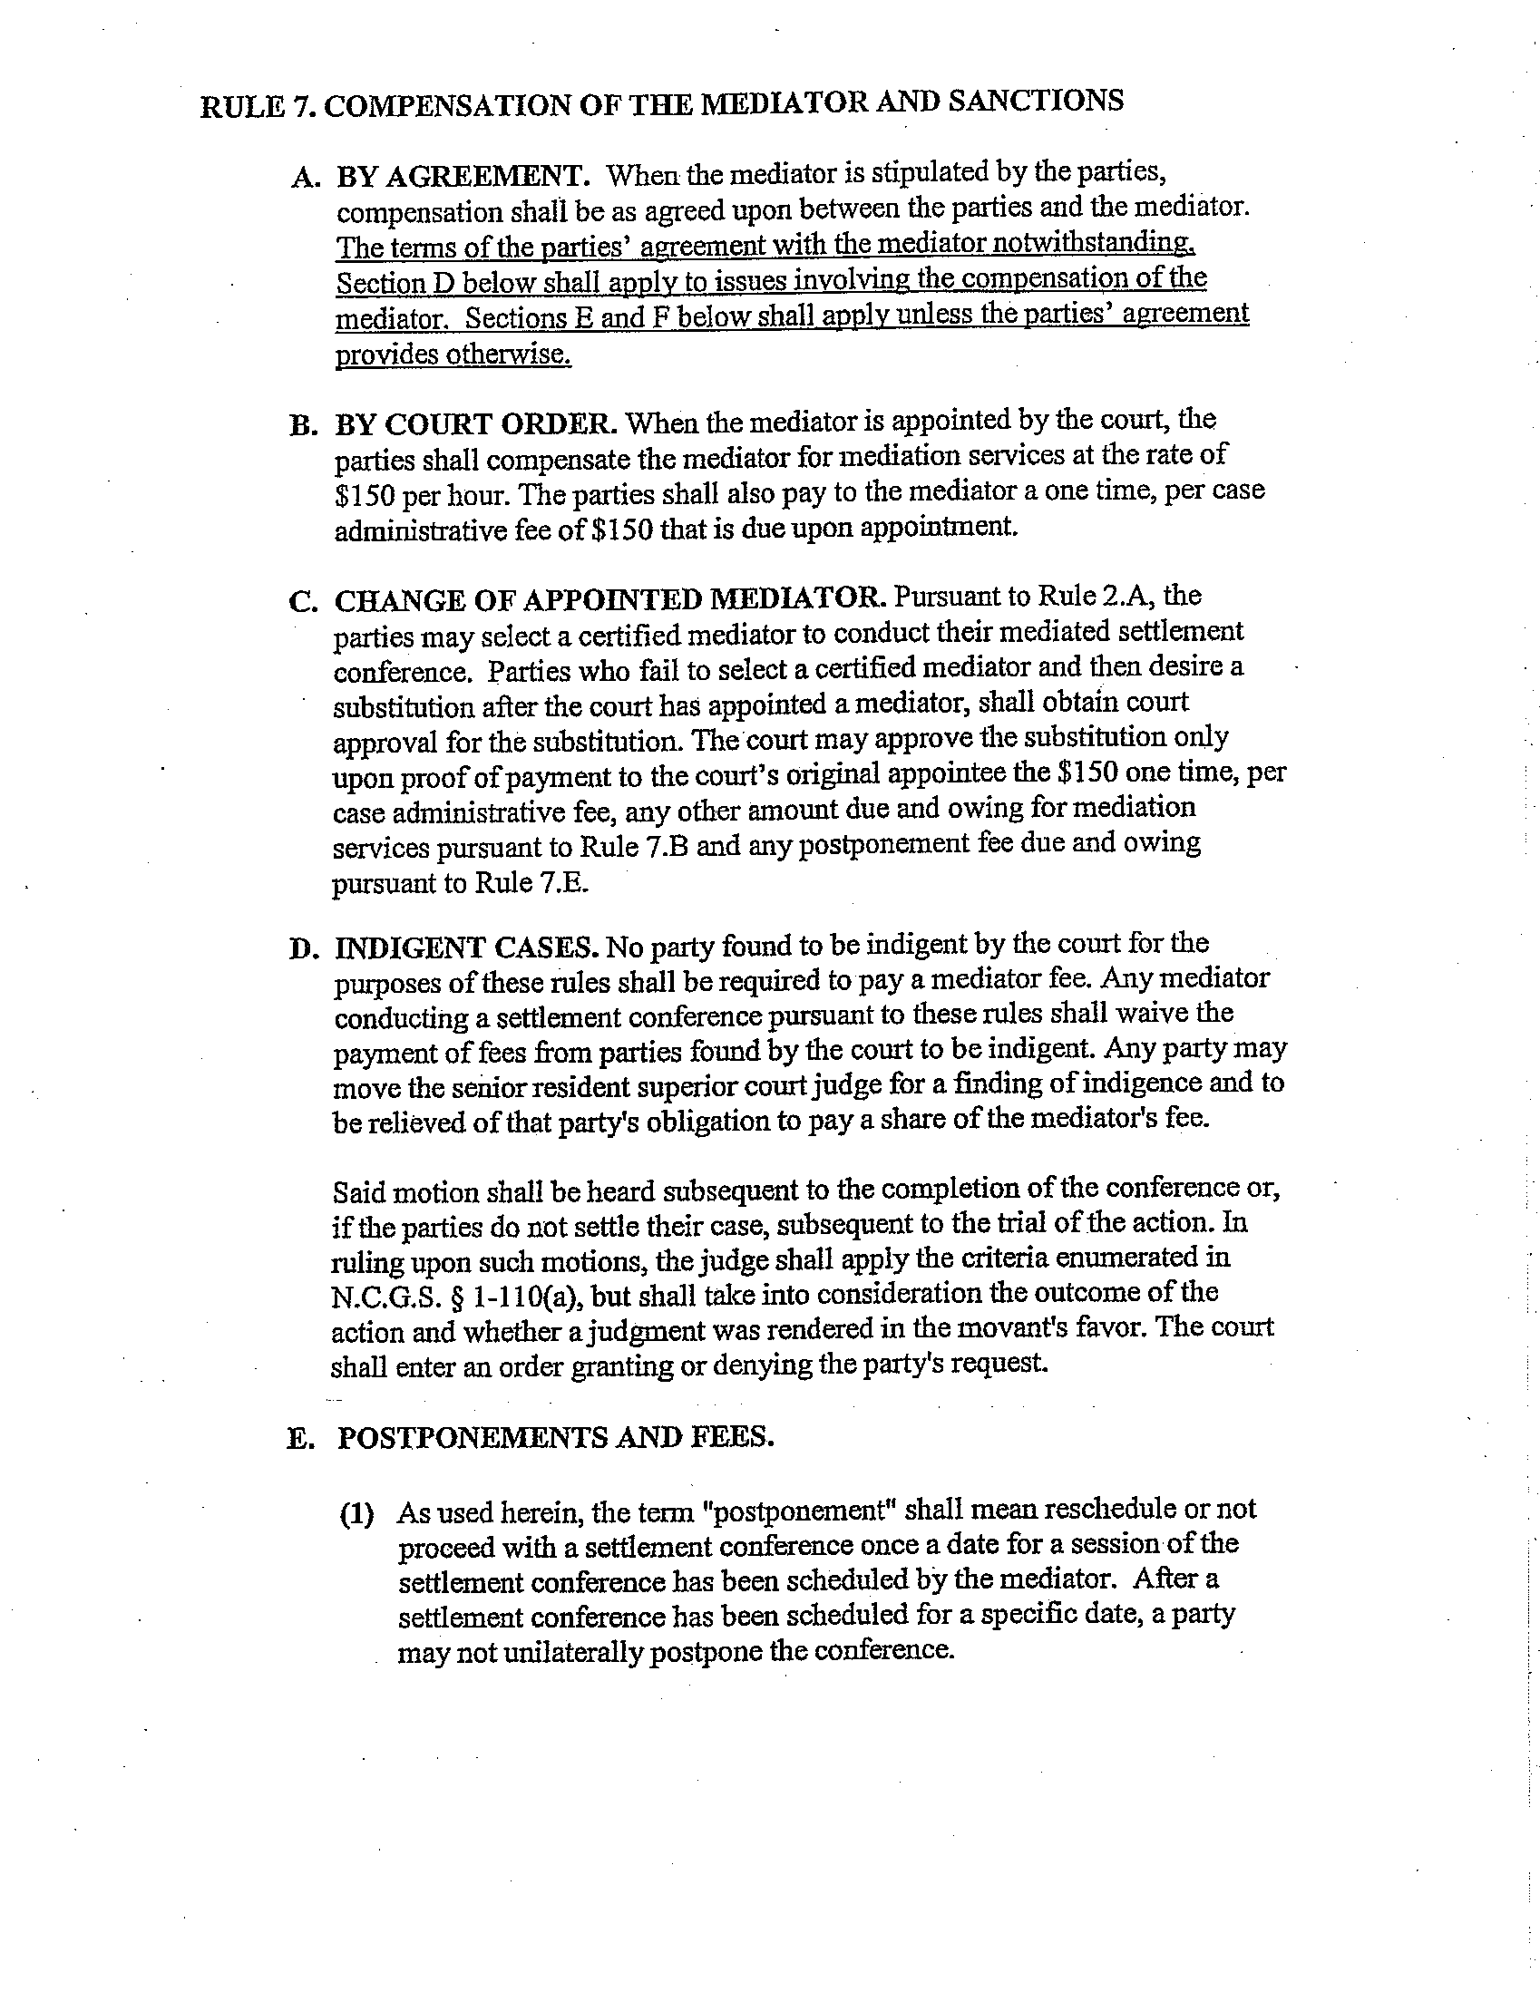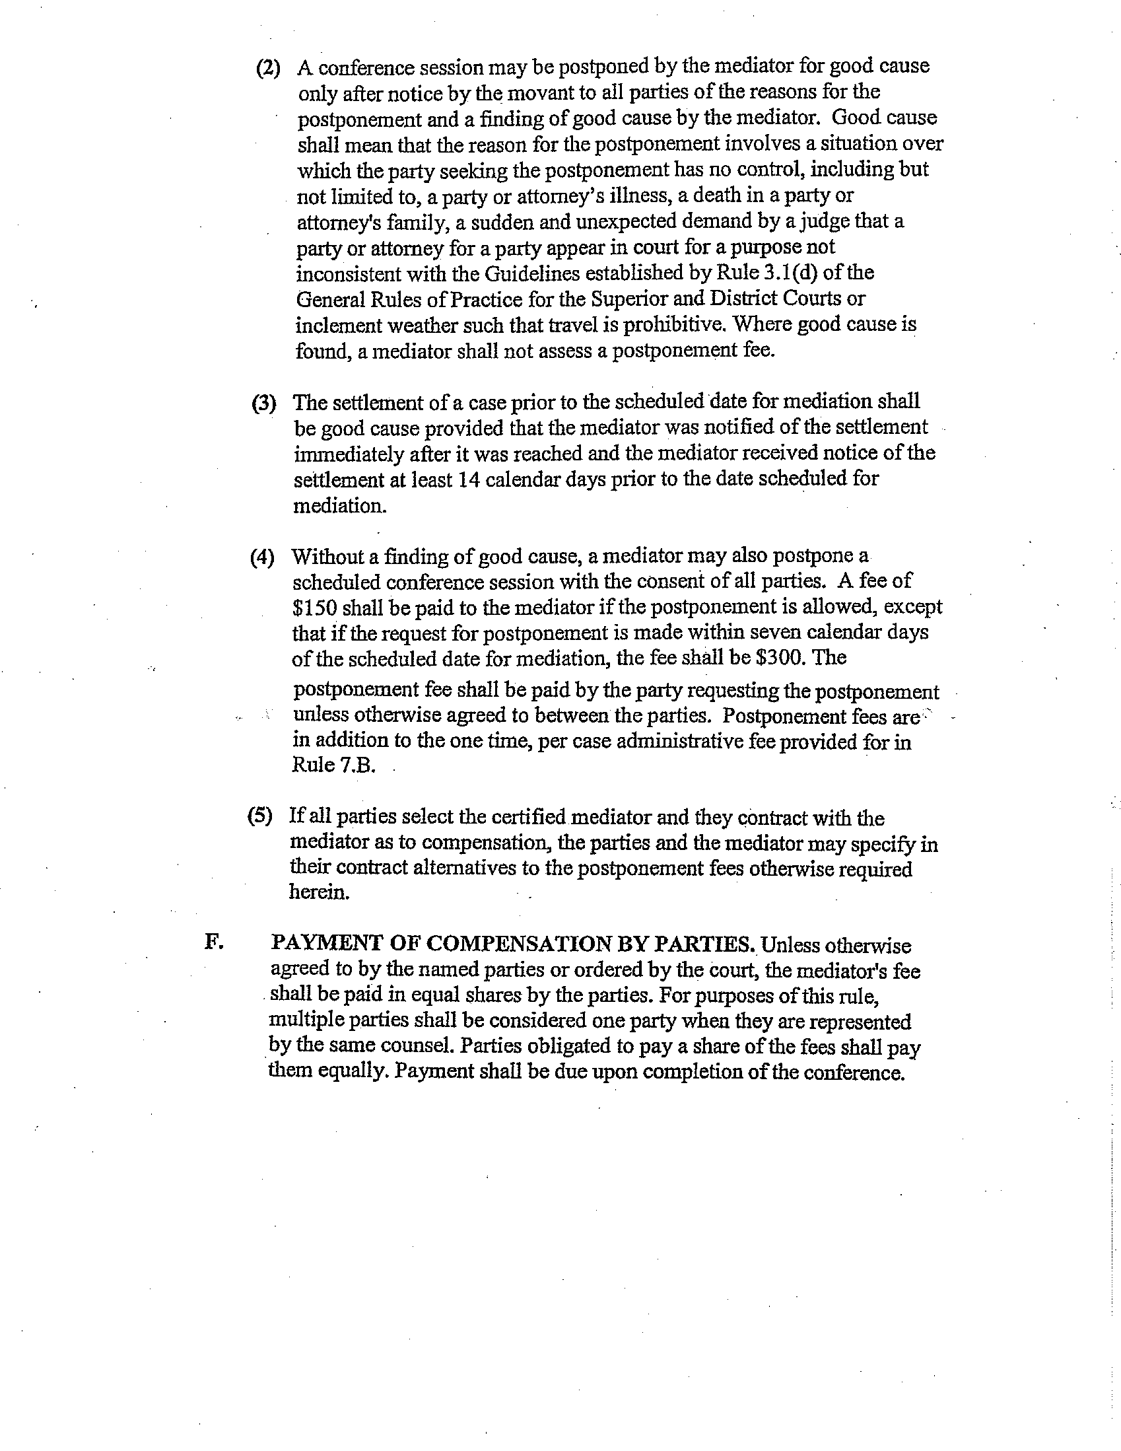

rrc staff OPINION

*Please Note: This communication is either 1) only the recommendation of an RRC staff attorney as to action that the attorney believes the Commission should take on the cited rule at its next meeting, or 2) an opinion of that attorney as to some matter concerning that rule. The agency and members of the public are invited to submit their own comments and recommendations (according to RRC rules) to the Commission.*

AGENCY: INDUSTRIAL COMMISSION

RULE CITATION: 04 NCAC 10G .0108

RECOMMENDED ACTION:

Approve, but note staff’s comment

X Object, based on:

Lack of statutory authority

X Unclear or ambiguous

Unnecessary

Failure to comply with the APA

Extend the period of review

COMMENT:

In (a), it is not clear what constitutes "good cause" for the Commission to bar any person from holding himself out as a mediator, etc. There does not appear to be a comparable provision in the Mediated Settlement Conference rules.

In (c), it is not clear what constitutes "good cause" for the failure of a mediator to appear. There does not appear to be a comparable provision in the Mediated Settlement Conference rules.

Robert A. Bryan, Jr.

Commission Counsel

rrc staff OPINION

*Please Note: This communication is either 1) only the recommendation of an RRC staff attorney as to action that the attorney believes the Commission should take on the cited rule at its next meeting, or 2) an opinion of that attorney as to some matter concerning that rule. The agency and members of the public are invited to submit their own comments and recommendations (according to RRC rules) to the Commission.*

AGENCY: INDUSTRIAL COMMISSION

RULE CITATION: 04 NCAC 10H .0201

RECOMMENDED ACTION:

Approve, but note staff’s comment

X Object, based on:

Lack of statutory authority

X Unclear or ambiguous

Unnecessary

Failure to comply with the APA

Extend the period of review

COMMENT:

In (b), it is not clear if the standard here also applies in Rule .0202(b).

Robert A. Bryan, Jr.

Commission Counsel

rrc staff OPINION

*Please Note: This communication is either 1) only the recommendation of an RRC staff attorney as to action that the attorney believes the Commission should take on the cited rule at its next meeting, or 2) an opinion of that attorney as to some matter concerning that rule. The agency and members of the public are invited to submit their own comments and recommendations (according to RRC rules) to the Commission.*

AGENCY: INDUSTRIAL COMMISSION

RULE CITATION: 04 NCAC 10H .0202

RECOMMENDED ACTION:

Approve, but note staff’s comment

X Object, based on:

Lack of statutory authority

X Unclear or ambiguous

Unnecessary

Failure to comply with the APA

Extend the period of review

COMMENT:

In (b), it is not clear what factors or standards the Commission will use in ordering a hearing or rehearing. It is also not clear if the Commission will use a different standard than that set out in .0201(b).

Robert A. Bryan, Jr.

Commission Counsel

rrc staff OPINION

*Please Note: This communication is either 1) only the recommendation of an RRC staff attorney as to action that the attorney believes the Commission should take on the cited rule at its next meeting, or 2) an opinion of that attorney as to some matter concerning that rule. The agency and members of the public are invited to submit their own comments and recommendations (according to RRC rules) to the Commission.*

AGENCY: INDUSTRIAL COMMISSION

RULE CITATION: 04 NCAC 10I .0201

RECOMMENDED ACTION:

Approve, but note staff’s comment

X Object, based on:

Lack of statutory authority

Unclear or ambiguous

X Unnecessary

Failure to comply with the APA

Extend the period of review

COMMENT:

This rule repeats the contents of G.S. 130A-425(d) and is thus unnecessary.

Robert A. Bryan, Jr.

Commission Counsel

§ 130A-425. Filing of claims.

(a)        Notwithstanding any other provision of State law, no action for compensation for a vaccine‑related injury may be filed against any person unless that person was named as a respondent in a claim filed pursuant to this section and unless the claim was filed within the applicable time period set forth in G.S. 130A-429.

(b)        In all claims filed pursuant to this Article, the claimant or the person in whose behalf the claim is made shall file with the Commission a verified petition in duplicate, setting forth the following information:

(1)        The name and address of the claimant;

(2)        The name and address of each respondent;

(3)        The amount of compensation in money and services sought to be recovered;

(4)        The time and place where the injury occurred;

(5)        A brief statement of the facts and circumstances surrounding the injury and giving rise to the claim; and

(6)        Supporting documentation and a statement of the claim that the claimant or the person in whose behalf the claim is made suffered a vaccine-related injury and has not previously collected an award or settlement of a civil action for damages for this injury. This supporting documentation shall include all available medical records pertaining to the alleged injury, including autopsy reports, if any, and if the injured person was under two years of age at the time of injury, all prenatal, obstetrical, and pediatric records of care preceding the injury, and an identification of any unavailable records known to the claimant or the person in whose behalf the claim is made.

(7)        Documentation to show that the claimant has filed an election pursuant to Section 2121 of the Public Health Service Act, P.L. 99-660, permitting such claimant to file a civil action for damages for a vaccine-related injury or death or documentation to show that such claimant is otherwise permitted by federal law to file an action against a vaccine manufacturer.

(c)        Upon receipt of this verified petition in duplicate, the Commission shall enter the case upon its hearing docket and shall determine the matter in the county where the injury occurred unless the parties agree or the Commission directs that the case may be heard in some other county. All parties shall be given reasonable notice of the date when and the place where the claim will be heard.  Immediately upon receipt of the claim, the Commission shall serve a copy of the verified petition on each respondent by registered or certified mail. The Commission shall also send a copy of the verified petition to the Secretary, who shall be a party to all proceedings involving the claim, and to the Attorney General who shall represent the State's interest in all the proceedings involving the claim.

(d)       The Commission shall adopt rules necessary to govern the proceedings required by this Article. The Rules of Civil Procedure as contained in G.S. 1A-1 **et seq.** and the General Rules of Practice for the Superior and District Courts as authorized by G.S. 7A-34 apply to claims filed with the Industrial Commission under this Article. The Commission shall keep a record of all proceedings conducted under this Article, and has the right to subpoena any persons and records it considers necessary in making its determinations. The Commission may require all persons called as witnesses to testify under oath or affirmation, and any member of the Commission may administer oaths. If any persons refuse to comply with any subpoena issued pursuant to this Article or to testify with respect to any matter relevant to proceedings conducted under this Article, the Superior Court of Wake County, on application of the Commission, may issue an order requiring the person to comply with the subpoena and to testify. Any failure to obey any such order may be punished by the court as for contempt. (1985 (Reg. Sess., 1986), c. 1008, s. 1; 1987, c. 215, s. 3; 1989, c. 727, s. 150; 1991, c. 410, s. 2.)