NORTH CAROLINA

REGISTER

VOLUME 33 ● ISSUE 22 ● Pages 2157 – 2237

May 15, 2019

I. EXECUTIVE ORDERS

Executive Order No. 94 2157 – 2158

II. IN ADDITION

Building Code Council – Notice of Rulemaking Proceedings 2159 – 2182

Environmental Management Commission 2183

III. PROPOSED RULES

Insurance, Department of

Department 2184 – 2185

Education, State Board of

Board 2185 – 2213

Occupational Licensing Boards and Commissions

Architecture, Board of 2213 – 2214

General Contractors, Licensing Board for 2214 – 2221

IV. TEMPORARY RULES

Elections, State Board of

Board 2222 – 2223

V. RULES REVIEW COMMISSION 2224 – 2233

VI. CONTESTED CASE DECISIONS

Index to ALJ Decisions 2234 – 2237

PUBLISHED BY
The Office of Administrative Hearings
Rules Division Julian Mann III, Director
6714 Mail Service Center Molly Masich, Codifier of Rules
Raleigh, NC 27699-6714 Dana McGhee, Publications Coordinator
Telephone (919) 431-3000 Lindsay Woy, Editorial Assistant
Fax (919) 431-3104 Cathy Matthews-Thayer, Editorial Assistant

Contact List for Rulemaking Questions or Concerns

For questions or concerns regarding the Administrative Procedure Act or any of its components, consult with the agencies below. The bolded headings are typical issues which the given agency can address, but are not inclusive.

Rule Notices, Filings, Register, Deadlines, Copies of Proposed Rules, etc.

Office of Administrative Hearings

Rules Division
1711 New Hope Church Road (919) 431-3000
Raleigh, North Carolina 27609 (919) 431-3104 FAX

contact: Molly Masich, Codifier of Rules molly.masich@oah.nc.gov (919) 431-3071
Dana McGhee, Publications Coordinator dana.mcghee@oah.nc.gov (919) 431-3075
Lindsay Woy, Editorial Assistant lindsay.woy@oah.nc.gov (919) 431-3078
Cathy Matthews-Thayer, Editorial Assistant cathy.thayer@oah.nc.gov (919) 431-3006

Rule Review and Legal Issues

Rules Review Commission
1711 New Hope Church Road (919) 431-3000
Raleigh, North Carolina 27609 (919) 431-3104 FAX

contact: Amber Cronk May, Commission Counsel amber.may@oah.nc.gov (919) 431-3074
Amanda Reeder, Commission Counsel amanda.reeder@oah.nc.gov (919) 431-3079
Alexander Burgos, Paralegal alexander.burgos@oah.nc.gov (919) 431-3080
Julie Brincefield, Administrative Assistant julie.brincefield@oah.nc.gov (919) 431-3073

Fiscal Notes & Economic Analysis

Office of State Budget and Management
116 West Jones Street (919) 807-4700
Raleigh, North Carolina 27603-8005 (919) 733-0640 FAX
Contact: Carrie Hollis, Economic Analyst osbmruleanalysis@osbm.nc.gov (919) 807-4757

NC Association of County Commissioners
215 North Dawson Street (919) 715-2893
Raleigh, North Carolina 27603
contact: Amy Bason amy.bason@ncacc.org

NC League of Municipalities (919) 715-4000
150 Fayetteville Street, Suite 300
Raleigh, North Carolina 27601
contact: Sarah Collins scollins@nclm.org

Legislative Process Concerning Rule-making
545 Legislative Office Building
300 North Salisbury Street (919) 733-2578
Raleigh, North Carolina 27611 (919) 715-5460 FAX

Jason Moran-Bates, Staff Attorney
Jeremy Ray, Staff Attorney

NORTH CAROLINA REGISTER
Publication Schedule for January 2019 – December 2019

FILING DEADLINES |  |  | NOTICE OF TEXT |  | PERMANENT RULE |  |  | TEMPORARY RULES
Volume & issue number | Issue date | Last day for filing | Earliest date for public hearing | End of required comment  Period | Deadline to submit to RRC  for review at  next meeting | RRC Meeting Date | Earliest Eff.  Date of  Permanent Rule | 270th day from publication in the Register
33:13 | 01/02/19 | 12/06/18 | 01/17/19 | 03/04/19 | 03/20/19 | 04/18/19 | 05/01/19 | 09/29/19
33:14 | 01/15/19 | 12/19/18 | 01/30/19 | 03/18/19 | 03/20/19 | 04/18/19 | 05/01/19 | 10/12/19
33:15 | 02/01/19 | 01/10/19 | 02/16/19 | 04/02/19 | 04/22/19 | 05/16/19 | 06/01/19 | 10/29/19
33:16 | 02/15/19 | 01/25/19 | 03/02/19 | 04/16/19 | 04/22/19 | 05/16/19 | 06/01/19 | 11/12/19
33:17 | 03/01/19 | 02/08/19 | 03/16/19 | 04/30/19 | 05/20/19 | 06/20/19 | 07/01/19 | 11/26/19
33:18 | 03/15/19 | 02/22/19 | 03/30/19 | 05/14/19 | 05/20/19 | 06/20/19 | 07/01/19 | 12/10/19
33:19 | 04/01/19 | 03/11/19 | 04/16/19 | 05/31/19 | 06/20/19 | 07/18/19 | 08/01/19 | 12/27/19
33:20 | 04/15/19 | 03/25/19 | 04/30/19 | 06/14/19 | 06/20/19 | 07/18/19 | 08/01/19 | 01/10/20
33:21 | 05/01/19 | 04/09/19 | 05/16/19 | 07/01/19 | 07/22/19 | 08/15/19 | 09/01/19 | 01/26/20
33:22 | 05/15/19 | 04/24/19 | 05/30/19 | 07/15/19 | 07/22/19 | 08/15/19 | 09/01/19 | 02/09/20
33:23 | 06/03/19 | 05/10/19 | 06/18/19 | 08/02/19 | 08/20/19 | 09/19/19 | 10/01/19 | 02/28/20
33:24 | 06/17/19 | 05/24/19 | 07/02/19 | 08/16/19 | 08/20/19 | 09/19/19 | 10/01/19 | 03/13/20
34:01 | 07/01/19 | 06/10/19 | 07/16/19 | 08/30/19 | 09/20/19 | 10/17/19 | 11/01/19 | 03/27/20
34:02 | 07/15/19 | 06/21/19 | 07/30/19 | 09/13/19 | 09/20/19 | 10/17/19 | 11/01/19 | 04/10/20
34:03 | 08/01/19 | 07/11/19 | 08/16/19 | 09/30/19 | 10/21/19 | 11/21/19 | 12/01/19 | 04/27/20
34:04 | 08/15/19 | 07/25/19 | 08/30/19 | 10/14/19 | 10/21/19 | 11/21/19 | 12/01/19 | 05/11/20
34:05 | 09/03/19 | 08/12/19 | 09/18/19 | 11/04/19 | 11/20/19 | 12/19/19 | 01/01/20 | 05/30/20
34:06 | 09/16/19 | 08/23/19 | 10/01/19 | 11/15/19 | 11/20/19 | 12/19/19 | 01/01/20 | 06/12/20
34:07 | 10/01/19 | 09/10/19 | 10/16/19 | 12/02/19 | 12/20/19 | 01/16/20 | 02/01/20 | 06/27/20
34:08 | 10/15/19 | 09/24/19 | 10/30/19 | 12/16/19 | 12/20/19 | 01/16/20 | 02/01/20 | 07/11/20
34:09 | 11/01/19 | 10/11/19 | 11/16/19 | 12/31/19 | 01/21/20 | 02/20/20 | 03/01/20 | 07/28/20
34:10 | 11/15/19 | 10/24/19 | 11/30/19 | 01/14/20 | 01/21/20 | 02/20/20 | 03/01/20 | 08/11/20
34:11 | 12/02/19 | 11/06/19 | 12/17/19 | 01/31/20 | 02/20/20 | 03/19/20 | 04/01/20 | 08/28/20
34:12 | 12/16/19 | 11/21/19 | 12/31/19 | 02/14/20 | 02/20/20 | 03/19/20 | 04/01/20 | 09/11/20

This document is prepared by the Office of Administrative Hearings as a public service and is not to be deemed binding or controlling.

EXPLANATION OF THE PUBLICATION SCHEDULE

This Publication Schedule is prepared by the Office of Administrative Hearings as a public service and the computation of time periods are not to be deemed binding or controlling. Time is computed according to 26 NCAC 2C .0302 and the Rules of Civil Procedure, Rule 6.

GENERAL

The North Carolina Register shall be published twice a month and contains the following information submitted for publication by a state agency:
(1) temporary rules;
(2) text of proposed rules;
(3) text of permanent rules approved by the Rules Review Commission;
(4) emergency rules
(5) Executive Orders of the Governor;
(6) final decision letters from the U.S. Attorney General concerning changes in laws affecting voting in a jurisdiction subject of Section 5 of the Voting Rights Act of 1965, as required by G.S. 120-30.9H; and
(7) other information the Codifier of Rules determines to be helpful to the public.

COMPUTING TIME: In computing time in the schedule, the day of publication of the North Carolina Register is not included. The last day of the period so computed is included, unless it is a Saturday, Sunday, or State holiday, in which event the period runs until the preceding day which is not a Saturday, Sunday, or State holiday.

FILING DEADLINES

ISSUE DATE: The Register is published on the first and fifteen of each month if the first or fifteenth of the month is not a Saturday, Sunday, or State holiday for employees mandated by the State Personnel Commission. If the first or fifteenth of any month is a Saturday, Sunday, or a holiday for State employees, the North Carolina Register issue for that day will be published on the day of that month after the first or fifteenth that is not a Saturday, Sunday, or holiday for State employees.

LAST DAY FOR FILING: The last day for filing for any issue is 15 days before the issue date excluding Saturdays, Sundays, and holidays for State employees.

NOTICE OF TEXT

EARLIEST DATE FOR PUBLIC HEARING: The hearing date shall be at least 15 days after the date a notice of the hearing is published.

END OF REQUIRED COMMENT PERIOD
An agency shall accept comments on the text of a proposed rule for at least 60 days after the text is published or until the date of any public hearings held on the proposed rule, whichever is longer.

DEADLINE TO SUBMIT TO THE RULES REVIEW COMMISSION: The Commission shall review a rule submitted to it on or before the twentieth of a month by the last day of the next month.

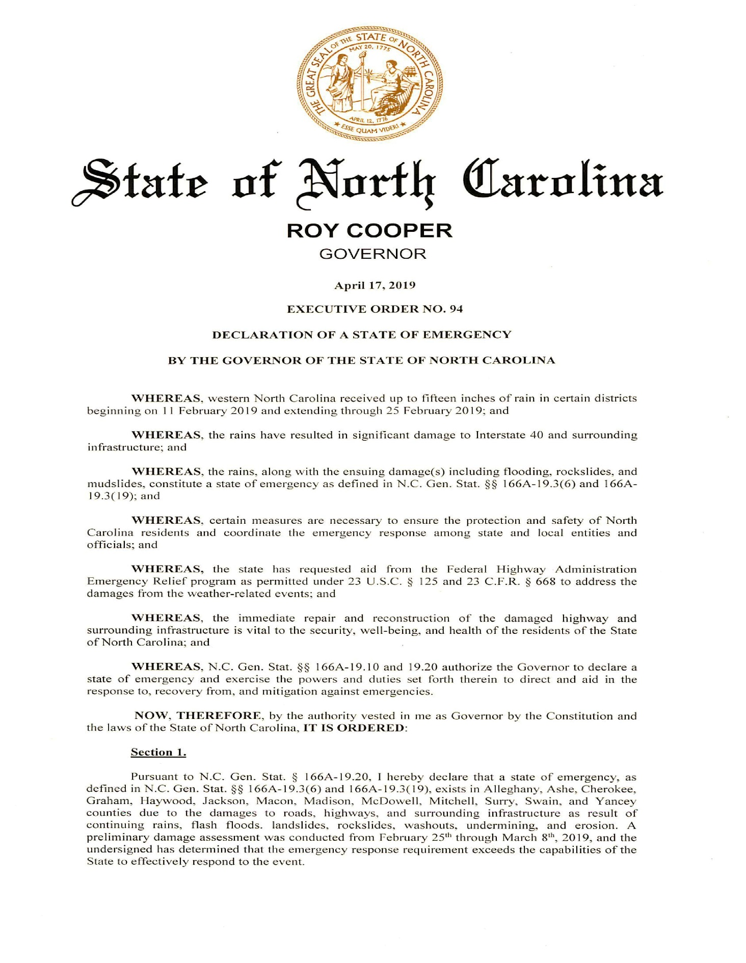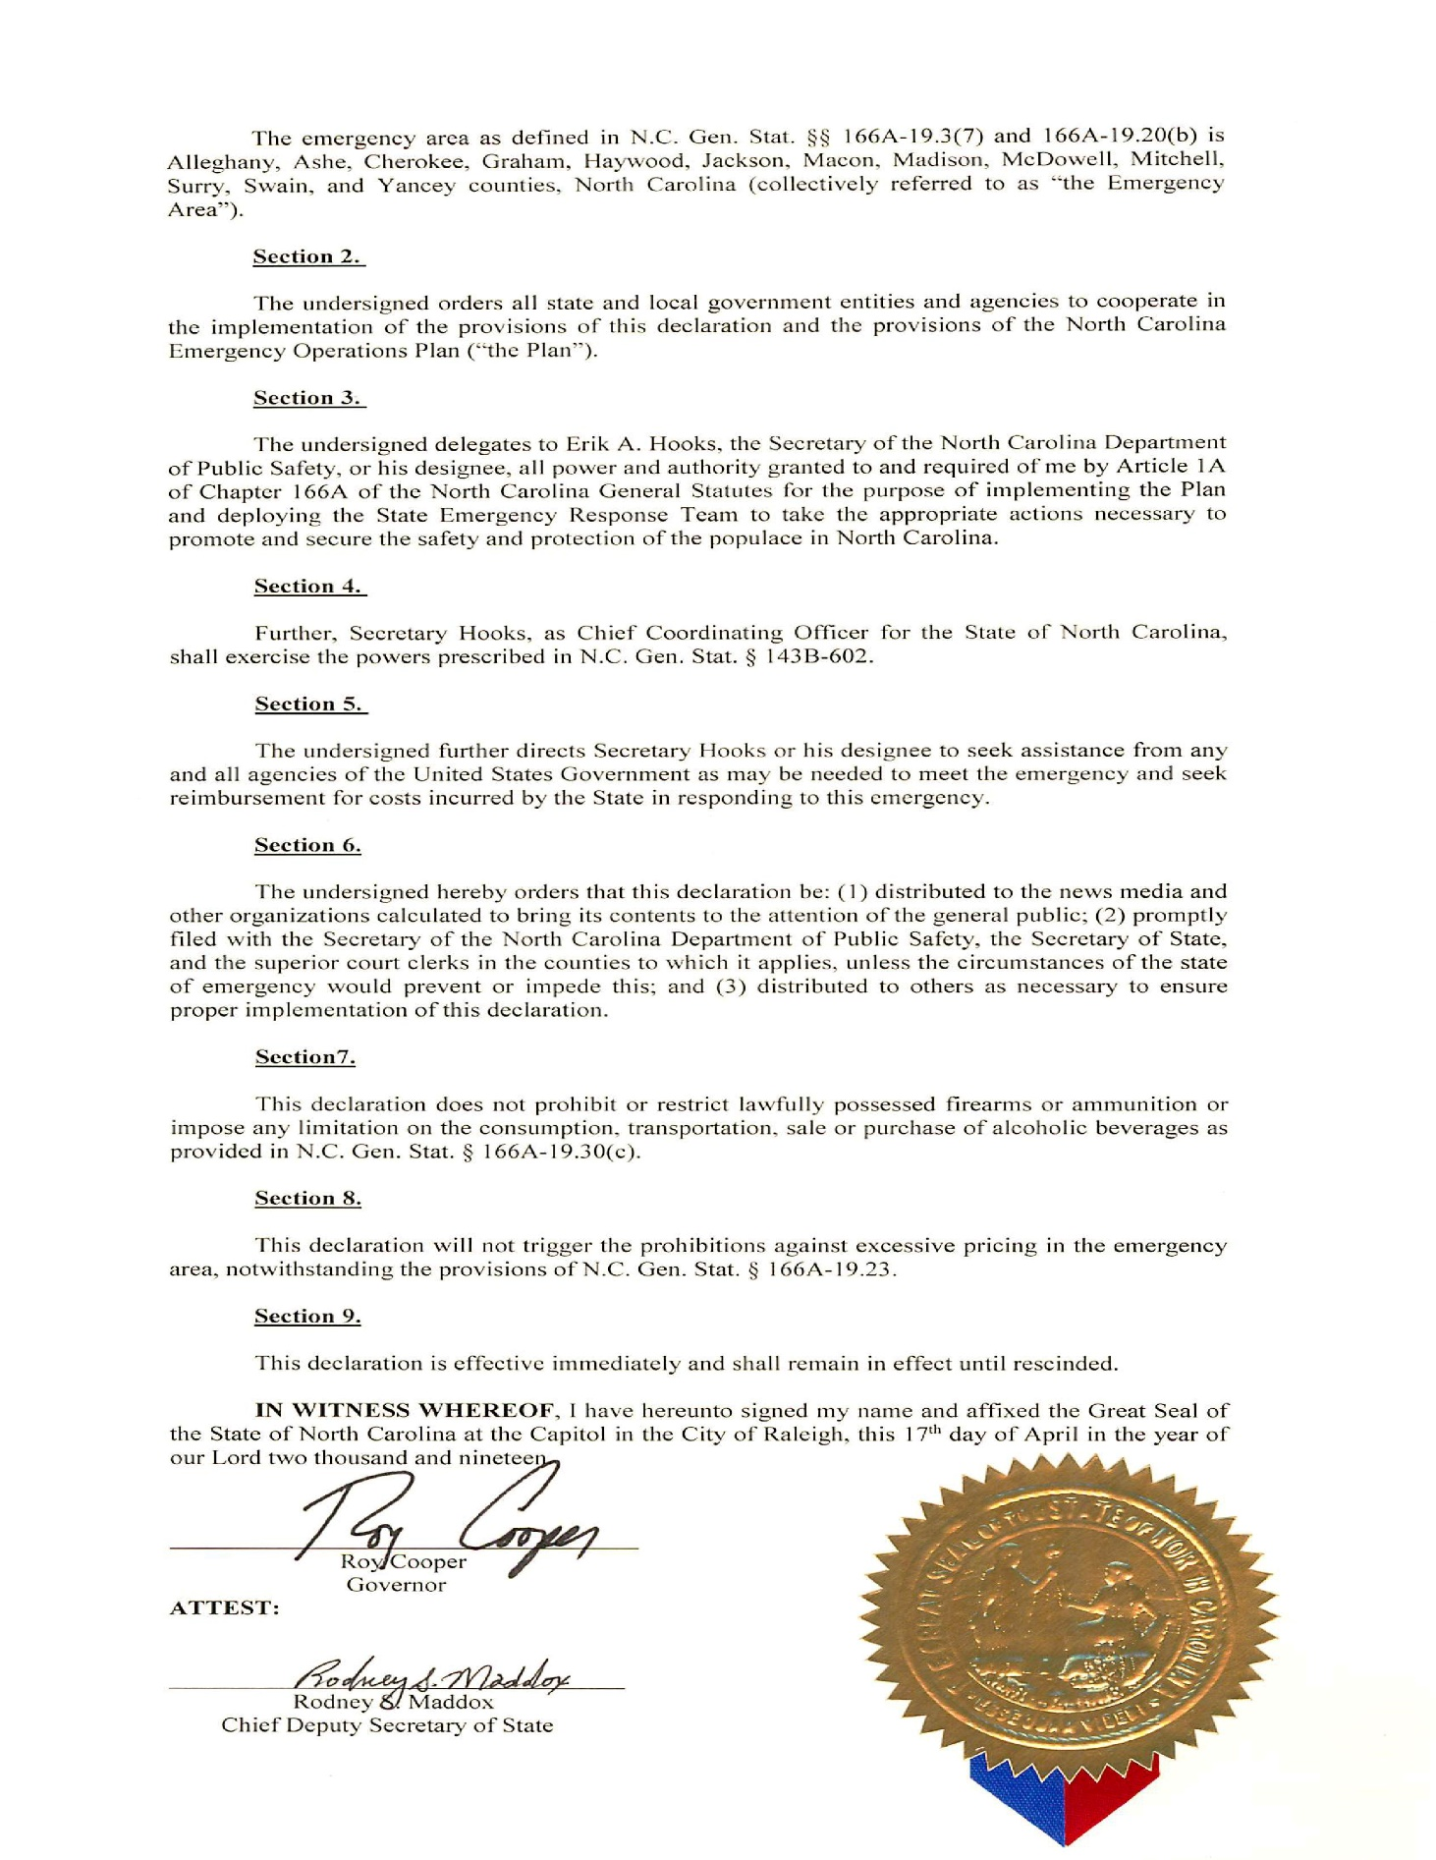

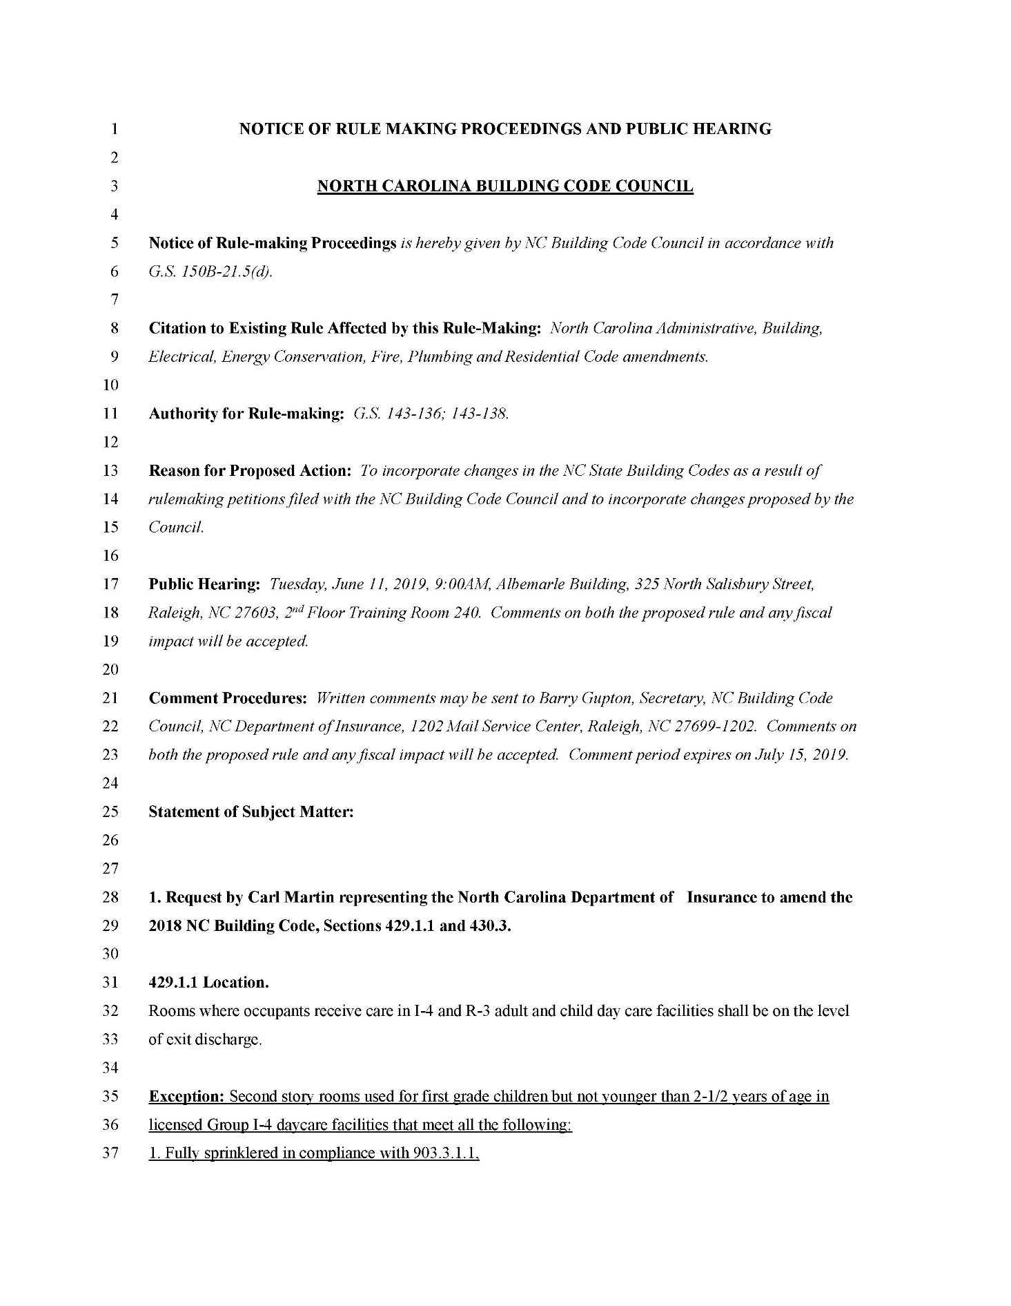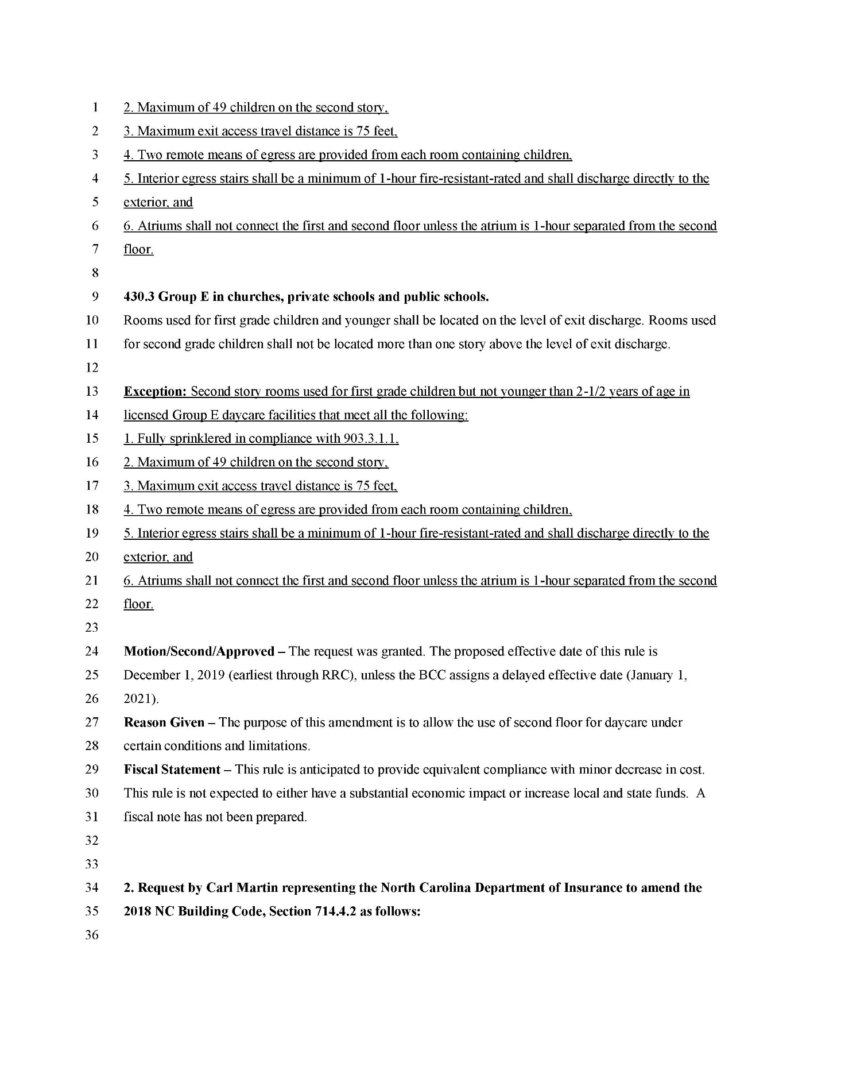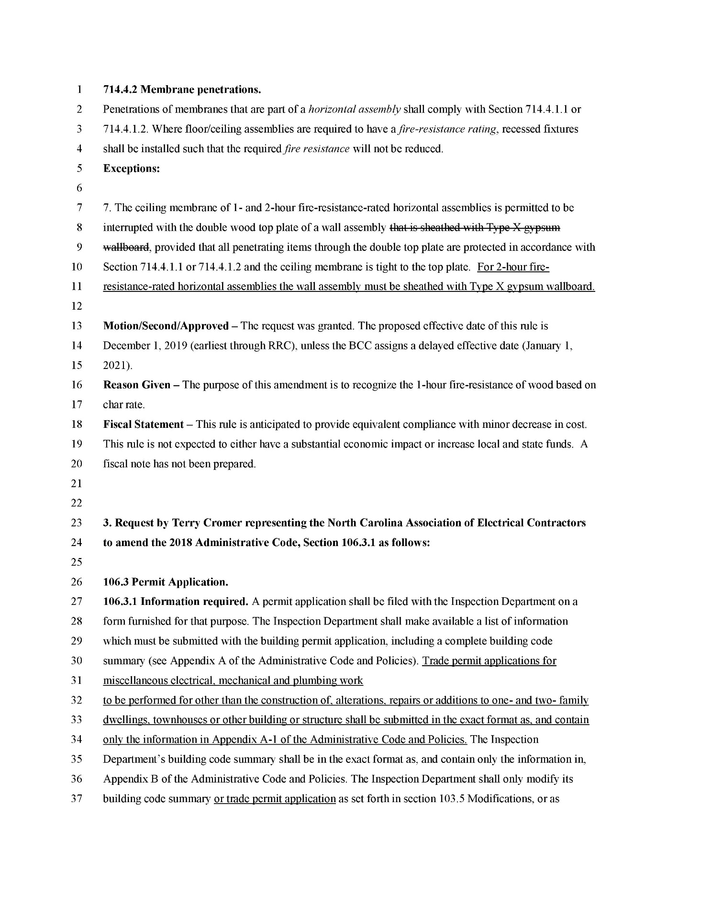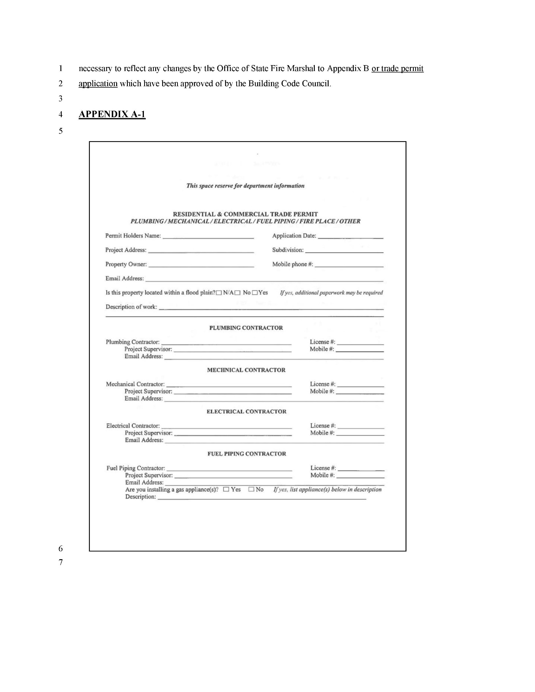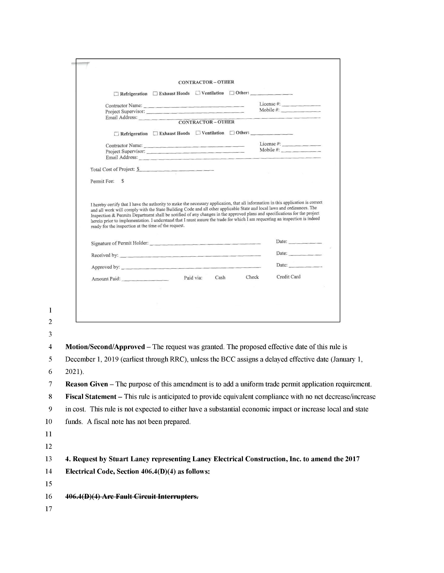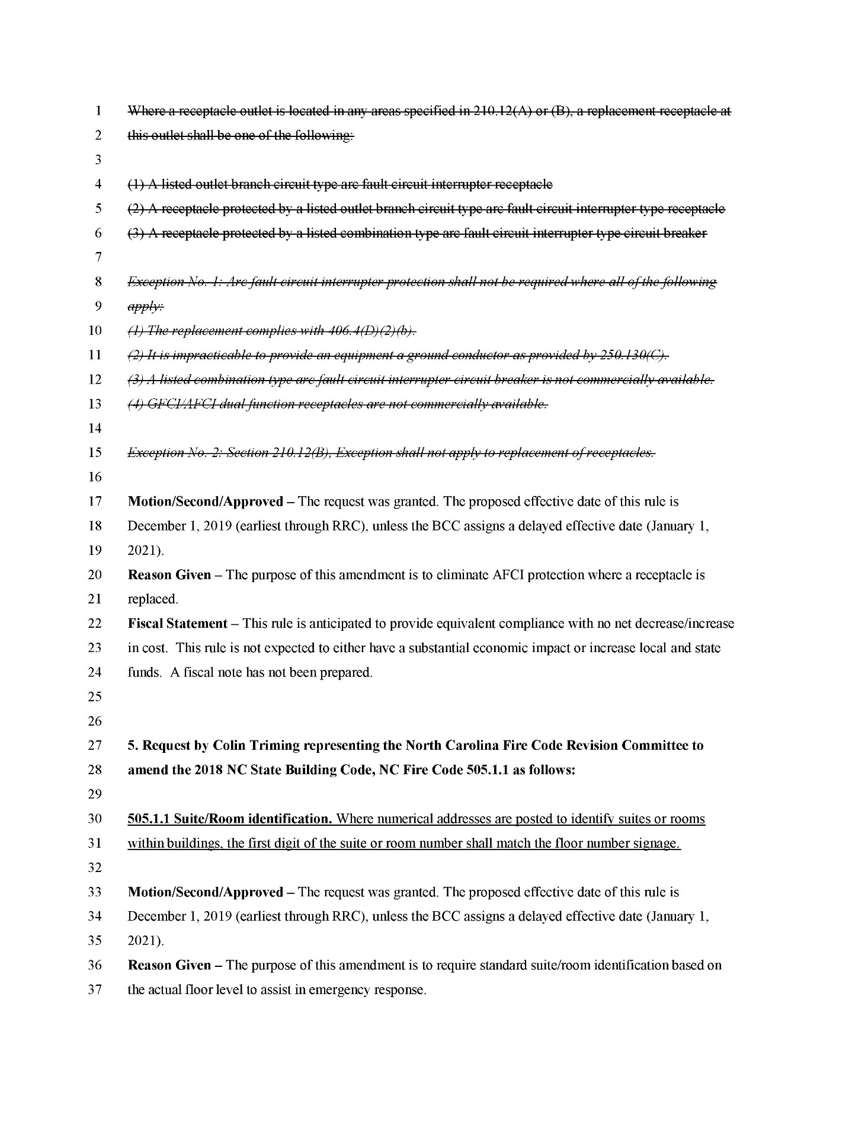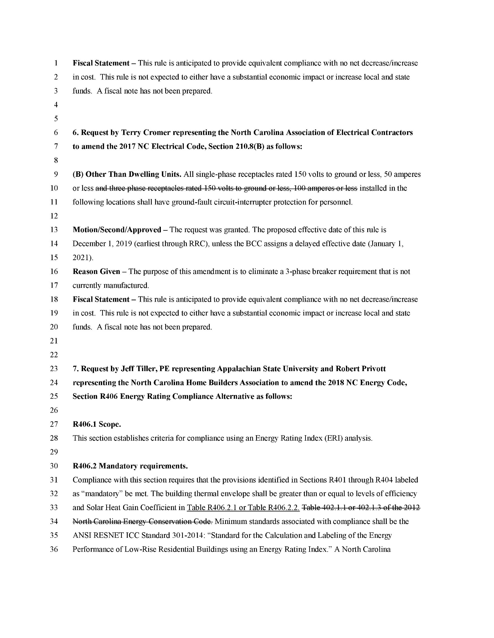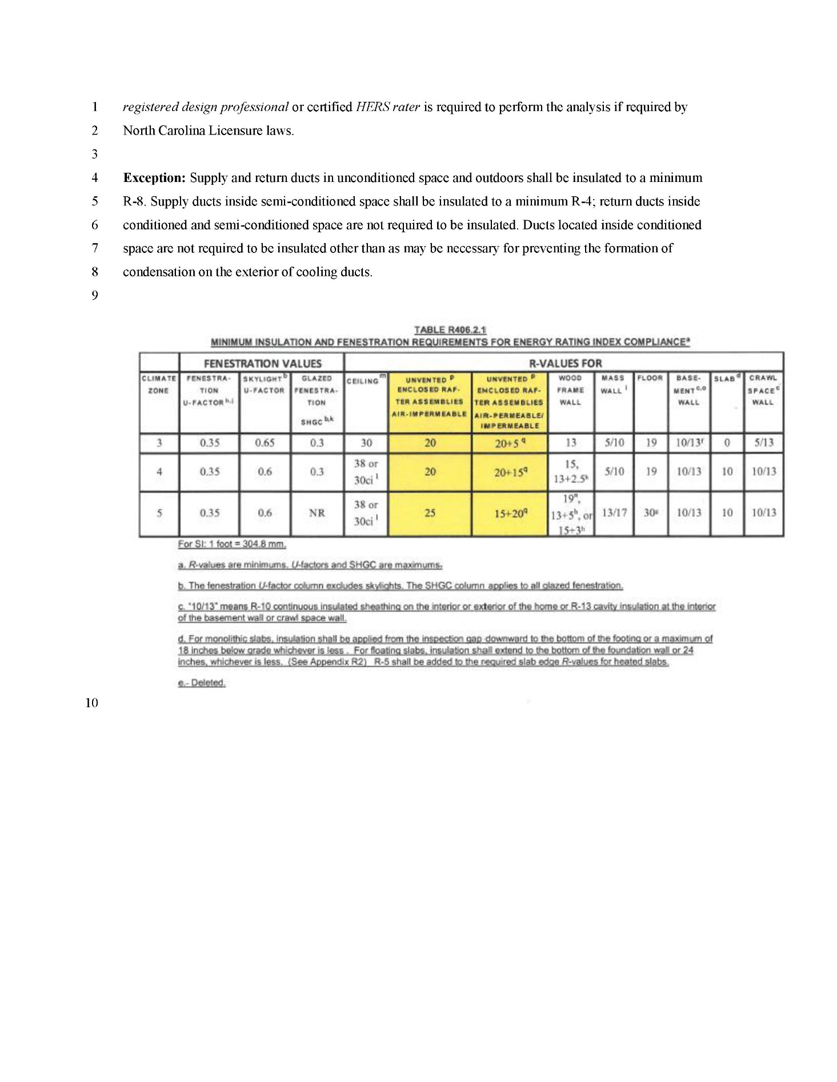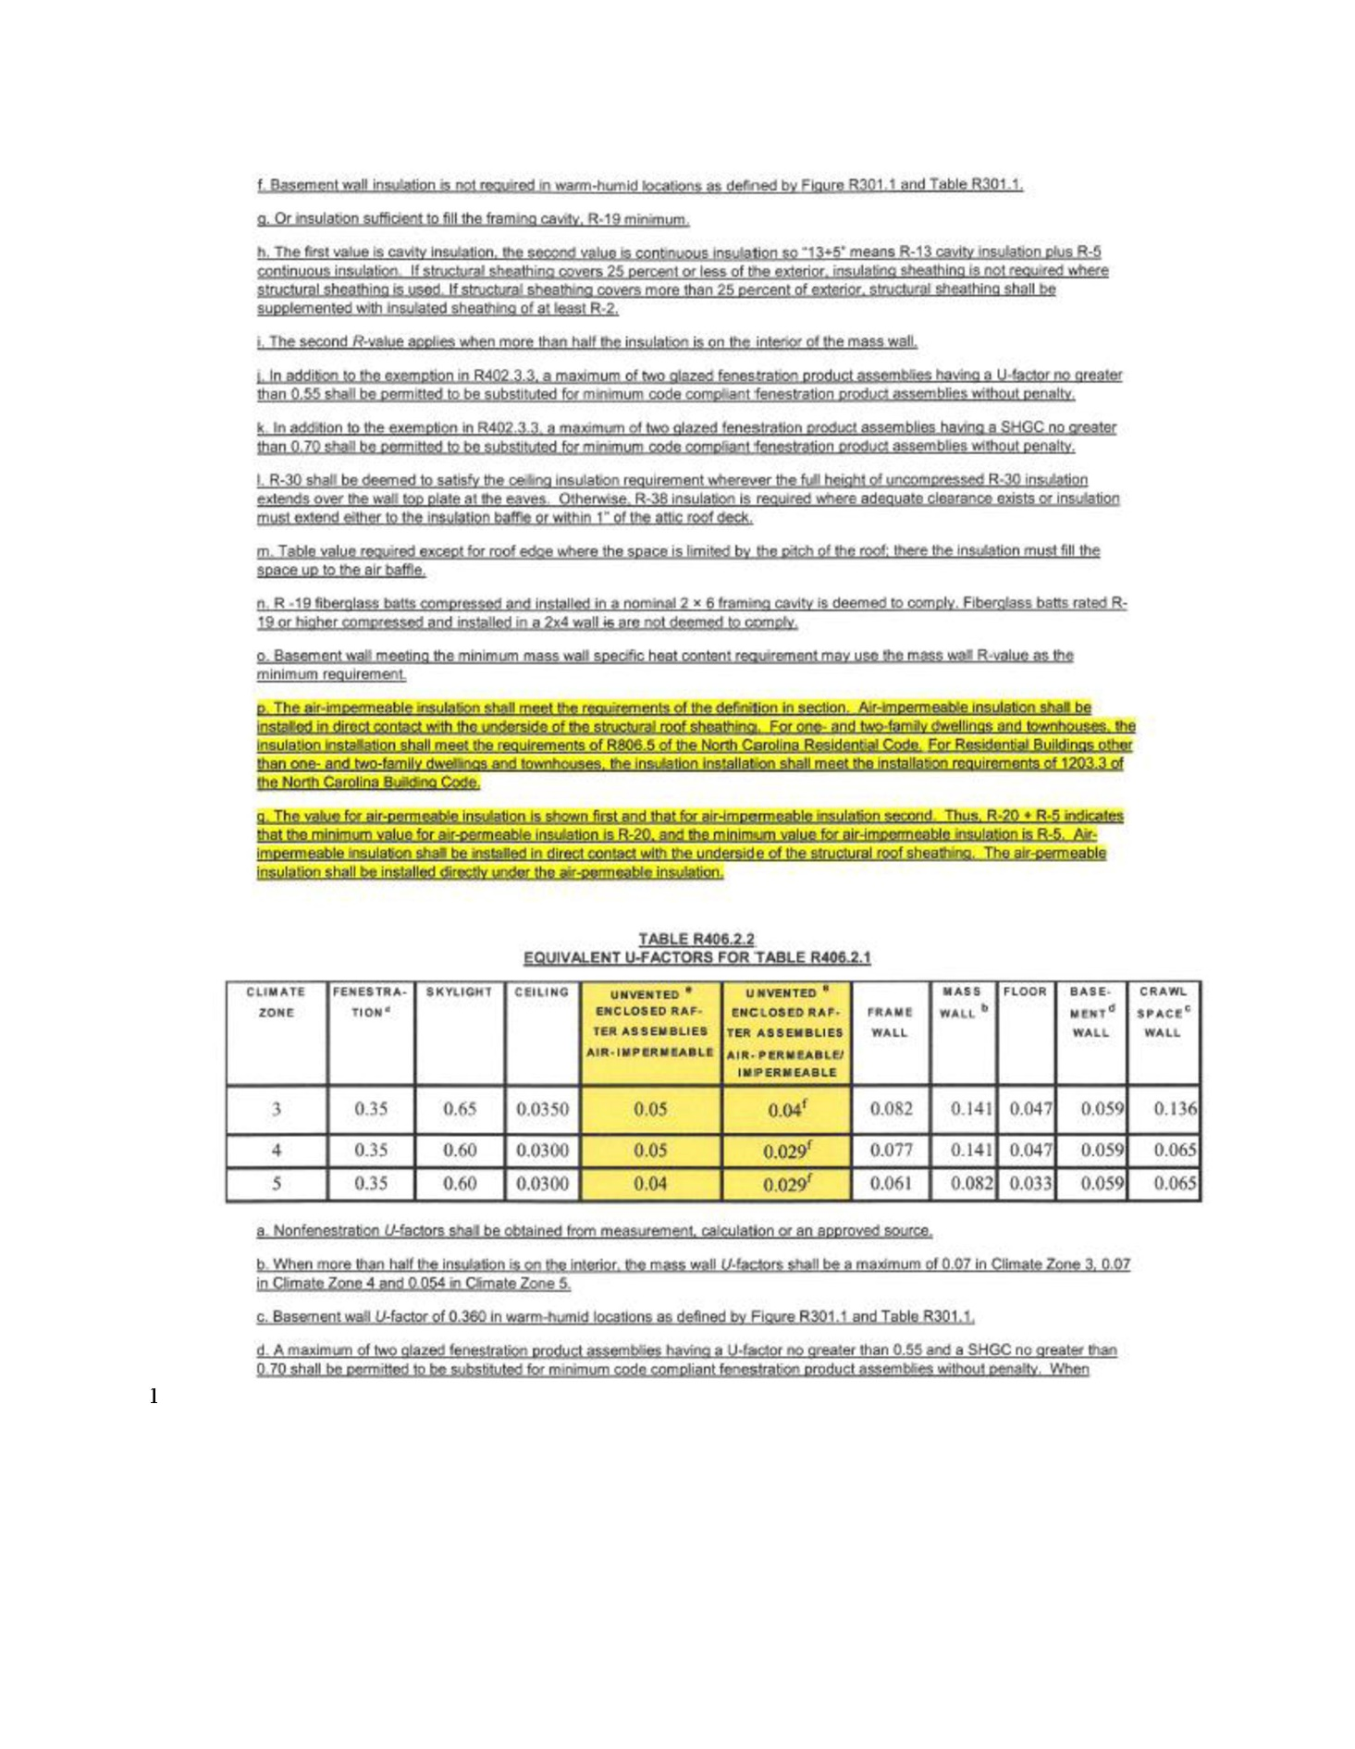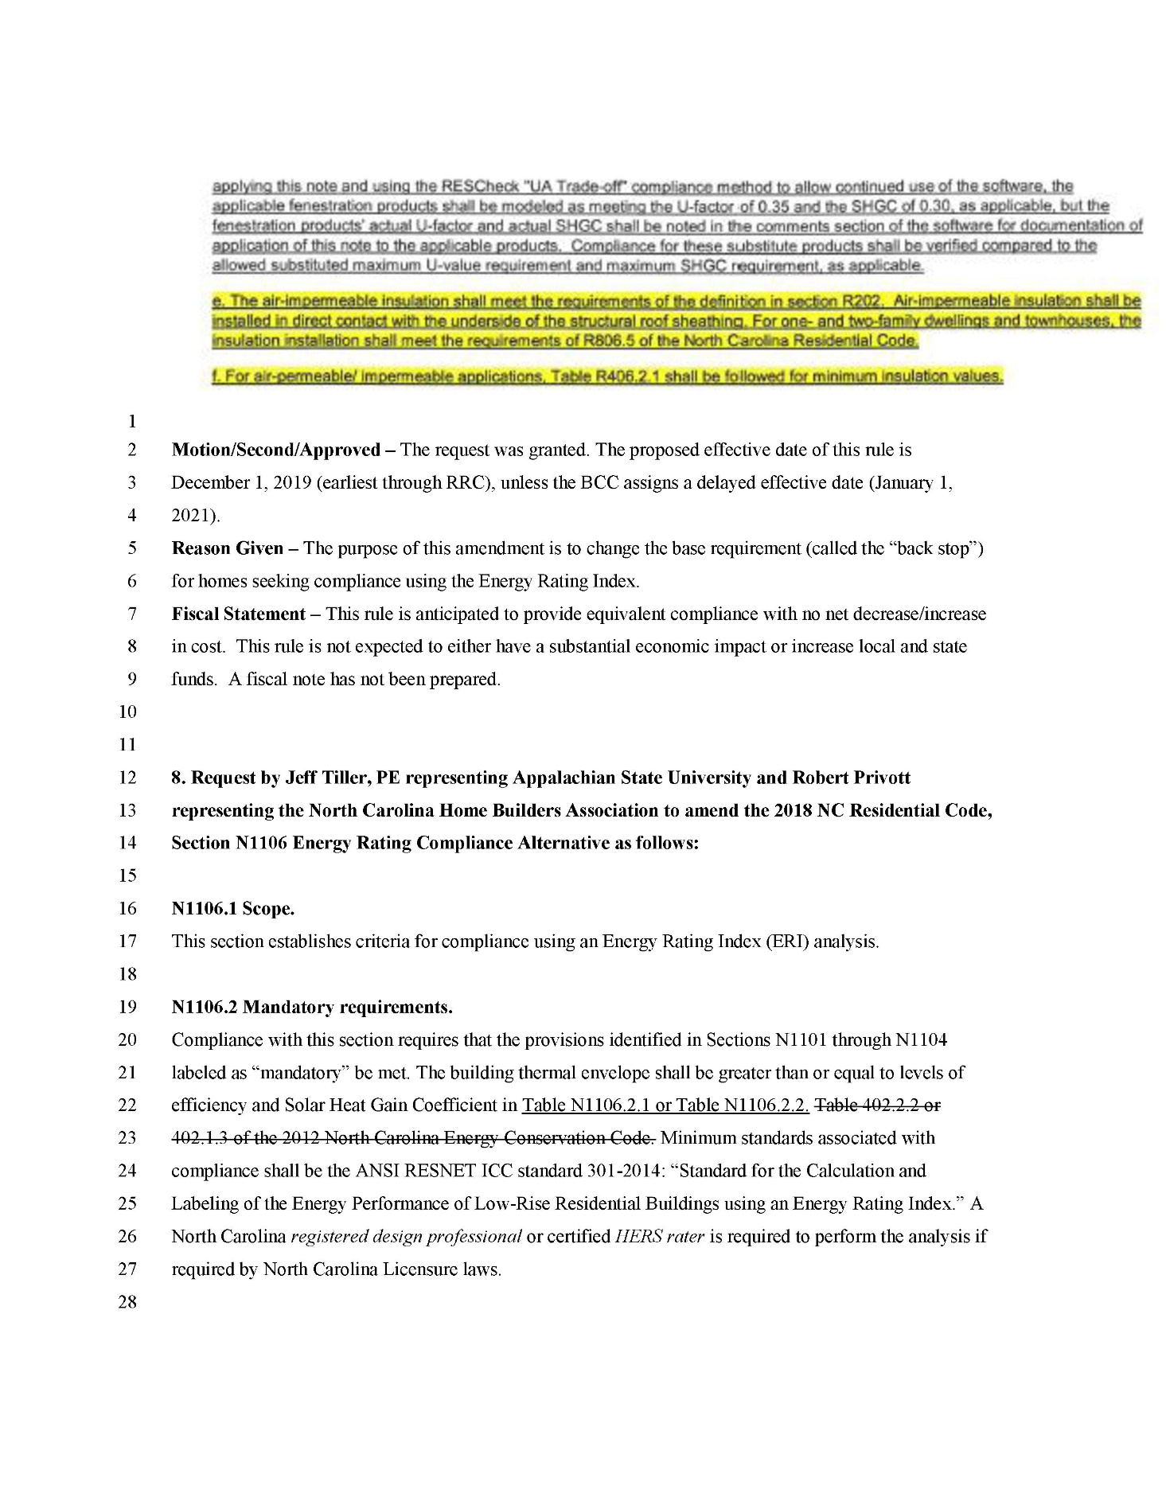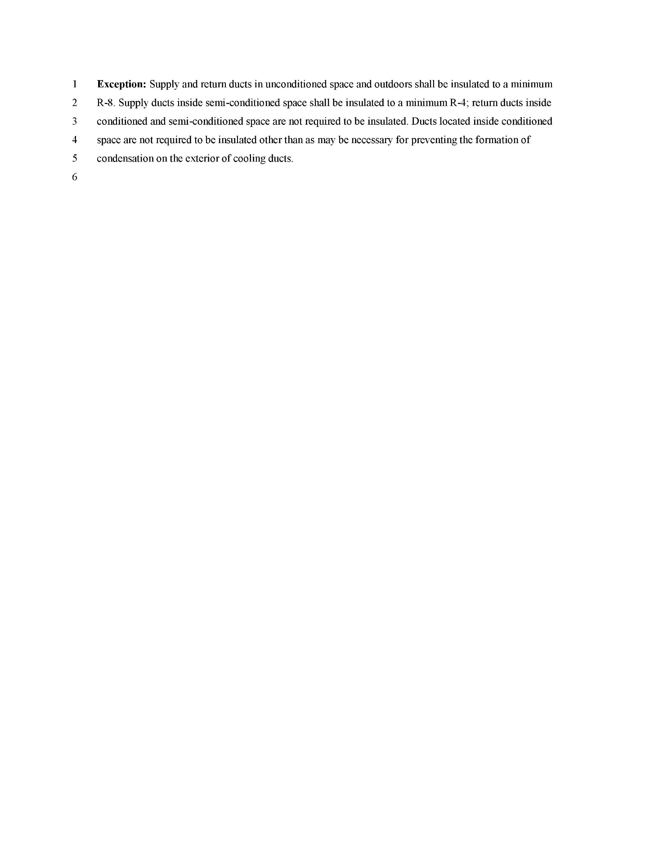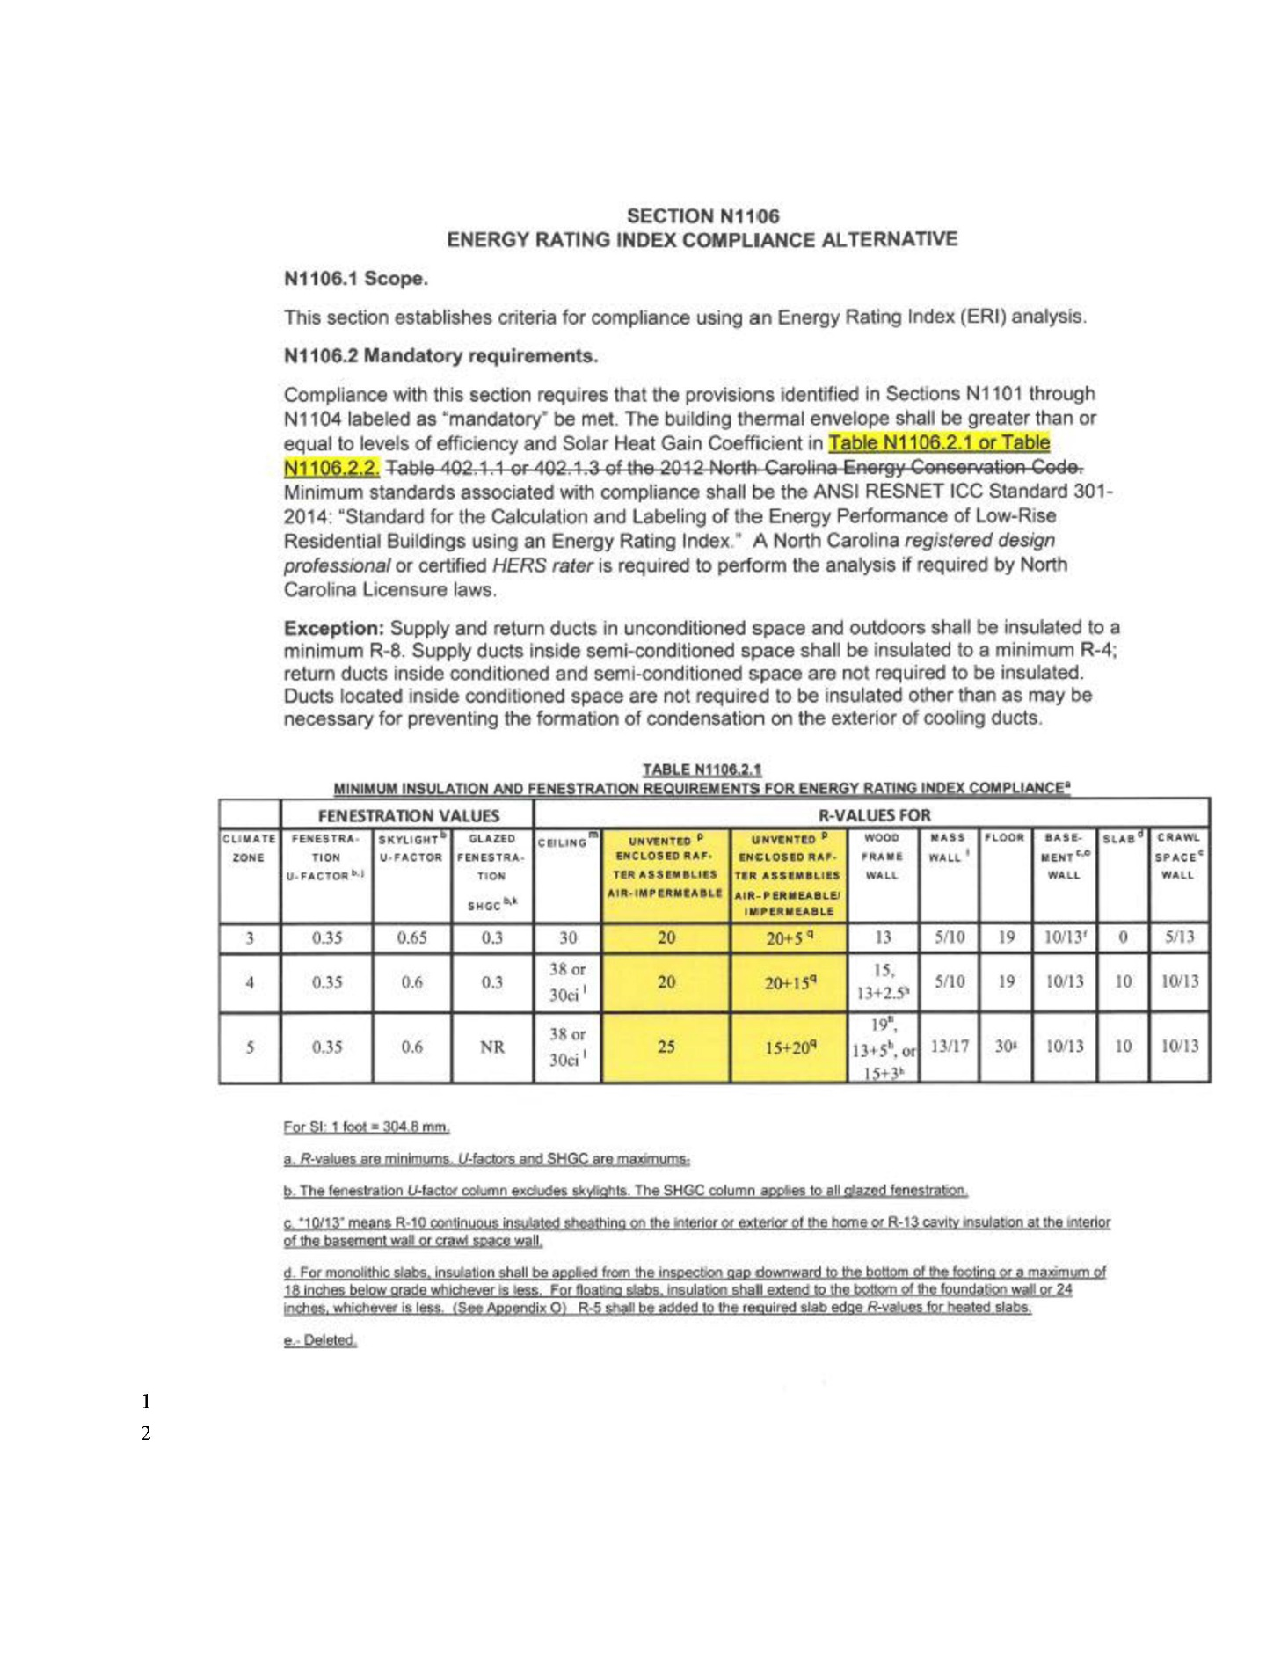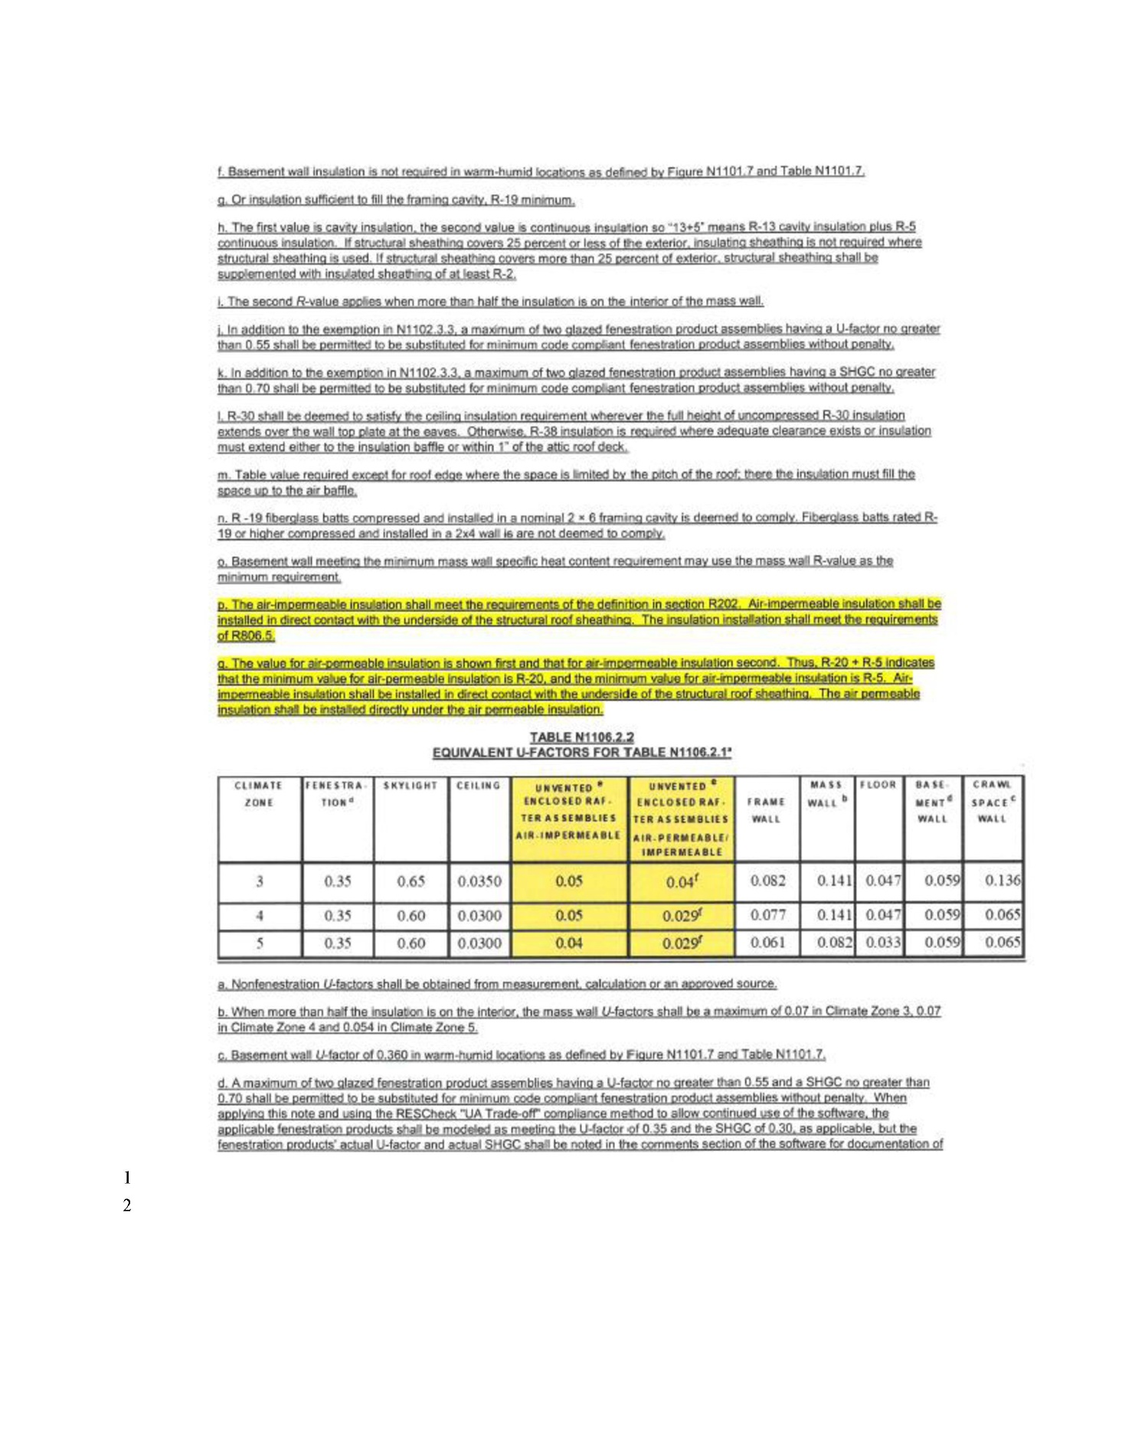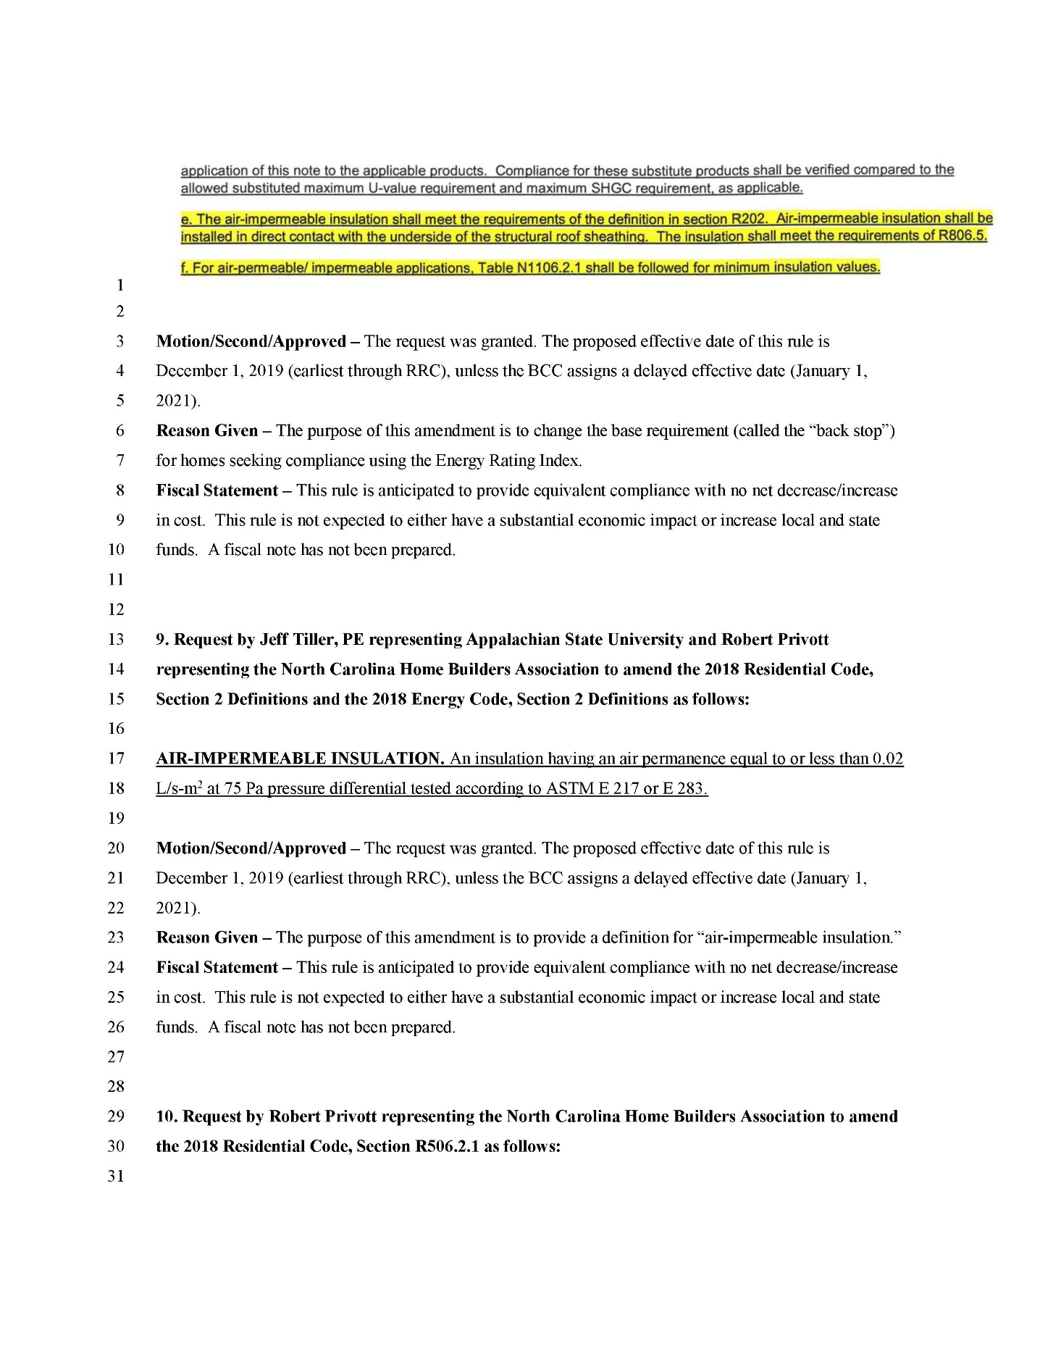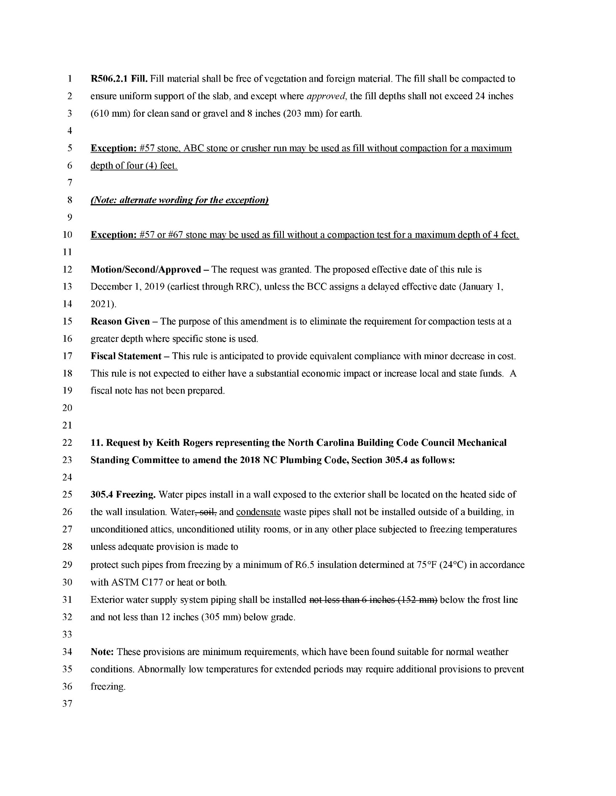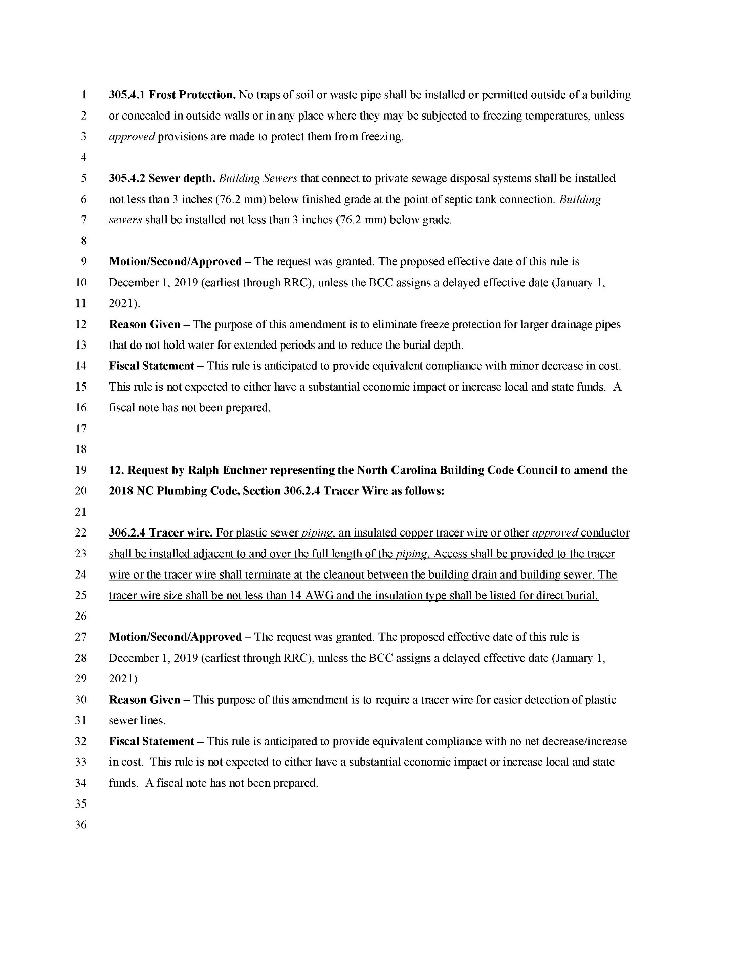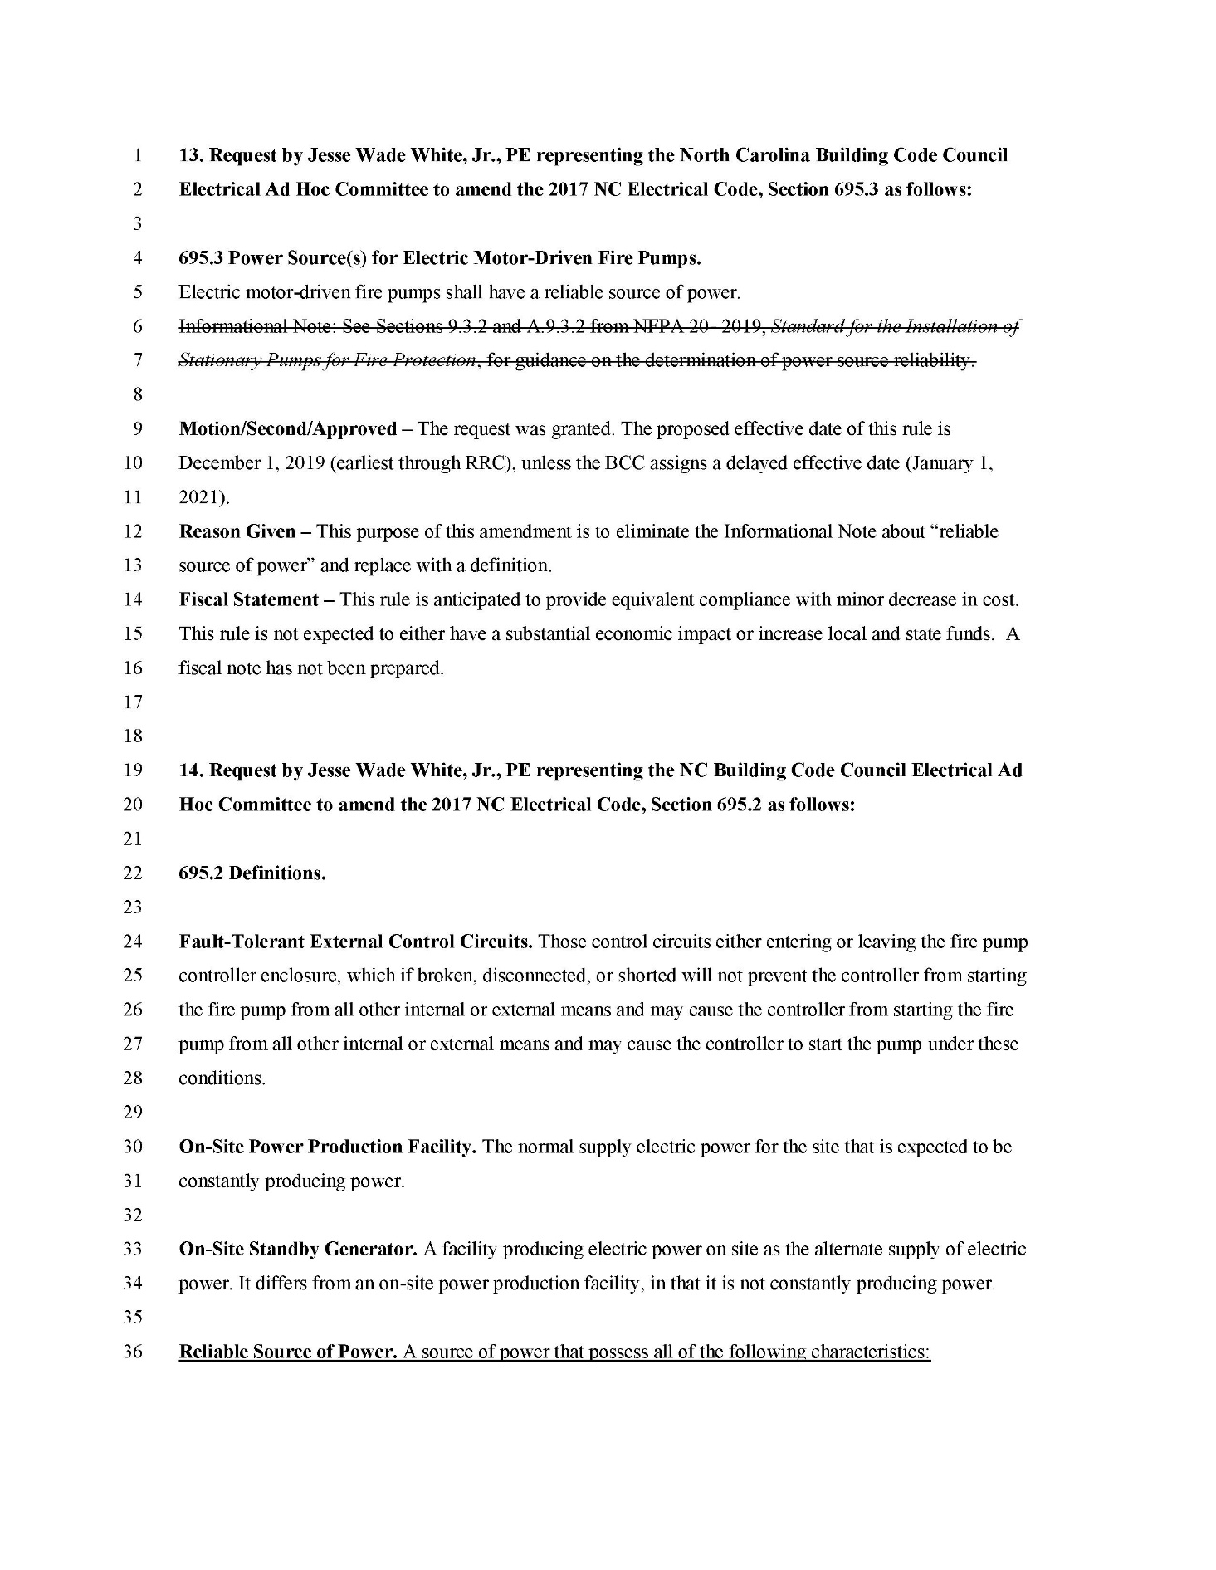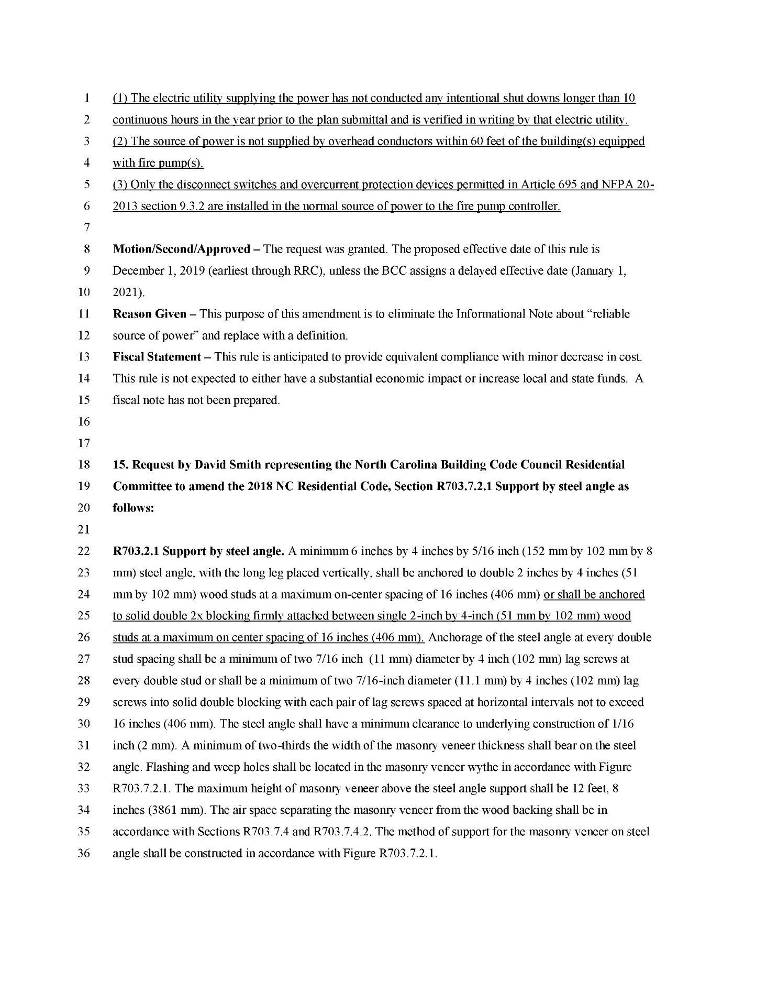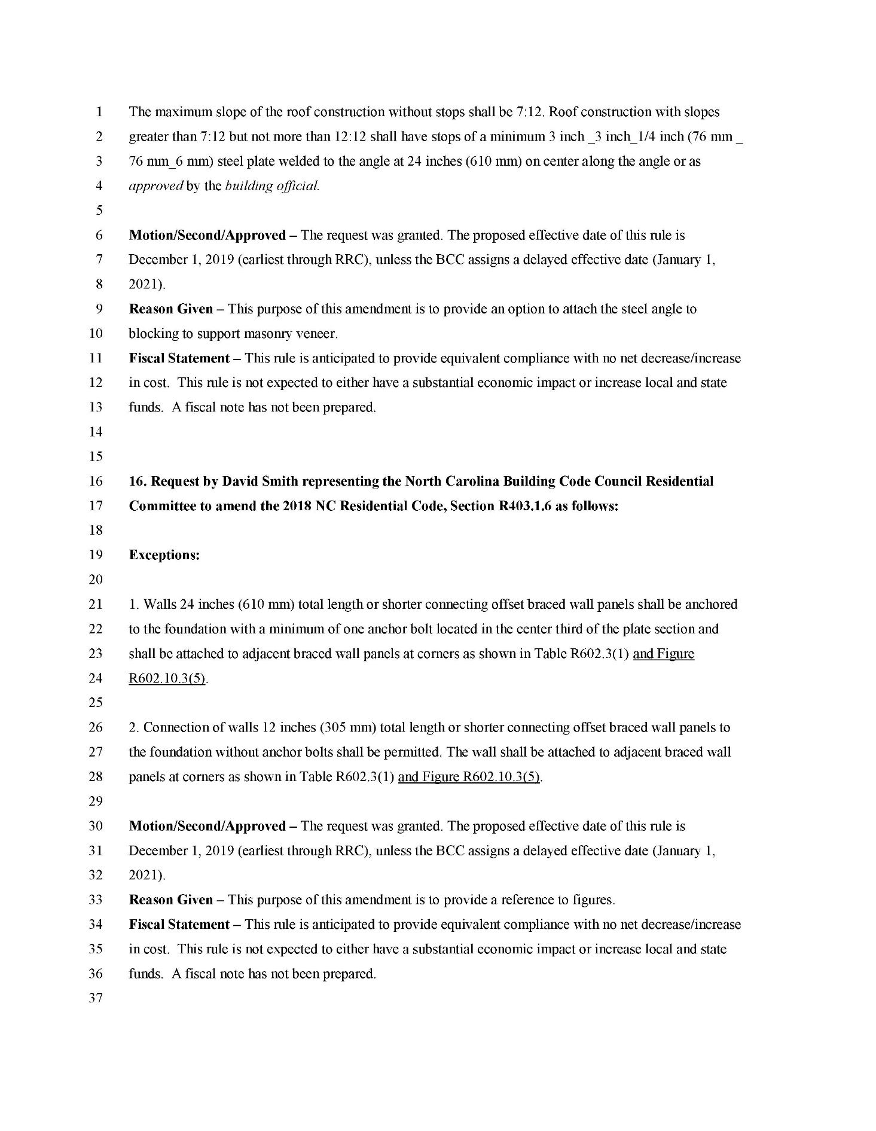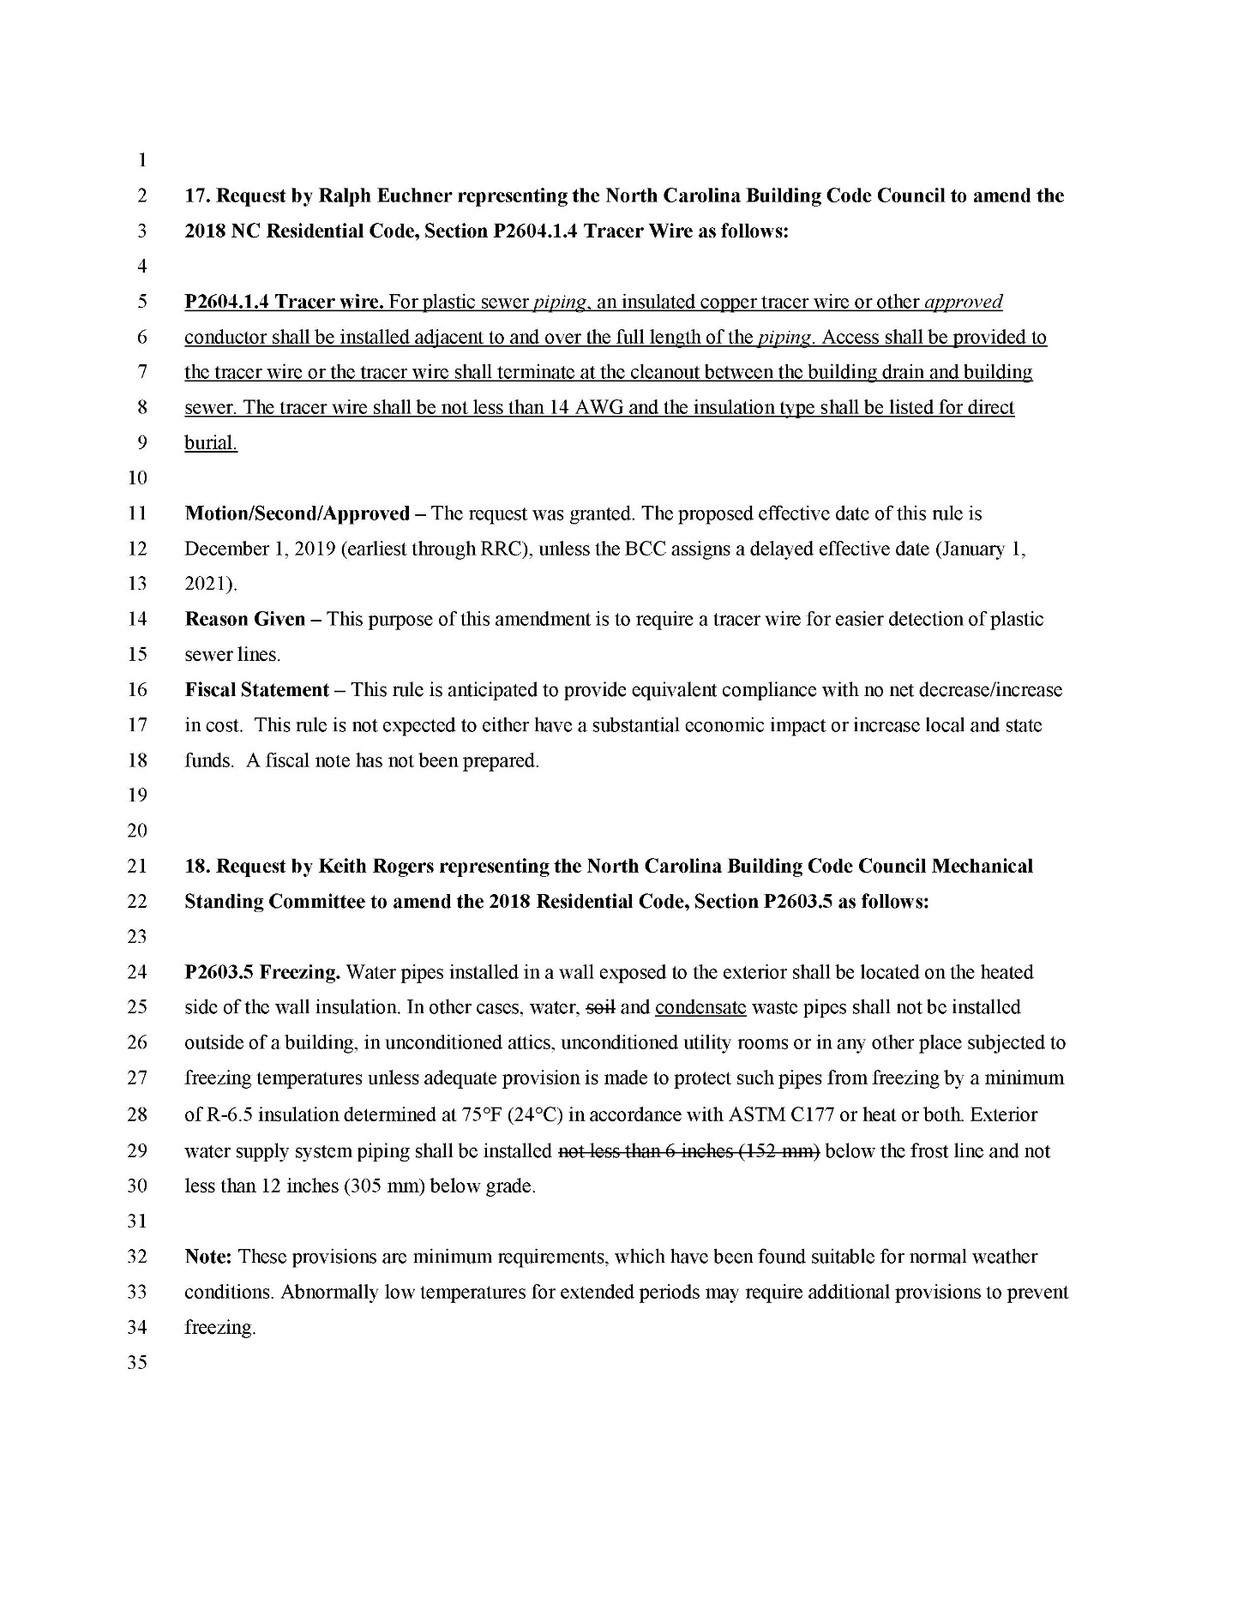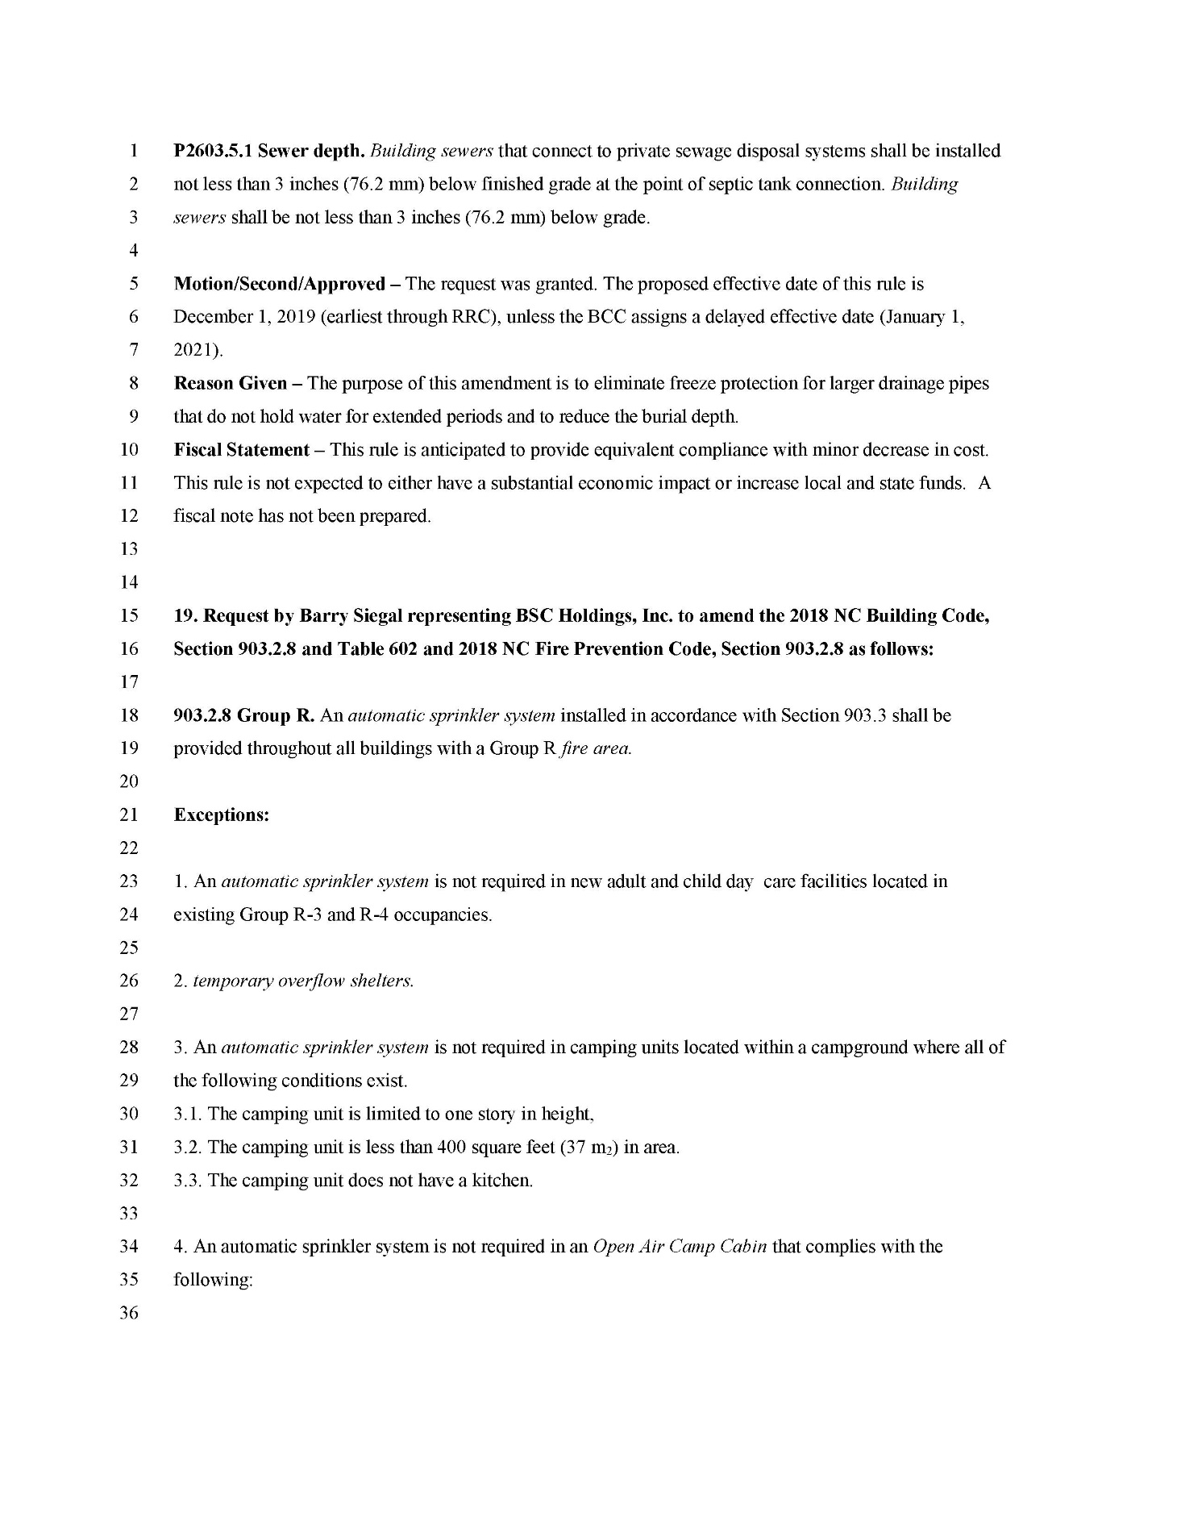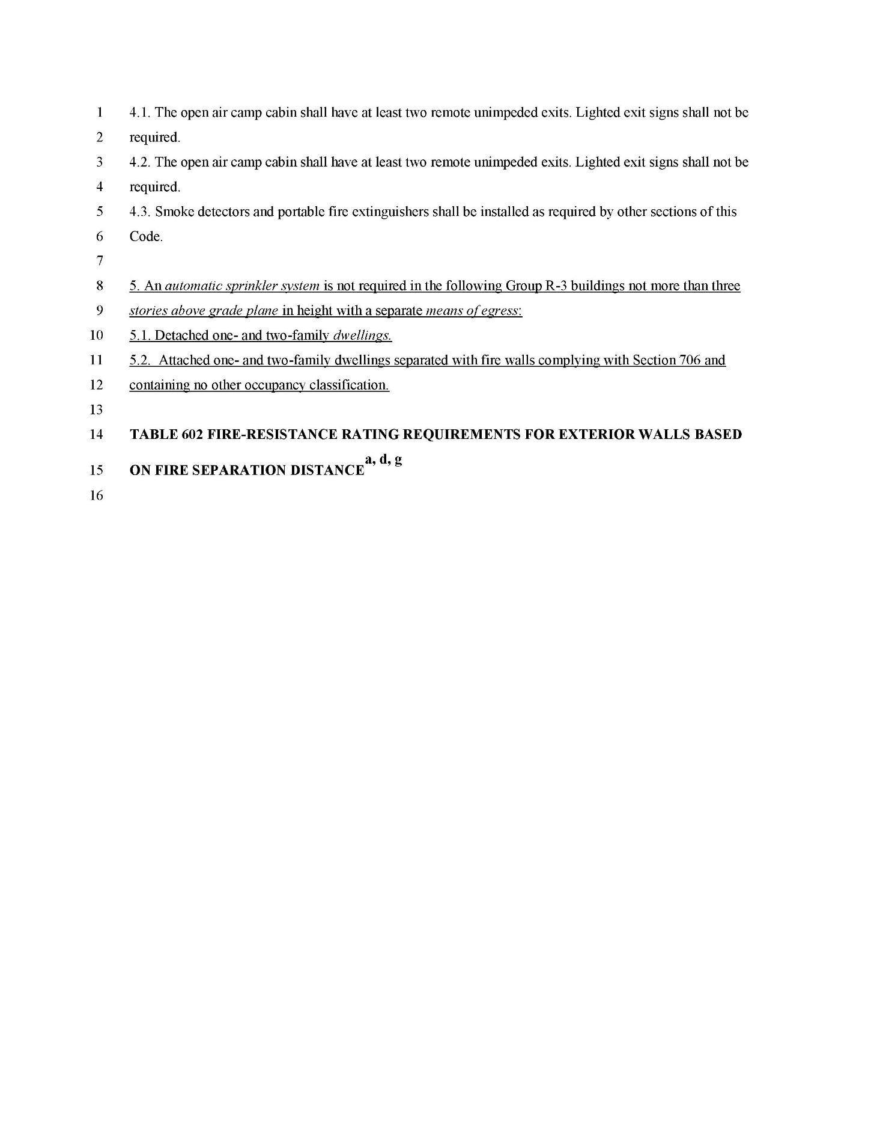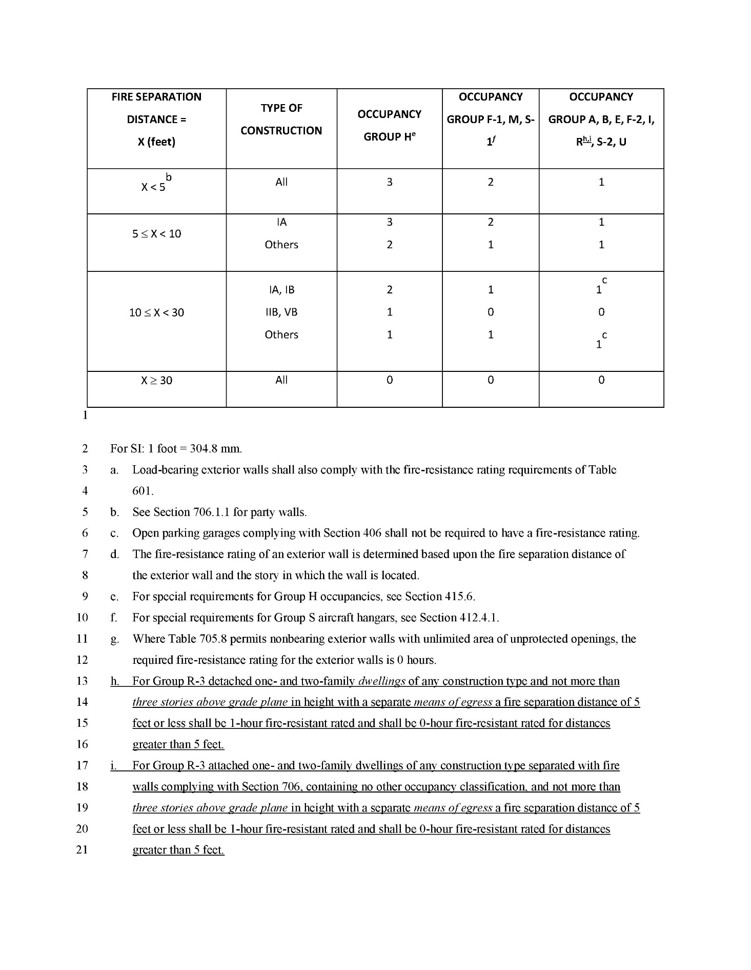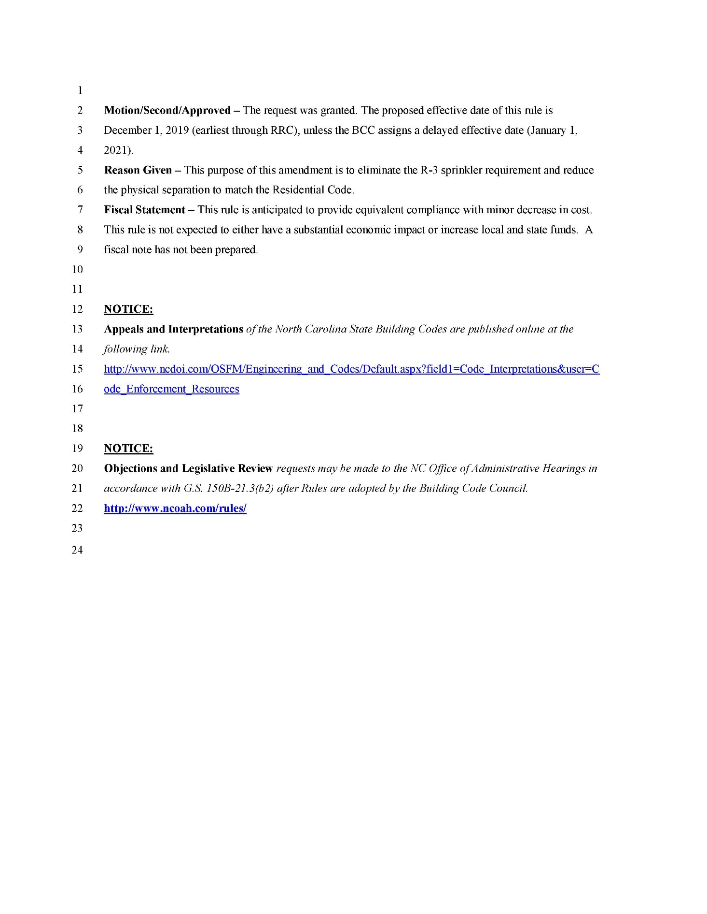

PUBLIC NOTICE
STATE OF NORTH CAROLINA
ENVIRONMENTAL MANAGEMENT COMMISSION

The Division of Energy, Mineral, and Land Resources (DEMLR) invites public comment on, or objections to, the following NPDES Industrial Stormwater General Permits to be revised and re-issued. The public comment period begins at 9:00 am on 5/15/2019 and ends at 5:00 pm on 6/16/2019.
Persons wishing to comment or object may submit written comments to the address below during the public comment period. All comments received during the public comment period will be considered in the final determinations regarding permit issuance. Public comments may result in changes to the proposed permitting actions. All comments should reference the specific permit number listed below.
- NCG160000 for Asphalt Paving, proposed issuance date 8/1/2019
- NCG170000 for Textile Mills, proposed issuance date 8/1/2019
- NCG180000 for Furniture Manufacture, proposed issuance date 8/1/2019
- NCG200000 for Scrap Metal, proposed issuance date 8/1/2019
- NCG250000 for Construction Activities not subject to the NC Sediment Pollution Control Act, proposed issuance date 8/1/2019 (a new NPDES Industrial Stormwater General Permit)
The General Permits and Fact Sheets may be viewed at: https://deq.nc.gov/news/events/public-notices-hearings
Please direct comments or objections to:
Annette Lucas
Stormwater Program
NC Division of Energy, Mineral, and Land Resources
1612 Mail Service Center
Raleigh, NC 27699-1612
Telephone Number: (919) 707-3639
annette.lucas@ncdenr.gov

Note from the Codifier: The notices published in this Section of the NC Register include the text of proposed rules. The agency must accept comments on the proposed rule(s) for at least 60 days from the publication date, or until the public hearing, or a later date if specified in the notice by the agency. If the agency adopts a rule that differs substantially from a prior published notice, the agency must publish the text of the proposed different rule and accept comment on the proposed different rule for 60 days.
Statutory reference: G.S. 150B-21.2.

TITLE 11 – DEPARTMENT OF INSURANCE

Notice is hereby given in accordance with G.S. 150B-21.2 that the Department of Insurance intends to adopt the rules cited as 11 NCAC 08 .1601-.1603.

Link to agency website pursuant to G.S. 150B-19.1(c): www.ncdoi.com/LS/Rules.aspx

Proposed Effective Date: September 1, 2019

Public Hearing:

Date: June 10, 2019

Time: 2:00 p.m.

Location: 1st Floor Hearing Room, Room 131 (Albemarle Building) located at 325 N. Salisbury Street, Raleigh, NC 27603

Reason for Proposed Action: SL 2018-29 modified G.S. 143-151.12 to establish within the Department of Insurance a "pool of qualified Code-enforcement officials". As a result, new rules are being submitted in response to the requirements in this Session Law.

Comments may be submitted to: Loretta Peace-Bunch, 1201 Mail Service Center, Raleigh, NC 27699, phone (919) 807-6004, email Loretta.Peace-Bunch@ncdoi.gov

Comment period ends: July 15, 2019

Procedure for Subjecting a Proposed Rule to Legislative Review: If an objection is not resolved prior to the adoption of the rule, a person may also submit written objections to the Rules Review Commission after the adoption of the Rule. If the Rules Review Commission receives written and signed objections after the adoption of the Rule in accordance with G.S. 150B-21.3(b2) from 10 or more persons clearly requesting review by the legislature and the Rules Review Commission approves the rule, the rule will become effective as provided in G.S. 150B-21.3(b1). The Commission will receive written objections until 5:00 p.m. on the day following the day the Commission approves the rule. The Commission will receive those objections by mail, delivery service, hand delivery, or facsimile transmission. If you have any further questions concerning the submission of objections to the Commission, please call a Commission staff attorney at 919-431-3000.

Fiscal impact. Does any rule or combination of rules in this notice create an economic impact? Check all that apply.

State funds affected

Local funds affected

Substantial economic impact (≥$1,000,000)

Approved by OSBM

No fiscal note required

CHAPTER 08 - Engineering and Building Codes Division

SECTION .1600 - ALTERNATIVE INSPECTIONS

11 NCAC 08 .1601 DEFINITIONS

As used in this Subchapter:
(1) "Alternative Inspection" means an inspection conducted by a Qualified Marketplace Inspector pursuant to G.S. 143-139.4 and these Rules.
(2) "Authority Having Jurisdiction" means an organization, office, or individual responsible for enforcing the requirements of a code or standard, or for approving equipment, materials, an installation, or a procedure.
(3) "Engineering Services Division" or "ESD" means a division of the Office of State Fire Marshal responsible for the Administration of the North Carolina Building code and the state resource which support it.
(4) "OSFM" means the Office of State Fire Marshal in the North Carolina Department of Insurance.
(5) "Permit Holder" means the individual with overall responsibility for the construction or renovation for which a permit has been applied for from the state or any city or county.
(6) "Qualified Marketplace Inspector" means an inspector that is licensed by the North Carolina Code Officials Qualification Board pursuant to G.S. 143-151.12(9).
(7) "Timely Manner" means any requested inspection shall be performed by the close of business on the second day. Inspection requests received after 12:00 noon shall be deemed to have been received on the next business day.
(8) "Other information" means information in which will be used to determine whether to assign personnel to conduct the requested inspection. Such information includes, but not limited to, inspection reports showing permit holders exceeding 15 violations in a framing inspection for one-and two-family dwellings, documentation showing a permit holder has been consistently not ready when inspections are requested, pending legal issues, etc.

Authority G.S. 143-139.4(k).
11 NCAC 08 .1602 REQUEST FOR AN ALTERNATIVE INSPECTION

(a) In accordance with G.S. 143-139(b)(2), a permit holder may submit a written request for an alternative inspection for any of the following types of inspections required by the North Carolina State Building Code:

(1) plumbing;

(2) electrical systems;

(3) general building restrictions and regulations;

(4) heating and air-conditioning; or

(5) general construction.

(b) Each request for an alternative inspection may request only one of the types of inspections outlined in Paragraph (a) of this Rule. Any additional inspections, including a follow-up inspection, require a new written request by the permit holder.

(c) A permit holder may request an alternative inspection by submitting a written request to the Engineering Services Division of the Office of State Fire Marshal that contains, in addition to the requirements of G.S. 143-139.4(b), the following information:

(1) Completed Application;

(2) Proof of paid inspection fees to the authority having jurisdiction; and

(3) Any other documentation required by the authority having jurisdiction.

(d) If a request for an alternative inspection is approved, a Qualified Marketplace Inspector shall be assigned to conduct the inspection within one business day of the approval of such request.

(e) If a request for an alternative inspection is not filed in accordance with these Rules, or the request does not meet the requirements of G.S. 143-139.4(e), the request shall be denied and the requestor notified of the reasons for the denial.

(f) The Commissioner may charge the permit holder a fee of sixty dollars ($60.00) per hour for alternative inspections conducted pursuant to G.S. 143-139.4 and these Rules. The hourly rate shall not include the time travelling to and from inspections, although the Commissioner may charge for reimbursement for the actual mileage costs of travelling to and from inspections at the rate established under G.S. 138-6. The total fee shall be paid to the Commissioner no later than 30 days after completion of the alternative inspection.

(g) A permit holder who has paid the authority having jurisdiction for an inspection that has been conducted under these Rules may recoup the fees paid for alternative inspections in accordance with G.S. 143A-354(b) and G.S. 160A-414(b).

Authority G.S. 143-139.4(a).

11 NCAC 08 .1603 QUALIFIED MARKETPLACE INSPECTORS

(a) In order to conduct an alternative inspection in accordance with G.S. 143-139.4 and these Rules, a Qualified Marketplace Inspector shall meet the requirements of a code enforcement official contained in 11 NCAC 08. 0706 for the type and size building requested to be inspected.

(b) A Qualified Marketplace Inspector must be approved for temporary work with the North Carolina Office of State Human Resources, Temporary Solutions.

(c) A Qualified Marketplace Inspector shall be issued an identification badge by OSFM prior to beginning work. The Qualified Marketplace Inspector shall display his or her identification badge in a conspicuous location on his or her person at all times during the conduct of an alternative inspection.

(d) A Qualified Marketplace Inspector shall submit a completed inspection report to OSFM no later than one business day following the completion of the alternative inspection.

Authority G.S. 143-151.12(2),(3).

TITLE 16 – STATE BOARD OF EDUCATION

Notice is hereby given in accordance with G.S. 150B-21.2 that the State Board of Education intends to adopt the rules cited as 16 NCAC 06B .0109-.0114; 06C .0313, .0701; 06D .0307-.0313; 06E .0105, .0106, .0204, .0205; 06G .0314-.0316, .0503-.0523; 06H .0113-.0117.

Link to agency website pursuant to G.S.150B-19.1(c): https://stateboard.ncpublicschools.gov/rules-apa/public-comments

Proposed Effective Date: September 1, 2019

Public Hearing:

Date: June 19, 2019

Time: 9:00 a.m.

Location: Education Building – Board Room, 7th Floor, 301 N. Wilmington Street, Raleigh, NC 27601

Date: June 26, 2019

Time: 9:00 a.m.

Location: Education Building – Room 504, 301 N. Wilmington Street, Raleigh, NC 27601

Date: July 2, 2019

Time: 9:00 a.m.

Location: Education Building – Board Room, 7th Floor, 301 N. Wilmington Street, Raleigh, NC 27601

Date: July 8, 2019

Time: 9:00 a.m.

Location: Education Building – Board Room, 7th Floor, 301 N. Wilmington Street, Raleigh, NC 27601

Date: July 9, 2019

Time: 9:00 a.m.

Location: Education Building – Board Room, 7th Floor, 301 N. Wilmington Street, Raleigh, NC 27601

Reason for Proposed Action: In North Carolina State Board of Education v. State of North Carolina and North Carolina Rules Review Commission, No. 110PA16-2 (June 8, 2018), the North Carolina Supreme Court affirmed the authority of the General Assembly to delegate authority to the Rules Review Commission to review and approve the administrative rules that are proposed by the State Board of Education for codification. After that decision issued, the General Assembly passed Session Law 2018-114, which states that "the existing policies of the State Board of Education subject to rule making as provided in Chapter 150B of the General Statutes shall be deemed interim rules so long as they do not conflict with any provisions of the General Statutes."

As part of the State Board's constitutional duty to supervise and administer the free public school system and the educational funds provided for its support, it publishes this notice of text so that certain interim rules it has formally adopted in the past may become permanent rules. The proposed rules identified in the attachment existed in the State Board's policy manual when the Session Law 2018-114 became law; no substantive changes have been made to the interim rules / existing policies.

Pursuant to S.L. 2018-114, sec. 27.(b). the General Assembly conferred "interim rule" status to "existing policies of the State Board of Education subject to rule making as provided in Chapter 150B of the General Statutes." The State Board of Education seeks to adopt as permanent rules those interim rules (i.e., existing policies) included and described in this Notice of Text. See attached Exhibit A for citations.

Comments may be submitted to: Lou Martin, 6302 Mail Service Center, Raleigh, NC 27699-6302; email lou.martin@dpi.nc,gov

Comment period ends: July 15, 2019 at 5:00 p.m.

Procedure for Subjecting a Proposed Rule to Legislative Review: If an objection is not resolved prior to the adoption of the rule, a person may also submit written objections to the Rules Review Commission after the adoption of the Rule. If the Rules Review Commission receives written and signed objections after the adoption of the Rule in accordance with G.S. 150B-21.3(b2) from 10 or more persons clearly requesting review by the legislature and the Rules Review Commission approves the rule, the rule will become effective as provided in G.S. 150B-21.3(b1). The Commission will receive written objections until 5:00 p.m. on the day following the day the Commission approves the rule. The Commission will receive those objections by mail, delivery service, hand delivery, or facsimile transmission. If you have any further questions concerning the submission of objections to the Commission, please call a Commission staff attorney at 919-431-3000.

Fiscal impact. Does any rule or combination of rules in this notice create an economic impact? Check all that apply.

State funds affected

Local funds affected

Substantial economic impact (≥$1,000,000)

Approved by OSBM

No fiscal note required

North Carolina State Board of Education
Exhibit A to Form 300 Notice of Text
April 24, 2019

Citation for Proposed Rule | Title of Proposed Rule | SBE Policy Manual Code
16 NCAC 06B .0109 | Contract Transportation of Exceptional Children | TRAN-000
16 NCAC 06B .0110 | Establishment of School Bus Routes | TRAN-002
16 NCAC 06B .0111 | School Bus Passengers | TRAN-006
16 NCAC 06B .0112 | Purchase of School Bus Equipment | TRAN-008
16 NCAC 06B .0113 | Activity Bus Drivers | TRAN-010
16 NCAC 06B .0114 | School Bus and Activity Bus Inspections | TRAN-011
16 NCAC 06C .0313 | Clinical Practice in Education Preparation Programs (EPPs) | EVAL-024
16 NCAC 06C .0701 | Model Teacher Contracts for Teachers | BENF-009
16 NCAC 06D .0307 | Test Administration in Public Schools | TEST-001
16 NCAC 06D .0308 | Role of the Testing Coordinator | TEST-002
16 NCAC 06D .0309 | Requirements of End-of-Course Assessments | TEST-003
16 NCAC 06D .0310 | Appropriate Use of State Tests | TEST-004
16 NCAC 06D .0311 | Testing Code of Ethics | TEST-010
16 NCAC 06D .0312 | English Learners: Identification, Participation in the Statewide Testing Program, Eligibility for Testing Accommodations and Exit Criteria | TEST-011
16 NCAC 06D .0313 | Use of State-Designated Assessments for the NC Teacher Evaluation Process | TEST-016
16 NCAC 06E .0105 | School Violence Acts Defined & Annual Report of these Crimes | SSCH-000
16 NCAC 06E .0106 | Definition of Student Chronic Absenteeism Rate | ATND-004
16 NCAC 06E .0204 | Interscholastic Athletics | ATHL-001
16 NCAC 06E .0205 | Concussion Safety Requirements for Interscholastic Competition | ATHL-003
16 NCAC 06G .0314 | Alternative Schools’ Accountability Models | ACCT-038
16 NCAC 06G .0315 | Accountability Annual Performance Standards | ACCT-021
16 NCAC 06G .0316 | Purpose and Composition of SBE’s Compliance Commission for Accountability | ADVS-000
16 NCAC 06G .0503 | Charter School Accountability Requirements | CHTR-001
16 NCAC 06G .0504 | Charter Schools Student Admissions | CHTR-003
16 NCAC 06G .0505 | Charter Schools Financial Noncompliance – Impact of Financial Noncompliance | CHTR-006
16 NCAC 06G .0506 | Charter Schools Governance Noncompliance | CHTR-006
16 NCAC 06G .0507 | Charter School Renewal Process | CHTR-007
16 NCAC 06G .0508 | Charter School Application and Review Process | CHTR-012
16 NCAC 06G .0509 | Planning Year for New Preliminary Charter Schools | CHTR-013
16 NCAC 06G .0510 | Charter Amendments for Existing Public Charter Schools – Approval Process | CHTR-014
16 NCAC 06G .0511 | Charter Amendments for Existing Public Charter Schools – Required Documentation | CHTR-014
16 NCAC 06G .0512 | Fast Track Replication of High Quality Charter Schools – Purpose and Definitions | CHTR-016
16 NCAC 06G .0513 | Fast Track Replication of High Quality Charter Schools - Eligibility | CHTR-016
16 NCAC 06G .0514 | Fast Track Replication of High Quality Charter Schools – General Requirements | CHTR-016
16 NCAC 06G .0515 | Fast Track Replication of High Quality Charter Schools - Accountability | CHTR-016
16 NCAC 06G .0516 | Virtual Charter Schools Attendance and Membership – Applicability | CHTR-018
16 NCAC 06G .0517 | Alternative Charter School Designation Policy – Purpose and Applicability | CHTR-020
16 NCAC 06G .0518 | Alternative Charter School Designation Policy - Eligibility | CHTR-020
16 NCAC 06G .0519 | Alternative Charter School Designation Policy - Application | CHTR-020
16 NCAC 06G .0520 | Alternative Charter School Designation Policy – Application Approval | CHTR-020
16 NCAC 06G .0521 | Alternative Charter School Designation Policy – Review and Renewal of Designation | CHTR-020
16 NCAC 06G .0522 | Alternative Charter School Designation Policy – Termination of Designation | CHTR-020
16 NCAC 06G .0523 | Management Organizations and Support Organizations | CHTR-021
16 NCAC 06H .0113 | Nutrition Standards for Elementary Schools | CHNU-002
16 NCAC 06H .0114 | Dispute Resolution Process for Homeless Students – Definitions | SBOP-020
16 NCAC 06H .0115 | Dispute Resolution Process for Homeless Students – LEA Dispute Resolution Process | SBOP-020
16 NCAC 06H .0116 | Dispute Resolution Process for Homeless Students – State Appeal Process | SBOP-020
16 NCAC 06H .0117 | Operations of Federal Programs | FEDL-000

CHAPTER 06 - ELEMENTARY AND SECONDARY EDUCATION

SUBCHAPTER 06B - STUDENT TRANSPORTATION SYSTEM

SECTION .0100 - STUDENT TRANSPORTATION SYSTEM

16 NCAC 06B .0109 Contract Transportation of Exceptional Children
Appropriate transportation shall be provided for all special education pupils when shown in their individualized education program that special transportation is required.
Upon the request of county and city boards of education, funds will be allotted by the assistant superintendent for Financial Services within the availability of funds.
Transportation arrangements will be administered through the appropriate county or city superintendent's office.
Transportation should be provided by public school bus, special vehicles titled to a board of education, by contracts or fares with commercial carriers where practicable and by individual contractors (i.e. parents, family members, volunteers, retirees, etc.).
A form of written contract shall be devised and signed by both parties before transportation of children begins. All contracts shall as a minimum, contain the standards outlined in items 7-12.
In arranging contracts, every effort should be made to obtain these transportation services as economically as possible with the following consideration:
Pupils should be grouped as much as possible by car pooling.
Payments for contract mileage shall be based on actual necessary mileage required for the sole purpose of providing transportation of handicapped children to and from the school to which the handicapped child is enrolled. (Necessary mileage for an employed contractor is interpreted to be that which is required beyond normal commuting mileage associated with the employment of the contractor.) When contractors have sought employment so they could transport an exceptional child to a specialized school, they should not be penalized for their efforts. Thus, one round trip is permitted. Necessary mileage for non-employed contractors may include two round trips from the home to the school to which the handicapped child is enrolled.
PAYMENT SHALL BE MADE FOR THE ACTUAL NUMBER OF DAYS THE PUPILS ARE TRANSPORTED, NOT TO EXCEED ONE HUNDRED EIGHTY-ONE DAYS UNLESS EXTENDED SCHOOL YEAR IS REQUIRED IN THE STUDENT'S IEP.
Frequency of trips should be in compliance with the requirements of the public/private institutional school not to exceed 181 days unless extended school year is required in the student's IEP.
PAYMENT FOR CONTRACT MILEAGE TO INDIVIDUAL CONTRACTORS SHALL NOT EXCEED THE CURRENT STATE APPROVED MAXIMUM RATE OF REIMBURSEMENT.
Contract vehicles shall at all times while school pupils are being transported, meet the requirements of the Division of Motor Vehicles safety inspection regulations.
Drivers of contract vehicles shall hold a valid North Carolina operator's license at all times.
The driver of any passenger-carrying vehicle of over 12 passengers, other than a school bus, shall hold the appropriate North Carolina operator's license at all times.
Supporting invoices signed by individual contractors must be attached to the Financial Services' copy of the voucher submitted by the various county and city boards of education (contractor's name or company on Form TD-24A).
Local administrative units entering into contracts will not assume any responsibility for any funding other than services outlined in the contract.
Contractors shall acquire and maintain liability insurance.
The initial allotments shall consist of 90% of the previous year's approved Annual Operating Budget.
Additional funds will be allotted within the availability of funds after receipt and approval of the Annual Operating Budget and in accordance with the North Carolina Public Schools Allotment Policy Manual.
In accordance with Public School Law GS (115C-250) and rules and regulations adopted by the State Board of Education, funds for contract transportation of handicapped children with special needs who are unable because of their handicap to ride the regular school buses may be used to purchase buses and minibuses as well as for the purpose authorized in the budget.
The Department of Public Instruction, Transportation Services shall deliver buses requisitioned by the local school units at the earliest possible date and shall work with the respective school units in providing for the installation of special equipment on these buses as may be required.
The Department of Public Instruction shall purchase these buses and equipment initially from the appropriations provided for school bus replacement. A local school unit may pay any portion of the cost for buses delivered under these regulations from sources other than state funds. The Department of Public Instruction shall deposit these funds into the school bus replacement appropriations.
If any vehicle purchased under authority of this section is sold prior to the time of replacement by the Department of Public Instruction, proceeds from such sale shall be distributed in a prorated amount to the sources from which the vehicle was originally funded. If the vehicle is replaced by the Department of Public Instruction through its replacement program, the proceeds from such sale shall be transmitted to the Department of Public Instruction in total.
The Department of Public Instruction shall approve school bus routes established by a local board of education for the transportation of exceptional children on buses purchased from these funds.
Upon the placement of buses into service under these provisions, the operating costs shall be provided form regular allotments.
A report of all expenses incurred in transportation of exceptional children on school buses purchased under this provision, and who were previously provided services under contract transportation, shall be maintained and transmitted to the Division of School Services - Transportation.
A regular school child who is eligible for school bus transportation shall not be denied transportation on these special buses if space is available.
A local board of education shall make every effort to provide for specially trained drivers on buses transporting exceptional children and may supplement salaries paid from transportation funds allotted by the Department of Public Instruction from other sources of funds. The salaries of aides who may be required on the special buses shall not be paid from the state allotment of funds for school bus transportation.

Authority G.S. 115C-240(a); 115C- 250; 115C-253; N.C. Constitution, Article IX, Sec.5.
Interim Rule status conferred Eff. June 27, 2018, pursuant to S.L. 2018-114, sec. 27.(b).

16 NCAC 06B .0110 Establishment of School Bus Routes
Bus Routes
Superintendents shall establish school bus routes for all students eligible for and requesting transportation as directed by G.S. 115C-246(a) with a goal of ensuring student safety. Superintendents shall, at a minimum, apply the following criteria when developing and implementing bus routes.
Bus routes shall be planned in a manner designed to conserve fuel and to use buses efficiently.
Unless safety or other conditions make it inadvisable to do so, a route shall not deviate from a general path of direction for a distance of less than one-half mile and then return to the original path except for:
groups of 10 or more pupils;
unescorted pupils in grades pre-kindergarten through three; and
pupils with special needs as defined by an Individual Education Program (IEP).
Unless safety or other conditions make it inadvisable to do so, superintendents shall not plan bus stops closer together than 0.2 miles.
Parents and guardians of students assigned to school bus routes shall be informed of the scheduled school bus arrival time and their responsibility to make sure that students are at the school bus stop prior to that arrival time.

Authority G.S. 115C-240; N.C. Constitution, Article IX, Sec. 5.

16 NCAC 06B .0111 School Bus Passengers
School Bus and Activity Bus Passenger Safety
This policy is effective January 1, 2016.
LEAs shall provide instruction in school bus safety to all children (regardless of whether they regularly ride a school bus to and from school) during the first five days of school and at least once during each semester thereafter. LEAs shall document the date on which training was provided to each student. This instruction shall include but not be limited to:

basic skills and knowledge vital to safety in school bus transportation;

proper loading techniques, including street crossing at the bus stop and the North Carolina crossing signal;

and

instruction as needed to ensure that passengers are familiar with location and operation of emergency exits for the vehicle on which they are riding for any specific trip.

LEAs shall adhere to the following when assigning pupils to school buses, activity buses, commercial buses, or other contracted vehicles.

LEAs shall not allow the number of passengers being transported to exceed the official rated capacity for the specific vehicle being used.

LEAs shall ensure that all riders are seated completely within the seating compartment, when any bus or other vehicle is in motion.

LEAs shall ensure that no person is standing or sitting in the aisle or stepwell when any bus or other vehicle is in motion.

LEAs shall require school bus drivers to utilize the North Carolina crossing signal to communicate to students when it is safe to cross the street to board the bus and when it is safe to cross the street after exiting the bus. The Department of Public Instruction shall develop and make available training materials describing the crossing signal for students and school bus drivers.

LEAs shall also provide safety instruction to students taking trips on activity buses or commercial buses as needed, including but not limited to instruction and demonstration of emergency exit operation for the vehicle on which they are riding for any specific trip.

Authority G.S. 115C-240; N.C. Constitution, Article IX, Sec. 5.

16 NCAC 06B. 0112 Purchase of School Bus Equipment
LEAs shall purchase school buses, school bus tires, brake pads, brake shoes, and brake hardware that meet the safety specifications listed in the request for bids for the statewide term contract for these items.

Authority G.S. 115C-249; G.S. 115C-249.1; G.S. 115C-522; N.C. Constitution, Article IX, Sec. 5.

16 NCAC 06B .0113 Activity Bus Drivers
Definitions:
CDL means a Commercial Drivers License, which is a license issued by the state that authorizes an individual to drive a commercial motor vehicle (G.S. 20-4.01).
CDL Activity Bus" means a school activity bus (G.S. 20-4.01) built to transport 16 or more passengers including the driver. A CDL is required to drive a "CDL Activity Bus" (G.S. 20-4.01).
"School bus driver's certificate" means a certificate issued by a duly designated representative of the Commissioner of Motor Vehicles and the Director of Transportation, or a designee of the Director in charge of school buses in the county which shows that he or she has been examined and has been certified fit and competent to drive a school bus over the highways and public vehicular areas of the State. (G.S. 20-218)
LEAs shall require individuals who transport students to or from a school-related activity in a CDL Activity Bus to hold a valid Commercial Drivers License with a Passenger (P) and School Bus (S) endorsement (CDL-P/S) as required by the Division of Motor Vehicles.
Beginning July 1, 2010, LEAs shall require individuals being initially licensed with a CDL-P/S, who transport students to or from a school-related activity in a CDL Activity Bus, also to hold a school bus driver's certificate.
Beginning July 1, 2015, LEAs shall not permit any individual to transport students in a CDL Activity Bus unless he or she holds both a CDL-P/S license and valid school bus driver's certificate.

Authority G.S. 115C-240; 115C-245(a); N.C. Constitution, Article IX, Sec. 5.

16 NcAC 06B .0114 School Bus and Activity Bus Inspections
LEAs shall require each 30-day inspection required under G.S. 115C-248 to be conducted by an individual who has completed the vehicle inspection training and certification requirements administered by the Department of Public Instruction.

Authority G.S. 115C-240; G.S. 115C-248; N.C. Constitution, Article IX, Sec. 5.

SUBCHAPTER 06C - PERSONNEL

section .0300 - certification

16 ncac 06c .0313 Clinical Practice in Educator Preparation Programs (EPPs)
This policy sets forth the requirements for clinical partnerships and practice in Educator Preparation Programs with a clinical student teaching component.
Definitions:
Clinical educator – An individual employed by a partner school, including a classroom teacher, who assesses, supports, and develops a clinical intern's knowledge, skills, and professional disposition during an internship.
Clinical internship or internship –Type of field experience in which a clinical intern works under the supervision of a clinical educator and may be delegated those duties granted to an educator and any other part of the school program for which the clinical educator is responsible.
Clinical residency or residency –Type of field experience in which a clinical resident who already holds a bachelor's degree is enrolled in a recognized EPP and also employed by a local school administrative unit as an educator and supervised by the recognized EPP in partial fulfillment of the recognized EPP's training requirements.
Requirements:
The State Board of Education requires that EPPs shall:
Establish and maintain collaborative, formalized partnerships with elementary and secondary partner schools that are focused on student achievement, continuous school improvement, and the professional development of elementary and secondary educators, as well as those preparing educators.
Work collaboratively with elementary and secondary schools and enter into a memorandum of understanding with local school administrative units or the partner school where students are placed or employed. In the memorandum, the EPP and the local school administrative unit, as applicable, shall:
Define the collaborative relationship between the EPP and the local school administrative unit or partner school and how this partnership will be focused on continuous school improvement and student achievement.
Adopt a plan for collaborative teacher selection, orientation, and clinical intern/clinical resident placement.
Determine how information will be shared and verified between the EPP and local school administrative unit or partner school.
Field Experience Requirements – To the extent practicable, EPPs shall require, in all programs leading to initial professional licensure, the following:
Field experiences in every semester that include organized and sequenced engagement of students in settings that provide them with opportunities to observe, practice, and demonstrate knowledge and skills. The experiences shall be systematically designed and sequenced to increase the complexity and levels of engagement with which students apply, reflect upon, and expand their knowledge and skills, and to increase in each semester prior to the student's internship the number of hours spent in field experiences.
A minimum of two hours of field experience in the first semester of the program and a cumulative total of at least 12 hours of field experiences prior to the student's internship.
At least one field experience in a low-performing school.
Clinical Practice Requirements. – EPPs shall require clinical practice in the form of one of the following:
Internship that lasts for a minimum of 16 weeks. Internships may be over the course of two semesters and shall, to the extent practicable, provide field experiences at both the beginning and ending of the school year. It shall be the responsibility of a clinical educator, in cooperation with the principal and the representative of the EPP, to assign to the intern responsibilities and duties that will provide adequate preparation for teaching.
Residency that meets the following criteria:
The residency lasts for a minimum of one year.
The EPP provides ongoing support to a student for the full term of the residency.
The EPP assigns a clinical educator to the resident.
The resident completes field experiences and training defined in each EPP's Assurances to the State Board of Education prior to the residency.
Clinical Educator Requirements - The EPP shall ensure clinical educators who supervise students in internships and residencies meet the following requirements:
Be professionally licensed in the field of licensure sought by the student;
Have a minimum of three years of experience in a teaching role;
Have been rated, through the educator's most recent formal evaluations, at least at the "proficient" level as part of the North Carolina Teacher Evaluation System, or the equivalent on an evaluation system utilized by another state or partner school, as applicable. For the purposes of this policy, "proficient" means a teacher has received ratings of proficient or higher on all five standards on the most recent summative evaluation, or on Standards 1 and 4 for teachers on an Abbreviated Evaluation.
The principal shall determine which clinical educator best meets the needs of each intern and shall assign the most appropriate clinical educator to that intern, with priority consideration for those clinical educators rated as "distinguished" and "accomplished." For the purposes of this policy, "distinguished" means a teacher has received ratings of distinguished on three of the five standards to include Standard 4 on the most recent summative evaluation, or on Standard 4 for teachers on an Abbreviated Evaluation. For the purposes of this policy, "accomplished" means a teacher has received ratings of accomplished or higher on three of the five standards to include Standard 4 on the most recent summative evaluation, or on Standard 4 for teachers on an Abbreviated Evaluation.
If a principal determines that a teacher rated as "proficient" is the most appropriate clinical educator for an intern, the principal shall maintain records of the reasons for that determination.
Require the ed Teacher Performance Assessment (edTPA) or the Praxis Performance Assessment for Teachers (PPAT), nationally normed and valid pedagogy assessments, to determine clinical practice performance for all teacher candidates. All student teachers shall meet passing scores and mastery criteria to be determined by the State Board of Education. The edTPA or the PPAT may replace the Praxis Principles of Learning and Teaching (PLT) tests for Secondary education teacher candidates.

Authority G.S. 115C-269.1; 115C-269.5; 115C-269.10; 115C-269.15; 115C-269.25; 115C-269.30; N.C. Constitution, Article IX, Sec. 5.

16 NCAC 06C .0701 Model Employment Contract for Teachers
All contracts between a local board of education, as defined in G.S. 115C-5(5), and a teacher, as defined in G.S. 115C-325.1(6), shall contain the following:
A statement that the contract is effective only if approved by a majority of the local board at an officially called meeting of the local board.
The term of the contract. Such term may be for any length permitted by law. At the conclusion of the contract term, the local board may, but is not required to, re-employ the teacher by offering the teacher a subsequent contract as provided by law.
An indication of the compensation that the teacher shall receive for professional services performed pursuant to the contract. Such compensation shall be at a rate consistent with the North Carolina General Statutes, the salary schedule for teachers established by the State of North Carolina, and any local supplement that may apply. If the teacher is to be paid from local funds, the compensation will be consistent with the local salary schedule adopted pursuant to G.S. 115C-302.1(h).
With respect to qualifications:
The teacher's obligation to maintain a North Carolina teaching license valid for the teacher's area of assignment.
The teacher's obligation to inform the local board's Human Resources Office in the event that the teacher's license is revoked, suspended, expired, or not renewed for any reason.
A statement that the teacher is solely responsible for obtaining and maintaining the required licensure.
With respect to duties:
A requirement that the teacher shall perform all duties assigned by the superintendent or superintendent's designee, and required by the laws of the State of North Carolina.
A statement that the contract does not give the teacher a right to any particular assignment or school site.
A requirement that the teacher agrees to become familiar with and abide by the policies and practices of the local board and the North Carolina State Board of Education, and to abide by the laws of the State of North Carolina and the United States.
With respect to special duties:
A statement that, if there are special duties or assignments for which the local board has agreed to compensate the teacher, those will be described in a separate agreement and the additional compensation will not be considered salary for the purpose of computing the teacher's salary under the provisions of G.S. 115C-325.1 et seq.
A statement that any return to regular duties is not a demotion as defined by law.
A provision that explains the teacher's entitlement to health care benefits, earned leave and such other benefits as are available pursuant to the laws of the State of North Carolina and the policies and practices of the local board.
Any requirements for termination of the contract initiated by the teacher pursuant to the provisions and procedures provided in G.S. 115C-325.1 et seq.
Any requirements for alteration or termination of the contract by the local board pursuant to the provisions and procedures provided in G.S. 115C-325.1 et seq.
With respect to modification, a statement that the contract is subject to modification as a result of subsequent legislative enactments.
With respect to severability, a statement that if any provision of the contract is held to be invalid or unenforceable, such provision shall be severed and shall be inoperative, and the remainder of the contract shall remain in full force and effect.
A statement indicating that the contract shall be governed by the laws of the State of North Carolina.
Any other provisions deemed necessary or appropriate by the parties, or as required by law.
The model teacher contract is found online on the Department of Public Instruction website.

History Note: Authority Session Law 2013-360, Sec. 9.6(e); N.C. Constitution, Article IX, Sec. 5.
Interim Rule status conferred Eff. June 27, 2018, pursuant to S.L. 2018-114, sec. 27.(b).

SUBCHAPTER 06D - INSTRUCTION

section .0300 - TESTING PROGRAMS

16 NCAC 06D .0307 test administration in public schools
Test Administration
Only persons who are employed by the school system, either permanently or contractually, and have professional training in education (preferably a North Carolina educator's license) and the state testing program shall administer secure tests to students.
The North Carolina Department of Public Instruction (NCDPI) shall supply the tests to the local education agencies (LEAs). LEAs shall:
account to the NCDPI for all tests received;
provide a secure, locked storage facility for all tests received;
prohibit the reproduction of any or all parts of the test; and
prohibit their employees from disclosing the content of the tests or specific items contained in the tests to persons other than authorized employees of the LEA.
LEAs must monitor test administration procedures. If school officials discover any instance of improper administration and determine that the validity of the test results has been affected, they must notify the local board of education, declare a misadministration, and order the affected students to be re-tested. Only the superintendent and the LEA test coordinator have the authority to declare misadministrations at the local level.
The Superintendent of Public Instruction may conduct audits of LEAs if he/she receives written complaints which allege improper test administration, and he/she may require the re-testing of students.
The NCDPI shall score or have scored all tests in the North Carolina Testing Program. In addition, the department shall provide score interpretative services to the LEAs.
LEAs shall, at the beginning of each school year, provide information to students and parents or guardians advising them of the districtwide and state-mandated tests that students will be required to take during that school year. In addition, LEAs shall advise students and parents or guardians of the dates the tests will be administered and how the results from the tests will be used. Also, information provided to parents shall include whether the State Board of Education or the local board of education requires the test(s).
LEAs shall report scores resulting from the administration of districtwide and state-mandated tests to students and parents or guardians along with available score interpretation information within thirty (30) days from generation of the score at the LEA level or receipt of the score and interpretive documentation from the NCDPI.
In order to ensure adequate representation and the generalizability of the data used to develop tests and to conduct evaluation studies, selected LEAs and schools, determined through stratified random samples, shall participate in field testing and other sample testing such as the National Assessment of Educational Progress (NAEP) and other national or international assessments as designated by the department or the SBE.

Authority G.S. 115C-12(9); N.C. Constitution, Article IX, Sec. 5.

16 NCAC 06D .0308 role of the testing coordinator
The local superintendent shall act as or appoint a school system (LEA) testing and accountability coordinator to assist in the local administration, reporting, and interpretation of test results and other accountability measures in the North Carolina Testing Program.
LEA testing and accountability coordinators shall attend training sessions provided by the department on subjects including, but not limited to, proper test administration, test security, appropriate use of accommodations, scanning and scoring answer sheets, and preparation of test materials for scoring at a central site. LEA test coordinators shall then conduct in-person training for the school test coordinators in their LEAs for the purpose of providing instruction to local test administrators and proctors. LEA testing and accountability coordinators shall arrange for the scanning, scoring, and reporting of results from tests adopted by the State Board of Education.
Per General Statute §115C-316.1(a) Counselors shall spend at least eighty percent (80%) of their work time providing direct services to students. Direct services do not include the coordination of standardized testing. During the remainder of their work time, counselors shall spend adequate time on school counseling program support activities that consist of professional development; consultation, collaboration, and training; and program management and operations.
School counseling program support activities do not include the coordination of standardized testing.
However, school counselors may assist other staff with the coordination of standardized testing.

Authority G.S. 115C-12(9); N.C. Constitution, Article IX, Sec. 5.

16 NCAC 06D .0309 Requirements regarding end-of-course assessments
All eligible students shall participate in the administration of end-of-course assessments (standard administrations with or without accommodations or an alternate assessment). This rule shall apply to all public schools, including traditional, charter, and regional schools. Public schools shall include each student's end-of-course (EOC) assessment results in the student's permanent records and high school transcript.
Public schools shall administer EOC assessments within the North Carolina Department of Public Instruction's designated testing window.
Public schools shall use results from all operational EOC assessments as a minimum of twenty percent (20%) of the student's final grade for each respective course with the exception of:
students following the Occupational Course of Study Pathway;
English Learner (EL) students in their first year in a U.S. school; and
effective with the 2018–19 school year and beyond, all students enrolled in a course during the initial implementation year of the new assessment for that course where scores are not immediately available due to standard setting.
For these exceptions, public schools shall adopt policies regarding the use of EOC assessment results in assigning final grades.
Public school students who are enrolled for credit in courses in which EOC assessments are required shall take the appropriate EOC assessment at the completion of the course.
Public school students who are exempt from final exams by local board of education policy shall not be exempt from EOC assessments.
Public school students shall take the appropriate EOC assessment the first time the student takes the course requiring the assessment.
Public school students shall take the appropriate EOC assessment at the end of the course regardless of the grade level in which the course is offered.
Public school students who are identified as failing a course for which an EOC assessment is required shall take the appropriate EOC assessment.
Public school students may drop a course with a required EOC assessment within the first 10 days of enrollment in a semester block schedule or within the first 20 days of enrollment in a yearlong traditional schedule. Students who are enrolled for credit after the 10/20 days, regardless of course delivery (e.g., traditional classroom, NC Virtual Public School, vendor-based online) shall not drop a course with a required EOC assessment and shall participate in the appropriate EOC assessment at the completion of the course.
Public school students enrolled in courses requiring the administration of the EOC assessment who previously obtained a proficient score on the appropriate EOC assessment may use the proficient score as a minimum of 20% of their final course grade or they may elect to retake the appropriate EOC assessment at the completion of the course and use the most recent score for the final grade calculation.

Authority G.S. 115C-12(9); N.C. Constitution, Article IX, Sec. 5.

16 NCAC 06D .0310 APPROPRIATE USE OF STATE TESTS
Secure tests developed by the State of North Carolina may not be used for purposes other than those approved by the Division of Accountability Services and the State Board of Education.

Authority G.S. 115C-12(9); N.C. Constitution, Article IX, Sec. 5.

16 NCAC 06D .0311 Testing Code of Ethics
This Rule sets out the administrative testing procedures and testing code of ethics and shall apply to all public school employees, including charter school and regional school employees, who are involved in the state testing program.
The superintendent/charter school director or superintendent's/charter school director's designee shall develop local policies and procedures to ensure maximum test security in coordination with the policies and procedures developed by the test publisher.
The superintendent/charter school director or superintendent's/charter school director's designee shall instruct personnel who are responsible for the testing program in testing administration procedures. This instruction shall include test administrations that require testing accommodations and shall emphasize the need to follow the directions outlined by the test publisher.
The superintendent/charter school director or superintendent's/charter school director's designee shall designate the personnel who are authorized to have access to secure test materials. "Access" to test materials by school personnel means handling the materials but does not include reviewing tests or analyzing test items.
Persons who have access to secure test materials shall not use those materials for personal gain.
No person may copy, reproduce, or paraphrase in any manner or for any reason the test materials without the express written consent of the test publisher.
The principal shall ensure test security within the school building. The principal shall store test materials in a secure, locked facility. The principal shall allow test materials to be distributed immediately before the test administration.
Any breach of security, loss of materials, failure to account for materials, or any other deviation from required security procedures shall be reported immediately to the principal, school test coordinator, school system (LEA) test coordinator, superintendent/charter school director, and regional accountability coordinator.
Preparation for testing.
The superintendent/charter school director shall ensure that school system (LEA) test coordinators:
secure necessary materials;
plan and implement training for school test coordinators, test administrators, and proctors;
ensure each school test coordinator and test administrator is trained before each test administration on the policies and procedures for conducting a proper test administration and for processing and returning test materials; and
in conjunction with program administrators, ensure the need for test accommodations is documented and that accommodations are limited to the specific need.
The principal or the principal's designee shall serve as school test coordinator.
The principal shall ensure the school test coordinator:
maintains test security and accountability of test materials, including taking the following actions: (a) before each test administration, the school test coordinator shall accurately count and distribute test materials, and (b) immediately after each test administration, the school test coordinator shall collect, count, and return all test materials to the secure, locked storage facility..
establishes any needed school policies and procedures to assure all eligible students are tested fairly;
identifies and trains personnel, proctors, and backup personnel for test administrations; and
encourages a positive atmosphere for testing.
Test administrators shall be school personnel who have professional training in education and the state-testing program.
Teachers shall provide instruction that meets or exceeds the state-adopted curriculum standards to meet the needs of the specific students in the class. Teachers may help students improve test-taking skills by:
helping students become familiar with test formats using curricular content;
teaching students test-taking strategies and providing practice sessions;
helping students learn ways of preparing to take tests; and
using resource materials such as test questions from test item banks and linking documents in instruction and test preparation.
With respect to test administration, the superintendent/charter school director or superintendent's/charter school director's designee shall:
assure each school establishes procedures to ensure all test administrators comply with test publisher guidelines;
inform the local board of education of any breach of this code of ethics; and
inform school system (LEA) test coordinators and principals of their responsibilities.
The school test coordinator shall:
assure school personnel know the content of state and local testing policies;
implement the school system and local testing policies and procedures to assure all eligible students are tested fairly;
ensure trained proctors are assigned to test administrations by the principal; and
ensure all testing irregularities are reported to the school system (LEA) test coordinator.
Test administrators shall:
administer tests according to the directions in the assessment guide and any subsequent updates developed by the test publisher;
administer tests to all eligible students;
report all testing irregularities to the school test coordinator; and
provide a positive test-taking environment.
Proctors shall serve as additional monitors to help the test administrator assure that testing occurs fairly.
Scoring. The school system test coordinator shall:
ensure each test is scored according to the procedures and guidelines defined for the test by the test publisher;
maintain quality control during the entire scoring process, which consists of handling and editing documents, scanning answer documents, and producing electronic files and reports. Quality control shall address at a minimum accuracy and scoring consistency.
maintain security of tests and data files at all times, including;
protecting the confidentiality of students at all times when publicizing test results; and
maintaining test security of answer keys and item-specific scoring rubrics.
Analysis and reporting. Educators shall use test scores appropriately. This means that the educator recognizes that a test score is only one piece of information and must be interpreted together with other scores and indicators. Test data help educators understand educational patterns and practices. The superintendent shall ensure that school personnel analyze and report test data ethically and within the limitations described in this paragraph.
Educators shall maintain the confidentiality of individual students. Publicizing test scores or any written material containing personally identifiable information from the student's educational records shall not be disseminated or otherwise made available to the public by a member of the State Board of Education, any employee of the State Board of Education, the State Superintendent of Public Instruction, any employee of the North Carolina Department of Public Instruction, any member of a local board of education, any employee of a local board of education, or any other person, except as permitted under the provisions of the Family Educational Rights and Privacy Act of 1974, 20 U.S.C.§1232g.
Educators shall release test scores to students, parents, legal guardians, teachers, and the media with interpretive materials as needed.
Staff development relating to testing must enable school personnel to respond knowledgeably to questions related to testing, including the tests, scores, scoring procedures, and other interpretive materials.
Items and associated materials on a secure test shall not be in the public domain. Only items that are within the public domain may be used for item analysis.
Data analysis of test scores for decision-making purposes shall be based upon: disaggregation of data based upon student demographics and other collected variables;
examination of grading practices in relation to test scores; and
examination of growth trends and goal summary reports for state-mandated tests.
Unethical testing practices include, but are not limited to, the following practices:
encouraging students to be absent the day of testing;
encouraging students not to do their best;
using secure test items or modified secure test items for instruction;
changing student responses at any time;
interpreting, explaining, or paraphrasing the test directions or the test items;
classifying students solely for the purpose of avoiding state testing;
not testing all eligible students;
failing to provide required accommodations during testing;
modifying scoring programs including answer keys, equating files, and lookup tables;
modifying student records solely for the purpose of raising test scores;
using a single test score to make individual decisions; and
misleading the public concerning the results and interpretations of test data.
In the event of a violation of this Rule, the State Board of Education may, in accordance with the contested case provisions of Chapter 150B of the General Statutes, impose any one or more of the following sanctions:
withhold any applicable monetary incentive awards;
file a civil action against the person or persons responsible for the violation for copyright infringement or for any other available cause of action;
seek criminal prosecution of the person or persons responsible for the violation; and
in accordance with the provisions of 16 NCAC 6C .0312, suspend or revoke the professional license of the person or persons responsible for the violation.

Authority G.S. 115C-12(9); N.C. Constitution, Article IX, Sec.5.

16 NCAC 06D .0312 English Learners: IDENTIFICATION, PARTICIPATION IN STATEWIDE TESTING PROGRAM, ELIGIBILITY FOR TESTING ACCOMMODATIONS, AND EXIT CRITERIA
To be identified as English Learners (ELs), students indicating a language other than English on the Home Language Survey (HLS) must be assessed using the state EL identification test at initial enrollment. Thereafter, all students identified as ELs must be annually assessed using the state EL proficiency test.
The W-APT™ is the state-identified EL proficiency identification assessment given to students in kindergarten and in first semester of grade 1. The WIDA™ Screener Online is the state-identified EL proficiency identification assessment given to students in second semester grade 1 through grade 12.
Initial assessment of both the W-APT™ and the WIDA™ Screener is required within thirty (30) calendar days of enrollment at the beginning of the school year or fourteen (14) days if the student enrolls after the beginning of the school year.
The ACCESS for ELLs® 2.0 is the state-designated EL proficiency assessment administered annually to kindergarten through twelfth-grade students who have been identified as ELs.
Students identified as ELs shall participate in the statewide testing program using either the standard test administration or the standard test administration with accommodations.
EL students in their first year in a United States school shall take required end-of-course (EOC) and North Carolina Final Exams (NCFEs), but the student's test scores shall not be included as at least 20% of the student's final grade for the course. This applies to English/Language Arts/Reading, Mathematics, Science, and Social Studies EOC and NCFE assessments.

English Learners may be eligible for testing accommodations:

Students who score below Level 5.0 Bridging on the reading domain of the WIDA Screener/ACCESS for ELLs® 2.0, are eligible to receive state-approved EL testing accommodations on all state tests.

Students who score Level 5.0 Bridging or above on the reading domain of the WIDA Screener/ACCESS for ELLs® 2.0 or exit EL status must participate in all state tests without accommodations.
English Learners may be removed from EL identification, subject to the following "Exit Criteria":
Results from the annual ACCESS for ELLs® 2.0 test are used in determining whether a student has exited EL identification. Students must meet the Comprehensive Objective Composite (COC) set by the state to exit EL status.
The COC defines the attainment of English language proficiency by a student reaching an overall composite score of 4.8 or above, with at least a 4.0 on the reading domain and at least a 4.0 on the writing domain for kindergarten and tiers B and C in grades 1–12 for the paper version.
The exit criteria for the adaptive online version of the ACCESS for ELLs® 2.0 has the same exit criteria as the paper/pencil version, but without tiers.
Students who exit EL identification are no longer assessed on the English language proficiency test; nor are those students eligible to receive EL accommodations on state tests.
Students who have exited EL status by obtaining the COC can be retested on the WIDA™ Screener Online for "Re-Identification" as an EL if observation and data collection indicates that a student was exited from the language assistance program prematurely.

Authority G.S. 115C-12(9); 115C-83.7; 115C-83.15; 115C-83.16; 115C-218.85; N.C. Constitution, Article IX, Sec. 5.

16 NCAC 06D .0313 USE OF STATE-DESIGNATED ASSESSMENTS FOR THE NC TEACHER EVALUATION PROCESS
This rule specifies requirements for the assessments used as standardized artifacts to report student growth for teachers and school growth for participants in the North Carolina Teacher Evaluation Process.
The following assessments are considered standardized artifacts reflective of student growth for teachers and school growth for participants in the Teacher Evaluation Process:
End-of-Grade English Language Arts/Reading (grades 3–8)
End-of-Grade Mathematics (grades 3–8)
End-of-Grade Science (grades 5 and 8)
End-of-Course NC Math 1
End-of-Course English II
End-of-Course Biology
NC Final Exams
K–3 Checkpoints
Career and Technical Education State Assessments
All eligible public school students shall participate in the standard administration of the aforementioned assessments, with or without accommodations).
All students (including charter school students) enrolled in North Carolina Virtual Public School (NCVPS) courses that administer a North Carolina Final Exam (NCFE) shall participate in the administration of the NCFE.
All students in NCVPS Occupational Course of Study (OCS) courses that are taught jointly between the local education agency (LEA) and the NCVPS shall participate in the administration of the NCFEs.
Public schools shall administer these assessments within the North Carolina Department of Public Instruction's (NCDPI's) designated testing window:
Last 5 days of the course for block or semester courses or
Last 10 days of the course for yearlong courses.
Public schools shall administer these assessments to students enrolled in NCVPS courses within the final five instructional days for block/semester courses and within the final 10 instructional days of the course for yearlong courses.
For students who will complete an NCVPS course before the five- or ten-day testing window opens, public schools shall apply to the NCDPI's Division of Accountability Services for permission to administer the assessment(s) at the completion of the NCVPS course as long as there is no impact on providing instruction to other students in the school.
Public schools shall use the course-specific operational assessment as the only final exam for the course.
Public schools shall use results from all course-specific operational assessments as a minimum of twenty percent (20%) of the student's final grade for each respective course.
This requirement does not apply to end-of-year assessments in grades 3–8 nor does it apply to students following the OCS Pathway.
This requirement does not apply to English Learner (EL) students in their first year in a U.S. school.
Effective with the 2018–19 school year and beyond, this requirement does not apply to students enrolled in a course during the initial implementation year of the new assessment for that course where scores are not immediately available due to standard setting.
Since the NCVPS is a supplement to public schools, determination of an NCVPS final course grade is the district's decision. The district determines according to local policy how much the final exam will count (i.e., minimum of 20% or higher) in the student's final grade for the course.
Public schools may adopt policies to use results from end-of-year assessments in grades 3–8 elementary and middle school assessments as part of the student's final grade.
Regardless of the grade level in which the course is offered, students enrolled in courses in which assessments are required shall take the appropriate assessment at the completion of the course.
This requirement does not apply to students for Science NCFEs at grades 4, 6, and 7 whose teachers have their test scores for the same year from the end-of-grade (EOG) tests of English Language Arts (ELA)/Reading and/or Mathematics and/or the Social Studies NCFEs. The decision must be applied consistently to all schools within a district so that teachers in like categories have the same measures.
This requirement does not apply to students for Social Studies NCFEs at grades 4, 5, 6, 7 and 8 whose teachers have their test scores for the same year from the EOG tests of ELA/Reading, Mathematics, and/or Science and/or Science NCFEs. The decision must be applied consistently to all schools within a district so that teachers in like categories have the same measures.
School Systems may elect to administer the Science and Social Studies Final Exams even if teachers have ELA/Reading, Mathematics, Science, or Social Studies scores.
Public school students (including seniors) who are exempt from final exams by local board of education policy shall not be exempt from these assessments.
Public school students who are identified as failing a course/grade/subject for which an assessment is required shall take the appropriate assessment.

Authority G.S. 115C-12(9);115C-83.6; 115C-83.5; 115C-174.12;115C-269.35; 115C-333.2;115C-334; 115C-335; N.C. Constitution, Article IX, Sec. 5.

SUBCHAPTER 06E - STUDENTS

SECTION .0100 - ATTENDANCE

16 NCAC 06E .0105 School Violence Acts Defined and the Annual Report of these Crimes
Local Education Agencies (LEAs) shall report the following crimes and offenses within five school days to the State Board of Education via the Department of Public Instruction-approved discipline reporting system in conformity with the State's Uniform Education Reporting System:
Homicide as defined in G.S. §14-17 and 14.18;
Assault resulting in serious personal injury as defined in G.S. §14-32.4;
Assault involving the use of a weapon as defined in G.S. §14-32 through 14-34.10;
Rape as defined in G.S. §14-27.2, 14-27.3 and 14-27.7A;
Sexual offense as defined in G.S §14-27.4, 14-27.5 and 14-27.7A;
Sexual assault as defined in G.S. §14-27.5A and 14-33(c)(2);
Kidnapping as defined in G.S. §14-39;
Robbery with a dangerous weapon as defined in G.S. §14-87;
Indecent liberties with a minor as defined in G.S. §14-202.1, 14-202.2 and 14-202.4;
Assault with a firearm or powerful explosive as defined in G.S. §14-34 through 14-34.10 and §14.49 through 14-50.1;
Robbery with a firearm or dangerous explosive as defined in G.S. §14-87;
Willfully burning a school building as defined in G.S. §14-60;
Making bomb threats or engaging in bomb hoaxes as defined in G.S. §14-69.2;
Assault on school officials, employees, and volunteers as defined in G.S. §14-33(c)(6);
Possession of a controlled substance in violation of the law as defined in G.S. §90-86 through 90-113.8;
Possession of a firearm in violation of the law as defined in G.S. §14-269.2;
Possession of a weapon in violation of the law as defined in G.S. §14-269.2;
Unlawful, underage sales, purchase, provision, possession, or consumption of alcoholic beverages as defined in G.S. §18B-302;
Assault as defined in G.S. §14-33 but not resulting in an injury as severe as defined in G.S. §14-32.4;
Fighting, or affray as defined in G.S. §14-33;
Gang activity as defined in G.S. §14-50.16 14-50.20;
Robbery as defined in G.S. §14-87, but without the use of a dangerous weapon;
Extortion as defined in G.S. §14-118.4;
Communicating threats as defined in G.S. §14-277.1;
Threat of assault with a firearm or powerful explosive as defined in G.S. §14-277.1;
Threat of assault with a weapon as defined in G.S. §14-277.1;
Threat of assault without a weapon as defined in G.S. §14-277.1;
Possession or use of tobacco products as defined in G.S. §14-313;
Property damage as defined in G.S. §115C-398;
Bullying as defined in G.S. §115C-407.15;
Cyberbullying as defined in G.S. §14-458.1 and 14-458.2;
Verbal harassment as defined in G.S. §115C-407.15;
Sexual harassment as defined in G.S. §115C-335.5; Title VII of the Civil Rights Act of 1964, 42 U.S.C. §2000e et seq.;
Harassment - Race/Ethnicity as defined in §115C-407.15;
Harassment – Disability as defined in § 115C-407.15;
Harassment – Sexual orientation as defined in §115C-407.15;
Harassment – Religious affiliation as defined in §115C-407.15; and
Discrimination as defined in Title VI of the Civil Rights Act of 1964, 42 U.S.C. §2000d et seq.; Title VII of the Civil Rights Act of 1964, 42 U.S.C. §2000e et seq.; Title IX of the Education Amendments of 1972, 20 U.S.C. §§1681-1688; Americans with Disabilities Act, 42 U.S.C. 12101 et seq.
Failure to follow reporting requirements under this provision may justify disciplinary action pursuant to 16 NCAC 6C.0312 (License Suspension and Revocation).
These offenses must be reported when they occur under the following conditions and circumstances: (1) on school property, defined as any public school building, bus, public school campus, grounds, recreational area, or athletic field in the charge of the principal or (2) off school property on a school-sponsored field trip.

Authority G.S. 115C-12(21); G.S. 115C-288(g); G.S. 115C-307(a); N.C. Constitution, Article IX, Sec. 5.

16 NCAC 06E .0106 Definition of Student Chronic Absenteeism Rate
Student chronic absence is a risk factor for adverse outcomes. Student chronic absence differs from both truancy and average daily attendance. Student daily attendance is the percentage of students present in a school each day. Student truancy measures unexcused absences only. Student chronic absence refers to missing so much school, for any type of absence – excused, unexcused, disciplinary – that a student is at risk of falling behind.
To track rates of student chronic absenteeism accurately and consistently for North Carolina students, the following definition is established:
"Student Chronic Absentee" is a student who is enrolled in a North Carolina public school for at least 10 school days at any time during the school year, and whose total number of absences is equal to or greater than 10 percent of the total number of days that such student has been enrolled at such school during such school year;
This definition applies to all students enrolled in a school, including those who have not reached the compulsory attendance age, as well as those who have reached or exceeded the compulsory attendance age.

Authority G.S. 115C-378; G.S. 115C-379; N.C. Constitution, Article IX, Sec. 5.

Interim Rule status conferred Eff. June 27, 2018, pursuant to S.L. 2018-114, sec. 27.(b).

SECTION .0200 - SCHOOL ATHLETICS AND SPORTS MEDICINE

16 NCAC 06E .0204 INTERSCHOLASTIC ATHLETICS
Local Education Agencies (LEAs) and charter school boards are authorized to determine whether and to what extent students in grades 6-12 may participate in interscholastic athletics; provided, however, that students in sixth grade are not eligible to participate in football.
In order to qualify for participation in public school athletics, a student must meet the following requirements:
The student must meet the residence criteria of G.S. 115C-366(a). The student may participate only at the school to which the student is assigned by the LEA or, if over the age requirements, the school to which the student would be assigned at the next higher grade level.
The student must meet age requirements at each grade level to participate. The principal must have evidence of the legal birth date of the student. A student who is ineligible to participate at one grade level due to age is eligible to participate at the next higher grade level only. However, no student may participate at the high school level for more than eight consecutive semesters, beginning with the student's first entry into grade nine or participation on a high school team, whichever occurs first. No student may be eligible to participate at the middle school level for a period lasting longer than six consecutive semesters, beginning with the student's entry into sixth grade.
A student is eligible to participate in high school athletic contests during a school year if the student does not reach the 19th birthday on or before August 31 of that school year.
A student shall not participate on a ninth grade junior high school team if the student becomes 16 years of age on or before August 31 of that school year.
A student shall not participate on a sixth, seventh or eighth grade team if the student becomes 15 years of age on or before August 31 of that school year.
In grades 9-12, the student must pass at least five courses (or the equivalent for non-traditional school schedules) each semester to be eligible anytime during the present semester and meet promotion standards established by the LEA/Charter School. In grades 6, 7 and 8, the student must pass at least one less course than the number of required core courses each semester and meet promotion standards established by the LEA/Charter School. Regardless of the school organization pattern, a student who is promoted from the eighth grade to the ninth grade automatically meets the courses passed requirement for the first semester of the ninth grade. Regardless of the school organization pattern, a student who is promoted from the fifth grade to the sixth grade automatically meets the courses passed requirement for the first semester of the sixth grade.
The student must receive a medical examination each year by a duly licensed physician, nurse practitioner, or physician assistant, subject to the provisions of G.S. 90-9, 90-18.1, and 90-18.2.
The student may not participate after any of the following:
graduation;
becoming eligible to graduate;
signing a professional athletic contract;
receiving remuneration as a participant in an athletic contest; or
participating on an all-star team or in an all-star game that is not sanctioned by the association of which the student's school is a member. The student is ineligible only for the specific sport involved.
Each principal of a school, which participates in interscholastic athletics must certify a list of eligible students for each sport.
Any student-athlete, coach or school official in grades 6-12 who is ejected from any athletic contest shall at least be penalized as follows:
for the first offense, the person shall be reprimanded and suspended for the next game at that level of play (varsity or junior varsity) and for any intervening games at either level;
for a second offense, the person shall be placed on probation and suspended for the next two games at that level of play (varsity or junior varsity) and for any intervening games at either level;
for a third offense, the person shall be suspended for one calendar year;
a coach who is suspended at any level of grades 6-12 (middle school, junior high or high school) may not coach in any other grade level in grades 6-12 during the period of suspension.
Penalties are cumulative from sport to sport and from sport season to sport season. If no member of the school's coaching staff is present to assume an ejected coach's duties, the contest shall be terminated by a forfeit.
LEAs/Charter Schools may allow their schools to belong to the North Carolina High School Athletic Association (NCHSAA), which has established as a minimum the rules adopted by the SBE. The NCHSAA may waive any eligibility requirement contained in this Rule, except the age requirement, if it finds that the rule fails to accomplish its purpose, or it works an undue hardship when applied to a particular student. The NCHSAA may enforce penalties for the violation of this Rule at the high school level.
The LEA/Charter School which has jurisdiction over the high school may impose additional penalties. LEAs/Charter Schools or conferences may adopt and impose penalties at the middle and junior high school levels.

Authority G.S. 115C-12(12); 115C-12(23); N.C. Constitution, Article IX, Sec. 5.

16 NCAC 06E .0205 Concussion Safety Requirements for Interscholastic Athletic Competition
For purposes of this rule, a concussion is defined as a traumatic brain injury caused by a direct or indirect impact to the head that results in disruption of normal brain function, which may or may not result in loss of consciousness.
All coaches, school nurses, athletic directors, first responders, volunteers, students who participate in middle or high school interscholastic athletic activities, and the parents or guardians of those students shall receive, on an annual basis, a concussion and head injury information sheet.
The information sheet must include:
The definitions and symptoms of concussions and head injuries;
A description of the physiology and the potential short-term and long-term effects of concussions and other head injuries;
The medical return-to-play protocol for post concussion participation in interscholastic athletic activities; and
Any other information deemed necessary by the local board of education.
School employees, first responders, volunteers, and students must sign the sheet and return it to the coach before participating in interscholastic athletic activities, including tryouts, practices, or competition.
Parents must sign the information sheet and return it to the coach before a child may participate in any such interscholastic athletic activities. The signed sheets shall be maintained in accordance with subsection (f).
If a student participating in a middle or high school interscholastic athletic activity exhibits signs or symptoms consistent with concussion, the student shall be removed from the activity at that time and shall not be allowed to return to play or practice that day.
A student removed from play for exhibiting signs or symptoms consistent with concussion shall not return to play or practice on a subsequent day until the student is evaluated by and receives written clearance for such participation from one of the following:
A physician licensed under Article 1 of Chapter 90 of the General Statutes with training in concussion management;
A neuropsychologist licensed under Article 18A of Chapter 90 of the General Statutes with training in concussion management and working in consultation with a physician licensed under Article 1 of Chapter 90 of the General Statutes;
An athletic trainer licensed under Article 34 of Chapter 90 of the General Statutes;
A physician assistant, consistent with the limitations of G.S. 90-18.1; or
A nurse practitioner, consistent with the limitations of G.S. 90-18.2.
Each school shall develop a venue-specific emergency action plan to deal with serious injuries and acute medical conditions in which the condition of the patient may deteriorate rapidly.
This plan must be:
In writing;
Reviewed by an athletic trainer licensed in North Carolina;
Approved by the principal of the school;
Distributed to all appropriate personnel;
Posted conspicuously for community and parental awareness at all athletic-sponsored venues; and
Reviewed and rehearsed annually by all licensed athletic trainers, first responders, coaches, school nurses, athletic directors, and volunteers for interscholastic athletic activities.
The plan shall include:
A delineation of roles;
Methods of communication;
Available emergency equipment; and
Access to and plan for emergency transport.
Each school shall maintain complete and accurate records of its compliance with the requirements of this subdivision pertaining to head injuries.
The State Board of Education authorizes the NCHSAA to apply and enforce this rule.

Authority G.S. 115C-12(12); 115C-12(23); N.C. Constitution, Article IX, Sec. 5.

SUBCHAPTER 06G - EDUCATION AGENCY RELATIONS

SECTION .0300 -SCHOOL-BASED MANAGEMENT AND ACCOUNTABILITY PROGRAM

16 nCAC 06G .0314 ALTERNATIVE SCHOOLS' ACCOUNTABILITY MODELS
This rule establishes the North Carolina Department of Public Instruction's (NCDPI) procedures for alternative schools' participation in the State's Alternative Schools' Accountability Model and shall apply to all alternative schools, including charter schools approved to use the alternative accountability model, that have an NCDPI-assigned local education agency (LEA)/school code. Accountability indicators and results for students who attend programs or classes in a facility that does not have an LEA/school code shall be reported to and included in the students' base school's accountability results.
At the beginning of each school year, local public school and charter school boards shall determine the option that each alternative school under their jurisdiction will follow for participation in the Alternative Schools' Accountability Model. The local board's participation decision must be reported to the NCDPI's Director of Accountability Services by August 1 of each school year.
Local public school and charter school boards shall select from the following Alternative Schools' Accountability Model options:
Option A. Alternative schools can participate in School Performance Grades as defined by G.S. §115C-83.15 or
Option B. Alternative schools can participate in the Alternative Schools' Progress Model.Schools electing to participate in the Alternative Schools' Progress Model will be evaluated as follows, with Components used in the overall school score:
20% Student Persistence, which is defined as the percent of alternative students who remain enrolled in any North Carolina;
20% School Achievement, which is comprised of:three years of data using the following indicators: End-of-Grade (EOG) English Language Arts/Reading and Mathematics Assessments at Grades 3–8; EOG Science Assessments at Grades 5 and 8; End-of-Course (EOC) Assessments in Biology, NC Math 1, NC Math 3, and English II; ACT®; ACT WorkKeys; 4-year graduation rate; 5-year graduation rate; and math course rigor.
60% Growth, which will be calculated using the Education Value-Added Assessment System (EVAAS).A change rating will be assigned to schools comparing their previous year to the current year. All schools will receive a rating of: "Progressing," which indicates a change in the school from the previous year by at least +3 points; "Maintaining," which indicates a change in the school from the previous year by -2.9 to +2.9 points;or, "Declining," which indicates a change in the school from the previous year by at least -3 points.
Option C. The alternative school may propose its own alternative accountability model for approval by the State Board of Education (SBE).The proposed model must include criteria for achievement and growth. A request for Option C must be submitted annually to the SBE for approval at its October meeting.
Schools that are identified as Developmental Day Centers (as determined by the Department of Health and Human Services) and schools which are providing special education and related services in public separate settings to students with disabilities who are significantly cognitively delayed, have multiple handicapping conditions, and may also have significant behavioral or sensory integration needs shall participate in accountability by administering the appropriate assessment to all eligible students, and participating in either Option B or Option C as defined herein. . To participate in this model, schools who meet the criteria in this section will be reviewed and approved by the Exceptional Children's Division and the Accountability Services Division.

Authority G.S. 115C-12(24); 115C-105.35; G.S. 115C-83.15; N.C. Constitution, Article IX, Sec. 5.

16 ncac 06g .0315 ACCOUNTABILITY ANNUAL PERFORMANCE STANDARDS
All eligible students in membership (i.e., enrolled in a school) at grades 3 through 8 and in high school courses in which an end-of-course (EOC) assessment is administered shall participate in the state assessment program adopted by the State Board of Education (SBE). Participation is reported for:
grades 3 through 8 end-of-grade (EOG) English language arts/reading and mathematics;
grades 5 and 8 EOG science;
grade 10 EOC English II,
grade 11 EOC assessments in NC Math, NC Math 3, and EOC Biology;
grade 11 ACT; and
grade 12 Career and Technical Education Concentrators and ACDT WorkKeys.
Effective 2017–18 and beyond, all eligible students in membership at grade 8 enrolled for credit in NC Math 1 shall take the EOC assessment at the completion of the course. Schools shall not assess these students on the grade 8 mathematics EOG assessment. These students will take the NC Math 3 EOC assessment for federal accountability in high school.
For the accountability model, a school that does not assess at least 95 percent of its expected test population for the all students group and each subgroup of students will be deemed not to have met participation rate requirements. For the ELA/reading and mathematics assessment (i.e., EOG ELA/reading, EOG Mathematics, EOC English, and EOCs NC Math 1/NC Math 3) academic indicator, the greater of all students tested, or 95 percent of students expected to test, shall be the denominator for proficiency calculations used in reporting, long-term goals, and the accountability model. Participation rates shall be publicly reported annually.
For the science (i.e., EOG Science and EOC Biology), ACT, and ACT WorkKeys assessments, participation rates shall be reported for all students and each subgroup of students. Missed participation rates will be highlighted in public reporting. Schools shall submit to the North Carolina Department of Public Instruction (NCDPI) justification for not meeting participation rates and a plan of action to improve participation rates.
Students identified as English Learners (ELs) shall participate in the statewide testing program using either the standard test administration or the standard test administration with accommodations.
Effective 2017–18 and beyond, ELs must participate in state assessments beginning with their first year in a U.S. school; however,
For the first year, the requirement is for participation and for reporting (e.g., NC School Report Card), not the accountability model.
For year two, ELs' test scores will be included in the growth analysis for the accountability model.
For year three and beyond, ELs' test scores will be included in growth and the achievement indicator of the accountability model.
All students with disabilities who are included in membership, including those with Individualized Education Programs (IEPs) and those identified under Section 504 of the Rehabilitation Act of 1973, shall participate in the state assessment program using one of the following assessments as appropriate and as determined by the student's IEP or Section 504 Plan:
The standard test administration with or without accommodations, or
An alternate assessment (as defined below in letter F) with or without accommodations, if eligible.
Only students with the most significant cognitive disabilities who have IEPs may participate in a state-designated alternate assessment based on alternate academic achievement standards.
These students shall be evaluated and included in the accountability performance composite.
The Every Students Succeeds Act (ESSA) requires the total number of students assessed in each subject using the alternate assessment based on alternate academic achievement standards statewide does not exceed 1.0 percent of the total number of all students assessed in each subject.
As required by ESSA, the NCDPI must notify districts and charter schools that have been identified (based on the previous school year's participation data) as being likely to exceed 1.0 percent of students assessed in a subject area on the alternate assessment for the current school year.
These identified districts and charter schools must provide the NCDPI a justification of the need to assess more than 1.0 percent of its students on the alternate assessment in any subject.
Districts and charter schools that did not exceed 1.0 percent in the previous school year but anticipate exceeding in the current school year, must also submit a justification.
Justifications from each district and charter school will be reviewed by the NCDPI, and follow up actions will be determined based on the information in the justification document.
The completed justification must be signed by the superintendent/charter school director, exceptional children's director, and LEA/charter school test coordinator.
The justification documents for districts and charter schools that actually exceed the 1.0 percent participation on the alternate assessment will be publicly posted.

Authority G.S.115C-105.35; Every Student Succeeds Act (ESSA); N.C. Constitution, Article IX, Sec. 5.

16 NCAC 06G .0316 Purpose and Composition of the State Board of Education's Compliance Commission for Accountability
The purpose of the Compliance Commission for Accountability (Commission) shall be to advise and to make recommendations to the State Board of Education (SBE) through the North Carolina Department of Public Instruction (NCDPI) on testing issues and other issues related to school accountability and improvement.
The SBE, after discussing issues related to testing and accountability as presented by the NCDPI, may request that the Commission further discuss such issues and make recommendations to the SBE.
Issues the Commission may discuss include the following:
proposed changes to the State's accountability program;
the testing code of ethics;
test security and administration;
auditing procedures to ensure integrity of the testing and accountability programs;
the relationship of testing to other aspects of schooling; and
other issues related to testing and accountability as deemed appropriate by the SBE.
The Commission shall consider requests from schools that desire to be exempt from participating in field test(s)/special studies and shall make a recommendation to the SBE on such requests.
Upon recommendation by the State Superintendent of Public Instruction, the SBE shall approve appointments to the Compliance Commission consisting of twenty-two members in accordance with the procedures stated in SBE Policy ADVS-002 (Appointments to Advisory Committees to the State Board of Education), who shall represent the following categories:
Four shall be teachers;
Five shall be principals representing elementary, middle, and high schools;
Four shall be from central office staffs, (at least one must represent Exceptional Children);
Two shall represent local boards of education;
One shall represent NC charter schools;
Two shall be members of the business community;
One shall be a parent representative;
One shall represent higher education; and
Two shall be at-large.
Terms of membership shall be for four years, be staggered, and shall run through December 31. Members may be reappointed by the SBE for one additional term.
To the extent possible, members will be appointed from the eight education districts (as defined in G.S. §115C-65) to keep the Commission balanced geographically and professionally.
As Commission members are replaced, the SBE shall, to the extent possible, recommend and approve replacements to keep the Commission balanced geographically and professionally.
A member of the SBE as designated by the State Board membership shall sit on the Commission as a non-voting ex-officio member.
The SBE shall appoint a chair from the membership of the Commission. The Chair shall serve for two years.
The Commission shall elect a Vice-Chair from its membership.
The Commission shall meet at least annually. The SBE may call a special meeting of the Commission to discuss an issue.
The Department of Public Instruction, Division of Accountability Services, shall staff the Commission and shall develop the agendas for the scheduled meetings in conjunction with the Commission's Chair. Draft minutes of the Commission meetings shall be provided to the SBE within one month following each meeting, with official approved minutes being shared with the SBE following approval by the Commission.

Authority G.S.115C-105.35; Every Student Succeeds Act (ESSA); N.C. Constitution, Article IX, Sec. 5.

SECTION .0500 - CHARTER SCHOOLS

16 nCAC 06G .0503 Charter School Accountability Requirements
Each year all eligible students must take state-required assessments. All charter schools shall comply with North Carolina's Accountability Model, unless otherwise approved by the State Board of Education.

Authority G.S. 115C-83.15, 115C-83.16, 115C-105.20, 115C-218(a)(6), 115C-218.85(a)(3); N.C. Constitution, Article IX, Sec. 5.
16 NCAC 06G .0504 Charter Schools Student Admission
All charter schools shall have open admission procedures and policies. Open enrollment for a charter school must follow the mission statement and targeted population in the State Board of Education approved application.
The admissions period shall be no less than 30 consecutive calendar days. If there are more applications than seats available, the charter school shall determine a date, time, and location to hold the legally required lottery. This lottery must be publicly noticed and open for public observation.

Authority G.S. 115C-218.45; N.C. Constitution, Article IX, Sec. 5.

16 NCAC 06G .0505 Charter Schools Financial Noncompliance – Impact of Financial Noncompliance
There are three stages of financial noncompliance under which a charter school may be placed: Cautionary, Probationary, and Disciplinary. A charter school may be placed in each stage of noncompliance based on any one of the following financial conditions:
If the charter school fails to report required, Uniform Education Reporting System (UERS), data within 10 days of the required or agreed-upon reporting date or does not submit accurate data due to incorrectly utilizing UERS approved materials or software within the next reporting cycle;
If the charter school fails to respond to a specific financial, personnel, or student information request for information/data by the required reporting date;
If the charter school fails to timely submit the required audited financial statements to the North Carolina Department of State Treasurer's Local Government Commission, as prescribed by North Carolina General Statute 115C-218.30. Accountability; reporting requirements to State Board of Education.
If the charter school shows signs of financial insolvency or weakness, including a decline in student membership;
If the Office of State Treasurer receives a "non-sufficient funds (NSF)" notification during the course of cash certification processing;
If the charter school receives a material audit finding in their annual independent financial statement audit which indicates a violation of State law or State Board of Education Policy, a violation of any of the conditions or procedures set forth in their Charter, a failure to meet generally accepted accounting practices and principles, including sound fiscal management in accordance with G.S.115C-218.95 and remains unresolved; and/or
If the charter school's staff fails to attend required financial training.
NOTE: For these warning conditions, funds may be frozen (i.e. the school's access to the cash management system is revoked) until the exception is corrected. Any combination of the above violations may immediately move the charter school to Financial Disciplinary Status without first being held in either the Cautionary or Probationary status. Should a charter school have repeated violations of the same or similar non-compliance condition, the charter school may be moved to Financial Disciplinary Status.
This policy does not preclude the State Board of Education from taking any action with regards to a charter school if so warranted, regardless of the charter school's financial noncompliance status.
The stages of financial noncompliance are as follows:
Level 1: Financial Cautionary Status
A charter school may receive a notification of Financial Cautionary Status for any of the above conditions. The school shall remain in cautionary status for a minimum of 30 calendar days from the date of notification, and during that time must correct the exception(s) that caused the financial warning(s) if applicable. When the exception(s) is corrected as prescribed in the notification of noncompliance by NCDPI, the school will be notified of removal from cautionary status.
Level 2: Financial Probationary Status
A charter school may receive a notification of Financial Probationary Status for any of the above conditions. The school will be placed in Financial Probationary Status, if the school fails to correct the exception(s) during the 30 calendar days cautionary period, unless otherwise stated in the initial notification of noncompliance. The school remains in probationary status for a minimum of 30 calendar days from the date of notification, and during that time must correct the exceptions that caused the financial warnings if applicable. When all of the exceptions have been corrected, the school will be notified of removal from probationary status. While in probationary status, state funds for the school may be allotted on a monthly basis until the exceptions that caused the financial warnings are corrected. Failure to resolve the exceptions may result in the school being placed on Financial Disciplinary Status, referred to the Charter School Advisory Board and/or to the State Board of Education for further action.
Level 3: Financial Disciplinary Status
The school will be placed in Financial Disciplinary Status, if the school fails to correct all of the exceptions during the established timeframe. Any of the financial conditions noted in this policy, or combination thereof, may immediately result in the charter school being placed on Financial Noncompliance Disciplinary status without the benefit of being first held in either the Cautionary or Probationary status. Also, should a charter school have repeat violations of the same or similar non-compliance condition, the charter school may be moved to Financial Disciplinary Status without the benefit of completing either the Cautionary or Probationary status periods.
When in Disciplinary status, the school is expected to immediately address all of the exceptions that caused the financial noncompliance within ten (10) business days from the date of notification or otherwise stated. State funds for the school may be allotted on a monthly basis until the exceptions causing the noncompliance are corrected. When all of the exceptions have been corrected, the school will be notified of removal from disciplinary status. Failure to resolve the exceptions will result in the school being referred to the Charter School Advisory Board and/or to the State Board of Education for further action.

Authority G.S. 115C-218, 115C-218.15, 115C-218.30, 115C-218.90, 115C-218.95; N.C. Constitution, Article IX, Sec. 5.

16 NCAC 06G .0506 Charter Schools Governance Noncompliance
There are three (3) stages of Governance Noncompliance: Governance Cautionary Status, Governance Probationary Status, and Governance Disciplinary Status.
A charter school may be placed within a governance non-compliance status based on any one of the following governance warning conditions:
Failure to have a functioning board in place, including failure to conduct regular meetings of the board and failure to adopt policies regarding the operation of the charter school. Such policies would include a minimum of Personnel, Disciplinary, and Parental Grievance policies.
Inability to show progress towards the educational and organizational goals described in the charter school application.
Failure to maintain student enrollment. (i.e., Required minimum of 80 students, or as otherwise stated in the charter application or approved waiver to operate under the minimum of 80 students.)
Bylaws violations including, but not limited to, failure to follow the Open Meetings Law, failure to maintain Public Records, failure to implement a Conflict of Interest Policy, failure to adhere to basic rules of Parliamentary Procedure.
Charter Agreement violations including, but not limited to, following State/Federal Regulations, ensuring Health & Safety Standards, making adequate academic progress, meeting Testing and Reporting requirements, and supplying all reports and documentation as requested by the Office of Charter Schools to ensure legal compliance with General Statute, State Board of Education Policy, and the Charter Agreement.
Substantiated complaints indicating that the Board is not acting as a representative of the school community to ensure that the needs of all students, parents, and teachers will be addressed.
Failure to maintain certification of at least fifty percent (50%) of teachers in all grades pursuant to G.S.115C-218.90. Charter schools shall maintain compliance with this law from December 31 of each year through the end of the school calendar year. Failure to do so will be seen as noncompliance with the statutory requirement.
The stages of noncompliance are as follows:
Level 1: Governance Cautionary Status: Upon receiving a Governance Warning for any of the above conditions, the charter school will be placed on Governance Cautionary Status. The school remains in cautionary status for 30 calendar days and during that time must correct the exception that caused the warning. When the 30 calendar days have ended and the exception is corrected, the governance warning will be removed and the school will be removed from cautionary status. Failure to correct the exception during the 30 calendar days cautionary period constitutes a second warning and the school will be placed on Governance Probationary Status.
Level 2: Governance Probationary Status: The school remains on Governance Probationary Status for 30 calendar days and during that time must correct the exceptions that caused all of the governance warnings. When the 30 calendar days have ended and the exception is corrected, the governance warning will be removed and the school will be removed from probationary status. Failure to correct the exception during the 30 calendar days probationary period constitutes a third warning and the school will be placed on Governance Noncompliance Status.
Level 3: Governance Noncompliance Status: The school remains on Governance Noncompliance Status for 10 calendar days. When in Noncompliance Status, the school is expected to immediately address all of the exceptions that caused the governance warnings. State funds for the school may be allotted on a monthly basis until the exceptions that caused all of the governance warnings are corrected. A School placed in Governance Noncompliance Status may be referred to the Charter Schools Advisory Board for appropriate inquiry and action as determined by the State Board of Education.

Authority G.S. 115C-218, 115C-218.15, 115C-218.30, 115C-218.90, 115C-218.95; N.C. Constitution, Article IX, Sec. 5.

16 NCAC 06G .0507 Charter Schools Renewal Process
It is stated in G.S. 115C-218.5 that the initial charter with the NC State Board of Education may be granted for up to ten years. It is also stated that the charter may be extended or renewed for up to ten years. Therefore, a process for exercising the renewal option is needed. The North Carolina Charter Schools Renewal Report (NCCSRR) is intended to be such a document.
The NC Charter Schools Renewal Report (NCCSRR) is intended to permit the North Carolina State Board of Education (NCSBE) the time to review the information needed to evaluate the progress of the submitting charter school. The renewal process should also be one that will guide charter schools through a self-assessment that becomes an update to the original application and a "roadmap" to future improvement. Furthermore, as a public document, the NCCSRR shall be made available to federal, state, and local educators, policy makers, parents, and the community. It should be constructed with this in mind.
Process for Renewal
A completed charter schools renewal report will consist of:
THE CHARTER SCHOOLS SELF-STUDY (completed by the school).
This section contains questions related to the viability of the charter school's academic program, governance structure, and business operations. It will be suggested that this portion be undertaken by a team of people having the ability to look objectively at the entire school and identify ways to further strengthen and align the existing program to its mission and the desires of the community that it serves.
THE RENEWAL SELF-STUDY PROCESS
Each charter school seeking renewal shall complete the Renewal Self-study first. Summaries should be written in a concise manner and free of jargon. Charter schools' administrators will be encouraged to seek outside assistance.
The self-study shall contain the following in this order:
COVER PAGE.
Each report will begin with a one-page fact sheet that contains the name and contact information for the school, the name of the principal including phone/fax /E-mail, contact information for the board chairperson, and the date of submission of the report.
LETTER OF INTENT.
Following the cover page is a formal letter signed by the Board Chairperson stating the Board's intent to seek renewal.
TABLE OF CONTENTS.
All pages of the NCCSRR will be numbered consecutively. The Table of Contents will allow easy access to the various sections. No font smaller than 12 point should be used and all reports should be typed or computer prepared (the report may be downloaded in word format from the DPI website).
EXECUTIVE SUMMARY.
An executive summary of the self-study is next. This begins with the school's mission statement and consists of no more than two typed pages.
SUPPORTING DOCUMENTATION.
The body of the self-study contains various evidence of the success of the students and the progress towards the charter school's goals as outlined in the charter application.

Authority G.S. 115C-218(a)(6), 115C-218.6; N.C. Constitution, Article IX, Sec. 5.

16 NCAC 06G .0508 Charter Schools Application and Review Process
Deadline for Filing Charter School Applications.
Prior to each application round, the State Board of Education shall approve the application process, timeline, and non-refundable fee.
Applications for charters, and the nonrefundable - fee, must be received by the Office of Charter Schools no later than the date and time specified for the charter application round that year.
Applications and fees received after the deadline specified by the Office of Charter Schools will not be considered, and any affected applicant groups will be notified in writing.
Rejection of Incomplete Applications. The Charter School Advisory Board and Office of Charter Schools shall review all timely applications and shall reject all incomplete applications.
Charter School Advisory Board Responsibilities
The Charter School Advisory Board, with the assistance of the Office of Charter Schools, will review applications and formulate recommendations to the State Board of Education.
The Charter School Advisory Board, with the assistance of the Office of Charter Schools, shall review each complete application and determine whether the application:
Meets all the requirements of the Charter School Act, G.S. 115C-218 et seq.;
Would achieve one or more of the purposes set forth in G.S. 115C-218(a);
Contains viable governance, business, and education plans; and
Satisfies any other requirements adopted by the SBE.
Of the applications which meet the requirements in (c)(2), the Charter School Advisory Board shall forward to the SBE those applications which warrant SBE review by its April meeting each year.
The Charter Schools Advisory Board will present its recommendations to the SBE at the May SBE meeting for discussion.
SBE Review of Applications and Award of Charters
The SBE may request information from applicants, their officers, agents or employees or other persons having information regarding the charter application reviewed by the Charter School Advisory Board.
When awarding charters, the SBE may give priority consideration to applications that demonstrate the capability to provide comprehensive learning experiences to students identified as at risk of academic failure.
When determining whether to award a charter, the SBE may consider any factor that it determines will promote the purposes of the Charter School Act, G.S. 115C-218 et seq., including but not limited to the extent to which the application:
Reflects the applicant's commitment to the purposes of the charter school law stated in G. S. 115C-218(a);
Promotes innovation through charter schools;
Reflects the applicant's planning, research and understanding of educational issues, including budgeting, financing and accounting;
Demonstrates the applicant's commitment to strong governance, including active participation of a large, diverse and locally-based board;
Contains proper articles of incorporation and by-laws;
Contains a sound budget that accurately reflects anticipated revenues and costs; including costs associated with maintenance of the school facilities and projected growth;
Describes student admission requirements and lottery system that comply with G.S. 115C;
Describes a sound plan for acquisition and utilization of an adequate facility;
Describes a sound five (5) year marketing plan that promotes a diverse learning environment; and
Any other factor that it determines will promote the purposes of the Charter School Act, G.S. 115C-218 et seq.
The SBE may award a charter to any applicant that submits an application that meets the requirements set forth in the statute and adopted by the SBE and when awarding the charter would achieve one or more of the purposes set forth in G.S. 115C-218(a).

Authority G.S. 115C-218, 115C-218.1; N.C. Constitution, Article IX, Sec. 5.
16 NCAC 06G .0509 Planning Year for New Preliminary Charter Schools
All new nonprofit boards receiving a charter must participate in a year-long planning program prior to the charter school's opening for students. The planning year provides an applicant time to prepare for the implementation of the school's curricular, financial, marketing, and facility plans. During this planning year, regular meetings are held with the Board of Directors and consultants from the Office of Charter Schools to provide information on the following topics: school opening plans, staff development, finance, governance, board training, marketing, policies and procedures, securing a school site, and hiring a school administrator.
Final approval of the charter will be contingent upon successfully completing all of the planning program requirements.
Acceleration
The State Board of Education, in its discretion, may accelerate the mandatory planning year to increase the number of high quality charter schools. In considering whether to accelerate the planning year, the applicant must meet the following requirements:
Demonstrate a clear and compelling need for the accelerated planning year;
Demonstrate an exceptional need for the charter school in the proposed location;
Agree to participate in the planning year while the charter application is being reviewed without any guarantee of charter award; and
Demonstrate that there is a facility identified by the applicant that is feasible for opening on an accelerated schedule.
Once evidence for the requirements has been verified, the State Board will also consider the presence or absence of the following factors in making its determination:
Unique mission and educational program.
Local, state, and national nonprofit partnerships committed to assisting the school.
Potential for economic and educational development of the region.
Mentoring by a successful organization that has experience in creating public schools.
Obstacles to educational reform efforts that leave chartering as an available option.
Commitment to work with a successful charter school board as a guiding mentor.\
The length of time the nonprofit corporation has existed.
Whether the proposed board has previously or currently operates a successful public charter school.
The above list is not exclusive or controlling and is intended to guide the exercise of the State Board's discretion. An applicant requesting acceleration must submit the request to the State Board of Education prior to the application due date for consideration.

Authority G.S. 115C-218, 115C-218.1, 115C-218.5(b); N.C. Constitution, Article IX, Sec. 5.

16 ncac 06g .0510 Charter Amendments for Existing Public Charter Schools - Approval Process
The following constitute material charter amendments that must receive approval from the State Board of Education ("SBE") prior to implementation:
Grade expansion beyond that approved as a nonmaterial revision in G.S. 115C-218.8(3);
Relocation outside a 5-mile radius or approved Local Education Agency (LEA);
Transferring the charter to another non-profit entity;
Altering the mission or targeted student population;
Employing or terminating a management company; and
Change to the charter application with respect to the National School Lunch program.
The following constitute charter amendments that must be approved by the Department of Public Instruction staff prior to implementation, but do not require further approval from the SBE:
Bylaws;
The name of the charter school;
The Articles of Incorporation;
Relocation within a 5-mile radius or an approved Local Education Agency (LEA);
Class sizes as stated in the application;
Length of school day and/or academic year;
Curriculum changes;
Change to the charter application with respect to student transportation;
Change to the charter application with respect to changing its food service plan; and
One year delay requests and/or using year 2 enrollment as outlined in the approved charter.
Notwithstanding the foregoing, the Department of Public Instruction may carry any proposed amendment to the SBE for its review.

Authority G.S. 115C-218.7, 115C-218.8; N.C. Constitution, Article IX, Sec. 5.

16 ncac 06g .0511 Charter Amendments for Existing Public Charter Schools – Required Documentation
Documentation Needed to Process Amendment Requests
Documentation needed to process amendment requests include, but are not limited to, the following:
Board meeting minutes reflecting the vote of the Board of Directors for the charter school;
Cover letter fully explaining/justifying the request signed by the board chair and lead administrator of the charter school;
Strikethrough version of the original charter application/document; and
Clean version of the original charter/document to include the new language.
No amendment will be processed without the needed documentation.

Authority G.S. 115C-218.7, 115C-218.8; N.C. Constitution, Article IX, Sec. 5.
16 ncac 06g .0512 Fast Track Replication of High Quality Charter Schools – Purpose and Definitions
Purpose
A charter school model that has been successfully implemented in North Carolina or elsewhere should serve as a platform on which additional schools could and should operate. Accordingly, the State Board of Education (SBE) may, in certain well-defined instances, grant permission for a non-profit corporation board of directors (board) to replicate either its own successful model, or to employ an educational management company (EMO) or a charter management organization (CMO) to replicate a successful model currently being operated under the management of the EMO or CMO. The SBE may also, in certain well-defined instances, grant permission for a non-profit corporation board to "fast track" such a replication by foregoing the planning year normally required for newly-approved charter applicants. These Rules outline the criteria and process by which the SBE may authorize fast-track replication.
Nothing in these Rules shall be construed to prohibit a North Carolina non-profit corporation board that seeks to replicate another charter school from doing so through the regular application process and, upon approval, receiving the planning year trainings from NCDPI.
Definitions
"Charter school model" or "model" mean the core mission and function of a charter school, including its governance, its curriculum, its organizational structure, its targeted population, and other key characteristics of the school, such as small class size, thematic academics, extended day, etc.
"Replication" means the act of copying, recreating, or repeating, in this case a successful charter school model. A "replication" would require the utilization of one charter school "model" to form the creation of a new charter school.
"Fast-Track Replication" is a special form of replication in which the approved applicant foregoes the planning year normally required of new charter school applicants. The "fast-track" applicant will still be required to participate in a one-day basic training workshop that will be provided by the Department of Public Instruction. The State Board of Education shall make final decisions regarding "fast track" replication applications in less than 120 days from the application submission.

Authority G.S. 115C-218.3; N.C. Constitution, Article IX, Sec. 5.

16 ncac 06g .0513 Fast Track Replication of High Quality Charter Schools – Eligibility
A non-profit corporation board that currently operates a charter school in North Carolina is eligible to apply to fast-track replicate its currently existing model only if the non-profit corporation board's current school or schools demonstrate a consistent track record of academic, financial, and operational success. If the board operates more than one school, each school must meet this standard. To meet this standard, the non-profit corporation board must meet each of the following conditions:
Each school operated by the non-profit corporation must:
(1) have academic outcomes at least comparable to those of the students enrolled in the LEAs in which they are located; or
(2) meet or exceed growth for the three years immediately preceding the application at issue.
Each school operated by the non-profit corporation must have unqualified audits for the three years immediately preceding the application.
Each school operated by the non-profit corporation must have resolved any noncompliance issues cited by the Department of Public Instruction during the three years immediately preceding the application.
A majority of the non-profit corporation board members and 50% or greater of the board officers must be North Carolina residents.
These standards must be met throughout the application period.
A non-profit corporation board that does not currently operate a charter school in North Carolina is eligible to apply to replicate through fast-track replication an existing model operated by an EMO/CMO. The non-profit corporation board is eligible to apply only if the schools operated by the EMO/CMO have a consistent track record of academic, financial, and operational success. The non-profit corporation board is eligible to replicate an existing model operated by the EMO/CMO only if the non-profit corporation board meets each of the following conditions:
The non-profit corporation board must demonstrate that each school managed by the EMO/CMO:
(1) has an academic proficiency comparable to the LEAs in which the current schools are located;
or
(2) meets or exceeds growth for the three years immediately preceding the application at issue.
The non-profit corporation board must demonstrate that the schools operated in other states by the EMO/CMO meet similarly rigorous standards for academic performance.
The non-profit corporation board must demonstrate that each school managed by the EMO/CMO have unqualified audits without fiscal compliance issues for three years immediately preceding the application.
The non-profit corporation board must demonstrate that the schools operated in other states by the EMO/CMO meet similarly rigorous standards for financial performance.
A majority of the non-profit corporation board members and 50% or greater of the board officers must be North Carolina residents.
These standards must be met throughout the application period.

Authority G.S. 115C-218.3; N.C. Constitution, Article IX, Sec. 5.

16 ncac 06g .0514 Fast Track Replication of High Quality Charter Schools – General Requirements
In addition to the specific requirements set forth in these Rules, the State Board of Education ("SBE") may impose reasonable requirements both in the review and application stages as well as in the approval process. The SBE's obligation and responsibility to ensure quality charter schools supersedes an applicant's opportunity to apply for fast-track replication.
In addition to considering growth and proficiency and financial audits, the SBE may consider any other relevant factors in determining whether to grant a fast-track replication request, including but not limited to the following:
The needs of the particular geographical area proposed to be served by the replicated model;
The ability of the non-profit corporation board to manage additional schools;
The abilities and strengths of the non-profit corporation board that seeks to employ the EMO/CMO; and
The community support for the replicated model.

Authority G.S. 115C-218.3; N.C. Constitution, Article IX, Sec. 5.

16 ncac 06g .0515 Fast Track Replication of High Quality Charter Schools – Accountability
For purposes of accountability, each school within a network of schools operated by a single non-profit corporation board or a single EMO/CMO is a separate and distinct charter school and will be assessed based upon its own separate academic, financial, and operational performance.
The strengths or weaknesses of other schools are not factors in determining whether the State Board of Education ("SBE") should take action against an individual school; however, the strengths and weaknesses of all schools in a network may influence the SBE's decision regarding whether or not to allow fast track replication of a school in that network.
The SBE, the Department of Public Instruction, and the Office of Charter Schools will observe and evaluate schools that are replications to the same extent and in the same manner as the State monitors all charter schools.
The non-profit corporation board shall ensure that, with respect to each of the schools in the EMO/CMO's network, the public will have open access to board members and meetings of the board.

Authority G.S. 115C-218.3; N.C. Constitution, Article IX, Sec. 5.

16 ncac 06g .0516 Virtual Charter Schools Attendance and Membership - Applicability
This Rule applies only to the pilot virtual charter schools approved by the State Board of Education on February 5, 2015.
Attendance
A Virtual charter school is not required to record and report daily attendance to the Department of Public Instruction. A virtual charter school is required to keep records of student activity (as defined by the school, consistent with its approved charter) by course and shall report that information to the Department of Public Instruction within fifteen days at the end of each school month.
Membership
A virtual charter school shall define a full instructional course load for each grade level it offers. A student is required to be enrolled for at least half of the instructional course load to be considered in membership at the virtual charter school.
A student's membership shall not begin until the student has actively participated in each of his or her courses.
A student who has no activity (as defined in section B.1. above) for ten consecutive calendar days, excluding holidays, shall be removed from membership by the school. If and when it is determined the student is not returning to the school and is to be withdrawn, the withdrawal shall be posted on the first day after the student's last day of activity.
Statewide student information system
Nothing in this Rule waives the requirement that virtual schools use the Statewide student information system to record and report school and student data.

Authority G.S. 115C-12(18), 115C-218, 115C-218.30; N.C. Constitution, Article IX, Sec. 5.

16 ncac 06g .0517 Alternative Charter School – Purpose and Applicability
Unless otherwise prohibited by federal or state law, a charter school that meets specific criteria may be eligible to be designated an "Alternative School" for purposes of participation in the "North Carolina Alternative Schools' Alternative Accountability Model." The purpose of the following rules is to establish the criteria for eligibility and the procedures for applying for this designation.

Authority G.S. 115C-12(24), 115C-218(a)(2); N.C. Constitution, Article IX, Sec. 5.

16 ncac 06g .0518 Alternative Charter School – Eligibility
Definitions
"Student at risk" means a young person who because of a wide range of individual, personal, financial, familial, social, behavioral or academic circumstances may experience school failure or other unwanted outcomes unless interventions occur to reduce the risk factors. Circumstances which often place students at risk may include, but are not limited to: not meeting state/local proficiency standards, grade retention; unidentified or inadequately addressed learning needs, alienation from school life; unchallenging curricula and/or instruction, tardiness and/or poor school attendance; negative peer influence; unmanageable behavior; substance abuse and other health risk behaviors, abuse and neglect; inadequate parental/family and/or school support; and limited English proficiency.
"Dropout" means any student who leaves school for any reason before graduation or completion of a program of studies without transferring to another elementary or secondary school.
Eligibility
In order to qualify for designation as an "alternative school" for purposes of accountability under these Rules, the charter school must demonstrate that it serves a student population as follows:
The school must include grades 9-12;
At least 75% of the school's population in grades 9-12 must be "Students at-risk" of academic failure as defined above and must also meet one or more of the following indicators:
The students must either be recently released from a juvenile justice facility, or otherwise be subject to and participating in the juvenile justice court process;
The students must be currently served by a treatment facility licensed pursuant to Chapter 122C of the General Statutes, or have recently been discharged from such a facility;
The students must be currently under long-term suspension from a public or private school; or
The students must be high-school dropouts as defined above; or be imminently at risk of dropping out as demonstrated by adequate documentation in the charter school's application for designation under this policy.

Authority G.S. 115C-12(24), 115C-218(a)(2); N.C. Constitution, Article IX, Sec. 5.

16 ncac 06g .0519 Alternative Charter School - Application
A charter school meeting the eligibility criteria set forth in these Rules and seeking designation as an "alternative school" must submit an application to the Office of Charter Schools describing in detail the following:
The school's mission as it relates to the request for designation as an "alternative school";
A designation of which alternative accountability option it is requesting under these Rules, which option cannot be changed except at the time of renewal;
The criteria the school plans to use that will meet the eligibility requirements set forth in these Rules, including the documentation the school will use to support its admissions process;
An admission plan that is well-defined and specifically limited to serving at-risk students as described in the application;
An explanation of how the school intends to serve the select population, educationally and otherwise; and
The goals the school is setting for academic achievement for this population.
A plan that is not well-defined will not be approved.

Authority G.S. 115C-12(24), 115C-218(a)(2); N.C. Constitution, Article IX, Sec. 5.

16 ncac 06g .0520 Alternative Charter School – Application Approval
The Charter School Advisory Board ("CSAB") will, if appropriate, establish a timeline for the submission of applications for alternative charter schools and for the review and approval of such applications.
The CSAB shall develop an application template to be used for applicants for alternative charter school designation.
Upon submission of an application, the Office of Charter Schools ("OCS") will first review the application for completeness and will then submit all complete applications to the CSAB for its review.
If the CSAB determines the application meets the criteria set forth in these Rules and is otherwise approvable, it may recommend the application to the State Board of Education for final approval.
Approvals are valid for three years from the effective date of the approval, which effective date will be set forth in the approval document.

Authority G.S. 115C-12(24), 115C-218(a)(2); N.C. Constitution, Article IX, Sec. 5.

16 ncac 06g. 0521 Alternative Charter School – Review and Renewal of Designation
The Charter School Advisory Board ("CSAB") will review each alternative charter school every three years to determine if the school should continue with the designation. In reviewing the school, the CSAB will utilize the criteria set forth in these Rules for initial approval but will also evaluate the academic progress of the school and the achievement of projected outcomes as set forth by the school initially.
If the review shows that the school meets this criteria and is otherwise approvable, the CSAB may recommend the school to the State Board of Education for final approval for another three-year designation.

Authority G.S. 115C-12(24), 115C-218(a)(2); N.C. Constitution, Article IX, Sec. 5.

16 ncac 06g .0522 Alternative Charter School – Termination of Designation
If at any time it appears the school is not meeting the criteria for designation under these Rules, or is otherwise not in compliance with law, regulation, or policy, the Charter School Advisory Board ("CSAB") may:
direct the Office of Charter Schools or the Department of Public Instruction to investigate the school; and/or
if appropriate, may direct the school to appear before the CSAB and respond to questions.
In the event the CSAB finds cause to revoke the school's designation as an alternative school, the CSAB may make such a recommendation to the State Board of Education ("SBE") and the SBE may take action as appropriate.
In the event that federal or State law affects the designation of an "alternative school" under these Rules, making such designation impossible, or illegal, the school's designation will cease without the need for any further action by the CSAB or the SBE.

Authority G.S. 115C-12(24), 115C-218(a)(2); N.C. Constitution, Article IX, Sec. 5.

16 ncac 06g .0523 Management Organizations and Support Organizations
Definitions
"Management Organization" means an entity that meets either of the following definitions, as determined by the Office of Charter Schools:
"Charter Management Organization" (CMO) means a non-profit organization that operates or manages one or multiple charter schools (e.g., through a contract with the charter schools) by centralizing support and operations.
"Education Management Organization" (EMO) means a for-profit organization that contracts with new or existing public-school districts, charter school districts, and charter schools to operate and manage one or multiple charter schools by centralizing support and operations.
"Charter Support Organization" (CSO) means a for profit or nonprofit, nongovernmental entity that provides:
assistance to developers during the application, planning, program design, and initial implementation of a charter school; or
technical assistance to operating charter schools, including specific and limited services such as but not limited to professional development, nonprofit board development, payroll, and curriculum development.
Required Approvals and Disclosures
All applicants for a charter school must receive SBE approval before partnering with a Management Organization. This approval may be sought as part of the application or renewal processes.
All existing charter schools must receive SBE approval before partnering with, or terminating an existing relationship with, a Management Organization.
All applicants for a charter school must disclose existing or contingent partnerships with Charter Support Organizations as part of the applicant's charter application.

Authority G.S. 115C-218, 115C-218.1, 115C-218.5; N.C. Constitution, Article IX, Sec. 5.

SUBCHAPTER 06H - FEDERAL PROGRAMS

16 NCAC 06H .0113 Nutrition Standards for Elementary Schools
Minimum Standards for School Meals are as follows:
Meals served must be consistent with the current edition of the Dietary Guidelines for Americans, Federal Regulations as approved for North Carolina and State Board of Education Policy on Nutrition Standards for School Meals.
When averaged over the week, reimbursable meals will contain twenty to thirty-five percent (20-35%) of calories from fat, and less than ten percent (10%) total calories from saturated fat. Trans fat and sodium levels will be monitored regularly and kept as low as possible.
In addition to the above, the following standards shall apply:
Reimbursable meals will contain no more than 200 mg cholesterol when averaged over breakfasts and lunches for the week.
Food preparation methods for all foods will be limited to baking, roasting, broiling, boiling, and steaming.
A minimum of one daily serving of whole grain products will be offered; whole grain foods will be increased gradually to a minimum of eight servings per week as market availability of whole grain products increases to supply menu needs. Efforts to meet the daily target of whole grain foods will be contingent upon market availability.
Four fruits and/or vegetables will be offered daily. Fruits and vegetables may be canned, frozen, fresh, or dried with preparation methods limited to baking, roasting, broiling, boiling, and steaming. Dark green, deep yellow or orange fruits or vegetables will be offered three or more times per week. Fresh fruits or vegetables will be offered at least four times weekly at breakfast and/or lunch.
Legumes will be offered at least one time per week.
All milk choices will be one percent (1%) or less milk fat.
Minimum Nutrition Standards for A la Carte Foods and Beverages
If local policy allows A la Carte food and beverage choices, the following options may be offered:
In addition to items offered as a part of the reimbursable meal, A la Carte items must contain less than thirty-five percent (35%) total calories from fat, excluding seeds and nuts, less than ten percent (10%) total calories from saturated fat, less than one percent (1%) total calories from trans-fat, and less than thirty-five percent (35%) added sugar by weight
Any item in the same serving size as offered that day as part of the reimbursable meal, with a limit of one additional entrée portion
Single serving dairy products containing less than 200 calories, less than thirty-five percent (35%) total calories from fat, less than ten percent (10%) total calories from saturated fat, less than one percent (1%) total calories from trans-fat, and less than thirty-five percent (35%) added sugar by weight
Nuts and seeds (less than 1 oz portion)
Single serving yogurt or frozen yogurt
Canned, frozen, fresh, or dried fruits and vegetables found in the Food Buying Guide for Child Nutrition Programs with preparation methods limited to baking, roasting, broiling, boiling, and steaming
Water
Milk containing one percent (1%) or less milk fat
Fruit juice containing fifty percent (50%) or more fruit juice with no added sweeteners (less than 8 oz portion)
Frozen fruit products containing 100% fruit with no added sweeteners (less than 8 oz portion)
Minimum Standards for After School Snack Programs
All After School Snack Programs (ASSP) administered by NC DPI shall meet the meal pattern requirements specified by the US Department of Agriculture.
All foods and beverages available to students enrolled in the ASSP shall meet the same criteria required for A la Carte foods and beverages.
Local Child Nutrition Programs shall implement these nutrition standards in all elementary schools no later than the first day of the 2008 school year.
The Child Nutrition Services Section of the Department of Public Instruction shall review the nutrition standards for elementary schools annually and shall modify the standards as needed based on several criteria, including, but not limited to, current science, best practices in the food and beverage industry, and the availability and affordability of new foods and beverages.
The Child Nutrition Services Section of the Department of Public Instruction shall monitor the progress of each local school administrative unit toward achieving the nutrition standards and shall provide technical assistance and training as needed to assist local school administrative units in implementing the nutrition standards. Each local Child Nutrition Program shall submit nutrient analyses of menus planned for the months of October and March annually which shall be used to assess progress towards achieving the standards.
The Child Nutrition Services Section shall report annually on the progress of each local school administrative unit to the State Board of Education, and to the Joint Legislative Education Oversight Committee.
Students who have special nutritional needs that are in conflict with the nutrition standards will be exempt from the standards. Each student's special needs must be addressed through a medically-recognized document provided by a health care professional. When the child's documented nutritional need differs from the nutrition standards, the Child Nutrition Program will comply with a documented plan or other specific instructions.

Authority G.S. 115C-264.3; N.C. Constitution, Article IX, Sec. 5.

16 NCAC 06H .0114 Dispute Resolution Process for Homeless Students - Definitions
The State Board of Education recognizes that the interests of students are best served when disputes are resolved informally at the local level where the issues and parties are best known.
As used in this Rule:
The terms "homeless," "homeless child," and "homeless student" shall mean the same as the term "homeless children and youth" as defined by 42 U.S.C. § 11434a(2). These terms shall also be deemed to include the term "unaccompanied youth".
The term "unaccompanied youth" shall mean the same as defined by 42 U.S.C. § 11434a(6).
The term "local educational agency" (LEA) includes local school administrative units, charter schools, lab schools, regional schools, Innovative School District schools, and Innovations Zone schools.
The term "LEA dispute resolution process" shall refer to the LEA's policy on resolving complaints brought by parents, guardians, or unaccompanied youth regarding students experiencing homelessness. The term shall refer to appeals processes within the LEA, prior to any appeal by the parent, guardian, or unaccompanied youth appeals to the State Coordinator.
The term "local liaison" shall refer to the official at each LEA, who ensures the LEA dispute resolution process for homeless children and youth is mediated in accordance with local, state, and federal policy as required by 42 U.S.C. § 11432(g)(6)(A)(vii).
The term "school business day" means days on which students are scheduled to be in attendance at school, according to the academic calendar adopted by the LEA.
The term "State Coordinator" shall refer to the staff person who carries out federally mandated duties regarding students experiencing homelessness as required by 42 U.S.C. § 11432(d)(3).
The term "State appeal process" shall refer to the policies the State Coordinator, LEAs, parents, guardians, and unaccompanied youth must follow when a parent, guardian, or unaccompanied youth seeks to appeal a dispute to the State Coordinator.

Authority G.S. 115C-12; 150B-21; 42 U.S. Code § 11431; 42 U.S. Code § 11432; N.C. Constitution, Article IX, Sec. 5.
16 NCAC 06H .0115 Dispute Resolution Process for Homeless Students – LEA Dispute Resolution PROCESS
Each LEA shall develop and implement a process for parents, guardians, or unaccompanied youth who have complaints about eligibility, school selection, or enrollment to file an appeal to the local liaison upon registering, or attempting to register, the child or youth at the school in which enrollment is sought. For purposes of this policy, the phrase "school in which enrollment is sought" may be either the school of origin or the school located in the attendance zone of the child or youth's temporary residence. Enrollment shall be deemed to include attending classes and participating fully in school activities. The LEA shall define and describe the LEA dispute resolution process in its local board of education's official policy manual. The LEA dispute resolution process shall provide that:
the parent, guardian, or unaccompanied youth may initiate the dispute resolution process with the local liaison at the school in which enrollment is sought or at the local liaison's office;
faculty and staff of the school who know about the complaint must refer the parent, guardian, or unaccompanied youth to the local liaison;
the local liaison shall expeditiously carry out the LEA dispute resolution process within fifteen school business days, or thirty calendar days, whichever is less;
the LEA official(s) responsible for making the final LEA decision are identified in the local policy;
the LEA shall enroll the child or youth immediately in the school in which enrollment is sought pending resolution of any complaint between the school or LEA and the parent, guardian, or unaccompanied youth over school enrollment;
the LEA shall provide the student with all the services for which the student is eligible and shall permit the student to participate fully in school activities while the dispute is being resolved;
the LEA shall, at the time a complaint is made to the local liaison when practicable, but in no case more than one school business day later, provide the parent, guardian, or unaccompanied youth with a statement of rights and procedures, written in an understandable and uniform format, and to the extent practicable, in a language that the parent, guardian, or unaccompanied youth can understand, that informs them of:
contact information including telephone number, e-mail address, and physical address of the local liaison and of the State Coordinator for homeless education, with a brief description of their roles;
the right to notify the local liaison, within two school business days of the school's decision, of the parent, guardian or unaccompanied youth's intent to appeal the decision and the right to receive notice of the appeal procedure, including the timeline and process for making the initial appeal and any subsequent appeals available under LEA policy, which process must allow for appeals to be made orally or in writing and must identify the LEA official(s) who makes the final LEA decision;
a simple form that parents, guardians, or unaccompanied youth can complete and submit to the local liaison to formally initiate the appeal and any subsequent appeals available under LEA policy;
the right to appeal the final LEA decision to the State Coordinator within three school business days after the final LEA decision with the option of requesting an extension from the State Coordinator (though extensions are not guaranteed) and a step-by-step description on how to file this appeal;
the right to enroll immediately in the school located in the attendance zone of the child or youth's temporary residence or remain in the school of origin with transportation provided pending resolution of the dispute, if such transportation is requested by the parent, guardian, or local liaison on behalf of the youth;
notice that immediate enrollment includes full participation in all school activities;
the right to obtain assistance of advocates or attorneys;
the right to provide supporting written or oral documentation during the appeals process.
Each LEA shall appoint a local liaison for identifying homeless students. The local liaison shall:
ensure that when parents, students, and unaccompanied youth initiate the dispute resolution process, all parties comply with the LEA's dispute resolution policy and that the parents, students, and unaccompanied youth are provided with the information listed above.
ensure that each unaccompanied youth and any student experiencing homelessness who files a dispute about enrollment or whose parent or guardian files such a dispute is enrolled immediately in the school pending resolution of the dispute;
communicate the LEA dispute resolution process to parents, guardians, and unaccompanied youth experiencing homelessness; and
inform the LEA superintendent, other appropriate school officials, and the State Coordinator of the dispute immediately after the parent, guardian, or unaccompanied youth has initiated the dispute resolution process.
The State Coordinator shall train the local liaisons to carry out and mediate the dispute resolution process and to ensure that each school and the LEA meets the requirements of the McKinney-Vento Act as amended by the Every Student Succeeds Act of 2015.

Authority G.S. 115C-12; 150B-21; 42 U.S. Code § 11431; 42 U.S. Code § 11432; N.C. Constitution, Article IX, Sec. 5.

16 NCAC 06H .0116 Dispute Resolution Process for Homeless Students - State Appeal Process
Any parent, guardian, or unaccompanied youth who is not satisfied with the final LEA decision regarding enrollment may appeal the decision, within three school business days after the final LEA decision, to the State Coordinator through an oral or written appeal to the State Coordinator, including:
the name, physical address if available, e-mail address, and telephone number of the person filing the appeal;
the relationship or connection of the person to the child in question;
the name of the school system and the specific school in question;
the federal requirement alleged to have been violated;
how the requirement has been violated; and
the relief the person is seeking.

If the State Coordinator receives an appeal that is not complete, the Coordinator shall contact the person making the appeal and the local liaison, explain the deficiency, and offer the person the opportunity to complete the appeal.

Upon request of the State Coordinator, the local liaison shall provide the State Coordinator with the record of the complaint, the LEA's actions, and other supporting documents. If the matter involves more than one LEA, then the local liaisons shall cooperate to provide the State Coordinator with a complete record. In either event, the local liaison or liaisons shall provide the complete record within three school business days following the State coordinator's request.

The State Coordinator shall provide the LEA and the parent, guardian, or unaccompanied youth with the opportunity to respond to the LEA decision and to provide any additional evidence they deem relevant within three school business days.

The State Coordinator shall issue a final written decision to the parent, guardian, or unaccompanied youth and the LEA involved within ten school business days following receipt of the complete appeal.

The State Coordinator's decision shall include:
a summary of the issue appealed;
the federal requirement at issue; and
a description of the State Coordinator's decision in an understandable and uniform format, and, to the extent practicable, provided in a language that the parent, guardian, or unaccompanied youth can understand, including further steps that the LEA or parent, guardian, or unaccompanied youth are required to take.
Nothing contained in this Rule shall prohibit the State Coordinator from investigating whether the parent, guardian, or unaccompanied youth knowingly and voluntarily entered into any agreement affecting their rights under McKinney-Vento Act as amended by the Every Student Succeeds Act of 2015. If the State Coordinator determines that the parent, guardian, or unaccompanied youth did not knowingly and voluntarily enter into the agreement, then the State Coordinator may void the agreement and enter a decision consistent with the applicable facts and law.

Authority G.S. 115C-12; 150B-21; 42 U.S. Code § 11431; 42 U.S. Code § 11432; N.C. Constitution, Article IX, Sec. 5.

16 ncac 06h .0117 Operation of Federal Programs
In accordance with applicable federal regulations, the Department shall administer such federal education programs as are authorized by Congress and accepted by the State Board of Education.
In administering federal programs, the Department shall reclaim and/or withhold funds from any LEA or program sponsor that fails to comply with current federal regulations and state policies until the LEA or program sponsor complies.

Authority G.S. 115C-263; 115C-264; 115C-409; N.C. Constitution, Article IX, Sec. 5.

Title 21 - Occupational Licensing Boards and Commissions

Chapter 02 – BOARD OF Architecture

Notice is hereby given in accordance with G.S. 150B-21.2 that the Board of Architecture intends to repeal the rule cited as 21 NCAC 02 .0211.

Pursuant to G.S. 150B-21.17, the Codifier has determined that publication of the complete text of the rules proposed for repeal is impractical. The text of the repealed rules is accessible on the OAH Website: http://reports.oah.state.nc.us/ncac.asp

Link to agency website pursuant to G.S. 150B-19.1(c): www.ncbarch.org

Proposed Effective Date: September 1, 2019

Instructions on How to Demand a Public Hearing: (must be requested in writing within 15 days of notice): Contact Cathe M. Evans, Executive Director, 127 W. Hargett St. #304 Raleigh, NC 27601, 919-733-9544, cathe@ncbarch.org

Reason for Proposed Action: Repeal unnecessary language.

Comments may be submitted to: Cathe M. Evans, 127 W. Hargett St. #304, Raleigh, NC 27601

Comment period ends: July 15, 2019

Procedure for Subjecting a Proposed Rule to Legislative Review: If an objection is not resolved prior to the adoption of the rule, a person may also submit written objections to the Rules Review Commission after the adoption of the Rule. If the Rules Review Commission receives written and signed objections after the adoption of the Rule in accordance with G.S. 150B-21.3(b2) from 10 or more persons clearly requesting review by the legislature and the Rules Review Commission approves the rule, the rule will become effective as provided in G.S. 150B-21.3(b1). The Commission will receive written objections until 5:00 p.m. on the day following the day the Commission approves the rule. The Commission will receive those objections by mail, delivery service, hand delivery, or facsimile transmission. If you have any further questions concerning the submission of objections to the Commission, please call a Commission staff attorney at 919-431-3000.

Fiscal impact. Does any rule or combination of rules in this notice create an economic impact? Check all that apply.

State funds affected

Local funds affected

Substantial economic impact (>= $1,000,000)

Approved by OSBM

No fiscal note required

SECTION .0200 - PRACTICE OF ARCHITECTURE

21 NCAC 02 .0211 UNAUTHORIZED PRACTICE

Authority G.S. 83A-1(7); 83A-6; 83A-10; 83A-12; 83A-13; 83A-17.

* * * * * * * * * * * * * * * * * * * *

Chapter 12 – licensing BOARD FOR General Contractors

Notice is hereby given in accordance with G.S. 150B-21.2 that the Licensing Board for General Contractors intends to adopt the rules cited as 21 NCAC 12 .0201, .0402 and amend the rules cited as 21 NCAC 12 .0202, .0204, .0205, .0303, .0308, .0501, .0503, and .0903.

Link to agency website pursuant to G.S. 150B-19.1(c): www.nclbgc.org

Proposed Effective Date: September 1, 2019

Public Hearing:

Date: June 19, 2019

Time: 9:00 am

Location: 5400 Creedmoor Road, Raleigh, NC 27612

Reason for Proposed Action:

21 NCAC 12 .0201 - Defines statutory terms.

21 NCAC 12 .0202 - Updates classifications to include "demolition".

21 NCAC 12 .0204 - Provides for alternative of "agreed-upon procedure" when demonstrating financial responsibility.

21 NCAC 12 .0205 - Clarifies that a qualifier must be a W-2 employee.

21 NCAC 12 .0303 - Clarifies that reciprocity applicants must take and pass the NC law, rule and code exam.

21 NCAC 12 .0308 - Provides details re: requirements for character references.

21 NCAC 12 .0402 - Describes subject matter of examinations.

21 NCAC 12 .0501 - Amends the type of documents on which license numbers are required.

21 NCAC 12 .0503 - Provides for alternative of "agreed-upon procedure" when demonstrating financial responsibility.

21 NCAC 12 .0903 - Clarifies how a claimant must demonstrate that they have attempted execution of a judgment.

Comments may be submitted to: C. Frank Wiesner, North Carolina Licensing Board for General Contractors, 5400 Creedmoor Road, Raleigh, NC 27612; phone (919) 571-4183; fax (919) 571-4703; email Frank.Wiesner@nclbgc.org

Comment period ends: July 15, 2019

Procedure for Subjecting a Proposed Rule to Legislative Review: If an objection is not resolved prior to the adoption of the rule, a person may also submit written objections to the Rules Review Commission after the adoption of the Rule. If the Rules Review Commission receives written and signed objections after the adoption of the Rule in accordance with G.S. 150B-21.3(b2) from 10 or more persons clearly requesting review by the legislature and the Rules Review Commission approves the rule, the rule will become effective as provided in G.S. 150B-21.3(b1). The Commission will receive written objections until 5:00 p.m. on the day following the day the Commission approves the rule. The Commission will receive those objections by mail, delivery service, hand delivery, or facsimile transmission. If you have any further questions concerning the submission of objections to the Commission, please call a Commission staff attorney at 919-431-3000.

Fiscal impact. Does any rule or combination of rules in this notice create an economic impact? Check all that apply.

State funds affected

Local funds affected

Substantial economic impact (>= $1,000,000)

Approved by OSBM

No fiscal note required

SECTION .0200 - LICENSING REQUIREMENTS

21 NCAC 12 .0201 GENERAL DEFINITIONS

The following definitions shall apply to the Rules in this Chapter:
(1) Completion: As used in G.S. 87-1(b), occurs upon issuance of a certificate of occupancy by the permitting authority with jurisdiction over the project.
(2) Cost of the undertaking: As used in G.S. 87-1(a), means the final price of a project, excluding the cost of land, as evidenced by the contract, or in the absence of a contract, permit records, invoices, and cancelled checks.
(3) Personally: As used in G.S. 87-14(a)(1), "personally" means the physical presence of the owner of the property and excludes the use of a power of attorney.
(4) Solely for occupancy: As used in G.S. 87-1(b), "solely for occupancy" is restricted to the family of a person, the officers and shareholders of a firm or corporation, and guests and social invitees where no consideration is received. For purposes of G.S. 87-1(b)(2), "family" is defined as a spouse or other family member living in the same household.
(5) Value: As used in G.S. 87-10(a1), means the same as "cost of the undertaking."

Authority G.S. 87-1; 87-1; 87-10; and 87-14.

21 ncac 12 .0202 CLASSIFICATION

(a) A general contractor shall be certified in one of the following five classifications:

(1) Building Contractor. This classification covers all building construction and demolition activity including: commercial, industrial, institutional, and all residential building construction. It includes parking decks; all site work, grading and paving of parking lots, driveways, sidewalks, and gutters; storm drainage, retaining or screen walls, and hardware and accessory structures; and indoor and outdoor recreational facilities including natural and artificial surface athletic fields, running tracks, bleachers, and seating. It also covers work done under the specialty classifications of S(Concrete Construction), S(Insulation), S(Interior Construction), S(Marine Construction), S(Masonry Construction), S(Roofing), S(Metal Erection), S(Swimming Pools), and S(Asbestos), and S(Wind Turbine).

(2) Residential Contractor. This classification covers all construction and demolition activity pertaining to the construction of residential units that are required to conform to the residential building code adopted by the Building Code Council pursuant to G.S. 143-138; all site work, driveways, sidewalks, and water and wastewater systems ancillary to the aforementioned structures and improvements; and the work done as part of such residential units under the specialty classifications of S(Insulation), S(Interior Construction), S(Masonry Construction), S(Roofing), S(Swimming Pools), and S(Asbestos).

(3) Highway Contractor. This classification covers all highway construction activity including: grading, paving of all types, installation of exterior artificial athletic surfaces, relocation of public and private utility lines ancillary to a principal project, bridge construction and repair, culvert construction and repair, parking decks, sidewalks, curbs, gutters and storm drainage. It also includes installation and erection of guard rails, fencing, signage and ancillary highway hardware; covers paving and grading of airport and airfield runways, taxiways, and aprons, including the installation of fencing, signage, runway lighting and marking; and work done under the specialty classifications of S(Boring and Tunneling), S(Concrete Construction), S(Marine Construction), S(Railroad Construction), and H(Grading and Excavating).

(4) Public Utilities Contractor. This classification includes operations that are the performance of construction work on water and wastewater systems and on the subclassifications of facilities set forth in G.S. 87-10(b)(3). The Board shall issue a license to a public utilities contractor that is limited to any of the subclassifications set forth in G.S. 87-10(b)(3) for which the contractor qualifies. A public utilities contractor license covers work done under the specialty classifications of S(Boring and Tunneling), PU(Communications), PU(Fuel Distribution), PU(Electrical-Ahead of Point of Delivery), PU(Water Lines and Sewer Lines), PU(Water Purification and Sewage Disposal), and S(Swimming Pools).

(5) Specialty Contractor. This classification covers all construction operation and performance of contract work outlined as follows:
(A) H(Grading and Excavating). This classification covers the digging, moving, and placing of materials forming the surface of the earth, excluding air and water, in such a manner that the cut, fill, excavation, grade, trench, backfill, or any similar operation may be executed with the use of hand and power tools and machines used for these types of digging, moving, and material placing. It covers work on earthen dams and the use of explosives used in connection with all or any part of the activities described in this Subparagraph. It also includes clearing and grubbing, and erosion control activities.
(B) S(Boring and Tunneling). This classification covers the construction of underground or underwater passageways by digging or boring through and under the earth's surface, including the bracing and compacting of such passageways to make them safe for the purpose intended. It includes preparation of the ground surfaces at points of ingress and egress.
(C) PU (Communications). This classification covers the installation of the following:
(i) all types of pole lines, and aerial and underground distribution cable for telephone systems;
(ii) aerial and underground distribution cable for cable TV and master antenna TV systems capable of transmitting R.F. signals;
(iii) underground conduit and communication cable including fiber optic cable; and
(iv) microwave systems and towers, including foundations and excavations where required, when the microwave systems are being used for the purpose of transmitting R.F. signals; and installation of PCS or cellular telephone towers and sites.
(D) S(Concrete Construction). This classification covers the construction construction, demolition, and installation of foundations, pre-cast silos, and other concrete tanks or receptacles, prestressed components, and gunite applications, but excludes bridges, streets, sidewalks, curbs, gutters, driveways, parking lots, and highways.
(E) PU(Electrical-Ahead of Point of Delivery). This classification covers the construction, installation, alteration, maintenance, or repair of an electrical wiring system, including sub-stations or components thereof, which is or is intended to be owned, operated, and maintained by an electric power supplier, such as a public or private utility, a utility cooperative, or any other properly franchised electric power supplier, for the purpose of furnishing electrical services to one or more customers.
(F) PU(Fuel Distribution). This classification covers the construction, installation, alteration, maintenance, or repair of systems for distribution of petroleum fuels, petroleum distillates, natural gas, chemicals, and slurries through pipeline from one station to another. It includes all excavating, trenching, and backfilling in connection therewith. It covers the installation, replacement, and removal of above ground and below ground fuel storage tanks.
(G) PU(Water Lines and Sewer Lines). This classification covers construction work on water and sewer mains, water service lines, and house and building sewer lines, as defined in the North Carolina State Building Code, and covers water storage tanks, lift stations, pumping stations, and appurtenances to water storage tanks, lift stations and pumping stations. It includes pavement patching, backfill, and erosion control as part of construction.
(H) PU(Water Purification and Sewage Disposal). This classification covers the performance of construction work on water and wastewater systems; water and wastewater treatment facilities; and all site work, grading, and paving of parking lots, driveways, sidewalks, and curbs and gutters that are ancillary to such construction of water and wastewater treatment facilities. It covers the work done under the specialty classifications of S(Concrete Construction), S(Insulation), S(Interior Construction), S(Masonry Construction), S(Roofing), and S(Metal Erection) as part of the work on water and wastewater treatment facilities.
(I) S(Insulation). This classification covers the installation, alteration, or repair of materials classified as insulating media used for the non-mechanical control of temperatures in the construction of residential and commercial buildings. It does not include the insulation of mechanical equipment, and ancillary lines and piping.
(J) S(Interior Construction). This classification covers the installation and demolition of acoustical ceiling systems and panels, partitions (load bearing and non-load bearing), load bearing and non-load bearing partitions, lathing and plastering, flooring and finishing, interior recreational surfaces, window and door installation, and installation of fixtures, cabinets, and millwork. It includes the removal of asbestos and replacement with non-toxic substances.
(K) S(Marine Construction). This classification covers all marine construction and repair activities and all types of marine construction and demolition in deep-water installations and in harbors, inlets, sounds, bays, and channels; it covers dredging, construction, and installation of pilings, piers, decks, slips, docks, and bulkheads. It does not include structures required on docks, slips, and piers.
(L) S(Masonry Construction). This classification covers the demolition and installation, with or without the use of mortar or adhesives, of the following:
(i) brick, concrete block, gypsum partition tile, pumice block, or other lightweight and facsimile units and products common to the masonry industry;
(ii) installation of fire clay products and refractory construction; and
(iii) installation of rough cut and dressed stone, marble panels and slate units, and installation of structural glazed tile or block, glass brick or block, and solar screen tile or block.
(M) S(Railroad Construction). This classification covers the building, construction, and repair of railroad lines including:
(i) the clearing and filling of rights-of-way;
(ii) shaping, compacting, setting, and stabilizing of road beds;
(iii) setting ties, tie plates, rails, rail connectors, frogs, switch plates, switches, signal markers, retaining walls, dikes, fences, and gates; and
(iv) construction and repair of tool sheds and platforms.
(N) S(Roofing). This classification covers the installation installation, demolition, and repair of roofs and decks on residential, commercial, industrial, and institutional structures requiring materials that form a water-tight and weather-resistant surface. The term "materials" for purposes of this Subparagraph includes cedar, cement, asbestos, clay tile and composition shingles, all types of metal coverings, wood shakes, single ply and built-up roofing, protective and reflective roof and deck coatings, sheet metal valleys, flashings, gravel stops, gutters and downspouts, and bituminous waterproofing.
(O) S(Metal Erection). This classification covers:
(i) the field fabrication, demolition, erection, repair, and alteration of architectural and structural shapes, plates, tubing, pipe and bars, not limited to steel or aluminum, that are or may be used as structural members for buildings, equipment, and structure; and
(ii) the layout, assembly and erection by welding, bolting, riveting, or fastening in any manner metal products as curtain walls, tanks of all types, hoppers, structural members for buildings, towers, stairs, conveyor frames, cranes and crane runways, canopies, carports, guard rails, signs, steel scaffolding as a permanent structure, rigging, flagpoles, fences, steel and aluminum siding, bleachers, fire escapes, and seating for stadiums, arenas, and auditoriums.
(P) S(Swimming Pools). This classification covers the construction, demolition, service, and repair of all swimming pools. It includes:
(i) excavation and grading;
(ii) construction of concrete, gunite, and plastic-type pools, pool decks, and walkways, and tiling and coping; and
(iii) installation of all equipment including pumps, filters, and chemical feeders. It does not include direct connections to a sanitary sewer system or to portable water lines, nor the grounding and bonding of any metal surfaces or the making of any electrical connections.
(Q) S(Asbestos). This classification covers renovation or demolition activities involving the repair, maintenance, removal, isolation, encapsulation, or enclosure of Regulated Asbestos Containing Materials (RACM) for any commercial, industrial, or institutional building, whether public or private. It also covers all types of residential building construction involving RACM during renovation or demolition activities. This specialty is required only when the cost of asbestos activities as described herein are equal to or exceed thirty thousand dollars ($30,000).
(R) S(Wind Turbine). This classification covers the construction, demolition, installation, and repair of wind turbines, wind generators, and wind power units. It includes assembly of blades, generator, turbine structures, and towers. It also includes ancillary foundation work, field fabrication of metal equipment, and structural support components.

(b) An applicant may be licensed in more than one classification of general contracting provided the applicant meets the qualifications for the classifications, which includes passing the examinations for the classifications in question. classification requested by the applicant. The license granted to an applicant who meets the qualifications for all of the classifications set forth in the rules of this Section shall be designated "unclassified."

Authority G.S. 87-1; 87-4; 87-10.

21 NCAC 12 .0204 LICENSE LIMITATIONS; ELIGIBILITY

(a) All licenses shall have an appropriate limitation as set forth in this Rule.

(b) Limited License. The applicant for a limited license shall:

(1) meet the requirements set out in G.S. 87-10 and Section .0400 of this Chapter;

(2) be financially stable to the extent that the total current have assets of the applicant or the firm or corporation he or she represents that exceed the total current liabilities by at least seventeen thousand dollars ($17,000) or the have a total net worth of the applicant or firm is at least eighty thousand dollars ($80,000);

(3) pass the examination which shall contain subject matter related to the specific contracting classification chosen by the applicant with a score as set out in Rule .0404 of this Chapter; and

(4) if the applicant or any owner, principal, or qualifier is in bankruptcy or has been in bankruptcy within five years prior to the filing of the application, provide to the Board an agreed-upon procedures report on a form provided by the Board or an audited financial statement with a classified balance sheet as part of the application. This requirement shall not apply to shareholders of an applicant that is a publicly traded corporation.

(c) Intermediate License. The applicant for an intermediate license shall:

(1) meet the requirements set out in G.S. 87-10 and Section .0400 of this Chapter;

(2) be financially stable to the extent that the total current have assets of the applicant or the firm or corporation he or she represents that exceed the total current liabilities by at least seventy-five thousand dollars ($75,000), as reflected in an agreed-upon procedures report on a form provided by the Board or an audited financial statement prepared by a certified public accountant or an independent accountant who is engaged in the public practice of accountancy; and

(3) pass the examination which shall contain subject matter related to the specific contracting classification chosen by the applicant with a score as set out in Rule .0404 of this Chapter.

(d) Unlimited License. The applicant for an unlimited license shall:

(1) meet the requirements set out in G.S. 87-10 and Section .0400 of this Chapter;

(2) be financially stable to the extent that the total current have assets of the applicant or the firm or corporation he or she represents that exceed the total current liabilities by at least one hundred fifty thousand dollars ($150,000), as reflected in an agreed-upon procedures report on a form provided by the Board or an audited financial statement prepared by a certified public accountant or an independent accountant who is engaged in the public practice of accountancy;

(3) pass the examination which shall contain subject matter related to the specific contracting classification chosen by the applicant with a score as set out in Rule .0404 of this Chapter.

(e) Surety Bonds. In lieu of demonstrating the level of working capital as required in Subparagraphs (c)(2) and (d)(2) of this Rule or net worth under Subparagraph (b)(2) of this Rule, an applicant may obtain a surety bond from a surety authorized to transact surety business in North Carolina pursuant to G.S. 58 Articles 7, 16, 21, or 22. The surety shall maintain a rating from A.M. Best, or its successor rating organization, of either Superior (A++ or A+) or Excellent (A or A-). The bond shall be continuous in form and shall be maintained in effect for as long as the applicant maintains a license to practice general contracting in North Carolina or until the applicant demonstrates the required level of working capital as required by Subparagraphs (c)(2) and (d)(2) of this Rule. The applicant shall submit proof of a surety bond meeting the requirements of this Rule with the application form and subsequent annual license renewal forms. forms shall require proof of a surety bond meeting the requirements of this Rule. The applicant shall maintain the bond in the amount of three hundred fifty one hundred seventy-five thousand dollars ($350,000)($175,000) for a limited license, one million five hundred thousand dollars ($1,000,000)($500,000) for an intermediate license, and two one million dollars ($2,000,000)($1,000,000) for an unlimited license. The bond shall list the State of North Carolina as obligee and be for the benefit of any person who is damaged by an act or omission of the applicant constituting breach of a construction contract, breach of a contract for the furnishing of labor, materials, or professional services to construction undertaken by the applicant, or by an unlawful act or omission of the applicant in the performance of a construction contract. The bond required by this Rule shall be in addition to and not in lieu of any other bond required of the applicant by law, regulation, or any party to a contract with the applicant. Should the surety cancel the bond, the surety and the applicant both shall notify the Board within 30 days in writing. If the applicant fails to provide written proof of financial responsibility in compliance with this Rule within 30 days of the bond's cancellation, then the applicant's license shall be suspended until written proof of compliance is provided.

(f) Financial statements, accounting, and reporting standards. Financial statements submitted by applicants to the Board shall be no older than twelve months from the date of submission. Financial statements shall conform to United States "generally accepted accounting principles" (GAAP). The Board may require non-GAAP financial statements from applicants wherein the only exception to GAAP is that such presentation is necessary to ascertain the working capital or net worth of the particular applicant. Examples of the circumstances when non-GAAP presentation may be necessary to ascertain the working capital or net worth of the applicant shall be when the only exception to GAAP is that assets and liabilities are classified as "current" and "noncurrent" on personal financial statements and when the only exception to GAAP is that the particular applicant is not combined with a related entity into one financial statement pursuant to AICPA Financial Interpretation 46R (ASC 810). The terminologies, working capital, balance sheet with current and fixed assets, current and long term liabilities, and any other accounting terminologies, used herein shall be construed in accordance with GAAP Standards as promulgated by the Financial Accounting Standards Board (FASB). The terminologies, audited financial statement, unqualified opinion, and any other auditing terminologies used herein shall be construed in accordance with those standards referred to as "generally accepted auditing standards" (GAAS) as promulgated by the American Institute of Certified Public Accountants (AICPA).

Authority G.S. 87-1; 87-4; 87-10; 87-15.1.

21 ncac 12 .0205 QUALIFIER

(a) The qualifier for the applicant shall be a responsible managing employee, officer, or member of the personnel of the applicant, as described in G.S. 87-10. applicant. A person may serve as a qualifier for no more than two licenses. A qualifier's examination credentials shall archive if the qualifier does not serve as a qualifier for an active licensee for a period of four consecutive years. Any subsequent attempts to qualify for a license shall require the qualifier to Once a qualifier's examination credentials archive, he or she shall retake the examination and earn a passing grade. grade in accordance with Rule .0404 of this Chapter to serve as a qualifier.

(b) Subject to the provisions of G.S. 150B and Section .0800 of these Rules, the Board may reject the application of an applicant seeking qualification by employment of a person who has already passed an examination if such person has previously served as qualifier for a licensee that has been disciplined by the Board.

(b)(c) A licensee shall notify the Board in writing in the event a qualifier ceases to be connected with the licensee. The notice shall include the date on which the qualifier was last connected with the licensee and shall be submitted no later than 10 days after the date of separation. A qualifier shall also be required to notify the Board in writing in such circumstances. After such notice is filed with the Board in writing, or the Board determines that the qualifier is no longer connected with the licensee licensee, and if there are no additional qualifiers for the licensee, the license shall remain in full force and effect for a period of 90 days from the termination date, and then becomes invalid unless a qualifier has transferred a valid examination credential to the licensee, as provided by be invalidated in accordance with G.S. 87-10.

(c)(d) Persons associated with a firm or corporation may take the required examination on behalf of the firm or corporation as described in G.S. 87-10. A partner may take an examination on behalf of a partnership.

(d)(e) "Responsible managing" as used in G.S. 87-10 shall describe means a person who is engaged in the work of the applicant a minimum of 20 hours per week or a majority of the hours operated by the applicant, whichever is less. If the person described herein is not an owner, officer, or partner of the applicant or licensee, the person must be a W-2 employee.

(e)(f) "Members of the personnel" as used in G.S. 87-10 shall describe means a person who is a responsible managing employee of the applicant. applicant or licensee. A member of the personnel must be a W-2 employee and shall not be an independent contractor. contractor of the applicant or licensee.

(f)(g) An applicant or licensee may have more than one qualifier. If one person associated with the applicant fails, and another passes, the license will shall be granted to that applicant. A license will shall be issued only in the classification held by a qualifier who has passed an examination in that classification.

Authority G.S. 87-1; 87-4; 87-10; 87-11(a).

SECTION .0300 - APPLICATION PROCEDURE

21 NCAC 12 .0303 APPLICATION FOR LICENSURE

(a) General. Applications for licensure shall contain the following:

(1) the Social Security Number of examinee(s) and qualifier(s) and tax identification numbers for corporate applicants;

(2) the applicant's contact information;

(3) the name of business under which the licensee will be operating, if any;

(4) requested designation of license limitation and classifications;

(5) information about all crimes of which the applicant has been convicted;

(6) certified copies of court records reflecting information regarding all crimes of which the applicant and qualifier(s) have been convicted;

(7) information indicating whether the applicant or qualifier(s) has any disciplinary history with the Board or any other occupational licensing, registration, or certification agency;

(8) information establishing financial responsibility as required by G.S. 87-10(a) and Rule .0204 of this Chapter;

(9) letters of reference as prescribed in Rule .0308 of this Chapter; and

(10) the application fee as set forth in Rule .0304 of this Chapter.

(b) Contents. The application form requires the applicant to state which limitation and classification or classifications of license he or she is applying for and also to set forth the experience of the applicant or of his or her principal employees, as appropriate. In addition, the application form requires the applicant to give information concerning his or her personal history, including personal references.

(c)(b) Reciprocity. Applicants based on reciprocity shall submit with the application form a copy of the applicant's license in the other state, certified by the other state licensing board as being a copy of a valid license. Applicants shall have taken and passed the exam offered in the state from which they are seeking reciprocity, or an examination offered by the National Association of State Contractors Licensing Agencies (NASCLA). Applicants shall also be required to take and pass the Board's North Carolina law, rule, and building code examination prior to licensure.

Authority G.S. 87-1; 87-10.

21 NCAC 12 .0308 CHARACTER REFERENCES

(a) The Board will request each person, firm or corporation named in an application form as a character reference by the Each applicant to shall submit to the Board a three written evaluation evaluations of the applicant as to the character reference's general knowledge of and experience with the applicant. If the applicant is a legal entity, character references shall be submitted for all individuals who sign the application on behalf of the applicant. If the applicant is a sole proprietorship, character references shall be for the applicant itself.

(b) All character references shall include:

(1) name of the person submitting the reference;

(2) mailing address, phone number, and email address of the person submitting the reference;

(3) date of the reference; and

(4) information regarding the reference's knowledge of and experience with the applicant or person about whom the reference is being provided.

(c) Character references shall be completed and dated no more than 12 months prior to the date the reference is submitted to the Board.
Authority G.S. 87-1; 87-10.

SECTION .0400 - EXAMINATION

21 NCAC 12 .0402 SUBJECT MATTER

(a) Examinations for licensure shall ascertain the following:

(1) The criteria set out in G.S. 87-10(b); and

(2) The qualifiers's knowledge of the practice of general contracting within the specific classification(s) he or she is seeking to be qualified as described in Rule .0202 of this Chapter.

(b) As a part of the Board's examination process, all applicants, including those seeking reciprocity from other jurisdictions, shall be tested on the Board's laws and rules.

Authority G.S. 87-1; 87-10.

SECTION .0500 - LICENSE

21 NCAC 12 .0501 LICENSE GRANTED

(a) License numbers shall be included on all contracts, contracts and bids. advertisements, and licensee websites.

(b) If a licensee files Articles of Dissolution or the N.C. Department of the Secretary of State withdraws the licensee's Certificate of Authority, the Board shall archive the license.

Authority G.S. 87-1; 87-10; 87-12.

21 NCAC 12 .0503 RENEWAL OF LICENSE

(a) Applications for renewal of license shall contain the following:

(1) the Social Security Number of the applicant and qualifier(s) and tax identification number for corporations, LLCs, or partnerships;

(2) the applicant's contact information;

(3) the name of business under which licensee will be operating, if any;

(4) information regarding any changes made in the status of the licensee's business, since the initial application or last renewal was submitted to the Board, whichever is later;

(5) confirmation of license limitation and classifications;

(6) information about all crimes of which the applicant has been convicted since the initial application or last renewal was submitted to the Board, whichever is later;

(7) documentation regarding all crimes referenced above;

(8) information indicating whether the applicant has any disciplinary history with any other occupational licensing, registration, or certification agency since the initial application or last renewal was submitted to the Board, whichever is later;

(9) a financial statement prepared by a representative of the licensee on a form provided by the Board, a certified public accountant, or an independent accountant who is engaged in the public practice of accountancy to demonstrate an attestation that the applicant maintains continued financial responsibility pursuant to Rule .0204 of this Chapter;

(10) if applicable, proof that the surety bond is maintained in compliance with Rule .0204 of this Chapter; and

(11) the application fee and any accrued late fees as set forth in Rule .0304 of this Chapter.

(b) A licensee shall submit an audited financial statement as evidence of continued financial responsibility in accordance with Rule .0204 of this Chapter if the Board finds that the licensee is insolvent, financially unstable, or unable to meet its financial responsibilities based upon the information provided in the renewal application.

(c) A licensee shall provide the Board with a copy of any bankruptcy petition filed by the licensee within 30 days of its filing. A licensee in bankruptcy shall provide to the Board an agreed-upon procedures report on a form provided by the Board or an audited financial statement with a classified balance sheet as part of any application for renewal.

(d) A corporate license shall not be renewed unless it is in good standing with the N.C. Department of the Secretary of State.

(e) Upon receipt of a written request by or on behalf of a licensee who is currently in good standing with the Board, is serving in the armed forces of the United States, and to whom G.S. 105-249.2 grants an extension of time to file a tax return, the Board shall grant that same extension of time for complying with renewal application deadlines, for paying renewal fees, and for meeting any other requirement or conditions related to the maintenance or renewal of the license issued by the Board. The applicant shall furnish to the Board a copy of the military orders or the extension approval by the Internal Revenue Service or by the North Carolina Department of Revenue.

Authority G.S. 87-1; 87-4;87-10; 87-12; 87-13; 93B-15.

SECTION .0900 – HOMEOWNERS RECOVERY FUND

21 NCAC 12 .0903 APPLICATION FOR PAYMENT

(a) Applicants desiring to obtain payment from the fund shall file a verified application with the Board on a prescribed form. The form shall require information concerning the applicant and the claim including, but not limited to, Homeowners meeting the requirements of G.S. 87-15.8 who wish to file for reimbursement from the Homeowners Recovery Fund shall provide the following information on an application prescribed by the Board:

(1) the applicant's name and address,

(2) the amount of the claim,

(3) a description of the acts of the general contractor which constitute the grounds for the claim claim, and

(4) a statement that all court proceedings are concluded the applicant has exhausted all civil remedies or the general contractor has filed for bankruptcy.

Requests for the application form shall be directed to the Board at the address shown in Rule .0101 of this Chapter.

(b) If the applicant has exhausted all civil remedies pursuant to G.S. 87-15.8(3), G.S. 87-15.8(3)(a), the application shall include certified copies from the civil action of the complaint, judgment judgment, and return of execution marked as unsatisfied. "unsatisfied."

(c) If the applicant is claiming against a general contractor that was a corporation which was dissolved no later than one year after the date of discovery by the applicant of the facts constituting the dishonest or incompetent conduct, and the applicant did not commence a civil action against the general contractor, then the applicant shall include certified copies of documents evidencing the dissolution.

(d) If the applicant has been precluded from filing suit, obtaining a judgment or otherwise proceeding due to the bankruptcy of the general contractor, then the applicant shall submit a certified copy of the bankruptcy petition and any proof of claim, and documents from the bankruptcy court or trustee certifying that the applicant has not and will not receive any payment from the bankruptcy proceeding.

(e) If the applicant is claiming against the estate of a deceased general contractor, then the applicant shall submit a statement from the administrator of the estate certifying that the applicant has not and will not receive any payment from the estate.

(f) If the applicant includes copies of a judgment and return of execution marked as unsatisfied, the applicant must demonstrate that the writ of execution was filed in the following counties:

(1) where the project at issue was located;

(2) where the contractor's last known principal place of business was located; and

(3) if the contractor was a licensee of the Board, the county in which the last address provided to the Board was located.

Authority G.S. 87-15.6; 87-15.7; 87-15.8.

Note from the Codifier: The rules published in this Section of the NC Register are temporary rules reviewed and approved by the Rules Review Commission (RRC) and have been delivered to the Codifier of Rules for entry into the North Carolina Administrative Code. A temporary rule expires on the 270th day from publication in the Register unless the agency submits the permanent rule to the Rules Review Commission by the 270th day.
This section of the Register may also include, from time to time, a listing of temporary rules that have expired. See G.S. 150B-21.1 and 26 NCAC 02C .0500 for adoption and filing requirements.

TITLE 08 – state board of elections

Rule-making Agency: North Carolina State Board of Elections

Rule Citation: 08 NCAC 17 .0107

Effective Date: April 29, 2019

Date Approved by the Rules Review Commission: April 18, 2019

Reason for Action: The effective date of a recent act of the General Assembly or of the U.S. Congress. Cite: NC Session Laws 2018-144, sec. 1.1.(a) and 1.1.(b). Effective date: December 19, 2018.

In November 2018 voters in North Carolina approved a constitutional amendment that voters presenting to vote in a person provide a photo ID before voting. The constitutional amendment also requires that the General Assembly enact enabling legislation. The General Assembly passed Session Law 2018-144 in December 2018.

Pursuant to Session Law 2018-144, sec. 1.1.(b), county boards of elections are required to begin issuing free voter photo identification cards upon request to registered voters no later than May 1, 2019. The State Board of Elections also was directed to adopt temporary rules to implement the issuance of voter photo identification cards by the county boards in accordance with G.S. 163A-869.1 no later than April 15, 2019.

While recently enacted Session Law 2019-4 delays the requirement that voter presenting to vote in person provide a photo ID until 2020, in anticipation of the 2020 election, county boards of elections are still required to begin issuing over photo identification cards by May 1, 2019. The State Board of Election's obligation to adopt temporary rules was also unchanged.

chapter 17 – photo identification

08 NCAC 17 .0107 Voter photo identification CARd

(a) Request. A voter may request a voter photo identification card free of charge in person at the county board of elections office, or at another location in the county prior to the start of the one-stop early voting period if approved by a majority of the county board of elections, in the county where the voter is registered to vote. The request shall be made on a form prescribed by the State Board of Elections Office and available on the State Board website and in the county board of elections office or another location designated by the county board of elections. The form shall include prompts for the voter's full name, voter's date of birth, the last four digits of the voter's Social Security number, the voter's signature or mark, and the date of request. If the required information provided by the voter matches the information on the voter registration on file with the county board of elections, the county board of elections shall issue the card. The county board of elections shall not refuse to issue a card because the voter registration does not contain the last four digits of the voter's Social Security number or complete date of birth. If the voter registration does not contain the last four digits of the voter's Social Security number or complete date of birth, the form shall serve as an update to the voter's voter registration record. The request may be made at the county board of elections office or at any other location in the county, including a one-stop early voting site, if the location is designated by an affirmative vote of the county board.

(b) Issuance. Once the county board of elections determines it shall issue the voter photo identification card, it shall take a photograph of the voter. If the face of the voter is covered, the county board of elections shall give the voter the opportunity to remove the covering but shall not require removal. If the voter declines to remove the covering, the county board of elections shall inform the voter that a voter photo identification card cannot be produced while the voter's face is covered and shall inform the voter of the ability to vote provisionally due to religious objection to being photographed pursuant to G.S. 163A-1145.1(d)(1).

(c) Simultaneous registration and request. A voter may register to vote and request a voter photo identification card simultaneously in person at the county board of elections office. office or other approved location in the county where the voter seeks to register to vote .] The county board of elections shall immediately process the voter registration form as soon as it is received and, if the voter appears eligible to vote based on the voter registration form, the county board of elections shall process the voter registration, assign a voter registration number to the voter, and issue a voter photo identification card to the voter. For the purposes of this Rule, "immediately" means without any delay. A voter who is not registered to vote in the county may apply to register to vote and request a voter photo identification card at another location in the county. The registration shall be processed at the county board of elections office, which shall mail the voter photo identification card to the voter if it makes a tentative determination that the applicant is qualified to vote pursuant to G.S. 163A-867.

(d) Timing of issuance. Voter photo identification cards shall be issued at any time, except during the time period between the end of one-stop voting for a primary or election as provided in G.S. 163A-1300 and the end of Election Day for each primary and election. A county board of election shall process a request for voter photo identification at the time it is received and immediately shall issue the card to the voter. If, due to the photo identification card being requested a location other than the county board of elections office or equipment, software, or other issues, the county board of elections cannot produce the photo identification card at the time the request is received, the county board of elections shall mail the photo identification card to the voter as soon as the issue is resolved.

(e) Replacement card. If a registered voter loses or defaces the voter's photo identification card, the registered voter may obtain a duplicate card without charge from his or her county board of elections upon request in person, by telephone, or by mail. Cards may not be requested by any other method, including e-mail. A request in person or by mail shall be made on a form required in Paragraph (a) of this Rule. In making the request, the voter shall provide the voter's name and the voter's date of birth or last four digits of the voter's Social Security number. If the information provided by the voter matches the information on file with the county board of elections, the county board of elections shall issue the replacement card. If the request is by telephone or mail, the county board of elections shall mail the card to the mailing address in the voter's voter registration file. A voter may request a new photo identification card in accordance with Paragraph (a) if the voter believes the photo does not reflect a change in the voter's appearance.

(f) Name change. If a registered voter has a change of name and has updated his or her voter registration to reflect the new name, the registered voter may request and obtain a replacement card from the registered voter's county board of elections by providing the registered voter's current name, date of birth birth, and the last four digits of the registered voter's Social Security number in person, by telephone, or by mail. Cards may not be requested by any other method, including e-mail. A request in person or by mail shall be made on a form required in Paragraph (a) of this Rule. If the information provided by the voter matches the information on file with the county board of elections, the county board of elections shall issue the replacement card. If the request is by telephone or mail, the county board of elections shall mail the card to the mailing address on the voter's voter registration file. The voter may use the form required in subsection Paragraph (a) of this Rule to update the name on his or her voter registration record and shall include if the form includes the voter's former name and current name, date of birth, the last four digits of the voter's Social Security number, and the voter's signature or mark.

(g) Content and design of card. The Executive Director of the State Board shall prescribe the design of the card. A voter photo identification card shall contain only the following information unique to the voter:

(1) A photograph of the voter;

(2) The voter's full name;

(3) The voter's voter registration number; and

(4) Expiration date.

The card may also contain a barcode including any of the information listed in this Paragraph. Voter photo identification cards must shall contain the following disclaimer: "Expiration of this voter photo identification card does not automatically result in the voter's voter registration becoming inactive."

(h) Photograph of voter not a public record. A photograph of a voter created pursuant to G.S. 163A-869.1 and this Rule may be viewed by the public but may not be copied or reproduced except by election officials for election administration purposes. Any such copy or reproduction is not a public record under Chapter 132 of the General Statutes.

(i)(h) Validity. A voter photo identification card shall be valid statewide for voting purposes. The photo identification card shall serve as proof of the voter's identity, not proof that the person is a registered voter.

(i) Assistance. A voter may receive assistance in completing the form required in this Rule but the voter shall sign or place his or her mark on the request form.

(j) Form retention. The county board of elections shall upload the form required by this Rule into the statewide computerized voter registration system, and the uploaded document shall serve as the official record of the form for records retention purposes.

History Note: Authority G.S. 163A-741; 163A-869.1(d); S.L. 2018-144, s. 1.1.(b);
Temporary Adoption Eff. April 29, 2019.

This Section contains information for the meeting of the Rules Review Commission April 18, 2019 at 1711 New Hope Church Road, RRC Commission Room, Raleigh, NC. Anyone wishing to submit written comment on any rule before the Commission should submit those comments to the RRC staff, the agency, and the individual Commissioners. Specific instructions and addresses may be obtained from the Rules Review Commission at 919-431-3000. Anyone wishing to address the Commission should notify the RRC staff and the agency no later than 5:00 p.m. of the 2nd business day before the meeting. Please refer to RRC rules codified in 26 NCAC 05.

RULES REVIEW COMMISSION MEMBERS

Appointed by Senate | Appointed by House
Jeff Hyde (1st Vice Chair) | Garth Dunklin (Chair)
Robert A. Bryan, Jr. | Andrew P. Atkins
Margaret Currin | Anna Baird Choi
Jeffrey A. Poley | Paul Powell
Brian P. LiVecchi | Jeanette Doran (2nd Vice Chair)
COMMISSION COUNSEL
Amber Cronk May (919)431-3074
Amanda Reeder (919)431-3079

RULES REVIEW COMMISSION MEETING DATES
May 16, 2019 June 20, 2019
July 18, 2019 August 22, 2019

RULES REVIEW COMMISSION MEETING

MINUTES

April 18, 2019

The Rules Review Commission met on Thursday, April 18, 2019, in the Commission Room at 1711 New Hope Church Road, Raleigh, North Carolina. Commissioners present were: Andrew Atkins, Bobby Bryan, Margaret Currin, Anna Baird Choi, Garth Dunklin, Jeff Hyde, Paul LiVecchi, Jeff Poley, and Paul Powell.

Staff members present were Commission Counsels Amber Cronk May and Amanda Reeder; and Alex Burgos and Dana McGhee.

The meeting was called to order at 9:01 a.m. with Chairman Dunklin presiding.
DRAFT

Chairman Dunklin read the notice required by G.S. 163A-159 and reminded the Commission members that they have a duty to avoid conflicts of interest and the appearances of conflicts of interest.

APPROVAL OF MINUTES

Chairman Dunklin asked for any discussion, comments, or corrections concerning the minutes of the March 21, 2019 meeting. There were none and the minutes were approved as distributed.

The Chairman notified the Commissioners that the following item on the agenda would be taken up out of order at the end of the agenda: Follow Up Matter for Department of Health and Human Services.

FOLLOW UP MATTERS
Soil and Water Conservation Commission
02 NCAC 59D .0101, .0102, .0103, .0104, .0105, .0106, .0107, .0108, .0109, and .0110 were unanimously approved.

Commissioner LiVecchi was not present for the discussion or vote on these Rules.

Board of Elections
The agency is addressing the objections for 08 NCAC 02 .0112, .0113; 03 .0101, .0102, .0103, .0104, .0105, .0106, .0201, .0202, .0301, .0302; 04 .0302, .0304, .0305, .0306, .0307; 06B .0103, .0104, .0105; 08 .0104; 09 .0106, .0107, .0108, .0109; 10B .0101, .0102, .0103, .0104, .0105, .0106, and .0107. No action was required by the Commission.
Commissioner LiVecchi was not present for the discussion on these Rules.

Department of Health and Human Services
10A NCAC 14J .0101, .0102, .0103, .0201, .0203, .0204, .0301, .0302, .0303, .0402, .0403, .0404, .0405, .0501, .0601, .0702, .0705, .0904, .1002, .1201, .1202, .1203, .1207, .1210, .1212, .1213, .1214, .1215, .1218, .1219, .1225, and .1226 were approved with Commissioners Dunklin, Hyde, LiVecchi, and Powell voting against.

10A NCAC 14J .1001 was approved contingent upon making a technical change to Paragraph (e). The rule was received following the meeting. Commissioners Dunklin, Hyde, LiVecchi, and Powell voted against.

The Commission received over 10 letters of objection to 10A NCAC 14J .0101, .0102, .0103, .0201, .0203, .0204, .0301, .0302, .0303, .0402, .0403, .0404, .0405, .0501, .0601, .0702, .0705, .0904, .1002, .1201, .1202, .1203, .1207, .1210, .1212, .1213, .1214, .1215, .1218, .1219, .1225, and .1226. Pursuant to G.S. 150B-21.3, these rules are now subject to legislative review and a delayed effective date.
DRAFT

Matthew Boyatt, Assistant General Counsel to the North Carolina Sheriffs’ Association, addressed the Commission.

Luke Woollard, with Disability Rights North Carolina, addressed the Commission.

Bethany Burgon, with the Attorney General's office and representing the agency, addressed the Commission.

Steve Lewis, Construction Chief with the Department of Health and Human Services, addressed the Commission.

Commission for the Blind
The agency is addressing the objections for 10A NCAC 63C .0203, .0204, .0403, and .0601. No action was required by the Commission.

Commissioner LiVecchi was not present for the discussion on these Rules.

LOG OF FILINGS (PERMANENT RULES)

Department of Health and Human Services

10A NCAC 15 .1106 was unanimously approved.

Commissioner LiVecchi was not present for the discussion or vote on the Rule.

Environmental Management Commission 15A NCAC 02B .0402-.0511 and 02H .0101-.0407, .1201-.1206
The Commission extended the period of review for the rules in accordance with G.S. 150B-21.10. They did so in response to a request from the Environmental Management Commission to extend the period in order to allow the agency to address the requested technical changes and submit the rewritten rules at a later meeting.

Commissioner LiVecchi was not present for the discussion or vote on these Rules.

Environmental Management Commission 15A NCAC 02B .0601-.0735 and 02H .0501-.0507, .1301-.1306
The Commission extended the period of review for the rules in accordance with G.S. 150B-21.10. They did so in response to a request from the Environmental Management Commission to extend the period in order to allow the agency to address the requested technical changes and submit the rewritten rules at a later meeting.

Commissioner LiVecchi was not present for the discussion or vote on these Rules.

Environmental Management Commission 15A NCAC 02H .0901-.0922
The Commission extended the period of review for the rules in accordance with G.S. 150B-21.10. They did so in response to a request from the Environmental Management Commission to extend the period in order to allow the agency to address the requested technical changes and submit the rewritten rules at a later meeting.

Commissioner LiVecchi was not present for the discussion or vote on these Rules.

Environmental Management Commission 15A NCAC 02L
The Commission extended the period of review for the rules in accordance with G.S. 150B-21.10. They did so in response to a request from the Environmental Management Commission to extend the period in order to allow the agency to address
the requested technical changes and submit the rewritten rules at a later meeting.

Commissioner LiVecchi was not present for the discussion or vote on these Rules.

Wildlife Resources Commission

All rules were unanimously approved.

Commissioner LiVecchi was not present for the discussion or vote on these Rules.

Marriage and Family Therapy Licensure Board
The Commission extended the period of review for the rules in accordance with G.S. 150B-21.10. They did so in response to a request from the Marriage and Family Therapy Licensure Board to extend the period in order to allow the agency to address the requested technical changes and submit the rewritten rules at a later meeting.
DRAFT

Commissioner LiVecchi was not present for the discussion or vote on these Rules.

Board of Physical Therapy Examiners

All rules were unanimously approved.

Building Code Council

All rules were unanimously approved.

LOG OF FILINGS (TEMPORARY RULES)

State Board of Elections

08 NCAC 17 .0107 was unanimously approved.

EXISTING RULES REVIEW

Department of Health and Human Services

10A NCAC 15 – The Commission unanimously approved the report as submitted by the agency.

Radiation Protection Commission

10A NCAC 15 – The Commission unanimously approved the report as submitted by the agency.

Department of Transportation

19A NCAC 02E – The agency requested an extension of the schedule for readoption until August 31, 2020 for rules subject to readoption in 19A NCAC 02E.

The extension request was approved.

The Commission rescheduled the date of readoption for rules subject to readoption in 19A NCAC 02E. The agency will readopt the rules no later than August 31, 2020 pursuant to G.S. 150B-21.3A(d)(2).

COMMISSION BUSINESS

The Commission amended Rule 26 NCAC 05 .0211 to reflect changes in the periodic review schedule.

The Commission voted to approve the minutes from the December 13, 2018 Closed Session.

Molly Masich, the Codifier of Rules, addressed the Commission on the status of the Style Guide.

The meeting adjourned at 11:00 a.m.

The next regularly scheduled meeting of the Commission is Thursday, May 16, 2019 at 9:00 a.m.

Alexander Burgos, Paralegal

Minutes approved by the Rules Review Commission:

Garth Dunklin, Chair

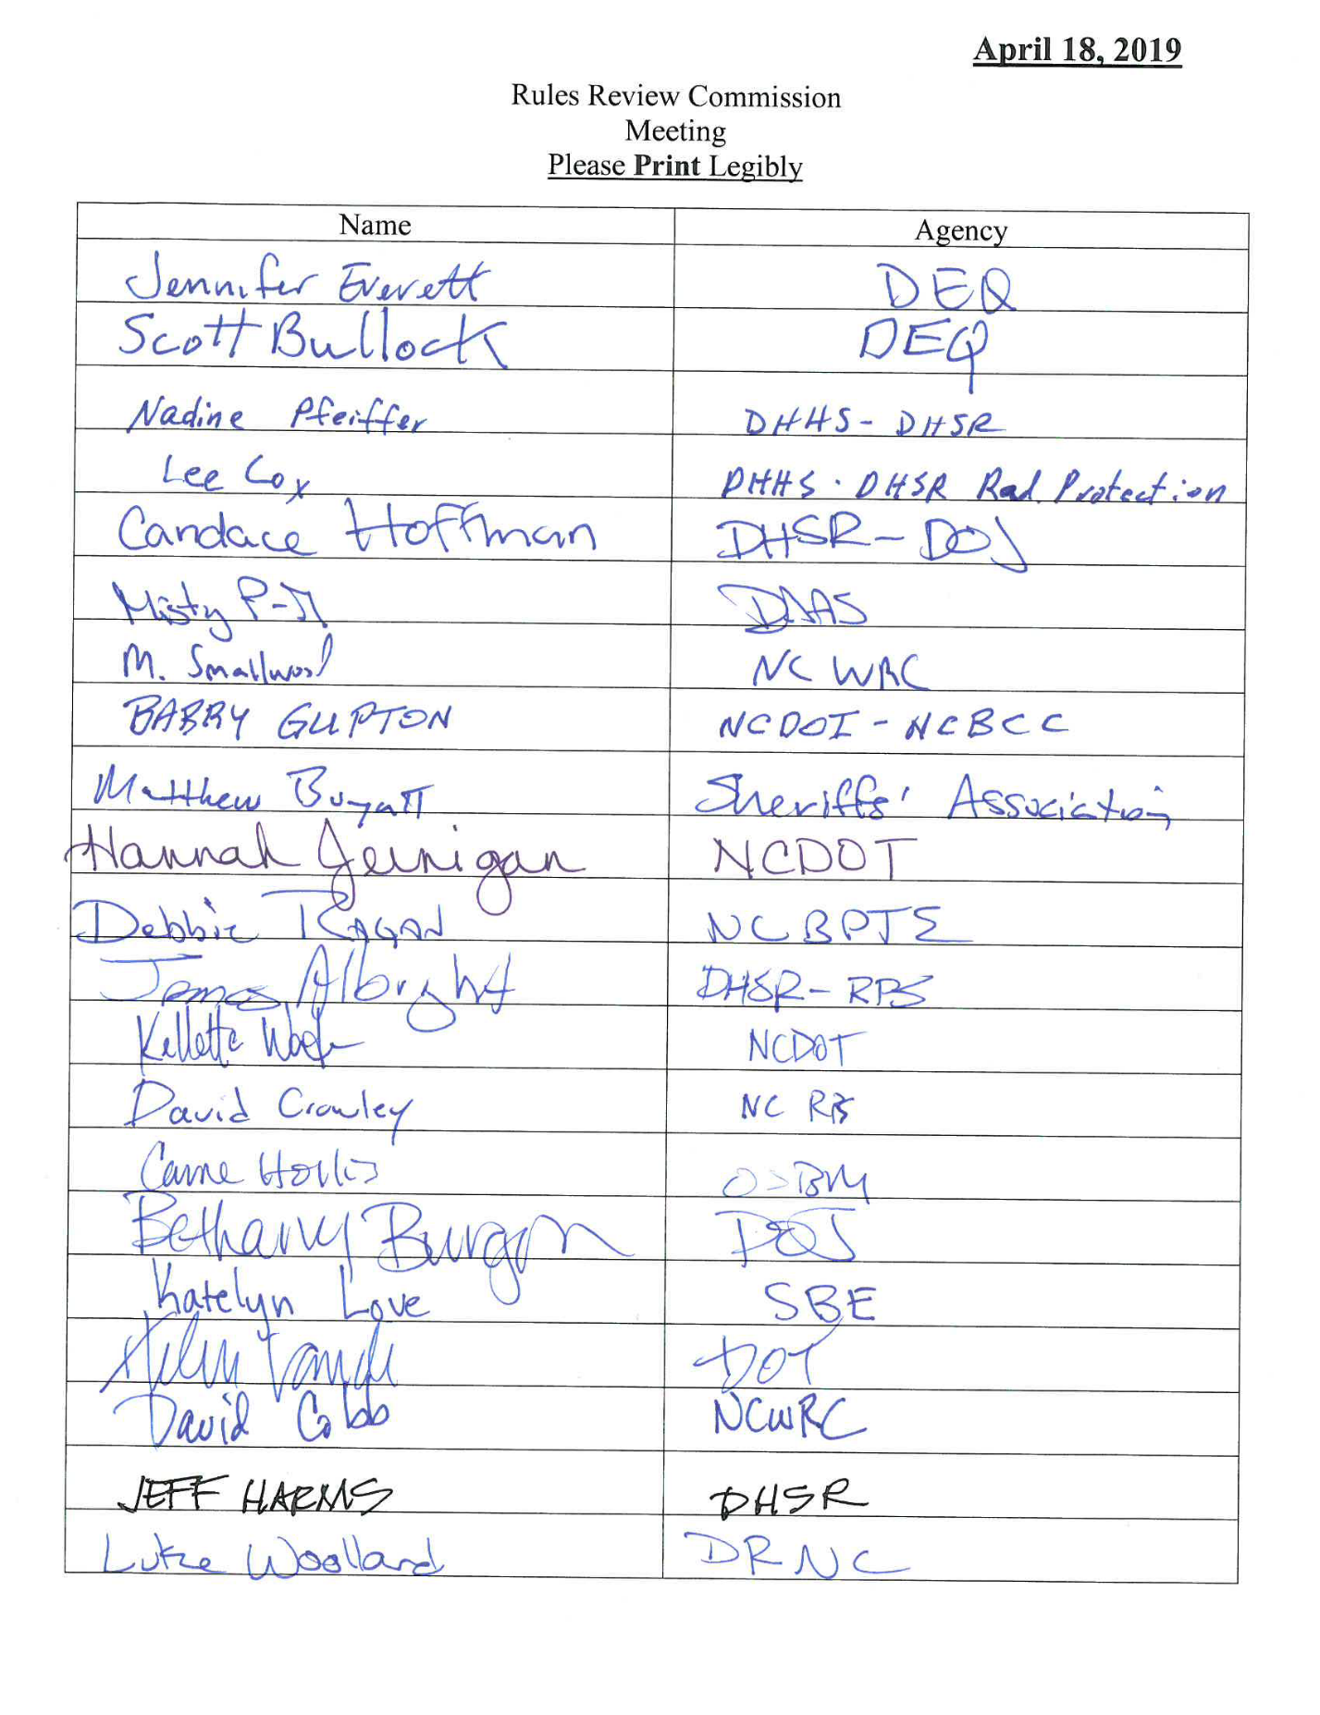

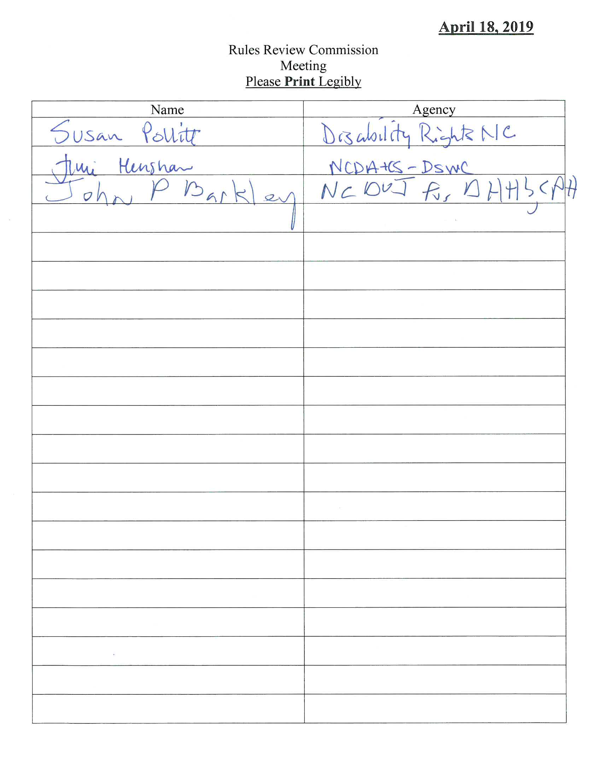

List of Approved Permanent Rules
April 18, 2019 Meeting
Soil and Water Conservation Commission
Purpose | 02 | NCAC | 59D | .0101
Definitions for Subchapter 59D | 02 | NCAC | 59D | .0102
Agriculture Cost Share Program Financial Assistance Alloc... | 02 | NCAC | 59D | .0103
Community Conservation Assistance Program Allocation Guid... | 02 | NCAC | 59D | .0104
Agricultural Water Resources Assistance Program Financial... | 02 | NCAC | 59D | .0105
Best Management Practices Eligible for Cost Share Payments | 02 | NCAC | 59D | .0106
Cost Share and Incentive Payments | 02 | NCAC | 59D | .0107
Technical Assistance Funds | 02 | NCAC | 59D | .0108
Cost Share Agreement | 02 | NCAC | 59D | .0109
District Program Operation | 02 | NCAC | 59D | .0110
Health and Human Services, Department of
Definitions | 10A | NCAC | 14J | .0101
Applicability - Operations and Enforcement and Incorporat... | 10A | NCAC | 14J | .0102
Applicability - Construction | 10A | NCAC | 14J | .0103
Requirement for Operations Manual | 10A | NCAC | 14J | .0201
Contents of Operations Manual | 10A | NCAC | 14J | .0203
Review of Manual | 10A | NCAC | 14J | .0204
Classification System and Total Design Capacity | 10A | NCAC | 14J | .0301
Separation of Male and Female Inmates | 10A | NCAC | 14J | .0302
Confinement of Inmates Under 18 Years of Age | 10A | NCAC | 14J | .0303
Portable Fire Extinguishers | 10A | NCAC | 14J | .0402
Fire Plan, Fire Evacuation Training, and Disaster Plan | 10A | NCAC | 14J | .0403
Mattresses | 10A | NCAC | 14J | .0404
Keys | 10A | NCAC | 14J | .0405
General Security Requirements | 10A | NCAC | 14J | .0501
Supervision | 10A | NCAC | 14J | .0601
Mattresses and Bedding | 10A | NCAC | 14J | .0702
Personal Hygiene Items | 10A | NCAC | 14J | .0705
Menus | 10A | NCAC | 14J | .0904
Medical Plan | 10A | NCAC | 14J | .1001
Screening of Inmates | 10A | NCAC | 14J | .1002
Applicability - Construction | 10A | NCAC | 14J | .1201
Consultation and Technical Assistance | 10A | NCAC | 14J | .1202
Compliance Review and Approval | 10A | NCAC | 14J | .1203
Inmate Processing Area and Padded Cell | 10A | NCAC | 14J | .1207
Other Areas | 10A | NCAC | 14J | .1210
Floors, Ceilings, and Walls | 10A | NCAC | 14J | .1212
Showers and Plumbing Fixtures | 10A | NCAC | 14J | .1213
Windows and Glazing | 10A | NCAC | 14J | .1214
Doors, Bunks, Locks, and Fasteners | 10A | NCAC | 14J | .1215
Plumbing Systems | 10A | NCAC | 14J | .1218
Electrical Systems | 10A | NCAC | 14J | .1219
Standards for Dayrooms | 10A | NCAC | 14J | .1225
Standards for Dormitories | 10A | NCAC | 14J | .1226
Radioactive Materials and Accelerator Fee Amounts | 10A | NCAC | 15 | .1106
Wildlife Resources Commission
Particular Offenses | 15A | NCAC | 10A | .1001
Summary Disposition | 15A | NCAC | 10A | .1501
Permitted Archery Equipment | 15A | NCAC | 10B | .0116
Importation of Animal Parts | 15A | NCAC | 10B | .0124
Bear | 15A | NCAC | 10B | .0202
Squirrels | 15A | NCAC | 10B | .0206
Rabbits | 15A | NCAC | 10B | .0207
Open Seasons | 15A | NCAC | 10B | .0303
Public Mountain Trout Waters | 15A | NCAC | 10C | .0205
Possession of Certain Fishes | 15A | NCAC | 10C | .0211
Black Bass | 15A | NCAC | 10C | .0305
Crappie | 15A | NCAC | 10C | .0306
Shad | 15A | NCAC | 10C | .0313
Striped Bass | 15A | NCAC | 10C | .0314
Trout | 15A | NCAC | 10C | .0316
Taking Nongame Fishes for Bait or Personal Consumption | 15A | NCAC | 10C | .0402
Permitted Special Devices and Open Seasons | 15A | NCAC | 10C | .0407
Hunting on Game Lands | 15A | NCAC | 10D | .0103
Bear Sanctuaries | 15A | NCAC | 10D | .0106
Use of Areas Regulated | 15A | NCAC | 10E | .0104
Beaufort County | 15A | NCAC | 10F | .0303
Mecklenburg and Gaston Counties | 15A | NCAC | 10F | .0333
Physical Therapy Examiners, Board of
Fees | 21 | NCAC | 48F | .0102
Investigations | 21 | NCAC | 48F | .0103
Complaints and Investigations | 21 | NCAC | 48G | .0504
Building Code Council
2018 NC Residential Code/Deck Bracing | AM109
2018 NC Residential Code/Lofts | R202, R305, R310, R328
2018 NC Mechanical Code/Carbon Monoxide Alarms | 313
2018 NC Fuel Gas Code/Carbon Monoxide Alarms | 311
2018 NC Fire Code/Carbon Monoxide Alarm and Detection Sys... | 915
2018 NC Fire Code/Lockdown Plans | 404.2.3
2018 NC Building Code/Masonry Construction | 1705.4
2017 NC Electrical Code/Minimum Cover Requirements | Table 300.5
2017 NC Electrical Code/Ground-Fault Circuit-Interrupter ... | 210.8

List of Approved Temporary Rules
April 18, 2019 Meeting
Elections, State Board of
Voter Photo Identification Fraud | 08 | NCAC | 17 | .0107

RRC Determination
Periodic Rule Review
April 18, 2019
Necessary with substantive public interest

Radiation Protection Commission
10A NCAC 15 .0101
10A NCAC 15 .0102
10A NCAC 15 .0103
10A NCAC 15 .0104
10A NCAC 15 .0105
10A NCAC 15 .0106
10A NCAC 15 .0107
10A NCAC 15 .0108
10A NCAC 15 .0109
10A NCAC 15 .0110
10A NCAC 15 .0113
10A NCAC 15 .0114
10A NCAC 15 .0115
10A NCAC 15 .0116
10A NCAC 15 .0117
10A NCAC 15 .0118
10A NCAC 15 .0202
10A NCAC 15 .0203
10A NCAC 15 .0204
10A NCAC 15 .0205
10A NCAC 15 .0206
10A NCAC 15 .0207
10A NCAC 15 .0209
10A NCAC 15 .0210
10A NCAC 15 .0213
10A NCAC 15 .0214
10A NCAC 15 .0301
10A NCAC 15 .0302
10A NCAC 15 .0303
10A NCAC 15 .0304
10A NCAC 15 .0305
10A NCAC 15 .0306
10A NCAC 15 .0307
10A NCAC 15 .0308
10A NCAC 15 .0309
10A NCAC 15 .0310
10A NCAC 15 .0311
10A NCAC 15 .0312
10A NCAC 15 .0313
10A NCAC 15 .0314
10A NCAC 15 .0315
10A NCAC 15 .0316
10A NCAC 15 .0317
10A NCAC 15 .0318
10A NCAC 15 .0319
10A NCAC 15 .0320
10A NCAC 15 .0321
10A NCAC 15 .0322
10A NCAC 15 .0323
10A NCAC 15 .0324
10A NCAC 15 .0327
10A NCAC 15 .0328
10A NCAC 15 .0329
10A NCAC 15 .0330
10A NCAC 15 .0331
10A NCAC 15 .0332
10A NCAC 15 .0333
10A NCAC 15 .0334
10A NCAC 15 .0335
10A NCAC 15 .0337
10A NCAC 15 .0338
10A NCAC 15 .0339
10A NCAC 15 .0340
10A NCAC 15 .0341
10A NCAC 15 .0342
10A NCAC 15 .0343
10A NCAC 15 .0344
10A NCAC 15 .0345
10A NCAC 15 .0346
10A NCAC 15 .0348
10A NCAC 15 .0349
10A NCAC 15 .0351
10A NCAC 15 .0352
10A NCAC 15 .0353
10A NCAC 15 .0354
10A NCAC 15 .0355
10A NCAC 15 .0356
10A NCAC 15 .0357
10A NCAC 15 .0358
10A NCAC 15 .0359
10A NCAC 15 .0360
10A NCAC 15 .0361
10A NCAC 15 .0362
10A NCAC 15 .0363
10A NCAC 15 .0364
10A NCAC 15 .0365
10A NCAC 15 .0503
10A NCAC 15 .0504
10A NCAC 15 .0505
10A NCAC 15 .0507
10A NCAC 15 .0508
10A NCAC 15 .0521
10A NCAC 15 .0524
10A NCAC 15 .0601
10A NCAC 15 .0602
10A NCAC 15 .0603
10A NCAC 15 .0604
10A NCAC 15 .0605
10A NCAC 15 .0606
10A NCAC 15 .0607
10A NCAC 15 .0608
10A NCAC 15 .0609
10A NCAC 15 .0610
10A NCAC 15 .0701
10A NCAC 15 .0702
10A NCAC 15 .0901
10A NCAC 15 .0902
10A NCAC 15 .0903
10A NCAC 15 .0904
10A NCAC 15 .0905
10A NCAC 15 .0906
10A NCAC 15 .0907
10A NCAC 15 .0908
10A NCAC 15 .0909
10A NCAC 15 .0910
10A NCAC 15 .1004
10A NCAC 15 .1007
10A NCAC 15 .1008

Health and Human Services, Department of
10A NCAC 15 .1102
10A NCAC 15 .1106

Radiation Protection Commission
10A NCAC 15 .1201
10A NCAC 15 .1202
10A NCAC 15 .1203
10A NCAC 15 .1204
10A NCAC 15 .1205
10A NCAC 15 .1206
10A NCAC 15 .1207
10A NCAC 15 .1208
10A NCAC 15 .1209
10A NCAC 15 .1210
10A NCAC 15 .1211
10A NCAC 15 .1212
10A NCAC 15 .1213
10A NCAC 15 .1214
10A NCAC 15 .1215
10A NCAC 15 .1216
10A NCAC 15 .1217
10A NCAC 15 .1218
10A NCAC 15 .1219
10A NCAC 15 .1220
10A NCAC 15 .1221
10A NCAC 15 .1222
10A NCAC 15 .1223
10A NCAC 15 .1224
10A NCAC 15 .1225
10A NCAC 15 .1226
10A NCAC 15 .1227
10A NCAC 15 .1228
10A NCAC 15 .1229
10A NCAC 15 .1230
10A NCAC 15 .1231
10A NCAC 15 .1233
10A NCAC 15 .1234
10A NCAC 15 .1235
10A NCAC 15 .1236
10A NCAC 15 .1237
10A NCAC 15 .1238
10A NCAC 15 .1239
10A NCAC 15 .1240
10A NCAC 15 .1241
10A NCAC 15 .1242
10A NCAC 15 .1301
10A NCAC 15 .1302
10A NCAC 15 .1303
10A NCAC 15 .1304
10A NCAC 15 .1305
10A NCAC 15 .1306
10A NCAC 15 .1307
10A NCAC 15 .1308
10A NCAC 15 .1309
10A NCAC 15 .1310
10A NCAC 15 .1311
10A NCAC 15 .1312
10A NCAC 15 .1313
10A NCAC 15 .1314
10A NCAC 15 .1315
10A NCAC 15 .1316
10A NCAC 15 .1317
10A NCAC 15 .1318
10A NCAC 15 .1319
10A NCAC 15 .1320
10A NCAC 15 .1321
10A NCAC 15 .1322
10A NCAC 15 .1323
10A NCAC 15 .1324
10A NCAC 15 .1325
10A NCAC 15 .1326
10A NCAC 15 .1327
10A NCAC 15 .1418
10A NCAC 15 .1501
10A NCAC 15 .1502
10A NCAC 15 .1503
10A NCAC 15 .1504
10A NCAC 15 .1505
10A NCAC 15 .1506
10A NCAC 15 .1507
10A NCAC 15 .1508
10A NCAC 15 .1509
10A NCAC 15 .1510
10A NCAC 15 .1511
10A NCAC 15 .1512
10A NCAC 15 .1513
10A NCAC 15 .1514
10A NCAC 15 .1515
10A NCAC 15 .1516
10A NCAC 15 .1517
10A NCAC 15 .1601
10A NCAC 15 .1602
10A NCAC 15 .1603
10A NCAC 15 .1604
10A NCAC 15 .1605
10A NCAC 15 .1606
10A NCAC 15 .1607
10A NCAC 15 .1608
10A NCAC 15 .1609
10A NCAC 15 .1610
10A NCAC 15 .1611
10A NCAC 15 .1612
10A NCAC 15 .1613
10A NCAC 15 .1614
10A NCAC 15 .1615
10A NCAC 15 .1616
10A NCAC 15 .1617
10A NCAC 15 .1618
10A NCAC 15 .1619
10A NCAC 15 .1620
10A NCAC 15 .1621
10A NCAC 15 .1622
10A NCAC 15 .1623
10A NCAC 15 .1624
10A NCAC 15 .1625
10A NCAC 15 .1626
10A NCAC 15 .1627
10A NCAC 15 .1628
10A NCAC 15 .1629
10A NCAC 15 .1630
10A NCAC 15 .1631
10A NCAC 15 .1632
10A NCAC 15 .1633
10A NCAC 15 .1634
10A NCAC 15 .1635
10A NCAC 15 .1636
10A NCAC 15 .1637
10A NCAC 15 .1638
10A NCAC 15 .1639
10A NCAC 15 .1640
10A NCAC 15 .1641
10A NCAC 15 .1642
10A NCAC 15 .1643
10A NCAC 15 .1644
10A NCAC 15 .1645
10A NCAC 15 .1646
10A NCAC 15 .1647
10A NCAC 15 .1648
10A NCAC 15 .1649
10A NCAC 15 .1650
10A NCAC 15 .1651
10A NCAC 15 .1652
10A NCAC 15 .1653

RRC Determination
Periodic Rule Review
April 18, 2019
Necessary without substantive public interest

Radiation Protection Commission
10A NCAC 15 .0111
10A NCAC 15 .0112
10A NCAC 15 .0201
10A NCAC 15 .0208
10A NCAC 15 .0211
10A NCAC 15 .0212
10A NCAC 15 .0501
10A NCAC 15 .0502
10A NCAC 15 .0506
10A NCAC 15 .0509
10A NCAC 15 .0510
10A NCAC 15 .0511
10A NCAC 15 .0512
10A NCAC 15 .0513
10A NCAC 15 .0514
10A NCAC 15 .0515
10A NCAC 15 .0516
10A NCAC 15 .0517
10A NCAC 15 .0519
10A NCAC 15 .0520
10A NCAC 15 .0522
10A NCAC 15 .0523
10A NCAC 15 .0525
10A NCAC 15 .0801
10A NCAC 15 .0802
10A NCAC 15 .0803
10A NCAC 15 .0804
10A NCAC 15 .0805
10A NCAC 15 .0806
10A NCAC 15 .1001
10A NCAC 15 .1002
10A NCAC 15 .1003
10A NCAC 15 .1005
10A NCAC 15 .1006

Health and Human Services, Department of
10A NCAC 15 .1101
10A NCAC 15 .1103
10A NCAC 15 .1104
10A NCAC 15 .1105

Radiation Protection Commission
10A NCAC 15 .1401
10A NCAC 15 .1402
10A NCAC 15 .1403
10A NCAC 15 .1404
10A NCAC 15 .1405
10A NCAC 15 .1406
10A NCAC 15 .1407
10A NCAC 15 .1408
10A NCAC 15 .1409
10A NCAC 15 .1410
10A NCAC 15 .1411
10A NCAC 15 .1412
10A NCAC 15 .1413
10A NCAC 15 .1414
10A NCAC 15 .1415
10A NCAC 15 .1416
10A NCAC 15 .1417
10A NCAC 15 .1419
10A NCAC 15 .1420
10A NCAC 15 .1421
10A NCAC 15 .1422

Health and Human Services, Department of
10A NCAC 15 .1423

This Section contains a listing of recently issued Administrative Law Judge decisions for contested cases that are non-confidential. Published decisions are available for viewing on the OAH website at http://www.ncoah.com/hearings/decisions/

If you are having problems accessing the text of the decisions online or for other questions regarding contested cases or case decisions, please contact the Clerk's office by email: oah.clerks@oah.nc.gov or phone 919-431-3000.

OFFICE OF ADMINISTRATIVE HEARINGS

Chief Administrative Law Judge

JULIAN MANN, III

Senior Administrative Law Judge

FRED G. MORRISON JR.

ADMINISTRATIVE LAW JUDGES

Melissa Owens Lassiter A. B. Elkins II

Don Overby Selina Malherbe

J. Randall May J. Randolph Ward

David Sutton Stacey Bawtinhimer

Tenisha Jacobs

Year | Code | Number | Date Decision  Filed | Petitioner |  |  |  | Respondent |  | ALJ
 |  |  |  |  | PUBLISHED
18 | ABC | 04349 | 2/20/2019 |  | NC Alcoholic Beverage Control Commission |  | v. |  | H and J Super Discount Inc T/A Super Discount Mini Mart | Overby
18 | DHR | 05011 | 2/11/2019 |  | Primary Care Solutions Inc |  | v. |  | Cardinal Innovations Healthcare Inc | Malherbe
18 | DHR | 05357 | 2/25/2019 |  | Iantha Southerland |  | v. |  | Department of Health and Human Services, Division of Health Service Regulation | Lassiter
18 | DHR | 06469 | 2/7/2019 |  | Jesusito Rondon Guzman t/a Tienda Mexicana La Posadita |  | v. |  | NC Department of Health and Human Services | Ward
18 | DOJ | 04480 | 2/26/2019 |  | Christopher Garris |  | v. |  | NC Criminal Justice Education and Training Standards Commission | Overby
18 | DOJ | 04664 | 2/13/2019 |  | Rosalind R Smith |  | v. |  | NC Criminal Justice Education and Training Standards Commission | Ward
18 | DOJ | 06219 | 2/18/2019 |  | Keifer Austin Furr |  | v. |  | NC Private Protective Services Board | Lassiter
18 | DOJ | 06375 | 2/27/2019 |  | Benjamin Louis Zucker |  | v. |  | North Carolina Department of Justice Criminal Standards Division | Bawtinhimer
18 | INS | 04465 | 2/14/2019 |  | Courtney N Viebrock |  | v. |  | North Carolina Department of State Treasurer | Malherbe
18 | OSP | 04046 | 2/6/2019 |  | Heather Harper |  | v. |  | Department of Public Safety | Ward
 |  |  |  |  | UNPUBLISHED
17 | CSE | 07720 | 2/27/2019 |  | Anthony R Coley |  | v. |  | NC Department of Health and Human Services, Division of Social Services, Child Support Enforcement | Elkins
18 | CSE | 01368 | 2/27/2019 |  | Mackie Barfield Jr |  | v. |  | Child Support Services | Elkins
18 | CSE | 06220 | 2/7/2019 |  | Douglas W Moyd (Mody) |  | v. |  | NC Department of Health and Human Services, Division of Social Services, Child Support Enforcement Section | Malherbe
18 | CSE | 06235 | 2/22/2019 |  | David Earl Rigg |  | v. |  | NC Department of Health and Human Services, Division of Social Services, Child Support Enforcement Section | Overby
18 | CSE | 06240 | 2/15/2019 |  | Felicia H Middleton |  | v. |  | NC Department of Health and Human Services, Division of Social Services, Child Support Enforcement | Elkins
18 | CSE | 06246 | 2/1/2019 |  | Mark Davis-Mccrary |  | v. |  | NC Department of Health and Human Services, Division of Social Services, Child Support Enforcement Section | Malherbe
18 | CSE | 06264 | 2/27/2019 |  | Melanie K Marino |  | v. |  | NC Department of Health and Human Services, Division of Social Services, Child Support Enforcement Section | Elkins
18 | CSE | 06276 | 2/15/2019 |  | Ricky Williams |  | v. |  | NC Department of Health and Human Services, Division of Social Services, Child Support Enforcement Section | Elkins
18 | CSE | 06301 | 2/27/2019 |  | Michael Anthony Cylar |  | v. |  | NC Department of Health and Human Services, Division of Social Services, Child Support Enforcement Section | Elkins
18 | CSE | 06306 | 2/27/2019; 3/15/2019 |  | Gregory L Thompson |  | v. |  | NC Department of Health and Human Services, Division of Social Services, Child Support Enforcement Section | Elkins
18 | CSE | 06388 | 2/15/2019 |  | Michael Norwood |  | v. |  | NC Department of Health and Human Services, Division of Social Services, Child Support Enforcement | Elkins
18 | CSE | 06392 | 2/27/2019 |  | Mark A Preston |  | v. |  | NC Department of Health and Human Services, Division of Social Services, Child Support Enforcement Section | Elkins
18 | CSE | 06409 | 2/20/2019 |  | John R Mitchell |  | v. |  | NC Department of Health and Human Services, Division of Social Services, Child Support Enforcement Section | May
18 | CSE | 06423 | 2/25/2019 |  | Martin Malamah-Thomas |  | v. |  | NC Department of Health and Human Services, Division of Social Services, Child Support Enforcement Section | Malherbe
18 | CSE | 06483 | 2/22/2019 |  | Jessica Collazo |  | v. |  | NC Department of Health and Human Services, Division of Social Services, Child Support Enforcement Section | Overby
18 | CSE | 06488 | 2/15/2019 |  | David M McDermott |  | v. |  | NC Department of Health and Human Services, Division of Social Services, Child Support Enforcement Section | Elkins
18 | CSE | 06537 | 2/19/2019 |  | Jeffrey S Brown |  | v. |  | NC Department of Health and Human Services, Division of Social Services, Child Support Enforcement | Ward
18 | CSE | 06554 | 2/18/2019 |  | Georgie A Mendoza |  | v. |  | NC Department of Health and Human Services, Division of Social Services, Child Support Enforcement Section | Sutton
18 | CSE | 06573 | 2/22/2019 |  | Brian O'Neal Black |  | v. |  | NC Department of Health and Human Services, Division of Social Services, Child Support Enforcement | Sutton
18 | CSE | 06639 | 2/8/2019 |  | Rashone Washington |  | v. |  | NC Department of Health and Human Services, Division of Social Services, Child Support EnforcementSection | May
18 | CSE | 06673 | 2/18/2019 |  | Arnold S Thomas |  | v. |  | NC Department of Health and Human Services, Division of Social Services, Child Support Enforcement Section | Malherbe
18 | CSE | 06869 | 2/8/2019 |  | William C Davis |  | v. |  | NC Department of Health and Human Services, Division of Social Services, Child Support Enforcement Section | May
18 | CSE | 06870 | 2/20/2019 |  | Michael Kearney |  | v. |  | NC Department of Health and Human Services, Division of Social Services, Child Support Enforcement | May
18 | CSE | 06997 | 2/8/2019; 2/19/2019 |  | Jason Leland McCrary |  | v. |  | NC Department of Health and Human Services, Division of Social Services, Child Support Enforcement Section | May
18 | CSE | 07088 | 2/8/2019 |  | Roosevelt Moore |  | v. |  | NC Department of Health and Human Services, Division of Social Services, Child Support Enforcement | May
18 | CSE | 07094 | 2/19/2019 |  | Erich M Pearl |  | v. |  | NC Department of Health and Human Services, Division of Social Services, Child Support Enforcement | Malherbe
18 | CSE | 07359 | 2/20/2019 |  | Felix Allende |  | v. |  | NC Department of Health and Human Services, Division of Social Services, Child Support Enforcement | May
18 | CSE | 07420 | 2/13/2019 |  | Gregory Leng |  | v. |  | NC Department of Health and Human Services, Division of Social Services, Child Support Enforcement | Malherbe
18 | CSE | 07424 | 2/7/2019 |  | Andres Montoya Vazquez |  | v. |  | NC Department of Health and Human Services, Division of Social Services, Child Support Enforcement | Malherbe
18 | CSE | 07576 | 2/19/2019 |  | Eric Garcia |  | v. |  | NC Department of Health and Human Services, Division of Social Services, Child Support Enforcement | Malherbe
18 | CSE | 07600 | 2/18/2019 |  | Kevin Michael Smith |  | v. |  | NC Department of Health and Human Services, Division of Social Services, Child Support Enforcement | Sutton
18 | CSE | 07636 | 2/19/2019 |  | Nathan E Justice |  | v. |  | NC Department of Health and Human Services, Division of Social Services, Child Support Enforcement | Malherbe
18 | CSE | 07815 | 2/26/2019 |  | William Walter |  | v. |  | NC Department of Health and Human Services, Division of Social Services, Child Support Enforcement Section | Sutton
19 | CSE | 00051 | 2/19/2019 |  | Sherman Addison |  | v. |  | NC Department of Health and Human Services, Division of Social Services, Child Support Enforcement Section | Bawtinhimer
19 | CSE | 00280 | 2/26/2019 |  | Scott F Rutherford |  | v. |  | NC Department of Health and Human Services, Division of Social Services, Child Support Enforcement | Bawtinhimer
18 | DCS | 02864 | 2/27/2019 |  | Adelia Wyatt |  | v. |  | NC Department of Health and Human Services, Division of Social Services, Child Support Enforcement Section | Elkins
18 | DHR | 01807 | 2/15/2019 |  | Amjad Sheikh |  | v. |  | North Carolina Department of Health and Human Services (File No NCRR0052) | Ward
18 | DHR | 06238 | 2/4/2019 |  | Reliable Home Care Ser Portia Shipman Owner |  | v. |  | North Carolina Department of Health and Human Services | May
18 | DHR | 06863 | 2/1/2019; 2/8/2019 |  | Agatha Jean Morris |  | v. |  | NC Dept of Health and Human Svcs Health Care Personnel Reg Section | Jacobs
18 | DHR | 06989 | 2/22/2019 |  | Shelia Holmes-Graham |  | v. |  | Betty Overman NC State Nurse Aid Registry Raleigh NC | Jacobs
18 | DHR | 07304 | 2/20/2019 |  | Dena Causey |  | v. |  | Division of Child Development and Early Education | May
18 | DHR | 07512 | 2/26/2019 |  | Taylor Phillips |  | v. |  | NC Department of Health and Human Services, Division of Health Service Regulation | Overby
18 | DHR | 07669 | 2/26/2019 |  | Noralene Locklear |  | v. |  | Department of Health and Human Services, Division of Health Service Regulation | Lassiter
18 | DHR | 07761 | 2/14/2019 |  | The Goddard School at Edison Square |  | v. |  | Division of Child Development and Early Education | Malherbe
18 | DHR | 07768 | 2/25/2019 |  | Valerie Denise Little |  | v. |  | Nurse Aide Listing No 169354 Health Care Personnel Registry | May
18 | DOJ | 06866 | 2/5/2019 |  | Lance Paul White |  | v. |  | NC Sheriffs Education and Training Standards Commission | Jacobs
18 | DOJ | 07492 | 2/28/2019 |  | Christopher Bruce |  | v. |  | NC Sheriffs Education and Training Standards Commission | Sutton
18 | DOJ | 07496 | 2/26/2019 |  | Mychella L George |  | v. |  | NC Sheriffs Education and Training Standards Commission | Bawtinhimer
19 | DOL | 00681 | 2/27/2019 |  | Leslie Duke |  | v. |  | NC Dept of Labor OSHA OSHA Mr William Peterson | Bawtinhimer
18 | OSP | 06335 | 2/11/2019 |  | Sharon Young |  | v. |  | Murdoch Development Center and NC Department of HAHS | Elkins

