
NORTH CAROLINA

REGISTER

VOLUME 33 ● ISSUE 20 ● Pages 1986 – 2081

April 15, 2019

I. IN ADDITION

State Board of Elections - Order 1986 – 2031

II. PROPOSED RULES

Administration, Department of

Department 2032

Public Safety, Department of

Alcoholic Beverage Control Commission 2032 – 2037

Environmental Quality, Department of

Environmental Management Commission 2037 – 2049

Occupational Licensing Boards and Commissions

Dietetics/Nutrition, Board of 2049 – 2056

Funeral Service, Board of 2056 – 2061

III. TEMPORARY RULES

Environmental Quality, Department of

Coastal Resources Commission 2062 – 2064

IV. RULES REVIEW COMMISSION 2065 – 2077

V. CONTESTED CASE DECISIONS

Index to ALJ Decisions 2078 – 2081

PUBLISHED BY
The Office of Administrative Hearings
Rules Division Julian Mann III, Director
6714 Mail Service Center Molly Masich, Codifier of Rules
Raleigh, NC 27699-6714 Dana McGhee, Publications Coordinator
Telephone (919) 431-3000 Lindsay Woy, Editorial Assistant
Fax (919) 431-3104 Cathy Matthews-Thayer, Editorial Assistant

Contact List for Rulemaking Questions or Concerns

For questions or concerns regarding the Administrative Procedure Act or any of its components, consult with the agencies below. The bolded headings are typical issues which the given agency can address, but are not inclusive.

Rule Notices, Filings, Register, Deadlines, Copies of Proposed Rules, etc.

Office of Administrative Hearings

Rules Division
1711 New Hope Church Road (919) 431-3000
Raleigh, North Carolina 27609 (919) 431-3104 FAX

contact: Molly Masich, Codifier of Rules molly.masich@oah.nc.gov (919) 431-3071
Dana McGhee, Publications Coordinator dana.mcghee@oah.nc.gov (919) 431-3075
Lindsay Woy, Editorial Assistant lindsay.woy@oah.nc.gov (919) 431-3078
Cathy Matthews-Thayer, Editorial Assistant cathy.thayer@oah.nc.gov (919) 431-3006

Rule Review and Legal Issues

Rules Review Commission
1711 New Hope Church Road (919) 431-3000
Raleigh, North Carolina 27609 (919) 431-3104 FAX

contact: Amber Cronk May, Commission Counsel amber.may@oah.nc.gov (919) 431-3074
Amanda Reeder, Commission Counsel amanda.reeder@oah.nc.gov (919) 431-3079
Alexander Burgos, Paralegal alexander.burgos@oah.nc.gov (919) 431-3080
Julie Brincefield, Administrative Assistant julie.brincefield@oah.nc.gov (919) 431-3073

Fiscal Notes & Economic Analysis

Office of State Budget and Management
116 West Jones Street (919) 807-4700
Raleigh, North Carolina 27603-8005 (919) 733-0640 FAX
Contact: Carrie Hollis, Economic Analyst osbmruleanalysis@osbm.nc.gov (919) 807-4757

NC Association of County Commissioners
215 North Dawson Street (919) 715-2893
Raleigh, North Carolina 27603
contact: Amy Bason amy.bason@ncacc.org

NC League of Municipalities (919) 715-4000
150 Fayetteville Street, Suite 300
Raleigh, North Carolina 27601
contact: Sarah Collins scollins@nclm.org

Legislative Process Concerning Rule-making
545 Legislative Office Building
300 North Salisbury Street (919) 733-2578
Raleigh, North Carolina 27611 (919) 715-5460 FAX

Jason Moran-Bates, Staff Attorney
Jeremy Ray, Staff Attorney

NORTH CAROLINA REGISTER
Publication Schedule for January 2019 – December 2019

FILING DEADLINES |  |  | NOTICE OF TEXT |  | PERMANENT RULE |  |  | TEMPORARY RULES
Volume & issue number | Issue date | Last day for filing | Earliest date for public hearing | End of required comment  Period | Deadline to submit to RRC  for review at  next meeting | RRC Meeting Date | Earliest Eff.  Date of  Permanent Rule | 270th day from publication in the Register
33:13 | 01/02/19 | 12/06/18 | 01/17/19 | 03/04/19 | 03/20/19 | 04/18/19 | 05/01/19 | 09/29/19
33:14 | 01/15/19 | 12/19/18 | 01/30/19 | 03/18/19 | 03/20/19 | 04/18/19 | 05/01/19 | 10/12/19
33:15 | 02/01/19 | 01/10/19 | 02/16/19 | 04/02/19 | 04/22/19 | 05/16/19 | 06/01/19 | 10/29/19
33:16 | 02/15/19 | 01/25/19 | 03/02/19 | 04/16/19 | 04/22/19 | 05/16/19 | 06/01/19 | 11/12/19
33:17 | 03/01/19 | 02/08/19 | 03/16/19 | 04/30/19 | 05/20/19 | 06/20/19 | 07/01/19 | 11/26/19
33:18 | 03/15/19 | 02/22/19 | 03/30/19 | 05/14/19 | 05/20/19 | 06/20/19 | 07/01/19 | 12/10/19
33:19 | 04/01/19 | 03/11/19 | 04/16/19 | 05/31/19 | 06/20/19 | 07/18/19 | 08/01/19 | 12/27/19
33:20 | 04/15/19 | 03/25/19 | 04/30/19 | 06/14/19 | 06/20/19 | 07/18/19 | 08/01/19 | 01/10/20
33:21 | 05/01/19 | 04/09/19 | 05/16/19 | 07/01/19 | 07/22/19 | 08/15/19 | 09/01/19 | 01/26/20
33:22 | 05/15/19 | 04/24/19 | 05/30/19 | 07/15/19 | 07/22/19 | 08/15/19 | 09/01/19 | 02/09/20
33:23 | 06/03/19 | 05/10/19 | 06/18/19 | 08/02/19 | 08/20/19 | 09/19/19 | 10/01/19 | 02/28/20
33:24 | 06/17/19 | 05/24/19 | 07/02/19 | 08/16/19 | 08/20/19 | 09/19/19 | 10/01/19 | 03/13/20
34:01 | 07/01/19 | 06/10/19 | 07/16/19 | 08/30/19 | 09/20/19 | 10/17/19 | 11/01/19 | 03/27/20
34:02 | 07/15/19 | 06/21/19 | 07/30/19 | 09/13/19 | 09/20/19 | 10/17/19 | 11/01/19 | 04/10/20
34:03 | 08/01/19 | 07/11/19 | 08/16/19 | 09/30/19 | 10/21/19 | 11/21/19 | 12/01/19 | 04/27/20
34:04 | 08/15/19 | 07/25/19 | 08/30/19 | 10/14/19 | 10/21/19 | 11/21/19 | 12/01/19 | 05/11/20
34:05 | 09/03/19 | 08/12/19 | 09/18/19 | 11/04/19 | 11/20/19 | 12/19/19 | 01/01/20 | 05/30/20
34:06 | 09/16/19 | 08/23/19 | 10/01/19 | 11/15/19 | 11/20/19 | 12/19/19 | 01/01/20 | 06/12/20
34:07 | 10/01/19 | 09/10/19 | 10/16/19 | 12/02/19 | 12/20/19 | 01/16/20 | 02/01/20 | 06/27/20
34:08 | 10/15/19 | 09/24/19 | 10/30/19 | 12/16/19 | 12/20/19 | 01/16/20 | 02/01/20 | 07/11/20
34:09 | 11/01/19 | 10/11/19 | 11/16/19 | 12/31/19 | 01/21/20 | 02/20/20 | 03/01/20 | 07/28/20
34:10 | 11/15/19 | 10/24/19 | 11/30/19 | 01/14/20 | 01/21/20 | 02/20/20 | 03/01/20 | 08/11/20
34:11 | 12/02/19 | 11/06/19 | 12/17/19 | 01/31/20 | 02/20/20 | 03/19/20 | 04/01/20 | 08/28/20
34:12 | 12/16/19 | 11/21/19 | 12/31/19 | 02/14/20 | 02/20/20 | 03/19/20 | 04/01/20 | 09/11/20

This document is prepared by the Office of Administrative Hearings as a public service and is not to be deemed binding or controlling.

EXPLANATION OF THE PUBLICATION SCHEDULE

This Publication Schedule is prepared by the Office of Administrative Hearings as a public service and the computation of time periods are not to be deemed binding or controlling. Time is computed according to 26 NCAC 2C .0302 and the Rules of Civil Procedure, Rule 6.

GENERAL

The North Carolina Register shall be published twice a month and contains the following information submitted for publication by a state agency:
(1) temporary rules;
(2) text of proposed rules;
(3) text of permanent rules approved by the Rules Review Commission;
(4) emergency rules
(5) Executive Orders of the Governor;
(6) final decision letters from the U.S. Attorney General concerning changes in laws affecting voting in a jurisdiction subject of Section 5 of the Voting Rights Act of 1965, as required by G.S. 120-30.9H; and
(7) other information the Codifier of Rules determines to be helpful to the public.

COMPUTING TIME: In computing time in the schedule, the day of publication of the North Carolina Register is not included. The last day of the period so computed is included, unless it is a Saturday, Sunday, or State holiday, in which event the period runs until the preceding day which is not a Saturday, Sunday, or State holiday.

FILING DEADLINES

ISSUE DATE: The Register is published on the first and fifteen of each month if the first or fifteenth of the month is not a Saturday, Sunday, or State holiday for employees mandated by the State Personnel Commission. If the first or fifteenth of any month is a Saturday, Sunday, or a holiday for State employees, the North Carolina Register issue for that day will be published on the day of that month after the first or fifteenth that is not a Saturday, Sunday, or holiday for State employees.

LAST DAY FOR FILING: The last day for filing for any issue is 15 days before the issue date excluding Saturdays, Sundays, and holidays for State employees.

NOTICE OF TEXT

EARLIEST DATE FOR PUBLIC HEARING: The hearing date shall be at least 15 days after the date a notice of the hearing is published.

END OF REQUIRED COMMENT PERIOD
An agency shall accept comments on the text of a proposed rule for at least 60 days after the text is published or until the date of any public hearings held on the proposed rule, whichever is longer.

DEADLINE TO SUBMIT TO THE RULES REVIEW COMMISSION: The Commission shall review a rule submitted to it on or before the twentieth of a month by the last day of the next month.

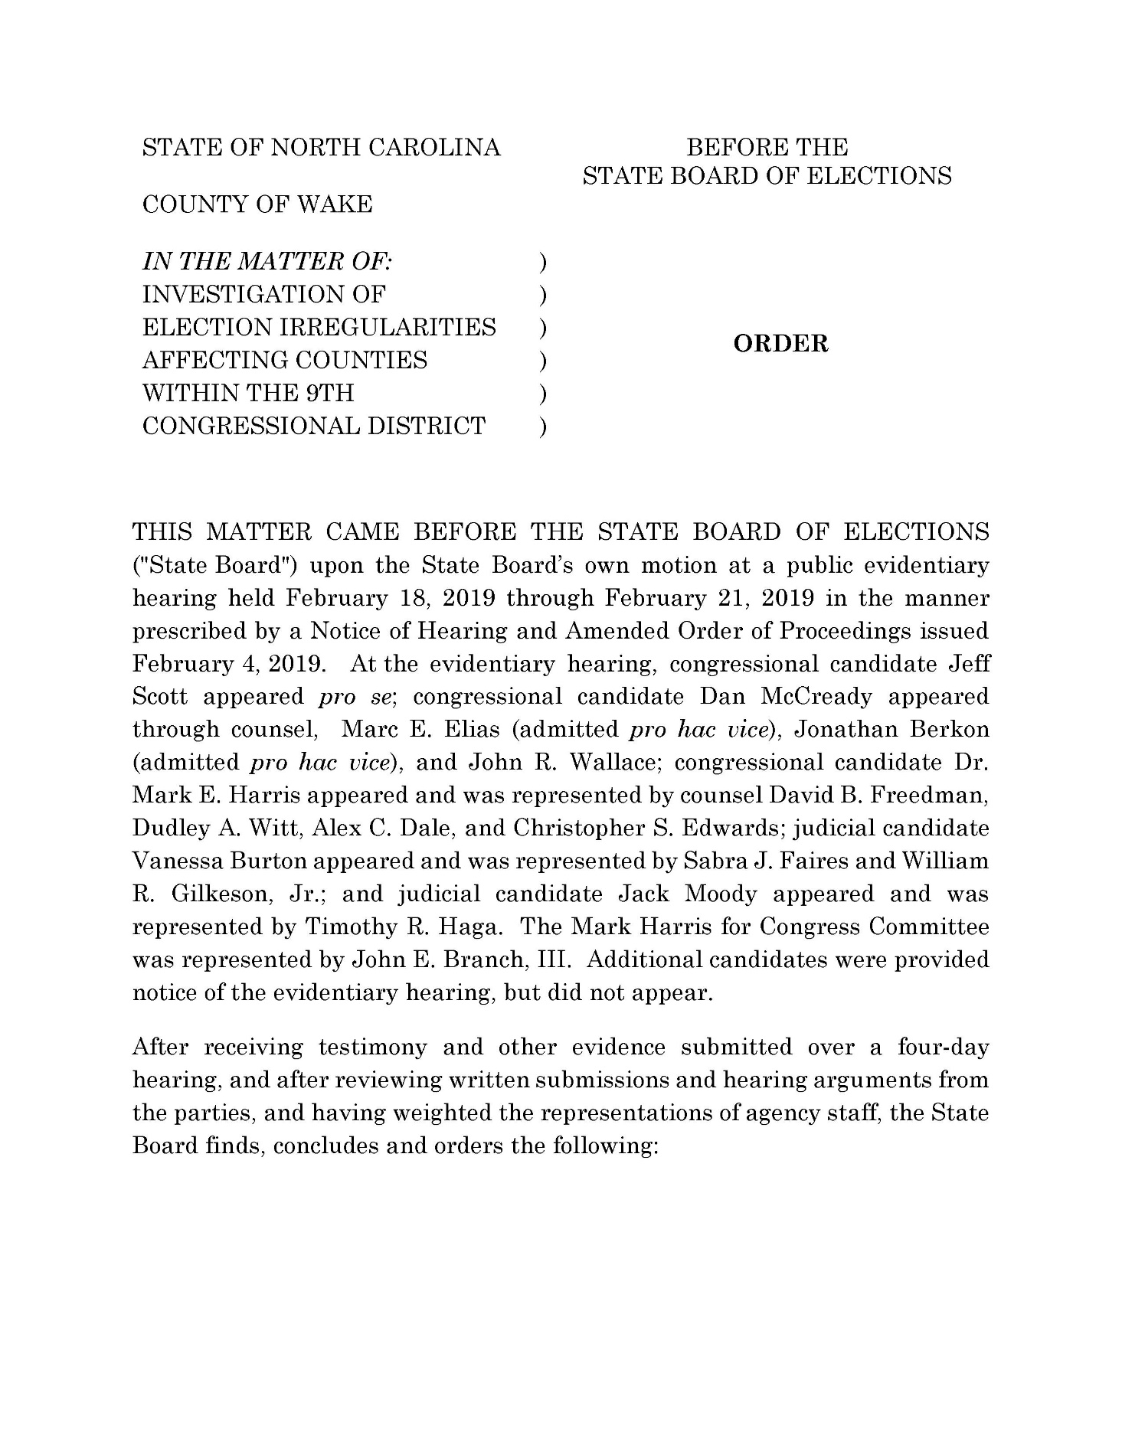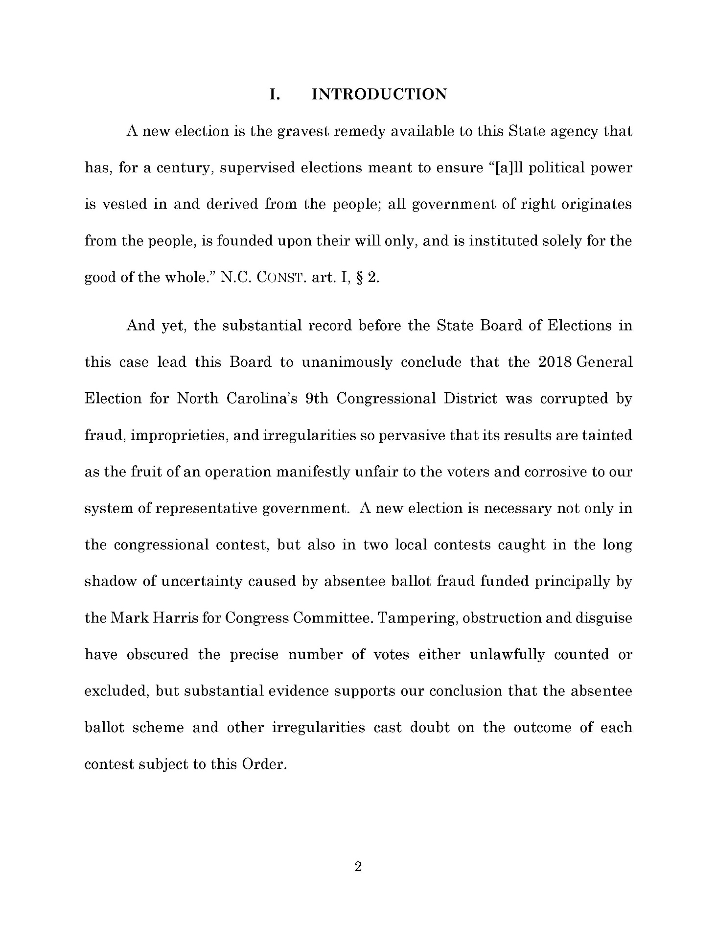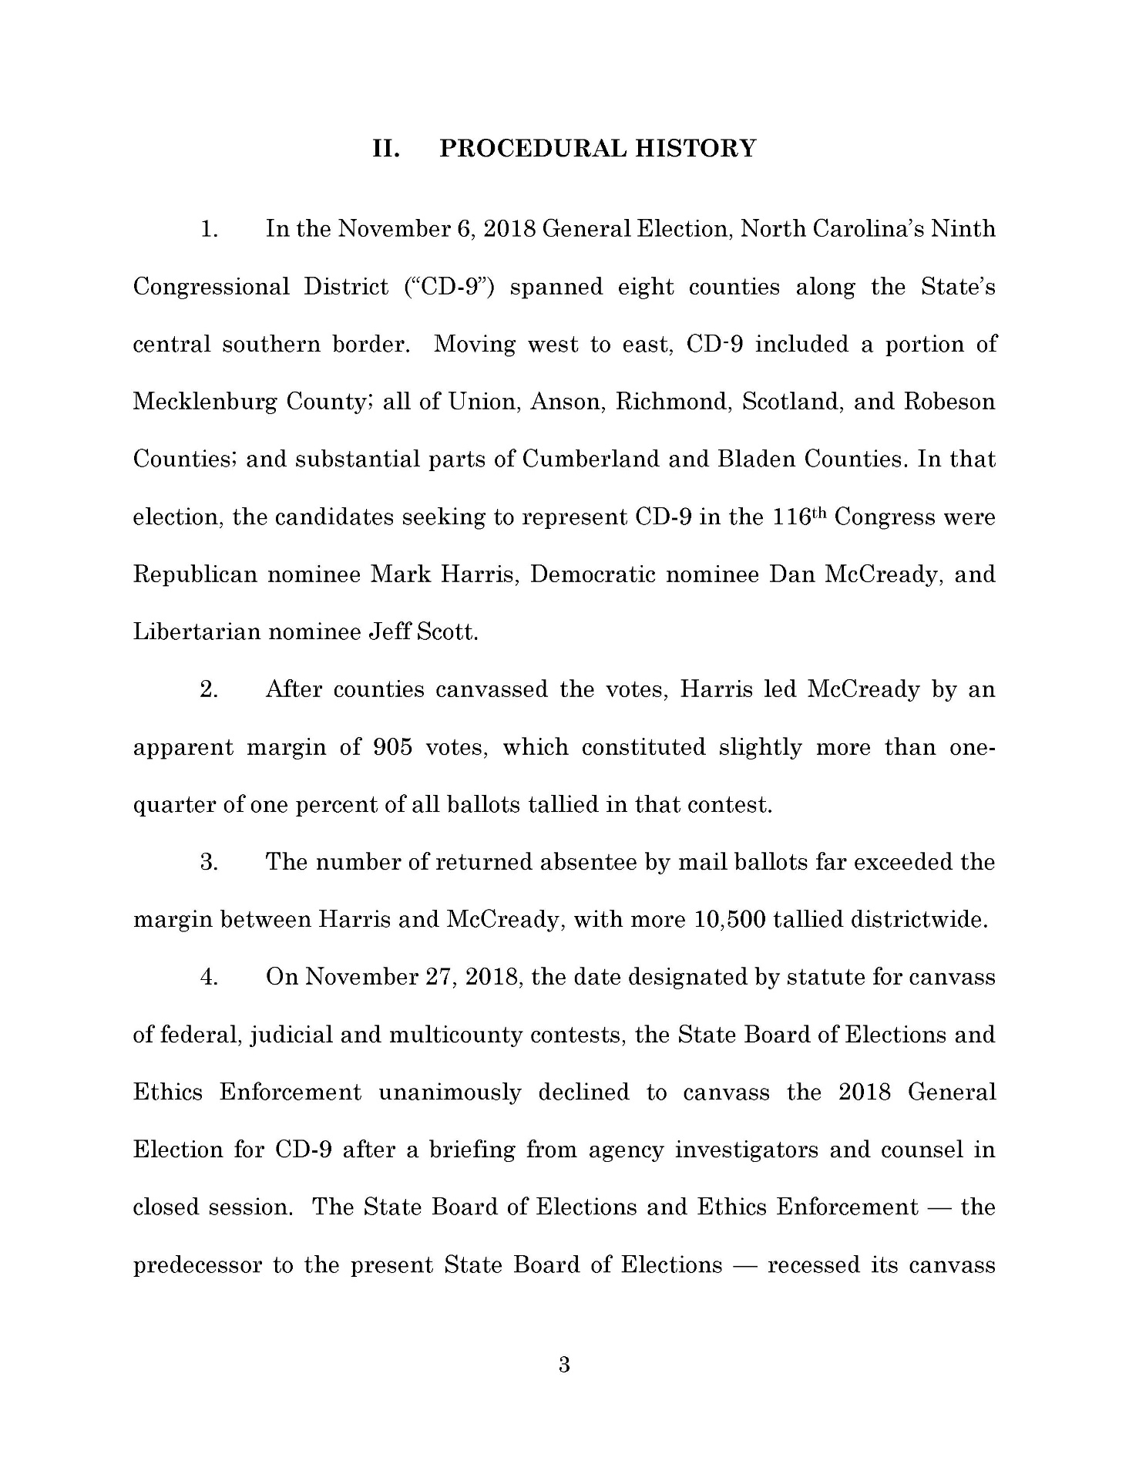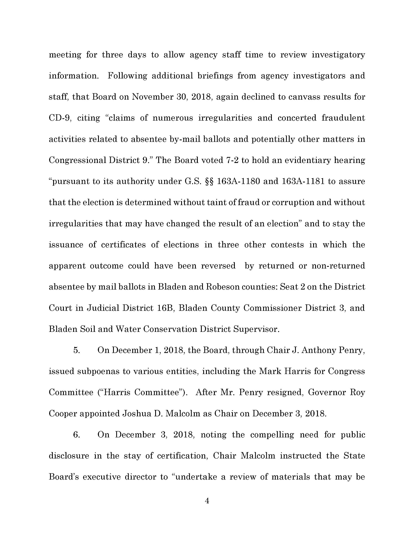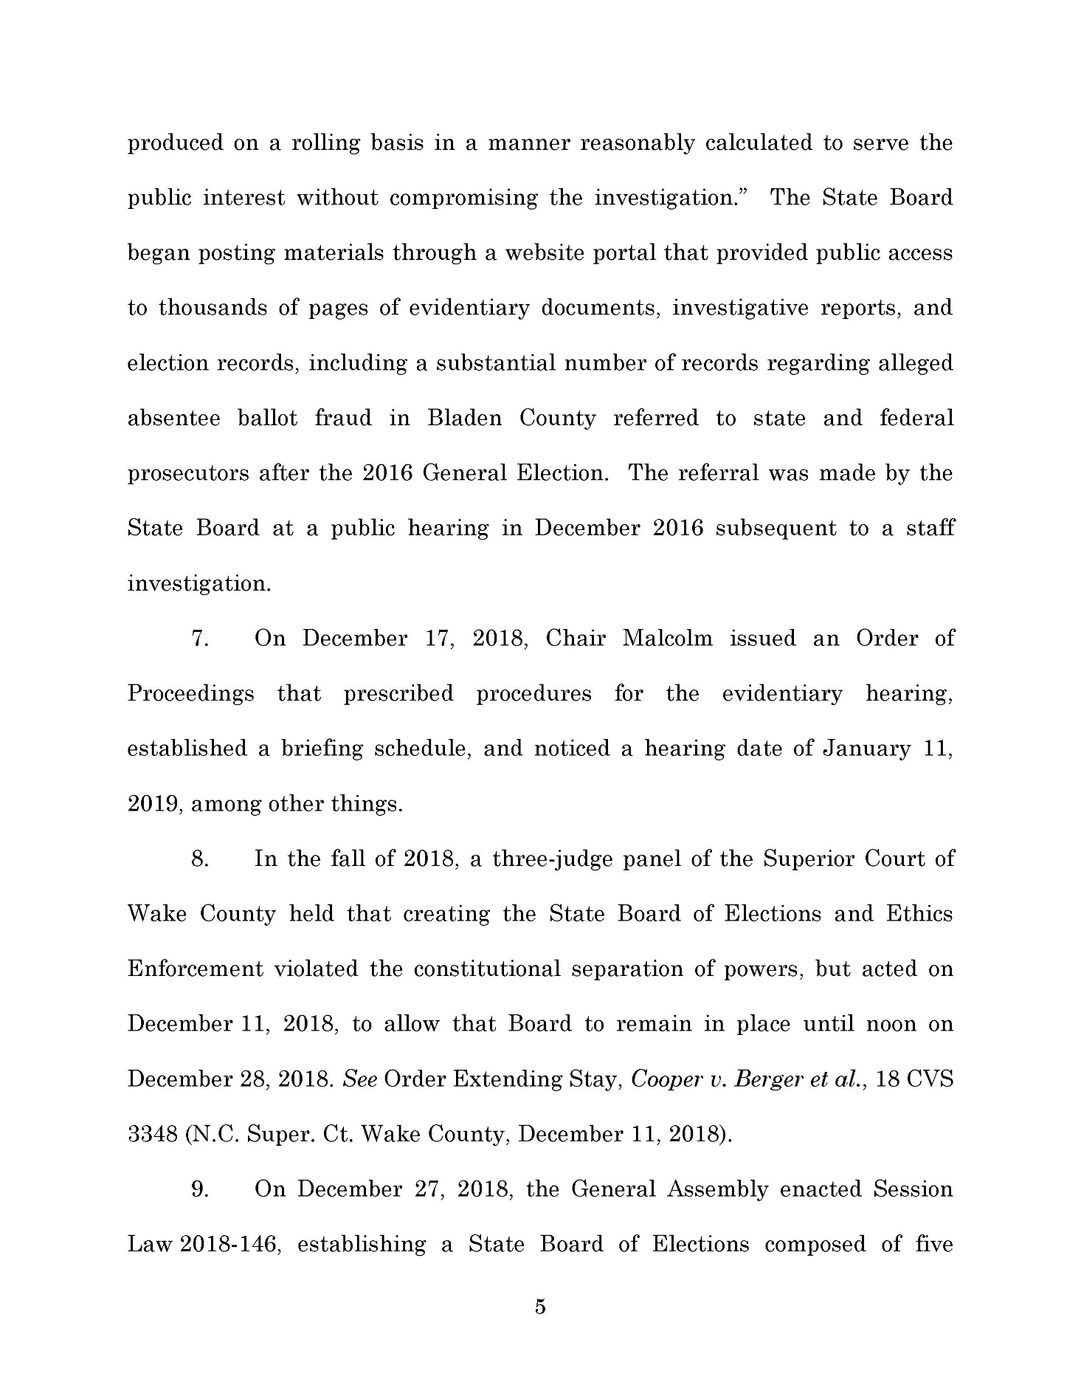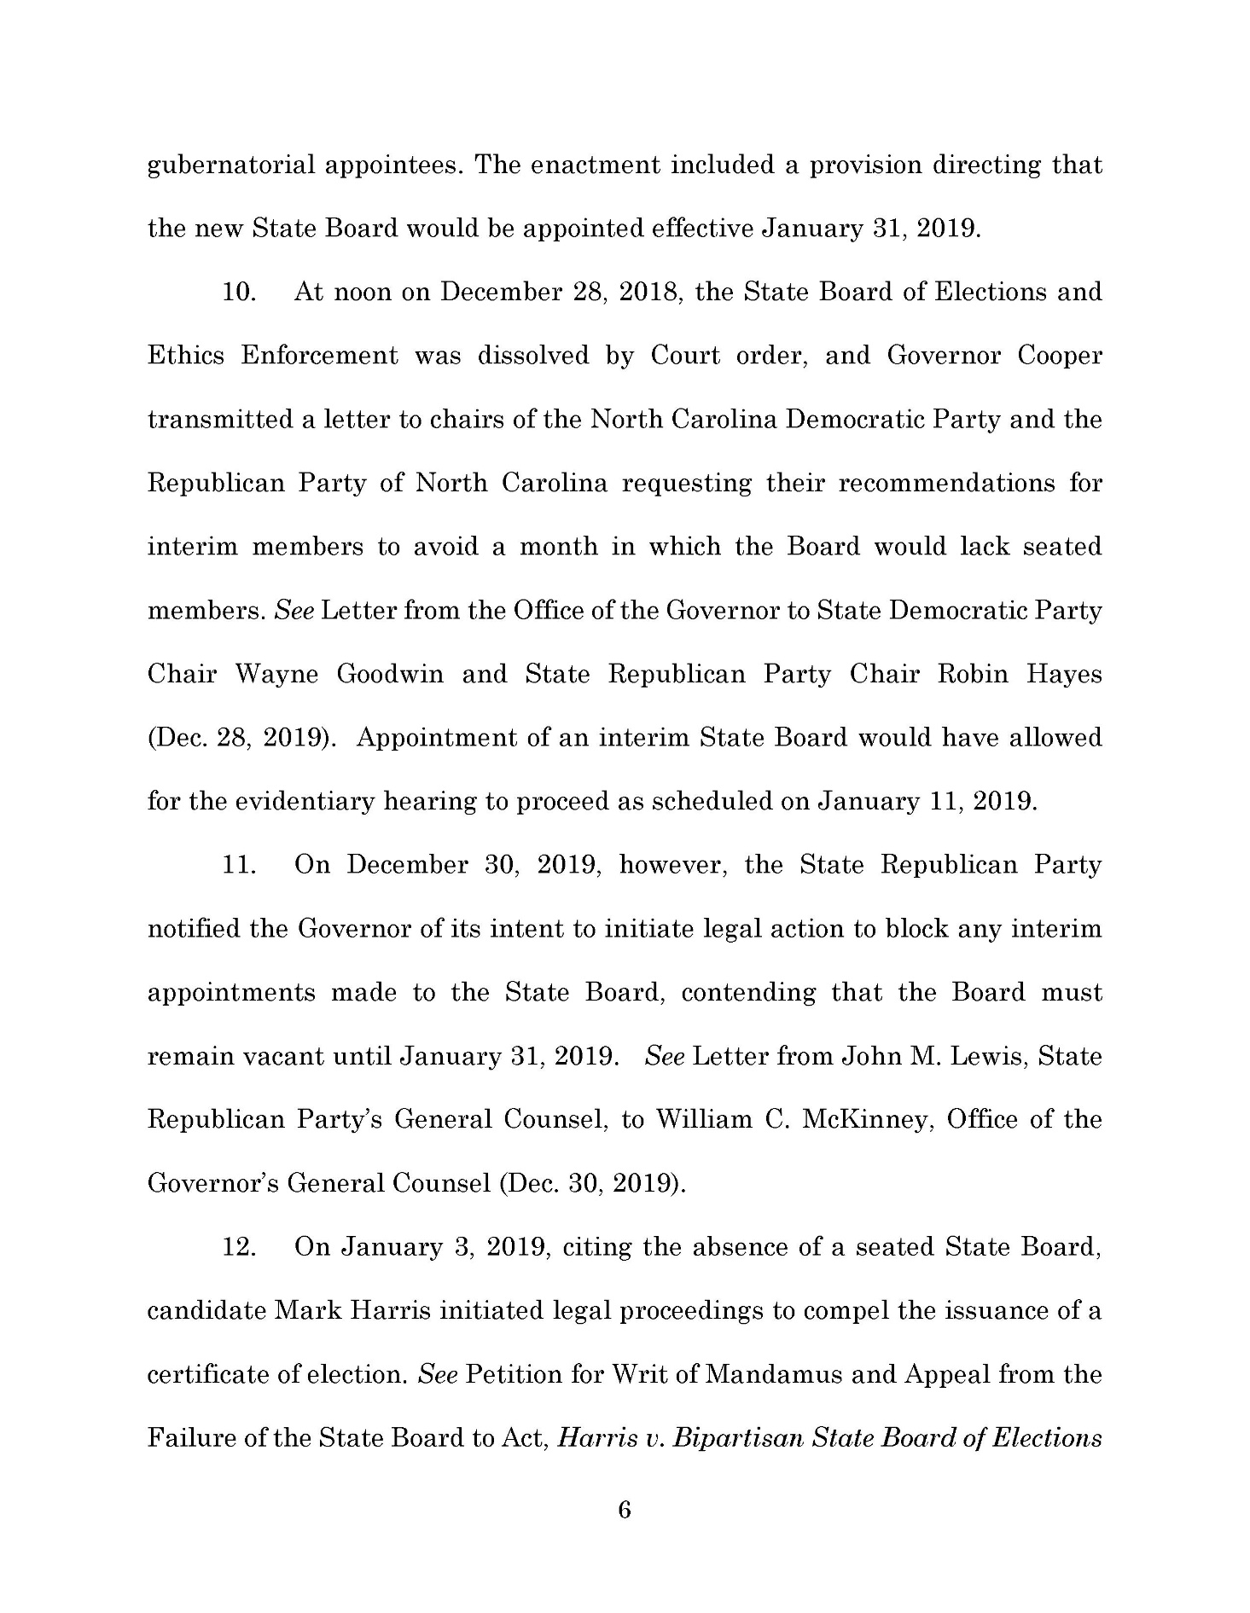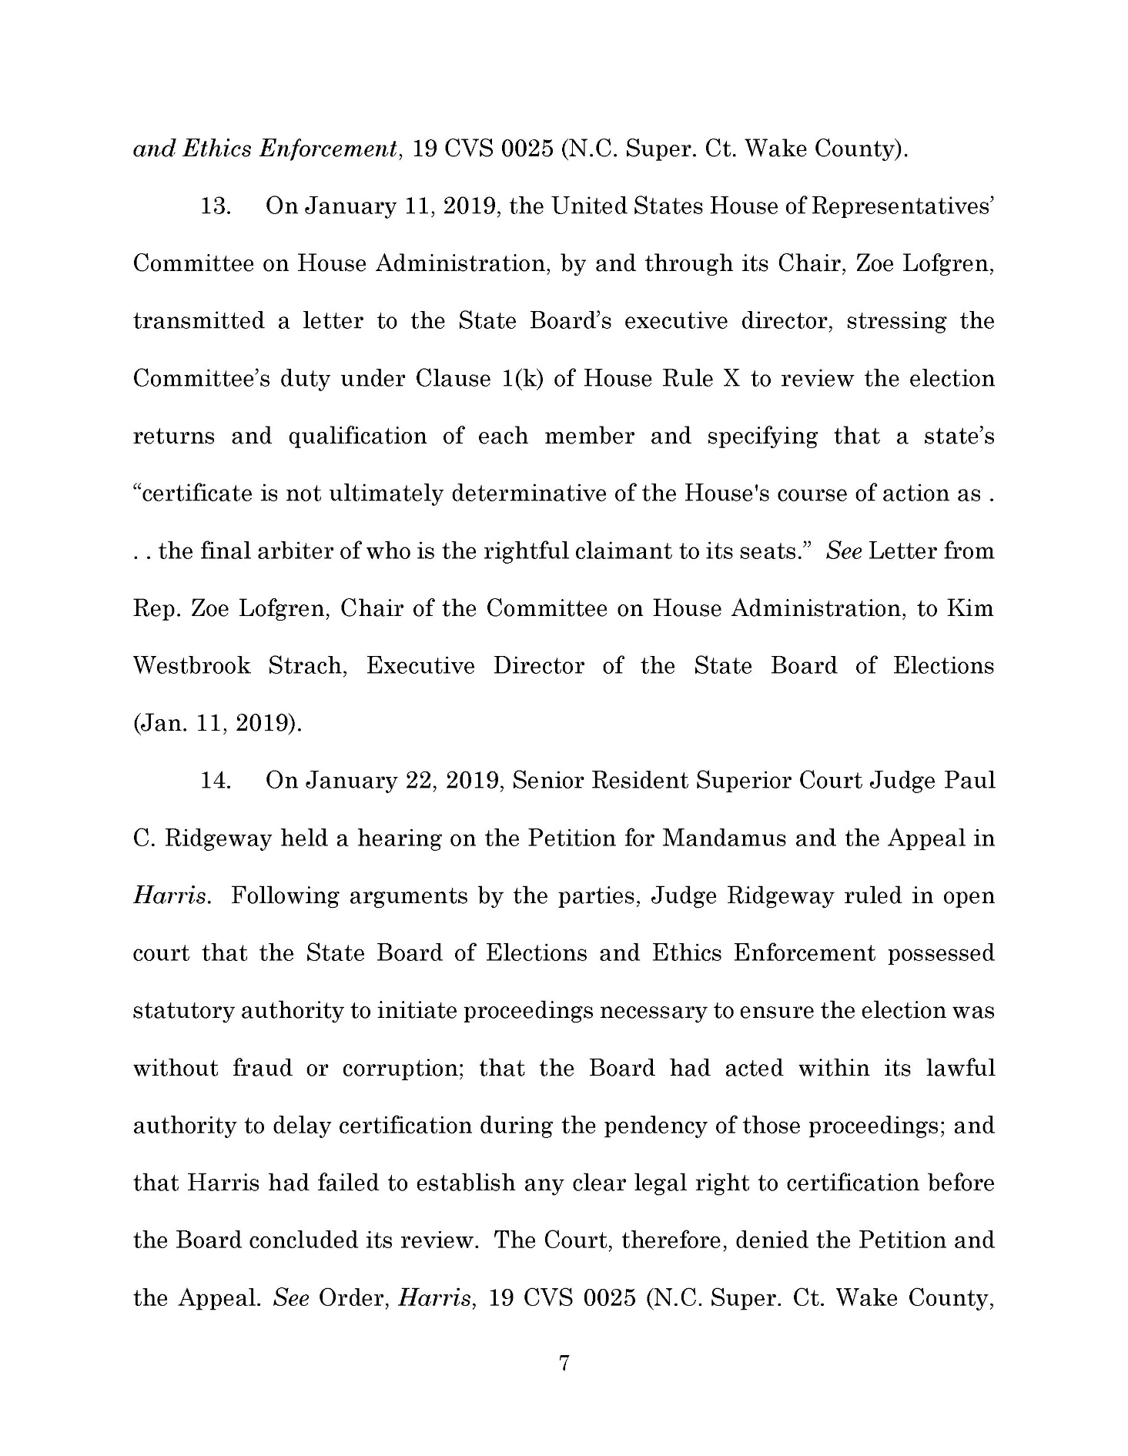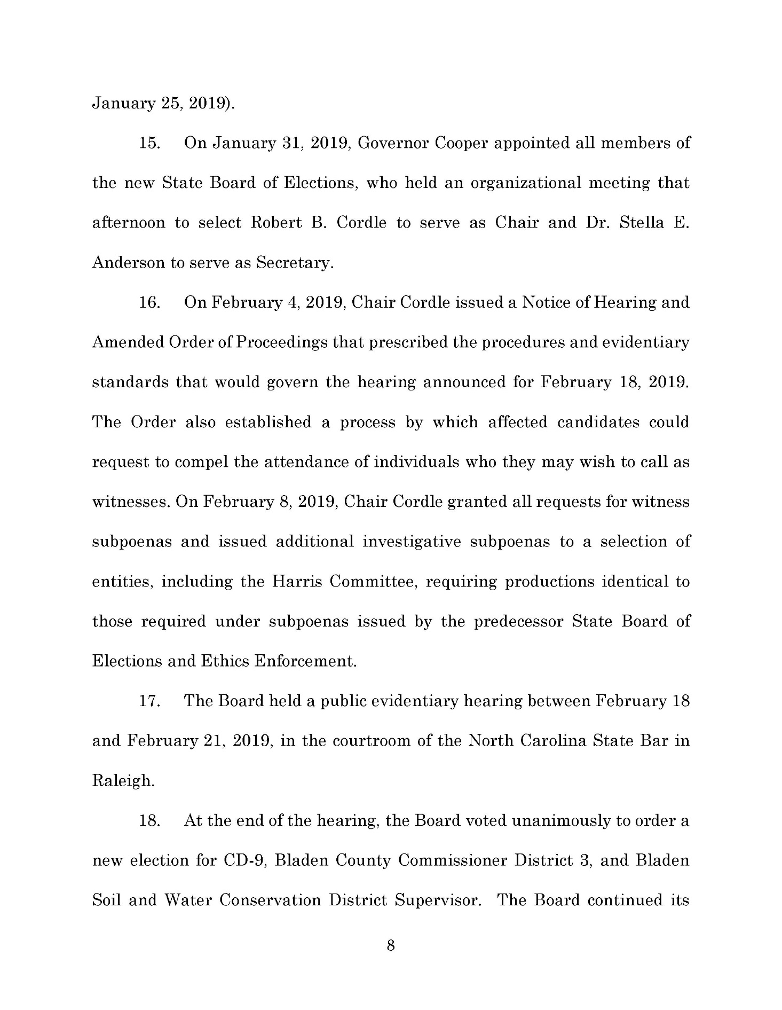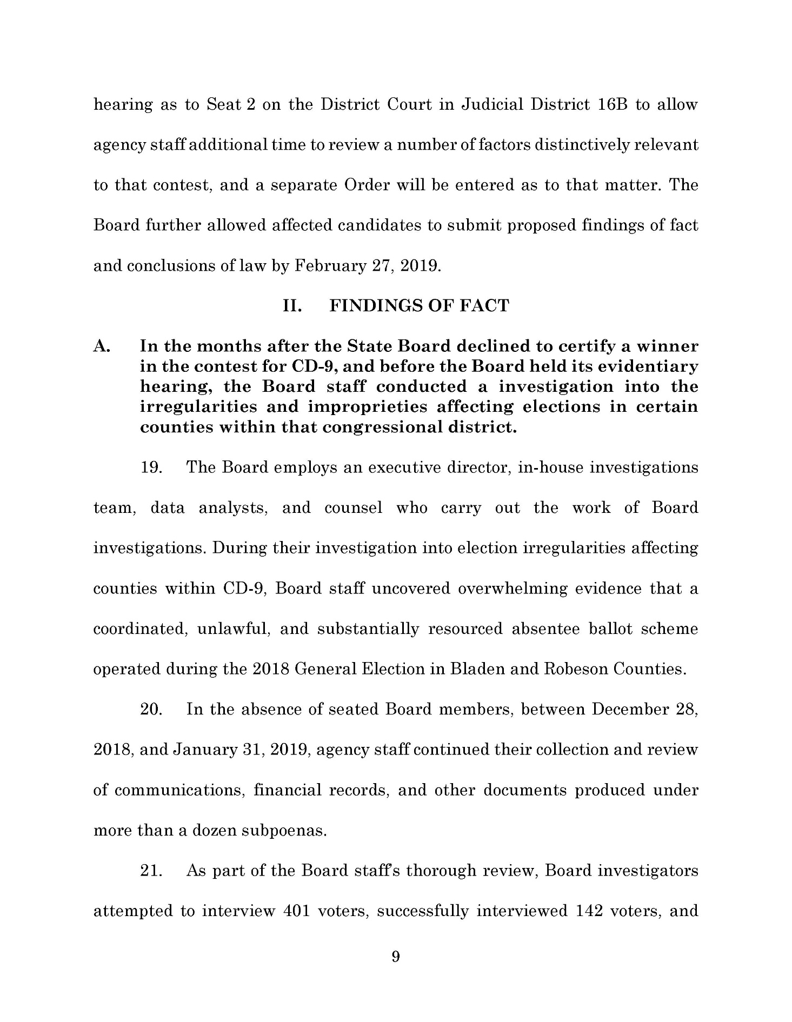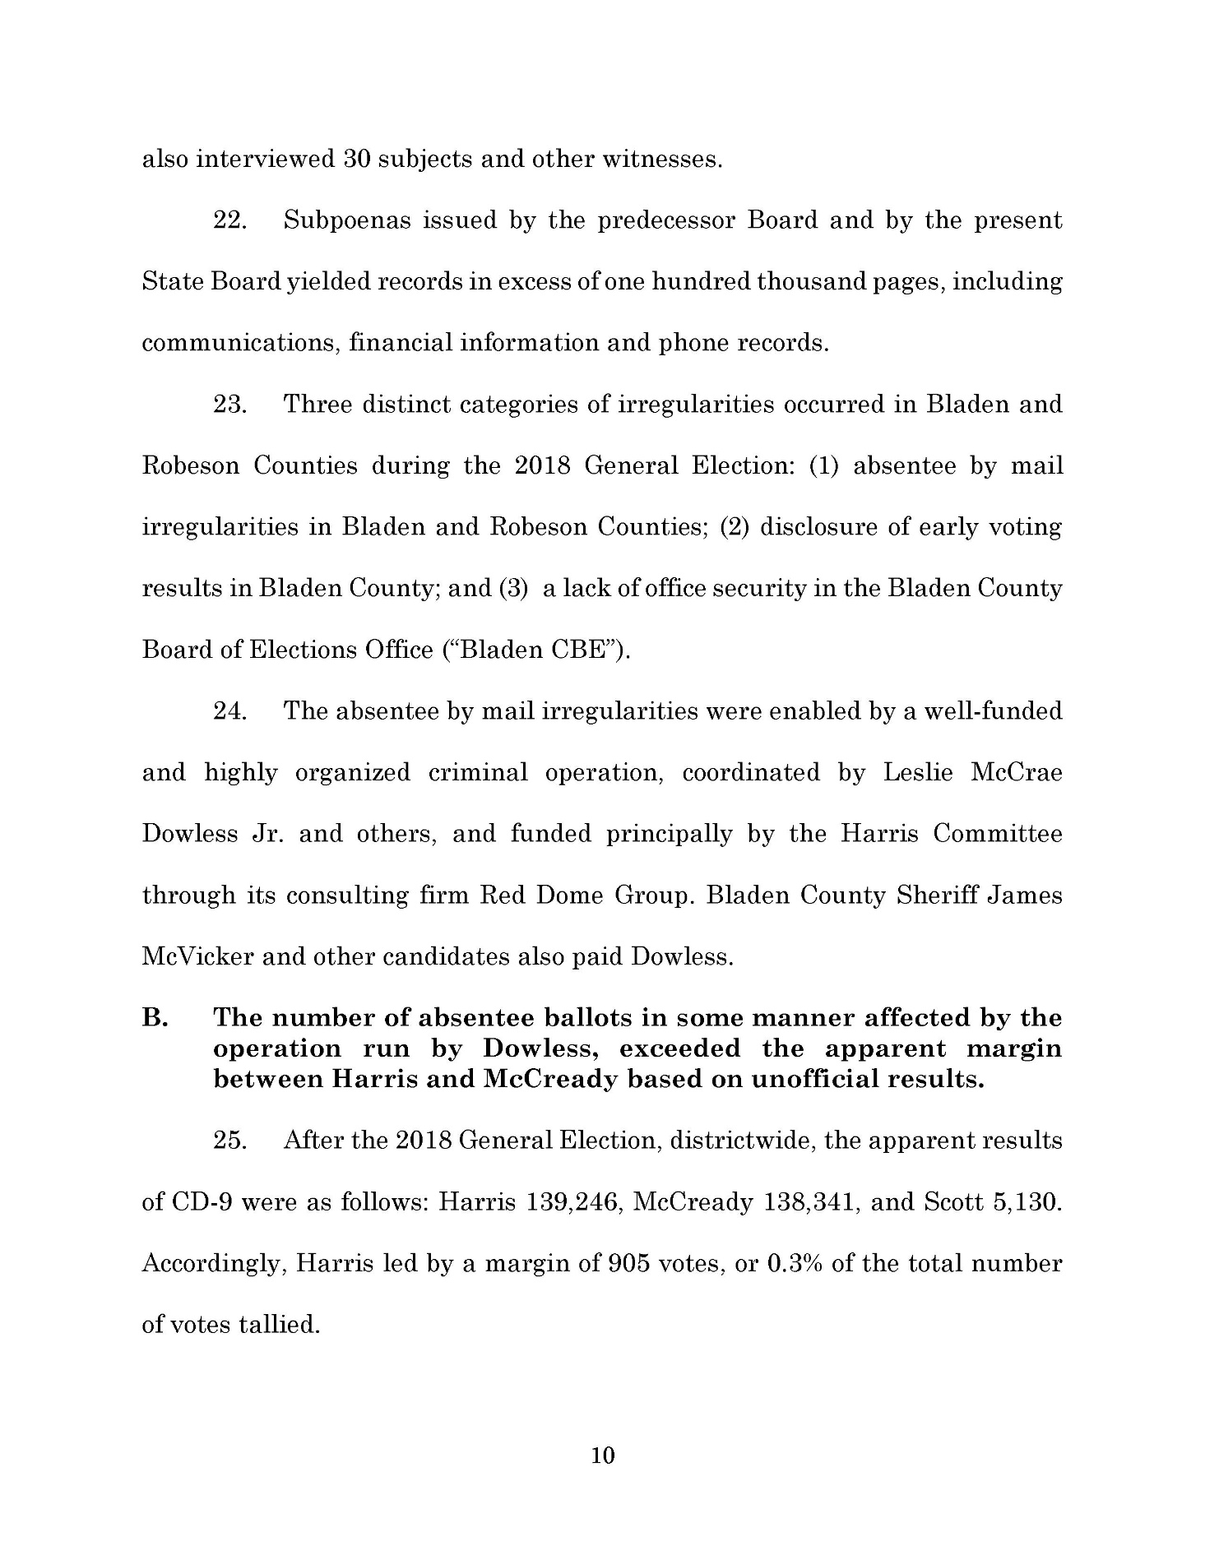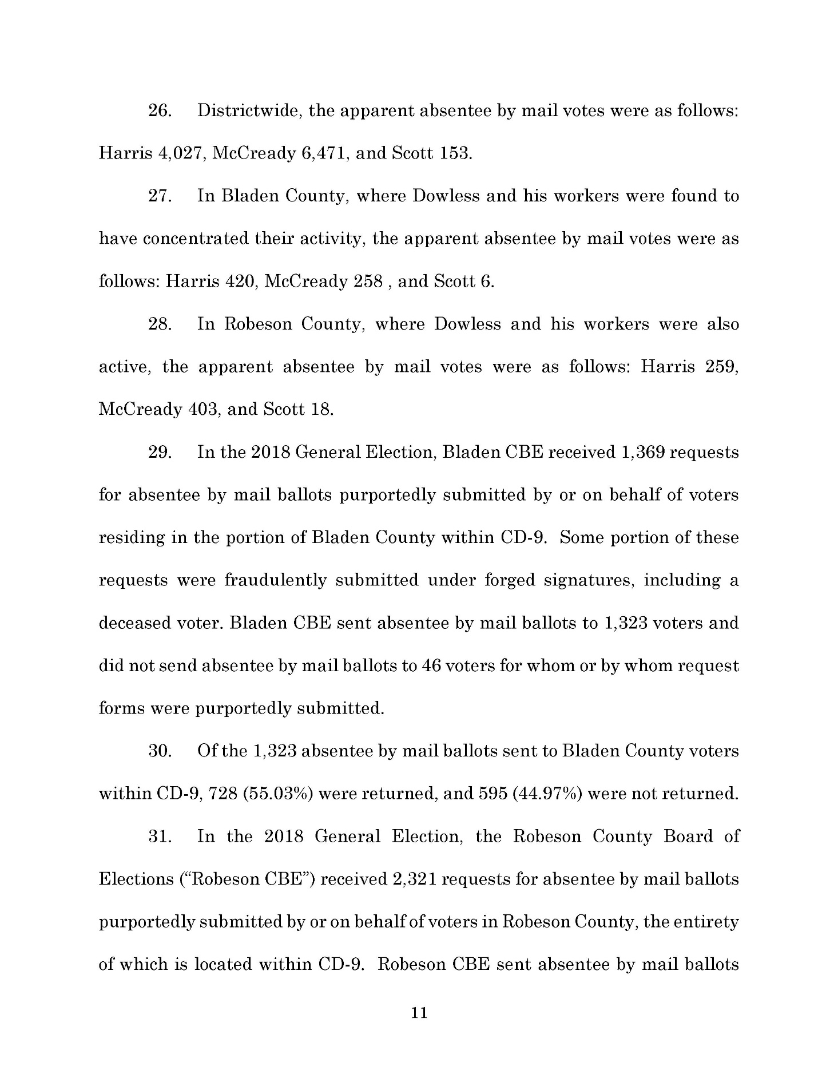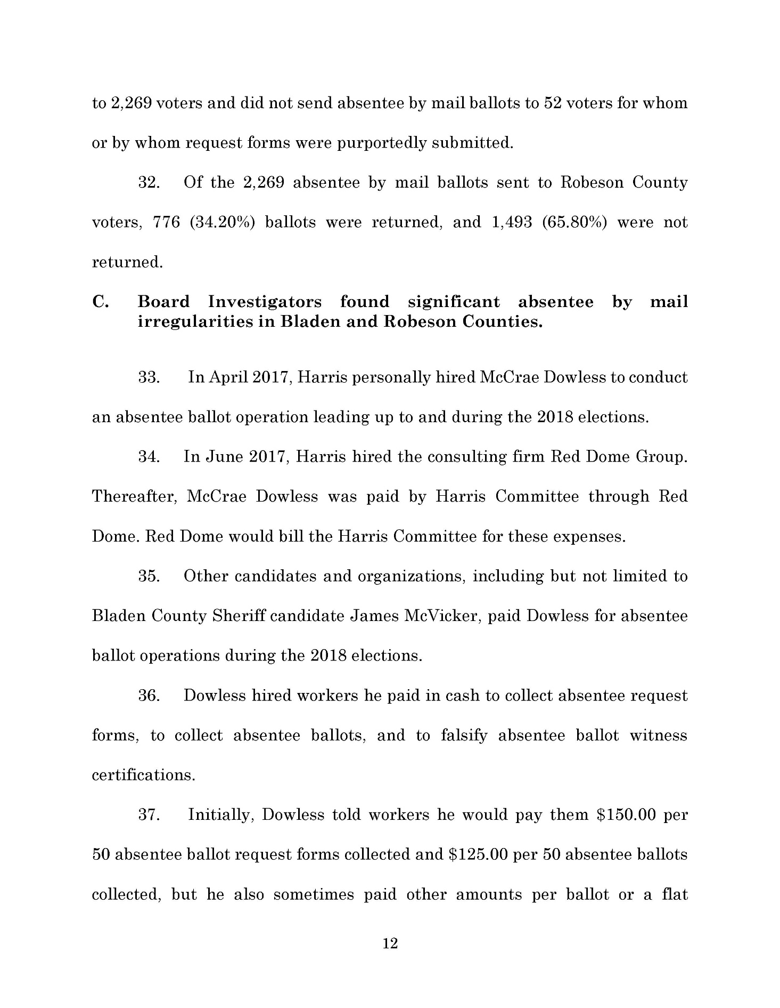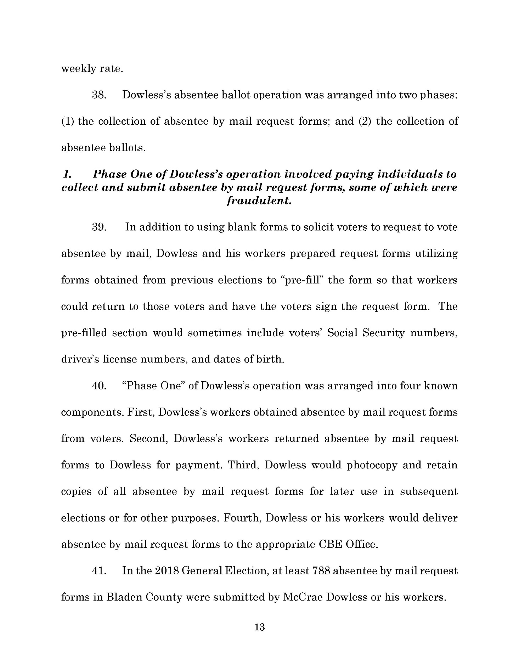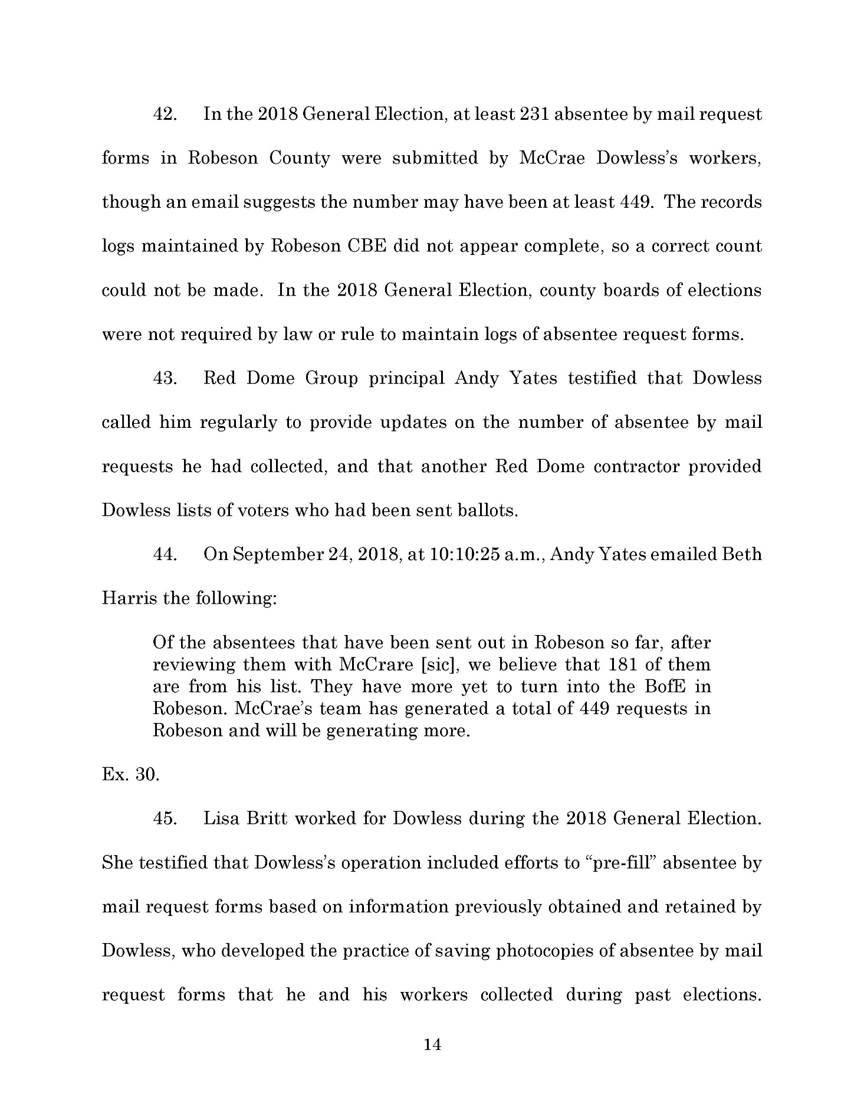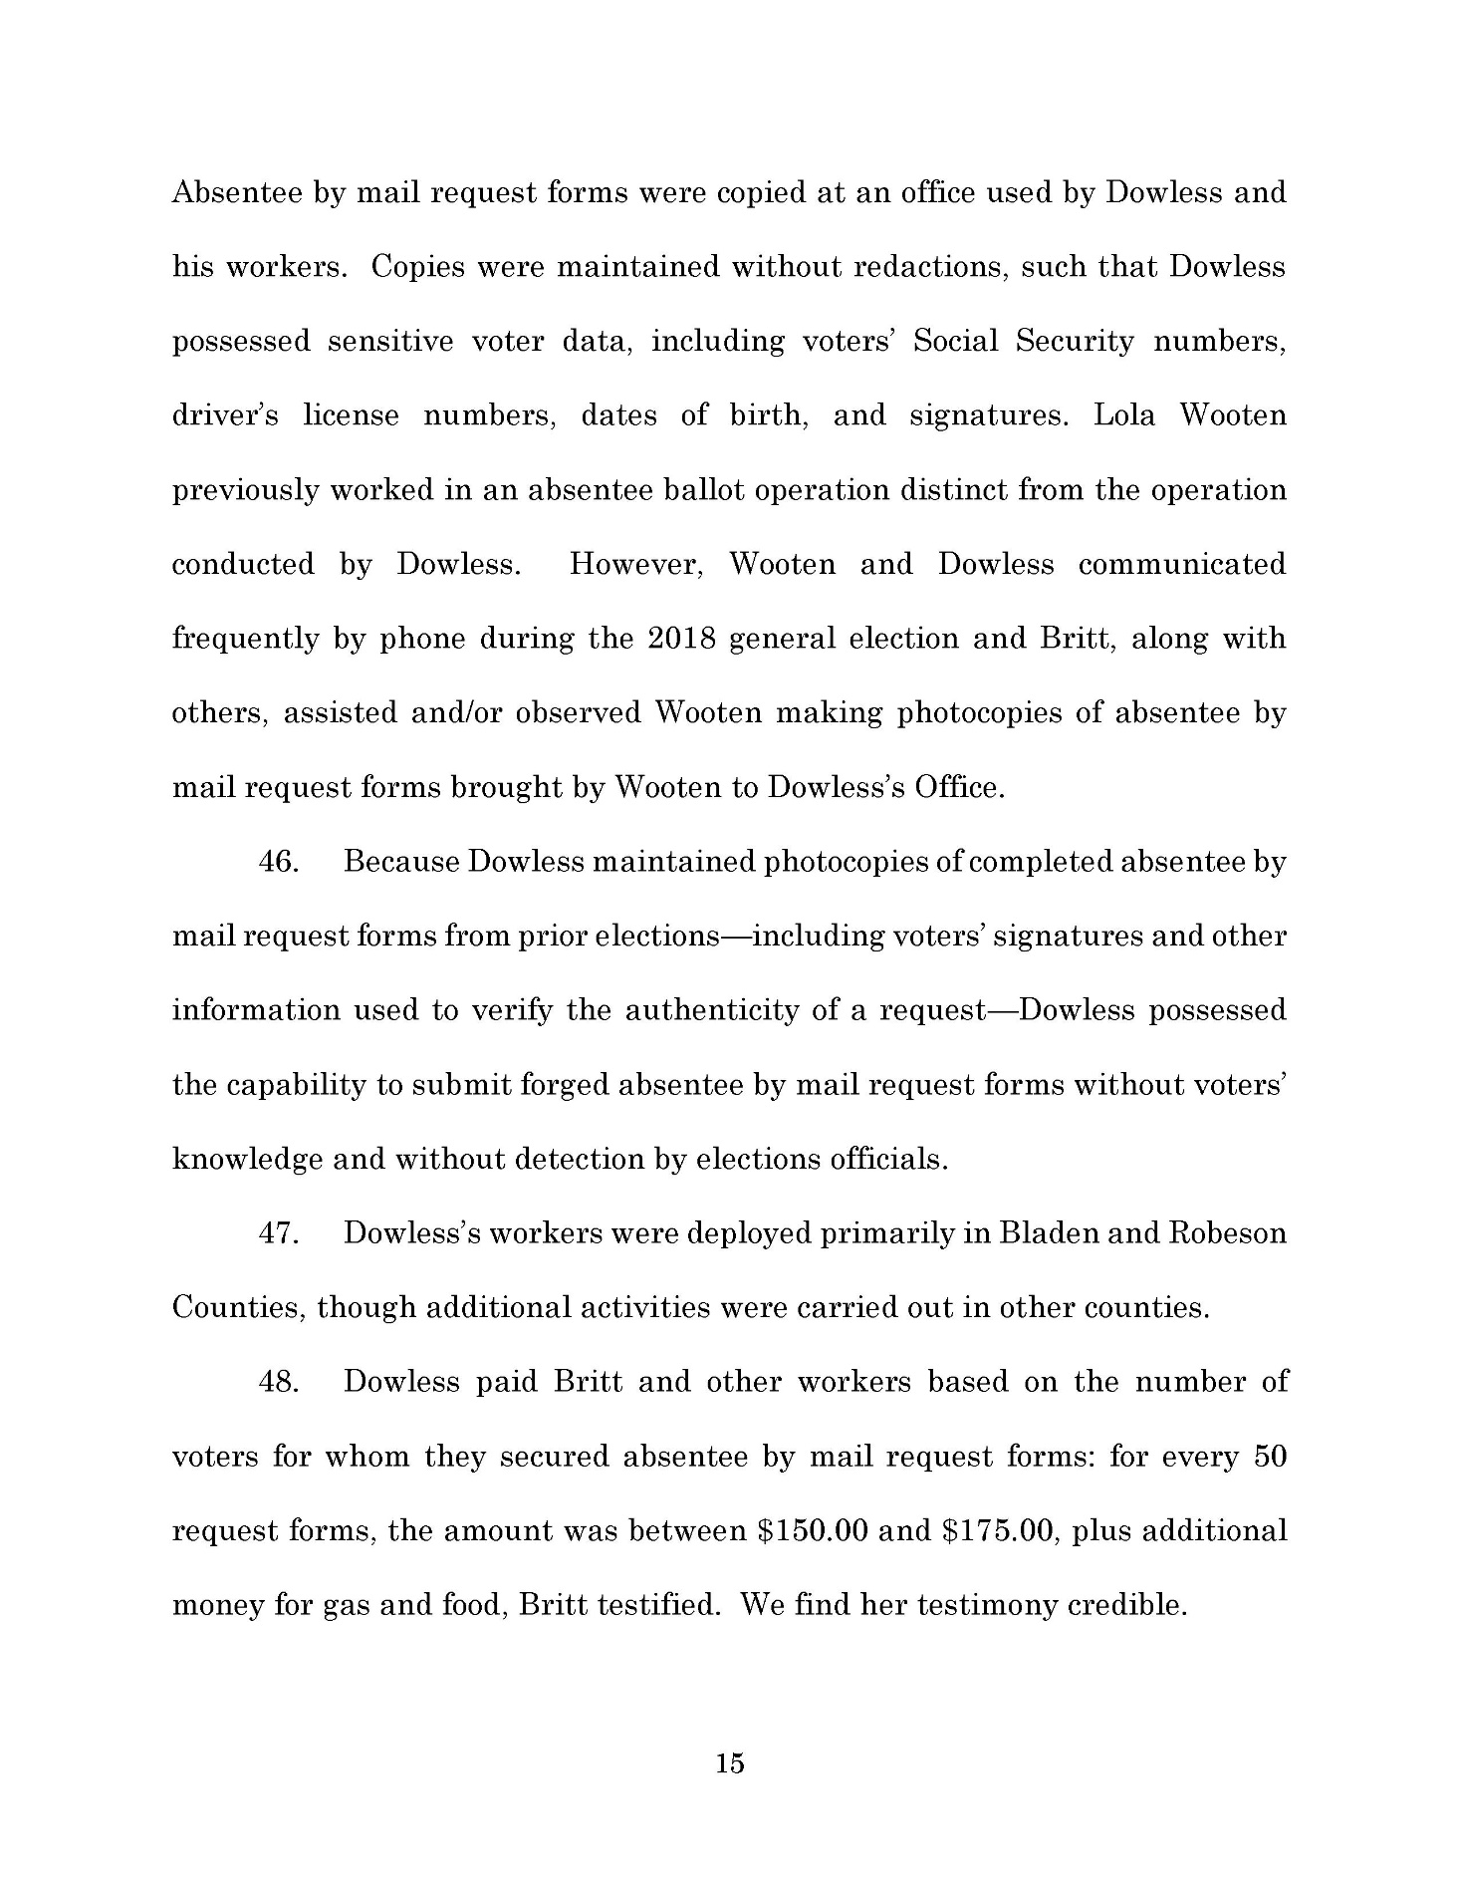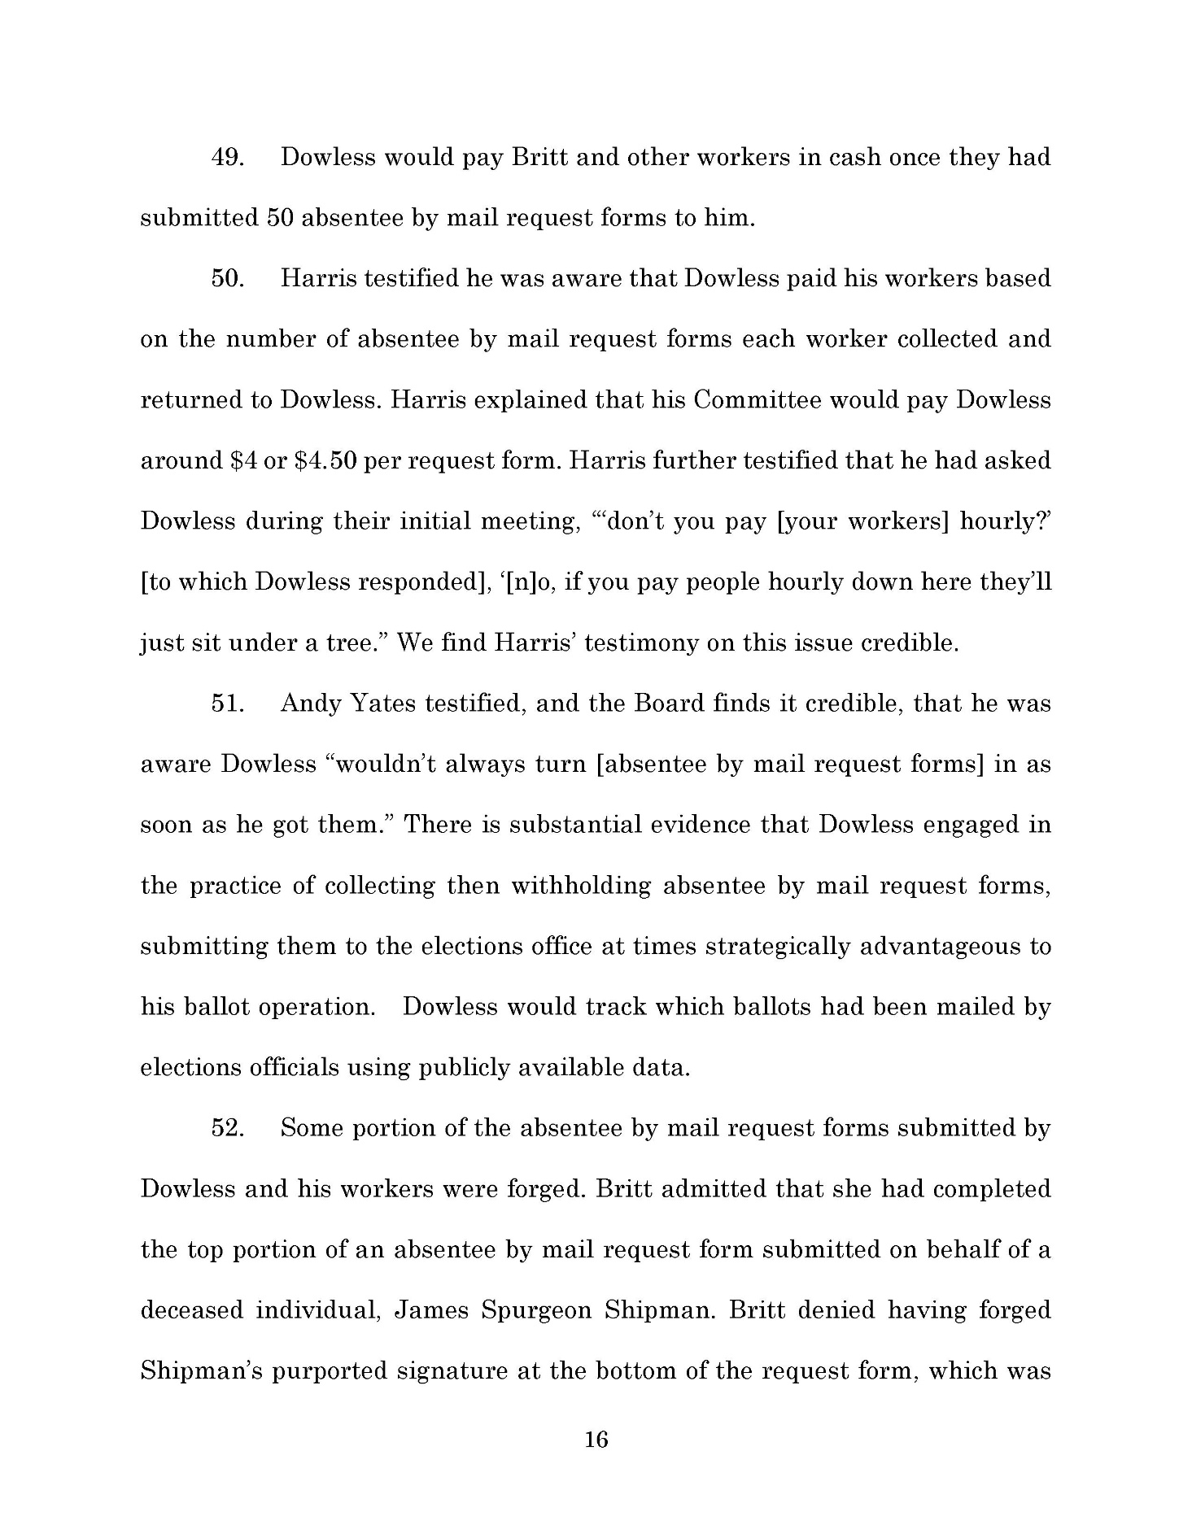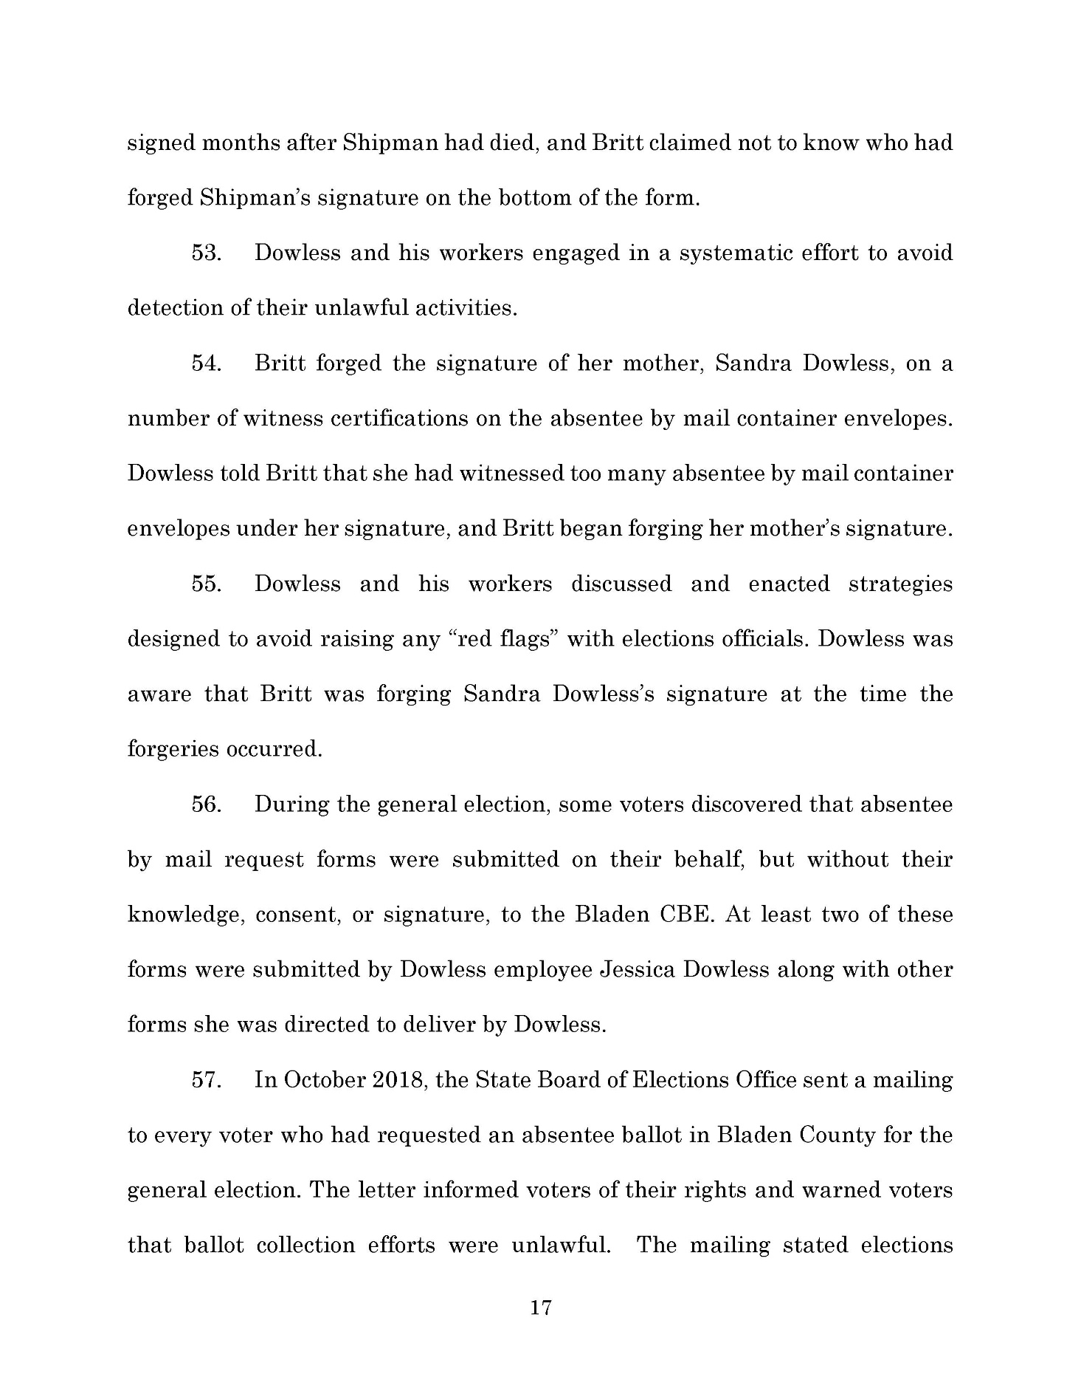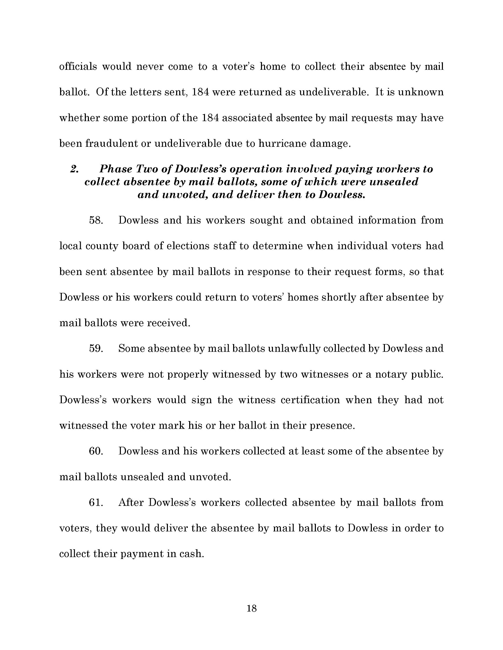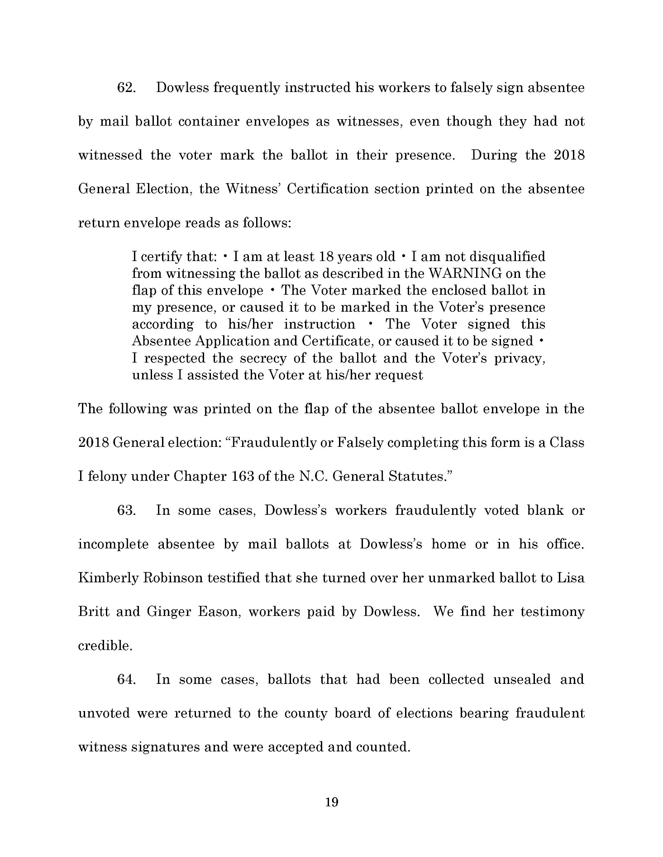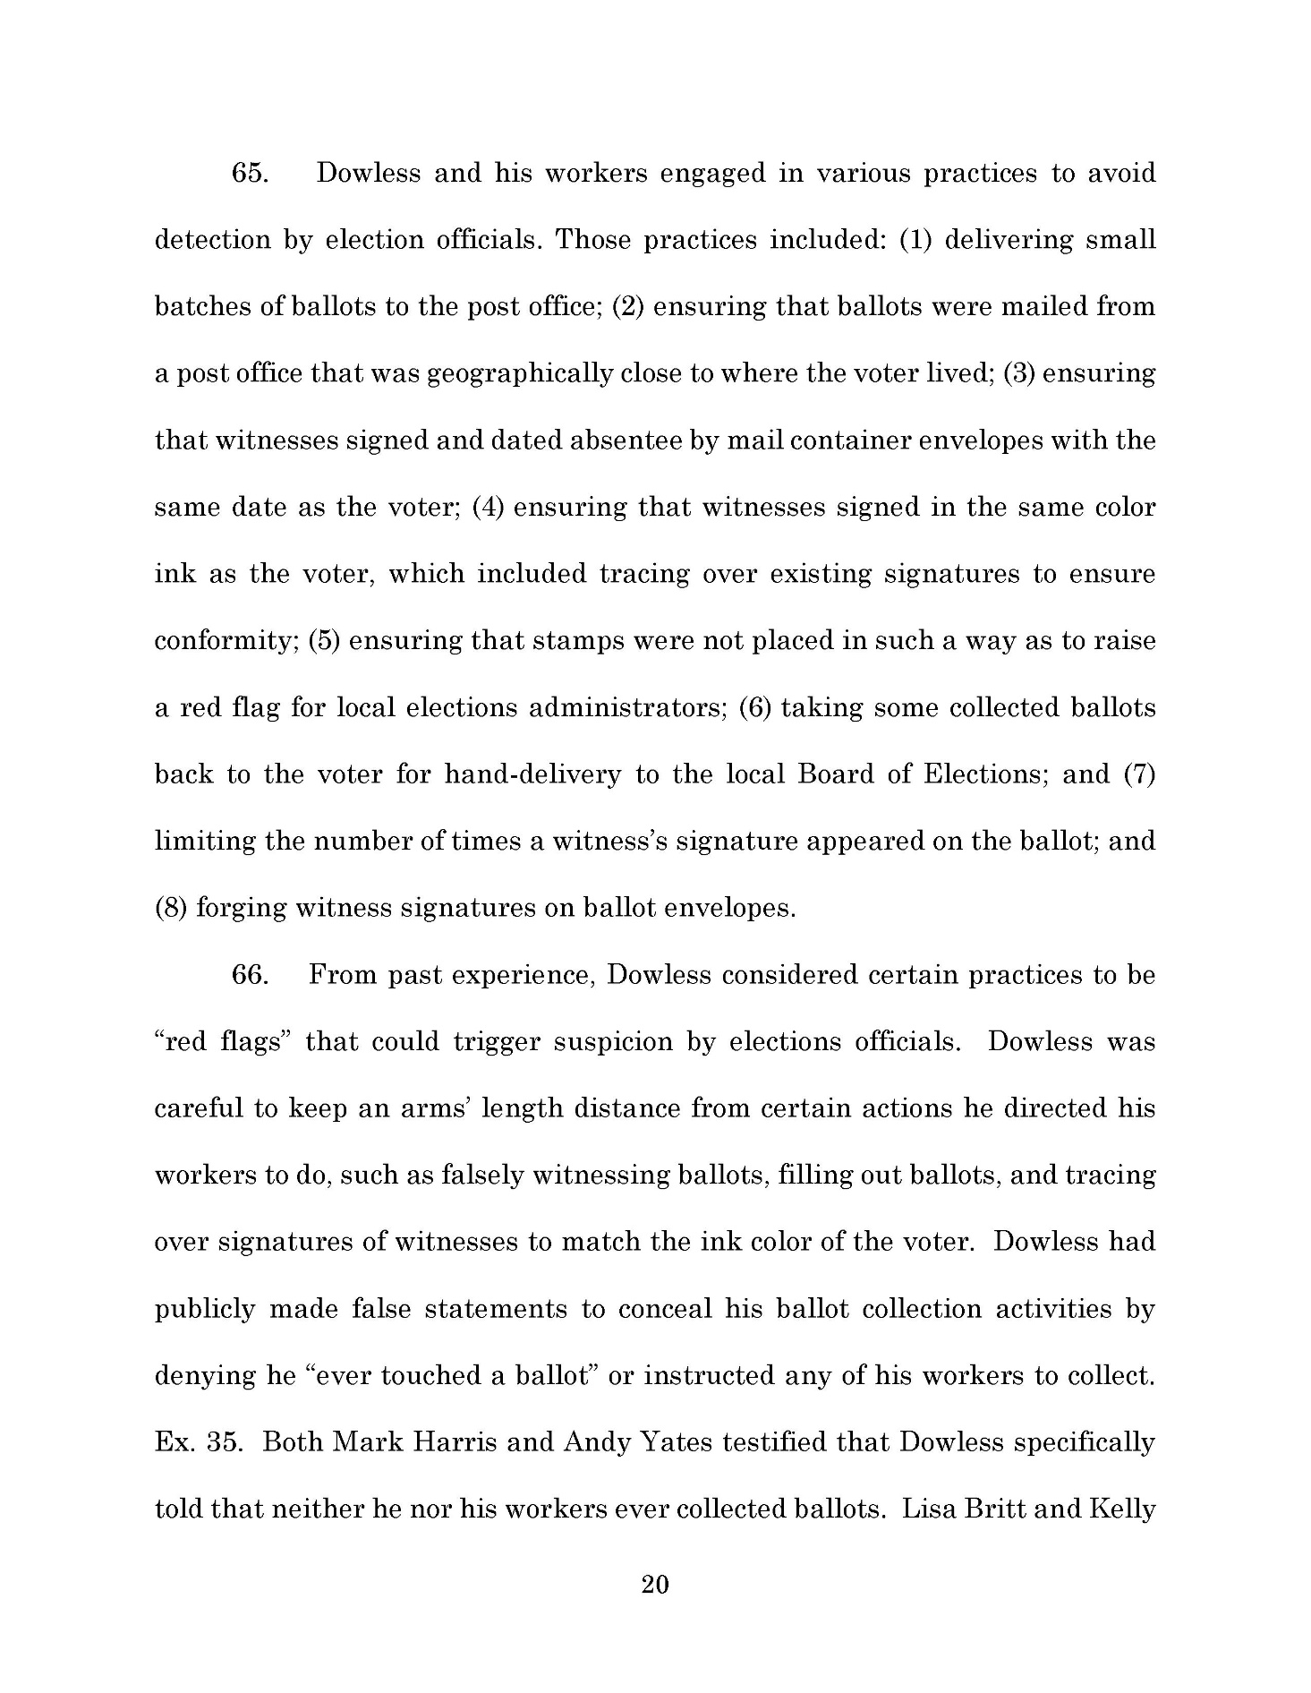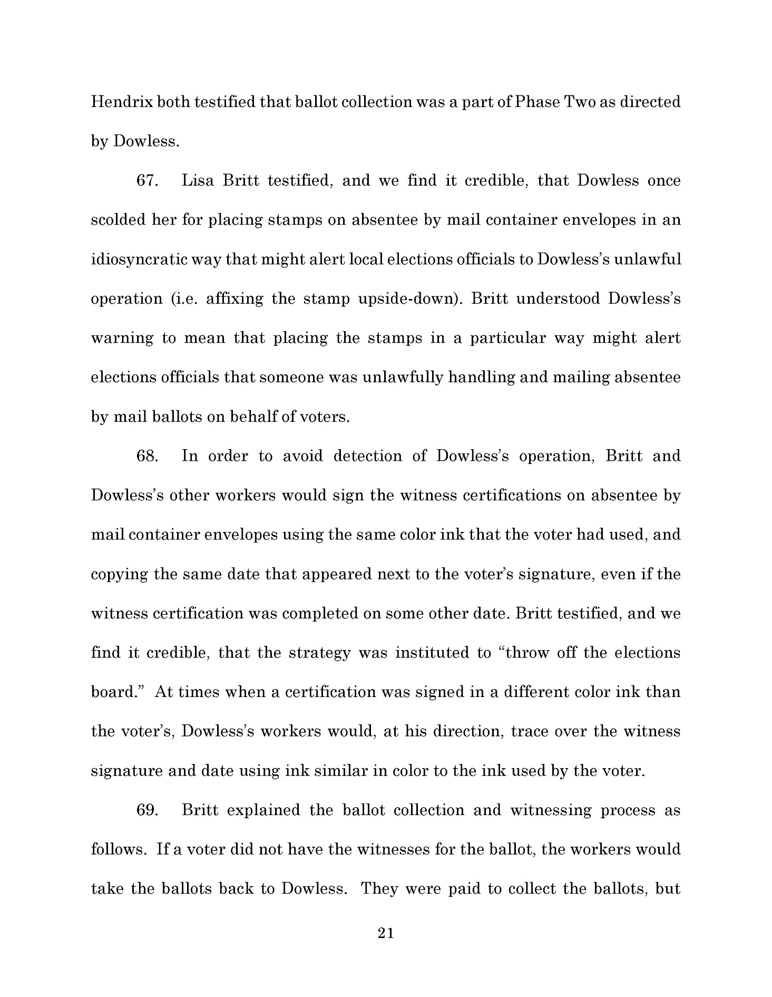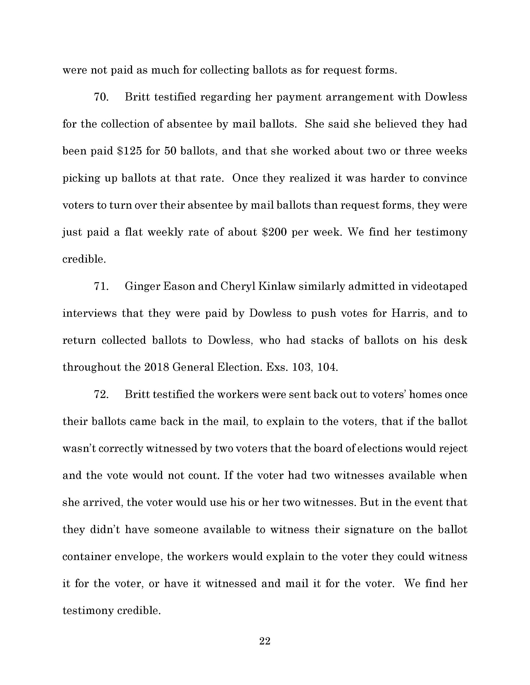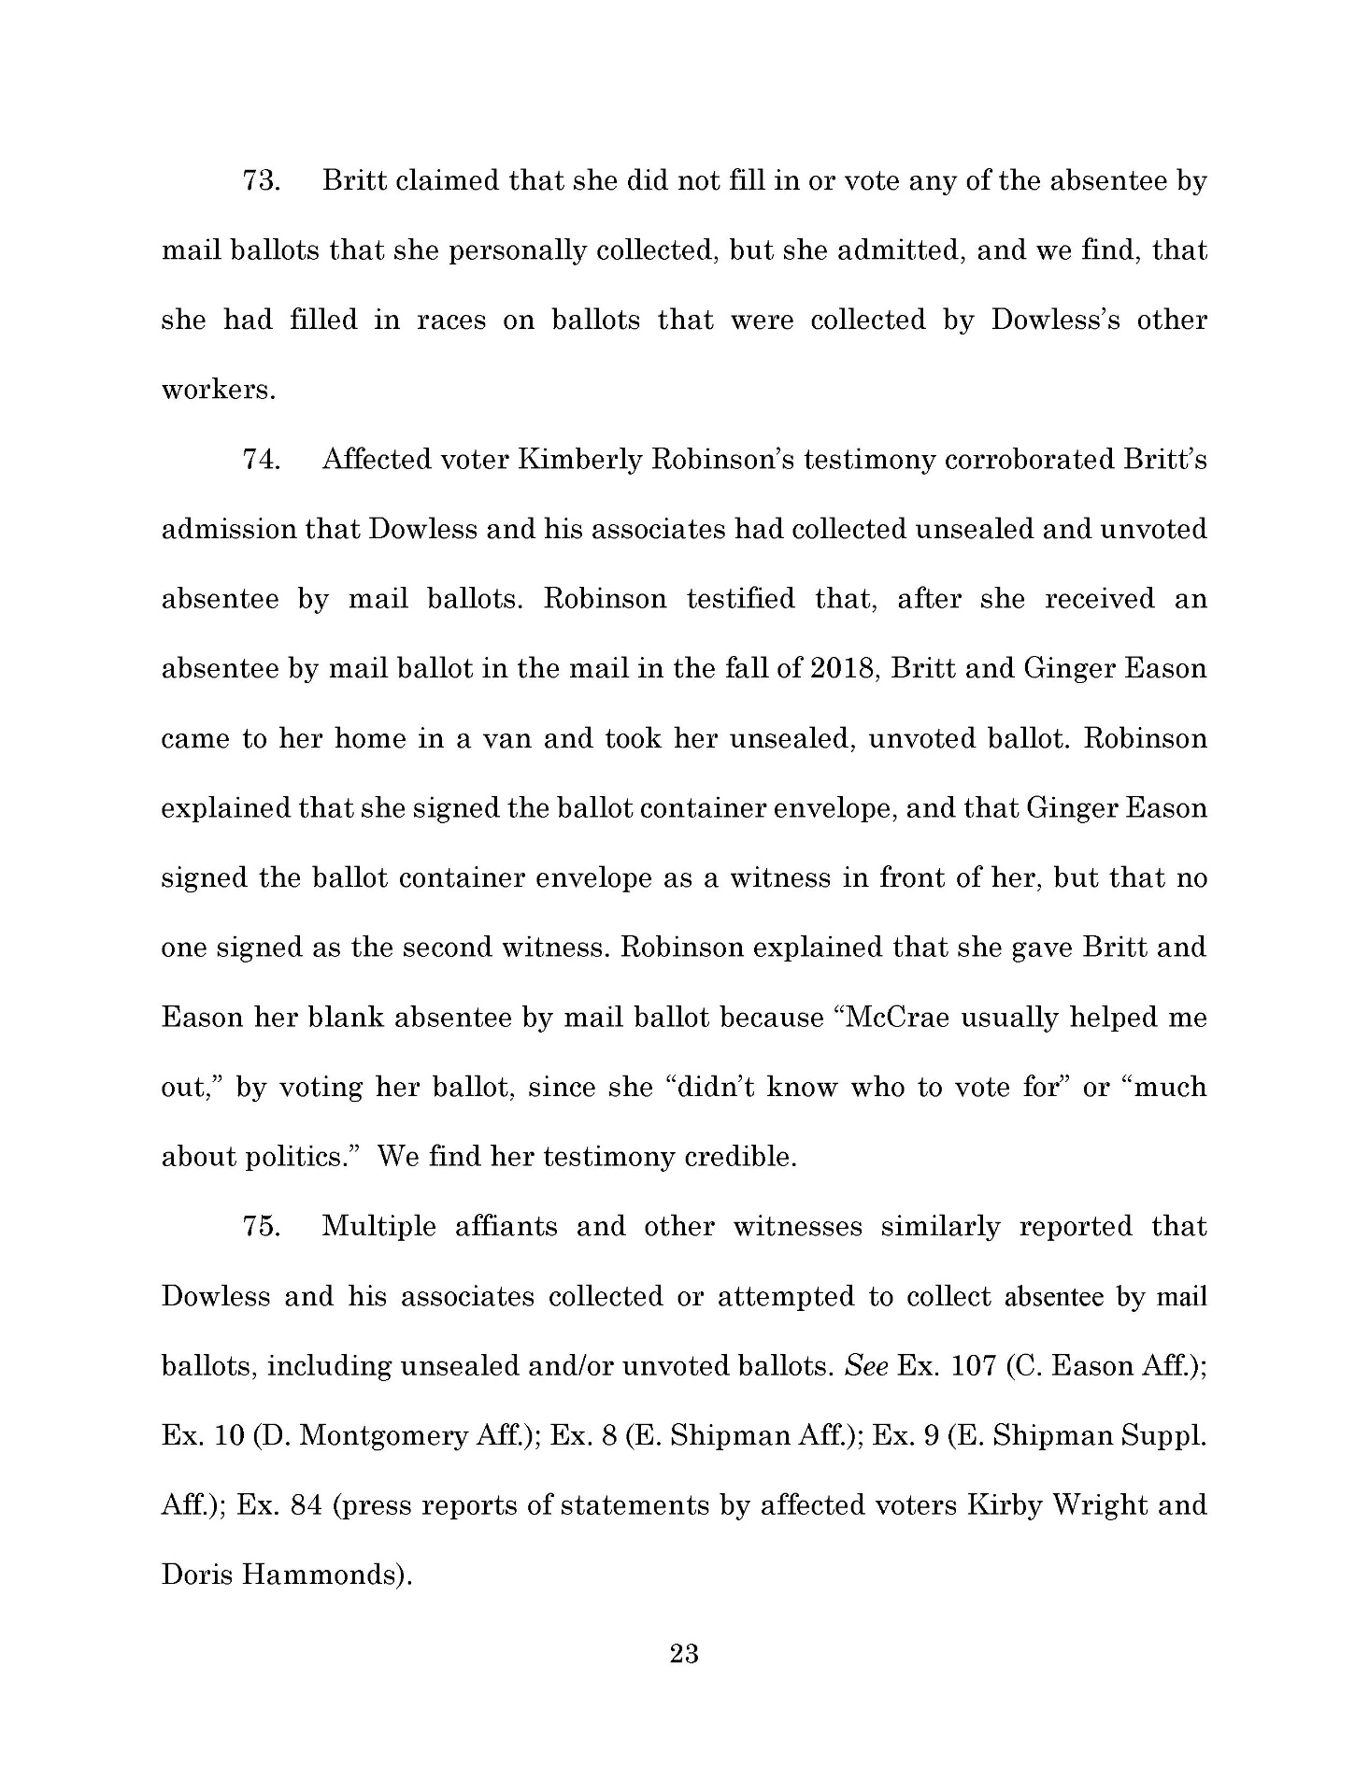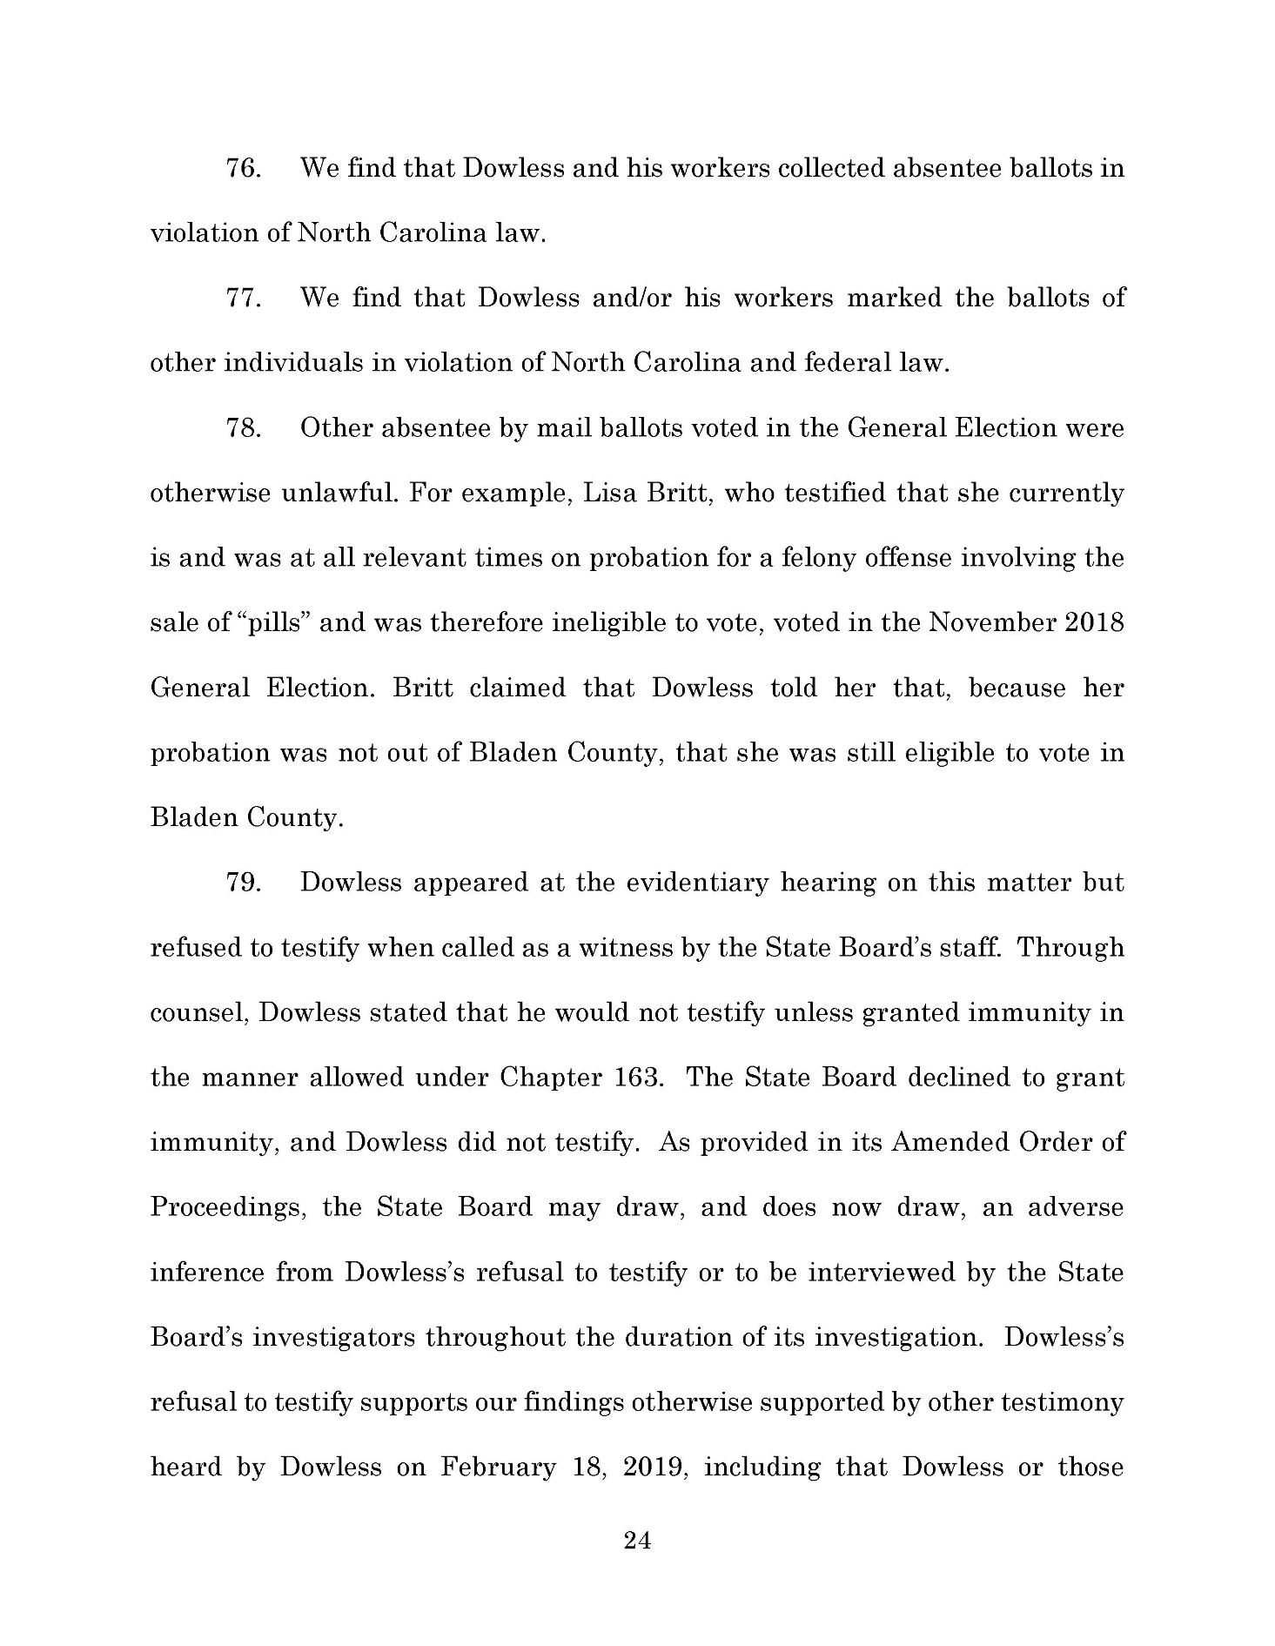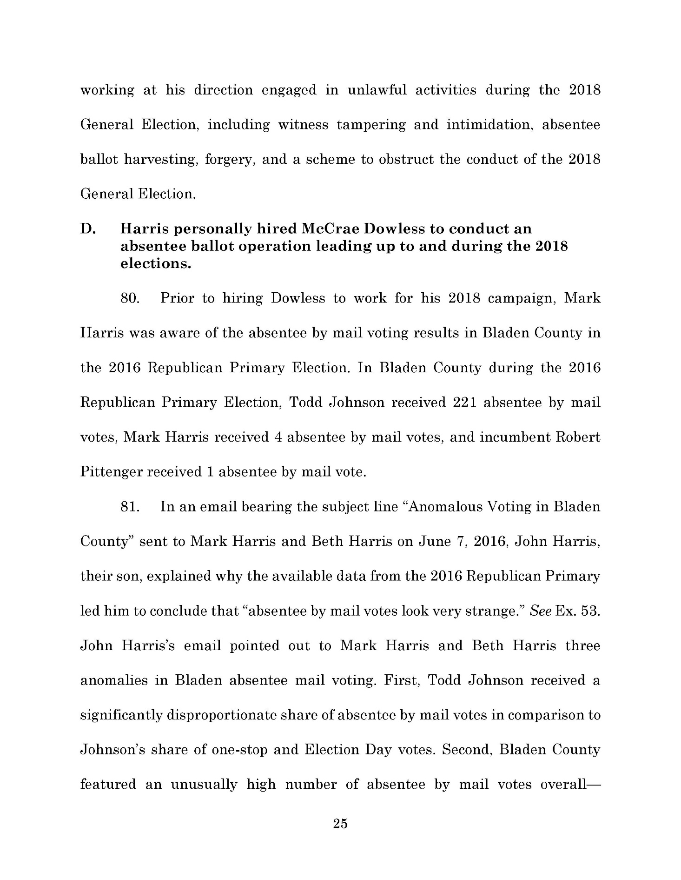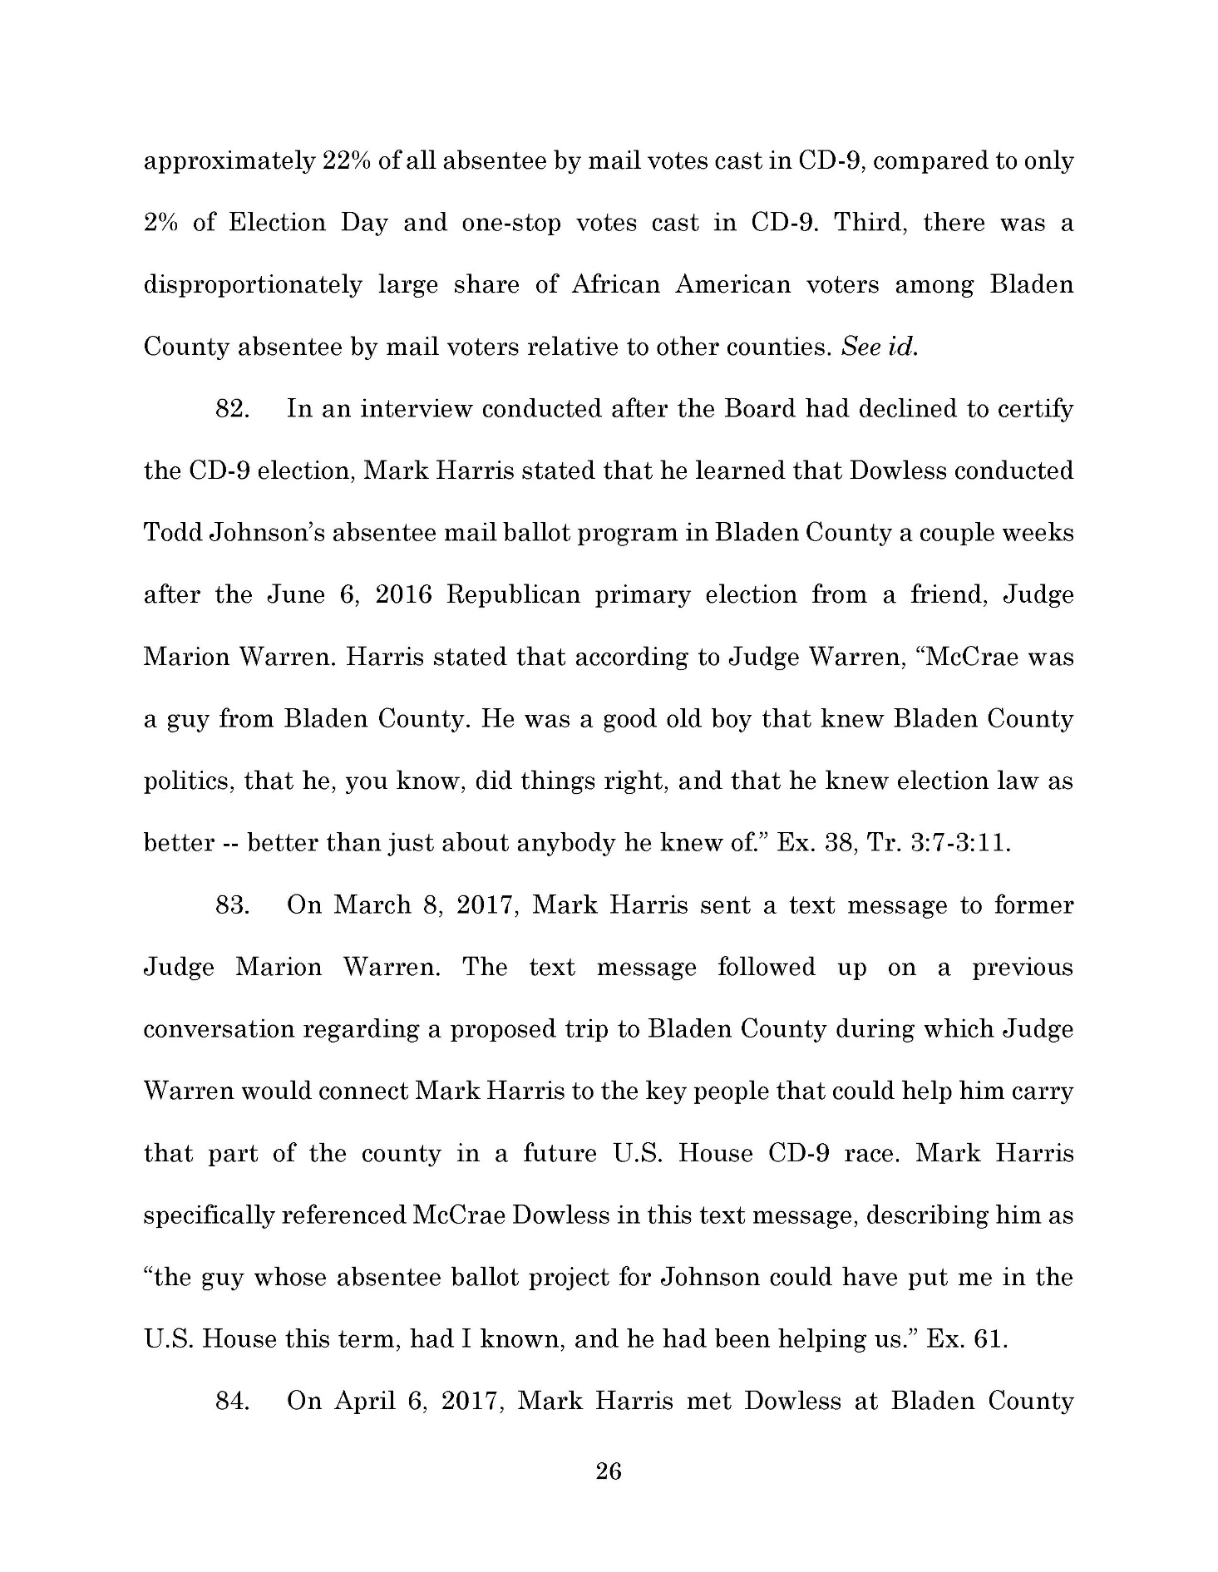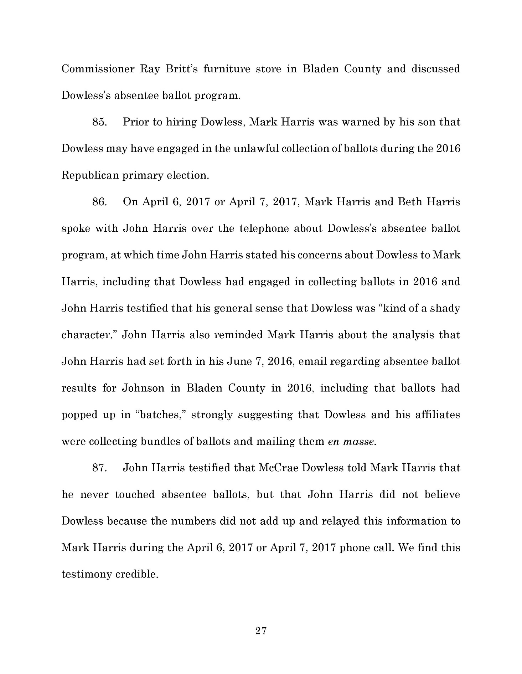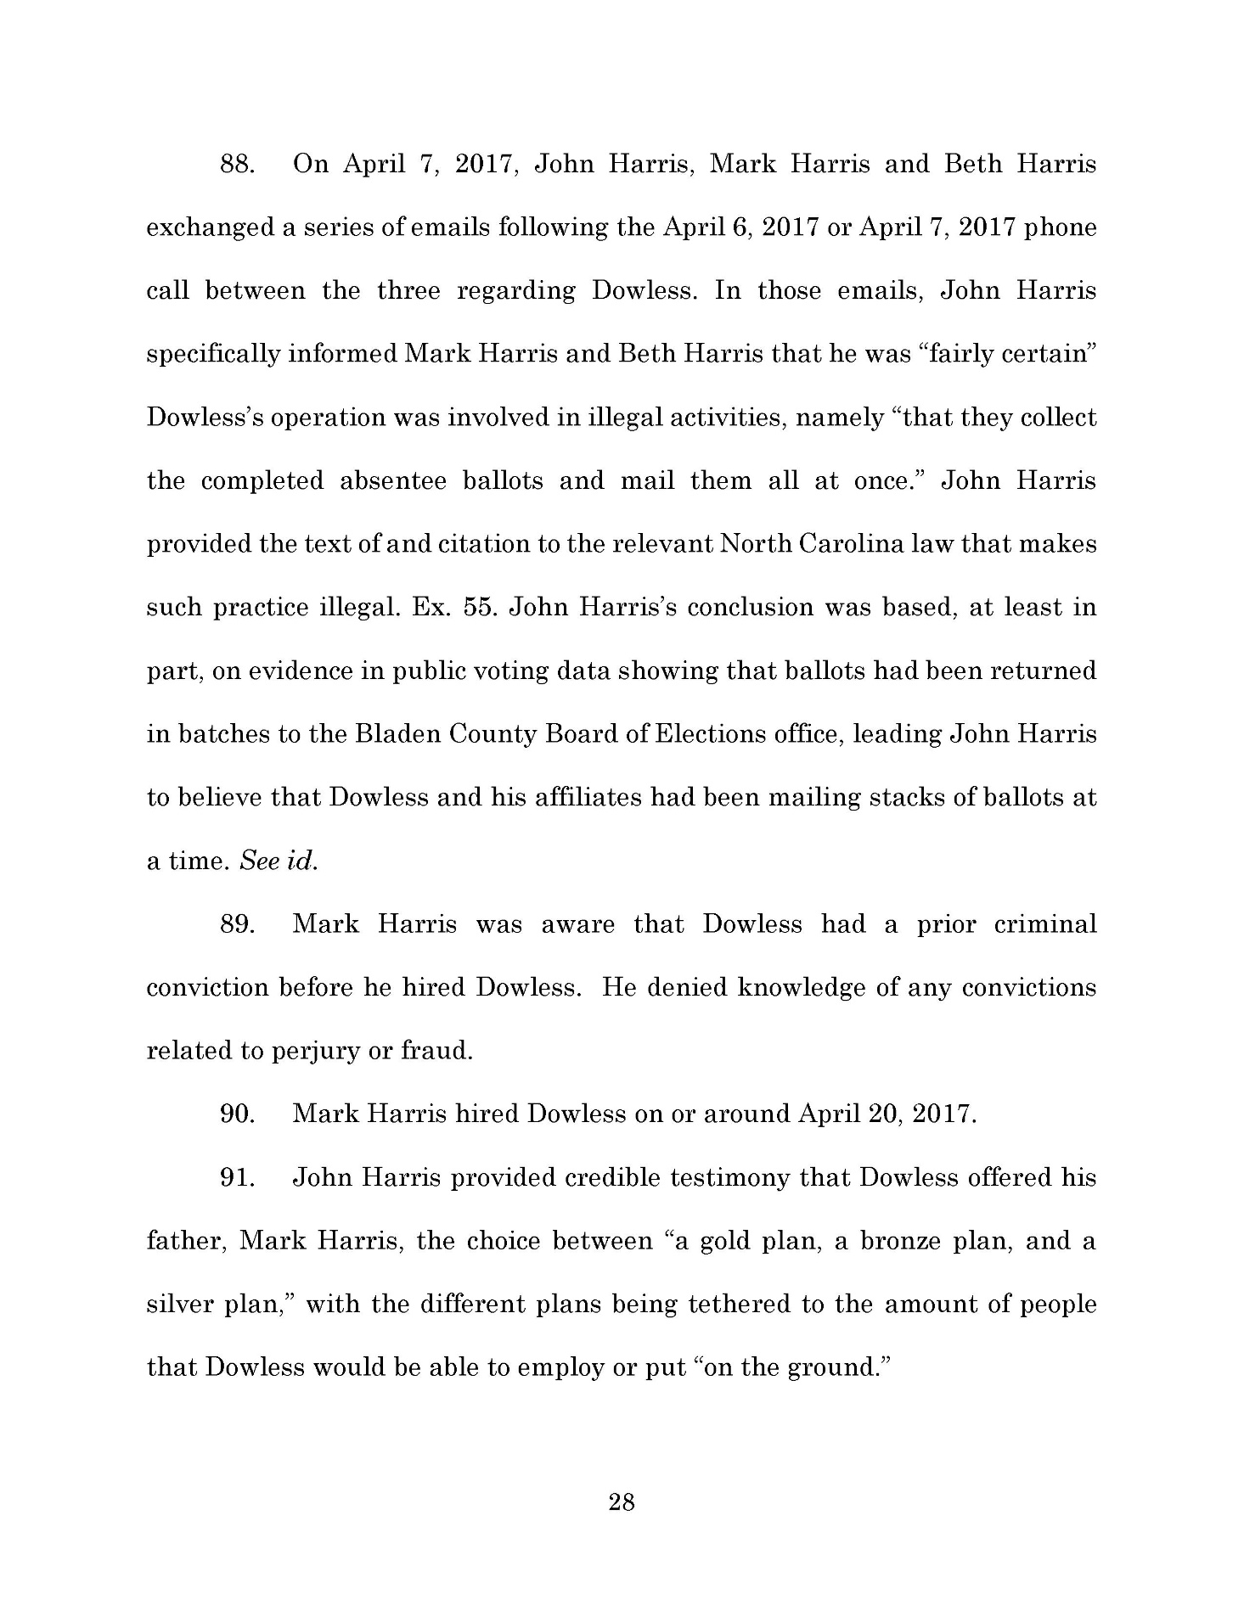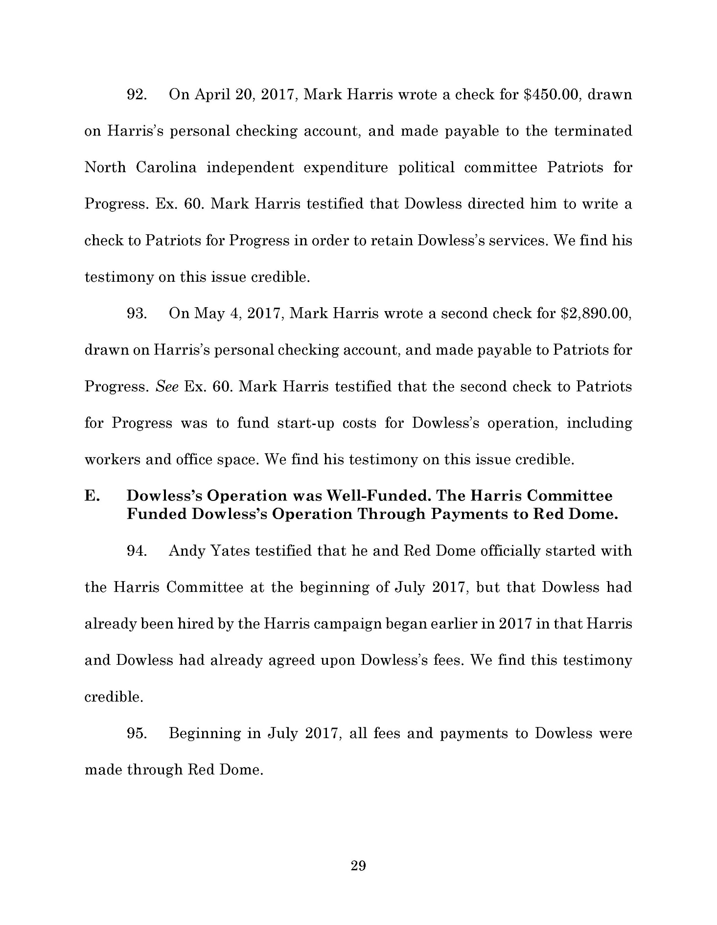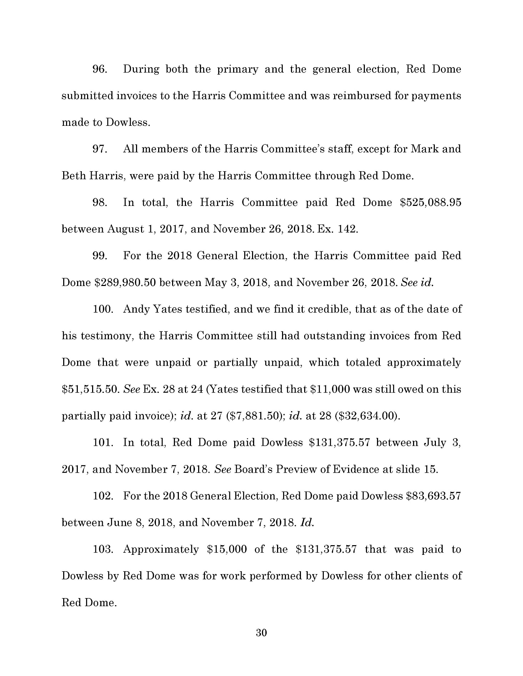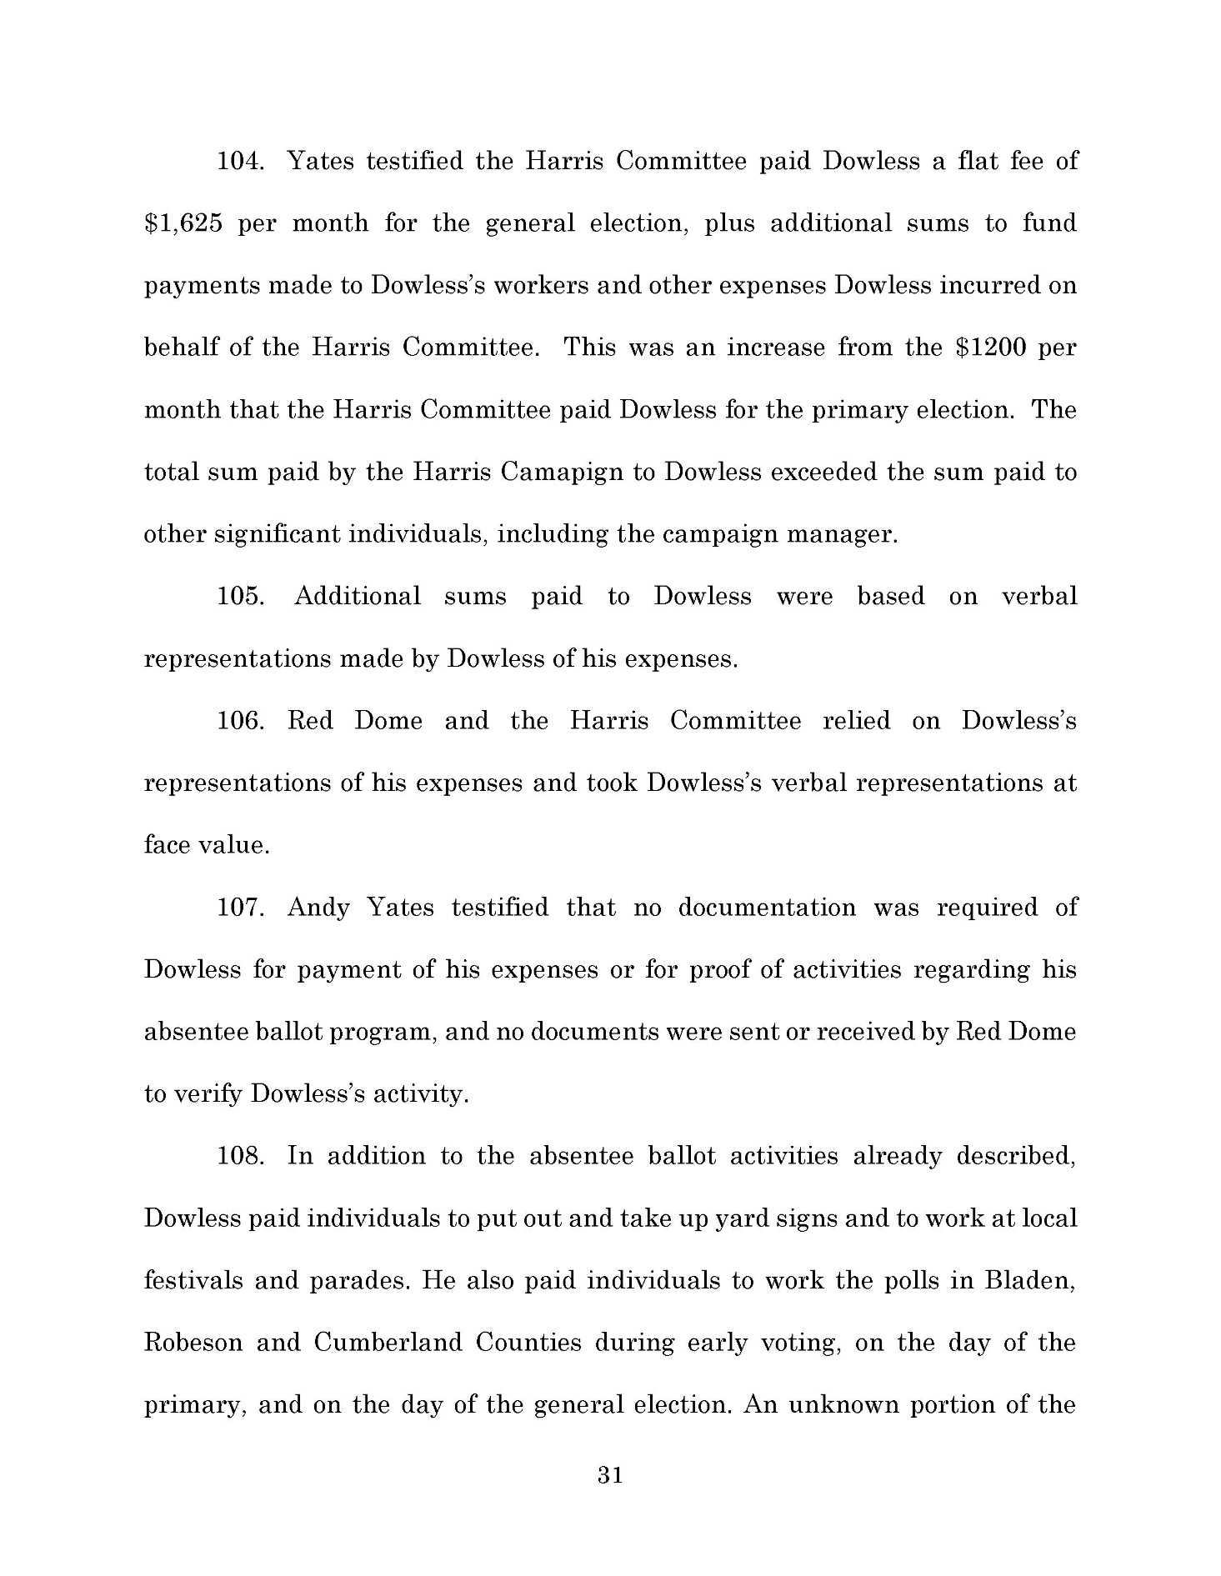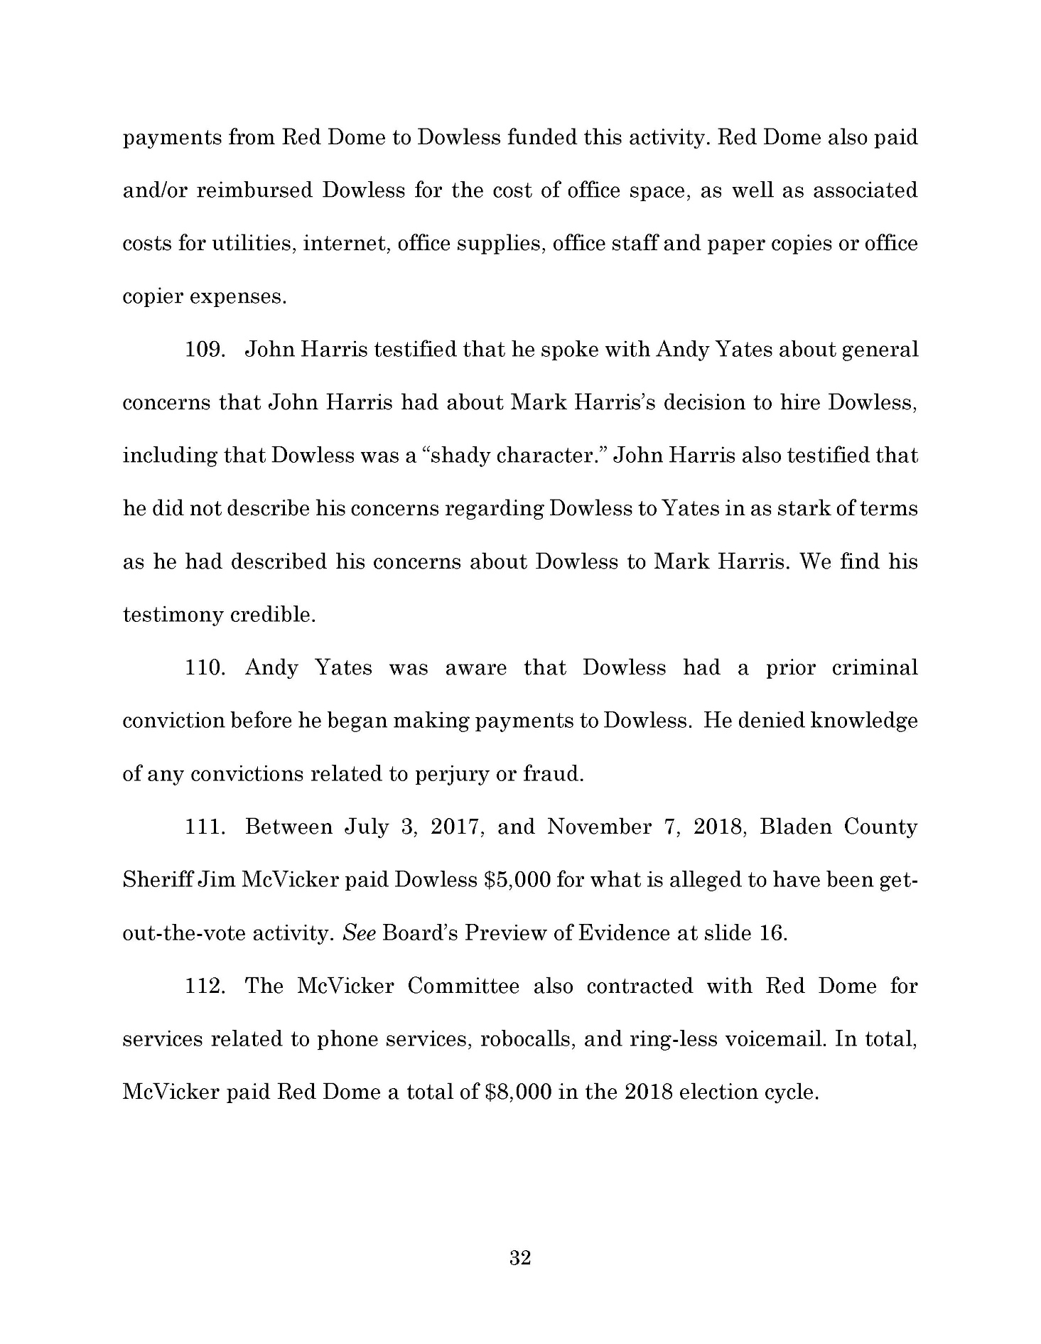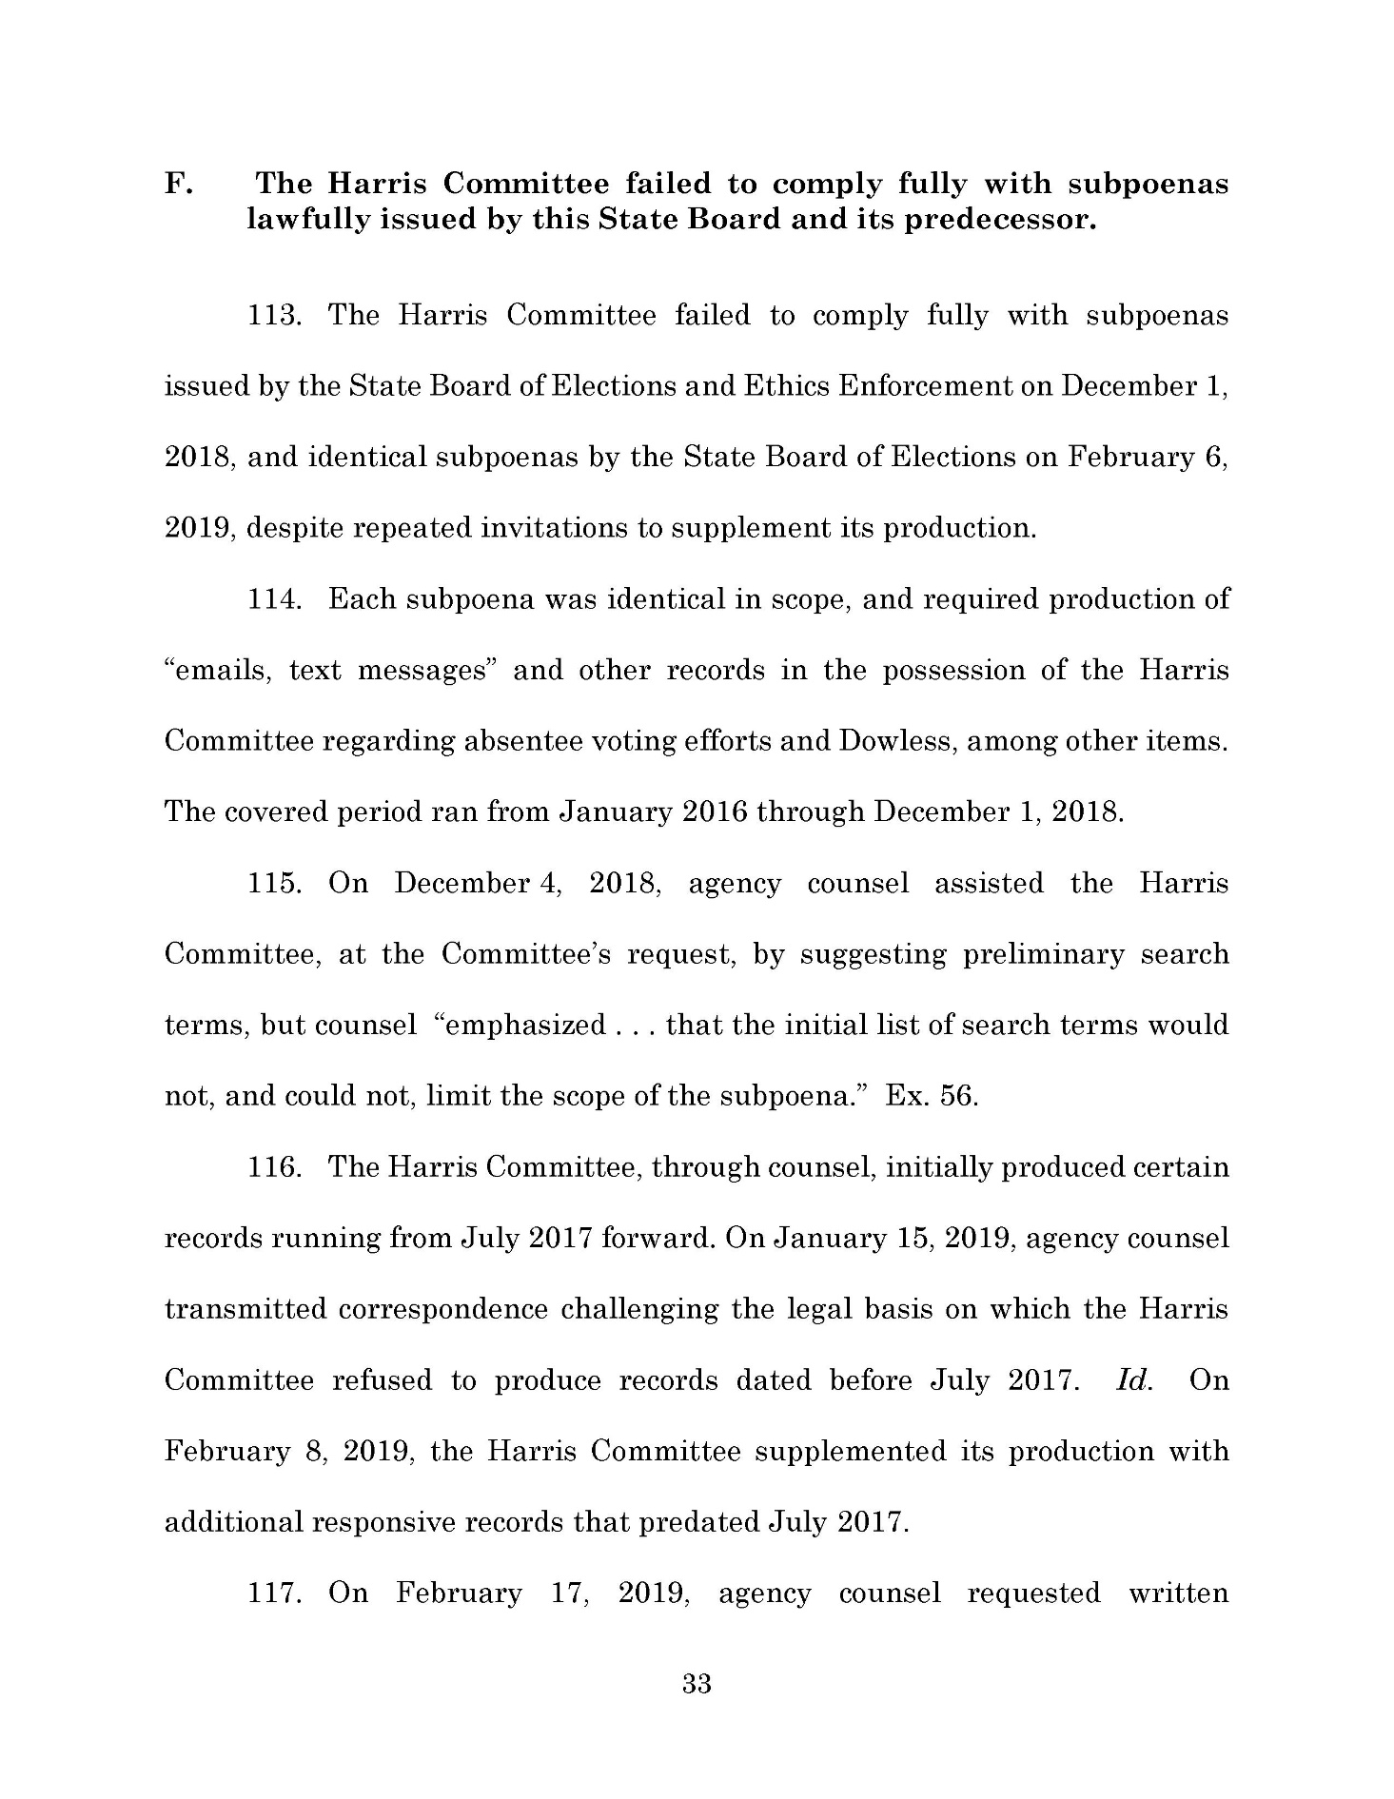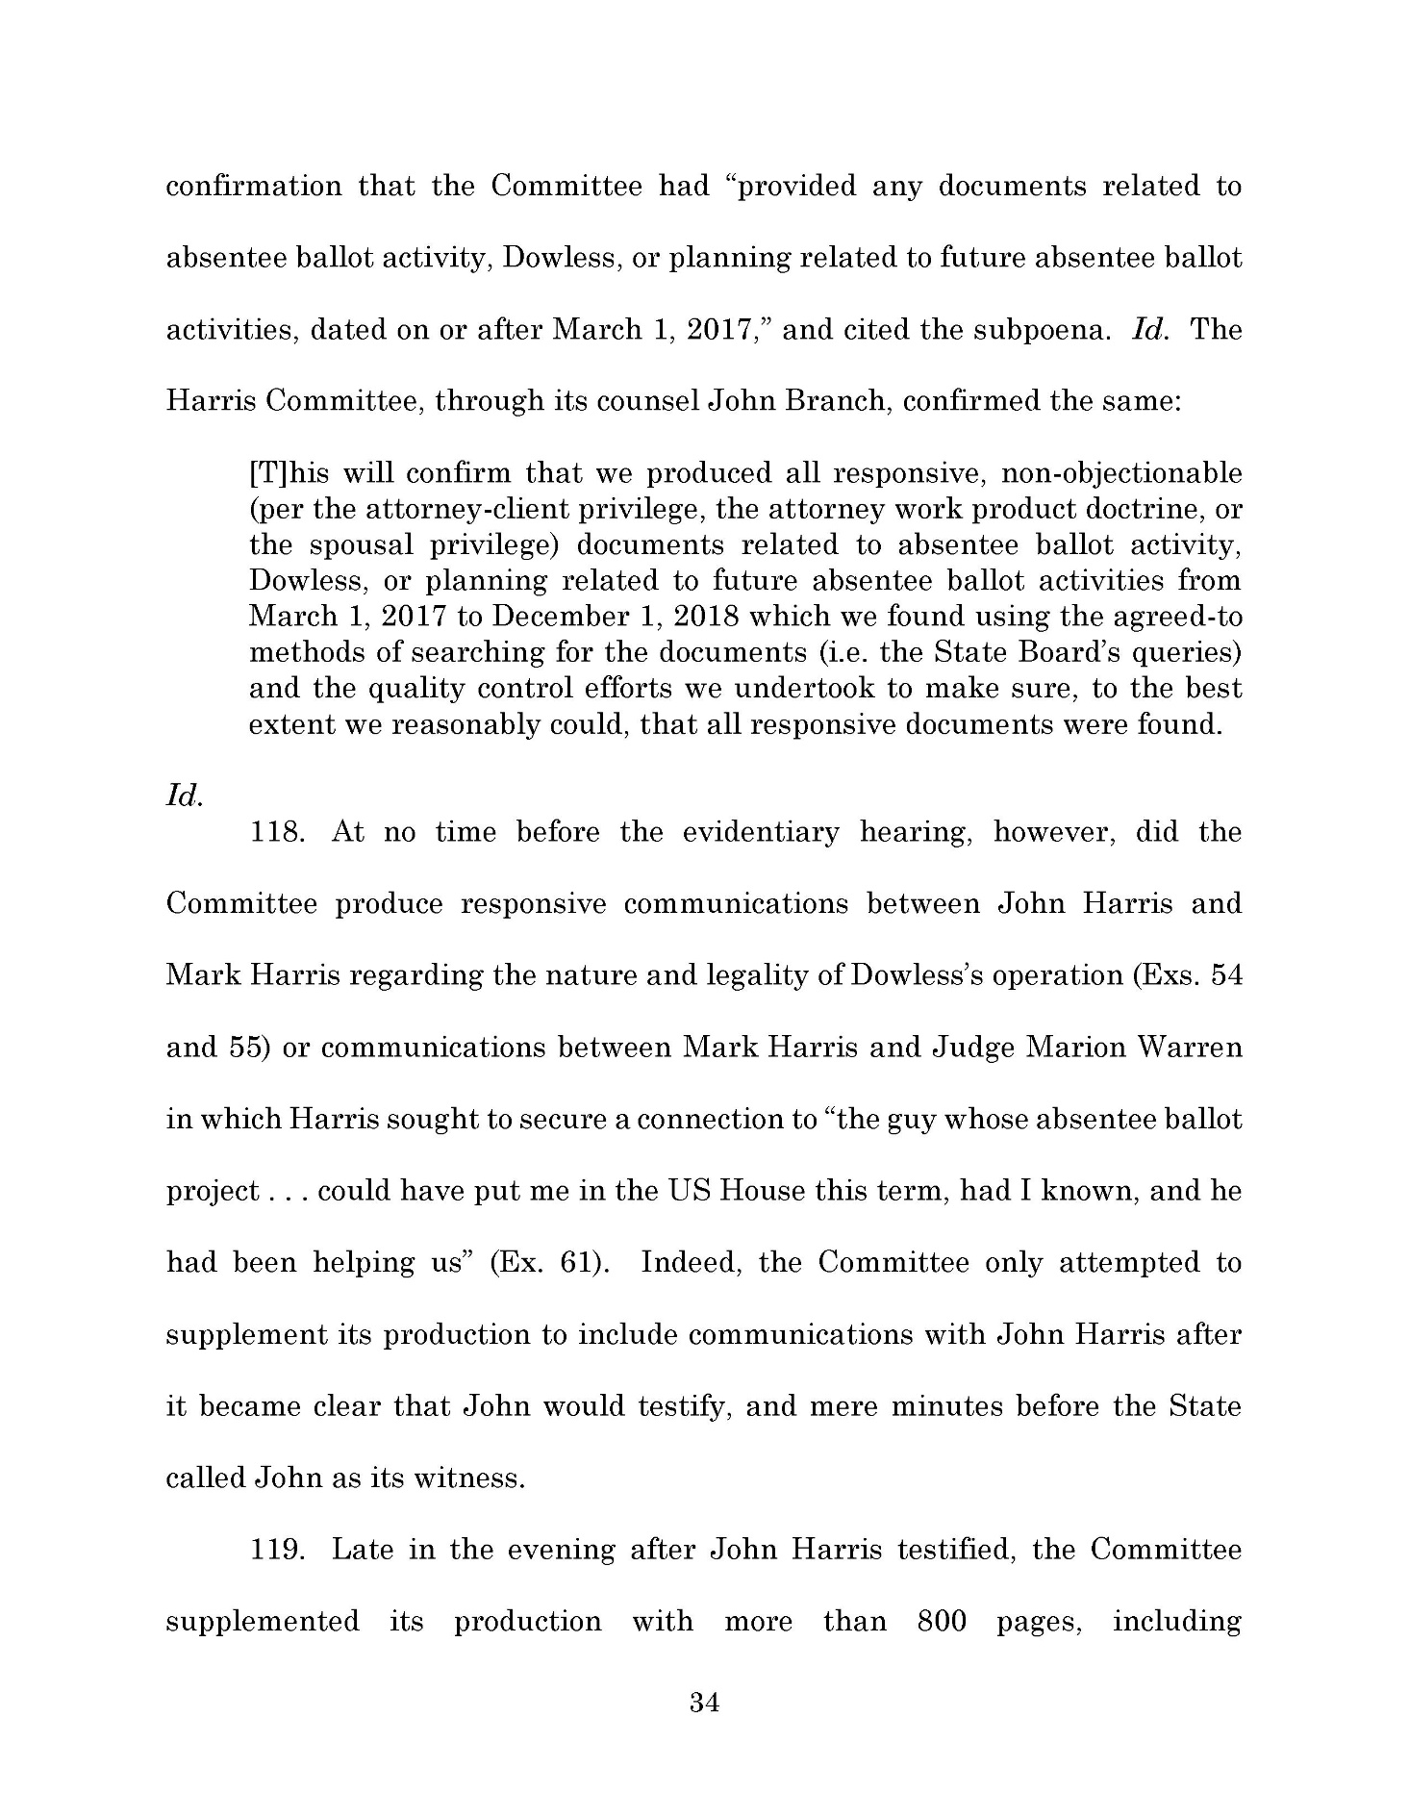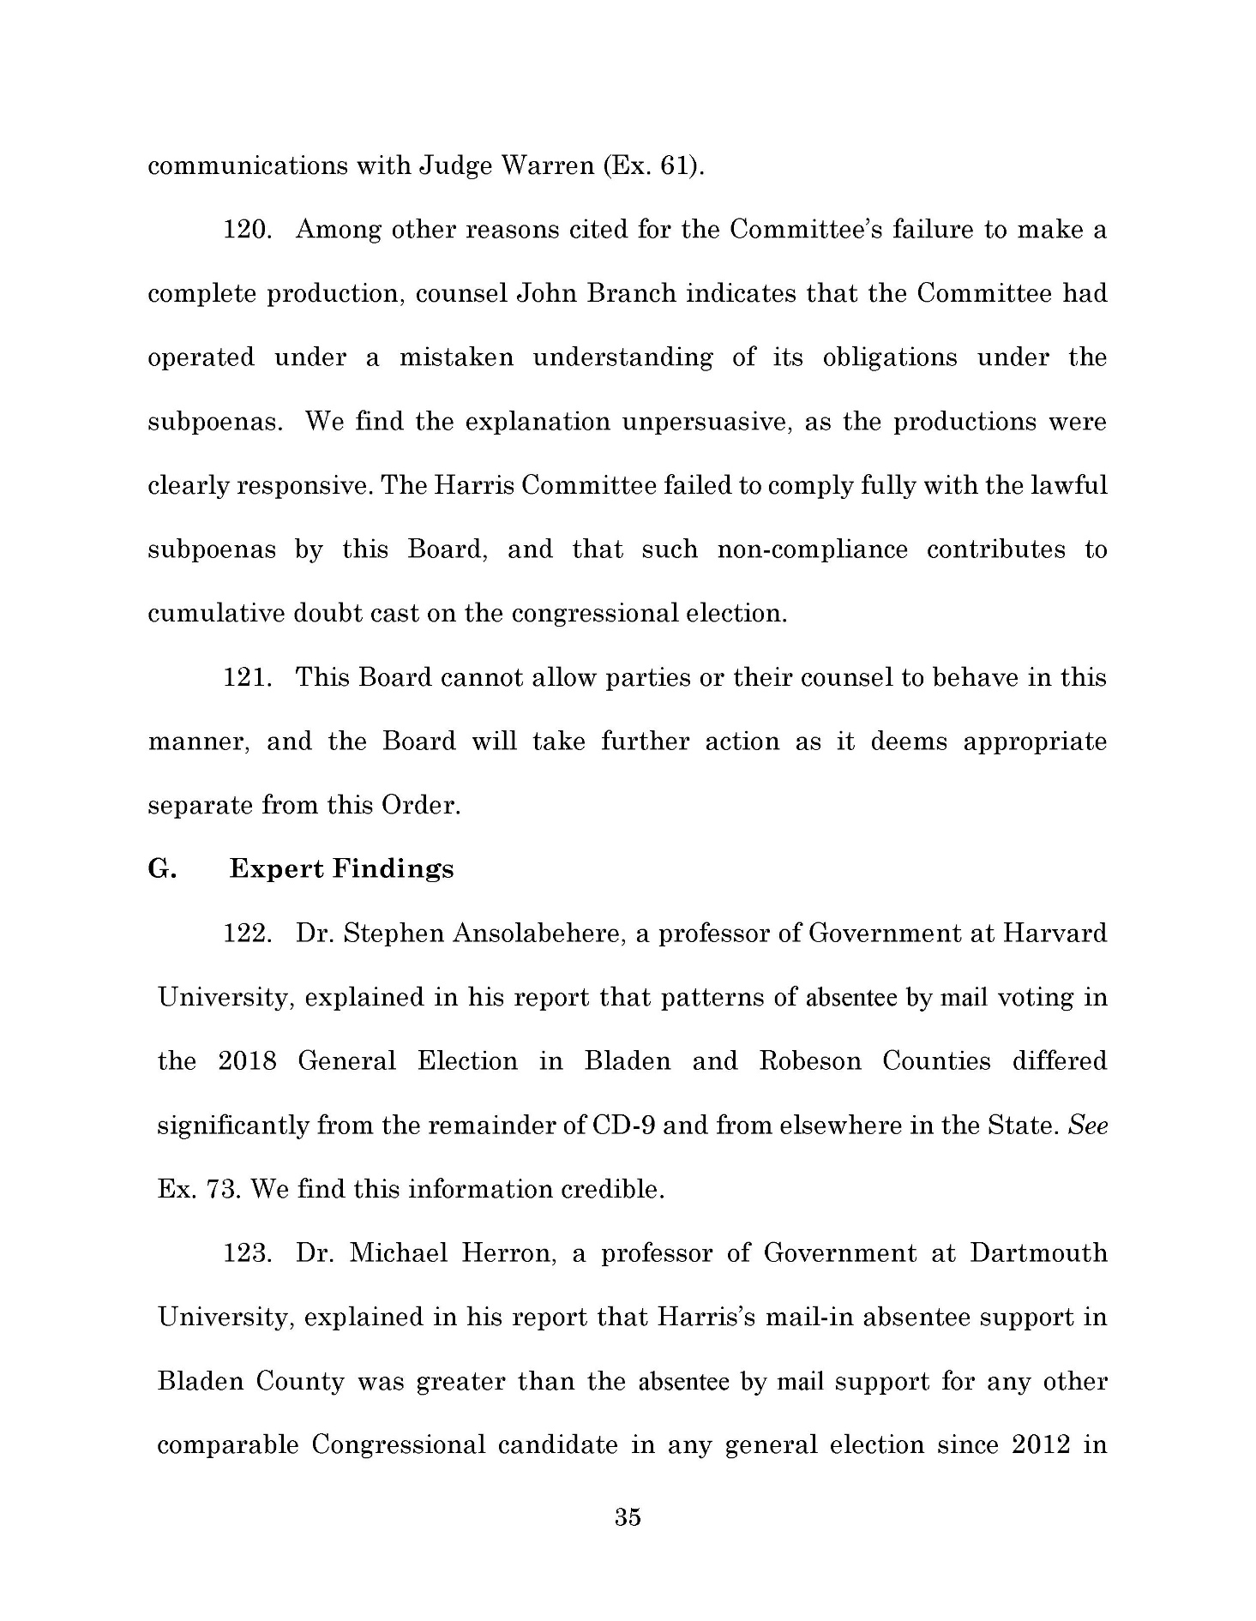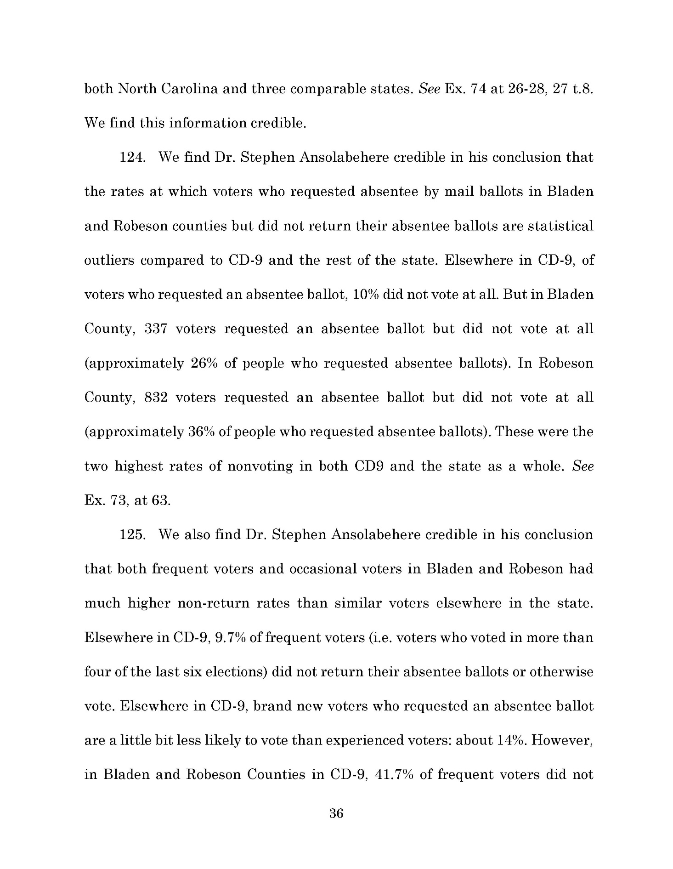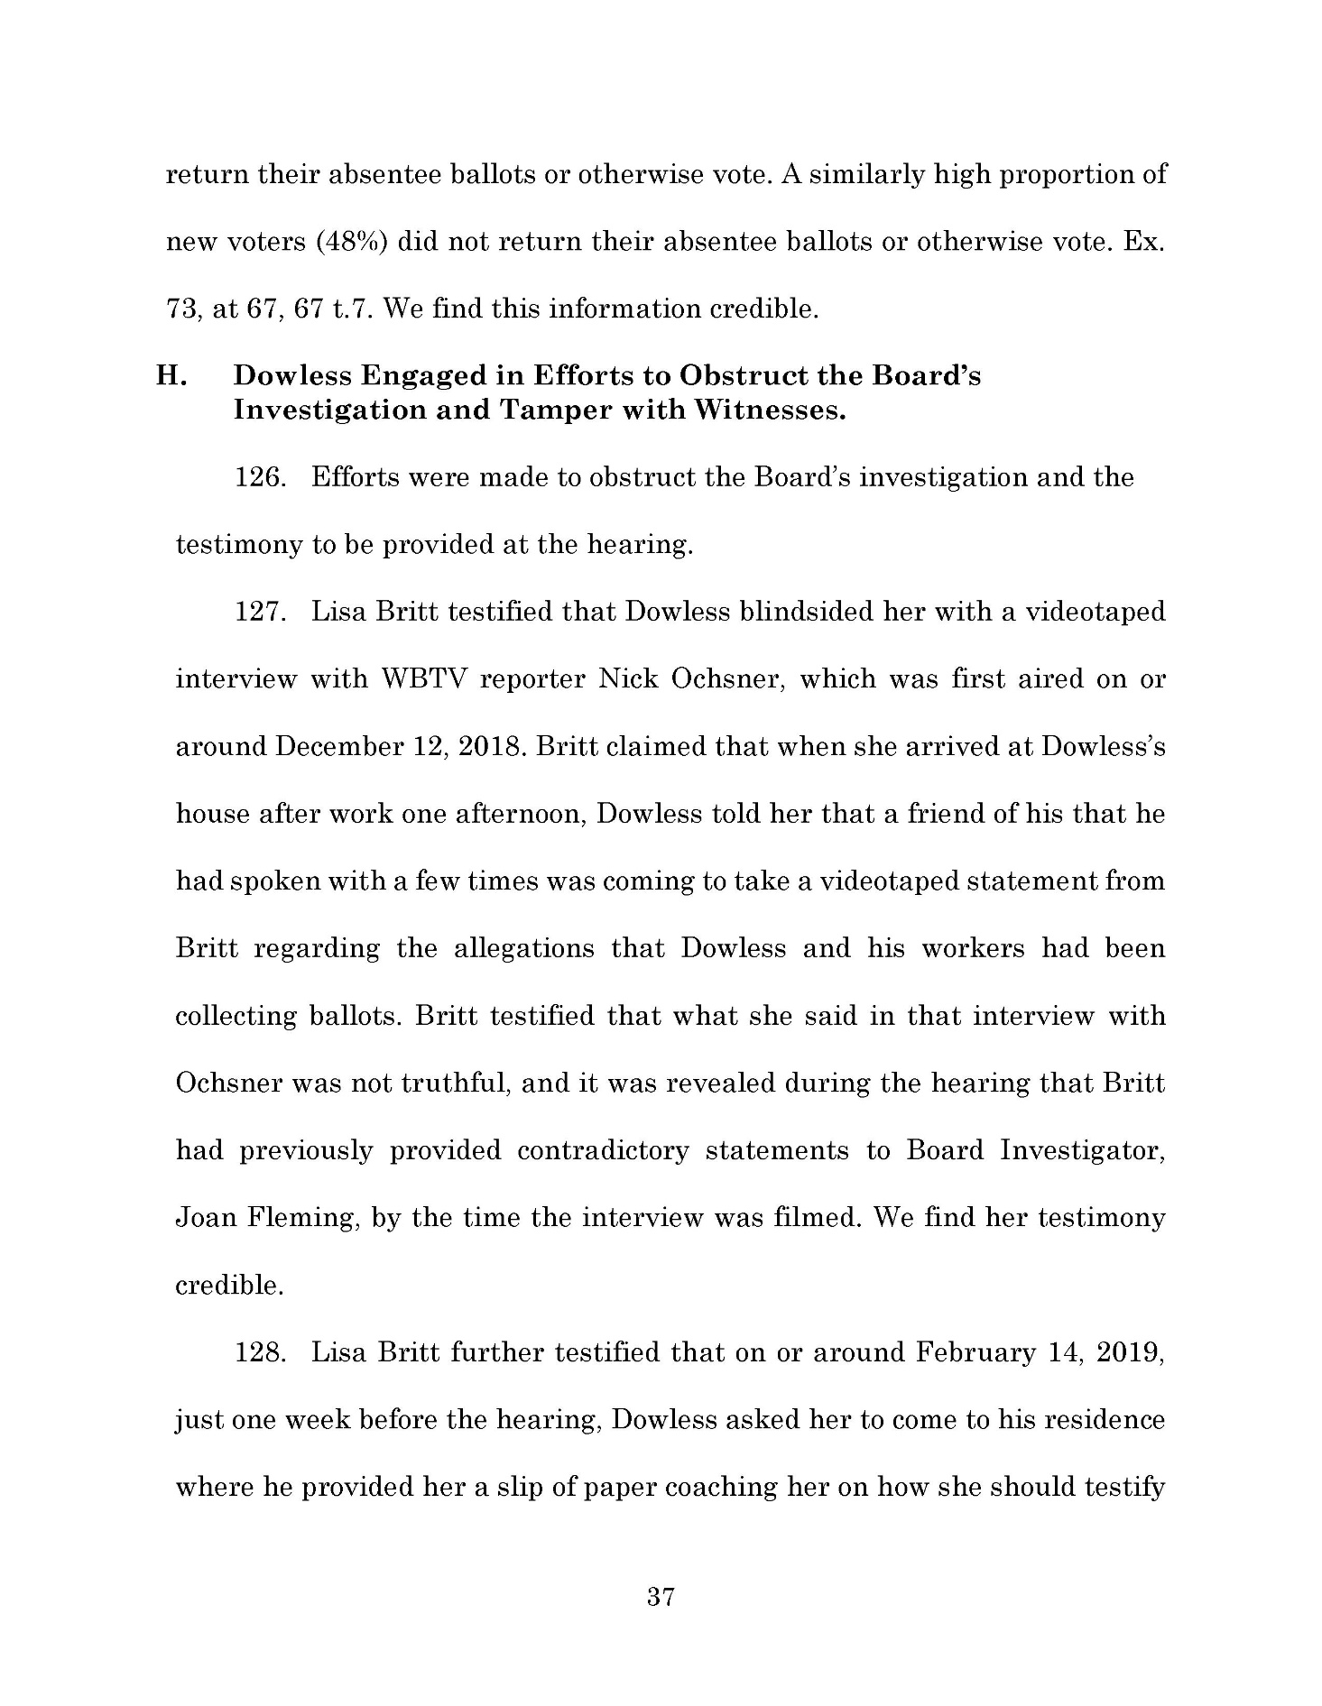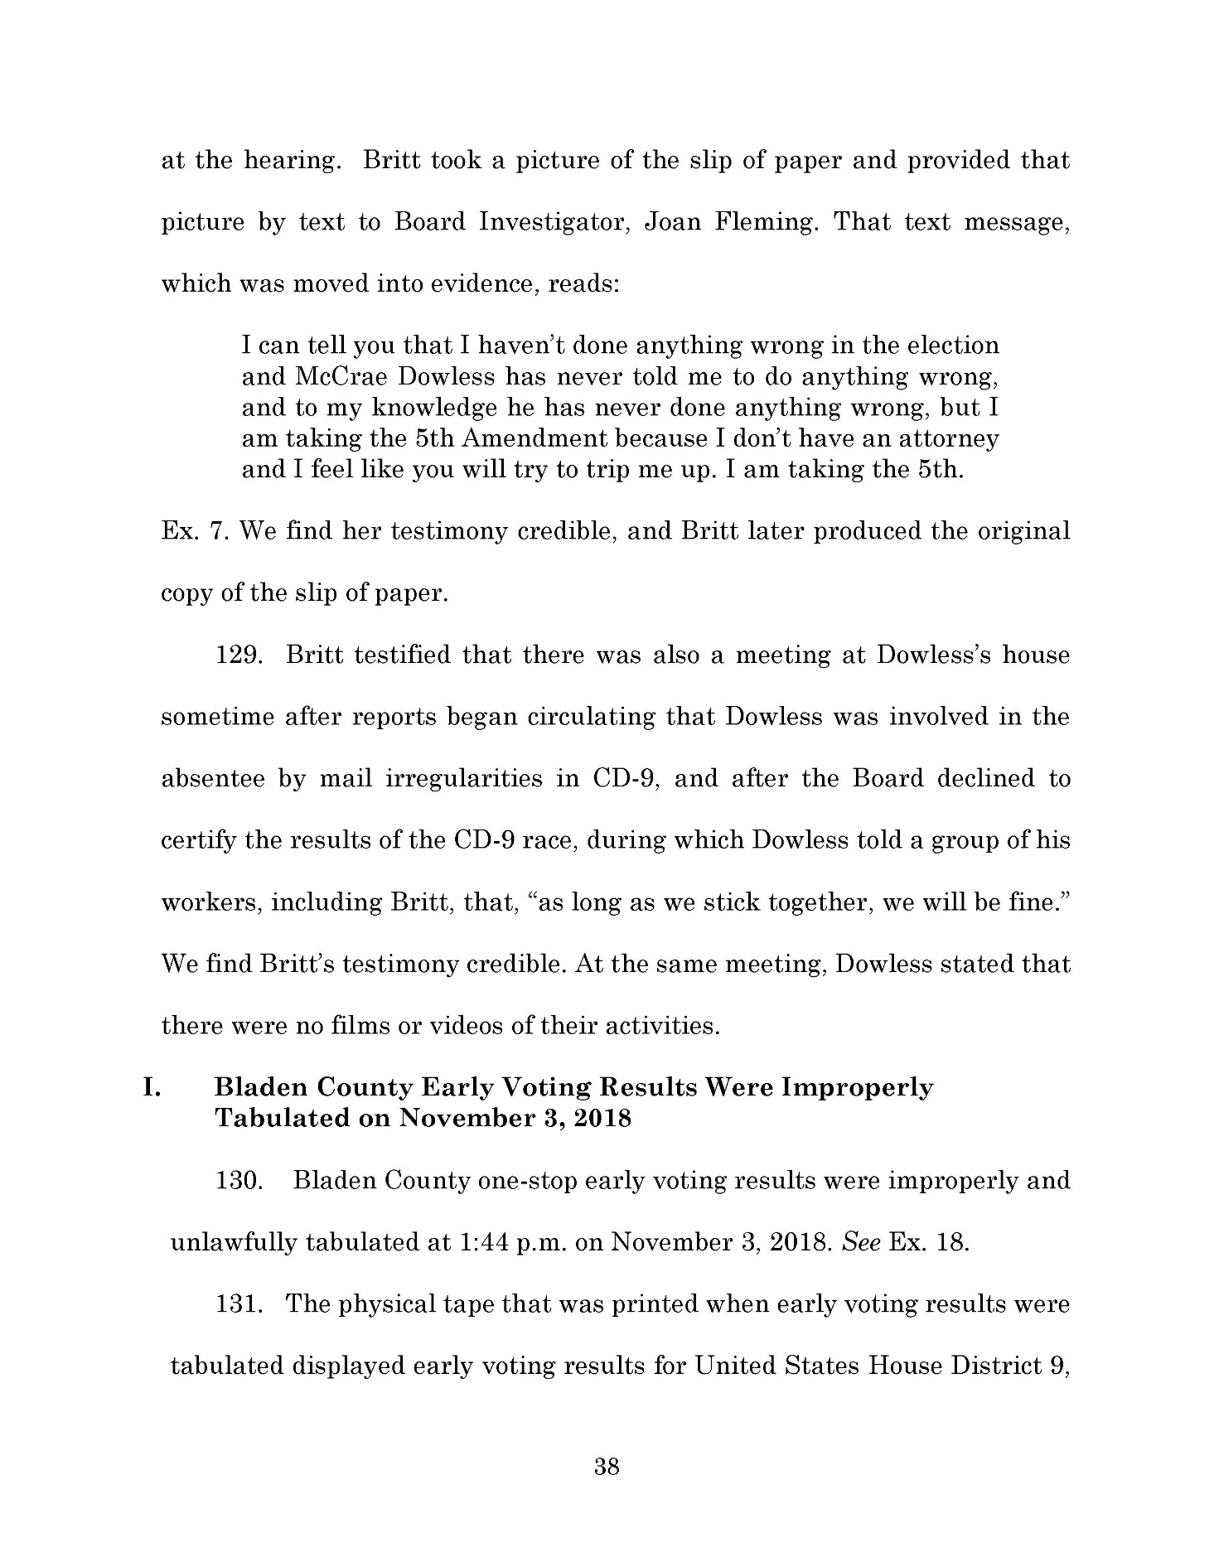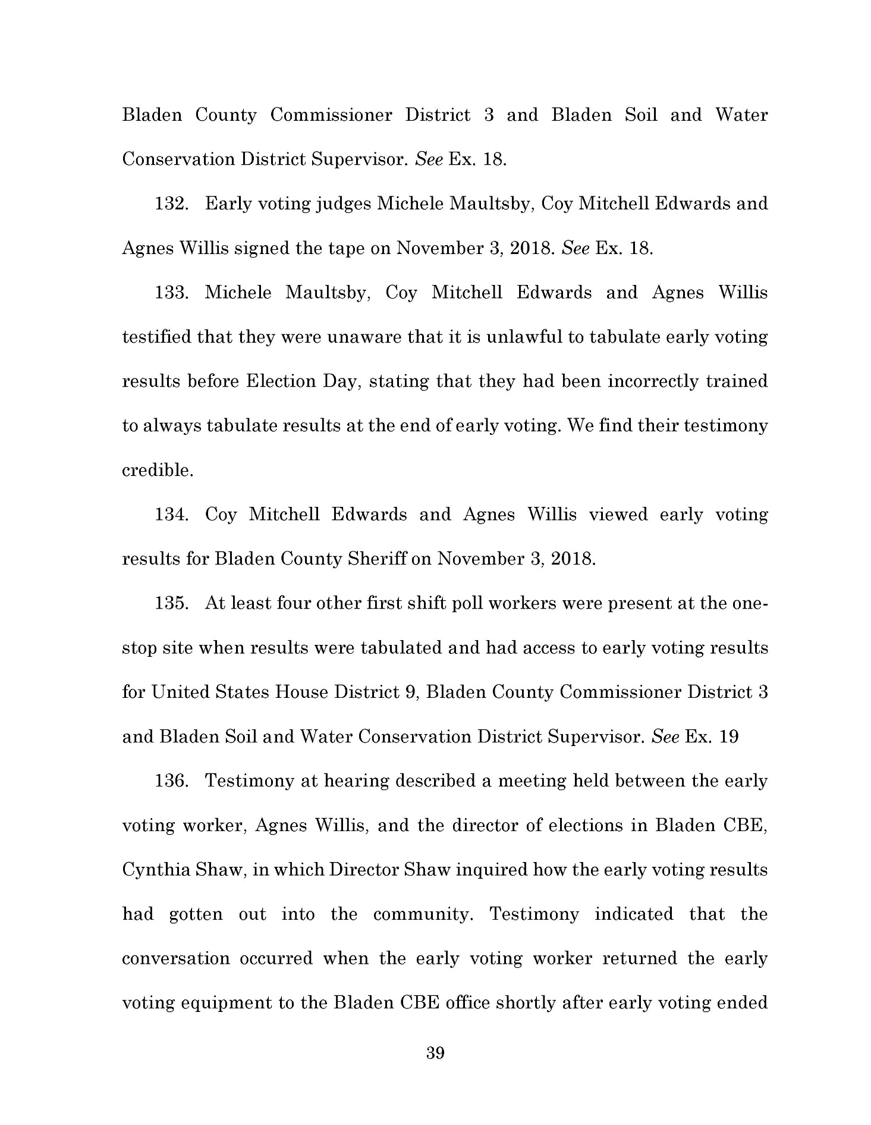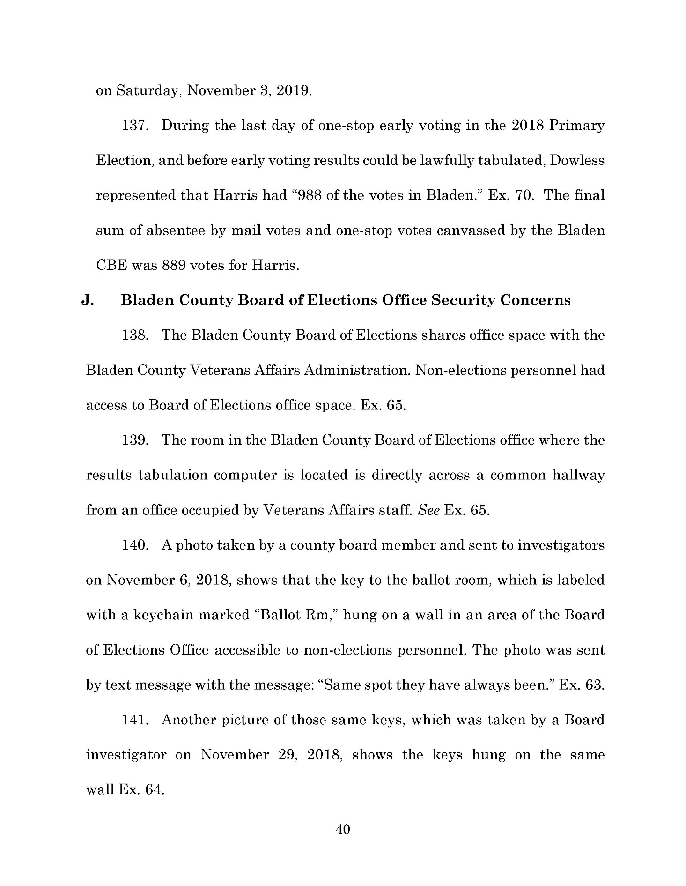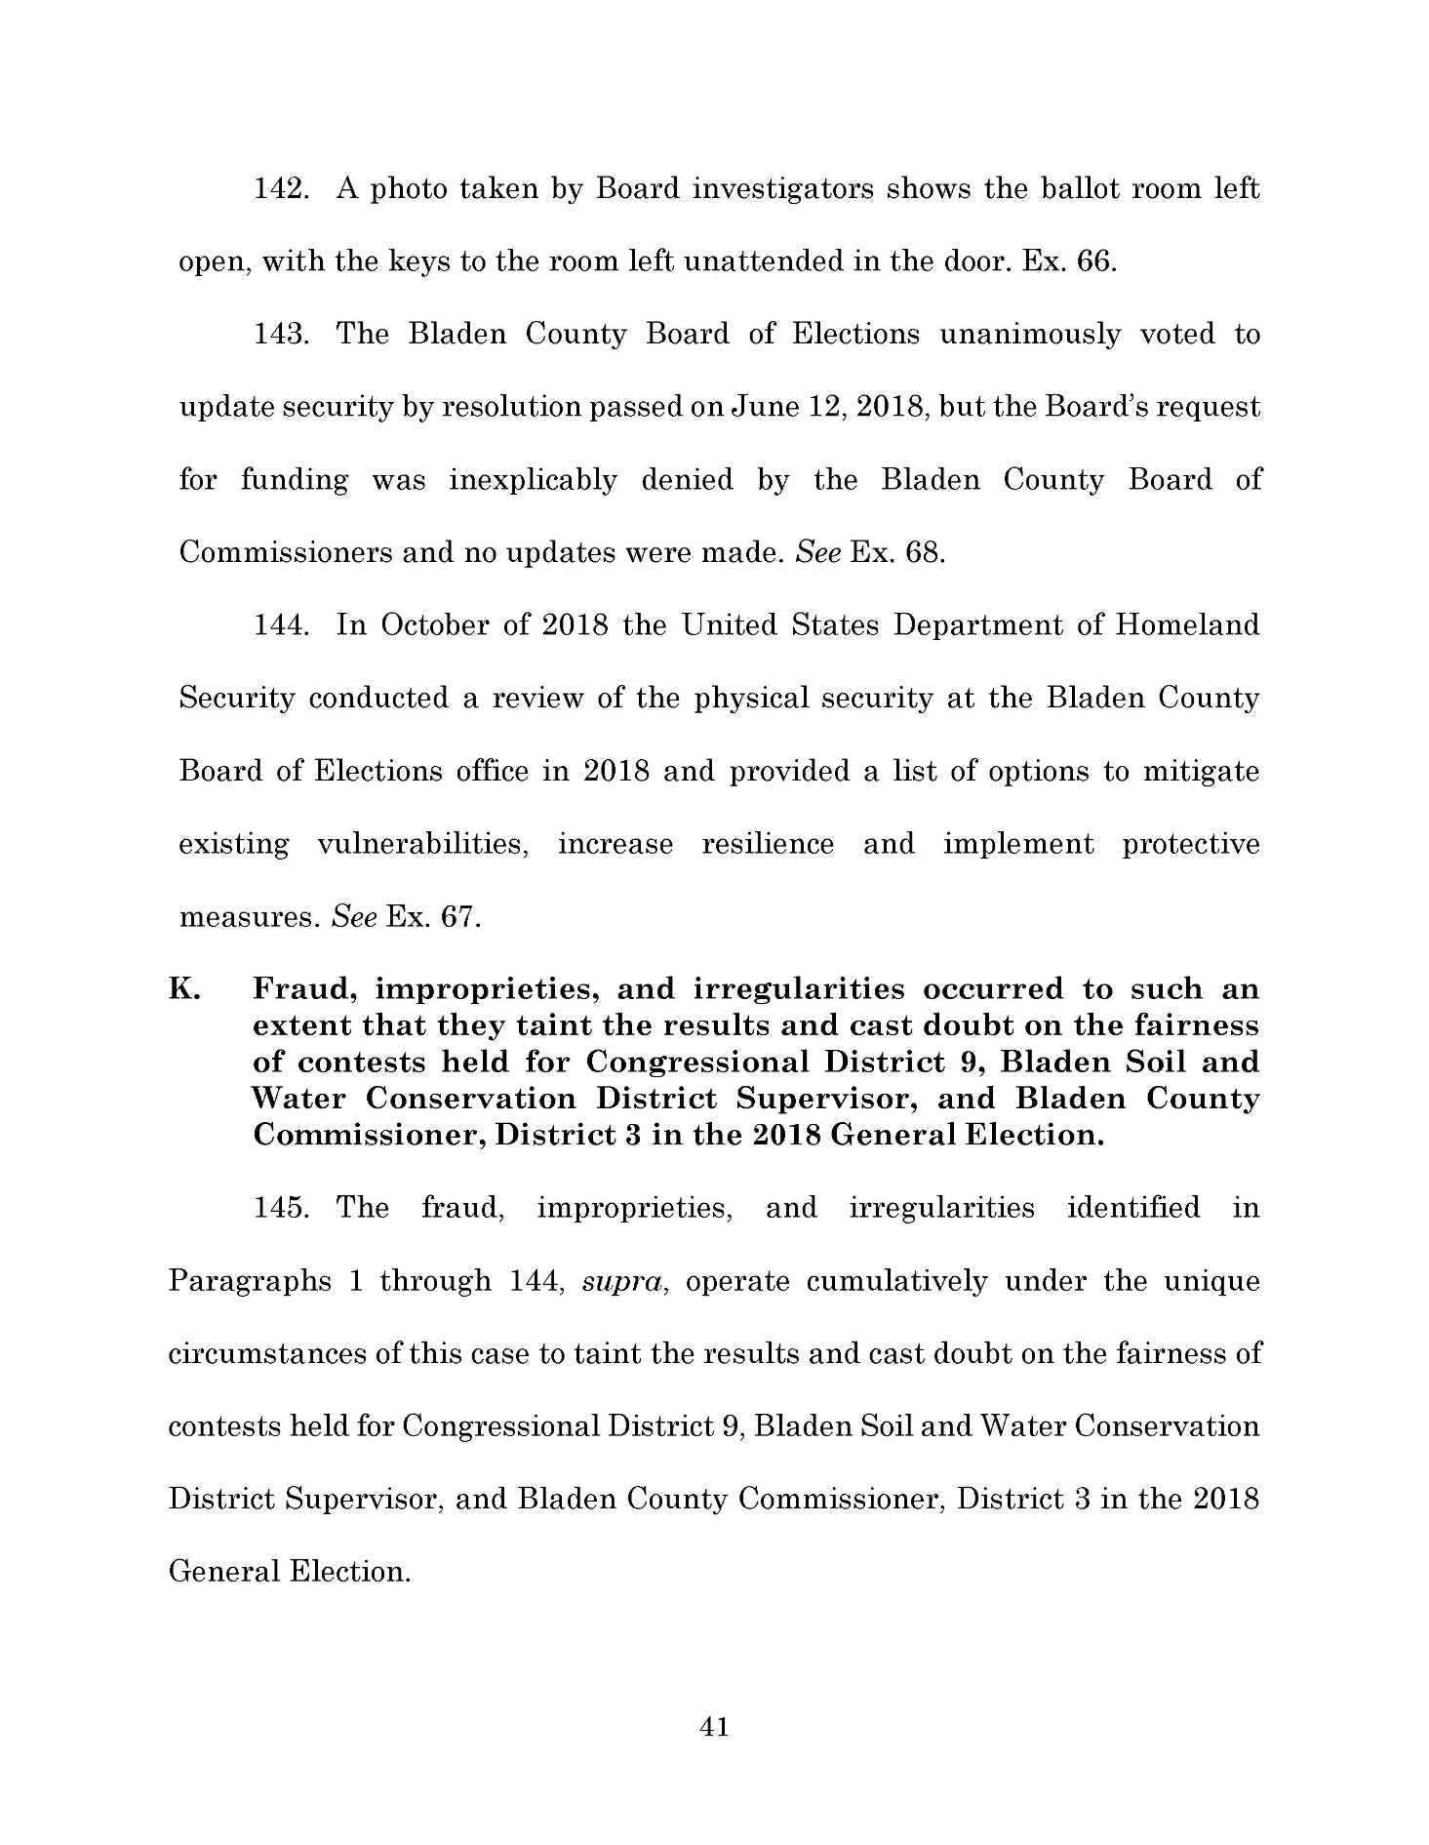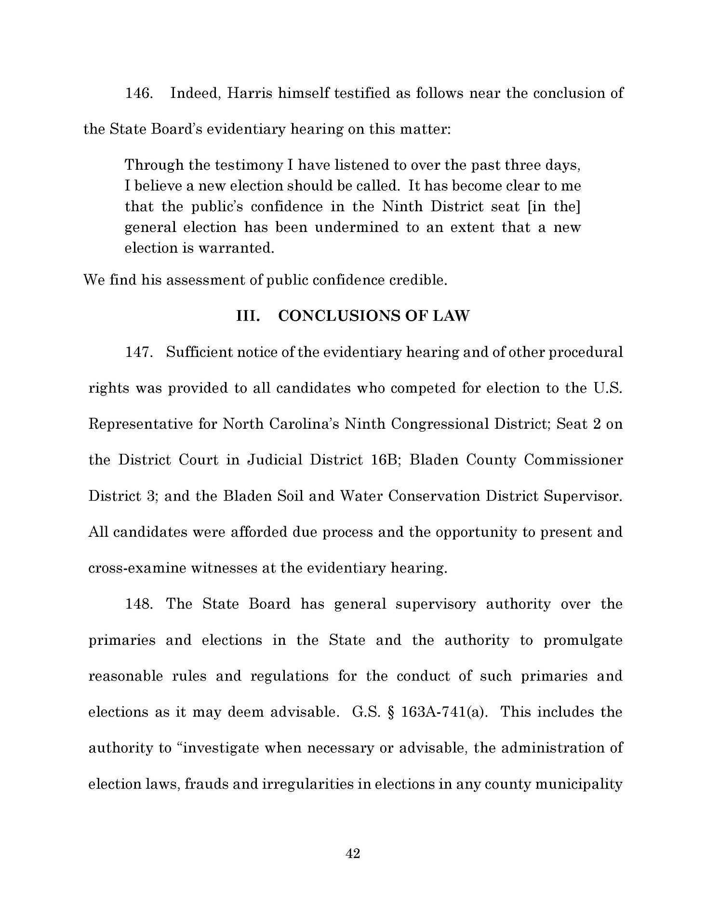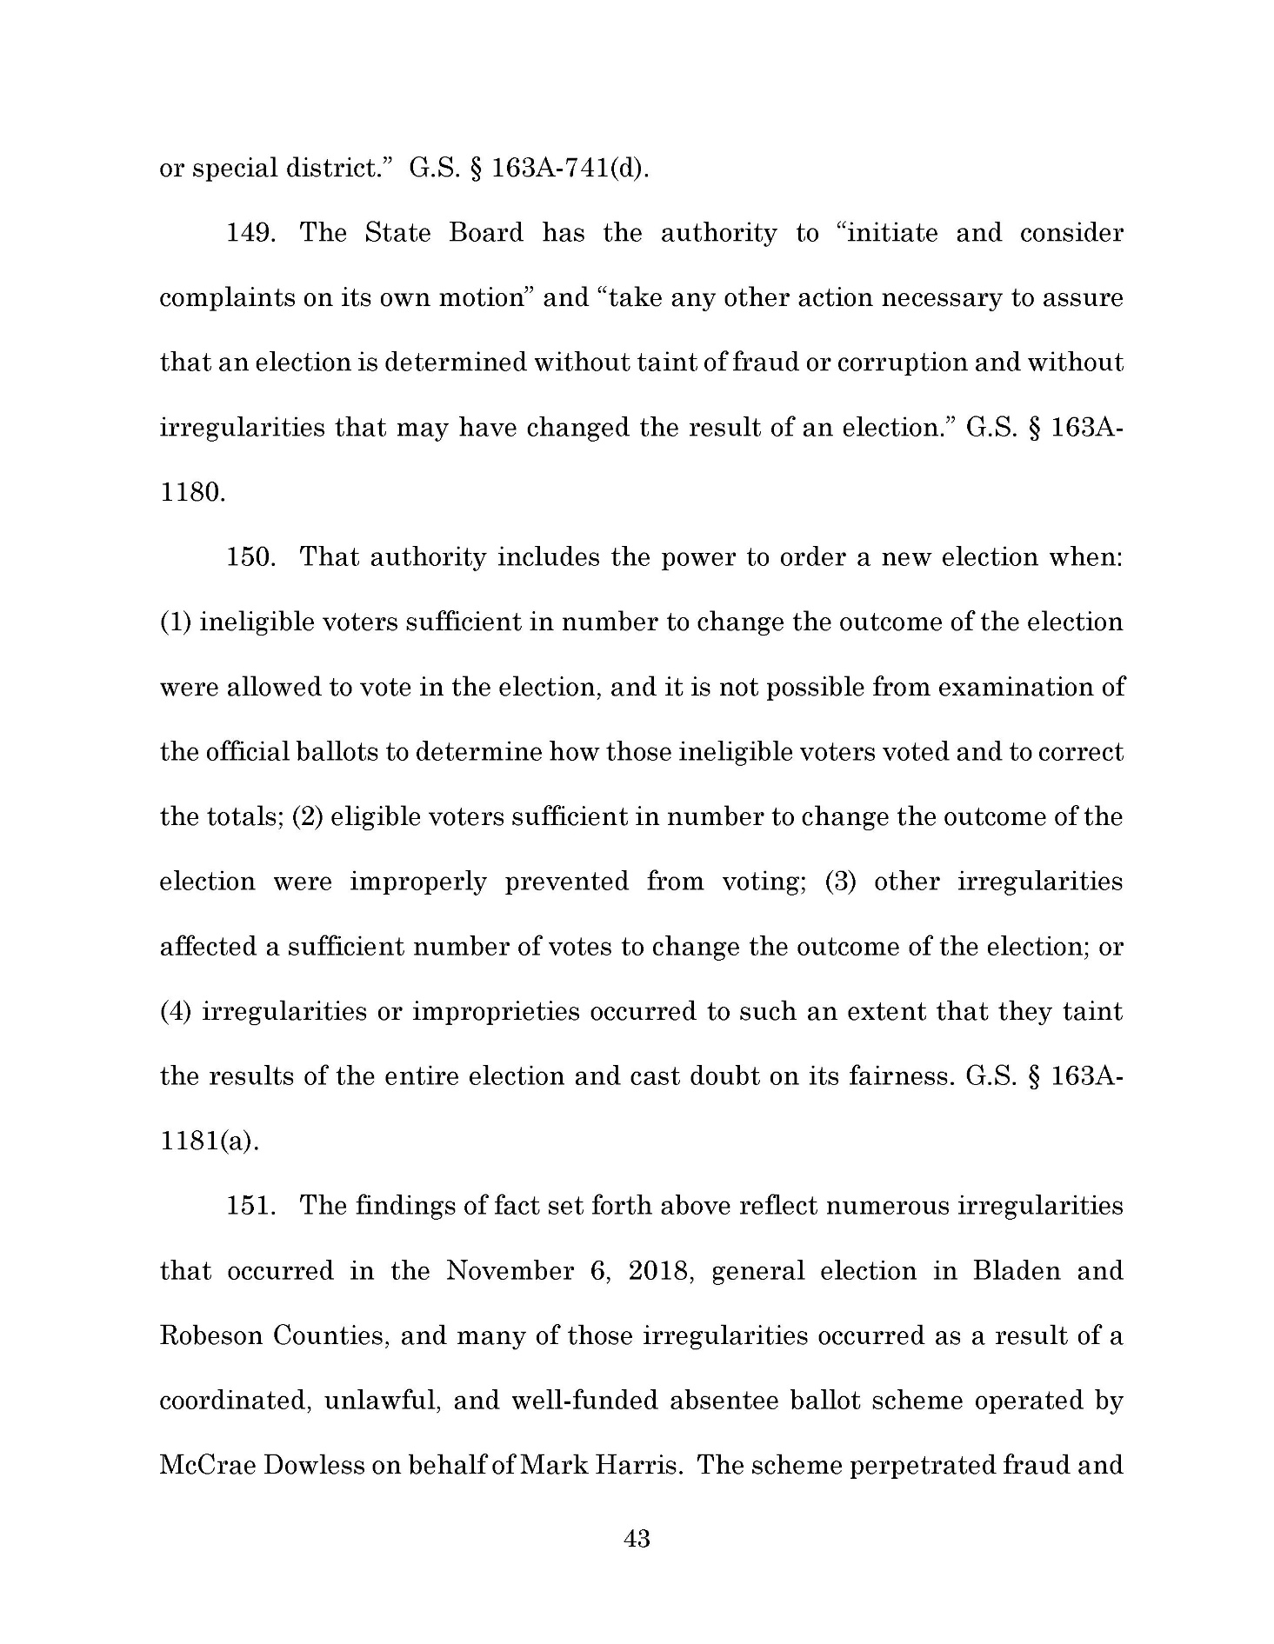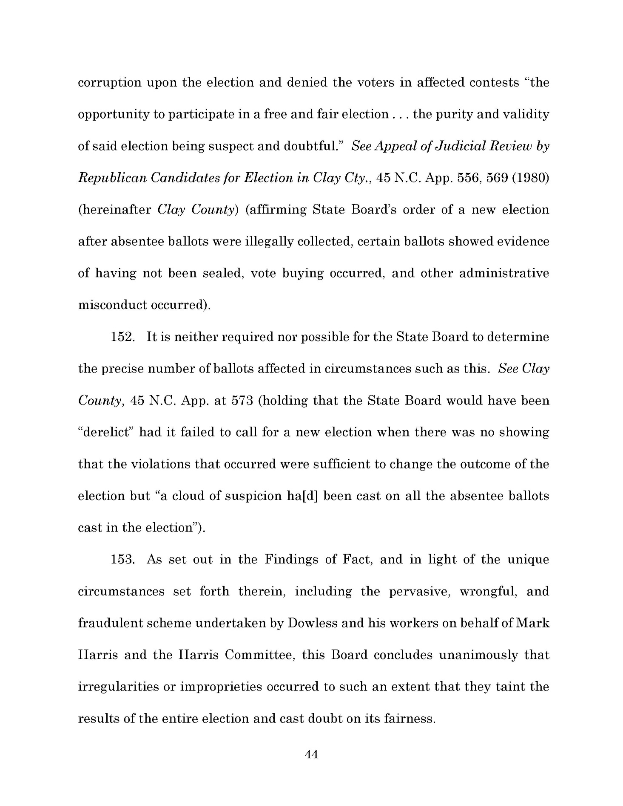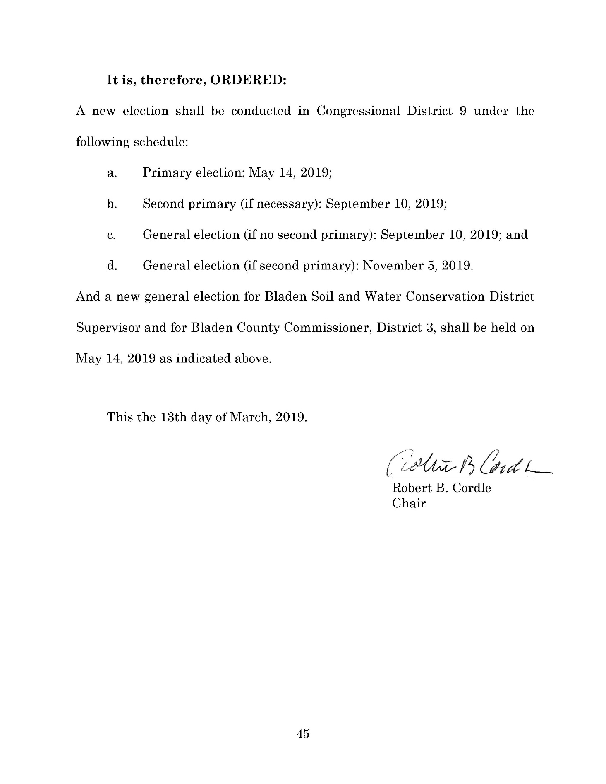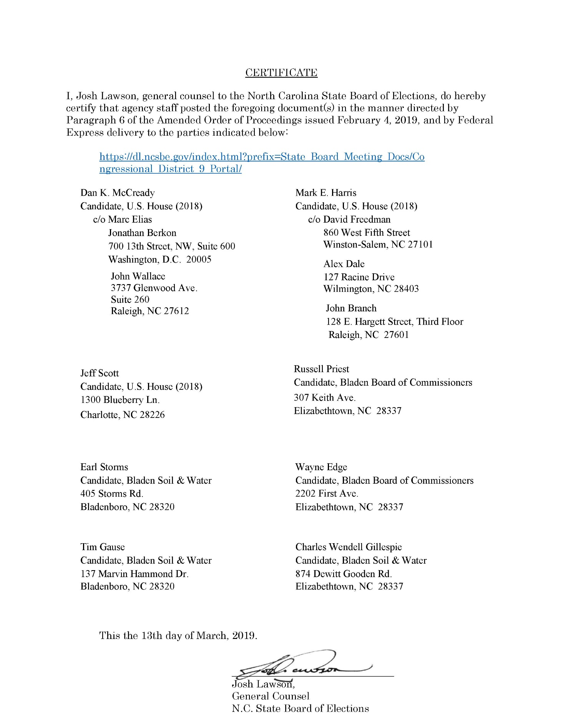

Note from the Codifier: The notices published in this Section of the NC Register include the text of proposed rules. The agency must accept comments on the proposed rule(s) for at least 60 days from the publication date, or until the public hearing, or a later date if specified in the notice by the agency. If the agency adopts a rule that differs substantially from a prior published notice, the agency must publish the text of the proposed different rule and accept comment on the proposed different rule for 60 days.
Statutory reference: G.S. 150B-21.2.

TITLE 01 – department of administration

Notice is hereby given in accordance with G.S. 150B-21.2 and G.S. 150B-21.3A(c)(2)g. that the Department of Administration intends to repeal through readoption the rules cited as 01 NCAC 09 .0501 and .0502.

Pursuant to G.S. 150B-21.17, the Codifier has determined it impractical to publish the text of rules proposed for repeal unless the agency requests otherwise. The text of the rule(s) are available on the OAH website at http://reports.oah.state.nc.us/ncac.asp.

Link to agency website pursuant to G.S. 150B-19.1(c): https://ncadmin.nc.gov/about-doa/administrative-rules-review/proposed-rules-and-public-comment

Proposed Effective Date: August 1, 2019

Public Hearing:

Date: May 21, 2019

Time: 10:00 a.m. -11:00 a.m.

Location: Conference Room, Capehart-Crocker House, 424 N. Blount Street, Raleigh, NC 27603

Reason for Proposed Action: Rules scheduled for readoption pursuant to the periodic review set forth in G.S. 150B-21.3.

Comments may be submitted to: Shanon M. Gerger, NC Department of Justice, 1301 Mail Service Center, Raleigh, NC 27699-1301; phone (984) 236-0008; email adminrules@doa.nc.gov

Comment period ends: June 14, 2019

Procedure for Subjecting a Proposed Rule to Legislative Review: If an objection is not resolved prior to the adoption of the rule, a person may also submit written objections to the Rules Review Commission after the adoption of the Rule. If the Rules Review Commission receives written and signed objections after the adoption of the Rule in accordance with G.S. 150B-21.3(b2) from 10 or more persons clearly requesting review by the legislature and the Rules Review Commission approves the rule, the rule will become effective as provided in G.S. 150B-21.3(b1). The Commission will receive written objections until 5:00 p.m. on the day following the day the Commission approves the rule. The Commission will receive those objections by mail, delivery service, hand delivery, or facsimile transmission. If you have any further questions concerning the submission of objections to the Commission, please call a Commission staff attorney at 919-431-3000.

Fiscal impact. Does any rule or combination of rules in this notice create an economic impact? Check all that apply.

State funds affected

Local funds affected

Substantial economic impact (≥$1,000,000)

Approved by OSBM

No fiscal note required

Chapter 09 - Intergovernmental Relations

SECTION .0500 - STATE CLEARINGHOUSE

01 NCAC 09 .0501 FUNCTION

Authority G.S. 113A; 143-341; Federal Executive Order 12372.

01 NCAC 09 .0502 APPLICANT REVIEW

Authority G.S. 143-341; Federal Executive Order 12372.

TITLE 14B – DEPARTMENT OF PUBLIC SAFETY

Notice is hereby given in accordance with G.S. 150B-21.2 that the Alcoholic Beverage Control Commission intends to amend the rules cited as 14B NCAC 15A .0101-.0103, .0201-.0204, .0301, .0302, .0401-.0404, .0501, .0601, .0602, .0605, .0801 and .0805; and repeal the rules cited as 14B NCAC 15A .0701 and 15C .0101.

Pursuant to G.S. 150B-21.17, the Codifier has determined that publication of the complete text of the rules proposed for repeal is impractical. The text of the repealed rules is accessible on the OAH Website: http://www.ncoah.com.

Link to agency website pursuant to G.S. 150B-19.1(c): https://abc.nc.gov/

Proposed Effective Date: September 1, 2019

Public Hearing:

Date: June 12, 2019

Time: 10:00 a.m.

Location: ABC Commission Hearing Room, 400 East Tryon Road, Raleigh, NC 27610

Reason for Proposed Action: To update, modernize, and conform rules related to the operations of the Alcoholic Beverage control Commission, including consolidations of definitions, Commission meeting procedures, distribution and posting of Commission documents, petitions for adoption of rules, emergency declarations, declaratory rulings, and notice of alleged violations.

Comments may be submitted to: Walker Reagan, 400 East Tryon Road, Raleigh, NC 27610, phone (919) 779-8367, fax (919) 661-6165, email walker.reagan@abc.nc.gov

Comment period ends: June 14, 2019

Procedure for Subjecting a Proposed Rule to Legislative Review: If an objection is not resolved prior to the adoption of the rule, a person may also submit written objections to the Rules Review Commission after the adoption of the Rule. If the Rules Review Commission receives written and signed objections after the adoption of the Rule in accordance with G.S. 150B-21.3(b2) from 10 or more persons clearly requesting review by the legislature and the Rules Review Commission approves the rule, the rule will become effective as provided in G.S. 150B-21.3(b1). The Commission will receive written objections until 5:00 p.m. on the day following the day the Commission approves the rule. The Commission will receive those objections by mail, delivery service, hand delivery, or facsimile transmission. If you have any further questions concerning the submission of objections to the Commission, please call a Commission staff attorney at 919-431-3000.

Fiscal impact. Does any rule or combination of rules in this notice create an economic impact? Check all that apply.

State funds affected

Local funds affected

Substantial economic impact (≥$1,000,000)

Approved by OSBM

No fiscal note required

Chapter 15 - Alcoholic Beverage Control Commission

SUBCHAPTER 15A - ORGANIZATIONAL RULES: POLICIES AND PROCEDURES

SECTION .0100 - GENERAL PROVISIONS

14B NCAC 15A .0101 PURPOSE

The purpose of the Alcoholic Beverage Control System is to provide regulation and control of the manufacture, distribution, advertisement, sale, possession and consumption of alcoholic beverages to serve the public health, safety and welfare. It is the objective of the North Carolina Alcoholic Beverage Control Commission at all times to conform to that purpose.

Authority G.S. 18B-100; 18B-105; 18B-207.

14B NCAC 15A .0102 LOCATION AND ADDRESS LOCATION, ADDRESSES AND BUSINESS HOURS

The principal office of the North Carolina Alcoholic Beverage Control Commission is located at 400 East Tryon Road, Raleigh, North Carolina 27610. The mailing address is 4307 Mail Service Center, Raleigh, North Carolina 27699-4307. The telephone number is (919) 779-0700. The Commission's email address is contact@abc.nc.gov. The Commission's website address is https://abc.nc.gov. This office is open to the public during regular business hours, from 8:00 a.m. to 5:00 p.m., Monday through Friday. Permit applications received after 3:00 p.m. will not be processed until the following business day.

Authority G.S. 18B-100; 18B-207.

14B NCAC 15A .0103 DEFINITIONS

(a) As used throughout in this Chapter: Chapter, the following terms mean:

(1) "Administrator" means the principal administrative officer of the Commission; Commission.

(2) "Agent," "alcohol law enforcement agent," "Alcohol law enforcement agent" or "ALE agent" means an enforcement agent of the Alcohol Law Enforcement Division, Branch, North Carolina Department of Crime Control and Public Safety; Safety.

(3) "Applicant" means any person who requests the issuance of a permit from the Commission; Commission, unless the context clearly means otherwise.

(4) "Brand," in relation to wines, means the name under which a wine is produced and includes trade names or trademarks. A brand shall not be construed to mean a class or type of wine, but all classes and types of wines sold under the same brand label shall be considered a single brand. Differences in packaging such as a different style, type, or size of container shall not be considered different brands.

(5) "Branded merchandise" means items, including glassware, cups, signs, t-shirts, hats and other apparel, that bears the brand of the alcoholic beverage being served, or the brand of the brewery, winery, or distiller whose alcoholic beverages is being served, at a tasting conducted pursuant to G.S. 18B-1114.1, 18B-1114.5 or 18B-1114.7.

(6) "Brokerage" means a business that brokers in the State the sale of spirituous liquor on behalf of a spirituous liquor supplier.

(7) "Brokerage representative" means an individual who promotes spirituous liquor on behalf of a brokerage.

(8) "Chairman" means the chairman of the Commission; Commission.

(5)(9) "Contract carrier" means the carriers operated by the contractor on behalf of the state for the purpose of distributing spirituous liquors; "Contractor" means the person or persons responsible for carrying out the storage and distribution of spirituous liquors at the State ABC warehouse.

(10) "Distiller representative" means an individual who promotes spirituous liquor on behalf of a distiller, or otherwise represents a distiller.

(6)(11) "Distressed liquor" means liquor which is not saleable due to adulteration or damage to the bottle, label or tax seal; seal.

(7)(12) "Industry Member" means any manufacturer, bottler, importer, vendor, representative or wholesaler of alcoholic beverages; wholesaler, salesman, brewery, winery, bottler, importer, liquor importer/bottler, distiller, distiller representative, brokerage, brokerage representative, supplier representative, rectifier, nonresident vendor, vendor representative, or affiliate thereof, that sells or solicits orders for alcoholic beverages, whether or not licensed in this State.

(8) "Operator" or "Contractor" means the person or persons responsible for carrying out the storage and distribution of spirituous liquors at the state ABC warehouse;

(9) "Permit" means a written or printed authorization to engage in some phase of the alcoholic beverage industry that is issued by the Commission;

(10) "Permittee" means a person to whom a permit has been issued by the Commission; and Commission.

(13) "Rectifier" means a permittee that processes spirituous liquor by cutting, blending, mixing, or infusing with any ingredient that reacts with the constituents of the distilled spirits and changes the character and nature, or standards of identity, of the distilled spirits, but does not include a person who extracts spirituous liquor by original or continuous distillation, or who mixes spirituous liquor with other ingredients for immediate consumption.

(14) "Retail permittee" or "retailer" means any permittee holding a retail alcoholic beverage permit issued pursuant to the authority of G.S. 18B-1001 but does not include a non-profit or political organization that has been issued a Special One-Time permit pursuant to the provisions of G.S. 18B-1002(a)(2) or (5).

(11)(15) "State ABC warehouse" means the contractor-operated facility or facilities storing spirituous liquors on behalf of the Commission pursuant to G.S. 18B-204, or, in cases of emergency, the facility or facilities operated by the state for the purpose of storing spirituous liquors.

(16) "Spirituous liquor supplier" means a distiller, liquor importer/bottler, or rectifier.

(17) "Supplier representative" means as the term is used in G.S. 18B-1114.7, an individual who promotes on behalf of a spirituous liquor supplier, or otherwise represents a spirituous liquor supplier.

(18) "Vendor" means any brewery, winery, bottler, malt beverages or wine importer, or nonresident malt beverage vendor or nonresident wine vendor as those terms are used in G.S. 18B-1113 and 18B-1114.

(19) "Vendor representative" means any person who holds a permit issued pursuant to G.S. 18B-1112.

(20) "Wine" means both fortified wine and unfortified wine.

(b) The definitions in Chapter 18B apply to the rules in this Chapter.

Authority G.S. 18B-100; 18B-207.

SECTION .0200 - STRUCTURE

14B NCAC 15A .0201 COMMISSION chairman

The North Carolina Alcoholic Beverage Control Commission shall be composed of a chairman and two associate members.

The chairman Chairman shall have the powers and perform the duties prescribed by the Commission including the authority to appoint, promote, demote, and discharge all subordinate officers and employees of the Commission.

The Commission shall have all the authority and duties given it by the provisions of the North Carolina General Statutes.

Authority G.S. 18B-100; 18B-200; 18B-207.

14B NCAC 15a .0202 COMMISSION MEETINGS

The Commission shall meet in monthly sessions open to the public in order to make final decisions on hearing cases, to adopt, amend or repeal alcoholic beverage control rules, and to consider and act upon any other business pending that may come before the Commission. The Commission may call special meetings in addition to the monthly meetings to consider and act upon any unfinished business pending before of the Commission.

The press public shall be notified of the time and place of both monthly and special meetings. meetings on the Commission's website.

The Commission may hold executive closed sessions with regard to personnel matters. matters and other matters as allowed pursuant to G.S. 143-318.11 These sessions are not open to the public nor is the press notified of these sessions. public.

Minutes of all Commission meetings shall be kept on file. file and made accessible on the Commission's website.

Authority G.S. 18B-100; 18B-200; 18B-207.

14B NCAC 15A .0203 ADMINISTRATIVE FUNCTIONS

The principal administrative officer shall be the administrator who executes rules, policies and procedures governing the sale of alcoholic beverages and coordinates the functions of the Commission with local boards and industry. the alcoholic beverage industry.

Authority G.S. 18B-100; 18B-200(d); 18B-207.

14b NCAC 15a .0204 LEGAL FUNCTIONS

The Legal Division processes cases involving permittees charged with violations of the ABC laws, and represents the Commission in contested cases before the Office of Administrative Hearings. Legal staff may also serve as hearing officers in cases filed under Article 12 of Chapter 18B. pursuant to G.S. 18B-1205.

Authority G.S. 18B-100; 18B-200(d); 18B-207.

SECTION .0300 - PUBLICATIONS: RECORDS: COPIES

14B NCAC 15A .0301 DISTRIBUTION, INSPECTION AND COPIES OF ABC LAWS

(a) Distribution of Rules and Statutes. The Commission shall distribute at no charge a one copy of Chapter 18B of the General Statutes and the Commission's Rules to each local ABC board, each ALE agent, ABC officer and local law enforcement officer employed by a contracting agency pursuant to G.S. 18B-501(f), and to each employee of the Commission.

(b) Purchasing Copies of Documents. Copies of the following documents are available from the Commission:

(1) Chapter 18B of the General Statutes and the Commission's Rules;

(2) Individual sections of Chapter 18B of the General Statutes;

(3) Individual Commission Rules;

(4)(2) ABC Retail Guide; and

(5)(3) Public records retained by the Commission.

Copies of the above documents are available at the "actual cost" as defined in G.S. 132-6.2(b) for making the copies and the mailing cost if applicable. The Commission shall provide its "actual cost" of documents specified under Paragraph (b)(1) and (2) of this Rule on the Commission's website. Persons requesting copies of the above documents shall make payment by certified check, cashier's check or money order check, money order, or credit card to the Commission prior to receiving any copies of the above documents.

(c) Online Documents. Copies of Chapter 18B of the General Statutes and Commission rules, forms, minutes and reports shall be made accessible online on the Commission's website without charge.

Authority G.S. 12-3.1; 18B-100; 18B-207; 132-6.2.

14b NCAC 15a .0302 FEE FOR COMPUTER SERVICES

Upon request, the Commission shall provide data processing services related to the public information maintained by the Commission, if feasible. Commission that the Commission has the capability to provide. Fees for such services are based on the actual cost to the Commission shall be determined by the Commission in accordance with G.S. 132-6.2(b) and shall be paid in advance by certified check, cashier's check or money order. check, money order, or credit card. The requester shall request and receive a quote from the Commission prior to payment of requested services.

Authority 18B-100; 18B-207; 132.6.2; 150B-19(5)(e).

SECTION .0400 - RULE-MAKING

14B NCAC 15A .0401 PETITION FOR ADOPTION OF RULES

(a) Any person wishing to submit a petition requesting the adoption, amendment or repeal of a rule by the Commission shall address the petition to the North Carolina Alcoholic Beverage Control Commission, Chief Counsel, 4307 Mail Service Center, Raleigh, North Carolina 27699-4307.

(b) Contents. The petition shall contain the following information:

(1) Drafts drafts of proposed rule or amendment, or summary of its contents;

(2) reasons for the adoption, amendment or repeal of the proposed rule;

(3) citation of authorities showing the legality of the proposed adoption, amendment or repeal of the rule;

(4) effect of existing rules or orders;

(5) any data supporting the proposal;

(6) effect of existing rules on existing practices in the area involved, including case factors;

(7) names and addresses of persons most likely to be affected by the proposal; involved; and

(8)(7) name and address of each petitioner.

Authority G.S. 18B-100; 18B-207; 150B-20(a).

14B NCAC 15A .0402 ADMINISTRATIVE ACTION

Based on a study of the petition and other relevant supporting material, the Commission shall deny the petition or initiate rule-making proceedings within a reasonable time time, but no later than 120 days following submission of the petition.
(1) If the Commission determines that the adoption, amendment or repeal of a rule will serve no public interest, it may deny the petition; the Commission denies the petition, it shall notify the petitioner in writing of its decision to deny the petition, stating the reasons for the denial.
(2) If the Commission determines that the proposed adoption, amendment or repeal of a rule will serve the public interest, grants the petition, it shall initiate rule-making proceedings by issuing a rule-making notice, as provided in this Section. in accordance with Chapter 150B of the General Statutes. In accordance with G.S. 150B-20(c), the Commission may publish the name of the person requesting the rule change.

Authority G.S. 18B-100; 18B-207; 150B-20.

14B NCAC 15A .0403 NOTICE OF RULE-MAKING HEARINGS; MAILING LIST

(a) Upon a determination to hold a rule-making proceeding, either in response to a petition or otherwise, the Commission shall give notice to all interested parties of the proceedings in accordance with the requirements of Chapter 150B of the General Statutes.

(b) Mailing List. Any person desiring to be placed on the mailing list for the rule-making notices may file a request in writing, furnishing his name the person's name, email and mailing address to the Commission. The request shall state the subject areas within the authority of the Commission for which notice is requested.

(c) Fee Charged. The cost to be on the mailing list for rule-making notices shall be fifteen dollars ($15.00) per year. A notice and invoice will be mailed in February of each year to persons on the mailing list. Persons who do not renew their request to remain on the mailing list by remitting the fee by March 1 of each year will be deleted from the list.

Authority G.S. 18B-100; 18B-207; 150B-21.2.

14B NCAC 15A .0404 RULE-MAKING HEARING

(a) Location. Unless otherwise stated in a particular rule-making notice, rule-making hearings shall be held in the administrative hearing room of the Commission's Raleigh principal office.

(b) Oral Presentations. Any person desiring to present oral data, views or arguments on the proposed rule is encouraged to file a written notice of that desire with the Chairman. Legal Division of the Commission. The notice of the oral presentation should contain a brief summary of the individual's or organization's views with respect to the proposed adoption, amendment or repeal of a rule, and a statement of the length of time the speaker intends to speak.

(c) The Chairman shall preside at the rule-making hearing, and hearing and shall ensure that each person participating is given a fair opportunity to present oral arguments, comments and data supporting his the person's position. The Chairman may limit the length of time any speaker may speak.

Authority G.S. 18B-100; 18B-207; 150B-21.2(e).

SECTION .0500 – declared EMERGENCY RULES

14B NCAC 15A .0501 REVOCATION OR SUSPENSION OF PERMIT

When the sale of alcoholic beverages is suspended in any area of the state pursuant to a state of emergency as declared by the Governor in accordance with Article 36A of Chapter 14 of the General Statutes, the The Commission may revoke or suspend the permit of any person violating who violates any order or rule of the Governor issued pursuant to that action. G.S. 18B-110 when the sale of alcoholic beverages is suspended in any area of the State pursuant to a state of emergency as declared by the Governor in accordance with Article 1A of Chapter 166A of the General Statutes,

Authority G.S. 18B-110; 18B-207; 14-288.1 through 14-288.20; 166A, Article 1A.

SECTION .0600 - DECLARATORY RULINGS

14B NCAC 15A .0601 ISSUANCE: GROUNDS

Upon request of an aggrieved party, except where the Commission for good cause finds issuance of a ruling undesirable, denies a request in accordance with Rules .0602 or .0603 of this Section, the Commission shall issue a declaratory ruling if the request for such a ruling will:
(1) determine the validity of a rule previously adopted by the Commission; or
(2) determine the applicability of a particular statute or rule administered or adopted by the Commission to a given specific fact situation.

Authority G.S. 18B-100; 18B-207; 150B-4.

14B NCAC 15A .0602 REQUEST FOR DECLARATORY RULING

(a) All requests for a declaratory ruling to contest the validity of a rule adopted by the Commission shall supply the following information:

(1) name and address of person aggrieved;

(2) statute or rule to which the request relates;

(3) a brief statement of the manner in which the person aggrieved is affected or may be affected by the statute or rule;

(4) names and addresses of additional third persons known to the person aggrieved who may possibly be affected by the requested ruling;

(5) statement of all material facts;

(6) statement whether or not the person aggrieved is aware of any pending Commission action or court action that may bear on the applicability of the statute or rule to the person's particular situation;

(7) statement of the arguments and legal authority supporting the person's position on the applicability of this statute or rule; and

(8) statement of whether or not a conference is desired and reasons for requesting conference.

The person aggrieved shall sign and verify the request before an officer qualified to administer oaths that the information supplied in the request form is true and accurate.

(b) The request and any supporting materials relevant to the request shall be sent to the North Carolina Alcoholic Beverage Control Commission, Legal Division, 4307 Mail Service Center, Raleigh, North Carolina 27699-4307.

(c) The Commission shall either deny the request, stating the reasons therefore, or issue a declaratory ruling. The Commission shall deny a request for a declaratory ruling when the Commission determines that:

(1) the request does not comply with the procedural guidelines within Paragraphs (a) and (b) of this Rule;

(2) the Commission has previously issued a declaratory ruling on substantially similar facts;

(3) the Commission has previously issued a final agency decision in a contested case on substantially similar facts;

(4) the facts underlying the request for a declaratory ruling were considered at the time of the adoption of the rule in question;

(5) the subject matter is one concerning which the Commission is without authority to make a decision binding the Commission or the petitioner;

(6) the petitioner is not aggrieved by the rule or statute in question or otherwise has no interest in the subject matter of the request;

(7) there is reason to believe that the petitioner or some other person or entity materially connected to the subject matter of the request is acting in violation of the G.S. 18B or the rules adopted by the Commission; or

(8) the subject matter of the request is involved in pending litigation, legislation, or rulemaking.

(d) The Commission shall not issue a declaratory ruling when the petitioner petitioner, or his or her request request, is the subject of, or materially related to, an investigation by the Commission or contested case before the Commission.

Authority G.S. 18B-100; 18B-207; 150B-4.

14B NCAC 15A .0605 WITHDRAWAL OF REQUEST FOR DECLARATORY RULING

At any time prior to issuance, issuing a ruling, upon a written request the Commission in its discretion may permit an aggrieved party to withdraw the request for a declaratory ruling, any such request for withdrawal to be in writing. ruling.

Authority G.S. 18B-100; 18B-207; 150B-4.

SECTION .0700 - PERSONNEL POLICIES: COMMISSION

14b NCAC 15a .0701 DISCIPLINARY ACTION OF EMPLOYEE

Authority G.S. 18B-100; 18B-202; 18B-207.

SECTION .0800 - ADJUDICATION: CONTESTED CASES

14b NCAC 15a .0801 NOTICE OF Alleged violation

If facts reported by a law enforcement officer indicate a violation of the ABC laws, the Commission shall send a Notice of Alleged Violation to the permittee. The permittee is deemed notified to have received the notice of alleged violation if service of the notice is delivered to made in accordance with the methods of service set forth in G.S. 1A-5(b), including service at the permittee's address as stated on the permit.

Authority G.S. 18B-100; 18B-203(a)(12); 18B-207.

14b NCAC 15a .0805 article 12 HEARINGS; FINAL ADMINISTRATIVE DECISION; ORDER

(a) Right to Submit Proposed Findings. The parties in a hearing conducted under Article 12 shall have an opportunity to file proposed findings of fact and conclusions of law within 30 days of the conclusion of the initial hearing.

(b) Recommended Decision. If a hearing conducted under Article 12 is presided over by a hearing officer, the hearing officer shall issue a recommended decision that contains proposed findings of fact and conclusions of law. The hearing officer shall serve a copy of the recommended decision upon all parties and the members of the Commission who will make the final administrative decision. Service shall be in the manner prescribed in Rule .0821(c) Rule .0803(c) of this Section.

(c) Exceptions. The parties to a case heard under Article 12 shall have the right to file written exceptions to a recommended decision by the hearing officer. Exceptions shall be filed with the Commission within 30 days of receipt of the recommended decision.

(d) Hearing Conducted by Commission. In lieu of assigning a hearing officer to preside over the initial hearing, the Commission may conduct the initial hearing. After the time for the filing of proposed findings of fact and conclusions of law by the parties has expired, the Commission will issue a final administrative decision and order that determines the issues set forth in any prior pre-hearing order.

(e) Petition to Office of Administrative Hearings. In any case heard by the Commission under Article 12 of Chapter 18B of the General Statutes, if the Commission finds evidence of violations of Article 12 of Chapter 18B, or any other ABC law, it may commence proceedings in accordance with the provisions of Rule .0802 Rule .0801 of this Section.

Authority G.S. 18B-100; 18B-207; 18B-1205; 18B-1207(c).

SUBCHAPTER 15C - INDUSTRY MEMBERS: RETAIL/INDUSTRY MEMBER RELATIONSHIPS: SHIP CHANDLERS: AIR CARRIERS: FUEL ALCOHOL

SECTION .0100 - DEFINITIONS: APPLICATION PROCEDURES

14B NCAC 15C .0101 DEFINITIONS

Authority G.S. 18B-100; 18B-101; 18B-207; 18B-1112; 18B-1113; 18B-1114; 18B-1116.

TITLE 15A – DEPARTMENT OF ENVIRONMENTAL QUALITY

Notice is hereby given in accordance with G.S. 150B-21.3A(c)(2)g. that the Environmental Management Commission intends to readopt with substantive changes the rules cited as 15A NCAC 02D .0614, .2104, .2303, .2305, .2307, .2601-.2603, .2608-.2611, .2614-.2616, .2618 and .2621; and readopt without substantive changes the rules cited as 15A NCAC 02D .0601, .0602, .0604-.0608, .0610-.0613, .0615, .2101-.2103, .2301, .2302, .2304, .2306, .2308-.2311, .2604-.2607, .2612, .2613, .2617, .2619 and .2620.

Pursuant to G.S. 150B-21.2(c)(1), the text of rules to be readopted without substantive changes are not required to be published. The text of the rules is available on the OAH website: http://reports.oah.nc.us/ncac.asp.

Link to agency website pursuant to G.S. 150B-19.1(c): http://deq.nc.gov/about/divisions/air-quality/air-quality-rules/rules-hearing-process

Proposed Effective Date: November 1, 2019

Public Hearing:

Date: May 22, 2019

Time: 6:00 p.m.

Location: Training Room (#1210), DEQ Green Square Office Building, 217 West Jones Street, Raleigh, NC 27603

Reason for Proposed Action: To receive comments on the proposed readoption of air quality rules in several Sections of 15A NCAC 02D to meet the requirements of G.S. 150B-21.3A, Periodic Review and Expiration of Existing Rules.

15A NCAC 02D .0600 – Monitoring: Recordkeeping: Reporting

This Section regulates monitoring, recordkeeping, and reporting of air pollutants emitted into the outdoor atmosphere of North Carolina. 15A NCAC 02D .0601, .0602, .0604-.0608, .0610-.0613, and .0615 are proposed for readoption without substantive changes to clarify requirements that were promulgated in previous rule actions, to update administrative language, general formatting, the format of references, and to introduce gender-neutral language. 15A NCAC 02D .0614 is proposed for readoption with substantive changes to remove unnecessary legal conclusions regarding the rule’s effect on compliance with other rules and its effect on the overall authority for the Division of Air Quality and the United States Environmental Protection Agency to conduct enforcement actions.

15A NCAC 02D .2100 – Risk Management Program

This Section consists of rules to manage regulated substances at stationary sources. 15A NCAC 02D .2101-.2103 are proposed for readoption without substantive changes to make minor revisions for consistency with federal requirements and to update administrative language and the format of references. 15A NCAC 02D .2104 is proposed for readoption with substantive changes to remove unnecessary language regarding the Division of Air Quality’s authority to conduct enforcement actions.

15A NCAC 02D .2300 – Banking Emission Reduction Credits

This Section regulates the banking of emission reduction credits for stationary sources. 15A NCAC 02D .2301, .2302, .2304, .2306, .2308-.2311 are proposed for readoption without substantive changes to update administrative language and the format of references. 15A NCAC 02D .2303 and .2307 are proposed for readoption with substantive changes to reflect that North Carolina does not currently have nonattainment areas pursuant to 40 CFR 81.334. 15A NCAC 02D .2305 is proposed for readoption with substantive changes for consistency with the recently readopted 15A NCAC 02Q .0303 regarding the “responsible official”. Also, several rules in 15A NCAC 02D Section .2300 had provisions removed that are addressed in air quality rules outside the scope of this rulemaking activity.

15A NCAC 02D .2600 – Source Testing

This Section regulates testing methods and methodologies in addition to the procedures for submitting testing protocols and reports. 15A NCAC 02D .2604-.2607, .2612, .2613, .2617, .2619, and .2620 are proposed for readoption without substantive changes to update rule references, general formatting, and to clarify language. 15A NCAC 02D .2601-.2603, .2608-.2611, .2614-.2616, .2618, and .2621 are proposed for readoption with substantive changes to reformat paragraphs, revise language for clarity, add references to current Environmental Protection Agency requirements, and by adding new test methods by the American Society for Testing and Materials and the United States Environmental Protection Agency.

Pursuant to G.S. 150B-21.2(c)(1), the text of the rules proposed for readoption without substantive changes are not required to be published. The text of the rules is available on the DAQ website: http://deq.nc.gov/about/divisions/air-quality/air-quality-rules/rules-hearing-process.

Comments may be submitted to: Patrick Knowlson, 217 West Jones St., Raleigh, NC 1641 Mail Service Center, Raleigh, NC 27699-1641, phone (919) 707-8711, fax (919) 707-8711, email daq.publiccomments@ncdenr.gov (Please type "Group 5 Hearing" in subject line)

Comment period ends: June 14, 2019

Procedure for Subjecting a Proposed Rule to Legislative Review: If an objection is not resolved prior to the adoption of the rule, a person may also submit written objections to the Rules Review Commission after the adoption of the Rule. If the Rules Review Commission receives written and signed objections after the adoption of the Rule in accordance with G.S. 150B-21.3(b2) from 10 or more persons clearly requesting review by the legislature and the Rules Review Commission approves the rule, the rule will become effective as provided in G.S. 150B-21.3(b1). The Commission will receive written objections until 5:00 p.m. on the day following the day the Commission approves the rule. The Commission will receive those objections by mail, delivery service, hand delivery, or facsimile transmission. If you have any further questions concerning the submission of objections to the Commission, please call a Commission staff attorney at 919-431-3000.

Fiscal impact. Does any rule or combination of rules in this notice create an economic impact? Check all that apply.

State funds affected

Local funds affected

Substantial economic impact (≥$1,000,000)

Approved by OSBM

No fiscal note required

Chapter 02 - Environmental Management

SUBCHAPTER 02D - AIR POLLUTION CONTROL REQUIREMENTS

SECTION .0600 - MONITORING: RECORDKEEPING: REPORTING

15A NCAC 02D .0601 PURPOSE AND SCOPE (READOPTION WITHOUT SUBSTANTIVE CHANGES)

15A NCAC 02D .0602 DEFINITIONS (READOPTION WITHOUT SUBSTANTIVE CHANGES)

15A NCAC 02D .0604 EXCEPTIONS TO MONITORING AND REPORTING REQUIREMENTS (READOPTION WITHOUT SUBSTANTIVE CHANGES)

15A NCAC 02D .0605 GENERAL RECORDKEEPING AND REPORTING REQUIREMENTS (READOPTION WITHOUT SUBSTANTIVE CHANGES)

15A NCAC 02D .0606 SOURCES COVERED BY APPENDIX P OF 40 CFR PART 51 (READOPTION WITHOUT SUBSTANTIVE CHANGES)

15A NCAC 02D .0607 LARGE WOOD AND WOOD-FOSSIL FUEL COMBINATION UNITS (READOPTION WITHOUT SUBSTANTIVE CHANGES)

15A NCAC 02D .0608 OTHER LARGE COAL OR RESIDUAL OIL BURNERS (READOPTION WITHOUT SUBSTANTIVE CHANGES)

15A NCAC 02D .0610 FEDERAL MONITORING REQUIREMENTS (READOPTION WITHOUT SUBSTANTIVE CHANGES)

15A NCAC 02D .0611 MONITORING EMISSIONS FROM OTHER SOURCES (READOPTION WITHOUT SUBSTANTIVE CHANGES)

15A NCAC 02D .0612 ALTERNATIVE MONITORING AND REPORTING PROCEDURES (READOPTION WITHOUT SUBSTANTIVE CHANGES)

15A NCAC 02D .0613 QUALITY ASSURANCE PROGRAM (READOPTION WITHOUT SUBSTANTIVE CHANGES)

15A NCAC 02D .0614 COMPLIANCE ASSURANCE MONITORING

(a) General Applicability. With the exception of Except as set forth in Paragraph (b) of this Rule, the requirements of this part shall apply to a pollutant-specific emissions unit at a facility required to obtain a permit under pursuant to 15A NCAC 02Q .0500 if the unit satisfies all of the following criteria: unit:

(1) The unit is subject to an emission limitation or standard for the applicable regulated air pollutant (or a surrogate thereof), pollutant, or a surrogate thereof, other than an emission limitation or standard that is exempt under pursuant to Subparagraph (b)(1) of this Rule;

(2) The unit uses a control device to achieve compliance with any such emission limitation or standard; and

(3) The unit has potential pre-control device emissions of the applicable regulated air pollutant that are equal to or greater than 100 percent of the amount, in tons per year, required for a source to be classified as a major source. For purposes of this Subparagraph, "potential pre-control device emissions" means the same as "potential to emit," emit" as defined in 15A NCAC 02Q .0103, except that emission reductions achieved by the applicable control device shall not be taken into account.

(b) Exemptions.

(1) Exempt emission limitations or standards. The requirements of this Rule shall not apply to any of the following emission limitations or standards:
(A) emission limitations or standards proposed by the Administrator of the Environmental Protection Agency after November 15, 1990 1990, pursuant to section 111 or 112 of the federal Clean Air Act;
(B) stratospheric ozone protection requirements under pursuant to title VI of the federal Clean Air Act;
(C) Acid Rain Program requirements pursuant to sections 404, 405, 406, 407(a), 407(b), or 410 of the federal Clean Air Act;
(D) emission limitations or standards or other applicable requirements that apply solely under an emissions trading program approved under the rules of this Subchapter and Subchapter 15A NCAC 02Q Subchapters 02D and 02Q of this Chapter and that are incorporated in a permit issued under pursuant to 15A NCAC 02Q .0500;
(E) an emissions cap that is approved under pursuant to the rules of this Subchapter and Subchapter 15A NCAC 02Q Subchapters 02D and 02Q of this Chapter and incorporated in a permit issued under pursuant to 15A NCAC 02Q .0500; or
(F) emission limitations or standards for which a permit issued under pursuant to 15A NCAC 02Q .0500 specifies a continuous compliance determination method, as defined in 40 CFR 64.1. (This This exemption shall not apply if the applicable compliance method includes an assumed control device emission reduction factor that could be affected by the actual operation and maintenance of the control device (such device, such as a surface coating line controlled by an incinerator for which continuous compliance is determined by calculating emissions on the basis of coating records and an assumed control device efficiency factor based on an initial performance test; in test (in this example, this exemption 15A NCAC 02D .0614 would apply to the control device and capture system, but not to the remaining elements of the coating line, such as raw material usage).

(2) Exemption for backup utility power emissions units. The requirements of this Rule shall not apply to a utility unit, as defined in 40 CFR 72.2, that is municipally-owned if the owner or operator provides documentation in a permit application submitted under pursuant to 15A NCAC 02Q .0500 that:
(A) The the utility unit is exempt from all monitoring requirements in 40 CFR Part 75 (including 75, including the appendices thereto); thereto;
(B) The the utility unit is operated for the sole purpose of providing electricity during periods of peak electrical demand or emergency situations and will be operated consistent with that purpose throughout the permit term. The owner or operator shall provide historical operating data and relevant contractual obligations to document that this criterion is satisfied; and
(C) The the actual emissions from the utility unit, based on the average annual emissions over the last three calendar years of operation (or operation, or such shorter time period that is available for units with fewer than three years of operation) operation, are less than 50 tons per year and are expected to remain so.

(c) For the purposes of this Rule, the definitions in 40 CFR 64.1 shall apply with the following exceptions:

(1) "Applicable requirement" and "regulated air pollutant" shall have the same definition as in 15A NCAC 02Q .0103.

(2) "Part 70 or 71 permit application" means an application (including application, any supplement to a previously submitted application) application, submitted by the owner or operator to obtain a permit under 15A NCAC 02Q .0500.

(3) "Part 70 or 71 permit" means a permit issued under 15A NCAC 02Q .0500.

(4) "Permitting authority" means the Division of Air Quality.

(d) The owner or operator subject to the requirements of this rule shall comply with these requirements:

(1) 40 CFR 64.3, Monitoring Design Criteria;

(2) 40 CFR 64.4, Submittal Requirements;

(3) 40 CFR 64.5, Deadlines for Submittals;

(4) 40 CFR 64.7, Operation of Approved Monitoring; and

(5) 40 CFR 64.9, Reporting and Recordkeeping Requirements.

(e) The Division shall follow the procedures and requirements in 40 CFR Part 64.6, Approval of Monitoring, in reviewing and approving or disapproving monitoring plans and programs submitted under this Rule.

(f) Based on the result of a determination made under pursuant to 40 CFR 64.7(d)(2), the Director may require the owner or operator to develop and implement a quality improvement plan. If a quality improvement plan is required, the quality improvement plan shall be developed and implemented according to the procedures and requirements of 40 CFR 64.8, Quality Improvement Plan (QIP) Requirements.

(g) Nothing in this Rule shall:

(1) excuse the owner or operator of a source from compliance with any existing emission limitation or standard, or any existing monitoring, testing, reporting or recordkeeping requirement that may apply under federal, state, or local law, or any other applicable requirements. The requirements of this Rule shall not be used to justify the approval of monitoring less stringent than the monitoring that is required under another Rule in this Subchapter or Subchapter 15A NCAC 02Q or Title 40 of the CFR and are not intended to establish minimum requirements for the purpose of determining the monitoring to be imposed under another Rule in this Subchapter or Subchapter 15A NCAC 02Q or Title 40 of the CFR. The purpose of this Rule is to require, as part of the issuance of a permit under 15A NCAC 2Q .0500, improved or new monitoring at those emissions units where monitoring requirements do not exist or are inadequate to meet the requirements of this Rule;

(2) restrict or abrogate the authority of the Division to impose additional or more stringent monitoring, recordkeeping, testing, or reporting requirements on any owner or operator of a source under any provision of this Subchapter or Subchapter 15A NCAC 02Q or the General Statutes;

(3) restrict or abrogate the authority of the Division to take any enforcement action for any violation of an applicable requirement; or

(4) restrict the authority of the Administrator of the Environmental Protection Agency or of any person to take action under Section 304 of the federal Clean Air Act as stated under 40 CFR 64.10.

Authority G.S. 143-215.3(a)(3); 143-215.65; 143-215.66; 143-215.107(a)(4).

15A NCAC 02D .0615 DELEGATION (READOPTION WITHOUT SUBSTANTIVE CHANGES)

SECTION .2100 – RISK MANAGEMENT PROGRAM

15A NCAC 02D .2101 APPLICABILITY (READOPTION WITHOUT SUBSTANTIVE CHANGES)

15A NCAC 02D .2102 DEFINITIONS (READOPTION WITHOUT SUBSTANTIVE CHANGES)

15A NCAC 02D .2103 REQUIREMENTS (READOPTION WITHOUT SUBSTANTIVE CHANGES)

15A NCAC 02D .2104 IMPLEMENTATION

(a) The owner or operator of each facility a stationary source covered governed under by this Section shall:

(1) submit a risk management plan plan, or a revised plan when as required by this Section 40 CFR 68.150, to the Environmental Protection Agency; and

(2) submit a source certification or, in its absence, submit a compliance schedule consistent with 15A NCAC 2Q .0508(g)(2). to meet the requirements of 15A NCAC 02Q .0508(h)(2).

(b) The Division may initiate enforcement action against any facility that fails to comply with the requirements of this Section or any provision of its plan submitted pursuant to this Section.

(c)(b) The Division may conduct completeness checks, source audits, record reviews, or facility inspections to ensure that facilities covered under this Section are in compliance with the requirements of this Section. In addition, the The Division may shall conduct periodic audits following in accordance with the audit procedures of in 40 CFR 68.220. The Division may take enforcement action if the owner or operator fails to comply with the provisions of 40 CFR 68.220.

Authority G.S. 143-215.3(a)(1); 143-215.107(a)(10).

SECTION .2300 – BANKING EMISSION REDUCTION CREDITS

15A NCAC 02D .2301 PURPOSE (READOPTION WITHOUT SUBSTANTIVE CHANGES)

15A NCAC 02D .2302 DEFINITIONS (READOPTION WITHOUT SUBSTANTIVE CHANGES)

15A NCAC 02D .2303 APPLICABILITY AND ELIGIBILITY

(a) Applicability. Any facility that has the potential to emit nitrogen oxides, volatile organic compounds, sulfur dioxide, ammonia, or fine particulate (PM2.5) in amounts greater than 25 tons per year and that is in a federally designated ozone or fine particulate (PM2.5) nonattainment area in North Carolina is eligible to create and bank nitrogen oxides, volatile organic compounds, sulfur dioxide, ammonia, or fine particulate (PM2.5) emission reduction credits.

(b) Eligibility of emission reductions.

(1) To be approved by the Director as an emission reduction credit, a reduction in emissions shall be real, permanent, quantifiable, enforceable, and surplus and shall have occurred:
(A) for ozone after December 31, 2002 for areas previously designated nonattainment according to the 1997 8-hour ozone standard, including the Charlotte-Gastonia-Rock Hill, NC-SC nonattainment area, the Raleigh-Durham-Chapel Hill nonattainment area, the Rocky Mount nonattainment area, and the Haywood and Swain Counties (Great Smoky Mountains National Park) nonattainment area, and after December 31, 2000 2000, for all other nonattainment areas.
(B) for fine particulate (PM2.5) after December 31, 2002 for the areas previously designated nonattainment according to the 1997 PM2.5 standard, including the former Greensboro-Winston-Salem-High Point, NC and Hickory-Morganton-Lenoir, NC nonattainment areas.

(2) To be eligible for consideration as emission reduction credits, emission reductions may be created by any of the following methods:
(A) installation of control equipment beyond what is necessary to comply with existing rules;
(B) a change in process inputs, formulations, products or product mix, fuels, or raw materials;
(C) a reduction in the actual emission rate;
(D) a reduction in operating hours;
(E) production curtailment or reduction in throughput;
(F) shutdown of emitting sources or facilities; or
(G) any other enforceable method that the Director finds resulting in real, permanent, quantifiable, enforceable, and surplus reduction of emissions.

(c) Ineligible for emission reduction credit. Emission reductions from the following are not shall not be eligible to be banked as emission reduction credits:

(1) sources covered under by a special order or variance until compliance with the emission standards that are the subject of the special order or variance is achieved;

(2) sources that have operated less than 24 months;

(3) emission allocations and allowances used in the a federal emissions budget trading program under 15A NCAC 02D .1419 or .2408; program;

(4) emission reductions outside North Carolina; or

(5) mobile sources.

Authority G.S. 143-215.3(a)(1); 143-215.107(a)(12).

15A NCAC 02D .2304 QUALIFICATION OF EMISSION REDUCTION CREDITS (READOPTION WITHOUT SUBSTANTIVE CHANGES)

15A NCAC 02D .2305 CREATING AND BANKING EMISSION REDUCTION CREDITS

(a) The owner or operator of a source seeking to create and bank emission reduction credits shall submit submit, over the signature of the responsible official for a Title V facility or the official identified in 15A NCAC 02Q .0304(j) as defined in 15A NCAC 02Q .0303, for a non-Title V facility the following information, which may shall be on an application form provided by the Division:

(1) the company name, contact person and telephone number, and street address of the source seeking the emission reduction credit;

(2) a description of the type of source where the proposed emission reduction occurred or will occur;

(3) a detailed description of the method or methods to be employed to create the emission reduction;

(4) the date that the emission reduction occurred or will occur;

(5) quantification of the emission reduction credit as described under in Rule .2304 of this Section; 15A NCAC 02D .2304;

(6) a demonstration that the proposed method for ensuring the reductions are permanent and enforceable, including any necessary application to amend the facility's air permit or, for a shutdown of an entire facility, a request for permit rescission;

(7) whether any portion of the reduction in emissions to be used to create the emission reduction credit has previously been used to avoid the requirements of 15A NCAC 02D .0530 (prevention of significant deterioration) or .0531 (nonattainment major new source review) through a netting demonstration;

(8) any other information necessary to demonstrate that the reduction in emissions is real, permanent, quantifiable, enforceable, and surplus; and

(9) a complete permit application if the permit needs to be modified to create or enforce the emission reduction credit.

(b) If the Director finds that The Director shall issue the source a certificate of emission reduction credit after the facility's permit is modified, if necessary, to reflect permanently the reduction of emissions, if:

(1) all the information required to be submitted under by Paragraph (a) of this Rule has been submitted;

(2) the source is eligible under pursuant to Rule .2303 of this Section; 15A NCAC 02D .2303;

(3) a complete permit application has been submitted, if necessary, to implement the reduction in emissions; and

(4) the reduction in emissions is real, permanent, quantifiable, enforceable, and surplus; the Director shall issue the source a certificate of emission reduction credit once the facility's permit is modified, if necessary, to reflect permanently the reduction in emissions. The Director shall register the emission reduction credit for use only after the reduction has occurred. surplus.

The Director shall register the emission reduction credit for use only after the reduction has occurred.

(c) Processing schedule.

(1) The Division shall send written acknowledgement of receipt of the request to create and bank emission credits within 10 days of receipt of the request.

(2) The Division shall review all request requests to create and bank emission credits within 30 days of receipt to determine whether the application is complete or incomplete for processing purposes. complete. If the application is incomplete the Division shall notify the applicant of the deficiency. The applicant shall have 90 days to submit the requested information. If the applicant fails to provide the requested information within 90 days, the Division shall return deny the application.

(3) The Director shall either approve or disapprove the request within 90 days after receipt of a complete application requesting the banking of emission reduction credits. Upon approval the Director shall issue a certificate of emission reduction credit.

Authority G.S. 143-215.3(a)(1); 143-215.107(a)(12).

15A NCAC 02D .2306 DURATION OF EMISSION REDUCTION CREDITS (READOPTION WITHOUT SUBSTANTIVE CHANGES)

15A NCAC 02D .2307 USE OF EMISSION REDUCTION CREDITS

(a) Persons holding emission reduction credits may withdraw the emission reduction credits and may use them in any manner consistent with this Section.

(b) An emission reduction credit may be withdrawn only by the owner of record or by the Director under pursuant to Rule 15A NCAC 02D .2310 of this Section and may be withdrawn in whole or in part. In the case of a partial withdrawal, the Director shall issue a revised certificate of emission reduction credit to the owner of record reflecting the new amount of the credit and shall revoke the original certificate.

(c) Emission reduction credits may be used for the following purposes:

(1) as offsets or netting demonstrations required by 15A NCAC 02D .0531 for a major new source or a major modification to an existing major source of:
(A) nitrogen oxides or volatile organic compounds in a federally designated ozone nonattainment area, or
(B) fine particulate (PM2.5) in a federally designated PM2.5 nonattainment area; or

(2) as offsets or netting demonstrations required by 15A NCAC 02D .0531 for a major modification to an existing major source of:
(A) nitrogen oxides or volatile organic compounds in a federally designated ozone nonattainment area, or
(B) fine particulate (PM2.5) in a federally designated PM2.5 nonattainment area;

(3) as part of a netting demonstration required by 15A NCAC 02D .0530 when the source using the emission reduction credits is the same source that created and banked the emission reduction credits; or

(4)(2) to remove a permit condition that created an emission reduction credit.

(d) Emission reduction credits generated through reducing emissions of one pollutant shall not be used for trading with or offsetting of another pollutant, for example pollutant. For example, emission reduction credits for volatile organic compounds in an ozone nonattainment area shall not be used to offset nitrogen oxide emissions.

(e) Limitations on use of emission reduction credits.

(1) Emission reduction credits shall not be used to exempt a source from:
(A) prevention of significant deterioration requirements (15A NCAC 02D .0530) for netting demonstrations unless the emission reduction credits have been banked by the facility at which the new or modified source is located and have been banked during the period specified in 15A NCAC 02D .0530. This Subparagraph does not preclude the use of emission reductions not banked as emission credits to complete netting demonstrations.
(B)(A) nonattainment major new source review (15A NCAC 02D .0531) .0531), unless the emission reduction credits have been banked by the facility at which the new or modified source is located and have been banked during the period specified in 15A NCAC 02D .0531. This Subparagraph does shall not preclude the use of emission reductions not banked as emission credits to complete netting demonstrations. demonstrations;
(C)(B) new source performance standards (15A NCAC 02D .0524), national emission standards for hazardous air pollutants (15A NCAC 02D .1110), or maximum achievable control technology (15A NCAC 02D .1109, .1111, or .1112); or
(D)(C) any other requirement of Subchapter 15A NCAC 02D unless the emission reduction credits have been banked by the facility at which the new or modified source is located.

(2) Emission reduction credits shall not be used to allow a source to emit above the limit established by a rule in Subchapter 15A NCAC 02D. (If If the owner or operator wants seeks to permit a source to emit above the limit established by a rule in Subchapter 15A NCAC 02D, he needs to he or she shall follow the procedures in 15A NCAC 02D .0501 for an alternative mix of controls ["bubble"].)("bubble").

Authority G.S. 143-215.3(a)(1); 143-215.107(a)(12).

15A NCAC 02D .2308 CERTIFICATES AND REGISTRY (READOPTION WITHOUT SUBSTANTIVE CHANGES)

15A NCAC 02D .2309 TRANSFERRING EMISSION REDUCTION CREDITS (READOPTION WITHOUT SUBSTANTIVE CHANGES)

15A NCAC 02D .2310 REVOCATION AND CHANGES OF EMISSION REDUCTION CREDITS (READOPTION WITHOUT SUBSTANTIVE CHANGES)

15A NCAC 02D .2311 MONITORING (READOPTION WITHOUT SUBSTANTIVE CHANGES)

SECTION .2600 - SOURCE TESTING

15A NCAC 02D .2601 PURPOSE AND SCOPE

(a) The purpose of this Section is to assure consistent application of testing methods and methodologies to demonstrate compliance with emission standards.

(b) This Section shall apply to all air pollution sources.

(c) Emission compliance testing shall be by comply with the procedures of this Section, except as may be otherwise required in Rules .0524, .0912, .1110, .1111, or .1415 of this Subchapter. by:

(1) 40 CFR Part 60, New Source Performance Standards in 15A NCAC 02D .0524;

(2) 40 CFR Part 61, National Emission Standards for Hazardous Air Pollutants in 15A NCAC 02D .1110; or

(3) 40 CFR Part 63, Maximum Achievable Control Technology requirements in 15A NCAC 02D .1111.

(d) Applicable source test audit requirements shall comply with the procedures specified in 40 CFR 60.8, 40 CFR 61.13, or 40 CFR 63.7.

(d)(e) The Director may approve using test Test methods other than those specified in this Section may be used under Paragraph (i) of Rule .2602 of this Section. pursuant to15A NCAC 02D .2602(h)(3). Requests for the use of alternative test methods shall be submitted to the Director at least 45 days prior to testing.

Authority G.S. 143-215.3(a)(1); 143-215.65; 143-215.66; 143-215.107(a)(5).

15A NCAC 02D .2602 GENERAL PROVISIONS ON TEST METHODS AND PROCEDURES

(a) The owner or operator of a source shall perform any all required test tests at his or her own expense.

(b) The final test report shall describe the training and air testing experience of the person directing the air test.

(c)(b) The owner or operator of the an air pollution source shall arrange for air emission testing protocols to be provided to the Director prior to air pollution testing. Testing protocols are not shall not be required to be pre-approved by the Director prior to air pollution testing. The If requested by the owner or operator at least 45 days before conducting the test, the Director shall review air emission testing protocols for pre-approval prior to testing if requested by the owner or operator at least 45 days before conducting the test. testing.

(d)(c) Any person proposing to conduct an emissions test to demonstrate compliance with an applicable standard shall notify the Director at least 15 days before beginning the test so that the Director may at his option observe the test.

(e)(d) For compliance determination, the The owner and operator of the source shall provide:

(1) sampling ports, pipes, lines, or appurtenances for the collection of samples and data required by the test procedure;

(2) scaffolding and safe access to the sample and data collection locations; and

(3) light, electricity, and other utilities required for sample and data collection.

(f) Unless otherwise specified in the applicable permit or during the course of the protocol review, the results of the tests shall be expressed in the same units as the emission limits given in the rule for which compliance is being determined.

(g)(e) The owner or operator of the source shall arrange for controlling and measuring the production rates during the period of air testing. The owner or operator of the source shall ensure that the equipment or process being tested is operated at the a production rate that best fulfills meets the purpose of the test. The individual conducting the emission test shall describe the procedures used to obtain accurate process data and include in the test report the average production rates determined during each testing period.

(h)(f) The final air emission test report shall be submitted to the Director not no later than 30 days after following sample collection. The owner or operator may request an extension to submit the final test report. The Director shall approve an extension request if he finds that the extension request is a result of actions beyond the control of the owner or operator.

(1) The final test report shall include a signed statement by the responsible official indicating the compliance or noncompliance of the stack test results with the applicable emission standards.

(2) The results of the tests shall be expressed in the same units as the emission limits given in the corresponding compliance rule, unless otherwise specified in the applicable permit or pre-approved air emissions testing protocol.

(3) The final test report shall describe the training and air testing experience of the person directing the test.

(4) The owner or operator may request an extension of time in which to submit the final test report. The Director shall approve an extension request if he or she finds the cause of the delay was unforeseeable and beyond the control of the owner or operator.

(g) Within 15 days of submission of a test report signifying noncompliance, the owner, operator, or responsible official shall submit to the Director a written plan that includes:

(1) interim actions to minimize emissions pending demonstration of compliance;

(2) corrective actions in place or proposed to return the source to compliance;

(3) a proposed date for the compliance retest; and

(4) changes necessary to update the site-specific test plan prior to a retest.

(i)(h) The Director shall make the final determination regarding any a testing procedure deviation and the validity of the compliance test. The Director may: shall:

(1) Allow allow deviations from a method specified under in a rule in this Section if the owner or operator of the tested source being tested demonstrates to the satisfaction of the Director that the specified method is inappropriate for the source being tested. that the deviation is appropriate.

(2) Prescribe prescribe alternate test procedures on an individual basis when if he finds that the alternative method is necessary to secure more reliable test data.

(3) Prescribe prescribe or approve methods on an individual basis for sources or pollutants for which no test method is specified in this Section if the methods can be demonstrated to determine compliance of permitted emission sources or pollutants.

(j)(i) The Director may shall authorize the Division of Air Quality to conduct independent tests of any source subject to a rule in this Subchapter if necessary to determine the compliance status of that source or to verify any test data submitted relating to that source. Any test conducted Test results obtained by the Division of Air Quality using the appropriate testing procedures described in this Section has precedence over all other tests. shall be presumed to be accurate despite differing results from any other test.

Authority G.S. 143-215.3(a)(1); 143-215.65; 143-215.66; 143-215.107(a)(5).

15A NCAC 02D .2603 TESTING PROTOCOL

(a) Testing protocols shall include:

(1) the facility and testing company contact information, including a mailing address, email, and phone number;

(2) the air permit number and revision including permitted source name and ID number;

(1)(3) an introduction explaining the purpose of the proposed test, including identification of identifying the regulations and permit requirements for which compliance is being demonstrated and the allowable emission limits;

(2)(4) a description of the facility and the source to be tested;

(3)(5) a description of the test procedures (sampling procedures, including sampling equipment, analytical procedures, sampling locations, reporting and data reduction requirements, and internal quality assurance and quality control activities); activities;

(6) source test audit requirements applicable to the proposed test methods;

(4)(7) any all modifications made to the test methods referenced in the protocol; and

(8) the permitted maximum process rate, maximum normal operation process rate, and the proposed target process rate during testing;

(5)(9) a description of how production or process data will be documented during testing. testing; and

(10) the proposed test schedule.

(b) The tester shall not deviate from the protocol or test plan unless the tester owner or operator documents the deviation. deviation in the test report.

Authority G.S. 143-215.3(a)(1); 143-215.65; 143-215.66; 143-215.107(a)(5).

15A NCAC 02D .2604 NUMBER OF TEST POINTS (READOPTION WITHOUT SUBSTANTIVE CHANGES)

15A NCAC 02D .2605 VELOCITY AND VOLUME FLOW RATE (READOPTION WITHOUT SUBSTANTIVE CHANGES)

15A NCAC 02D .2606 MOLECULAR WEIGHT (READOPTION WITHOUT SUBSTANTIVE CHANGES)

15A NCAC 02D .2607 DETERMINATION OF MOISTURE CONTENT (READOPTION WITHOUT SUBSTANTIVE CHANGES)

15A NCAC 02D .2608 NUMBER OF RUNS AND COMPLIANCE DETERMINATION

Each test test, (excluding excluding fuel samples) sample tests, shall consist of three consecutive repetitions or runs of the applicable test method. method at the same operating condition. If other operating conditions or scenarios are to be tested, then three consecutive runs shall be performed for each of these operating conditions or scenarios. For determining compliance with an applicable emission standard, the average of the results of all repetitions applies. shall apply. On a case-by-case basis, compliance may be determined using the arithmetic average of two run results if the Director determines that an unavoidable and unforeseeable event happened beyond the owner's or operator's or tester's owner's, operator's, or tester's control and that a third run could be not be completed.

Authority G.S. 143-215.3(a)(1); 143-215.65; 143-215.66; 143-215.107(a)(5).

15A NCAC 02D .2609 PARTICULATE TESTING METHODS

(a) With the exception Except as allowed under by Paragraph (b) of this Rule, Method 5 of Appendix A of to 40 CFR Part 60 and Method 202 of Appendix M of to 40 CFR Part 51 shall be used to demonstrate compliance with particulate emission standards. The owner or operator may request an exemption from using Method 202 and the Director shall approve the exemption if the Director determines that the demonstration of compliance with an applicable emission standard is unlikely to change with or without the Method 202 results included.

(b) Method 17 of Appendix A of to 40 CFR Part 60 may be used instead of Method 5 if:

(1) The the stack gas temperature does not exceed 320º F, F;

(2) Particulate particulate matter concentrations are known to be independent of temperature over the normal range of temperatures characteristic of emissions from a specified source category, category; and

(3) The the stack does not contain liquid droplets or is not saturated with water vapor.

(c) Particulate testing on steam generators that use soot blowing as a routine means for cleaning heat transfer surfaces shall be conducted so that the contribution of the soot blowing is represented as follows:

(1) If the soot blowing periods are expected to represent less than 50 percent of the total particulate emissions, only one of the test runs shall include a soot blowing cycle.

(2) If the soot blowing periods are expected to represent more than 50 percent of the total particulate emissions emissions, then two of the test runs shall each include a soot blowing cycle. Under no circumstances shall all No more than two of the three test runs shall include soot blowing. The average emission rate of particulate matter is calculated by the equation:
EAVG = S(ES){(A+B)/AR} + EN{((R-S)/R) - (BS/AR)}

(3) The average emission rate of particulate matter for steam generators that use soot blowing shall be calculated by the equation:
E_{AVG} = (S * E_{S})[(A + B)/(A * R)] + E_{N}[((R – S)/R) – (B * S)/(A * R)]
where:
(A) EAVG equals the average emission rate in pounds per million Btu for daily operating time.
(B) ES equals the average emission rate in pounds per million Btu of sample(s) containing soot blowing.
(C) EN equals the average emission rate in pounds per million Btu of sample(s) with no soot blowing.
(D) A equals hours of soot blowing during sample(s).
(E) B equals hours without soot blowing during sample(s) containing soot blowing.
(F) R equals average hours of operation per 24 hours.
(G) S equals average hours of soot blowing per 24 hours.
E_{AVG} = the average emission rate in pounds per million Btu for daily operating time;
E_{S} = the average emission rate in pounds per million Btu during soot blowing runs;
E_{N} = the average emission rate in pounds per million Btu during non-soot blowing runs;
A = number of hours of soot blowing during soot blowing runs;
B = number of hours without soot blowing during soot blowing runs;
R = average number of hours of operation per 24 hours; and
S = average number of hours of soot blowing per 24 hours.

The Director may approve an alternate method of prorating the emission rate during soot blowing if the owner or operator of the source demonstrates that changes in boiler load or stack flow occur during soot blowing that are not representative of normal soot blowing operations.

(4) The Director may approve an alternate method of prorating the emission rate during soot blowing if the owner or operator of the source demonstrates that changes in boiler load or stack flow occur during soot blowing are not representative of normal soot blowing operations.

(d) Unless otherwise specified by an applicable rule or federal subpart, the minimum time per test point for particulate testing shall be two minutes, minutes and the minimum time per test run shall be one hour.

(e) Unless otherwise specified by an applicable rule or federal subpart, the sample gas drawn during each test run shall be at least 30 dry standard cubic feet.

(f) Method 201 in combination with Method 202 of Appendix M to 40 CFR Part 51 or Method 201A in combination with Method 202 of Appendix M of to 40 CFR Part 51 shall be used to determine compliance with PM2.5 or PM10 emission standards. If the exhaust gas contains entrained moisture droplets, Method 5 of Appendix A of 40 CFR Part 60 in combination with Method 202 of Appendix M of to 40 CFR Part 51 shall be used to determine PM2.5 or PM10 emission compliance.

Authority G.S. 143-215.3(a)(1); 143-215.65; 143-215.66; 143-215.107(a)(5).

15A NCAC 02D .2610 OPACITY

(a) Method 9 of Appendix A of to 40 CFR Part 60 shall be used to show compliance with opacity standards when if opacity is determined by visual observation.

(b) Method 22 of Appendix A of to 40 CFR Part 60 shall be used to determine compliance with opacity standards when if such these standards are based upon the frequency of fugitive emissions from stationary sources as that are visible during the observation period specified in the applicable rule or by permit condition.

Authority G.S. 143-215.3(a)(1); 143-215.65; 143-215.66; 143-215.107(a)(5).

15A NCAC 02D .2611 SULFUR DIOXIDE TESTING METHODS

(a) If compliance with a sulfur dioxide emission standard is to be demonstrated for a combustion source through stack sampling sampling, the procedures described in Method 6 or Method 6C of to Appendix A of 40 CFR Part 60 shall be used. When Method 6 of Appendix A of 40 CFR Part 60 is used to determine compliance, compliance shall be determined by averaging six 20-minute samples taken over such a period of time that no more than 20 minutes elapses between any two consecutive samples. The 20-minute run requirement only applies to Method 6 not to Method 6C. Method 6C is an instrumental method and the sampling is done continuously. used as follows:

(1) If Method 6 of Appendix A to 40 CFR Part 60 is used to determine compliance, compliance shall be determined by averaging six 20-minute runs taken over such a period of time that no more than 20 minutes elapse between any two consecutive runs.

(2) If Method 6C of Appendix A to 40 CFR Part 60 is used to determine compliance, the sampling shall be performed continuously during each run.

(b) Method 8 of Appendix A to 40 CFR Part 60 shall be used to determine compliance with emission standards for sulfuric acid manufacturing plants governed by 15A NCAC 02D .0517 and spodumene ore roasting plants governed by 15A NCAC 02D .0527. Compliance shall be determined by averaging emissions measured from three one-hour test runs, unless otherwise specified in the applicable rule or federal subpart.

(c) For stationary gas turbines, Method 20 of Appendix A to 40 CFR Part 60 shall be used to demonstrate compliance with applicable sulfur dioxide emissions standards.

(b)(d) Fuel burning sources not required to use continuous emissions monitoring to demonstrate compliance with sulfur dioxide emission standards, standards may determine compliance with sulfur dioxide emission standards by stack sampling or by analyzing sulfur content of the fuel.

(c) For stationary gas turbines, Method 20 of 40 CFR Part 60 shall be used to demonstrate compliance with applicable sulfur dioxide emissions standards.

(d)(e) When compliance is to be demonstrated for a combustion source For a combustion source demonstrating compliance with the sulfur dioxide emission standards by analysis of sulfur in fuel, the sampling, preparation, and analysis of fuels shall be according to the following American Society of Testing and Materials (ASTM) methods. The Director may shall approve ASTM methods different from those described in this Paragraph if they will provide equivalent or more reliable results. The Director may shall prescribe alternate ASTM methods on an individual basis if that action is necessary to secure reliable test data.

(1) Coal Sampling:
(A) Sampling Location. Coal shall be collected from a location in the handling or processing system that provides a sample representative of the fuel bunkered or burned during a boiler operating boiler-operating day. For the purpose of this method, a fuel lot size is defined as the weight of coal bunkered or consumed during each boiler-operating day. For reporting and calculation purposes, the gross sample shall be identified with the calendar day on which sampling began. The Director may shall approve alternate definitions of fuel lot sizes if the alternative will provide a more representative sample.
(B) Sample Increment Collection. A coal sampling procedure shall be used that meets the requirements of ASTM D 2234 D2234 Type I, condition A, B, and C, and systematic spacing for collection of sample increments. All requirements and restrictions regarding increment distribution and sampling device constraints shall be observed.
(C) Gross Samples. ASTM D 2234, D2234 7.1.2, 8.1.1.2 Table 2 shall be used except as provided in 7.1.5.2 8.1.1.5 to determine the number and weight of increments (composite from a composite or gross samples). sample.
(D) Preparation. ASTM D 2013 D2013 shall be used for sample preparation from a composite or gross sample.
(E) Gross Caloric Value (GCV). ASTM D 2015 or D 3286 D5865 shall be used to determine GCV on a dry basis from a composite or gross sample.
(F) Moisture Content. ASTM D 3173 D3173 shall be used to determine moisture from a composite or gross sample.
(G) Sulfur Content. ASTM D 3177 or D 4239 D4239 shall be used to determine the percent sulfur on a dry basis from a composite or gross sample.

(2) Oil Sampling
(A) Sample Collection. A sample shall be collected at the pipeline inlet to the fuel-burning unit after sufficient fuel has been drained from the line to remove all fuel that may have been standing in the line.
(B) Heat Of of Combustion. ASTM Method D 240 D240 or D 2015 D4809 shall be used to determine the heat of combustion.
(C) Sulfur Content. ASTM Method D 129 D129 or D 1552 D1552 shall be used to determine the sulfur content.

The sulfur content and BTU content of the fuel shall be reported on a dry basis. When the test methods described in Subparagraph (d)(1) or (d)(2) of this Rule are used to demonstrate that the ambient air quality standards for sulfur dioxide are being protected, the sulfur content shall be determined at least once per year from a composite of at least three or 24 samples taken at equal time intervals from the fuel being burned over a three-hour or 24-hour period, respectively, whichever is the time period for which the ambient standard is most likely to be exceeded; this requirement shall not apply to sources that are only using fuel analysis in place of continuous monitoring to meet the requirements of Section .0600 of this Subchapter.

(e) When compliance is shown for sulfuric acid manufacturing plants or spodumene ore roasting plants with Rules .0517 and .0527, respectively, of this Section through stack sampling, the procedures described in Method 8 of Appendix A of 40 CFR Part 60 shall be used. When Method 8 of Appendix A of 40 CFR Part 60 is used to determine compliance, compliance shall be determined by averaging emissions measured by three one-hour test runs unless otherwise specified in the applicable rule or federal subpart.

(f) When compliance is shown for a combustion source emitting sulfur dioxide not covered under Paragraph (a) through (e) of this Rule through stack sampling, the procedures described in Method 6 or Method 6C of Appendix A of 40 CFR Part 60 shall be used. When using Method 6 procedures to show compliance, compliance shall be determined by averaging six 20-minute samples taken over such a period of time that no more than 20 minutes elapses between any two consecutive samples. The 20-minute run requirement only applies to Method 6 not to Method 6C. Method 6C is an instrumental method and the sampling is done continuously.

(f) If the test methods described in Subparagraph (d)(1) or (d)(2) of this Rule are used to demonstrate that the ambient air quality standards for sulfur dioxide set forth in 15A NCAC 02D .0402 are being protected, the sulfur content shall be determined at least once per year from a composite of:

(1) at least three samples over a three-hour period for sources that are most likely to exceed the maximum three-hour ambient standard; or

(2) at least 24 samples over a 24-hour period for sources that are most likely to exceed the maximum 24-hour ambient standard.

This requirement shall not apply to sources that are only using fuel analysis in place of continuous monitoring to meet the requirements of 15A NCAC 02D .0600.

Authority G.S. 143-215.3(a)(1); 143-215.65; 143-215.66; 143-215.107(a)(5).

15A NCAC 02D .2612 NITROGEN OXIDE TESTING METHODS (READOPTION WITHOUT SUBSTANTIVE CHANGES)

15A NCAC 02D .2613 VOLATILE ORGANIC COMPOUND TESTING METHODS (READOPTION WITHOUT SUBSTANTIVE CHANGES)

15A NCAC 02D .2614 DETERMINATION OF VOC EMISSION CONTROL SYSTEM EFFICIENCY

(a) The provisions of this Rule are shall be applicable to any test method employed to determine the collection capture or control efficiency of any device or system designed, installed, and operated for the purpose of reducing volatile organic compound emissions.

(b) The control efficiency of volatile organic compound emission control systems shall be determined using the following procedures shall be used to determine efficiency: procedures:

(1) The volatile organic compound containing material shall be sampled and analyzed using the procedures contained in this Section.

(2) Samples of the gas stream containing volatile organic compounds shall be taken simultaneously at the inlet and outlet of the emissions control device.

(3) The efficiency of the control device shall be expressed as the fraction a percent of the total combustible carbon content reduction achieved.

(4) The volatile organic compound mass emission rate shall be the sum of emissions from the control device and emissions not collected by the capture system.

(c) The volatile organic compound mass emission rate shall be the sum of emissions from the control device and the emissions not collected by the capture system.

(c)(d) Capture efficiency performance of volatile organic compound emission control systems shall be determined using the EPA recommended capture efficiency protocols and test methods as described in the EPA document, EMTIC GD-035, "Guidelines for Determining Capture Efficiency." This document is hereby incorporated by reference including subsequent amendments or editions. A copy of the referenced materials may be obtained free of charge via the Internet from the EPA TTN website at http://www3.epa.gov/ttn/emc/guidlnd/gd-036.pdf.

(d) The EPA document, EMTIC GD-035, "Guidelines for Determining Capture Efficiency" cited in this Rule is hereby incorporated by reference including any subsequent amendments or editions. A copy of the referenced materials may be obtained free of charge via the Internet from the EPA TTN website at http://www.epa.gov/ttn/emc/guidlnd.html.

Authority G.S. 143-215.3(a)(1); 143-215.68; 143-215.107(a)(5).

15A NCAC 02D .2615 DETERMINATION OF LEAK TIGHTNESS AND VAPOR LEAKS

(a) Leak Testing Detection Procedures. One of the following test methods from the EPA document "Control of Volatile Organic Compound Leaks from Gasoline Tank Trucks and Vapor Collection System," EPA-450/2-78-051, published by the U.S. Environmental Protection Environmental Protection Agency, December 1978, shall be used to determine compliance with Rule .0932 15A NCAC 02D .0932 Gasoline Truck Tanks And Vapor Collector Systems of this Section: Systems:

(1) The gasoline vapor leak detection procedure by combustible gas detector described in Appendix B of to EPA-450/2-78-051 shall be used to determine leakage from gasoline truck tanks and vapor control systems.

(2) The leak detection procedure for bottom-loaded truck tanks by bag capture method described in Appendix C of to EPA-450/2-78-051 shall be used to determine the leak tightness of truck tanks during bottom loading.

(b) Annual Certification. The pressure-vacuum test procedures for leak tightness of truck tanks described in Method 27 of Appendix A of to 40 CFR Part 60 or 49 CFR Part 180.407 shall be used to determine the leak tightness of gasoline truck tanks in use and equipped with vapor collection equipment. Method 27 of Appendix A of 40 CFR Part 60 is shall be changed to read: read as follows:

(1) 8.2.1.2 "Connect static electrical ground connections to tank."

(2) 8.2.1.3 "Attach test coupling to vapor return line."

(3) 16.0 No alternative procedure is applicable.

(c) Copies of Appendix B and C of the EPA document, "Control of Volatile Organic Compound Leaks from Gasoline Tank Trucks and Vapor Collection System," EPA-450/2-78-051, cited in this Rule, are hereby incorporated with subsequent amendments and editions by reference and are available on the Division's Website http://daq.state.nc.us/enf/sourcetest. http://deq.nc.gov/about/divisions/air-quality/air-quality-enforcement/emission-measurement.

Authority G.S. 143-215.3(a)(1), 143-215.107(a)(5).

15A NCAC 02D .2616 FLUORIDES

The procedures for determining compliance with fluoride emissions standards shall be by completed using:
(1) Method 13A or 13B of Appendix A of to 40 CFR Part 60 for sampling determining total fluoride emissions from stacks; or
(2) Method 14 of Appendix A of to 40 CFR Part 60 for sampling determining total fluoride emissions from roof monitors not employing stacks or pollutant collection systems. systems; or
(3) Method 26 or Method 26A of Appendix A to 40 CFR Part 60 for determining hydrogen halide and halogen emissions.

Authority G.S. 143-215.3(a)(1); 143-215.65; 143-215.66; 143-215.107(a)(5).

15A NCAC 02D .2617 TOTAL REDUCED SULFUR (READOPTION WITHOUT SUBSTANTIVE CHANGES)

15A NCAC 02D .2618 MERCURY

Method 101 or 102 of Appendix b of 40 CFR Part 61 shall be used to show compliance with mercury emission standards.

The procedures for determining compliance with mercury emission standards shall be performed using one of the following methods:
(1) Method 29 of Appendix A to 40 CFR Part 60;
(2) Method 30A of Appendix A to 40 CFR Part 60;
(3) Method 30B of Appendix A to 40 CFR 60;
(4) Method 101 of Appendix B to 40 CFR Part 61;
(5) Method 101A of Appendix B to 40 CFR Part 61; or
(6) Method 102 of Appendix B to 40 CFR Part 61.

Authority G.S. 143-215.3(a)(1); 143-215.65; 143-215.66; 143-215.107(a)(5).

15A NCAC 02D .2619 ARSENIC, BERYLLIUM, CADMIUM, HEXAVALENT CHROMIUM (READOPTION WITHOUT SUBSTANTIVE CHANGES)

15A NCAC 02D .2620 DIOXINS AND FURANS (READOPTION WITHOUT SUBSTANTIVE CHANGES)

15A NCAC 02D .2621 DETERMINATION OF FUEL HEAT CONTENT USING F-FACTOR POLLUTANT EMISSIONS USING the F FACTOR

(a) Emission rates Emissions for wood or fuel burning sources that are expressed in units of pounds per million BTU Btu shall be determined by the "Oxygen Based "Oxygen-Based F Factor Procedure" described in Section 5 12.2.1 of Method 19 of Appendix A of to 40 CFR Part 60. Other procedures described in Method 19 may be used if appropriate. To provide data of sufficient accuracy for use with the F-factor methods, an integrated (bag) sample shall be taken for the duration of each test run. For simultaneous testing of multiple ducts, there shall be a separate bag sample for each sampling train. The bag sample shall be analyzed with an Orsat analyzer by Method 3 of Appendix A of 40 CFR Part 60. (The number of analyses and the tolerance between analyses are specified in Method 3.) The specifications stated in Method 3 for the construction and operation of the bag sampling apparatus shall be followed.

(b) A continuous oxygen (O₂) and or carbon dioxide (CO₂) monitor under analyzer meeting the requirements of Method 3E 3A of Appendix A of to 40 CFR Part 60 may be used if the average of all values during the run are used to compute determine the average O₂ or CO₂ concentrations.

(c) If the continuous monitor method in Paragraph (b) of this Rule is not used, an integrated bag sample shall be taken for the duration of each test run. For simultaneous testing of multiple ducts, there shall be a separate bag sample for each sampling train. Each bag sample shall be analyzed with an Orsat analyzer by Method 3 of Appendix A to 40 CFR Part 60. The specifications stated in Method 3 for the construction and operation of the bag sampling apparatus shall be followed.

(c)(d) The Director may approve shall review the use of alternative methods according to Rule 15A NCAC 02D .2602 .2601(e) of this Section if and shall approve them if they meet the requirements of Method 3 of Appendix A of to 40 CFR Part 60.

Authority G.S. 143-215.3(a)(1); 143-215.65; 143-215.66; 143-215.107(a)(5).

TITLE 21 – occupational licensing boards and commissions

Chapter 17 – board of Dietetics, Nutrition

Notice is hereby given in accordance with G.S. 150B-21.2 and G.S. 150B-21.3A(c)(2)g. that the Board of Dietetics/Nutrition intends to readopt with substantive changes the rules cited as 21 NCAC 17 .0101, .0104, .0105, .0107, .0109, and .0303.

Link to agency website pursuant to G.S. 150B-19.1(c): http://www.ncbdn.org/proposed-rule-changes

Proposed Effective Date: August 1, 2019

Public Hearing:

Date: May 22, 2019

Time: 3:00 p.m.

Location: Conference Room, 140 Preston Executive Drive, Cary, NC 27513

Reason for Proposed Action: Pursuant to G.S. 150B-21.3A9d)(2), the North Carolina Board of Dietetics/Nutrition (the NCBDN) must readopt rules 21 NCAC 17 .0101, .0104, .0105, .0107, .0109, and .0303 as all of these rules were determined to be necessary with substantive public interest. These rules involve definitions, the application process, the examinations the Board recognizes, provisional licensure for those who have not yet passed the qualifying examination, issuance and renewal of a license, and supervision of those working on their supervised practice requirements in order to qualify for licensure. In 2016, the NCBDN classified these rules as rules that would require readoption because it was aware of (and supported) proposed legislation that would significantly change the NC Dietetics/Nutrition Practice Act (the Act), and consequently impact the rules drafted pursuant to this Act. Such legislation was passed in 2018 as SL 2018-91. In addition to the other changes, SL 2018-91 provided for a new pathway to licensure for qualified nutrition professionals. The NCBDN recognized each of these rules provided for in this Notice of Text as rules that either involved a piece of that licensure process or maintenance of a license once obtained. With the creation of the new licensure pathway provided under NC Gen. Stat 90-357.5(c), which went into effect July 1, 2018, the current versions of these rules no longer align with the provisions of Article 25 of Chapter 90.

Comments may be submitted to: Charla Burill, 140 Preston Executive Drive, Suite 205-C, Cary, NC 27513; fax (919) 882-1776; email director@ncbdn.org

Comment period ends: June 14, 2019 at 5:00 p.m.

Procedure for Subjecting a Proposed Rule to Legislative Review: If an objection is not resolved prior to the adoption of the rule, a person may also submit written objections to the Rules Review Commission after the adoption of the Rule. If the Rules Review Commission receives written and signed objections after the adoption of the Rule in accordance with G.S. 150B-21.3(b2) from 10 or more persons clearly requesting review by the legislature and the Rules Review Commission approves the rule, the rule will become effective as provided in G.S. 150B-21.3(b1). The Commission will receive written objections until 5:00 p.m. on the day following the day the Commission approves the rule. The Commission will receive those objections by mail, delivery service, hand delivery, or facsimile transmission. If you have any further questions concerning the submission of objections to the Commission, please call a Commission staff attorney at 919-431-3000.

Fiscal impact. Does any rule or combination of rules in this notice create an economic impact? Check all that apply.

State funds affected

Local funds affected

Substantial economic impact (≥$1,000,000)

Approved by OSBM

No fiscal note required

SECTION .0100 – LICENSURE

21 NCAC 17 .0101 DEFINITIONS AND ACRONYMS

(a) As used in this Chapter, the following terms and phrases, which have not already been defined in the

Practice Act, G.S. 90-350 through 90-369, shall have the meanings specified: mean:

(1) "Act" means Dietetics/Nutrition Practice Act.

(2) "ADA" means The American Dietetic Association.

(2)(3) "Applicant" means any person who has applied to the Board for a license to practice dietetics/nutrition provide medical nutrition therapy in the State of North Carolina.

(3)(4) "Application" means a written request directed to and received by the Board, on forms supplied by the Board, for a license to practice dietetics/nutrition provide medical nutrition therapy in the State of North Carolina, together with all information, documents documents, and other materials necessary for the Board to act on that application. to demonstrate that the applicant has met the requirements for licensure as specified in G.S. 90, Article 25.

(5) "CDR" means the Commission on Dietetic Registration which is a member of the National Commission for Health Certifying Agencies.

(6) "CADE" means the Commission on Accreditation for Dietetics Education.

(4)(7) "Degree" means a degree received from a college or university that was regionally accredited at the time the degree was conferred. conferred, or a validated foreign equivalent.

(5)(8) "Dietitian/nutritionist" or "nutritionist" means one engaged in dietetics/nutrition dietetics or nutrition practice.

(9) "Executive Secretary" means the person employed to carry out the administrative functions of the Board.

(6)(10) "Health care practitioner" includes any individual who is licensed under G.S. 90. 90 and whose licensed scope of practice includes dietetics or nutrition.

(7)(11) "Nutrition assessment" means:
(A) the evaluation of the nutrition needs of individuals and groups based upon biochemical, anthropometric, nutrigenomic, physical, and food and diet history data to determine nutritional needs and recommend appropriate nutrition intake order therapeutic diets, including, including enteral and parenteral nutrition. nutrition; and
(B) the ordering laboratory tests related to the practice of nutrition and dietetics.

(8)(12) "Nutrition counseling" means the advice and assistance provided by licensed dietitians/nutritionists and licensed nutritionists to individuals or groups on nutrition intake by integrating information from the nutrition assessment with information on food and other sources of nutrient and meal preparation consistent with therapeutic needs and cultural background, which shall include ethnicity, race, language, religious and spiritual beliefs, education, and socioeconomic status status. and therapeutic needs.

(13) "Provisionally licensed dietitian/nutritionist" means a person provisionally licensed under the act.

(14) "Equivalent major course of study" means one which meets the knowledge requirements of the ADA-Approved Didactic Program in Dietetics as referenced in the most current edition of the "Eligibility Requirements and Accreditation Standards for Didactic Programs in Dietetics (DPD)" which is hereby incorporated by reference including any subsequent amendments and editions of the referenced material. Copies of this manual are available at no charge through the ADA's website at: http://www.eatright.org/CADE/content.aspx?id=57.

(15) "Supervised practice program" means one which meets the standards of the ADA-accredited Dietetic Internship Program as referenced in the most current edition of the "Eligibility Requirements and Accreditation Standards for Dietetic Internship Programs (DI)" which is hereby incorporated by reference including any subsequent amendments and editions of the referenced material. Copies of this manual are available at no charge through the ADA's website at: http://www.eatright.org/CADE/content.aspx?id=57.

(16) "Medical nutrition therapy" (MNT) is an evidence-based application of the Nutrition Care Process, as currently defined by the ADA, AND, focused on prevention, delay or management of diseases and conditions, and involves an in-depth assessment, periodic reassessment and intervention. The ADA's AND's definition of "Nutrition Care Process," which is listed in the ADA's AND's "Definition of Terms List," is hereby incorporated by reference including any subsequent amendments and editions of the referenced material. Copies of this publication can be found on the ADA's AND's website at: http://www.eatright.org/HealthProfessionals/content.aspx?id=6867. http://www.eatrightpro.org/~/media/eatrightpro%20files/practice/scope%20standards%20of%20practice/definition%20of%20terms%20list.ashx.

(b) As used in this Chapter, the following acronyms mean:

(1) ACEND: the Accreditation Council for Education in Nutrition and Dietetics.

(2) AND: the Academy of Nutrition and Dietetics.

(3) BCNS: the Board for Certification of Nutrition Specialists, whose Certified Nutrition Specialist credential is accredited by the National Commission for Certifying Agencies.

(4) CDR: the Commission on Dietetic Registration, whose Registered Dietitian Nutritionist credential is accredited by the National Commission for Certifying Agencies.

(5) ACBN: the American Clinical Board of Nutrition, whose Diplomate of the American Clinical Board of Nutrition credential is accredited by the National Commission for Certifying Agencies.

(6) LDN: licensed dietitian/nutritionist.

(7) LN: licensed nutritionist.

(8) PLDN: provisionally licensed dietitian/nutritionist.

(9) PLN: provisionally licensed nutritionist.

Authority G.S. 90-352; 90-356.
21 NCAC 17 .0104 APPLICATIONS

(a) Each applicant for initial licensure or renewal shall file a completed application with the Board. Application forms are available at www.ncbdn.org.

(b) Applicants shall submit an application that is typed or written in ink, A complete application shall be:

(1) typed;

(2) signed by the applicant under the penalty of perjury affirming that the information on the application is true and releasing to the Board information pertaining to the application; and

(3) accompanied by the appropriate nonrefundable application, issuance, and criminal history record check fees fees; and

(4) accompanied by such evidence, statements statements, or documents showing to the satisfaction of the Board that applicant meets requirements. demonstrating the applicant meets the applicable requirements specified in G.S. 90-357.5, and the applicant is not in violation of G.S. 90-363.

(c) Applicants shall submit a completed application to: to the North Carolina Board of Dietetics/Nutrition, 1000 Centre Green Way, Suite 200, Cary, NC 27513. Dietetics/Nutrition on its website at www.ncbdn.org.

(d) Applications and all documents filed in support thereof shall become the property of the Board upon receipt.

(d)(e) The Board shall not consider review an application until the applicant pays the application fee. The fee may be paid online via credit card, or by check mailed to: North Carolina Board of Dietetics/Nutrition, 140 Preston Executive Drive, Suite 205-C, Cary, NC 27513.

(e)(f) Applicants seeking examination eligibility from the Board must submit the application at least 60 days prior to the date the applicant wishes to take the examination. Examination information for each of the examinations the Board recognizes may be found on the following websites:

(1) Information regarding the Registered Dietitian Nutritionist examination offered by the Commission on Dietetic Registration may be found at: https://www.cdrnet.org/program-director/student-instructions.

(2) Information regarding the Certified Nutrition Specialist examination offered by the Board for Certification of Nutrition Specialists may be found at: www.nutritionspecialists.org/CNSExam.

(3) Information regarding the Diplomate of the American Clinical Board of Nutrition examination offered by the American Clinical Board of Nutrition may be found at: https://www.acbn.org/handbook.pdf.

(f)(g) Before cancelling an application, the The Executive Secretary Director shall send a notice to an applicant who does not complete the application which that lists the additional materials required. An incomplete application shall be valid for a period of six months from the date the application is filed with the Board. After six months, if an application has not been completed by the applicant and ready for Board review, the application shall be considered cancelled due to failure to complete. Complete applications that the Board determines require additional evidence under Paragraph (m) of this Rule, shall be eligible for consideration for the timeline set forth in that Paragraph.

(g)(h) Applicants, Applicants who must provide providing evidence of current registration as a Registered Dietitian Nutritionist by the CDR in G.S. 90-357(3)a, 90-357.5(a)(2) shall submit a notarized photocopy of the applicant's signed registration identification card. card, or a copy of a CDR Credential Verification certificate certifying that the applicant is a Registered Dietitian Nutritionist.

(h)(i) Applicants, who must provide Applicants providing evidence of completing academic requirements in G.S. 90-357(3) b.1, c.1 and d, 90-357.5(a)(1) shall either:

(1) Submit transcripts and a verification statement which that includes the original signature of the Program Director of a college or university in which where the course of study was approved accredited by the Commission on Accreditation for Dietetics Education ACEND as meeting the current knowledge requirements of the ADA; the competency requirements of the most current edition of the Accreditation Standards for Nutrition and Dietetic Didactic Programs; or

(2) Submit sufficient documentation, including official transcripts, for the Board to determine if the equivalent major course of study meets the ADA requirements as referenced in 21 NCAC 17 .0101(14). demonstrating the course of study met the competency requirements of the most current edition of the ACEND Accreditation Standards for Nutrition and Dietetic Didactic Programs.

(j) Applicants, who must provide evidence of completing supervised practice program in G.S. 90-357(3)b.2 and c.2, shall either:

(1) Submit a verification statement which includes the original signature of the Program Director or Sponsor of a supervised practice program; or

(2) Submit sufficient documentation for the Board to determine if the supervised practice program meets the ADA requirements as referenced in 21 NCAC 17.0101(15).

(i) Applicants providing evidence of completing academic requirements in G.S. 90-357.5(c) shall submit documentation, including official transcripts, demonstrating completion of the requirements stated in G.S. 90-357.5(c)(1).

(k) Applicants who have obtained their education outside of the United States and its territories must:

(1) Have their academic degree evaluated by CDR, as equivalent to the baccalaureate or higher degree conferred by a U.S. college or university accredited by the regional accrediting agencies recognized by the Council on Postsecondary Accreditation and the U.S. Department of Education; and

(2) Have any Board required documents submitted in a language other than English be accompanied by a certified translation thereof in English from World Education Services, Inc.

(j) Applicants providing evidence of completing a supervised practice program in G.S. 90-357.5(a)(1)(b) shall either:

(1) Submit a verification statement that includes the original signature of the Program Director of a documented, supervised practice experience that has been accredited by the ACEND as meeting the competency requirements of the most current edition of the Accreditation Standards for Nutrition and Dietetics Internship Programs; or

(2) Submit documentation demonstrating at least 1000 hours of documented, supervised practice experience, meeting the competency requirements of the most current edition of the Accreditation Standards for Nutrition and Dietetics Internship Programs issued by ACEND. The scope of activities may include alternate supervised experiential learning such as simulation, case studies, and role playing, but must also include at least 750 hours in a professional work setting. The 1000 hours must be concurrent with or following completion of the academic requirements for licensure and need not be a paid experience. The following shall be necessary to determine and verify supervised practice experience:
(A) The supervisor shall have access to all patient/client records kept during the supervised practice experience. The supervisor shall review performance by periodic observation, either in real-time, or by some recording of the nutrition service.
(B) If there is more than one supervisor or facility for different parts of the supervised practice experience, information and verification of each part is required.
(C) The applicant shall provide to the Board for each supervisor/facility:
(i) the name and address of the facility providing the supervised practice experience;
(ii) the name, address, phone, and title of the supervisor who supervised the supervised practice experience;
(iii) a summary of nutrition services performed, along with dates and hours spent performing them;
(iv) evidence that the supervisor met the requirements stated in G.S. 90-357.5(a)(1)(b) at the time of supervision; and
(v) an attestation that the supervisor is not related to, married to, or domestic partners with the supervisee.
(D) Each supervisor shall review the evidence provided by the applicant and verify that the information is true, including:
(i) that the applicant participated in nutrition services under his or her supervision, stating the total number of hours;
(ii) providing a summary of the nutrition services provided under his or her supervision; and
(iii) providing an evaluation of the applicant for the Board to be able to assess the applicant's performance in completion of the competencies required by ACEND.

(k) Applicants providing evidence of completing a supervised practice program in G.S. 90-357.5(c)(2) shall submit documentation demonstrating at least 1000 hours of documented, supervised practice experience, meeting the requirements as stated in G.S. 90-357.5(c)(2). The scope of activities may include alternate supervised experiential learning such as simulation, case studies, and role playing, but must also include at least 750 hours in a professional work setting. The 1000 hours must be concurrent with or following completion of the academic requirements for licensure and need not be a paid experience. The following shall be necessary to determine and verify the supervised practice experience:

(1) The supervisor shall have access to all relevant patient/client records kept during the supervised practice experience. The supervisor shall review performance by periodic observation, either in real-time or by some recording of the nutrition service.

(2) If there is more than one supervisor or facility for different parts of the supervised practice experience, information and verification of each part is required.

(3) The applicant shall provide to the Board for each supervisor/facility:
(A) the name and address of the facility providing the supervised practice experience;
(B) the name, address, phone, and title of the supervisor who supervised the supervised practice experience;
(C) a summary of nutrition services performed, along with dates, and hours spent performing them;
(D) evidence that the supervisor met the requirements as stated in G.S. 90-357.5(c)(2) at the time of supervision; and
(E) an attestation that the supervisor is not related to, married to, or domestic partners with the supervisee.

(4) Each supervisor must review the evidence provided by the applicant and verify that the information is true including:
(A) that the applicant participated in nutrition services under his or her supervision, stating the total number of hours;
(B) providing a summary of the nutrition services provided under his or her supervision; and
(C) providing an evaluation of the applicant for the Board to be able to assess the applicant's performance in the areas of nutrition assessment; nutrition intervention, education, counseling, or management; and nutrition monitoring or evaulation.

(l) Applicants who have obtained their education outside of the United States and its territories shall:

(1) Have their academic degree(s) evaluated by a Board-approved foreign credential evaluating service as equivalent to a baccalaureate or higher degree conferred by a U.S. college or university accredited by the regional accrediting agencies recognized by the Council on Higher Education Accreditation and the U.S. Department of Education; and

(2) All documents submitted in a language other than English shall be accompanied by a certified translation thereof in English from a Board-approved translation service.

(3) The following foreign credential evaluating and translation services are Board-approved:
(A) Academic and Professional International Evaluation, Inc., which may be found at: www.apie.org;
(B) Academic Credentials Evaluation Institute, Inc., which may be found at: https://www.acei-global.org/;
(C) American Education Research Corporation, Inc., which may be found at: http://www.aerc-eval.com/;
(D) Association of International Credential Evaluators, Inc., which may be found at: www.aice-eval.org;
(E) Bruscan Educational Information Services, which may be found at: http://www.bruscan.com/;
(F) Center for Educational Documentation, Inc., which may be found at: http://www.cedevaluations.com/;
(G) Education Credential Evaluators, Inc., which may be found at: www.ece.org;
(H) Educational Perspectives, which may be found at: https://www.edperspective.org/;
(I) Foundation for International Services, Inc., which may be found at: https://www.fis-web.com/;
(J) International Education Research Foundation, which may be found at: www.ierf.org;
(K) Josef Silny & Associates, which may be found at: http://www.jsilny.org/;
(L) SpanTran: The Evaluation Company, which may be found at: https://www.spantran.com/; or
(M) World Education Services, Inc., which may be found at: https://www.wes.org/.

(m) If the Board determines that the application does not demonstrate satisfaction of the requirements specified in G.S. 90-357.5, the Board shall notify the applicant in writing. The notification shall include what is required to demonstrate the applicant meets the statutory requirements, and the applicant shall be:

(1) offered the ability to place the application on hold for a time period of up to one year from the date of the letter providing the Board's determination, so long as such a request is made in writing within 30 days of the date of the letter. During this hold time, the applicant may provide other evidence demonstrating the applicant satisfied the requirements the Board determined were not met;

(2) offered the opportunity to appear for an interview before the Board. At any time during that interview, applicant may stop the interview, and request to have all or any part of requested information provided in writing; and

(3) offered the ability to withdraw the application so long as such a request is made in writing within 30 days of the date of the letter. The applicant will be allowed to apply for licensure at a later time.

(n) If an applicant who received the notice specified in Paragraph (m) of this Rule does not provide a written response to the Board within 30 days of the date of the notification requesting that he or she be granted an interview or his or her application be placed on hold or withdrawn, the Board shall issue the applicant an official rejection as provided in G.S. 90-358.

(o) A rejected applicant shall be deemed to be a "person aggrieved" within the meaning of G.S. 150B-2(6). The applicant shall have 60 days from the date of official rejection to request an administrative hearing.

Authority G.S. 90-356; 90.356; 90-357.5; 90-358.

21 NCAC 17 .0105 EXAMINATION FOR LICENSURE

(a) The Board approves the examination offered by the Commission on Dietetic Registration (CDR).

(b) The examination shall be offered by ACT year round at designated ACT testing centers to qualified applicants for licensing.

(c) The Board recognizes the passing score set by the CDR.

The Board shall recognize the passing scores set by the testing agencies for the exams in G.S. 90-359 as "successful completion."

Authority G.S. 90-356; 90-359.

21 NCAC 17 .0107 PROVISIONAL LICENSE

(a) Applicants for a provisional license under G.S. 90-357.5(a) shall provide evidence of completing the academic educational and clinical practice requirements by: by submitting the information required by 21 NCAC 17 .0104(h) and (j), and providing evidence of making application to take the Registered Dietitian Nutritionist examination. Applicants granted provisional licensure under G.S. 90-357.5(a) shall be given the credential "PLDN."

(1) Submitting transcripts and a verification statement which includes the original signature of the Program Director of a college or university in which the course of study has been approved by the Commission on Accreditation for Dietetics Education as meeting the current knowledge requirements of the ADA; or

(2) Submit sufficient documentation for the Board to determine if the equivalent major course of study meets the ADA requirements as referenced in 21 NCAC 17.0101(14).

(b) Applicants shall provide evidence of completing a supervised practice program by:

(1) Submitting a verification statement which includes the original signature of the Program Director or Sponsor of a supervised practice program which has been approved by CDR to meet the dietetic practice requirements of ADA; or

(2) Submit sufficient documentation for the Board to determine if the supervised practice program meets the ADA requirements as referenced in 21 NCAC 17.0101(15).

(b) Applicants for a provisional license under G.S. 90-357.5(c) shall provide evidence of completing the educational and clinical practice requirements by submitting the information required by 21 NCAC 17 .0104(i) and (k), and providing evidence of making application to take the Certified Nutrition Specialist examination or the Diplomate of the American Clinical Board of Nutrition examination. Applicants granted a provisional license under G.S. 90-357.5(c) shall be given the credential "PLN."

(c) Applicants shall provide evidence of making application to take the examination. Applications for a provisional license are available at www.ncbdn.org.

(d) A provisional license shall be issued for a period of not exceeding one year 12 months upon the applicant completing the following:

(1) payment of application, issuance fees; issuance, and criminal history record check fees;

(2) submission of a completed completed, approved application as provided by the Board; and

(3) provision of evidence of being under the supervision of North Carolina licensed dietitian(s)/nutritionist(s). dietitian(s)/nutritionist(s) or licensed nutritionist(s).

(e) Following the successful completion completion, as defined in 21 NCAC 17.0105, of one of the licensing examination, examinations, the provisionally licensed dietitian/nutritionist or provisionally licensed nutritionist shall remit submit a completed application for licensure pursuant to G.S. 90-357.5, upgrading license, payment of fees, and evidence of passing one of the examination examinations referenced in 21 NCAC 17 .0105. G.S. 90-359. If the provisionally licensed dietitian/nutritionist or provisionally licensed nutritionist successfully completes one of the licensing examination examinations and obtains a license submits an application for licensure pursuant to G.S. 90-357 G.S. 90-357.5 within six 12 months of the date that the provisional license became effective, the provisional license or renewal fee shall be deducted from the issuance fee. provisionally licensed dietitian/nutritionist or provisionally licensed nutritionist shall only be required to pay the balance of the issuance fee.

(f) If the provisionally licensed dietitian/nutritionist or provisionally licensed nutritionist does not successfully complete the licensing examination and apply for a license pursuant to G.S. 90-357.5 within 12 months of the date that the provisional license became effective, the provisionally licensed dietitian/nutritionist or provisionally licensed nutritionist must reapply and pay all applicable fees in order to obtain licensure under G.S. 90-357.5.

Authority G.S. 90-356; 90-361; 90-357.5; 90-361.

21 NCAC 17 .0109 ISSUANCE AND RENEWAL OF LICENSE

(a) An applicant shall be issued a license based on compliance with requirements stated in G.S. 90-357 90-357.5 and the rules in this Chapter.

(b) A licensee shall notify the Board of any change in the licensee's personal or professional mailing address within 30 days of that change.

(c) Licenses shall expire on March 31 of every year. Beginning in 1993, the licenses A license for an LDN or LN shall be issued for a period of one year beginning April 1 and ending March 31. If an LDN or LN license is initially granted, reinstated, or reactivated between January 1 and March 31, the license shall be granted from the time of issuance through March 31 of the following year.

(d) At least 60 30 days prior to the expiration date of the license, the Board shall send the licensee written notice via USPS or electronic mail of the amount of renewal fee due, and instructions on how to obtain a license renewal form which must be submitted with the required fee. the licensee may renew online at www.ncbdn.org.

(e) A licensee's renewal application must be postmarked submitted online prior to the expiration date date. The licensee's renewal fee must also be received or postmarked prior to the expiration date in order to avoid the late renewal fee. If the fee is mailed, it must be sent to the mailing address provided in 21 NCAC 17 .0104(d). The licensee shall be responsible for filing any change of email or physical address where renewal notices should be sent. Failure to receive renewal notice due to the licensee's failure to file change of addresses with the Board is not shall not be justification for late renewal.

(f) The Board may not renew the license of a person who is in violation of the Act, or Board rules at the time of application for renewal. Renewal applications shall require licensees attest that the information on the application is true and complete. The applicant shall provide a written explanation and all available court documents evidencing the circumstances of any pending charge or conviction, not previously made known to the Board, if requested by the Board. The Board shall use these documents when determining if a license should be renewed under G.S. 90-363.

(g) Applicants for renewal of licenses shall provide documentation of having met continuing education requirements by submitting either: submitting:

(1) Evidence of completing continuing education hours to maintain Verification of current certification as a Registered Dietitian Nutritionist by the Commission on Dietetic Registration, CDR, and verification of compliance with CDR's continuing education requirements. These The continuing education standards required to maintain certification standards are contained in the "Professional Development Portfolio Guide", Guide," which is hereby incorporated by reference including subsequent amendments or additions and editions of reference material. Copies of this standard may be obtained at no charge from the Commission on Dietetic Registration's CDR's website at: http://www.cdrnet.org/pdrcenter/; https://www.cdrnet.org/pdp/professional-development-portfolio-guide; or

(2) A summary of continuing education on the form provided by the Board documenting completion of 30 75 hours of continuing education for a two five year period. The continuing education hours must meet the standards contained in the "Professional Development Portfolio Guide." Documentary evidence for continuing education activities shall include the following for each activity:
(A) the name of provider/sponsor;
(B) the name of accrediting organization;
(C) the title of the activity;
(D) the date attended;
(E) the continuing education hours earned; and
(F) a record of attendance or participation;

(3) Verification of current certification as a Certified Nutrition Specialist by the BCNS, and verification of compliance with BCNS's continuing education requirements. The continuing education standards required to maintain certification are listed on the Board for Certification of Nutrition Specialists' website, which is hereby incorporated by reference including subsequent amendments or editions of reference material. Copies of this standard may be obtained at no charge from the BCNS's website at: https://nutritionspecialists.org/cns-tools/recertification; or

(4) Verification of current certification as a Diplomate, American Clinical Board of Nutrition by the ACBN, and verification of compliance with ACBN's continuing education requirements. The continuing education standards required to maintain certification are listed on the American Clinical Board of Nutrition's website, which is hereby incorporated by reference including subsequent amendments or editions of reference material. Copies of this standard may be obtained at no charge from the ACBN's website at: https://www.acbn.org/policiesprocedures.pdf.

(h) The Board shall furnish a A renewal license shall be furnished to each licensee who meets all renewal requirements by the expiration date.

(i) The Board shall renew a license upon the payment of a late fee within 60 days of the expiration date of March 31. date. If the license has been expired for 60 days or less, the license may be renewed by returning submitting the online license renewal form form, with all appropriate the renewal and late fees fee, and verification of current certification as a Registered Dietitian Nutritionist, Certified Nutrition Specialist, Diplomate, American Clinical Board of Nutrition, or, if following the requirements of Subparagraph (g)(2) of this Rule, continuing education documentation and documentation to the Board, postmarked on or before the end of the 60-day grace period.

Authority G.S. 90-356; 90-362; 90-363.

SECTION .0300 - DIETETIC/NUTRITION STUDENTS OR TRAINEES

21 NCAC 17 .0303 SUPERVISION

(a) A planned, continuous program in clinical practice pursuant to G.S. 90-357(3)b.2. shall designate a licensed dietitian/nutritionist who shall supervise a student or trainee; and

(1) shall meet the qualifications of the current standards of education as referenced in the most current edition of the "Eligibility Requirements and Accreditation Standards for Dietetic Internship Programs (DI)" which is hereby incorporated by reference including any subsequent amendments and editions of the referenced material. Copies of this manual are available at no charge through the ADA's website at: http://www.eatright.org/CADE/content.aspx?id=57; and

(2) shall meet his/her employment qualifications of the sponsoring institution, if any.

(b) In accordance with the current standards of education referenced in this Rule, a Program Director shall:

(1) provide student/trainee advisement, evaluation, counseling and supervision;

(2) provide academic or supervised practice program assessment, planning, implementation and evaluation;

(3) inform student(s)/trainee(s) of laws, regulations and standards affecting the practice of dietetics/nutrition, including the Dietetics/Nutrition Practice Act and its Rules; and

(4) advise student(s)/trainee(s) on meeting the requirements to be licensed to practice dietetics/nutrition.

For purposes of G.S. 90-368(2), "direct supervision" means the supervising practitioner:

(1) discusses and recommends, with the student or trainee, nutrition care services undertaken by the student or trainee, which are appropriate to the level of nutrition care;

(2) is available for consultation on nutrition care activities being performed by the student or trainee, either through on-site or through electronic communication;

(3) shall be available to render assistance when requested by the student or trainee or the patient or client, or shall have arranged for another practitioner to be available in the absence of the supervising practitioner;

(4) personally observes, evaluates, and approves the acts or functions of the student or trainee supervised; and

(5) shall maintain responsibility for the nutrition care activities performed by the student or trainee. For patients or clients receiving medical nutrition therapy in NC, the supervising practitioner shall be licensed in the State to provide the medical nutrition therapy he or she is supervising. For patients or clients outside of NC, the supervising practitioner shall be lawfully allowed to provide the nutrition care activities in the state where the patients or clients are located.

Authority G.S. 90-356(2); 90-357; 90-357.5; 90-368(2).

* * * * * * * * * * * * * * * * * * * *

chapter 34 – board of funeral service

Notice is hereby given in accordance with G.S. 150B-21.3A(c)(2)g. that the Board of Funeral Service intends to readopt with substantive changes the rules cited as 21 NCAC 34A .0201; 34B .0310; 34C .0305; 34D. 0105, .0203 and .0303.

Link to agency website pursuant to G.S. 150B-19.1(c): www.ncbfs.org

Proposed Effective Date: September 1, 2019

Public Hearing:

Date: May 8, 2019

Time: 9:30 a.m.

Location: 1033 Wade Avenue, Suite 108, Raleigh, NC 27605

Reason for Proposed Action: Pursuant to G.S. 150B-21.3A(c)(2)g., all six rules proposed for readoption were determined to be necessary with substantive public interest as part of the periodic review of this agency's rules and, therefore, are subject to readoption. Pursuant to G.S. 150B-21.3A(d)(2), these rules are required to be readopted by the North Carolina Board of Funeral Service (the "Board") no later than September 30, 2019.

The substantive changes being proposed, among other things, reflect recent legislative changes as enacted by the passage of House Bill 529, "An Act Amending the Laws Pertaining to the Practice of Funeral Service" (S.L. 2018-78). In addition, the proposed changes reflect evolving technology and administrative practices of the Board staff to improve the efficiency with which the Board's regulations are administered.

It should be noted that, although substantive changes are proposed to 21 NCAC 34A .0201 – Fees AND OTHER PAYMENTS, these changes do not alter the existing fee amounts, but rather simply update existing fee structures to reflect the licensing of hydrolysis facilities and operators, as authorized by House Bill 529, codified as G.S. 90-210.136.

Comments may be submitted to: Catherine E. Lee, 1033 Wade Avenue, Suite 108, Raleigh, NC 27605, email clee@ncbfs.org

Comment period ends: June 14, 2019

Procedure for Subjecting a Proposed Rule to Legislative Review: If an objection is not resolved prior to the adoption of the rule, a person may also submit written objections to the Rules Review Commission after the adoption of the Rule. If the Rules Review Commission receives written and signed objections after the adoption of the Rule in accordance with G.S. 150B-21.3(b2) from 10 or more persons clearly requesting review by the legislature and the Rules Review Commission approves the rule, the rule will become effective as provided in G.S. 150B-21.3(b1). The Commission will receive written objections until 5:00 p.m. on the day following the day the Commission approves the rule. The Commission will receive those objections by mail, delivery service, hand delivery, or facsimile transmission. If you have any further questions concerning the submission of objections to the Commission, please call a Commission staff attorney at 919-431-3000.

Fiscal impact. Does any rule or combination of rules in this notice create an economic impact? Check all that apply.

State funds affected

Local funds affected

Substantial economic impact (≥$1,000,000)

Approved by OSBM

No fiscal note required

SUBCHAPTER 34A - BOARD FUNCTIONS

SECTION .0200 - FEES AND OTHER PAYMENTS

21 NCAC 34A .0201 FEES ANd other payments

(a) Fees for funeral service shall be as follows:

Establishment permit
Application $350.00
Annual renewal $250.00
Late renewal fee $150.00

Establishment and embalming facility reinspection fee $100.00

Courtesy card
Application $75.00
Annual renewal $50.00

Out-of-state licensee
Application $200.00

Embalmer, funeral director, funeral service
Application, North Carolina resident $150.00
Application, non-resident $200.00

Annual renewal
Embalmer $75.00
Funeral Director $75.00
Total fee, embalmer and funeral director, when both are held by same person $100.00
Funeral service $100.00
Inactive status $30.00
Reinstatement fee $50.00

Resident trainee permit
Application $50.00
Voluntary change in supervisor $50.00
Annual renewal $35.00
Late renewal $25.00

Duplicate License certificate $25.00

Chapel registration
Application $150.00
Annual renewal $100.00
Late renewal $75.00

(b) Fees for crematories crematory and hydrolysis licensees shall be as follows:

License
Application $400.00
Annual renewal $150.00
Late renewal fee $75.00

Crematory or hydrolysis reinspection fee $100.00

Per-cremation or per hydrolysis fee $10.00

Late filing or payment fee for each cremation or hydrolysis $10.00

Late filing fee for cremation or hydrolysis report, per month $75.00

Crematory or Hydrolysis Manager Permit
Application $150.00
Annual renewal $40.00

(c) Fees for preneed funeral contract regulation shall be as follows:

Preneed funeral establishment license
Application $350.00
Annual renewal $250.00
Late renewal fee $100.00
Reinspection fee $100.00

Preneed sales license
Application $20.00
Annual renewal $20.00
Late renewal fee $25.00

Preneed contract filings
Filing fee for each contract $20.00
Late filing or payment fee for each contract $25.00
Late filing fee for each certificate of performance $25.00
Late filing fee for annual report $150.00

(d) Fees for Transportation Permits shall be as follows:

Application $125.00

Annual renewal $75.00

Late fee $50.00

(e) All fees remitted to the Board are non-refundable.

Authority G.S. 90-210.23(a); 90-210.25(c); 90-210.28; 90-210.67(b),(c),(d),(d1); 90-210.68(a); 90-210.134(a); 90-210.136.

SUBCHAPTER 34B - FUNERAL SERVICE

SECTION .0300 - LICENSING

21 NCAC 34B .0310 PRACTICE OF FUNERAL SERVICE OR FUNERAL DIRECTING NOT AS AN OWNER, EMPLOYEE OR AGENT OF A LICENSED FUNERAL ESTABLISHMENT UNaffiliated practice permit

(a) A funeral director or funeral service licensee registered to practice under G.S. 90-210.25(a2) shall not use its business office required by G.S. 90-210.25(a2)(2)a. to conduct the practice of funeral service or funeral directing. A funeral director or funeral service licensee shall not hold out to the public that its business office is a funeral establishment and shall not use a business name that misleads the public to believe that its business office is a funeral establishment or operates or maintains a facility that is a funeral establishment. Applications for an unaffiliated practice permit, pursuant to G.S. 90-210.25(a2), shall be made on forms provided by the Board, including the following information and documentation:

(1) the full name and the applicant's Board-issued funeral directing or funeral service license number;

(2) the applicant's physical address and, if different, mailing address;

(3) the applicant's telephone number and facsimile number;

(4) the name of the individual or entity that owns the unaffiliated practice;

(5) the ownership percentages of each individual owner, partner, limited liability company member, or corporate officer;

(6) the name and address of the funeral establishment or embalming facility where embalming will occur;

(7) the address of the location where the business records of the unaffiliated practice will be maintained;

(8) the name and address of the location where sheltering of human remains will occur prior to moving remains to the location where funeral services will be held;

(9) the names, licensure, and employment information for any other licensees who will be employed by the unaffiliated practice;

(10) a "yes" or "no" response to the question asking whether the applicant has been, within the previous two years, the subject of any investigation for employee misclassification, as defined by G.S. 143-762(a)(5);

(11) if the unaffiliated practice is owned by a corporation or limited liability company, proof showing that the entity is in good standing with the North Carolina Department of the Secretary of State;

(12) the new application fee charged to funeral establishments, pursuant to 21 NCAC 34A .0202;

(13) a copy of the General Price List intended for use by the unaffiliated practice;

(14) a copy of the Casket Price List intended for use by the unaffiliated practice;

(15) a copy of the Outer Burial Container Price List intended for use by the unaffiliated practice;

(16) a copy of the Statement of Funeral Goods and Services Selected intended for use by the unaffiliated practice;

(17) if the unaffiliated practice is owned by a partnership, a copy of the partnership agreement;

(18) if the unaffiliated practice is owned by a corporation, a copy of the Articles of Incorporation of the owning entity;

(19) if the unaffiliated practice is owned by a limited liability company, a copy of the Articles of Organization of the owning entity;

(20) if the unaffiliated practice will conduct business in a different name than that of its owning entity, a copy of the Certificate of Assumed Name; and

(21) verification by the applicant.

(b) An applicant to practice under the provisions of G.S. 90-210.25(a2) shall submit a form provided by the Board with an application fee. The applicant shall furnish the name, address, telephone number, and county of location for the applicant and any business organization operating under the laws of North Carolina, the license number of the applicant, the location where the applicant shall shelter remains, the location where the applicant uses as an embalming facility, the name and license numbers of any other embalmers retained by a funeral director to embalm, and any other information the Board deems necessary as required by law. The applicant shall complete a verification before a notary public. An unaffiliated practice shall not hold itself out to the public as a funeral establishment.

(c) An unaffiliated practice shall not embalm or cause to be embalmed a dead human body in any location other than the preparation room of a funeral establishment or embalming facility licensed by the Board.

(d) The records of an unaffiliated practice and each location at which the practice of funeral service or embalming is performed on behalf of the unaffiliated practice shall be subject to inspection by inspectors of the Board during normal hours of operation and periods shortly before or after normal hours of operation.

(e) Upon request by the Board, an unaffiliated practice shall furnish information related to the unaffiliated practice.

Authority G.S. 90-210.20(c1), (g), (h); 90-210.23(a); 90-210.25(a2)(2)a., b.; 90-210.25(e)(1); 90-210.27A(a), (c), (g), (i).

SUBCHAPTER 34C - CREMATORIES

SECTION .0300 - AUTHORIZATIONS, REPORTS, RECORDS

21 NCAC 34C .0305 MONTHLY REPORTS

No later than the tenth day of each month, every crematory licensee shall remit to the Board the per-cremation fees under 21 NCAC 34A .0201(b) for the cremations which the licensee performed during the immediately preceding calendar month. The fees shall be accompanied by a statement signed by an authorized representative of the crematory indicating the name of the crematory, each decedent's name, date of each cremation, the person or other entity for whom each cremation was performed, the number of cremations contained in the report and the total amount of fees remitted with the report.

(a) Each crematory and hydrolysis licensee shall submit a monthly report on forms prescribed by the Board. Monthly reports shall be accompanied by the per-cremation or per-hydrolysis fee set forth in 21 NCAC 34A .0201(b). Monthly reports may be submitted electronically. The Board also will accept monthly reports submitted by facsimile, mail, or hand-delivery.

(b) The monthly report form shall require crematory and hydrolysis licensees to furnish the following information:

(1) the name and permit number of the crematory or hydrolysis licensee;

(2) the name of each decedent for which a cremation or hydrolysis was performed;

(3) the date of each decedent's death and cremation or hydrolysis;

(4) the name of the individual and/or entity on whose behalf the cremation or hydrolysis was performed;

(5) the name of at least one authorizing agent and the relationship to the decedent;

(6) the total number of cremations and hydrolyses performed in the preceding month; and

(7) the signature of the crematory or hydrolysis manager.
(c) Both the report and fees shall be received by the Board on or before the 10th calendar day in the month that immediately follows the month for which cremations and hydrolyses are being reported.

(d) A crematory or hydrolysis licensee that fails to timely submit a monthly report and the required fees shall pay the late fees set forth in 21 NCAC 34 .0201(b).

Authority G.S. 90-210.132; 90-210.134(a); 90-210.136(d), (h).

SUBCHAPTER 34D - PRENEED FUNERAL CONTRACTS

SECTION .0100 - GENERAL PROVISIONS

21 NCAC 34D .0105 PRENEED FUNERAL CONTRACT COPIES TO BE FILED SUBMITTED TO BOARD; AMENDMENTS

(a) Within 10 days following the sale execution of a preneed funeral contract, contract or amendment to an existing preneed funeral contract, any person selling the preneed sales licensee must submit a copy of the contract shall send a copy of it to the Board, accompanying accompanied by the filing fee required by G.S. 90-210.67(d). set forth in G.S. 90-210.67(d) and 21 NCAC 34A .0201.

(b) All preneed funeral contract amendments must be submitted on the appropriate Board-approved preneed funeral contract amendment form.

(c) The following restrictions shall apply to preneed funeral contract amendments:

(1) an existing irrevocable preneed funeral contract cannot be amended by a subsequently-filed revocable preneed funeral contract; and

(2) an existing irrevocable inflation-proof preneed funeral contract cannot be amended by a subsequently-filed standard preneed funeral contract.

(d) When and where additional preneed funeral funds are deposited into an existing preneed funeral trust account or an existing prearrangement insurance policy or product, and the additional funds do not alter the preneed statement of funeral goods and services selected, the additional deposit of funds shall not constitute an amendment to an existing preneed funeral contract for purposes of this Rule. The preneed funeral establishment or preneed sales licensee shall not be required to file a preneed funeral contract amendment form for additional preneed funeral funds deposited in accordance with this Paragraph.

Authority G.S. 90-210.62(b); 90-210.67(d); 90-210.68(a); 90-210.69(a).

SECTION .0200 – LICENSING

21 NCAC 34D .0203 SURETY BONDS

(a) Any applicant for a new preneed funeral establishment license or any preneed licensee required to maintain a surety bond under G.S. 90-210.67(b) shall submit a copy of the bond with its initial application and with each renewal application. The bond shall cover all insurance premiums paid under a preneed insurance policy and all trust payments under a preneed funeral trust. The bond shall name the Board as trustee and shall be issued by a bonding company licensed to do business in this State. The Board shall recognize all surety bond forms approved by the N.C. Department of Insurance. Prior to the issuance of a preneed establishment permit, an applicant shall either deposit fifty thousand dollars ($50,000) with the clerk of superior court in the county where the preneed establishment maintains its facility that is licensed or has submitted an application for licensure to the Board or shall obtain a surety bond meeting the following requirements:

(1) the bond shall be in an amount not less than fifty thousand dollars ($50,000);

(2) the bond shall name the Board as the obligee;

(3) the bond shall name the preneed funeral establishment and its owners as principals; and

(4) the bond shall be issued by a bonding company licensed to conduct business as surety in this State.

(b) Any preneed establishment licensee required to obtain a bond may petition the Board to repeal the requirement one year after obtaining the bond. The preneed establishment licensee shall establish that the firm is solvent. For purposes of this paragraph, solvency shall be defined as assets in excess of liabilities; provided, however, that goodwill shall not be considered an asset and that unperformed preneed funeral contracts shall be treated as both an asset and a liability of equal value. A preneed establishment may demonstrate solvency by submitting a balance sheet prepared by a certified public accountant that is no more than 90 days old or through other financial evidence generally recognized as valid by certified public accountants. The following preneed funeral establishment permit holders shall maintain a surety bond meeting the criteria set forth in Paragraph (a) of this Rule for five years following licensure:

(1) any preneed funeral establishment that failed to renew its permit on or before February 1 of any year within the preceding five years;

(2) any preneed funeral establishment whose permit was suspended, revoked, or placed on probation within the preceding five years; and

(3) any preneed funeral establishment for which a bond claim has ever been paid.

(c) All petitions must be filed on a form provided by the Board. The petition form shall be verified before a notary public by the owner, a corporate officer, partner, or member of the limited liability company owning the preneed establishment and shall require the petitioner to furnish the following information: A preneed establishment that continuously has maintained bond coverage for a period of at least one year and that never has had a bond claim paid on its behalf or on behalf of any individual thereof, may apply to the Board for a waiver of the requirement that it continue to maintain a surety bond. The waiver application shall be made on forms prescribed by the Board. The applicant shall furnish the following information and documentation:

(1) the name of the and preneed establishment; funeral establishment permit number of the applicant;

(2) certifications that the firm is solvent, has no unsatisfied civil judgments against it, and has not paid a claim on the bond; and a balance sheet showing the preneed funeral establishment's assets, liabilities, and equity prepared by a Certified Public Accountant no more than 60 days prior to the date of the application;

(3) any other information that the Board deems necessary to determine solvency or to process the petition and that is required by law. a profit and loss statement showing the preneed funeral establishment's revenues and expenses prepared by a Certified Public Accountant no more than 60 days preceding the date of the application;

(4) a list of each individual and entity that will agree to be held jointly and severally liable, in lieu of a surety, if a reimbursable claim is paid by the Board's Preneed Recovery Fund on behalf of the preneed funeral establishment;

(5) copies of the declarations page for each insurance policy providing liability coverage to the preneed funeral establishment, to the extent this coverage exists; and

(6) verification by each individual named in Subparagraph (c)(4) of this Rule.

(d) The Board shall refuse to grant any waiver request unless it is first shown that the applicant's current assets exceed its current liabilities in an amount not less than fifty thousand dollars ($50,000).

Authority G.S. 90-210.67(b); 90-210.69(a).

SECTION .0300 - OPERATIONS

21 NCAC 34D .0303 CERTIFICATE CERTIFICATES OF PERFORMANCE OF PRENEED FUNERAL CONTRACTS

(a) The certificate of performance as required by G.S. 90-210.64(a) shall be on a form provided by the Board and shall require the following information: the names, addresses and preneed funeral establishment license numbers of the performing funeral establishment and the contracting funeral establishment; the name of the deceased beneficiary of the preneed funeral contract; the date of death and the county where the death certificate was or will be filed; the invoice amount; certification that the contract was or was not performed in whole or in part; the name and address of the financial institution where the preneed trust funds are deposited and the trust account or certificate number; the name and address of the insurance company that issued the prearrangement insurance policy and the policy number; and the amount and the date of the payment by the financial institution or insurance company and to whom paid.

(1) the name, permit number, and contact information of the performing funeral establishment;

(2) the name, permit number, and contact information of the contracting preneed funeral establishment, if different;

(3) the full name and the last four digits of the social security number of the decedent;

(4) the date the preneed funeral contract was executed;

(5) the preneed funeral contract number assigned by the Board;

(6) the date of the decedent's death;

(7) the county and state of death;

(8) the contract amount of the goods and services provided at the time of death;

(9) a statement that one of the following scenarios applies:
(A) the performing funeral establishment performed the preneed funeral contract in its entirety;
(B) the preneed funeral contract was revoked or transferred after the death of the decedent and either the contracting preneed funeral establishment provided some services prior to the revocation or transfer or the contracting preneed funeral establishment provided no services prior to the revocation or transfer;

(10) the name and location of each financial institution or insurance company where preneed funeral funds were held;

(11) each account and insurance policy number from which preneed funeral funds were paid;

(12) the date on which any preneed funeral funds were paid, the amount paid, and to whom;

(13) if the preneed funeral contract was an inflation-proof preneed funeral contract, a calculation showing the proper distribution for cash advance goods or services provided or any goods or services modified pursuant to G.S. 90-210.63A(c);

(14) if a refund was owed, the date paid and the check number of the check remitting the refund; and

(15) the date and signature of the licensee completing the form.

(b) The form shall be completed by each funeral establishment performing any services or providing any merchandise pursuant to the preneed funeral contract, or, if none are performed or provided, by the contracting funeral establishment. The form shall be presented to the financial institution or insurance company for payment. Within 10 days following its receipt of payment, any funeral establishment that is required to complete the form shall file a copy with the Board

(b) Any licensee of the Board that is required to file a certificate of performance pursuant to G.S. 90-210.64(a) that fails to timely submit a certificate of performance to the Board shall pay the late fees set forth in 21 NCAC 34A .0201(c).

Authority G.S. 90-210.64(a); 90-210.68; 90-210.69(a).

Note from the Codifier: The rules published in this Section of the NC Register are temporary rules reviewed and approved by the Rules Review Commission (RRC) and have been delivered to the Codifier of Rules for entry into the North Carolina Administrative Code. A temporary rule expires on the 270th day from publication in the Register unless the agency submits the permanent rule to the Rules Review Commission by the 270th day.
This section of the Register may also include, from time to time, a listing of temporary rules that have expired. See G.S. 150B-21.1 and 26 NCAC 02C .0500 for adoption and filing requirements.

TITLE 15A – DEPARTMENT OF ENVIRONMENTAL QUALITY

Rule-making Agency: Coastal Resources Commission

Rule Citation: 15A NCAC 07H .2701, .2704, and .2705

Effective Date: April 1, 2019

Date Approved by the Rules Review Commission: March 21, 2019

Reason for Action: The effective date of a recent act of the General Assembly or of the U.S. Congress. Cite: Session Law 2018-136.

Session Law 2018-136 Section 5.13 directs the Coastal Resources Commission shall adopt temporary rules pursuant to G.S. 150B-21.1 to revise the Commission's general permit for the construction of riprap sills for wetland enhancement in estuarine and public trust waters (15A NCAC 07H .2700) in order to make the general permit consistent with the United States Army Corps of Engineers Wilmington District regional general permit for living shorelines. The CRC is proposing to amend its rules governing the construction of marsh sills in order to be more consistent with other general permits that govern construction of shoreline stabilization methods such as bulkheads.

Chapter 07 - Coastal Management

SUBCHAPTER 07H - STATE GUIDELINES FOR AREAS OF ENVIRONMENTAL CONCERN

SECTION .2700 – GENERAL PERMIT FOR THE CONSTRUCTION OF RIPRAP SILLS FOR WETLAND ENHANCEMENT IN ESTUARINE AND PUBLIC TRUST WATERS MARSH SILLS

15A NCAC 07H .2701 PURPOSE

A general permit pursuant to under this Section shall allow for the construction of riprap marsh sills for wetland enhancement and shoreline stabilization in estuarine and public trust waters as set out in Subchapter 07J .1100 and according to the rules in this Section. Marsh sills are defined as sills that are shore-parallel structures built in conjunction with existing, created, or restored wetlands. This general permit shall not apply within the Ocean Hazard System AECs or waters adjacent to these AECs with the exception of those portions of shoreline within the Inlet Hazard Area AEC that feature characteristics of Estuarine Shorelines. Such features include the presence of wetland vegetation, lower wave energy, and lower erosion rates than in the adjoining Ocean Erodible Area.

History Note: Authority G.S. 113A-107; 113A-118.1;
Temporary Adoption Eff. June 15, 2004;
Eff. April 1, 2005;
Temporary Amendment Eff. April 1, 2019.

15A NCAC 07H .2704 GENERAL CONDITIONS

(a) Structures authorized by a permit issued pursuant to this Section shall be riprap or stone marsh sills conforming to the standards in these Rules.

(b) Individuals shall allow authorized representatives of the Department of Environment and Natural Resources (DENR) Environmental Quality (DEQ) to make periodic inspections at any time deemed necessary in order to insure ensure that the activity being performed under authority of this general permit is in accordance with the terms and conditions prescribed in these Rules.

(c) The placement of riprap or stone marsh sills authorized in these Rules shall not interfere with the established or traditional rights of navigation of the waters by the public.

(d) This permit shall not be applicable to proposed construction where the Department has determined, based on an initial review of the application, that notice and review pursuant to G.S. 113A-119 is necessary because there are unresolved questions concerning the proposed activity's impact on adjoining properties or on water quality, air quality, coastal wetlands, cultural or historic sites, wildlife, fisheries resources, or public trust rights.

(e) This permit does not eliminate the need to obtain any other required state, local, or federal authorization.

(f) Development carried out under this permit shall be consistent with all local requirements, AEC Guidelines as set out in Subchapter 07H .0200, and local land use plans current at the time of authorization.

History Note: Authority G.S. 113A-107; 113A-118.1;
Temporary Adoption Eff. June 15, 2004;
Eff. April 1, 2005;
Temporary Amendment Eff. April 1, 2019.

15A NCAC 07H .2705 SPECIFIC CONDITIONS

(a) A general permit issued pursuant to this Section shall be applicable only for the construction of riprap or stone marsh sill structures built in conjunction with existing, created created, or restored wetlands. Planted wetland vegetation shall consist only of native species.

(b) This general permit shall not apply within the Ocean Hazard System Areas of Environmental Concern (AEC) or waters adjacent to these AECs with the exception of those portions of shoreline within the Inlet Hazard Area AEC that feature characteristics of Estuarine Shorelines. Such features include the presence of wetland vegetation, lower wave energy, and lower erosion rates than in the adjoining Ocean Erodible Area.

(c)(b) On shorelines where no fill is proposed, the The landward edge of the sill shall be positioned no more than 5 greater than 30 feet waterward of the waterward depth contour of locally growing wetlands or to mid-tide depth contour, of the normal high water or normal water level or five feet waterward of the existing wetlands, whichever distance is greater. Where no wetlands exist, in no case shall the landward edge of the sill be positioned greater than 30 feet waterward of the mean high water or normal high water line.

(d) On shorelines where fill is proposed, the landward edge of the sill shall be positioned no more than 30 feet waterward of the existing mean high water or normal high water line.

(e)(c) The permittee shall maintain the authorized sill sill, and existing or planted wetlands including wetlands and tidal inundation, in conformance with the terms and conditions of this permit, or the remaining sill structures shall be removed within 90 days of notification of noncompliance from the Division of Coastal Management.

(f)(d) The height of sills shall not exceed six 12 inches above mean normal high water, normal water level, or the height of the adjacent wetland substrate, whichever is greater. higher.

(g)(e) Sill construction authorized by this permit shall be limited to a maximum length of 500 feet.

(h) Sills shall be porous to allow water circulation through the structure.

(i)(f) The sills shall have at least one five-foot drop-down or opening every 100 feet and may be staggered or overlapped staggered, overlapped, or left open as long as the five-foot drop-down or separation between sections is maintained. Overlapping sections shall not overlap more than 10 feet. Deviation from these drop-down opening requirements shall be allowable following coordination with the N.C. Division of Marine Fisheries and the National Marine Fisheries Service. N.C. Division of Coastal Management.

(j)(g) The riprap sill structure shall not exceed a slope of a one foot rise over a two foot horizontal distance and a minimum slope of a one and a half foot rise over a one foot horizontal distance. one and a half foot horizontal distance over a one foot vertical rise. The width of the structure on the bottom shall be no wider than 15 not exceed 12 feet.

(k) For the purpose of protection of public trust rights, fill waterward of the existing mean high water line shall not be placed higher than the mean high water elevation.

(l) The permittee shall not claim title to any lands raised above the mean high or normal water levels as a result of filling or accretion.

(m)(h) For water bodies more narrow narrower than 150 feet, no portion of the structures shall not be positioned offshore more than one sixth (1/6) the width of the waterbody.

(n)(i) The sill shall not be within a navigation channel or associated setbacks marked or maintained by a state or federal agency.

(o)(j) The sill shall not interfere with leases or franchises for shellfish culture.

(p)(k) All structures shall have a minimum setback distance of 15 feet between any parts of the structure and the adjacent property owner's riparian access corridor, unless either a signed waiver statement is obtained from the adjacent property owner or the portion of the structure within 15 feet of the adjacent riparian access corridor is located no more than 25 feet from the mean normal high or normal water level. The riparian access corridor line is determined by drawing a line parallel to the channel, then drawing a line perpendicular to the channel line that intersects with the shore at the point where the upland property line meets the water's edge. edge, as defined in 15A NCAC 07H .1205(t). Additionally, the sill shall not interfere with the exercise of riparians rights by adjacent property owners, including access to navigation channels from piers, or other means of access.

(q) The sill shall not interfere with the exercise of riparian rights by adjacent property owners, including access to navigation channels from piers, or other means of access.

(r)(l) Sills shall be marked at 50-foot intervals with yellow reflectors extending at least three feet above mean normal high water level. or normal water level and must be maintained for the life of the structure.

(s)(m) If the crossing of wetlands with mechanized construction equipment is necessary, temporary construction mats shall be utilized for the areas to be crossed. The temporary mats shall be removed immediately upon completion of the construction of the riprap sill structure. Material used to construct the sill shall not be stockpiled on existing wetlands or in open water unless contained in a containment structure supported by construction mats.

(t)(n) Sedimentation and erosion control measures shall be implemented to ensure that eroded materials do not enter adjacent wetlands or waters.

(u)(o) No excavation or filling of any native submerged aquatic vegetation filling, other than that necessary for the construction and bedding of the sill structure structure, is authorized by this general permit.

(p) Sills shall not be constructed within any native submerged aquatic vegetation. If submerged aquatic vegetation is present within a project area, a submerged aquatic vegetation survey shall be completed during the growing season of April 1 thru September 30. All sills shall have a minimum setback of 10 feet from any native submerged aquatic vegetation.

(q) Sills shall not be constructed within any habitat that includes oyster reefs or shell banks. All sills shall have a minimum setback of 10 feet from any oysters, oyster beds, or shell banks.

(v)(r) No excavation of the shallow water bottom or any wetland is authorized by this general permit.

(w) No more than 100 square feet of wetlands may be filled as a result of the authorized activity.

(x) Backfilling of sill structures may be utilized only for the purpose of creating a suitable substrate for the establishment or reestablishment of wetlands. Only clean sand fill material may be utilized.

(y)(s) The riprap sill material shall consist of clean rock rock, marl, oyster shell, or masonry materials such as granite or broken concrete. concrete, or other similar materials that are approved by the N.C. Division of Coastal Management. Riprap Sill material shall be free of loose sediment or any pollutant. pollutant, including exposed rebar. The structures sill material shall be of sufficient size and slope to prevent its movement from the site approved alignment by wave or current action.

(z) If one or more contiguous acre of property is to be graded, excavated or filled, an erosion and sedimentation control plan shall be filed with the Division of Energy, Mineral, and Land Resources, or appropriate government having jurisdiction. The plan must be approved prior to commencing the land-disturbing activity.

(aa) In order to ensure that no adverse impacts occur to important fisheries resources, the Division of Marine Fisheries shall review and concur with the location and design of the proposed project prior to the issuance of this general permit.

(bb) Prior to the issuance of this general permit, Division staff shall coordinate with the Department of Administration's State Property Office to determine whether or not an easement shall be required for the proposed activity.

(cc) Following issuance of this general permit, the permittee shall contact the N.C. Division of Water Quality and the U.S. Army Corps of Engineers to determine any additional permit requirements. Any such required permits, or a certification from the appropriate agency(s) that no additional permits are required, shall be obtained and copies provided to the Division of Coastal Management prior to the initiation of any development activities authorized by this permit.

History Note: Authority G.S. 113A-107; 113A-118.1;
Temporary Adoption Eff. June 15, 2004;
Eff. April 1, 2005;
Amended Eff. August 1, 2012 (see S.L. 2012-143, s.1.(f));
Temporary Amendment Eff. April 1, 2019.

This Section contains information for the meeting of the Rules Review Commission March 21, 2019 at 1711 New Hope Church Road, RRC Commission Room, Raleigh, NC. Anyone wishing to submit written comment on any rule before the Commission should submit those comments to the RRC staff, the agency, and the individual Commissioners. Specific instructions and addresses may be obtained from the Rules Review Commission at 919-431-3000. Anyone wishing to address the Commission should notify the RRC staff and the agency no later than 5:00 p.m. of the 2nd business day before the meeting. Please refer to RRC rules codified in 26 NCAC 05.

RULES REVIEW COMMISSION MEMBERS

Appointed by Senate | Appointed by House
Jeff Hyde (1st Vice Chair) | Garth Dunklin (Chair)
Robert A. Bryan, Jr. | Andrew P. Atkins
Margaret Currin | Anna Baird Choi
Jeffrey A. Poley | Paul Powell
Brian P. LiVecchi | Jeanette Doran (2nd Vice Chair)
COMMISSION COUNSEL
Amber Cronk May (919)431-3074
Amanda Reeder (919)431-3079

RULES REVIEW COMMISSION MEETING DATES
April 18, 2019 May 16, 2019
June 20, 2019 July 18, 2019

RULES REVIEW COMMISSION MEETING

MINUTES

March 21, 2019

The Rules Review Commission met on Thursday, March 21, 2019, in the Commission Room at 1711 New Hope Church Road, Raleigh, North Carolina. Commissioners present were: Andrew Atkins, Bobby Bryan, Margaret Currin, Anna Baird Choi, Garth Dunklin, Jeff Hyde, Jeff Poley, and Paul Powell.
DRAFT

Staff members present were Commission Counsels Amber Cronk-May and Amanda Reeder; and Julie Brincefield and Alex Burgos.

The meeting was called to order at 9:02 a.m. with Chairman Dunklin presiding.

Chairman Dunklin read the notice required by G.S. 163A-159 and reminded the Commission members that they have a duty to avoid conflicts of interest and the appearances of conflicts of interest.

APPROVAL OF MINUTES

Chairman Dunklin asked for any discussion, comments, or corrections concerning the minutes of the February 21, 2019 meeting. There were none and the minutes were approved as distributed.

FOLLOW UP MATTERS
Soil and Water Conservation Commission
02 NCAC 59D .0101, .0102, .0103, .0104, .0105, .0106, .0107, .0108, .0109, .0110; 59H .0101, .0102, .0103, .0104, .0105, .0106, .0107, and .0108. The rewritten rules in 59H were approved.

The Commission objected to all rules in 02 NCAC 59D based upon ambiguity, as reflected in the Requests for Technical Changes for each rule issued on January 3, 2019.

Board of Elections and Ethics Enforcement
The agency is addressing the objections for 08 NCAC 02 .0112, .0113; 03 .0101, .0102, .0103, .0104, .0105, .0106, .0201, .0202, .0301, .0302; 04 .0302, .0304, .0305, .0306, .0307; 06B .0103, .0104, .0105; 08 .0104; 09 .0106, .0107, .0108, .0109; 10B .0101, .0102, .0103, .0104, .0105, .0106, and .0107. No action was required by the Commission.
Commission for the Blind
10A NCAC 63C .0203 and .0601 – The rewritten rules were unanimously approved. Pursuant to G.S. 150B-21.12(c), the Commission found that the rules were responsive to the Commission’s objection; however, the Commission also found that the changes were substantial, requiring the revised rules to be republished.

The agency is addressing the objections for 10A NCAC 63C .0204 and .0403. No action was required by the Commission on these Rules.
DRAFT
The agency will republish Rules 10A NCAC 63C .0203, .0204, .0403, and .0601 in the NC Register for a 60-day comment period and the Commission will review the rules after the close of the comment period.

Coastal Resources Commission
15A NCAC 07H .0209, .0308, .1704, and .1705 - All rules were unanimously approved.

LOG OF FILINGS (PERMANENT RULES)

Commerce/Credit Union Division

04 NCAC 06C .0708 was unanimously approved.

Medical Care Commission

All rules were unanimously approved.

Prior to the review of the rules from the Medical Care Commission, Commissioner Poley recused himself and did not participate in any discussion or vote concerning the rules because his law firm represents them.

Department of Health and Human Services

The Commission extended the period of review for 10A NCAC 14J .0101 - .0103; .0201, .0203, .0204; .0301 - .0303; .0402 - .0405; .0501; .0601; .0702; .0705; .0904; .1001, .1002; .1201 - .1203; .1207; .1210; .1212 - .1215; .1218, .1219; .1225 and .1226 in accordance with G.S. 150B-21.10. They did so in response to a request from the agency to extend the period in order to allow the agency to address public comments at a later meeting.

Alcoholic Beverage Control Commission

All rules were unanimously approved.

Prior to the review of 14B NCAC 15C .0101 and .0102 from the Alcoholic Beverage Control Commission, Commissioner Powell recused himself and did not participate in any discussion or vote concerning these Rules because they have a direct effect on his company.

Department of Transportation

All rules were unanimously approved.

Board of Barber Examiners

All rules were unanimously approved.

Prior to the review of the rules from the Board of Barber Examiners, Commissioner Choi recused herself and did not participate in any discussion or vote concerning the rules because her law firm represents the Board in general legal matters.

Medical Board

All rules were unanimously approved.

Prior to the review of the rules from the Medical Board, Commissioner Atkins recused himself and did not participate in any discussion or vote concerning the rules because of a conflict.

LOG OF FILINGS (TEMPORARY RULES)

Coastal Resources Commission

All rules were unanimously approved.

EXISTING RULES REVIEW

Criminal Justice Education and Training Standards Commission

12 NCAC 09 - The Commission unanimously approved the report as submitted by the agency.

Department of Revenue

17 NCAC 07 - The Commission unanimously approved the report as submitted by the agency.
DRAFT

Wildlife Resources Commission

15A NCAC 10A,D,E,G,I,J,K – As reflected in the attached letter, the Commission voted to schedule readoption of the rules no later than December 31, 2024 pursuant to G.S. 150B-21.3A(d)(2).

Wildlife Resources Commission

15A NCAC 10H – The agency requested an extension of the schedule for readoption until December 31, 2020 for rules subject to readoption in 15A NCAC 10H .1200.

The extension request was approved.

The Commission rescheduled the date of readoption for Rules 15A NCAC 10H .1201 - .1207. The agency will readopt the rules no later than December 31, 2020 pursuant to G.S. 150B-21.3A(d)(2).

COMMISSION BUSINESS

The Chair gave an update on the consent order in the matter of DHHS/CPH v. RRC.

The meeting adjourned at 9:29 a.m.

The next regularly scheduled meeting of the Commission is Thursday, April 18, 2019 at 9:00 a.m.

Alexander Burgos, Paralegal

Minutes approved by the Rules Review Commission:

Garth Dunklin, Chair

List of Approved Permanent Rules
March 21, 2019 Meeting
Soil and Water Conservation Commission
Purpose | 02 | NCAC | 59H | .0101
Definitions | 02 | NCAC | 59H | .0102
Allocation Guidelines And Procedures | 02 | NCAC | 59H | .0103
Best Management Practices Eligible For Cost Share Payments | 02 | NCAC | 59H | .0104
Cost Share And Incentive Payments | 02 | NCAC | 59H | .0105
Technical Assistance Funds | 02 | NCAC | 59H | .0106
Cost Share Agreement | 02 | NCAC | 59H | .0107
District Program Operation | 02 | NCAC | 59H | .0108
Credit Union Division
Charitable Contributions and Charitable Donation Accounts | 04 | NCAC | 06C | .0708
Medical Care Commission
Plan Approval | 10A | NCAC | 13B | .3102
List of Referenced Codes, Rules, Regulation, and Standards | 10A | NCAC | 13B | .6101
General | 10A | NCAC | 13B | .6102
Equivalency and Conflicts with Requirements | 10A | NCAC | 13B | .6103
Outpatient Surgical Facilities | 10A | NCAC | 13B | .6207
Alcoholic Beverage Control Commission
Requirements for Storage | 14B | NCAC | 15A | .1603
Prohibited Practices | 14B | NCAC | 15A | .1604
Removal of Beverages from ABC Stores | 14B | NCAC | 15A | .1701
Mixed Beverages Tax Stamp | 14B | NCAC | 15A | .1901
Nonprofit Sales at Raffle or Auction | 14B | NCAC | 15A | .2206
Definitions | 14B | NCAC | 15B | .0101
Consumption: Intoxication by Permittee Prohibited | 14B | NCAC | 15B | .0209
Advertising of Malt Beverages, Wine and Beverages by Reta... | 14B | NCAC | 15B | .1006
Definitions | 14B | NCAC | 15C | .0101
Application Procedures | 14B | NCAC | 15C | .0102
Distiller, Supplier and Brokerage Representatives: Prohib... | 14B | NCAC | 15C | .0901
Definitions | 14B | NCAC | 15C | .1301
Other Similar Events Approval | 14B | NCAC | 15C | .1302
Tastings Held for Consumers | 14B | NCAC | 15C | .1303
Special Event Compliance Procedure | 14B | NCAC | 15C | .1304
Special Event Sale of Branded Merchandise, Point-of-Sale ... | 14B | NCAC | 15C | .1305
Special Event Participation Limitations | 14B | NCAC | 15C | .1306
Coastal Resources Commission
Coastal Shorelines | 15A | NCAC | 07H | .0209
Specific Use Standards for Ocean Hazard Areas | 15A | NCAC | 07H | .0308
General Conditions | 15A | NCAC | 07H | .1704
Specific Conditions | 15A | NCAC | 07H | .1705
Transportation, Department of
Purpose and Scope | 19A | NCAC | 02D | .1101
Definitions | 19A | NCAC | 02D | .1102
Certification of Firms | 19A | NCAC | 02D | .1103
Renewal of Certification | 19A | NCAC | 02D | .1104
Change in Ownership or Control | 19A | NCAC | 02D | .1105
Decertification | 19A | NCAC | 02D | .1106
Appeals of Denial of Certification | 19A | NCAC | 02D | .1107
Goals | 19A | NCAC | 02D | .1108
Counting Participation Toward Meeting the Goal | 19A | NCAC | 02D | .1109
Non-Attainment of Goals | 19A | NCAC | 02D | .1110
Performance Related Replacement of Eligible Firms | 19A | NCAC | 02D | .1111
Replacement of a Firm Removed by Decertification | 19A | NCAC | 02D | .1112
Barber Examiners, Board of
Physical and Mailing Address | 21 | NCAC | 06A | .0102
Student Permit | 21 | NCAC | 06F | .0113
State Authorization as a Postsecondary Institution | 21 | NCAC | 06F | .0127
Medical Board
Qualifications and Requirements for License | 21 | NCAC | 32S | .0202
Annual Renewal | 21 | NCAC | 32S | .0204
Expedited Application for Physician Assistant Licensure | 21 | NCAC | 32S | .0220

List of Approved Temporary Rules
March 21, 2019 Meeting
Coastal Resources Commission
Purpose | 15A | NCAC | 07H | .2701
General Conditions | 15A | NCAC | 07H | .2704
Specific Conditions | 15A | NCAC | 07H | .2705

RRC Determination
Periodic Rule Review
March 21, 2019
Necessary with substantive public interest

Revenue, Department of
17 NCAC 07B .0104
17 NCAC 07B .0106
17 NCAC 07B .0108
17 NCAC 07B .0112
17 NCAC 07B .0115
17 NCAC 07B .0117
17 NCAC 07B .0121
17 NCAC 07B .0801
17 NCAC 07B .0901
17 NCAC 07B .0902
17 NCAC 07B .0904
17 NCAC 07B .1101
17 NCAC 07B .1123
17 NCAC 07B .1202
17 NCAC 07B .1301
17 NCAC 07B .1302
17 NCAC 07B .1303
17 NCAC 07B .1305
17 NCAC 07B .1404
17 NCAC 07B .1601
17 NCAC 07B .1602
17 NCAC 07B .1605
17 NCAC 07B .1701
17 NCAC 07B .1702
17 NCAC 07B .1704
17 NCAC 07B .1705
17 NCAC 07B .1801
17 NCAC 07B .1905
17 NCAC 07B .1907
17 NCAC 07B .2001
17 NCAC 07B .2002
17 NCAC 07B .2101
17 NCAC 07B .2102
17 NCAC 07B .2105
17 NCAC 07B .2201
17 NCAC 07B .2204
17 NCAC 07B .2205
17 NCAC 07B .2209
17 NCAC 07B .2210
17 NCAC 07B .2212
17 NCAC 07B .2213
17 NCAC 07B .2301
17 NCAC 07B .2401
17 NCAC 07B .2603
17 NCAC 07B .2604
17 NCAC 07B .2605
17 NCAC 07B .2701
17 NCAC 07B .2702
17 NCAC 07B .2801
17 NCAC 07B .2802
17 NCAC 07B .2901
17 NCAC 07B .3004
17 NCAC 07B .3009
17 NCAC 07B .3101
17 NCAC 07B .3106
17 NCAC 07B .3107
17 NCAC 07B .3301
17 NCAC 07B .3302
17 NCAC 07B .3801
17 NCAC 07B .3804
17 NCAC 07B .3907
17 NCAC 07B .3910
17 NCAC 07B .4102
17 NCAC 07B .4105
17 NCAC 07B .4106
17 NCAC 07B .4109
17 NCAC 07B .4201
17 NCAC 07B .4202
17 NCAC 07B .4203
17 NCAC 07B .4204
17 NCAC 07B .4205
17 NCAC 07B .4206
17 NCAC 07B .4210
17 NCAC 07B .4301
17 NCAC 07B .4302
17 NCAC 07B .4401
17 NCAC 07B .4403
17 NCAC 07B .4404
17 NCAC 07B .4406
17 NCAC 07B .4411
17 NCAC 07B .4413
17 NCAC 07B .4415
17 NCAC 07B .4503
17 NCAC 07B .4510
17 NCAC 07B .4609
17 NCAC 07B .4614
17 NCAC 07B .4701
17 NCAC 07B .4707
17 NCAC 07B .4708
17 NCAC 07B .4716
17 NCAC 07B .4801
17 NCAC 07B .4802
17 NCAC 07B .4803
17 NCAC 07B .5001
17 NCAC 07B .5002
17 NCAC 07B .5004

RRC Determination
Periodic Rule Review
March 21, 2019
Necessary without substantive public interest

Criminal Justice Education and Training Standards Commission
12 NCAC 09A .0101
12 NCAC 09A .0102
12 NCAC 09A .0103
12 NCAC 09A .0106
12 NCAC 09A .0107
12 NCAC 09A .0201
12 NCAC 09A .0202
12 NCAC 09A .0203
12 NCAC 09A .0204
12 NCAC 09A .0205
12 NCAC 09A .0206
12 NCAC 09B .0101
12 NCAC 09B .0102
12 NCAC 09B .0103
12 NCAC 09B .0104
12 NCAC 09B .0105
12 NCAC 09B .0106
12 NCAC 09B .0111
12 NCAC 09B .0114
12 NCAC 09B .0116
12 NCAC 09B .0117
12 NCAC 09B .0201
12 NCAC 09B .0202
12 NCAC 09B .0203
12 NCAC 09B .0204
12 NCAC 09B .0205
12 NCAC 09B .0209
12 NCAC 09B .0210
12 NCAC 09B .0211
12 NCAC 09B .0212
12 NCAC 09B .0213
12 NCAC 09B .0214
12 NCAC 09B .0215
12 NCAC 09B .0218
12 NCAC 09B .0219
12 NCAC 09B .0220
12 NCAC 09B .0221
12 NCAC 09B .0222
12 NCAC 09B .0224
12 NCAC 09B .0225
12 NCAC 09B .0226
12 NCAC 09B .0227
12 NCAC 09B .0232
12 NCAC 09B .0233
12 NCAC 09B .0235
12 NCAC 09B .0236
12 NCAC 09B .0237
12 NCAC 09B .0238
12 NCAC 09B .0239
12 NCAC 09B .0240
12 NCAC 09B .0241
12 NCAC 09B .0242
12 NCAC 09B .0243
12 NCAC 09B .0244
12 NCAC 09B .0245
12 NCAC 09B .0301
12 NCAC 09B .0302
12 NCAC 09B .0303
12 NCAC 09B .0304
12 NCAC 09B .0305
12 NCAC 09B .0306
12 NCAC 09B .0307
12 NCAC 09B .0308
12 NCAC 09B .0309
12 NCAC 09B .0310
12 NCAC 09B .0312
12 NCAC 09B .0401
12 NCAC 09B .0402
12 NCAC 09B .0403
12 NCAC 09B .0404
12 NCAC 09B .0405
12 NCAC 09B .0406
12 NCAC 09B .0408
12 NCAC 09B .0409
12 NCAC 09B .0410
12 NCAC 09B .0411
12 NCAC 09B .0412
12 NCAC 09B .0413
12 NCAC 09B .0414
12 NCAC 09B .0415
12 NCAC 09B .0416
12 NCAC 09B .0417
12 NCAC 09B .0501
12 NCAC 09B .0502
12 NCAC 09B .0503
12 NCAC 09B .0601
12 NCAC 09B .0602
12 NCAC 09B .0603
12 NCAC 09B .0604
12 NCAC 09B .0605
12 NCAC 09B .0606
12 NCAC 09B .0607
12 NCAC 09B .0608
12 NCAC 09B .0701
12 NCAC 09C .0101
12 NCAC 09C .0102
12 NCAC 09C .0103
12 NCAC 09C .0201
12 NCAC 09C .0202
12 NCAC 09C .0203
12 NCAC 09C .0204
12 NCAC 09C .0205
12 NCAC 09C .0207
12 NCAC 09C .0208
12 NCAC 09C .0209
12 NCAC 09C .0211
12 NCAC 09C .0212
12 NCAC 09C .0213
12 NCAC 09C .0214
12 NCAC 09C .0215
12 NCAC 09C .0216
12 NCAC 09C .0219
12 NCAC 09C .0301
12 NCAC 09C .0302
12 NCAC 09C .0303
12 NCAC 09C .0304
12 NCAC 09C .0306
12 NCAC 09C .0307
12 NCAC 09C .0308
12 NCAC 09C .0309
12 NCAC 09C .0310
12 NCAC 09C .0401
12 NCAC 09C .0402
12 NCAC 09C .0403
12 NCAC 09C .0404
12 NCAC 09C .0601
12 NCAC 09C .0607
12 NCAC 09C .0608
12 NCAC 09D .0101
12 NCAC 09D .0102
12 NCAC 09D .0104
12 NCAC 09D .0105
12 NCAC 09D .0106
12 NCAC 09D .0201
12 NCAC 09D .0202
12 NCAC 09D .0204
12 NCAC 09D .0205
12 NCAC 09D .0206
12 NCAC 09E .0101
12 NCAC 09E .0103
12 NCAC 09E .0104
12 NCAC 09E .0105
12 NCAC 09E .0106
12 NCAC 09E .0107
12 NCAC 09E .0108
12 NCAC 09E .0109
12 NCAC 09E .0110
12 NCAC 09F .0101
12 NCAC 09F .0102
12 NCAC 09F .0103
12 NCAC 09F .0104
12 NCAC 09F .0105
12 NCAC 09F .0106
12 NCAC 09F .0107
12 NCAC 09G .0101
12 NCAC 09G .0102
12 NCAC 09G .0103
12 NCAC 09G .0201
12 NCAC 09G .0202
12 NCAC 09G .0203
12 NCAC 09G .0204
12 NCAC 09G .0205
12 NCAC 09G .0206
12 NCAC 09G .0301
12 NCAC 09G .0302
12 NCAC 09G .0303
12 NCAC 09G .0304
12 NCAC 09G .0305
12 NCAC 09G .0306
12 NCAC 09G .0307
12 NCAC 09G .0308
12 NCAC 09G .0309
12 NCAC 09G .0310
12 NCAC 09G .0311
12 NCAC 09G .0312
12 NCAC 09G .0313
12 NCAC 09G .0314
12 NCAC 09G .0315
12 NCAC 09G .0316
12 NCAC 09G .0401
12 NCAC 09G .0402
12 NCAC 09G .0403
12 NCAC 09G .0404
12 NCAC 09G .0405
12 NCAC 09G .0406
12 NCAC 09G .0407
12 NCAC 09G .0408
12 NCAC 09G .0409
12 NCAC 09G .0410
12 NCAC 09G .0411
12 NCAC 09G .0412
12 NCAC 09G .0414
12 NCAC 09G .0415
12 NCAC 09G .0416
12 NCAC 09G .0501
12 NCAC 09G .0502
12 NCAC 09G .0503
12 NCAC 09G .0504
12 NCAC 09G .0505
12 NCAC 09G .0506
12 NCAC 09G .0601
12 NCAC 09G .0602
12 NCAC 09G .0604
12 NCAC 09G .0605
12 NCAC 09G .0606
12 NCAC 09G .0701
12 NCAC 09H .0101
12 NCAC 09H .0102
12 NCAC 09H .0103
12 NCAC 09H .0104
12 NCAC 09H .0105

Revenue, Department of
17 NCAC 07B .0113
17 NCAC 07B .0118
17 NCAC 07B .0120
17 NCAC 07B .0122
17 NCAC 07B .1001
17 NCAC 07B .1122
17 NCAC 07B .1304
17 NCAC 07B .1501
17 NCAC 07B .1902
17 NCAC 07B .2207
17 NCAC 07B .2402
17 NCAC 07B .2501
17 NCAC 07B .2502
17 NCAC 07B .2503
17 NCAC 07B .2504
17 NCAC 07B .3001
17 NCAC 07B .3002
17 NCAC 07B .3003
17 NCAC 07B .3005
17 NCAC 07B .3011
17 NCAC 07B .3013
17 NCAC 07B .3102
17 NCAC 07B .3103
17 NCAC 07B .3402
17 NCAC 07B .3501
17 NCAC 07B .3503
17 NCAC 07B .3504
17 NCAC 07B .3505
17 NCAC 07B .3904
17 NCAC 07B .3909
17 NCAC 07B .4104
17 NCAC 07B .4110
17 NCAC 07B .4207
17 NCAC 07B .4208
17 NCAC 07B .4209
17 NCAC 07B .4303
17 NCAC 07B .4402
17 NCAC 07B .4405
17 NCAC 07B .4410
17 NCAC 07B .4412
17 NCAC 07B .4414
17 NCAC 07B .4508
17 NCAC 07B .4509
17 NCAC 07B .4511
17 NCAC 07B .4514
17 NCAC 07B .4602
17 NCAC 07B .4611
17 NCAC 07B .4709
17 NCAC 07B .4715
17 NCAC 07B .4718
17 NCAC 07B .5003
17 NCAC 07B .5101

RRC Determination
Periodic Rule Review
March 21, 2019
Unnecessary

Criminal Justice Education and Training Standards Commission
12 NCAC 09D .0203

Revenue, Department of
17 NCAC 07B .0105
17 NCAC 07B .0109
17 NCAC 07B .0111
17 NCAC 07B .0123
17 NCAC 07B .0804
17 NCAC 07B .1102
17 NCAC 07B .1103
17 NCAC 07B .1104
17 NCAC 07B .1105
17 NCAC 07B .1107
17 NCAC 07B .1108
17 NCAC 07B .1109
17 NCAC 07B .1110
17 NCAC 07B .1111
17 NCAC 07B .1112
17 NCAC 07B .1114
17 NCAC 07B .1115
17 NCAC 07B .1116
17 NCAC 07B .1117
17 NCAC 07B .1118
17 NCAC 07B .1119
17 NCAC 07B .1120
17 NCAC 07B .1406
17 NCAC 07B .1603
17 NCAC 07B .1604
17 NCAC 07B .1802
17 NCAC 07B .1804
17 NCAC 07B .1805
17 NCAC 07B .2103
17 NCAC 07B .2104
17 NCAC 07B .2202
17 NCAC 07B .2302
17 NCAC 07B .2606
17 NCAC 07B .2607
17 NCAC 07B .2609
17 NCAC 07B .2611
17 NCAC 07B .2612
17 NCAC 07B .2703
17 NCAC 07B .2902
17 NCAC 07B .3012
17 NCAC 07B .3104
17 NCAC 07B .3105
17 NCAC 07B .3201
17 NCAC 07B .3202
17 NCAC 07B .3204
17 NCAC 07B .3506
17 NCAC 07B .3702
17 NCAC 07B .3802
17 NCAC 07B .3803
17 NCAC 07B .3901
17 NCAC 07B .3902
17 NCAC 07B .3903
17 NCAC 07B .3905
17 NCAC 07B .3906
17 NCAC 07B .4002
17 NCAC 07B .4003
17 NCAC 07B .4004
17 NCAC 07B .4006
17 NCAC 07B .4007
17 NCAC 07B .4008
17 NCAC 07B .4009
17 NCAC 07B .4101
17 NCAC 07B .4107
17 NCAC 07B .4108
17 NCAC 07B .4408
17 NCAC 07B .4504
17 NCAC 07B .4513
17 NCAC 07B .4713
17 NCAC 07B .5102
17 NCAC 07B .5201
17 NCAC 07B .5202
17 NCAC 07B .5301
17 NCAC 07C .0103
17 NCAC 07C .0304

This Section contains a listing of recently issued Administrative Law Judge decisions for contested cases that are non-confidential. Published decisions are available for viewing on the OAH website at http://www.ncoah.com/hearings/decisions/

If you are having problems accessing the text of the decisions online or for other questions regarding contested cases or case decisions, please contact the Clerk's office by email: oah.clerks@oah.nc.gov or phone 919-431-3000.

OFFICE OF ADMINISTRATIVE HEARINGS

Chief Administrative Law Judge

JULIAN MANN, III

Senior Administrative Law Judge

FRED G. MORRISON JR.

ADMINISTRATIVE LAW JUDGES

Melissa Owens Lassiter A. B. Elkins II

Don Overby Selina Malherbe

J. Randall May J. Randolph Ward

David Sutton Stacey Bawtinhimer

Tenisha Jacobs

Year | Code | Number | Date Decision  Filed | Petitioner |  |  |  | Respondent |  | ALJ
 |  |  |  |  | PUBLISHED
18 | ABC | 04349 | 2/20/2019 |  | NC Alcoholic Beverage Control Commission |  | v. |  | H and J Super Discount Inc T/A Super Discount Mini Mart | Overby
18 | DHR | 05011 | 2/11/2019 |  | Primary Care Solutions Inc |  | v. |  | Cardinal Innovations Healthcare Inc | Malherbe
18 | DHR | 05357 | 2/25/2019 |  | Iantha Southerland |  | v. |  | Department of Health and Human Services, Division of Health Service Regulation | Lassiter
18 | DHR | 06469 | 2/7/2019 |  | Jesusito Rondon Guzman t/a Tienda Mexicana La Posadita |  | v. |  | NC Department of Health and Human Services | Ward
18 | DOJ | 04480 | 2/26/2019 |  | Christopher Garris |  | v. |  | NC Criminal Justice Education and Training Standards Commission | Overby
18 | DOJ | 04664 | 2/13/2019 |  | Rosalind R Smith |  | v. |  | NC Criminal Justice Education and Training Standards Commission | Ward
18 | DOJ | 06219 | 2/18/2019 |  | Keifer Austin Furr |  | v. |  | NC Private Protective Services Board | Lassiter
18 | DOJ | 06375 | 2/27/2019 |  | Benjamin Louis Zucker |  | v. |  | North Carolina Department of Justice Criminal Standards Division | Bawtinhimer
18 | INS | 04465 | 2/14/2019 |  | Courtney N Viebrock |  | v. |  | North Carolina Department of State Treasurer | Malherbe
18 | OSP | 04046 | 2/6/2019 |  | Heather Harper |  | v. |  | Department of Public Safety | Ward
 |  |  |  |  | UNPUBLISHED
17 | CSE | 07720 | 2/27/2019 |  | Anthony R Coley |  | v. |  | NC Department of Health and Human Services, Division of Social Services, Child Support Enforcement | Elkins
18 | CSE | 01368 | 2/27/2019 |  | Mackie Barfield Jr |  | v. |  | Child Support Services | Elkins
18 | CSE | 06220 | 2/7/2019 |  | Douglas W Moyd (Mody) |  | v. |  | NC Department of Health and Human Services, Division of Social Services, Child Support Enforcement Section | Malherbe
18 | CSE | 06235 | 2/22/2019 |  | David Earl Rigg |  | v. |  | NC Department of Health and Human Services, Division of Social Services, Child Support Enforcement Section | Overby
18 | CSE | 06240 | 2/15/2019 |  | Felicia H Middleton |  | v. |  | NC Department of Health and Human Services, Division of Social Services, Child Support Enforcement | Elkins
18 | CSE | 06246 | 2/1/2019 |  | Mark Davis-Mccrary |  | v. |  | NC Department of Health and Human Services, Division of Social Services, Child Support Enforcement Section | Malherbe
18 | CSE | 06264 | 2/27/2019 |  | Melanie K Marino |  | v. |  | NC Department of Health and Human Services, Division of Social Services, Child Support Enforcement Section | Elkins
18 | CSE | 06276 | 2/15/2019 |  | Ricky Williams |  | v. |  | NC Department of Health and Human Services, Division of Social Services, Child Support Enforcement Section | Elkins
18 | CSE | 06301 | 2/27/2019 |  | Michael Anthony Cylar |  | v. |  | NC Department of Health and Human Services, Division of Social Services, Child Support Enforcement Section | Elkins
18 | CSE | 06306 | 2/27/2019; 3/15/2019 |  | Gregory L Thompson |  | v. |  | NC Department of Health and Human Services, Division of Social Services, Child Support Enforcement Section | Elkins
18 | CSE | 06388 | 2/15/2019 |  | Michael Norwood |  | v. |  | NC Department of Health and Human Services, Division of Social Services, Child Support Enforcement | Elkins
18 | CSE | 06392 | 2/27/2019 |  | Mark A Preston |  | v. |  | NC Department of Health and Human Services, Division of Social Services, Child Support Enforcement Section | Elkins
18 | CSE | 06409 | 2/20/2019 |  | John R Mitchell |  | v. |  | NC Department of Health and Human Services, Division of Social Services, Child Support Enforcement Section | May
18 | CSE | 06423 | 2/25/2019 |  | Martin Malamah-Thomas |  | v. |  | NC Department of Health and Human Services, Division of Social Services, Child Support Enforcement Section | Malherbe
18 | CSE | 06483 | 2/22/2019 |  | Jessica Collazo |  | v. |  | NC Department of Health and Human Services, Division of Social Services, Child Support Enforcement Section | Overby
18 | CSE | 06488 | 2/15/2019 |  | David M McDermott |  | v. |  | NC Department of Health and Human Services, Division of Social Services, Child Support Enforcement Section | Elkins
18 | CSE | 06537 | 2/19/2019 |  | Jeffrey S Brown |  | v. |  | NC Department of Health and Human Services, Division of Social Services, Child Support Enforcement | Ward
18 | CSE | 06554 | 2/18/2019 |  | Georgie A Mendoza |  | v. |  | NC Department of Health and Human Services, Division of Social Services, Child Support Enforcement Section | Sutton
18 | CSE | 06573 | 2/22/2019 |  | Brian O'Neal Black |  | v. |  | NC Department of Health and Human Services, Division of Social Services, Child Support Enforcement | Sutton
18 | CSE | 06639 | 2/8/2019 |  | Rashone Washington |  | v. |  | NC Department of Health and Human Services, Division of Social Services, Child Support EnforcementSection | May
18 | CSE | 06673 | 2/18/2019 |  | Arnold S Thomas |  | v. |  | NC Department of Health and Human Services, Division of Social Services, Child Support Enforcement Section | Malherbe
18 | CSE | 06869 | 2/8/2019 |  | William C Davis |  | v. |  | NC Department of Health and Human Services, Division of Social Services, Child Support Enforcement Section | May
18 | CSE | 06870 | 2/20/2019 |  | Michael Kearney |  | v. |  | NC Department of Health and Human Services, Division of Social Services, Child Support Enforcement | May
18 | CSE | 06997 | 2/8/2019; 2/19/2019 |  | Jason Leland McCrary |  | v. |  | NC Department of Health and Human Services, Division of Social Services, Child Support Enforcement Section | May
18 | CSE | 07088 | 2/8/2019 |  | Roosevelt Moore |  | v. |  | NC Department of Health and Human Services, Division of Social Services, Child Support Enforcement | May
18 | CSE | 07094 | 2/19/2019 |  | Erich M Pearl |  | v. |  | NC Department of Health and Human Services, Division of Social Services, Child Support Enforcement | Malherbe
18 | CSE | 07359 | 2/20/2019 |  | Felix Allende |  | v. |  | NC Department of Health and Human Services, Division of Social Services, Child Support Enforcement | May
18 | CSE | 07420 | 2/13/2019 |  | Gregory Leng |  | v. |  | NC Department of Health and Human Services, Division of Social Services, Child Support Enforcement | Malherbe
18 | CSE | 07424 | 2/7/2019 |  | Andres Montoya Vazquez |  | v. |  | NC Department of Health and Human Services, Division of Social Services, Child Support Enforcement | Malherbe
18 | CSE | 07576 | 2/19/2019 |  | Eric Garcia |  | v. |  | NC Department of Health and Human Services, Division of Social Services, Child Support Enforcement | Malherbe
18 | CSE | 07600 | 2/18/2019 |  | Kevin Michael Smith |  | v. |  | NC Department of Health and Human Services, Division of Social Services, Child Support Enforcement | Sutton
18 | CSE | 07636 | 2/19/2019 |  | Nathan E Justice |  | v. |  | NC Department of Health and Human Services, Division of Social Services, Child Support Enforcement | Malherbe
18 | CSE | 07815 | 2/26/2019 |  | William Walter |  | v. |  | NC Department of Health and Human Services, Division of Social Services, Child Support Enforcement Section | Sutton
19 | CSE | 00051 | 2/19/2019 |  | Sherman Addison |  | v. |  | NC Department of Health and Human Services, Division of Social Services, Child Support Enforcement Section | Bawtinhimer
19 | CSE | 00280 | 2/26/2019 |  | Scott F Rutherford |  | v. |  | NC Department of Health and Human Services, Division of Social Services, Child Support Enforcement | Bawtinhimer
18 | DCS | 02864 | 2/27/2019 |  | Adelia Wyatt |  | v. |  | NC Department of Health and Human Services, Division of Social Services, Child Support Enforcement Section | Elkins
18 | DHR | 01807 | 2/15/2019 |  | Amjad Sheikh |  | v. |  | North Carolina Department of Health and Human Services (File No NCRR0052) | Ward
18 | DHR | 06238 | 2/4/2019 |  | Reliable Home Care Ser Portia Shipman Owner |  | v. |  | North Carolina Department of Health and Human Services | May
18 | DHR | 06863 | 2/1/2019; 2/8/2019 |  | Agatha Jean Morris |  | v. |  | NC Dept of Health and Human Svcs Health Care Personnel Reg Section | Jacobs
18 | DHR | 06989 | 2/22/2019 |  | Shelia Holmes-Graham |  | v. |  | Betty Overman NC State Nurse Aid Registry Raleigh NC | Jacobs
18 | DHR | 07304 | 2/20/2019 |  | Dena Causey |  | v. |  | Division of Child Development and Early Education | May
18 | DHR | 07512 | 2/26/2019 |  | Taylor Phillips |  | v. |  | NC Department of Health and Human Services, Division of Health Service Regulation | Overby
18 | DHR | 07669 | 2/26/2019 |  | Noralene Locklear |  | v. |  | Department of Health and Human Services, Division of Health Service Regulation | Lassiter
18 | DHR | 07761 | 2/14/2019 |  | The Goddard School at Edison Square |  | v. |  | Division of Child Development and Early Education | Malherbe
18 | DHR | 07768 | 2/25/2019 |  | Valerie Denise Little |  | v. |  | Nurse Aide Listing No 169354 Health Care Personnel Registry | May
18 | DOJ | 06866 | 2/5/2019 |  | Lance Paul White |  | v. |  | NC Sheriffs Education and Training Standards Commission | Jacobs
18 | DOJ | 07492 | 2/28/2019 |  | Christopher Bruce |  | v. |  | NC Sheriffs Education and Training Standards Commission | Sutton
18 | DOJ | 07496 | 2/26/2019 |  | Mychella L George |  | v. |  | NC Sheriffs Education and Training Standards Commission | Bawtinhimer
19 | DOL | 00681 | 2/27/2019 |  | Leslie Duke |  | v. |  | NC Dept of Labor OSHA OSHA Mr William Peterson | Bawtinhimer
18 | OSP | 06335 | 2/11/2019 |  | Sharon Young |  | v. |  | Murdoch Development Center and NC Department of HAHS | Elkins

