
NORTH CAROLINA

REGISTER

VOLUME 32 ● ISSUE 16 ● Pages 1573 – 1667

February 15, 2018

I. EXECUTIVE ORDERS

Executive Order No. 33-35 1573 – 1579

II. IN ADDITION

Building Code Council – Notice of Rule Making Proceedings 1580 – 1596

Rate Bureau – Public Notice 1597

III. PROPOSED RULES

Environmental Quality, Department of

Environmental Management Commission 1598 – 1603

Occupational Licensing Boards and Commissions

Dental Examiners, Board of 1603 – 1616

Occupational Therapy, Board of 1616 – 1622

IV. TEMPORARY RULES

Health and Human Services, Department of

Director, Health Service Regulation, Division of 1623 – 1626

V. RULES REVIEW COMMISSION 1627 – 1664

VI. CONTESTED CASE DECISIONS

Index to ALJ Decisions 1665 – 1667

PUBLISHED BY
The Office of Administrative Hearings
Rules Division Julian Mann III, Director
6714 Mail Service Center Molly Masich, Codifier of Rules
Raleigh, NC 27699-6714 Dana McGhee, Publications Coordinator
Telephone (919) 431-3000 Lindsay Woy, Editorial Assistant
Fax (919) 431-3104

Contact List for Rulemaking Questions or Concerns

For questions or concerns regarding the Administrative Procedure Act or any of its components, consult with the agencies below. The bolded headings are typical issues which the given agency can address, but are not inclusive.

Rule Notices, Filings, Register, Deadlines, Copies of Proposed Rules, etc.

Office of Administrative Hearings

Rules Division
1711 New Hope Church Road (919) 431-3000
Raleigh, North Carolina 27609 (919) 431-3104 FAX

contact: Molly Masich, Codifier of Rules molly.masich@oah.nc.gov (919) 431-3071
Dana McGhee, Publications Coordinator dana.mcghee@oah.nc.gov (919) 431-3075
Lindsay Woy, Editorial Assistant lindsay.woy@oah.nc.gov (919) 431-3078

Rule Review and Legal Issues

Rules Review Commission
1711 New Hope Church Road (919) 431-3000
Raleigh, North Carolina 27609 (919) 431-3104 FAX

contact: Abigail Hammond, Commission Counsel abigail.hammond@oah.nc.gov (919) 431-3076
Amber Cronk May, Commission Counsel amber.may@oah.nc.gov (919) 431-3074
Amanda Reeder, Commission Counsel amanda.reeder@oah.nc.gov (919) 431-3079
Jason Thomas, Commission Counsel jason.thomas@oah.nc.gov (919) 431-3081
Alexander Burgos, Paralegal alexander.burgos@oah.nc.gov (919) 431-3080
Julie Brincefield, Administrative Assistant julie.brincefield@oah.nc.gov (919) 431-3073

Fiscal Notes & Economic Analysis and Governor's Review

Office of State Budget and Management
116 West Jones Street (919) 807-4700
Raleigh, North Carolina 27603-8005 (919) 733-0640 FAX
Contact: Anca Grozav, Economic Analyst osbmruleanalysis@osbm.nc.gov (919) 807-4740
Carrie Hollis, Economic Analyst osbmruleanalysis@osbm.nc.gov (919) 807-4757

NC Association of County Commissioners
215 North Dawson Street (919) 715-2893
Raleigh, North Carolina 27603
contact: Amy Bason amy.bason@ncacc.org

NC League of Municipalities (919) 715-4000
150 Fayetteville Street, Suite 300
Raleigh, North Carolina 27601
contact: Sarah Collins scollins@nclm.org

Legislative Process Concerning Rule-making
545 Legislative Office Building
300 North Salisbury Street (919) 733-2578
Raleigh, North Carolina 27611 (919) 715-5460 FAX

Karen Cochrane-Brown, Director/Legislative Analysis Division karen.cochrane-brown@ncleg.net
Jeff Hudson, Staff Attorney Jeffrey.hudson@ncleg.net

NORTH CAROLINA REGISTER
Publication Schedule for January 2018 – December 2018

FILING DEADLINES |  |  | NOTICE OF TEXT |  | PERMANENT RULE |  |  |  | TEMPORARY RULES
Volume & issue number | Issue date | Last day for filing | Earliest date for public hearing | End of required comment  Period | Deadline to submit to RRC  for review at  next meeting | RRC Meeting Date | Earliest Eff.  Date of  Permanent Rule | Delayed Eff. Date of  Permanent Rule  31st legislative day of the session beginning: | 270th day from publication in the Register
32:13 | 01/02/18 | 12/06/17 | 01/17/18 | 03/05/18 | 03/20/18 | 04/19/18 | 05/01/18 | 05/2018 | 09/29/18
32:14 | 01/16/18 | 12/19/17 | 01/31/18 | 03/19/18 | 03/20/18 | 04/19/18 | 05/01/18 | 05/2018 | 10/13/18
32:15 | 02/01/18 | 01/10/18 | 02/16/18 | 04/02/18 | 04/20/18 | 05/17/18 | 06/01/18 | 01/2019 | 10/29/18
32:16 | 02/15/18 | 01/25/18 | 03/02/18 | 04/16/18 | 04/20/18 | 05/17/18 | 06/01/18 | 01/2019 | 11/12/18
32:17 | 03/01/18 | 02/08/18 | 03/16/18 | 04/30/18 | 05/21/18 | 06/21/18 | 07/01/18 | 01/2019 | 11/26/18
32:18 | 03/15/18 | 02/22/18 | 03/30/18 | 05/14/18 | 05/21/18 | 06/21/18 | 07/01/18 | 01/2019 | 12/10/18
32:19 | 04/02/18 | 03/09/18 | 04/17/18 | 06/01/18 | 06/20/18 | 07/19/18 | 08/01/18 | 01/2019 | 12/28/18
32:20 | 04/16/18 | 03/23/18 | 05/01/18 | 06/15/18 | 06/20/18 | 07/19/18 | 08/01/18 | 01/2019 | 01/11/19
32:21 | 05/01/18 | 04/10/18 | 05/16/18 | 07/02/18 | 07/20/18 | 08/16/18 | 09/01/18 | 01/2019 | 01/26/19
32:22 | 05/15/18 | 04/24/18 | 05/30/18 | 07/16/18 | 07/20/18 | 08/16/18 | 09/01/18 | 01/2019 | 02/09/19
32:23 | 06/01/18 | 05/10/18 | 06/16/18 | 07/31/18 | 08/20/18 | 09/20/18 | 10/01/18 | 01/2019 | 02/26/19
32:24 | 06/15/18 | 05/24/18 | 06/30/18 | 08/14/18 | 08/20/18 | 09/20/18 | 10/01/18 | 01/2019 | 03/12/19
33:01 | 07/02/18 | 06/11/18 | 07/17/18 | 08/31/18 | 09/20/18 | 10/18/18 | 11/01/18 | 01/2019 | 03/29/19
33:02 | 07/16/18 | 06/22/18 | 07/31/18 | 09/14/18 | 09/20/18 | 10/18/18 | 11/01/18 | 01/2019 | 04/12/19
33:03 | 08/01/18 | 07/11/18 | 08/16/18 | 10/01/18 | 10/22/18 | 11/15/18 | 12/01/18 | 01/2019 | 04/28/19
33:04 | 08/15/18 | 07/25/18 | 08/30/18 | 10/15/18 | 10/22/18 | 11/15/18 | 12/01/18 | 01/2019 | 05/12/19
33:05 | 09/04/18 | 08/13/18 | 09/19/18 | 11/05/18 | 11/20/18 | 12/20/18 | 01/01/19 | 01/2019 | 06/01/19
33:06 | 09/17/18 | 08/24/18 | 10/02/18 | 11/16/18 | 11/20/18 | 12/20/18 | 01/01/19 | 01/2019 | 06/14/19
33:07 | 10/01/18 | 09/10/18 | 10/16/18 | 11/30/18 | 12/20/18 | 01/17/19 | 02/01/19 | 05/2020 | 06/28/19
33:08 | 10/15/18 | 09/24/18 | 10/30/18 | 12/14/18 | 12/20/18 | 01/17/19 | 02/01/19 | 05/2020 | 07/12/19
33:09 | 11/01/18 | 10/11/18 | 11/16/18 | 12/31/18 | 01/22/19 | 02/21/19 | 03/01/19 | 05/2020 | 07/29/19
33:10 | 11/15/18 | 10/24/18 | 11/30/18 | 01/14/19 | 01/22/19 | 02/21/19 | 03/01/19 | 05/2020 | 08/12/19
33:11 | 12/03/18 | 11/07/18 | 12/18/18 | 02/01/19 | 02/20/19 | 03/21/19 | 04/01/19 | 05/2020 | 08/30/19
33:12 | 12/17/18 | 11/26/18 | 01/01/19 | 02/15/19 | 02/20/19 | 03/21/19 | 04/01/19 | 05/2020 | 09/13/19

This document is prepared by the Office of Administrative Hearings as a public service and is not to be deemed binding or controlling.
EXPLANATION OF THE PUBLICATION SCHEDULE

This Publication Schedule is prepared by the Office of Administrative Hearings as a public service and the computation of time periods are not to be deemed binding or controlling. Time is computed according to 26 NCAC 2C .0302 and the Rules of Civil Procedure, Rule 6.

GENERAL

The North Carolina Register shall be published twice a month and contains the following information submitted for publication by a state agency:
(1) temporary rules;
(2) text of proposed rules;
(3) text of permanent rules approved by the Rules Review Commission;
(4) emergency rules
(5) Executive Orders of the Governor;
(6) final decision letters from the U.S. Attorney General concerning changes in laws affecting voting in a jurisdiction subject of Section 5 of the Voting Rights Act of 1965, as required by G.S. 120-30.9H; and
(7) other information the Codifier of Rules determines to be helpful to the public.

COMPUTING TIME: In computing time in the schedule, the day of publication of the North Carolina Register is not included. The last day of the period so computed is included, unless it is a Saturday, Sunday, or State holiday, in which event the period runs until the preceding day which is not a Saturday, Sunday, or State holiday.

FILING DEADLINES

ISSUE DATE: The Register is published on the first and fifteen of each month if the first or fifteenth of the month is not a Saturday, Sunday, or State holiday for employees mandated by the State Personnel Commission. If the first or fifteenth of any month is a Saturday, Sunday, or a holiday for State employees, the North Carolina Register issue for that day will be published on the day of that month after the first or fifteenth that is not a Saturday, Sunday, or holiday for State employees.

LAST DAY FOR FILING: The last day for filing for any issue is 15 days before the issue date excluding Saturdays, Sundays, and holidays for State employees.

NOTICE OF TEXT

EARLIEST DATE FOR PUBLIC HEARING: The hearing date shall be at least 15 days after the date a notice of the hearing is published.

END OF REQUIRED COMMENT PERIOD
An agency shall accept comments on the text of a proposed rule for at least 60 days after the text is published or until the date of any public hearings held on the proposed rule, whichever is longer.

DEADLINE TO SUBMIT TO THE RULES REVIEW COMMISSION: The Commission shall review a rule submitted to it on or before the twentieth of a month by the last day of the next month.

FIRST LEGISLATIVE DAY OF THE NEXT REGULAR SESSION OF THE GENERAL ASSEMBLY: This date is the first legislative day of the next regular session of the General Assembly following approval of the rule by the Rules Review Commission. See G.S. 150B-21.3, Effective date.
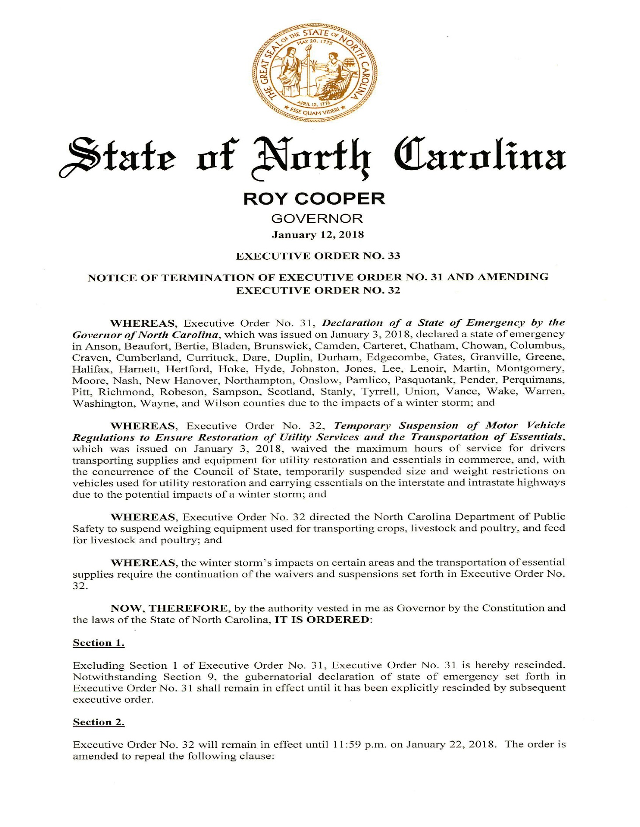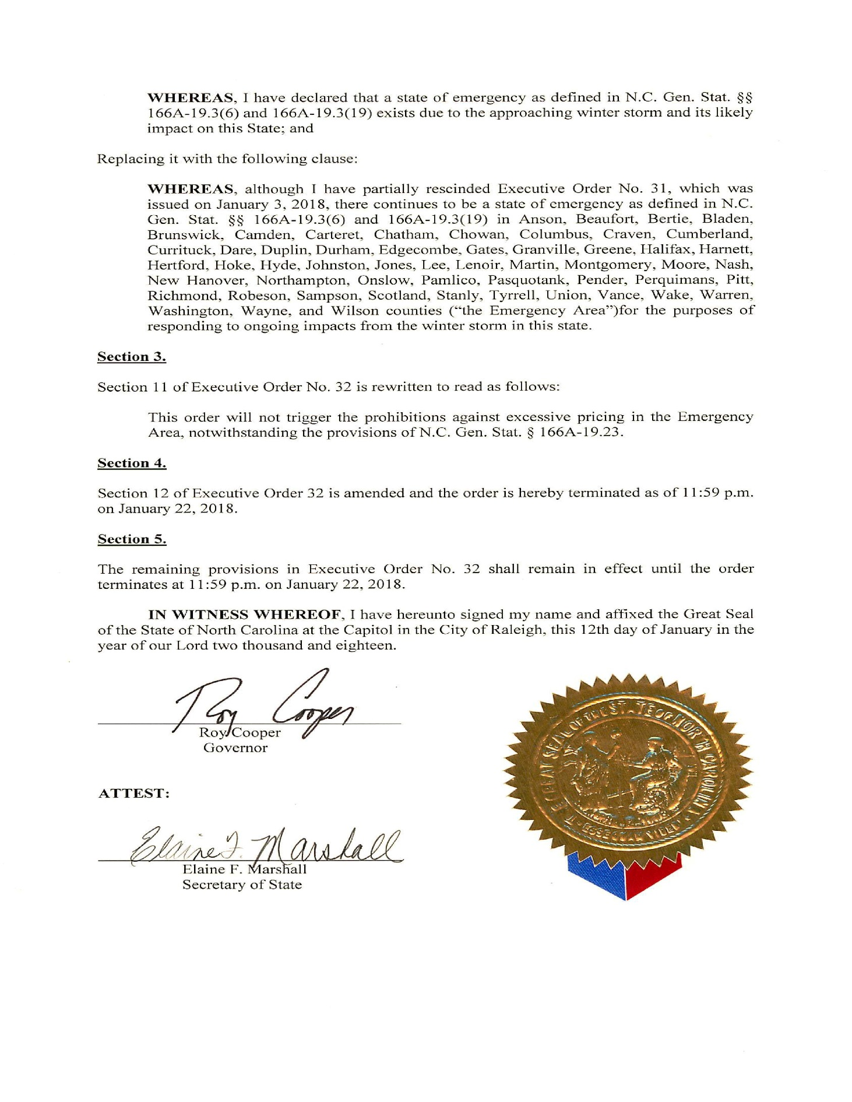
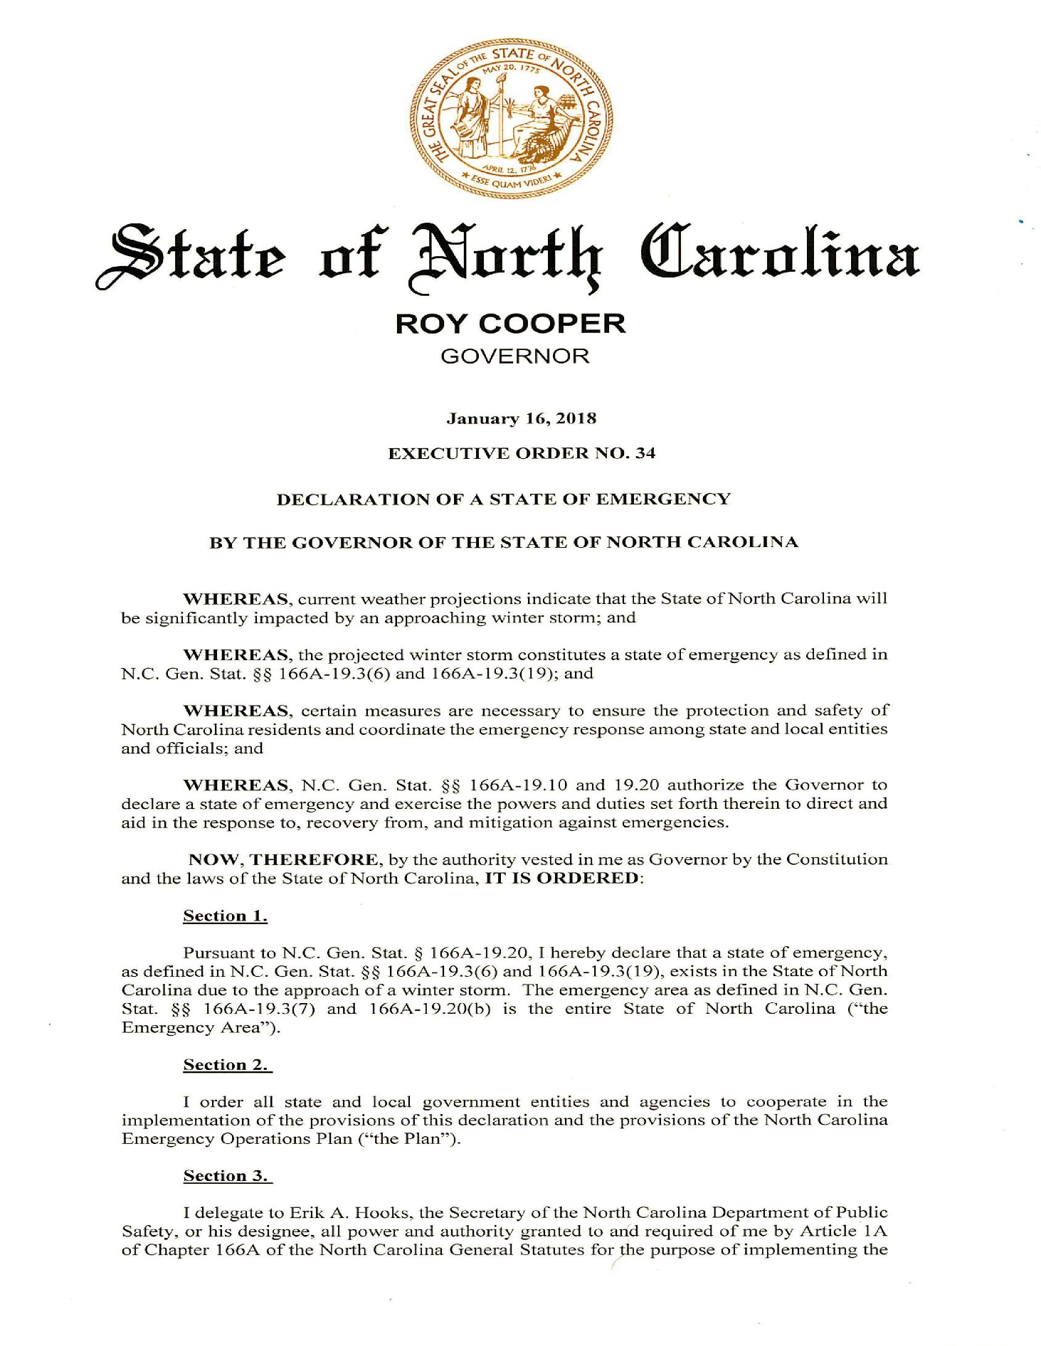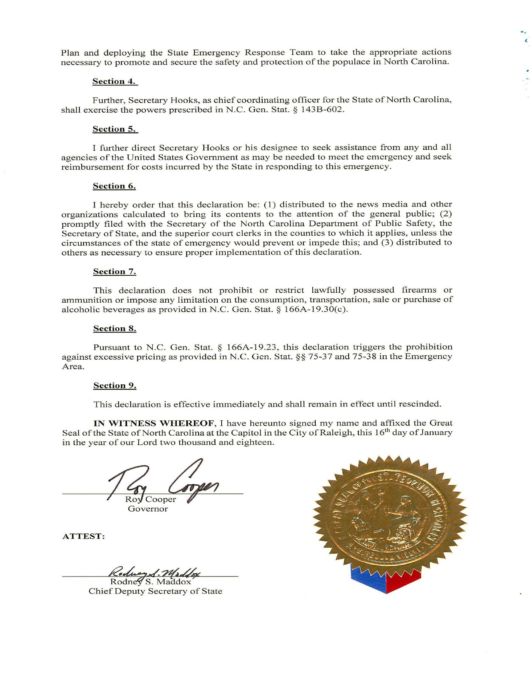
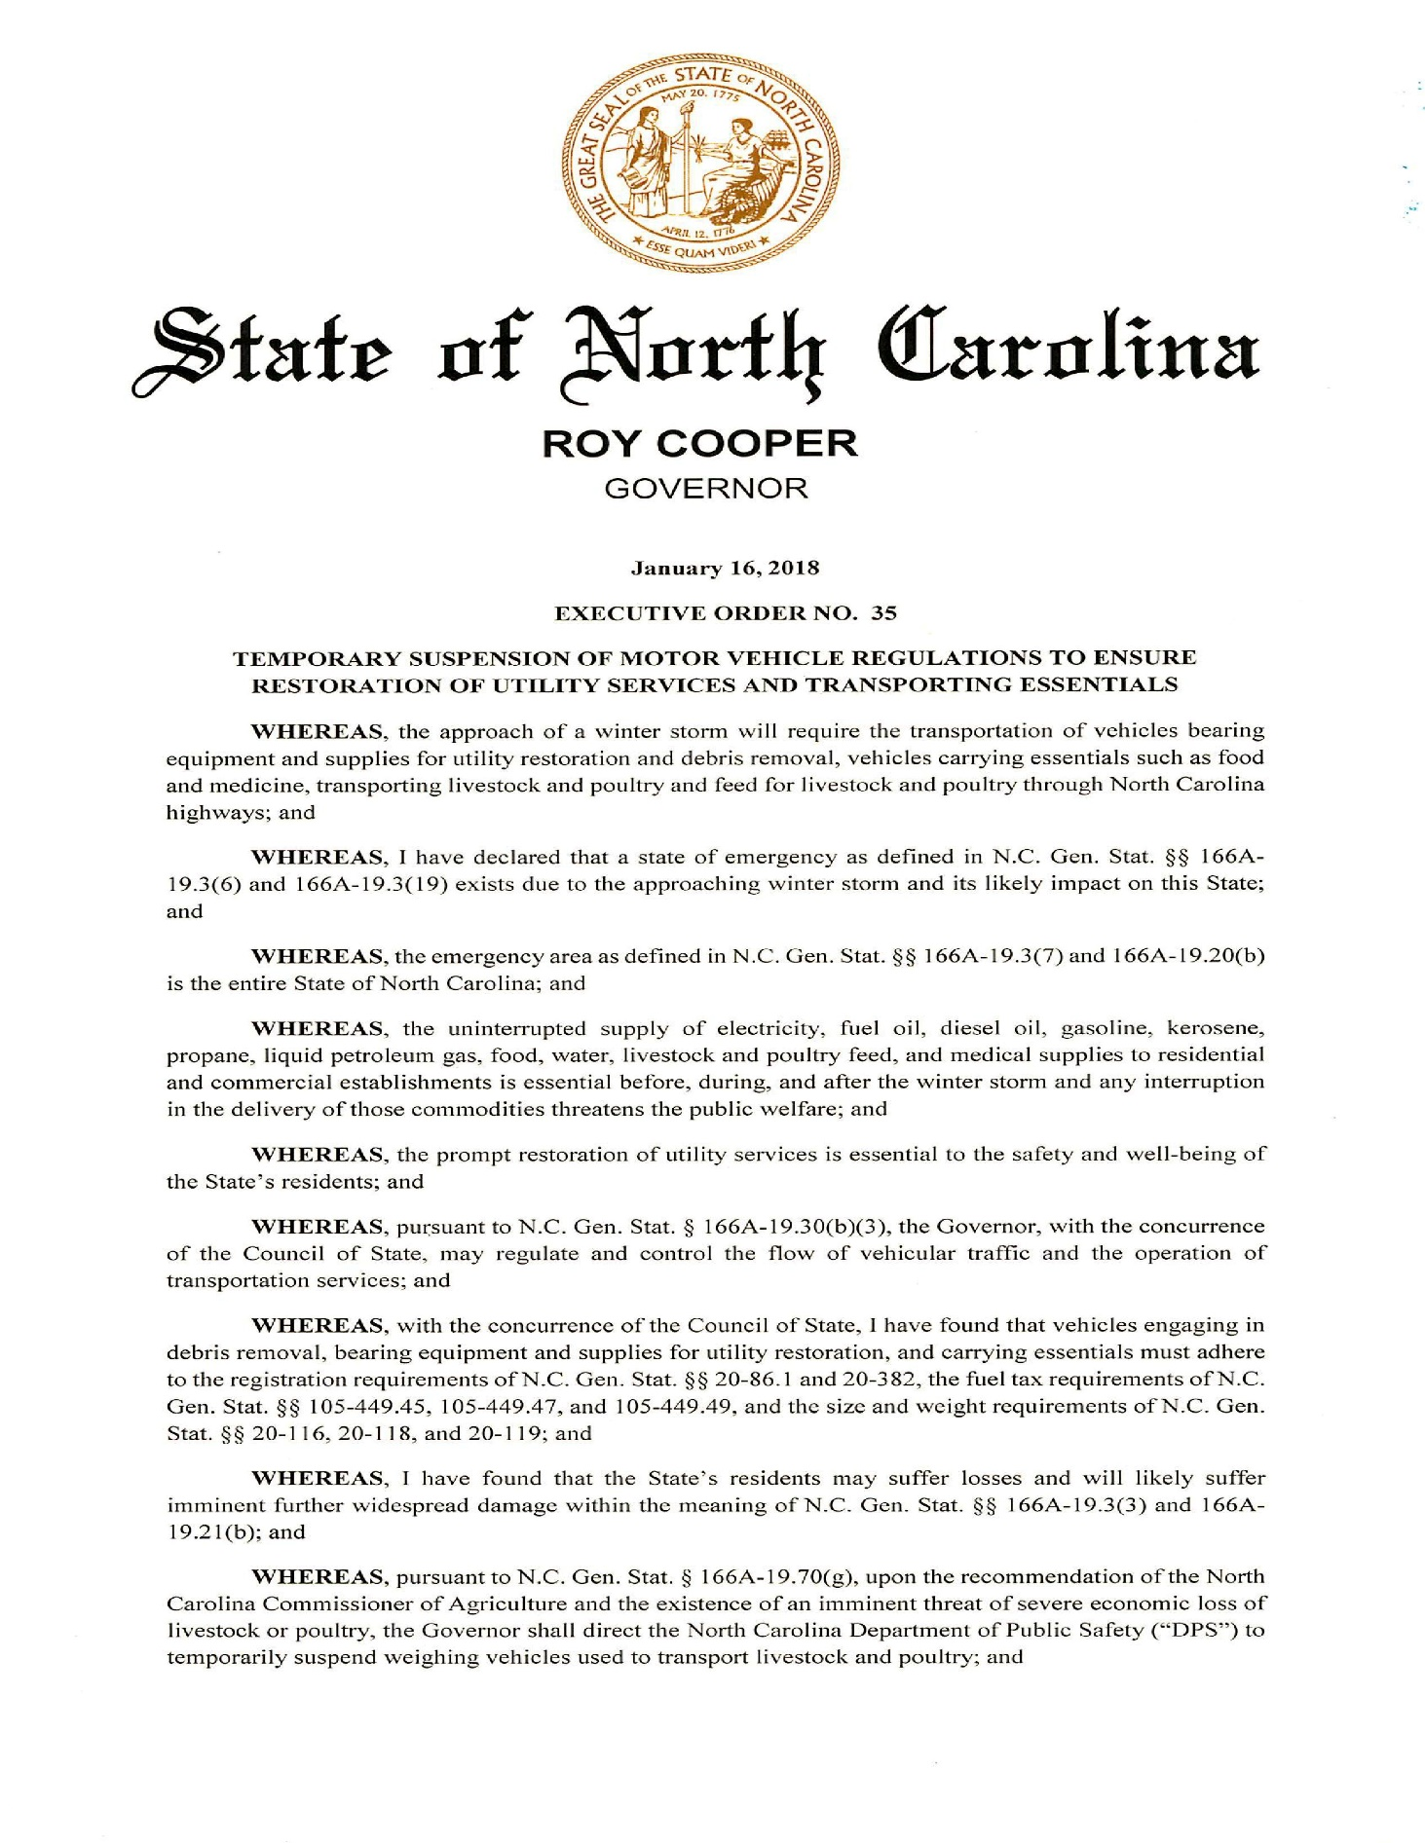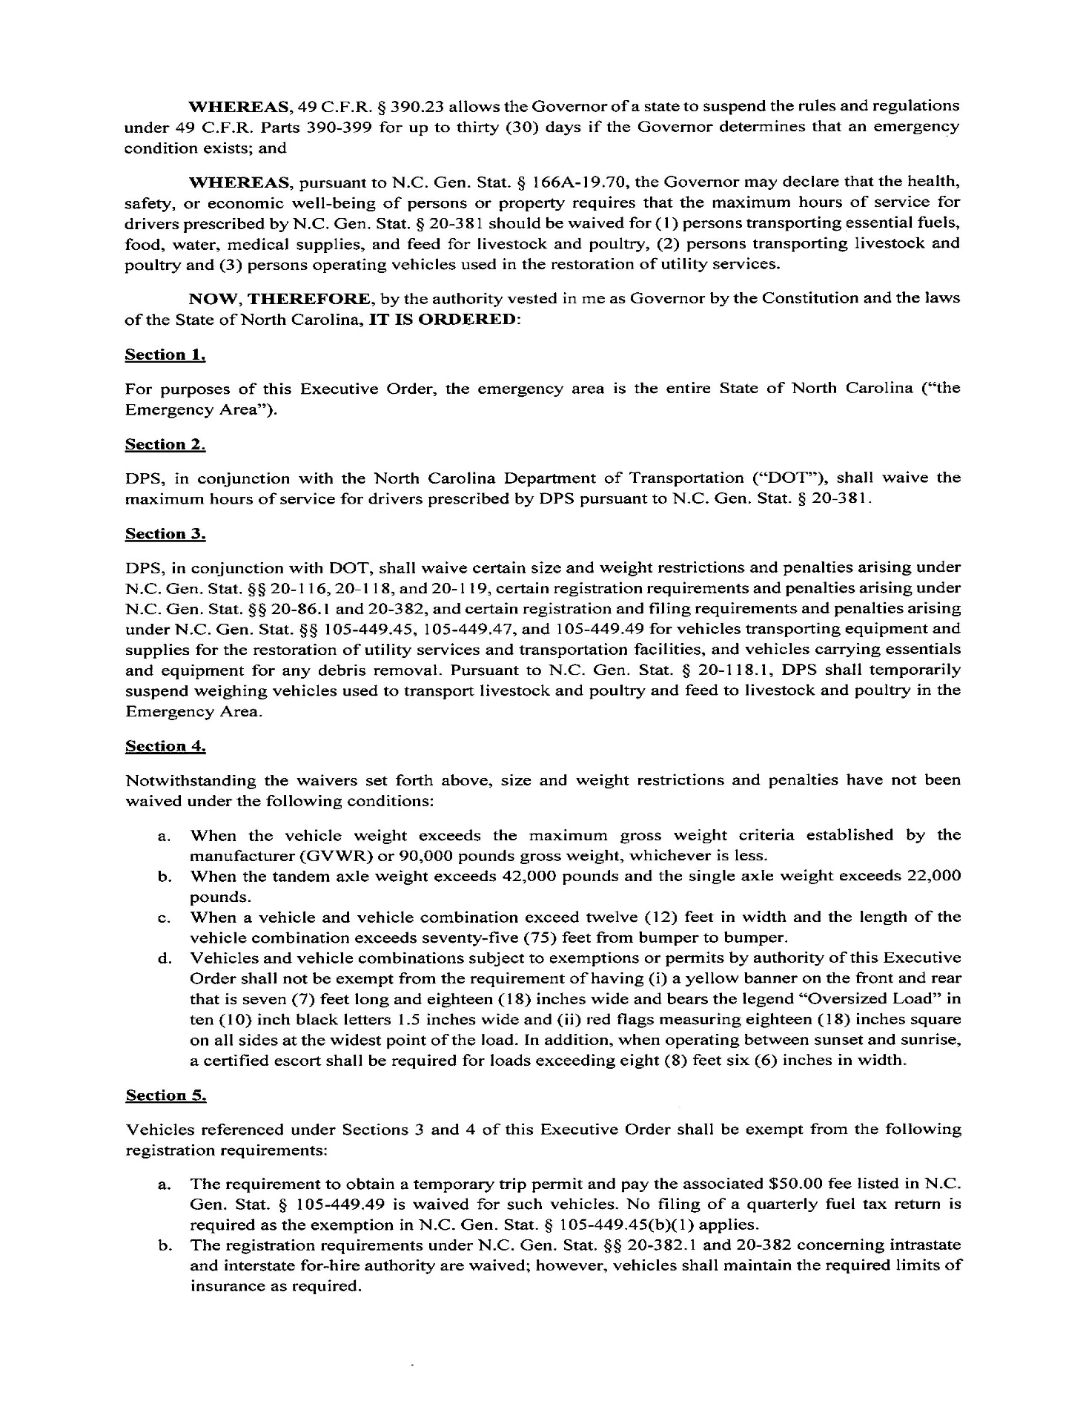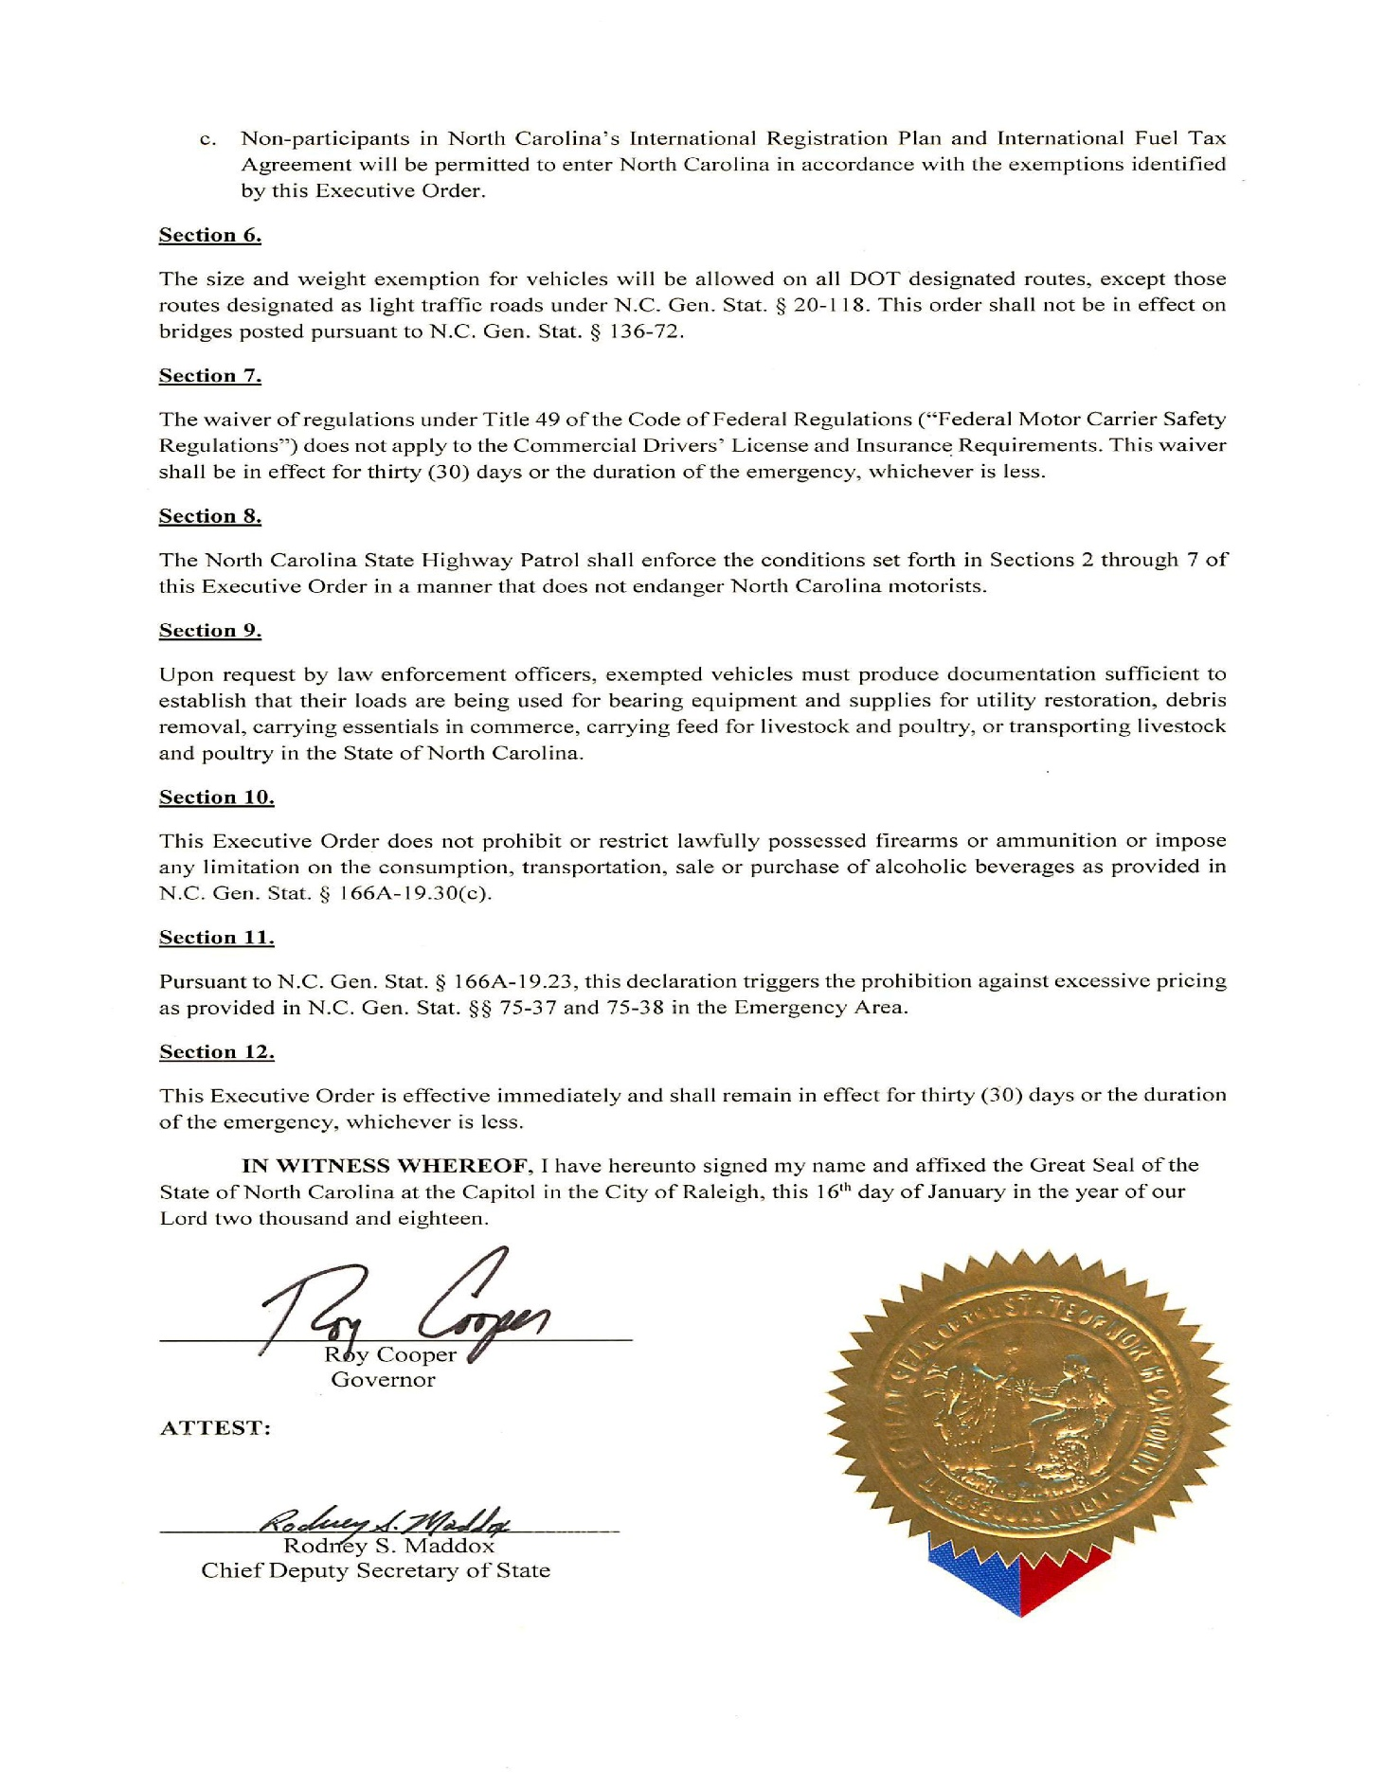

NOTICE OF RULE MAKING PROCEEDINGS AND PUBLIC HEARING

NORTH CAROLINA BUILDING CODE COUNCIL

Notice of Rule-making Proceedings is hereby given by NC Building Code Council in accordance with G.S. 150B-21.5(d).

Citation to Existing Rule Affected by this Rule-Making: North Carolina Administrative Code and Policies, Building, Electrical, Fire Prevention, Mechanical, and Residential Code amendments.

Authority for Rule-making: G.S. 143-136; 143-138.

Reason for Proposed Action: To incorporate changes in the NC State Building Codes as a result of rulemaking petitions filed with the NC Building Code Council and to incorporate changes proposed by the Council.

Public Hearing: Tuesday, March 13, 2018, 9:00AM, Albemarle Building, 325 North Salisbury Street, Raleigh, NC 27603, 2nd Floor Training Room 240. Comments on both the proposed rule and any fiscal impact will be accepted.

Comment Procedures: Written comments may be sent to Barry Gupton, Secretary, NC Building Code Council, NC Department of Insurance, 1202 Mail Service Center, Raleigh, NC 27699-1202. Comments on both the proposed rule and any fiscal impact will be accepted. Comment period expires on April 16, 2018.

Statement of Subject Matter:

1. Request by Terry Cromer representing the N.C. Association of Electrical Contractors, Inc. to amend the 2017 North Carolina Electrical Code Article 320.23(A) as follows:

320.23 In Accessible Attics. Type AC cables in accessible attics or roof spaces shall be installed as specified in 320.23(A) and (B).

(A) Cabled Run Across the Top of Floor Joists.
Where run across the top of floor joists, or within 2.1 m (7 ft) of the floor or floor joists across the face of ceiling rafters or studding, the cable shall be protected by guard strips that are at least as high as the cable, unless the cables are physically considered outside any floored area. Where this space is not accessible by permanent stairs or ladders, protection shall only be required within 1.8 m (6 ft) of the nearest edge of the scuttle hole or attic entrance where cables are run across the top of floor (ceiling) joists.
The cable shall be protected by guard strips that are at least as high as the cable where one of the following applies:
1. Where this space is accessible by permanent stairs or ladders, protection shall be required where run across the top of floor joists, or the area directly over a permanent floor and not exceeding 2.1 m (7 ft) vertically from the floor.
2. Where this space is not accessible by permanent stairs or ladders, protection shall be required within 1.8 m (6 ft) horizontally of the nearest edge of the scuttle hole or attic entrance where run across the top of any flooring, or flooring or ceiling joists. Protection is not required where run across the face of overhead roofing trusses or rafters.

Exception: For the purpose of this section, pull-down type stairs are not to be considered as permanent stairs or ladders.

Motion/Second/Approved – The request was granted. The proposed effective date of this rule is September 1, 2018 (earliest through RRC), unless the BCC assigns a delayed effective date (January 1, 2019).
Reason Given – The purpose of this amendment was not written.
Fiscal Statement – This rule is anticipated to provide equivalent compliance with no net decrease/increase in cost. This rule is not expected to either have a substantial economic impact or increase local and state funds. A fiscal note has not been prepared.

2. Request by Terry Cromer representing the N.C. Association of Electrical Contractors, Inc. to amend the 2017 North Carolina Electrical Code Article 410.2 as follows:

410.2 Definition.
Closet Storage Space. The volume bounded by the side and back closet walls and planes extending from the closet floor vertically to a height of 1.8 m (6 ft) or to the highest clothes-hanging rod and parallel to the walls at a horizontal distance of 600 mm (24 in.) from the sides and back of the closet walls, respectively, and continuing vertically to the closet ceiling parallel to the walls at a horizontal distance of 300 mm (12 in.) or the width of the shelf, whichever is greater; for a closet that permits access to both sides of a hanging rod, this space includes the volume below the highest rod extending 300 mm (12 in.) on either side of the rod on a plane horizontal to the floor extending the entire length of the rod. See Figure 410.2.

Exception: The area above the door including wall or ceiling space the width of door shall not be considered storage space.

Motion/Second/Approved – The request was granted. The proposed effective date of this rule is September 1, 2018 (earliest through RRC), unless the BCC assigns a delayed effective date (January 1, 2019).
Reason Given – The purpose of this amendment is to allow a lighting fixture above the door in a closet.
Fiscal Statement – This rule is anticipated to provide equivalent compliance with no net decrease/increase in cost. This rule is not expected to either have a substantial economic impact or increase local and state funds. A fiscal note has not been prepared.

3. Request by Michael Rettie representing NC BIA to amend the 2018 NC State Building Code Section 202 and the NC State Fire Prevention Code Section 202 as follows:

Section 202 – Definitions
OPEN AIR CAMP CABIN. A Single story residential building that has three walls consisting of at least twenty percent (20%) screened openings with a maximum height of 44 inches above the finished floor to the bottom of the openings has no heating or cooling system, is occupied for no more than 150 days within any rolling 365 day time span.

OPEN AIR CAMP CABIN. A single-story residential building meeting all of the following:
1. Consists of a single room;
Exception: The building may also contain toilet/bathing rooms arranged to not interrupt the free flow of air through the building.
2. Has a maximum sleeping capacity of 10 which will be permanently posted within the cabin adjacent to the main entry doorway;
3. Has three exterior walls with a minimum of twenty percent (20%) screened opening area in each wall with a maximum height of 44 inches above the finished floor to the bottom of the openings;
4. Has no heating or cooling system;
5. Is occupied for no more than 150 days within any rolling 365-day time span; and
6. A maximum of two such cabins may be located in a single structure. The two cabins must be separated by a fire wall complying with Section 706.

Motion/Second/Approved – The request was granted. The proposed effective date of this rule is September 1, 2018 (earliest through RRC), unless the BCC assigns a delayed effective date (January 1, 2019).
Reason Given – The purpose of this amendment is to clarify that open air cabins are intended to have a single room so occupants can observe fire hazards and to provide free ventilation of smoke.
Fiscal Statement – This rule is anticipated to provide equivalent compliance with no net decrease/increase in cost. This rule is not expected to either have a substantial economic impact or increase local and state funds. A fiscal note has not been prepared.

4. Request by Leon Skinner representing the NC Residential Code Standing Committee to amend the NC State Building Code, Volume 2018 NC Residential Code – Appendix H as follows:

Appendix H PATIO COVERS Tiny Houses
(The provisions contained in this appendix are adopted as part of this code.)

SECTION AH101
GENERAL

AH101.1 Scope.
This appendix shall be applicable to tiny houses used as single family dwelling units. Tiny houses shall comply with this code except as otherwise stated in this appendix. Tiny houses built off-site of closed-construction and shipped to its site of installation shall be constructed, inspected, and labeled as a modular home in accordance with NC General Statute 142-139.1. Tiny houses build on-site shall be open-construction and shall be inspected by the local building official having jurisdiction over the site.

SECTION AH102
DEFINITION

AH102.1 General
The following word and term shall, for the purposes of this appendix, have the meaning shown herein. Refer to Chapter 2 of this code for general definitions.

EGRESS ROOF ACCESS WINDOW. A skylight or roof window designed and installed to satisfy the emergency escape and rescue opening requirements in Section R310.2.

LANDING PLATFORM. A landing provided as the top step of a stairway accessing a loft.

LOFT. A floor level located more than 30 inches (762 mm) above the main floor and open to it on at least one side with a ceiling height of less than 6 feet 8 inches (2032 mm), used as a living or sleeping space.

TINY HOUSE. A dwelling that is 400 square feet (37 m²) or less in floor area excluding lofts.

SECTION AH103
CEILING HEIGHT

AH103.1 Minimum ceiling height. Habitable space and hallways in tiny houses shall have a ceiling height of not less than 6 feet 8 inches (2032 mm). Bathrooms, toilet rooms, and kitchens shall have a ceiling height of not less than 6 feet 4 inches (1930 mm). Obstructions shall not extend below these minimum ceiling heights including beams, girders, ducts, lighting and other obstructions.

Exception: Ceiling heights in lofts are permitted to be less than 6 feet 8 inches.

SECTION AH104
LOFTS

AH104.1 Minimum loft area and dimensions. Lofts used as a sleeping or living space shall meet the minimum area and dimension requirements Sections AH104.1.1 through AH104.1.3.

AH104.1.1 Minimum area. Lofts shall have a floor area of not less than 35 square feet (3.25 m²).

AH104.1.2 Minimum dimensions. Lofts shall be not less than 5 feet (1524 mm) in any horizontal dimension.

AH104.1.3 Height effect on loft area. Portions of a loft with a sloping ceiling measuring less than 3 feet (914 mm) from the finished floor to the finished ceiling shall not be considered as contributing to the minimum required area for the loft.

Exception: Under gable roofs with a minimum slope of 6 units vertical in 12 units horizontal (50-percent slope) portions of a loft with a sloped ceiling measuring less than 16 inches (406 mm) from the finished floor to the finished ceiling shall not be considered as contributing to the minimum required area for the loft.

AH104.2 Loft access. The access to and primary egress from lofts shall be any type described in Sections AH104.2.1 through AH104.2.4.

AH104.2.1 Stairways. Stairways accessing lofts shall comply with this code or with Sections AH104.2.1.1 through AH104.2.1.5.

AH104.2.1.1 Width. Stairways accessing a loft shall not be less than 17 inches (432 mm) in clear width at or above the handrail. The minimum width below the handrail shall not be less than 20 inches (508 mm).

AH104.2.1.2 Headroom. The headroom in stairways accessing a loft shall be not less than 6 feet 2 inches (1880 mm), as measured vertically, from a sloped line connecting the tread or landing platform nosings in the middle of their width.

AH104.2.1.3 Treads and risers. Risers for stairs accessing a loft shall be not less than 7 inches (178 mm) and not more than 12 inches (305mm) in height. Tread depth and riser height shall be calculated in accordance with one of the following formulas;
1. The tread depth shall be 20 inches (508 mm) minus 4/3 of the riser height,
2. The riser height shall be 15 inches (381 mm) minus ¾ of the tread depth.

AH104.2.1.4 Landing Platforms. The top tread and riser of stairways accessing lofts shall be constructed as a landing platform where the loft ceiling height is less than 6 feet 2 inches (1880 mm) where the stairway meets the loft. The landing platform shall be 18 inches to 22 inches (457 to 559 mm) in depth measured from the nosing of the landing platform to the edge of the loft, and 16 to 18 inches (406 to 457 mm) in height measured from the landing platform to the loft floor.

AH104.2.1.5 Handrails. Handrails shall comply with Section R311.7.8.

AH104.2.1.6 Stairway guards. Guards at open sides of stairways shall comply with Section R312.1.

AH104.2.2 Ladders. Ladders accessing lofts shall comply with Sections AH104.2.1 and AH104.2.2.

AH104.2.2.1 Size and capacity. Ladders accessing lofts shall have a rung width of not less than 12 inches (305 mm) and 10 inches (254 mm) to 14 inches (356 mm) spacing between rungs. Ladders shall be capable of supporting a 200 pound (75 kg) load on any rung. Rung spacing shall be uniform within 3/8-inch (9.5 mm).

AH104.2.2.2 Incline. Ladders shall be installed at 70 to 80 degrees from horizontal.

AH104.2.4 Ships ladders. Ships ladders accessing lofts shall comply with Sections R311.7.12.1 and R311.7.12.2. The clear width at and below handrails shall be not less than 20 inches (508 mm).

AH104.2.5 Loft Guards. Loft guards shall be located along the open side of lofts. Loft guards shall not be less than 36 inches (914 mm) in height or one-half of the clear height to the ceiling, whichever is less.

SECTION AH105
EMERGENCY ESCAPE AND RESCUE OPENINGS

AH105.1 General. Tiny houses shall meet the requirements of Section R310 for emergency escape and rescue openings.

Exception: Egress roof access windows in lofts used as sleeping rooms shall be deemed to meet the requirements of Section R310 where installed such that the bottom of the opening is not more than 44 inches (1118 mm) above the loft floor, provided the egress roof access window complies with the minimum opening area requirements of Section R310.2.1.

Motion/Second/Approved – The request was granted. The proposed effective date of this rule is September 1, 2018 (earliest through RRC), unless the BCC assigns a delayed effective date (January 1, 2019).
Reason Given – The purpose of this amendment is to adopt the 2018 IRC Tiny House appendix for dwellings less than 400-sf.
Fiscal Statement – This rule is anticipated to provide equivalent compliance with no net decrease/increase in cost. This rule is not expected to either have a substantial economic impact or increase local and state funds. A fiscal note has not been prepared.

5. Request by Leon Skinner representing the City of Raleigh to amend the NC State Building Code, Volume 2018 NC Mechanical Code – Section 306.5 as follows:

306.5 Equipment and appliances on roofs or elevated structures. Where equipment and appliances requiring periodic maintenance are installed on roofs or elevated structures at a height exceeding 16 feet (4877 mm), such access shall be provided by a permanent approved means of access, the extent of which shall be from grade or floor level to the equipment and appliances’ level service space. Such access shall not require climbing over obstructions greater than 30 inches (762 mm) high or walking on roofs having a slope greater than four units vertical in 12 units horizontal (33-percent slope). Where access involves climbing over parapet walls, the height shall be measured to the top of the parapet wall.

Exception: Where permanent means of access is technically infeasible, wall-mounted equipment and appliance maintenance, replacement and repairs that are over 16 feet can be serviced by motorized equipment upon approval.-The owner/tenant shall provide a maintenance service and cleaning schedule contract which shall be renewed annually.

Motion/Second/Approved – The request was granted. The proposed effective date of this rule is September 1, 2018 (earliest through RRC), unless the BCC assigns a delayed effective date (January 1, 2019).
Reason Given – The purpose of this amendment is to provide an alternate to permanent ladder access.
Fiscal Statement – This rule is anticipated to provide equivalent compliance with no net decrease/increase in cost. This rule is not expected to either have a substantial economic impact or increase local and state funds. A fiscal note has not been prepared.

6. Request by Leon Skinner representing the City of Raleigh to amend the NC State Building Code, Volume 2018 NC Mechanical Code – Section 306.5 as follows:

1013.6.1 Equipment and appliances on roofs or elevated structures. Where equipment and appliances requiring periodic maintenance are installed on roofs or elevated structures at a height exceeding 16 feet (4877 mm), such access shall be provided by a permanent approved means of access, the extent of which shall be from grade or floor level to the equipment and appliances’ level service space. Such access shall not require climbing over obstructions greater than 30 inches (762 mm) high or walking on roofs having a slope greater than four units vertical in 12 units horizontal (33-percent slope). Where access involves climbing over parapet walls, the height shall be measured to the top of the parapet wall.

Exception: Where permanent means of access is technically infeasible, wall-mounted equipment and appliance maintenance, replacement and repairs that are over 16 feet can be serviced by motorized equipment upon approval.-The owner/tenant shall provide a maintenance service and cleaning schedule contract which shall be renewed annually.

Motion/Second/Approved – The request was granted. The proposed effective date of this rule is September 1, 2018 (earliest through RRC), unless the BCC assigns a delayed effective date (January 1, 2019).
Reason Given – The purpose of this amendment is to provide an alternate to permanent ladder access.
Fiscal Statement – This rule is anticipated to provide equivalent compliance with no net decrease/increase in cost. This rule is not expected to either have a substantial economic impact or increase local and state funds. A fiscal note has not been prepared.

7. Request by Daniel Priest representing the NC Building Code Council to amend the NC State Building Code, Volume 2018 Administrative Code and Policies, Section 106 as follows:

106.3 Permit Application.
106.3.1 Information required. A permit application shall be filed with the Inspection Department on a form furnished for that purpose. The Inspection Department shall make available a list of information which must be submitted with the building permit application, including a complete building code summary (see Appendix A of the Administrative Code and Policies). The Inspection Department’s building code summary shall be in the exact format as, and contain only the information in, Appendix B of the Administrative Code and Policies. The Inspection Department shall only modify its building code summary as set forth in section 103.5 Modifications, or as necessary to reflect any changes by the Office of State Fire Marshal to Appendix B which have been approved of by the Building Code Council.

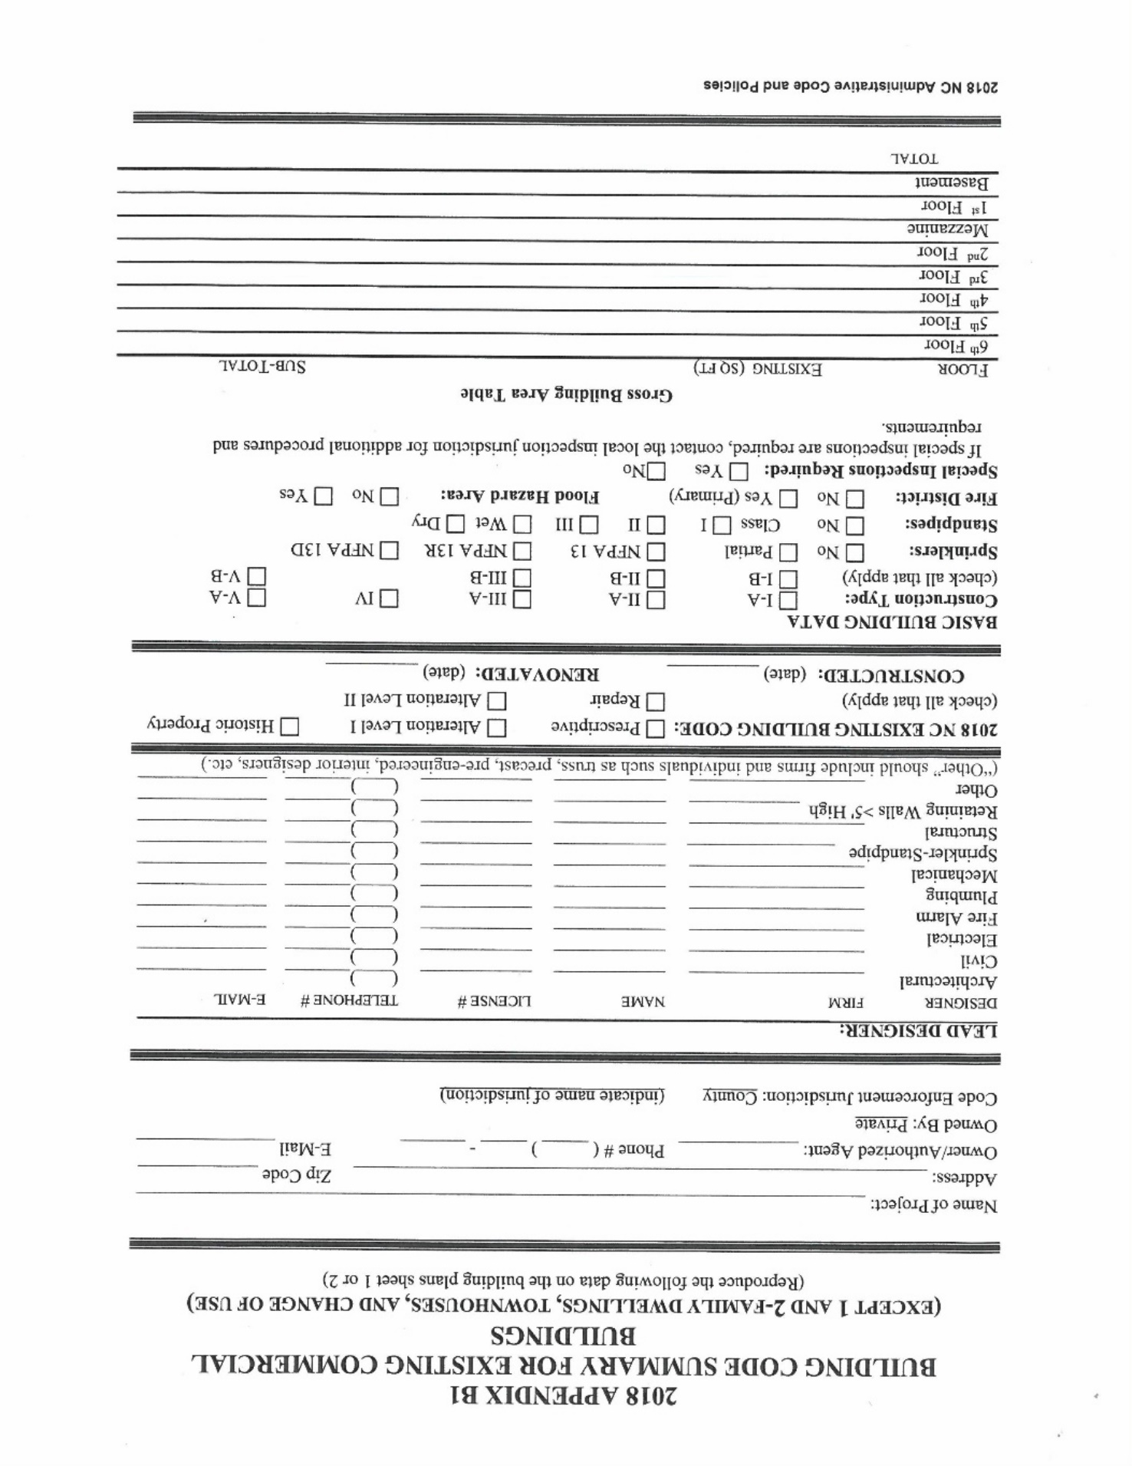

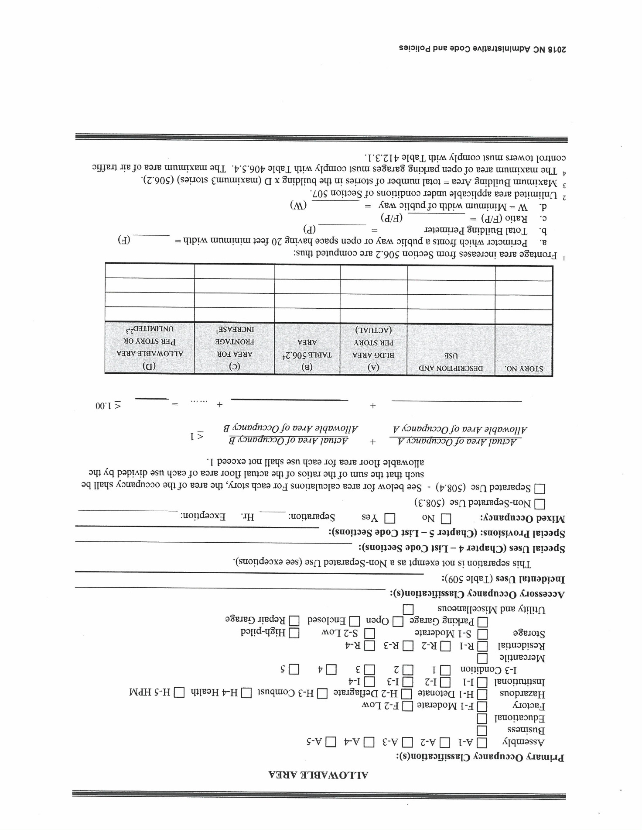

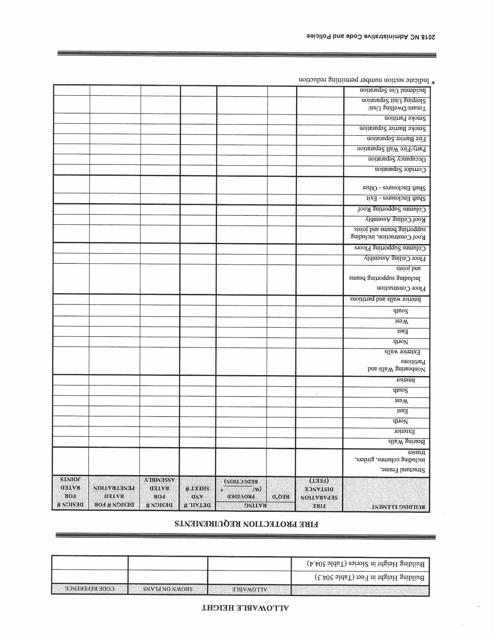

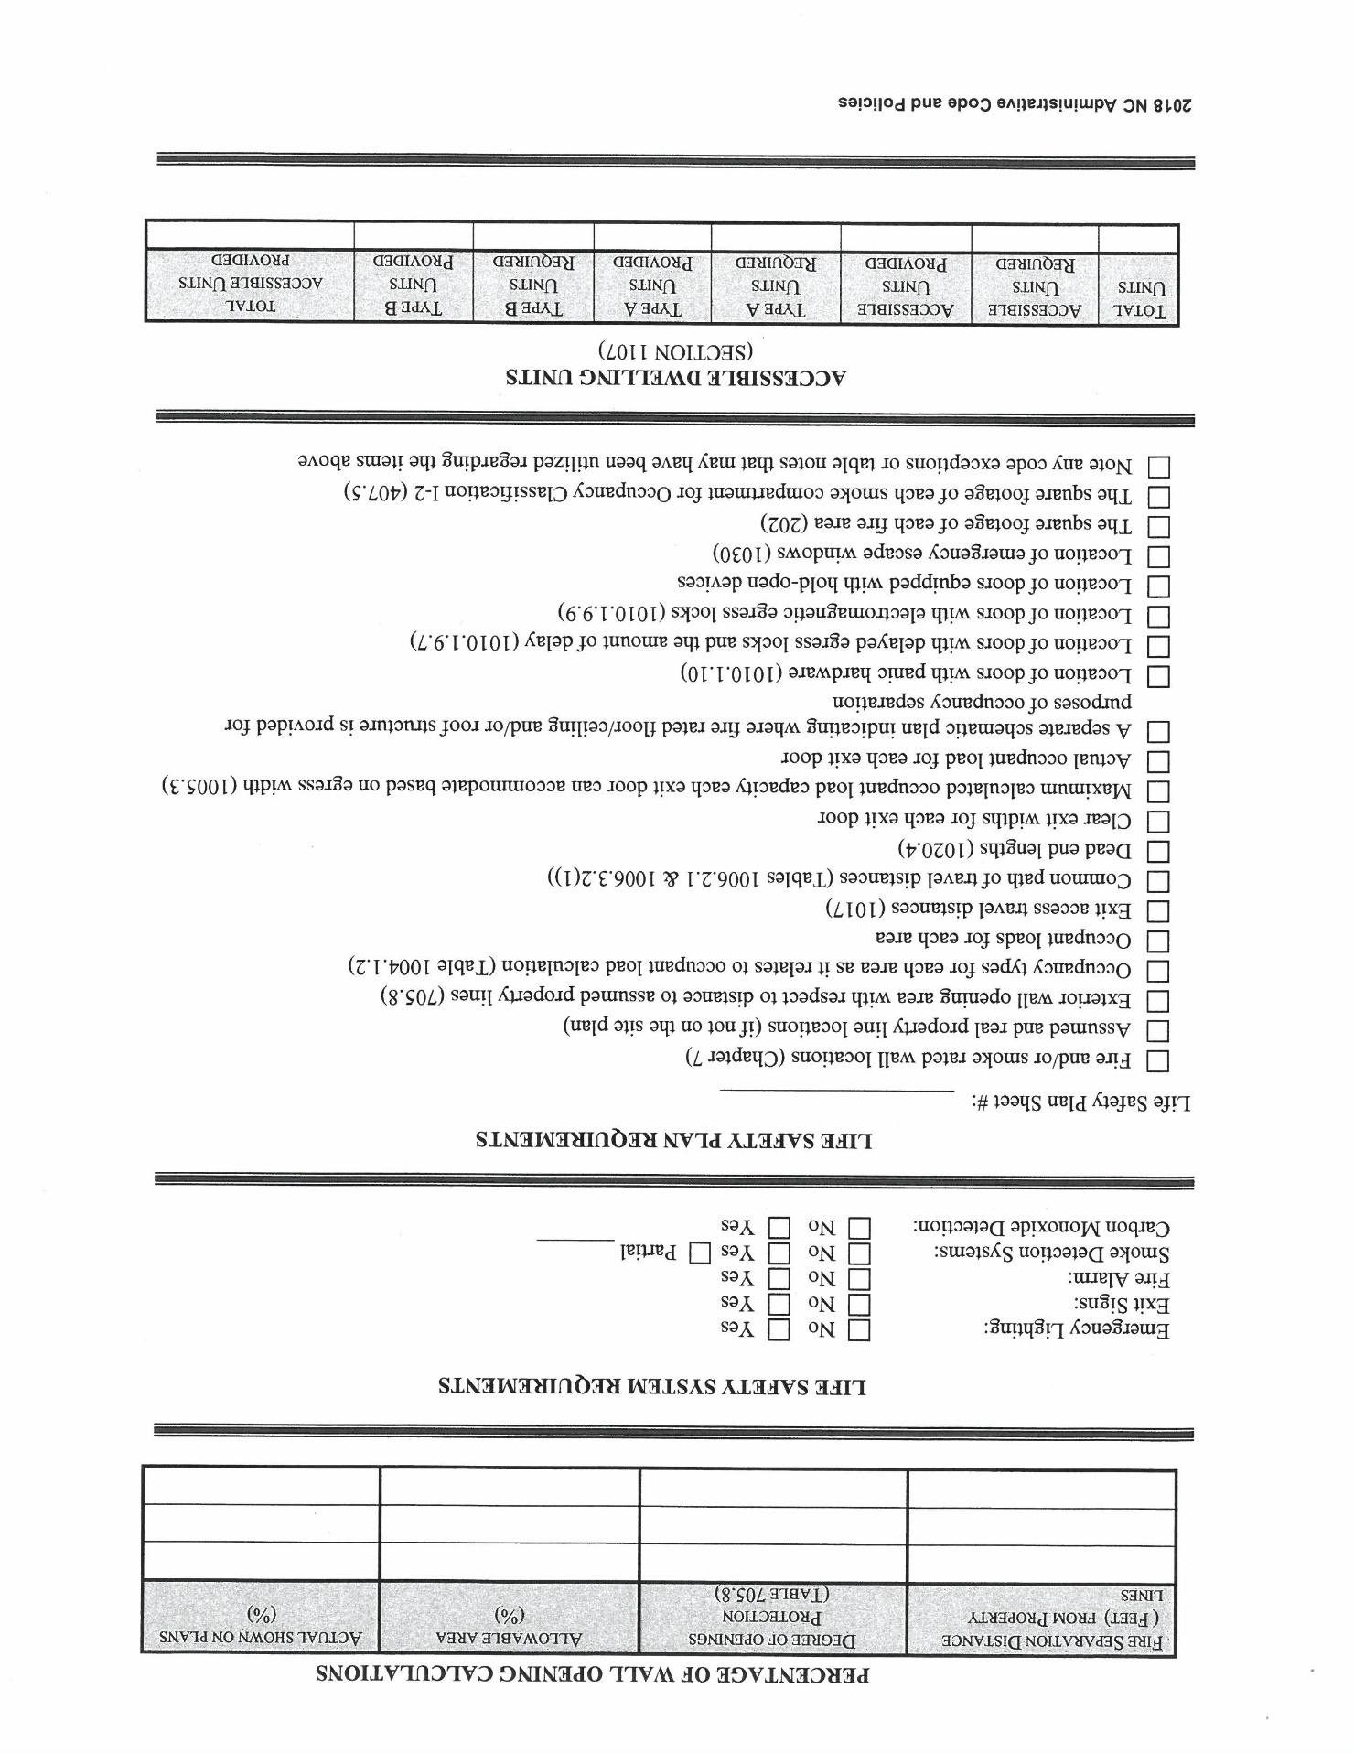

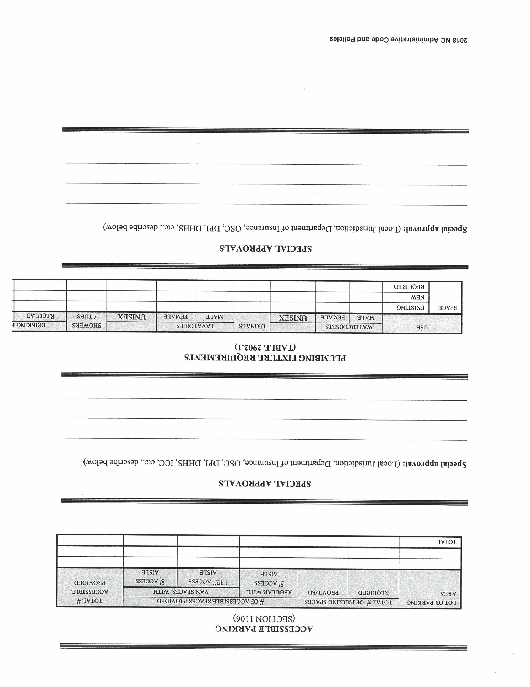

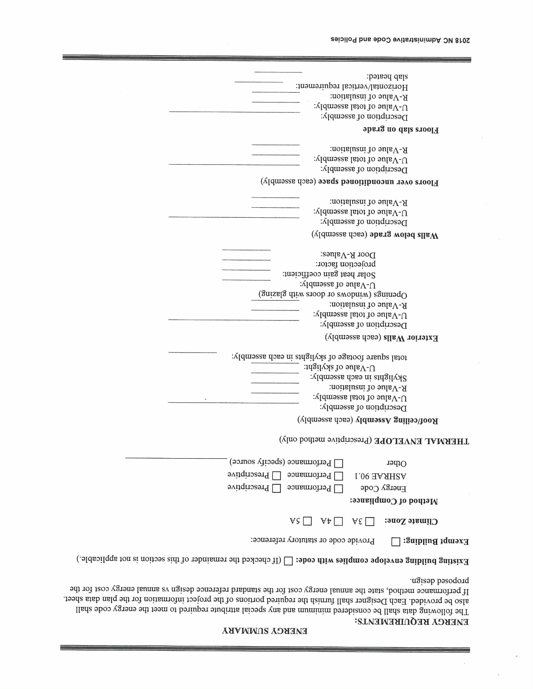

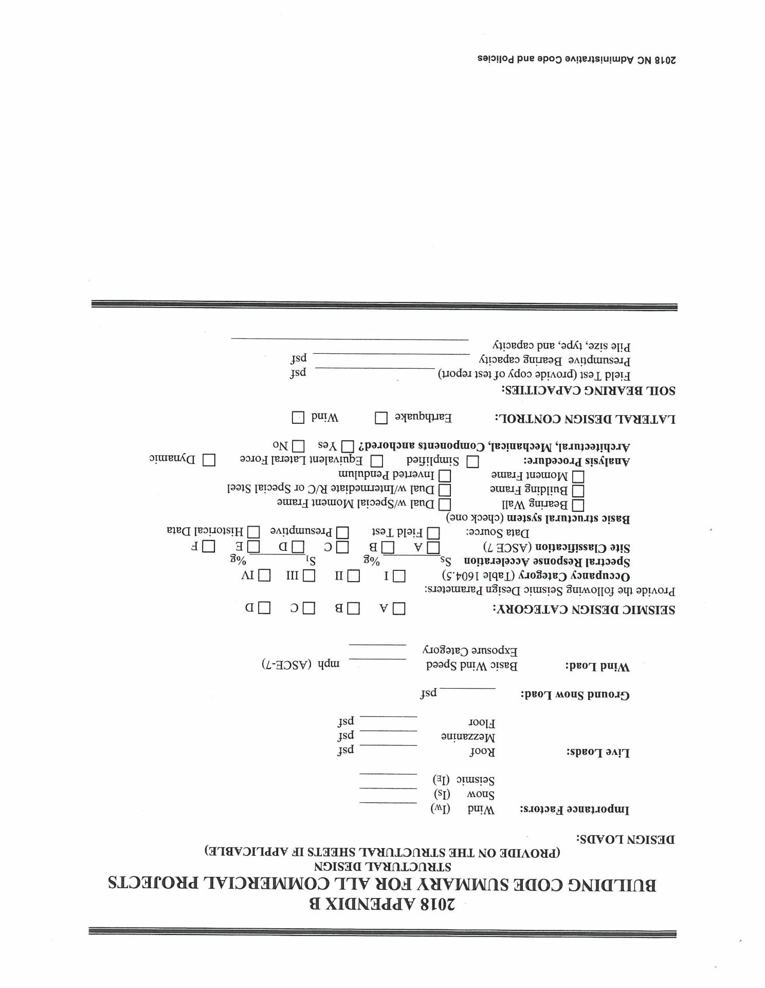

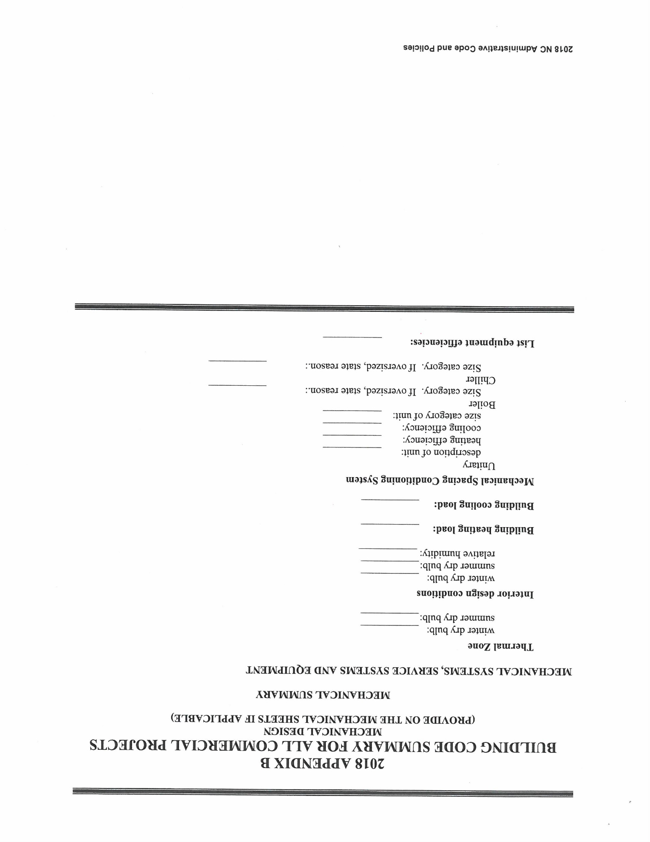

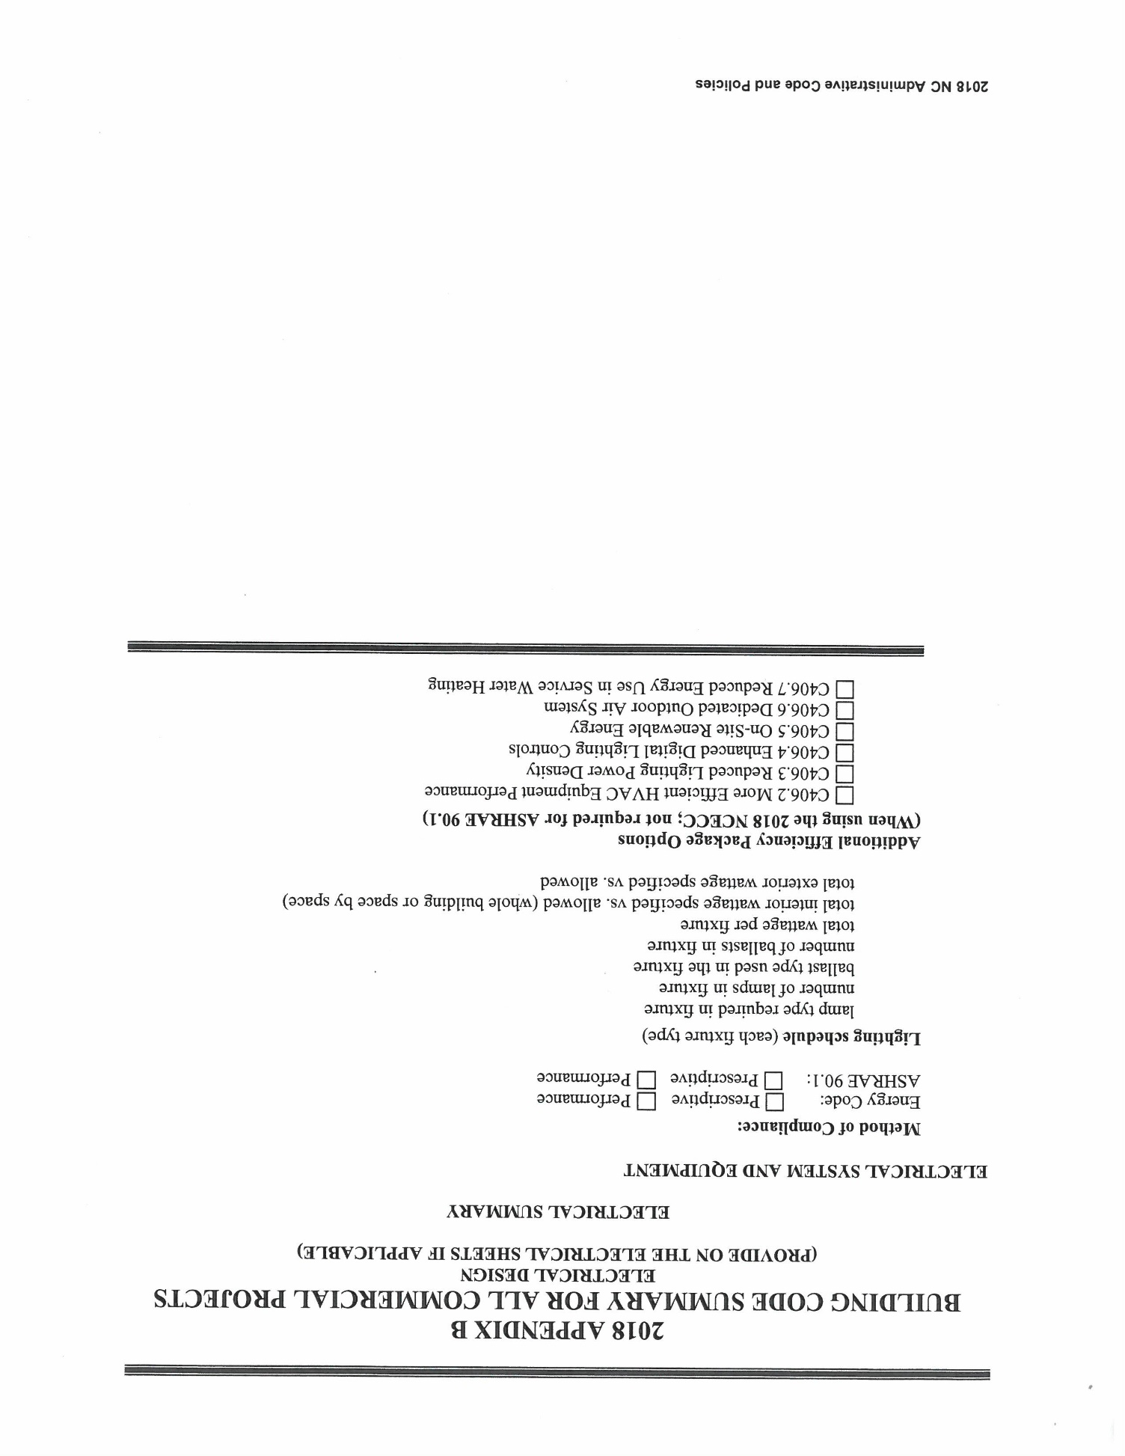

Motion/Second/Approved – The request was granted. The proposed effective date of this rule is September 1, 2018 (earliest through RRC), unless the BCC assigns a delayed effective date (January 1, 2019).
Reason Given – This purpose of this amendment is to streamline the permit application process by providing a statewide Appendix B building code summary.
Fiscal Statement – This rule is anticipated to provide equivalent compliance with no net decrease/increase in cost. This rule is not expected to either have a substantial economic impact or increase local and state funds. A fiscal note has not been prepared.

NOTICE:
Appeals and Interpretations of the North Carolina State Building Codes are published online at the following link.
http://www.ncdoi.com/OSFM/Engineering_and_Codes/Default.aspx?field1=Code_Interpretations&user=Code_Enforcement_Resources

NOTICE:

Objections and Legislative Review requests may be made to the NC Office of Administrative Hearings in accordance with G.S. 150B-21.3(b2) after Rules are adopted by the Building Code Council.

http://www.ncoah.com/rules/

NORTH CAROLINA RATE BUREAU

PUBLIC NOTICE

Notice is hereby given pursuant to North Carolina General Statute 58-36-120 that on February 7, 2018, the North Carolina Rate Bureau filed for an increase in rates as to Dwelling insurance policies under its jurisdiction. Public notice of the Filing is being given in two newspapers with statewide distribution, and information is being posted on the websites of the North Carolina Rate Bureau and the North Carolina Department of Insurance. The Commissioner of Insurance may or may not schedule and conduct a hearing with respect to the Filing.

Note from the Codifier: The notices published in this Section of the NC Register include the text of proposed rules. The agency must accept comments on the proposed rule(s) for at least 60 days from the publication date, or until the public hearing, or a later date if specified in the notice by the agency. If the agency adopts a rule that differs substantially from a prior published notice, the agency must publish the text of the proposed different rule and accept comment on the proposed different rule for 60 days.
Statutory reference: G.S. 150B-21.2.

TITLE 15A – DEPARTMENT OF ENVIRONMENTAL QUALITY

Notice is hereby given in accordance with G.S. 150B-21.2 and G.S. 150B-21.3A(c)(2)g. that the Environmental Management Commission intends to readopt with substantive changes the rules cited as 15A NCAC 02S .0102, .0202, .0301, .0503, .0506, .0508, .0509 and readopt without substantive changes the rules cited as 15A NCAC 02S .0101, .0201, .0501, .0502, and .0507.

Pursuant to G.S. 150B-21.2(c)(1), the text of the rule(s) proposed for readoption without substantive changes are not required to be published. The text of the rules are available on the OAH website: http://reports.oah.state.nc.us/ncac.asp.

Link to agency website pursuant to G.S. 150B-19.1(c): http://deq.nc.gov/permits-regulations/rules-regulations/proposed-main

Proposed Effective Date: September 1, 2018

Public Hearing:

Date: March 6, 2018

Time: 6:00 p.m.

Location: NC Department of Environmental Quality, 217 West Jones Street, Raleigh, NC 27603, Room 1210

Reason for Proposed Action: The rules 15A NCAC 02S .0101, .0102, .0201, .0202, .0301, .0501, .0502, .0503, .0506, .0507, .0508, .0509 are proposed for readoption to comply with the Rule Review requirements pursuant to G.S. 150B-21.3A. Proposed amendments to the rules include technical corrections, clarifications of form requirements and No Further Action Criteria, and an amendment to the definition of site specific target level to be consistent with risk-based standards in G.S. 130A-310.68.

Comments may be submitted to: Peter Doorn, 1646 Mail Service Center, Raleigh, NC 27699-1646; phone (919) 707-8369, fax (919) 707-8369; email peter.doorn@ncdenr.gov

Comment period ends: April 16, 2018

Procedure for Subjecting a Proposed Rule to Legislative Review: If an objection is not resolved prior to the adoption of the rule, a person may also submit written objections to the Rules Review Commission after the adoption of the Rule. If the Rules Review Commission receives written and signed objections after the adoption of the Rule in accordance with G.S. 150B-21.3(b2) from 10 or more persons clearly requesting review by the legislature and the Rules Review Commission approves the rule, the rule will become effective as provided in G.S. 150B-21.3(b1). The Commission will receive written objections until 5:00 p.m. on the day following the day the Commission approves the rule. The Commission will receive those objections by mail, delivery service, hand delivery, or facsimile transmission. If you have any further questions concerning the submission of objections to the Commission, please call a Commission staff attorney at 919-431-3000.

Fiscal impact (check all that apply).

State funds affected

Environmental permitting of DOT affected

Analysis submitted to Board of Transportation

Local funds affected

Substantial economic impact (≥$1,000,000)

Approved by OSBM

No fiscal note required by G.S. 150B-21.4

No fiscal note required by G.S. 150B-21.3A(d)(2)

Chapter 02 - Environmental Management

SUBCHAPTER 02S – RULES AND CRITERIA FOR THE ADMINISTRATION OF THE DRY-CLEANING SOLVENT CLEANUP FUND

SECTION .0100 – GENERAL CONSIDERATIONS

15A NCAC 02S .0101 SCOPE AND PURPOSE (READOPTION WITHOUT SUBSTANTIVE CHANGES)

15A NCAC 02S .0102 DEFINITIONS

The definition of any word or phrase used in this Subchapter shall be the same as given in G.S. 143-215.104B and the following words and phrases shall have the following meanings:
(1) "Act" means the Dry-Cleaning Solvent Cleanup Act of 1997. 1997 and any amendments thereto.
(2) "Apparel and household fabrics" means apparel and fabrics that have been purchased at retail or have been purchased at wholesale for rental at retail.
(3) "Business" means "business" as defined in G.S. 59-102.
(4) "Chemicals of concern" means the specific compounds and their breakdown products that are identified for evaluation in the risk-based corrective action process. Identification may can be based on their historical and current use at the site, detected concentrations in environmental media, media and their mobility, toxicity, and persistence in the environment.
(5) "Closed container solvent transfer system" means a device or system specifically designed to fill a dry-cleaning machine with dry-cleaning solvent through a mechanical valve or sealed coupling in order to prevent spills or other loss of solvent liquids or vapors to the environment.
(6) "Complete exposure pathway" means an exposure pathway where a chemical of concern has reached a receptor.
(7) "Contaminated site" or "site" means the area defined by the likely current and future location of the chemicals of concern from a facility or abandoned site. A contaminated site may could be an entire property or facility, a defined area or portion of a facility or property, property or multiple facilities or properties.
(8) "Discovery Site" means the physical site or area where dry-cleaning solvent contamination has been discovered. A discovery site may or may not be the same property as the facility site.
(9) "Division" means the Division of Waste Management of the Department of Environment and Natural Resources. Environmental Quality.
(10) "Dry-Cleaning Business" means a business having engaged in dry-cleaning operations or the operation of a wholesale distribution facility at a facility site.
(11) "Environmental media" means soil, sediment, surface water, groundwater, air, air or other physical substance.
(12) "Engineering controls" means physical modifications to a site to reduce or eliminate the potential for exposure to chemicals of concern.
(13) "Exposure pathway" means the course that a chemical of concern takes or may take from a source area to a receptor. Each exposure pathway includes a source or release from a source of a chemical of concern, a potential point of exposure, an exposure route, route and the potential receptor.
(14) "Facility site" means the physical location of a dry-cleaning facility, a wholesale distribution facility, facility or an abandoned site.
(15) "Hazard Index" means the sum of two or more hazard quotients for chemicals of concern or multiple exposure pathways to a particular receptor.
(16) "Hazard quotient" means the ratio of level of exposure of a chemical of concern over a specified time period to a reference dose for that chemical of concern derived for a similar exposure period.
(17) "Individual excess lifetime cancer risk" means the increase over background in an individual's probability of getting cancer over a lifetime due to exposure to a chemical.
(18) "Institutional controls" means nonengineered measures, including land-use restrictions, used to prevent unsafe exposure to contamination.
(19) "Material impervious to dry-cleaning solvent" means a material that has been certified by the manufacturer or an independent testing laboratory such as Underwriters Laboratory, to maintain its chemical and structural integrity in the presence of the applicable dry-cleaning solvent and prevent the movement of dry-cleaning solvent for a period of a least 72 hours.
(20) "Monitored natural attenuation" means an approach to the reduction in the concentration of chemicals of concern in environmental media due to naturally occurring physical, chemical and biological processes. processes, which is based on best available scientific information.
(21) "Non-residential land use" means a use that is not a residential land use.
(22) "Number of full time employees" means the number of full-time equivalent employees employed by a person who owns a dry-cleaning facility, as calculated pursuant to 15A NCAC 02S .0103.
(23) "Person" means "person" as defined in G.S. 143-215.77(13).
(24) "Petitioner" means a potentially responsible party who submits a petition for certification of a facility site.
(25) "Point of demonstration" means the location selected between the source area and a point of exposure where levels of chemicals of concern are measured to ensure that site-specific target levels are being met.
(26) "Point of exposure" means the location at which an individual or population may come in contact with a chemical of concern originating from a site.
(27) "Receptor" means any human, plant, or animal that which is, or has the potential to be, adversely affected by the release or migration of chemicals of concern.
(28) "Reference dose" means a toxicity value for evaluating potential non-carcinogenic effects in humans resulting from exposure to a chemical of concern.
(29) "Remedial action plan" means a plan that outlines activities to be undertaken to clean up a contaminated site and to reduce or eliminate current or potential exposures to receptors.
(30) "Representative concentrations" means a typical or average concentration to which the receptor is exposed over the specified exposure duration, within a specified geographical area, and for a specific route of exposure.
(31) "Residential land use" means use for human habitation, including dwellings such as single family houses and multi-family apartments, children's homes, nursing homes, and residential portions of government-owned lands (local, State state or federal). Because of the similarity of exposure potential and the sensitive nature of the potentially exposed human population, use for day care facilities, educational facilities, hospitals, and parks (local, State state or federal) shall be considered residential land use for the purpose of land use classification.
(32) "Risk-based screening level" means chemical-specific, risk-based values for chemicals of concern that shall be are protective of human health. The risk-based screening levels are as follows:
(a) For known or suspected carcinogens, except for those chemicals of concern that have groundwater standards or interim standards established in 15A NCAC 02L, risk-based screening levels shall be are established for each chemical of concern at exposures that represent an individual excess lifetime cancer risk of one in 1,000,000.
(b) For systemic toxicants, except for those chemicals of concern that have groundwater standards or interim standards established in 15A NCAC 02L, risk-based screening levels shall be are established using a hazard quotient for each chemical of concern of 0.2.
(c) For chemicals of concern in groundwater that have 15A NCAC 02L standards, the risk-based screening level shall be the standards and interim standards established in 15A NCAC 02L.
(33) "Site-specific target level" means risk-based values for chemicals of concern that are protective of human health for specified exposure pathways and are derived from a consideration of site-specific information. The site-specific target levels shall be consistent with the Department's risk-based corrective action standards under G.S. 130A-310.68 and rules adopted pursuant to Article 9 of Chapter 130A of the General Statutes. are as follows:
(a) For known or suspected carcinogens, the sum of individual excess lifetime cancer risk values for all chemicals of concern for all exposure pathways may not exceed one in 100,000.
(b) For systemic toxicants, the Hazard Index for all chemicals of concern for all complete exposure pathways may not exceed 1.0.
(34) "Source" means non-aqueous phase liquid chemical, the locations of highest soil or ground water concentrations of the chemicals of concern, concern or the location releasing the chemical of concern.
(35) "Systemic toxicant" means a substance or agent that may enter the human body and have an adverse health effect other than causing cancer.
(36) "Unsaturated zone" means that part of the subsurface where interconnected voids are not all filled with water.

Note: Portions of this rule extracted, with permission, from E2081-00(2004)e1 Standard Guide for Risk-Based Corrective Action, copyright ASTM International, 100 Barr Harbor Drive, West Conshohocken, PA 19428, www.astm.org.

Authority G.S. 143-215.104B; 143-215.104D(b); 150B-21.2.

SECTION .0200 – MINIMUM MANAGEMENT PRACTICES

15A NCAC 02S .0201 APPLICABILITY (READOPTION WITHOUT SUBSTANTIVE CHANGES)

15A NCAC 02S .0202 REQUIRED MINIMUM MANAGEMENT PRACTICES

(a) All abandoned sites, as defined by G.S. 143-215.104B(b)(1), G.S.143-215.104(B)(b)(1), shall at all times after August 1, 2000, this Rule becomes effective, comply with Required Minimum Management Practice, Subparagraph (b)(5) of this Rule.

(b) All dry-cleaning facilities and wholesale distribution facilities shall shall, at all times after this Rule becomes effective, comply with the following minimum management practices:

(1) At no time shall any dry-cleaning solvent, wastes containing dry-cleaning solvent, or water containing dry-cleaning solvent be discharged onto land or into waters of the State, sanitary sewers, storm drains, floor drains, septic systems, boilers, or cooling- towers. All invoices generated as a result of disposal of all dry-cleaning solvent waste shall be made available for review upon request by the Department. If a dry-cleaning facility uses devices such as atomizers, evaporators, carbon filters, or other equipment for the treatment of wastewater containing solvent, all records, including but not limited to, invoices for the purchase, maintenance, and service of the such devices, shall be made available upon request by to the Department. Records shall be kept for a period of three years.

(2) Spill containment shall be installed and maintained under and around dry-cleaning machines, filters, dry-cleaning solvent pumps, stills, vapor adsorbers, solvent storage areas, and waste solvent storage areas by January 1, 2002. Spill containment shall have a volumetric capacity of 110 percent of the largest vessel, tank, or container within the spill containment area and shall be capable of preventing the release of the applicable liquid dry-cleaning solvent beyond the spill containment area for a period of at least 72 hours. All floor drains within or beneath the spill containment area shall be removed or permanently sealed with materials impervious to dry-cleaning solvents. Emergency adsorbent spill clean-up materials shall be on the premises. Facilities shall must maintain an emergency response plan that is in compliance with federal, State state and local requirements.

(3) All perchloroethylene dry-cleaning machines installed at a dry-cleaning facility after August 1, 2000, the effective date of this Rule shall meet air emissions that equal or exceed the standards that apply to a comparable dry-to-dry perchloroethylene dry-cleaning machine with an integrated refrigerated condenser. All perchloroethylene dry-cleaning facilities shall must be in compliance with the EPA Perchloroethylene Dry Cleaner NESHAP: 40CFR, Part 63, Subpart M to be eligible for certification.

(4) Facilities that use perchloroethylene shall use a closed container solvent transfer system by January 1, 2002.

(5) After February 1, 2001, Within six months of the effective date of this Rule, no dry-cleaning facility shall use underground storage tanks for solvents or waste.

Authority G.S. 143-215.104D(b); 150B-21.2.

SECTION .0300 - PETITIONS FOR CERTIFICATION

15A NCAC 02S .0301 FILING

(a) Any potentially responsible party petitioning may petition for certification of a facility site shall file by filing a petition with the Division using the DSCA Petitioner Questionnaire Form forms provided by the Division. The petition shall include a laboratory analysis demonstrating the presence of dry-cleaning solvent in environmental media at the discovery site. Pursuant to G.S. 143-215.104F and .104G, the DSCA Petitioner Questionnaire Form shall include the following:

(1) petitioner contact information, their corporate status, and their relationship to the facility site;

(2) property owner contact information;

(3) location of the facility site; and

(4) status of the facility, and facility size pursuant to 15A NCAC 02S .0103. Petitions shall be verified by the petitioner, and shall include a laboratory analysis demonstrating the presence of dry-cleaning solvent in environmental media at the discovery site.

(b) Petition forms may be obtained from the Dry-Cleaning Solvent Cleanup Act Program of the Superfund Section of the Division, Division at https://deq.nc.gov/about/divisions/waste-management/dry-cleaning-solvent-cleanup-act-program. 401 Oberlin Road, Raleigh, North Carolina, 27605.

Authority G.S. 143-215.104D(b); 143-215.104F; 143-215.104G; 150B-21.2.

SECTION .0500 – RISK-BASED CORRECTIVE ACTION

15A NCAC 02S .0501 PURPOSE AND APPLICABILITY (READOPTION WITHOUT SUBSTANTIVE CHANGES)

15A NCAC 02S .0502 ABATEMENT OF IMMINENT HAZARD (READOPTION WITHOUT SUBSTANTIVE CHANGES)

15A NCAC 02S .0503 Prioritization of certified facilities and sites

(a) The Division shall determine the priority ranking of certified facilities and abandoned sites for the initiation and scheduling of assessment and remediation activities.

(b) The Division shall consider the following factors in determining the priority ranking of a facility or site:

(1) proximity Proximity of contamination to public and private water supply wells and surface water;

(2) existing Existing or potential impacts to public and private water supply wells and surface water;

(3) existing Existing or potential vapors from contamination entering buildings and other structures;

(4) existing Existing or potential exposure to contaminated soils;

(5) the The degree of contamination in soil, groundwater, groundwater and surface water; and

(6) any Any other factor relevant to the degree of harm or risk to public health and the environment posed by the existence or migration of contamination at the facility or site.

(c) The Division shall determine the initial priority of facilities and sites based on information available to the Division.

(c)(d) The priority ranking of facilities and sites shall be updated and revised annually to reflect updated changes in site conditions and current information.

Authority G.S. 143-215.104C; 143-215.104D; 150B-21.2.

15A NCAC 02S .0506 TIERED RISK ASSESSMENT

(a) A tiered risk assessment shall be conducted to establish risk-based screening levels or site-specific target levels for a site.

(b) A site conceptual model shall be developed including the following elements:

(1) the The type and distribution of chemicals of concern;

(2) the The geology and hydrogeology;

(3) an An exposure model that identifies the receptors, including sensitive subgroups, and the exposure pathways; and

(4) land Land use classification as either residential or non-residential.

(c) Tier 1. A Tier 1 risk assessment is based on chemical-specific risk-based screening levels. The representative concentrations of chemicals of concern that exist at a site shall be compared to these risk-based screening levels for all complete and potentially complete exposure pathways. If the concentrations exceed the risk-based screening levels, the Division may require remediation of the site to risk-based screening levels or the performance of a Tier 2 risk assessment to establish site-specific target levels. Factors considered by the Division when determining if a Tier 2 assessment is warranted shall include:

(1) whether Whether the assumptions on which the risk-based screening levels are based are representative of the site-specific conditions;

(2) whether Whether the site-specific target levels developed under Tier 2 either are likely to be significantly different than the risk-based screening levels or will significantly modify remediation activities; or

(3) whether Whether the cost of remediation to achieve risk-based screening levels will likely be greater than the cost of further tier evaluation and subsequent remediation.

(d) Tier 2. A Tier 2 assessment shall allow consideration of site-specific information in order to calculate site-specific target levels. This information includes the locations of actual points of exposure and points of demonstration as well as site-specific geologic, hydrogeologic, hydrogeologic and contaminant fate and transport parameters. All parameters and procedures used during the Tier 2 risk assessment shall be provided by the Division. The representative concentrations of chemicals of concern that exist at a site shall be compared to these Tier 2 site-specific target levels for all complete and potentially complete exposure pathways. If the concentrations exceed the Tier 2 site-specific target levels, the Division may require remediation of the site to Tier 2 site-specific target levels or the performance of a Tier 3 risk assessment to establish alternative site-specific target levels. Factors considered by the Division when determining if a Tier 3 assessment is warranted shall include:

(1) whether Whether the assumptions on which the Tier 2 site-specific target levels are based are sufficiently representative of the site-specific conditions;

(2) whether Whether the alternative site-specific target levels developed under Tier 3 either are likely to be significantly different than the Tier 2 site-specific target levels or will significantly modify remediation activities; or

(3) whether Whether the cost of remediation to achieve Tier 2 site-specific target levels will likely be greater than the cost of further tier evaluation and subsequent remediation.

(e) Tier 3. A Tier 3 risk assessment shall allow consideration of additional site-specific and toxicological data in order to calculate alternative site-specific target levels. This data may include alternative, technically defensible toxicity factors, physical and chemical properties, site-specific exposure factors, and alternative fate and transport models. The representative concentrations of chemicals of concern that exist at a site shall be compared to these Tier 3 site-specific target levels for all complete and potentially complete exposure pathways. If the concentrations exceed the Tier 3 site-specific target levels, the Division shall consider the results of the Tier 2 and Tier 3 assessments to determine the site-specific target levels.

(f) The determination of risk-based screening levels and site-specific target levels shall be based on the following assumptions and requirements:

(1) concentrations Concentrations of chemicals of concern in soil shall not exceed Tier 1 residential risk-based screening levels on land classified as residential land use. Concentrations in soil may exceed Tier 1 residential risk-based screening levels on property containing both residential and non-residential land use if the ground-level uses are non-residential and the potential for exposure to contaminated soil has been eliminated;

(2) an An ecological risk evaluation shall be conducted with guidance provided by the Division to determine the risk to plant and animal receptors and habitats; habitats.

(3) the The most recent versions of the following references, in order of preference, shall be used to obtain the quantitative toxicity values necessary to calculate risk to identified receptors:
(A) Integrated Risk Information System (IRIS);
(B) provisional peer reviewed toxicity values Provisional Peer Reviewed Toxicity Values (PPRTVs); and
(C) published Published health risk assessment data, and scientifically valid peer-reviewed published toxicological data; data.

(4) all All current and probable future use of groundwater shall be protected. If groundwater has been contaminated or is likely to be contaminated, a point of exposure shall must be established to quantitatively evaluate the groundwater use pathway. The point of exposure shall be established at the nearest to the source of the following locations:
(A) closest Closest existing water supply well;
(B) likely Likely nearest future location of a water supply well;
(C) hypothetical Hypothetical point of exposure located at a distance of 500 feet from the downgradient property boundary of the facility site; or
(D) hypothetical Hypothetical point of exposure located at a distance of 1000 feet downgradient from the source; source.

(5) for For chemicals of concern for which there is a groundwater quality standard in 15A NCAC 02L, concentrations at the point of exposure shall not exceed the groundwater quality standards as specified in 15A NCAC 02L. For chemicals of concern for which there are no groundwater quality standards, concentrations at the point of exposure shall not exceed the risk-based screening levels or site-specific target levels for these chemicals of concern that assume ingestion based on domestic water use;

(6) concentrations Concentrations of chemicals of concern shall be measured and evaluated at a point of demonstration well to ensure that concentrations are protective of any point of exposure; exposure.

(7) surface Surface water is protected. The standards for surface water shall be the water quality standards in 15A NCAC 02B.

Note: Portions of this rule extracted, with permission, from E2081-00(2004)e1 Standard Guide for Risk-Based Corrective Action, copyright ASTM International, 100 Barr Harbor Drive, West Conshohocken, PA 19428, www.astm.org.

Authority G.S. 143-215.104D; 150B-21.2.

15A NCAC 02S .0507 REMEDIAL ACTION PLAN (READOPTION WITHOUT SUBSTANTIVE CHANGES)

15A NCAC 02S .0508 LAND-USE RESTRICTIONS

(a) The Division, pursuant to the risk assessment procedures of 15A NCAC 02S .0506, Division may require the imposition, recordation, recordation and enforcement of land-use restrictions pursuant to G.S. 143-215.104M.

(b) All land use restrictions and notices shall be on forms provided by the Division.

Authority G.S. 143-215.104D; 143-215.104M; 150B-21.2.

15A NCAC 02S .0509 NO FURTHER ACTION CRITERIA

(a) A "No Further Action" notice documents the Division's decision that the site has been assessed and remediated, and that the site conditions pose no unacceptable risks as long as the recorded land-use restrictions are maintained. The Division shall issue a "No Further Action" notice letter if each of the following criteria is met:

(1) risk-based Risk-based screening levels or site-specific target levels for each chemical of concern have been achieved, and, if applicable, plant and animal receptors and their habitats have been protected; protected.

(2) The stability monitoring of the groundwater plume for has been verified by a monitoring period of at least one year following a complete site characterization as described in 15A NCAC 02S .0504 shows that the plume is not expanding, and concentrations of chemicals of concern in groundwater exhibit a stable or decreasing trend based on all available data representative of the entirety of the groundwater plume; after achievement of the goals set forth in the remedial action plan; and

(3) all All required land-use restrictions and notices pursuant to G.S. 143-215.104M have been filed in the office of the register of deeds of the county or counties in which the property described is located. recorded.

(b) The Division shall not issue a "No Further Action" notice letter if the Division has determined that it is technically impracticable pursuant to 15A NCAC 02S .0507 to remediate the site to risk-based screening levels or site-specific target levels.

(c) If site conditions change or additional information becomes available to the Division to indicate that the "No Further Action" notice letter no longer applies, the site poses an unacceptable risk to human health, safety, safety or the environment, or the land-use restrictions imposed in accordance with G.S. 143-215.104M are violated, the Division may rescind the "No Further Action" notice letter and require further remedial action at the site.

Authority G.S. 143-215.104D; 143-215.104M; 150B-21.2.

TITLE 21 – OCCUPATIONAL LICENSING BOARDS AND COMMISSIONS

CHAPTER 16 – BOARD OF DENTAL EXAMINERS

Notice is hereby given in accordance with G.S. 150B-21.2 that the Board of Dental Examiners intends to amend the rules cited as 21 NCAC 16Q .0202, .0204, .0206, .0207, .0301, .0302, .0304-.0306, .0404-.0408, .0501, .0503 and repeal the rule cited as 21 NCAC 16Q .0502.

Pursuant to G.S. 150B-21.17, the Codifier has determined it impractical to publish the text of rules proposed for repeal unless the agency requests otherwise. The text of the rule(s) are available on the OAH website at http://reports.oah.state.nc.us/ncac.asp.

Link to agency website pursuant to G.S. 150B-19.1(c): www.ncdentalboard.org

Proposed Effective Date: June 1, 2018

Public Hearing:

Date: March 8, 2018

Time: 6:30 p.m.

Location: 2000 Perimeter Park Drive, Suite 160, Morrisville, NC 27560

Reason for Proposed Action: The North Carolina State Board of Dental Examiners proposes to establish permits for itinerant (mobile) moderate conscious sedation and itinerant (mobile) moderate pediatric conscious sedation and set forth the requirements for each of these permits. Additional amendments would adjust the fees for inspections and renewals related to the permits covered by Subchapter 16Q. The Board is also proposing amendments to ensure consistency across Subchapter 16Q, including the repeal of 21 NCAC 16Q .0502.

Comments may be submitted to: Bobby D. White, Esq., 2000 Perimeter Park Drive, Suite 160, Morrisville, NC 27560

Comment period ends: April 16, 2018

Procedure for Subjecting a Proposed Rule to Legislative Review: If an objection is not resolved prior to the adoption of the rule, a person may also submit written objections to the Rules Review Commission after the adoption of the Rule. If the Rules Review Commission receives written and signed objections after the adoption of the Rule in accordance with G.S. 150B-21.3(b2) from 10 or more persons clearly requesting review by the legislature and the Rules Review Commission approves the rule, the rule will become effective as provided in G.S. 150B-21.3(b1). The Commission will receive written objections until 5:00 p.m. on the day following the day the Commission approves the rule. The Commission will receive those objections by mail, delivery service, hand delivery, or facsimile transmission. If you have any further questions concerning the submission of objections to the Commission, please call a Commission staff attorney at 919-431-3000.

Fiscal impact (check all that apply).

State funds affected

Environmental permitting of DOT affected

Analysis submitted to Board of Transportation

Local funds affected

Substantial economic impact (≥$1,000,000)

Approved by OSBM

No fiscal note required by G.S. 150B-21.4

SECTION .0200 - GENERAL ANESTHESIA

21 NCAC 16Q .0202 GENERAL ANESTHESIA EQUIPMENT AND CLINICAL REQUIREMENTS

(a) A dentist administering general anesthesia shall be responsible to ensure that the facility where the general anesthesia is administered meets the following requirements:

(1) The facility shall be equipped with the following:
(A) an operatory of size and design to permit access of emergency equipment and personnel and to permit emergency management;
(B) a CPR board or a dental chair without enhancements, suitable for providing emergency treatment;
(C) lighting as necessary for specific procedures and back-up lighting; and
(D) suction equipment as necessary for specific procedures, including non-electrical back-up suction;
(E) positive pressure oxygen delivery system, including full face masks for small, medium, and large patients, and back-up E-cylinder portable oxygen tank apart from the central system;
(F) small, medium, and large oral and nasal airways;
(G) blood pressure monitoring device;
(H) EKG monitor; electrocardiograph;
(I) pulse oximeter;
(J) automatic external defibrillator (AED); defibrillator;
(K) precordial stethoscope or capnograph;
(L) thermometer;
(M) vascular access set-up as necessary for specific procedures, including hardware and fluids;
(N) laryngoscope with working batteries;
(O) intubation forceps and advanced airway devices;
(P) tonsillar suction with back-up suction;
(Q) syringes as necessary for specific procedures; and
(R) tourniquet and tape.

(2) The following unexpired drugs shall be maintained in the facility and with access from the operatory and recovery rooms:
(A) Epinephrine;
(B) Atropine;
(C) antiarrhythmic;
(D) antihistamine;
(E) antihypertensive;
(F) bronchodilator;
(G) antihypoglycemic agent;
(H) vasopressor;
(I) corticosteroid;
(J) anticonvulsant;
(K) muscle relaxant;
(L) appropriate reversal agents;
(M) nitroglycerine; and
(N) antiemetic. antiemetic; and
(O) Dextrose.

(3) The permit holder shall maintain written emergency and patient discharge protocols and training to familiarize auxiliaries in the treatment of clinical emergencies shall be provided;

(4) The permit holder shall maintain the following records for 10 years:
(A) Patient's current written medical history, including a record of known allergies and previous surgeries;
(B) Consent to general anesthesia, signed by the patient or guardian, identifying the risks and benefits, level of anesthesia, and date signed;
(C) Consent to the procedure, signed by the patient or guardian identifying the risks, benefits, and date signed; and
(D) Patient base line vital signs, including temperature, SPO2, blood pressure, and pulse;

(5) The anesthesia record shall include:
(A) base line vital signs, blood pressure (unless patient behavior prevents recording), oxygen saturation, ET CO2 if capnography is utilized, pulse and respiration rates of the patient recorded in real time at 15 minute intervals;
(B) procedure start and end times;
(C) gauge of needle and location of IV on the patient, if used;
(D) status of patient upon discharge; and
(E) documentation of complications or morbidity; and

(6) The facility shall be staffed with at least two BLS certified auxiliaries, one of whom shall be dedicated to patient monitoring and recording general anesthesia or sedation data throughout the sedation procedure. This Subparagraph shall not apply if the dentist permit holder is dedicated to patient care and monitoring regarding general anesthesia or sedation throughout the sedation procedure and is not performing the surgery or other dental procedure.

(b) During an inspection or evaluation, the applicant or permit holder shall demonstrate the administration of anesthesia while the evaluator observes, and shall demonstrate competency in the following areas:

(1) monitoring of blood pressure, pulse, ET CO2 if capnography is utilized, and respiration;

(2) drug dosage and administration;

(3) treatment of untoward reactions including respiratory or cardiac depression;

(4) sterile technique;

(5) use of BLS certified auxiliaries;

(6) monitoring of patient during recovery; and

(7) sufficiency of patient recovery time.

(c) During an inspection or evaluation, the applicant or permit holder shall verbally demonstrate competency in the treatment of the following clinical emergencies:

(1) laryngospasm;

(2) bronchospasm;

(3) emesis and aspiration;

(4) respiratory depression and arrest;

(5) angina pectoris;

(6) myocardial infarction;

(7) hypertension and hypotension;

(8) syncope;

(9) allergic reactions;

(10) convulsions;

(11) bradycardia;

(12) hypoglycemia;

(13) cardiac arrest; and

(14) airway obstruction.

(d) A general anesthesia permit holder shall evaluate a patient for health risks before starting any anesthesia procedure.

(e) Post-operative monitoring and discharge shall include the following:

(1) vital signs shall be continuously monitored when the sedation is no longer being administered and the patient shall have direct continuous supervision until oxygenation and circulation are stable and the patient is recovered as defined by Subparagraph (e)(2) of this Rule and is ready for discharge from the office; and

(2) recovery from general anesthesia shall include documentation of the following:
(A) cardiovascular function stable;
(B) airway patency uncompromised;
(C) patient arousable and protective reflexes intact;
(D) state of hydration within normal limits;
(E) patient can talk, if applicable;
(F) patient can sit unaided, if applicable;
(G) patient can ambulate, if applicable, with minimal assistance; and
(H) for the special needs patient or a patient incapable of the usually expected responses, the pre-sedation level of responsiveness or the level as close as possible for that patient shall be achieved; and

(3) before allowing the patient to leave the office, the dentist shall determine that the patient has met the recovery criteria set out in Subparagraph (e)(2) of this Rule and the following discharge criteria:
(A) oxygenation, circulation, activity, skin color, and level of consciousness are sufficient, stable, and have been documented;
(B) explanation and documentation of written postoperative instructions have been provided to the patient or a responsible adult at time of discharge; and
(C) vested adult is available to transport the patient after discharge.

Authority G.S. 90-28; 90-30.1; 90-48.

21 ncac 16q .0204 PROCEDURE FOR GENERAL ANESTHESIA EVALUATION OR INSPECTION and RE-inspection

(a) When both an evaluation or and on-site inspection is required, the Board shall designate two or more qualified persons to serve as evaluators, each of whom has administered general anesthesia for at least three years preceding the inspection. Training in general anesthesia shall not be counted in the three years. The fee for an evaluation and on-site inspection shall be three hundred seventy-five dollars ($375.00). When an on-site inspection involves only a facility and equipment check and not an evaluation of the dentist, the inspection may be accomplished by one evaluator. evaluator, and the fee for the on-site inspection shall be two hundred seventy-five dollars ($275.00).

(b) An inspection fee of three hundred two hundred seventy-five dollars ($375.00) ($275.00) shall be due 10 days after the dentist receives notice of the inspection of each additional location at which the dentist administers general anesthesia.

(c) Any dentist-member of the Board may observe or consult in any evaluation or inspection.

(d) The inspection team shall determine compliance with the requirements of the Rules rules in this Subchapter, as applicable, by assigning a grade of "pass" or "fail."

(e) Each evaluator shall report his or her recommendation to the Board's Anesthesia and Sedation Committee, setting forth the details supporting his or her conclusion. The Committee shall not be bound by these recommendations. The Committee shall determine whether the applicant has passed the evaluation or inspection and shall notify the applicant in writing of its decision.

(f) An applicant who fails an inspection or evaluation shall not receive a permit to administer general anesthesia. If a permit holder fails an evaluation, the permit shall be summarily suspended as provided by G.S. 150B-3(c). If a permit holder's facility fails an inspection, no further general anesthesia procedures shall be performed at the facility until it passes a re-inspection by the Board.

(g) An applicant who fails an inspection or evaluation may request a re-evaluation or re-inspection within 15 days of receiving the notice of failure. The request shall be directed to the Board in writing and shall include a statement of the grounds supporting the re-evaluation or re-inspection. The Board shall require the applicant to receive additional training prior to the re-evaluation to address the areas of deficiency determined by the evaluation. The Board shall notify the applicant in writing of the need for additional training.

(h) Re-evaluations and re-inspections shall be conducted by Board-appointed evaluators not involved in the failed evaluation or inspection.

Authority G.S. 90-28; 90-30.1; 90-39.

21 NCAC 16Q .0206 ITINERANT (Mobile) GENERAL ANESTHESIA PERMIT, EQUIPMENT AND EVALUATION

(a) A dentist who holds a general anesthesia permit from the Board and who wishes to provide general anesthesia or other sedation services in the office of another practitioner shall obtain a mobile general anesthesia permit from the Board by completing the application requirements of this Rule and paying a one hundred dollar ($100.00) application fee. fee and a two hundred seventy-five dollar ($275.00) inspection fee. No mobile permit shall be required to administer general anesthesia in a hospital or credentialed surgery center.

(b) Before a mobile general anesthesia permit may be issued, a general anesthesia permit holder appointed by the Board shall inspect the applicant's equipment and medications to ensure that they comply with Paragraphs (c) and (d) of this Rule.

(c) The permit holder shall maintain the following equipment: in good working order the equipment required by Rule .0202(a)(1) of this Section.

(1) positive pressure ventilation system and back-up E cylinder portable oxygen tank;

(2) standard ASA monitors with back-up power;

(3) EKG monitor;

(4) precordial stethoscope or capnograph;

(5) small, medium, and large oral airways and nasal trumpets;

(6) small, medium, and large laryngoscope blades and back-up laryngoscope;

(7) small, medium, and large nasal and oral endotracheal tubes;

(8) Magill forceps;

(9) small, medium, and large supraglottic airway devices;

(10) back-up suction;

(11) defibrillator with pediatric capability;

(12) small, medium, and large anesthesia circuits;

(13) back-up lighting;

(14) gastric suction device;

(15) endotracheal tube and pulmonary suction device;

(16) equipment for performing emergency cricothyrotomies and delivering positive pressure ventilation;

(17) back-up ventilation measurement;

(18) rebreathing device;

(19) scavenging system;

(20) intermittent compression devices;

(21) CPR board or dental chair without enhancements suitable for providing emergency treatment;

(22) laryngoscope with working batteries; and

(23) tourniquet and tape.

(d) The unexpired medications required by Rule .0202(a)(2) of this Section shall be immediately available to the permit holder. The following unexpired medications shall be immediately available to the permit holder:

(1) Epinephrine;

(2) Atropine;

(3) antiarrhythic;

(4) antihistamine;

(5) antihypertensive;

(6) bronchodilator;

(7) antihypoglycemic agent;

(8) vasopressor;

(9) corticosteroid;

(10) anticonvulsant;

(11) muscle relaxant;

(12) appropriate reversal agents;

(13) nitroglycerine;

(14) antiemetic;

(15) neuromuscular blocking agent; and

(16) anti-malignant hyperthermia agent.

(e) The evaluation and on-site inspection shall be conducted as set out in Rule .0204 of this Section.

(f) Before Prior to administering general anesthesia or sedation at another provider's office, the mobile permit holder shall inspect the host facility within 24 business hours before each procedure and shall to ensure that:

(1) the operatory's size and design permit emergency management and access of emergency equipment and personnel;

(2) there is a CPR board or dental chair without enhancements suitable for providing emergency treatment;

(3) there is lighting to permit performance of all procedures planned for the facility;

(4) there is suction equipment, including non-electrical back-up suction; and

(5) the facility shall be staffed with at least two BLS certified auxiliaries, one of whom shall be dedicated to patient monitoring and recording general anesthesia or sedation data throughout the sedation procedure. This Subparagraph shall not apply if the dentist permit holder is dedicated to patient care and monitoring regarding general anesthesia or sedation throughout the sedation procedure and is not performing the surgery or other dental procedure.

(g) At least 24 hours before the procedure is scheduled to begin, the mobile permit holder shall send written notice to the Board office confirming that the facility where the general anesthesia or sedation will be performed meets the requirements of Paragraph (f) of this Rule and documenting when the inspection was conducted. The permit holder shall retain a copy of the written notice for 10 years following the procedure. No procedure shall be performed until the report required by this Paragraph is filed. Upon inspection, the permit holder shall document that the facility where the general anesthesia or sedation procedure will be performed was inspected and that it met the requirements of Paragraph (f) of this Rule. The permit holder shall retain the inspection and compliance record required by this Paragraph for 10 years following the procedure and provide these records to the Board upon request.

(h) The mobile general anesthesia permit shall be displayed in the host facility where it is visible to patients receiving treatment.

(i) All applicants for mobile general anesthesia permit shall be in good standing with the Board.

Authority G.S. 90-28; 90-30.1; 90-39; 90-48.

21 NCAC 16Q .0207 ANNUAL RENEWAL OF GENERAL ANESTHESIA AND ITinERANT (Mobile) GENERAL ANESTHESIA PERMIT REQUIRED

(a) General anesthesia permits shall be renewed by the Board annually at the same time as dental licenses by paying a one hundred dollar ($100.00) fee and completing the application requirements of this Rule. If the completed renewal application and renewal fee are not received before January 31 of each year, a one hundred fifty dollar ($100.00) ($50.00) late fee shall be paid.

(b) Itinerant general anesthesia permits shall be renewed by the Board annually at the same time as dental licenses by paying a one hundred dollar ($100.00) fee and completing an application available from the Board's website: www.ncdentalboard.org. If the completed itinerant general sedation permit and renewal fee are not received before January 31 of each year, a one hundred fifty dollar ($100.00) ($50.00) late fee shall be paid.

(c) Any dentist who fails to renew a general anesthesia permit or itinerant general anesthesia permit before March 31 of each year shall complete a reinstatement application, pay the renewal fee, late fee, and comply with all conditions for renewal set out in this Rule. Dentists whose anesthesia permits or itinerant general anesthesia permits have been lapsed for more than 12 calendar months shall pass an inspection and an evaluation as part of the reinstatement process.

(d) A dentist who administers general anesthesia in violation of this Rule shall be subject to the penalties prescribed by Rule .0701 of this Subchapter.

(e) As a condition for renewal of the general anesthesia and itinerant general anesthesia permit, the general anesthesia permit holder shall maintain meet the clinical equipment and requirements set out in Rules Rule .0202 of this Section and the itinerant general anesthesia permit holder shall maintain the clinical equipment and requirements set out in Rule .0206 of this Section and shall document the following:

(1) six hours of continuing education each year in one or more of the following areas, which may be counted toward fulfillment of the continuing education required each calendar year for license renewal:
(A) sedation;
(B) medical emergencies;
(C) monitoring IV sedation and the use of monitoring equipment;
(D) pharmacology of drugs and agents used in general anesthesia and IV sedation;
(E) physical evaluation, risk assessment, or behavioral management; or
(F) airway management;

(2) unexpired ACLS certification, which shall not count towards the six hours of continuing education required in Subparagraph (e)(1) of this Rule;

(3) that the permit holder and all auxiliaries involved in anesthesia or sedation procedures have practiced responding to dental emergencies as a team at least once every six months in the preceding year;

(4) that the permit holder and all auxiliaries involved in anesthesia or sedation procedures have read the practice's emergency manual in the preceding year; and

(5) that all auxiliaries involved in sedation procedures have completed BLS certification and three hours of continuing education annually in any of the areas set forth in Subparagraph (e)(1) of this Rule.

(f) All permit holders applying for renewal of a general anesthesia or itinerant general anesthesia permit shall be in good standing and their office shall be subject to inspection by the Board.

Authority G.S. 90-28; 90-30.1; 90-31; 90-39(12); 90-48.

SECTION .0300 - PARENTERAL CONSCIOUS SEDATION

21 NCAC 16Q .0301 CREDENTIALS AND PERMITS FOR MODERATE PARENTERAL AND ENTERAL CONSCIOUS SEDATION

(a) Before a dentist licensed to practice in North Carolina may administer or supervise a CRNA employed to administer or RN employed to deliver moderate conscious sedation, the dentist shall obtain a permit from the Board by completing the application requirements in this Rule and paying a fee of three hundred seventy-five dollar seventy five dollars ($375.00) fee that includes the one-hundred one hundred dollar ($100.00) application fee and the two-hundred two hundred seventy-five dollar ($275.00) inspection fee. The permit shall be renewed annually and shall be displayed with the current renewal at all times in the facility of the permit holder where it is visible to patients receiving treatment.

(b) The permit holder shall provide supervision to any CRNA employed to administer or RN employed to deliver sedation, and shall ensure that the level and duration of the sedation does not exceed the permit holder's permit.

(c) A dentist applying for a permit to administer moderate conscious sedation shall document the following:

(1) Training which that may consist of either:
(A) Completion of 60 hours of Board approved didactic training in intravenous conscious sedation, and 30 hours of clinical training that shall include successful management of a minimum of 20 live patients, under supervision of the course instructor, using intravenous sedation. Training shall be provided by one or more individuals who meet the American Dental Association Guidelines for Teaching Pain Control and Sedation to Dentists that is hereby incorporated by reference, including subsequent amendments and editions. The guidelines may be found at www.ada.org/coda; or
(B) Completion of a pre-doctoral dental or postgraduate program that included intravenous conscious sedation training equivalent to that defined in Part (c)(1)(A) of this Rule;

(2) Unexpired ACLS certification; and

(3) That all auxiliaries involved in sedation procedures have unexpired BLS certification.

(d) All applicants for a moderate conscious sedation permit shall be in good standing with the Board.

(e) Prior to issuance of a moderate conscious sedation permit, the applicant shall pass an evaluation and a facility inspection. The applicant shall be responsible for passing the evaluation and inspection of his or her facility within 90 days of notification. An extension of no more than 90 days shall be granted if the designated evaluator or applicant requests one by contacting the Board in writing.

(f) A dentist who holds a moderate conscious sedation permit shall not intentionally administer deep sedation.

(g) A moderate conscious sedation permit holder may provide moderate conscious sedation at the office of another licensed dentist, regardless of the permit, if any held, by the hosting dentist. The permit holder shall ensure that the facility where the moderate conscious sedation is administered has been inspected and complies with the requirements set out in Rule .0302 of this Section. The permit holder shall also obtain an itinerant moderate conscious sedation permit and comply with the requirements of Rule .0304 of this Section.

Authority G.S. 90-30.1; 90-39; 90-48.

21 NCAC 16Q .0302 MODERATE PARENTERAL AND ENTERAL CONSCIOUS SEDATION CLINICAL REQUIREMENTS AND EQUIPMENT

(a) A dentist administering moderate conscious sedation or supervising any CRNA employed to administer or RN employed to deliver moderate conscious sedation shall be responsible to ensure that the facility where the sedation is administered meets the following requirements:

(1) The facility shall be equipped with the following:
(A) an operatory of size and design to permit access of emergency equipment and personnel and to permit emergency management;
(B) a CPR board or a dental chair without enhancements, suitable for providing emergency treatment;
(C) lighting as necessary for specific procedures and back-up lighting; and
(D) suction equipment as necessary for specific procedures, including non-electrical back-up suction;
(E) positive pressure oxygen delivery system, including full face masks for small, medium, and large patients and back-up E-cylinder portable oxygen tank apart from the central system;
(F) small, medium, and large oral and nasal airways;
(G) blood pressure monitoring device;
(H) EKG monitor; electrocardiograph;
(H)(I) pulse oximeter;
(I)(J) automatic external defibrillator (AED);
(J) EKG monitor;
(K) precordial stethoscope or capnograph;
(L) thermometer;
(M) vascular access set-up as necessary for specific procedures, including hardware and fluids;
(N) laryngoscope with working batteries;
(O) intubation forceps and advanced airway devices;
(P) tonsillar suction with back-up suction;
(N)(Q) syringes as necessary for specific procedures; and
(O)(R) tourniquet and tape; tape.
(P) advanced airway devices; and
(Q) tonsillar suction with back-up suction.

(2) The following unexpired drugs shall be maintained in the facility and with access from the operatory and recovery rooms:
(A) injectable epinephrine Epinephrine;
(B) injectable Atropine;
(C) antiarrhythmic;
(C) injectable appropriate reversal agents;
(D) injectable antihistamine;
(E) antihypertensive;
(F) bronchodilator;
(G) antihypoglycemic agent;
(H) vasopressor;
(E)(I) injectable corticosteroid;
(J) anticonvulsant;
(K) muscle relaxant;
(L) appropriate reversal agents;
(F)(M) nitroglycerine;
(G) bronchodilator;
(H)(N) injectable antiemetic; and
(I)(O) Dextrose. Dextrose; and
(J) injectable anti-arrhythmic.

(3) The permit holder shall maintain written emergency and patient discharge protocols and training to familiarize auxiliaries in the treatment of clinical emergencies shall be provided; and

(4) The dentist shall maintain the following records for at least 10 years:
(A) Patient's patient's current written medical history and pre-operative assessment; and
(B) Drugs drugs administered during the procedure, including route of administration, dosage, strength, time, and sequence of administration. administration;

(5) The sedation record shall include:
(A) base line vital signs, blood pressure (unless patient behavior prevents recording), oxygen saturation, ET CO2 if capnography is utilized, pulse and respiration rates of the patient recorded in real time at 15 minute intervals;
(B) procedure start and end times;
(C) gauge of needle and location of IV on the patient, if used;
(D) status of patient upon discharge;
(E) documentation of complications or morbidity; and
(F) consent form, signed by the patient or guardian, identifying the procedure, risks and benefits, level of sedation, and date signed. signed; and

(6) The following conditions shall be satisfied during a sedation procedure:
(A) The facility shall be staffed with at least two BLS certified auxiliaries, one of whom shall be dedicated to patient monitoring and recording sedation data throughout the sedation procedure. This Subparagraph shall not apply if the dentist permit holder is dedicated to patient care and monitoring regarding general anesthesia or sedation throughout the sedation procedure and is not performing the surgery or other dental procedure.
(B) If IV sedation is used, IV infusion shall be administered before the start of the procedure and maintained until the patient is ready for discharge.

(b) During an inspection or evaluation, the applicant or permit holder shall demonstrate the administration of moderate conscious sedation on a patient, including the deployment of an intravenous delivery system, while the evaluator observes. During the demonstration, the applicant or permit holder shall demonstrate competency in the following areas:

(1) monitoring blood pressure, pulse, ET CO2 if capnography is utilized, and respiration;

(2) drug dosage and administration;

(3) treatment of untoward reactions including respiratory or cardiac depression if applicable;

(4) sterile technique;

(5) use of BLS certified auxiliaries;

(6) monitoring of patient during recovery; and

(7) sufficiency of patient recovery time.

(c) During an inspection or evaluation, the applicant or permit holder shall verbally demonstrate competency to the evaluator in the treatment of the following clinical emergencies:

(1) laryngospasm;

(2) bronchospasm;

(3) emesis and aspiration;

(4) respiratory depression and arrest;

(5) angina pectoris;

(6) myocardial infarction;

(7) hypertension and hypotension;

(8) allergic reactions;

(9) convulsions;

(10) syncope;

(11) bradycardia;

(12) hypoglycemia;

(13) cardiac arrest; and

(14) airway obstruction.

(d) A moderate conscious sedation permit holder shall evaluate a patient for health risks before starting any sedation procedure as follows:

(1) a patient who is medically stable and who is ASA I or II shall be evaluated by reviewing the patient's current medical history and medication use or;

(2) a patient who is not medically stable or who is ASA III or higher shall be evaluated by a consultation with the patient's primary care physician or consulting medical specialist regarding the potential risks posed by the procedure.

(e) Post-operative monitoring and discharge:

(1) vital signs shall be continuously monitored when the sedation is no longer being administered and the patient shall have direct continuous supervision until oxygenation and circulation are stable and the patient is recovered as defined in Subparagraph (e)(2) of this Rule and is ready for discharge from the office.

(2) recovery from moderate conscious sedation shall include documentation of the following:
(A) cardiovascular function stable;
(B) airway patency uncompromised;
(C) patient arousable and protective reflexes intact;
(D) state of hydration within normal limits;
(E) patient can talk, if applicable;
(F) patient can sit unaided, if applicable;
(G) patient can ambulate, if applicable, with minimal assistance; and
(H) for the special needs patients patient or patients patient incapable of the usually expected responses, the pre-sedation level of responsiveness or the level as close as possible for that patient shall be achieved.

(3) before allowing the patient to leave the office, the dentist shall determine that the patient has met the recovery criteria set out in Subparagraph (e)(2) of this Rule and the following discharge criteria:
(A) oxygenation, circulation, activity, skin color, and level of consciousness are stable, and have been documented;
(B) explanation and documentation of written postoperative instructions have been provided to the patient or a responsible adult at time of discharge; and
(C) a vested adult is available to transport the patient after discharge.

Authority G.S. 90-28; 90-30.1; 90-48.

21 NCAC 16Q .0304 Off Site Use of MODERATE PARENTERAL AND ENTERAL CONSCIOUS Sedation Permits ITINERANT (Mobile) Moderate PERMIT, EQUIPMENT AND EVALUATION

The holder of a moderate conscious sedation permit may travel to the office of a licensed dentist and provide moderate conscious sedation for the patients of that dentist who are undergoing dental procedures. The permit holder shall be responsible to ensure that the facility where the sedation is administered has passed inspection by the Board and meets the requirements set out in Rule .0302 of this Section. The permit holder shall be responsible to ensure that the facility is staffed with at least two BLS certified auxiliaries, one of whom shall be dedicated to patient monitoring and recording general anesthesia or sedation data throughout the sedation procedure. This Subparagraph shall not apply if the dentist permit holder is dedicated to patient care and monitoring regarding general anesthesia or sedation throughout the sedation procedure and is not performing the surgery or other dental procedure.

(a) A dentist who holds a moderate conscious sedation permit from the Board and who wishes to provide moderate conscious sedation or other sedation services in the office of another practitioner shall obtain a mobile moderate conscious sedation permit from the Board by completing the application requirements of this Rule and paying a one hundred dollar ($100.00) application fee and a two hundred seventy-five dollar ($275.00) inspection fee. No mobile permit shall be required to administer moderate conscious sedation in a hospital or credentialed surgery center.

(b) The permit holder shall maintain in good working order the equipment required by Rule .0302(a)(1) of this Section.

(c) The unexpired medications required by Rule .0302(a)(2) of this Section shall be immediately available to the permit holder.

(d) Before a mobile moderate sedation permit may be issued, a permit holder appointed by the Board shall inspect the applicant's equipment and medications to ensure that they comply with Paragraphs (b) and (c) of this Rule. The evaluation and inspection shall be conducted as set out in Rule .0306 of this Section.

(e) Prior to administering moderate conscious sedation or other sedation services at another provider's office, the mobile permit holder shall inspect the host facility within 24 business hours before each procedure and shall ensure that:

(1) the operatory's size and design permit emergency management and access of emergency equipment and personnel;

(2) there is a CPR board or dental chair without enhancements suitable for providing emergency treatment;

(3) there is lighting to permit performance of all procedures planned for the facility;

(4) there is suction equipment, including non-electrical back-up suction; and

(5) the facility shall be staffed with at least two BLS certified auxiliaries, one of whom shall be dedicated to patient monitoring and recording moderate conscious sedation or other sedation services data throughout the sedation procedure. This Subparagraph shall not apply if the dentist permit holder is dedicated to patient care and monitoring regarding sedation throughout the sedation procedure and is not performing the surgery or other dental procedure.

(f) Upon inspection, the permit holder shall document that the facility where the general anesthesia or sedation procedure will be performed was inspected and that it met the requirements of Paragraph (e) of this Rule. The permit holder shall retain the inspection and compliance record required by this Paragraph for 10 years following the procedure and provide these records to the Board upon request.

(g) The mobile moderate conscious sedation permit shall be displayed in the host facility where it is visible to patients receiving treatment.

(i) All applicants for mobile moderate conscious sedation permit shall be in good standing with the Board.

Authority G.S. 90-28; 90-30; 90-30.1; 90-39; 90-48.

21 NCAC 16Q .0305 ANNUAL RENEWAL of MODERATE PARENTERAL AND ENTERAL CONSCIOUS SEDATION PERMIT REQUIRED

(a) Moderate conscious sedation permits shall be renewed by the Board annually at the same time as dental licenses by paying a one hundred dollar ($100.00) fee and completing the application requirements in this Rule. If the completed permit renewal application and renewal fee are not received before January 31 of each year, a fifty dollar ($50.00) late fee shall be paid.

(b) Itinerant moderate conscious sedation permits shall be renewed by the Board annually at the same time as dental licenses by paying a one hundred dollar ($100.00) fee and completing the application requirements in this Rule. If the completed permit renewal application and renewal fee are not received before January 31 of each year, a one hundred fifty dollar ($100.00) ($50.00) late fee shall be paid.

(c) Any dentist who fails to renew a moderate conscious sedation permit or itinerate moderate conscious sedation permit before March 31 of each year shall complete a reinstatement application, pay the renewal fee, late fee, and comply with all conditions for renewal set out in this Rule. Dentists whose sedation permits have been lapsed for more than 12 calendar months shall pass an inspection and an evaluation as part of the reinstatement process.

(d) A dentist who administers moderate conscious sedation in violation of this Rule shall be subject to the penalties prescribed by Rule .0701 of this Subchapter.

(e) As a condition for renewal of the moderate conscious sedation permit, permit and itinerate moderate conscious sedation permit, the permit holder shall meet the clinical and equipment requirements of Rule Rules .0302 and .0304 of this Section and shall document the following:

(1) six hours of continuing education each year in one or more of the following areas, which may be counted toward fulfillment of the continuing education required each calendar year for license renewal:
(A) sedation;
(B) medical emergencies;
(C) monitoring IV sedation and the use of monitoring equipment;
(D) pharmacology of drugs and agents used in IV sedation;
(E) physical evaluation, risk assessment, or behavioral management; or
(F) airway management;

(2) unexpired ACLS certification, which shall not count towards the six hours of continuing education required in Subparagraph (e)(1) of this Rule;

(3) that the permit holder and all auxiliaries involved in sedation procedures have practiced responding to dental emergencies as a team at least once every six months in the preceding year;

(4) that the permit holder and all auxiliaries involved in sedation procedures have read the practice's emergency manual in the preceding year; and

(5) that all auxiliaries involved in sedation procedures have completed BLS certification and three hours of continuing education annually in any of the areas set forth in Subparagraph (e)(1) of this Rule.

(f) All permit holders applying for renewal of a moderate conscious sedation permit or itinerate moderate conscious sedation permit shall be in good standing and their office shall be subject to inspection by the Board.

Authority G.S. 90-28; 90-30.1; 90-31; 90-39(12); 90-48.

21 ncac 16q .0306 PROCEDURE FOR MODERATE CONSCIOUS SEDATION EVALUATION OR INSPECTION and Re-INSPECTION

(a) When an evaluation or on-site inspection is required, the Board shall designate one or more qualified persons to serve as evaluators each of whom has administered moderate conscious sedation for at least three years preceding the inspection. Training in moderate conscious sedation shall not be counted in the three years.

(b) An inspection fee of three hundred two hundred seventy-five dollars ($375.00) ($275.00) shall be due 10 days after the dentist receives notice of the inspection of each additional location at which the dentist administers moderate conscious sedation.

(c) Any dentist-member of the Board may observe or consult in any evaluation or inspection.

(d) The inspection team shall determine compliance with the requirements of the rules in this Subchapter, as applicable, by assigning a grade of "pass" or "fail."

(e) Each evaluator shall report his or her recommendation to the Board's Anesthesia and Sedation Committee, setting forth the details supporting his or her conclusion. The Committee shall not be bound by these recommendations. The Committee shall determine whether the applicant has passed the evaluation or inspection and shall notify the applicant in writing of its decision.

(f) An applicant who fails an inspection or evaluation shall not receive a permit to administer moderate conscious sedation. If a permit holder fails an evaluation, the permit shall be summarily suspended as provided by G.S. 150B-3(c). If a permit holder's facility fails an inspection, no further moderate sedation procedures shall be performed at the facility until it passes a re-inspection by the Board.

(g) An applicant who fails an inspection or evaluation may request a re-evaluation or re-inspection within 15 days of receiving the notice of failure. The request shall be directed to the Board in writing and shall include a statement of the grounds supporting the re-evaluation or re-inspection. The Board shall require the applicant to receive additional training prior to the re-evaluation to address the areas of deficiency determined by the evaluation. The Board shall notify the applicant in writing of the need for additional training.

(h) Re-evaluations and re-inspections shall be conducted by Board-appointed evaluators not involved in the failed evaluation or inspection.

Authority G.S. 90-30.1; 90-39; 90-48.

SECTION .0400 - ENTERAL CONSCIOUS SEDATION

21 NCAC 16Q .0404 CREDENTIALS AND PERMITS FOR MODERATE PEDIATRIC CONSCIOUS SEDATION

(a) Before a dentist licensed to practice in North Carolina may administer moderate pediatric conscious sedation, the dentist shall obtain a general anesthesia or moderate pediatric conscious sedation permit from the Board by completing the application requirements of this Rule and paying a fee of three hundred seventy-five dollars ($375.00) that includes the one-hundred one hundred dollar ($100.00) application fee and the two-hundred seventy-five dollar ($275.00) inspection fee. The permit shall be renewed annually and shall be displayed with the unexpired current renewal at all times in the permit holder's facility where it is visible to patients receiving treatment.

(b) A dentist applying for a permit to administer moderate pediatric conscious sedation shall meet at least one of the following criteria:

(1) completion of a postgraduate program that included pediatric intravenous conscious sedation training;

(2) completion of a Commission On Dental Accreditation (CODA) approved pediatric residency that included intravenous conscious sedation training; or

(3) completion of a pediatric degree or pediatric residency at a CODA approved institution that includes training in the use and placement of IVs or intraosseous vascular access. A list of CODA approved institutions that is hereby incorporated by reference, including subsequent amendments and editions, appears at www.ada.org/coda and is available at no cost.

(c) All applicants for moderate pediatric conscious sedation permits shall have completed the training required by Paragraph (b) of this Rule within the last two years or show evidence of moderate pediatric conscious sedation practice within the last two years in another state or U.S. Territory.

(d) All applicants for moderate pediatric conscious sedation permits shall be in good standing with the Board.

(e) A moderate pediatric conscious sedation permit holder may provide moderate pediatric conscious sedation at the office of another licensed dentist, regardless of the permit, if any held, by the hosting dentist. The permit holder shall ensure that the facility where the moderate pediatric conscious sedation is administered has been inspected and complies with the requirements set out in Rule .0405 of this Section. The permit holder shall also obtain an itinerant moderate pediatric conscious sedation permit and comply with the requirements of Rule .0406 of this Section.

Authority G.S. 90-30.1; 90-39; 90-48.

21 NCAC 16Q .0405 MODERATE PEDIATRIC CONSCIOUS SEDATION CLINICAL REQUIREMENTS AND EQUIPMENT

(a) A dentist administering moderate pediatric conscious sedation shall be responsible to ensure that the facility where the sedation is administered meets the following requirements:

(1) The facility shall be equipped with the following:
(A) an operatory of size and design to permit access of emergency equipment and personnel and to permit emergency management;
(B) a CPR board or a dental chair without enhancements, suitable for providing emergency treatment;
(C) lighting as necessary for specific procedures and back-up lighting;
(D) suction equipment as necessary for specific procedures, including non-electrical back-up suction;
(E) positive pressure oxygen delivery system, including full face masks for small, medium, and large patients and back-up E-cylinder portable oxygen tank apart from the central system;
(F) small, medium, and large oral and nasal airways airways; of various sizes;
(G) blood pressure monitoring device;
(H) EKG monitor; electrocardiograph;
(H)(I) pulse oximeter;
(I) precordial stethoscope or capnograph;
(J) automatic external defibrillator (AED); defibrillator;
(K) EKG monitor;
(K) precordial stethoscope or capnograph;
(L) thermometer;
(M) vascular access set-up as necessary for specific procedures, including hardware and fluids;
(N) laryngoscope with working batteries;
(O) intubation forceps and advanced airway devices;
(P) tonsillar suction with back-up suction;
(N)(Q) syringes as necessary for specific procedures; and
(O) advanced airways; and
(P)(R) tourniquet and tape.

(2) The following unexpired drugs shall be maintained in the facility and with access from the operatory and recovery rooms:
(A) epinephrine Epinephrine;
(B) Atropine;
(C) appropriate reversal agents;
(C) antiarrhythmic;
(D) antihistamine;
(E) antihypertensive;
(F) bronchodilator;
(G) antihypoglycemic agent;
(H) vasopressor;
(E)(I) corticosteroid;
(J) anticonvulsant;
(K) muscle relaxant;
(L) appropriate reversal agents;
(F)(M) nitroglycerine;
(G) bronchodilator;
(H)(N) antiemetic; and
(I)(O) Dextrose.

(3) The permit holder shall maintain written emergency and patient discharge protocols and training to familiarize auxiliaries in the treatment of clinical emergencies shall be provided;

(4) The following records are maintained for at least 10 years:
(A) patient's current written medical history and pre-operative assessment;
(B) drugs administered during the procedure, including route of administration, dosage, strength, time, and sequence of administration;
(C) a sedation record; and
(D) a consent form, signed by the patient or a guardian, identifying the procedure, risks and benefits, level of sedation, and date signed. signed;

(5) The sedation record shall include:
(A) base line vital signs, blood pressure (unless patient behavior prevents recording), oxygen saturation, ET CO2 if capnography is utilized, pulse and respiration rates of the patient recorded in real time at 15 minute intervals;
(B) procedure start and end times;
(C) gauge of needle and location of IV on the patient, if used;
(D) status of patient upon discharge; and
(E) documentation of complications or morbidity; and

(6) The following conditions shall be satisfied during a sedation procedure:
(A) the facility shall be staffed with at least two BLS certified auxiliaries, one of whom shall be dedicated to patient monitoring and recording sedation data throughout the sedation procedure. This Subparagraph shall not apply if the dentist permit holder is dedicated to patient care and monitoring regarding general anesthesia or sedation throughout the sedation procedure and is not performing the surgery or other dental procedure; and
(B) when IV sedation is used, IV infusion shall be administered before the commencement of the procedure and maintained until the patient is ready for discharge.

(b) During an inspection or evaluation, applicants and permit holders who use intravenous sedation shall demonstrate the administration of moderate pediatric conscious sedation on a live patient, including the deployment of an intravenous delivery system, while the evaluator observes. Applicants and permit holders who do not use IV sedation shall describe the proper deployment of an intravascular intravenous delivery system to the evaluator and shall demonstrate the administration of moderate pediatric conscious sedation on a live patient while the evaluator observes.

(c) During the demonstration, all applicants and permit holders shall demonstrate competency in the following areas:

(1) monitoring blood pressure, pulse, and respiration;

(2) drug dosage and administration;

(3) treatment of untoward reactions including respiratory or cardiac depression if applicable;

(4) sterile technique;

(5) use of BLS certified auxiliaries;

(6) monitoring of patient during recovery; and

(7) sufficiency of patient recovery time.

(d) During an inspection or evaluation, the applicant or permit holder shall verbally demonstrate competency in the treatment of the following clinical emergencies:

(1) laryngospasm;

(2) bronchospasm;

(3) emesis and aspiration;

(4) respiratory depression and arrest;

(5) angina pectoris;

(6) myocardial infarction;

(7) hypertension and hypotension;

(8) allergic reactions;

(9) convulsions;

(10) syncope;

(11) bradycardia;

(12) hypoglycemia;

(13) cardiac arrest; and

(14) airway obstruction. obstruction; and

(15) vascular access.

(e) A moderate pediatric conscious sedation permit holder shall evaluate patients for health risks before starting any sedation procedure as follows:

(1) a patient who is medically stable and who is ASA I or II shall be evaluated by reviewing the patient's current medical history and medication use; or

(2) a patient who is not medically stable or who is ASA III or higher shall be evaluated by a consultation with the patient's primary care physician or consulting medical specialist regarding the potential risks posed by the procedure.

(f) Patient monitoring:

(1) Patients who have been administered moderate pediatric conscious sedation shall be monitored for alertness, responsiveness, breathing, and skin coloration during waiting periods before operative procedures.

(2) Vital signs shall be continuously monitored when the sedation is no longer being administered and the patient shall have direct continuous supervision until oxygenation and circulation are stable and the patient is recovered as defined in Subparagraph (f)(3) of this Rule and is ready for discharge from the office.

(3) Recovery from moderate pediatric conscious sedation shall include documentation of the following:
(A) cardiovascular function stable;
(B) airway patency uncompromised;
(C) patient arousable and protective reflexes intact;
(D) state of hydration within normal limits;
(E) patient can talk, if applicable;
(F) patient can sit unaided, if applicable;
(G) patient can ambulate, if applicable, with minimal assistance; and
(H) for the special needs patient or a patient incapable of the usually expected responses, the pre-sedation level of responsiveness or the level as close as possible for that patient shall be achieved.

(4) Before allowing the patient to leave the office, the dentist shall determine that the patient has met the recovery criteria set out in Subparagraph (f)(3) of this Rule and the following discharge criteria:
(A) oxygenation, circulation, activity, skin color, and level of consciousness are sufficient and stable, and have been documented;
(B) explanation and documentation of written postoperative instructions have been provided to a responsible adult at time of discharge; and
(C) a vested adult is available to transport the patient after discharge, discharge; and for the patient for whom a motor vehicle restraint system is required, an additional responsible individual is available to attend to the patient.
(D) a vested adult shall be available to transport patients for whom a motor vehicle restraint system is required and an additional responsible individual shall be available to attend to the patient.

Authority G.S. 90-28; 90-30.1; 90-48.

21 NCAC 16Q .0406 Off Site Use of MODERATE PEDIATRIC CONSCIOUS Sedation Permits ITINERANT (Mobile) Moderate PEDIATRIC CONSCIOUS SEDATION PERMITS
The holder of a moderate pediatric conscious sedation permit may travel to the office of a licensed dentist and provide moderate pediatric conscious sedation. The permit holder shall be responsible to ensure that the facility where the sedation is administered has been inspected by the Board as required by Rule .0404 of this Section, and that the equipment, facility, and auxiliaries meet the requirements of Rule .0405 of this Section.

(a) A dentist who holds a moderate pediatric conscious sedation permit from the Board and who wishes to provide moderate pediatric conscious sedation or other sedation services in the office of another practitioner shall obtain a mobile moderate pediatric conscious sedation permit from the Board by completing the application requirements of this Rule and paying a one hundred dollar ($100.00) application fee and a two hundred seventy-five dollar ($275.00) inspection fee. No mobile permit shall be required to administer moderate pediatric conscious sedation in a hospital or credentialed surgery center.
(b) The permit holder shall maintain in good working order the equipment required by Rule .0405(a)(1) of this Section.
(c) The unexpired medications required by Rule .0405(a)(2) of this Section shall be immediately available to the permit holder.
(d) Before a mobile moderate pediatric sedation permit may be issued, a permit holder appointed by the Board shall inspect the applicant's equipment and medications to ensure that they comply with Paragraphs (b) and (c) of this Rule. The evaluation and on-site inspection shall be conducted as set out in Rule .0405 of this Section.
(e) Prior to administering moderate pediatric conscious sedation or other sedation services at another provider's office, the mobile permit holder shall inspect the host facility within 24 business hours before each procedure and shall ensure that:

(1) the operatory's size and design permit emergency management and access of emergency equipment and personnel;

(2) there is a CPR board or dental chair without enhancements suitable for providing emergency treatment;

(3) there is lighting to permit performance of all procedures planned for the facility;

(4) there is suction equipment, including non-electrical back-up suction; and

(5) the facility shall be staffed with at least two BLS certified auxiliaries, one of whom shall be dedicated to patient monitoring and recording moderate pediatric conscious sedation or other sedation services data throughout the sedation procedure. This Subparagraph shall not apply if the dentist permit holder is dedicated to patient care and monitoring regarding sedation throughout the sedation procedure and is not performing the surgery or other dental procedure.
(f) Upon inspection, the permit holder shall document that the facility where the sedation procedure will be performed was inspected and that it met the requirements of Paragraph (e) of this Rule. The permit holder shall retain the inspection and compliance record required by this Paragraph for 10 years following the procedure and provide these records to the Board upon request.
(g) The mobile moderate pediatric conscious sedation permit shall be displayed in the host facility where it is visible to patients receiving treatment.
(h) All applicants for a mobile moderate pediatric conscious sedation permit shall be in good standing with the Board.

Authority G.S. 90-28; 90-30.1; 90-48.

21 NCAC 16Q .0407 ANNUAL RENEWAL OF MODERATE PEDIATRIC CONSCIOUS SEDATION PERMIT REQUIRED

(a) Moderate pediatric conscious sedation permits shall be renewed by the Board annually at the same time as dental licenses by paying a one hundred dollar ($100.00) fee and completing the application requirements in this Rule.

(b) If the completed renewal application and renewal fee are not received before January 31 of each year, a one hundred ($100.00) fifty dollar ($50.00) late fee shall be paid.

(b) Itinerant moderate pediatric conscious sedation permits shall be renewed by the Board annually at the same time as dental licenses by paying a one hundred dollar ($100.00) fee and completing the application requirements in this Rule. If the completed permit renewal application and renewal fee are not received before January 31 of each year, a fifty dollar ($50.00) late fee shall be paid.

(c) Any dentist who fails to renew a moderate pediatric conscious sedation permit or itinerant moderate pediatric conscious sedation permit before March 31 of each year shall complete a reinstatement application, pay the renewal fee, late fee, and comply with all conditions for renewal set out in this Rule. Dentists whose sedation permits have been lapsed for more than 12 calendar months shall pass an inspection and an evaluation as part of the reinstatement process.

(d) A dentist who administers moderate pediatric conscious sedation in violation of this Rule shall be subject to the penalties prescribed by Rule .0701 of this Subchapter.

(e) As a condition for renewal of the moderate pediatric conscious sedation permit, permit and itinerant moderate pediatric conscious sedation permit, the permit holder shall meet the clinical and equipment requirements of Rule .0405 of this Section and shall document the following:

(1) six hours of continuing education each year in one or more of the following areas, which may be counted toward fulfillment of the continuing education required each calendar year for license renewal:
(A) sedation;
(B) medical emergencies;
(C) monitoring IV sedation and the use of monitoring equipment;
(D) pharmacology of drugs and agents used in IV sedation;
(E) physical evaluation, risk assessment, or behavioral management; or
(F) airway management;

(2) unexpired PALS certification, which shall not count towards the six hours of continuing education required in Subparagraph (e)(1) of this rule;

(3) that the permit holder and all auxiliaries involved in sedation procedures have practiced responding to dental emergencies as a team at least once every six months in the preceding year.

(4) that the permit holder and all auxiliaries involved in sedation procedures have read the practice's emergency manual in the preceding year; and

(5) that all auxiliaries involved in sedation procedures have completed BLS certification and three hours of continuing education annually in any of the areas set forth in Subparagraph (e)(1) of this Rule.

(f) All permit holders applying for renewal of a moderate pediatric conscious sedation permit or itinerant moderate pediatric conscious sedation permit shall be in good standing and their office shall be subject to inspection by the Board.

Authority G.S. 90-28; 90-30.1; 90-31; 90-39(12); 90-48.

21 ncac 16q .0408 PROCEDURE FOR MODERATE PEDIATRIC SEDATION EVALUATION OR INSPECTION and RE-INSPECTION

(a) When an evaluation or on-site inspection is required, the Board shall designate one or more qualified persons to serve as evaluators, each of whom has administered moderate pediatric sedation for at least three years preceding the evaluation or inspection. Training in moderate pediatric sedation shall not count toward the three years.

(b) An inspection fee of three hundred two hundred seventy-five dollars ($375.00) ($275.00) shall be due 10 days after the dentist receives notice of the inspection of each additional location at which the dentist administers moderate pediatric sedation.

(c) Any dentist-member of the Board may observe or consult in any evaluation or inspection.

(d) The inspection team shall determine compliance with the requirements of the rules in this Subchapter, as applicable, by assigning a grade of "pass" or "fail."

(e) Each evaluator shall report his or her recommendation to the Board's Anesthesia and Sedation Committee, setting forth the details supporting his or her conclusion. The Committee shall not be bound by these recommendations. The Committee shall determine whether the applicant has passed the evaluation or inspection and shall notify the applicant in writing of its decision.

(f) An applicant who fails an inspection or evaluation shall not receive a permit to administer moderate pediatric sedation. If a permit holder fails an evaluation, the permit shall be summarily suspended as provided by G.S. 150B-3(c). If a permit holder's facility fails an inspection, no further moderate pediatric sedation procedures shall be performed at the facility until it passes a re-inspection by the Board.

(g) An applicant who fails an inspection or evaluation may request a re-evaluation or re-inspection within 15 days of receiving the notice of failure. The request shall be directed to the Board in writing and include a statement of the grounds supporting the re-evaluation or re-inspection. The Board shall require the applicant to receive additional training prior to the re-evaluation to address the areas of deficiency determined by the evaluation. The Board shall notify the applicant in writing of the need for additional training.

(h) Re-evaluations and re-inspections shall be conducted by Board-appointed evaluators not involved in the failed evaluation or inspection.

Authority G.S. 90-30.1; 90-39; 90-48.

SECTION .0500 - RENEWAL OF PERMITS

21 NCAC 16Q .0501 ANNUAL RENEWAL REQUIRED

(a) General anesthesia and all sedation permits shall be renewed by the Board annually. Such renewal shall be accomplished in conjunction with the license renewal process, and applications for permits shall be made at the same time as applications for renewal of licenses. A one hundred dollar ($100.00) annual permit renewal fee shall be paid at the time of renewal. renewal and is in addition to the annual license renewal fee.

(b) All sedation permits shall be subject to the same renewal deadlines as are dental practice licenses, in accordance with G.S. 90-31. If the permit renewal application is not received by the date specified in G.S. 90-31, continued administration of general anesthesia or any level of conscious sedation shall be unlawful and shall subject the dentist to the penalties prescribed by Section .0700 of this Subchapter.

(c) As a condition for renewal of the general anesthesia permit, permit or itinerate general anesthesia permit, the permit holder shall meet the requirements of 21 NCAC 16Q .0202 Rule .0207 of this Subchapter. and document current, successful completion of advanced cardiac life support (ACLS) training, or its age-specific equivalent or other equivalent course, and auxiliary personnel shall document annual, successful completion of basic life support (BLS) training.

(d) As a condition for renewal of the moderate conscious sedation permit or itinerate moderate pediatric conscious sedation permit, the permit holder shall meet the requirements of 21 NCAC 16Q .0302 and: Rule .0305 of this Subchapter.

(1) document annual, successful completion of BLS training and obtain three hours of continuing education each year in one or more of the following areas, which may be counted toward fulfillment of the continuing education required each calendar year for license renewal:
(A) sedation;
(B) medical emergencies;
(C) monitoring IV sedation and the use of monitoring equipment;
(D) pharmacology of drugs and agents used in IV sedation;
(E) physical evaluation, risk assessment, or behavioral management;
(F) audit ACLS/Pediatric Advanced Life Support (PALS) courses; and
(G) airway management; or

(2) document current, successful completion of ACLS training or its age-specific equivalent, or other equivalent course and annual successful completion of BLS.

(e) As a condition for renewal of the moderate pediatric conscious sedation permit holders or itinerate moderate pediatric conscious sedation permit, the permit holder shall meet the requirements of Rule .0407 of this Subchapter. must have current PALS at all times.

(f) As a condition for renewal of the minimal conscious sedation permit and the moderate conscious sedation permit limited to oral routes and nitrous oxide inhalation, the permit holder shall meet the requirements of 16Q .0402 Rule .0402 of this Subchapter and shall document annual, successful completion of BLS training and obtain six hours of continuing education every two years in one or more of the following areas, which may be counted toward fulfillment of the continuing education required each calendar year for license renewal:

(1) pediatric or adult sedation;

(2) medical emergencies;

(3) monitoring sedation and the use of monitoring equipment;

(4) pharmacology of drugs and agents used in sedation;

(5) physical evaluation, risk assessment, or behavioral management; or

(6) audit ACLS/PALS courses; and

(7) airway management.

(g) Any dentist who fails to renew a general anesthesia or sedation permit on or before March 31 of each year must complete a reinstatement application, pay the one hundred dollar ($100.00) renewal fee and a one hundred fifty dollar ($100.00) ($50.00) penalty and comply with all conditions for renewal set out in this Rule for the permit sought. Dentists whose anesthesia or sedation permits have been lapsed for more than 12 calendar months must pass a an evaluation and facilities inspection and must pay the application evaluation and inspection fee set forth in the applicable rules of this Subchapter as part of the reinstatement process.

Authority G.S. 90-28; 90-30.1; 90-48.

21 NCAC 16Q .0502 PAYMENT OF FEES
Authority G.S. 90-28; 90-30.1.

21 ncac 16q .0503 INSPECTION AUTHORIZED

Incident to the renewal of an anesthesia or sedation permit or any itinerant permit, for cause or routinely at reasonable time intervals in order to ensure compliance, the Board may require an on-site inspection of the dentist's facility, equipment, personnel personnel, and procedures. Such The inspection shall be conducted in accordance with Rules .0205, .0303, and .0401 the applicable rules of this Subchapter.

Authority G.S. 90-28; 90-30.1.

* * * * * * * * * * * * * * * * * * * *

CHAPTER 38 – BOARD OF OCCUPATIONAL THERAPY

Notice is hereby given in accordance with G.S. 150B-21.2 that the Board of Occupational Therapy intends to amend the rules cited as 21 NCAC 38 .0103, .0803, .0903, and .0905.

Link to agency website pursuant to G.S. 150B-19.1(c): http://www.ncbot.org/OTpages/news_and_announcements.html

Proposed Effective Date: July 1, 2018

Public Hearing:

Date: March 19, 2018

Time: 11:00 a.m.

Location: Wells Fargo Capital Center, 13th Floor Conference Room, 150 Fayetteville Street, Raleigh, NC 27601

Reason for Proposed Action: The amendments to Rules .0103, .0903 and .0905 are being submitted to clarify supervision changes. The amendment to Rule .0803 is being submitted to clarify continuing competence activity pre-approval requirements.

Comments may be submitted to: Charles P. Wilkins, P.O. Box 2280, Raleigh, NC 27602; phone (919) 832-1380; email cwilkins@bws-law.com

Comment period ends: April 16, 2018

Procedure for Subjecting a Proposed Rule to Legislative Review: If an objection is not resolved prior to the adoption of the rule, a person may also submit written objections to the Rules Review Commission after the adoption of the Rule. If the Rules Review Commission receives written and signed objections after the adoption of the Rule in accordance with G.S. 150B-21.3(b2) from 10 or more persons clearly requesting review by the legislature and the Rules Review Commission approves the rule, the rule will become effective as provided in G.S. 150B-21.3(b1). The Commission will receive written objections until 5:00 p.m. on the day following the day the Commission approves the rule. The Commission will receive those objections by mail, delivery service, hand delivery, or facsimile transmission. If you have any further questions concerning the submission of objections to the Commission, please call a Commission staff attorney at 919-431-3000.

Fiscal impact (check all that apply).

State funds affected

Environmental permitting of DOT affected

Analysis submitted to Board of Transportation

Local funds affected

Substantial economic impact (≥$1,000,000)

Approved by OSBM

No fiscal note required by G.S. 150B-21.4

SECTION .0100 - ORGANIZATION AND GENERAL PROVISIONS

21 NCAC 38 .0103 DEFINITIONS

The definitions in G.S. 90-270.67 apply to this Chapter. The following definitions also apply to the Chapter:
(1) "Activities of daily living" means self-care activities.
(2) "Assessment" means the specific tools or instruments that are used during the evaluation process.
(3) "Client" means a person, group, program, organization, or community for whom the occupational therapy practitioner is providing services.
(4) "Entry-level" means a person who has no experience in a specific position, such as a new graduate, a person new to the position, or a person in a new setting with no previous experience in that area of practice.
(5) "Evaluation" means the process of obtaining and interpreting data necessary for intervention. This includes planning for and documenting the evaluation process and results.
(6) "Instrumental activities of daily living" means multi-step activities to care for self and others, such as household management, financial management and childcare.
(7) "Intervention" means treatment.
(8) "Intervention plan" is the program established by the occupational therapist for the delivery of occupational therapy services. It may also be referred to as treatment plan, individualized education plan (IEP), individualized family service plan (IFSP), plan of care, or other terminology as determined by the occupational therapy service delivery setting.
(9) "Level I Fieldwork" provides introductory level clinical training opportunities.
(10) "Level II Fieldwork" provides clinical training in preparation for entry-level practice.
(11) "Neglect of duty" occurs when a Board member fails to attend a majority of the official meetings of the Board within any 12 month period.
(12) "Occupational Therapy", as defined in G.S. 90-270.67(4), may include evaluation of activities of daily living (ADL), instrumental activities of daily living (IADL), education, work, play, leisure, and social participation.
(13) "Occupational Therapy evaluation, treatment, and consultation" include the following:
(a) remediation or restitution of performance abilities that are limited due to impairment in biological, physiological, psychosocial and developmental process;
(b) adaptation of skills, process or environment, or the teachings of compensatory techniques in order to enhance performance;
(c) disability prevention methods and techniques which facilitate the development or safe application of performance skills;
(d) promotion of health and wellness to those who have or are at risk for developing an illness, injury, disease, disorder, condition, impairment, disability, activity limitation, or participation restriction; and
(e) interpretation of the physical, cognitive, psychosocial, sensory, and other aspects of performance in a variety of contexts to support engagement in everyday life activities that affect health, well-being, and quality of life.
(14) "Occupational therapy practitioner" means an individual currently licensed by the Board as an occupational therapist or an occupational therapy assistant.
(15) "Occupational therapy services" include the following:
(a) Methods or strategies selected to direct the process of interventions such as:
(i) Establishment, remediation, or restoration of a skill or ability that has not yet developed or is impaired;
(ii) Compensation, modification, or adaptation of activity or environment to enhance performance;
(iii) Maintenance and enhancement of capabilities without which performance in everyday life activities would decline;
(iv) Health promotion and wellness to enable or enhance performance in everyday life activities; and
(v) Prevention of barriers to performance, including disability prevention.
(b) Evaluation of factors affecting activities of daily living (ADL), instrumental activities of daily living (IADL), education, work, play, leisure, and social participation, including:
(i) Client factors, including body functions (such as neuromuscular, sensory, visual, perceptual, cognitive) and body structures (such as cardiovascular, digestive, integumentary, genitourinary systems);
(ii) Habits, routines, roles, and behavior patterns;
(iii) Cultural, physical, environmental, social, and spiritual contexts and activity demands that affect performance; and
(iv) Performance skills, including motor, process, and communication/interaction skills.
(c) Interventions and procedures to promote or enhance safety and performance in activities of daily living (ADL), instrumental activities of daily living (IADL), education, work, play, leisure and social participation, including:
(i) Therapeutic use of occupations, exercises, and activities;
(ii) Training in self-care, self-management, home management, and community/work reintegration;
(iii) Development, remediation, or compensation of physical, cognitive, neuromuscular, sensory functions and behavioral skills;
(iv) Therapeutic use of self, including one's personality, insights, perceptions, and judgments, as part of the therapeutic process;
(v) Education and training of individuals, including family members, caregivers, and others;
(vi) Care coordination, case management, and transition services;
(vii) Consultative services to groups, programs, organizations, or communities;
(viii) Modification of home, work school or community environments and adaptation of processes, including the application of ergonomic principles;
(ix) Assessment, design, fabrication, application, fitting, and training in assistive technology, adaptive devices, and orthotic devices, and training in the use of prosthetic devices;
(x) Assessment, recommendation, and training in techniques to enhance functional mobility, including wheelchair management;
(xi) Driver rehabilitation and community mobility;
(xii) Management of feeding, eating, and swallowing to enable eating and feeding performance; and
(xiii) Application of physical agent modalities, and use of a range of specific therapeutic procedures to enhance performance skills.
(16) "Occupational therapy student" means an individual currently enrolled in an occupational therapist or occupational therapy assistant program accredited by the Accreditation Council for Occupational Therapy Education (ACOTE).
(17) "Practice Act" refers to the North Carolina Occupational Therapy Practice Act found in G.S. 90-270.65 et. seq.
(18) "Screening" means obtaining and reviewing data relevant to a potential client to determine the need for further evaluation and intervention.
(19) "Service Competency" is the ability to provide occupational therapy services in a safe and effective manner. It implies that two practitioners can perform the same or equivalent procedure and obtain the same result.
(20) "Skilled occupational" therapy services when rendered by an occupational therapist or occupational therapy assistant means functions that require the exercise of professional occupational therapy judgment, including the interpretation of referrals, screening, assessment, evaluation, development or modification of intervention plans, implementation of intervention, reassessment, or discharge planning.
(21) "Supervision" is the process by which two or more people participate in joint effort to establish, maintain and elevate a level of performance to ensure the safety and welfare of clients during the provision of occupational therapy. A variety of types and methods of supervision may be used. Methods Supervision may include direct face-to-face contact and indirect contact. Examples of methods or types of supervision that involve face-to-face direct contact include observation, modeling, co-treatment, discussions, teaching, instruction, phone conversations and video teleconferencing. Methods of observation include face-to-face, synchronous or asynchronous videoconferencing. Examples of methods or types of supervision that involve indirect contact include phone conversations, written correspondence, electronic exchanges, and other methods using telecommunication technology. Supervision is structured according to the supervisee's qualifications, position, level of preparation, depth of experience and the environment within which the supervisee functions. A change in practice setting may require a change in level of supervision until service competency has been established. Levels of supervision are:
(a) "Close supervision" requires daily, direct contact at the service delivery site (where intervention plan is provided). at least weekly:
(i) observation for a minimum of 60 minutes of occupational therapy services provided by the occupational therapy assistant; and
(ii) review of the occupational therapy assistant's entire caseload, observations and delegated services through direct or indirect contact.
(b) "General supervision" requires at least monthly direct contact, with supervision available as needed by other methods. or indirect contact.
(c) "Direct supervision" of unlicensed personnel and volunteers means the Occupational Therapy supervisor must be within audible and visual range of the client and unlicensed personnel and available for immediate physical intervention. Direct supervision is required for unlicensed personnel. Videoconferencing is not allowed for direct supervision.
(22) "Unlicensed personnel" means individuals within an occupational therapy setting who provide supportive services to the occupational therapist and the occupational therapy assistant and who function only under the guidance, responsibility, and supervision of the licensed occupational therapist or occupational therapy assistant to provide only specifically selected client-related or non-client related tasks for which the unlicensed personnel has been trained and has demonstrated competence.

Authority G.S. 90-270.67; 90-270.69(4).

SECTION .0800 – CONTINUING COMPETENCE ACTIVITY

21 NCAC 38 .0803 APPROVAL OF ACTIVITIES FOR MAINTAINING CONTINUING COMPETENCE

(a) Provided that the activities are consistent with the provisions of rules in this Section, the Board shall grant pre-approval to:

(1) Continuing competence activities sponsored or approved by the North Carolina Occupational Therapy Association,

(2) Continuing competence activities sponsored or approved by the American Occupational Therapy Association,

(3) Continuing competence activities sponsored by AOTA approved providers.

(b) A provider who wishes to obtain Board approval of activities for maintaining continuing competence, consistent with Rule .0804 of this Section, shall submit to the Board, at least 90 days in advance of the program, the following:

(1) course description;

(2) learning outcomes;

(3) target audience;

(4) content focus;

(5) agenda for the activity;

(6) amount of contact hours;

(7) qualifications for the presenter(s);

(8) sample documentation for demonstrating satisfactory completion by course participants such as certificate of completion.

(c) Upon review of the completed application, the Board shall notify the provider as to whether or not the program has been approved.

(d)(b) A provider of a continuing competence activity shall furnish documentation for demonstrating completion to all participants, specifying the following information:

(1) name of the participant;

(2) name of the provider;

(3) dates of the activity and completion;

(4) title and location of the activity;

(5) number of contact hours; and

(6) signature of the provider or representative.

Authority G.S. 90-270.69; 90-270.75(a).

SECTION .0900 - SUPERVISION, SUPERVISORY ROLES, AND CLINICAL RESPONSIBILITIES OF OCCUPATIONAL THERAPIST AND OCCUPATIONAL THERAPY ASSISTANTS

21 NCAC 38 .0903 Types of supervision

Occupational therapy assistants at all levels require supervision by an occupational therapist. The specific frequency, methods, and content of supervision may vary by practice setting and are dependent on the complexity of client needs, number and diversity of clients, demonstrated service competency of the occupational therapist and the occupational therapy assistant, type of practice setting, requirements of the practice setting, and other regulatory requirements. Based on this the following apply:

(1) Occupational therapy assistants with less than one year experience and occupational therapy assistants new to a particular practice setting require close supervision;

(2) Occupational therapy assistants with more than one year of experience require general supervision; and

(3) Supervision that is more frequent than the minimum level required by the practice setting or regulatory agencies is necessary when the needs of the client and the occupational therapy process are complex and changing, the practice setting provides occupational therapy services to a large number of clients with diverse needs, or the occupational therapist and occupational therapy assistant determine that additional supervision is necessary to ensure safe and effective delivery of occupational therapy services.

Authority G.S. 90-270.69.

21 NCAC 38 .0905 DELINEATION OF CLINICAL RESPONSIBILITIES

Regardless of the setting in which occupational therapy services are delivered, the occupational therapist and the occupational therapy assistant have the following responsibilities during evaluation, intervention, and outcomes evaluation:
(1) Evaluations:
(a) The occupational therapist shall;
(i) Direct the evaluation process;
(ii) Determine the need for services;
(iii) Define the problems within the domain of occupational therapy that need to be addressed;
(iv) Determine the client's goals and priorities in collaboration with the occupational therapy assistant and the client or caregiver;
(v) Interpret the information provided by the occupational therapy assistant and integrate that information into the evaluation decision-making process;
(vi) Establish intervention priorities;
(vii) Determine specific future assessment needs;
(viii) Determine specific assessment tasks that can be delegated to the occupational therapy assistant; and
(ix) Initiate and complete the evaluation, interpret the data, and develop the intervention plan in collaboration with the occupational therapy assistant.
(b) The occupational therapy assistant may contribute to the evaluation process by implementing specifically delegated assessments for which service competency has been established.
(2) Intervention Planning:
(a) The occupational therapist shall develop the occupational therapy intervention plan. The plan shall be developed collaboratively with the occupational therapy assistant and the client or caregiver; and
(b) The occupational therapy assistant may provide input into the intervention plan.
(3) Intervention implementation:
(a) The occupational therapist:
(i) Shall implement the occupational therapy intervention;
(ii) May delegate aspects of the occupational therapy intervention to the occupational therapy assistant depending on the occupational therapy assistant's service competency; and
(iii) Shall supervise all aspects of intervention delegated to the occupational therapy assistant.
(b) The occupational therapy assistant shall implement delegated aspects of intervention in which the occupational therapy assistant has established service competency; and
(c) Occupational therapists or occupational therapy assistants shall not be subject to disciplinary action by the Board for refusing to delegate or refusing to provide the required training for delegation, if the occupational therapist or occupational therapy assistant determines that delegation may compromise client safety.
(4) Intervention review:
(a) The occupational therapist shall meet with each client who has been assigned to an occupational therapy assistant to further assess the client, to evaluate intervention, and, if necessary, to modify the individual's intervention plan. The occupational therapy assistant may be present at this meeting;
(b) The occupational therapist shall determine the need for continuing or discontinuing services; and
(c) The occupational therapy assistant shall contribute to the process of determining continuing or discontinuing services by providing information about the client's response to intervention to assist with the occupational therapist's decision making.
(5) Documentation:
(a) The occupational therapy practitioner shall document each evaluation, intervention and discharge plan recognizing the unique requirements of specific practice settings, payors, and service delivery models. Documentation shall include the following elements:
(i) Client name or identifiable information;
(ii) Signature with occupational therapist or occupational therapy assistant designation of the occupational therapy practitioner who performed the service;
(iii) Date of the evaluation, intervention, or discharge plan;
(iv) Objective and measurable description of contact or intervention and client response; and
(v) Length of time of intervention session or evaluation.
(b) The occupational therapist shall determine the overall completion of the evaluation, intervention, or discharge plan; and
(c) The occupational therapy assistant shall;
(i) Document intervention, intervention response and outcome; and
(ii) Document client's level of function at discharge.
(6) Discharge:
(a) The occupational therapist shall determine the client's discharge from occupational therapy services; and
(b) The occupational therapy assistant shall:
(i) Report data for discharge summary; and
(ii) Formulate discharge or follow-up plans under the supervision of the occupational therapist.
(7) Outcome evaluation:
(a) The occupational therapist is responsible for the selection, measurement, and interpretation of outcomes that are related to the client's ability to engage in occupations; and
(b) The occupational therapy assistant must be knowledgeable about the client's targeted occupational therapy outcome and provide information relating to outcome achievement.
(8) Supervision of occupational therapy students:
(a) An occupational therapy practitioner shall comply with Accreditation Council for Occupational Therapy Education (ACOTE) requirements for experience when supervising Level II fieldwork occupational therapist and occupational therapy assistant students, which ACOTE requirements, including subsequent amendments and editions, are incorporated by reference. Copies of the incorporated material are available for inspection at the Board office and are available for purchase for five dollars ($5.00);
(b) The occupational therapist may supervise Level I and Level II fieldwork occupational therapist and occupational therapy assistant students; and
(c) The occupational therapy assistant may:
(i) Supervise Level I occupational therapist or occupational therapy assistant students;
(ii) Supervise Level II occupational therapy assistant students; and
(iii) Participate in the supervision of Level II occupational therapist students under the direction and guidance of the supervising occupational therapist.
(9) Supervision of unlicensed personnel and volunteers. Direct supervision is required for unlicensed personnel. Unlicensed personnel or volunteers may be supervised by occupational therapists or occupational therapy assistants.

Authority G.S. 90-270.69.

Note from the Codifier: The rules published in this Section of the NC Register are temporary rules reviewed and approved by the Rules Review Commission (RRC) and have been delivered to the Codifier of Rules for entry into the North Carolina Administrative Code. A temporary rule expires on the 270th day from publication in the Register unless the agency submits the permanent rule to the Rules Review Commission by the 270th day.
This section of the Register may also include, from time to time, a listing of temporary rules that have expired. See G.S. 150B-21.1 and 26 NCAC 02C .0500 for adoption and filing requirements.

Title 10A - Department of Health and Human Services

Rule-making Agency: Department of Health and Human Services/Director, DHSR

Rule Citation: 10A NCAC 14C .2101 and .2103

Effective Date: February 1, 2018

Date Approved by the Rules Review Commission: January 25, 2018

Reason for Action: Several subject matters are addressed in the State Medical Facilities Plan (SMFP). The operating room need methodology was changed in the 2018 SMFP. Revisions to existing Certificate of Need rules are required to compliment or to be made consistent with the SMFP signed by the governor on December 11, 2017. The effective date of the 2018 SMFP is January 1, 2018.

Chapter 14 - Director, Division of Health Service Regulation

SUBCHAPTER 14C – CERTIFICATE OF NEED REGULATIONS

section .2100 – criteria and standards for surgical services and operating rooms

10A ncac 14C .2101 DEFINITIONS

The following definitions apply to all rules in this Section:
(1) "Ambulatory surgical facility" means a facility as defined in G.S. 131E-176(1b).
(2) "Operating room" means a room as defined in G.S. 131E-176(18c), which includes an inpatient operating room, an outpatient or ambulatory surgical operating room, or a shared operating room. "Ambulatory surgical program" means a program as defined in G.S. 131E-176(1c).
(3) "Ambulatory surgical program" means a program as defined in G.S. 131E-176(1c). "Approved operating rooms" means those operating rooms that were approved for a certificate of need prior to the date on which the applicant's proposed project was submitted to the Agency, but that have not been licensed.
(4) "Dedicated cesarean section operating room" or "Dedicated C-section operating room" means an operating room as defined in the applicable Chapter 6 in the 2018 State Medical Facilities Plan. For purposes of this Section, Chapter 6 in the 2018 State Medical Facilities Plan is hereby incorporated by reference including subsequent amendments and editions. This document is available at no cost at https://www2.ncdhhs.gov/dhsr/ncsmfp/index.html.
(5) "Existing operating rooms" means those operating rooms in ambulatory surgical facilities and hospitals which that were reported in the License Application for Ambulatory Surgical Facilities and Programs Facility License Renewal Application Form and or in Part III of the Hospital Licensure License Renewal Application Form submitted to the Acute and Home Care Licensure and Certification Section of the Division of Health Service Regulation Regulation, and which that were licensed and certified prior to the beginning of the review period.
(6) "Approved operating rooms" means those operating rooms that were approved for a certificate of need by the Certificate of Need Section prior to the date on which the applicant's proposed project was submitted to the Agency but that have not been licensed. "Health system" shall have the same meaning as defined in Chapter 6 in the 2018 State Medical Facilities Plan.
(7) "Multispecialty ambulatory surgical program" means a program as defined in G.S. 131E-176(15a). "Inpatient operating room" means an operating room in a hospital as defined in G.S. 131E-176(13) used for the performance of surgical procedures on inpatients.
(8) "Outpatient or ambulatory surgical operating room" means an operating room used solely for the performance of surgical procedures which require local, regional or general anesthesia and a period of post-operative observation of less than 24 hours. "Multispecialty ambulatory surgical program" means a program as defined in G.S. 131E-176(15a).
(9) "Related entity" means the parent company of the applicant, a subsidiary company of the applicant (i.e., the applicant owns 50 percent or more of another company), a joint venture in which the applicant is a member, or a company that shares common ownership with the applicant (i.e., the applicant and another company are owned by some of the same persons). "Operating room" means a room as defined in G.S. 131E-176(18c), and includes an inpatient operating room, an outpatient or ambulatory surgical operating room, or a shared operating room.
(10) "Service area" means the Operating Room Service Area as defined in the applicable State Medical Facilities Plan. "Operating Room Need Methodology" means the Methodology for Projecting Operating Room Need in Chapter 6 in the 2018 State Medical Facilities Plan.
(11) "Shared operating room" means an operating room that is used for the performance of both ambulatory and inpatient surgical procedures. "Outpatient or ambulatory surgical operating room" means an operating room used for the performance of surgical procedures that require local, regional, or general anesthesia, and a period of post-operative observation of less than 24 hours.
(12) "Specialty area" means an area of medical practice in which there is an approved medical specialty certificate issued by a member board of the American Board of Medical Specialties and includes the following: gynecology, otolaryngology, plastic surgery, general surgery, ophthalmology, urology, orthopedics, and oral surgery. "Service area" means the Operating Room Service Area as defined in Chapter 6 in the 2018 State Medical Facilities Plan.
(13) "Specialty ambulatory surgical program" means a program as defined in G.S. 131E-176(24c). "Shared operating room" means an operating room that is used for the performance of both ambulatory and inpatient surgical procedures.
(14) "Surgical case" means an individual who receives one or more surgical procedures in an operating room during a single operative encounter. "Specialty ambulatory surgical program" means a program as defined in G.S. 131E-176(24f).
(15) "Specialty area" means an area of medical practice in which there is an approved medical specialty certificate issued by a member board of the American Board of Medical Specialties and includes the following: gynecology, otolaryngology, plastic surgery, general surgery, ophthalmology, urology, orthopedics, and oral surgery.

Authority G.S. 131E-177(1); 131E-183(b).

10A ncac 14C .2103 performance standards

(a) In projecting utilization, the operating rooms shall be considered to be available for use five days per week and 52 weeks a year.

(b)(a) A proposal to establish a new ambulatory surgical facility, to establish a new campus of an existing facility, to establish a new hospital, to increase the number of operating rooms in an existing facility (excluding dedicated C-section operating rooms), to convert a specialty ambulatory surgical program to a multispecialty ambulatory surgical program program, or to add a specialty to a specialty ambulatory surgical program shall: shall demonstrate the need for the number of proposed operating rooms in the facility that is proposed to be developed or expanded in the third operating year of the project based on the Operating Room Need Methodology set forth in the 2018 State Medical Facilities Plan. The applicant is not required to use the population growth factor.

(1) demonstrate the need for the number of proposed operating rooms in the facility which is proposed to be developed or expanded in the third operating year of the project based on the following formula: {[(Number of facility's projected inpatient cases, excluding trauma cases reported by Level I or II trauma centers, cases reported by designated burn intensive care units and cases performed in dedicated open heart and C-section rooms, times 3.0 hours) plus (Number of facility's projected outpatient cases times 1.5 hours)] divided by 1872 hours} minus the facility's total number of existing and approved operating rooms and operating rooms proposed in another pending application, excluding one operating room for Level I or II trauma centers, one operating room for facilities with designated burn intensive care units, and all dedicated open heart and C-section operating rooms or demonstrate conformance of the proposed project to Policy AC-3 in the State Medical Facilities Plan titled "Exemption From Plan Provisions for Certain Academic Medical Center Teaching Hospital Projects;" and

(2) The number of rooms needed is determined as follows:
(A) in a service area which has more than 10 operating rooms, if the difference is a positive number greater than or equal to 0.5, then the need is the next highest whole number for fractions of 0.5 or greater and the next lowest whole number for fractions less than 0.5; and if the difference is a negative number or a positive number less than 0.5, then the need is zero;
(B) in a service area which has 6 to 10 operating rooms, if the difference is a positive number greater than or equal to 0.3, then the need is the next highest whole number for fractions of 0.3 or greater and the next lowest whole number for fractions less than 0.3, and if the difference is a negative number or a positive number less than 0.3, then the need is zero; and
(C) in a service area which has five or fewer operating rooms, if the difference is a positive number greater than or equal to 0.2, then the need is the next highest whole number for fractions of 0.2 or greater and the next lowest whole number for fractions less than 0.2; and if the difference is a negative number or a positive number less than 0.2, then the need is zero.

(c)(b) A proposal to increase the number of operating rooms (excluding dedicated C-section operating rooms) in a service area shall: shall demonstrate the need for the number of proposed operating rooms in addition to the existing and approved operating rooms in all of the licensed facilities identified in response to 10A NCAC 14C .2102(b)(2) the applicant's health system in the third operating year of the proposed project based on the Operating Room Need Methodology set forth in the 2018 State Medical Facilities Plan. The applicant is not required to use the population growth factor.

(1) demonstrate the need for the number of proposed operating rooms in addition to the rooms in all of the licensed facilities identified in response to 10A NCAC 14C .2102(b)(2) in the third operating year of the proposed project based on the following formula: {[(Number of projected inpatient cases for all the applicant's or related entities' facilities, excluding trauma cases reported by Level I or II trauma centers, cases reported by designated burn intensive care units and cases performed in dedicated open heart and C-section rooms, times 3.0 hours) plus (Number of projected outpatient cases for all the applicant's or related entities' facilities times 1.5 hours)] divided by 1872 hours} minus the total number of existing and approved operating rooms and operating rooms proposed in another pending application, excluding one operating room for Level I or II trauma centers, one operating room for facilities with designated burn intensive care units, and all dedicated open heart and C-Section operating rooms in all of the applicant's or related entities' licensed facilities in the service area; and

(2) The number of rooms needed is determined as follows:
(A) in a service area which has more than 10 operating rooms, if the difference is a positive number greater than or equal to 0.5, then the need is the next highest whole number for fractions of 0.5 or greater and the next lowest whole number for fractions less than 0.5; and if the difference is a negative number or a positive number less than 0.5, then the need is zero;
(B) in a service area which has 6 to 10 operating rooms, if the difference is a positive number greater than or equal to 0.3, then the need is the next highest whole number for fractions of 0.3 or greater and the next lowest whole number for fractions less than 0.3, and if the difference is a negative number or a positive number less than 0.3, then the need is zero; and
(C) in a service area which has five or fewer operating rooms, if the difference is a positive number greater than or equal to 0.2, then the need is the next highest whole number for fractions of 0.2 or greater and the next lowest whole number for fractions less than 0.2; and if the difference is a negative number or a positive number less than 0.2, then the need is zero.

(d)(c) An applicant that has one or more existing or approved dedicated C-section operating rooms and is proposing to develop an additional dedicated C-section operating room in the same facility shall demonstrate that an average of at least 365 C-sections per room were performed in the facility's existing dedicated C-section operating rooms in the previous 12 months and are projected to be performed in the facility's existing, approved approved, and proposed dedicated C-section rooms during the third year of operation following completion of the project.

(e)(d) An applicant proposing to convert a specialty ambulatory surgical program to a multispecialty ambulatory surgical program or to add a specialty area to a specialty ambulatory surgical program shall:

(1) provide documentation to show that each existing ambulatory surgery program in the service area that performs ambulatory surgery in the same specialty area as proposed in the application is currently utilized an average of at least 1,872 1,312.5 hours per operating room per year, excluding dedicated open heart and C-Section operating rooms. The hours utilized per operating room shall be calculated as follows: [(Number of projected inpatient cases, excluding open heart and C-sections performed in dedicated rooms, times 3.0 hours) plus (Number of projected outpatient cases times 1.5 hours)] divided by the number of operating rooms, excluding dedicated open heart and C-Section operating rooms; year; and

(2) demonstrate the need in the third operating year of the project based on the following formula: [(Total number of projected outpatient cases for all ambulatory surgery programs in the service area times 1.5 hours) divided by 1872 hours] minus the total number of existing, approved and proposed outpatient or ambulatory surgical operating rooms and shared operating rooms in the service area. The need is demonstrated if the difference is a positive number greater than or equal to one, after the number is rounded to the next highest number for fractions of 0.50 or greater. Operating Room Need Methodology set forth in the 2018 State Medical Plan. The applicant is not required to use the population growth factor.

(f)(e) The applicant shall document the assumptions and provide data supporting the methodology used for each projection in this Rule.

Authority G.S. 131E-177; 131E-183(b).

This Section contains information for the meeting of the Rules Review Commission January 25, 2018 at 1711 New Hope Church Road, RRC Commission Room, Raleigh, NC. Anyone wishing to submit written comment on any rule before the Commission should submit those comments to the RRC staff, the agency, and the individual Commissioners. Specific instructions and addresses may be obtained from the Rules Review Commission at 919-431-3000. Anyone wishing to address the Commission should notify the RRC staff and the agency no later than 5:00 p.m. of the 2nd business day before the meeting. Please refer to RRC rules codified in 26 NCAC 05.

RULES REVIEW COMMISSION MEMBERS

Appointed by Senate | Appointed by House
Jeff Hyde (1st Vice Chair) | Garth Dunklin (Chair)
Robert A. Bryan, Jr. | Andrew P. Atkins
Margaret Currin | Anna Baird Choi
Jay Hemphill | Paul Powell
Jeffrey A. Poley | Jeanette Doran (2nd Vice Chair)
COMMISSION COUNSEL
Abigail Hammond (919)431-3076
Amber Cronk May (919)431-3074
Amanda Reeder (919)431-3079
Jason Thomas (919)431-3081

RULES REVIEW COMMISSION MEETING DATES
March 15, 2018 April 19, 2018
May 17, 2018 June 21, 2018

RULES REVIEW COMMISSION MEETING

MINUTES

January 25, 2018

The Rules Review Commission met on Thursday, January 25, 2018, in the Commission Room at 1711 New Hope Church Road, Raleigh, North Carolina. Commissioners present were: Andrew Atkins, Bobby Bryan, Anna Baird Choi, Margaret Currin, Jeanette Doran, Garth Dunklin, Jay Hemphill, Jeff Hyde, and Paul Powell.

Staff members present were Commission Counsels Abigail Hammond, Amber Cronk May, and Jason Thomas; and Julie Brincefield, Alex Burgos, and Dana McGhee.

Chairman Dunklin introduced OAH extern Alexandra Johnson.

DRAFT

The meeting was called to order at 10:02 a.m. with Chairman Dunklin presiding.

Chairman Dunklin read the notice required by G.S. 138A-15(e) and reminded the Commission members that they have a duty to avoid conflicts of interest and the appearances of conflicts of interest.

APPROVAL OF MINUTES

Chairman Dunklin asked for any discussion, comments, or corrections concerning the minutes of the December 14, 2017 meeting. There were none and the minutes were approved as distributed.

FOLLOW UP MATTERS

Environmental Management Commission

15A NCAC 02D .2203 was unanimously approved.

LOG OF FILINGS (PERMANENT RULES)

Pre-Reviewed Rules

Department of Commerce - Credit Union Division

All rules were unanimously approved.

Prior to the review of the rules from the Department of Commerce - Credit Union Division, Commissioner Doran recused herself and did not participate in any discussion or vote concerning the rules because she is employed by the Department of Commerce, DES.

Prior to the review of the rules from the Department of Commerce - Credit Union Division, Commissioner Hemphill recused himself and did not participate in any discussion or vote concerning the rules because of any potential for the appearance of a professional conflict of interest.

DRAFT

Department of Natural and Cultural Resources

All rules were unanimously approved.

Wildlife Resources Commission

All rules were unanimously approved.

Department of Transportation
All rules were unanimously approved.

Non Pre-Reviewed Rules
Well Contractors Certification Commission

15A NCAC 27 .0702 was unanimously approved.

Board of Certified Public Accountant Examiners

All rules were unanimously approved.

Prior to the review of the rules from the Board of Certified Public Accountant Examiners, Commissioner Atkins recused himself and did not participate in any discussion or vote concerning the rules because of a conflict of interest.

Veterinary Medical Board

21 NCAC 66 .0206 was unanimously approved.

LOG OF RULES (TEMPORARY RULES)
DHHS/Division of Health Service Regulation

All rules were unanimously approved.

EXISTING RULES REVIEW

Medical Care Commission

10A NCAC 13F – The Commission unanimously approved the report as submitted by the agency.

Prior to the review of the report from the Medical Care Commission, Commissioner Atkins recused himself and did not participate in any discussion or vote concerning the report because of a conflict.

Commission for MH/DD/SAS

10A NCAC 28B – The Commission unanimously approved the report as submitted by the agency.

10A NCAC 28C – The Commission unanimously approved the report as submitted by the agency.

Coastal Resources Commission

15A NCAC 07A – The Commission unanimously approved the report as submitted by the agency.

15A NCAC 07H - The Commission unanimously approved the report as submitted by the agency.

15A NCAC 07I - The Commission unanimously approved the report as submitted by the agency.

15A NCAC 07J – The Commission unanimously approved the report as submitted by the agency.

15A NCAC 07K – The Commission unanimously approved the report as submitted by the agency.

15A NCAC 07L – The Commission unanimously approved the report as submitted by the agency.

15A NCAC 07M - The Commission unanimously approved the report as submitted by the agency.

Staff presented a summary of the readoption process to the Commission.

Banking Commission

04 NCAC 03 – As reflected in the attached letter, the Commission voted to schedule readoption of these Rules no later than January 31, 2020 pursuant to G.S. 150B-21.3A(d)(2).

Department of Health and Human Services

10A NCAC 01 – As reflected in the attached letter, the Commission voted to schedule readoption of these Rules no later than January 31, 2020 pursuant to G.S. 150B-21.3A(d)(2).

Medical Care Commission

10A NCAC 13C – As reflected in the attached letter, the Commission voted to schedule readoption of these Rules no later than June 30, 2021 pursuant to G.S. 150B-21.3A(d)(2).

DRAFT

Prior to the review of the proposed readoption dates from the Medical Care Commission, Commissioner Atkins recused himself and did not participate in any discussion or vote concerning the proposed readoption dates because of a conflict.

DHHS/Medical Care Commission

10A NCAC 14A – As reflected in the attached letter, the Commission voted to schedule readoption of these Rules no later than August 31, 2020 pursuant to G.S. 150B-21.3A(d)(2).

Prior to the review of the proposed readoption dates from DHHS/Medical Care Commission, Commissioner Atkins recused himself and did not participate in any discussion or vote concerning the proposed readoption dates because of a conflict.

DHHS/Division of Health Service Regulation

10A NCAC 14G – As reflected in the attached letter, the Commission voted to schedule readoption of these Rules no later than August 31, 2020 pursuant to G.S. 150B-21.3A(d)(2).

Prior to the review of the proposed readoption dates from the DHHS/Division of Health Service Regulation, Commissioner Atkins recused himself and did not participate in any discussion or vote concerning the proposed readoption dates because of a conflict.

Social Services Commission

10A NCAC 71 – As reflected in the attached letter, the Commission voted to schedule readoption of these Rules no later than August 31, 2021 pursuant to G.S. 150B-21.3A(d)(2).

Department of Insurance

11 NCAC 08 – As reflected in the attached letter, the Commission voted to schedule readoption of these Rules no later than September 30, 2019 pursuant to G.S. 150B-21.3A(d)(2).

Code Officials Qualification Board

11 NCAC 08 .0600, .0700 – As reflected in the attached letter, the Commission voted to schedule readoption of these Rules no later than September 30, 2019 pursuant to G.S. 150B-21.3A(d)(2).

Home Inspector Licensure Board

11 NCAC 08 .1100 and .1300 – As reflected in the attached letter, the Commission voted to schedule readoption of these Rules no later than September 30, 2019 pursuant to G.S. 150B-21.3A(d)(2).

Midwifery Joint Committee

21 NCAC 33 – As reflected in the attached letter, the Commission voted to schedule readoption of these Rules no later than December 31, 2018 pursuant to G.S. 150B-21.3A(d)(2).

Board of Nursing

21 NCAC 36 – As reflected in the attached letter, the Commission voted to schedule readoption of these Rules no later than December 31, 2018 pursuant to G.S. 150B-21.3A(d)(2).

Prior to the review of the proposed readoption date from the Board of Nursing, Commissioner Choi recused herself and did not participate in any discussion or vote concerning the proposed readoption date because her law firm provides legal services to the Board.

2018 STATE MEDICAL FACILITIES PLAN

The Commission found that the Department of Health and Human Services and the State Health Coordinating Council complied with G.S. 131E-176(25) in the adoption of the 2018 Plan.

COMMISSION BUSINESS

The Commission amended Rule 26 NCAC 05 .0211 to reflect a change in the periodic review schedule.

The Commission voted on the rescheduling of the December 2018 meeting date. The December meeting will be held on December 13, 2018.

DRAFT

The Commission’s Bylaws require that elections be held at the January meeting. The following members were elected as officers:

Garth Dunklin was re-elected Chairman.

Jeff Hyde was re-elected 1st Vice-Chairman.

Jeanette Doran re-elected 2nd Vice-Chairman.

At 10:53 a.m., Chairman Dunklin ended the public meeting of the Rules Review Commission and called the meeting into closed session pursuant to G.S. 143-318.11(a)(3) to discuss the lawsuit filed by the State Board of Education against the Rules Review Commission.

The Commission came out of closed session and reconvened at 11:39 a.m.

The meeting adjourned at 11:39 a.m.

The next regularly scheduled meeting of the Commission is Thursday, February 15th at 10:00 a.m.

There is a digital recording of the entire meeting available from the Office of Administrative Hearings /Rules Division.

Respectfully Submitted,

Alexander Burgos, Paralegal

Minutes approved by the Rules Review Commission:

Garth Dunklin, Chair

List of Approved Permanent Rules
January 25, 2018 Meeting
Commerce, Department of - Credit Union Division
Response Of Administrator To Petition | 04 | NCAC | 06B | .0402
Definitions | 04 | NCAC | 06C | .0101
Incorporation Of State Chartered Credit Unions | 04 | NCAC | 06C | .0201
Minimum Potential Membership Guidelines | 04 | NCAC | 06C | .0202
Fields of Membership | 04 | NCAC | 06C | .0203
Out Of State Office Facilities | 04 | NCAC | 06C | .0209
General Provisions | 04 | NCAC | 06C | .0301
Procedures | 04 | NCAC | 06C | .0302
Management Duties | 04 | NCAC | 06C | .0304
Display Of Financial Statements | 04 | NCAC | 06C | .0306
Listing of Officials and Operating Hours | 04 | NCAC | 06C | .0307
Fidelity and Surety Bonds and Insurance Coverage | 04 | NCAC | 06C | .0311
Insurance And Group Purchasing | 04 | NCAC | 06C | .0312
Credit Union Service Organization (CUSO) | 04 | NCAC | 06C | .0313
Delinquent Loans And Loan Losses | 04 | NCAC | 06C | .0401
Charge-Off Of Uncollectible Loans | 04 | NCAC | 06C | .0402
Line Of Credit Loans | 04 | NCAC | 06C | .0404
Commercial Lending and Member Business Loans | 04 | NCAC | 06C | .0407
Loan Limitations | 04 | NCAC | 06C | .0409
Impairment | 04 | NCAC | 06C | .0501
Insolvency | 04 | NCAC | 06C | .0502
Dividends | 04 | NCAC | 06C | .0601
Statements Of Accounts | 04 | NCAC | 06C | .0707
Financial Statements and Other Information | 04 | NCAC | 06C | .0801
Credit Union As Custodian | 04 | NCAC | 06C | .0901
Permanent Records | 04 | NCAC | 06C | .1001
Non-Permanent Records | 04 | NCAC | 06C | .1002
Investment Activities | 04 | NCAC | 06C | .1201
Federal Funds | 04 | NCAC | 06C | .1204
Special Reserves for Liquidity | 04 | NCAC | 06C | .1301
Other Reserves | 04 | NCAC | 06C | .1302
Natural and Cultural Resources, Department of
Scope of Rules | 07 | NCAC | 02G | .0101
Eligibility for State Library Services | 07 | NCAC | 02G | .0102
Access and Circulation | 07 | NCAC | 02H | .0103
Reproduction Services | 07 | NCAC | 02H | .0104
Information, Reference and Research Services | 07 | NCAC | 02H | .0105
Services for State Agencies | 07 | NCAC | 02H | .0106
Eligibility | 07 | NCAC | 02H | .0302
Application | 07 | NCAC | 02H | .0303
Library Collections | 07 | NCAC | 02H | .0304
Circulation | 07 | NCAC | 02H | .0305
Scope of Rules | 07 | NCAC | 02I | .0101
State Aid Grants | 07 | NCAC | 02I | .0202
Regional Agreement | 07 | NCAC | 02I | .0302
Environmental Management Commission
Public Notice | 15A | NCAC | 02D | .2203
Wildlife Resources Commission
Wild Turkey | 15A | NCAC | 10B | .0209
Definitions | 15A | NCAC | 10H | .0801
Permit and License Requirements | 15A | NCAC | 10H | .0802
Application for License | 15A | NCAC | 10H | .0803
Examination | 15A | NCAC | 10H | .0804
Duration of License | 15A | NCAC | 10H | .0805
Acquisition, Sale and Status Change | 15A | NCAC | 10H | .0806
Levels of Licenses | 15A | NCAC | 10H | .0807
Facilities and Equipment | 15A | NCAC | 10H | .0808
Banding and Marking | 15A | NCAC | 10H | .0809
Taking Raptors | 15A | NCAC | 10H | .0810
Other Restrictions and Conditions | 15A | NCAC | 10H | .0811
Interstate Transportation | 15A | NCAC | 10H | .0812
Release of Raptors and Moving Raptors to Another License ... | 15A | NCAC | 10H | .0814
Other Uses and Allowed Activities | 15A | NCAC | 10H | .0815
Duty of a Taxidermist | 15A | NCAC | 10H | .1002
Records | 15A | NCAC | 10H | .1003
Purchase and Sale of Wildlife | 15A | NCAC | 10H | .1004
Taxidermy Preservation Facility | 15A | NCAC | 10H | .1005
Well Contractors Certification Commission
Requirements of Certification | 15A | NCAC | 27 | .0702
Transportation, Department of
Designing for Bicycles and Bikeways | 19A | NCAC | 06D | .0203
Certified Public Accountant Examiners, Board of
Filing of Examination Applications and Fees | 21 | NCAC | 08F | .0103
Application for CPA Certificate | 21 | NCAC | 08F | .0502
Veterinary Medical Board
Minimum Standards for Continuing Education | 21 | NCAC | 66 | .0206

List of Approved Temporary Rules
January 25, 2018 Meeting
HHS - Health Service Regulation, Division of
Definitions | 10A | NCAC | 14C | .2101
Performance Standards | 10A | NCAC | 14C | .2103

RRC Determination
Periodic Rule Review
January 25, 2018
Necessary with substantive public interest

Medical Care Commission
10A NCAC 13F .0203
10A NCAC 13F .0207
10A NCAC 13F .0214
10A NCAC 13F .0301
10A NCAC 13F .0302
10A NCAC 13F .0304
10A NCAC 13F .0305
10A NCAC 13F .0306
10A NCAC 13F .0307
10A NCAC 13F .0309
10A NCAC 13F .0311
10A NCAC 13F .0402
10A NCAC 13F .0403
10A NCAC 13F .0404
10A NCAC 13F .0405
10A NCAC 13F .0407
10A NCAC 13F .0501
10A NCAC 13F .0503
10A NCAC 13F .0601
10A NCAC 13F .0602
10A NCAC 13F .0603
10A NCAC 13F .0604
10A NCAC 13F .0605
10A NCAC 13F .0606
10A NCAC 13F .0702
10A NCAC 13F .0703
10A NCAC 13F .0704
10A NCAC 13F .0801
10A NCAC 13F .0802
10A NCAC 13F .0904
10A NCAC 13F .1006
10A NCAC 13F .1008
10A NCAC 13F .1010
10A NCAC 13F .1106
10A NCAC 13F .1206
10A NCAC 13F .1213
10A NCAC 13F .1304
10A NCAC 13F .1307
10A NCAC 13F .1601
10A NCAC 13F .1602
10A NCAC 13F .1603
10A NCAC 13F .1604
10A NCAC 13F .1605

Coastal Resources Commission
15A NCAC 07H .0104
15A NCAC 07H .0105
15A NCAC 07H .0106
15A NCAC 07H .0201
15A NCAC 07H .0203
15A NCAC 07H .0205
15A NCAC 07H .0206
15A NCAC 07H .0207
15A NCAC 07H .0208
15A NCAC 07H .0209
15A NCAC 07H .0301
15A NCAC 07H .0302
15A NCAC 07H .0303
15A NCAC 07H .0304
15A NCAC 07H .0305
15A NCAC 07H .0306
15A NCAC 07H .0308
15A NCAC 07H .0309
15A NCAC 07H .0310
15A NCAC 07H .0311
15A NCAC 07H .0312
15A NCAC 07H .0401
15A NCAC 07H .0404
15A NCAC 07H .0405
15A NCAC 07H .0406
15A NCAC 07H .0501
15A NCAC 07H .0502
15A NCAC 07H .0503
15A NCAC 07H .0504
15A NCAC 07H .0505
15A NCAC 07H .0506
15A NCAC 07H .0507
15A NCAC 07H .0508
15A NCAC 07H .0509
15A NCAC 07H .0510
15A NCAC 07H .0601
15A NCAC 07H .0602
15A NCAC 07H .0603
15A NCAC 07H .0604
15A NCAC 07H .1101
15A NCAC 07H .1102
15A NCAC 07H .1103
15A NCAC 07H .1104
15A NCAC 07H .1105
15A NCAC 07H .1201
15A NCAC 07H .1202
15A NCAC 07H .1203
15A NCAC 07H .1204
15A NCAC 07H .1205
15A NCAC 07H .1301
15A NCAC 07H .1302
15A NCAC 07H .1303
15A NCAC 07H .1304
15A NCAC 07H .1305
15A NCAC 07H .1401
15A NCAC 07H .1402
15A NCAC 07H .1403
15A NCAC 07H .1404
15A NCAC 07H .1405
15A NCAC 07H .1501
15A NCAC 07H .1502
15A NCAC 07H .1503
15A NCAC 07H .1504
15A NCAC 07H .1505
15A NCAC 07H .1601
15A NCAC 07H .1602
15A NCAC 07H .1603
15A NCAC 07H .1604
15A NCAC 07H .1605
15A NCAC 07H .1701
15A NCAC 07H .1702
15A NCAC 07H .1703
15A NCAC 07H .1704
15A NCAC 07H .1705
15A NCAC 07H .1801
15A NCAC 07H .1802
15A NCAC 07H .1803
15A NCAC 07H .1804
15A NCAC 07H .1805
15A NCAC 07H .1901
15A NCAC 07H .1902
15A NCAC 07H .1903
15A NCAC 07H .1904
15A NCAC 07H .1905
15A NCAC 07H .2001
15A NCAC 07H .2002
15A NCAC 07H .2003
15A NCAC 07H .2004
15A NCAC 07H .2005
15A NCAC 07H .2101
15A NCAC 07H .2102
15A NCAC 07H .2103
15A NCAC 07H .2104
15A NCAC 07H .2105
15A NCAC 07H .2201
15A NCAC 07H .2202
15A NCAC 07H .2203
15A NCAC 07H .2204
15A NCAC 07H .2205
15A NCAC 07H .2301
15A NCAC 07H .2302
15A NCAC 07H .2303
15A NCAC 07H .2304
15A NCAC 07H .2305
15A NCAC 07H .2401
15A NCAC 07H .2402
15A NCAC 07H .2403
15A NCAC 07H .2404
15A NCAC 07H .2405
15A NCAC 07H .2501
15A NCAC 07H .2502
15A NCAC 07H .2503
15A NCAC 07H .2504
15A NCAC 07H .2505
15A NCAC 07H .2601
15A NCAC 07H .2602
15A NCAC 07H .2603
15A NCAC 07H .2604
15A NCAC 07H .2605
15A NCAC 07H .2701
15A NCAC 07H .2702
15A NCAC 07H .2703
15A NCAC 07H .2704
15A NCAC 07H .2705
15A NCAC 07I .0204
15A NCAC 07I .0302
15A NCAC 07I .0305
15A NCAC 07I .0306
15A NCAC 07I .0401
15A NCAC 07I .0402
15A NCAC 07I .0406
15A NCAC 07I .0504
15A NCAC 07I .0505
15A NCAC 07I .0506
15A NCAC 07I .0507
15A NCAC 07I .0508
15A NCAC 07I .0509
15A NCAC 07I .0510
15A NCAC 07I .0511
15A NCAC 07I .0601
15A NCAC 07I .0602
15A NCAC 07I .0701
15A NCAC 07I .0702
15A NCAC 07J .0102
15A NCAC 07J .0201
15A NCAC 07J .0203
15A NCAC 07J .0204
15A NCAC 07J .0206
15A NCAC 07J .0207
15A NCAC 07J .0208
15A NCAC 07J .0209
15A NCAC 07J .0210
15A NCAC 07J .0211
15A NCAC 07J .0301
15A NCAC 07J .0302
15A NCAC 07J .0312
15A NCAC 07J .0403
15A NCAC 07J .0404
15A NCAC 07J .0405
15A NCAC 07J .0406
15A NCAC 07J .0407
15A NCAC 07J .0409
15A NCAC 07J .0410
15A NCAC 07J .0602
15A NCAC 07J .0603
15A NCAC 07J .0604
15A NCAC 07J .0605
15A NCAC 07J .0701
15A NCAC 07J .0702
15A NCAC 07J .0703
15A NCAC 07J .1105
15A NCAC 07J .1106
15A NCAC 07J .1107
15A NCAC 07J .1201
15A NCAC 07J .1202
15A NCAC 07J .1203
15A NCAC 07J .1204
15A NCAC 07J .1205
15A NCAC 07J .1206
15A NCAC 07J .1301
15A NCAC 07J .1302
15A NCAC 07J .1303
15A NCAC 07K .0101
15A NCAC 07K .0103
15A NCAC 07K .0202
15A NCAC 07K .0204
15A NCAC 07K .0205
15A NCAC 07K .0206
15A NCAC 07K .0207
15A NCAC 07K .0208
15A NCAC 07K .0209
15A NCAC 07K .0210
15A NCAC 07K .0211
15A NCAC 07K .0212
15A NCAC 07K .0401
15A NCAC 07K .0402
15A NCAC 07L .0503
15A NCAC 07M .0201
15A NCAC 07M .0202
15A NCAC 07M .0301
15A NCAC 07M .0302
15A NCAC 07M .0303
15A NCAC 07M .0306
15A NCAC 07M .0307
15A NCAC 07M .0308
15A NCAC 07M .0401
15A NCAC 07M .0402
15A NCAC 07M .0403
15A NCAC 07M .0503
15A NCAC 07M .0601
15A NCAC 07M .0602
15A NCAC 07M .0603
15A NCAC 07M .0701
15A NCAC 07M .0702
15A NCAC 07M .0703
15A NCAC 07M .0704
15A NCAC 07M .0705
15A NCAC 07M .0801
15A NCAC 07M .0802
15A NCAC 07M .0902
15A NCAC 07M .1001
15A NCAC 07M .1002
15A NCAC 07M .1101
15A NCAC 07M .1102
15A NCAC 07M .1201
15A NCAC 07M .1202

RRC Determination
Periodic Rule Review
January 25, 2018
Necessary without substantive public interest

Medical Care Commission
10A NCAC 13F .0201
10A NCAC 13F .0202
10A NCAC 13F .0204
10A NCAC 13F .0206
10A NCAC 13F .0208
10A NCAC 13F .0209
10A NCAC 13F .0211
10A NCAC 13F .0212
10A NCAC 13F .0213
10A NCAC 13F .0303
10A NCAC 13F .0308
10A NCAC 13F .0310
10A NCAC 13F .0406
10A NCAC 13F .0502
10A NCAC 13F .0504
10A NCAC 13F .0505
10A NCAC 13F .0506
10A NCAC 13F .0507
10A NCAC 13F .0508
10A NCAC 13F .0509
10A NCAC 13F .0512
10A NCAC 13F .0701
10A NCAC 13F .0901
10A NCAC 13F .0902
10A NCAC 13F .0903
10A NCAC 13F .0905
10A NCAC 13F .0906
10A NCAC 13F .0907
10A NCAC 13F .0909
10A NCAC 13F .1001
10A NCAC 13F .1002
10A NCAC 13F .1003
10A NCAC 13F .1004
10A NCAC 13F .1005
10A NCAC 13F .1007
10A NCAC 13F .1009
10A NCAC 13F .1101
10A NCAC 13F .1102
10A NCAC 13F .1103
10A NCAC 13F .1104
10A NCAC 13F .1105
10A NCAC 13F .1201
10A NCAC 13F .1202
10A NCAC 13F .1205
10A NCAC 13F .1207
10A NCAC 13F .1208
10A NCAC 13F .1209
10A NCAC 13F .1210
10A NCAC 13F .1211
10A NCAC 13F .1212
10A NCAC 13F .1301
10A NCAC 13F .1302
10A NCAC 13F .1303
10A NCAC 13F .1305
10A NCAC 13F .1306
10A NCAC 13F .1308
10A NCAC 13F .1309
10A NCAC 13F .1310
10A NCAC 13F .1501
10A NCAC 13F .1701

Mental Health, Commission for
10A NCAC 28B .0101
10A NCAC 28B .0102
10A NCAC 28B .0103
10A NCAC 28B .0201
10A NCAC 28B .0202
10A NCAC 28B .0203
10A NCAC 28B .0204
10A NCAC 28B .0205
10A NCAC 28B .0206
10A NCAC 28B .0207
10A NCAC 28B .0208
10A NCAC 28B .0301
10A NCAC 28B .0302
10A NCAC 28B .0303
10A NCAC 28B .0401
10A NCAC 28B .0402
10A NCAC 28B .0403
10A NCAC 28C .0101
10A NCAC 28C .0102
10A NCAC 28C .0103
10A NCAC 28C .0104
10A NCAC 28C .0105
10A NCAC 28C .0106
10A NCAC 28C .0201
10A NCAC 28C .0202
10A NCAC 28C .0203
10A NCAC 28C .0204
10A NCAC 28C .0301
10A NCAC 28C .0302
10A NCAC 28C .0303
10A NCAC 28C .0304
10A NCAC 28C .0305
10A NCAC 28C .0306
10A NCAC 28C .0307
10A NCAC 28C .0308
10A NCAC 28C .0309
10A NCAC 28C .0310

Coastal Resources Commission
15A NCAC 07A .0101
15A NCAC 07H .0402
15A NCAC 07H .0403
15A NCAC 07I .0102
15A NCAC 07I .0205
15A NCAC 07I .0407
15A NCAC 07I .0501
15A NCAC 07I .0502
15A NCAC 07I .0503
15A NCAC 07J .0101
15A NCAC 07J .0202
15A NCAC 07J .0303
15A NCAC 07J .0305
15A NCAC 07J .0306
15A NCAC 07J .0601
15A NCAC 07J .1101
15A NCAC 07J .1102
15A NCAC 07J .1103
15A NCAC 07J .1104
15A NCAC 07J .1108
15A NCAC 07L .0501
15A NCAC 07M .0501

RRC Determination
Periodic Rule Review
January 25, 2018
Unnecessary

Medical Care Commission
10A NCAC 13F .0908
10A NCAC 13F .1401
10A NCAC 13F .1402
10A NCAC 13F .1403
10A NCAC 13F .1404
10A NCAC 13F .1405
10A NCAC 13F .1406
10A NCAC 13F .1407
10A NCAC 13F .1408
10A NCAC 13F .1409
10A NCAC 13F .1410
10A NCAC 13F .1411

Coastal Resources Commission
15A NCAC 07H .0101
15A NCAC 07H .0102
15A NCAC 07H .0103
15A NCAC 07H .0202
15A NCAC 07H .0204
15A NCAC 07I .0101
15A NCAC 07I .0201
15A NCAC 07I .0202
15A NCAC 07I .0206
15A NCAC 07J .0401
15A NCAC 07J .0402
15A NCAC 07J .0501
15A NCAC 07K .0201
15A NCAC 07L .0101
15A NCAC 07L .0102
15A NCAC 07M .0102
15A NCAC 07M .0309
15A NCAC 07M .0502
15A NCAC 07M .0901

This Section contains a listing of recently issued Administrative Law Judge decisions for contested cases that are non-confidential. Published decisions are available for viewing on the OAH website at http://www.ncoah.com/hearings/decisions/

If you are having problems accessing the text of the decisions online or for other questions regarding contested cases or case decisions, please contact the Clerk's office by email: oah.clerks@oah.nc.gov or phone 919-431-3000.

OFFICE OF ADMINISTRATIVE HEARINGS

Chief Administrative Law Judge

JULIAN MANN, III

Senior Administrative Law Judge

FRED G. MORRISON JR.

ADMINISTRATIVE LAW JUDGES

Melissa Owens Lassiter A. B. Elkins II

Don Overby Selina Malherbe

J. Randall May J. Randolph Ward

David Sutton Stacey Bawtinhimer

Year | Code | Number | Date Decision  Filed | Petitioner |  | Respondent | ALJ
 |  |  |  | PUBLISHED
15 | CPS | 07494 | 12/6/2017 | Brenda Shelton | v. | Crime Victims Compensation Commission | May
17 | CPS | 03238 | 12/14/2017 | Sharon Anita Baker | v. | NC Crime Victims Compensation Commission | Mann
17 | DHR | 02352 | 12/11/2017 | Ronald McIlwain | v. | NC Department of Health and Human Services | Lassiter
17 | DHR | 03968 | 12/6/2017 | Elona Nichols, Willing Care Day Care Home | v. | Division of Child Development and Early Education-Dept. Health and Human Services | Lassiter
17 | DHR | 04533 | 12/5/2017 | Harriet Small Wiegand Kapossy | v. | Medicaid Recovery Unit Glana M Surles | Sutton
17 | DHR | 04609 | 12/1/2017 | Robert Y Allen/Dorsina Hargrove | v. | North Carolina Department of Health and Human Services, Division of Medical Assistance | Overby
17 | DHR | 05079 | 12/1/2017 | Mary Y Mason | v. | Dept of Health and Human Services, Division of Medical Assistance (Medicaid) | Culpepper
17 | DHR | 05340 | 12/18/2017 | Linda Lane | v. | NC Medicaid Recovery | Malherbe
17 | DOJ | 02169 | 12/22/2017 | Jennifer Lynn Cabrera | v. | NC Criminal Justice Education and Training Standards Commission | Ward
17 | DOJ | 02256 | 12/21/2017 | Timothy Natan Teves | v. | NC Criminal Justice Education and Training Standards Commission | Bawtinhimer
17 | DOJ | 04886 | 12/15/2017 | Stephen P Wilder | v. | NC Sheriffs Education and Training Standards Commission | Overby
17 | DOJ | 05780 | 12/13/2017 | Ikey Lee Moser | v. | NC Private Protective Services Board | Bawtinhimer
17 | DOJ | 06014 | 12/22/2017 | Randy Scott High | v. | NC Private Protective Services Board | Overby
17 | DOJ | 06331 | 12/8/2017 | Daniel Carl Hagerty | v. | North Carolina Alarm Systems Licensing Board | Overby
16 | EHR | 10879; 11067; 12265 | 12/1/2017 | Eaven Brice Partnership James Rice | v. | Department of Environmental Quality Dvision of Water Resources; Department of Environment Quality Division of Water Resources; Sam M Hayes General Council Dept of Environmental Quality | Malherbe
17 | EHR | 03759 | 9/11/2017; 12/21/2017 | Town of Leland, North Carolina | v. | North Carolina Department of Environmental Quality, Division of Water Resources | Bawtinhimer
17 | INS | 03692 | 12/18/2017 | Millie Rosen | v. | North Carolina State Health Plan | Lassiter
16 | OSP | 10131 | 12/5/2017 | Debra McLeod-Duncan | v. | NC Department of Public Safety | May
 |  |  |  | UNPUBLISHED
17 | ABC | 05266 | 12/6/2017 | David Wynn Divine Ego QC Inc | v. | NC Alcoholic Beverage Control Commission | Mann
17 | ABC | 06923 | 12/7/2017 | NC Alcoholic Beverage Control Commission | v. | El Ray Mexican Restaurant Inc T/A El Rey Mexican Restaurant | Sutton
17 | BAR | 06306 | 12/29/2017 | Valerie Arroyo | v. | North Carolina State Bar | Morrison
17 | BOE | 07248 | 12/28/2017 | Andrea E Smith | v. | NC State Board of Elections & Ethics Enforcement | Bawtinhimer
17 | CPS | 04684 | 12/4/2017 | Rashad A Saylon | v. | NC Crime Victims Compensation Commission | Lassiter
17 | CSE | 06000 | 12/15/2017 | William C Davis | v. | NC Department of Health and Human Services, Division of Social Services, Child Support Enforcement | Lassiter
17 | CSE | 07030 | 12/22/2017 | Vernon Gibbs Jr | v. | NC Department of Health and Human Services, Division of Social Services, Child Support Enforcement | Malherbe
17 | CSE | 07032 | 12/22/2017 | Vernon Gibbs Jr | v. | NC Department of Health and Human Services, Division of Social Services, Child Support Enforcement | Malherbe
16 | DCS | 04756 | 12/8/2017 | Georgina L Rose White | v. | N.C. Department of Health and Human Services, Division of Social Services, Child Support Services | Ward
17 | DHR | 05937 | 12/22/2017 | Cathy Gathings | v. | NC Department of Health and Human Services, Division of Health Service Regulation | Elkins
17 | DHR | 06103 | 12/6/2017 | Gaston Memorial Hospital Rachel Stiles | v. | NCDHHS/NC Medicaid Program | Mann
17 | DHR | 06105 | 12/6/2017 | Gaston Memorial Hospital Rachel Stiles | v. | NCDHHS/NC Medicaid Program | Mann
17 | DHR | 06106 | 12/6/2017 | Gaston Memorial Hospital Rachel Stiles | v. | NCDHHS/NC Medicaid Program | Mann
17 | DHR | 06272 | 12/7/2017 | Natasha Tyson | v. | Health Care Personnel/Investigations | Overby
17 | DHR | 06472 | 12/7/2017 | Monah V Toe | v. | DHHS Div Health Serv | Malherbe
17 | DHR | 06914 | 12/1/2017 | Antanique Kearney | v. | NC Department of Health and Human Services | Ward
17 | DHR | 07621 | 12/22/2017 | Aaron Joseph Honeycutt | v. | NC Department of Health and Human Services, Division of Health Service Regulation | Lassiter
17 | EHR | 06405 | 12/22/2017 | Harmon Miley | v. | NC Department of Environmental Quality | Lassiter
17 | INS | 04855 | 12/21/2017 | Kishen Renauld Judge | v. | North Carolina State Health Plan | Lassiter
17 | OSP | 06482 | 12/14/2017 | Walle Laniyan | v. | Durham Co Govt Health Dept | Elkins
17 | OSP | 06581 | 12/14/2017 | Robert Bright | v. | NC Department of Public Safety | Elkins
17 | OSP | 06582 | 12/20/2017 | Anthony Reeves | v. | DHHS | Elkins

