
NORTH CAROLINA

REGISTER

VOLUME 32 ● ISSUE 05 ● Pages 215 – 495

September 1, 2017

I. EXECUTIVE ORDERS

Executive Order No. 11-14 215 - 225

II. IN ADDITION

2018 Low Income Housing Tax Credit Qualified Allocation Plan 226 - 259

III. PROPOSED RULES

Health and Human Services, Department of

Medical Care Commission 260 – 279

Public Health, Commission for 279 – 283

Insurance, Department of

Department 284 – 289

Public Safety, Department of

Alcoholic Beverage Control Commission 289 – 291

Environmental Quality, Department of

Wildlife Resources Commission 291 – 299

Public Health, Commission for 299 – 450

Well Contractors Certification Commission 450 – 451

Occupational Licensing Boards and Commissions

Barber Examiners, Board of 451 – 452

Cosmetic Art Examiners, Board of 452 – 458

Veterinary Medical Board 458 – 460

IV. APPROVED RULES 461 - 483

Commerce, Department of

Credit Union Division

Natural and Cultural Resources, Department of

Department

Health and Human Services, Department of

Social Services Commission

Occupational Licensing Boards and Commissions

Locksmith Licensing Board

Physical Therapy Examiners, Board of

V. RULES REVIEW COMMISSION 484 - 491

VI. CONTESTED CASE DECISIONS

Index to ALJ Decisions 492 - 495

Contact List for Rulemaking Questions or Concerns

For questions or concerns regarding the Administrative Procedure Act or any of its components, consult with the agencies below. The bolded headings are typical issues which the given agency can address, but are not inclusive.

Rule Notices, Filings, Register, Deadlines, Copies of Proposed Rules, etc.

Office of Administrative Hearings

Rules Division
1711 New Hope Church Road (919) 431-3000
Raleigh, North Carolina 27609 (919) 431-3104 FAX

contact: Molly Masich, Codifier of Rules molly.masich@oah.nc.gov (919) 431-3071
Dana Vojtko, Publications Coordinator dana.vojtko@oah.nc.gov (919) 431-3075
Lindsay Woy, Editorial Assistant lindsay.woy@oah.nc.gov (919) 431-3078

Rule Review and Legal Issues

Rules Review Commission
1711 New Hope Church Road (919) 431-3000
Raleigh, North Carolina 27609 (919) 431-3104 FAX

contact: Abigail Hammond, Commission Counsel abigail.hammond@oah.nc.gov (919) 431-3076
Amber Cronk May, Commission Counsel amber.may@oah.nc.gov (919) 431-3074
Amanda Reeder, Commission Counsel amanda.reeder@oah.nc.gov (919) 431-3079
Jason Thomas, Commission Counsel jason.thomas@oah.nc.gov (919) 431-3081
Alexander Burgos, Paralegal alexander.burgos@oah.nc.gov (919) 431-3080
Julie Brincefield, Administrative Assistant julie.brincefield@oah.nc.gov (919) 431-3073

Fiscal Notes & Economic Analysis and Governor's Review

Office of State Budget and Management
116 West Jones Street (919) 807-4700
Raleigh, North Carolina 27603-8005 (919) 733-0640 FAX
Contact: Anca Grozav, Economic Analyst osbmruleanalysis@osbm.nc.gov (919) 807-4740
Carrie Hollis, Economic Analyst osbmruleanalysis@osbm.nc.gov (919) 807-4757

NC Association of County Commissioners
215 North Dawson Street (919) 715-2893
Raleigh, North Carolina 27603
contact: Amy Bason amy.bason@ncacc.org

NC League of Municipalities (919) 715-4000
215 North Dawson Street
Raleigh, North Carolina 27603
contact: Sarah Collins scollins@nclm.org

Legislative Process Concerning Rule-making
545 Legislative Office Building
300 North Salisbury Street (919) 733-2578
Raleigh, North Carolina 27611 (919) 715-5460 FAX

Karen Cochrane-Brown, Director/Legislative Analysis Division karen.cochrane-brown@ncleg.net
Jeff Hudson, Staff Attorney Jeffrey.hudson@ncleg.net

NORTH CAROLINA REGISTER
Publication Schedule for January 2017 – December 2017
FILING DEADLINES |  |  | NOTICE OF TEXT |  | PERMANENT RULE |  |  | TEMPORARY RULES
Volume & issue number | Issue date | Last day for filing | Earliest date for public hearing | End of required comment  Period | Deadline to submit to RRC  for review at  next meeting | Earliest Eff.  Date of  Permanent Rule | Delayed Eff. Date of  Permanent Rule  31st legislative day of the session beginning: | 270th day from publication in the Register
31:13 | 01/03/17 | 12/07/16 | 01/18/17 | 03/06/17 | 03/20/17 | 05/01/17 | 05/2018 | 09/30/17
31:14 | 01/17/17 | 12/20/16 | 02/01/17 | 03/20/17 | 04/20/17 | 06/01/17 | 05/2018 | 10/14/17
31:15 | 02/01/17 | 01/10/17 | 02/16/17 | 04/03/17 | 04/20/17 | 06/01/17 | 05/2018 | 10/29/17
31:16 | 02/15/17 | 01/25/17 | 03/02/17 | 04/17/17 | 04/20/17 | 06/01/17 | 05/2018 | 11/12/17
31:17 | 03/01/17 | 02/08/17 | 03/16/17 | 05/01/17 | 05/22/17 | 07/01/17 | 05/2018 | 11/26/17
31:18 | 03/15/17 | 02/22/17 | 03/30/17 | 05/15/17 | 05/22/17 | 07/01/17 | 05/2018 | 12/10/17
31:19 | 04/03/17 | 03/13/17 | 04/18/17 | 06/02/17 | 06/20/17 | 08/01/17 | 05/2018 | 12/29/17
31:20 | 04/17/17 | 03/24/17 | 05/02/17 | 06/16/17 | 06/20/17 | 08/01/17 | 05/2018 | 01/12/18
31:21 | 05/01/17 | 04/07/17 | 05/16/17 | 06/30/17 | 07/20/17 | 09/01/17 | 05/2018 | 01/26/18
31:22 | 05/15/17 | 04/24/17 | 05/30/17 | 07/14/17 | 07/20/17 | 09/01/17 | 05/2018 | 02/09/18
31:23 | 06/01/17 | 05/10/17 | 06/16/17 | 07/31/17 | 08/21/17 | 10/01/17 | 05/2018 | 02/26/18
31:24 | 06/15/17 | 05/24/17 | 06/30/17 | 08/14/17 | 08/21/17 | 10/01/17 | 05/2018 | 03/12/18
32:01 | 07/03/17 | 06/12/17 | 07/18/17 | 09/01/17 | 09/20/17 | 11/01/17 | 05/2018 | 03/30/18
32:02 | 07/17/17 | 06/23/17 | 08/01/17 | 09/15/17 | 09/20/17 | 11/01/17 | 05/2018 | 04/13/18
32:03 | 08/01/17 | 07/11/17 | 08/16/17 | 10/02/17 | 10/20/17 | 12/01/17 | 05/2018 | 04/28/18
32:04 | 08/15/17 | 07/25/17 | 08/30/17 | 10/16/17 | 10/20/17 | 12/01/17 | 05/2018 | 05/12/18
32:05 | 09/01/17 | 08/11/17 | 09/16/17 | 10/31/17 | 11/20/17 | 01/01/18 | 05/2018 | 05/29/18
32:06 | 09/15/17 | 08/24/17 | 09/30/17 | 11/14/17 | 11/20/17 | 01/01/18 | 05/2018 | 06/12/18
32:07 | 10/02/17 | 09/11/17 | 10/17/17 | 12/01/17 | 12/20/17 | 02/01/18 | 05/2018 | 06/29/18
32:08 | 10/16/17 | 09/25/17 | 10/31/17 | 12/15/17 | 12/20/17 | 02/01/18 | 05/2018 | 07/13/18
32:09 | 11/01/17 | 10/11/17 | 11/16/17 | 01/02/18 | 01/22/18 | 03/01/18 | 05/2018 | 07/29/18
32:10 | 11/15/17 | 10/24/17 | 11/30/17 | 01/16/18 | 01/22/18 | 03/01/18 | 05/2018 | 08/12/18
32:11 | 12/01/17 | 11/07/17 | 12/16/17 | 01/30/18 | 02/20/18 | 04/01/18 | 05/2018 | 08/28/18
32:12 | 12/15/17 | 11/22/17 | 12/30/17 | 02/13/18 | 02/20/18 | 04/01/18 | 05/2018 | 09/11/18

This document is prepared by the Office of Administrative Hearings as a public service and is not to be deemed binding or controlling.

EXPLANATION OF THE PUBLICATION SCHEDULE

This Publication Schedule is prepared by the Office of Administrative Hearings as a public service and the computation of time periods are not to be deemed binding or controlling. Time is computed according to 26 NCAC 2C .0302 and the Rules of Civil Procedure, Rule 6.

GENERAL

The North Carolina Register shall be published twice a month and contains the following information submitted for publication by a state agency:
(1) temporary rules;
(2) text of proposed rules;
(3) text of permanent rules approved by the Rules Review Commission;
(4) emergency rules
(5) Executive Orders of the Governor;
(6) final decision letters from the U.S. Attorney General concerning changes in laws affecting voting in a jurisdiction subject of Section 5 of the Voting Rights Act of 1965, as required by G.S. 120-30.9H; and
(7) other information the Codifier of Rules determines to be helpful to the public.

COMPUTING TIME: In computing time in the schedule, the day of publication of the North Carolina Register is not included. The last day of the period so computed is included, unless it is a Saturday, Sunday, or State holiday, in which event the period runs until the preceding day which is not a Saturday, Sunday, or State holiday.

FILING DEADLINES

ISSUE DATE: The Register is published on the first and fifteen of each month if the first or fifteenth of the month is not a Saturday, Sunday, or State holiday for employees mandated by the State Personnel Commission. If the first or fifteenth of any month is a Saturday, Sunday, or a holiday for State employees, the North Carolina Register issue for that day will be published on the day of that month after the first or fifteenth that is not a Saturday, Sunday, or holiday for State employees.

LAST DAY FOR FILING: The last day for filing for any issue is 15 days before the issue date excluding Saturdays, Sundays, and holidays for State employees.

NOTICE OF TEXT

EARLIEST DATE FOR PUBLIC HEARING: The hearing date shall be at least 15 days after the date a notice of the hearing is published.

END OF REQUIRED COMMENT PERIOD
An agency shall accept comments on the text of a proposed rule for at least 60 days after the text is published or until the date of any public hearings held on the proposed rule, whichever is longer.

DEADLINE TO SUBMIT TO THE RULES REVIEW COMMISSION: The Commission shall review a rule submitted to it on or before the twentieth of a month by the last day of the next month.

FIRST LEGISLATIVE DAY OF THE NEXT REGULAR SESSION OF THE GENERAL ASSEMBLY: This date is the first legislative day of the next regular session of the General Assembly following approval of the rule by the Rules Review Commission. See G.S. 150B-21.3, Effective date.
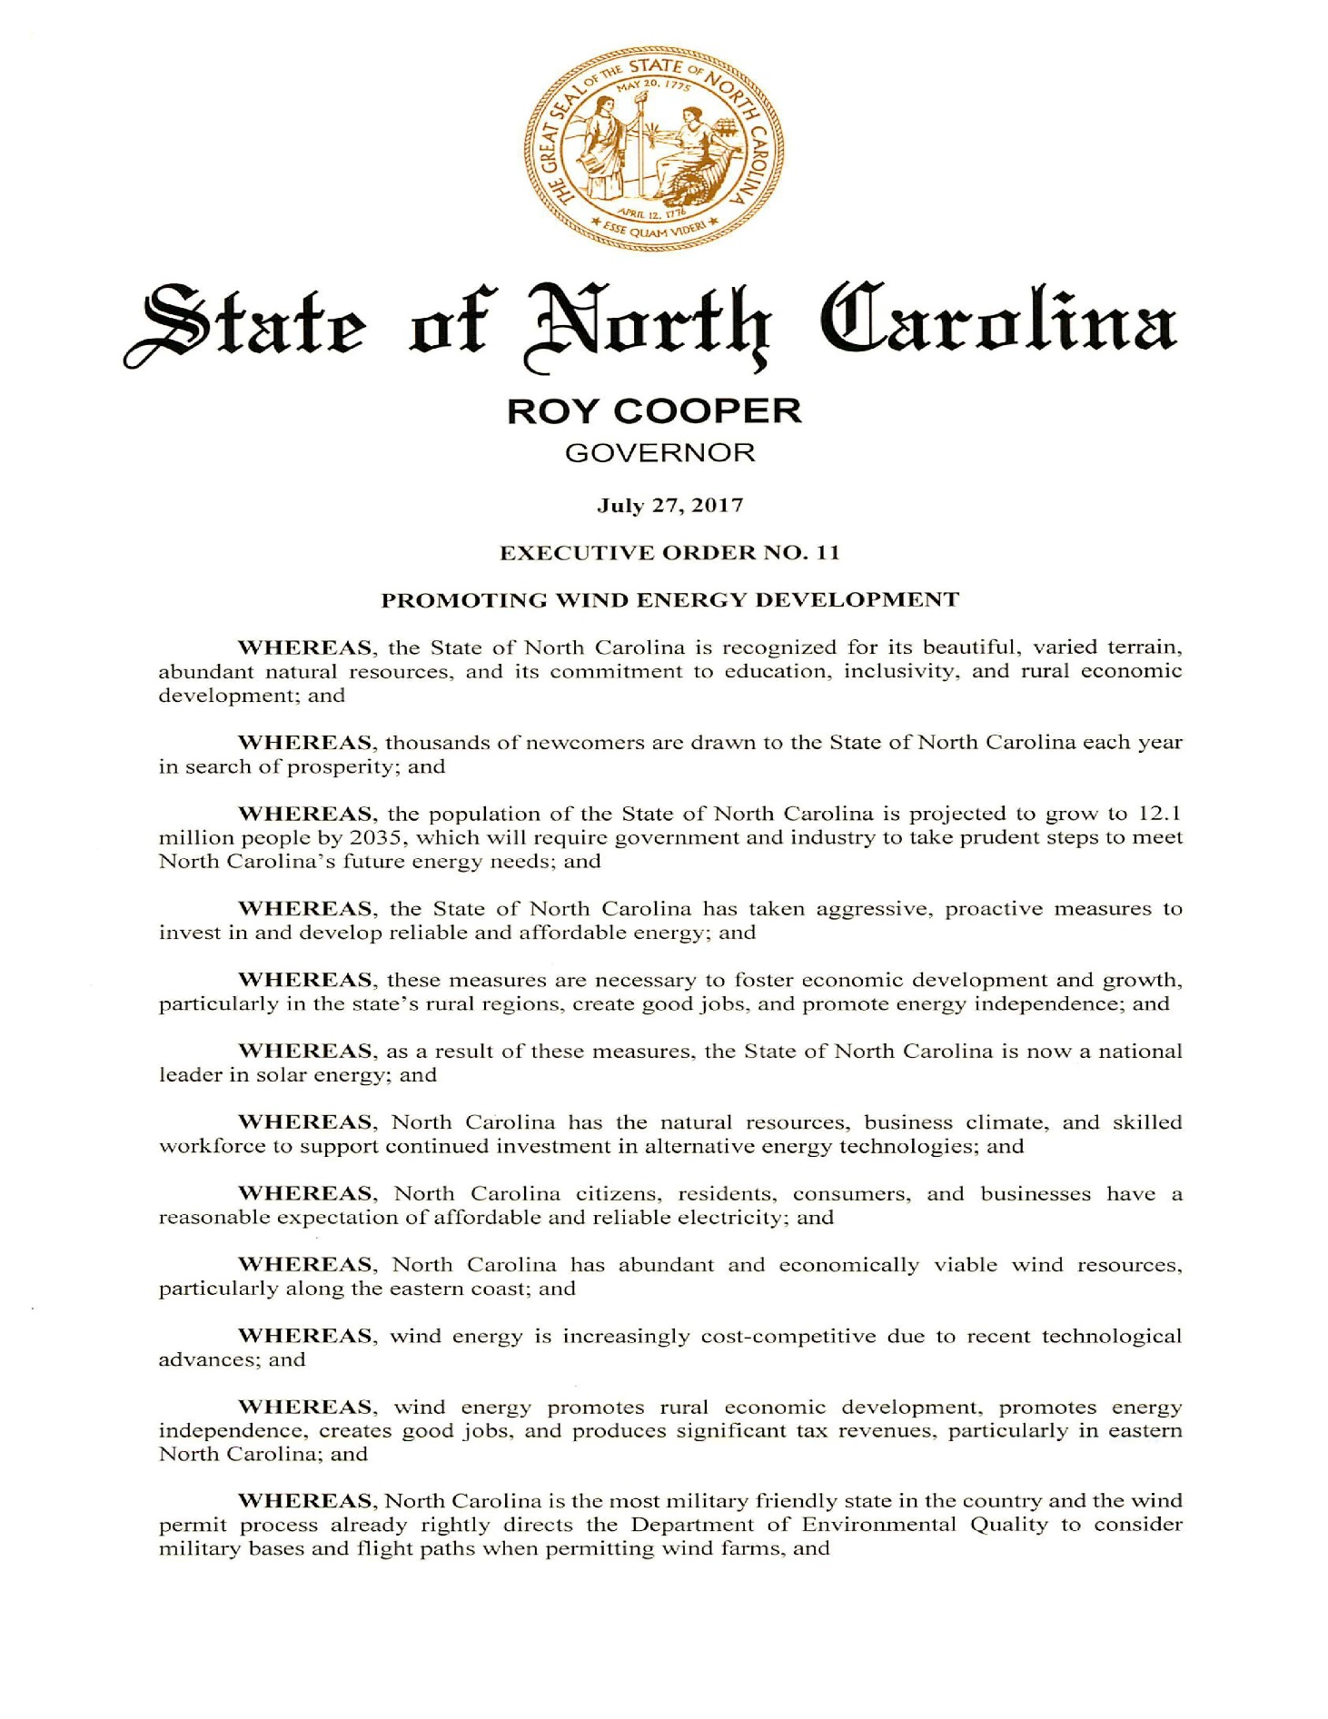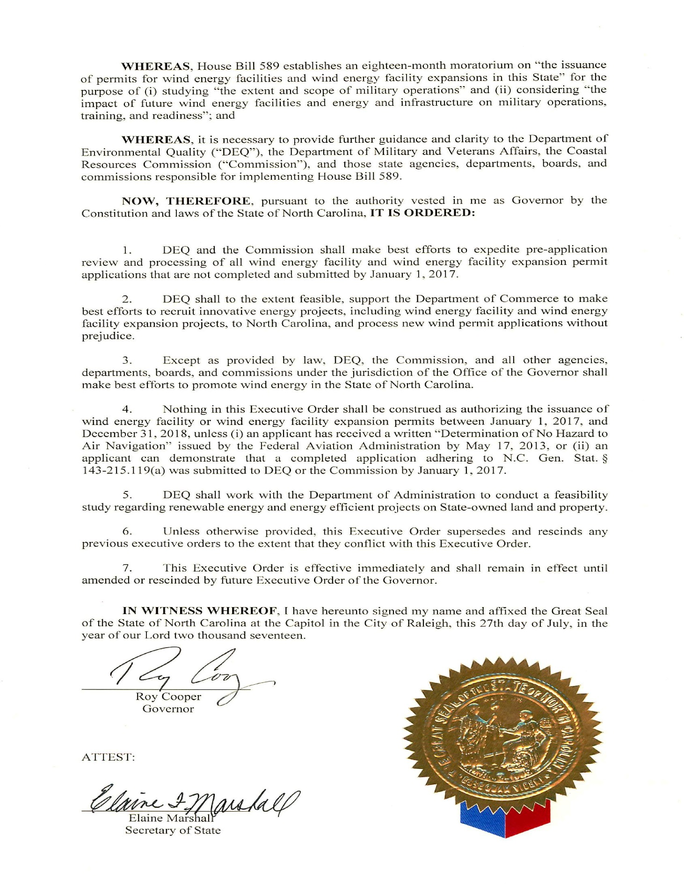
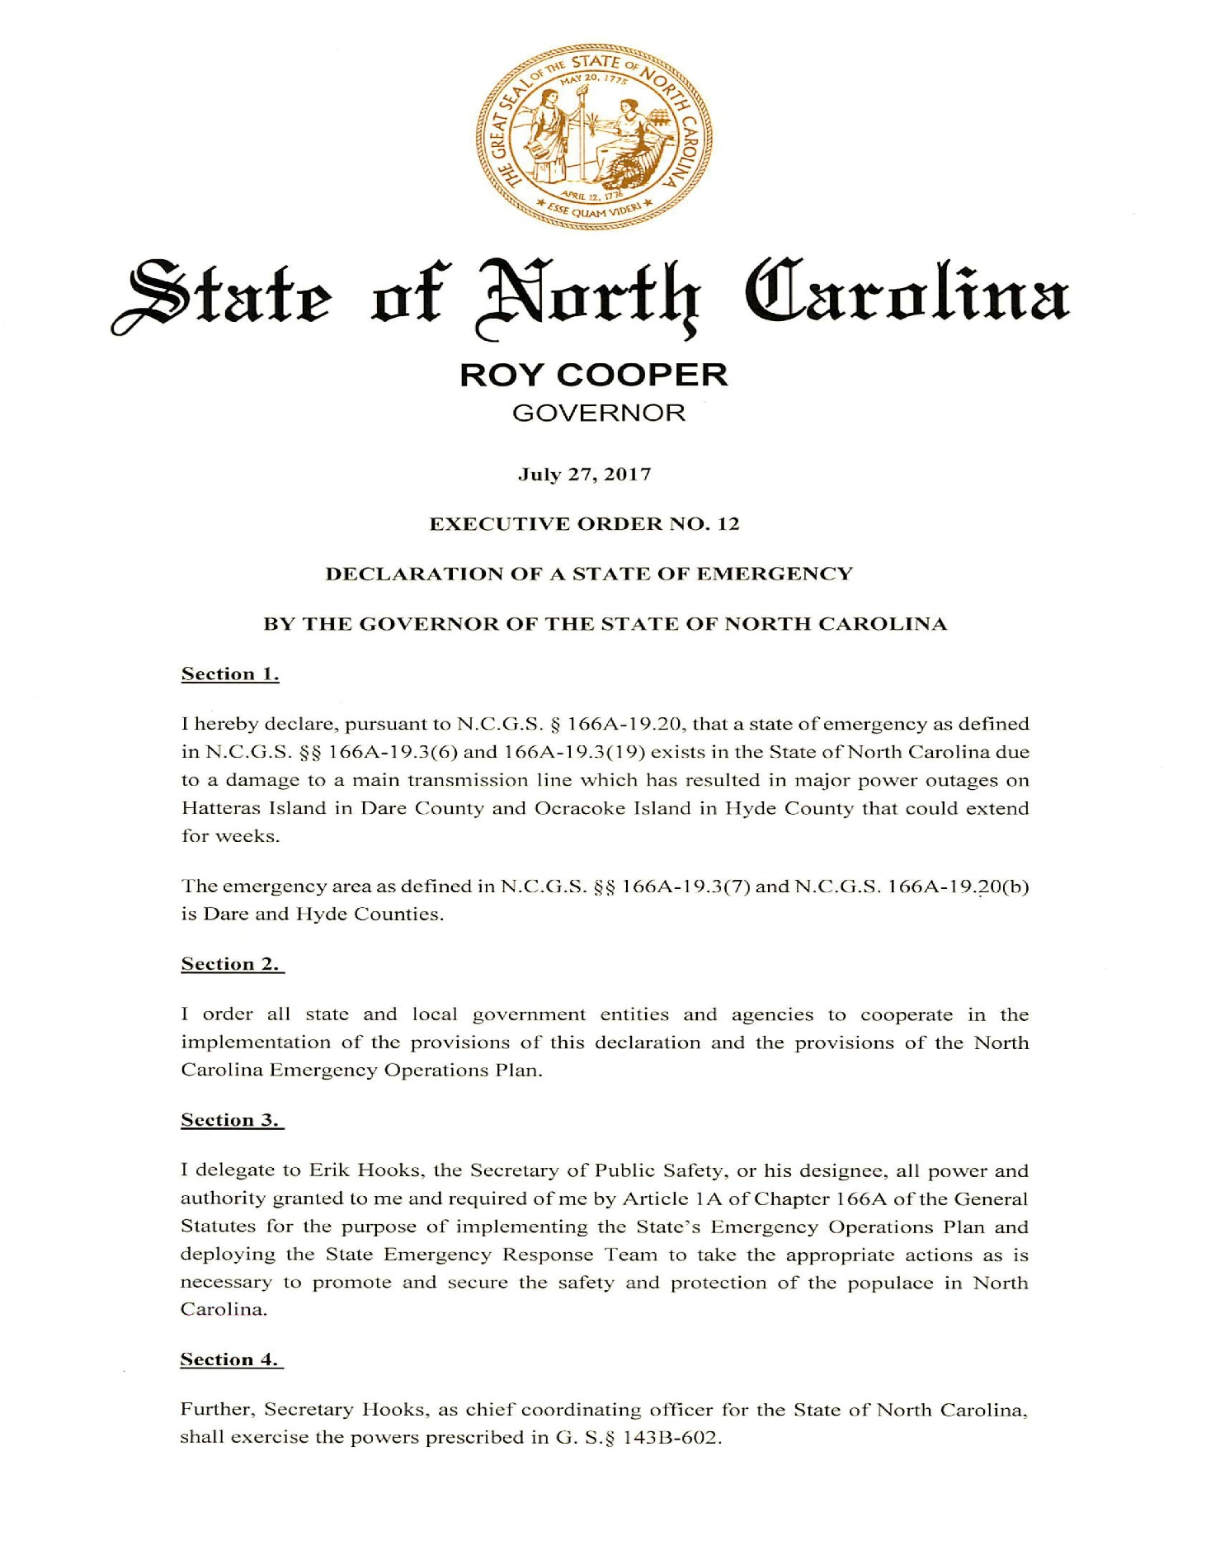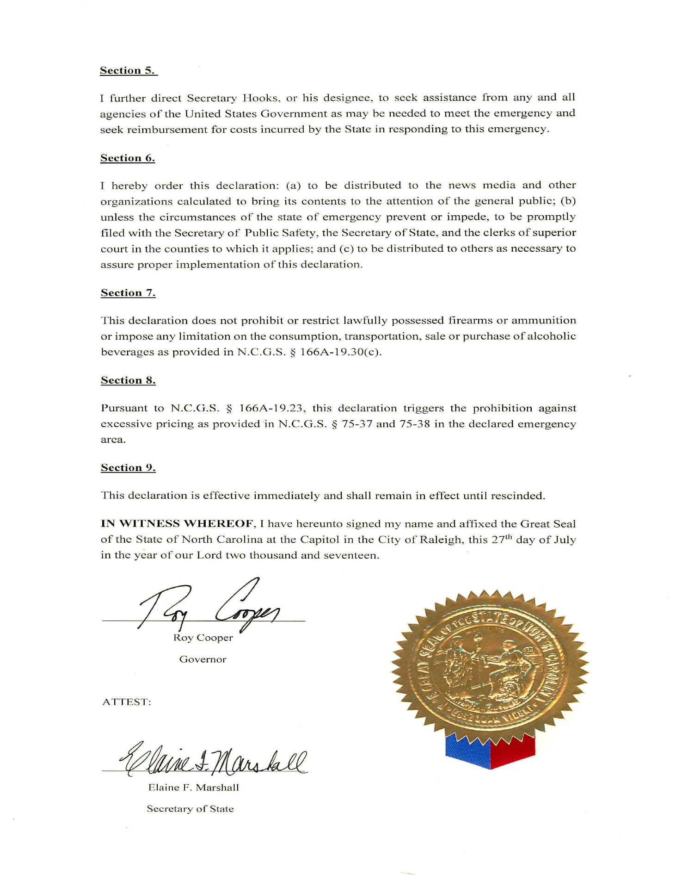
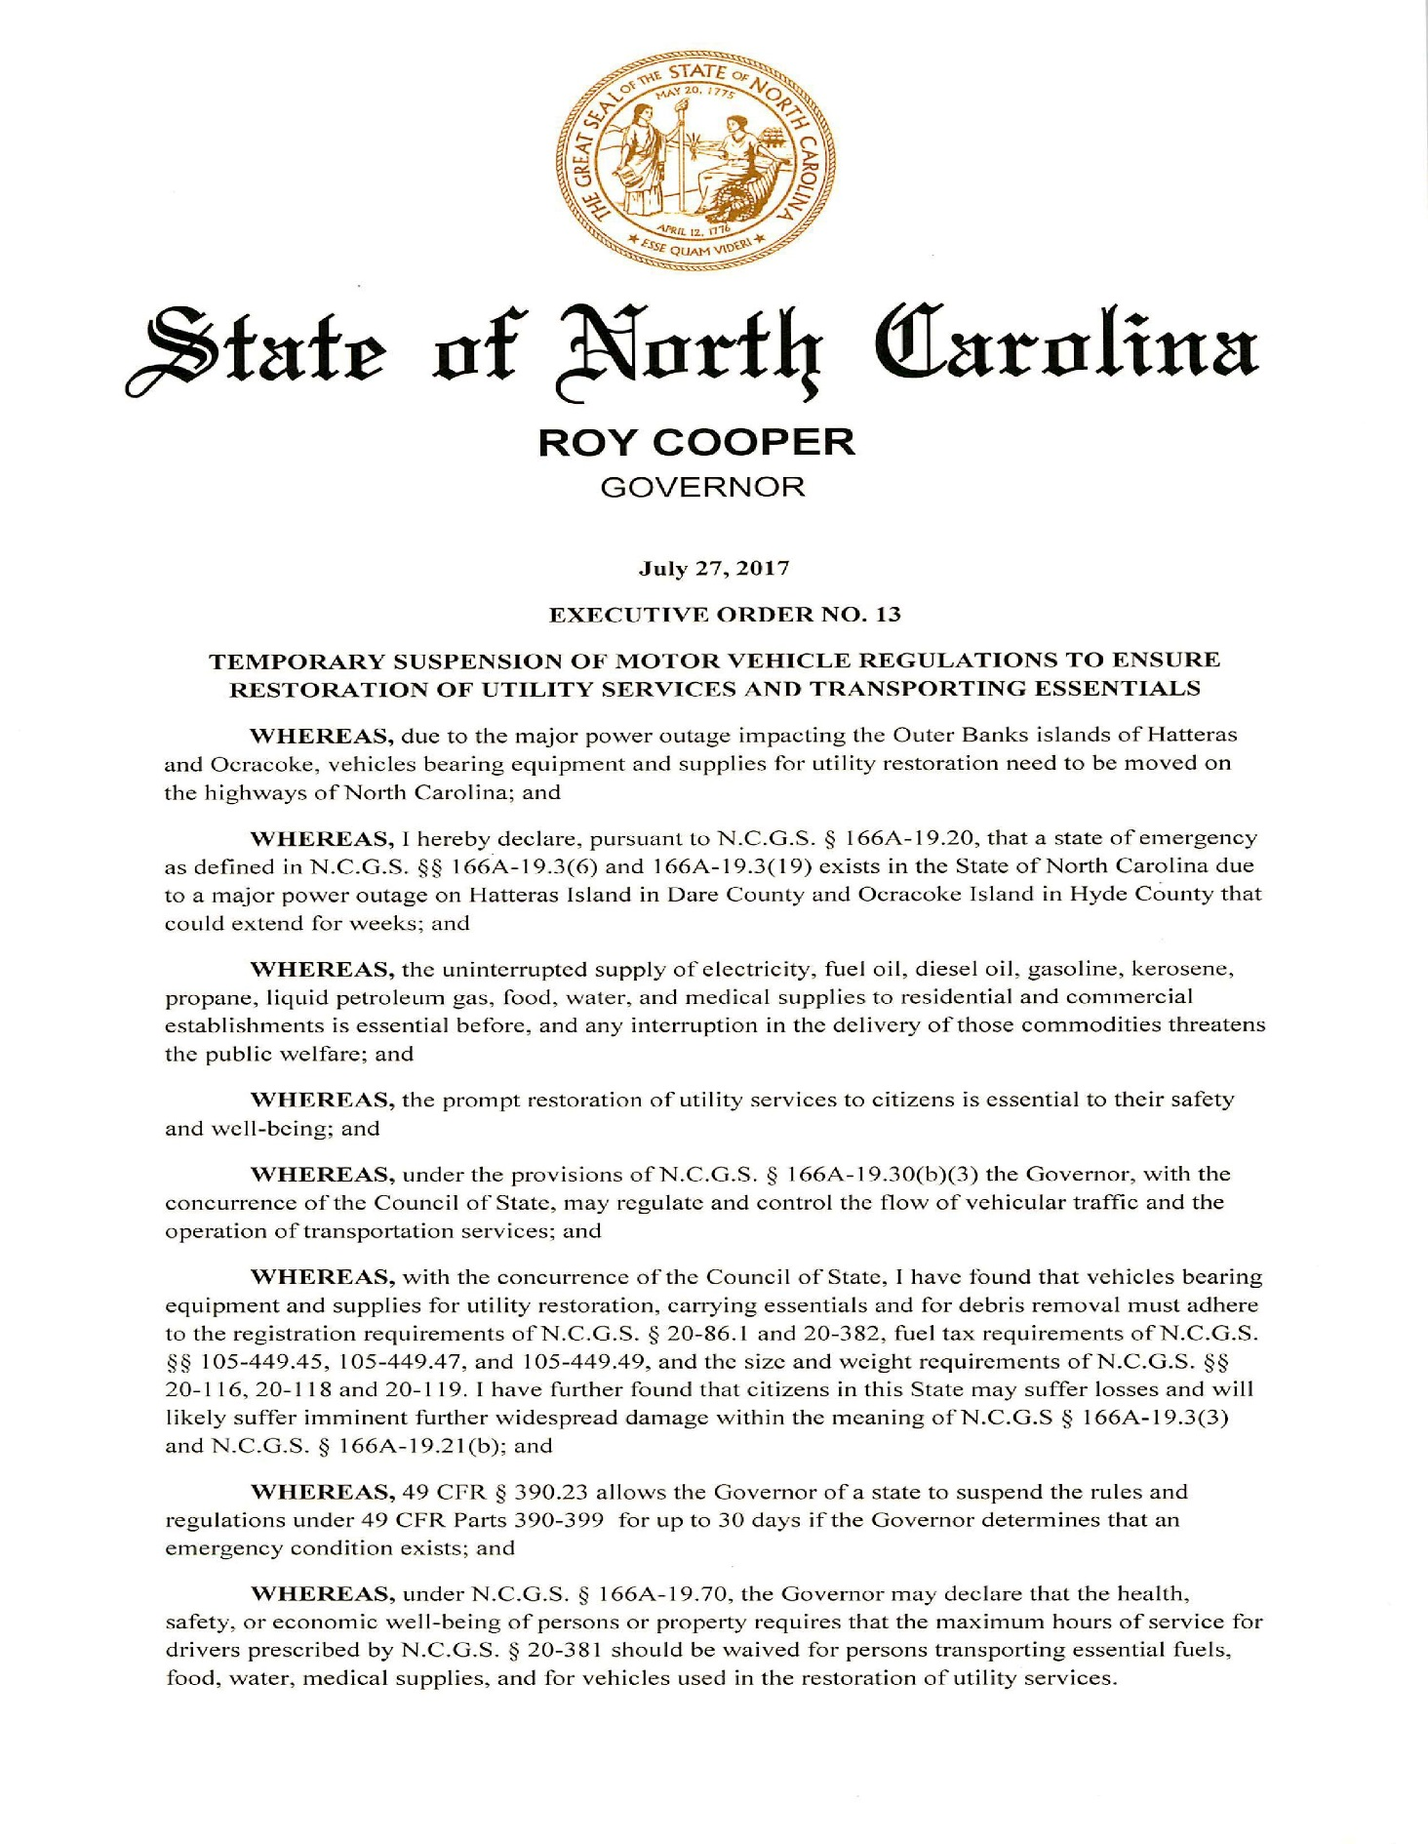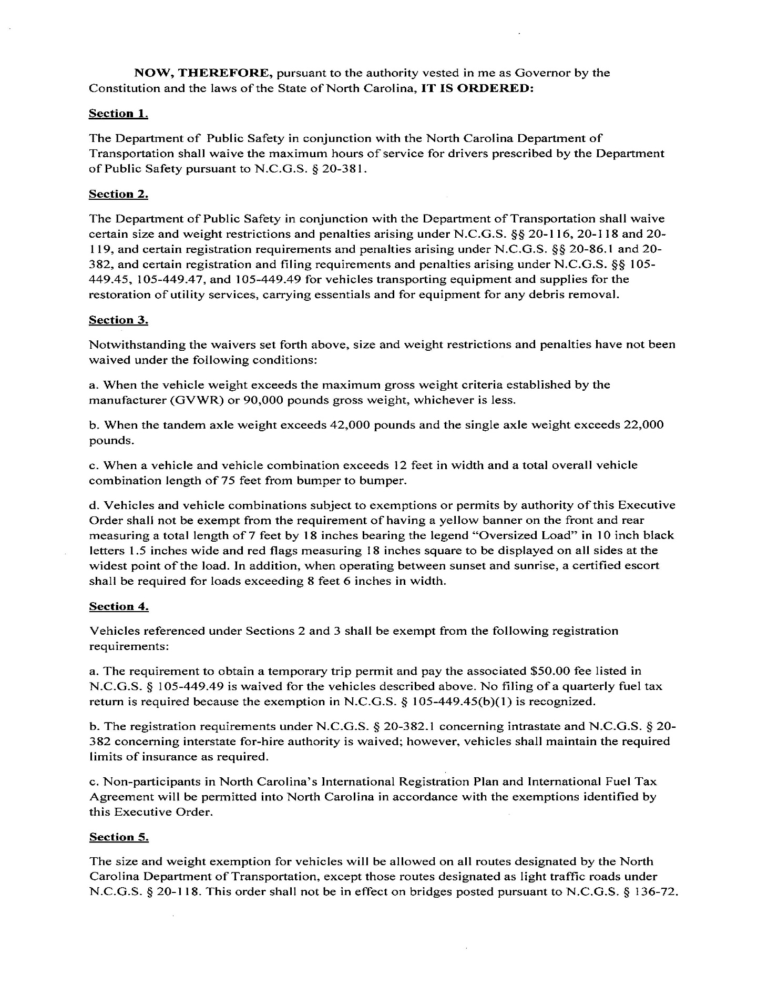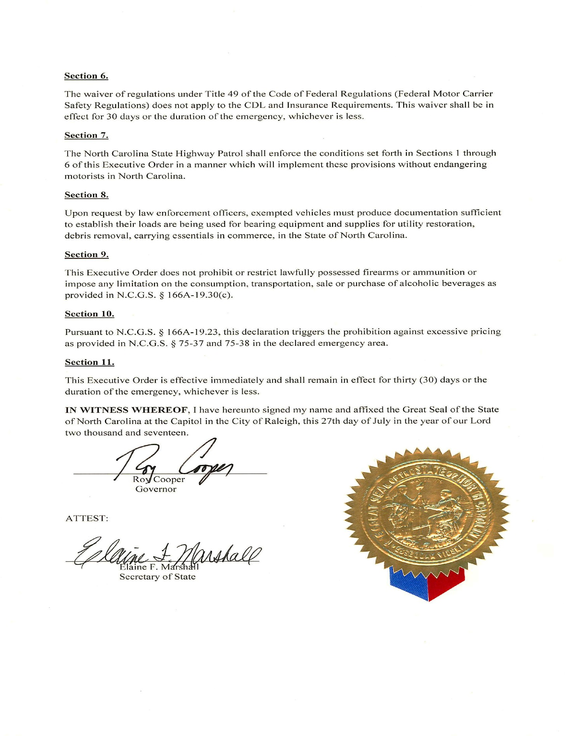
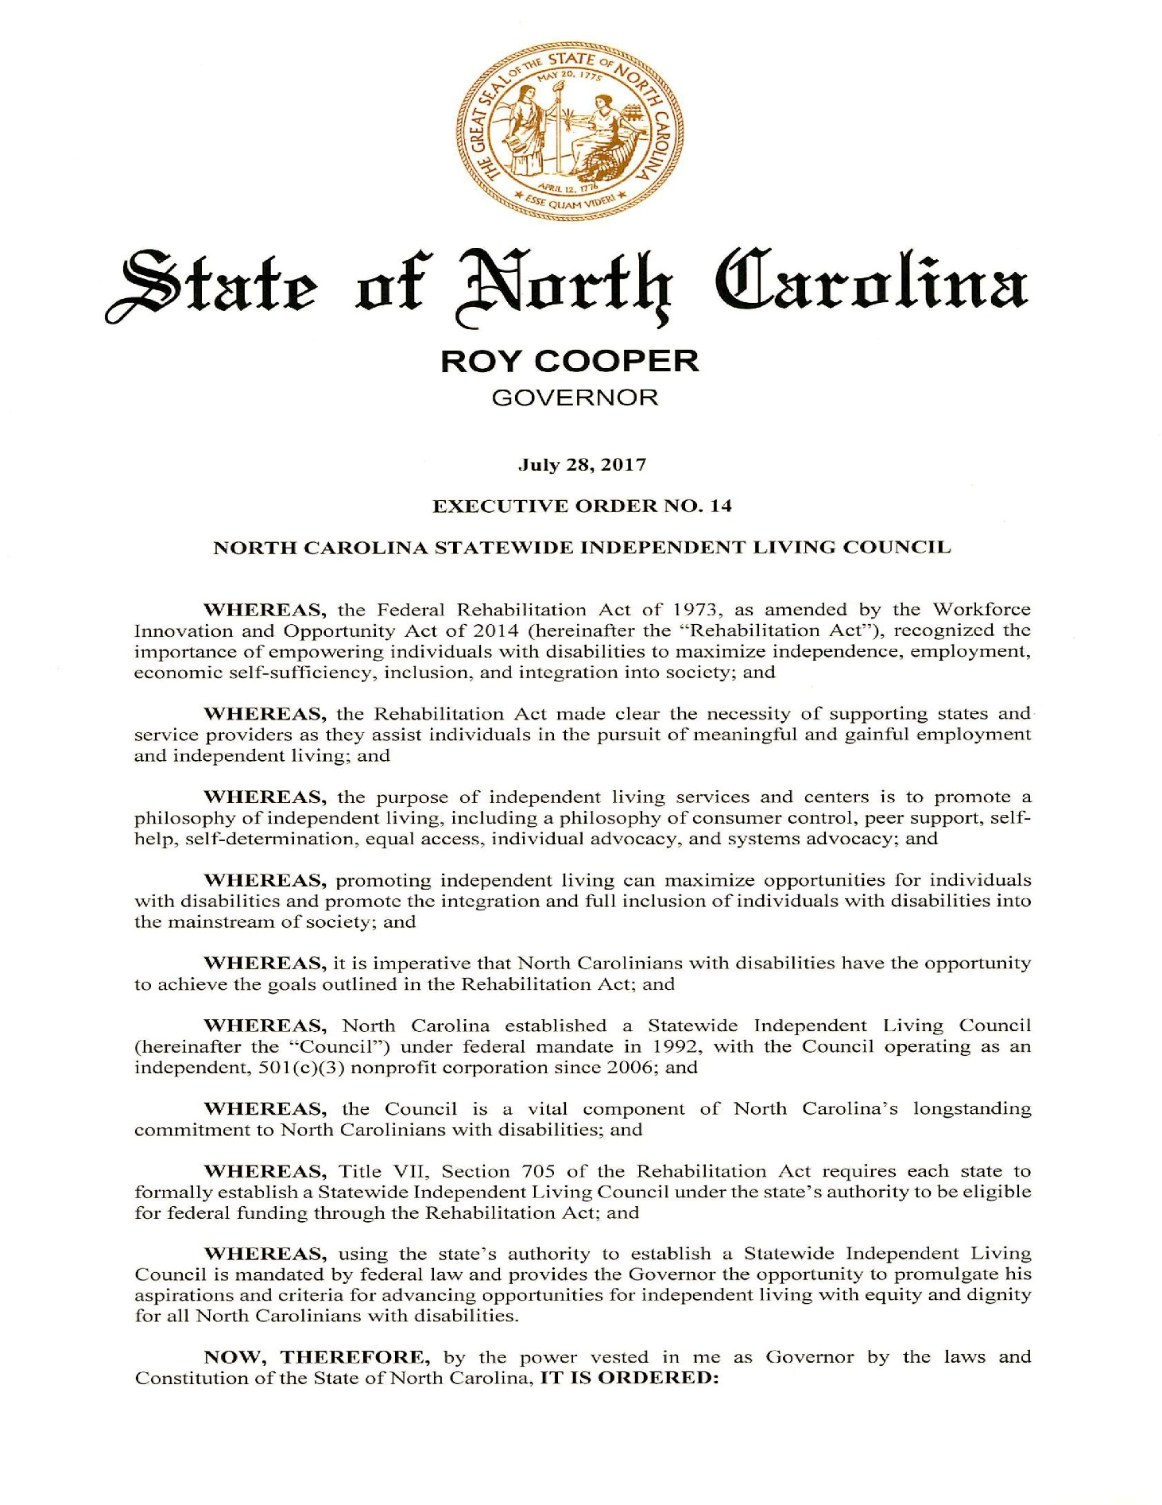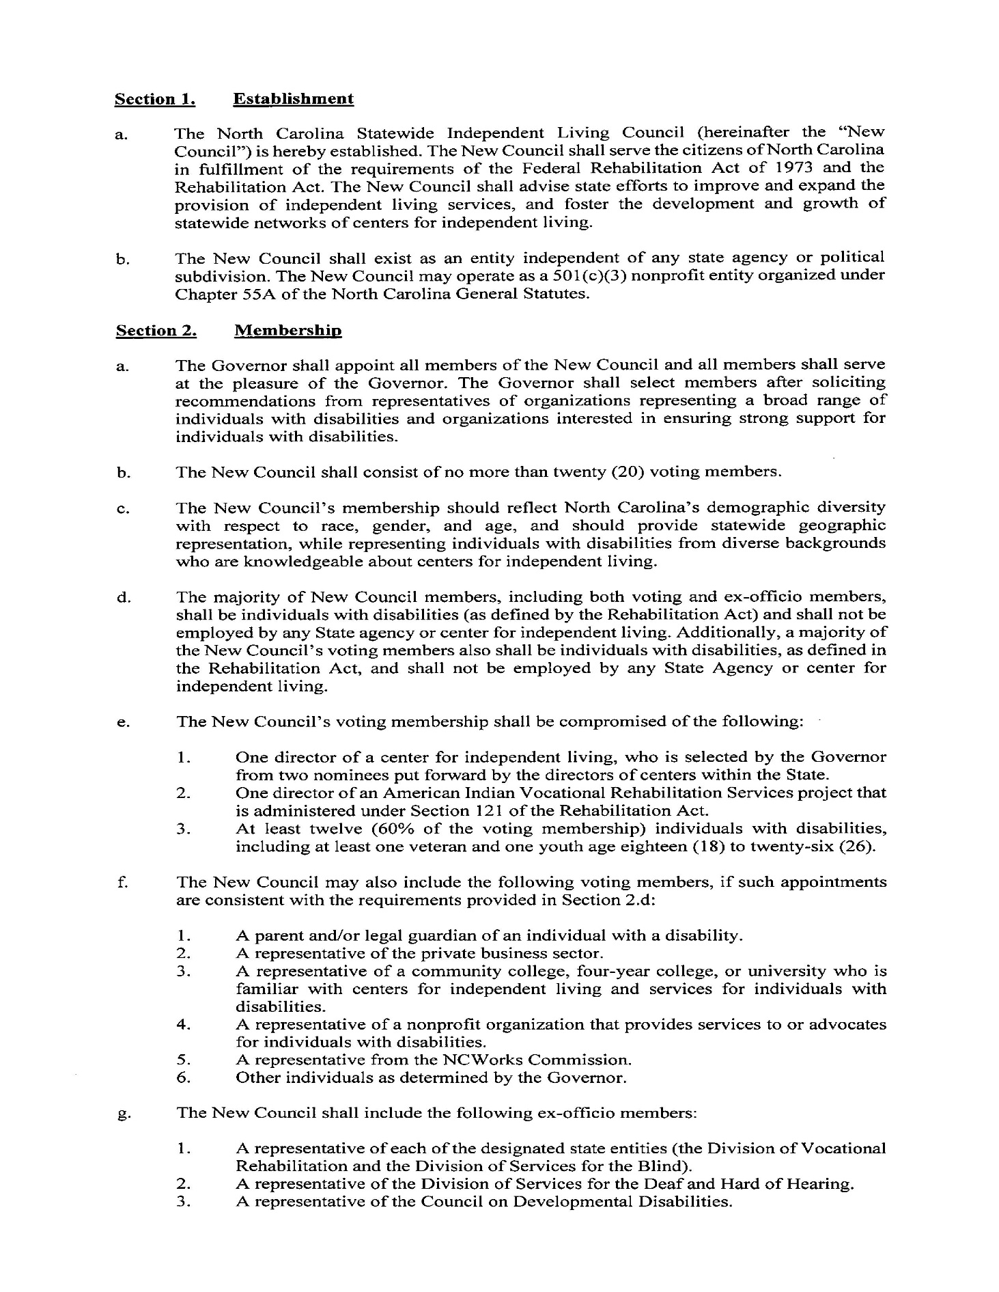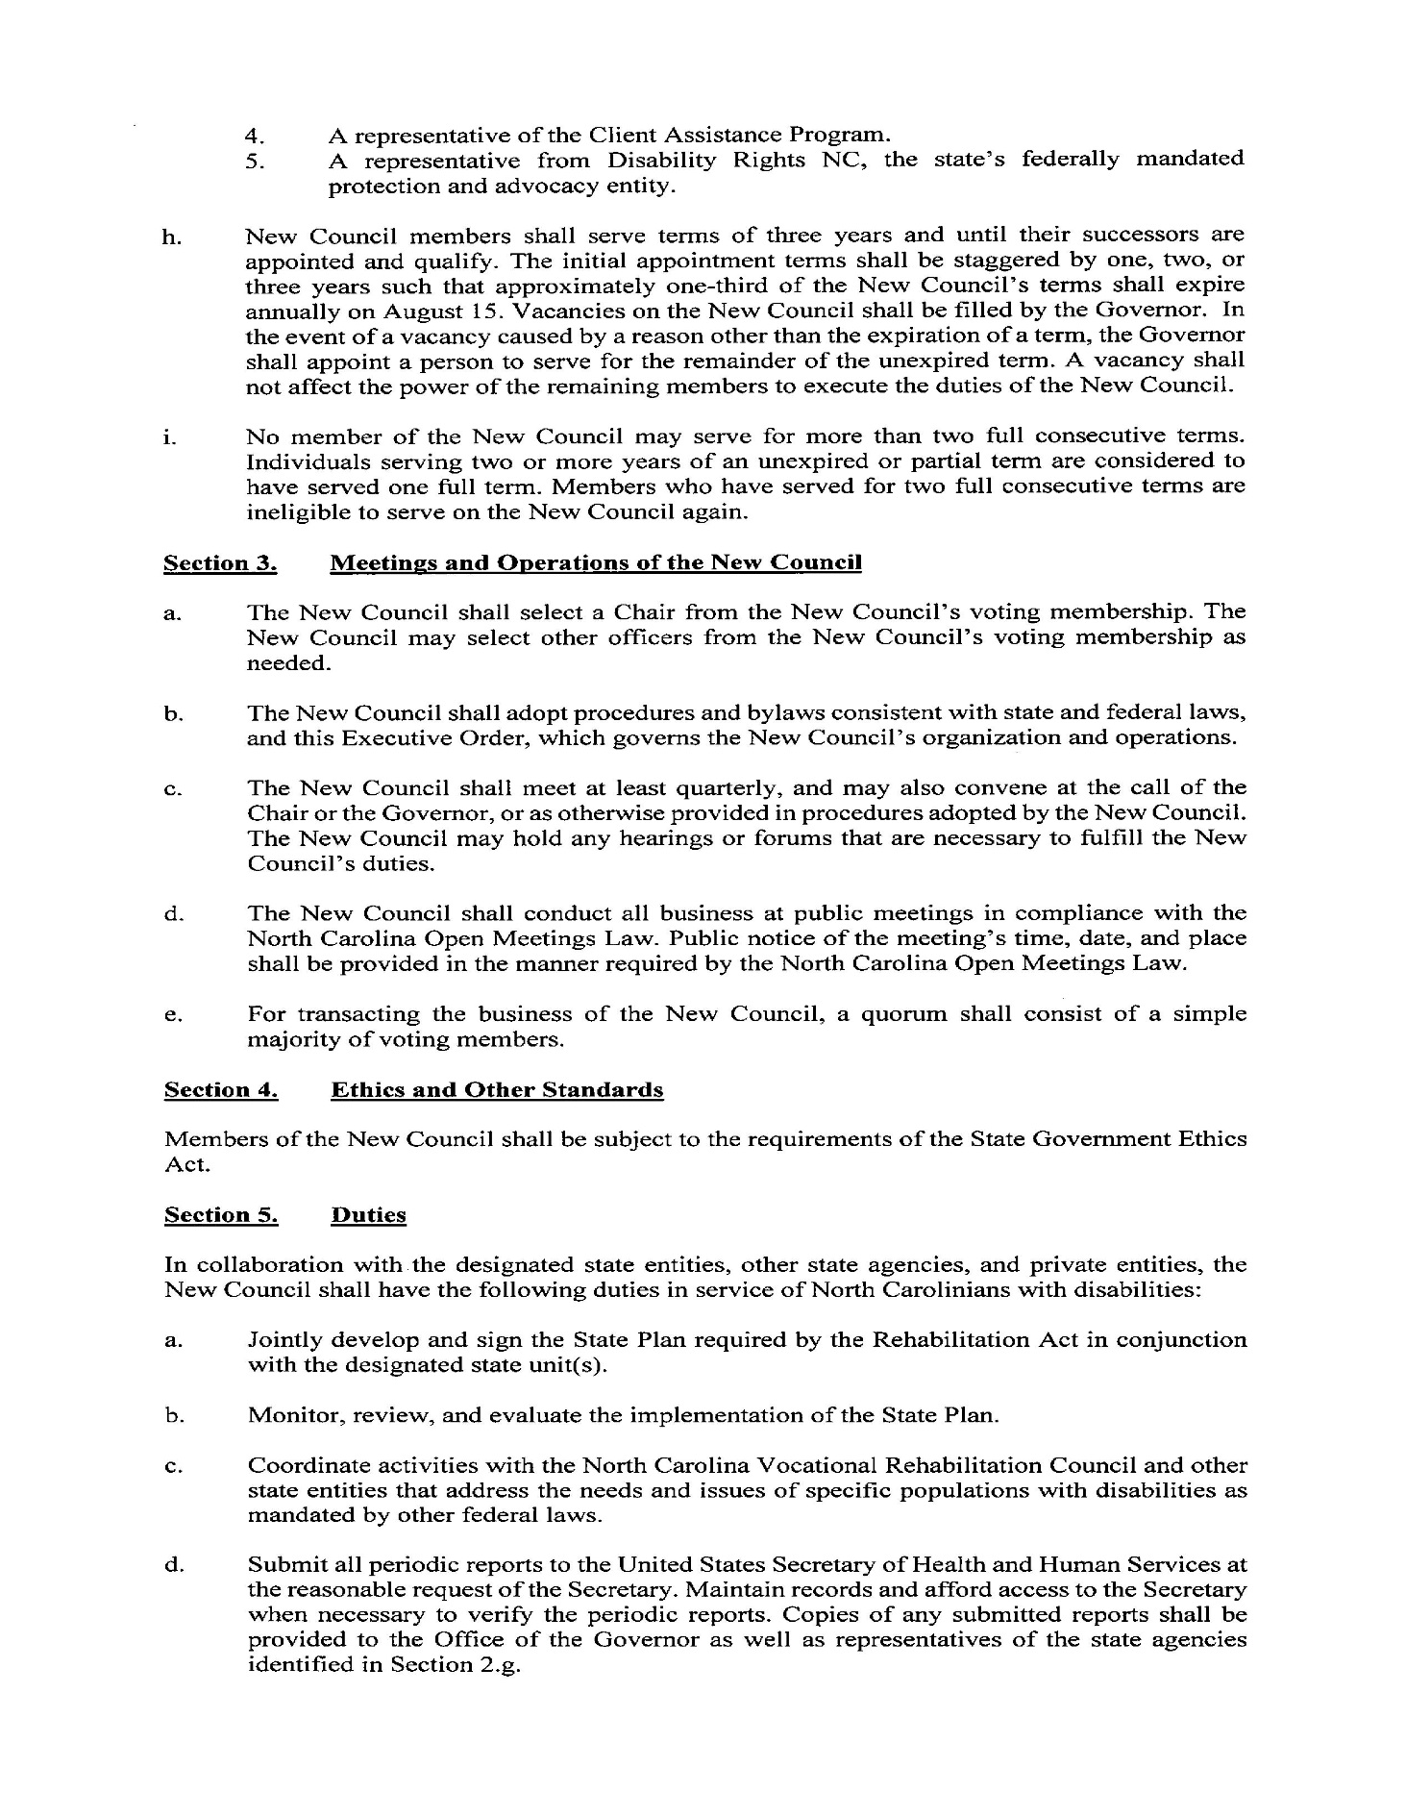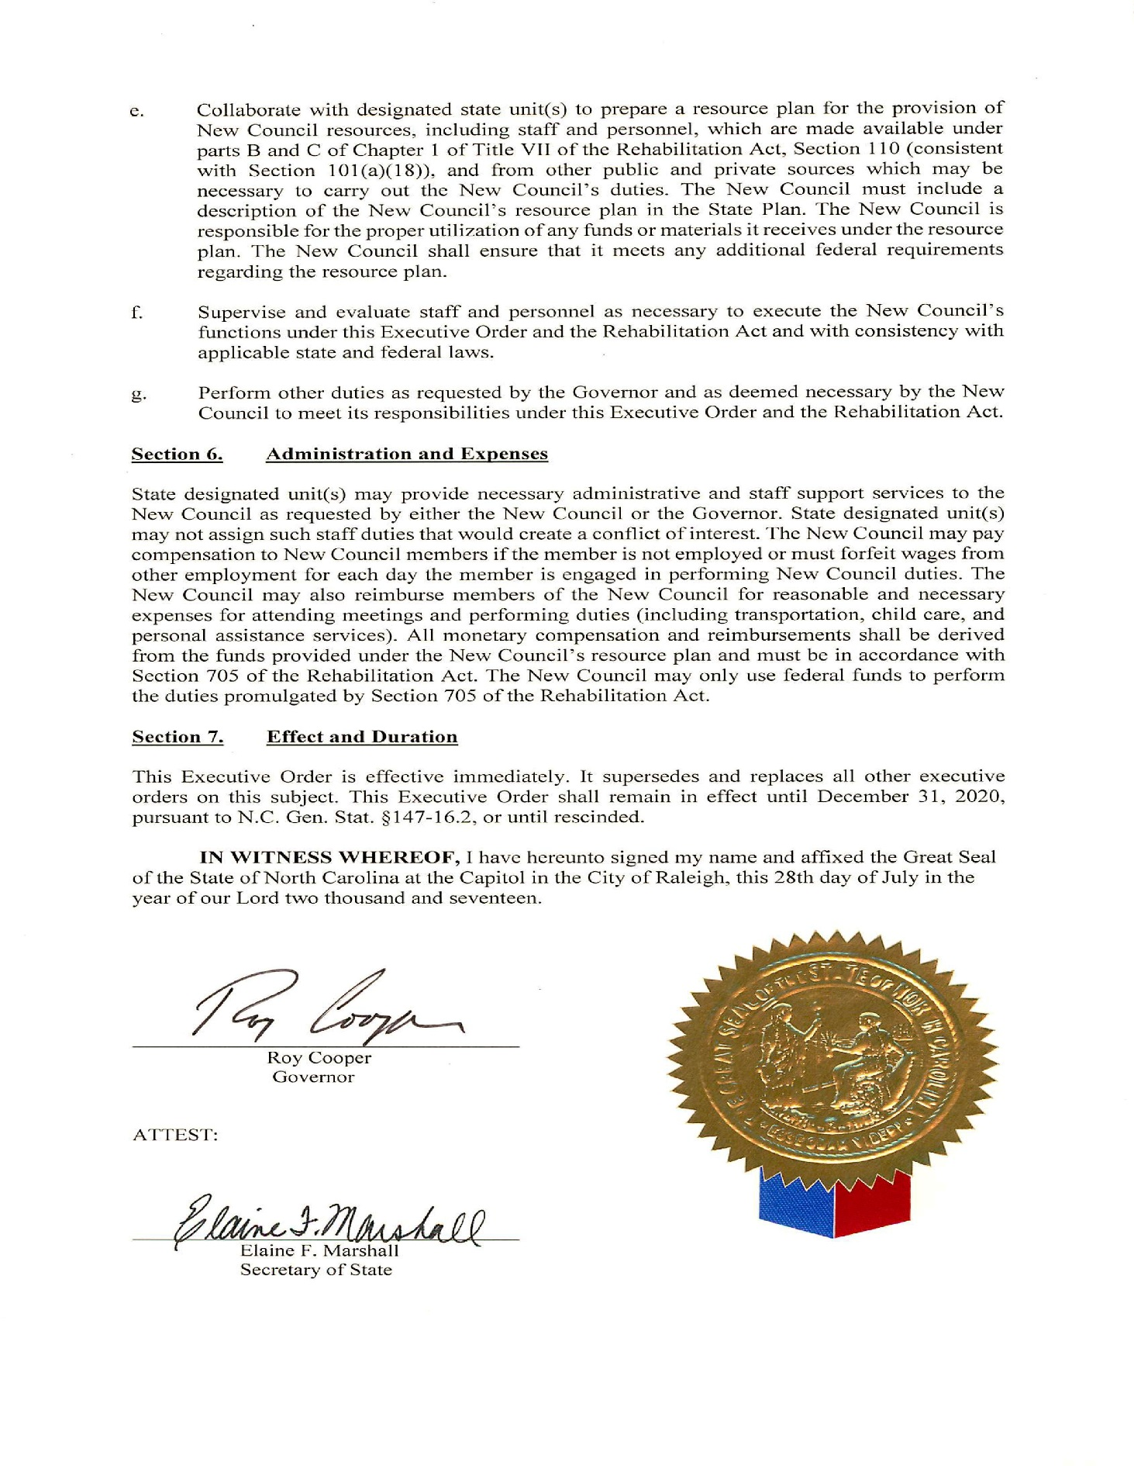

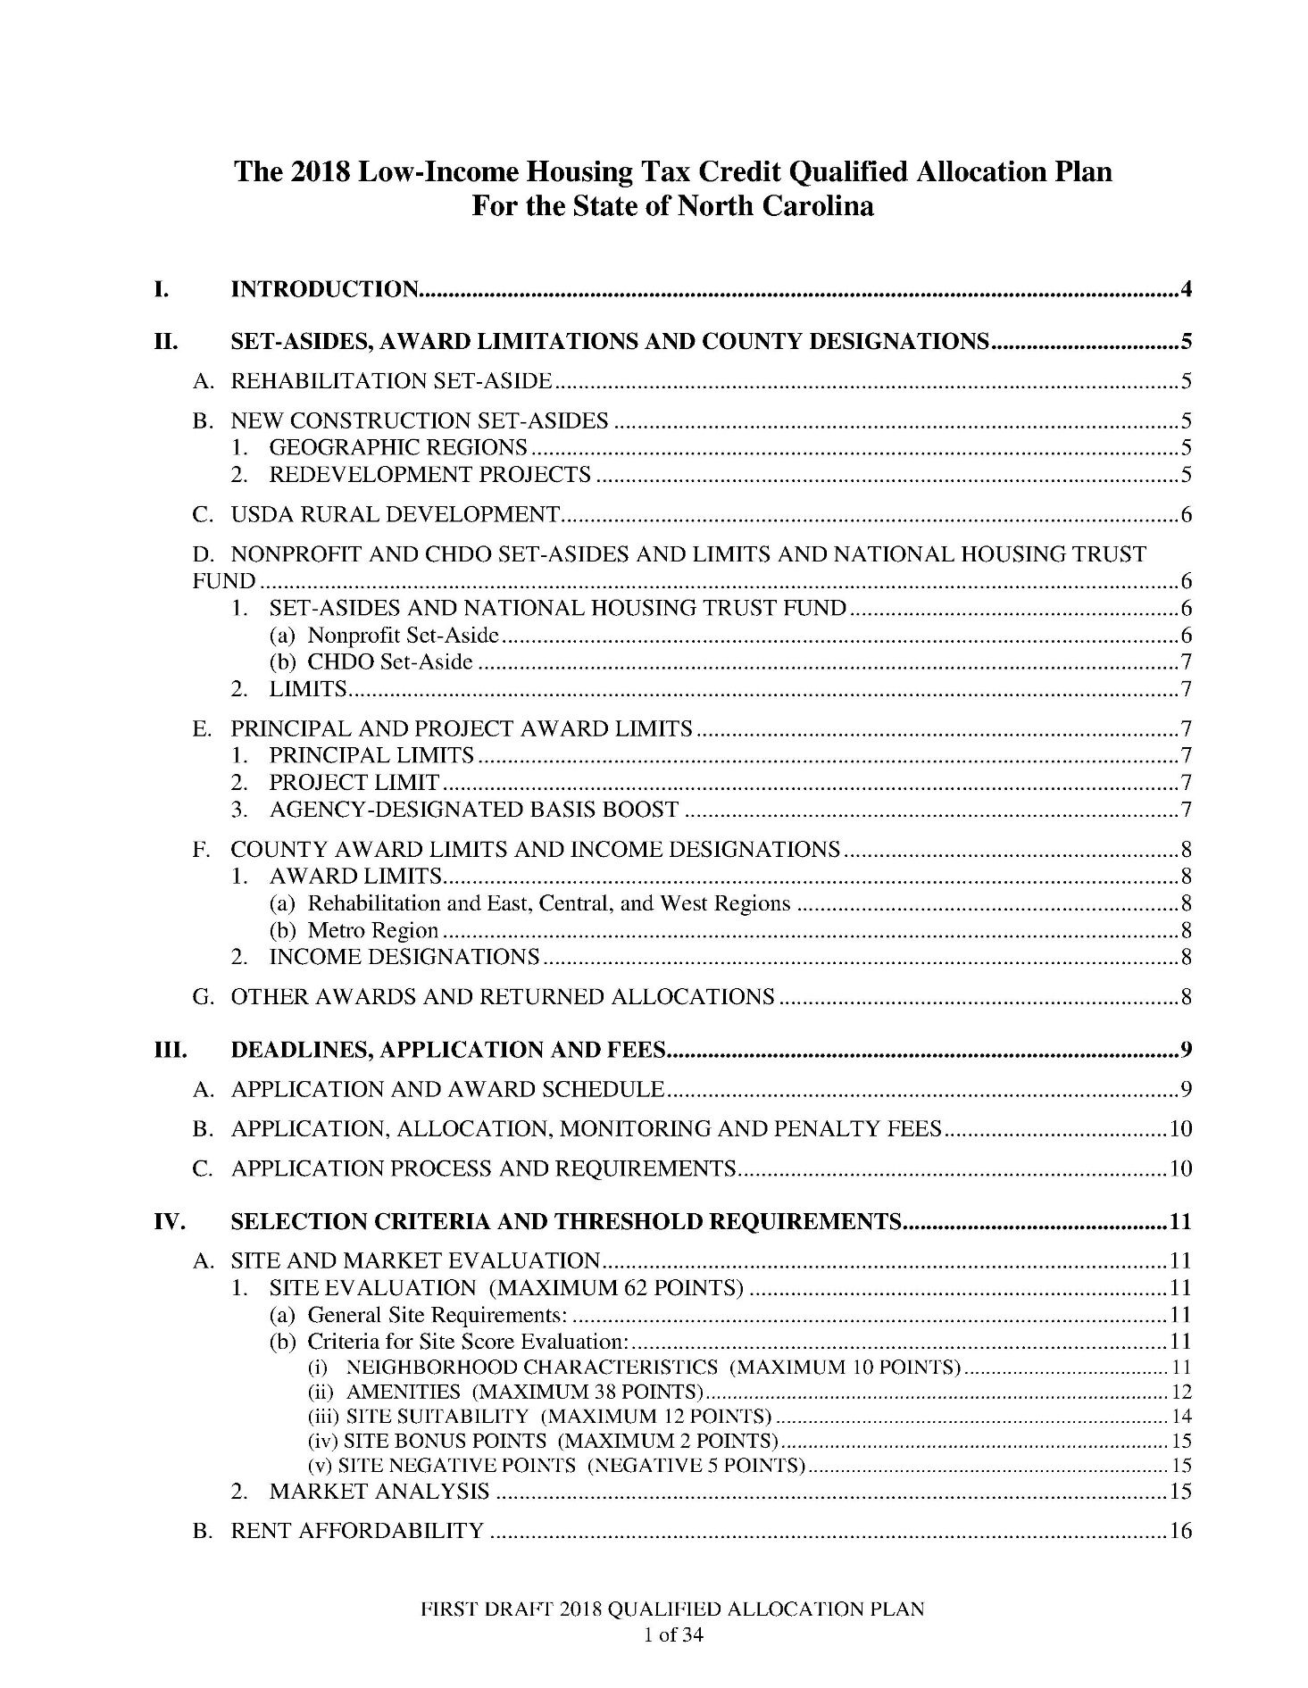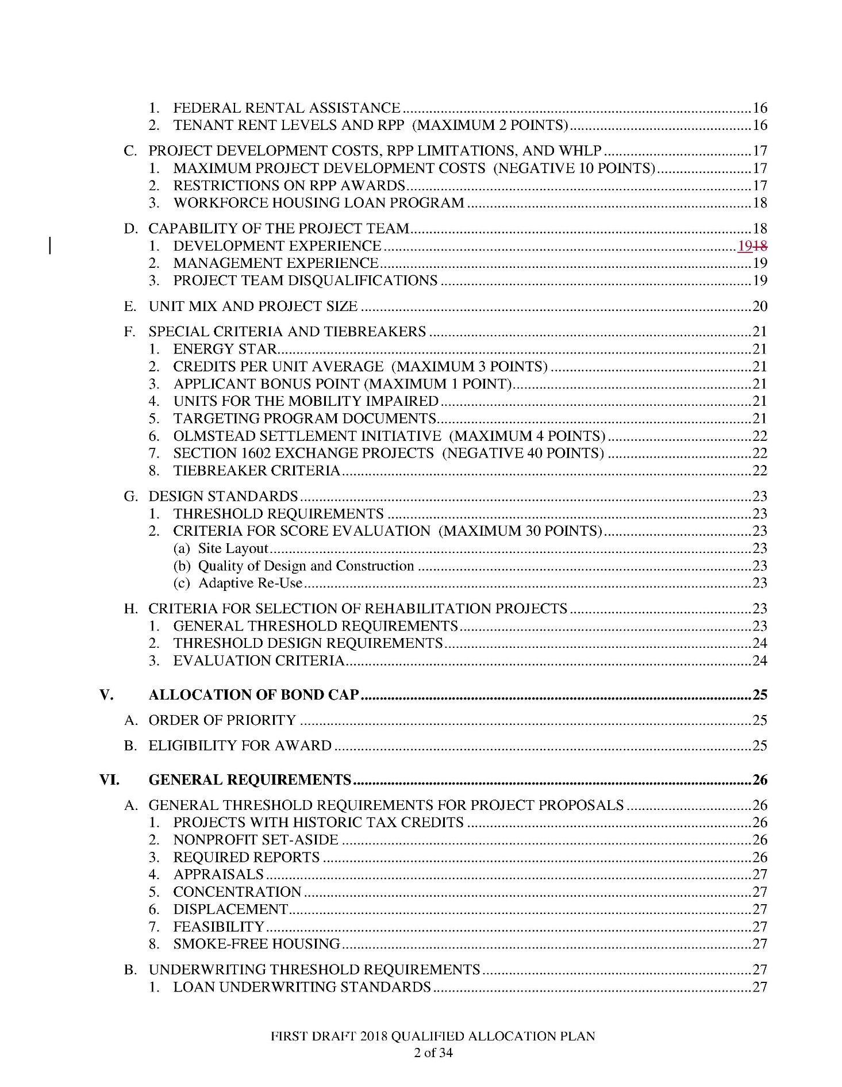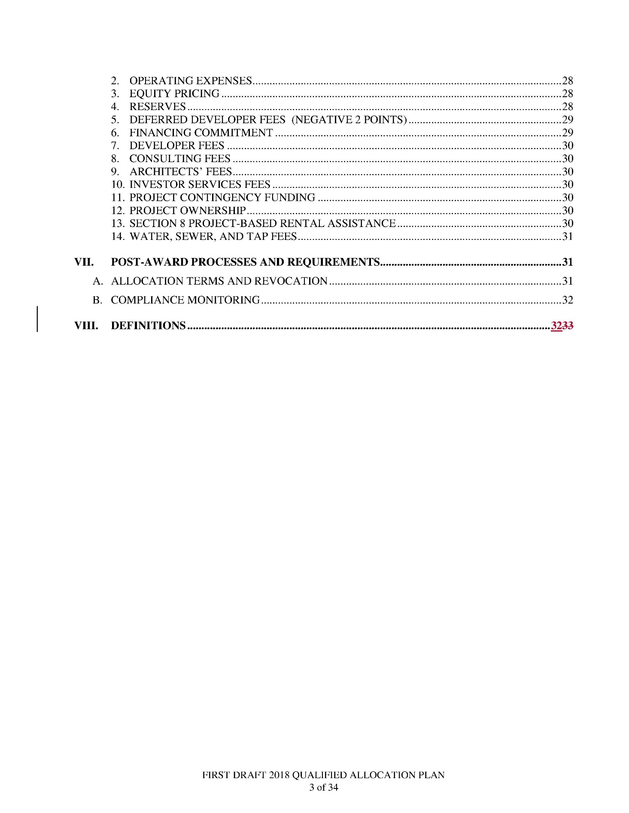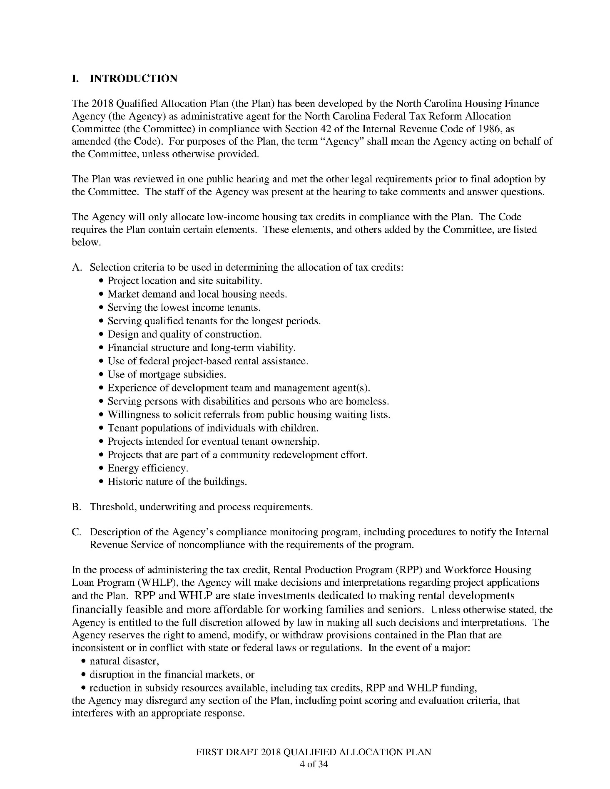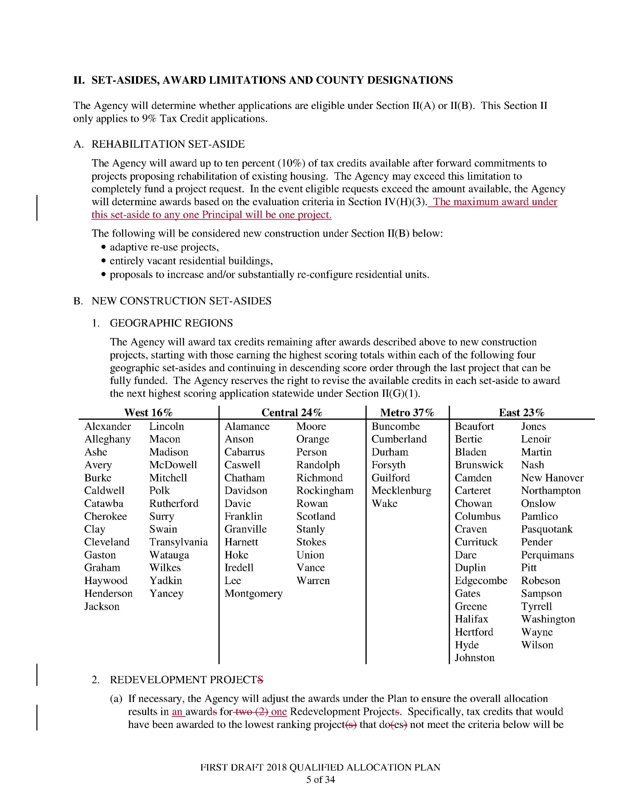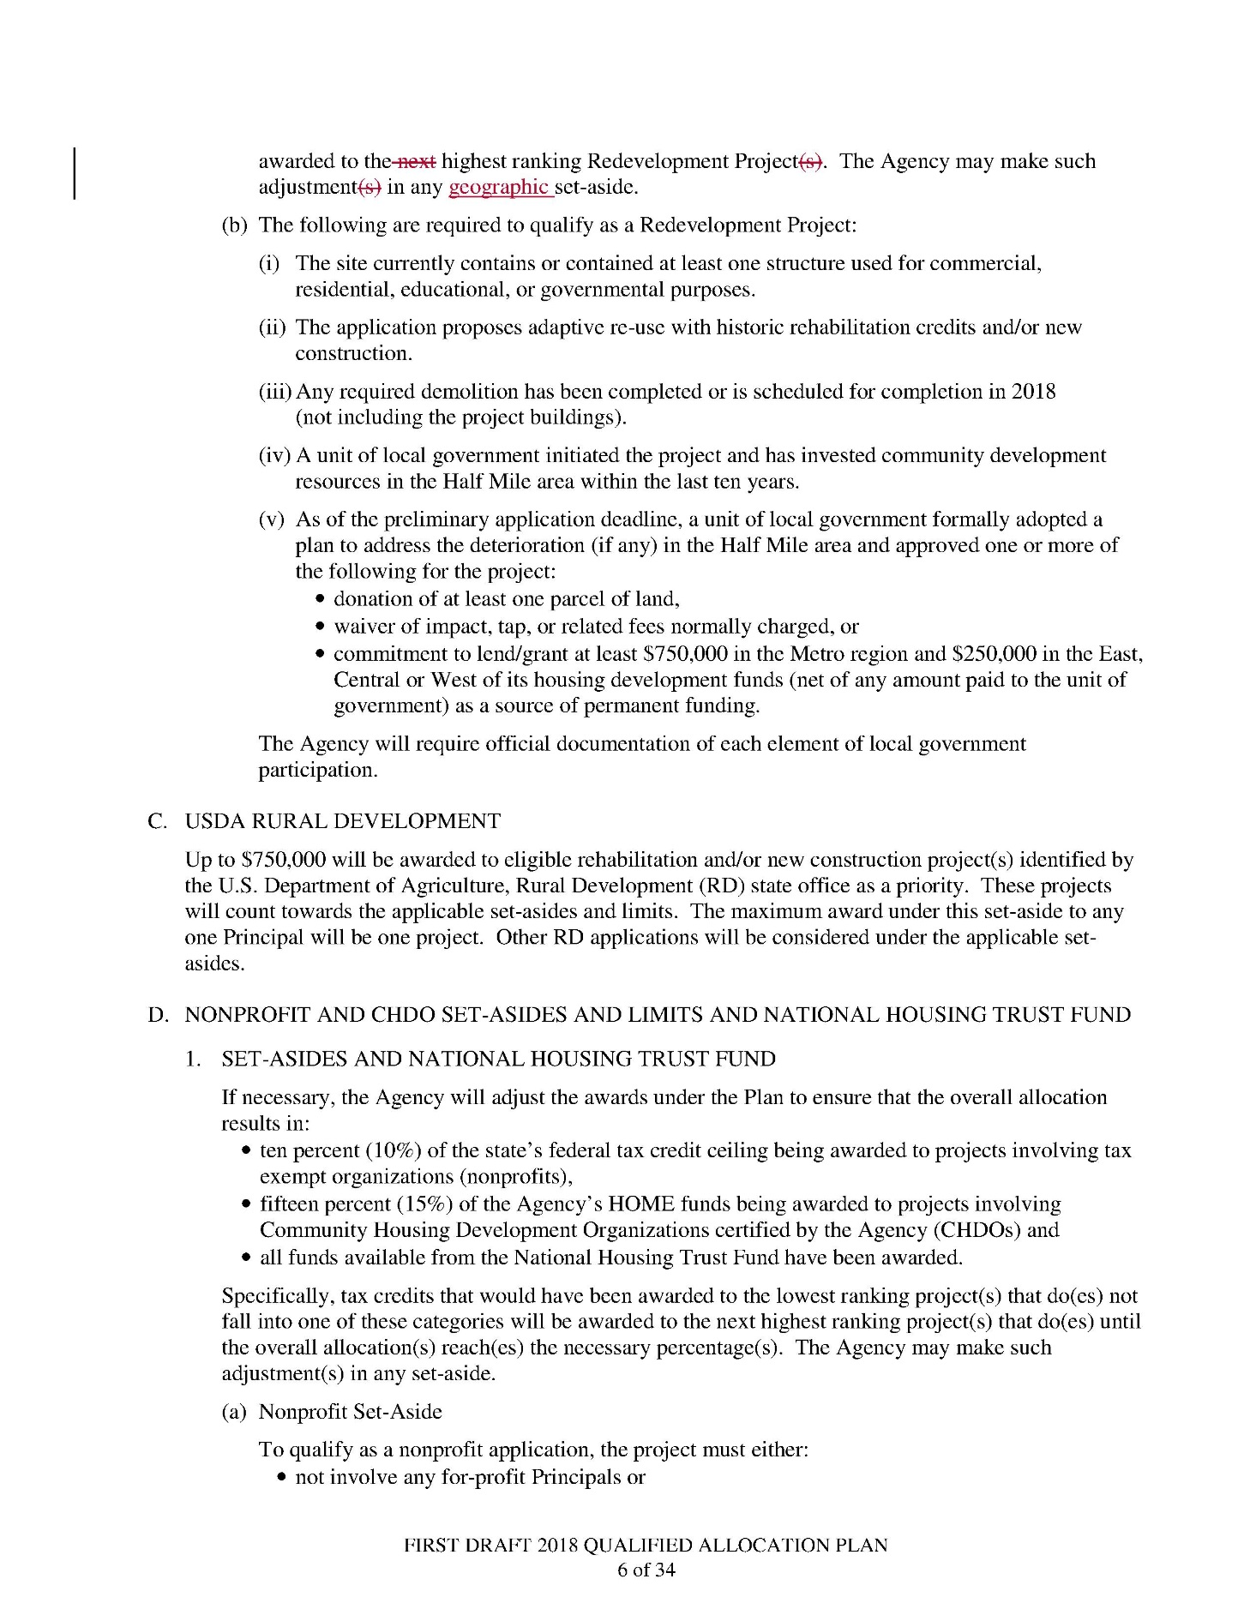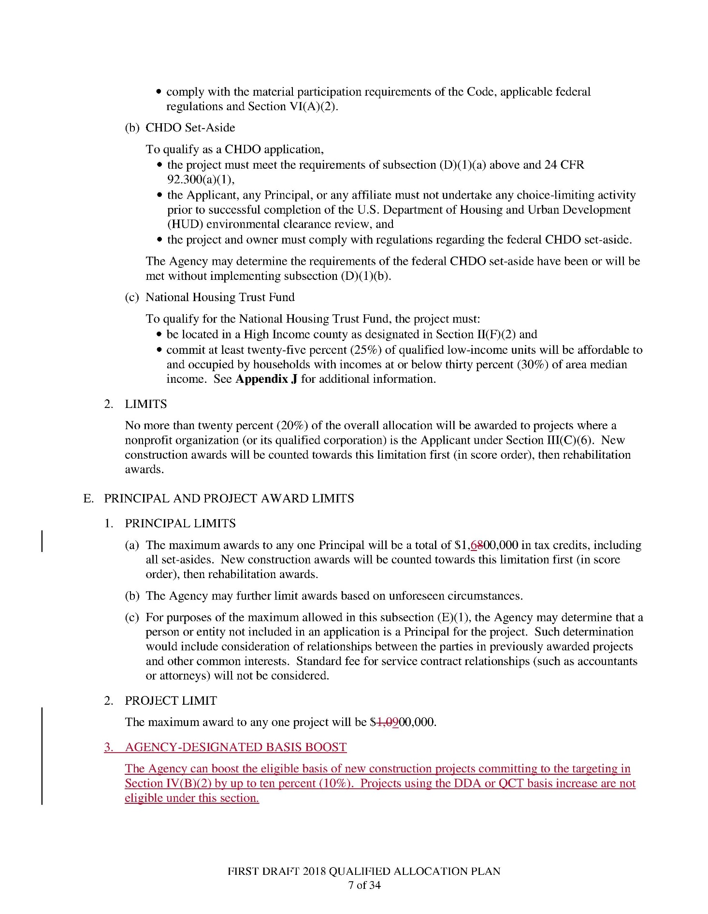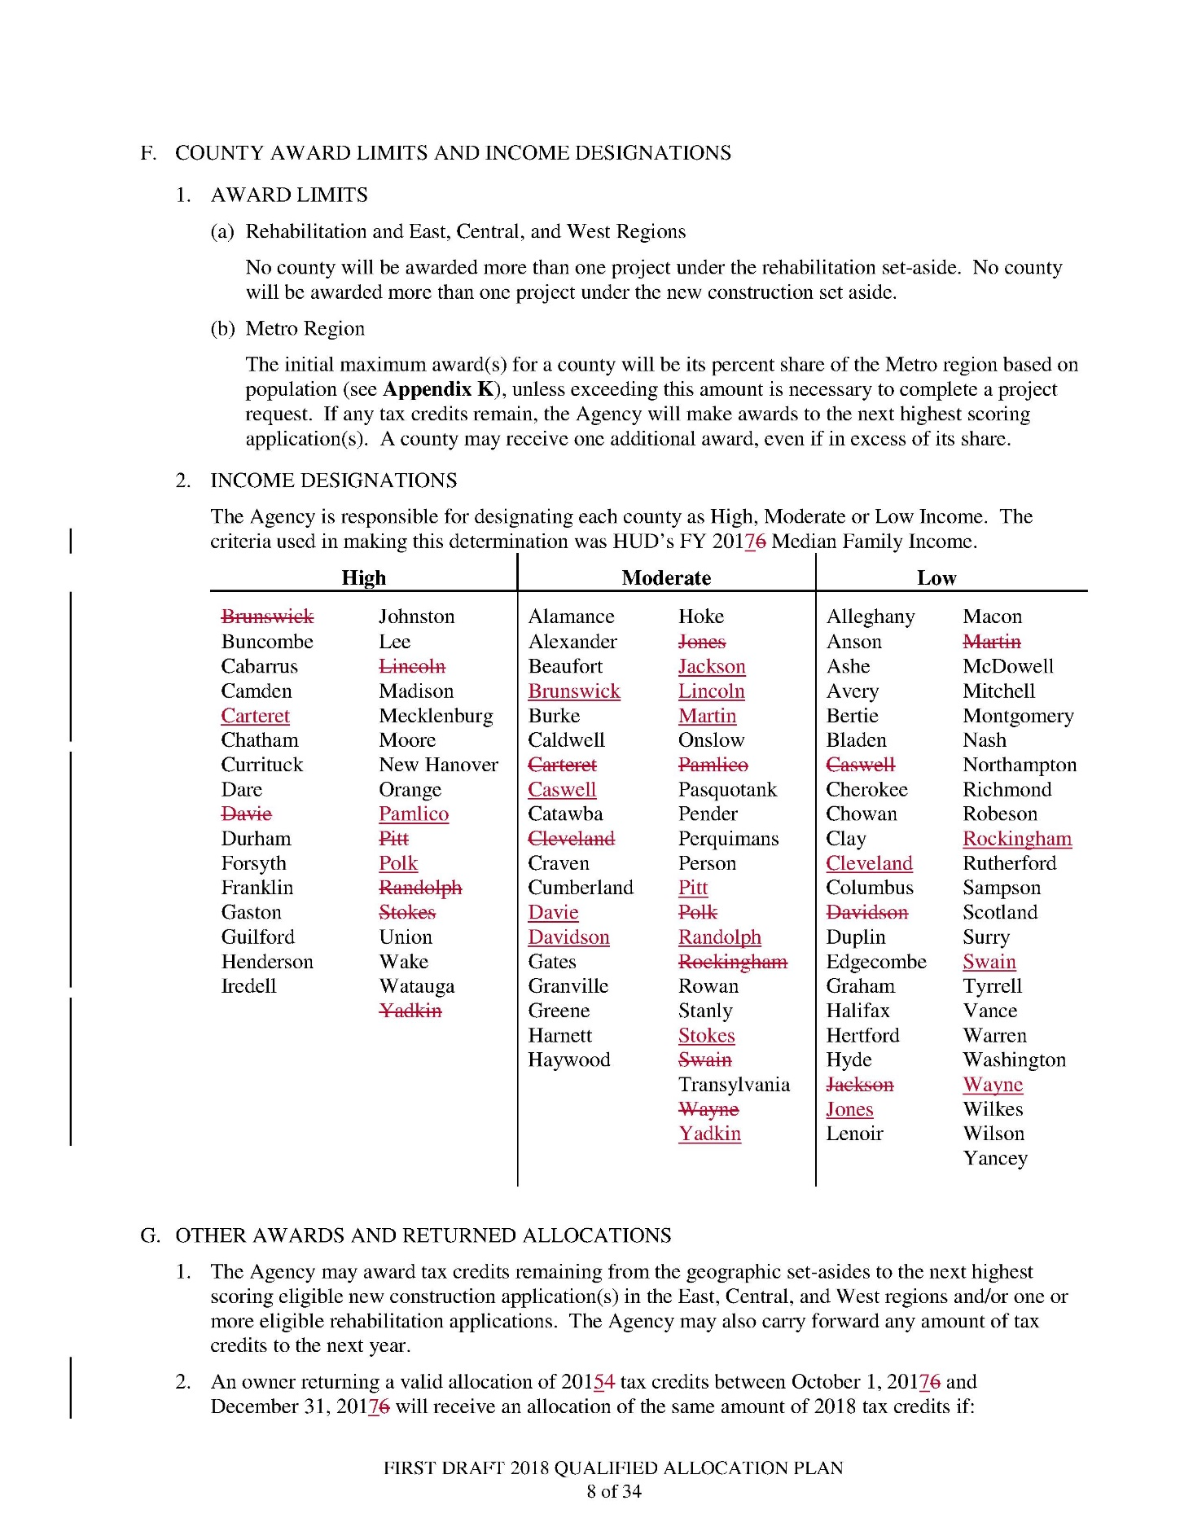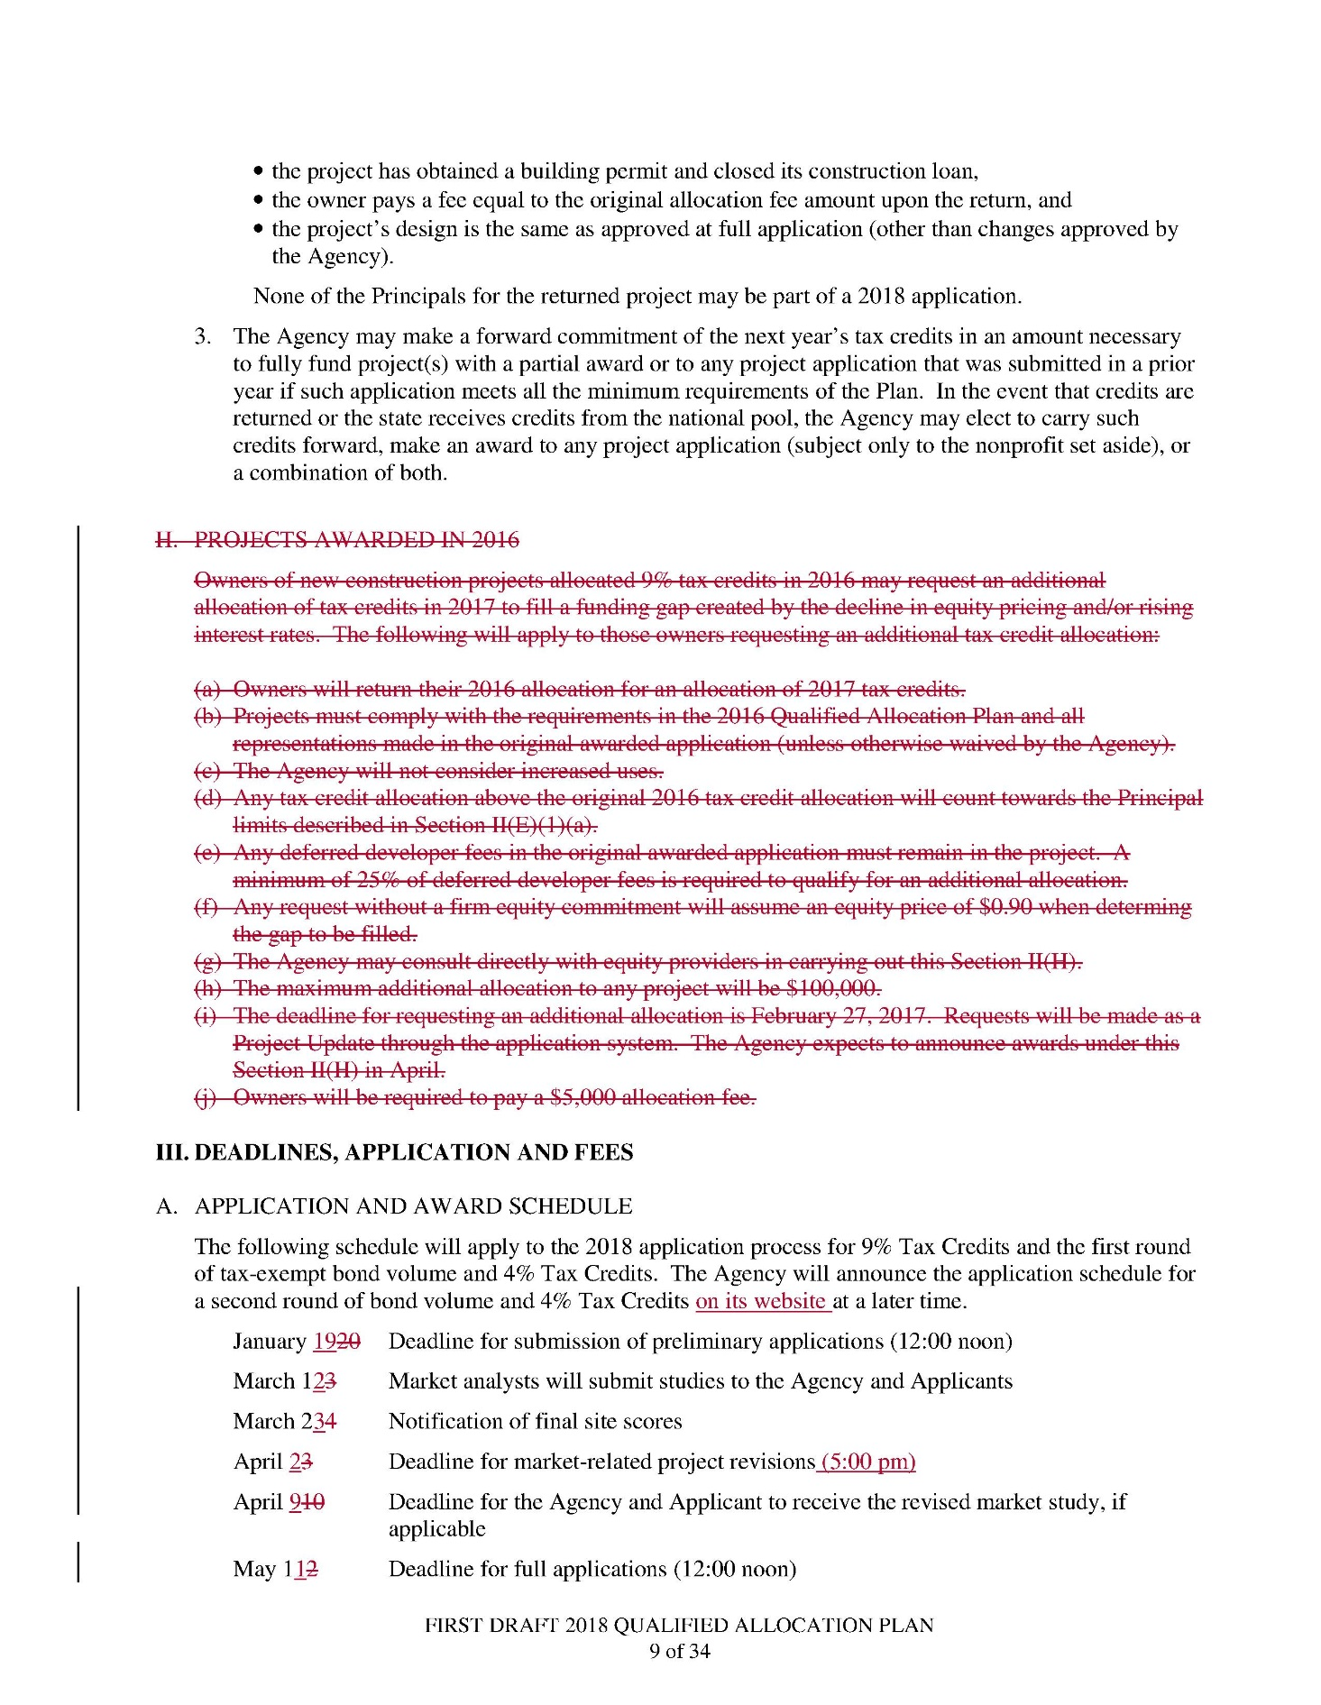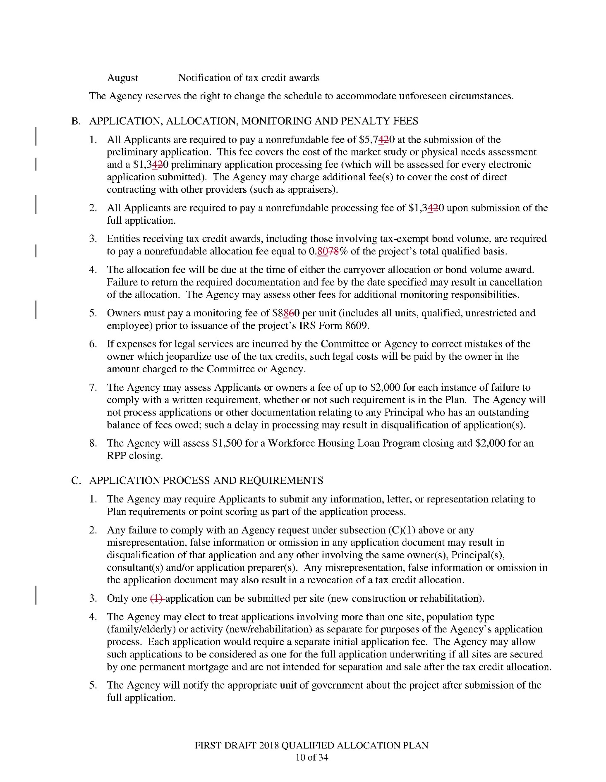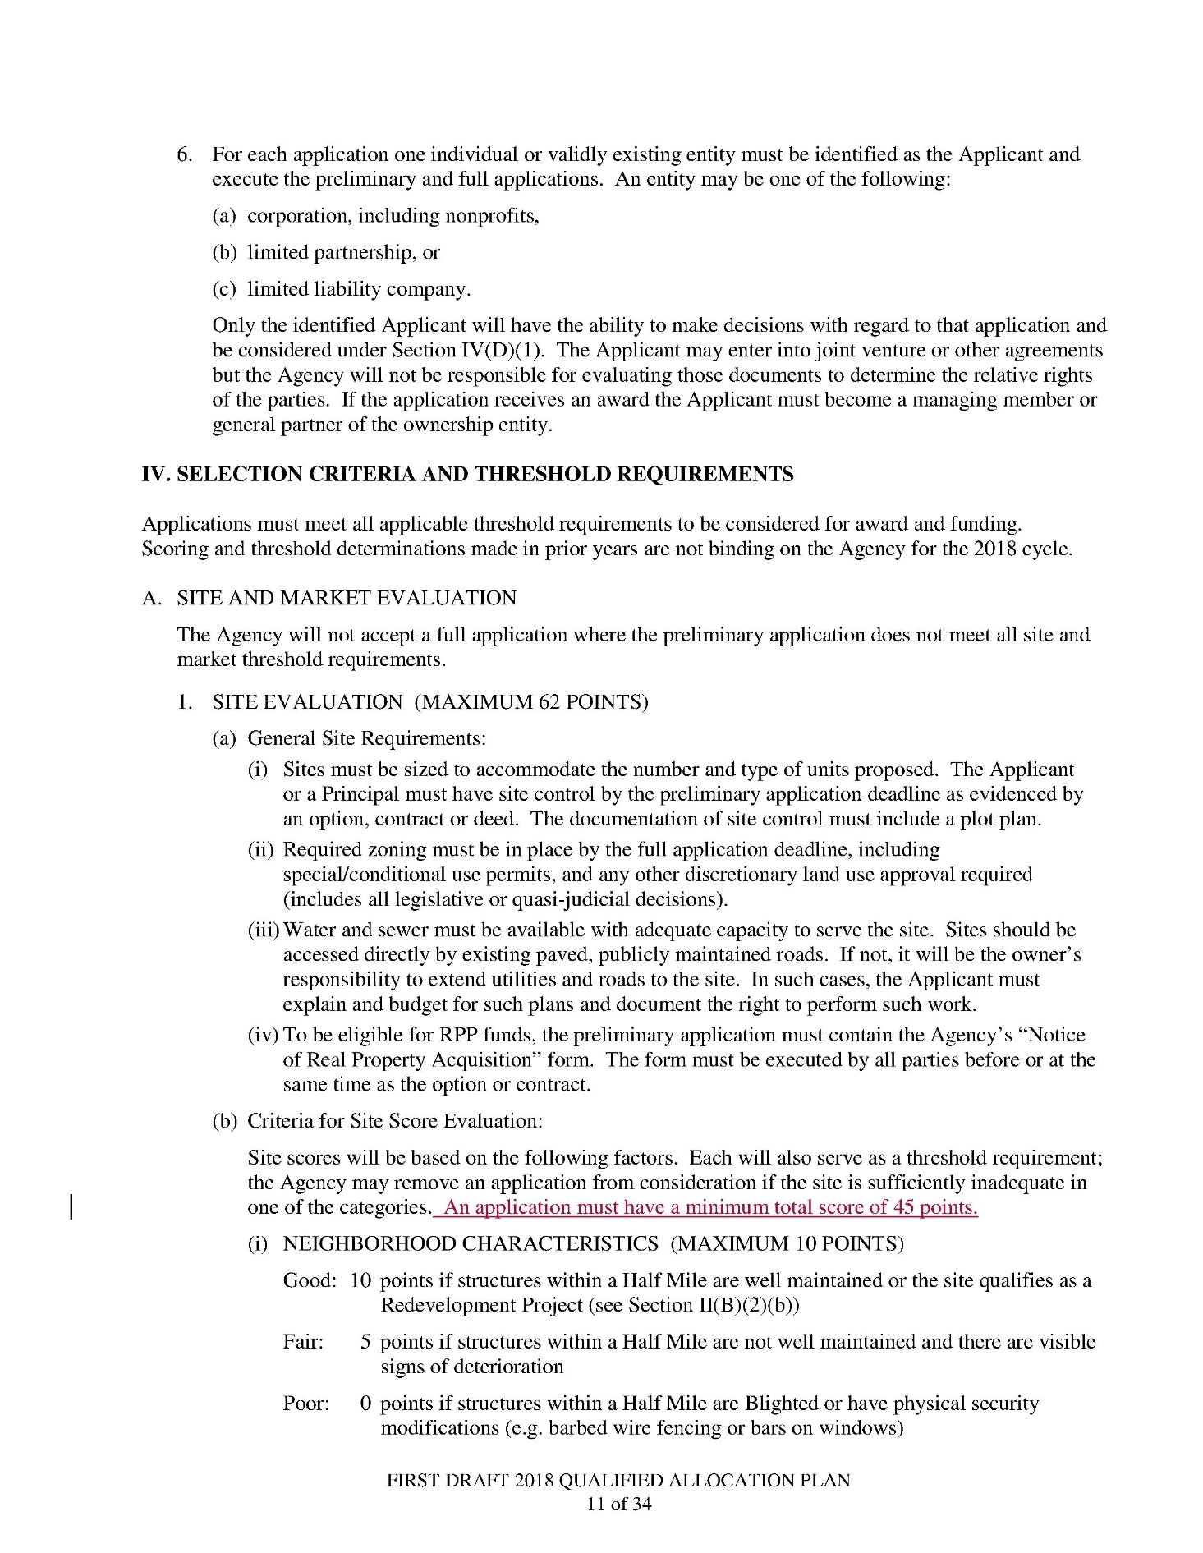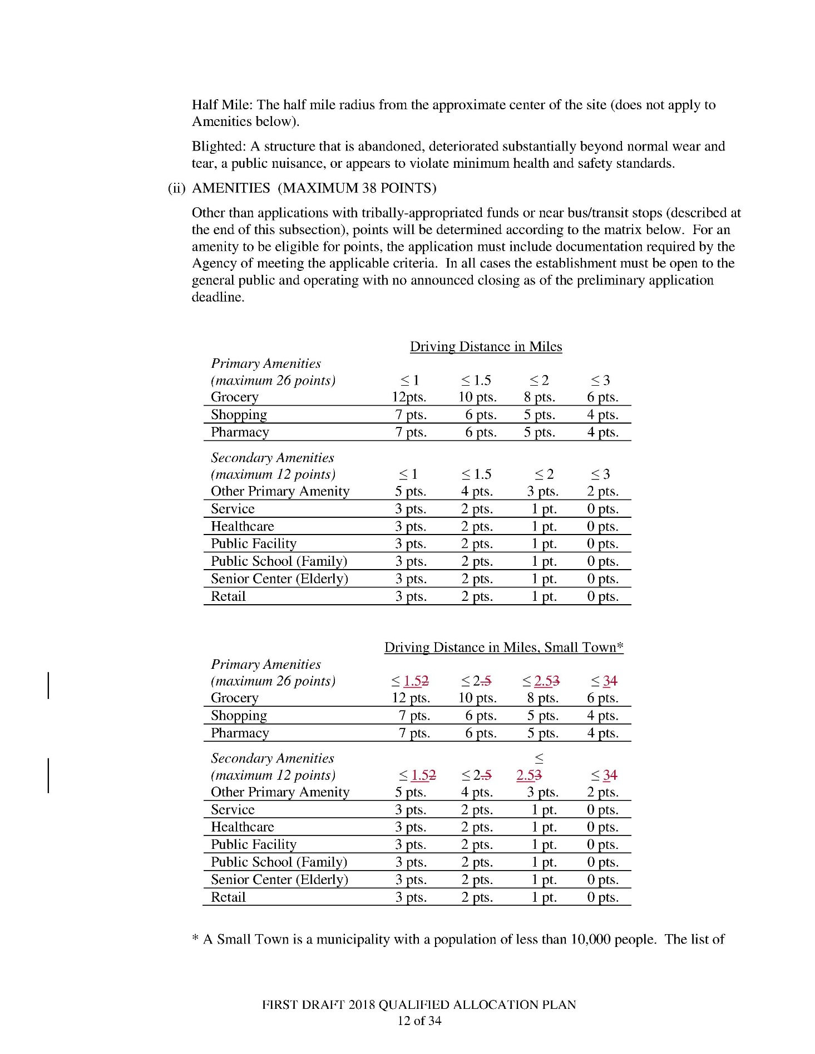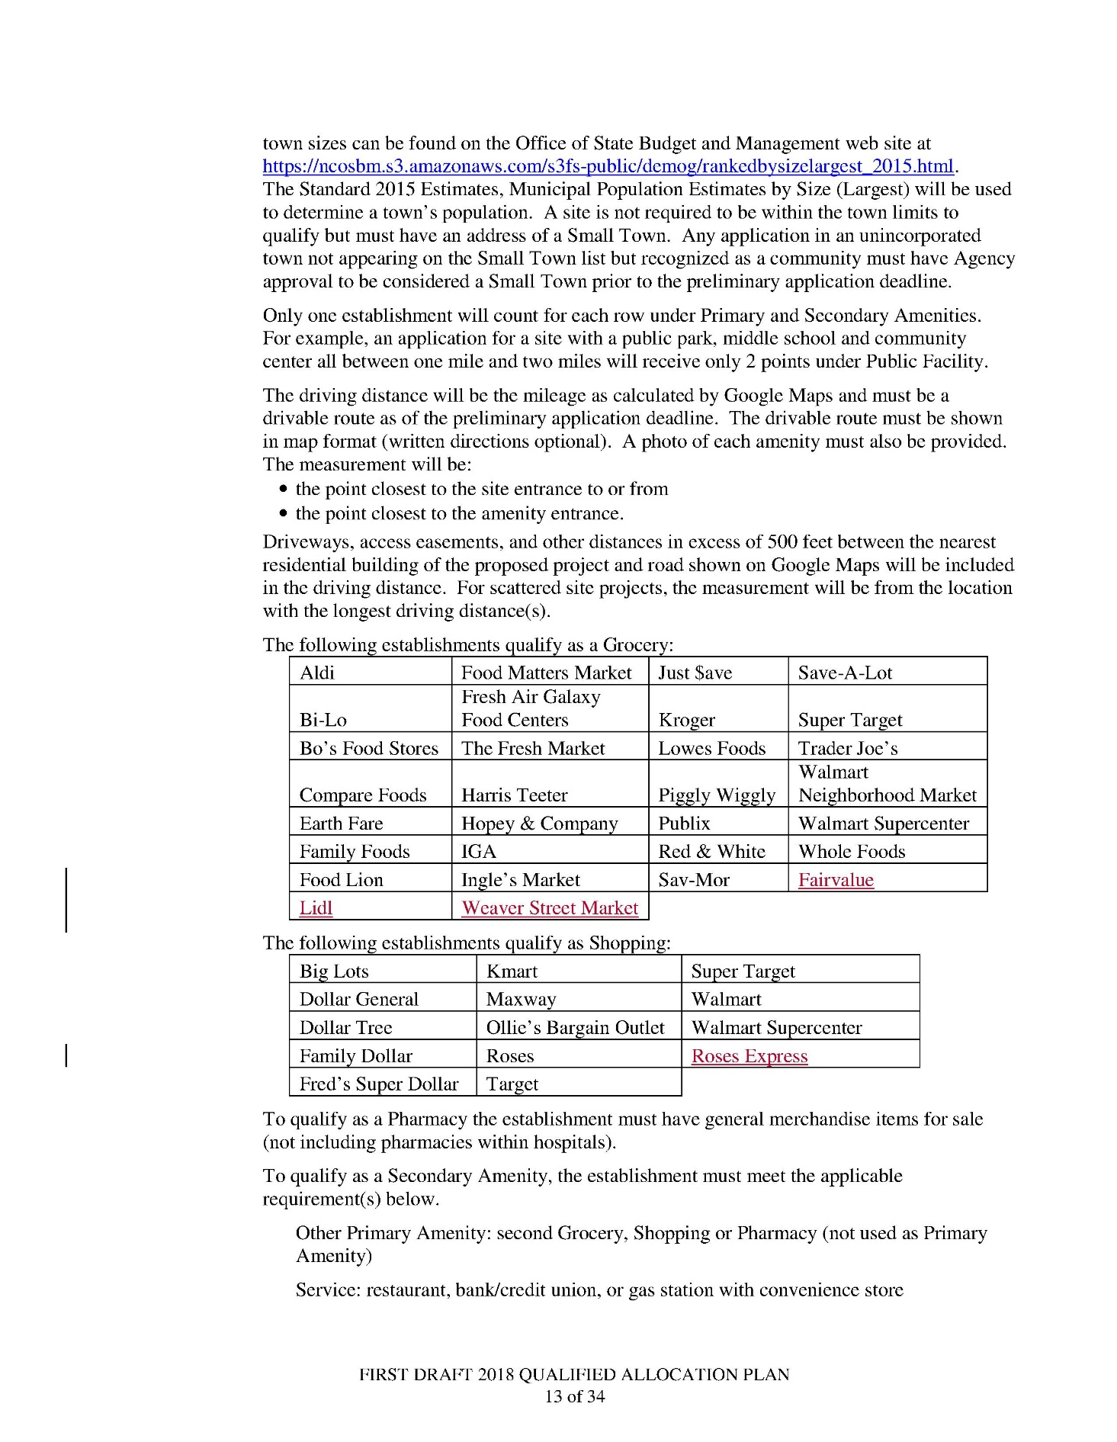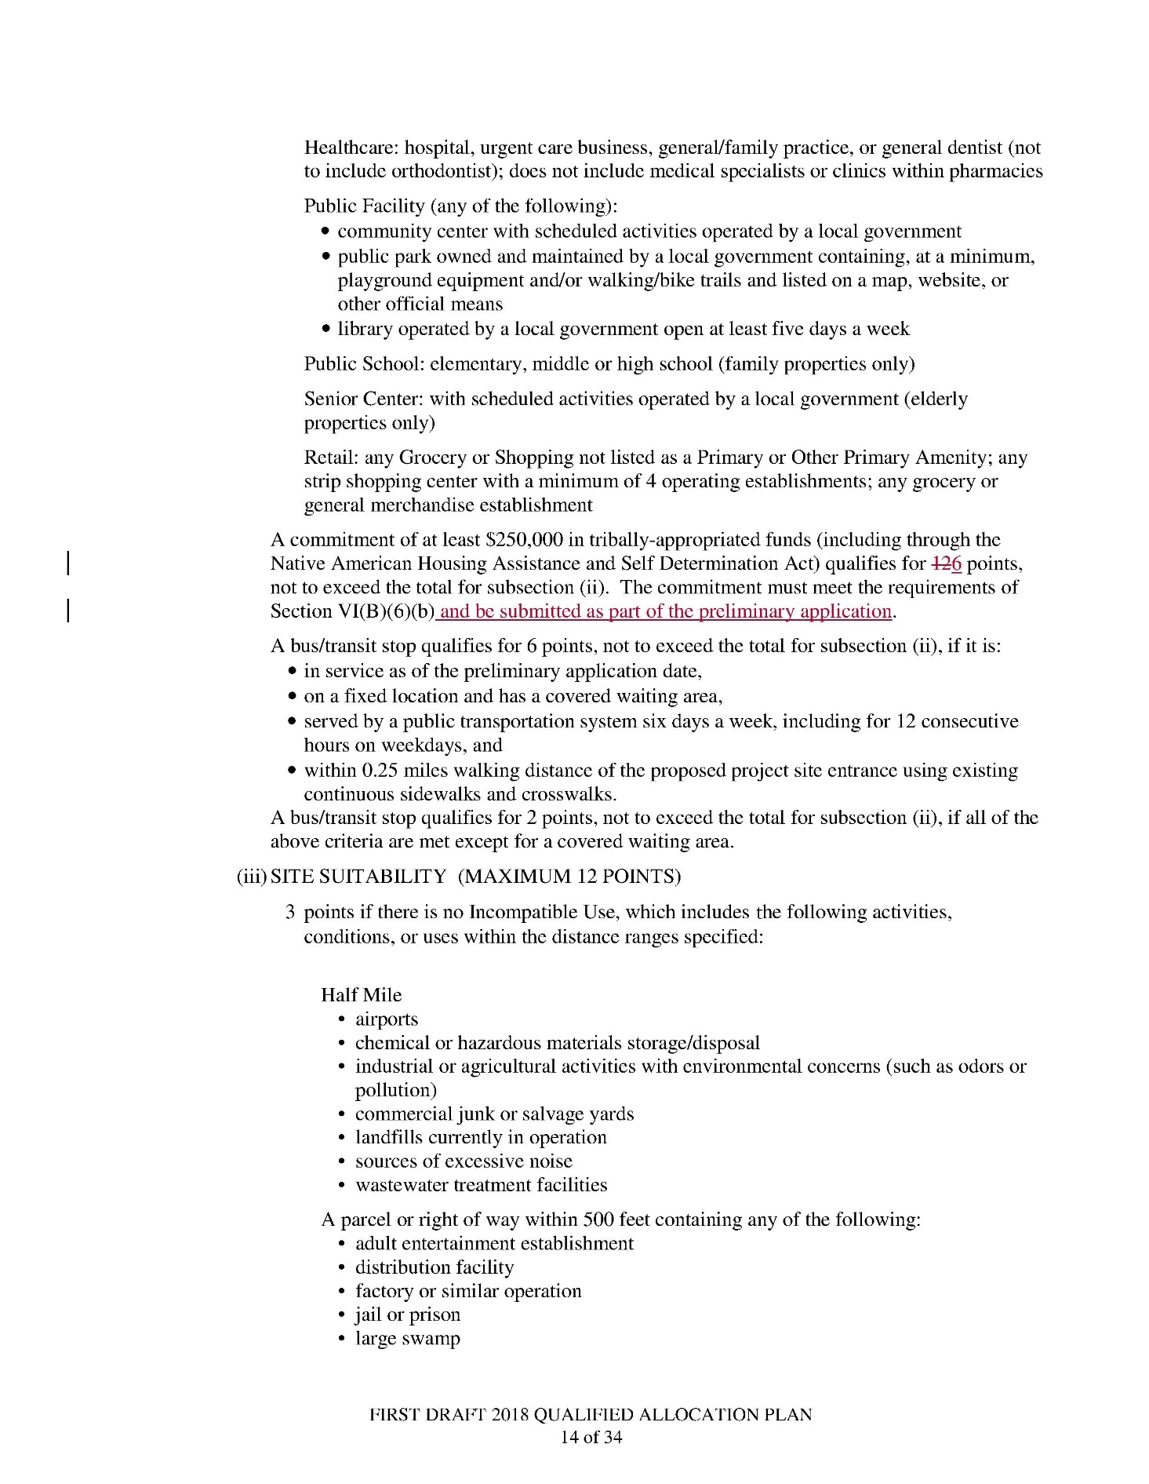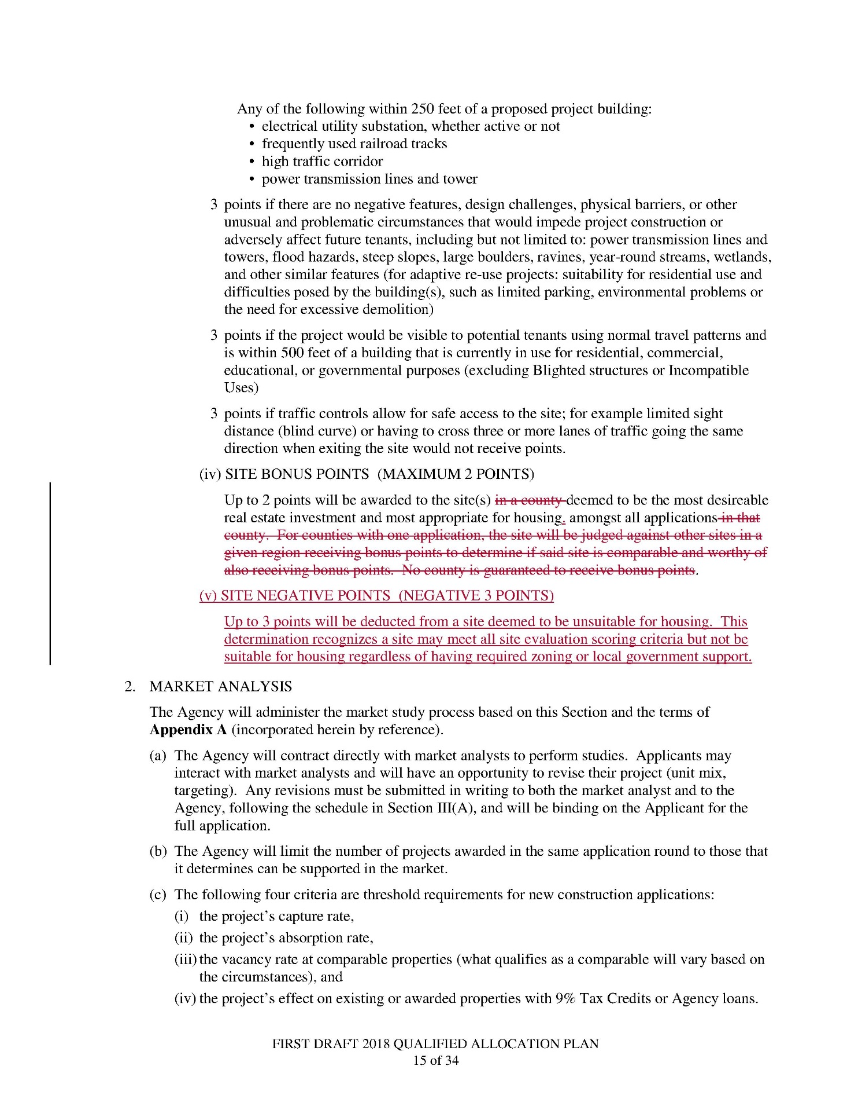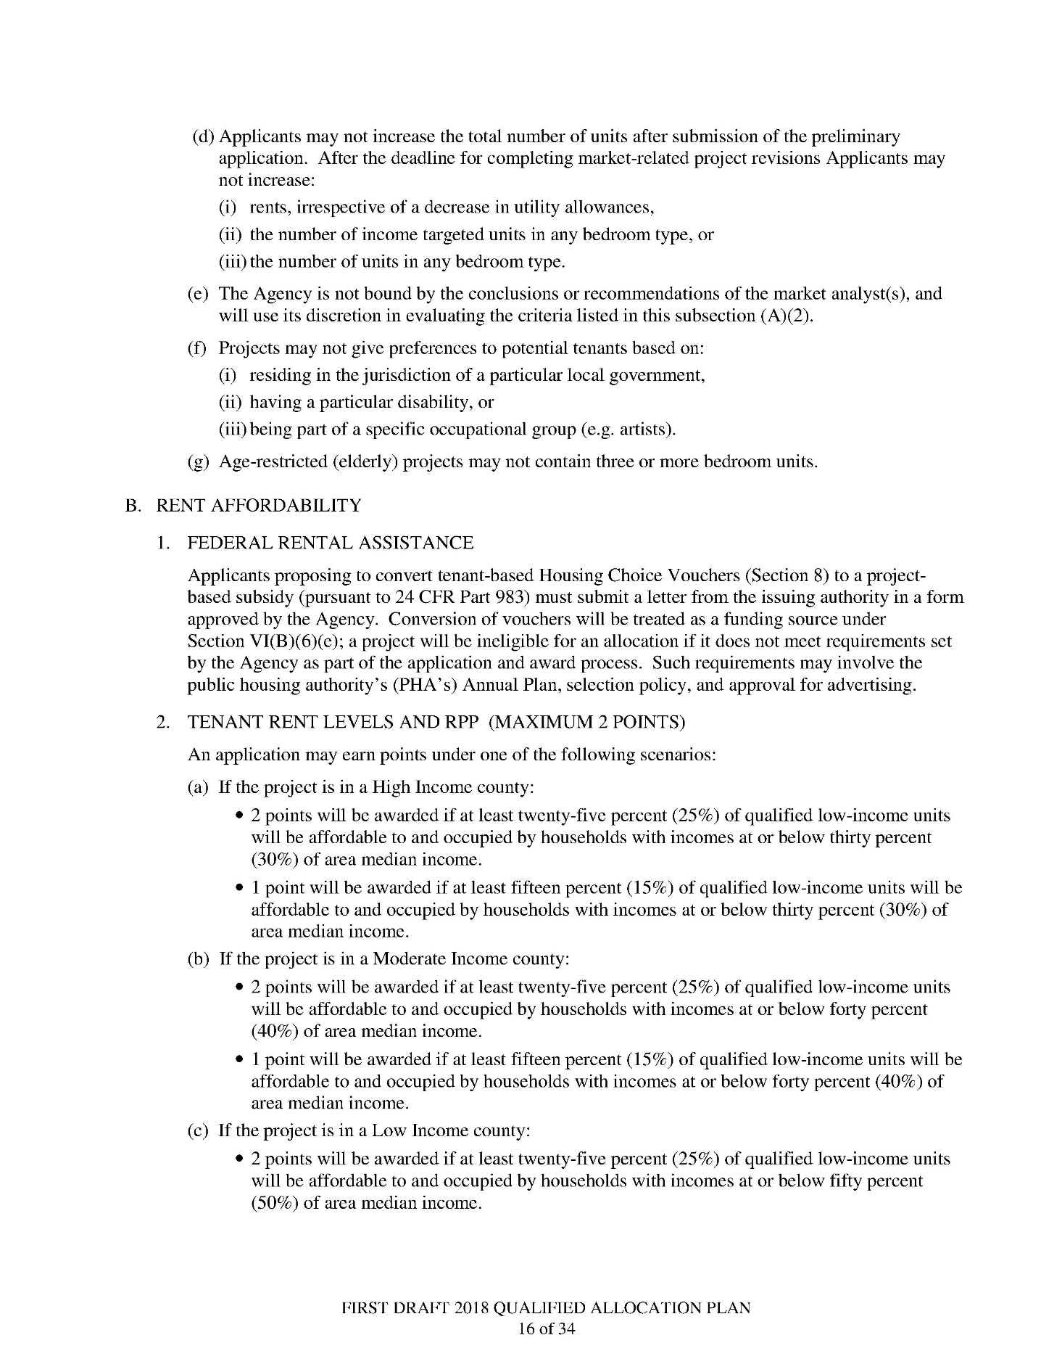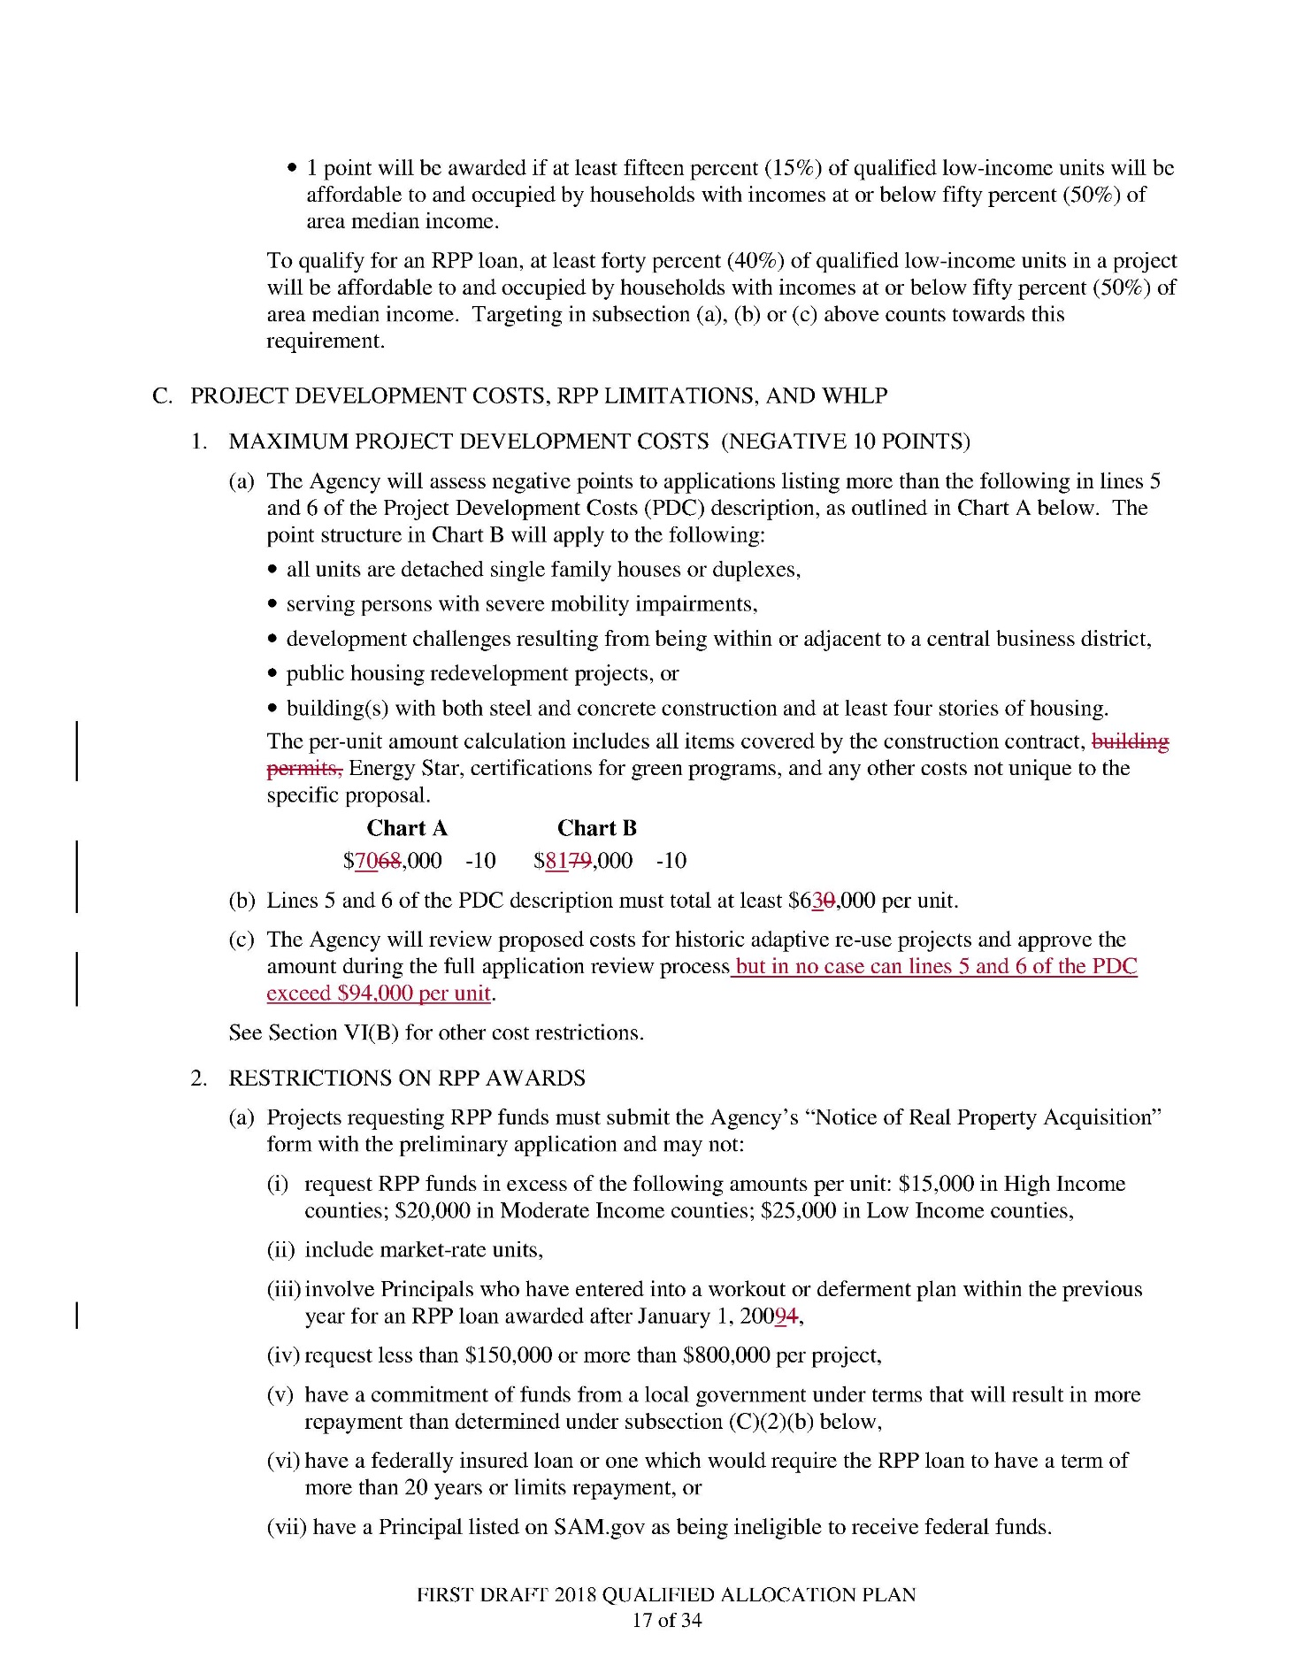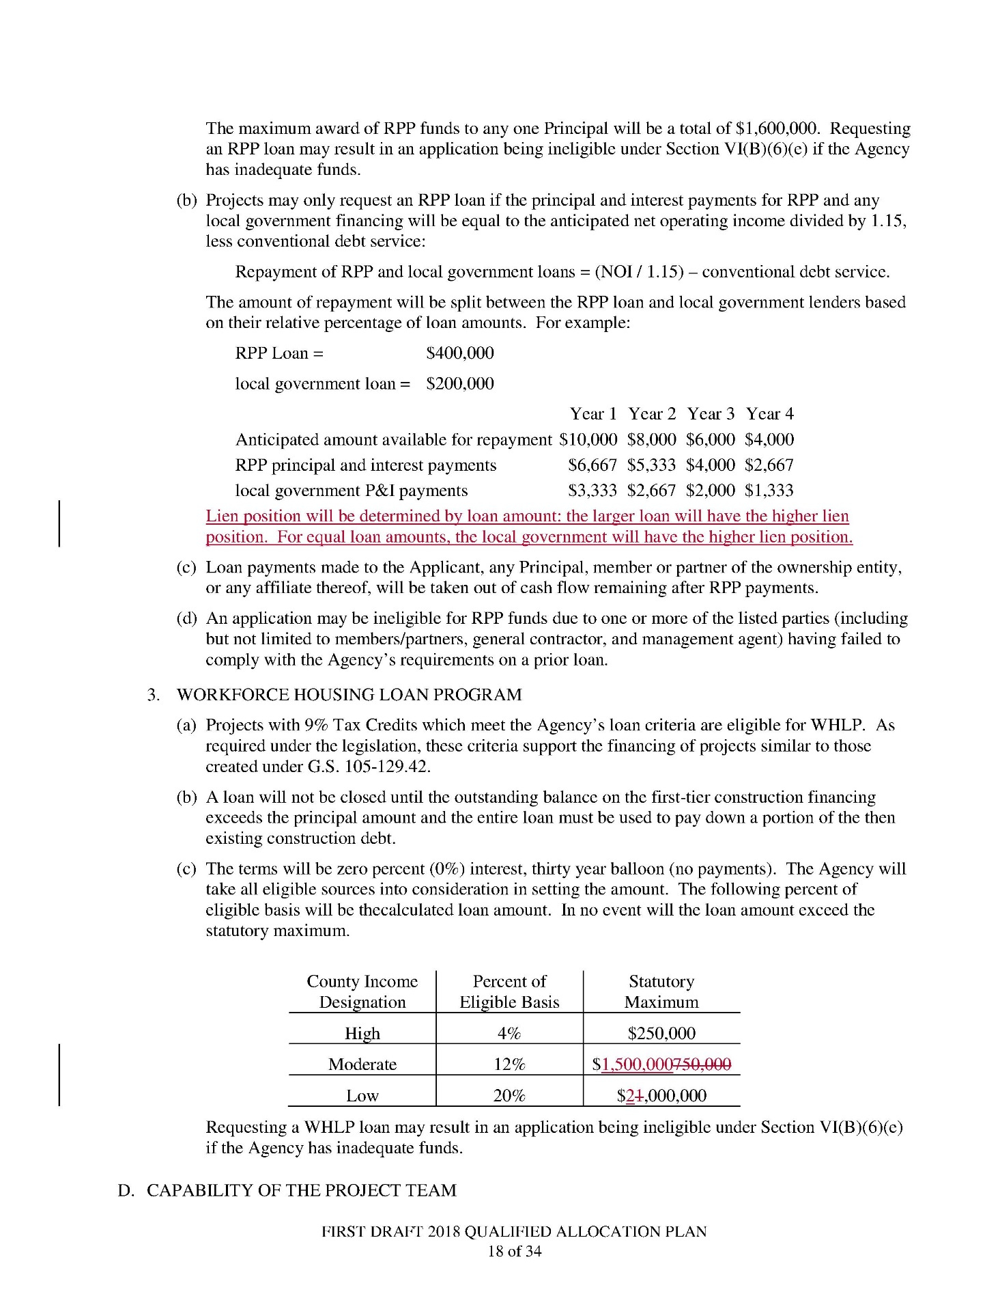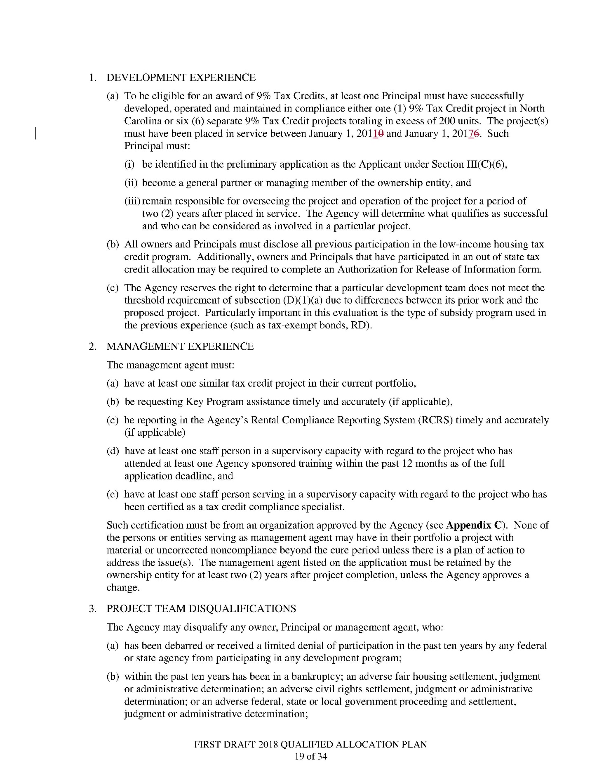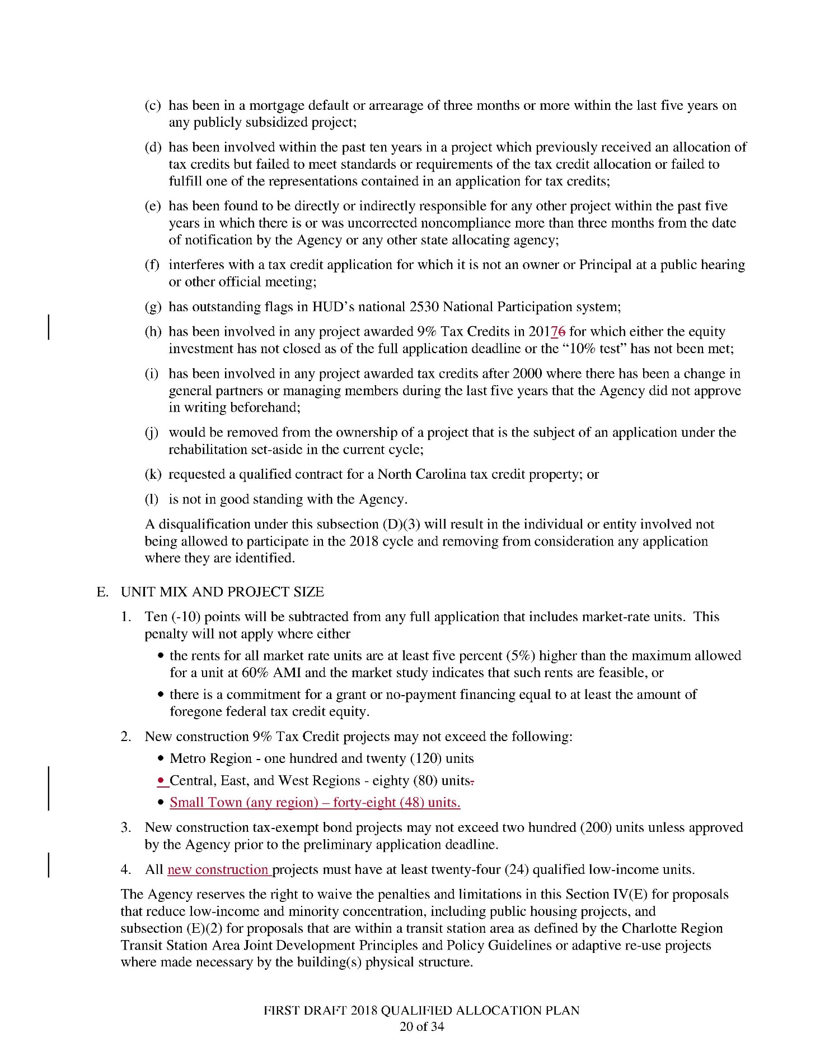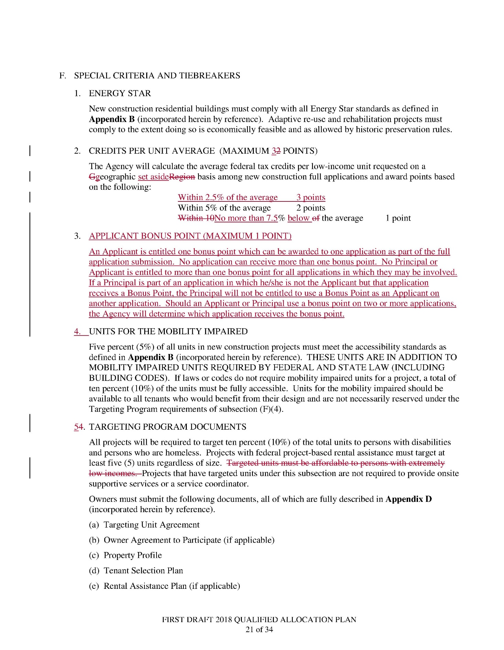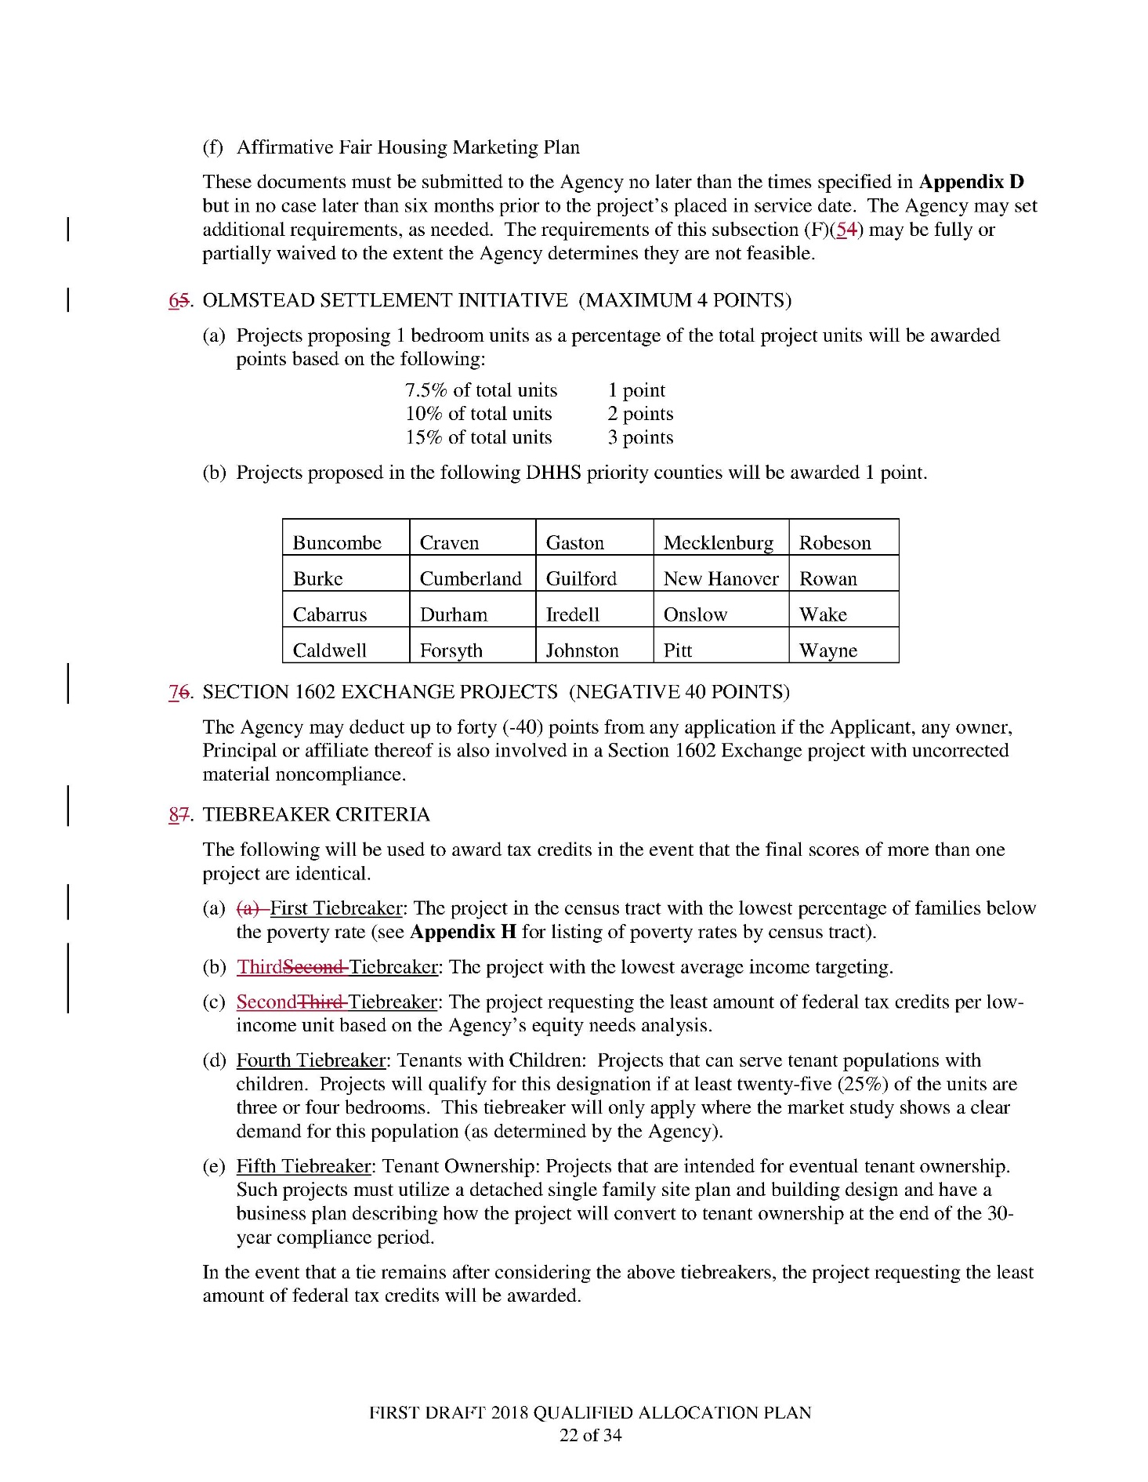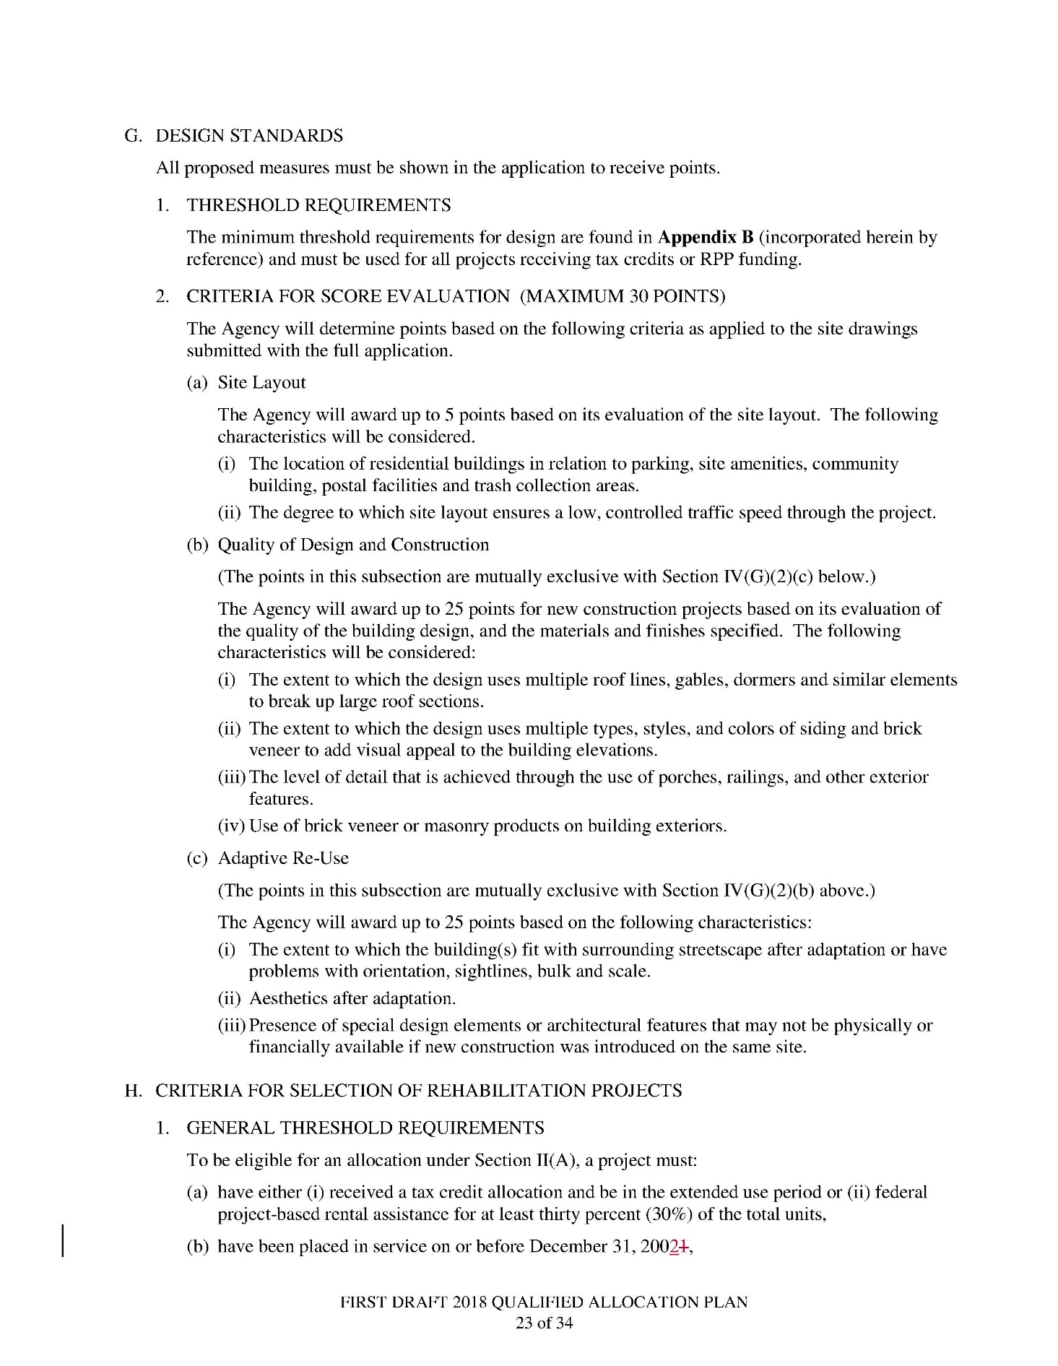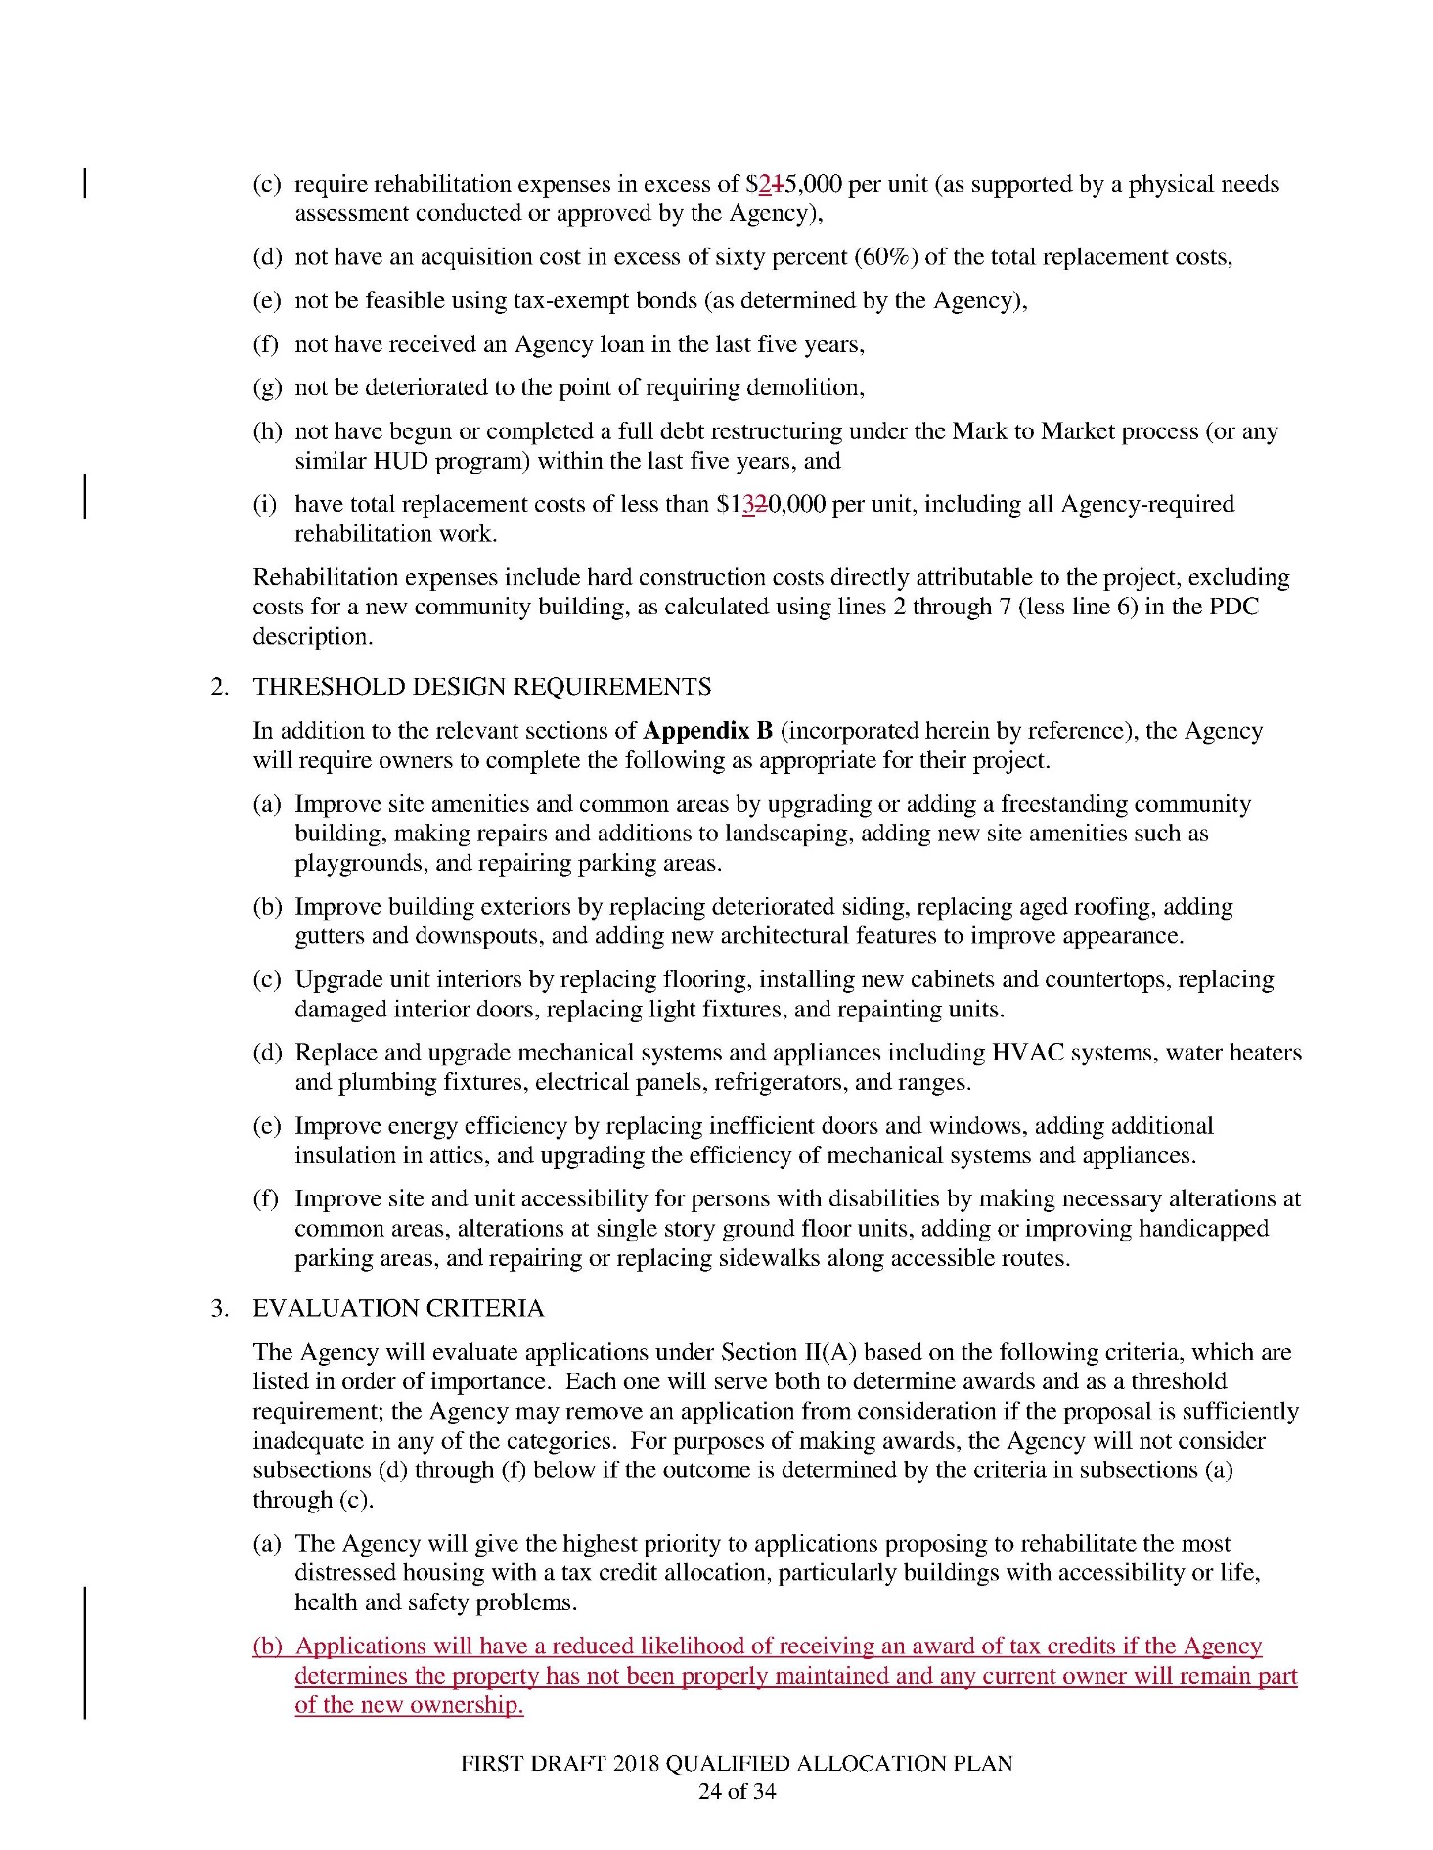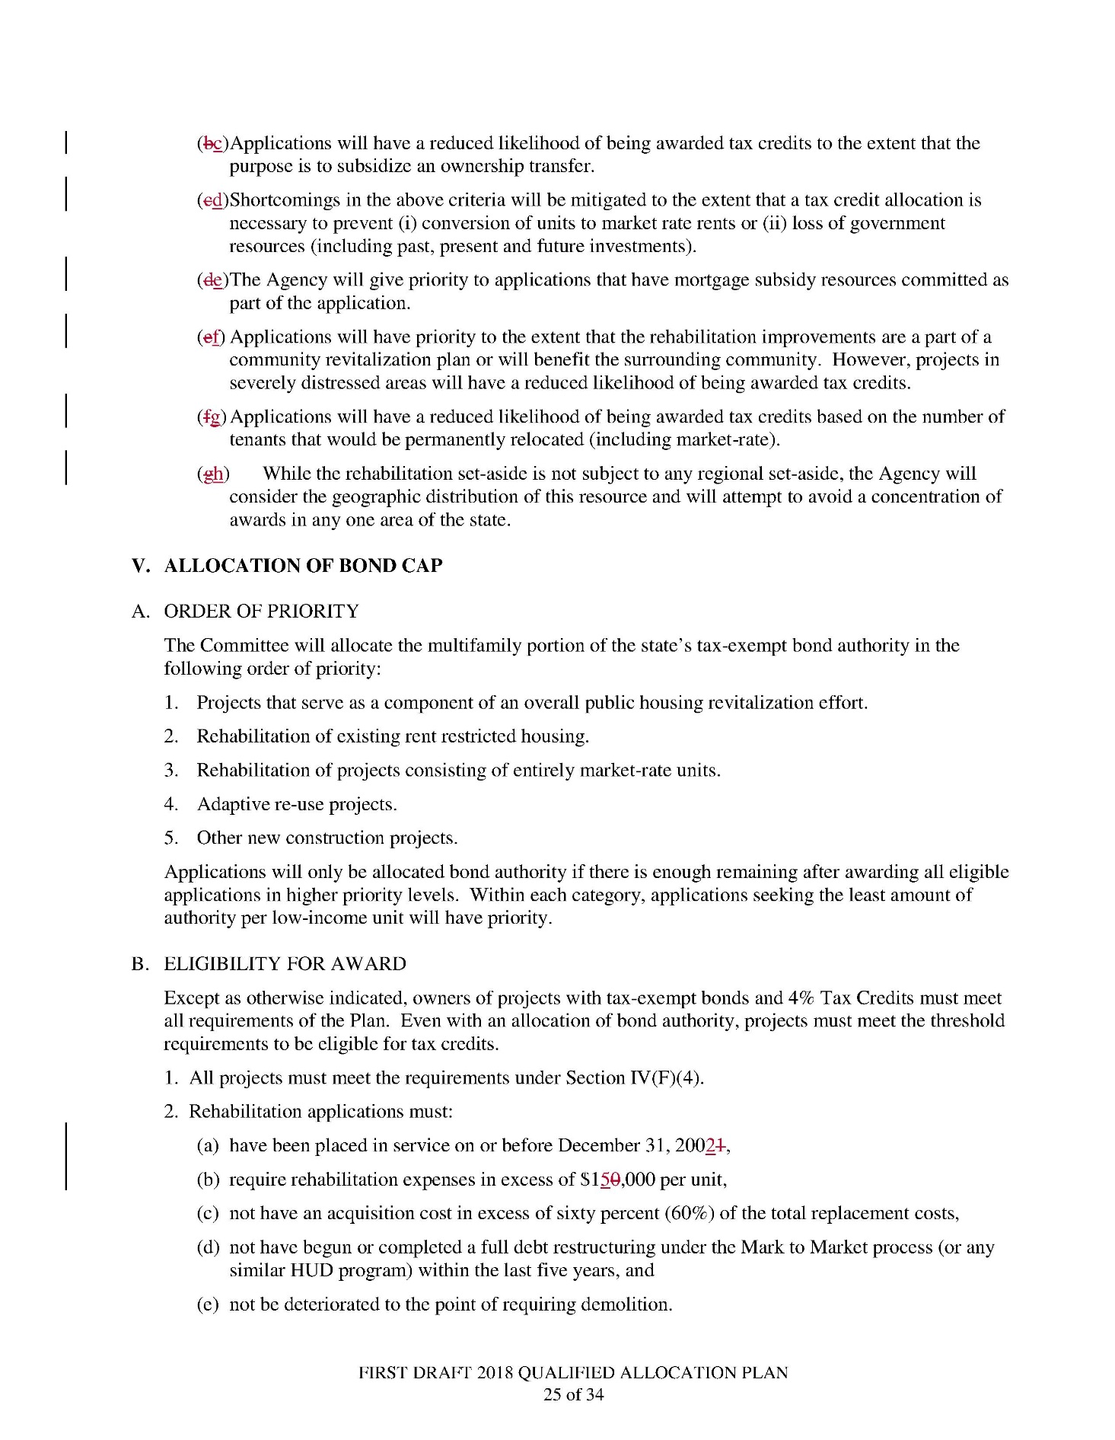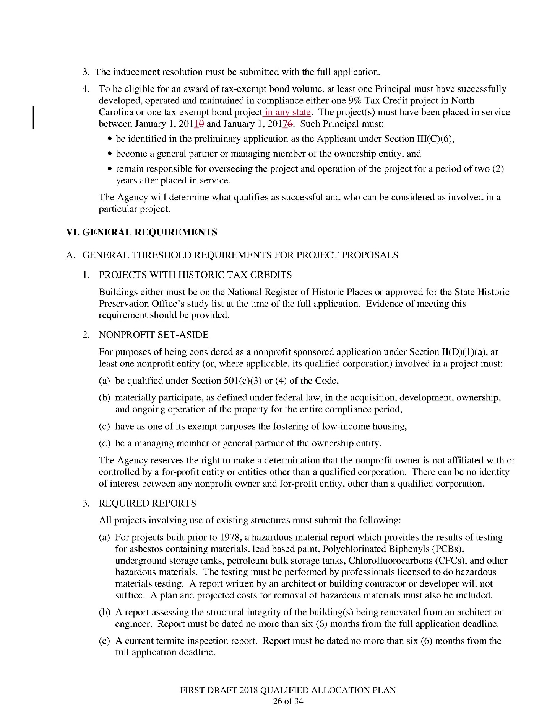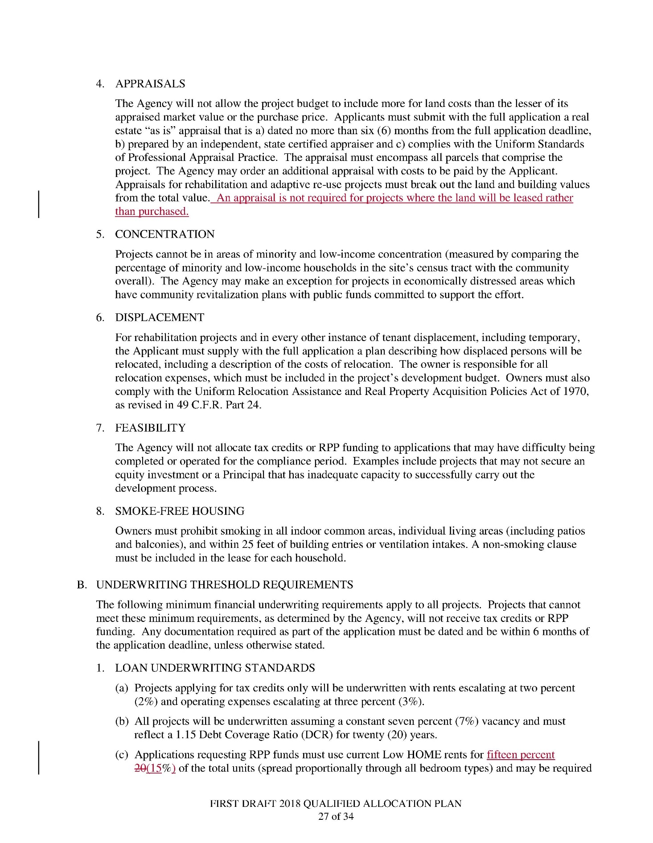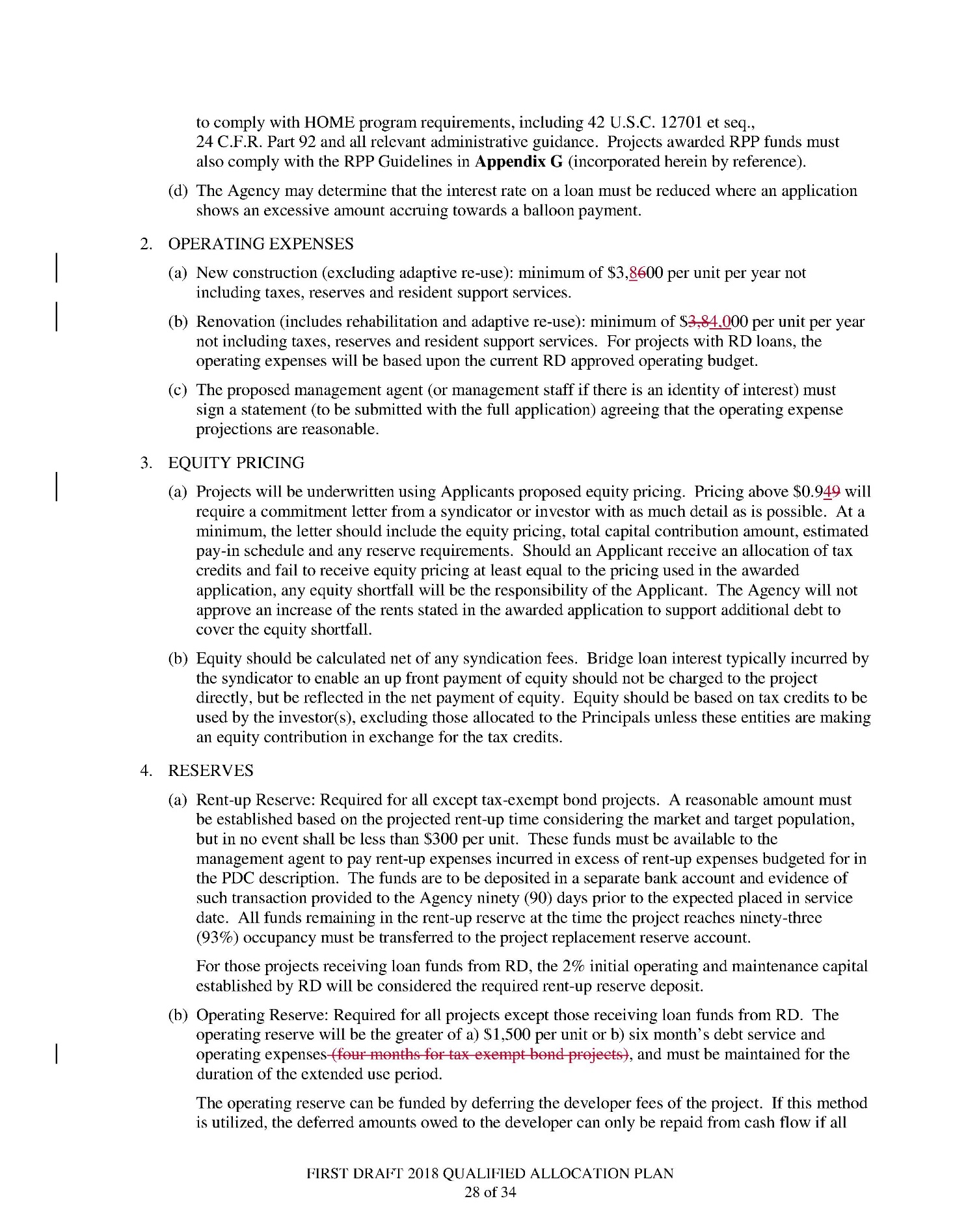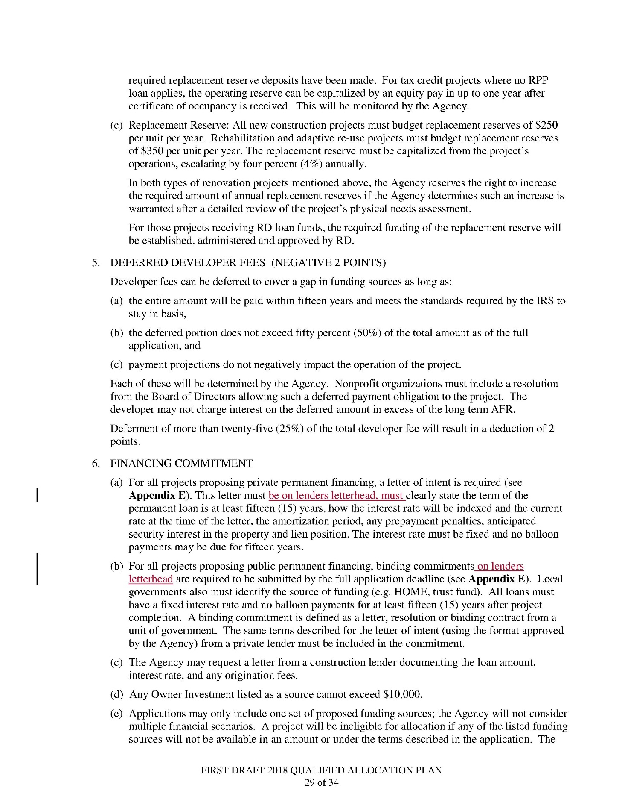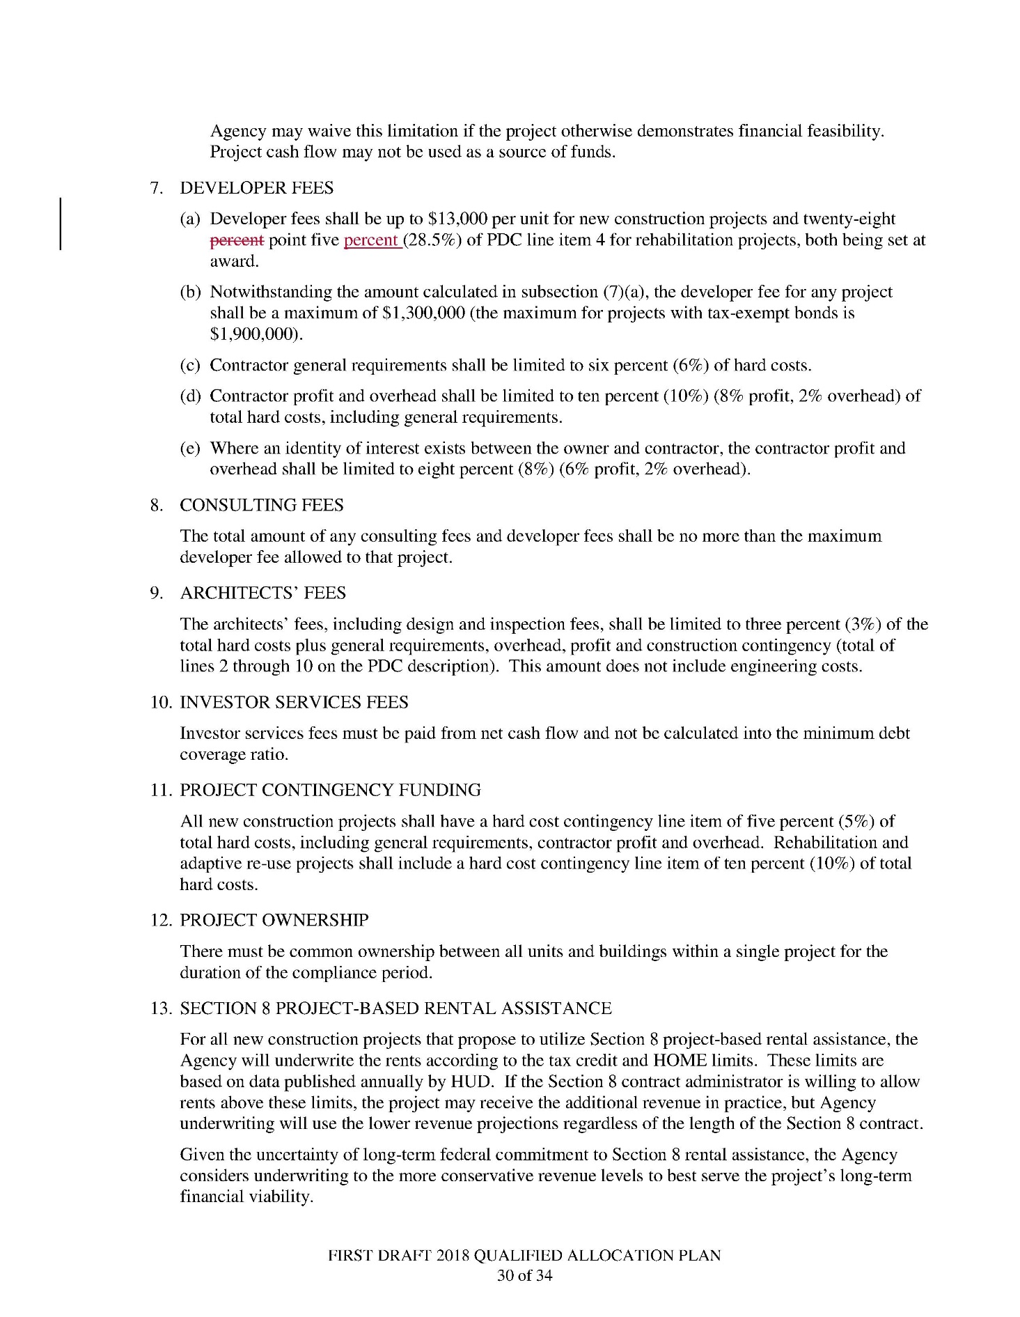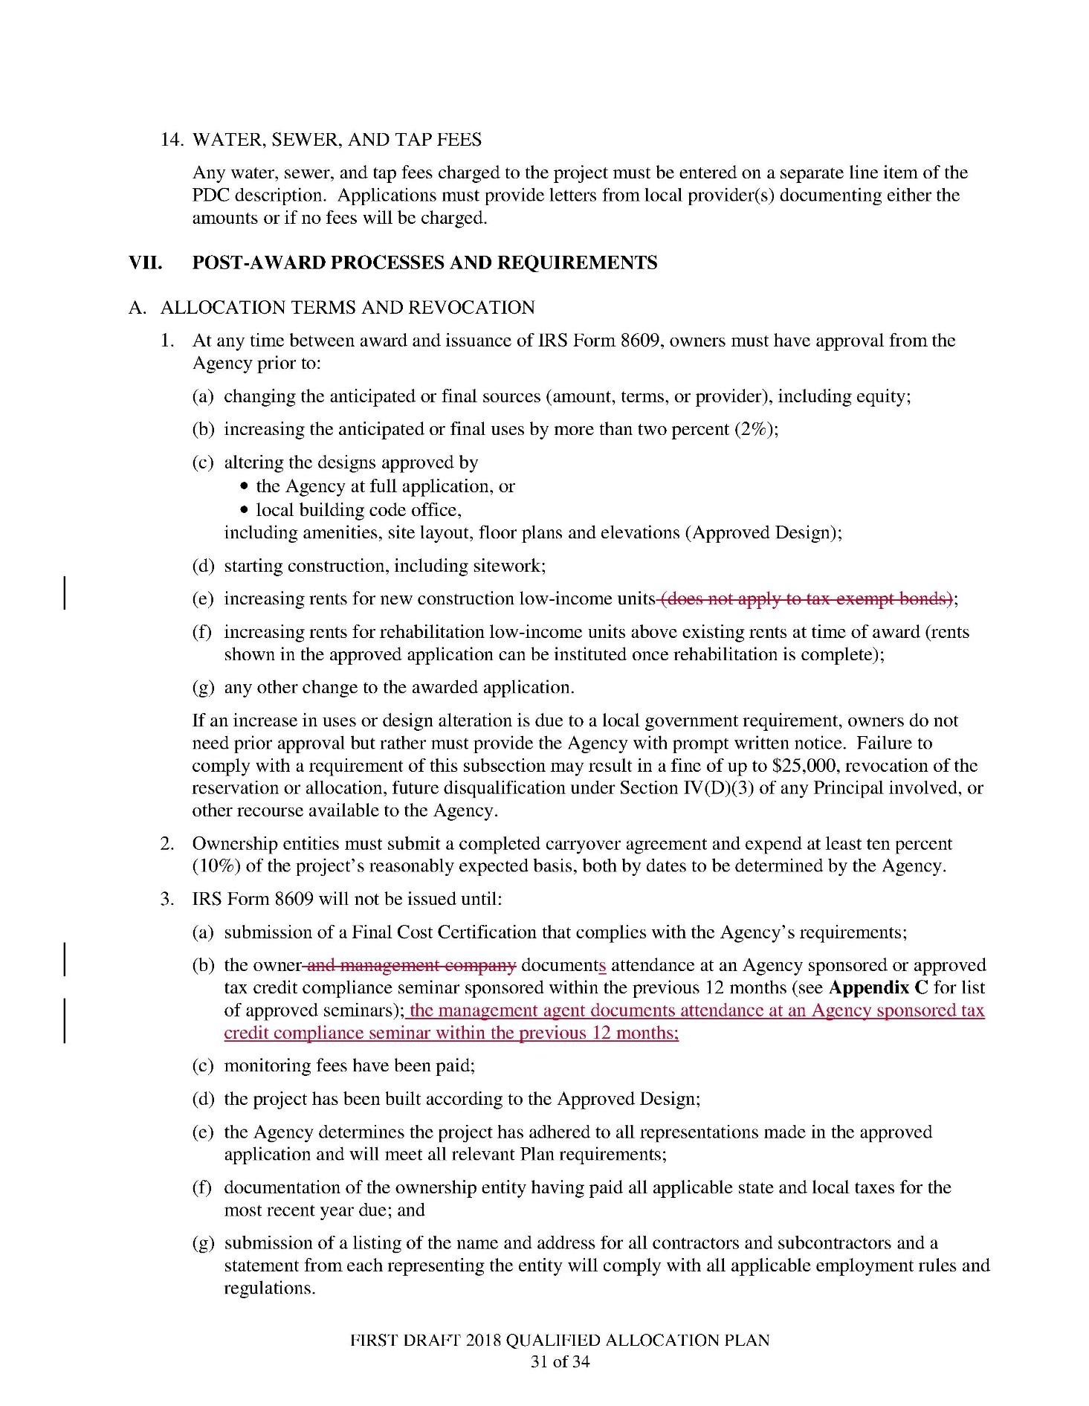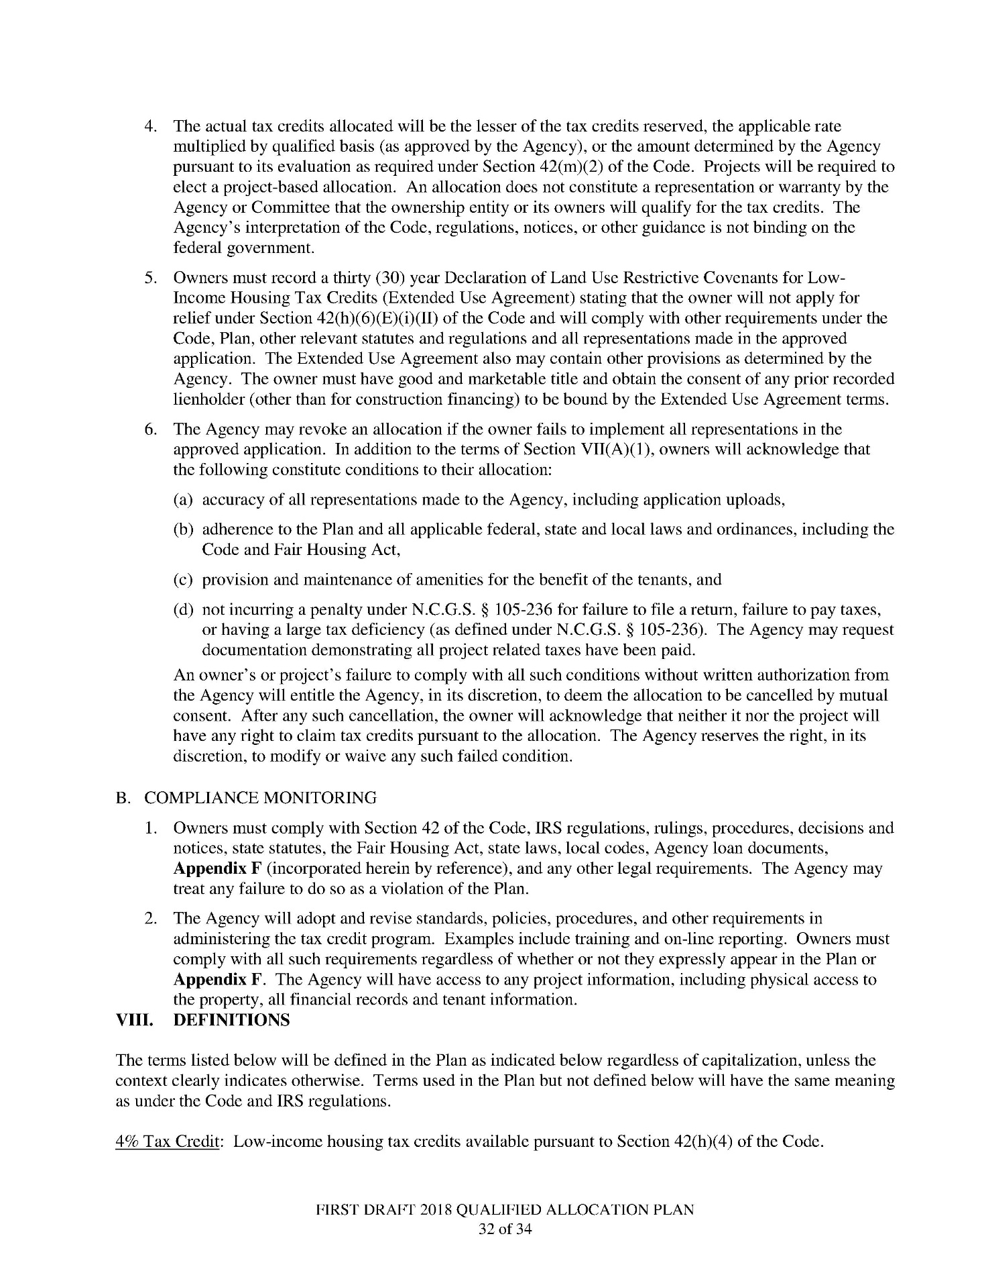

Note from the Codifier: The notices published in this Section of the NC Register include the text of proposed rules. The agency must accept comments on the proposed rule(s) for at least 60 days from the publication date, or until the public hearing, or a later date if specified in the notice by the agency. If the agency adopts a rule that differs substantially from a prior published notice, the agency must publish the text of the proposed different rule and accept comment on the proposed different rule for 60 days.
Statutory reference: G.S. 150B-21.2.

TITLE 10A – Department of health and human services

Notice is hereby given in accordance with G.S. 150B-21.2 that the Medical Care Commission intends to repeal the rules cited as 10A NCAC 13B .6001, .6002, .6104, .6201-.6206, .6208-.6227.

Link to agency website pursuant to G.S. 150B-19.1(c): http://www2.ncdhhs.gov/dhsr/ruleactions.html

Proposed Effective Date: January 1, 2018

Public Hearing:

Date: October 20, 2017

Time: 1:00 p.m.

Location: Dorothea Dix Park, Williams Building, Room 123B, 1800 Umstead Drive, Raleigh, NC 27603

Reason for Proposed Action: The proposed repeal of 29 rules in Subchapter 10A NCAC 13B, Licensing of Hospitals, is in response to enactment of Session Law 2017-174, Senate Bill 42, Section 1.(b) that became effective July 21, 2017. The provisions in this act require the Hospital Facilities Rules to be repealed within 120 days after the act becomes law. These rules are being repealed because the legislature eliminated the need for these rules, as the Session Law specifies for additional temporary and permanent rulemaking replacing the rules with requirements of the Facilities Guidelines Institute (FGI), Guidelines for the Design and Construction of Hospitals so that licensed hospitals in North Carolina are designed and constructed in compliance with a national standard of practice.

Comments may be submitted to: Nadine Pfeiffer, 809 Ruggles Drive, 2701 Mail Service Center, Raleigh, NC 27699-2701, email dhsr.rulescoordinator@dhhs.nc.gov.

Comment period ends: October 31, 2017

Procedure for Subjecting a Proposed Rule to Legislative Review: If an objection is not resolved prior to the adoption of the rule, a person may also submit written objections to the Rules Review Commission after the adoption of the Rule. If the Rules Review Commission receives written and signed objections after the adoption of the Rule in accordance with G.S. 150B-21.3(b2) from 10 or more persons clearly requesting review by the legislature and the Rules Review Commission approves the rule, the rule will become effective as provided in G.S. 150B-21.3(b1). The Commission will receive written objections until 5:00 p.m. on the day following the day the Commission approves the rule. The Commission will receive those objections by mail, delivery service, hand delivery, or facsimile transmission. If you have any further questions concerning the submission of objections to the Commission, please call a Commission staff attorney at 919-431-3000.

Fiscal impact (check all that apply).

State funds affected

Environmental permitting of DOT affected

Analysis submitted to Board of Transportation

Local funds affected

Substantial economic impact (≥$1,000,000)

Approved by OSBM

No fiscal note required by G.S. 150B-21.4

SECTION .6000 - PHYSICAL PLANT

10A NCAC 13B .6001 LOCATION

(a) The site of any facility shall be accessible to service vehicles, fire protection and emergency apparatus.

(b) The water supply system available to the site shall be tested to determine the mineral and salts content and their effect on the various water systems in the facility. When these tests indicate the facility will have problems in maintenance and upkeep, the facility shall provide a water treatment system.

Authority G.S. 131E-79.

10A NCAC 13B .6002 ROADS AND PARKING

(a) Paved roads shall be provided within the property lines to provide access to the main entrance, emergency entrance, and to service entrances, including loading and unloading docks for delivery trucks.

(b) Facilities having an organized emergency services department shall have the emergency entrance well marked to facilitate entry from the public roads or streets serving the site.

(c) Paved walkways shall be provided for necessary pedestrian traffic.

(d) Off-street parking shall be made available for patients, staff, and visitors.

Authority G.S. 131E-79.

SECTION .6100 - GENERAL REQUIREMENTS

10A NCAC 13B .6104 ACCESS AND SAFETY

Projects involving replacement, alterations of, and additions to existing facilities shall be planned and phased so that construction will minimize disruptions of essential facility operations. Facility access, exit ways, safety provisions, and building and life safety systems shall be maintained so that the health and safety of the occupants will not be jeopardized during construction. Additional safety and operating measures shall be planned and executed to compensate for hazards related to construction or renovation activities to maintain an equivalent degree of health, safety, and operational effectiveness to that required by rules, standards, and codes for a facility not under construction or renovation.

Authority G.S. 131E-79.

SECTION .6200 - CONSTRUCTION REQUIREMENTS

10A NCAC 13B .6201 MEDICAL, SURGICAL AND POST-PARTUM CARE UNIT

The following requirements shall apply to licensed beds:
(1) Each patient room shall meet the following requirements:
(a) Maximum room capacity shall be four patients;
(b) Minimum room areas exclusive of toilet rooms, closets, lockers, wardrobes, bathing room, or vestibules less than six feet wide shall be 100 square feet in single bed rooms and 80 square feet per bed in multi-bed rooms;
(c) A minimum of three feet of clear working space on three sides of each bed shall be provided;
(d) A window which can be opened from the inside shall be provided. The window sill shall not be higher than three feet above the floor and shall be above grade;
(e) A nurses' calling station at each patient bed and toilet room shall be provided;
(f) At least one lavatory shall be provided in each patient room. In a single bedroom other than post-partum rooms, the lavatory may be omitted from the patient room when a lavatory is located in an adjoining toilet room which serves that room only;
(g) A toilet room containing a water closet and a lavatory shall be provided to serve no more than four beds or two patient rooms;
(h) A wardrobe, locker or closet shall be provided for each patient suitable for hanging garments as well as for storage of personal effects; and
(i) Provision shall be made for the visual privacy of each patient in multi-bed rooms.
(2) The following service areas shall be located no further than 120 feet travel distance from each patient bedroom door:
(a) Nurses' station with work counter and storage facilities;
(b) Hand washing facilities located at the nurses' station;
(c) Charting facilities;
(d) A clean workroom or a clean holding room for storage and distribution of clean supply materials. The clean workroom shall contain a work counter and hand washing and storage facilities. A clean holding room shall be similar to a clean workroom except it shall be a part of a clean supply system and the work counter and hand washing facilities may be omitted;
(e) A soiled workroom or a soiled holding room as a part of a system for the collection and disposal of soiled materials. The soiled workroom shall contain a clinical sink or other suitable flushing device, sink equipped for hand washing, a work counter, a waste receptacle, and a linen receptacle. A soiled holding room shall be similar to the soiled workroom except that it shall be a part of the soiled disposal system. The waste receptacle clinical sink and work counter may be omitted;
(f) A drug distribution station that meets the current minimum requirements of governing state and federal agencies regulating controlled substances including a lavatory;
(g) A clean linen storage closet. This may be a designated area within the clean workroom. If a closed cart system is used, storage may be in a controlled alcove out of corridor traffic;
(h) A separate nourishment station that contains a lavatory, equipment for serving nourishment between meals, refrigerator and storage facilities. Ice dispensing facilities for patient service and treatment shall be of a type that will not require use of scoops;
(i) Storage of equipment including emergency equipment shall be provided to insure corridors are kept clear; and
(j) Parking for stretchers and wheelchairs located out of corridor widths.
(3) The following service areas shall be provided for each nursing unit:
(a) Nurses office;
(b) Closets or compartments for the safekeeping of coats and personal effects of staff;
(c) Conference room;
(d) Room for examination and treatment of patients. This room may be omitted if all patient rooms are single-bed rooms. This room shall have a minimum floor area of 100 square feet, excluding space for vestibule less than six feet wide, toilet, closets and work counters (whether fixed or movable). The minimum room dimension shall be 10 feet. The room shall contain a lavatory, a work counter, storage facilities and a desk, counter or shelf space for writing;
(e) Lounge and toilet room for staff;
(f) Janitors' closet. This room shall contain a floor receptor or service sink and storage space for housekeeping supplies and equipment; and
(g) Individually enclosed bathtubs or individually enclosed showers at the rate of one for each 12 beds or fraction thereof which are not otherwise served by bathing facilities within the patient rooms.
(4) Each facility shall make provisions for at least one room for patients needing close supervision including provisions to minimize the chance of a patients' hiding, escape, injury or suicide.
(5) Isolation Rooms. Rooms for patients requiring protective or infectious isolation for infection control purposes shall be provided at the ratio of one isolation room for each 30 acute care licensed beds or major fraction thereof. These may be located within each nursing unit or placed together in a separate unit. Each isolation room shall be a single-bed room and shall conform to the requirements of Item (1) of this Rule except as follows:
(a) A private toilet room containing a water closet and a bath or shower for the exclusive use of the patient which can be entered directly from the patient bed area without passing through the vestibule or anteroom shall be provided;
(b) A lavatory for the exclusive use of the patient shall be provided. It may be located in the patient room or in the private toilet room;
(c) Entrance from the corridor shall be through a closed anteroom which contains facilities to assist staff personnel in maintaining aseptic conditions. The anteroom shall contain a lavatory equipped for hand washing, storage for clean and soiled materials, and gowning facilities; and
(d) A view window in the door for nursing observation of the patient from the anteroom shall be provided.
(6) Provision shall be made for delivery of medications to patients. All medications and related items shall be stored in compliance with current Federal and State laws and rules and made accessible only to authorized personnel. A medication preparation area, alcove, room or other designated area shall be under the direct supervision of the nursing staff when not in use. It shall contain at least a work counter, lavatory, medication-only refrigerator and designated locked area for controlled substances; if mobile systems are used, storage in corridors is prohibited except when in use by the nursing staff.

Authority G.S. 131E-79.

10A NCAC 13B .6202 SPECIAL CARE UNIT

(a) Each patient room shall meet the following requirements:

(1) Clearance between beds in multi-bed rooms shall be not less than 7 feet with provision for visual privacy of patients. Each patient bed space shall have a minimum of 130 square feet with a minimum dimension of 11 feet;

(2) One single isolation bedroom meeting the requirements of Rule .6201(5) of this Section shall be provided for each 12 special care beds or fraction thereof;

(3) Glazing in all viewing panels in partitions and doors shall be safety glass, wire glass, or fire rated glass;

(4) A lavatory shall be provided in each patient room. In multi-bed rooms, lavatories shall be provided within 10 feet of each bed;

(5) A nurse call system is required except in neonatal units;

(6) Each single-bed cubicle or room shall have a window to the outdoors. In the case of ward-type patient bed areas of two or more patients where cubicle privacy curtains are used, at least one window shall be provided for every two beds. Windows shall be positioned to provide a maximum distance of 18 feet between the normal head position of each patient and a window. Window sills shall not exceed five feet above the floor; and

(7) Toilet facilities provided for each special care unit shall be accessible from within the unit. Portable toilets may be used within the patient room. Storage and service of portable toilets shall be provided, if used. Fixed toilets shall have sufficient clearance to facilitate use by patients needing assistance.

(b) The service elements and areas listed below shall be provided within each special care unit:

(1) A nurses' station located to permit visual observation of each patient served;

(2) Hand washing facilities convenient to nurses' station;

(3) Designated charting space in addition to monitoring service space;

(4) A staff toilet room containing a water closet and a lavatory;

(5) Facilities for the safekeeping of coats and personal effects of staff;

(6) A clean workroom or a system for storage and distribution of clean supplies. The clean area shall contain a work counter, hand washing facilities and storage facilities;

(7) A soiled workroom, or a soiled holding room as part of a system for the collection and disposal of soiled materials. The soiled workroom shall contain a clinical sink or other flushing device, a sink equipped for hand washing, and a work counter. A soiled holding room shall be similar to the soiled workroom except that the clinical sink and work counter may be omitted;

(8) A drug distribution station that meets the current minimum requirements of governing state and federal agencies including lavatory;

(9) A clean linen storage closet or alcove. This may be a designated area within the clean workroom. If a closed cart system is used, storage may be in a controlled alcove clear of corridor width;

(10) A separate nourishment area with a sink, equipment for serving nourishment between meals, a refrigerator, and storage facilities. New or replacement ice dispensing equipment for patient service shall be of a self-dispensing type that will not require use of utensils;

(11) Storage area for emergency and other rolling equipment outside of corridor width;

(12) Secure facilities for storage of patients' personal effects;

(13) Bedpan washing devices; and

(14) A separate waiting room with seating accommodations for visitors, a toilet room, and a public telephone. The waiting room may serve more than one special care unit.

Authority G.S. 131E-79.

10A NCAC 13B .6203 NEONATAL LEVEL I AND LEVEL II NURSERY UNIT

(a) Neonatal infant units shall be on the same floor as post-partum nursing units. No nursery shall open directly into another nursery. Each nursery shall contain the following:

(1) Lavatory located within 20 feet travel distance of each bassinet;

(2) Emergency calling system;

(3) Glazed observation windows for viewing infants from public areas; and

(4) Charting facilities.

(b) A full term nursery shall contain not more than 24 bassinets. The minimum floor area per bassinet shall be 30 square feet exclusive of fixed work or storage counters, toilet rooms, or vestibules less than six feet wide. There shall be available three feet clear in all directions for each bassinet.

(c) Each nursery shall be served by a connecting workroom. It shall contain gowning facilities at the entrance for staff and housekeeping personnel, lavatory, and storage area. One workroom may serve more than one nursery.

(d) Space for examination and treatment shall contain a counter, storage, and a lavatory. It may serve more than one nursery room and may be located in a workroom.

(e) If commercially-prepared formula is not used, space and equipment to accommodate the handling, storage, and preparation of formula shall be provided.

(f) A janitor's closet for the exclusive use of the housekeeping staff in maintaining the nursery suite shall be provided. It shall contain a floor receptor or service sink and storage space for housekeeping equipment and supplies.

(g) Doors to nurseries shall be no less than three feet wide. If doors are provided directly from nurseries to public corridors or public spaces, they shall be equipped with "one-way" hardware for exit only to prevent unauthorized entry.

(h) Smoke detection shall be provided in each nursery bed space.

Authority G.S. 131E-79.

10A NCAC 13B .6204 NEONATAL LEVEL III AND LEVEL iv NURSERY

(a) Units shall be accessible to post-partum nursing and delivery units.

(b) The nursery shall be located and arranged to preclude unrelated traffic through the nursery.

(c) Each nursery shall contain the following:

(1) Lavatory located within 20 feet travel distance of each bassinet;

(2) Emergency calling system; and

(3) Charting facilities.

(d) There shall be six feet between bassinets for Neonatal Level IV units and five feet between bassinets for Neonatal Level III units. Neonatal Level IV nurseries shall have 80 square feet per bassinet not including corridors and cabinets. Neonatal Level III nurseries shall have 50 square feet per bassinet not including cabinets and corridors. Corridors or aisles shall have at least eight feet of clear width for access to bassinets.

(e) Each nursery shall be served by a connecting workroom. It shall contain gowning facilities at the entrance for staff and housekeeping personnel, lavatory, and storage. One workroom may serve more than one nursery. The workroom may be omitted if equivalent work area and facilities are provided within the nursery. Gowning and hand washing facilities shall be provided at the entrance to each nursery.

(f) Space for examination and treatment shall be provided and shall contain a counter, storage, and lavatory. It may serve more than one nursery room and may be located in a workroom.

(g) If commercially prepared formula is not used, space and equipment to accommodate the handling, storage, and preparation of formula shall be provided.

(h) A janitor's closet for the exclusive use of the housekeeping staff in maintaining the nursery suite shall be provided. It shall contain a floor receptor or service sink and storage space for housekeeping equipment and supplies.

(i) Doors to nurseries shall be no less than three feet wide. If doors are provided directly from nurseries to public corridors or public spaces, they shall be equipped with "one-way" hardware for exit only to prevent unauthorized entry.

(j) Smoke detection shall be provided in each nursery bed space.

Authority G.S. 131E-79.

10A NCAC 13B .6205 PSYCHIATRIC UNIT

When a facility elects to establish an identifiable psychiatric unit, the following requirements shall be met:
(1) Patient rooms shall meet the requirements of Rule .6201 of this Section with the following exceptions:
(a) Patient room doors shall be designed with hardware that will permit the doors to swing into the corridors by the use of a special tool for emergency purposes;
(b) Patient room doors shall be lockable from the corridor side only;
(c) Outside wall corners shall be omitted where possible;
(d) The ceiling shall be of monolithic construction and the air distribution devices, lighting fixtures, sprinkler heads, and other appurtenances shall be of the security type;
(e) Oxygen and suction outlets are not required;
(f) All windows shall have security screens or be designed to prevent escape and shall be openable without keys or tools; and
(g) Each patient room shall be provided with a private toilet that meets the following requirements:
(i) The door shall not be lockable;
(ii) The door shall be capable of swinging outward;
(iii) Where provided, electrical outlets shall be protected by ground fault interrupting devices;
(iv) A nurse call system is not required where the documented programmatic demands of the facility prohibit its use; and
(v) The ceiling shall comply with the requirements of Subitem (1)(d) of this Rule.
(2) Where provided, a seclusion room shall meet the following requirements:
(a) The room shall meet the requirements of Subitems (1)(a), (b), (c), (d) and (f) of this Rule;
(b) The room shall have a view window of impact resistant glass in the door that permits visual observation of the entire room;
(c) The floor space of the room shall not be less than 50 square feet in area with a ceiling height of not less than eight feet; and
(d) The walls shall be completely free of objects.
(3) The service areas noted in Rule .6201 of this Section and the following shall be provided:
(a) Consultation room;
(b) Examination and treatment room for exclusive use of the psychiatric unit located within the unit;
(c) A conference room for exclusive use of the psychiatric unit located within the unit;
(d) Space for dining and recreation with a total area of 35 square feet per patient;
(e) Storage closets or cabinets for recreational and occupational therapy equipment; and
(f) Storage facilities for patients' personal effects.

Authority G.S. 131E-79.

10A NCAC 13B .6206 SURGICAL DEPARTMENT REQUIREMENTS

(a) Each operating room shall have an emergency communication system connected to the operating suite control station.

(b) A separate room for direct observation of post-anesthesia surgical patients shall be provided. This space shall include medicine dispensing facilities, hand washing facilities, charting facilities, clinical sink with flushing device, and storage space for supplies and equipment. A toilet room for nursing staff with water closet and lavatory shall be provided adjacent to the recovery room. Provisions shall also be made for observation and isolation of infectious patients.

(c) Service areas shall be provided in individual rooms when so noted; otherwise, alcoves or other open space which will not interfere with traffic may be used. Services, except for the soiled workroom and the janitor's closet, may be shared with and organized as a part of the obstetrical facilities. The following service areas shall be provided:

(1) An operating suite control station. The station shall be located to permit visual surveillance of all traffic which enters the operating suite or provisions shall be made to prevent unauthorized entry into the suite;

(2) Supervisor's office or station;

(3) Sterilizing facilities with a high speed autoclave located to serve the operating rooms;

(4) Medicine dispensing facilities;

(5) Scrub stations adjacent to each operating room and arranged to minimize any incidental splatter on nearby personnel or supply carts. A minimum of two scrub sinks per operating room shall be provided. Facilities with no more than three operating rooms may reduce the number of scrub sinks to four;

(6) A soiled workroom containing a flushing device, a work counter, and a sink equipped for hand washing;

(7) A soiled linen holding room with a sink equipped for hand washing. This service may be combined with soiled workroom and/or trash holding room;

(8) A trash holding room with a sink equipped for hand washing. This service may be combined with the soiled workroom and/or soiled linen holding room;

(9) Clean workroom or clean supply room when clean materials require assembly prior to use and this assembly is performed within the surgical suite. This room shall contain a work counter, a sink equipped for hand washing and space for clean and sterile supplies. A clean supply room shall be provided when the program defines a system for the storage and distribution of clean and sterile supplies which would not require the use of a clean workroom;

(10) Anesthesia storage. If facility bylaws do not prohibit flammable anesthetics, a separate room shall be provided for storage of flammable gases;

(11) Anesthesia workroom with a work counter and sink for cleaning, testing, and storage of anesthesia equipment;

(12) A room for storage of medical gas reserve cylinders;

(13) Equipment storage room for equipment and supplies used in surgical suite;

(14) Staff clothing change areas appropriate for male and female personnel working within the surgical suite. These areas shall contain lockers, showers, toilets, lavatories, and space for donning scrub suits and boots. These areas shall be arranged to provide a one-way traffic pattern so that personnel entering from outside the surgical suite can change, shower, gown and move directly into the surgical suite;

(15) Patients' holding area to accommodate stretcher patients waiting for surgery. This waiting area shall be under the visual control of operating room staff and shall be in a room or in an alcove out of the direct line of normal traffic;

(16) Storage area for stretchers out of the corridor width;

(17) Staff lounges and toilet facilities for staff located to facilitate use without leaving the surgical suite; and

(18) Janitors' closet containing a floor receptor or service sink and storage space for housekeeping supplies and equipment for the exclusive use of the surgical suite.

Authority G.S. 131E-79.

10A NCAC 13B .6208 OBSTETRICAL DEPARTMENT REQUIREMENTS

(a) The obstetrical unit shall be located so as to prevent unrelated traffic through the unit and to provide for reasonable protection of mothers from infection and from cross-infection.

(b) An emergency communication system connected to the operations and control station shall be provided by the facility.

(c) Resuscitation facilities for neonates shall be provided within the obstetrical unit and convenient to the delivery room.

(d) A labor room shall be provided and shall meet the following requirements:

(1) A minimum of 80 sq. ft. of area shall be provided per labor bed;

(2) The labor rooms shall be located so as to permit visual observation of each room from the nurses' work station;

(3) Labor rooms shall afford privacy, and shall be conveniently located with reference to the delivery room;

(4) If labor rooms also serve as birthing rooms, they shall be equipped to handle obstetric and neonatal emergencies;

(5) A labor room shall contain facilities for medication, hand washing, charting, and storage for supplies and equipment;

(6) At least one shower with direct access from within the delivery unit shall be provided;

(7) At least two labor beds with adjacent toilet shall be provided for each delivery room; and

(8) No more than two labor beds may be located in one labor room.

(e) A toilet with hand-washing facilities shall be provided for the staff.

(f) A separate recovery room may be omitted in facilities with less than 1500 births per year. When provided, the recovery room shall meet the following requirements:

(1) A recovery room shall contain not less than two beds and shall have charting facilities located so as to permit visual observation of all beds;

(2) Provisions for medicine dispensing, hand washing, clinical sink with bedpan washer, and storage for supplies and equipment shall be provided; and

(3) A toilet with hand washing facilities shall be provided for staff.

(g) When a facility elects to provide labor, delivery and recovery room (LDR) service as a part of its total services, the following requirements shall be met:

(1) Each LDR room shall have a minimum of 250 square feet of floor space exclusive of toilet room, closet, or vestibule;

(2) A toilet directly accessible from each LDR room shall be provided for use by that room only and equipped with a clinical sink or other suitable flushing device for emptying bed pans;

(3) Each LDR room shall be provided with directly accessible shower for use by that room only;

(4) Each LDR room shall be equipped with oxygen, suction, medical air, and electrical outlets; and

(5) Each LDR room shall contain facilities for medication storage, hands-free hand washing, charting, and storage for supplies and equipment.

(h) When a facility elects to provide labor, delivery, recovery and postpartum (LDRP) service as a part of its total services the following requirements shall be met:

(1) Each LDRP room shall meet the requirements listed in Paragraph (g) of this Rule; and

(2) Each LDRP room shall be counted as a single patient room for purposes of determining the facility's bed capacity.

(i) The following shall be provided:

(1) If analgesia is used, beds shall be equipped with side rails; and

(2) There shall be facilities for examination and preparation of patients.

(j) The obstetrical (OB) unit shall be provided with the following services either in individual rooms, alcoves, or other open spaces not subject to traffic:

(1) Scrub facilities with stations located adjacent to each pair of delivery rooms and arranged to minimize incidental splatter on nearby personnel or supply carts;

(2) A storage room for equipment and supplies;

(3) One delivery room with support services meeting the requirements of a surgical operating room and support services referenced in Rule .6206 of this Section if caesarean sections are to be performed in the obstetrical delivery unit; and

(4) One janitor's closet exclusively for use by the obstetrics unit.

(k) The obstetrical unit shall be provided with the following services either in individual rooms, alcoves, or other open spaces not subject to traffic, however, they may be located either in the obstetrics unit or may be shared with the surgical unit if arranged so as to avoid cross traffic between the surgical and obstetrics units:

(1) Delivery unit control station located so as to permit visual surveillance of all traffic which enters the obstetrical unit;

(2) Supervisor's office or station;

(3) Medicine dispensing facilities;

(4) Scrub facilities with stations located adjacent to each pair of delivery rooms and arranged so as to minimize incidental splatter on nearby personnel or supply carts;

(5) Soiled workroom or a soiled holding room as a part of a system for the collection and disposal of soiled materials:
(A) A soiled workroom may not be shared with the surgical unit and shall contain a flushing device, a work counter and sink equipped for hand washing, a waste receptacle, and a linen receptacle; and
(B) A soiled holding room may be shared with the surgical unit and shall be similar to the soiled workroom except that the flushing device and work counter may be omitted.

(6) Fluid waste disposal facilities convenient to the delivery rooms; the flushing device in a soiled workroom meets this requirement;

(7) Staff clothing change areas appropriate for male and female personnel working within the obstetrics unit including lockers, shower, toilet, and lavatory, and space for donning scrub suit and boots;

(8) Lounge and toilet facilities for obstetrical staff;

(9) Stretcher storage provisions out of direct line of traffic;

(10) Clean workroom, or clean supply room:
(A) A clean workroom or supply room is required when clean materials require assembly prior to use and this assembly is performed within the obstetrics unit; and
(B) Clean workroom shall contain a work counter, a sink equipped for hand washing, and space for clean and sterile supplies;

(11) Anesthesia workroom for the cleaning, testing, and storage of anesthesia equipment with a work counter and sink;

(12) Space for storage of nitrous oxide and oxygen cylinders;

(13) A storage room for equipment and supplies used in a surgical unit;

(14) Delivery room(s) used for no other purpose than for the completion of labor and delivery and including a minimum clear area of 300 square feet, exclusive of fixed and movable cabinets and shelves. The minimum room dimension shall be 16 feet; and

(15) One delivery room meeting the following requirements if caesarean sections are to be performed in the obstetrics unit:
(A) The delivery room shall meet the requirements for surgical operating rooms; and
(B) Support services required for surgical operating rooms shall be provided.

Authority G.S. 131E-79.

10A NCAC 13B .6209 EMERGENCY SERVICES

(a) The minimum requirements for emergency care required under Section .4100 of this Subchapter shall determine the type facilities to be provided.

(b) When a facility provides emergency services under one of the classifications listed in Section .4100 of this Subchapter, the following shall be provided:

(1) Level I, II, III:
(A) a drive at grade level with provision for ambulance and pedestrian service and a well marked covered entrance with a minimum clear passage height of 12 feet 8 inches and a clear width of 16 feet;
(B) public waiting space with toilet facilities, telephone, drinking fountain, stretcher, and wheelchair storage;
(C) nurses' work and charting space shall be provided. This may be combined with reception and control area for Level III;
(D) storage for clean supplies and equipment. Facilities shall be available for the administration of blood, blood plasma, and intravenous medication as well as for the control of bleeding, emergency splinting of fractures, and the administration of oxygen, anesthesia, and suction;
(E) soiled holding area with flushing device;
(F) janitor's closet with service sink;
(G) patient toilets; and
(H) staff toilets.

(2) Level I, II:
(A) a reception and control area that is staffed around the clock;
(B) visual control of the entrance, waiting room, and treatment area shall be maintained;
(C) communication with other facility departments;
(D) at least one treatment room shall be available around the clock for the examination and initial treatment of emergency patients. This room shall be independent of the operating room;
(E) treatment rooms or areas shall contain cabinets, medication storage, work counters, X-ray film illuminators, and space for storage of emergency equipment;
(F) the size of the rooms or areas shall allow for a minimum of 3 feet clear on three sides of each stretcher; and
(G) hand washing facilities shall be provided.

Authority G.S. 131E-79.

10A NCAC 13B .6210 IMAGING SERVICES

Imaging services include fluoroscopy, radiography, mammography, computerized tomography scanning, position emission tomography, ultrasound, magnetic resonance imaging, angiography, cardiac catheterization and other similar techniques.
(1) Radiology services are required for all facilities and shall contain the following:
(a) Radiographic and fluoroscopic rooms;
(b) Film processing equipment;
(c) Administration and viewing areas;
(d) Provisions for film storage;
(e) Toilet room with hand washing facilities directly accessible to each fluoroscopy and radiography room where gastrointestinal or genitourinary system procedures are performed;
(f) Dressing area with immediate access to toilets;
(g) Waiting room or alcove for patients;
(h) Holding area for stretcher patients out of corridor width; and
(i) A shielded control alcove with a view window for full view of patient.
(2) Angiography or cardiac catheterization services are not required for licensure; however, when either service is offered, the following shall be provided:
(a) Procedure room sized to accommodate and service the equipment purchased but having a minimum area of 400 square feet;
(b) A control room with a view window that permits a full view of the patient;
(c) A designated radiographic view area having a minimum length of 10 feet (3.05 meters);
(d) Scrub sink outside staff entrance to the procedure room;
(e) Patient holding area large enough to accommodate two stretchers out of the corridor width;
(f) Storage area for portable equipment and supplies out of the corridor width; and
(g) Post procedure observation area for patients.
(3) Computerized Tomography (CT) Scanning or positron emission tomography service is not required for licensure; however, when either service is offered, the following shall be provided:
(a) Procedure room sized to accommodate and service the equipment purchased;
(b) Control room with a view window to permit full view of the patient;
(c) Film processing area adjacent to the control room;
(d) Patient toilet with hand washing facilities, located within 50 feet of the procedure room door; accessible to the procedure room located to permit the patient to exit the toilet without reentering the procedure room;
(e) At least one emergency light located in the procedure room; and
(f) Hand washing sink within the procedure room.
(4) Magnetic Resonance Imaging (MRI) service is not required for licensure; however, when this service is offered, the following shall be provided:
(a) Procedure and support rooms sized to accommodate and service the equipment purchased;
(b) A control room with full view of the patient and MRI unit and having a minimum area of 100 square feet;
(c) A patient holding area located near the MRI unit and large enough to accommodate stretchers out of the corridor width;
(d) Patient toilet with hand washing facilities, located within 50 feet of the procedure room door;
(e) At least one emergency light located in the procedure room; and
(f) Hand washing sink adjacent to the entrance to the procedure room.
(5) Design and performance specifications related to the radiation shielding of imaging rooms shall be furnished by a qualified physicist approved by the Radiation Protection Division of the N.C. Department of Environment and Natural Resources.

Authority G.S. 131E-79.

10A NCAC 13B .6211 LABORATORY SERVICES

Laboratory services may be provided within the facility or through contract with a laboratory service. If laboratory services are offered within the facility, then the following shall be provided:
(1) Laboratory work counter with sink, vacuum, gas and electrical outlets;
(2) Lavatory or counter sinks equipped for hand washing;
(3) Blood storage equipment with temperature monitoring and alarm signals; and
(4) Specimen collection:
(a) Urine collection rooms shall be equipped with a water closet and lavatory; and
(b) Blood collection area shall have space for a chair, work counter, and hand washing sink.

Authority G.S. 131E-79.

10A NCAC 13B .6212 MORGUE

(a) Where facilities have an agreement to transfer bodies within six hours of death, a single room large enough to contain a stretcher is acceptable.

(b) When autopsies are conducted at the facility, the morgue shall be directly accessible to the service entrance or an outside entrance, and shall be located to avoid movement of bodies through lobbies and other public areas. The following elements shall be provided:

(1) Refrigeration equipment for body-holding; and

(2) Autopsy room containing:
(A) Work counter with sink equipped for hand washing;
(B) Storage space for supplies, equipment, and specimens;
(C) Autopsy table;
(D) A deep sink for washing of specimens;
(E) Clothing change area with shower, toilet, and lockers; and
(F) Janitor's closet with service sink or receptor.

(c) Where no transfer agreement exists with another facility, or bodies cannot be transferred within six hours or autopsies are not conducted at the facility, a well ventilated, temperature controlled body-holding room shall be provided.

Authority G.S. 131E-79.

10A NCAC 13B .6213 PHARMACY SERVICES

The size of the pharmacy and the type of services to be provided in the pharmacy will depend upon the facility mission statement, the type of drug distribution system to be used in the facility, and the extent of shared or purchased services. When pharmacy services are planned, provisions shall be made for the following:
(1) Administrative functions including pick-up and receiving, requisition processing, drug information and storage for general supplies, volatile fluids and alcohol;
(2) Quality control area with sufficient counter space when bulk compounding and packaging functions are performed;
(3) Secure storage for controlled substances;
(4) An area for temporary storage, exchange and restocking of carts; and
(5) Hand washing facilities within each separate room where open medication is handled.

Authority G.S. 131E-79.

10A NCAC 13B .6214 DIETARY SERVICES

(a) Construction, equipment, and installation shall comply with the standards of the N.C. Department of Environment and Natural Resources.

(b) The following shall be provided to implement the type of food service system outlined in the hospital's mission statement:

(1) Control station for receiving food supplies;

(2) Space for four days' food supply including refrigeration space is required for a conventional food preparation system;

(3) Food preparation space for conventional food preparation equipment needed in preparing, cooking, and baking foods; convenience food service systems (frozen prepared meals, bulk packaged entrees, individual packaged portions, etc.) or systems utilizing contractual commissary services require space and equipment for thawing, portioning, cooking and baking. In addition, a lavatory shall be provided in the food preparation area;

(4) Tray assembly and distribution space;

(5) Dining space for ambulatory patients, staff, and visitors;

(6) Dietary office;

(7) Locker room and toilet facilities for dietary staff;

(8) Storage space for housekeeping equipment and supplies located within the dietary department, including a floor receptor or service sink; and

(9) Ice making equipment convenient to salad preparation area and cafeteria.

Authority G.S. 131E-79.

10A NCAC 13B .6215 ADMINISTRATION

(a) The facility entrance shall be at grade level, sheltered from the effects of inclement weather, and able to accommodate wheelchairs and stretchers.

(b) The entrance lobby shall contain:

(1) Reception and information counter or desk;

(2) Waiting space;

(3) Storage area(s) for wheelchairs and stretchers;

(4) Public toilets;

(5) Public telephone; and

(6) Drinking fountain.

(c) Private interview space shall be provided.

(d) Office spaces for administrative staff shall be provided.

(e) Medical library shall be provided.

(f) Staff toilets shall be provided.

(g) Storage for office equipment and supplies shall be provided.

(h) A janitor's closet containing a floor receptor or service sink and storage space for housekeeping equipment and supplies shall be provided.

Authority G.S. 131E-79.

10A NCAC 13B .6216 MEDICAL RECORDS SERVICES

Medical records services shall include the following:
(1) Medical record director's office or space;
(2) A separate review and dictating room;
(3) Work area for sorting, recording, or microfilming records;
(4) Storage area for records; and
(5) A smoke detection system, approved by the authority having jurisdiction, interconnected with the facility fire alarm system if medical records are stored in a separate building.

Authority G.S. 131E-79.

10A NCAC 13B .6217 CENTRAL MEDICAL AND SURGICAL SUPPLY SERVICES

(a) A separate receiving room shall be provided and shall contain work space and equipment for initial sterilization and disinfection of medical and surgical equipment and for disposal or processing of unclean articles. Hand washing facilities shall be provided.

(b) A separate clean workroom shall be provided and shall contain work space and equipment for sterilizing medical and surgical equipment and supplies. Storage areas for clean supplies and for sterile supplies shall be included in this room.

(c) A separate storage room for assembly, final packaging, and storage of sterile supplies and equipment shall be provided.

(d) A storage room for unsterile supplies and equipment shall be provided but may be located in another area of the facility.

(e) Provisions shall be made for cleaning and sanitizing carts serving the central supply services, dietary services, and linen services departments and may be centralized or departmentalized.

Authority G.S. 131E-79.

10A NCAC 13B .6218 GENERAL STORAGE

General storage room(s) shall have a total area of not less than 20 square feet (1.86 square meters) per inpatient bed and shall be concentrated in one area but may be divided in a multiple building complex and shall include:
(1) Receiving area; and
(2) Off street loading area.

Authority G.S. 131E-79.

10A NCAC 13B .6219 LAUNDRY SERVICES

(a) When the facility elects to provide its own laundry, the laundry shall contain the following:

(1) A soiled linen holding room;

(2) A designated clean linen storage area unless a closed linen cart system is utilized;

(3) A linen cart cleanup and storage area;

(4) Toilet facilities accessible to employees from soiled linen, clean linen, and laundry processing;

(5) Laundry processing area with hand washing facilities and commercial type equipment which can process seven days' needs within a scheduled work week;

(6) A janitor's closet containing a floor receptor or service sink and storage space for housekeeping equipment and supplies; and

(7) Supply storage.

(b) When the facility elects to contract for laundry service off premises it shall provide the following:

(1) Soiled linen holding room;

(2) Clean linen holding room;

(3) Linen cart cleanup and storage room; and

(4) Hand washing facilities.

Authority G.S. 131E-79.

10A NCAC 13B .6220 PHYSICAL REHABILITATION SERVICES

When physical rehabilitation services are offered in the facility, the following shall be provided:
(1) Patient waiting space, with provisions for wheelchair patients and stretcher patients;
(2) Office space;
(3) Patients' toilet;
(4) Hand washing facilities;
(5) Treatment areas or room that provides visual privacy (visual privacy not required for Occupational Therapy and Speech Therapy);
(6) Soiled linen storage (not required for Occupational Therapy and Speech Therapy);
(7) Clean linen storage (not required for Occupational Therapy and Speech Therapy);
(8) Equipment storage; and
(9) Wheelchair and stretcher storage.

Authority G.S. 131E-79.

10A NCAC 13B .6221 ENGINEERING SERVICES

The following provisions for engineering services shall be included:
(1) A room or separate building for boilers, mechanical equipment, and electrical equipment;
(2) Office;
(3) Maintenance shop;
(4) Maintenance supplies storage room; and
(5) Locker and toilet rooms for engineering service employees.

Authority G.S. 131E-79.

10A NCAC 13B .6222 WASTE PROCESSING

Each facility shall provide for the processing and disposing of all waste products in accordance with local city or county requirements and the requirements of the N.C. Department of Environment Health and Natural Resources and shall produce evidence of approval from each regulatory agency having jurisdiction prior to the start of facility operation.

Authority G.S. 131E-79.

10A NCAC 13B .6223 DETAILS AND FINISHES

(a) All details and finishes for modernization projects as well as for new construction shall meet the following requirements:

(1) All rooms containing baths, showers, and toilets, subject to patient occupancy, shall be equipped to open from the outside without the use of a key in any emergency. When such rooms have only one opening, the door shall open outward from the room or shall be designed so that the door can be opened without need to push against the occupant in the room;

(2) Doors in all openings between corridors and rooms or spaces subject to occupancy shall be of the side hinged type or an approved sliding type door;

(3) No doors shall swing into corridors in a manner that might obstruct traffic flow or reduce the required corridor width except for doors to spaces such as closets less than 25 square feet in floor area, which are not subject to occupancy;

(4) Grab bars shall be provided at all patient toilets, showers, and tubs. Grab bars shall have not less than 1-1/2 inch clearance to the wall or support and shall be capable of supporting not less than a 250 pound concentrated load;

(5) Single use soap dispensers, towel dispensers or air driers shall be provided at all hand washing fixtures except scrub sinks;

(6) All rooms shall have not less than 8 foot high ceilings except that ceilings of corridors, storage rooms, toilet rooms, and other minor rooms shall be no less than 7 feet 6 inches high. Suspended tracks, rails, pipes, etc., located in the path of normal traffic, shall be no less than 7 feet 6 inches above the floor;

(7) Rooms containing equipment shall be insulated or ventilated to prevent any patient use floor surface above from exceeding a temperature 10 degrees F. above the ambient room temperature; and

(8) Fire extinguishers shall be provided throughout the building to comply with National Fire Protection Association Standard 10 as found in Rule .6102(2) of this Section.

(b) Finishes shall meet the following requirements:

(1) Floors in areas used for food preparation or food assembly shall be water, oil and slip resistant. Joints in tile and similar material in such areas shall be resistant to food acids. In all areas subject to frequent wet cleaning, floors shall not be physically affected by germicidal and cleaning solutions. Floors that are subject to traffic while wet, as in kitchens, showers, and bath areas and similar work areas, shall have a non-slip surface;

(2) Floors and wall bases in operating and delivery rooms shall be joint free. Wall bases shall be tightly sealed within the wall and constructed without voids that can harbor vermin;

(3) Floors and wall bases in kitchens, soiled workrooms, and other areas subject to frequent wet cleaning, shall be made integral with the floor, tightly sealed to the wall, and constructed without voids that can harbor vermin;

(4) In patient care areas, walls shall be washable; in the immediate area of plumbing fixtures, the finish shall be smooth, moisture resistant, and easily cleanable;

(5) Floor and wall penetrations and joints of structural elements shall be tightly sealed to minimize entry of rodents and insects;

(6) Ceilings throughout shall be easily cleanable. Ceilings in operating and delivery rooms, nurseries, isolation rooms, sterile processing rooms, and other sensitive areas shall be readily washable and without crevices that can retain dirt particles. Dietary and food preparation areas shall have a finished ceiling covering all overhead structural elements and building systems. Finished ceilings may be omitted in mechanical and equipment spaces, shops, general storage areas, and similar spaces except where required for fire rating;

(7) Rooms used for protective isolation shall not have carpet. Ceilings shall be of monolithic construction; and

(8) Rooms where impact noises are generated shall not be located directly over or under patient bed areas, and delivery or operating suites unless special provisions are made to minimize noise.

Authority G.S. 131E-79.

10A NCAC 13B .6224 ELEVATOR REQUIREMENTS

Elevators shall meet the following:
(1) Facilities with patient areas located on other than the grade-level entrance floor shall have at least one hospital-type elevator;
(2) In the absence of an engineered traffic study, the following guidelines for number of elevators shall apply:
(a) At least one hospital-type elevator shall be installed when 60 patient beds or less are located on any floor other than the main entrance floor;
(b) At least two hospital-type elevators shall be installed when 61 to 200 patient beds are located on floors other than the main entrance floor, or where inpatient services are located on a floor other than those containing patient beds. Elevator service may be reduced for those floors providing only partial inpatient services;
(c) At least three hospital-type elevators shall be installed where 201 to 350 patient beds are located on floors other than the main entrance floor, or where inpatient services are located on a floor other than those containing patient beds. Elevator service may be reduced for those floors providing only partial inpatient services; and
(d) For facilities with more than 350 beds, the number of elevators shall be determined from an engineering study of the facility plan and the expected vertical transportation requirements.
(3) Hospital-type elevator cars shall have inside dimensions that will accommodate a patient's bed with attendants. Cars shall be at least five feet (1.52 meters) wide by seven feet six inches (2.29 meters) deep. Car doors shall have a clear opening of not less than four feet (1.22 meters) wide and seven feet (2.13 meters) high; and
(4) Elevators, except freight elevators, shall be equipped with a two-way service switch for staff use for bypassing all landing button calls and traveling directly to any floor.

Authority G.S. 131E-79.

10A NCAC 13B .6225 MECHANICAL REQUIREMENTS

(a) Prior to occupancy of the facility, the facility shall obtain documentation verifying that all mechanical systems have been tested, balanced, and operated to demonstrate that the installation and performance of these systems conform to the approved design. Test results shall be maintained in the facility maintenance files.

(b) Upon completion of equipment installation, the facility shall acquire and maintain a complete set of manufacturers' operating, maintenance, and preventive maintenance instructions, parts lists, and procurement information including equipment numbers and descriptions.

(c) Operating staff shall be provided with instructions for properly operating systems and equipment.

(d) The facility structure, component parts, and building systems shall be kept in good repair and maintained with consideration for the safety and comfort of patients, staff and visitors.

(e) There shall be a definite assignment of maintenance functions to qualified personnel under supervision.

(f) General design requirements shall meet the following:

(1) Heating plants shall be adequate to maintain a cold weather temperature of 70 degrees F. (21.1 degrees C.) in all rooms used by patients;

(2) Boilers shall have capacity to supply all the heating functions of the facility. The number and arrangement of boilers shall accommodate the facility's needs despite the breakdown or routine maintenance of any one boiler;

(3) Insulating materials shall be provided within the facility to conserve energy, protect personnel, prevent vapor condensation, and reduce unnecessary noise and vibration;

(4) Facility design considerations shall include recognized energy saving measures. When using variable air volume systems within the facility special care shall be taken to assure that minimum ventilation rates and pressure relationships between various departments are maintained;

(5) The general air pressure relationships, ventilation rates, and relative humidity requirements of Table 1 shall be maintained;

Table 1
Ventilation Requirements for Areas Affecting Patient Care in Hospitals and Skilled Nursing Units and Outpatient Facilities in Hospitals¹

Area Designation | Air  movement relationship to adjacent area² | Minimum air changes of outdoor air per hour³ | Minimum total air changes per hour⁴ | All air exhausted directly to outdoors⁵ | Recirculated by means of room units⁶ | Relative humidity (%)⁷ | Design temperature (º F/º C)⁸
Surgery and Critical Care
Operating room⁹ | Out | 3 | 15 | -- | No | 50 | 70-75/21-24
Delivery room⁹ | Out | 4 | 15 | -- | No | 45 | 70-75/21-24
Recovery room⁹ | -- | 2 | 6 | -- | No | 30 | 70/21
Special care | -- | 2 | 6 | -- | No | 30 | 70-75/21-24
Treatment room¹⁰ | -- | -- | 6 | -- | -- |  | 75/24
Trauma room¹⁰ | Out | 3 | 15 | -- | No | 45 | 70-75/21-24
Anesthesia gas storage | -- | -- | 8 | Yes | -- |  | --
NURSING  Patient room  Toilet room  Newborn nursery suite  Protective isolation when provided¹¹  Infectious isolation when provided¹²  Isolation alcove or anteroom¹¹ ¹²  Labor/delivery/recovery  Labor/delivery/recovery/postpartum  Patient corridor | --  In  --  Out  In  In/Out  --  --  -- | 1  --  2  1  1  --  --  --  -- | 2  10  6  6  6  10  2  2  2 | --  Yes  --  --  Yes  Yes  --  --  -- | --  Yes  No  No  No  No  --  --  -- | --  --  30-60  --  --  --  --  --  -- | 70-75/21-24  --  75/24  70-75/21-24  70-75/21-24  --  70-75/21-24  70-75/21-24  --
ANCILLARY  Radiology¹³  X-ray (surg/critical care)  X-ray (diagnostic & treat.)  Darkroom  Laboratory  General¹⁴  Biochemistry¹⁴  Cytology  Glass Washing  Histology  Microbiology¹⁴  Nuclear medicine¹³  Pathology  Serology  Sterilizing  Autopsy room  Non refrigerated body-holding room¹⁵  Pharmacy | Out  --  In  --  Out  In  In  In  In  In  In  Out  In  In  In  -- | 3  --  --  --  --  --  --  --  --  --  --  --  --  --  -- | 15  6  10  6  6  6  10  6  6  6  6  6  10  12  10  4 | --  --  Yes  --  --  Yes  Yes  Yes  Yes  Yes  Yes  --  Yes  Yes  Yes  -- | No  --  No  --  No  No  --  No  No  No  No  No  --  No  Yes  -- | 45-60  --  --  --  --  --  --  --  --  --  --  --  --  --  --  -- | 70-75/21-24  75/24  --  --  --  --  --  --  --  --  --  --  --  --  70/21  --
DIAGNOSTIC AND TREATMENT  Examination Room  Medication room  Treatment room  Physical therapy and hydrotherapy  Soiled workroom or soiled holding  Clean workroom or clean holding | --  --  --  In  In  -- | --  --  --  --  --  -- | 6  4  6  6  10  4 | --  --  --  --  Yes  -- | --  --  --  --  No  -- | --  --  --  --  --  -- | 75/24  --  75/24  75/24  --  --
STERILIZING AND SUPPLY  ETO-sterilizer room¹⁶  Sterilizer equipment room¹⁶  Central medical and surgical supply  Soiled or decontamination room  Clean workroom and sterile storage | In  In  Out  In  Out | --  --  --  --  -- | 10  10  6  4  6 | Yes  Yes  --  Yes  -- | No  --  No  --  No | --  --  --  --  (Max) 70 | 75/24  --  --  --  75/24
SERVICE  Food preparation center¹⁷  Warewashing  Dietary day storage  Laundry, general  Soiled linen (sorting and storage)  Clean linen storage  Soiled linen and trash chute room  Bedpan room  Bathroom  Janitor's closet | --  In  In  --  In  --  In  In  --  In | --  --  --  --  --  --  --  --  --  -- | 10  10  2  10  10  2  10  10  10  10 | --  Yes  --  Yes  Yes  --  Yes  Yes  --  Yes | No  No  --  --  No  --  No  Yes  --  No | --  --  --  --  --  --  --  --  --  -- | --  --  --  --  --  --  --  --  75/24  --

Table Notes:

1 The ventilation rates in this table cover ventilation for comfort, as well as for asepsis and odor control in areas of acute care hospitals that directly affect patient care and are determined based on health care facilities being predominantly "No Smoking" facilities. Where smoking may be allowed, ventilation rates will need adjustments. Specialized patient care areas, including organ transplant units, burn units, specialty procedure rooms, etc., shall have additional ventilation provisions for air quality control as may be appropriate.

2 Design of the ventilation system shall provide that air movement is from "clean to less clean" areas. However, continuous compliance may be impractical with full utilization of some forms of variable air volume and load shedding systems that may be used for energy conversation. Areas that do require positive and continuous control are noted with "Out" or "In" to indicate the required direction of air movement in relation to the space named. Rate of air movement may be varied as needed within the limits required for positive control. Air movement for rooms with dashes and non-patient areas may vary as necessary to satisfy the requirements of those spaces. Additional adjustments may be needed when space is unused or unoccupied and air systems are de-energized or reduced.

3 To satisfy exhaust needs, replacement air from outside is necessary. Table 1 does not attempt to describe specific amounts of outside air to be supplied to individual spaces except for certain areas such as those listed. Distribution of the outside air, added to the system to balance required exhaust, shall be as required by good engineering practice.

4 Number of air changes may be reduced when the room is unoccupied if provisions are made to ensure that the number of air changes indicated is reestablished any time the space is being utilized. Adjustments shall include provisions so that the direction of air movement shall remain the same when the number of air changes is reduced. Areas not indicated as having continuous directional control may have ventilation systems shut down when space is unoccupied and ventilation is not otherwise needed.

5 Air from areas with contamination and/or odor problems shall be exhausted to the outside and not recirculated to other areas. Note that individual circumstances may require special consideration for air exhaust to outside, e.g., in intensive care unit in which patients with pulmonary infection are treated, and rooms for burn patients.

6 Because of cleaning difficulty and potential for buildup of contamination, recirculating room units shall not be used in areas marked "No." Isolation and intensive care unit rooms may be ventilated by reheat induction units in which only the primary air supplied from a central system passes through the reheat unit. Gravity-type heating or cooling units such as radiators or connectors shall not be used in operating rooms and other special care areas.

7 The ranges listed are minimum and maximum limits where control is specifically needed.

8 Dual temperature indications (such as 70-75/21-24) are for an upper and lower variable range at which the room temperature shall be controlled. A single figure indicates a heating or cooling capacity of at least the indicated temperature. This is usually applicable when patients may be undressed and require a warmer environment. Nothing in these rules shall be construed as precluding the use of temperatures lower than those noted when the patients' comfort and medical conditions make lower temperatures desirable. Unoccupied areas such as storage rooms shall have temperatures appropriate for the function intended.

9 For Information Only - National Institute of Occupational Safety and Health (NIOSH) Criteria Documents regarding Occupational Exposure to Waste Anesthetic Gases and Vapors, and Control of Occupational Exposure to Nitrous Oxide indicate a need for both local exhaust (scavenging) systems and general ventilation of the areas in which the respective gases are utilized.

10 The term trauma room as used here is the operating room space in the emergency department or other trauma reception area that is used for emergency surgery. The first aid room and/or "emergency room" used for initial treatment of accident victims may be ventilated as noted for the "treatment room."

11 The protective isolation rooms described in these rules are those that might be utilized for patients with a high susceptibility to infection from leukemia, burns, bone marrow transplant, or acquired immunodeficiency syndrome and that require special consideration for which air movement relationship to adjacent areas would be positive rather than negative. For protective isolation the patient room shall be positive to both anteroom and toilet. Anteroom shall be neutral to corridor. Where requirements for both infectious and protective isolation are reflected in the anticipated patient load, ventilation shall be modified as necessary. Variable supply air and exhaust systems that allow maximum isolation room space flexibility with reversible air movement direction would be acceptable only if appropriate adjustments can be ensured for different types of isolation occupancies. Control of the adjustments shall be under the supervision of the medical staff.

12 The infectious isolation rooms described in these rules are those that might be utilized in the average community hospital. The assumption is made that most isolation procedures will be for infectious patients and that the room is suitable for normal private patient use when not needed for isolation. This compromise obviously does not provide for ideal isolation. The design shall consider types and numbers of patients who might need this separation within the facility. Isolation room shall be negative to anteroom and positive to toilet. Anteroom shall be neutral to corridor.

13 Large hospitals may have separate departments for diagnostic and therapeutic radiology and nuclear medicine. For specific information on radiation precautions and handling of nuclear materials, refer to appropriate sections of requirements developed by the Division of Radiation Protection, NCDEHNR.

14 When required, appropriate hoods and exhaust devices for the removal of noxious gases shall be provided.

15 A non-refrigerated body-holding room would be applicable only for health care facilities in which autopsies are not performed on-site, or the space is used only for holding bodies for short periods prior to transferring.

16 For Information Only - Specific OSHA regulations regarding ethylene oxide (ETO) use have been promulgated. 29CRF Part 1910.1047 includes specific ventilation requirements including local exhaust of the ETO sterilizer area.

17 Food preparation centers shall have an excess air supply for "out" air movements when hoods are not in operation. The number of air changes may be reduced or varied to any extent required for odor control when the space is not in use.

(6) Air duct liners exposed to the air stream shall not be used in ducts serving special care areas or special procedure rooms when such liners are constructed with frangible materials that will enter the air stream;

(7) All central ventilation or air conditioning systems shall be equipped with filters with efficiencies equal to, or greater than, those specified in Table 2. Where two filter beds are required, filter bed No. 1 shall be located upstream of the air conditioning equipment and filter bed No. 2 shall be downstream of any fan or blowers. A manometer shall be installed across each filter bed having a required efficiency of 75 percent or more;

Table 2
Filter Efficiencies for Central Ventilation and Air Conditioning Systems in General Hospitals
Area Designation | No. filter beds | Filter bed No. 1 | Filter bed No. 2
All areas for inpatient care, treatment, and diagnosis, and those areas providing direct service or clean supplies such as sterile and clean processing, etc. | 2 | 25%o | 90%o
Protective isolation room when used | 2 | 25%o | 99.7%5
Laboratories | 1 | 80%o | --
Administrative, bulk storage, soiled holding areas, food preparation areas, and laundries | 1 | 25%o | --
Table notes: Note 1 - Ratings based on ASHRAE 52-76
Note 2 - Rating based on DOP (Dioctyl-phthalate) test method

(8) Any system utilized for occupied areas shall include provisions to avoid air stagnation in interior spaces where comfort demands are met by temperatures of surrounding areas;

(9) All rooms and areas in the facility used for patient care shall have provisions for year round mechanical ventilation;

(10) Each patient's room shall have at least one openable window, opening to the outside to permit ventilation; and

(11) In psychiatric units, all convectors, HVAC enclosures, or air distribution devices that are exposed in the room shall be constructed with rounded corners and shall be fastened with tamper-proof screws.

(g) Mechanical air intakes shall meet the following:

(1) Air intakes shall be located not less than 30 feet (9.14 m.) from exhaust outlets of combustion equipment stacks, ventilation exhaust outlets from the facility or adjoining buildings, medical-surgical vacuum system exhausts or areas that may be subject to vehicular exhaust or other noxious fumes; and

(2) The bottom of the outdoor air intakes shall be at least 6 feet (1.83 m.) above ground level, or if installed above the roof, at least 3 feet (.91 m.) above roof level.

(h) Mechanical air exhaust/ventilation systems shall meet the following:

(1) Fans serving exhaust duct systems shall be located at the discharge end of the duct and shall be readily accessible for servicing; and

(2) Exhaust outlets shall be located a minimum of 10 feet (3 m.) above ground and directed away from occupied areas, doors, or openable windows. Prevailing winds, adjacent buildings, and discharge velocities shall be taken into account when designing such outlets.

(i) Surgery and special care areas shall meet the following:

(1) All air shall be supplied at or near the ceiling and removed from at least two remote locations near the floor;

(2) Bottom of exhaust or return registers shall be no less than 3 inches (7.62 cm.) above the finished floor level; and

(3) Exhaust grilles for anesthesia evacuation and other special applications shall be permitted to be installed in the ceiling.

(j) Nursery, labor, delivery, recovery, postpartum, and invasive procedure rooms shall meet the following:

(1) Air supply shall be at or near the ceiling. Return or exhaust air registers shall be near the floor;

(2) Bottom of exhaust or return registers shall be no less than 3 inches (7.62 cm.) above the finished floor level; and

(3) Exhaust grilles for anesthesia evacuation and other special applications shall be permitted to be installed in the ceiling.

(k) Isolation units shall meet the following:

(1) Rooms for isolation of patients shall meet the ventilation requirements of Table 1 (See 10A NCAC 13B .6225);

(2) A separate anteroom used as an air lock to minimize the potential for airborne particulates from the patients' area reaching adjacent areas shall be provided; and

(3) Air supply shall be introduced at or near the ceiling, flowing past the patient, and exhausted or returned at the floor.

(l) Smoke control/evacuation system(s) shall meet the following:

(1) When an engineered smoke control/evacuation system is provided, the system shall incorporate a design of the air duct system(s) and controls to inhibit the migration of smoke from the fire zone to the required means of egress and refuge areas;

(2) When an emergency manual control stop switch is provided to shut down supply, return, and exhaust fans, the switch shall be incorporated into the smoke control system in a manner that will not jeopardize the effectiveness or dependability of the smoke control/evacuation system;

(3) Static pressure sensors, freeze-stats, or other operating controls shall not jeopardize the effectiveness of the smoke control system during emergency operation;

(4) Where smoke dampers are required to be installed as part of a passive smoke control system, smoke dampers shall be installed in ducts that are capable of communicating smoke between floors; and

(5) Smoke dampers shall have a maximum air leakage of 10 cubic feet per minute per square foot of damper opening when tested at one inch water gauge of duct pressure. Smoke dampers shall be fail-safe to the emergency position. Dampers shall close upon activation of the fire alarm system unless a part of an engineered smoke control system.

(m) Laboratories shall meet the following:

(1) In new construction and renovation work, each hood used to process infectious or radioactive materials shall have a minimum face velocity of 150 feet per minute with static pressure operated dampers and audio-visual alarms to alert staff of ventilation system failure. Each hood shall also have filters with a 99.7 percent efficiency (based on the DOP, dioctyl-phthalate test method) in the exhaust stream, and be designed and equipped to permit the safe removal, disposal, and replacement of contaminated filters; and

(2) Each installation shall have an exhaust fan located at the discharge end of the duct system to maintain a negative pressure in the exhaust duct.

(n) Where ethylene oxide is used, the following requirements shall be met:

(1) Equipment utilizing ethylene oxide shall be installed in accordance with equipment manufacturer's installation instructions; and

(2) An air flow sensing device shall be installed in the exhaust duct. The sensor shall activate a visible and audible signal to alert personnel of ventilation system failure.

Authority G.S. 131E-79.

10A NCAC 13B .6226 PLUMBING AND OTHER PIPING SYSTEMS REQUIREMENTS

(a) A toilet room shall be directly accessible from each patient room and from each central bathing area without going through the general corridor. One toilet room may serve two patient rooms but not more than eight beds. The lavatory may be omitted from the toilet room if one is provided in each patient room.

(b) All plumbing systems shall be installed in such a manner as to completely prevent the possibility of cross connections between safe and unsafe supplies or back siphonage.

(c) The following standards shall apply to plumbing fixtures:

(1) Lavatories and sinks installed in patient care areas shall have the water spout mounted so that its discharge point is a minimum distance of 5 inches (12.7 cm.) above the rim of the fixture;

(2) All fixtures used by medical and nursing staff and all lavatories used by patients and food handlers shall be trimmed with valves that can be operated without hands (single-lever devices may be used). Blade handles used for this purpose shall not exceed 4.5 inches (11.4 cm.) in length. Handles on scrub sinks and clinical sinks shall be at least 6 inches (15.2 cm.) long; and

(3) Showers and tubs shall have non-slip walking surfaces.

(d) The following standards shall apply to potable water supply systems:

(1) Vacuum breakers shall be installed on hose bibbs and supply nozzles used for connection of hoses or tubing;

(2) Bedpan-flushing devices shall be provided in each inpatient toilet room; installation is optional in psychiatric and substance-abuse treatment units where patients are ambulatory;

(3) Potable water storage vessels (hot and cold) not intended for constant use shall not be installed; and

(4) All piping, except control-line tubing, shall be identified. All valves shall be tagged, and a valve schedule shall be provided to the facility owner for permanent record and reference. Where the functional program includes hemodialysis, continuously circulated filtered cold water shall be provided.

(e) The following standards shall apply to hot water systems:

(1) The water-heating system shall have sufficient supply capacity at the temperatures and amounts indicated in Table 3. Water temperature is measured at the point of use or inlet to the equipment; and

Table 3
Minimum Hot Water Capacity Requirements
 |  | Use
 | Clinical | Dietary | Laundry
Gallons/Hour/Bed | 6.5 | 4 | 4.5
Liters/Second/Bed | .007 | .004 | .005
Temperature F | 116 | 180 | 180
Temperature C | 46.7 | 82.2 | 82.2

(2) Hot-water distribution systems serving patient care areas shall be under constant recirculation to provide continuous hot water at each hot water outlet with a temperature range of 100F to 116F (37.8C to 46.6C).

(f) The following standards shall apply to drainage systems:

(1) Drain lines serving some types of automatic blood-cell counters shall be of carefully selected material that will eliminate the potential for undesirable chemical reactions or explosions between sodium azide wastes and copper, lead, brass, and solder;

(2) Drainage piping shall be installed to avoid installations in the ceiling directly over operating and delivery rooms, nurseries, food preparation centers, food serving facilities, food storage areas, central services, electronic data processing areas, electrical closets, and other sensitive areas. Where overhead drain piping in these areas is unavoidable, special provisions such as auxiliary drain pans shall be installed to protect the space below from leakage;

(3) Floor drains shall not be installed in operating and delivery rooms, but may be installed in cystoscopic operating rooms;

(4) Drain systems for autopsy tables shall be designed to avoid splatter or overflow onto floors or back siphonage and for easy cleaning and trap flushing;

(5) Kitchen grease traps, unless of the self-skimming type, shall be located and arranged to permit access without the need to enter food preparation or storage areas; and

(6) Where plaster traps are used, provisions shall be made for routine access and cleaning.

(g) The performance, maintenance, installation, and testing of medical gas systems, laboratory gas systems, and clinical vacuum systems shall comply with the requirements of the latest edition of National Fire Protection Association Standard 99 and Table 4 for medical gas station outlet requirements. When any piping or supply of medical gases is installed, altered, or augmented, the altered zone shall be tested and certified as required by National Fire Protection Association Standard 99. Testing shall be conducted by the facility and at least one other independent testing organization to ensure that the system is safe for patient use.

Table 4
Minimum Medical Gas Station Outlets and Vacuum Station Inlets
Location | Oxygen | Vacuum | Medical Air
Operating Room | 2/room | 3/room | 1/room
Delivery Rooms | 2/room | 3/room | 1/room
Cystoscopy Room | 1/room | 3/room | -
Special Procedures Room | 1/room | 3/room | 1/room
Other anesthetizing Locations | 1/room | 3/room | 1/room
Recovery Room | 1/bed | 3/bed | 1/bed
Intensive Care Unit | 2/bed | 3/bed | 1/bed
Cardiac Intensive Care Unit | 2/bed | 2/bed | 1/bed
Emergency Room | 1/bed | 1/bed | 1/bed
Trauma Room | 2/bed | 3/bed | 1/bed
Catheterization Lab | 1/bed | 2/bed | -
Labor Room | 1/bed | 1/bed | -
Nurseries | 1/bassinet | 1/bassinet | 1/bassinet
Patient Room | 1/bed | 1/bed | -
Exam & Treatment Rooms | 1/bed | 1/bed | -
Anesthesia Workroom | 1/room | 1/room | 1/room
Autopsy Room | - | 1/room | -

(h) The line pressure for the medical gases shall be set in the following order:

(1) Oxygen, highest pressure;

(2) Medical air, next to lowest pressure; and

(3) Nitrous oxide, lowest pressure.

Authority G.S. 131E-79.

10A NCAC 13B .6227 ELECTRICAL REQUIREMENTS

(a) All material and equipment, including conductors, controls, and signaling devices, shall be installed in compliance with applicable sections of North Carolina State Building Code, Electrical Code as found in Rule .6102(1) of this Subchapter. A written record of performance tests on electrical systems and equipment shall show compliance with applicable codes and standards.

(b) The main switchboard shall be located in an area separate from plumbing and mechanical equipment and shall be accessible to authorized persons only. The main switchboard shall be located in a dry, ventilated space free of corrosive or explosive fumes, gases, or any combustible material.

(c) Panelboards serving normal lighting and appliance circuits shall be located on the same floor as the circuits they serve. Panelboards for emergency system critical branch and equipment system branch circuits shall be located on each floor that has service requirements. Only panels for emergency system life safety branch circuits may serve floors other than the floor that the panel is located on.

(d) Lighting shall be provided as follows:

(1) Approaches to buildings and parking lots, and all occupied spaces within buildings shall have fixtures for lighting;

(2) Patient rooms shall have general lighting and night lighting. A reading light shall be provided for each patient. At least one night light fixture in each patient room shall be controlled at the room entrance. All light controls in patient areas shall be quiet-operating. Lighting for special care bed areas shall permit staff observation of the patient but shall minimize glare;

(3) Nursing unit corridors shall have general illumination with provisions for reducing light levels at night; and

(4) Consideration shall be given to controlling lighting intensity to prevent harm to the patients' eyes (i.e., retina damage in premature infants and cataracts due to ultraviolet light).

(e) Receptacles shall be provided as follows:

(1) Each operating room and delivery room shall have at least eight 120 volt duplex receptacles;

(2) In areas where mobile X-ray equipment is intended to be used, single receptacles marked for X-ray equipment only shall be installed;

(3) Neonatal Level I nurseries shall have a minimum of one 120 volt duplex receptacle located on each nursery wall connected to the critical branch of the emergency electrical system in addition to the receptacles for each bassinet required by Section 517-18 of the North Carolina State Building Code Volume IV;

(4) Emergency department examination and treatment rooms shall have a minimum of two 120 volt duplex receptacles located convenient to the head of each bed. Trauma rooms shall have a minimum of three 120 volt duplex receptacles convenient to the head of each bed;

(5) 120 volt duplex receptacles for general use shall be installed 50 feet (15.2 m.) apart in all corridors and within 25 feet (7.6 m.) of corridor ends; and

(6) Inhalation anesthetizing locations and other areas where patients are intended to have a direct electrical path to the heart muscle shall be equipped with an isolated power system, approved by the authority having jurisdiction including the following requirements:
(A) The line isolation monitor shall be visible to attending staff while caring for the patient;
(B) No more than one patient may be served by an isolated power system serving emergency power receptacles;
(C) Transformers shall not be located over any patient bed location; and
(D) Branch circuit wiring for isolated power systems shall have a dielectric constant of less than 3.5.

(f) Emergency electrical service shall be provided as follows:

(1) To provide electricity during an interruption of normal electrical service, a generating set or sets located on the facility site capable of carrying the full emergency load shall be installed;

(2) Fuel shall be stored on the site in sufficient quantity to provide for not less than 24 hours of operation;

(3) Where the generator sets are in close proximity to the heating plant, the emergency generator fuel storage capacity may be included in the standby fuel storage tank for the heating burners when the fuels are the same;

(4) All devices, switches, receptacles, etc., connected to the automatically started generator shall be distinctively identified so that personnel can easily select which device is expected to operate during a failure of the normal source of power; and

(5) As a minimum, the following areas shall be connected to the essential electrical system:
(A) Task lighting connected to the critical branch of the emergency system to serve boiler rooms, main switchgear rooms, electrical closets, fire pump rooms, central fire alarm and control rooms, central telephone switchboard room; and
(B) Heating equipment and associated controls to provide heating for patient care areas shall be connected to the equipment system.

(g) A nurses' calling system shall be provided as follows:

(1) Each patient room shall be served by at least one calling station for two-way voice communication. Each bed shall be provided with a call device. Two call devices serving adjacent beds may be served by one calling station. Calls shall activate a visible signal in the corridor at the patient's door, in the clean workroom, in the soiled workroom, and at the nursing station of the nursing unit. In multi-corridor nursing units, additional visible signals shall be installed at corridor intersections. In rooms containing two or more calling stations, indicating lights shall be provided at each station. Nurses calling systems at each calling station shall be equipped with an indicating light which remains lighted as long as the voice circuit is operating;

(2) An emergency calling station shall be provided at each patient-use toilet, bath, sitz bath, and shower. This station shall be accessible to a patient lying on the floor. Inclusion of a pull cord approved by the authority having jurisdiction will satisfy this standard. The emergency call system shall be designed so that a signal activated at a patient's calling station will initiate a visible and audible signal distinct from the regular nurse calling system that can be turned off only at the patient calling station. The signal shall activate an enumerator panel at the nurse station, and a visible signal in the corridor at the room;

(3) In areas such as special care where patients are under constant visual surveillance, the nurses' call system may be limited to a bedside button or station that activates a signal readily seen at the control station; and

(4) A staff emergency assistance system for staff to summon additional assistance shall be provided in each operating, delivery, recovery, emergency examination or treatment area, and in special care units, nurseries, special procedure rooms, stress-test areas, triage, out-patient surgery admission and discharge areas, and areas for mental patients, including seclusion and security rooms, anterooms and toilet rooms serving them, communal toilet and bathing facility rooms, therapy, exam, and treatment rooms. This system shall annunciate at the nurse station with back-up to another staffed area from which assistance can be summoned.

Authority G.S. 131E-79.

* * * * * * * * * * * * * * * * * * * *

Notice is hereby given in accordance with G.S. 150B-21.2 that the Medical Care Commission intends amend the rule cited as 10A NCAC 13D .2201.

Link to agency website pursuant to G.S. 150B-19.1(c): http://www2.ncdhhs,gov/dhsr/ruleactions.html

Proposed Effective Date: January 1, 2018

Public Hearing:

Date: October 18, 2017

Time: 1:00 p.m.

Location: Dorothea Dix Park, Lineberger Building, Room 134, 1205 Umstead Drive, Raleigh, NC 27603

Reason for Proposed Action: There are 417 licensed nursing homes in the State and each one must have an administrator licensed by the N.C. Board of Examiners for Nursing Home Administrators to oversee operation of the home. A need was identified to amend the rule to clarify and eliminate ambiguous requirements for the administrator in a Nursing Home. A reference to the N.C. Board of Examiners for Nursing Home Administrators was added to clarify that an administrator must have a license or temporary license issued by the State. The administrator's compliance with the Nursing Home licensure rules was simplified. To satisfy a previous Rules Review Commission objection, language was removed for staff responsibilities for which there was no authority.

Comments may be submitted to: Nadine Pfeiffer, 809 Ruggles Drive, 2701 Mail Service Center, Raleigh, NC 27699-2701; email dhsr.rulescoordinator@dhhs.nc.gov.

Comment period ends: October 31, 2017

Procedure for Subjecting a Proposed Rule to Legislative Review: If an objection is not resolved prior to the adoption of the rule, a person may also submit written objections to the Rules Review Commission after the adoption of the Rule. If the Rules Review Commission receives written and signed objections after the adoption of the Rule in accordance with G.S. 150B-21.3(b2) from 10 or more persons clearly requesting review by the legislature and the Rules Review Commission approves the rule, the rule will become effective as provided in G.S. 150B-21.3(b1). The Commission will receive written objections until 5:00 p.m. on the day following the day the Commission approves the rule. The Commission will receive those objections by mail, delivery service, hand delivery, or facsimile transmission. If you have any further questions concerning the submission of objections to the Commission, please call a Commission staff attorney at 919-431-3000.

Fiscal impact (check all that apply).

State funds affected

Environmental permitting of DOT affected

Analysis submitted to Board of Transportation

Local funds affected

Substantial economic impact (≥$1,000,000)

Approved by OSBM

No fiscal note required by G.S. 150B-21.4

SECTION .2200 - GENERAL STANDARDS OF ADMINISTRATION

10A NCAC 13D .2201 ADMINISTRATOR

(a) The A facility shall be under the direct management control of an administrator. administrator licensed by the North Carolina State Board of Examiners for Nursing Home Administrators or one with a temporary license issued in accordance with G.S. 90-278(3). The administrator shall not serve simultaneously as the director of nursing.

(b) If an administrator is not the sole owner of a facility, his or her authority and responsibility shall be clearly defined in a written agreement or in the facility's governing bylaws.

(c) The administrator shall be responsible for the operation of a facility on a full-time basis.

(d) The administrator shall ensure patient services are provided in accordance comply with all applicable local, State and federal regulations and codes, and with acceptable standards of practice that apply to professionals providing such services in the facility. the rules of this Subchapter.

(e) The administrator shall be responsible for developing and implementing policies for the management and operation of the facility. facility as set forth in 21 NCAC 37B .0204 incorporated herein by reference including subsequent amendments and editions. These rules can be accessed free of charge at http://reports.oah.state.nc.us/ncac.asp.

(f) In the temporary absence of the administrator, a person shall be on-site who is designated to be in charge of the overall facility operation.

Authority G.S. 131E-104; 131E-116.

* * * * * * * * * * * * * * * * * * * *

Notice is hereby given in accordance with G.S. 150B-21.2 that the Commission for Public Health intends to amend the rule cited as 10A NCAC 41A .0202.

Link to agency website pursuant to G.S. 150B-19.1(c): http://cph.publichealth.nc.gov/

Proposed Effective Date: January 1, 2018

Public Hearing:

Date: October 3, 2017

Time: 10:00 a.m.

Location: Cardinal Room, located at 5605 Six Forks Road, Raleigh, NC

Reason for Proposed Action: Scientific data that shows that undetectable HIV viral load equates with being non-infectious; therefore, identifying linking, and retaining HIV-infected individuals in medical care is critical to ending the HIV epidemic in North Carolina. The proposed rule amendment modernized North Carolina's current HIV control measures to reflect this current science and highlights the importance of persons living with HIV to be engaged in care.

Comments may be submitted to: Chris Hoke, 1931 Mail Service Center, Raleigh, NC 27699-1931, phone (919)707-5006, fax (919)870-4829, email chris.hoke@dhhs.nc.gov.

Comment period ends: October 31, 2017

Procedure for Subjecting a Proposed Rule to Legislative Review: If an objection is not resolved prior to the adoption of the rule, a person may also submit written objections to the Rules Review Commission after the adoption of the Rule. If the Rules Review Commission receives written and signed objections after the adoption of the Rule in accordance with G.S. 150B-21.3(b2) from 10 or more persons clearly requesting review by the legislature and the Rules Review Commission approves the rule, the rule will become effective as provided in G.S. 150B-21.3(b1). The Commission will receive written objections until 5:00 p.m. on the day following the day the Commission approves the rule. The Commission will receive those objections by mail, delivery service, hand delivery, or facsimile transmission. If you have any further questions concerning the submission of objections to the Commission, please call a Commission staff attorney at 919-431-3000.

Fiscal impact (check all that apply).

State funds affected

Environmental permitting of DOT affected

Analysis submitted to Board of Transportation

Local funds affected

Substantial economic impact (≥$1,000,000)

Approved by OSBM

No fiscal note required by G.S. 150B-21.4

Chapter 41 - Epidemiology Health

SUBCHAPTER 41A - COMMUNICABLE DISEASE CONTROL

SECTION .0200 - CONTROL MEASURES FOR COMMUNICABLE DISEASES

10A NCAC 41A .0202 CONTROL MEASURES – HIV

The following are the control measures for the Acquired Immune Deficiency Syndrome (AIDS) and Human Immunodeficiency Virus (HIV) infection:
(1) Infected persons shall: Persons diagnosed with HIV infection (hereafter "person living with HIV") shall:
(a) refrain from sexual intercourse unless condoms are used; exercise caution when using condoms due to possible condom failure; used except when:
(i) the person living with HIV is in HIV care, is compliant with the treatment plan of the attending physician, and had been virally suppressed for at least six months (HIV levels below 200 copies per milliliter) at the time of sexual intercourse; or
(ii) the sexual intercourse partner is HIV positive; or
(iii) the sexual intercourse partner is taking HIV Pre-Exposure Prophylaxis (PrEP – antiretroviral medication used to prevent HIV infection) as directed by an attending physician; or
(iv) condoms were not used by the person living with HIV at the time of the sexual intercourse because sexual intercourse occurred in the context of a sexual assault.
(b) not share needles or syringes, or any other drug-related equipment, paraphernalia, or works that may be contaminated with blood through previous use;
(c) not donate or sell blood, plasma, platelets, other blood products, semen, ova, tissues, organs, or breast milk; milk except when:
(i) The person living with HIV is donating organs as part of a clinical research study that has been approved by an institutional review board under the criteria, standards, and regulations described in subsection (a) and (b) of Section 274f-5 of Title 42 of the United States Code, or, if the United States Secretary of Health and Human Services determines under subsection (c) of Title 42 of the United States Code that participation in this clinical research is no longer warranted as a requirement for transplants, and the organ recipient is receiving the transplant under the criteria, standards, and regulations of Subsection (c) of Title 42 of the United States Code; or
(ii) Sperm or ova are harvested under the supervision of an attending physician to be used by the person's spouse or partner for the purpose of achieving pregnancy.
(d) have a skin test for tuberculosis;
(e) notify future sexual intercourse partners of the infection; infection, unless the person living with HIV meets the criteria listed in (1)(a)(i) of this rule. If the person living with HIV is the victim of a sexual assault, there is no requirement to notify the assailant, and
(f) if the time of initial infection is known, notify persons who have been sexual intercourse and or needle- needle-sharing partners since the date of infection; infection or give the names to a disease intervention specialist employed by the local health department or by the Division of Public Health for contact tracing and notification; and and,
(g) if the date of initial infection is unknown, notify persons who have been sexual intercourse and needle or needle-sharing partners for the previous year. 12 months or give names to a disease intervention specialist employed by the local health department or by the Division of Public Health for contact tracing of all sexual and needle-sharing partners for the preceding 12 months.
(2) The attending physician shall:
(a) give the control measures in Item (1) of this Rule to infected patients, patients living with HIV in accordance with 10A NCAC 41A .0210;
(b) advise persons living with HIV to notify all future sexual partners of infection;
(c)(b) If the attending physician knows the identity of the spouse of an HIV-infected patient the person living with HIV and has not, with the consent of the infected patient, person living with HIV, notified and counseled the spouse, the physician shall list the spouse on a form provided by the Division of Public Health and shall mail send the form to the Division. Division by secure transmission, required by 45 CFR 164.312(e)(1), or fax; The the Division shall undertake to counsel the spouse; the attending physician's responsibility to notify exposed and potentially exposed persons is satisfied by fulfilling the requirements of Sub-Items (2)(a) and (c)(b) of this Rule;
(d)(c) advise infected persons living with HIV concerning proper methods for the clean-up of blood and other body fluids;
(e)(d) advise infected persons living with HIV concerning the risk of perinatal transmission and transmission by breastfeeding.
(3) The attending physician of a child who is infected living with HIV and who may pose a significant risk of transmission in the school or day care setting because of open, oozing wounds or because of behavioral abnormalities such as biting shall notify the local health director. The local health director shall consult with the attending physician and investigate the following circumstances:
(a) If the child is in school or scheduled for admission and the local health director determines that there may be a significant risk of transmission, the local health director shall consult with an interdisciplinary committee, which shall include school personnel, a medical expert, and the child's parent or guardian to assist in the investigation and determination of risk. The local health director shall notify the superintendent or private school director of the need to appoint such an interdisciplinary committee. Risk of transmission shall be determined in accordance with the HIV Risk and Prevention Estimates published by the Centers for Disease Control and Prevention, which are hereby incorporated by reference including subsequent amendments and editions. A copy of this publication is on file for public viewing and may be obtained free of charge by writing the Division of Public Health, 1915 Mail Service Center, Raleigh, North Carolina 27699-1915.
(i) If the superintendent or private school director establishes such a committee within three days of notification, the local health director shall consult with this committee.
(ii) If the superintendent or private school director does not establish such a committee within three days of notification, the local health director shall establish such a committee.
(b) If the child is in school or scheduled for admission and the local health director determines, after consultation with the committee, that a significant risk of transmission exists, the local health director shall:
(i) notify the parents; parents or legal guardians;
(ii) notify the committee;
(iii) assist the committee in determining whether an adjustment can be made to the student's school program to eliminate significant risks of transmission;
(iv) determine if an alternative educational setting is necessary to protect the public health;
(v) instruct the superintendent or private school director concerning protective measures to be implemented in the alternative educational setting developed by school personnel; and
(vi) consult with the superintendent or private school director to determine which school personnel directly involved with the child need to be notified of the HIV infection in order to prevent transmission and ensure that these persons are instructed regarding the necessity for protecting confidentiality.
(c) If the child is in day care and the local health director determines that there is a significant risk of transmission, the local health director shall notify the parents that the child must be placed in an alternate child care setting that eliminates the significant risk of transmission.
(4) When health care workers or other persons have a needlestick or nonsexual non-intact skin or mucous membrane exposure to blood or body fluids that, if the source were infected with HIV, would pose a significant risk of HIV transmission, the following shall apply:
(a) When the source person is known:
(i) The attending physician or occupational health care provider responsible for the exposed person, if other than the attending physician of the person whose blood or body fluids is the source of the exposure, shall notify the attending physician of the source that an exposure has occurred. The attending physician of the source person shall discuss the exposure with the source and, unless the source is already known to be infected, living with HIV, shall test the source for HIV infection without consent unless it reasonably appears that the test cannot be performed without endangering the safety of the source person or the person administering the test. If the source person cannot be tested, an existing specimen, if one exists, shall be tested. The attending physician of the exposed source person shall be notified notify the attending physician of the exposed person of the infection status of the source.
(ii) The attending physician of the exposed person shall inform the exposed person about the infection status of the source, offer testing for HIV infection as soon as possible after exposure and at reasonable intervals up to one year to determine whether until the interval since last exposure is sufficient to assure detection using current CDC HIV testing guidelines, transmission occurred, and, if the source person was HIV positive, infected, give the exposed person the control measures listed in Sub-Items (1)(a) through (c) of this Rule. The attending physician of the exposed person shall instruct the exposed person regarding the necessity for protecting confidentiality. confidentiality of the source person's HIV status.
(b) When the source person is unknown, the attending physician of the exposed persons shall inform the exposed person of the risk of transmission and offer testing for HIV infection as soon as possible after exposure and at reasonable intervals up to one year to determine whether transmission occurred. until the interval since the last exposure is sufficient to assure detection using the current CDC HIV testing guidelines.
(c) A health care facility may release the name of the attending physician of a source person upon request of the attending physician of an exposed person.
(5) The attending physician shall notify the local health director when the physician, in good faith, has reasonable cause to suspect a patient infected living with HIV is not following or cannot follow control measures and is thereby causing a significant risk of transmission. Any other person may notify the local health director when the person, in good faith, has reasonable cause to suspect a person infected living with HIV is not following control measures and is thereby causing a significant risk of transmission.
(6) When the local health director is notified pursuant to Item (5) of this Rule, of a person who is mentally ill or mentally retarded, intellectually impaired, the local health director shall confer with the attending mental health physician or mental health authority and the physician, if any, who notified the local health director to develop a plan to prevent transmission.
(7) The Division of Public Health shall notify the Director of Health Services of the North Carolina Department of Correction Public Safety and the prison facility administrator when any person confined in a state prison is determined to be infected living with HIV. If the prison facility administrator, in consultation with the Director of Health Services, determines that a confined HIV infected person living with HIV is not following or cannot follow prescribed control measures, thereby presenting a significant risk of HIV transmission, the administrator and the Director shall develop and implement jointly a plan to prevent transmission, including making recommendations to the unit housing classification committee.
(8) The local health director shall ensure that the health plan for local jails include education of jail staff and prisoners about HIV, how it is transmitted, and how to avoid acquiring or transmitting this infection.
(9) Local health departments shall provide counseling and testing for HIV infection at no charge to the patient. Third party payors may be billed for HIV counseling and testing when such services are provided and the patient provides written consent.
(10) HIV pre-test counseling is not required. Post-test counseling for persons infected living with HIV is required, must be individualized, and shall include referrals for medical and psychosocial services and control measures. measures counselling.
(11) A local health department or the Department may release information regarding an infected person pursuant to G.S. 130A-143(3) only when the local health department or the Department has provided direct medical care to the infected person and refers the person to or consults with the health care provider to whom the information is released.
(11)(12) Notwithstanding Rule .0201(d) of this Section, a local or state health director may require, as a part of an isolation order issued in accordance with G.S. 130A-145, compliance with a plan to assist the individual to comply with control measures. The plan shall be designed to meet the specific needs of the individual including linkage to care and may include referral to one or more of the following available and appropriate services:
(a) substance abuse counseling and treatment;
(b) harm reduction services;
(c)(b) mental health counseling and treatment; and
(d)(c) education and counseling sessions about HIV, HIV transmission, and behavior change required to prevent transmission.
(e) intimate partner violence intervention services.
(12)(13) The Division of Public Health shall conduct a partner notification program to assist in the notification and counseling of partners of HIV infected persons. persons living with HIV.
(13)(14) Every pregnant woman shall be offered HIV testing by her attending physician at her first prenatal visit and in the third trimester. The attending physician shall test the pregnant woman for HIV infection, unless the pregnant woman refuses to provide informed consent pursuant to G.S. 130A-148(h). If there is no record at labor and delivery of an HIV test result during the current pregnancy for the pregnant woman, the attending physician shall inform the pregnant woman that an HIV test will be performed, explain the reasons for testing, and the woman shall be tested for HIV without consent using a rapid HIV test unless it reasonably appears that the test cannot be performed without endangering the safety of the pregnant woman or the person administering the test. If the pregnant woman cannot be tested, an existing specimen, if one exists that was collected within the last 24 hours, shall be tested using a rapid HIV test. The attending physician must provide the woman with the test results as soon as possible. However, labor and delivery providers who do not currently have the capacity to perform rapid HIV testing are not required to use a rapid HIV test until January 1, 2009.
(14)(15) If an infant is delivered by a woman with no record of the result of an HIV test conducted during the pregnancy and if the woman was not tested for HIV during labor and delivery, the fact that the mother has not been tested creates a reasonable suspicion pursuant to G.S. 130A-148(h) that the newborn has HIV infection and the infant shall be tested for HIV. An infant born in the previous 12 hours shall be tested using a rapid HIV test. However, providers who do not currently have the capacity to perform rapid HIV testing shall not be required to use a rapid HIV test until January 1, 2009.
(15)(16) Testing for HIV may be offered as part of routine laboratory testing panels using a general consent which is obtained from the patient for treatment and routine laboratory testing, so long as the patient is notified that they are being tested for HIV and given the opportunity to refuse.

Authority G.S. 130A-135; 130A-144; 130A-145; 130A-148(h).

TITLE 11 – DEPARTMENT OF INSURANCE

Notice is hereby given in accordance with G.S. 150B-21.2 that the Department of Insurance intends to adopt the rules cited as 11 NCAC 05A .0901-.0912 and repeal the rules cited as 11 NCAC 05A .0502-.0504, .0506-.0507, .0509, .0512.

Link to agency website pursuant to G.S. 150B-19.1(c): http://www.ncdoi.com/LS/Rules.aspx

Proposed Effective Date: January 1, 2018

Public Hearing:

Date: September 28, 2017

Time: 10:00 a.m.

Location: 1st Floor Hearing Room, Room 131 (Albemarle Building) located at 325 N. Salisbury Street, Raleigh, NC 27603

Reason for Proposed Action: Pursuant to the North Carolina General Statutes, the Commissioner of Insurance is directed to establish and modify from time to time insurance public protective districts for all rural areas of the State and for cities with populations of 100,000 or fewer. The standards are required to be at least as effective as the standards established by the Insurance Services Office, Inc. To that end, over the years the rules contained in Title 11, Subchapter 05A, Section .0500 have been utilized by the Department's Office of the State Fire Marshall (OSFM) to conduct inspections to assign a public protection classification rating to fire departments across the state. The rules in Section .0500 are outdated, and in need of updating. In order to clarify and streamline the departmental rules regarding inspections of fire departments for purposes of public protection classification ratings, the Department is proposing to repeal the remaining rules in Section .0500, and to enact 12 news rules in a new section – Section .0900.

Comments may be submitted to: Loretta Peace-Bunch, 1201 Mail Service Center, Raleigh, NC 27699-1201, phone (919)807-6004, email NCDOIrules@lists.ncmail.net.

Comment period ends: October 31, 2017

Procedure for Subjecting a Proposed Rule to Legislative Review: If an objection is not resolved prior to the adoption of the rule, a person may also submit written objections to the Rules Review Commission after the adoption of the Rule. If the Rules Review Commission receives written and signed objections after the adoption of the Rule in accordance with G.S. 150B-21.3(b2) from 10 or more persons clearly requesting review by the legislature and the Rules Review Commission approves the rule, the rule will become effective as provided in G.S. 150B-21.3(b1). The Commission will receive written objections until 5:00 p.m. on the day following the day the Commission approves the rule. The Commission will receive those objections by mail, delivery service, hand delivery, or facsimile transmission. If you have any further questions concerning the submission of objections to the Commission, please call a Commission staff attorney at 919-431-3000.

Fiscal impact (check all that apply).

State funds affected

Environmental permitting of DOT affected

Analysis submitted to Board of Transportation

Local funds affected

Substantial economic impact (≥$1,000,000)

Approved by OSBM

No fiscal note required by G.S. 150B-21.4

chapter 05 - OFFICE OF STATE FIRE MARSHAL

SUBCHAPTER 05A - FIRE AND RESCUE

SECTION .0500 - INITIAL CERTIFICATION AND RESPONSE RATINGS FOR FIRE DEPARTMENTS

11 NCAC 05A .0502 QUALIFICATIONS

All fire departments previously certified as of the effective date of this Rule are automatically certified and hereby declared eligible for benefits under G.S. 58-86-25 and G.S. 143-166.1.

Authority G.S. 58-2-40; 58-84-5; 58-86-25; 143-166.1.

11 NCAC 05A .0503 ESTABLISHMENT OF FIRE DEPARTMENT

To become a rated and certified fire department, a fire department shall apply and meet the following criteria:
(1) the fire department shall be operated by a city, county, or sanitary district as a division of that governmental unit or be incorporated under Chapter 55A of the General Statutes;
(2) if the fire department is incorporated, it shall operate under a contract with either a city, county, or sanitary district or any combination thereof;
(3) boundaries defining the area of responsibility shall be established by a County Board of Commissioners for areas outside municipalities pursuant to G.S. 153A-233; and
(4) the fire department shall provide OSFM with a hand drawn map with a written description or a GIS computer generated map of its initial or revised fire insurance district with the documentation of the approval by the County Commissioners.
General Statutes

G.S. 153A-233
G.S. 58-2-40; G.S. 58-86-25

G.S. 58-2-40; G.S. 58-86-25

G.S. 58-2-40; G.S. 58-86-25

G.S. 58-86-25, G.S. 58-86-1
G.S. 58-2-40; G.S. 58-36-10; 58-78-5

G.S. 150B-21.6

G.S. 58-2-40; G.S. 58-36-10; G.S. 58-78-5; [G.S. 58-86-25]

Authority G.S. 58-2-40; 58-84-5; 58-86-25; 143-166.1.

11 NCAC 05A .0504 PRIMARY PERSONNEL

Upon initial or re-inspection for certification as a Class "9S" fire department, the fire department shall have 20 primary personnel. No eligible firefighter may be counted as a primary firefighter of two, on call, volunteer departments. At the time of re-inspection, a fire department shall maintain 20 primary personnel on their certified state roster. At least one engine with four personnel must respond to each reported structure fire, which includes fire alarm activations where fire or damage has occurred. For the purpose of this Section "primary personnel" means an eligible firefighter that is associated with the fire department for the purpose of satisfying certification inspection requirements.

Authority G.S. 58-2-40; 58-84-5; 58-86-25; 143-166.1.

11 NCAC 05A .0506 ALARM AND COMMUNICATIONS

Communications facilities shall be provided for the receipt of reported emergencies, dispatching, documentation of responding fire apparatus, and notification of firefighters. The communications system shall provide facilities for dispatching assistance to fire emergencies 24 hours a day, seven days a week. The communications facility shall have the capability of activating all types of systems utilized to dispatch the fire apparatus and notify all firefighters of an emergency. The alert may be provided by pagers, portable radios with alerting capabilities, siren activation from the communications center, or station alerting devices with paid personnel. Text paging or phone paging shall not be a means of notification.

Authority G.S. 58-2-40; 58-79-45.

11 NCAC 05A .0507 RECORDS AND DOCUMENTS

(a) The city or county manager, fire department chief, or county fire marshal shall keep records on dates, times and locations of all emergencies on the current version of the National Fire Incident Reporting System (NFIRS) as prescribed in Rule .0101 of this Subchapter; and shall submit the following documents to the Department of Insurance upon request prior to an inspection: certified state roster, charter, contract(s) with city(ies) and county(ies), service test report, weight tickets, an inventory of protective clothing, and verification of workers compensation coverage.

(b) A fire department shall comply with G.S. 58-79-45 by using the NFIRS reporting requirements found at no charge at the following link: http://www.ncdoi.com/OSFM/Fire_Rescue_Commission/Default.aspx?field1=Incident_Reporting_-_Information&user=Incident_Reporting. All reports shall be submitted within 120 days of incident occurrence.

Authority G.S. 58-2-40; 58-79-45.

11 NCAC 05A .0509 FIRE STATION

A fire station shall be provided with suitable heating for all-weather protection of apparatus.

Authority G.S. 58-2-40; 58-86-25; 143-166.1.

11 NCAC 05A .0512 STANDARDS AND POLICIES

(a) The NCFSRS shall be used by OSFM when OSFM inspects fire departments for the purpose of determining Fire Insurance District Ratings Classifications. Each fire department shall assure the response of at least four firefighters and one engine to all fires and fire alarms where fire or damage occurred in structures. The chief may be one of the four responding firefighters. Response of a fire department, as primary first alarm department, to a fire or fire alarm in a structure within its established fire insurance district with less than the minimum required engine or four firefighters shall be considered by OSFM to be an inadequate response. Fire alarms where no fire or damage has occurred as determined by a fire official on-scene shall not be considered by the inspector. Any department determined by OSFM to have two or more inadequate responses shall be placed on probation by OSFM for a period of up to 12 consecutive months. A fire department on probation shall submit quarterly records to the OSFM inspector for all fires and fire alarms reported in structures for the next 12 consecutive calendar months showing there have been no additional inadequate response within the period. If the fire department fails to submit the quarterly report, the insurance district for the fire department shall be designated as "Class 10" (non-certified) by OSFM. In addition, any department found to have any deficiencies during an Inspection shall be placed on probation until the deficiency, as determined by the 9S inspection requirement, has been corrected, or up to 12 months at which time the department shall be designated a "Class 10" insurance district by in accordance with Rule .0501 of this Section.

(b) After evaluation of data collected during an NCFSRS inspection, if the results of the inspection indicate that a fire department's ratings classification must be reduced, OSFM shall notify the city or county manager, the fire department chief, and the county fire marshal in writing of the reduction in ratings classification. For the purpose of survey grading inspections below 9S notification shall include:

(1) hydrant flow tests and hauled water evaluations;

(2) ratings classification details; and

(3) OSFM community report of conditions found.

(c) If the city or county manager, the fire department chief, and the county fire marshal fails to acknowledge receipt within 30 days after receipt of the notification, OSFM shall reduce the ratings classification of the fire department.

(d) If the city or county manager, the fire department chief, and the county fire marshal acknowledges receipt of the notification to OSFM within 30 days after receipt of the notification and advises OSFM that the fire department wants to retain its ratings classification. The city or county manager, the fire department chief, and the county fire marshal shall consult with the individual inspector who conducted the NCFSRS inspection and develop a plan of action to correct the deficiencies which caused the reduction in ratings classification.

(e) Within 90 days after the consultation, the city or county manager, or fire department chief, and the county fire marshal shall submit the plan to OSFM that shall determine whether the plan is satisfactory to cover the deficiencies. OSFM shall notify the city manager, county manager, fire department chief, and county fire marshal in writing when OSFM approves the plan.
General Statute
G.S. 58-2-40; G.S. 58-36-10(3); G.S. 58-86-25

(f) The fire department shall have one year after the receipt of the approval to complete the plan of action to correct the deficiencies which caused the reduction in ratings classification.

(g) The sharing or borrowing of equipment between or among fire departments or between or among stations within a fire department, the falsifying of documents, or engaging in any other act of misrepresentation, for the purpose of falsely satisfying the apparatus or equipment grading score of a NCFSRS survey grading or 9S inspection shall be prohibited, and shall result in the department being placed on probation. Ratings and inspections information may be found at the following link http://www.ncdoi.com/OSFM/Ratings_and_Inspections/Default.aspx?field1=Forms.

Authority G.S. 58-2-40; 58-36-10(3).

SECTION .0900 – Public Protection Classifications FOR FIRE DISTRICTS

11 NCAC 05A .0901 DEFINITIONS

As used in this Subchapter:
(1) "9S Inspection" means an inspection conducted by the Office of State Fire Marshal (OSFM) to ensure compliance with the requirements of this Section in order to receive a public protection classification rating.
(2) "Eligible Firefighter" means all persons 18 years of age or older who are firefighters of the State of North Carolina or any political subdivision thereof, including those performing such functions in the protection of life and property through firefighting within a county or city governmental unit. Eligible firefighter shall also mean an employee of a county whose duty is to act as fire marshal, deputy fire marshal, assistant fire marshal, or firefighter of the county.
(3) "Engine" means a motorized vehicle meeting the requirements of NFPA 1901, Standard for Automotive Fire Apparatus, designed to transport personnel and equipment, and to support the suppression of fires and mitigation of other hazardous conditions.
(4) "Fire Department" means an organization established or organized under applicable state and local laws, for the purpose of limiting, reducing or preventing damage or personal injury caused by fire or other emergency.
(5) "Fire Districts" or "Insurance Districts" means an area within a city, town, municipality or county that is established in order to provide fire prevention and fire suppression services.
(6) "Fire Station" means a building for the housing of fire department apparatus and personnel.
(7) "Gallons Per Minute" or "GPM" means the volume of water flow from a hose, hydrant or other fire suppression apparatus.
(8) "Public Protection Classification" or "PPC" means a rating given to fire districts or insurance districts throughout the State that relates to their ability to provide fire prevention and fire suppression services to affected areas within its jurisdictional boundaries.
(9) "Rural Fire District" means a fire district that is outside the jurisdictional boundaries of a city, town or municipality and is established pursuant to Chapter 153A, Article 11 of the North Carolina General Statutes or Chapter 69, Article 3A of the North Carolina General Statutes.
(10) "Structure Fire" means a condition where an actual monetary loss or physical damage has occurred to a building or constructed area, due to the result of a fire, uncontrolled or otherwise.
(11) "Tanker" means a fire truck/engine designed to carry water to fires, and is equipped with a pump to dispense the water.

Authority G.S. 58-2-40; 58-36-10; 58-40-25.

11 NCAC 05A .0902 PURPOSE

(a) The purpose of this Section is to establish basic standards for insurance public protection classifications for fire districts throughout the State.

(b) Fire districts in all rural areas of the State and in cities with populations of 100,000 or fewer according to the most recent annual population estimates certified by the State Budget Officer shall be inspected by the Department in accordance with the requirements of this Section. All other fire districts in the State are inspected by the Insurance Services Office ("ISO") in accordance with this Section.

(c) A "PPC 1" is the best rating, and a "PPC 10" indicates that the fire district does not meet the minimum protection requirements.

(d) A fire district that meets the basic certification requirements set forth in this Section shall be given a public protection classification of "PPC 9S."

(e) A fire district that meets the certification requirements set forth in this Section, but contains properties within its jurisdictional limits that are more than five but within six road miles from a responding fire station, shall be given a public protection classification rating of "PPC 9E."

(f) If a fire district contains some properties within its jurisdictional limits that meet the requirements of a certain PPC rating, and some properties within its jurisdictional limits that meet the requirements of another PPC rating, the fire district may receive a split rating.

(g) To receive a public protection classification better than a "PPC 9S," a fire district must meet the requirements of this Section as well as certain requirements of the North Carolina Fire Suppression Rating Schedule ("NCFSRS"), which is incorporated by reference in accordance with 11 NCAC 05A .0101.

Authority G.S. 58-2-40; 58-36-10; 58-40-25.

11 NCAC 05A .0903 RATING OF FIRE DISTRICTS

(a) To receive a PPC rating, a fire department shall submit a written request to OSFM containing the following information:

(1) The name of the fire district;

(2) The name of the entity that operates the fire district (e.g., city, town, county);

(3) Whether the fire department is incorporated;

(4) The name and title of the person responsible for the operation of the fire department;

(5) Physical address of the location of every fire station utilized by the fire department;

(6) Mailing address of the fire department;

(7) Federal (FEIN) Tax ID number of the fire department;

(8) If any contracts are with a local governmental body to provide fire protection, copies of any such contracts;

(9) A Geographic Information System ("GIS") computer generated map of the fire district, and documentation of the approval of the local governing body of such map, if applicable; and

(10) Any other information OSFM requests.

(b) A fire department may contract with more than one unit of government to provide fire protection. In addition, a local unit of government may contract with more than one fire department to provide fire protection.

(c) 9S Re-Inspections. Fire departments shall be re-inspected at intervals set by OSFM, and shall be notified by OSFM of such 9S re-inspection in a timely manner. In addition, OSFM may perform unannounced re-inspections of fire departments upon receipt of information indicating noncompliance with this Section.

(e) New Station Inspection. The governing body of a fire department may request a certification inspection for any new station. Before the inspection will be conducted, the fire department must provide the following:

(1) Proof of Certificate of Occupancy;

(2) If the fire department is adding to their rated insurance district with an additional station or making any changes to the insurance district lines, new maps and approvals must be provided in accordance with Subparagraph (a)(9) of this Rule.

(f) Merging of fire Departments. When two or more fire departments merge into one fire department, a 9S inspection will be conducted. Before the inspection will be conducted, the fire departments must provide, in addition to the requirements of Paragraph (a) of this Rule, the following:

(1) Name of the Fire Chief of the resulting organization,

(2) Name of the President or Chairman of the Board of the resulting organization,

(3) Verification of the roster and workers' compensation requirements of 11 NCAC 05A .0906,

(4) Verification of all Contracts, including automatic aid, updated to reflect coverage/participation by the resulting merged organization.

(g) Unless otherwise approved pursuant to Paragraph (h) of this Rule, a fire district may not extend more than five road miles from a responding fire station.

(h) A rural fire district may extend its boundaries to more than five road miles but within six road miles from a responding fire department if, in addition to the requirements of Paragraph (a) of this Rule, it meets the following requirements:

(1) Unless already specified in another contract, the fire department shall enter a written automatic aid contract with another jurisdiction that requires, among other things, the responding party to respond with a minimum of one piece of fire apparatus capable of carrying a minimum of 1,000 gallons of water; and

(2) The fire department shall establish automatic aid protocols. These protocols shall be maintained at the communication center, shall be used on all alarms involving reported structure fires, and shall include the signature of each department chief and the effective date.

Authority G.S. 58-2-40; 58-36-10; 58-40-25; 58-83-1.

11 NCAC 05A .0904 FACILITIES

(a) A fire station shall be provided with suitable heating for all-weather protection of apparatus.

(b) If a fire department has multiple fire stations, each fire station cannot be more than 10 road miles from another fire station within the fire district.

Authority G.S. 58-2-40; 58-36-10; 58-40-25.

11 NCAC 05A .0905 APPARATUS SPECFICATIONS AND EQUIPMENT

(a) Engines. All stations shall have at least one engine that meets the requirements below:

(1) Certified by Underwriters Laboratories, Inc. or National Bureau of Fire Underwriters;

(2) Constructed in accordance with NFPA 1901, Standard for Automotive Fire Apparatus;

(3) Equipped with the following:
(A) A pump rated at not less than 750 GPM at 150 PSI net pump pressure.
(B) A tank with at least a 300-gallon capacity.
(C) Two 200-foot pre-connected hose lines, with a diameter of 1 ½ inches, 1 ¾ inches or 2 inches, with nozzles that have a minimum flow of 95 GPM.
(D) At least 20 feet of hard-suction hose in a size necessary to flow the capacity of the engine, or at least 15 feet of soft-suction hose with a diameter of at least four inches.
(E) Four NFPA approved self-contained breathing apparatus (SCBA) in proper working condition. A SCBA shall be considered in proper working condition if the facepiece, back frame and harness, cylinder, hoses, low air alarms, regulators and accessories (if applicable) are regularly tested and operational.
(F) Four spare SCBA cylinders.
(G) One roof ladder at least 12 feet long.
(H) One extension ladder at least 24 feet long.
(I) One folding ladder.
(J) One pike-head axe.
(K) one flat-head axe.
(L) One forcible entry tool.
(M) One pike pole or plaster hook at least six feet long.
(N) Two portable, rechargeable hand lights suitable for use in hazardous conditions.
(O) 100 feet of utility rope, at least ½ inch in diameter.
(P) Two 20 pound, class BC portable extinguishers.
(Q) One 2½-gallon water extinguisher.
(R) One first aid kit.
(S) One bolt cutter at least 14 inches long.
(T) One two-way radio assigned to the apparatus.
(U) One traffic vest for each riding position.

(b) Tankers. Where applicable, tankers shall meet the requirements below:

(1) Be equipped with at least 1,000 gallons of water.

(2) Be equipped with the necessary hose and equipment for filling the tank and transferring water to the engine.

(3) Be properly baffled in accordance with the National Fire Protection Association Standard 1901.

(4) One traffic vest for each riding position.

(c) Protective Clothing. Each eligible firefighter shall be provided NFPA approved (at the time of purchase) protective clothing including the following:

(1) helmet;

(2) coat;

(3) pants;

(4) boots;

(5) gloves; and

(6) hoods.

(d) A fire station shall inspect all apparatus equipment inventory monthly, and document verification of the inspection.

Authority G.S. 58-2-40; 58-36-10; 58-40-25.

11 NCAC 05A .0906 STAFFING LEVELS

(a) Primary Station.

(1) Each fire department shall maintain a minimum of 15 eligible firefighters on its roster.

(2) Each fire department shall provide a roster containing the names and date of birth of all eligible firefighters. A report submitted to the North Carolina State Firefighters’ Association pursuant to G.S. 58-86-25 constitutes compliance with this section.

(3) Each fire department shall provide current workers compensation insurance certifications for all of its eligible firefighters.

(4) Junior firefighters or firefighters under the age of 18 will not be counted for purposes of meeting the requirements of this Rule.

(b) Additional Stations: Fire departments that operate more than one station shall have four additional personnel for each additional station.

Authority G.S. 58-2-30; 58-36-10; 58-40-25; S.L. 2017-167.

11 NCAC 05A .0907 TRAINING

(a) Eligible firefighters shall attend at least 36 hours of training annually in the area of fire prevention, fire suppression, or protection of life and property. No more than 12 hours of medical training may be counted toward the 36-hour training requirement.

(b) Fire departments shall provide at least four hours of training per month, for a total of 48 hours of training per year.

(c) The chief officer of each fire department shall complete a class on basic management of fire department operations and records approved by the State Fire and Rescue Commission within one year of appointment.

(d) Fire departments shall maintain training records in accordance with 11 NCAC 05A .0911.

Authority G.S. 58-2-40; 58-36-10; 58-40-25.

11 NCAC 05A .0908 COMMUNICATIONS AND ALARMS

(a) Communications facilities shall be provided for the receipt of reported emergencies, dispatching, documentation of responding fire apparatus, and notification of firefighters.

(b) The communications system shall provide facilities for dispatching assistance to fire emergencies 24 hours a day, seven days a week.

(c) The communications facility shall have the capability of activating all types of systems utilized to dispatch the fire apparatus and notify all firefighters of an emergency.

(d) The alert may be provided by pagers, portable radios with alerting capabilities, or station alerting devices with paid personnel. Text paging or phone paging by a third party shall not be a credible means of notification.

(e) In jurisdictions utilizing Automatic Vehicle Location (AVL), the fire department that is responsible for the fire district shall be dispatched along with the closest unit recommendation of the AVL. In accordance with 11 NCAC 05A .0903(h), if a jurisdiction is utilizing AVL for unit dispatch, it shall ensure that an apparatus with a minimum of 1,000 gallons of water is dispatched as required by the automatic aid protocols.

Authority G.S. 58-2-40; 58-36-10; 58-40-25.

11 NCAC 05A .0909 RESPONSE TO STRUCTURE FIRES

(a) Each fire department shall ensure the response of at least four of its members and one engine to all structure fires and fire alarms in structures where there is fire damage. The chief may be one of the four responding members.

(b) The fire department responding to a structure fire shall have a plan to provide a minimum flow of 200 GPM for 20 minutes within five minutes of the first arriving engine.

Authority G.S. 58-2-40; 58-36-10; 58-40-25.

11 NCAC 05A .0910 INCIDENT REPORTING

(a) When a fire department responds to a fire, the chief shall complete or cause to be completed a fire incident report on the current version of the National Fire Incident Reporting System (NFIRS).

(b) A fire department shall keep records on dates, times and locations of all fires on the current version of the NFIRS.

(c) All reports shall be submitted to OSFM within 120 days of incident occurrence.

(d) When a fire department responds to a fire involving fatalities, an initial report shall be filed by the district fire chief or fire marshal within 48 hours of the incident to the Office of State Fire Marshal.

Authority G.S. 58-2-40; 58-36-10; 58-40-25; 58-79-1; 58-79-45.

11 NCAC 05A .0911 RECORDS

(a) Annually. A fire department shall perform a pump service test on all engines annually. If the engine has been purchased within the previous 12 months, the certification required by 11 NCAC 05A .0905 will satisfy this requirement. A fire department shall maintain a record of the pump service test for each engine since the date of the fire department's last rating inspection.

(b) Monthly. A fire department shall maintain the following monthly records:

(1) Apparatus maintenance logs for in service engines and tankers.

(2) Apparatus equipment inventory checks in accordance with 11 NCAC 05A .0905 for all in service engines and tankers.

(3) Eligible firefighter training records for all eligible firefighters in accordance with 11 NCAC 05A .0907.

Authority G.S. 58-2-40; 58-36-10; 58-40-25.

11 NCAC 05A .0912 NON-COMPLIANCE

(a) Upon completion of an inspection, the OSFM inspector will review the inspection results with the fire chief or the chief's designee. Any fire department that fails to meet any of the standards set forth in this Section shall be considered non-compliant for the purpose of determining Fire Insurance District Rating Classifications.

(b) A fire department that is considered non-compliant shall have a period of 30 days from the date of the inspection to submit a written corrective action plan to OSFM. The corrective action plan shall address each deficiency found in the inspection and the corrective action the fire department will take in response to the deficiency. Upon receipt of approval of the corrective action plan from OSFM, the fire department shall have six months to become compliant. If, after the six-month corrective action period the fire department remains non-compliant, OSFM will consult with the governing body of the fire department and place the fire department on probation for a period not to exceed six months. Upon completion of the probationary period, OSFM will re-inspect the fire department for compliance. If the department remains non-compliant, OSFM shall designate the department as a "PPC10" (non-certified).

Authority G.S. 58-2-40; 58-36-10; 58-40-25.

TITLE 14B – DEPARTMEnt OF PUBLIC SAFETY

Notice is hereby given in accordance with G.S. 150B-21.2 that the Alcoholic Beverage Control Commission intends to adopt the rules cited as 14B NCAC 15A .1403; 15B .0523, and amend the rules cited as 14B NCAC 15A .1303, .1304, .1402 and .1901.

Link to agency website pursuant to G.S. 150B-19.1(c): www.abc.nc.gov

Proposed Effective Date: January 1, 2018

Public Hearing:

Date: November 15, 2017

Time: 10:00 a.m.

Location: ABC Commission Hearing Room, 400 East Tryon Road, Raleigh, NC 27610

Reason for Proposed Action: To adopt permanent rules establishing the process, procedures and conditions for permissible sales and transport of antique spirituous liquors as authorized by G.S. 18B-1001, and pursuant to G.S.18B-1002(a)(4) as amended in S.L. 2017-87, Sec. 3(b).

Comments may be submitted to: Walker Reagan, 400 East Tryon Street, Raleigh NC 27610; phone (919) 779-8367; fax (919) 661-6165; email walker.reagan@abc.nc.gov

Comment period ends: November 15, 2017 at 10:00 a.m.

Procedure for Subjecting a Proposed Rule to Legislative Review: If an objection is not resolved prior to the adoption of the rule, a person may also submit written objections to the Rules Review Commission after the adoption of the Rule. If the Rules Review Commission receives written and signed objections after the adoption of the Rule in accordance with G.S. 150B-21.3(b2) from 10 or more persons clearly requesting review by the legislature and the Rules Review Commission approves the rule, the rule will become effective as provided in G.S. 150B-21.3(b1). The Commission will receive written objections until 5:00 p.m. on the day following the day the Commission approves the rule. The Commission will receive those objections by mail, delivery service, hand delivery, or facsimile transmission. If you have any further questions concerning the submission of objections to the Commission, please call a Commission staff attorney at 919-431-3000.

Fiscal impact (check all that apply).

State funds affected

Environmental permitting of DOT affected

Analysis submitted to Board of Transportation

Local funds affected

Substantial economic impact (≥$1,000,000)

Approved by OSBM

No fiscal note required by G.S. 150B-21.4

Chapter 15 - Alcoholic Beverage Control Commission

SUBCHAPTER 15A - ORGANIZATIONAL RULES: POLICIES AND PROCEDURES

SECTION .1300 - STORAGE AND DISTRIBUTION OF SPIRITUOUS LIQUORS: COMMERCIAL TRANSPORTATION

14B NCAC 15A .1303 TRANSPORTATION FROM STATE ABC WAREHOUSE

Except as specifically authorized by statute or the rules of the Commission, no spirituous liquors or antique spirituous liquors shall be transported within, into, or through this State for delivery to a local ABC store or board except from the state State ABC warehouse.

Authority G.S. 18B-100; 18B-101; 18B-207; 18B-701(a)(1); 18B-1001.

14B NCAC 15A .1304 DIRECT SHIPMENTS

(a) A direct shipment is "direct shipment" means a shipment of a distiller's spirituous liquors from the distiller or a warehouse of spirituous liquors, or from an antique spirituous liquor seller of antique spirituous liquor, directly to a local board without passing through the Commission's State ABC warehouse.

(b) Direct shipments are shall be allowed by the Commission in emergency situations when the State ABC warehouse is closed due to natural or other disasters or in a situation that where for transportation reasons it is mutually advantageous to local boards, the Commission Commission, and or the operator of the Commission's warehouse (for example, commemorative bottles). State ABC warehouse.

(c) Direct shipment shall have prior written approval from the Commission. Merchandise authorized to be shipped by direct shipment shall be consigned by the Commission's State ABC warehouse to the distiller's account in care of the local board. The local board shall acknowledge receipt of the merchandise on the shipping documents and forward them to the contractor Contractor for processing through the accounting system as though the merchandise were shipped from the Commission's State ABC warehouse.

(d) Upon compliance with 14B NCAC 15A .1403 and obtaining a transportation permit as required by G.S. 18B-403, an antique spirituous liquor seller may deliver antique spirituous liquor listed in its inventory directly to the local board that placed the special order for that inventory.

Authority G.S. 18B-100; 18B-109(a); 18B-204; 18B-207; 18B-403; 18B-701(1); 18B-1001.

SECTION .1400 - PURCHASE OF ALCOHOLIC BEVERAGES BY LOCAL BOARDS

14B NCAC 15A .1402 PERMIT REQUIRED TO SELL ALCOHOLIC BEVERAGES

No purchase of any spirituous liquor liquor, antique spirituous liquor, or fortified wine for resale in ABC stores shall be made by any local board from any person that does not hold a permit from the Commission authorizing the sale of those beverages to the local boards, except that approved brands of taxpaid liquor boards. However, brands approved for sale in North Carolina on which all taxes have been paid may be purchased for resale from the board of county commissioners of any county pursuant to a sale ordered pursuant to G.S. 18B-503 for an amount not to exceed the usual wholesale price of the liquor when liquor has been confiscated for a violation of the ABC laws. A local board shall purchase fortified wine only from a North Carolina wholesaler who has been issued a holds an active wine wholesaler permit.

Authority G.S. 18B-100; 18B-101; 18B-207; 18B-304(a); 18B-503(e); 18B-1107(a)(2).

14B NCAC 15A .1403 Special Orders

(a) Spirituous liquor products shall be approved for purchase from the Special Orders Price List as follows:

(1) The Commission shall approve for special order brands of spirituous liquor not otherwise on the spirituous liquor product list of approved brands pursuant to 14B NCAC 15C .0203 and .0204, including container sizes not on the approved list.

(2) When requested by a customer, a local board shall request that the Commission consider approval for inclusion on the Special Orders Price List any spirituous liquor brand or container size, not otherwise approved. The Commission shall consider the request and add any brand or product approved for sale pursuant to 14B NCAC 15C .0203 and .0204 to the Special Orders Price List, including the minimum order size requirement as required by the vendor of at least one case.

(b) When requested by a customer, a local board may place an order with the Commission for any product on the Special Orders Price list. All customer orders shall be prepaid by the customer prior to the order being placed with the Commission. Any order must meet the minimum order quantity requirements set by the Commission.

(c) Upon receipt of the special order from the local board, the Commission shall place the order with the vendor for shipment to the State ABC warehouse for delivery to the local board by the State ABC warehouse with the next regularly scheduled shipment to the local board.

(d) After completing the special order transaction with the customer, the local board shall report the sale of merchandise sold pursuant to this Rule on its next monthly report to the Commission.

(f) In addition to the provisions set forth in Paragraph (a) of this Rule, antique spirituous liquor products shall be approved for purchase from the Special Orders Price List as follows:

(1) Upon receipt of a request for inclusion of an antique spirituous liquor on the Special Orders Price List from either a local board at the request of the owner of antique spirituous liquor, the owner of antique spirituous liquor, or a mixed beverages permittee, the Commission shall consider the request. Any antique spirituous liquor brand or product approved by the Commission for sale pursuant to 14B NCAC 15C .0203 and .0204 shall be added to the Special Orders Price List. The Commission shall determine the retail price for each product based on the markup formula pursuant to G.S. 18B-804, set up each product in its pricing system, assign code numbers for each product, and notify the local board and the State ABC warehouse of the price and product code number of each product.

(2) The seller of the antique spirituous liquor shall provide to the Commission an inventory of each product to be sold, the seller's selling price per bottle, and a legible picture or copy of the label of each product sufficient to identify the product to be sold.

(g) An owner of antique spirituous liquor who desires to sell antique spirituous liquor shall obtain a Special One-Time permit pursuant to G.S. 18B-1002(a)(4) prior to the sale.

(h) A mixed beverages permittee who wants to order antique spirituous liquor from the Special Orders Price List from a permittee authorized to sell antique spirituous liquor pursuant to G.S. 18B-1002(a)(4) shall first obtain an antique spirituous liquor permit pursuant to G.S. 18B-1001(20).

(i) When requested by an antique spirituous liquor permittee, a local board shall place an order from the Special One-Time permittee selling the antique spirituous liquor on the Special Orders Price list. All orders shall be prepaid by the antique spirituous liquor permittee to the local board prior to the order being placed with the Special One-Time permittee.

(j) Upon delivery of the antique spirituous liquor to the local board by the Special One-Time permittee, the local board shall pay the seller's price to the Special One-Time permittee and notify the antique spirituous liquor permittee the order is available for pick up.

(k) Once the local board has possession of the antique spirituous liquor to be sold, the local board shall notify the Commission and the State ABC warehouse, and forward the invoice bill of lading for the product to the State ABC warehouse. The State ABC warehouse shall bill the local board for the bailment and bailment surcharge for the product. The local board shall pay the bailment and bailment surcharge to the Commission.

Authority G.S. 18B-100; 18B-101; 18B-207; 18B-800(c); 18B-804; 18B-807; 18B-1001; 18B-1002(a)(4).

SECTION .1900 - SALES OF LIQUOR TO MIXED BEVERAGES PERMITTEES

14B NCAC 15A .1901 MIXED BEVERAGES TAX STAMP

(a) Prior to the sale of any container of spirituous liquor or antique spirituous liquor to a permittee, the local board shall affix to the container a mixed beverages tax stamp that indicates states the following:

(1) the local board system of sale, sale;

(2) the permittee's transaction number, number; and

(3) the permittee's Mixed Beverage Permit number.

(b) The mixed beverages tax stamp shall be affixed to the original paper labeling of each container, except that in the case of a container bearing no original label label, the stamp shall be affixed to any conspicuous vertical portion of the container. In no event may shall the stamp be affixed to the cap or closure of a container. Where a case of one brand has been purchased, the mixed beverages tax stamp shall be affixed to each container in the case and it shall not be sufficient to stamp the exterior of the case.

(c) For sales of liquor to a guest room cabinet permittee, a local board may affix the mixed beverages tax stamp to any portion of the container other than the cap or closure. In lieu of affixing the stamp to each container purchased by a guest room cabinet permittee, a local board may choose to give to the guest room cabinet permittee one tax stamp for each container of liquor purchased for resale from a guest room cabinet, as authorized by Rule .1804 of this Subchapter.

(d) Mixed beverage permittees may transport no more than eight liters of opened containers of spirituous liquor without a purchase-transportation permit to and from an ABC Board a local board in the non-passenger area of a motor vehicle for the purpose of replacing mixed beverage tax stamps that are defaced or that have worn out numbers.

Authority G.S. 18B-100; 18B-101; 18B-203(a)(1); 18B-207; 18B-804(b)(8); 18B-807.

SUBCHAPTER 15B - RETAIL BEER: WINE: MIXED BEVERAGES: BROWNBAGGING: ADVERTISING: SPECIAL PERMITS

SECTION .0500 - ADDITIONAL REQUIREMENTS FOR MIXED BEVERAGES PERMITTEES

14B NCAC 15B .0523 antique spirituous liquor regulated

As it relates to mixed beverage permittees in this Subchapter, antique spirituous liquor shall be regulated and treated the same as spirituous liquor.

Authority G.S. 18B-101; 18B-207; 18B-1001.

TITLE 15A – DEPARTMENT OF ENVIRONMENTAL QUALITY

Notice is hereby given in accordance with G.S. 150B-21.2 and G.S. 150B-21.3A(c)(2)g. that the Wildlife Resources Commission intends to amend the rules cited as 15A NCAC 10B .0209; 10H .0801-.0811, .0814, .0815, .1002, .1003, .1005, repeal the rule cited as 15A NCAC 10H .0812, and readopt with substantive changes the rule cited as 15A NCAC 10H .1004.

Link to agency website pursuant to G.S. 150B-19.1(c): www.ncwildlife.org

Proposed Effective Date: February 1, 2018

Public Hearing:

Date: September 19, 2017

Time: 7:00 p.m.

Location: WRC Headquarters, 1751 Varsity Drive, Raleigh, NC 27606

Reason for Proposed Action: The NC Wildlife Resources Commission routinely reviews the need to adjust seasons, bag limits, and the management of resources and land in order to achieve conservation management goals, comply with statutory changes, and respond with constituent requests. Additionally, pursuant to 150B-21.3A, the agency is required to review all existing rules on a schedule determined by the Rules Review Commission. All 15A NCAC 10H rules were reviewed during the 2016 periodic review process. As a result of this review, 10H .1004 was determined to be "necessary with substantive public interest" thus necessitating readoption. Other amendments to the 10H rules are proposed to update language and references throughout these rules.

Comments may be submitted to: Carrie Ruhlman, Rule-making Coordinator, 1701 Mail Service Center, Raleigh, NC 27699-1701; email regulations@ncwildlife.org

Comment period ends: October 31, 2017

Procedure for Subjecting a Proposed Rule to Legislative Review: If an objection is not resolved prior to the adoption of the rule, a person may also submit written objections to the Rules Review Commission after the adoption of the Rule. If the Rules Review Commission receives written and signed objections after the adoption of the Rule in accordance with G.S. 150B-21.3(b2) from 10 or more persons clearly requesting review by the legislature and the Rules Review Commission approves the rule, the rule will become effective as provided in G.S. 150B-21.3(b1). The Commission will receive written objections until 5:00 p.m. on the day following the day the Commission approves the rule. The Commission will receive those objections by mail, delivery service, hand delivery, or facsimile transmission. If you have any further questions concerning the submission of objections to the Commission, please call a Commission staff attorney at 919-431-3000.

Fiscal impact (check all that apply).

State funds affected

Environmental permitting of DOT affected

Analysis submitted to Board of Transportation

Local funds affected

Substantial economic impact (≥$1,000,000)

Approved by OSBM

No fiscal note required by G.S. 150B-21.4

No fiscal note required by G.S. 150B-21.3A(d)(2)

Chapter 10 - Wildlife Resources and Water Safety

SUBCHAPTER 10B - HUNTING AND TRAPPING

SECTION .0200 - HUNTING

15A NCAC 10B .0209 WILD TURKEY

(a) Open Seasons:

(1) Spring Wild Turkey Season is from the second Saturday in April through the Saturday of the fourth week thereafter on only bearded or male turkeys only in all counties statewide.

(2) Spring Youth Only Wild Turkey Season is from the first Saturday in April until the Friday thereafter on only bearded or male wild turkeys. turkeys only. The bag limit during the Spring Youth Only Wild Turkey season is one bird. For purposes of this Subparagraph Subparagraph, a youth hunter is younger than 18 years of age. Each youth hunting during this season shall be accompanied by a licensed adult at least 21 years of age. The adult shall remain in close enough proximity to monitor the activities of, and communicate with, the youth at all times.

(b) Bag Limits: Limits. The daily bag limit is one bird and the annual bag limit shall be two birds. Possession limit is two birds.

(c) Dogs: Dogs. The use of dogs for hunting wild turkeys is prohibited.

(d) Kill Reports. The kill shall be validated at the site of kill and the kill reported as provided by 15A NCAC 10B .0113.

Authority G.S. 113-134; 113-270.3; 113-276.1; 113-291.2; 113-291.5.

SUBCHAPTER 10H - REGULATED ACTIVITIES

SECTION .0800 - FALCONRY

15A NCAC 10H .0801 DEFINITIONS

(a) In addition to the definitions contained in G.S. 113-130, and unless the context requires otherwise, as used in 15A NCAC 10B .0216 and in this Section: Section, the following definitions apply:
(1) "Falconry permit" or "permit" means a falconry permit or license issued by another state, tribe, tribe or territory that which has been certified approved by the U.S. Fish and Wildlife Service. Service, as meeting the federal falconry standards in 50 CFR 21.29.
(2) "Falconry license" means the annual special purpose falconry license which is required by G.S. 113-270.3(b)(4) and referenced in the rules of this Section.
(3) "State" means the State of North Carolina, except when the context indicates reference to another state of the United States.
(4) "Commission" means the North Carolina Wildlife Resources Commission.
(5) "Executive director" Director" means the Executive Director of the North Carolina Wildlife Resources Commission. When action is required by the commission Commission by any provision of this Section, such action may be performed by the executive director Executive Director on behalf of the commission. Commission.
(6) "Bred in captivity" or "captive-bred" refers to means raptors hatched in captivity from parents that mated or otherwise transferred gametes in captivity.
(7) "Raptor" means a live migratory bird of the Order Accipitriformes, Order Falconiformes Falconiformes, or the Order Strigiformes, other than a bald eagle (Haliaeetus leucocephalus).
(8) "Wild-caught" and "wild" raptors means any free-ranging wild raptor held in captivity regardless of its length of captivity or ownership changes according to in accordance with 50 CFR 21.29(f)(1). 50 CFR 21.29(f)(1) which is hereby incorporated by reference, including subsequent amendments and editions.
(b) For this Section, 50 CFR 21.29 is hereby incorporated by reference, including all subsequent amendments and editions. 50 CFR 21.29 may be found free of charge at: www.ecfr.gov.

Authority G.S. 113-134; 113-270.3(b)(4); 50 C.F.R. 21.28; 50 C.F.R. 21.29.

15A NCAC 10H .0802 PERMIT AND LICENSE REQUIREMENTS

(a) No non-resident Non-residents of this state State shall not take, possess, transport, or import a raptor for falconry purposes or practice falconry in this state State without having first obtaining the following: obtained and having in possession:

(1) a falconry license or permit from a state, tribe tribe, or territory which that has been certified approved by the U.S. Fish and Wildlife Service as meeting federal falconry standards; and

(2) a North Carolina falconry license as required by G.S. 113-270.3(b)(4), unless traveling through North Carolina with no intention of practicing falconry while in North Carolina.

(b) No resident Residents of this state State shall not take, possess, transport, or import a raptor for falconry purposes or practice falconry in this state State without having first obtained and having in possession a North Carolina falconry license.

(c) A North Carolina resident who holds a falconry license issued by the Commission may transport his or her raptors into or through other states, tribal lands, and territories for use in falconry, and shall observe all laws and regulations of such states governing the possession and transportation of raptors and the practice of falconry.

(c)(d) In addition to criminal penalties for violation provided by federal law and state statute, licenses are shall be subject to suspension or revocation in accordance with applicable law.

Authority G.S. 113-134; 113-270.3(b)(4); 50 C.F.R. 21.28; 50 C.F.R. 21.29.

15A NCAC 10H .0803 APPLICATION FOR license

(a) Any individual who wishes to take raptors in this state or to practice falconry in this state shall must submit an application for a falconry license on a form supplied by the commission Commission. and Applicants shall either proof of a have successful passed the examination as described in Rule .0804 of this Section, or Section. Non-residents may substitute provide proof of a valid falconry permit or license from their another state, state in lieu of the proof of a successful examination and a letter, if required as described in Rule .0807 of this Section, provided that the state which issued the falconry permit or license has been certified approved by the U.S. Fish and Wildlife Service. Service as meeting federal falconry standards.

(b) Individuals who have relocated to North Carolina have 60 days from the date of relocation to apply for a North Carolina falconry license. Until his or her license is granted, issued by the Commission, the individual may keep any lawfully obtained raptors in facilities described in Rule .0808 of this Section, and may practice falconry provided he or she has a permit or license from a state, tribe tribe, or territory that has been certified approved by the U.S. Fish and Wildlife Service.

(c) Apprentice license applications must shall include a letter from a sponsor as described in 50 CFR 21.29(c)(3)(i) 50 CFR 21.29(c)(2)(i)(C). which is hereby incorporated by reference, including subsequent amendments and editions.

(d) General license applications must shall include a letter from a General or Master falconer as described in 50 CFR 21.29(c)(3)(ii) 50 CFR 21.29(c)(2)(ii)(C). which is hereby incorporated by reference, including subsequent amendments and editions.

(e) Any application submitted by an individual less than 18 years of age must shall be co-signed by that individual's parent or legal guardian. The parent or legal guardian is legally responsible for the underage falconer's activities.

(f) A falconer with an expired license less than five years old may apply for a new license at his or her previous level level, on a form supplied by the Commission, provided the license has not been expired for more than five years, and the falconer can show proof he or she has previously met the requirements for the level of license sought. A falconer who whose license has been expired for more than has not had an active license within the past five years may apply for a new license, license on a form supplied by the Commission, but he or she must shall pass the examination described in Rule .0804 of this Section and pass facilities a facility inspection described in Rule .0808 of this Section, in order to be reinstated at his or her previous level. He or she must shall provide records showing prove he has previously met the requirements for the level of license sought. sought have been previously met.

(g) Applications shall be accompanied by a fee in the amount of ten dollars ($10.00).

Authority G.S. 113-134; 113-270.3(b)(4); 50 C.F.R. 21.28; 50 C.F.R. 21.29.

15A NCAC 10H .0804 EXAMINATION

(a) Prior to applying for a falconry license, an An applicant shall successfully pass, with a score of at least 80 percent, a falconry examination administered by the Commission, as detailed in 50 CFR 21.29(f). answer correctly at least 80 percent of the questions on a supervised examination administered by the Commission relating to basic biology, care, and handling of raptors, literature, laws, and regulations before the Commission grants a falconry license.

(b) The examination is not required of any applicant who holds a currently valid permit from another state, tribe tribe, or territory meeting the federal standards and which has been certified that has been approved by the U.S. Fish and Wildlife Service.

(c) The examination shall not be required for license renewal, provided the license has not been expired for more than five years.

(d) The cost for taking the examination is ten dollars ($10.00).

Authority G.S. 113-134; 113-270.3(b)(4); 50 C.F.R. 21.29.

15A NCAC 10H .0805 DURATION OF License

A falconry license or the renewal of such a license is shall be valid when issued by the state upon issuance and expires on June 30. 30 of each year.

Authority G.S. 113-134; 113-270.3(b)(4); 50 C.F.R. 21.28.

15A NCAC 10H .0806 Acquisition, Sale and Status change

(a) Sale, transfer, purchase and barter. A licensee may transfer a wild-caught raptor to another licensee if no money or other consideration money, goods, or services are is involved. exchanged. A licensee may purchase, trade, sell sell, trade, or barter any lawfully possessed raptor that is bred in captivity under a federal raptor propagation permit and banded with a numbered seamless marker provided issued by the issuing office, provided: Commission, provided that the parties involved in the transaction are authorized to possess the raptor under this Section, 50 CFR 21, or the foreign country of his or her residence or domicile, in accordance with 50 CFR 21.29(f)(15).

(1) the person receiving the raptor is authorized to possess it under this Section, or 50 CFR 21, or the foreign country of his residence or domicile in accordance with 50 CFR 21.29(f)(15); and

(2) the licensee transferring such raptor has acquired it from a person authorized to possess it as provided by 15A NCAC 10H .0807.

(b) Acquisition from a rehabilitator. A licensee may acquire a raptor from a permitted rehabilitator subject to the restrictions and conditions set forth in 50 CFR 21.29(e)(7)(i)-(ii) 50 CFR 21.29(e)(7). which is hereby incorporated by reference, including subsequent amendments and editions.

(c) A licensee may shall not take, possess, or transport a raptor in violation of the restrictions, conditions, and requirements of the CFR 21.28 – 21.29, G.S. 113-270.3, and this Section. federal and state falconry regulations.

(d) Death. If a licensee dies his Upon the death of a licensee, any lawfully held raptors may shall be transferred in accordance with 50 CFR 21.29 (f)(21), 50 CFR 21.29(f)(21). which is hereby incorporated by reference, including subsequent amendments and editions, for up to 90 days. After 90 days the Commission shall take possession of the birds.

(e) Status change. Any status change of a raptor, including death of the raptor or the licensee, loss due to theft, acquisition, sale, transfer, intentional release release, and rebanding must shall be reported to the U.S. Fish and Wildlife Service, as set forth in 50 CFR 21.29(e)(6)(i)-(iii) 50 CFR 21.29(e)(6). which is hereby incorporated by reference, including subsequent amendments and editions.

(f) Disposition of dead birds. Dead birds must shall be disposed of in a manner described in 50 CFR 21.29(f)(13)(i)-(v) 50 CFR 21.29(f)(13). which is hereby incorporated by reference, including subsequent amendments and editions.

Authority G.S. 113-134; 113-270.3(b)(4); 50 C.F.R. 21.28; 50 C.F.R. 21.29.

15A NCAC 10H .0807 levels OF Licenses

(a) Falconry licenses. Falconry licenses are shall be issued at three levels based upon the age and experience of the falconer.

(b) Apprentice level falconry licenses are shall be subject to the conditions, requirements requirements, and limitations set forth in 50 CFR 21.29(c)(3)(i) 50 CFR 21.29(c)(2)(i). which is hereby incorporated by reference, including subsequent amendments and editions. The following restrictions In addition to 50 CFR 21.29(c)(2)(i), the following conditions apply: are in addition to those set forth in federal code: The apprentice's sponsor must live within 200 miles of the apprentice. A sponsor may not have more than three apprentices at any one time. A sponsor must provide written notification to the Commission when he decides to stop sponsoring an apprentice. The Commission shall notify the apprentice who must obtain another sponsor and so advise the Commission within 90 days. The apprentice's raptors shall be seized by the Commission and the permit revoked if after the 90 day period the apprentice fails to obtain another sponsor and to notify the Commission of the new sponsor. If after 180 days, the apprentice fails to obtain another sponsor and to notify the Commission of the same, he shall reapply and be reexamined prior to the reissuance of his license.

(1) the apprentice's sponsor shall live within 200 miles of the apprentice;

(2) a sponsor shall not have more than three apprentices at any one time; and

(3) a sponsor shall provide written notification to the Commission when he or she decides to stop sponsoring an apprentice. The Commission shall notify the apprentice, who must obtain another sponsor and notify the Commission within 90 days.
(A) If after the 90-day period, the apprentice fails to obtain another sponsor, the disposition of the raptor(s) shall be determined on a case-by-case basis by the Commission and may include release or transfer to another licensed falconer, and the apprentice's license shall be suspended.
(B) If after 180 days, the apprentice fails to obtain another sponsor, the Commission shall revoke their license and he or she shall be required to reapply for an apprentice license.

(c) General level falconry licenses are shall be subject to the conditions, requirements requirements, and limitations set forth in 50 CFR 21.29(c)(3)(ii) 50 CFR 21.29(c)(2)(ii). which is hereby incorporated by reference, including subsequent amendments and editions.

(d) Master level falconry licenses are shall be subject to the following conditions, requirements requirements, and limitations set forth in 50 CFR 21.29(c)(3)(iii) 50 CFR 21.29(c)(2)(iii). which is hereby incorporated by reference, including subsequent amendments and editions.

Authority G.S. 113-134; 113-270.3(b)(4); 50 C.F.R. 21.29.

15A NCAC 10H .0808 FACILITIES AND EQUIPMENT:

(a) Inspection and Certification. Prior to initial issuance of a North Carolina falconry license to a resident of North Carolina, the applicant's raptor housing facilities and falconry equipment shall be certified inspected and approved by a representative of the Commission as meeting the standards set forth in this Rule. Applicants must shall have indoor facilities or outdoor facilities as described in Paragraph (b) of the Rule. Applicants may have both types of facilities.

(b) Housing Facilities. The primary consideration of raptor housing, whether indoors (mews) or outdoors (weathering area), being protection of the raptor from the environment, predators, and domestic animals, the The applicant shall have holding facilities meeting the following standards: standards, regardless of whether the facilities are located on property owned by the licensee or owned by another:

(1) All facilities. All facilities must shall conform to the standards in 50 CFR 21.29(d)(1)(ii)(A) 50 CFR 21.29(d)(1)(ii)(A). which is hereby incorporated by reference, including subsequent amendments and editions.

(2) Indoor Facilities (Mews). Indoor facilities must shall conform to the standards in 50 CFR 21.29(d)(1)(ii)(B) 50 CFR 21.29(d)(1)(ii)(B). which is hereby incorporated by reference, including subsequent amendments and editions. In addition to the federal standards, incorporated CFR, the mews mew must shall have a door that allows easy access and for maintenance, and that shall close automatically or be is securable inside and outside. outside and closes automatically. Mews shall be located away from disturbance and shade shall be provided. The floor of the mews mew shall permit allow easy for cleaning and shall be well drained. drainage. The interior of the mews mew shall be free of splinters, protruding nails and other obstructions that could be injurious to the raptor. Any lighting fixtures shall be shielded or otherwise protected.

(3) Outdoor Facilities (Weathering Areas). Outdoor facilities must shall conform to the standards in 50 CFR 21.29(d)(1)(ii)(D) 50 CFR 21.29(d)(1)(ii)(D). which is hereby incorporated by reference, including subsequent amendments and editions. In addition to the federal standards, incorporated CFR, covers or roofs shall not be less than seven feet. feet high. The enclosed area shall be large enough to insure the raptor cannot strike the fence, sides, cover cover, or roof of the enclosure when flying from the perch. The floor of the weathering area shall allow for drainage to prevent standing water. Protection from sun, wind, and inclement weather shall be provided for the raptor. At least two perches shall be provided for the raptor.

(4) Human facilities. Raptors may be brought inside a human dwelling as needed to address health, training training, and safety issues. Human facilities The residence must shall conform to the standards in 50 CFR 21.29(d)(1)(ii)(C) 50 CFR 21.29(d)(1)(ii)(C). which is hereby incorporated by reference, including subsequent amendments and editions.

(5) A licensee may have his or her raptors outside in the open temporarily under the conditions set forth in 21.29(d)(1(iii) 50 CFR 21.29(d)(1)(iii). which is hereby incorporated by reference, including subsequent amendments and editions.

(c) Equipment. Licensees must shall possess the equipment listed in 50 CFR 21.29(d)(3) 50 CFR 21.29(d)(3). which is hereby incorporated by reference, including subsequent amendments and editions.

(d) Maintenance. All facilities and equipment shall be kept maintained at or above the standards contained in Paragraphs (b) and (c) of this Rule at all times. times, regardless whether the facilities are located on property owned by the licensee or owned by another.

(e) Transportation and Temporary Holding. A raptor may be transported or held in temporary facilities as described in 50 CFR 21.29(d)(4)(5) 50 CFR 21.29(d)(4) and (5). which is hereby incorporated by reference, including subsequent amendments and editions.

(f) Care by others. A licensee may leave his or her raptors in the care of another person subject to the restrictions in 50 CFR 21.29(d)(6)(7) 50 CFR 21.29(d)(6) and (7). which is hereby incorporated by reference, including subsequent amendments and editions.

(g) Change of location. A licensee must shall inform the Commission within five business days if he or she moves his or her facilities.

Authority G.S. 113-134; 113-270.3(b)(4); 50 C.F.R. 21.29.

15A NCAC 10H .0809 BANDING AND MARKING

(a) All peregrine falcons (Falco peregrinus), gryfalcons gyrfalcons (Falco rusticolus), Harris's hawks (Parabuteo unicinctus) unicinctus), and goshawks removed from the wild or acquired from a falconer or rehabilitator for falconry purposes must shall be banded as set forth in 50 CFR 21.29(c)(7)(i) 50 CFR 21.29(c)(6)(i). which is hereby incorporated by reference, including subsequent amendments and editions.

(b) Raptors bred in captivity must shall be banded as set forth in 50 CFR 21.29(c)(7)(ii) 50 CFR 21.29(c)(6)(ii). which is hereby incorporated by reference, including subsequent amendments and editions.

(c) Loss or removal of any band must shall be reported to the issuing office Commission within five days of the loss and must shall be replaced as described in 50 CFR 21.29(c)(7)(iii) 50 CFR 21.29(c)(6)(iii). which is hereby incorporated by reference, including subsequent amendments and editions.

(d) No person shall counterfeit, alter, or deface any band marker required by this Rule, except that licensees may remove the rear tabs on bands markers and may smooth any surface imperfections imperfections, provided the integrity of the bands markers and numbering are not affected.

(e) No A raptor removed from the wild may shall not be marked with a seamless numbered band.

(f) A falconer may request and receive a band exemption from the issuing office Commission for a raptor with documented health problems or injuries caused by a band band, but must shall adhere to the restrictions set forth in 50 CFR 21.29(c)(7)(v) 50 CFR 21.29(c)(6)(v). which is hereby incorporated by reference, including subsequent amendments and editions.

Authority G.S. 113-134; 113-270.3(b)(4); 50 C.F.R. 21.29.

15A NCAC 10H .0810 TAKING RAPTORS

(a) No raptor shall be taken from the wild in this state State except by an individual holding a currently valid current falconry license as defined in Rule .0801 of this Section and Section, or a falconry permit or license from the individual's state of residence if the individual is a non-resident of North Carolina. Falconers may only take species of raptors from the wild that are authorized under their level of permit. permit or license. If a falconer captures an unauthorized species of raptor or other bird, he or she must release that bird immediately. immediately upon capture.

(b) All levels of licensees may take up to two raptors from the wild annually annually, subject to the conditions and restrictions set forth in 50 CFR 21.29(e)(2)(i)(viii) 50 CFR 21.29(e)(2). which is hereby incorporated by reference, including subsequent amendments and editions. Apprentices may keep only one bird at a time.

(c) Apprentices may take any species of raptor from the wild except for those species specified in 50 CFR 21.29(c)(3)(i) 50 CFR 21.29(c)(2)(i)(E). which is hereby incorporated by reference, including subsequent amendments and editions.

(d) Any raptor native to this state State may be taken from the wild subject to the restrictions on species and license level as follows:

(1) Nestlings. Only persons holding general or master level falconry licenses may take nestlings. Nestlings may only be taken from May 1 through June 30. No more than two nestlings may be taken by the same licensee. At least one nestling must shall be left in the nest or aerie.

(2) Young birds. First year (passage) birds may be taken only during the period August 1 through the last day of February, except that marked raptors may be retrapped at any time.

(3) Only American kestrels (Falco sparverius) and great horned owls (Bubo Virginianus) may only be taken when over one year old. Only General and Master falconers may take this age class in accordance with 50 CFR 21.29(e)(3)(i) 50 CFR 21.29(e)(3)(i). which is hereby incorporated by reference, including subsequent amendments and editions. The time period for taking is August 1 through the last day of February.

(4) Federally Listed Species. Only General and Master falconers may take a federally threatened species and the falconer must shall follow the restrictions in 50 CFR 21.29(e)(3)(ix) 50 CFR 21.29(e)(3)(ix). which is hereby incorporated by reference, including subsequent amendments and editions.

(5) State listed species. A falconer must shall obtain a North Carolina endangered species permit before taking any raptors listed in 15A NCAC 10I .0103, 15A NCAC 10I .0104 15A NCAC 10I .0104, or 15A NCAC 10I .0105. Furthermore, a falconer must shall possess a special hunt permit to take a passage peregrine falcon (Falco peregrinus tundrius).

(e) Traps must shall be designed to prevent injury to the raptor. All traps except box-type traps must shall be attended and visible to the trapper at all times when in use. Box-type traps must be checked every 24 hours. Traps must be of one of the following types:

(1) Leg noose snare traps. Nooses on these leg noose snare traps must shall be tied in such a manner as to prevent the noose from locking when under pressure. The trapper must shall use a drag weight based on the species being trapped.

(2) Nets that collapse on and enclose around the raptor.

(3) Box-type traps with automatic closing entry doors or funnels.

(f) Licensees may recapture their own birds or any birds wearing falconry equipment at any time. Disposition of banded birds, captive-bred birds birds, and birds wearing falconry equipment is as allowed in accordance with 50 CFR 21.29(e)(3)(iv)-(v) 50 CFR 21.29(e)(3)(iv)-(v). which is hereby incorporated by reference, including subsequent amendments and editions.

(g) Licensees must shall keep their license on their person when trapping raptors.

(h) Raptors injured due to falconry trapping efforts must shall be treated humanely and in accordance with 50 CFR 21.29(e)(5) 50 CFR 21.29(e)(5). which is hereby incorporated by reference, including subsequent amendments and editions.

Authority G.S. 113-134; 113-270.3(b)(4); 50 C.F.R. 21.29.

15A NCAC 10H .0811 OTHER RESTRICTIONS AND CONDITIONS

(a) Every falconer must shall carry his or her license on his or her person when conducting any falconry activities away from approved facilities as described in Rule .0808 of this Section.

(b) Visitors to the United States may practice falconry under the conditions set forth in 50 CFR 21.29(f)(14) 50 CFR 21.29(f)(14). which is hereby incorporated by reference, including subsequent amendments and editions.

(c) A licensee may take his or her raptors to another country to practice falconry under the conditions set forth in 50 CFR 21.29(f)(15) 50 CFR 21.29(f)(15). which is hereby incorporated by reference, including subsequent amendments and editions.

(d) A licensee who practices falconry in the vicinity of a federally listed species must shall avoid take of the listed species as described in 50 CFR 21.29(f)(17) 50 CFR 21.29(f)(17). which is hereby incorporated by reference, including subsequent amendments and editions.

(e) If a licensee's raptor unintentionally takes a non-target species, the licensee may allow his or her bird to feed on the prey, but shall not take the non-target species into his or her possession.

(f) Feathers that are molted may be retained and exchanged by falconry licensees only for imping purposes or otherwise disposed of as set forth in 50 CFR 21.29(f)(12)(i)-(v) 50 CFR 21.29(f)(12)(i)-(v). which is hereby incorporated by reference, including subsequent amendments and editions.

Authority G.S. 113-134; 113-270.3(b)(4); 50 C.F.R. 21.29.

15A NCAC 10H .0812 INTERSTATE TRANSPORTATION

(a) A nonresident of this state who holds a currently valid falconry permit from another state, tribe or territory which has been certified by the U.S. Fish and Wildlife Service may transport his raptors into or through this state for use in the practice of falconry, provided all laws and regulations governing the practice of falconry in this state are observed.

(b) A North Carolina resident who holds a falconry license issued by the commission may transport his raptors into or through other states, tribal lands and territories for use in falconry, provided all laws and regulations of such states governing the possession and transportation of raptors and the practice of falconry are observed.

Authority G.S. 113-134; 113-270.3(b)(4); 50 C.F.R. 21.29.

15A NCAC 10H .0814 Release of Raptors and moving raptors to another LICENSE OR permit

(a) No raptor which is not Non- native to the state of North Carolina and no hybrid raptors of any kind may shall not be released to into the wild. Native, captive-bred birds may only be released upon written request and approval with written permission from the Commission and under the conditions set forth in 50 CFR 21.29(e)(9)(ii) 50 CFR 21.29(e)(9)(ii). which is hereby incorporated by reference, including subsequent amendments and editions.

(b) Native, Native wild birds may be released to into the wild under the conditions set forth in 50 CFR 21.29(e)(9)(iii) 50 CFR 21.29(e)(9)(iii). which is hereby incorporated by reference, including subsequent amendments and editions.

(c) Wild-caught birds may be transferred to another type of license or permit under the conditions set forth in 50 CFR 21.29(f)(5)(i)-(ii) 50 CFR 21.29(f)(5). which is hereby incorporated by reference, including subsequent amendments and editions.

(d) Captive-bred birds may be transferred to another type of license or permit under the conditions set forth in 50 CFR 21.29(f)(6) 50 CFR 21.29(f)(6). which is hereby incorporated by reference, including subsequent amendments and editions.

(e) Hacking and other training and conditioning techniques are allowed under conditions set for in 50 CFR 21.29(f)(2)(3) 50 CFR 21.29(f)(2) and (3). which is hereby incorporated by reference, including subsequent amendments and editions.

Authority G.S. 113-134; 113-270.3(b)(4); 50 C.F.R. 21.29.

15A NCAC 10H .0815 other uses and allowed activities

(a) Raptors may be used in captive propagation as allowed under the conditions set forth in 50 CFR 21.29(f)(7) 50 CFR 21.29(f)(7). which is hereby incorporated by reference, including subsequent amendments and editions.

(b) General and master falconers may use raptors in conservation education programs as set forth in 50 CFR 21.29(f)(8)(i)-(vi) 50 CFR 21.29(f)(8)(i)-(vi). which is hereby incorporated by reference, including subsequent amendments and editions. Other educational uses of raptors are restricted to those allowed in 50 CFR 21.29(f)(9)(i)-(ii) 50 CFR 21.29(f)(9). which is hereby incorporated by reference, including subsequent amendments and editions.

(c) General and master falconers may use raptors in abatement activities under the conditions set forth in 50 CFR 21.29(f)(11)(i)-(ii) 50 CFR 21.29(f)(11). which is hereby incorporated by reference, including subsequent amendments and editions.

(d) General and master falconers may assist in raptor rehabilitation under the conditions set forth in 50 CFR 21.29(f)(10)(i)-(v) 50 CFR 21.29(f)(10)(i)-(v). which is hereby incorporated by reference, including subsequent amendments and editions.

(e) Licensees may take bird species for which there is a federal depredation order by means of falconry in accordance with 50 CFR 21.29(f)(20) 50 CFR 21.29(f)(20). which is hereby incorporated by reference, including subsequent amendments and editions.

Authority G.S. 113-134; 113-270.3(b)(4); 50 C.F.R. 21.29.

SECTION .1000 - TAXIDERMY

15A NCAC 10H .1002 DUTY OF A TAXIDERMIST

(a) Before a Prior to a taxidermist accepts accepting delivery of any wildlife which may be that has been lawfully taken in North Carolina or in any other state, state during a prescribed open season, he or she shall must make a reasonable effort to determine effort, satisfactory to himself, that the wildlife was lawfully taken. To aid in making this determination, the The taxidermist may rely upon the statement of the person delivering the wildlife or upon any applicable license or permit that may provide provides verification of entitlement to take or possess the wildlife in question. It is unlawful for a taxidermist to accept delivery of any wildlife the acquisition of which he knows or through the exercise of reasonable effort as described herein should know to be illegal.

(b) No taxidermist shall accept delivery of any wildlife on which there is no open season from any person other than a representative of a museum or other institution who has a permit to possess such wildlife for scientific or educational purposes. A taxidermist may accept delivery of wildlife resources killed accidentally or found dead of natural causes as specified by 15A NCAC 10B .0127 for taxidermy purposes.

Authority G.S. 113-134; 113-273.

15A NCAC 10H .1003 RECORDS

(a) Every licensed taxidermist Licensed taxidermists shall keep an accurate record records of each wildlife specimen delivered and contained within his or her place of business. Such record Records shall include include: the species and sex of the specimen, the date of delivery, the name and address of the person delivering the specimen, the name and address of the person killing the specimen if different from those of the person delivering the same, the date when and the location where the specimen was killed, and the date and disposition of the mounted specimen.

(1) the species and sex of the specimen;

(2) the date the specimens were delivered;

(3) the name and address of the person delivering the specimen;

(4) the name and address of the person responsible for take of the specimen if different;

(5) the date and location of the take;

(6) the big game harvest authorization number if applicable; and

(7) the date and disposition of the mounted specimen.

Such records Records shall be maintained chronologically by dates the date the specimen was delivered. of delivery of specimens to the taxidermist during the taxidermy license year, Records shall be retained by the taxidermist for at least one year after the termination following expiration of the applicable taxidermy license license year, and shall be made available for inspection, upon request by to any agent of the Wildlife Resources Commission.

(b) The records required by the United States Fish and Wildlife Service under its taxidermy permit regulations for migratory game birds (50 C.F.R. 21.24) as set forth in 50 CFR 21.24, which is hereby incorporated by reference including subsequent amendments and editions, are sufficient to shall satisfy requirements under this Rule.

Authority G.S. 113-134; 113-273.

15A NCAC 10H .1004 PURCHASE AND SALE OF WILDLIFE

(a) Except as provided in Paragraphs (b), (c), (d), (e), and (f) of this Rule, it is shall be unlawful for any taxidermist to purchase or sell any wildlife.

(b) Any species of nongame wildlife Wildlife resources that have which has been lawfully killed and which that may be lawfully bought, sold sold, and possessed may be purchased and sold by a taxidermist without any restriction other than the records required by Rule .1003 of this Section.

(c) Lawfully acquired specimens of fur-bearing animals, including bobcats, opossum opossum, and raccoon taken by hunting, may be purchased only for taxidermy purposes and may be sold only as mounted specimens. A fur dealer license Fur-Dealer License, as specified in G.S. 113-273, shall be is required to purchase furs for resale.

(d) No game or inland game fish that has been mounted, other than bobcats, opossum and raccoon taken by hunting, may be purchased or sold, except that a mounted specimen of a game animal, game bird or inland game fish, in for which a taxidermist has acquired a possessory lien by reason of labor or materials furnished in the mounting thereof, may be sold in satisfaction of said the lien as provided by Article 1 of 44A of the General Statutes of North Carolina. The taxidermy license shall authorize such sale. Upon the sale of a mounted specimen in satisfaction of a lien as authorized by this Paragraph, the taxidermist shall prepare a receipt showing the name and address of the purchaser purchaser. The receipt shall be provided to the purchaser as evidence of the transaction and right to possess the specimen, and keep a copy shall be retained by the taxidermist for of such receipt as a part of his or her records in accordance with Rule .1003 of this Section. 10B .1003. He shall provide the purchaser with the receipt as evidence of his right to possess the specimen. A condition for renewal of the taxidermy license annually shall be a report submitted with the application for renewal that accurately describes the mounted specimens of game that have been sold by the taxidermist during the previous license year and to whom they were sold.

(e) Nothing in this Section Rule shall prevent a taxidermist from obtaining parts of lawfully acquired game by gift, trade, or purchase from any other taxidermist or person person, provided that a record is maintained of all such exchanges that identifies the article and includes the name and address of the taxidermist or person from whom the article was obtained. obtained; except that no No part of any black bear bear, fox, or wild turkey may shall be bought or sold under this provision. Paragraph. Parts of game acquired under provisions of this Paragraph may shall be used only for taxidermy purposes and may shall not be resold.

(f) The mounted specimens of commercially-raised inland game fish or pen-raised game birds birds, except wild turkey and grouse, may be sold under authority of the taxidermy license license, provided that records are maintained by the taxidermist accurately showing the source of all commercially-raised inland game fish or pen-raised game birds that are to be mounted, including the name, address, and propagation license number of the supplier. Upon sale of a mounted specimen of a commercially-raised inland game fish or pen-raised game bird, bird under provision of this Paragraph, the taxidermist shall prepare a receipt for showing the name and address of the purchaser purchaser's records, as and give it to the purchaser to show evidence of the transaction and of his right to possess the specimen. A copy of the receipt shall be maintained as a part of the taxidermist's records.

Authority G.S. 113-134; 113-273; 113-291.3(b)(4); 113-292.

15A NCAC 10H .1005 TAXIDERMY PRESERVATION FACILITY

(a) A taxidermist may utilize an off-site preservation facility to provide storage for wildlife specimens accepted for taxidermy purposes.

(a)(b) Every individual Individuals operating a preservation facility for a licensed taxidermist shall be listed on the sponsoring taxidermist's annual license. license application and on the license itself. The taxidermist shall provide the operator of each listed sponsored preservation facility with a copy of the annual taxidermy license to which shall serve as a permit authorizing the facility to possess wildlife owned by another. The purpose of this possession shall be to provide temporary storage for wildlife specimens accepted for taxidermy purposes. Preservation facility operators are not authorized to process, skin, or conduct any regulated taxidermy activities.

(c) Preservation facility operators shall not be authorized to process, skin, or conduct any taxidermy activities.

(b)(d) Before a taxidermist delivers and stores wildlife in an individual operating a preservation facility accepts delivery of any wildlife he or she shall must ascertain that the wildlife was lawfully taken taken in accordance with Rule .1002 of this Section and shall keep written records as specified in Rule .1003 of this Subchapter.

(c)(e) The preservation facility and its records shall be accessible for inspection upon request by any agent of the Wildlife Resources Commission.

(d)(f) It shall be the responsibility of the sponsoring taxidermist to ensure that each preservation facility listed on his or her license is operated in compliance with this Section. all rules governing this activity.

Authority G.S. 113-134; 113-273.

* * * * * * * * * * * * * * * * * * * *

Notice is hereby given in accordance with G.S. 150B-21.2 that the Commission for Public Health intends to adopt the rules cited as 15A NCAC 18E .0101-.0105, .0201-.0207, .0301-.0305, .0401-.0403, .0501-.0510, .0601-.0602, .0701-.0703, .0801-.0806, .0901-.0911, .1001-.1002, .1101-.1106, .1201-.1207, .1301-.1307, .1401-.1406, .1501-.1505, .1601-.1603, .1701-.1713 and repeal the rules cited as 15A NCAC 18A .1934-.1935, .1937-.1962, .1964-.1971.

Link to agency website pursuant to G.S. 150B-19.1(c): http://cph.publichealth.nc.gov/

Proposed Effective Date: January 1, 2018

Public Hearing:

Date: October 2, 2017

Time: 10:00 a.m.

Location: Cardinal Room, located at: 5605 Six Forks Road, Raleigh, NC

In addition to the public hearing scheduled for October 2 at 10:00 a.m. in Raleigh, the following two listening sessions are scheduled and open to the public. Both meetings will start at 10 a.m.

Date: September 20, 2017

Time: 10:00 a.m.
Location: Pitt County Cooperative Extension, Agricultural Auditorium, 403 Government Circle, Greenville, NC 27834

Date: October 4, 2017

Time: 10:00 a.m.
Location: AB Tech Asheville, Ferguson Auditorium, 340 Victoria Road, Asheville, NC 28801

Reason for Proposed Action: The on-site wastewater treatment system rules (15A NCAC 18A .1900) have not been updated as a complete package since 1990. In the intervening 27 years, the industry has seen many technological advances, terminology has been standardized and practical knowledge has been enhanced. The proposed rules incorporate current rule interpretations and existing knowledge of advanced technologies, include previously excluded products, updated and simplified terminology, and reflect significant improvement in consistency and clarity.

The majority of changes in the proposed rules are a re-organization of the current code and clarification of current language as part of an effort to simplify and streamline the current rules. Interpretations that have been in place for many years have been clarified and the rules now better match the many options now available in technology, system design, data collection, and operation, maintenance, and management of on-site wastewater treatment systems.

Comments may be submitted to: Chris Hoke, 1931 Mail Service Center, Raleigh, NC 27699-1931, phone (919)707-5006, fax (919)870-4829, email chris.hoke@dhhs.nc.gov.

Comment period ends: October 31, 2017

Procedure for Subjecting a Proposed Rule to Legislative Review: If an objection is not resolved prior to the adoption of the rule, a person may also submit written objections to the Rules Review Commission after the adoption of the Rule. If the Rules Review Commission receives written and signed objections after the adoption of the Rule in accordance with G.S. 150B-21.3(b2) from 10 or more persons clearly requesting review by the legislature and the Rules Review Commission approves the rule, the rule will become effective as provided in G.S. 150B-21.3(b1). The Commission will receive written objections until 5:00 p.m. on the day following the day the Commission approves the rule. The Commission will receive those objections by mail, delivery service, hand delivery, or facsimile transmission. If you have any further questions concerning the submission of objections to the Commission, please call a Commission staff attorney at 919-431-3000.

Fiscal impact (check all that apply).

State funds affected

Environmental permitting of DOT affected

Analysis submitted to Board of Transportation

Local funds affected

Substantial economic impact (≥$1,000,000)

Approved by OSBM

No fiscal note required by G.S. 150B-21.4

Chapter 18 - Environmental Health

SUBCHAPTER 18A - SANITATION

SECTION .1900 - SEWAGE TREATMENT AND DISPOSAL SYSTEMS

15A NCAC 18A .1934 SCOPE

The rules contained in this Section shall govern the treatment and disposal of domestic type sewage from septic tank systems, privies, incinerating toilets, mechanical toilets, composting toilets, recycling toilets, or other such systems serving single or multiple-family residences, places of business, or places of public assembly, the effluent from which is designed not to discharge to the land surface or surface waters.

Authority G.S. 130A-335(e).

15A NCAC 18A .1935 DEFINITIONS

The following definitions shall apply throughout this Section:
(1) "Alluvial Soils" means stratified soils without distinct horizons, deposited by flood waters.
(2) "Alternative System" means any approved ground absorption sewage treatment and disposal system other than an approved privy or an approved septic tank system.
(3) "Approved" means that which the State or local health department has determined is in accordance with this Section and G.S. 130A, Article 11.
(4) "Approved Privy" means a fly-tight structure consisting of a pit, floor slab, and seat riser constructed in accordance with Rule .1959 of this Section.
(5) "Areas subject to frequent flooding" means those areas inundated at a 10-year or less frequency and includes alluvial soils and areas subject to tidal or storm overwash.
(6) "Certified Operator" means a person authorized to operate a wastewater system in accordance with G.S. 90A, Article 3 and applicable rules of the Water Pollution Control System Operators Certification Commission.
(7) "Collection sewer" means gravity flow pipelines, force mains, effluent supply lines, and appliances appurtenant thereto, used for conducting wastes from building drains to a treatment system or to a ground absorption sewage treatment and disposal system.
(8) "Designated wetland" means an area on the land surface established under the provisions of the Coastal Area Management Act or the Federal Clean Water Act.
(9) "Design unit" means one or more dwelling units, places of business, or places of public assembly on:
(a) a single lot or tract of land;
(b) multiple lots or tracts of land served by a common ground absorption sewage treatment and disposal system; or
(c) a single lot or tract of land or multiple lots or tracts of land where the dwelling units, places of business or places of public assembly are under multiple ownership (e.g. condominiums) and are served by a ground absorption system or multiple ground absorption systems which are under common or joint ownership or control.
(10) "Dwelling unit" means any room or group of rooms located within a structure and forming a single, habitable unit with facilities which are used or intended to be used for living, sleeping, bathing, toilet usage, cooking, and eating.
(11) "Effluent" means the liquid discharge of a septic tank or other sewage treatment device.
(12) "Estimated saturated hydraulic conductivity" - means a saturated hydraulic conductivity value based upon the soil profile evaluation and description of the soil texture, soil structure, soil consistency, soil pores, and roots following the procedures in Field Book for Describing and Sampling of Soils, NRCS, USDA and comparison to soil profile saturated hydraulic conductivity data for soil input files for similar soils. The Field Book is hereby incorporated by reference, including any subsequent amendments and editions, in accordance with G.S. 150B-21.6. Copies of the Field Book may be inspected at the Division of Environmental Health Raleigh Office, 2728 Capital Boulevard, Raleigh, 27604, and copies may be downloaded at no cost from the internet at http://soils.usda.gov/procedures/field_bk/main.htm#intro, or obtained from the National Soil Survey Center, MS 34, Room 152,100 Centennial Mall North, Lincoln, NE 68508-3866.
(13) "Gravity distribution" means an approved drainfield utilizing gravity and not pressure to distribute effluent from the inlet to the distal end of each nitrification line.
(14) "Ground absorption sewage treatment and disposal system" means a system that utilizes the soil for the subsurface disposal of partially treated or treated sewage effluent.
(15) "Horizon" means a layer of soil, approximately parallel to the surface, that has distinct characteristics produced by soil forming processes.
(16) "Horizon subdivision" - means a portion of a horizon, approximately parallel to the surface that has distinct characteristics produced by soil forming processes.
(17) "Lateral water movement" - means the movement of water down slope on sites of at least a four percent slope and above a less permeable horizon, and as observed periodically in bore holes, excavations, or monitoring wells.
(18) "Long Term Acceptance Rate (LTAR)" means the rate of wastewater effluent absorption by the soil in a ground absorption system after long-term use. The LTAR, in units of gallons per day per square foot (gpd/ft²), is assigned based upon soil textural class and system type, and is used to determine the required length of nitrification trenches and size of drainfield area when designing a ground absorption system, pursuant to applicable rules of this Section.
(19) "Local health department" means any county, district, or other health department authorized to be organized under the General Statutes of North Carolina.
(20) "Matrix" - means a volume equivalent to 50 percent or greater of the total volume of a horizon or horizon subdivision.
(21) "Mean high water mark" means, for coastal waters having six inches or more lunar tidal influence, the average height of the high water over a 19 year period as may be ascertained from National Ocean Survey or U.S. Army Corps of Engineers tide stations data or as otherwise determined under the provisions of the Coastal Area Management Act.
(22) "Mottle" - means a feature(s) which occupies less than 50 percent of the total volume of a horizon or horizon subdivision.
(23) "NEMA 4X" means an enclosure for an electrical control panel or junction box that meets standards for protection of equipment due to the ingress of water (including rain and hose-directed water) and an additional level of protection again corrosion, as set forth in Standard 250 of the National Electrical Manufacturers Association. NEMA Standard 250 is hereby incorporated by reference, including any subsequent amendments and editions. Copies may be inspected at the On-Site Wastewater Section Central Office, located at 2728 Capital Blvd., Raleigh, NC in the Parker Lincoln Building, and copies may be downloaded from the internet at http://www.nema.org/stds/250.cfm, or obtained from HIS/Global, 15 Inverness Way East, Englewood, CO 80112, at a cost of sixty-one dollars ($61.00).
(24) "NSF-40 Systems" means individual residential wastewater treatment systems (RWTS) that are approved and listed in accordance with the standards adopted by NSF International for Class I residential wastewater treatment systems under NSF/ANSI Standard 40, and approved for use pursuant to G.S. 130A-342 and the rules in this Section.
(25) "Naturally occurring soil" means soil formed in place due to natural weathering processes and being unaltered by filling, removal, or other man-induced changes other than tillage.
(26) "Nitrification field" means the area in which the nitrification lines are located.
(27) "Nitrification lines" means approved pipe, specially designed porous blocks, or other approved materials which receive partially treated sewage effluent for distribution and absorption into the soil beneath the ground surface.
(28) "Nitrification trench," also referred to as a sewage absorption trench, means a ditch into which a single nitrification line is laid and covered by soil.
(29) "Non-ground absorption sewage treatment system" means a system for waste treatment designed not to discharge to the soil, land surface, or surface waters, including approved vault privies, incinerating toilets, mechanical toilets, composting toilets, chemical toilets, and recycling systems.
(30) "Operator in Responsible Charge ('ORC')" means the individual designated by the person owning or controlling the system as the certified operator of record of the system who has primary responsibility for the operation of such system as defined in G.S. 90A-46 and applicable rules of the Water Pollution Control System Operators Certification Commission.
(31) "Organic soils" means those organic mucks and peats consisting of more than 20 percent organic matter (by dry weight) and 18 inches or greater in thickness.
(32) "Parent material" means the mineral matter that is in its present position through deposition by water, wind, gravity or by decomposition of rock and exposed at the land surface or overlain by soil or saprolite.
(33) "Ped" means a unit of soil structure, such as an aggregate, crumb, prism, block, or granule formed by natural processes.
(34) "Perched water table" means a saturated soil horizon or horizon subdivision, with a free water surface periodically observed in a bore hole or shallow monitoring well, but generally above the normal water table, or may be as identified by drainage mottles or redoximorphic features, and caused by a less permeable lower horizon.
(35) "Person" means any individual, firm, association, organization, partnership, business trust, corporation, company, or unit of local government.
(36) "Place of business" means any store, warehouse, manufacturing establishment, place of amusement or recreation, service station, foodhandling establishment, or any other place where people work or are served.
(37) "Place of public assembly" means any fairground, auditorium, stadium, church, campground, theater, school, or any other place where people gather or congregate.
(38) "Pressure Dispersal" means an approved system utilizing an effluent pump or siphon to distribute effluent uniformly to each nitrification line and along each nitrification line in the drainfield through a pressurized pipe network.
(39) "Privy building" means and includes any and all buildings which are used for privacy in the acts of urination and defecation which are constructed over pit privies and are not connected to a ground absorption sewage treatment and disposal system or a public or community sewage system.
(40) "Public management entity" means a city (G.S. 160A, Article 16), county (G.S. 153A, Article 15), interlocal contract (G.S. 153A, Article 16), joint management agency (G.S. 160A-461 -462), county service district (G.S. 153A, Article 16), county water and sewer district (G.S. 162A, Article 6), sanitary district (G.S. 130A, Article 2), water and sewer authority (G.S. 162A, Article 1), metropolitan water district (G.S. 162A, Article 4), metropolitan sewerage district (G.S. 162A, Article 5), public utility [G.S. 62-3(23)], county or district health department (G.S. 130A, Article 2), or other public entity legally authorized to operate and maintain on-site sewage systems.
(41) "Redoximorphic features" - means a color pattern of a horizon or horizon subdivision due to a loss (depletion) or gain (concentration) of pigment compared to the matrix color, formed by oxidation/reduction of iron (Fe) coupled with its removal, translocation, or accrual; or a soil matrix color controlled by the presence of Fe+2 (see Field Book for Describing and Sampling of Soils, NRCS, USDA which is hereby incorporated by reference, including any subsequent amendments and editions, in accordance with G.S. 150B-21.6).
(42) "Relocation" means the displacement of a residence, place of business, or place of public assembly from one location to another.
(43) "Repair area" means an area, either in its natural state or which is capable of being modified, consistent with the rules in this Section, which is reserved for the installation of additional nitrification fields and is not covered with structures or impervious materials.
(44) "Residence" means any home, hotel, motel, summer camp, labor work camp, mobile home, dwelling unit in a multiple-family structure, or any other place where people reside.
(45) "Residential Wastewater Treatment Systems (RWTS)" means approved individual advanced pretreatment systems which are covered under standards of NSF International, in accordance with G.S. 130A-342 and applicable rules in this Section.
(46) "Restrictive horizon" means a soil horizon that is capable of perching ground water or sewage effluent and that is brittle and strongly compacted or strongly cemented with iron, aluminum, silica, organic matter, or other compounds. Restrictive horizons may occur as fragipans, iron pans or organic pans, and are recognized by their resistance in excavation or in using a soil auger.
(47) "Rock" means the body of consolidated or partially consolidated material composed of minerals at or below the land surface. Rock includes bedrock and partially weathered rock that is hard and cannot be dug with hand tools. The upper boundary of rock is "saprolite," "soil," or the land surface.
(48) "Sanitary system of sewage treatment and disposal" means a complete system of sewage collection, treatment and disposal, including approved privies, septic tank systems, connection to public or community sewage systems, incinerators, mechanical toilets, composting toilets, recycling toilets, mechanical aeration systems, or other such systems.
(49) "Saprolite" means the body of porous material formed in place by weathering of igneous or metamorphic rocks. Saprolite has a massive, rock-controlled structure, and retains the fabric (arrangement of minerals) of its parent rock in at least 50 percent of its volume. Saprolite can be dug with hand tools. The lower limit of saprolite is "rock" and its upper limit is "soil" or the land surface. The term "saprolite" does not include sedimentary parent materials.
(50) "Saturated soils" - means a horizon or horizon subdivision with a free water surface at the corresponding depth and observed in a bore hole or monitoring well.
(51) "Septic tank" means a water-tight, covered receptacle designed for primary treatment of sewage and constructed to:
(a) receive the discharge of sewage from a building;
(b) separate settleable and floating solids from the liquid;
(c) digest organic matter by anaerobic bacterial action;
(d) store digested solids through a period of detention; and
(e) allow clarified liquids to discharge for additional treatment and final disposal.
(52) "Septic tank system" means a subsurface sanitary sewage system consisting of a septic tank and a subsurface disposal field.
(53) "Sewage" means the liquid and solid human waste and liquid waste generated by water-using fixtures and appliances, including those associated with food handling. The term does not include industrial process wastewater or sewage that is combined with industrial process wastewater.
(54) "Site" means the area in which the sewage treatment and disposal system is to be located and the area required to accommodate repairs and replacement of nitrification field and permit proper functioning of the system.
(55) "Soil" means the naturally occurring body of porous mineral and organic materials on the land surface. Soil is composed of sand-, silt-, and clay-sized particles that are mixed with varying amounts of larger fragments and some organic material. Soil contains less than 50 percent of its volume as rock, saprolite, or coarse-earth fraction (mineral particles greater than 2.0 millimeters). The upper limit of the soil is the land surface, and its lower limit is "rock," "saprolite," or other parent materials.
(56) "Soil series" - means an official series name established by NRCS, USDA and confirmed to be present on the site by detailed on-site soil profile descriptions and taxonomic classification, and not necessarily the soil series mapped on the county soil survey.
(57) "Soil structure" means the arrangement of primary soil particles into compound particles, peds, or clusters that are separated by natural planes of weakness from adjoining aggregates.
(58) "Soil textural classes" means soil classification based upon size distribution of mineral particles in the fine-earth fraction less than two millimeters in diameter. The fine-earth fraction includes sand (2.0 - 0.05 mm in size), silt (less than 0.05 mm - 0.002 mm or greater in size), and clay (less than 0.002 mm in size) particles. The specific textural classes are defined as follows and as shown in the Field Book for Describing and Sampling Soils, NRCS, USDA. The Field Book is hereby incorporated by reference, including any subsequent amendments and editions. Copies of the Field Book may be inspected at the On-Site Wastewater Section Central Office, located at 2728 Capital Blvd., Raleigh, NC in the Parker Lincoln Building, and copies may be downloaded at no cost from the internet at http://soils.usda.gov/technical/fieldbook, or obtained from the US Government Printing office at http://bookstore.gpo.gov/ at a cost of twenty-four dollars ($24.00).
(a) "Sand" means soil material that contains 85 percent or more of sand; the percentage of silt plus 1.5 times the percentage of clay shall not exceed 15.
(b) "Loamy sand" means soil material that contains at the upper limit 85 to 90 percent sand, and the percentage silt plus 1.5 times the percentage of clay is not less than 15; at the lower limit it contains not less than 70 to 85 percent sand, and the percentage of silt plus twice the percentage of clay does not exceed 30.
(c) "Sandy loam" means soil material that contains either 20 percent clay or less, and the percentage of silt plus twice the percentage of clay exceeds 30, and contains 52 percent or more sand; or less than seven percent clay, less than 50 percent silt, and between 43 and 52 percent sand.
(d) "Loam" means soil material that contains seven to 27 percent clay, 28 to 50 percent silt, and less than 52 percent sand.
(e) "Silt loam" means soil material that contains 50 percent or more silt and 12 to 27 percent clay; or contains 50 to 80 percent silt and less than 12 percent clay.
(f) "Silt" means soil material that contains 80 percent or more silt and less than 12 percent clay.
(g) "Sandy clay loam" means soil material that contains 20 to 35 percent clay, less than 28 percent silt, and 45 percent or more sand.
(h) "Clay loam" means soil material that contains 27 to 40 percent clay and 20 to 45 percent sand.
(i) "Silty clay loam" means soil material that contains 27 to 40 percent clay and less than 20 percent sand.
(j) "Sandy clay" means soil material that contains 35 percent or more clay and 45 percent or more sand.
(k) "Silty clay" means soil material that contains 40 percent or more clay and 40 percent or more silt.
(l) "Clay" means soil material that contains 40 percent or more clay, less than 45 percent sand, and less than 40 percent silt.
(59) "State" means the Department of Environment and Natural Resources, Division of Environmental Health.
(60) "Stream" means a natural or manmade channel, including groundwater lowering ditches and devices, in which water flows or stands most of the year.
(61) "Subsurface disposal" means the application of sewage effluent beneath the surface of the ground by distribution through approved nitrification lines.
(62) "TS-I Systems" means advanced pretreatment systems which are approved in accordance with TS-I effluent quality standards in Table VII of Rule .1970.
(63) "TS-II Systems" means advanced pretreatment systems which are approved in accordance with TS-II effluent quality standards in Table VII of Rule .1970.
(64) "Third-Party" means a person or body that is independent of the parties involved which does not gain financially or otherwise benefit from the outcome of the testing, and which has a knowledge of the subject area based upon relevant training and experience.

Authority G.S. 130A-335(e) and (f).

15A NCAC 18A .1937 PERMITS

(a) Any person owning or controlling a residence, place of business, or place of public assembly containing water-using fixtures connected to a water supply source shall discharge all wastewater directly to an approved wastewater system permitted for that specific use.

(b) An Improvement Permit, Authorization for Wastewater System Construction (Construction Authorization) and Operation Permit, shall be required in accordance with G.S. 130A-336, G.S. 130A-337 and G.S. 130A-338. Rule .1949 of this Section shall be used to determine whether subsequent additions, modifications, or change in the type of facility increase wastewater flow or alter wastewater characteristics.

(c) An application for an Improvement Permit or Construction Authorization, as applicable, shall be submitted to the local health department for each site prior to the construction, location, or relocation of a residence, place of business, or place of public assembly. Applications for systems required to be designed by a professional engineer and applications for industrial process wastewater systems shall meet the provisions of Rule .1938 of this Section.

(d) The application for an Improvement Permit shall contain at least the following information: owner's name, mailing address, and phone number, location of property, plat of property or site plan, description of existing and proposed facilities or structures, number of bedrooms, or number of persons served, or other factors required to determine wastewater system design flow or wastewater characteristics, type of water supply including the location of proposed or existing well(s), and signature of owner or owner's legal representative. The applicant shall identify property lines and fixed reference points in the field. The applicant shall make the site accessible for an evaluation as required in Rule .1939 of this Section. The applicant shall notify the local health department on the application of the following:

(1) the property contains previously identified jurisdictional wetlands:

(2) wastewater other than sewage will be generated; or

(3) the site is subject to approval by other public agencies.

(e) The application for a Construction Authorization shall contain:

(1) the information required in Paragraph (d) of this Rule; however, a plat or site plan shall not be required with the application for a Construction Authorization to repair a previously permitted system when the repairs will be accomplished on property owned and controlled by the applicant and for which the property lines are readily identifiable in the field;

(2) the locations of the proposed facility, appurtenances, and the site for the system showing setbacks to property line(s) or other fixed reference point(s); and

(3) the proposed system type as specified by the owner or owner's legal representative and that meets the conditions of the Improvement Permit, the provisions of these Rules, and G.S. 130A, Article 11.

(f) An authorized agent of DENR shall issue an Improvement Permit after determining that the site is suitable or provisionally suitable and that a system can be installed so as to meet the provisions of these Rules. The Improvement Permit shall include those items required in G.S. 130A-336(a). An Improvement Permit for which a plat is provided shall be valid without expiration and an Improvement Permit for which a site plan is provided shall be valid for 60 months from the date of issue as provided in G.S. 130A-335(f) and G.S. 130A-336(a). The Improvement Permit is transferable to subsequent owners except as provided in G.S. 130A-335(f) and G.S. 130A-336(a).

(g) The Construction Authorization as provided in G.S. 130A-335(f) and G.S. 130A-336(b) shall be valid for a period equal to the period of validity of the Improvement Permit, not to exceed 60 months. Site modifications required as conditions of an Improvement Permit shall be completed prior to the issuance of a Construction Authorization. The Construction Authorization shall be issued by an authorized agent for the installation of a wastewater system when it is found that the Improvement Permit conditions and rules of this Section are met. The Construction Authorization shall contain conditions regarding system type, system layout, location, and installation requirements. The property owner shall ensure that a Construction Authorization is obtained and is valid prior to the construction or repair of a system. The property owner shall obtain a Construction Authorization prior to the construction, location, or relocation of a residence, place of business, or place of public assembly. If the installation has not been completed during the period of validity of the Construction Authorization, the information submitted in the application for a Permit or Construction Authorization is found to have been incorrect, falsified or changed, or the site is altered, the Permit or Construction Authorization shall become invalid, and may be suspended or revoked. When a Permit or Construction Authorization has become invalid, expired, suspended, or revoked, the installation shall not be commenced or completed until a new Permit or Construction Authorization has been obtained. Revised Construction Authorizations shall be issued for sites where Improvement Permits are valid without expiration in compliance with G.S. 130A-335(f1).

(h) Prior to the issuance of a Construction Authorization for a wastewater system to serve a condominium or other multiple-ownership development where the system will be under common or joint control, a draft agreement (tri-party) among the local health department, developer, and a proposed non-profit, incorporated owners association shall be submitted to the local health department for approval. Prior to the issuance of an Operation Permit for a system requiring a tri-party agreement, the agreement shall be executed among the local health department, developer, and a non-profit, incorporated owners association and filed with the local register of deeds. The tri-party agreement shall address ownership transfer of ownership, maintenance, repairs, operation, and the necessary funds for the continued satisfactory performance of the wastewater system, including collection, treatment, disposal, and other appurtenances.

(i) No residence, place of business, or place of public assembly shall be occupied nor shall any wastewater system be covered or placed into use until an authorized agent issues an Operation Permit. The Operation Permit shall not be issued or reissued until the authorized agent finds that the system is in compliance with Article 11 of G.S. Chapter 130A, these Rules, and all conditions prescribed by the Improvement Permit, and Construction Authorization. The Operation Permit shall specify the system type in accordance with Table V(a) of Rule .1961 of this Section, and shall include conditions for system performance, operation, maintenance, monitoring and reporting. At the review frequency specified in Rule .1961, Table V(a) of this Section, an authorized agent shall determine whether a system in compliance with the conditions of the Operation Permit, these Rules, and Article 11 of G.S. Chapter 130A. An authorized agent may modify, suspend or revoke the Operation Permit or seek other remedies under Article 2, Chapter 130A, if the system is not in compliance with Article 11 of G.S. Chapter 130A, these Rules, and all conditions imposed by the Operation Permit.

(j) For a Type V or VI system as specified in Rule .1961, Table V(a) of Paragraph (b)(9) of this Section, the Operation Permit shall expire either;

(1) 60 months after the Operation Permit is issued for any system installed on or after the effective date of these Rules, or

(2) 60 months after the effective date of these Rules for any system with a valid Operation Permit issued prior to the effective date of these Rules.

(k) Upon determining that an existing wastewater system including all subsystems and system components in a manufactured home park has a valid Operation Permit and is in compliance with Article 11 of G.S. Chapter 130A, these Rules, and permit conditions, an authorized agent shall issue a written authorization for a manufactured home to be connected to the existing system.

(l) Any person other than the owner or controller of a residence, place of business, or place of public assembly, who engages in the business of constructing, installing, or repairing wastewater systems shall register with the local health department in each county where he operates before constructing, installing, or repairing wastewater systems.

(m) An authorized agent shall prepare a written report with reference to the site and soil conditions required to be evaluated pursuant to this Section. When a permit is denied, the report shall be provided to the applicant. If modifications or alternatives are available, information shall be provided to the applicant. The report shall be signed and dated by an authorized agent of the State.

Authority G.S. 130A-335(e),(f).

15A NCAC 18A .1938 RESPONSIBILITIES

(a) The permitting of a wastewater system shall be the responsibility of agents authorized by the State in accordance with G.S. 130A-40, 130A-50, and registered with the State of North Carolina Board of Sanitarian Examiners if required in G.S. 90A Article 4.

(b) The person owning or controlling the system shall be responsible for assuring compliance with the laws, rules, and permit conditions regarding system location, installation, operation, maintenance, monitoring, reporting, and repair.

(c) Prior to the issuance of an Improvement Permit or Construction Authorization, plans and specifications may be required by the local health department where there is an unsuitable soil or unsuitable characteristic and shall be required for drainage systems serving two or more lots. These plans and specifications shall be required to be prepared by a person or persons who are licensed or registered to consult, investigate, evaluate, plan or design wastewater systems, soil and rock characteristics, ground water hydrology, or drainage systems if required in G.S. 89C, 89E, 89F, and 90A Article 4.

(d) Any wastewater system which meets one or more of the following conditions shall be designed by a registered professional engineer if required by G.S. 89C:

(1) The system is designed to handle over 3,000 gallons per day, as determined in Rule .1949(a) or (b) of this Section, except where the system is limited to an individual septic tank system serving an individual dwelling unit or several individual septic tank systems, each serving an individual dwelling unit.

(2) The system requires pretreatment before disposal, other than by a conventional septic or other system approved under Rule .1957 or .1969 of this Section.

(3) The system requires use of sewage pumps prior to the septic tank or other pretreatment system, except for systems subject to the North Carolina Plumbing code or which consist of grinder pumps and associated pump basins that are approved and listed in accordance with standards adopted by the National Sanitation Foundation.

(4) The individual system is required by Rule .1952 of this Section to use more than one pump or siphon in a single pump tank.

(5) The system includes a collection sewer, prior to the septic tank or other pretreatment system, which serves two or more buildings, except for systems subject to the North Carolina Plumbing Code.

(6) The system includes structures which have not been pre-engineered.

(7) The system is designed for the collection, treatment and disposal of industrial process wastewater, except under the following circumstances:
(A) the State has determined that the wastewater generated by the proposed facility has a pollutant strength which is lower than or equal to domestic sewage, and does not require specialized pretreatment or management, or
(B) the State has pre-approved a predesigned pretreatment system or process and management method proposed by the facility owner which shall enable the industrial process wastewater to have a pollutant strength which is lower than or equal to domestic sewage.

(8) Any other system serving a business or multi-family dwelling so specified by the local health department.

(e) The State shall review and approve the system layout on a site plan or plat, plans and specifications for all systems serving a design unit with a design flow greater than 3,000 gallons per day, as determined in Rule .1949(a) or (b) of this Section, except:

(1) where the system is limited to an individual septic tank system serving an individual dwelling unit or several individual septic tank systems, each serving an individual dwelling unit, or

(2) where the system consists of individual septic tank systems, each serving an individual facility, and which meets all of the following criteria;
(A) each individual system's design flow does not exceed 1500 gallons per day, as determined in Rule .1949(a) or (b) of this Section,
(B) the site for the nitrification field and repair area for each individual system is at least 20 feet from any other individual system site, and
(C) the design wastewater loading on the lot or tract of land containing the design unit is less than 1,500 gallons per day per acre for new or expanded systems and 3,000 gallons per day/acre for malfunctioning systems.

(f) The state shall also review and approve plans and specifications for any industrial process wastewater system required by this Section to be designed by a registered professional engineer and any other system so specified by the local health department.

(g) For systems that require State review and approval, an improvement permit shall not be issued unless the site plan or plat and system layout, including details for any proposed site modifications, are approved. A Construction Authorization shall not be issued unless plans and specifications, including methods of operation and maintenance, are approved.

(h) Prior to issuance of the operation permit for a system required to be designed by a registered professional engineer, the owner shall submit to the local health department a statement signed by a registered professional engineer stating that construction is complete and in accordance with approved plans and specifications and approved modifications. Periodic observations of construction and a final inspection for design compliance by the certifying registered professional engineer or his representative shall be required for this statement. The statement shall be affixed with the registered professional engineer's seal.

(i) Plans and specifications required to be prepared by a registered professional engineer shall contain the information necessary for construction of the system in accordance with applicable rules and laws and shall include any of the following, determined to be applicable by the local health department or the State:

(1) the seal, signature, and the date on all plans and the first sheet of specifications; specifications and reports prepared by the design engineer and licensed or registered professionals who contributed to the plans, specifications, or reports;

(2) a description of the facilities served and the calculations and basis for the design flow proposed;

(3) a site plan based on a surveyed plat showing all system components, public water supply sources within 500 feet, private water supplies and surface water supplies within 200 feet, water lines serving the project and within 10 feet of all components, building foundations, basements, property lines, embankments or cuts of two feet or more in vertical height, swimming pools, storm sewers, interceptor drains, surface drainage ditches, and adjacent nitrification fields;

(4) specifications describing all materials to be used, methods of construction, means for assuring the quality and integrity of the finished product, and operation and maintenance procedures addressing requirements for the system operator, inspection schedules, residuals management provisions, process and performance monitoring schedules, and provisions for maintaining mechanical components and nitrification field vegetative cover;

(5) plan and profile drawings for collection sewers, force mains and supply lines, showing pipe diameter, depth of cover, cleanout and manhole locations, invert and ground surface elevations, valves and other appurtenances, lateral connections, proximity to utilities and pertinent features such as wells, water lines, storm drains, surface waters, structures, roads, and other trafficked areas;

(6) plans for all tanks, showing capacity, invert and ground elevations, access manholes, inlet and outlet details, and plans for built-in-place or nonstate-approved, precast tanks, also showing dimensions, reinforcement details, liquid depth, and other pertinent construction features;

(7) calculations for pump or siphon sizing, pump curves, and plan and profile drawings for lift stations and effluent dosing tanks, showing anti-buoyancy provisions, pump or siphon locations, discharge piping, valves, vents, pump controls, pump removal system, electrical connection details, and activation levels for pumps or siphons and high-water alarms;

(8) plan and profile drawings for wastewater treatment plants and other pretreatment systems, including cross-section views of all relevant system components, and data and contact lists from comparable facilities for any non-standard systems;

(9) plans for nitrification field and repair area, based on an evaluation and report prepared by a person licensed or registered to practice soil science, if required in G.S. 89F showing the following:
(A) field locations with existing and final relative contour lines based on field measurements at intervals not exceeding two feet or spot elevations if field areas are essentially flat or of uniform grade;
(B) field layout, pipe sizes, length, spacing, connection and clean out details, invert elevations of flow distribution devices and laterals, valves, and appurtenances;
(C) trench plan and profile drawings and flow distribution device details; and
(D) location and design of associated surface and groundwater drainage systems; and

(10) any other information required by the local health department or the State.

(j) The entire wastewater sewage system shall be on property owned or controlled by the person owning or controlling the system. Necessary easements, right of ways, or encroachment agreements, as applicable, shall be obtained prior to the issuance of a Construction Authorization for the system installation or repair. Terms of the easement, right-of-way or encroachment agreement shall provide that the easement, right-of-way, or encroachment agreement:

(1) is appurtenant to specifically described property and runs with the land and is not affected by change of ownership or control;

(2) is valid for as long as the wastewater system is required for the facility that it is designed to serve;

(3) describes and specifies the uses being granted and shall include ingress and egress, system installation, operation, maintenance, monitoring, and repairs:

(4) specifies by metes and bounds description or attached plat, the area or site required for the wastewater system and appurtenances including a site for any required system replacement; and

(5) shall be recorded with the register of deeds in the county where the system and facility is located.

Authority G.S. 89C; 89E; 89F; 90A; 130A-335(e),(f).

15A NCAC 18A .1939 SITE EVALUATION

(a) The local health department shall investigate each proposed site. The investigation shall include the evaluation of the following factors:

(1) topography and landscape position;

(2) soil characteristics (morphology);

(3) soil wetness;

(4) soil depth;

(5) restrictive horizons; and

(6) available space.

(b) Soil profiles shall be evaluated at the site by borings or other means of excavation to at least 48 inches or to an UNSUITABLE characteristic and a determination shall be made as to the suitability of the soil to treat and absorb septic tank effluent. Applicants may be required to dig pits when necessary for proper evaluation of the soil at the site.

(c) Site evaluations shall be made in accordance with Rules .1940 through .1948 of this Section. Based on this evaluation, each of the factors listed in Paragraph (a) of this Rule shall be classified as SUITABLE (S), PROVISIONALLY SUITABLE (PS), or UNSUITABLE (U).

(d) The local health department shall determine the long-term acceptance rate to be used for sites classified SUITABLE OR PROVISIONALLY SUITABLE in accordance with these rules.

Authority G.S. 130A-335(e).

15A NCAC 18A .1940 TOPOGRAPHY AND LANDSCAPE POSITION

(a) Uniform slopes under 15 percent shall be considered SUITABLE with respect to topography.

(b) Uniform slopes between 15 percent and 30 percent shall be considered PROVISIONALLY SUITABLE with respect to topography.

(c) Slopes greater than 30 percent shall be considered UNSUITABLE as to topography. Slopes greater than 30 percent may be reclassified as PROVISIONALLY SUITABLE after an investigation indicates that a modified system may be installed in accordance with Rule .1956 of this Section; however, slopes greater than 65 percent shall not be reclassified as PROVISIONALLY SUITABLE.

(d) Complex slope patterns and slopes dissected by gullies and ravines shall be considered UNSUITABLE with respect to topography.

(e) Depressions shall be considered UNSUITABLE with respect to landscape position except when the site complies essentially with the requirements of this Section and is specifically approved by the local health department.

(f) The surface area on or around a ground absorption sewage treatment and disposal system shall be landscaped to provide adequate drainage if directed by the local health department. The interception of perched or lateral ground-water movement shall be provided where necessary to prevent soil saturation on or around the ground absorption sewage treatment and disposal system.

(g) A designated wetland shall be considered UNSUITABLE with respect to landscape position, unless the proposed use is specifically approved in writing by the U.S. Army Corps of Engineers or the North Carolina Division of Coastal Management.

Authority G.S. 130A-335(e).

15A NCAC 18A .1941 SOIL CHARACTERISTICS (MORPHOLOGY)

(a) The soil characteristics which shall be evaluated by the local health department are as follows:

(1) Texture - The relative proportions of sand, silt, and clay sized mineral particles in the fine-earth fraction of the soil are referred to as soil texture. The texture of the different horizons of soils shall be classified into four general groups and 12 soil textural classes based upon the relative proportions of sand, silt, and clay sized mineral particles.
(A) SOIL GROUP I - SANDY TEXTURE SOILS. The sandy group includes the sand and loamy sand soil textural classes and shall be considered SUITABLE with respect to texture.
(B) SOIL GROUP II - COARSE LOAMY TEXTURE SOILS. The coarse loamy group includes sandy loam and loam soil textural classes and shall be considered SUITABLE with respect to texture.
(C) SOIL GROUP III - FINE LOAMY TEXTURE SOILS. The fine loamy group includes silt, silt loam, sandy clay loam, clay loam, and silty clay loam textural classes and shall be considered PROVISIONALLY SUITABLE with respect to texture.
(D) SOIL GROUP IV - CLAYEY TEXTURE SOILS. The clayey group includes sandy clay, silty clay, and clay textural classes and shall be considered PROVISIONALLY SUITABLE with respect to texture.
(E) The soil textural class shall be determined in the field by hand texturing samples of each soil horizon in the soil profile using the following criteria:
(i) Sand: Sand has a gritty feel, does not stain the fingers, and does not form a ribbon or ball when wet or moist.
(ii) Loamy Sand: Loamy sand has a gritty feel, stains the fingers (silt and clay), forms a weak ball, and cannot be handled without breaking.
(iii) Sandy Loam: Sandy loam has a gritty feel and forms a ball that can be picked up with the fingers and handled with care without breaking.
(iv) Loam: Loam may have a slightly gritty feel but does not show a fingerprint and forms only short ribbons of from 0.25 inch to 0.50 inch in length. Loam will form a ball that can be handled without breaking.
(v) Silt Loam: Silt loam has a floury feel when moist and will show a fingerprint but will not ribbon and forms only a weak ball.
(vi) Silt: Silt has a floury feel when moist and sticky when wet but will not ribbon and forms a ball that will tolerate some handling.
(vii) Sandy Clay Loam: Sandy clay loam has a gritty feel but contains enough clay to form a firm ball and may ribbon to form 0.75-inch to one-inch long pieces.
(viii) Silty Clay Loam: Silty clay loam is sticky when moist and will ribbon from one to two inches. Rubbing silty clay loam with the thumbnail produces a moderate sheen. Silty clay loam produces a distinct fingerprint.
(ix) Clay Loam: Clay loam is sticky when moist. Clay loam forms a thin ribbon of one to two inches in length and produces a slight sheen when rubbed with the thumbnail. Clay loam produces a nondistinct fingerprint.
(x) Sandy Clay: Sandy clay is plastic, gritty, and sticky when moist and forms a firm ball and produces a thin ribbon to over two inches in length.
(xi) Silty Clay: Silty clay is both plastic and sticky when moist and lacks any gritty feeling. Silty clay forms a firm ball and readily ribbons to over two inches in length.
(xii) Clay: Clay is both sticky and plastic when moist, produces a thin ribbon over two inches in length, produces a high sheen when rubbed with the thumbnail, and forms a strong ball resistant to breaking.
(F) The Department may substitute laboratory determination of the soil textural class as defined in these Rules by particle-size analysis of the fine-earth fraction (less than 2.0 mm in size) using the sand, silt, and clay particle sizes as defined in these Rules for field testing when conducted in accordance with ASTM (American Society for Testing and Materials) D-422 procedures for sieve and hydrometer analyses which are hereby adopted by reference in accordance with G.S. 150B-14(c). For fine loamy and clayey soils (Groups III and IV), the dispersion time shall be increased to 12 hours. Copies may be inspected in and copies obtained from the Department of Environment, Health, and Natural Resources, Division of Environmental Health, P.O. Box 27687, Raleigh, North Carolina 27611-7687.

(2) Soil Structure - The following types of soil structure shall be evaluated:
(A) CRUMB AND GRANULAR SOIL STRUCTURE - Soils which have crumb or granular structure shall be considered SUITABLE as to structure.
(B) BLOCK-LIKE SOIL STRUCTURE - Block-Like Soil Structure with peds 2.5 cm (1 inch) or less in size shall be considered PROVISIONALLY SUITABLE as to structure. Block-like soil structure with peds greater than 2.5 cm (1 inch) in size within 36 inches of the naturally occurring soil surface shall be considered UNSUITABLE as to structure.
(C) PLATY SOIL STRUCTURE - soils which have platy soil structure within 36 inches of the naturally occurring soil surface shall be considered UNSUITABLE as to structure.
(D) PRISMATIC SOIL STRUCTURE - Soils which have prismatic soil structure within 36 inches of the naturally occurring soil surface shall be considered UNSUITABLE as to structure.
(E) ABSENCE OF SOIL STRUCTURE - Soils which are single grained and exhibit no structural aggregates shall be considered SUITABLE as to structure. Soils which are massive and exhibit no structural peds within 36 inches of the naturally occurring soil surface shall be considered UNSUITABLE as to structure.
(F) Structure shall be evaluated using Soil Taxonomy, Appendix I, which is hereby adopted by reference in accordance with G.S. 150B-14(c). Copies may be inspected in, and copies obtained from, the Department of Environment, Health, and Natural Resources, Division of Environmental Health, P.O. Box 27687, Raleigh, NC 27611-7687.

(3) Clay Mineralogy - Along with soil texture, the mineralogy of the clay-sized fraction determines the degree to which some soils swell when wetted and thereby affects the size and number of pores available for movement of sewage effluent through the soil. There are two major types of clays, including the 1:1 clays, such as Kaolinite, which do not shrink or swell extensively when dried or wetted; and the 2:1 clays, including mixed mineralogy clays, such as clays containing both Kaolinite and Montmorillonite that will shrink and swell when dried and wetted. The type of clay minerals in the clay-sized fraction shall be determined by a field evaluation of moist soil consistence or of wet soil consistence using Soil Taxonomy, Appendix I, which is hereby adopted by reference in accordance with G.S. 150B-14(c). The Department may substitute laboratory determination of the expansive clay mineralogy as defined in these Rules for field testing when conducted in accordance with ASTM D-4318, procedures A and B, for the determination of liquid limit, plastic limit, and plasticity index of soils. These procedures are hereby adopted by reference in accordance with G.S. 150B-14(c). If the liquid limit exceeds 50 percent and the plasticity index exceeds 30, the soil shall be considered as having an expansive clay mineralogy. Copies may be inspected in, and copies obtained from, the Department of Environment, Health, and Natural Resources, Division of Environmental Health, P.O. Box 27687, Raleigh, NC 27611-7687.
(A) SLIGHTLY EXPANSIVE CLAY MINERALOGY - Soils which have loose, very friable, friable or firm moist soil consistence, or have slightly sticky to sticky or nonplastic, slightly plastic to plastic wet soil consistence, are considered to have predominantly 1:1 clay minerals and shall be considered SUITABLE as to clay mineralogy.
(B) EXPANSIVE CLAY MINERALOGY - Soils which have either very firm or extremely firm moist soil consistence, or have either very sticky or very plastic wet soil consistence, are considered to have predominantly 2:1 clay minerals (including mixed mineralogy clays) and shall be considered UNSUITABLE as to clay mineralogy.

(4) Organic Soils - Organic soils shall be considered UNSUITABLE.

(b) Where the site is UNSUITABLE with respect to structure or clay mineralogy, it may be reclassified PROVISIONALLY SUITABLE after an investigation indicates that a modified or alternative system may be installed in accordance with Rule .1956 or Rule .1957 of this Section.

Authority G.S. 130A-335(e).

15a ncac 18A .1942 SOIL WETNESS CONDITIONS

(a) Soil wetness conditions caused by seasonal high-water table, perched water table, tidal water, seasonally saturated soil or by lateral water movement shall be determined by field evaluation for soil wetness colors and field observations, and may be assessed by well monitoring, computer modeling, or a combination of monitoring and modeling as required by this Rule. All sites shall be evaluated by an Authorized Agent of the Department using Basic Field Evaluation Procedures pursuant to Paragraph (b) of this Rule.

(b) Basic Field Evaluation Procedures:

(1) A soil wetness condition shall be determined by the indication of colors of chroma 2 or less (Munsell Color Charts) at ≥2% of soil volume in mottles or matrix of a horizon or horizon subdivision. However, colors of chroma 2 or less which are relic from minerals of the parent material shall not be considered indicative of a soil wetness condition.

(2) A Soil wetness condition shall also be determined by the periodic direct observation or indication of saturated soils or a perched water table, or lateral water movement flowing into a bore hole, monitoring well, or open excavation above a less permeable horizon or horizon subdivision, that may occur without the presence of colors of chroma 2 or less. A soil wetness condition caused by saturated soils or a perched water table shall be confirmed to extend for at least three consecutive days. The shallowest depth to soil wetness condition determined by Subparagraph (b)(1) or (b)(2) of this Rule shall take precedence.

(c) Site Suitability as to Soil Wetness: Initial suitability of the site as to soil wetness shall be determined based upon the findings of the Basic Field Evaluation Procedures made pursuant to Paragraph (b) of this Rule. Sites where soil wetness conditions are greater than 48 inches below the naturally occurring soil surface shall be considered SUITABLE with respect to soil wetness. Sites where soil wetness conditions are between 36 and 48 inches below the naturally occurring soil surface shall be considered PROVISIONALLY SUITABLE with respect to soil wetness. Sites where soil wetness conditions are less than 36 inches below the naturally occurring soil surface shall be considered UNSUITABLE with respect to soil wetness. Sites where a soil wetness condition is determined based upon the observation or indication of lateral water movement within 48 inches of the naturally occurring soil surface shall be considered UNSUITABLE, except when such water can be intercepted in accordance with 15A NCAC 18A .1956(4).

(d) Alternative Procedures for Soil Wetness Determination: The Owner or the Owner's Legal Representative (Applicant) shall have the opportunity to submit documentation that the soil wetness condition and resultant site classification be alternately determined and reclassified by direct monitoring, computer modeling, or a combination of monitoring and modeling, in accordance with a Direct Monitoring Procedure, Monitoring and Modeling Procedure, or Modeling Procedure made pursuant to Paragraphs (e), (f), or (g) of this Rule. This determination shall take precedence over the determination made pursuant to the Basic Field Evaluation Procedures [Paragraph (b) of this Rule], when the conditions of Paragraphs (e), (f), or (g) of this Rule are met. Determination by one of these Monitoring or Modeling procedures shall also be required when:

(1) the Owner proposes to use a wastewater system requiring a deeper depth to a soil wetness condition than the depth determined by the Basic Field Evaluation Procedures pursuant to Paragraph (b) of this Rule; or

(2) the Owner proposes to use sites with Group III or IV soil within 36 inches of the surface and where drainage modifications are proposed to be made, including the installation of subsurface drain tile, open drainage ditches, or surface landscape modifications, or on such sites when fill is proposed to be used in conjunction with existing or proposed drainage modifications. Final determination of soil wetness condition for these sites shall be made pursuant to the Modeling Procedure in Paragraph (g) of this Rule

(e) Direct Monitoring Procedure. Soil wetness conditions may be determined by direct observation of the water surface in wells during periods of typically high water elevations utilizing the following monitoring procedures and interpretation method.

(1) The applicant shall notify the local health department of the intent to monitor water surface elevations by submitting a proposal that includes a site plan, well and soil profile at each monitoring location, and a monitoring plan no later than 30 days prior to the monitoring period. An applicant other than the property owner shall have written authorization from the owner to be the owner's legal representative. Soil wetness and rainfall monitoring shall be conducted under the responsible charge of a third-party consultant or by the property owner or the owner's agent. A third party consultant is qualified when licensed or registered in accordance with G.S. 89C (Engineers), G.S. 89E (Geologists), G.S. 89F (Soil Scientists), or G.S. 90A Article 4 (Registered Sanitarians), if required. The Owner shall submit the name(s) of the consultant(s) performing any monitoring on their behalf to the local health department.

(2) The applicant shall submit a site plan showing proposed sites for wastewater system, shall provide the longitude and latitude of the site, location of monitoring wells, and all drainage features that may influence the soil wetness conditions, and specify any proposed fill and drainage modifications.

(3) The applicant shall submit a monitoring plan indicating the proposed number, installation depth, screening depth, soil and well profile, materials and installation procedures for each monitoring well, and proposed method of analysis. A minimum of three water level monitoring wells shall be installed for water surface observation at each site. Additional wells shall be required for sites handling systems with a design flow greater than 600 gallons per day (minimum of one additional well per 600 gallons per day increment).

(4) The local health department shall be given the opportunity to conduct a site visit and verify the appropriateness of the proposed plan. Well locations shall include portions of the initial and replacement drainfield site(s) containing the most limiting soil/site conditions. Prior to installation of the wells the local health department shall approve the plan. If the plan is disapproved, the local health department shall include specific changes necessary for approval of the monitoring plan.

(5) Wells shall extend at least five feet below the natural soil surface, or existing soil surface for fill installed prior to July 1, 1977 meeting the requirements for consideration of a site with existing fill of G.S. 130A-341 and the rules adopted pursuant thereto. However, a well or wells which extend(s) down only 40 inches may be used if they provide a continuous record of the water table for at least half of the monitoring period, and one or more shallower wells may be required on sites where shallow lateral water movement or perched soil wetness conditions are anticipated.

(6) Water surface in the monitoring wells shall be recorded at least daily from January 1 to April 30, taken at the same time during the day (plus or minus three hours). A rain (precipitation) gauge is required within one-half mile of the site. At least daily rainfall shall be recorded beginning no later than December 1 through April 30 (the end of the well monitoring period).

(7) Interpretation Method for Direct Monitoring Procedure: The following method of determining depth to soil wetness condition from water surface observations in wells shall be used when the 60-day weighted rainfall index for the January through April monitoring period equals or exceeds the site's long-term (historic) 60-day weighted rainfall index for January to April rainfall with a 30 percent recurrence frequency (wetter than the 9th driest year of 30, on average). The 60-day weighted rainfall index for the monitoring period and historic rainfall record shall be computed as:

WRI₆₀ = 0.5P_{D} + P_{J} + P_{F} + P_{M} + 0.5P_{A}

Where WRI₆₀ = 60-day weighted rainfall index for January to April

P_{D} = Total December rainfall

P_{J} = Total January rainfall

P_{F} = Total February rainfall

P_{M} = Total March rainfall

P_{A} = Total April rainfall

The Department shall prepare contour maps for each county where this interpretation procedure is proposed. Contours shall be prepared following standard interpolation procedures using normalized data collected from all National Weather Service Stations, or equivalent, from which appropriate data are available, at least prior to February 1 of the monitoring season. Data from each station shall be normalized by fitting a 2-parameter gamma distribution to the 60-day weighted rainfall index computed for at least the most recent three decades of historic data, in accordance with procedures outlined in Chapter 18 of the National Engineering Handbook, NRCS, USDA. From this fitted distribution, the 60-day weighted rainfall index for January through April rainfall with a 30%, 50%, 70% and 80% recurrence frequency shall be computed for each Station, to provide the raw data points from which the contour maps shall be prepared. From these maps, the site's 60-day weighted rainfall index for the January through April monitoring period shall be compared to the long-term (historic) January to April 60-day weighted rainfall index at different expected recurrence frequencies. The soil wetness condition shall be determined as the highest level that is continuously saturated for the number of consecutive days during the January through April monitoring period shown in the following table:

Recurrence Frequency Range  January to April 60-Day  Weighted Rainfall Index | Number of Consecutive Days  of Continuous Saturation  for Soil Wetness Condition
30% to 49.9% | 3 days or 72 hours
50% to 69.9% | 6 days or 144 hours
70% to 79.9% | 9 days or 216 hours
80% to 100% | 14 days or 336 hours

(8) If monitoring well data is collected during monitoring periods that span multiple years, the year which yields the highest (shallowest) soil wetness condition shall be applicable.

(f) Monitoring and Modeling Procedure: A combination of monitoring and modeling may be used to determine a soil wetness condition utilizing the following monitoring procedures and interpretation method.

(1) The procedures described for the Direct Monitoring Procedure in Subparagraphs (e)(1), (2), (3), (4), (5), and (6) of this Rule shall be used to monitor water surface elevation and precipitation for determining soil wetness conditions by a combination of direct observation and modeling, except that the rainfall gauge and each monitoring well shall use a recording device and a data file (DRAINMOD-compatible) shall be submitted with the report to the local health department (devices shall record rainfall at least hourly and well water level at least daily).

(2) The ground water simulation model DRAINMOD shall be used to predict daily water levels over at least a 30 year historic time period after the model is calibrated using the water surface and rainfall observations made on-site during the monitoring period. The soil wetness condition shall be determined as the highest level predicted by the model to be saturated for a 14-day continuous period between January 1 and April 30 with a recurrence frequency of 30 percent (an average of at least 9 years in 30).
(A) Weather input files, required to run the DRAINMOD, shall be developed from hourly rainfall gauge data taken within a half-mile of the site and from daily temperature and hourly or daily rainfall data collected over a minimum 30-year period from the closest available National Weather Service, or equivalent, measuring station to the site. DRAINMOD weather data files on file with the Department shall be made available upon request to the applicant or applicant's consultants. Daily maximum and minimum temperature data for the January 1 through April 30 monitoring period, plus for at least 30 days prior to this period, shall be obtained from the closest available weather station.
(B) Soil and Site inputs for DRAINMOD, including a soils data file closest to the soil series identified, depths of soil horizons, estimated saturated hydraulic conductivity of each horizon, depth and spacing of drainage features and depression storage, shall be selected in accordance with procedures outlined in the DRAINMOD Users Guide, and guidance is also available in Reports 333 and 342 of the University of North Carolinas Water Resources Research Institute. DRAINMOD soils data files on file with the Department shall be made available upon request to the applicant or applicant's consultants.
(C) Inputs shall be based upon site specific soil profile descriptions Soil and site input factors shall be adjusted during the model calibration process to achieve a best fit by least squares analysis of the daily observations over the whole monitoring period (mean absolute deviation between measured and predicted values no greater than eight inches), and to achieve the best possible match between the highest water table depth during the monitoring period (measured-vs-predicted) that is saturated for 14 consecutive days.
(D) For sites intended to receive over 1500 gallons per day, the soil wetness determination using DRAINMOD shall take into consideration the impact of wastewater application on the projected water table surface.
(E) The ground water simulation analysis shall be prepared and submitted to the local health department by individuals qualified to use DRAINMOD by training and experience and who are licensed or registered in North Carolina if required in G.S. 89C (Engineers), G.S. 89E (Geologists), and G.S. 89F (Soil Scientists). The local health department or Owner may request a technical review by the Department prior to approval of the soil wetness condition determination.

(g) Modeling Procedure: A soil wetness condition may be determined by application of DRAINMOD to predict daily water levels over at least a 30 year historic time period after all site-specific input parameters have been obtained, as outlined in the DRAINMOD Users Guide. This modeling procedure shall be used when a ground water lowering system is proposed for a site with Group III or IV soils within 36 inches of the naturally occurring soil surface. This procedure shall also be used to evaluate sites with Group III or IV soils within 36 inches of the naturally occurring soil surface, where the soil wetness condition was initially determined using a procedure described in Paragraphs (e) or (f) of this Rule and where drainage modifications are proposed or when fill is proposed to be used in conjunction with existing or proposed drainage modifications. The soil wetness condition shall be determined as the highest level predicted by the model to be saturated for a 14-day continuous period between January 1 and April 30 with a recurrence frequency of 30 percent (an average of at least 9 years in 30).

(1) Weather input files, required to run DRAINMOD, shall consist of hourly rainfall and daily temperature data collected over the entire period of record but for at least a 30-year period from the closest available National Weather Service, or equivalent, measuring station to the site. DRAINMOD weather data files on file with the Department shall be made available upon request to the applicant or applicant's consultants.

(2) Soil and Site inputs for DRAINMOD, including a soils data file closest to the soil series identified, depths of soil horizons, hydraulic conductivity of each horizon, depth and spacing of proposed drainage features and surface storage and drainage parameters, shall be selected in accordance with procedures outlined in the DRAINMOD User's Guide. DRAINMOD soils data files on file with the Department shall be made available upon request to the applicant or applicant's consultants. Inputs shall include:
(A) Soil input file with the soil moisture characteristic curve and data for the soil profile that is closest to the described soil profile that is present on the site;
(B) Soil horizon depths determined on site;
(C) Site measured or proposed drain depth and spacing, and drain outlet elevation;
(D) In-situ saturated hydraulic conductivity measurements for at least three representative locations on the site and at each location for at least three most representative soil horizons within five feet of the surface. Conductivity measurements shall be for one representative soil horizon at or above redoximorphic depletion features and two representative soil horizons at and below redoximorphic concentration features at each location on the site;
(E) All other model parameters based upon the DRAINMOD User's Guide, or other accepted values consistent with the simulation model; and
(F) A sensitivity analysis shall be conducted for the following model parameters:
(i) Soil input files for at least two other most closely related soil profiles;
(ii) Saturated hydraulic conductivity of each of horizons measured on-site;
(iii) Drain depth and spacing; and
(iv) Surface storage and depth of surface flow inputs.

The sensitivity analysis shall be used to evaluate the range of soil and site characteristics for choosing input parameters related to the soil profiles, hydraulic conductivity input values based upon the range of hydraulic conductivity values measured on the site, and inputs for surface and subsurface drainage features based upon the range of possible elevations and distances that occur or may occur after installation of improvements. The sensitivity analysis shall establish which parameters are most critical for determination of the depth to soil wetness condition. Conservative values for the most critical parameters shall be used in applying the model to the site.

(3) For sites designed to receive over 600 gallons per day, the soil wetness determination using DRAINMOD shall take into consideration the impact of wastewater application on the projected water table surface.

(4) The ground water simulation analysis shall be prepared and submitted to the local health department by individuals qualified to use DRAINMOD by training and experience and who are licensed or registered in North Carolina if required in G.S. 89C (Engineers), G.S. 89E (Geologists), and G.S. 89F (Soil Scientists). The local health department shall submit the ground water simulation analysis to the Department for technical review prior to approval of the soil wetness condition determination.

(h) A report of the investigations made for the Direct Monitoring Procedure, Monitoring and Modeling Procedure or Modeling Procedure pursuant to Paragraphs (e), (f), or (g) of this Rule shall be prepared prior to approval of the soil wetness condition determination. Reports prepared by a licensed or registered professional shall bear the professional seal of the person(s) whom conducted the investigation (Engineer, Geologist, Soil Scientist or Registered Sanitarian). A request for technical review of the report by the Department shall include digital copies of monitoring data and digital copies of model inputs, output data, and graphic results, as applicable.

(j) Where the site is UNSUITABLE with respect to soil wetness conditions, it may be reclassified PROVISIONALLY SUITABLE if a modified, alternative or innovative system can be installed in accordance with 15A NCAC 18A .1956, .1957, or .1969.

Authority G.S. 130A-335(e).

15A NCAC 18A .1943 SOIL DEPTH

(a) Soil depths to saprolite, rock, or parent material greater than 48 inches shall be considered SUITABLE as to soil depth. Soil depths to saprolite, rock, or parent material between 36 inches and 48 inches shall be considered PROVISIONALLY SUITABLE as to soil depth. Soil depths to saprolite, rock, or parent material less than 36 inches shall be classified UNSUITABLE as to soil depth.

(b) Where the site is UNSUITABLE with respect to depth, it may be reclassified PROVISIONALLY SUITABLE after a special investigation indicates that a modified or alternative system can be installed in accordance with Rule .1956 or Rule .1957 of this Section.

Authority G.S. 130A-335(e).

15A NCAC 18A .1944 RESTRICTIVE HORIZONS

(a) Soils in which restrictive horizons are three inches or more in thickness and at depths greater than 48 inches below the naturally occurring soil surface shall be considered SUITABLE as to depth to restrictive horizons. Soils in which restrictive horizons are three inches or more in thickness and at depths between 36 inches and 48 inches shall be considered PROVISIONALLY SUITABLE as to depth to restrictive horizons. Soils in which restrictive horizons are three inches or more in thickness and at depths less than 36 inches shall be considered UNSUITABLE as to depth to restrictive horizons.

(b) Where the site is UNSUITABLE with respect to restrictive horizons, it may be reclassified PROVISIONALLY SUITABLE after an investigation indicates that a modified or alternative system can be installed in accordance with Rules .1956 or .1957 of this Section.

Authority G.S. 130A-335(e).

15A NCAC 18A .1945 AVAILABLE SPACE

(a) Sites shall have sufficient available space to permit the installation and proper functioning of ground absorption sewage treatment and disposal systems, based upon the square footage of nitrification field required for the long-term acceptance rate determined in accordance with these Rules.

(b) Sites shall have sufficient available space for a repair area separate from the area determined in Paragraph (a) of this Rule. The repair area shall be based upon the area of the nitrification field required to accommodate the installation of a replacement system as specified in Rule .1955, .1956, or .1957 of this Section. Prior to issuance of the initial Improvement Permit for a site, the local health department shall designate on the permit the original system layout, the repair area, and the type of replacement system.

(c) The repair area requirement of Paragraph (b) of this Rule shall not apply to a lot or tract of land:

(1) which is specifically described in a document on file with the local health department on July 1, 1982, or which is specifically described in a recorded deed or a recorded plat on January 1, 1983; and

(2) which is of insufficient size to satisfy the repair area requirement of Paragraph (b) of this Rule, as determined by the local health department; and

(3) on which a ground absorption sewage treatment and disposal system with a design daily flow of:
(A) no more than 480 gallons is to be installed; or
(B) more than 480 gallons is to be installed if application for an improvement permit which meets the requirements of Rule .1937(c) of this Subchapter is received by the local health department on or before April 1, 1983.

(d) Although a lot or tract of land is exempted under Paragraph (c) from the repair area requirement of Paragraph (b), the maximum feasible area, as determined by the local health department, shall be allocated for a repair area.

Authority G.S. 130A-335(e) and (f).

15A NCAC 18A .1946 OTHER APPLICABLE FACTORS

The site evaluation shall include consideration of any other applicable factors involving accepted public health principles, such as, but need not be limited to:
(1) The proximity of a large-capacity water-supply well, the cone of influence of which would dictate a larger separation distance than the minimum distance specified in Rule .1950 of this Section;
(2) The potential public health hazard due to possible failures of soil absorption systems when specifically identified, would dictate larger separation distances than the minimums specified in Rule .1950 and Rule .1955(m) of this Section;
(3) The potential public health hazard of possible massive failures of soil absorption systems proposed to serve large numbers of residences, as in residential subdivisions or mobile home parks;
(4) For sites serving systems designed to handle over 3,000 gallons per day, as determined in Rule .1949 (a) or (b) of this Section, which include one or more nitrification fields with a design flow of greater than 1500 gallons per day, the applicant shall submit sufficient site-specific data to predict the height of the water table mound that will develop beneath the field (level sites) and the rate of lateral and vertical flow away from the nitrification trenches (sloping sites). The data submitted may include soil borings to depths greater than 48 inches, permeability and hydraulic conductivity measurements, water level readings, and other information determined to be necessary by the local health department or the State. The site shall be considered UNSUITABLE if the data indicate that the groundwater mound which will develop beneath the site cannot be maintained two feet or more below the bottom of the nitrification trenches or it is determined that effluent is likely to become exposed on the ground surface within, or adjacent to, the nitrification field.

Authority G.S. 130A-335(e).

15A NCAC 18A .1947 DETERMINATION OF OVERALL SITE SUITABILITY

All of the criteria in Rules .1940 through .1946 of this Section shall be determined to be SUITABLE, PROVISIONALLY SUITABLE, or UNSUITABLE, as indicated. If all criteria are classified the same, that classification will prevail. Where there is a variation in classification of the several criteria, the most limiting uncorrectable characteristics shall be used to determine the overall site classification.

Authority G.S. 130A-335(e).

15A NCAC 18A .1948 SITE CLASSIFICATION

(a) Sites classified as SUITABLE may be utilized for a ground absorption sewage treatment and disposal system consistent with these Rules. A suitable classification generally indicates soil and site conditions favorable for the operation of a ground absorption sewage treatment and disposal system or have slight limitations that are readily overcome by proper design and installation.

(b) Sites classified as PROVISIONALLY SUITABLE may be utilized for a ground absorption sewage treatment and disposal system consistent with these Rules but have moderate limitations. Sites classified Provisionally Suitable require some modifications and careful planning, design, and installation in order for a ground absorption sewage treatment and disposal system to function satisfactorily.

(c) Sites classified UNSUITABLE have severe limitations for the installation and use of a properly functioning ground absorption sewage treatment and disposal system. An improvement permit shall not be issued for a site which is classified as UNSUITABLE. However, where a site is UNSUITABLE, it may be reclassified PROVISIONALLY SUITABLE if a special investigation indicates that a modified or alternative system can be installed in accordance with Rules .1956 or .1957 of this Section.

(d) A site classified as UNSUITABLE may be used for a ground absorption sewage treatment and disposal system specifically identified in Rules .1955, .1956, or .1957 of this Section or a system approved under Rule .1969 if written documentation, including engineering, hydrogeologic, geologic or soil studies, indicates to the local health department that the proposed system can be expected to function satisfactorily. Such sites shall be reclassified as PROVISIONALLY SUITABLE if the local health department determines that the substantiating data indicate that:

(1) a ground absorption system can be installed so that the effluent will be non-pathogenic, non-infectious, non-toxic, and non-hazardous;

(2) the effluent will not contaminate groundwater or surface water; and

(3) the effluent will not be exposed on the ground surface or be discharged to surface waters where it could come in contact with people, animals, or vectors.
The State shall review the substantiating data if requested by the local health department.

Authority G.S. 130A-335(e).

15A NCAC 18A .1949 SEWAGE FLOW RATES FOR DESIGN UNITS

(a) In determining the volume of sewage from dwelling units, the flow rate shall be 120 gallons per day per bedroom. The minimum volume of sewage from each dwelling unit shall be 240 gallons per day and each additional bedroom above two bedrooms shall increase the volume of sewage by 120 gallons per day. In determining the number of bedrooms in a dwelling unit, each bedroom and any other room or addition that can reasonably be expected to function as a bedroom shall be considered a bedroom for design purposes. When the occupancy of a dwelling unit exceeds two persons per bedroom, the volume of sewage shall be determined by the maximum occupancy at a rate of 60 gallons per person per day.

(b) Table No. I shall be used to determine the minimum design daily flow of sewage required in calculating the design volume of sanitary sewage systems to serve selected types of establishments. The minimum design volume of sewage from any establishment shall be 100 gallons per day. Design of sewage treatment and disposal systems for establishments not identified in this Rule shall be determined using available flow data, water-using fixtures, occupancy or operation patterns, and other measured data.

TABLE NO. I

TYPE OF ESTABLISHMENT DAILY FLOW FOR DESIGN
Airports 5 gal/passenger
(Also R.R. stations, bus terminals --not
including food service facilities)
Barber Shops 50 gal/chair
Bars, Cocktail Lounges (Not including
food service) 20 gal/seat
Beauty Shops (Style Shops) 125 gal/chair
Bowling Lanes 50 gal/lane
Businesses (other than those listed elsewhere in this table) 25 gal/employee
Camps
Construction or Work Camps 60 gal/person
40 gal/person

(with chemical toilets)
Summer Camps 60 gal/person
Campgrounds -- With Comfort Station
(Without water and sewer hookups) 100 gal/campsite
Travel Trailer/Recreational Vehicle Park
(With water and sewer hookups) 120 gal/space
Churches (Not including a Kitchen, Food Service
Facility, Day Care or Camp) 3 gal/seat
Churches (With a Kitchen but, not including a Food
Service Facility, Day Care, or Camp) 5 gal/seat
Country Clubs 20 gal/member
Day Care Facilities 15 gal/person
Factories (Exclusive of industrial waste) 25 gal/person/shift
Add for showers 10 gal/person/shift
Food Service Facilities
Restaurants 40 gal/seat or
40 gal/15 ft2 of
dining area, whichever is greater
24-hour Restaurant 75 gal/seat
Food Stands

(1) Per 100 square feet of food stand floor space 50 gal

(2) Add per food employee 25 gal
Other Food Service Facilities 5 gal/meal
Hospitals 300 gal/bed
Marinas 10 gal/boat slip
With bathhouse 30 gal/boat slip
Meat Markets

(1) Per 100 square feet of market floor space 50 gal

(2) Add per market employee 25 gal
Motels/Hotels 120 gal/room
With cooking facilities 175 gal/room
Offices (per shift) 25 gal/person
Residential Care Facilities 60 gal/person
Rest Homes and Nursing Homes
With laundry 120 gal/bed
Without laundry 60 gal/bed
Schools
Day Schools
With cafeteria, gym, and showers 15 gal/student
With cafeteria only 12 gal/student
With neither cafeteria nor showers 10 gal/student
Boarding Schools 60 gal/person
Service Stations 250 gal/water
closet or urinal
24-hour Service Stations 325 gal/water closet
Stores, Shopping Centers, and Malls
(Exclusive of food service and meat markets) 120 gal/1000 ft2
of retail sales area
Stadium, Auditorium, Theater, Drive-in 5 gal/seat or space
Swimming Pools, Spas, and Bathhouses 10 gal/person

(c) An adjusted design daily sewage flow may be granted by the local health department upon a showing as specified in Subparagraphs (c)(1) through (c)(2) that a sewage system is adequate to meet actual daily water consumption from a facility included in Paragraph (b) of this Rule.

(1) Documented data from that facility or a comparable facility justifying a flow rate reduction shall be submitted to the local health department and the State. The submitted data shall consist of at least 12 previous consecutive monthly total water consumption readings and at least 30 consecutive daily water consumption readings. The daily readings shall be taken during a projected normal or above normal sewage flow month. A peaking factor shall be derived by dividing the highest monthly flow as indicated from the 12 monthly readings by the sum of the 30 consecutive daily water consumption readings. The adjusted design daily sewage flow shall be determined by taking the numerical average of the greatest ten percent of the daily readings and multiplying by the peaking factor. Further adjustments shall be made in design sewage flow rate used for sizing nitrification fields and pretreatment systems when the sampled or projected wastewater characteristics exceed those of domestic sewage, such as wastewater from restaurants or meat markets.

(2) An adjusted daily sewage flow rate may be granted contingent upon use of extreme water-conserving fixtures, such as toilets which use 1.6 gallons per flush or less, spring-loaded faucets with flow rates of one gallon per minute or less, and showerheads with flow rates of two gallons per minute or less. The amount of sewage flow rate reduction shall be determined by the local health department and the State based upon the type of fixtures and documentation of the amount of flow reduction to be expected from the proposed facility. Adjusted daily flow rates based upon use of water-conserving fixtures shall apply only to design capacity requirements of dosing and distribution systems and nitrification fields. Minimum pretreatment capacities shall be determined by the design flow rate of Table I of this Rule.

Authority G.S. 130A-335(e).

15A NCAC 18A .1950 LOCATION OF SANITARY SEWAGE SYSTEMS

(a) Every sanitary sewage treatment and disposal system shall be located at least the minimum horizontal distance from the following:

(1) Any private water supply source, including any well or spring 100 feet;

(2) Any public water supply source 100 feet;

(3) Streams classified as WS-I 100 feet;

(4) Waters classified as S.A. 100 feet, from

mean high

water mark;

(5) Other coastal waters 50 feet, from

mean high

water mark;

(6) Any other stream, canal, marsh, or other surface waters 50 feet;

(7) Any Class I or Class II reservoir 100 feet, from

normal pool

elevation;

(8) Any permanent storm water retention pond 50 feet, from

flood pool

elevation;

(9) Any other lake or pond 50 feet, from

normal pool

elevation;

(10) Any building foundation 5 feet;

(11) Any basement 15 feet;

(12) Any property line 10 feet;

(13) Top of slope of embankments or cuts of 2 feet or more vertical height 15 feet;

(14) Any water line 10 feet;

(15) Drainage Systems:
(A) Interceptor drains, foundation drains, and storm water diversions
(i) upslope 10 feet,
(ii) sideslope 15 feet, and
(iii) downslope 25 feet;
(B) Groundwater lowering ditches and devices 25 feet;

(16) Any swimming pool 15 feet;

(17) Any other nitrification field (except repair area) 20 feet;

(b) Ground absorption sewage treatment and disposal systems may be located closer than 100 feet from a private water supply, except springs and uncased wells located downslope and used as a source of drinking water, for repairs, space limitations, and other site-planning considerations but shall be located the maximum feasible distance and in no case less than 50 feet.

(c) Nitrification fields and repair areas shall not be located under paved areas or areas subject to vehicular traffic. If effluent is to be conveyed under areas subject to vehicular traffic, ductile iron or its equivalent pipe shall be used. However, pipe specified in Rule .1955 (e) may be used if a minimum of 30 inches of compacted cover is provided over the pipe.

(d) In addition to the requirements of Paragraph (a) of this Rule, sites to be used for subsurface disposal for design units with flows over 3,000 gallons per day, as determined in Rule .1949 (a) or (b) of this Section, which include one or more nitrification fields with individual capacities of greater than 1,500 gallons per day, shall be located at least the minimum horizontal distance from the following:

(1) Any Class I or II reservoir or any public water supply

source utilizing a shallow (under 50 feet) groundwater aquifer 500 feet;

(2) Any other public water supply source, unless determined to utilize a confined aquifer 200 feet;

(3) Any private water supply source, unless determined to utilize a confined aquifer 100 feet;

(4) Waters classified as SA 200 feet, from

mean high

water mark;

(5) Any waters classified as WS-I 200 feet;

(6) Any surface waters classified as WS-II, WS-III, B, or SB 100 feet; and

(7) Any property line 25 feet.

(e) Collection sewers, force mains, and supply lines shall be located at least the minimum horizontal distance from the following:

(1) Any public water supply source, including wells, springs,
and Class I or Class II reservoirs 100 feet, unless
constructed of leakproof
pipe, such as ductile iron
pipe with mechanical
joints equivalent to
water main standards, in which case
the minimum setback may be reduced to 50 feet;

(2) Any private water supply source, including wells and springs50 feet, unless
constructed of similar
leakproof pipe, such as
ductile iron pipe with
mechanical joints
equivalent to water main
standards, in which case
the minimum setback may
be reduced to 25 feet;

(3) Any waters classified as WS-I, WS-II,
WS-III, B, SA, or SB 50 feet, unless
constructed of similar
leakproof pipe, such as
ductile iron pipe with
mechanical joints
equivalent to water main
standards, in which case
the minimum setback may
be reduced to 10 feet;

(4) Any other stream, canal, marsh, coastal
waters, lakes and other impoundments, or other surface waters 10 feet;

(5) Any basement 10 feet;

(6) Any property line 5 feet;

(7) Top of slope of embankments or cuts of two feet or more vertical height 10 feet;

(8) Drainage Systems:
(A) Interceptor drains, storm drains, and storm water diversions 5 feet;
(B) Ground-water lowering ditches and devices 10 feet;

(9) Any swimming pool 10 feet;

(10) Any other nitrification field 5 feet.

(f) Sewer lines may cross a water line if 18 inches clear separation distance is maintained, with the sewer line passing under the water line. When conditions prevent an 18-inch clear separation from being maintained or whenever it is necessary for the water line to cross under the sewer, the sewer line shall be constructed of ductile iron pipe or its equivalent and the water line shall be constructed of ferrous materials equivalent to water main standards for a distance of at least ten feet on each side of the point of crossing, with full sections of pipe centered at the point of crossing.

(g) Sewer lines may cross a storm drain if:

(1) 12 inches clear separation distance is maintained; or

(2) the sewer is of ductile iron pipe or encased in concrete or ductile iron pipe for at least five feet on either side of the crossing.

(h) Sewer lines may cross a stream if at least three feet of stable cover can be maintained or the sewer line is of ductile iron pipe or encased in concrete or ductile iron pipe for at least ten feet on either side of the crossing and protected against the normal range of high and low water conditions, including the 100-year flood/wave action. Aerial crossings shall be by ductile iron pipe with mechanical joints or steel pipe. Pipe shall be anchored for at least ten feet on either side of the crossing.

(i) Septic tanks, lift stations, wastewater treatment plants, sand filters, and other pretreatment systems shall not be located in areas subject to frequent flooding (areas inundated at a ten-year or less frequency) unless designed and installed to be watertight and to remain operable during a ten-year storm. Mechanical or electrical components of treatment systems shall be above the 100-year flood level or otherwise protected against a 100-year flood.

Authority G.S. 130A-335(e) and (f).

15A NCAC 18A .1951 APPLICABILITY OF RULES

(a) Except as required in Paragraph (b) of this Rule, the minimum horizontal distance requirements in Rule .1950(a)(4), (11), (12), or (13) shall not apply to the installation of a single septic tank system serving a single-family residence not to exceed four bedrooms on a lot or tract of land:

(1) which, on July 1, 1977, is specifically described in a deed, contract, or other instrument conveying fee title or which is specifically described in a recorded plat; and

(2) which, on July 1, 1977, is of insufficient size to satisfy the minimum horizontal distance requirements in Rule .1950(a)(4), (11), (12), or (13) of this Section; and

(3) which, on the date system construction is proposed to begin, is not capable of being served by a community or public sewerage system.

(b) For those lots or tracts of land described in Rule .1951(a) of this Section, where any of the minimum horizontal distance requirements prescribed in Rule .1950(a)(4), (11), (12), or (13) of this Section can be met, such minimum horizontal distances shall be required.

(c) For those lots or tracts of land described in Rule .1951(a) of this Section, where a specific minimum horizontal distance requirement prescribed in Rule .1950(a)(4), (11), (12), or (13) of this Section cannot be met, the maximum feasible horizontal distance, as determined by the local agency, shall be required. Provided, however, that at least the following minimum horizontal distances shall be required in all cases:

(1) Rule .1950(a)(4) of this Section, the minimum horizontal distance shall be not less than 50 feet;

(2) Rule .1950(a)(11) of this Section, the minimum horizontal distance shall be not less than 8 feet;

(3) Rule .1950(a)(12) and (13) of this Section, the minimum horizontal distance shall be not less than 5 feet.

(d) All other provisions of this Section except as exempted by this Rule shall apply to the lots or tracts of land described in Rule .1951(a) of this Section. Any rules and regulations of the Commission for Public Health or any local board of health in effect on June 30, 1977, which establish greater minimum distance requirements than those provided for in this Section, shall remain in effect and shall apply to a lot or tract of land to which Rule .1950(a)(4), (11), (12), or (13) of this Section do not apply.

(e) It shall be the responsibility of any owner of a lot or tract of land, who applies for a permit required by Rule .1937 of this Section, and who seeks, under the provisions of Rule .1951(a) of this Section, to exempt his lot or tract of land from any of the minimum horizontal distance requirements of Rule .1950(a)(4), (11), (12), or (13) of this Section to provide to the local health department necessary records of title to the lot or tract of land for which the exemption is sought in order that the local agency may determine whether the applicant is entitled to any such exemption.

(f) For those lots or tracts of land which, on the effective date of this Section, are specifically described in a deed or recorded plat, and the minimum horizontal distance requirements prescribed in Rule .1950(a)(15)(B) cannot be met, the maximum feasible horizontal distance, as determined by the local health department, shall be required, but shall not be less than ten feet.

Authority G.S. 130A-335(e).

15A ncac 18a .1952 SEPTIC TANK, EFFLUENT FILTER, DOSING TANK AND LIFT STATION DESIGN

(a) A septic tank or dosing tank shall be watertight, structurally sound, and not subject to excessive corrosion or decay. Septic tanks shall be of two-compartment design. The inlet compartment of a two-compartment tank shall hold between two-thirds and three-fourths of the total tank capacity. Septic tanks shall have an approved effluent filter and access devices. The effluent filter shall function without a bypass of unfiltered wastewater, sludge or scum. The effluent filter case shall be designed to function as a sanitary tee with the inlet extending down to between 25 and 40 percent of the liquid depth. The requirement(s) for an effluent filter and access devices shall apply to septic tanks for which a Construction Authorization is issued on or after January 1, 1999. A properly designed dosing siphon or pump shall be used for discharging sewage effluent into nitrification lines when the total length of such lines exceeds 750 linear feet in a single system and as required for any pressure-dosed system. When the design daily flow from a single system exceeds 3,000 gallons per day or when the total length of nitrification lines exceeds 2,000 linear feet in a single system, alternating siphons or pumps shall be used which shall discharge to separate nitrification fields. The dose volume from pump or siphon systems shall be of such design so as to fill the nitrification lines from 66 percent to 75 percent of their capacity at each discharge except as required for low-pressure distribution systems. The discharge rate from dosing systems shall be designed to maximize the distribution of the effluent throughout the nitrification field. Septic tanks installed where the top will be deeper than six inches below the finished grade shall have an access manhole over each compartment with cover, extending to within six inches of the finished grade, having a minimum opening adequate to accommodate the installation or removal of the septic tank lid, septage removal, and maintenance of the effluent filter. When the top of the septic tank or access manhole is below the finished grade, the location of each manhole shall be visibly marked at finished grade. Any system serving a design unit with a design sewage flow greater than 3,000 gallons per day shall have access manholes that extend at least to finished grade and be designed and maintained to prevent surface water inflow. The manholes shall be sized to allow proper inspection and maintenance. All dosing tanks shall have a properly functioning high-water alarm. The alarm shall be audible and visible by system users and weatherproof if installed outdoors. The alarm circuit shall be provided with a manual disconnect in a watertight, corrosion-resistant outside enclosure (NEMA 4X or equivalent) adjacent to the dosing tank.

(b) Minimum liquid capacities for septic tanks shall be in accordance with the following:

(1) Residential Septic Tanks (for each individual residence or dwelling unit):
Number of Minimum Liquid Equivalent Capacity
Bedrooms Capacity Per Bedroom
3 or less 900 gallons 300 gallons
4 1,000 gallons 250 gallons
5 1,250 gallons 250 gallons

(2) Septic tanks for large residences, multiple dwelling units, or places of business or public assembly shall be in accordance with the following:
(A) The liquid capacity of septic tanks for places of business or places of public assembly with a design sewage flow of 600 gallons per day or less shall be determined in accordance with the following: V = 2Q; where V is the liquid capacity of the septic tank and Q is the design daily sewage flow. However, the minimum capacity of any septic tanks shall be 750 gallons.
(B) Individual residences with more than five bedrooms, multiple-family residences, individual septic tank systems serving two or more residences, or any place of business or public assembly where the design sewage flow is greater than 600 gallons per day, but less than 1,500 gallons per day, the liquid capacity of the septic tank shall be designed in accordance with the following: V = 1.17Q + 500; where V is the liquid capacity of the septic tank and Q is the design daily sewage flow. The minimum liquid capacity of a septic tank serving two or more residences shall be 1,500 gallons.
(C) Where the design sewage flow is between 1,500 gallons per day and 4,500 gallons per day, the liquid capacity of the septic tank shall be designed in accordance with the following: V = 0.75Q + 1,125; where V is the liquid capacity of the septic tank and Q is the design daily sewage flow.
(D) Where the design sewage flow exceeds 4,500 gallons per day, the septic tank shall be designed in accordance with the following: V = Q; where V is the liquid capacity of the septic tank and Q is the design daily sewage flow.
(E) The minimum liquid capacity requirements of Subparagraph (b)(2) of this Rule shall be met by use of a single two-compartment septic tank or by two tanks installed in series, provided the first tank is constructed without a baffle wall and contains at least two-thirds of the total required liquid capacity.

(c) The following are minimum standards of design and construction of pump tanks and pump dosing systems:

(1) The liquid capacity of a pump tank shall be considered as the entire internal volume with no additional requirement for freeboard. Pump tanks shall have a minimum liquid capacity in accordance with the following:
(A) Pump tanks for systems with nitrification fields installed in Soil Group I, II, or III soils, as defined in these Rules, shall have a minimum liquid capacity equal to two-thirds of the required septic tank liquid capacity.
(B) Pump tanks for systems installed in Group IV soils shall have a minimum liquid capacity equal to the required septic tank liquid capacity.
(C) The minimum liquid capacity of any pump tank shall be 750 gallons.
(D) An alternate method to determine minimum liquid capacity of a pump tank shall be to provide for the minimum pump submergence requirement (Subparagraph (c)(5) of this Rule), the minimum dose volume requirement (Paragraph (a) of this Rule), and the minimum emergency storage capacity requirement. The emergency storage capacity requirement is determined based on the type of facility served, the classification of surface waters which would be impacted by a pump tank failure, and the availability of standby power devices and emergency maintenance personnel. The emergency storage capacity shall be the freeboard space in the pump tank above the high-water alarm activation level plus the available freeboard space in previous tankage and in the collection system below the lowest ground elevation between the pump tank and the lowest connected building drain invert. The minimum emergency storage capacity for residential systems and other systems in full-time use on sites draining into WS-I, WS-II, WS-III, SA, SB, and B waters shall be 24 hours, without standby power, or 12 hours with standby power manually activated, or four hours with standby power automatically activated or with a high-water alarm automatically contacting a 24-hour maintenance service. The minimum emergency storage capacity for systems not in full-time use and for all systems at sites draining into all other surface waters shall be 12 hours without standby power, or eight hours with standby power manually activated, or four hours with standby power automatically activated or with a high-water alarm automatically contacting a 24-hour maintenance service.
(E) Notwithstanding Paragraphs (c)(1)(A)-(D), other criteria for pump tank capacity may be approved by the local health department and the State for raw sewage lift stations, pressure sewer systems, and systems with design flows exceeding 3,000 gallons per day.

(2) The effluent pump shall be capable of handling at least one-half inch solids and designed to meet the discharge rate and total dynamic head requirements of the effluent distribution system. The pump shall be listed by Underwriter's Laboratory or an equivalent third party electrical testing and listing agency, unless the proposed pump model is specified by a registered professional engineer.

(3) Pump discharge piping shall be of Schedule 40 PVC or stronger material and adequately secured. Fittings and valves shall be of compatible corrosion-resistant material. A threaded union, flange, or similar disconnect device shall be provided in each pump discharge line. All submersible pumps shall be provided with a corrosion-resistant rope or chain attached to each pump enabling pump removal from the ground surface without requiring dewatering or entrance into the tank. Valves shall also be readily accessible from the ground surface.

(4) Antisiphon holes (three-sixteenth inch) shall be provided when the discharge or invert elevation of the distribution system is below the high-water alarm elevation in the pump tank, or in accordance with pump manufacturer's specifications. Check valves shall be provided when the volume of the supply line is greater than 25 percent of the dosing volume, or in accordance with pump manufacturer's specifications. When provided, the antisiphon hole shall be located between the pump and the check valve.

(5) Sealed mercury control floats or similar devices designed for detecting liquid levels in septic tank effluent shall be provided to control pump cycles. A separate level sensing device shall be provided to activate the high-water alarm. Pump-off level shall be set to keep the pump submerged at all times or in accordance with the manufacturer's specifications. A minimum of 12 inches of effluent shall be maintained in the bottom of the pump tank. The high-water alarm float shall be set to activate within six inches of the pump-on level. The lag pump float switch, where provided, shall be located at or above the high-water alarm activation level.

(6) Pump and control circuits shall be provided with manual circuit disconnects within a watertight, corrosion-resistant, outside enclosure (NEMA 4X or equivalent) adjacent to the pump tank, securely mounted at least 12 inches above the finished grade. The pump(s) shall be manually operable without requiring the use of special tools or entrance into the tank for testing purposes. Conductors shall be conveyed to the disconnect enclosure through waterproof, gasproof, and corrosion-resistant conduits, with no splices or junction boxes provided inside the tank. Wire grips, duct seal, or other suitable material shall be used to seal around wire and wire conduit openings inside the pump tank and disconnect enclosure.

(7) For systems requiring duplex and multiplex pumps, a control panel shall be provided which shall include short-circuit protection for each pump and for the control system, independent disconnects, automatic pump sequencer, hand-off-automatic (H-O-A) switches, run lights, and elapsed time counters for each pump. Alarm circuits shall be supplied ahead of any pump overload or short circuit protective devices. The control panel must be in a watertight, corrosion-resistant enclosure (NEMA 4X or equivalent) unless installed within a weathertight building. The panel shall be protected from intense solar heating.

(8) Dual and multiple fields shall be independently dosed by separate pumps which shall automatically alternate. The supply lines shall be "H" connected to permit manual alternation between fields dosed by each pump. "H" connection valving shall be readily accessible from the ground surface, either from the pump tank access manhole or in a separate valve chamber outside the pump tank. Other equivalent methods of dosing dual or multiple fields may be approved by the State.

(9) The pump tank shall have a properly functioning high-water alarm. The alarm circuit shall be supplied ahead of any pump overload and short circuit protective devices. The alarm shall be audible and visible by system users and weatherproof if installed outdoors in an enclosure (NEMA 4X or equivalent).

(d) Siphons and siphon dosing tanks may be used when at least two feet of elevation drop can be maintained between the siphon outlet invert and the inlet invert in the nitrification field distribution system.

(1) Siphon dosing tanks shall be designed in accordance with the minimum dose requirements in this Rule and shall meet the construction requirements of this Section. The siphon dose tank shall provide at least 12 inches of freeboard, and the inlet pipe shall be at least three inches above the siphon trip level. The high-water alarm shall be set to activate within two inches of the siphon trip level.

(2) Siphon dosing tanks shall have a watertight access opening over each siphon with a minimum diameter of 24 inches and extending to finished grade and designed to prevent surface water inflow.

(3) The slope and size of the siphon discharge line shall be sufficient to handle the peak siphon discharge by gravity flow without the discharge line flowing full. Vents for the discharge lines shall be located outside of the dosing tank or otherwise designed to not serve as an overflow for the tank.

(4) All siphon parts shall be installed in accordance with the manufacturer's specifications. All materials must be corrosion-resistant, of cast iron, high density plastic, fiberglass, stainless steel, or equal.

(5) Siphon dosing tanks shall have a properly functioning high-water alarm that is audible and visible by system users and weatherproof if installed outdoors in an enclosure (NEMA 4X or equivalent).

(e) Raw sewage lift stations shall meet the construction standards of this Section and all horizontal setback requirements for sewage treatment and disposal systems in accordance with Rule .1950(a) of this Section unless the station is a sealed, watertight chamber, in which case the setback requirements for collection sewers in Rule .1950(e) of this Section shall apply. Sealed, watertight chambers shall be of a single, prefabricated unit, such as fiberglass, with sealed top cover, and preformed inlet and outlet pipe openings connected with solvent welds, O-ring seals, rubber boots, stainless steel straps, or equivalent. Dual pumps shall be provided for stations serving two or more buildings or for a facility with more than six water closets. Pumps shall be listed by Underwriter's Laboratories or an equivalent third party electrical testing and listing agency, and shall be grinder pumps or solids-handling pumps capable of handling at least three-inch spheres unless the station serves no more than a single water closet, lavatory, and shower, in which case two-inch solids handling pumps shall be acceptable. Minimum pump capacity shall be 2.5 times the average daily flow rate. The dosing volume shall be set so that the pump-off time does not exceed 30 minutes, except for stations serving single buildings, and pump run-time shall be from three to ten minutes at average flow. Pump station emergency storage capacity and total liquid capacity shall be determined in accordance with Paragraph (c)(1)(D) of this Rule except for a sealed, watertight chamber serving an individual building, in which case a minimum storage capacity of eight hours shall be required. All other applicable requirements for pump tanks and pump dosing systems in accordance with Paragraph (c) of this Rule shall also apply to raw sewage lift stations.

Authority G.S. 130A-335 (e)(f)(f1)[2nd].

15a ncac 18a .1953 PREFABRICATED SEPTIC TANKS AND PUMP TANKS

When prefabricated concrete tanks or tanks of other material are used, they shall be constructed in accordance with the plans which have been approved by the State and shall comply with all requirements of this Section. At least three complete sets of plans and specifications for the initial design of the prefabricated septic tank or subsequent changes and modifications shall be submitted to the Department of Environment, and Natural Resources, On-Site Wastewater Section, PO Box 29594, Raleigh, North Carolina 27626-0594. Separate plans and specifications for the design of each septic tank or pump tank to be produced shall be submitted to the On-Site Wastewater Section for approval. These plans and specifications shall show the design of the septic tank in detail, including:
(1) All pertinent dimensions;
(2) Reinforcement material and location;
(3) Material strength;
(4) Liquid depth;
(5) Pipe penetration, joint material and method of sealing;
(6) Access manhole riser, lid, and other proposed appurtenances to the septic tank;
(7) Approved effluent filter(s), filter support detail and filter access detail; and
(8) Other design features.

Authority G.S. 130A-335 (e)(f)f1)[2nd].

15A NCAC 18A .1954 MINIMUM STANDARDS FOR PRECAST REINFORCED CONCRETE TANKS

(a) The following are minimum standards of design and construction of precast reinforced concrete septic tanks:

(1) The minimum requirement for the liquid depth is 36 inches.

(2) A minimum of nine inches freeboard is required, the freeboard being the air space between the top of the liquid and the bottom side of the lid or cap of the tank.

(3) The length of the septic tank shall be at least twice as long as the width.

(4) There shall be three inlet openings in the tank, one on the tank end and one on each sidewall of the inlet end of the tank. The blockouts for these openings shall leave a concrete thickness of not less than one inch in the tank wall. The blockouts shall be made for a minimum of four-inch pipe or a maximum of six-inch pipe. The outlet pipe penetration of the tank shall be through a resilient, watertight, sealed, non-corrosive and flexible connective sleeve. The outlet pipe penetration shall be precast to be compatible with the connective sleeve. No pipe penetration points or openings shall be permitted below the tank liquid level.

(5) The inlet pipe in the tank shall be a straight pipe.

(6) The outlet shall be through an approved effluent filter secured in place in an effluent filter support case. The effluent filter support case shall serve as a functioning sanitary tee with the bottom inlet extending down between 25 and 40 percent of the liquid depth. The approved effluent filter and support case shall be furnished by the septic tank manufacturer. The invert of the outlet shall be at least two inches lower in elevation than the invert of the inlet.

(7) Other equivalent methods of supporting the effluent filter and for making the pipe penetrations shall be approved by the On-Site Wastewater Section.

(8) In order to obtain approval of an effluent filter, the filter manufacturer shall submit to the State the following information with supporting documentation:
(A) For each septic tank system that is designed to treat 3,000 gallons per day or less of sewage, a written certification that the effluent filter is designed, constructed, and performs in compliance with G.S. 130A-335.1(a)(1)(2)(3), and (4);
(B) Sizing as to capacity and wastewater strength for all models of proposed filters to be approved; and
(C) Specifications for application, installation, operation, and maintenance.

(9) All tanks shall be manufactured with a cast-in-place partition so that the tank contains two compartments. The partition shall be located at a point not less than two-thirds nor more than three-fourths the length of the tank from the inlet end. The top of the partition shall terminate two inches below the bottom side of the tank top in order to leave space for air or gas passage between compartments. The top and bottom halves of the partition shall be cast in such manner as to leave a water passage slot four inches high for the full width of the tank. The partition (both halves) shall be reinforced by the placing of six-inch by six-inch No. 10 gage welded reinforcing wire. The reinforcing wire shall be bent to form an angle of 90 degrees on the ends in order to form a leg not less than four inches long. When the wire is placed in the mold the four-inch legs should lay parallel with the sidewall wire and adjacent to it. It is recognized that there are other methods of constructing a partition or two-compartment tank. Any method other than the one described will be considered on an individual basis for approval by the On-Site Wastewater Section. However, the tank wall thickness must remain not less than two and one-half inches thick throughout the tank except for the pipe penetrations.

(10) Adequate access openings must be provided in the tank top. Access shall be provided for cleaning or rodding out of the inlet pipe, for cleaning or clearing the air or gas passage space above the partition, for pumping of each compartment, and for the maintenance of the effluent filter. This shall be accomplished by properly locating two manholes or access openings with each having a minimum opening of 15 inches by 15 inches or 17 inches in diameter as the opening cuts the plane of the bottom side of the top of the tank or other equidimensional opening with at least 225 square inches. The manhole covers shall be beveled on all sides in such manner as to accommodate a uniform load of 150 pounds per square foot without damage to the cover or the top of the tank. If the top of the tank is to be multislab construction, the slabs over the inlet of the tank, partition, and outlet of the tank must not weigh in excess of 150 pounds each. Multislab construction allows for the elimination of the manholes. Manhole covers, tank lids, access opening covers, or slabs shall have a handle of steel or other rot-resistant material equivalent in strength to a No. 3 reinforcing rod (rebar).

(11) The concrete tank and tank lid shall be reinforced by using a minimum reinforcing of six-inch by six-inch No. 10 gage welded steel reinforcing wire in the top, bottom ends, and sides of the tank. The reinforcing wire shall be lapped at least six inches. Concrete cover shall be required for all reinforcement. Reinforcement shall be placed to maximize the structural integrity of the tank. The tank, tank lid, riser and riser cover shall be able to withstand a uniform live loading of 150 pounds per square foot in addition to all loads to which an underground tanks, riser, or riser cover is normally subjected, such as the dead weight of the concrete and soil cover, active soil pressure on tank walls, and the uplifting force of the ground water. Additional reinforcement shall be required when the loads on a concrete tank, riser, or riser cover are exceeded by subjecting it to vehicular traffic or when the top of the tank is placed deeper than three feet below the finished grade.

(12) The top, bottom, ends, and sides of the tank must have a minimum thickness of two and one-half inches.

(13) A minimum 28-day concrete compressive strength of 3,500 pounds per square inch shall be used in the construction of the septic tank, concrete access riser and riser cover. The concrete shall achieve a minimum compressive strength of 3,000 pounds per square inch prior to removal of the tank from the place of manufacture. It shall be the responsibility of the manufacturer to certify that this condition has been met prior to shipment. A septic tank shall be subject to testing to ascertain the strength of the concrete prior to its being approved for installation. Recognized devices for testing the strength of concrete include a properly calibrated Schmidt Rebound Hammer or Windsor Probe Test. Accelerated curing in the mold by use of propane gas or other fuels is prohibited, except in accordance with accepted methods and upon prior approval of the State.

(14) After curing, tanks manufactured in two sections and as required, concrete risers shall be joined and sealed at the joint by using a mastic, butyl rubber, or other pliable sealant that is waterproof, corrosion-resistant, and approved for use in septic tanks. The sealant shall have a minimum size of one inch nominal diameter or equivalent. Before sealing, the joint shall be smooth, intact, and free of all deleterious substances. Tank halves shall be properly aligned to ensure a tight seal. The sealant shall be provided by the manufacturer.

(15) All tanks produced shall bear an imprint identifying the manufacturer, the serial number assigned to the manufacturer's plans and specifications approved by the State, and the liquid or working capacity of the tanks. This imprint shall be located to the right of the blockout made for the outlet pipe on the outlet end of the tank. All tanks shall also be permanently marked with the date of manufacture adjacent to the tank imprint or on the top of the tank directly above the imprint.

(16) Risers and access covers shall have a clear opening sized to allow for maintenance and removal of internal devices of the septic tank and shall not allow accidental entry. The access cover and tank lid shall be designed, constructed, and maintained to prevent unauthorized access. Risers shall be sealed watertight where they join the top of the septic tank, and constructed to prevent water inflow through the lid or cover.

(b) Pump tanks shall meet the construction requirements of Paragraph (a) of this Rule with the following modifications.

(1) Tanks shall be cast with a single compartment, or, if a partition is provided, the partition shall be cast to contain a minimum of two four-inch diameter circular openings, or equivalent, located no more than 12 inches above the tank bottom.

(2) There shall be no requirement as to tank length, width, or shape, provided the tank satisfies all other requirements of this Section.

(3) The invert of the inlet openings shall be located within 12 inches of the tank top. No freeboard shall be required in the pump tank.

(4) After joining, tanks manufactured in two sections shall be plastered along the joint with hydraulic cement, cement mortar, or other waterproofing sealant. Other methods of waterproofing tanks may be used as specifically approved in the plans and specifications for the tank. Prior to backfilling, the local health department shall make a finding that a two section tank is watertight if a soil wetness condition is present within five feet of the elevation of the top of the tank.

(5) Tanks shall be vented and accessible for routine maintenance. A watertight access manhole with removable lid shall be provided over the pump with a minimum diameter of 24 inches. The access manhole shall extend at least to six inches above finished grade and be designed and maintained to prevent surface water inflow. Larger or multiple manholes shall be provided when two or more pumps are required. Pumps shall be removable without requiring entrance into the tank. Manhole lids and electrical controls shall be secured against unauthorized access. Manhole risers shall be joined to the tank top and sealed in accordance with Paragraphs (a)(14) and (b)(4) of this Rule.

(6) All pump tanks shall bear an imprint identifying the manufacturer, pump tank serial number assigned by the Division of Environmental Health, and the liquid or working capacity of the tank. The imprint shall be located to the left of the outlet blockout. All tanks shall also be permanently marked with the date of manufacture adjacent to the tank imprint or on the top of the tank directly above the imprint.

(c) Plans for prefabricated tanks, risers and riser covers, other than those approved under Paragraph (a) or (b) of this Rule shall be approved on an individual basis as determined by the information furnished by the designer which indicates the tank, riser or riser cover will provide equivalent effectiveness as those designed in accordance with the provisions of Paragraphs (a) and (b) of this Rule.

(d) Tanks other than approved prefabricated tanks shall be constructed consistent with the provisions of this Rule except as follows:

(1) Cast-in-place concrete septic and pump tanks shall have a minimum wall thickness of six inches.

(2) Concrete block or brick masonry tanks shall have a minimum wall thickness of at least six inches when the design volume is less than 1,000 gallons and a minimum wall thickness of at least eight inches when the design volume is 1,000 gallons or more. All joints between masonry units shall be mortared using masonry cement mortar or equivalent. The joints shall have a nominal thickness of three-eighths inch. All concrete block masonry tanks shall have a minimum wall reinforcement of number three reinforcing bars on 20-inch centers, or equivalent. The maximum allowable reinforcement spacing in either direction shall be four feet. All block wall cores shall be filled with concrete with a minimum compressive strength of 3,000 pounds per square inch. All tanks constructed of block or brick shall be plastered on the inside with a 1:3 mix (one part cement, three parts sand) of Portland cement at least three-eighths inch thick or the equivalent using other approved waterproofing material.

(3) The bottom of the built-in-place tank shall be poured concrete with a minimum thickness of four inches. All built-in-place tanks shall be reinforced to satisfy the structural strength requirements of Paragraph (a)(9) of this Rule. Reinforcement shall be placed in both directions throughout the entire tank, including top, bottom, walls, and ends.

(e) Manufacturers of septic tanks, effluent filters, pump tanks, risers, and riser locators shall comply with the General Statutes, this Section, and Approval conditions. If the approved products or materials are found to be in non-compliance, the Operation Permit shall not be issued or shall be denied. The State shall suspend or revoke the product approval upon a finding that the information submitted is falsified, the product has been subsequently altered, or subsequent experience with the product results in altered conclusions about its design or performance. Suspension or revocation of the product approval shall not affect systems previously installed pursuant to the approval.

Authority G.S. 130A-335 (e)(f)f1)[2nd].

15A NCAC 18A .1955 DESIGN INSTALLATION CRITERIA FOR CONVENTIONAL SEWAGE SYSTEMS

(a) Conventional septic tank systems shall utilize a septic tank of approved construction with an approved effluent filter and support case, access devices, and design volume which provides primary treatment of the sewage in accordance with the provisions of these Rules. The effluent filter support case shall be solvent welded to a PVC Schedule 40 outlet pipe with a minimum diameter of three inches inserted through the outlet connective sleeve creating a watertight and mechanically sound joint and shall extend at least 24 inches beyond the tank outlet. The filter and support case shall be installed and maintained in accordance with the filter manufacturer's specifications. The effluent filter shall be accessible without the operator entering the septic tank and removable by hand. The effluent filter shall be secured in the support case and located under the outlet access opening or manhole. When the top of the septic tank or access manhole is installed below finished grade, the location of each access opening or manhole shall be visibly marked at finished grade. The visible marker(s) shall be located over or within a five foot radius of each access opening or manhole. The marker(s) shall be identified as a septic tank locator. When not placed over each access opening or manhole, the marker(s) shall indicate location of tank access opening(s) or manhole(s). The filtered effluent from the septic tank shall be conveyed to an approved nitrification line where the soil provides for final treatment and disposal of the sewage.

(b) Table II shall be used in determining the maximum long-term acceptance rate for septic tank systems of conventional trench design. The long-term acceptance rate shall be based on the most hydraulically limiting naturally occurring soil horizon within three feet of the ground surface or to a depth of one foot below trench bottom, whichever is deeper.

TABLE II

LONG-TERM
SOIL GROUP SOIL TEXTURE CLASSES ACCEPTANCE RATE
(USDA CLASSIFICATION) gpd/ft2

I Sands Sand 1.2 - 0.8
(With S or PS Loamy Sand
structure and
clay mineralogy)

II Coarse Loams Sandy Loam 0.8 - 0.6
(With S or PS Loam
structure and
clay mineralogy)

III Fine Loams Sandy Clay Loam 0.6 - 0.3
(With S or PS Silt Loam
structure and Clay Loam
clay mineralogy) Silty Clay Loam
Silt

IV Clays Sandy Clay 0.4 - 0.1
(With S or PS Silty Clay
structure and Clay
clay mineralogy)

The long-term acceptance rate shall not exceed the mean rate for the applicable soil group for food service facilities, meat markets, and other places of business where accumulation of grease can cause premature failure of a soil absorption system. Long-term acceptance rates up to the maximum for the applicable soil group may be permitted for facilities where data from comparable facilities indicates that the grease and oil content of the effluent will be less than 30 mg/l and the chemical oxygen demand (COD) will be less than 500 mg/l.

(c) The design daily sewage flow shall be divided by the long-term acceptance rate to determine the minimum area of nitrification trench bottom. The total length of the nitrification line shall be determined by dividing the required area of nitrification trench bottom by the trench width, not to exceed 36 inches. Trenches shall be located not less than three times the trench width on centers with a minimum spacing of five feet on centers.

(d) The local health department may permit the use of a bed system on sites where the soil texture can be classified into either Soil Groups I, II, or III, meeting the other requirements of this Section, and only on lots which are limited by topography, space, or other site-planning considerations. In such cases, the number of square feet of bottom area needed shall be increased by 50 percent over what would be required for a trench system. Nitrification lines shall be at least 18 inches from the side of the bed and shall have lines on three-foot centers. When the design daily flow exceeds 600 gallons per day, bed systems shall not be used.

(e) The pipe or tubing used between the septic tank and the nitrification line shall be a minimum of three-inch nominal size Schedule 40 polyvinyl chloride (PVC), polyethylene (PE), or acrylonitrile-butadiene-styrene (ABS) or equivalent with a minimum fall of one-eighth inch per foot. However, three-inch or greater nonperforated polyethylene (PE) corrugated tubing may be substituted for Schedule 40 pipe between a distribution device and the nitrification line if the following conditions are met:

(1) the trench has a minimum bottom width of one foot;

(2) the trench bed is compacted, smooth, and at a uniform grade;

(3) the pipe is placed in the middle of the trench with a minimum of three inches of clearance between the pipe and the trench walls;

(4) washed stone or washed gravel envelope is placed in the trench on both sides of the pipe and up to a point at least two inches above the top of the pipe;

(5) a minimum of six inches of soil cover is placed and compacted over the stone or gravel envelope; and

(6) earthen dams consisting of two feet of undisturbed or compacted soil are placed at both ends of the trench separating the trench from the distribution device and the nitrification line.
All joints from the septic tank to the nitrification line shall be watertight.

(f) When four or six-inch diameter corrugated plastic tubing is used for nitrification lines, it shall be certified as complying with ASTM F 405, Standard Specification for Corrugated Polyethylene (PE) Tubing and Fittings, which is hereby adopted by reference in accordance with G.S. 150B-21.6. The corrugated tubing shall have three rows of holes, each hole between one-half inch and three-fourths inch in diameter, and spaced longitudinally approximately four inches on centers. The rows of holes may be equally spaced 120 degrees on centers around the periphery, or three rows may be located in the lower portion of the tubing, the outside rows being approximately on 120-degree centers. The holes may be located in the same corrugation or staggered in adjacent corrugations. Other types of pipe may be used for nitrification lines provided the pipe satisfies the requirements of this Section for hole size and spacing and the pipe has a stiffness equivalent to corrugated polyethylene tubing (ASTM F-405) or stronger. The nitrification line shall be located in the center of the nitrification trench.

(g) Nitrification trenches shall be constructed as level as possible but in no case shall the fall in a single trench bottom exceed one-fourth inch in 10 feet as determined by an engineer's level or equivalent. When surface slopes are greater than two percent, the bottom of the nitrification trenches shall follow the contour of the ground. An engineer's level or equivalent shall be used for installation and inspection. The nitrification trench shall not exceed a width of three feet and a depth of three feet, except as approved by the local health department.

(h) Rock used in soil absorption systems shall be clean, washed gravel or crushed stone and graded or sized in accordance with size numbers 3, 4, 5, 57, or 6 of ASTM D-448 (standard sizes of coarse aggregate) which is hereby adopted by reference in accordance with G.S.150B-21.6. Copies may be inspected in, and copies obtained from the Division of Environmental Health, P.O. Box 27687, Raleigh, North Carolina 27611-7687. The rock shall be placed a minimum of one foot deep with at least six inches below the pipe and two inches over the pipe and distributed uniformly across the trench bottom and over the pipe.

(i) The soil cover over the nitrification field shall be to a depth of at least six inches. The finished grade over the nitrification field shall be landscaped to prevent the ponding of surface water and runoff of surface water shall be diverted away from the nitrification field. Soil cover above the original grade shall be placed at a uniform depth over the entire nitrification field, except as required to prevent the ponding of surface water, and shall extend laterally five feet beyond the nitrification trench. The soil cover shall be placed over a nitrification field only after proper preparation of the original ground surface. The type of soil cover and placement shall be approved by the local health department.

(j) Effluent distribution devices, including distribution boxes, flow dividers, and flow diversion devices, shall be of sound construction, watertight, not subject to excessive corrosion, and of adequate design as approved by the local health department. Effluent distribution devices shall be separated from the septic tank and nitrification lines by a minimum of two feet of undisturbed or compacted soil and shall be placed level on a solid foundation of soil or concrete to prevent differential settlement of the device. The installer shall demonstrate that the distribution devices perform as designed.

(k) Grease traps or grease interceptors shall be required at food service facilities, meat markets, and other places of business where the accumulation of grease can cause premature failure of a soil absorption system. The following design criteria shall be met:

(1) The grease trap shall be plumbed to receive all wastes associated with food handling and no toilet wastes;

(2) The grease trap liquid capacity shall be sufficient to provide for at least five gallons of storage per meal served per day, or at least two-thirds of the required septic tank liquid capacity, or a capacity as determined in accordance with the following:

LC = D x GL x ST x HR/2 x LF

where LC = grease trap liquid capacity (gallons)
D = number of seats in dining area
GL = gallons of wastewater per meal (1.5 single-service; 2.5 full service)
ST = storage capacity factor = 2.5
HR = number of hours open
LF = loading factor = (1.25 interstate highway
= 1.0 other highways and recreational areas
= 0.8 secondary roads)

(3) Two or more chambers must be provided, with total length-to-width ratio at least 2:1. Chamber opening and outlet sanitary tee must extend down at least 50 percent of the liquid depth.

(4) Access manholes, with a minimum diameter of 24 inches, shall be provided over each chamber and sanitary tee. The access manholes shall extend at least to finished grade and be designed and maintained to prevent surface water infiltration. The manholes shall also have readily removable covers to facilitate inspection, filter maintenance, and grease removal.

(5) One tank or multiple tanks, in series, shall be constructed in accordance with Rules .1952, .1953, and .1954 of this Section, and the provisions of Paragraphs (k)(3) and (k)(4) of this Rule.

(6) Where it has been demonstrated that specially designed grease interceptors will provide improved performance, the grease trap liquid capacity may be reduced by up to 50 percent.

(l) Stepdowns or drop boxes may be used where it is determined by the local health department that topography prohibits the placement of nitrification trenches on level grade. Stepdowns shall be constructed of two linear feet of undisturbed soil and constructed to a height which fully utilizes the upstream nitrification trench. Effluent shall be conveyed over the stepdown through nonperforated pipe or tubing and backfilled with compacted soil. Drop boxes shall be constructed so that the invert of the inlet supply pipe is one inch above the invert of the outlet supply pipe which is connected to the next lower drop box. The top of the trench outlet laterals, which allow effluent to move to the nitrification lines, shall be two inches below the invert of the outlet supply line. Area taken up by stepdowns and drop boxes shall not be included as part of the minimum area required for nitrification trench bottoms.

(m) Nitrification trenches shall be installed with at least one foot of naturally occurring soil between the trench bottom and saprolite, rock, or any soil horizon unsuitable as to structure, clay mineralogy or wetness. If the separation between the bottom of the nitrification trench and any soil wetness condition is less than 18 inches, and if more than six inches of this separation consists of Group I soils, a low pressure pipe system shall be required.

(n) If sewage effluent pumps are used, the applicable requirements of Rule .1952 of this Section shall apply.

(o) Collection sewers shall be designed and constructed in accordance with the following minimum criteria:

(1) Building drains and building sewers shall be in accordance with the state plumbing code and approved by the local building inspector.

(2) Pipe material shall be specified to comply with the applicable ASTM standards, with methods of joining and other special installation procedures specified which are appropriate for the pipe to be used.

(3) Gravity sewers shall be designed to maintain scour velocities of at least two feet per second with the pipe half full and a minimum of one foot per second at the peak projected instantaneous flow rate. Force mains shall be sized to obtain at least a two-foot per second scour velocity at the projected pump operating flow rate.

(4) Infiltration and exfiltration shall not exceed 100 gallons per day per inch diameter per mile of gravity sewer pipe or 20 gallons per day per inch diameter per mile of pressure pipe in force mains and supply lines.

(5) Three-foot minimum cover shall be provided for all sewers unless ferrous material pipe is specified. Ferrous material pipe or other pipe with proper bedding to develop design-supporting strength shall be provided where sewers are subject to traffic-bearing loads.

(6) Manholes shall be used for sewers at any bends, junctions, and at least every 425 feet along the sewer lines. Drop manholes are required where the inlet to outlet elevation difference exceeds 2.5 feet. Manhole lids shall be watertight if located below the 100-year flood elevation, within 100 feet of any public water supply source, or within 50 feet of any private water supply source or any surface waters classified WS-I, WS-II, WS-III, SA, SB, or B.

(7) Cleanouts may be used instead of manholes for four-inch and six-inch sewers serving one or two buildings or as otherwise allowed by the North Carolina Plumbing Code. When used, cleanouts are required at least every 50 feet for four-inch sewers and every 100 feet for six-inch sewers and at all junctions and bends which exceed 45 degrees.

(8) Additional ventilation provisions may be required for collection sewers. Air relief valves shall be provided as needed for force mains.

(p) Alternating dual field nitrification systems may be utilized where soils are limited by high clogging potentials (Soil Groups III and IV) and where the potential for malfunction and need for immediate repair is required. Alternating dual nitrification fields shall be designed with two complete nitrification fields, each sized a minimum of 75 percent of the total area required for a single field and separated by an effluent flow diversion valve. The diversion valve shall be constructed to resist 500 pounds crushing strength, structurally sound, and shall be resistant to corrosion. Valves placed below ground level shall be provided with a valve box and suitable valve stem so that they may be operated from the ground surface.

Authority G.S. 130A-335 (e)(f)(f1)[2nd].

15A NCAC 18A .1956 MODIFICATIONS TO SEPTIC TANK SYSTEMS

The following are modifications to septic tank systems or sites which may be utilized singly or in combination to overcome selected soil and site limitations. Except as required in this Rule, the provisions for design and installation of Rule .1955 and .1970 of this Section shall apply:
(1) SHALLOW SYSTEMS: Sites classified UNSUITABLE as to soil depth or soil wetness may be reclassified as PROVISIONALLY SUITABLE with respect to soil depth or soil wetness conditions by utilizing shallow placement of nitrification trenches in the naturally occurring soil. Shallow trenches may be used where at least 24 inches of naturally occurring soil are present above saprolite, rock, or soil wetness conditions and all other factors are PROVISIONALLY SUITABLE or SUITABLE. Shallow trenches shall be designed and constructed to meet the vertical separation requirements in Rule .1955(m) or .1970 of this Section. The long-term acceptance rate shall be based on the most hydraulically limiting naturally occurring soil horizon within 24 inches of the ground surface or to a depth of one foot below the trench bottom, whichever is deeper. Soil cover above the original grade shall be placed at a uniform depth over the entire nitrification field and shall extend laterally five feet beyond the nitrification trench. The type and placement of soil cover shall be approved by the local health department.
(2) DRAINAGE AND RESTRICTIVE HORIZONS: Sites classified UNSUITABLE as to soil wetness conditions or restrictive horizons may be reclassified PROVISIONALLY SUITABLE as to soil wetness conditions or restrictive horizons when:
(a) Soils are Soil Groups I or II with SUITABLE structure, and clay mineralogy;
(b) Restrictive horizons, if present, are less than three inches thick or less than 12 inches from the soil surface;
(c) Modifications can be made to meet the requirements in Rule .1955(m) of this Section for the separation between the water table and the bottom of the nitrification trench at all times and when provisions are made for maintenance of the drainage systems;
(d) Easements are recorded and have adequate width for egress and ingress for maintenance of drainage systems serving two or more lots; and
(e) Maintenance of the drainage system is made a condition of any permit issued for the use or operation of a sanitary sewage system.
Drainage may be used in other types of soil when the requirements of Rule .1942, .1970 or .1948(d) in this Section are met.
(3) MODIFIED TRENCHES: Modified nitrification trenches or lines, including large diameter pipe (greater than four inches I.D.), and specially designed porous block systems may be permitted by the local health department as follows:
(a) GRAVELLESS TRENCHES: Gravelless nitrification trench systems may be substituted for conventional trench systems on any site found to be SUITABLE or PROVISIONALLY SUITABLE in accordance with Rules .1940 to .1948 of this Section to eliminate the need for gravel, minimize site disturbance, or for other site planning considerations. Gravelless nitrification trench systems shall not be used, however, where wastes contain high amounts of grease and oil, such as restaurants. Large diameter pipe systems and porous block systems may be permitted by the local health department as follows:
(i) Large diameter pipe systems shall consist of eight-inch or 10-inch (inside diameter), corrugated, polythylene tubing encased in a nylon, polyester, or nylon/polyester blend filter wrap installed in a nitrification trench, 12 or more inches wide and backfilled with soil classified as soil group I, II, or III. Nitrification area requirement shall be determined in accordance with Rules .1955(b) and .1955(c), or in Rule .1956(6)(b), Table III(a) of this Section, when applicable, with eight-inch tubing considered equivalent to a two-foot-wide conventional trench and 10-inch tubing considered equivalent to a two and one-half-foot-wide conventional trench. The long-term acceptance rate shall not exceed 0.8 gallons per day per square foot. Tubing and fittings shall comply with the requirements of ASTM F-667, "Standard Specification for Large Diameter Corrugated Polyethylene Pipe and Fittings, "which is hereby incorporated by reference including any subsequent amendments and editions. Copies of the standards may be inspected at the Division of Environmental Health Central Office, located at 2728 Capital Blvd., Raleigh, NC, and copies may be downloaded from the Internet at http://www.astm.org, or obtained from ASTM International, 100 Barr Harbor Drive, P.O. Box C700, West Conshohocken, PA 19438-2959, at a cost of thirty dollars ($30.00). The corrugated tubing shall have two rows of holes, each hole between three-eighths and one-half-inch in diameter, located 120 degrees apart along the bottom half of the pipe (each 60 degrees from the bottom center line) and staggered so that one hole is present in the valley of each corrugation. The tubing shall be marked with a visible top location indicator, 120 degrees away from each row of holes. Filter wrap shall be spun, bonded, or spunlaced nylon, polyester, or nylon/polyester blend nylon filter wrap meeting the minimum requirements in Table III(a):

Table III(a): Minimum Filter Wrap Requirements for Large Diameter Pipe Systems
PROPERTY | VALUE
Unit Weight | 1.0 ounce per square yard
Sheet Grab Tensile Strength | Machine Direction: 23 pounds
Trapezoid Tear Strength | Machine Direction: 6.2 pounds  Cross Direction: 5.1 pounds
Mullen Burst Strength | 40 pounds per square inch or  276 kilopascals
Frazier Air Permeability | 500 cubic feet per minute per square foot at pressure differential of 0.5 inches of water

Corrugated tubing shall be covered with filter wrap at the factory and each joint shall be immediately encased in a black polyethylene sleeve which shall continue to encase the large diameter pipe and wrap until just prior to installation in the trench to prevent physical damage and ultraviolet radiation deterioration of the filter wrap. Large diameter pipe systems shall be installed in accordance with this Rule and the manufacturer's guidelines. The trench bottom and pipe shall be level (with a maximum fall of one inch in 100 feet). Rocks and large soil clumps shall be removed from backfill material prior to being used. Clayey soils (soil group IV) shall not be used for backfill. The near end of the large diameter pipe shall have an eight-inch by four-inch offset adapter (small end opening at top) suitable for receiving the pipe from the septic tank or distribution device and making a mechanical joint in the nitrification trench.
(ii) A Prefabricated, Permeable Block Panel System (PPBPS), utilizing both horizontal and vertical air chambers and constructed to promote downline and horizontal distribution of effluent, may be used under the following conditions:
(A) the soil and site criteria of this Section shall be met;
(B) in calculating the required linear footage for a PPBPS's nitrification field, the linear footage for the nitrification line as determined in Rule .1955 (b) and (c), or in Rule .1956 (6)(b), Table III(a) of this Section when applicable, shall be multiplied by 0.5 for a 16 inch PPBPS;
(C) installation of the PPBPS shall be in accordance with Rule .1955 except:
(I) the PPBPS trench shall be located not less than eight feet on centers;
(II) the installation shall be in accordance with the manufacturer's specifications; and
(III) the sidewalls of nitrification trenches placed in Group IV soils shall be raked to open pores which were damaged or sealed during excavation;
(D) where design sewage flow is more than 480 gallons per day, the system shall be pressure-dosed; and
(E) the long-term acceptance rate shall not exceed 0.8 gallons per day per square foot.
(b) Other types of nitrification trenches or lines may be approved by the local health department on a site-specific basis in accordance with Rule .1969 of this Section.
(4) INTERCEPTOR DRAINS: Sites classified as UNSUITABLE as to soil wetness conditions because of the presence of lateral water movement may be reclassified PROVISIONALLY SUITABLE as to soil wetness conditions when such water is intercepted and diverted to prevent saturation of the soil absorption system.
(5) STEEP SLOPES: Stable slopes greater than 30 percent may be reclassified as PROVISIONALLY SUITABLE when:
(a) The soil characteristics can be classified as SUITABLE or PROVISIONALLY SUITABLE to a depth of at least one foot below the bottom of the nitrification trench at the upslope side of the trench;
(b) Surface water runoff is diverted around the nitrification field if necessary to prevent scouring or erosion of the soil over the field; and
(c) The finished grade over the nitrification field site is returned to the original topography and seeded to establish a permanent vegetative cover, unless otherwise specified by the local health department.
(6) SAPROLITE SYSTEM: Sites classified UNSUITABLE as to soil depth, with saprolite present, may be reclassified PROVISIONALLY SUITABLE as to soil depth when:
(a) An investigation of the site using pits at locations specified by the local health department is conducted. The following physical properties and characteristics shall be present in the two feet of saprolite below the proposed trench bottom:
(i) the saprolite texture is sand, loamy sand, sandy loam, loam, or silt loam;
(ii) clay mineralogy is suitable;
(iii) greater than two-thirds of the material has a moist consistence that is loose, very friable, friable, or firm;
(iv) the saprolite wet consistence is nonsticky or slightly sticky and nonplastic or slightly plastic;
(v) the saprolite is in an undisturbed, naturally occurring state; and
(vi) the saprolite has no open and continuous joints, quartz veins, or fractures that are relic of parent rock to a depth of two feet below the proposed trench bottom.
(b) Table III(b) is used in determining the long-term acceptance rate. The long-term acceptance rate shall be based on the most hydraulically limiting, naturally occurring saprolite to a depth of two feet below trench bottom.

Table III(b): Long-Term Acceptance Rates for Saprolite Systems
SAPROLITE GROUP | SAPROLITE TEXTURAL CLASS |  | LONG-TERM ACCEPTANCE RATE (gallons per day per square foot)
I | Sands | Sand | 0.8 – 0.6
I | Sands | Loamy Sand | 0.7 – 0.5
II | Loams | Sandy Loam | 0.6 – 0.4
II | Loams | Loam | 0.4 – 0.2
II | Loams | Silt Loam | 0.3 – 0.1

If a low pressure pipe system is used, the long-term acceptance rate in Table III(b) shall be reduced by one-half and the system shall be designed in accordance with Rule 1957(a) of this Section, except that Rule .1957(a)(2)(B) and Rule .1957(a)(3) shall not apply. Other design criteria may also be used in conjunction with an advanced pretreatment system pursuant to Rule .1970. Saprolite textural classifications shall be determined from disturbed materials and determined by Rule .1941(a)(1) of this Section. Low-pressure distribution shall be used when the total length of nitrification lines exceeds 750 feet in a single system.
(c) The design daily flow does not exceed 1000 gallons.
(d) The nitrification field is constructed using nitrification trenches with a maximum width of three feet and a maximum depth of three feet on the downslope side of the nitrification trench. The bottom of a nitrification trench shall be a minimum of two feet above rock or saprolite that does not meet the requirements of Subparagraph (6)(a) of this Rule, or the requirements of Subparagraph (h)(2) of Rule .1970 in conjunction with an advanced pretreatment system. However, where SUITABLE or PROVISIONALLY SUITABLE soil underlies the trench bottom, this separation distance may be reduced by subtracting the actual soil depth beneath the trench bottom from 24 inches to establish the minimum separation distance from the trench bottom to rock.
(e) The bottom of any nitrification trench is a minimum of two feet above any wetness condition.
(f) Surface and subsurface interceptor drains are required on sites with more slowly permeable horizons above the usable saprolite to intercept laterally flowing waters or perched waters.
Exceptions to the provisions of Rule .1950(a) found in Rule .1950 and .1951 of this Section shall not apply to systems installed pursuant to this Item [Rule .1956(6)]. Other saprolite systems may be approved on a site-specific basis in accordance with Rule .1948(d) or .1970 of this Section.
(7) SAND LINED TRENCH SYSTEM: Sites classified UNSUITABLE as to soil wetness, soil morphology, restrictive horizon or soil depth where a horizon with higher permeability underlies less permeable horizons, may be reclassified PROVISIONALLY SUITABLE as to soil wetness, soil morphology, restrictive horizon or soil depth (soil depth to parent material, not rock) when:
(a) An investigation of the site using pits or auger borings at locations specified by the local health department is conducted. The following physical properties and characteristics shall be present:
(i) if the receiving permeable horizon is deeper than five feet below the natural grade, the effluent is to receive pretreatment to TS-I or TS-II level prior to pressure dispersal in the sand lined trenches. If the receiving permeable horizon is encountered at depths of five feet or less below the natural grade, pretreatment to TS-I or TS-II level and pressure dispersal is not required;
(ii) the texture of the receiving permeable horizon is sand, loamy sand, sandy loam, loam, or silt loam;
(iii) the structure of the receiving horizon is classified as SUITABLE or PROVISIONALLY SUITABLE;
(iv) the moist consistence of the receiving permeable horizon is loose, very friable, friable, or firm;
(v) if the receiving permeable horizon has zones of heavier textured materials, these zones are discontinuous with an average thickness not exceeding 1/3 of the required thickness of the receiving permeable horizon;
(vi) if the texture of the receiving permeable horizon is sandy loam or loam, and the system design flow is greater than 600 gallons per day, the saturated hydraulic conductivity of the permeable horizon shall be field-determined; and
(vii) if the texture of the receiving permeable horizon is silt loam, the saturated hydraulic conductivity of the permeable horizon shall be field-determined.
(b) The minimum thickness required of the receiving permeable horizon is dependent upon the texture of the receiving horizon as follows:
(i) sand or loamy sand – 1 foot thick;
(ii) sandy loam or loam – 2 feet thick; or
(iii) silt loam – 3 feet thick.
(c) Table III(c) is used in determining the long-term acceptance rate (LTAR) for all sand-lined trench systems. The long-term acceptance rate shall be:
(i) the rate set forth in Table III(c), based on the most hydraulically limiting, naturally occurring soils overlying the permeable receiving layer, or
(ii) when the saturated hydraulic conductivity of the underlying horizons is required to be determined pursuant to Subitem (7)(a)(vi) or Subitem (7)(a)(vii) of this Rule, either the rate set forth in Table III(c), based on the most hydraulically limiting, naturally occurring soils overlying the permeable receiving layer, or 10 percent of the saturated hydraulic conductivity of the underlying permeable horizon (or 20 percent with TS-I or TS-II pretreatment), whichever is less.

Table III(c): Long-Term Acceptance Rates for Sand Lined Trench Systems
SOIL GROUP | TEXTURAL CLASS OF MOST HYDRAULICALLY LIMITING OVERLYING SOIL HORIZON | DISTRIBUTION OR  PRETREATMENT CONDITION | LONG-TERM  ACCEPTANCE RATE (LTAR)  (gallons per day per square foot, on trench bottom area  basis)*
I | Sands (Sand, Loamy Sand) | Gravity Distribution | 0.7 – 0.9
I | Sands (Sand, Loamy Sand) | Pressure Dispersal | 0.8 – 1.2
I | Sands (Sand, Loamy Sand) | Pressure Dispersal and TS-I or TS-II pretreatment | 0.9 – 1.4
II | Coarse Loams (Sandy Loam, Loam) | Gravity Distribution | 0.5 – 0.7
II | Coarse Loams (Sandy Loam, Loam) | Pressure Dispersal | 0.6 – 0.8
II | Coarse Loams (Sandy Loam, Loam) | Pressure Dispersal and TS-I or TS-II pretreatment | 0.7 – 1.0
III | Fine Loams (Sandy Clay Loam, Silt Loam, Clay Loam, Silty Clay Loam, Silt) | Gravity Distribution | 0.2 - 0.4
III |  | Pressure Dispersal | 0.3 – 0.6
III |  | Pressure Dispersal and TS-I or TS-II pretreatment | 0.4 – 0.8
IV | Clays (Clay, Sandy Clay, Silty Clay) | Gravity Distribution | 0.1 – 0.2
IV | Clays (Clay, Sandy Clay, Silty Clay) | Pressure Dispersal | 0.15 – 0.3
IV | Clays (Clay, Sandy Clay, Silty Clay) | Pressure Dispersal and TS-I or TS-II pretreatment | 0.2 – 0.4

*The LTAR for all sand-lined trench systems shall not exceed the loading rates set forth in this table or 10 percent of the saturated hydraulic conductivity of the underlying permeable horizon (or 20 percent with TS-I or TS-II pretreatment) when required to be determined pursuant to Subitem (7)(a)(vi) or Subitem (7)(a)(vii) of this Rule, whichever is less. There shall be no reduction in trench length compared to a conventional gravel trench when accepted or innovative nitrification trenches are used.

If a low pressure pipe system is used, the system shall be designed in accordance with Rule .1957(a) of this Section, except that Rule .1957 (a)(2)(B) and Rule .1957(a)(3) shall not apply and trenches shall be a maximum of three feet in width. Textural classifications of the overlying material shall be determined from disturbed materials and determined by Rule .1941(a)(1) of this Section. Pressure distribution shall be used when the total length of nitrification lines exceed 600 linear feet in a single system and pressure dispersal such as LPP or drip irrigation shall be used when the total length of nitrification lines exceeds 1200 linear feet in a single system.
(d) A Certified Operator or a Public Management Entity with a Certified Operator is required for all sand lined trench systems, if required by Article 3 of G.S. 90A. A Public Management Entity with a Certified Operator, if required by Article 3 of G.S. 90A, shall be required for sand lined trench systems when drainage is utilized to lower the water table on a site.
(e) The sand lined trench system is classified as a type V system in accordance with Rule .1961 of this Section, except that the required inspection frequency shall be at least once per year by the operator and greater frequency for advanced pretreatment and pressure dispersal systems as required by Rule .1961, Rule .1969 or Rule .1970.
(f) The design daily flow does not exceed 1000 gallons.
(g) The nitrification field is constructed using nitrification trenches with a maximum width of three feet. The bottom of the gravel portion of the sand lined trench shall be no deeper than 24 inches below finished grade.
(h) The sand lined trenches are constructed to extend into the permeable horizon. If the sand lined trench bottoms are deeper than five feet below the natural grade, the effluent shall receive pretreatment to TS-I or TS-II level prior to dispersal in the sand lined trench.
(i) Filter media used in the sand lined portion of the trench is sand or loamy sand in texture. If required by the local health department in the Construction Authorization, the installer shall provide written laboratory verification of the media textural classification and quality prior to the sand lined trench being installed. When laboratory analysis is required, the material shall be determined to be a clean, uncoated fine, medium, or coarse sand with at least 90 percent in sizes ranging from 0.1 to 1.0 millimeters, with no more than one percent smaller than 0.002 millimeters.
(j) Drainage is required when the sand lined trench is used and soil wetness conditions are present that are not related to lateral water movement. Drainage shall extend into the permeable layer. Drainage shall be maintained on the site to provide for 18 inches of separation between the water table and the bottom of the gravel portion of the trench. This separation distance may be reduced to 12 inches if pressure dispersal is utilized, nine inches if advanced pretreatment meeting TS-I or TS-II is utilized and six inches if both pressure dispersal and TS-I or TS-II pretreatment are utilized.
(k) The drainage plan is prepared by a person or persons who are licensed or registered to consult, investigate, evaluate, plan or design wastewater systems, soil and rock characteristics, ground water hydrology, or drainage systems if required in G.S. 89C, 89E, 89F, or 90A Article 4. The drainage shall have an outlet accessed by gravity or by a designed pump drainage system. The outlet location and elevation must be shown with relative water level elevations and drainfield site elevations labeled on the drainage plan.
(l) Plans and specifications for a drainage system serving two or more lots are prepared in accordance with Rule .1938(c) of this Section.
(m) All required drainage components are considered to be a part of the wastewater system and subject to ownership and easement requirements in Sub-item (2)(d) of this Rule and Paragraphs (c) and (j) of Rule .1938.
(n) Side ditches or surface swales in a U shape around the system are used to facilitate surface water removal. Swales shall be at least 18 inches deep and located at least 25 feet from the outer edge of the nitrification trenches.
(o) The drainfield area is crowned at a minimum grade of one percent as measured from the centerline of the drainfield to the top of the bank of the side ditches or surface swales.
(p) No depressions are allowed over the drainfield area, including no linear depressions shall be allowed over the trenches.
Exceptions to the provisions of Rule .1950(a) found in Rule .1950 and .1951 of this Section shall not apply to systems installed pursuant to this Item [Rule .1956(7)]. Other sand lined trench systems may be approved by the local health department on a site-specific basis in accordance with Rule .1948(d) of this Section.

Authority G.S. 130A-335(e) and (f).

15A NCAC 18A .1957 CRITERIA FOR DESIGN OF ALTERNATIVE SEWAGE SYSTEMS

(a) LOW-PRESSURE PIPE SYSTEMS: Low-pressure pipe (LPP) systems with a two to five-foot pressure head may be utilized on sites which are SUITABLE or PROVISIONALLY SUITABLE for conventional or modified systems or on sites where soil and site conditions prohibit the installation of a conventional or modified septic tank system if the requirements of this Paragraph are met.

(1) The LPP system shall consist of the following basic components:
(A) a network of small-diameter (one to two inches) perforated PVC 160 pounds per square inch (psi) or stronger pressure-rated pipe placed in naturally occurring soil at shallow depths (generally 12 to 18 inches) in narrow trenches not less than eight inches in width and spaced not less than five feet on center. Trenches shall include at least five inches of washed stone or washed gravel below the pipe and two inches above the pipe; and four inches of soil cover.
(B) an approved, two-compartment septic tank or other approved pretreatment system, and a pumping or dosing tank;
(C) a watertight supply manifold pipe, of Schedule 40 PVC or stronger pressure-rated material or other pressure rated pipe specified in a system designed by a registered professional engineer, for conveying effluent from the dosing chamber to the low-pressure network.

(2) The soil and site criteria for LPP systems shall meet the following requirements:
(A) LPP nitrification fields shall not be installed on slopes in excess of ten percent unless design procedures to assure proper distribution of effluent over the nitrification field are approved. Landscaping of the LPP distribution field shall be constructed to shed rainwater or runoff. All other requirements of Rule .1940 of this Section shall be met.
(B) Site suitability for an LPP system shall be based on the first 24 inches of soil beneath the naturally occurring soil surface. This 24 inches shall consist of SUITABLE or PROVISIONALLY SUITABLE soil as determined in accordance with Rules .1941 through .1944 and .1956 of this Section.
(C) Location of the septic tank, other approved pretreatment unit, pumping or dosing chamber, and nitrification field shall be in accordance with Rule .1950 of this Section. Horizontal distances from the nitrification field shall be measured from a margin two and one-half feet beyond the lateral and manifold pipes.
(D) There shall be no soil disturbance of the site or repair area for an LPP system except the minimum required for installation.
(E) The available space requirements of Rule .1945 of this Section shall apply.

(3) Table IV shall be used in determining the long-term acceptance rate for LPP systems. The long-term acceptance rate shall be based on the most hydraulically limiting, naturally occurring soil horizon within two feet of the ground surface or to a depth of one foot below the trench bottom, whichever is deeper.
Table IV
SOIL GROUP | SOIL TEXTURAL CLASS | USDA CLASSIFICATION | LONG-TERM ACCEPTANCE RATE (gallons per day per square foot)
I | Sands  (with suitable or provisionally suitable clay mineralogy) | Sand  Loamy Sand | 0.6 – 0.4
II | Coarse Loams  (with suitable or provisionally suitable clay mineralogy) | Sandy Loam  Loam | 0.4 – 0.3

III | Fine Loams  (with suitable or provisionally suitable clay mineralogy) | Sandy Clay Loam  Silt Loam  Clay Loam  Silty Clay Loam  Silt | 0.3 – 0.15
IV | Clays  (with suitable or provisionally suitable clay mineralogy) | Sandy Clay  Silty Clay  Clay | 0.2 – 0.05

The long-term acceptance rate shall not exceed 0.5, 0.35, 0.225 or 0.125 gallons per day per square foot for Soil Groups I, II, III, or IV, respectively, for food service facilities, meat markets, and other places of business where accumulation of grease can cause premature failure of a soil absorption system unless data from comparable facilities indicates that the grease and oil content of the effluent will be less than 30 milligrams per liter (mg/l) and the chemical oxygen demand (COD) will be less than 500 mg/l or an approved pretreatment system is used which is designed to produce equal or better effluent quality.

(4) In calculating the number of square feet for the nitrification field, the design sewage flow shall be divided by the long-term acceptance rate from Table IV. In calculating the minimum length of trenches in the LPP system, the total square footage of the nitrification field shall be divided by five feet.

(5) Low-pressure systems shall be designed for uniform distribution of effluent. The trenches shall be level and parallel to the ground elevation contours. Laterals, manifolds and LPP drainfields shall comply with the following design criteria:
(A) The maximum lateral length shall yield no more than a ten-percent difference in discharge rate between the first and last hole along the lateral.
(B) Minimum hole size shall be 5/32-inch for at least two-thirds of the field lateral lines. Smaller holes (no less than 1/8-inch) may be used in no more than one-third of the lateral lines where necessary to balance flow distribution on sloping sites. However, for systems serving restaurants, foodstands, meat markets and other establishments where effluent is expected to have a high clogging potential, the minimum hole size shall be 5/32-inch.
(C) Maximum hole spacing shall be as follows: Soil Group I, five feet; Soil Group II, six feet; Soil Group III, eight feet; and Soil Group IV, ten feet.
(D) The following design provisions are required for sloping sites:
(i) Separately valved manifolds are required for all subfield segments where the elevation difference between the highest and lowest laterals exceeds three feet.
(ii) The hole spacing, hole size or both shall be adjusted to compensate for relative head differences between laterals branching off a common supply manifold and to compensate for the bottom lines receiving more effluent at the beginning and end of a dosing cycle. The lateral network shall be designed to achieve a ten to 30 percent higher steady state (pipe full) flow rate into the upper lines, relative to the lower lines, depending on the amount of elevation difference.
(iii) Maximum elevation difference between the highest and lowest laterals in a field shall not exceed ten feet unless the flow is hydraulically split between subfield segments without requiring simultaneous adjustment of multiple valves.
(E) Turn-ups shall be provided at the ends of each lateral, constructed of Schedule 40 PVC pipe or stronger pressure-rated pipe, and protected with sleeves of larger diameter pipe (six inches or greater). Turn-ups and sleeves shall be cut off and capped at or above the ground surface, designed to be protected from damage, and easily accessible.
(F) The supply manifold shall be sized large enough relative to the size and number of laterals served so that friction losses and differential entry losses along the manifold do not result in more than a 15 percent variation in discharge rate between the first and last laterals. The supply manifold shall comply with the following design criteria:
(i) The ratio of the supply manifold inside cross sectional area to the sum of the inside cross sectional areas of the laterals served shall exceed 0.7:1.
(ii) The reduction between the manifold and connecting laterals shall be made directly off the manifold using reducing tees.
(iii) Cleanouts to the ground surface shall be installed at the ends of the supply manifold.
(G) Gate valves shall be provided for pressure adjustment at the fields whenever the supply line exceeds 100 feet in length. Valves shall be readily accessible from the ground surface and protected in valve boxes.

(6) Septic tanks, pump tanks, pump dosing systems, siphons, and siphon dosing tanks shall be provided in accordance with Rule .1952 of this Section. The LPP dosing system shall comply with the following design criteria:
(A) Design flow rate shall be based upon delivering two feet to five feet of static pressure head at the distal end of all lateral lines.
(B) Dose volume shall be between five and ten times the liquid capacity of the lateral pipe dosed, plus the liquid capacity of the portions of manifold and supply lines which drain between doses.

(b) FILL SYSTEM: A fill system (including new and existing fill) is a system in which all or part of the nitrification trench(es) is installed in fill material. A fill system, including an existing fill site, shall be approved where soil and site conditions prohibit the installation of a conventional or modified septic tank system if the requirements of Subparagraphs (b)(1) or (b)(2) of this Rule are met.

(1) Fill systems may be installed on sites where at least the first 18 inches below the naturally occurring soil surface consists of soil that is SUITABLE or PROVISIONALLY SUITABLE with respect to soil structure and clay mineralogy, and where organic soils, restrictive horizons, saprolite or rock are not encountered. Further, no soil wetness condition shall exist within the first 12 inches below the naturally occurring soil surface and a groundwater lowering system shall not be used to meet this requirement. Fill systems shall not be utilized on designated wetlands unless the proposed use is specifically approved in writing by the designating agency. The following requirements shall also be met:
(A) Nitrification trenches shall be installed with at least 24 inches separating the trench bottom and any soil horizon UNSUITABLE as to soil structure, clay mineralogy, organic soil, rock or saprolite. However, if a low pressure pipe system is used, the minimum separation distance shall be 18 inches.
(B) Nitrification trenches shall be installed with at least 18 inches separating the trench bottom and any soil wetness condition. This separation requirement for soil wetness conditions may be met with the use of a groundwater lowering system only in Soil Groups I and II, with SUITABLE structure and clay mineralogy. However, if a low pressure pipe system is used, the minimum separation distance shall be 12 inches.
(C) Systems shall be installed only on sites with uniform slopes less than 15 percent. Storm water diversions and subsurface interceptor drains or swales may be required upslope of the system to divert surface runoff or lateral flow from passing over or into the system.
(D) The long-term acceptance rate shall be based on the most hydraulically limiting soil horizon within 18 inches of the naturally occurring soil surface or to a depth one foot below the trench bottom, whichever is deeper. The lowest long-term acceptance rate for the applicable soil group shall be used for systems installed pursuant to this Rule. However, the long-term acceptance rate shall not exceed 1.0 gallons per day per square foot for gravity distribution or 0.5 gallons per day per square foot for low-pressure pipe systems installed on sites with at least 18 inches of Group I soils below the naturally occurring soil surface or to a depth of one foot below the trench bottom, whichever is deeper.
(E) If the fill system uses low-pressure pipe distribution, all the requirements of Paragraph (a) of this Rule, except Paragraph (a)(2)(B), shall apply. Systems with a design daily flow greater than 480 gallons per day shall use low-pressure pipe distribution.
(F) Fill material shall have such soil texture to be classified as sand or loamy sand (Soil Group I) up to the top of the nitrification trenches. The final six inches of fill used to cover the system shall have a finer texture (such as Group II, III) for the establishment of a vegetative cover. Existing fill material shall have no more than ten percent by volume of fibrous organics, building rubble, or other debris and shall not have discreet layers containing greater than 35 percent of shell fragments.
(G) Where fill material is added, the fill material and the existing soil shall be mixed to a depth of six inches below the interface. Heavy vegetative cover or organic litter shall be removed before the additional fill material is incorporated.
(H) The fill system shall be constructed as an elongated berm with the long axis parallel to the ground elevation contours of the slope.
(I) The side slope of the fill shall not exceed a rise to run ratio of 1:4. However, if the first 18 inches below the naturally occurring soil surface is Group I soil, the side slope of the fill shall not exceed a rise to run ratio of 1:3.
(J) The outside edge of the nitrification trench shall be located at least five feet horizontally from the top of the side slope.
(K) The fill system shall be shaped to shed surface water and shall be stabilized with a vegetative cover against erosion.
(L) The setback requirements shall be measured from the projected toe of the slope. However, if this setback cannot be met, the setback requirements shall be measured from a point five feet from the nearest edge of the nitrification trench if the following conditions are met:
(i) Slope of the site shall not exceed two percent;
(ii) The first 18 inches of soil beneath the naturally occurring soil surface shall consist of Group I soils;
(iii) The lot or tract of land was recorded on or before December 31, 1989; and
(iv) A condition is placed upon the Improvement Permit to require connection to a public or community sewage system within 90 days after such system is available for connection and after it is determined that 300 feet or less of sewer line is required for connection.
(M) The available space requirements of Rule .1945 of this Section shall apply.

(2) An existing fill site that does not meet the requirements of Paragraph (b)(1) of this Rule may be utilized for a sanitary sewage system if the following requirements are met:
(A) Substantiating data are provided by the lot owner (if not readily available to the local health department) indicating that the fill material was placed on the site prior to July 1, 1977.
(B) The fill material placed on the site prior to July 1, 1977 shall have such soil texture to be classified as sand or loamy sand (Group I) for a depth of at least 24 inches below the existing ground surface. This fill material shall have no more than ten percent by volume of fibrous organics, building rubble, or other debris. This fill shall not have discreet layers containing greater than 35 percent of shell fragments. However, if at least 24 inches of Group I fill material was in place prior to July 1, 1977, additional fill with soil texture classified as Group I may be added to meet the separation requirements of Paragraph (b)(2)(D) of this Rule.
(C) Soil wetness conditions, as determined by Rule .1942(a) in this Section, are 18 inches or greater below the ground surface of the fill placed on the lot prior to July 1, 1977. This requirement shall be met without the use of a groundwater lowering system.
(D) Low-pressure pipe distribution shall be used and shall meet all the requirements of Paragraph (a) of this Rule, except (a)(2)(B). The long-term acceptance rate shall not exceed 0.5 gallons per day per square foot. However, for existing fill sites with 48 inches of Group I soils, conventional nitrification trenches utilizing a maximum long-term acceptance rate of 1.0 gallons per day per square foot may be installed in lieu of low-pressure pipe systems. The minimum separation distance between the trench bottom and any soil wetness condition or any soil horizon UNSUITABLE as to soil structure, clay mineralogy, organic soil, rock, or saprolite shall be 24 inches for low pressure pipe systems and 48 inches for conventional systems. This separation requirement may be met by adding additional Group I soil, but shall not be met with the use of a groundwater lowering system. Where fill is to be added, the requirements of Paragraphs (b)(1)(C), (F), (G), (H), (J), (K), of this Rule and the following requirements shall be met:
(i) The side slope of the fill shall not exceed a side slope ratio of 1:3, and;
(ii) The setback requirements shall be measured from the projected toe of the slope. However, if this setback cannot be met, the setback requirements shall be measured from a point five feet from the nearest edge of the nitrification trench if the following conditions are met:
(I) Slope of the site shall not exceed two percent;
(II) The lot or tract of land was recorded on or before December 31, 1989; and
(III) A condition is placed upon the Improvement Permit to require connection to a public or community sewage system within 90 days after such system is available for connection and after it is determined that 300 feet or less of sewer line is required for connection.
(E) The available space requirements of Rule .1945 of this Section shall apply.
(F) The design flow shall not exceed 480 gallons per day.

(3) Other fill systems may be approved by the local health department on a site-specific basis in accordance with Rule .1948(d) of this Section.

(c) Residential Wastewater Treatment Systems (RWTS) that comply with the National Sanitation Foundation (NSF) Standard 40 for Class I residential wastewater treatment systems shall be designed and constructed and installed in accordance with this Rule to serve a facility with a design daily flow rate of up to 1500 gallons per day, as determined in Rule .1949(a) or .1949(b) of this Section. RWTS shall not be used, however, where wastes contain high amounts of fats, grease and oil (30 mg/l or more), including restaurants and food service facilities, and the strength of the influent wastewater shall be similar to domestic wastewater with raw influent Biological Oxygen Demand (BOD) and suspended solids not to exceed 350 parts per million. RWTS performance, siting, sizing, installation, operation, monitoring, maintenance and reporting requirements shall comply with G.S. 130A-342 and 15A NCAC 18A .1970. NSF Standard 40 for Class I residential wastewater treatment systems is hereby incorporated by reference including any subsequent amendments and editions. Copies of the standards may be inspected at the On-Site Wastewater Section Central Office, located at 2728 Capital Blvd., Raleigh, NC in the Parker Lincoln Building, and copies may be obtained on-line at http://www.techstreet.com/nsfgate.html at a cost of ninety-five dollars ($95.00), or by mail from Techstreet, 777 East Eisenhower Parkway, Ann Arbor, MI 48108 at a cost of ninety-five dollars ($95.00) plus shipping and handling. RWTS shall bear the NSF mark and the NSF listed model number or shall bear the certification mark and listed model number of a third party certification program accredited by the American National Standards Institute (ANSI), pursuant to ANSI Policy and Procedures for Accreditation of Certification Programs to certify residential wastewater treatment systems in accordance with NSF Standard Number 40. The following conditions for approval, design, construction and installation of RWTS shall be met:

(1) An application shall be submitted in writing to the State for an RWTS, which shall include the following, as applicable:
(A) manufacturer's name, address, phone number, plant location(s), and contact information for manufacturer's licensed distributors in North Carolina and their current service areas;
(B) verification of current approval and listing of a NSF Standard 40 Class I system by the National Sanitation Foundation or other ANSI-accredited third party certification program;
(C) manufacturer's identifying name or logo, listed model number(s) and treatment capacity (in gallons per day) to be imprinted on unit;
(D) three legible copies of plans and specifications, and information required to evaluate any tanks as required pursuant to 15A NCAC 18A .1953; and
(E) fee payment as required by G.S. 130A-343(k)(6), by corporate check, money order or cashier's check made payable to: North Carolina On-Site Wastewater System Account or NC OSWW System Account, and mailed to the On-Site Wastewater Section, 1642 Mail Service Center, Raleigh, NC 27699-1642 or hand delivered to Rm. 1A-245, Parker Lincoln Building, 2728 Capital Blvd., Raleigh, NC.

(2) The rated capacity of RWTS listed as complying with NSF Standard 40 shall not be less than the design daily flow as determined by Rule .1949(a) or .1949(b) of this Section.

(3) The following are minimum standards of design and construction of RWTS:
(A) No blockouts or openings shall be permitted below the liquid level of the RWTS.
(B) RWTS shall be resilient, watertight, corrosion resistant structures, with all components needing to be routinely maintained easily accessible to the system operator. Access openings shall be provided in the RWTS top. Access shall be provided for:
(i) cleaning or rodding out the inlet pipe,
(ii) cleaning or clearing the air or gas passage space above the partition,
(iii) pumping of each compartment required to be pumped,
(iv) sampling the effluent, and
(v) repairing any system components or maintaining system component requiring repair or maintenance.
(C) Tanks used in RWTS designed to hold sewage or effluent shall comply with the same design and construction requirements as septic tanks and pump tanks pursuant to 15A NCAC 18A .1954, as applicable.
(D) Fiberglass reinforced plastic tanks used in RWTS designed to hold sewage or effluent shall be constructed with materials capable of resisting corrosion from sewage and sewage gases, and the active and passive loads on the unit walls. Except as required by the rules of this Section, fiberglass tanks shall comply with IAPMO PS 1-2004, Standard for Prefabrication Septic Tanks, and CSA International B66-05, Standard for Design, Material, and Manufacturing Requirements for Prefabricated Septic Tanks and Sewage Holding Tanks, as applicable. IAPMO PS 1-2004 and CSA International B66-05 are hereby incorporated by reference including any subsequent amendments and editions. Copies of these standards may be inspected at the On-Site Wastewater Section Central Office, located at 2728 Capital Blvd., Raleigh, NC in the Parker-Lincoln Building, and copies may be obtained from the ANSI On-Line Store at http://webstore.ansi.org/ansidocstore at a cost of forty-nine dollars and ninety-five cents ($49.95), and from the Canadian Standards Association, at 5060 Spectrum Way, Suite 100, Mississauga, Ontario, L4W 5N6 Canada at a cost of one hundred dollars ($100.00) plus shipping and handling, respectively. Documentation shall be provided that at least one of each size tank in each model meets specified physical properties set forth in IAPMO PS 1-2004 and CSA International B66-05, as applicable. At least one of each size of fiberglass reinforced plastic tank used in an RWTS shall be subjected to a vacuum test by an independent testing laboratory. Test unit must withstand negative pressure of 2.5 pounds per square inch (69.3 inches of water) without leakage or failure. Test results shall be included with the specifications that are provided to the state for approval.
(E) Prefabricated tanks used in RWTS other than precast reinforced concrete or fiberglass reinforced plastic units shall be approved on an individual basis by the State based on information furnished by the designer which indicates the unit will provide effectiveness equivalent to reinforced concrete or fiberglass reinforced plastic units.
(F) RWTS shall bear an imprint identifying the manufacturer, the RWTS serial number assigned to the manufacturer's model approved by the State, and the liquid or working capacity of the unit. The imprint shall be located to the right of the outlet opening pipe penetration point.
(G) The design, construction, and operation of RWTS shall prevent bypass of wastewater.
(H) Electrical circuits to the RWTS shall be provided with manual circuit disconnects within a watertight, corrosion-resistant, outside enclosure (NEMA 4X or equivalent) adjacent to the RWTS securely mounted at least 12 inches above the finished grade. Control panels provided by the manufacturer shall be installed in a watertight, corrosion-resistant enclosure (NEMA 4X or equivalent) mounted at least 12 inches above finished grade and located adjacent to the RWTS or in view of the RWTS on the side of the facility. The control panel shall not be located more than 50 feet from the RWTS components controlled by the panel. The control panel shall remain accessible at all times to the system operator (ORC). Conductors shall be conveyed to the disconnect enclosure and control panel through waterproof, gasproof, and corrosion-resistant conduits. Splices and wire junctions, if needed, shall be made outside the RWTS in a watertight, corrosion-resistant enclosure (NEMA 4X or equivalent) securely mounted adjacent to the unit at least 12 inches above the finished grade. Wire grips, duct seal, or other similar materials shall be used to seal around wire and wire conduit openings inside the RWTS and disconnect enclosure that shall prevent the transfer of liquid or gas into the RWTS or into the enclosure. The RWTS shall have an alarm device or devices to warn the user or operator of a unit malfunction or a high water condition. The alarm shall be audible and visible by system users and securely mounted adjacent to the RWTS, at least 12 inches above finished grade or in view of the RWTS on the side of the facility. The alarm shall not be located more than 50 feet from the RWTS component triggering the alarm condition. The alarm shall remain accessible at all times to the system operator (ORC). The alarm shall meet NEMA 4X standards or otherwise be equivalently watertight and corrosion resistant. The alarm circuit or circuits shall be supplied ahead of any RWTS electrical control circuit overload and short circuit protective devices. Blower location shall be shown on plans and plans and specifications shall detail proposed corrosion-resistant blower enclosure, if applicable.

(4) A settling tank shall be required prior to or as an integral part of the design of the RWTS. The liquid capacity of the settling tank shall be at least equal to half of the design daily flow of the RWTS, or as otherwise specified by the manufacturer, whichever is larger. The settling tank may either be an integral chamber of the RWTS tank, an approved prefabricated septic tank or another tank specially designed for a specific individual system and approved by the State as a part of the plans for the RWTS.

(5) A manufacturer of an RWTS who desires consideration for approval as an Experimental, Controlled Demonstration, Innovative or Accepted system shall apply separately pursuant to Rule .1969 of this Section.

Authority G.S. 130A-335(e),(f); 130A-342.

15A NCAC 18A .1958 NON-GROUND ABSORPTION SEWAGE TREATMENT SYSTEMS

(a) Where an approved privy, an approved septic tank system, or a connection to an approved public or community sewage system is impossible or impractical, this Section shall not prohibit the state or local health department from permitting approved non-ground absorption treatment systems utilizing heat or other approved means for reducing the toilet contents to an inert or stabilized residue or to an otherwise harmless condition, rendering such contents noninfectious or noncontaminating. Alternative systems shall be designed to comply with the purposes and intent of this Section.

(b) Holding tanks shall not be considered as an acceptable sewage treatment and disposal system. An improvement permit shall not be issued for a sewage holding tank for any new construction. However, an Authorization to Construct may be issued for a holding tank for pumping and hauling of wastewater effluent to a wastewater system approved under this Section when the owner has provided a showing that a malfunctioning system cannot otherwise be repaired by connection to a system approved under this Section or to a system approved under the rules of the Environmental Management Commission. Pumping and hauling wastewater effluent shall be performed by a septage management firm permitted in accordance with G.S. 130A-291.1.

(c) Incinerating, composting, vault privies, and mechanical toilets shall be approved by the state agency or local health department only when all of the wastewater is handled by a system approved under this Section.

(d) Sewage recycling systems which discharge treated waste-water meeting the state drinking water standards may be used only for toilet flushing and recycled sewage shall not be used for body contact or human consumption. Such systems must be approved by the state or local health department.

(e) Chemical or portable toilets for human waste may be approved in accordance with G.S. 130A-335. Chemical or portable toilets shall have a watertight waste receptacle constructed of nonabsorbent, acid resistant, noncorrosive material.

Authority G.S. 89C; 89E; 89F; 90A; 130A-335.

15A NCAC 18A .1959 PRIVY CONSTRUCTION

An "approved privy" shall consist of a pit, floor slab, and seat assembly housed in a building which affords privacy and reasonable protection from the weather.
(1) The pit shall consist of an excavation at least 42 inches square and in no case shall the bottom of an excavation be closer than one foot from the seasonally high water table or rock.
(2) The pit shall be properly curbed to prevent caving. In sandy or loose soil, the curb should extend the full depth of the pit. In tight soils, partial curbing is acceptable if it prevents caving.
(3) The privy floor slab shall be constructed of reinforced concrete. Where it is impractical to secure or construct reinforced concrete floor assemblies, wood construction shall be acceptable provided the floor slab is made of rough sub-flooring and covered with tight tongue-and-groove flooring or other type flooring materials to provide strength and prevent entrance of flies and mosquitoes to the privy pit. Where wood construction is used, floors shall be anchored to at least four-inch by four-inch sills.
(4) Wood used for riser, seat assemblies, and the floor slab shall be tongue-and-groove or plywood (exterior or marine) material.
(5) Privies shall not be used for the disposal of water-carried sewage.

Authority G.S. 130A-335(e).

15A NCAC 18A .1960 MAINTENANCE OF PRIVIES

(a) Any person owning or controlling the property upon which a privy is located shall be responsible for these requirements:

(1) The privy building shall afford a reasonable degree of protection from bad weather conditions.

(2) When the pit becomes filled to within 18 inches of the top of the ground, the privy building shall be moved to a new pit and the old pit completely covered with earth.

(3) If the pit caves in, a new pit shall be provided.

(b) The tenant or person occupying the property shall be responsible for these requirements:

(1) The walls, floors, and seat of the privy and grounds immediately adjacent to the building shall be kept in a clean and decent condition.

(2) Fowl and other animals shall not be harbored in the privy building.

(3) Seat cover shall be hinged and closed at all times when the privy is not in use.

(4) Flies shall be excluded from the pit at all times.

(5) Ashes, garbage, and trash shall be kept out of the pit.

Authority G.S. 130A-335(e) and (f).

15A NCAC 18A .1961 MAINTENANCE OF SEWAGE SYSTEMS

(a) Any person owning or controlling the property upon which a ground absorption sewage treatment and disposal system is installed shall be responsible for the following items regarding the maintenance of the system:

(1) Ground absorption sewage treatment and disposal systems shall be operated and maintained to prevent the following conditions:
(A) a discharge of sewage or effluent to the surface of the ground, the surface waters, or directly into groundwater at any time; or
(B) a back-up of sewage or effluent into the facility, building drains, collection system, or freeboard volume of the tanks; or
(C) a free liquid surface within three inches of finished grade over the nitrification trench for two or more observations made not less than 24 hours apart. Observations shall be made greater than 24 hours after a rainfall event.
The system shall be considered to be malfunctioning when it fails to meet one or more of these requirements, either continuously or intermittently, or if it is necessary to remove the contents of the tank(s) at a frequency greater than once per month in order to satisfy the conditions of Parts (A), (B), or (C) of this Paragraph. Legal remedies may be pursued after an authorized agent has observed and documented one or more of the malfunctioning conditions and has issued a notice of violation.

(2) Ground absorption sewage treatment and disposal systems shall be checked, and the contents of the septic tank removed, periodically from all compartments, to ensure proper operation of the system. The contents shall be pumped whenever the solids level is found to be more than 1/3 of the liquid depth in any compartment.

(b) System management in accordance with Tables V(a) and V(b) of this Rule shall be required for all systems installed or repaired after July 1, 1992. After July 1, 1992, system management in accordance with Tables V(a) and V(b) shall be required for all existing Type V and Type VI systems.

(c) No Improvement Permit or Construction Authorization shall be issued for Type IV, Type V, or Type VI systems, unless a management entity of the type specified in Table V(b) is specifically authorized, funded, and operational to carry out this management program in the service area where the proposed system is to be located.

(d) A local health department may be the public management entity only for systems classified Type IV, V(a) and V(b) and only when specifically authorized by resolution of the local board of health.

(e) A contract shall be executed between the system owner and a management entity prior to the issuance of an Operation Permit for a system required to be maintained by a public or private management entity, unless the system owner and certified operator are the same. The contract shall include the specific requirements for maintenance and operation, responsibilities of the owner and system operator, provisions that the contract shall be in effect for as long as the system is in use, and other requirements for the continued proper performance of the system. It shall also be a condition of the Operation Permit that subsequent owners of the system execute such a contract.

(f) Inspections of the system shall be performed by a management entity at the frequency specified in Table V(b). The management entity shall report the results of their inspections to the local health department at the specified reporting frequency. However, where inspections indicate the need for system repairs, the management entity shall notify the local health department within 48 hours in order to obtain a Construction Authorization for the repairs.

(g) The management entity shall be responsible for assuring routine maintenance procedures and monitoring requirements in accordance with the conditions of the Operation Permit and the contract.

(h) Sewage systems with multiple components shall be classified by their highest or most complex system type in accordance with Table V to determine local health department and management entity responsibilities.

(i) Sewage systems not identified in this Rule shall be classified by the Division of Environmental Health after consultation with the appropriate commission governing operators of pollution control facilities.

(j) The local health department shall routinely review the performance and operation reports submitted in accordance with Table V(b) of this Rule and shall perform an on-site inspection of the systems as required in Table V(a).

(k) The certified operator shall hold a valid and current certificate from the appropriate commission, and nothing in this Section shall preclude any requirements for system operators, in accordance with Article 3 of G.S. 90A.

TABLE V(a)

LOCAL HEALTH DEPARTMENT RESPONSIBILITIES

Minimum
System
System System Permits Review
Classification Description Required Frequency
___________________________________________________________________________________________________
Type I a. Privy Improvement N/A
b. Chemical toilet Permit, Construction
c. Incinerating toilet Authorization, and Operation
d. Other toilet system Permit
e. Grease trap
____________________________________________________________________________________________________
Type II a. Conventional septic system Improvement N/A

(single-family or 480 GPD Permit, Construction
or less) Authorization, and
b. Conventional septic system Operation Permit
with 750 linear feet of
nitrification line or less
c. Conventional system with
shallow placement
____________________________________________________________________________________________________
Type III a. Conventional septic system Improvement 5 yrs. (IIIb only)
> 480 GPD (excluding Permit, Construction
single-family residence) Authorization, and Operation
b. Septic system with Permit
single effluent pump
or siphon
c. Gravity fill system
d. Dual gravity field system
e. PPBPS system, gravity dosed
f. Large diameter pipe system
g. Other non-conventional
trench systems
____________________________________________________________________________________________________
Type IV a. Any system with LPP Improvement 3 yrs.
distribution Permit, Construction
b. System with more than Authorization, and Operation
1 pump or siphon Permit
____________________________________________________________________________________________________
Type V a. Sand filter pretreatment Improvement 12 mos.
system Permit, Construction
b. Any > 3,000-GPD septic Authorization, and Operation
tank system with a Permit
nitrification field
designed for > 1500 GPD
c. Aerobic Treatment Unit (ATU)
d. Other mechanical, biological,
or chemical pretreatment plant
(< 3000 GPD)
____________________________________________________________________________________________________
Type VI a. Any > 3,000 GPD system Improvement 6 mos.
with mechanical, biological, Permit, Construction
or chemical pretreatment Authorization, and Operation
system plant Permit
b. Wastewater reuse/recycle

TABLE V(b)

MANAGEMENT ENTITY RESPONSIBILITIES

Minimum System
System Management Inspection/Maintenance Reporting
Classification Entity Frequency Frequency
____________________________________________________________________________________________________
Type I Owner N/A N/A
____________________________________________________________________________________________________
Type II Owner N/A N/A
____________________________________________________________________________________________________
Type III Owner N/A N/A
____________________________________________________________________________________________________
Type IV Public Management 2/yr. 12 mos.
Entity with a
Certified Operator or a
private Certified Operator
____________________________________________________________________________________________________
Type V Public Management a. 2/yr (0-1500 GPD) 6 mos.
Entity With a 4/yr (1500-3000 GPD)
Certified Operator or a 12/yr (3000-10000 GPD)
private Certified 1/wk (> 10000 GPD)
Operator b. 12/yr (3000-10000 GPD)
1/wk (> 10000 GPD)
c. 4/yr.
d. 12/yr.
____________________________________________________________________________________________________
Type VI Public Management Entity a. 1/wk(3000-10000 GPD) 3 mos.
With a Certified Operator 2/wk(10000-25000 GPD)
3/wk(25000-50000 GPD)
5/wk(> 75000 GPD)
b. 12/yr.
____________________________________________________________________________________________________

(l) A sewage collection, treatment, and disposal system that creates or has created a public health hazard or nuisance by surfacing of effluent or discharge directly into groundwater or surface waters, or that is partially or totally destroyed shall be repaired within 30 days of notification by the state or local health department unless the notification otherwise specifies a repair period in writing. If a system described in the preceding sentence has for any reason been disconnected, the system shall be repaired prior to reuse. The state or local health department shall use its best professional judgement in requiring repairs that will reasonably enable the system to function properly. If, for any reason, a sewage collection, treatment, and disposal system is found to be nonrepairable, or is no longer required, the system shall not be used, and may be required to have any contents removed, collapse any components and backfill, or otherwise secured as directed by the authorized agent to protect the public health and safety.

(m) When necessary to protect the public health, the state or local health department may require the owner or controller of a malfunctioning system to pump and haul sewage to an approved wastewater system during the time needed to repair the system.

Authority G.S. 130A-335(e),(f).

15A NCAC 18A .1962 APPLICABILITY

The provisions of this Section shall not apply to properly functioning sewage collection, treatment, and disposal systems in use or for which a valid permit to install a system has been issued prior to July 1, 1977. This provision is applicable only where the sewage flow and sewage characteristics are unchanged. This provision does not affect the requirements for system operation, maintenance, and management in accordance with Rule .1961 of this Section.

Authority G.S. 130A-335(e).

15A NCAC 18A .1964 INTERPRETATION AND TECHNICAL ASSISTANCE

(a) The provisions of this Section shall be interpreted, as applicable, in accordance with the recognized principles and practices of soil science, geology, engineering, and public health.

(b) The State will provide technical assistance. Local health departments may obtain technical information and assistance from appropriate personnel as may be needed for interpretation of this Section.

Authority G.S. 130A-335(e).

15A NCAC 18A .1965 APPEALS PROCEDURE

Appeals concerning the interpretation and enforcement of the rules in this Section shall be made in accordance with G.S. 150B and 10 NCAC 1B.

Authority G.S. 130A-335(e).

15A NCAC 18A .1966 SEVERABILITY

If any provision of these Rules or the application thereof to any person or circumstance is held invalid, the remainder of the rules or the application of such provisions to other persons or circumstances shall not be affected thereby.

Authority G.S. 130A-335(e).

15A NCAC 18A .1967 INJUNCTIONS

A person who violates any rule of this Section is subject to the injunctive relief provisions of G.S. 130A-18.

Authority G.S. 130A-335(e).

15A NCAC 18A .1968 PENALTIES

A person who violates any rule of this Section is subject to the penalty provisions contained in G.S. 130A-22(c)(Administrative Penalties), 130A-23 (Suspension and Revocation of Permits), and 130A-25 (Criminal Penalties).

Authority G.S. 130A-335(e).

15A NCAC 18A .1969 APPROVAL AND PERMITTING OF ON-SITE SUBSURFACE WASTEWATER SYSTEMS, TECHNOLOGIES, COMPONENTS, OR DEVICES

(a) Experimental, controlled demonstration, and innovative wastewater systems (hereinafter referred to as E & I systems) are any wastewater systems, system components, or devices that are not specifically described in Rules .1955, .1956, .1957, or .1958 of this Section, including any system for which reductions are proposed in the minimum horizontal or vertical separation requirements or increases are proposed to the maximum long-term acceptance rates of this Section; or any E & I systems as defined by G.S. 130A-343(a) and approved pursuant to applicable laws and this Rule. Accepted systems are as defined by G.S. 130A-343(a). This Rule shall provide for the approval and permitting of E & I and accepted systems.

(b) APPLICATION: An application shall be submitted in writing to the State for an E & I system. The application shall include the information required by G.S. 130A-343(d),(e),(f), and (g), and the following, as applicable:

(1) specification of the type of approval requested as either innovative, controlled demonstration, experimental, or a combination;

(2) description of the system, including materials used in construction, and its proposed use;

(3) summary of pertinent literature, published research, and previous experience and performance with the system;

(4) results of any available testing, research or monitoring of pilot systems or full-scale operational systems and shall identify whether the testing, research or monitoring provided was conducted by a third party research or testing organization;

(5) specification of system evaluation protocol as either an approved and listed protocol by the State or the applicant shall submit an alternative protocol for the evaluation of the performance of the manufacturer's system. National Sanitation Foundation (NSF) Standard 40 has been approved as an evaluation protocol pursuant to G.S. 130A-343(d);

(6) verification that a system being submitted for approval has been tested and certified in accordance with an approved evaluation protocol, if applicable. For systems with no prior approval pursuant to this Rule, the manufacturer shall provide an affidavit certifying that the product submitted for approval is the same as the certified or listed product or identify any modifications made to the submitted product.

(7) identity and qualifications of any proposed research or testing organization and the principal investigators, and an affidavit certifying that the organization and principal investigators have no conflict of interest and do not stand to gain financially from the sale of the E & I system;

(8) objectives, methodology, and duration of any proposed research or testing;

(9) specification of the number of systems proposed to be installed, the criteria for site selection, and system monitoring and reporting procedures;

(10) operation and maintenance procedures, system classification, proposed management entity and system operator;

(11) procedure to address system malfunction and replacement or premature termination of any proposed research or testing;

(12) notification of any proprietary or trade secret information, system, component, or device;

(13) in the case of a request for innovative system approval intended by the applicant to be subsequently reclassified from an innovative to an accepted system, monitoring, reporting and evaluation protocols to be followed by the manufacturer, the results of which shall be submitted in its future petition for accepted status; and

(14) fee payment as required by G.S. 130A-343(k), by corporate check, money order or cashier's check made payable to: North Carolina On-Site Wastewater System Account or NC OSWW System Account, and mailed to the On-Site Wastewater Section, 1642 Mail Service Center, Raleigh, NC 27699-1642 or hand delivered to Rm. 1A-245, Parker Lincoln Building, 2728 Capital Blvd., Raleigh, NC.

(c) REVIEW: The State shall review all applications submitted as follows:

(1) the completeness of the application shall be determined, and a determination shall be made whether additional information is needed to continue the review. The State shall inform the applicant of the acceptance or rejection of the application, or of any additional information needed to continue the review, within 30 days. When an application is rejected, the State shall inform the applicant in writing of the reasons for rejection and whether additional information is required for the application to be reconsidered. Acceptance of the application does not constitute a qualitative review of the information provided, nor the approval or denial of the proposed system designation. Additional requested information for the application to be considered complete shall be received within 180 days, or the application file shall be closed. Notwithstanding a prior rejection or denial, an applicant may reapply pursuant to Paragraph (b) of this Rule;

(2) the determination shall be made for a complete application whether the system meets the standards of an experimental system under G.S. 130A-343(a)(4), G.S. 130A-343(e) and Paragraph (d) of this Rule; a controlled demonstration system under G.S. 130A-343(a)(2), G.S. 130A-343(f) and Paragraph (e) of this Rule; or whether the system meets the standards of an innovative system under G.S. 130A-343(a)(5), G.S. 130A-343(g), and Paragraph (g) of this Rule, as applicable. This review shall be completed in accordance with the following time frame:

Table VI: Time Frame For State Review of Completed E & I System Applications
Type of Approval Requested | Normal Review | Fast Track Review | Rule Reference
Experimental | 90 days | 45 days | .1969(d)(2) of this Section
Controlled Demonstration | 120 days | 60 days | .1969(e)(4) of this Section
Innovative | 180 days | 120 days | .1969(g)(2) of this Section

and:

(3) The State shall notify the applicant and local health department of the approval or denial of an E & I system. Such notice shall include conditions for permitting, siting, installation, use, monitoring, operation and maintenance, and number of systems which can be installed, as applicable.

(d) APPROVAL OF EXPERIMENTAL SYSTEMS: A system may be approved for use as an experimental system as follows:

(1) the system shall be part of a research or testing program which has been approved by the State. The research or testing program shall be conducted by a third party research or testing organization which has knowledge and experience relevant to the proposed research or testing and has no conflict of interest and does not stand to gain financially from the sale of the proposed system. To be approved by the State, the proposed research or testing program shall:
(A) Be designed such that, if the objectives were met, the system would satisfy the standards for approval as a controlled demonstration or an innovative system under Paragraph (e) or Paragraph (g) of this Rule, respectively; and
(B) Be designed and include research and testing methodology that shall have a reasonable likelihood of meeting the objectives, and
(C) Include in the proposal for evaluation all information required pursuant to G.S. 130A-343(e).

(2) Applications for an experimental system shall be "Fast Track" approved or denied within 45 days from the acceptance of a complete application when the proposed research or testing program is a prior approved evaluation protocol.

(e) APPROVAL OF CONTROLLED DEMONSTRATION SYSTEMS: A system may be approved for use as a controlled demonstration system as follows:

(1) Acceptable research is provided from prior evaluation of the system in North Carolina as an experimental system or from any comparable evaluations of the system in other states, including any prior evaluation pursuant to an approved evaluation protocol, which supports the proposed use of the system; and

(2) Documentation is provided of at least 50 installations operational for at least 12-months, unless:
(A) data have been collected that show all other requirements for controlled demonstration approval have been met from a lesser number of North Carolina installations in conjunction with an approved experimental research or testing program; or
(B) documentation is provided of the system's design and functional similarity to another approved system and that substantiates performance in a manner equal or superior to the comparable approved system in terms of structural integrity, chemical durability, hydraulic performance and wastewater treatment; or
(C) the provisions for "Fast-Track" approval of Subparagraph (4) of this Paragraph are met; and

(3) The system shall be part of a research or testing program which has been approved by the State. To be approved by the State, the proposed research or testing program shall:
(A) Be designed such that, if the objectives were met, the system would satisfy the standards for approval as an innovative system under Paragraph (g) of this Rule, and
(B) Be designed and include testing methodology that shall have a reasonable likelihood of meeting the objectives, and
(C) Include in the proposal for evaluation all information required pursuant to G.S. 130A-343(f).

(4) Applications for a controlled demonstration shall be "Fast Track" approved or denied within 60 days from the acceptance of a complete application when the application includes TS-I or TS-II compliant certification data collected under NSF Standard 40 or another prior-approved evaluation protocol, and all other available field verification data provided under Subparagraph (b)(4) of this Rule are consistent with TS-I or TS-II performance standards.

(f) PERMITTING OF EXPERIMENTAL AND CONTROLLED DEMONSTRATION SYSTEM: A local health department shall issue an Improvement Permit and Construction Authorization and an Operation Permit for an experimental or controlled demonstration system when the following conditions are met:

(1) There is an application for an Improvement Permit and Construction Authorization in accordance with 15A NCAC 18A .1937(c), with the proposed use of an experimental or controlled demonstration system specified;

(2) The proposed site is included as part of an approved research or testing program and any conditions specified for use of the system have been met;

(3) When an experimental or controlled demonstration system is proposed to serve a residence, place of business or place of public assembly, there shall be a designated area for a repair system in accordance with the provisions of 15A NCAC 18A .1945(b) or an innovative or accepted system of this Rule, except:
(A) When an existing and properly functioning wastewater system is available for immediate use, including connection to a public or community wastewater system; or
(B) When the experimental or controlled demonstration system is used as a repair to an existing malfunctioning system when there are no other approved or accepted repair options; or
(C) As provided in G.S. 130A-343(f) for Controlled Demonstration Systems;

(4) When an experimental or controlled demonstration system is proposed which shall not serve a residence, place of business, or place of public assembly, a repair area or backup system shall not be required.

(5) The application for an experimental system shall include statements that the property owner is aware of its experimental nature, that the local health department and State do not guarantee or warrant that these systems will function in a satisfactory manner for any period of time, that use of the system may need to be discontinued if the system research or testing program is prematurely terminated, and that the site and system are to be accessible during reasonable hours for monitoring and evaluation by the research or testing organization. Such statements shall be signed by the owner;

(6) Provisions shall be made for operation and maintenance of the system;

(7) Any special conditions required for the installation of the experimental or controlled demonstration system shall be specified in the Improvement Permit and the Construction Authorization. Use of an experimental or controlled demonstration system and any conditions shall be described on the Improvement Permit, Construction Authorization and any subsequent operation permits, with provisions for a repair area and backup system specified;

(8) The State shall be notified of a proposed Improvement Permit, Construction Authorization and any subsequent operation permits for experimental or controlled demonstration systems prior to issuance by the local health department. The State shall notify the manufacturer and local health department if the proposed use is found to be inconsistent with the approved research or testing program.

(9) Upon completion of the installation and prior to use, an Experimental or Controlled Demonstration System Operation Permit (ESOP or CDSOP) shall be issued by the local health department. The ESOP or CDSOP shall be valid for a specified period of time based upon the projected duration of the research and testing program, not to exceed five years. Maintenance, monitoring and testing requirements shall be specified as permit conditions, in accordance with the approved research or testing program. Failure to carry out these conditions shall be grounds for permit suspension or revocation.

(10) Prior to expiration of the ESOP (CDSOP) and based upon satisfactory system performance as determined during the research or testing program, the local health department shall issue an Operation Permit. Premature termination of the research or testing program shall be grounds for ESOP (CDSOP) suspension or revocation.

(11) Upon completion of monitoring, research and testing, the research or testing organization shall prepare a final report to the State including recommendations on future use of the system. If the State determines that the results indicate that the standards of Paragraph (e) or (g) of this Rule are met, the State shall approve the use as a controlled demonstration or an innovative system, respectively.

(g) INNOVATIVE SYSTEMS: Innovative systems, technologies, components, or devices shall be reviewed and approved by the State, and the local health department shall permit innovative systems in accordance with the following:

(1) The State shall approve the system as an innovative system when there has been successful completion of a prior evaluation of the system in North Carolina as an experimental or controlled demonstration system or when sufficient documentation is provided from any comparable evaluations of the system in other states which support the proposed use of the system, and when the performance requirements for an innovative system of G.S. 130A-343(a) and G.S. 130A-343(g) and the following conditions have been met:
(A) The system, shall have been demonstrated to perform equal or superior to a system, which is described in Rules .1955, .1956, .1957, or .1958, of this Section, based upon controlled pilot-scale research studies or statistically-valid monitoring of full-scale operational systems;
(B) Materials used in construction shall be equal or superior in physical properties and chemical durability, compared to materials used for similar proposed systems, specifically described in Rules .1955, .1956, .1957, or .1958 of this Section; and
(C) Documentation is provided of at least 100 installations operational for at least 12-months unless data have been collected that show all other requirements for innovative approval have been met from a lesser number of North Carolina installations in conjunction with an approved experimental or controlled demonstration research or testing program.

(2) In lieu of the requirements specified in Subparagraph (1) of this Paragraph, applications for innovative approval shall be "Fast Track" approved or denied within 120 days from the acceptance of a complete application when the application includes TS-I or TS-II compliant evaluation data collected under NSF Standard 40 or another prior approved evaluation protocol; and the following:
(A) The system, shall have been demonstrated to perform equal or superior to a system, which is described in Rules .1955, .1956, .1957, or .1958, of this Section, and to comply with TS-I or TS-II standards, based upon statistically valid third-party field verification data which include at least 50 data points from a minimum of 15 sites, with a minimum of two data points per site, collected over at least a 12-month period, and with no data excluded from the field sampling sites; and
(B) Materials used in construction shall be equal or superior in physical properties and chemical durability, compared to materials used for similar proposed systems, specifically described in Rules .1955, .1956, .1957, or .1958 of this Section.

(3) Approved innovative systems shall be assigned a unique code for tracking purposes. Prior to making a request for reclassification of a system from innovative to accepted, the manufacturer shall have a system in place to keep track of the number and location of new system installations, and of any system installations it becomes aware of which were required to be repaired, and to provide this information to the State upon request and in any subsequent petition for accepted status.

(4) A local health department shall issue an Improvement Permit and a Construction Authorization for any innovative system approved by the State upon a finding that the provisions of this Section including any conditions of the approval are met. Use of an innovative system and any conditions shall be described on the Improvement Permit, Construction Authorization, or Operation Permit.

(5) Manufacturers of proprietary innovative systems which include an advanced pretreatment component may choose to comply with the performance audit requirements as stipulated in Subparagraph (h)(8) of this Rule, in lieu of routine effluent sampling for each system on an annual basis as may otherwise be required, and shall comply with those performance audit requirements prior to being granted accepted system status. The approved audit procedure shall be carried out annually until receipt of Accepted System approval by the Commission.

(h) ACCEPTED SYSTEMS: A petition to the Commission for reclassification of a proprietary innovative system to an accepted system, as defined in G.S. 130A-343(a)(1), shall be submitted by the manufacturer for review to the State, accompanied by the fee payment as required by G.S. 130A-343(k) and as stipulated in Paragraph (b) of this Rule. The State shall review all petitions submitted and evaluate the following: the completeness of the petition, and whether additional information is needed to continue the review; and whether the system meets the standards of an accepted system under G.S. 130A-343(a)(l), G.S. 130A-343(h), and this Section. The State shall inform the petitioner if the petition is determined to be complete or of any additional information needed to continue the review, within 30 days. When a petition is determined to be incomplete, the petitioner shall be informed in writing why and whether additional information is required for the petition to be reconsidered. This review of the petition for completeness does not constitute a qualitative review of the information provided, nor the approval or denial of the proposed system designation. Additional requested information for the petition to be considered complete shall be received within 180 days, or the petition file shall be closed. Upon request of the petitioner, the Commission may modify this 180 day time frame if the Commission determines that more time is necessary to obtain the additional information requested by the State and it can be provided within the requested modified time frame. The petitioner may also request Commission review of the State's determination that a petition is incomplete or a request by the State for additional information. The State may also initiate a review of a nonproprietary innovative system pursuant to G.S. l30A-343(i)(2). The State shall submit to the Commission findings and recommendations based upon its review for final Commission action on system designation. The State's findings and recommendations for a proprietary innovative system shall be presented to the Commission within 120 days of receipt of a complete petition. The Commission shall designate a wastewater system technology, component or device as an accepted system when it finds that the standards set forth by G.S. 130A-343(a)(1) and G.S. l30A-343(h) have been met. The following factors shall be considered prior to granting accepted system status:

(1) documentation provided that there have been at least 300 systems installed statewide and the system has been in use as an approved innovative system for more than five years;

(2) data and findings of all prior evaluations of the system performance as provided by the manufacturer;

(3) results of prior performance surveys of innovative systems in use in North Carolina for at least the five year period immediately preceding the petition, including any information available to the manufacturer pertinent to the accuracy and validity of performance surveys not completed under their control;

(4) review(s) of records on system use and performance reported by local health departments and other information documenting the experiences with performance of the system in North Carolina, including information collected and reported pursuant to Subparagraph (g)(1) and Paragraph (p) of this Rule. Upon request of the manufacturer, the State and manufacturer shall meet to discuss the accuracy and validity of performance data and surveys to be considered for inclusion in the review. Local health departments shall be invited to participate in the discussion;

(5) for proprietary nitrification trench systems, a statistically valid survey of system performance shall be performed, as follows:
(A) The manufacturer shall provide a proposed survey plan for State concurrence prior to carrying out the survey. This plan shall specify the number of systems to be evaluated, period of evaluation, method to randomly select systems to be evaluated, methods of field and data evaluation, and proposed survey team members, including proposed cooperative arrangements to be made with State and local health department on-site wastewater program staff. The State shall facilitate local health department participation with any performance review or survey. The State shall utilize the Division of Public Health's State Center for Health Statistics for assistance in evaluating the statistical validity of proposed evaluation protocols.
(B) The survey shall include the field evaluation of at least 250 randomly selected innovative systems compared with 250 comparably-aged randomly selected conventional systems, with at least 100 of each type of surveyed system currently in use and in operation for at least five years. Systems surveyed shall be distributed throughout the three physiographic regions of the state (Mountain, Piedmont and Coastal Plain) in approximate proportion to the relative usage in the three regions. The survey shall determine comparative system failure rates, with field evaluations completed during a typical wet-weather season (February through early April), with matched innovative and conventional systems sampled during similar time periods in each region. The petitioner shall provide a statistical analysis of the survey results showing a "one-sided" test where, if the failure rate in the sample of 250 innovative systems is at least five percentage points higher than the failure rate in the sample of 250 conventional systems, there is only a five percent chance that a difference this large would occur by chance (95% confidence level). If a statistically significant higher failure rate in the innovative system is not detected, the Commission shall find that the innovative system performs the same as or better than the conventional system.

(6) The Commission shall grant accepted status to an innovative system based upon a showing by the manufacturer that there have been at least 10,000 operational systems installed in the state, in more than one county of the state, over at least an eight year period with a total reported failure rate statewide based on records provided by the manufacturer and local health departments of less than one percent. However, the granting of accepted status based upon this criteria shall be conditioned on the manufacturer successfully completing an approved field survey pursuant to Parts (h)(5)(A) or (h)(5)(B) of this Rule within no more than 24 months of being granted accepted status;

(7) The manufacturer of a proprietary innovative system, which includes an advanced pretreatment component designed to achieve NSF-40, TS-I or TS-II effluent quality standards requesting accepted status shall document that the system has received certification under NSF Standard 40 or another prior approved evaluation protocol. A certified system which has been modified pursuant to Paragraph (i) of this Rule or as otherwise necessary to be approved for use in North Carolina shall still be considered in compliance with this certification requirement. For approved innovative systems in general use in North Carolina for more than five years prior to January 1, 2006, which only lack certification under NSF Standard 40 or another approved evaluation protocol but meet all other requirements for Accepted System status, the Commission shall grant conditional accepted status provided such certification is obtained within 24 months from the date this conditional status is granted;

(8) Performance Audit: Prior to Accepted System approval by the Commission of a proprietary innovation system which includes an advanced pretreatment component, a performance audit shall be run for a minimum of three consecutive years or until data have been collected from at least 30 separate operational North Carolina systems. The performance audit shall consist of third-party random sampling of a minimum of 10 separate operational North Carolina sites by an approved field evaluation protocol. The manufacturer shall propose the third-party, and the third-party shall submit a plan for system evaluation to include their third-party credentials and the number of systems to be sampled, the method for randomly selecting the sites to be sampled, and details of the procedure for sample collection and analysis, which shall be prior-approved by the State. Samples shall be collected by 24-hour composite sampling (grab sampling for fecal coliform) and analyzed by a wastewater laboratory certified by the Division of Water Quality for all applicable performance parameters. All systems to be included in the performance audit shall be found by the third-party to be in compliance with the design requirements of the Innovative Approval. In order to be granted accepted status, the following conditions shall be met:
(A) the mean values of sample data from all sites statewide in each sampling year shall meet NSF-40, TS-I or TS-II effluent quality standards for each parameter, as applicable;
(B) no more than 20 percent of these randomly sampled sites during each sampling year shall exceed the designated NSF-40, TS-I or TS-II effluent quality standards for any parameter, as applicable;
(C) the sampled systems for the purposes of evaluation for Accepted System status shall be operational for at least three years, with at least 10 systems in operation for at least five years, and results from no more than 20 percent of these sampled systems over five years old shall exceed the designated NSF-40, TS-I or TS-II effluent quality standards for any parameter, as applicable;
(D) no data collected and analyzed pursuant to Parts (A) through (C) of this Subparagraph shall be considered as part of the audit that is collected before April 1, 2006;
(E) operation, maintenance or sampling activities that have taken place or are proposed by the third-party at the audited sites, including Operator reports, maintenance logs and projected sample collection days and laboratory reports for samples analyzed, shall be provided to the local health department and the State;
(F) if the performance criteria in Parts (A) and (B) of this Subparagraph are not met in any sampling year, the sites from which substandard samples are obtained shall be resampled for any non-compliant parameter. If the performance criteria in Parts (A) and (B) of this Subparagraph are still not met using the results from the resampled data, at least 20 new sites or twice as many as were initially sampled, not to exceed 30, shall be sampled for all applicable performance parameters. If this second set of sample results does not meet performance criteria stipulated in Parts (A) and (B) of this Subparagraph, the accepted system status shall be denied.

(9) Provisions shall be in place for the manufacturer of a proprietary accepted system which include an advanced pretreatment component to remain certified and listed under NSF Standard 40 or another prior State approved evaluation, certification and listing protocol that includes routine audits of the system manufacturing facilities and of the performance of operational systems that verifies ongoing conformity with the approved protocol.

(10) Other criteria for determining whether the proposed system has been in general use, and other surveys, including evaluations of different numbers of innovative and conventional systems, designed to verify equal or superior performance of the innovative system compared to the conventional system under actual field conditions in North Carolina shall be approved by the state when they are demonstrated to have comparable statistical validity as described in Subparagraphs (5) or (8) of this Paragraph, as applicable. The State's review and approval of proposed alternate criteria for determining whether the system has been in general use, or of other proposed surveys are subject to review and concurrence by the Commission.

(i) APPROVAL AND PERMITTING OF ACCEPTED SYSTEMS: The following conditions apply to the approval and permitting of accepted systems:

(1) When a petition or recommendation for an accepted wastewater system designation is approved by the Commission, the State shall notify local health departments and publish a listing of accepted systems. The Commission shall impose any use, design, installation, operation, maintenance, monitoring, and management conditions pursuant to G.S. 130A-343.

(2) The local health department shall permit systems designated as accepted nitrification trench systems that meet the requirements of this Section, laws, and conditions of its accepted system approval in an equivalent manner as a conventional system. The Owner may choose to substitute an accepted system for a conventional system or another accepted system without prior approval of the health department as long as no changes are necessary in the location of each nitrification line, trench depth, or effluent distribution method.

(3) The owner may choose to substitute an accepted advanced pretreatment system for another accepted advanced pretreatment system provided the owner applies to the local health department and receives a revised Construction Authorization prior to its installation.

(4) The type of accepted system installed shall be indicated on the Operation Permit, including designation of the manufacturer and model or unique code.

(j) MODIFICATION OF APPROVED SYSTEMS: Where a manufacturer of an approved E & I or accepted system seeks to modify such system or its conditions of approval (including siting or sizing criteria) and retain its approved status, the manufacturer shall submit to the State a request for approval of the proposed modification. If the manufacturer demonstrates that the modified system will perform in a manner equal or superior to the approved system in terms of structural integrity, chemical durability, hydraulic performance and wastewater treatment, the state shall approve the modified system with the same status as the previously approved system. Approvals of proposed modifications to E & I systems pursuant to this Paragraph shall be made by the State. Approvals of proposed modifications to accepted systems pursuant to this Paragraph shall be made by the Commission when the manufacturer's demonstration provides clear, convincing and cogent supporting evidence. In order to confirm the satisfactory performance of an approved modified accepted system, the manufacturer shall conduct a survey or audit of installed modified systems in accordance with Subparagraphs (h)(5) or (h)(8) of this Rule, as applicable, within one year of the fifth anniversary of the approval of the modified system and shall submit the results of the survey to the State. The State may modify, suspend, or revoke its approval of the modified system based on the survey results or any other information that supports a finding that the modified system does not perform in a manner equal or superior to the previously approved E & I system. The Commission may similarly modify, suspend, or revoke its approval of a modified accepted system.

(k) The State may modify, suspend or revoke the approval of a system as provided for in G.S. 130A-343(c), and as follows:

(1) The system approval shall be modified as necessary to comply with subsequent changes in laws or rules which affect their approval.

(2) The approval of a system may be modified, suspended or revoked upon a finding that:
(A) subsequent experience with the system results in altered conclusions about system performance, reliability, or design;
(B) the system or component fails to perform in compliance with performance standards established for the system; or
(C) the system or component or the system applicant fails to comply with wastewater system laws, rules or conditions of the approval.

(3) The State shall notify the Commission of any action required for Commission approval of any modifications to the status of an accepted system. The Commission may require the manufacturer or the State to complete a follow-up survey of a proprietary nitrification trench system or a performance audit of an advanced pretreatment system such as described in this Rule if the Commission determines further information is necessary prior to rendering a final decision on modification of the status of an accepted system.

(l) Modification, suspension or revocation of a system approval shall not affect systems previously installed pursuant to the approval.

(m) Reductions in total nitrification trench length allowed for systems, as compared to the system sizing requirements delineated in Rule .1955 of this Section for conventional systems based upon excavated trench width, apply only to drainfields receiving septic tank effluent of domestic strength or better quality. The system may be used for facilities producing non-domestic strength wastewater with nitrification trench length and trench bottom area determined based upon excavated trench width equal to what is required by Rule .1955 of this Section for a conventional gravel trench system, with no reduction or application of an equivalency factor. However, reductions up to 25 percent when allowed for approved innovative or accepted system models may be applied for facilities producing higher strength wastewater following a specifically approved pretreatment system designed to assure effluent strength equal to or better than domestic septic tank effluent, with a five-day Biochemical Oxygen Demand (BOD) less than 150 milligrams per liter (mg/l), total suspended solids (TSS) less than 100 mg/l and fats, oil and grease (FOG) less than 30 mg/l.

(n) A Performance Warranty shall be provided by the manufacturer of any approved innovative or accepted wastewater system handling untreated septic tank effluent which allows for a reduction in the total nitrification trench length of more than 25 percent as compared to the total nitrification trench length required for a 36-inch wide conventional wastewater system, pursuant to G.S. 130A-343(j). The Department shall approve the warranty when found in compliance with the applicable laws and this Paragraph. When a wastewater system warranted according to G.S. 130A-343(j)(warranty system) is proposed to serve a residence, place of business, or place of public assembly, the site shall include a repair or replacement area in accordance with Rule .1945(b) of this Section or an innovative or accepted system approved under this Rule with no more than a 25 percent reduction in excavated trench bottom area. The following conditions are applicable for the performance warranty and a system approved pursuant to this Paragraph:

(1) The Manufacturer shall provide the approved Performance Warranty in effect on the date of the Operation Permit issuance to the owner or purchaser of the system. The warranty shall be valid for a minimum of five-years from the date the warranty system is placed into operation.

(2) The Manufacturer shall issue the Performance Warranty to the property owner through its authorized installer who shall sign the Performance Warranty indicating the system has been installed in accordance with the manufacturer's specifications, any conditions of the system approval granted by the Department, and all conditions of the Authorization to Construct a Wastewater System by the local health department. The installer or contractor shall return a copy of the signed Performance Warranty to the Manufacturer within 10 days indicating the physical address or location of the facility served by the warranty system, date the system was installed or placed into use, and type and model of system installed.

(3) The Performance Warranty shall provide that the manufacturer shall furnish all materials and labor necessary to repair or replace a malfunctioning warranty system as defined in Rule .1961(a) of this Section or a warranty system that failed to meet any performance conditions of the approval. The system shall be repaired or replaced with a fully functional wastewater system at no cost to the Owner, in accordance with this Section and applicable laws.

(4) Performance Warranty repairs such as full replacement of the nitrification system, extension of the nitrification system or other repairs shall be completed pursuant to a repair Authorization to Construct that is issued by the local health department in accordance with this Section.

(5) The Performance Warranty shall be attached to the Operation Permit issued by the Health Department for the wastewater system. The Performance Warranty shall remain in effect, notwithstanding change in ownership, to the end of the five-year warranty period.

(o) Manufacturers of proprietary systems approved under this Rule shall provide a list of manufacturer's authorized installers to the Department and applicable local health departments, and update this list whenever there are additions or deletions. No Operation Permit shall be issued for a proprietary system installed by a person not authorized by the Manufacturer, unless the Manufacturer of the proprietary system specifically approves the installation in writing.

(p) The local health department shall include in its monthly activity report submitted to the State the number of new system Operation Permits issued for E & I and accepted systems. Additionally, the number of Operation Permits issued for repairs of E & I and accepted systems, and repair system type shall be reported to the State as part of the monthly activity report. The State shall accumulate and store this installation data for future reference and surveys, including site locations.

(q) The State shall provide assistance and training to its authorized agents to assure approved E & I and accepted systems are permitted, installed, operated and evaluated in accordance with the system approval.

Authority G.S. 130A-335(e),(f); 130A-343.

15A NCAC 18A .1970 ADVANCED WASTEWATER PRETREATMENT SYSTEM

(a) ADVANCED PRE-TREATMENT SYSTEM PERFORMANCE STANDARDS: A wastewater system with a design flow of up to 3000 gallons per day approved pursuant to 15A NCAC 18A .1957(c) or .1969 that includes an advanced pretreatment component shall be designed to meet one of the effluent quality standards specified in Table VII prior to dispersal of the effluent to the soil and shall comply with the requirements of this Rule.

Table VII (Effluent Quality Standards for Advanced Pretreatment Systems)
Parameter | NSF-40 | TS-I | TS-II
Carbonaceous Biochemical Oxygen Demand (CBOD) | <25 (mg/l)* | <15 (mg/l) | <10 (mg/l)
Total Suspended Solids (TSS) | <30 (mg/l) | <15 (mg/l) | <10 (mg/l)
Total Ammonia Nitrogen (NH3) |  | <10 (mg/1), or at least 80% removal of NH3 if influent TKN exceeds 50 mg/l | <10 (mg/l)
Total Nitrogen (TN) (TN is Total Kjeldahl Nitrogen plus Nitrate+Nitrite Nitrogen) |  |  | <20 mg/l or >60% removal
Fecal Coliform |  | <10,000 (colonies/100 ml) | <1,000 (colonies/100 ml)

*mg/l is milligrams per liter

System performance monitoring, site and system compliance criteria pursuant to these standards are delineated in Paragraphs (n) and (o) of this Rule. These standards or modifications to these standards may be proposed to be complied with by the designer of systems with a design flow of over 3000 gallons per day or Industrial Process Wastewater Systems and approved by the State pursuant to Rules .1938(e) or .1938(f) of this Section, respectively, when documentation is provided that the performance criteria of Rule .1946 of this Section and 15A NCAC 02L will be met.

(b) Design influent quality shall not exceed the criteria specified in Table VIII, unless the system is designed and approved by the State to handle higher strength wastewater on a product or project-specific basis.

Table VIII (Influent Quality Standards for Advanced Pretreatment Systems)
Parameter | Influent Not to Exceed (mg/l)*
Biochemical Oxygen Demand (BOD) | 350
Total Suspended Solids (TSS) | 200
Total Kjeldahl Nitrogen (TKN) | 100
Fats, Grease and Oil (FOG) | 30
*mg/l is milligrams per liter

Maximum influent characteristics in Table VIII are based upon septic tank pretreatment. The product's RWTS, Experimental, Controlled Demonstration, Innovative or Accepted System approval, as applicable, may include alternate or additional influent limitations, such as for systems designed to handle untreated wastewater and special limitations for TS-I and TS-II systems to achieve the proper amount of nitrification.

(c) The site shall be initially evaluated and classified in accordance with the rules of this Section or as otherwise specified in a system-specific approval issued pursuant to 15A NCAC 18A .1969. A ground absorption system receiving effluent from an advanced wastewater pretreatment system may be used on sites classified as SUITABLE or PROVISIONALLY SUITABLE for conventional, modified, alternative, or E & I or accepted systems in accordance with this Section. Modifications to siting and system design criteria pursuant to Paragraphs (d), (e), (f), (g), (h), (i), and (j) of this Rule shall be acceptable, as applicable.

(d) NSF-40 SYSTEMS SITING AND SIZING REQUIREMENTS: For systems approved to achieve at least NSF-40 standards and designed for no more than 1500 gallons per day, the following siting and sizing factors apply when designing the soil absorption system:

(1) Trench or bed bottom separation distances are as specified in this Subparagraph. In Table IX, "SWC" means "Soil Wetness Condition," and "USC" means an "UNSUITABLE Soil/Fill Condition," other than a SWC.

Table IX: Vertical Separation Requirements for NSF-40 Systems ≤1500 gallons per day
Soil/System Criteria | Rule* Reference | Depth from Surface** to UNSUITABLE Soil/Fill Condition |  | Minimum Vertical Trench/Bed Bottom Separation Requirement
Soil/System Criteria | Rule* Reference | Gravity Distribution | Pressure Dispersal | Gravity Distribution |  | Pressure Dispersal
 |  |  |  | Depth to USC | Depth to SWC | Depth to USC | Depth to SWC
Soil Group I | Rules .1955, .1956, and  .1957(a) | 24- inches | 24-inches | 12-inches | 12-inches | 12-inches | 12-inches
Soil Groups II-IV | Rules .1955, .1956, and  .1957(a) | 24-inches | 24-inches | 12-inches | 12-inches | 12-inches | 12-inches
New Fill | Rule .1957(b)(1) | 18-inches to USC, and 12-inches to SWC | 18-inches to USC, and 12-inches to SWC | 18-inches | 18-inches | 18-inches | 12-inches
Existing Fill (≤480 gpd only) | Rule .1957(b)(2) | 36-inches of Group I Fill/Soils | 24-inches of Group I Fill/Soils | 36-inches | 36-inches | 18-inches | 18-inches

*Except as allowed in this Rule, all other requirements of the Rules referenced remain applicable

**Minimum depth of soil/fill required at site to permit system. Depth shall be measured from the naturally occurring soil surface or Existing Fill surface, as applicable

(2) The total drainfield trench length or bed system bottom area, as required for a ground absorption system receiving septic tank effluent, is reduced by 25 percent in soils which are Groups I or II with SUITABLE structure and clay mineralogy. No other reductions in linear footage of nitrification trench, square footage of trench bottom area or system area shall be applied when a PPBPS or innovative trenches or accepted systems are used for the absorption field, except where based on an adjusted design daily flow rate granted in accordance with 15A NCAC 18A .1949(c). Bed systems remain restricted to a design flow of 600 gallons per day or less; and

(3) The minimum horizontal setback requirements of 15A NCAC 18A .1950, .1951 and .1956(6)(g), as applicable, shall be met, except as follows:

Table X
Minimum horizontal setbacks for ground absorption systems
Where NSF-40 Pretreatment System are used for ≤ 1500 gallons per day
Land Feature or Component | NSF-40 (feet)
Streams classified as WS-1, except for saprolite | 70
Waters classified as S.A., from mean high water mark | 70
Other coastal waters from mean high water mark | 35
Any other stream, canal, marsh or other surface waters, from normal pool elevation | 35
Any Class I or Class II reservoir from normal pool elevation | 70
Any permanent storm water retention pond from flood pool elevation | 35
Any other lake or pond from normal pool or mean high water elevation | 35

The Provisions of Subparagraphs (1), (2) and (3) of this Paragraph are also applicable to systems approved as meeting TS-I or TS-II standards pursuant to 15A NCAC 18A .1969, unless otherwise restricted elsewhere in this Rule.

(e) TS-I SYSTEMS SITING AND SIZING REQUIREMENTS: Except as allowed in Parts (3)(A) and (3)(B) of this Paragraph, when trenches are used for the drainfield in conjunction with an advanced pretreatment system meeting TS-I standards, one and only one of the following siting, sizing or system factors pursuant to Subparagraphs (1), (2) or (3) of this Paragraph apply when designing the ground absorption component of the system. When a system is permitted pursuant to this Paragraph, the provisions of Paragraph (d) of this Rule do not apply.

(1) Trench bottom separation distances for a system with a design flow no greater than 1000 gallons per day are as specified in this Subparagraph. In Table XI, "SWC" means "Soil Wetness Condition," and "USC" means an "UNSUITABLE Soil/Fill Condition," other than a SWC.

Table XI: Vertical Separation Requirements for TS-I Systems ≤ 1000 gallons per day
Soil/System Criteria | Rule* Reference | Depth from Surface** to UNSUITABLE Soil/Fill Condition |  | Minimum Vertical Trench Bottom Separation Requirement
Soil/System Criteria | Rule* Reference | Gravity Distribution | Pressure Dispersal | Gravity Distribution |  | Pressure Dispersal
 |  |  |  | Depth to USC | Depth to SWC | Depth to USC | Depth to SWC
Soil Group I | Rules .1955, .1956, and  .1957(a) | 24- inches | 18-inches | 12-inches | 12-inches | 9-inches | 9-inches
Soil Groups II-IV | Rules .1955, .1956, and  .1957(a) | 21-inches | 18-inches | 9-inches | 9-inches | 9-inches | 9-inches
New Fill | Rule .1957(b)(1) | 14-inches to USC, and  12-inches to SWC | 12-inches | 18-inches | 14 -inches | 12-inches | 9-inches
Existing Fill (≤480 gpd only) | Rule .1957(b)(2) | 36-inches of Group I Fill/Soil | 24-inches of Group I Fill/Soil | 36-inches | 36-inches | 12-inches | 12-inches

*Except as allowed in this Rule, all other requirements of the Rules referenced remain applicable

**Minimum depth of soil/fill required at site to permit system. Depth shall be measured from the naturally occurring soil surface or Existing Fill surface, as applicable

(A) The trench bottom vertical separation distance shall not be reduced to less than 12 inches to rock or tidal water;
(B) With the exception of the reduced setbacks to drainage devices pursuant to Table XII of this Rule, the minimum horizontal setback requirements of 15A NCAC 18A .1950, .1951 and .1956(6)(g), as applicable, shall be met; and
(C) A special site evaluation shall be provided to the local health department on behalf of the owner, pursuant to Paragraph (p) of this Rule;

(2) The long term acceptance rate (LTAR) that would be assigned by the local health department for a ground absorption system using septic tank effluent may be increased by up to a factor of two when all of the following conditions are met:
(A) A special site evaluation is provided to the local health department on behalf of the owner, pursuant to Paragraph (p) of this Rule, when Group III or IV soils or saprolite occur within three feet of the trench bottom or the site requires drainage of Group II or III soils or whenever the design flow exceeds 1000 gallons per day;
(B) No further reductions in linear footage of nitrification trench or system area is applied when a PPBPS or innovative trenches or accepted systems are used for the absorption field;
(C) For systems to be installed in fill, pressure dispersal (LPP or Drip distribution) is utilized; and
(D) With the exception of the reduced setbacks to drainage devices pursuant to Table XII of this Rule or as allowed pursuant to Part (3)(B) of this Paragraph, the minimum horizontal setback requirements of 15A NCAC 18A .1950, .1951, and .1956(6)(g), as applicable, are met. For systems with a design flow in excess of 1000 gallons per day, a 25-foot horizontal separation shall be maintained to the property line, unless a site-specific nitrogen migration analysis indicates that a nitrate concentration at the property line will not exceed 10 milligrams per liter (mg/l); or

(3) The minimum horizontal setback requirements of 15A NCAC 18A .1950, .1951 and .1956(6)(g), as applicable, shall be met, except as follows for a system with a design flow not to exceed 1000 gallons per day:

Table XII
Minimum horizontal setbacks for ground absorption systems
Where TS-I Pretreatment Systems are used for ≤ 1000 gallons per day
Land Feature or Component | TS-I (feet)
Any public water supply | 100
Streams classified as WS-I, except for saprolite | 70
Waters classified as S-A, from mean high water mark | 70
Other coastal waters, from mean high water mark | 35
Any other stream, canal, marsh or other surface waters, from normal pool elevation | 35
Any Class I or Class II reservoir, from normal pool elevation | 70
Any permanent storm water retention pond, from flood pool elevation | 35
Any other lake or pond, from normal pool or mean high water elevation | 35
Any building foundation | 5
Any basement | 15
Any property line | 10
Top of slope of embankments or cuts of 2 feet or more vertical height | 15
Any water line | 10
Upslope interceptor/foundation drains/diversions | 7
Sideslope interceptor/foundation drains/diversions | 10
Downslope interceptor/foundation drains/diversions | 20
Groundwater lowering ditches or devices | 20
Any swimming pool | 15
Any other nitrification field (except the system repair area) | 10

(A) With the exception of the reduced setbacks to drainage devices or as allowed pursuant to Part (B) of this Subparagraph, when any horizontal setbacks are proposed to be reduced pursuant to Table XII, the vertical separation modifications or LTAR increases shall not be concurrently applied pursuant to Subparagraphs (1) and (2) of this Paragraph, respectively.
(B) When an accepted system is used which allows for a 25 percent reduction in drainfield trench length, compared with a conventional trench system, for a system designed for 1000 gallons per day or less, the horizontal setback modifications in Table XII and a 25 percent trench length reduction may be concurrently applied when the site has space for an equivalently sized repair system. A special site evaluation shall be provided to the local health department on behalf of the owner, pursuant to Paragraph (p) of this Rule, when Group III or IV soils or saprolite occur within three feet of the trench bottom.

(f) TS-II SYSTEMS SITING AND SIZING REQUIREMENTS: Except as allowed in Parts (3)(A) and (3)(B) of this Paragraph, when trenches are used for the drainfield in conjunction with an advanced pretreatment system meeting TS-II standards, one and only one of the following siting, sizing or system factors pursuant to Subparagraphs (1), (2) or (3) of this Paragraph apply when designing the ground absorption component of the system. When a system is permitted pursuant to this Paragraph, the provisions of Paragraph (d) of this Rule do not apply.

(1) Trench bottom separation distances for systems with a design flow no greater than 1000 gallons per day are as specified in this Subparagraph. In Table XIII, "SWC" means "Soil Wetness Condition," and "USC" means an "UNSUITABLE Soil/Fill Condition," other than a SWC.

Table XIII: Vertical Separation Requirements for TS-II Systems ≤ 1000 gallons per day
Soil/System Criteria | Rule* Reference | Depth from Surface** to UNSUITABLE Soil/Fill Condition |  | Minimum Vertical Trench Bottom Separation Requirement
Soil/System Criteria | Rule* Reference | Gravity Distribution | Pressure Dispersal | Gravity Distribution |  | Pressure Dispersal
 |  |  |  | Depth to USC | Depth to SWC | Depth to USC | Depth to SWC
Soil Group I | Rules .1955, .1956, and  .1957(a) | 24- inches | 15-inches | 12-inches | 12-inches | 6-inches | 6-inches
Soil Groups II-IV | Rules .1955, .1956, and  .1957(a) | 21-inches | 15-inches | 9-inches | 9-inches | 6-inches | 6-inches
New Fill | Rule .1957(b)(1) | 14-inches to USC, and  12-inches to SWC | 12-inches | 18-inches | 14-inches | 12-inches | 9-inches
Existing Fill (≤480 gpd only) | Rule .1957(b)(2) | 36-inches of Group I Fill/Soil | 24-inches of Group I Fill/Soils | 36-inches | 36-inches | 12-inches | 12-inches

*Except as allowed in this Rule, all other requirements of the Rules referenced remain applicable

**Minimum depth of soil/fill required at site to permit system. Depth shall be measured from the naturally occurring soil surface or Existing Fill surface, as applicable

(A) The trench bottom vertical separation distance shall not be reduced to less than 12 inches to rock or tidal water;
(B) With the exception of the reduced setbacks to drainage devices pursuant to Table XIV of this Rule, the minimum horizontal setback requirements of 15A NCAC 18A .1950, .1951 and .1956 (6)(g), as applicable, shall be met; and
(C) A special site evaluation shall be provided to the local health department on behalf of the owner, pursuant to Paragraph (p) of this Rule;

(2) The long term acceptance rate (LTAR) that would be assigned by the local health department for a ground absorption system using septic tank effluent may be increased by up to a factor of 2.0 in Group II, III and IV Soils and by up to a factor of 2.5 in Group I Soils when all of the following conditions are met:
(A) A special site evaluation is provided to the local health department on behalf of the owner, pursuant to Paragraph (p) of this Rule, when Group III or IV Soils or saprolite occur within three feet of the trench bottom or the site requires drainage of Group II or III soils, or whenever the design flow exceeds 1000 gallons per day;
(B) No further reductions in linear footage of nitrification trench or system area are applied when a PPBPS or innovative trenches or accepted systems are used for the absorption field;
(C) For systems to be installed in fill, a pressure dispersal system (LPP or Drip distribution) is utilized;
(D) With the exception of the reduced setbacks to drainage devices pursuant to Table XIV of this Rule or as allowed pursuant to Part (3)(B) of this Paragraph, the minimum horizontal setback requirements of 15A NCAC 18A .1950, .1951 and .1956 (6)(g), as applicable, are met;
(E) For the LTAR to be increased by a factor above 2.0 (up to 2.5) for a system designed for 1000 gallons per day, or less, there is at least 36 inches of Group I Soils from the naturally occurring soil surface, the depth to a soil wetness condition below the naturally occurring soil surface is at least 24 inches, a pressure dispersal system (LPP or Drip) is utilized, and there is a 100-percent repair area; and
(F) For the LTAR to be increased by a factor above 2.0 (up to 2.5) for a system designed for greater than 1000 gallons per day, there is at least 48 inches of Group I Soils from the naturally occurring soil surface, the depth to a soil wetness condition below the naturally occurring soil surface is at least 30 inches, a pressure dispersal system (LPP or Drip) is utilized, and there is a 100-percent repair area; or

(3) The minimum horizontal setback requirements of 15A NCAC 18A .1950, .1951 and .1956(6)(g), as applicable, shall be met, except as follows for a system with a design flow not to exceed 1000 gallons per day:

Table XIV: Minimum horizontal setbacks for ground absorption systems
Where TS-II Pretreatment Systems are used for ≤ 1000 gallons per day
Land Feature or Component | TS-II (feet)
Any public water supply | 100
Streams classified as WS-I, except for saprolite | 50
Waters classified as S-A, from mean high water mark | 50
Other coastal waters, from mean high water mark | 25
Any other stream, canal, marsh or other surface waters, from normal pool elevation | 25
Any Class I or Class II reservoir, from normal pool elevation | 50
Any permanent storm water retention pond, from flood pool elevation | 25
Any other lake or pond, from normal pool or mean high water elevation | 25
Any building foundation | 5
Any basement | 15
Any property line | 10
Top of slope of embankments or cuts of 2 feet or more vertical height | 15
Any water line | 10
Upslope interceptor/foundation drains/diversions | 7
Sideslope interceptor/foundation drains/diversions | 10
Downslope interceptor/foundation drains/diversions | 15
Groundwater lowering ditches and devices | 15
Any swimming pool | 15
Any other nitrification field (except the system repair area) | 10

(A) With the exception of the reduced setbacks to drainage devices or as allowed pursuant to Part (B) of this Subparagraph, when any horizontal setbacks are proposed to be reduced pursuant to Table XIV, the vertical separation modifications or LTAR increases shall not be concurrently applied pursuant to Subparagraphs (1) and (2) of this Paragraph, respectively.
(B) If the horizontal setbacks for a TS-II system are only proposed to be reduced to the extent allowed for a TS-I system (Table XII), for a system designed for 1000 gallons per day or less, a 25 percent trench length reduction may be concurrently applied, compared to the length required for any type of trench system receiving septic tank effluent, when the site has space for an equivalently sized repair system. A special site evaluation shall be provided to the local health department on behalf of the owner, pursuant to Paragraph (p) of this Rule when Group III or IV soils or saprolite occur within three feet of the trench bottom. No further reductions in linear footage of nitrification trench or system area shall be applied when a PPBPS or innovative trenches or accepted systems are used for the absorption field.

(g) ARTIFICAL DRAINAGE SYSTEMS which include a TS-I or TS-II pretreatment system may be used when soils are Group I, II or III with SUITABLE clay mineralogy, and all other soil and site factors are SUITABLE or PROVISIONALLY SUITABLE or when a groundwater lowering system is proposed to meet the requirements for a fill system, provided all other soil and site factors are met pursuant to 15A NCAC 18A .1957(b)(i). The following conditions shall be met:

(1) The drainage system shall meet the requirements of Rule .1956(2)(c), (d) and (e) of this Section;

(2) The provisions for LTAR or Horizontal Setbacks pursuant to Paragraphs (e) or (f) of this Rule for TS-I or TS-II systems, respectively, shall also apply to Artificial Drainage Systems. However, there shall be no vertical separation modifications pursuant to Subparagraph (e)(1) or (f)(1) of this Rule from as specified elsewhere in the rules of this Section;

(3) A special site evaluation shall be provided to the local health department on behalf of the owner, pursuant to Paragraph (p) of this Rule, when there are Group III soils at any depth above the proposed drainage system invert elevation, when a groundwater lowering system is proposed for a fill system, or whenever the system is designed for greater than 1000 gallons per day; and

(4) Plans and specifications are provided to the local health department of the drainage system pursuant to 15A NCAC 18A .1938(c).

(h) SAPROLITE SYSTEMS which include a TS-I or TS-II pretreatment system may be used for systems with a design flow not to exceed 1000 gallons per day when the following conditions are met:

(1) The requirements of Rule .1956(6) of this Section shall be met, except where modifications are allowed in this Paragraph.

(2) Allowable saprolite textures include sandy clay loam in addition to sand, loamy sand, sandy loam, loam, or silt loam.

(3) Maximum trench depth is five feet.

(4) The provisions for LTAR or Horizontal Setback modifications as allowed in Paragraphs (e) or (f) of this Rule for TS-I or TS-II systems, respectively, shall also apply to Saprolite Systems. However, there shall be no vertical separation modifications from as specified elsewhere in the Rules of this Section;

(5) For systems installed in saprolite with sandy clay loam texture, the maximum LTAR for gravity trenches shall be 0.2 gallons per day per square foot and 0.1 gallons per day per square foot for pressure dispersal (LPP or Drip) systems and

(6) A special site evaluation shall be provided to the local health department on behalf of the owner, pursuant to Paragraph (p) of this Rule.

(i) BED GROUND ABSORPTION SYSTEMS may be used in conjunction with a TS-I or TS-II system as specified in the system approval on sites with a design flow not to exceed 1000 gallons per day under the following circumstances:

(1) Bed Systems designed for 1000 gallons per day or less shall be subject to the siting and system criteria of this Subparagraph. In Table XV, "SWC" means "Soil Wetness Condition," and "USC" means an "UNSUITABLE Soil/Fill Condition," other than a SWC.

Table XV: Vertical Separation Requirements for TS-I and TS-II Bed Systems Designed for ≤1000
Gallons Per Day
Soils/System Criteria to Permit System | Allowable Adjustments to Soil Criteria to Permit System | Depth from Surface* to Soil Wetness Condition | Minimum Vertical Bed Bottom Separation Requirement
Soils/System Criteria to Permit System | Allowable Adjustments to Soil Criteria to Permit System | Depth from Surface* to Soil Wetness Condition | Depth to USC | Depth to SWC
SUITABLE or PROVISIONALLY SUITABLE Soils, 30-inches Group I or II Soils from naturally occurring soil surface, and slope≤2% | can increase allowable slope from ≤2% to ≤10% based on hydraulic assessment | 36 -inches | 24-inches | 12-inches
36-inches of Group I Soils from naturally occurring soil surface, and  slope≤2% | can reduce from 36 to 18-inches of Group I Soils based on hydraulic assessment, and/or  b. can increase allowable slope from ≤2% to ≤10% based on hydraulic assessment | 12-inches | 12-inches | 12-inches
24-inches of Group I Existing Fill meeting Rule .1957(b)(2)(A),(B), and (C), and only when design flow ≤480 gallons per day | No Adjustments Applicable | 18-inches | 18-inches | 18-inches

*Minimum depth of soil/fill required at site to permit system. Depth shall be measured from the naturally occurring soil surface or Existing Fill surface, as applicable

(A) Vertical separation requirements may be met by adding additional SUITABLE Group I fill material, but shall not be met with the use of a groundwater lowering system.
(B) The hydraulic assessment in Table XV shall be completed pursuant to Paragraph (p) of this Rule, and shall demonstrate that effluent will not discharge to the ground surface and the required separation distance to soil wetness can be maintained.
(C) When effluent is distributed to the bed by a pump or siphon and the bed is not located directly beneath the pretreatment component, effluent shall be uniformly distributed by a pressure dispersal system (LPP or Drip).

(2) Horizontal separation distances specified in Subparagraphs (e)(3) and (f)(3) of this Rule are applicable for systems receiving TS-I or TS-II effluent, respectively. The setbacks shall be measured from the nearest edge of the gravel bed, except for fill systems. For fill systems, the setbacks shall be measured from a point five feet from the nearest edge of the gravel bed sidewall, or from the projected toe of the side slope of the fill that is required to meet soil and site limitations, whichever is greater. The system shall be considered to be a fill system only if the gravel bed bottom is installed less than six inches below the naturally occurring soil surface. For fill systems, the requirements of Rule .1957(b) of this Section, for the side slope of the fill shall be met, as determined beginning at a point six-inches above the top edge of the gravel bed.

(3) The minimum number of square feet of bottom area shall be determined by dividing the design daily sewage flow by the LTAR, determined in accordance with Rule .1955 of this Section. When the bed is installed in fill material, the LTAR shall not exceed 1.0 gallons per day per square foot. The minimum bed size may be reduced as follows:
(A) The minimum bed size may be reduced by 25 percent, unless the bed is installed in existing fill, in which case the bed area shall not be reduced; or
(B) For sites that have Group I Soil in the first 36 inches of naturally occurring soil and no soil wetness condition exists within the first 30 inches below the naturally occurring soil surface, the minimum bed size may be reduced by 40 percent when a pressure dispersal system is utilized to distribute flow uniformly throughout the bed area; a timer controller is used to distribute flow evenly over a 24-hour period; and the system is designed and approved to meet TS-II performance standards. Furthermore, the repair area exemption in 15A NCAC 18A .1945(c) does not apply when the bed size is reduced by more than 25 percent pursuant to this Part.

With the exception of reduced setbacks to drainage devices (Tables XII or XIV), whenever the minimum bed size is reduced pursuant to Parts (A) or (B) of this Subparagraph, the minimum horizontal setbacks as specified in Rules. 1950, .1951 and .1956(6)(g) of this Section, as applicable, shall apply and with no reductions applied.

(j) BED GROUND ABSORPTION SYSTEMS may be used in conjunction with a TS-I or TS-II system as specified in the system approval on sites with a design flow greater than 1000 gallons per day not to exceed 3000 gallons per day under the following circumstances:

(1) Bed Systems designed for greater than 1000 gallons per day but not exceeding 3000 gallons per day shall be subject to the siting and system criteria of this Subparagraph.

Table XVI: Vertical Separation Requirements for TS-I and TS-II Bed Systems Designed for >1000 to ≤3000 Gallons Per Day
Soils/System Criteria | Depth from Surface* to Soil Wetness Condition | Minimum Vertical Bed Bottom Separation Requirement
Soils/System Criteria | Depth from Surface* to Soil Wetness Condition | Depth to Soil Wetness Condition | Allowable Adjustment in Depth to Soil Wetness Condition
54-inches of Group I Soils from naturally occurring soil surface | 48-inches | 24-inches | Can reduce from 24-inches to 12-inches in naturally occurring soil, or to 18-inches for fill systems based on groundwater mounding analysis

*Minimum depth required at site to permit system shall be measured from the naturally occurring soil surface.

(A) Vertical separation requirements may be met by adding additional SUITABLE Group I fill material, but shall not be met with the use of a groundwater lowering system.
(B) A special site evaluation shall be provided to the local health department on behalf of the owner, pursuant to Paragraph (p) of this Rule. The groundwater mounding analysis in Table XVI must demonstrate that required vertical separations between bed bottom and a soil wetness condition shall be maintained after accounting for projected groundwater mounding.
(C) Two or more equally sized beds shall be utilized for any TS-I system designed for over 1000 gallons per day, or for any TS-II system designed for over 1500 gallons per day. When two beds are used, the minimum separation between beds shall be 20 feet, and when three or more beds are used, the minimum separation between beds shall be 10 feet. Effluent shall be distributed to the beds by a pump and timer control system to distribute flow evenly over a 24-hour period.
(D) When the system is designed for greater than 1500 gallons per day, the beds shall be located in an area separate from the pretreatment components.
(E) Whenever the beds are not located directly beneath the pretreatment components, effluent shall be uniformly distributed by a pressure dispersal system (LPP or Drip).

(2) Horizontal separation distances specified in Rules .1950(a), .1951, or .1956(6)(g) of this Section shall apply without reduction for bed systems designed for greater than 1000 gallons per day. Furthermore, a 25-foot horizontal separation distance shall be maintained from the bed to the property line and the bed, unless a site-specific nitrogen migration analysis indicates that the nitrate concentration at the property line will not exceed 10 milligrams per liter (mg/l), or TS-II effluent is produced by the approved system.

(3) The minimum number of square feet of bed bottom area shall be determined by dividing the design daily sewage flow by the LTAR, determined in accordance with Rule .1955 of this Section. When the bed is installed in fill material, the LTAR shall not exceed 1.0 gallons per day per square foot. The minimum bed size may be reduced as follows:
(A) The minimum bed size may be reduced by 25 percent, unless the bed is installed in existing fill, in which case the bed area shall not be reduced; or
(B) For sites that have Group I Soil in the first 54 inches below the naturally occurring soil surface and no soil wetness condition exists within the first 36 inches below the naturally occurring soil surface, the minimum bed size may be reduced by 40 percent when a pressure dispersal system (LPP or Drip) is utilized to distribute flow uniformly throughout the bed area; a timer controller is used to distribute flow evenly over a 24-hour period; the system is designed and approved to meet TS-II performance standards; and there shall be a 100-percent repair area.

(k) DESIGN:

(1) Special system design requirements shall be as prescribed in the product's RWTS, Experimental, Controlled Demonstration, Innovative or Accepted System approval, as applicable;

(2) Provisions shall be made to allow for the influent to and effluent from the system to be sampled while the system is operational; and

(3) The system design shall include a means to measure and record daily wastewater flows. The recording device shall provide a means for determining at least the last 30 days of wastewater flow to the system.

(l) INSTALLATION: Pre-treatment systems shall be installed according to the manufacturer's installation specifications and system-specific installation conditions prescribed in the product's RWTS, Experimental, Controlled Demonstration, Innovative or Accepted System approval, as applicable, by a manufacturer-authorized installer. Installation and construction specifications for the ground absorption system shall be in accordance with this Section and site-specific conditions as specified in the Authorization to Construct.

(m) OPERATION AND MAINTENANCE: Maintenance, as specified in the product's RWTS, Experimental, Controlled Demonstration, Innovative or Accepted System approval, as applicable, shall be performed by the certified operator pursuant to 15A NCAC 18A .1961 and as specified in the product approval. The following provisions apply to the Operation and Maintenance of Advanced Pretreatment Systems:

(1) For systems installed after July 1, 2006, the manufacturer of a proprietary advanced pretreatment system shall provide for the ongoing operation and maintenance of its systems. The manufacturer shall make available to the owner an operation and maintenance contract that meets the management entity requirements for the system pursuant to 15A NCAC 18A .1961. The contract shall be renewable and the contract term shall be for a minimum of one year.

(2) For systems installed prior to July 1, 2006, the manufacturer shall provide an optional renewable yearly operation and maintenance contract with the owner that fulfills the management entity requirements for the system pursuant to 15A NCAC 18A .1961.

(3) Prior to the issuance or re-issuance of an Operation Permit for a proprietary advanced pretreatment system after July 1, 2006, the owner shall provide to the health department documentation that a contract for operation and maintenance of the system is in place with either the manufacturer, manufacturer's representative, or with a certified operator authorized in writing by the manufacturer or manufacturer's representative to operate the system.

(4) The manufacturer shall notify the local health department and the State when the owner chooses to not renew an operation and maintenance contract executed pursuant to Subparagraphs (1) or (2) of this Paragraph.

(n) SYSTEM PERFORMANCE: The performance of each system shall be monitored by the certified wastewater treatment facility operator (ORC). A performance report shall be submitted annually to the local health department by the ORC. Type of monitoring and monitoring frequency shall vary by type of approval, the designated performance standard, system design flow, and history of system performance as follows:

(1) Each system shall be visually inspected by the ORC at least annually using a procedure proposed by the manufacturer and approved by the state as part of the product's RWTS, Experimental, Controlled Demonstration, Innovative or Accepted System approval, as applicable.

(2) The 7-day and 30-day influent wastewater flow from the facility to the system prior to a monitoring visit shall be measured by the ORC using the recording device delineated in Subparagraph (k)(3) of this Rule, or by an alternate approved means. For systems serving Vacation Rentals subject to the North Carolina Vacation Rental Act, G.S. 42A, this visit shall be scheduled during the seasonal high use period and shall be coincident with any required water quality sampling. For existing systems where it is not feasible to directly obtain the past 7-day and 30-day influent wastewater flow data, wastewater usage during the 7 to 30 day period prior to the monitoring visit shall be estimated by using either elapsed time clock readings when an effluent pump is present, water meter readings, or as otherwise specified in the product or site-specific system approval.

(3) Effluent from an approved Controlled Demonstration, RWTS and Innovative System shall be sampled prior to disposal in the absorption field as follows:
(A) A Controlled Demonstration system shall be sampled quarterly for all applicable performance parameters until the system receives Innovative approval, unless the product specific approval includes an alternate monitoring schedule proposed by the manufacturer and approved by the State;
(B) Sites with an approved RWTS or Innovative system shall be grab or composite sampled annually for all applicable performance parameters (semi-annually when the design flow is 1500 to 3000 gallons per day). After two years of data have been collected from at least 50 separate sites that indicate compliant system performance, the number of parameters sampled for TS-I and TS-II Systems may be reduced by 50 percent. An alternative monitoring schedule may be proposed by the manufacturer and approved by the State when determined to provide an equal or more reliable indication of system performance compliance; or
(C) Sites with a design flow up to 1500 gallons per day, which are being managed under an on-going maintenance and operation contract between the owner and the system manufacturer or ORC authorized by the manufacturer, may alternatively be sampled randomly if the manufacturer chooses to comply with the performance audit requirements as stipulated in 15A NCAC 18A .1969(h)(8), when there are at least 10 operational systems covered under such contracts. The manufacturer may also choose to include other existing sites in the performance audit required prior to obtaining accepted system status. Notwithstanding this provision for random sampling, sampling at any other site not being sampled during the audit may be determined to be necessary by the ORC during the visual inspection of the system pursuant to Subparagraph (1) of this Paragraph.

An influent sample to the pre-treatment system (e.g., septic tank effluent) shall be taken concurrently whenever the system effluent is sampled and analyzed for at least BOD and TKN. Effluent shall be re-sampled within 15 days when laboratory results indicate non-compliance with Part (o)(1)(C) of this Rule and analyzed at least for the non-compliant parameter(s), unless an alternate re-sampling schedule is required for a site included in a performance audit. When re-sampling, an influent sample shall be collected concurrently and analyzed for the corresponding parameter.

(4) An Accepted System with a design flow up to 1500 gallons per day shall comply with Subparagraphs (n)(1) and (n)(2) of this Rule and 15A NCAC 18A .1969(h)(9). Routine sampling of individual sites shall no longer be carried out, unless determined to be necessary during the visual inspection of the system pursuant to Subparagraph (n)(1) of this Rule or if required as part of an enforcement action by the local health department or the State. If sampling is determined to be necessary, an alternative monitoring schedule may be proposed by the manufacturer or the State and approved by the Commission when the system is granted accepted Status.

(5) All samples shall be collected, preserved, transported and analyzed in compliance with 40 CFR 136. The manufacturer shall demonstrate that the system can be sampled in compliance with 40 CFR 136 and that the method for system sampling accurately monitors system performance. Samples shall be analyzed by a state certified laboratory. Samples shall be analyzed for the applicable parameters. The sample collector shall maintain a complete chain of custody from sample collection to analysis for each sample collected. The results of all analyses for each sample shall be reported by the certified wastewater laboratory directly to the ORC and simultaneously to the health department and the state. Repeat sampling at any site shall be performed as required in the system approval, approved performance audit, this Rule, or as otherwise directed by the health department or state as part of an enforcement action. The owner or manufacturer or manufacturer's representative may also re-sample a system to verify or refute sample results, as long as the results of all samples collected are similarly reported.

(o) SITE AND SYSTEM COMPLIANCE: Compliance with the performance standards shall be determined as follows:

(1) An individual advanced pretreatment system at a single site shall be considered to be in compliance when:
(A) The annual visual inspection indicates compliant conditions as specified in the visual inspection procedure approved pursuant to Subparagraph (n)(1) of this Rule;
(B) The 7-day inflow does not exceed 1.3 times the design daily flow and the 30-day inflow does not exceed the design daily flow;
(C) Influent wastewater to the system does not exceed the requirements in Table VIII, at sites where influent sampling is required; and
(D) When annual effluent sampling is required, sample value is no more than two times (2.5 times for fecal coliform) the designated standard for one or more parameters in Table VII, even after re-sampling; or if four or more effluent samples are collected on different operating days over a one year period, the arithmetic mean (geometric mean for fecal coliform) of the data does not exceed the designated standard for one or more parameters in Table VII, even when excluding from the mean a statistical outlier or an instance of non-compliance that has been remedied by corrective maintenance.

(2) An approved system shall be considered in compliance when:
(A) The arithmetic mean (geometric mean for fecal coliform) of all data collected from all sites during a given one-year period, or from a representative sampling of sites in the state (excluding statistical outliers) does not exceed the designated standard;
(B) No more than 20 percent of the sites from which the data were collected in Part (o)(2)(A) of this Rule shall exceed the designated standard for one or more parameters (an individual non-compliant site shall be reclassified "compliant" if found to meet the designated standard upon re-sampling within 30 days); and
(C) No more than 10 percent of samples collected from all sites during a given one-year period or from a representative sampling of sites in the state shall exceed two times the designated standard for one or more parameters (with the exception of fecal coliform, for which a 2.5 multiplication factor shall be used).

When determining compliance with system performance standards set forth in Parts (A), (B) and (C) of this Subparagraph, data shall be excluded from individual advanced pretreatment systems at single sites found to be out of compliance pursuant to Parts (1)(B) and (1)(C) of this Paragraph and from individual sites that have otherwise been documented to have been subjected to significant abuse, as specified by the manufacturer in its operation and maintenance manual which has been provided to the system owner.

(3) When a site or system is found to be out of compliance the following actions shall occur:
(A) The Operator (ORC) shall inform the owner and the local health department of an individual system at a single site found to be out of compliance, including when wastewater flow is greater than the system design flow rate; influent wastewater quality exceeds the standards set forth in Table VII; or maintenance/repairs are found to be needed as identified during system inspection. This notice shall identify non-compliant condition(s), explain potential impacts, and suggest methods to bring the system or use back into compliance.
(B) The local health department shall issue a notice of violation to the owner of an individual system at a single site found to be out of compliance when, the system is found to be malfunctioning as determined during the visual inspection specified in Part (1)(A) of Paragraph (o) of this Rule; wastewater flow exceeds wastewater flow standards in Part (1)(B) of this Paragraph; or the effluent sample results are out of compliance as specified in Parts (1)(D) or (1)(E) of this Paragraph, even upon re-sampling. The notice shall identify the violations and steps necessary to remedy the problems, including modification of the system, establish time frame to achieve compliance, and other follow-up requirements and set forth further enforcement possibilities if compliance is not achieved.
(C) The state shall issue a notice of violation to the manufacturer of a system found to be out of compliance as specified in Subparagraph (2) of this Paragraph. The notice shall identify the violations and steps necessary to remedy the problems, including modification of the system, establish time frame to achieve compliance, and other follow-up requirements and set forth further enforcement possibilities if compliance is not achieved which may include action on the system's approval status pursuant to applicable Laws and Rules.
(D) The local health department shall issue the manufacturer or manufacturer's representative an intent to suspend issuance of new construction authorizations for new systems of a particular manufacturer that has installed and has in operation at least 10 systems in the county if more than 10 percent of the manufacturer's systems installed in the county are found to be malfunctioning during the visual inspection specified in Subparagraph (n)(1) of this Rule or in violation of effluent performance standards as specified in Parts (1)(D) or (1)(E) of this Paragraph in any single year excluding single sites found to be out of compliance pursuant to Parts (1)(B) or (1)(C) of this Paragraph, sites where the owner has not maintained a contract for operation and maintenance of the system pursuant to Rule .1961 of this Section, and individual sites that have otherwise been documented to have been subjected to significant abuse, as specified by the manufacturer in its operation and maintenance manual which has been provided to the system owner.
(E) The local health department shall issue the manufacturer or manufacturer's representative an intent to suspend issuance of new construction authorizations for new systems of a particular manufacturer that has installed and has in operation at least 10 systems in the county if more than five percent of the manufacturer's systems installed in the county that are being managed under an ongoing maintenance and operation contract between the owner and the system manufacturer or ORC authorized by the manufacturer have required operation and maintenance activities under the control of the manufacturer that have not been completed for the last reported year.
(F) The Operator (ORC) shall submit all individual system compliance data and all operations and maintenance records to the local health department. The local health department shall convey information on individual system compliance to the State on at least an annual basis. Action by a local health department on approval of a system in a county does not preclude action by the State on the system's approval status, pursuant to applicable Laws and Rules.
(G) Notwithstanding the activities delineated for dealing with non-compliance elsewhere in Subparagraph (3) of this Paragraph, nothing shall preclude the local health department or State from using any available remedy when an imminent health hazard is determined to exist, in accordance with applicable Laws and Rules.

(p) RESPONSIBILITIES AND PERMITTING PROCEDURES: Special responsibilities and permitting procedures for pre-treatment systems shall be as prescribed in the system approval and applicable rules of this Section. The following summarize the conditions requiring a special evaluation of a site where the ground absorption system is to be preceded by an advanced pretreatment system, and what such an evaluation shall include:

(1) Prior to the issuance of the Improvement Permit at a site where the drainfield is to be preceded by an advanced pre-treatment system, an evaluation shall be provided to the local health department on behalf of the owner when any of the following conditions are applicable:
(A) the initial vertical separation siting criteria or vertical separation distances for trench bottoms are proposed to be reduced in accordance with Subparagraphs (e)(1) or (f)(1) of this Rule,
(B) drainage is proposed for Group III soils or a groundwater lowering system is proposed to be used in conjunction with a fill system in accordance with Paragraph (g) of this Rule,
(C) sandy clay loam texture saprolite is proposed to be used in accordance with Paragraph (h) of this Rule,
(D) the LTAR is proposed to be increased on a site with Group III or IV soils within three feet of the proposed trench bottom or on a site where drainage of Group II or III soils is proposed, or on any site when the design flow exceeds 1000 gallons per day, in accordance with Subparagraphs (e)(2) or (f)(2) of this Rule, or
(E) for a bed system with flow exceeding 1000 gallons per day in accordance with Paragraph (j) of this Rule, or if required for other bed systems in accordance with Subparagraph (i)(1) of this Rule.

(2) When a special site evaluation is required pursuant to Subparagraph (1) of this Paragraph, it shall contain the following information, as applicable. This evaluation shall be prepared by a person or persons who are licensed or registered to consult, investigate, or evaluate soil and rock characteristics, hydraulic conductivity, lateral flow, groundwater hydrology and nutrient transport, if required pursuant to G.S. 89F or 89E. This evaluation shall be provided to the local health department in a written report sealed, signed and dated by any licensed or registered professionals who contributed to the report.
(A) descriptions of soil profiles and soil morphological conditions to a depth of at least three feet below the proposed trench or bed bottom and description of landscape setting in the initial system area and repair area. Descriptions shall be in accordance with the methodology and standards in the Field Book for Describing and Sampling Soils, NRCS, USDA, which is hereby incorporated by reference, including any subsequent amendments and editions. Copies of the Field Book may be inspected at the Environmental Health Section Raleigh Office, 2728 Capital Boulevard, Raleigh, 27609, and copies may be downloaded at no cost from the internet at: http://soils.usda.gov/technical/fieldbook/;
(B) field measurements of the depth and thickness of each of the soil horizons;
(C) recommended location and depth for placement of the trenches or beds and the recommended LTAR;
(D) hydraulic assessment, based on site-specific information, substantiating the projected effectiveness of system performance. This shall include supporting documentation that indicates the treated effluent applied at the proposed LTAR will not result in the discharge of effluent to the surface of the ground after the system is installed and operated within design parameters; that all required vertical separation distances shall be maintained; and justification for any proposed drainage systems or other site modifications. This hydraulic assessment shall require in-situ tests of saturated hydraulic conductivity, groundwater mounding analysis, lateral flow analysis, and monitoring or modeling of existing or projected depth to a soil wetness condition based upon procedures of Rule .1942 of this Section, as needed;
(E) site-specific nitrogen migration analysis, if needed pursuant to Subparagraphs (e)(2) or (j)(2) of this Rule; and
(F) proposed site-specific requirements for system design, installation, site preparation, modifications, final landscaping and vegetative cover.

Authority G.S. 130A-334; 130A-335; 130A-336; 130A-337; 130A-340; 130A-342; 130A-343.

15A NCAC 18A .1971 ENGINEERED OPTION PERMIT

(a) An owner choosing to use an Engineered Option Permit (EOP) for on-site wastewater systems pursuant to G.S. 130A-336.1 shall employ the services of a professional engineer licensed pursuant to G.S. 89C to prepare signed and sealed drawings, specifications, plans, and reports for the design, construction, operation, and maintenance of the wastewater system.

(b) SITE EVALUATION: Prior to the submittal of a Notice of Intent to Construct (NOI) for an EOP system, a soil scientist licensed pursuant to G.S. 89F or a geologist licensed pursuant to G.S. 89E shall conduct an evaluation of soil conditions and site features of the proposed site. This evaluation shall be in accordance with the rules of this Section.

(c) NOTICE OF INTENT TO CONSTRUCT: The NOI for an EOP System shall be submitted by the owner or a professional engineer authorized as the legal representative of the owner to the local health department in the county where the design unit is located. The NOI shall be submitted on the common form provided by the Department. The common form is available by accessing the Department's website at http://ehs.ncpublichealth.com/oswp/docs/rules/EOPCommonFormNovember-1-2016.pdf. It shall include all of the information specified in G.S. 130A-336.1(b) and the following:

(1) The soil scientist's, geologist's, and on-site wastewater system contractor's name, license number, address, e-mail address, and telephone number;

(2) Information required in Rules .1937(d) and .1937(e) of this Section for Improvement Permit and Construction Authorization applications;

(3) Identification and location on the site plan of existing or proposed potable water supplies, geothermal heating and cooling wells, and groundwater monitoring wells for the proposed site. The professional engineer shall reference any existing permit issued for a private drinking water supply, public water supply, or a wastewater system on both the subject and adjoining properties to provide documentation of compliance with setback requirements in Rule.1950 of this Section; and

(4) Proof of insurance for the professional engineer, soil scientist, geologist, and on-site wastewater system contractor.

(d) DESIGN PLANS AND SPECIFICATIONS: The professional engineer design shall incorporate findings and recommendations on soil and site conditions, limitations, and any site modifications specified by the soil scientist or geologist, as applicable, and in accordance with G.S. 130A-336.1(k)(1). When the professional engineer chooses to employ pretreatment technologies not yet approved in this State, the engineering report shall specify the proposed technology, and the associated siting, installation, operation, maintenance, and monitoring requirements, including manufacturers endorsements associated with its proposed use.

(e) CONSTRUCTION OF WASTEWATER SYSTEM: No building permit for construction, location, or relocation shall be issued until after a decision of completeness of the NOI is made by the local health department, or the local health department fails to act within 15 business days. Construction of the wastewater system shall not commence until the system design plans and specifications have been provided to the on-site wastewater system contractor and the signed and dated statement by the contractor is provided to the owner. The owner shall be responsible for assuring no modifications or alterations to the site for the wastewater system or the system repair area are made as a result of any construction activities for the design unit before or after construction of the wastewater system, unless approved by the professional engineer, soil scientist, or geologist, as applicable.

(f) AUTHORIZATION TO OPERATE: Prior to providing written confirmation for Authorization to Operate, the local health department shall receive the following:

(1) Documentation that all reporting requirements identified in G.S. 130A-336.1(l) have been met;

(2) Information set forth in Rule .1938(h) of this Section;

(3) System start-up documentation, including applicable baseline operating parameters for all components;

(4) Documentation by the owner or their legal representative that all necessary legal agreements, including easements, encroachments, multi-party agreements, and other documents have been properly prepared, executed and recorded in accordance with Rules .1937(h) and .1938(j) of this Section; and

(5) Record drawings.

The local health department shall use the common form for written confirmation.

(g) OPERATION: The owner of the wastewater system approved pursuant to the EOP shall be responsible for maintaining the wastewater system in accordance with the written operation and management program required in G.S. 130A-336.1(i)(1) and Rule .1961 of this Section.

(h) SYSTEM MALFUNCTION: For repair of a malfunctioning EOP system, this Rule shall be followed in conjunction with Rule .1961 of this Section. The operator shall notify the local health department within 48 hours of the system malfunction.

(i) DESIGN UNIT CHANGE OF USE: The owner of an EOP system who wishes to change the use of the design unit shall contact the professional engineer, soil scientist, geologist, and on-site wastewater system contractor, to determine whether the current system would continue to meet the requirements of the rules of this Section for the proposed change of use. The professional engineer, soil scientist, geologist, or on-site wastewater system contractor shall determine what, if any, modifications shall be necessary for the wastewater system to continue to meet the requirements of the Rules of this Section following the proposed change of use. A NOI reflecting the change of use and any required modifications to the system shall be submitted to the local health department and follow the EOP permitting process.

(j) LOCAL HEALTH DEPARTMENT RESPONSIBILITIES: The local health department is responsible for the following activities related to the EOP system:

(1) File all EOP documentation consistent with current permit filing procedures at the local health department;

(2) Submit a copy to the Department of the NOI common form and written confirmation of Authorization to Operate;

(3) Review the performance and operation reports submitted in accordance with Table V(b) of Rule .1961 of this Section;

(4) Perform on-site compliance inspections of the wastewater system in accordance with Table V(a) of Rule .1961 of this Section;

(5) Investigate complaints regarding EOP systems;

(6) Issue a notice of violation for systems determined to be malfunctioning in accordance with Rule .1961(a) of this Section. The local health department shall direct the owner to contact the professional engineer, soil scientist, geologist, and on-site wastewater system contractor, as appropriate, for determination of the reason of the malfunction and development of a NOI for repairs; and

(7) Require an owner receiving a notice of violation to pump and haul sewage in accordance with Rule .1961(m) of this Section.

(k) CHANGE IN LICENSED PROFESSIONALS: The Owner may contract with another licensed professional to complete an EOP project. An updated NOI shall be submitted to the local health department.

(l) Nothing in this Rule shall be construed as allowing any licensed professional to provide services for which he or she has neither the educational background, expertise, or license to perform, or is beyond his or her scope of work as provided for pursuant to G.S. 130A-336.1 and the applicable statues for their respective professions.

Authority G.S. 130A-335; 130A-336.1.

SUBCHAPTER 18E – WASTEWATER TREATMENT AND DISPERSAL SYSTEMS

SECTION .0100 – GENERAL

15A NCAC 18E .0101 SCOPE
The rules contained in this Subchapter shall govern wastewater treatment and dispersal from wastewater systems, as defined in G.S. 130A-334(15), serving single or multiple-family residences, places of business, or places of public assembly. The wastewater system shall be designed to not discharge effluent to the land surface, surface waters, or directly to groundwater.

Authority G.S. 130A-335(e).

15A NCAC 18E .0102 APPLICABILITY

(a) The provisions of this Subchapter shall not apply to functioning wastewater systems in use prior to July 1, 1977, unless the wastewater strength changes or design daily flow increases.

(b) If the existing facility's design daily flow increases or wastewater strength changes, the owner shall submit an application in accordance with Rule .0202 of this Subchapter. The owner shall submit this application to the LHD prior to any change of flow or wastewater strength.

(c) All wastewater systems shall comply with Section .1300 of this Subchapter, except for the wastewater systems that meet the requirements of Paragraph (a) of this Rule.

Authority G.S. 130A-335(e).

15A NCAC 18E .0103 INCORPORATION BY REFERENCE

For this Subchapter, the following rules, standards, and other materials are hereby incorporated by reference, including any subsequent amendments and editions. Table I lists the agency, document title, and contact information for where a copy of the documents may be obtained from.

Table I: Rules, standards, and other materials incorporated by reference
United States Department of Agriculture – Natural Resources Conservation Service (USDA-NRCS)
Soil Survey Laboratory Information Manual, Soil Survey Investigations Report No. 45 | Available at no charge at:  http://www.nrcs.usda.gov/wps/portal/nrcs/main/soils/ref/
Kellogg Soil Survey Laboratory Methods Manual, Soil Survey Investigation Report No. 42 | Available at no charge at:  http://www.nrcs.usda.gov/wps/portal/nrcs/main/soils/ref/
Field Book for Describing and Sampling Soils | Available at no charge at:  http://www.nrcs.usda.gov/wps/portal/nrcs/main/soils/ref/copy or  U. S. Government Publishing Office, P. O. Box 979050, St. Louis, MO, 63197-9000
Guide to Soil Texture by Feel, Journal of Agronomic Education | Available at no charge at:  http://www.nrcs.usda.gov/wps/portal/nrcs/detail/soils/edu/?cid=nrcs142p2_054311
National Engineering Handbook, Part 624 (Drainage), Chapter 10 (Water Table Control); Part 630 (Hydrology), Chapter 18; Part 650 (Engineering Field Handbook), Chapter 14 (Water Management, Drainage) | Available at no charge at:  http://www.nrcs.usda.gov/wps/portal/nrcs/detail/mi/technical/engineering
National Electrical Manufacturers Association
1300 North 17th Street, Suite 900, Arlington, VA 22209
www.nema.org
Standard 250 | One hundred twenty four dollars ($124.00)
U. S. Environmental Protection Agency (EPA)
U. S. EPA/NSCEP
P. O. Box 42419, Cincinnati, OH 45242-0419
Method 9080 | Available at no charge at:  https://www.epa.gov/hw-sw846/sw-846-test-method-9080-cation-exchange-capacity-soils-ammonium-acetate
ASTM International
100 Barr Harbor Drive, P.O. Box C700, West Conshohocken, PA 19438-2959
http://www.astm.org
C890 | Forty five dollars ($45.00) each plus six dollars and ten cents ($6.10) shipping and handling
C990 | Forty dollars ($40.00) each plus six dollars and ten cents ($6.10) shipping and handling
C1644 | Forty five dollars ($45.00) each plus six dollars and ten cents ($6.10) shipping and handling
D448 | Thirty nine dollars ($39.00) each plus six dollars and ten cents ($6.10) shipping and handling
D1784 | Thirty nine ($39.00) dollars each plus six dollars and ten cents ($6.10) shipping and handling
D1785 | Fifty dollars ($50.00) plus six dollars and ten cents ($6.10) shipping and handling
D2241 | Forty four dollars ($44.00) each plus six dollars and ten cents ($6.10) shipping and handling
D2466 | Forty four ($44.00) dollars each plus six dollars and ten cents ($6.10) shipping and handling
D2564 | Forty four dollars ($44.00) each plus six dollars and ten cents ($6.10) shipping and handling
D2729 | Forty five dollars ($45.00) each plus six dollars and ten cents ($6.10) shipping and handling
D2774 | Forty four dollars ($44.00) each plus six dollars and ten cents ($6.10) shipping and handling
D3034 | Fifty dollars ($50.00) each plus six dollars and ten cents ($6.10) shipping and handling
D6913 | Sixty five dollars ($65.00) each plus six dollars and ten cents ($6.10) shipping and handling
D7928 | Sixty five dollars ($65.00) each plus six dollars and ten cents ($6.10) shipping and handling
F667 | Forty five dollars ($45.00) each plus six dollars and ten cents ($6.10) shipping and handling
North Carolina Administrative Code
15A NCAC 01O | Available at no charge at:  http://reports.oah.state.nc.us/ncac/title%2015a%20-%20environmental%20quality/chapter%2001%20-%20departmental%20rules/subchapter%20o/subchapter%20o%20rules.html
15A NCAC 02C | Available at no charge at: http://reports.oah.state.nc.us/ncac/title%2015a%20-%20environmental%20quality/chapter%2002%20-%20environmental%20management/subchapter%20c/subchapter%20c%20rules.pdf
15A NCAC 02H | Available at no charge at:  http://reports.oah.state.nc.us/ncac/title%2015a%20-%20environmental%20quality/chapter%2002%20-%20environmental%20management/subchapter%20h/15a%20ncac%2002h%20.0101.pdf
15A NCAC 02L | Available at no charge at:  http://reports.oah.state.nc.us/ncac/title%2015a%20-%20environmental%20quality/chapter%2002%20-%20environmental%20management/subchapter%20l/subchapter%20l%20rules.pdf
15A NCAC 02U | Available at no charge at:  http://reports.oah.state.nc.us/ncac/title%2015a%20-%20environmental%20quality/chapter%2002%20-%20environmental%20management/subchapter%20u/subchapter%20u%20rules.pdf
15A NCAC 13B | Available at no charge at:  http://reports.oah.state.nc.us/ncac/title%2015a%20-%20environmental%20quality/chapter%2013%20-%20solid%20waste%20management/subchapter%20b/subchapter%20b%20rules.pdf
NSF International
PO Box 130140, Ann Arbor, MI 48105
http://www.nsf.org/
Standard 40 | One hundred five dollars ($105.00) each plus shipping and handling
International Association of Plumbing and Mechanical Officials (IAPMO)
4755 E Philadelphia St, Ontario, CA 91761
http://www.iapmo.org/Pages/IAPMOgroup.aspx
IAPMO/ANSI Z1000 | One hundred dollars ($100.00) each
Canadian Standards Association
178 Rexdale Blvd, Toronto, ON Canada M9W 1R3
http://www.csagroup.org/
B66 | One hundred eighty dollars ($180.00) each plus eighteen dollars ($18.00) shipping and handling
North Carolina Plumbing Code
Available at no charge at:
http://www.ncdoi.com/OSFM/Engineering_and_Codes/Documents/2012_NCBuildingCode_amendments/PlumbingCode-2012NCAmendments100517.pdf
U.S. Government Publishing Office
732 North Capitol St, NW, Washington, DC 20401-0001
https://bookstore.gpo.gov/
40 CFR 136 | Sixty seven dollars ($67.00) each
American Association of State and Highway Transportation Officials (AASHTO)
444 North Capital Street, NW, Suite 249, Washington, DC 20001
https://www.transportation.org/
Standard Specifications for Highway Bridges (AASHTO H5 and H10) | Three hundred eighty dollars ($380.00) each plus shipping and handling

Authority G.S. 130A-335(e).

15A NCAC 18E .0104 ABBREVIATIONS

As used in this Subchapter, the following abbreviations mean:
(1) ABS: Acrylonitrile-Butadiene-Styrene;
(2) ACEC: Apparent Cation Exchange Capacity;
(3) ANSI: American National Standards Institute;
(4) ASTM: American Society for Testing and Materials;
(5) ATO: Authorization to Operate;
(6) BOD: Biochemical Oxygen Demand;
(7) CA: Construction Authorization;
(8) CBOD: Carbonaceous Biochemical Oxygen Demand;
(9) CFR: Code of Federal Regulations;
(10) CSA: Canadian Standards Association;
(11) DDF: Design Daily Flow;
(12) DEQ: Department of Environmental Quality;
(13) DIP: Ductile Iron Pipe;
(14) DOT: Department of Transportation;
(15) DSE: Domestic Strength Effluent;
(16) EOP: Engineer Option Permit;
(17) FOG: Fats, Oil, and Grease;
(18) gpd: Gallons per Day;
(19) IP: Improvement Permit;
(20) IPWW: Industrial Process Wastewater;
(21) LC: Limiting Condition;
(22) LDP: Large Diameter Pipe;
(23) LG: Licensed Geologist;
(24) LHD: Local Health Department;
(25) LPP: Low Pressure Pipe;
(26) LSS: Licensed Soil Scientist;
(27) LTAR: Long Term Acceptance Rate;
(28) mg/L: Milligrams/Liter;
(29) NEMA: National Electrical Manufacturers Association;
(30) NH₃: Total Ammonia Nitrogen;
(31) NOI: Notice of Intent to Construct;
(32) NOV: Notice of Violation;
(33) NSF: NSF International;
(34) OP: Operation Permit;
(35) PE: Professional Engineer;
(36) PIA: Provisional, Innovative, and Accepted;
(37) PPBPS: Prefabricated Permeable Block Panel System;
(38) psi: Pounds per square inch;
(39) PVC: Poly Vinyl Chloride;
(40) RV: Recreational Vehicle;
(41) RWTS: Residential Wastewater Treatment Systems;
(42) SDR: Standard Dimension Ratio;
(43) SWC: Soil Wetness Condition;
(44) TKN: Total Kjeldahl Nitrogen;
(45) TL: Trench Length;
(46) TN: Total Nitrogen;
(47) TSS: Total Suspended Solids;
(48) TW: Trench Width;
(49) USDA-NRCS: United States Department of Agriculture – Natural Resources Conservation Service;
(50) VIP: Visual Inspection Protocol; and
(51) WS: Water Supply Class.

Authority G.S. 130A-335(e).

15A NCAC 18E .0105 DEFINITIONS

The following definitions shall apply throughout this Subchapter:
(1) "Aggregate" means naturally occurring inorganic material (crushed rock or gravel) screened to size for various uses.
(2) "Apparent Cation Exchange Capacity" (ACEC) means the sum of exchangeable bases plus total soil acidity at a pH of 7.0. ACEC is expressed in milliequivalents per 100 grams of soil (meq/100g of soil) or centimoles per kilogram of soil (cmols/kg of soil). The apparent soil ACEC is calculated by determining the ACEC using the neutral normal ammonium acetate method, pH of 7.0 neutral normal, and then dividing by the percent clay as determined by particle size distribution (pipette method) and then multiplying by 100, as described in USDA-NRCS Soil Survey Laboratory Information Manual, Soil Survey Investigations Report No. 45 and Kellogg Soil Survey Laboratory Methods Manual, Soil Survey Investigation Report No. 42.
(3) "Approved" means that which the State or LHD has determined is in accordance with this Subchapter and G.S. 130A, Article 11.
(4) "Artificial drainage" means any man-made structure or device designed to overcome a soil wetness condition or intercept lateral flowing ground or surface water. Artificial drainage systems include the following: groundwater lowering system, interceptor drain, foundation drain, and surface water diversion.
(5) "Authorized agent of the LHD" referred to as authorized agent, means a person who has been authorized by the State in accordance with G.S. 130A, Article 4 and 15A NCAC 01O .0100 to permit wastewater systems.
(6) "Authorized designer" means a service provider authorized by the manufacturer who creates plans for the installation, expansion, or repair of a proprietary wastewater system.
(7) "Bed" means an excavation with a width greater than three feet containing dispersal media and one or more laterals.
(8) "Bedroom" means any room defined as a sleeping room in the current North Carolina Building Code.
(9) "Berm" means a raised drainage feature used to divert stormwater runoff.
(10) "Certified Inspector" means a person authorized to inspect a wastewater system at the time of sale of a facility in accordance with G.S. 90A, Article 5, and applicable rules of the North Carolina On-Site Wastewater Contractors and Inspectors Certification Board.
(11) "Collection sewer" means gravity flow pipelines, force mains, effluent supply lines, manholes, lift stations and all applicable appliances, used for conducting wastes from the sanitary building drain or building sewer to and within a wastewater system.
(12) "Complete data set" means analytical results for all required influent and effluent constituents (as specified in the effluent quality standard) for a specific site on a specific date. A data set may include other constituents specified in an RWTS or PIA approval, permit, or other document.
(13) "Composite sample" means commingled individual samples collected from the same point at different times. Samples may be of equal volume or may be proportional to the flow at time of sampling.
(14) "Demand dosing" means a configuration in which a specific volume of effluent is delivered to a component based upon patterns of wastewater generation from the source and dosing activation elevation settings.
(15) "Design daily flow" means the quantity of wastewater a facility is projected to produce in a 24-hour period upon which wastewater system sizing and design are based as determined in Section .0400 of this Subchapter.
(16) "Design unit" means a discrete connection such as an individual dwelling unit, place of business, or place of public assembly on which wastewater design daily flows are based. Multiple design units can comprise a facility.
(17) "Dispersal field" means physical location where final treatment and dispersal of effluent occurs in the soil.
(18) "Dispersal media" means the media used to provide void space through which effluent flows and is stored prior to infiltration (e.g., washed gravel or crushed stone, polystyrene aggregate, chambers, pipe, drip tubing with emitters, etc.).
(19) "Dose volume" means an amount of effluent delivered during a dosing event as determined by the activation levels in a demand dosing system or by a timer in a time dosing system.
(20) "Dwelling unit" means any room or group of rooms located within a structure and forming a single, habitable unit with facilities which are used or intended to be used for living, sleeping, bathing, toilet usage, cooking, and eating.
(21) "Effluent" means the liquid discharge from a pretreatment component.
(22) "Facility" means one or more design units located on a single or multiple lot(s) or tract(s) of land and served by a common wastewater system comprised of one or more ground absorption systems.
(23) "Finished grade" means the final elevation of the land over the wastewater system after installation.
(24) "Flood pool elevation" means the maximum water surface elevation of a reservoir, equal to the elevation of the spillway.
(25) "Flow equalization" means a system configuration that includes sufficient storage capacity to allow for uniform flow to a subsequent component despite variable flow from the source.
(26) "Full kitchen" means all the appliances in a warming kitchen plus a warewashing machine or equipment.
(27) "Grab sample" means a discrete sample collected at a specific time and location.
(28) "Gravity distribution" means gravity delivery of effluent to and within each lateral.
(29) "Groundwater lowering system" means a type of artificial drainage system designed to lower the water table by gravity or in conjunction with a pump to maintain the vertical separation distance beneath a dispersal field.
(30) "Horizon" means a layer of soil, approximately parallel to the surface that has distinct physical, chemical, and biological properties or characteristics such as color, structure, texture, consistence, kinds and number of organisms present, degree of acidity or alkalinity, etc, resulting from soil forming processes.
(31) "Infiltrative surface" means the designated interface where effluent moves from dispersal media or a distribution device into treatment media, naturally occurring soil, or fill.
(32) "Installer" means a person authorized to construct, install, or repair a wastewater system in accordance with G.S. 90A, Article 5 and applicable rules of the North Carolina On-Site Wastewater Contractors and Inspectors Certification Board.
(33) "Interceptor drain" means subsurface artificial drainage designed to intercept and divert lateral moving groundwater or perched water away from the dispersal field or other system component to an effective outlet. Interceptor drains are a type of artificial drainage.
(34) "Invert" means the lowest elevation of the internal cross-section of a pipe, fitting, or component.
(35) "Jurisdictional wetland" means land established as a wetland by DEQ or the US Army Corp of Engineers under Section 404 of the Federal Clean Water Act.
(36) "Ksat" or saturated hydraulic conductivity, means the value of water flow (flux) through a unit cross sectional area of soil under saturated conditions. In-situ Ksat is measured in the field using clean water. Results of in-situ Ksat are used to simulate movement of effluent through the soil and may be used to field verify LTAR.
(37) "Lateral water movement" means the movement of subsurface water down gradient often associated with a less permeable horizon. Lateral water movement can be observed in a bore hole, excavation, or monitoring well on sloping sites.
(38) "Lateral" means any pipe, tubing, or other device used to convey and distribute effluent in a dispersal field.
(39) "Limiting condition" means soil conditions (morphology, wetness, depth, restrictive horizon, or organic matter content) or site features (topography, slope, landscape position, or available space) that restrict design options or prohibit permitting a wastewater system.
(40) "Lithochromic feature" means soil mottle or matrix associated with variations of color due to weathering of parent materials.
(41) "Long Term Acceptance Rate," referred to as LTAR, means the rate of effluent absorption by the soil or saprolite in a wastewater system after long-term use. The LTAR, in units of gallons per day per square foot (gpd/ft²), is assigned based upon soil textural class, structure, consistence, depth, percent coarse rock, landscape position, topography, and system type, and is used to determine the dispersal field sizing requirements, in accordance with applicable rules of this Subchapter.
(42) "Local health department," referred to as LHD, means any county, district, or other health department authorized to be organized under the General Statutes of North Carolina.
(43) "Management Entity" means the person, entity, company, or firm designated by the owner of the system who has primary responsibility for the operation of a wastewater system in accordance with this Subchapter, G.S. 90A, Article 3, and applicable rules of the Water Pollution Control System Operators Certification Commission. The Management Entity can be the owner, a public Management Entity, a certified operator, a management company, or an entity that employs certified operators. The Management Entity is or employs the operator in responsible charge for the wastewater system.
(44) "Mass loading" means the total mass of one or more organic or inorganic effluent constituents delivered to the wastewater system over a specified period. It is computed by multiplying the total volume of flow during the specified period by the flow-weighted average constituent concentration in the same period. Units of measurement are pounds per day.
(45) "Matrix" means a volume of soil equivalent to 50 percent or greater of the total volume of a horizon.
(46) "Mean high-water mark" or normal high-water mark, means, for coastal waters having six inches or more lunar tidal influence, the average height of the high-water over a 19-year period as may be ascertained from National Ocean Survey, U.S. Army Corps of Engineers tide stations data, or as otherwise determined under the provisions of the Coastal Area Management Act. The most stringent high-water mark shall be applied.
(47) "Media" means a solid material that can be described by shape, dimensions, surface area, void space, and application.
(48) "Mottle" means subordinate color of a differing Munsell color system notation in a soil horizon.
(49) "Naturally occurring soil" means soil formed in place due to natural formation processes and being unaltered by filling, removal, or other artificial modification other than tillage.
(50) "NEMA 4X" means an enclosure for an electrical control panel or junction box that meets standards for protection of equipment due to the ingress of water (including rain and hose-directed water) and an additional level of protection against corrosion, as set forth in NEMA Standard 250.
(51) "NSF-40 systems" means individual residential wastewater treatment systems (RWTS) that are approved and listed in accordance with the standards adopted by NSF International for Class I residential wastewater treatment systems under NSF-ANSI Standard 40 and approved for use in accordance with G.S. 130A-342 and the rules of this Subchapter.
(52) "Non-ground absorption system" means a system for waste treatment designed not to discharge to the soil, land surface, or surface waters, including approved vault privies, incinerating toilets, mechanical toilets, composting toilets, chemical toilets, and recycling systems.
(53) "Off-site system" means a wastewater system where any system component is located on property other than the lot the facility is located on.
(54) "Organic soils" means those organic mucks and peats consisting of more than 20 percent organic matter, by dry weight, and 18 inches or greater in thickness.
(55) "Owner" means owner or owner's representative who is a person holding legal title to the facility, wastewater system, or property or who holds power of attorney to act on the owner's behalf. The owner's representative is an agent designated by letter or contract to act on the owner's behalf.
(56) "Parallel distribution" means the distribution of effluent that proportionally loads multiple sections of a dispersal field at one time.
(57) "Parent material" means the mineral matter that is in its present position through deposition by water, wind, gravity or by decomposition of rock.
(58) "Ped" means a unit of soil structure, such as blocky, granular, prismatic, or platy formed by natural processes, in contrast to a clod, which is formed artificially.
(59) "Perched water table" means a zone of saturation held above the main groundwater body by a slowly-permeable layer, impermeable rock, or sediment, which may or may not exhibit redoximorphic features.
(60) "Person" means any individual, firm, association, organization, partnership, business trust, corporation, company, or unit of local government.
(61) "Pressure dispersal" means an approved system utilizing an effluent pump or siphon to distribute effluent uniformly to the infiltrative surface in the dispersal field through a pressurized pipe network.
(62) "Pressure dosed gravity distribution" means pressure delivery of effluent to a manifold, dissipator box, or other splitter with subsequent gravity distribution within one or more laterals to the infiltrative surface.
(63) "Public management entity" means a city (G.S. 160A, Article 16), county (G.S. 153A, Article 15), interlocal contract (G.S. 153A, Article 16), joint management agency (G.S. 160A, Articles 461 and 462), county service district (G.S. 153A, Article 16), county water and sewer district (G.S. 162A, Article 6), sanitary district (G.S. 130A, Article 2), water and sewer authority (G.S. 162A, Article 1), metropolitan water district (G.S. 162A, Article 4), metropolitan sewerage district (G.S. 162A, Article 5), public utility [G.S. 62-3(23)], county or district health department (G.S. 130A, Article 2), or other public entity legally authorized to operate and maintain wastewater systems.
(64) "Redoximorphic features" means a color pattern of a horizon due to a loss (depletion) or gain (concentration) of pigment compared to the matrix color, formed by oxidation and reduction of iron (Fe) coupled with its removal, translocation, or accrual, or a soil matrix color controlled by the presence of Fe⁺².
(65) "Repair area" means an area that has been classified suitable consistent with the rules in this Subchapter. The repair area is reserved for the extension, alteration, wastewater system relocation, or replacement of part or all of the initial wastewater system. The repair area shall be available to be used in the event of a malfunction or if a wastewater system is partially or totally destroyed.
(66) "Residential Wastewater Treatment Systems," referred to as RWTS, means approved individual advanced pretreatment systems which are covered under standards of NSF International, in accordance with G.S. 130A-342 and applicable rules in this Subchapter.
(67) "Restrictive horizon" means a soil horizon that is capable of perching groundwater or effluent. Restrictive horizons may occur as:
(a) physical root restrictions due to high bulk density;
(b) strong pedogenic cementation or induration, physically root restrictive;
(c) plinthite; or
(d) fragipan characteristics.
The horizon suffixes d, m, and x from the USDA-NRCS Field Book for Describing and Sampling Soils can be used to describe restrictive horizons. Restrictive horizons are recognized by their resistance in excavation or in using a soil auger.
(68) "Rock" means the body of consolidated or partially consolidated material composed of minerals at or below the land surface. Rock includes bedrock and partially weathered rock that is hard and cannot be dug with hand tools. The upper boundary of rock is saprolite, soil, or the land surface.
(69) "Saprolite" means the body of porous material formed in place by weathering of rock that has a massive, rock-controlled structure and retains the fabric (arrangement of minerals) of its parent rock in 50 percent of its volume. Saprolite can be dug with hand tools. The lower limit of saprolite is rock and its upper limit is soil or the land surface.
(70) "Septic tank" means a water-tight, covered receptacle designed for primary treatment of wastewater and constructed to:
(a) receive the discharge of wastewater from a building;
(b) separate settleable and floating solids from the liquid;
(c) digest organic matter by anaerobic bacterial action;
(d) store digested solids through a period of detention; and
(e) allow effluent to discharge for additional treatment and final dispersal.
(71) "Sequential distribution" means the distribution method in which effluent is loaded into one trench and fills it to a predetermined level before passing through a relief line or device to the succeeding trench at a lower elevation. All trenches are fed through the proximal end.
(72) "Setback" means the minimum horizontal separation distance between the wastewater system and features listed in Section .0600 of this Subchapter.
(73) "Serial distribution" means the distribution method in which effluent is loaded into one trench and fills it to a predetermined level and passes through a relief line or device to the succeeding trench, in a single uninterrupted flow path.
(74) "Soil" means the naturally occurring body of porous mineral and organic materials on the land surface. Soil is composed of sand-, silt-, and clay-sized particles that are mixed with varying amounts of larger fragments and some organic material. Soil contains less than 50 percent of its volume as rock, saprolite, or coarse-earth fraction (mineral particles greater than 2.0 millimeters). The upper limit of the soil is the land surface, and its lower limit is rock, saprolite, or other parent materials.
(75) "Soil consistence" means the degree and kind of cohesion and adhesion that a soil exhibits.
(76) "Soil series" means an official series name established by USDA-NRCS.
(77) "Soil structure" means the arrangement of primary soil particles into compound particles, peds, or clusters that are separated by natural planes of weakness from adjoining aggregates.
(78) "Soil textural classes" means soil classification based upon size distribution of mineral particles in the fine-earth fraction less than two millimeters in diameter. The fine-earth fraction includes sand (2.0 - 0.05 mm in size), silt (less than 0.05 mm or greater than 0.002 mm in size), and clay (less than 0.002 mm in size) particles.
(79) "State" means the Department of Health and Human Services, Division of Public Health, Environmental Health Section, On-Site Water Protection Branch. The mailing address for the State is as follows: 1642 Mail Service Center, Raleigh, NC 27699-1642.
(80) "Stream" means a body of concentrated flowing water in a natural low area or natural or manmade channel on the land surface. This includes ephemeral, intermittent, and perennial streams as defined by DEQ, as well as streams which have been modified by channeling, culvert installation, or relocation.
(81) "Suitable" means classification of a specific site evaluation parameter or the site. A site is classified suitable for a wastewater system when all site evaluation parameters are suitable.
(82) "Surface water diversion" means a natural or constructed drainage feature used to divert surface water, collect runoff and direct it to an effective outlet. Surface water diversions include waterways, interceptor drains, foundation drains, swales, and ditches. Surface water diversions are a type of artificial drainage.
(83) "Swales" mean natural or constructed elongated, sloped depressional drainage features used to collect runoff and direct the flow to an effective outlet to prevent surface water convergence downslope. Swales can be used in conjunction with a berm.
(84) "TS-I systems" means advanced pretreatment systems which are approved in accordance with TS-I effluent quality standards in Table XXIV in Rule .1201(a) of this Subchapter.
(85) "TS-II systems" means advanced pretreatment systems which are approved in accordance with TS-II effluent quality standards in Table XXIV in Rule .1201(a) of this Subchapter.
(86) "Third-party" means a person or body engaged in testing or evaluation that may be compensated for their work product that is independent of the parties for whom testing or evaluation is performed and does not otherwise benefit regardless of the outcome. The third-party person or body has knowledge of the subject area based upon relevant training and experience.
(87) "Timed dosing" means a configuration in which a specific volume of effluent is delivered to a component based upon a prescribed interval, regardless of facility water use variation over time.
(88) "Treatment media" means the non- or slowly-degradable media used for physical, chemical, and biological treatment in a wastewater treatment component.
(89) "Trench" means an excavation with a width of three feet or less containing dipsersal media and one or more laterals.
(90) "Unstable slopes" means areas showing indications of mass downslope movement.
(91) "Unsuitable" means classification of a specific site evaluation parameter or the site. A site is classified unsuitable for a wastewater system when any one site evaluation parameter is unsuitable.
(92) "Vertical separation distance" means the vertical measurement from the infiltrative surface to a limiting condition.
(93) "Warming kitchen" means a kitchen which includes only the following appliances: handwashing sink, domestic two compartment sink, heating appliance (microwave, oven, or stove), and a refrigerator.

Authority G.S. 130A-335(e) and (f).

section .0200 - permits

15A NCAC 18E .0201 GENERAL

Wastewater system permits issued in accordance with the rules of this Subchapter shall be a three-tier process. Upon receipt from the owner of an application which includes a site plan or plat, the LHD shall perform a soil and site evaluation to determine if the site is suitable or unsuitable in accordance with Section .0500 of this Subchapter. If the site is classified suitable, the LHD shall issue an IP which states that a specific trench type can be installed in a specific location on the site, based on the proposed facility type listed in the application. The LHD shall issue a CA with the design details for the wastewater system. After the wastewater system has been installed, the LHD shall inspect the wastewater system installation and confirm that it meets all the permit requirements. The LHD shall then issue an OP. A PE, LSS, or LG may be needed to perform the soil and site evaluation, geologic or hydrogeologic evaluation, or wastewater system design if required in G.S. 89C, 89E, or 89F.

Authority G.S. 130A-335.

15A NCAC 18E .0202 APPLICATION

(a) Any person owning or controlling a facility containing water-using fixtures connected to a water supply source shall discharge all wastewater directly to an approved wastewater system permitted for that specific use.

(b) An application for an IP, CA, and existing system authorization shall be submitted to the LHD for each site prior to the construction, location, or relocation of a residence, place of business, or place of public assembly.

(c) A complete application for an IP, CA, or existing system authorization shall expire 12 months from the date of application.

(d) When an IP, CA, or existing system authorization expires or is revoked a new application shall be required prior to evaluation for a new IP, CA, or existing system authorization.

(e) The application for an IP shall contain the following information:

(1) owner's name, mailing address, and phone number;

(2) type of permit requested:
(A) new;
(B) change of use;
(C) expansion or increase in design daily flow; or
(D) wastewater system relocation;

(3) site plan or plat indicating the locations of the following:
(A) existing and proposed facilities, structures, appurtenances, and wastewater systems;
(B) site for the proposed wastewater system showing setbacks to property line(s) or other fixed reference point(s);
(C) existing and proposed vehicular traffic areas;
(D) existing and proposed water supplies, wells, springs, and water lines; and
(E) all existing and proposed artificial drainage;

(4) designation of the permit requested: five-year expiration (with site plan) or non-expiring (with plat);

(5) location, Parcel Identification Number or other property identification, 911 address (if known), acreage, and general directions to the property;

(6) description of existing and proposed facilities and wastewater systems;

(7) information needed to determine design daily flow and effluent strength of the facility(s) served including number and function of individual design units, number of bedrooms, or number of occupants;

(8) notification if the property contains any of the following, when applicable:
(A) previously identified jurisdictional wetlands;
(B) existing or proposed easements, rights-of-way, encroachments, or other areas subject to legal restrictions; and
(C) site is subject to approval by other public agencies, such as the Coastal Area Management Act, U.S. Army Corp of Engineers, etc.; and

(9) signature of owner.

(f) The application for a CA shall contain:

(1) the information required in Paragraph (e) of this Rule;

(2) identification of the proposed use of a garbage disposal, grinder pump, or sewage pump; and

(3) the proposed wastewater system type in accordance with Table XXXI of Rule .1301 of this Subchapter specified by the owner.

(g) The application for an existing system authorization shall contain:

(1) the owner's name, mailing address, and phone number;

(2) a site plan or plat indicating the locations of the existing and proposed facilities, existing wastewater systems, existing and proposed water supplies, easements, rights-of-way, encroachments, artificial drainage, and all appurtenances;

(3) location, Parcel Identification Number, other property identification, 911 address (if known), acreage, and directions to the property;

(4) for reconnections, information needed to determine design daily flow of the facility served including number and function of individual design units, number of bedrooms, or number of occupants; and

(5) signature of owner.

(h) The application shall state that submittal of a signed application constitutes right of entry to the property.

Authority G.S. 130A-335; 130A-336; 130A-337; 130A-338.

15A NCAC 18E .0203 IMPROVEMENT PERMIT

(a) Upon receipt of a complete application for an IP, an authorized agent shall evaluate the site to determine whether the site is suitable or unsuitable for the installation of a wastewater system in accordance with Section .0500 of this Subchapter. If the site is classified suitable, a IP shall be issued in accordance with this Subchapter. The authorized agent shall prepare dated, written documentation of the soil and site conditions required to be evaluated in Section .0500 of this Subchapter.

(b) When the site is classified suitable an authorized agent shall issue an IP that includes the items contained in G.S. 130A-336(a)(1) through (6) and the following information:

(1) a site plan or plat as defined in G.S. 130A-334 showing the location of the initial wastewater system and repair area including dimensions from two fixed reference points;

(2) all applicable setbacks and requirements in accordance with Section .0600 of this Subchapter;

(3) location(s) of existing and proposed public or private water supplies, including private drinking water wells and springs and associated water lines;

(4) location and description of the facility, structures, vehicular traffic areas, and other proposed improvements;

(5) design daily flow, number of bedrooms, maximum number of occupants or people served, and wastewater strength in accordance with Section .0400 of this Subchapter;

(6) the proposed initial wastewater system and repair system types in accordance with Table XXXI of Rule .1301 of this Subchapter, including LTARs for each system;

(7) required effluent quality standard - DSE, NSF-40, TS-I, or TS-II in accordance with Table III of Rule .0402 and Table XXIV of Rule .1201 of this Subchapter;

(8) easements, rights-of-way, encroachments agreements, as applicable; and

(9) permit conditions, such as site-specific installation requirements, maintenance of the groundwater lowering system, etc.

(c) When the site is classified unsuitable, the IP application shall be denied and a signed, written report shall be provided to the owner describing the unsuitable site characteristics and citing the applicable rule(s). If modifications or alternatives are available to support site reclassification, this information shall be included in the report.

(d) An IP for which a plat is provided shall be valid without expiration. An IP for which a site plan is provided shall be valid for five years from the date of issue.

(e) The IP shall be transferable subject to the conditions set forth in G.S. 130A-336(a).

(f) An IP shall be revoked or suspended if:

(1) the information submitted in the application is found to be false, incorrect, or altered;

(2) the site is altered and the permitted system cannot be installed or operated as permitted;

(3) conditions of the IP or the rules of this Subchapter cannot be met; or

(4) a new application for an IP is filed for the same design unit on the same property.

(g) An IP shall be applicable to both initial and repair dispersal field areas identified and approved on the IP.

Authority G.S. 130A-335; 130A-336.

15A NCAC 18E .0204 CONSTRUCTION AUTHORIZATION

(a) The owner shall obtain a CA after an IP has been issued and prior to the construction, location, or relocation of a facility or the construction or repair of a wastewater system.

(b) Conditions of an IP shall be completed prior to the issuance of a CA. A CA shall be issued by an authorized agent for wastewater system installation when it is found that the IP conditions and rules of this Subchapter are met.

(c) The CA shall contain the following:

(1) all information required in Rule .0203(b) of this Section;

(2) the initial wastewater system type and layout, location of all initial wastewater system components, and design details and specifications for the following, as applicable;
(A) tanks;
(B) collection sewers;
(C) pump requirements;
(D) advanced pretreatment;
(E) distribution devices; and
(F) trench widths, lengths, and depth on the downslope side of the trench;

(3) if a Management Entity is required and the minimum operation and maintenance requirements in accordance with Section .1300 of this Subchapter; and

(4) permit conditions, such as site-specific installation requirements, maintenance of the groundwater lowering system, etc.

(d) A CA shall be issued for each wastewater system serving a facility. Separate CAs may be issued for individual components. A building permit shall not be issued until CAs for all wastewater system components serving the facility have been issued.

(e) Prior to the issuance of a CA for a system where all or part of the system will be under common or joint control, a draft multi-party agreement between the developer and an incorporated owners' association shall be submitted to the LHD for approval. The draft multi-party agreement shall include and address the following, as applicable:

(1) ownership;

(2) transfer of ownership;

(3) maintenance;

(4) operation;

(5) wastewater system repairs; and

(6) designation of fiscal responsibility for the continued satisfactory performance of the wastewater system and repair or replacement of collection, treatment, dispersal, and other components.

(f) Systems or components under common or joint control include the following:

(1) wastewater system serving a condominium or other multiple-ownership development; or

(2) off-site system.

(g) The CA shall be valid for a period equal to the period of validity of the IP.

(h) The CA shall be transferable subject to the conditions set forth in G.S. 130A-336(a).

(i) A CA shall be revoked or suspended if:

(1) the information submitted in the application is found to be false, incorrect, or altered;

(2) the site is altered and the permitted system cannot be installed or operated as permitted;

(3) conditions of the CA or the rules of this Subchapter cannot be met; or

(4) a new application for an CA is filed for the same design unit on the same property.

(j) Upon written request of the owner, revised CAs shall be issued for sites where the CA is greater than five years old and current technology can be expected to improve the wastewater system performance.

Authority G.S. 130A-335; 130A-336; 130A-338.

15A NCAC 18E .0205 OPERATION PERMIT

(a) The owner shall obtain an OP after the wastewater system has been installed and the authorized agent has inspected the system prior to the system being covered and determined that the system has been installed in accordance with this Subchapter and any conditions of the IP, CA.

(b) If the wastewater system has been permitted in accordance with G.S. 130A-336.1 and Rule .0207 of the Section, an ATO shall be issued by the authorized agent.

(c) The OP shall include:

(1) the initial system and designated repair system type in accordance with Table XXXI of Rule .1301 of this Subchapter and the system code assigned under Rule .1713(9) of this Subchapter;

(2) facility description including design daily flow, number of bedrooms, maximum number of occupants or people served, and wastewater strength;

(3) a site plan or plat showing the location of the proposed or existing facility, the entire wastewater system as installed from two fixed reference points, including the location and dimensions of the repair area;

(4) dispersal field design including trench or bed length, width, depth, and location;

(5) the tank(s) location, capacity, and ID numbers;

(6) groundwater monitoring well locations, sampling frequency, and characteristics sampled, as applicable;

(7) conditions for system performance, operation, monitoring, influent and effluent sampling requirements, and reporting, including the requirement for a contract with a Management Entity, as applicable; and

(8) approved engineered plans and specifications if required in Rule .0303(b) of this Subchapter.

(d) Prior to the issuance of an OP for a system requiring a multi-party agreement, the multi-party agreement shall be executed between the developer and an incorporated owners' association and filed with the local register of deeds.

(e) When a wastewater system is designed by an authorized designer or PE, the information in Rule .0303(e) of this Subchapter shall be provided to the authorized agent prior to issuance of the OP.

(f) When an authorized agent determines that the system installation does not meet the rules of this Subchapter and conditions described in the IP and CA, corrections shall be made to bring the system into compliance with this Subchapter. If corrections cannot be made, an authorized agent shall not issue an OP and the system shall not be placed into use. The authorized agent making the determination shall prepare a written report referencing deficiencies in the system installation, citing the applicable rule(s) and IP and CA conditions, and include a letter of Intent to Revoke the IP and CA. A copy of the report shall be provided to the owner and the installer.

(g) An OP shall be valid and remain in effect for a system provided:

(1) wastewater strength and design daily flow remain unchanged;

(2) the system is operated and maintained in accordance the G.S. 130A, Article 11, and this Subchapter;

(3) no malfunction is found as defined in Rule .1303(a)(1) and (2) of this Subchapter;

(4) the system has not been abandoned in accordance with Rule .1307 of this Subchapter;

(5) the system complies with the condition(s) of the OP; and

(6) OP has not expired or been revoked.

(h) For a Type V or VI system as specified in Table XXXI of Rule .1301 of this Subchapter, the OP shall expire five years after being issued.

(i) At the compliance inspection frequency specified in Table XXXI of Rule .1301 of this Subchapter, an authorized agent shall determine whether a system complies with the conditions of the OP, this Subchapter, and G.S. 130A, Article 11.

(j) An authorized agent may modify, suspend, or revoke the OP or seek other remedies under G.S. 130A, Article 2, if it is determined that the system is not being operated and maintained as specified in G.S. 130A, Article 11, this Subchapter, and all conditions imposed by the OP.

(k) When an OP expires or is revoked a new application shall be required prior to evaluation for a new IP, CA, OP, or existing system authorization.

(l) All documentation related to a wastewater system shall be maintained in the county where the permit is issued.

Authority G.S. 130A-335; 130A-337.

15A NCAC 18E .0206 EXISTING SYSTEM APPROVALS FOR reCONNECTIONS AND PROPERTY ADDITIONS

(a) Approval by an authorized agent shall be issued prior to any of the following:

(1) a facility being reconnected to an existing system;

(2) reuse of an existing system; or

(3) other site modifications as described in Paragraph (c) of this Rule.

(b) Approvals for reconnecting a facility to or resuming use of an existing system which has a valid OP or to which Rule .0102 of this Subchapter applies, shall be issued upon determination of the following:

(1) the site complies with its OP or Rule .0102 of this Subchapter;

(2) there is no evidence or documentation of a current or past uncorrected malfunction of the system as described in Rule .1303(a)(1) and (2) of this Subchapter;

(3) the design daily flow and wastewater strength for the proposed facility do not exceed that of the existing system;

(4) the facility meets required setbacks; and

(5) the existing system is being operated and maintained as specified in G.S. 130A, Article 11, this Subchapter, and permit conditions.

(c) Prior to construction, relocation of a structure, the expansion of an existing facility's footprint, or other site modifications which do not increase design flow or change wastewater strength and require the issuance of a building permit, an authorization shall be issued upon determination of the compliance of the proposed structure with setback requirements in Section .0600 of this Subchapter.

(d) For authorizations issued in accordance with this Rule the authorized agent shall provide written documentation to the owner that describes the site modification, system use and design flow, number of bedrooms, number of occupants and includes a site plan showing the location, dimensions, and setbacks of existing and proposed structures to the existing system and repair area.

Authority G.S. 130A-335; 130A-337(c) and (d).

15A NCAC 18E .0207 ENGINEER OPTION PERMIT

(a) An owner choosing to use an EOP for wastewater systems in accordance with G.S. 130A-336.1 shall employ the services of a PE to prepare signed and sealed drawings, specifications, plans, and reports for the design, construction, operation, and maintenance of the wastewater system.

(b) Prior to the submittal of an NOI for an EOP system as required by G.S. 130A-336.1(b), an LSS shall conduct soil and site evaluations and, as applicable, an LG shall evaluate geologic and hydrogeologic conditions. These evaluations shall be in accordance with the rules of this Subchapter.

(c) The NOI for an EOP System shall be submitted by the owner or a PE to the LHD in the county where the facility is located. The NOI shall be submitted on the common form provided by the State. The common form is available by accessing the State's website at http://ehs.ncpublichealth.com/rules.htm#oswprules. It shall include all the information specified in G.S. 130A-336.1(b) and the following:

(1) the LSS's, LG's, and installer's name, license number, address, e-mail address, and telephone number;

(2) information required in Rule .0201 of this Subchapter for IP and CA applications;

(3) identification and location on the site plan of existing or proposed potable water supplies, geothermal heating and cooling wells, and groundwater monitoring wells for the proposed site. The PE shall reference any existing permit issued for a private drinking water supply, public water supply, or a wastewater system on both the subject and adjoining properties to provide documentation of compliance with setback requirements in Section .0600 of this Subchapter; and

(4) proof of insurance for the PE, LSS, LG, and installer, as applicable.

(d) The PE design shall incorporate findings on soil and site conditions, limitations, site modifications, and geologic and hydrogeologic conditions specified by the LSS or LG, as applicable, and in accordance with G.S. 130A-336.1(k)(1). When the PE chooses to employ pretreatment technologies not approved in this State, the engineering report shall specify the proposed technology and the associated siting, installation, operation, maintenance, and monitoring requirements, including written manufacturers endorsement of the proposed use.

(e) No building permit for construction, location, or relocation shall be issued until after a decision of completeness of the NOI is made by the LHD, or the LHD fails to act within 15 business days.

(f) If the owner chooses to increase the design daily flow or change the wastewater strength discharging to the wastewater system prior to construction, a new NOI shall be submitted to the LHD. The owner shall request in writing that the PE invalidate the prior NOI with a signed and sealed letter sent to the owner and LHD.

(g) Construction of the wastewater system shall not commence until the system design plans and specifications have been provided to the installer and the signed and dated statement by the installer is provided to the owner. The owner shall be responsible for preventing modifications or alterations of the site for the wastewater system or the system repair area due to any construction activities for the facility before or after construction of the wastewater system, unless approved by the PE, LSS, or LG, as applicable.

(h) Prior to providing written confirmation for the ATO, the PE shall submit the following to the LHD:

(1) documentation that all reporting requirements identified in G.S. 130A-336.1(l) have been met;

(2) information set forth in Rule .0301(d) of this Subchapter;

(3) system start-up documentation, including applicable baseline operating parameters for all components;

(4) documentation by the owner that all necessary legal agreements, including easements, encroachments, multi-party agreements, and other documents have been prepared, executed, and recorded in accordance with Rule .0301(b) and (c) of this Subchapter; and

(5) record drawings.

The LHD shall use the common form for written confirmation.

(i) The owner of the wastewater system approved in accordance with the EOP shall be responsible for maintaining the wastewater system in accordance with the written operation and management program required in G.S. 130A-336.1(i)(1) and Section .1300 of this Subchapter.

(j) For repair of a malfunctioning EOP system, this Rule shall be followed in conjunction with Rule .1306 of this Subchapter. The Management Entity shall notify the LHD within 48 hours of the system malfunction.

(k) The owner of an EOP system who wishes to change the use of the facility shall contact the PE, LSS, LG, and installer, as applicable, to determine whether the current system would continue to meet the requirements of the rules of this Section for the proposed change of use. The PE, LSS, LG, or installer shall determine what, if any, modifications shall be necessary for the wastewater system to continue to meet the requirements of the rules of this Section following the proposed change of use. A NOI reflecting the change of use and any required modifications to the system shall be submitted to the LHD and follow the EOP permitting process.

(l) The LHD is responsible for the following activities related to the EOP system:

(1) file all EOP documentation consistent with current permit filing procedures at the LHD;

(2) submit a copy to the State of the NOI common form and written confirmation of ATO;

(3) review the performance and operation reports submitted in accordance with Rule .1305(c) and Table XXXI of Rule .1301 of this Subchapter;

(4) perform on-site compliance inspections of the wastewater system in accordance with Rule .1305(d) and Table XXXI of Rule .1301 of this Subchapter;

(5) investigate complaints regarding EOP systems;

(6) issue a NOV for systems determined to be malfunctioning in accordance with Rule .1303(a)(1) and (2) of this Subchapter. The LHD shall direct the owner to contact the PE, LSS, LG, and installer, as applicable, for determination of the reason of the malfunction and development of a NOI for repairs; and

(7) require an owner receiving a NOV to pump and haul sewage in accordance with Rule .1306 of this Subchapter.

(m) The Owner may contract with another licensed professional to complete an EOP project. A revised NOI shall be submitted to the LHD.

(n) Nothing in this Rule shall be construed as allowing any licensed professional to provide services for which he or she has neither the educational background, expertise, or license to perform, or is beyond his or her scope of work as provided for in accordance with G.S. 130A-336.1 and the applicable statues for their respective professions.

Authority G.S. 130A-335; 130A-336.1.

section .0300 - responsibilities

15A NCAC 18E .0301 OWNERS

(a) The owner shall:

(1) apply in accordance with Section .0200 of this Subchapter;

(2) comply with the laws, this Subchapter, and permit conditions regarding wastewater system location, including repair area;

(3) identify property lines and fixed reference points in the field prior to the LHD site evaluation;

(4) make the site accessible for the site evaluation described in Rule .0501 of this Subchapter;

(5) field stake the proposed facility location and all associated appurtenances (such as vehicular traffic areas, garage, swimming pool, shed, entryways, decks, etc.);

(6) excavate pits with adequate ingress and egress when necessary for a soil and site evaluation at the site as determined by the LHD or the State in accordance with Rule .0501 of this Subchapter;

(7) provide for system operation, maintenance, monitoring, and reporting, including access for system maintenance;

(8) maintain artificial drainage systems;

(9) prevent encroachment on the initial wastewater system and repair area by utilities, structures, vehicular traffic areas, etc.;

(10) provide necessary records of title to the LHD when seeking an exemption for a lot or tract of land from the minimum setback requirements in Rule .0601(a) of this Subchapter; and

(11) repair a malfunctioning system as necessary in accordance with this Subchapter.

(b) The entire initial wastewater system and repair area shall be on property owned or controlled by the person owning or controlling the system. An easement or encroachment agreement shall be required for the permitting of the following wastewater system installations:

(1) common area with other wastewater systems;

(2) area with multiple or third-party ownership or control;

(3) proposed off-site area; or

(4) system and the facility are located on different lots or tracts of land and cross a property line or right-of-way.

(c) Necessary easements, rights-of-way, or encroachment agreements, as applicable, shall be obtained prior to the issuance of an IP. Terms of the easement, right-of-way, or encroachment agreement shall provide that the easement, right-of-way, or encroachment agreement meets the following criteria:

(1) appurtenant to described property, runs with the land, and is not affected by change of ownership or control;

(2) valid for as long as the wastewater system is required for the facility that it is designed to serve;

(3) describes and specifies the uses being granted and shall include ingress, egress, and regress, system installation, operation, maintenance, monitoring, repairs, and any other activity required to remain in compliance with this Subchapter including that the easement, right-of-way, or encroachment remain free of structures, landscaping, or any other activities that would interfere with the use of the easement or encroachment for its intended purpose;

(4) specified in a deed by metes and bounds description and attached survey map, the area or site required for the wastewater system and repair area, including collection sewers, tankage or raw sewage lift stations, distribution devices, and dispersal fields; and

(5) shall be recorded with the register of deeds in the county (or counties) where the system and facility are located.

(d) Prior to OP issuance for a system required to be designed by an authorized designer or PE, the owner shall submit to the LHD a statement signed by the authorized designer or PE specifying that the system has been installed in accordance with the permitted design. For systems designed by a PE, the statement shall be affixed with the PE seal.

Authority G.S. 130A-335.

15A NCAC 18E .0302 LOCAL HEALTH DEPARTMENT AND STATE

(a) The permitting of a wastewater system shall be the responsibility of agents authorized by the State in accordance with G.S. 130A, Article 4 and 15A NCAC 01O .0100, and registered with the North Carolina State Board of Environmental Health Specialist Examiners, as required in G.S. 90A, Article 4, unless the permit is issued in accordance with G.S. 130A-336.1.

(b) When the wastewater system crosses county lines or the facility is in one county and the wastewater system is in another county, the LHD in the county that assesses property taxes on the facility shall implement the requirements of this Subchapter.

(c) The State shall review and approve the wastewater system design layout, including plans and specifications for all wastewater systems, which serve a facility with a design daily flow greater than 3,000 gpd, as determined in Section .0400 of this Subchapter. The State shall also review and approve plans and specifications for the following:

(1) IPWW systems required by this Section to be designed by a PE unless the wastewater has been determined to not be IPWW in accordance with Rule .0303(b)(13) of this Section;

(2) advanced pretreatment or drip dispersal systems not previously approved by the State; and

(3) any other system so specified by the authorized agent.

(d) State review is not required when the design daily flow for the facility is greater than 3,000 gpd as determined in Section .0400 of this Subchapter and all the following are met:

(1) individual ground absorption system(s) serving individual design units with a design daily flow less than or equal to 1,500 gpd;

(2) initial and repair dispersal fields for each individual ground absorption system(s) are 20 feet from any other individual wastewater system;

(3) total design daily flow for all ground absorption system(s) on a lot or tract of land is less than 1,500 gpd per acre.

(e) State review is not required when a PE calculates the proposed design daily flow to be less than or equal to 3,000 gpd based on engineering design utilizing low-flow fixtures and low-flow technologies in accordance with Rule .0403(e) of this Subchapter. In accordance with S.L. 2013-413 and S.L. 2014-120, neither the State nor any LHD shall be liable for a system approved or permitted in accordance with this Paragraph.

(f) For systems that require State review and approval, an IP shall not be issued by the LHD until the site plan or plat and system layout, including details for any proposed site modifications, are approved by the State. A CA shall not be issued by the LHD until plans and specifications, submitted in accordance with Rule .0304 of this Section, are approved by the State.

(g) The State will provide technical assistance to the LHD as may be needed for interpretation of this Subchapter, in accordance with the recognized principles and practices of soil science, geology, engineering, and public health.

Authority G.S. 130A-335.

15A NCAC 18E .0303 LICENSED OR CERTIFIED PROFESSIONALS

(a) Prior to the issuance of an IP or CA, plans and specifications shall be required by the authorized agent where there is a limiting condition and a groundwater lowering system is required. These plans and specifications shall be prepared by a person or persons who are licensed or registered to consult, investigate, evaluate, plan, or design wastewater systems, soil and rock characteristics, groundwater hydrology, or artificial drainage systems if required in G.S. 89C, 89E or 89F.

(b) Any wastewater system which meets one or more of the following conditions shall be designed by a PE if required in G.S. 89C and plans and specifications shall comply with Rule .0304 of this Section:

(1) the system has a design daily flow greater than 3,000 gpd, as determined in Section .0400 of this Subchapter, except where the system is limited to an individual wastewater system serving an individual dwelling unit or multiple individual wastewater systems, each serving an individual dwelling unit;

(2) the system requires advanced pretreatment or drip dispersal other than a system approved under Sections .1500, .1600, or .1700 of this Subchapter;

(3) the system requires pumping more than 1,000 feet horizontally;

(4) elevation head is greater than 100 feet;

(5) the system requires pumping downhill to a pressure dosed gravity or pressure dispersal field where the volume of the supply line that could drain to the dispersal field between doses exceeds 25 percent of the required dose volume;

(6) the pump system has one intermediate high point greater than five feet relative elevation;

(7) the system includes a pressure sewer receiving effluent from two or more pump tanks;

(8) an adjusted design daily flow is proposed based on the use of low-flow fixtures or low-flow technologies in accordance with Rule .0403(e) of this Subchapter;

(9) the system requires use of sewage pumps prior to the septic tank or other treatment system, except for systems subject to the North Carolina Plumbing Code or which consist of grinder pumps and associated pump basins that are approved and listed in accordance with standards adopted by NSF International;

(10) an individual system uses more than one pump or siphon in a single pump tank;

(11) the system includes a collection sewer prior to the septic tank or other treatment system serving two or more buildings, except for systems subject to the North Carolina Plumbing Code;

(12) the system includes structures which have not been pre-engineered;

(13) the system is designed for the collection, treatment, and dispersal of IPWW, except under the following circumstances:
(A) the State has determined that the wastewater generated by the proposed facility has a pollutant strength which is lower than or equal to domestic wastewater and does not require specialized treatment or management; or
(B) the State has pre-approved a predesigned treatment system or process and management method proposed by the facility owner which shall enable the IPWW to have a pollutant strength which is lower than or equal to domestic wastewater;

(14) any wastewater system designed by a licensed professional that has been determined to be within the practice of engineering in accordance with G.S. 89C-3(6) by the North Carolina Board of Examiners for Engineers and Surveyors;

(15) any wastewater system approved in accordance with Sections .1500, .1600, and .1700 of this Subchapter that requires in the RWTS or PIA approval that the system be designed by a PE; and

(16) any other system so specified by the LHD.

(c) An installer shall construct, install, or repair wastewater systems as required by G.S. 90A, Article 5. The installer shall be responsible for the following:

(1) certification at the appropriate Level according to the system design specifications as required by G.S. 90A-72;

(2) notification to the LHD upon completion of the system installation or each stage requiring inspection as conditioned on a CA;

(3) participation in a preconstruction conference when specified in the CA or by the RWTS or PIA approval;

(4) participation during the inspection of the wastewater system by the authorized agent;

(5) participation during the post-construction conference when the wastewater system is permitted in accordance with Rule .0207 of this Subchapter; and

(6) final cover of the system after LHD approval. The wastewater system shall be in the same condition when covered as when approved.

(d) Nothing in this Rule shall be construed as allowing any licensed professional to provide services for which he or she has neither the educational background, expertise, or license to perform, or is beyond his or her scope of work and the applicable statues for their respective professions.

(e) The PE or authorized designer shall provide a written statement to the owner specifying that construction is complete and in accordance with approved plans, specifications, and modifications. This statement is based on periodic observations of construction and a final inspection for design compliance.

Authority G.S. 89C; 89E; 89F; 90A; 130A-335.

15A NCAC 18E .0304 SUBMITTAL REQUIREMENTS FOR PLANS, SPECIFICATIONS, AND REPORTS PREPARED BY LICENSED PROFESSIONALS FOR SYSTEMS OVER 3,000 GALLONS/DAY

(a) Plans and specifications required to be prepared by a LSS, PE, or other North Carolina licensed professional shall contain the information necessary for construction of the wastewater system in accordance with G.S. 130A, Article 11, and this Subchapter, and shall include the information in Paragraphs (b) through (d) of this Rule, and any other information, determined to be applicable by the LHD or the State.

(b) Applicant information and design daily flow determination:

(1) the seal, signature, and the date on all plans, specifications, and reports prepared by the PE, LSS, and any other licensed or registered professionals who contributed to the plans, specifications, or reports;

(2) name, address, and phone number for owner and all consultants; and

(3) design daily flow and projected wastewater strength based on the application submitted to the LHD that includes calculations and the basis for the proposed design daily flow and wastewater strength.

(c) Special Site Evaluation including soil and site evaluation, hydraulic and hydrologic assessment reports, and site plans:

(1) soil and site evaluation report, written by the LSS, on the field evaluation of the soil conditions and site features within the proposed initial and repair dispersal field areas including the following:
(A) vertical soil profile descriptions for pits and soil borings in accordance with Section .0500 of this Subchapter;
(B) recommended LTAR, system type, trench width, length, depth on downslope side of trench for proposed initial and repair dispersal field areas with justification;
(C) soil and site based criteria for dispersal field design and site modifications;
(D) for sites originally classified unsuitable, written documentation indicating that the proposed system can be expected to function in accordance with Rule .0509(e) of this Subchapter; and
(E) recommended effluent quality standard for proposed initial and repair dispersal field areas with justification; and

(2) hydraulic assessment reports on site-specific field information which shall include, as applicable:
(A) in-situ Ksat measurements at the proposed infiltrative surface elevation and at every distinct horizon within and beneath the treatment zone;
(B) logs from deep borings identifying restrictive layers, changes in texture and density, and aquifer boundaries;
(C) groundwater mounding analysis (level sites) or lateral flow analysis (sloping sites) in accordance with Rule .0510(d) of this Subchapter; and
(D) contaminant transport assessment showing projected compliance with groundwater standards at property lines or at the required setback from water supply sources within the property; and

(3) site evaluation plan showing:
(A) site topography;
(B) proposed site modifications;
(C) location of existing and proposed site features listed in Rule .0601 of this Subchapter;
(D) proposed facility location;
(E) location and proposed initial and repair dispersal field area and type; and
(F) location of LSS soil pits, hand auger borings, deep borings, and in-situ Ksat tests as appropriate; and

(4) site plan prepared by the PE based on a boundary survey prepared by a registered land surveyor with the information listed in Subparagraph (a)(3) of this Rule and the following:
(A) existing and proposed public wells or water supply sources on the property or within 500 feet of any proposed initial and repair dispersal field areas;
(B) existing and proposed private wells or water supply sources within 200 feet of existing or proposed system component locations;
(C) other existing and proposed wells, existing and proposed water lines (including fire protection, irrigation, etc.) within the property boundaries and within 10 feet of any projected system component;
(D) surface waters with water quality classification, jurisdictional wetlands, and existing and proposed stormwater management drainage features and groundwater drainage systems;
(E) topographic map with two-foot contour intervals (or spot elevations when there is less than a two-foot elevation difference across the site) identifying areas evaluated for initial and repair dispersal field areas, proposed location of trenches, and pits and soil borings labeled to facilitate field identification;
(F) location of tanks and advanced pretreatment components, including means of access for pumping and maintenance; and
(G) any site modifications and site and slope stabilization plans.

(d) System components design, installation, operation, and maintenance information:

(1) collection systems and sewers:
(A) plan and profile drawings, including location, pipe diameter, invert and ground surface elevations of manholes and cleanouts;
(B) proximity to utilities and pertinent features;
(C) drawings of service connections, manholes, cleanouts, valves and other appurtenances, aerial crossings, road crossings, water lines, stormwater management drainage features, streams, or ditches; and
(D) installation and testing procedures and pass or fail criteria; and

(2) tank information:
(A) plan and profile drawings of all tanks, including tank dimensions and all elevations;
(B) access riser, manhole, chamber interconnection, effluent filter, and inlet and outlet details;
(C) construction details for built-in-place tanks, including dimensions, reinforcement details and calculations, and construction methods;
(D) identification number for State approved tanks;
(E) installation criteria and water tightness testing procedures with pass or fail criteria; and
(F) anti-buoyancy calculations and provisions; and

(3) pump stations, including raw sewage lift stations and effluent pump tanks:
(A) information required in Subparagraph (d)(2) of this Rule;
(B) specifications for pumps, discharge piping, pump removal system, and all related appurtenances;
(C) system total dynamic head calculations, pump specifications, pump curves and expected operating conditions (dosing, flushing, etc.);
(D) control panel, float switches and settings, and high-water alarm components, location, and operational description under normal and high-water conditions;
(E) emergency storage capacity calculations, timer control settings, and provisions for stand-by power; and
(F) lighting, wash-down water supply with back siphon protection and protective fencing; and

(4) advanced pretreatment systems:
(A) information required in Subparagraphs (d)(2) and (3) of this Rule;
(B) drawings and details showing all advanced pretreatment units and appurtenances (pumps, valves, vents, removal systems, floats, etc.), piping (size and type), disinfection unit, blowers if needed, location of control panels, height of control panels, etc; and
(C) documentation from the manufacturer supporting the proposed design and use of the advanced pretreatment system to achieve specified effluent quality standards if not otherwise approved by the State in accordance with Section .1700 of this Subchapter; and

(5) dispersal field plans and specifications with design and construction details:
(A) final field layout, including ground elevations based on field measurements at a maximum of two-foot intervals (or spot elevations when there is less than a two-foot elevation difference across the site);
(B) trench plan and profile drawings, including cross sectional details, length, spacing, connection, clean out, etc., and invert elevations for each lateral;
(C) manifolds, supply lines, pipe sizes, cleanouts and interconnection details and invert elevations;
(D) flow distribution device design;
(E) artificial drainage system locations, elevations, discharge points and design details;
(F) site preparation procedures;
(G) construction and system testing phasing; and
(H) final landscaping and compliance with erosion control requirements; and

(6) materials specification for all materials to be used, methods of construction, means for assuring the quality and integrity of the finished product; and

(7) operation and maintenance procedures for the Management Entity, inspection schedules, and maintenance specifications for mechanical components and dispersal field vegetative cover.

Authority G.S. 130A-335.

15A NCAC 18E .0305 SUBMITTAL REQUIREMENTS FOR PLANS, SPECIFICATIONS, AND REPORTS PREPARED BY LICENSED PROFESSIONALS FOR SYSTEMS LESS THAN OR EQUAL TO 3,000 GALLONS/DAY

Wastewater systems with a design daily flow less than or equal to 3,000 gpd that are required to be prepared by a LSS, PE, or other North Carolina licensed professional shall include the following information in the plans and specifications:
(1) Rule .0304(b) of this Section;
(2) Rules .0304(c)(1) through (c)(3) of this Section for Special Site Evaluations and submittals prepared under Rule .0510 of this Subchapter; and
(3) Rule .0304(d) of this Section for advanced pretreatment and IPWW.

Authority G.S. 89C; 89E; 89F; 130A-335.

section .0400 – design daily flow and effluent characteristics

15A NCAC 18e .0401 Design daily FLOW

(a) The minimum design daily flow for dwelling units shall be based on:
(1) 120 gpd per bedroom with a minimum of 240 gpd per dwelling unit;
(2) 60 gpd per person when occupancy exceeds two persons per bedroom; or
(3) greater of Subparagraphs (1) or (2) of this Paragraph.

(b) The minimum design daily flow for dwelling units with one bedroom, no more than two occupants, and 400 square feet of living space or less is 175 gpd.

(c) Table II shall be used to determine design daily flows for facilities other than dwelling units.

(d) The minimum design daily flow from any facility other than a dwelling unit shall be 100 gpd. For facilities with multiple design units, the minimum design daily flow shall be 100 gpd per design unit. The design daily flow of the facility is the sum of all design unit flows.

(e) Design of wastewater systems for facilities not identified in this Rule shall be determined using available water use data, capacity of water-using fixtures, occupancy or operation patterns, and other measured data from the facility itself or a comparable one.

(f) Unless otherwise noted in Table II, the design daily flow for laundry facilities is not included. Where laundry is not specified for a facility in Table II, but is proposed to be provided, the design daily flow shall be adjusted to account for the proposed usage and machine water capacity. Applicant shall provide cut-sheets for laundry machines proposed for use in facilities.

(g) HVAC unit or ice machine condensate, gutter or sump pump discharge, or similar incidental flows shall not discharge to the wastewater system.

(h) Unless otherwise noted in Table II, the design daily flow per unit includes employees.

(i) Food service facilities and other facilities that are projected to generate wastewater with constituent levels greater than domestic strength, as defined in Rule .0402 of this Section, are identified in Table II. Any facility which has a food service component that contributes 50 percent of the design daily flow shall be considered to generate high strength wastewater. Determination of wastewater strength is based on projected or measured levels of one or more of the following: BOD, TSS, FOG, or TN. Table III identifies the constituent limits for DSE. Excess concentrations of other constituents may result in a high strength wastewater classification on a site-specific basis.

TABLE II. Design daily flow for Facilities
Facility type | Design daily flow
Commercial
Airport, railroad stations, bus, and ferry terminals, etc. | 5 gal/traveler, food preparation not included
Barber shops | 50 gal/chair
Bars, cocktail lounges* | 20 gal/seat, food preparation not included
Beauty shops, style shops, hair salons | 125 gal/chair, booth, or bowl
Bed and breakfast homes and inns | Dwelling unit design daily flow based on Paragraph (a) of this Rule plus  120 gal/rented room which includes the following:  Meals served to overnight guests  Laundry for linens  150 gal/room with cooking facilities in individual rooms
Event Center* | 2 gal/person with toilets and hand sinks;  3 gal/person with addition of a warming kitchen;  5 gal/person with full kitchen
Markets open less than four days/week | 30 gal/stall or vendor, food preparation not included
Marinas with no holding tank discharge included | 30 gal/boat slip, with bathhouse  10 gal/boat slip, wet slips (slips on dock)  5 gal/boat slip, dry storage (warehouse)
Motels/hotels | 120 gal/room includes the following:  No cooking facilities in individual rooms  No food service or limited food service establishment  Laundry for linens  150 gal/room with cooking facilities in individual rooms
Offices and factories with no IPWW included | 12 gal/employee/ ≤ 8 hr shift  Add 2 gal/employee/ hour for more than 8 hr shift  Add 10 gal/employee for showers
Stores, shopping centers, and malls | 100 gal/1,000 ft² of retail sales area, food preparation not included
Warehouse (not retails sales warehouses) | 100 gal/loading bay, or  12 gal/employee/≤ 8 hr shift  Add 2 gal/employee/hr for more than 8 hr shift
Storage warehouse including self-storage facilities and does not include caretaker residence | 12 gal/employee/≤ 8 hr shift  Add 2 gal/employee/hr for more than 8 hr shift
Alcoholic beverage tasting areas* with no process wastewater included | 200 gal/1,000 ft² of tasting area floor space, food preparation not included
Camps/Campgrounds
Summer camps (overnight stay)** | 60 gal/person, applied as follows:  15 gal/person/food preparation  20 gal/person/toilet facilities  10 gal/person/bathing facilities  15 gal/person/laundry facilities
Day camps (not inclusive of swimming area bathhouse)** | 20 gal/person; and  5 gal/meal served with multi use service; or  3 gal/meal served with single-service articles
Temporary Labor Camp or Migrant Housing Camp (overnight stay)** | 60 gal/person, applied as follows:  15 gal/person/food preparation  20 gal/person/toilet facilities  10 gal/person/bathing facilities  15 gal/person/laundry facilities
Travel trailer/RV in an RV park** | 120 gal/space
Recreational Park Trailer (Park Model) in an RV park** | 175 gal/space
Bathhouse for campsites and RV park sites with no water and sewer hook ups (maximum of four people per campsite) | 70 gal/campsite
Food preparation facilities
Food Establishments with multiuse articles** | 25 gal/seat or 25 gal/15 ft² of floor space for the following:  Open 6 hrs/day or less  Add 2.5 gpd/seat for every additional hour open
Food Establishments with single service articles** | 20 gal/seat or 20 gal/15 ft² of floor space for the following:  Open 6 hrs/day or less  Add 2.0 gpd/seat for every additional hour open
Food stand with up to eight seats, mobile food units, and commissary kitchens** | 50 gal/100 ft² of food stand, food unit, or food prep floor space; and  12 gal/employee/≤ 8 hr shift  Add 2 gal/employee/hr for more than 8 hr shift
Other food service facilities** | 5 gal/meal served with multiuse articles  3 gal/meal served with single service articles
Meat markets/fish markets with no process wastewater included** | 50 gal/100 ft² of floor space and  12 gal/employee/≤ 8 hr shift  Add 2 gal/employee/hr for more than 8 hr shift
Health care and other care institutions
Hospitals** | 300 gal/bed
Rest homes, assisted living homes, and nursing homes** | 150 gal/bed with laundry  75 gal/bed without laundry  Add 60 gal/resident employee with laundry
Day care facilities | 15 gal/person/≤ 12 hr shift with the following:  No food preparation  Warming kitchen only  Single service articles  No laundry  Add 1 gal/person/hr for more than 12 hr shift
Group homes, drug rehabilitation, mental health, and other care institutions | 75 gal/person with laundry
Orphanages | 60 gal/student or resident employee with laundry
Public access restrooms
Convenience store, service station, truck stop** | 250 gal/toilet or urinal meeting the following:  Open less than 16 hours/day  Food preparation not included  Retail space not included
Convenience store, service station, truck stop** | 325 gal/toilet or urinal meeting the following:  Open 16 to 24 hours/day  Food preparation not included  Retail space not included
Highway rest areas and visitor centers** | 325 gal/toilet or urinal; or  10 gal/parking space, whichever is greater
Recreational facilities
Bowling center* | 50 gal/lane, food preparation not included
Community center, gym* | 5 gal/person plus 12 gal/employee/≤ 8 hr shift  Add 2 gal/employee/hr for more than 8 hr shift; or  50 gal/100 ft², whichever is larger
Country club/golf course* | 10 gal/person  12 gal/employee/≤ 8 hr shift  Add 2 gal/employee/hr for more than 8 hr shift  3 gal/person for convenience stations  Food preparation not included
Fairground | 250 gal/toilet or urinal
Fitness center, spas, karate, dance, exercise* | 50 gal/100 ft² of floor space used by clientele, food preparation not included
Recreational park, State park, county park, and other similar facilities with no sports facilities | 10 gal/parking space
Outdoor sports facilities, mini golf, batting cages, driving ranges, motocross, athletic park, ball fields, stadiums*, and other similar facilities | 250 gal/toilet or urinal; or 5 gal/seat; or 10 gal/parking space, whichever is greater  food preparation not included
Auditorium*, theater*, amphitheater, drive-in theater | 2 gal/seat; or  10 gal/parking space, whichever is greater  Food preparation not included
Swimming pools and bathhouses | 5 gal/person domestic waste only, bathing load of pool as alternative method of sizing
Sports facilities courts or other similar facilities | 250 gal/toilet or urinal; or 50 gal/court, whichever is greater
Institutions
Church | 2 gal/seat with no kitchen, school, day care, or camp  3 gal/seat with warming kitchen; no school, day care, or camp  5 gal/seat with full kitchen
Public or private assembly halls used for worship, recreation, regularly scheduled meetings, events, or amusement – building occupancy* (for churches, flow should be in addition to sanctuary flow) | 2 gal/person with toilets and hand sinks;  3 gal/person with addition of a warming kitchen;  5 gal/person with full kitchen
Schools
Day schools** | 6 gal/student with no cafeteria or gymnasium  9 gal/student with cafeteria only  12 gal/student with cafeteria and gymnasium
After school program | 5 gal/student in addition to flow for regular school day
Boarding schools | 60 gal/student and resident employee with laundry

*Designer may alternately use the maximum building occupancy assigned by the local fire marshal in determining design daily flow.

**Facility has potential to generate high strength wastewater

Authority G.S. 130A-335(e).

15A NCAC 18E .0402 EFFLUENT CHARACTERISTICS

(a) Effluent quality standards are listed in Table III.

Table III. Effluent quality standards for domestic strength effluent
Constituent | DSE (maximum)  mg/L
BOD | ≤ 350
TSS | ≤ 200
TN* | ≤ 100
FOG | ≤ 30

*TN is the sum of TKN, nitrate nitrogen, and nitrite nitrogen

(b) Wastewater systems with an adjusted design daily flow in accordance with Rule .0403 of this Section or a design daily flow greater than or equal to 1,500 gpd, and with projected or measured effluent characteristics that exceed domestic strength as identified in Table III of this Section or otherwise determined by the State, authorized agent, or licensed consultant in accordance with G.S. 89C, G.S. 89E, or G.S. 89F, shall utilize advanced pretreatment to produce DSE prior to dispersal. Alternately, a licensed consultant may justify not using advanced pretreatment by providing the following:

(1) mass loading calculations based on site-specific projected or measured effluent characteristics and water use data. Calculations shall demonstrate that the soil loading rate does not exceed the mass loading rate identified in Table XVI or Table XVII of Rule .0901 of this Subchapter or Table XX or Table XXI of Rule .0907 of this Subchapter; and

(2) site-specific nitrogen migration analysis based on projected or measured effluent nitrogen levels. Analysis shall demonstrate that the nitrate-nitrogen concentration at the property line will not exceed 10 mg/L.

Authority G.S. 130A-335(e).

15A NCAC 18E .0403 ADJUSTMENTS TO DESIGN DAILY FLOW

(a) The authorized agent and the State may approve a proposed adjusted design daily flow relative to the values in Table II. The water use information provided to support the proposed adjusted design daily flow shall meet the requirements of Paragraphs (b) or (c) of this Rule.

(b) Documented data from the facility or a comparable facility justifying an adjusted design daily flow and meeting the following criteria:

(1) the submitted data shall consist of 12 consecutive monthly total water consumption readings, and 30 consecutive daily water consumption readings taken during a projected normal or above normal wastewater flow month;

(2) a hydraulic peaking factor shall be derived by dividing the highest monthly flow from the 12 monthly readings by the sum of 30 consecutive daily water consumption readings;

(3) the adjusted design daily flow shall be determined by taking the numerical average of the greatest 10 percent of the daily readings and multiplying that average by the hydraulic peaking factor; and

(4) an alternative method of determining the adjusted design daily flow is to multiply the highest monthly flow from the 12 monthly readings by 1.5 and then divide by the number of days in the month.

(c) Proposed use of extreme water-conserving fixtures shall be based upon the capacity of fixtures and documentation of the amount of flow reduction to be expected from the proposed facility. Cut sheets of the proposed fixtures shall be provided.

(d) The proposed adjusted design daily flow calculations in accordance with Paragraphs (b) or (c) of this Rule shall account for projected increased constituent concentrations in accordance with Rule .0402(b) of this Section.

(e) In accordance with S.L. 2013-413 and S.L. 2014-120, a PE can propose an adjusted design daily flow in accordance with the following:

(1) design daily flows less than those listed in Rule .0401 of this Section that are achieved through engineering design which utilizes low-flow fixtures and low-flow technologies;

(2) comparison of flow from proposed fixtures and technologies to flow from conventional fixtures and technologies;

(3) the signed and sealed proposal shall account for projected increased constituent concentrations resulting from reduction in water use in accordance with Rule .0402(b) of this Section;

(4) proposed adjusted design daily flows for wastewater systems determined to be less than 3,000 gpd shall not require State review in accordance with Rule .0302(e) of this Subchapter unless requested by the LHD; and

(5) neither the State nor any LHD shall be liable for any damages caused by a system approved or permitted in accordance with this Paragraph.

(f) A PE can propose and the State approve an adjusted design daily flow for a facility made up of individual dwelling units when the following criteria are met:

(1) design daily flow calculated in accordance with this Section is greater than 3,000 gpd;

(2) adjusted design daily is based on information in Paragraphs (b) or (c) of this Rule; and

(3) increase in wastewater strength is accounted for in accordance with Paragraph (d) of this Rule.

(g) Adjusted design daily flows based upon use of water-conserving fixtures shall apply only to design capacity requirements of the dosing system and dispersal fields. The design daily flow from Table II shall be used to determine minimum pretreatment component capacities.

Authority G.S. 130A-335(e).

section .0500 – soil and site evaluation

15A NCAC 18E .0501 SITE EVALUATION

(a) Upon receipt of an application, an authorized agent shall investigate each proposed site to determine if a wastewater system can be installed. The field investigation shall include the evaluation of the following soil and site features with written field descriptions including:

(1) topography, slope, and landscape position;

(2) soil morphology:
(A) horizons;
(B) texture;
(C) structure;
(D) consistence;
(E) color; and
(F) organic soils, as applicable;

(3) soil wetness;

(4) soil depth;

(5) restrictive horizons;

(6) the suitability and LTAR for each profile description; and

(7) available space.

(b) Soil profiles shall be evaluated at the site by borings, pits, or other means of excavation.

(c) Soil profiles shall be evaluated and described to the following depths:

(1) 48 inches from the ground surface; or

(2) to an unsuitable soil condition determined in accordance with this Section.

(d) Owners may be required to dig pits when necessary for evaluation of the site as determined by the authorized agent.

(e) Soil profiles shall be excavated and described to reflect variations in soil and site characteristics across both initial and repair areas.

(f) Site evaluations shall be completed in accordance with this Section. Based on the evaluation of the soil and site features listed in Paragraph (a) of this Rule, each soil profile shall be classified suitable (S) or unsuitable (U).

(g) A limiting condition initially classified unsuitable may be reclassified suitable if the requirements of Rule .0509(c), (d), or (e) of this Section are met.

(h) The authorized agent shall specify the overall site classification and suitability in accordance with Rule .0509 of this Section.

(i) The authorized agent shall specify the LTAR for sites classified suitable in accordance with Rule .0509 of this Section.

Authority G.S. 130A-335(e).

15A NCAC 18E .0502 TOPOGRAPHY AND LANDSCAPE POSITION

(a) Uniform stable slopes less than or equal to 65 percent shall be considered suitable with respect to topography.

(b) Unstable slopes shall be considered unsuitable with respect to topography.

(c) Slopes greater than 65 percent shall be considered unsuitable with respect to topography.

(d) Areas subject to surface water convergence shall be considered unsuitable with respect to topography, unless the surface water can be diverted from the site.

(e) Slope patterns (topography) that prohibit the design, installation, maintenance, monitoring, or repair of the wastewater system shall be considered unsuitable with respect to topography.

(f) Depressions shall be considered unsuitable with respect to landscape position except when, with site modifications, the site complies with the requirements of this Section and is approved by an authorized agent.

(g) A jurisdictional wetland as determined by the U.S. Army Corps of Engineers or DEQ shall be considered unsuitable with respect to landscape position, unless the proposed use is approved in writing by the U.S. Army Corps of Engineers or DEQ.

(h) For all sites, except where a drip dispersal system is proposed, additional required soil depth (slope correction) shall be calculated using the following formula to determine site suitability for soil depth in accordance with Rule .0505 of this Section:
SD = MSD + (TW x S)
Where SD = soil depth required
with slope correction (inches)
MSD = minimum soil
depth
(inches)
TW = actual trench
width
(inches)
S = percent slope (in
decimal form)

Authority G.S. 130A-335(e).

15A NCAC 18E .0503 SOIL MORPHOLOGY

The soil morphology shall be evaluated by an authorized agent in accordance with the following:
(1) Texture – The texture of each soil horizon in a profile shall be classified into four general groups and 12 soil textural classes based upon the relative proportions of sand, silt, and clay sized mineral particles. The soil textural class shall be determined in the field by hand texturing samples of each soil horizon in the soil profile in accordance with the criteria in Guide to Soil Texture by Feel, Journal of Agronomic Education, USDA, NRCS. Table IV identifies the Soil Groups that are suitable with respect to texture.

Table IV. Soil Groups that are suitable with respect to texture
Soil Group | USDA Soil Textural Class
I | Sands | Sand
I | Sands | Loamy Sand
II | Coarse Loams | Sandy Loam
II | Coarse Loams | Loam
III | Fine Loams | Silt
III | Fine Loams | Silt Loam
III | Fine Loams | Sandy Clay Loam
III | Fine Loams | Clay Loam
III | Fine Loams | Silty Clay Loam
IV | Clays | Sandy Clay
IV | Clays | Silty Clay
IV | Clays | Clay

In place of field testing, the LHD or the State may substitute laboratory determination of the soil textural class when conducted in accordance with ASTM D6913 and D7928.
(2) Structure – Soil structure shall be determined in the field for each soil horizon in the soil profile and shall be classified granular, blocky, platy, prismatic, and absence of structure and suitability determined based on Table V. If an authorized agent determines that the soil structure cannot be determined from auger borings, pits shall be required.

Table V. Soil structure and associated suitability classification
Structure | Size (diameter) | Classification
Granular | N/A | suitable
Blocky | ≤ 1 inches (2.5 cm) | suitable
Blocky | > 1 inches (2.5 cm) | unsuitable
Platy | N/A | unsuitable
Prismatic | ≤ 2 inches (5 cm) | suitable
Prismatic | > 2 inches (5 cm) | unsuitable
Absence of structure: Single Grain | N/A | suitable
Absence of Structure: Massive  (no structural peds) | N/A | unsuitable

(3) Clay Mineralogy – Clay mineralogy shall be determined in the field by evaluation of moist and wet soil consistence in accordance with the USDA-NRCS Field Book for Describing and Sampling Soils. The clay mineralogy suitability shall be determined based on Table VI.

Table VI. Clay mineralogy (consistence) field method results, associated mineralogy, and suitability classification
Consistence | Mineralogy | Classification
Moist
Loose, very friable | Slightly expansive | suitable
Friable, firm | Slightly expansive | suitable
Very firm or extremely firm | Expansive | unsuitable*
Wet
Nonsticky, slightly sticky  Nonplastic, slightly plastic | Slightly expansive | suitable
Moderately sticky  Moderately plastic | Slightly expansive | suitable
Very sticky or very plastic | Expansive | unsuitable*

*If either the moist consistence or wet consistence is unsuitable then clay mineralogy is classified unsuitable.

(a) Laboratory testing of ACEC may be substituted for field testing to determine clay mineralogy. The laboratory testing shall be conducted in accordance with Kellogg Soil Survey Laboratory Methods Manual, Soil Survey Investigation Report No. 42, page 229, or EPA Method 9080. Table VII shall be used to determine the clay mineralogy suitability when laboratory testing is used. When using laboratory testing to determine clay mineralogy, the clay content of the soil must be greater than 35 percent and the organic matter component must be less than 0.5 percent.

Table VII. Clay mineralogy laboratory method results, mineralogy, and associated suitability classification
ACEC (cmol/kg) | Mineralogy | Classification
≤ 16.3 | Slightly expansive | suitable
> 16.3 | Expansive | unsuitable

(b) When laboratory testing of clay mineralogy is proposed, the LHD shall be notified 48 hours before samples are to be taken by the licensed consultant in accordance with G.S. 89C, G.S. 89E, or G.S. 89F. The authorized agent and the consultant shall be present when the samples are collected. Samples shall be representative of the soil horizon being evaluated for clay mineralogy. Split samples shall be made available to the LHD when requested. The consultant shall document chain of custody and seal, sign, and date the first page of the report.
(4) Organic Soils - Organic soils shall be considered unsuitable.

Authority G.S. 130A-335(e).

15a ncac 18E .0504 SOIL WETNESS CONDITIONS

(a) Soil wetness conditions caused by a seasonal high-water table, a perched water table, tidal water, seasonally saturated soil, or by lateral water movement shall be determined by field evaluation for soil wetness indicators and field observations, and may be further characterized by well monitoring, computer modeling, or a combination of monitoring and modeling as required by this Rule. All sites shall be evaluated by an authorized agent using Basic Field Evaluation Procedures in accordance with Paragraph (b) of this Rule.

(b) Basic Field Evaluation Procedures:

(1) A soil wetness condition shall be determined by the indication of colors of chroma 2 or less (Munsell Color System) at greater than or equal to two percent of soil volume in mottles or matrix of a horizon. Colors of chroma 2 or less that are lithochromic shall not be considered indicative of a soil wetness condition; or

(2) A soil wetness condition shall be determined by the periodic observation or indication of saturated soils or a perched water table, or lateral water movement flowing into a bore hole, monitoring well, or open excavation above a less permeable horizon, that may occur without the presence of colors of chroma 2 or less. A soil wetness condition resulting from saturated soils or a perched water table shall be confirmed to persist for three consecutive days.

(3) The shallowest depth to soil wetness condition determined by Subparagraph (b)(1) or (b)(2) of this Rule shall take precedence.

(c) Site Suitability as to Soil Wetness: Initial suitability of the site as to soil wetness shall be determined based upon the findings of the Basic Field Evaluation Procedures made in accordance with Paragraph (b) of this Rule. Sites where the soil wetness condition is less than 12 inches below the naturally occurring soil surface shall be considered unsuitable with respect to soil wetness.

(d) Alternative Procedures for Soil Wetness Determination: The owner shall have the opportunity to submit documentation that the soil wetness condition and resultant site classification be alternately determined and reclassified by monitoring, computer modeling, or a combination of monitoring and modeling, in accordance with Direct Monitoring Procedure, Monitoring and Modeling Procedure, or Modeling Procedure made in accordance with Paragraphs (e), (f), or (g) of this Rule. This determination shall take precedence over the determination made in accordance with the Basic Field Evaluation Procedures in accordance with Paragraph (b) of this Rule, when the conditions of Paragraphs (e), (f), or (g) of this Rule are met. Determination by one of these Monitoring or Modeling procedures shall also be required when:

(1) the Owner proposes to use a wastewater system requiring a deeper depth to a soil wetness condition than the depth determined by the Basic Field Evaluation Procedures in accordance with Paragraph (b) of this Rule; or

(2) the Owner proposes to use sites with Group III or IV soil within 36 inches of the naturally occurring soil surface and where artificial drainage systems are existing or are proposed or on such sites when fill is proposed to be used in conjunction with artificial drainage systems. Final determination of soil wetness condition for these sites shall be made in accordance with the Modeling Procedure in Paragraph (g) of this Rule.

(e) Direct Monitoring Procedure: Soil wetness conditions may be determined by observation of the water surface in wells during periods of high-water elevations utilizing the following monitoring procedures and interpretation method.

(1) The owner shall notify the LHD of the intent to monitor water surface elevations by submitting a proposal that includes a site plan, well and soil profile at each monitoring location, and a monitoring plan no later than 30 days prior to the start of the monitoring period. Soil wetness and rainfall monitoring shall be conducted by a third-party consultant or by the owner. A third-party consultant is qualified when licensed or registered in accordance with G.S. 89C, G.S. 89E, or G.S. 89F, if required. The Owner shall submit the name(s) of the consultant(s) performing any monitoring on their behalf to the LHD.

(2) The owner shall submit a site plan showing proposed sites for wastewater systems, shall provide the longitude and latitude of the site, location of monitoring wells, and all drainage features that may influence the soil wetness conditions, and specify any proposed fill and drainage modifications.

(3) The owner shall submit a monitoring plan indicating the proposed number, installation depth, screening depth, soil and well profile, materials, and installation procedures for each monitoring well, and proposed method of analysis. A minimum of three water level monitoring wells shall be installed for water surface observation at each site. Sites handling systems with a design daily flow greater than 600 gpd shall have one additional well per 600 gpd increment.

(4) The authorized agent shall be given the opportunity to conduct a site visit and verify the appropriateness of the proposed plan. Well locations shall include portions of the initial and repair dispersal field areas containing the most limiting soil/site conditions. Prior to installation of the wells the authorized agent shall approve the plan. If the plan is disapproved, the authorized agent shall include specific changes necessary for approval of the monitoring plan.

(5) Wells shall extend five feet below the naturally occurring soil surface, or existing soil surface for fill installed prior to July 1, 1977 meeting the requirements for consideration of a site with existing fill in accordance with G.S. 130A-341 and the rules of this Subchapter. However, a well or wells which extend(s) down only 40 inches may be used if they provide a continuous record of the water table for half of the monitoring period, and one or more shallower wells may be required on sites where shallow lateral water movement or perched soil wetness conditions are anticipated.

(6) Water elevation in the monitoring wells shall be recorded daily from January 1 to April 30, taken at the same time during the day (plus or minus three hours). A rain (precipitation) gauge is required within one-half mile of the site. Daily rainfall shall be recorded beginning no later than December 1 through April 30 (the end of the well monitoring period).

(7) Interpretation Method for Direct Monitoring Procedure: The following method of determining depth to soil wetness condition from water surface observations in wells shall be used when the 60-day weighted rainfall index for the January through April monitoring period equals or exceeds the site’s long-term (historic) 60-day weighted rainfall index for January to April rainfall with a 30 percent recurrence frequency (wetter than the 9th driest year of 30, on average). The 60-day weighted rainfall index for the monitoring period and historic rainfall record shall be computed as:

WRI₆₀ = 0.5P_{D} + P_{J} + P_{F} + P_{M} + 0.5P_{A}
Where WRI₆₀ = 60-day
weighted rainfall index for
January to April
P_{D} = Total December rainfall (inches)
P_{J} = Total January rainfall (inches)
P_{F} = Total February rainfall (inches)
P_{M} = Total March rainfall (inches)
P_{A} = Total April rainfall (inches)

The State shall prepare contour maps for each county where this interpretation procedure is proposed. Contours shall be prepared following standard interpolation procedures using normalized data collected from all National Weather Service Stations, or equivalent, from which appropriate data are available, prior to February 1 of the monitoring season. Data from each station shall be normalized by fitting a 2-parameter gamma distribution to the 60-day weighted rainfall index computed for the most recent three decades of historic data, in accordance with procedures outlined in Chapter 18 of the National Engineering Handbook, USDA-NRCS. From this fitted distribution, the 60-day weighted rainfall index for January through April rainfall with a 30 percent, 50 percent, 70 percent and 80 percent recurrence frequency shall be computed for each Station, to provide the raw data points from which the contour maps shall be prepared. From these maps, the site's 60-day weighted rainfall index for the January through April monitoring period shall be compared to the long-term (historic) January to April 60-day weighted rainfall index at different expected recurrence frequencies. The soil wetness condition shall be determined as the highest level that is continuously saturated for the number of consecutive days during the January through April monitoring period shown in Table VIII.

TABLE VIII. Weighted rainfall index related to number of consecutive days of continuous saturation
Recurrence Frequency Range  January to April 60-Day  Weighted Rainfall Index | Number of Consecutive Days  of Continuous Saturation  for Soil Wetness Condition
30% to 49.9% | 3 days or 72 hours
50% to 69.9% | 6 days or 144 hours
70% to 79.9% | 9 days or 216 hours
80% to 100% | 14 days or 336 hours

(8) If monitoring well data is collected during monitoring periods that span multiple years, the year which yields the highest (shallowest) soil wetness condition shall be applicable.

(f) Monitoring and Modeling Procedure: A combination of monitoring and modeling may be used to determine a soil wetness condition utilizing the following monitoring procedures and interpretation method.

(1) The procedures described for the Direct Monitoring Procedure in Subparagraphs (e)(1) through (e)(6) of this Rule shall be used to monitor water surface elevation and precipitation for determining soil wetness conditions by a combination of direct observation and modeling, except that the rainfall gauge and each monitoring well shall use a recording device and a data file (DRAINMOD compatible) shall be submitted with the report to the LHD (devices shall record rainfall hourly and well water level daily).

(2) The groundwater simulation model DRAINMOD shall be used to predict daily water levels over a 30-year historic time period after the model is calibrated using the water surface and rainfall observations made on-site during the monitoring period. The soil wetness condition shall be determined as the highest level predicted by the model to be saturated for a 14-day continuous period between January 1 and April 30 with a recurrence frequency of 30 percent (an average of nine years in 30).
(A) Weather input files, required to run the DRAINMOD, shall be developed from hourly rainfall gauge data taken within a half-mile of the site and from daily temperature and hourly or daily rainfall data collected over a minimum 30-year period from the closest available National Weather Service, State Climate Office of North Carolina, or equivalent, measuring station to the site. DRAINMOD weather data files on file with the State shall be made available upon request to the owner or owner's consultants. Daily maximum and minimum temperature data for the January 1 through April 30 monitoring period, plus for 30 days prior to this period, shall be obtained from the closest available weather station.
(B) Soil and Site inputs for DRAINMOD, including a soils data file closest to the soil series identified, depths of soil horizons, in-situ Ksat of each horizon, depth and spacing of drainage features and depression storage, shall be selected in accordance with procedures outlined in the DRAINMOD Users Guide, and guidance is also available in Reports 333 and 342 of the University of North Carolina Water Resources Research Institute. DRAINMOD soil data files on file with the State shall be made available upon request to the owner or owner’s consultants.
(C) Inputs shall be based upon site-specific soil profile descriptions. Soil and site input factors shall be adjusted during the model calibration process to achieve the best possible fit as indicated by least squares analysis of the daily observations over the whole monitoring period (mean absolute deviation between measured and predicted values no greater than eight inches), and to achieve the best possible match between the highest water table depth during the monitoring period (measured vs predicted) that is saturated for 14 consecutive days.
(D) For sites intended to receive over 1,500 gpd, the soil wetness determination using DRAINMOD shall take into consideration the impact of wastewater application on the projected water table surface.
(E) The groundwater simulation analysis shall be prepared and submitted to the LHD by individuals qualified to use DRAINMOD by training and experience and who are licensed in North Carolina if required in G.S. 89C, G.S. 89E, and G.S. 89F. The LHD or Owner may request a technical review by the State prior to approval of the soil wetness condition determination.

(g) Modeling Procedure: A soil wetness condition may be determined by application of DRAINMOD to predict daily water levels over a 30-year historic time period after all site-specific input parameters have been obtained, as outlined in the DRAINMOD Users Guide. This modeling procedure shall be used when a groundwater lowering system is proposed for a site with Group III or IV soils within 36 inches of the naturally occurring soil surface. This procedure shall also be used to evaluate sites with Group III or IV soils within 36 inches of the naturally occurring soil surface, where the soil wetness condition was initially determined using a procedure described in Paragraphs (e) or (f) of this Rule and where artificial drainage systems are proposed or when fill is proposed to be used in conjunction with artificial drainage systems. The soil wetness condition shall be determined as the highest level predicted by the model to be saturated for a 14-day continuous period between January 1 and April 30 with a recurrence frequency of 30 percent (an average of nine years in 30).

(1) Weather input files, required to run DRAINMOD, shall consist of hourly rainfall and daily temperature data collected over the entire period of record but for a 30-year period from the closest available National Weather Service, State Climate Office of North Carolina, or equivalent, measuring station to the site. DRAINMOD weather data files on file with the State shall be made available upon request to the owner or owner's consultants.

(2) Soil and Site inputs for DRAINMOD, including a soils data file closest to the soil series identified, depths of soil horizons, in-situ Ksat of each horizon, depth and spacing of proposed drainage features and surface storage and drainage parameters, shall be selected in accordance with procedures outlined in the DRAINMOD User's Guide. DRAINMOD soils data files on file with the State shall be made available upon request to the owner or owner's consultants. Inputs shall include:
(A) Soil input file with the soil moisture characteristic curve and data for the soil profile that is closest to the described soil profile that is present on the site;
(B) Soil horizon depths determined on site;
(C) Site measured or proposed drain depth and spacing, and drain outlet elevation;
(D) In-situ Ksat measurements for a minimum of three representative locations on the site and at each location for the three most representative soil horizons within five feet of the surface. In-situ Ksat measurements shall be for one representative soil horizon at or above redoximorphic depletion features and two representative soil horizons at and below redoximorphic concentration features at each location on the site;
(E) All other model parameters based upon the DRAINMOD User's Guide, or other accepted values consistent with the simulation model; and
(F) A sensitivity analysis shall be conducted for the following model parameters: soil input files for two other most closely related soil profiles; in-situ Ksat of each horizon; drain depth and spacing; and surface storage and depth of surface flow inputs. The sensitivity analysis shall be used to evaluate the range of soil and site characteristics for choosing input parameters related to the soil profiles, Ksat input values based upon the range of in-situ Ksat values measured on the site, and inputs for surface and subsurface drainage features based upon the range of possible elevations and distances that occur or may occur after installation of improvements. The sensitivity analysis shall establish which parameters are most critical for determination of the depth to soil wetness condition. Conservative values for the most critical parameters shall be used in applying the model to the site.

(3) For sites designed to receive over 600 gpd, the soil wetness determination using DRAINMOD shall take into consideration the impact of wastewater application on the projected water table surface.

(4) The groundwater simulation analysis shall be prepared and submitted to the LHD by individuals qualified to use DRAINMOD by training and experience and who are licensed in North Carolina if required in G.S. 89C, G.S. 89E, and G.S. 89F. The LHD shall submit the groundwater simulation analysis to the State for technical review prior to approval of the soil wetness condition determination.

(h) A report of the investigations made for the Direct Monitoring Procedure, Monitoring and Modeling Procedure or Modeling Procedure in accordance with Paragraphs (e), (f), or (g) of this Rule shall be prepared prior to approval of the soil wetness condition determination. Reports prepared by a licensed professional shall bear the professional seal of the person(s) whom conducted the investigation. A request for technical review of the report by the State shall include digital copies of monitoring data and digital copies of model inputs, output data, and graphic results, as applicable.

Authority G.S. 130A-335(e).

15A NCAC 18E .0505 SOIL DEPTH to rock, saprolite, or parent material

(a) Soil depths to saprolite, rock, or parent material 18 inches or greater shall be considered suitable as to soil depth for DSE using gravity or pressure dosed gravity distribution.

(b) Soil depths to saprolite, rock, or parent material less than 18 inches shall be considered unsuitable as to soil depth for DSE using gravity or pressure dosed gravity distribution.

(c) The soil depth shall be measured from the naturally occurring soil surface to rock, saprolite, or parent material.

Authority G.S. 130A-335(e).

15A NCAC 18E .0506 SAPROLITE

(a) Sites classified unsuitable as to depth to saprolite may be reclassified suitable in accordance with this Rule.

(b) A 24-inch minimum vertical separation distance shall be maintained in saprolite to an unsuitable soil condition. If any of the vertical separation is suitable soil, then one-inch of suitable soil equals two inches of saprolite.

(c) An investigation of the site using pits, at locations approved by the authorized agent, shall be conducted. The following physical properties and characteristics shall be present in the 24 inches (or less if combined with soil) of saprolite below the proposed infiltrative surface:

(1) the saprolite texture as determined in the field by hand texturing samples of each horizon, shall be sand, loamy sand, sandy loam, loam, or silt loam;

(2) clay mineralogy shall be suitable in accordance with Rule .0503(3) of this Section;

(3) greater than 2/3 of the saprolite by volume shall have a moist consistence of loose, very friable, friable, or firm;

(4) the saprolite wet consistence shall be nonsticky or slightly sticky and nonplastic or slightly plastic;

(5) the saprolite shall be in an undisturbed, naturally occurring state;

(6) the saprolite shall have no open and continuous joints, quartz veins, or fractures relic of parent rock; and

(7) lab determinations may be used to supplement field determinations. Split samples shall be made available to the LHD when requested.

Authority G.S. 130A-335(e).

15A NCAC 18E .0507 RESTRICTIVE HORIZONS

(a) Soils in which restrictive horizons are three inches or more in thickness located at depths less than 18 inches below the naturally occurring soil surface shall be considered unsuitable as to depth to restrictive horizons.

(b) Soils in which restrictive horizons are three inches or more in thickness and at depths greater than 18 inches below the naturally occurring soil surface shall be considered suitable as to depth to restrictive horizons.

Authority G.S. 130A-335(e).

15A NCAC 18E .0508 AVAILABLE SPACE

(a) Sites shall have sufficient available space to allow for the installation of the initial wastewater system and repair area for a system identified or approved in Sections .0900, .1500, or .1700 of this Subchapter. The available space provided shell meet all required setbacks in Section .0600 of the Subchapter and provide access for operation and maintenance activities.

(b) The dispersal field repair area shall not be altered so that the specified system cannot be installed or function as permitted.

(c) Prior to the issuance of the IP, the proposed dispersal field shall be field located and staked on-contour, as applicable, to determine that initial and repair dispersal field systems can be installed in the area delineated. The dispersal field may be installed level but off contour if an authorized agent has determined that there is sufficient vertical separation distance to a limiting condition along the entire trench length in accordance with Rule .0901(d)(3) of this Subchapter.

(d) The repair area requirement of Paragraph (a) of this Rule shall not apply to a lot or tract of land which meets the following:

(1) described in a recorded deed or a recorded plat on January 1, 1983;

(2) insufficient size to satisfy the repair area requirement of Paragraph (a) of this Rule, as determined by the authorized agent;

(3) design daily flow is no more than 480 gallons for a single-family dwelling unit or a single facility; and

(4) designed for DSE.

(e) Repair area shall be required for any proposed additional flow from an existing facility meeting the requirements of Paragraph (d) of this Rule.

(f) Repair area shall be required when any new initial wastewater system is proposed on a lot or tract of land on which the exemption in Paragraph (d) of this Rule was previously utilized.

(g) Although a lot or tract of land is exempted under Paragraph (d) of this Rule from the repair area requirement of Paragraph (a) of this Rule, the maximum feasible area, as determined by the authorized agent, shall be allocated for a repair area and documented on the IP, CA, and OP.

Authority G.S. 130A-335(e) and (f).

15A NCAC 18E .0509 SITE SUITABILITY AND CLASSIFICATION

(a) The most limiting condition determined in Rules .0502 through .0508 of this Section shall be used to determine the overall site classification as suitable or unsuitable. The overall site shall be classified suitable if there is sufficient soil and area for a wastewater system that complies with the minimum vertical separation distance to a limiting condition consistent with this Subchapter.

(b) The minimum vertical separation distance to any limiting conditions shall be 18 inches.

(c) Sites classified unsuitable due to soil wetness conditions may be reclassified suitable when modifications are made to meet the requirements in Sections .0900 or .1200 of this Subchapter for the minimum vertical separation distance to the water table.

(d) Sites classified unsuitable due to soil wetness conditions because of the presence of lateral water movement may be reclassified suitable as to soil wetness conditions when such water is intercepted and diverted to prevent saturation of the wastewater system.

(e) A site classified unsuitable may be approved for a system identified or approved in Sections .0900, .1500, or .1700 of this Subchapter. A Special Site Evaluation in accordance with Rule .0510 of this Section shall be provided to the authorized agent that demonstrates that the proposed system can be expected to overcome the unsuitable soil or site conditions and function in accordance with this Subchapter. The written documentation shall be prepared and submitted to the LHD by individuals qualified by training and experience and licensure in North Carolina in accordance with G.S. 89C, G.S. 89E, and G.S. 89F, to consult, investigate and evaluate soil and rock characteristics, groundwater hydrology, design artificial drainage systems, or design wastewater systems. The proposed wastewater system or artificial drainage system shall be designed, installed, operated, and maintained in accordance with this Subchapter. The State shall review the substantiating data if requested by the LHD.

(f) An IP shall not be issued for a site which is classified unsuitable.

Authority G.S. 130A-335(e).

15A NCAC 18E .0510 SPECIAL SITE EVALUATIONS

(a) A Special Site Evaluation shall demonstrate that the proposed use of the site with a specific wastewater system design and configuration will not result in effluent discharge to the ground surface or adversely impact ground and surface water quality. Any site for a wastewater system that is proposed with one or more of the following shall require a Special Site Evaluation by a person or persons who are licensed or registered to consult, investigate, or evaluate soil characteristics and hydrologic and hydraulic testing and analysis in accordance with G.S. 89F or G.S. 89E:

(1) proposal submitted in accordance with Rule .0504(h) of this Section;

(2) proposal submitted in accordance with Rule .0509(e) of this Section;

(3) advanced pretreatment is required for any of the following:
(A) vertical separation distance to a limiting condition is proposed to be reduced. The vertical separation distance to rock or tidal water shall not be reduced to less than 12 inches;
(B) less than 18 inches of naturally occurring soil to an unsuitable soil condition, excluding soil wetness;
(C) increased LTAR is proposed for a site with Group III or IV soils within three feet of the infiltrative surface;
(D) increased LTAR is proposed for a site which requires artificial drainage of Group II or III soils;
(E) proposed use of a groundwater lowering system to meet vertical separation distance requirements to a soil wetness condition;
(F) bed systems located directly beneath the advanced pretreatment unit on a site with uniform slope exceeding two percent;
(G) bed systems with a design daily flow greater than 1,500 gpd; or
(H) increased LTAR is proposed on a site with a design daily flow greater than 1,500 gpd;

(4) sand lined trench systems when the texture of the receiving permeable horizon is sandy loam or loam and the design daily flow is greater than 600 gpd; or when the texture of the receiving permeable horizon is silt loam;

(5) DSE drip dispersal systems meeting the following soil and site conditions:
(A) depth from the naturally occurring soil surface to any unsuitable soil condition is greater than or equal to 18 inches and the LTAR is proposed to exceed 0.5 gpd/ft² for Group I, 0.35 gpd/ft² for Group II, or 0.2 gpd/ft² for Group III soils;
(B) depth from the naturally occurring soil surface to any soil wetness condition is less than 18 inches and the LTAR is proposed to exceed 0.5 gpd/ft² for Group I, 0.3 gpd/ft² for Group II, or 0.15 gpd/ft² for Group III soils;
(C) Group IV soils are encountered within 18 inches of the naturally occurring soil surface or within 12 inches of the infiltrative surface, whichever is deeper, and the LTAR is proposed to exceed 0.05 gpd/ft²;
(D) Group IV soils are encountered within 18 inches of the naturally occurring soil surface and depth from the naturally occurring soil surface to any unsuitable soil condition is less than 24 inches;
(E) Group IV soils are encountered within 18 inches of the naturally occurring soil surface and driplines are installed in new fill material;
(F) groundwater lowering system is used to meet soil depth and vertical separation distance requirements to a soil wetness condition;
(G) proposed LTAR exceeds that assigned by the LHD;
(H) design daily flow exceeds 1,500 gpd; or

(6) NSF-40 and drip dispersal systems when the LTAR is proposed to exceed 0.8 gpd/ft² for Group I soils, 0.5 gpd/ft² for Group II soils, 0.25 gpd/ft² for Group III soils, or 0.1 gpd/ft² for Group IV soils within 18 inches of the naturally occurring soil surface or within 12 inches of the infiltrative surface, whichever is deeper;

(7) TS-I and drip dispersal systems which meet the following criteria:
(A) site has less than 18 inches of naturally occurring soil to any unsuitable limiting condition;
(B) Group III soils are present and a groundwater lowering system is used to meet the vertical separation distance requirements to a soil wetness condition;
(C) Group IV soils are encountered within 18 inches of the naturally occurring soil surface, the LTAR is proposed to exceed 0.05 gpd/ft², and the system is proposed to be installed in new fill; or
(D) LTAR is proposed to exceed 1.0 gpd/ft² for Group I soils, 0.6 gpd/ft² for Group II soils, 0.3 gpd/ft² for Group III soils, or 0.12 gpd/ft² for Group IV soils within 18 inches of the naturally occurring soil surface or within 12 inches of the infiltrative surface, whichever is deeper;

(8) TS-II and drip dispersal systems which meet the following criteria:
(A) Subparagraphs (7)(A), (B), or (C) of this Rule; or
(B) LTAR is proposed to exceed 1.2 gpd/ft² for Group I soils, 0.7 gpd/ft² for Group II soils, 0.4 gpd/ft² for Group III soils, or 0.15 gpd/ft² for Group IV soils within 18 inches of the naturally occurring soil surface or within 12 inches of the infiltrative surface, whichever is deeper; or

(9) site-specific nitrogen migration analysis is required to verify that the nitrate concentration at the property line will not exceed groundwater standards;

(10) LHD or State determines that the combination of soil conditions, site topography and landscape position, design daily flow, system layout and/or proposed stormwater appurtenances will potentially result in hydraulic overload; or

(11) design daily flow greater than 3,000 gpd, unless the requirements of Rule .0302(d) of this Subchapter are met.

(b) If the adjusted design daily flow is less than or equal to 3,000 gpd, a Special Site Evaluation is not required.

(c) The Special Site Evaluation shall include hydrologic and hydraulic testing and analysis, in accordance with Rule .0304(c)(2) of this Subchapter.

(d) For sites serving systems with a design daily flow greater than 3,000 gpd, the Special Site Evaluation shall include sufficient site-specific data to predict the height of the water table mound that will develop beneath the field (level sites) and the rate of lateral and vertical flow away from the trenches (sloping sites). The data submitted may include deep soil borings to an impermeable layer or to a depth to support the hydrologic testing and modeling, permeability, and in-situ Ksat measurements, water level readings, and other information determined to be necessary by the LHD or the State. The site shall be considered unsuitable if the data indicate any of the following:

(1) the groundwater mound which will develop beneath the site cannot be maintained two feet or more below the bottom of the trenches;

(2) effluent is likely to become exposed on the ground surface; or

(3) contaminant transport assessment indicates that groundwater standards established in accordance with 15A NCAC 02L are determined or projected to be violated at the property line.

Authority G.S. 89E; 89F; 130A-335(a1), (e) and (f).

section .0600 – location of wastewater systems

15A NCAC 18E .0601 LOCATION OF WASTEWATER SYSTEMS

(a) Every wastewater system shall be located the minimum setbacks from the site features specified in Table IX. The setback shall be measured from the nearest wastewater system component sidewall or as otherwise specified in a system specific rule or PIA approval.

TABLE IX. Minimum setbacks from all wastewater systems to site features
Site Features | Setback (feet)
Any public or private water supply source, including a private drinking water well or spring* | 100
Surface waters classified Water Supply Class I (WS-I), from mean high-water mark | 100
Waters classified SA, from mean high-water mark | 100
Any Class I or Class II reservoir, from normal pool elevation | 100
Lake, pond, or stormwater detention pond, from flood pool elevation | 50
Any other coastal water, canal, marsh, stream, non-water supply spring, perennial waterbodies, streams, or other surface waters, from the mean high-water mark | 50
Any water line, including fire protection and irrigation water lines | 10
Geothermal wells – open or closed loop vertical bore | 50
Geothermal wells – horizontal closed loop system | 10
Building foundation with artificial drainage | 15
Building or other foundation without artificial drainage, including patio, deck, porch, stoop, lighting fixtures, or signage supporting columns, or posts | 5
Any basement, cellar, or in-ground swimming pool | 15
Buried storage tank or basin, except stormwater | 15
Above ground swimming pool | 5
Top of slope of embankment or cuts of two feet or more vertical height | 15
Subsurface groundwater lowering system, ditch, or device, as measured on the ground surface from the edge of the feature | 25
Surface water diversion, as measured on the ground surface from the edge of the diversion | 15
Any stormwater conveyance (pipe or open channel) or ephemeral stream | 15
Permanent stormwater retention basin or sediment detention basin | 50
Bio-retention area, injection well, or infiltration gallery | 25
Any other dispersal field, except designated dispersal field repair area for project site | 20
Any property line | 10
Burial plot or graveyard boundary | 15
Above ground storage tank (from dripline or foundation pad, whichever is more limiting) | 5
Utility transmission and distribution line poles and towers, including guy wires | 15
Utility transformer, ground-surface mounted | 10

(b) Wastewater systems not listed in Paragraphs (d) and (e) of this Rule may be located closer than 100 feet from a private water supply source for repairs, space limitations, and other site-planning considerations under the following conditions:

(1) the private water supply is a well on a lot serving a single-family dwelling and intended for domestic use; or

(2) the private water supply is a well for which a variance for a reduced separation has been issued.

(c) The wastewater system sited in accordance with Paragraph (b) of this Rule shall be located the maximum feasible distance and never less than 50 from the private water supply.

(d) Wastewater systems shall not be located closer than 100 feet to springs and uncased wells located downslope from the dispersal field and used as a source of drinking water.

(e) Dispersal fields utilizing saprolite for treatment shall not be located closer than 100 feet to a private water supply source.

(f) Initial and repair dispersal field systems shall not be located under impervious surfaces or areas subject to vehicular traffic unless approved in accordance with G.S. 130A-343 and Section .1700 of this Subchapter.

(g) If effluent is conveyed under areas subject to vehicular traffic or areas subject to soil disturbance or compaction, one of the following shall be used:

(1) DIP;

(2) Schedule 40 pipe (PVC, Polyethylene, or ABS) sleeved in DIP;

(3) Schedule 40 pipe (PVC, Polyethylene, or ABS) sleeved in DOT traffic rated culvert pipe;

(4) Schedule 40 pipe (PVC, Polyethylene, or ABS) with 30 inches of compacted cover provided over the crown of the pipe; or

(5) other pipe materials may be proposed when designed, inspected, and certified by a PE and approved by the LHD.

(h) In addition to the requirements of Paragraph (a) of this Rule, wastewater systems with a proposed design daily flow greater than 3,000 gpd, as determined in Rule .0401 of this Subchapter, shall be located the minimum setbacks from the site features in Table X.

TABLE X. Minimum setbacks from wastewater systems greater than 3,000 gpd to site features*
Feature | Setback (feet)
Any Class I or II reservoir or any public water supply source utilizing a shallow (under 50 feet) groundwater aquifer | 500
Any other public water supply source, unless a confined aquifer | 200
Any private water supply source, unless a confined aquifer | 100
Surface water classified WS- I, from mean high-water mark | 200
Surface waters classified WS-II, WS-III, B, or SB, from mean high-water mark | 100
Waters classified SA, from mean high-water mark | 200
Any property line | 25

*Increased setbacks for separate dispersal fields that are part of wastewater systems with a design daily flow greater than 3,000 gpd shall not apply to one or more field(s) that are designed for less than 1,500 gpd when a Special Site Evaluation in accordance with Rule .0510 of this Subchapter demonstrates that the wastewater system will comply with the performance requirements in Rule .0510(d) of this Subchapter.

(i) In addition to the requirements of Paragraph (a) of this Rule, collection sewers shall be located the minimum setbacks to site features shown in Table XI.

TABLE XI. Minimum setbacks from collection sewers to site features
Feature | Setback (feet)
Any public water supply source, including wells, springs, and Class I or Class II reservoirs | 100, unless the collection sewer is constructed of or sleeved in DIP with mechanical joints equivalent to water main standards, in which case the minimum setback may be reduced to 50 ft*
Any private water supply source, including wells and springs | 50, unless the collection sewer is construction of or sleeved in DIP with mechanical joints equivalent to water main standards, in which case the minimum setback may be reduced to 25 ft*
Surface waters classified WS-I, WS-II, WS-III, B, SA, or SB, from flood pool elevation | 50, unless the collection sewer is construction of or sleeved in DIP with mechanical joints equivalent to water main standards, in which case the minimum setback may be reduced to 10 ft*
Any other stream, canal, march, coastal water, lakes, and other impoundments, or other surface waters | 10
Geothermal wells – open or closed loop vertical bore | 25
Geothermal wells – horizontal closed loop system | 5
Any basement, cellar, or in-ground swimming pool | 10
Top of slope of embankment or cuts of two feet or more vertical height | 5
Surface water diversion, as measured on the ground surface from the edge of the diversion | 5
Any stormwater conveyance (pipe or open channel) or ephemeral stream | 10
Permanent stormwater retention basin or sediment detention basin | 10
Bio-retention area, injection well, or infiltration gallery | 5
Any other dispersal field except designated dispersal field repair area for project site | 5
Any property line | 5
Burial plot or graveyard boundary | 5
Utility transmission and distribution line poles and towers, including guy wires | 5
Utility transformer, ground-surface mounted | 5

*Pipe materials other than DIP shall be acceptable when the materials conform to materials, testing methods, and acceptability standards meeting water main standards and when the line has been designed, installed, inspected, and certified by a PE and approved by the LHD.

(j) The minimum setback from water lines to collection sewers shall be 10 feet. If a 10-foot setback is not maintained, the following criteria shall be met:

(1) water line is laid in a separate trench with the elevation of the bottom of the water line 18 inches above the top of the collection sewer; or

(2) water line is laid in the same trench as the collection sewer with the water line located on one side of the trench, on a bench of undisturbed earth and with the elevation of the bottom of the water line 18 inches above the top of the collection sewer. The collection sewer shall be located the maximum setback from the water line.

(k) Crossings of collection sewers and a water line may occur with the following:

(1) 18 inches clear vertical separation distance is maintained, with the sewer line passing under the water line; or

(2) the water line crosses under the sewer line or 18 inches clear vertical separation distance is not maintained and the following criteria are met:
(A) collection sewer shall be constructed of DIP with joints equivalent to water main standards and extend 10 feet on each side of the point of crossing, with full sections of pipe centered at the point of crossing; and
(B) water line shall be constructed of ferrous materials and with joints equivalent to water main standards and extend 10 feet on each side of the point of crossing, with full sections of pipe centered at the point of crossing.

(l) Collection sewers may cross a storm drain if:

(1) 12 inches clear vertical separation distance is maintained;

(2) collection sewer is constructed of DIP with mechanical joints or restrained push-on joints; or

(3) collection sewer is encased in concrete or DIP for five feet on either side of the crossing.

(m) Collection sewers may cross a stream if:

(1) 36 inches of stable cover is maintained;

(2) sewer line is constructed of DIP with mechanical joints or restrained push-on joints; or

(3) sewer line is encased in concrete or DIP for 10 feet on either side of the crossing and protected against the normal range of high and low water conditions, including the 100-year flood or wave action.

(n) Collection sewer aerial crossings shall be constructed of DIP with mechanical joints or restrained push-on joints. Pipe shall be anchored for 10 feet on either side of the crossing.

(o) Septic tanks, pump tanks, grease tanks, raw sewage lift stations, wastewater treatment plants, sand filters, and other advanced pretreatment systems shall not be located in areas subject to frequent flooding (areas inundated at a 10-year or less frequency), unless designed and installed to be watertight and to remain operable during a 10-year storm. Mechanical or electrical components of treatment systems shall be above the 100-year flood level or otherwise protected against a 100-year flood.

Authority G.S. 130A-334; 130A-335(e) and (f).

15A NCAC 18E .0602 APPLICABILITY OF SETBACKS

(a) The minimum setback requirements in Table IX of Rule .0601(a) of this Section for SA waters, basements, property lines, or cuts of two feet or more vertical height, shall not apply to the installation of a single wastewater system serving a single-family residence with a maximum design daily flow of 480 gpd on a lot or tract of land that meets the following requirements:

(1) on July 1, 1977, is described in a deed, contract, or other instrument conveying fee title or that is described in a recorded plat;

(2) insufficient size to satisfy the minimum setback requirements in Table IX of Rule .0601(a) of this Section for SA waters, basement, property lines, or cuts of two feet or more vertical height of this Section on July 1, 1977; and

(3) cannot be served by a community or public sewerage system on the date system construction is proposed to begin.

(b) For those lots or tracts of land described in Paragraph (a) of this Rule, the maximum feasible setback as determined by an authorized agent shall be required. The minimum setbacks in Table XII shall be required in all cases.

TABLE XII. Minimum setbacks from wastewater systems to specific site features on lots described in this Rule
Feature | Minimum setback (feet)
SA waters from mean high-water mark | 50
Basement | 8
Property line | 5
Cuts of two feet or more vertical height | 5

(c) For those lots or tracts of land that meet the requirements of Paragraph (a) of this Rule, and the wastewater system will be installed in Group I soils, the wastewater system shall be located as far as possible, but not less than 10 feet from any other wastewater system.

(d) For those lots or tract of land which, on July 1, 1982, are specifically described in a deed or recorded plat and the minimum horizontal setbacks in Table IX of Rule .0601(a) of this Section for groundwater lowering systems cannot be met, the maximum feasible horizontal distance as determined by the authorized agent shall be required. The minimum setback shall not be less than 10 feet

(e) Any rules and regulations of the Commission for Public Health or any local board of health in effect on June 30, 1977, which establish greater minimum distance requirements than those provided for in this Section, shall remain in effect and shall apply to a lot or tract of land to which Table IX of Rule .0601(a) of this Section does not apply.

Authority G.S. 130A-335(e).

section .0700 – collection sewers, Raw Sewage Lift Stations, and Pipe Materials

15A NCAC 18E .0701 COLLECTION SEWERS

Collection sewers shall be designed and constructed in accordance with the following criteria:
(1) Building drains and building sewers shall be in accordance with the North Carolina Plumbing Code and approved by the local building inspector.
(2) Pipe material shall be specified to comply with the applicable ASTM standards based on pipe material.
(3) Gravity sewers shall be designed to maintain scour velocities of two feet per second with the pipe half full and one-foot per second at the peak projected instantaneous flow rate. Force mains shall be sized to obtain a two-foot per second scour velocity at the projected pump operating flow rate.
(4) Infiltration and exfiltration shall not exceed 100 gpd per inch diameter per mile of gravity sewer pipe or 20 gpd per inch diameter per mile of pressure pipe in force mains and supply lines.
(5) Three-foot minimum cover shall be provided for all collection sewers, except as provided for in Rule .0601(g) of this Subchapter.
(6) Ferrous material pipe or other pipe designed and bedded for traffic-bearing loads shall be provided where collection sewers are subject to traffic-bearing loads.
(7) Manholes shall be used for collection sewers at any bends, junctions, and every 425 feet along the sewer lines. Drop manholes are required where the inlet to outlet elevation difference exceeds 2.5 feet. Manhole lids shall be watertight if located below the 100-year flood elevation, within 100 feet of any public water supply source, or within 50 feet of any private water supply source or any surface waters classified WS-I, WS-II, WS-III, SA, SB, or B.
(8) Cleanouts may be used instead of manholes for four-inch and six-inch sewers serving one or two buildings, or as otherwise allowed by the North Carolina Plumbing Code. Cleanouts are required every 100 feet for four or six-inch sewers and at all junctions and bends which exceed 45 degrees, unless otherwise allowed by the North Carolina Plumbing Code.
(9) Collection sewers may require additional ventilation provisions. Air relief valves shall be provided as needed for force mains.

Authority G.S. 130A-335(e), (f), (f1).

15A NCAC 18E .0702 RAW SEWAGE LIFT STATIONS

(a) Raw sewage lift stations permitted by the LHD shall meet all setbacks for wastewater systems in accordance with Rule .0601(a) of this Subchapter. If the raw sewage lift station is a sealed, watertight chamber the setbacks requirements for collection sewers in Rule .0601(i) of this Subchapter shall apply.

(b) Raw sewage lift stations shall meet the following design and construction standards:

(1) sealed, watertight chamber shall be a prefabricated unit with a sealed top cover, and preformed inlet and outlet pipe openings connected with solvent welds, O-ring seals, rubber boots, stainless steel straps, or equivalent;

(2) dual pumps shall be provided for stations serving two or more buildings or for a facility with more than six water closets;

(3) pumps shall be listed by Underwriter's Laboratories or an equivalent third-party electrical testing and listing agency;

(4) pumps shall be grinder pumps or solids-handling pumps capable of handling three-inch spheres. If the raw sewage lift station serves no more than a single water closet, lavatory, and shower, two-inch solids handling pumps shall be acceptable;

(5) minimum pump operating flow rate shall be 2.5 times the average design daily flow;

(6) systems shall be designed so that the pump-off time does not exceed 30 minutes;

(7) raw sewage lift stations serving single buildings shall be designed for pump run-times between three to 10 minutes at average flow;

(8) pump station emergency storage capacity and total liquid capacity shall be determined in accordance with Rule .0802 of this Subchapter except for a sealed, watertight chamber serving an individual building, in which case a minimum storage capacity of eight hours shall be required; and

(9) all other applicable requirements for pump tanks and dosing systems in accordance with Rule .0802 and Section .1100 of this Subchapter shall also apply to raw sewage lift stations.

Authority G.S. 130A-335(e), (f), (f1).

15A NCAC 18E .0703 PIPE MATERIALS

(a) The gravity pipe between a septic tank, gravity distribution device, and the dispersal field shall be three-inch nominal size Schedule 40 PVC, Schedule 40 polyethylene, Schedule 40 ABS, or non-perforated polyethylene with a minimum fall of 1/8-inch per foot if the installation requirements of Paragraph (b) of this Rule are met.

(b) Three-inch or greater non-perforated polyethylene corrugated tubing, or alternative pipe materials described in Paragraph (c) of this Rule, may be substituted for Schedule 40 PVC between the distribution device and the dispersal field when the following installation criteria are met:

(1) the pipe is placed on a compacted, smooth surface at a uniform grade, and with a minimum excavation width of one-foot;

(2) the pipe is placed in the middle of the excavation with three inches of clearance between the pipe and the walls;

(3) a washed gravel or crushed stone envelope is placed in the excavation on both sides of the pipe and to a point two inches above the top of the pipe;

(4) six inches of soil cover is placed and compacted over the stone or gravel envelope; and

(5) earthen dams consisting of two feet of undisturbed or compacted soil are placed at both ends of the excavation separating the trench from the distribution device.

(c) Alternative pipe materials allowed from the distribution device to the dispersal field, when installed in accordance with Paragraph (b) of this Rule, are as follows:

(1) PVC SDR 21 and SDR 26 pressure rated at 160 psi or greater and labeled as compliant with ASTM D2241; or

(2) PVC SDR 35 gravity sewer pipe rated as compliant with ASTM D3034.

(d) All pipe joints from the septic tank to the dispersal field shall be watertight. Solvent cement-joints shall be made in a two-step process with primer manufactured for thermoplastic piping systems and solvent cement conforming to ASTM D2564.

(e) Alternative gravity pipe materials may be proposed when designed and certified by a PE, including any installation and testing procedures. The pipe materials shall be shown to meet the requirements of Paragraphs (a), (b), and (c) of this Rule.

(f) Pipe used for gravity distribution laterals shall be corrugated plastic tubing certified as complying with ASTM F667 or smooth-wall plastic pipe certified as complying with ASTM D2729. The corrugated tubing or smooth-wall pipe shall have three rows of holes, each hole between ½-inch and ¾-inch in diameter, and spaced longitudinally approximately four inches on centers. The rows of holes may be equally spaced 120 degrees on centers around the pipe periphery, or three rows may be located in the lower portion of the tubing, the outside rows being approximately on 120-degree centers. The holes may be located in the same corrugation or staggered in adjacent corrugations. Other types of pipe may be used for laterals provided the pipe satisfies the requirements of this Section and is approved by the State.

(g) Pump discharge piping shall be of Schedule 40 PVC or stronger material and pressure rated for water service at two times the operating pressure. The pipe shall meet ASTM D1784, ASTM D1785, and ASTM D2466.

(h) Alternative pressure rated pipe materials are allowed in place of Schedule 40 PVC from the pump tank to the distribution device or dispersal field are when designed and certified by a PE. The proposed pipe shall be constructed of PVC, polyethylene, or other pressure rated pipe and comply with applicable ASTM standards for pipe material. The proposed pipe shall be installed per ASTM D2774. Installation testing shall include a hydrostatic pressure test similar to pressure testing required for water mains and shall comply with the requirements of Rule .0701(4) of this Section.

Authority G.S. 130A-335(e), (f), (f1).

section .0800 – tank capacity, leak testing, and installation requirements

15A ncac 18e .0801 SEPTIC TANK CAPACITY REQUIREMENTs

(a) Minimum liquid capacities for septic tanks shall be in accordance with the following:

(1) The minimum capacity of any septic tank shall be 1,000 gallons.

(2) Individual dwelling units with five bedrooms or less shall be sized based on Table XIII.

TABLE XIII. Minimum septic tank liquid capacity for dwelling units
Number of bedrooms | Minimum liquid capacity (gallons) without a garbage disposal | Minimum liquid capacity (gallons) with a garbage disposal
4 or less | 1,000 | 1,250
5 | 1,250 | 1,500

(3) Septic tanks for dwelling units greater than five bedrooms, multiple dwelling units, places of business, or places of public assembly shall be sized in accordance with Table XIV.

TABLE XIV. Septic tank capacity for facilities not listed in Table XIII
Design daily flow (gpd) (Q)* | Minimum septic tank liquid capacity (V) calculation (gallons)
Q ≤ 600 | V = 2Q
600 < Q < 1,500 | V = 1.17Q + 500
1,500 ≤ Q ≤ 4,500 | V = 0.75Q + 1,125
Q > 4,500 | V = Q

*For individual wastewater systems serving dwelling units with more than five bedrooms or more than one design unit, the minimum septic tank capacity is 1,500 gallons

(b) The minimum liquid capacity requirements of Paragraph (a) of this Rule shall be met by use of a single two compartment tank or by two tanks installed in series. Each tank shall have a minimum liquid capacity of 1,000 gallons. The tanks in series may be constructed with or without a baffle wall. For two tanks installed in series, one of the tanks or tank compartments shall contain two-thirds of the total required liquid capacity.

(c) When a grinder pump or sewage lift pump is installed prior to the septic tank, the required septic tank liquid capacity shall be doubled, and meet the following:

(1) minimum liquid capacity may be met by installing two or more septic tanks in series, each tank containing two compartments; and

(2) each tank shall have a minimum liquid capacity of 1,000 gallons.

(d) The State may consider other septic tank designs to receive wastewater from grinder pumps or sewage lift pumps if designed by a PE. The design shall demonstrate that the effluent discharged to the septic tank meets DSE in accordance with Table III of Rule .0402(a) of this Subchapter.

(e) A State approved effluent filter shall be in the second compartment of the septic tank. When two or more tanks are used in series in accordance with Paragraphs (b) or (c) of this Rule, the following conditions shall be met:

(1) approved effluent filter shall be in the compartment immediately prior to discharge; and

(2) outlet sanitary tee extending down 25 to 50 percent of the liquid depth shall be used at the outlet end of the initial tank.

Authority G.S. 130A-334; 130A-335(e), (f), (f1).

15A NCAC 18E .0802 PUMP TANK CAPACITY REQUIREMENTS

(a) The minimum pump tank liquid capacity shall be based on one of the following, but shall never be less than 1,000 gallons:

(1) equal to the required septic tank capacity in Group IV soils;

(2) equal to two-thirds of the required septic tank capacity in Group I, II, or III soils; or

(3) based on the following:
(A) pump submergence or as recommended by the pump manufacturer;
(B) required dose volume in accordance with Rule .1101(d) of this Subchapter;
(C) flow equalization storage, if applicable; and
(D) 24-hour emergency storage above the high-water alarm activation level.

(b) An alternate method to determine the minimum pump tank liquid capacity shall be calculated by a PE and provide for the following:

(1) pump submergence or as recommended by the pump manufacturer;

(2) required dose volume in accordance with Rule .1101(d) of this Subchapter;

(3) flow equalization storage, if applicable; and

(4) minimum emergency storage capacity requirement determined in accordance with Table XV of this Rule.

(c) The emergency storage capacity may be calculated as the sum of freeboard space in the pump tank above the high-water alarm activation level, the available freeboard space in previous tankage, and the available freeboard space in the collection system below the lowest ground elevation between the pump tank and the lowest connected building drain invert.

(d) The emergency storage capacity requirement shall be determined based on the following and in accordance with Table XV:

(1) type of facility served;

(2) classification of surface waters which would be impacted by a pump tank failure; and

(3) availability of standby power devices and emergency maintenance personnel.

TABLE XV. Pump tank emergency storage capacity requirements
Facility Type | Surface Water Classification of Watershed | Standby Power and Emergency Maintenance Personnel Provisions | Emergency Storage Capacity Period Requirement
Residential systems and other systems in full time use | WS-I, WS-II, WS-III, SA, SB, and B waters | No standby power | 24 hours
Residential systems and other systems in full time use | WS-I, WS-II, WS-III, SA, SB, and B waters | Manually activated standby power and telemetry contacting a 24-hour maintenance service | 12 hours
Residential systems and other systems in full time use | WS-I, WS-II, WS-III, SA, SB, and B waters | Automatically activated standby power and telemetry contacting a 24-hour maintenance service | 4 hours
Residential systems and other systems in full time use | All other surface waters | No standby power | 12 hours
Residential systems and other systems in full time use | All other surface waters | Manually activated standby power and telemetry contacting a 24-hour maintenance service | 8 hours
Residential systems and other systems in full time use | All other surface waters | Automatically activated standby power and telemetry contacting a 24-hour maintenance service | 4 hours
Non-residential systems not in full-time use and all other systems | All surface waters | No standby power | 12 hours
 | All surface waters | Manually activated standby power and telemetry contacting a 24-hour maintenance service | 8 hours
 | All surface waters | Automatically activated standby power and telemetry contacting a 24-hour maintenance service | 4 hours

Authority G.S. 130A-335(e), (f), (f1).

15A NCAC 18E .0803 GREASE TANK CAPACITY REQUIREMENTS

(a) Grease tanks or grease tanks in conjunction with grease interceptors shall be required at food preparation facilities, food processing facilities, meat markets, churches with commercial kitchen equipment, institutions, places of public assembly with a kitchen, and other facilities where the accumulation of FOG may cause premature failure of a wastewater system. The grease tank shall be plumbed to receive all wastes associated with food handling, preparation, and cleanup. No toilet wastes shall be discharged to a grease tank.

(b) The minimum liquid capacity of any grease tank shall be 1,000 gallons with two compartments.

(c) When the required minimum grease tank capacity for a facility is less than or equal to 1,500 gallons, the grease tank may be a single tank with two compartments and a 2:1 length to width ratio.

(d) When the required minimum grease tank capacity for a facility is greater than 1,500 gallons, the grease tank shall have a 4:1 length to width ratio and four compartments. This requirement can be met by two or more tanks in series. Each tank shall have a minimum liquid capacity of 1,000 gallons.

(e) The grease tank liquid capacity shall be calculated by one of the following:

(1) five gallons per meal served per day;

(2) equal to the required septic tank liquid capacity; or

(3) equal to the capacity as determined in accordance with the following, whichever is greater:

LC = D x GL x ST x

HR/2

x LF

Where LC = grease tank liquid

capacity (gallons)

D = number of seats in

dining area

GL = gallons of

wastewater per

meal

(1.5 single-use; 2.5

multi-use)

ST = storage capacity

factor (2.5)

HR = number of hours

open

LF = loading factor

(1.25 if along an interstate highway;

1.0 if along US and

recreational areas;

0.8 if along other

roads)

(f) An approved grease rated effluent filter shall be in the second compartment of the grease tank. When two or more grease tanks are used in series in accordance with Paragraph (d) of this Rule, the following conditions shall be met:

(1) approved grease rated effluent filter shall be in the compartment immediately prior to discharge; and

(2) outlet sanitary tee extending down 40 to 60 percent of the liquid depth shall be used at the outlet end of the initial tank.

(g) The grease tank liquid capacity may be reduced by up to 50 percent when grease interceptors are used inside the facility. The system shall be designed by a PE, if required by G.S. 89(c), and approved by the State. The PE shall provide documentation showing that the grease interceptor is projected to reduce the FOG concentration by 50 percent.

(h) Grease interceptors shall be maintained by a permitted septage management firm and the contents disposed of in accordance with 15A NCAC 13B .0800.

Authority G.S. 130A-335(e), (f), (f1).

15A NCAC 18E .0804 SIPHON TANK CAPACITY REQUIREMENTS

Siphon tanks shall be sized to provide the minimum dose requirements of Rule .1101(d) of this Subchapter, plus three inches of freeboard above the siphon trip level.

Authority G.S. 130A-335(e), (f), (f1).

15A NCAC 18E .0805 TANK STRUCTURAL INTEGRITY AND LEAK TESTING REQUIREMENTS

(a) Ten percent of all tanks installed in each county shall be tested for structural integrity on the job site or at the tank yard using a method approved by the State for the specific material used for construction.

(1) Reinforced precast concrete tanks shall be tested by an authorized agent using a Schmidt Rebound Hammer or approved equal that is calibrated according to the manufacturer's recommendations.

(2) Thermoplastic and glass-fiber reinforced tanks shall be enrolled in a third-party quality assurance and quality control program, which includes material testing and unannounced annual audits. The results of the annual audit and material testing shall be submitted to the State on an annual basis.

(3) A concrete tank manufacturer enrolled in a third-party quality assurance and quality control program as described in Subparagraph (a)(2) of this Rule is not subject to 10 percent testing of all tanks installed.

(b) Tanks installed under the following conditions shall be leak tested at the site using leak testing methods described in this Rule:

(1) soil wetness condition is present within five feet of the elevation of the top of a mid-seam pump tank;

(2) advanced pretreatment; or

(3) PE design.

(c) Tanks subject to leak testing in accordance with Paragraph (b) of this Rule shall be leak tested with one of the following standards:

(1) Hydrostatic test procedure
(A) Fill tank with clean water to the outlet invert or pipe, as applicable.
(B) Allow the tank to sit for 24 hours if the tank is made of material that absorbs water (such as concrete) and refill to the tank outlet.
(C) Let the tank stand for one hour.
(D) If a leak is detected, the tank may be repaired in accordance with the tank manufacturer's written instructions and retested.
(E) Tank shall be approved if there is no visible flowing leakage and the water level in the tank has not fallen after sitting for one hour.

(2) Vacuum test procedure
(A) Temporarily seal inlet and outlet pipes and access openings.
(B) Using calibrated equipment, draw a vacuum on the empty tank to a negative pressure of 2.5 inches of mercury.
(C) Hold the vacuum for five minutes and re-measure and record the ending negative pressure inside the tank.
(D) Tank shall be approved if there is no difference between the starting negative pressure and the ending negative pressure and no permanent deformation that impairs the shape and working effectiveness of the tank openings.
(E) All tank openings shall be un-sealed after the vacuum test is completed.

(3) Other test procedures as specified by PE.

(d) Tanks unable to pass a leak test or be repaired to pass a leak test shall be removed from the site and the imprint described in Rule .1402(d)(17) and (e)(8) of this Subchapter marked over.

Authority G.S. 130A-335(e), (f), (f1).

15A NCAC 18E .0806 TANK INSTALLATION REQUIREMENTS

(a) An effluent filter and support case shall be installed level in the outlet end of the septic tank and shall meet the following criteria:

(1) solvent welded to three-inch PVC Schedule 40 outlet pipe at a minimum;

(2) installed in accordance with filter manufacturer's specifications and effluent filter approval; and

(3) accessible and removable without entering the septic tank.

(b) The tank outlet pipe shall be inserted through the outlet pipe penetration, creating a watertight joint, and extending two feet beyond the tank outlet.

(c) The tank outlet pipe shall be placed on undisturbed soil or bedded in accordance with Rule .0703 of this Subchapter to prevent differential settling of the pipe and shall be level for two feet after exiting the tank.

(d) Septic tanks shall be installed with the access openings within six inches of finished grade. If the septic tank is installed deeper than six inches, the risers shall be brought to within six inches of finished grade.

(e) Risers shall be installed in accordance with the rules of this Subchapter, the manufacturer's specifications, and a product specific approval.

(f) The bottom of the tank shall be installed level in undisturbed or compacted soil, or bedded using sand, gravel, stone, or other equivalent approval material, and installed in accordance with the tank manufacturer's instructions and industry standards. When rock or other protruding obstacles are encountered, the bottom of the tank excavation shall be backfilled with sand, gravel, stone, or other approved equivalent material to three inches above rock or obstacle.

(g) Leak testing of tanks shall be done in accordance with Rule .0805(c) of this Section.

Authority G.S. 130A-335(e), (f), (f1).

section .0900 – subsurface dispersal

15A NCAC 18E .0901 GENERAL DESIGN AND INSTALLATION CRITERIA FOR SUBSURFACE DISPERSAL SYSTEMS

(a) Wastewater systems shall be used on sites classified suitable in accordance with Rule .0509 of this Subchapter. The site shall meet the following criteria:

(1) 12 inches of naturally occurring soil is on the downslope side of the trench between the infiltrative surface and any limiting condition; and

(2) 18 inches of separation between the infiltrative surface and any soil wetness condition in Group I soils.

(b) The LTAR shall be determined in accordance with the following:

(1) Tables XVI and XVII shall be used;

(2) LTARs determined from Table XVI shall be based on the soil textural class of the most limiting, naturally occurring soil horizon within 30 inches of the ground surface (36 inches for Group I soils) or to a depth of 12 inches below the infiltrative surface, whichever is deeper;

(3) LTARs determined from Table XVII shall be based on the most limiting, naturally occurring saprolite to a depth of 24 inches (or less if combined with soil) below the infiltrative surface;

(4) for shallow systems, the LTAR shall be based on the most limiting, naturally occurring soil horizon or to a depth of 12 inches below the infiltrative surface, whichever is deeper;

(5) the LTAR shall be assigned based upon soil textural class, structure, consistence, depth, percent coarse rock, landscape position, topography, and system type; and

(6) the LTAR shall not exceed the mean rate for the applicable Soil Group for effluent exceeding DSE as specified in Table III of Rule .0402(a) of this Subchapter.

(c) The minimum required infiltrative surface area and trench length shall be calculated in accordance with the following:

(1) The minimum required infiltrative surface area shall be determined by dividing the design daily flow by the LTAR.

(2) The minimum trench length shall be determined by dividing the required infiltrative surface area by the trench width. The authorized agent may approve trench widths between two and three feet. The following equation shall be used to calculate the minimum line length required:

TL = (DDF ÷ LTAR) ÷ ETW

Where TL = length of trench

(feet)

DDF = design daily flow (gpd)

LTAR = in gpd/ft²

ETW = equivalent trench width (feet)

(3) The area occupied by step-downs and drop boxes shall not be included as part of the minimum required infiltrative surface area.

(4) The total trench length required for trench products approved under Section .1700 of this Subchapter shall be determined in accordance with the PIA approval.

(5) When high strength effluent is proposed to be discharged to a dispersal field with no advanced pretreatment, a licensed consultant shall calculate the mass loading to the soil in accordance with Rule .0402(b) of this Subchapter. The consultant shall demonstrate that the mass loading rate on the soil does not exceed the mass loading rates identified in Tables XVI and XVII.

TABLE XVI. LTAR and mass loading rate for wastewater systems based on Soil Group and texture class
Soil Group | USDA Soil Textural Class |  | LTAR (gpd/ft²) | Mass Loading Rate (lbs/day/ft²)*
I | Sands | Sand | 0.8 – 1.2 | 0.00151 – 0.00227
I | Sands | Loamy Sand | 0.8 – 1.2 | 0.00151 – 0.00227
II | Coarse Loams | Sandy Loam | 0.6 – 0.8 | 0.00113 – 0.00151
II | Coarse Loams | Loam | 0.6 – 0.8 | 0.00113 – 0.00151
III | Fine Loams | Sandy Clay Loam | 0.3 – 0.6 | 0.00057 – 0.00113
III | Fine Loams | Silt Loam | 0.3 – 0.6 | 0.00057 – 0.00113
III | Fine Loams | Clay Loam | 0.3 – 0.6 | 0.00057 – 0.00113
III | Fine Loams | Silty Clay Loam | 0.3 – 0.6 | 0.00057 – 0.00113
III | Fine Loams | Silt | 0.3 – 0.6 | 0.00057 – 0.00113
IV | Clays | Sandy Clay | 0.1 – 0.4 | 0.00019 – 0.00076
IV | Clays | Silty Clay | 0.1 – 0.4 | 0.00019 – 0.00076
IV | Clays | Clay | 0.1 – 0.4 | 0.00019 – 0.00076

*Mass loading rate is based on the combined load of BOD and TSS.

TABLE XVII. LTAR for wastewater systems in saprolite based on Saprolite Group and texture class
Saprolite Group | Saprolite Textural Class |  | LTAR (gpd/ft²) | Mass Loading Rate (lbs/day/ft²)*
I | Sands | Sand | 0.6 – 0.8 | 0.0012 – 0.0015
I | Sands | Loamy Sand | 0.5 – 0.7 | 0.00095 – 0.0013
II | Loams | Sandy Loam | 0.4 – 0.6 | 0.00076 – 0.0012
II | Loams | Loam | 0.2 – 0.4 | 0.00038 – 0.00076
II | Loams | Silt Loam | 0.1 – 0.2 | 0.00019 – 0.00038
III | Sandy Clay Loam** |  | 0.05 – 0.15 | 0.000095 – 0.00029

*Mass loading rate is based on the combined load of BOD and TSS.

** Sandy clay loam saprolite can only be used with advanced pretreatment in accordance with Section .1200 of this Subchapter.

(d) Wastewater system installation shall be in accordance with the following criteria:

(1) an engineer's level, laser level, or equivalent shall be used for the following:
(A) staking (flagging) or marking on the soil surface the location of trenches on site before installation begins;
(B) installation of the trenches; and
(C) verification of elevations, excavations, and installation of other system components;

(2) the trenches shall follow the ground contour. Trenches may be installed level but off contour if an authorized agent has determined that there is sufficient vertical separation distance to a limiting condition along the entire trench length in accordance with Subparagraph (d)(3) of this Rule;

(3) trenches shall be installed with 12 inches of naturally occurring suitable soil between the downslope side of the infiltrative surface and any unsuitable soil condition. If a site has six inches of Group I soils, trenches shall be installed with 18 inches of naturally occurring suitable soil between the downslope side of the infiltrative surface and a soil wetness condition;

(4) the pipe shall be centered laterally in the trench;

(5) final soil cover over the dispersal field shall be to a depth of six inches after settling. The finished grade over the wastewater system shall be sloped to shed surface water. Surface water runoff, including stormwater, shall be diverted away from the wastewater system;

(6) Schedule 40 PVC or other State-approved equivalent pipe may be used as needed to connect sections of trench and overcome site limitations. The bottom area of trench where solid piping is installed shall not be included as part of the minimum area required for infiltrative surfaces;

(7) gravity effluent distribution components including distribution boxes, drop boxes, and flow diversion devices shall be of sound construction, watertight, corrosion resistant, and meeting the following criteria:
(A) separated by two feet of undisturbed soil from the septic tank and trench(es);
(B) placed level on a solid foundation of undisturbed soil, pea gravel, or concrete to prevent differential settling of the component; and
(C) backfilled by hand to minimize disturbance;

(8) when parallel distribution is used to distribute effluent to the trenches, the installer shall demonstrate that the distribution devices perform as designed;

(9) serial and sequential distribution may be used when approved by the authorized agent. The effluent in an individual trench shall be constructed to allow full utilization of the upstream trench prior to overflowing to the next downslope trench through either a stepdown or drop box in accordance with Subparagraphs (d)(10) and (d)(11) of this Rule;

(10) step-downs shall be constructed of two feet of undisturbed soil, bedding material, or concrete and the effluent shall be conveyed over the step-down through Schedule 40 PVC or other equivalent State-approved pipe. The installer shall demonstrate that the drop boxes perform as designed;

(11) drop boxes shall be separated from the trench by two feet of undisturbed soil and constructed so that the invert of the inlet supply pipe is one-inch above the invert of the outlet supply pipe which is connected to the next lower drop box. The installer shall demonstrate that the drop boxes perform as designed;

(12) trench products approved under Section .1700 of this Subchapter shall be installed in accordance with their PIA approval; and

(13) appropriate site-specific vegetation shall be established over the wastewater system and repair area.

Authority G.S. 130A-335(e), (f), (f1).

15A NCAC 18E .0902 CONVENTIONAL WASTEWATER SYSTEMS

(a) A conventional wastewater system consists, at a minimum, of an approved septic tank and a gravity distribution dispersal field. Except as otherwise required in this Rule, the requirements of Rule .0901 of this Section shall apply.

(b) Conventional wastewater systems shall be used on sites that have been classified suitable in accordance with Rules .0509 of this Subchapter. Sites classified suitable as to soil depth may utilize shallow placement of dispersal system

(c) The LTAR shall be determined in accordance with Rule .0901(b) of this Section. An equivalent trench width of three feet shall be used to determine trench length in accordance with Rule .0901(c) of this Section.

(d) Conventional wastewater system installation shall be in accordance with Rule .0901(d) of this Section and the following:

(1) trenches shall be constructed level in all directions with a plus or minus one-half inch tolerance from side-to-side and the maximum fall in a in a single trench bottom not to exceed one-fourth inch in 10 feet as determined by an engineer's level, laser level, or equivalent;

(2) trenches shall be located not less than three times the trench width on centers. The minimum spacing for trenches is six feet on center;

(3) trench widths shall not exceed three feet and trench depth shall not exceed 36 inches on the downslope side of the trench, except as approved by an authorized agent;

(4) aggregate used in trenches shall be clean, washed gravel or crushed stone and graded or sized in accordance with size numbers 4, 5, or 6 of ASTM D448. The aggregate shall be distributed uniformly across the infiltrative surface and over the pipe and placed 12 inches deep with six inches below the pipe and two inches over the pipe; and

(5) aggregate shall be accompanied by a bill of lading labeled as drainfield aggregate which certifies that the aggregate meets the requirements of this Rule. The installer shall provide a copy of the bill of lading as documentation of the type and quantity of aggregate installed.

(e) Shallow systems shall not be installed on slopes greater than 30 percent and shall be installed in accordance with Paragraph (d) of this Rule and the following:

(1) soil cover above the original grade shall be placed over the entire dispersal field and shall extend laterally five feet beyond the trenches, with the dispersal field crowned at one-half percent as measured from the centerline of the dispersal field; and

(2) the type and placement of soil cover shall be approved by the authorized agent. The cover material shall have not more than 10 percent by volume of fibrous organics, building rubble, rocks, or other debris and shall be Soil Groups II or III.

(f) Alternating dual dispersal fields shall only be used with DSE in Soil Groups III and IV. Alternating dual dispersal fields shall be approved when designed and installed in accordance with Paragraph (d) of this Rule and the following:

(1) both initial and repair dispersal fields shall be installed at the same time;

(2) initial and repair dispersal fields of the same system type are sized at 75 percent of the total area required;

(3) the initial and repair dispersal fields shall be separated by an effluent flow diversion valve(s);

(4) diversion valve(s) shall be resistant to 500 pounds crushing strength and resistant to corrosion;

(5) effluent flow diversion valves placed below finished grade shall be installed in a valve box and be operable from the ground surface;

(6) trench products approved under Section .1700 of this Subchapter shall be installed in accordance with their PIA approval; and

(7) the maximum reduction in dispersal field area is 25 percent, unless a greater percentage is specifically identified in a PIA approval or this Subchapter.

Authority G.S. 130A-335(e) and (f).

15A NCAC 18E .0903 BED SYSTEMS

(a) This Rule provides for the permitting of bed systems receiving DSE. Bed systems shall be limited to 600 gpd design daily flow. Except as otherwise required in this Rule, the requirements of Rule .0901 of this Section shall apply.

(b) The site has been classified suitable in accordance with Rule .0509 of this Subchapter. Beds may be permitted on sites that meet the following criteria:

(1) soil texture is Group I, II, or III; and

(2) topography or available space limits the design options for the site.

(c) The LTAR shall be determined in accordance with Rule .0901(b) of this Section. The number of square feet of infiltrative surface area required shall be increased by 50 percent over that required for a conventional trench system as calculated in accordance with Rule .0901(c) of this Section.

(d) Bed system installation shall be in accordance with Rule .0901(d) of this Section and the following:

(1) the bottom of the bed shall be excavated level, plus or minus one-half inch, in all directions;

(2) laterals shall be one and one-half feet from the side of the bed;

(3) laterals shall be placed on a maximum of three-foot centers;

(4) the lateral design criteria shall meet the requirements of Rule .0902(d)(3) and (4) of this Section for gravity and pressure dosed gravity distribution systems;

(5) trench products approved under Section .1700 of this Subchapter shall be installed in accordance with their PIA approval;

(6) the gravel surface shall be covered by an approved geo-textile fabric capable of preventing the downward movement of soil particles while allowing the movement of liquids and gases; and

(7) if pressure dispersal is used, the pressure dispersal system shall be designed in accordance with Rules .0907(d) and (e) or .0908(c) and (e) of this Section or in accordance with a PIA approval.

Authority G.S. 130A-335(e), (f), (f1).

15A NCAC 18E .0904 LARGE DIAMETER PIPE SYSTEMS

(a) Large diameter pipe (LDP) systems consist of laterals composed of eight-inch or 10-inch (inside diameter) corrugated, polyethylene tubing encased in a nylon and polyester blend filter wrap that are installed in trenches in the dispersal field. LDP systems shall only be used with domestic strength wastewater. Except as otherwise required in this Rule, the requirements of Rule .0901 of this Section shall apply.

(b) The site has been classified suitable in accordance with Rule .0509 of this Subchapter.

(c) The LTAR shall be determined in accordance with Rule .0901(b) of this Section except that the LTAR shall not exceed 0.8 gpd/ft². To calculate trench length in accordance with Rule .0901(c) of this Section, an equivalent trench width of two feet shall be used for eight-inch pipe and an equivalent trench width of two and one-half feet shall be used for 10-inch pipe.

(d) LDP tubing, filter wrap, and fittings shall meet the following criteria:

(1) tubing and fittings shall comply with the requirements of ASTM F667;

(2) the corrugated tubing shall have two rows of holes, each hole between three-eighths inch and one-half inch in diameter, located 120 degrees apart along the bottom half of the pipe (each 60 degrees from the bottom center line) and staggered so that one hole is present in the valley of each corrugation;

(3) the tubing shall be marked with a visible top location indicator, 120 degrees away from each row of holes;

(4) corrugated tubing shall be covered with filter wrap at the factory;

(5) filter wrap shall be spun, bonded, or spunlaced nylon, polyester, or nylon/polyester blend nylon filter wrap meeting the minimum requirements in Table XVIII; and

(6) the large diameter pipe with filter wrap shall be encased in a black polyethylene sleeve until immediately prior to installation in the trench to prevent physical damage and ultraviolet radiation deterioration of the filter wrap.

Table XVIII. Minimum filter wrap requirements for large diameter pipe
Property | Value
Unit Weight | 1.0 ounce per square yard
Sheet Grab Tensile Strength | Machine Direction: 23 pounds
Trapezoid Tear Strength | Machine Direction: 6.2 pounds  Cross Direction: 5.1 pounds
Mullen Burst Strength | 40 psi or 276 kilopascals
Frazier Air Permeability | 500 cubic feet per minute per square foot at pressure differential of 0.5 inches of water

(e) LDP system installations shall be in accordance with Rule .0901(d) of this Section and the following:

(1) trenches shall be 12 inches wide;

(2) the infiltrative surface and pipe shall be level (with a maximum fall of one inch in 100 feet);

(3) backfill material shall have no more than 10 percent by volume of fibrous organics, building rubble, rocks, large clods, or other debris and shall be Soil Groups II or III;

(4) the LDP shall be connected to the septic tank or distribution box outlet pipe using an offset adapter, with the small end of the adapter facing upwards, to create a mechanical joint; and

(5) minimum on center spacing for eight and 10-inch LDP shall be six feet.

Authority G.S. 130A-335(e) and (f).

15A NCAC 18E .0905 PREFABRICATED PERMEABLE BLOCK PANEL SYSTEMS

(a) PPBPS utilize both horizontal and vertical air chambers in a 16-inch PPBPS and are constructed to promote downline and horizontal distribution of effluent. PPBPS systems shall only be used with domestic strength wastewater. Except as otherwise required in this Rule, the requirements of Rule .0901 of this Section shall apply.

(b) The site has been classified suitable in accordance with Rule .0509 of this Subchapter.

(c) The LTAR shall be determined in accordance with Rule .0901(b) of this Section except that the LTAR shall not exceed 0.8 gpd/ft² for DSE. An equivalent trench width of six feet shall be used to determine trench length in accordance with Rule .0901(c) of this Section.

(d) PPBPS installation shall be in accordance with Rule .0901(d) of this Section, the following, and the manufacturer's specifications:

(1) PPBPS trenches shall be located a minimum of eight feet on center;

(2) trench sidewalls shall be raked in Group IV soils;

(3) pressure dosed gravity distribution or pressure dispersal shall be used when the individual trench lengths are greater than 50 feet and less than or equal to 70 feet;

(4) pressure dispersal shall be used when the individual trench lengths are greater than 70 feet; and

(5) trenches shall be constructed level in all direction with a plus or minus one-half inch tolerance from side-to-side and maximum fall in a single trench bottom shall not exceed one-fourth inch in 10 feet as determined by an engineer's level, laser level, or equivalent.

Authority G.S. 130A-335(e) and (f).

15A NCAC 18E .0906 SAND LINED TRENCH SYSTEMS

(a) Sand lined trench systems may be used on sites originally classified unsuitable due to soil wetness, soil morphology, restrictive horizon, or soil depth, and which may be reclassified suitable in accordance with this Rule. Sand lined trenches are limited to 1,500 gpd design daily flow. Except as otherwise required in this Rule, the requirements of Rule .0901 of this Section shall apply.

(b) The soil and site shall meet the following criteria:

(1) texture of the receiving permeable horizon is sand, loamy sand, sandy loam, loam, or silt loam;

(2) structure of the receiving permeable horizon is classified suitable;

(3) moist consistence of the receiving permeable horizon is loose, very friable, friable, or firm;

(4) if the receiving permeable horizon has zones of heavier textured materials, these zones are discontinuous with an average thickness not exceeding 1/3 of the required thickness of the receiving permeable horizon;

(5) the naturally occurring receiving permeable horizon shall be less than 60 inches below the natural soil surface;

(6) artificial drainage shall be provided, as needed, to maintain the following minimum separation distances to a soil wetness condition:
(A) 18 inches with gravity distribution; or
(B) 12 inches with pressure dispersal; and

(7) the minimum required thickness of the receiving permeable horizon shall be determined by the texture of that horizon as follows:
(A) sand or loamy sand texture requires a minimum thickness of one-foot;
(B) sandy loam or loam texture requires a minimum thickness of two feet; or
(C) silt loam texture requires a minimum thickness of three feet.

(c) If a groundwater lowering system is required to meet the minimum vertical separation distance in Paragraph (b)(6) of this Rule to a soil wetness condition that is not related to lateral water movement, the following conditions apply to the groundwater lowering system:

(1) shall extend into the receiving permeable horizon;

(2) shall be prepared by a person or persons who are licensed to consult, investigate, evaluate, plan, or design wastewater systems, soil and rock characteristics, groundwater hydrology, or artificial drainage systems if required in G.S. 89C, G.S. 89E, or G.S. 89F;

(3) shall have a suitable outlet accessed by the artificial drainage system. The outlet location and elevation must be shown on the artificial drainage system plan with relative water level elevations and dispersal field site elevations labeled; and

(4) all artificial drainage system components are integral to the wastewater system and subject to ownership and easement requirements of Rule .0301(b) and (c) of this Subchapter.

(d) The LTAR shall be determined in accordance with Table XIX for all DSE sand-lined trench systems. The LTAR shall be one of the following:

(1) LTAR set forth in Table XIX based on the texture of the receiving permeable horizon; or

(2) 10 percent of the in-situ Ksat of the receiving permeable horizon, whichever is less.

(e) There shall be no reduction in trench length comparted to a conventional gravel trench when Accepted or Innovative gravelless trench media is used.

TABLE XIX. LTAR for sand lined trench systems based on receiving permeable horizon texture
Texture of receiving permeable horizon | Distribution type | LTAR  (gpd/ft²⁾
Sand or Loamy Sand | Gravity Distribution | 0.3 – 0.6
Sand or Loamy Sand | Pressure Dispersal | 0.4 – 0.7
Sandy Loam or Loam | Gravity Distribution | 0.2 – 0.4
Sandy Loam or Loam | Pressure Dispersal | 0.3 – 0.6
Silt Loam | Gravity Distribution | ≤ 0.3*
Silt Loam | Pressure Dispersal | ≤ 0.4*

* For Silt Loam soils, LTAR shall be field verified and no greater than 10 percent of in-situ Ksats.

(f) A Special Site Evaluation in accordance with Rule .0510 of this Subchapter is required for the following conditions:

(1) texture of the receiving permeable horizon is sandy loam or loam and the system design daily flow is greater than 600 gpd; or

(2) texture of the receiving permeable horizon is silt loam.

(g) Sand lined trench dispersal field installation shall be in accordance with Rule .0901(d) of this Section and the following:

(1) gravity trenches shall have a maximum width of three feet and a minimum width of one and a half feet;

(2) trenches shall have a center-to-center spacing three times the trench width, but no less than five feet on centers;

(3) drip dispersal systems in sand lined trenches shall require multiple runs per trench of drip tubing with emitters: two runs within a trench between one and one half and two feet wide; and three runs within a trench between two and three feet wide. The drip tubing shall be uniformly spaced across the trench with the tubing six inches from the trench sidewalls. Drip tubing shall be covered by six inches of sand lined trench media;

(4) the sand lined trenches shall be constructed to extend into the naturally occurring receiving permeable horizon;

(5) the infiltrative surface shall be no deeper than 24 inches below finished grade. The top of the media for a media filled trench shall be at or below the naturally occurring soil surface. Drip tubing shall be installed six inches below the natural grade;

(6) sand used to line the trench shall be sand in texture. If required by the LHD in the CA, the installer shall provide written laboratory verification of the media textural classification and quality prior to the sand lined trench being installed. When laboratory analysis is required, the material shall be determined to be clean, uncoated fine, medium, or coarse sand with 90 percent in sizes ranging from 0.1 to 2.0 millimeters, with no more than one percent smaller than 0.002 millimeters;

(7) pressure dosed gravity distribution shall be used when the total dispersal field line length exceeds 600 linear feet in a single system;

(8) pressure dispersal shall be used when the total dispersal field line length exceeds 1,200 linear feet in a single system;

(9) if pressure dispersal is used, the pressure dispersal network shall be designed in accordance with Rules .0907(e) or .0908(e) of this Section, except that the trenches shall have a maximum width of three feet;

(10) no depressions are allowed over the dispersal field area, including no linear depressions over the trenches;

(11) finished grade shall provide for positive surface drainage away from all system components, with the dispersal field crowned at 1/2 percent as measured from the centerline of the dispersal field. The finished grade requirements shall be made a condition of the CA; and

(12) trench products approved under Section .1700 of this Subchapter shall be installed in accordance with PIA approval.

(h) Other sand lined trench systems may be approved by the authorized agent on a site-specific basis in accordance with Rule .0509(e) of this Subchapter.

Authority G.S. 130A-335(e) and (f).

15A NCAC 18E .0907 LOW PRESSURE PIPE SYSTEMS

(a) LPP systems utilize a network of small diameter pipes with a three to six-foot pressure head to distribute effluent across the entire dispersal field. Except as otherwise required in this Rule, the requirements of Rule .0901 of this Section shall apply.

(b) The site has been classified suitable in accordance with Rule .0509 of this Subchapter.

(c) The LTAR shall be determined in accordance with Rule .0901(b) of this Section, except for the following:

(1) LTAR shall be based on the soil textural class of the most limiting, naturally occurring soil horizon within 24 inches of the naturally occurring soil surface or to a depth of 12 inches below infiltrative surface, whichever is deeper; and

(2) Tables XX and XXI shall be used to determine the LTAR for LPP systems.

TABLE XX. LTAR for LPP systems based on Soil Group and texture
Soil Group | USDA Soil Textural Class |  | LTAR (gpd/ft²) | Mass Loading Rate (lbs/day/ft²)*
I | Sands | Sand | 0.4 – 0.6 | 0.00076 – 0.0012
I | Sands | Loamy Sand | 0.4 – 0.6 | 0.00076 – 0.0012
II | Coarse Loams | Sandy Loam | 0.3 – 0.4 | 0.00057 – 0.00076
II | Coarse Loams | Loam | 0.3 – 0.4 | 0.00057 – 0.00076
III | Fine Loams | Sandy Clay Loam | 0.15 – 0.3 | 0.00029 – 0.00057
III | Fine Loams | Silt Loam | 0.15 – 0.3 | 0.00029 – 0.00057
III | Fine Loams | Clay Loam | 0.15 – 0.3 | 0.00029 – 0.00057
III | Fine Loams | Silty Clay Loam | 0.15 – 0.3 | 0.00029 – 0.00057
III | Fine Loams | Silt | 0.15 – 0.3 | 0.00029 – 0.00057
IV | Clays | Sandy Clay | 0.05 – 0.2 | 0.000095 – 0.00038
IV | Clays | Silty Clay | 0.05 – 0.2 | 0.000095 – 0.00038
IV | Clays | Clay | 0.05 – 0.2 | 0.000095 – 0.00038

*Mass loading rate is based on the combined load of BOD and TSS.

TABLE XXI. LTAR for LPP systems in saprolite based on Saprolite Group and texture class
Saprolite Group | Saprolite Textural Class |  | LTAR (gpd/ft²) | Mass Loading Rate (lbs/day/ft²)*
I | Sands | Sand | 0.3 – 0.4 | 0.0006 – 0.00075
I | Sands | Loamy Sand | 0.25 – 0.35 | 0.0000475 – 0.00065
II | Loams | Sandy Loam | 0.2 – 0.3 | 0.00038 – 0.0006
II | Loams | Loam | 0.1 – 0.2 | 0.00019 – 0.0003
II | Loams | Silt Loam | 0.005 – 0.1 | 0.000095 – 0.00019

*Mass loading rate is based on the combined load of BOD and TSS.

(d) The minimum required dispersal field area and trench length shall be calculated in accordance with the following:

(1) the minimum required dispersal field area shall be determined by dividing the design daily flow by the LTAR; and

(2) the minimum trench length shall be determined by dividing the required dispersal field area by a lateral spacing of five feet. The following equation shall be used to calculate the minimum line length required.

TL = (DDF ÷ LTAR) ÷ LS

Where TL = length of trench

(feet)

DDF = design daily

flow (gpd)

LTAR = in gpd/ft²

LS = five feet

(3) When high strength effluent is proposed to be discharged to a dispersal field with no advanced pretreatment, a licensed consultant shall calculate the mass loading to the soil in accordance with Rule .0402(b) of this Subchapter. The consultant shall demonstrate that the mass loading rate on the soil does not exceed the mass loading rates identified in Tables XX and XXI.

(e) LPP system design and installation shall be in accordance with Rule .0901(d) of this Section and the following:

(1) the LPP distribution network shall be constructed of small diameter pressure rated Schedule 40 PVC laterals placed in gravel or other approved media filled trenches;

(2) the trench width shall be one to two feet;

(3) trenches shall be located no less than three times the trench width on centers, with a minimum spacing of five feet on centers;

(4) trenches shall include eight inches of approved gravel or other approved media, with no less than six inches vertical separation distance from the discharge piping to the infiltrative surface;

(5) laterals, manifolds and LPP fields shall comply with the following design criteria:
(A) the maximum lateral length shall yield no more than a 10 percent difference in discharge rate between the first and last orifice along the lateral;
(B) minimum orifice size shall be 5/32-inch for 2/3 of the field lateral lines, with no orifices sized smaller than 1/8-inch in any lateral line; and
(C) maximum orifice spacing shall be as follows: Soil Group I - five feet; Soil Group II - six feet; Soil Group III - eight feet; and Soil Group IV - 10 feet;

(6) the orifices shall be protected by the following:
(A) lateral sleeved within four-inch perforated corrugated or smooth wall tubing meeting the requirements of Rule .0703 of this Subchapter;
(B) specially designed and approved orifice shields; or
(C) State-approved equivalent tubing or pipe;

(7) the following additional design provisions are required for sloping sites:
(A) separately valved manifolds are required for all subfield segments where the elevation difference between the highest and lowest laterals exceeds three feet;
(B) the orifice spacing, orifice size or both shall be adjusted to compensate for relative elevation differences between laterals branching off a common supply manifold and to compensate for the bottom lines receiving more effluent at the beginning and end of a dosing cycle;
(C) the lateral network shall be designed to achieve a 10 to 30 percent higher steady state (pipe full) flow rate into the upper lines, relative to the lower lines, depending on the amount of elevation difference; and
(D) maximum elevation difference between the highest and lowest laterals in a field shall not exceed 10 feet unless the flow is uniformly divided using multiple pumps or split between subfield segments, such as with State-approved automatically alternating valves, without requiring simultaneous adjustment of multiple throttling valves, or as otherwise approved by the State;

(8) turn-ups shall be provided at the ends of each lateral, constructed of Schedule 40 PVC pipe or stronger pressure-rated pipe, and protected with valve boxes, or approved equivalent protective access devices. Turn-ups shall terminate at or above the ground surface and be installed in a valve box or equivalent for protection and accessibility;

(9) the supply manifold shall be constructed of solvent-welded pressure rated Schedule 40 PVC;

(10) the supply manifold shall be sized large enough based on the size and number of laterals served to prevent more than a 15 percent variation in discharge rate between the first and last laterals when feeding the manifold from the downhill side;

(11) the supply manifold shall comply with the following design criteria:
(A) the ratio of the supply manifold inside cross-sectional area to the sum of the inside cross-sectional areas of the laterals served shall exceed 0.7:1;
(B) the reduction between the manifold and connecting laterals shall be made directly off the manifold using reducing tees or threaded fittings (Schedule 80 PVC only); and
(C) cleanouts shall be installed at the ends of the supply manifold and shall be enclosed in valve boxes for protection and accessibility from the ground surface;

(12) gate valves or other State approved valves shall be provided for pressure adjustment at the fields whenever the supply line exceeds 100 feet in length or the dispersal field is not visible from the pump tank;

(13) valves shall be installed in a valve box or other approved access device and be readily accessible from the ground surface;

(14) the LPP dosing system shall comply with the following design criteria:
(A) the flow rate shall be based upon delivering three feet to six feet of static pressure head at the distal end of all lateral lines;
(B) the dose volume shall be between five and 10 times the liquid capacity of the lateral pipe dosed, plus the liquid capacity of the portions of manifold and supply lines which drain between doses; and
(C) when pumping downhill and the supply line volume exceeds 20 percent of the calculated dose volume, special design considerations shall be followed to prevent more than 20 percent of the dose volume from draining by gravity to the dispersal field between doses;

(15) the dispersal field shall be covered to a depth four inches after settling; and

(16) trench products approved under Section .1700 of this Subchapter shall be installed in accordance with their PIA approval.

Authority G.S. 130A-335(e) and (f).

15A NCAC 18E .0908 DRIP DISPERSAL SYSTEMS

(a) This Rule provides for the permitting of drip dispersal systems receiving DES. Except as otherwise required in this Rule, the requirements of Rule .0901 of this Section shall apply.

(b) Drip dispersal systems shall meet the following soil and site criteria:

(1) Eighteen inches of naturally occurring suitable soil above a limiting condition, 13 inches of naturally occurring suitable soil above a soil wetness condition, and the minimum vertical separation distance to any unsuitable limiting condition shall be 12 inches.

(2) For new fill, the soil and site shall meet the following criteria:
(A) Rule .0909(b) and (c) of this Section, except as otherwise specified in this Subparagraph;
(B) no soil wetness exists within the first 12 inches below the naturally occurring soil surface. A groundwater lowering system may be used to meet the vertical separation distance to a soil wetness condition only when Group I or II soils with suitable structure are present within 36 inches of the naturally occurring soil surface; and
(C) minimum vertical separation distance to any unsuitable soil horizon or rock shall be 18 inches and 12 inches for any soil wetness condition.

(3) For existing fill, the soil and site shall meet the following criteria:
(A) Rule .0909(d) and (e) of this Section, except as otherwise specified in this Subparagraph; and
(B) minimum vertical separation distance to any limiting condition shall be 24 inches.

(c) Tables XXII and XXIII shall be used to determine the LTAR for all DSE drip dispersal systems:

(1) Table XXII shall be used for systems utilizing soil. The LTAR shall be based on the most limiting, naturally occurring soil horizon within 18 inches of the naturally occurring soil surface or to a depth of 12 inches below the infiltrative surface, whichever is deeper;

(2) Table XXIII shall be used for systems utilizing saprolite. The LTAR shall be based on the most limiting, naturally occurring saprolite to a depth of 24 inches below the infiltrative surface;

(3) the LTAR for new fill systems shall not exceed 0.5 gpd/ft² for Group I, 0.3 for gpd/ft² Group II, 0.15 gpd/ft² for Group III or 0.05 gpd/ft² for Group IV soils, respectively;

(4) sections of tubing without emitters (blank tubing) shall not count towards the minimum dripline length required; and

(5) the design daily flow shall be divided by the LTAR, determined from Table XXII or XXIII, to determine the minimum dispersal field area required. The minimum dripline length shall be determined by dividing the required area by the maximum line spacing of two feet. The designer may recommend additional linear footage as soil and site conditions allow. The following equations shall be used to calculate the minimum dispersal field area and dripline length required:

MA = DDF ÷ LTAR

DL = MA ÷ LS

Where MA = minimum

dispersal field area (ft²)

DDF = design daily

flow (gpd)

LTAR = in gpd/ft²

DL = dripline length

(feet)

LS = two-foot line

spacing

TABLE XXII. LTAR for DSE drip dispersal systems based on Soil Group
Soil Group | USDA Soil Textural Class |  | LTAR (gpd/ft²)
I | Sands | Sand | 0.4 – 0.6
I | Sands | Loamy Sand | 0.4 – 0.6
II | Coarse Loams | Sandy Loam | 0.3 – 0.4
II | Coarse Loams | Loam | 0.3 – 0.4
III | Fine Loams | Sandy Clay Loam | 0.15 – 0.3
III | Fine Loams | Silt Loam | 0.15 – 0.3
III | Fine Loams | Clay Loam | 0.15 – 0.3
III | Fine Loams | Silty Clay Loam | 0.15 – 0.3
III | Fine Loams | Silt | 0.15 – 0.3
IV | Clays | Sandy Clay | 0.05 – 0.2
IV | Clays | Silty Clay | 0.05 – 0.2
IV | Clays | Clay | 0.05 – 0.2

TABLE XXIII. LTAR for DSE drip dispersal systems based on Saprolite Group
Saprolite Group | Saprolite Textural Class | LTAR (gpd/ft²)
I | Sand | 0.3 – 0.4
I | Loamy sand | 0.25 – 0.35
II | Sandy loam | 0.2 – 0.3
II | Loam | 0.1 – 0.2
II | Silt Loam | 0.05 – 0.1

(d) A Special Site Evaluation in accordance with Rule .0510 of this Subchapter is required for the following conditions:

(1) depth from the naturally occurring soil surface to any unsuitable soil condition is greater than or equal to 18 inches and the LTAR is proposed to exceed 0.5 gpd/ft² for Group I, 0.35 gpd/ft² for Group II, or 0.2 gpd/ft² for Group III soils;

(2) depth from the naturally occurring soil surface to any soil wetness condition is less than 18 inches and the LTAR is proposed to exceed 0.5 gpd/ft² for Group I, 0.3 gpd/ft² for Group II, or 0.15 gpd/ft² for Group III soils;

(3) Group IV soils are encountered within 18 inches of the naturally occurring soil surface or within 12 inches of the infiltrative surface, whichever is deeper, and the LTAR is proposed to exceed 0.05 gpd/ft²;

(4) depth from the naturally occurring soil surface to any unsuitable soil condition is less than 24 inches and Group IV soils are encountered within 18 inches of the naturally occurring soil surface;

(5) driplines are installed in new fill material and Group IV materials are encountered within 18 inches of the naturally occurring soil surface;

(6) groundwater lowering system is used to meet soil depth and vertical separation distance requirements to a soil wetness condition and the LHD or State requires such an evaluation to determine its projected effectiveness;

(7) verify a proposed LTAR that exceeds the LTAR assigned by the LHD;

(8) the design daily flow exceeds 1,500 gpd; and

(9) the LHD or State determines that the combination of soils conditions, site topography and landscape position, design daily flow, system layout and/or proposed stormwater appurtenances creates the potential for hydraulic overloading of the proposed site.

(e) Drip dispersal installation shall be in accordance with the following criteria:

(1) dripline shall be installed in accordance with the approved design. The design shall specify installation depth, installation equipment, blanking, drainback prevention, and any other site-specific design requirements identified by the designer;

(2) dripline shall be installed one-inch into naturally occurring soil, except when installed in a fill system;

(3) driplines shall be installed level. A maximum variance of plus or minus two inches may be allowed within any contiguous section of dripline containing drip emitters;

(4) six inches of cover over the dripline shall be maintained;

(5) the requirement for six inches of cover may be met by the addition of up to six inches, after settling, of suitable Group II or III soil over the drip field;

(6) minimum required soil cover shall be uniform over the entire drip dispersal field;

(7) drip dispersal fields shall be graded to shed surface water;

(8) if cover material is required and the slope is greater than 30 percent, a slope stabilization plan must be provided by an appropriately licensed individual; and

(9) the drip dispersal field shall be field tested after installation in accordance with Rule .1603 of this Subchapter.

Authority G.S. 130A-335(e) and (f).

15A NCAC 18E .0909 FILL SYSTEMS

(a) A fill system (including new and existing fill) is a system in which all or part of the dispersal field media is installed in fill material. The system includes both the basal area of dispersal field and the toe slopes in all directions. The fill pad shall be constructed when the wastewater system is installed.

(b) New fill systems may be installed on sites that meet the following requirements:

(1) the first 18 inches below the naturally occurring soil surface consist of suitable soil;

(2) no soil wetness condition exists within the first 12 inches below the naturally occurring soil surface and a groundwater lowering system is not used to meet this requirement;

(3) systems shall be installed only on sites with uniform slopes less than four percent. Stormwater diversions, subsurface interceptor drains, or swales shall be required as needed upslope of the system to divert surface runoff or lateral flow from passing over or into the system; and

(4) the area of suitable soil shall be large enough to include the basal area of dispersal field and the toe slopes in all directions.

(c) New fill system design and installation shall be in accordance with the following criteria:

(1) trenches shall be installed with 24 inches separating the infiltrative surface and any limiting condition. If pressure dispersal is used, the minimum separation distance shall be 18 inches;

(2) trenches shall be installed with 18 inches separating the infiltrative surface and any soil wetness condition. This separation requirement may be met with the use of a groundwater lowering system only in Soil Groups I and II with suitable structure. If pressure dispersal is used, the minimum separation distance shall be 12 inches;

(3) fill systems with a design daily flow greater than 480 gpd shall use pressure dispersal systems;

(4) fill material soil texture shall be classified sand or loamy sand (Soil Group I) up to the top of the trenches. The final six inches of fill used to cover the system shall have a finer texture (such as Group II or III) for the establishment of a vegetative cover;

(5) minimum cover shall be six inches of settled soil;

(6) additional fill may be added to facilitate drainage and accommodate landscaping requirements at the site provided the infiltrative surface is less than 30 inches below the finished grade;

(7) where fill material is added, the fill material and the existing soil shall be mixed to a depth of six inches below the interface. Vegetative cover or organic litter (O horizon) shall be removed before the additional fill material is incorporated;

(8) the fill system shall be constructed as an elongated berm with the long axis parallel to the ground elevation contours of the slope;

(9) the side slope of the fill system shall not exceed a rise to run ratio of 1:4. If the first 18 inches below the naturally occurring soil surface is Group I soil, the side slope of the fill shall not exceed a rise to run ratio of 1:3;

(10) the outside edge of the trench shall be located five feet horizontally from the top of the side slope;

(11) the fill system shall be shaped to shed surface water and shall be stabilized with a vegetative cover;

(12) the setback requirements shall be measured from the projected toe of the slope. If this setback cannot be met, the setback requirements shall be measured five feet from the nearest edge of the trench if the following conditions are met:
(A) slope of the site shall not exceed two percent;
(B) the first 18 inches of soil beneath the naturally occurring soil surface shall consist of Group I soils; and
(C) the lot or tract of land was recorded on or before December 31, 1989; and

(13) trench products approved under Section .1700 of this Subchapter shall be installed in accordance with PIA approval.

(d) An existing pre-July 1, 1977 fill site that does not meet the requirements of Paragraph (b) of this Rule may be utilized for a wastewater system if the following requirements are met:

(1) substantiating data are provided by the lot owner (if not readily available to the LHD) indicating that the fill material was placed on the site prior to July 1, 1977;

(2) the fill material shall have sand or loamy sand (Group I) soil texture for a depth of 24 inches below the existing ground surface;

(3) the fill material shall have no more than 10 percent by volume of fibrous organics, building rubble, or other debris. The fill shall not have discreet layers containing greater than 35 percent of shell fragments;

(4) if 24 inches of Group I fill material is present, additional fill with soil texture classified Group I may be added to meet the separation requirements of Subparagraph (e)(5) of this Rule;

(5) soil wetness condition, as determined by Rule .0504 of this Subchapter, is 18 inches or greater below the ground surface of the fill. This requirement shall be met without the use of a groundwater lowering system; and

(6) the area of suitable soil factors shall be large enough to include the basal area of dispersal field and the toe slopes in all directions.

(e) Existing fill system design and installation shall be in accordance with Paragraph (c) of this Rule and the following criteria:

(1) the design daily flow shall not exceed 480 gpd;

(2) pressure dispersal shall be used. LPP systems shall meet the requirements of Rule .0907(c), (d), and (e) of this Section. Drip dispersal systems shall meet the requirements of Rule .0908(c) and (e) of this Section;

(3) the LTAR shall not exceed 0.5 gpd/ft²;

(4) existing fill sites with 48 inches of Group I soils may use conventional trenches with a maximum LTAR of 1.0 gpd/ft² in lieu of a pressure dispersal system;

(5) the minimum vertical separation distance to any limiting condition shall be 24 inches for pressure dispersal systems and 48 inches for conventional systems. This vertical separation requirement may be met by adding additional Group I soil, but shall not be met with the use of a groundwater lowering system;

(6) where additional Group I fill is to be added, the side slope of the fill shall not exceed a side slope ratio of 1:3; and

(7) trench products approved under Section .1700 of this Subchapter shall be installed in accordance with their PIA approval.

(f) The LTAR shall be determined in accordance with Rule .0901(c) of this Section and the following:

(1) the LTAR shall be based on the hydraulic conductivity of the most limiting, naturally occurring soil horizon within 18 inches of the ground surface or to a depth 12 inches below the infiltrative surface, whichever is deeper;

(2) the lowest LTAR for the applicable Soil Group shall be used for systems installed in accordance with this Rule; and

(3) for sites with 18 inches of Group I soils below the naturally occurring soil surface or to a depth of 12 inches below the infiltrative surface, whichever is deeper, the LTAR shall not exceed 1.0 gpd/ft² for gravity distribution or 0.5 gpd/ft² for pressure dispersal systems.

(g) Other fill systems may be approved by the authorized agent on a site-specific basis in accordance with Rule .0509(e) of this Subchapter.

Authority G.S. 130A-335(e) and (f).

15A NCAC 18E .0910 ARTIFICIAL DRAINAGE SYSTEMS

(a) Artificial drainage systems are a site modification and may be proposed to reclassify sites as suitable which were originally classified unsuitable due to a soil wetness condition. Artificial drainage systems include groundwater lowering systems, interceptor drains, and surface water diversions.

(b) Artificial drainage systems may be used on the following sites:

(1) Group I or II soils with suitable structure and clay mineralogy; and

(2) the artificial drainage system shall be designed to maintain the required minimum vertical separation distance to a soil wetness condition as specified in Rule .0901(d)(3) of this Section.

(c) Artificial drainage systems shall be designed in accordance with the following, as applicable.

(1) Groundwater lowering systems shall be designed in accordance with the following:
(A) substantiating information, calculations and data shall be provided justifying the effectiveness of the proposed artificial drainage system design;
(B) artificial drainage system design and devices shall comply with accepted standards of practice as set forth in the USDA-NRCS National Engineering Handbook, Part 624 - Drainage, Chapter 10 - Water Table Control, and Part 650 - Engineering Field Handbook, Chapter 14 - Water Management, Drainage;
(C) the effectiveness of artificial drainage shall be determined by use of the Ellipse, Hooghoudt, or equivalent drainage equations for sites with Group I or II soils. Justification for use of a specific drainage equation shall be provided;
(D) artificial drainage equation input parameters shall be based upon field determinations of soil profiles and in-situ Ksat measurements. The drainage coefficient used in these equations shall be calculated from the highest monthly rainfall value with a 30-percent exceedance probability from the closest available National Weather Service or North Carolina State Climate Office station. A source of these data is the WETS tables published on the Natural Resource Conservation Service Website: www.wcc.nrcs.usda.gov/climate/wedlands.html. This monthly value shall be divided by 14 to give the drainage coefficient (inches per day). For systems designed for over 1,500 gpd, the projected contribution of wastewater application shall be added to the drainage coefficient used in the equations;
(E) DRAINMOD shall be used to determine the artificial drainage system effectiveness at sites with the following conditions: three of more effective soil layers; Group III or IV soils within 36 inches of the naturally occurring soil surface; or sites requiring a pump drainage system; and
(F) the modeling procedure set forth in Rule .0504(g) of this Subchapter shall be followed.

(2) Artificial drainage systems using pumps shall be designed in accordance with the following:
(A) plan and profile detail drawings of pump tank, showing all dimensions, pumps, discharge piping, floats, and float and alarm activation levels;
(B) calculations and supporting information shall be provided as the basis for sizing the pumps, dose volume, emergency storage capacity, and overall tank capacity;
(C) the high-water alarm in the control panel shall automatically contact a 24-hour maintenance service;
(D) information on discharge pipe line, line location, materials, and provisions for erosion control at the discharge point;
(E) except as required in this Rule, the requirements in Section .1100 of this Subchapter are applicable to artificial drainage systems using pumps; and
(F) dual alternating pumps shall be required when serving two or more design units. Each pump shall be sized at a capacity of 2.5 times the projected peak inflow rate to the station.

(3) Plans and specifications for artificial drainage systems shall include the following information in addition to the information in Subparagraphs (c)(2) and (c)(3) of this Rule:
(A) location of existing and proposed artificial drainage systems in relation to all facilities and wastewater system components. Plans shall indicate flow direction, slope and drain outlet location;
(B) profile drawings showing drainage trench dimensions, depth, pipe size, aggregate envelop and filter fabric detail, cover, and cleanout detail;
(C) all relevant elevations with reference to an established benchmark;
(D) specifications for all artificial drainage system materials and installation procedures;
(E) the entire artificial drainage system shall be on property owned or controlled by the person owning or controlling the system. Necessary legal agreements shall be provided in accordance with Rule .0301(c) of this Subchapter; and
(F) easements for egress, ingress, and regress for maintenance of artificial drainage systems serving two or more lots shall have adequate width, in no case less than 20 feet plus the width of the artificial drainage system.

(d) Interceptor drains shall be used on sites where soil wetness conditions are based on lateral water movement that can be intercepted and diverted to prevent saturation of the dispersal field.

(e) Other artificial drainage systems, including surface water diversions, shall comply with USDA-NRCS guidance documents.

Authority G.S. 130A-335(e) and (f).

15A NCAC 18E .0911 PRIVIES

(a) An approved privy shall consist of a pit, floor slab, and seat assembly housed in a building which affords privacy and reasonable protection from the weather and shall meet the following criteria:

(1) the pit shall consist of an excavation with a bottom surface area of 3.5 feet square;

(2) the maximum depth of the pit shall not exceed 36 inches;

(3) the pit bottom shall not be located closer than 12 inches to saprolite, rock, parent material, expansive clay mineralogy, unsuitable soil structure, restrictive horizons, or soil wetness condition;

(4) the pit bottom shall not be in a depression;

(5) the pit shall be curbed to prevent caving. In sandy or loose soil, the curb should extend the full depth of the pit. In clay soils, partial curbing may be acceptable if sufficient stability can be provided;

(6) the privy floor slab shall be constructed of reinforced concrete;

(7) where it is impractical to secure or construct reinforced concrete floor assemblies, wood construction shall be acceptable. The floor slab shall be constructed of the following:
(A) rot resistant joists covered with tight tongue-and-groove rot resistant flooring;
(B) other approved flooring materials to provide strength, durability and prevent entrance of flies and mosquitoes to the privy pit; and
(C) where wood construction is used, floors shall be anchored to the sills. The minimum sill size is four-inch by four-inch;

(8) the pit shall be vented through approved screened PVC Schedule 40 pipe or approved equal, six inches in diameter, and extending above the roofline. The vent pipe shall be:
(A) located on a south side wall of the building;
(B) covered to prevent rainfall from entering, but still allow gases to escape;
(C) not have any bends in the pipe; and
(D) shall be black colored pipe; and

(9) privies shall not be used for the disposal of water-carried sewage.

(b) Any person owning or controlling the property upon which a privy is located shall be responsible for the following requirements:

(1) the privy building shall afford a reasonable degree of protection from bad weather conditions;

(2) when the pit becomes filled to within 18 inches of the top of the ground, the privy building shall be moved to a new pit and the old pit completely covered with soil; and

(3) if the pit caves in, a new pit shall be provided.

(c) The person owning or controlling the system shall be responsible for the following requirements:

(1) the privy and grounds immediately adjacent shall be kept clean;

(2) a hinged seat cover shall be provided and kept closed when the privy is not in use;

(3) privy shall have a hinged door that can be locked when not in use;

(4) flies shall always be excluded from the pit;

(5) garbage and trash shall be kept out of the pit; and

(6) privy building shall not be used as a storage building.

(d) When a new pit is required, an IP, CA, and OP shall be obtained.

Authority G.S. 130A-335(e) and (f).

section .1000 – Non-ground absorption wastewater treatment systems

15A NCAC 18E .1001 ALTERNATIVE TOILETS

(a) Incinerating, composting, and mechanical toilets, and vault privies shall comply with the North Carolina Plumbing Code.

(b) When an alternative toilet is used, the rest of the wastewater generated by any other plumbing fixture in the facility shall be discharged to a wastewater system that is approved under this Subchapter.

Authority G.S. 130A-335(e).

15A NCAC 18E .1002 WASTEWATER RECYCLE/REUSE

(a) Wastewater recycling systems that produce treated wastewater may be used for toilet flushing as long as the wastewater recycling system meets:

(1) the North Carolina Plumbing Code requirements; and

(2) 15A NCAC 02U as adopted by the Environmental Management Commission.

(b) Recycled wastewater shall be not used for body contact or human consumption.

Authority G.S. 130A-335(e).

section .1100 – system dosing and controls

15A NCAC 18E .1101 GENERAL DOSING SYSTEM REQUIREMENTS

(a) A pump or siphon shall be used for discharging effluent into laterals when:

(1) total lateral length exceeds 750 linear feet in a single system; or

(2) discharging to a pressure dosed gravity distribution or pressure dispersal system.

(b) Alternating siphons or pumps shall be used and discharge to separate dispersal fields for the following:

(1) design daily flow from a single system exceeds 3,000 gpd; or

(2) total length of trench exceeds 2,000 linear feet in a single system.

(c) If alternating pumps are not required in accordance with Paragraph (b) of this Rule, the pumps may discharge to a single dispersal field.

(d) The dose volume from pressure dosed gravity distribution systems shall be designed to fill the installed linear footage of the laterals between 66 and 75 percent at each dosing event. The lateral capacity for trench products with a PIA approval is equivalent to the capacity of a four-inch corrugated pipe. Dose volumes for LPP systems shall be calculated in accordance with Rule .0907(e)(14)(B) of this Subchapter. Dose volumes for drip dispersal systems shall be calculated in accordance with Rule .1602(f)(3) of this Subchapter.

(e) The pump operating flow rate from dosing systems shall be designed to optimize the distribution of the effluent throughout the dispersal field.

Authority G.S. 130A-335(e), (f), (f1).

15A NCAC 18E .1102 PUMP DOSING

(a) The effluent pump shall be:

(1) capable of handling ½-inch solids or be a screened, high head pump designed for effluent;

(2) designed to meet the discharge rate and total dynamic head of the effluent distribution system;

(3) removable without requiring entrance into the tank; and

(4) listed by Underwriter's Laboratory or an equivalent third-party electrical testing and listing agency, unless a PE specifies the proposed pump model.

(b) Air locking of the pump and siphoning from the pump tank when pumping downhill shall be prevented using a vent or anti-siphon holes (3/16-inch minimum).

(c) A pressure-rated threaded union, flange, camlock, or similar disconnect device shall be provided in each pump discharge line.

(d) Check valves or other type valves shall prevent drainback from the dispersal field or supply line back into the pump tank. These back-flow prevention devices shall be located on the pump side of the disconnect device.

(e) A shut-off valve shall be provided on the field side of the disconnect device when pumping uphill.

(f) The pump discharge piping shall be accessible within the tank or riser from finished grade.

(g) Fittings and valves shall be of compatible non-corrodible material. Shut-off valves and disconnects shall be located within 18 inches of the top of the access riser opening.

(h) All submersible pumps shall be provided with a non-corrodible rope or chain attached to each pump enabling pump removal from the ground surface without requiring dewatering or entrance into the tank.

Authority G.S. 130A-335(e), (f), (f1).

15A NCAC 18E .1103 CONTROL PANELS

(a) A control panel shall be provided for all systems requiring use of a pump. The panel enclosure shall be NEMA 4X or equivalent. Underwriter's Laboratory or an equivalent third-party electrical testing and listing agency shall list the panel. The panel shall include for each pump:

(1) an independent overload protection (if not integral with the pump motor);

(2) a circuit breaker(s);

(3) a motor contactor or solid-state relay which breaks all current to the pump;

(4) a latching hand-off automatic (H-O-A) switch or alternate method to enable manual or automatic pump operation and for the pump to be manually deactivated;

(5) a pump run light;

(6) an elapsed time meter; and

(7) an event counter.

(b) An automatic pump sequencer shall be provided in systems requiring multiple pumps and shall remain operable whenever any pump or pump circuit is inoperable.

(c) When telemetry is required in accordance with Sections .0800, .1500, .1600, and .1700 of this Subchapter, the control panel shall be connected to an active phone line, wireless internet router, dedicated cellular line, or any other form of telemetry that allows the Management Entity to properly monitor system performance and respond to alarm conditions. The telemetry shall remain active for the life of the wastewater system.

(d) The control panel shall be mounted 36 inches above finished grade, within 50 feet of and in direct view of the pump tank. The control panel shall always be accessible.

(e) A NEMA 4X outside junction box shall be installed above grade on or adjacent to the pump tank access riser when the control panel is more than 10 feet from the access riser.

(f) Wiring shall be conveyed to the control panel or outside junction box through waterproof, gasproof, and corrosion-resistant conduits, with no splices or junction boxes inside the tank. Wire grips, duct seal, or other suitable material or methods shall be used to seal around wire and wire conduit openings inside the pump tank and disconnect enclosure.

(g) Dual and multiple fields shall be independently dosed by separate pumps which shall automatically alternate or sequence. The supply lines shall be "H" connected to permit manual alternation between fields dosed by each pump. "H" connection valving shall be accessible from the ground surface, either from the pump tank access manhole or in a separate valve chamber outside the pump tank. The State may approve other equivalent methods of dosing dual or multiple fields.

(h) Floats or similar State approved devices designed for detecting liquid levels in DSE shall be provided to control pump cycles:

(1) 18 inches of effluent shall be maintained in the bottom of the pump tank;

(2) pump-off level shall be set to keep the pump submerged or in accordance with the manufacturer's written specifications;

(3) a separate sealed control float shall be provided to activate the high-water alarm;

(4) the high-water alarm float shall be set to activate within six inches of the pump-on level or higher, as needed, to provide design equalization capacity in a timed dosing system;

(5) the lag pump float switch, where provided, shall be located at or above the high-water alarm activation level; and

(6) floats shall be supported utilizing durable, corrosion resistant material, and designed to be adjustable, removable, and replaceable from the ground surface without requiring dewatering, entrance into the tank, or pump removal.

(i) The pump tank shall have a high-water alarm that shall:

(1) be audible and visible to the system users and the Management Entity;

(2) have a silencer button or device shall be visible and located on the outside of the panel enclosure;

(3) provide for manual testing, and shall enable the audible alarm to be silenced by the system user. The alarm shall automatically reset after testing and when an alarm condition has cleared;

(4) remain operable whenever the pump or pump circuit is inoperable;

(5) have an enclosure that is watertight, corrosion resistant, and rated NEMA 4X or equivalent; and

(6) be mounted outside the facility and always accessible.

(j) All pump systems shall have their performance demonstrated using clean water prior to issuance of an OP. The test shall include a demonstration and documentation of the following:

(1) pump delivery rate;

(2) float control levels;

(3) operating pressure head, when applicable; and

(4) structural integrity of the piping network.

(k) For systems designed by a PE, the PE may propose other panel construction and location criteria that meet these panel performance criteria, comply with local electrical codes, and are approved by the local electrical inspector.

Authority G.S. 130A-335(e), (f), (f1).

15A NCAC 18E .1104 SIPHON DOSING

Siphons and siphon tanks may be used when two feet of elevation drop is maintained between the siphon outlet invert and the inlet invert in the dispersal field distribution system. Siphons and siphon tanks shall meet the following criteria:
(1) slope and size of the siphon discharge line shall be sufficient to handle the peak siphon discharge by gravity flow without the discharge line flowing full. Vents for the discharge lines shall be located outside of the siphon tank or otherwise designed to not serve as an overflow for the tank;
(2) all siphon parts shall be installed in accordance with the manufacturer's specifications. All materials shall be corrosion-resistant, of cast iron, high-density plastic, fiberglass, stainless steel, or equal; and
(3) siphon tanks shall have a functioning high-water alarm that is audible and visible by system users and weatherproof if installed outdoors in a NEMA 4X enclosure or equivalent. The high-water alarm shall be set to activate within two inches of the siphon trip level.

Authority G.S. 130A-335(e), (f), (f1).

15A NCAC 18E .1105 TIMED DOSING

(a) Timed dosing systems shall be used with the following:

(1) advanced pretreatment or dispersal systems, if required by the manufacturer; or

(2) when a dosing system is required in accordance with Rule .1101 of this Section and in conjunction with an adjusted design daily flow granted in accordance with Rule .0403 of this Subchapter.

(b) Flow equalization systems designed under a PIA approval issued in accordance with Section .1700 of this Subchapter and G.S. 130A-343(i) shall incorporate timed dosing to control the maximum amount of effluent that shall be delivered to the advanced pretreatment or dispersal field in a specific period.

(c) The timed dosing system shall be integrated with the pump tank control sensors to assure that the minimum dose volume calculated in accordance with Rule .1101(d) of this Section shall be present prior to the start of any scheduled dose event.

Authority G.S. 130A-335(e), (f), (f1).

15A NCAC 18E .1106 PRESSURE DOSED GRAVITY DISTRIBUTION DEVICES

(a) Pressure manifolds for pressure dosed gravity distribution shall meet the following minimum design and performance requirements:

(1) uniform distribution of flow among individual laterals with two feet of residual pressure head;

(2) a pressure regulating valve incorporated to control pressure to the manifold;

(3) a mechanism or device for measuring residual pressure head in the manifold;

(4) a mechanism to stop flow to individual laterals;

(5) observation ports located inside or outside of the pressure manifold box to verify flow to individual laterals; and

(6) the pressure manifold and appurtenances shall be designed and installed to be accessible for inspection, operation, maintenance, and monitoring.

(b) A dissipator box may be used to dissipate flow in a pressure dosed system designed for pressure dosed gravity dispersal of effluent in a serial or sequential manner. Such devices shall be of sound construction, watertight, not subject to excessive corrosion, of adequate capacity, and approved by the authorized agent.

Authority G.S. 130A-335(e), (f), (f1).

section .1200 – advanced pretreatment systems standards, siting, and sizing criteria

15A NCAC 18E .1201 ADVANCED PRETREATMENT SYSTEM STANDARDS

(a) Advanced pretreatment systems with a design daily flow up to 3,000 gpd shall meet the following conditions:

(1) RWTS or PIA approval in accordance with Sections .1500 or .1700 of this Subchapter;

(2) design that meets one of the effluent quality standards specified on the OP and defined in Table XXIV prior to dispersal of the effluent to the soil;

(3) compliance with the siting and sizing requirements of this Section; and

(4) compliance with Rules .1302(d) and .1709 of this Subchapter.

TABLE XXIV. Effluent quality standards for advanced pretreatment systems
Constituent | Effluent Quality Standards
Constituent | NSF-40 | TS-I | TS-II
CBOD | ≤ 25 mg/L | ≤ 15 mg/L | ≤ 10 mg/L
TSS | ≤ 30 mg/L | ≤ 15 mg/L | ≤10 mg/L
NH₃ |  | ≤ 10 mg/L or 80% removal of NH₃ if influent TKN exceeds 50 mg/L | ≤ 10 mg/L
TN |  |  | ≤ 20 mg/L
Fecal Coliform |  | ≤ 10,000 colonies/100 mL | ≤ 1,000 colonies/100 mL

(b) The effluent applied to advanced pretreatment systems shall not exceed DSE as specified in Table III of Rule .0402(a) of this Subchapter, unless the system is designed to treat high strength effluent and approved by the State on a product or project-specific basis.

Authority G.S. 130A-334; 130A-335; 130A-336; 130A-337; 130A-340; 130A-342; 130A-343.

15A NCAC 18E .1202 SITING AND SIZING CRITERIA FOR SYSTEMS WITH A DESIGN DAILY FLOW LESS THAN OR EQUAL TO 1,500 GALLONS/DAY

(a) The initial site evaluation shall be conducted and depth to limiting conditions determined in accordance with Section .0500 of this Subchapter. Except as otherwise required in this Rule, the requirements of Rule .0901 of this Subchapter shall apply.

(b) Only one of the following modifications to system siting and sizing criteria may be approved, unless otherwise identified in this Rule:

(1) reduction in depth to limiting condition and vertical separation distance;

(2) setback reduction; or

(3) LTAR increase.

(c) The minimum required vertical separation distance to a limiting condition may be reduced with the use of advanced pretreatment in accordance with Table XXV. Table XXVI provides the minimum depths and vertical separation distances for new and existing fill. A Special Site Evaluation shall be submitted and approved in accordance with Rule .0510 of this Subchapter when a reduction in vertical separation distance to a limiting condition is proposed in accordance with this Rule.

Table XXV. Minimum vertical separation distance to soil wetness condition (SWC) or limiting condition (LC) based on effluent quality
Minimum vertical separation distance (inches) from infiltrative surface to SWC or LC
Soil Group | Distribution Method | Effluent Quality Standard**
Soil Group | Distribution Method | DSE* | NSF-40 | TS-I | TS-II
I | Gravity | 18 | 12 | 12 | 12
I | LPP | 12 | 12 | 9 | 6
I | Drip | 12 | 12 | 9 | 6
II-IV | Gravity | 12 | 12 | 9 | 9
II-IV | LPP | 12 | 12 | 9 | 6
II-IV | Drip | 12 | 12 | 9 | 6
*For comparison
**12-inch vertical separation shall always be maintained to rock or tidal water

Table XXVI. Minimum depth to LC and vertical separation to SWC in new or existing fill based on effluent quality
Minimum depth (inches)*** from naturally occurring soil surface to LC
Type of Fill | Distribution Method |  | Effluent Quality Standard
Type of Fill | Distribution Method | DSE* | NSF-40 | TS-I | TS-II
New Fill  (≤1,500 gpd)  (slope ≤ 4%) | Gravity | 18 to LC  12 to SWC | 18 to LC  12 to SWC | 14 to LC  12 to SWC | 14 to LC  12 to SWC
New Fill  (≤1,500 gpd)  (slope ≤ 4%) | LPP | 18 to LC  12 to SWC | 18 to LC  12 to SWC | 12 | 12
New Fill  (≤1,500 gpd)  (slope ≤ 4%) | Drip | 18 to LC  12 to SWC | 18 to LC  12 to SWC | 12 | 12
Existing Fill  (≤480 gpd) | Gravity | 36 of Group I Fill/Soils
Existing Fill  (≤480 gpd) | LPP | 24 of Group I Fill/Soils
Existing Fill  (≤480 gpd) | Drip | 24 of Group I Fill/Soils
Minimum vertical separation distance (inches) from infiltrative surface to SWC or LC
Type of Fill | Distribution Method | Effluent Quality Standard
Type of Fill | Distribution Method | DSE* | NSF-40 | TS-I | TS-II
New Fill  (≤1,500 gpd)  (slope ≤ 4%) | Gravity | 24 to LC  18 to SWC | 18 | 18 to LC  14 to SWC | 18 to LC  14 to SWC
New Fill  (≤1,500 gpd)  (slope ≤ 4%) | LPP | 18 to LC  12 to SWC | 18 to LC  12 to SWC | 12 to LC  9 to SWC | 12 to LC  9 to SWC
New Fill  (≤1,500 gpd)  (slope ≤ 4%) | Drip | 18 to LC  12 to SWC | 18 to LC  12 to SWC | 12 to LC  9 to SWC | 12 to LC  9 to SWC
Existing Fill  (≤480 gpd) | Gravity | 36 | 36 | 36 | 36
Existing Fill  (≤480 gpd) | LPP | 18 | 18 | 12 | 12
Existing Fill  (≤480 gpd) | Drip | 18 | 18 | 12 | 12

*For comparison

***Minimum depth after adjustment for slope correction

(d) The LTAR may be modified when the following criteria are met:

(1) for advanced pretreatment systems meeting NSF-40 effluent quality standards the LTAR may be increased by up to a factor of 1.33 when compared to the rate assigned by the authorized agent for a new system using DSE in soils which are Group I or II with suitable structure;

(2) for advanced pretreatment systems meeting TS-I or TS-II effluent quality standards the LTAR may be increased by up to a factor of 2.0 when compared to the rate assigned by the authorized agent for a new system using DSE when pressure dispersal is utilized;

(3) for advanced pretreatment systems meeting TS-II effluent quality standards the LTAR may be increased by up to a factor of 2.5 when compared to the rate assigned by the authorized agent for a new system using DSE and all the following conditions are met:
(A) 36 inches of Group I soils from the naturally occurring soil surface;
(B) depth to a soil wetness condition below the naturally occurring soil surface is 24 inches;
(C) space shall be available for an equivalently sized dispersal field repair area; and
(D) pressure dispersal shall be utilized;

(4) a Special Site Evaluation shall be submitted and approved in accordance with Rule .0510 of this Subchapter when an increased LTAR for TS-I or TS-II systems is proposed in accordance with Subparagraphs (d)(2) or (d)(3) of this Rule on sites that also meet one of the following conditions:
(A) Group III or IV soils occur within three feet of the infiltrative surface; or
(B) site requires artificial drainage of Group II or III soils;

(5) the LTAR for an aerobic drip system shall be assigned in accordance with Rule .1204 of this Section;

(6) for trench dispersal products subject to a specific dispersal field area reduction when receiving DSE in accordance with the rules or a PIA approval, the dispersal field area or trench length, as applicable, shall not be reduced by more than 50 percent when any LTAR adjustments are taken in accordance with this Rule; and

(7) design daily flow shall not be increased by the addition of advanced pretreatment to an existing wastewater system.

(e) Advanced pretreatment systems shall meet the following setback requirements:

(1) minimum setback requirements of Section .0600 of this Subchapter, as applicable, shall be met, except as shown in Table XXVII of this Rule; and

(2) when any other siting or sizing modifications are applied (reduced depth to limiting condition, vertical separation distance or increased LTAR) for a TS-I or TS-II system in accordance with Paragraphs (c) and (d) of this Rule, no setback reductions shall be taken except those to artificial drainage systems described in Table XXVII.

Table XXVII: Setbacks for wastewater systems meeting NSF-40, TS-1 or TS-II effluent quality standards
Feature  (structure, water source, etc.) | Setback (feet) according to Effluent Quality Standard
Feature  (structure, water source, etc.) | DSE* | NSF-40 | TS-I | TS-II
Surface waters classified WS-I, from mean high-water mark | 100 | 70 | 70 | 50
Waters classified SA, from mean high-water mark | 100 | 70 | 70 | 50
Any Class I or Class II reservoir, from normal pool elevation | 100 | 70 | 70 | 50
Any other coastal water, canal, marsh, stream, perennial waterbodies, streams, or other surface waters, from mean high-water mark | 50 | 35 | 35 | 25
Lake or pond, from flood pool elevation | 50 | 35 | 35 | 25
Subsurface groundwater lowering system, ditch, or device, as measured on the ground surface from the edge of the feature | 25 | 25 | 20 | 15
Surface water diversion, as measured on the ground surface from the edge of the diversion | 15 | 15 | 10 | 10
Any stormwater conveyance (pipe or open channel) or ephemeral stream | 15 | 15 | 10 | 10
Permanent stormwater retention basin or detention basin | 50 | 50 | 35 | 25
Any other dispersal field except designated dispersal field repair area for project site | 20 | 20 | 10 | 10

*For comparison

Authority G.S. 130A-334; 130A-335; 130A-336; 130A-337; 130A-340; 130A-342; 130A-343.

15A NCAC 18E .1203 SITING AND SIZING CRITERIA FOR SYSTEMS WITH A DESIGN DAILY FLOW GREATER THAN 1,500 GALLONS/DAY AND LESS THAN OR EQUAL TO 3,000 GALLONS/DAY

(a) No reductions in depth to limiting condition, vertical separation distance or setback requirements shall be taken. Except as otherwise required in this Rule, the requirements of Rule .0901 of this Subchapter shall apply.

(b) The LTAR may be modified when the following criteria are met:

(1) For advanced pretreatment systems meeting TS-I or TS-II effluent quality standards, the LTAR may be increased by up to a factor of 2.0 compared to that assigned by the authorized agent for a system using DSE.

(2) For advanced pretreatment systems meeting TS-II effluent quality standards, LTAR may be increased by up to a factor of 2.5 compared to that assigned by the authorized agent for a system using DSE when the following conditions are met:
(A) 48 inches of Group I soils from the naturally occurring soil surface; and
(B) 30 inches to a soil wetness condition below the naturally occurring soil surface.

(3) When the LTAR for a system is proposed to be increased in accordance with this Rule, the following conditions shall also be met:
(A) Special Site Evaluation required in accordance with Rule .0510 of this Subchapter shall be submitted and approved;
(B) pressure dispersal shall be utilized;
(C) space shall be available for an equivalently sized dispersal field repair area; and
(D) 25-foot setback shall be maintained to all property lines unless one of the following criteria are met: site-specific nitrogen migration analysis for a TS-I system indicates that the nitrate-nitrogen concentration at the property line will not exceed 10 mg/L; or a TS-II system is used.

(4) The LTAR for an aerobic drip system shall be assigned in accordance with Rule .1204 of this Section.

(c) For trench dispersal products that are subject to a specific percent dispersal field area reduction when receiving DSE in accordance with this Subchapter or a PIA approval, when any LTAR adjustments are taken in accordance with this Rule, the dispersal field area or trench length, as applicable, shall not be reduced by more than 50 percent when compared to a conventional wastewater system.

(d) Design daily flow shall not be increased by the addition of advanced pretreatment to an existing wastewater system.

Authority G.S. 130A-334; 130A-335; 130A-336; 130A-337; 130A-340; 130A-342; 130A-343.

15A NCAC 18E .1204 ADVANCED PRETREATMENT DRIP DISPERSAL SYSTEMS

(a) Drip dispersal systems may utilize the following siting and sizing criteria when used with advanced pretreatment and a design daily flow less than or equal to 1,500 gpd. Except as otherwise required in this Rule, the requirements of Rule .0901 of this Section shall apply.

(b) The soil and site characteristics shall meet the following criteria based on effluent quality standards:

(1) NSF-40 Systems
(A) 18 inches of naturally occurring suitable soil above a limiting condition and 13 inches of naturally occurring suitable soil above a soil wetness condition, and the minimum vertical separation distance to any limiting condition shall be 12 inches;
(B) for new fill, the requirements of Rules .0909(b) and (c) of this Subchapter shall be met, except as follows: 18 inches of naturally occurring suitable soil above a limiting condition and 12 inches of naturally occurring suitable soil above a soil wetness condition; and the minimum vertical separation distance shall be 12 inches to a soil wetness condition and 18 inches for any other limiting condition; or
(C) for existing fill, the requirements of Rules .0909(d) and (e) of this Subchapter shall be met, except that the minimum vertical separation distance to any limiting condition shall be 18 inches;

(2) TS-I Systems
(A) 15 inches of naturally occurring suitable soil above a limiting condition and 13 inches of naturally occurring suitable soil above a soil wetness condition, and the minimum vertical separation distance to any limiting condition shall be nine inches;
(B) for new fill, the requirements of Rules .0909(b) and (c) of this Subchapter shall be met, except as follows: 12 inches of naturally occurring suitable soil above a limiting condition; nine inches vertical separation distance to a soil wetness condition, and 12 inches vertical separation distance to any other limiting conditions; or
(C) for existing fill, the requirements of Rules .0909(d) and (e) of this Subchapter shall be met, except that the minimum vertical separation distance to any limiting condition shall be 12 inches; and

(3) TS-II Systems
(A) 13 inches of naturally occurring suitable soil above a limiting condition and the minimum vertical separation distance to any limiting condition shall be six inches;
(B) for new fill, the requirements of Part (2)(B) of this Paragraph shall be met; or
(C) for existing fill, the requirements of Part (2)(C) of this Paragraph shall be met.

(c) Site modifications shall meet the following criteria based on effluent quality standards:

(1) NSF-40 Systems may utilize a groundwater lowering system to meet the vertical separation distance requirements to a soil wetness condition only when Group I or II soils with suitable structure are present within 36 inches of the naturally occurring soil surface. The minimum vertical separation distance to the projected (drained) soil wetness condition shall be 12 inches. The addition of fill material shall not be used to meet this requirement; and

(2) TS-I and TS-II Systems may utilize a groundwater lowering system to meet the vertical separation distance requirements to a soil wetness condition. The minimum vertical separation distance to the projected (drained) soil wetness condition shall be 12 inches. The groundwater lowering system may be used with the following:
(A) Group III soils are present at any depth above the invert elevation of the highest point of the artificial drainage system or within 36 inches of the naturally occurring soil surface, whichever is deeper; or
(B) on new fill sites.

(d) Table XXVIII shall be used to determine the LTAR for advanced pretreatment drip dispersal systems based on Soil Group. Limitations in adjustment allowances for NSF-40, TS-I, and TS-II systems are listed in Subparagraphs (d)(5), (d)(6), and (d)(7) of this Rule.

TABLE XXVIII. LTAR for advanced pretreatment drip dispersal systems based on Soil Group
Soil Group | USDA Soil Textural Class |  | LTAR (gpd/ft²)
Soil Group |  |  | NSF-40 | TS-I | TS-II
I | Sands | Sand | 0.6 1.0 | 0.8 – 1.2 | 0.8 – 1.5
I | Sands | Loamy Sand | 0.6 1.0 | 0.8 – 1.2 | 0.8 – 1.5
II | Coarse Loams | Sandy Loam | 0.4 – 0.6 | 0.5 – 0.8 | 0.6 – 0.8
II | Coarse Loams | Loam | 0.4 – 0.6 | 0.5 – 0.8 | 0.6 – 0.8
III | Fine Loams | Sandy Clay Loam | 0.15 – 0.4 | 0.2 – 0.6 | 0.2 – 0.6
III | Fine Loams | Silt Loam | 0.15 – 0.4 | 0.2 – 0.6 | 0.2 – 0.6
III | Fine Loams | Clay Loam | 0.15 – 0.4 | 0.2 – 0.6 | 0.2 – 0.6
III | Fine Loams | Silty Clay Loam | 0.15 – 0.4 | 0.2 – 0.6 | 0.2 – 0.6
III | Fine Loams | Silt | 0.15 – 0.4 | 0.2 – 0.6 | 0.2 – 0.6
IV | Clays | Sandy Clay | 0.05 – 0.15 | 0.05 – 0.2 | 0.05 – 0.2
IV | Clays | Silty Clay | 0.05 – 0.15 | 0.05 – 0.2 | 0.05 – 0.2
IV | Clays | Clay | 0.05 – 0.15 | 0.05 – 0.2 | 0.05 – 0.2

(1) The LTAR shall be based on the hydraulic conductivity of the most limiting, naturally occurring soil horizon within 18 inches of the naturally occurring soil surface or to a depth of 12 inches below the infiltrative surface, whichever is greater.

(2) The design daily flow shall be divided by the LTAR, determined from Table XXVIII or XXIX, to determine the minimum dispersal field area required. The minimum dripline length shall be determined by dividing the required area by the maximum line spacing of two feet. The following equations shall be used to calculate the minimum dispersal field area and dripline length required:

MA = DDF ÷ LTAR

DL = MA ÷ LS

Where MA = minimum

dispersal field area (ft²)

DDF = design daily flow

(gpd)

LTAR = in gpd/ft²

DL = dripline length

(feet)

LS = two-foot line

spacing

(3) The minimum dripline length calculated in Subparagraph (d)(2) of this Rule shall not be less than 0.5 x DDF for Group I soils, 0.83 x DDF for Group II soils, 1.25 x DDF for Group III soils, or 3.33 x DDF for Group IV soils. This shall not change the minimum area required for the system calculated in Subparagraph (d)(2) of this Rule. The dripline spacing may be adjusted in accordance with Rule .1602(e)(3) of this Subchapter and the PIA approval.

(4) Sections of tubing without emitters (blank tubing) required to meet site-specific conditions shall not count towards the minimum length of dripline needed when laying out the system or when calculating the linear footage of dripline needed.

(5) LTAR adjustment limitations for NSF-40 Systems
(A) the LTAR for new fill shall not exceed 0.6 gpd/ft² for Group I soils, 0.4 gpd/ft² for Group II soils, 0.15 gpd/ft² for Group III soils, or 0.05 gpd/ft² for Group IV soils; and
(B) the LTAR for existing fill shall not exceed 0.8 gpd/ft².

(6) LTAR adjustment limitations for TS-I Systems
(A) the LTAR for new fill shall not exceed 1.0 gpd/ft² for Group I soils, 0.5 gpd/ft² for Group II soils, 0.2 gpd/ft² for Group III soils, or 0.07 gpd/ft² for Group IV soils;
(B) the LTAR for existing fill shall not exceed 1.0 gpd/ft²; and
(C) the LTAR for sites with less than 18 inches of naturally occurring soil to any unsuitable limiting condition shall not exceed the lowest LTAR for Soil Groups I, II, and III, and 0.1 gpd/ft² for Group IV soils.

(7) LTAR adjustment limitations for TS-II Systems
(A) the LTAR for new fill shall not exceed 1.0 gpd/ft² for Group I soils, 0.6 gpd/ft² for Group II soils, 0.2 gpd/ft² for Group III soils, or 0.07 gpd/ft² for Group IV soils;
(B) the LTAR for existing fill shall not exceed 1.0 gpd/ft²; and
(C) the LTAR for sites with less than 18 inches of naturally occurring soil to any unsuitable limiting condition shall not exceed the lowest LTAR for Soil Groups I, II, and III, and 0.1 gpd/ft² for Group IV soils.

(8) Table XXIX shall be used in determining the LTAR for advanced pretreatment drip dispersal systems installed in saprolite. The LTAR shall be based on the hydraulic conductivity of the most limiting, naturally occurring saprolite to a depth of 24 inches below the infiltrative surface.

TABLE XXIX. LTAR for advanced pretreatment drip dispersal systems based on Saprolite Group
Saprolite Group | Saprolite Textural Class | LTAR (area basis) (gpd/ft²)
Saprolite Group | Saprolite Textural Class | NSF-40 | TS-I and TS-II
I | Sand | 0.4 – 0.5 | 0.4 – 0.6
I | Loamy sand | 0.3 – 0.4 | 0.3 – 0.5
II | Sandy loam | 0.25 – 0.35 | 0.25 – 0.4
II | Loam | 0.2 – 0.25 | 0.2 – 0.3
II | Silt loam | 0.05 – 0.1 | 0.05 – 0.15
III | Sandy clay loam | 0.05 – 0.1 | 0.05 – 0.15

(e) A Special Site Evaluation in accordance with Rule .0510 of this Subchapter shall be required to permit advanced pretreatment drip dispersal systems for the following:

(1) NSF-40 Systems
(A) Group IV soils are encountered within 18 inches of the naturally occurring soil surface or within 12 inches of the infiltrative surface, whichever is deeper, and the LTAR is proposed to exceed 0.1 gpd/ft²; or
(B) LTAR is proposed to exceed 0.8 gpd/ft² for Group I soils, 0.5 gpd/ft² for Group II soils, 0.25 gpd/ft² for Group III soils, or 0.2 gpd/ft² for Group IV soils.

(2) TS-I Systems
(A) site has less than 18 inches of naturally occurring soil to any unsuitable limiting condition;
(B) Group III soils are present and a groundwater lowering system is used to meet the vertical separation distance requirements to a soil wetness condition;
(C) Group IV soils are encountered within 18 inches of the naturally occurring soil surface or within 12 inches of the infiltrative surface, whichever is deeper, and the LTAR is proposed to exceed 0.12 gpd/ft²;
(D) LTAR is proposed to exceed 1.0 gpd/ft² for Group I soils, 0.6 gpd/ft² for Group II soils, 0.3 gpd/ft² for Group III soils, or 0.12 gpd/ft² for Group IV soils; or
(E) system is proposed to be installed in new fill, Group IV soils are encountered within 18 inches of the naturally occurring soil surface, and the LTAR is proposed to exceed 0.05 gpd/ft².

(3) TS-II Systems
(A) site meets the requirements of Parts (2)(A), (B), or (E) of this Paragraph;
(B) Group IV soils are encountered within 18 inches of the naturally occurring soil surface or within 12 inches of the infiltrative surface, whichever is deeper, and the LTAR is proposed to exceed 0.15 gpd/ft²; or
(C) LTAR is proposed to exceed 1.2 gpd/ft² for Group I soils, 0.7 gpd/ft² for Group II soils, 0.4 gpd/ft² for Group III soils, or 0.15 gpd/ft² for Group IV soils.

(f) Setback reductions allowed in Table XXVII of Rule .1202(e) of this Section may be used with advanced pretreatment drip dispersal systems when no reduction in the required minimum depth to a limiting condition or vertical separation distance reduction is proposed compared to the requirements for DSE in Rule .1202(c) of this Section. Eighteen inches of naturally occurring soil to an unsuitable limiting condition shall be required to take setback reductions. The following LTAR limitations shall be applicable:

(1) for NSF-40 and TS-I systems, with the exception of the setback reductions to artificial drainage systems, when reductions are taken in setbacks, the LTAR shall not exceed the lowest LTAR for Soil Groups I, II, and III, and 0.1 gpd/ft² for Group IV soil;

(2) for TS-II Systems, with the exception of setback reductions to artificial drainage systems, when reductions are taken in setbacks, the LTAR shall not exceed the mid-range LTAR for Soil Groups I, II, and III, and 0.1 gpd/ft² for Group IV soils; and

(3) for NSF-40, TS-I, and TS-II Systems, Table XXVIII may be used to determine the LTAR when only setback reductions to artificial drainage systems are taken.

(g) Drip dispersal installation shall be in accordance with Rule .0908(e) of this Subchapter.

(h) Drip dispersal systems with a design daily flow greater than 1,500 gpd and less than or equal to 3,000 gpd used with advanced pretreatment may propose an adjusted LTAR if the following criteria are met:

(1) no reduction in the depth to a limiting condition, vertical separation distance, or setback reductions is proposed;

(2) proposed LTAR is supported by a Special Site Evaluation in accordance with Rule .0510 of this Subchapter; and

(3) 25-foot setback shall be maintained to all property lines, unless one of the following criteria is met:
(A) site-specific nitrogen migration analysis for a TS-I system indicates that the nitrogen concentration at the property line will not exceed 10 mg/L; or
(B) TS-II system is used.

Authority G.S. 130A-334; 130A-335; 130A-336; 130A-337; 130A-340; 130A-342; 130A-343.

15A NCAC 18E .1205 ADVANCED PRETREATMENT SAND LINED TRENCH SYSTEMS

(a) Sand lined trench systems receiving TS-I or TS-II effluent quality may be proposed in accordance with the requirements of this Rule. Except as otherwise required in this Rule, the requirements of Rule .0906 of this Section shall apply.

(b) The site meets the criteria in Rule .0906(b) of this Subchapter and the receiving permeable horizon may be deeper than 60 inches below the natural grade.

(c) If artificial drainage is proposed to meet the required minimum vertical separation distance to a soil wetness condition that is not related to lateral water movement, the following conditions shall apply:

(1) site shall comply with the requirements of Rule .0906(c) of this Subchapter; and

(2) vertical separation distance requirement to a soil wetness condition may be reduced to nine inches with pressure dosed gravity distribution or six inches with pressure dispersal.

(d) Table XXX shall be used to determine the LTAR for a sand-lined trench system and shall be based on the hydraulic conductivity of the most limiting, naturally occurring soils overlying the permeable receiving layer. The LTAR shall be one of the following:

(1) the rate set forth in Table XXX; or

(2) 20 percent of the in-situ Ksat of the receiving permeable horizon or the rate set forth in Table XXX, whichever is less.

TABLE XXX. LTAR for advanced pretreatment sand lined systems based on receiving permeable horizon texture
Texture of receiving permeable horizon | LTAR (gpd/ft²) *
Sand or Loamy Sand | 0.6 – 1.0
Sandy Loam or Loam | 0.4 – 0.8
Silt Loam | No greater than 20% of in-situ Ksats or ≤ 0.5, whichever is less

*There shall be no reduction in trench length compared to a conventional gravel trench when Accepted or Innovative gravelless trench media is used.

(e) A Special Site Evaluation in accordance with Rule .0510 of this Subchapter is required for the following conditions:

(1) texture of the receiving permeable horizon is sandy loam or loam, and the system design daily flow is greater than 600 gpd; or

(2) texture of the receiving permeable horizon is silt loam.

(f) Setback reductions in accordance with Table XXVII of Rule .1202(e) of this Section may be applied with sand lined trench systems.

(g) Sand lined trench system installation shall be in accordance with Rule .0906(g) of this Subchapter and pressure dosed gravity distribution or pressure dispersal shall be required.

Authority G.S. 130A-334; 130A-335; 130A-336; 130A-337; 130A-340; 130A-342; 130A-343.

15A NCAC 18E .1206 ADVANCED PRETREATMENT BED SYSTEMS

(a) Except as otherwise required in this Rule, the requirements of Rule .0901 of this Section shall apply.

(b) Bed systems receiving NSF-40 effluent quality, or better, on sites with a design daily flow not to exceed 600 gpd may be approved when the following requirements have been met:

(1) the soil and site shall meet the following criteria:
(A) the vertical separation distance requirements of Rule .0901(d)(3) of this Subchapter are met;
(B) soil texture is Group I, II or III; and
(C) sites limited by topography, available space, or other site constraints;

(2) Table XVI in Rule .0901(c) of this Subchapter is used to determine the LTAR for a bed system. On sites where the soil texture is Group I or II, the LTAR may be increased by a factor of 1.125 with no further reduction in bed size allowed;

(3) setback reductions allowed in Table XXVII of Rule .1202(e) of this Section may be used; and

(4) bed system installation shall be in accordance with Rule .0903(d) of this Subchapter.

(c) Bed systems receiving TS-I or TS-II effluent quality on sites with a design daily flow less than or equal to 1,500 gpd may be approved when the following requirements have been met:

(1) The soil and site meet the following criteria:
(A) 30 inches of Group I or II soils below the naturally occurring soil surface and no soil wetness condition within the first 36 inches below the naturally occurring soil surface or 36 inches of Group I soils below the naturally occurring soil surface and no soil wetness condition exists within the first 12 inches below the naturally occurring soil surface;
(B) the requirement for 30 inches of Group I or II soils or 36 inches of Soil Group I in Part (c)(1)(A) of this Rule may be reduced to 18 inches when a Special Site Evaluation in accordance with Rule .0510 of this Subchapter is provided;
(C) sites shall have a uniform slope not exceeding two percent, unless a Special Site Evaluation submitted and approved in accordance with Rule .0510 of this Subchapter is provided; and
(D) the bed system shall be considered to be a fill system if the infiltrative surface is installed less than six inches below the naturally occurring soil surface. For bed systems in fill, the requirements of Paragraph (e) of this Rule shall also be met.

(2) Table XVI in Rule .0901(b) of this Subchapter shall be used to determine the initial LTAR for a bed system and shall be based on the hydraulic conductivity of the most limiting, naturally occurring soil horizon within 36 inches of the ground surface or to a depth of 12 inches below the bed bottom, whichever is deeper. The minimum bed size shall be determined in accordance with the following:
(A) the minimum amount of bottom area square feet shall be determined by dividing the design daily flow by the LTAR;
(B) when the bed is a fill system, the lowest LTAR for the applicable Soil Group shall be used. The LTAR shall not exceed 1.0 gpd/ft²;
(C) fill shall not be added to the naturally occurring soil surface in order to increase the LTAR of a bed system;
(D) the minimum bed size may be reduced by up to 25 percent when the system is designed to meet TS-I or TS-II effluent quality and is not installed in existing fill; and
(E) the minimum bed size may be reduced by up to 40 percent when the following criteria are met: the system is designed to meet TS-II effluent quality; Group I Soil is present in the first 36 inches of naturally occurring soil; no soil wetness condition exists within the first 30 inches below the naturally occurring soil surface or within 24 inches of the bed bottom; the bed or beds shall not be located directly beneath the advanced pretreatment components, and pressure dispersal is used; effluent shall be distributed to the beds by a pump and timer control system designed to distribute flow evenly over a 24-hour period; and there shall be 100 percent dispersal field repair area.

(3) A Special Site Evaluation shall be submitted and approved in accordance with Rule .0510 of this Subchapter shall be required when the vertical separation distance to a limiting condition is reduced and on sites with slopes greater than two percent.

(4) Setback reductions allowed in Table XXVII of Rule .1202(e) of this Section may be proposed in accordance with the following:
(A) the setbacks shall be measured from the nearest edge of the gravel bed;
(B) for bed systems using fill, the setbacks shall be measured from a point five feet from the nearest edge of the gravel bed sidewall, or from the projected toe of the slope that is required to meet the soil and site limitations, whichever is greater;
(C) the minimum separation between initial and repair dispersal field areas serving a single system and facility shall be two feet of naturally occurring soil. Ten feet of naturally occurring soils shall separate the initial and repair dispersal field areas serving separate facilities when these bed systems are on a common site or tract of land; and
(D) whenever the bed size is reduced in accordance with this Rule, only reduced setbacks to artificial drainage systems in accordance with Table XXVII of Rule .1202(e) of this Section are allowed. No other setback reductions are allowed.

(5) Bed system installation shall be in accordance with Rule .0903(d) of this Subchapter and the following:
(A) pressure dispersal shall be used whenever effluent is distributed to a bed not located directly beneath the advanced pretreatment component; and
(B) when new fill is required for the installation of a bed system, suitable Group I fill material shall be used to meet the vertical separation distance requirements from the bed bottom to an unsuitable limiting condition, when all of the following conditions are met: a groundwater lowering system shall not be used to meet the vertical separation distance requirements; new fill material shall be sand or loamy sand, containing not more than 10 percent by volume fibrous organics, building rubble, or other debris and shall not have discreet layers containing greater than 35 percent of shell fragments by volume; and the requirements of Rule .0909(c)(9) of this Subchapter, for the projected side slope of the fill shall be met, as determined beginning at a point six inches above the top edge of the gravel bed.

(d) Bed systems receiving TS-I or TS-II effluent quality on sites with a design daily flow greater than 1,500 gpd and less than or equal to 3,000 gpd may be permitted on the following sites:

(1) The soil and site shall meet the following criteria:
(A) Group I soils are present for 54 inches below the naturally occurring soil surface;
(B) no soil wetness condition exists within the first 48 inches below the naturally occurring soil surface; and
(C) vertical separation distance of 24 inches to any soil wetness condition shall be maintained below the bed bottom, unless a site-specific groundwater mounding analysis is performed and demonstrates a 12-inch separation or 18-inch minimum for a fill system in accordance with Rule .0909(c) of this Subchapter shall be maintained.

(2) Table XVI in Rule .0901(b) of this Subchapter shall be used to determine the initial LTAR for a bed system and shall be based on the hydraulic conductivity of the most limiting, naturally occurring soil horizon within 36 inches of the ground surface or to a depth of 12 inches below the bed bottom, whichever is deeper. The minimum bed size shall be determined in accordance with the following:
(A) the minimum number of square feet of bed bottom area shall be determined by dividing the design daily flow by the LTAR;
(B) the minimum bed size may be reduced by up to 25 percent when the system is designed and approved to meet TS-I or TS-II effluent quality standards and will be installed in naturally occurring soil; and
(C) the minimum bed size may be reduced by up to 40 percent when all of the following criteria are met: the system is designed and approved to meet TS-II effluent quality standards; the hydraulic assessment demonstrates that a 24-inch minimum vertical separation distance to a soil wetness condition shall be maintained after accounting for projected groundwater mounding; and there shall be 100 percent dispersal field repair area.

(3) A Special Site Evaluation shall be submitted and approved in accordance with Rule .0510 of this Subchapter.

(4) No setback reductions shall be allowed in accordance with Table XXVII of Rule .1202(e) of this Section. The following horizontal setbacks shall be met:
(A) the minimum setback between initial and repair dispersal field areas serving a single system and facility shall be two feet of naturally occurring soil. Ten feet of naturally occurring soil shall separate the initial and repair dispersal field areas serving separate facilities when these bed systems are on a common site or tract of land;
(B) when two beds are used, the minimum separation between two beds shall be 20 feet. When three or more beds are used, the minimum separation between beds shall be 10 feet; and
(C) a 25-foot setback shall be maintained from edge of the bed to the property line unless a site-specific nitrogen migration analysis indicates that the nitrate concentration at the property line will not exceed 10 milligrams per liter (mg/l), or TS-II or better effluent is produced by the approved system.

(5) Bed system installation shall be in accordance with Rule .0903(d) of this Subchapter and the following criteria:
(A) two or more equally sized beds shall be used and the beds shall not be located directly beneath the advanced pretreatment components; and
(B) effluent shall be distributed to the beds by a pressure dispersal system. A timer control system shall be used to distribute flow evenly to the beds over a 24-hour period.

(e) Bed systems receiving TS-I or TS-II quality effluent may be proposed for a site with existing fill that meets the requirements of Rule .0909(d) of this Subchapter under the following conditions:

(1) no soil wetness condition exists within 18 inches of the existing fill surface;

(2) 18 inches of vertical separation distance exists to the soil wetness condition;

(3) the design daily flow shall not exceed 480 gpd; and

(4) pressure dispersal is used. The requirement for pressure dispersal shall not be required if the advanced pretreatment system PIA approval issued in accordance with Section .1700 of this Subchapter allows for advanced pretreatment unit(s) to discharge directly to the underlying bed and for multiple units, where applicable, to be uniformly laid out over the bed area.

Authority G.S. 130A-334; 130A-335; 130A-336; 130A-337; 130A-340; 130A-342; 130A-343.

15A NCAC 18E .1207 SITE AND SYSTEM COMPLIANCE CRITERIA FOR ADVANCED PRETREATMENT SYSTEMS

Compliance with the effluent quality standards of Rule .1201 of this Section shall be determined as follows:
(1) an individual advanced pretreatment system at a single site shall be in compliance when all the criteria of Rule .1302(d) of this Subchapter have been met; and
(2) an approved system shall be considered in compliance when all the criteria of Rule .1710 of this Subchapter have been met.

Authority G.S. 130A-334; 130A-335; 130A-336; 130A-337; 130A-340; 130A-342; 130A-343.

section .1300 – operation and maintenance

15A NCAC 18E .1301 OPERATION AND MAINTENANCE OF WASTEWATER SYSTEMS

(a) Wastewater systems and non-ground absorption systems shall be operated and maintained in accordance with the conditions of the OP, PIA approval, and this Section, including maintaining setbacks as required in Section .0600 of this Subchapter and the manufacturer’s operation and maintenance instructions, as applicable. Dispersal field repair areas shall be maintained in accordance with the rules of this Subchapter.

(b) System management in accordance with Table XXXI shall be required for all systems installed or repaired after July 1, 1992. System management in accordance with Table XXXI shall also be required for all Type V and VI systems existing or installed on or before July 1, 1992.

(c) Wastewater systems with multiple components shall be classified by their highest or most complex system classification type in accordance with Table XXXI to determine LHD and Management Entity responsibilities.

(d) The State shall classify wastewater systems not identified in Table XXXI after consultation with the appropriate commission governing operators of pollution control facilities.

(e) The site for the wastewater system shall be accessible for monitoring, maintenance, inspection, and repair.

(f) The system shall be maintained to meet the effluent quality standards as specified in Table XXIV of Rule .1201(a) of this Subchapter and the OP, as applicable. Influent and effluent sampling may be required for food preparation or processing facilities, IPWW, and other systems as specified in the PIA approval or OP.

(g) The applicant may submit a written request to the LHD and State to reduce the wastewater system effluent sampling frequency, effluent sampling constituents, or Management Entity inspection frequency.

(h) The replacement of a specific component by an identical replacement component, including pipes, blowers, pumps, disinfection components, effluent filters, and control panels and appurtenances, shall be considered maintenance. When the replacement is performed as maintenance, this activity shall be reported to the owner and LHD within 30 days.

(i) All residuals shall be removed as specified in the OP, the RWTS or PIA approval, or as otherwise determined to be needed by the Management Entity. Residuals from the wastewater system shall be transported and disposed of in accordance with G.S. 130A, Article 9, and 15A NCAC 13B et seq.

TABLE XXXI. Management responsibilities based on wastewater system classification type and description
System Classification Type and Description | LHD Compliance Inspection Frequency | Management Entity | Management Entity Minimum Maintenance Inspection Frequency
Ia – Privy or vault privy* | N/A | Owner | N/A
Ib – Chemical toilet* | N/A | Owner | N/A
Ic – Incinerating toilet* | N/A | Owner | N/A
Id – Composing toilet system* | N/A | Owner | N/A
Ie – Other toilet system* | N/A | Owner | N/A
IIa – Conventional system (single family or 480 gpd or less) | N/A | Owner | N/A
IIb – Conventional system with less than 750 linear feet of trench | N/A | Owner | N/A
IIc – Conventional system with shallow placement | N/A | Owner | N/A
IId – Accepted wastewater gravity system | N/A | Owner | N/A
IIIa – Conventional wastewater system greater than 480 gpd (excluding single family residences) | N/A | Owner | N/A
IIIb – Wastewater system with a single pump or siphon | 5 years | Owner | 5 years
IIIc – Gravity fill system | N/A | Owner | N/A
IIId – Alternating dual fields with gravity distribution | N/A | Owner | N/A
IIIe – PPBPS gravity system | N/A | Owner | N/A
IIIf – LDP gravity system | N/A | Owner | N/A
IIIg – Other non-conventional systems | N/A | Owner | N/A
IIIh – Sand lined trench gravity distribution no artificial drainage | NA | Owner | NA
IIIi – Gravity groundwater lowering system | 5 years | Owner | 5 years
IVa – LPP distribution | 3 years | Certified Operator | 2/year
IVb – System with more than one pump or siphon | 3 years | Certified Operator | 2/year
IVc –Off-site system | 5 years | Certified Operator | 1/year
IVg –Alternating dual fields with pressure dosed gravity distribution including off-site systems | 3 years | Certified operator | 1/year
Va – Fixed media advanced pretreatment | 1 year | Certified Operator | < 1,500 gpd - 2/year  ≥ 1,500 gpd and < 3,000 gpd - 4/year  ≥ 3,000 gpd and < 10,000 gpd – 12/year  > 10,000 gpd – 1/week
Vb – DSE wastewater systems > 3,000 gpd with dispersal field > 1,500 gpd | 1 year | Certified Operator | 3,000 – 10,000 gpd - monthly > 10,000 gpd flow - weekly
Vc – RWTS | 1 year | Certified Operator | 4/year
Vd – Other mechanical, biological, or chemical treatment plants < 3,000 gpd | 1 year | Certified Operator | monthly
Ve – Drip dispersal systems | 1 year | Certified Operator | < 1,500 gpd - 2/year  ≥ 1,500 gpd and < 3,000 gpd - 4/year  ≥ 3,000 gpd and < 10,000 gpd – 12/year  > 10,000 gpd – 1/week
Vf – IPWW designed by a PE and reviewed by the State and determined to be IPWW | 1 year | Certified Operator | < 1,500 gpd - 2/year  ≥ 1,500 gpd and < 3,000 gpd - 4/year  ≥ 3,000 gpd and < 10,000 gpd – 12/year  > 10,000 gpd – 1/week
Vh - Flow equalization | ≤ 1,500 gpd – once every three years  > 1,500 gpd – 1/year | Certified Operator | Based on equalized flow  < 1,500 gpd - 2/year  > 1,500 and ≤ 3,000 gpd - 4/year  > 3,000 gpd and ≤ 10,000 gpd – 12/year  > 10,000 gpd – 1/week
Vi – Wastewater system with pump groundwater lowering systems | Yearly | Certified operator | 2/year with one visit during the wet season
VIa – Any system > 3,000 gpd with mechanical, biological, or chemical treatment plant | 6 months | Certified Operator | > 3,000 – 9,999 gpd - 1/week  10,000 – 24,999 gpd - 2/week  25,000 – 50,000 gpd - 3/week  > 50,000 gpd - 5/week
VIb – Wastewater reuse or recycle | 6 months | Certified Operator | ≤ 3,000 gpd – 12/year  > 3,000 – 9,999 gpd - 1/week  10,000 – 24,999 gpd - 2/week  25,000 – 50,000 gpd - 3/week  > 50,000 gpd - 5/week

*Toilet systems serving public facilities or more than 10 users per day shall be required to have a Management Entity other than the Owner as well as annual LHD compliance inspections.

Authority G.S. 130A-335(e) and (f).

15A NCAC 18E .1302 OPERATION AND MAINTENANCE OF ADVANCED PRETREATMENT SYSTEMS

(a) This Rule applies to all advanced pretreatment systems approved in accordance with Sections .1500 and .1700 of this Subchapter.

(b) System management in accordance with Table XXXI of Rule .1301 of this Section shall be required for advanced pretreatment systems. The following provisions apply to the operation and maintenance contracts for advanced pretreatment systems:

(1) for systems installed after July 1, 2006, the manufacturer of a proprietary advanced pretreatment system shall provide for the ongoing operation and maintenance of its systems. The manufacturer shall make available to the owner an operation and maintenance contract that meets the requirements for the system in accordance with this Section. The contract shall be renewable and the contract term shall be for one year;

(2) for systems installed prior to July 1, 2006, the manufacturer shall provide an optional renewable yearly operation and maintenance contract with the owner that fulfills the requirements for the system in accordance with this Section;

(3) prior to the issuance or re-issuance of an OP for a proprietary advanced pretreatment system, the owner shall provide to the LHD documentation that a contract for operation and maintenance of the system is in place. The contract shall be with either the manufacturer, manufacturer's representative, or a Management Entity authorized in writing by the manufacturer or manufacturer's representative to operate the system; and

(4) the manufacturer shall notify the LHD and the State when the owner chooses to not renew an operation and maintenance contract executed in accordance with this Paragraph.

(c) Operation and maintenance for advanced pretreatment shall be in accordance with the following:

(1) the Management Entity shall evaluate the performance of each system;

(2) minimum inspection, sampling, and reporting frequency shall be in accordance with this Section, Rule .1709 of this Subchapter, the RWTS or PIA approval, and conditions of the OP;

(3) the Management Entity shall inspect each system twice a year while the system is in operation using a VIP specified by the manufacturer and included in the RWTS or PIA approval. The VIP shall include the following:
(A) a visual inspection and evaluation of effluent in the field for solids, clarity, color, and odor. The VIP shall also include field tests of pH, turbidity, and dissolved oxygen content and, for TS-II systems, alkalinity, and any other tests proposed by the manufacturer and specified in the RWTS or PIA approval;
(B) criteria to determine system compliance status and proposed responses to conditions observed; and
(C) for systems serving vacation rentals subject to the North Carolina Vacation Rental Act, G.S. 42A, this visit shall be scheduled during the seasonal high use period and shall coincide with a water quality sampling event if required in accordance with Rule .1709 of this Subchapter;

(4) the seven-day and 30-day influent wastewater flow from the facility to the system shall be measured by the Management Entity prior to the visual inspection of the system in accordance with Subparagraph (c)(3) of this Rule and prior to any effluent sampling event required in accordance with Rule .1709 of this Subchapter; and

(5) sampling and resampling for an approved RWTS, Provisional, and Innovative System shall be undertaken as required in accordance with Rule .1709 of the Subchapter and the following:
(A) all samples shall be collected, preserved, transported, and analyzed in compliance with 40 CFR 136;
(B) samples shall be taken to a State certified laboratory for analyzing;
(C) complete chain of custody from sample collection to analysis for each sample collected shall be maintained; and
(D) repeat sampling at any site shall be performed as required in the RWTS or PIA approval, Rule .1709 of this Subchapter, or as otherwise directed by the LHD or State as part of an enforcement action. The owner, manufacturer, or manufacturer's representative may also re-sample a system to verify or refute sample results and substitute out of compliance samples with compliant samples. All samples results collected shall be reported.

(d) An individual advanced pretreatment system at a single site shall be considered compliant with the effluent quality standards of Table XXIV of Rule .1201(a) of this Subchapter when the following conditions are met:

(1) annual VIP specified in the RWTS or PIA approval indicates compliant conditions;

(2) seven-day average daily inflow shall not exceed 1.3 times the design daily flow and the 30-day average daily inflow shall not exceed the design daily flow; and

(3) arithmetic mean (geometric mean for Fecal Coliform) of each constituent across three or more consecutive sampling dates does not exceed the designated effluent quality standard in Table XXIV in Rule .1201(a) of this Subchapter. Non-compliant data may be substituted with a new data set found to meet the designated effluent quality standard upon re-sampling within 30 days of receipt of the non-compliant data results for purposes of meeting the effluent quality standard.

(4) The mass loading of the system, based on site-specific water use records and effluent sampling results may be used to document system compliance with the performance criteria in Subparagraph (d)(3) of this Rule.

(e) The Management Entity may sample influent sample to the advanced pretreatment system as needed to determine compliance with this Rule.

Authority G.S. 130A-335(e) and (f).

15A NCAC 18E .1303 OWNER RESPONSIBILITIES FOR WASTEWATER SYSTEM OPERATION AND MAINTENANCE

(a) Any person owning or controlling the property upon which a wastewater system is installed shall be responsible for the following items regarding the operation and maintenance of the system:

(1) the wastewater system shall be operated and maintained to protect North Carolina ground and surface water quality standards and to prevent the following conditions:
(A) discharge of sewage or effluent to the surface of the ground, surface waters, or directly into groundwater at any time;
(B) back-up of sewage or effluent into the facility, building drains, collection system, freeboard volume of the tanks, or distribution system; or
(C) effluent within three inches of finished grade over one or more trenches based on two or more observations made not less than 24 hours apart, and greater than 24 hours after a rainfall event;

(2) the system shall be considered to be malfunctioning when it fails to meet one or more of the conditions of Subparagraph (a)(1) of this Rule, either continuously or intermittently, or if it is necessary to remove the contents of the tank(s) at a frequency greater than once per month in order to satisfy these conditions. The owner shall contact the LHD when the wastewater system is malfunctioning. Legal remedies may be pursued after an authorized agent has observed and documented one or more of the malfunctioning conditions and has issued an NOV;

(3) wastewater systems shall be inspected, and the entire contents of all septic tank compartments shall be removed to ensure proper operation of the system. The contents shall be pumped whenever the solids level (scum and sludge) is found to be more than 1/3 of the liquid depth in any compartment. The effluent filter shall be cleaned or replaced as needed;

(4) residuals from the wastewater system shall be transported and disposed of in accordance with G.S. 130A, Article 9, and 15A NCAC 13B et seq;

(5) grease traps and tanks shall be pumped as needed, but no less than yearly. The owner shall maintain a contract with a certified pumper. All pumping records shall be maintained onsite;

(6) appropriate site-specific vegetation shall be established and maintained over the wastewater system and repair area to stabilize slope and control erosion; and

(7) activities that result in soil disturbance or soil compaction shall not occur over the initial and repair dispersal field areas.

(b) A contract shall be executed between the system owner and a Management Entity prior to the issuance of an OP for a system required to be maintained by a Management Entity, as specified in Table XXXI of Rule .1301 of the Section, unless the system owner and Management Entity are the same. The contract shall include:

(1) specific requirements for operation, maintenance, and associated reporting;

(2) responsibilities of the owner;

(3) responsibilities of the system Management Entity;

(4) provisions that the contract shall be in effect for as long as the system is in use; and

(5) other requirements for the continued performance of the system.

Authority G.S. 130A-335(e) and (f).

15A NCAC 18E .1304 MANAGEMENT ENTITY RESPONSIBILITIES FOR WASTEWATER SYSTEM OPERATION AND MAINTENANCE

(a) The Management Entity, or its employees, shall hold a valid and current certificate or certifications as required for the system operated from the appropriate commission, and nothing in this Subchapter shall preclude any requirements for system Management Entities in accordance with G.S. 90A, Article 3.

(b) The Management Entity shall inspect the wastewater system at the frequency specified in Table XXXI in Rule .1301 of this Section.

(c) The Management Entity shall provide a copy of the inspection report to the owner and LHD within 30 days of the system inspection.

(d) When inspections indicate the need for system repairs, the Management Entity shall notify the LHD within 48 hours for the owner to obtain a CA for the repairs.

(e) The Management Entity shall be responsible for assuring routine maintenance procedures and monitoring requirements in accordance with the conditions of the OP and the contract.

(f) The Management Entity shall notify the LHD when the owner or the Management Entity chooses not to renew an operation and maintenance contract executed in accordance with this Rule.

Authority G.S. 130A-335(e) and (f).

15A NCAC 18E .1305 LOCAL HEALTH DEPARTMENT RESPONSIBILITIES FOR WASTEWATER SYSTEM OPERATION AND MAINTENANCE

(a) No IP, CA, or OP shall be issued for Type IV, V, or VI systems, unless a Management Entity of the type specified in Table XXXI in Rule .1301 of this Section is authorized and operational to carry out operation and maintenance requirements for the wastewater system.

(b) A LHD may be the Management Entity only for systems classified Type IV, Va, and Vb and only when authorized by resolution of the local board of health.

(c) An authorized agent shall review the performance and operation reports submitted in accordance with Rule .1304(c) of this Section.

(d) An authorized agent shall perform an on-site compliance inspection of the systems as required in Table XXXI in Rule .1301 of this Section. More frequent inspections may be performed by an authorized agent if requested by the system owner or the Management Entity, or identified in the PIA approval or OP.

(e) The authorized agent may provide the owner with the option for a private Management Entity (not the owner) to perform the on-site compliance inspection for Type IIIb and IIIh systems in accordance with Table XXXI in Rule .1301 of this Section instead of the LHD. The Management Entity (not the owner) shall provide to the owner and LHD a written compliance inspection report.

Authority G.S. 130A-335(e) and (f).

15A NCAC 18E .1306 SYSTEM MALFUNCTION AND REPAIR

(a) The LHD or State shall issue a written NOV to the wastewater system owner for the following:

(1) malfunctioning wastewater system determined in accordance with Rule .1303(a)(1) and (2) of this Section;

(2) wastewater system that creates or has created a public health hazard or nuisance by effluent surfacing, or effluent discharging directly into groundwater or surface waters; or

(3) wastewater system that is partially or totally destroyed.

(b) The wastewater system shall be repaired within 30 days of notification by the State or LHD unless the NOV specifies a different time frame for the repair.

(c) After investigating the malfunction, the State or LHD shall use its best professional judgement in requiring repairs that will enable the system to function.

(d) When necessary to protect the public health, the State or LHD shall require the owner of a malfunctioning system to pump and haul sewage to an approved wastewater system during the time needed to repair the wastewater system. This requirement shall be included in the NOV issued to the owner.

(e) If no repair options are available for the wastewater system, the LHD may issue a CA for a permanent pump and haul system. Prior to issuing the CA, the LHD shall receive the following information from the owner:

(1) confirmation that a septage management firm permitted in accordance with G.S. 130A-291.1 will be pumping and hauling the sewage from the pump and haul tanks;

(2) identification of the approved wastewater system that will be accepting the sewage. The wastewater system shall be approved under this Subchapter or approved by the Environmental Management Commission in accordance with 15A NCAC 02H; and

(3) approval shall be obtained from the facility receiving the sewage in addition to confirmation that the additional sewage will not result in an exceedance of the treatment capacity of the receiving wastewater system.

(f) A non-transferrable OP, valid for a period not to exceed five years, shall be issued to the pump and haul system owner.

(g) A malfunctioning wastewater system that has been disconnected from the facility for any reason shall be repaired prior to reuse.

(h) If a malfunctioning wastewater system is found to be nonrepairable, or is no longer required, the system shall not be used. The system owner shall be required to abandon the system to protect the public health and safety as specified in Rule .1307 of this Section.

Authority G.S. 130A-291.1; 130A-291.2; 130A-335(e) and (f).

15A NCAC 18E .1307 WASTEWATER SYSTEM ABANDONMENT

If a wastewater system is found to be non-repairable or is no longer required, the system shall have the contents removed, and the components collapsed, backfilled, or otherwise secured as directed by the authorized agent to protect public health and safety.

Authority G.S. 130A-335.

section .1400 – approval of tanks and appurtenances

15a ncac 18e .1401 PLANS FOR PREFABRICATED TANKS

(a) All tanks or appurtenances (riser, effluent filter, or pipe penetration) proposed for use in a wastewater system shall be approved by the State. All tanks and appurtenances shall be constructed in accordance with the approved plans and shall comply with all rules of this Section.

(b) Three separate sets of plans and specifications for the initial design of each tank or appurtenance (tank approval, riser approval, effluent filter approval, or pipe penetration approval) including subsequent changes or modifications shall be submitted to the State.

(c) Tanks shall be approved with a two step process. First the tank design shall be approved based on the plans and specifications submitted in accordance with Paragraph (d) of this Rule. After the tank design has been approved and a temporary identification number issued, the tank manufacturer shall conduct the structural loading requirements of Paragraph (f) of this Rule. Once third-party documentation in accordance with Paragraph (f) of this Rule has been submitted to the State, a tank approval letter will be issued to the tank manufacturer with a permanent identification number. Tanks may not be sold without a permanent identification number. The temporary identification number is for tracking purposes only.

(d) Plans and specifications for tanks with a total liquid capacity of 3,500 gallons or less shall show the design in detail, including the following:

(1) all pertinent dimensions in inches, including:
(A) wall and slab thickness and variations;
(B) minimum and maximum dimensions on tanks with tapered or ribbed walls;
(C) baffle wall minimum and maximum thickness and variations;
(D) location and dimension of all openings in baffle wall for gas and liquid movement; and
(E) dimensions of all compartments;

(2) material type and strength, including reinforcement material and location, as applicable, specified by the manufacturer;

(3) liquid depth and operating capacity in gallons;

(4) pipe penetration locations and State approved pipe penetration boot;

(5) methods and material for sealing sections and forming water tight joints in tanks with multiple sections;

(6) detailed drawings showing access openings, tank lids, access manhole risers, and other proposed appurtenances to the tank; and

(7) tank manufacturer and PE requirements for installation, including bedding and recommend methods for additional sealing, as applicable.

(e) Plans and specifications for tanks with a total liquid capacity greater than 3,500 gallons and all tanks designed for traffic loads shall be designed by a PE in accordance with ASTM C890. Plans shall show the design in detail, including all the information listed in Paragraph (d) of this Rule and engineering calculations showing the minimum soil cover, water table, and traffic load the tank is designed to support.

(f) Prior to tank approval, all tank manufacturers shall provide third-party documentation that the proposed tank meet the loading requirements of Rule .1403(a) of this Section based on the following:

(1) structural testing of the tank to a vacuum of four inches of mercury for five minutes with no loss of pressure. The vacuum test shall not result in permanent deformation after testing that impairs the shape and working effectiveness of the tank or tank openings;

(2) after completion of the vacuum test requirement in Subparagraph (f)(1) of this Rule, the tank shall be subject to a water test. The water test shall be conducted in accordance with Rule .0805(c)(1) of this Subchapter; and

(3) written documentation of the testing shall be provided to the State. The written documentation shall include:
(A) drawing of the tank model tested, showing dimensions and type of reinforcement used;
(B) results of the vacuum and water tests, including if there was any vacuum or water drop, surface cracking, deformation, or cracking of the tank during the test; and
(C) third-party person(s) present who witnessed the testing and their written statement of agreement with the results submitted to the State.

(g) Plans for prefabricated tanks other than those pre-approved under this Section shall be considered for tank approval on an individual basis based on the information provided by the tank manufacturer or designer to the State. The information shall indicate the tank shall perform in the same manner and to the same standard as those designed in accordance with the rules of this Section.

(h) The State or LHD may inspect approved tanks at the place of manufacture, the inventoried sites of the distributors, or at the installation of the tank in a wastewater system, for compliance with the approved plans and specifications.

Authority G.S. 130A-335(e), (f), (f1).

15A NCAC 18E .1402 TANK DESIGN AND CONSTRUCTION

(a) Tanks shall be watertight and not subject to excessive corrosion or decay.

(b) Septic tanks and grease tanks shall have State approved effluent filters and access devices.

(c) Septic tanks installed where the access openings on the top of the tank will be deeper than six inches below finished grade shall have an access riser over each compartment with cover, extending to within six inches of the finished grade. The opening shall be adequate to accommodate the removal of the septic tank lid. When the top of the septic tank or access riser is below the finished grade, the location of the tank shall be visibly marked at finished grade.

(d) Septic tanks shall meet the following minimum design standards:

(1) minimum liquid depth of 36 inches;

(2) minimum of nine inches freeboard, measured as the air space between the top of the liquid and the bottom of the tank top. Venting of the tank shall be provided to prevent the buildup of gases;

(3) approved septic tank capacity shall be determined as the liquid volume below the outlet invert to the bottom of the tank;

(4) length of the tank shall be twice as long as the width, as measured by the longest axis and widest axis based on the internal tank dimensions;

(5) three inlet openings in the tank, one on the tank end and one on each sidewall of the inlet end of the tank;

(6) inlet and outlet openings shall have cast or manufactured penetration points;

(7) inlet and outlet pipe penetrations shall be through a resilient, watertight, sealed, non-corrodible, and flexible connective sleeve. The connective sleeve shall meet ASTM C1644;

(8) inlet penetrations shall be greater than or equal to four inches in diameter and outlet penetrations shall be greater than or equal to three inches in diameter;

(9) no pipe penetration points or openings shall be permitted below the septic tank operating liquid level;

(10) the outlet shall be through an approved effluent filter secured in place in an effluent filter support case. The effluent filter case inlet shall extend down to between 25 and 50 percent of the liquid depth;

(11) invert of the outlet shall be two inches lower in elevation than the invert of the inlet;

(12) other methods of supporting the effluent filter case and for making pipe penetrations shall meet all the requirements of this Rule and shall be reviewed on a case by case basis by the State;

(13) all septic tanks shall be designed with a partition so that the tank contains two compartments. The following conditions shall be met:
(A) the partition shall be located at a point not less than two-thirds or more than three-fourths the length of the tank from the inlet end;
(B) the partition shall be designed to remain in position when subjected to a liquid capacity in one compartment;
(C) the partition shall be designed to create a gas passage, not less than the area of the inlet pipe, and the passage shall not extend lower than seven inches from the bottom side of the tank top;
(D) the top and bottom sections of the partition shall be designed to leave a water passage slot four inches high for the full interior width of the tank;
(E) two four-inch openings, or one four-inch opening per 30 linear inches of baffle wall, whichever is greater, may be designed into the partition instead of the four-inch slot;
(F) the entire liquid passage shall be located between 25 and 50 percent of the liquid depth of the tank, as measured from the top of the liquid level;
(G) there shall be no other openings in the partition wall below the water passage slot or openings; and
(H) other methods for designing partition showing performance identical to those designed in accordance with this Paragraph shall be considered for approval by the State on an individual basis;

(14) access openings shall be provided in the top of the tank, located over each compartment, and having a nominal opening of 15 inches by 15 inches or 17 inches in diameter. The opening shall allow for maintenance and removal of internal devices of the septic tank;

(15) access risers and covers shall be designed and installed to prevent water infiltration;

(16) tank lids and riser covers shall be locked, secured, or weigh 40 pounds, but no more than 80 pounds; and

(17) all septic tanks shall bear an imprint identifying the manufacturer, the septic tank serial number assigned to the manufacturer's plans and specifications approved by the State, and the liquid or working capacity of the tanks.

(e) Pump tanks shall meet the design requirements of Paragraph (d) of this Rule with the following modifications:

(1) a watertight access riser with removable cover shall be located over the pump. The access riser shall extend to six inches above finished grade;

(2) the access opening over the pump shall have a nominal clear opening of 24 inches in diameter or other equidimensional opening;

(3) larger or multiple access risers shall be provided when two or more pumps are required;

(4) tanks may be designed with a single compartment. If a partition is provided, the partition shall be designed to contain two four-inch diameter circular openings, or equivalent, located no more than 12 inches above the tank bottom;

(5) there shall be no requirement as to tank length, width, or shape, provided the tank satisfies all other requirements of this Section;

(6) the invert of the inlet openings shall be located within 12 inches of the tank top. No freeboard shall be required in the pump tank;

(7) tanks shall be vented if more than 50 feet from the facility, and accessible for routine maintenance;

(8) all pump tanks shall bear an imprint identifying the manufacturer, the pump tank serial number assigned to the manufacturer by the State, and the liquid or working capacity of the tank; and

(9) the pump tank working capacity shall be the entire internal tank volume.

(f) Grease tanks shall be approved septic tanks with the following modifications:

(1) the liquid passage between chambers shall be located between 40 and 60 percent of the operating liquid depth. The liquid passage between chambers may be made using a sanitary tee extending down between 40 and 60 percent of the liquid depth;

(2) when two tanks, or more, in series are used, a sanitary tee shall be provided in the outlet end of each interconnected tank extending down between 40 and 60 percent of the liquid depth;

(3) the final chamber shall contain an effluent filter and case extending down between 40 and 60 percent of the liquid depth. The effluent filter shall be approved by the State for use in grease tanks. The grease rated effluent filter shall be sized for the design daily flow and have opening of 1/32-inch or less;

(4) access risers shall extend to finished grade and be capped with cast iron manhole rings and covers. Lockable aluminum hatches may be substituted for cast iron manhole rings and covers in non-traffic areas. Locks shall be the responsibility of the person owning or controlling the system; and

(5) when a sanitary tee is used as the liquid passage through an interior compartment partition, an access opening and riser to grade over the tee(s) shall be provided for servicing and routine maintenance.

(g) Siphon tanks shall meet the design requirements of Paragraph (e) of this Rule with the following modifications:

(1) designed in accordance with the minimum dose and construction requirements of this Rule;

(2) provide three inches of freeboard;

(3) inlet pipe shall be three inches above the siphon trip level; and

(4) tanks shall have a watertight access opening over each siphon with a minimum diameter of 24 inches, extending to finished grade, and designed to prevent surface water inflow.

Authority G.S. 130A-335(e), (f), (f1).

15A NCAC 18E .1403 TANK MATERIAL REQUIREMENTS

(a) Tanks designed to hold sewage shall be constructed with materials capable of resisting corrosion from sewage and sewage gases, and the active and passive loads on tank walls. Tanks and tank lids shall be able to withstand a uniform live loading of 300 pounds per square foot, in addition to all loads to which an underground tank is normally subjected, such as dead weight of the material and soil cover, active soil pressure on tank walls, and the uplifting force of groundwater.

(b) Reinforced precast concrete tanks shall meet the following minimum material and construction requirements:

(1) the ends and sides of the tank shall have a minimum thickness of two and one-half inches. The top and bottom of the tanks shall be three inches thick;

(2) the top, bottom, end and sides of the concrete tank and tank lid shall be reinforced by using a minimum reinforcing of six-inch by six-inch No. 10 gage welded steel reinforcing wire;
(A) the reinforcing wire shall be lapped six inches;
(B) concrete cover shall be required for all reinforcement; and
(C) reinforcement shall be placed to maximize the structural integrity of the tank;

(3) when the concrete tank, tank lid, riser, or riser cover are subjected to vehicular traffic, the tank shall be designed by a PE to handle the traffic load in accordance with ASTM C890;

(4) any tank installed deeper than three feet shall be designed by a PE for the proposed tank burial depth. The tank design shall be submitted to the State for review and tank approval;

(5) the concrete shall achieve a minimum compressive strength of 4,000 psi prior to removal of the tank from the place of manufacture. It shall be the responsibility of the manufacturer to certify that this condition has been met prior to shipment. A tank may be subject to testing to ascertain the strength of the concrete prior to its being approved for installation. Testing shall be performed using a properly calibrated Schmidt Rebound Hammer or approved equal;

(6) tanks manufactured in multiple sections shall be joined and sealed at the joint by using butyl rubber or other pliable sealant meeting ASTM C990 or State approved equivalent that is waterproof, corrosion-resistant, and approved for use with concrete tanks; and

(7) tank lids and riser covers shall have a handle of steel equivalent in strength to a No. 3 reinforcing rod (rebar).

(c) Unless otherwise required, thermoplastic tanks shall either be IAPMO/ANSI Z1000 or CSA B66 certified.

(d) Glass-fiber-reinforced tanks shall meet the following material and construction requirements:

(1) top, bottom, ends, and sides of the tank shall have a minimum thickness of 0.2 inches. The baffle wall shall be 3/16-inch thick; and

(2) material and laminate requirements specified in IAMPO/ANSI Z1000 for glass-fiber-reinforced tanks.

(e) Cast in place tanks shall be designed by a PE, if required by G.S. 89C, and approved by the State.

Authority G.S. 130A-335(e), (f), (f1).

15A NCAC 18E .1404 PLANS FOR RISERS, EFFLUENT FILTERS, AND PIPE PENETRATIONS

(a) Risers and riser lids shall be able to withstand a uniform live loading of 300 pounds per square foot in addition to all loads to which a riser is normally subjected, such as dead weight of the material and soil cover and active soil pressure on riser walls.

(b) Riser plans and specifications submitted for review and riser approval shall show the design of the riser in detail, including:

(1) manufacturer's name, address, phone, and fax numbers;

(2) physical dimensions of the riser and riser cover, such as wall thickness, internal diameter, proposed casting or installation details and methods, pipe penetrations, and all other dimensions as appropriate;

(3) material type and strength including reinforcement material and location as required;

(4) documentation by a third-party of structural testing to four inches of mercury for five minutes without deformation or failure. Testing shall be done on each diameter of riser and shall be done on the greatest height of a single section that the owner is seeking approval for;

(5) for septic tank risers, a secondary lid, concrete plug, or other State approved safety device to be provided inside the riser for additional security and to prevent accidental entry;

(6) for pump tank risers, State approved primary and secondary safety mechanism shall be provided; and

(7) installation instructions, for both new and retrofit applications, for single and multiple riser sections.

(c) Effluent filter plans and specifications submitted for review and effluent filter approval shall show the design of the effluent filter in detail, including:

(1) documentation and a written certification that the effluent filter is designed, constructed, and performs in compliance with G.S. 130A-335.1(a);

(2) sizing as to capacity and wastewater strength for all models of proposed filters to be approved; and

(3) specifications for application, installation, operation, and maintenance.

(d) Pipe penetration plans and specifications submitted for review and pipe penetration approval shall show the design of the pipe penetration in detail, including:

(1) manufacturer's name, address, phone and fax numbers;

(2) design specifications and materials used in the manufacture of pipe penetration components;

(3) applicable testing results from third-party verification showing pull and flexibility testing;

(4) testing for watertight seal around piping including any component or device included to assure the seal, such as non-corrodible adjustable bands;

(5) documentation that the pipe penetration meets the requirements of ASTM C1644; and

(6) specifications for application, installation, operation, and maintenance.

(e) Plans for risers, effluent filters, and pipe penetrations shall be reviewed and approved by the State and assigned an Identification Number when the design is found to comply with this Section.

(f) Plans for prefabricated risers, effluent filters, and pipe penetrations other than those pre-approved under this Rule shall be considered for approval on an individual basis based on the information provided by the manufacturer or designer to the State. The information shall indicate the riser, effluent filter, or pipe penetration shall perform to the same standard as those designed in accordance with the provisions of this Section.

Authority G.S. 130A-335(e), (f), (f1); 130A-335.1.

15A NCAC 18E .1405 RISERS, EFFLUENT FILTERS, AND PIPE PENETRATION APPROVAL RENEWAL

(a) All riser, effluent filter, and pipe penetration approvals will expire five years after the date the approval is signed. Approvals shall be re-issued when the provisions of this Rule have been met.

(b) Six months prior to the approval expiration, the manufacturer shall submit a written re-approval request to the State that includes verification of their continued compliance with the criteria listed in Rule .1404 of this Section.

(c) The State may re-issue a riser, effluent filter, or pipe penetration approval for a new five-year period when the manufacturer's re-approval request provided in accordance with Paragraph (b) of this Rule shows continued product compliance.

Authority G.S. 130A-335(e) and (f); 130A-343.

15A NCAC 18E .1406 MODIFICATION, SUSPENSION, AND REVOCATION OF APPROVALS

The State shall modify, suspend, or revoke the approval for tanks, risers, effluent filters, pipe penetrations, distribution devices or other components, upon a finding that:
(1) approval is determined to be based on false, incomplete, or misleading information or the tank or tank components have been subsequently altered;
(2) experience with the product or component results in altered conclusions about system performance, reliability, or design;
(3) product or component fails to perform in compliance with performance standards established for the product or component; or
(4) product, component, or the applicant fails to comply with G.S. 130A, Article 11, this Subchapter, or conditions of the approval.

Authority G.S. 130A-335(e), (f), (f1).

section .1500 – approval and use of residential wastewater treatment systems

15A NCAC 18E .1501 GENERAL

(a) RWTS that comply with NSF International Standard 40 for Class I residential wastewater treatment systems shall be designed, constructed, and installed in accordance with this Section to serve facilities with a design daily flow less than or equal to 1,500 gpd.

(b) RWTS shall only be used with domestic strength wastewater.

(c) RWTS shall bear one of the following to certify that the product is in accordance with NSF Standard 40:

(1) the NSF mark and the NSF listed model number; or

(2) the certification mark and listed model number of a third-party certification program accredited by ANSI.

(d) For approval of an RWTS as a Provisional or Innovative system, a manufacturer shall apply in accordance with Section .1700 of this Subchapter.

Authority G.S. 130A-342.

15A NCAC 18E .1502 APPLICATION

An application shall be submitted for RWTS approval in writing to the State and shall include the following:
(1) manufacturer's name, address, phone number, plant location(s), and contact information for distributors;
(2) verification of NSF Standard 40 Class I system approval and listing by NSF International or other ANSI-accredited third-party certification program;
(3) manufacturer's identifying name or logo, listed model number(s) and treatment capacity in gpd to be imprinted on unit;
(4) three legible copies of plans and specifications, including information required to evaluate any tanks as required in accordance with Rules .1401 and .1503(3) of this Subchapter; and
(5) fee payment as required by G.S. 130A-343(k)(6), by corporate check, money order or cashier's check made payable to: North Carolina On-Site Water Protection Account or North Carolina OSWW System Account, and mailed to the State.

Authority G.S. 130A-342.

15A NCAC 18E .1503 DESIGN AND CONSTRUCTION STANDARDS

RWTS shall meet the following design and construction standards:
(1) No blockouts or openings shall be permitted below the liquid level of the RWTS.
(2) RWTS shall be watertight, corrosion resistant structures, with all components needing to be maintained accessible to the Management Entity. Access openings shall be provided in the RWTS top. Access shall be provided for:
(a) cleaning or rodding out the inlet pipe;
(b) cleaning or clearing the air or gas passage space above any partition;
(c) pumping of each compartment required to be pumped;
(d) sampling the effluent; and
(e) repairing any system components or maintaining system components requiring repair or maintenance.
(3) Tanks used in RWTS designed to hold sewage or effluent shall comply with all tank requirements in accordance with Section .1400 of this Subchapter.
(4) RWTS shall bear an imprint identifying the manufacturer, the RWTS serial number assigned to the manufacturer's model approved by the State, and the liquid or working capacity of the unit. The imprint shall be located on the outlet end of the tank within 24 inches of the top of the tank.
(5) The design, construction, and operation of RWTS shall prevent bypass of wastewater.
(6) The manufacturer shall demonstrate that the system can be sampled in compliance with 40 CFR 136 and shall specify the recommended method for effluent sampling.
(7) Control panels provided by the manufacturer shall comply with the requirements for control panels in accordance with Rule .1103 of this Subchapter.
(8) The RWTS shall have an alarm device or devices to warn the user or Management Entity of a unit malfunction or a high-water condition in accordance with Rule .1103 of this Subchapter.
(9) The control panel shall include a method to automatically measure and record daily wastewater flow dispersed to the dispersal field, including tracking the last seven days and 30 days, in accordance with Rule .1702(a)(2)(I) of this Subchapter.
(10) The blower location shall be shown on the plans and detail proposed corrosion-resistant blower enclosures, if applicable.

(11) A settling tank shall be required prior to or as an integral part of the design of the RWTS. The liquid capacity of the settling tank shall be half of the design daily flow of the RWTS, or as otherwise specified by the manufacturer, whichever is larger. The settling tank may either be an integral chamber of the RWTS tank, an approved prefabricated septic tank, or another tank specially designed for a specific individual system and approved by the State as a part of the plans for the RWTS.

Authority G.S. 130A-342.

15A NCAC 18E .1504 SAMPLING REQUIREMENTS FOR RESIDENTIAL WASTEWATER TREATMENT SYSTEMS

Effluent from an approved RWTS shall be grab or composite sampled annually for all effluent quality standards listed in Table XXIV of Rule .1201(a) of this Subchapter for NSF-40 systems, unless adjusted sampling requirements have been requested and granted in accordance with Rules .1302 and .1709 of this Subchapter.

Authority G.S. 130A-342.

15A NCAC 18E .1505 RESIDENTIAL WASTEWATER TREATMENT SYSTEM APPROVAL RENEWAL

(a) All RWTS approvals will expire five years after the date the approval is issued. Approvals shall be re-issued when the requirements of this Rule have been met.

(b) Six months prior to the approval expiration, the manufacturer shall submit a written re-approval request to the State that includes verification of their continued certification and listing by a nationally recognized certification body, such as NSF International, as compliant with NSF Standard 40 and authorized by NSF to distribute and service products in North Carolina.

(c) The State shall re-issue a RWTS approval for a new five-year period when the manufacturer's re-approval request provided in accordance with Paragraph (b) of this Rule shows continued product certification.

(d) The State may suspend or revoke a system approval upon a finding that the system fails to perform in compliance with established effluent quality standards.

Authority G.S. 130A-342.

section .1600 – approval of pre-engineered package drip dispersal systems

15A NCAC 18E .1601 GENERAL

(a) Drip dispersal systems for design daily flows less than or equal to 3,000 gpd shall be configured as a package and approved as a Provisional, Innovative, or Accepted System in accordance with Section .1700 of this Subchapter.

(b) The integrated system package shall be provided from a single source manufacturer or system integrator, comprised of catalogued standardized design components that have been coordinated and tested by the manufacturer or integrator. Components shall include:

(1) dispersal field pump(s) and floats;

(2) headworks assemblies;

(3) dispersal field piping network, drip tubing, and appurtenances; and

(4) system controls that provide for automatic filter cleaning, timed field dosing, field flushing, alarm notification, and operating data logging.

(c) All components shall be integrated and designed to work together for the operation of the drip dispersal system. The system manufacturer or integrator shall provide system design information including:

(1) head loss charts, tables, or formulas for various drip tubing lateral lengths during a dosing and flushing cycle;

(2) minimum and maximum zone size and design;

(3) installation specifications;

(4) operation and maintenance manuals; and

(5) design plans and specifications for all components.

(d) The system manufacturer shall provide ongoing support to train and authorize designers, installers, Management Entities, regulators, and users.

(e) Drip dispersal system performance, siting, sizing, installation, operation, monitoring, maintenance and reporting requirements shall comply with Rules .0908, .1204, and Section .1300 of this Subchapter, and this Section.

(f) Drip dispersal systems that are not pre-engineered packages approved in accordance with Section .1600 of this Subchapter shall be designed on a project specific basis by a PE. The drip dispersal system design shall comply with Rules .0908, .1204, Section .1300 of this Subchapter, and this Section.

(g) Drip dispersal systems for design daily flows greater than 3,000 gpd shall comply with the design and performance requirements of this Section and shall be designed on a project specific basis by a PE. The system design shall be reviewed and approved by the State in accordance with Rule .0302 of this Subchapter, unless the system is permitted in accordance with Rule .0207 of this Subchapter.

Authority G.S. 130A-343.

15A NCAC 18E .1602 DESIGN AND CONSTRUCTION STANDARDS

(a) Drip dispersal systems shall be preceded by pretreatment designed to meet one of the following effluent standards: DSE, NSF-40, TS-I, or TS-II as specified in Table III of Rule .0402(a) and Table XXIV of Rule .1201(a) of this Subchapter.

(b) The drip dispersal system pump tank shall meet the following conditions:

(1) a separate pump tank sized in accordance with Rule .0802 of this Subchapter; or

(2) a pump tank or compartment that is part of an advanced pretreatment system approved in accordance with Section .1700 of this Subchapter. Pump tank operating levels shall not result in effluent backing up into a part of any pretreatment component designed for free gravity flow drainage. All pump submergence, dose volume, flow equalization, and emergency storage capacity requirements for the dosing system shall be met without interfering in the performance of the pretreatment components.

(c) Pumps shall meet the following conditions:

(1) sufficient capacity to accommodate projected flow and total dynamic head conditions;

(2) delivery of 10 to 60 psi of pressure during dosing events;

(3) minimum pressure as required to backwash or forward flush headworks filter;

(4) manufacturer requirements shall be followed to protect the pump intake from solids materials that may accumulate in the pump tank and for pump cooling during operation;

(5) maintenance of velocities of two feet per second at the distal end of each drip lateral line during automatic field flushing for DSE; and

(6) maintenance of velocities of one-foot per second at the distal end of each drip lateral line during automatic field flushing for advanced pretreatment effluent. Valving shall be provided to achieve flushing velocities of two feet per second at the distal end of each dripline with manual flushing.

(d) Headworks assemblies shall contain filtration, totalizing flow meter, mechanism for filter cleaning, and field flushing valves. Zone and isolation valves may be located in the headworks assembly or in the drip dispersal field. The headworks assemblies shall meet the following conditions:

(1) filters shall remove particles greater than 115 microns at the peak design daily flow, typically during network forward flushing. Filter number and size shall operate during both dosing and flushing conditions at a flow rate within the filter manufacturer's specified acceptable operating range;

(2) filters for drip dispersal systems receiving DSE shall be configured with two independently backwashed disk filters;

(3) for drip dispersal systems receiving advanced pretreatment effluent, single or multiple screens or disc filters may be used, designed to be cleaned by either backwashing or forward washing;

(4) filter cleaning and field flushing residuals shall be returned to the head of the pretreatment unit or to a separate settling tank to allow for primary settling prior to the pump tank;

(5) a totalizing flow meter shall be used to record total flow through the system. The meter shall also monitor flow rates during dosing and flushing events; and

(6) the headworks and associated components shall be in a separate enclosure that is freeze protected, UV and corrosion resistant, and accessible for routine operation, maintenance, monitoring and servicing. Design shall facilitate access to all internal components.

(e) The drip dispersal field shall consist of one or more separately dosed zones comprised of a supply and return manifold, manifold to lateral connections, laterals containing drip tubing with emitters, blank sections of tubing, and associated field appurtenances. Drip emitter and associated field appurtenances design shall meet the following:

(1) drip emitters shall be designed and demonstrated to uniformly distribute wastewater effluent at a pre-determined rate when operated in accordance with manufacturer's specified pressure range for emitter operation. Emitter design coefficient of variation (Cv) shall be 0.05 percent or less. Emitters shall be designed to be self-cleaning and to resist root intrusion. Hydraulic design of a drip dispersal zone shall be based upon achieving no more than a 10 percent variation in flow from any emitter over the entire zone, regardless of emitter elevation or position along the lateral including any effluent redistribution due to drainback;

(2) drip emitters shall be pressure compensating unless the manufacturer and designer provide documentation and calculations that a maximum 10 percent flow variance allowance can otherwise be achieved with non-pressure compensating emitters on a project-specific basis. Drip tubing shall be marked to identify the emitter type and flow rate;

(3) drip emitters shall be uniformly spaced along the tubing on 24-inch centers or less, and drip tubing with emitters shall be spaced an average of 24 inches on centers or less, in accordance with the proposed system design. Spacing shall be chosen as needed to assure a sufficient number and density of emitters are present to achieve uniform distribution and instantaneous emitter loading rates that do not exceed the hydraulic capacity of the receiving infiltrative surfaces;

(4) connections between supply and return manifolds, and between runs or drip lateral sections installed at varying elevations or locations shall be made with solvent welded solid Schedule 40 PVC or flexible PVC;

(5) blanking sections of tubing without drip emitters may be used where unfavorable site conditions are encountered along a drip run. Blanking tubing shall be differently colored or marked tubing of the same material, specifications and diameter as the connecting dripline, or flexible PVC;

(6) manufacturer shall specify methods for dealing with drainback; and

(7) field appurtenances shall include the following:
(A) air or vacuum relief valve at the highest elevation of each zone;
(B) cleanout at both ends of the supply and return manifolds;
(C) pressure monitoring fittings at the zone inlet and outlet points;
(D) pressure regulating valve where needed;
(E) for two or more zones: solenoid valves for each zone in the headworks or at the field, with an isolation valve on the supply line side; and a check valve with an isolation valve for each zone between the return manifold and the common return line; and
(F) valves, vents, cleanouts, and pressure monitoring fittings shall be provided with protective vaults or boxes that are decay resistant, ultraviolet rated, and accessible to the Management Entity from the ground surface.

(f) An integrated controller shall be provided to manage the multifunction processes of drip dispersal systems and meet the following conditions:

(1) enable each drip dispersal field or zone to be time-dosed at regular intervals throughout the day, at a projected average flow or design daily flow (peak enable float) dose regime. The controller shall allow for adjustable and variable dose volumes between or among zones;

(2) adjust pump dosing and resting cycles to meet system design and varying operating conditions;

(3) minimum dose volume per zone shall be set as needed so that 80 percent of each dose is delivered when the minimum pressure in the field network is 10 psi;

(4) provide for automatic cleaning of headworks filter(s) at designer and manufacturer-specified frequency and duration;

(5) provide for routine automatic forward flushing of the drip laterals (field flushing) with filtered effluent, at designer and manufacturer-specified frequency and duration;

(6) monitor pump cycles and run times;

(7) systems with a design daily flow greater than 1,500 gpd or as required in conjunction with an advanced pretreatment system shall include telemetry in accordance with Rule .1103(c) of this Subchapter;

(8) for systems with a design daily flow greater than 3,000 gpd the controller shall monitor flow volume to each zone and provide a flow variance indication when flow is plus or minus 20 percent of design. The telemetry system and alarm shall include an automatically rechargeable battery back-up power supply or be otherwise designed to be functional during power outages;

(9) in multi-zone systems, the system controller shall provide for a zone to be rested or taken out of service manually. The controller shall have the capability to bypass the zones that have been taken out of service and dose the next available zone with the normal dosing sequence continuing; and

(10) controls and floats in the pump tank shall be synchronized to assure the minimum dose is available prior to initiating a dosing cycle to the dispersal field or zone.

Authority G.S. 130A-343.

15A NCAC 18E .1603 DRIP DISPERSAL SYSTEM TESTING

(a) The drip dispersal system field testing shall include the following items and any other requirements included by the system designer:

(1) all leaks in the pipe network or from emitters exhibiting excessive emission rates, as evidenced by wet spots during dosing cycles comparable to normal operating conditions, shall be repaired; and

(2) dosing and flushing flow rates shall be measured and confirmed to be in accordance with the drip system design parameters as follows:
(A) dosing pressure shall be measured at the lowest point in the supply manifold;
(B) maximum emitter pressure shall be verified to be within emitter design parameters; and
(C) flushing pressures at the ends of each zone supply and return manifold shall be measured and recorded to document system start-up conditions.

(b) All mechanical components, pumps, pump cycling, filters, valves, vents, flushing, high-water alarm, and telemetry systems shall be demonstrated to be operable and in accordance with their design.

Authority G.S. 130A-343.

section .1700 – approval and permitting of wastewater systems, technologies, components, or devices

15A NCAC 18E .1701 GENERAL

PIA Systems are any wastewater systems, system components, or devices as defined by G.S 130-343(a) that are not described in other Sections of this Subchapter. This includes systems for which any of the following are proposed:
(1) minimum setbacks reductions;
(2) depth to limiting condition reductions;
(3) vertical separation distance requirements reductions; or
(4) LTAR increases.
This Section shall provide for the approval and permitting of PIA Systems.

Authority G.S. 130A-335(e) and (f); 130A-343.

15A NCAC 18E .1702 APPLICATION

(a) An application shall be submitted in writing to the Department for a PIA System. All applications shall include the information required by G.S. 130A-343(d), (f), (g), (g1), and (h), and the following, as applicable:

(1) identification of the type of PIA approval requested:
(A) Provisional;
(B) Innovative;
(C) Functionally Equivalent;
(D) Accepted; or
(E) a combination of any of the above;

(2) plans and specifications for the system, including the following:
(A) description of the system;
(B) materials used in construction;
(C) proposed use of system;
(D) system design criteria;
(E) detailed system design/drawings;
(F) installation manual;
(G) operation and maintenance manual, including a checklist for documentation of inspection and maintenance activities and the VIP;
(H) influent and effluent sampling locations for advanced pretreatment systems while the system remains in operation;
(I) method for automatically measuring and recording daily wastewater flow dispersed to the dispersal field, including tracking the last seven days and 30 days of wastewater flow for advanced pretreatment systems; and
(J) start-up requirements and information;

(3) summary of the following information:
(A) pertinent literature;
(B) published research; and
(C) previous experience and performance with the system;

(4) results of any available testing, research or monitoring of pilot systems or full-scale operational systems including:
(A) identification of the third-party research or testing organization that conducted the testing, research, or monitoring provided;
(B) documentation that the protocol or evaluation used in the testing, research, or monitoring is: established by a nationally recognized certification body; a listed protocol that has been approved by the Department in accordance with G.S. 130A-343(d); a comparable evaluation protocol used for system approval in other states; or in accordance with an alternative performance evaluation protocol proposed for approval by the manufacturer;
(C) documentation that the system is tested, certified, and listed by a nationally recognized certification body and complies with an ongoing verification program administered by that certification body, as applicable; and
(D) documentation that the system can be sampled in compliance with 40 CFR 136 and that the method for system sampling accurately monitors system compliance with effluent quality standards;

(5) verification that the product submitted for PIA approval is the same as the certified, listed, or tested product, and if not, identification of any modifications made to the submitted product;

(6) notification of any proprietary or trade secret information, system, component, or device. All documents received are considered Public Records in accordance with G.S. 132, unless they meet the criteria for classification as a trade secret as defined in G.S. 66-152(3);

(7) draft written PIA approval that includes criteria for site selection, installation requirements, operation and maintenance procedures including a VIP, system classification, frequency of system inspection and monitoring in accordance with Table XXXI of Rule .1301 of this Subchapter, minimum certification/licensing requirements for designers, installers, and Management Entities; and

(8) fee payment as required by G.S. 130A-343(k), by corporate check, money order or cashier's check made payable to: North Carolina On-Site Water Protection System Account or North Carolina OSWW System Account, and mailed to the State. Fees received are non-refundable.

(b) Provisional System applications shall include the information listed in Paragraph (a) of this Rule and the following evaluation proposal containing all information set forth in G.S. 130-343(f), including:

(1) identity and qualifications of the proposed third-party evaluator, including documentation of their third-party status;

(2) description of the evaluation proposal including any proposed laboratory and field testing;

(3) number of systems to be installed;

(4) site selection criteria;

(5) system monitoring and reporting procedures, and proposed duration of evaluation; and

(6) any other information needed for the system to be able to achieve Innovative status upon successful completion of the Provisional System evaluation proposal.

(c) Functionally Equivalent Trench System Innovative applications shall include the information listed in Paragraph (a) of this Rule and documentation that the manufacturer has petitioned the Commission for Public Health in accordance with G.S. 130A-343(g1).

(d) Accepted Wastewater Dispersal System applications shall include the information listed in Paragraph (a) of this Rule and documentation that the manufacturer has petitioned the Commission for Public Health in accordance with G.S. 130A-343(h).

(e) The Department may initiate review of a nonproprietary PIA system in accordance with G.S. 130A-343(i) without having received an application from a manufacturer. The system may be approved as Provisional or Innovative or the Department may recommend approval to the Commission as an Accepted system. The system shall have been shown to meet all applicable approval criteria of this Section.

Authority G.S. 130A-335(e) and (f); 130A-343.

15A NCAC 18E .1703 DEPARTMENT AND COMMISSION APPLICATION REVIEW

(a) The Department shall review all applications submitted to determine if the information listed in Rule .1702 of this Section is included and determine whether additional information is needed to continue the review.

(b) Within 30 days of receipt of the initial application, the Department shall notify the manufacturer of any items necessary to complete the application or notify the manufacturer that the application is complete. This determination shall not constitute a qualitative review of the information provided, nor the approval or denial of the proposed system designation. Specified additional information shall be received within 180 days or the application file shall be closed.

(c) Upon receipt of a complete application, the Department shall conduct a qualitative review in accordance with PIA approval criteria identified in Rules .1704, .1705, and .1706 of this Section.

(d) For systems that are certified and listed by a nationally recognized certification body, the Department shall complete its review and determine whether to approve or deny Provisional System applications within 90 days of receipt of a complete application.

(e) The Department shall complete its review and determine whether to approve or deny Innovative System applications within 90 days of publication in the North Carolina Register of the notice of receipt of a complete application.

(f) The Department shall prepare and submit its findings and recommendations for a Functionally Equivalent Trench System or an Accepted Wastewater Dispersal System to the Commission within 120 days of receipt of a complete application.

(g) Upon request by the petitioner, the Commission may modify the 180-day time frame for receipt of additional information specified by the Department for a Functionally Equivalent or Accepted System petition based on a determination that a petition is incomplete and additional information is needed. The petitioner may also request Commission review of the Department's determination that a petition is incomplete or additional information request.

(h) The Department may hold technical advisory meetings to discuss PIA applications with stakeholders.

(i) The Department shall notify the applicant and LHDs of the approval or denial of a PIA System. The PIA approval shall include conditions for permitting, siting, installation, use, monitoring, operation and maintenance, and number of systems that can be installed. When an application is denied, the Department shall inform the applicant in writing of the reason for denial and specify appeal rights. The Department shall assign a unique code to the approved products for tracking purposes.

(j) An applicant may reapply in accordance with this Section. When reapplying, a new application shall be required and the applicant shall make a new fee payment as required by G.S. 130A-343(k).

Authority G.S. 130A-335(e) and (f); 130A-343.

15A NCAC 18E .1704 APPROVAL CRITERIA FOR PROVISIONAL SYSTEMS

A system shall be approved for use as a Provisional System when all of the following criteria have been met:
(1) For trench and dispersal systems documentation of one of the following:
(a) 50 installations operational and in use for 12 months, with available information indicating comparable hydraulic performance and rate of malfunction to a conventional trench system;
(b) the system's design and functional similarity to another approved system described elsewhere in this Subchapter, or to a Provisional, Innovative or Accepted System approved in accordance with this Section. The system's design and functional similarity shall be equal or superior to the comparable system for the following:
(i) material physical properties and chemical durability;
(ii) field installed permeable sidewall area and bottom infiltrative area;
(iii) method and manner of function for conveyance and application of effluent;
(iv) structural integrity; and
(v) field installed storage volume;
(c) the system has been certified and listed by a nationally recognized certification body, as defined by G.S. 130A-343(a)(6), for a period that exceeds one year; or
(d) the system has complied with a comparable evaluation protocol used for system approval in other states.
(2) Documentation shall be provided that all trench and dispersal systems have been subject to and complied with AASHTO Standard H-5 and H-10 load testing that demonstrates the structural integrity to be comparable to a conventional trench system.
(3) For advanced pretreatment systems requesting Provisional approval for designs complying with TS-I or TS-II effluent quality standards, documentation of one of the following:
(a) 50 complete third-party field verification data sets from 15 sites in operation for six months, including all constituents necessary to verify compliance with the applicable effluent quality standard. Two to five data sets may be from the same site if collected three months apart, with no data excluded from the field sampling sites. The data sets shall demonstrate compliance with TS-I or TS-II effluent quality standards in accordance with Rule .1709 of this Section;
(b) the system's design and functional similarity to another approved system described elsewhere in this Subchapter, or to a Provisional or Innovative System approved in accordance with this Section. The system's design and functional similarity shall be equal or superior to the comparable system for all of the following:
(i) material physical properties and chemical durability;
(ii) structural integrity;
(iii) biological, chemical, or physical treatment processes;
(iv) method and manner of function for conveyance and transformation of wastewater and effluent through the system; and
(v) number and size of system compartments;
(c) the system has been certified and listed by a nationally recognized certification body, as defined by G.S. 130A-343(a)(6), for a period that exceeds one year; or
(d) the system has complied with a comparable evaluation protocol used for system approval in other states.
(4) Submittal of a proposed evaluation protocol to be overseen by a third-party evaluator. The evaluation protocol shall ensure that all information necessary to satisfy the criteria to achieve Innovative approval under G.S. 130A-343(f) and Rule .1705 of this Section is collected.
(a) For trench and dispersal systems:
(i) a total of 100 installations operational and in use for 12 months; and
(ii) sufficient information collected to evaluate the systems hydraulic performance, structural integrity and rate of malfunction compared with a conventional trench system;
(b) For advanced pretreatment systems, one of the following:
(i) for a system that has been certified and listed by a nationally recognized certification body, as defined by G.S. 130A-343(a)(6) for a period that exceeds two consecutive years, 50 complete third-party field verification data sets from 15 sites in operation for six months, including all constituents necessary to verify compliance with the applicable effluent quality standard. Two to five data sets may be from the same site if collected three months apart, with no data excluded from the field sampling sites. The data sets shall show compliance with TS-I or TS-II effluent quality standards in accordance with Rule .1709 of this Section, as applicable; or
(ii) 150 complete third-party field verification data sets from 50 sites in operation for six months, including all constituents necessary to verify compliance with the applicable effluent quality standard. Two to five data sets may be from the same site if collected three months apart, with no data excluded from the field sampling sites. The data sets shall demonstrate compliance with TS-I or TS-II effluent quality standards in accordance with Rule .1709 of this Section, as applicable.
(5) Manufacturers requesting Provisional approval as both an advanced pretreatment and dispersal system must meet the requirements for advanced pretreatment and dispersal as described in this Rule.

Authority G.S. 130A-335(e) and (f); 130A-343.

15A NCAC 18E .1705 APPROVAL CRITERIA FOR INNOVATIVE SYSTEMS

A system shall be approved for use as an Innovative System when all of the following criteria have been met:
(1) The performance requirements for an Innovative System identified in G.S. 130A-343(a)(5) and (g) have been met.
(2) Materials used in construction shall be equal or superior in physical properties, chemical durability, and structural integrity compared to materials used for similar proposed systems described in other Sections of this Subchapter.
(3) The system has been demonstrated to perform equal or superior to a system which is described in other Sections of this Subchapter or to an Innovative or Accepted System previously approved in accordance with this Section, based upon controlled pilot-scale research studies or statistically-valid monitoring of full-scale operational systems.
(4) The system has met one of the following criteria:
(a) the system has completed an evaluation protocol as a Provisional System in accordance with Rule .1704 of this Section;
(b) the manufacturer has provided comparable third-party research and testing conducted in other states, with the data and findings of all evaluations of the system performance, the results of which support the proposed use of the system; or
(c) the system has been evaluated in accordance with G.S. 130A-343(g)(3).
(5) The following documentation is provided for trench and dispersal systems:
(a) the results of AASHTO Standard H-5 and H-10 load testing that demonstrate structural integrity comparable to a conventional trench system;
(b) 100 installations operational and in use for one year. The 100 installations sites may include any combination of systems installed in conjunction with an approved Provisional System evaluation completed in North Carolina and systems in other states; and
(c) system hydraulic performance and rate of malfunction is equal or superior to the demonstrated performance of a conventional trench system.
(6) For advanced pretreatment systems requesting Innovative approval for designs complying with TS-I or TS-II effluent quality standards, documentation is provided of one of the following:
(a) for a system that has been certified and listed by a nationally recognized certification body, as defined by G.S. 130A-343(a)(6) for a period that exceeds two consecutive years, 50 complete third-party field verification data sets from 15 sites in operation for six months, including all constituents necessary to verify compliance with the applicable effluent quality standard. Two to five data sets may be from the same site if collected three months apart, with no data excluded from the field sampling sites. The data sets shall demonstrate compliance with TS-I or TS-II effluent quality standards, as applicable; or
(b) 150 complete third-party field verification data sets from 50 sites in operation for six months, including all constituents necessary to verify compliance with the applicable effluent quality standard. Two to five data sets may be from the same site if collected three months apart, with no data excluded from the field sampling sites. The 50 sites may include a combination of sites monitored in conjunction with an approved Provisional system evaluation completed in North Carolina and sites in other states. The data sets shall demonstrate compliance with TS-I or TS-II effluent quality standards, as applicable.
(7) Manufacturers requesting Innovative approval as both an advanced pretreatment and dispersal system shall also meet the requirements for advanced pretreatment and dispersal as described in this Rule.

Authority G.S. 130A-335(e) and (f); 130A-343.

15A NCAC 18E .1706 APPROVAL CRITERIA FOR ACCEPTED SYSTEMS

(a) The Commission shall designate a wastewater dispersal system as an Accepted System when it finds based on clear, convincing, and cogent evidence that the standards set forth by G.S. 130A-343(a)(1) and G.S. l30A-343(h) have been met.

(b) The following information shall be provided by the petitioner and reviewed by the Commission prior to granting Accepted system status:

(1) documentation of 300 systems installed statewide and in use as an approved Innovative System for more than five years;

(2) data and findings of all prior evaluations of the system performance as provided by the manufacturer;

(3) results of prior performance surveys of Innovative Systems in use in North Carolina for the five-year period immediately preceding the petition, including any information available to the manufacturer pertinent to the accuracy and validity of performance surveys not completed under their control;

(4) review(s) of records on system use and performance reported by LHDs, authorized designers, installers, and Management Entities documenting the experiences with performance of the system in North Carolina, including information collected and reported in accordance with Rules .1711 and .1712 of this Section. Upon request of the manufacturer, the Department and manufacturer shall meet to discuss the accuracy and validity of performance data and surveys to be considered for inclusion in the review. LHDs shall be invited to participate in the discussion;

(5) a statistically valid survey of system performance shall be performed, as follows:
(A) the manufacturer shall provide a proposed survey plan for Department concurrence prior to carrying out the survey. This plan shall specify the number of systems to be evaluated, period of evaluation, method to randomly select systems to be evaluated, methods of field and data evaluation, and proposed survey team members, including proposed cooperative arrangements to be made with Department and LHD staff. The Department shall facilitate LHD participation with any performance review or survey. The Department shall utilize the Division of Public Health's State Center for Health Statistics for assistance in evaluating the statistical validity of proposed evaluation protocols; and
(B) the survey shall include the field evaluation of 250 randomly selected Innovative Systems compared with 250 comparably aged randomly selected conventional systems, with 100 of each type of surveyed system currently in use and in operation for five years. Systems surveyed shall be distributed throughout the three physiographic regions of the state (Mountain, Piedmont and Coastal Plain) in approximate proportion to the relative usage in the three regions. The survey shall determine comparative system failure rates, with field evaluations completed during a typical wet-weather season (February through early April), with matched Innovative and conventional Systems sampled during similar time periods in each region. The petitioner shall provide a statistical analysis of the survey results showing a one-sided test where, if the failure rate in the sample of 250 Innovative Systems is five percentage points higher than the failure rate in the sample of 250 conventional systems, there is only a five percent chance that a difference this large would occur by chance (95 percent confidence level). If a statistically significant higher failure rate in the Innovative System is not detected, the Commission shall find that the Innovative System performs the same as or better than the conventional system;

(6) Other criteria for determining whether the proposed system has been in general use, and other surveys, including evaluations of different numbers of Innovative and conventional systems, designed to verify equal or superior performance of the Innovative System compared to the conventional system under actual field conditions in North Carolina shall be approved by the Department when they are demonstrated to have comparable statistical validity as described in Subparagraph (b)(5) of this Rule. The Department's review and approval of proposed alternate criteria for determining whether the system has been in general use, or of other proposed surveys are subject to review and concurrence by the Commission.

(c) The Commission shall impose any use, design, installation, operation, maintenance, monitoring, and management conditions in accordance with G.S. 130A-343.

(d) Accepted system applications for products that are approved to both treat and disperse wastewater must meet the requirements for treatment and dispersal as described in this Section.

Authority G.S. 130A-335(e) and (f); 130A-343.

15A NCAC 18E .1707 DESIGN AND INSTALLATION CRITERIA FOR PROVISIONAL, INNOVATIVE, AND ACCEPTED APPROVALS

All products approved under this Section shall be designed and installed in accordance with the requirements of the PIA approval.

Authority G.S. 130A-335(e) and (f); 130A-343.

15A NCAC 18E .1708 MODIFICATION, SUSPENSION, AND REVOCATION OF APPROVALS

The Department may modify, suspend, or revoke the PIA approval of a system as provided for in G.S. 130A-343(c) and as follows:
(1) The PIA approval shall be modified as necessary to comply with subsequent changes in laws or rules which affect their approval.
(2) The manufacturer of an approved Provisional or Innovative System that seeks to modify their system or its conditions of approval, including siting or sizing criteria, shall submit to the Department a written application. If the manufacturer demonstrates that the modified system will perform in a manner equal or superior to the approved system in terms of structural integrity, chemical durability, hydraulic performance, and wastewater treatment, the Department shall approve the modified system with the same status as the previously approved system.
(3) The manufacturer of an approved Provisional or Innovative System shall notify the Department within 30 days if they lose their approval from any nationally recognized certification body or choose to drop their listing, as applicable.
(4) The manufacturer of an approved Accepted System that seeks to modify their system or its conditions of approval, including siting or sizing criteria, shall submit to the Department a written application. The manufacturer shall demonstrate that the modified system will perform in a manner equal or superior to the approved system in terms of structural integrity, chemical durability, hydraulic performance, and wastewater treatment. The Commission shall approve proposed modifications to Accepted Systems when the manufacturer's demonstration provides clear, convincing, and cogent supporting evidence.
(5) The Department may modify, suspend, or revoke a PIA approval upon a finding that:
(a) subsequent experience with the system results in altered conclusions about system performance, reliability, or design;
(b) the system fails to perform in compliance with established effluent quality standards;
(c) the modified system fails to perform in a manner equal or superior to the previously approved PIA System;
(d) the system or the system petitioner fails to comply with wastewater system laws, rules, or conditions of the PIA approval; or
(e) the manufacturer lost their approval or chooses to drop their listing by any nationally recognized certification body, if applicable.
(6) The Commission may modify, suspend, or revoke its approval of a modified Accepted System if the modified system or component fails to perform in a manner equal or superior to the previously approved system. The Department shall notify the Commission of any action required for Commission approval of any modifications to the status of an Accepted System. The Commission may require the manufacturer or the Department to complete a follow-up survey of a proprietary trench system such as described in this Rule if the Commission determines further information is necessary prior to rendering a final decision on modification of the status of an Accepted System.
(7) Modification, suspension, or revocation of a PIA approval shall not affect systems previously installed in accordance with the approval.

Authority G.S. 130A-335(e) and (f); 130A-343.

15A NCAC 18E .1709 EFFLUENT SAMPLING REQUIREMENTS FOR ADVANCED PRETREATMENT SYSTEMS

(a) Wastewater sampling requirements shall vary in accordance with system classification, designated effluent quality standard, system design daily flow, and system performance history.

(b) Effluent from Provisional Systems shall be grab or composite sampled quarterly for all applicable influent and effluent quality constituents until the system receives Innovative Approval.

(c) Effluent from an approved Innovative System shall be grab or composite sampled annually for all applicable influent and effluent quality constituents when the design daily flow is less than or equal to 1,500 gpd, unless adjusted sampling requirements have been requested and approved in accordance with this Rule.

(d) Effluent from an approved Innovative System shall be grab or composite sampled twice a year for all applicable influent and effluent quality constituents when the design daily flow is greater than 1,500 gpd and less than or equal to 3,000 gpd, unless adjusted sampling requirements have been requested and approved in accordance with this Rule.

(e) Innovative Systems serving vacation rentals subject to the North Carolina Vacation Rental Act, G.S. 42A, shall be sampled during the seasonal high use period.

(f) The manufacturer of an approved Innovative System may request an adjustment in sampling requirements (constituents or frequency) based on a written application submitted to the Department that includes the following information:

(1) data from 50 separate North Carolina sites in operation for six months;

(2) written reports summarizing results of the VIPs for all North Carolina sites submitted as part of this Rule;

(3) 80 complete data sets, including all data sets that do not meet the limits. Data sets may be from the same site if collected three months apart;

(4) analysis indicating compliant system performance in accordance with Rule .1710 of this Section; and

(5) identification of the constituents for which the manufacturer requests a reduced sampling frequency.

(g) Manufacturers of proprietary advanced pretreatment systems with Innovative approval that are also certified and listed by a nationally recognized certification body, as defined by G.S. 130A-343(a)(6), and are in compliance with the ongoing verification program of such body, may submit a written application with a sampling protocol that reduces the data set requirements by up to 50 percent.

(h) Manufacturers of proprietary advanced pretreatment systems that comply with Paragraphs (f) and (g) of this Rule may apply to the Department to replace the requirement for routine effluent sampling of all individual sites with routine field constituent testing that is included as part of the VIP.

(i) While routine sampling of individual sites may no longer be required in accordance with Paragraphs (b), (c), or (d) of this Rule, effluent sampling may still be determined to be necessary during the visual inspection of the system in accordance with Rule .1302(b) of this Subchapter or if required as part of an enforcement action by the LHD or the Department.

(j) Effluent may be re-sampled within 30 days from receiving laboratory results indicating non-compliance with Table XXIV of Rule .1201 of this Subchapter. Complete data sets from resampling may be substituted to meet the minimum number of compliant data sets required for PIA approval. Data sets from resampling may be used by a manufacturer as part of a reduced effluent sampling request in accordance with Paragraph (f) of this Rule.

(k) Alternative sampling requirements may be proposed by the manufacturer for a Provisional or Innovative System and approved by the Department when determined to provide an equal or more reliable indication of system compliance with effluent quality standards.

Authority G.S. 130A-335(e) and (f); 130A-343.

15A NCAC 18E .1710 SYSTEM COMPLIANCE CRITERIA FOR ADVANCED PRETREATMENT SYSTEMS

An approved system shall be considered in compliance with the effluent quality standards of Table XXIV of Rule .1201 of this Subchapter when all the following conditions are met:
(1) the arithmetic mean (geometric mean for Fecal Coliform) of all data collected from all sites does not exceed the designated effluent quality standard;
(2) no more than 20 percent of all data from all sites shall exceed the designated effluent quality standard for any applicable constituent. Non-compliant data may be substituted with a new data set meeting the designated effluent quality standard upon re-sampling within 30 days of receipt of the non-compliant data results;
(3) fifty percent of all complete data sets from all sites shall comply with the designated effluent quality standard for all applicable constituents;
(4) when determining compliance with system effluent quality standards in Items (1), (2), and (3) of this Rule, no data sets shall be excluded from individual advanced pretreatment systems except at single sites found to be out of compliance in accordance with Rule .1302(d) of this Subchapter and sites that have been otherwise documented to have been subjected to significant abuse; and
(5) results of influent samples from all sites shall be provided to demonstrate compliance with percent reduction effluent criteria in accordance with Table XXIV in Rule .1201(a) of this Subchapter.

Authority G.S. 130A-335(e) and (f); 130A-343.

15A NCAC 18E .1711 PROVISIONAL AND INNOVATIVE APPROVAL RENEWAL

(a) All Provisional and Innovative approvals shall expire five years after the date the approval is issued. Approvals shall be re-issued when the applicable provisions of this Rule have been met.

(b) Six months prior to the approval expiration, the manufacturer shall submit a written report and re-approval request to the Department that includes the following:

(1) summary of the current status of systems permitted and installed under their approval;

(2) number of malfunctioning systems, including location, reason for malfunction, and how the system was repaired;

(3) documentation of system compliance with effluent quality standards in accordance with Rule .1710 of this Section, including analysis of all effluent data collected subsequent to the most recent system approval;

(4) documentation of compliance with all requirements in current Provisional or Innovative approval;

(5) documentation that 80 percent of the individual advanced pretreatment systems at a single site are in compliance with Rule .1302(d) of this Subchapter;

(6) current status of certification and listing by a nationally recognized certification body; and

(7) any other information the manufacturer deems necessary to support re-issuance of their PIA Approval.

(c) The Department shall re-issue a Provisional Approval for a specified additional period, not to exceed five years, when the manufacturer has demonstrated progress in completing the approved evaluation protocol; compliance with applicable effluent quality standards; and that there is the likelihood that re-issuance of the approval will enable the evaluation protocol to be completed. A Provisional Approval may be re-issued only one time.

(d) The Department shall re-issue an Innovative Approval for a five-year period when the manufacturer's report provided in accordance with Paragraph (b) of this Rule shows system compliance with effluent quality standards and this Subchapter.

(e) The Department shall suspend or revoke a PIA approval upon a finding that the system fails to perform in compliance with established effluent quality standards.

Authority G.S. 130A-335(e) and (f); 130A-343.

15A NCAC 18E .1712 AUTHORIZED DESIGNERS, INSTALLERS, AND MANAGEMENT ENTITIES

(a) All designers, installers, and Management Entities shall be authorized in writing by the manufacturer and as defined in the PIA approval.

(b) Manufacturers of proprietary systems approved under this Section shall provide a list of manufacturer's authorized designers, installers, and Management Entities, as identified in the PIA approval, to the Department and LHDs, and update this list annually.

Authority G.S. 130A-335(e) and (f); 130A-343.

15A NCAC 18E .1713 LOCAL HEALTH DEPARTMENT RESPONSIBILITIES

To implement this Section the LHD shall:
(1) When a Provisional System is proposed, confirm that the designated repair system complies with the provisions of Rule .0508 of this Subchapter and with individual PIA approval requirements, except:
(a) when an existing wastewater system is available for immediate use, including connection to a public or community wastewater system; or
(b) when the Provisional System is used as a repair to an existing malfunctioning system when there are no other approved or Accepted repair options; or
(c) as provided in G.S. 130A-343(f) for Provisional Systems.
(2) Notify the Department of all IPs, CAs, and OPs issued for Provisional Systems.
(3) Permit systems designated as approved Accepted Systems in an equivalent manner to a conventional system at the owner's request, provided the location of each trench, trench depth, or effluent distribution method remains unchanged. The type of Accepted System installed shall be indicated on the OP.
(4) Grant permit reductions in total trench length less than or equal to 25 percent for Innovative or Accepted Systems only to dispersal fields receiving DSE or better quality.
(5) Grant facilities generating high strength effluent the 25 percent reduction allowed for Innovative or Accepted Systems if the system includes an approved advanced pretreatment system designed to assure effluent strength equal to or better than DSE.
(6) Prohibit issuance of an OP for a proprietary system installed by a person not authorized by the manufacturer, unless the manufacturer of the proprietary system approves the installation in writing.
(7) Inform the Department as well as the manufacturer or their authorized representative of any system determined to be malfunctioning.
(8) Issue a NOV to the owner when the system is determined to be malfunctioning in accordance with Rule .1303(a)(1) and (2) of this Subchapter or when an individual advanced pretreatment system at a single site is out of compliance in accordance with Rule .1302(d) of this Subchapter. The notice shall identify the violations and steps necessary to remedy the problems, including modification of the system, established time frame to achieve compliance, other follow-up requirements, and set forth further enforcement possibilities if compliance is not achieved.
(9) Include in its monthly activity report submitted to the Department the following information identified by unique codes:
(a) number of new system OPs issued for PIA Systems;
(b) number of new system OPs issued for Accepted Systems;
(c) number of CAs issued for Provisional Systems, including system type;
(d) number of CAs issued for repairs of PIA Systems, including system type being repaired;
(e) number of CAs issued for repairs of Accepted Systems, including system type being repaired; and
(f) repair system type.

Authority G.S. 130A-335(e) and (f); 130A-343.

* * * * * * * * * * * * * * * * * * * *

Notice is hereby given in accordance with G.S. 150B-21.2 that the NC Well Contractors Certification Commission intends to readopt without substantive changes the rules cited as 15A NCAC 27 .0110, .0301, .0410, .0420, and .0440.

Pursuant to G.S. 150B-21.2(c)(1), the text of the rule(s) proposed for readoption without substantive changes are not required to be published. The text of the rules are available on the OAH website: http://reports.oah.state.nc.us/ncac.asp.

Link to agency website pursuant to G.S. 150B-19.1(c): http://wellcontractors.nc.gov/web/eh/rules

Proposed Effective Date: January 1, 2018

Public Hearing:

Date: October 10, 2017

Time: 10:00 a.m.

Location: 5605 Six Forks Rd., Raleigh, NC 27609, 1st floor, Cardinal Room

Reason for Proposed Action: 15A NCAC 27 .0110, .0301, .0410, .0420, .0440 – Being readopted pursuant to G.S. 150B-21.3A.

Comments may be submitted to: Joanne Rutkofske, 1653 Mail Service Center, Raleigh, NC 27699-1653; email Joanne.Rutkofske@dhhs.nc.gov

Comment period ends: October 31, 2017

Procedure for Subjecting a Proposed Rule to Legislative Review: If an objection is not resolved prior to the adoption of the rule, a person may also submit written objections to the Rules Review Commission after the adoption of the Rule. If the Rules Review Commission receives written and signed objections after the adoption of the Rule in accordance with G.S. 150B-21.3(b2) from 10 or more persons clearly requesting review by the legislature and the Rules Review Commission approves the rule, the rule will become effective as provided in G.S. 150B-21.3(b1). The Commission will receive written objections until 5:00 p.m. on the day following the day the Commission approves the rule. The Commission will receive those objections by mail, delivery service, hand delivery, or facsimile transmission. If you have any further questions concerning the submission of objections to the Commission, please call a Commission staff attorney at 919-431-3000.

Fiscal impact (check all that apply).

State funds affected

Environmental permitting of DOT affected

Analysis submitted to Board of Transportation

Local funds affected

Substantial economic impact (≥$1,000,000)

Approved by OSBM

No fiscal note required by G.S. 150B-21.4

No fiscal note required by G.S. 150B-21.3A(d)(2)

CHAPTER 27 - WELL CONTRACTOR CERTIFICATION RULES

SECTION .0100 - DUTIES AND DEFINITIONS

15a NCAC 27 .0110 Types of certification (READOPTION WIThOUT SUBSTANTIVE CHANGES)

SECTION .0300 - CERTIFICATION OF WELL CONTRACTORS

15a ncac 27 .0301 APPLICATION FOR CERTIFICATION (READOPTION WITHOUT SUBSTANTIVE CHANGES)

SECTION .0400 - CERTIFICATION BY EXAMINATION

15a NCAC 27 .0410 WELL CONTRACTOR EXAMINATIONS (READOPTION WITHOUT SUBSTANTIVE CHANGES)

15a NCAC 27 .0420 TIME AND PLACE OF EXAMINATION (READOPTION WITHOUT SUBSTANTIVE CHANGES)

15a NCAC 27 .0440 EXAMINATION RESULTS AND ISSUANCE OF CERTIFICATES (READOPTION WITHOUT SUBSTANTIVE CHANGES)

TITLE 21 – OCCUPATIONAL LICENSING BOARDS AND COMMISSIONS

Chapter 06 – BOARD OF Barber Examiners

Notice is hereby given in accordance with G.S. 150B-21.2 that the Board of Barber Examiners intends to amend the rule cited as 21 NCAC 06N .0101.

Link to agency website pursuant to G.S. 150B-19.1(c): https://www.ncbarbers.com/news.html

Proposed Effective Date: January 1, 2018

Public Hearing:

Date: September 18, 2017

Time: 10:00 a.m.

Location: 5809 Departure Drive, Suite 102, Raleigh, NC 27616

Reason for Proposed Action: The amendment to 21 NCAC 06N .0101 would require licensees to renew licenses and permits online, except for school permits. The amendment allows licensees who cannot renew online to request a waiver.

Comments may be submitted to: Dennis Seavers, Board of Barber Examiners, 5809 Departure Drive, Suite 102, Raleigh, NC 27616, phone (919)981-5210 ext. 22, fax (919)981-5068, email dseavers@ncbarbers.com.

Comment period ends: October 31, 2017

Procedure for Subjecting a Proposed Rule to Legislative Review: If an objection is not resolved prior to the adoption of the rule, a person may also submit written objections to the Rules Review Commission after the adoption of the Rule. If the Rules Review Commission receives written and signed objections after the adoption of the Rule in accordance with G.S. 150B-21.3(b2) from 10 or more persons clearly requesting review by the legislature and the Rules Review Commission approves the rule, the rule will become effective as provided in G.S. 150B-21.3(b1). The Commission will receive written objections until 5:00 p.m. on the day following the day the Commission approves the rule. The Commission will receive those objections by mail, delivery service, hand delivery, or facsimile transmission. If you have any further questions concerning the submission of objections to the Commission, please call a Commission staff attorney at 919-431-3000.

Fiscal impact (check all that apply).

State funds affected

Environmental permitting of DOT affected

Analysis submitted to Board of Transportation

Local funds affected

Substantial economic impact (≥$1,000,000)

Approved by OSBM

No fiscal note required by G.S. 150B-21.4

SUBCHAPTER 06N – FEES AND FORMS

21 NCAC 06N .0101 FEES, ACCESS TO FORMS, AND RENEWALS

(a) The Board charges the following amounts for the fees authorized by G.S. 86A-25:

(1) Certificate of registration or renewal as a barber $50.00

(2) Certificate of registration or renewal as an apprentice barber $50.00

(3) Barbershop permit or renewal $50.00

(4) Examination to become a registered barber $85.00

(5) Examination to become a registered apprentice barber $85.00

(6) Late fee for restoration of an expired barber certificate within first year after expiration $35.00

(7) Late fee for restoration of an expired barber certificate after first year after expiration but within

five years after expiration $70.00

(8) Late fee for restoration of an expired apprentice certificate within the first year after

expiration $35.00

(9) Late fee for restoration of an expired apprentice certificate after first year after expiration

but within three years of first issuance of the certificate $45.00

(10) Late fee for restoration of an expired barber shop certificate $45.00

(11) Examination to become a barber school instructor $165.00

(12) Student permit $25.00

(13) Issuance of any duplicate copy of a license, certificate, or permit $10.00

(14) Barber school permit or renewal $130.00

(15) Late fee for restoration of an expired barber school certificate $85.00

(16) Barber school instructor certificate or renewal $85.00

(17) Late fee for restoration of an expired barber school instructor certificate within first year

after expiration $45.00

(18) Late fee for restoration of an expired barber school instructor certificate after first year after expiration but within three years after expiration $85.00

(19) Inspection of newly established barbershop $120.00

(20) Inspection of newly established barber school $220.00

(21) Issuance of a registered barber or apprentice certificate by certification $120.00

(22) Charge for certified copies of public documents $10.00 for first page, $0.25 per page thereafter

(23) Charge for duplication services and material shall be as set forth in 26 NCAC 01 .0103(a), including any subsequent amendments and editions of the Rule

(24) Certificate of registration or renewal as a barber for barbers over 70 years of age $0.00

(25) Administrative fee under G.S. 86A-27(d) for paying any required fee for renewal or restoration, or a civil penalty and attorney fee, where the apprentice barber or registered barber is subject to a pick-up order issued to an inspector. $70.00

(b) In the event the Board's authority to expend funds is suspended pursuant to G.S. 93B-2, the Board shall continue to issue and renew licenses and all fees tendered shall be placed in the escrow account maintained by the Board for this purpose.

(c) The forms set forth in this Subchapter may be obtained on the website or at the address listed in 21 NCAC 06A .0102.

(d) All timely renewals of licenses, permits, or certificates of registration shall be submitted online at the website listed in 21 NCAC 06A .0102, along with any fees required by this Rule.

(e) Barber school permits are exempt from the online renewal requirement in Paragraph (d) of this Rule.

(f) Registered barbers, apprentice barbers, barber instructors, or barber shops that are unable to comply with the online requirement of Paragraph (d) of this Rule may submit the renewal and payment by mail or in person after receiving a waiver from the Board. This waiver shall be effective only for one renewal period. The Board shall issue a waiver within five business days after receiving the following:
(1) For registered barbers, apprentice barbers, or barber instructors, a notarized statement from the holder of the license, permit, or certificate of registration that the barber is not able to renew online; or
(2) For barber shops, a notarized statement from the manager or owner that neither the manager nor owner are able to renew online.

Authority G.S. 86A-5; 86A-13; 86A-17; 86A-23; 86A-24; 86A-25; 86A-27(d); 93B-2; 150B-19.1.

* * * * * * * * * * * * * * * * * * * *

CHAPTER 14 – BOARD OF COSMETIC ART EXAMINERS

Notice is hereby given in accordance with G.S. 150B-21.2 that the Board of Cosmetic Art Examiners intends to amend the rules cited as 21 NCAC 14A .0101; 14H .0301-.0303, .0401, .0403, .0404, .0505; and 14I .0401.

Link to agency website pursuant to G.S. 150B-19.1(c): www.nccosmeticarts.com/uploads/Board/Rules7-2017.pdf

Proposed Effective Date: January 1, 2018

Public Hearing:

Date: September 16, 2017

Time: 9:00 a.m.

Location: 1207 Front Street Suite 110, Raleigh, NC 27609

Reason for Proposed Action: These rule changes update definitions and wording in existing rules to provide clarity in the disinfection process for appropriate standards to be performed in salons and schools. The changes to 14I .0401 is to eliminate a burdensome requirement.

Comments may be submitted to: Stefanie Kuzdrall, 1207 Front Street Suite 110, Raleigh, NC 27609; phone (919) 715-0018; email skuzdrall@nccosmeticarts.com

Comment period ends: October 31, 2017

Procedure for Subjecting a Proposed Rule to Legislative Review: If an objection is not resolved prior to the adoption of the rule, a person may also submit written objections to the Rules Review Commission after the adoption of the Rule. If the Rules Review Commission receives written and signed objections after the adoption of the Rule in accordance with G.S. 150B-21.3(b2) from 10 or more persons clearly requesting review by the legislature and the Rules Review Commission approves the rule, the rule will become effective as provided in G.S. 150B-21.3(b1). The Commission will receive written objections until 5:00 p.m. on the day following the day the Commission approves the rule. The Commission will receive those objections by mail, delivery service, hand delivery, or facsimile transmission. If you have any further questions concerning the submission of objections to the Commission, please call a Commission staff attorney at 919-431-3000.

Fiscal impact (check all that apply).

State funds affected

Environmental permitting of DOT affected

Analysis submitted to Board of Transportation

Local funds affected

Substantial economic impact (≥$1,000,000)

Approved by OSBM

No fiscal note required by G.S. 150B-21.4

SUBCHAPTER 14A – DEPARTMENTAL RULES

SECTION .0100 – ORGANIZATION RULES

21 NCAC 14A .0101 DEFINITIONS

The following definitions apply in this Chapter:
(1) "Beauty Establishment" refers to both cosmetic art schools and cosmetic art shops.
(2) "Cosmetology School" is any cosmetic art school that teaches cosmetic art as defined by G.S. 88B-2(5), but is not solely a manicurist or an esthetics school.
(3) "Cosmetology Student" is a student in any cosmetic art school whose study is the full curriculum.
(4) "Manicurist School" is a cosmetic art school that teaches only the cosmetic art of manicuring.
(5) "Manicurist Student" is a student in any cosmetic art school whose study is limited to the manicurist curriculum set forth in 21 NCAC 14K .0102. 14T.0605.
(6) "Successful Completion" is the completion of an approved cosmetic art curriculum with a minimum grade of "C" or 70 percent, whichever is deemed as passing by the cosmetic art school.
(7) "Esthetician School" is any cosmetic art school that teaches only the cosmetic art of skin care.
(8) "Esthetician Student" is a student in any cosmetic art school whose study is limited to the esthetician curriculum set forth in 21 NCAC 14O .0102. 14T .0604.
(9) "Licensing cycle" for cosmetologists is a three-year period beginning on the first day of October and ending on the third following first day of October and continuing thereafter in three year intervals. For estheticians, natural hair care specialists and manicurists, the licensing cycle is one year in length beginning on the first day of October and ending on the next first day of October. For teachers, the licensing cycle is a two-year period beginning on the first day of October of an even-numbered year and ending on the next first day of October of the next even-numbered year.
(10) "Renewal period" for individual licensees is a three-month period beginning on the first day of July and ending on the first day of October of a renewal year. The "renewal period" for salon licensees is a two-month period beginning on the first day of December and ending on the first day of February of a renewal year.
(11) "Clean" is the removal of visible/surface debris, washing with soap (or detergent) and water, detergent or chemical "cleaner". Prepares non-porous items for disinfection. Reduces the number and slows the growth of pathogens on both porous and non-porous surfaces. Cleaning does not make multi-use items safe for use.
(12) "Disinfect" is the process of making a non-porous item safe for use. Requires the use of a chemical intended to kill or denature a bacteria, virus or fungus. Items to be disinfected must be cleaned prior to disinfection. UV light is not acceptable for disinfection.
(13) "Sterilize" is the eradication of all microbial life through the use of heat, steam or chemical sterilants. Autoclaves and/or dry heat sterilizers used to sterilize must be spore tested through an independent lab every 30 days to ensure functionality. Autoclaves and/or dry heat sterilizers used to sterilize must be FDA approved and used only as instructed by the manufacturer. Spore testing results and maintenance records must be kept onsite for 12 months.
(14) "Disinfectant" is an EPA registered bactericidal, virucidal and fungicidal disinfectant that is approved for use in hospital settings, following instruction label for dilution ratio and contact time, or an EPA registered Sodium Hypochlorite 5.25 percent or higher (household bleach) with instructions for disinfection, diluted as instructed on the label and observing the contact time listed on the manufacturers label. Bleach must be active (not expired) with a manufacture date of less than six months prior to use.
(15) "Porous" is a material that has minute spaces or holes through which liquid or air may pass (permeable, penetrable, cellular).
(16) "Non-porous" is a material that has no pores and does not allow for liquids to be absorbed or pass through. Common non-porous materials include glass, metal and plastic.
(17) "Contact time" is the amount of moist contact time required for a disinfectant to be effective against the pathogens on the label. Clean items or surfaces must remain completely immersed, or visibly wet if using sprays or wipes, for full contact time to be effective.

Authority G.S. 88B-2; 88B-4.

SUBCHAPTER 14H - SANITATION

SECTION .0300 - COSMETIC ART SHOP AND EQUIPMENT

21 NCAC 14H .0301 WATER

(a) Cosmetic art shops shall have a sink with hot and cold running water in the clinic area, separate from restrooms.

(b) When a service is provided in a room closed off by a door, the sink required in this Rule must be within 20 50 feet of the door. door or 25 feet from the service table or chair. The restroom sink shall not be used to meet this requirement.

Authority G.S. 88B-2; 88B-4; 88B-14.

21 NCAC 14H .0302 Ventilation and Light

(a) Ventilation shall be provided at all times in the areas where patrons are serviced in all cosmetic art shops and there must be a continuous exchange of air.

(b) All doors and windows, if open for ventilation, must be effectively screened.

(c)(b) Light shall be provided in the service area.

(d)(c) All cosmetic art shops must adhere to any federal, state and local government regulation or ordinance regarding fire safety codes, plumbing and electrical work.

Authority G.S. 88B-2; 88B-4; 88B-14.

21 NCAC 14H .0303 Bathroom Facilities

(a) Toilet and hand washing facilities consisting of at least one commode and one hand washing sink with hot and cold running water, liquid soap and individual clean towels or hand air dryer shall be provided.

(b) Shops with an initial licensure date after March 1, 2012 must have toilet and hand washing facilities in the bathroom.

Authority G.S. 88B-2; 88B-4; 88B-14.

Section .0400 - Sanitation Procedures and Practices

21 NCAC 14H .0401 Licensees and Students

(a) Notwithstanding Rule .0201 in this Subchapter, this Rule applies to licensees and students in practice in cosmetic art schools and shops. Each licensee and student shall wash his or her hands with soap and water or an equally effective cleansing agent immediately before and after serving each client.

(b) Each licensee and student shall wear clean garments and shoes while serving patrons.

(c) Licensees or students shall not use or possess in a cosmetic art school or shop any of the following:

(1) Methyl Methacrylate Liquid Monomer, a.k.a. MMA;

(2) razor-type callus shavers designed and intended to cut growths of skin including skin tags, corns, and calluses;

(3) FDA rated Class III devices;

(4) carbolic acid (phenol) over two percent strength;

(5) animals including insects, fish, amphibians, reptiles, birds, or non-human mammals to perform any service; or

(6) a variable speed electrical nail file on a natural nail unless it has been designed for use on a natural nail.

(d) A licensee or student shall not:

(1) use any product, implement, or piece of equipment in any manner other than the product's, implement's, or equipment's intended use as described or detailed by the manufacturer;

(2) treat any medical condition unless referred by a physician;

(3) provide any service unless trained prior to performing the service;

(4) perform services on a client if the licensee has reason to believe the client has any of the following:
(A) fungus, lice, or nits;
(B) an inflamed, infected, broken, raised, or swollen skin or nail tissue in the area to be worked on; or
(C) an open wound or sore in the area to be worked on;

(5) alter or duplicate a license issued by the Board;

(6) advertise or solicit clients in any form of communication in a manner that is false or misleading;

(7) use any FDA rated Class II device without the documented supervision of a licensed physician;

(8) use any product that will penetrate the dermis; or

(9) make any statement to a member of the public either verbally or in writing stating or implying action is required or forbidden by Board rules when such action is not required or forbidden by Board rules. A violation of this prohibition is considered practicing or attempting to practice by fraudulent misrepresentation. misrepresentation;

(10) use or possess any product banded by the FDA.

(e) In using a disinfectant, the user shall wear any personal protective equipment, such as gloves, recommended by the manufacturer in the Material Safety Data Sheet.

Authority G.S. 88B-2; 88B-4; 88B-14; 88B-24.

21 NCAC 14H .0403 Disinfection Procedures

(a) Sanitation rules which apply to towels and cloths are as follows:

(1) Clean protective capes, drapes, linens and towels shall be used for each patron;

(2) After a protective cape has been in contact with a patron's neck it shall be placed in a clean, closed container until laundered with soap and hot water and dried in a heated dryer. Capes that cannot be laundered and dried in a heater dryer may be disinfected with an EPA registered hospital grade disinfectant mixed and used in accordance with the manufacturer directions; and

(3) After a drape, linen or towel has been in contact with a patron's skin it shall be placed in a clean, covered container until laundered with soap and hot water and dried in a heated dryer. A covered container may have an opening so soiled items may be dropped into the container.

(b) Any paper or nonwoven protective drape or covering shall be discarded after one use.

(c) There shall be a supply of clean protective drapes, linens and towels at all times. Wet towels used in services must be prepared fresh each day. Unused, prepared wet towels must be laundered daily.

(d) Clean drapes, capes, linens, towels and all other supplies shall be stored in a clean area.

(e) Bathroom facilities must be kept cleaned.

(f) All implements shall be cleaned and disinfected after each use in the following manner:

(1) They shall be washed with warm water and a cleaning solution and scrubbed to remove debris and dried.

(2) They shall be disinfected in accordance with the following:
(A) EPA registered hospital/pseudomonacidal (bactericidal, virucidal, and fungicidal) disinfectant or tuberculocidal that is mixed and used according to the manufacturer's directions. They shall be rinsed with hot tap water and dried with a clean towel before their next use. They shall be stored in a clean, closed cabinet or container until they are needed; or
(B) 1 and 1/3 cup of 5.25 percent unexpired household bleach to one gallon of water for 10 minutes. They shall be rinsed with hot tap water and dried with a clean towel before their next use. They shall be stored in a clean, closed cabinet or container until they are needed; or
(C) UV-C, ultraviolet germicidal irradiation used accordance with the manufacturer's directions.

(3) If the implement is not immersible or is not disinfected by UV-C irradiation, it shall be cleaned by wiping it with a clean cloth moistened or sprayed with a disinfectant EPA registered, hospital/pseudomonacidal (bactericidal, virucidal, and fungicidal) or tuberculocidal, used in accordance with the manufacturer's directions.

(4) Implements that come in contact with blood, shall be disinfected by:
(A) disinfectant, used in accordance with the manufacturer's instructions, that states the solution will destroy HIV, TB or HBV viruses and approved by the Federal Environmental Protection Agency; or
(B) EPA registered hospital/pseudomonacidal (bactericidal, virucidal, and fungicidal) and tuberculocidal that is mixed and used according to the manufacturer's directions; or
(C) unexpired household bleach in a 10 percent solution (1 and 2/3 cup of bleach to 1 gallon of water) for 10 minutes.

(g) All disinfected non-electrical implements shall be stored in a clean closed cabinet or clean closed container.

(h) All disinfected electrical implements shall be stored in a clean area.

(i) Disposable and porous implements and supplies must be discarded after use or upon completion of the service.

(j) Product that comes into contact with the patron must be discarded upon completion of the service.

(k) Clean, closable storage must be provided for all disinfected implements not in use. Containers with open faces may be covered/closed with plastic wrapping. Disinfected implements must be kept in a clean closed cabinet or clean closed container and must not be stored with any implement or item that has not been disinfected.

(l) Lancets, disposable razors, and other sharp objects shall be disposed in puncture-resistant containers.

(m) All creams, lotions, wax, cosmetics, and other products dispensed to come in contact with patron's skin must be kept in clean, closed containers, and must conform in all respects to the requirements of the Pure Food and Drug Law. Any product apportioned for use and removed from original containers must be distributed in a sanitary manner that prevents contamination of product or container. Any product dispensed in portions into another container must be dispensed into a sanitized clean container and applied to patrons by means of a disinfected or disposable implement or other sanitized clean methods. Any product dispensed in portions not dispensed into another container must be used immediately and applied to patrons by means of a disinfected or disposable implement or other sanitized clean methods. No product dispensed in portions may be returned to the original container.

(n) As used in this Rule whirlpool or footspa means any basin using circulating water.

(o) After use by each patron each whirlpool or footspa must be cleaned and disinfected as follows:

(1) All water must be drained and all debris removed from the basin;

(2) The basin must be disinfected by filling the basin with water and circulating:
(A) Two tablespoons of automatic dishwashing powder and 1/4 cup of 5.25 percent household bleach to one gallon of water through the unit for 10 minutes; or
(B) Surfactant or enzymatic soap with an EPA registered disinfectant with bactericidal, tuberculocidal, fungicidal and virucidal activity used according to manufacturer's instructions through the unit for 10 minutes;

(3) The basin must be drained and rinsed with clean water; and

(4) The basin must be wiped dry with a clean towel.

(p) At the end of the day each whirlpool or footspa must be cleaned and disinfected as follows:

(1) The screen must be removed and all debris trapped behind the screen removed;

(2) The screen and the inlet must be washed with surfactant or enzymatic soap or detergent and rinsed with clean water;

(3) Before replacing the screen one of the following procedures must be performed:
(A) The screen must be totally immersed in a household bleach solution of 1/4 cup of 5.25 percent household bleach to one gallon of water for 10 minutes; or
(B) The screen must be totally immersed in an EPA registered disinfectant with bactericidal tuberculocidal, fungicidal and virucidal activity in accordance to the manufacturer's instructions for 10 minutes;

(4) The inlet and area behind the screen must be cleaned with a brush and surfactant soap and water to remove all visible debris and residue; and

(5) The spa system must be flushed with low sudsing surfactant or enzymatic soap and warm water for at least 10 minutes and then rinsed and drained.

(q) Every week after cleaning and disinfecting pursuant to Paragraphs (a) and (b) of this Rule each whirlpool and footspa must be cleaned and disinfected in the following manner:

(1) The whirlpool or footspa basin must be filled with water and 1/4 cup of 5.25 percent household bleach for each one gallon of water or EPA registered disinfectant with bactericidal, tuberculocidal, fungicidal and virucidal activity in accordance to the manufacturer's instructions; and

(2) The whirlpool or footspa system must be flushed with the bleach and water or EPA registered disinfectant solution for 10 minutes and allowed to sit for at least six hours; and

(3) The whirlpool or footspa system must be drained and flushed with water before use by a patron.

(r)(q) A record must be made of the date and time of each cleaning and disinfecting as required by this Rule including the date, time, reason and name of the staff member who performed the cleaning. This record must be made for each whirlpool or footspa and must be kept and made available for at least 90 days upon request by either a patron or inspector.

(s)(r) The water in a vaporizer machine must be emptied daily and the unit disinfected daily after emptying.

(t)(s) The area where services are performed that come in contact with the patron's skin including treatment chairs, treatment tables and beds shall be disinfected between patrons.

(t) A manufacturers label for all disinfectant concentrate must be available at all times. If a concentrate bottle is emptied, it must remain available until a new bottle is available.

(u) When mixed disinfectant concentrate is placed in a secondary container such as a spray bottle, tub or jar, that container must be labeled to indicate what chemical is in the container. SDS sheets must be readily available for all disinfectants in use at all times.

(v) Disinfectants must be stored and disposed of in accordance with all local, state and federal requirements.

(w) The cabinet and supplies of a towel warmer machine must be emptied daily and the unit dried daily after emptying.

Authority G.S. 88B-2; 88B-4; 88B-14.

21 NCAC 14H .0404 First Aid

(a) Each cosmetic art shop and school shall have antiseptics, gloves or finger guards, sterile bandages, and other necessary supplies available to provide first aid.

(b) If the skin of the licensee or student is punctured, the licensee or student shall immediately do the following in this order:

(1) Wash and dry the punctured area with soap and running water and a disposable towel;

(1)(2) Apply protective gloves to remove materials from first aid kit;

(2)(3) Cleanse injured area with antiseptic (e.g. alcohol, hand sanitizer);

(3)(4) Apply a sterile bandage;

(4)(5) Disinfect any implement or work area exposed to blood per Rule .0403 in this Section;

(5)(6) Dispose of all contaminated supplies and gloves in a zip lock bag then place in the trash;

(6)(7) Wash hands with soap and running water; and

(7)(8) If the injured area is on the hands, fingers or thumb Apply apply disposable, protective gloves glove(s) or a finger guard.

(c) If the skin of the patron is punctured, the licensee or student shall immediately do the following in this order:

(1) Apply protective gloves to remove materials from first aid kit;

(2) Make first aid supplies available to the patron or assist the patron with:
(a) Cleansing injured area with antiseptic (e.g. alcohol, hand sanitizer)
(b) Applying a sterile bandage;

(3) Disinfect any implement or work area exposed to blood per Rule .0403 in this Section;

(4) Dispose of all contaminated supplies and gloves in a zip lock bag then place in the trash;

(5) Wash hands with soap and running water; and

(6) Put on disposable, protective gloves or a finger guard. gloves.

Authority G.S. 88B-2; 88B-4; 88B-14.

SECTION .0500 - ENFORCEMENT, MAINTENANCE OF LICENSURE

21 NCAC 14H .0505 Rule Compliance and Enforcement Measures

(a) The use of or possession of the following products or equipment in a school or shop shall result in civil penalty in the amount of three hundred dollars ($300.00) per container of product or piece of equipment:

(1) Methyl Methacrylate Liquid Monomer a.k.a. MMA; or

(2) razor-type callus shavers designed and intended to cut growths of skin including skin tags, corns, and calluses.

(b) The use of or possession of the following in a school or shop shall result in civil penalty in the amount of one hundred dollars ($100.00) per use or possession:

(1) animals including insects, fish, amphibians, reptiles, birds, or non-human mammals to perform any service; or

(2) variable speed electrical nail file on the natural nail unless it has been designed for use on the natural nail.

(c) The action of any student or licensee to violate the Board rules in the following manner shall result in civil penalty in the amount of one hundred dollars ($100.00) per instance of each action:

(1) use of any product, implement, or piece of equipment in any manner other than the product's, implement's, or equipment's intended use as described or detailed by the manufacturer;

(2) treatment of any medical condition unless referred by a physician;

(3) use of any product that will penetrate the dermis;

(4) provision of any service unless trained prior to performing the service;

(5) performance of services on a client if the licensee has reason to believe the client has any of the following:
(A) fungus, lice, or nits;
(B) inflamed infected, broken, raised, or swollen skin or nail tissue in the area to be worked on; or
(C) an open wound or sore in the area to be worked on; or

(6) alteration of or duplication of a license issued by the Board;

(7) advertisement or solicitation of clients in any form of communication in a manner that is false or misleading; or

(8) use of any FDA rated Class II device without the documented supervision of a licensed physician.

(d) The failure to record the date and time of each cleaning and disinfecting of a footspa in a cosmetic art school or shop as required by this Subchapter including the date, time, reason, and name of the staff member who performed the cleaning or the failure to keep or make such record available for at least 90 days upon request by either a patron or inspector shall result in civil penalty in the amount of twenty-five dollars ($25.00) per footspa.

(e) The failure to clean and disinfect a footspa in a cosmetic art shop or school as required by this Subchapter shall result in civil penalty in the amount of one hundred dollars ($100.00) per footspa.

(f) The failure to maintain in a cosmetic art shop and school antiseptics, gloves or finger guards, and sterile bandages available to provide first aid shall result in civil penalty in the amount of twenty-five dollars ($25.00) per item.

(g) The failure to maintain a sink with hot and cold running water in the clinic area, separate from restrooms, shall result in civil penalty in the amount of one hundred dollars ($100.00).

(h) The failure to provide ventilation at all times in the areas where patrons are serviced in cosmetic art shops shall result in civil penalty in the amount of twenty-five dollars ($25.00).

(i) The failure to screen all doors and windows open for ventilation shall result in civil penalty in the amount of twenty-five dollars ($25.00).

(j)(i) The failure to maintain equipment and supplies necessary to perform any cosmetic art service offered in the shop shall result in civil penalty in the amount of one hundred dollars ($100.00).

(k)(j) The failure to maintain a sanitation grade of 80 percent or higher shall result in a civil penalty in the amount of two hundred dollars ($200.00).

(l)(k) Repeated violations of the rules in this Subchapter exceeding three written notifications of any one rule documented to any one individual, shop, or school shall result in a mandatory disciplinary hearing in accordance with 21 NCAC 14C.

Authority G.S. 88B-2; 88B-4; 88B-14; 88B-23; 88B-24; 88B-26; 88B-27; 88B-29.

SUBCHAPTER 14I - OPERATIONS OF SCHOOLS OF COSMETIC ART

SECTION .0400 - LICENSURE OF INDIVIDUALS WHO HAVE BEEN CONVICTED OF A FELONY

21 NCAC 14I .0401 APPLICATION/LICENSURE/
INDIVIDUALS WHO HAVE BEEN CONVICTED OF FELONY

(a) Any applicant convicted of a felony or charged with a felony that is still pending may apply for Board approval upon enrollment in a cosmetic art school. All documentation submitted shall have no effect on an individual's ability to attend a cosmetic art school, take an examination administered by the Board, or apply for a license.

(b) The applicant shall supply the following;

(1) a statement of facts of the crime, accompanied by a certified copy of the indictment (or, in the absence of an indictment, a copy of the "information" that initiated the formal judicial process), the judgment and any commitment order for each felony for which there has been a conviction;

(2) at least three letters attesting to the applicant's character from individuals unrelated by blood or marriage;

(3) a summary of the applicant's personal history since conviction including, if applicable, date of release, parole or probation status, employment, and military service; and

(4) records of any cosmetology, esthetics, natural hair care, or manicurist school disciplinary actions; or a statement from the school indicating no disciplinary actions were taken; and

(5)(4) any other information that in the opinion of the applicant would be useful or pertinent to the consideration by the Board of the applicant's request.

Authority G.S. 88B-4; 88B-24(1).

* * * * * * * * * * * * * * * * * * * *

CHAPTER 66 – VETERINARY MEDICAL BOARD

Notice is hereby given in accordance with G.S. 150B-21.2 that the Veterinary Medical Board intends to amend the rule cited as 21 NCAC 66 .0206.

Link to agency website pursuant to G.S. 150B-19.1(c): www.ncvmb.org

Proposed Effective Date: January 1, 2018

Instructions on How to Demand a Public Hearing: (must be requested in writing within 15 days of notice): Send a written request to the office of the North Carolina Veterinary Medical Board mailed to NCVMB, 1611 Jones Franklin Road, Suite 106, Raleigh, NC 27606.

Reason for Proposed Action: Add the American Association of Veterinary State boards to the list of continuing education providers. To increase the number of continuing education hours allowed by computer. Allow veterinarians or technicians in the armed forces an extension to comply with continuing education requirements.

Comments may be submitted to: Thomas Mickey, North Carolina Veterinary Medical Board, 1611 Jones Franklin Road, Suite 106, Raleigh, NC 27606; phone (919) 854-5601; fax (919) 854-5606; email tmickey@ncvmb.org

Comment period ends: October 31, 2017

Procedure for Subjecting a Proposed Rule to Legislative Review: If an objection is not resolved prior to the adoption of the rule, a person may also submit written objections to the Rules Review Commission after the adoption of the Rule. If the Rules Review Commission receives written and signed objections after the adoption of the Rule in accordance with G.S. 150B-21.3(b2) from 10 or more persons clearly requesting review by the legislature and the Rules Review Commission approves the rule, the rule will become effective as provided in G.S. 150B-21.3(b1). The Commission will receive written objections until 5:00 p.m. on the day following the day the Commission approves the rule. The Commission will receive those objections by mail, delivery service, hand delivery, or facsimile transmission. If you have any further questions concerning the submission of objections to the Commission, please call a Commission staff attorney at 919-431-3000.

Fiscal impact (check all that apply).

State funds affected

Environmental permitting of DOT affected

Analysis submitted to Board of Transportation

Local funds affected

Substantial economic impact (≥$1,000,000)

Approved by OSBM

No fiscal note required by G.S. 150B-21.4

SECTION .0200 - PRACTICE OF VETERINARY MEDICINE

21 ncac 66 .0206 MINIMUM STANDARDS FOR CONTINUING EDUCATION

Each person holding a veterinary license, limited license, a faculty certificate, or a zoo veterinary certificate (collectively referred to herein as "veterinarian") or a veterinary technician registration issued by the Board shall comply with the standards in this Rule, Rule. which The standards shall be a condition precedent to the renewal of a license certificate or registration, respectively. Except as otherwise qualified, the criteria with respect to continuing veterinary medical education of a person holding a certificate of registration as a veterinary technician shall be the same as that for a licensed veterinarian. The standards are as follows:
(1) Continuing education credit hours shall relate to veterinary medicine.
(1)(2) A Veterinarians veterinarian shall earn 20 continuing education credit hours each calendar. for the calendar year license renewal period.
(2)(3) A Veterinary veterinary technicians technician registered with the Board shall earn 12 continuing education credit hours every for the two calendar years. year registration renewal period.
(3)(4) A Veterinarians veterinarian or veterinary technician may request and be granted an extension of time, not to exceed six months, to satisfy the continuing education requirement if the veterinarian or veterinary technician provides evidence of an incapacitating illness or evidence of other circumstance which constituted constitutes a severe and verifiable hardship such that to comply with the continuing education requirement would have been is or was impossible or unreasonably burdensome. If the incapacitating illness or circumstance is likely to result in loss of life of the veterinarian the Board shall exempt the veterinarian from the unearned portion of the continuing education requirement for that renewal period. If the evidence shows that the incapacitating illness or other circumstance is or was so severe that it is or was impractical or impossible, or unreasonably burdensome to comply with the continuing education requirement, the Board shall exempt the veterinarian or veterinary technician from any unearned portion of the continuing education requirement for that renewal period.
(4) Credit hours may be earned as follows: one hour credit for each hour of attendance at in-depth seminars such as seminars sponsored by the American Veterinary Medical Association (AVMA), the American Animal Hospital Association (AAHA), the North Carolina Veterinary Medical Association (NCVMA), and academies and schools of veterinary medicine. Only one hour credit may be acquired for attendance at a local sectional association meeting. The Board shall consider additional course offerings for approval for continuing education credit, provided that the Board is furnished sufficient information to establish that the course content and quality is substantially comparable to the course offerings by those seminars sponsored by the organizations or institutions listed in this Subparagraph. Approval for continuing education credit for courses other than those specified herein shall be obtained prior to attendance at a course; however, the Board may waive the requirement of approval prior to attendance at the course if circumstances beyond the veterinarian's or registrant's control prevented obtaining the prior approval. Only three four hours credit per year may be acquired from review of an audio or video cassette or computer-based training.
(5) Continuing education credits hours may be earned only from courses, programs, or materials presented or approved by the following providers: American Veterinary Medical Association (AVMA); the American Animal Hospital Association; (AAHA), the North Carolina Veterinary Medical Association (NCVMA); the American Association of Veterinary State Boards' (AAVSB) Registry of Approved Continuing Education (RACE); and academies or schools or colleges of veterinary medicine. These providers are designated herein as "approved continuing education credit providers." The Board shall consider additional courses, presentations or materials eligible for approval for continuing education credit hours provided that the individual seeking the credit furnish the Board sufficient information to establish that the content and quality of the course, presentation or material are substantially comparable to that offered or approved by the approved continuing education credit providers. Board approval for continuing education credits for such additional courses, presentations or materials shall be obtained prior to attendance or participation; however, the Board may waive the requirement of prior approval if circumstances beyond the control of the veterinarian or veterinary technician prevent obtaining the prior approval.
(6) Subject to the limitations in this Rule, continuing education credit hours may be earned by attendance at in-depth courses or presentations; or by completion of independent self-study courses or non-interactive on-line presentations, courses or materials; or by completion of live interactive on-line presentations or courses.
(7) One continuing education credit hour may be earned for each hour of attendance at courses presented or approved by approved continuing education credit providers. Up to 25 percent of the CE requirement for renewal may be obtained from independent self-study courses or materials, approved by approved continuing education credit providers, with content transmitted through videos, DVDs, CDs, prerecorded webinars, audio conferences, and non-interactive on-line presentations. Up to 50 percent of the CE requirement for renewal may be obtained from live interactive on-line presentations or courses approved by approved continuing education credit providers; provided, however, the number of credit hours earned from live interactive on-line presentations or courses shall be reduced by the number of credit hours earned from independent self-study courses or materials and non-interactive on-line presentations or courses. A live interactive on-line presentation or course must:
(a) include instant or asynchronous two-way communication; and
(b) provide timely access to both technical personnel and professional faculty, as well as interactivity among participants for the exchange of questions and answers via instant messaging or a moderated teleconference; and
(c) document the level of participation.
(5)(8) Each veterinarian and veterinary technician shall keep a record of for the three most recent renewal periods of the content of courses submitted to the Board for continuing education credit hours hours. earned. Each year he or she shall certify on a form provided by the Board the number of credit hours earned. The Board shall mail the form to each veterinarian at the time of annual renewal.
(6) During the calendar year in which a veterinarian graduates from veterinary college or during the calendar year in which a veterinary technician graduates from veterinary technician school, a veterinarian or veterinary technician, respectively, shall not be required to earn continuing education credits for that portion of the calendar year remaining from the date when the license or registration was issued to the end of the calendar year.
(7)(9) A veterinarian licensed in the year of graduation from a veterinary medical college is not required to earn continuing education credit hours to be eligible for license renewal for the next renewal period.
(8)(10) A veterinary technician registered in the year of graduation from a veterinary medical technology program is not required to earn continuing education credit hours to be eligible for registration renewal for the next renewal period.
(9)(11) A veterinarian or veterinary technician serving in the armed forces of the United States and to whom an extension of time to file a tax return is granted pursuant to G.S. 105-249.2 is granted the same extension of time to comply with the continuing education requirement of this rule.

Authority G.S. 90-185(6); 90-186(1).

This Section includes a listing of rules approved by the Rules Review Commission followed by the full text of those rules. The rules that have been approved by the RRC in a form different from that originally noticed in the Register or when no notice was required to be published in the Register are identified by an * in the listing of approved rules. Statutory Reference: G.S. 150B-21.17.

Rules approved by the Rules Review Commission at its meeting on July 20, 2017 Meeting.

REGISTER CITATION TO THE
NOTICE OF TEXT
Commerce, Department of - Credit Union Division
Business Loans | 04 | NCAC | 06C | .0407 | 31:19 NCR
Natural and Cultural Resources, Department of
Fishing | 07 | NCAC | 13B | .0802 | 31:20 NCR
Social Services Commission
Definitions | 10A | NCAC | 70E | .0602* | 31:14 NCR
Responsibility | 10A | NCAC | 70E | .0702* | 31:14 NCR
Periodic Reassessment of Home | 10A | NCAC | 70E | .0805* | 31:14 NCR
Agency Foster Parents' Agreement | 10A | NCAC | 70E | .0902* | 31:14 NCR
Client Rights | 10A | NCAC | 70E | .1101* | 31:14 NCR
Physical Restraints | 10A | NCAC | 70E | .1103* | 31:14 NCR
Relationship to Supervising Agency | 10A | NCAC | 70E | .1107* | 31:14 NCR
Criminal History Checks | 10A | NCAC | 70E | .1116* | 31:14 NCR
Training Requirements | 10A | NCAC | 70E | .1117* | 31:14 NCR
Responsibilities of the Governing Body | 10A | NCAC | 70F | .0202* | 31:15 NCR
Responsibility to Licensing Authority | 10A | NCAC | 70F | .0205* | 31:15 NCR
Confidentiality | 10A | NCAC | 70F | .0208* | 31:15 NCR
Normalcy for Foster Children | 10A | NCAC | 70F | .0214* | 31:15 NCR
Definitions | 10A | NCAC | 70G | .0402* | 31:18 NCR
Personnel | 10A | NCAC | 70G | .0501* | 31:18 NCR
Placement Services | 10A | NCAC | 70G | .0503* | 31:18 NCR
Out-of-Home Family Services Agreement for Children Receiv... | 10A | NCAC | 70G | .0504* | 31:18 NCR
Client Records | 10A | NCAC | 70G | .0506* | 31:18 NCR
Client Rights | 10A | NCAC | 70G | .0507* | 31:18 NCR
Health Services | 10A | NCAC | 70G | .0510* | 31:18 NCR
Physical Restraint Holds, Behavior Management and Discipline | 10A | NCAC | 70G | .0512* | 31:18 NCR
Critical Incidents | 10A | NCAC | 70G | .0513* | 31:18 NCR
Definition | 10A | NCAC | 70K | .0101* | 31:18 NCR
Personnel | 10A | NCAC | 70K | .0201* | 31:18 NCR
Services | 10A | NCAC | 70K | .0202* | 31:18 NCR
Locksmith Licensing Board
Establishment of Moral and Ethical Character | 21 | NCAC | 29 | .0402* | 31:12 NCR
Petitions for Adoption, Amendment or Repeal of Rules | 21 | NCAC | 29 | .0601* | 31:12 NCR
Physical Therapy Examiners, Board of
Fees | 21 | NCAC | 48F | .0102* | 31:14 NCR

TITLE 04 - Department of Commerce

04 NCAC 06C .0407 Commercial Lending and Member Business Loans

(a) Commercial lending and member business loans. State chartered federally insured credit unions shall adhere to the federal regulations prescribed by the National Credit Union Administration relating to commercial lending and member business loan program pursuant to 12 C.F.R. Part 723, and this Rule, and any subsequent amendments, are incorporated by reference and can be found at no cost on the Code of Federal Regulations website www.ecfr.gov.

(b) Written loan policies. The Board of Directors shall give notification to the Administrator of Credit Unions prior to initiating a commercial lending and member business loan program and adopt specific commercial lending and member business loan policies and review them at least annually. The Board of Directors shall review its commercial lending and member business loan policies prior to any material change in the credit union's commercial lending and member business loan program or related organizational structure, and in response to any material change in portfolio performance or change in economic conditions. Credit unions with an asset size of two hundred fifty million dollars ($250,000,000) or below shall have commercial lending and member business loan polices submitted to the Administrator of Credit Unions 30 days prior to initiating a commercial lending and member business loan program.

History Note: Authority G.S. 54-109.12; 54-109.21(25); 54-109.78; 12 C.F.R. Part 741.3; 12 C.F.R. Part 723; 12 C.F.R. Part 741.203;
Eff. January 1, 1988;
Amended Eff. August 1, 1998; March 2, 1992;
Temporary Amendment Eff. January 1, 2017;
Amendment Eff. August 1, 2017.

Title 07 – department of Natural and Cultural Resources

07 NCAC 13B .0802 FISHING

(a) A person shall not fish in any swimming area, from any boat ramp, or in any area designated by signage as a non-fishing area. Any person fishing within a State Park shall comply with all applicable rules in 15A NCAC 03 and 15A NCAC 10C.

(b) Live specimens to be used for fishing bait shall not be collected within any State park.

History Note: Authority G.S. 143B-135.16(c)(2);
Eff. February 1, 1976;
Amended Eff. May 1, 2010; October 1, 1984; January 1, 1983;
Transferred from 15A NCAC 12B .0802 Eff. April 1, 2017;
Amended Eff. August 1, 2017.

TITLE 10A - Department of Health and Human Services

10A NCAC 70E .0602 DEFINITIONS

The following definitions shall apply to the rules in Subchapter 70E:
(1) "Agency" means a child placing agency as defined in G.S. 131D-10.2 that is authorized by law to receive children for purposes of placement in foster homes or adoptive homes.
(2) "Family Foster Home" has the meaning as defined in G.S. 131D-10.2(8).
(3) "Family Foster Care" means foster care, as defined in G.S. 131D-10.2(9), that is provided in a family foster home.
(4) "Licensing Authority" means the North Carolina Division of Social Services.
(5) "Owner" means any person who holds an ownership interest of five percent or more of an applicant. A person includes a sole proprietor, co-owner, partner or shareholder, principal or affiliate, or any person who is the applicant or any owner of the applicant.
(6) "Supervising Agency" means a county department of social services or a private child-placing agency that is authorized by law to receive children for purposes of placement in foster homes or adoptive homes. Supervising agencies are responsible for recruiting, training, and supporting foster parents. Supervising agencies recommend the licensure of foster homes to the licensing authority.
(7) "Therapeutic Foster Care" means a foster home where the foster parent has received additional training in providing care to children with behavioral mental health or substance abuse problems.
(8) The "reasonable and prudent parent standard" has the meaning set forth in 131D-10.2A

History Note: Authority G.S. 131D-10.1; 131D-10.2A; 131D-10.3; 131D-10.5; 143B-153;
Eff. September 1, 2007;
Amended Eff. August 1, 2017.

10A NCAC 70E .0702 RESPONSIBILITY

(a) Each supervising agency providing foster care services shall assess its applicants and licensees in accordance with 10A NCAC 70E .0802 through .0805. Supervising agencies shall submit to the licensing authority information and reports that are used as the basis of either issuing or renewing a license.

(b) The supervising agency shall submit the following information to the licensing authority within 30 days after any of the following events occur:

(1) changes in household income;

(2) criminal charges of any household member;

(3) changes in the membership of the household;

(4) change of address; and

(5) changes in physical or mental health.

History Note: Authority G.S. 131D-10.1; 131D-10.3; 131D-10.5; 143B-153;
Eff. September 1, 2007;
Amended Eff. August 1, 2017; November 1, 2009.

10A NCAC 70E .0805 PERIODIC REASSESSMENT OF HOME

(a) A family or therapeutic foster home shall be reassessed annually by the supervising agency.

(b) Reassessment shall include a mutual assessment with the foster parents of their strengths, skills, and abilities to provide care for children, including ways in which they have met the needs of children placed in their home and areas in which they need further development.

(c) Any changes in physical set up and in the foster parents' capacities for providing foster care since the original home assessment or previous reassessments shall be documented in the family's record.

(d) Reassessment shall be used as a tool for biennial relicensing of the home.

History Note: Authority G.S. 131D-10.3; 131D-10.5; 143B-153;
Eff. September 1, 2007;
Amended Eff. August 1, 2017.

10A NCAC 70E .0902 AGENCY FOSTER PARENTS' AGREEMENT

(a) Foster parents shall sign an agreement pursuant to which the foster parents shall:

(1) allow a representative of the supervising agency to visit the home in conjunction with licensing procedures, foster care planning, and placement;

(2) accept children into the home only through the supervising agency and not through other individuals, agencies, or institutions;

(3) treat a child placed in the home as a member of the family and, when so advised by the supervising agency, support encourage, and enhance the child's relationship with the child's parents or guardian;

(4) maintain contact and exchange information with the supervising agency about matters affecting the adjustment of any child placed in the home. The foster parents shall agree to keep these matters confidential and discuss them only with the supervising agency staff member or with other professionals designated by the agency;

(5) obtain the permission of the supervising agency if the child is to be out of the home for a period exceeding 72 hours;

(6) report to the supervising agency any change of address before it occurs and any of the following within 72 hours of its occurrence:
(A) changes in the membership of the household;
(B) changes in physical or mental health of any household member;
(C) criminal charges against any household member; and
(D) changes in the financial resources or income of the household;

(7) make no independent plans for a child to visit the home of the child's parents, guardian, or relatives without prior consent from the supervising agency;

(8) adhere to the supervising agency's plan of medical care, both for routine care and treatment and for emergency care and hospitalization;

(9) provide any child placed in the home with supervision that is appropriate for the child's age, intelligence, emotional make up, and past experiences and adhere to the supervision requirements specified in the out-of-home family services agreement or person-centered plan; and

(10) agree to comply with Title VI Civil Rights Act of 1964, Section 504 of the Rehabilitation Act of 1973, the Americans with Disabilities Act, the Multiethnic Placement Act, which are incorporated by reference including subsequent amendments and editions.

(b) The supervising agency shall sign an agreement under which the supervising agency shall:

(1) assume responsibility for the overall planning for the child and assist the foster parents in meeting their day-to-day responsibility towards the child;

(2) inform the foster parents concerning the agency's procedures and financial responsibilities for obtaining medical care and hospitalization;

(3) pay the foster parents a monthly room and board payment and, if applicable, a respite care payment for children placed in the home;

(4) discuss with the foster parents any plans to remove a child from the foster home;

(5) give the foster parents notice before removing a child from the foster home;

(6) visit the foster home and child according to the out-of-home family services agreement or person-centered plan and be available to give needed services and consultation concerning the child's welfare;

(7) respect the foster parents' preferences in terms of sex, age range, and number of children placed in the home;

(8) provide or arrange for training for the foster parents;

(9) include foster parents as part of the decision-making team for a child;

(10) allow foster parents to review and receive copies of their licensing record; and

(11) notify foster parents of their right to obtain personal liability insurance in accordance with G.S. 58-36-44.

(c) The agreement shall also contain all other provisions mutually agreed by the parties.

(d) The foster parents and a representative of the supervising agency shall sign and date the agreement initially and at each relicensure. The foster parents and the supervising agency shall retain copies of the agreements.

History Note: Authority G.S. 131D-10.1; 131D-10.2A; 131D-10.3; 131D-10.5; 143B-153;
Eff. September 1, 2007;
Amended Eff. August 1, 2017.

10A NCAC 70E .1101 CLIENT RIGHTS

(a) Foster parents shall ensure that each foster child:

(1) has clothing to wear that is appropriate to the weather;

(2) is allowed to have personal property;

(3) is encouraged to express opinions on issues concerning care;

(4) is provided care in a manner that recognizes the child's cultural values and traditions;

(5) is provided the opportunity for spiritual development and is not denied the right to practice his or her religious beliefs;

(6) is not identified as a foster child in any way;

(7) is not forced to acknowledge dependency on or gratitude to the foster parents;

(8) is encouraged to contact and have telephone conversations with family members unless contraindicated in the child's visitation and contact plan;

(9) is provided training and discipline that is appropriate for the child's age, intelligence, emotional makeup, and past experience;

(10) is not subjected to cruel or abusive punishment, as established in G.S. 7B 101(1) and (15);

(11) is not subjected to corporal punishment;

(12) is not deprived of a meal or contacts with family for punishment or placed in isolation time-out except when isolation time-out means the removal of a child to an unlocked room or area from which the child is not physically prevented from leaving. The foster parent may use isolation time-out as a behavioral control measure when the foster parent provides it within hearing distance of a foster parent. The length of the isolation time-out shall be appropriate for the child's age, intelligence, emotional makeup, and past experiences;

(13) is not subjected to verbal abuse, threats, or humiliating remarks about himself or herself or his or her family;

(14) is provided a daily routine in the home that promotes a positive mental health environment and provides an opportunity for normal activities with time for rest and play;

(15) is provided training in nutrition and personal hygiene. Each child shall be provided food with nutritional content for normal growth and health. Diets prescribed by a licensed medical provider shall be provided;

(16) is provided medical care in accordance with the treatment prescribed for the child;

(17) of mandatory school age, as established in G.S. 115C-378(a), maintains regular school attendance unless the child has been excused by the authorities;

(18) is encouraged to participate in neighborhood and group activities, to have friends visit the home, and to visit in the homes of friends;

(19) assumes responsibility for himself or herself and for household duties that are appropriate for the child's age intelligence, emotional makeup, and past experiences. Household tasks shall not interfere with school, sleep, or study periods;

(20) is not permitted to do any task that violates child labor laws, as established in G.S. 95-25.5 and Fair Labor Standards Act (FLSA), incorporated by reference including subsequent amendments and editions, or not appropriate for the child's age, intelligence, emotional makeup, and past experiences;

(21) is provided supervision that is appropriate for the child's age, intelligence, emotional makeup, and experience;

(22) if less than eight years of age or weighs less than 80 pounds, is properly secured in a child passenger restraint system in accordance with the manufacturer's instructions;

(23) is protected from disclosure of confidential information about the child or the child's family. Such confidential information shall not be shared unless lawfully authorized; and

(24) is encouraged to participate in extracurricular, recreational, enrichment, cultural, and social activities in accordance with G.S. 131D-10.2A.

(b) Foster parents shall initially and at relicensure sign a Discipline Agreement that specifically acknowledges their agreement as specified in Subparagraphs (a)(9), (10), (11), (12), and (13) of this Rule, as well as discipline requirements outlined in the out-of-home family services agreement or person-centered plan. The foster parents and the supervising agency shall retain copies of these agreements.

History Note: Authority G.S. 131D-10.1; 131D-10.2A; 131D-10.3; 131D-10.5; 143B-153;
Eff. September 1, 2007;
Amended Eff. August 1, 2017.

10A NCAC 70E .1103 PHYSICAL RESTRAINTS

(a) Foster parents who utilize physical restraint holds shall not engage in discipline or behavior management that includes:

(1) protective or mechanical restraints;

(2) a drug used as a restraint, except as outlined in Paragraph (b) of this Rule;

(3) the seclusion of a child in a locked room; or

(4) physical restraint holds except for a child who is at imminent risk of harm to himself, herself, or others until there is no longer any risk of imminent harm to any party.

(b) Foster parents shall not administer drugs to a foster child for the purpose of punishment, foster parent convenience, substitution for supervision, or for the purpose of restraining the child. A drug used as a restraint means a medication used only to control behavior or to restrict a child's freedom of movement and is not a standard medication to treat a psychiatric condition.

(c) Before a foster parent administers physical restraint holds, each foster parent shall complete training that includes 16 hours of initial training in behavior management, including techniques for de-escalating problem behavior, the use of physical restraint holds, monitoring of vital indicators, and debriefing children and foster parents involved in physical restraint holds. Foster parents authorized to use physical restraint holds shall annually complete eight hours of behavior management training, including techniques for de-escalating problem behavior. This training shall count toward the training requirements as set forth in 10A NCAC 70E .1117(6). Only foster parents trained in the use of physical restraint holds may administer physical restraint holds.

(d) Instructors who train foster parents shall have met the following qualifications and training requirements:

(1) demonstrate competence by scoring 100 percent on testing in a training program aimed at preventing, reducing, and eliminating the need for restrictive interventions;

(2) demonstrate competence by scoring 100 percent on testing in a training program teaching the use of physical restraint;

(3) demonstrate competence by scoring a passing grade on testing in an instructor training program as determined by the North Carolina Division of Mental Health, Developmental Disabilities and Substance Abuse Services;

(4) the instructors' training shall be competency-based and shall include measurable learning objectives, measurable testing (written and by observation of behavior) on those objectives, and measurable methods to determine passing or failing the course;

(5) the content of the instructor training shall be approved by the Division of Mental Health, Developmental Disabilities and Substance Abuse Services;

(6) be retrained annually and demonstrate competence in the use of physical restraints;

(7) be trained in CPR such as those provided by the American Red Cross, American Heart Association, or equivalent organizations. Division staff shall determine that an organization is substantially equivalent if the organization is already approved by the Department or meets the same standard of care as the American Heart Association or American Red Cross. The Division shall not accept web-based trainings for certification in CPR;

(8) have been coached in teaching the use of restrictive interventions two times with a positive review by the coach, and instructors shall teach a program on the use of physical restraints once annually; and

(9) complete a refresher instructor training at least every two years;

(e) In administering physical restraints, the following shall apply:

(1) foster parents shall use only those physical restraint holds approved by the Division of Mental Health, Developmental Disabilites, and Substance Abuse Services, pursuant to 10A NCAC 27E .0108. Approved physical restraint holds can be found at the following web site: https://www2.ncdhhs.gov/mhddsas/providers/trainingandconferences/restraints.htm;

(2) a foster parent shall not use physical restraints that will cause a child harm, given their medical condition or any medications that they are taking;

(3) no child shall be restrained using a physical object;

(4) no child or group of children shall be allowed to participate in the physical restraint of another child;

(5) physical restraint holds shall:
(A) not be used for purposes of discipline or convenience;
(B) be used only when there is imminent risk of harm to the child or others and less restrictive approaches have failed;
(C) be administered in the least restrictive manner possible to protect the child or others from imminent risk of harm; and
(D) end when there is no longer any risk of imminent harm to any party;

(6) The foster parent shall:
(A) ensure that any physical restraint hold used on a child is administered by a trained foster parent with a second trained adult in attendance. Concurrent with the administration of a physical restraint hold and for a minimum of 15 minutes subsequent to the termination of the hold, a foster parent shall monitor the child's breathing, ascertain the child is verbally responsive and has motor control and ensure the child remains conscious without any complaints of pain. The supervising agency may seek a waiver from the licensing authority for a foster parent to administer a physical restraint hold without a second trained adult in attendance. The licensing authority shall grant the waiver if it receives a written waiver request; written approval from the child's parent, guardian, or custodian that the administering of a physical restraint hold without a second trained person present is acceptable; written approval from the supervising agency that the foster parent is authorized to administer a physical restraint hold without a second trained person present; documentation that there is approval by the child and family team; and documentation in the person-centered plan or out-of-home family services agreement that it is acceptable for the foster parent to administer a physical restraint hold without a second trained person present;
(B) terminate the physical restraint hold or adjust the position to ensure that the child's breathing and motor control are not restricted if at any time during the administration of a physical restraint hold the child complains of being unable to breathe or loses motor control;
(C) immediately seek medical attention for the child if at any time it appears to be necessary;
(D) conduct an interview with the foster child about the incident following the use of a physical restraint hold;

(7) The supervising agency shall interview the foster parent administering the physical restraint about the incident following the use of a physical restraint and shall document the incident in a report. Each report shall include:
(A) the child's name, age, height, and weight;
(B) the type of hold utilized;
(C) the duration of the hold;
(D) the trained foster parent administering the hold;
(E) the trained adult witnessing the hold;
(F) the less restrictive alternatives that were attempted prior to utilizing physical restraint;
(G) the child's behavior that necessitated the use of physical restraint; and
(H) whether the child's condition required medical attention; and
(8) Physical restraints where a person ends up in a prone or face down position shall be prohibited.

(f) Foster parents shall annually receive written approval from the executive director of the supervising agency or his or her designee before administering physical restraint holds. This written approval shall be based upon the executive director's evaluation of the foster parent's historical use of physical restraints. The foster parent shall retain a copy of the written approval and a copy shall be placed in the foster home record.

History Note: Authority G.S. 131D-10.1; 131D-10.3; 131D-10.5; 143B-153;
Eff. September 1, 2007;
Amended Eff. August 1, 2017.

10A NCAC 70E .1107 RELATIONSHIP TO SUPERVISING AGENCY

(a) Foster parents shall agree to work with the supervising agency in the following ways:

(1) work with the child and the child's parent or guardian in the placement process, reunification process, adoption process, and any change of placement process;

(2) consult with social workers, mental health personnel, licensed medical providers, and other persons authorized by the child's parent, guardian, or custodian who are involved with the child;

(3) maintain confidentiality regarding children and their parent or guardian;

(4) keep records regarding the child's illnesses, behaviors, social needs, educational needs, and family visits and contacts; and

(5) report to the supervising agency any changes as required by 10A NCAC 70E .0902.

(b) In addition to Paragraph (a) of this Rule, foster parents who provide therapeutic foster care services shall:

(1) be trained as set out in 10A NCAC 70E .1117;

(2) allow weekly supervision and support from a qualified professional as defined in 10A NCAC 27G .0104(19); and

(3) allow weekly supervision and support from a qualified professional as outlined in 10A NCAC 70G .0503(r).

History Note: Authority G.S. 131D-10.1; 131D-10.3; 131D-10.5; 143B-153;
Eff. September 1, 2007;
Amended Eff. August 1, 2017; November 1, 2009.

10A NCAC 70E .1116 CRIMINAL HISTORY CHECKS

(a) The supervising agency shall complete the following activities at initial licensure for new foster parent applicants and any member of the prospective foster parents' household who is 18 years of age or older:
(1) furnish the written notice as required by G.S. 131D-10.3A(e);
(2) obtain a signed consent form for a criminal history check and submit the signed consent form to the Department of Health and Human Services, Criminal Records Check Unit;
(3) obtain two sets of fingerprints on SBI identification cards and forward both sets of fingerprints to the Department of Health and Human Services, Criminal Records Check Unit. Once an individual's fingerprints have been submitted to the Department of Health and Human Services, Criminal Records Check Unit, additional fingerprints shall not be required;
(4) conduct a local criminal history check through accessing the Administrative Office of the Courts and the Department of Corrections Offender Population Unified System and submit the results of the criminal history checks to the licensing authority;
(5) obtain a signed statement that:
(A) the individual has no criminal, social or medical history which would adversely affect their capacity to work with children and adults;
(B) obtain a signed statement that the individual has not abused or neglected a child, been a respondent in a juvenile court proceeding that resulted in the removal of a child, or had child protective services involvement that resulted in the removal of a child; and
(C) obtain a signed statement that the applicant has not abused, neglected, or exploited a disabled adult and has never committed an act of domestic violence upon another person;
(6) conduct a search of the North Carolina Sex Offender and Public Protection Registry; and
(7) conduct a search of the North Carolina Health Care Personnel Registry pursuant to G.S. 131E-256.

(b) The supervising agency shall conduct a local criminal history check through accessing the Administrative Office of the Courts and the North Carolina Department of Public Safety, Division of Adult Correction, Offender Information and submit the results of the criminal history checks to the licensing authority at relicensure for foster parents and any member of the prospective foster parents' household 18 years of age or older.

(c) Every two years, the supervising agency shall require that foster parents and any adult member of the household provide:

(1) a signed statement that the individual has no criminal, social, or medical history which would adversely affect their capacity to work with children and adults;

(2) a signed statement that the individual has not abused or neglected a child, been a respondent in a juvenile court proceeding that resulted in the removal of a child, or had child protective services involvement that resulted in the removal of a child;

(3) a signed statement that the applicant has not abused, neglected, or exploited a disabled adult and has never committed an act of domestic violence upon another person; and

(4) a signed statement that the applicant is not listed on the North Carolina Health Care Personnel Registry pursuant to G.S. 131E-256.

History Note: Authority G.S. 131D-10.1; 131D-10.3; 131D-10.3A; 131D-10.5; 143B-153;
Eff. September 1, 2007;
Amended Eff. August 1, 2017.

10A NCAC 70E .1117 TRAINING REQUIREMENTS

Each supervising agency shall provide, or cause to be provided, preservice and in-service training for all prospective and licensed foster parents as follows:
(1) Prior to licensure or within six months from the date a provisional license is issued, each applicant shall complete 30 hours of preservice training. Preservice training shall include the following:
(a) general orientation to foster care adoption process;
(b) communication skills;
(c) understanding the dynamics of foster care;
(d) separation and loss;
(e) attachment and trust;
(f) child and adolescent development;
(g) behavior management;
(h) working with birth families and maintaining connections;
(i) lifebook preparation;
(j) planned moves and the impact of disruption;
(k) the impact of placement on foster and adoptive families;
(l) teamwork to achieve permanence
(m) cultural sensitivity;
(n) confidentiality;
(o) health and safety;
(p) trauma informed care; and
(q) the Reasonable and Prudent Parent Standard as defined in G.S. 131D-10.2A.
(2) Prior to licensure or within six months from the date a provisional license is issued, therapeutic foster parent applicants shall receive ten hours of preservice training in behavioral mental health treatment services in addition to the training required by Item (1) of this Rule, including the following:
(a) the role of the therapeutic foster parent;
(b) safety planning; and
(c) managing behaviors.
(3) During the initial two years of licensure, each therapeutic foster parent shall receive additional training in the following areas:
(a) development of the person-centered plan;
(b) the dynamics of emotionally disturbed and substance abusing youth and families;
(c) the symptoms of substance abuse;
(d) the needs of emotionally disturbed and substance abusing youth and families; and
(e) crisis intervention.
(4) Foster parents shall complete certification in first-aid, cardiopulmonary resuscitation (CPR) and universal precautions provided by either the American Heart Association, the American Red Cross, or equivalent organizations before a foster child is placed with the foster family. Division staff shall determine that an organization is substantially equivalent if the organization is already approved by the Department or meets the same standard of care as the American Heart Association or American Red Cross. First-aid, CPR, and universal precautions training shall be renewed as required by the American Heart Association, the American Red Cross, or equivalent organizations. Successfully completed shall mean demonstrating competency, as evaluated by the instructor who has been approved by the American Heart Association, the American Red Cross, or other organizations approved by the Division of Social Services to provide first-aid, CPR, and universal precautions training. Training in CPR shall be appropriate for the ages of children in care. Documentation of successful completion of first-aid, CPR, and universal precautions shall be maintained by the supervising agency. The Division shall not accept web-based trainings for certification in first-aid, CPR, or universal precautions.
(5) Child-specific training shall be provided to the foster parents as required in the out-of-home family services agreement or person-centered plan as a condition of the child being placed in the foster home. If the child or adolescent requires treatment for abuse, for example, if the child or adolescent engages in reactive, sexually reactive, or sexual offender behaviors, specific treatment shall be identified in his or her person-centered plan. Training of therapeutic foster parents is required in all aspects of reactive and offender-specific sexual treatment and shall be made available by a provider who meets the requirements specified for a qualified professional as defined in 10A NCAC 27G .0104. When the child or adolescent requires treatment for substance abuse, specific treatment shall be identified in his/her person-centered plan. Training and supervision of therapeutic foster parents are required in all aspects of substance abuse and shall be made available by a provider who meets the requirements specified for a qualified substance abuse prevention professional as defined in 10A NCAC 27G .0104. This training shall count towards the training requirements of Item (6) of this Rule.
(6) Prior to licensure renewal, each foster parent shall complete twenty hours of in-service training. This training may be child-specific or may concern issues relevant to the general population of children in foster care. In order to meet this requirement:
(a) each supervising agency shall provide, or cause to be provided, 10 hours of in-service training for foster parents annually;
(b) the training shall include subjects that would enhance the skills of foster parents and promote stability for children;
(c) a foster parent may complete training provided by a community college, a licensed supervising agency, or other departments of State or county governments and, upon approval by the supervising agency, such training shall count towards meeting the requirements specified in this Item; and
(d) each supervising agency shall document in the foster parent record the type of activity the foster parent has completed pursuant to this Item.
(7) A foster family caring for a child with HIV (human immunodeficiency virus) or AIDS (acquired immunodeficiency syndrome) shall complete six hours of training on issues relevant to HIV or AIDS annually. This training shall count towards the training requirements Item (6) of this Rule.
(8) Training for physical restraint holds pursuant to 10A NCAC 70E .1103.

History Note: Authority G.S. 131D-10.1; 131D-10.2A; 131D-10.3; 131D-10.5; 131D-10.6A; 143B-153;
Eff. September 1, 2007;
Amended Eff. August 1, 2017; November 1, 2009.

10A NCAC 70F .0202 RESPONSIBILITIES OF THE GOVERNING BODY

(a) The governing body shall provide leadership for the agency and shall approve the agency's policies and programs.

(b) The governing body shall employ an executive director who is located in the agency's administrative office within the geographical boundaries of North Carolina and shall delegate responsibility for the administration and operation of the agency to that director, including the employment and discharge of all agency staff.

(c) The governing body shall:
(1) require the executive director provide a signed statement that the executive director has no criminal, social, or medical history that would adversely affect his or her capacity to work with children and adults;
(2) ensure that the criminal histories of an executive director are completed;
(3) ensure that searches of the North Carolina Sex Offender and Public Protection Registry and the North Carolina Health Care Personnel Registry pursuant to G.S. 131E-256 are completed;
(3) submit authorization to the licensing authority to search the Responsible Individuals List, as defined in 10A NCAC 70A .0102, to determine if the executive director has had child protective services involvement resulting in a substantiation of child abuse or serious neglect;
(5) make all determinations concerning an individual's fitness for employment based on the requirements of this Paragraph prior to employment;
(6) require that the executive director provide a signed statement prior to employment that he or she has not abused or neglected child, has not been a respondent in a juvenile court proceeding that resulted in the removal of a child, and has not had child protective services involvement that resulted in the removal of a child; and
(7) require that the executive director provide a signed statement that he or she has not abused, neglected, or exploited a disabled adult and that he or she has never committed an act of domestic violence upon another person.

Agencies or applicants that do not have a governing body shall provide this information directly to the licensing authority.

(d) The executive director is not eligible for employment if he or she has been convicted of a felony involving:

(1) child abuse or neglect;

(2) spouse abuse;

(3) a crime against a child or children, including child pornography; or

(4) a crime of rape, sexual assault, or homicide.

(e) The executive director is not eligible for employment if within the last five years he or she has been convicted of a felony involving:
(1) assault;
(2) battery; or
(3) a drug-related offense.

(f) The governing body shall annually evaluate the executive director's performance, except a sole proprietor or partner is exempt from this Rule if he or she serves as executive director.

(g) The governing body shall approve the annual budget of anticipated income and expenditures necessary to provide the services described in its statement of purpose. Child-placing agencies and residential maternity homes receiving foster care payments or state maternity home funds shall submit an annual audit of their financial statements to the Department of Health and Human Services, Controller's Office, Cost Analysis Branch, Rate Setting Unit and shall comply with 10A NCAC 70D .0105(a)(5).

(h) The governing body shall annually evaluate the effectiveness of the agency's service to its clients. This evaluation shall include the agency's services to ensure client safety.

(i) The governing body shall establish in writing confidentiality policies and procedures for control and access to and receipt, use, or release of information about its clients.

(j) The governing body of child-placing agencies providing foster care services shall develop a written disaster plan that is provided to agency personnel and foster parents. The disaster plan shall be prepared and updated at least annually. The governing body of residential maternity homes shall comply with 10A NCAC 70K .0315(g).

(k) The governing body shall develop a plan, in the event of the closing of the agency, that shall contain:

(1) the date of projected closing;

(2) the name, address, email, and phone number of the contact person responsible for accessing the agency's records;

(3) the physical location of the records; and

(4) how the agency plans to keep records secure and confidential.

(l) The governing body shall develop and implement policies and procedures to comply with Title VI Civil Rights Act of 1964, Section 504 of the Rehabilitation Act of 1973, and the Americans with Disabilities Act, incorporated by reference including subsequent amendments and editions.
(m) The governing body shall insure that the agency complies with the Multiethnic Placement Act (MEPA) of 1994, P.L. 103-82, as amended by the Interethnic Adoption Provisions (IEP) of 1996, which is incorporated by reference, including subsequent amendments and editions.
(n) The governing body shall comply with the terms and conditions of State and Federal requirements to participate in procurement contracts and covered non-procurement transactions as required by 45 C.F.R. 82.510 and 49 C.F.R. 29.630, which is incorporated by reference, including subsequent amendments and editions.

History Note: Authority G.S. 131D-10.5; 131D-10.6; 131D-10.10; 143B-153;
Eff. February 1, 1986;
Amended Eff. July 1, 1990;
Temporary Amendment Eff. February 1, 2002;
Amended Eff. August 1, 2017; June 1, 2010; November 1, 2009; October 1, 2008; July 18, 2002.

10A NCAC 70F .0205 RESPONSIBILITY TO LICENSING AUTHORITY

(a) The agency shall submit, biennially to the licensing authority, the information and materials to document compliance with the licensure rules and to support issuance of a license.

(b) The agency shall submit to the licensing authority a biennial statistical report of program activities that shall include information such as agency governance structure, financial data, staff employed, and clients served during the licensure period.

(c) The agency shall provide written notification to the licensing authority of a change in the executive director within 72 hours.

(d) The agency shall provide written notification to the licensing authority of any changes in policies and procedures to assure that the changes are in compliance with the rules in Subchapters 70E, 70F, 70G, 70H, or 70K. The agency shall not institute any changes in policies and procedures until after it receives written approval from the licensing authority.

(e) Child-placing agencies for foster care shall comply with requirements related to the handling and reporting of critical incidents, in accordance with 10A NCAC 70G .0513. Residential maternity homes shall comply with requirements related to the handling and reporting of critical incidents in accordance with 10A NCAC 70K .0210.

(f) If there is a death of a child or resident in placement in a home supervised by the agency, the executive director or his or her designee shall notify the licensing authority within 72 hours.

(g) The agency shall provide to the licensing authority at the time of license application the legal name and social security number of each individual who holds at least a five percent interest in the agency.

(h) The agency shall provide to the licensing authority written notification of a change in the legal name of any person holding an interest in the agency of at least five percent within 30 days following the changes.

(i) The agency shall notify the local management entity within 24 hours of placement that a child may require Mental Health, Developmental Disability or Substance Abuse Services.

(j) If a child-placing agency for foster care is monitored by a local management entity, the agency shall provide data to the local management entity as required by Department of Health and Human Services for monitoring and reporting to the General Assembly.

(k) The agency shall notify the licensing authority within 24 hours if the agency receives notice of debarment that prohibits the agency from participating in State and Federal procurement contracts and covered non-procurement transactions.

History Note: Authority G.S. 131D-1; 131D-10.3; 131D-10.5; 143B-153;
Eff. February 1, 1986;
Amended Eff. July 18, 2002; July 1, 1990;
Temporary Amendment Eff. July 1, 2003;
Amended Eff. August 1, 2017; October 1, 2008; August 1, 2004.

10A NCAC 70F .0208 CONFIDENTIALITY

(a) The agency shall develop and enforce a policy on confidentiality that:

(1) identifies the individuals with access to or control over confidential information;

(2) specify that persons who have access to records or specified information in a record be limited to persons authorized pursuant to law, including:
(A) the client;
(B) the parents, guardian, or legal custodian if the client is a minor;
(C) agency staff;
(D) auditing, licensing, or accrediting personnel; and
(E) those persons for whom the agency has obtained a signed consent for release of confidential information;

(3) requires that when a client's information is disclosed, a signed written consent for release of information is obtained from the parent, guardian, legal custodian, or client if age 18 or older;

(4) provides for a secure place for the storage of records with confidential information;

(5) informs any individual with access to confidential information of the provisions of this Rule;

(6) ensures that, upon employment and whenever revisions are made to the policy, staff sign a compliance statement that indicates an understanding of the requirements of confidentiality;

(7) permits a client to review his or her case record in the presence of agency personnel on the agency premises, in a manner that protects the confidentiality of other family members or other individuals referenced in the record, unless agency personnel determines the information in the client's case record would be harmful to the client;

(8) in cases of perceived harm to the client, documents in writing any refusal to share information with the client, parents, guardian, or legal custodian;

(9) maintains a confidential case record for each client;

(10) maintain confidential personnel records for all employees (full-time, part-time and contracted); and

(11) maintain confidential records for all volunteers and interns;

(b) A child-placing agency for foster care and a residential maternity home may destroy in its office:

(1) the closed record of a child or resident who has been discharged from foster care or residential maternity care for a period of three years unless included in a federal or state fiscal audit or program audit that is unresolved, in which case the agency may destroy the record in its office when released from all audits; and

(2) a record three years after a child or resident has reached the age of 21, unless included in a federal fiscal audit or program audit that is unresolved, in which case the agency may destroy the record in its office when released from all audits.

(c) All individual children, birth parents, and adoptive family records shall be permanently retained by the agency. After a period of seven years, the files may be microfilmed or scanned in accordance with provisions of G.S. 8-45.1, following which the original files may be destroyed by a shredding process. The adoption agency may destroy in its office the closed records of applicants who were not accepted or who did not have a child placed with them three years after the date of their application, unless included in a federal or state fiscal audit or program audit that is unresolved, then the agency may destroy the record in its office when released from all audits.

History Note: Authority G.S. 131D-1; 131D-10.3; 131D-10.5; 143B-153;
Temporary Adoption Eff. February 1, 2002;
Eff. July 18, 2002;
Amended Eff. August 1, 2017; October 1, 2008.

10A NCAC 70F .0214 NORMALCY FOR FOSTER CHILDREN

(a) Child placing agencies and residential maternity homes shall develop and follow policies and procedures to implement the reasonable and prudent parent standard established in G.S. 131D-10.2A.

(b) The agency shall demonstrate compliance with policies and procedures that include:

(1) appointment of a designated official to apply the reasonable and prudent parent standard when determining whether to allow a child to participate in extracurricular, enrichment, cultural, and social activities;

(2) documentation of any reasonable and prudent parent standard decision;

(3) training for residential maternity home staff, child placing agency staff, and foster parents in the reasonable and prudent parent standard; and

(4) supervision and support to staff and foster parents in implementing the reasonable and prudent parent standard.

History Note: Authority G.S. 131D-10.2A; 131D-10.5; 131D-10.6; 143B-153;
Eff. August 1, 2017.

10A NCAC 70G .0402 DEFINITIONS

The following definitions shall apply to the rules in Subchapter 70G:
(1) "Agency" means a child placing agency as defined in G.S. 131D-10.2 that is authorized by law to receive children for purposes of placement in foster homes or adoptive homes.
(2) "Family Foster Home" has the meaning as defined in G.S. 131D-10.2(8).
(3) "Family Foster Care" means means foster care, as defined in G.S. 131D-10.2(9), that is provided in a family foster home.
(4) "Guardian" means:
(a) an individual as defined in G.S. 7B-600 who is appointed by the court to serve as the guardian of the person for a juvenile;
(b) an individual appointed by the clerk of court in North Carolina to exercise all the powers conferred by G.S. 35A-1241, including a standby guardian appointed under Article 21A of Chapter 35A whose authority has actually commenced; and
(c) an individual appointed in another jurisdiction according to the law of that jurisdiction who has the powers consistent with G.S. 35A-1241.
(5) "Legal Custodian" means a person or agency that has been awarded legal custody of a juvenile by a court of competent jurisdiction.
(6) "Licensing Authority" means the North Carolina Division of Social Services.
(7) "Out-of-Home Family Services Agreement" means a document prepared by a county department of social services regarding a child in the custody of a county department of social services who receives family foster care services or therapeutic foster care services. This agreement defines the primary permanency plan, identifies the family's strengths and needs, sets objectives and case activities to assist the family in resolving those issues that place the child at risk, specifies consequences if the plan does not succeed, and establishes the alternative permanency plan if the primary plan does not succeed.
(8) "Owner" means any person who holds the ownership interest of five percent or more of the applicant. A person includes a sole proprietor, co-owner, partner or shareholder, principal or affiliate, or any person who is the applicant or any owner of the applicant.
(9) "Parent" means the birth parent or adoptive parent.
(10) "Person-Centered Plan" means a document prepared by the Division of Mental Health, Developmental Disabilities and Substance Abuse Services regarding a child receiving therapeutic foster care services that includes all planning for treatment, services, and support.
(11) "Supervising Agency" means a county department of social services or a private child- placing agency that is authorized by law to receive children for purposes of placement in foster homes or adoptive homes. Supervising agencies are responsible for recruiting, training, and supporting foster parents. Supervising agencies recommend the licensure of foster homes to the licensing authority.
(12) "Social worker" means an individual who has earned a bachelor's, master's, or doctorate degree in social work from a social work program accredited by the Council on Social Work Education (CSWE) as provided in the Social Worker Certification and Licensure Act (G.S. 90B).
(13) "Therapeutic Foster Care" means a foster home in which the foster parent has received additional training in providing care to children with behavioral, mental health, or substance abuse problems.
(14) The "reasonable and prudent parent standard has the meaning set forth in G.S. 131D 10.2A.

History Note: Authority G.S. 131D-10.1; 131D 10.2A; 131D-10.3; 131D-10.5; 143B-153;
Eff. October 1, 2008;
Amended Eff. August 1, 2017.

10A NCAC 70G .0501 PERSONNEL

(a) The executive director shall manage and administer the agency in accordance with licensing requirements and policies of the governing body. The executive director shall meet the requirements of a Social Services Program Administrator I as defined by the North Carolina Office of State Human Resources. A copy of these requirements can be found at the following web site: (http://www.oshr.nc.gov/state-employee-resources/classifications/job-classification). The college or university degree shall be from a college or university listed at the time of the degree in the Higher Education Directory. This information can be obtained by calling Higher Education Publications, Inc. or at: http://www.hepinc.com.

(b) The Social Work Supervisor or Case Manager Supervisor shall supervise, evaluate, and monitor the work and progress of the Social Work or Case Management staff. The Social Work Supervisor or Case Manager Supervisor shall meet the requirements of a Social Work Supervisor II as defined by the North Carolina Office of State Human Resources. A copy of these requirements can be found at (http://www.oshr.nc.gov/state-employee-resources/classification/job-classification). The college or university degree shall be from a college or university listed at the time of the degree in the Higher Education Directory. This information can be obtained by calling Higher Education Publications, Inc. or at: http://www.hepinc.com. Social Work Supervisors or Case Management Supervisors shall receive 24 hours of continuing education annually.

(c) The Social Worker or Case Manager shall provide intake services and casework or group work services for children and their families, conduct home-finding and assessment studies related to foster parents and planning, and coordinate the services and resources affecting foster children and their families. The Social Worker or Case Manager shall meet the requirements of a Social Worker II as defined by the North Carolina Office of State Human Resources. A copy of these requirements can be found at the following web site: (http://www.oshr.nc.gov/state-employee-resources/classification/job-classification). The college or university degree shall be from a college or university listed at the time of the degree in the Higher Education Directory. This information can be obtained through Higher Education Publications, Inc. at: http://www.hepinc.com. Social Workers or Case Managers shall receive 24 hours of continuing education annually.

(d) Social Workers or Case Managers serving children in family foster homes shall serve no more than 15 children. Social Workers or Case Managers serving children in therapeutic foster homes shall serve no more than 12 children. Social Workers or Case Managers providing foster home licensing services (in this Rule, "licensing workers") shall serve no more than 32 foster families. Agencies providing family foster care services may combine the duties of the social worker or case manager and licensing worker and serve no more than ten children and ten foster families. Agencies providing therapeutic foster care services may combine the duties of the social worker or case manager and licensing worker and serve no more than eight children and eight foster families.

(e) Supervision of social workers or case managers shall be assigned as follows:

Supervisors Required | Social Workers or Case Managers
0 | 0-4  (executive director serves as social work or case manager supervisor)
1 | 5
2 | 6-11
3 | 12-17
There shall be one additional supervisor for every one to five additional social workers or case managers.

(f) The agency shall ensure that the Social Work Supervisors or Case Management Supervisors and Social Workers or Case Managers receive training in the areas of child development, permanency planning methodology, family systems and relationships, child sexual abuse, trauma-informed care, and the reasonable and prudent parent standard.

History Note: Authority G.S. 131D-10.2A; 131D-10.5; 143B-153;
Eff. October 1, 2008;
Amended Eff. August 1, 2017; June 1, 2010.

10A NCAC 70G .0503 PLACEMENT SERVICES

(a) The agency shall assist the parents or guardian to assume or resume their parental roles and responsibilities as specified in the out-of-home family services agreement or person-centered plan.

(b) The agency shall assist the parents or guardian to gain access to the services necessary to accomplish the goals and objectives specified in the out-of-home family services agreement or person-centered plan.

(c) The agency shall encourage contacts between parents or guardian and children after placement, in accordance with the visitation and contact plan.

(d) The agency shall have a signed agreement with the parents, guardian, or legal custodian of the child in care that includes the expectations and responsibilities of the agency and the parents, guardian, or legal custodian for carrying out the steps to meet the out-of-home family services agreement or goals of the person-centered plan, the financial arrangements for the child in care, and visitation and contact plans.

(e) The agency shall select the most appropriate form of family foster care or therapeutic foster care for the child consistent with the needs of the child, parents, and guardian. The agency shall provide for any services the child may need and, when placing the child, shall select the least restrictive and most appropriate setting closest to the child's home.

(f) The agency shall document any need to place a child in a family foster home or therapeutic foster home that is beyond a radius of 150 miles from the agency and the child's parents or guardian.

(g) The agency, when selecting care, shall maintain the child's connections to their neighborhood, community, faith, extended family, tribe, school, and friends.

(h) The agency shall involve the parents or guardian in the selection of the placement. In accordance with G.S. 7B-903.1(d), when the supervising agency intends to change a child's placement, it shall give the parent or guardian notice of its intention unless precluded by emergency circumstances. Where emergency circumstances exist, the supervising agency shall notify the parent or guardian within 72 hours of the placement change.

(i) Each family foster home or the therapeutic foster home in which a foster child is placed shall be licensed by the Division of Social Services.

(j) The agency social worker for the child shall become acquainted with the child and family prior to placement, except when a child is placed on an emergency basis or if the child is an infant.

(k) The agency social worker shall help the child understand the reasons for placement and prepare him or her for the new environment. The social worker shall, except when placing under emergency conditions, arrange at least one preplacement visit for the child and shall be available to the child, the parents or guardian, and the foster parents for supportive services.

(l) The agency shall supervise the care of the child and shall coordinate the planning and services for the child and family, as stated in the out-of-home family services agreement or person-centered plan.

(m) Children in family foster homes and therapeutic foster homes shall have a monthly face-to-face contact by the social worker or case manager or more if specified in the out-of-home family services agreement or person-centered plan. The parents or guardian of children in family foster care and therapeutic foster care shall have a monthly face-to-face contact by the social worker or case manager unless the out-of-home family services agreement or person-centered plan indicates a different schedule of face-to-face contacts.

(n) The agency social worker or case manager shall meet with the children and the parents, guardian, or legal custodian, either separately or together based on the out-of-home family services agreement or person-centered plan, to assess and work on the following:

(1) progress in resolving problems which precipitated placement;

(2) parent and child relationship difficulties;

(3) adjustment to separation;

(4) adjustment to placement;

(5) achievement of out-of-home family services agreement goals or person-centered plan goals; and

(6) the reasonable and prudent parent standard.

(o) The agency shall refer the child's parents or guardian to other agencies in the community if they require services the agency does not provide and these services are specified in the out-of-home family services agreement or person-centered plan. The agency shall receive reports from the agency providing services regarding the parents' or guardian's progress or lack of progress.

(p) The agency shall make provisions for social work, mental health, and health care, as stated in the out-of-home family services agreement or person-centered plan.

(q) The agency shall give foster parents assistance, training, consultation, and emotional support in caring for children and in resolving problems related to their role as foster parents. Foster parents shall have one face-to-face contact per month by the social worker or case manager unless the out-of-home family services agreement or person-centered plan indicates a different schedule of face-to-face contacts for each foster child placed in the home. Phone support and 24-hour on-call support shall be provided to foster parents. Therapeutic foster care parents shall have at least 60 minutes of supervision by a qualified professional as defined in 10A NCAC 27G .0104 on a weekly basis for each therapeutic foster child placed in the foster home unless the person centered plan indicates a different schedule of supervision for each therapeutic foster child placed in the home. At least 50 percent of the supervision shall be face-to-face in the foster home unless specified differently in the person centered plan. Therapeutic foster parents providing treatment to children or youths with substance abuse treatment needs shall receive supervision from a qualified substance abuse professional as defined in 10A NCAC 27G .0104. The agency shall provide each foster parent with a Foster Parent Handbook that outlines agency procedures, requirements and expectations.

History Note: Authority G.S. 131D-10.2; 131D-10.2A; 131D-10.5; 143B-153;
Eff. October 1, 2008;
Amended Eff. August 1, 2017; November 1, 2009.

10A NCAC 70G .0504 OUT-OF-HOME FAMILY SERVICES AGREEMENT FOR CHILDREN RECEIVING FAMILY FOSTER CARE SERVICES

(a) The agency shall develop a written out-of-home family services agreement within 30 days of admission of a child in a family foster home. The out-of-home family services agreement shall be developed in cooperation with parents, guardian or legal custodian, and, when possible, the child and foster parents. The out-of-home family services agreement shall be based upon an assessment of the needs of the child, parents or guardian. The out-of-home family services agreement shall include goals stated in specific, realistic, and measurable terms and plans that are action oriented, including responsibilities of staff, parents or guardian, other family members, legal custodian, foster parents, and the child. The agreement shall address the following services to be provided or arranged:

(1) the visitation plan designed to maintain links with the family;

(2) the expectations of the family, agency, placement provider, and community members;

(3) target dates; and

(4) expected outcomes.

(b) The out-of-home family services agreement shall be reviewed by the agency within 60 days of placement, the second out-of-home family services agreement review shall occur within 90 days of the first review, and subsequent reviews shall be held every six months. Parents, guardian, legal custodian, the foster parents, the child, and individuals or agencies designated as providing services shall participate in the reviews to determine the child's and parents' or guardian's progress or lack of progress towards meeting the goals and objectives and to determine changes that need to be made in the out-of-home family services agreement.

(c) If the legal custodian is a county department of social services, the agency, the department of social services, the parents or guardian, the foster parents, other service providers, and the child shall develop a single out-of-home family services agreement. A copy of the child's out-of-home family services agreement shall be provided to the parents, guardian, the executive director of the agency or his or her designee, and the foster parents by the county department of social services serving as the legal custodian. The child's out-of-home family services agreement shall be provided to other agencies and individuals listed as providing services to the child and to his or her parents or guardian. An age-appropriate version of the out-of-home family services agreement shall be written and provided to each child by the legal custodian.

(d) The child-placing agency and foster parents shall be informed of court reviews, child and family team meetings, agency reviews and permanency planning action team meetings. The Out-of-Home Family Services Agreement (DSS-5240 or DSS-5241) and the Transitional Living Plan may serve as the out-of-home family services agreement for the agency if the documents reflect input and participation by the parents, agency and foster parents.

History Note: Authority G.S. 131D-10.5; 131D-10.10; 143B-153;
Eff. October 1, 2008;
Amended Eff. August 1, 2017; November 1, 2009.

10A NCAC 70G .0506 CLIENT RECORDS

(a) The agency shall maintain an individual record for each child receiving foster care services that contains:

(1) an application for services that includes:
(A) demographic information about the child, including name, address, sex, race, birth date, birth place, educational information, medical information, and client record number;
(B) demographic information about the parents or guardian of the child, including names, addresses, telephone numbers, birth dates, races, religion, and marital status;
(C) demographic information about the siblings and other relatives of the child, including names, addresses, and telephone numbers;
(D) the reasons the child was removed from the home of his or her parents;
(E) a record of the child's prior placements with names and addresses of foster parents and other caregivers and dates of care provided by each foster parent or caregiver, and
(F) the services the agency shall provide the child and his or her parents or guardian;

(2) legal documents of importance to the child, including a birth certificate and court dispositions;

(3) pre-admission medical examination report or a medical examination report completed within two weeks of admission (unless the child's health indicates the completion of a medical examination report sooner) and copies of subsequent medical examination reports;

(4) medical reports including medical history, cumulative health history, immunization records, and available psychological and psychiatric reports; and if applicable:
(A) documentation of mental illness, developmental disabilities, or substance abuse diagnosis coded according to the latest edition of the Diagnostic and Statistical Manual of Mental Disorders;
(B) documentation of screening and assessment;
(C) medication orders and Medication Administration Record (MAR);
(D) documentation of medication administration errors;
(E) documentation of adverse drug reactions; and
(F) orders and copies of lab tests;

(5) educational assessments, records, and reports of school-age children;

(6) intake study that includes initial social assessment and background of parents or guardian and the circumstances leading to the decision to place the child;

(7) one of the following:
(A) a signed out-of-home family services agreement and reviews that reflect the status of the child, parents, or guardian, and any progress or lack of progress in the goals;
(B) a person-centered plan and reviews that reflect the status of the child, parents, or guardian, and any progress or lack of progress in the goals; or
(C) a person-centered plan along with an out-of-home family services agreement and reviews that reflect the status of the child, parents, or guardian, and any progress or lack of progress in the goals;

(8) documentation of services provided;

(9) documentation that reports the dates and content of social worker's or case manager's visits with the child;

(10) documentation of the agency's involvement with the parents, guardian, or legal custodian, including services offered, delivered, or rejected;

(11) documentation that includes the content of any administrative or service reviews;

(12) a visitation and contact plan that specifies the child's contacts with parents, guardian, siblings and other family members, and individuals who may have contact with the child;

(13) consents for release of information;

(14) a signed statement from the parents, guardian, or legal custodian, granting permission to seek emergency care from a hospital or licensed medical provider;

(15) emergency information for each child that shall include the name, address, and telephone number of the person to be contacted in case of sudden illness or accident and the name, address, and telephone number of the child's preferred licensed medical provider;

(16) authorization from the parents, guardian, legal custodian, or licensed medical provider to administer non-prescription medications;

(17) consents for time-limited audio-visual recordings signed by the parents, guardian, or legal custodian, and the child if 12 years of age or older;

(18) documentation of searches for drugs, weapons, contraband, or stolen property, including date and time of the search, and action taken by foster parents and the agency, name of foster parent informing the agency, the date and time the agency is informed of the search, the date and time of the notification to the child's parents, guardian, or legal custodian; and

(19) discharge summary including date and time of discharge, the name, address, telephone number, and relationship of the person or agency to whom the child was discharged, a summary of services provided during care and needs which remain to be met, and plans for the services needed to meet these goals.

(b) The agency shall document events and enter information required by the Rule in the record of the child within five days of the event or receipt of the information by the agency.

(c) The agency shall keep separate records for each family foster home that contains:

(1) the agency application;

(2) the mutual home assessment;

(3) the medical examination reports;

(4) the fire inspection safety report;

(5) the environmental conditions checklist;

(6) proof of high school diploma or GED of each foster parent;

(7) the dates and content of contacts with the foster family by an agency representative;

(8) the training record that includes all required and ongoing training;

(9) the foster parent agreement signed by foster parents and agency representative;

(10) the discipline agreement signed by foster parents and agency representative;

(11) three references relevant to the role and responsibilities of a foster parent;

(12) the annual assessment of strengths and needs of the foster family in providing foster care to children;

(13) a chronological record of all placements of children receiving care in the home, including the dates of their care and an assessment of the care;

(14) the written approval letter from executive director or his or her designee authorizing foster parents to administer physical restraint holds, if applicable;

(15) a signed statement by the foster parents and adult members of the household that they have not been found to have abused or neglected a child or have not been a respondent in a juvenile court proceeding that resulted in the removal of a child or has had child protective services involvement that resulted in the removal of a child;

(16) a signed statement by the foster parents and adult members of the household that they have not been confirmed or substantiated for abusing, neglecting, or exploiting a disabled adult;

(17) documentation of the results of the search of the Responsible Individual's List as described in 10A NCAC 70A .0102 for all adult members of the household that indicate they have not had child protective services involvement resulting in a substantiation of child abuse or serious neglect;

(18) signed statement by the foster parents and adult members of the household that they have never committed an act of domestic violence upon another person;

(19) documentation of the results of the search of the North Carolina Sex Offender and Public Protection Registry of all adult members of the household;

(20) documentation of the results of the search of the North Carolina Health Care Personnel Registry pursuant to G.S. 131E-256 of all adult members of the household;

(21) copies of waivers, authorized by 10A NCAC 70L .0102;

(22) when closed, a summary containing reasons for the closing of the home and an assessment of the strengths and needs of the foster family in providing foster care to children;

(23) documentation of the results of criminal record [ checks of all adult members of the household;

(24) fingerprint clearance letters of all adult members of the household;

(25) documentation of the results of child abuse and neglect registry checks of every state where the foster parent resided in the past five years; and

(26) documentation of the results of the search of the North Carolina Department of Public Safety, Division of Adult Correction, Offender Information for all adult members of the household.

History Note: Authority G.S. 131D-10.5; 143B-153;
Eff. October 1, 2008;
Amended Eff. August 1, 2017; May 1, 2010.

10A NCAC 70G .0507 CLIENT RIGHTS

(a) The agency shall develop and implement policies and procedures to protect the individual rights and dignity of children and families who are provided services by the agency.

(b) The agency shall have a client's and family's rights policy that complies with 10A NCAC 70E .1101(a).

(c) The agency shall have a policy that prohibits direct involvement by a child in soliciting funds for the agency.

(d) The agency shall have a policy that prohibits the child's participation in any activities involving audio or visual recording and research without the voluntary signed, time-limited consent of the parents, guardian or legal custodian, and the child if 12 years of age or older.

(e) Each agency shall ensure that information about AIDS or related conditions is disclosed only in accordance with the communicable disease laws specified in G.S. 130A-143.

(f) The agency shall have a policy to comply with the reasonable and prudent parent standard in accordance with G.S. 131D-10.2A.

History Note: Authority G.S. 131D-10.2A; 131D-10.5; 143B-153;
Eff. October 1, 2008;
Amended Eff. August 1, 2017.

10A NCAC 70g .0510 HeALTH SERVICES

(a) The agency shall have written policies and procedures regarding foster parents administering medications to children placed in their home that shall be discussed with each child and the child's parents, guardian, or legal custodian prior to or upon placement.

(b) These policies and procedures shall address medication:

(1) administration;

(2) dispensing, packaging, labeling, storage, and disposal;

(3) review;

(4) education and training;

(5) documentation, including medication orders, Medication Administration Record (MAR), orders and copies of lab tests, and medication administration errors and adverse drug reactions; and

(6) record in a medical administration record (MAR), provided by the supervising agency, all medications administered to each child. The MAR shall include the following: child's name; the name, strength, and quantity of the medications; instructions for administering the medications; the date and time the medication is administered, discontinued, or returned to the supervising agency or the person legally authorized to remove the child from foster care; the name or initials of the person administering or returning the medications; the child's request for changes or clarifications concerning medications; and the child's refusal of any prescribed medications.

(c) Upon discharge of a child from foster care, the foster parents or the agency shall return prescription medication to the person or agency legally authorized to remove the child from foster care. Unwanted, out-dated, improperly labeled, damaged, adulterated, or discontinued prescription medications shall be disposed in accordance with the Federal Drug Administration guidelines found at: http://www.fda.gov/ForConsumers/ConsumerUpdates/ucm101653.htm, incorporated by reference with subsequent amendments and editions.

(d) The agency shall ensure that each child started or maintained on a medication by a licensed medical provider receives either oral or written education regarding the prescribed medication by the licensed medical provider or his or her designee. In instances where the ability of the child to understand the education is questionable, as determined by a licensed medical or mental health provider, the agency shall ensure that a responsible person receives either oral or written education regarding the prescribed medication by the licensed medical provider or his or her designee and provides either oral or written instructions to the child. The agency shall ensure that the medication education provided is sufficient to enable the child or other responsible person to make an informed consent, to safely administer the medication and to encourage compliance with the prescribed regimen.

(e) The agency shall ensure that each child shall have a current medical examination. Medical examinations completed by a licensed medical provider (physician, physician's assistant or nurse practitioner) (in this Rule, "licensed medical provider") within 12 months prior to the admission of the child in foster care shall be considered current. If a child has not had a medical examination by a licensed medical provider within 12 months prior to admission, the agency shall arrange a medical examination for the child within two weeks after admission or sooner if indicated by the child's health condition. The medical examination report shall include a signed statement by a licensed medical provider specifying the child's medical condition and medications prescribed and indicating the presence of any communicable disease which may pose a risk of transmission in the foster home. If a child is in the custody of a county department of social services, is already scheduled to have a medical examination completed annually, and is entering a foster home the schedule of annual medical examinations are not required to be changed. A copy of the most recent medical examination report shall be obtained from the responsible county department of social services by the agency.

(f) The agency shall obtain and record a developmental history for each child.

(g) Children shall have had a dental examination by a licensed dentist within one year prior to admission or arrangements shall be made for an exam within six weeks after admission and annually thereafter. The agency shall document dental services in the child's record.

History Note: Authority G.S. 131D-10.5;
Eff. October 1, 2008;
Amended Eff. August 1, 2017.

10A NCAC 70G .0512 PHYSICAL RESTRAINT HOLDS, BEHAVIOR MANAGEMENT AND DISCIPLINE

(a) If a foster parent or agency staff member uses a physical restraint hold, the agency staff shall, within 72 hours of an incident involving a physical restraint, review the incident report to ensure that correct steps were followed and forward the report to the parents, guardian or legal custodian and the licensing authority on a report form developed by the licensing authority.

(b) Agencies shall submit a report to the licensing authority by the 10th day of each month indicating the number of physical restraint holds used during the previous month on each child and any injuries that resulted.

(c) Agencies shall maintain reports of physical restraint holds in a manner consistent with the agency's risk management policies (clinical decisions and activities undertaken to identify, evaluate, and reduce the risk of injury to clients, staff, and visitors and reduce the risk of loss to the agency) and shall make the reports available to the licensing authority upon request.

(d) Agencies shall provide foster parents and agency staff authorized to use physical restraint holds with 16 hours of training in behavior management, including techniques for de-escalating problem behavior; the appropriate use of physical restraint holds; monitoring of vital indicators; and debriefing children, foster parents, and agency staff involved in physical restraint holds. , Agencies shall provide foster parents and agency staff authorized to use physical restraint holds with eight hours of behavior management training annually, including techniques for de-escalating problem behavior. Instructors who train foster parents and agency staff shall have met the following qualifications and training requirements:

(1) demonstrate competence by scoring 100 percent on testing in a training program aimed at preventing, reducing and eliminating the need for restrictive interventions;

(2) demonstrate competence by scoring 100 percent on testing in a training program teaching the use of physical restraint; and by scoring a passing grade on testing in an instructor training program;

(3) the training shall be competency-based and shall include measurable learning objectives, measurable testing (written and by observation of behavior) on those objectives, and measurable methods to determine passing or failing the course;

(4) the content of the instructor training shall be approved by the Division of Mental Health, Developmental Disabilities and Substance Abuse Services;

(5) trainers shall be retrained annually and demonstrate competence in the use of physical restraints;

(6) be trained in CPR such as those provided by the American Red Cross, American Heart Association, or equivalent organizations. Division staff shall determine that an organization is substantially equivalent if the organization is already approved by the Department or meets the same standard of care as the American Heart Association or American Red Cross. The Division shall not accept web-based trainings for certification in CPR;

(7) have been coached in teaching the use of restrictive interventions two times with a positive review by the coach;

(8) teach a program on the use of physical restraints once annually; and

(9) complete a refresher instructor training every two years.

(e) Foster parents and agency staff shall only use physical restraint holds approved by the Division of Mental Health, Developmental Disabilities and Substance Abuse Services.

(f) Physical restraints that place a person in a prone or face-down position are prohibited.

(g) The executive director of the agency or his or her designee shall issue approvals to administer physical restraint holds to foster parents and agency staff, pursuant to the rules in this Chapter. A copy of this letter shall be placed in the foster home record of foster parents and the personnel file of agency staff members.

(h) Agencies shall complete an annual review of the discipline and behavior management policies and techniques to verify that the physical restraint holds being used are being applied properly and safely. The review of the policies and techniques shall be documented and submitted to the licensing authority at the time of relicensure as part of the reapplication process.

History Note: Authority G.S. 131D-10.5; 131D-10.5A; 143B-153;
Eff. October 1, 2008;
Amended Eff. August 1, 2017; November 1, 2009.

10A NCAC 70G .0513 CRITICAL INcIdENTS

(a) The agency shall have written policies and procedures for reporting critical incidents.

(b) The agency shall follow policies and procedures for handling any suspected incidents of abuse or neglect of a child involving staff, subcontractors, volunteers, interns, or foster parents in a foster home supervised by the agency. The policies and procedures shall include:

(1) a provision for reporting any suspicion of abuse or neglect to the appropriate county department of social services for investigation;

(2) a provision for recording any suspected incident of abuse or neglect and for reporting it to the executive director or to the governing body;

(3) a provision for notifying parents, guardian, or legal custodian;

(4) a provision for preventing a recurrence of the alleged incident pending the investigative assessment;

(5) a policy concerning personnel action to be taken when the incident involves a staff member, subcontractor, volunteer, or intern;

(6) a policy concerning the action to be taken when the incident involves a foster parent;

(7) a provision for submitting a critical incident report to the licensing authority within 72 hours of the incident being accepted for an investigation by a county department of social services; and

(8) a provision for submitting written notification to the licensing authority within 72 hours of the case decision by the county department of social services conducting the investigative assessment.

(c) Critical incident reports shall be submitted to the licensing authority by the executive director or his or her designee on a form provided by the licensing authority within 72 hours of the critical incident. Critical incidents involving a child in placement in a foster home supervised by the agency shall include the following:

(1) a death of a child;

(2) reports of abuse and neglect;

(3) an admission to a hospital;

(4) a suicide attempt;

(5) a runaway lasting more than 24 hours; and

(6) an arrest for violations of state, municipal, county or federal laws.

(d) Documentation of critical incidents shall include:

(1) the name of child or children involved;

(2) the date and time of incident;

(3) a brief description of incident;

(4) the action taken by staff;

(5) a need for medical attention;

(6) the name of staff involved and person completing the report;

(7) the name of child's parent, guardian or legal custodian who was notified and the date and time of notification; and

(8) the approval of supervisory or administrative staff reviewing the report.

(e) If there is a death of a child in placement in a foster home supervised by the agency, the executive director or his or her designee shall notify the parent, guardian, or legal custodian and the licensing authority within 72 hours of the death of the child.

(f) Critical incident reports shall be maintained in manner consistent with the agency's risk management policies and shall include clinical decisions and activities undertaken to identify, evaluate, and reduce the risk of injury to clients, staff, and visitors and reduce the risk of loss to the agency and shall be made available to the licensing authority upon request.

(g) When a foster parent determines that a foster child under the age of 18 is missing, they shall notify the appropriate law enforcement authority within 24 hours.

History Note: Authority G.S. 131D-1; 131D-10.5; 131D-10.5A; 143B-153; P.L. 113-183;
Eff. October 1, 2008;
Amended Eff. August 1, 2017; November 1, 2009.

10A NCAC 70K .0101 DEFINITION

(a) For the purposes of the rules in this Subchapter, "residential maternity home" means a child-caring institution that provides continuing full-time care for adolescent and adult women during pregnancy and after delivery when delivery takes place in a licensed hospital. Residential maternity homes shall not hold dual licensure under G.S. 131D and G.S. 122C. A residential maternity home shall not be licensed under both 10A NCAC 70I and 10A NCAC 70K. The North Carolina Department of Health and Human Services, Division of Social Services, is the licensing authority for residential maternity homes.

(b) The "Reasonable and Prudent Parent Standard" means the term as defined in G.S. 131D-10.2A.

History Note: Authority G.S. 131D-10.2A; 131D-10.10; 143B-153;
Eff. February 1, 1986;
Amended Eff. October 1, 2008; June 1, 1990;
Readopted Eff. August 1, 2017.

10A NCAC 70K .0201 PERSONNEL

(a) Staff Qualifications and Functions.

(1) Executive Director. There shall be an executive director employed for the general management and supervision of the maternity home. The executive director shall meet the requirements of a Social Services Program Administrator I as defined by the North Carolina Office of State Human Resources, which is incorporated by reference, including subsequent amendments and editions. A copy of these requirements can be found at no cost at http://www.oshr.nc.gov/state-employee-resources/classification-compensation/job-classification. The college or university degree shall be from a college or university listed at the time of the degree in the Higher Education Directory, which is incorporated by reference, including subsequent amendments and editions. This information can be obtained through Higher Education Publications, Inc. at its website, www.hepinc.com at a cost of one hundred twenty-five dollars ($125.00).
The executive director shall:
(A) direct the maternity home's program of care and services in accordance with policies established by the governing board and within license standards;
(B) recruit, employ, supervise, and discharge staff;
(C) provide, or cause to be provided a training program for staff;
(D) prepare the annual budget, supervise expenditures, and operate within the maternity home's budget;
(E) establish and maintain relationships with other human service agencies and represent the agency in the community; and
(F) delegate authority to a staff member meeting the qualifications described in this Subparagraph or Subparagraph (a)(3) of this Rule during his or her absence.

(2) Professional Services Staff. The maternity home shall have available professional services personnel to assure appropriate services are provided for each resident identified by her case plan or out-of-home family services agreement.

(3) Social Work Supervisor or Case Manager Supervisors. Social Work Supervisors shall be employed by the maternity home to supervise, evaluate, and monitor the work and progress of the social work staff. The Social Work Supervisor or Case Manager Supervisor shall meet the requirements of a Social Work Supervisor II as defined by the North Carolina Office of State Human Resources. The college or university degree shall be from a college or university listed at the time of the degree in the Higher Education Directory. Social work supervisors shall receive 24 hours of continuing education annually.

(4) Social Worker or Case Manager. Social Workers or Case Managers shall be employed by the maternity home to provide intake services and social work services to the residents and their families in accordance with the case plan or out-of-home family services agreement. The Social Worker or Case Manager shall meet the requirements of a Social Worker II as defined by the North Carolina Office of State Human Resources. The college or university degree shall be from a college or university listed at the time of the degree in the Higher Education Directory. Social Workers or Case Managers shall receive 24 hours of continuing education annually.

(5) Direct Care Staff. All direct care staff shall have a high school diploma or GED. Direct care staff shall receive 24 hours of continuing education annually.

(6) Direct Care Supervisory Staff. All direct care supervisory staff shall have a high school diploma or GED. Direct care supervisory staff shall receive 24 hours of continuing education annually.

(7) Staff members of the maternity home may maintain dual employment or serve as volunteers with adoption agencies or crisis pregnancy centers as long as the maternity home does not provide services to the clients of the adoption agency or crisis pregnancy center. Staff members of the maternity home may serve on the board of directors of adoption agencies or crisis pregnancy centers as long as the adoption agency or crisis pregnancy center does not provide services to the clients of the maternity home.

(b) Staffing Requirements. There shall be at least one Social Worker or Case Manager assigned for every 15 residents. Supervision of Social Workers or Case Managers shall be assigned as follows:

Supervisors Required | Social Workers or Case Managers Employed
0 | 0-4  (the executive director serves as social work supervisor)
1 | 5
2 | 6-10
3 | 11-15
There shall be one additional supervisor for every one to five additional social workers.

(c) Direct Care Staff Requirements. Direct care staff shall be employed for direct care of maternity home residents, which shall include mothers and infants as well as any children or dependents of staff members who live or are cared for in the home. There shall be at least one direct care staff member assigned for every eight residents during waking hours and one direct care staff member for every twelve residents during sleeping hours. Additional direct care staff or other personnel shall be available to assist with emergency situations or special needs of the residents.

(d) Direct Care Supervisory Staff Requirements. There shall be at least one direct care supervisor for every 15 direct care staff members.

(e) Volunteers and Interns Requirements. If the maternity home uses volunteers or interns to work directly with residents, the requirements of 10A NCAC 70F .0207 apply.

(f) Additional Personnel Requirements. In addition to those requirements specified in 10A NCAC 70F .0207, the following rules are applicable to maternity home programs:

(1) Health Examinations. All direct care staff, any food service staff, and anyone serving in those capacities shall have a medical examination completed by a physician, physician's assistant, or nurse practitioner, hereafter referred to as "licensed medical provider," within at least 12 months before beginning employment and biennially thereafter. The agency shall maintain documentation that all direct care staff and food service staff or anyone serving in those capacities have had a TB skin test or chest x-ray prior to employment unless contraindicated by a licensed medical provider. A medical history form shall be completed by all direct care staff and food service staff. The licensed medical provider shall conduct examinations that include tests necessary to determine that the staff member is able to carry out assigned duties and does not have any communicable disease or condition that poses risk of transmission in the facility. A report of each examination shall be made a part of the employee's personnel file. A medical examination report shall be completed on any adopted children or relative children of direct care staff residing in the maternity home within 12 months prior to the license date. The birth children of direct care staff who reside in the maternity home shall be tested for TB only if one or more of the parents tests positive for TB. There shall be documentation that adopted children or other relative children residing in the maternity home have had a TB skin test or chest x-ray prior to initial licensure unless contraindicated by a licensed medical provider. A medical examination and TB test, if required, shall be completed on any children or relative children of direct care staff who begin residing in the maternity home. Examinations shall include tests necessary to determine that the children or relative children of staff members who reside in the maternity home do not have any communicable diseases or conditions that pose risk of transmission in the facility. A medical history form shall be completed on any children or relative children of direct care staff who reside in the living unit. The medical history form shall be signed and dated by the staff member and contain the name, contact information, date of birth, health history, and statement of health. A copy of the medical history form ("Medical History Form" DSS-5017) can be obtained from the Division or found on the Division's website at https://www.ncdhhs.gov/division/dss. Medical examination reports and medical history forms of children of the residents residing in the maternity home shall be maintained in the personnel file of their parent or relative.

(2) Staff Development. The maternity home staff shall have a written staff development plan that provides staff training in the following areas:
(A) medical, physical, and psychological aspects of pregnancy;
(B) prenatal and postnatal care;
(C) developmental needs of adolescents and adults;
(D) developmental needs of infants and toddlers;
(E) parenting preparation classes;
(F) stages of growth in infants;
(G) day-to-day care of infants;
(H) disciplinary techniques;
(I) education planning;
(J) job seeking skills;
(K) locating housing;
(L) money management;
(M) food management;
(N) child care programs;
(O) health education;
(P) stress management;
(Q) life skills;
(R) decision making;
(S) substance abuse;
(T) pregnancy prevention;
(U) counseling skills;
(V) emergency medical care;
(W) nutrition and food preparation;
(X) reasonable and prudent parent standard; and
(Y) trauma informed care.

(3) A residential maternity home shall ensure that a staff member trained in cardiopulmonary resuscitation (CPR) and first-aid, such as those provided by the American Red Cross, the American Heart Association, or equivalent organizations, is always available to the clients in care. Residential maternity home staff shall, within the first 30 days of employment, successfully complete certification in first-aid, CPR, and universal precautions provided by either the American Heart Association, the American Red Cross, or equivalent organizations approved by the Division of Social Services. Division staff shall determine that an organization is substantially equivalent if the organization is already approved by the Department or meets the same standard of care as the American Heart Association or the American Red Cross. First-aid, CPR, and universal precautions training shall be renewed as required by the American Heart Association, the American Red Cross, or equivalent organizations. "Successfully completed" is defined as demonstrating competency, as evaluated by the instructor who has been approved by the American Heart Association, the American Red Cross, or other organizations approved by the Division of Social Services to provide first-aid, CPR, and universal precautions training. Training in CPR shall be appropriate for the ages of children in care. Documentation of successful completion of first-aid, CPR, and universal precautions shall be maintained by the maternity home. The Division shall not accept web-based trainings for certification in first-aid, CPR, or universal precautions.

History Note: Authority G.S. 7B-505.1; 131D-10.5(7); 131D-10.10; 143B-153;
Eff. February 1, 1986;
Amended Eff. June 1, 1990;
RRC Objection Eff. April 15, 1993 Due to Lack of Statutory Authority;
Amended Eff. August 1, 2011; August 1, 2010; November 1, 2009; October 1, 2008; July 2, 1993;
Readopted Eff. August 1, 2017.

10A NCAC 70K .0202 SERVICES

(a) A maternity home shall have a written statement of purpose and objectives, services offered, eligibility requirements, application procedures, and procedures for implementing all services. This information shall be available to persons or agencies making inquiries about the maternity home.

(b) Social Services. The maternity home shall provide admission, residential, and discharge services to applicants, residents in care, and their families or legal custodians, as follows:

(1) Admission services shall include an assessment of: the individual's need for maternity home care; services for the applicant's individual needs; and a determination whether the maternity home's program of care and services can meet the applicant's needs.

(2) When an applicant who lives out of state is being considered for admission and the applicant is under 18 years old, the provisions of the North Carolina interstate placement laws (G.S. 7B-3800 et. seq.) shall be met.

(3) Staff shall be assigned the responsibility for making admission decisions.

(4) Applicants or legal custodians shall complete a written application before or upon admission. Written agreements shall be made concerning release of information, medical care, and fees for care and services.

(5) An applicant accepted for care shall be referred to and have a working agreement with a licensed child-placing agency or county department of social services of the applicant's choice for planning and decision making in relation to her baby. No maternity home staff member shall assume any responsibility for placement of children for adoption.

(6) Residential services throughout the period of care shall include counseling for each resident and her family.

(7) Each resident shall have the opportunity to talk privately with staff, family members, friends, and social workers from child-placing agencies or county departments of social services and to express grievances regarding the maternity home.

(8) Each resident shall have assistance as requested in making the best use of her time in the maternity home, adjusting to the living situation, accessing all services needed, resolving personal and family problems, and planning for discharge.

(9) Discharge services for residents shall include planning for living arrangements, employment, or education. For those residents planning to keep their babies, discharge services shall include preparation for parenthood and support services for single parents.

(c) Psychological and Psychiatric Services. Arrangements shall be made available for a resident to have the services of a psychologist or a psychiatrist, as well as for consultation for the staff providing care and services to the resident. Maternity homes shall request documentation regarding who has the authority to consent to psychological and psychiatric services received by the resident. Persons or entities with authority to consent may include the resident's parent, legal guardian or custodian, or county department of social services with legal custody of the resident in accordance with G.S. 7B-505.1.

History Note: Authority G.S. 7B-505.1; 131D-10.10; 143B-153;
Eff. February 1, 1986;
Amended Eff. October 1, 2008;
Pursuant to G.S. 150B-21.3A, rule is necessary without substantive public interest Eff. April 5, 2016;
Amended Eff. August 1, 2017.

TITLE 21 - Occupational Licensing Boards and Commissions

Chapter 29 - Locksmith Licensing Board

21 NCAC 29 .0402 ESTABLISHMENT OF MORAL AND ETHICAL CHARACTER

(a) Falsification or concealment of facts relating to employment, military service, criminal conviction, court-martial, or age shall be grounds for license denial, revocation, or suspension.

(b) Applicants with criminal histories from any jurisdiction shall be categorized according to the seriousness of the offense. The category shall be determined by the most serious offense.

(c) These categories are as follows:

(1) Category I. This Category consists of all Class A and B felonies.

(2) Category II. This Category consists of all felonies of Classes C-F.

(3) Category III. This Category consists of all felonies of Classes G or lesser, and all misdemeanors of Classes A1 and 1. Three or more Category III convictions (committed as separate incidents) shall be reclassified as a Category II offense.

(4) Category IV. This Category consists of misdemeanors of Classes 2 and 3. Three or more Category IV convictions (committed as separate incidents) shall be reclassified as a Category III offense.

(d) The Board shall determine if the conviction is related to the duties and responsibilities of a locksmith or bears on an applicant's fitness for licensure to practice locksmithing. In order to make this determination, the Board shall consider the following factors:

(1) The nature and seriousness of the crime;

(2) The relationship of the crime to the purposes for requiring a license as a locksmith;

(3) The extent to which a license might offer an opportunity to engage in further criminal activity of the same type; and

(4) The relationship of the crime to the ability, capacity, or fitness required to perform the duties and discharge the responsibilities of a licensed locksmith.

(e) If the Board determines that the conviction does not relate to the duties and responsibilities of a locksmith, the Board shall process the application according to standard procedures.

(f) If the Board determines that the conviction relates to the duties and responsibilities of a locksmith, the Board shall evaluate the present fitness of the individual to provide locksmith services.

(g) The Board shall use the following guidelines in evaluating an individual's present fitness:

(1) An applicant with a Category I conviction may be ineligible for licensure, in accordance with the factors set forth in G.S. 74F-18(c). A licensed locksmith with a Category I conviction may be subject to revocation of license pursuant to G.S. 150B-3, as set forth in G.S. 74F-15.

(2) An applicant with a Category II conviction shall have at least 12 years since the applicant has completed all aspects of his or her sentence received as a result of the last Category II conviction to be eligible for licensure. A licensed locksmith convicted of a Category II offense may be subject to immediate license revocation, following administrative procedures pursuant to G.S. 150B-3.

(3) An applicant with a Category III conviction shall have at least seven years since the applicant has completed all aspects of his or her sentence received as a result of the last Category III conviction to be eligible for licensure. A licensed locksmith convicted of a Category III offense may be subject to immediate license revocation, following administrative procedures pursuant to G.S. 150B-3.

(4) An applicant with a Category IV conviction shall have at least three years since the applicant has completed all aspects of his or her sentence received as a result of the last Category IV conviction to be eligible for licensure. A licensed locksmith convicted of a Category IV offense may be subject to immediate license revocation, following administrative procedures pursuant to G.S. 150B-3.

(h) The Board shall consider the following factors in the application or submitted supplementary by the applicant in determining the present fitness of a person who has been convicted of a crime that relates to the duties and responsibilities of a locksmith:

(1) The age of the applicant at the time each crime was committed and the date of the application;

(2) The conduct and work history of the person before and after the criminal conviction;

(3) Evidence of the person's rehabilitation efforts and outcome, provided by the court and healthcare professionals;

(4) The extent and nature of the past criminal history;

(5) Two letters of recommendation from licensed locksmiths; and

(6) Other evidence of fitness, such as a psychological test, mental health status report or substance abuse assessment.

(i) If the person's criminal activity is related to chemical dependency, the Board shall also consider the person's efforts and success in achieving and maintaining recovery. Applicants with a self-reported history of chemical dependency shall demonstrate evidence of treatment or rehabilitation and a minimum of two years of sustained sobriety.

(j) An individual whose application is denied or whose license is suspended or revoked may request a hearing under the procedures established in of G.S. 150B, Article 3A.

History Note: Authority G.S. 74F-6; 74F-7; 74F-15; 74F-18;
Temporary Adoption Eff. August 13, 2002;
Eff. August 1, 2004;
Readopted Eff. August 1, 2017.

21 ncac 29 .0601 PETITIONS FOR ADOPTION, AMENDMENT OR REPEAL OF RULES

(a) Any person may petition the Board under G.S. 150B-20 to adopt a new rule or to amend or repeal an existing rule by sending a written petition for rulemaking to the Chair at the Board's address, PO Box 10972, Raleigh, NC 27605. The petition shall be entitled "Petition for Rulemaking" and shall include the following information:

(1) the name and address of the person submitting the petition;

(2) a citation for any rule for which an amendment or repeal is requested; and

(3) a draft of the proposed new rule or amended rule.

(b) The petitioner may provide additional information he or she believes is relevant and wishes the Board to consider as part of the petition, including:

(1) the effect of the proposed new rule or amendment on existing rules or decisions;

(2) industry or regulatory practices likely to be affected by the proposed new rule or amendment; or

(3) an identification of the persons or class of persons most likely to be affected by the proposal.

(c) The Board may request additional information from the petitioner following its receipt of the petition and before making its decision if the Board determines it needs the information to make the decision.

History Note: Authority G.S. 74F-6; 150B-20;
Temporary Adoption Eff. March 26, 2003;
Eff. March 1, 2004;
Readopted Eff. August 1, 2017.

* * * * * * * * * * * * * * * * * * * *

Chapter 48 – board of Physical Therapy Examiners

21 NCAC 48F .0102 FEES

(a) The following fees are charged by the Board:

(1) application for physical therapist licensure, one hundred fifty dollars ($150.00);

(2) application for physical therapist assistant licensure, one hundred fifty dollars ($150.00);

(3) renewal for all persons, one hundred twenty dollars ($120.00);

(4) revival of license lapsed less than five years, thirty dollars ($30.00) plus renewal fee;

(5) transfer of licensure information fee, including either the examination scores or licensure verification or both, thirty dollars ($30.00);

(6) retake examination, sixty dollars ($60.00);

(7) certificate replacement or duplicate, thirty dollars ($30.00);

(8) licensee list or labels or any portion thereof for physical therapists, sixty dollars ($60.00);

(9) licensee list or labels or any portion thereof for physical therapist assistants, sixty dollars ($60.00); and

(10) processing fee for returned checks, maximum allowed by G.S. 25-3-506.

(b) The application fee is not refundable.

(c) Payment of application fees listed in Subparagraphs (a)(1) and (2) of this Rule may be made by certified check, cash, credit card, or debit card.

History Note: Authority G.S. 90-270.26; 90-270.29; 90-270.33;
Eff. February 1, 1976;
Readopted Eff. September 30, 1977;
Amended Eff. August 1, 1998; October 1, 1995; October 1, 1994; November 1, 1991; August 1, 1991;
Temporary Amendment Eff. October 1, 1999;
Amended Eff. August 1, 2017; July 1, 2013; December 1, 2006; August 1, 2002; August 1, 2000.

This Section contains information for the meeting of the Rules Review Commission September 21, 2017 at 1711 New Hope Church Road, RRC Commission Room, Raleigh, NC. Anyone wishing to submit written comment on any rule before the Commission should submit those comments to the RRC staff, the agency, and the individual Commissioners. Specific instructions and addresses may be obtained from the Rules Review Commission at 919-431-3000. Anyone wishing to address the Commission should notify the RRC staff and the agency no later than 5:00 p.m. of the 2nd business day before the meeting. Please refer to RRC rules codified in 26 NCAC 05.

RULES REVIEW COMMISSION MEMBERS

Appointed by Senate | Appointed by House
Jeff Hyde (1st Vice Chair) | Garth Dunklin (Chair)
Robert A. Bryan, Jr. | Andrew P. Atkins
Margaret Currin | Anna Baird Choi
Jay Hemphill | Paul Powell
Jeffrey A. Poley | Jeanette Doran
COMMISSION COUNSEL
Abigail Hammond (919)431-3076
Amber Cronk May (919)431-3074
Amanda Reeder (919)431-3079
Jason Thomas (919)431-3081

RULES REVIEW COMMISSION MEETING DATES
September 21, 2017 October 19, 2017
November 16, 2017 December 21, 2017

AGENDA

RULES REVIEW COMMISSION

Thursday, September 21, 2017 10:00 A.M.

1711 New Hope Church Rd., Raleigh, NC 27609
- Ethics reminder by the chair as set out in G.S. 138A-15(e)
- Approval of the minutes from the last meeting
- Follow-up matters
- Child Care Commission - 10A NCAC 09 .0102, .0201, .0204, .0205, .0301, .0302, .0304, .0403, .0508, .0509, .0510, .0511, .0601, .0602, .0603, .0604, .0605, .0606, .0607, .0608, .0701, .0702, .0703, .0704, .0705, .0707, .0710, .0711, .0712, .0713, .0714, .0801, .0802, .0803, .0804, .0806, .0901, .0902, .0903, .1001, .1002, .1003, .1004, .1005, .1101, .1102, .1103, .1104, .1105, .1106, .1301, .1302, .1303, .1304, .1401, .1402, .1403, .1701, .1702, .1703, .1704, .1706, .1707, .1708, .1709, .1710, .1711, .1712, .1713, .1714, .1716, .1718, .1719, .1720, .1721, .1722, .1723, .1724, .1725, .1726, .1727, .1728, .1729, .1730, .1801, .1802, .1803, .1804, .1901, .1903, .2101, .2102, .2214, .2215, .2318, .2401, .2402, .2403, .2404, .2405, .2406, .2407, .2408, .2409, .2410, .2411, .2501, .2502, .2503, .2504, .2505, .2506, .2507, .2508, .2509, .2510, .2512, .2901, .2902, .2903, .2904, .2905, .3001, .3002, .3003, .3005, .3006, .3007, .3008, .3009, .3010, .3011, .3012, .3013, .3014, .3015, .3016, .3017 (May)
- Commission for Mental Health, Developmental Disabilities and Substance Abuse Services - 10A NCAC 27H .0202, .0203, .0204, .0205, .0206 (May)
- Social Services Commission - 10A NCAC 70I .0101, .0201, .0202, .0302, .0305, .0306, .0308, .0405, .0503, .0504, .0506, .0601, .0604, .0609, .0613, .0614 (Reeder)
- Social Services Commission - 10A NCAC 97B .0401, .0402, .0403; 97C .0104, .0106, .0108, .0109, .0111 (Reeder)
- Review of Log of Filings (Permanent Rules) for rules filed July 21, 2017 through August 21, 2017
    - Pre-Reviewed Rules
- Commission For Public Health Title 10A (Reeder)
- Board Of Recreational Therapy Licensure (Reeder)

    - Non Pre-Reviewed Rules
- Radiation Protection Commission (Hammond)
- Criminal Justice Education And Training Standards Commission (Thomas)
- Wildlife Resources Commission (Hammond)
- Commission For Public Health Title 15A (May)
- Local Government Commission (Hammond)
- Board Of Chiropractic Examiners (Thomas)
- Veterinary Medical Board (Reeder)
- Building Code Council (Reeder)

- Review of Log of Filings (Temporary Rules) for any rule filed within 15 business days prior to the RRC Meeting

VI. Existing Rules Review
      - Review of Reports
      - 04 NCAC 03 – Banking Commission (Thomas)
      - 10A NCAC 43A - Commission for Public Health (Thomas)
      - 10A NCAC 43B - Commission for Public Health (Thomas)
      - 10A NCAC 43F - Commission for Public Health (Thomas)
      - 10A NCAC 70H – Social Services Commission (Thomas)
      - 21 NCAC 46 – Board of Pharmacy (Reeder)
      - 21 NCAC 54 - North Carolina Psychology Board (Hammond)
VII. Commission Business
      - Rescheduling of the December meeting date
      - Next meeting: Thursday, October 19, 2017

Commission Review
Log of Permanent Rule Filings
July 21, 2017 through August 21, 2017
Radiation Protection Commission
The rules in Chapter 15 are from the Radiation Protection Commission and include general provisions (.0100); registration of radiation machines, facilities and services (.0200); licensing of radioactive material (.0300); safety requirements for industrial radiography operations (.0500); x-rays in the healing arts (.0600); use of radioactive sources in the healing arts (.0700); requirements for analytical x-ray equipment (.0800); requirements for particle accelerators (.0900); notices, instructions, reports and inspections (.1000); fees (.1100); land disposal of radioactive waste (.1200); requirements for wire-line service operators and subsurface-tracer studies (.1300); tanning facilities (.1400); licenses for disposal site access (.1500); and standards for protections against radiation (.1600).
Computed Tomography (CT) X-Ray Systems  Adopt/* |  | 10A | NCAC | 15 | .0611
Public Health, Commission for
The rules in Subchapter 43D concern WIC/Nutrition including definitions (.0100); WIC program general information (.0200); selection of local WIC agencies (.0300); eligibility for WIC program participation (.0400); WIC program food package (.0500); WIC program nutrition education (.0600); WIC program food delivery system (.0700); WIC program administrative appeals (.0800); WIC program participant fair hearings (.0900); consultation services (.1000); and maternal and child health block grant nutrition program (.1200).
Definitions  Amend/* |  | 10A | NCAC | 43D | .0202
References  Amend/* |  | 10A | NCAC | 43D | .0203
Use of Food Instruments and Cash Value Vouchers  Amend/* |  | 10A | NCAC | 43D | .0703
Vendor Applicants  Amend/* |  | 10A | NCAC | 43D | .0707
Authorized Vendors  Amend/* |  | 10A | NCAC | 43D | .0708
Criminal Justice Education and Training Standards Commission
The rules in Chapter 9 are from the Criminal Justice Education and Training Standards Commission. This Commission has primary responsibility for setting statewide education, training, employment, and retention standards for criminal justice personnel (not including sheriffs).

The rules in Subchapter 9A cover the Commission organization and procedure (.0100) and enforcement of the rules (.0200).
Summary Suspensions  Amend/* |  | 12 | NCAC | 09A | .0206
The rules in Subchapter 9B cover minimum standards for: employment (.0100); schools and training programs (.0200); criminal justice instructors (.0300); completion of training (.0400); school directors (.0500); and certification of post-secondary criminal justice education programs (.0600).
Minimum Standards for Criminal Justice Officers  Amend/* |  | 12 | NCAC | 09B | .0101
Medical Examination  Amend/* |  | 12 | NCAC | 09B | .0104
Basic Law Enforcement Training  Amend/* |  | 12 | NCAC | 09B | .0205
Criminal Justice Instructor Training  Amend/* |  | 12 | NCAC | 09B | .0209
Certification of Instructors  Amend/* |  | 12 | NCAC | 09B | .0301
General Instructor Certification  Amend/* |  | 12 | NCAC | 09B | .0302
Evaluation for Training Waiver  Amend/* |  | 12 | NCAC | 09B | .0403
Criminal Justice Instructor Training Course  Amend/* |  | 12 | NCAC | 09B | .0410
The rules in Subchapter 9C concern the administration of criminal justice education and training standards including responsibilities of the criminal justice standards division (.0100); forms (.0200); certification of criminal justice officers (.0300); accreditation of criminal justice schools and training courses (.0400); minimum standards for accreditation of associate of applied science degree programs incorporating basic law enforcement training (.0500); and equipment and procedures (.0600).
Request for Training Course Accreditation  Repeal/* |  | 12 | NCAC | 09C | .0210
Lateral Transfer of Law Enforcement Officers  Amend/* |  | 12 | NCAC | 09C | .0306
The rules in Chapter 9 are from the Criminal Justice Education and Training Standards Commission. The rules in Subchapter 9E relate to the law enforcement officers' in-service training program.
Minimum Training Specifications: Annual In-Service Training  Amend/* |  | 12 | NCAC | 09E | .0105
Annual In-Service Firearms Qualification Specifications  Amend/* |  | 12 | NCAC | 09E | .0106
The rules in Subchapter 9G are the standards for correction including scope, applicability and definitions (.0100); minimum standards for certification of correctional officers, probation/parole officers, and probation/parole officers-intermediate (.0200); certification of correctional officers, probation/parole officers, probation/parole officers intermediate and instructors (.0300); minimum standards for training of correctional officers, probation/parole officers, and probation/parole officers-intermediate (.0400); enforcement of rules (.0500); professional certification program (.0600); and forms (.0700).
Moral Character  Amend/* |  | 12 | NCAC | 09G | .0206
Corrections Instructor Training Course  Amend/* |  | 12 | NCAC | 09G | .0313
Instructor Training  Amend/* |  | 12 | NCAC | 09G | .0414
Wildlife Resources Commission
The rules in Subchapter 10I concern endangered and threatened species.
Endangered Species Listed  Amend/* |  | 15A | NCAC | 10I | .0103
Threatened Species Listed  Amend/* |  | 15A | NCAC | 10I | .0104
Special Concern Species Listed  Amend/* |  | 15A | NCAC | 10I | .0105
Public Health, Commission for
The rules in Chapter 18 cover environmental aspects of health such as sanitation (18A), mosquito control (18B), water supplies (18C), and water treatment facility operators (18D).

The rules in Subchapter 18A deal with sanitation and include handling, packing and shipping of crustacean meat (.0100) and shellfish (.0300 and .0400); operation of shellstock plants and reshippers (.0500); shucking and packing plants (.0600); depuration mechanical purification facilities (.0700); wet storage of shellstock (.0800); shellfish growing waters (.0900); summer camps (.1000); grade A milk (.1200); hospitals, nursing homes, rest homes, etc. (.1300); mass gatherings (.1400); local confinement facilities (.1500); residential care facilities (.1600); protection of water supplies (.1700); lodging places (.1800); sewage treatment and disposal systems (.1900); migrant housing (.2100); bed and breakfast homes (.2200); delegation of authority to enforce rules (.2300); public, private and religious schools (.2400); public swimming pools (.2500); restaurants, meat markets, and other food handling establishments (.2600); child day care facilities (.2800); restaurant and lodging fee collection program (.2900); bed and breakfast inns (.3000); lead poisoning prevention (.3100); tattooing (.3200); adult day service facilities (.3300); primitive camps (.3500); rules governing the sanitation of resident camps (.3600); and private drinking water well sampling (.3800).
Definitions  Repeal/* |  | 15A | NCAC | 18A | .1801
Permits  Repeal/* |  | 15A | NCAC | 18A | .1802
Public Display of Grade Card  Repeal/* |  | 15A | NCAC | 18A | .1803
Inspections  Repeal/* |  | 15A | NCAC | 18A | .1804
Inspection Forms  Repeal/* |  | 15A | NCAC | 18A | .1805
Grading  Repeal/* |  | 15A | NCAC | 18A | .1806
Approved Lodging Establishments  Repeal/* |  | 15A | NCAC | 18A | .1807
Lobby: Halls: Stairs: and Vending Areas  Repeal/* |  | 15A | NCAC | 18A | .1808
Lavatories and Baths  Repeal/* |  | 15A | NCAC | 18A | .1809
Water Supply  Repeal/* |  | 15A | NCAC | 18A | .1810
Drinking Water Facilities  Repeal/* |  | 15A | NCAC | 18A | .1811
Guestrooms  Repeal/* |  | 15A | NCAC | 18A | .1812
Storage and Laundry Facilities  Repeal/* |  | 15A | NCAC | 18A | .1813
Disposal of Garbage and Trash: Premises  Repeal/* |  | 15A | NCAC | 18A | .1814
Severability  Repeal/* |  | 15A | NCAC | 18A | .1815
Appeals Procedure  Repeal/* |  | 15A | NCAC | 18A | .1817
Plan Review  Repeal/* |  | 15A | NCAC | 18A | .1818
Definitions  Adopt/* |  | 15A | NCAC | 18A | .1821
Management and Personnel  Adopt/* |  | 15A | NCAC | 18A | .1822
Food  Adopt/* |  | 15A | NCAC | 18A | .1823
Equipment and Utensils  Adopt/* |  | 15A | NCAC | 18A | .1824
Water, Plumbing, and Waste  Adopt/* |  | 15A | NCAC | 18A | .1825
Physical Facilities  Adopt/* |  | 15A | NCAC | 18A | .1826
Premises, Storage, Poisonous or Toxic Materials  Adopt/* |  | 15A | NCAC | 18A | .1827
Laundry and Linens  Adopt/* |  | 15A | NCAC | 18A | .1828
Permits  Adopt/* |  | 15A | NCAC | 18A | .1829
Public Display of Grade Card  Adopt/* |  | 15A | NCAC | 18A | .1830
Inspections and Reinspections  Adopt/* |  | 15A | NCAC | 18A | .1831
Grading  Adopt/* |  | 15A | NCAC | 18A | .1832
Application and Plan Review  Adopt/* |  | 15A | NCAC | 18A | .1833
Informal Review Process and Appeals Procedure  Adopt/* |  | 15A | NCAC | 18A | .1834
Definitions  Repeal/* |  | 15A | NCAC | 18A | .2201
Permits  Repeal/* |  | 15A | NCAC | 18A | .2202
Inspections: Visits: Posting of Grade Card  Repeal/* |  | 15A | NCAC | 18A | .2203
Inspection Forms  Repeal/* |  | 15A | NCAC | 18A | .2204
Grading  Repeal/* |  | 15A | NCAC | 18A | .2205
Floors  Repeal/* |  | 15A | NCAC | 18A | .2206
Walls and Ceilings  Repeal/* |  | 15A | NCAC | 18A | .2207
Lighting and Ventilation  Repeal/* |  | 15A | NCAC | 18A | .2208
Toilet: Handwashing: Laundry: and Bathing Facilities  Repeal/* |  | 15A | NCAC | 18A | .2209
Water Supply  Repeal/* |  | 15A | NCAC | 18A | .2210
Drinking Water Facilities: Ice Handling  Repeal/* |  | 15A | NCAC | 18A | .2211
Disposal of Wastes  Repeal/* |  | 15A | NCAC | 18A | .2212
Vermin Control: Premises  Repeal/* |  | 15A | NCAC | 18A | .2213
Storage: Miscellaneous  Repeal/* |  | 15A | NCAC | 18A | .2214
Beds: Linen: Furniture  Repeal/* |  | 15A | NCAC | 18A | .2215
Food Service Utensils and Equipment  Repeal/* |  | 15A | NCAC | 18A | .2216
Food Supplies  Repeal/* |  | 15A | NCAC | 18A | .2217
Food Protection  Repeal/* |  | 15A | NCAC | 18A | .2218
Food Service Persons  Repeal/* |  | 15A | NCAC | 18A | .2219
Severability  Repeal/* |  | 15A | NCAC | 18A | .2220
Appeals Procedure  Repeal/* |  | 15A | NCAC | 18A | .2221
Definitions  Repeal/* |  | 15A | NCAC | 18A | .3001
Permits  Repeal/* |  | 15A | NCAC | 18A | .3002
Inspections: Visits: Posting of Grade Cards  Repeal/* |  | 15A | NCAC | 18A | .3003
Inspection Forms  Repeal/* |  | 15A | NCAC | 18A | .3004
Grading  Repeal/* |  | 15A | NCAC | 18A | .3005
Food Source and Protection  Repeal/* |  | 15A | NCAC | 18A | .3006
Food Service Persons  Repeal/* |  | 15A | NCAC | 18A | .3007
Food Service Utensils and Equipment and Their Cleaning  Repeal/* |  | 15A | NCAC | 18A | .3008
Lavatories and Bathrooms  Repeal/* |  | 15A | NCAC | 18A | .3009
Water Supply  Repeal/* |  | 15A | NCAC | 18A | .3010
Drinking Water Facilities  Repeal/* |  | 15A | NCAC | 18A | .3011
Beds: Linen  Repeal/* |  | 15A | NCAC | 18A | .3012
Vermin Control: Premises  Repeal/* |  | 15A | NCAC | 18A | .3013
Storage: Miscellaneous  Repeal/* |  | 15A | NCAC | 18A | .3014
Floors: Walls: Ceilings: Lighting: Ventilation  Repeal/* |  | 15A | NCAC | 18A | .3015
Disposal of Garbage and Trash  Repeal/* |  | 15A | NCAC | 18A | .3016
Local Government Commission
The rules in Chapter 3 concern the Local Government Commission including general provisions (.0100); approval of debt obligations (.0200); sale and delivery of bonds and notes (.0300); accounting and internal controls (.0400); audit contracts (.0500); school budgeting and accounting (.0600); mutual fund for local government investment (.0700); systems of registration (.0800) other requests for approval (.0900); and evidentiary hearing on refunding bonds (.1000).
Organization and Functions  Amend/* |  | 20 | NCAC | 03 | .0101
General Information  Amend/* |  | 20 | NCAC | 03 | .0701
Petition for Hearing  Amend/* |  | 20 | NCAC | 03 | .1003
Chiropractic Examiners, Board of
The rules in Chapter 10 include organization of the Board (.0100); the practice of chiropractic (.0200); rules of unethical conduct (.0300); rule-making procedures (.0400); investigation of complaints (.0500); contested cases and hearings in contested cases (.0600-.0700); and miscellaneous provisions (.0800).
Publication of Non-Diplomate Credentials  Adopt/* |  | 21 | NCAC | 10 | .0306
Recreational Therapy Licensure, Board of
The rules in Chapter 65 cover the practice of recreational therapy including general provisions (.0100); requirements for practice (.0200); requirements for licensure (.0300); application (.0400); fees (.0500); license renewal requirements (.0600); reinstatement (.0700); inactive status (.0800); reciprocity (.0900); and revocation, suspension or denial of licensure (.1000).
Complaints  Amend/* |  | 21 | NCAC | 65 | .1001
Investigations  Adopt/* |  | 21 | NCAC | 65 | .1002
Letter of Notification  Adopt/* |  | 21 | NCAC | 65 | .1003
Unauthorized Practice  Adopt/* |  | 21 | NCAC | 65 | .1004
Sanctions  Adopt/* |  | 21 | NCAC | 65 | .1005
Violations  Adopt/* |  | 21 | NCAC | 65 | .1006
Hearings  Adopt/* |  | 21 | NCAC | 65 | .1007
Veterinary Medical Board
The rules in Chapter 66 are from the Veterinary Medical Board including statutory and administrative provisions (.0100); practice of veterinary medicine (.0200); examination and licensing procedures (.0300); rules petitions hearings (.0400); declaratory rulings (.0500); administrative hearings procedures (.0600); administrative hearings decisions related rights (.0700) and judicial review (.0800).
Fees  Amend/* |  | 21 | NCAC | 66 | .0108
Building Code Council
2018 Energy Conservation Code  Adopt/* |  | 2018 Energy Conservation Code
2018 Existing Building Code  Adopt/* |  | 2018 Existing Building Code
2018 Mechanical Code  Adopt/* |  | 2018 Mechanical Code
2018 Residential Code  Adopt/* |  | 2018 Residential Code

This Section contains a listing of recently issued Administrative Law Judge decisions for contested cases that are non-confidential. Published decisions are available for viewing on the OAH website at http://www.ncoah.com/hearings/decisions/

If you are having problems accessing the text of the decisions online or for other questions regarding contested cases or case decisions, please contact the Clerk's office by email: oah.clerks@oah.nc.gov or phone 919-431-3000.

OFFICE OF ADMINISTRATIVE HEARINGS

Chief Administrative Law Judge

JULIAN MANN, III

Senior Administrative Law Judge

FRED G. MORRISON JR.

ADMINISTRATIVE LAW JUDGES

Melissa Owens Lassiter A. B. Elkins II

Don Overby Selina Malherbe

J. Randall May J. Randolph Ward

David Sutton Stacey Bawtinhimer

Year | Code | Number | Date Decision  Filed | Petitioner |  | Respondent | ALJ
 |  |  |  | PUBLISHED
16 | CPS | 08523 | 6/15/2017 | Judy Y Su | v. | NC Crime Victims Compensation Commission | Brooks
17 | CPS | 00723 | 6/27/2017 | Jennifer Lee Recio | v. | Janice W Carmicheal | Sutton
16 | DHR | 07520 | 6/5/2017 | Elaine Shelton | v. | NC Child Development and Early Education Health and Human Services | Brooks
16 | DHR | 10569 | 6/6/2017 | Loving Caring & Sharing Development Center | v. | NC Department of Health and Human Services, Division of Child Development and Early Education | Ward
16 | DHR | 10873 | 6/14/2017 | Goldsboro Dental Arts | v. | North Carolina Department of Health and Human Services Division of Medical Assistance | Overby
16 | DOJ | 10875 | 6/14/2017 | Terry Lee Vaughan Jr. | v. | NC Sheriffs Education and Training Standards Commission | Elkins
16 | DOJ | 10877 | 6/22/2017 | James Lee Burnette | v. | NC Sheriffs Education and Training Standards Commission | Sutton
16 | DOJ | 11317 | 6/19/2017 | Harfel Clementa Davis | v. | NC Sheriffs Education and Training Standards Commission | Ward
17 | DOJ | 00883 | 6/27/2017 | Tarek Maurice Ollison | v. | NC Private Protective Services Board | Ward
17 | DOJ | 00913 | 6/27/2017 | Orrin Anthony Bynes | v. | NC Private Protective Services Board | Ward
17 | DOJ | 01213 | 6/27/2017 | Jeremy Kendall Muldrow | v. | NC Private Protective Services Board | Ward
17 | DOJ | 01658 | 6/27/2017 | Darrell Lynn Stevenson | v. | NC Private Protective Services Board | Ward
14 | EHR | 02032 | 6/29/2017 | Keever & Peryear LP | v. | Person County Environmental Health Department and NC Department of Health and Human Services, Environmental Health Section | Overby
16 | INS | 12336 | 6/14/2017 | Karen O'Brien | v. | North Carolina State Health Plan for Teachers and State Employees | Lassiter
17 | INS | 00783 | 4/5/2017; 6/22/2017 | Michael John Dayton | v. | North Carolina State Health Plan | Overby
17 | INS | 01031 | 6/16/2017 | Curtis W Price | v. | North Carolina State Health Plan | Culpepper
16 | OSP | 10021 | 6/8/2017 | Timothy Scott Reynolds | v. | North Carolina Department of Public Safety Adult Corrections & Juvenile Justice | Sutton
16 | OSP | 12067 | 6/23/2017 | Tankita T Peterson | v. | Caswell Developmental Center Dept of Health & Human Services | Lassiter
17 | SOS | 03019 | 6/20/2017 | Pamela Rene L'Tanya Hailey | v. | Notary Public in North Carolina NC Dept of the Secretary of State | Brooks
 |  |  |  | UNPUBLISHED
17 | CRA | 02827 | 6/13/2017 | Yah-Oshawar Alkebulanis Ali El | v. | NC Department of Health and Human Services, Division of Social Services, Child Support Enforcement Section | Brooks
14;15 | CSE | 09125; 08281 | 6/1/2017 | Paul C Castagno | v. | NC Department of Health and Human Services, Division of Social Services, Child Support Services | May
15 | CSE | 04887 | 6/19/2017 | Michael J Laverne | v. | NC Department of Health and Human Services, Division of Social Services, Child Support Services | Elkins
16 | CSE | 04121 | 6/19/2017 | Cecil Campbell | v. | NC Department of Health and Human Services, Division of Social Services, Child Support Services | Elkins
16 | CSE | 10242 | 6/13/2017 | Jason N Maddox | v. | NC Department of Health and Human Services, Division of Social Services, Child Support Enforcement | Brooks
16 | CSE | 10244 | 6/7/2017 | Antwan Daniels | v. | NC Department of Health and Human Services, Division of Social Services, Child Support Enforcement | Overby
16 | CSE | 10754 | 6/19/2017 | Wesley J Booth | v. | NC Department of Health and Human Services, Division of Social Services, Child Support Enforcement | Elkins
16 | CSE | 10841 | 6/19/2017 | Elijah R Lewis | v. | NC Department of Health and Human Services, Division of Social Services, Child Support Enforcement | Elkins
16 | CSE | 10849 | 6/1/2017 | Herbert Leon Johnson | v. | NC Department of Health and Human Services, Division of Social Services, Child Support Enforcement | Brooks
16 | CSE | 10934 | 6/19/2017 | Joanna L Smith | v. | NC Wake Co CSE Agency | Elkins
16 | CSE | 11269 | 6/21/2017 | Thomas C Yu | v. | NC Department of Health and Human Services, Division of Social Services, Child Support Enforcement | Overby
16 | CSE | 11315 | 6/21/2017 | Jeffrey John Laforge | v. | NC Department of Health and Human Services, Division of Social Services, Child Support Enforcement | Sutton
16 | CSE | 11441 | 6/23/2017 | Luis Giraldo | v. | NC Department of Health and Human Services, Division of Social Services, Child Support Enforcement | Lassiter
16 | CSE | 11598 | 6/28/2017 | Roderick F Harmon | v. | NC Department of Health and Human Services, Division of Social Services, Child Support Enforcement | Bawtinhimer
16 | CSE | 11784 | 6/12/2017 | Vernon L Quinn | v. | NC Department of Health and Human Services, Division of Social Services, Child Support Enforcement | Bawtinhimer
17 | CSE | 03160 | 6/21/2017 | Justin Neeley | v. | NC Department of Health and Human Services, Division of Social Services, Child Support Enforcement | Overby
17 | CSE | 03243 | 6/14/2017 | Ray Rhinehardt | v. | NC Department of Health and Human Services, Division of Social Services, Child Support Enforcement | May
16 | DCS | 05310 | 6/19/2017 | Shaneeka Currence | v. | NC Department of Health and Human Services, Division of Social Services, Child Support Services | Elkins
16 | DHR | 11131 | 6/7/2017 | Tiffiany Cannady | v. | NC Department of Health and Human Services, Division of Health Service Regulation | Lassiter
17 | DHR | 00488 | 6/15/2017 | Bennett's Family Care Home Kelly Bennett | v. | NC Department of Health and Human Services | May
17 | DHR | 00724 | 6/13/2017 | Millicent Mccray | v. | Department of Health and Human Services, Division of Health Service Regulation | Brooks
17 | DHR | 01576 | 6/7/2017 | Veleria Smith | v. | Department of Health and Human Services | Overby
17 | DHR | 01624 | 6/16/2017 | Jenise Whisnant | v. | Division of Child Development Department of Health and Human Services | Mann
17 | DHR | 01673 | 6/28/2017 | Christy Fogg | v. | NC Department of Health and Human Services, Division of Health Service Regulation | Bawtinhimer
17 | DHR | 01855 | 6/29/2017 | Robert Robinson Birch Manor Group Home | v. | NC Department of Health and Human Services | Mann
17 | DHR | 01859 | 6/28/2017 | Joshua Bustamante | v. | Person County Environmental Health | Bawtinhimer
17 | DHR | 02083 | 6/1/2017 | Matthew T Salley | v. | NC Department of Health and Human Services, Division of Health Service Regulation | Brooks
17 | DHR | 02358 | 6/28/2017 | Nicole Kennedy | v. | NC Department of Health and Human Services, Division of Health Service Regulation | Bawtinhimer
17 | DHR | 02467 | 6/28/2017 | Jonathan Hause | v. | NC Department of Health and Human Services Central Regional Hospital | Bawtinhimer
17 | DHR | 02502 | 6/20/2017 | Jeffrey Clarence Simmons | v. | Department of Health and Human Services, Division of Health Service Regulation | Brooks
17 | DHR | 02560 | 6/9/2017 | The Sunshine House #40 ID 41000202 | v. | Division of Child Dev & Early Education | May
17 | DHR | 02618 | 6/22/2017 | Garry Sanders | v. | NC Department of Health and Human Services Office of Controller | Overby
17 | DHR | 03079 | 6/7/2017 | Angela M Lockhart | v. | Department of Health and Human Services, Division of Health Service Regulation | Brooks
17 | DHR | 03763 | 6/22/2017; 6/27/2017 | Dean's Tender Daycare Center | v. | NC Department of Health and Human Services, Division of Child Development and Early Education | Ward
17 | DOJ | 00876 | 6/13/2017 | Andrell Rosenique Boyd | v. | NC Private Protective Services Board | Ward
17 | DOJ | 00885 | 6/13/2017 | Lovern Northington | v. | NC Private Protective Services Board | Ward
17 | DOJ | 01051 | 6/13/2017 | Marcus McCrimmon | v. | NC Private Protective Services Board | Ward
11 | DST | 10875 | 6/5/2017 | Russell E Greene | v. | North Carolina Department of State Treasurer Retirement Systems Division | May
17 | EHR | 02500 | 6/20/2017; 6/21/2017 | Ironworld Manufacting LLC | v. | NCDENR DEQ | Brooks
17 | INS | 00984 | 6/20/2017 | Kasey Best Jordan | v. | North Carolina State Health Plan | Lassiter
17 | INS | 01785 | 6/28/2017 | John Layne Denton | v. | State Employees Health Plan/ OAH | Bawtinhimer
17 | INS | 02464 | 6/21/2017 | Sharon Marie Glenn | v. | Dept. of State Treasurer Lotta Crabtree, Deputy Executive Administrator and Legal Counsel | Overby
17 | INS | 02615 | 6/28/2017 | Wesley Jason Winkelman | v. | The University of North Carolina at Chapel Hill | Bawtinhimer
17 | INS | 02723 | 6/26/2017 | Patricia Fazzone | v. | North Carolina State Health Plan | Overby

