
NORTH CAROLINA

REGISTER

VOLUME 36 ● ISSUE 18 ● Pages 1472 – 1508

March 15, 2022

I. EXECUTIVE ORDERS

Executive Order Nos. 249-250 1472 – 1485

II. IN ADDITION

Environmental Management Commission – Public Notice 1486

III. PROPOSED RULES

Health and Human Services, Department of

Medical Care Commission 1487 – 1495

DHHS - Division of Health Benefits 1495 – 1498

IV. RULES REVIEW COMMISSION 1499 – 1508

PUBLISHED BY
The Office of Administrative Hearings
Rules Division Donald R. van der Vaart, Director
1711 New Hope Church Road Ashley B. Snyder, Codifier of Rules
Raleigh, NC 27609 Dana McGhee, Publications Coordinator
Telephone 984-236-1850 Cathy Matthews-Thayer, Editorial Assistant
Fax 984-236-1947

Contact List for Rulemaking Questions or Concerns

For questions or concerns regarding the Administrative Procedure Act or any of its components, consult with the agencies below. The bolded headings are typical issues which the given agency can address but are not inclusive.

Rule Notices, Filings, Register, Deadlines, Copies of Proposed Rules, etc.

Office of Administrative Hearings

Rules Division
1711 New Hope Church Road 984-236-1850
Raleigh, North Carolina 27609 984-236-1947 FAX

contact: Ashley B. Snyder, Codifier of Rules ashley.snyder@oah.nc.gov 984-236-1941
Dana McGhee, Publications Coordinator dana.mcghee@oah.nc.gov 984-236-1937
Cathy Matthews-Thayer, Editorial Assistant cathy.thayer@oah.nc.gov 984-236-1901

Rule Review and Legal Issues

Rules Review Commission
1711 New Hope Church Road 984-236-1850
Raleigh, North Carolina 27609 984-236-1947 FAX

contact: Amber Cronk May, Commission Counsel amber.may@oah.nc.gov 984-236-1936
Brian Liebman, Commission Counsel brian.liebman@oah.nc.gov 984-236-1948
Lawrence Duke, Commission Counsel lawrence.duke@oah.nc.gov 984-236-1938
William W. Peaslee, Commission Counsel bill.peaslee@oah.nc.gov 984-236-1939
Alexander Burgos, Paralegal alexander.burgos@oah.nc.gov 984-236-1940
Julie Brincefield, Administrative Assistant julie.brincefield@oah.nc.gov 984-236-1935

Fiscal Notes & Economic Analysis

Office of State Budget and Management
116 West Jones Street
Raleigh, North Carolina 27603-8005
Contact: Carrie Hollis, Economic Analyst osbmruleanalysis@osbm.nc.gov 984-236-0689

NC Association of County Commissioners
215 North Dawson Street 919-715-2893
Raleigh, North Carolina 27603
contact: Amy Bason amy.bason@ncacc.org

NC League of Municipalities 919-715-2925
424 Fayetteville Street, Suite 1900
Raleigh, North Carolina 27601
contact: Monica Jackson mjackson@nclm.org

Legislative Process Concerning Rulemaking
545 Legislative Office Building
300 North Salisbury Street 919-733-2578
Raleigh, North Carolina 27611 919-715-5460 FAX

Jason Moran-Bates, Staff Attorney
Chris Saunders, Staff Attorney
Aaron McGlothlin, Staff Attorney

NORTH CAROLINA REGISTER
Publication Schedule for January 2022 – December 2022

FILING DEADLINES |  |  | NOTICE OF TEXT |  | PERMANENT RULE |  |  | TEMPORARY RULES
Volume & issue number | Issue date | Last day for filing | Earliest date for public hearing | End of required comment  Period | Deadline to submit to RRC  for review at  next meeting | RRC Meeting Date | Earliest Eff.  Date of  Permanent Rule | 270th day from publication in the Register
36:13 | 01/03/22 | 12/08/21 | 01/18/22 | 03/04/22 | 03/21/22 | 04/21/2022 | 05/01/22 | 09/30/22
36:14 | 01/18/22 | 12/22/21 | 02/02/22 | 03/21/22 | 04/20/22 | 05/19/2022 | 06/01/22 | 10/15/22
36:15 | 02/01/22 | 01/10/22 | 02/16/22 | 04/04/22 | 04/20/22 | 05/19/2022 | 06/01/22 | 10/29/22
36:16 | 02/15/22 | 01/25/22 | 03/02/22 | 04/18/22 | 04/20/22 | 05/19/2022 | 06/01/22 | 11/12/22
36:17 | 03/01/22 | 02/08/22 | 03/16/22 | 05/02/22 | 05/20/22 | 06/16/2022 | 07/01/22 | 11/26/22
36:18 | 03/15/22 | 02/22/22 | 03/30/22 | 05/16/22 | 05/20/22 | 06/16/2022 | 07/01/22 | 12/10/22
36:19 | 04/01/22 | 03/11/22 | 04/16/22 | 05/31/22 | 06/20/22 | 07/21/2022 | 08/01/22 | 12/27/22
36:20 | 04/18/22 | 03/25/22 | 05/03/22 | 06/17/22 | 06/20/22 | 07/21/2022 | 08/01/22 | 01/13/23
36:21 | 05/02/22 | 04/08/22 | 05/17/22 | 07/01/22 | 07/20/22 | 08/18/2022 | 09/01/22 | 01/27/23
36:22 | 05/16/22 | 04/25/22 | 05/31/22 | 07/15/22 | 07/20/22 | 08/18/2022 | 09/01/22 | 02/10/23
36:23 | 06/01/22 | 05/10/22 | 06/16/22 | 08/01/22 | 08/22/22 | 09/15/2022 | 10/01/22 | 02/26/23
36:24 | 06/15/22 | 05/24/22 | 06/30/22 | 08/15/22 | 08/22/22 | 09/15/2022 | 10/01/22 | 03/12/23
37:01 | 07/01/22 | 06/10/22 | 07/16/22 | 08/30/22 | 09/20/22 | 10/20/2022 | 11/01/22 | 03/28/23
37:02 | 07/15/22 | 06/23/22 | 07/30/22 | 09/13/22 | 09/20/22 | 10/20/2022 | 11/01/22 | 04/11/23
37:03 | 08/01/22 | 07/11/22 | 08/16/22 | 09/30/22 | 10/20/22 | 11/17/2022 | 12/01/22 | 04/28/23
37:04 | 08/15/22 | 07/25/22 | 08/30/22 | 10/14/22 | 10/20/22 | 11/17/2022 | 12/01/22 | 05/12/23
37:05 | 09/01/22 | 08/11/22 | 09/16/22 | 10/31/22 | 11/21/22 | 12/15/2022 | 01/01/23 | 05/29/23
37:06 | 09/15/22 | 08/24/22 | 09/30/22 | 11/14/22 | 11/21/22 | 12/15/2022 | 01/01/23 | 06/12/23
37:07 | 10/03/22 | 09/12/22 | 10/18/22 | 12/02/22 | 12/20/22 | 01/19/2023 | 02/01/23 | 06/30/23
37:08 | 10/17/22 | 09/26/22 | 11/01/22 | 12/16/22 | 12/20/22 | 01/19/2023 | 02/01/23 | 07/14/23
37:09 | 11/01/22 | 10/11/22 | 11/16/22 | 01/03/23 | 01/20/23 | 02/16/2023 | 03/01/23 | 07/29/23
37:10 | 11/15/22 | 10/24/22 | 11/30/22 | 01/17/23 | 01/20/23 | 02/16/2023 | 03/01/23 | 08/12/23
37:11 | 12/01/22 | 11/07/22 | 12/16/22 | 01/30/23 | 02/20/23 | 03/16/2023 | 04/01/23 | 08/28/23
37:12 | 12/15/22 | 11/22/22 | 12/30/22 | 02/13/23 | 02/20/23 | 03/16/2023 | 04/01/23 | 09/11/23

This document is prepared by the Office of Administrative Hearings as a public service and is not to be deemed binding or controlling.

EXPLANATION OF THE PUBLICATION SCHEDULE

This Publication Schedule is prepared by the Office of Administrative Hearings as a public service and the computation of time periods are not to be deemed binding or controlling. Time is computed according to 26 NCAC 2C .0302 and the Rules of Civil Procedure, Rule 6.

GENERAL

The North Carolina Register shall be published twice a month and contains the following information submitted for publication by a state agency:
(1) temporary rules;
(2) text of proposed rules;
(3) text of permanent rules approved by the Rules Review Commission;
(4) emergency rules
(5) Executive Orders of the Governor;
(6) final decision letters from the U.S. Attorney General concerning changes in laws affecting voting in a jurisdiction subject of Section 5 of the Voting Rights Act of 1965, as required by G.S. 120-30.9H; and
(7) other information the Codifier of Rules determines to be helpful to the public.

COMPUTING TIME: In computing time in the schedule, the day of publication of the North Carolina Register is not included. The last day of the period so computed is included, unless it is a Saturday, Sunday, or State holiday, in which event the period runs until the preceding day which is not a Saturday, Sunday, or State holiday.

FILING DEADLINES

ISSUE DATE: The Register is published on the first and fifteen of each month if the first or fifteenth of the month is not a Saturday, Sunday, or State holiday for employees mandated by the State Personnel Commission. If the first or fifteenth of any month is a Saturday, Sunday, or a holiday for State employees, the North Carolina Register issue for that day will be published on the day of that month after the first or fifteenth that is not a Saturday, Sunday, or holiday for State employees.

LAST DAY FOR FILING: The last day for filing for any issue is 15 days before the issue date excluding Saturdays, Sundays, and holidays for State employees.

NOTICE OF TEXT

EARLIEST DATE FOR PUBLIC HEARING: The hearing date shall be at least 15 days after the date a notice of the hearing is published.

END OF REQUIRED COMMENT PERIOD
An agency shall accept comments on the text of a proposed rule for at least 60 days after the text is published or until the date of any public hearings held on the proposed rule, whichever is longer.

DEADLINE TO SUBMIT TO THE RULES REVIEW COMMISSION: The Commission shall review a rule submitted to it on or before the twentieth of a month by the last day of the next month.

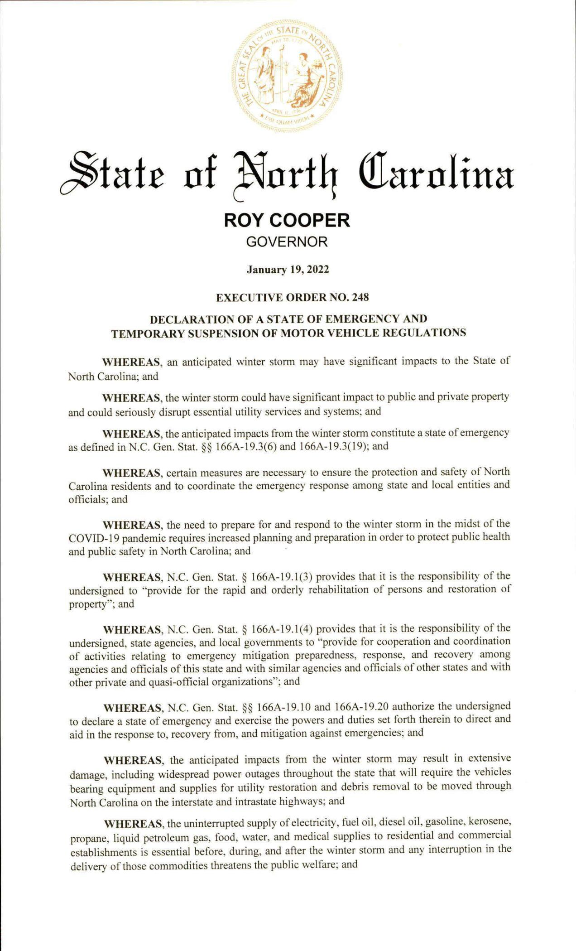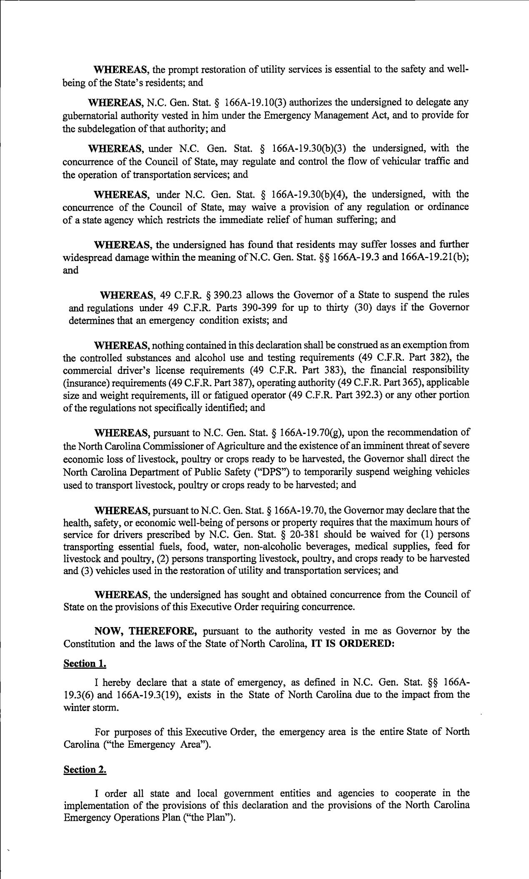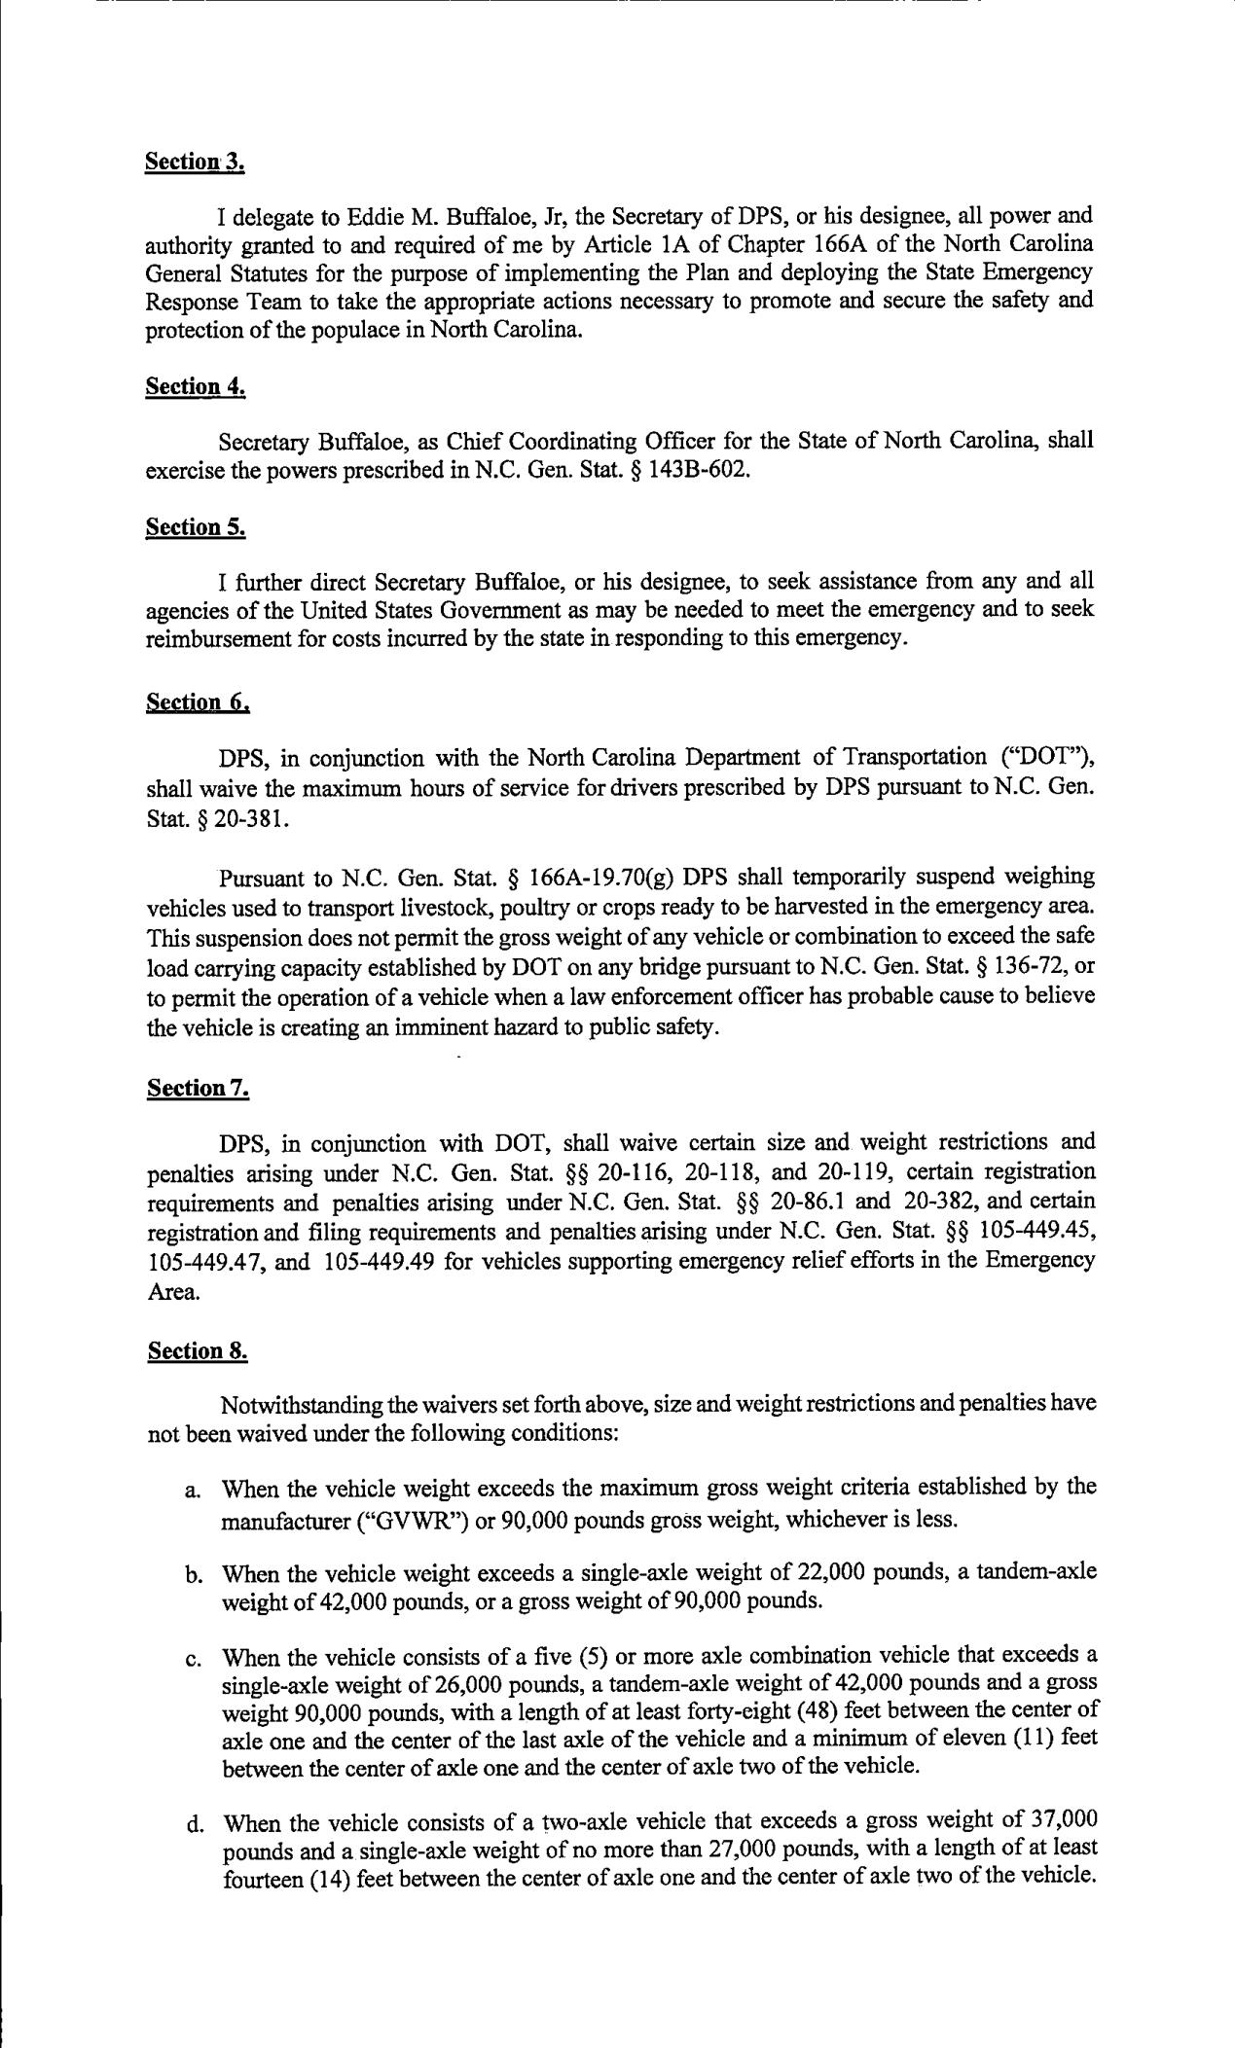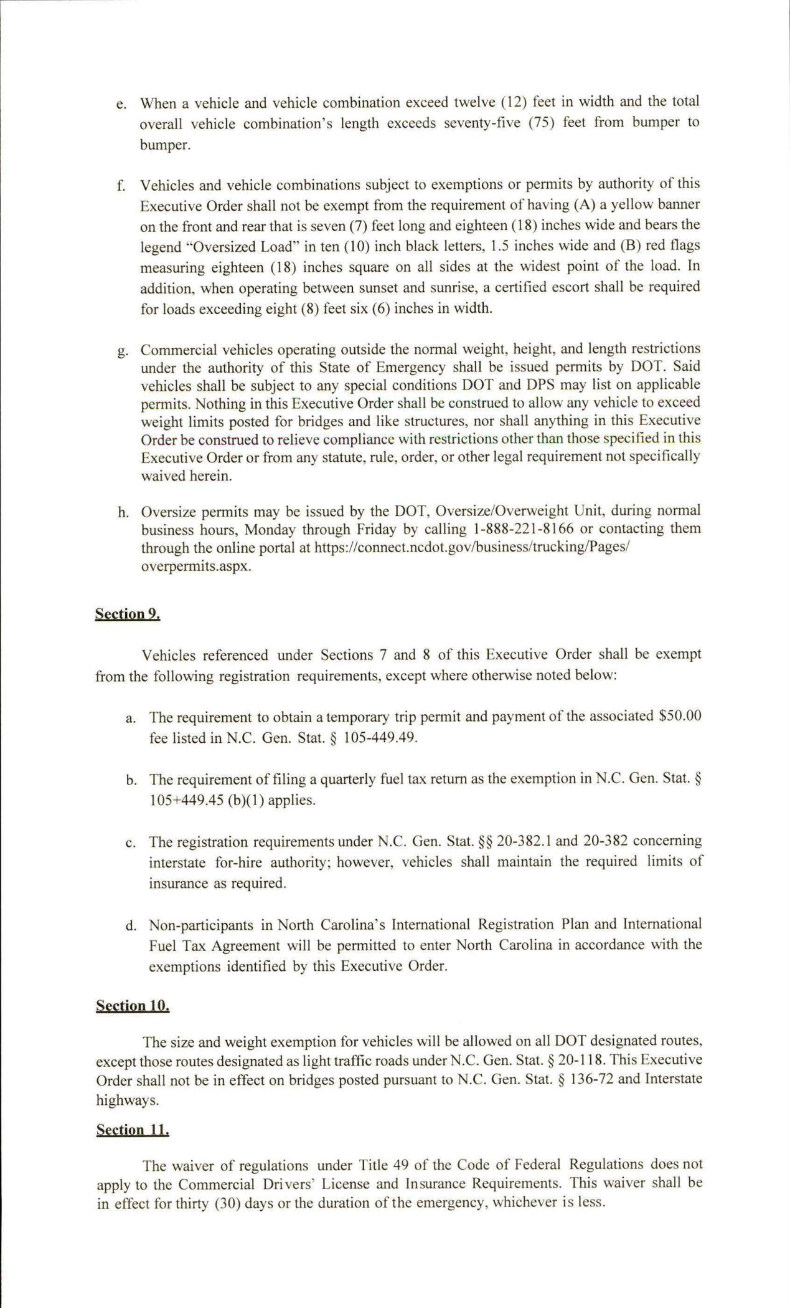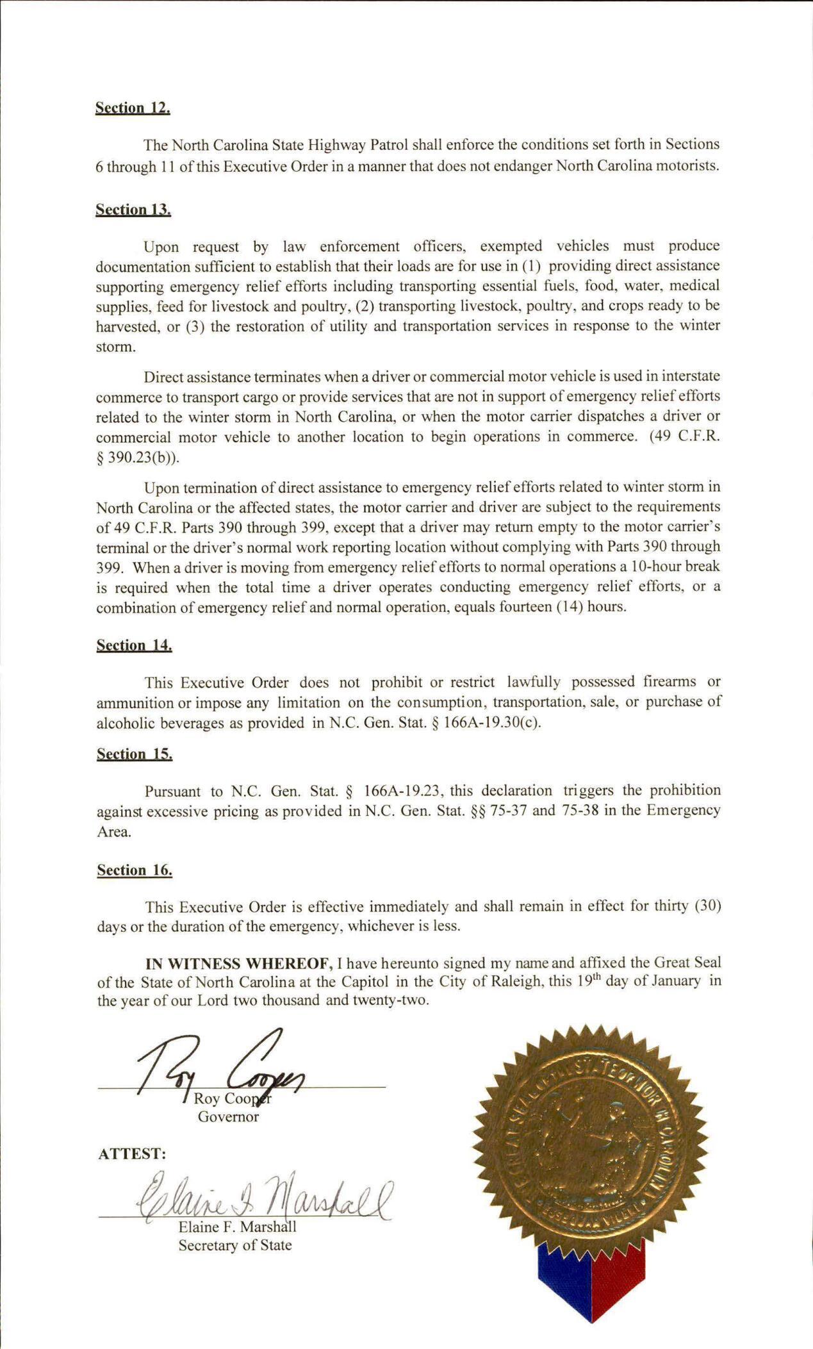

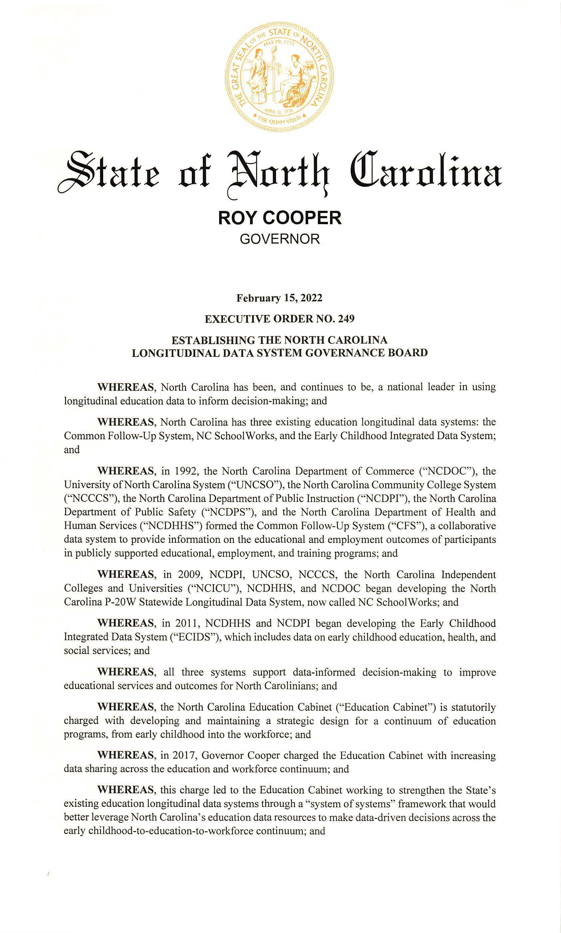
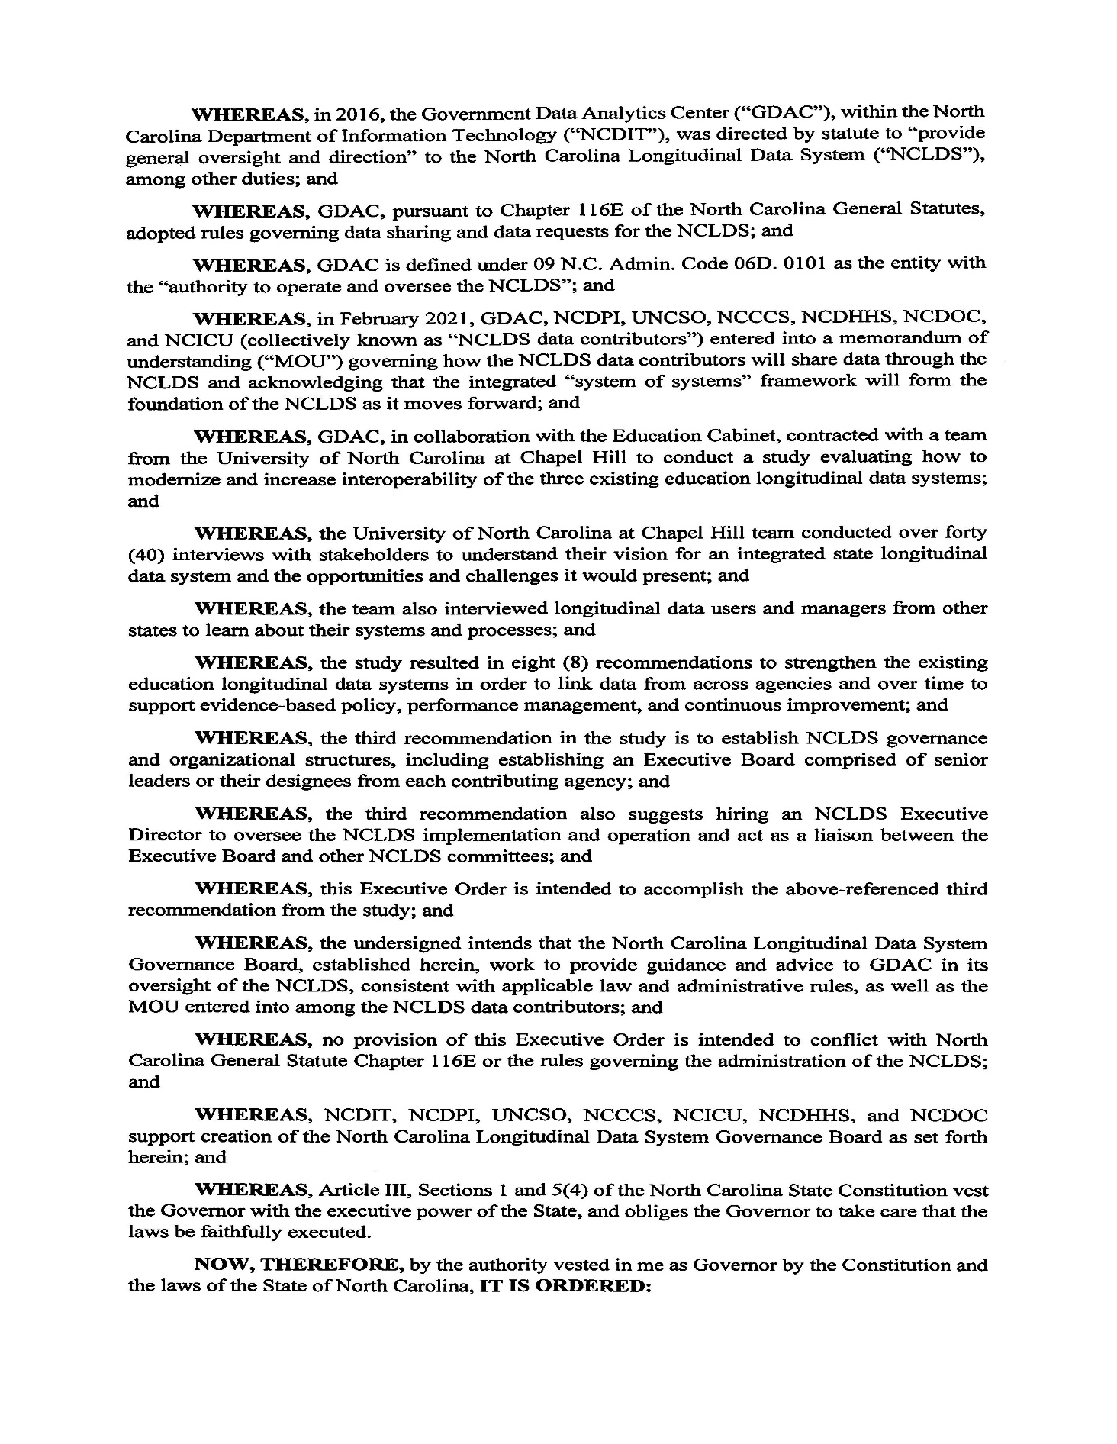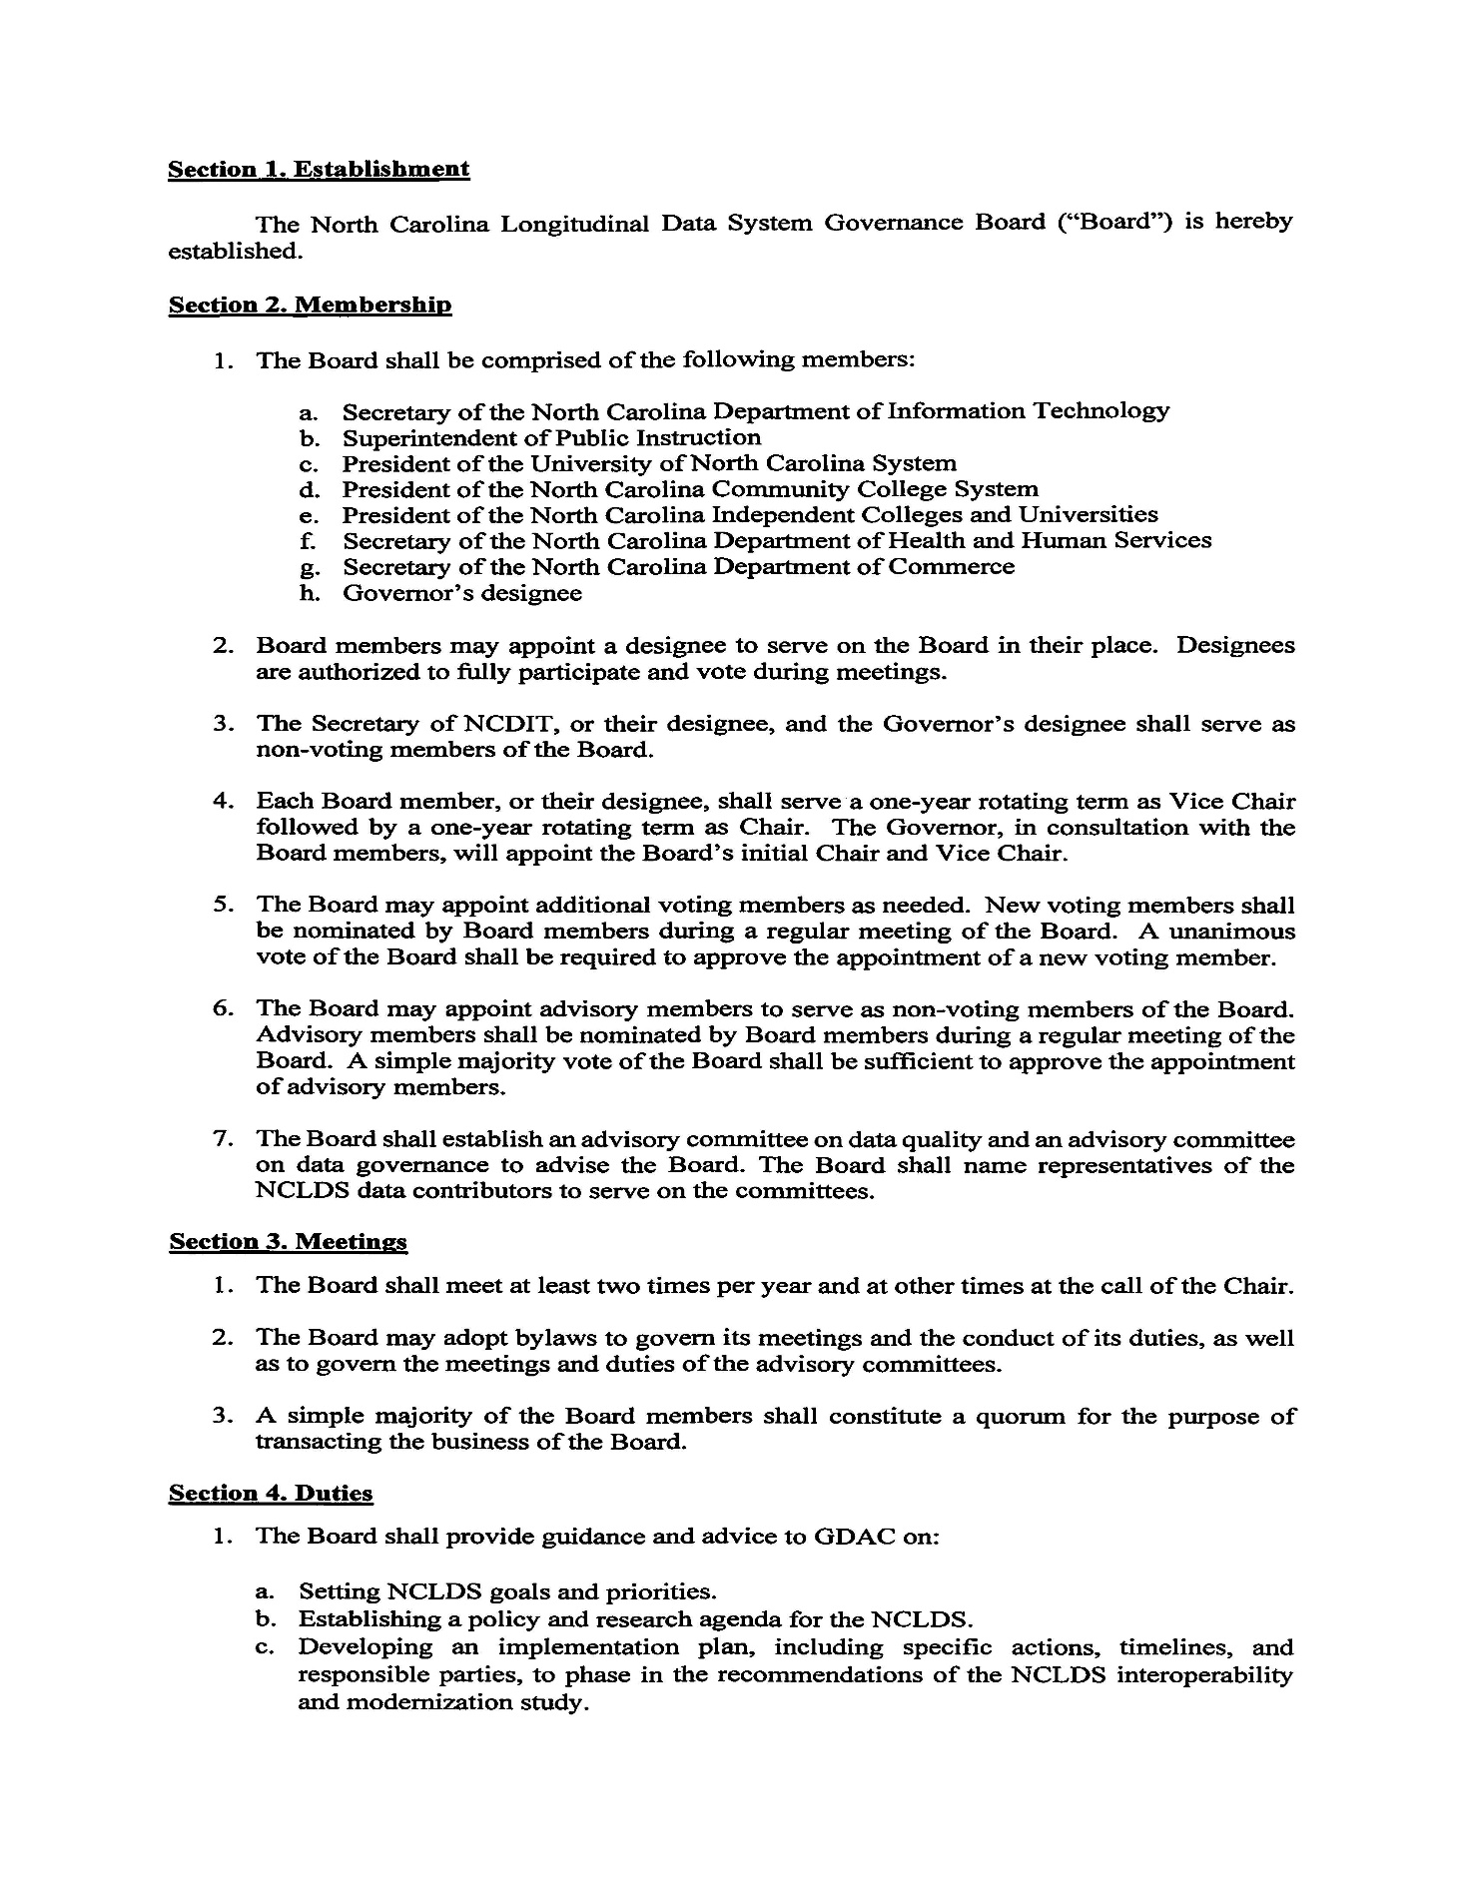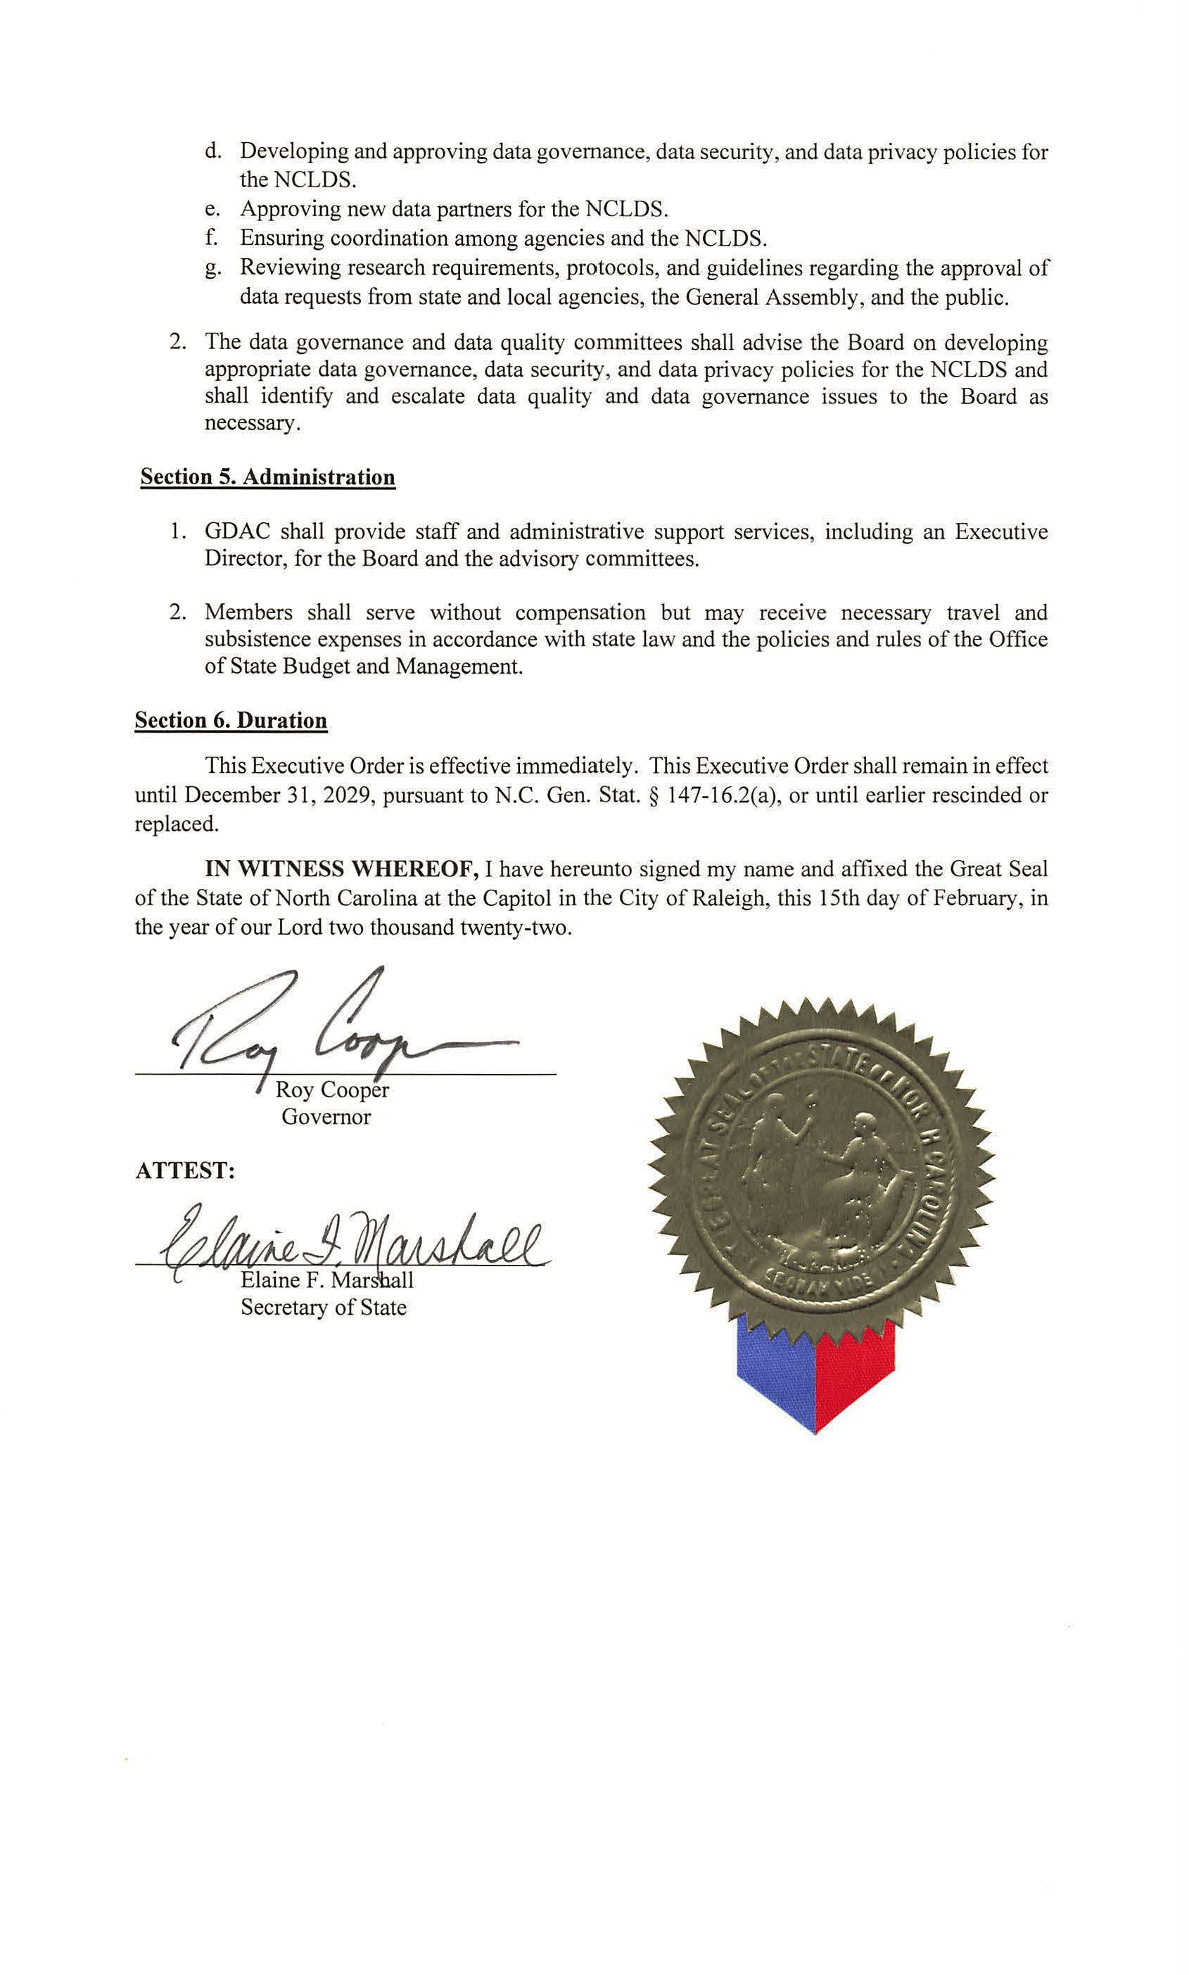
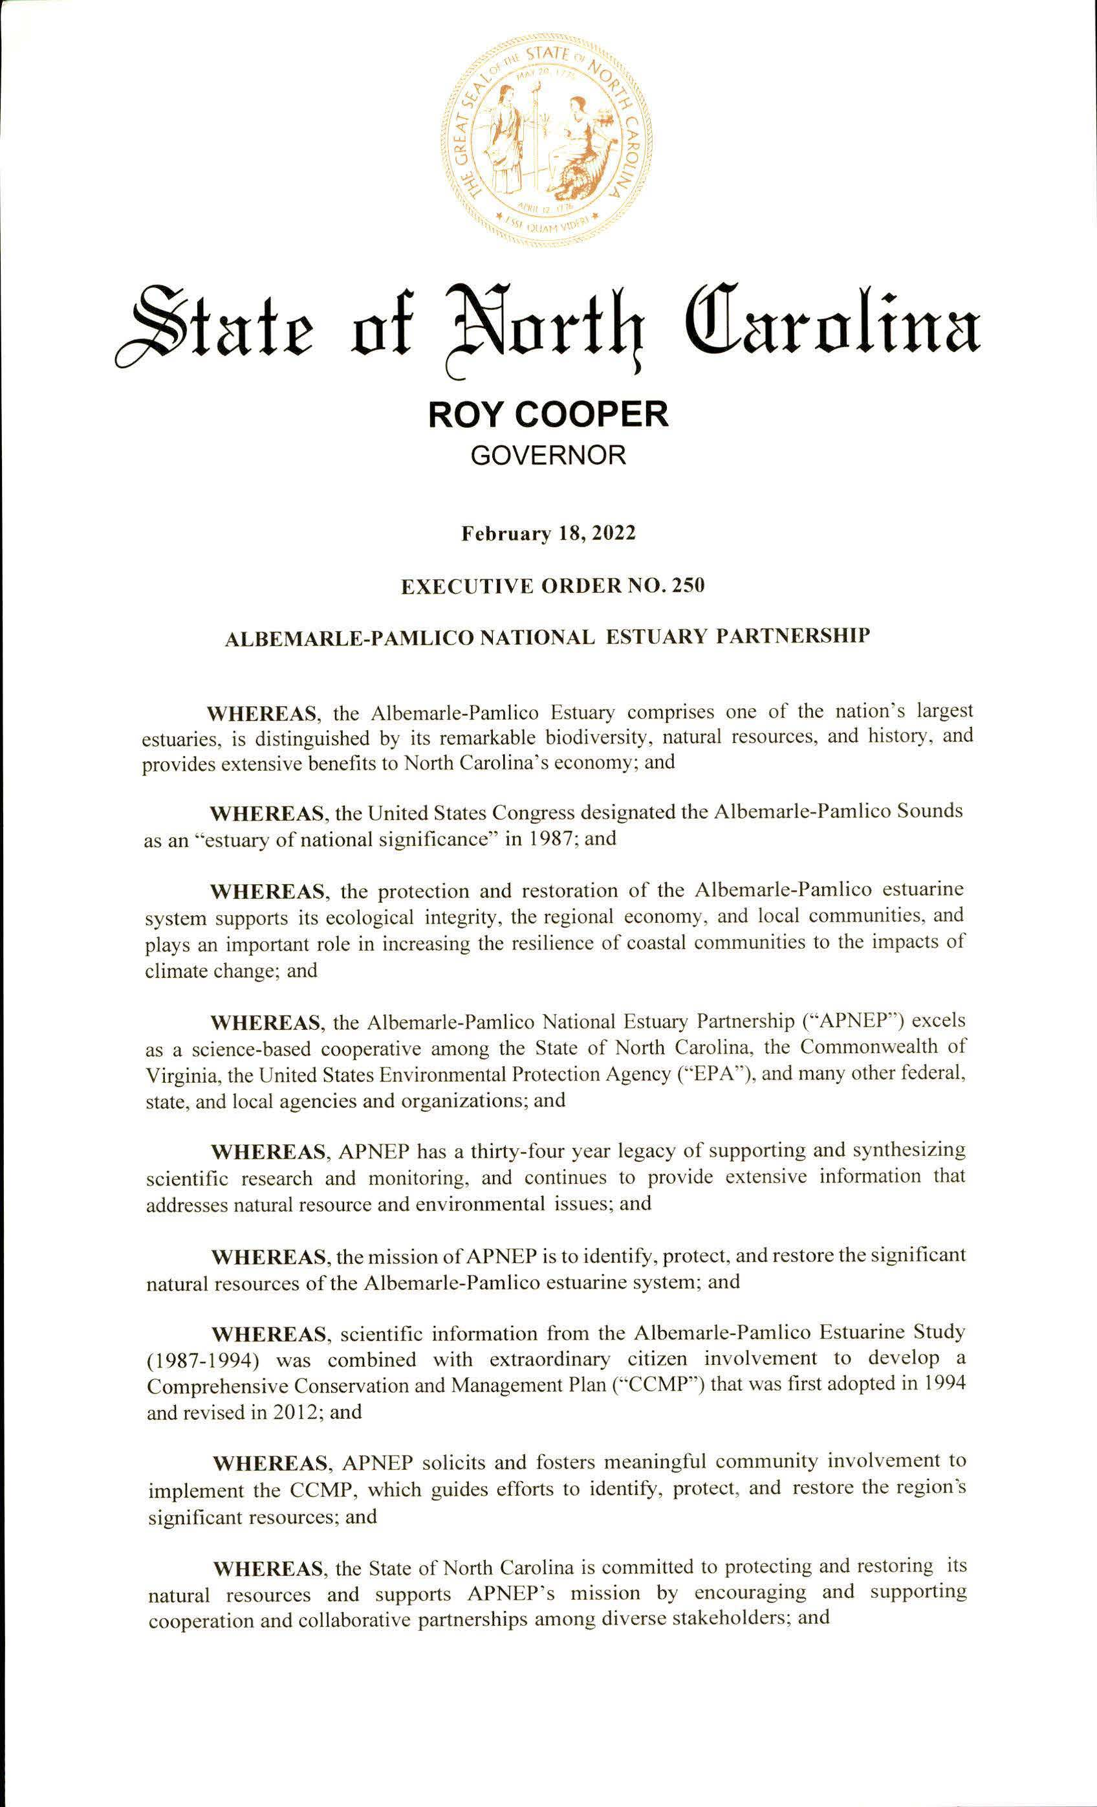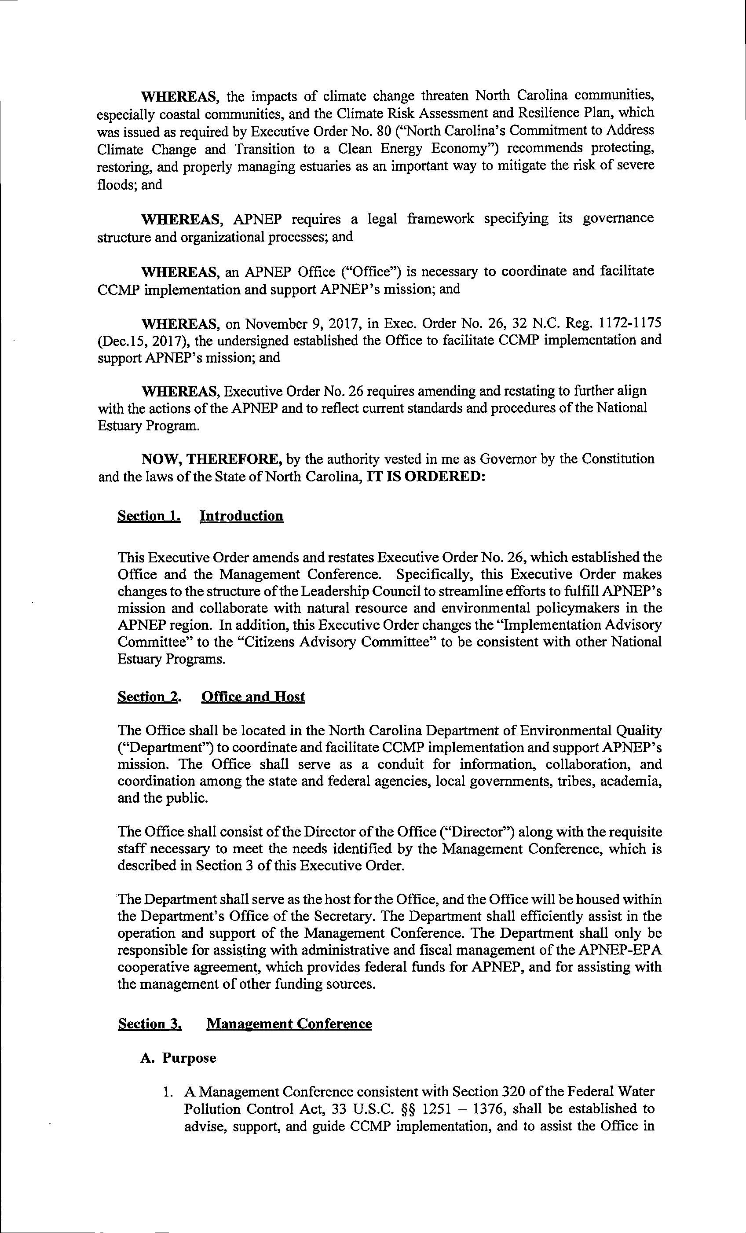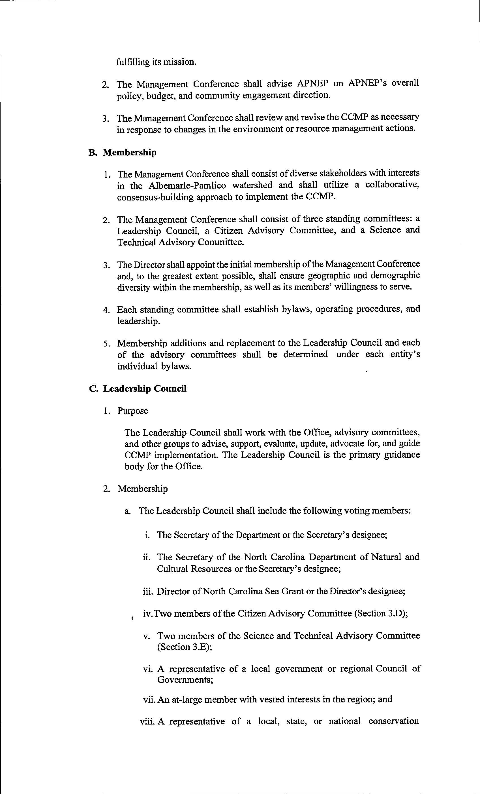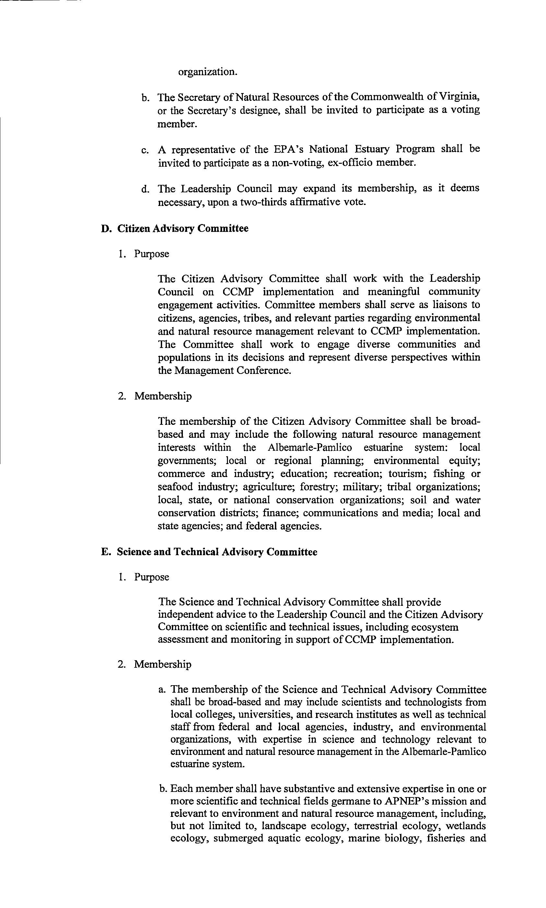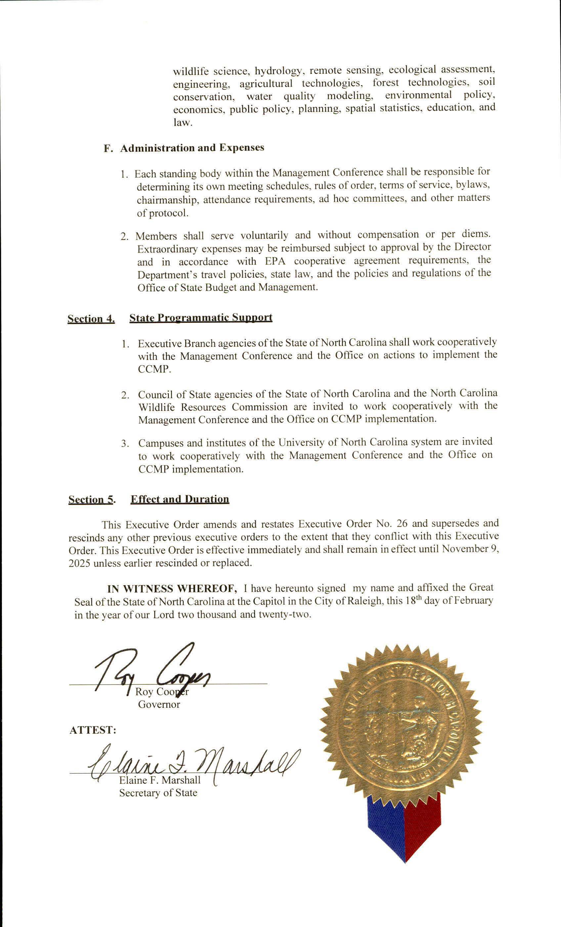

PUBLIC NOTICE

STATE OF NORTH CAROLINA ENVIRONMENTAL MANAGEMENT COMMISSION

The Division of Energy, Mineral, and Land Resources (DEMLR) invites public comment on, or objections to, the following individual statewide NPDES Municipal Separate Storm Sewer System Permit to be revised and re-issued. The public comment period begins at 9:00 am on 03/15/2022 and ends at 5:00 pm on 04/14/2022. Persons wishing to comment on or object may submit written comments to the address below during the public comment period. All comments received during the public comment period will be considered in the final determinations regarding permit issuance. Public comments may result in changes to the proposed permitting actions. All comments should reference the specific permit number NCS000250 for the North Carolina Department of Transportation, proposed issuance date 05/02/2022. The Draft Permit may be viewed at: https://deq.nc.gov/about/divisions/energy-mineral-and-landresources/stormwater/stormwater-program/stormwater-public. Please direct comments or questions to: Jeanette Powell, Stormwater Program, NC Division of Energy, Mineral, and Land Resources, 1612 Mail Service Center, Raleigh, NC 27699-1612 or jeanette.powell@ncdenr.gov.

Note from the Codifier: The notices published in this Section of the NC Register include the text of proposed rules. The agency must accept comments on the proposed rule(s) for at least 60 days from the publication date, or until the public hearing, or a later date if specified in the notice by the agency. If the agency adopts a rule that differs substantially from a prior published notice, the agency must publish the text of the proposed different rule and accept comment on the proposed different rule for 60 days.
Statutory reference: G.S. 150B-21.2.

Title 10A – Department of Health and Human Services

Notice is hereby given in accordance with G.S. 150B-21.2 and G.S. 150B-21.3A(c)(2)g. that the Medical Care Commission intends to amend the rules cited as 10A NCAC 13F .0504, .0508, .0905, .1207, repeal the rule cited as 10A NCAC 13F .0502, readopt with substantive changes the rules cited as 10A NCAC 13F .0404, .0407, .0501; 13G .0404, .0406, .0501, .0504, .0507, .0905, readopt without substantive changes the rules cited as 10A NCAC 13F .0503, .1006, .1008, .1010; 13G .0503, .0508, .0903, .1005, .1006, .1208, repeal through readoption the rule cited as 10A NCAC 13G .0502.

Pursuant to G.S. 150B-21.17, the Codifier has determined it impractical to publish the text of rules proposed for repeal unless the agency requests otherwise. The text of the rule(s) are available on the OAH website at http://reports.oah.state.nc.us/ncac.asp.

Pursuant to G.S. 150B-21.2(c)(1), the text of the rule(s) proposed for readoption without substantive changes are not required to be published. The text of the rules are available on the OAH website: http://reports.oah.state.nc.us/ncac.asp.

Link to agency website pursuant to G.S. 150B-19.1(c): https://info.ncdhhs.gov/dhsr/ruleactions.html

Proposed Effective Date: October 1, 2022

Public Hearing:
Date: April 28, 2022
Time: 10:00 a.m.
Location: Being held by teleconference call using the following: Telephone number: 1-877-848-7030; Access code: 5133201

Reason for Proposed Action: Pursuant to GS 150B-21.3A, Periodic Review and Expiration of Existing Rules, all rules are reviewed at least every 10 years, or they shall expire. As a result of the periodic review of Subchapters 10A NCAC 13F, Licensing of Adult Care Homes of Seven or More Beds, and 10A NCAC 13G, Licensing of Family Care Homes, these 20 proposed readoption rules were part of the 97 total rules determined as “Necessary With Substantive Public Interest,” requiring readoption. With input from stakeholders, substantive changes are proposed to nine rules for readoption, 10 rules are proposed without substantive changes for readoption, and one rule is proposed for readoption as a repeal. In addition, four rules are proposed for amendment, and one rule is proposed for repeal for the regulation of licensed Adult Care Homes and Family Care Homes in N.C. The secondary intent of the proposed rules is to make the rules of these two types of assisted living residences comparable, if not the same, for regulatory efficiency since they both house the same type of residents as permitted by law.

The proposed rules for Adult Care Homes and Family Care Homes add the requirement for the results of the examination and screening for controlled substances for each staff person. The rules require completion of and list requirements for the facility staff personal care training and competency program curriculum, require documentation of training and competency in the facility, and list and update training requirement exemptions. The rules update the educational requirements and the exemptions for completion of the basic activity director course for the activity director in an adult care and family care home. The proposed rules allow an immunizing pharmacist to validate staff competency for specific personal care tasks. The rules remove the staff CPR training exemption and add an equipment requirement in the facility for CPR trained staff for resuscitation use. Proposed Rules 10A NCAC 13F .0502 and 10A NCAC 13G .0502 are not necessary because the requirements from these rules for personal care training and competency were moved to other rules within the Subchapters, therefore these rules are proposed for repeal and proposed for readoption as a repeal, respectively. In addition, the proposed rules update standards, update and correct repealed and recodified statutes, clarify rule text, remove unnecessary text, make technical changes, and remove unnecessary and outdated requirements.

Comments may be submitted to: Nadine Pfeiffer, 809 Ruggles Drive, 2701 Mail Service Center, Raleigh, NC 27699-2701; email DHSR.RulesCoordinator@dhhs.nc.gov

Comment period ends: May 16, 2022

Procedure for Subjecting a Proposed Rule to Legislative Review: If an objection is not resolved prior to the adoption of the rule, a person may also submit written objections to the Rules Review Commission after the adoption of the Rule. If the Rules Review Commission receives written and signed objections after the adoption of the Rule in accordance with G.S. 150B-21.3(b2) from 10 or more persons clearly requesting review by the legislature and the Rules Review Commission approves the rule, the rule will become effective as provided in G.S. 150B-21.3(b1). The Commission will receive written objections until 5:00 p.m. on the day following the day the Commission approves the rule. The Commission will receive those objections by mail, delivery service, hand delivery, or facsimile transmission. If you have any further questions concerning the submission of objections to the Commission, please call a Commission staff attorney at 984-236-1850.

Fiscal impact. Does any rule or combination of rules in this notice create an economic impact? Check all that apply.

State funds affected

Local funds affected

Substantial economic impact (>= $1,000,000)

Approved by OSBM

No fiscal note required

Chapter 13 - NC Medical Care Commission

SUBCHAPTER 13F – LICENSING OF ADULT CARE HOMES OF SEVEN OR MORE BEDS

SECTION .0400 - STAFF QUALIFICATIONS

10A NCAC 13f .0404 QUALIFICATIONS OF ACTIVITY DIRECTOR

There shall be a designated adult Adult care home homes shall have an activity director who meets the following qualifications:
(1) The activity director (employed hired on or after August 1, 1991) September 30, 2022 shall meet a minimum educational requirement by being at least a high school graduate or certified under the GED Program or by passing an alternative examination established by the Department of Health & Human Services. Program.
(2) The activity director hired on or after July 1, 2005 September 30, 2022 shall have completed or complete, within nine months of employment or assignment to this position, the basic activity course for assisted living activity directors offered by community colleges or a comparable activity course as determined by the Department based on instructional hours and content. A person with a degree in recreation administration or therapeutic recreation or who is state or nationally certified as a Therapeutic Recreation Specialist or certified by the National Certification Council for Activity Professionals meets this requirement as does a person who completed the activity coordinator course of 48 hours or more through a community college before July 1, 2005. An activity director shall be exempt from the required basic activity course if one or more of the following applies:
(a) be a licensed recreational therapist or be eligible for certification as a therapeutic recreation specialist as defined by the North Carolina Recreational Therapy Licensure Act in accordance with G.S. 90C;
(b) have two years of experience working in a social or recreation program within the last five years, one year of which was full-time in a patient activities program in a health care setting;
(c) be a licensed occupational therapist or licensed occupational therapy assistant in accordance with G.S. 90, Article 18D; or
(d) be certified as an Activity Director by the National Certification Council for Activity Professionals.

Authority G.S. 131D-2.16; 131D-4.5; 143B-165.

10A NCAC 13F .0407 OTHER STAFF qualifications

(a) Each staff person at an adult care home shall:

(1) have a job description that reflects actual the positions, duties and responsibilities and is signed by the administrator and the employee;

(2) be able to apply implement all of the adult care home's accident, fire safety safety, and emergency procedures for the protection of the residents;

(3) be informed of the confidential nature of resident information and shall protect and preserve such the information from unauthorized use and disclosure. disclosure, in accordance with
Note: G.S. 131D-2(b)(4), 131D-21(6), G.S. 131D-21(6) and 131D-21.1 govern the disclosure of such information; 131D 21.1;

(4) not hinder or interfere with the exercise of the rights guaranteed under the Declaration of Residents' Rights in G.S. 131D-21;

(5) have no substantiated findings listed on the North Carolina Health Care Personnel Registry according to G.S. 131E-256;

(6) have documented annual immunization against influenza virus according to G.S. 131D-9, except as documented otherwise according to exceptions in this law;

(7) have a criminal background check in accordance with G.S. 114-19.10 and 131D-40;

(8) have results of the examination and screening for the presence of controlled substances in accordance with G.S. 131D-45;

(8)(9) maintain a valid current driver's license if responsible for transportation of residents; and

(9)(10) be willing to work cooperate with bona fide state and local inspectors and the monitoring and licensing agencies toward meeting and maintaining when determining and maintaining compliance with the rules of this Subchapter.

(b) Any At all times, there shall be at least one staff member left person in the facility left in charge of the resident care of residents who shall be 18 years or older.

(c) If licensed practical nurses are employed by the facility and practicing in their licensed capacity as governed by their practice act and occupational licensing laws, the North Carolina Board of Nursing, there shall be continuous availability of a registered nurse consistent available in accordance with the rules set forth in Rules 21 NCAC 36 .0224(i) .0224 and 21 NCAC 36 .0225. .0225, which are hereby incorporated by reference including subsequent amendments.

Note: The practice of licensed practical nurses is governed by their occupational licensing laws.

Authority G.S. 131D-2.16; 131D-4.5; 131D 4.5(4); 143B-165.

section .0500 - staff orientation, training, competency and continuing education

10A NCAC 13F .0501 PERSONAL CARE TRAINING AND COMPETENCY

(a) An adult care home The facility shall assure that staff who provide or directly supervise staff who provide personal care to residents successfully complete an 80-hour personal care training and competency evaluation program established or approved by the Department. For the purpose of this Rule, Directly supervise "Directly supervise" means being on duty in the facility to oversee or direct the performance of staff duties. Copies A copy of the 80-hour training and competency evaluation program are is available at the cost of printing and mailing by contacting the Division of Health Service Regulation, Adult Care Licensure Section, 2708 Mail Service Center, Raleigh, NC 27699-2708. online at https://info.ncdhhs.gov/dhsr/acls/training/PCA-trainingmanual.html, at no cost. The 80-hour personal care training and competency evaluation program curriculum shall include:

(1) observation and documentation skills;

(2) basic nursing skills, including special health-related tasks;

(3) activities of daily living and personal care skills;

(4) cognitive, behavioral, and social care;

(5) basic restorative services; and

(6) residents' rights as established by G.S. 131D-21.

(b) The facility shall assure that training specified in Paragraph (a) of this Rule is successfully completed within six months after hiring for staff hired after September 1, 2003. October 1, 2022. Documentation of the successful completion of the 80-hour training and competency evaluation program shall be maintained in the facility and available for review. review by the Division of Health Service Regulation and the county department of social services.

(c) The facility shall assure that staff who perform or directly supervise staff who perform personal care receive training and supervision on the performance of individual job assignments prior to meeting the training and competency requirements of this Rule. Documentation of training shall be maintained in the facility and available for review by the Division of Health Service Regulation and the county department of social services.

(c)(d) The Department shall exempt staff from the 80-hour training and competency evaluation program who are:

(1) licensed health professionals;

(2) listed on the Nurse Aide Registry; or

(3) documented as having successfully completed a 40-45 or 75-80 hour training program or competency evaluation program approved by the Department since January 1, 1996 according to Rule .0502 of this Section. one of the following previously approved training programs:
(A) a 40-hour or 75-hour training and competency evaluation program prior to July 1, 2000; or
(B) a 45-hour or 80-hour training and competency evaluation program for training exemption from July 1, 2000 through August 31, 2003.

(d) The facility shall assure that staff who perform or directly supervise staff who perform personal care receive on-the-job training and supervision as necessary for the performance of individual job assignments prior to meeting the training and competency requirements of this Rule. Documentation of the on-the-job training shall be maintained in the facility and available for review.

Authority G.S. 131D-2.16; 131D-4.3; 131D-4.5; 143B-165.

10A NCAC 13F .0502 personal care training content and instructors

Authority G.S. 131D-2.16; 131D-4.3; 131D-4.5; 143B-165.

10A NCAC 13F .0503 MEDICATION ADMINISTRATION COMPETENCY (READOPTION WITHOUT SUBSTANTIVE CHANGES)

10A NCAC 13F .0504 COMPETENCY VALIDATION FOR LICENSED HEALTH PROFESSIONAL SUPPORT TASKS

(a) An adult care home The facility shall assure that non-licensed personnel and licensed personnel non-licensed staff and licensed staff not practicing in their licensed capacity as governed by their practice act and in accordance with occupational licensing laws are competency validated by return demonstration for any personal care task specified in Subparagraph (a)(1) through (28) of Rule .0903 of this Subchapter Subchapter. The facility shall assure the competency validation occurs prior to staff performing the task and that their ongoing competency is assured through facility staff oversight and supervision.

(b) Competency validation shall be performed by the following licensed health professionals:

(1) A registered nurse shall validate the competency of staff who perform any of the personal care tasks specified in Subparagraphs (a)(1) through (28) of Rule .0903 of this Subchapter.

(2) In lieu of a registered nurse, a licensed respiratory care practitioner licensed under G.S. 90, Article 38, may validate the competency of staff who perform personal care tasks specified in Subparagraphs (a)(6), (a)(11), (a)(16), (a)(18), (a)(19)(a)(19), and (a)(21) of Rule .0903 of this Subchapter.

(3) In lieu of a registered nurse, a registered licensed pharmacist may validate the competency of staff who perform the personal care task tasks specified in Subparagraph (a)(8) and (a)(11) of Rule .0903 of this Subchapter. An immunizing pharmacist may validate the competency of staff who perform the personal care task specified in Subparagraph (a)(15) of Rule .0903 of this Subchapter.

(4) In lieu of a registered nurse, an occupational therapist or physical therapist may validate the competency of staff who perform personal care tasks specified in Subparagraphs (a)(17) and (a)(22) through (27) of Rule .0903 of this Subchapter.

(c) Competency validation of staff, according to Paragraph (a) of this Rule, for the licensed health professional support tasks specified in Paragraph (a) of Rule .0903 of this Subchapter and the performance of these tasks is limited exclusively to these tasks except in those cases in which a physician acting under the authority of G.S. 131D-2.2(a) certifies that non-licensed personnel can be competency validated to perform other tasks on a temporary basis to meet the resident's needs and prevent unnecessary relocation. relocation of the resident.

Authority G.S. 131D-2.16; 131D-4.5; 143B-165.

10A NCAC 13F .0508 ASSESSMENT Training

The person or persons designated by the administrator to perform resident assessments as required by Rule .0801 of this Subchapter shall successfully complete training on resident assessment established by the Department before performing the required assessments. Registered nurses are exempt from the assessment training. The Resident Assessment Self-Instructional Manual for Adult Care Homes herein incorporated by reference including subsequent amendments and editions. The instruction manual on resident assessment is available on the internet Adult Care Licensure website, http://facility-services.state.nc.us/gcpage.htm, or it is available at the cost of printing and mailing from the Division of Health Service Regulation, Adult Care Licensure Section, 2708 Mail Service Center, Raleigh, NC 27699-2708. https://info.ncdhhs.gov/dhsr/acls/pdf/assessmentmanual.pdf, at no cost.

Authority G.S. 131D-2.15; 131D-2.16; 131D-4.5; 143B-165.

SECTION .0900 – RESIDENT CARE AND SERVICES

10A NCAC 13F .0905 ACTIVITIES PROGRAM

(a) Each adult care home shall develop a program of activities designed to promote the residents' active involvement with each other, their families, and the community.

(b) The program shall be designed to promote active involvement by all residents but is not to require any individual to participate in any activity against his or her will. If there is a question about a resident's ability to participate in an activity, the resident's physician shall be consulted to obtain a statement regarding the resident's capabilities.

(c) The activity director, as required in Rule .0404 of this Subchapter, shall:

(1) use information on the residents' interests and capabilities as documented upon admission and updated as needed to arrange for or provide planned individual and group activities for the residents, taking into account the varied interests, capabilities capabilities, and possible cultural differences of the residents;

(2) prepare a monthly calendar of planned group activities which shall be easily readable with large print, to residents within the community, posted in a prominent location accessible to residents by the first day of each month, and updated when there are any changes;

(3) involve community resources, such as recreational, volunteer, religious, aging and developmentally disabled-associated agencies, and religious organizations, to enhance the activities available to residents;

(4) evaluate and document the overall effectiveness of the activities program at least every six months with input from the residents to determine what have been the most valued activities and to elicit suggestions of ways to enhance the program;

(5) encourage residents to participate in activities; and

(6) assure there are adequate supplies, supplies necessary for planned activities, supervision supervision, and assistance to enable each resident to participate. Aides and other facility staff may be used to assist with activities.

(d) There shall be a minimum of 14 hours of a variety of planned group activities per week that include activities that promote socialization, physical interaction, group accomplishment, creative expression, increased knowledge knowledge, and learning of new skills. Homes that care exclusively for residents with HIV disease are exempt from this requirement as long as the facility can demonstrate planning for each resident's involvement in a variety of activities. Examples of group activities are group singing, dancing, games, exercise classes, seasonal parties, discussion groups, drama, resident council meetings, book reviews, music appreciation, review of current events and spelling bees.

(e) Residents shall have the opportunity to participate in activities involving one to one interaction and activity by oneself that promote enjoyment, a sense of accomplishment, increased knowledge, learning of new skills, and creative expression. Examples of these activities are crafts, painting, reading, creative writing, buddy walks, card playing, and nature walks.

(f) Each resident shall have the opportunity to participate in at least one outing every other month. Residents interested in being involved in the community more frequently shall be encouraged to do so.

(g) Each resident Residents shall have the opportunity to participate in meaningful work-type and volunteer service activities in the home facility or in the community, but participation shall be on an entirely voluntary basis, never forced upon residents and not assigned in place of staff. community. Participation in volunteer activities shall not be required of residents and shall not involve duties that are typically performed by facility staff.

Authority G.S. 131D-2.16; 131D-4.5; 143B-165; 131D-4.1; 131D-4.3.

SECTION .1000 - MEDICATIONS

10a NCAC 13F .1006 MEDICATION STORAGE (READOPTION WITHOUT SUBSTANTIVE CHANGES)

10A NCAC 13F .1008 CONTROLLED SUBSTANCES (READOPTION WITHOUT SUBSTANTIVE CHANGES)

10A NCAC 13F .1010 PHARMACEUTICAL SERVICES (READOPTION WITHOUT SUBSTANTIVE CHANGES)

SECTION .1200 – POLICIES, RECORDS AND REPORTS

10A NCAC 13F .1207 facilties to report resident deaths

For purposes of this Section, facilities licensed in accordance with G.S. 131D-2 The facility shall report resident deaths to the Division of Health Service Regulation. Regulation in accordance with G.S. 131D-34.1.

Authority G.S. 131D-2.4; 131D-2.16; 131D-2.4; 131D-34.1; 143B-165.

SUBCHAPTER 13G – LICENSING OF FAMILY CARE HOMES

SECTION .0400 – STAFF QUALIFICATIONS

10A NCAC 13G .0404 QUALIFICATIONS OF ACTIVITY DIRECTOR

There shall be a designated family Adult care home homes shall have an activity director who meets the following qualifications: qualifications set forth in this Rule.
(1) The activity director (employed hired on or after August 1, 1991) September 30, 2022 shall meet a minimum educational requirement by being at least a high school graduate or certified under the GED Program or by passing an alternative examination established by the Department of Health & Human Services. Program.
(2) The activity director hired on or after July 1, 2005 September 30, 2022 shall have completed or complete, within nine months of employment or assignment to this position, the basic activity course for assisted living activity directors offered by community colleges or a comparable activity course as determined by the Department based on instructional hours and content. A person with a degree in recreation administration or therapeutic recreation or who is state or nationally certified as a Therapeutic Recreation Specialist or certified by the National Certification Council for Activity Professional meets this requirement as does a person who completed the activity coordinator course of 48 hours or more through a community college before July 1, 2005. An activity director shall be exempt from the required basic activity course if one or more of the following applies:
(a) be a licensed recreational therapist or be eligible for certification as a therapeutic recreation specialist as defined by the North Carolina Recreational Therapy Licensure Act in accordance with G.S. 90C;
(b) have two years of experience working in a social or recreation program within the last five years, one year of which was full-time in a patient activities program in a health care setting;
(c) be a licensed occupational therapist or licensed occupational therapy assistant in accordance with G.S. 90, Article 18D; or
(d) be certified as an Activity Director by the National Certification Council for Activity Professionals.

Authority G.S. 131D-2.16; 131D-4.5; 143B-165.

10A NCAC 13G .0406 OTHER Staff Qualifications

(a) Each staff person of a family care home shall:

(1) have a job description that reflects actual the positions, duties duties, and responsibilities and is signed by the administrator and the employee;

(2) be able to apply implement all of the family care home's accident, fire safety safety, and emergency procedures for the protection of the residents;

(3) be informed of the confidential nature of resident information and shall protect and preserve such the information from unauthorized use and disclosure; disclosure, in accordance with
Note: G.S. 131D-2(b)(4), G.S. 131D-21(6), and G.S. 131D-21.1 govern the disclosure of such the information; G.S. 131D 21.1;

(4) not hinder or interfere with the exercise of the rights guaranteed under the Declaration of Residents' Rights in G.S. 131D-21;

(5) have no substantiated findings listed on the North Carolina Health Care Personnel Registry according to G.S. 131E-256;

(6) have documented annual immunization against influenza virus according to G.S. 131D-9, except as documented otherwise according to exceptions in this law.

(7) have a criminal background check in accordance with G.S. 114-19.10 and G.S. 131D-40;

(8) have results of the examination and screening for the presence of controlled substances in accordance with G.S. 131D-45;

(8)(9) maintain a valid current driver's license if responsible for transportation of residents; and

(9)(10) be willing to work cooperate with bona fide state and local inspectors and the monitoring and licensing agencies toward meeting and maintaining when determining and maintaining compliance with the rules of this Subchapter.

(b) Any At all times, there shall be at least one staff member person in the facility left in charge of the resident care of residents who shall be 18 years or older.

(c) If licensed practical nurses are employed by the facility and practicing in their licensed capacity as governed by their practice act and occupational licensing laws, the North Carolina Board of Nursing, there shall be continuous availability of a registered nurse consistent available in accordance with the rules set forth in Rules 21 NCAC 36 .0224(i) .0224 and 21 NCAC 36 .0225. .0225, which are hereby incorporated by reference including subsequent amendments.

Note: The practice of licensed practical nurses is governed by their occupational licensing laws.

Authority G.S. 131D-2.16; 131D-4.5; 143B-165.

section .0500 – staff orientation, training, competency and continuing education

10A NCAC 13G .0501 Personal care training and competency

(a) The facility shall assure that personal care staff and those who directly supervise them in facilities without heavy care residents successfully complete a 25-hour training program, including competency evaluation, approved by the Department according to Rule .0502 of this Section. For the purposes of this Subchapter, heavy care residents are those for whom the facility is providing personal care tasks listed in Paragraph (i) of this Rule. Directly supervise means being on duty in the facility to oversee or direct the performance of staff duties.

(b) The facility shall assure that staff who perform or directly supervise staff who perform personal care tasks listed in Paragraph (i) of this Rule in facilities with heavy care residents successfully complete an 80-hour training program, including competency evaluation, approved by the Department according to Rule .0502 of this Section and comparable to the State-approved Nurse Aide I training.

(c) The facility shall assure that training specified in Paragraphs (a) and (b) of this Rule is successfully completed six months after hiring for staff hired after July 1, 2000. Staff hired prior to July 1, 2000, shall have completed at least a 20-hour training program for the performance or supervision of tasks listed in Paragraph (i) of this Rule or a 75-hour training program for the performance or supervision of tasks listed in Paragraph (j) of this Rule. The 20 and 75-hour training shall meet all the requirements of this Rule except for the interpersonal skills and behavioral interventions listed in Paragraph (j) of this Rule, within six months after hiring.

(d) The Department shall have the authority to extend the six-month time frame specified in Paragraph (c) of this Rule up to six additional months for a maximum allowance of 12 months for completion of training upon submittal of documentation to the Department by the facility showing good cause for not meeting the six-month time frame.

(e) Exemptions from the training requirements of this Rule are as follows:

(1) The Department shall exempt staff from the 25-hour training requirement upon successful completion of a competency evaluation approved by the Department according to Rule .0502 of this Section if staff have been employed to perform or directly supervise personal care tasks listed in Paragraph (h) and the interpersonal skills and behavioral interventions listed in Paragraph (j) of this Rule in a comparable long-term care setting for a total of at least 12 months during the three years prior to January 1, 1996, or the date they are hired, whichever is later.

(2) The Department shall exempt staff from the 80-hour training requirement upon successful completion of a 15-hour refresher training and competency evaluation program or a competency evaluation program approved by the Department according to Rule .0502 of this Section if staff have been employed to perform or directly supervise personal care tasks listed in Paragraph (i) and the interpersonal skills and behavioral interventions listed in Paragraph (j) of this Rule in a comparable long-term care setting for a total of at least 12 months during the three years prior to January 1, 1996, or the date they are hired, whichever is later.

(3) The Department shall exempt staff from the 25 and 80-hour training and competency evaluation who are or have been licensed health professionals or Certified Nursing Assistants.

(f) The facility shall maintain documentation of the training and competency evaluations of staff required by the rules of this Subchapter. The documentation shall be filed in an orderly manner and made available for review by representatives of the Department.

(g) The facility shall assure that staff who perform or directly supervise staff who perform personal care tasks listed in Paragraphs (h) and (i), and the interpersonal skills and behavioral interventions listed in Paragraph (j) of this Rule receive on-the-job training and supervision as necessary for the performance of individual job assignments prior to meeting the training and competency requirements of this Rule.

(h) For the purposes of this Rule, personal care tasks which require a 25-hour training program include, but are not limited to the following:

(1) assist residents with toileting and maintaining bowel and bladder continence;

(2) assist residents with mobility and transferring;

(3) provide care for normal, unbroken skin;

(4) assist with personal hygiene to include mouth care, hair and scalp grooming, care of fingernails, and bathing in shower, tub, bed basin;

(5) trim hair;

(6) shave resident;

(7) provide basic first aid;

(8) assist residents with dressing;

(9) assist with feeding residents with special conditions but no swallowing difficulties;

(10) assist and encourage physical activity;

(11) take and record temperature, pulse, respiration, routine height and weight;

(12) trim toenails for residents without diabetes or peripheral vascular disease;

(13) perineal care;

(14) apply condom catheters;

(15) turn and position;

(16) collect urine or fecal specimens;

(17) take and record blood pressure if a registered nurse has determined and documented staff to be competent to perform this task;

(18) apply and remove or assist with applying and removing prosthetic devices for stable residents if a registered nurse, licensed physical therapist or licensed occupational therapist has determined and documented staff to be competent to perform the task; and

(19) apply or assist with applying ace bandages, TED's and binders for stable residents if a registered nurse has determined and documented staff to be competent to perform the task.

(i) For the purposes of this Rule, personal care tasks which require a 80-hour training program are as follows:

(1) assist with feeding residents with swallowing difficulty;

(2) assist with gait training using assistive devices;

(3) assist with or perform range of motion exercises;

(4) empty and record drainage of catheter bag;

(5) administer enemas;

(6) bowel and bladder retraining to regain continence;

(7) test urine or fecal specimens;

(8) use of physical or mechanical devices attached to or adjacent to the resident which restrict movement or access to one's own body used to restrict movement or enable or enhance functional abilities;

(9) non-sterile dressing procedures;

(10) force and restrict fluids;

(11) apply prescribed heat therapy;

(12) care for non-infected pressure ulcers; and

(13) vaginal douches.

(j) For purposes of this Rule, the interpersonal skills and behavioral interventions include, but are not limited to the following:

(1) recognition of residents' usual patterns of responding to other people;

(2) individualization of appropriate interpersonal interactions with residents;

(3) interpersonal distress and behavior problems;

(4) knowledge of and use of techniques, as alternatives to the use of restraints, to decrease residents' intrapersonal and interpersonal distress and behavior problems; and

(5) knowledge of procedures for obtaining consultation and assistance regarding safe, humane management of residents' behavioral problems.

(a) The facility shall assure that staff who provide or directly supervise staff who provide personal care to residents complete an 80-hour personal care training and competency evaluation program established by the Department. For the purpose of this Rule, "Directly supervise" means being on duty in the facility to oversee or direct the performance of staff duties. A copy of the 80-hour training and competency evaluation program is available online at https://info.ncdhhs.gov/dhsr/acls/training/PCA-trainingmanual.html, at no cost. The 80-hour personal care training and competency evaluation program curriculum shall include:

(1) observation and documentation skills;

(2) basic nursing skills, including special health-related tasks;

(3) activities of daily living and personal care skills;

(4) cognitive, behavioral, and social care;

(5) basic restorative services; and

(6) residents' rights as established by G.S. 131D-21.

(b) The facility shall assure that training specified in Paragraph (a) of this Rule is completed within six months after hiring for staff hired after October 1, 2022. Documentation of the successful completion of the 80-hour training and competency evaluation program shall be maintained in the facility and available for review by the Division of Health Service Regulation and the county department of social services.

(c) The facility shall assure that staff who perform or directly supervise staff who perform personal care receive training and supervision for the performance of individual job assignments prior to meeting the training and competency requirements of this Rule. Documentation of training shall be maintained in the facility and available for review by the Division of Health Service Regulation and the county department of social services.

(d) The Department shall exempt staff from the 80-hour training and competency evaluation program who are:

(1) licensed health professionals;

(2) listed on the Nurse Aide Registry; or

(3) documented as having completed one of the following previously approved training programs:
(A) a 20-hour or 75-hour training and competency evaluation program prior to July 1, 2000; or
(B) a 25-hour or 80-hour training and competency evaluation program from July 1, 2000 through September 30, 2017.
Authority G.S. 131D-2.16; 131D-4.3; 131D-4.5; 143B-165.

10A NCAC 13G .0502 personal care training and competency program approval

Authority G.S. 131D-2.16; 131D-4.3; 131D-4.5; 143B-165.

10A NCAC 13G .0503 MEDICATION ADMINISTRATION COMPETENCY EVALUATION (READOPTION WITHOUT SUBSTANTIVE CHANGES)

10A NCAC 13G .0504 COMPETENCY VALIDATION FOR LICENSED HEALTH PROFESSIONAL SUPPORT TASKS

(a) A family care home The facility shall assure that non-licensed personnel and licensed personnel non-licensed staff and licensed staff not practicing in their licensed capacity as governed by their practice act and in accordance with occupational licensing laws are competency validated by return demonstration for any personal care task specified in Subparagraph (a)(1) through (28) of Rule .0903 of this Subchapter Subchapter. The facility shall assure the competency validation occurs prior to staff performing the task and that their ongoing competency is assured through facility staff oversight and supervision.

(b) Competency validation shall be performed by the following licensed health professionals:

(1) A registered nurse shall validate the competency of staff who perform any of the personal care tasks specified in Subparagraphs (a)(1) through (28) of Rule .0903 of this Subchapter.

(2) In lieu of a registered nurse, a licensed respiratory care practitioner licensed under G.S. 90, Article 38, may validate the competency of staff who perform personal care tasks specified in Subparagraphs (a)(6), (11), (16), (18), (19)(19), and (21) of Rule .0903 of this Subchapter.

(3) In lieu of a registered nurse, a registered licensed pharmacist may validate the competency of staff who perform the personal care task tasks specified in Subparagraph (a)(8) and (11) of Rule .0903 of this Subchapter. An immunizing pharmacist may validate the competency of staff who perform the personal care task specified in Subparagraph (a)(15) of Rule .0903 of this Subchapter.

(4) In lieu of a registered nurse, an occupational therapist or physical therapist may validate the competency of staff who perform personal care tasks specified in Subparagraphs (a)(17) and (a)(22) through (27) of Rule .0903 of this Subchapter.

(c) Competency validation of staff, according to Paragraph (a) of this Rule, for the licensed health professional support tasks specified in Paragraph (a) of Rule .0903 of this Subchapter and the performance of these tasks is limited exclusively to these tasks except in those cases in which a physician acting under the authority of G.S. 131D-2(a1) 131D-2.2(a) certifies that non-licensed personnel can be competency validated to perform other tasks on a temporary basis to meet the resident's needs and prevent unnecessary relocation. relocation of the resident.

Authority G.S. 131D-2.16; 131D-4.5; 143B-165.

10A NCAC 13G .0507 TRAINING ON CARDIO-PULMONARY RESUSCITATION

Each family care home shall have at least one staff person on the premises at all times who has completed within the last 24 months a course on cardio-pulmonary resuscitation and choking management, including the Heimlich maneuver, provided by the American Heart Association, American Red Cross, National Safety Council, American Safety and Health Institute and Medic First Aid, or by a trainer with documented certification as a trainer on these procedures from one of these organizations. If the only staff person on site has been deemed physically incapable of performing these procedures by a licensed physician, that person is exempt from the training. The staff person trained according to this Rule shall have access at all times in the facility to a one-way valve pocket mask for use in performing cardio-pulmonary resuscitation.

Authority G.S. 131D-2.16; 131D-4.5; 143B-165.

10A NCAC 13G .0508 ASSESSMENT Training (READOPTION WITHOUT SUBSTANTIVE CHANGES)

SECTION .0900 – RESIDENT CARE AND SERVICES

10A NCAC 13G .0903 LICENSED HEALTH PROFESSIONAL SUPPORT (READOPTION WITHOUT SUBSTANTIVE CHANGES)

10A NCAC 13G .0905 ACTIVITIES PROGRAM

(a) Each family care home shall develop a program of activities designed to promote the residents' active involvement with each other, their families, and the community.

(b) The program shall be designed to promote active involvement by all residents but is not to require any individual to participate in any activity against his or her will. If there is a question about a resident's ability to participate in an activity, the resident's physician shall be consulted to obtain a statement regarding the resident's capabilities.

(c) The activity director, as required in Rule .0404 of this Subchapter, shall:

(1) use information on the residents' interests and capabilities as documented upon admission and updated as needed to arrange for or provide planned individual and group activities for the residents, taking into account the varied interests, capabilities capabilities, and possible cultural differences of the residents;

(2) prepare a monthly calendar of planned group activities which shall be easily readable with large print, to residents within the community, posted in a prominent location accessible to residents by the first day of each month, and updated when there are any changes;

(3) involve community resources, such as recreational, volunteer, religious, aging and developmentally disabled-associated agencies, and religious organizations, to enhance the activities available to residents;

(4) evaluate and document the overall effectiveness of the activities program at least every six months with input from the residents to determine what have been the most valued activities and to elicit suggestions of ways to enhance the program;

(5) encourage residents to participate in activities; and

(6) assure there are adequate supplies, supplies necessary for planned activities, supervision supervision, and assistance to enable each resident to participate. Aides and other facility staff may be used to assist with activities.

(d) There shall be a minimum of 14 hours of a variety of planned group activities per week that include activities that promote socialization, physical interaction, group accomplishment, creative expression, increased knowledge knowledge, and learning of new skills. Homes that care exclusively for residents with HIV disease are exempt from this requirement as long as the facility can demonstrate planning for each resident's involvement in a variety of activities. Examples of group activities are group singing, dancing, games, exercise classes, seasonal parties, discussion groups, drama, resident council meetings, book reviews, music appreciation, review of current events and spelling bees.

(e) Residents shall have the opportunity to participate in activities involving one to one interaction and activity by oneself that promote enjoyment, a sense of accomplishment, increased knowledge, learning of new skills, and creative expression. Examples of these activities are crafts, painting, reading, creative writing, buddy walks, card playing, and nature walks.

(f) Each resident shall have the opportunity to participate in at least one outing every other month. Residents interested in being involved in the community more frequently shall be encouraged to do so.

(g) Each resident Residents shall have the opportunity to participate in meaningful work-type and volunteer service activities in the home facility or in the community, but participation shall be on an entirely voluntary basis, never forced upon residents and not assigned in place of staff. community. Participation in volunteer activities shall not be required of residents and shall not involve duties that are typically performed by facility staff.

Authority G.S. 131D-2.16; 143B-165; 131D-4.1; 131D-4.3.

SECTION .1000 – MEDICATIONS

10A NCAC 13G .1005 SELF-ADMINISTRATION OF MEDICATIONS (READOPTION WITHOUT SUBSTANTIVE CHANGES)

10a NCAC 13G .1006 MEDICATION STORAGE (READOPTION WITHOUT SUBSTANTIVE CHANGES)

SECTION .1200 – POLICIES, RECORDS AND REPORTS

10a NCAC 13G .1208 FACILITIES to report resident deaths (READOPTION WITHOUT SUBSTANTIVE CHANGES)

* * * * * * * * * * * * * * * * * * * *

Notice is hereby given in accordance with G.S. 150B-21.2 that the DHHS - Division of Health Benefits intends to adopt the rules cited as 10A NCAC 22Q .0101-.0106; and 22R .0101-.0105.

Link to agency website pursuant to G.S. 150B-19.1(c): https://medicaid.ncdhhs.gov/meetings-notices/rules-actions

Proposed Effective Date: July 1, 2022

Public Hearing:
Date: March 31, 2022
Time: 10:00 a.m.
Location: This remote hearing can be accessed by dialing (877) 336-1839 and entering access code 3956100.

Reason for Proposed Action: The new rules under Subchapters 22Q and 22R will effectuate the directive from the General Assembly for the Department to create rules to implement G.S. 143C-9-9 ("Hospital Uncompensated Care Fund"). The purpose of these rules is to establish the sequence of allocations of federal disproportionate share adjustment receipts arising from certified public expenditures, define the hospitals eligible for participation in the distribution of these funds, and codify formulas for calculating the distributions using outpatient cost metrics. Most supplemental payments are not permitted in managed care, which launched on July 1, 2021. The process for certifying DSH and calculating distribution of those funds to qualifying hospitals is essential for ensuring maximum receipt of federal Medicaid funds.

Comments may be submitted to: Shazia A. Keller, NC DHHS Division of Health Benefits, 2501 Mail Service Center, Raleigh, NC 27699-2501; phone (919) 218-1372; email MedicaidRulesComments@dhhs.nc.gov

Comment period ends: May 17, 2022

Procedure for Subjecting a Proposed Rule to Legislative Review: If an objection is not resolved prior to the adoption of the rule, a person may also submit written objections to the Rules Review Commission after the adoption of the Rule. If the Rules Review Commission receives written and signed objections after the adoption of the Rule in accordance with G.S. 150B-21.3(b2) from 10 or more persons clearly requesting review by the legislature and the Rules Review Commission approves the rule, the rule will become effective as provided in G.S. 150B-21.3(b1). The Commission will receive written objections until 5:00 p.m. on the day following the day the Commission approves the rule. The Commission will receive those objections by mail, delivery service, hand delivery, or facsimile transmission. If you have any further questions concerning the submission of objections to the Commission, please call a Commission staff attorney at 984-236-1850.

Fiscal impact. Does any rule or combination of rules in this notice create an economic impact? Check all that apply.

State funds affected

Local funds affected

Substantial economic impact (>= $1,000,000)

Approved by OSBM

No fiscal note required

Chapter 22 - Medical Assistance Eligibility

SUBCHAPTER 22Q – DISTRIBUTION OF FEDERAL DISPROPORTIONATE SHARE ADJUSTMENT RECEIPTS ARISING FROM CERTIFIED PUBLIC EXPENDITURES

10A NCAC 22Q .0101 SCOPE

This Subchapter establishes the requirements for the distribution of federal disproportionate share adjustment receipts as established by 42 CFR 447.298 arising from certified public expenditures.

Authority G.S. 108A-54; 143C-9-9.

10A NCAC 22Q .0102 DEFINITIONS

(a) "Certifying Hospitals" means an institution that meets all of the following criteria:

(1) meets the definition in G.S. 131E-176(13);

(2) is licensed by the State of North Carolina; and

(3) certifies as a public agency that its expenditures are eligible for Federal Financial Participation in accordance with 42 CFR 433.51(b), which is incorporated by reference, including subsequent amendments and editions. This document may be accessed at https://www.ecfr.gov at no charge.

(b) "Department" means the North Carolina Department of Health and Human Services.

(c) "Outpatient services" means those services as defined by 42 CFR 440.20(a), which is hereby incorporated by reference, including subsequent amendments and editions. This document can be accessed at https://www.ecfr.gov at no charge.

(d) "Uninsured patient" means medical care recipients who do not have health insurance, Medicaid or Medicare, or other third-party coverage. State or local government payments made to a hospital for services provided to indigent patients shall not be considered a source of third-party coverage.

(e) "Hospital Uncompensated Care Fund" means the fund established by G.S. 143C-9-9 and governed by 10A NCAC 22R.

(f) "Payment period" means the 12-month term ending September 30th of each year.

Authority G.S. 108A-54; 143C-9-9.

10A NCAC 22Q .0103 DISTRIBUTIONS

After distributions are made pursuant to an act appropriating funds for the operation of the North Carolina Medicaid Program and the "Basic Disproportionate Share Hospital (DSH) Payment" section of the North Carolina Medicaid State Plan, Attachment 4.19-A, which is incorporated by reference, including subsequent amendments and editions, and may be accessed free of charge at https://medicaid.ncdhhs.gov/media/973/download?attachment, the Department shall make distributions of the remaining DSH funds in the following order to:
(1) Certifying hospitals; and
(2) The Hospital Uncompensated Care Fund.

Authority G.S. 108A-54; 143C-9-9.

10A NCAC 22Q .0104 CERTIFYING HOSPITAL DISTRIBUTION

The Department shall distribute available funds to certifying hospitals in two parts:
(1) An amount equal to 10 percent of expenditures certified by the hospital pursuant to 42 CFR 433.51; and
(2) An amount equal to the hospital's proportionate share, calculated pursuant to Rule .0106 of this Section, of the available funds based on the hospital's share of outpatient costs for uninsured patients as a percentage of the Statewide aggregate of outpatient costs for uninsured patients. To be eligible for a proportionate share, a hospital shall file with the Department 90 days prior to the date of payment as determined by the Department, a form prescribed by the Department attesting to the hospital's:
(a) Qualification for disproportionate share status under the "Disproportionate Share Hospital (DSH) Payment" section of the North Carolina Medicaid State Plan, Attachment 4.19-A;
(b) Unreimbursed charges and payments for outpatient services provided to uninsured patients; and
(c) Aggregate Medicaid outpatient cost-to-charge ratio.

Authority G.S. 108A-54; 143C-9-9.

10A NCAC 22q .0105 Certifying hospitals' outpatient costs

(a) A certifying hospital's outpatient costs for uninsured patients will be determined by multiplying the hospital's outpatient cost-to-charge ratio in Rule .0104(2)(c) of this Section by the hospital's outpatient charges for uninsured patients from Rule .0104(2)(b) of this Section.

(b) From the product calculated in Paragraph (a) of this Rule, the Department will then subtract payments that the hospital received from uninsured patients for outpatient services in Rule .0104(2)(b) of this Section.

(c) The Department will bring the uncompensated care cost data forward to the end of the payment period by applying the applicable Centers for Medicare and Medicaid Services' Prospective Payment System Hospital Input Price Indices, which are available at https://www.cms.gov/Research-Statistics-Data-and-Systems/Statistics-Trends-and-Reports/MedicareProgramRatesStats/MarketBasketData.

Authority G.S. 108A-54; 143C-9-9.

10A NCAC 22q .0106 Certifying hospital's proportionate share

The Department shall calculate the certifying hospital's proportionate share of outpatient costs as follows:
(1) Adding the certifying hospitals' outpatient costs and each of the eligible hospitals' (as defined in 10A NCAC 22R .0103) eligible outpatient costs under 10A NCAC 22R .0104. The sum represents the total of the outpatient costs.
(2) The sum of all certifying hospitals' outpatient costs under Rule .0105 of this Section shall be divided by the total outpatient costs in Item (1) of this Rule. The quotient represents the certifying hospitals' proportionate share, expressed as a decimal.
(3) The amount of available funds shall be multiplied by the certifying hospitals' proportionate share in Item (2) of this Rule. The product represents the funds available for distribution to individual certifying hospitals.
(4) A certifying hospital shall be eligible for a payment from funds available for distribution in Item (3) of this Rule. In each payment period, a certifying hospital shall receive a proportional payment of the available funds based on the certifying hospital's share of outpatient costs for uninsured patients as a percentage of the aggregate of outpatient costs for uninsured patients for certifying hospitals.
(5) Hospitals receiving payments pursuant to this Subchapter shall be subject to the audit and reporting requirements of the North Carolina Medicaid State Plan, Attachment 4.19-A.

Authority G.S. 108A-54; 108A-55(c); 143C-9-9.

SUBCHAPTER 22R - DISTRIBUTION OF HOSPITAL UNCOMPENSATED CARE FUND

10A NCAC 22R .0101 SCOPE

This Subchapter establishes the requirements for the distribution of funds allocated to the Hospital Uncompensated Care Fund pursuant to G.S. 143C-9-9 after distributions of available funds have been made pursuant to 10A NCAC 22Q.

Authority G.S. 108A-54; 143C-9-9.

10A NCAC 22R .0102 DEFINITIONS

(a) "Department" means the North Carolina Department of Health and Human Services.

(b) "Eligible hospital" means an institution that meets the requirements of Rule .0103 of this Section.

(c) "Eligible hospital cost" means the values calculated pursuant to Rule .0104 of this Section.

(d) "Outpatient services" means the medical care and items as defined by 42 CFR 440.20(a), which is incorporated by reference in 10A NCAC 22Q .0102.

(e) "Uninsured patient" means a recipient of medical care who has no health insurance, Medicaid or Medicare, or other third-party coverage. State and local government payments made to a hospital for services provided to indigent patients shall not be considered third-party coverage.

(f) "Payment period" means the 12-month term ending September 30th of each year.

Authority G.S. 108A-54; 143C-9-9.

10A NCAC 22R .0103 ELIGIBLE HOSPITAL

An institution licensed by the State of North Carolina that meets the definition in G.S. 131E-176 (13) is eligible for reimbursement from the Hospital Uncompensated Care Fund if it:
(1) is not a public agency qualified to certify expenditures in accordance 42 CFR 433.51(b), which is incorporated by reference in 10A NCAC 22Q .0102;
(2) received payment for more than 50 percent of their Medicaid inpatient discharges under the North Carolina Medicaid State Plan, Attachment 4.19-A discharge Diagnosis Related Groups methodology for the most recent payment period;
(3) files with the Department 90-days prior to the date of payment under this Subchapter forms prescribed by the Department attesting to the hospital's:
(a) qualification for disproportionate share status of the "Disproportionate Share Hospital (DSH) Payment" section of the North Carolina Medicaid State Plan, Attachment 4.19-A;
(b) unreimbursed charges and payments for outpatient services provided to uninsured patients; and
(c) aggregate Medicaid outpatient cost-to-charge.

Authority G.S. 108A-54; 143C-9-9.

10A NCAC 22R .0104 ELIGIBLE OUTPATIENT COSTS

(a) An eligible hospital's eligible outpatient costs for uninsured patients will be determined by multiplying the hospital's outpatient cost-to-charge ratio in Rule .0103(3)(c) of this Section by the hospital's outpatient charges for uninsured patients from Rule .0103(3)(b) of this Section.

(b) From the product calculated in Paragraph (a) of this Rule, the Department will then subtract payments that the hospital received from uninsured patients for outpatient services from Rule .0103(3)(b) of this Section.

(c) The Department will bring the uncompensated care cost data forward to the end of the payment period by applying the applicable Centers for Medicare and Medicaid Services' Prospective Payment System Hospital Input Price Indices, which are available at https://www.cms.gov/Research-Statistics-Data-and-Systems/Statistics-Trends-and-Reports/MedicareProgramRatesStats/MarketBasketData.

Authority G.S. 108A-54; 143C-9-9.

10A NCAC 22R .0105 DISTRIBUTION OF AVAILABLE FUNDS

(a) An eligible hospital satisfying the requirements of Rule .0103 of this Section shall be eligible for a payment from funds available under this Subchapter. In a payment period, an eligible hospital shall receive a proportional payment of the available funds based on the eligible hospital's share of outpatient costs for uninsured patients as a percentage of the aggregate of outpatient costs for uninsured patients for all eligible hospitals.

(b) Based on the availability of funds, payments authorized by this Rule shall be made at least annually on a frequency determined by the Department in consultation with certifying hospitals.

(c) To confirm the hospital's eligibility to receive payments pursuant to this Subchapter and the accuracy of the hospital's attestation to unreimbursed charges for outpatient services provided to uninsured patients and the hospital's Medicaid outpatient cost-to-charge ratios, the Department may audit a hospital receiving more than two million dollars ($2,000,000) for compliance with the requirements of this Subchapter. Upon completion of the audit, the following shall occur when applicable:

(1) If a hospital received payments pursuant to Paragraph (a) of this Rule in excess of the percentage determined by the audit, the excess payments shall be refunded to the Department.

(2) The Department shall distribute any refunded amounts to eligible hospitals within 12 months of receipt using the distribution method set forth Paragraph (a) of this Rule.

(3) No additional payment shall be made to eligible hospitals in connection with the audit except for the redistribution of amounts refunded after an audit conducted by the Division of Health Benefits.

Authority G.S. 108A-54; 143C-9-9.

This Section contains information for the meeting of the Rules Review Commission February 7 and February 17, 2022 at 1711 New Hope Church Road, RRC Commission Room, Raleigh, NC. Anyone wishing to submit written comment on any rule before the Commission should submit those comments to the RRC staff, the agency, and the individual Commissioners. Specific instructions and addresses may be obtained from the Rules Review Commission at 984-236-1850. Anyone wishing to address the Commission should notify the RRC staff and the agency no later than 5:00 p.m. of the 2nd business day before the meeting. Please refer to RRC rules codified in 26 NCAC 05.

RULES REVIEW COMMISSION MEMBERS

Appointed by Senate | Appointed by House
Jeanette Doran (Chair) | Andrew P. Atkins (1st Vice Chair)
Robert A. Bryan, Jr. (2nd Vice Chair) | Wayne R. Boyles, III
Margaret Currin | Barbara A. Jackson
Jeff Hyde | Randy Overton
Robert A. Rucho | Paul Powell

COMMISSION COUNSEL
Amber Cronk May 984-236-1936
Brian Liebman 984-236-1948
Lawrence Duke 984-236-1938
William W. Peaslee 984-236-1939

RULES REVIEW COMMISSION MEETING DATES
March 17, 2022 May 19, 2022
April 21, 2022 June 16, 2022

RULES REVIEW COMMISSION SPECIAL MEETING
MINUTES
February 7, 2022

The Rules Review Commission met for a Special Meeting on Monday, February 7, 2022, in the Commission Room at 1711 New Hope Church Road, Raleigh, North Carolina, and via WebEx. The special meeting was called pursuant to G.S. 150B-21.1(b1), in order to review a response from the Criminal Justice Education Training and Standards Commission regarding temporary rules originally filed for and objected to at the January 20, 2022 RRC meeting.

Commissioners Andrew Atkins, Wayne R. Boyles III, and Jeanette Doran were present in the Commission Room. Commissioners present via WebEx were Bob Rucho and Paul Powell.
DRAFT
Staff members present were Alexander Burgos, Commission Counsel Lawrence Duke, and Amber May. Commission Counsel Brian Liebman was present via WebEx.

The meeting was called to order at 1:00 p.m. with Chair Doran presiding.

The Chair read the notice required by G.S. 138A-15(e) and reminded the Commission members that they have a duty to avoid conflicts of interest and the appearance of conflicts of interest.

FOLLOW UP MATTERS
Criminal Justice Education and Training Standards Commission
Upon the call of the Chair, the Commission approved 12 NCAC 09B .0101 and 09G .0205 by roll-call vote, ayes 4, noes 1 as follows: Voting in the affirmative: Andrew Atkins, Wayne R. Boyles III, Jeanette Doran, and Paul Powell – 4. Voting in the negative: Bob Rucho - 1.

Leslie Cooley-Dismukes, with the Attorney General's Office and representing the agency, addressed the Commission.

COMMISSION BUSINESS
The meeting adjourned at 1:57 p.m.
The next regularly scheduled meeting of the Commission is Thursday, February 17, 2022, at 9:00 a.m.

Alexander Burgos, Paralegal

Minutes approved by the Rules Review Commission:
Jeanette Doran, Chair

Rules Review Commission Special Meeting February 7, 2022
Held Via WebEx

Name | Agency
Andy Perrigo
Helen Landi | DOT
Jeffrey Smythe | DOJ/CJETS

List of Approved Temporary Rules
February 07, 2022 Meeting
Criminal Justice Education and Training Standards Commission
Minimum Standards for Criminal Justice Officers | 12 | NCAC | 09B | .0101
Physical and Mental Standards | 12 | NCAC | 09G | .0205

RULES REVIEW COMMISSION MEETING
MINUTES
February 17, 2022

The Rules Review Commission met on Thursday, February 17, 2022, in the Commission Room at 1711 New Hope Church Road, Raleigh, North Carolina, and via WebEx.

Commissioners Andrew Atkins, Wayne R. Boyles III, Bobby Bryan, Margaret Currin, Jeanette Doran, Randy Overton, and Bob Rucho were present in the Commission Room. Commissioners present via WebEx were Jeff Hyde and Barbara Jackson.

Staff members present were Alexander Burgos; Commission Counsel Lawrence Duke, Brian Liebman, and Amber May.

The meeting was called to order at 9:00 a.m. with Chair Doran presiding.

The Chair read the notice required by G.S. 138A-15(e) and reminded the Commission members that they have a duty to avoid conflicts of interest and the appearance of conflicts of interest.
DRAFT
APPROVAL OF MINUTES
The Chair asked for any discussion, comments, or corrections concerning the minutes of the February 7, 2022, special meeting. There were none and the minutes were approved as distributed.

Commissioners Margaret Currin, Barbara Jackson, and Randy Overton abstained from voting on the special meeting minutes.

Upon the call of the Chair, the special meeting minutes were approved by roll-call vote, ayes 5, noes 0 as follows: Voting in the affirmative: Andrew Atkins, Wayne R. Boyles III, Bobby Bryan, Jeff Hyde, and Bob Rucho – 5. Voting in the negative: None.

The Chair asked for any discussion, comments, or corrections concerning the minutes of the January 20, 2022, meeting. There were none and the minutes were approved as distributed.

Upon the call of the Chair, the minutes were approved by roll-call vote, ayes 8, noes 0 as follows: Voting in the affirmative: Andrew Atkins, Wayne R. Boyles III, Bobby Bryan, Margaret Currin, Jeff Hyde, Barbara Jackson, Randy Overton, and Bob Rucho – 8. Voting in the negative: None.

The Chair notified the Commissioners that the following items on the agenda would be taken up out of order at the end of the agenda: Follow up matters for the Environmental Management Commission and Board of Pharmacy.

FOLLOW UP MATTERS
Soil and Water Conservation Commission
Upon the call of the chair, 02 NCAC 59A .0101, .0102, .0103, .0104, .0201, .0202, .0203, .0204, .0301, and .0302 were approved by roll-call vote, ayes 8, noes 0 as follows: Voting in the affirmative: Andrew Atkins, Wayne R. Boyles III, Bobby Bryan, Margaret Currin, Jeff Hyde, Barbara Jackson, Randy Overton, and Bob Rucho – 8. Voting in the negative: None.

Criminal Justice Education and Training Standards Commission
12 NCAC 09B .0101; 09G .0205 – The rules were approved at the February 7, 2022 RRC special meeting. No action was required by the Commission.

Environmental Management Commission
15A NCAC 02L .0202 - Upon the call of the Chair, the Commission waived Rule 26 NCAC 05 .0103 and allowed the submission of written comments received after the deadline by roll-call vote, ayes 8, noes 0 as follows: Voting in the affirmative: Andrew Atkins, Wayne R. Boyles III, Bobby Bryan, Margaret Currin, Jeff Hyde, Barbara Jackson, Randy Overton, and Bob Rucho – 8. Voting in the negative: None.

Upon the call of the Chair, the Commission voted to approve the rule by roll-call vote, ayes 4, noes 5 as follows: Voting in the affirmative Andrew Atkins, Wayne R. Boyles III, Bobby Bryan, and Barbara Jackson – 4. Voting in the negative: Margaret Currin, Jeanette Doran, Jeff Hyde, Randy Overton, and Bob Rucho – 5. The motion failed.

Upon the call of the Chair, the Commission objected to the rule by roll-call vote, ayes 5, noes 3 as follows: Voting in the affirmative: Wayne R. Boyles III, Margaret Currin, Jeff Hyde, Randy Overton, and Bob Rucho – 5. Voting in the negative: Andrew Atkins, Bobby Bryan, and Barbara Jackson – 3.

The Commission objected to Rule 15A NCAC 02L .0202 finding that the rule was not clear and unambiguous. Specifically, the Commission found the Rule was unclear and ambiguous as it lacked specific guidelines required by G.S. 150B-19(6) to waive or modify the practical quantitation limit requirement through the use of an Interim Maximum Allowable Concentration.

Chris Millis with the North Carolina Home Builders Association addressed the Commission.

Phillip Reynolds with the Department of Justice, and representing the agency, addressed the Commission.
DRAFT

Karen Higgins with the Division of Water Resources addressed the Commission.

Marine Fisheries Commission
15A NCAC 03I .0108, .0115, .0122; 03J .0103, .0104, .0106, .0111, .0202, .0208, .0401, .0402; 03L .0207, .0210, .0301, .0302; 03M .0301, .0302, .0511, .0516, .0519; 18A .0134, .0136, .0137, .0138, .0139, .0144, .0145, .0147, .0148, .0149, .0151, .0152, .0153, .0156, .0157, .0158, .0161, .0162, .0164, .0165, .0166, .0168, .0173, .0174, .0175, .0176, .0177, .0178, .0181, .0182, .0183, .0184, .0185, .0186, .0187, and .0191 – The agency is addressing the technical change requests from the January meeting. No Action was required by the Commission.

Coastal Resources Commission
15A NCAC 07H .1101, .1102, .1103, .1104, .1105, .1801, .1802, .1803, .1804, and .1805 - The agency is addressing the technical change requests from the January meeting. No action was required by the Commission.

Board of Examiners of Electrical Contractors
21 NCAC 18B .0308 – The rule was returned at the request of the agency. No action was required by the Commission.

Board of Pharmacy
Upon the call of the Chair, the Commission waived Rules 26 NCAC 05 .0103 and 05 .0105 to allow the submission of written comments and requests to speak after the deadline by roll-call vote, ayes 8, noes 0 as follows: Voting in the affirmative: Andrew Atkins, Wayne R. Boyles III, Bobby Bryan, Margaret Currin, Jeff Hyde, Barbara Jackson, Randy Overton, and Bob Rucho – 8. Voting in the negative: None.

Upon the call of the Chair, 21 NCAC 46 .1417 and .1816 were approved by roll-call vote, ayes 8, noes 0 as follows: Voting in the affirmative: Andrew Atkins, Wayne R. Boyles III, Bobby Bryan, Margaret Currin, Jeff Hyde, Barbara Jackson, Randy Overton, and Bob Rucho – 8. Voting in the negative: None.
Mark Boesen with Boesen and Snow, LLC, addressed the Commission.

Jay Campbell representing the agency, addressed the Commission.

Andy Ellen with the North Carolina Retail Merchants Association, addressed the Commission.

Board of Examiners of Plumbing, Heating and Fire Sprinkler Contractors
21 NCAC 50 .0415 - The rule was returned at the request of the agency. No action was required by the Commission.

LOG OF FILINGS (PERMANENT RULES)
Department of Administration
Upon the call of the Chair, the rules were approved by roll-call vote, ayes 8, noes 0 as follows: Voting in the affirmative: Andrew Atkins, Wayne R. Boyles III, Bobby Bryan, Margaret Currin, Jeff Hyde, Barbara Jackson, Randy Overton, and Bob Rucho – 8. Voting in the negative: None.

Department of Natural and Cultural Resources
Upon the call of the Chair, the rules were approved by roll-call vote, ayes 8, noes 0 as follows: Voting in the affirmative: Andrew Atkins, Wayne R. Boyles III, Bobby Bryan, Margaret Currin, Jeff Hyde, Barbara Jackson, Randy Overton, and Bob Rucho – 8. Voting in the negative: None.

Private Protective Services Board
Upon the call of the Chair, the rules were approved by roll-call vote, ayes 8, noes 0 as follows: Voting in the affirmative: Andrew Atkins, Wayne R. Boyles III, Bobby Bryan, Margaret Currin, Jeff Hyde, Barbara Jackson, Randy Overton, and Bob Rucho – 8. Voting in the negative: None.

Licensing Board for General Contractors
Upon the call of the Chair, the rules were approved by roll-call vote, ayes 8, noes 0 as follows: Voting in the affirmative: Andrew Atkins, Wayne R. Boyles III, Bobby Bryan, Margaret Currin, Jeff Hyde, Barbara Jackson, Randy Overton, and Bob Rucho – 8. Voting in the negative: None.
DRAFT

Board of Cosmetic Art Examiners
Upon the call of the Chair, the rules were approved by roll-call vote, ayes 8, noes 0 as follows: Voting in the affirmative: Andrew Atkins, Wayne R. Boyles III, Bobby Bryan, Margaret Currin, Jeff Hyde, Barbara Jackson, Randy Overton, and Bob Rucho – 8. Voting in the negative: None.

Board of Dental Examiners
Upon the call of the Chair, 21 NCAC 16U .0103 was approved by roll-call vote, ayes 8, noes 0 as follows: Voting in the affirmative: Andrew Atkins, Wayne R. Boyles III, Bobby Bryan, Margaret Currin, Jeff Hyde, Barbara Jackson, Randy Overton, and Bob Rucho – 8. Voting in the negative: None.

Board of Hearing Aid Dealers and Fitters
Upon the call of the Chair, the rules were approved by roll-call vote, ayes 8, noes 0 as follows: Voting in the affirmative: Andrew Atkins, Wayne R. Boyles III, Bobby Bryan, Margaret Currin, Jeff Hyde, Barbara Jackson, Randy Overton, and Bob Rucho – 8. Voting in the negative: None.

Building Code Council
Upon the call of the Chair, the rules were approved by roll-call vote, ayes 8, noes 0 as follows: Voting in the affirmative: Andrew Atkins, Wayne R. Boyles III, Bobby Bryan, Margaret Currin, Jeff Hyde, Barbara Jackson, Randy Overton, and Bob Rucho – 8. Voting in the negative: None.

COMMISSION BUSINESS
The Chair announced that starting with the March meeting, there will be changes to the posting of follow-up matters to the online agenda.

The meeting adjourned at 11:21 a.m.

The next regularly scheduled meeting of the Commission is Thursday, March 17, 2022, at 9:00 a.m.

Alexander Burgos, Paralegal

Minutes approved by the Rules Review Commission:
Jeanette Doran, Chair

Rules Review Commission Meeting February 21, 2022
Held Via WebEx

Name | Agency
Sarah Bales | brubakernc.com
Elizabeth Kountis | EMC
C Carroll | Honeycutt Corp.
Dan | Public
Susan Delmonico | Genoa healthcare
Susan Meadows | DENR
Kaitlin Rothecker | Brubakernc.com
Frank Wiesner | NCLBGC
D Hargrove | EMC
Grady Mccallie | ncconservationnetwork.org
Juliane Bradshaw | DOJ
Donya Strong | DOA
Jessica Adama | telepharm.com
Christopher Ventaloro | DEQ
Dennis Seavers | Barbers Examiners
Jonathan Avery | DNCR
Jay Campbell | NCBOP
Mark Boesen | Boesen and Snow
Helen Landi | DOT
Vernon Cox | NCAGR
Caitlin Schwab-Falzone | NCHALB
Dale Masten | Genoa Healthcare
Bridget | Ashevillenc.gov
Pearson Cost | UNC
Ademola Are | Pillpack.com
Joseph Lavino | CVS
Brenda Shafer | quarles.com
David Rittlinger | DOI
Hannah Jernigan | DOT
Laura Rowe | Treasurer
Liana Madison | DOA
Anna Hayworth | NCAGR
Catherine Blum | Marine Fisheries
Carl Martin | DOI
Dauna Bartley | Dental Examiners
Jeff Manning | DENR
Gina Cammarano | Industrial Commission
Kathy Capps | Parks
Lynda Elliott | Cosmetic Arts

List of Approved Permanent Rules
February 17, 2022 Meeting
Administration, Department of
Definitions | 01 | NCAC |  | 05A | .0112
Contracting Requirements | 01 | NCAC |  | 05B | .0301
Solicitation Documents | 01 | NCAC |  | 05B | .0314
Terms and Conditions | 01 | NCAC |  | 05B | .0318
Contract Terms | 01 | NCAC |  | 05B | .0319
Contract Extensions | 01 | NCAC |  | 05B | .0320
Factors for Contract Extension or Renewal | 01 | NCAC |  | 05B | .0321
General Delegations | 01 | NCAC |  | 05B | .1604
Soil and Water Conservation Commission
Objectives | 02 | NCAC |  | 59A | .0101
Address | 02 | NCAC |  | 59A | .0102
Definitions | 02 | NCAC |  | 59A | .0103
Supervisor Vacancies | 02 | NCAC |  | 59A | .0104
General | 02 | NCAC |  | 59A | .0201
Required Basic Training | 02 | NCAC |  | 59A | .0202
Continuing Training Requirements | 02 | NCAC |  | 59A | .0203
Supervisor Training Credits | 02 | NCAC |  | 59A | .0204
Supervisor Removal Procedures and Reporting | 02 | NCAC |  | 59A | .0301
Inquiry Committee | 02 | NCAC |  | 59A | .0302
Natural and Cultural Resources, Department of
Definition of Terms | 07 | NCAC |  | 13B | .0101
Permits | 07 | NCAC |  | 13B | .0104
Rock Climbing | 07 | NCAC |  | 13B | .0204
Bicycles | 07 | NCAC |  | 13B | .0507
Camping | 07 | NCAC |  | 13B | .0602
Sports and Games: When Permitted | 07 | NCAC |  | 13B | .0701
Horses | 07 | NCAC |  | 13B | .0702
Firearms: Weapons: Explosives | 07 | NCAC |  | 13B | .0901
Smoking | 07 | NCAC |  | 13B | .0905
Animals at Large | 07 | NCAC |  | 13B | .1004
Commercial Enterprises | 07 | NCAC |  | 13B | .1101
Commercial Photography, Filming and Recording | 07 | NCAC |  | 13B | .1102
Public Assemblies and Meetings; Special Activity Permit | 07 | NCAC |  | 13B | .1105
Closing and Opening Hours; Restricted Use Areas | 07 | NCAC |  | 13B | .1201
Aviation | 07 | NCAC |  | 13B | .1204
Reservations | 07 | NCAC |  | 13B | .1205
Private Protective Services Board
Definitions | 14B | NCAC |  | 16 | .0103
Complaints | 14B | NCAC |  | 16 | .0115
General Contractors, Licensing Board for
Assumed Name Application | 21 | NCAC |  | 12A | .0209
Building Projects | 21 | NCAC |  | 12A | .0210
Application for Licensure | 21 | NCAC |  | 12A | .0303
Reporting Criminal Convictions and Disciplinary Actions | 21 | NCAC |  | 12A | .0508
Cosmetic Art Examiners, Board of
Definitions | 21 | NCAC |  | 14A | .0101
School Affiliation with Cosmetic Art Shops and Other Busi... | 21 | NCAC |  | 14G | .0114
Failure to Comply with Rules | 21 | NCAC |  | 14G | .0115
Equipment for Beginner Department | 21 | NCAC |  | 14J | .0106
Live Model/Mannequin Performance Requirements | 21 | NCAC |  | 14J | .0207
Internships | 21 | NCAC |  | 14J | .0208
Equipment | 21 | NCAC |  | 14J | .0302
Students' Personal Supplies | 21 | NCAC |  | 14J | .0303
Course Work Requirements for Beginners and Advanced | 21 | NCAC |  | 14J | .0306
Tests | 21 | NCAC |  | 14J | .0307
Approval of Credit for Cosmetology Instruction/Another State | 21 | NCAC |  | 14J | .0501
Application to Take Examination | 21 | NCAC |  | 14L | .0106
Re-examination | 21 | NCAC |  | 14N | .0113
New School Applications | 21 | NCAC |  | 14T | .0102
All Cosmetic Art Schools | 21 | NCAC |  | 14T | .0201
Equipment for All Cosmetic Art Schools | 21 | NCAC |  | 14T | .0301
Instruction Guidelines | 21 | NCAC |  | 14T | .0612
Teacher Trainees | 21 | NCAC |  | 14T | .0617
School Operations/Licensure Maintenance | 21 | NCAC |  | 14T | .0701
School Approval Changes and School Closing | 21 | NCAC |  | 14T | .0706
Dental Examiners, Board of
Reports from the Controlled Substance Reporting System | 21 | NCAC |  | 16U | .0103
Hearing Aid Dealers and Fitters Board
Definitions and Interpretations | 21 | NCAC |  | 22A | .0401
Sponsors' Duties | 21 | NCAC |  | 22F | .0302
Pharmacy, Board of
Remote Medication Order Processing Services | 21 | NCAC |  | 46 | .1417
Centralized Pharmacy Services | 21 | NCAC |  | 46 | .1816
Building Code Council
2018 NC Administrative Code/Building Code Summary | 106.3.2
2018 NC Administrative Code/Information Required | 106.3.1
2018 NC Residential Code/Definitions | R202
2018 NC Residential Code/Definitions | R202
2018 NC Residential Code/Townhouse Automatic Fire Sprinkl... | R313.1
2018 NC Residential Code/Townhouses | R302.2
2018 NC Residential Code/Lofts | R328
2018 NC Residential Code/Minimum Height | R305.1
2018 NC Residential Code/Tiny Houses | Appendix Q
2018 NC Residential Code/Fastener Corrosion Resistance | R4606

