
NORTH CAROLINA

REGISTER

VOLUME 36 ● ISSUE 15 ● Pages 1274 – 1369

February 1, 2022

I. EXECUTIVE ORDERS

Executive Order Nos. 243-246 1274 – 1291

II. PROPOSED RULES

Justice, Department of

Sheriffs' Education and Training Standards Commission 1292 – 1296

Public Safety, Department of

Private Protective Services Board 1296 – 1300

Occupational Licensing Boards and Commissions

Architecture and Registered Interior Designers, Board of 1300 – 1316

Recreational Therapy Licensure, Board of 1316 – 1318

III. APPROVED RULES 1319 – 1363

Health and Human Services, Department of

Medical Care Commission

Health Service Regulation, Division of

Justice, Department of

Criminal Justice Education and Training Standards Commission

Public Safety, Department of

Private Protective Services Board

Environmental Quality, Department of

Environmental Management Commission

Occupational Licensing Boards and Commissions

Chiropractic Examiners, Board of

General Contractors, Licensing Board for

Landscape Architects, Board of

Medical Board

IV. RULES REVIEW COMMISSION 1364 – 1369

PUBLISHED BY
The Office of Administrative Hearings
Rules Division Donald R. van der Vaart, Director
1711 New Hope Church Road Ashley B. Snyder, Codifier of Rules
Raleigh, NC 27609 Dana McGhee, Publications Coordinator
Telephone 984-236-1850 Cathy Matthews-Thayer, Editorial Assistant
Fax 984-236-1947

Contact List for Rulemaking Questions or Concerns

For questions or concerns regarding the Administrative Procedure Act or any of its components, consult with the agencies below. The bolded headings are typical issues which the given agency can address but are not inclusive.

Rule Notices, Filings, Register, Deadlines, Copies of Proposed Rules, etc.

Office of Administrative Hearings

Rules Division
1711 New Hope Church Road 984-236-1850
Raleigh, North Carolina 27609 984-236-1947 FAX

contact: Ashley B. Snyder, Codifier of Rules ashley.snyder@oah.nc.gov 984-236-1941
Dana McGhee, Publications Coordinator dana.mcghee@oah.nc.gov 984-236-1937
Cathy Matthews-Thayer, Editorial Assistant cathy.thayer@oah.nc.gov 984-236-1901

Rule Review and Legal Issues

Rules Review Commission
1711 New Hope Church Road 984-236-1850
Raleigh, North Carolina 27609 984-236-1947 FAX

contact: Amber Cronk May, Commission Counsel amber.may@oah.nc.gov 984-236-1936
Brian Liebman, Commission Counsel brian.liebman@oah.nc.gov 984-236-1948
Lawrence Duke, Commission Counsel lawrence.duke@oah.nc.gov 984-236-1938
Alexander Burgos, Paralegal alexander.burgos@oah.nc.gov 984-236-1940
Julie Brincefield, Administrative Assistant julie.brincefield@oah.nc.gov 984-236-1935

Fiscal Notes & Economic Analysis

Office of State Budget and Management
116 West Jones Street
Raleigh, North Carolina 27603-8005
Contact: Carrie Hollis, Economic Analyst osbmruleanalysis@osbm.nc.gov 984-236-0689

NC Association of County Commissioners
215 North Dawson Street 919-715-2893
Raleigh, North Carolina 27603
contact: Amy Bason amy.bason@ncacc.org

NC League of Municipalities 919-715-2925
424 Fayetteville Street, Suite 1900
Raleigh, North Carolina 27601
contact: Monica Jackson mjackson@nclm.org

Legislative Process Concerning Rulemaking
545 Legislative Office Building
300 North Salisbury Street 919-733-2578
Raleigh, North Carolina 27611 919-715-5460 FAX

Jason Moran-Bates, Staff Attorney
Chris Saunders, Staff Attorney
Aaron McGlothlin, Staff Attorney

NORTH CAROLINA REGISTER
Publication Schedule for January 2022 – December 2022

FILING DEADLINES |  |  | NOTICE OF TEXT |  | PERMANENT RULE |  |  | TEMPORARY RULES
Volume & issue number | Issue date | Last day for filing | Earliest date for public hearing | End of required comment  Period | Deadline to submit to RRC  for review at  next meeting | RRC Meeting Date | Earliest Eff.  Date of  Permanent Rule | 270th day from publication in the Register
36:13 | 01/03/22 | 12/08/21 | 01/18/22 | 03/04/22 | 03/21/22 | 04/21/2022 | 05/01/22 | 09/30/22
36:14 | 01/18/22 | 12/22/21 | 02/02/22 | 03/21/22 | 04/20/22 | 05/19/2022 | 06/01/22 | 10/15/22
36:15 | 02/01/22 | 01/10/22 | 02/16/22 | 04/04/22 | 04/20/22 | 05/19/2022 | 06/01/22 | 10/29/22
36:16 | 02/15/22 | 01/25/22 | 03/02/22 | 04/18/22 | 04/20/22 | 05/19/2022 | 06/01/22 | 11/12/22
36:17 | 03/01/22 | 02/08/22 | 03/16/22 | 05/02/22 | 05/20/22 | 06/16/2022 | 07/01/22 | 11/26/22
36:18 | 03/15/22 | 02/22/22 | 03/30/22 | 05/16/22 | 05/20/22 | 06/16/2022 | 07/01/22 | 12/10/22
36:19 | 04/01/22 | 03/11/22 | 04/16/22 | 05/31/22 | 06/20/22 | 07/21/2022 | 08/01/22 | 12/27/22
36:20 | 04/18/22 | 03/25/22 | 05/03/22 | 06/17/22 | 06/20/22 | 07/21/2022 | 08/01/22 | 01/13/23
36:21 | 05/02/22 | 04/08/22 | 05/17/22 | 07/01/22 | 07/20/22 | 08/18/2022 | 09/01/22 | 01/27/23
36:22 | 05/16/22 | 04/25/22 | 05/31/22 | 07/15/22 | 07/20/22 | 08/18/2022 | 09/01/22 | 02/10/23
36:23 | 06/01/22 | 05/10/22 | 06/16/22 | 08/01/22 | 08/22/22 | 09/15/2022 | 10/01/22 | 02/26/23
36:24 | 06/15/22 | 05/24/22 | 06/30/22 | 08/15/22 | 08/22/22 | 09/15/2022 | 10/01/22 | 03/12/23
37:01 | 07/01/22 | 06/10/22 | 07/16/22 | 08/30/22 | 09/20/22 | 10/20/2022 | 11/01/22 | 03/28/23
37:02 | 07/15/22 | 06/23/22 | 07/30/22 | 09/13/22 | 09/20/22 | 10/20/2022 | 11/01/22 | 04/11/23
37:03 | 08/01/22 | 07/11/22 | 08/16/22 | 09/30/22 | 10/20/22 | 11/17/2022 | 12/01/22 | 04/28/23
37:04 | 08/15/22 | 07/25/22 | 08/30/22 | 10/14/22 | 10/20/22 | 11/17/2022 | 12/01/22 | 05/12/23
37:05 | 09/01/22 | 08/11/22 | 09/16/22 | 10/31/22 | 11/21/22 | 12/15/2022 | 01/01/23 | 05/29/23
37:06 | 09/15/22 | 08/24/22 | 09/30/22 | 11/14/22 | 11/21/22 | 12/15/2022 | 01/01/23 | 06/12/23
37:07 | 10/03/22 | 09/12/22 | 10/18/22 | 12/02/22 | 12/20/22 | 01/19/2023 | 02/01/23 | 06/30/23
37:08 | 10/17/22 | 09/26/22 | 11/01/22 | 12/16/22 | 12/20/22 | 01/19/2023 | 02/01/23 | 07/14/23
37:09 | 11/01/22 | 10/11/22 | 11/16/22 | 01/03/23 | 01/20/23 | 02/16/2023 | 03/01/23 | 07/29/23
37:10 | 11/15/22 | 10/24/22 | 11/30/22 | 01/17/23 | 01/20/23 | 02/16/2023 | 03/01/23 | 08/12/23
37:11 | 12/01/22 | 11/07/22 | 12/16/22 | 01/30/23 | 02/20/23 | 03/16/2023 | 04/01/23 | 08/28/23
37:12 | 12/15/22 | 11/22/22 | 12/30/22 | 02/13/23 | 02/20/23 | 03/16/2023 | 04/01/23 | 09/11/23

This document is prepared by the Office of Administrative Hearings as a public service and is not to be deemed binding or controlling.

EXPLANATION OF THE PUBLICATION SCHEDULE

This Publication Schedule is prepared by the Office of Administrative Hearings as a public service and the computation of time periods are not to be deemed binding or controlling. Time is computed according to 26 NCAC 2C .0302 and the Rules of Civil Procedure, Rule 6.

GENERAL

The North Carolina Register shall be published twice a month and contains the following information submitted for publication by a state agency:
(1) temporary rules;
(2) text of proposed rules;
(3) text of permanent rules approved by the Rules Review Commission;
(4) emergency rules
(5) Executive Orders of the Governor;
(6) final decision letters from the U.S. Attorney General concerning changes in laws affecting voting in a jurisdiction subject of Section 5 of the Voting Rights Act of 1965, as required by G.S. 120-30.9H; and
(7) other information the Codifier of Rules determines to be helpful to the public.

COMPUTING TIME: In computing time in the schedule, the day of publication of the North Carolina Register is not included. The last day of the period so computed is included, unless it is a Saturday, Sunday, or State holiday, in which event the period runs until the preceding day which is not a Saturday, Sunday, or State holiday.

FILING DEADLINES

ISSUE DATE: The Register is published on the first and fifteen of each month if the first or fifteenth of the month is not a Saturday, Sunday, or State holiday for employees mandated by the State Personnel Commission. If the first or fifteenth of any month is a Saturday, Sunday, or a holiday for State employees, the North Carolina Register issue for that day will be published on the day of that month after the first or fifteenth that is not a Saturday, Sunday, or holiday for State employees.

LAST DAY FOR FILING: The last day for filing for any issue is 15 days before the issue date excluding Saturdays, Sundays, and holidays for State employees.

NOTICE OF TEXT

EARLIEST DATE FOR PUBLIC HEARING: The hearing date shall be at least 15 days after the date a notice of the hearing is published.

END OF REQUIRED COMMENT PERIOD
An agency shall accept comments on the text of a proposed rule for at least 60 days after the text is published or until the date of any public hearings held on the proposed rule, whichever is longer.

DEADLINE TO SUBMIT TO THE RULES REVIEW COMMISSION: The Commission shall review a rule submitted to it on or before the twentieth of a month by the last day of the next month.

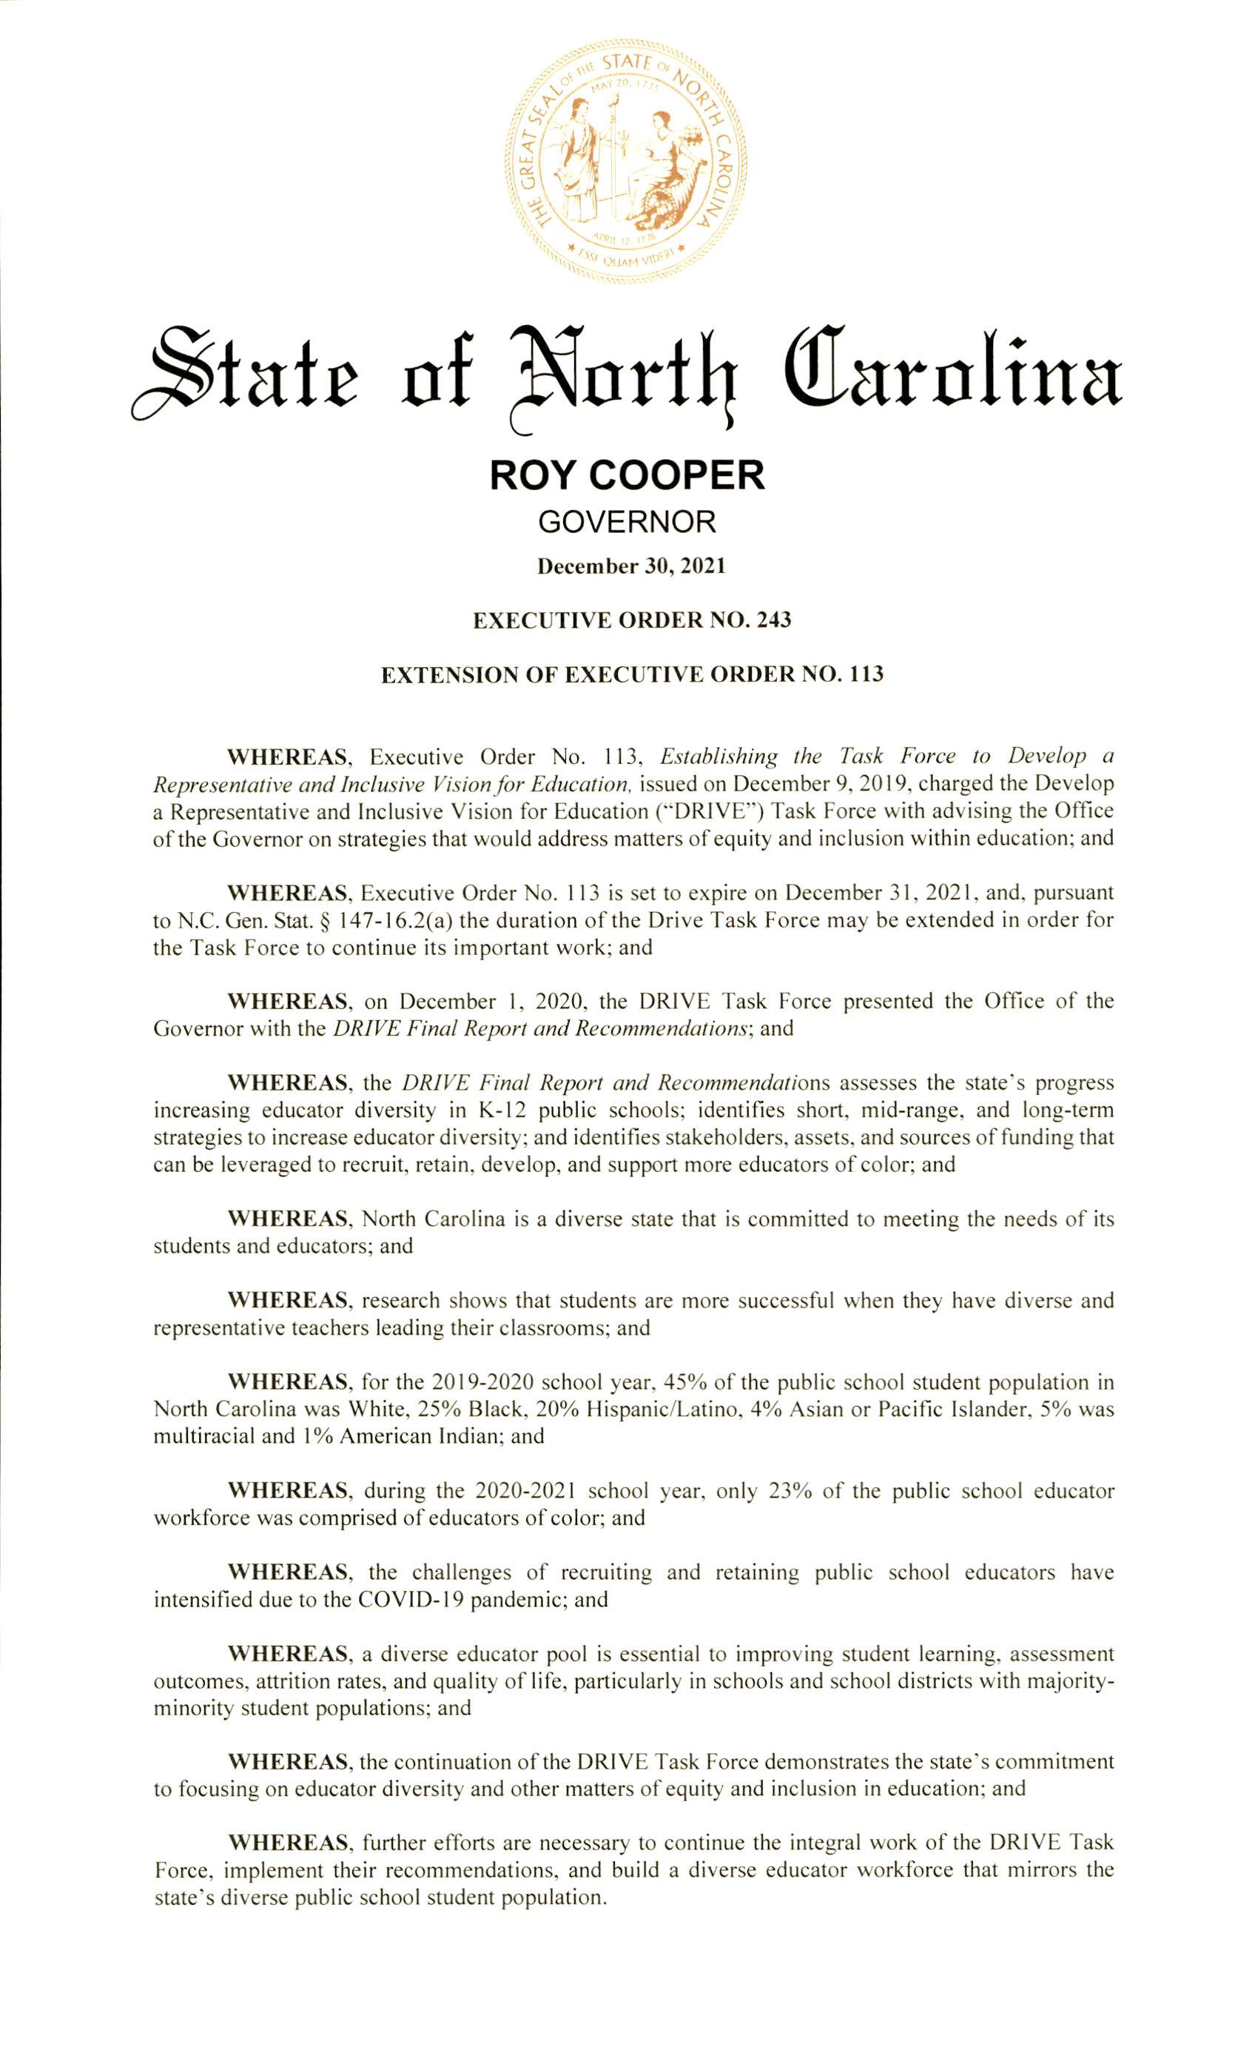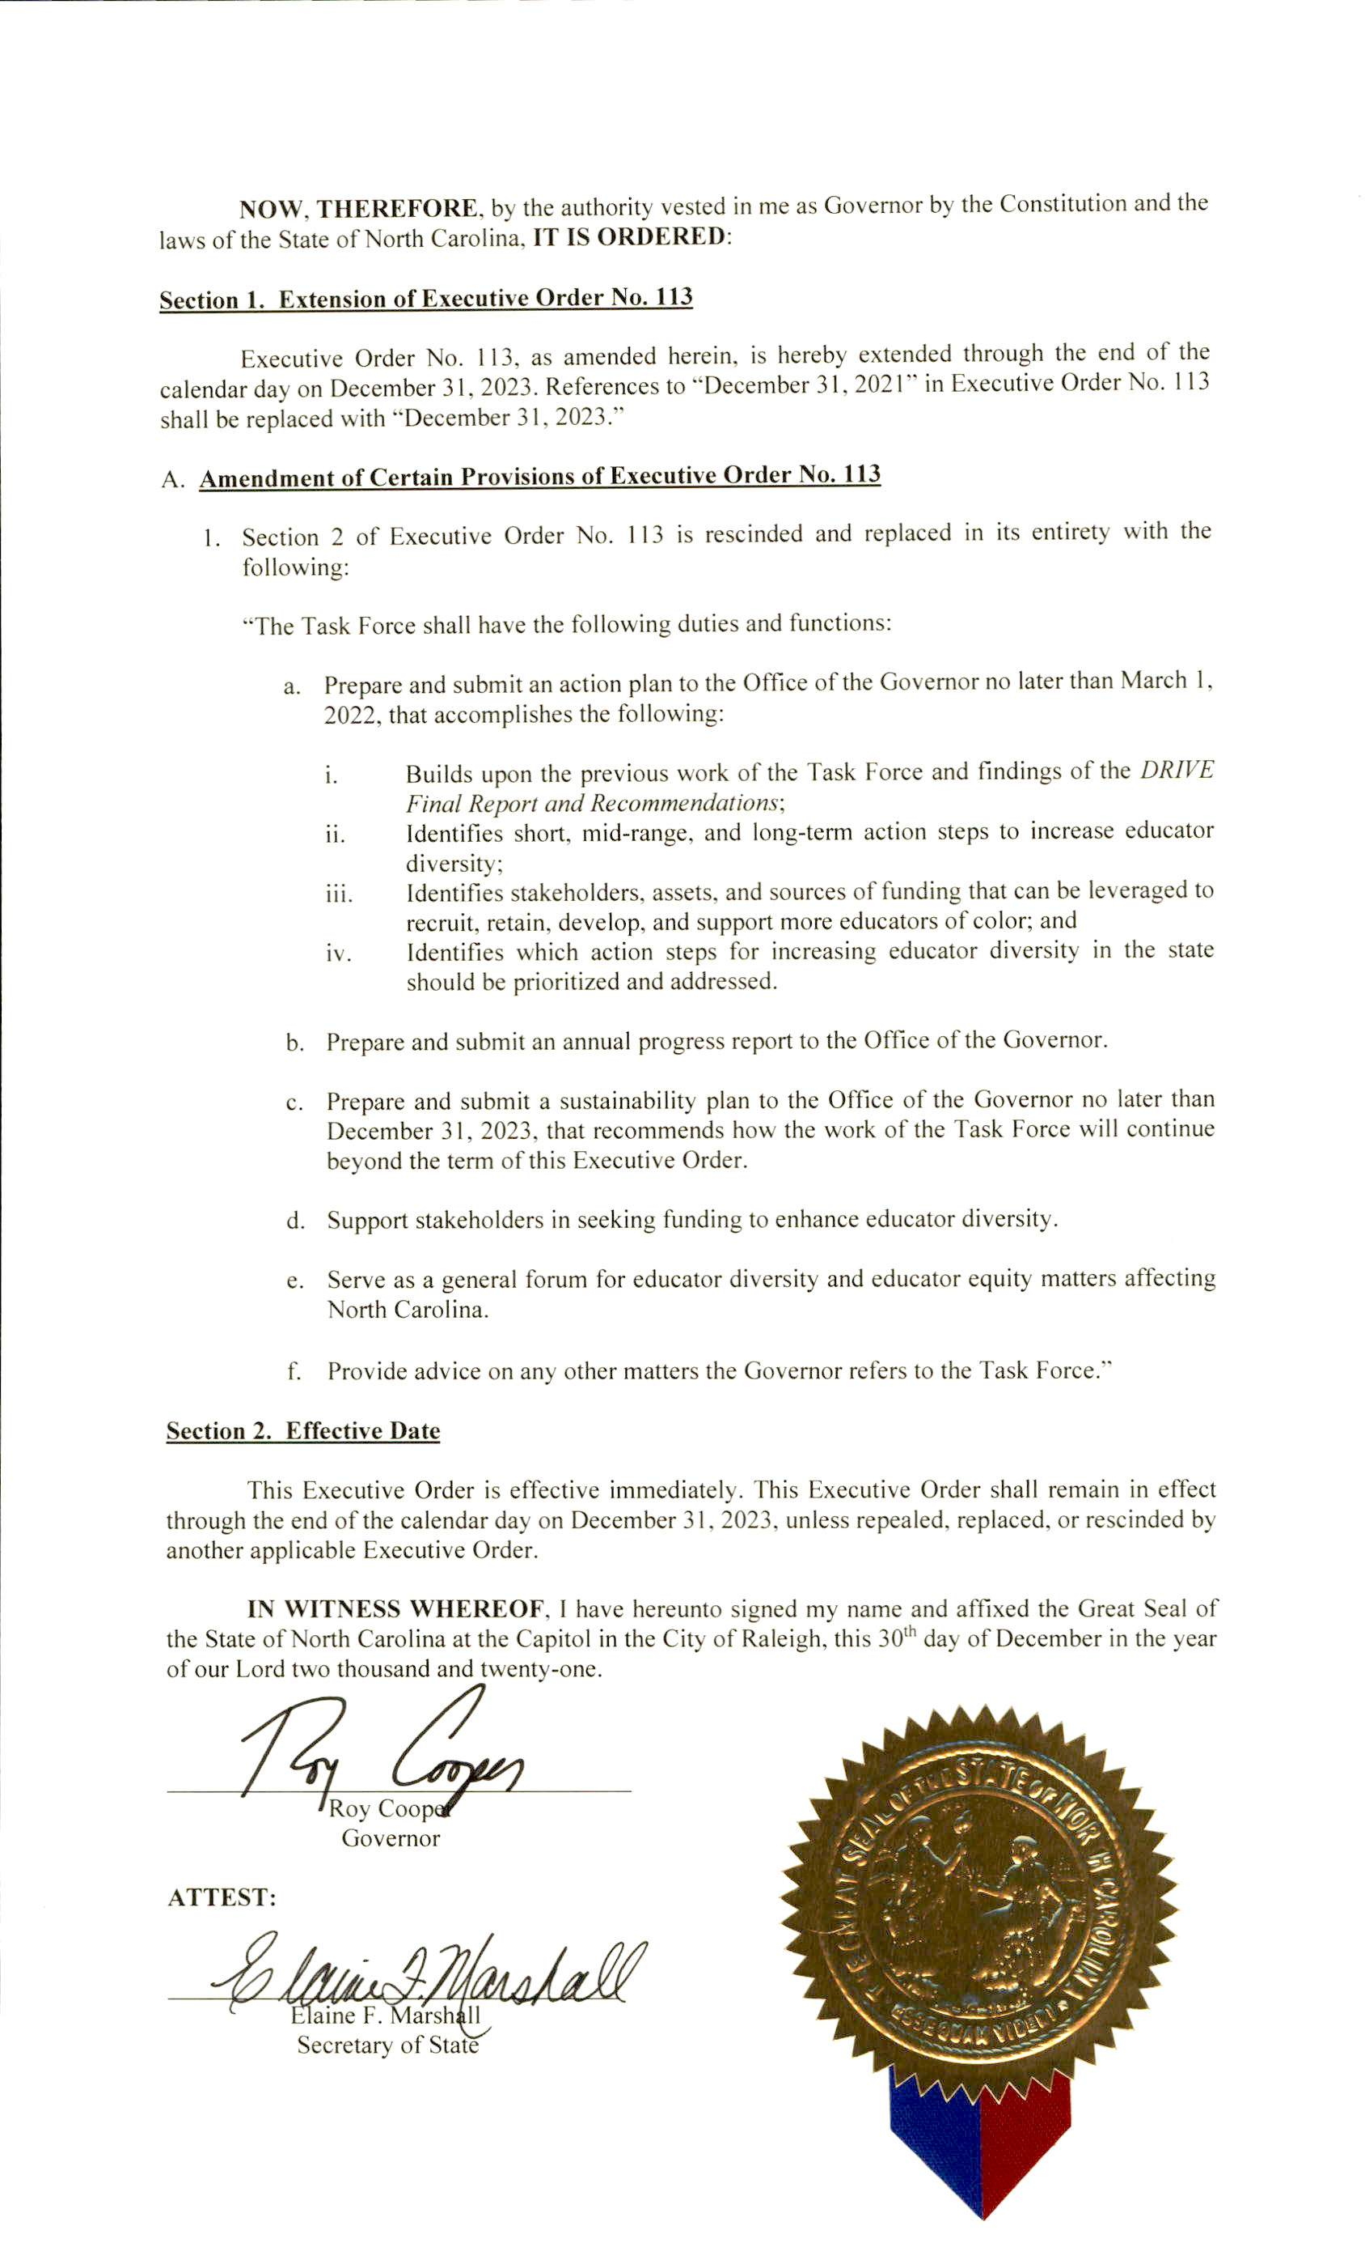
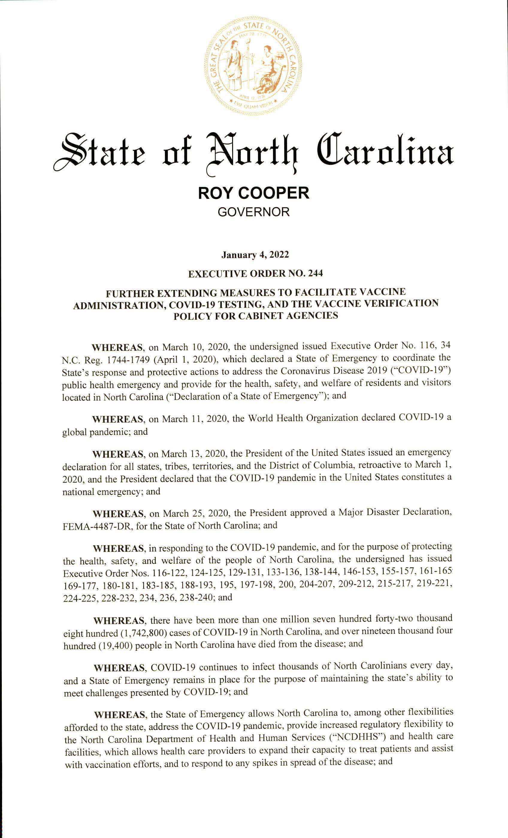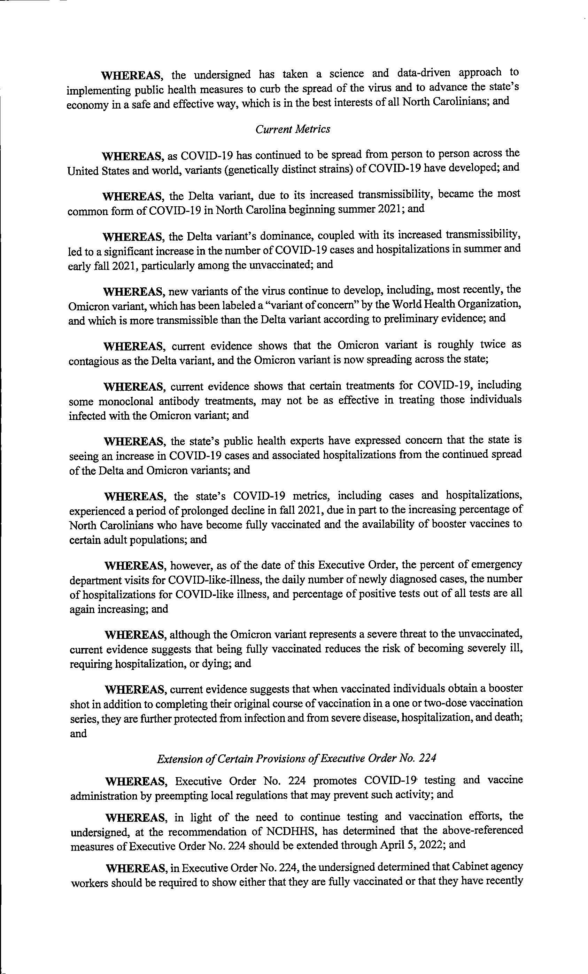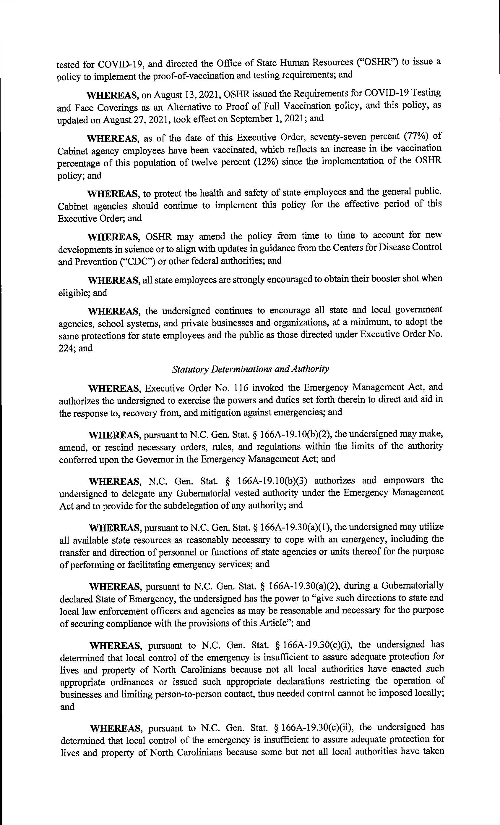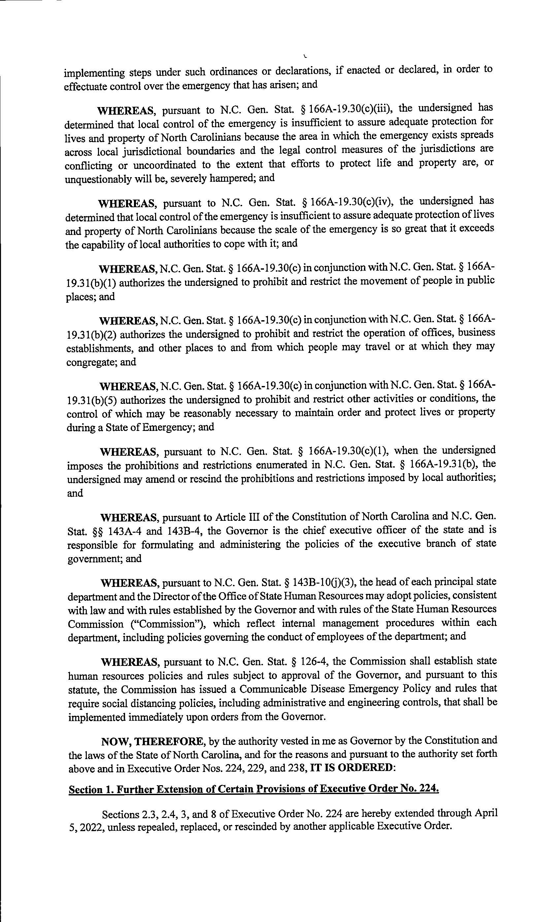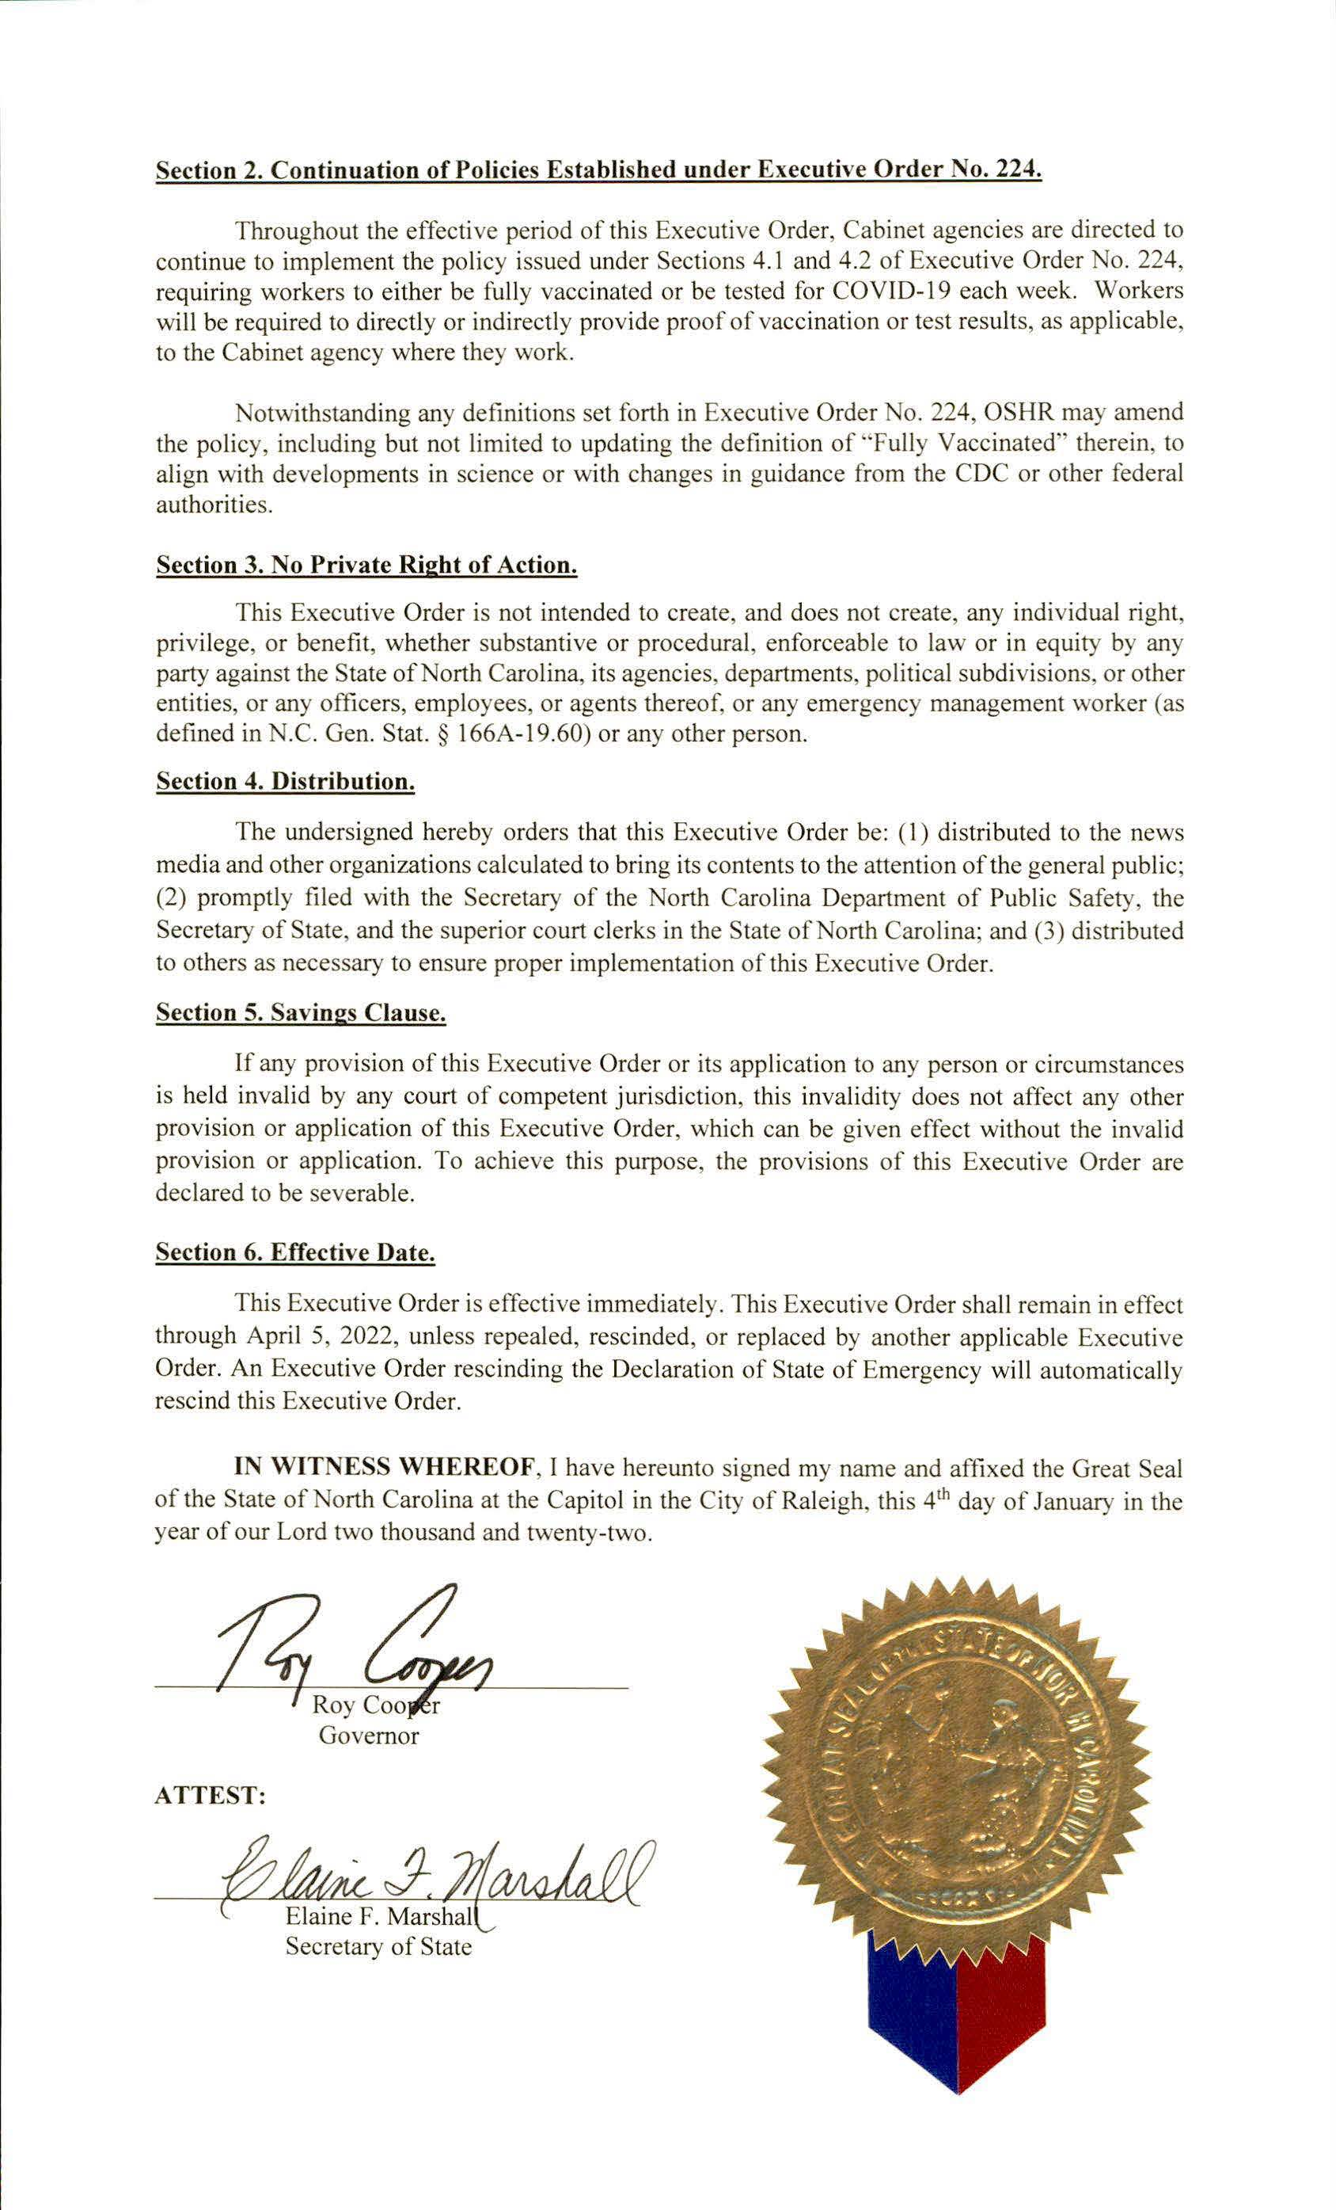
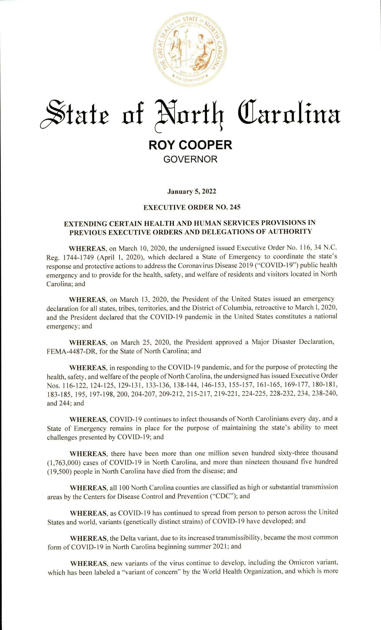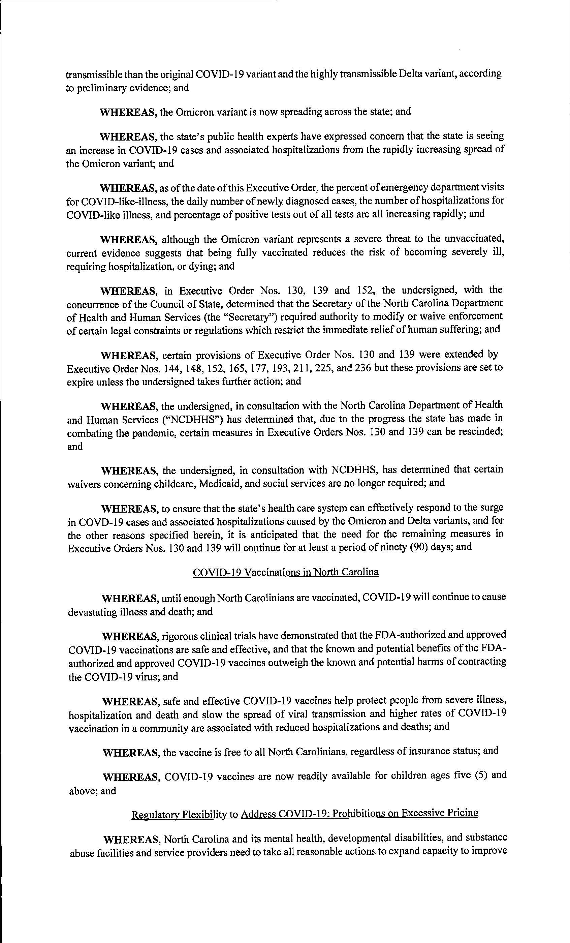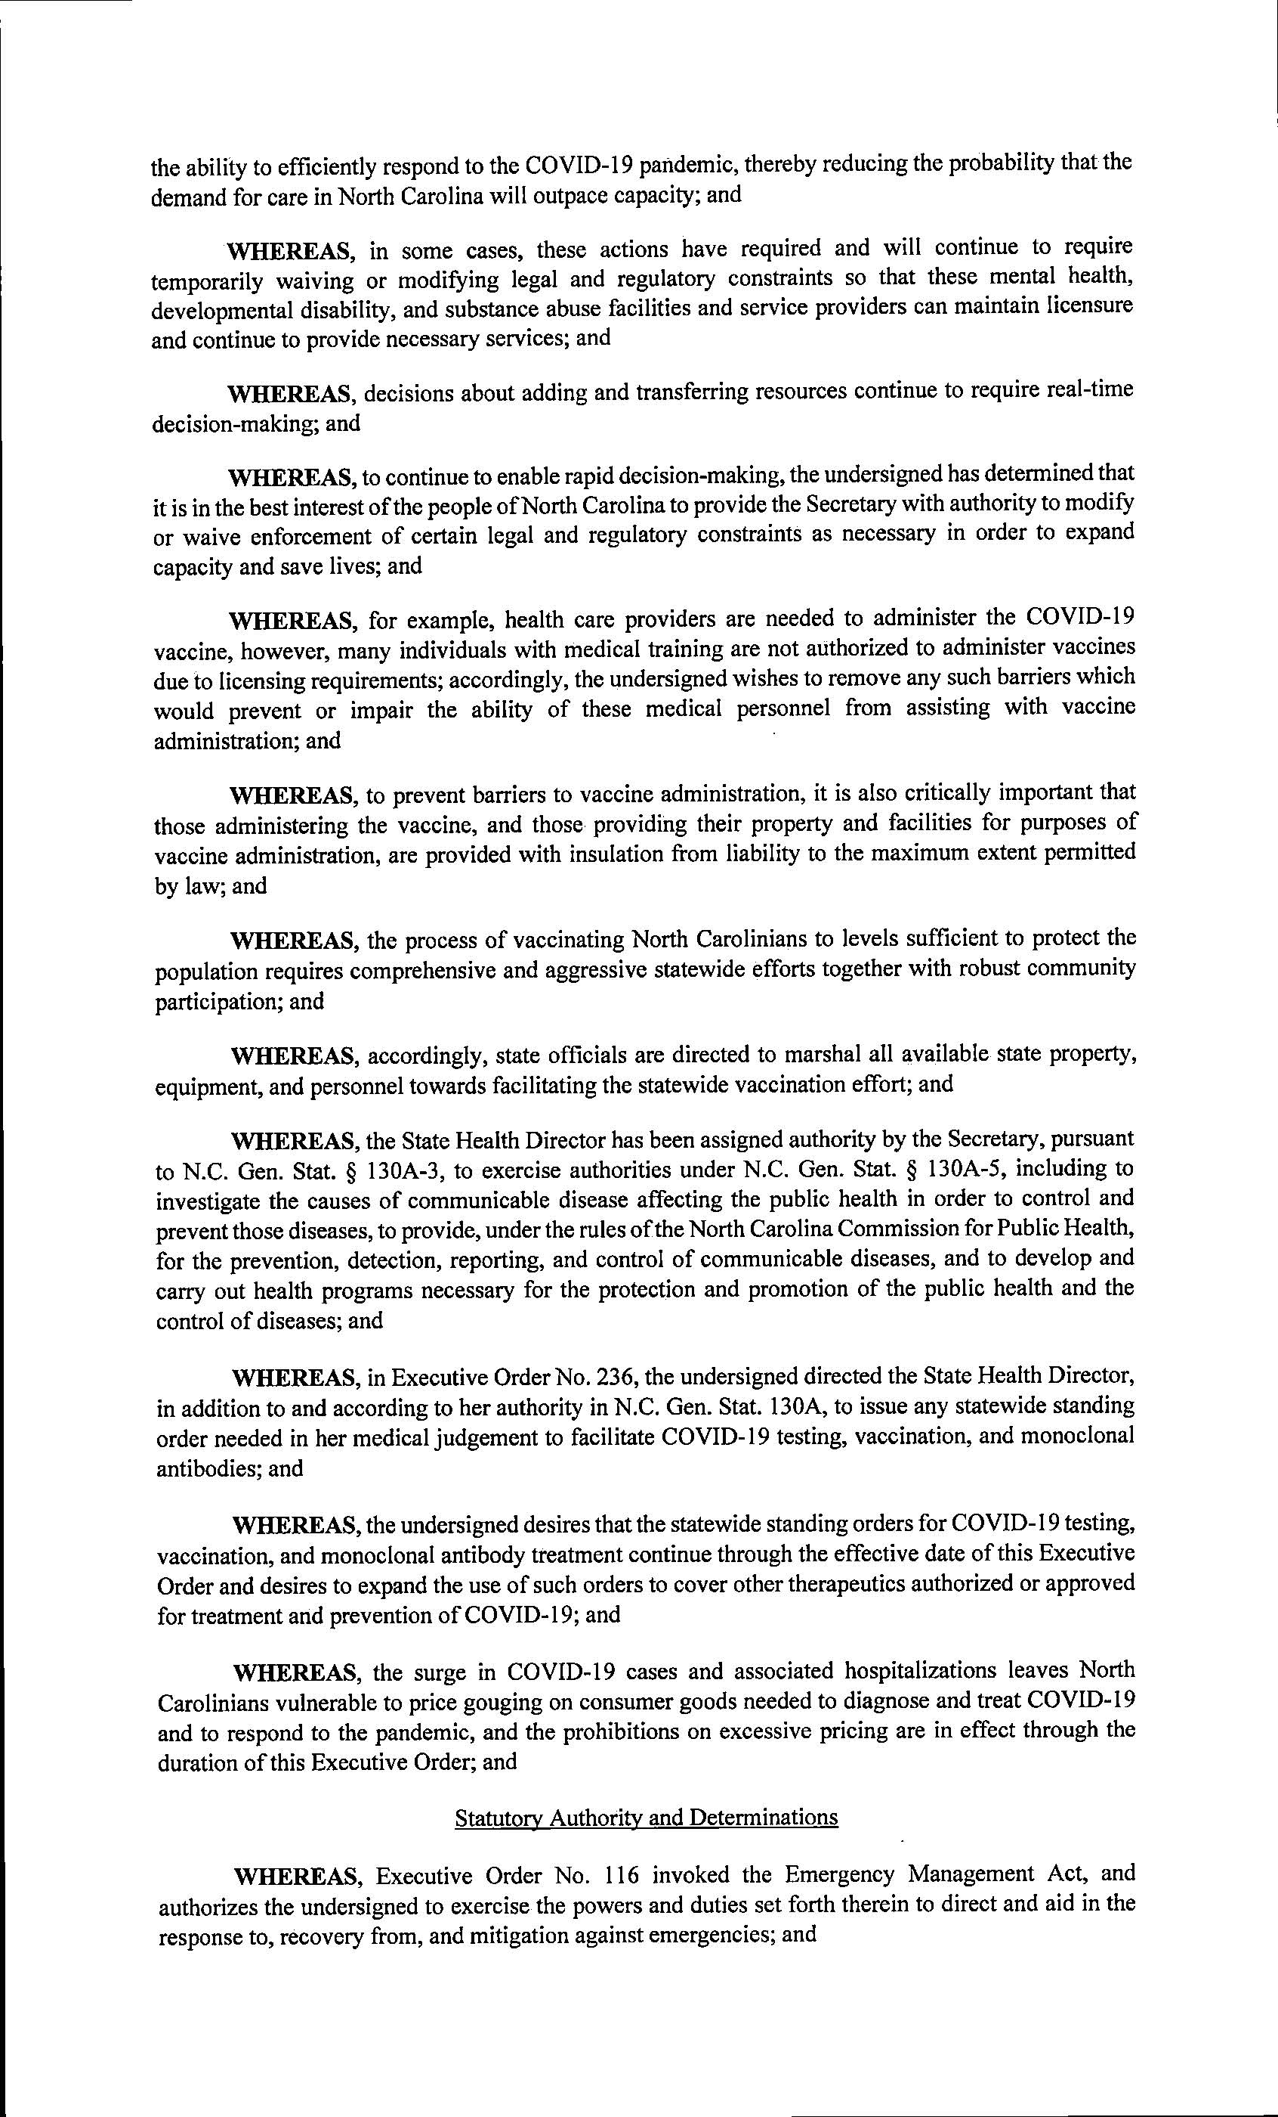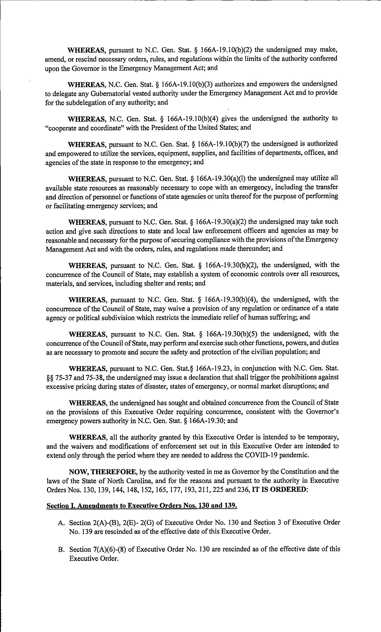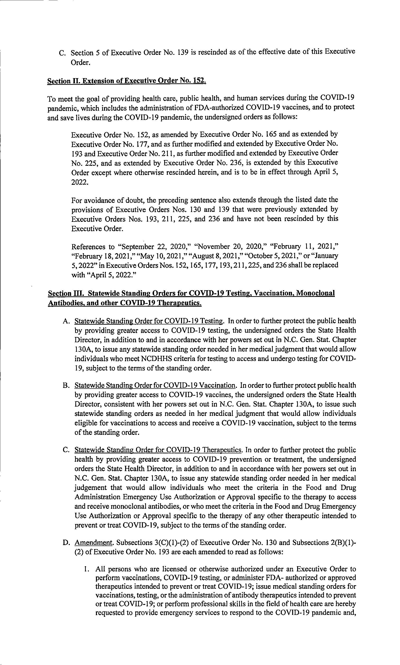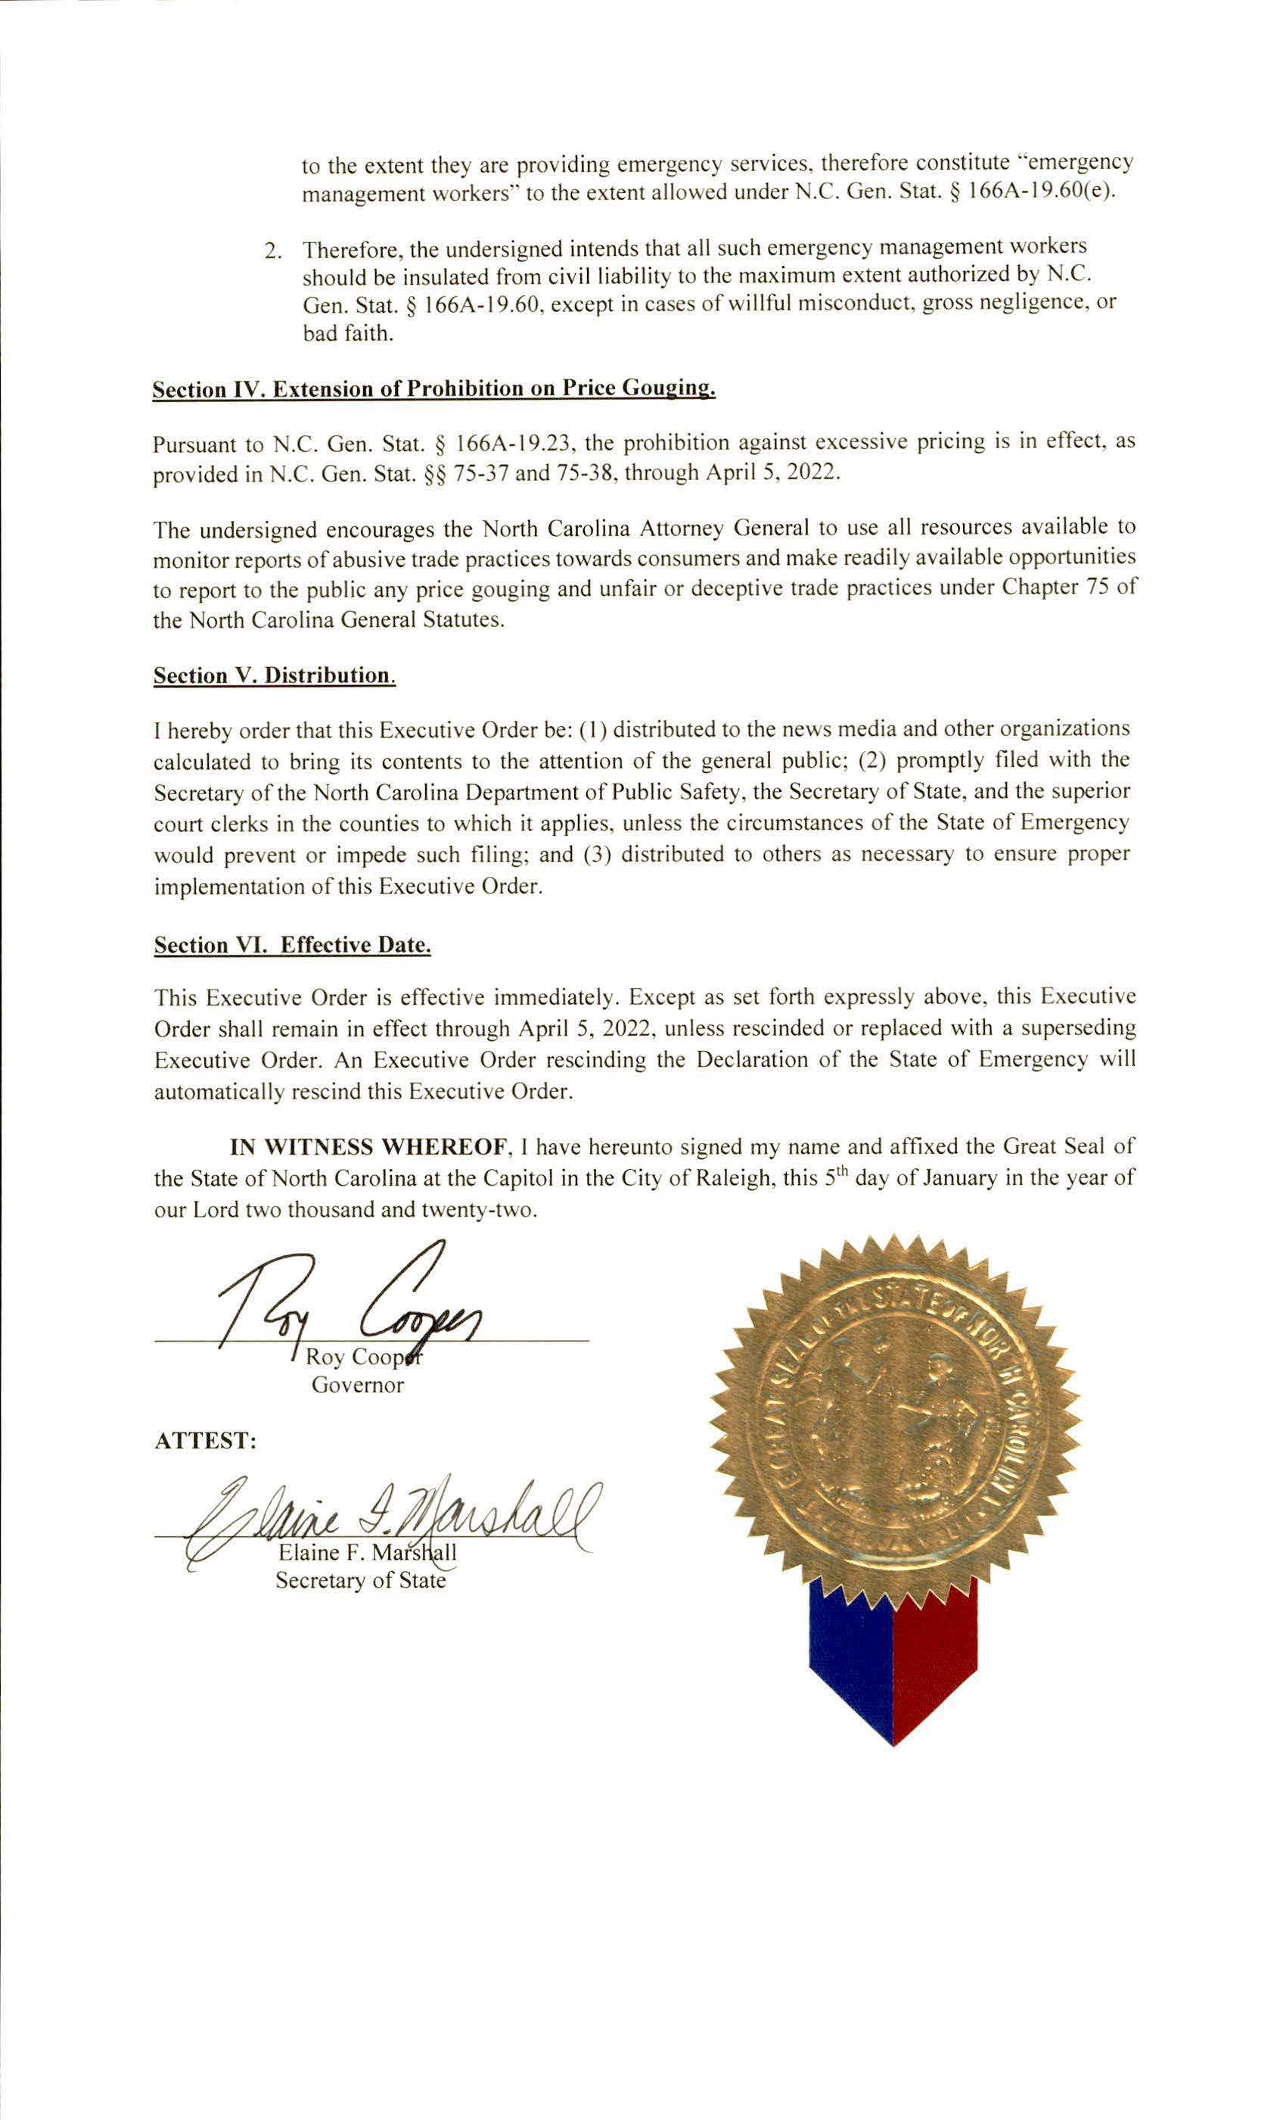
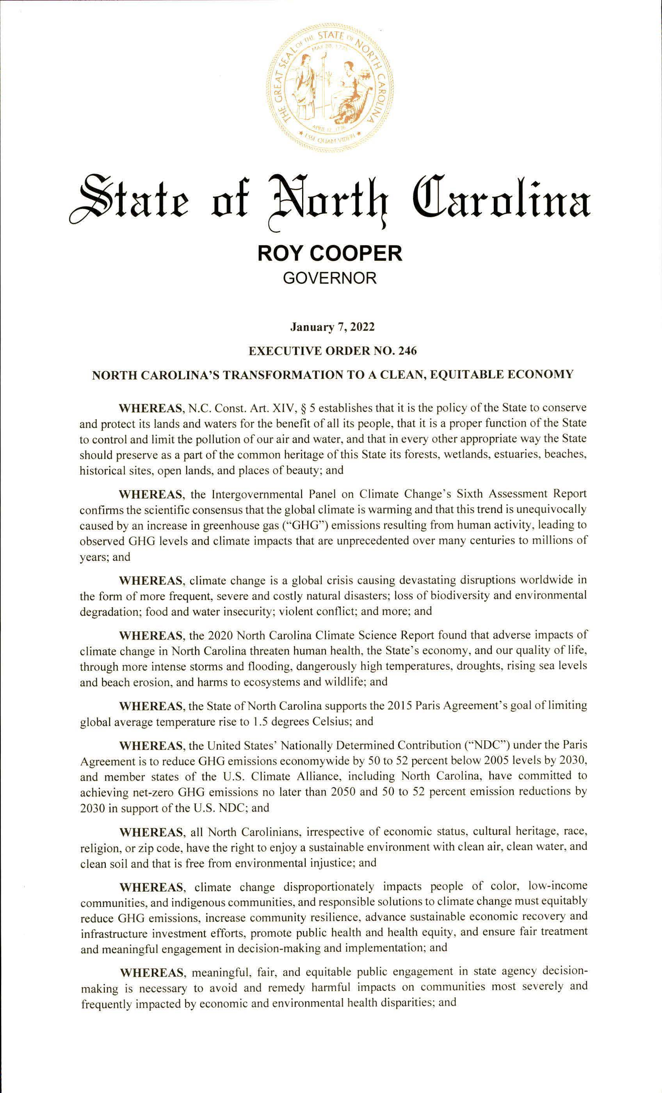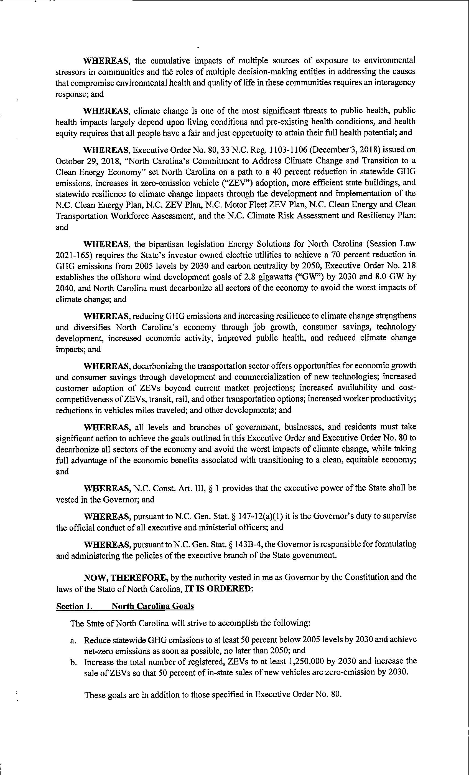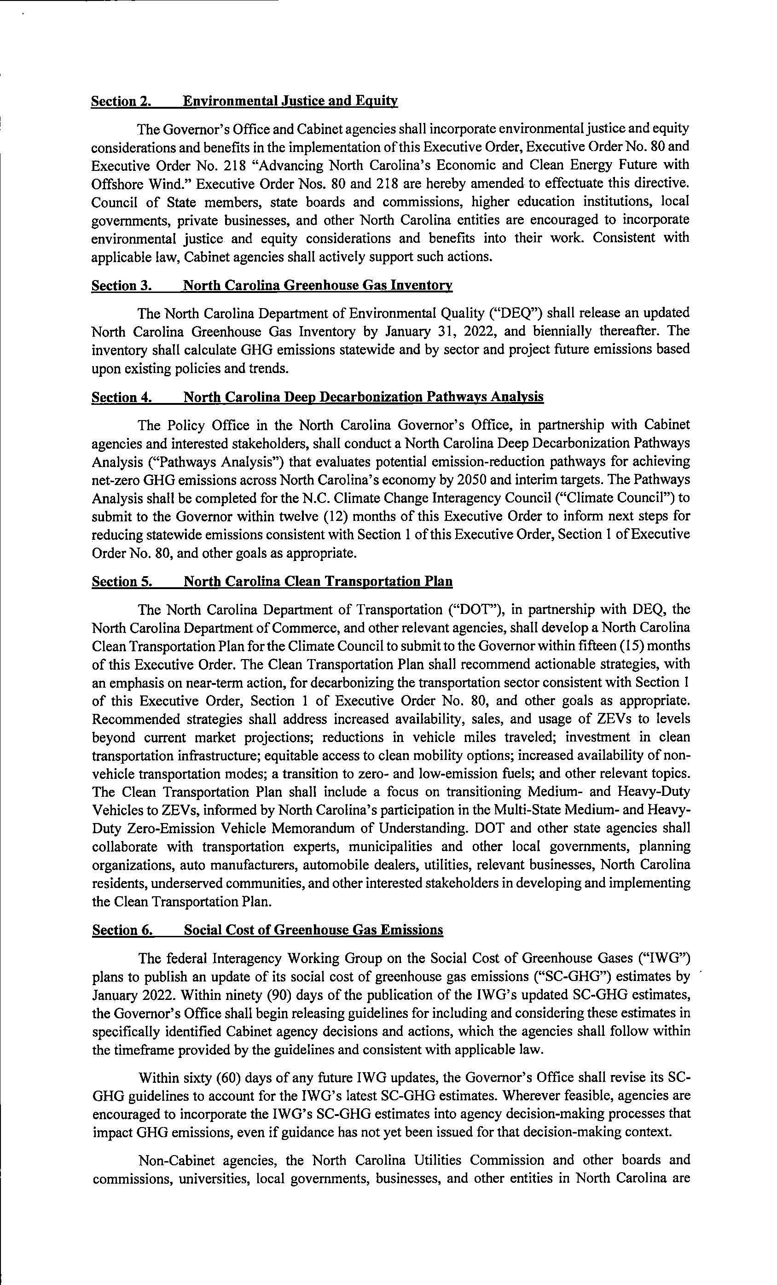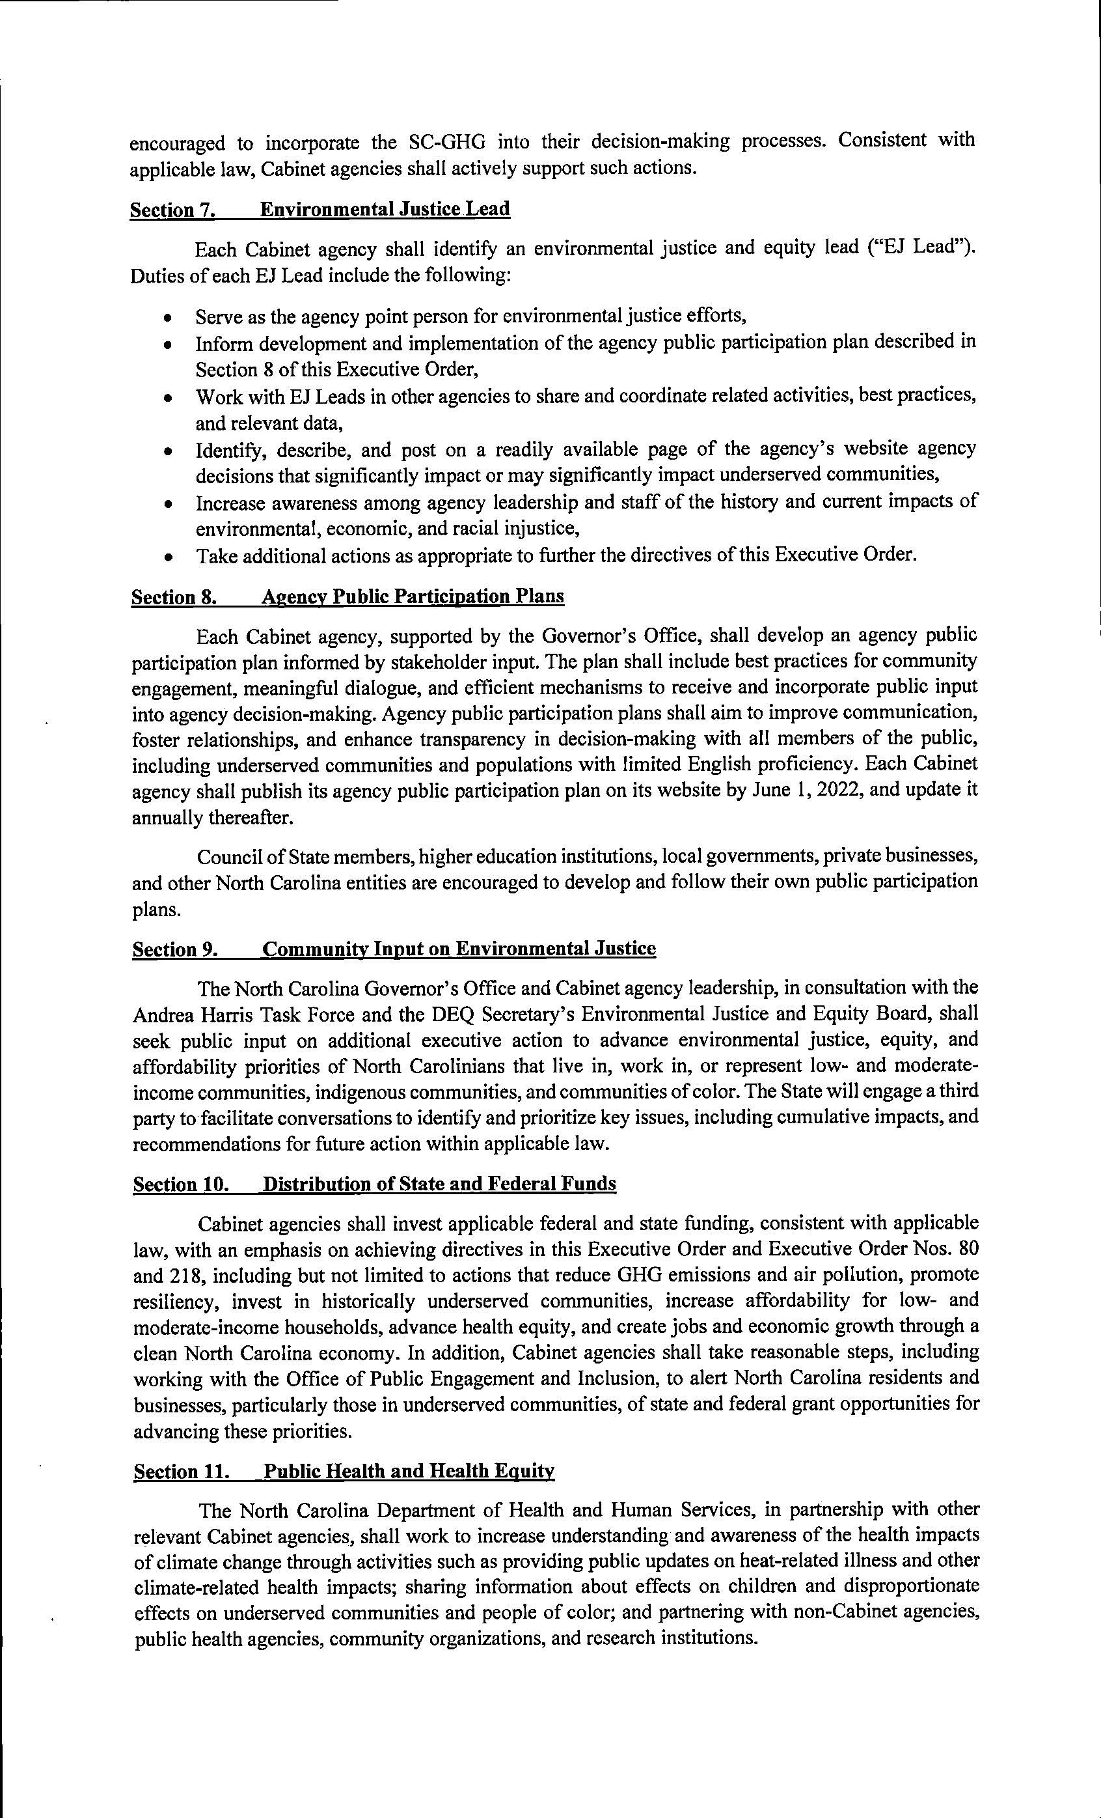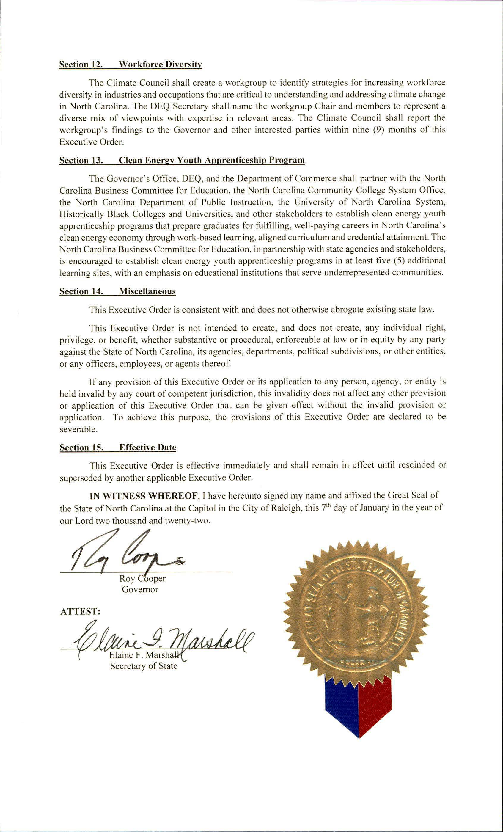

Note from the Codifier: The notices published in this Section of the NC Register include the text of proposed rules. The agency must accept comments on the proposed rule(s) for at least 60 days from the publication date, or until the public hearing, or a later date if specified in the notice by the agency. If the agency adopts a rule that differs substantially from a prior published notice, the agency must publish the text of the proposed different rule and accept comment on the proposed different rule for 60 days.
Statutory reference: G.S. 150B-21.2.

Title 12 – Department of Justice

Notice is hereby given in accordance with G.S. 150B-21.2 that the Sheriffs' Education and Training Standards Commission intends to amend the rule cited as 12 NCAC 10B .0704.

Link to agency website pursuant to G.S. 150B-19.1(c): https://ncdoj.gov/law-enforcement-training/sheriffs/all-commission-forms-publications/

Proposed Effective Date: June 1, 2022

Public Hearing:
Date: February 17, 2022
Time: 9:00 a.m.
Location: 1700 Tryon Park Drive, Raleigh, NC 27610

Reason for Proposed Action: Detention Officers seeking certification with the Sheriffs' Commission must comply with basic training requirements set forth by the Commission. One such requirement is mandated by 12 NCAC 10B .0704. This rule requires that the Detention Officer Certification Course (DOCC) must be taught in consecutive weeks. However, continuing a course when there is an outbreak of COVID-19, any of its variants, or any other unforeseen public emergency poses a threat to the safety, health and well-being for the students and staff. Likewise a delay in a detention officer receiving this important training, as well as the understaffing of a jail facility when officers are away attending training, may also threaten the safety of both officers and inmates.

These courses are delivered various locations across the state. The Commission is proposing this rule change so that the Division Director may waive this requirement under certain circumstances in the event of a lawfully declared State of Emergency.

Comments may be submitted to: Diane Konopka, 1700 Tryon Park Drive, Raleigh, NC 27610; phone (919) 662-4375; email dkonopka@ncdoj.gov

Comment period ends: April 4, 2022

Procedure for Subjecting a Proposed Rule to Legislative Review: If an objection is not resolved prior to the adoption of the rule, a person may also submit written objections to the Rules Review Commission after the adoption of the Rule. If the Rules Review Commission receives written and signed objections after the adoption of the Rule in accordance with G.S. 150B-21.3(b2) from 10 or more persons clearly requesting review by the legislature and the Rules Review Commission approves the rule, the rule will become effective as provided in G.S. 150B-21.3(b1). The Commission will receive written objections until 5:00 p.m. on the day following the day the Commission approves the rule. The Commission will receive those objections by mail, delivery service, hand delivery, or facsimile transmission. If you have any further questions concerning the submission of objections to the Commission, please call a Commission staff attorney at 984-236-1850.

Fiscal impact. Does any rule or combination of rules in this notice create an economic impact? Check all that apply.

State funds affected

Local funds affected

Substantial economic impact (>= $1,000,000)

Approved by OSBM

No fiscal note required

Chapter 10 - Sheriffs' Education and Training Standards Commission

SUBCHAPTER 10B - N.C. SHERIFFS' EDUCATION AND TRAINING STANDARDS COMMISSION

SECTION .0700 - MINIMUM STANDARDS FOR JUSTICE OFFICER SCHOOLS AND TRAINING PROGRAMS OR COURSES OF INSTRUCTION

12 NCAC 10B .0704 RESPONSIBILITIES: SCHOOL DIRECTORS, DETENTION OFFICER COURSE

(a) In planning, developing, coordinating, and delivering each commission-certified Detention Officer Certification Course, the school director shall:

(1) Formalize and schedule the course curriculum in accordance with the curriculum standards established by the rules in this Chapter.
(A) The Detention Officer Certification Course shall be presented with a minimum of 40 hours of instruction each week during consecutive calendar weeks until course requirements are completed, with the exception of weeks in which there are regularly scheduled holidays.
(B) In the event of exceptional or emergency circumstances, the Director shall, upon written finding of justification, grant a waiver of the minimum hours requirement.
(C) the Director may allow additional breaks in a specific course delivery when the Director determines that doing so is necessary based on circumstances related to a lawfully declared State of Emergency.

(2) Select and schedule instructors who are properly certified by the Commission. The selecting and scheduling of instructors is subject to special requirements as follows:
(A) No single individual may be scheduled to instruct more than 35 percent of the total hours of the curriculum during any one delivery except as set forth in Part (a)(2)(B) of this Rule.
(B) Where the school director shows exceptional or emergency circumstances and the school director documents that an instructor is properly certified to instruct more than 35 percent of the total hours of the curriculum, the Director of the Division shall grant written approval for the expansion of the individual instructional limitation.
(C) The appropriate number of instructors for specific topic areas shall be scheduled as required in 12 NCAC 10B .0703.

(3) Provide each instructor with a commission-approved course outline and all necessary additional information concerning the instructor's duties and responsibilities.

(4) Review each instructor's lesson plans and other instructional materials for conformance to the rules in this Chapter and to minimize repetition and duplication of subject matter.

(5) Arrange for the timely availability of appropriate audiovisual aids and materials, publications, facilities and equipment for training in all topic areas as required in the "Detention Officer Certification Course Management Guide".

(6) Develop, adopt, reproduce, and distribute any supplemental rules, regulations, and requirements determined by the school to be necessary or appropriate for:
(A) Effective course delivery;
(B) Establishing responsibilities and obligations of agencies or departments employing course trainees; and
(C) Regulating trainee participation and demeanor and ensuring trainee attendance and maintaining performance records.

A copy of such rules, regulations and requirements shall be submitted to the Director as an attachment to the Pre-Delivery Report of Training Course Presentation, Form F-7A. A copy of such rules shall also be given to each trainee and to the sheriff of each trainee's employing agency at the time the trainee enrolls in the course.

(7) If appropriate, recommend housing and dining facilities for trainees.

(8) Not less than 30 days before commencing delivery of the course, submit to the Commission a Pre-Delivery Report of Training Course Presentation (Form F-7A) along with the following attachments:
(A) A comprehensive course schedule showing arrangement of topical presentations and proposed instructional assignments;
(B) A copy of any rules, regulations, and requirements for the school and, when appropriate, completed applications for certification of instructors. The Director shall review the submitted Pre-Delivery Report together with all attachments to ensure that the school is in compliance with all commission rules; if school's rules are found to be in violation, the Director shall notify the school director of deficiency, and approval shall be withheld until all matters are in compliance with the Commissions' rules.

(9) Administer the course delivery in accordance with the rules in this Chapter and ensure that the training offered is as effective as possible.

(10) Monitor or designate a certified instructor to monitor the presentations of all probationary instructors during course delivery and prepare written evaluations on their performance and suitability for subsequent instructional assignments. A person holding General Instructor Certification under the Criminal Justice Education and Training Standards Commission may evaluate instructors teaching any lecture portion of the course. However, if a Limited Lecturer is evaluated during the practical portion of a block of instruction, he/she must be evaluated by either the School Director or another instructor holding the equivalent type of certification. These evaluations shall be prepared on commission forms and forwarded to the Division at the conclusion of each delivery. Based on this evaluation the school director shall recommend approval or denial of requests for Detention Officer Instructor Certification, Limited Lecturer Certification or Professional Lecturer Certification. The observations shall be of sufficient duration to ensure the instructor is using the Instructional System Development model, as taught in Criminal Justice Instructor Training set out in 12 NCAC 09B .0209, and that the delivery is objective based, documented by and consistent with a Commission-approved lesson plan. For each topic area, the school director's or designee's evaluation shall be based on the course delivery observations, the instructor's use of the approved lesson plan, and the results of the students evaluations of the instructor.

(11) Monitor or designate a certified instructor to monitor the presentations of all other instructors during course delivery and prepare written evaluations on their performance and suitability for subsequent instructional assignments. A person holding General Instructor Certification under the Criminal Justice Education and Training Standards Commission may evaluate instructors teaching any lecture portion of the course. However, if a Limited Lecturer is evaluated during the practical portion of a block of instruction, he/she must be evaluated by either the School Director or another instructor holding the equivalent type of certification. Instructor evaluations shall be prepared on commission forms in accordance with the rules in this Chapter. These evaluations shall be kept on file by the school for a period of three years and shall be made available for inspection by a representative of the Commission upon request. The observations shall be of sufficient duration to ensure the instructor is using the Instructional System Development model, as taught in Criminal Justice Instructor Training set out in 12 NCAC 09B .0209, and that the delivery is objective based, documented by and consistent with a Commission-approved lesson plan. For each topic area, the school director's or designee's evaluation shall be based on the course delivery observations, the instructor's use of the approved lesson plan, and the results of the students evaluations of the instructor.

(12) Ensure that any designated certified instructor who is evaluating the instructional presentation of another holds certification in the same instructional topic area as that being taught.

(13) Administer or designate a person to administer appropriate tests as determined necessary at various intervals during course delivery.

(14) Maintain direct supervision, direction, and control over the performance of all persons to whom any portion of the planning, development, presentation, or administration of a course has been delegated.

(15) During a delivery of the Detention Officer Certification Course, make available to authorized representatives of the Commission three hours of scheduled class time and classroom facilities for the administration of a written examination to those trainees who have satisfactorily completed all course work.

(16) Not more than ten days after receiving from the Commission's representative the Report of Examination Scores, submit to the Commission a Post-Delivery Report of Training Course Presentation (Form 7-B).

(b) In addition to the requirements in 12 NCAC 10B .0704(a), the school director shall be readily available to students and Division staff at all times during course delivery by telephone, pager, or other means. The means, and applicable numbers, shall be filed with the commission-certified training delivery site and the Division prior to the beginning of a scheduled course delivery.

Authority G.S. 17E-4.

* * * * * * * * * * * * * * * * * * * *

Notice is hereby given in accordance with G.S. 150B-21.2 that the Sheriffs' Education and Training Standards Commission intends to amend the rule cited as 12 NCAC 10B .0713.

Link to agency website pursuant to G.S. 150B-19.1(c): https://ncdoj.gov/law-enforcement-training/sheriffs/all-commission-forms-publications/

Proposed Effective Date: June 1, 2022

Public Hearing:
Date: February 17, 2022
Time: 9:00 a.m.
Location: 1700 Tryon Park Drive, Raleigh, NC 27610

Reason for Proposed Action: Admission into the Detention Officer Certification Course (DOCC) and the Telecommunicator Certification Course (TCC) requires that the trainee must be administered the reading component of a standardized test. The majority of standardized reading tests no longer report a reading grade level as currently required by this rule. The Sheriffs' Commission wishes to maintain the requirement for this standardized test, without the reading grade level requirement.

Comments may be submitted to: Diane Konopka, 1700 Tryon Park Drive, Raleigh, NC 27610; phone (919) 662-4375; email dkonopka@ncdoj.gov

Comment period ends: April 4, 2022

Procedure for Subjecting a Proposed Rule to Legislative Review: If an objection is not resolved prior to the adoption of the rule, a person may also submit written objections to the Rules Review Commission after the adoption of the Rule. If the Rules Review Commission receives written and signed objections after the adoption of the Rule in accordance with G.S. 150B-21.3(b2) from 10 or more persons clearly requesting review by the legislature and the Rules Review Commission approves the rule, the rule will become effective as provided in G.S. 150B-21.3(b1). The Commission will receive written objections until 5:00 p.m. on the day following the day the Commission approves the rule. The Commission will receive those objections by mail, delivery service, hand delivery, or facsimile transmission. If you have any further questions concerning the submission of objections to the Commission, please call a Commission staff attorney at 984-236-1850.

Fiscal impact. Does any rule or combination of rules in this notice create an economic impact? Check all that apply.

State funds affected

Local funds affected

Substantial economic impact (>= $1,000,000)

Approved by OSBM

No fiscal note required

Chapter 10 - Sheriffs' Education and Training Standards Commission

SUBCHAPTER 10B - N.C. SHERIFFS' EDUCATION AND TRAINING STANDARDS COMMISSION

SECTION .0700 - MINIMUM STANDARDS FOR JUSTICE OFFICER SCHOOLS AND TRAINING PROGRAMS OR COURSES OF INSTRUCTION

12 ncac 10b .0713 ADMISSION OF TRAINEES

(a) The school director shall not admit any individual as a trainee in any commission-certified basic training course who is not a citizen of the United States.

(b) The school shall not admit any individual younger than 21 years of age as a trainee in the Detention Officer Certification Course and shall not admit any individual younger than 18 years of age as a trainee in the Telecommunicator Certification Course without the prior written approval of the Director of the Standards Division. The Director shall approve those individuals who will turn 21 years of age prior to the end of the Detention Officer Certification Course and, those individuals who will turn 18 years of age prior to the end of the Telecommunicator Certification Course.

(c) The school shall not admit any individual who has not provided documentation that he or she meets the educational requirement set out in 12 NCAC 10B .0302.

(d) The school shall give priority admission in commission-certified basic training courses to individuals holding full-time employment with criminal justice agencies.

(e) The school shall administer the reading component of a standardized test that reports a grade level for each trainee participating in either the Telecommunicator or Detention Officer Certification Course. The specific test instrument shall be determined by the school director and shall be administered within the first week of the Course. The grade level results for each trainee shall be submitted to the Commission on each trainee's Report of Student Course Completion.

(f) The school shall not admit any individual as a trainee in a presentation of the Detention Officer Certification Course or the Telecommunicator Certification Course unless the individual has provided to the School Director a Medical Examination Report Form (F-2) and the Medical History Statement Form (F-1) in compliance with 12 NCAC 10B .0304. The Medical Examination Report Form (F-2) and the Medical History Statement Form (F-1) required by the North Carolina Criminal Justice Education and Training Standards Commission shall be recognized by the Commission for the purpose of complying with this Rule.

(g) The school shall not admit any individual trainee in commission-certified basic training courses unless the individual has provided the School Director a certified criminal record check for local and state records where the trainee has resided within the past 10 years and where the trainee attended high school. An Administrative Office of the Courts criminal record check or a comparable out-of-state criminal record check shall satisfy this requirement. If an individual trainee has received a probationary certificate from the Commission at the time of enrollment, this records check requirement shall be waived.

(h) The school shall not admit any individual as a trainee in commission-certified basic training courses who has been convicted of the following:

(1) a felony;

(2) a crime for which the punishment could have been imprisonment for more than two years;

(3) a crime or unlawful act defined as a "Class B Misdemeanor" within the five year period prior to the date of appointment;

(4) four or more crimes or unlawful acts as defined as "Class B Misdemeanors" regardless of the date of conviction;

(5) four or more crimes or unlawful acts defined as "Class A Misdemeanors" except the trainee may be enrolled if the last conviction occurred more than two years prior to the date of enrollment; or

(6) a combination of four or more "Class A Misdemeanors" or "Class B Misdemeanors" regardless of the date of conviction.

(i) Individuals charged with crimes specified in this Paragraph that were dismissed or the person was found not guilty may be admitted into the commission-certified basic training courses, but completion will not ensure that certification as a justice officer through the Commission will be issued. Every individual who is admitted as a trainee in a presentation of the Commission-certified Basic Law Enforcement Training Course shall notify the School Director of all criminal offenses that the trainee is arrested for, charged with, pleads no contest to, pleads guilty to, or is found guilty of, and shall notify the School Director of all Domestic Violence Orders (G.S. 50B) and Civil No Contact Orders (50C) that are issued by a judicial official that provide an opportunity for both parties to be present, including all criminal offenses except minor traffic offenses. A minor traffic offense is defined for purposes of this Paragraph as any offense under G.S. 20 or similar laws of other jurisdictions except those Chapter 20 offenses published in the Class B Misdemeanor Manual. Other traffic offenses under laws of other jurisdictions that shall be reported to the School Director include driving while impaired if the maximum allowable punishment is for a term of more than six months but not more than two years and driving while license permanently revoked or permanently suspended. The notifications required under this Paragraph shall be in writing and shall specify the nature of the offense, the court in which the case was handled, the date of the arrest or criminal charge, the date of issuance of the Domestic Violence Order (G.S 50B) or Civil No Contact Order (G.S. 50C), and the final disposition and the date thereof. The notifications required under this Paragraph shall be received by the School Director within 30 days of the date the case was disposed of in court. The requirements of this Paragraph shall apply at all times during which the trainee is enrolled in a Basic Law Enforcement Training Course. The requirements of this Paragraph shall be in addition to the notifications required under 12 NCAC 10B .0301 and 12 NCAC 09B .0101(8).

Authority G.S. 17C-4; 17E-7.

Title 14B – Department of Public Safety

Notice is hereby given in accordance with G.S. 150B-21.2 that the Private Protective Services Board intends to amend the rules cited as 14B NCAC 16 .0201, .0203, .0404, .0706, .0806, .0904, .0911, .1306 and .1406.

Link to agency website pursuant to G.S. 150B-19.1(c): https://www.ncdps.gov/about-dps/boards-commissions/private-protective-services-board

Proposed Effective Date: June 1, 2022

Public Hearing:
Date: February 22, 2022
Time: 2:00 p.m.
Location: 3101 Industrial Dr., Suite 104, Raleigh, NC 27609

Reason for Proposed Action: One rule amendment establishes a new procedure to allow character letters to be submitted electronically; a second amendment requires a Private Investigator to have proof that a requested written report was provided to a client; a third amendment repeals an antiquated provision requiring payment of a fee for a criminal history record check for renewal of a firearms trainer certificate; further, all renewed rules (i.e., .0203, .0706, .0806, .0904, .0911, .1306 and .1406) are amended to allow Board staff to hold a renewal application if there is a deniable criminal charge pending.

Comments may be submitted to: Paul Sherwin, 3101 Industrial Dr., Suite 4, Raleigh, NC 27609; phone (919)788-5320; email Paul.sherwin@ncdps.gov

Comment period ends: April 4, 2022

Procedure for Subjecting a Proposed Rule to Legislative Review: If an objection is not resolved prior to the adoption of the rule, a person may also submit written objections to the Rules Review Commission after the adoption of the Rule. If the Rules Review Commission receives written and signed objections after the adoption of the Rule in accordance with G.S. 150B-21.3(b2) from 10 or more persons clearly requesting review by the legislature and the Rules Review Commission approves the rule, the rule will become effective as provided in G.S. 150B-21.3(b1). The Commission will receive written objections until 5:00 p.m. on the day following the day the Commission approves the rule. The Commission will receive those objections by mail, delivery service, hand delivery, or facsimile transmission. If you have any further questions concerning the submission of objections to the Commission, please call a Commission staff attorney at 984-236-1850.

Fiscal impact. Does any rule or combination of rules in this notice create an economic impact? Check all that apply.

State funds affected

Local funds affected

Substantial economic impact (>= $1,000,000)

Approved by OSBM

No fiscal note required

Chapter 16 - Private Protective Services Board

SECTION .0200 - LICENSES: TRAINEE PERMITS

14B NCAC 16 .0201 APPLICATION FOR LICENSE AND TRAINEE PERMITS

(a) Each applicant for a license or trainee permit shall submit an online application on the website provided by the Board. The online application shall be accompanied by:

(1) electronic submission of fingerprints from a Live Scan or similar system approved by the State Bureau of Investigations or one set of classifiable fingerprints on an applicant fingerprint card that shall be mailed separately to the Board's office;

(2) one head and shoulders digital photograph of the applicant in JPG, JPEG, or PNG format of sufficient quality for identification, taken within six months prior to online application and submitted by uploading the photograph online with the application submission;

(3) upload online a statement of the results of a statewide criminal history records search by the reporting service designated by the Board pursuant to G.S. 74C-8.1(a) for each state where the applicant has resided within the preceding 60 months;

(4) the applicant's non-refundable application fee, along with a four dollar ($4.00) convenience fee and credit card transaction fee;

(5) the actual cost charged to the Private Protective Services Board by the State Bureau of Investigation to cover the cost of criminal record checks performed by the State Bureau of Investigation, collected online by the Private Protective Services Board; and

(6) an Equifax credit check run within 30 days of the license application submission date, which will be submitted to the Board's investigator during the application process. process; and

(7) five letters attesting to the good character and reputation of the applicant using the online character letter submission process.

(b) Applications for trainee permits shall be accompanied by a notarized statement on a form provided by the Board and signed by the applicant and his or her prospective supervisor, stating that the trainee applicant shall at all times work with and under the direct supervision of that supervisor and the form shall be uploaded as part of the online application process.

(c) Private investigator trainees applying for a license shall make available for inspection a log of experience on a form provided by the Board.

(d) Each applicant must upload evidence of high school graduation either by diploma, G.E.D. certificate, or other proof.

(e) Each applicant for a license shall meet personally with a Board investigator, the Screening Committee, the Director, or another Board representative designated by the Director prior to being issued a license. The applicant shall discuss the provisions of G.S. 74C and the administrative rules in this Chapter during the personal meeting. The applicant shall sign a form provided by the Board indicating that he or she has reviewed G.S. 74C and the administrative rules in this Chapter with the Board's representative.

Authority G.S. 74C-2; 74C-5; 74C-8; 74C-8.1; 74C-12.

14B NCAC 16 .0203 RENEWAL OR RE-ISSUE OF LICENSES AND TRAINEE PERMITS

(a) Each applicant for renewal of a license or trainee permit shall submit an online renewal application on the website provided by the Board. This online application shall be submitted not less than 30 days prior to expiration of the applicant's current license or trainee permit and shall be accompanied by:

(1) one head and shoulders digital color photograph of the applicant in JPG, JPEG, or PNG format of sufficient quality for identification, taken within six months prior to online application and submitted by uploading the photograph online with the application submission;

(2) upload online a statement of the result of a statewide criminal history records search by the reporting service designated by the Board pursuant to G.S. 74C-8.1(a) for each state where the applicant has resided within the preceding 24 months;

(3) the applicant's renewal fee, along with a four dollar ($4.00) convenience fee and credit card transaction fee; and

(4) for license applicants, proof of liability insurance as set out in G.S. 74C-10(e).

(b) If a licensee has maintained a license at least two years and then allows the license to expire, the license may be re-issued if application is made within three years of the expiration date and the following documentation is submitted to the Board:

(1) an online Application For Reinstatement of an Expired License;

(2) one set of classifiable fingerprints on an applicant fingerprint card that shall be mailed separately to the Board's office;

(3) one head and shoulders digital color photograph of the applicant in JPG, JPEG, or PNG format of sufficient quality for identification, taken within six months prior to online application and submitted by uploading the photograph online with the application submission;

(4) upload online a statement of the result of a statewide criminal history records search by the reporting service designated by the Board pursuant to G.S. 74C-8.1(a) for each state where the applicant has resided within the preceding 60 months;

(5) the applicant's non-refundable application fee, along with a four dollar ($4.00) convenience fee and credit card transaction fee;

(6) proof of liability insurance as set out in G.S. 74C-10(e); and

(7) payment to the State Bureau of Investigations to cover the cost of criminal record checks performed by the State Bureau of Investigations, with payment to be paid online through the Board's online application process.

(c) A member of the armed forces whose license is in good standing and to whom G.S. 105-249.2 grants an extension of time to file a tax return shall receive that same extension of time to pay the license renewal fee and complete any continuing education requirements prescribed by the Board. A copy of the military order or the extension approval by the Internal Revenue Service or by the North Carolina Department of Revenue shall be furnished to the Board.

Authority G.S. 74C-5; 74C-8; 74C-8.1; 74C-9.

SECTION .0400 - PRIVATE INVESTIGATOR: ELECTRONIC COUNTERMEASURES

14B NCAC 16 .0404 REPORTS

(a) In addition to the requirements in G.S. 74C-12(a)(20), private investigators shall make and offer to each client a written report containing the findings and details of the investigation within 30 days after the completion of the investigation for which the client has paid the investigator for the services. The licensee shall retain a copy of the written report. report, and if provided to the client, proof of such delivery.

(b) Descriptive reports, chronological reports, cover letters, and itemized invoices to the client shall be personally signed by a licensee. The file copy shall reflect the names of all participating employees and a description of the work performed by each one. These documents shall be retained by the licensee who signed the report.

Authority G.S. 74C-5.

SECTION .0700 - SECURITY GUARD REGISTRATION (UNARMED)

14B NCAC 16 .0706 RENEWAL OF UNARMED SECURITY GUARD REGISTRATION

(a) Each applicant for renewal of a registration identification card or his or her employer shall complete an online form on the website provided by the Board. This online form shall be submitted not fewer than 90 days prior to the expiration of the applicant's current registration and shall be accompanied by:

(1) one head and shoulders color digital photograph of the applicant in JPG, JPEG, or PNG format of sufficient quality for identification, taken within six months prior to online application and submitted by uploading the photograph online with the application submission;

(2) upload online a statement of the results of a statewide criminal history records search by the reporting service designated by the Board pursuant to G.S. 74C-8.1(a) for each state where the applicant has resided within the preceding 12 months;

(3) the applicant's renewal fee, along with the four dollar ($4.00) convenience fee and credit card transaction fee; and

(4) upload a completed affidavit form and public notice statement form.

(b) If there is a criminal charge pending against the applicant for renewal that constitutes a deniable offense under G.S. 74C-8(d)(2), consideration of the application shall be deferred until the criminal charge is adjudicated. The deadline for completion of any requirement mandated by the Board's law and rules, such as continuing education or firearms re-qualification, will be stayed during the period of deferral.

(b)(c) The employer of each applicant for a registration renewal shall give the applicant a copy of the online application and a copy of the completed affidavit form to serve as a record of application for renewal and shall retain a copy of the application, including affidavit, in the guard's personnel file in the employer's office.

(c)(d) Members of the armed forces whose registration is in good standing and to whom G.S. 105-249.2 grants an extension of time to file a tax return shall receive that same extension of time to pay the registration renewal fee and to complete any continuing education requirements prescribed by the Board. A copy of the military order or the extension approval by the Internal Revenue Service or by the North Carolina Department of Revenue shall be furnished to the Board.

Authority G.S. 74C-5; 74C-11.

SECTION .0800 - ARMED SECURITY GUARD FIREARM REGISTRATION PERMIT

14B NCAC 16 .0806 RENEWAL OF ARMED SECURITY GUARD FIREARM REGISTRATION PERMIT

(a) Each applicant for renewal of an armed security guard firearm registration permit identification card or his or her employer shall complete an online form on the website provided by the Board. This online form shall be submitted not more than 90 days prior to expiration of the applicant's current armed registration and shall be accompanied by:

(1) one head and shoulders color digital photograph of the applicant in JPG, JPEG, or PNG format of sufficient quality for identification, taken within six months prior to online application and submitted by uploading the photograph online with the application submission;

(2) upload online a statement of the results of a statewide criminal history search obtained by the reporting service designated by the Board pursuant to G.S. 74C-8.1(a) for each state where the applicant has resided within the preceding 12 months;

(3) the applicant's renewal fee, along with the four dollar ($4.00) convenience fee and credit card transaction fee;

(4) the actual cost charged to the Private Protective Services Board by the State Bureau of Investigation to cover the cost of criminal record checks performed by the State Bureau of Investigation, collected online by the Private Protective Services Board;

(5) a statement signed by a certified trainer that the applicant has successfully completed the training requirements of Rule .0807 of this Section; and

(6) a completed affidavit form and public notice statement form.

(b) If there is a criminal charge pending against the applicant for renewal that constitutes a deniable offense under G.S. 74C-8(d)(2), consideration of the application shall be deferred until the criminal charge is adjudicated. The deadline for completion of any requirement mandated by the Board's law and rules, such as continuing education or firearms re-qualification, will be stayed during the period of deferral.

(b)(c) The employer of each applicant for a registration renewal shall give the applicant a copy of the online application and a copy of the completed affidavit form to serve as a record of application for renewal and shall retain a copy of the application, including affidavit in the guard's personnel file in the employer's office.

(c)(d) Members of the armed forces whose registration is in good standing and to whom G.S. 105-249.2 grants an extension of time to file a tax return shall receive that same extension of time to pay the registration renewal fee and to complete any continuing education requirements prescribed by the Board. A copy of the military order or the extension approval by the Internal Revenue Service or by the North Carolina Department of Revenue shall be furnished to the Board.

(d)(e) A registered armed security guard may utilize a dedicated light system or gun-mounted light for requalification.

(e)(f) During a national or State declared state of emergency that restricts or prohibits a registered armed security guard from requalifying, the Board shall, upon written request to the Director, extend the deadline for requalification up to 60 days beyond the effective period of the state of emergency. Any registration renewed pursuant to this Paragraph shall be issued conditionally and shall automatically expire on the 60th day if requalification requirements have not been met.

Authority G.S. 74C-5; 74C-13.

SECTION .0900 – TRAINER CERTIFICATE

14B NCAC 16 .0904 RENEWAL OF A FIREARMS TRAINER CERTIFICATE

(a) Each applicant for renewal of a firearms trainer certificate shall complete an online renewal form on the website provided by the Board. This form shall be submitted online not less than 30 days prior to the expiration of the applicant's current certificate and shall be accompanied by:

(1) uploaded online a certificate of successful completion of a firearms trainer refresher course approved by the Board and the Secretary of Public Safety consisting of a minimum of eight hours of classroom and practical range training in safety and maintenance of the applicable firearm (i.e. handgun, shotgun, or rifle), range operations, control and safety procedures, and methods of firing. This training shall be completed within 180 days of the submission of the renewal application;

(2) uploaded online a statement of the results of a criminal history records search by the reporting service designated by the Board pursuant to G.S. 74C-8.1(a) for each state where the applicant has resided within the preceding 48 24 months;

(3) the applicant's renewal fee, along with the four dollar ($4.00) convenience fee and credit card transaction fee; and

(4) the actual cost charged to the Private Protective Services Board by the State Bureau of Investigation to cover the cost of criminal record checks performed by the State Bureau of Investigation, collected online by the Private Protective Services Board.

(b) If there is a criminal charge pending against the applicant for renewal that constitutes a deniable offense under G.S. 74C-8(d)(2), consideration of the application shall be deferred until the criminal charge is adjudicated. The deadline for completion of any requirement mandated by the Board's law and rules, such as continuing education or firearms re-qualification, will be stayed during the period of deferral.

(b)(c) Members of the armed forces whose certification is in good standing and to whom G.S. 105-249.2 grants an extension of time to file a tax return shall receive that same extension of time to pay the certification renewal fee and to complete any continuing education requirements prescribed by the Board. A copy of the military order or the extension approval by the Internal Revenue Service or by the North Carolina Department of Revenue shall be furnished to the Board.

(c)(d) Any firearms trainer who fails to qualify with the minimum score during the refresher course shall not continue to instruct during the period between the failure to qualify and the expiration of his or her permit.

(d)(e) The holder of a firearms trainer certificate may utilize a dedicated light system or gun mounted light for personal requalification.

(e)(f) During a national or State declared state of emergency that restricts or prohibits a registered armed security guard from requalifying, the Board shall, upon written request to the Director, extend the deadline for requalification up to 60 days beyond the effective period of the state of emergency. Any registration renewed pursuant to this Paragraph shall be issued conditionally and shall automatically expire on the 60th day if requalification requirements have not been met.

Authority G.S. 74C-5; 74C-8.1(a); 74C-13.

14b ncac 16 .0911 RENEWAL OF AN Unarmed Trainer Certificate

(a) Each applicant for renewal of an unarmed trainer certificate shall complete an online renewal form on the website provided by the Board. This form shall be submitted online not less than 30 days prior to the expiration of the applicant's current certificate. In addition, the applicant shall include the following:

(1) the renewal fee set forth in Rule .0903(a)(3) of this Section and collected online as part of the application process;

(2) a certificate of completion of a minimum of 16 hours of Board developed armed or unarmed instruction performed during the current unarmed trainer certification period; and

(3) a statement verifying the classes taught during the current unarmed trainer certification period on a form provided by the Board as part of the online application process. process; and

(4) uploaded online a statement of the results of a criminal history records search by the reporting service designated by the Board pursuant to G.S. 74C-8.1(a) for each state where the applicant has resided within the preceding 24 months.

(b) If there is a criminal charge pending against the applicant for renewal that constitutes a deniable offense under G.S. 74C-8(d)(2), consideration of the application shall be deferred until the criminal charge is adjudicated. The deadline for completion of any requirement mandated by the Board's law and rules, such as continuing education or firearms re-qualification, will be stayed during the period of deferral.

(b)(c) Members of the armed forces whose certification is in good standing and to whom G.S. 105-249.2 grants an extension of time to file a tax return are granted that same extension of time to pay the certification renewal fee and to complete any continuing education requirements prescribed by the Board. A copy of the military order or the extension approval by the Internal Revenue Service or by the North Carolina Department of Revenue must be furnished to the Board.

Authority G.S. 74C-8; 74C-9; 74C-11; 74C-13.

SECTION .1300 – ARMORED CAR SERVICE GUARD REGISTRATION (UNARMED)

14b NCAC 16 .1306 RENEWAL OR REISSUE OF UNARMED armored car service guard REGISTRATION

(a) Each applicant for renewal of an unarmed armored car service guard registration identification card or his or her employer shall complete an online form provided by the Board. This online form shall be submitted not fewer than 90 days prior to the expiration of the applicant's current registration and shall be accompanied by:

(1) upload online a statement of the results of a statewide criminal history records search obtained from the reporting service designated by the Board pursuant to G.S. 74C-8.1(a) for each state where the applicant has resided within the preceding 12 months;

(2) the applicant's renewal fee, along with a four dollar ($4.00) convenience fee and credit card transaction fee.

(3) one head and shoulders color digital photograph of the applicant in JPG, JPEG, or PNG format of sufficient quality for identification, taken within six months prior to online application and submitted by uploading the photograph online with application submission; and

(4) a completed affidavit form and public notice statement form.

(b) If there is a criminal charge pending against the applicant for renewal that constitutes a deniable offense under G.S. 74C-8(d)(2), consideration of the application shall be deferred until the criminal charge is adjudicated. The deadline for completion of any requirement mandated by the Board's law and rules, such as continuing education or firearms re-qualification, will be stayed during the period of deferral.

(b)(c) The employer of each applicant for a registration renewal or reissue shall give the applicant a copy of the online application, including the completed affidavit form, that shall serve as a record of application for renewal or reissue and shall retain a copy of the online application and affidavit in the guard's personnel file in the employer's office.

(c)(d) Members of the armed forces whose registration is in good standing and to whom G.S. 105-249.2 grants an extension of time to file a tax return shall receive that same extension of time to pay the registration renewal fee and to complete any continuing education requirements prescribed by the Board. A copy of the military order or the extension approval by the Internal Revenue Service or by the North Carolina Department of Revenue shall be furnished to the Board.

Authority G.S. 74C-3; 74C-5; 78C-8.1(a).

SECTION .1400 - ARMED ARMORED CAR SERVICE GUARDS FIREARM REGISTRATION PERMIT

14B NCAC 16 .1406 RENEWAL OF armed ARMORED CAR service guard FIREARM REGISTRATION PERMIT

(a) Each applicant for renewal of an armed armored car service guard firearm registration permit identification card his or her employer or designee shall complete an online form provided by the Board. This online form shall be submitted not more than 90 days nor fewer than 30 days prior to expiration of the applicant's current armed registration and shall be accompanied by:

(1) one head and shoulders color digital photograph of the applicant in JPG, JPEG, or PNG format of sufficient quality for identification, taken within six months prior to online application and submitted by uploading the photograph online with the application submission;

(2) upload online a statement of the result of a statewide criminal history records search by the reporting service designated by the Board pursuant to G.S. 74C-8.1(a) for each state where the applicant has resided within the preceding 12 months;

(3) the applicant's renewal fee, along with a four dollar ($4.00) convenience fee and credit card transaction fee;

(4) the actual cost charged to the Private Protective Services Board by the State Bureau of Investigation to cover the cost of criminal record checks performed by the State Bureau of Investigation, collected online by the Private Protective Services Board;

(5) a statement signed by a certified trainer that the applicant has successfully completed the training requirements of Rule .0807 of the Section; and

(6) a completed affidavit form and public notice statement form.

(b) If there is a criminal charge pending against the applicant for renewal that constitutes a deniable offense under G.S. 74C-8(d)(2), consideration of the application shall be deferred until the criminal charge is adjudicated. The deadline for completion of any requirement mandated by the Board's law and rules, such as continuing education or firearms re-qualification, will be stayed during the period of deferral.

(b)(c) The employer of each applicant for a registration renewal shall give the applicant a copy of the online application and completed application, including the completed affidavit form, to serve as a record of application for renewal and shall retain a copy of the online application and affidavit in the guard's personnel file in the employer's office.

(c)(d) Members of the armed forces whose registration is in good standing and to whom G.S. 105-249.2 grants an extension of time to file a tax return shall receive that same extension of time to pay the registration renewal fee and to complete any continuing education requirements prescribed by the Board. A copy of the military order or the extension approval by the Internal Revenue Service or by the North Carolina Department of Revenue shall be furnished to the Board.

Authority G.S. 74C-3; 74C-5; 74C-8.1(a); 74C-13.

Title 21 - Occupational Licensing Boards and Commissions

Chapter 02 – board of Architecture and Registered Interior Designers

Notice is hereby given in accordance with G.S. 150B-21.2 that the Board of Architecture and Registered Interior Designers intends to adopt the rule cited as 21 NCAC 02 .0306, amend the rules cited as 21 NCAC 02 .0106, .0108, .0109, .0201, .0203-.0206, .0210, .0213-.0215, .0217, .0302, .0303, .0901, .0903-.0910, and repeal the rules cited as 21 NCAC 02 .0102, .0202, .0208, .0209, .0212 and .0218.

Pursuant to G.S. 150B-21.17, the Codifier has determined it impractical to publish the text of rules proposed for repeal unless the agency requests otherwise. The text of the rule(s) are available on the OAH website at http://reports.oah.state.nc.us/ncac.asp.

Link to agency website pursuant to G.S. 150B-19.1(c): www.ncbarch.org

Proposed Effective Date: June 1, 2022

Public Hearing:
Date: March 3, 2022
Time: 3:15 p.m.
Location: https://us02web.zoom.us/j/85611915483?pwd=YVVmTHM2UVl1azVLajR2YjFnMk9Udz09

Reason for Proposed Action: Updates to include registration for interior designers as set forth in SB 188.

Comments may be submitted to: Cathe Evans, 434 Fayetteville St, Suite 2005, Raleigh, NC 27601

Comment period ends: April 4, 2022

Procedure for Subjecting a Proposed Rule to Legislative Review: If an objection is not resolved prior to the adoption of the rule, a person may also submit written objections to the Rules Review Commission after the adoption of the Rule. If the Rules Review Commission receives written and signed objections after the adoption of the Rule in accordance with G.S. 150B-21.3(b2) from 10 or more persons clearly requesting review by the legislature and the Rules Review Commission approves the rule, the rule will become effective as provided in G.S. 150B-21.3(b1). The Commission will receive written objections until 5:00 p.m. on the day following the day the Commission approves the rule. The Commission will receive those objections by mail, delivery service, hand delivery, or facsimile transmission. If you have any further questions concerning the submission of objections to the Commission, please call a Commission staff attorney at 984-236-1850.

Fiscal impact. Does any rule or combination of rules in this notice create an economic impact? Check all that apply.

State funds affected

Local funds affected

Substantial economic impact (>= $1,000,000)

Approved by OSBM

No fiscal note required

SECTION .0100 - GENERAL PROVISIONS

21 NCAC 02 .0102 ORGANIZATION OF BOARD AND OFFICERS

Authority G.S. 83A-2; 83A-6.

21 NCAC 02 .0106 SEAL OF BOARD

The Board has adopted a seal, which is circular in shape and contains the words, "North Carolina Board of Architecture." The seal is maintained in the Board's office under the care, custody and charge of the Executive Director. The seal shall be used at the direction of the Board to authenticate any official action or report of the Board. The absence of the seal shall not automatically imply the lack of authentication of any document issued by the Board. The official seal adopted by the Board is the Great Seal of the State of North Carolina with the inscription of the Board name on the perimeter.

Authority G.S. 83-5; 83A-6.

21 NCAC 02 .0108 FEES

The fees required by the Board Board, are payable in advance and are set forth below:

Initial Registration Application by Exam

Residents and Non-Residents $ 50.00

Firm Registration $ 75.00

Annual license renewal

Individual $ 50.00

Firm $100.00

Late renewal Penalty $ 50.00

Reciprocal registration $150.00

Initial License to Practice Architecture:

By Exam $50.00

By Reciprocity $150.00

Firm License $75.00

Annual License to Practice Architecture Renewal:

Individual $50.00

Firm $100.00

Late Renewal Penalty for Individual Architects and Firms:

Up-to-30 days $50.00

30 days to 1 year $100.00

Reinstatement of Expired License:

Architect $250.00

Firm $250.00

Initial Registration to Practice Interior Design:

By Reciprocity $150.00

Firm Registration $75.00

Annual Registration to Practice Interior Design Renewal:

Individual $50.00

Firm $100.00

Late Renewal Penalty for Interior Designers and Interior Design Firms:

Up-to-30 days $50.00

30 days to 1 year $100.00

Reinstatement of Expired Registration

Interior Designer $250.00

Interior Design Firm $250.00

Individual or Firm Reinstatement shall be the fee as described in G.S. 83A-11 and G.S. 55B-10.

All fees paid to the Board are non-refundable.

Other publications and services provided by the Board are available on the Board web site at www.ncbarch.org.

Authority G.S. 55B-10; 83A-4; 83A-11.

21 NCAC 02 .0109 DEFINITIONS

In addition to the statutory definitions in G.S. 83A-1, as used in these Rules, the following terms shall have the following meanings:

(1) "Delinquent" is the status of a license registration that has not been renewed in accordance with 21 NCAC 02 .0213(b) for individuals and 21 NCAC 02 .0214(d) 21 NCAC 02 .0214(c) for firms.
(2) "Licensed" means holding a license to practice architecture in the State of North Carolina as defined by North Carolina General Statute Chapter 83A. "Registered" has the same meaning as licensed. "Licensed" means holding a license to practice architecture in the State of North Carolina as defined by G.S. 83A. "Registered" has the same meaning as 'registered interior designer' as set forth in G.S. 83A.

(3) "Fictitious name" is any assumed name, style style, or designation other than the proper legal name of the entity as registered with the Secretary of State. using such name. The surname of a person, standing alone or coupled with words that describe the business, is not a fictitious business name. The inclusion of words that suggest additional owners, such as "Company," "& Company," "& Sons," "& Associates," makes the name an assumed or fictitious name. For partnerships, the last name of all partners must be listed listed, or the fictitious name definition applies.

(4) "Responsible control" has the meaning described in Rule .0206(d). "Architectural Firm" means any Professional Corporation or Professional Limited Liability Company approved by the Board and engaged in the practice of architecture. "Registered Interior Design Firm" means any Business Corporation or Limited Liability Company approved by the Board and engaged in registered interior design services.

(5) "Firm" or "Architectural Firm" means any Professional Corporation or Professional Limited Liability Company approved by the Board and engaged in the practice of architecture.

(6)(5) "Procurement" means purchasing or pricing of materials to construct a building or structure.
(7)(6) Direct Supervision as used in North Carolina General Statute 83A means responsible control. control as defined in 21 NCAC 02 .0203.
(8)(7) "Continuing Competency" as used in North Carolina General Statute 83A-6(a)(5) means continuing education obtained post licensure that enables a registered architect to increase or update knowledge of and competence in technical and professional subjects related to the practice of architecture to safeguard the public's health, safety and welfare. "Continuing Competency" as used in North Carolina General Statute 83A-6(a)(5) means continuing education obtained post licensure or registration that enables an architect or registered interior designer to increase or update knowledge of and competence in technical and professional subjects related to the practice of architecture and interior design to safeguard the public's health, safety and welfare.

(9)(8) "Health, safety and welfare" (HSW) as used in North Carolina General Statute 83A-6 (a)(5) means technical and professional subjects that according to these rules safeguard the public and that are necessary for the proper evaluation, design, construction and utilization of buildings and the built environment.
(9) "Architect-of-record" or "Designer-of-record" means persons or entities whose seals appear on plans, specifications, and contract documents.

Authority G.S. 83A-6.

SECTION .0200 - PRACTICE OF ARCHITECTURE

21 NCAC 02 .0201 ARCHITECT, REGISTERED INTERIOR DESIGNER, FIRM OR PARTNERSHIP contact information as on file with the board

(a) Every individual licensee and registrant shall keep the Board advised of his/her his or her preferred current contact information. information, Current contact information includes a including physical mailing address, email and phone numbers, principle place of business and electronic mail address email, phone numbers, and the name of the firm or partnership where he/she is he or she is employed.

(b) Each firm or partnership shall shall, within 30 days days, notify the Board of all changes in ownership, of association, contact information, electronic email email, or physical address. Upon the dissolution of a firm, the architect or registered interior designer in responsible control of the firm at the time of dissolution shall notify the Board within 30 days notify the Board concerning such dissolution, dissolution and of the succeeding status and addresses of the architects and registered interior designers employed by the firm. and addresses of the firm. This requirement is in addition to registration, listing and renewal requirements set out elsewhere in rules of this Chapter.

Authority G.S. 83A-5; 83A-6.

21 NCAC 02 .0202 APPLICABILITY OF BOARD RULES

Authority G.S. 83A-6.

21 NCAC 02 .0203 GENERAL OBLIGATIONS OF PRACTICE rules of professional conducT

As a primary obligation and responsibility, the architect shall conduct his office and all aspects of his practice in such manner as to "safeguard life, health and property" as provided in G.S. 83A-12. All persons licensed or registered under the provisions of Chapter 83A of the North Carolina General Statutes are charged with having knowledge of the rules of this Chapter and are deemed to be familiar with their provisions and to understand them. Each licensed or registered person and entity shall sign a statement on the renewal notice affirming understanding of the laws and rules.
(1) Licensees and registrants shall conduct their practice in order to protect the public health, safety, or welfare. The licensee or registrant shall always recognize the primary obligation to protect the public in the performance of the professional duties. The architect or registered interior designer acts as a professional adviser to their client and their advice shall not be prejudiced. If the licensee or registrant's professional judgment is overruled under circumstances where the safety, health and welfare of the public are endangered, the licensee or registrant shall inform the employer, the client, the contractor, other affected parties, and any appropriate regulatory agency of the possible consequences of the situation.
(2) In designing a project, the licensee or registrant shall consider all applicable federal, State and municipal building laws and rules. A licensee or registrant shall undertake to perform professional services only when they, together with those whom the licensee or registrant may engage as consultants, are qualified by education, training and experience in the specific technical areas involved. While a licensee or registrant may rely on the advice of other professionals such as attorneys, engineers or other qualified persons as to the intent and meaning of such laws and rules, once having obtained advice, a licensee or registrant shall not design a project in violation of laws and rules.
(3) In practicing architecture or interior design, the licensee or registrant shall act with reasonable care and competence and shall apply the technical knowledge and skill which is ordinarily applied by architects or interior designers of good standing, practicing in the same locality.

In addition, an architect is also charged with the following personal and professional obligations of good practice:
(1) The concern and purpose of the profession of architecture are the creation of a physical environment of use, order, and beauty through the resources of design, economics, technology, and management. The physical environment includes a spectrum of elements serving man, from the artifact and the building to the community and the region.
(2) The profession of architecture calls for individuals of the highest integrity, judgment, business capacity and artistic and technical ability. An architect's honesty of purpose must be above suspicion. An architect acts as professional adviser to his client and his advice must be unprejudiced.
(4) Responsible Control. No architect or registered interior designer shall affix his or her seal and signature to contract documents developed by others not under the architect's or registered interior designer's responsible control. "Responsible control" means that amount of control over and professional knowledge of the content of technical submissions during their preparation as is exercised by an architect or registered interior designer applying the required professional standard of care, including:
(a) dissemination of programmatic requirements;
(b) ongoing coordination and correlation of services with other aspects of the total design of the project;
(c) verification with consultant that owner's requirements are being met;
(d) authority over the services of those who assisted in the preparation of the documents;
(e) assumption of responsibility for the services;
(f) incorporation of services and technical submissions into design documents to be issued for permitting purposes; and
(g) incorporation and integration of information from manufacturers, suppliers, installers, the architect's or registered interior designer's consultants, owners, contractors, or other sources the architect or registered interior designer trusts that is incidental to and intended to be incorporated into the architect's or registered interior designer's technical submissions if the architect or registered interior designer has coordinated and reviewed such information.
(5) An architect or registered interior designer shall not deliberately make a false statement or deliberately fail to disclose a fact requested in connection with their application for license or registration renewal.
(6) An architect or registered interior designer shall not in assist the application for licensure or registration of a person known by the architect or registered interior designer to be unqualified with respect to education, training, experience, or character.
(7) An architect or registered interior designer shall issue public statements only in an unbiased and truthful manner and:
(a) shall be objective and truthful in all professional reports, statements, or testimony. The architect or registered interior designer shall include all relevant and pertinent information in such reports, statements or testimony;
(b) when serving as an expert or technical witness before any court, commission, or other tribunal, shall express an opinion only when it is founded upon adequate knowledge of the facts at issue, upon a background of technical competence in the subject matter, and upon honest conviction of the accuracy and propriety of the individual's testimony;
(c) shall issue no statements, criticisms, or arguments on architectural or interior design matters connected with public policy which are inspired or paid for by an interested party, or parties, unless the architect or registered interior designer has prefaced the comment by explicitly identifying their name, by disclosing the identities of the party or parties on whose behalf the architect or registered interior designer is speaking, and by revealing the existence of any pecuniary interest the architect or registered interior designer may have in the matters; and
(d) shall not attempt to harm the professional reputation, prospects, practice, or employment of another architect or registered interior designer, nor indiscriminately criticize another architect's or registered interior designer's work. Indiscriminate criticism includes statements without valid basis or cause or that are not objective and truthful or that fail to include all factual information. If the architect or registered interior designer believes that another architect or registered interior designer is in violation of G.S. 83A or the Rules of this Chapter, such information shall be presented to the North Carolina Board of Architecture and Registered Interior Designers in writing.
(8) An architect or registered interior designer shall avoid conflicts of interest and:
(a) shall inform the employer or client, and any reviewing agency, of any business association, interests, or circumstances that attempts to influence the judgment or the quality of services of the architect or registered interior designer. If, in the course of their work on a project, an architect or registered interior designer becomes aware of a decision taken by their employer or client, against their advice, which violates applicable State or municipal building laws and regulations and which will, in their judgment, affect adversely the safety to the public of the finished project, the architect or registered interior designer shall:
(i) report the decision to the local building inspector or other public official charged with the enforcement of the applicable State or municipal building laws and regulations;
(ii) refuse to consent to the decision;
(iii) in circumstances where the architect or registered interior designer reasonably believes that other such decisions will be taken notwithstanding his or her objection, terminate their services with reference to the project; and
(iv) in the case of termination in accordance with clause in Sub-Item (a)(iii) of this Rule, the architect or registered interior designer shall have no liability to their client or employer on account of such termination.
(b) shall not accept compensation, financial or otherwise, from more than one party for services on the same project, or for services pertaining to the same project, unless the circumstances are disclosed to, and agreed to, in writing, by all interested parties;
(c) shall not solicit or accept financial or other valuable considerations from material, furniture, fixtures, or equipment suppliers for specifying their products unless disclosed to the client;
(d) shall not pay or offer to pay, a commission, political contribution, gift, or other consideration in order to secure work. Gifts of nominal value including reasonable entertainment and hospitality are permitted;
(e) when in public service as a member, advisor, or employee of a governmental body or department, shall not participate in considerations or actions with respect to services provided by the licensee or registrant or the licensee's or registrant's firm in private architectural or registered interior design practices;
(f) shall not engage in any false, deceptive, fraudulent, or misleading advertising;
(g) shall not attempt to supplant another architect or registered interior designer on a specific project after becoming aware that the other has been selected for the employment;
(h) when acting as the interpreter of building contract documents and the judge of contract performance, an architect or interior designer shall render decisions in an impartial manner;
(j) if an architect or registered interior designer has any business association or financial interest which is substantial enough to influence their judgment in connection with the performance of professional services, they shall disclose in writing to their client or employer the nature of the business association or financial interest, and if the client or employer objects to such association or financial interest, they will either terminate such association or interest or offer to give up the commission or employment;
(k) an architect or registered interior designer making public statements on architectural or interior design questions shall disclose when they are being compensated for making such statements.
(9) A licensee or registrant shall solicit or accept work on the basis of qualifications and:
(a) shall not offer to pay any commission, political contribution, gift, or other consideration in order to secure work, exclusive of securing salaried positions through employment agencies;
(b) shall not solicit or submit proposals for professional services containing a false, fraudulent, misleading, deceptive, or unfair statement or claim regarding the cost, quality or extent of services to be rendered;
(c) shall, with regard to fee bidding on public projects, comply with the provisions of G.S. 143-64.31 Article D (or for federal projects, the Brooks Act, 40 U.S.C. 541 et seq.) and shall not knowingly cooperate in a violation of any provision of G.S. 143-64.31 Article D (or of 40 U.S.C. 541 et seq.);
(d) shall not falsify or permit misrepresentation of academic or professional qualifications and shall only report educational qualifications when a degree or certificate was awarded unless it is stated that no degree or certificate was awarded; and
(e) shall represent to a prospective or existing client or employer their qualifications and the scope of their responsibility in connection with work for which they are claiming credit. Misrepresentation shall be found if any of the following is not complied with:
(i) Each licensee or registrant shall state their prior professional experience and the firm they are representing while presenting qualifications to all prospective clients. If the licensee or registrant uses visual representations of prior projects or experience, all designers or architects of record shall be identified.
(ii) An architect or registered interior designer who has been an employee of another firm may not claim credit for projects contracted for in the name of the previous employer. They shall indicate, next to the listing for each project, that individual experience gained in connection with the project was acquired as an employee and identify the previous firm. The architect or registered interior designer shall also describe the nature and extent of their participation in the project.
(iii) An architect or registered interior designer who presents a project that has received awards or public recognition shall comply with the requirements in this Sub-Item with regard to project presentation to the public and prospective clients.
(iv) Projects that remain unconstructed and are listed as credits in presentation items shall be listed as "unbuilt" or a similar designation, as determined by the architect or registered interior designer.
(10) A licensee or registrant shall perform services in compliance with all of the provisions of this Chapter and any federal, State, and municipal laws or regulations that apply and:
(a) shall not knowingly associate with or permit the use of the licensee's or registrant's name or firm name in a business venture by any person or firm which the licensee or registrant knows, or has reason to believe, is engaging in business or professional practices of a fraudulent or dishonest nature or is not licensed or registered;
(b) if the licensee or registrant has knowledge or reason to believe that another person or firm may be in violation of the Rules of this Chapter or of the North Carolina Architectural and Registered Interior Design Practice Act (G.S. 83A), they shall present such information to the Board in writing and shall cooperate with the Board in furnishing further information or assistance as may be required by the Board.
(c) An architect or registered interior designer shall cooperate with the Board in connection with any inquiry it shall make. Cooperation includes responding to all inquiries from the Board or its representative and claiming correspondence from the U. S. Postal Service, or other delivery service, sent to the licensee or registrant from the Board in a timely manner. The Board shall utilize electronic mail as its primary method of communication with licensees and registrants. "Timely" is defined as within the time specified in the correspondence, or if no time is specified, within 15 business days of receipt.
(11) An architect or registered interior designer who has received a reprimand or civil penalty or whose professional license or registration is revoked, suspended, denied, refused renewal, refused reinstatement, put on probation, restricted, or surrendered as a result of disciplinary action by another jurisdiction is subject to discipline by the Board if the licensee's or registrant's action constitutes a violation of G.S. 83A or the Rules of this Chapter adopted by the Board.
(12) In addition to the grounds stated in G.S. 83A-14 and G.S. 83A-15(3), the following acts or omissions may be deemed to be "unprofessional conduct" and to be cause for the levy of a civil penalty or for denial, suspension, or revocation of a license or registration or firm certificate of licensure or registration to practice architecture or registered interior design:
(a) An architect or registered interior designer shall not, in the conduct of their professional practice, knowingly violate any State or federal criminal law. A criminal conviction shall be deemed prima facie evidence of knowingly violating the law.
(b) Evasion of professional duties.
(i) An architect or registered interior designer shall not, through employment by contractors whether or not the contractors are licensed under G.S. 87, or by another individual or entity not holding an individual or firm registration from the Board, enable the employer to offer or perform architectural services or registered interior design services. In design/build arrangements, the architect or registered interior designer shall not be an employee of a person or firm not holding a license to practice architecture or registered interior design in North Carolina.
(ii) An architect or registered interior designer shall not furnish limited services in such manner as to enable owners, draftsmen, or others to evade the public health and safety requirements of Chapter 83A, G.S. 133-2, G.S. 153A, G.S. 153A-357, G.S. 160A-412, or G.S. 160A-417.
(iii) When building plans are begun or contracted for by persons not licensed or registered and qualified, an architect or registered interior designer shall not take over, review, revise, or sign or seal such drawings or revisions thereof for such persons or do any act to enable either persons or the project owners to evade the requirements of Chapter 83A, G.S. 133-2, G.S. 153A-357, or G.S. 160A-417.
(c) It is unprofessional conduct for an architect or registered interior designer to be found by a court to have infringed upon the copyrighted works of other architects, registered interior designers or other design professionals.
(13) An architect, registered interior designer or firm shall not maintain or represent by sign, listing, or other manner that they have a physical presence in North Carolina unless such office employs a licensed architect or registered interior designer who is a resident in North Carolina whose principal place of business takes place in that office. This item does not apply to on-site project offices during construction of a project.
(14) An architect or registered interior designer shall not knowingly continue to offer or render architectural or registered interior design services as set forth in G.S. 83A after their license or registration expires, is placed on delinquent status, is revoked, or suspended for failure to renew.
(15) Architects or registered interior designers preparing plans for building permits shall submit plans that are complete and buildable. Such plans shall conform with the State Building Code and local plan submission requirements. Professional judgment shall be exercised to reflect sufficient documentation necessary for plan approval. Provided, however, this Rule does not alter any standard of liability applicable to licensees or registrants.

Authority G.S. 83A-6; 83A-14; 83A-15; 83A-16.

21 NCAC 02 .0204 FORMS OF PRACTICE

(a) The practice of architecture shall be carried out by one of the following types of entities:

(1) sole practitioners;

(2) professional limited liability companies that are established under the provisions of G.S. 57C; G.S. 57D-2-02;

(3) limited liability partnerships that are established under the provisions of G.S. 59-84.2;

(4) professional corporations that are established under the provisions of G.S. 55B; or

(5) general partnerships.

(b) The practice of registered interior design shall be carried out by one of the following types of entities:

(1) sole practitioners;

(2) limited liability companies that are established under the provisions of G.S. 57D;

(3) limited liability partnerships that are established under the provisions of G.S. 59-84.2;

(4) business corporations that are established under the provisions of G.S. 55; or

(5) general partnerships.

Each limited liability partnership and each general partnership engaged in the practice of architecture or registered interior design in North Carolina shall keep a current list of all resident and non-resident partners of the partnership. One annual listing by a representative of the partnership shall satisfy the requirement of this Paragraph for all partners in the firm; however, each partner shall remain responsible for compliance with the rules. Changes in the information required by this Paragraph shall be filed with the Board office within 30 days after the change occurs.

(b) All individuals who practice through entities described in Subparagraphs (a)(1) through (a)(4) of this Rule shall be licensed to practice architecture.

(c) All individuals who practice architecture through entities described in Subparagraphs (a)(1) through (a)(4) of this Rule shall be licensed to practice architecture.

Authority G.S. 55B; 57C; 59-84.2; 83A-4; 83A-6; 83A-8.

21 NCAC 02 .0205 NAME OF FIRM

(a) A licensee or registrant shall not engage in the practice of architecture or registered interior design under a firm name which is misleading or deceptive in any way as to the legal form of the firm or the persons who are partners, officers, members, or shareholders in the firm. The Board shall approve all firm names to be used in this State. Examples of misleading or deceptive firm names include the following:

(1) Use use of the plural "architects" or "registered interior designers" when the number of architects or registered interior designers in a firm does not warrant such use;

(2) Use use of the name of an employee unless that employee is a licensed or registered partner, licensed or registered officer, licensed or registered member or licensed or registered shareholder;

(3) Use use of the name of a deceased architect or registered interior designer in order to benefit from their reputation, when that architect or registered interior designer was not a former partner, officer, member or shareholder in the present firm;

(4) Use use a name which is deceptively similar to that of an existing firm name; and

(5) Use use of a fictitious or assumed name by a sole proprietor.

(b) Failure of the firm to register a fictitious name shall be prima facie evidence of the name being misleading or deceptive.

Authority G.S. 55B-5; 83A-6; 83A-8; 83A-9; 83A-12.

21 NCAC 02 .0206 REQUIREMENT FOR AND USE OF PROFESSIONAL SEAL BY AN ARCHITECT OR REGISTERED INTERIOR DESIGNER

(a) An architect shall seal his or her work whether or not the work is for an exempt project as defined in G.S. 83A-13. An architect shall not sign nor seal drawings, specifications, reports, or other professional work that were not prepared by the architect or under his or her responsible control. Documents shall be sealed as follows:

(1) An architect may seal those portions of the professional work that:
(A) were prepared by or under the responsible control of persons who are registered licensed architects in this State if the architect has reviewed in whole or in part such portions and has either coordinated their preparation or integrated them into his or her work; and
(B) are not required by law to be prepared by or under the responsible control of an architect if the architect has reviewed and adopted in whole or in part such portions and has integrated them into his or her work.

(2) A registered interior designer may seal those portions of the professional work that were prepared by or under the responsible control of persons who are registered interior designers in this State if the registered interior designer has reviewed in whole or in part such portions and has either coordinated their preparation or integrated them into their work.

(2)(3) Individual Architect Seal Design shall be as follows:
(A) The seal may be a rubber stamp, embossed seal, computer-generated seal, or other facsimile that becomes a permanent addition to original paper drawings or sets of specifications for use in this State. For the purposes of this Rule, the term "for use in this State" means drawings and sets of specifications prepared for bidding, procurement, permitting, or for construction. For purposes of this Rule, "original" means the version of drawings and sets of specifications from which all paper copies can be made.
(B) The standard design of the seal shall be two concentric circles in which "North Carolina" and the name of the licensee are placed within the outermost circle and in which the license number of the licensee and "Registered "Licensed Architect" placed within the innermost circle. The size shall be 1 ½ to 1 ¾ inches in diameter.
(C) The original, handwritten signature of the individual named on the seal shall be considered part of an the individual seal and shall appear across the face of each original seal imprint along with the date of affixation. The use of signature reproductions such as rubber stamps, computer generated, or other facsimiles on paper copies are not permitted in lieu of actual handwritten and hand dated signatures.

(3)(4) Architecture Firm Seal Design shall be as follows:
(A) The seal may be a rubber stamp, embossed seal, computer-generated seal, or other facsimile that becomes a permanent addition to paper drawings or sets of specifications. The design of the seal shall be two concentric circles in which the Architectural Firm's approved name and "North Carolina" shall be between the inner and outer circles and the firm's license registration number is placed within the innermost circle. The size shall be 1 ½ to 1 ¾ inches in diameter.
(B) The design of the firm seal shall be two concentric circles in which the architectural firm's approved name shall be between the inner and outer circles and the firm's license number is placed within the innermost circle. The size shall be 1½ to 1¾ inches in diameter. For a Professional Corporation the words "Architectural Corporation, North Carolina" shall be along the inside perimeter of the inner circle. For a Professional Limited Liability Company, the words "Architectural Company" shall be along the inside perimeter of the inner circle.
(B) For a Professional Corporation the words "Registered Architectural Corporation, North Carolina" shall be along the inside perimeter of the inner circle. For a Professional Limited Liability Company, the words "Registered Architectural Company" shall be along the inside perimeter of the inner circle.
A sole proprietorship is not required to have firm seal and shall seal all work with the individual seal as set forth in Subparagraph (2) of this Paragraph.

(4)(5) The use of pre-printed documents bearing a pre-printed facsimile of the signed and dated seal is prohibited. Individual Registered Interior Designer Seal Design shall be as follows:
(A) The seal may be a rubber stamp, embossed seal, computer-generated seal, or other facsimile that becomes a permanent addition to original paper drawings or sets of specifications for use in this State. For the purposes of this Rule, the term "for use in this State" means drawings and sets of specifications prepared for bidding, procurement, permitting, or for construction. For purposes of this Rule, "original" means the version of drawings and sets of specifications from which all paper copies can be made.
(B) The standard design of the seal shall be two concentric ovals in which "North Carolina" and the name of the registrant are placed within the outermost oval and in which the registration number of the registrant and "Registered Interior Designer" be placed within the innermost oval. The dimensions shall be two inches tall by 2.75 inches wide.
(C) The original, handwritten signature of the individual named on the seal shall be considered part of the individual seal and shall appear across the face of each original seal imprint along with the date of affixation. The use of signature reproductions such as rubber stamps, computer generated, or other facsimiles on paper are not permitted in lieu of actual handwritten and hand dated signatures.

(6) Registered Interior Design Firm Seal Design shall be as follows:
(A) The seal may be a rubber stamp, embossed seal, computer-generated seal, or other facsimile that becomes a permanent addition to drawings or sets of specifications.
(B) The design of the seal shall be two concentric ovals in which the registered interior design firm's approved name shall be between the inner and outer ovals and the firm's registration number is placed within the innermost oval. The size shall be 2 to 2¾ inches in diameter. For a Corporation the words "Registered Interior Design Corporation, North Carolina" shall be along the inside perimeter of the inner circle. For a Limited Liability Company, the words "Registered Interior Design Company" shall be along the inside perimeter of the inner oval.

(5)(7) Architects and registered interior designers shall affix their seal on one original of all their drawings and sets of specifications prepared by them for use in this State as follows:
(A) on the cover sheet of each design and on each drawing prepared by the architect or registered interior designer for the design;
(B) on the index page identifying each set of specifications; and
(C) on the index page of all other technical submissions. For the purposes of this Rule, "technical submissions" refer to plans, drawings, specifications, studies, addenda, and other technical reports prepared in the course of practicing architecture or registered interior design. architecture.

(6)(8) Presentation documents, such as renderings created by an architect or registered interior designer used to communicate conceptual information, shall not be sealed or signed.

(7)(9) Documents considered incomplete by the architect or registered interior designer may be released for interim review without the architect's or registered interior designers seal or signature affixed, but shall be dated, bear the architect's or registered interior designer's name, and be marked or designated to indicate the documents are for interim review and not intended for bidding, procurement, permit, or construction purposes. as follows "Incomplete - for interim review only and not intended for bidding, procurement, permit, or construction purposes."

(8)(10) Those sheets or pages prepared by licensed professional consultants, such as structural, mechanical or electrical engineers, retained by the architect or registered interior designer shall bear the seal and registration or license number of the consultant responsible therefore and shall not be sealed by the architect or registered interior designer. architect.

(9) Original Signature. The use of signature reproductions such as rubber stamps, computer generated, or other facsimiles are not permitted in lieu of actual handwritten and hand dated signatures. However, a digital signature as defined in Paragraph (e) of this Rule may be used in lieu of a handwritten signature and handwritten date.

(10)(11) The use of the prescribed seal on paper is an individual act whereby the architect or registered interior designer must personally sign over the imprint of the seal. By sealing documents for use in this State, an architect or registered interior designer is representing that he or she is in responsible control over the content of such documents and has applied the required professional standard of care. The architect or registered interior designer is responsible for security of the seal when not in use.

(11)(12) Use of Firm Seal. The use of the firm seal does not replace the statutory requirement for an architect's or registered interior designer's individual seal as required in Paragraph (d). Rule .0203(4) of this Chapter. The firm seal must be affixed in addition to the individual seal on the cover sheet.

(b) Prototypical Building design documents prepared by architects or registered interior designers who are licensed or registered in this State or in their state of origin may be sealed by a succeeding licensed architect or registered interior designer registered in North Carolina provided:

(1) the seal of the original architect or registered interior designer appears on the documents to authenticate authorship;

(2) the words "Prototypical Design Documents/Not for Construction" appear on each sheet of the documents by the original architect; architect or registered interior designer;

(3) the succeeding North Carolina architect or registered interior designer identifies all modifications to the standard design documents;

(4) the succeeding North Carolina architect or registered interior designer assumes responsibility for the adequacy of the design for the specific application in North Carolina and for the design conforming with applicable building codes, local conditions, site condition; and

(5) the succeeding North Carolina architect or registered interior designer affixes his or her seal to the prototypical design documents with a statement as follows: "These documents have been examined by the undersigned. I have determined that they comply with existing local North Carolina codes, and I assume responsibility for the adequacy of the design for the specific application in North Carolina."

(c) Post Construction record drawings prepared by an architect or registered interior designer, but based upon representations of contractors, are not plans that are for "bidding, procurement, permit, or construction purposes" and therefore shall not be sealed by the architect or registered interior designer. as long as the Post construction record drawings documents shall bear the name of the architect or registered interior designer and include language that states stating "these drawings are post construction record drawings and are based in part upon the representations of others and are not for bidding, procurement, permit, or construction purposes".

(d) Responsible Control. No architect shall affix his or her seal and signature to contract documents developed by others not under the architect's responsible control. "Responsible control" means that amount of control over and professional knowledge of the content of technical submissions during their preparation as is exercised by an architect applying the required professional standard of care, including:

(1) Dissemination of programmatic requirements;

(2) Ongoing coordination and correlation of services with other aspects of the total design of the project;

(3) Verification with consultant that owner's requirements are being met;

(4) Authority over the services of those who assisted in the preparation of the documents;

(5) Assumption of responsibility for the services;

(6) Incorporation of services and technical submissions into design documents to be issued for permitting purposes; and

(7) Incorporation and integration of information from manufacturers, suppliers, installers, the architect's consultants, owners, contractors, or other sources the architect trusts that is incidental to and intended to be incorporated into the architect's technical submissions if the architect has coordinated and reviewed such information

(e) The procedure for digitally signing and electronically sealing electronically transmitted plans, specifications, reports, or other documents prepared for use in this State in the course of practicing architecture is as follows:

(1) Information stored in electronic files representing plans or specifications that must be sealed under the provisions of G.S. 83A-10 shall be signed, dated, and sealed by the architect in responsible control.
(A) A scanned image of an original signature shall not be used in lieu of a digital or electronic signature.
(B) The date that the electronic signature file was created or the digital signature was placed in to the document must appear on the document in the same manner as date is required to be applied when a licensee uses the manual sealing procedure set out in Subparagraph (a)(5) of this Rule.

(d)(2) An architect utilizing a digital signature to seal electronic documents for use in this State shall ensure that the digital signature is: Documents to be electronically transmitted beyond the direct control of the licensee or registrant that are signed using a digital signature, shall contain the authentication procedure in a secure mode and a list of the hardware, software and parameters used to prepare the document(s). Secure mode means that the authentication procedure has protective measures to prevent alteration or overriding of the authentication procedure. The term "digital signature" shall be an electronic authentication process that is attached to or logically associated with an electronic document. The digital signature shall be:

(A)(1) Unique to the person using it;

(B)(2) Capable of verification;

(C)(3) Under the sole control of the person using it; and

(D)(4) Linked to a document in such a manner that the digital signature is invalidated if any data in the document is changed.

(3) Each electronically signed file shall have an authentication code defined as a "message digest," as set forth in the Federal Information Processing Standards (FIPS)180-4, "Secure Hash Standard," amended August 2015. The standard is incorporated by reference, including subsequent amendments and editions, and may be accessed at no cost at http://nvlpubs.nist.gov/nistpubs/FIPS/NIST.FIPS.180-4.pdf.

(e)(4) The architect is responsible for the security of the digital seal. Documents for use in this state, that are transmitted electronically beyond the direct control of the licensee or registrant shall have the computer-generated image of the seal removed from the original file, unless signed with a digital signature as defined in this Rule. After removal of the image of seal the electronic media shall have the following inserted in lieu of the signature and date: "This document was originally issued and sealed by (name of sealer), (license or registration number), on (date of sealing). This medium shall not be considered a certified document." Hardcopy documents containing the original seal, signature and date of the licensee or registrant may be duplicated by photocopy or electronic scanning processes and distributed either in hardcopy or electronic medium. The scanned digital files of certified documents are not subject to the requirements of this Paragraph. The electronic transmission beyond the direct control of the licensee or registrant of Computer Aided Design (CAD), vector or other files subject to easy editing are subject to the requirements of this paragraph. Easy editing is based on the file consisting of separate elements that can be individually modified or deleted. Documents that are excepted from certification by a statement meeting the following requirements are not subject to the requirements of this Paragraph:

(1) "Preliminary - Do not use for construction";

(2) "Progress Drawings - Do not use for construction";

(3) "Final Drawing - Not released for construction";

(4) "Final Drawing - For Review Purposes Only";

(5) "Not a Certified Document – This document was originally issued and sealed by (name of licensee or registrant), (license or registration number), on (date of sealing). This document shall not be considered a certified document";

(6) "Not a Certified Document as to the Original Document but Only as to the Revisions - This document originally issued and sealed by (name of licensee or registrant), (license or registration number), on (date of sealing). This document is only certified as to the revisions".

Authority G.S. 83A-6; 83A-10; 83A-12.
21 NCAC 02 .0208 DISHONEST CONDUCT

Authority G.S. 14-353; 83A-6; 83A-14; 83A-15.

21 NCAC 02 .0209 UNPROFESSIONAL CONDUCT

Authority G.S. 83A-6; 83A-14; 83A-15.

21 NCAC 02 .0210 INCOMPETENCE

(a) In practicing architecture, an architect shall act with reasonable care and competence and shall apply the technical knowledge and skill which is ordinarily applied by architects of good standing, practicing in the same locality.

(b) In designing a project, an architect shall take into account all applicable state and municipal building laws and rules. While an architect may rely on the advice of other professionals (e.g., attorneys, engineers and other qualified persons) as to the intent and meaning of such laws and rules, once having obtained such advice, an architect shall not design a project in violation of such laws and rules.

(c) An architect shall undertake to perform professional services only when he, together with those whom the architect may engage as consultants, are qualified by education, training and experience in the specific technical areas involved.

(d) No person shall be permitted to practice architecture if such person's professional competence is substantially impaired by physical or mental disabilities.

(e) Architects preparing plans for building permits for projects not exempt under G.S. 83A- 13 shall submit plans that are complete and buildable. Such plans shall conform with the State Building Code and local plan submission requirements. Professional judgment shall be exercised to reflect sufficient documentation necessary for plan approval. Provided, however, this Rule does not alter any standard of liability applicable to licensees.

An individual's license to practice architecture or interior design registration shall be revoked if found insane or incompetent by a court of law.

Authority G.S. 83A-6; 83A-14; 83A-15.

21 NCAC 02 .0212 INDEPENDENT JUDGMENT AND DISCLOSURE

Authority G.S. 83A-6; 83A-16; 83A-17.

21 NCAC 02 .0213 INDIVIDUAL LICENSES and registrationS

(a) Renewal. License registration The license to practice architecture or interior design registration must be renewed on or before the first day in July each year. No less than 30 days prior to the renewal date, the Board shall send a notice of renewal to each individual licensee or registrant via electronic mail. It shall be the professional responsibility of the licensee or registrant to renew the license or registration on or before the 30th day of July each year. Continued practice after such date shall constitute unlawful practice as set forth in G.S. 83A-12 and may be grounds for disciplinary action. The licensee shall complete the current license renewal documentation required by the Board. The licensee or registrant shall submit to the Board the completed license or registration renewal documentation, along with the annual license or registration renewal fee. The Board shall not accept incomplete renewal documentation. If the accompanying payment in the amount of the renewal fee is dishonored by the architect's licensee or registrant's drawee bank for any reason, the Board shall suspend the license or registration until the renewal fees and check charges are paid. When the annual renewal has been completed according to the provisions of G.S. 83A-11, as well as Section .0900 of this Chapter, the Executive Director shall approve renewal of the license or registration for the current license renewal year. Renewal fees are non-refundable.

(b) Late Renewal. If the Board has not received the annual renewal fee and completed renewal documentation on or before the first day of July, each year the license or registration shall expire and be placed on delinquent status. For the purpose of this Rule, "delinquent status" means an administrative revocation suspension and is not considered discipline. The license or registration may be renewed at any time within one year of being deemed delinquent, upon the return of the completed renewal documentation, the annual renewal fee, and the late renewal penalty and demonstration of compliance with Section .0900 of this Chapter.

(c) Reinstatement. After one year from the date of expiration, the Board shall revoke the license or registration for failure to renew. Reinstatement shall occur pursuant to G.S. 83A-11 and Sections .0300 and .0900 of this Chapter.

(d) Any individual who is currently licensed by or registered by and in good standing with the Board who is serving in the armed forces of the United States shall not be subject to late fees, suspension or revocation for failure to renew licensure on or before the first day July each year, provided that the individual has been granted an extension of time to file a tax return as set forth in G.S. 105-249.2.

Authority G.S. 83A-6; 83A-11; 93B-15(b).

21 NCAC 02 .0214 Firm PRACTICE OF ARCHITECTURE AND REGISTERED INTERIOR DESIGN

(a) Registration. Prior to offering and rendering architectural or registered interior design services as set forth in G.S. 83A and 21 NCAC 02 Rule .0204(a) and Rule .0204(c) of this Chapter, all firms shall submit an application for firm licensure or registration and be granted licensure or registration by the Board. Application for firm licensure or registration to practice of architecture or registered interior design within the State of North Carolina shall be made upon forms provided on the Board web site at www.ncbarch.org and include the required application fee as set forth in Rule .0108 of this Chapter. Certificates Licensure for firm practice of architecture shall be issued only under the provisions of the Professional Corporation Act, G.S. 55B, except as provided in Subsection (b) of this Rule 55B and G.S 57D-2-02. 57C. Registration for firm practice of interior design shall be issued only under the provisions of the Business Corporation G.S. 55 and G.S 57D.

(b) Architectural Corporations Under G.S. 55, the Business Corporation Act. Applications for certificate of registration as exempt from the Professional Corporation Act under the provisions of G.S. 55B-15 shall be made upon forms provided by the Board. Completed applications shall be accompanied by the corporate application fee. To be eligible as an exempt corporation under the provisions of G.S. 55B-15, the following conditions must exist:

(1) The corporation must have been incorporated prior to June 5, 1969 as a business corporation;

(2) Prior to and since June 5, 1969, the corporation must have been a bona fide architectural or architectural-engineering firm with services limited to the practice of architecture or architecture-engineering and ancillary services within the State of North Carolina; and

(3) The corporation must have applied to be an exempt corporation before October 1, 1979.

(c)(b) Renewal of Certificate. Architecture firm Firm registration licensure and interior design firm registration shall be renewed on or before December 31st of each year. If the Board has not received the annual renewal fee and completed application on or before December 31st of each year, the architecture firm license or interior design firm registration shall expire. No less than 30 days prior to the renewal date, the The Board shall send a notice of renewal to each licensed and registered firm. firm no less than 30 days prior to the renewal date. Renewal documentation shall be accompanied by the renewal fee. If the accompanying draft or check in the amount of the renewal fee is dishonored by the firm's drawee bank for any reason, the Board shall suspend the firm license or registration until the renewal fees and returned check charges are paid. When the annual renewal has been complete completed according to the provision provisions of G.S. 83A-11, the Executive Director shall approve renewal for the firm for the current renewal year. Upon completion of the firm annual renewal, the Board may randomly audit the compliance of firm licenses and registrations and require proof in the form of corporate records maintained pursuant to North Carolina General Statute 55B. 55B or 57D. Such records must shall be maintained for a period of seven years after the renewal is submitted. Renewal fees are non-refundable.

(d)(c) Failure to Renew and Reinstatement. Within one year of the expiration, the firm license or registration may be renewed at any time, upon the return of the completed renewal documents, the annual renewal fee, and the late renewal fees. After one year from the date of expiration for non-payment of the annual renewal fee the licensee or registrant shall seek reinstatement, as allowed by G.S. 83A-11. The Board may reinstate the firms' license or certificate of registration, as allowed by G.S. 83A-11.

(e)(d) Seal. Each licensed or registered corporation firm shall adopt a seal pursuant to 21 NCAC 02 .0206(a)(3). Rule .0206 of this Chapter.

(f) Approval of Name. In addition to the requirements and limitations of G.S. 55 and 55B, the firm name used by an architectural corporation shall conform with Rule .0205 and be approved by the Board before being used. This Rule shall not prohibit the continued use of any firm name adopted in conformity with the General Statutes of North Carolina and Board Rules in effect at the date of such adoption.

Authority G.S. 55B-5; 55B-10; 55B-15; 83A-6; 83A-8; 83A-10.

21 NCAC 02 .0215 out of state firmS

(a) Incorporation in Other States. Architectural and interior design firms from other states may shall be granted firm certificates of licensure or registration for practice in this State upon receipt by the Board of a completed application, fees, the submission of a certified copy of their firm charter, or other corresponding documents, amended as may be necessary to insure ensure compliance with all requirements of Chapter 55B, the Professional Corporation Act for architectural firms and Chapter 55, the Business Corporation Act for registered interior design firms. of the State of North Carolina, and the payment of the firm application fee. In addition to the other requirements as set out in G.S. 83A-8, foreign out of state interior design firms shall, must, prior to registration, receive from the Secretary of State of North Carolina a certificate of authority to do business within the state. A Architectural firms shall obtain a certificate for filing for a certificate of authority must be obtained by the from the Board prior to submitting application to the Secretary of State. State for a Certificate of Authority.

(b) Designated Individuals. Foreign entities may be permitted to practice architecture within the State of North Carolina provided that it complies with G.S. Chapter 55B. If a foreign an out of state entity offers both architectural and engineering services, then it must shall comply with requirements set forth in G.S. 89C. A foreign An out of state entity must shall have at least one officer, director and shareholder licensed as an individual architect in this state. Two-thirds of the issued and outstanding shares of the foreign out of state corporations must shall be owned by licensed architects or engineers who are licensed to practice their profession in a jurisdiction of the United States. However, the firm must shall designate at least one architect who is licensed in the State of North Carolina to be in responsible charge control for the firm practice of architecture within the State of North Carolina. Notwithstanding the requirements of this Rule, an individual architect who is licensed under G.S. Chapter 83A-7 may practice as an individual. A registered interior design firm shall designate one registered interior designer to be in responsible control of all interior design work offered and performed by that firm in this State.

(c) Partnerships. An out of state architectural or registered interior design partnership may practice architecture, architecture or registered interior design, if every partner in the firm is licensed or registered as an individual in this state under Rule .0213 and the partnership complies with Paragraph (f) this Rule .

(d) Limited Liability Companies. An out of state Limited Liability Company may practice architecture, architecture or registered interior design if the Limited Liability Company complies with G.S. 57C 57D and at least one member and one owner are licensed or registered as in individuals an individual under Rule .0213 and comply with Paragraph (a) of this Rule.

(e) Limited Liability Partnerships. An out of state Limited Liability Partnership may practice architecture, architecture or registered interior design, if the Limited Liability Partnership complies with G.S. 59, and at least one partner is licensed or registered as an individual under Rule .0213.

(f) Failure to Renew and Reinstatement. If the Board has not received the annual firm renewal fee and completed application on or before December 31st each year the firm license or registration shall expire and be deemed delinquent. The firm registration may be renewed at any time within one year, upon the return of the completed application, the annual renewal fee and the late renewal fees. After one year from the date of expiration for non-payment of the annual renewal fee, the license or registration shall be automatically revoked. The Board may reinstate the firm's certificate of license or registration, as allowed by G.S. 83A-11.

Authority G.S. 55B-6; 55B-16; 83A-6; 83A-8; 83A-9.

21 NCAC 02 .0217 ARCHITECT EMERITUS

Resident architects who have been registered in this state State who are retired from active practice or other related professional activities in any jurisdictions whatsoever, may apply for "Emeritus Status" by submitting a form provided by the Board showing compliance with the requirements of this Section. "Retired" means that the architect no longer practices architecture in that he/she no longer seals and certifies documents with his/her seal or otherwise offers to practice or practices architecture as defined in G.S. 83A-1. G.S. 83A-1 as amended. Nonresident architects who have been continuously certified by NCARB the National Council of Architecture Registration Boards who are retired from active practice [or or other related professional activities activities] in any jurisdictions whatsoever, jurisdiction and who are "emeritus", inactive or retired in every other jurisdiction in which they are licensed may also apply for "Emeritus Status" by submitting a form provided by the Board showing compliance with the requirements of this Section. Any such "architect emeritus" must renew that status on forms provided by the Board on or before the first day of July in each year. Any reference to an architect on "Emeritus Status" on any letter, title, sign, card card, or other device shall list such architect individual as "Architect Emeritus." Emeritus".

Authority G.S. 83A-4; 83A-6; 83A-11; 83A-12.

21 NCAC 02 .0218 LIMITED LIABILITY COMPANIES

Authority G.S. 57C-2-01; 83A-6.

SECTION .0300 - EXAMINATION PROCEDURES

21 NCAC 02 .0302 ARCHITECTURAL LICENSURE BY EXAMINATION

(a) The Board became a Direct Registration State with the National Council of Architecture Registration Boards (NCARB) on July 25, 2016. Those individuals who wish to take the Architectural Registration Exam (ARE) must shall contact the National Council of Architecture Registration Boards (NCARB) NCARB directly to obtain exam eligibility to take the ARE. Upon completion of all requirements set forth in the NCARB Architecture Experience Program (AXP), a candidate seeking license registration licensure by exam in North Carolina must shall direct NCARB to transmit a completed AXP record to the North Carolina Board of Architecture. Architecture and Registered Interior Designers.

(b) Upon passing all sections of the NCARB ARE NCARB, fulfillment of all NCARB AXP requirements, and completion of the National Architectural Accrediting Board (NAAB) accredited degree, NCARB, as directed by the candidate, will transmit a completed AXP file to the Board for review. Upon notification of receipt of a completed AXP file from the Board, an individual may submit the application for Candidate Record Review to determine compliance with G.S. 83A-7(a)(1)a. G.S. General Statute 83A-7(a)(1)a. shall be deemed satisfied through completion of the requirements set forth in Subparagraphs (1) through (5) of this Paragraph. The Board shall grant licensure by exam to those individuals who:

(1) are of good moral character as defined in G.S. 83A-1(5);

(2) are at least 18 years of age;

(3) have completed a NAAB accredited professional degree in architecture or who have completed a NAAB accredited degree program that is identified as an NCARB endorsed Integrated Path To Architectural Licensure Degree Program;

(4) have completed the NCARB AXP; and

(5) submits submit the Application for Licensure by Exam and fee.

(c) Retention of credit for purposes of licensure by examination in North Carolina.

(1) Passing scores received after July 1, 2006 on any part of the ARE remain valid for a period of time established by the exam provider, NCARB.

(2) Scores received on any part of the ARE prior to July 1, 2006 are invalid.

(d) Practical training pursuant to G.S. 83A-7(a)(2) means practical experience and diversified training as defined by the Architectural Experience Program through the NCARB.

(e) During the application process, Board members, in order to augment the evidence submitted in an application may interview the applicant regarding qualifications required in Paragraph (b) of this Rule. The Board shall determine whether an interview is needed on a case-by-case basis, based upon information in the application, including any academic or professional discipline.

(f) To complete the ARE, an exam candidate shall receive a passing grade in each division of the ARE. Information regarding NCARB grading methods and procedures can be found on their web site at www.ncarb.org.

(g) A person currently employed under the responsible control of an architect, who holds a Professional Degree from a NAAB accredited program, and who maintains an active NCARB AXP record or has completed the NCARB AXP may use the title "Architectural Intern" or "Intern Architect" in conjunction with his or her current employment.

(h) The fees for examination, or parts thereof, are set and collected by the NCARB. Fee information is available on the NCARB web site www.ncarb.org.

(i) The standards of the National Council of Architecture Registration Boards and its components are hereby incorporated by reference including subsequent amendments and editions, and can be accessed at no charge at www.ncarb.org.

Authority G.S. 83A-1; 83A-6; 83A-7; 83A-12.

21 NCAC 02 .0303 ARCHITECTURE licensure by reciprocitY

(a) An individual who holds a current license in good standing from a National Council of Architecture Registration Boards (NCARB) recognized jurisdiction and a Certified Council Certificate (also known as "Blue Cover") issued by NCARB may shall qualify for licensure by reciprocity. Upon reciprocity upon receipt of a certified record from NCARB and the Board application for licensure by reciprocity and fee fee, the Board may issue a license to an applicant as provided in G.S. 83A-7(b). Revocation of the certificate by NCARB shall automatically suspend the architect's license to practice in North Carolina until such time as the certificate is reinstated by NCARB.

(b) In order to supplement or clarify the contents of a record or application, The the Board may interview with the applicant to satisfy the Board, or its designee ensure that the applicant has had sufficient recent architectural practice experience to be able to competently practice architecture in this State. state.

Authority G.S. 83A-6; 83A-7.

21 NCAC 02 .0306 INTERIOR DESIGNER REGISTRATION

(a) Those individuals who wish to become registered to practice as a registered interior designer in North Carolina, shall demonstrate that they have satisfied the educational and professional experience eligibility requirements adopted by the Council for Interior Design Qualification (CIDQ) to sit for the National Council for Interior Design Qualification Examination (NCIDQ), shall successfully complete the NCIDQ Examination and submit the Board application for registration and fee. Revocation of the certificate by CIDQ shall automatically suspend the interior designer's registration to practice in North Carolina until such time as the certificate is reinstated by CIDQ.

(b) An architect may be granted registration to practice interior design so long as they are currently licensed and in good standing in the State of North Carolina and submit the Board application for registration and fee.

(c) In order to supplement or clarify the contents of a record or application, the Board may interview the applicant to ensure that the applicant has had sufficient interior design experience to be able to practice registered interior design in this State.

(d) The standards of the CIDQ and its components are hereby incorporated by reference including subsequent amendments and editions and can be accessed at no charge at www.cidq.org.

Authority G.S. 83A-7.

SECTION .0900 - CONTINUING EDUCATION

21 NCAC 02 .0901 SCOPE

The rules in this Section set forth the continuing education requirements to be complied with by licensees or registrants.

Authority G.S. 83A-6(a)(4); 83A-6(a)(5); 83A-11.

21 NCAC 02 .0903 REQUIREMENTS

(a) Every licensee and registrant shall obtain 12 contact hours of continuing education for each calendar year. "Contact Hour" means a minimum of 50 minutes contact.

(b) The contact hours shall be obtained in structured educational activities intended to increase or update the architect's or registered interior designer's knowledge and competence in technical and professional architectural and interior design subjects directly related to safeguarding public health, safety and welfare("HSW"). "Structured educational activities" are activities in which at least 75 percent of an activity's content and instructional time is devoted to HSW subjects related to the practice of architecture, including courses of study or other activities under the areas identified as HSW by individuals or organizations, whether delivered by direct contact or distance learning methods.

(c) Registrants Licensees and registrants shall not carry forward any contact hours into the subsequent period.

(d) Registrants Licensees and registrants shall certify completion of the contact hours for the previous calendar year with annual registration renewal.

Authority G.S. 83A-6(a)(4); 83A-6(a)(5); 83A-11.

21 NCAC 02 .0904 DETERMINATION OF CREDIT

(a) The Board has final authority with respect to approval of courses, programs, and contact hours.

(b) The Board may randomly audit the compliance of individual licensees and registrants and require proof in the form of records maintained pursuant to Rule .0905 of this Section of participation in courses or programs that conform with the content and contact hours calculation requirements contained in G.S. 83A-6(a) and these Rules.

Authority G.S. 83A-6(a)(4); 83A-6(a)(5); 83A-11.

21 NCAC 02 .0905 RECORD KEEPING

(a) The licensee or registrant shall maintain records to support credits claimed. Records required include:

(1) A a self-made log showing the type of activity claimed, sponsoring organization, location, duration, the name of the instructor or speaker and contact hours earned; or

(2) Attendance attendance certificates or other evidence of participation that includes the type of activity claimed, sponsoring organization, location, duration, the name of the instructor or speaker and contact hours earned; or

(3) Records records maintained by the American Institute of Architects Continuing Education system(AIA/CES. System(AIA/CES) or the International Design Continuing Education Council (IDCEC).

(b) Records shall be retained by the licensee or registrant for a period of six years after the credit is claimed and provided to the Board upon request.

Authority G.S. 83A-6(a)(4); 83A-6(a)(5); 83A-11.

21 NCAC 02 .0906 cONTINUING EDUCATION EXCEPTIONS

A licensee or registrant shall be exempt from the continuing education requirements for any of the following reasons:
(1) New licensees or registrants by way of examination or reciprocity for the calendar year in which they become licensed; licensed or registered;
(2) A registrant serving on temporary active duty in the armed forces of the United States for a period of time exceeding 90 consecutive days in a year or as provided by statute, whichever is greater; Architects or registered interior designers currently licensed by or registered and in good standing with the Board (whose license or registration is not suspended or revoked) who are serving in the armed forces of the United States and who are eligible for an extension of time to file a tax return pursuant to G.S. 105-249.2 are granted a waiver of their mandatory continuing education requirements for the time period disregarded pursuant to the Internal Revenue Code 26 U.S.C. 7508;
(3) Registrants experiencing physical disability or illness if supporting documentation is approved by the Board. Such documentation shall be in the form of a statement by the registrant, a statement from a physician, or medical records which show that the disability or illness prevented registrant's participation in a course which the registrant had enrolled, or prevented registrant's participation in the continuing education program for at least 90 consecutive days in a year; and The Board shall exempt a licensee or registrant if the Board determines that the licensee or registrant is experiencing physical disability, illness, or other extenuating circumstances that prevent the licensee or registrant from continuing education. Supporting documentation must be furnished to the Board.
(4) Registrants Licensees who receive emeritus status from the Board. In order to return to active practice, registrants licensees shall complete continuing education requirements for each exempted year not to exceed two years.

Authority G.S. 83A-6(a)(4); 83A-6(a)(5); 83A-11.

21 NCAC 02 .0907 REINSTATEMENT

A former licensee or registrant may only apply for reinstatement pursuant to G.S. 83A-11 if he has he or she has earned all delinquent contact hours within the 12 months preceding the application. However, if the total number of contact hours required to become current exceeds 24, then 24 shall be the maximum number required.

Authority G.S. 83A-6(a)(4); 83A-6(a)(5); 83A-11.

21 NCAC 02 .0908 Continuing EDUCATION RECIPROCITY

The continuing education requirements of North Carolina shall be deemed satisfied by a non-resident licensee or registrant provided:
(1) Registrant's The licensee or registrant's resident jurisdiction has a comparable similar continuing education program; and
(2) The same jurisdiction accepts the North Carolina continuing education requirements as satisfying their requirements.

Authority G.S. 83A-6(a)(4); 83A-6(a)(5); 83A-11.

21 NCAC 02 .0909 FORMS Documentation and audits

All renewal applications shall require the completion of a continuing education certification provided by the Board documenting the contact hours claimed for the renewal period. The Upon request by the Board, the licensee or registrant shall supply sufficient detail documentation as set forth in Rule .0905 of this Chapter to permit audit verification. verification and shall certify and sign the continuing education certification with the renewal application and fee.

Authority G.S. 83A-6(a)(4); 83A-6(a)(5); 83A-11.

21 NCAC 02 .0910 NON-COMPLIANCE

(a) If any credits are disallowed by the Board, then the licensee or registrant shall have 60 calendar days after notification from the date on the notice to substantiate the original claim or obtain other contact hours to meet the minimum requirements.

(b) Licensees or registrants who fail to complete the continuing education requirement by the end of the previous calendar year shall have his or her license placed on probation and shall complete the outstanding continuing education by December 31st of the current calendar year. If the licensee or registrant fails to complete the outstanding continuing education requirements his or her license shall be suspended for 60 days or until such time as compliance is demonstrated if prior to 60 days. If the licensee or registrant fails to complete the outstanding continuing education within the 60 days suspension period period, his or her license or registration shall be revoked.

Authority G.S. 83A-6(a)(4); 83A-6(a)(5); 83A-11; 83A-15.

* * * * * * * * * * * * * * * * * * * *

Chapter 65 – board of Recreational Therapy Licensure

Notice is hereby given in accordance with G.S. 150B-21.2 that the Board of Recreational Therapy Licensure intends to amend the rule cited as 21 NCAC 65 .0301.

Link to agency website pursuant to G.S. 150B-19.1(c): www.ncbrtl.org

Proposed Effective Date: June 1, 2022

Instructions on How to Demand a Public Hearing: (must be requested in writing within 15 days of notice): Submit written comments to becky@ncbrtl.org, or PO Box 2655, Durham, NC 27715

Reason for Proposed Action:

-Professional standards have increased as well as content and number of courses have increased in universities therefore NCBRTL sees the need to also require additional coursework for basic competencies to six Recreational therapy content courses

-NCBRTL is clarifying education and training is a part of recreational therapy practice so all recreational therapy content courses must be taught by a licensed recreational therapist.

-Update process for applying when internship supervisor cannot be located and remove outdated date.

-Clarify internship supervisor must be licensed throughout the entire internship. A person with an expired license cannot supervise a recreational therapy intern.

Comments may be submitted to: Becky Garrett, PO Box 2655, Durham, NC 27715; phone (336) 212-1133; email becky@ncbrtl.org

Comment period ends: April 4, 2022

Procedure for Subjecting a Proposed Rule to Legislative Review: If an objection is not resolved prior to the adoption of the rule, a person may also submit written objections to the Rules Review Commission after the adoption of the Rule. If the Rules Review Commission receives written and signed objections after the adoption of the Rule in accordance with G.S. 150B-21.3(b2) from 10 or more persons clearly requesting review by the legislature and the Rules Review Commission approves the rule, the rule will become effective as provided in G.S. 150B-21.3(b1). The Commission will receive written objections until 5:00 p.m. on the day following the day the Commission approves the rule. The Commission will receive those objections by mail, delivery service, hand delivery, or facsimile transmission. If you have any further questions concerning the submission of objections to the Commission, please call a Commission staff attorney at 984-236-1850.

Fiscal impact. Does any rule or combination of rules in this notice create an economic impact? Check all that apply.

State funds affected

Local funds affected

Substantial economic impact (>= $1,000,000)

Approved by OSBM

No fiscal note required

SECTION .0300 – REQUIREMENTS FOR LICENSURE

21 NCAC 65 .0301 MINIMUM LEVEL OF EDUCATION AND COMPETENCY FOR LICENSED RECREATIONAL THERAPIST

(a) For the purposes of G.S. 90C-27(a), a candidate for licensure as a recreational therapist shall have graduated from an accredited college or university with a baccalaureate degree or higher and with a major or specialization in recreational therapy or therapeutic recreation. The academic major or specialization shall be verified by an official transcript.

(b) For the purposes of this Rule, the following terms mean:

(1) An "academic major" is defined as a degree in recreational therapy or therapeutic recreation.

(2) A "specialization in recreational therapy or therapeutic recreation" is defined as a degree in recreation and leisure studies, or recreation, or health and physical education, or health and human performance with a specialization, also known as an option, emphasis, or concentration, in therapeutic recreation or recreational therapy.

(3) An "accredited college or university" is defined as a college or university accredited by an accreditation body recognized by the United States Department of Education or by the Committee on Accreditation of Recreational Therapy Education (CARTE) under the Commission of Accreditation of Allied Health Education (CAAHEP).

(c) An academic major or specialization is defined by the following components:

(1) Coursework for a degree or specialization in recreational therapy or therapeutic recreation shall reflect five six courses, three hours per course in which the title, course description, and course outline reflects recreational therapy or therapeutic recreation content related to the "APIE "APIE(D) Process" Process". including Assessment/Evaluation, Planning and Implementation, and Advancement of the Profession. Course titles may include Introduction or Foundations, Assessment, Planning, Implementation, Evaluation, Research, and Advancement of the Profession. Topics that should be addressed in classes should include Ethics, Standards of Practice, and documentation. Recreational Therapy/Therapeutic Recreation coursework offered in North Carolina must be taught by a licensed recreational therapist (LRT) or out of state by a Certified Therapeutic Recreation Specialist (CTRS). For candidates for licensure who have passed the NCTRC examination and were certified by the National Council for Therapeutic Recreation Certification, a therapeutic recreation or recreational therapy content course taught is considered the same as a therapeutic recreation or recreational therapy content course taken.

(2) "Supportive coursework" are courses, not including the recreational therapy or therapeutic recreation content courses, that provide knowledge necessary to develop the ability to practice recreational therapy or therapeutic recreation and are required for the major or specialization in recreational therapy or therapeutic recreation. Supportive courses provide knowledge about human development, human functioning, health, health care and human services, illness and disabling conditions. Supportive courses for a degree or specialization in recreational therapy or therapeutic recreation shall include three semester hours of anatomy and physiology, three semester hours of abnormal psychology, three semester hours of human growth and development across the lifespan, and nine semester hours in the area of health and human services. Health and human services coursework may include content in the areas of education, ethics, and other supportive courses related to the practice of recreational therapy.

(3) In addition to the coursework required in Subparagraphs (c)(1) and (2) of this Rule, a field placement course shall be required for a an academic major or specialization in therapeutic recreation or recreational therapy.
(A) A "field placement course," sometimes called an "internship course," is a course taken for college or university credit and shall require clinical education in an agency providing therapeutic recreation services to clients. The field placement or internship course shall meet the criteria for a field placement set forth by the NCTRC in the NCTRC Standards publication herein incorporated by reference including any subsequent amendments and editions. A copy of the NCTRC field placement requirements may be obtained at no cost on the National Council for Therapeutic Recreation Certification (NCTRC) website at: http://www.nctrc.org.
(B) A "university supervisor" of a field placement course is defined as the university faculty assigned to supervise the student and course from the university. If the university is located in North Carolina, University supervisors shall be licensed by the North Carolina Board of Recreational Therapy Licensure (NCBRTL) throughout the entire internship experience.
(C) An "agency supervisor" is the recreational therapist or therapeutic recreation specialist, in an agency providing therapeutic recreation or recreational therapy services to patients or clients, assigned to provide clinical supervision to the field placement student from the agency. Supervisors of students completing field placements in North Carolina shall be licensed by the North Carolina Board of Recreational Therapy Licensure (NCBRTL). (NCBRTL) throughout the entire internship experience.
(D) "Successful performance" in a field placement course is defined as a grade of D or Pass awarded by the university supervisor. "Successful performance from the agency supervisor" is defined by an overall rating of "Achieves Expectations" documented on the Clinical Performance Appraisal and Summary Reference Form, (CPASRF) that may be accessed at the Board's website, www.ncbrtl.org or by contacting the Board. The CPASRF includes the content and performance criteria from the ATRA SOP, as set forth in Rule .0203 of this Chapter. The CPASRF is provided by the Board or at the Board's website www.ncbrtl.org.

(d) Candidates for licensure who have been certified as a Certified Therapeutic Recreation Specialist, (CTRS™) by the National Council for Therapeutic Recreation Certification (NCTRC) since 1990 and have completed all recreational therapy or therapeutic recreation content courses, and all support content course requirements, but have not completed an internship or field placement course cannot locate their internship supervisor, shall file an Internship Supervisor Location Appeals Form and shall be issued a license to practice as a recreational therapist if they verify a minimum of one year of successful performance as a recreational therapist or therapeutic recreation specialist during which time they were a " CTRS™ by the NCTRC. Successful work performance shall be verified to the NCBRTL on a CPASRF provided by NCBRTL. "Successful performance" is defined as an overall rating completed by the agency supervisor of "Achieves Expectations" on the CPASRF provided by the NCBRTL.

(e) Successful passage of the NCTRC examination shall be determined by the NCTRC. Applicants for licensure shall submit evidence of successful passage of the NCTRC examination to the NCBRTL. Evidence of successful passage of the NCTRC examination shall be copy of his or her NCTRC certificate or a successful passage notification letter from

NCTRC.

Authority G.S. 90C-22(2)(i); 90C-22(7); 90C-24(13); 90C-27(a).

This Section includes a listing of rules approved by the Rules Review Commission followed by the full text of those rules. The rules that have been approved by the RRC in a form different from that originally noticed in the Register or when no notice was required to be published in the Register are identified by an * in the listing of approved rules. Statutory Reference: G.S. 150B-21.17.

Rules approved by the Rules Review Commission at its meeting on December 16, 2021 Meeting.

REGISTER CITATION TO THE
NOTICE OF TEXT
Medical Care Commission
Food Service Orientation | 10A | NCAC | 13F | .0509* | 35:24 NCR
Availability of Corrective Action and Survey Reports | 10A | NCAC | 13F | .1213* | 35:24 NCR
Food Service Orientation | 10A | NCAC | 13G | .0509* | 35:24 NCR
Availability of Corrective Action and Survey Reports | 10A | NCAC | 13G | .1214* | 35:24 NCR
HHS - Health Service Regulation, Division of
Definitions | 10A | NCAC | 14C | .1601 | 36:02 NCR
Performance Standards | 10A | NCAC | 14C | .1603 | 36:02 NCR
Definitions | 10A | NCAC | 14C | .1701 | 36:02 NCR
Definitions | 10A | NCAC | 14C | .1901 | 36:02 NCR
Performance Standards | 10A | NCAC | 14C | .1903* | 36:02 NCR
Definitions | 10A | NCAC | 14C | .2301 | 36:02 NCR
Performance Standards | 10A | NCAC | 14C | .2303 | 36:02 NCR
Definitions | 10A | NCAC | 14C | .2401 | 36:02 NCR
Performance Standards | 10A | NCAC | 14C | .2403 | 36:02 NCR
Definitions | 10A | NCAC | 14C | .2501 | 36:02 NCR
Performance Standards | 10A | NCAC | 14C | .2503 | 36:02 NCR
Definitions | 10A | NCAC | 14C | .2601 | 36:02 NCR
Performance Standards | 10A | NCAC | 14C | .2603 | 36:02 NCR
Definitions | 10A | NCAC | 14C | .2701 | 36:02 NCR
Performance Standards | 10A | NCAC | 14C | .2703* | 36:02 NCR
Definitions | 10A | NCAC | 14C | .3701* | 36:02 NCR
Performance Standards | 10A | NCAC | 14C | .3703 | 36:02 NCR
Criminal Justice Education and Training Standards Commission
Period of Suspension: Revocation: or Denial | 12 | NCAC | 09A | .0205* | 36:18 NCR
Basic Training - Juvenile Court Counselors and Chief Cour... | 12 | NCAC | 09B | .0235 | 36:18 NCR
Terms and Conditions of Specialized Instructor Certification | 12 | NCAC | 09B | .0305* | 35:24 NCR
Period of Suspension: Revocation: or Denial | 12 | NCAC | 09G | .0505 | 36:18 NCR
Private Protective Services Board
Application for Licenses and Trainee Permits | 14B | NCAC | 16 | .0201* | 36:03 NCR
Renewal of Armed Security Guard Firearm Registration Permit | 14B | NCAC | 16 | .0806* | 36:03 NCR
Renewal of a Firearms Trainer Certificate | 14B | NCAC | 16 | .0904* | 36:03 NCR
Required Continuing Education Hours | 14B | NCAC | 16 | .1202 | 36:03 NCR
Accreditation Standards | 14B | NCAC | 16 | .1203 | 36:03 NCR
Environmental Management Commission
Definitions | 15A | NCAC | 02E | .0106 | 35:21 NCR
Delegation | 15A | NCAC | 02E | .0107 | 35:21 NCR
Application; Processing Fees | 15A | NCAC | 02E | .0301* | 35:21 NCR
Declaration and Delineation of Central Coastal Plain Capa... | 15A | NCAC | 02E | .0501 | 35:21 NCR
Withdrawal Permits | 15A | NCAC | 02E | .0502* | 35:21 NCR
Prescribed Water Use Reductions in Cretaceous Aquifer Zones | 15A | NCAC | 02E | .0503 | 35:21 NCR
Requirements for Entry and Inspection | 15A | NCAC | 02E | .0504* | 35:21 NCR
Acceptable Withdrawal Methods that do not Require a Permit | 15A | NCAC | 02E | .0505 | 35:21 NCR
Central Coastal Plain Capacity Use Area Status Report | 15A | NCAC | 02E | .0506 | 35:21 NCR
Definitions | 15A | NCAC | 02E | .0507* | 35:21 NCR
Scope | 15A | NCAC | 02E | .0601 | 35:21 NCR
Definitions | 15A | NCAC | 02E | .0602* | 35:21 NCR
General Information | 15A | NCAC | 02E | .0603 | 35:21 NCR
Annual Reporting of Water Use Data | 15A | NCAC | 02E | .0604 | 35:21 NCR
Water Use Reduction Reporting. New Water Withdrawal Repor... | 15A | NCAC | 02E | .0605 | 35:21 NCR
Water Shortage Response Planning Requirements | 15A | NCAC | 02E | .0606 | 35:21 NCR
Publicly and Privately Owned Water System Water Shortage ... | 15A | NCAC | 02E | .0607 | 35:21 NCR
State Agency Water Shortage Response Planning Requirements | 15A | NCAC | 02E | .0608 | 35:21 NCR
Local Government Water Shortage Response Planning Require... | 15A | NCAC | 02E | .0609 | 35:21 NCR
Business and Industrial Water Shortage Response Planning ... | 15A | NCAC | 02E | .0610 | 35:21 NCR
Agricultural and Horticultural Water Shortage Response Pl... | 15A | NCAC | 02E | .0611 | 35:21 NCR
Default Water Shortage Response Planning Measures | 15A | NCAC | 02E | .0612 | 35:21 NCR
Default Water Use Reduction Measures During NCDMAC… | 15A | NCAC | 02E | .0613 | 35:21 NCR
Default Water Use Reduction Measures During NCDMAC… | 15A | NCAC | 02E | .0614 | 35:21 NCR
Water Reuse During Droughts and Water Emergencies | 15A | NCAC | 02E | .0615 | 35:21 NCR
Chiropractic Examiners, Board of
Requirements for Licensure | 21 | NCAC | 10 | .0201 | 35:23 NCR
Licensure; Renewal of License | 21 | NCAC | 10 | .0204* | 35:23 NCR
Renewal of License | 21 | NCAC | 10 | .0205 | 35:23 NCR
Certification of Radiologic Technologists | 21 | NCAC | 10 | .0206 | 35:23 NCR
Certified Chiropractic Assistants | 21 | NCAC | 10 | .0213* | 35:23 NCR
Designation of Specialties | 21 | NCAC | 10 | .0304 | 35:23 NCR
General Contractors, Licensing Board for
Classification | 21 | NCAC | 12A | .0202 | 36:04 NCR
License Granted | 21 | NCAC | 12A | .0501 | 36:04 NCR
Denial or Withdrawal of Provider Approval | 21 | NCAC | 12B | .0203 | 36:04 NCR
Approval and Renewal of Elective Course | 21 | NCAC | 12B | .0302 | 36:04 NCR
Application Criteria for Initial Instructor Approval | 21 | NCAC | 12B | .0401 | 36:04 NCR
Landscape Architects, Board of
Authority: Name and Location of the Board | 21 | NCAC | 26 | .0101* | 36:02 NCR
Fees | 21 | NCAC | 26 | .0105 | 36:02 NCR
Definitions | 21 | NCAC | 26 | .0107 | 36:02 NCR
Board Listing of Individuals and Firm Names | 21 | NCAC | 26 | .0201* | 36:02 NCR
Name of Firm | 21 | NCAC | 26 | .0206 | 36:02 NCR
Unprofessional Conduct | 21 | NCAC | 26 | .0209 | 36:02 NCR
Dishonest Practice | 21 | NCAC | 26 | .0210 | 36:02 NCR
Scope of Practice | 21 | NCAC | 26 | .0212* | 36:02 NCR
License by Comity | 21 | NCAC | 26 | .0303 | 36:02 NCR
Reinstatement After Revocation | 21 | NCAC | 26 | .0306 | 36:02 NCR
Duties and Functions of Continuing Education Advisory Com... | 21 | NCAC | 26 | .0308 | 36:02 NCR
Exemptions and Extension of Time | 21 | NCAC | 26 | .0309* | 36:02 NCR
Reinstatement Criteria | 21 | NCAC | 26 | .0310 | 36:02 NCR
Continuing Education Requests for Approval | 21 | NCAC | 26 | .0311 | 36:02 NCR
Compliance | 21 | NCAC | 26 | .0312 | 36:02 NCR
Individual Licenses | 21 | NCAC | 26 | .0313 | 36:02 NCR
Corporate Practice of Landscape Architecture | 21 | NCAC | 26 | .0314* | 36:02 NCR
Out-of-State Entities | 21 | NCAC | 26 | .0315* | 36:02 NCR
Complaints and Disciplinary Review Process | 21 | NCAC | 26 | .0510* | 36:02 NCR
Medical Board
Approved Categories of CME | 21 | NCAC | 32R | .0102* | 36:06 NCR
Continuing Medical Education | 21 | NCAC | 32S | .0216 | 36:06 NCR

TITLE 10a - Department of health and human services

10A NCAC 13F .0509 FOOD SERVICE ORIENTATION

(a) The food service supervisor and adult care home dietary staff who prepare and serve food shall complete a food service orientation training that provides an overview of food service in adult care homes, including the preparation of therapeutic diets, established by the Department or an equivalent that contains at least the same information as required in the training approved by the Department within 30 days of hire. The food service orientation training is available at https://info.ncdhhs.gov/dhsr/acls/pdf/foodsrvman.pdf, at no cost.

(b) Licensed dietitian/nutritionists are exempt from this orientation.

History Note: Authority G.S. 131D-2.16; 131D-4.5; 143B-165;
Temporary Adoption Eff. July 1, 2004;
Temporary Adoption Expired March 12, 2005;
Eff. June 1, 2005;
Pursuant to G.S. 150B-21.3A, rule is necessary without substantive public interest Eff. March 6, 2018;
Amended Eff. January 1, 2022.

10A NCAC 13F .1213 AVAILABILITY OF CORRECTIVE ACTION AND SURVEY REPORTS

An adult care home shall make available to residents and their families or responsible persons and to prospective residents and their families or responsible persons, upon request and in a location accessible to residents and visitors in the home the following:
(1) the most recent annual or biennial and subsequent facility survey reports issued by the Adult Care Licensure Section of the Division of Health Service Regulation;
(2) any other reports issued by the Adult Care Licensure Section of the Division of Health Service Regulation within the past 12 months; and
(3) corrective action reports issued by the county department of social services within the past 12 months.

History Note: Authority G.S. 131D-2.16; 143B-165;
Eff. July 1, 2005;
Readopted Eff. January 1, 2022.

10A NCAC 13G .0509 FOOD SERVICE ORIENTATION

Family care home staff who prepare and serve food shall complete a food service orientation training that provides an overview of food service in adult care homes, including the preparation of therapeutic diets, established by the Department or an equivalent that contains at least the same information as required in the training approved by the Department within 30 days of hire. The food service orientation training is available at https://info.ncdhhs.gov/dhsr/acls/pdf/foodsrvman.pdf, at no cost.

History Note: Authority G.S. 131D-2.16; 131D-4.5; 143B-165;
Temporary Adoption Eff. July 1, 2004;
Temporary Adoption Expired March 12, 2005;
Eff. June 1, 2005;
Readopted Eff. January 1, 2022.

10A NCAC 13G .1214 AVAILABILITY OF CORRECTIVE ACTION AND SURVEY REPORTS

A family care home shall make available to residents and their families or responsible persons and to prospective residents and their families or responsible persons, upon request and in a location accessible to residents and visitors in the home the following:
(1) the most recent annual or biennial and subsequent facility survey reports issued by the Adult Care Licensure Section of the Division of Health Service Regulation;
(2) any other survey reports issued by the Adult Care Licensure Section of the Division of Health Service Regulation within the past 12 months; and
(3) corrective action reports issued by the county department of social services within the past 12 months.

History Note: Authority 131D-2.16; 143B-165;
Eff. July 1, 2005;
Readopted Eff. January 1, 2022.

* * * * * * * * * * * * * * * * * * * *

10A ncac 14c .1601 DEFINITIONS

The following definitions shall apply to all rules in this Section:
(1) "Angiography procedures" means procedures performed using cardiac catheterization equipment that are not cardiac catheterization services.
(2) "Approved cardiac catheterization equipment" means cardiac catheterization equipment that was issued a certificate of need but is not being used to provide cardiac catheterization services as of the application deadline for the review period.
(3) "Cardiac catheterization equipment" shall have the same meaning as defined in G.S. 131E-176(2f).
(4) "Cardiac catheterization services" shall have the same meaning as defined in G.S. 131E-176(2g).
(5) "Diagnostic-equivalent cardiac catheterization procedures" shall have the same meaning as defined in the annual State Medical Facilities Plan in effect as of the first day of the review period.
(6) "Existing cardiac catheterization equipment" means cardiac catheterization equipment that is being used to offer cardiac catheterization services as of the application deadline for the review period.
(7) "Fixed cardiac catheterization equipment" means cardiac catheterization equipment that is not mobile or shared fixed cardiac catheterization equipment.
(8) "Fixed cardiac catheterization equipment service area" shall have the same meaning as defined in the annual State Medical Facilities Plan in effect as of the first day of the review period.
(9) "Host site" means the location where the mobile cardiac catheterization equipment provides cardiac catheterization services.
(10) "Mobile cardiac catherization equipment" means cardiac catheterization equipment that is moved weekly to provide cardiac catheterization services at two or more host sites.
(11) "Mobile cardiac catheterization equipment service area" shall have the same meaning as defined in the annual State Medical Facilities Plan in effect as of the first day of the review period.
(12) "Proposed cardiac catheterization equipment" means the cardiac catheterization equipment proposed in the certificate of need application.
(13) "Shared fixed cardiac catheterization equipment" means fixed cardiac catheterization equipment that is used to perform cardiac catheterization procedures and angiography procedures.

History Note: Authority G.S. 131E-177(1); 131E-183(b);
Eff. January 1, 1987;
Temporary Amendment Eff. September 1, 1993 for a period of 180 days or until the permanent rule becomes effective, whichever is sooner;
Amended Eff. November 1, 1996; February 1, 1994;
Temporary Amendment Eff. January 1, 1999;
Temporary Eff. January 1, 1999 Expired on October 12, 1999;
Temporary Amendment Eff. January 1, 2000;
Temporary Amendment effective January 1, 2000 amends and replaces a permanent rulemaking originally proposed to be effective August 1, 2000;
Temporary Amendment Eff. January 1, 2001;
Temporary Amendment effective January 1, 2001 amends and replaces a permanent rulemaking originally proposed to be effective April 1, 2001;
Amended Eff. August 1, 2002;
Temporary Amendment Eff. February 1, 2006;
Amended Eff. November 1, 2006;
Readopted Eff. January 1, 2022.

10A ncac 14C .1603 PERFORMANCE STANDARDS

(a) An applicant proposing to acquire fixed cardiac catheterization equipment pursuant to a need determination in the annual State Medical Facilities Plan in effect as of the first day of the review period shall:

(1) identify the existing fixed cardiac catheterization equipment owned or operated by the applicant or a related entity and located in the proposed fixed cardiac catheterization equipment service area;

(2) identify the approved fixed cardiac catheterization equipment owned or operated by the applicant or a related entity and located in the proposed fixed cardiac catheterization equipment service area;

(3) provide projected utilization of the cardiac catheterization equipment identified in Subparagraphs (1) and (2) of this Paragraph and the proposed fixed cardiac catheterization equipment during each of the first three full fiscal years of operation following completion of the project;

(4) provide the assumptions and methodology used to project the utilization required by Subparagraph (3) of this Paragraph; and

(5) project that the cardiac catheterization equipment identified in Subparagraphs (1) and (2) of this Paragraph and the proposed fixed cardiac catheterization equipment shall perform 900 or more diagnostic-equivalent cardiac catheterization procedures per unit of cardiac catheterization equipment during the third full fiscal year of operation following completion of the project.

(b) An applicant proposing to acquire shared fixed cardiac catheterization equipment pursuant to a need determination in the annual State Medical Facilities Plan in effect as of the first day of the review period shall:

(1) provide projected utilization of the proposed shared fixed cardiac catheterization equipment during each of the first three full fiscal years of operation following completion of the project;

(2) provide the assumptions and methodology used to project the utilization required by Subparagraph (1) of this Paragraph; and

(3) project that the proposed shared fixed cardiac catheterization equipment shall perform 225 or more diagnostic-equivalent cardiac catheterization and angiography procedures during the third full fiscal year of operation following completion of the project.

(c) An applicant proposing to acquire mobile cardiac catheterization equipment pursuant to a need determination in the State Medical Facilities Plan in effect as of the first day of the review period shall:

(1) identify the existing mobile cardiac catheterization equipment owned or operated by the applicant or a related entity that provides cardiac catheterization services at host sites located in the proposed mobile cardiac catheterization equipment service area;

(2) identify the approved mobile cardiac catheterization equipment owned or operated by the applicant or a related entity that will provide cardiac catheterization services at host sites located in the proposed mobile cardiac catheterization equipment service area;

(3) provide projected utilization of the cardiac catheterization equipment identified in Subparagraphs (1) and (2) of this Paragraph and the proposed mobile cardiac catheterization equipment during each of the first three full fiscal years of operation following completion of the project;

(4) provide the assumptions and methodology used to project the utilization required by Subparagraph (3) of this Paragraph; and

(5) project that the cardiac catheterization equipment identified in Subparagraphs (1) and (2) of this Paragraph and the proposed mobile cardiac catheterization equipment shall perform 225 or more diagnostic-equivalent cardiac catheterization procedures per unit of cardiac catheterization equipment during the third full fiscal year of operation following completion of the project.

History Note: Authority G.S. 131E-177(1); 131E-183(b);
Eff. January 1, 1987;
Temporary Amendment Eff. September 1, 1993 for a period of 180 days or until the permanent rule becomes effective, whichever is sooner;
Amended Eff. November 1, 1996; February 1, 1994;
Temporary Amendment Eff. January 1, 1999;
Temporary Eff. January 1, 1999 Expired on October 12, 1999;
Temporary Amendment Eff. January 1, 2000;
Temporary Amendment effective January 1, 2000 amends and replaces a permanent rulemaking originally proposed to be effective August 2000;
Temporary Amendment Eff. January 1, 2001;
Temporary Amendment effective January 1, 2001 amends and replaces a permanent rulemaking originally proposed to be effective April 1, 2001;
Temporary Amendment Eff. January 1, 2002;
Amended Eff. August 1, 2002;
Temporary Amendment effective January 1, 2002 amends and replaces the permanent rule effective August 1, 2002;
Amended Eff. April 1, 2003;
Temporary Amendment Eff. February 1, 2006;
Amended Eff. November 1, 2006;
Readopted Eff. January 1, 2022.

10A NCAC 14C .1701 DEFINITIONS

The following definitions shall apply to all rules in this Section:
(1) "Approved heart-lung bypass machine" means a heart-lung bypass machine that was issued a certificate of need but is not being used as of the application deadline for the review period.
(2) "Existing heart-lung bypass machine" means a heart-lung bypass machine that is being used as of the application deadline for the review period.
(3) "Health service facility" shall have the same meaning as defined in G.S. 131E-176(9b).
(4) "Heart-lung bypass machine" shall have the same meaning as defined in G.S. 131E-176(10a).
(5) "Open-heart surgical procedure" means one visit by a patient to an operating room for open heart surgery services.
(6) "Open-heart surgery services" shall have the same meaning as defined in G.S. 131E-176(18b).
(7) "Proposed heart-lung bypass machine" means the heart-lung bypass machine proposed in the application under review.

History Note: Authority G.S. 131E-177(1); 131E-183(b);
Eff. January 1, 1987;
Amended Eff. November 1, 1989;
Temporary Amendment Eff. September 1, 1993 for a period of 180 days or until the permanent rule becomes effective, whichever is sooner;
Amended Eff. November 1, 1996; January 4, 1994;
Temporary Amendment Eff. January 1, 1999;
Temporary Eff. January 1, 1999 Expired on October 12, 1999;
Temporary Amendment Eff. January 1, 2000 and shall expire on the date on which the permanent amendment to this Rule, approved by the Rules Review Commission on November 17, 1999, becomes effective;
Amended Eff. July 1, 2000;
Temporary Amendment Eff. March 1, 2010;
Amended Eff. January 1, 2013; November 1, 2010;
Readopted Eff. January 1, 2022.

10A ncac 14C .1901 DEFINITIONS

The following definitions shall apply to all rules in this Section:
(1) "Approved LINAC" means a linear accelerator (LINAC) that was issued a certificate of need but is not being used to provide services as of the application deadline for the review period.
(2) "Equivalent Simple Treatment Visit (ESTV)" shall have the same meaning as defined in the annual State Medical Facilities Plan in effect as of the first day of the review period.
(3) "Existing LINAC" means a LINAC that is being used to provide services as of the application deadline for the review period.
(4) "LINAC service area" shall have the same meaning as defined in the annual State Medical Facilities Plan in effect as of the first day of the review period.
(5) "Linear accelerator (LINAC)" shall have the same meaning as defined in G.S. 131E-176(14g).
(6) "Proposed LINAC" means the LINAC proposed in the application under review.

History Note: Authority G.S. 131E-177(1); 131E-183(b);
Temporary Adoption Eff. September 1, 1993 for a period of 180 days or until the permanent rule becomes effective, whichever is sooner;
Eff. January 4, 1994;
Amended Eff. November 1, 1996;
Temporary Amendment January 1, 1999;
Temporary Amendment Eff. January 1, 1999 expired October 12, 1999;
Temporary Amendment Eff. January 1, 2000;
Temporary Amendment effective January 1, 2000 amends and replaces a permanent rulemaking originally proposed to be effective August 2000;
Amended Eff. April 1, 2001;
Temporary Amendment Eff. January 1, 2002;
Amended Eff. April 1, 2003;
Temporary Amendment Eff. January 1, 2005;
Amended Eff. November 1, 2005;
Temporary Amendment Eff. February 1, 2006;
Amended Eff. November 1, 2006;
Readopted Eff. January 1, 2022.

10A NCAC 14C .1903 PERFORMANCE STANDARDS

An applicant proposing to acquire a LINAC pursuant to a need determination in the annual State Medical Facilities Plan in effect as of the first day of the review period shall:
(1) identify the existing LINACs owned or operated by the applicant or a related entity and located in the proposed LINAC service area;
(2) identify the approved LINACs owned or operated by the applicant or a related entity and located in the proposed LINAC service area;
(3) provide projected utilization of the LINACs identified in Items (1) and (2) of this Rule and the proposed LINAC during each of the first three full fiscal years of operation following completion of the project;
(4) provide the assumptions and methodology used for the projected utilization required by Item (3) of this Rule;
(5) project that the LINACs identified in Items (1) and (2) of this Rule and the proposed LINAC shall perform during the third full fiscal year of operation following completion of the project either:
(a) 6,750 or more ESTVs per LINAC; or
(b) serve 250 or more patients per LINAC.

History Note: Authority G.S. 131E-177(1); 131E-183(b);
Temporary Adoption Eff. September 1, 1993 for a period of 180 days or until the permanent rule becomes effective, whichever is sooner;
Eff. January 4, 1994;
Amended Eff. November 1, 1996
Temporary Amendment Eff. January 1, 1999;
Temporary Amendment effective January 1, 1999 expired October 12, 1999;
Temporary Amended Eff. January 1, 2000;
Temporary Amendment Eff. February 1, 2006;
Amended Eff. November 1, 2006.
Temporary Amendment effective January 1, 2000 amends and replaces a permanent rulemaking originally proposed to be effective August 2000;
Amended Eff. April 1, 2001;
Temporary Amendment Eff. March 15, 2002; January 1, 2002; Amended Eff. April 1, 2003;
Temporary Amendment Eff. February 1, 2008;
Amended Eff. November 1, 2008;
Temporary Amendment Eff. February 1, 2009;
Amended Eff. November 1, 2009;
Readopted Eff. January 1, 2022.

10A NCAC 14C .2301 DEFINITIONS

History Note: Authority G.S. 131E-177(1); 131E-183(b);
Temporary Adoption Eff. September 1, 1993 for a period of 180 days or until the permanent rule becomes effective, whichever is sooner;
Eff. February 1, 1994;
Amended Eff. February 1, 2008;
Repealed Eff. January 1, 2022.

10A NCAC 14C .2303 PERFORMANCE STANDARDS

History Note: Authority G.S. 131E-177(1); 131E-183(b);
Temporary Adoption Eff. September 1, 1993 for a period of 180 days or until the permanent rule becomes effective, whichever is sooner;
Eff. February 1, 1994;
Amended Eff. February 1, 2008;
Repealed Eff. January 1, 2022.

10A NCAC 14C .2401 DEFINITIONS

The following definitions shall apply to all rules in this Section:
(1) "Catchment area" means as defined in G.S. 122C-3(4).
(2) "Intermediate care facility for individuals with intellectual disabilities" means as defined in G.S. 131E-176(14a).

History Note: Authority G.S. 131E-177(1); 131E-177(5); 131E-183;
Eff. December 1, 1981;
Amended Eff. November 1, 1996; September 1, 1989;
Readopted Eff. January 1, 2022.

10A NCAC 14C .2403 PERFORMANCE STANDARDS

(a) An applicant proposing to add intermediate care facility for individuals with intellectual disabilities (ICF/IID) beds to an existing facility shall not be approved unless the average occupancy, over the six months immediately preceding the submittal of the application, of the total number of ICF/IID beds within the facility in which the new beds are to be operated was at least 90 percent.

(b) An applicant proposing to establish new ICF/IID beds shall not be approved unless occupancy is projected to be at least 90 percent for the total number of ICF/IID beds proposed to be operated in the entire facility, no later than one year following the completion of the proposed project.

(c) An applicant proposing to establish new ICF/IID beds shall comply with one of the following models:

(1) a residential community based freestanding facility with six beds or less, i.e., group home model; or

(2) a community-based facility with 7 to 15 beds if documentation is provided that a facility of this size is necessary because adequate residential community based freestanding facilities are not available in the Area Authority catchment area to meet the needs of the population to be served.

(d) No more than three ICF/IID facilities housing a combined total of 18 persons shall be developed on contiguous pieces of property.

History Note: Authority G.S. 131E-177(1); 131E-177(5); 131E-183;
Eff. November 1, 1996;
Temporary Amendment Eff. January 1, 2003;
Amended Eff. August 1, 2004;
Readopted Eff. January 1, 2022.

10A ncac 14C .2501 DEFINITIONS

History Note: Authority G.S. 131E-177(1); 131E-183;
Eff. March 1, 1983;
Amended Eff. November 1, 1996; October 1, 1984.
Temporary Amendment Eff. January 1, 2001;
Amended Eff. August 1, 2002;
Repealed Eff. January 1, 2022.

10A NCAC 14C .2503 PERFORMANCE STANDARDS

History Note: Authority G.S. 131E-177(1); 131E-183(b);
Eff. November 1, 1996;
Temporary Amendment Eff. January 1, 2002;
Amended Eff. April 1, 2003;
Temporary Amendment Eff. February 1, 2006;
Amended Eff. January 1, 2007;
Repealed Eff. January 1, 2022.

10A NCAC 14C .2601 DEFINITIONS

History Note: Authority G.S. 131E-177(1); 131E-183(b);
Eff. May 1, 1983;
Amended Eff. August 1, 2009; November 1, 1989;
Repealed Eff. January 1, 2022.

10A NCAC 14C .2603 PERFORMANCE STANDARDS

History Note: Authority G.S. 131E-177(1); 131E-183;
Eff. November 1, 1996;
Repealed Eff. January 1, 2022.

10A NCAC 14C .2701 DEFINITIONS

The following definitions shall apply to all rules in this Section:
(1) "Adjusted MRI procedure" shall have the same meaning as defined in the annual State Medical Facilities Plan in effect as of the first day of the review period.
(2) "Approved MRI scanner" means a magnetic resonance imaging (MRI) scanner that was issued a certificate of need but is not being used to provide services as of the application deadline for the review period.
(3) "Existing MRI scanner" means an MRI scanner that is being used to provide services as of the application deadline for the review period.
(4) "Fixed MRI scanner" means an MRI scanner that is not a mobile MRI scanner.
(5) "Fixed MRI scanner service area" shall have the same meaning as defined in the annual State Medical Facilities Plan in effect as of the first day of the review period.
(6) "Host site" means the location where the mobile MRI scanner provides services.
(7) "Magnetic resonance imaging (MRI) scanner" shall have the same meaning as defined in G.S. 131E-176(14m).
(8) "Mobile MRI scanner" means an MRI scanner that is moved weekly to provide services at two or more host sites.
(9) "Mobile MRI scanner service area" shall have the same meaning as defined in the annual State Medical Facilities Plan in effect as of the first day of the review period.
(10) "Proposed MRI scanner" means the MRI scanner proposed in the application under review.

History Note: Authority G.S. 131E-177(1); 131E-183(b);
Temporary Adoption Eff. September 1, 1993 for a period of 180 days or until the permanent rule becomes effective, whichever is sooner;
Eff. February 1, 1994;
Temporary Amendment Eff. January 1, 1999;
Temporary Amendment Eff. January 1, 1999 Expired on October 12, 1999;
Temporary Amendment Eff. January 1, 2000;
Temporary Amendment effective January 1, 2000 amends and replaces a permanent rulemaking originally proposed to be effective August 2000;
Temporary Amendment Eff. January 1, 2001;
Temporary Amendment effective January 1, 2001 amends and replaces a permanent rulemaking originally proposed to be effective April 1, 2001;
Temporary Amendment Eff. January 1, 2002;
Amended Eff. August 1, 2002;
Temporary Amendment effective January 1, 2002 amends and replaces the permanent rule effective August 1, 2002;
Temporary Amendment Eff. January 1, 2003;
Amended Eff. August 1, 2004; April 1, 2003;
Temporary Amendment Eff. January 1, 2005;
Amended Eff. November 1, 2005;
Temporary Amendment Eff. February 1, 2006;
Amended Eff. November 1, 2006;
Temporary Amendment Eff. February 1, 2008;
Amended Eff. November 1, 2008;
Temporary Amendment Eff. February 1, 2009;
Amended Eff. November 1, 2009;
Temporary Amendment Eff. February 1, 2010;
Amended Eff. November 1, 2010;
Readopted Eff. January 1, 2022.

10A NCAC 14C .2703 PERFORMANCE STANDARDS

(a) An applicant proposing to acquire a fixed MRI scanner pursuant to a need determination in the annual State Medical Facilities Plan in effect as of the first day of the review period shall:

(1) identify the existing fixed MRI scanners owned or operated by the applicant or a related entity and located in the proposed fixed MRI scanner service area;

(2) identify the approved fixed MRI scanners owned or operated by the applicant or a related entity and located in the proposed fixed MRI scanner service area;

(3) identify the existing mobile MRI scanners owned or operated by the applicant or a related entity that provided mobile MRI services at host sites located in the proposed fixed MRI scanner service area during the 12 months before the application deadline for the review period;

(4) identify the approved mobile MRI scanners owned or operated by the applicant or a related entity that will provide mobile MRI services at host sites located in the proposed fixed MRI scanner service area;

(5) provide projected utilization of the MRI scanners identified in Subparagraphs (1) through (4) of this Paragraph and the proposed fixed MRI scanner during each of the first three full fiscal years of operation following completion of the project;

(6) provide the assumptions and methodology used to project the utilization required by Subparagraph (5) of this Paragraph;

(7) project that the fixed MRI scanners identified in Subparagraphs (1) and (2) of this Paragraph and the proposed fixed MRI scanner shall perform during the third full fiscal year of operation following completion of the project as follows:
(A) 3,364 or more adjusted MRI procedures per fixed MRI scanner if there are four or more fixed MRI scanners in the fixed MRI scanner service area;
(B) 3,123 or more adjusted MRI procedures per fixed MRI scanner if there are three fixed MRI scanners in the fixed MRI scanner service area;
(C) 2,883 or more adjusted MRI procedures per fixed MRI scanner if there are two fixed MRI scanners in the fixed MRI scanner service area;
(D) 2,643 or more adjusted MRI procedures per fixed MRI scanner if there is one fixed MRI scanner in the fixed MRI scanner service area; or
(E) 1,201 or more adjusted MRI procedures per MRI scanner if there are no existing fixed MRI scanners in the fixed MRI scanner service area; and

(8) project that the mobile MRI scanners identified in Subparagraphs (3) and (4) of this Paragraph shall perform 3,328 or more adjusted MRI procedures per mobile MRI scanner during the third full fiscal year of operation following completion of the project.

(b) An applicant proposing to acquire a mobile MRI scanner pursuant to a need determination in the annual State Medical Facilities Plan in effect as of the first day of the review period shall:

(1) identify the existing mobile MRI scanners owned or operated by the applicant or a related entity that provided mobile MRI services at host sites located in the proposed mobile MRI scanner service area during the 12 months before the application deadline for the review period;

(2) identify the approved mobile MRI scanners owned or operated by the applicant or a related entity that will provide mobile MRI services at host sites located in the proposed mobile MRI scanner service area;

(3) identify the existing fixed MRI scanners owned or operated by the applicant or a related entity that are located in the proposed mobile MRI scanner service area;

(4) identify the approved fixed MRI scanners owned or operated by the applicant or a related entity that will be located in the proposed mobile MRI scanner service area;

(5) identify the existing and proposed host sites for each mobile MRI scanner identified in Subparagraphs (1) and (2) of this Paragraph and the proposed mobile MRI scanner;

(6) provide projected utilization of the MRI scanners identified in Subparagraphs (1) through (4) of this Paragraph and the proposed mobile MRI scanner during each of the first three full fiscal years of operation following completion of the project;

(7) provide the assumptions and methodology used to project the utilization required by Subparagraph (6) of this Paragraph;

(8) project that the mobile MRI scanners identified in Subparagraphs (1) and (2) of this Paragraph and the proposed mobile MRI scanner shall perform 3,328 or more adjusted MRI procedures per MRI scanner during the third full fiscal year of operation following completion of the project; and

(9) project that the fixed MRI scanners identified in Subparagraphs (3) and (4) of this Paragraph shall perform during the third full fiscal year of operation following completion of the project as follows:
(A) 3,364 or more adjusted MRI procedures per fixed MRI scanner if there are four or more fixed MRI scanners in the fixed MRI scanner service area;
(B) 3,123 or more adjusted MRI procedures per fixed MRI scanner if there are three fixed MRI scanners in the fixed MRI scanner service area;
(C) 2,883 or more adjusted MRI procedures per fixed MRI scanner if there are two fixed MRI scanners in the fixed MRI scanner service area;
(D) 2,643 or more adjusted MRI procedures per fixed MRI scanner if there is one fixed MRI scanner in the fixed MRI scanner service area; or
(E) 1,201 or more adjusted MRI procedures per MRI scanner if there are no fixed MRI scanners in the fixed MRI scanner service area.

History Note: Authority G.S. 131E-177(1); 131E-183(b);
Temporary Adoption Eff. September 1, 1993 for a period of 180 days or until the permanent rule becomes effective, whichever is sooner;
Eff. February 1, 1994;
Temporary Amendment Eff. January 1, 1999;
Temporary Amendment Eff. January 1, 1999 Expired on October 12, 1999;
Temporary Amendment Eff. January 1, 2000;
Temporary Amendment effective January 1, 2000 amends and replaces a permanent rulemaking originally proposed to be effective August 2000;
Temporary Amendment Eff. January 1, 2001;
Temporary Amendment effective January 1, 2001 amends and replaces a permanent rulemaking originally proposed to be effective April 1, 2001;
Temporary Amendment Eff. January 1, 2002;
Temporary Amendment Eff. January 1, 2002 amends and replaces the permanent rule effective, August 1, 2002;
Temporary Amendment Eff. January 1, 2003;
Amended Eff. August 1, 2004; April 1, 2003;
Temporary Amendment Eff. January 1, 2005;
Amended Eff. November 1, 2005;
Temporary Amendment Eff. February 1, 2006;
Amended Eff. November 1, 2006;
Temporary Amendment Eff. February 1, 2008;
Amended Eff. November 1, 2008;
Readopted Eff. January 1, 2022.

10A NCAC 14C .3701 DEFINITIONS

The following definitions shall apply to all rules in this Section:
(1) "Approved PET scanner" means a positron emission tomography (PET) scanner that was issued a certificate of need but is not being used to provide services as of the application deadline for the review period.
(2) "Existing PET scanner" means a PET scanner that is being used to provide services as of the application deadline for the review period.
(3) "Fixed PET scanner" means a PET scanner that is not mobile.
(4) "Fixed PET scanner service area" shall have the same meaning as defined in the annual State Medical Facilities Plan in effect as of the first day of the review period.
(5) "Host site" means the location where the mobile PET scanner provides services.
(6) "Mobile PET scanner" means a PET scanner that is moved weekly to provide services at two or more host sites.
(7) "Mobile PET scanner service area" shall have the same meaning as defined in the annual State Medical Facilities Plan in effect as of the first day of the review period.
(8) "Positron emission tomography scanner" shall have the same meaning as defined in G.S. 131E-176(19a).
(9) "Proposed PET scanner" means the PET scanner proposed in the application under review.

History Note: Authority G.S. 131E-177(1); 131E-183(b);
Temporary Adoption Eff. September 1, 1993 for a period of 180 days or until the permanent rule becomes effective, whichever is sooner;
Eff. January 4, 1994;
Temporary Amendment Eff. January 1, 2001;
Temporary Amendment Eff. January 1, 2002;
Amended Eff. August 1, 2002;
Temporary Amendment effective January 1, 2002 amends and replaces the permanent rule effective August 1, 2002;
Temporary Amendment Eff. January 1, 2003;
Amended Eff. August 1, 2004; April 1, 2003;
Readopted Eff. January 1, 2022.

10A NCAC 14C .3703 PERFORMANCE STANDARDS

(a) An applicant proposing to acquire a fixed PET scanner pursuant to a need determination in the annual State Medical Facilities Plan in effect as of the first day of the review period shall:

(1) identify the existing fixed PET scanners owned or operated by the applicant or a related entity and located in the proposed fixed PET scanner service area;

(2) identify the approved fixed PET scanners owned or operated by the applicant or a related entity and located in the proposed fixed PET scanner service area;

(3) identify the existing mobile PET scanners owned or operated by the applicant or a related entity that provided services at host sites located in the proposed fixed PET scanner service area during the 12 months before the application deadline for the review period;

(4) identify the approved mobile PET scanners owned or operated by the applicant or a related entity that will provide services at host sites located in the proposed fixed PET scanner service area;

(5) provide projected utilization of the PET scanners identified in Subparagraphs (1) through (4) of this Paragraph and the proposed fixed PET scanner during each of the first three full fiscal years of operation following completion of the project;

(6) provide the assumptions and methodology used to project the utilization required by Subparagraph (5) of this Paragraph; and

(7) project that the PET scanners identified in Subparagraphs (1) through (4) of this Paragraph and the proposed fixed PET scanner shall perform 2,080 or more procedures per PET scanner during the third full fiscal year of operation following completion of the project.

(b) An applicant proposing to acquire a mobile PET scanner pursuant to a need determination in the annual State Medical Facilities Plan in effect as of the first day of the review period shall:

(1) identify the existing mobile PET scanners owned or operated by the applicant or a related entity that provided services at host sites located in the proposed mobile PET scanner service area during the 12 months before the application deadline for the review period;

(2) identify the approved mobile PET scanners owned or operated by the applicant or a related entity that will provide services at host sites located in the proposed mobile PET scanner service area during the first three full fiscal years following completion of the project;

(3) identify the existing fixed PET scanners owned or operated by the applicant or a related entity and located in the proposed mobile PET scanner service area;

(4) identify the approved fixed PET scanners owned and operated by the applicant or a related entity and located in the proposed mobile PET scanner service area;

(5) identify the existing and proposed host sites for each mobile PET scanner identified in Subparagraphs (1) and (2) of this Paragraph and the proposed mobile PET scanner;

(6) provide projected utilization of the PET scanners identified in Subparagraphs (1) through (4) of this Paragraph and the proposed mobile PET scanner during each of the first three full fiscal years of operation following completion of the project;

(7) provide the assumptions and methodology used to project the utilization required by Subparagraph (6) of this Paragraph; and

(8) project that the PET scanners identified in Subparagraphs (1) through (4) of this Paragraph and the proposed mobile PET scanner shall perform 2,080 or more procedures per PET scanner during the third full fiscal year of operation following completion of the project.

History Note: Authority G.S. 131E-177(1); 131E-183(b);
Temporary Adoption Eff. September 1, 1993 for a period of 180 days or until the permanent rule becomes effective, whichever is sooner;
Eff. January 4, 1994;
Temporary Amendment Eff. January 1, 2002; January 1, 2001;
Amended Eff. August 1, 2002;
Temporary Amendment effective January 1, 2002 amends and replaces the permanent rule effective August 1, 2002;
Temporary Amendment Eff. January 1, 2003;
Amended Eff. August 1, 2004; April 1, 2003;
Temporary Amendment Eff. January 1, 2005;
Amended Eff. November 1, 2005;
Temporary Amendment Eff. February 1, 2006;
Amended Eff. November 1, 2006;
Readopted Eff. January 1, 2022.

TITLE 12 - Department of Justice

12 NCAC 09A .0205 PERIOD OF SUSPENSION: REVOCATION: OR DENIAL

(a) When the Commission revokes or denies the certification of a criminal justice officer, the period of the sanction shall be permanent where the cause of sanction is:

(1) commission or conviction of a felony offense, except as provided by G.S. 17C-13(a);

(2) commission or conviction of a criminal offense for which punishment is authorized by law to included imprisonment for more than two years, except as provided by G.S. 17C-13(a); or

(3) the second suspension of an officer's certification for any of the causes requiring a five-year period of suspension pursuant to 12 NCAC 09A .0204.

(b) When the Commission suspends or denies the certification of a criminal justice officer, the period of sanction shall be not less than five years; however, the Commission may reduce or suspend the period of sanction or substitute a period of probation in lieu of suspension of certification, or impose a combination of reduction, suspension, or probation as determined on a case-by-case basis following a consent order or an administrative hearing, where the cause of sanction is:

(1) commission or conviction of a criminal offense other than those listed in Paragraph (a) of this Rule;

(2) refusal to submit to the applicant or lateral transferee drug screen required by these Rules;

(3) production of a positive result on a drug screen reported to the Commission under 12 NCAC 09C .0310, where the positive result cannot be explained to be in compliance with the law;

(4) material misrepresentation of any information required for certification or accreditation;

(5) obtaining, attempting to obtain, aiding another person to obtain, or aiding another person to attempt to obtain credit, training or certification by any means of false pretense, deception, defraudation, misrepresentation or cheating;

(6) failure to make either of the notifications as required by 12 NCAC 09B .0101(8);

(7) removal from office under the provisions of G.S. 128-16 or the provisions of G.S. 14-230;

(8) performing activities or duties for which certification by the Commission is required without having first obtained the appropriate certification; or

(9) commission or conviction of four or more crimes or unlawful acts defined as "Class B misdemeanors" in 12 NCAC 09A .0103(24)(b), regardless of the date of conviction.

(c) When the Commission suspends or denies the certification of a criminal justice officer, the period of sanction shall be for an indefinite period, but continuing so long as the stated deficiency, infraction, or impairment continues to exist, where the cause of sanction is:

(1) failure to meet or satisfy relevant basic training requirements pursuant to 12 NCAC 09B .0205, 0225, .0235, and 0236;

(2) failure to meet or maintain the minimum standards of employment pursuant to 09B .0101, .0111, .0114, .0116, .0117;

(3) discharge from a criminal justice agency for impairment of physical or mental capabilities; or

(4) failure to meet or satisfy the in-service training requirements as prescribed in 12 NCAC 09E.

History Note: Authority G.S. 17C-6; 17C-10;
Eff. January 1, 1981;
Amended Eff. February 1, 2006; August 1, 2001; November 1, 1993; July 1, 1990; July 1, 1989; October 1, 1985;
Pursuant to G.S. 150B-21.3A, rule is necessary without substantive public interest Eff. May 25, 2019;
Amended Eff. January 1, 2022; July 1, 2020.

12 NCAC 09B .0235 BASIC TRAINING – juvenile court counselors and chief court counselors

(a) The basic training course for Juvenile Court Counselors and Chief Court Counselors shall consist of a minimum of 151 hours of instruction designed to provide the trainee with the skills and knowledge to perform those tasks essential to function as a Juvenile Court Counselor and a Chief Court Counselor.

(b) Each basic training course for Juvenile Court Counselors shall include training in the following topic areas:

(1) Juvenile Justice Common Core:
(A) Basic Individual Counseling Skills 8 hours
(B) Interpersonal Communication Skills 8 hours
(C) Working with Families 3 hours
(D) Characteristics of Delinquents 4 hours
(E) Unlawful Workplace Harassment 2 hours
(F) Career Survival: Integrity and Ethics in the North Carolina
Department of Public Safety Workplace 2 hours
(G) Staff and Juvenile Relationships 4 hours
(H) Gang Awareness 4 hours
(I) Situational Awareness and Risk Assessment 4 hours
(J) Restraints, Controls, and Defensive Techniques 28 hours
(K) Mechanical Restraints 4 hours
(L) Mental Health 8 hours
(M) CPR 4 hours
(N) First Aid 4 hours
(O) Employee Fitness and Wellness 4 hours
(P) Trauma and Delinquents 6 hours
(Q) Driver and Secure Transport Safety 8 hours
(R) DMC- Addressing DMC within the JJ System 2 hours
(S) Verbal De-escalation for Juvenile Justice 4 hours
Total Hours 111 hours

(2) Juvenile Court Counselor Specific:
(A) Roles and Responsibilities 8 hours
(B) Juvenile Law 8 hours
(C) Intake 8 hours
(D) Assessing Risk and Needs 4 hours
(E) Report Writing and Documentation 12 hours
Total Hours 40 hours
Total Course Hours 151 hours

(c) The "Juvenile Court Counselor Basic Training Manual" as published by the North Carolina Department of Public Safety shall be applied as the curriculum for delivery of Juvenile Court Counselor basic training courses. Copies of this publication may be inspected at or purchased at the cost of printing and postage from the office of the agency:
The Office of Staff Development and Training
North Carolina Department of Public Safety
2211 Schieffelin Road
Apex, North Carolina 27502

(d) Upon completion of a Commission-certified training course for Juvenile Court Counselors and Chief Court Counselors, the Director of the school conducting the course shall notify the Commission of training completion by submitting a Report of Training Course Completion for each trainee. The Report of Training Completion Form is located on the agency's website: http://www.ncdoj.gov/getattachment/fbf3480c-05a1-4e0c-a81a-04070dea6199/F-11-Form_10-2-14.pdf.aspx.

(e) Employees of the Division of Adult Correction and Juvenile Justice who have completed the minimum 151 hour training program accredited by the Commission pursuant to Rule .0236 of this Section after January 1, 2013 who transfer from a Juvenile Justice Officer position to a Juvenile Court Counselor position shall be required to complete only the portions of the course identified as specific to the duties and responsibilities of a Juvenile Court Counselor under Subparagraph (b)(2) of this Rule.

History Note: Authority G.S. 17C-2; 17C-6; 17C-10;
Temporary Adoption Eff. April 15, 2003;
Eff. April 1, 2004;
Amended Eff. July 1, 2017; July 1, 2016; August 1, 2015; May 1, 2014;
Pursuant to G.S. 150B-21.3A, rule is necessary without substantive public interest Eff. May 25, 2019;
Amended Eff. January 1, 2022.

12 NCAC 09B .0305 TERMS AND CONDITIONS OF SPECIALIZED INSTRUCTOR CERTIFICATION

(a) An applicant meeting the requirements for Specialized Instructor Certification as set forth in Rule .0304 of this Section shall be issued a certification to expire three years from the date of issuance. The applicant shall apply for certification as a Specialized Instructor within 60 days after the date the applicant achieved a passing score on the state comprehensive exam for the respective Specialized Instructor training course.

(b) Where certification for both General Probationary Instructor as set forth in Rule .0303 of this Section and Specialized Instructor Certification are issued on the same date, the instructor is required to instruct, within three years after certification, a minimum of 12 hours in each of the topics for which Specialized Instructor Certification was granted, and that instruction was provided in a Commission-accredited basic training, Specialized Instructor Training, Commission-recognized in-service training course, or training course delivered pursuant to 12 NCAC 10B .0601, .1302, or .2005. The instructor may satisfy the teaching requirement for the General Probationary Instructor certification by teaching any specialized topic for which certification has been issued.

(c) When Specialized Instructor Certification is issued during an existing period of General Probationary Instructor Certification, the specialized instructor may satisfy the teaching requirement for the General Probationary Certification by teaching the specialized subject for which certification has been issued.

(d) The term of certification as a specialized instructor shall be three years. An application for renewal shall contain, in addition to the requirements listed in Rule .0304 of this Section, documentary evidence that the applicant has remained active in the instructional process during the previous three-year period. Such documentary evidence shall include the following:

(1) proof that the applicant has, within the three-year period preceding application for renewal, instructed at least 12 hours in each of the topics for which Specialized Instructor Certification was granted, and that instruction was provided in a Commission-accredited basic training, Specialized Instructor Training, Commission-recognized in-service training course, or training course delivered pursuant to 12 NCAC 10B .0601, .1302, or .2005. Acceptable documentary evidence shall include official Commission records submitted by School Directors or In-Service Training Coordinators and written certification from a School Director or In-Service Training Coordinator;

(2) proof that the applicant has, within the three-year period preceding application for renewal, attended and completed all instructor updates that have been issued by the Commission. Acceptable documentary evidence shall include official Commission records submitted by School Directors or In-Service Training Coordinators, or copies of certificates of completion issued by the institution which provided the instructor updates; and
(A) a favorable written recommendation from a School Director or In-Service Training Coordinator completed on a Commission Renewal of Instructor and Professional Lecturer Certification Form (Form F-12A) stating the instructor taught at least 12 hours in each of the topics for which Specialized Instructor Certification was granted. The teaching shall have been provided in a Commission-accredited basic training, Specialized Instructor Training course, pursuant to Rule 12 NCAC 09C .0401, Commission-recognized in-service training course, or training course delivered pursuant to 12 NCAC 09F .0101, 12 NCAC 09H, 12 NCAC 10B .0601, .1302, or .2005;
(B) a favorable written evaluation by a School Director, Qualified Assistant, In-Service Training Coordinator, or another Specialized Instructor certified in the same specialized subject, based on an on-site classroom evaluation of a presentation by the instructor in a Commission-accredited basic training, Specialized Instructor Training, Commission-recognized in-service training course, or in-service training course delivered pursuant to 12 NCAC 10B .0601, .1302, or .2005 during the three-year period of Specialized Instructor Certification. Such evaluation shall be certified on a Criminal Justice Instructor Evaluation Form F-16, located on the agency's website: http://www.ncdoj.gov/getdoc/c2eba6aa-12bc-4303-bf4b-5fa0431ef5a1/F-16-6-11.aspx;
(C) proof that the applicant has met the requirement set forth in Rule .0303(d) of this Section;
(D) proof that the individual applying for renewal as a Specialized Firearms Instructor has achieved a minimum score of 92 on the day and night Basic Law Enforcement Training firearms qualification courses, administered by a certified Specialized Firearms Instructor, within the three-year period preceding the application for renewal; and
(E) proof that the individual applying for renewal as a Specialized Physical Fitness Instructor has passed the Basic Law Enforcement Training Police Officer Physical Abilities Test, administered by a certified Specialized Physical Fitness Instructor, within the three-year period preceding the application for renewal.

(e) Certification as a Specialized Instructor in the First Responder, Physical Fitness, Explosive and Hazardous Materials, and Juvenile Justice Medical Emergencies topic areas as outlined in Rule .0304(d)(1), (g)(2), (i)(1), and (j)(1) of this Section shall remain in effect for 36 months from the date of issuance. During the 36 month term all non-Commission certificates required in Rule .0304(d)(1), (g)(2), (i)(1), and (j)(1) for Specialized Instructor certification in the First Responder, Physical Fitness, Explosive and Hazardous Materials, and Juvenile Justice Medical Emergencies topical areas shall be maintained.

(f) Those individuals who have previously held Specialized Instructor Certification and have not exceeded a three year time period from when his or her Specialized Instructor Certification expired are eligible to reapply for re-issuance of the previously held Specialized Instructor Certification. An application for re-issuance shall contain documentation that the applicant:

(1) holds a current General Instructor certification;

(2) has completed all pre-qualification requirements for that specialty;

(3) has passed the state examination for that specialty with a minimum score of 75;

(4) has completed eight hours of evaluated instruction in the specialty where re-issuance of certification is taught, as documented on an F-16 located on the agency's website: https://ncdoj.gov/law-enforcement training/criminal-justice/forms-and-publications/. The eight hours of instruction shall be taught within 60 days of the Specialized Instructor Certification being reissued and evaluated by a Specialized Instructor certified in that specialty. Failure to complete the required eight hours of evaluated instruction will result in the reissued Specialized Instructor Certification being revoked; and

(5) has maintained non-Commission certificates required in Rule .0304(d)(1), (g)(2), (i)(1), and (j)(1) for Specialized Instructor certification in the First Responder, Physical Fitness, Explosive and Hazardous Materials, and Juvenile Justice Medical Emergencies topical areas.

(g) Applicants for re-issuance of the Specialized Instructor Certification shall have one opportunity to pass the prequalification skills assessment and the state examination for that specialty. Should an applicant not achieve a passing score on either the prequalification skills assessment or the state examination for that specialty, the applicant shall complete the specific Specialized Instructor Course in its entirety.

(h) Applicants whose Specialized Instructor Certification is suspended or revoked shall not qualify for re-issuance. The applicant shall complete the specific Specialized Instructor Course in its entirety.

(i) The use of guest participants in a delivery of the "Basic Law Enforcement Training Course" shall be permissible. However, such guest participants are subject to the on-site supervision of a Commission-certified instructor and shall be authorized by the School Director. A guest participant shall be used only to complement the primary certified instructor of the block of instruction and shall not replace the primary instructor.

History Note: Authority G.S. 17C-6;
Eff. January 1, 1981;
Amended Eff. January 1, 2017; February 1, 2016; August 1, 2015; May 1, 2014; June 1, 2012; November 1, 2007; January 1, 2006; December 1, 2004; August 1, 2004; August 1, 2000; July 1, 1991; July 1, 1989; December 1, 1987; February 1, 1987;
Pursuant to G.S. 150B-21.3A, rule is necessary without substantive public interest Eff. May 25, 2019;
Amended Eff. January 1, 2022; January 1, 2020; August 1, 2019.

12 NCAC 09G .0505 PERIOD OF SUSPENSION: REVOCATION: OR DENIAL

(a) When the Commission revokes or denies the certification of a corrections officer pursuant to 12 NCAC 09G .0504 of this Section, the period of the sanction shall be 10 years where the cause of sanction is:

(1) commission or conviction of a felony offense;

(2) the second suspension of an officer's certification for any of the causes requiring a three-year period of suspension; or

(3) revocation or denial of certification by the North Carolina Sheriffs' Education and Training Standards Commission based on grounds that would constitute a violation of this Subchapter.

(b) When the Commission suspends or denies the certification of a corrections officer pursuant to 12 NCAC 09G .0504 of this Section, the period of sanction, shall be not less than three years; however, the Commission may either reduce or suspend the period of sanction substitute a period of probation in lieu of suspension of certification, or impose a combination of reduction, suspension, or probation following an administrative hearing, where the cause of sanction is:

(1) commission or conviction of a misdemeanor as defined in 12 NCAC 09G .0102;

(2) discharge by the North Carolina Department of Public Safety, Division of Adult Correction and Juvenile Justice pursuant to 12 NCAC 09G .0504(b)(4) and (b)(5) of this Section;

(3) refusal to submit to the applicant drug screen required by the Rules in this Subchapter;

(4) production of a positive result on a drug screen reported to the Commission under 12 NCAC 09G .0206, where the positive result cannot be explained to the Commission's satisfaction. For the purposes of this Rule, "to the Commission's satisfaction" shall be determined on a case-by-case basis, and the use of a prescribed drug shall be satisfactory;

(5) has knowingly made a material misrepresentation of any information required for certification or accreditation;

(6) has knowingly and willfully obtained, attempted to obtain, aided another person to obtain, or aided another person attempt to obtain credit, training or certification by any means of false pretense, deception, defraudation, misrepresentation or cheating;

(7) failure to make either of the notifications as required by 12 NCAC 09G .0302;

(8) removal from office under the provisions of G.S. 128-16 or the provisions of G.S. 14-230; or

(9) certification revoked or denied by the North Carolina Sheriffs' Education and Training Standards Commission, if such certification was revoked or denied based on grounds that would constitute a violation of Section 09G of these Rules.

(c) When the Commission suspends or denies the certification of a corrections officer, the period of sanction shall be for an indefinite period, but continuing so long as the stated deficiency, infraction, or impairment continues to exist, where the cause of sanction is:

(1) failure to meet or satisfy relevant basic training requirements;

(2) failure to meet or maintain the minimum standards for certification; or

(3) discharge from the North Carolina Department of Correction for impairment of physical or mental capabilities.

History Note: Authority G.S. 17C-6; 17C-10;
Temporary Adoption Eff. January 1, 2001;
Eff. August 1, 2002;
Amended Eff. December 1, 2018; December 1, 2004;
Pursuant to G.S. 150B-21.3A, rule is necessary without substantive public interest Eff. May 25, 2019;
Amended Eff. January 1, 2022.

TITLE 14B - Department of Public Safety

14B NCAC 16 .0201 APPLICATION FOR LICENSE AND TRAINEE PERMITS

(a) Each applicant for a license or trainee permit shall submit an online application on the website provided by the Board. The online application shall be accompanied by:

(1) one set of classifiable fingerprints on an applicant fingerprint card that shall be mailed separately to the Board's office;

(2) one head and shoulders digital photograph of the applicant in JPG, JPEG, or PNG format of sufficient quality for identification, taken within six months prior to online application and submitted by uploading the photograph online with the application submission;

(3) upload online a statement of the results of a statewide criminal history records search by the reporting service designated by the Board pursuant to G.S. 74C-8.1(a) for each state where the applicant has resided within the preceding 60 months;

(4) the applicant's non-refundable application fee, along with a four dollar ($4.00) convenience fee and credit card transaction fee;

(5) the actual cost charged to the Private Protective Services Board by the State Bureau of Investigation to cover the cost of criminal record checks performed by the State Bureau of Investigation, collected online by the Private Protective Services Board; and

(6) an Equifax credit check run within 30 days of the license application submission date, which will be submitted to the Board's investigator during the application process.

(b) Applications for trainee permits shall be accompanied by a notarized statement on a form provided by the Board and signed by the applicant and his or her prospective supervisor, stating that the trainee applicant shall at all times work with and under the direct supervision of that supervisor and the form shall be uploaded as part of the online application process.

(c) Private investigator trainees applying for a license shall make available for inspection a log of experience on a form provided by the Board.

(d) Each applicant must upload evidence of high school graduation either by diploma, G.E.D. certificate, or other proof.

(e) Each applicant for a license shall meet personally with a Board investigator, the Screening Committee, the Director, or another Board representative designated by the Director prior to being issued a license. The applicant shall discuss the provisions of G.S. 74C and the administrative rules in this Chapter during the personal meeting. The applicant shall sign a form provided by the Board indicating that he or she has reviewed G.S. 74C and the administrative rules in this Chapter with the Board's representative. During a national or State declared state of emergency that restricts or prohibits travel, the personal meeting requirement may be waived if requested by the applicant in favor of alternative means of communication.

History Note: Authority G.S. 74C-2; 74C-5; 74C-8; 74C-8.1; 74C-12;
Eff. June 1, 1984;
Amended Eff. May 1, 2012; July 1, 2011; August 1, 1998; December 1, 1995; July 1, 1987; December 1, 1985;
Transferred and Recodified from 12 NCAC 07D .0201 Eff. July 1, 2015;
Amended Eff. November 1, 2017;
Readopted Eff. March 1, 2020;
Emergency Amendment Eff. May 6, 2020;
Temporary Amendment Eff. July 24, 2020;
Temporary Amendment Expired May 14, 2021;
Amended Eff. January 1, 2022; July 1, 2021.

14B NCAC 16 .0806 RENEWAL OF ARMED SECURITY GUARD FIREARM REGISTRATION PERMIT

(a) Each applicant for renewal of an armed security guard firearm registration permit identification card or his or her employer shall complete an online form on the website provided by the Board. This online form shall be submitted not more than 90 days prior to expiration of the applicant's current armed registration and shall be accompanied by:

(1) one head and shoulders color digital photograph of the applicant in JPG, JPEG, or PNG format of sufficient quality for identification, taken within six months prior to online application and submitted by uploading the photograph online with the application submission;

(2) upload online a statement of the results of a statewide criminal history search obtained by the reporting service designated by the Board pursuant to G.S. 74C-8.1(a) for each state where the applicant has resided within the preceding 12 months;

(3) the applicant's renewal fee, along with the four dollar ($4.00) convenience fee and credit card transaction fee;

(4) the actual cost charged to the Private Protective Services Board by the State Bureau of Investigation to cover the cost of criminal record checks performed by the State Bureau of Investigation, collected online by the Private Protective Services Board;

(5) a statement signed by a certified trainer that the applicant has successfully completed the training requirements of Rule .0807 of this Section; and

(6) a completed affidavit form and public notice statement form.

(b) The employer of each applicant for a registration renewal shall give the applicant a copy of the online application and a copy of the completed affidavit form to serve as a record of application for renewal and shall retain a copy of the application, including affidavit in the guard's personnel file in the employer's office.

(c) Members of the armed forces whose registration is in good standing and to whom G.S. 105-249.2 grants an extension of time to file a tax return shall receive that same extension of time to pay the registration renewal fee and to complete any continuing education requirements prescribed by the Board. A copy of the military order or the extension approval by the Internal Revenue Service or by the North Carolina Department of Revenue shall be furnished to the Board.

(d) A registered armed security guard may utilize a dedicated light system or gun-mounted light for requalification.

(e) During a national or State declared state of emergency that restricts or prohibits a registered armed security guard from requalifying, the Board shall, upon written request to the Director, extend the deadline for requalification up to 60 days beyond the effective period of the state of emergency. Any registration renewed pursuant to this Paragraph shall be issued conditionally and shall automatically expire on the 60th day if requalification requirements have not been met.

History Note: Authority G.S. 74C-5; 74C-13;
Eff. June 1, 1984;
Amended Eff. May 1, 2012; October 1, 2010; December 1, 1995; February 1, 1990; December 1, 1985;
Transferred and Recodified from 12 NCAC 07D .0806 Eff. July 1, 2015;
Amended Eff. January 1, 2018; November 1, 2017;
Readopted Eff. November 1, 2019;
Amended Eff. March 1, 2020;
Emergency Amendment Eff. May 6, 2020;
Temporary Amendment Eff. July 24, 2020;
Temporary Amendment Expired Eff. May 14, 2021;
Amended Eff. January 1, 2022.

14B NCAC 16 .0904 RENEWAL OF A FIREARMS TRAINER CERTIFICATE

(a) Each applicant for renewal of a firearms trainer certificate shall complete an online renewal form on the website provided by the Board. This form shall be submitted online not less than 30 days prior to the expiration of the applicant's current certificate and shall be accompanied by:

(1) uploaded online a certificate of successful completion of a firearms trainer refresher course approved by the Board and the Secretary of Public Safety consisting of a minimum of eight hours of classroom and practical range training in safety and maintenance of the applicable firearm (i.e. handgun, shotgun, or rifle), range operations, control and safety procedures, and methods of firing. This training shall be completed within 180 days of the submission of the renewal application;

(2) uploaded online a statement of the results of a criminal history records search by the reporting service designated by the Board pursuant to G.S. 74C-8.1(a) for each state where the applicant has resided within the preceding 48 months;

(3) the applicant's renewal fee, along with the four dollar ($4.00) convenience fee and credit card transaction fee; and

(4) the actual cost charged to the Private Protective Services Board by the State Bureau of Investigation to cover the cost of criminal record checks performed by the State Bureau of Investigation, collected online by the Private Protective Services Board.

(b) Members of the armed forces whose certification is in good standing and to whom G.S. 105-249.2 grants an

extension of time to file a tax return shall receive that same extension of time to pay the certification renewal fee and to complete any continuing education requirements prescribed by the Board. A copy of the military order or the extension approval by the Internal Revenue Service or by the North Carolina Department of Revenue shall be

furnished to the Board.

(c) Any firearms trainer who fails to qualify with the minimum score during the refresher course shall not continue to instruct during the period between the failure to qualify and the expiration of his or her permit.

(d) The holder of a firearms trainer certificate may utilize a dedicated light system or gun mounted light for personal requalification.

(e) During a national or State declared state of emergency that restricts or prohibits a certified firearms trainer from requalifying, the Board shall, upon written request to the Director, extend the deadline for requalification up to 60 days beyond the effective period of the state of emergency. Any certificate renewed pursuant to this Paragraph shall be issued conditionally and shall automatically expire on the 60th day if requalification requirements have not been met.

History Note: Authority G.S. 74C-5; 74C-8.1(a); 74C-13;
Eff. June 1, 1984;
Amended Eff. January 1, 2013; October 1, 2010; June 1, 2009; December 1, 1995; December 1,
1985;
Transferred and Recodified from 12 NCAC 07D .0904 Eff. July 1, 2015;
Amended Eff. November 1, 2017; February 1, 2016; October 1, 2015;
Readopted Eff. November 1, 2019;
Amended Eff. March 1, 2020;
Emergency Amendment Eff. May 6, 2020;
Temporary Amendment Eff. July 24, 2020;
Temporary Amendment Expired Eff. May 14, 2021;
Amended Eff. January 1, 2022.

14B NCAC 16 .1202 REQUIRED CONTINUING EDUCATION HOURS

(a) Each licensee shall complete 12 credit hours of continuing education training during each two year renewal period.

(b) Credit shall be given only for classes that have been approved by the Board as set forth in Rule .1203 of this Section.

(c) A licensee who attends a complete meeting of a regularly scheduled meeting of the Board shall receive two credit hours for each meeting that the licensee attends, with credit being given for a maximum of two meetings per year with no more than four credit hours per year and eight credit hours per renewal period.

(d) No more than six hours of CEU credit shall be given during a renewal period for online courses. However, during a national or State declared state of emergency that restricts or prohibits a licensee from attending live continuing education courses or a meeting of the Board, all required hours may be obtained online and credit shall be given upon written request to the Director.

(e) No course offering CEU credits may be taken for credit more than one time during a renewal period.

History Note: Authority G.S. 74C-2; 74C-5; 74C-22;
Eff. February 1, 2010;
Amended Eff. May 1, 2014;
Transferred and Recodified from 12 NCAC 07D .1302 Eff. July 1, 2015;
Emergency Amendment May 6, 2020;
Readopted Eff. July 1, 2020;
Emergency Amendment Eff. May 6, 2020;
Temporary Amendment Eff. July 24, 2020;
Temporary Amendment Expired May 14, 2021;
Amended Eff. January 1, 2022.

14B NCAC 16 .1203 ACCREDITATION STANDARDS

(a) CE courses may obtain the approval of the Board by submitting the following information to the Board for consideration:

(1) the nature and purpose of the course;

(2) the course objectives or goals;

(3) the outline of the course, including the number of training hours for each segment; and

(4) the name of the instructor.

(b) To determine if a course will receive approval from the Board, the Board shall complete the following review:

(1) The matter shall be referred to the Training and Education Committee for the appointment of a sub-committee that shall review the course under consideration. The sub-committee shall consist of at least two industry members of the Training and Education Committee. Other members of the sub-committee may be appointed at the discretion of the Training and Education Committee Chairman.

(2) The sub-committee shall review the course to determine if the course is pertinent to the industry, and if the course meets its stated objectives or goals.

(3) When the sub-committee completes its review, it shall report to the Training and Education Committee. The Training and Education Committee shall review the course to determine if the course is pertinent to the industry, and if the course meets its stated objectives and goals. The Training and Education Committee shall then report the findings with a recommendation of acceptance or denial to the Private Protective Services Board.

(c) Upon receipt of the Training and Education Committee report, the Private Protective Services Board shall determine by majority vote if the course will be approved for continuing education credits. In making its determination, the Board shall review the course to determine if the course is pertinent to the industry, and if the course meets its stated objectives or goals.

(d) Each approved course shall remain an approved course for four years from the date of approval by the Board, unless the course instructor changes.

(e) Trainers and instructors shall receive continuing education credit of five hours for every actual teaching hour with an eight hour cap of continuing education credit every two years.

(f) Colleges, universities, trade schools, and other degree granting institutions shall be granted standing approval when the institutions are accredited, certified, or approved by the Department of Public Instruction or by a similar agency in another state and the course is related to law, criminal justice, security profession, finance, ethics, forensics, crime prevention, and investigation. Approval is one credit hour per contact hour not to exceed eight credit hours.

(g) Online courses shall be approved by the Board based on compliance with the standards set forth in Paragraph (a) of this Rule.

History Note: Authority G.S. 74C-5; 74C-22;
Eff. February 1, 2010;
Amended Eff. October 1, 2011;
Transferred and Recodified from 12 NCAC 07D .1303 Eff. July 1, 2015;
Emergency Amendment Eff. May 6, 2020;
Readopted Eff. July 1, 2020;
Temporary Amendment Eff. July 24, 2020;
Temporary Amendment Expired May 14, 2021;
Amended Eff. January 1, 2022.

TITLE 15A - Department of Environmental Quality

15A NCAC 02E .0106 DEFINITIONS

In addition to the definitions set forth in G.S. 143-215.21, the following definitions shall apply to this Subchapter:
(1) "Director" means the Director of the Division of Water Resources.
(2) "Division" means the Division of Water Resources.

History Note: Authority G.S. 87-87; 143-215.14; 143-215.21;
Eff. March 1, 1985;
Amended Eff. August 1, 2002;
Readopted Eff. January 1, 2022.

15A NCAC 02E .0107 DELEGATION

(a) The Director is delegated the authority to grant, modify, revoke or deny permits under G.S. 143-215.15 and G.S. 143-215.16.

(b) The Director may delegate any permitting function given by the Rules of this Subchapter.

(c) The Director is delegated the authority to assess civil penalties and request the Attorney General to institute civil actions under G.S. 143-215.17.

(d) The Director is delegated the authority to process applications and collect fees for registration of water withdrawals and transfers under G.S. 143-215.22H and G.S. 143- 215.3(a)(1b).

(e) The Director may delegate any water withdrawal or transfer registration processing functions given by the Rules of this Subchapter.

History Note: Authority G.S. 143-215.3(a)(1); 143-215.3(a)(4);
Eff. March 1, 1985;
Temporary Amendment Eff. October 14, 1991 for a Period of 180 Days to Expire on April 11, 1992;
Amended Eff. August 1, 2002; September 1, 1994; April 1, 1992;
Readopted Eff. January 1, 2022.

15A NCAC 02E .0301 APPLICATION; PROCESSING FEES

(a) Any person subject to G.S. 143-215.22H, shall complete, sign, and submit an application for registration, on a form provided by the Department, to the Director of the Division of Water Resources. The registration application and registration processing fee as set forth in Paragraph (b) of this Rule shall be mailed to the Division of Water Resources, North Carolina Department of Environmental Quality. The mailing address shall be provided by Division of Water Resources.

(b) Except as otherwise provided in this Rule, a non-refundable registration processing fee in the amount of fifty dollars ($50.00) shall be paid when the registration application form is submitted.

(1) No registration application form is complete until the registration processing fee is paid.

(2) The penalty pursuant to G.S. 143-215.22H(e) shall stop accruing on the date of receipt of the completed registration application by the Division of Water Resources.

(3) Payment of the registration processing fee may be by check or money order made payable to the "N.C. Department of Environmental Quality." The check or money order shall refer to the water withdrawal or transfer registration application.

(c) Except as otherwise provided in this Rule, upon receipt of a completed application form and the registration processing fee, the applicant shall be issued a receipt of registration.

(d) Pursuant to G.S. 143-215.3(a)(la), and G.S. 143-215.22H, no fees, including late registration fees for failing to register or update registrations in a timely manner, are required to be paid under this Rule by a farmer whose activities are directly related or incidental to the production of crops, fruits, vegetables, ornamental and flowering plants, dairy products, livestock, poultry, and other agricultural products, or to the creation or maintenance of waterfowl impoundments.

History Note: Authority G.S. 143-215.3(a)(1a); 143-215.3(a)(1b); 143-215.22H ;
Temporary Rule Eff. October 14, 1991 for a Period of 180 Days to Expire on April 11, 1992;
Eff. April 1, 1992;
Amended Eff. September 1, 1994;
Readopted Eff. January 1, 2022.

15A NCAC 02E .0501 DECLARATION AND DELINEATION OF CENTRAL COASTAL PLAIN CAPACITY USE AREA

The area encompassed by the following 15 North Carolina counties and adjoining creeks, streams, and rivers is hereby declared and delineated as the Central Coastal Plain Capacity Use Area:
(1) Beaufort
(2) Carteret
(3) Craven
(4) Duplin
(5) Edgecombe
(6) Greene
(7) Jones
(8) Lenoir
(9) Martin
(10) Onslow
(11) Pamlico
(12) Pitt
(13) Washington
(14) Wayne; and
(15) Wilson.

The use of ground water requires coordination and limited regulation in this delineated area for protection of the public interest. The intent is to protect the long-term productivity of aquifers within the designated area and to allow the use of ground water for uses at rates which do not exceed or threaten to exceed the recharge rate of the aquifers within the designated area.

History Note: Authority G.S. 143-215.13;
Eff. August 1, 2002;
Readopted Eff. January 1, 2022.

15A NCAC 02E .0502 WITHDRAWAL PERMITS

(a) Permits are not required for surface water use under Section .0500 of this Subchapter in the Central Coastal Plain Capacity Use Area as delineated in Rule .0501 of this Section.

(b) No person shall withdraw ground water in excess of 100,000 gallons per day by a well, group of wells operated as a system, or sump for any purpose unless he or she obtains a water use permit from the Director.

(c) Ground water withdrawals shall be governed by the following standards:

(1) Adverse impacts of ground water withdrawals shall be avoided or minimized. Adverse impacts include, but are not limited to:
(A) dewatering of aquifers;
(B) encroachment of salt water;
(C) land subsidence or sinkhole development; or
(D) declines in aquifer water levels that indicate that aggregate water use exceeds the aquifer replenishment rate.

(2) Adverse impacts on other water users from ground water withdrawals shall be corrected or minimized through efficient use of water and development of sustainable water sources.

(3) In determining the importance and necessity of a proposed withdrawal the efficiency of water use and implementation of conservation measures shall be considered.

(d) An application for a water use permit must be submitted on a form to the North Carolina Division of Water Resources. The application shall describe the purpose or purposes for which water shall be used, shall set forth the method and location of withdrawals, shall justify the quantities needed, and shall document water conservation measures to be used by the applicant to ensure efficient use of water and avoidance of waste. Any other information necessary to determine whether to grant or deny an application as requested by the Division shall be submitted to the Division within 30 days of the request. Withdrawal permit applications shall include the following information:

(1) location by latitude and longitude of all wells to be used for withdrawal of water and all other wells within 1500 feet of the applicant's wells;

(2) specifications for design and construction of existing and proposed production and monitoring wells including well diameter, total depth of well, depths of all open hole or screened intervals that will yield water to the well, depth of pump intake(s), size, capacity, and type of pump, depth to gravel pack, and depth measurements shall be within accuracy limits of plus or minus 0.10 feet and referenced to a known land surface elevation; exceptions may be made where specific items of information are not critical, as determined by the Director based upon site specific conditions, to manage the ground water resource;

(3) withdrawal permit applications for use of ground water from the Cretaceous aquifer system shall be reviewed protecting the Cretaceous aquifer system zones. Cretaceous aquifer system wells shall be identified using the specifications in Rule .0502(d)(1) and .0502(d)(2) of this Section and the hydrogeological framework;

(4) withdrawal permit applications for dewatering of mines, pits, or quarries shall include a dewatering or depressurization plan that includes:
(A) the current withdrawal rate or estimates of the proposed withdrawal rate;
(B) the location, designs, and specifications of any sumps, drains, or other withdrawal sources including wells and trenches;
(C) the lateral extent and depth of the zone(s) to be dewatered or depressurized;
(D) location by latitude and longitude of all wells within 1500 feet of the excavation boundary;
(E) a monitoring plan that provides data to delineate the nature and extent of dewatering or depressurization; and
(F) certification of all engineering plans and hydrogeological analyses prepared to meet these requirements consistent with professional licensing board statutes and rules governing such activities.
Exceptions may be made where specific items of information are not critical, as determined by the Director based upon site specific conditions, to manage the ground water resource; and

(5) the applicant shall provide information on existing conservation measures and conservation measures to be implemented during the permit period as follows:
(A) Public water supply systems shall develop and implement a water conservation plan incorporating, at a minimum, the following components. Each component shall be described, including a timetable for implementing each component that does not already exist.
(i) adoption of a water conservation-based rate structure, such as flat rates, increasing block rates, seasonal rates, or quantity-based surcharges;
(ii) implementation of a water loss reduction program if unaccounted for water is greater than 15 percent of the total amount produced, as documented annually using a water audit. Water loss reduction programs shall consist of annual water audits, in-field leak detection, and leak repair;
(iii) adoption of a water conservation ordinance for irrigation, such as time-of-day and day-of-week restrictions on lawn and ornamental irrigation or automatic irrigation system shut-off devices;
(iv) implementation of a retrofit program that makes available indoor water conservation devices to customers, such as showerheads, toilet flappers, and faucet aerators;
(v) implementation of a public education program, such as water bill inserts, school and civic presentations, water treatment plant tours, and public services announcements; and
(vi) evaluation of the feasibility of water reuse as a means of conservation, where applicable.
(B) Users of water for commercial purposes, other than irrigation of crops and forestry stock, shall develop and implement a water conservation plan as follows:
(i) an audit of water use by type of activity, such as process make up water and non-contact cooling water, including existing and potential conservation and reuse measures for each type of water use; and
(ii) an implementation schedule for feasible measures identified in the above item for conservation and reuse of water at the facility.
(C) Users of water for irrigation of crops and forestry stock shall provide the following information:
(i) total acreage with irrigation available;
(ii) types of crops that may be irrigated;
(iii) method of irrigation such as wells that supply water to canals, ditches or central pivot systems or any other irrigation method using ground water); and
(iv) a statement that the applicant uses conservation practice standards for irrigation as defined by the Natural Resources Conservation Service.

(6) if an applicant intends to operate an aquifer storage and recovery program (ASR), the applicant shall provide information on the storage zone, including the depth interval of the storage zone, lateral extent of the projected storage area, construction details of wells used for injection and withdrawal of water, and performance of the ASR program.

(e) Persons holding a permit shall submit signed water usage and water level reports to the Director not later than 30 days after the end of each permit reporting period as specified in the permit. Monitoring report requirements shall include:

(1) amounts of daily withdrawal from each well;

(2) pumping and static water levels for each supply well as measured with a steel or electric tape, or an alternative method as specified in the permit, at time intervals specified in the permit;

(3) static water levels in observation wells at time intervals specified in the permit;

(4) annual sampling by applicants located in the salt water encroachment zone and chloride concentration analysis by a State certified laboratory; and

(5) any other information the Director determines to be pertinent and necessary to the evaluation of the effects of withdrawals during the application review process.

(f) Water use permit holders shall not add new wells without prior approval from the Director through a permit modification.

(g) The Director may require permit holders to construct observation wells to observe water level and water quality conditions before and after water withdrawals begin if there are concerns about adverse impacts to the aquifer based on the withdrawal amount and location. Aquifer monitoring may be necessary to assess the impact of the withdrawal on the aquifer.

(h) For all water uses other than dewatering of mines, pits, or quarries, withdrawals shall be permitted only from wells that are constructed such that the pump intake or intakes are at a shallower depth than the top of the uppermost confined aquifer that yields water to the well. Confined aquifer tops are established in the hydrogeological framework. Where wells in existence as of August 1, 2002 are not in compliance with the requirements of this provision, the permit shall include a compliance schedule for retrofitting or replacement of non-compliant wells. Withdrawals from unconfined aquifers shall not lower the water table by an amount large enough to decrease the effective thickness of the unconfined aquifer by more than 50 percent.

(i) For withdrawals to dewater mines, pits, or quarries, the permit shall delimit the extent of the area and depths of the aquifer(s) to be dewatered or depressurized. Maximum withdrawal rates and the permissible extent of dewatering or depressurization shall be determined by the Director using data provided by the applicant, data related to permits under G.S. 74-50, and other publicly available information. Withdrawal rates that do not cause adverse impacts, as defined in Paragraph (c) of this Rule, shall be approved.

(j) Withdrawals of water that cause changes in water quality such that the available uses of the resource are adversely impacted, by dewatering or salt water encroachment, shall not be permitted.

(k) General permits may be developed by the Division and issued by the Director for categories of withdrawal that involve the same or substantially similar operations, have similar withdrawal characteristics, require the same limitations or operating conditions, and require similar monitoring.

(l) Permitted water users may withdraw and sell or transfer water to other users provided that their permitted withdrawal limits are not exceeded.

(m) A permitted water user may sell or transfer to other users a portion of his permitted withdrawal. To carry out such a transfer, the original permittee must request a permit modification to reduce his permitted withdrawal and the proposed recipient of the transfer must apply for a new or amended withdrawal permit.

(n) The Director shall issue a temporary permit when the following conditions are met:

(1) an applicant or permit holder demonstrates that compliance with water withdrawal limits established pursuant to this Section is not possible because of construction schedules, requirements of other laws, or other reasons beyond the control of the applicant or permit holder;

(2) the applicant or permit holder has made efforts to conserve water and develop other water sources; and

(3) the applicant or permit holder provides data from monitoring wells that support a higher withdrawal rate which does not exceed the recharge rate.

History Note: Authority G.S. 143-215.14; 143-215.15; 143-215.16;
Eff. August 1, 2002;
Readopted Eff. January 1, 2022.

15A NCAC 02E .0503 PRESCRIBED WATER USE REDUCTIONS IN CRETACEOUS AQUIFER ZONES

History Note: Authority G.S. 143-215.15;
Eff. August 1, 2002;
Repealed Eff. January 1, 2022.

15A NCAC 02E .0504 REQUIREMENTS FOR ENTRY AND INSPECTION

(a) The Division may enter and inspect property in order to evaluate wells, pumps, metering equipment, or other withdrawal or measurement devices and records of water withdrawals and water levels, if:

(1) Persons conduct an activity that the Division believes requires the use of water at quantities that subject the person pursuant to Rule .0502(b) of this Section.

(2) A permittee or applicant has not provided data or information on use of water and wells and other water withdrawal facilities as required by these Rules; or

(3) Water levels and chloride concentrations at the person's facility, or at nearby facilities or monitoring stations, indicate that aquifers may be damaged by overpumping, salt water encroachment, or other adverse impacts that may be attributed to withdrawal by the person.

(b) All information submitted to fulfill the requirements of these Rules, or to obtain a permit under these Rules, or obtained by inspection under these Rules, shall be treated as Confidential Business Information, if requested by the applicant, and found to be such by the Division pursuant to G.S. 143-215.19(e). Reports defined in Rule .0502(e) of this Section are not considered Confidential Business Information.

History Note: Authority G.S. 143-215.19;
Eff. August 1, 2002;
Readopted Eff. January 1, 2022.

15A NCAC 02E .0505 ACCEPTABLE WITHDRAWAL METHODS THAT DO NOT REQUIRE A PERMIT

(a) Any person who is not subject to Rule .0502 of this Section and withdraws more than 10,000 gallons per day from surface or ground water in the Central Coastal Plain Capacity Use Area, shall register such withdrawals on a form supplied by the Division pursuant to G.S. 143-355(k) and comply with the following provisions:

(1) construct new wells such that the pump intake or intakes are above the top of the uppermost confined aquifer that yields water to the well. Confined aquifer tops are established in the hydrogeological framework;

(2) report surface and ground water use to the Division of Water Resources on an annual basis on a form supplied by the Division; and

(3) withdraw water in a manner that does not damage the aquifer, cause salt water encroachment, or other adverse impacts.

(b) Requirements of this Rule shall not apply to withdrawals to supply an individual domestic dwelling.

History Note: Authority G.S. 143-215.14;
Eff. August 1, 2002;
Readopted Eff. January 1, 2022.

15A NCAC 02E .0506 CENTRAL COASTAL PLAIN CAPACITY USE AREA STATUS REPORT

History Note: Authority G.S. 143-215.14;
Eff. August 1, 2002;
Repealed Eff. January 1, 2022.

15A NCAC 02E .0507 DEFINITIONS

The following is a list of definitions for terms found in Section .0500 of this Subchapter:
(1) Approved base rate: The larger of a person's January 1, 1997 through December 31, 1997 or August 1, 1999 through July 31, 2000 annual water use rate from the Cretaceous aquifer system, or an adjusted water use rate determined by the Division based upon documentation of the following information:
(a) water use reductions made since January 1, 1992;
(b) use of wells for which funding has been approved or for which plans have been approved by the Department of Environmental Quality by August 1, 2002;
(c) the portion of a plant nursery operation using low volume micro-irrigation; or
(d) other information pertaining to water use during the time periods specified.
(2) Aquifer: Water-bearing earth materials that are capable of yielding water in usable quantities to a well or spring.
(3) Aquifer recharge: The addition of water to the zone of saturation.
(4) Aquifer storage and recovery program (ASR): Controlled injection of water into an aquifer with the intent to store water in the aquifer for subsequent withdrawal and use.
(5) Confining unit: A geologic formation that does not yield usable quantities of water to wells or springs. Confining units separate aquifers and slow the movement of ground water.
(6) Cretaceous aquifer system: A system of aquifers in the North Carolina coastal plain that is comprised of water-bearing earth materials deposited during the Cretaceous period of geologic time. The extent of the Cretaceous Aquifer System is defined in the hydrogeological framework and includes the Peedee, Black Creek, Upper Cape Fear, and Lower Cape Fear aquifers.
(7) Cretaceous aquifer system zones: Regions established in the fresh water portion of the Cretaceous aquifer system that delimit zones of salt water encroachment, dewatering, and declining water levels. These zones are designated on the paper and digital map entitled "Central Coastal Plain Capacity Use Area Cretaceous Aquifer Zones" (CCPCUA) on file in the Office of the Secretary of State. These zones encompass areas sensitive to over-development because aquifer withdrawal rates can exceed recharge rates and includes the regions where, between August 1, 2002 and July 31, 2019, Cretaceous Aquifer system zone users were required to reduce withdrawals from their Approved Base Rates up to 30 percent in the declining water level zone and up to 75 percent in the dewatering and salt water encroachment zones. Intermittent users and users of wells exclusively screened or open to the Peedee aquifer were not required to reduce withdrawals.
(8) Dewatering: Dewatering occurs when aquifer water levels are depressed below the top of a confined aquifer or water table declines adversely impact the resource.
(9) Flat rates: Unit price remains the same regardless of usage within customer class.
(10) Fresh water: Water containing chloride concentrations less than 250 milligrams per liter.
(11) Gravel pack: Sand or gravel sized material inside the well bore and outside the well screen and casing.
(12) Ground water: Water in pore spaces or void spaces of subsurface sediments or consolidated rock.
(13) Hydrogeological framework: A three-dimensional representation of aquifers and confining units that is stored in Division data bases and may be adjusted by applicant supplied information.
(14) Increasing block rates: Unit price increases with additional usage.
(15) Intermittent users: Persons who withdraw ground water less than 60 days per calendar year or who withdraw less than 15 million gallons of ground water in a calendar year; or aquaculture operations registered by the Board of Agriculture in accordance with G.S. 106-761 using water for the initial filling of ponds or refilling of ponds no more frequently than every five years.
(16) Observation well: A non-pumping well screened in a particular aquifer where water levels can be measured and water samples can be obtained.
(17) Pumping water level: The depth to ground water in a pumping well as measured from a known land surface elevation. Measurements shall be made four hours after pumping begins. Measurements shall be within accuracy limits of plus or minus 0.10 feet.
(18) Quantity based surcharges: Surcharges billed with usage over a certain determined quantity.
(19) Recharge rate: The rate of which water replenishes an aquifer.
(20) Salt water: Water containing chloride concentrations equal to and in excess of 250 milligrams per liter.
(21) Salt water encroachment: The lateral or vertical migration of salt water toward areas occupied by fresh water. This may occur in aquifers due to natural or man-made causes.
(22) Seasonal rates: Unit price changes according to the season.
(23) Static water level: The depth to ground water in a non-pumping well as measured from a known land surface elevation. Measurements shall be made after pumping has ceased for 12 hours. Measurements shall be within accuracy limits of plus or minus 0.10 feet.
(24) Unaccounted for water: The difference between the total water entering the system, including produced and purchased, and the total metered or otherwise accounted for water usage.
(25) Water table: The water level in an unconfined aquifer.

History Note: Authority G.S. 143-215.14;
Eff. August 1, 2002;
Readopted Eff. January 1, 2022.

15A NCAC 02E .0601 SCOPE

The purpose of this Section is to minimize harmful impacts of drought and water supply emergencies on public health and safety, environmental quality, and the economy by establishing minimum standards and practices for water shortage response planning, water use reporting, water conservation, and water reuse during droughts and water supply emergencies.

History Note: Authority G.S. 143-354(a)(1); 143-354(a)(8); S.L. 2002-167;
Eff. March 19, 2007;
Readopted Eff. January 1, 2022.

15A NCAC 02E .0602 DEFINITIONS

The following definitions shall apply for the purposes of this Section:
(1) "Council" and "NCDMAC" mean the North Carolina Drought Management Advisory Council.
(2) "Department" means the North Carolina Department of Environmental Quality (DEQ).
(3) "Drought Advisory" means an advisory issued by the NCDMAC that delineates the geographic extent and severity of a water deficit significant enough to have social, environmental, or economic effects. Drought Advisories shall be designated as Abnormally Dry, Moderate Drought, Severe Drought, Extreme Drought, and Exceptional Drought to indicate the severity of conditions from least to most severe, respectively.
(4) "Effective" means producing the desired or intended result.
(5) "Efficient" achieving maximum productivity with minimum wasted effort or expense.
(6) "Efficient use" is reducing water wastage by measuring the amount of water required for a particular purpose and the amount of water used or delivered.
(7) "Essential water use" means the use of water necessary for fire fighting, health, and safety purposes; water needed to sustain human and animal life; and water necessary to satisfy federal, state, and local public health, safety, or environmental protection requirements.
(8) "Industry Best Management Practices" are methods that are the most effective and practical means of completing a task.
(9) "Industry Standards" are a set of criteria within an industry relating to the standard functioning and carrying out of operations in their respective fields of production.
(10) "Normal Operating Procedures (NOPs)" is a set of step-by-step instructions compiled by an organization to help workers carry out routine operations. NOPs aim to achieve efficiency, quality output, and uniformity of performance, while reducing miscommunication and failure to comply with industry regulations.
(11) "Non-essential water use" means categories of water use, other than essential water use, that may be curtailed during droughts and water emergencies.
(12) "Person" means any individual, corporation, company, association, partnership, unit of local government, state agency, federal agency, or other legal entity.
(13) "Privately owned" are water systems that can be for-profit systems managed by investors or shareholders.
(14) "Publicly owned" are water systems that are non-profit entities managed by local or state governments, for which rates are set by a governing board.
(15) "State agencies" includes all agencies of the executive branch of the government of North Carolina, the General Assembly, the General Court of Justice, and the University of North Carolina.
(16) "Syringing" means the application of 0.10 inch or less of water, near midday to correct plant water deficits, reduce plant tissue temperatures, and reduce the heat stress on turfgrass plants.
(17) "Unit of local government" means a county, city, town, incorporated village, consolidated city-county, sanitary district or other local political subdivision, or authority or agency of local government.
(18) "Water" means any waters of the State located on or below the land surface as well as water contained within a water treatment and distribution system.
(19) "Water delivery system" means any open or closed conveyance system used to move water for potable or non-potable purposes from its point of origin to a point of use, including: municipal water systems; residential, commercial, industrial, and commercial plumbing systems; irrigation systems; water using equipment; and flexible hoses.

History Note: Authority G.S. 143-354(a)(8); S.L. 2002-167;
Eff. March 19, 2007;
Readopted Eff. January 1, 2022.

15A NCAC 02E .0603 GENERAL INFORMATION

(a) The provisions of this Section apply to the following classes of water users:

(1) Publicly owned and privately owned water supply systems;

(2) State agencies;

(3) Units of local government;

(4) Business and industrial water users; and

(5) Agricultural and horticultural water users.

(b) All owners and operators of a water delivery system may develop, implement, and require more stringent standards than those set forth in Rules .0612 through .0614 of this Section in response to droughts or emergency water shortages.

(c) All established and new uses of reclaimed water, consistent with the provisions of 15A NCAC 02U .0100 and any successive rules and amendments that define and the use of reclaimed water, as administered by the Department's Division of Water Resources, shall be exempt from the requirements set forth in this Section.

History Note: Authority S.L. 2002-167;
Eff. March 19, 2007;
Readopted Eff. January 1, 2022.

15A NCAC 02E .0604 ANNUAL REPORTING OF WATER USE DATA

In order to improve the availability of data for the development of the State water supply plan to be used when managing water resources during drought and water supply emergencies and to provide a basis for evaluating the effectiveness of emergency water conservation measures, the following data reporting requirements have been established:
(1) Water systems that are required to prepare a Local Water Supply Plan under G.S. 143-355(l) shall, irrespective of the issuance of a drought advisory, annually report to the Department the following information:
(a) Water system identification information;
(b) Annual average daily water use (total amount of surface and ground water withdrawn as well as water supplied by another system) by the water system, in million gallons per day (MGD);
(c) The average daily water use (total amount of surface and ground water withdrawn as well as water supplied by another system) for each month of the prior calendar year, in million gallons per day (MGD);
(d) The number of connections for residential, industrial, commercial, and institutional metered and non-metered water use, as of December 31st of the reporting year;
(e) The annual average daily water use in million gallons per day (MGD) categorized by residential, industrial, commercial, institutional water uses, and sales to other systems to the extent that this information by category is available; and
(f) Water used by the system, in addition to the amount delivered to customers, to meet water treatment and distribution requirements, in million gallons per day (MGD).
(2) All persons that are required to register water withdrawals and transfers under G.S. 143-215.22H, who are not subject to Item (1) of this Rule, shall annually report to the Department monthly average water use in million gallons per day (MGD) for each month. The following information shall be reported:
(a) Owner and facility identification information;
(b) Sources of water withdrawn;
(c) Number of days water was withdrawn for each month; and
(d) Average daily withdrawal for the actual number of days water was withdrawn each month, in million gallons per day (MGD).
(3) Data shall be submitted electronically. Water users that exhibit to the Division of Water Resources an inability to submit data electronically may submit data in writing on a form supplied by the Department.
(4) Data shall be submitted to the Department by April 1st of each year for the period of January 1st to December 31st of the prior year.

History Note: Authority G.S. 143-355(k); 143-355(l); 143-354(a);
Eff. March 19, 2007;
Readopted Eff. January 1, 2022.

15A NCAC 02E .0605 WATER USE REDUCTION REPORTING, NEW WATER WITHDRAWAL REPORTING AND REGIONAL COORDINATION DURING DROUGHTS

In order to promote regional cooperation for the equitable use of water resources during a drought or other water supply emergency, all persons, as specified below, shall comply with the following reporting and coordination procedures:
(1) Publicly and privately owned community water systems and units of local government shall report to the Division of Water Resources the implementation of mandatory water conservation measures within 72 hours of their initial enactment.
(2) All persons that intend to make a new water withdrawal that have not previously been registered under G.S. 143-215.22H, of 100,000 gallons or more in an area designated by the Council as suffering from Extreme or Exceptional Drought shall report to the Division of Water Resources, by the same means outlined in Rule .0604(3) of this Section, the following information at least seven days prior to the withdrawal:
(a) Contact information for the person making the water withdrawal;
(b) Source(s) of water to be withdrawn;
(c) Number of days water is anticipated to be withdrawn; and
(d) Anticipated average daily withdrawal in million gallons per day (MGD).
(3) All persons that withdraw water shall monitor drought and water supply conditions and shall participate in regional coordination for the management of water resources, evaluation of the cumulative effects of water withdrawals on regional water resources, and the development of alternative water supply sources. Based on an assessment of drought severity and regional water supply conditions, the Department may contact water systems within the affected region to arrange a consultation meeting between water systems and relevant state and local agencies. The Department shall moderate these consultations and provide technical assistance.

History Note: Authority G.S. 143-354(a)(8); 143-355(k); S.L. 2002-167;
Eff. March 19, 2007;
Readopted Eff. January 1, 2022.

15A NCAC 02E .0606 WATER SHORTAGE RESPONSE PLANNING REQUIREMENTS

All classes of water users shall prepare a Water Shortage Response Plan in accordance with Rules .0607-.0611 of this Section. The purpose of these Water Shortage Response Plans is to plan for an effective course of action to minimize harmful impacts of drought and water supply emergencies on public health and safety, environmental quality, and the economy. Water Shortage Response Plans shall take into account the specific characteristics of the water sources and the water uses for which the plan is prepared.

History Note: Authority G.S. 143-354(a)(1); 143-355(l); S.L. 2002-167;
Eff. March 19, 2007;
Readopted Eff. January 1, 2022.

15A NCAC 02E .0607 PUBLICLY AND PRIVATELY OWNED WATER SYSTEM WATER SHORTAGE RESPONSE PLANNING REQUIREMENTS

(a) Units of local governments and large community water systems that are required to prepare a Local Water Supply Plan under G.S. 143-355(l) shall include the following information in their local Water Shortage Response Plans for review by the Division of Water Resources:

(1) The designation of a staff position or organizational unit responsible for the implementation of their Water Shortage Response Plan;

(2) Notification procedures that will be used to inform employees and water users about the implementation of the plan and required water conservation response measures;

(3) Tiered levels of response actions to be taken to reduce water use based on the severity of water shortage conditions;

(4) Specific measurements of available water supply, water demand, and system conditions that will be used to determine the severity of water shortage conditions and to initiate water use reduction measures and the movement between various levels;

(5) Procedures that will be used to regulate compliance with the provisions of the plan;

(6) Procedures for affected parties to review and comment on the plan prior to final adoption;

(7) Procedures to receive and review applications for variances from specific requirements of the plan and the criteria that will be considered in the determination to issue a variance;

(8) An evaluation method to determine the actual water savings accomplished and the effectiveness of the Water Shortage Response Plan when implemented; and

(9) Procedures for revising and updating Water Shortage Response Plans to improve plan effectiveness and adapt to new circumstances.

(b) Units of local governments and large community water systems that are required to prepare a Local Water Supply Plan shall submit a copy of their Water Shortage Response Plan and any subsequent revisions of the plan to the Division of Water Resources for review every five years with the full Local Water Supply Plan, as required by G.S. 143-355(l).

(c) Publicly and privately owned water systems not required to prepare a Local Water Supply Plan shall:

(1) Assess their vulnerability to drought and water shortage emergencies; and

(2) Prepare a written plan for responding to water shortage emergencies and drought using the provisions of Paragraph (a) of this Rule.

(d) Publicly and privately owned water systems that depend on the water storage in a private or public impoundment that they do not own and operate under a contract for the withdrawal of water issued by the owner of an impoundment shall prepare a written plan for responding to water shortages that is consistent with the provisions of the contract and shall comply with all Water Shortage Response Plan provisions established by the owner of the impoundment.

(e) Water Shortage Response Plans shall provide for water users who have made improvements to maximize water use efficiency in their daily operations and may face hardships when making further water use reductions. Water Shortage Response Plans shall avoid restricting efficient water users in ways that would undermine incentives for water users to seek continued improvements in water use efficiency and shall honor locally approved certification programs that recognize efficient water users who meet industry standards for water use efficiency and water conservation.

(f) When the NCDMAC issues a drought advisory designating an area of the state as currently suffering from drought, publicly and privately owned water systems that depend on water from the designated area shall for the duration of the designation:

(1) Implement the provisions of their Water Shortage Response Plan, as determined by the specific indicators established in the plan for initiating response measures;

(2) Monitor and document water supply conditions;

(3) Educate customers and employees on the need to conserve water and how to prepare for potential drought conditions;

(4) Inspect water delivery system components and ensure that existing equipment is operating as efficiently as possible;

(5) Stay informed on drought and water shortage emergency conditions and participate in regional coordination for the management of water resources; and

(6) Evaluate the feasibility of reclaiming and recycling water to meet water needs.

History Note: Authority G.S. 143-354(a)(1); 143-355(l); S.L. 2002-167;
Eff. March 19, 2007;
Readopted Eff. January 1, 2022.

15A NCAC 02E .0608 STATE AGENCY WATER SHORTAGE RESPONSE PLANNING REQUIREMENTS

(a) State agencies that supply their own water shall prepare a written plan for responding to water shortages using the provisions of Rule .0607(a) of this Section.

(b) State agencies that are supplied water by a publicly or privately owned water system shall:

(1) Review normal operating procedures and water use to identify options to reduce water use and maximize water use efficiency during water supply emergencies, including changes to normal operating procedures;

(3) Provide information to their water purveyor(s) upon request to support development of the purveyor's Water Shortage Response Plan(s), including the agency's ability to reduce water use and limitations to reducing water use during droughts and water emergencies;

(4) Develop procedures for informing employees of drought designations, water emergency declarations, and response measures; and

(5) Evaluate the feasibility of reclaiming and recycling water to meet water needs.

History Note: Authority G.S. 143-354(a)(1); S.L. 2002-167;
Eff. March 19, 2007;
Readopted Eff. January 1, 2022.

15A NCAC 02E .0609 LOCAL GOVERNMENT WATER SHORTAGE RESPONSE PLANNING REQUIREMENTS

(a) Units of local government that provide water to the public shall meet the requirements of Rule .0607(a) of this Section.

(b) Units of local government that do not provide water to the public shall:

(1) Review normal water use for the types and number of facilities operated to identify options to reduce water use and maximize water use efficiency by local government operations during water shortage emergencies, including possible changes to normal operating procedures;

(2) Cooperate with local water purveyor(s) on the development and implementation of the purveyor's Water Shortage Response Plan(s);

(3) Establish a procedure for informing citizens of drought designations, recommended conservation activities, and mandatory response measures to reduce water use during droughts and water shortage emergencies;

(4) Provide a mechanism whereby residents can apply for and receive a variance from specific water use reduction requirements implemented by local governments;

(5) Consider hardships that water shortage response policies and ordinances may cause water users who have already made improvements to maximize water use efficiency in their daily operations; and

(6) Evaluate the feasibility of reclaiming and recycling water to meet water needs.

History Note: Authority G.S. 143-354(a)(1); S.L. 2002-167;
Eff. March 19, 2007;
Readopted Eff. January 1, 2022.

15A NCAC 02E .0610 BUSINESS AND INDUSTRIAL WATER SHORTAGE RESPONSE PLANNING REQUIREMENTS

(a) Self-supplied business and industrial water users subject to the water withdrawal registration requirements of G.S. 143-215.22H shall prepare a written plan, for responding to water shortages that is consistent with industry water efficiency and drought response guidelines, that incorporate the relevant provisions of Rule .0607(a) of this Section.

(b) Business and industrial water users that depend on the water storage of a privately or publicly owned impoundment or withdraw water under a contract issued by the owner of an impoundment shall have a written plan for responding to water shortages that is consistent with the provisions of the contract and with any Water Shortage Response Plan provisions established by the owner of the impoundment.

(c) Business and industrial water users that are supplied water by a publicly or privately owned water system shall establish a procedure for responding to water shortages that is complementary to their water purveyor's Water Shortage Response Plan.

History Note: Authority G.S. 143-354(a)(1); S.L. 2002-167;
Eff. March 19, 2007;
Readopted Eff. January 1, 2022.

15A NCAC 02E .0611 AGRICULTURAL AND HORTICULTURAL WATER SHORTAGE RESPONSE PLANNING REQUIREMENTS

(a) Agricultural and horticultural water users subject to the water withdrawal registration requirements of G.S. 143-215.22H shall develop a written plan for responding to water shortages to maximize water use efficiency and reduce water usage to the maximum extent possible. Any of the guidance documents on best management practices for the efficient use of water in agricultural and horticultural operations developed by the United States Department of Agriculture's Natural Resources Conservation Service, the North Carolina Department of Agriculture and Consumer Services (NCDA&CS), the NCDA&CS Division of Soil and Water Conservation, North Carolina State University, the North Carolina Cooperative Extension Service, or other industry trade organizations may be used to assist agricultural and horticultural water users identify the most appropriate water use efficiency measures that they may incorporate into the plan for their particular operational needs.

(b) When a region of the State is designated as suffering from Severe Drought, Extreme Drought, or Exceptional Drought by a NCDMAC drought advisory, agricultural and horticultural water users shall reexamine and maintain water delivery systems to minimize water loss and maximize water use efficiency.

(c) Agricultural and horticultural water users that depend on the water storage of a privately or publicly owned impoundment or withdraw water under a contract issued by the owner of an impoundment shall have a written plan for responding to water shortages that is consistent with the provisions of the contract and with any Water Shortage Response Plan provisions established by the owner of the impoundment.

History Note: Authority S.L. 2002-167;
Eff. March 19, 2007;
Readopted Eff. January 1, 2022.

15A NCAC 02E .0612 DEFAULT WATER SHORTAGE RESPONSE PLANNING MEASURES

Publicly or privately owned water systems that are required to prepare a Local Water Supply Plan under G.S. 143-355(l) that do not have a written Water Shortage Response Plan, as outlined in Rule .0607 of this Section, shall implement the default water use reduction measures of Rules .0613 and .0614 of this Section when their water system or water source is located in an area designated as suffering from Extreme or Exceptional Drought by the Council.

History Note: Authority S.L. 2002-167;
Eff. March 19, 2007;
Readopted Eff. January 1, 2022.

15A NCAC 02E .0613 DEFAULT WATER USE REDUCTION MEASURES DURING NCDMAC EXTREME DROUGHT DESIGNATIONS

When the NCDMAC designates a region of the state as suffering from Extreme Drought, the following water use reduction standards shall apply to water users in the designated area, as indicated in Rule .0612 of this Section:
(1) Water users shall reduce water use by at least 10% below the amount used in the month prior to a NCDMAC Extreme Drought designation in the affected area.
(2) All water users shall minimize non-essential use of water.
(3) Outdoor irrigation is prohibited, except for:
(a) Watering lawns less than one inch of water per week, between the hours of 8:00 PM and 8:00 AM;
(b) Maintaining newly installed landscapes, lawns, and erosion control projects that were initiated prior to the issuance of an Extreme Drought advisory, not to exceed the minimum rate necessary on the day of installation and for 60 days following installation, by means designed and operated to maximize water use efficiency and to prevent run-off and excessive watering;
(c) Using spray irrigation by wastewater effluent treatment systems from the NCDMAC Extreme Drought designated area(s) according to permit conditions under the provisions of North Carolina Administrative Code 15A NCAC 02U .0100 and any successive rules and amendments;
(d) Maintaining athletic fields with less than one inch of water per week between the hours of 8:00 PM and 8:00 AM;
(e) Maintaining personal food gardens;
(f) Maintaining existing landscape plantings at the minimum rate necessary, between the hours of 8:00 PM and 8:00 AM, using a hand held container or hose with an automatic shutoff or using drip irrigation;
(g) Watering golf course tees, fairways, and greens by means of an automated irrigation system between the hours of 8:00 PM and 8:00 AM with less than one inch of water per week;
(h) Syringing golf course tees and greens exhibiting visible signs of stress between the hours of 12:00 PM and 4:00 PM, at the minimum rate necessary; and
(i) Maintaining plant inventories, by means designed and operated to maximize water use efficiency, at retail garden centers, garden centers within mass merchant stores, or other businesses with live plants as their stock in trade.
(4) The use of water for washing or cleaning of mobile equipment including automobiles, trucks, boats, and fleet vehicles is prohibited, except for:
(a) Operating commercial car washes that utilize the industry's best management practices for the efficient use of water and those that recycle, reclaim, or reuse a portion of their wash water in their daily operations and have reduced total water consumption by 10% below the amount used in the month prior to a NCDMAC Extreme Drought designation in the affected area;
(b) Washing with a hand-held hose with an automatic shutoff device using less than five gallons per vehicle;
(c) Cleaning new and used vehicles using less than five gallons per vehicle to prepare for display in a dealer's show room, upon receipt from the manufacturer or prior owner, and following a sale prior to delivery to the purchaser; and
(d) Cleaning of construction, emergency, transport, or public transportation vehicles if necessary to preserve the functioning and operation of the vehicle.
(5) The use of water for washing impervious and paved surfaces is prohibited, except for:
(a) Prewashing in preparation for painting, recoating, or sealing; and
(b) Applying at the minimum rate necessary for sanitation and public health purposes.
(6) The use of water for ornamental fountains, artificial waterfalls, misting machines, reflecting pools, and ornamental ponds is prohibited, except for the minimum amount of make-up water necessary to maintain aquatic life.
(7) The use of water for power washing of buildings and other structures is prohibited except when necessary to meet federal, state, and local public health and safety requirements.
(8) The use of water for flushing sewer lines is prohibited except when necessary to meet public health and safety standards.
(9) The use of water from fire hydrants is prohibited, except for:
(a) Fighting fire and fire protection purposes;
(b) Testing or training if it is necessary to protect public safety and has been approved by the applicable water purveyor; and
(c) Flushing of potable water lines to protect the public health.
(10) The filling of family, public, or private swimming pools, including hot tubs, spas, and whirlpool tubs, is prohibited, except:
(a) For health and rehabilitative purposes as prescribed by a medical doctor or administered by a medical facility; and
(b) For the minimal amount of make-up water necessary to maintain a pool's structural integrity and filtration system.
(11) The serving of water in eating and drinking establishments shall be done on customer request only.
(12) Water shall be applied at the minimum rate necessary to maintain effective dust and erosion control during the construction of roads and highways initiated prior to the declaration of an Extreme Drought by the NCMDAC.

History Note: Authority S.L. 2002-167;
Eff. March 19, 2007;
Readopted Eff. January 1, 2022.

15A NCAC 02E .0614 DEFAULT WATER USE REDUCTION MEASURES DURING NCDMAC EXCEPTIONAL DROUGHT DESIGNATIONS

When the NCDMAC designates a region of the state as suffering from Exceptional Drought, the following water use reduction standards shall apply to water users in the designated area, as indicated in Rule .0612 of this Section:
(1) Water users shall reduce water use by at least 20% below the amount used in the month prior to the most recent NCDMAC Extreme Drought designation in the affected area.
(2) Non-essential water use shall be minimized by the maximum extent possible.
(3) Outdoor irrigation is prohibited, except for:
(a) Using spray irrigation by wastewater effluent treatment systems in NCDMAC Exceptional Drought designated areas according to permit conditions under the provisions of North Carolina Administrative Code 15A NCAC 02U .0100 and any successive rules and amendments;
(b) Watering personal food gardens by hand with a container or hand held hose with an automatic shutoff device or using drip irrigation between the hours of 8:00 PM and 8:00 AM;
(c) Maintaining existing landscape plantings at the minimum rate necessary, between the hours of 8:00 PM and 8:00 AM, using a hand held container or hose with an automatic shutoff or using drip irrigation;
(d) Watering golf course tees, fairways and greens, athletic fields, and lawns between the hours of 8:00 PM and 8:00 AM with less than one half inch of water per week;
(e) Syringing of golf course tees and greens exhibiting visible signs of stress between the hours of 1:00 PM and 4:00 PM, at the minimum rate necessary;
(f) Maintaining newly installed landscapes, lawns, and erosion control projects that were initiated prior to the issuance of an Extreme Drought advisory, not to exceed the minimum rate necessary on the day of installation and for 28 days following installation, by means designed and operated to maximize water use efficiency and to prevent run-off and excessive watering; and
(g) Maintaining plant inventories, by means designed and operated to maximize water use efficiency, at retail garden centers, garden centers within mass merchant stores, or other businesses with live plants as their stock in trade.
(4) The use of water for washing or cleaning mobile equipment including automobiles, trucks, boats, and fleet vehicles is prohibited, except for:
(a) Operating commercial car washes that utilize the industry's best management practices for the efficient use of water and those that recycle, reclaim, or reuse a portion of their wash water and have reduced total water consumption by 20% below the amount used in the month prior to the most recent NCDMAC Extreme Drought designation in the affected area;
(b) Cleaning of new and used vehicles in preparation for display in a dealer's show room, using less than five gallons per vehicle; and
(c) Using the minimum amount of water necessary to clean construction, emergency, transport, or public transportation vehicles, if required to preserve the functioning and operation of the vehicle as required by law.
(5) The use of water for washing impervious and paved surfaces is prohibited except for using the minimum amount of water necessary for sanitation and public health purposes.
(6) The use of water for power washing of buildings and other structures is prohibited.
(7) The use of water for flushing sewer lines is prohibited except when necessary to meet public health and safety standards.
(8) The use of water from fire hydrants is prohibited, except for:
(a) Fighting fire and fire protection purposes; and
(b) Flushing of drinking water lines to protect public health and safety.
(9) The filling of family, public, or private swimming pools, including hot tubs, spas, and whirlpool tubs, is prohibited except for health and rehabilitative purposes as prescribed by a medical doctor or administered by a medical facility.
(10) The use of water for ornamental fountains, artificial waterfalls, misting machines, reflecting pools, and ornamental ponds is prohibited, except for the minimum amount of make-up water necessary to maintain aquatic life.
(11) The serving of water in eating and drinking establishments shall be done on customer request only.
(12) Water shall be applied at the minimum rate necessary to maintain effective dust and erosion control during the construction of roads and highways initiated prior to the declaration of an Extreme Drought by the NCDMAC.

History Note: Authority S.L. 2002-167;
Eff. March 19, 2007;
Readopted Eff. January 1, 2022.

15A NCAC 02E .0615 WATER REUSE DURING DROUGHTS AND WATER SHORTAGE EMERGENCIES

Water users may use reclaimed water under the provisions of North Carolina Administrative Code 15A NCAC 02U .0100 and any successive rules and amendments, during droughts and other water shortage emergencies as defined by G.S. 143-350 to reduce withdrawals of surface water and ground water and to extend available water supplies.

History Note: Authority G.S. 143-215.1; 143-215.3(a)(1); 143-355.5; S.L. 2002-167;
Eff. March 19, 2007;
Readopted Eff. January 1, 2022.

TITLE 21 - Occupational Licensing Boards and Commissions

Chapter 10 – board of Chiropractic Examiners

21 NCAC 10 .0201 REQUIREMENTS FOR LICENSURE

History Note: Authority G.S. 90-142; 90-143; 90-143.1; 150B-9(d);
Eff. February 1, 1976;
Readopted Eff. January 27, 1978;
Amended Eff. January 1, 1983;
Legislative Objection Lodged Eff. January 31, 1983;
Curative Amended Eff. February 28, 1983;
Amended Eff. April 1, 1989; July 1, 1988;
Pursuant to G.S. 150B-21.3A, rule is necessary without substantive public interest Eff. April 27, 2019;
Repealed Eff. January 1, 2022.

21 NCAC 10 .0204 LICENSURE; RENEWAL OF LICENSE

(a) Initial Licensure. The initial license awarded to an applicant who passed the examination shall be mailed to the address appearing on the application form.

(b) Change of Contact Information. The licentiate shall inform the Board of any change in his or her contact information. Updated contact information shall be forwarded to the Board office email at ncboce@ncchiroboard.com within 30 days after any such change.

(c) General. The renewal, inactivation, and restoration of a license are governed by G.S. 90-155 and this Rule. A current license that is not renewed shall be placed on inactive status on January 30th of the following year. A licentiate desiring license renewal shall submit to the Board, on or before the date of inactivation, a completed license renewal form accompanied by the renewal fee as provided in Paragraph (i) of this Rule. The renewal fee shall not be paid in cash and may be paid by credit card through the Board's website, www.ncchiroboard.com, or by a check made payable to the North Carolina Board of Chiropractic Examiners.

(d) License Renewal Notification and Form. On or before December 1 of each year, the Board shall email to each licentiate, at the licentiate's current email address on file with the Board, license renewal instructions. The license renewal form with instructions shall also be available at the Board's website, www.ncchiroboard.com, or upon request at the Board's office. A licentiate desiring license renewal shall note on the form changes in name, address, specialty, employment circumstances, and criminal convictions since the last renewal form was submitted to the Board. The licentiate shall also note on the form any professional development continuing education for which the licentiate seeks credit pursuant to Rule .0210(d) of this Chapter.

(e) Continuing Education. As used in G.S. 90-155, one "day" of continuing education shall mean nine hours. Except as provided in Paragraphs (f), (g) and (h) of this Rule, a licentiate seeking license renewal shall obtain 18 hours (2 days) of Board-approved continuing education each calendar year. At least 10 hours shall be obtained by attending in-person educational sessions. As many as eight hours may be obtained in the manner set forth in Rule .0210 of this Chapter. The Board shall not award credit for any continuing education hours until the sponsor or licentiate submits to the Board the sponsor's certificate of attendance or course completion.

(f) First-Year Continuing Education Exemptions. A licentiate who was enrolled in chiropractic college at any time during the year of initial licensure or a licentiate initially licensed after September 1st of the current year shall be permitted to renew his or her license for the ensuing year without obtaining continuing education but shall be required to submit a license renewal form and pay the renewal fee. In subsequent years, a licentiate shall not be permitted to renew his or her license until the continuing education requirements set forth in Paragraph (e) of this Rule are satisfied.

(g) Hardship Waivers. A licentiate seeking a hardship waiver of the continuing education requirement shall make written application to the Board no later than December 15th of the current year explaining the nature and circumstances of the hardship. Upon the applicant's showing that compliance with the continuing education requirement poses an undue hardship, the Board may waive the requirement in whole or part or grant an extension of time within which to comply. "Undue hardship" shall include protracted medical illness, natural disaster, or extended absence from the United States.

(h) Military Hardship. A licentiate who is serving in the Armed Forces of the United States and to whom G.S. 93B-15(a) grants an extension of time to pay a renewal fee shall also be granted an identical extension of time to complete the continuing education required for license renewal.

(i) Renewal Fee. A renewal fee in the maximum amount allowed by G.S. 90-155 shall be paid by each licentiate applying for renewal.

(j) Restoration of Inactive License. Evidence of Proficiency. In order to provide evidence of proficiency, a former licentiate whose license has been inactive for 180 or fewer days due to non-compliance with G.S. 90-155 shall be re-examined and shall pay the non-refundable application fee prescribed in Rule .0202(d) of this Chapter and shall demonstrate compliance with continuing education requirements. A former licentiate whose license has been inactive for more than 180 days shall comply with Rule .0203(f) of this Chapter in addition to this Paragraph. Payment of the application fee shall not constitute payment of the reinstatement fee of twenty-five dollars ($25.00) mandated by G.S. 90-155.

History Note: Authority G.S. 90-142; 90-145; 90-155; 90-148; 93B-15;
Eff. February 1, 1976;
Readopted Eff. January 27, 1978;
Amended Eff. January 1, 1983;
Legislative Objection Lodged Eff. January 31, 1983;
Curative Amended Eff. February 28, 1983;
Amended Eff. July 1, 2014; December 1, 1988;
Pursuant to G.S. 150B-21.3A, rule is necessary without substantive public interest Eff. April 27, 2019;
Amended Eff. January 1, 2022; January 1, 2020.

21 NCAC 10 .0205 RENEWAL OF LICENSE

History Note: Authority G.S. 90-142; 90-155; 93B-15;
Eff. February 1, 1976;
Readopted Eff. January 27, 1978;
Amended Eff. January 1, 1983; October 17, 1980;
Legislative Objection Lodged Eff. January 31, 1983;
Curative Amended Eff. February 18, 1983;
Amended Eff. April 1, 2018; June 1, 2015; July 1, 2011; January 4, 1993; December 1, 1988;
Pursuant to G.S. 150B-21.3A, rule is necessary without substantive public interest Eff. April 27, 2019;
Repealed Eff. January 1, 2022.

21 NCAC 10 .0206 CERTIFICATION OF RADIOLOGIC TECHNOLOGISTS

History Note: Authority G.S. 90-143.2; 90-154.3;
Eff. February 1, 1993;
Temporary Amendment Eff. January 1, 2003;
Temporary Amendment Expired October 31, 2003;
Amended Eff. April 1, 2018; July 1, 2010; January 1, 2004;
Pursuant to G.S. 150B-21.3A, rule is necessary without substantive public interest Eff. April 27, 2019;
Amended Eff. January 1, 2020;
Repealed Eff. January 1, 2022.

21 NCAC 10 .0213 CERTIFIED CHIROPRACTIC ASSISTANTS

(a) Designation. The Board shall classify Certified Chiropractic Assistants as follows:

(1) Level 1 – Clinical

(2) Level 2 – X-ray

For purposes of this Rule, a Certified Chiropractic Assistant – Level 1 is the same as a "chiropractic clinical assistant" as defined in G.S. 90-143.4(a). For purposes of this Rule, a Certified Chiropractic Assistant – Level 2 is the same as a "diagnostic imaging technician" as defined in G.S. 90-143.2 and may be referred to as a "radiologic technologist", "X-ray tech", and "X-ray technician."

(b) Application Procedure. Anyone seeking to be certified as a Chiropractic Assistant shall submit an application found on the Board's website at https://ncchiroboard.com. All applicants shall:

(1) Be at least 18 years of age;

(2) Demonstrate that he or she graduated from high school or the equivalent;

(3) Possess good moral character as determined by the Board; and

(4) Submit an application fee of thirty-five dollars ($35.00).

(c) New Applicants – Level 1.

(1) Education. In addition to the requirements set forth in Paragraph (b) of this Rule, new applicants shall submit evidence of completion of a clinical assistant education program at least 24 hours in length, of which at least 6 hours shall be in-person didactic training with an instructor or instructors who, based on education and experience, are competent to teach the portion of the curriculum they have been assigned. Credit for online coursework shall not exceed 18 hours, and all online coursework shall precede didactic training. The education program shall provide sufficient instruction in the five subjects set forth in G.S. 90-143.4(c) to enable its graduates to satisfy all applicable standards of care. To obtain approval of an education program, the program sponsor shall submit to the Board, at least 60 days prior to the proposed starting date, all instructional materials to be used in the program, including a syllabus of the didactic training, and a curriculum vitae for each instructor.

(2) Examination. The proficiency examination for new applicants shall assess both academic knowledge and practical skills acquired through education programs and shall be administered at least four times per year on dates and at locations to be announced by the Board at least 30 days in advance and published on the Board's website at https://ncchiroboard.com. In its discretion, the Board may authorize additional testing sessions based on the number of applications received. The minimum passing score on the examination is 75 percent.

(d) New Applicants – Level 2.

(1) Education. In addition to the requirements set forth in Paragraphs (b) and (c) of this Rule, new applicants shall complete a radiological technologist education program at least 50 hours in length, of which at least 6 hours shall be in-person didactic training with an instructor or instructors who, based on education and experience, are competent to teach the portion of the curriculum they have been assigned, and completion of the practical requirement as set forth in Subparagraph (d)(2) of this Rule. The education program shall provide sufficient instruction in the five subjects set forth in G.S. 90-143.2 to enable its graduates to satisfy all applicable standards of care governing the production of X-rays. To obtain approval of an education program, the program sponsor shall submit to the Board, at least 60 days prior to the proposed starting date, all instructional materials to be used in the program, including a syllabus of the didactic training and a curriculum vitae for each instructor. Any person registered as "active" with the American Chiropractic Registry of Radiologic Technologists shall be deemed to have satisfied the educational requirements of this paragraph.

(2) Practical Requirement. Upon completion of the training set forth in Subparagraph (d)(1) of this Rule, a person desiring certification as a Certified Chiropractic Assistant – Level 2 shall undergo a Practical whereby the person is evaluated by his or her program sponsor on the following competencies while performing x-ray examinations under the in-person observation of a sponsor for four different patients:
(A) Image quality;
(B) Marking sides of the body;
(C) Technique input to controller;
(D) Tube/focal film distance;
(E) Bucky/tube alignment;
(F) Patient positioning;
(G) Gonad shielding;
(H) Ability to name additional views in the series; and
(I) Collimation.
The person shall submit written documentation of the Practical evaluation on a form prescribed by the Board that is available on the Board's website at https://ncchiroboard.com/x-ray-technician.

(3) Examination. The competency examination shall be administered at least three times per year. The Board shall publish on its website, https://ncchiroboard.com, the date, time, and location of the examination at least 30 days in advance. In its discretion, the Board may authorize additional testing sessions based on the number of applications received. The minimum passing score is 75 percent.

(e) Reciprocity Applicants. A "reciprocity applicant" means an applicant who is currently certified or registered as a clinical assistant or X-ray technician in another state whose requirements for certification or registration are substantially similar to or more stringent than the requirements for certification in North Carolina. A reciprocity applicant shall submit a copy of the applicant's current certification or registration as a clinical assistant in a state with which North Carolina reciprocates and shall also submit written confirmation from the state's certifying authority or registrar that the applicant is in good standing in that state.

(f) Certification Expiration and Renewal. Starting with certifications issued or renewed on or after July 1, 2022, a certificate of competency shall expire on June 30th of the second year following the year in which it was issued unless otherwise renewed. A certificate holder seeking to renew shall submit evidence that the applicant has completed six hours of Board-approved continuing education. A Level 2 certificate holder shall complete six hours of education applicable to a Level 1 renewal plus six hours in radiologic technology. A certificate of attendance or completion issued by the course sponsor and filed with the Board shall constitute prima facie evidence that the applicant has completed the number of hours recited in the certificate. The applicant shall pay to the Board a renewal fee in the amount of fifty dollars ($50.00).

(g) Lapsed Certificates. If a certificate of competency has lapsed due to non-renewal and the lapse does not exceed 60 days, the certificate holder may obtain reinstatement by making up the accrued deficiency in continuing education. If the lapse is greater than 60 days, no make-up continuing education shall be required, but the certificate holder shall re-take and pass the proficiency examination for new applicants. Regardless of the length of lapse, a certificate holder seeking reinstatement shall pay the renewal fee set forth in Paragraph (f) of this Rule.

(h) Exemptions. Graduates of accredited chiropractic colleges and students enrolled in accredited chiropractic colleges who are serving college-sponsored preceptorships in North Carolina are deemed by the Board to have satisfied all requirements imposed by this Rule and shall be deemed competent to perform the duties of a clinical assistant. Any person who qualifies for exemption and who works as a clinical assistant in this state for more than 180 days shall submit the applicant pursuant to this Rule and note the claim of exempt status. Exempt persons shall not be required to pay a certification fee. For the purposes of this Rule, "accredited" shall mean colleges accredited by the Council on Chiropractic Education.

(i) Displaying Certificate. The holder of a Level 1 certificate issued pursuant to this Rule shall display the certificate in the chiropractic clinic in which the holder is employed in a location where the certificate may be viewed by patients. The holder of a Level 2 certificate issued pursuant to this Rule shall display the certificate in the x-ray room of the chiropractic clinic in which the holder is employed in a location where the certificate may be viewed by patients.

History Note: Authority G.S. 90-142; 90-143.2; 90-143.4; 90-154.3;
Eff. July 1, 2014;
Amended Eff. April 1, 2018;
Pursuant to G.S. 150B-21.3A, rule is necessary without substantive public interest Eff. April 27, 2019;
Amended Eff. January 1, 2022; January 1, 2020.

21 NCAC 10 .0304 DESIGNATION OF SPECIALTIES

(a) Definitions. For purposes of this Rule, the following definitions shall apply:

(1) Claim of Specialization: any use of the designations listed in this Rule or any representation stating or implying that, by virtue of additional training, a licentiate possesses greater expertise in any aspect of health care than is possessed by chiropractic physicians who have not had additional training. The mere recitation of academic degrees awarded to a licentiate does not constitute a claim of specialization.

(2) Publication: representations regarding any claim of specialization made by a licentiate which may include representations made in advertising, whether printed or broadcast; written representations appearing on professional stationery, business cards, curriculum vitae, or office signage; and oral representations made in judicial proceedings.

(b) Recognized Specialties. The Board of Examiners recognizes the specialties in the following fields of practice:

(1) Chiropractic Orthopedics;

(2) Chiropractic Radiology;

(3) Chiropractic Neurology;

(4) Chiropractic Internal Disorders;

(5) Chiropractic Pediatrics;

(6) Chiropractic Sports Injuries;

(7) Chiropractic Nutrition; and

(8) Chiropractic Rehabilitation.

(c) Any licentiate wishing to request a specialty designation not listed in Paragraph (b) of this Rule shall first submit a written request to the Board and provide evidence that the designation meets the criteria set forth in Paragraph (d) of this Rule. A licentiate shall not publish the specialty designation until the Board has approved, in writing, the specialty designation requested.

(d) Criteria for approval. In order to publish a claim of specialization as set forth in Paragraph (b) of this Rule or upon request of a specialty pursuant to Paragraph (c) of this Rule, a licentiate shall demonstrate the following:

(1) Evidence of completion of a post-graduate course of study in the specialty requested at least 300 hours in length and offered by a college approved by the Council on Chiropractic Education; and

(2) Evidence that the licentiate has passed an examination offered by a 501(c)(3) organization whose testing for specialization is recognized by the House of Delegates of the American Chiropractic Association or an exam deemed by the Board to be an equivalent.

(e) Claim of Specialty. Any published claim of specialization outside the recognized specialties or any published claim of specialization made by or at the behest of a licentiate who has not satisfied all applicable provisions of this Rule constitutes false or misleading advertising.

History Note: Authority G.S. 90-142; 90-154; 90-154.2(5);
Eff. November 1, 2007;
Pursuant to G.S. 150B-21.3A, rule is necessary without substantive public interest Eff. April 27, 2019;
Amended Eff. January 1, 2022.

* * * * * * * * * * * * * * * * * * * *

Chapter 12 – licensing board for General Contractors

21 ncac 12A .0202 CLASSIFICATION

(a) A general contractor shall be certified in one of the following five classifications:

(1) Building Contractor. This classification covers all building construction and demolition activity including: commercial, industrial, institutional, and all residential building construction. It includes parking decks; all site work, grading and paving of parking lots, driveways, sidewalks, and gutters; storm drainage, retaining or screen walls, and hardware and accessory structures; and indoor and outdoor recreational facilities including natural and artificial surface athletic fields, running tracks, bleachers, and seating. It also covers work done under the specialty classifications of S(Concrete Construction), S(Insulation), S(Interior Construction), S(Marine Construction), S(Masonry Construction), S(Roofing), S(Metal Erection), S(Swimming Pools), and S(Asbestos), and S(Wind Turbine).

(2) Residential Contractor. This classification covers all construction and demolition activity pertaining to the construction of residential units that are required to conform to the residential building code adopted by the Building Code Council pursuant to G.S. 143-138; all site work, driveways, sidewalks, and water and wastewater systems ancillary to the aforementioned structures and improvements; and the work done as part of such residential units under the specialty classifications of S(Insulation), S(Interior Construction), S(Masonry Construction), S(Roofing), S(Swimming Pools), and S(Asbestos).

(3) Highway Contractor. This classification covers all highway construction activity including: grading, paving of all types, installation of exterior artificial athletic surfaces, relocation of public and private utility lines ancillary to a principal project, bridge construction and repair, culvert construction and repair, parking decks, sidewalks, curbs, gutters and storm drainage. It also includes installation and erection of guard rails, fencing, signage and ancillary highway hardware; covers paving and grading of airport and airfield runways, taxiways, and aprons, including the installation of fencing, signage, runway lighting and marking; and work done under the specialty classifications of S(Boring and Tunneling), S(Concrete Construction), S(Marine Construction), S(Railroad Construction), and H(Grading and Excavating).

(4) Public Utilities Contractor. This classification includes operations that are the performance of construction work on water and wastewater systems and on the subclassifications of facilities set forth in G.S. 87-10(b)(3). The Board shall issue a license to a public utilities contractor that is limited to any of the subclassifications set forth in G.S. 87-10(b)(3) for which the contractor qualifies. A public utilities contractor license covers work done under the specialty classifications of S(Boring and Tunneling), PU(Communications), PU(Fuel Distribution), PU(Electrical-Ahead of Point of Delivery), PU(Water Lines and Sewer Lines), PU(Water Purification and Sewage Disposal), and S(Swimming Pools).

(5) Specialty Contractor. This classification covers all construction operation and performance of contract work outlined as follows:
(A) H(Grading and Excavating). This classification covers the digging, moving, and placing of materials forming the surface of the earth, excluding air and water, in such a manner that the cut, fill, excavation, grade, trench, backfill, or any similar operation may be executed with the use of hand and power tools and machines used for these types of digging, moving, and material placing. It covers work on earthen dams and the use of explosives used in connection with all or any part of the activities described in this Subparagraph. It also includes clearing and grubbing, and erosion control activities.
(B) S(Boring and Tunneling). This classification covers the construction of underground or underwater passageways by digging or boring through and under the earth's surface, including the bracing and compacting of such passageways to make them safe for the purpose intended. It includes preparation of the ground surfaces at points of ingress and egress.
(C) PU (Communications). This classification covers the installation of the following:
(i) all types of pole lines, and aerial and underground distribution cable for telephone systems;
(ii) aerial and underground distribution cable for cable TV and master antenna TV systems capable of transmitting R.F. signals;
(iii) underground conduit and communication cable including fiber optic cable; and
(iv) microwave systems and towers, including foundations and excavations where required, when the microwave systems are being used for the purpose of transmitting R.F. signals; and installation of PCS or cellular telephone towers and sites.
(D) S(Concrete Construction). This classification covers the construction, demolition, and installation of foundations, pre-cast silos, and other concrete tanks or receptacles, prestressed components, and gunite applications, but excludes bridges, streets, sidewalks, curbs, gutters, driveways, parking lots, and highways.
(E) PU(Electrical-Ahead of Point of Delivery). This classification covers the construction, installation, alteration, maintenance, or repair of an electrical wiring system, including sub-stations or components thereof, which is or is intended to be owned, operated, and maintained by an electric power supplier, such as a public or private utility, a utility cooperative, or any other properly franchised electric power supplier, for the purpose of furnishing electrical services to one or more customers.
(F) PU(Fuel Distribution). This classification covers the construction, installation, alteration, maintenance, or repair of systems for distribution of petroleum fuels, petroleum distillates, natural gas, chemicals, and slurries through pipeline from one station to another. It includes all excavating, trenching, and backfilling in connection therewith. It covers the installation, replacement, and removal of above ground and below ground fuel storage tanks.
(G) PU(Water Lines and Sewer Lines). This classification covers construction work on water and sewer mains, water service lines, and house and building sewer lines, as defined in the North Carolina State Building Code, and covers water storage tanks, lift stations, pumping stations, and appurtenances to water storage tanks, lift stations and pumping stations. It includes pavement patching, backfill, and erosion control as part of construction.
(H) PU(Water Purification and Sewage Disposal). This classification covers the performance of construction work on water and wastewater systems; water and wastewater treatment facilities; and all site work, grading, and paving of parking lots, driveways, sidewalks, and curbs and gutters that are ancillary to such construction of water and wastewater treatment facilities. It covers the work done under the specialty classifications of S(Concrete Construction), S(Insulation), S(Interior Construction), S(Masonry Construction), S(Roofing), and S(Metal Erection) as part of the work on water and wastewater treatment facilities.
(I) S(Insulation). This classification covers the installation, alteration, or repair of materials classified as insulating media used for the non-mechanical control of temperatures in the construction of residential and commercial buildings. It does not include the insulation of mechanical equipment, and ancillary lines and piping.
(J) S(Interior Construction). This classification covers the installation and demolition of acoustical ceiling systems and panels, load bearing and non-load bearing partitions, lathing and plastering, flooring and finishing, interior recreational surfaces, window and door installation, and installation of fixtures, cabinets, and millwork. It includes the removal of asbestos and replacement with non-toxic substances.
(K) S(Marine and Freshwater Construction). This classification covers all marine and freshwater construction and repair activities and all types of marine and freshwater construction and demolition in deep-water installations and in harbors, inlets, sounds, bays, channels, canals, rivers, lakes, ponds, or any navigable waterway; it covers dredging, construction, and installation of pilings, piers, decks, slips, docks, and bulkheads. It does not include other structures that may be constructed on docks, slips, and piers.
(L) S(Masonry Construction). This classification covers the demolition and installation, with or without the use of mortar or adhesives, of the following:
(i) brick, concrete block, gypsum partition tile, pumice block, or other lightweight and facsimile units and products common to the masonry industry;
(ii) installation of fire clay products and refractory construction; and
(iii) installation of rough cut and dressed stone, marble panels and slate units, and installation of structural glazed tile or block, glass brick or block, and solar screen tile or block.
(M) S(Railroad Construction). This classification covers the building, construction, and repair of railroad lines including:
(i) the clearing and filling of rights-of-way;
(ii) shaping, compacting, setting, and stabilizing of road beds;
(iii) setting ties, tie plates, rails, rail connectors, frogs, switch plates, switches, signal markers, retaining walls, dikes, fences, and gates; and
(iv) construction and repair of tool sheds and platforms.
(N) S(Roofing). This classification covers the installation, demolition, and repair of roofs and decks on residential, commercial, industrial, and institutional structures requiring materials that form a water-tight and weather-resistant surface. The term "materials" for purposes of this Subparagraph includes cedar, cement, asbestos, clay tile and composition shingles, all types of metal coverings, wood shakes, single ply and built-up roofing, protective and reflective roof and deck coatings, sheet metal valleys, flashings, gravel stops, gutters and downspouts, and bituminous waterproofing.
(O) S(Metal Erection). This classification covers:
(i) the field fabrication, demolition, erection, repair, and alteration of architectural and structural shapes, plates, tubing, pipe and bars, not limited to steel or aluminum, that are or may be used as structural members for buildings, equipment, and structure; and
(ii) the layout, assembly and erection by welding, bolting, riveting, or fastening in any manner metal products as curtain walls, tanks of all types, hoppers, structural members for buildings, towers, stairs, conveyor frames, cranes and crane runways, canopies, carports, guard rails, signs, steel scaffolding as a permanent structure, rigging, flagpoles, fences, steel and aluminum siding, bleachers, fire escapes, and seating for stadiums, arenas, and auditoriums.
(P) S(Swimming Pools). This classification covers the construction, demolition, service, and repair of all swimming pools. It includes:
(i) excavation and grading;
(ii) construction of concrete, gunite, and plastic-type pools, pool decks, and walkways, and tiling and coping; and
(iii) installation of all equipment including pumps, filters, and chemical feeders. It does not include direct connections to a sanitary sewer system or to portable water lines, nor the grounding and bonding of any metal surfaces or the making of any electrical connections.
(Q) S(Asbestos). This classification covers renovation or demolition activities involving the repair, maintenance, removal, isolation, encapsulation, or enclosure of Regulated Asbestos Containing Materials (RACM) for any commercial, industrial, or institutional building, whether public or private. It also covers all types of residential building construction involving RACM during renovation or demolition activities. This specialty is required only when the cost of asbestos activities as described herein are equal to or exceed thirty thousand dollars ($30,000).
(R) S(Wind Turbine). This classification covers the construction, demolition, installation, and repair of wind turbines, wind generators, and wind power units. It includes assembly of blades, generator, turbine structures, and towers. It also includes ancillary foundation work, field fabrication of metal equipment, and structural support components.

(b) An applicant may be licensed in more than one classification of general contracting provided the applicant meets the qualifications for the classifications, which includes passing the examinations for the classification requested by the applicant. The license granted to an applicant who meets the qualifications for all of the classifications set forth in the rules of this Section shall be designated "unclassified."

History Note: Authority G.S. 87-1; 87-4; 87-10;
Eff. February 1, 1976;
Readopted Eff. September 26, 1977;
Amended Eff. June 1, 1994; June 1, 1992; May 1, 1989; January 1, 1983;
Temporary Amendment Eff. February 18, 1997;
Amended Eff. April 1, 2014; June 1, 2011; September 1, 2009; April 1, 2004; April 1, 2003; August 1, 2002; April 1, 2001; August 1, 2000; August 1, 1998;
Pursuant to G.S. 150B-21.3A, rule is necessary without substantive public interest Eff. July 23, 2016;
Amended Eff. September 1, 2019; April 1, 2018;
Recodified from 21 NCAC 12 .0202 Eff. January 2, 2020;
Amended Eff. January 1, 2022.

21 NCAC 12a .0501 LICENSE GRANTED

(a) License numbers shall be included on all contracts and bids.

(b) If a licensee files Articles of Dissolution or the N.C. Department of the Secretary of State withdraws the licensee's Certificate of Authority, the Board shall archive the license.

(c) A licensee shall notify the Board within 30 days of a change in ownership or a filing with the N.C. Department of the Secretary of State that amends or changes the corporate structure of the licensed entity.

History Note: Authority G.S. 87-1; 87-10; 87-12;
Eff. February 1, 1976;
Readopted Eff. September 26, 1977;
Amended Eff. May 1, 1989;
Pursuant to G.S. 150B-21.3A, rule is necessary without substantive public interest Eff. July 23, 2016;
Amended Eff. September 1, 2019; April 1, 2018;
Recodified from 21 NCAC 12 .0501 Eff. January 2, 2020;
Amended Eff. January 1, 2022.

21 NCAC 12B .0203 DENIAL OR WITHDRAWAL OF PROVIDER APPROVAL

(a) The Board may deny or withdraw approval of any continuing education provider upon finding that the provider or the continuing education coordinator in the employ of the provider:

(1) made any false statements or presented any false, incomplete, or incorrect information in connection with an application for course or provider approval or renewal;

(2) made any false statements in course advertisement or promotional materials;

(3) provided false, incomplete, or incorrect information in connection with any reports the continuing education provider is required to submit to the Board;

(4) delivered CE course content that infringed upon copyright or any intellectual property right of another;

(5) provided the Board a check or credit card for required fees that was not honored by a financial institution or bank or returned for insufficient funds;

(6) collected money from licensees and qualifiers for a continuing education course but refused or failed to provide the promised instruction;

(7) intentionally provided false, incomplete, or misleading information relating to general contractors licensing, education matters, or the qualifier's education requirements or license status;

(8) failed to submit the CE Roster Reports as required by Rule .0206 of this Subchapter;

(9) failed to submit the per student fee as required by 21 NCAC 12A .0304; or

(10) failed to comply with any other provision of this Chapter.

(b) A licensed general contractor and its qualifier(s) shall be subject to discipline pursuant to G.S. 87-11 if the licensee or its qualifier(s) engages in dishonest, fraudulent, or improper conduct in connection with the operations of a continuing education course provider if that licensee or qualifier(s):

(1) has an ownership interest in the course provider;

(2) is the designated continuing education coordinator for the course provider; or

(3) is an instructor for the course provider.

(c) When ownership of an approved continuing education provider is transferred to a separate legal entity, the provider's approval is not transferable and shall terminate on the effective date of the transfer. All courses shall be completed by the effective date of the transfer. The transferring owner shall report course completion(s) to the Board. The new entity shall obtain an original continuing education provider approval as required by Rule .0202 of this Subchapter prior to advertising courses, registering students, accepting tuition, conducting courses, or otherwise engaging in any provider operations.

History Note: Authority G.S. 87-10.2(b) and (c);
Temporary Adoption Eff. January 2, 2020;
Eff. September 1, 2020;
Amended Eff. January 1, 2022.

21 NCAC 12B .0302 APPROVAL AND RENEWAL OF ELECTIVE COURSE

(a) Prior to obtaining the Board's written approval of a continuing education elective course, providers shall not offer, advertise, or otherwise represent that any continuing education elective course is, or may be, approved for continuing education credit in North Carolina.

(b) A provider seeking initial approval of a proposed elective course shall complete an application on a form available on the Board's website that requires the applicant to set forth the following:

(1) title of the proposed elective course;

(2) provider's legal name, address, and telephone number;

(3) continuing education coordinator's name;

(4) provider's ID number, if previously approved;

(5) credit hours awarded for completing the course;

(6) subject matter of the course as evidenced by course outlines, PowerPoint slides, videos, or other similar materials;

(7) identity of the course content owner;

(8) written permission of the course content owner, if other than the applicant;

(9) certification that the course content does not infringe upon any copyright or any intellectual property right of another;

(10) identity of prospective instructors; and

(11) signature of the provider or its legal designee.

(c) The application for initial approval shall be accompanied by a copy of the elective course guide, which shall include course objectives, learning objectives for each topic, a timed outline, instructional methods and aids to be employed, and all materials that will be provided to students.

(d) A provider seeking approval to offer an already approved elective course shall complete an application on a form available on the Board's website that requires the applicant to submit the following:

(1) title of the elective course;

(2) applicant's legal name, address, and telephone number;

(3) applicant's continuing education coordinator's name;

(4) applicant's continuing education provider code, if previously approved;

(5) identity of the course content owner;

(6) written permission of the course content owner, if other than the applicant;

(7) certification that the course content does not infringe upon any copyright or any intellectual property right of another;

(8) identity of prospective instructors;

(9) signature of the provider or its legal designee; and

(10) certification that there have been no changes to the course materials since the course was last approved.

(e) If the course will be taught by any method other than live, in-person, in-class instruction, the provider shall, if requested, make the presentation available and accessible to the Board at no cost to the Board during the Board's operating hours. In case of an internet-based course, the Board shall be provided access to the course at a date and time set by the Board and shall not be charged any fee for such access.

(f) All applications for approval and renewal of elective courses shall be accompanied by fees as required by 21 NCAC 12A .0304.

(g) Board approval of all continuing education elective courses shall expire on December 1 of each year.

(h) In order to obtain approval for an expired continuing education elective, a course provider shall submit an application for initial approval.

(i) Courses offered prior to Board approval shall not be eligible for continuing education credit.

History Note: Authority G.S. 87-10.2(b);
Temporary Adoption Eff. January 2, 2020;
Eff. September 1, 2020;
Amended Eff. January 1, 2022.

21 NCAC 12B .0401 APPLICATION AND CRITERIA FOR INITIAL INSTRUCTOR APPROVAL

(a) A provider seeking initial instructor approval shall submit an application on a form available on the Board's website that requires the instructor applicant to indicate the course(s) for which he or she is seeking approval and set forth the instructor applicant's:

(1) legal name, address, email address, and telephone number;

(2) general contractor's license number, qualifier ID number, and instructor ID number, if any, assigned by the Board;

(3) education background, including specific general contracting education;

(4) experience in the general contracting industry;

(5) professional licenses or certifications held by the prospective instructor;

(6) teaching experience, if any; and

(7) signature of the prospective instructor.

(b) Prior to teaching the Mandatory course, an instructor shall attend the Board's Mandatory Instructor Seminar for the designated license year.

(c) Approved instructors who are also qualifiers shall receive one hour of CE credit for each one hour of class instruction. Approved instructors shall only receive instruction credit once per course. Course providers shall be responsible for payment of all CE fees for instructors seeking CE credit.

History Note: Authority G.S. 87-10.2(b) and (d);
Temporary Adoption Eff. January 2, 2020;
Eff. September 1, 2020;
Amended Eff. January 1, 2022.

* * * * * * * * * * * * * * * * * * * *

Chapter 26 – board of Landscape Architects

21 NCAC 26 .0101 AUTHORITY: NAME AND LOCATION OF BOARD

The "North Carolina Landscape Architecture Act," G.S. Chapter 89A, establishes and authorizes the "North Carolina Board of Landscape Architects," hereafter called the "Board." Unless otherwise directed, all communications shall be addressed to the Board at Post Office Box 41225, Raleigh, North Carolina 27629. Applications and other information are available on the Board's website: www.ncbola.org.

History Note: Authority G.S. 89A-3.1;
Eff. February 1, 1976;
Readopted Eff. September 30, 1977;
Amended Eff. March 1, 2015; August 1, 2000; July 2, 1979;
Readopted Eff. April 1, 2018;
Amended Eff. January 1, 2022.

21 NCAC 26 .0105 FEES

(a) The fee for any initial license application shall be one hundred dollars ($100.00).

(b) Examination fees payable to the Board shall be paid prior to the examination and in accordance with G.S 89A-6.

(c) The initial fee for a license by examination or comity shall be one hundred fifty dollars ($150.00).

(d) The initial fee for a corporate certificate of registration shall be two hundred dollars ($200.00).

(e) The fee for the annual renewal of any certificate of registration of any person, firm, or corporation shall be one hundred dollars ($100.00).

(f) Annual renewal fees received after June 30th of each year shall be subject to a late fee of fifty dollars ($50.00). Lapse of license renewal in excess of one year shall require an application for reinstatement and an application fee of one hundred dollars ($100.00).

(g) The fee for re-issue of a lost or damaged certificate shall be twenty-five dollars ($25.00).

(h) If the accompanying payment in the amount of the renewal fee is dishonored by the firm's drawee bank for any reason, the Board shall suspend the firm registration until the renewal fee is paid.

History Note: Authority G.S. 89A-3.1; 89A-5; 89A-6;
Eff. February 1, 1976;
Readopted Eff. September 30, 1977;
Amended Eff. December 1, 1994; June 1, 1991; April 1, 1990; July 1, 1989;
Temporary Amendment Eff. October 1, 1997;
Temporary Amendment Expired July 12, 1998;
Amended Eff. March 1, 2015; August 1, 2000;
Readopted Eff. April 1, 2018;
Amended Eff. January 1, 2022.

21 NCAC 26 .0107 DEFINITIONS

In addition to the definitions in G.S. 89A-1, for purposes of this Section, the following definitions apply:
(1) "Board Executive" means the administrator of the Board.
(2) "CLARB" means the Council of Landscape Architectural Registration Boards.
(3) "Contact hour" means 60 continuous minutes.
(4) "CEAC" means the Continuing Education Advisory Committee of the Board.
(5) "Direct Supervision" means the level of supervision by a licensed professional overseeing the work of another in which both work in circumstances where professional contact is relevant and routine, and the supervisor has both control over and detailed professional knowledge of the work prepared under his or her supervision.
(6) "Education Activity" means an activity that increases the professional knowledge or skills of a licensee and relates to the protection or enhancement of the health, safety and welfare of the public and is approved by the Board.
(7) "Examination" means the process by which the Board determines the experience, academic or other qualifications and fitness for practice of an applicant, and may include a written examination administered by the Board or a third party.
(8) "Foreign Corporation" means a foreign corporation as defined in G.S. 55B-16(b).
(9) "LAAB" means the Landscape Architecture Accreditation Board.
(10) "LARE" means the Landscape Architecture Registration Exam administered by the CLARB.
(11) "License" means registration with the Board and use of "RLA" as a designator for Registered Landscape Architect shall denote licensure by the Board.
(12) "License Year" means July 1st through June 30th.
(13) "Resident licensed professional" means a licensee who spends a majority of the licensee's normal working time in a specifically identified place of business within North Carolina. Such time shall not be less than a majority of the operating hours of the business. A licensed professional shall be the resident licensee at only one place of business at one time unless each business is at least one- third owned by the resident professional and is approved by the Board after a determination that the businesses are integrated in operation, ownership, office location, and that the licensee will be in responsible charge of the professional services.

History Note: Authority G.S. 89A-3.1(2); 89A-5;
Eff. March 1, 2015;
Amended Eff. January 1, 2022.

21 NCAC 26 .0201 BOARD LISTING OF INDIVIDUAL AND FIRM NAMES

Every individual licensee, partnership, firm or corporation shall keep the Board advised of his, her or its current mailing address and other contact information and the name or names under which he, she or it is practicing landscape architecture. Each licensee or firm shall keep current its online profile and changes of association, address or contact information. Upon the dissolution or change of a professional relationship, the member or members thereof shall notify the Board in writing concerning such dissolution, and of the succeeding status and addresses of the individual or firm. Notice to the Board required by this Rule shall be provided within 10 days of the change.

History Note: Authority G.S. 89A-3.1(2);
Eff. February 1, 1976;
Readopted Eff. September 30, 1977;
Amended Eff. March 1, 2015;
Readopted Eff. April 1, 2018;
Amended Eff. January 1, 2022.

21 NCAC 26 .0206 NAME OF FIRM

(a) The name of a landscape architectural firm shall not include the proper name of any officer or employee who is not a licensed landscape architect, architect, geologist, soil scientist, land surveyor or professional engineer.

(b) The word "associate" may be used only with reference to a licensee who is a principal or regular employee of the firm. The plural form may be used only when justified by the number of licensees in addition to those licensees whose proper names are included in the firm name as follows:

(1) Example: Proper Name and (&) Associates shall refer to a principal landscape architect and at least two licensed landscape architectural employees.

(2) Example: Proper Name Associates shall refer to at least one principal landscape architect and at least one licensed landscape architectural employee.

(3) Example: Assumed Name Associates shall refer to at least one principal landscape architect and at least one licensed landscape architectural employee, or two or more principal landscape architects.

(c) This Rule shall not be construed to require any firm to seek approval of, or to change, any name duly adopted in conformity with Board Rules in effect at the date of such adoption.

History Note: Authority G.S. 55B-5; 89A-3.1;
Eff. July 1, 1993;
Amended Eff. February 1, 1994;
Readopted Eff. April 1, 2018;
Amended Eff. January 1, 2022.

21 NCAC 26 .0209 UNPROFESSIONAL CONDUCT

A licensee shall not:
(1) allow his or her name to be associated with an undertaking in any professional capacity without having served specifically in that capacity;
(2) accept compensation in whole or in part from fees, commissions, earnings, commercial or speculative profit deriving from sales of materials or services provided to a Landscape Architect's client by others;
(3) make exaggerated or misleading statements or claims about any personal qualifications, experience or performance;
(4) fail to disclose to a client or employer the existence of any financial interest which bears upon the landscape architectural services or project in any way;
(5) fail to respond within 30 calendar days to any inquiry from the Board; or
(6) fail to supervise his or her practice. Each office maintained for the preparation of drawings, specifications, reports or other professional work shall have a registered landscape architect employed in that office who shall have direct knowledge and supervisory control of such work, except field offices maintained only for the purpose of project construction administration shall have at least one employee present with the supervising landscape architect maintaining control and making periodic visits.

History Note: Authority G.S. 89A-3.1; 89A-7;
Eff. August 1, 1993;
Amended Eff. November 1, 2005; March 1, 1994;
Readopted Eff. April 1, 2018;
Amended Eff. January 1, 2022.

21 NCAC 26 .0210 DISHONEST PRACTICE

(a) A licensee shall not:

(1) knowingly make any deceptive or false statement about another's professional work or maliciously injure or attempt to injure the prospects, practice, or employment position of those so engaged;

(2) knowingly make any deceptive or false statements in an application for examination or in any other statements or representations to the Board, to any public agency, to a prospective or actual client, or to another Landscape Architect; or

(3) fail to notify the Board of disciplinary action by a landscape architect licensing, registration or certification entity in another jurisdiction within five business days of that jurisdiction's final action in the matter.

(b) Because of the inherent conflict of interest with construction services, a landscape architect shall not provide contracting services, including combined design and construction (design-build) practice, unless he or she does the following:

(1) uses the term "limited landscape architectural services" in all representations to the public and the client; and

(2) affixes a notation on each construction drawing and the cover of technical specifications stating: "These construction drawings and technical specifications represent the full extent of the limited landscape architectural services provided for this project."

History Note: Authority G.S. 89A-3.1; 89A-7;
Eff. August 1, 1993;
Amended Eff. November 1, 2005; March 1, 1994;
Readopted Eff. April 1, 2018;
Amended Eff. January 1, 2022.

21 NCAC 26 .0212 SCOPE OF PRACTICE

The scope of practice as defined by G.S. 89A-1(3) and G.S. 89A-2(b) shall be limited only by the licensee possessing the requisite knowledge and experience to provide the service. Consistent with the North Carolina State Building Code, a licensee shall not design any retaining wall greater than five vertical feet in height from the finished grade unless the licensee has the requisite knowledge and experience to determine the appropriate construction material and calculate the embedment, vertical load, backfill and other criteria.

History Note: Authority G.S. 89A-1(c); 89A-3.1;
Eff. January 1, 2022.

21 NCAC 26 .0303 LICENSE BY COMITY

(a) To assure that the requirements of the other state are at least equivalent to those of this state, an applicant for a license by comity shall show education and experience equal to those required of applicants who seek licensure by examination.

(b) An application for a license by comity shall be made on the on-line form available on the Board's website: www.ncbola.org and shall be accompanied by the fee.

(c) To be approved for a license by comity the applicant shall meet the following requirements:

(1) Provide evidence of having successfully completed the written examination established by the CLARB or hold a certificate issued by the CLARB;

(2) Provide certification from the proper official of any state having a landscape architectural licensure or registration act that the individual is currently certified, licensed, or registered and in good standing in that state;

(3) Submit such additional information concerning the applicant's qualifications as may be requested by the Board; and

(4) Submit examples of work upon request.

(d) In lieu of the requirements of Subparagraph (c)(1) of this Rule, an applicant for licensure by comity who was licensed prior to the adoption of a national written examination shall show proof of having met the requirements of his or her licensing state at the time of their licensure.

History Note: Authority G.S. 89A-3.1(3); 89A-4(c);
Eff. February 1, 1976;
Readopted Eff. September 30, 1977;
Amended Eff. March 1, 2015; January 1, 2008; August 1, 1988; July 1, 1984;
Readopted Eff. April 1, 2018;
Amended Eff. January 1, 2022.

21 NCAC 26 .0306 REINSTATEMENT AFTER REVOCATION

Any person whose license is revoked shall be reinstated at any time by majority vote of the Board if there is a finding that the cause for revocation no longer exists.

History Note: Authority G.S. 89A-3.1;
Eff. February 1, 1976;
Readopted Eff. September 30, 1977;
Amended Eff. December 1, 2005;
Readopted Eff. April 1, 2018;
Amended Eff. January 1, 2022.

21 NCAC 26 .0308 DUTIES AND FUNCTIONS OF CONTINUING EDUCATION ADVISORY COMMITTEE (CEAC)

(a) CEAC members shall be reimbursed per diem and travel expenses for official meetings at rates equivalent to rates allowed for Board members.

(b) CEAC members shall serve at the discretion of the Board. The Board Chair shall appoint the CEAC Chair who shall serve at the discretion of the Board Chair.

(c) Each continuing education activity recommended for approval by the Board shall, in the opinion of a majority of the members of the CEAC, have a direct relationship to the practice of landscape architecture as defined in Chapter 89A of the General Statutes of North Carolina and contain elements that will enhance the health, safety, and welfare of the citizens of North Carolina served by North Carolina licensed landscape architects.

(d) The CEAC shall meet at least once during each three month quarter of the year and act on each course, seminar, webinar, session, or program submitted for its review through the licensee or provider's secure online profile. The CEAC shall review submissions in accordance with Paragraph (c) of this Rule. Each program shall be recommended for approval, recommended for disapproval, or deferred for lack of information. Programs recommended for approval shall be accompanied by a brief statement of findings by the committee of how the program meets the criteria established by this Rule.

(e) An activity may be recommended for pre-approval by the CEAC before it actually occurs by following the same procedure for submission as utilized for post-activity approval.

History Note: Authority G.S. 89A-3.1(6); 89A-5;
Eff. March 1, 2015;
Amended Eff. January 1, 2022.

21 NCAC 26 .0309 EXEMPTIONS AND EXTENSION OF TIME

(a) A licensee shall be exempt from the continuing education requirements for any of the following reasons:

(1) New licensees by way of examination or comity for the current registration year;

(2) A licensee serving on temporary active duty in the armed forces of the United States for a period of time exceeding 90 consecutive days in a year or as provided by G.S. 93B-15(b), whichever is greater;

(3) A licensee experiencing physical disability or illness if supporting documentation is approved by the Board. Such documentation shall be in the form of a sworn statement by the licensee, a statement from a physician, or medical records which show that the disability or illness, prevented the licensee's participation in a course that the licensee had enrolled, or prevented the licensee's participation in the continuing education program for at least 90 consecutive days in a year; or

(4) A licensee with emeritus status from the Board.

(b) In order to return to active practice, licensees who have received an exemption shall complete continuing education requirements for each exempted year, not to exceed two years.

(c) During a national or State declared state of emergency that restricts or prohibits a licensee from obtaining by active participation in Board approved continuing education, the Board may extend the compliance period if requested by the licensee up to 90 days beyond the effective period of the state of emergency. Any license renewed in reliance on this exemption shall be issued conditionally and shall automatically expire on the 90th day if compliance is not documented in the licensee's secure online profile by that date.

History Note: Authority G.S. 89A-3.1(6); 89A-5; 93B-15;
Eff. March 1, 2015;
Emergency Amendment Eff. May 6, 2020;
Temporary Amendment Eff. August 28, 2020;
Temporary Amendment Expired Eff. June 12, 2021;
Amended Eff. January 1, 2022.

21 NCAC 26 .0310 REINSTATEMENT CRITERIA

(a) A former licensee may only apply for reinstatement pursuant to G.S. 89A-5 if he or she has earned all delinquent contact hours within the 12 months preceding the application. However, if the total number of contact hours required to become current exceeds 30, then upon application, the Board shall determine the number of hours required.

(b) An application for reinstatement shall be made on the form provided by the Board on its website: www.ncbola.org and shall be accompanied by the fee.

History Note: Authority G.S. 89A-3.1(6); 89A-5;
Eff. March 1, 2015;
Amended Eff. January 1, 2022.

21 NCAC 26 .0311 CONTINUING EDUCATION REQUESTS FOR APPROVAL

(a) Renewal applications require the completion of a continuing education form through the licensee's secure online profile specifying credit claimed. The licensee shall report and supply sufficient detail to permit audit verification, certify the continuing education by signature, and submit with the license renewal and the fee.

(b) The following schedule for submittal of hours shall apply:

(1) Application for approval of continuing education shall be submitted through the licensee's secure online profile.

(2) The deadline for submittal of an application shall be seven days prior to the regularly scheduled meeting of the CEAC.

(3) Renewal requests submitted after May 15th cannot be guaranteed approval within the license renewal year.

(4) Requests for approval of continuing education shall be completed in full and the answers to the essay questions contained in the application shall be in complete sentences, using proper grammar.

(5) Administrative staff, the CEAC, and the Board may defer any request deemed incomplete and return it to the licensee for further information or if the request does not meet the requirements set forth in this Section. It is the responsibility of the licensee to submit sufficient information to satisfy the requirements of this Section.

(6) Failure of a licensee to complete the continuing education requirements, or failure to file a report of completed continuing education are grounds for denial of license renewal, possible suspension of license, or denial of consideration for future license reinstatement.

History Note: Authority G.S. 89A-3.1(6); 89A-5;
Eff. March 1, 2015;
Amended Eff. January 1, 2022.

21 NCAC 26 .0312 COMPLIANCE

(a) Compliance with annual continuing education requirements shall be determined through an audit process conducted by the Board. Determination of individuals to be audited shall be accomplished through a random selection process or as the result of information received or obtained by the Board that gives rise to the need for an audit. Licensees selected for auditing shall provide the Board with attendance verification records in the form of transcripts, completion certificates, or other documents supporting evidence of attendance.

(b) Attendance records shall be maintained by individual licensees for a period of three years for audit verification purposes.

History Note: Authority G.S. 89A-3.1(6); 89A-5;
Eff. March 1, 2015;
Amendment Eff. January 1, 2022.

21 NCAC 26 .0313 INDIVIDUAL LICENSES

(a) A licensee shall be renewed on or before June 30th of each year. No less than 30 days prior to the renewal date, the Board shall send a renewal reminder to each individual licensee. The licensee shall complete the current license renewal documentation required by the Board and found in the licensee's secure online profile. The licensee shall submit to the Board the completed license renewal documentation, along with the annual license renewal fee. The Board shall not accept incomplete renewal documentation. If the accompanying charge, draft, or check in the amount of the renewal fee is dishonored by the landscape architect's drawee bank for any reason, the Board shall suspend the license until the renewal fee is paid. When the annual renewal has been completed according to the provisions of G.S. 89A-5 and Rule .0307 of this Section, the Board Executive shall approve renewal of the license for the current license year.

(b) If the Board has not received the annual renewal fee and completed renewal documentation, before the first day of July each year the license shall expire and be delinquent. The license may be renewed at any time within one year of being deemed delinquent, upon the completion of the renewal process, payment of the annual renewal fee and the late renewal fee, along with demonstration of compliance with Rule .0307 of this Section. After one year from the date of delinquency the license may no longer be renewed, but the licensee shall seek reinstatement. Reinstatement shall occur according to the provisions of G.S. 89A-5 and Rule .0301 of this Section.

(c) Renewal fees are non-refundable.

(d) Any individual who is currently licensed by and in good standing with the Board who is serving in the armed forces of the United States shall not be subject to late fees, suspension, or revocation for failure to renew licensure on or before June 30th each year, provided that the individual has been granted an extension of time to file a tax return as set forth in G.S. 105-249.2. The licensee shall, however, comply with the continuing education requirement of Rule .0310 of this Section.

History Note: Authority G.S. 89A-5; 89A-6;
Eff. March 1, 2015;
Amended Eff. January 1, 2022.

21 NCAC 26 .0314 CORPORATE PRACTICE OF LANDSCAPE ARCHITECTURE

(a) Prior to offering and rendering landscape architectural services as set forth in G.S. 89A and Rule .0206 of this Chapter, all corporations shall, submit an application for registration and must be granted registration by the Board. Application for registration to practice landscape architecture within the State of North Carolina shall be made on the appropriate application for organization certificate of registration for a corporation or a PLLC provided by the Board on its website and include the required application fee. Certificates for corporate practice may be issued only under the provisions of G.S. Chapter 55B, except as provided in Paragraph (b) of this Rule and G.S. Chapter 57D.

(b) Applications for certificate of registration as exempt from the Professional Corporation Act under the provisions of G.S. 55B-15 shall be made through the Board's website: www.ncbola.org accompanied by the corporate application fee. To be eligible as an exempt corporation under the provisions of G.S. 55B-15, the following conditions shall exist:

(1) The corporation or limited liability company must have been incorporated or organized prior to June 5, 1969 and permitted by law to render professional services, or must be a corporate successor to such corporation or limited liability company as defined by G.S. 55B-15; or

(2) The corporation or limited liability company must have been incorporated or organized prior to October 1, 1979 and must have been a bona fide firm engaged in the practice of landscape architecture and such services as may be ancillary thereto within the State of North Carolina prior to that date.

(c) Firm registration must be renewed on or before June 30th. If the Board has not received the annual renewal fee and completed application on or before June 30th, the firm license shall expire and be delinquent. No less than 30 days prior to the renewal date, the Board shall send a notice of renewal to each registered firm. The firm shall designate a firm manager to complete the renewal documentation required by the Board. The Board shall not accept incomplete renewal documentation. Renewal documentation shall be accompanied by the renewal fee. If the accompanying payment in the amount of the renewal fee is dishonored by the firm's drawee bank for any reason, the Board shall suspend the firm registration until the renewal fee is paid. When the annual renewal has been completed according to the provisions of G.S. 89A-5, the Board Executive shall approve renewal for the firm registration for the current renewal year. The firm registration shall not be renewed until the individual landscape architect in responsible charge for the firm has completed the individual renewal process.

(d) Within one year of expiration, the firm registration may be renewed at any time upon the return of the completed renewal documents, the annual renewal fee, and the late renewal fee. After one year from the date of expiration for non-payment of the annual renewal fee, the registered firm shall not be eligible to seek renewal, as set forth in G.S. 89A-5, and the Board may reinstate the firms' certificate of registration only as allowed by G.S. 89A-4.

(e) Renewal fees are non-refundable.

(f) A registered corporation may adopt a seal pursuant to Rule .0207 of this Chapter.

(g) In addition to the requirements and limitations of G.S. Chapter 55 and G.S. Chapter 55B, the firm name used by a landscape architectural corporation shall conform with Rule .0206 of this Chapter and be approved by the Board before being used. This Rule shall not prohibit the continued use of any firm name adopted in conformity with the General Statutes of North Carolina and the Board's rules in effect at the date of such adoption.

(h) Landscape architects may practice in this State through duly authorized limited liability companies only as provided under G.S. 57D-2-01(c). Any limited liability company that offers to practice or practices landscape architecture in this State shall comply with the same requirements applicable to professional corporations under Rules .0201, .0206, .0214, .0218 and .0219 of this Chapter.

History Note: Authority G.S. 55B-5; 55B-10; 55B-15; 89A-3.1(4);
Eff. March 1, 2015;
Amended Eff. January 1, 2022.

21 NCAC 26 .0315 OUT-OF-STATE ENTITIES

(a) Landscape architectural entities from other states may be granted certificates of registration for practice in this State upon receipt by the Board of a completed application, fees, the submission of a certified copy of its corporate charter, or other corresponding documents, amended as may be necessary to ensure compliance with all requirements of Chapter 55B, the Professional Corporation Act of the State of North Carolina, and the payment of the firm application fee. In addition to the other requirements as set out in G.S. 89A-2(a1), out-of-state (or "foreign") entities shall, prior to registration, receive from the Secretary of State of North Carolina a certificate of authority to do business within the State. A certificate for filing for a certificate of authority shall be obtained from the Board prior to submitting the application to the Secretary of State.

(b) An out-of-state entity may be permitted to practice landscape architecture within the State of North Carolina provided that it complies with G.S. 55B. If an out-of-state entity offers landscape architectural services, then it shall comply with requirements set forth in G.S. 89A. An out-of-state entity shall have at least one officer or director licensed in the State as a landscape architect. Two-thirds of the issued and outstanding shares of the out-of-state corporations shall be held by a landscape architect, architect, geologist, soil scientist, engineer, or land surveyor licensed to practice the profession in a jurisdiction of the United States. However, the entity shall designate at least one landscape architect who is licensed in the State of North Carolina to be in responsible charge for the entity's practice of landscape architecture within the State of North Carolina. Notwithstanding the requirements of this Rule, an individual landscape architect who is licensed under G.S. Chapter 89A, et seq., may practice as an individual.

(c) An out-of-state limited liability company may practice landscape architecture, if the limited liability company complies with G.S. Chapter 57D and at least one member and one manager or member/manager is licensed as a landscape architect, architect, geologist, soil scientist, engineer, or land surveyor to comply with Paragraph (a) of this Rule.

(d) An out of state limited liability partnership may practice landscape architecture, if the limited liability partnership complies with G.S. 59-84.2, and at least one partner is licensed in this State as an individual pursuant to Rule .0301 of this Section.

(e) If the Board has not received the annual firm renewal fee and completed application on or before June 30th, the firm registration shall expire and be deemed delinquent. The firm registration may be renewed at any time within

one year upon the payment of the annual renewal fee and the late renewal fees. After one year from the date of expiration for non-payment of the annual renewal fee, the license shall be automatically revoked. The Board may reinstate the firm's certificate of registration, as allowed by Rule .0301 of this Section.

History Note: Authority G.S. 55B-6; 83A-6; 89A-2(a1);
Eff. March 1, 2015;
Amended Eff. January 1, 2022.

21 NCAC 26 .0510 COMPLAINTS AND DISCIPLINARY REVIEW PROCESS

(a) Any person may file a complaint against a licensed Landscape Architect for an alleged violation of G.S. Chapter 89A or 21 NCAC 26 on a form provided on the Board's website: www.ncbola.org which may also be requested from the Board staff.

(b) The complaint shall set forth the facts upon which the complaint is based and the complainant shall confirm he or she believes the facts stated are true and that he or she is prepared to prove them at a hearing. Supporting documents may be provided.

(c) Allegations or evidence of a violation of the Landscape Architecture Licensing Act or the rules in this Chapter shall be preliminarily reviewed by the Board Chair and legal counsel to the Board. Upon a determination that evidence of a violation exists, the matter shall be subject to Board investigation and may ultimately be subject to disciplinary action by the Board.

(d) An investigation shall be initiated by a written notice and explanation of the allegation being forwarded to the licensee or entity against whom the charge is made and a response shall be requested of the licensee or firm so charged within 30 days of receipt of said notice to show compliance with all requirements for retention of the license. Notice of the charge and of the alleged facts or alleged conduct shall be given personally or by certified mail, return receipt requested.

(e) In the discretion of the Board Chair, a field investigation may be performed.

(f) After additional evidence has been obtained, the Board Chair shall either:

(1) recommend dismissal of the charge; or

(2) refer the matter to the Disciplinary Review Committee.

(g) If the Board Chair recommends dismissal, the Chair shall give a summary report to the Board and a vote shall be called to dismiss the complaint. If the Board does not vote to dismiss the complaint, the matter shall be forwarded to the Disciplinary Review Committee for further consideration.

(h) The Disciplinary Review Committee shall be made up of a minimum of one member of the Board, the Board Chair, and legal counsel to the Board.

(i) Upon review of the evidence, and further investigation if necessary, the Disciplinary Review Committee shall present to the Board a written recommendation that may include the following:

(1) The charge be dismissed as unfounded or that the Board is without jurisdiction over the matter;

(2) The charge is admitted as true, whereupon the Board may accept the admission of guilt by the licensee or entity charged and discipline the licensee or entity accordingly;

(3) The Board may accept a proposed settlement negotiated in an effort to resolve the alleged violations; or

(4) The charge be presented to the full Board for a hearing and determination of sanctions by the Board in accordance with the substantive and procedural requirements of the provisions of G.S. 150B, Article 3A.

(j) A consultant to the Disciplinary Review Committee shall be designated by the legal counsel of the Board if the Chair of the Disciplinary Review Committee determines that it needs assistance. The consultant shall be a currently licensed landscape architect selected from former Board members or other licensed professionals who are knowledgeable with the Board's processes and have expressed an interest in serving as a consultant. The consultant shall review all case materials and assist the Disciplinary Review Committee in making a recommendation as to the merits of the case.

(k) At least 15 days written notice of the date of consideration by the Board of the recommendations of the Disciplinary Review Committee shall be given to the licensee or entity against whom the charges have been brought and the person submitting the complaint.

(l) When the Board issues a notice of hearing against the licensee or entity the licensee or entity may request in writing a settlement conference to pursue resolution of the issue(s) through informal procedures. If, after the completion of a settlement conference, the person or entity and the Board's Disciplinary Review Committee do not agree to a resolution of the dispute for the full Board's consideration, the original disciplinary review process shall commence. During the course of the settlement conference, no sworn testimony shall be taken.

History Note: Authority G.S. 89A-3.1(7),(8),(9); 89A-7;
Eff. December 1, 2005;
Amended Eff. March 1, 2015;
Readopted Eff. April 1, 2018;
Amended Eff. January 1, 2022.

* * * * * * * * * * * * * * * * * * * *

Chapter 32 - Medical Board

21 NCAC 32R .0102 APPROVED CATEGORIES OF CME

(a) Category 1 CME providers are:

(1) Institutions or organizations accredited by the Accreditation Council on Continuing Medical Education (ACCME) and reciprocating organizations;

(2) The American Osteopathic Association (AOA);

(3) A state medical society or association;

(4) The American Medical Association (AMA);

(5) Specialty boards accredited by the American Board of Medical Specialties (ABMS), the AOA, or Royal College of Physicians and Surgeons of Canada (RCPSC;) and

(6) The Joint Accreditation for Interprofessional Continuing Education.

(b) Category 1 CME education shall be presented, offered, or accredited by a Category 1 provider as set forth in Paragraph (a) of this Rule and shall include:

(1) Educational courses;

(2) Scientific or clinical presentations or publications;

(3) Printed, recorded, audio, video, online, or electronic educational materials for which CME credits are awarded by the provider;

(4) Journal-based CME activities within a peer-reviewed, professional journal;

(5) Skill development;

(6) Performance improvement activities;

(7) Interprofessional continuing education; or

(8) Cultural competency or implicit bias training.

History Note: Authority G.S. 90-5.1;
Eff. January 1, 2000;
Amended Eff. August 1, 2012; July 1, 2007; January 1, 2001;
Pursuant to G.S. 150B-21.3A rule is necessary without substantive public interest Eff. March 1, 2016;
Amended Eff. January 1, 2022; September 1, 2020.

21 NCAC 32S .0216 CONTINUING MEDICAL EDUCATION

(a) A physician assistant shall complete at least 50 hours of Continuing Medical Education (CME) every two years. The CME shall be recognized by the National Commission on Certification of Physician Assistants (NCCPA) as Category I CME. The physician assistant shall provide CME documentation for inspection by the Board or its agent upon request. The two-year period shall begin on the physician assistant's birthday following the issuance of his or her license.

(b) A physician assistant who prescribes controlled substances shall complete at least two hours of CME, from the required 50 hours, designed specifically to address controlled substance prescribing practices. The controlled substance prescribing CME shall include instruction on controlled substance prescribing practices and controlled substance prescribing for chronic pain management. CME that includes recognizing signs of the abuse or misuse of controlled substances, or non-opioid treatment options shall qualify for purposes of this Rule.

(c) A physician assistant who possesses a current certification with the NCCPA shall be deemed in compliance with the requirement of Paragraph (a) of this Rule. The physician assistant shall attest on his or her annual renewal he or she is currently certified by the NCCPA. Physician assistants who attest he or she possesses a current certificate with the NCCPA shall not be exempt from the controlled substance prescribing CME requirement of Paragraph (b) of this Rule. A physician assistant shall complete the required two hours of controlled substance CME unless the CME is a component part of their certification activity.

(d) Courses pertaining to interprofessional continuing education and courses pertaining to cultural competency or implicit bias training shall qualify for any CME hours required under this Rule so long as such courses are approved by the NCCPA.
History Note: Authority G.S. 90-5.1(a)(3); 90-5.1(a)(10); 90-18.1; S.L. 2015-241, 12F.16(b) and 12F.16(c);
Eff. September 1, 2009;
Amended Eff. May 1, 2015; November 1, 2010;
Pursuant to G.S. 150B-21.3A rule is necessary without substantive public interest Eff. March 1, 2016;
Amended Eff. January 1, 2022; April 1, 2020; September 1, 2016.

This Section contains information for the meeting of the Rules Review Commission February 17, 2022 at 1711 New Hope Church Road, RRC Commission Room, Raleigh, NC. Anyone wishing to submit written comment on any rule before the Commission should submit those comments to the RRC staff, the agency, and the individual Commissioners. Specific instructions and addresses may be obtained from the Rules Review Commission at 984-236-1850. Anyone wishing to address the Commission should notify the RRC staff and the agency no later than 5:00 p.m. of the 2nd business day before the meeting. Please refer to RRC rules codified in 26 NCAC 05.

RULES REVIEW COMMISSION MEMBERS

Appointed by Senate | Appointed by House
Jeanette Doran (Chair) | Andrew P. Atkins (1st Vice Chair)
Robert A. Bryan, Jr. (2nd Vice Chair) | Wayne R. Boyles, III
Margaret Currin | Barbara A. Jackson
Jeff Hyde | Randy Overton
Robert A. Rucho | Paul Powell

COMMISSION COUNSEL
Amber Cronk May 984-236-1936
Brian Liebman 984-236-1948
Lawrence Duke 984-236-1938

RULES REVIEW COMMISSION MEETING DATES
February 17, 2022 April 21, 2022
March 17, 2022 May 19, 2022

AGENDA
RULES REVIEW COMMISSION
Thursday, February 17, 2022, 9:00 A.M.
1711 New Hope Church Rd., Raleigh, NC 27609

- Ethics reminder by the chair as set out in G.S. 138A-15(e)
- Approval of the minutes from the last meeting
- Follow-up matters
- Soil and Water Conservation Commission - 02 NCAC 59A .0101, .0102, .0103, .0104, .0201, .0202, .0203, .0204, .0301, .0302 (May)
- Criminal Justice Education and Training Standards Commission - 12 NCAC 09B .0101; 09G .0205 (May)
- Environmental Management Commission - 15A NCAC 02L .0202 (May)
- Marine Fisheries Commission - 15A NCAC 03I .0108, .0115, .0122; 03J .0103, .0104, .0106, .0111, .0202, .0208, .0401, .0402; 03L .0207, .0210, .0301, .0302; 03M .0301, .0302, .0511, .0516, .0519; 18A .0134, .0136, .0137, .0138, .0139, .0144, .0145, .0147, .0148, .0149, .0151, .0152, .0153, .0156, .0157, .0158, .0161, .0162, .0164, .0165, .0166, .0168, .0173, .0174, .0175, .0176, .0177, .0178, .0181, .0182, .0183, .0184, .0185, .0186, .0187, .0191 (May)
- Coastal Resources Commission - 15A NCAC 07H .1101, .1102, .1103, .1104, .1105, .1801, .1802, .1803, .1804, .1805 (Liebman)
- Board of Examiners of Electrical Contractors – 21 NCAC 18B .0308 (Liebman)
- Board of Pharmacy - 21 NCAC 46 .1417, .1816 (May)
- Board of Examiners of Plumbing, Heating and Fire Sprinkler Contractors – 21 NCAC 50 .0415 (Liebman)
- Review of Filings (Permanent Rules) for rules filed between December 21, 2021 through January 20, 2022
- Department of Administration (Liebman)
- Department of Natural and Cultural Resources (May)
- Private Protective Services Board (Liebman)
- Licensing Board for General Contractors (May)
- Board of Cosmetic Art Examiners (May)
- Board of Dental Examiners (Liebman)
- Board of Hearing Aid Dealers and Fitters (Liebman)
- Building Code Council (Liebman)
- Review of Log of Filings (Temporary Rules) for any rule filed within 15 business days prior to the RRC Meeting
- Existing Rules Review
- Commission Business
- Next meeting: March 17, 2022

Commission Review
Log of Permanent Rule Filings
December 21, 2021 through January 20, 2022

Administration, Department of
The rules in Chapter 5 concern purchase and contract.

The rules in Subchapter 5A concern the division of purchase and contract.
Definitions  Amend* |  | 01 | NCAC | 05A | .0112
The rules in Subchapter 5B concern purchase procedures including requisitioning (.0100); specifications (.0200); procurement authorization and procedures (.0300); rejection of offers (.0500); purchase of used items (.0600); removal of certain items from general construction (.0700); inspection and testing (.0900); guarantees and warranties (.1000); term contracts (.1100); partial and multiple awards (.1200); waiver of competition (.1400); miscellaneous provisions (.1500) exemptions, emergencies and special delegations (.1600); inventories and stores (.1800); and records of the division of purchase and contract (.1900).
Contracting Requirements  Amend* |  | 01 | NCAC | 05B | .0301
Solicitation Documents  Amend* |  | 01 | NCAC | 05B | .0314
Terms and Conditions  Adopt* |  | 01 | NCAC | 05B | .0318
Contract Terms  Adopt* |  | 01 | NCAC | 05B | .0319
Contract Extensions  Adopt* |  | 01 | NCAC | 05B | .0320
Factors for Contract Extension or Renewal  Adopt* |  | 01 | NCAC | 05B | .0321
General Delegations  Repeal* |  | 01 | NCAC | 05B | .1604
Natural and Cultural Resources, Department of
The rules in Subchapter 13B concern parks and recreation areas including general provisions (.0100); preservation of the park (.0200); bathing (.0300); refuse and rubbish (.0400); traffic and parking (.0500); boating and camping (.0600); sports and games (.0700); hunting and fishing (.0800); firearms, explosives, fires, etc. (.0900); disorderly conduct, public nuisance, etc. (.1000); commercial enterprises, advertising, meetings, exhibitions, etc. (.1100); and miscellaneous (.1200).
Definition of Terms  Readopt with Changes* |  | 07 | NCAC | 13B | .0101
Permits  Readopt with Changes* |  | 07 | NCAC | 13B | .0104
Rock Climbing  Amend* |  | 07 | NCAC | 13B | .0204
Bicycles  Adopt* |  | 07 | NCAC | 13B | .0507
Camping  Amend* |  | 07 | NCAC | 13B | .0602
Sports and Games: When Permitted  Amend* |  | 07 | NCAC | 13B | .0701
Horses  Amend* |  | 07 | NCAC | 13B | .0702
Firearms: Weapons: Explosives  Readopt with Changes* |  | 07 | NCAC | 13B | .0901
Smoking  Adopt* |  | 07 | NCAC | 13B | .0905
Animals at Large  Readopt with Changes* |  | 07 | NCAC | 13B | .1004
Commercial Enterprises  Readopt with Changes* |  | 07 | NCAC | 13B | .1101
Commercial Photography, Filming and Recording  Readopt with Changes* |  | 07 | NCAC | 13B | .1102
Public Assemblies and Meetings; Special Activity Permit  Readopt/Repeal* |  | 07 | NCAC | 13B | .1105
Closing and Opening Hours; Restricted Use Areas  Amend* |  | 07 | NCAC | 13B | .1201
Aviation  Amend* |  | 07 | NCAC | 13B | .1204
Reservations  Readopt with Changes* |  | 07 | NCAC | 13B | .1205
Private Protective Services Board
The rules in Chapter 16 are from the Private Protective Services Board and cover organization and general provisions (.0100); licenses and trainee permits (.0200); security guard patrol and guard dog service (.0300); private investigator: electronic countermeasures (.0400); polygraph (.0500); psychological stress evaluator (PSE) (.0600); unarmed security guard registration (.0700); armed security guard firearm registration permit (.0800); trainer certificate (.0900); recovery fund (.1000); training and supervision for private investigator associates (.1100); continuing education (.1300); and armed armored car service guards firearm registration permit (.1400).
Definitions  Amend* |  | 14B | NCAC | 16 | .0103
Complaints  Adopt* |  | 14B | NCAC | 16 | .0115
General Contractors, Licensing Board for
The rules in Subchapter 12A concern general provisions including organization and responsibilities of the board (.0100); licensing requirements (.0200); application procedure (.0300); examination (.0400); license (.0500); board disciplinary procedures (.0700); contested cases (.0800); and homeowners recovery fund (.0900).
Assumed Name Application  Amend* |  | 21 | NCAC | 12A | .0209
Building Projects  Amend* |  | 21 | NCAC | 12A | .0210
Application for Licensure  Amend* |  | 21 | NCAC | 12A | .0303
Reporting Criminal Convictions and Disciplinary Actions  Adopt* |  | 21 | NCAC | 12A | .0508
Cosmetic Art Examiners, Board of
The rules in Subchapter 14A are the Cosmetic Art Board of Examiners departmental rules including organizational rules (.0100); and license renewal waiver for armed forces (.0400).
Definitions  Amend* |  | 21 | NCAC | 14A | .0101
The rules in Subchapter 14G give the requirements for the establishment of cosmetic art schools.
School Affiliation with Cosmetic Art Shops and Other Busi...  Repeal* |  | 21 | NCAC | 14G | .0114
Failure to Comply with Rules  Repeal* |  | 21 | NCAC | 14G | .0115
The rules in Subchapter 14J cover the cosmetology curriculum including the beginners' department (.0100); the advanced department (.0200); combined studies (.0300); the course of study (.0400); and credit for study outside of North Carolina (.0500).
Equipment for Beginner Department  Repeal* |  | 21 | NCAC | 14J | .0106
Live Model/Mannequin Performance Requirements  Repeal* |  | 21 | NCAC | 14J | .0207
Internships  Repeal* |  | 21 | NCAC | 14J | .0208
Equipment  Repeal* |  | 21 | NCAC | 14J | .0302
Students' Personal Supplies  Repeal* |  | 21 | NCAC | 14J | .0303
Course Work Requirements for Beginners and Advanced  Repeal* |  | 21 | NCAC | 14J | .0306
Tests  Repeal* |  | 21 | NCAC | 14J | .0307
Approval of Credit for Cosmetology Instruction/Another State  Repeal* |  | 21 | NCAC | 14J | .0501
The rules in Subchapter 14L deal with teacher qualifications and examinations (.0100) and teacher program and curriculum (.0200).
Application to Take Examination  Repeal* |  | 21 | NCAC | 14L | .0106
The rules in Subchapter 14N deal with examinations including general provisions (.0100), cosmetologist exam (.0200), manicurist exam (.0300), cosmetologist teacher exam (.0400), and manicurist teach examination (.0500), esthetician examination (.0600), and esthetician teacher examination (.0700).
Re-examination  Repeal* |  | 21 | NCAC | 14N | .0113
The rules in Subchapter 14T concern cosmetic art schools including the scope of the rules and school applications (.0100); physical requirements for cosmetic art schools (.0200); school equipment and supplies (.0300); student equipment (.0400); record keeping (.0500); curricula for all cosmetic art disciplines (.0600); school licensure, operations, closing and relocating schools (.0700); school inspections (.0800); and disciplinary actions (.0900).
New School Applications  Amend* |  | 21 | NCAC | 14T | .0102
All Cosmetic Art Schools  Amend* |  | 21 | NCAC | 14T | .0201
Equipment for All Cosmetic Art Schools  Amend* |  | 21 | NCAC | 14T | .0301
Instruction Guidelines  Amend* |  | 21 | NCAC | 14T | .0612
Teacher Trainees  Amend* |  | 21 | NCAC | 14T | .0617
School Operations/Licensure Maintenance  Amend* |  | 21 | NCAC | 14T | .0701
School Approval Changes and School Closing  Amend* |  | 21 | NCAC | 14T | .0706
Dental Examiners, Board of
The rules in Subchapter 16U concern investigations including procedures (.0100); and complaints (.0200).
Reports from the Controlled Substance Reporting System  Amend* |  | 21 | NCAC | 16U | .0103
Hearing Aid Dealers and Fitters Board
The rules in Subchapter 22A concern the board's definitions (.0400); and fees and applications (.0500).
Definitions and Interpretations  Amend* |  | 21 | NCAC | 22A | .0401
The rules in Subchapter 22F concern general examination and license provisions.
Sponsors' Duties  Amend* |  | 21 | NCAC | 22F | .0302
Building Code Council
2018 NC Administrative Code/Information Required  Amend* |  | 106.3.1
2018 NC Administrative Code/Building Code Summary  Amend* |  | 106.3.2
2018 NC Residential Code/Definitions  Amend* |  | R202
2018 NC Residential Code/Townhouses  Amend* |  | R302.2
2018 NC Residential Code/Minimum Height  Amend* |  | R305.1
2018 NC Residential Code/Townhouse Automatic Fire Sprinkl...  Repeal* |  | R313.1
2018 NC Residential Code/Lofts  Repeal* |  | R328
2018 NC Residential Code/Tiny Houses  Adopt* |  | Appendix Q
2018 NC Residential Code/Fastener Corrosion Resistance  Amend* |  | R4606

