
NORTH CAROLINA

REGISTER

VOLUME 36 ● ISSUE 08 ● Pages 571 – 633

October 15, 2021

I. EXECUTIVE ORDERS

Executive Orders No. 233 - 234 571 – 578

II. IN ADDITION

Elections, State Board of – Advisory Opinion 579 – 582

DHHS – Notice of Application for Approval of a Wastewater System 583

III. PROPOSED RULES

Environmental Quality, Department of

Department 584 – 595

Environmental Management Commission 595 – 616

Occupational Licensing Boards and Commissions

Dental Examiners, Board of 616 – 617

IV. TEMPORARY RULES

Agriculture and Consumer Services, Department of

Agriculture, Board of 618 – 619

Occupational Licensing Boards and Commissions

Pharmacy, Board of 619 – 620

V. RULES REVIEW COMMISSION 621 – 633

PUBLISHED BY
The Office of Administrative Hearings
Rules Division Donald R. van der Vaart, Director
6714 Mail Service Center Ashley B. Snyder, Codifier of Rules
Raleigh, NC 27699-6714 Dana McGhee, Publications Coordinator
Telephone 984-236-1850 Cathy Matthews-Thayer, Editorial Assistant
Fax 984-236-1947

Contact List for Rulemaking Questions or Concerns

For questions or concerns regarding the Administrative Procedure Act or any of its components, consult with the agencies below. The bolded headings are typical issues which the given agency can address but are not inclusive.

Rule Notices, Filings, Register, Deadlines, Copies of Proposed Rules, etc.

Office of Administrative Hearings

Rules Division
1711 New Hope Church Road 984-236-1850
Raleigh, North Carolina 27609 984-236-1947 FAX

contact: Ashley B. Snyder, Codifier of Rules ashley.snyder@oah.nc.gov 984-236-1941
Dana McGhee, Publications Coordinator dana.mcghee@oah.nc.gov 984-236-1937
Cathy Matthews-Thayer, Editorial Assistant cathy.thayer@oah.nc.gov 984-236-1901

Rule Review and Legal Issues

Rules Review Commission
1711 New Hope Church Road 984-236-1850
Raleigh, North Carolina 27609 984-236-1947 FAX

contact: Amber Cronk May, Commission Counsel amber.may@oah.nc.gov 984-236-1936
Amanda Reeder, Commission Counsel amanda.reeder@oah.nc.gov 984-236-1939
Alexander Burgos, Paralegal alexander.burgos@oah.nc.gov 984-236-1940
Julie Brincefield, Administrative Assistant julie.brincefield@oah.nc.gov 984-236-1935

Fiscal Notes & Economic Analysis

Office of State Budget and Management
116 West Jones Street
Raleigh, North Carolina 27603-8005
Contact: Carrie Hollis, Economic Analyst osbmruleanalysis@osbm.nc.gov 984-236-0689

NC Association of County Commissioners
215 North Dawson Street 919-715-2893
Raleigh, North Carolina 27603
contact: Amy Bason amy.bason@ncacc.org

NC League of Municipalities 919-715-2925
424 Fayetteville Street, Suite 1900
Raleigh, North Carolina 27601
contact: Monica Jackson mjackson@nclm.org

Legislative Process Concerning Rulemaking
545 Legislative Office Building
300 North Salisbury Street 919-733-2578
Raleigh, North Carolina 27611 919-715-5460 FAX

Jason Moran-Bates, Staff Attorney
Jeremy Ray, Staff Attorney

NORTH CAROLINA REGISTER
Publication Schedule for January 2021 – December 2021

FILING DEADLINES |  |  | NOTICE OF TEXT |  | PERMANENT RULE |  |  | TEMPORARY RULES
Volume & issue number | Issue date | Last day for filing | Earliest date for public hearing | End of required comment  Period | Deadline to submit to RRC  for review at  next meeting | RRC Meeting Date | Earliest Eff.  Date of  Permanent Rule | 270th day from publication in the Register
35:13 | 01/04/21 | 12/08/20 | 01/19/21 | 03/05/21 | 03/22/21 | 04/15/21 | 05/01/21 | 10/01/21
35:14 | 01/15/21 | 12/21/20 | 01/30/21 | 03/16/21 | 03/22/21 | 04/15/21 | 05/01/21 | 10/12/21
35:15 | 02/01/21 | 01/08/21 | 02/16/21 | 04/05/21 | 04/20/21 | 05/20/21 | 06/01/21 | 10/29/21
35:16 | 02/15/21 | 01/25/21 | 03/02/21 | 04/16/21 | 04/20/21 | 05/20/21 | 06/01/21 | 11/12/21
35:17 | 03/01/21 | 02/08/21 | 03/16/21 | 04/30/21 | 05/20/21 | 06/17/21 | 07/01/21 | 11/26/21
35:18 | 03/15/21 | 02/22/21 | 03/30/21 | 05/14/21 | 05/20/21 | 06/17/21 | 07/01/21 | 12/10/21
35:19 | 04/01/21 | 03/11/21 | 04/16/21 | 06/01/21 | 06/21/21 | 07/15/21 | 08/01/21 | 12/27/21
35:20 | 04/15/21 | 03/24/21 | 04/30/21 | 06/14/21 | 06/21/21 | 07/15/21 | 08/01/21 | 01/10/22
35:21 | 05/03/21 | 04/12/21 | 05/18/21 | 07/02/21 | 07/20/21 | 08/19/21 | 09/01/21 | 01/28/22
35:22 | 05/17/21 | 04/26/21 | 06/01/21 | 07/16/21 | 07/20/21 | 08/19/21 | 09/01/21 | 02/11/22
35:23 | 06/01/21 | 05/10/21 | 06/16/21 | 08/02/21 | 08/20/21 | 09/16/21 | 10/01/21 | 02/26/22
35:24 | 06/15/21 | 05/24/21 | 06/30/21 | 08/16/21 | 08/20/21 | 09/16/21 | 10/01/21 | 03/12/22
36:01 | 07/01/21 | 06/10/21 | 07/16/21 | 08/30/21 | 09/20/21 | 10/21/21 | 11/01/21 | 03/28/22
36:02 | 07/15/21 | 06/23/21 | 07/30/21 | 09/13/21 | 09/20/21 | 10/21/21 | 11/01/21 | 04/11/22
36:03 | 08/02/21 | 07/12/21 | 08/17/21 | 10/01/21 | 10/20/21 | 11/18/21 | 12/01/21 | 04/29/22
36:04 | 08/16/21 | 07/26/21 | 08/31/21 | 10/15/21 | 10/20/21 | 11/18/21 | 12/01/21 | 05/13/22
36:05 | 09/01/21 | 08/11/21 | 09/16/21 | 11/01/21 | 11/22/21 | 12/16/21 | 01/01/22 | 05/29/22
36:06 | 09/15/21 | 08/24/21 | 09/30/21 | 11/15/21 | 11/22/21 | 12/16/21 | 01/01/22 | 06/12/22
36:07 | 10/01/21 | 09/10/21 | 10/16/21 | 11/30/21 | 12/20/21 | 01/20/22 | 02/01/22 | 06/28/22
36:08 | 10/15/21 | 09/24/21 | 10/30/21 | 12/14/21 | 12/20/21 | 01/20/22 | 02/01/22 | 07/12/22
36:09 | 11/01/21 | 10/11/21 | 11/16/21 | 01/03/22 | 01/20/22 | 02/17/22 | 03/01/22 | 07/29/22
36:10 | 11/15/21 | 10/22/21 | 11/30/21 | 01/14/22 | 01/20/22 | 02/17/22 | 03/01/22 | 08/12/22
36:11 | 12/01/21 | 11/05/21 | 12/16/21 | 01/31/22 | 02/21/22 | 03/17/22 | 04/01/22 | 08/28/22
36:12 | 12/15/21 | 11/22/21 | 12/30/21 | 02/14/22 | 02/21/22 | 03/17/22 | 04/01/22 | 09/11/22

This document is prepared by the Office of Administrative Hearings as a public service and is not to be deemed binding or controlling.

EXPLANATION OF THE PUBLICATION SCHEDULE

This Publication Schedule is prepared by the Office of Administrative Hearings as a public service and the computation of time periods are not to be deemed binding or controlling. Time is computed according to 26 NCAC 2C .0302 and the Rules of Civil Procedure, Rule 6.

GENERAL

The North Carolina Register shall be published twice a month and contains the following information submitted for publication by a state agency:
(1) temporary rules;
(2) text of proposed rules;
(3) text of permanent rules approved by the Rules Review Commission;
(4) emergency rules
(5) Executive Orders of the Governor;
(6) final decision letters from the U.S. Attorney General concerning changes in laws affecting voting in a jurisdiction subject of Section 5 of the Voting Rights Act of 1965, as required by G.S. 120-30.9H; and
(7) other information the Codifier of Rules determines to be helpful to the public.

COMPUTING TIME: In computing time in the schedule, the day of publication of the North Carolina Register is not included. The last day of the period so computed is included, unless it is a Saturday, Sunday, or State holiday, in which event the period runs until the preceding day which is not a Saturday, Sunday, or State holiday.

FILING DEADLINES

ISSUE DATE: The Register is published on the first and fifteen of each month if the first or fifteenth of the month is not a Saturday, Sunday, or State holiday for employees mandated by the State Personnel Commission. If the first or fifteenth of any month is a Saturday, Sunday, or a holiday for State employees, the North Carolina Register issue for that day will be published on the day of that month after the first or fifteenth that is not a Saturday, Sunday, or holiday for State employees.

LAST DAY FOR FILING: The last day for filing for any issue is 15 days before the issue date excluding Saturdays, Sundays, and holidays for State employees.

NOTICE OF TEXT

EARLIEST DATE FOR PUBLIC HEARING: The hearing date shall be at least 15 days after the date a notice of the hearing is published.

END OF REQUIRED COMMENT PERIOD
An agency shall accept comments on the text of a proposed rule for at least 60 days after the text is published or until the date of any public hearings held on the proposed rule, whichever is longer.

DEADLINE TO SUBMIT TO THE RULES REVIEW COMMISSION: The Commission shall review a rule submitted to it on or before the twentieth of a month by the last day of the next month.

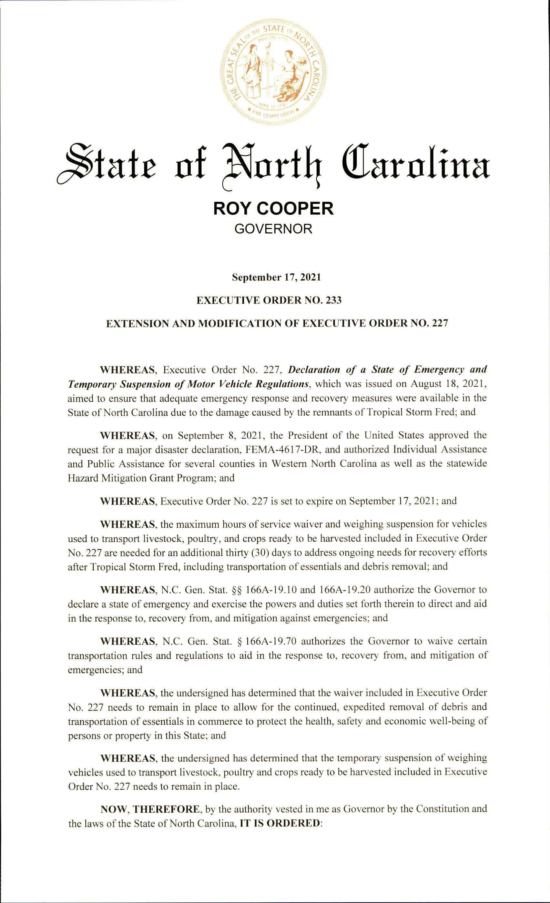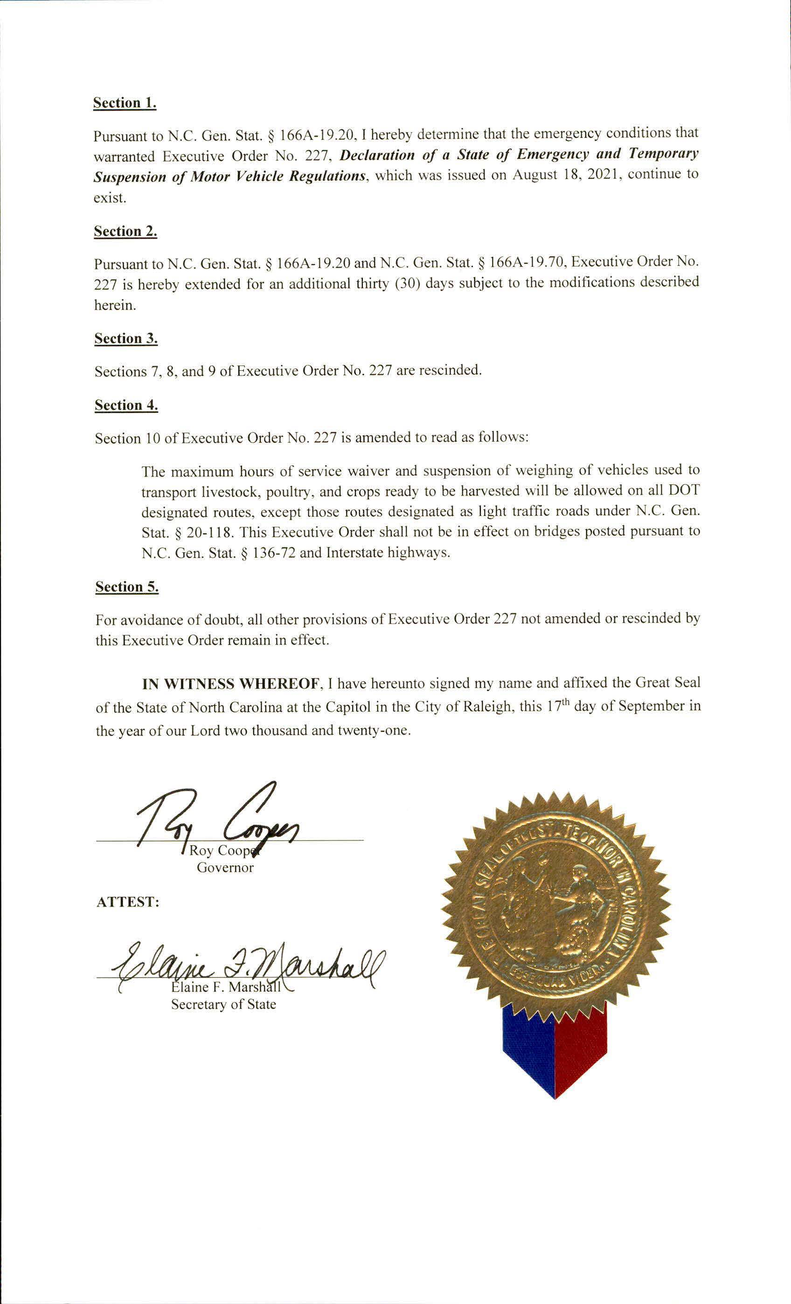
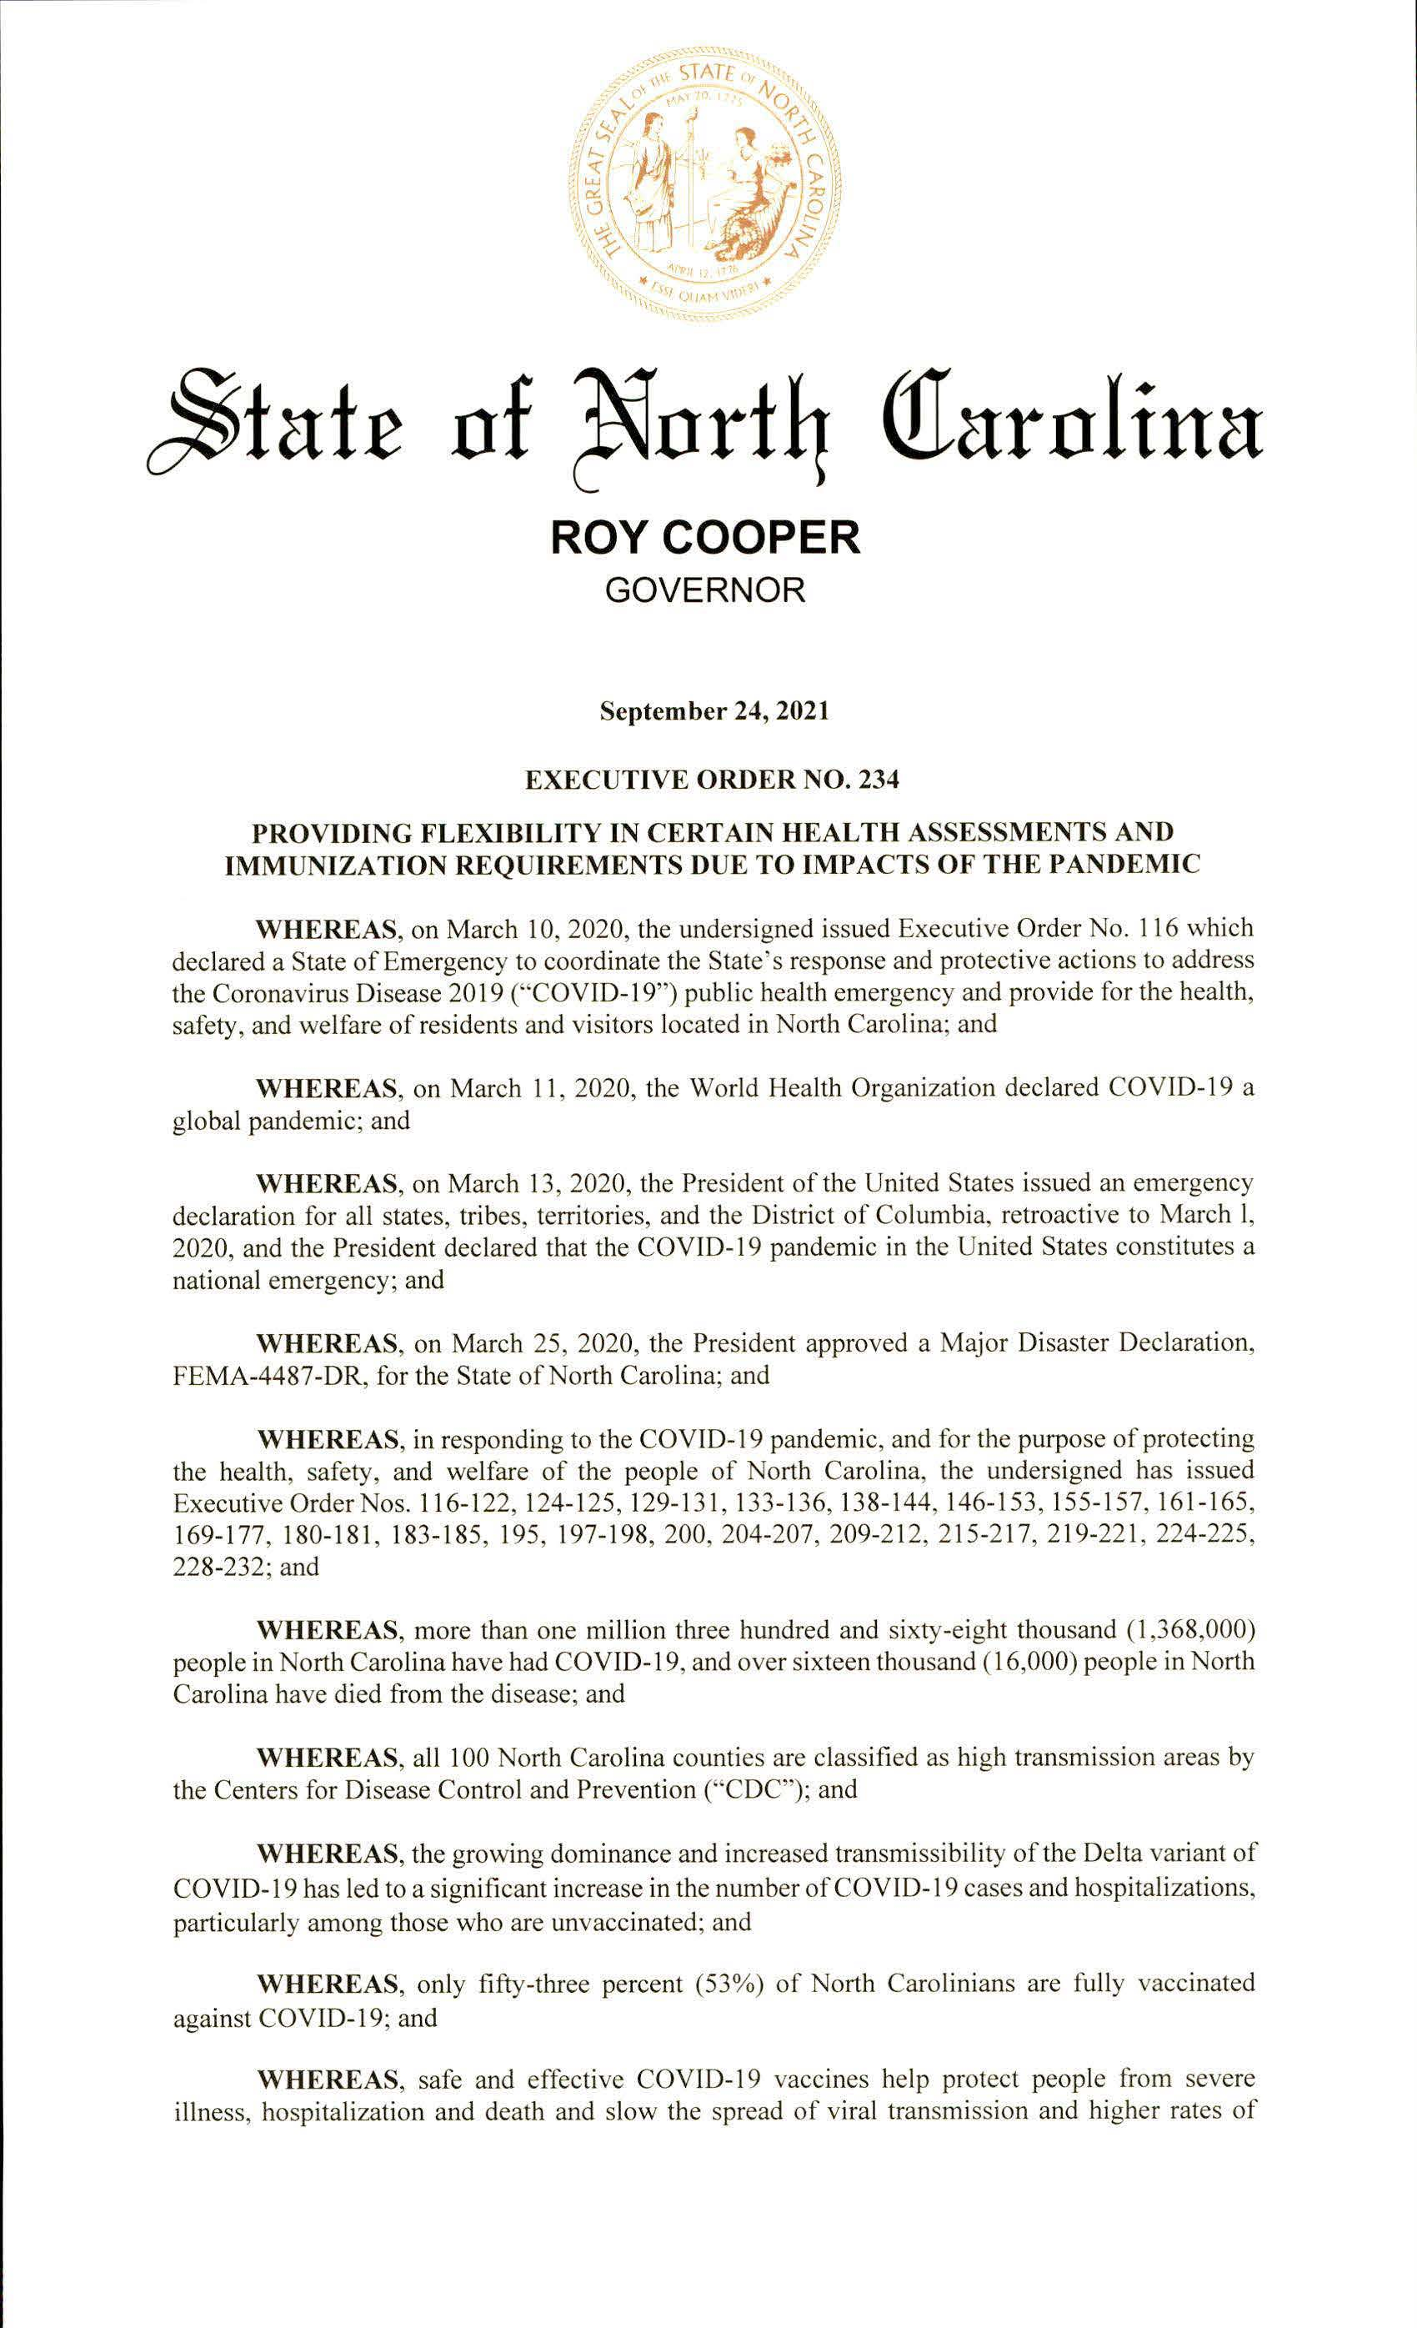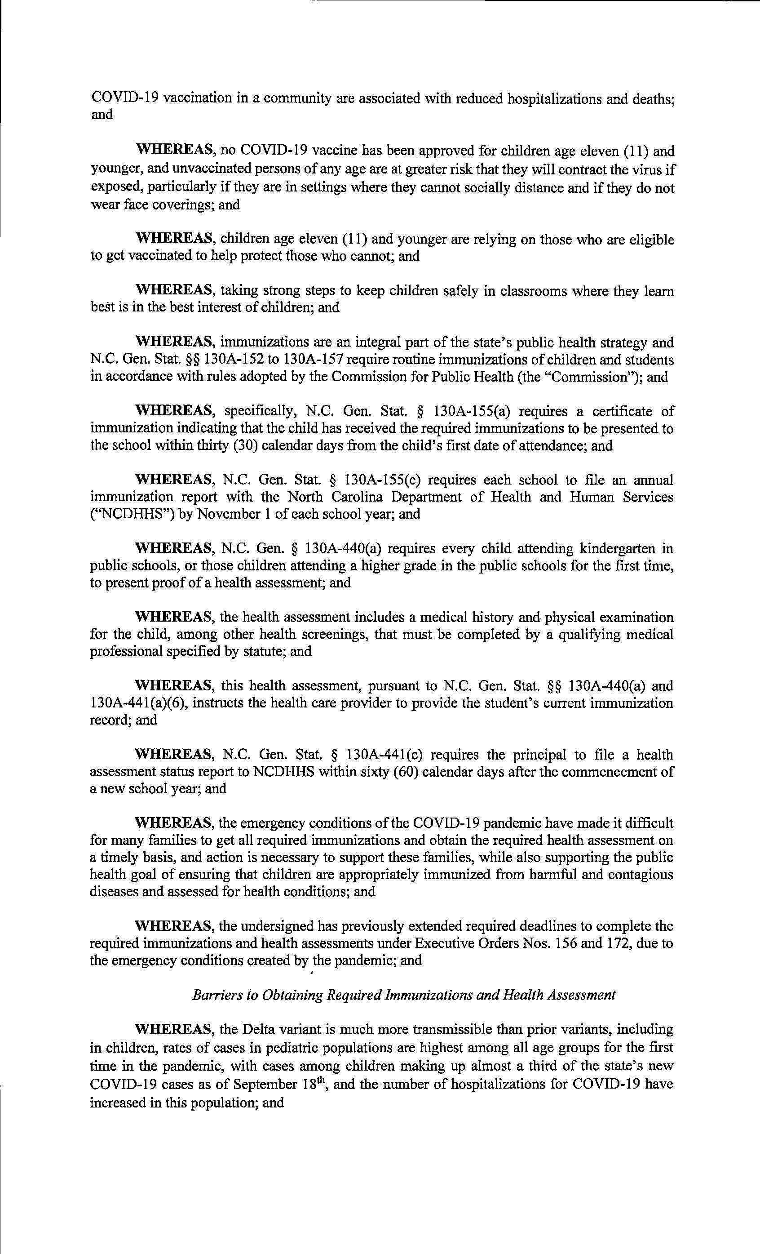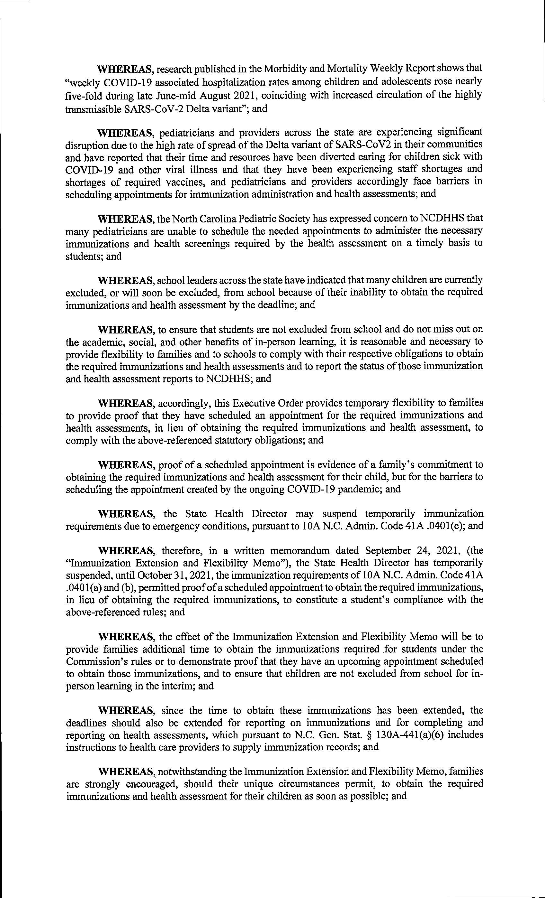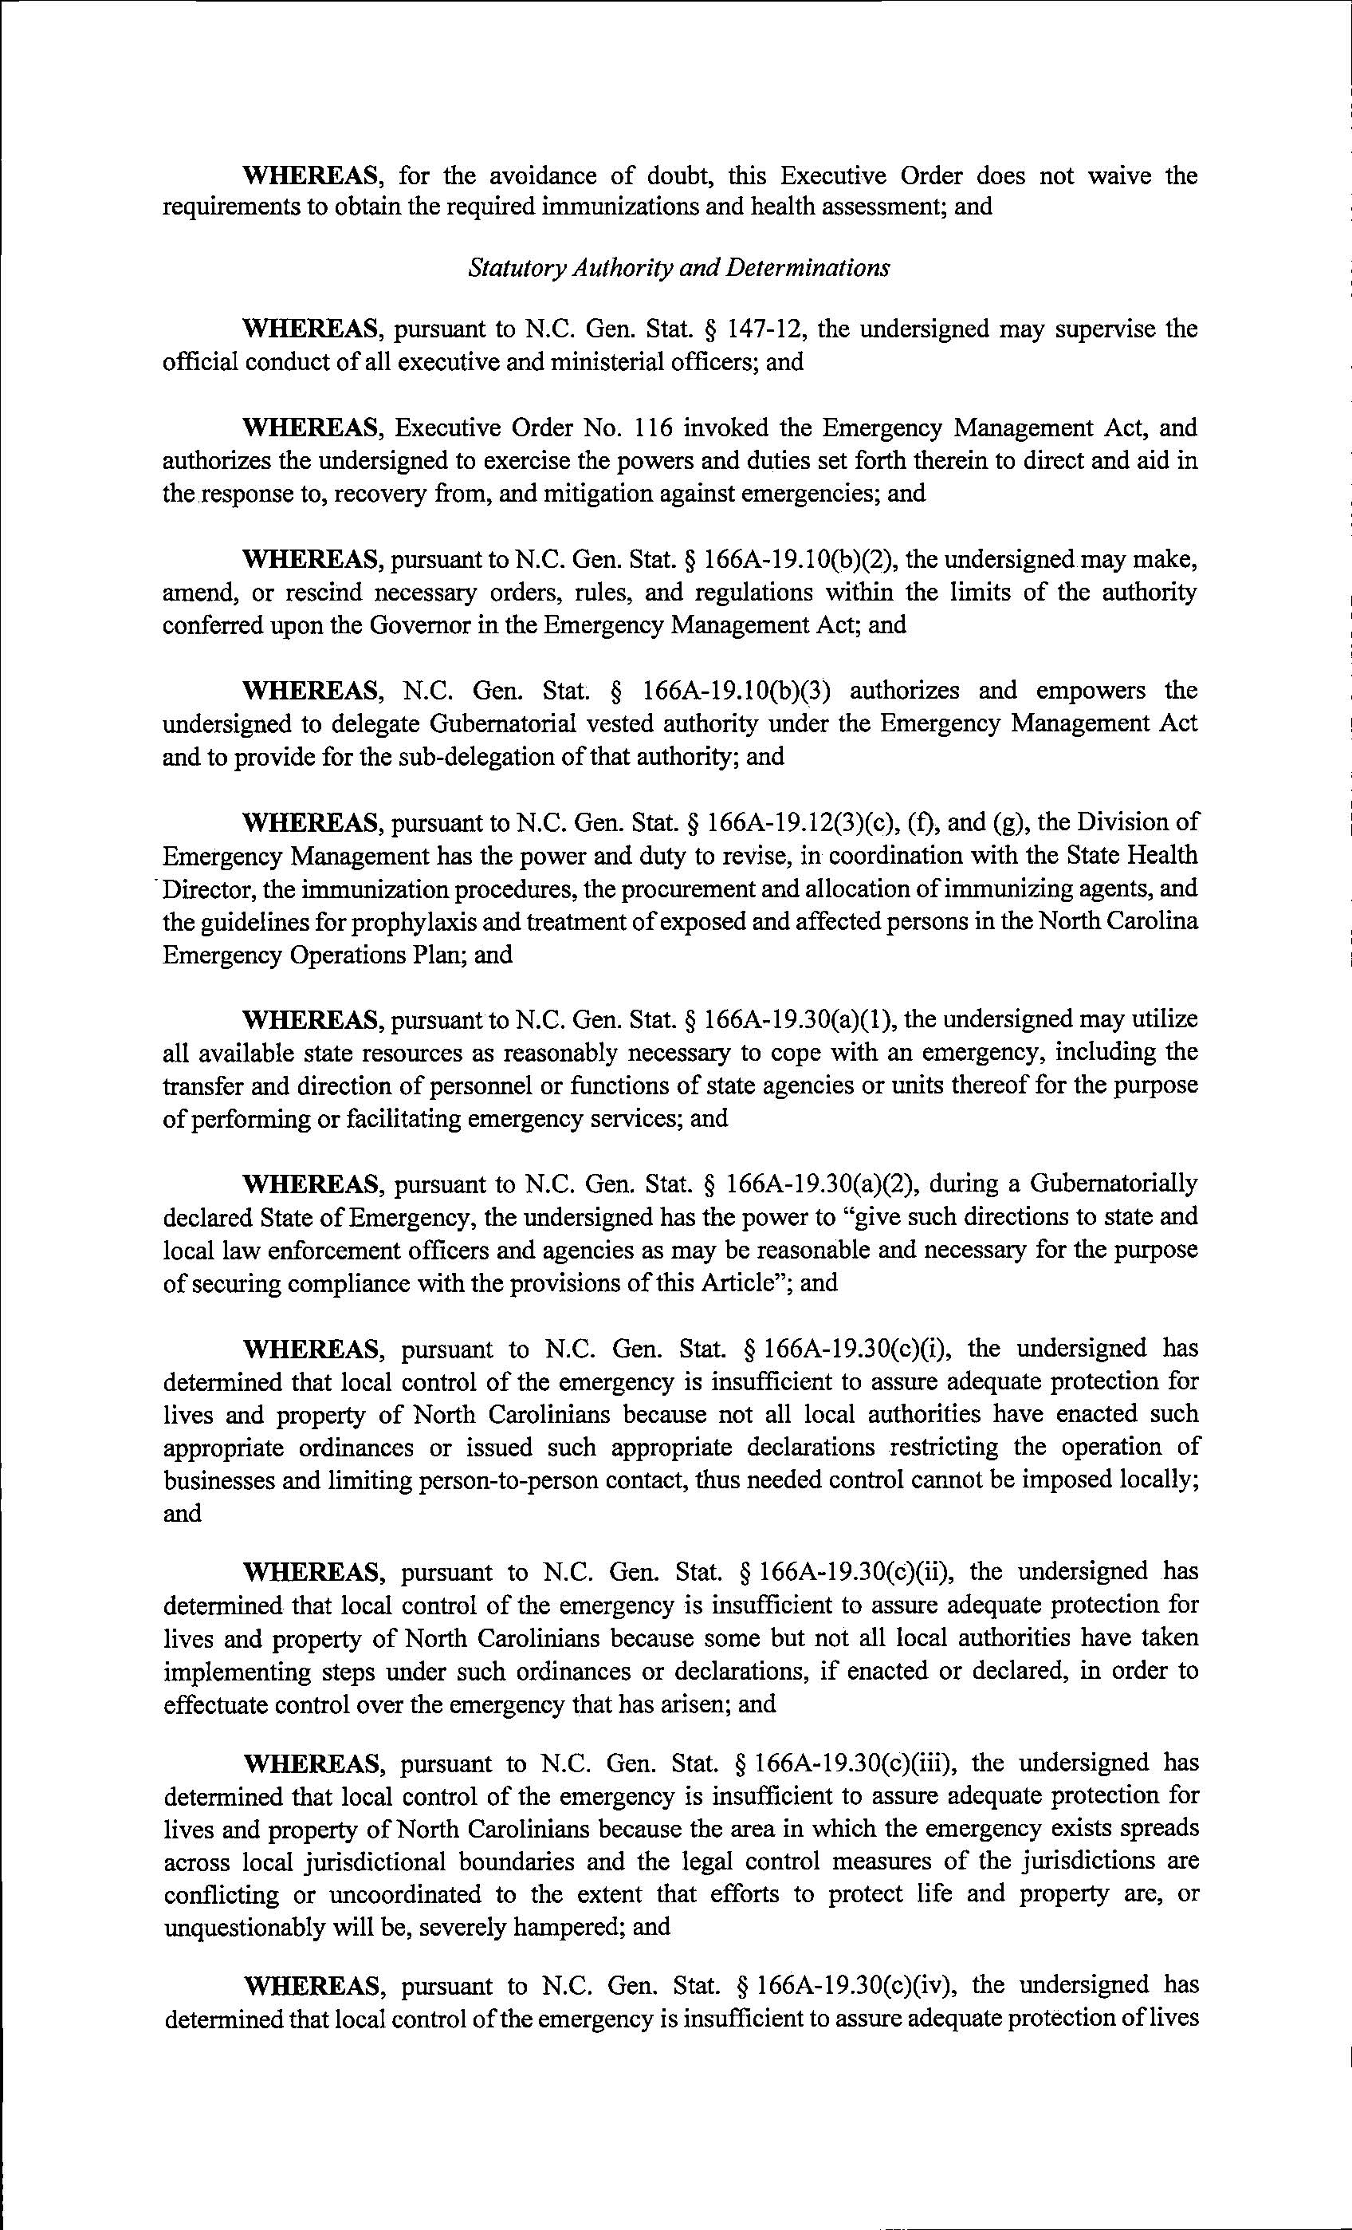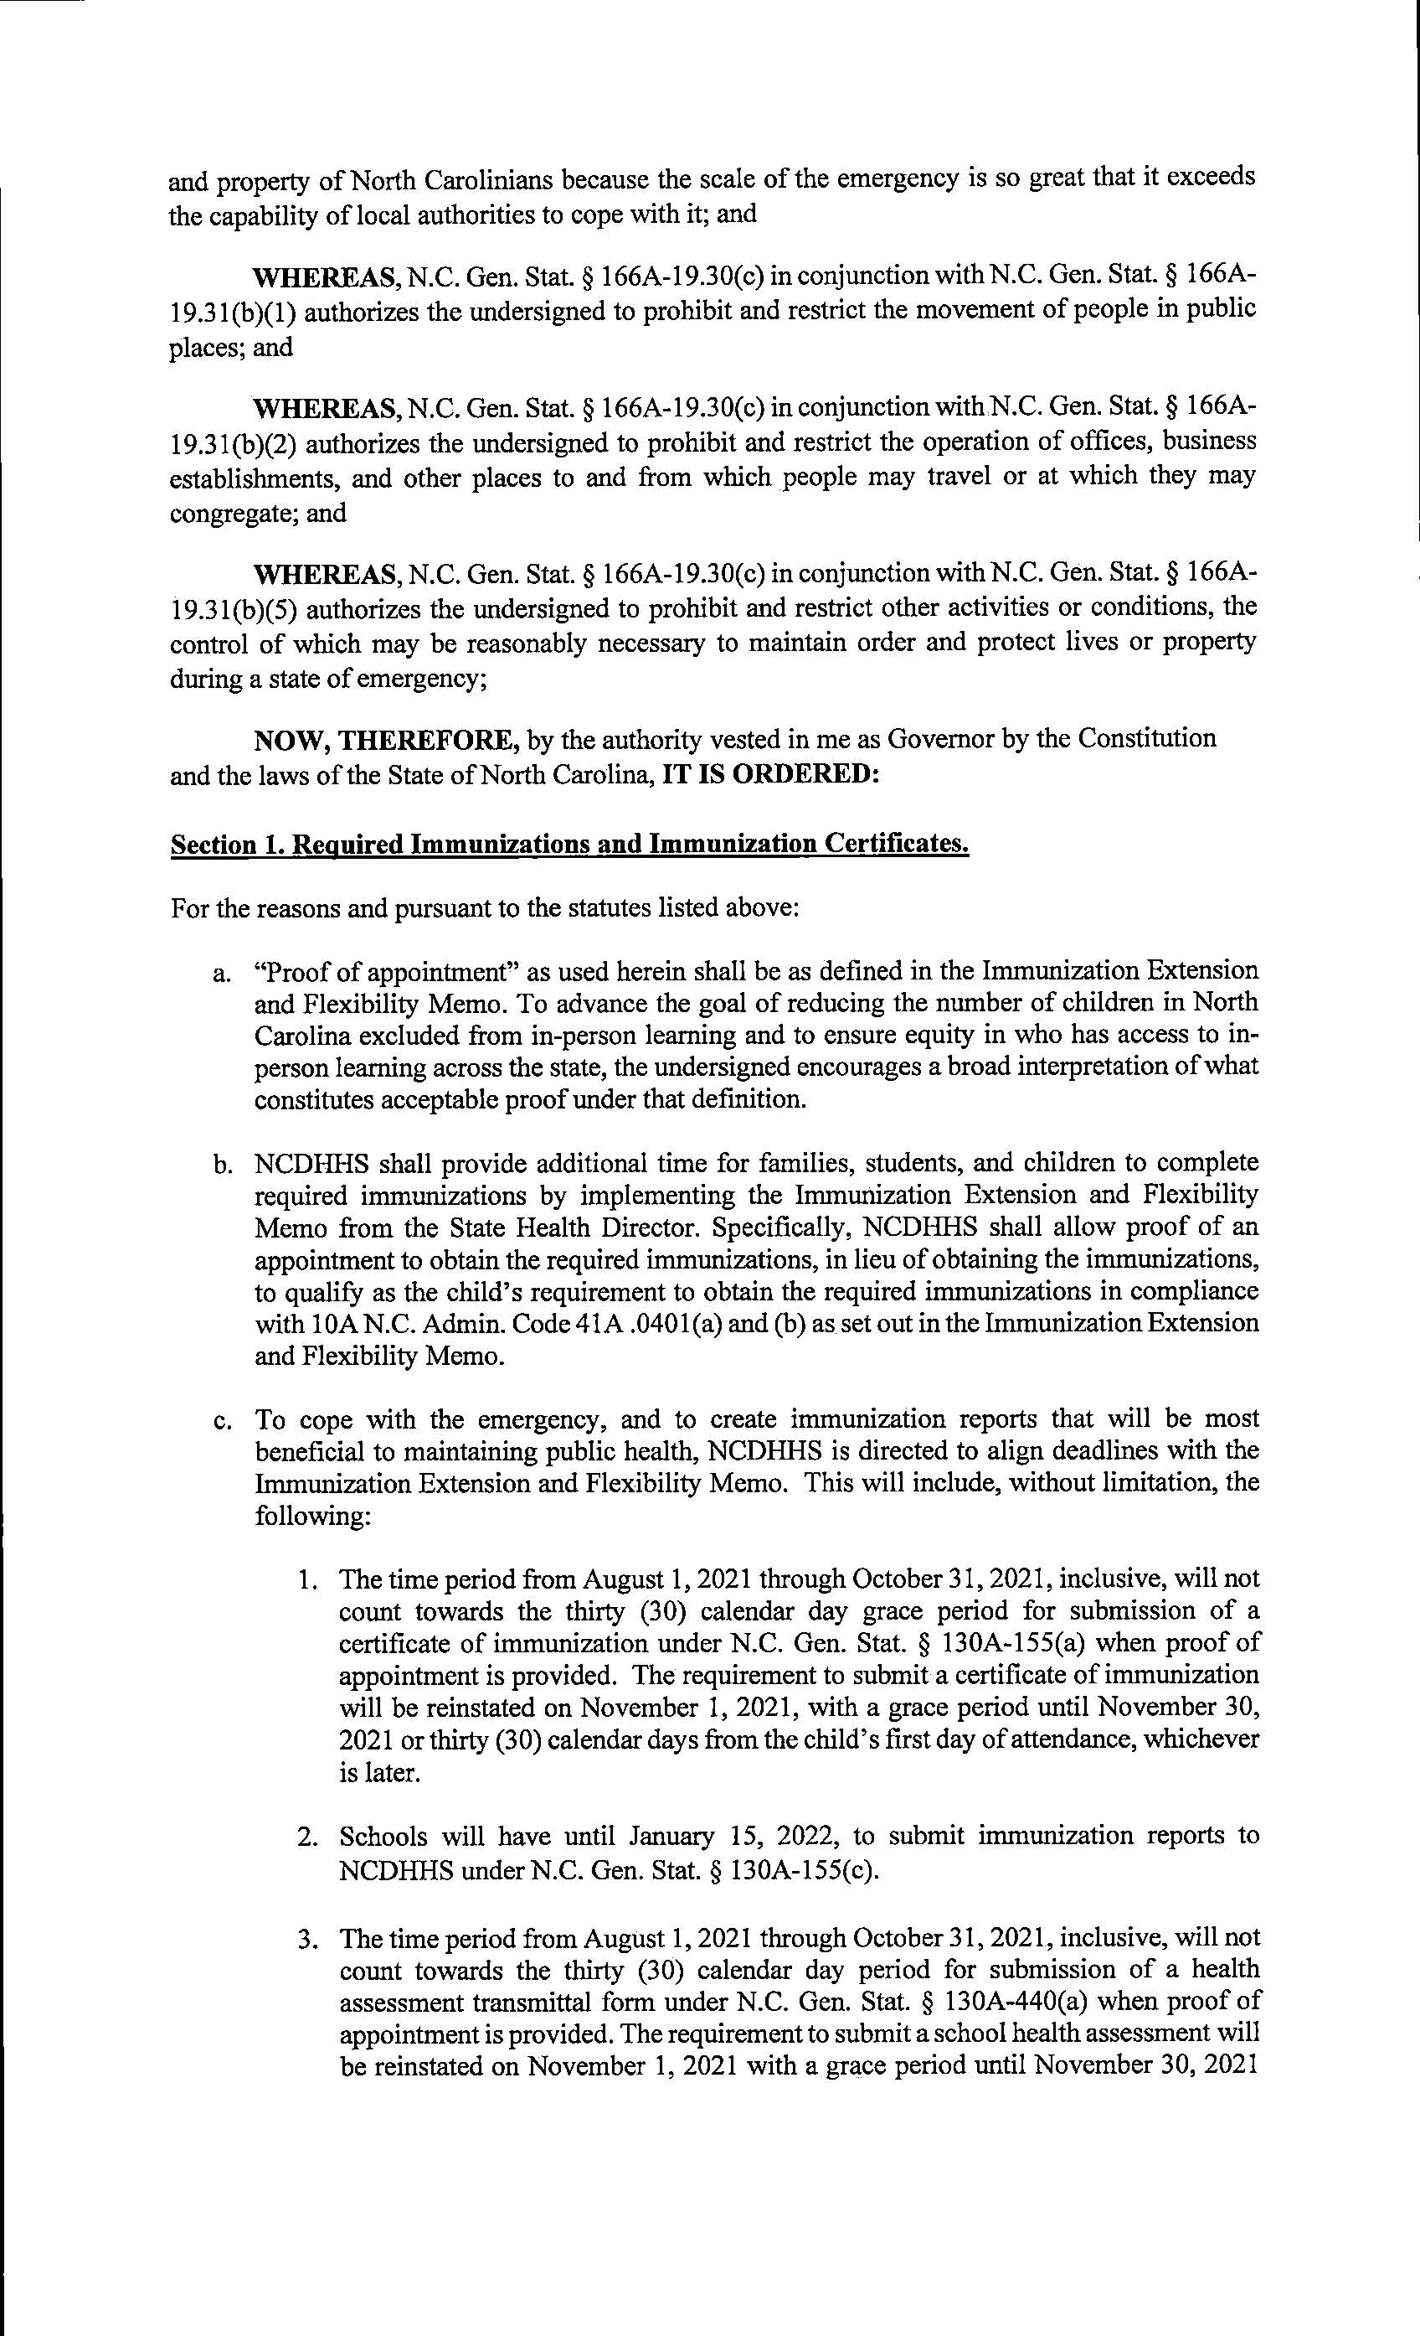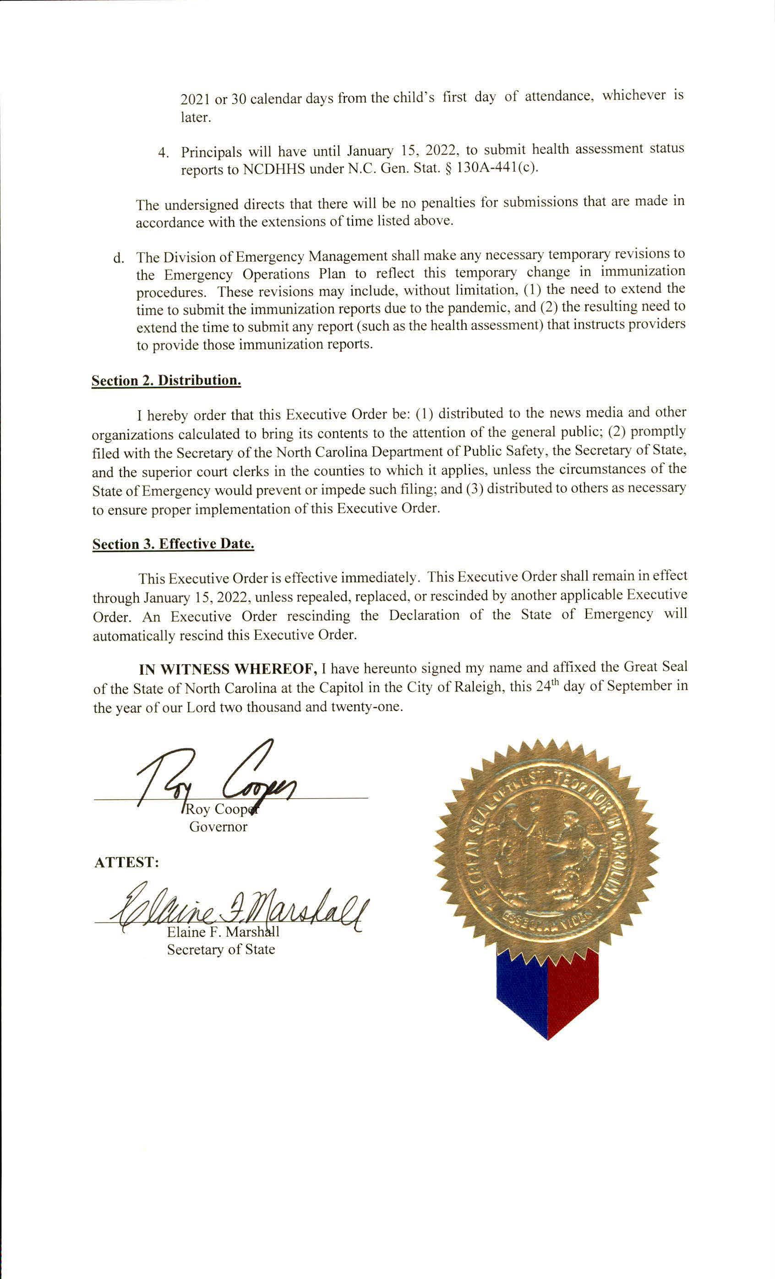

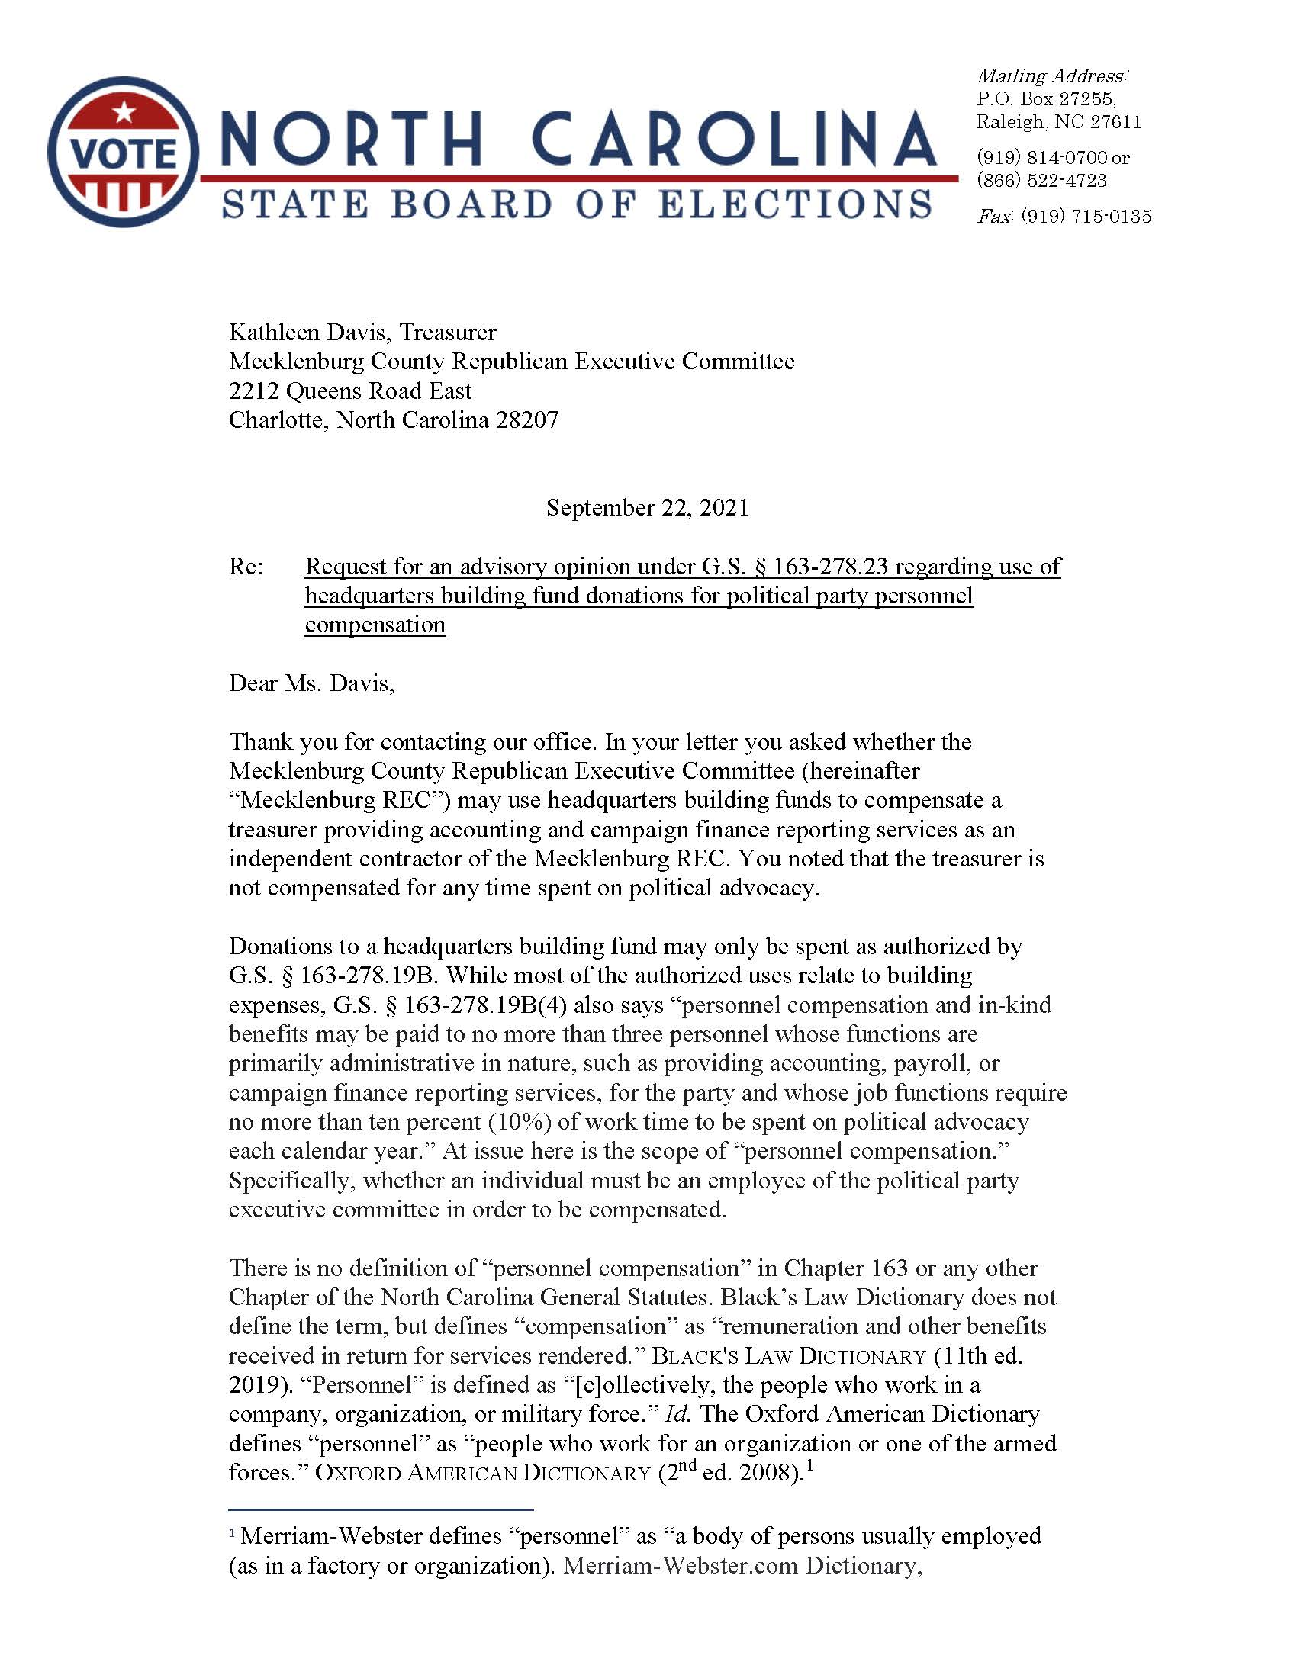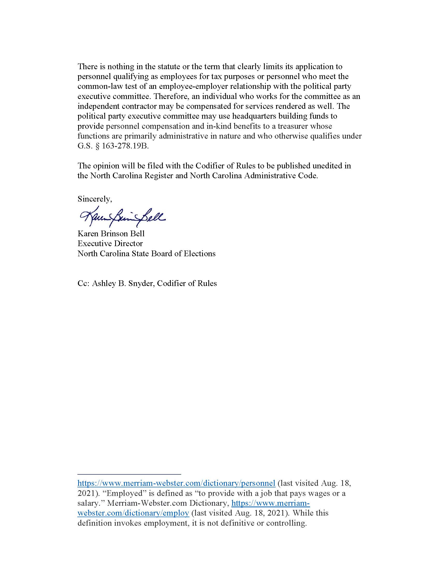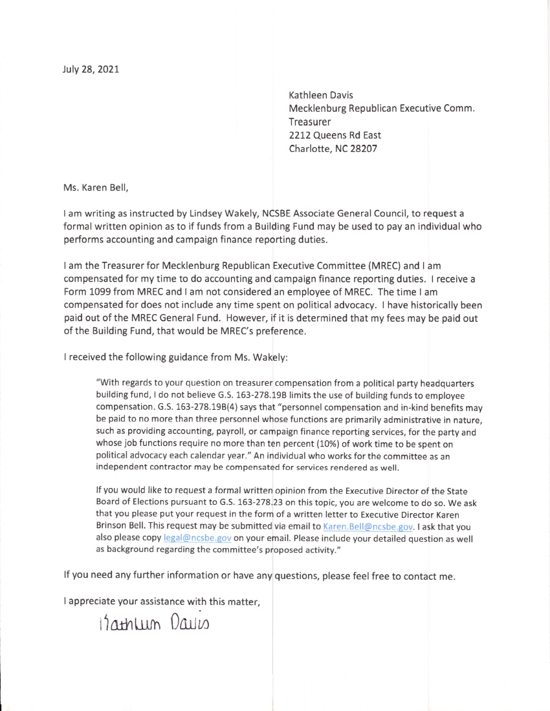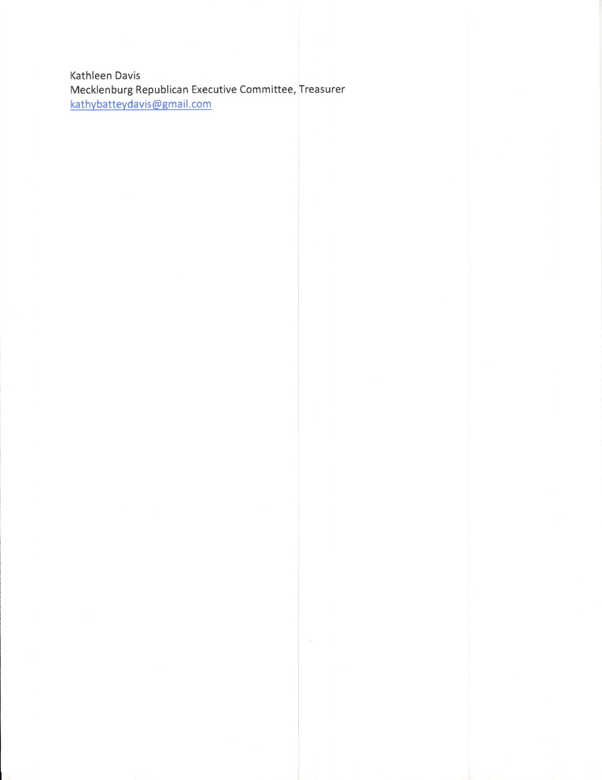

Notice of Application for a new Innovative Approval of a Wastewater System for On-site Subsurface Use

Pursuant to NCGS 130A-343(g), the North Carolina Department of Health and Human Services (DHHS) shall publish a Notice in the NC Register that a manufacturer has submitted a request for approval of a wastewater system, component, or device for on-site subsurface use. The following applications have been submitted to DHHS:

Application by: Tom Loughlin
Cur-Tech Systems DBA GoodFlow Solutions
23 Ryan St
Stamford, CT 06907

For: New Innovative Approval for CTL 12 and CTL 18 Chamber Trench Systems

Application by: Trey Johnson
Ecological Tanks, Inc
2247 Hwy 151 North
Downsville, LA 71234

For: New Innovative Approval for AquaSafe Wastewater Treatment System

DHHS Contact: Jon Fowlkes

1-919-707-5875

Fax: 919-845-3973

jon.fowlkes@dhhs.nc.gov

These applications may be reviewed by contacting the applicant or Jon Fowlkes, Branch Head, at 5605 Six Forks Rd, Raleigh, NC, On-Site Water Protection Branch, Environmental Health Section, Division of Public Health. Draft proposed innovative approvals and proposed final action on the application by DHHS can be viewed on the On-Site Water Protection Branch web site: http://ehs.ncpublichealth.com/oswp/.

Written public comments may be submitted to DHHS within 30 days of the date of the Notice publication in the North Carolina Register. All written comments should be submitted to Mr. Jon Fowlkes, Branch Head, On-site Water Protection Branch, 1642 Mail Service Center, Raleigh, NC 27699-1642, jon.fowlkes@dhhs.nc.gov, or fax 919-845-3973. Written comments received by DHHS in accordance with this Notice will be taken into consideration before a final agency decision is made on the innovative subsurface wastewater system application.

Note from the Codifier: The notices published in this Section of the NC Register include the text of proposed rules. The agency must accept comments on the proposed rule(s) for at least 60 days from the publication date, or until the public hearing, or a later date if specified in the notice by the agency. If the agency adopts a rule that differs substantially from a prior published notice, the agency must publish the text of the proposed different rule and accept comment on the proposed different rule for 60 days.
Statutory reference: G.S. 150B-21.2.

Title 15A – Department of Environmental Quality

Notice is hereby given in accordance with G.S. 150B-21.3A(c)(2)g. that the Department of Environmental Quality intends to readopt with substantive changes the rules cited as 15A NCAC 01C .0101, .0103-.0109, .0206-.0208, .0305, .0306, .0405-.0411 and repeal through readoption the rules cited as 15A NCAC 01C .0205 and .0304.

Link to agency website pursuant to G.S. 150B-19.1(c): https://deq.nc.gov/permits-regulations/rules-regulations/proposed-main/proposed-rules

Proposed Effective Date: March 1, 2022

Public Hearing:
Date: December 2, 2021
Time: 5:00 p.m.
Location:
WebEx link:
https://ncdenrits.webex.com/ncdenrits/onstage/g.php?MTID=efa9744ccc8b4b8711e6ffe493ca18a2b
WebEx password: NCDEQ

Audio Conference: 1-415-655-0003
Audio Conference Access code: 2437 801 8812

If you wish to speak at the virtual public hearing, you must register before noon on December 2, 2021. To register, please use the following link: https://forms.office.com/g/ESsj4Jzfkq or QR Code:



Reason for Proposed Action: G.S. 150B-21.3A requires state agencies to review existing rules every ten years, determine which rules are still necessary, and either readopt or repeal each rule. Two rules are proposed for repeal. 15A NCAC 01C .0205 is proposed for repeal because the content of the first sentence is being moved to 15A NCAC 01C .0109 and the second sentence was duplicative of language that was in and continues to be in 15A NCAC 01C .0109. 15A NCAC 01C .0304 is proposed for repeal because the significance of the minimum criteria and its relationship to the statutory thresholds is more completely described in 15A NCAC 01C .0206, .0306, and .0405. The remaining rules are proposed for readoption and all proposed revisions are technical in nature for the purpose of providing clarity, updating agency names, recognizing that some divisions are no longer within DEQ, reducing redundancy with other State regulations, and updating language to reflect changes to North Carolina General Statutes.

Comments may be submitted to: Jennifer Everett, 1601 Mail Service Center, Raleigh, NC 27699-1601; email jennifer.everett@ncdenr.gov

Comment period ends: December 14, 2021

Procedure for Subjecting a Proposed Rule to Legislative Review: If an objection is not resolved prior to the adoption of the rule, a person may also submit written objections to the Rules Review Commission after the adoption of the Rule. If the Rules Review Commission receives written and signed objections after the adoption of the Rule in accordance with G.S. 150B-21.3(b2) from 10 or more persons clearly requesting review by the legislature and the Rules Review Commission approves the rule, the rule will become effective as provided in G.S. 150B-21.3(b1). The Commission will receive written objections until 5:00 p.m. on the day following the day the Commission approves the rule. The Commission will receive those objections by mail, delivery service, hand delivery, or facsimile transmission. If you have any further questions concerning the submission of objections to the Commission, please call a Commission staff attorney at 919-431-3000.

Fiscal impact. Does any rule or combination of rules in this notice create an economic impact? Check all that apply.

State funds affected

Local funds affected

Substantial economic impact (>= $1,000,000)

Approved by OSBM

No fiscal note required

Chapter 01 - Departmental Rules

SUBCHAPTER 01C - CONFORMITY WITH NORTH CAROLINA ENVIRONMENTAL POLICY ACT

section .0101 .0100 – general provisions

15A NCAC 01C .0101 STATEMENT OF PURPOSE, POLICY, AND SCOPE

(a) The purpose of the rules in this Subchapter is to establish procedures within the Department of Environment and Natural Resources (DENR) Environmental Quality (DEQ) for conforming with related to the North Carolina Environmental Policy Act (NCEPA).

(b) Rules for implementation of the NCEPA (01 NCAC 25) are hereby incorporated by including subsequent amendments and editions. Copies of these Rules can be obtained from the Department of Administration, State Clearinghouse, 1302 Mail Service Center, Raleigh, NC 27699-1302.

(c)(b) Environmental documents shall be available to public officials and citizens before decisions are made and before actions are taken. The information shall be reliable and sufficient to allow selection among alternatives.

(d)(c) The Secretary is the "responsible state official" for DENR. DEQ. The Secretary may delegate responsibility for the implementation of the NCEPA to staff.

(e)(d) The provisions of the rules in this Subchapter, the state Department of Administration's rules (01 NCAC 25), and the NCEPA shall be read together as a whole in order to comply with the spirit and letter of the law.

(f)(e) These Rules rules establish minimum criteria to determine when preparation of an environmental document is not required when DEQ is the state project agency. the procedures for determining whether an environmental document is required when DENR is the State Project Agency.

Authority G.S. 113A-2; 113A-6; 113A-9; 143B-10.

15A NCAC 01C .0103 DEFINITIONS

The definition of any word or phrase used in rules of this Subchapter is the same as given in G.S. 113A-9 113A-9. and in 1 NCAC 25, including subsequent amendments and editions. The following words and phrases have the following meaning.
(1) "Agency" means the Divisions and Offices of DENR, as well as the boards, commissions, committees, and councils of DENR having decision-making authority and adopting these rules by reference; except where the context clearly indicates otherwise.
(2)(1) "Channel Disturbance" means activities that permanently remove or degrade the natural functions of the stream such as culverting, relocation, channelization or streambank stabilization methods including gabions, rip rap or similar hard structures.
(3)(2) "Cumulative Impacts" mean means environmental impacts resulting from incremental effects of an activity when added to other past, present, and reasonably foreseeable future activities regardless of what entities undertake such other actions. Cumulative impacts are the reasonably foreseeable impacts from individually minor but collectively significant activities.
(4)(3) "Direct Impacts" mean environmental impacts which are caused by an activity and occurring at the same time and place.
(5)(4) "Disposal" means the discharge, deposit, injection, dumping, spilling, leaking or placing of any waste into or on any land or water so that the waste or any constituent part of the waste may enter the environment or be emitted into the air or discharged into any waters, including groundwaters, or beneath or on the surface of the land.
(6)(5) "Ecosystem" means all the interrelated organisms and their environment within a defined area.
(7)(6) "Forestry Management Plan" means a document that guides the practical and sustainable application of biological, physical, quantitative, managerial, economic, social and policy principles to the regeneration, management, utilization and conservation of forests to meet specified goals and objectives while maintaining the productivity of the forest. Forest management includes management for aesthetics, fish, recreation, urban values, water, wilderness, wildlife, wood products and other forest resource values.
(8)(7) "Hazardous Waste" means a waste, or combination of wastes, in any state or form including gas, liquid or solid, that because of its quantity, concentration or physical, chemical or infectious characteristics may cause or contribute to an increase in mortality or an increase in irreversible or incapacitating reversible illness, or pose a present or potential hazard to human health or the environment when improperly treated, stored, transported, disposed of or otherwise managed.
(9)(8) "High Quality Waters (HQW)" has the same meaning as in 15A NCAC 02B .0224. means a subset of waters with quality higher than the existing classification standards. These include those rated as excellent based on biological and physical/chemical characteristics through Division of Water Quality monitoring or special studies; native and special native trout waters (and their tributaries) designated by the Wildlife Resources Commission; primary nursery areas (PNA) designated by the Marine Fisheries Commission and other functional nursery areas designated by the Marine Fisheries Commission; all water supply watersheds which are either classified as WS-I or WS-II or those for which a formal petition for reclassification as WS-I or WS-II has been received from the appropriate local government and accepted by the Division of Water Quality; and all Class SA waters.
(10)(9) "Inlet" means a waterway between islands connecting a lagoon, estuary, sound or similar water body with the ocean.
(11)(10) "Instream Flow" means the amount of water needed in a stream to adequately provide for downstream uses occurring within the stream channel, including some or all of the following: aquatic habitat, recreation, wetlands maintenance, navigation, hydropower, riparian vegetation, and water quality.
(12)(11) "Land-Disturbing Activity" has the same meaning as in G.S. 113A-52. means any use of the land by any person in residential, industrial, educational, institutional or commercial development, highway and road construction and maintenance that results in a change in the natural cover or topography and that may cause or contribute to sedimentation.
(13) "Lead Agency" means the agency or agencies preparing or having taken primary responsibility for preparing an environmental document. The lead agency is a sub-agency of the state project agency.
(14) "Non-State Entity" means local governments, special purpose units of government, contractors, and individuals or corporations to whom NCEPA may apply.
(12) "Lead Division" means the division within DEQ that has been appointed by the Secretary, pursuant to 15A NCAC 01C .0105, to have primary responsibility for preparation of an environmental document when DEQ is the state project agency.
(15)(13) "Perennial Stream" means a channel that contains water year round during a year of normal rainfall with the aquatic bed located below the water table for most of the year. Groundwater is the primary source of water for a perennial stream, but it also carries stormwater runoff. A perennial stream exhibits the typical biological, hydrological, and physical characteristics commonly associated with the continuous conveyance of water.
(16)(14) "Prime agricultural and forest land" means lands which that possess the best combination of physical and chemical characteristics for producing food, feed, fiber (including forest products), forage, oilseed, and other agricultural products (including livestock), without intolerable soil erosion. This does not apply to lands which that are already in or committed to development projects such as water impoundment, transportation, and urban development.
(17)(15) "Reclaimed Water Utilization" means the use of reclaimed water that meets the criteria provided in 15A NCAC 02H .0219(k) for beneficial uses in lieu of water from other sources. "Reclaimed Water" has the same meaning as in 15A NCAC 02U .0103.
(18)(16) "Resource" means any natural product or value, not necessarily economic, but including trees, minerals, wildlife, clean air and water, fisheries, ecosystems, landscapes and open space.
(19)(17) "River Basin" means the watershed of a major river system.
(20)(18) "Secondary Impacts" mean indirect impacts caused by and resulting from a specific activity that occur later in time or further removed in distance than direct impacts, but are reasonably foreseeable. Indirect impacts may include growth inducing effects and other effects related to induced changes in the pattern of land use, population density or growth rate, and related effects on air and water and other natural systems, including ecosystems.
(21)(19) "Secretary" means the Secretary of DENR. DEQ.
(22)(20) "State Project Agency" means the state department or council of state agency which that has been designated pursuant to 1 01 NCAC 25 .0210(a) for ensuring compliance with NCEPA.
(23)(21) "Stream Enhancement" means the process of implementing stream rehabilitation practices in order to improve water quality or ecological function. These practices are typically conducted on the stream bank or in the flood prone area. Enhancement activities may also include the placement of in-stream habitat structures.
(24)(22) "Stream Restoration" means the process of converting an unstable, altered or degraded stream corridor, including adjacent riparian zone and flood prone areas to its natural or referenced, stable conditions considering recent and future watershed conditions. This process also includes restoring the geomorphic dimension, pattern and profile as well as biological and chemical integrity, including transport of water and sediment produced by the stream's watershed in order to achieve dynamic equilibrium.
(25)(23) "Total Design Withdrawal" means the pumping rate at which water can be removed from the contributing stream. It is the sum of any pre-existing withdrawal capacity plus any withdrawal increase.
(26)(24) "Wetlands" mean "wetlands" as defined has the same meaning as in 15A NCAC 02B .0202.

Authority G.S. 113A-2; 113A-6; 113A-9; 143B-10.

15A NCAC 01C .0104 AGENCY COMPLIANCE

(a) Each DENR agency DEQ shall interpret the provisions of the NC EPA NCEPA as a supplement to its existing authority and as a mandate to view its policies and programs in the light of the NC EPA's NCEPA's comprehensive environmental objectives. objectives, except where existing law applicable to the DENR agency's DEQ's operations expressly prohibits compliance or makes compliance impossible.

(b) As part of making a decision on a project for which an environmental document has been prepared, the DENR agency decision-maker DEQ shall review the document and incorporate it as part of continuing deliberations. The resulting decision shall be made after weighing all of the impacts and mitigation measures presented in the environmental document, which shall become part of the decision-making record.

Authority G.S. 113A-2; 113A-5; 113A-6; 113A-10; 143B-10.

15A NCAC 01C .0105 LEAD AND COOPERATING AGENCY DivisionS RESPONSIBILITY

Where DENR DEQ is the State Project Agency state project agency and more than one of its divisions DENR agency must issue a permit or other authorization for the project requiring review under NCEPA, the Secretary shall appoint a lead division DENR agency to be responsible for issuance preparation of the environmental document. The lead and cooperating DENR agencies' divisions' responsibilities shall be established by the Secretary.

Authority G.S. 113A-2; 113A-4; 113A-6; 113A-7; 143B-10.

15A NCAC 01C .0106 SCOPING AND HEARINGS

DENR agencies When DEQ is the state project agency, DEQ shall utilize scoping and hearing processes in their NCEPA activities to the extent appropriate to the complexity, potential for environmental effects, and level of expressed interest associated with the proposed activity. action. Scoping and hearing processes are public processes designed to determine the types of environmental issues to be addressed in environmental documents. They are open processes intended to obtain the view of other agencies and the public in order for state agencies to make informed decisions.

Authority G.S. 113A-2; 113A-4; 113A-6; 143B-10.

15A NCAC 01C .0107 LIMITATION ON ACTIONS DURING NCEPA PROCESS

(a) While work on an environmental document is in progress, no DENR agency shall undertake in the interim any action which might limit the choice among alternatives or otherwise prejudice the ultimate decision on the issue. A permit approval or other action to approve land disturbing activity or construction of part of the project or action, other than those actions necessary for gathering information needed to prepare the environmental document, limits the choice among alternatives and shall not be approved until the final environmental document for the action is published in the Environmental Bulletin pursuant to 01 NCAC 25 .0212 and adopted by the DENR agency through the procedures established by to the Department of Administration's Rules for administering NC EPA and this Subchapter of the Department's rules. If an environmental document is required under NCEPA, DEQ shall not undertake an action until the environmental document for that action is final.

(b) If a DENR agency DEQ is considering a proposed action for which an environmental document is to be or is being prepared, prepared under NCEPA, the DENR agency DEQ shall promptly notify the initiating party applicant that the DENR agency DEQ cannot take final action until the environmental documentation document is completed and available for use as a decision-making tool. The notification shall be consistent with the statutory and regulatory requirements of the DENR agency DEQ and may be in the form of a notification that the application is incomplete.

(c) When a DENR agency a program within DEQ decides that a proposed action, activity, for which state other DEQ actions are pending or have been taken, requires environmental documentation, then the DENR agency that program shall promptly notify all the other relevant DEQ programs DENR action agencies of the decision. When statutory and regulatory requirements prevent a DENR agency from suspending action, the DENR agency shall deny any action for which it determines an environmental document is necessary but not yet available as a decision-making tool.

(d) When statutory and regulatory requirements prevent DEQ from suspending action, DEQ shall deny any action for which it determines an environmental document is required under NCEPA but not yet available as a decision-making tool.

Authority G.S. 113A-2; 113A-4; 113A-6; 113A-7; 143B-10.

15A NCAC 01C .0108 EMERGENCIES

(a) Where emergency circumstances make it necessary to take an otherwise lawful action with potential environmental effects without observing the public review provisions of the NC EPA, the DENR agency taking the action shall notify the Secretary and limit actions to those necessary to control and mitigate for the immediate threat to the public health, safety, and welfare. If there is an immediate threat to public health, safety, and welfare, DEQ may take otherwise lawful actions with potential environmental effects without preparing an environmental document. In those emergency circumstances, DEQ shall limit actions to those necessary to control and mitigate for the immediate threat to the public health, safety, and welfare.

(b) DENR agencies DEQ may prepare and maintain environmental documents for repetitive emergency programs affecting the public, to review the scope of involved activities, identify specific effects to be expected, and mitigation measures that can be employed in various circumstances to assure protection of the public and long-term environmental productivity.

(c) The minimum criteria established pursuant to Section .0400 of this Subchapter or the review processes for environmental assessments or environmental impact statements set out in Rules 01 NCAC 25 .0506 and .0605, may be altered where an emergency makes it necessary to take action or control or mitigate any threat to the public health, safety and welfare caused by the emergency. Rule 01 NCAC 25 .1002 establishes the procedures to supplement the provisions of this Chapter in an emergency consistent with the policies of NC EPA.

Authority G.S. 113A-4; 113A-6; 113A-7; 143B-10.

15A NCAC 01C .0109 NON-STATE INVOLVEMENT AND CONSULTANTS PREPARATION OF ENVIRONMENTAL DOCUMENTS

(a) If a lead DENR agency requires a non-state entity to submit environmental information for use by the DENR agency in preparing an environmental document for the non-state entity's activity, then the DENR agency shall assist by outlining the types of information requested. When DEQ is the state project agency, DEQ may request information from an applicant to prepare an environmental document. The DENR agency DEQ shall independently evaluate the information provided and shall be responsible for its accuracy.

(b) When DEQ is the state project agency, an environmental document may be prepared by a consultant, including the applicant for the action's consultant. If a lead DENR agency DEQ a non-state entity allows an applicant for the action to prepare an environmental document, the lead DENR agency DEQ shall furnish guidance and participate in the preparation, and take responsibility for its scope, objectivity, content, and accuracy.

(c) An environmental document may be prepared by a consultant.

(d)(c) The Environmental Assessment Guidance Document available through the State Clearinghouse and Rules 01 NCAC 25 .0400 through .1000 offer provides guidance in preparing environmental documents.

(d) When DEQ is the state project agency, the content and finalization of an environmental document shall comply with NCEPA, DEQ's rules, and the Department of Administration's rules (01 NCAC 25).

Authority G.S. 113A-4; 113A-5; 113A-6; 113A-9; 143B-10.

section .0200 - INTEGRATION WITH AGENCY ACTIVITY

15A NCAC 01C .0205 IMPLEMENTATION

DENR agencies shall prepare environmental documents in accordance with the NC EPA, its related rules at 01 NCAC 25, and the rules in this Subchapter. As set out in Rule .0109 of this Subchapter, consultants may prepare environmental documents.

Authority G.S. 113A-2; 113A-4; 113A-5; 113A-6; 143B-10.

15A NCAC 01C .0206 WHEN TO PREPARE ENVIRONMENTAL DOCUMENTS

(a) DENR agencies shall prepare an environmental assessment in accordance with the NC EPA and the related state rules at 01 NCAC 25 for those activities described in Section .0300 of this Subchapter, and for those activities above the thresholds set in DENR's minimum criteria described in Section .0400 of this Subchapter. When an environmental document is required under NCEPA and DEQ is the state project agency, DEQ shall prepare an environmental document unless the action falls below the minimum criteria set forth in Section .0400 of this Subchapter. As described in 15A NCAC 01C .0306, the Secretary may require preparation of an environmental document that would otherwise not be required through application of DEQ's minimum criteria.

(b) An environmental assessment is not necessary if a DENR agency DEQ has decided to prepare an environmental impact statement. statement, because the scope or complexity of the activity has a clear potential for environmental effects.

(c) DENR agencies DEQ shall insure ensure that the activity that is the subject of the environmental document is properly defined. Closely connected activities should be reviewed together. Closely connected activities include:

(1) activities that automatically trigger other activities that may require environmental impact statements;

(2) activities that cannot or will not proceed unless other activities occur either previously or simultaneously; and

(3) activities that are interdependent parts of a larger plan of development and depend on the larger plan of development for justification.

Authority G.S. 113A-2; 113A-4; 113A-6; 143B-10.

15A NCAC 01C .0207 INCORPORATION BY REFERENCE

(a) DENR agencies DEQ shall incorporate material into environmental documents by reference to cut down on bulk without impeding DENR agency DEQ and public reviews of the action. The incorporated material shall be cited in the document and its contents briefly described.

(b) Incorporated-by-reference material must shall be made available by the applicant for inspection by reviewers and potentially interested persons within the time allowed for comment.

Authority G.S. 113A-4; 113A-6; 113A-10; 143B-10.

15A NCAC 01C .0208 INCOMPLETE OR UNAVAILABLE INFORMATION

(a) Where a DENR agency DEQ is evaluating significant effects upon the environment in an environmental document and there are gaps in relevant information or scientific uncertainty, the DENR agency DEQ should always shall make clear that such information is lacking or that uncertainty exists.

(b) If the information relevant to the effects is essential to a reasonable choice among alternatives and the overall costs of and time for obtaining it are not out of proportion to the potential environmental effects of the activity, the DENR agency DEQ should shall include the information in the environmental document.

(c) If the information relevant to the effects is essential to a reasoned choice among alternatives and the overall cost of and time for obtaining it are out of proportion to the potential environmental effects of the activity, or the means of obtaining it are not known (beyond the state of the art), then the DENR agency DEQ shall weigh the need for the action against the risk and severity of possible adverse impacts were the action to proceed in the face of uncertainty. If the DENR agency DEQ proceeds, it shall include within the environmental document:

(1) a statement that such information is incomplete or unavailable;

(2) a statement of the relevance of the incomplete or unavailable information to evaluating reasonably foreseeable significant adverse impacts on the human environment;

(3) a summary of existing credible scientific evidence which is relevant to evaluating the reasonably foreseeable significant adverse impacts on the human environment; and

(4) the DENR agency's DEQ's evaluation of such impacts based upon theoretical approaches or research methods generally accepted in the scientific community.

(d) For the purposes of this Section, "reasonably foreseeable" includes impacts which have catastrophic consequences, even if their probability of occurrence is low, provided that the analysis of the impacts is supported by credible scientific evidence, is not based on pure conjecture, and is within the rule of reason.

Authority G.S. 113A-4; 113A-6; 143B-10.

section .0300 - PREPARATION OF ENVIRONMENTAL DOCUMENTS SPECIAL CIRUMSTANCES

15A NCAC 01C .0304 ACTIVITIES ABOVE THE MINIMUM CRITERIA

Any activity which is outside the parameters of the minimum criteria set out in Section .0400 of this Subchapter is required to have environmental documentation under the NCEPA.

Authority G.S. 113A-2; 113A-4; 113A-6; 113A-11; 143B-10.

15A NCAC 01C .0305 ACTIVITIES UNDERTAKEN BY DEQ TYPES OF ACTIVITIES REQUIRING ENVIRONMENTAL DOCUMENTATION

The following DENR agency activities activities, when undertaken by DEQ, will shall be deemed to have a potential effect upon the environment of the state and require preparation of an environmental document unless they fall under satisfy the minimum criteria set out in Section .0400 of this Subchapter.
(1) Proposed construction of facilities or infrastructures on lands and waters owned or managed by any DENR agency DEQ.
(2) Specific programs conducted by DENR agencies on lands and waters or in the atmosphere owned or managed by the state.
(3)(2) Demolition of or additions, rehabilitation and/or renovations to a structure listed in the National Register of Historic Places or more than 50 years of age except where agreement exists with the Department of Natural and Cultural Resources that the structure lacks architectural or historical significance.
(4)(3) Ground disturbances involving National Register listed archaeological sites or areas around buildings 50 years old or older, except where agreement exists with the Department of Natural and Cultural Resources.

Authority G.S. 113A-4; 113A-6; 113A-8; 113A-9; 113A-10; 143B-10.

15A NCAC 01C .0306 ACTIVITIES OF A SPECIAL NATURE

Any activity falling within the parameters of the minimum criteria set out in Section .0400 of this Subchapter shall not routinely be required to have environmental documentation under the NCEPA. However, an environmental document is required when the Secretary determines that The Secretary may require preparation of an environmental document that would otherwise not be required through application of DEQ's minimum criteria if the Secretary determines:
(1) the proposed activity may have a potential for significant adverse effects on wetlands; surface waters such as rivers, streams and estuaries; parklands; game lands; prime agricultural or forest lands; or areas of local, state or federally recognized scenic, recreational, archaeological, ecological, scientific research or historical value, including secondary impacts; or would threaten a species identified on the Department of Interior's or the state's threatened and endangered species lists; or
(2) the proposed activity could cause changes in industrial, commercial, residential, agricultural, or silvicultural land use concentrations or distributions which would be expected to create adverse water quality, instream flow, air quality, or ground water impacts; or affect long-term recreational benefits, fish, wildlife, or their natural habitats; or
(3) the proposed activity has secondary impacts, or is part of cumulative impacts, not generally covered in the approval process for the state action, and that may result in a potential risk to human health or the environment; or
(4) the proposed activity is of such an unusual nature or has such widespread implications that a concern for its environmental effects has been identified by the DENR agency DEQ or expressed to the DENR agency. DEQ.

Authority G.S. 113A-4; 113A-6; 113A-9; 113A-10; 113A-11; 113A-12; 143B-10.

SECTION .0400 — OTHER REQUIREMENTS MINIMUM CRITERIA

15A NCAC 01C .0405 PURPOSE OF THE MINIMUM CRITERIA THRESHOLDS

(a) This Section establishes minimum criteria to be used in determining when environmental documents are not required. The minimum criteria, as defined in state rules at 01 NCAC 25, shall be used by the Secretary and DENR agencies to provide sound decision-making processes by allowing separation of activities with a high potential for environmental effects from those with only a minimum potential.

(b) The minimum criteria set out in this Section are established to determine when environmental documentation under the NCEPA is not required. If NCEPA requires preparation of an environmental document and DEQ is the state project agency, the minimum criteria set forth in this Section determine when preparation of an environmental document is not required because the action or class of actions have no significant long-term impact on the environment. An activity must be at or below shall satisfy each applicable minimum criteria threshold to maintain this status. As set out in Rule .0306 of Section .0300 this Subchapter, the Secretary may require preparation of an environmental documentation document for activities that would otherwise not be required through application of DEQ's qualify under these minimum criteria. criteria thresholds.

Authority G.S. 113A-2; 113A-4; 113A-6; 113A-11; 143B-10.

15A NCAC 01C .0406 SAMPLING, SURVEY, MONITORING, AND RELATED RESEARCH ACTIVITIES

Sampling, survey, monitoring and research activities do not require the filing preparation of environmental documentation. documents. These activities include, but are not limited to the following:
(1) Aerial photography projects involving the photographing or mapping of the lands of the state;
(2) Biology sampling and monitoring of:
(a) Fisheries resources through the use of traditional commercial fishing gear, electricity, and rotenone; and
(b) Wildlife resources through the use of traditional techniques, including but not limited to traps, drugs, and firearms;
(3) Soil survey projects involving the sampling or mapping of the soils of the state;
(4) Establishing stream gaging stations for the purpose of measuring water flow at a particular site;
(5) Placement of monitoring wells for the purpose of measuring groundwater levels, quantity, or quality;
(6) Gathering surface or subsurface information on the geology, minerals, or energy resources, of the state.
(7) Placement and use of geodetic survey control points;
(8) Other routine survey and resource monitoring activities, or other temporary activities required for research into the environment which that do not have adverse effects; and
(9) Investigation and assessment of sites contaminated with regulated substances.

Authority G.S. 113A-4; 113A-6; 113A-9; 113A-10; 113A-11; 113A-12; 143B-10.

15A NCAC 01C .0407 STANDARD MAINTENANCE OR REPAIR ACTIVITIES

Standard maintenance or repair activities, if needed to maintain the originally defined function of an existing project or facility (but without expansion, increase in quantity, decrease in quality, use, or release of hazardous waste), do not require the filing preparation of environmental documents. These activities include but are not limited to maintenance and repair of the following:
(1) Housekeeping projects which that maintain a facility's original condition and physical features, including re-roofing and minor alterations where in-kind materials and techniques are used. This also encompasses structures 50 years of age and older and for which no separate law, rule, or regulation dictates a formal review and approval process;
(2) Roads, bridges, parking lots, and their related facilities;
(3) Utilities on their existing rights-of-way;
(4) Surface drainage systems;
(5) Boat ramps, docks, piers, bulkheads, rip rap, breakwaters and associated facilities;
(6) Diked, high ground dredge-material disposal areas;
(7) Activities necessary to fulfill the existing requirements of in-effect permits for the protection of the environment and human health;
(8) Other maintenance and repair activities on projects which that are consistent with previously approved environmental documents; and
(9) Routine grounds maintenance and landscaping of sidewalks, trails, walls, gates, and related facilities, including outdoor exhibits.

Authority G.S. 113A-4; 113A-6; 113A-9; 113A-10; 113A-11; 113A-12; 143B-10.

15A NCAC 01C .0408 MINOR CONSTRUCTION ACTIVITIES

This Rule sets out the general and specific minimum criteria for construction activities. Construction and land disturbing activities must fall under that satisfy both the general minimum criteria and any specific minimum criteria applicable to the project. project do not require preparation of environmental documents.
(1) General criteria. The following categories of land disturbing activity do not require preparation of an environmental document.
(a) In the 20 coastal counties, land disturbing activity that:
(i) is located more than 575 feet away from waters classified as High Quality Waters (HQW) or impacts less than five acres located all or in part within 575 feet of waters classified as High Quality Waters (HQW);
(ii) is located outside of any Outstanding Resource Waters (ORW) watershed or area that requires specific management actions to protect ORW waters as defined in 15A NCAC 02B .0225; and
(iii) impacts less than five acres located in any Outstanding Resource Waters (ORW) watershed or in any area that requires specific management actions to protect ORW waters as defined in 15A NCAC 02B .0225.
(b) Land disturbing activity outside the twenty 20 coastal counties that:
(i) is located more than one mile from waters classified as HQW or impacts less than five acres located within one mile of and draining to waters classified as HQW;
(ii) is located outside of any Outstanding Resource Waters (ORW) watershed or area that requires specific management actions to protect ORW waters as defined in 15A NCAC 02B .0225;
(iii) impacts less than five acres located in any Outstanding Resource Waters (ORW) watershed or in any area that requires specific management actions to protect ORW waters as defined in 15A NCAC 02B .0225; and
(iv) is located more than 25 feet from any waters classified as Trout (Tr) waters or impacts less than five acres located all or in part within 25 feet of any waters classified as Trout (Tr) waters.
(c) Channel disturbance and land disturbing activities associated with non-compensatory stream restoration or stream enhancement.
(d) Land disturbing activities impacting wetlands if the activity will result in the loss of one acre or less of Class WL wetlands.
(e) Land disturbing activities impacting streams if the activity will result in channel disturbance of less than 500 linear feet of perennial streams. Land disturbing activities that impact 500 linear feet or more of perennial streams do not require preparation of an environmental document if stream restoration or stream enhancement is performed.
(2) Specific Criteria. Construction or expansion activities listed below require an environmental document if they exceed either the minimum criteria set out in Item (1) of this Rule or the thresholds established below.
(a) The following activities related to wastewater treatment systems.
(i) Relocation of discharge points within the same river basin;
(ii) New discharge facilities with a proposed permitted expansion of less than 500,000 gallons per day and producing an instream waste concentration of less than 33 percent during the 7-day 10-year low flow conditions;
(iii) Expansion of an existing discharge facility of less than 500,000 gallons per day additional flow;
(iv) New surface irrigation, high rate infiltration, or subsurface waste water systems with a proposed permitted capacity not exceeding 100,000 gallons per day;
(v) Reclaimed water utilization systems with reclaimed water utilization being the sole disposal option with a proposed permitted capacity not exceeding 200,000 gallons per day;
(vi) New reclaimed water utilization sites with a proposed permitted capacity not to exceed 500,000 gallons per day when the reclaimed water utilization system is required for compliance with any other wastewater disposal permit;
(vii) New reclaimed water utilization sites with a proposed permitted capacity not to exceed 1,000,000 gallons per day when the reclaimed water utilization system is not required for compliance with any other wastewater disposal permit;
(viii) New reclaimed water utilization distribution lines;
(ix) New permits or modification to existing permits for land application of residuals utilization, where less than 10 acres not previously permitted is prior converted within three years or will be converted from a non-plantation forested area to application area;
(x) New or expanding surface disposal sites disposing less than 3000 dry tons of residuals per year;
(xi) Gravity sewer extensions with less than three miles of new lines or lines of less than 18 inches in diameter; and
(xii) New or expanding individual pump stations and associated force mains with a proposed permitted capacity of less than 1750 gallons per minute.
(b) The following activities related to potable water systems.
(i) Improvements to water treatment plants that involve less than 1,000,000 gallons per day added capacity and total design withdrawal less than one-fifth of the 7-day, 10-year low flow of the contributing stream;
(ii) Improvements not intended to add capacity to the facility;
(iii) Installation of appurtenances in existing rights-of-way for streets or utilities, or water lines and appurtenances less than five miles in length and having only directional bore stream crossings or no stream crossings; and
(iv) Construction of water tanks, or booster pumping or secondary or remote disinfection stations.
(c) Groundwater withdrawals of less than 1,000,000 gallons per day where such withdrawals are not expected to cause alterations in established land use patterns, or degradation of groundwater or surface water quality.
(d) The following activities related to solid waste disposal:
(i) Construction of solid waste management facilities, other than landfills exempt pursuant to G.S. 130A-294 (a)(4), which store, treat, process incinerate, or dispose of less than 350 tons per day (averaged over one year) of solid waste; and
(ii) Disposal of solid waste by land application on 100 total acres or less, where less than 10 percent of the total land application area is converted from a non-plantation forested area.
(e) Development requiring a Coastal Area Management Act (CAMA) permit or State Dredge and Fill Law permit that does not involve:
(i) Construction of a new marina, or a 25% or greater expansion in the number of slips at existing and operating marinas;
(ii) Excavation of a new navigation channel. Maintenance activities associated with maintaining the traditional and established use of a channel and new excavation activities located entirely within 100 feet of the shoreline, or within 50 feet from the waterward edge of any existing or authorized docking facility and involving the excavation of less than 5,000 square feet of public trust bottom do not constitute excavation of a new navigation channel for purposes of these rules.
(iii) Excavation of materials from aquatic environments for use for beach nourishment or other purposes not directly related to approved navigation projects;
(iv) A large scale beach nourishment or spoil deposition project. A project shall be considered large scale when it places more than a total volume of 200,000 cubic yards of sand at an average ratio of more than 50 cubic yards of sand per linear foot of shoreline;
(v) The salvaging of cut logs from public trust waters for commercial use, unless the salvage operation complies with any departmentally-approved best management practices developed for such activities;
(vi) The construction over state owned submerged lands of private bridges to privately owned islands, unless the length of the bridge is less than 50 feet; and
(vii) The excavation, dredging or other hydrodynamic manipulation of an inlet, inlet channel(s) or inlet shoal(s) for non-navigational purposes.
(f)(e) Construction of a minor source or modification of a minor source of air emissions as defined in 15A NCAC 02D .0530, that are less than 100 tons per year or 250 tons per year as defined therein.
(g)(f) Construction relating to the reclamation of underground storage tanks and restoration of groundwater quality.
(h)(g) The construction, repair or removal of dams less than 25 feet in height and having less than 50 acre-feet of effective storage capacity.
(i)(h) Any new construction for a building which that involves all of the following;
(i) A footprint of less than 10,000 square feet;
(ii) A location that is not a National Register Archaeological site; and
(iii) The building's purpose is not for storage of hazardous waste.
(j)(i) Demolition of or additions, rehabilitation or renovations to a structure not listed in the National Register of Historic places or less than 50 years of age.
(k)(j) Routine grounds construction and landscaping of sidewalks, trails, walls, gates and related facilities, including outdoor exhibits.
(l)(k) Installation of on-farm Best Management Practices that meet the standards of the North Carolina Soil and Water Conservation Commission and the federal Natural Resources Conservation Service.
(m)(l) Construction or remodeling of swimming pools.
(n)(m) Construction of a new two-lane road in accordance with DOT accepted design practices and DOT standards and specifications involving less than a total of 25 cumulative acres of ground surface limited to a single project, and not contiguous to any other project making use of this provision.
(o)(n) Expansion of a two-lane road in accordance with DOT accepted design practices and DOT standards and specifications involving less than a total of 10 cumulative acres of ground surface limited to a single project, and not contiguous to any other project making use of this provision.

Authority G.S. 113A-4; 113A-6; 113A-9; 113A-10; 113A-11; 113A-12; 143B-10.

15A NCAC 01C .0409 MANAGEMENT ACTIVITIES

Management activities do not require the filing preparation of environmental documents. These activities include but are not limited to the following:
(1) Replenishment of shellfish beds through the placement of seed oysters, seed clams or shellfish cultch on marine or estuarine habitats.
(2) Creation and enhancement of marine fisheries habitat through the establishment of artificial reefs in accordance with the Division of Marine Fisheries' Artificial Reef Master Plan.
(3) Placement of fish attractors and shelter in public waters managed by the N.C. Wildlife Resources Commission.
(4) Translocation and stocking of native or naturalized fish and wildlife in accordance with appropriate DENR agency DEQ species management plans, watershed management plans, or other state agency approved resource management plans.
(5) Reintroduction of native endangered or threatened species in accordance with state or federal guidelines or recovery plans.
(6) Production of native and agricultural plant species to create or enhance fish or wildlife habitat and forest resources, including fertilization, planting, mowing, and burning in accordance with fisheries, wildlife, or forestry management plans.
(7) Forest products harvest in accordance with the forestry Best Management Practices (BMPs) and the performance standards in the Forest Practice Guidelines (FPGs) Related to Water Quality (15A NCAC 01I .0201 - .0209) and the United States Forest Service or the N.C. Division of Forest Resources forest management plans.
(8) Reforestation of woodlands in accordance with the United States Forest Service or the N.C. Division of Forest Resources forest management plans.
(9) Use of forestry best management practices to meet the performance standards in Forest Practice Guidelines Related to Water Quality codified as 15A NCAC 01I.
(10) The control of forest or agricultural insects and disease outbreaks by biological treatments, mechanical treatments, or the lawful application of labeled pesticides by licensed applicators, or any combination of those practices, on areas of no more than 100 acres.
(11) Control of species composition on managed forestlands as prescribed by approved forest management plans by the lawful application of labeled herbicides by licensed applicators, on areas no more than 100 acres.
(12)(7) Control of aquatic weeds in stream channels, canals and other water bodies, by the lawful application of labeled herbicides by licensed applicators pursuant to Article 15, Chapter 113A of the NC General Statutes. applicators, on areas of no more than two acres or 25 percent of surface area, whichever is less, except in Primary Nursery Areas designated by the Marine Fisheries Commission, Inland Primary Nursery Areas designated by the Wildlife Resources Commission, and Anadromous Fish Spawning Areas designated by the Marine Fisheries Commission or the Wildlife Resources Commission.
(13)(8) Removal of logs, stumps, trees, and other debris from stream channels where there is no channel excavation, and activities are carried out in accordance with "Best Management Practices (BMPs) for Selective Clearing and Snagging," Appendix B in Incremental Effects of Large Woody Debris Removal on Physical Aquatic Habitat, US Army Corps of Engineers Technical Report EL-92-35, Smith et al, 1992, or other guidelines approved through the Intergovernmental Review process as set out at 01 NCAC 25 .0211.
(14)(9) Dredging of existing navigation channels and basins to originally approved specifications, provided that the spoil is placed in existing and approved high ground disposal areas.
(15)(10) Controlled or prescribed burning for wildlife, timber enhancement, and hazard reduction in accordance with applicable management plans.
(16)(11) Plowing fire lines with tractor plow units, or other mechanized equipment, for the purpose of suppressing wildland (brush, grass, or woodland) fires and prescribed burning.
(17)(11) Scooping or dipping water from streams, lakes, or sounds with aircraft or helicopters for the purpose of suppressing wild land (brush, grass, or woodland) fires.
(18)(12) Drainage projects where the mean seasonal water table elevation will be lowered less than one foot over an area of one square mile or less, and riparian and wetland areas will not be affected.
(19)(13) Manipulation of water levels in reservoirs or impoundments in accordance with approved management plans, for the purpose of providing for water supply storage, flood control, recreation, hydroelectric power, fish and wildlife, downstream water quality and aquatic weed control.
(20)(14) Installation of on-farm Best Management Practices that meet the standards of the North Carolina Soil and Water Conservation Commission and the federal Natural Resources Conservation Service.
(21)(15) Continuation of previously permitted activities where no increase in quantity or decrease in quality are proposed.
(22)(16) Acquisition or acceptance of real property to be retained in a totally natural condition for its environmental benefits.
(23)(17) Acquisition or acceptance of real property to be managed in accordance with plans for which environmental documents have been approved.
(24)(18) Care of all trees, plants, and groundcovers on public lands.
(25)(19) Care, including medical treatment, of all animals maintained for public display.
(26)(20) Activities authorized for control of mosquitoes such as the following:
(a) Mosquito control water management work in freshwater streams performed in accordance with "Best Management Practices (BMPs) for Selective Clearing and Snagging" Appendix B in Incremental Effects of Large Woody Debris Removal on Physical Aquatic Habitat, US Army Corps of Engineers Technical Report EL-92-35, Smith et al, 1992, or other guidelines reviewed through the Intergovernmental Review process as set out at 01 NCAC 25 .0211;
(b) Mosquito control water management work in salt marsh environments performed under Open Marsh Water Management guidelines reviewed through the Intergovernmental Review process as set out at 01 NCAC 25 .0211;
(c) Lawful application of chemicals approved for mosquito control by the United States Environmental Protection Agency and the State when performed under the supervision of licensed operators; and
(d) Lawful use of established species to control mosquitoes.

Authority G.S. 113A-4; 113A-6; 113A-9; 113A-10; 113A-11; 113A-12; 143B-10.

15A NCAC 01C .0410 PRIVATE USE OF PUBLIC LANDS

Activities related to the private use of public lands, when conducted in accordance with permit requirements, do not require the filing preparation of environmental documents. These activities include but are not limited to the following:
(1) Use of pound nets.
(2) Shellfish relaying and transplanting.
(3) Harvest of shellfish during closed season.
(4) Special fisheries management activities under 15A NCAC 03I .0012 15A NCAC 03O .0506.
(5) Aquaculture operations within coastal waters.
(6) Scientific collecting within coastal waters.
(7) Introduction and transfer of marine and estuarine organisms.
(8) Development requiring a Coastal Area Management Act (CAMA) or a State Dredge and Fill Law permit that does not involve:
(a) Construction of a new marina, or a 25% or greater expansion in the number of slips at existing and operating marinas;
(b) Excavation of a new navigation channel. Maintenance activities associated with maintaining the traditional and established use of a channel and new excavation activities located entirely within 100 feet of the shoreline, or within 50 feet from the waterward edge of any existing or authorized docking facility and involving the excavation of less than 5,000 square feet of public trust bottom do not constitute excavation of a new navigation channel for purposes of these rules.
(c) Excavation of materials from aquatic environments for use for beach nourishment or other purposes not directly related to approved navigation projects;
(d) A large scale beach nourishment or spoil deposition project. A project shall be considered large scale when it places more than a total volume of 200,000 cubic yards of sand at an average ratio of more than 50 cubic yards of sand per linear foot of shoreline;
(e) The salvaging of cut logs from public trust waters for commercial use, unless the salvage operation complies with any Departmentally approved best management practices developed for such activities;
(f) The construction over state owned submerged lands or private bridges to privately owned islands, unless the length of the bridge is less than 50 feet; and
(g) The excavation, dredging or other hydrodynamic manipulation of an inlet, inlet channel(s) or inlet shoal(s) for non-navigational purposes.
(9) Construction of piers and boat docks on all State Lakes when conducted in accordance with 15A NCAC 12C .0300.

Authority G.S. 113A-4; 113A-6; 113A-9; 113A-10; 113A-11; 113A-12; 143B-10.

15A NCAC 01C .0411 REMEDIATION ACTIVITIES

Activities that seek to clean up, remove, remediate, abate, contain or otherwise protect public health or the environment from the effect of contamination released to the environment do not require the filing preparation of environmental documentation documents.

Authority G.S. 113A-4; 113A-6; 113A-9; 113A-10; 113A-11; 113A-12; 143B-10.

* * * * * * * * * * * * * * * * * * * *

Notice is hereby given in accordance with G.S. 150B-21.2 that the Environmental Management Commission intends to adopt the rules cited as 15A NCAC 02D .1424, .1425 and amend the rules cited as 15A NCAC 02D .1401 and .1402.

Link to agency website pursuant to G.S. 150B-19.1(c): http://deq.nc.gov/about/divisions/air-quality/air-quality-rules/rules-hearing-process

Proposed Effective Date: May 1, 2022

Public Hearing:
Date: December 1, 2021
Time: 6:00 p.m.
Location: A virtual public hearing will be held by webinar as follows: WebEx Events meeting link: https://bit.ly/3oDLv7T, Event password: NCDAQ
Audio conference: To receive a call back, provide your phone number when you join the event, or call the number below and enter the access code. US TOLL +1-415-655-0003, Access code: 2438 351 6868
If you wish to speak at the digital public hearing, you must register, provide the required information, and follow instructions on ways to join the public hearing. Registration must be completed by 4:00 p.m. on December 1, 2021. To register, please go to the following link: https://bit.ly/3v0EoI9

Reason for Proposed Action: To receive comments on the adoption of the Large Non-Electric Generating Units and NOx SIP Call Budget rules and amendments to the Definition and Applicability rules. Also, to receive comment on the accompanying regulatory impact analysis for the proposed adoptions and amendments.

On March 8, 2019 (84 FR 8422), the Environmental Protection Agency (EPA) finalized the NOx SIP Alternative Monitoring Rule providing states with flexibility to allow large non-Electric Generating Units (EGU) subject to the NOx SIP Call to use monitoring methods other than a Continuous Emissions Monitoring System (CEMS) to demonstrate compliance with the state’s NOx SIP Call budget. During the 2020 rule readoption process for Group 6, the existing Paragraph (j) of 15A NCAC 02D .1404 allowed facilities to use alternative monitoring in compliance of the NOx SIP Call budget, at the time it was believed this was sufficient to comply with the EPA’s rule. Based on consultation with the EPA, the Division of Air Quality (DAQ) determined the existing Paragraph (j) of 15A NCAC 02D .1404 does not fulfill the requirements specified in the EPA’s NOx SIP Call Alternative Monitoring Rule for large non-EGUs, therefore North Carolina DAQ requested the Environmental Management Commissions (EMC) to amend existing rules (15A NCAC 02D .1401, .1402) and adopt new rules (15A NCAC 02D .1424, .1425) to fully implement the monitoring flexibility offered by EPA. On September 9, 2021 the EMC approved proceeding to public comment.

The proposed rulemaking amends the existing 15A NCAC 02D.1400 rules to incorporate the NOx SIP Call statewide ozone season budgets for EGUs and large non-EGUs to satisfy the anti-backsliding requirements of 40 CFR Part 51. Actual ozone season NOx emissions associated with the impacted EGUs and large non-EGUs are below their respective emission budgets and this action is not expected to require any additional NOx controls. It is also recommended the 15A NCAC 02D .1400 rules be revised to provide large non-EGUs subject the NOx SIP Call the option to use non-CEMS alternative methods to track NOx emissions reported to North Carolina DAQ used to demonstrate to the EPA compliance with the statewide budget. Adoption of the alternative monitoring requirements potentially reduce the regulatory burden for some owners or operators of large industrial boilers, satisfy the anti-backsliding requirements of 40 CFR Part 51 relative to the state budgets, and facilitate clean-up and synchronization of the approved state and federal requirements. Related clarifications and/or cross reference adjustments are included.

The proposed adoptions and amendments are as follows:

15A NCAC 02D .1401, Definitions. This rule is proposed for amendment to add clarity and consistency for the definitions of “EGU”, “Large non-EGU”, and “NOx SIP Call control period.”; and

15A NCAC 02D .1402, Applicability. This rule is proposed for amendment to add clarity and consistency by updating the rule references for applicability.

15A NCAC 02D .1424, Large Non-Electric Generating Units. This rule is proposed for adoption to specify the monitoring, record keeping, and reporting for permitted facilities with large non-EGUs that opt to implement alternative monitoring to the 40 CFR Part 75 monitoring requirements. The rule outlines specific methodology for facilities to implement to qualify for the alternative monitoring approach.

15A NCAC 02D .1425, NOx Call SIP Budget. This rule is proposed for adoption to directly incorporate the statewide NOx SIP Call Budgets and the reporting requirements of effected facilities with EGUs.

The text of the rules and fiscal note are available on the DAQ website: http://deq.nc.gov/about/divisions/air-quality/air-quality-rules/rules-hearing-process

Comments may be submitted to: Patrick Knowlson, 217 West Jones St., 1641 Mail Service Center, Raleigh, NC 27699-1641; voicemail (919) 707-8403; fax (919) 715-0717; email daq.publiccomments@ncdenr.gov. (Please type "Nox SIP Call" in subject line)

Comment period ends: December 14, 2021

Procedure for Subjecting a Proposed Rule to Legislative Review: If an objection is not resolved prior to the adoption of the rule, a person may also submit written objections to the Rules Review Commission after the adoption of the Rule. If the Rules Review Commission receives written and signed objections after the adoption of the Rule in accordance with G.S. 150B-21.3(b2) from 10 or more persons clearly requesting review by the legislature and the Rules Review Commission approves the rule, the rule will become effective as provided in G.S. 150B-21.3(b1). The Commission will receive written objections until 5:00 p.m. on the day following the day the Commission approves the rule. The Commission will receive those objections by mail, delivery service, hand delivery, or facsimile transmission. If you have any further questions concerning the submission of objections to the Commission, please call a Commission staff attorney at 919-431-3000.

Fiscal impact. Does any rule or combination of rules in this notice create an economic impact? Check all that apply.

State funds affected

Local funds affected

Substantial economic impact (>= $1,000,000)

Approved by OSBM

No fiscal note required

Chapter 02 - Environmental Management

SUBCHAPTER 02D - AIR POLLUTION CONTROL REQUIREMENTS

SECTION .1400 – NITROGEN OXIDES

15A NCAC 02D .1401 DEFINITIONS

(a) For the purpose of this Section, in addition to the definitions in G.S. 143-212, G.S. 143-213, and 15A NCAC 02D .0101, the following definitions shall apply. If a term in this Rule is also defined at 15A NCAC 02D .0101, then the definition in this Rule controls.

(1) "Acid Rain Program" means the federal program for the reduction of acid rain including 40 CFR Parts 72, 75, 76, and 77.

(2) "Actual emissions" means for 15A NCAC 02D .1418, emissions of NOx as measured and calculated pursuant to 40 CFR Part 75, Subpart H.

(3) "Actual heat input" means for 15A NCAC 02D .1418, heat input as measured and calculated pursuant to 40 CFR Part 75, Subpart H.

(4) "Averaging set of sources" means all the stationary sources included in an emissions averaging plan pursuant to 15A NCAC 02D .1410.

(5) "Averaging source" means a stationary source that is included in an emissions averaging plan pursuant to 15A NCAC 02D .1410.

(6) "Boiler" means an enclosed fossil or other fuel-fired combustion device used to produce heat and to transfer heat to recirculating water, steam, or other medium.

(7) "Combined cycle system" means a system consisting of one or more combustion turbines, heat recovery steam generators, and steam turbines configured to improve overall efficiency of electricity generation or steam production.

(8) "Combustion turbine" means an enclosed fossil or other fuel-fired device that is comprised of a compressor, a combustor, and a turbine, and in which the flue gas resulting from the combustion of fuel in the combustor passes through the turbine, rotating the turbine.

(9) "Diesel engine" means a compression ignited two- or four-stroke engine in which liquid fuel injected into the combustion chamber ignites when the air charge has been compressed to a temperature sufficiently high for auto-ignition.

(10) "Dual fuel engine" means a compression ignited stationary internal combustion engine that is burning liquid fuel and gaseous fuel simultaneously.

(11) "EGU" or electric generating unit means a stationary, fossil fuel-fired boiler or combustion turbine that serves a generator with a nameplate capacity greater than 25 MWe producing electricity for sale at any time, except a large non-EGU.

(11)(12) "Emergency generator" means a stationary internal combustion engine used to generate electricity only during:
(A) the loss of primary power at the facility that is beyond the control of the owner or operator of the facility; or
(B) maintenance when maintenance is being performed on the power supply to equipment that is essential in protecting the environment or to such equipment itself.
An emergency generator may be operated periodically to ensure that it will operate.

(12)(13) "Emergency use internal combustion engines" means stationary internal combustion engines used to drive pumps, aerators, and other equipment only during:
(A) the loss of primary power at the facility that is beyond the control of the owner or operator of the facility; or
(B) maintenance when maintenance is being performed on the power supply to equipment that is essential in protecting the environment or to such equipment itself.
An emergency use internal combustion engine may be operated periodically to ensure that it will operate.

(13)(14) "Excess emissions" means an emission rate that exceeds the applicable limitation or standard; for the purposes of this definition, NOx emitted by a source regulated by 15A NCAC 02D .1418 during the ozone season above its allocation are not considered excess emissions.

(14)(15) "Fossil fuel fired" means:
(A) For sources that began operation before January 1, 1996, where fossil fuel combusted either alone or in combination with any other fuel, comprises more than 50 percent of the annual heat input on a Btu basis during 1995, or, if a source had no heat input in 1995, during the last year of operation of the unit before 1995;
(B) For sources that began operation on or after January 1, 1996 and before January 1, 1997, where fossil fuel combusted either alone or in combination with any other fuel, comprises more than 50 percent of the annual heat input on a Btu basis during 1996; or
(C) For sources that began operation on or after January 1, 1997:
(i) Where fossil fuel combusted either alone or in combination with any other fuel, comprises more than 50 percent of the annual heat input on a Btu basis during any year; or
(ii) Where fossil fuel combusted either alone or in combination with any other fuel, is projected to comprise more than 50 percent of the annual heat input on a Btu basis during any year, provided that the unit shall be "fossil fuel-fired" as of the date, during such year, on which the source begins combusting fossil fuel.

(15)(16) "Indirect-fired process heater" means an enclosed device using controlled flame where the device's primary purpose is to transfer heat by indirect heat exchange to a process fluid, a process material that is not a fluid, or a heat transfer material, instead of steam, for use in a process.

(17) "Large non-EGU" or large non-electric generating unit means a stationary fossil fuel fired boiler or combustion turbine with a maximum heat input greater than 250 MMBtu/hr which was permitted before October 31, 2000 that either:
(A) does not serve at any time a generator producing electricity for sale; or
(B) serves at any time a generator producing electricity for sale and qualifies under 40 CFR 72.6(b)(4), that addresses certain cogeneration facilities, as an unaffected unit for purposes of the Acid Rain Program.

(16)(18) "Lean-burn internal combustion engine" means a spark ignition internal combustion engine originally designed and manufactured to operate with an exhaust oxygen concentration greater than one percent.

(17)(19) "NOx" means nitrogen oxides.

(20) "NOx SIP Call control period" for the purposes of the NOx SIP Call budgets in 15A NCAC 02D .1425 means the period May 1 through the end of September 30.

(18)(21) "Ozone season" means the period beginning May 31 and ending September 30 for 2004 and beginning May 1 and ending September 30 for all other years. 30.

(19)(22) "Potential emissions" means the quantity of NOx that would be emitted at the maximum capacity of a stationary source to emit NOx under its physical and operational design. Any physical or operational limitation on the capacity of the source to emit NOx shall be treated as a part of its design if the limitation is federally enforceable. Such physical or operational limitations include air pollution control equipment and restrictions on hours of operation or on the type or amount of material combusted, stored, or processed.

(20)(23) "Projected seasonal energy input" means the maximum design heat input per hour times 3300 hours.

(21)(24) "Projected seasonal energy output" means the maximum design energy output per hour times 3300 hours.

(22)(25) "Reasonable assurance" means a demonstration to the Director that a method, procedure, or technique is possible and practical for a source or facility under the expected operating conditions.

(23)(26) "Reasonably Available Control Technology" or "RACT" means the lowest emission limitation for NOx that a particular source can meet by the application of control technology that is reasonably available considering technological and economic feasibility.

(24)(27) "Reasonable effort" means the proper installation of technology designed to meet the requirements of 15A NCAC 02D .1407, .1408, or .1409 and the utilization of this technology according to the manufacturer's recommendations or other similar guidance for not less than six months, in an effort to meet the applicable limitation for a source.

(25)(28) "Rich-burn internal combustion engine" means a spark ignition internal combustion engine originally designed and manufactured to operate with an exhaust oxygen concentration less than or equal to one percent.

(26)(29) "Seasonal energy input" means the total energy input of a combustion source during the period beginning May 1 and ending September 30.

(27)(30) "Seasonal energy output" means the total energy output of a combustion source during the period beginning May 1 and ending September 30.

(28)(31) "Shutdown" means the cessation of operation of a source or its emission control equipment.

(29)(32) "Source" means a stationary boiler, combustion turbine, combined cycle system, reciprocating internal combustion engine, indirect-fired process heater, or a stationary article, machine, process equipment, or other contrivance, or combination thereof, from which NOx emanate or are emitted.

(30)(33) "Startup" means the commencement of operation of any source that has shutdown or ceased operation for a period sufficient to cause temperature, pressure, process, chemical, or pollution control device imbalance that would result in excess emissions.

(31)(34) "Stationary internal combustion engine" means a reciprocating internal combustion engine that is not self-propelled; however, it may be mounted on a vehicle for portability.

(b) Whenever reference is made to the Code of Federal Regulations in this Section, the definitions in the Code of Federal Regulations shall apply unless specifically stated otherwise in a particular rule in this Section.

Authority G.S. 143-215.3(a)(1); 143-215.107(a)(5); 143-215.107(a)(7); 143-215.107(a)(10).

15A NCAC 02D .1402 APPLICABILITY

(a) The rules in this Section do not apply except as specifically set out in this Rule.

(b) The requirements of this Section apply to all sources May 1 through September 30 of each year.

(c) Rules 15A NCAC 02D .1409(c), .1418 .1418, .1423, .1424, and .1423 .1425 apply Statewide.

(d) Rules 15A NCAC 02D .1407 through .1409(b) and .1413 apply to facilities with potential emissions of NOx greater than or equal to 100 tons per year or 560 pounds per calendar day beginning May 1 through September 30 of any year in the following areas:

(1) Cabarrus County;

(2) Gaston County;

(3) Lincoln County;

(4) Mecklenburg County;

(5) Rowan County;

(6) Union County; and

(7) Davidson Township and Coddle Creek Township in Iredell County.

(e) If a violation of the ambient air quality standard for ozone is measured according to 40 CFR 50.9 in Davidson, Forsyth, or Guilford County or that part of Davie County bounded by the Yadkin River, Dutchmans Creek, North Carolina Highway 801, Fulton Creek and back to Yadkin River, the Director shall initiate analysis to determine the control measures needed to attain and maintain the ambient air quality standard for ozone. By the following May 1, the Director shall implement the specific stationary source control measures contained in this Section that are required as part of the control strategy necessary to bring the area into compliance and to maintain compliance with the ambient air quality standard for ozone. The Director shall implement the rules in this Section identified as necessary by the analysis by notice in the North Carolina Register. The notice shall identify the rules that are to be implemented and shall identify whether the rules implemented are to apply in Davidson, Forsyth, or Guilford County or that part of Davie County bounded by the Yadkin River, Dutchmans Creek, North Carolina Highway 801, Fulton Creek and back to Yadkin River or any combination thereof. At least one week before the scheduled publication date of the North Carolina Register containing the Director's notice implementing rules in this Section, the Director shall send written notification to all permitted facilities within the county where the Rules are being implemented that are or may be subject to the requirements of this Section, informing them that they are or may be subject to the requirements of this Section. For the purposes of notifying permitted facilities in Forsyth County, "Director" means the Director of the Forsyth County local air pollution control program. Compliance shall be determined by 15A NCAC 02D .1403.

(f) If a violation of the ambient air quality standard for ozone is measured according to 40 CFR 50.9 in Durham County, Wake County, or Dutchville Township in Granville County, the Director shall initiate analysis to determine the control measures needed to attain and maintain the ambient air quality standard for ozone. By the following May 1, the Director shall implement the specific stationary source control measures contained in this Section that are required as part of the control strategy necessary to bring the area into compliance and to maintain compliance with the ambient air quality standard for ozone. The Director shall implement the rules in this Section identified as necessary by the analysis by notice in the North Carolina Register. The notice shall identify the rules that are to be implemented and shall identify whether the rules implemented are to apply in Durham County, Wake County, or Dutchville Township in Granville County or any combination thereof. At least one week before the scheduled publication date of the North Carolina Register containing the Director's notice implementing 15A NCAC 02D .1407 through .1409(b) and 15A NCAC 02D .1413, the Director shall send written notification to all permitted facilities within the county where the Rules are being implemented that are or may be subject to the requirements of this Section, informing them that they are or may be subject to the requirements of this Section. Compliance shall be according to 15A NCAC 02D .1403.

(g) If the State nonattainment plan for ozone has failed to attain the ambient air quality standard for ozone in 40 CFR 50.9 and does not qualify for an extension of the attainment date in the Charlotte-Gastonia-Rock Hill ozone nonattainment area, the rules in this Section shall apply to facilities in Cabarrus, Gaston, Lincoln, Mecklenburg, Rowan, and Union Counties and Davidson and Coddle Creek townships in Iredell County with the potential to emit at least 50 tons of NOx per year. Once the nonattainment plan for ozone has failed and the area does not qualify for an extension of the attainment date, the Director shall notice the applicability of these Rules to those sources in the North Carolina Register and shall send written notification to all permitted facilities within the counties where the Rules are being implemented that are or may be subject to the requirements of this Section, informing them that they are or may be subject to the requirements of this Section. For the purposes of notifying permitted facilities in Mecklenburg County, "Director" means the Director of the Mecklenburg County local air pollution control program. Compliance shall be according to 15A NCAC 02D .1403.

(h) Regardless of any other statement of applicability of this Section, this Section does not apply to any:

(1) source not required to obtain an air permit pursuant to 15A NCAC 02Q .0102 or is an insignificant activity as defined in 15A NCAC 02Q .0103;

(2) incinerator or thermal or catalytic oxidizer used primarily for the control of air pollution;

(3) emergency generator;

(4) emergency use internal combustion engine; or

(5) stationary internal combustion engine less than 2400 brake horsepower that operates no more than the following hours between May 1 and September 30:
(A) for diesel engines:
(B) for natural gas-fired engines:
where t equals time in hours and ES equals engine size in horsepower.

Authority G.S. 143-215.3(a)(1); 143.215.107(a)(5); 143.215.107(a)(7); 143.215.107(a)(10).

15A NCAC 02D .1424 LARGE NON-ELECTRIc Generating Units

(a) General requirements. The owner or operator of a large non-EGU shall comply with the monitoring, recordkeeping and reporting requirements in 15A NCAC 02D .0600, with the exception of Rules .0604 and .0612. For a period of five years, the owner or operator shall maintain all records necessary for determining compliance with all applicable limitations and standards of this Section.

(b) The owner or operator of a large non-EGU covered by this Rule may request alternative monitoring procedures if the source is not required by 15A NCAC 02D .1418 or any other federal regulation to comply with 40 CFR Part 75.

(c) For a source subject to 40 CFR Part 60 Subpart D or Subpart Db, the source shall determine NOx mass emissions using the NOx emission rate, total heat input derived, and time interval from each type of fuel during the NOx SIP Call control period.

(d) For a large non-EGU requesting an alternative monitoring procedure, one of the following monitoring options shall be used to determine NOx emissions.

(1) For sources with at least five years of historical CEMS operational data, the NOx mass emissions shall be determined using:
(A) the average NOx concentration of the unit as demonstrated by previous 40 CFR Part 75 monitoring;
(B) the average flow rate of the unit under normal operating conditions as demonstrated by previous 40 CFR Part 75 monitoring; and
(C) the total operating time.

(2) For sources without historical CEMS operational data, the source shall test utilizing 40 CFR Part 60, Appendix A, Methods 1-4 and 7 or 7e to determine NOx concentration and flow rate factors prior to the ozone season for three years.
(A) The NOx concentration and flow rate factors determined from the testing and the number of hours operated during the ozone season will be used to determine NOx emissions for that ozone season.
(B) After a total of three years of testing, the source shall use the average NOx concentration and flow rate factors for subsequent ozone season NOx emissions reporting.

(e) If the approved alternative monitoring or reporting requirements differ from those specified in a corresponding rule in Subchapters 02D or 02Q of this Chapter, the permit shall contain conditions stating the monitoring or reporting requirements.

Authority G.S. 143-215.3(a)(1); 143-215.65; 143-215.66; 143.215.107(a)(5); 143.215.107(a)(7); 143.215.107(a)(10).

15A NCAC 02D .1425 NOx SIP Call Budget

(a) This Rule establishes general provisions and reporting requirements for the NOx SIP Call control period budgets pursuant to 40 CFR 51.121 through 51.122.

(b) The owner or operator of an EGU or large non-EGU as defined in 15A NCAC 02D .1401 shall submit a report to the Division no later than 120 days after the NOx SIP Call control period listing the NOx emissions from these sources during the NOx SIP Call control period. The NOx emissions in this report shall be determined in accordance with Part 75 for EGUs and in accordance with 15A NCAC 02D .1424 for large non-EGUs.

(c) The information provided by the EGU and large non-EGU sources will be used to evaluate state level NOx budgets in Paragraph (d) of this Rule. The sum of the tons of NOx emitted from all such units in each control period beginning after the effective date of this rule shall not exceed this budget amount.

(d) For North Carolina's NOx Budget Program, the following budgets shall apply:

(1) The total NOx SIP Call control period budget for EGU's is 31,212 tons; and

(2) The total NOx SIP Call control period budget for large non-EGU's is 2,329 tons.

Authority G.S. 143-215.3(a)(1); 143-215.65; 143-215.66; 143.215.107(a)(5); 143.215.107(a)(7); 143.215.107(a)(10).

* * * * * * * * * * * * * * * * * * * *

Notice is hereby given in accordance with G.S. 150B-21.3A(c)(2)g. that the Environmental Management Commission intends to readopt with substantive changes the rules cited as 15A NCAC 02L .0101-.0104 and .0106-.0114.

Link to agency website pursuant to G.S. 150B-19.1(c): https://deq.nc.gov/permits-regulations/rules-regulations/proposed-main/proposed-rules

Proposed Effective Date: May 1, 2022

Public Hearing:
Date: November 3, 2021
Time: 6:00 p.m.

Public Hearing location: A virtual public hearing will be held by webinar as follows:

https://ncdenrits.webex.com/ncdenrits/j.php?MTID=me8e9760d90fbb373c01c9b5790727440

Event number: 2429 916 8947

Event password: NCDEQ

Join by phone

+1-415-655-0003 US TOLL

Access code: 242 991 68947

Reason for Proposed Action: The purpose of the rule-making is to incorporate changes required by Session Law 2018-114 Sections 19.(a)-(e) and 19.1(a)-(e) and Session Law 2020-74 Section 17.1(a)-(e). In addition, these rules are being readopted pursuant to G.S. 150B-21.3A.

Comments may be submitted to: Eric Smith, 1636 Mail Service Center, Raleigh, NC 27699-1636; email groundwater.comments@ncdenr.gov

Comment period ends: December 14, 2021

Procedure for Subjecting a Proposed Rule to Legislative Review: If an objection is not resolved prior to the adoption of the rule, a person may also submit written objections to the Rules Review Commission after the adoption of the Rule. If the Rules Review Commission receives written and signed objections after the adoption of the Rule in accordance with G.S. 150B-21.3(b2) from 10 or more persons clearly requesting review by the legislature and the Rules Review Commission approves the rule, the rule will become effective as provided in G.S. 150B-21.3(b1). The Commission will receive written objections until 5:00 p.m. on the day following the day the Commission approves the rule. The Commission will receive those objections by mail, delivery service, hand delivery, or facsimile transmission. If you have any further questions concerning the submission of objections to the Commission, please call a Commission staff attorney at 919-431-3000.

Fiscal impact. Does any rule or combination of rules in this notice create an economic impact? Check all that apply.

State funds affected

Local funds affected

Substantial economic impact (>= $1,000,000)

Approved by OSBM

No fiscal note required

Chapter 02 - Environmental Management

SUBCHAPTER 02L - GROUNDWATER CLASSIFICATION AND STANDARDS

SECTION .0100 - GENERAL CONSIDERATIONS

15A NCAC 02L .0101 AUTHORIZATION Purpose

(a) N.C. General Statute 143-214.1 directs that the Commission develop and adopt after proper study a series of classifications and standards which will be appropriate for the purpose of classifying each of the waters of the state State in such a way as to promote the policy and purposes of the act. Pursuant to this statute, the rules in Sections .0200 and .0300 of this Subchapter establish a series of classifications and water quality standards applicable to the groundwaters of the state. State.

(b) These The rules in Section .0100 of this Subchapter are shall applicable apply to all permitted and unpermitted activities or actions, intentional or accidental, which that contribute to the degradation of groundwater quality, regardless of any permit issued by a governmental agency authorizing such action or activity activity. except an An innocent landowner who is a bona fide purchaser of property which contains a source of groundwater contamination, who purchased such property without knowledge or a reasonable basis for knowing that groundwater contamination had occurred, or a person whose interest or ownership in the property is based or derived from a security interest in the property, shall not be considered a responsible party.

Authority G.S. 143-214.1; 143-214.2; 143-215.3(a)(1); 143B-282.

15A NCAC 02L .0102 DEFINITIONS

The definition of any word or phrase used in these the Rules in this Subchapter shall be the same as given in G.S. 143-212 and G.S. 143-213 except that the following words and phrases shall have the following meanings:
(1) "Active remediation" means corrective action that includes active physical, biological, or chemical manipulation of groundwater or of the rock or soil media for the purpose of reducing the amount of contamination or minimizing the spread of contamination.
(2) "Anthropogenic" means of, relating to, or resulting from the influence of human beings on nature.
(3) "Background threshold values" mean statistically derived values of the concentrations of substances in environmental media not affected by site conditions, actions, or activities for use as a basis for compliance with the rules in this Subchapter.
(1)(4) "Bedrock" means any consolidated rock encountered in the place in which it was formed or deposited and which cannot be readily excavated without the use of explosives or power equipment.
(2) "Commission" means the Environmental Management Commission as organized under G.S. 143B.
(3)(5) "Chief administrative officer" shall be, for the purposes of this Rule, the mayor, chairman of the county commissioners, the county manager, or the city manager who is responsible for environmental issues in their jurisdiction.
(6) "Compliance boundary" means a boundary around the a waste disposal area of a disposal system at and beyond which groundwater quality standards may not be exceeded and only applies to facilities which have received a an individual permit issued under the authority of G.S. 143-215.1 or G.S. 130A. 143 215.1, Article 9 of G.S. 130A, or Article 11 of G.S. 130A.
(7) "Compliance zone" means the area encompassed within the compliance boundary.
(8) "Constituent of interest" means any substance that is manmade or naturally occurring that is or may be associated with or influenced by site activities or actions and that is of interest to the protection of public health and the environment.
(4)(9) "Contaminant" means any substance occurring that occurs in groundwater as a result of anthropogenic sources or activities in concentrations which exceed the groundwater quality standards specified in Rule .0202 of this Subchapter. standards.
(10) "Control" means the ability to direct, restrain, or influence sources of contamination and contaminant distribution.
(5)(11) "Corrective action plan" means a plan for controlling or eliminating sources of groundwater contamination or for restoring groundwater quality. achieving groundwater quality restoration or both.
(6)(12) "Director" means Director of the Division of Environmental Management. Water Resources or Waste Management or their delegate.
(7)(13) "Division" means the Division of Environmental Management. Water Resources or Waste Management.
(8)(14) "Exposure pathway" means a course taken by a contaminant by way of a transport medium after its release to the environment.
(9)(15) "Free product" means a non-aqueous phase liquid which may be present within the saturated zone or in surface water.
(10)(16) "Fresh groundwaters" waters" means those groundwaters having a chloride concentration equal to or less than 250 milligrams per liter.
(11)(17) "Groundwaters" means those waters occurring in the subsurface under saturated conditions.
(12)(18) "Hazardous substance" means any substance as defined by Section 101(14) of the Comprehensive Environmental Response, Compensation and Liability Act of 1980 (CERCLA). 42 U.S.C. 9601(14).
(13)(19) "Licensed geologist" means a person who has been duly licensed as a geologist in accordance with the requirements of G.S. 89E.
(20) "Licensed soil scientist" means a person who has been licensed as a soil scientist in accordance with the requirements of G.S. 89F.
(14)(21) "Natural remediation" attenuation" means those natural processes acting to restore groundwater quality, including dilution, filtration, sorption, ion-exchange, chemical transformation transformation, and biodegradation.
(22) "Natural conditions or naturally occurring" means the physical, biological, chemical and radiological conditions which occur naturally and are not a result of anthropogenic sources or activities.
(23) "Person" shall be as defined in G.S. 130A-290(22).
(24) "Potable waters" means those waters suitable for drinking by humans.
(15)(25) "Practical Quantitation Limit" means the lowest concentration of a given material that can be reliably achieved among laboratories within specified limits of precision and accuracy by a given analytical method during routine laboratory analysis.
(16) "Natural conditions" means the physical, biological, chemical and radiological conditions which occur naturally.
(17) "Potable waters" means those waters suitable for drinking by humans.
(18)(26) "Professional Engineer" means a person who has been duly registered and licensed as a professional engineer in accordance with the requirements of G.S. 89C.
(19)(27) "Receptor" means any human, plant, animal, or structure which is, or has the potential to be, adversely effected by the release or migration of contaminants. Any well constructed for the purpose of monitoring groundwater and contaminant concentrations shall not be considered a receptor. is as defined in G.S. 130A-309.201 and, for the purposes of this Rule, shall also include waters of the State as defined in G.S. 143-212(6).
(20)(28) "Review boundary" means a boundary around a permitted waste disposal facility, area midway between a waste boundary and a compliance boundary at which groundwater monitoring is may be required.
(21) "Saline groundwaters" means those groundwaters having a chloride concentration of more than 250 mg/l.
(22)(29) "Saturated zone" means that part of the subsurface below the water table in which all the interconnected voids are filled with water under pressure at or greater than atmospheric. It does not include the capillary fringe.
(30) "Secretary" means the Secretary of the Department of Environmental Quality or their delegate.
(23)(31) "Standards" "Standard" or "standards" means groundwater quality standards as specified in Rule .0202 of this Subchapter. Subchapter and any interim maximum allowable concentrations established by the Director per Rule .0202(c) of this Subchapter.
(24)(32) "Suitable for drinking" means a quality of water which does not contain substances in concentrations which, either singularly or in combination if ingested into the human body, may cause death, disease, behavioral abnormalities, congenital defects, genetic mutations, or result in an incremental lifetime cancer risk in excess of 1x10-6, or render the water unacceptable due to aesthetic qualities, including taste, odor odor, or appearance.
(25) "Time of travel" means the time required for contaminants in groundwater to move a unit distance.
(26)(33) "Waste boundary" means the perimeter of the permitted waste disposal area.
(34) "Waste disposal area" means that portion of a disposal system permitted under authority of G.S 143-215.1, Article 9 of G.S. 130A, or Article 11 of G.S. 130A whose purpose is the temporary or permanent disposal of waste.
(27)(35) "Water table" means the surface of the saturated zone below which all interconnected voids are filled with water and at which the pressure is atmospheric.

Authority G.S. 143-214.1; 143-215; 143B-282.

15A NCAC 02L .0103 POLICY

(a) The rules established in this Subchapter are intended to maintain and preserve the quality of the groundwaters, prevent and abate pollution and contamination of the waters of the state, protect public health, and permit management of the groundwaters for their best usage by the citizens of North Carolina. It is the policy of the Commission that the best usage of the groundwaters of the state is as a source of drinking water. These groundwaters generally are a potable source of drinking water without the necessity of significant treatment. It is the intent of these Rules to protect the overall high quality of North Carolina's groundwaters to the level established by the standards and to enhance and restore the quality of degraded groundwaters where feasible and necessary to protect human health and the environment, or to ensure their suitability as a future source of drinking water.

(b) It is the intention of the Commission to protect all groundwaters to a level of quality at least as high as that required under the standards established in Rule .0202 of this Subchapter. In keeping with the policy of the Commission to protect, maintain, and enhance groundwater quality within the State of North Carolina, the The Commission will shall not approve any disposal system subject to the provisions of G.S. 143-215.1 which would result in: in any of the following:

(1) the The significant degradation of groundwaters which have existing quality that is better than the assigned standard, unless such degradation is found to be in the best interests of the citizens of North Carolina public based upon the projected economic benefits of the facility and a determination that public health will be protected, or protected.

(2) a A violation of a groundwater quality standard beyond a designated compliance boundary, or boundary as a result of the permitted activities.

(3) the The impairment of existing groundwater uses or increased risk to the public health or safety of the public due to the operation of a waste disposal system.

(c) Violations of the standards resulting from groundwater withdrawals which are in compliance with water use permits issued pursuant to G.S. 143-215.15, shall not be subject to the corrective action requirements of Rule .0106 of this Subchapter. Section.

(d) No person shall conduct or cause to be conducted, any activity which causes the concentration of any substance to exceed that specified in Rule .0202 of this Subchapter, the standards, except as authorized by the rules of this Subchapter.

(e) Work that is within the scope of the practice of geology and engineering, performed pursuant to the requirements of this Subchapter, which that involves site assessment, the interpretation of subsurface geologic conditions, preparation of conceptual corrective action plans plans, or any work requiring detailed technical knowledge of site conditions which is submitted to the Director, shall be performed by persons, firms firms, or professional corporations who are duly licensed to offer geological or engineering services by the appropriate occupational licensing board or are exempted from such licensing by G.S. 89E-6. Work which involves design of remedial systems or specialized construction techniques shall be performed by persons, firms firms, or professional corporations who are duly licensed to offer engineering services. Corporations that are authorized by law to perform engineering or geological services and are exempt from the Professional Corporation Act, G.S. 55B, may perform these services.

Authority G.S. 143-214; 143-214.1; 143-214.2; 143-215.3(e); 143-215.3(a)(1); 143B-282.

15A NCAC 02L .0104 RESTRICTED DESIGNATION (RS)

(a) The RS designation restricted designation (RS) serves as a warning means that groundwater so designated may not be suitable for use as a drinking water supply without treatment. The designation is temporary and will be removed by the Director upon a determination that the quality of the groundwater so designated has been restored to the level of the applicable standards or when the groundwaters have been reclassified by the Commission. The Director is authorized to designate GA or GSA groundwaters as RS under any of the following circumstances:

(1) Where, as a result of man's activities, groundwaters have been contaminated and the Director has approved a corrective action plan, or termination of corrective action, that will not result in the immediate restoration of such groundwaters to the standards established under this Subchapter.

(2) Where a statutory variance has been granted as provided in Rule .0113 of this Subchapter.

(b) The Director is authorized to apply the RS to GA or GSA groundwaters, as defined under Rule .0201 of this Subchapter, under any of the following circumstances:

(1) For sites undergoing risk-based remediation per Rule .0106(i) of this Section.

(2) Areas of remaining contamination where the Secretary has approved the termination of an approved corrective action per Rule .0106(j) of this Section.

(3) Where a variance has been granted by the Commission as provided in Rule .0113 of this Section.

(b)(c) Groundwaters occurring within an area defined by a compliance boundary in a waste disposal permit are deemed to be designated RS.

(c)(d) The boundary of a designated RS the RS area may be approximated in the absence of analytical data sufficient to define the dimension of the area. The boundary shall be located at least 250 feet or greater away from the predicted edge boundary of the contaminant plume, plume and shall include any areas into which the contamination is expected to migrate. Predictive modeling may be used to supplement site-specific sample data in characterizing the current and predicted future extent of the plume.

(d) In areas designated RS, the person responsible for groundwater contamination shall establish and implement a groundwater monitoring system sufficient to detect changes in groundwater quality within the RS designated area. Monitoring shall be quarterly for the first year and may be reduced to semi-annually thereafter until the applicable standards have been achieved. If during the monitoring period, contaminant concentrations increase, additional remedial action or monitoring pursuant to these Rules may be required.

(e) The applicant for an RS designation shall also provide written verification that all property owners within and adjacent to the proposed RS area have been notified of the requested RS designation.

(e) Where the RS area crosses, intercepts, or adjoins surface waters, the RS shall not give the right to cause or contribute to an exceedance of the surface water standards established under 15A NCAC 02B .0200.

(f) Application for RS. The person requesting a RS shall provide to the Director a plan that includes the following:

(1) The person's name, address, phone number.

(2) The physical location of the of facility or site where the contamination originated.

(3) If applicable, a copy of the Secretary's approval for termination of corrective action or a variance granted by the Commission as provided in Rule .0113 of this Section.

(4) A summary of the site assessment and corrective actions including the results of any predictive modeling that estimates the time to return compliance for the RS area.

(5) Maps showing the current horizontal and vertical extent of any contamination and the areas where the contamination is predicted or expected to migrate including the current and predicted quantities of any contaminants and all current and potential future receptors within 1,500 feet of contamination.

(6) A map showing the proposed RS area including the county title number, county tax identification number, or the property tax book and page identifiers of the properties included within the proposed RS area.

(7) A plan for monitoring the groundwater quality within the RS area that includes the current or proposed wells to be monitored, the frequency of the monitoring, and the constituents of interest to be monitored.

(8) If the proposed RS area extends beyond the source property's boundary, a signed statement from each property owner agreeing to the proposed RS area on their property if required by programmatic statute.

(9) If the proposed RS area crosses, intercepts, or adjoins surface waters, a plan to ensure the surface water standards established under 15A NCAC 02B .0200 are not violated.

(g) The Director shall review the proposed plan and whether the proposed plan is protective of public health and the environment for receptors within the RS and otherwise complies with requirements of this Rule.

(f)(h) Prior to approving the proposed plan in Paragraph (f) of this Rule, The the Division shall provide public notice of the intent to designate any groundwater with RS in accordance with the following requirements: as follows:

(1) Notice shall be published Publish notice at least 30 days prior to any proposed final action in accordance with G.S. 143-215.4. G.S. 143-215.4 In addition, notice shall be provided to all property owners identified pursuant to Paragraph (e) of this Rule and to the local County Health Director and the chief administrative officer of the political jurisdiction(s) in which the contamination occurs. and provide such notice to all property owners with signed statements per Subparagraph (f)(8) of this Rule, to the local County Health Director, and the chief administrative officer of the jurisdiction(s) in which the contamination occurs.

(2) The notice shall contain the following information:
(A) name, Name, address, and phone number of the agency issuing the public notice;
(B) A copy of the plan in Paragraph (f) of this Rule or where the plan can be obtained.
(B) the location and extent of the designated area;
(C) the county title number, county tax identification number, or the property tax book and page identifiers;
(D) a brief description of the action or actions which resulted in the degradation of groundwater in the area;
(E) actions or intended actions taken to restore groundwater quality;
(F) the significance of the RS designation;
(G)(C) conditions Conditions applicable to removal of the RS designation; and
(H)(D) address Address and phone number of a Division contact from whom interested parties may obtain further information.

(3) The Director shall consider all requests for a public hearing, and if he they determines determine that there is significant public interest he interest, he or she shall issue public notice and hold a public hearing in accordance with G.S. 143-215.4(b) and Rule .0113(e).0113(e)(2) of this Section.

(4) These The requirements of this Paragraph shall not apply to groundwaters defined in Paragraph (b)(c) of this Rule.

(i) The Director shall approve the plan if the proposal complies with requirements of this Rule. Upon making a determination, the Director shall provide specific findings to support their decision to approve or disapprove a proposed plan and may require a person who proposes a plan to supply any additional information not provided in Paragraph (f) of this Rule necessary to make their determination.

(j) The process for recordation, application, and removal of an approved RS area shall be in accordance with G.S. 143B-279.10 or G.S. 143B-279.11. The land use restriction shall be that groundwater within the RS may not be suitable for drinking without treatment.

(k) The RS shall also be removed if the groundwater within the RS is reclassified by the Commission per G.S. 143-214.1.

Authority G.S. 143-214.1; 143-215.3(a)(1); 143B-279.9; 143B-279.10; 143B-279.11; 143B-282(2).

15A NCAC 02L .0106 INITIAL RESPONSE, SITE ASSESSMENT, AND CORRECTIVE ACTION

(a) Where groundwater quality has been degraded, the goal of any required corrective action shall be restoration to the level of the standards, or as closely thereto as is economically and technologically feasible as determined by the Department in accordance with this Rule. The corrective action strategies addressed in this Rule can be through either active remediation in Paragraph (g) of this Rule, natural attenuation in Paragraph (h) of this Rule, or risk-based remediation in Paragraph (i) of this Rule. In all cases involving requests to the Secretary, as defined in 15A NCAC 02C .0102, Secretary for approval of corrective action plans, plans or termination of corrective action, the responsibility for providing all information required by this Rule lies with the person(s) making the request.

(b) Any person conducting or controlling an activity activity, permitted or unpermitted, that results in the discharge of a waste or hazardous substance or oil to the ground surface, vadose zone, or groundwaters of the State, or in proximity thereto, State shall take action upon discovery to terminate and control the discharge, mitigate any hazards resulting from exposure to the pollutants contaminants, and notify the Department, as defined in 15A NCAC 02C .0102, of the discharge. follow the steps in Paragraphs (c), (d), or (e) of this Rule.

(c) Any person conducting or controlling an activity that has not been permitted by the Department pursuant to G.S. 143-215.1, Article 9 of G.S. 130A, or Article 11 of G.S. 130A and that results in an increase in the concentration of a substance in excess of the standard, other than agricultural operations, operations defined under G.S. 106-581.1, shall: shall take the following steps:

(1) within Within 24 hours of discovery of the violation, notify the Department of the activity that has resulted in the increase and the contaminant concentration levels; levels, if known.

(2) respond Respond in accordance with Paragraph (f) of this Rule; Rule.

(3) submit a report to the Secretary assessing the cause, significance, and extent of the violation; and

(4) implement an approved corrective action plan for restoration of groundwater quality in accordance with a schedule established by the Secretary. In establishing a schedule, the Secretary shall consider a schedule proposed by the person submitting the plan. A report shall be made to the Health Director of the county or counties in which the contamination occurs in accordance with the requirements of Rule .0114(a) in this Section.

(3) Implement a monitoring program in accordance with Rule .0110 of this Section.

(4) Submit a site assessment report to the Director in accordance with Rule .0111 of this Section.

(5) Submit a notification in accordance with the requirements of Rule .0114(a) of this Section.

(6) If required, submit a corrective action plan to the Director in accordance with Rule .0111 of this Section or pursue risk-based remediation per Paragraph (i) of this Rule. If a corrective action plan is submitted for active remediation or natural attenuation, then:
(A) Submit a notification in accordance with the requirements of Rule .0114(b) of this Section.
(B) Implement corrective action plan upon its approval by the Secretary.
(C) Submit a notification in accordance with the requirements of Rule .0114(c) of this Section.

Any activity not permitted pursuant to G.S. 143-215.1 or G.S. 130A-294 shall, for the purpose of this Rule, be deemed not permitted by the Department and subject to the provisions of this Paragraph.

(d) For Any any person conducting or controlling an activity that is conducted under the authority of a permit initially issued by the Department on or after December 30, 1983 pursuant to G.S. 143-215.1 143-215.1, Article 9 of G.S. 130A, or Article 11 of G.S. 130A or G.S. 130A-294 and that results in an increase in concentration of a substance in excess of the standards: standards at or beyond the review boundary:

(1) at or beyond a review boundary: The Director may require, based on information including data trends, geologic and hydrogeologic conditions, and spacing between the review and compliance boundaries, that the person shall demonstrate, through predictive calculations or modeling, that one or more of the following natural site conditions, facility design and operational controls will prevent a violation of standards at the compliance boundary. boundary:
(A) geologic or hydrogeologic conditions;
(B) facility design; or
(C) operational controls.
Alternately, the person may submit a plan for alteration of existing site conditions, facility design, or operational controls that will prevent a violation at the compliance boundary, and implement that plan upon its approval by the Secretary.

(2) at or beyond a compliance boundary: the person shall respond in accordance with Paragraph (f) of this Rule, assess the cause, significance and extent of the violation of standards and submit the results of the investigation, and a plan and proposed schedule for corrective action to the Secretary. The permittee shall implement the plan as approved by and in accordance with a schedule established by the Secretary. In establishing a schedule the Secretary shall consider any schedule proposed by the permittee, the scope of the project, the extent of contamination, and the corrective action being proposed. If an exceedance of the standards is predicted at or beyond the compliance boundary, the person may submit a plan for alteration of existing site conditions, facility design, or operational controls that will prevent a violation at the compliance boundary, and implement that plan upon its approval by the Director. In approving the plan, the Director shall consider geologic and hydrogeologic conditions, the nature and extent of the contamination, technical and economic feasibility, and public health impacts on all potential receptors should the contaminated plume reach them.

(e) For any person conducting or controlling an activity that is conducted under the authority of a permit issued by the Department pursuant to G.S. 143-215.1, Article 9 of G.S. 130A, or Article 11 of G.S. 130A that results in an increase in concentration of a substance in excess of the standards beyond the compliance boundary or within the compliance zone as specified by Rule .0107(q) of this Section, the person shall take the following steps:

(1) Within 24 hours of discovery of the initial violation, notify the Department of the activity that has resulted in the increase, the contaminants that are in exceedance, and the contaminant concentration levels.

(2) Respond in accordance with Paragraph (f) of this Rule.

(3) Implement a monitoring program in accordance with Rule .0110 of this Section.

(4) Submit a site assessment report to the Director in accordance with Rule .0111 of this Section.

(5) Submit a notification in accordance with the requirements of Rule .0114(a) of this Section.

(6) If required, submit a corrective action plan to the Director in accordance with Rule .0111 of this Section or pursue risk-based remediation per Paragraph (i) of this Rule. The corrective action plan may include alteration of existing site conditions, facility design, or operational controls that will prevent a violation at the compliance boundary. If a corrective action plan is submitted for active remediation or natural attenuation, then:
(A) Submit a notification in accordance with the requirements of Rule .0114(b) of this Section.
(B) Implement an approved corrective action upon its approval by the Secretary.
(C) Submit a notification in accordance with the requirements of Rule .0114(c) of this Section.

(e) Any person conducting or controlling an activity that is conducted under the authority of a permit initially issued by the Department prior to December 30, 1983 pursuant to G.S. 143-215.1 or G.S. 130A-294, and that results in an increase in concentration of a substance in excess of the standards at or beyond the compliance boundary specified in the permit, shall:

(1) within 24 hours of discovery of the violation, notify the Department of the activity that has resulted in the increase and the contaminant concentration levels;

(2) respond in accordance with Paragraph (f) of this Rule;

(3) submit a report to the Secretary assessing the cause, significance and extent of the violation; and

(4) implement an approved corrective action plan for restoration of groundwater quality at or beyond the compliance boundary, in accordance with a schedule established by the Secretary. In establishing a schedule the Secretary shall consider any schedule proposed by the person submitting the plan. A report shall be made to the Health Director of the county or counties where the contamination occurs in accordance with the requirements of Rule .0114(a) in this Section.

(f) Initial response actions required to be conducted prior to or concurrent with the site assessment required in Paragraphs (c), (d), or (e)(c) and (e) of this Rule shall include:

(1) Prevention of fire, explosion, or the spread of noxious fumes; fumes.

(2) Abatement, containment, or control of the migration of contaminants; contaminants.

(3) Removal, treatment, or control of any primary pollution source such as buried waste, waste stockpiles, or surficial accumulations of free products; products.

(4) Removal, treatment, or control of secondary pollution sources that would be potential continuing sources of pollutants to the groundwaters, such as contaminated soils and non-aqueous phase liquids. Contaminated soils that threaten the quality of groundwaters shall be treated, contained, or disposed of in accordance with rules in this Chapter Subchapter and in 15A NCAC 13 applicable to such activities. The treatment or disposal of contaminated soils shall be conducted in a manner that will not result in a violation of the standards or North Carolina Hazardous Waste Management rules. standards or 15A NCAC 13 Rules.

The initial response actions shall be documented in the site assessment report required under Rule .0111(b) of this Section. The Director may request written documentation of the response actions in advance of the site assessment report if there is an immediate threat to human health.

(g) The site assessment conducted pursuant to the requirements of Paragraphs (c), (d), or (e) of this Rule, shall include:

(1) The source and cause of contamination;

(2) Any imminent hazards to public health and safety, as defined in G.S. 130A-2, and any actions taken to mitigate them in accordance with Paragraph (f) of this Rule;

(3) All receptors and significant exposure pathways;

(4) The horizontal and vertical extent of soil and groundwater contamination and all significant factors affecting contaminant transport; and

(5) Geological and hydrogeological features influencing the movement, chemical, and physical character of the contaminants.

Reports of site assessments shall be submitted to the Department as soon as practicable or in accordance with a schedule established by the Secretary. In establishing a schedule the Secretary shall consider a proposal by the person submitting the report.

(h) Corrective action plans for restoration of groundwater quality, submitted pursuant to Paragraphs (c), (d), and (e) of this Rule shall include:

(1) A description of the proposed corrective action and reasons for its selection;

(2) Specific plans, including engineering details where applicable, for restoring groundwater quality;

(3) A schedule for the implementation and operation of the proposed plan; and

(4) A monitoring plan for evaluating the effectiveness of the proposed corrective action and the movement of the contaminant plume.

(i) In the evaluation of corrective action plans, the Secretary shall consider the extent of any violations, the extent of any threat to human health or safety, the extent of damage or potential adverse impact to the environment, technology available to accomplish restoration, the potential for degradation of the contaminants in the environment, the time and costs estimated to achieve groundwater quality restoration, and the public and economic benefits to be derived from groundwater quality restoration.

(j)(g) Corrective action using active remediation. A corrective action plan prepared pursuant to Paragraphs (c), (d), or (e)(c) or (e) of this Rule shall be implemented using a remedial technology demonstrated to provide the most effective means, taking into consideration geological and hydrogeological conditions at the contaminated site, for restoration of groundwater quality to the level of the standards. Corrective action plans prepared pursuant to Paragraphs (c) or (e) of this Rule may request an exception as provided in Paragraphs (k), (l), (m), (r), and (s) of this Rule. Corrective action plans for active remediation shall include the information in Rule .0111(c) of this Section.

(k) Any person required to implement an approved corrective action plan for a site subject to Paragraphs (c) or (e) of this Rule may request that the Secretary approve such a plan without requiring groundwater remediation to the standards. A request submitted to the Secretary under this Paragraph shall include a description of site-specific conditions, including information on the availability of public water supplies for the affected area; the technical basis for the request; and any other information requested by the Secretary to evaluate the request in accordance with Subparagraphs (1) through (7) of this Paragraph. The person making the request shall demonstrate:

(1) that all sources of contamination and free product have been removed or controlled pursuant to Paragraph (f) of this Rule;

(2) that the time and direction of contaminant travel can be predicted with reasonable certainty;

(3) that contaminants have not and will not migrate onto adjacent properties, or that:
(A) such properties are served by an existing public water supply system dependent on surface waters or hydraulically isolated groundwater; or
(B) the owners of such properties have consented in writing to the request;

(4) that the standards specified in Rule .0202 of this Subchapter will be met at a location no closer than one year time of travel upgradient of an existing or foreseeable receptor, based on travel time and the natural attenuation capacity of subsurface materials or on a physical barrier to groundwater migration that exists or will be installed by the person making the request;

(5) that, if the contaminant plume is expected to intercept surface waters, the groundwater discharge will not possess contaminant concentrations that would result in violations of standards for surface waters contained in 15A NCAC 02B .0200;

(6) that public notice of the request has been provided in accordance with Rule .0114(b) of this Section; and

(7) that the proposed corrective action plan would be consistent with all other environmental laws.

(l)(h) Corrective action using natural attenuation. Any person required to implement an approved corrective action plan for a site subject to Paragraphs (c) or (e) of this Rule may request that the Secretary approve such a plan based upon natural processes of degradation and attenuation of contaminants. Corrective action plans for natural attenuation shall make the demonstration and include the information in Rule .0111(d) of this Section. A request submitted to the Secretary under this Paragraph shall include a description of site-specific conditions, including written documentation of projected groundwater use in the contaminated area based on current state or local government planning efforts; the technical basis for the request; and any other information requested by the Secretary to evaluate the request in accordance with Subparagraphs (1) through (10) of this Paragraph. The person making the request shall demonstrate:

(1) that all sources of contamination and free product have been removed or controlled pursuant to Paragraph (f) of this Rule;

(2) that the contaminant has the capacity to degrade or attenuate under the site-specific conditions;

(3) that the time and direction of contaminant travel can be predicted based on subsurface conditions and the contaminant's physical and chemical properties;

(4) that contaminant migration will not result in any violation of applicable groundwater standards at any existing or foreseeable receptor;

(5) that contaminants have not and will not migrate onto adjacent properties, or that:
(A) such properties are served by an existing public water supply system dependent on surface waters or hydraulically isolated groundwater; or
(B) the owners of such properties have consented in writing to the request;

(6) that, if the contaminant plume is expected to intercept surface waters, the groundwater discharge will not possess contaminant concentrations that would result in violations of standards for surface waters contained in 15A NCAC 02B .0200;

(7) that the person making the request will put in place a groundwater monitoring program that, based on subsurface conditions and the physical and chemical properties of the contaminant, will accurately track the degradation and attenuation of contaminants and contaminant by-products within and down gradient of the plume and to detect contaminants and contaminant by-products prior to their reaching any existing or foreseeable receptor at least one year's time of travel upgradient of the receptor and no greater than the distance the groundwater at the contaminated site is predicted to travel in five years;

(8) that all necessary access agreements needed to monitor groundwater quality pursuant to Subparagraph (7) of this Paragraph have been or can be obtained;

(9) that public notice of the request has been provided in accordance with Rule .0114(b) of this Section; and

(10) that the proposed corrective action plan would be consistent with all other environmental laws.

(i) Corrective action using risk-based remediation. A person choosing to use risk-based remediation shall comply with the requirements in G.S. 130A Article 9 Part 8.

(m)(j) Termination of active remediation prior to achieving the standards. The Department or any Any person required to implement an approved corrective action plan for a site subject to Paragraphs (c) or (e) Paragraph (g) of this Rule may request that the Secretary approve termination of corrective action. the active remediation. The owner and operator of an active remediation system shall demonstrate that, by terminating the active remediation and then implementing an approved natural attenuation corrective action under Paragraph (h) of this Rule, all potential receptors will be protected.

(1) A request submitted to the Secretary under this Paragraph shall include:
(A) a A discussion of the duration of the corrective action, the total project cost, projected annual cost for continuance continuance, and evaluation of the success of the corrective action; action.
(B) an An evaluation of alternate treatment technologies that could potentially result in further reduction of contaminant levels, projected capital, and annual operating costs for each technology; and technology.
(C) the The effects, including public health and safety impacts, on groundwater users if contaminant levels remain at levels existing at the time corrective action is terminated.
(D) The proposed contaminant concentrations to actively remediate to in the source area and all predictive calculations and model runs demonstrating that the standards will be met at all existing or potential receptors, based on travel time and the natural attenuation capacity of subsurface materials or on a barrier to groundwater migration that exists or will be installed by the person making the request.
(E) A demonstration that continuation of active remediation would not result in a significant reduction in the concentration of contaminants. This demonstration shall show the duration and degree of success of existing remedial efforts to attain the standards. For the purpose of this Rule, a "significant reduction" is demonstrated by showing that the asymptotic slope of the contaminant concentrations over time is less than a ratio of 1:40 over a term of one year based on four consecutive quarters with sampling events spaced at least three months apart.
(F) A natural attenuation corrective action plan for the remaining contamination in accordance with Paragraph (h) of this Rule.

(2) In addition, the person making the request shall demonstrate:
(A) that continuation of corrective action would not result in a significant reduction in the concentration of contaminants. This demonstration shall show the duration and degree of success of existing remedial efforts to attain standards. For the purpose of this Part, a "significant reduction" is demonstrated by showing that the asymptotic slope of the contaminants curve of decontamination is less than a ratio of 1:40 over a term of one year based on quarterly sampling;
(B) that contaminants have not and will not migrate onto adjacent properties, or that:
(i) such properties are served by an existing public water supply system dependent on surface waters or hydraulically isolated groundwater; or
(ii) the owners of such properties have consented in writing to the request;
(C) that, if the contaminant plumes are expected to intercept surface waters, the groundwater discharge will not possess contaminant concentrations that would result in violations of standards for surface waters contained in 15A NCAC 02B .0200;
(D) that public notice of the request has been provided in accordance with Rule .0114(b) of this Section; and
(E) that the proposed termination would be consistent with all other environmental laws.

(3)(2) The Secretary shall not authorize termination of active remediation corrective action for any area that, at the time the request is made, has been identified by a state or local groundwater use planning process for resource development.

(4)(3) The Secretary may authorize the termination of active remediation, corrective action, or amend the corrective action plan after considering all the information in the request. In making the authorization, the Secretary shall consider geologic and hydrogeologic conditions, the nature and extent of the contamination, technical and economic feasibility, and public health and safety impacts on all existing and foreseeable potential receptors should the contaminated plume reach them. receptors and the impacts the contaminated plume may have if it reaches them. The Secretary will review the request for completeness and may request any additional information necessary to make their authorization. Upon termination of corrective action, the Secretary shall require implementation of a groundwater monitoring program that, based on subsurface conditions and the physical and chemical properties of the contaminants, will accurately track the degradation and attenuation of contaminants at a location of no less than one year's predicted time of travel upgradient of any existing or foreseeable receptor. The monitoring program shall remain in effect until there is sufficient evidence that the contaminant concentrations have been reduced to the level of the standards. For the purpose of this Part, "sufficient evidence" means that sampling and analyses demonstrate that contaminant concentrations have been reduced to the level of the standards on multiple sampling events.

(k) In the evaluation of active remediation or natural attenuation corrective action plans, the Secretary shall consider the extent of any violations, the extent of any threat to human health, the extent of damage or potential adverse impact to the environment, technology available to accomplish restoration, the potential for degradation of the contaminants in the environment, geologic and hydrogeologic conditions, the time estimated to achieve groundwater quality restoration, technical and economic feasibility, and the public and economic benefits to be derived from groundwater quality restoration.

(n)(l) Upon a determination by the Secretary that Where continued corrective action would result in no significant reduction in contaminant concentrations, concentrations as determined in Part (j)(1)(E) of this Rule, and the contaminated groundwaters can be rendered potable by treatment using technologies that are in use in other applications and shown to be effective for removal of contaminants, the person may request that the Secretary may designate the remaining area of degraded groundwater RS. Where the remaining degraded groundwaters cannot be made potable by such treatment, the The Secretary Commission may also consider a request for reclassification of the groundwater to a GC classification as outlined in Rule .0201 .0319 of this Subchapter.

(o)(m) If at any time the Secretary determines that a new technology is available that would remediate the contaminated groundwater to the standards specified in Rule .0202 of this Subchapter, the Secretary may require the responsible party person to evaluate the economic and technological feasibility of implementing the new technology in an active groundwater remediation corrective action plan in accordance with a schedule established by the Secretary. plan. The Secretary's determination to utilize new technology at any site or for any particular contaminant or constituent of interest shall include a consideration of the factors in Paragraph (h) of this Rule. Rule .0111(c) of this Section.

(p)(n) Where the standards are exceeded as a result of the application of pesticides or other agricultural chemicals, the Secretary shall request the Pesticide Board or the Department of Agriculture and Consumer Services to assist the Department in determining the cause of the violation. If the violation is determined to have resulted from the use of pesticides, the Secretary shall request the Pesticide Board to take appropriate regulatory action to control the use of the chemical or chemicals responsible for, or contributing to, such violations, or to discontinue their use.

(q) The approval pursuant to this Rule of any corrective action plan, or modification or termination thereof, that permits the migration of a contaminant onto adjacent property, shall not affect any private right of action by any party that may be affected by that contamination.

(r)(o) If a discharge or release is not governed by the rules in Section .0400 of this Subchapter and the increase in the concentration of a substance in excess of the standard resulted in whole or in part from a release from a commercial or noncommercial underground storage tank as defined in G.S. 143-215.94A, any person required to implement an approved corrective action plan pursuant to this Rule and seeking reimbursement for the Commercial or Noncommercial Leaking Petroleum Underground Storage Tank Cleanup Funds shall implement a corrective action plan meeting the requirements of Paragraph (k) or (l)(g) or (h) of this Rule unless the person demonstrates to the Secretary that:

(1) contamination resulting from the discharge cannot qualify for approval of a plan based on the requirements of the Paragraphs; or

(2) the cost of making such a demonstration would exceed the cost of implementing a corrective action plan submitted pursuant to Paragraph (c) of this Rule. Rule .0111(c) of this Section.

(s)(p) If a discharge or release is not governed by the rules in Section .0400 of this Subchapter and the increase in the concentration of a substance in excess of the standard resulted in whole or in part from a release from a commercial or noncommercial underground storage tank as defined in G.S. 143-215.94A, the Secretary may require any person implementing or operating a previously approved corrective action plan pursuant to this Rule to:

(1) develop and implement a corrective action plan meeting the requirements of Paragraphs (k) and (l)(g) and (h) of this Rule; or

(2) seek discontinuance of corrective action pursuant to Paragraph (m)(j) of this Rule.

(q) Pursuant to this Rule, the approval of any corrective action plan, modification, or termination thereof, that permits the migration of a contaminant onto adjacent property, shall not affect any private right of action by any party that may be affected by that contaminant.

Authority G.S. 143-215.1; 143-215.3; 143-215.94A; 143-215.94T; 143-215.94V; 143B-282.

15A NCAC 02L .0107 COMPLIANCE BOUNDARY

(a) For disposal systems individually permitted prior to December 30, 1983, the compliance boundary is shall be established at a horizontal distance of 500 feet from the waste boundary or at the property boundary, whichever is closer to the source.

(b) For disposal systems individually permitted on or after December 30, 1983, a compliance boundary shall be established at a horizontal distance of 250 feet from the waste boundary, or 50 feet within the property boundary, whichever point is closer to the source.

(c) The compliance boundary shall be established by the Director, or his designee at the time of permit issuance. issuance and shall remain in place for the duration of the permit. Any sale or transfer of property which affects a compliance boundary shall be reported immediately to the Director, or his designee. For disposal systems which are not governed by Paragraphs (e) or (f) of this Rule, the compliance boundary affected by the sale or transfer of property will be re-established consistent with Paragraphs (a) or (b) of this Rule, whichever is applicable.

(d) Except as provided in Paragraph (g) of this Rule, no water supply wells shall be constructed or operated within the compliance boundary of a disposal system individually permitted or repermitted after January 1, 1993.

(d) The compliance boundary and zone shall extend vertically from the surface through the water table to the maximum depth of saturation.

(e) The permitted activity shall not cause or contribute to an exceedance of the surface water standards established under 15A NCAC 02B .0200.

(f) Multiple contiguous properties under common ownership and permitted for use as a waste disposal area shall be treated as a single property with regard to determination of a compliance zone and setbacks to property lines as per Paragraphs (a) or (b) of this Rule.

(g) Where compliance zones for separately permitted waste disposal areas under the same ownership on the same property intersect, the Director shall combine the compliance zones into one single compliance zone with a single compliance boundary.

(h) The permittee shall establish a monitoring program within the compliance zone per the requirements in Rule .0110 of this Section.

(i) Except as provided in Paragraph (m) of this Rule, no new water supply wells shall be constructed within the compliance zone of a disposal system individually permitted after January 1, 1993.

(e)(j) Except as provided in Paragraph (g)(m) of this Rule, a permittee shall not transfer if the land within an established compliance boundary zone of a disposal system permitted or repermitted after January 1, 1993 unless: is transferred and that land is serviced by a community water system as regulated under 15A NCAC 18C, the source of which is located outside the compliance boundary, the deed shall contain notice of the permit, including the permit number, a description of the type of permit, and the name, address and telephone number of the permitting agency.

(1) the land transferred is serviced by a community water system as defined in 15A NCAC 18C, the source of which is located outside the compliance boundary; and

(2) the deed transferring the property:
(A) contains notice of the permit, including the permit number, a description of the type of permit, and the name, address and telephone number of the permitting agency; and
(B) contains a restrictive covenant running with the land and in favor of the permittee and the State, as a third party beneficiary, which prohibits the construction and operation of water supply wells within the compliance boundary; and
(C) contains a restrictive covenant running with the land and in favor of the permittee and the State, as a third party beneficiary, which grants the right to the permittee and the State to enter on such property within the compliance boundary for groundwater monitoring and remediation purposes.

(f)(k) Except as provided in Paragraph (g)(m) of this Rule, if at the time a permit is issued or reissued after January 1, 1993, the permittee is not the owner of the land within the compliance boundary, zone, it shall be a condition of the permit issued or renewed that the landowner of the land within the compliance boundary, zone, if other than the permittee, execute and file in the Register of Deeds in the county in which the land is located, an easement running with the land which: that contains either a notice of the permit, including the permit number, a description of the type of permit, and the name, address and telephone number of the permitting agency; or a reference to a notice of the permit with book and page number of its recordation if such notice is required to be filed by statute. The Director shall, upon request by the landowner, file a document terminating the easement with the appropriate Register of Deeds once the following conditions have been met:

(1) all required groundwater remediation has been completed;

(2) groundwater monitoring is no longer required; and

(3) monitoring wells have been abandoned in accordance with 15A NCAC 02C .0113.

(1) contains:
(A) either a notice of the permit, including the permit number, a description of the type of permit, and the name, address and telephone number of the permitting agency; or
(B) a reference to a notice of the permit with book and page number of its recordation if such notice is required to be filed by statute;

(2) prohibits the construction and operation of water supply wells within the compliance boundary; and

(3) reserves the right to the permittee and the State to enter on such property within the compliance boundary for groundwater monitoring and remediation purposes. The easement may be terminated by the Director when its purpose has been fulfilled or the need for the easement no longer exists. Under those conditions the Director shall, upon request by the landowner, file a document terminating the easement with the appropriate Register of Deeds.

(l) Any sale or transfer of property which affects a compliance boundary shall be reported to the Director within seven days of the final sale or transfer. For disposal systems which are not governed by Paragraphs (j) or (k) of this Rule, the compliance boundary affected by the sale or transfer of property shall be reestablished consistent with this Rule.

(g)(m) The requirements of Paragraphs (d), (e) and (f) of this Rule are not applicable to For ground adsorption sewage treatment and disposal systems serving four or fewer single family dwellings or multiunit dwellings of four or fewer units. units regulated under 15A NCAC 02T .0600, the requirements of Paragraphs (i), (j), and (k) of this Rule shall not be applicable.

(h) The boundary shall form a vertical plane extending from the water table to the maximum depth of saturation.

(i)(n) For ground absorption sewage treatment and disposal systems which are permitted regulated under 15A NCAC 02T .0600, 18A .1900, the compliance boundary shall be established at the property boundary.

(j)(o) Penalties authorized pursuant to G.S. 143-215.6A(a)(1) will shall not be assessed for violations of the standards within a compliance boundary zone unless the violations are the result of violations of permit conditions or negligence in the management of the facility.

(k) The Director shall require:

(1) that permits for all activities governed by G.S. 143-215.1 be written to protect the quality of groundwater established by applicable standards, at the compliance boundary;

(2) that necessary groundwater quality monitoring shall be conducted within the compliance boundary; and

(3) that a violation of standards within the compliance boundary resulting from activities conducted by the permitted facility be remedied through clean-up, recovery, containment, or other response when any of the following conditions occur:
(A) a violation of any standard in adjoining classified groundwaters occurs or can be reasonably predicted to occur considering hydrogeologic conditions, modeling, or other available evidence;
(B) an imminent hazard or threat to the public health or safety exists; or
(C) a violation of any standard in groundwater occurring in the bedrock other than limestones found in the Coastal Plain sediments, unless it can be demonstrated that the violation will not adversely affect, or have the potential to adversely affect a water supply well.

(p) The Director shall require that permits for all activities governed by G.S. 143-215.1, Article 9 of G.S. 130A, or Article 11 of G.S. 130A be written in such a way to protect groundwater at or beyond the compliance boundary.

(q) The Director shall require that exceedances of the standards resulting from activities conducted by the permitted facility within the compliance zone be remedied through clean-up, recovery, containment, facility design, or operational control if any of the following occur:

(1) A violation of the standards occurs or is predicted to occur through groundwater modeling in groundwater at or beyond the compliance boundary as a result of the permitted activities.

(2) A violation of the surface water standards established under 15A NCAC 02B .0200 occurs or is predicted to occur through modeling as a result of the permitted activities.

(3) An imminent hazard as defined in G.S.130A-2 exists.

(4) An exceedance of the standards occurs in bedrock within the compliance zone as a result of the permitted activities unless it can be demonstrated that the violation will not adversely affect any receptor.

Authority G.S. 143-215.1(b); 143-215.1; 143-215.3(a)(1); 143B-282.

15A NCAC 02L .0108 REVIEW BOUNDARY

A review boundary is established around any waste disposal system area midway between the compliance boundary and the waste boundary. When the concentration of any substance equals or exceeds the standard at the review boundary as determined by monitoring, the permittee shall be required to take action in accordance with the provisions of Rule .0106(c)(2)(A).0106(d) of this Subchapter. Section.

Authority G.S. 143-215.1(b); 143-215.3(a)(1); 143B-282.

15A NCAC 02L .0109 DELEGATION

(a) The Director is delegated the authority to enter into consent special orders under G.S. 143-215.2 for violations of the standards except when a public meeting is required as provided in 15A NCAC 2H 02H .1203.

(b) The Director is delegated the authority to prepare a proposed special order to be issued by the Commission without the consent of the person affected and to notify the affected person of that proposed order and of the procedure set out in G.S. 150B-23 to contest the proposed special order.

(c) The Director, or his designee Director shall give public notice of proposed consent special orders as specified in 15A NCAC 2H 02H .1203.

Authority G.S. 143-215.2; 143-215.3(a)(1); 143-215.3(a)(4).

15A NCAC 02L .0110 MONITORING

(a) Except where exempted by statute or this Subchapter, the Director may require any person who causes, permits permits, or has control over any discharge of waste, waste or groundwater cleanup program, shall install and to implement a monitoring program system, at such locations, and in such detail, detail as the Director, or his designee may require required to evaluate the effects of the discharge upon the environment or waters of the state, State, including the effect of any actions taken to restore groundwater quality, as well as the efficiency of any treatment facility. The Director shall consider information including the geologic and hydrogeologic conditions, potential receptors, and risks to public health and the environment in determining the nature and extent of any required monitoring program. The monitoring program plan shall be prepared under the responsible charge of a Professional professional Engineer engineer or Licensed licensed Geologist geologist and bear the seal of the same. same if required under G.S. 89C or G.S. 89E.

(b) Monitoring systems within the monitoring program shall be constructed and operated in a manner that will not result in the contamination of adjacent groundwaters of a higher quality. waters of the State.

(c) The Director may require modification of a monitoring program or system or require additional monitoring of a contaminant or constituent of interest if it is determined to be in the best interest to public health and the environment.

(d) Monitoring systems within the monitoring program shall be able to:

(1) Track the migration, degradation, and attenuation of contaminants and contaminant by-products from the source area through a point of compliance such as a compliance boundary (if applicable), within a contaminant plume, and in areas where the contaminant plume is expected or predicted to migrate.

(2) Be used to determine the background groundwater quality that is not affected by site conditions, actions, or activities.

(3) Detect contaminants and contaminant by-products prior to their reaching any potential receptor.

(4) Detect if a groundwater contaminant plume is causing or contributing to exceedances of the surface water standards established under 15A NCAC 02B .0200.

(c)(e) Monitoring shall be conducted and results reported in a manner and at a frequency specified by the Director, or his designee. Director based on information including the geologic and hydrogeologic conditions, potential receptors, and risks to public health and the environment.

(f) Monitoring programs shall remain in effect until it is demonstrated that the contaminant concentrations resulting from site activities or actions have been reduced to a level at or below the standards for a minimum of four consecutive quarters with monitoring events spaced at least three months apart. The Director may require an extension of monitoring if the Director determines that concentrations are fluctuating at or near the standards or the data trends suggest that concentrations may be increasing. Once the Director is satisfied that the standards have been met or that corrective action is no longer necessary to ensure compliance with the Rules of this Subchapter, the Director shall furnish a letter stating that no further action is required. The Director shall also require a plan be submitted for maintaining or abandoning the monitoring wells in accordance with 15A NCAC 02C .0100.

Authority G.S. 143-215.1(b); 143-215.3(a)(1); 143-215.65; 143-215.66; 143B-282.

15A NCAC 02L .0111 REPORTS

(a) Any person subject to the requirements for corrective action specified in Rule .0106 of this Section Subchapter shall submit to the Director, in such detail as the Director may require, a written report that describes: plans or reports including those associated with initial response, site assessment, and corrective action. Reports shall be submitted in accordance with a schedule established by the Director. In establishing a schedule, the Director shall consider a proposal by the person submitting the plan or report.

(1) the results of the investigation specified in Paragraphs (c) and (d) of Rule .0106 of this Section, including but not limited to:
(A) a description of the sampling procedures followed and methods of chemical analyses used; and
(B) all technical data utilized in support of any conclusions drawn or determinations made.

(2) the results of the predictive calculations or modeling, including a copy of the calculations or model runs and all supporting technical data, used in the demonstration required in Paragraph (d) of Rule .0106 of this Section; and

(3) the proposed methodology and timetable associated with the corrective action for those situations identified in Paragraphs (c) and (d) of Rule .0106 of this Section.

(b) The report shall be prepared under the responsible charge of a Professional Engineer or Licensed Geologist and bear the seal of the same as specified in Rule .0106(d) of this Section.

(b) A site assessment conducted pursuant to the requirements of Paragraphs (c) or (e) in Rule .0106 of this Section shall include:

(1) a description of the site including current and historical operations at the facility and all current and historical waste streams;

(2) the source and cause of contamination;

(3) any imminent hazards to public health and any actions taken to mitigate them;

(4) a description of the initial response actions taken in accordance with Rule .0106(f) of this Section;

(5) all potential receptors and expected exposure pathways;

(6) the horizontal and vertical extent of soil and groundwater contamination and all significant factors affecting contaminant transport;

(7) background threshold values for affected media;

(8) geological and hydrogeological features influencing the movement, chemical, and physical character of the contaminants;

(9) the nature and extent of any surface water or sediment contamination resulting from interactions with contaminated soil or groundwater;

(10) a description of the sampling procedures followed, and methods of chemical analyses used;

(11) all technical data utilized in support of any interpretations, conclusions, determinations, or evaluations made; and

(12) the results of predictive calculations or modeling, including a copy of the calculations or model runs and all supporting technical data.

(c) Corrective action plans submitted pursuant to Paragraphs (c) or (e) in Rule .0106 of this Section for active remediation shall include:

(1) a summary of the results of the site assessment submitted in accordance with Paragraph (b) of this Rule;

(2) the technical basis for the requested corrective action;

(3) an evaluation of risk to receptors within the contaminant plume and in areas where the plume is predicted to migrate through modeling;

(4) an evaluation of projected groundwater use within 1,500 feet of the predicted impacted area based on current State or local government planning efforts;

(5) a summary of the available technology that could feasibly be used as a potential remedial strategy based on the specific site conditions and nature and extent of the contamination that includes the predicted time to return to compliance with the standards and the estimated costs to implement each potential strategy;

(6) the proposed remedial technology that the person proposes to implement that includes:
(A) the rationale for selecting the proposed technology;
(B) plans and specifications, including engineering details;
(C) a schedule for implementation and operation of the technology;
(D) the predicted time to return to compliance with the standards;
(E) the estimated costs to implement and operate the technology;
(F) a monitoring plan that evaluates the effectiveness of the technology; and
(G) the results of any modeling that shows the projected movement of the contaminant plume until the predicted time to return to compliance with the standards;

(7) all technical data utilized in support of any interpretations, conclusions, determinations, or evaluations made; and

(8) the results of predictive calculations or modeling, including a copy of the calculations or model runs and all supporting technical data.

(d) Corrective action plans submitted pursuant to Paragraphs (c) or (e) in Rule .0106 of this Section for natural attenuation shall include all of the information required in Paragraph (c) of this Rule and demonstrate that:

(1) all sources of contamination and free product have been removed or controlled pursuant to Rule .0106(f) of this Section;

(2) the contaminant has the capacity to degrade or attenuate under the site-specific conditions;

(3) the time and direction of contaminant travel can be predicted based on subsurface conditions and the contaminant's physical and chemical properties;

(4) contaminant migration will not result in any violation of applicable standards at any existing or potential receptor;

(5) contaminants have not and will not migrate onto adjacent properties, or that:
(A) such properties are served by an existing public water supply system dependent on surface waters or hydraulically isolated groundwater; or
(B) the owners of such properties have consented in writing to the request;

(6) if the contaminant plume is expected to intercept surface waters, the groundwater discharge will not possess contaminant concentrations that would result in violations of the surface water standards established under 15A NCAC 02B .0200;

(7) the person making the request will put in place a groundwater monitoring program in conformance with Rule .0110 of this Section;

(8) all necessary access agreements needed to monitor groundwater quality have been or can be obtained;

(9) public notice of the request has been provided in accordance with Rule .0114(b) of this Section; and

(10) the proposed corrective action plan would be consistent with all other environmental laws.

(e) All reports and plans shall be prepared under the charge of a professional engineer, licensed soil scientist, or licensed geologist if required under G.S. 89C, G.S. 89E, or G.S. 89F.

Authority G.S. 143-215.1(b); 143-215.3(a)(1); 143-215.65; 143B-282.

15A NCAC 02L .0112 ANALYTICAL PROCEDURES

Tests or analytical procedures to determine compliance or noncompliance with the standards established in Rule .0202 of this Subchapter will shall be in accordance with: with 15A NCAC 02H .0805(a)(1).
(1) The most sensitive of the following methods or procedures for substances where the standard is at or above the method detection limit value:
(a) The most recent version of Standard Methods for the Examination of Water and Wastewater, published jointly by American Public Health Association, American Water Works Association and Water Pollution Control Federation;
(b) Methods for Chemical Analysis of Water and Waste, 1979, U.S. Environmental Protection Agency publication number EPA-600/4-79-020, as revised March 1983;
(c) Test Methods for Evaluating Solid Wastes: Physical/Chemical Methods, 3rd Edition, 1986, U.S. Environmental Protection Agency publication number SW-846;
(d) Test Procedures for the Analysis of Pollutants Under the Clean Water Act, Federal Register Vol. 49, No. 209, 40 CFR Part 136, October 26, 1984;
(e) Methods or procedures approved by letter from the Director upon application by the regulated source; or
(2) A method or procedure approved by the Director for substances where the standard is less than the method detection limit value.

Authority G.S. 143-215.3(a)(1); 143B-282.

15A NCAC 02L .0113 VARIANCE

(a) The Commission, on its own initiative or pursuant to a request under G.S. 143-215.3(e), may grant variances to the rules of this Subchapter.

(b) Requests for variances are filed by letter from submitted by the applicant to the Environmental Management Commission. The application shall be mailed submitted in writing to the chairman of the Commission in care of the Director, Division of Environmental Management, Post Office Box 29535, Raleigh, N.C. 27626-0535. Director.

(c) The application shall contain the following information:

(1) Applications filed by counties or municipalities must shall include a resolution of the County Board of Commissioners or the governing board of the municipality requesting the variance.

(2) A description of the past, existing existing, or proposed activities or operations that have or would result in a discharge of contaminants to the groundwaters.

(3) Description of the proposed area for which a variance is requested. A detailed location map, map showing the orientation of the facility, potential for groundwater contaminant migration, as well as the area covered by the variance request, with reference to at least two geographic references including (numbered numbered roads, named streams/rivers, etc.) etc. must shall be included.

(4) Supporting information to establish that the variance will not endanger the public health and safety, health, including health and environmental effects from exposure to groundwater contaminants. (Location Location of wells and other water supply sources including details of well construction construction, if known, within 1/2 mile of site must shall be shown on a map). map.

(5) Supporting information to establish that requirements of this Rule cannot be achieved by providing the best available technology economically reasonable. This information must shall identify specific technology considered, and the costs of implementing the technology technology, and the impact of the costs on the applicant.

(6) Supporting information to establish that compliance would produce serious financial hardship on the applicant.

(7) Supporting information that compliance would produce serious financial hardship without equal or greater public benefit.

(8) A copy of any Special Order that was issued in connection with contaminants in the proposed area and supporting information that applicant has complied with the Special Order.

(9) A list of the names and addresses of any property owners within the proposed area of the variance variance, as well as any property owners adjacent to the site covered by the variance.

(d) Upon receipt of the application, the Director will shall review it for completeness and request additional information if necessary. incomplete. When the application is complete, the Director shall give public notice of the application and schedule the matter for a public hearing in accordance with G.S. 143-215.4(b) and the procedures set out in Paragraph (e) of this Rule.

(e) Notice of Public Hearing:

(1) Notice of public hearing on any variance application shall be circulated in the geographical areas of the proposed variance variance. by the Director at At least 30 20 days prior to the date of the hearing: hearing, the Director shall:
(A) by publishing publish the notice one time in a newspaper having general circulation in said county;
(B) by mailing submit the notice to the North Carolina Department of Environment, Health, and Natural Resources, Health and Human Services, Division of Environmental Health Section and appropriate local health agency; health director;
(C) by mailing submit the notice to any other federal, state or local agency upon request;
(D) by mailing submit the notice to the local governmental unit or units having jurisdiction over the geographic area covered by the variance;
(E) by mailing submit the notice to any property owner within the proposed area of the variance, as well as any property owners adjacent to the site covered by the variance; and variance;
(F) by mailing submit the notice to any person or group upon request. request; and
(G) post the notice on the Department website.

(2) The contents of public notice of any hearing shall include at least the following:
(A) name, name, address, and phone number of agency holding the public hearing;
(B) name name and address of each applicant whose application will be considered at the meeting;
(C) a brief summary of the variance request;
(D) a geographic description of a proposed area for which a variance is requested;
(E) a brief description of activities or operations which have or will result in the discharge of contaminants to the groundwaters waters of the State described in the variance application;
(F) a brief reference to the public notice issued for each variance application;
(G) information regarding the time and location for the hearing;
(H) the purpose of the hearing;
(I) the address and phone number of premises at which interested persons may obtain further information, request a copy of each application, and inspect and copy forms and related documents; and
(J) a brief description of the nature of the hearing including the rules and procedures to be followed. The notice shall also state that additional information is on file with the Director and may be inspected at any time during normal working hours. Copies of the information on file will be made available upon request and payment of cost or reproduction.

(f) All comments received within 30 days following the date of the public hearing publication in the newspaper in Part (e)(1)(a) of this Rule shall be made part of the application file and shall be considered by the Commission prior to taking final action on the application.

(g) In determining whether to grant a variance, the Commission shall consider whether the applicant has complied with any Special Order, Order or Special Order by Consent issued under G.S. 143-215.2.

(h) If the Commission's final decision is unacceptable, the applicant may file a petition for a contested case in accordance with Chapter 150B of the General Statutes. If the petition is not filed within 60 days, the decision on the variance shall be final and binding.

(i) A variance shall not operate as a defense to an action at law based upon a public or private nuisance theory or any other cause of action.

Authority G.S. 143-215.3(a)(1); 143-215.3(a)(3); 143-215.3(a)(4); 143-215.3(e); 143-215.4.

15A NCAC 02L .0114 NOTIFICATION REQUIREMENTS

(a) Any person subject to the requirements of Rule .0106(c) .0106(c) or (e) of this Section shall submit to the local Health health Director, director and the chief administrative officer of the political jurisdictions in which the groundwater contamination has occurred, a report that describes:

(1) The area extent of the contaminant plume;

(2) The chemical constituents in the groundwater which exceed the standards described in Rule .0202 of this Subchapter;

(3) Actions taken and intended to mitigate threats to human health;

(4) The location of any wells installed for the purpose of monitoring the contaminant plume and the frequency of sampling.

The report described in this Rule shall be submitted no later than five working days after submittal of the completed copy of the site assessment report assessing the cause, significance and extent of the violation as required by Rule .0106(c). .0111(b) of this Section.

(b) Any person who submits a request under Rule .0106(k), (l), or (m) .0106(g) or (h) of this Section shall notify the local Health Director health director and the chief administrative officer of the political jurisdictions in which the contaminant plume occurs, and all property owners and occupants within or contiguous to the area underlain by the contaminant plume, and under the areas where it is expected to migrate, of the nature a summary of the request and reasons supporting it. Notification shall be made by certified mail concurrent with the submittal of the request to the Director. A final decision by the Director shall be postponed for a period of 30 days following receipt of the request so that the Director may consider comments submitted by individuals interested in the request.

(c) Any person whose request under Rule .0106(k), (l), or (m) .0106(g) or (h) of this Section is granted by the Director shall notify parties specified in Paragraph (b) of this Rule of the Director's decision. decision and a summary of the actions to be taken. Notification shall be made by certified mail within 30 days of receipt of the Director's decision.

Authority G.S. 143-214.1; 143-215.3(a)(1); 143B-282(2)b.

Title 21 - Occupational Licensing Boards and Commissions

Chapter 16 – BOARD OF Dental Examiners

Notice is hereby given in accordance with G.S. 150B-21.2 that the Board of Dental Examiners intends to amend the rule cited as 21 NCAC 16U .0103.

Link to agency website pursuant to G.S. 150B-19.1(c): www.ncdentalboard.org

Proposed Effective Date: March 1, 2022

Public Hearing:
Date: November 11, 2021
Time: 6:30 p.m.
Location: 2000 Perimeter Park Drive, Suite 160, Morrisville, NC 27560

Reason for Proposed Action: 21 NCAC 16U .0103 is proposed for amendment to establish specific criteria by which the North Carolina Department of Health and Human Services may provide reports to the Dental Board from the Controlled Substance Reporting System.

Comments may be submitted to: Bobby White, 2000 Perimeter Park Drive, Suite 160, Morrisville, NC 27560

Comment period ends: December 14, 2021

Procedure for Subjecting a Proposed Rule to Legislative Review: If an objection is not resolved prior to the adoption of the rule, a person may also submit written objections to the Rules Review Commission after the adoption of the Rule. If the Rules Review Commission receives written and signed objections after the adoption of the Rule in accordance with G.S. 150B-21.3(b2) from 10 or more persons clearly requesting review by the legislature and the Rules Review Commission approves the rule, the rule will become effective as provided in G.S. 150B-21.3(b1). The Commission will receive written objections until 5:00 p.m. on the day following the day the Commission approves the rule. The Commission will receive those objections by mail, delivery service, hand delivery, or facsimile transmission. If you have any further questions concerning the submission of objections to the Commission, please call a Commission staff attorney at 919-431-3000.

Fiscal impact. Does any rule or combination of rules in this notice create an economic impact? Check all that apply.

State funds affected

Local funds affected

Substantial economic impact (>= $1,000,000)

Approved by OSBM

No fiscal note required

SUBCHAPTER 16U - INVESTIGATIONS

SECTION .0100 - PROCEDURES

21 NCAC 16U .0103 REPORTS FROM THE CONTROLLED SUBSTANCES REPORTING SYSTEM

(a) The Department of Health and Human Services (DHHS) may submit a report to the North Carolina State Board of Dental Examiners if it receives information that DHHS believes provides a basis to investigate whether a dentist has issued prescriptions for controlled substances in a manner that may violate laws governing the prescribing of controlled substances or the practice of dentistry. regarding the prescribing practices of those dentists who have issued:

(1) at least 10 prescriptions for an opioid with at least 75 morphine milligram equivalents per day;

(2) a benzodiazepine and an opioid to at least five patients where the patient's prescriptions overlap for at least two days; or

(3) at least five atypical prescriptions, which is defined as either:
(A) medications classified as a stimulant, muscle relaxant, or hypnotic; or
(B) at least 120 doses of an opioid or benzodiazepine.

(b) DHHS may report to the Board information regarding dentists who have had a patient death in the 12 months preceding the report due to opioid poisoning where the dentist prescribed 30 or more tablets of an opioid to the patient within 60 days of the patient's death.

(c) DHHS may submit these reports to the Board upon request and may include the information described in G.S. 90-113.73(b).

(d) The reports and communications between DHHS and the Board shall remain confidential pursuant to G.S. 90-41 and G.S. 90-113.74.

Authority G.S. 90-41; 90-48; 90-113.74.

Note from the Codifier: The rules published in this Section of the NC Register are temporary rules reviewed and approved by the Rules Review Commission (RRC) and have been delivered to the Codifier of Rules for entry into the North Carolina Administrative Code. A temporary rule expires on the 270th day from publication in the Register unless the agency submits the permanent rule to the Rules Review Commission by the 270th day.
This section of the Register may also include, from time to time, a listing of temporary rules that have expired. See G.S. 150B-21.1 and 26 NCAC 02C .0500 for adoption and filing requirements.

TITLE 02 – Department of Agriculture and Consumer Services

Rule-making Agency: Board of Agriculture

Rule Citation: 02 NCAC 52B .0214

Effective Date: September 24, 2021

Date Approved by the Rules Review Commission: September 16, 2021

Reason for Action: This rule is necessary for preventing the introduction and mitigation of Rabbit Hemorrhagic Disease Virus – 2("RHDV – 2"). RHDV – 2 is highly contagious and always fatal disease for both domesticated and wild rabbits. Many times, the only signs of the disease are sudden death and blood stained noses cause by internal bleeding. Infected rabbits may also develop a fever, be hesitant to eat, or show respiratory or nervous signs. RHDV – 2 is a foreign animal disease and has spread to multiple states, including the Southwest, West, Midwest, and Florida. Cases were also detected in New York City, and more recently, Georgia. Currently, there are no import restrictions or any monitoring requirements for the importation of rabbits into North Carolina. This rule will establish permitting and health certificate requirement for rabbits that are imported from RHDV – 2 detected countries and states so that the Veterinary Division may monitor the imported rabbits for RHDV – 2.

Chapter 52 - Veterinary

SUBCHAPTER 52B - ANIMAL DISEASE

SECTION .0200 - ADMISSION OF LIVESTOCK TO NORTH CAROLINA

02 NCAC 52B .0214 IMPORTATION REQUIREMENTS: RABBITS

(a) An import permit from the State Veterinarian is required for the importation of a rabbit into the State of North Carolina originating from:

(1) any country or state with Rabbit Hemorrhagic Disease Virus-2 ("RHDV-2") detected; or

(2) a state or country without RHDV-2 if the rabbit makes any intervening stop in a country or state with RHDV-2 detected, if the rabbit is commingled or exposed to any other rabbit not being shipped directly from the point of origin together, or if the imported rabbit is exposed to materials such as cages, beddings, and supplies that have been in contact with another rabbit not shipped directly from the point of origin together.

(b) The rabbit import permit application shall be accompanied by an official health certificate certifying the rabbit to be free from any contagious animal disease, including RHDV-2, as follows:

(1) If the rabbit is shipped directly without any intervening stops, without commingling or exposure to any other rabbit not being shipped directly from the point of origin together, and without exposure to materials such as cages, beddings, and supplies that have been in contact with another rabbit not shipped directly from the point of origin together, then the official health certificate shall be obtained within seven days of the date of importation into North Carolina.

(2) If the rabbit is shipped with intervening stops, with commingling or exposure to another rabbit not being shipped directly from the point of origin together, or with exposure to materials such as cages, beddings, and supplies that have been in contact with another rabbit not shipped directly from the point of origin together, then the official health certificate shall be obtained from the location of the last intervening stop, commingling, or exposure, and within seven days of the date of importation into North Carolina.

(c) No permit is needed for direct shipment of a rabbit from a country or state without RHDV-2 or if the rabbit makes intervening stops only in countries or states without RHDV-2, the rabbit is not commingled or exposed to another rabbit not shipped directly from the point of origin together, and the rabbit is not exposed to materials such as cages, beddings, and supplies that have been in contact with another rabbit not shipped directly from the point of origin together.

(d) The application for rabbit importation shall include the state of origin, health certificate inspection date, the owner's name, address, and phone number at the time of import, the import destination within the State of North Carolina, the name, address, and phone number of the person with control and responsibility over the rabbit at the import destination, and any federal licensing, permit, and documentation required for the importation of the rabbit if imported from outside of the United States of America.

(e) A rabbit requiring an import permit that is imported into North Carolina shall be accompanied by an official health certificate with the import permit number and shall be made available for inspection by the State Veterinarian or his or her designee upon request.

(f) An intervening stop is defined as a stop in a country or state longer than 24 hours but less than 10 days. The location of any stop for longer than 10 days shall be deemed the new country or state of origin.

(g) Health certificates issued outside of the United States shall be issued in English and by a veterinarian with a valid license to practice veterinary medicine in the country of export.

History Note: Authority G.S. 106-317; 106-400;
Emergency Adoption Eff. July 13, 2021;
Temporary Adoption Eff. September 24, 2021.

Title 21 - Occupational Licensing Boards and Commissions

Chapter 46 – BOARD OF Pharmacy

Rule-making Agency: Board of Pharmacy

Rule Citation: 21 NCAC 46 .2514

Effective Date: October 1, 2021

Date Approved by the Rules Review Commission: September 16, 2021

Reason for Action: Session Law 2021-3, Section 2.9.(a), permits "immunizing pharmacists" (as defined by statute) to administer long-acting injectable medications to adults pursuant to prescription. The law becomes effective on October 1, 2021, and explicitly permits the Board of Pharmacy to adopt temporary rules to implement the section. The rule is being proposed as a temporary rule so that – by the effective date of the statute – the appropriate standards are in place for training, recordkeeping and other requirements needed to ensure that the drugs are administered with adequate protection of the public health, safety and welfare. The requirements in the proposed temporary rule are largely imported from 21 NCAC 46 .2507, which governs immunizing pharmacist administration of vaccines, so that the regulated pharmacists will already be familiar with these requirements.

SECTION .2500 - MISCELLANEOUS PROVISIONS

21 NCAC 46 .2514 ADMINISTRATION OF LONG-ACTING INJECTABLES

(a) A "long-acting injectable" is drug product formulated to produce sustained release and gradual absorption of the active pharmaceutical ingredient over an extended period of time after administration by subcutaneous or intramuscular injection.

(b) "Administer" means the direct application of a drug to the body of a patient by injection by:

(1) an Immunizing Pharmacist or a pharmacy intern who is under the direct, in-person supervision of an Immunizing Pharmacist; or

(2) the patient at the direction of either an Immunizing Pharmacist or a health care provider authorized by North Carolina law to prescribe the long-acting injectable.

(c) In order to administer long-acting injectables, an Immunizing Pharmacist must:

(1) satisfy all requirements to be an "Immunizing Pharmacist" under G.S. 90-85.3(i1);

(2) document training on administering long-acting injectables both subcutaneously and intramuscularly. This training may include a program accredited by the American Council on Pharmaceutical Education (ACPE) or the North Carolina Association of Pharmacists, curriculum based programs from an ACPE-accredited school of pharmacy, state or local health department programs, or training by a health care practitioner with experience in administering long-acting injectables;

(3) notify the Board of the status as both an Immunizing Pharmacist and a pharmacist who administers long-acting injectables; and

(4) administer long-acting injectables in accordance with G.S. 90-85.15B.

(d) An Immunizing Pharmacist who, because of physical disability, is unable to obtain a current provider level CPR certification pursuant to G.S. 90-85.3(i1)(1), may administer long-acting injectables in the presence of a pharmacy technician or pharmacist who holds a current provider level CPR certification.

(e) Before each administration of a long-acting injectable, the Immunizing Pharmacist must personally and affirmatively conduct patient counseling that complies with Rule .2504 of this Chapter.

(f) The following requirements pertain to long-acting injectables administered by an Immunizing Pharmacist:

(1) Drugs administered by an Immunizing Pharmacist under the provisions of this Rule shall be in the legal possession of:
(A) a pharmacy, which shall be the pharmacy responsible for drug accountability, including the maintenance of records of administration of the long-acting injectable; or
(B) a prescriber, who shall be responsible for drug accountability, including the maintenance of records of administration of the long-acting injectable.

(2) Drugs shall be transported and stored at the proper temperatures indicated for each drug.

(3) Immunizing Pharmacists, while engaged in the administration of long-acting injectables, shall have in their custody and control drugs needed to treat adverse events.

(4) After administering long-acting injectables at a location other than a pharmacy, the Immunizing Pharmacist shall return all unused prescription medications to the pharmacy or prescriber responsible for the drugs.

(g) Record Keeping and Reporting.

(1) An Immunizing Pharmacist shall maintain the following information, readily retrievable, in the pharmacy records in accordance with the applicable rules and statute regarding each administration of a long-acting injectable:
(A) the name, address, and date of birth of the patient;
(B) the date of the administration;
(C) the administration site of injection (e.g., right arm, left leg, right upper arm);
(D) route of administration of the drug;
(E) the name, manufacturer, lot number, and expiration date of the drug;
(F) dose administered;
(G) the name and address of the prescriber; and
(H) the name or identifiable initials of the Immunizing Pharmacist.

(2) An Immunizing Pharmacist shall report to the prescriber adverse events associated with administration of a long-acting injectable.

(h) The Immunizing Pharmacist shall maintain written policies and procedures for handling and disposal of used or contaminated equipment and supplies.

History Note: Authority G.S. 90-85.3; 90-85.6; 90-85.15B;
Temporary Adoption Eff. October 1, 2021.

This Section contains information for the meeting of the Rules Review Commission September 16, 2021 at 1711 New Hope Church Road, RRC Commission Room, Raleigh, NC. Anyone wishing to submit written comment on any rule before the Commission should submit those comments to the RRC staff, the agency, and the individual Commissioners. Specific instructions and addresses may be obtained from the Rules Review Commission at 984-236-1850. Anyone wishing to address the Commission should notify the RRC staff and the agency no later than 5:00 p.m. of the 2nd business day before the meeting. Please refer to RRC rules codified in 26 NCAC 05.

RULES REVIEW COMMISSION MEMBERS

Appointed by Senate | Appointed by House
Jeanette Doran (Chair) | Andrew P. Atkins (1st Vice Chair)
Robert A. Bryan, Jr. (2nd Vice Chair) | Barbara A. Jackson
Margaret Currin | Randy Overton
Jeff Hyde | Paul Powell
Robert A. Rucho

COMMISSION COUNSEL
Amber Cronk May 984-236-1936
Amanda Reeder 984-236-1939

RULES REVIEW COMMISSION MEETING DATES
October 21, 2021 December 16, 2021
November 18, 2021 January 20, 2022

RULES REVIEW COMMISSION MEETING

MINUTES

September 16, 2021

The Rules Review Commission met on Thursday, September 16, 2021, in the Commission Room at 1711 New Hope Church Road, Raleigh, North Carolina, and via WebEx.

Commissioners Andrew Atkins, Bobby Bryan, Jeanette Doran, and Bob Rucho were present in the Commission Room. Commissioners present via WebEx were Margaret Currin, Jeff Hyde, Barbara Jackson, Randy Overton, and Paul Powell.

Staff members present were Alexander Burgos and Codifier of Rules Ashley Snyder. Commission Counsel Amber May and Amanda Reeder were present via WebEx.
DRAFT
The meeting was called to order at 9:00 a.m. with Chair Doran presiding.

The Chair read the notice required by G.S. 138A-15(e) and reminded the Commission members that they have a duty to avoid conflicts of interest and the appearance of conflicts of interest.

APPROVAL OF MINUTES

The Chair asked for any discussion, comments, or corrections concerning the minutes of the August 19, 2021 meeting. There were none and the minutes were approved as distributed.

Upon the call of the Chair, the minutes were approved by roll-call vote, ayes 8, noes 0 as follows: Voting in the affirmative: Andrew Atkins, Bobby Bryan, Margaret Currin, Jeff Hyde, Barbara Jackson, Randy Overton, Paul Powell, and Bob Rucho – 8. Voting in the negative: None.

FOLLOW UP MATTERS

Social Services Commission
10A NCAC 71U .0101, .0201, .0203, .0204, .0205, .0206, .0207, .0209, .0210, .0211, .0212, .0213, .0214, .0215, .0216, .0302, .0303, .0401, .0402; 71V .0102, .0103, .0104, .0105, .0106, .0107, .0108, .0201, .0202, .0203, .0204, .0205; 71W .0101, .0302, .0303, .0304, .0403, .0404, .0405, .0407, .0408, .0410, .0412, .0413, .0502, .0503, .0601, .0602, .0603, .0604, .0605, .0606, .0607, and .0704 - Upon the call of the Chair, the rules were approved by roll-call vote, ayes 8, noes 0 as follows: Voting in the affirmative: Andrew Atkins, Bobby Bryan, Margaret Currin, Jeff Hyde, Barbara Jackson, Randy Overton, Paul Powell, and Bob Rucho – 8. Voting in the negative: None.

Building Code Council
2020 Electrical Code - The agency is addressing the objections from the August meeting. No action was required by the Commission.

LOG OF FILINGS (PERMANENT RULES)
Board of Elections
Upon the call of the Chair, 08 NCAC 06B .0103 was approved by roll-call vote, ayes 8, noes 0 as follows: Voting in the affirmative: Andrew Atkins, Bobby Bryan, Margaret Currin, Jeff Hyde, Barbara Jackson, Randy Overton, Paul Powell, and Bob Rucho – 8. Voting in the negative: None.

Child Care Commission
Upon the call of the Chair, the rules were approved by roll-call vote, ayes 8, noes 0 as follows: Voting in the affirmative: Andrew Atkins, Bobby Bryan, Margaret Currin, Jeff Hyde, Barbara Jackson, Randy Overton, Paul Powell, and Bob Rucho – 8. Voting in the negative: None.

Medical Care Commission
Upon the call of the Chair, the rules were approved by roll-call vote, ayes 8, noes 0 as follows: Voting in the affirmative: Andrew Atkins, Bobby Bryan, Margaret Currin, Jeff Hyde, Barbara Jackson, Randy Overton, Paul Powell, and Bob Rucho – 8. Voting in the negative: None.

DHHS - Division of Health Benefits
Upon the call of the Chair, 10A NCAC 23B .0102 was approved by roll-call vote, ayes 8, noes 0 as follows: Voting in the affirmative: Andrew Atkins, Bobby Bryan, Margaret Currin, Jeff Hyde, Barbara Jackson, Randy Overton, Paul Powell, and Bob Rucho – 8. Voting in the negative: None.

Commission for Public Health 10A NCAC 41A
Upon the call of the Chair, the rules were approved by roll-call vote, ayes 8, noes 0 as follows: Voting in the affirmative: Andrew Atkins, Bobby Bryan, Margaret Currin, Jeff Hyde, Barbara Jackson, Randy Overton, Paul Powell, and Bob Rucho – 8. Voting in the negative: None.
DRAFT

Department of Insurance
Upon the call of the Chair, Rules 11 NCAC 04 .0116, .0121, .0122, .0417, and .0430 were approved by roll-call vote, ayes 8, noes 0 as follows: Voting in the affirmative: Andrew Atkins, Bobby Bryan, Margaret Currin, Jeff Hyde, Barbara Jackson, Randy Overton, Paul Powell, and Bob Rucho – 8. Voting in the negative: None.

Upon the call of the Chair, the Commission objected to 11 NCAC 04 .0416 for lack of statutory authority. Specifically, the Commission found that the agency failed to cite to any existing law as underlying authority for the Rule. The decision was by roll-call vote, ayes 8, noes 0 as follows: Voting in the affirmative: Andrew Atkins, Bobby Bryan, Margaret Currin, Jeff Hyde, Barbara Jackson, Randy Overton, Paul Powell, and Bob Rucho – 8. Voting in the negative: None.

11 NCAC 04 .0115, .0117, .0118, .0119, .0120, .0123, .0124, .0312, .0313, .0314, .0315, .0316, .0317, .0318, .0319, .0320, .0415, .0420, .0422, .0423, .0426, .0427, .0429, .0431, .0432, .0433, .0501, .0502, .0503, .0504, .0505, .0506, .0507, .0508, and .0509 - Upon the call of the Chair, the period of review was extended as requested by the agency to address technical changes by roll-call vote ayes 8, noes 0 as follows: Voting in the affirmative: Andrew Atkins, Bobby Bryan, Margaret Currin, Jeff Hyde, Barbara Jackson, Randy Overton, Paul Powell, and Bob Rucho – 8. Voting in the negative: None.

Wildlife Resources Commission
Upon the call of the Chair, the rules were approved by roll-call vote, ayes 8, noes 0 as follows: Voting in the affirmative: Andrew Atkins, Bobby Bryan, Margaret Currin, Jeff Hyde, Barbara Jackson, Randy Overton, Paul Powell, and Bob Rucho – 8. Voting in the negative: None.

Commission for Public Health 15A NCAC 18A and 18E
Upon the call of the Chair, the rules were approved by roll-call vote, ayes 8, noes 0 as follows: Voting in the affirmative: Andrew Atkins, Bobby Bryan, Margaret Currin, Jeff Hyde, Barbara Jackson, Randy Overton, Paul Powell, and Bob Rucho – 8. Voting in the negative: None.

In accordance with G.S. 150B-21.3(b2), the Commission received over ten letters of objection requesting legislative review and a delayed effective date of 15A NCAC 18E .0401-.0403; .0508-.0510; .0601-.0602; .0802-.0803 and .0805; .0905 and .0908; .1002; .1101-.1102; .1201-.1206; .1301 and .1304-.1306; .1501-.1502 and .1504-.1505; .1602; and .1701-.1713. Rules 18E .0508, .1301, and .1708 were not subject to RRC review.

Department of Transportation - Division of Motor Vehicles
Prior to the review of the rules from the Department of Transportation, Commissioner Bryan recused himself and did not participate in any discussion or vote concerning the rules because his family is involved in litigation with the agency.

Upon the call of the Chair, the rules were approved by roll-call vote, ayes 7, noes 0 as follows: Voting in the affirmative: Andrew Atkins, Margaret Currin, Jeff Hyde, Barbara Jackson, Randy Overton, Paul Powell, and Bob Rucho – 7. Voting in the negative: None.

Board of Funeral Service
Upon the call of the Chair, the rules were approved by roll-call vote, ayes 8, noes 0 as follows: Voting in the affirmative: Andrew Atkins, Bobby Bryan, Margaret Currin, Jeff Hyde, Barbara Jackson, Randy Overton, Paul Powell, and Bob Rucho – 8. Voting in the negative: None.

Social Work Certification and Licensure Board
Upon the call of the Chair, the rules were approved by roll-call vote, ayes 8, noes 0 as follows: Voting in the affirmative: Andrew Atkins, Bobby Bryan, Margaret Currin, Jeff Hyde, Barbara Jackson, Randy Overton, Paul Powell, and Bob Rucho – 8. Voting in the negative: None.

LOG OF FILINGS (TEMPORARY RULES)

Board of Agriculture
DRAFT

Upon the call of the Chair 02 NCAC 52B .0214 was approved by roll-call vote, ayes 8, noes 0 as follows: Voting in the affirmative: Andrew Atkins, Bobby Bryan, Margaret Currin, Jeff Hyde, Barbara Jackson, Randy Overton, Paul Powell, and Bob Rucho – 8. Voting in the negative: None.

Board of Pharmacy

Upon the call of the Chair, 21 NCAC 46 .2514 was approved by roll-call vote, ayes 8, noes 0 as follows: Voting in the affirmative: Andrew Atkins, Bobby Bryan, Margaret Currin, Jeff Hyde, Barbara Jackson, Randy Overton, Paul Powell, and Bob Rucho – 8. Voting in the negative: None.

COMMISSION BUSINESS

The Commission’s Bylaws require that elections be held at the September meeting.

Upon the call of the Chair, the Commission waived its bylaws to re-elect the current Chair and allow the nomination of all candidates in one motion by roll-call vote, ayes 8 noes 0 as follows: Voting in the affirmative: Andrew Atkins, Bobby Bryan, Margaret Currin, Jeff Hyde, Barbara Jackson, Randy Overton, Paul Powell, and Bob Rucho – 8. Voting in the negative: None.

Upon the call of the Chair, the following members were elected as officers: Jeanette Doran was re-elected Chair, Andrew Atkins was elected 1st Vice-Chair, and Bobby Bryan was elected 2nd Vice-Chair by roll-call vote, ayes 8 noes 0 as follows: Voting in the affirmative: Andrew Atkins, Bobby Bryan, Margaret Currin, Jeff Hyde, Barbara Jackson, Randy Overton, Paul Powell, and Bob Rucho – 8. Voting in the negative: None.

The Chair informed the Commissioners that pursuant to SL 2021-131, a new Commissioner, Wayne R. Boyles III, was appointed and would join the Commission at its October meeting.

The meeting adjourned at 9:24 a.m.

The next regularly scheduled meeting of the Commission is Thursday, October 21, 2021, at 9:00 a.m.

Alexander Burgos, Paralegal

Minutes approved by the Rules Review Commission:

Jeanette Doran, Chair

Rules Review Commission Meeting September 16, 2021

Held Via WebEx
Name | Agency
John West | mecknc.gov
Paris Penny | DHHS
Wayne Boyles | Incoming RRC
John Smith
Eva Fulcher | DHHS
Alison Keisler | DHHS
Tien Cheng | DOJ
Nicola Allen | DHHS
Anna Hayworth | Agriculture
Thomas Campbell | DOJ
Shazia Keller | DHHS
Kim Harron | DHHS
Dennis Seavers | Barber Examiners
Laura Rowe | Treasurer
Helen Landi | DOT
Dedra Alston | Child Care Commission
Josh Jordan | DHHS
Chris Millis | NCHBA
Raj Premakumar | DOJ
Ashley Pekrul | WRC
Loretta Peace-Bunch | DOI
Ashton Roberts | DHHS
Betsy Haywood | WRC
errol cooper | mecknc.gov
Amber Davis | DOJ
Elizabeth Pope | NCSW Board
Grant Simpkins | NCL-Law
Larry Michael | DHHS
Nadine Pfeiffer | DSHR
Tricia Angoli | DHHS
Terri Ritter | DHHS
John Hoomani | DOJ
Jean-Marie Maillard | DHHS
John Barkley | DOJ
Virginia Niehaus | DHHS
shane smith | DHHS
John Green | DOJ
Clint Pinyan | Brooks Pierce
Tammy Sylvester | DHHS
Carl Williams | DHHS
Kirsten Leloudis | DHHS
Jon Fowlkes | DHHS

List of Approved Temporary Rules
September 16, 2021 Meeting
Agriculture, Board of
Importation Requirements: Rabbits | 02 | NCAC | 52B | .0214
Pharmacy, Board of
Administration of Long-Acting Injectables | 21 | NCAC | 46 | .2514

List of Approved Permanent Rules
September 16, 2021 Meeting
Elections, State Board of
Arrangement of Official Ballots | 08 | NCAC | 06B | .0103
Child Care Commission
NC Pre-K Teacher Assistant Education and Credentials | 10A | NCAC | 09 | .3013
Scope | 10A | NCAC | 09 | .3101
Definitions | 10A | NCAC | 09 | .3102
Public Schools | 10A | NCAC | 09 | .3103
Adding Space at Licensed Centers for Care of School-Age C... | 10A | NCAC | 09 | .3104
Medical Care Commission
Definitions | 10A | NCAC | 13D | .2001
Resident Care Areas | 10A | NCAC | 13K | .1109
Design and Construction | 10A | NCAC | 13K | .1112
Plans and Specifications | 10A | NCAC | 13K | .1113
Plumbing | 10A | NCAC | 13K | .1114
Waste Disposal | 10A | NCAC | 13K | .1115
Application of Physical Plant Requirements | 10A | NCAC | 13K | .1116
Requirements for Hospice Inpatient Units | 10A | NCAC | 13K | .1201
Additional Patient Care Area Requirements for Hospice Inp... | 10A | NCAC | 13K | .1204
Furnishings for Hospice Inpatient Care | 10A | NCAC | 13K | .1205
Hospice Inpatient Fire and Safety Requirements | 10A | NCAC | 13K | .1206
Hospice Inpatient Requirements for Heating/Air Conditioning | 10A | NCAC | 13K | .1207
Hospice Inpatient Requirements for Emergency Electrical S... | 10A | NCAC | 13K | .1208
Hospice Inpatient Requirements for General Electrical | 10A | NCAC | 13K | .1209
Other Hospice Inpatient Requirements | 10A | NCAC | 13K | .1210
Additional Plumbing Requirements for Hospice Inpatient Units | 10A | NCAC | 13K | .1211
Application of Physical Plant Requirements | 10A | NCAC | 13K | .1212
HHS - Health Benefits, Division of
Issuance | 10A | NCAC | 23B | .0102
Public Health, Commission for
Reporting of COVID-19 Diagnostic Test Results | 10A | NCAC | 41A | .0107
Handling and Transportation of Bodies | 10A | NCAC | 41A | .0212
Social Services Commission
Administration and Supervision | 10A | NCAC | 71U | .0101
Intentional Program Violation Disqualification | 10A | NCAC | 71U | .0201
Fair Hearings | 10A | NCAC | 71U | .0203
Denial of Zero Benefit Households | 10A | NCAC | 71U | .0204
Immediate Termination or Reduction of Assistance | 10A | NCAC | 71U | .0205
Standard Utility Allowances | 10A | NCAC | 71U | .0206
Social Security Numbers | 10A | NCAC | 71U | .0207
Second Party Review | 10A | NCAC | 71U | .0209
Income Exclusions | 10A | NCAC | 71U | .0210
Vehicle Determinations | 10A | NCAC | 71U | .0211
Transitional FNS Benefits | 10A | NCAC | 71U | .0212
Simplified Reporting | 10A | NCAC | 71U | .0213
Deductions | 10A | NCAC | 71U | .0214
Resource Exclusions | 10A | NCAC | 71U | .0215
Medical Deductions for Medicare Prescription Drug Card Be... | 10A | NCAC | 71U | .0216
Household Application | 10A | NCAC | 71U | .0302
Authorized Representative Form | 10A | NCAC | 71U | .0303
Electronic Benefit Transfer (EBT) Card Replacement Fee | 10A | NCAC | 71U | .0401
Fair Hearings | 10A | NCAC | 71U | .0402
Groups Covered | 10A | NCAC | 71V | .0102
Eligibility Requirements | 10A | NCAC | 71V | .0103
Benefit Levels | 10A | NCAC | 71V | .0104
Method of Payment | 10A | NCAC | 71V | .0105
Duplicate Payments and Overpayments | 10A | NCAC | 71V | .0106
Suspected Fraud | 10A | NCAC | 71V | .0107
Appeals | 10A | NCAC | 71V | .0108
Eligibility Requirements | 10A | NCAC | 71V | .0201
Benefit Levels | 10A | NCAC | 71V | .0202
Method of Payment | 10A | NCAC | 71V | .0203
Overpayments and Suspected Fraud | 10A | NCAC | 71V | .0204
Appeals | 10A | NCAC | 71V | .0205
Definitions | 10A | NCAC | 71W | .0101
Initial Interview | 10A | NCAC | 71W | .0302
Eligibility Determination Process | 10A | NCAC | 71W | .0303
Effective Date | 10A | NCAC | 71W | .0304
United States Citizenship | 10A | NCAC | 71W | .0403
Kinship and Living with a Specified Relative | 10A | NCAC | 71W | .0404
Residence | 10A | NCAC | 71W | .0405
Dreams | 10A | NCAC | 71W | .0407
Income | 10A | NCAC | 71W | .0408
Prospective Budgeting and Quarterly Reporting | 10A | NCAC | 71W | .0410
Jobs Program (JOBS) | 10A | NCAC | 71W | .0412
Two-Parent Families | 10A | NCAC | 71W | .0413
Interview | 10A | NCAC | 71W | .0502
Home Visits | 10A | NCAC | 71W | .0503
Check Issuance | 10A | NCAC | 71W | .0601
Receipt and Use of Checks | 10A | NCAC | 71W | .0602
Lost, Stolen and Forged Checks | 10A | NCAC | 71W | .0603
Correction of Overpayments | 10A | NCAC | 71W | .0604
Corrections of Underpayments | 10A | NCAC | 71W | .0605
Client Fraud and Intentional Violations | 10A | NCAC | 71W | .0606
Determination of Payment Amount | 10A | NCAC | 71W | .0607
Benefit Levels | 10A | NCAC | 71W | .0704
Insurance, Department of
Inquiries and Information | 11 | NCAC | 04 | .0116
Premium Payment Receipts | 11 | NCAC | 04 | .0121
Power-of-Attorney | 11 | NCAC | 04 | .0122
Drive-In Claim Service Facilities | 11 | NCAC | 04 | .0417
Proof of Mailing; Automobile Insurance | 11 | NCAC | 04 | .0430
Wildlife Resources Commission
Manner of Taking Inland Game Fishes | 15A | NCAC | 10C | .0302
Flounder, Sea Trout, and Red Drum | 15A | NCAC | 10C | .0307
Muskellunge | 15A | NCAC | 10C | .0309
Pickerel | 15A | NCAC | 10C | .0310
Roanoke and rock bass | 15A | NCAC | 10C | .0311
Sauger | 15A | NCAC | 10C | .0312
Sunfish | 15A | NCAC | 10C | .0315
Walleye | 15A | NCAC | 10C | .0317
White Perch | 15A | NCAC | 10C | .0319
Yellow Perch | 15A | NCAC | 10C | .0320
Scope and Purpose | 15A | NCAC | 10C | .0501
Primary Nursery Areas Defined | 15A | NCAC | 10C | .0502
Descriptive Boundaries | 15A | NCAC | 10C | .0503
Scope and Purpose | 15A | NCAC | 10C | .0601
Anadromous Fish Spawning Areas Defined | 15A | NCAC | 10C | .0602
Descriptive Boundaries | 15A | NCAC | 10C | .0603
Stanly County | 15A | NCAC | 10F | .0317
Montgomery County | 15A | NCAC | 10F | .0327
Rowan County | 15A | NCAC | 10F | .0329
Endangered Species Listed | 15A | NCAC | 10I | .0103
Threatened Species Listed | 15A | NCAC | 10I | .0104
Special Concern Species Listed | 15A | NCAC | 10I | .0105
Public Health, Commission for
Scope | 15A | NCAC | 18A | .1934
Definitions | 15A | NCAC | 18A | .1935
Permits | 15A | NCAC | 18A | .1937
Responsibilities | 15A | NCAC | 18A | .1938
Site Evaluation | 15A | NCAC | 18A | .1939
Topography and Landscape Position | 15A | NCAC | 18A | .1940
Soil Characteristics (Morphology) | 15A | NCAC | 18A | .1941
Soil Wetness Conditions | 15A | NCAC | 18A | .1942
Soil Depth | 15A | NCAC | 18A | .1943
Restrictive Horizons | 15A | NCAC | 18A | .1944
Available Space | 15A | NCAC | 18A | .1945
Other Applicable Factors | 15A | NCAC | 18A | .1946
Determination of Overall Site Suitability | 15A | NCAC | 18A | .1947
Site Classification | 15A | NCAC | 18A | .1948
Sewage Flow Rates for Design Units | 15A | NCAC | 18A | .1949
Location of Sanitary Sewage Systems | 15A | NCAC | 18A | .1950
Applicability of Rules | 15A | NCAC | 18A | .1951
Septic Tank, Effluent Filter, Dosing Tank and Lift Statio... | 15A | NCAC | 18A | .1952
Prefabricated Septic Tanks and Pump Tanks | 15A | NCAC | 18A | .1953
Minimum Standards for Precast Reinforced Concrete Tanks | 15A | NCAC | 18A | .1954
Design Installation Criteria for Conventional Sewage Systems | 15A | NCAC | 18A | .1955
Modifications to Septic Tank Systems | 15A | NCAC | 18A | .1956
Criteria for Design of Alternative Sewage | 15A | NCAC | 18A | .1957
Non-Ground Absorption Sewage Treatment Systems | 15A | NCAC | 18A | .1958
Privy Construction | 15A | NCAC | 18A | .1959
Maintenance of Privies | 15A | NCAC | 18A | .1960
Maintenance of Sewage Systems | 15A | NCAC | 18A | .1961
Applicability | 15A | NCAC | 18A | .1962
Interpretation and Technical Assistance | 15A | NCAC | 18A | .1964
Appeals Procedure | 15A | NCAC | 18A | .1965
Severability | 15A | NCAC | 18A | .1966
Injunctions | 15A | NCAC | 18A | .1967
Penalties | 15A | NCAC | 18A | .1968
Approval and Permitting of On-Site Subsurface Wastewater ... | 15A | NCAC | 18A | .1969
Advanced Wastewater Pretreatment System | 15A | NCAC | 18A | .1970
Engineered Option Permit | 15A | NCAC | 18A | .1971
General - Adoption by Reference | 15A | NCAC | 18A | .2650
Definitions | 15A | NCAC | 18A | .2651
Management and Personnel | 15A | NCAC | 18A | .2652
Food | 15A | NCAC | 18A | .2653
Equipment, Utensils, and Linens | 15A | NCAC | 18A | .2654
Water, Plumbing, and Waste | 15A | NCAC | 18A | .2655
Inspections and Reinspections | 15A | NCAC | 18A | .2661
General Requirements for Pushcarts and Mobile Food Units | 15A | NCAC | 18A | .2670
Limited Food Service Establishments | 15A | NCAC | 18A | .2674
Scope | 15A | NCAC | 18E | .0101
Applicability | 15A | NCAC | 18E | .0102
Incorporation by Reference | 15A | NCAC | 18E | .0103
Abbreviations | 15A | NCAC | 18E | .0104
Definitions | 15A | NCAC | 18E | .0105
General | 15A | NCAC | 18E | .0201
Application | 15A | NCAC | 18E | .0202
Improvement Permit | 15A | NCAC | 18E | .0203
Construction Authorization | 15A | NCAC | 18E | .0204
Operation Permit | 15A | NCAC | 18E | .0205
Existing System Approvals for Reconnections and Property ... | 15A | NCAC | 18E | .0206
Alternative Wastewater System Permitting Options | 15A | NCAC | 18E | .0207
Owners | 15A | NCAC | 18E | .0301
Local Health Department and Department | 15A | NCAC | 18E | .0302
Licensed or Certified Professionals | 15A | NCAC | 18E | .0303
Submittal Requirements for Plans, Specifications, and Rep... | 15A | NCAC | 18E | .0304
Submittal Requirements for Plans, Specifications, and Rep... | 15A | NCAC | 18E | .0305
Design Daily Flow | 15A | NCAC | 18E | .0401
Septic Tank Effluent Characteristics | 15A | NCAC | 18E | .0402
Adjustments to Design Daily Flow | 15A | NCAC | 18E | .0403
Site Evaluation | 15A | NCAC | 18E | .0501
Topography and Landscape Position | 15A | NCAC | 18E | .0502
Soil Morphology | 15A | NCAC | 18E | .0503
Soil Wetness Conditions | 15A | NCAC | 18E | .0504
Soil Depth | 15A | NCAC | 18E | .0505
Saprolite | 15A | NCAC | 18E | .0506
Restrictive Horizons | 15A | NCAC | 18E | .0507
Site Suitability and Classification | 15A | NCAC | 18E | .0509
Special Site Evaluations | 15A | NCAC | 18E | .0510
Location of Wastewater Systems | 15A | NCAC | 18E | .0601
Applicability of Setbacks | 15A | NCAC | 18E | .0602
Collection Sewers | 15A | NCAC | 18E | .0701
Raw Sewage Lift Stations | 15A | NCAC | 18E | .0702
Pipe Materials | 15A | NCAC | 18E | .0703
Septic Tank Capacity Requirements | 15A | NCAC | 18E | .0801
Pump Tank Capacity Requirements | 15A | NCAC | 18E | .0802
Grease Tank Capacity Requirements | 15A | NCAC | 18E | .0803
Siphon Tank Capacity Requirements | 15A | NCAC | 18E | .0804
Tank Leak Testing and Installation Requirements | 15A | NCAC | 18E | .0805
General Design and Installation Criteria for Subsurface D... | 15A | NCAC | 18E | .0901
Conventional Wastewater Systems | 15A | NCAC | 18E | .0902
Bed Systems | 15A | NCAC | 18E | .0903
Large Diameter Pipe Systems | 15A | NCAC | 18E | .0904
Prefabricated Permeable Block Panel Systems | 15A | NCAC | 18E | .0905
Sand Lined Trench Systems | 15A | NCAC | 18E | .0906
Low Pressure Pipe Systems | 15A | NCAC | 18E | .0907
Drip Dispersal Systems | 15A | NCAC | 18E | .0908
Fill Systems | 15A | NCAC | 18E | .0909
Artificial Drainage Systems | 15A | NCAC | 18E | .0910
Privies | 15A | NCAC | 18E | .0911
Alternative Toilets | 15A | NCAC | 18E | .1001
Reclaimed Water Systems | 15A | NCAC | 18E | .1002
General Dosing System Requirements | 15A | NCAC | 18E | .1101
Pump Dosing | 15A | NCAC | 18E | .1102
Control Panels | 15A | NCAC | 18E | .1103
Siphon Dosing | 15A | NCAC | 18E | .1104
Timed Dosing | 15A | NCAC | 18E | .1105
Pressure Dosed Gravity Distribution Devices | 15A | NCAC | 18E | .1106
Advanced Pretreatment System Standards | 15A | NCAC | 18E | .1201
Siting and Sizing Criteria for Advanced Pretreatment Syst... | 15A | NCAC | 18E | .1202
Siting and Sizing Criteria for Advanced Pretreatment Syst... | 15A | NCAC | 18E | .1203
Advanced Pretreatment Drip Dispersal Systems | 15A | NCAC | 18E | .1204
Advanced Pretreatment Sand Lined Trench Systems | 15A | NCAC | 18E | .1205
Advanced Pretreatment Bed Systems | 15A | NCAC | 18E | .1206
Operation and Maintenance of Advanced Pretreatment Systems | 15A | NCAC | 18E | .1302
Owner Responsibilities for Wastewater System Operation an... | 15A | NCAC | 18E | .1303
Management Entity Responsibilities for Wastewater System ... | 15A | NCAC | 18E | .1304
Local Health Department Responsibilities for Wastewater S... | 15A | NCAC | 18E | .1305
System Malfunction and Repair | 15A | NCAC | 18E | .1306
Wastewater Systems Abandonment | 15A | NCAC | 18E | .1307
Plans for Prefabricated Tanks | 15A | NCAC | 18E | .1401
Tank Design and Construction | 15A | NCAC | 18E | .1402
Tank Material Requirements | 15A | NCAC | 18E | .1403
Plans and Specifications for Risers, Effluent Filters, an... | 15A | NCAC | 18E | .1404
Risers, Effluent Filters, Pipe Penetration Boots Approval... | 15A | NCAC | 18E | .1405
Modification, Suspension, and Revocation of Approvals | 15A | NCAC | 18E | .1406
General | 15A | NCAC | 18E | .1501
Application | 15A | NCAC | 18E | .1502
Design and Construction Standards | 15A | NCAC | 18E | .1503
Sampling Requirements for Residential Wastewater Treatment | 15A | NCAC | 18E | .1504
Residential Wastewater Treatment System Approval Renewal | 15A | NCAC | 18E | .1505
General | 15A | NCAC | 18E | .1601
Design and Construction Standards | 15A | NCAC | 18E | .1602
Drip Dispersal System Testing | 15A | NCAC | 18E | .1603
General | 15A | NCAC | 18E | .1701
Application | 15A | NCAC | 18E | .1702
Department and Commission Application Review | 15A | NCAC | 18E | .1703
Approval Criteria for Provisional Systems | 15A | NCAC | 18E | .1704
Approval Criteria for Innovative Systems | 15A | NCAC | 18E | .1705
Approval Criteria for Accepted Systems | 15A | NCAC | 18E | .1706
Design and Installation Criteria for Provisional, Innovat... | 15A | NCAC | 18E | .1707
Wastewater Sampling Requirements for Advanced Pretreatmen... | 15A | NCAC | 18E | .1709
Compliance Criteria for Advanced Pretreatment Systems | 15A | NCAC | 18E | .1710
Provisional and Innovative Approval Renewal | 15A | NCAC | 18E | .1711
Authorized Designers, Installers, and Management Entities | 15A | NCAC | 18E | .1712
Local Health Department Responsibilities | 15A | NCAC | 18E | .1713
Transportation - Motor Vehicles, Division of
Operation of Safety or Emissions Inspection Stations | 19A | NCAC | 03D | .0523
Pre-Inspection Requirements | 19A | NCAC | 03D | .0525
Safety Equipment Grading Items | 19A | NCAC | 03D | .0526
Emission Controls Tampering Check | 19A | NCAC | 03D | .0527
Safety Equipment Emission Inspections | 19A | NCAC | 03D | .0528
Certification | 19A | NCAC | 03D | .0529
Disapproval | 19A | NCAC | 03D | .0530
Reinspection | 19A | NCAC | 03D | .0531
Brakes | 19A | NCAC | 03D | .0532
Lights | 19A | NCAC | 03D | .0533
Horn | 19A | NCAC | 03D | .0534
Steering Mechanism | 19A | NCAC | 03D | .0535
Windshield Wiper | 19A | NCAC | 03D | .0536
Directional Signals | 19A | NCAC | 03D | .0537
Tires | 19A | NCAC | 03D | .0538
Tires - Definitions | 19A | NCAC | 03D | .0539
Rear View Mirrors | 19A | NCAC | 03D | .0540
Exhaust Emission Controls | 19A | NCAC | 03D | .0541
Emissions Control Device | 19A | NCAC | 03D | .0542
Inspection Procedure for Emissions Equipment | 19A | NCAC | 03D | .0543
Safety Inspection of Motorcycles | 19A | NCAC | 03D | .0544
Investigation/Audits/Safety or Emissions Inspection Stations | 19A | NCAC | 03D | .0545
Waivers from Emissions Test Requirements | 19A | NCAC | 03D | .0550
Window Tinting | 19A | NCAC | 03D | .0551
Photometer Design and Performance Requirements | 19A | NCAC | 03D | .0552
Funeral Service, Board of
License Renewal Form | 21 | NCAC | 34A | .0119
Refrigeration | 21 | NCAC | 34B | .0707
Refrigeration | 21 | NCAC | 34C | .0202
Annual Report | 21 | NCAC | 34D | .0302
Social Work Certification and Licensure Board
Application Process | 21 | NCAC | 63 | .0202
Transcripts | 21 | NCAC | 63 | .0203
References | 21 | NCAC | 63 | .0204
Substantial Equivalency | 21 | NCAC | 63 | .0207
Application Fee | 21 | NCAC | 63 | .0208
Exam Eligibility | 21 | NCAC | 63 | .0209
Associate Licenses | 21 | NCAC | 63 | .0210
Temporary Licenses | 21 | NCAC | 63 | .0213
Certification and Licensure for Military Personnel and Mi... | 21 | NCAC | 63 | .0214
Qualifying Examinations | 21 | NCAC | 63 | .0301
Cancellation | 21 | NCAC | 63 | .0304
Examination Fees | 21 | NCAC | 63 | .0306
Continuing Education Requirements | 21 | NCAC | 63 | .0401
Renewal Application and Fees | 21 | NCAC | 63 | .0403
Reinstatement | 21 | NCAC | 63 | .0404
Required Reporting by Licensee or Certificate Holder of C... | 21 | NCAC | 63 | .0405
Military Waiver or Extension of Time for Renewal of Certi... | 21 | NCAC | 63 | .0406
General Professional Responsibilities | 21 | NCAC | 63 | .0503
Responsibilities in Professional Relationships | 21 | NCAC | 63 | .0504
Relationships with Colleagues | 21 | NCAC | 63 | .0505
Pursuit of Research and Scholarly Activities | 21 | NCAC | 63 | .0508
Public Statements | 21 | NCAC | 63 | .0509
Grounds for Disciplinary Procedures | 21 | NCAC | 63 | .0601
Investigation | 21 | NCAC | 63 | .0602
Notice of Charges and Hearing | 21 | NCAC | 63 | .0603
Conduct of Hearing | 21 | NCAC | 63 | .0607
Decision of Board | 21 | NCAC | 63 | .0608
Reporting of Disciplinary Actions | 21 | NCAC | 63 | .0609
Continuances | 21 | NCAC | 63 | .0610
Petitions for Adoption of Rules | 21 | NCAC | 63 | .0701
Temporary Rules | 21 | NCAC | 63 | .0703
Declaratory Rulings | 21 | NCAC | 63 | .0704
Insufficient Fees | 21 | NCAC | 63 | .0705
Application for a Certificate of Registration | 21 | NCAC | 63 | .0901
Renewal of Certificate of Registration | 21 | NCAC | 63 | .0902

