NORTH CAROLINA

REGISTER

VOLUME 36 ● ISSUE 02 ● Pages 72 – 148

July 15, 2021

I. EXECUTIVE ORDERS

Executive Order No. 218-221 72 – 93

II. PROPOSED RULES

Health and Human Services, Department of

HHS - Division of Health Service Regulation 94 – 108

Environmental Quality, Department of

Department 108 – 112

Transportation, Department of

Motor Vehicles, Division of 112 – 113

Occupational Licensing Boards and Commissions

Landscape Architects, Board of 113 – 119

State Human Resources, Office of

State Human Resources Commission 119 – 121

III. TEMPORARY RULES

Environmental Quality, Department of

Wildlife Resources Commission 122 – 137

IV. RULES REVIEW COMMISSION 138 – 144

V. CONTESTED CASE DECISIONS

Index to ALJ Decisions 145 – 148

PUBLISHED BY
The Office of Administrative Hearings
Rules Division Donald R. van der Vaart, Director
6714 Mail Service Center Ashley B. Snyder, Codifier of Rules
Raleigh, NC 27699-6714 Dana McGhee, Publications Coordinator
Telephone 984-236-1850 Lindsay Silvester, Editorial Assistant
Fax 984-236-1947 Cathy Matthews-Thayer, Editorial Assistant

Contact List for Rulemaking Questions or Concerns

For questions or concerns regarding the Administrative Procedure Act or any of its components, consult with the agencies below. The bolded headings are typical issues which the given agency can address but are not inclusive.

Rule Notices, Filings, Register, Deadlines, Copies of Proposed Rules, etc.

Office of Administrative Hearings

Rules Division
1711 New Hope Church Road 984-236-1850
Raleigh, North Carolina 27609 984-236-1947 FAX

contact: Ashley B. Snyder, Codifier of Rules ashley.snyder@oah.nc.gov 984-236-1941
Dana McGhee, Publications Coordinator dana.mcghee@oah.nc.gov 984-236-1937
Lindsay Silvester, Editorial Assistant lindsay.silvester@oah.nc.gov 984-236-1938
Cathy Matthews-Thayer, Editorial Assistant cathy.thayer@oah.nc.gov 984-236-1901

Rule Review and Legal Issues

Rules Review Commission
1711 New Hope Church Road 984-236-1850
Raleigh, North Carolina 27609 984-236-1947 FAX

contact: Amber Cronk May, Commission Counsel amber.may@oah.nc.gov 984-236-1936
Amanda Reeder, Commission Counsel amanda.reeder@oah.nc.gov 984-236-1939
Alexander Burgos, Paralegal alexander.burgos@oah.nc.gov 984-236-1940
Julie Brincefield, Administrative Assistant julie.brincefield@oah.nc.gov 984-236-1935

Fiscal Notes & Economic Analysis

Office of State Budget and Management
116 West Jones Street
Raleigh, North Carolina 27603-8005
Contact: Carrie Hollis, Economic Analyst osbmruleanalysis@osbm.nc.gov 984-236-0689

NC Association of County Commissioners
215 North Dawson Street 919-715-2893
Raleigh, North Carolina 27603
contact: Amy Bason amy.bason@ncacc.org

NC League of Municipalities 919-715-2925
424 Fayetteville Street, Suite 1900
Raleigh, North Carolina 27601
contact: Monica Jackson mjackson@nclm.org

Legislative Process Concerning Rulemaking
545 Legislative Office Building
300 North Salisbury Street 919-733-2578
Raleigh, North Carolina 27611 919-715-5460 FAX

Jason Moran-Bates, Staff Attorney
Jeremy Ray, Staff Attorney

NORTH CAROLINA REGISTER
Publication Schedule for January 2021 – December 2021

FILING DEADLINES |  |  | NOTICE OF TEXT |  | PERMANENT RULE |  |  | TEMPORARY RULES
Volume & issue number | Issue date | Last day for filing | Earliest date for public hearing | End of required comment  Period | Deadline to submit to RRC  for review at  next meeting | RRC Meeting Date | Earliest Eff.  Date of  Permanent Rule | 270th day from publication in the Register
35:13 | 01/04/21 | 12/08/20 | 01/19/21 | 03/05/21 | 03/22/21 | 04/15/21 | 05/01/21 | 10/01/21
35:14 | 01/15/21 | 12/21/20 | 01/30/21 | 03/16/21 | 03/22/21 | 04/15/21 | 05/01/21 | 10/12/21
35:15 | 02/01/21 | 01/08/21 | 02/16/21 | 04/05/21 | 04/20/21 | 05/20/21 | 06/01/21 | 10/29/21
35:16 | 02/15/21 | 01/25/21 | 03/02/21 | 04/16/21 | 04/20/21 | 05/20/21 | 06/01/21 | 11/12/21
35:17 | 03/01/21 | 02/08/21 | 03/16/21 | 04/30/21 | 05/20/21 | 06/17/21 | 07/01/21 | 11/26/21
35:18 | 03/15/21 | 02/22/21 | 03/30/21 | 05/14/21 | 05/20/21 | 06/17/21 | 07/01/21 | 12/10/21
35:19 | 04/01/21 | 03/11/21 | 04/16/21 | 06/01/21 | 06/21/21 | 07/15/21 | 08/01/21 | 12/27/21
35:20 | 04/15/21 | 03/24/21 | 04/30/21 | 06/14/21 | 06/21/21 | 07/15/21 | 08/01/21 | 01/10/22
35:21 | 05/03/21 | 04/12/21 | 05/18/21 | 07/02/21 | 07/20/21 | 08/19/21 | 09/01/21 | 01/28/22
35:22 | 05/17/21 | 04/26/21 | 06/01/21 | 07/16/21 | 07/20/21 | 08/19/21 | 09/01/21 | 02/11/22
35:23 | 06/01/21 | 05/10/21 | 06/16/21 | 08/02/21 | 08/20/21 | 09/16/21 | 10/01/21 | 02/26/22
35:24 | 06/15/21 | 05/24/21 | 06/30/21 | 08/16/21 | 08/20/21 | 09/16/21 | 10/01/21 | 03/12/22
36:01 | 07/01/21 | 06/10/21 | 07/16/21 | 08/30/21 | 09/20/21 | 10/21/21 | 11/01/21 | 03/28/22
36:02 | 07/15/21 | 06/23/21 | 07/30/21 | 09/13/21 | 09/20/21 | 10/21/21 | 11/01/21 | 04/11/22
36:03 | 08/02/21 | 07/12/21 | 08/17/21 | 10/01/21 | 10/20/21 | 11/18/21 | 12/01/21 | 04/29/22
36:04 | 08/16/21 | 07/26/21 | 08/31/21 | 10/15/21 | 10/20/21 | 11/18/21 | 12/01/21 | 05/13/22
36:05 | 09/01/21 | 08/11/21 | 09/16/21 | 11/01/21 | 11/22/21 | 12/16/21 | 01/01/22 | 05/29/22
36:06 | 09/15/21 | 08/24/21 | 09/30/21 | 11/15/21 | 11/22/21 | 12/16/21 | 01/01/22 | 06/12/22
36:07 | 10/01/21 | 09/10/21 | 10/16/21 | 11/30/21 | 12/20/21 | 01/20/22 | 02/01/22 | 06/28/22
36:08 | 10/15/21 | 09/24/21 | 10/30/21 | 12/14/21 | 12/20/21 | 01/20/22 | 02/01/22 | 07/12/22
36:09 | 11/01/21 | 10/11/21 | 11/16/21 | 01/03/22 | 01/20/22 | 02/17/22 | 03/01/22 | 07/29/22
36:10 | 11/15/21 | 10/22/21 | 11/30/21 | 01/14/22 | 01/20/22 | 02/17/22 | 03/01/22 | 08/12/22
36:11 | 12/01/21 | 11/05/21 | 12/16/21 | 01/31/22 | 02/21/22 | 03/17/22 | 04/01/22 | 08/28/22
36:12 | 12/15/21 | 11/22/21 | 12/30/21 | 02/14/22 | 02/21/22 | 03/17/22 | 04/01/22 | 09/11/22

This document is prepared by the Office of Administrative Hearings as a public service and is not to be deemed binding or controlling.

EXPLANATION OF THE PUBLICATION SCHEDULE

This Publication Schedule is prepared by the Office of Administrative Hearings as a public service and the computation of time periods are not to be deemed binding or controlling. Time is computed according to 26 NCAC 2C .0302 and the Rules of Civil Procedure, Rule 6.

GENERAL

The North Carolina Register shall be published twice a month and contains the following information submitted for publication by a state agency:
(1) temporary rules;
(2) text of proposed rules;
(3) text of permanent rules approved by the Rules Review Commission;
(4) emergency rules
(5) Executive Orders of the Governor;
(6) final decision letters from the U.S. Attorney General concerning changes in laws affecting voting in a jurisdiction subject of Section 5 of the Voting Rights Act of 1965, as required by G.S. 120-30.9H; and
(7) other information the Codifier of Rules determines to be helpful to the public.

COMPUTING TIME: In computing time in the schedule, the day of publication of the North Carolina Register is not included. The last day of the period so computed is included, unless it is a Saturday, Sunday, or State holiday, in which event the period runs until the preceding day which is not a Saturday, Sunday, or State holiday.

FILING DEADLINES

ISSUE DATE: The Register is published on the first and fifteen of each month if the first or fifteenth of the month is not a Saturday, Sunday, or State holiday for employees mandated by the State Personnel Commission. If the first or fifteenth of any month is a Saturday, Sunday, or a holiday for State employees, the North Carolina Register issue for that day will be published on the day of that month after the first or fifteenth that is not a Saturday, Sunday, or holiday for State employees.

LAST DAY FOR FILING: The last day for filing for any issue is 15 days before the issue date excluding Saturdays, Sundays, and holidays for State employees.

NOTICE OF TEXT

EARLIEST DATE FOR PUBLIC HEARING: The hearing date shall be at least 15 days after the date a notice of the hearing is published.

END OF REQUIRED COMMENT PERIOD
An agency shall accept comments on the text of a proposed rule for at least 60 days after the text is published or until the date of any public hearings held on the proposed rule, whichever is longer.

DEADLINE TO SUBMIT TO THE RULES REVIEW COMMISSION: The Commission shall review a rule submitted to it on or before the twentieth of a month by the last day of the next month.

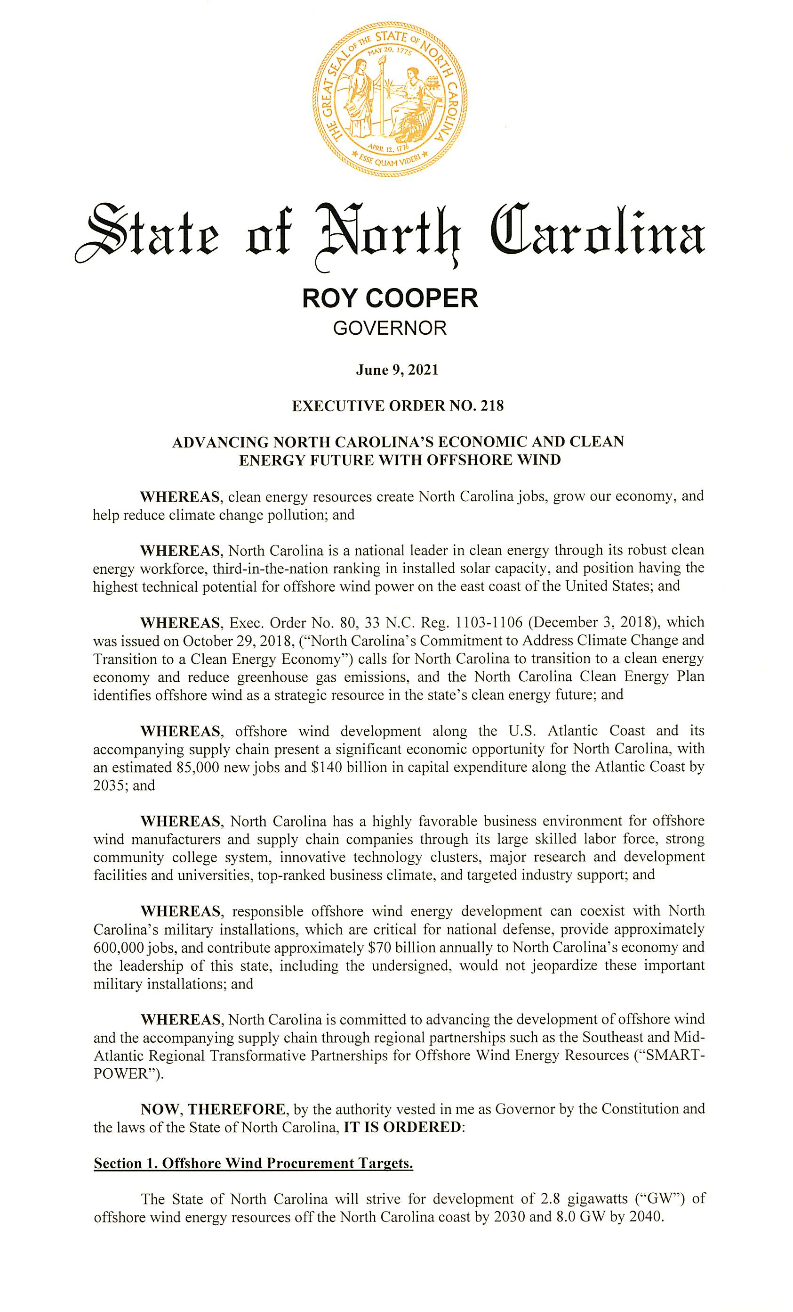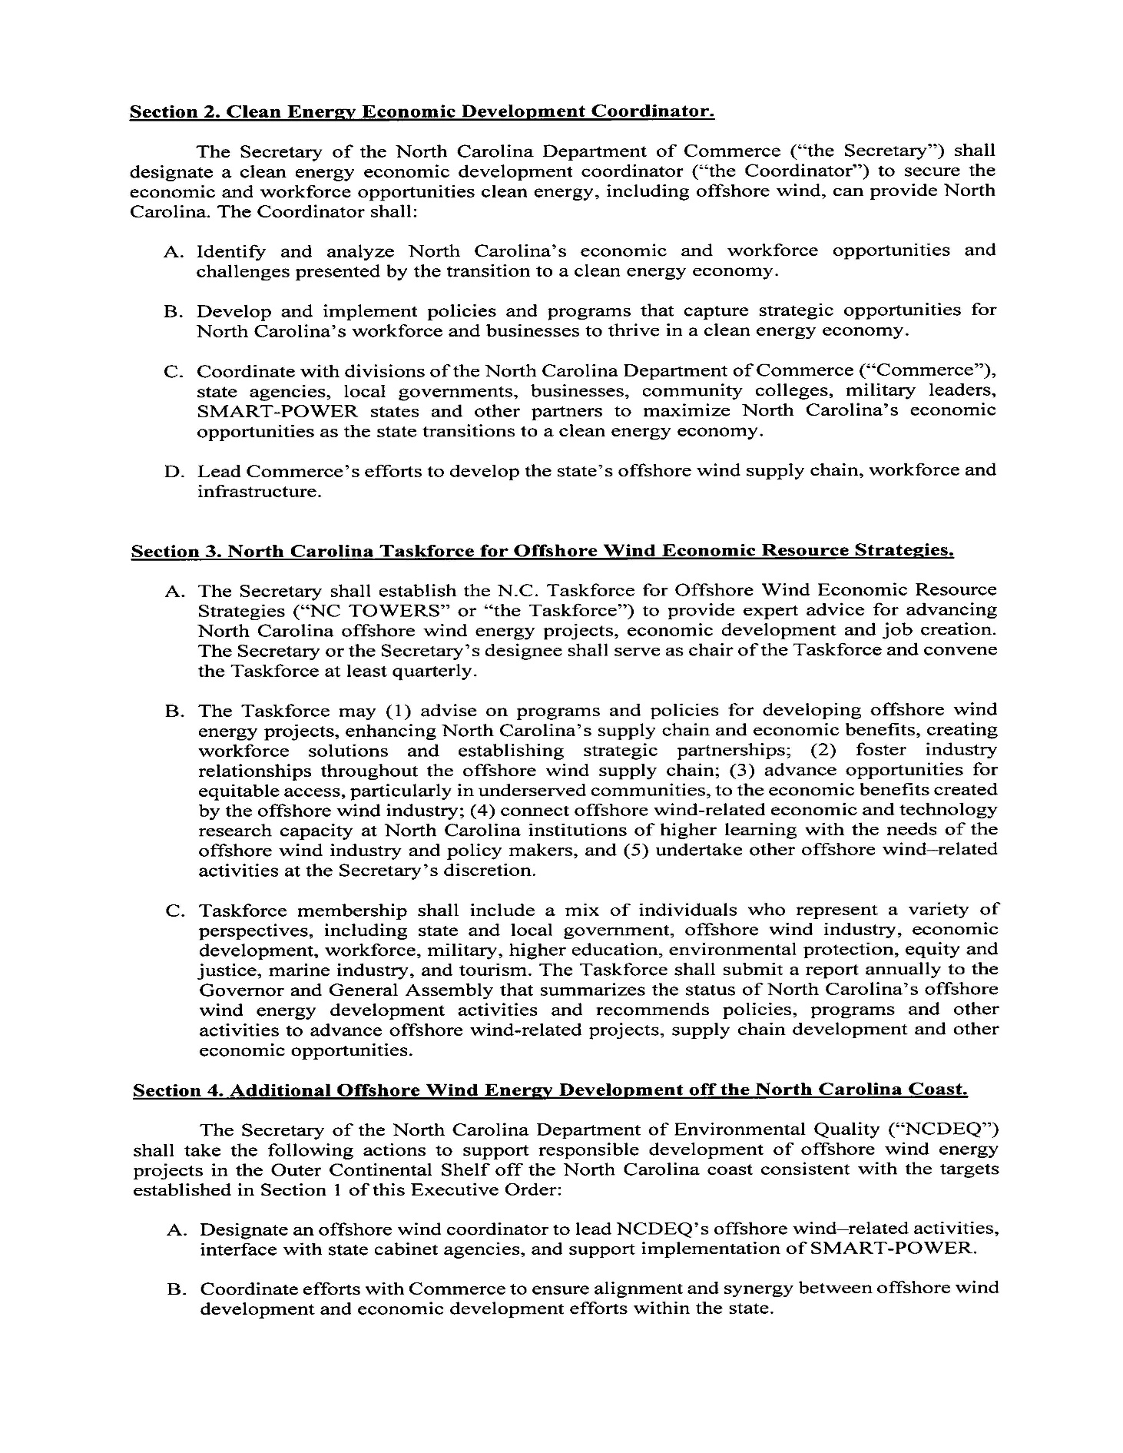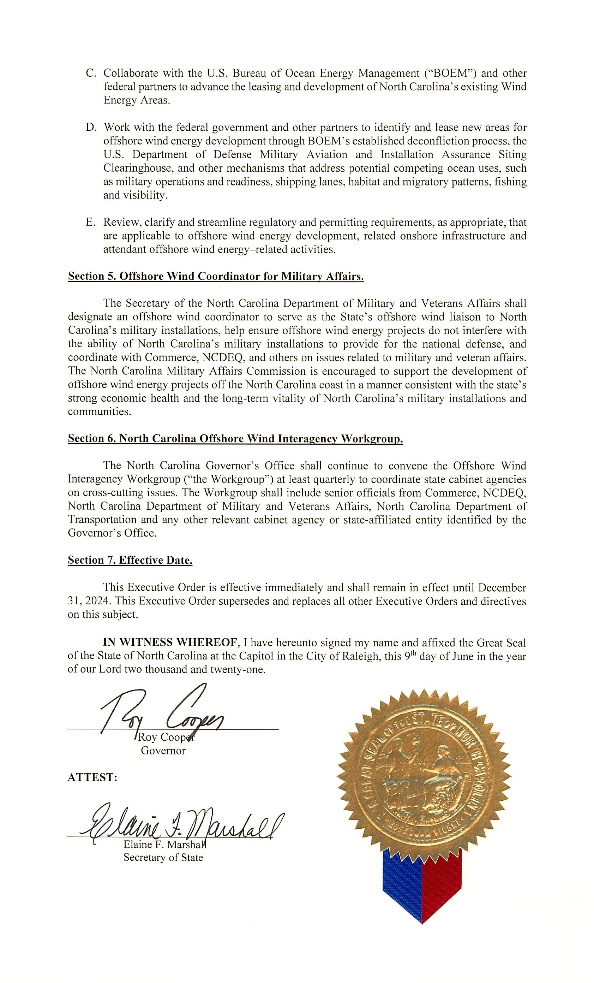
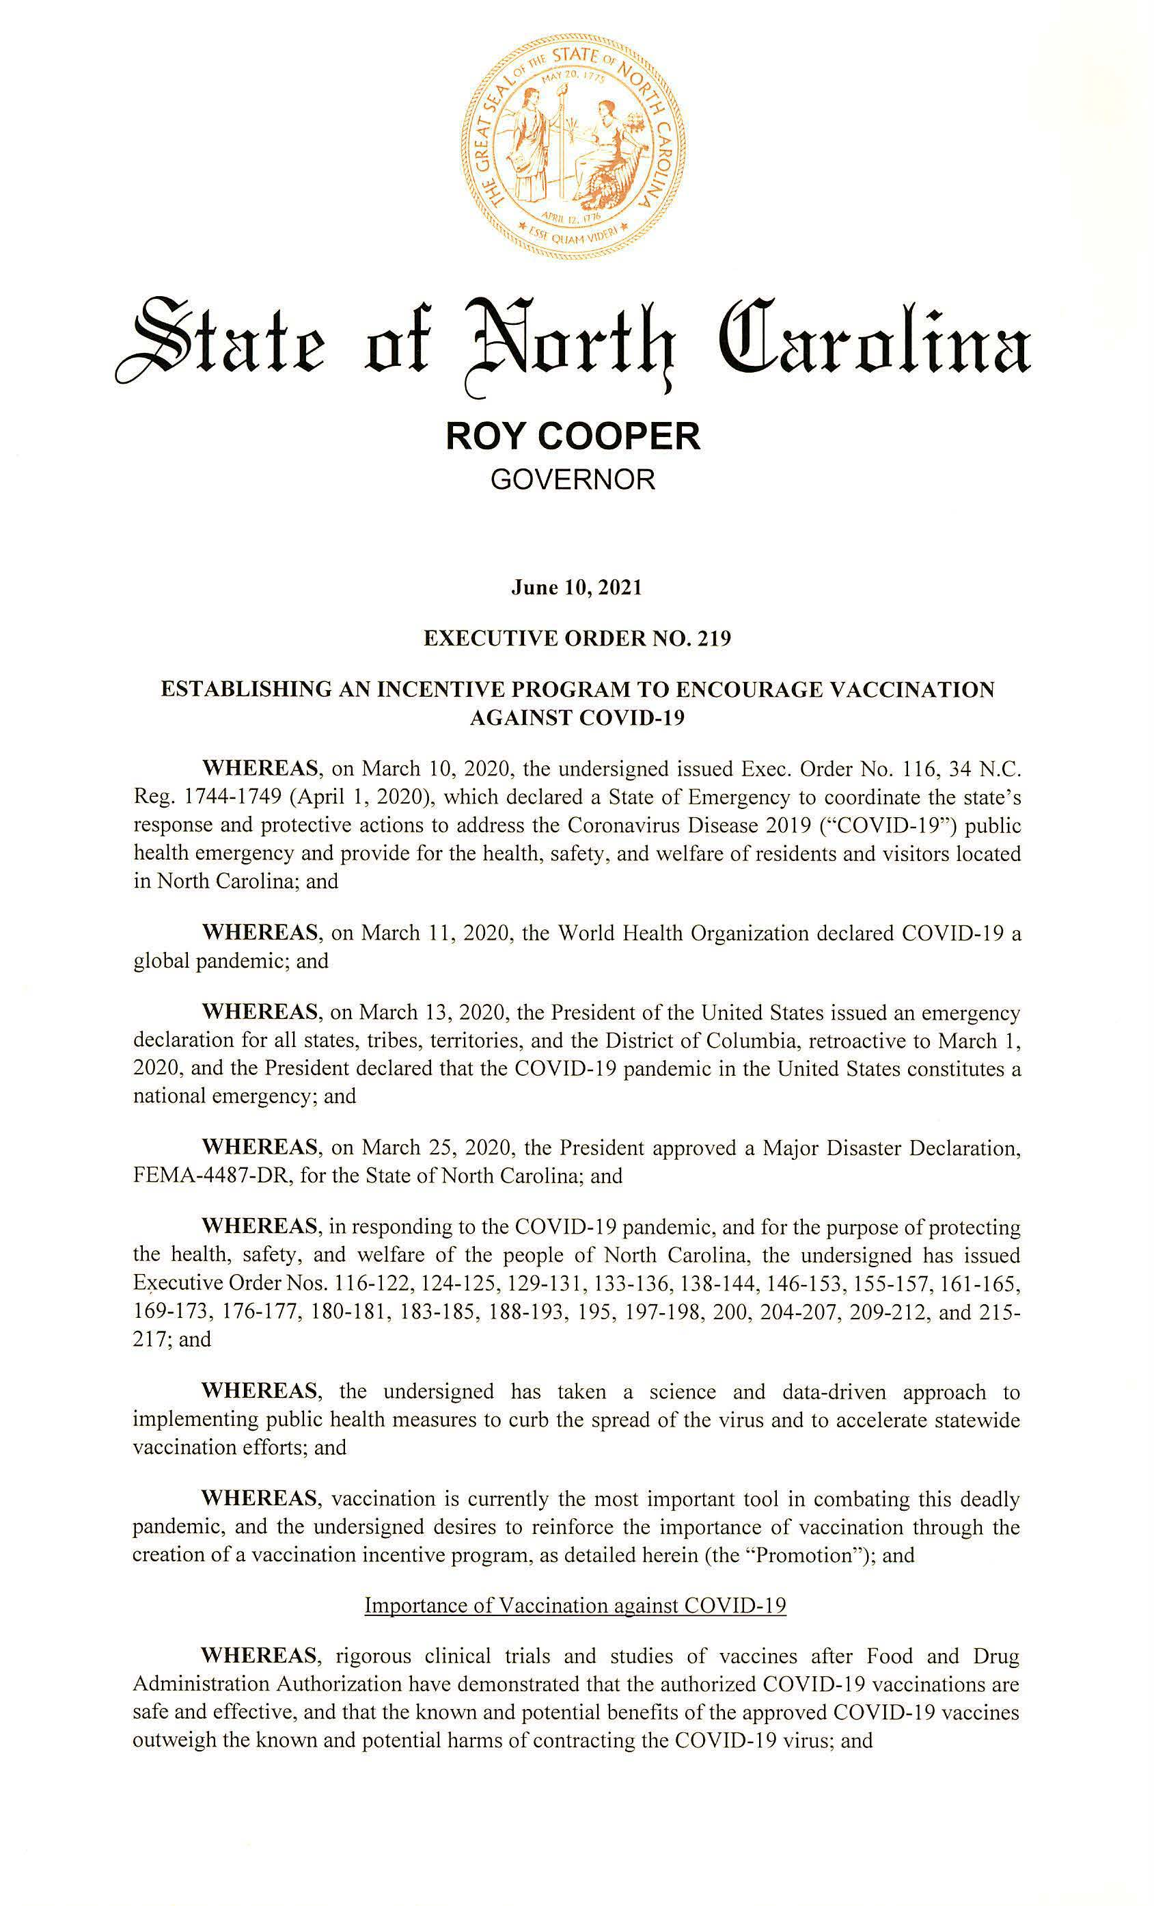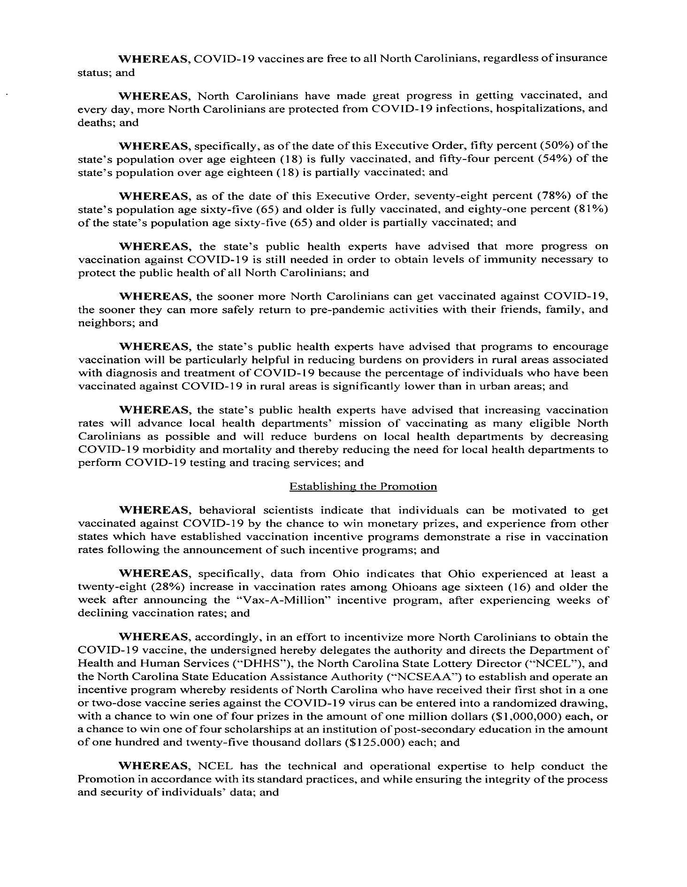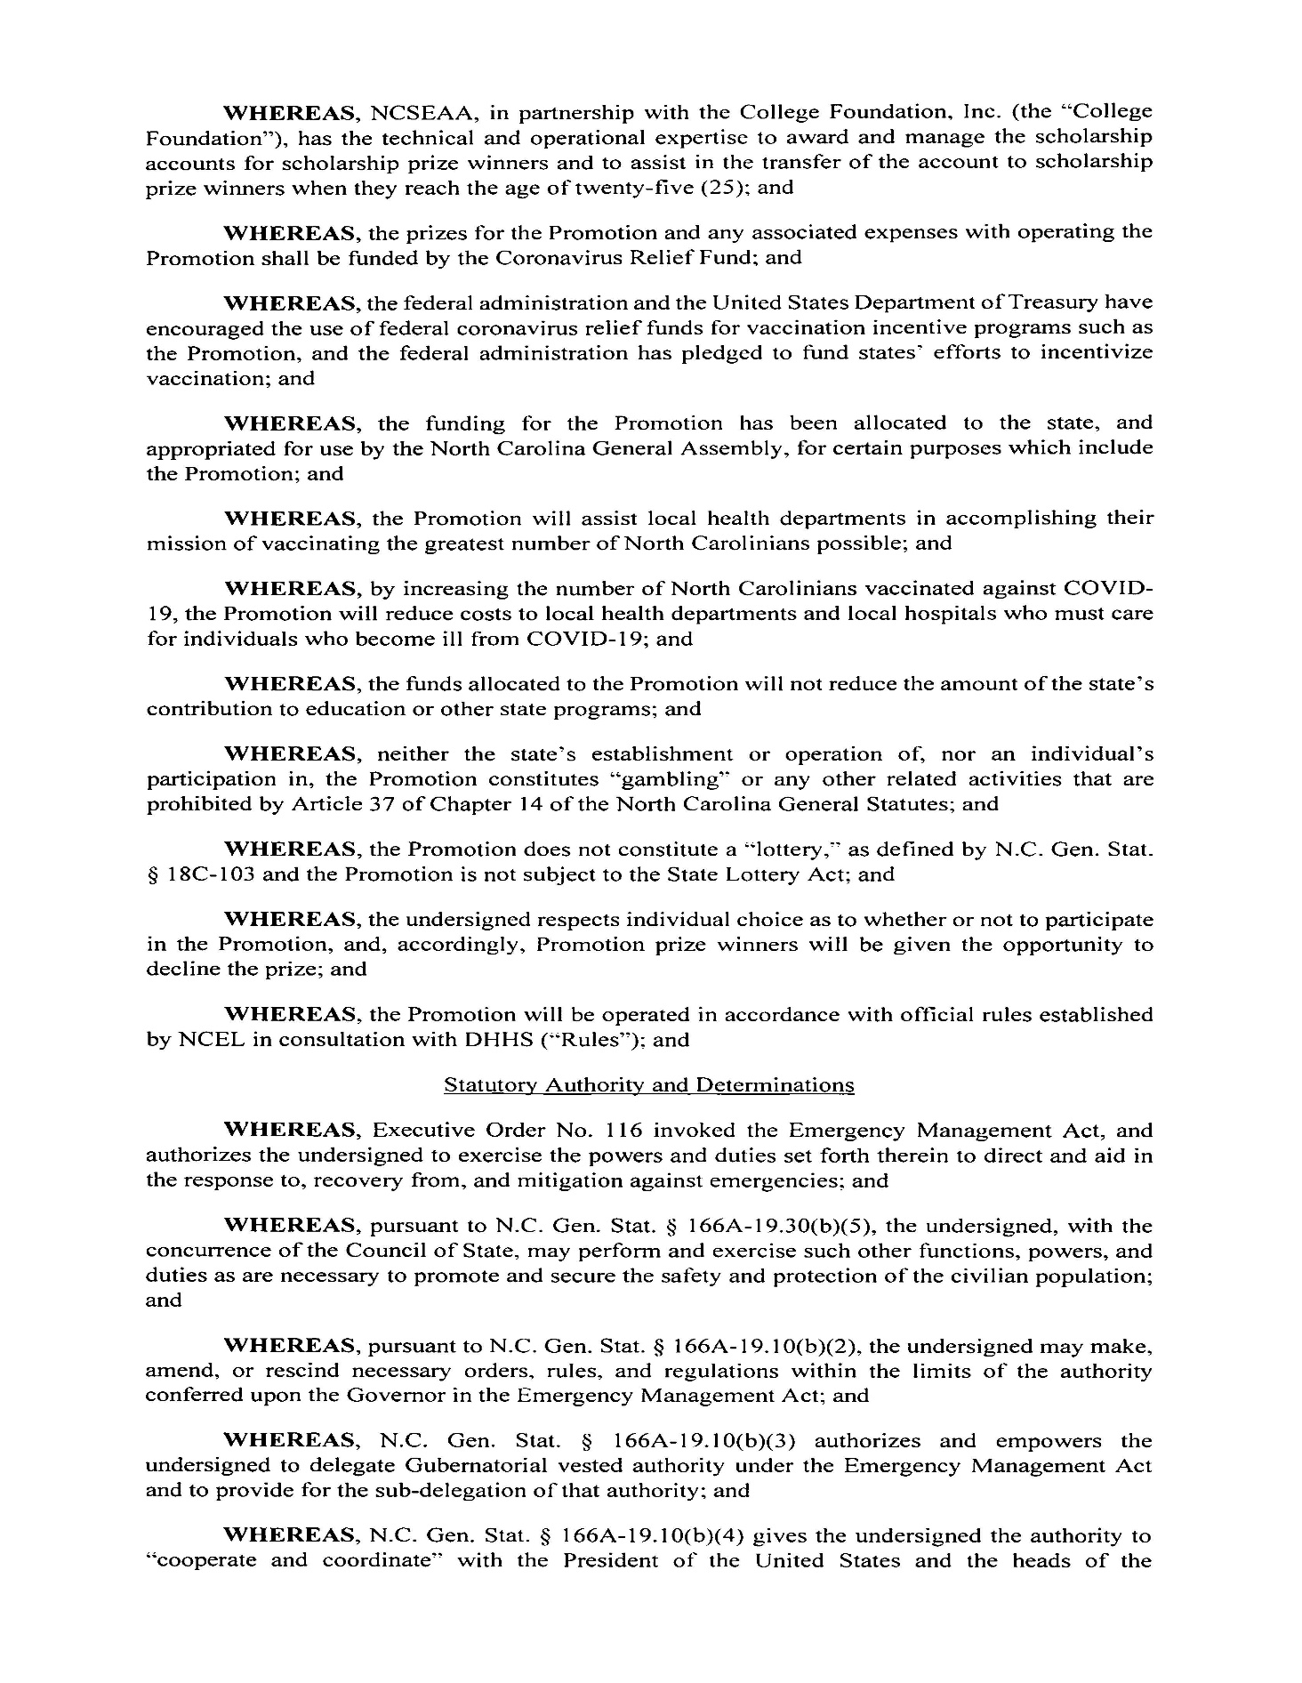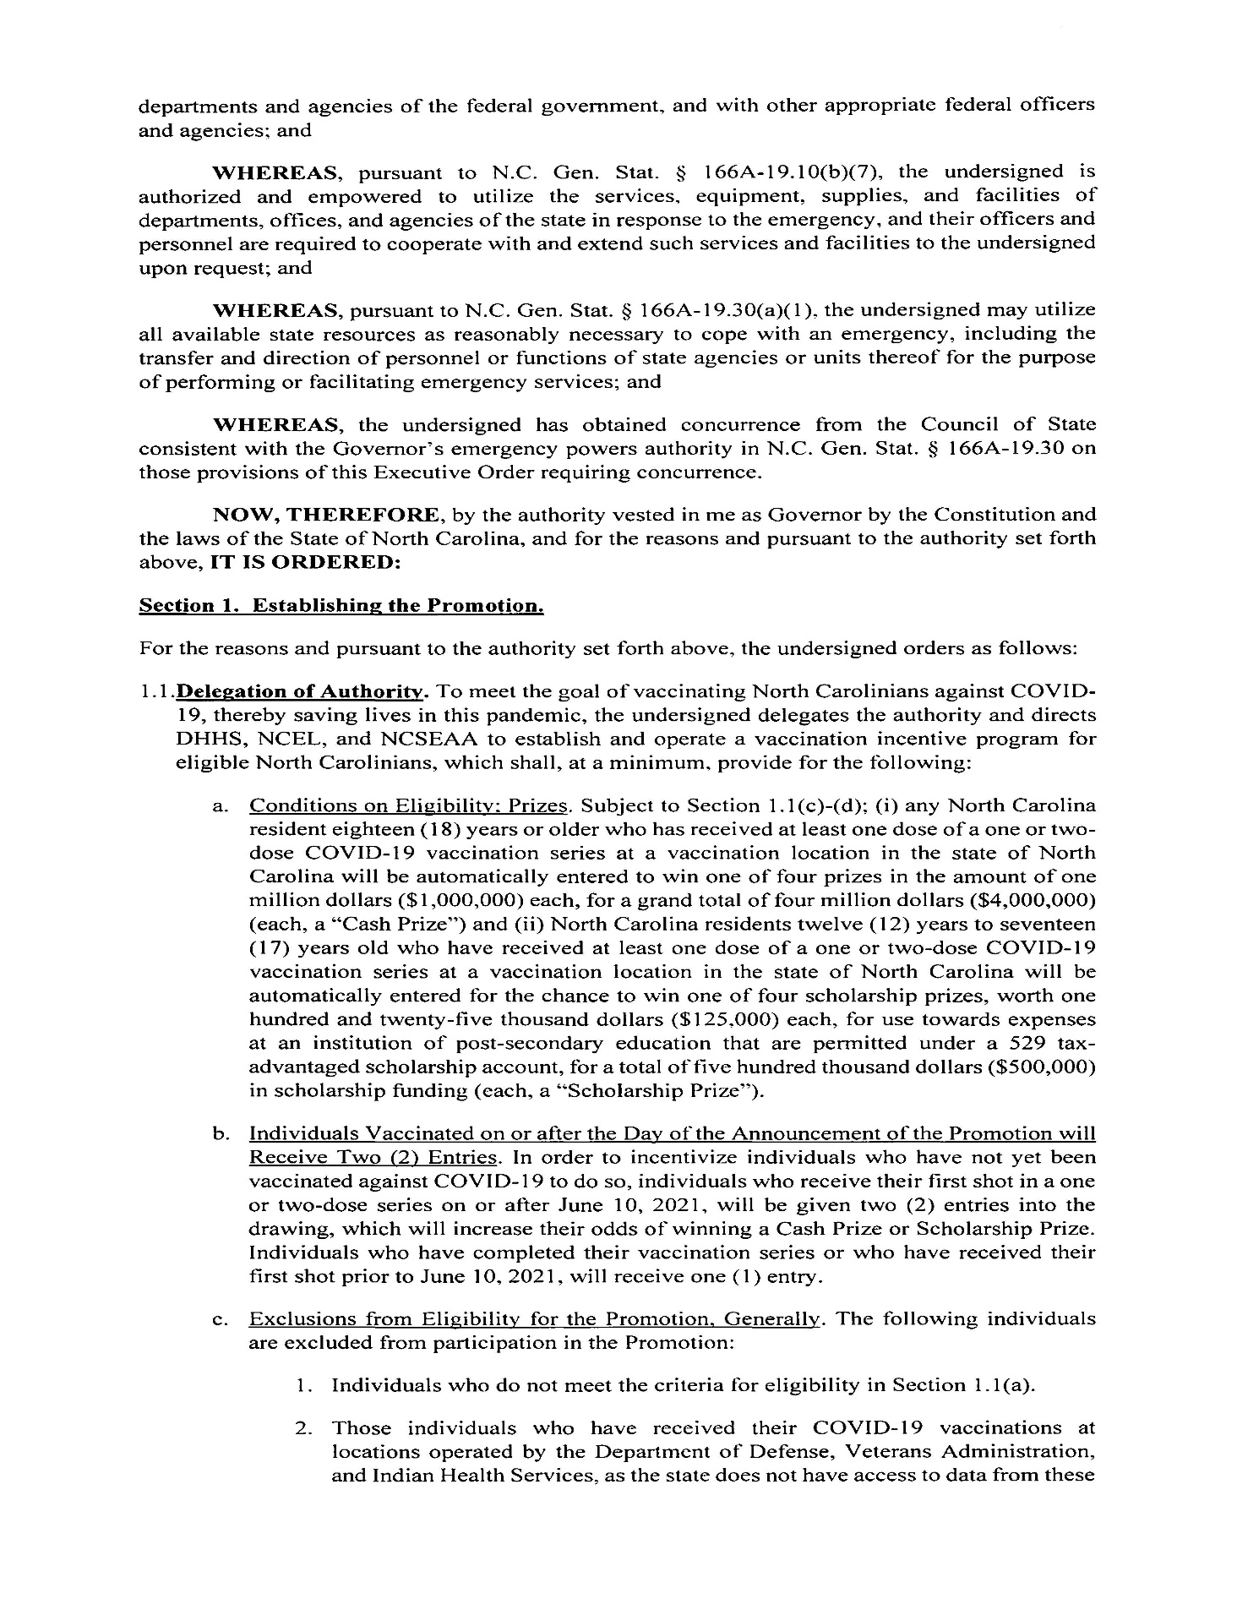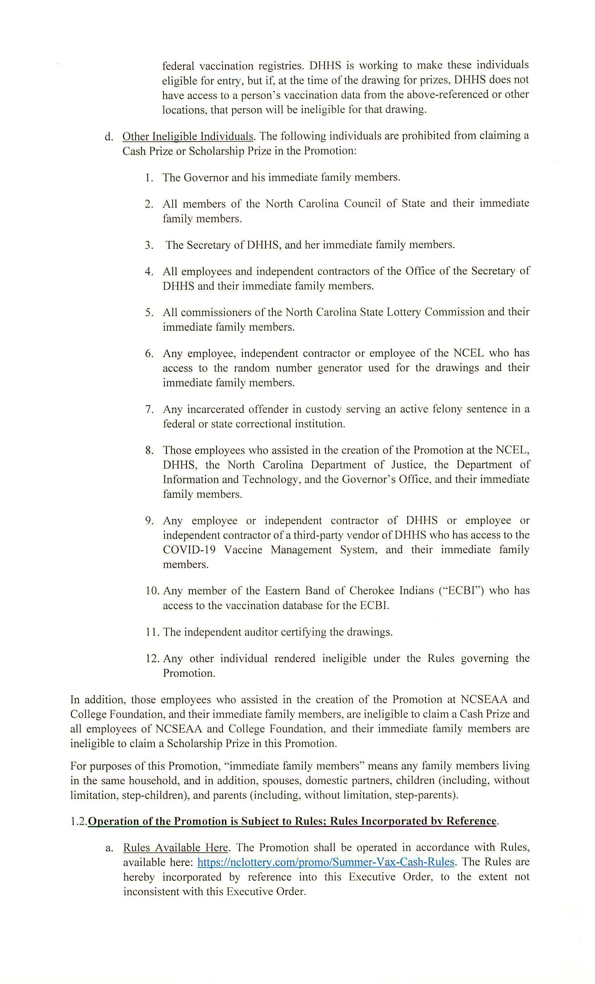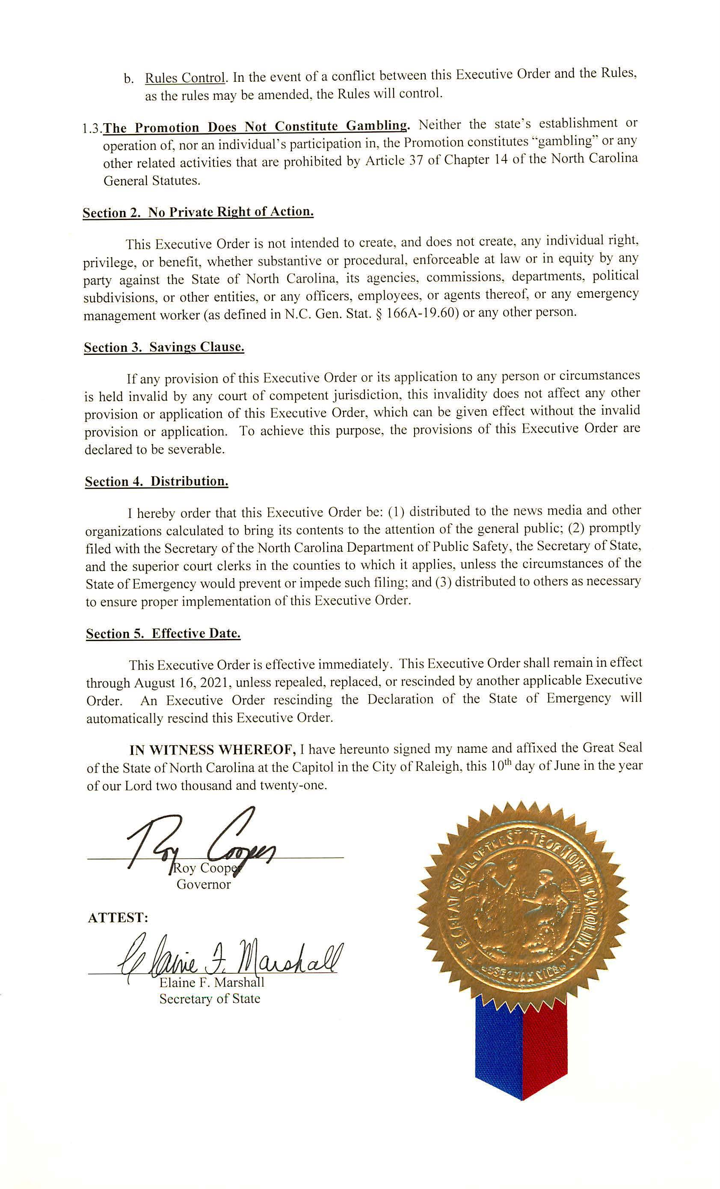
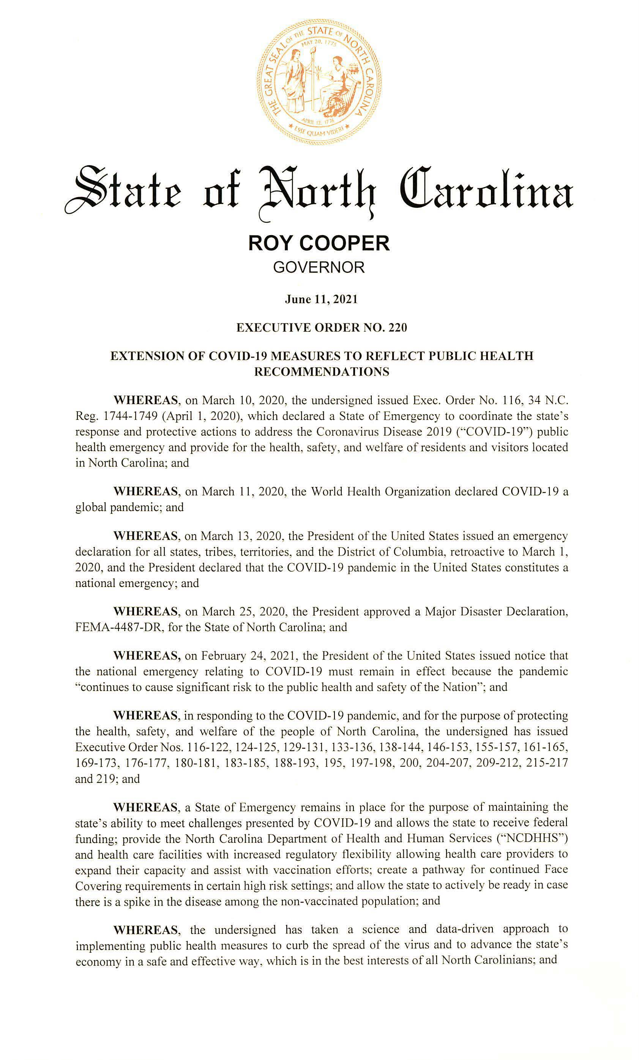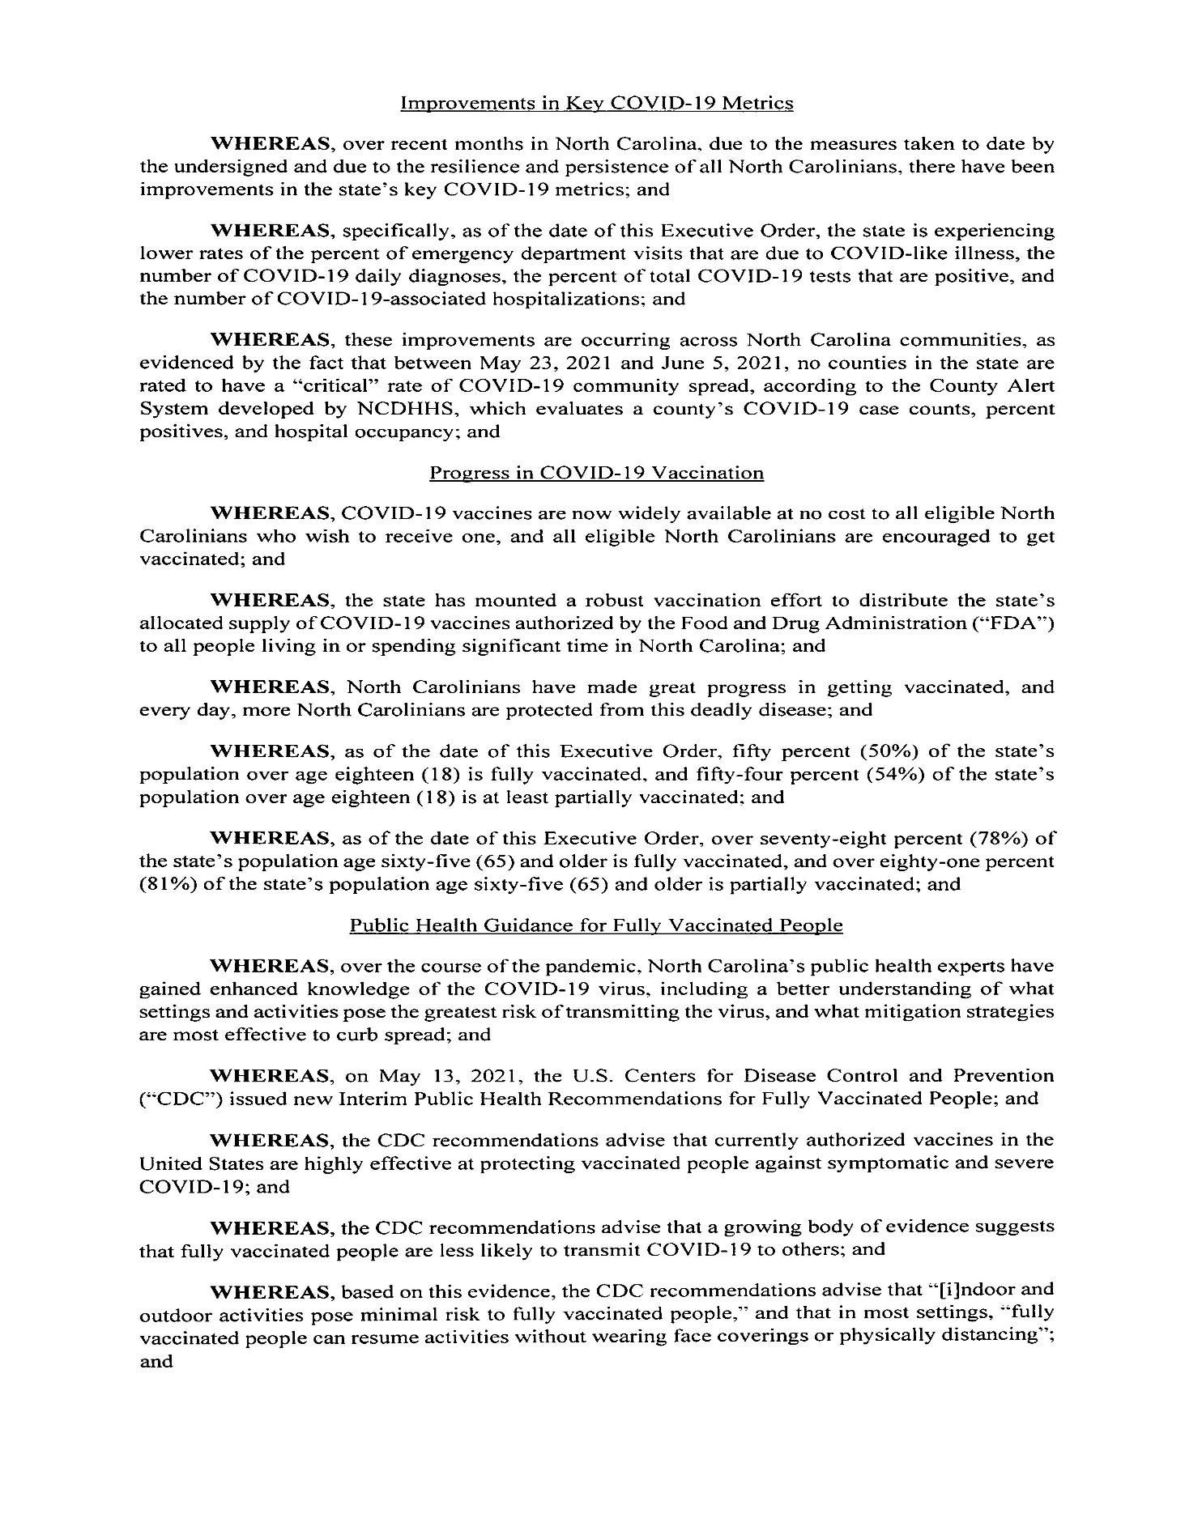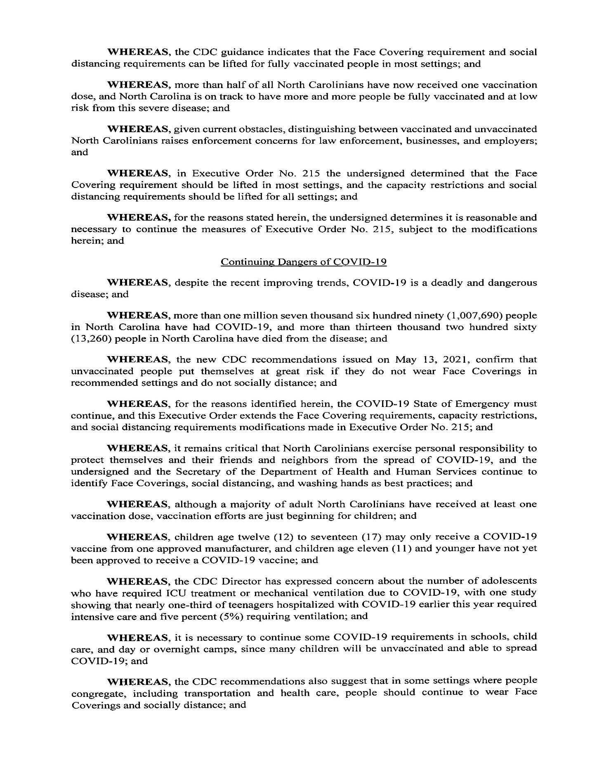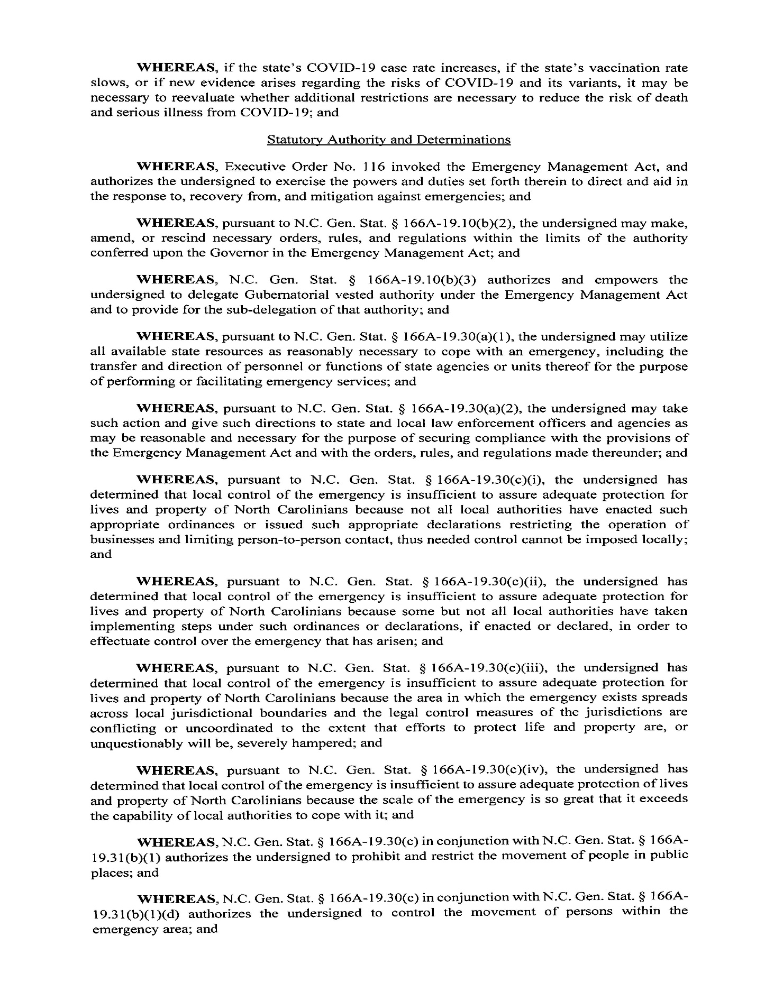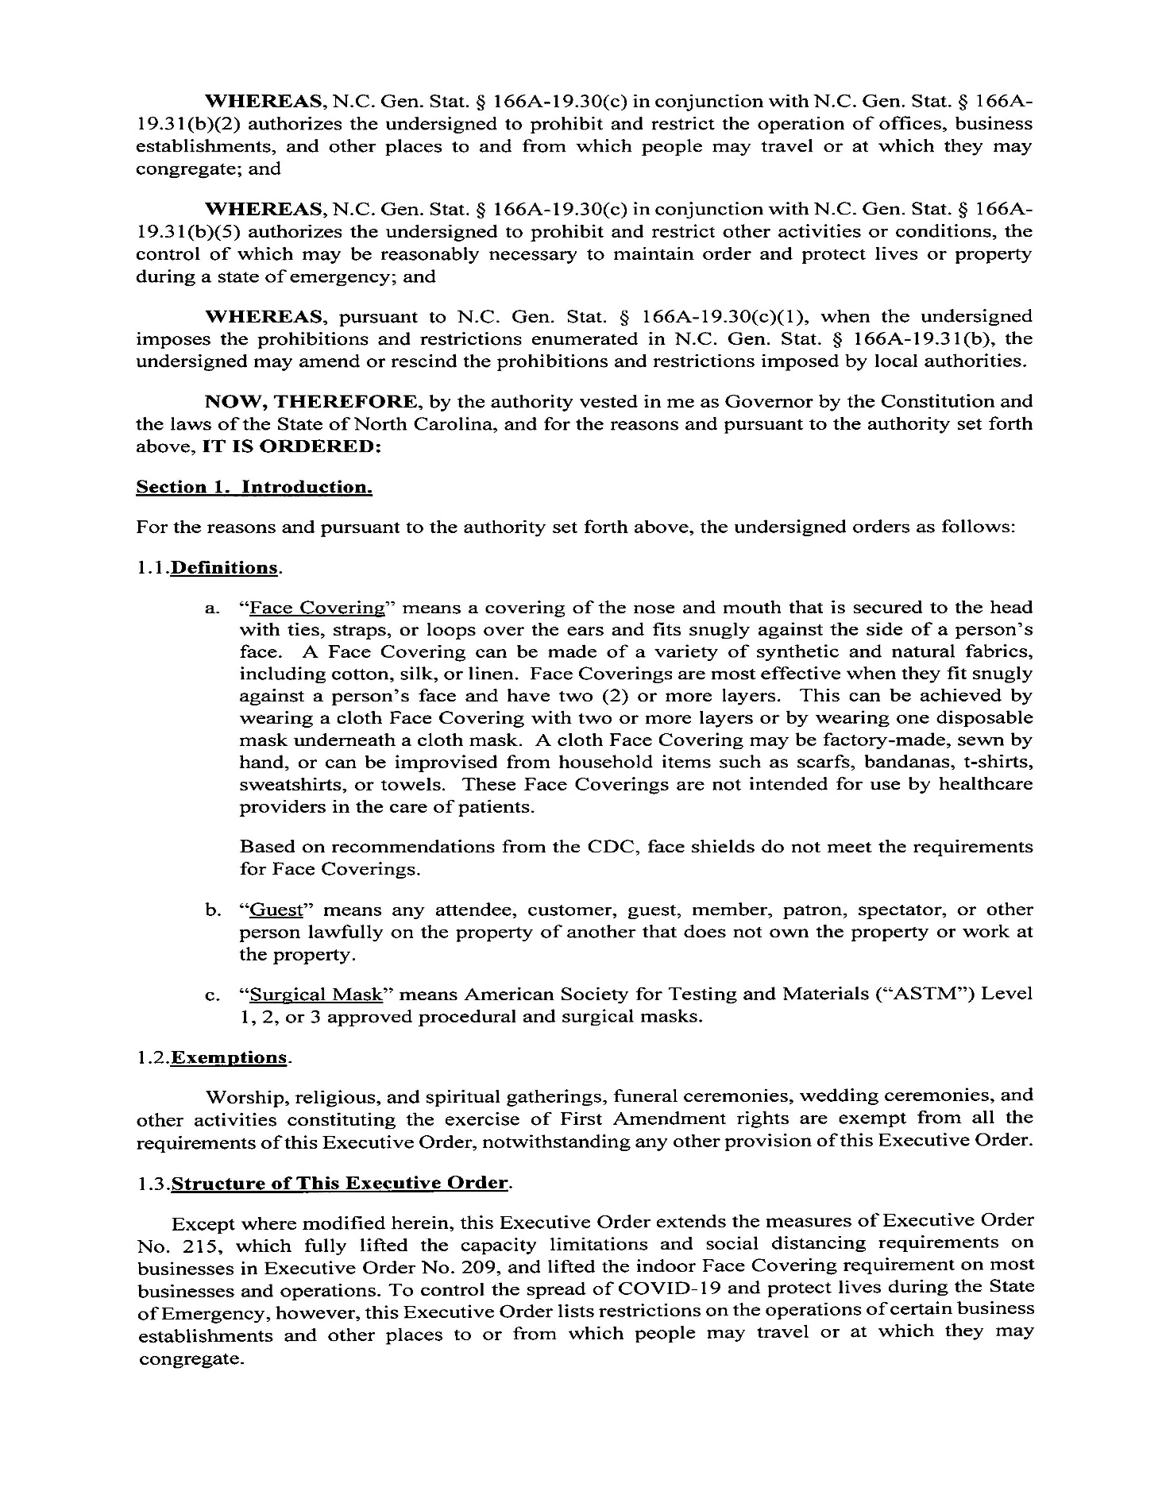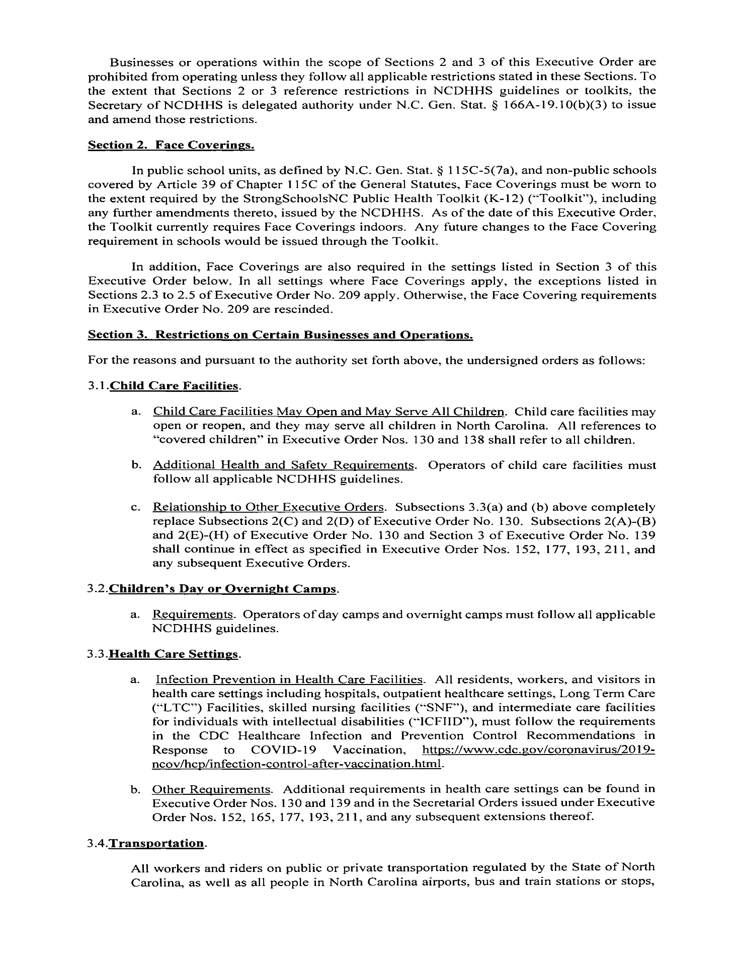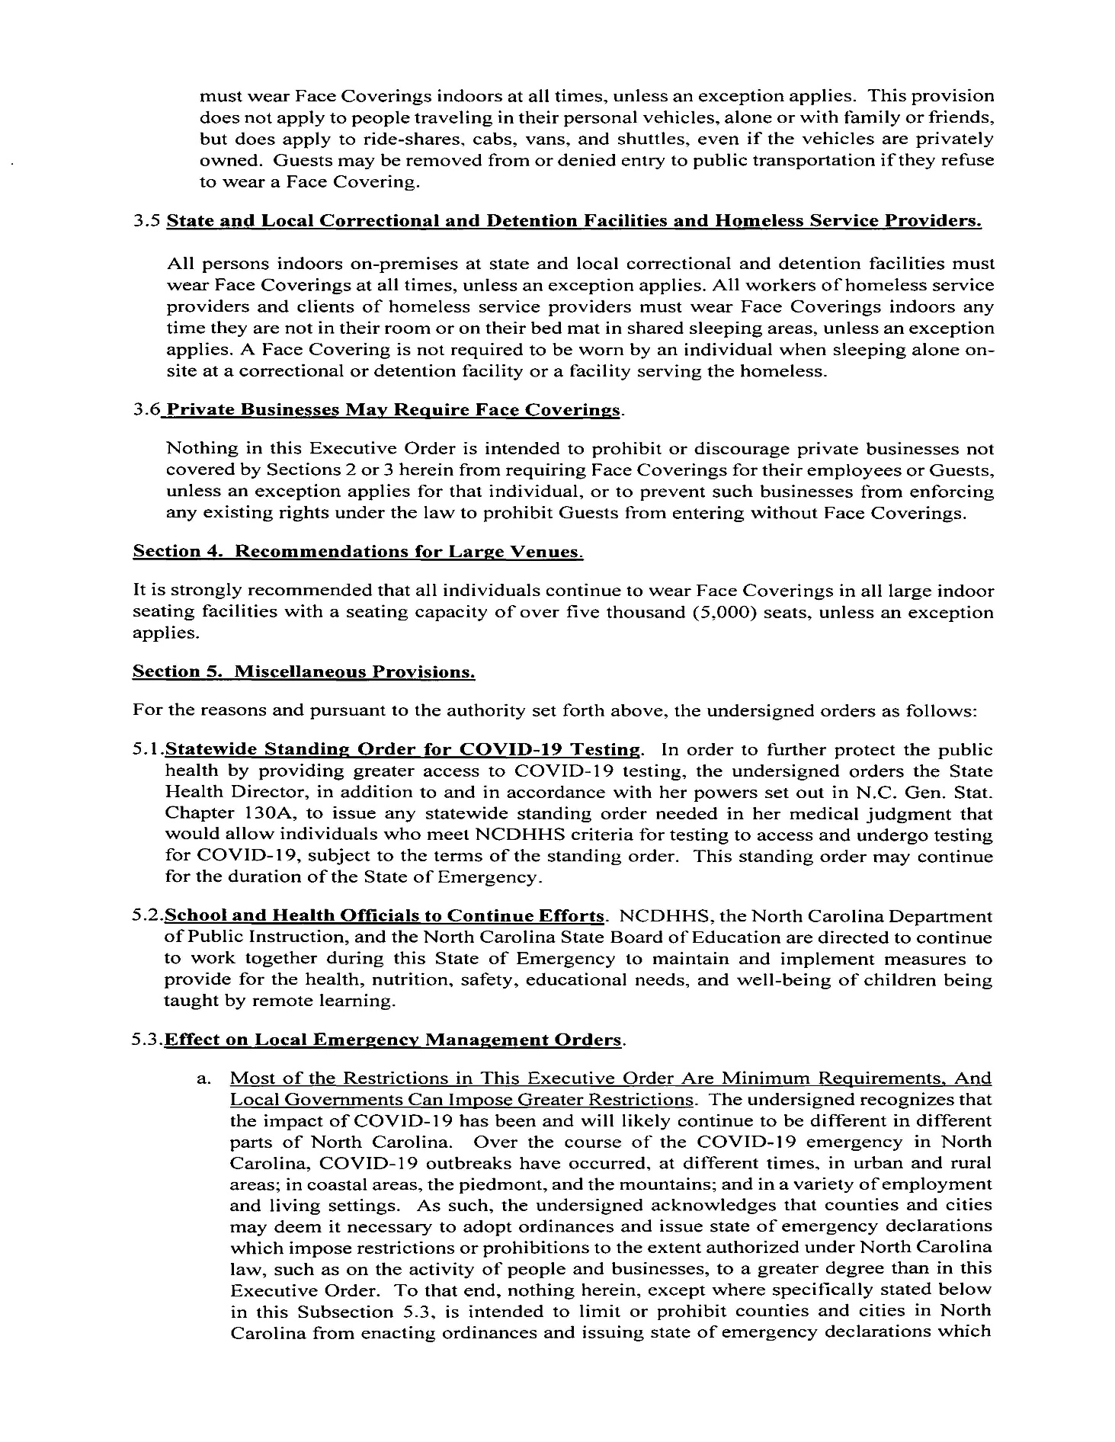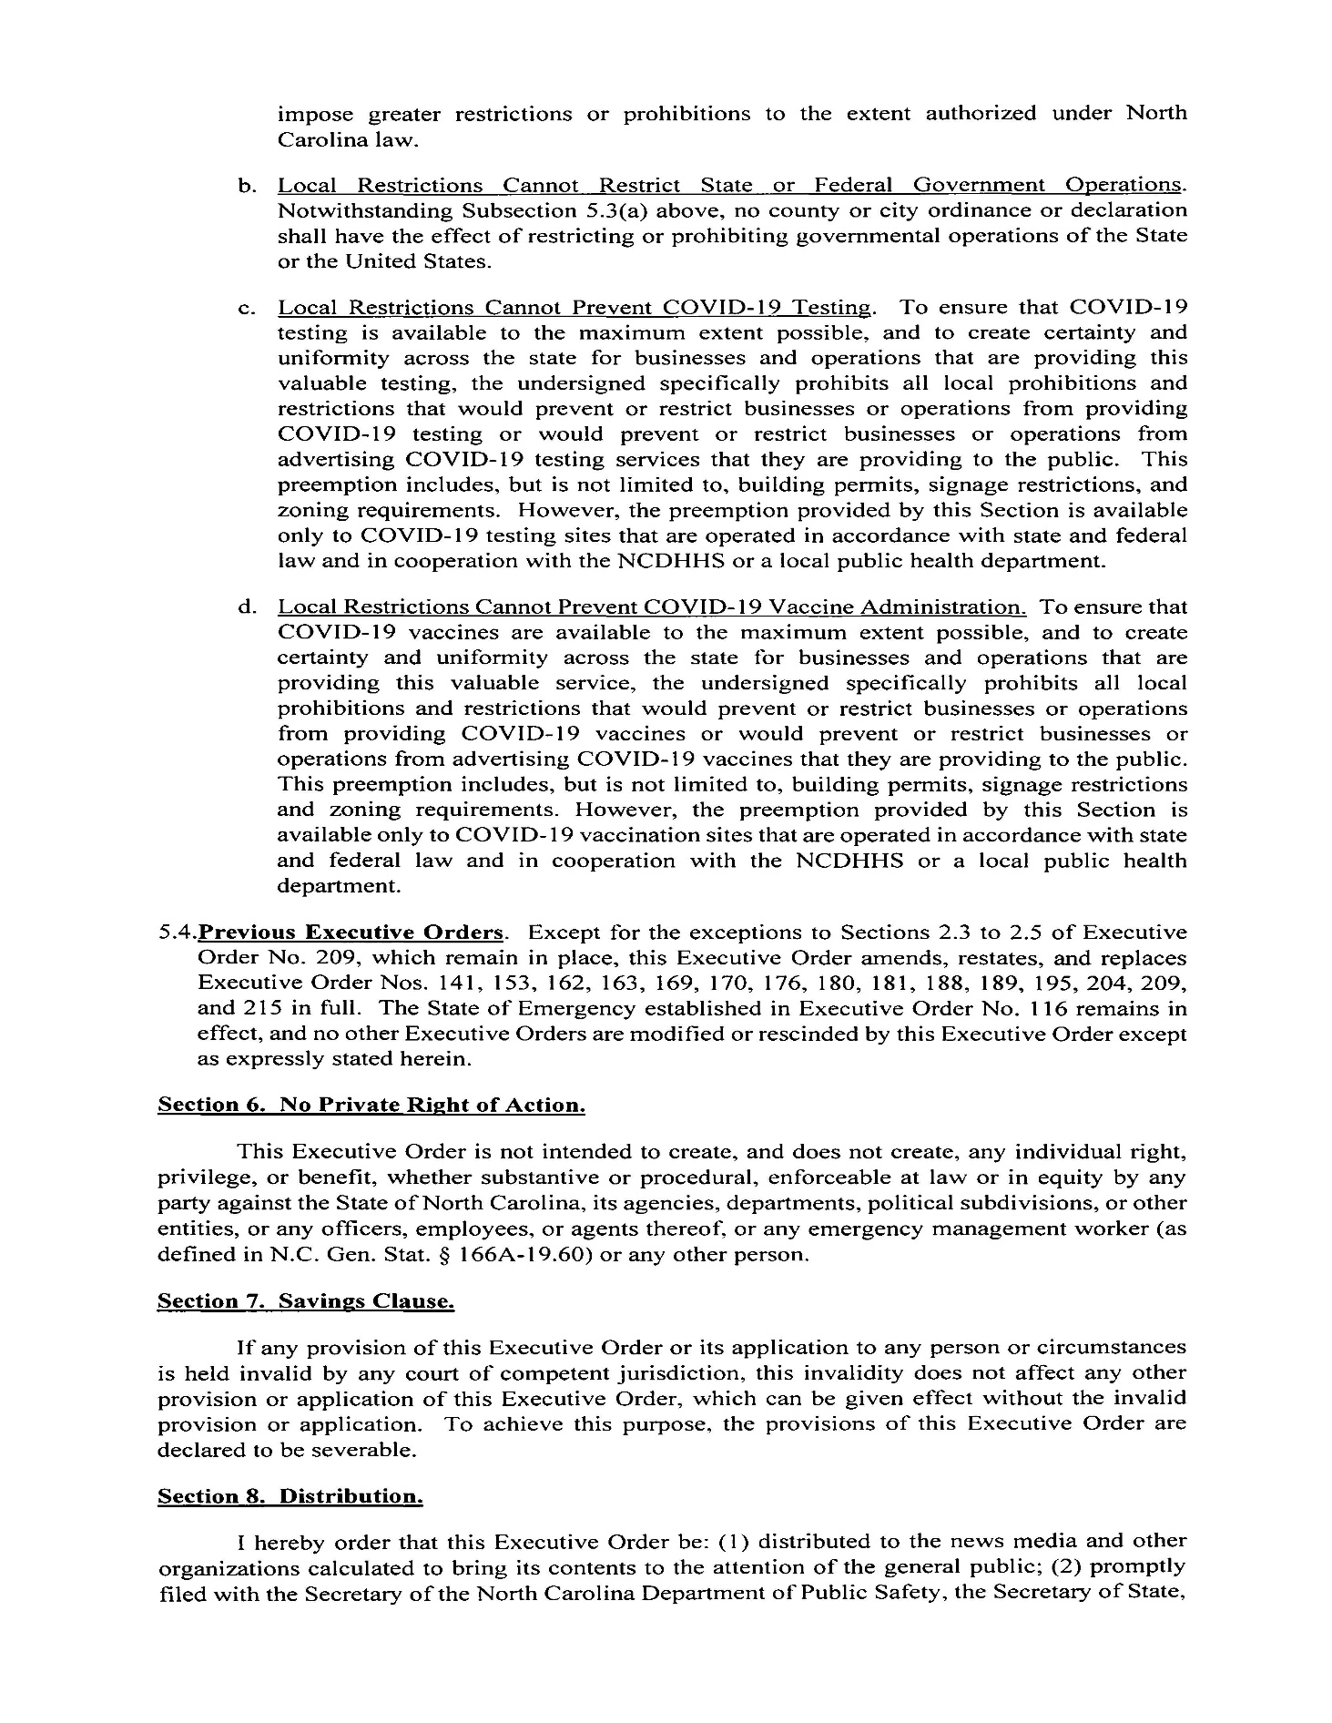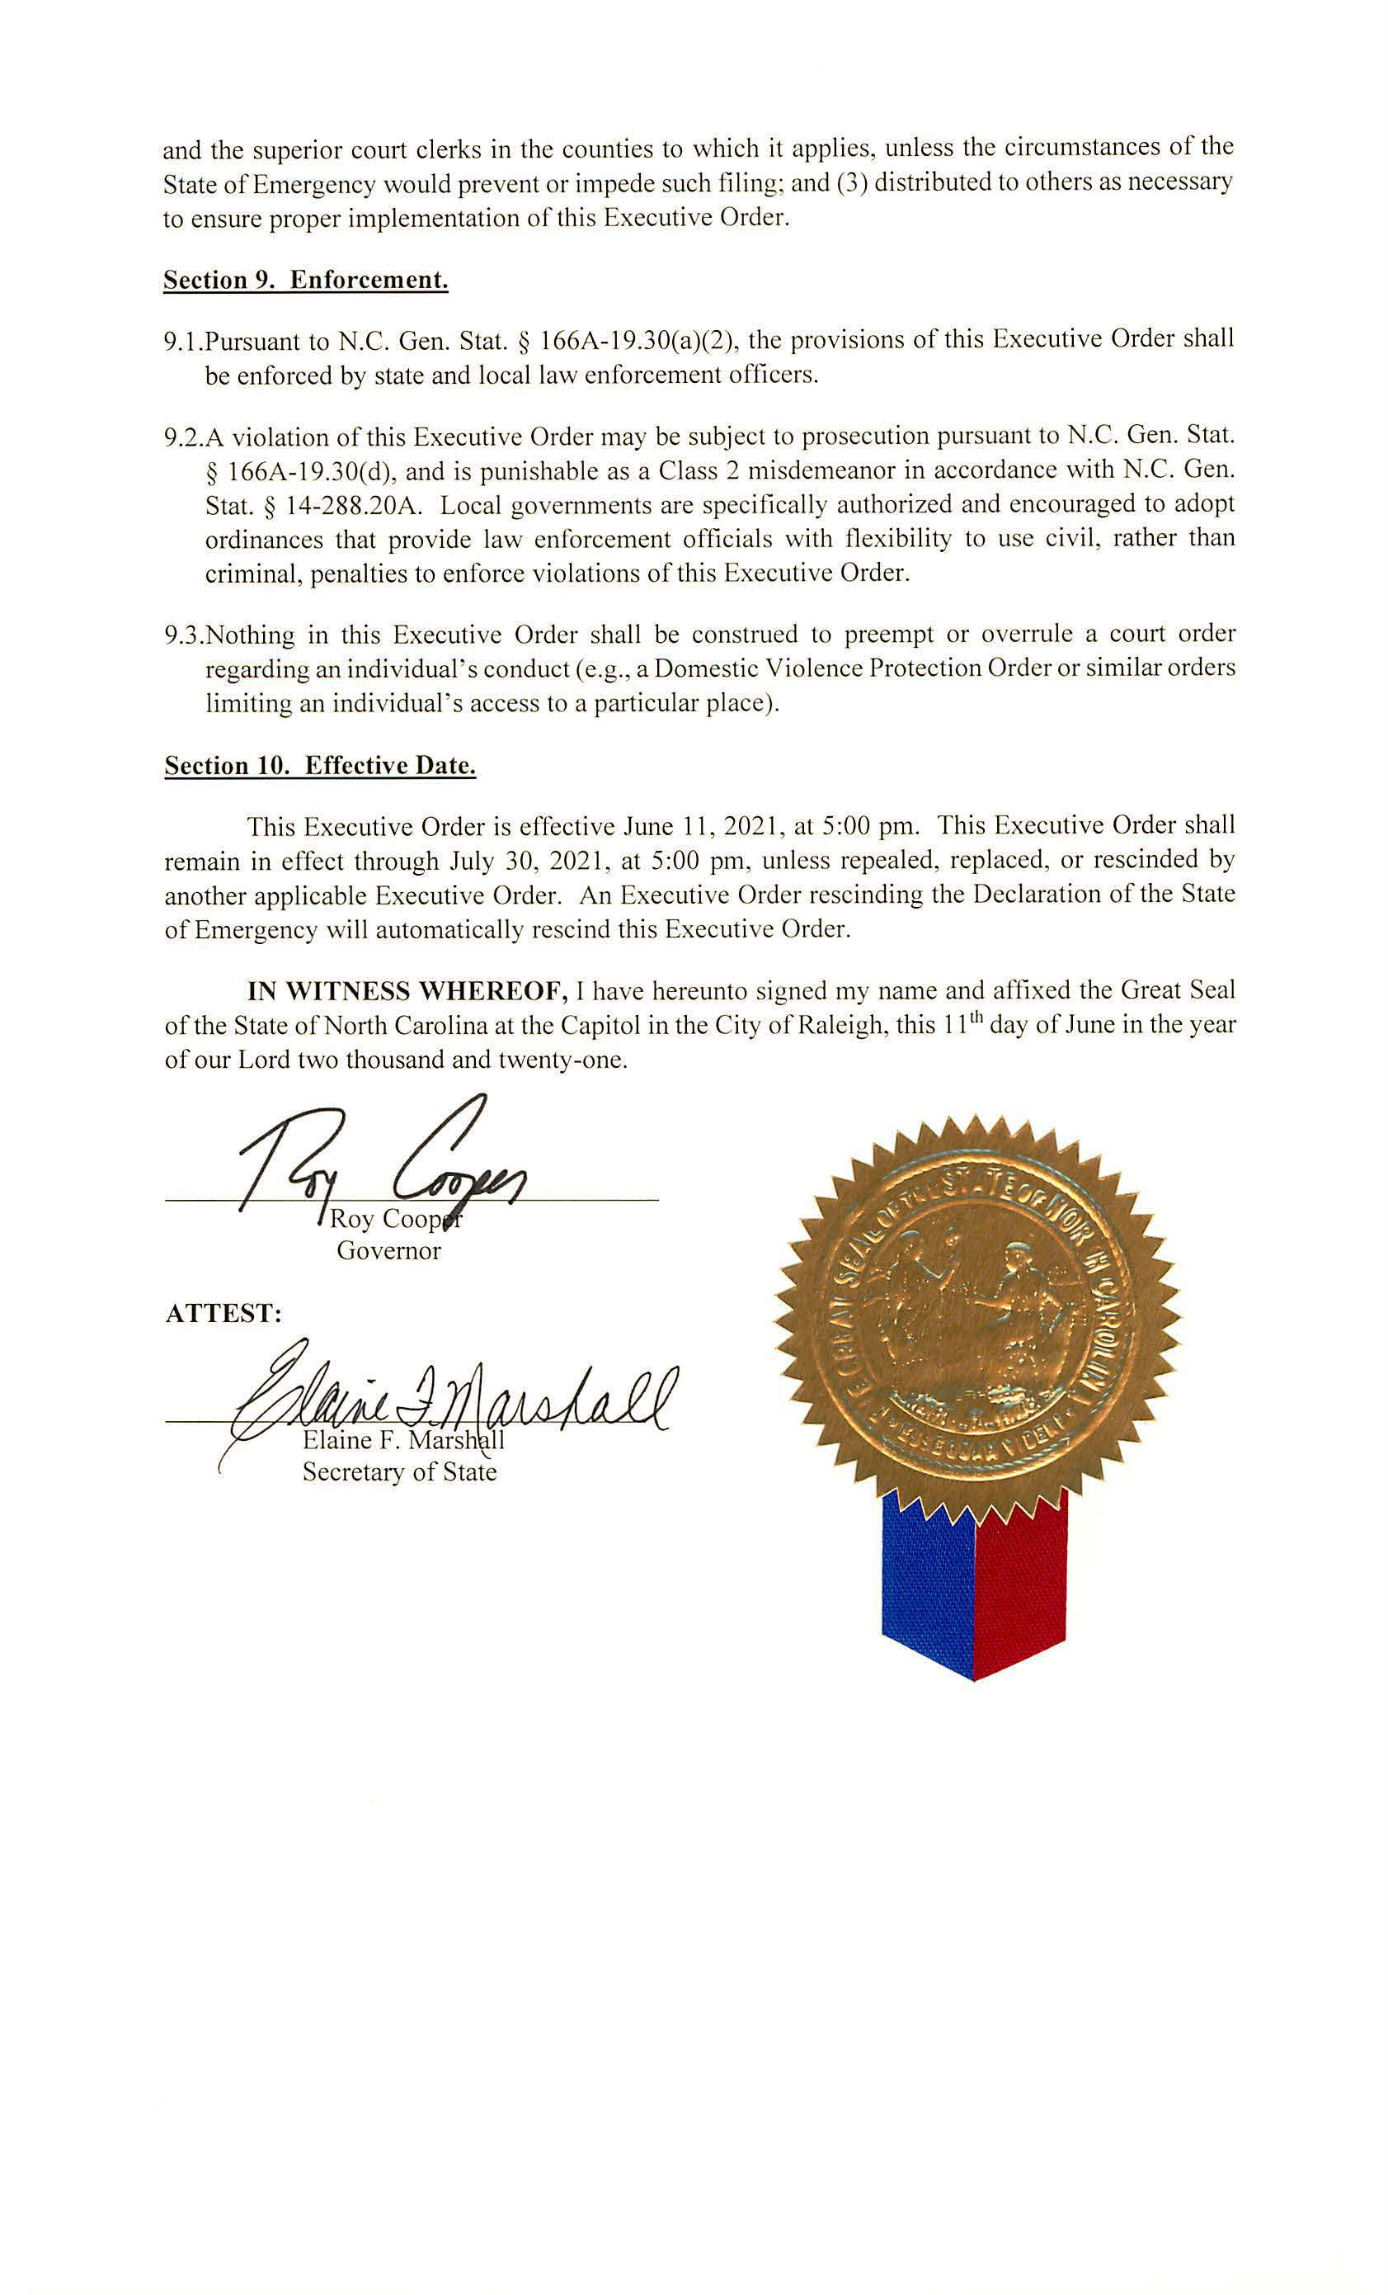
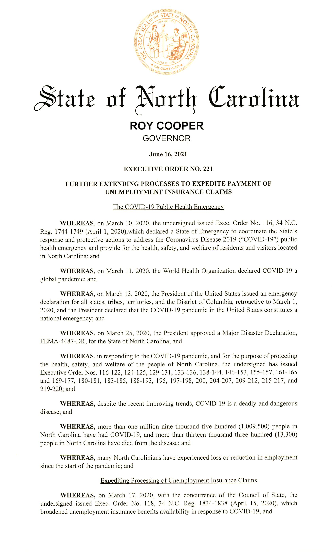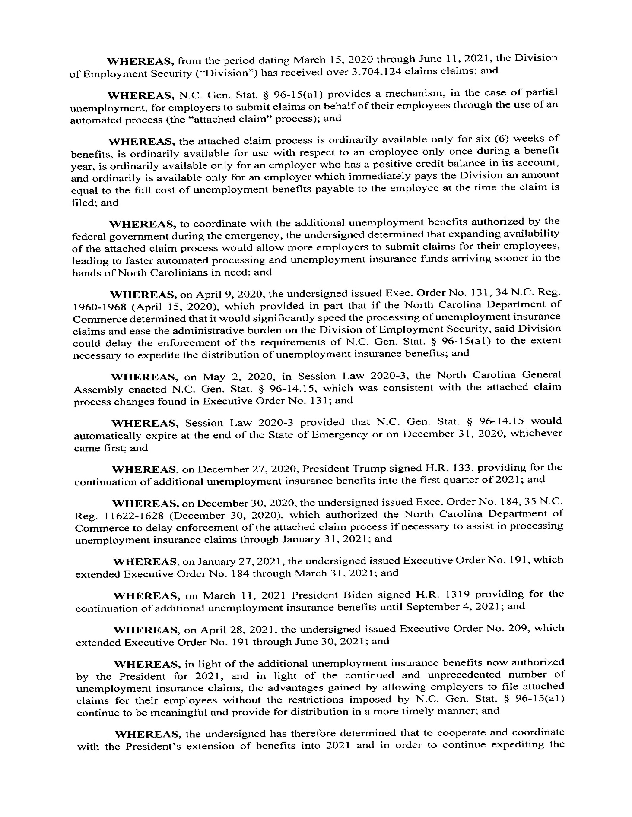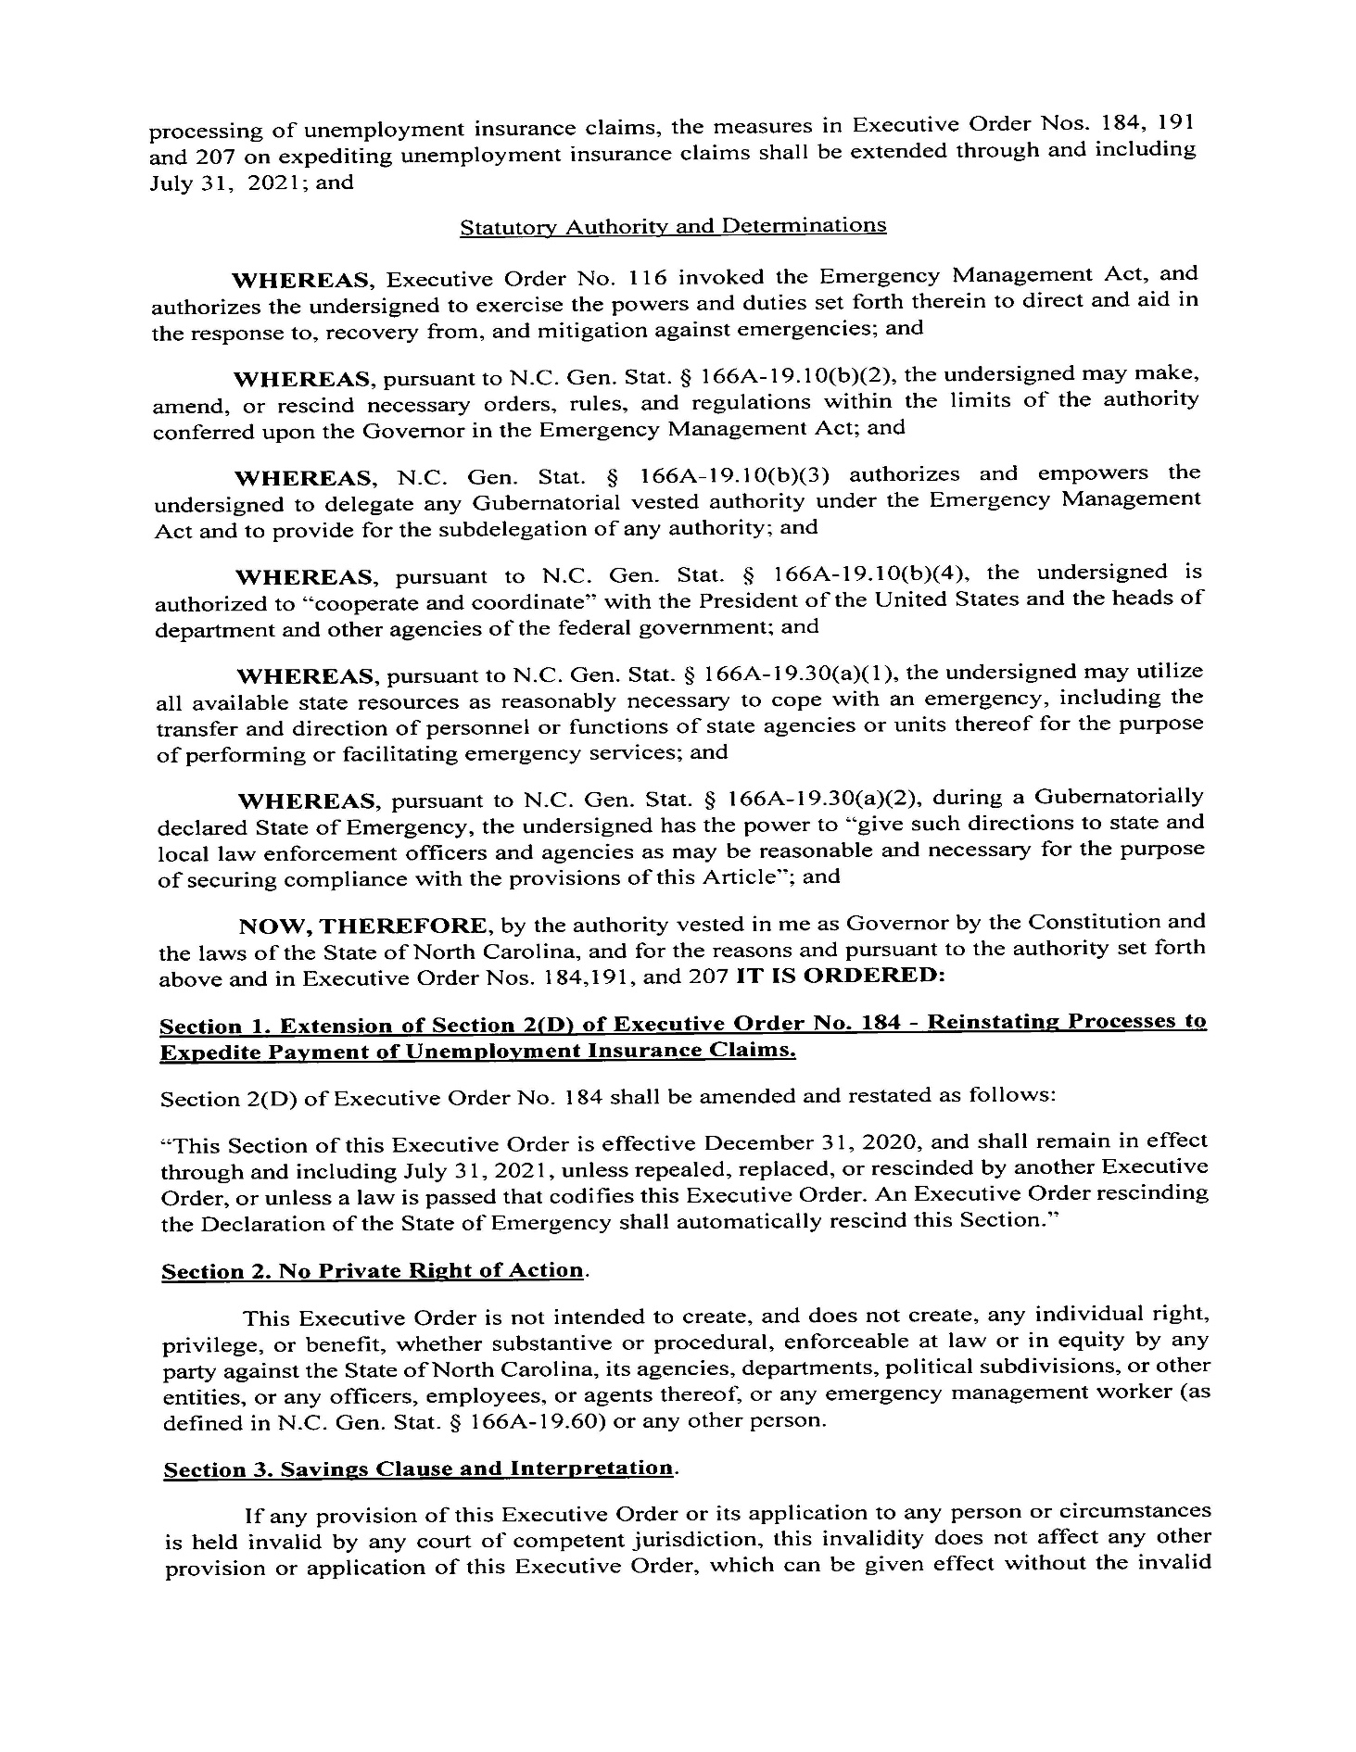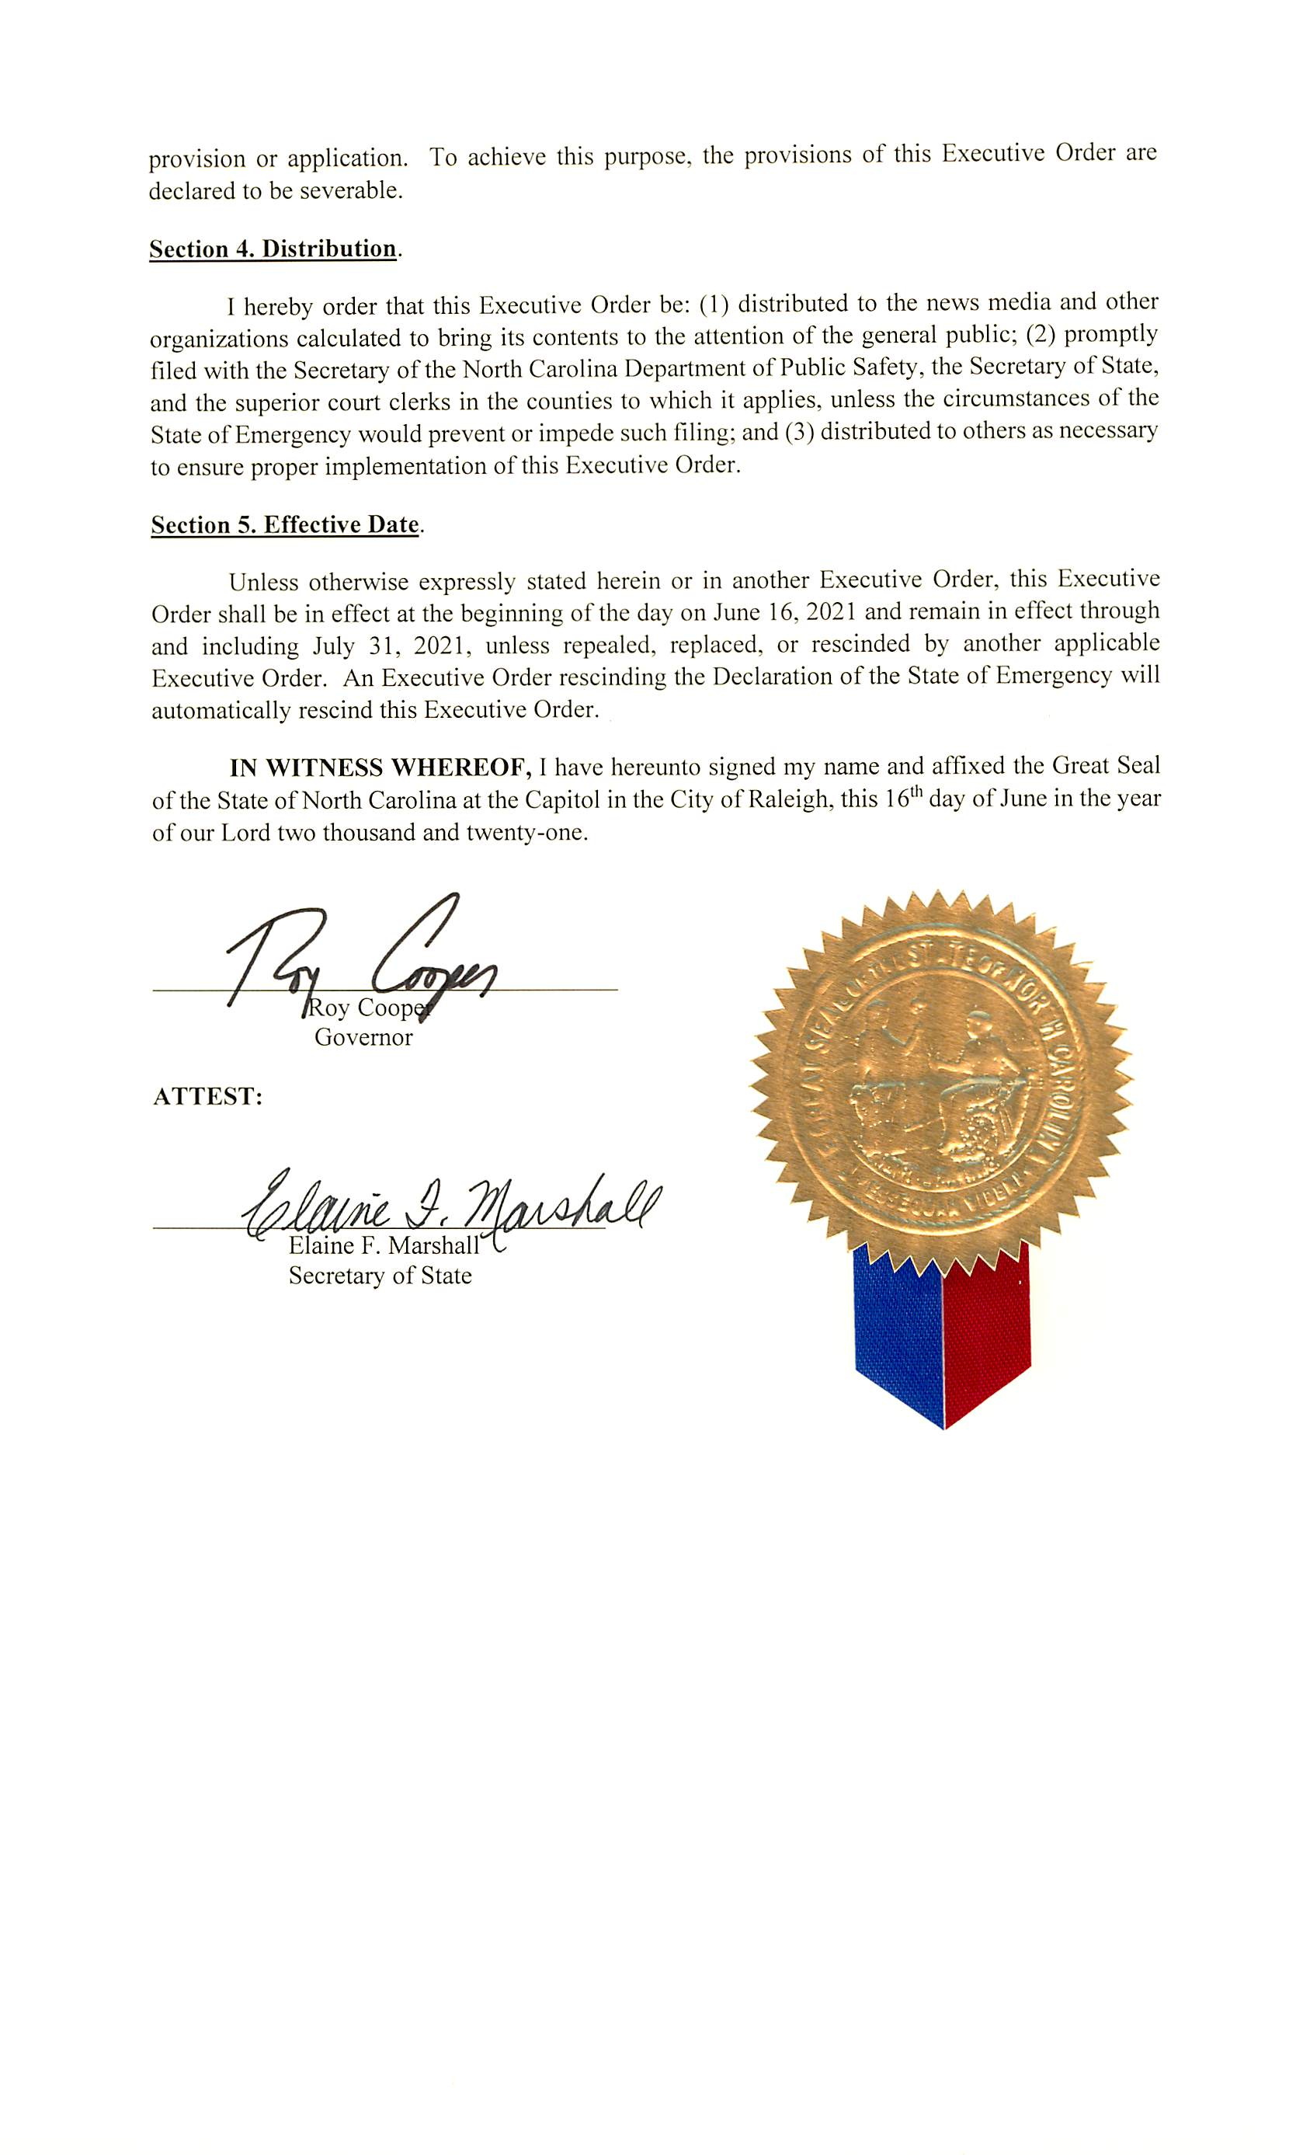

Note from the Codifier: The notices published in this Section of the NC Register include the text of proposed rules. The agency must accept comments on the proposed rule(s) for at least 60 days from the publication date, or until the public hearing, or a later date if specified in the notice by the agency. If the agency adopts a rule that differs substantially from a prior published notice, the agency must publish the text of the proposed different rule and accept comment on the proposed different rule for 60 days.
Statutory reference: G.S. 150B-21.2.

Title 10A – Department of Health and Human Services

Notice is hereby given in accordance with G.S. 150B-21.3A(c)(2)g. that the HHS - Division of Health Service Regulation intends to readopt with substantive changes the rules cited as 10A NCAC 14C .1601, .1603, .1701, .1703, .1901, .1903, .2401, .2701, .2703, .3701, .3703, readopt without substantive changes the rule cited as 10A NCAC 14C .2403, and repeal through readoption the rules cited as 10A NCAC 14C .2301, .2303, .2501, .2503, .2601, and .2603.

Pursuant to G.S. 150B-21.17, the Codifier has determined it impractical to publish the text of rules proposed for repeal unless the agency requests otherwise. The text of the rule(s) are available on the OAH website at http://reports.oah.state.nc.us/ncac.asp.

Pursuant to G.S. 150B-21.2(c)(1), the text of the rule(s) proposed for readoption without substantive changes are not required to be published. The text of the rules are available on the OAH website: http://reports.oah.state.nc.us/ncac.asp.

Link to agency website pursuant to G.S. 150B-19.1(c): https://info.ncdhhs.gov/dhsr/ruleactions.html

Proposed Effective Date: January 1, 2022

Public Hearing:
Date: August 31, 2021
Time: 10:00 a.m.
Location: By Webex. Participants may log in 15 minutes before meeting begins. To join the meeting by audio only or by audio and video: Copy this link to your browser (preferably Google Chrome):
https://ncgov.webex.com/ncgov/onstage/g.php?MTID=ee186691c2ec542255615a59edf2f4214.
Meeting password (case sensitive): rules. Access code: 161 511 9699.
To join the meeting by telephone audio only: Call telephone number: 415-655-0003; Access code: 161 511 9699

Reason for Proposed Action: Pursuant to GS 150B-21.3A, Periodic Review and Expiration of Existing Rules, all rules are reviewed at least every 10 years, or they shall expire. As a result of the periodic review of Subchapter 10A NCAC 14C, Certificate of Need Regulations, these 18 proposed rules for readoption were part of the 39 rules determined as "Necessary With Substantive Public Interest," requiring readoption. With input from stakeholders, substantive changes are being made to 11 of these proposed rules, non-substantive changes are being made to one proposed rule, and six rules are proposed for readoption as a repeal.

Substantive changes have been made to definitions to revise and update terms that apply to CON application performance standards for cardiac catheterization equipment, open-heart surgery services and heart-lung bypass machines, linear accelerators, magnetic resonance imaging scanners, positron emission tomography scanners and intermediate care facilities for individuals with intellectual disabilities.

Substantive changes have been made to these proposed rules to revise, condense, clarify, and remove unnecessary text in the Certificate of Need applicant performance standards criteria for acquiring fixed, shared fixed, or mobile cardiac catheterization equipment, a fixed or mobile MRI (magnetic resonance imaging) scanner, a fixed or mobile PET (positron emission tomography), and a linear accelerator pursuant to a need determination in the State Medical Facilities Plan in effect as of the first day of the review period. The performance projections for proposed MRI scanner acquisition applicants has been lowered. Substantive changes have been made to revise, condense, clarify, and remove unnecessary text in the performance standards criteria for developing a new open-heart surgery service and acquiring a heart-lung bypass machine.

The six rules proposed for readoption as a repeal are no longer necessary because the Certificate of Need applicant performance standards are obsolete for CT (computed tomography) scanners, substance use disorder (chemical dependency treatment) beds, and psychiatric beds.

In addition, non-substantive and technical changes were made to the proposed rules. Non substantive changes include updating to ICF/IID terminology and removing references to State Medical Facilities Plan adjusted need determinations no longer relevant.

Comments may be submitted to: Nadine Pfeiffer, 809 Ruggles Drive, 2701 Mail Service Center, Raleigh, NC 27699-2701; email DHSR.RulesCoordinator@dhhs.nc.gov

Comment period ends: September 13, 2021

Procedure for Subjecting a Proposed Rule to Legislative Review: If an objection is not resolved prior to the adoption of the rule, a person may also submit written objections to the Rules Review Commission. If the Rules Review Commission receives written and signed objections in accordance with G.S. 150B-21.3(b2) from 10 or more persons clearly requesting review by the legislature and the Rules Review Commission approves the rule, the rule will become effective as provided in G.S. 150B-21.3(b1). The Commission will receive written objections until 5:00 p.m. on the day following the day the Commission approves the rule. The Commission will receive those objections by mail, delivery service, hand delivery, or email. If you have any further questions concerning the submission of objections to the Commission, please call a Commission staff attorney at 984-236-1850.

Fiscal impact. Does any rule or combination of rules in this notice create an economic impact? Check all that apply.

State funds affected

Local funds affected

Substantial economic impact (>= $1,000,000)

Approved by OSBM

No fiscal note required

Chapter 14 - Director, Division of Health Service Regulation

SUBCHAPTER 14C – CERTIFICATE OF NEED REGULATIONS

section .1600 – criteria and standards for cardiac catheterization equipment and cardiac angioplasty equipment

10A ncac 14c .1601 DEFINITIONS

The following definitions shall apply to all rules in this Section:
(1) "Approved" means the equipment was not in operation prior to the beginning of the review period and had been issued a certificate of need.
(2) "Capacity" of an item of cardiac catheterization equipment means 1500 diagnostic-equivalent procedures per year. One therapeutic cardiac catheterization procedure is valued at 1.75 diagnostic-equivalent procedures. One cardiac catheterization procedure performed on a patient age 14 or under is valued at two diagnostic-equivalent procedures. All other procedures are valued at one diagnostic-equivalent procedure.
(3) "Cardiac catheterization equipment" shall have the same meaning as defined in G.S. 131E-176(2f).
(4) "Cardiac catheterization procedure," for the purpose of determining utilization in a certificate of need review, means a single episode of diagnostic or therapeutic catheterization which occurs during one visit to a cardiac catheterization room, whereby a flexible tube is inserted into the patient's body and advanced into the heart chambers to perform a hemodynamic or angiographic examination or therapeutic intervention of the left or right heart chamber, or coronary arteries. A cardiac catheterization procedure does not include a simple right heart catheterization for monitoring purposes as might be done in an electrophysiology laboratory, pulmonary angiography procedure, cardiac pacing through a right electrode catheter, temporary pacemaker insertion, or procedures performed in dedicated angiography or electrophysiology rooms.
(5) "Cardiac catheterization room" means a room or a mobile unit in which there is cardiac catheterization or cardiac angioplasty equipment for the performance of cardiac catheterization procedures. Dedicated angiography rooms and electrophysiology rooms are not cardiac catheterization rooms.
(6) "Cardiac catheterization service area" means a geographical area defined by the applicant, which has boundaries that are not farther than 90 road miles from the facility, if the facility has a comprehensive cardiac services program; and not farther than 45 road miles from the facility if the facility performs only diagnostic cardiac catheterization procedures; except that the cardiac catheterization service area of an academic medical center teaching hospital designated in 10A NCAC 14B shall not be limited to 90 road miles.
(7) "Cardiac catheterization services" means the provision of diagnostic cardiac catheterization procedures or therapeutic cardiac catheterization procedures performed utilizing cardiac catheterization equipment in a cardiac catheterization room.
(8) "Comprehensive cardiac services program" means a cardiac services program which provides the full range of clinical services associated with the treatment of cardiovascular disease including community outreach, emergency treatment of cardiovascular illnesses, non-invasive diagnostic imaging modalities, diagnostic and therapeutic cardiac catheterization procedures, open heart surgery and cardiac rehabilitation services. Community outreach and cardiac rehabilitation services shall be provided by the applicant or through arrangements with other agencies and facilities located in the same city. All other components of a comprehensive cardiac services program shall be provided within a single facility.
(9) "Diagnostic cardiac catheterization procedure," for the purpose of determining utilization in a certificate of need review, means a cardiac catheterization procedure performed for the purpose of detecting and identifying defects or diseases in the coronary arteries or veins of the heart, or abnormalities in the heart structure, but not the pulmonary artery.
(10) "Electrophysiology procedure" means a diagnostic or therapeutic procedure performed to study the electrical conduction activity of the heart and characterization of atrial ventricular arrhythmias.
(11) "Existing" means the equipment was in operation prior to the beginning of the review period.
(12) "High-risk patient" means a person with reduced life expectancy because of left main or multi-vessel coronary artery disease, often with impaired left ventricular function and with other characteristics as referenced in the American College of Cardiology/ Society for Cardiac Angiography and Interventions Clinical Expert Consensus Document on Cardiac Catheterization Laboratory Standards (June 2001) report.
(13) "Mobile equipment" means cardiac catheterization equipment and transporting equipment which is moved to provide services at two or more host facilities.
(14) "Percutaneous transluminal coronary angioplasty (PTCA)" is one type of therapeutic cardiac catheterization procedure used to treat coronary artery disease in which a balloon-tipped catheter is placed in the diseased artery and then inflated to compress the plaque blocking the artery.
(15) "Primary cardiac catheterization service area" means a geographical area defined by the applicant, which has boundaries that are not farther than 45 road miles from the facility, if the facility has a comprehensive cardiac services program; and not farther than 23 road miles from the facility if the facility performs only diagnostic cardiac catheterization procedures; except that the primary cardiac catheterization service area of an academic medical center teaching hospital designated in 10A NCAC 14B shall not be limited to 45 road miles.
(16) "Therapeutic cardiac catheterization procedure," for the purpose of determining utilization in a certificate of need review, means a cardiac catheterization procedure performed for the purpose of treating or resolving anatomical or physiological conditions which have been determined to exist in the heart or coronary arteries or veins of the heart, but not the pulmonary artery.

The following definitions shall apply to all rules in this Section:
(1) "Angiography procedures" means procedures performed using cardiac catheterization equipment that are not cardiac catheterization services.
(2) "Approved cardiac catheterization equipment" means cardiac catheterization equipment that was issued a certificate of need but is not being used to provide cardiac catheterization services as of the application deadline for the review period.
(3) "Cardiac catheterization equipment" shall have the same meaning as defined in G.S. 131E-176(2f).
(4) "Cardiac catheterization services" shall have the same meaning as defined in G.S. 131E-176(2g).
(5) "Diagnostic-equivalent cardiac catheterization procedures" shall have the same meaning as defined in the annual State Medical Facilities Plan in effect as of the first day of the review period.
(6) "Existing cardiac catheterization equipment" means cardiac catheterization equipment that is being used to offer cardiac catheterization services as of the application deadline for the review period.
(7) "Fixed cardiac catheterization equipment" means cardiac catheterization equipment that is not mobile or shared fixed cardiac catheterization equipment.
(8) "Fixed cardiac catheterization equipment service area" shall have the same meaning as defined in the annual State Medical Facilities Plan in effect as of the first day of the review period.
(9) "Host site" means the location where the mobile cardiac catheterization equipment provides cardiac catheterization services.
(10) "Mobile cardiac catherization equipment" means cardiac catheterization equipment that is moved weekly to provide cardiac catheterization services at two or more host sites.
(11) "Mobile cardiac catheterization equipment service area" shall have the same meaning as defined in the annual State Medical Facilities Plan in effect as of the first day of the review period.
(12) "Proposed cardiac catheterization equipment" means the cardiac catheterization equipment proposed in the certificate of need application.
(13) "Shared fixed cardiac catheterization equipment" means fixed cardiac catheterization equipment that is used to perform cardiac catheterization procedures and angiography procedures.

Authority G.S. 131E-177(1); 131E-183; 131E-183(b).

10A ncac 14C .1603 PERFORMANCE STANDARDS

(a) An applicant proposing to acquire cardiac catheterization equipment shall demonstrate that the project is capable of meeting the following standards:

(1) each proposed item of cardiac catheterization equipment, including mobile equipment but excluding shared fixed cardiac catheterization equipment, shall be utilized at an annual rate of at least 60 percent of capacity excluding procedures not defined as cardiac catheterization procedures in 10A NCAC 14C .1601(5), measured during the fourth quarter of the third year following completion of the project;

(2) if the applicant proposes to perform therapeutic cardiac catheterization procedures, each of the applicant's therapeutic cardiac catheterization teams shall be performing at an annual rate of at least 100 therapeutic cardiac catheterization procedures, during the third year of operation following completion of the project;

(3) if the applicant proposes to perform diagnostic cardiac catheterization procedures, each diagnostic cardiac catheterization team shall be performing at an annual rate of at least 200 diagnostic-equivalent cardiac catheterization procedures by the end of the third year following completion of the project;

(4) at least 50 percent of the projected cardiac catheterization procedures shall be performed on patients residing within the primary cardiac catheterization service area;

(b) An applicant proposing to acquire mobile cardiac catheterization equipment shall:

(1) demonstrate that each existing item of cardiac catheterization equipment, excluding mobile equipment, located in the proposed primary cardiac catheterization service area of each host facility shall have been operated at a level of at least 80 percent of capacity during the 12 month period reflected in the most recent licensure form on file with the Division of Health Service Regulation;

(2) demonstrate that the utilization of each existing or approved item of cardiac catheterization equipment, excluding mobile equipment, located in the proposed primary cardiac catheterization service area of each host facility shall not be expected to fall below 60 percent of capacity due to the acquisition of the proposed mobile cardiac catheterization equipment;

(3) demonstrate that each item of existing mobile equipment operating in the proposed primary cardiac catheterization service area of each host facility shall have been performing at least an average of four diagnostic-equivalent cardiac catheterization procedures per day per site in the proposed cardiac catheterization service area in the 12 month period preceding the submittal of the application;

(4) demonstrate that each item of existing or approved mobile equipment to be operating in the proposed primary cardiac catheterization service area of each host facility shall be performing at least an average of four diagnostic-equivalent cardiac catheterization procedures per day per site in the proposed cardiac catheterization service area in the applicant's third year of operation; and

(5) provide documentation of all assumptions and data used in the development of the projections required in this Rule.

(c) An applicant proposing to acquire cardiac catheterization equipment excluding shared fixed and mobile cardiac catheterization shall:

(1) demonstrate that its existing items of cardiac catheterization equipment, except mobile equipment, located in the proposed cardiac catheterization service area operated at an average of at least 80 percent of capacity during the twelve month period reflected in the most recent licensure renewal application form on file with the Division of Health Service Regulation;

(2) demonstrate that its existing items of cardiac catheterization equipment, except mobile equipment, shall be utilized at an average annual rate of at least 60 percent of capacity, measured during the fourth quarter of the third year following completion of the project; and

(3) provide documentation of all assumptions and data used in the development of the projections required in this Rule.

(d) An applicant proposing to acquire shared fixed cardiac catheterization equipment as defined in the applicable State Medical Facilities Plan shall:

(1) demonstrate that each proposed item of shared fixed cardiac catheterization equipment shall perform a combined total of at least 225 cardiac catheterization and angiography procedures during the fourth quarter of the third year following completion of the project; and

(2) provide documentation of all assumptions and data used in the development of the projections required in this Rule.

(e) If the applicant proposes to perform cardiac catheterization procedures on patients age 14 and under, the applicant shall demonstrate that it meets the following additional criteria:

(1) the facility has the capability to perform diagnostic and therapeutic cardiac catheterization procedures and open heart surgery services on patients age 14 and under; and

(2) the proposed project shall be performing at an annual rate of at least 100 cardiac catheterization procedures on patients age 14 or under during the fourth quarter of the third year following initiation of the proposed cardiac catheterization procedures for patients age 14 and under.

(a) An applicant proposing to acquire fixed cardiac catheterization equipment pursuant to a need determination in the annual State Medical Facilities Plan in effect as of the first day of the review period shall:

(1) identify the existing fixed cardiac catheterization equipment owned or operated by the applicant or a related entity and located in the proposed fixed cardiac catheterization equipment service area;

(2) identify the approved fixed cardiac catheterization equipment owned or operated by the applicant or a related entity and located in the proposed fixed cardiac catheterization equipment service area;

(3) provide projected utilization of the cardiac catheterization equipment identified in Subparagraphs (a)(1) and (a)(2) of this Paragraph and the proposed fixed cardiac catheterization equipment during each of the first three full fiscal years of operation following completion of the project;

(4) provide the assumptions and methodology used to project the utilization required by Subparagraph (a)(3) of this Paragraph; and

(5) project that the cardiac catheterization equipment identified in Subparagraphs (a)(1) and (a)(2) of this Paragraph and the proposed fixed cardiac catheterization equipment shall perform 900 or more diagnostic-equivalent cardiac catheterization procedures per unit of cardiac catheterization equipment during the third full fiscal year of operation following completion of the project.

(b) An applicant proposing to acquire shared fixed cardiac catheterization equipment pursuant to a need determination in the annual State Medical Facilities Plan in effect as of the first day of the review period shall:

(1) provide projected utilization of the proposed shared fixed cardiac catheterization equipment during each of the first three full fiscal years of operation following completion of the project;

(2) provide the assumptions and methodology used to project the utilization required by Subparagraph (b)(1) of this Paragraph; and

(3) project that the proposed shared fixed cardiac catheterization equipment shall perform 225 or more diagnostic-equivalent cardiac catheterization and angiography procedures during the third full fiscal year of operation following completion of the project.

(c) An applicant proposing to acquire mobile cardiac catheterization equipment pursuant to a need determination in the State Medical Facilities Plan in effect as of the first day of the review period shall:

(1) identify the existing mobile cardiac catheterization equipment owned or operated by the applicant or a related entity that provides cardiac catheterization services at host sites located in the proposed mobile cardiac catheterization equipment service area;

(2) identify the approved mobile cardiac catheterization equipment owned or operated by the applicant or a related entity that will provide cardiac catheterization services at host sites located in the proposed mobile cardiac catheterization equipment service area;

(3) provide projected utilization of the cardiac catheterization equipment identified in Subparagraphs (c)(1) and (c)(2) of this Paragraph and the proposed mobile cardiac catheterization equipment during each of the first three full fiscal years of operation following completion of the project;

(4) provide the assumptions and methodology used to project the utilization required by Subparagraph (c)(3) of this Paragraph; and

(5) project that the cardiac catheterization equipment identified in Subparagraphs (c)(1) and (c)(2) of this Paragraph and the proposed mobile cardiac catheterization equipment shall perform 225 or more diagnostic-equivalent cardiac catheterization procedures per unit of cardiac catheterization equipment during the third full fiscal year of operation following completion of the project.

Authority G.S. 131E-177(1); 131E-183(b).

SECTION .1700 - criteria and standards for open-heart surgery services and heart-lung bypass machines

10A NCAC 14C .1701 DEFINITIONS

The following definitions apply to all rules in this Section:
(1) "Approved heart-lung bypass machine" means a heart-lung bypass machine that was not operational prior to the beginning of the review period.
(2) "Capacity" of a heart-lung bypass machine means 400 adult-equivalent open heart surgical procedures per year. One open heart surgical procedure on persons age 14 and under is valued at two adult open heart surgical procedures. For purposes of determining capacity, one open heart surgical procedure is defined to be one visit or trip by a patient to an operating room for an open heart operation.
(3) "Cardiac Surgical Intensive Care Unit" means an intensive care unit as defined in 10A NCAC 14C .1201(2) and that is for exclusive use by post-surgical open heart patients.
(4) "Existing heart-lung bypass machine" means a heart-lung bypass machine in operation prior to the beginning of the review period.
(5) "Heart-lung bypass machine" has the same meaning as defined in G.S. 131E-176(10a).
(6) "Open heart surgery services" has the same meaning as defined in G.S. 131E-176(18b).
(7) "Open heart surgical procedures" means specialized surgical procedures that:
(a) utilize a heart-lung bypass machine (the "pump"); and
(b) are designed to correct congenital or acquired cardiac and coronary disease by opening the chest for surgery on the heart muscle, valves, arteries, or other parts of the heart.

The following definitions shall apply to all rules in this Section:
(1) "Approved heart-lung bypass machine" means a heart-lung bypass machine that was issued a certificate of need but is not being used as of the application deadline for the review period.
(2) "Existing heart-lung bypass machine" means a heart-lung bypass machine that is being used as of the application deadline for the review period.
(3) "Health service facility" shall have the same meaning as defined in G.S. 131E-176(9b).
(4) "Heart-lung bypass machine" shall have the same meaning as defined in G.S. 131E-176(10a).
(5) "Open-heart surgical procedure" means one visit by a patient to an operating room for open heart surgery services.
(6) "Open-heart surgery services" shall have the same meaning as defined in G.S. 131E-176(18b).
(7) "Proposed heart-lung bypass machine" means the heart-lung bypass machine proposed in the application under review.

Authority G.S. 131E-177(1); 131E-183; 131E-183(b).

10A ncac 14C .1703 PERFORMANCE STANDARDS

(a) An applicant that proposes to develop open-heart surgery services shall:

(1) demonstrate that the projected utilization and proposed staffing patterns are such that each open heart surgical team shall perform at least 150 open heart surgical procedures in the third year following completion of the project; and

(2) document the assumptions and provide data supporting the methodology used to make these projections.

(b) An applicant that proposes to acquire a heart-lung bypass machine shall demonstrate either:

(1) that the applicant's projected annual utilization of its existing, approved, and proposed heart-lung bypass machines (other than a machine acquired pursuant to 10A NCAC 14C .1703(b)(3)) will be at least 200 open heart surgical procedures per machine during the third year following completion of the project;

(2) that the projected annual utilization of its existing, approved, and proposed heart-lung bypass machines (other than a machine acquired pursuant to 10A NCAC 14C .1703(b)(3)), will be at least 900 hours per year during the third year following completion of the project, as measured in minutes used or staffed on standby for all procedures; or

(3) that the proposed machine is needed to provide coverage for open-heart surgery emergencies and will not be scheduled for use at the same time as the applicant's equipment used to support scheduled open heart surgical procedures.

(a) A health service facility that proposes to develop a new open-heart surgery service shall:

(1) provide the projected number of open-heart surgical procedures to be performed during each of the first three full fiscal years of operation following completion of the project;

(2) provide the assumptions and methodology used to project the utilization required by Subparagraph (a)(1) of this Paragraph; and

(3) project to perform 150 or more open-heart surgical procedures in the third full fiscal year of operation following completion of the project.

(b) A health service facility that proposes to acquire a heart-lung bypass machine, excluding a heart-lung bypass machine proposed to be acquired pursuant to Policy AC-6 in the annual State Medical Facilities Plan in effect as of the first day of the review period, shall:

(1) provide the number of existing heart-lung bypass machines owned or operated by the health service facility;

(2) provide the number of approved heart-lung bypass machines that will be owned or operated by the health service facility;

(3) provide projected utilization of the existing and approved heart-lung bypass machines identified in Subparagraphs (b)(1) and (b)(2) of this Paragraph and the proposed heart-lung bypass machine during each of the first three full fiscal years of operation following completion of the project;

(4) provide the assumptions and methodology used to project the utilization required by Subparagraph (b)(3) of this Paragraph; and

(5) project that the existing and approved heart-lung bypass machines identified in Subparagraphs (b)(1) and (b)(2) of this Paragraph and the proposed heart-lung bypass machine will be used during the third full fiscal year of operation following completion of the project:
(A) to perform 200 or more open-heart surgical procedures per heart-lung bypass machine; or
(B) for 900 hours or more per heart-lung bypass machine, including time in use and time spent on standby, for all types of procedures.

Authority G.S. 131E-177(1); 131E-183(b).

section .1900 – criteria and standards for radiation therapy equipment Linear Accelerators

10A ncac 14C .1901 DEFINITIONS

These definitions shall apply to all rules in this Section:
(1) "Approved linear accelerator" means a linear accelerator which was not operational prior to the beginning of the review period.
(2) "Complex Radiation treatment" is equal to 1.0 ESTV and means: treatment on three or more sites on the body; use of techniques such as tangential fields with wedges, rotational or arc techniques; or use of custom blocking.
(3) "Equivalent Simple Treatment Visit [ESTV]" means one basic unit of radiation therapy which normally requires up to fifteen (15) minutes for the uncomplicated set-up and treatment of a patient on a megavoltage teletherapy unit including the time necessary for portal filming.
(4) "Existing linear accelerator" means a linear accelerator in operation prior to the beginning of the review period.
(5) "Intermediate Radiation treatment" means treatment on two separate sites on the body, three or more fields to a single treatment site or use of multiple blocking and is equal to 1.0 ESTV.
(6) "Linear accelerator" shall have the same meaning as defined in G.S. 131E-176(14g).
(7) "Linear accelerator service area" means a single or multi-county area as used in the development of the need determination in the applicable State Medical Facilities Plan.
(8) "Megavoltage unit" means MRT equipment which provides a form of teletherapy that involves the delivery of energy greater than, or equivalent to, one million volts by the emission of x-rays, gamma rays, electrons, or other radiation.
(9) "Megavoltage radiation therapy (MRT)" means the use of ionizing radiation in excess of one million electron volts in the treatment of cancer.
(10) "MRT equipment" means a machine or energy source used to provide megavoltage radiation therapy including linear accelerators and other particle accelerators.
(11) "Radiation therapy equipment" means medical equipment which is used to provide radiation therapy services.
(12) "Radiation therapy services" means those services which involve the delivery of controlled and monitored doses of radiation to a defined volume of tumor bearing tissue within a patient. Radiation may be delivered to the tumor region by the use of radioactive implants or by beams of ionizing radiation or it may be delivered to the tumor region systemically.
(13) "Radiation therapy service area" means a single or multi-county area as used in the development of the need determination in the applicable State Medical Facilities Plan.
(14) "Simple Radiation treatment" means treatment on a single site on the body, single treatment field or parallel opposed fields with no more than simple blocks and is equal to 1 ESTV.
(15) "Simulator" shall have the same meaning as defined in G.S. 131E-176(24b).
(16) "Special technique" means radiation therapy treatments that may require increased time for each patient visit including:
(a) total body irradiation (photons or electrons) which equals 2.5 ESTVs;
(b) hemi-body irradiation which equals 2.0 ESTVs;
(c) intraoperative radiation therapy which equals 10.0 ESTVs;
(d) neutron and proton radiation therapy which equals 2.0 ESTVs;
(e) intensity modulated radiation treatment (IMRT) which equals 1.0 ESTV;
(f) limb salvage irradiation at lengthened SSD which equals 1.0 ESTV;
(g) additional field check radiographs which equals .50 ESTV;
(h) stereotactic radiosurgery treatment management with linear accelerator or gamma knife which equals 3.0. ESTVs; and
(i) pediatric patient under anesthesia which equals 1.5 ESTVs.

The following definitions shall apply to all rules in this Section:
(1) "Approved LINAC" means a linear accelerator (LINAC) that was issued a certificate of need but is not being used to provide services as of the application deadline for the review period.
(2) "Equivalent Simple Treatment Visit (ESTV)" shall have the same meaning as defined in the annual State Medical Facilities Plan in effect as of the first day of the review period.
(3) "Existing LINAC" means a LINAC that is being used to provide services as of the application deadline for the review period.
(4) "LINAC service area" shall have the same meaning as defined in the annual State Medical Facilities Plan in effect as of the first day of the review period.
(5) "Linear accelerator (LINAC)" shall have the same meaning as defined in G.S. 131E-176(14g).
(6) "Proposed LINAC" means the LINAC proposed in the application under review.

Authority G.S. 131E-177(1); 131E-183(b).

10A NCAC 14C .1903 PERFORMANCE STANDARDS

(a) An applicant proposing to acquire a linear accelerator shall demonstrate that each of the following standards will be met:

(1) an applicant's existing linear accelerators located in the proposed radiation therapy service area performed at least 6,750 ESTV treatments per machine or served at least 250 patients per machine in the twelve months prior to the date the application was submitted;

(2) each proposed new linear accelerator will be utilized at an annual rate of 250 patients or 6,750 ESTV treatments during the third year of operation of the new equipment; and

(3) an applicant's existing linear accelerators located in the proposed radiation therapy service area are projected to be utilized at an annual rate of 6,750 ESTV treatments or 250 patients per machine during the third year of operation of the new equipment.

(b) A linear accelerator shall not be held to the standards in Paragraph (a) of this Rule if the applicant provides documentation that the linear accelerator has been or will be used exclusively for clinical research and teaching.

(c) An applicant proposing to acquire radiation therapy equipment other than a linear accelerator shall provide the following information:

(1) the number of patients who are projected to receive treatment from the proposed radiation therapy equipment, classified by type of equipment, diagnosis, treatment procedure, and county of residence; and

(2) the maximum number and type of procedures that the proposed equipment is capable of performing.

(d) The applicant shall document all assumptions and provide data supporting the methodology used to determine projected utilization as required in this Rule.

An applicant proposing to acquire a LINAC pursuant to a need determination in the annual State Medical Facilities Plan in effect as of the first day of the review period shall:

(1) identify the existing LINACs owned or operated by the applicant or a related entity and located in the proposed LINAC service area;

(2) identify the approved LINACs owned or operated by the applicant or a related entity and located in the proposed LINAC service area;

(3) provide projected utilization of the LINACs identified in Items (1) and (2) of this Rule and the proposed LINAC during each of the first three full fiscal years of operation following completion of the project;

(4) provide the assumptions and methodology used for the projected utilization required by Item (3) of this Rule;

(5) project that the LINACs identified in Items (1) and (2) of this Rule and the proposed LINAC shall perform during the third full fiscal year of operation following completion of the project:
(A) 6,750 or more ESTVs per LINAC; or
(B) serve 250 or more patients per LINAC.

Authority G.S. 131E-177(1); 131E-183(b).

section .2300 – criteria and standards for Computed tomography equipment

10A NCAC 14C .2301 DEFINITIONS

Authority G.S. 131E-177(1); 131E-183(b).

10A NCAC 14C .2303 PERFORMANCE STANDARDS

Authority G.S. 131E-177(1); 131E-183(b).

section .2400 – criteria and standards for intermediate care facilities for individuals with intellectual disabilities

10A NCAC 14C .2401 DEFINITIONS

The definitions in this Rule shall apply to all rules in this Section:
(1) "Intermediate care facility for the mentally retarded (ICF/MR)" shall have the same meaning as defined in G.S. 131E-176(14a).
(2) "Active treatment" means:
(a) regular participation in professionally developed and supervised activities, experiences, or therapies in accordance with an individual plan of care;
(b) an individual plan of care which is a written plan that is based on individual choice and sets forth measurable goals or behaviorally stated objectives and prescribes an integrated program of individually designed activities, experiences or therapies necessary to achieve such goals or objectives;
(c) an interdisciplinary professional evaluation consisting of complete medical, social, or psychological diagnosis and an evaluation of the individual's need for the facility's care, prior to admission but not to exceed three months before admission to the facility or, in the case of individuals who make application while in such facility, before requesting payment under the plan;
(d) re-evaluation medically, socially, and psychologically, at least annually by the staff involved in carrying out the resident's individual plan of care, including review of the individual's progress toward meeting the plan of care, assessment of continuing need for facility care, and consideration of alternate methods of care; and
(e) an individual plan (as part of the individual's total plan of care) developed prior to discharge that is based on individual choice by a qualified developmental disabilities professional and other appropriate professionals, which includes the present residence, specifying the type of care and services that will be needed to enable the individual to function in a different environment and also includes provisions for protective supervision.
(3) "Qualified Developmental Disabilities Professional" means a staff person in an ICF/MR facility designated to be responsible for supervising the implementation of each resident's individual plan of care, integrating the various aspects of the facility's program, recording each resident's progress and initiating periodic review of each individual plan of care. A Qualified Developmental Disabilities Professional shall meet the minimum qualifications for employment as defined in the 42 CFR 483.430 which is incorporated by reference including all subsequent amendments.
(4) "Catchment area" means the geographic part of the State served by a specific area authority ("Area authority" means the Mental Health, Developmental Disabilities, and Substance Abuse Authority.)

The following definitions shall apply to all rules in this Section:
(1) "Catchment area" means as defined in G.S. 122C-3(4).
(2) "Intermediate care facility for individuals with intellectual disabilities" means as defined in G.S. 131E-176(14a).

Authority G.S. 131E-177(1), (5); 131E-177(1); 131E-177(5); 131E-183.

10A NCAC 14C .2403 PERFORMANCE STANDARDS (READOPTION WITHOUT SUBSTANTIVE CHANGES)

section .2500 – criteria and standards for substance Use disorder (chemical dependency treatment) beds

10A ncac 14C .2501 DEFINITIONS

Authority G.S. 131E-177(1); 131E-183.

10A NCAC 14C .2503 PERFORMANCE STANDARDS

Authority G.S. 131E-177(1); 131E-183(b).

section .2600 – criteria and standards for psychiatric beds

10A NCAC 14C .2601 DEFINITIONS

Authority G.S. 131E-177(1); 131E-183(b).

10A NCAC 14C .2603 PERFORMANCE STANDARDS

Authority G.S. 131E-177(1); 131E-183.

SECTION .2700 - CRITERIA AND STANDARDS FOR MAGNETIC RESONANCE IMAGING SCANNER

10A NCAC 14C .2701 DEFINITIONS

The following definitions apply to all rules in this Section:
(1) "Approved MRI scanner" means an MRI scanner which was not operational prior to the beginning of the review period but which had been issued a certificate of need.
(2) "Capacity of fixed MRI scanner" means 100 percent of the procedure volume that the MRI scanner is capable of completing in a year, given perfect scheduling, no machine or room downtime, no cancellations, no patient transportation problems, no staffing or physician delays and no MRI procedures outside the norm. Annual capacity of a fixed MRI scanner is 6,864 weighted MRI procedures, which assumes two weighted MRI procedures are performed per hour and the scanner is operated 66 hours per week, 52 weeks per year.
(3) "Capacity of mobile MRI scanner" means 100 percent of the procedure volume that the MRI scanner is capable of completing in a year, given perfect scheduling, no machine or room downtime, no cancellations, no patient transportation problems, no staffing or physician delays and no MRI procedures outside the norm. Annual capacity of a mobile MRI scanner is 4,160 weighted MRI procedures, which assumes two weighted MRI procedures are performed per hour and the scanner is operated 40 hours per week, 52 weeks per year.
(4) "Dedicated breast MRI scanner" means an MRI scanner that is configured to perform only breast MRI procedures and is not capable of performing other types of non-breast MRI procedures.
(5) "Existing MRI scanner" means an MRI scanner in operation prior to the beginning of the review period.
(6) "Extremity MRI scanner" means an MRI scanner that is utilized for the imaging of extremities and is of open design with a field of view no greater than 25 centimeters.
(7) "Fixed MRI scanner" means an MRI scanner that is not a mobile MRI scanner.
(8) "Magnetic Resonance Imaging" (MRI) means a non-invasive diagnostic modality in which electronic equipment is used to create tomographic images of body structure. The MRI scanner exposes the target area to nonionizing magnetic energy and radio frequency fields, focusing on the nuclei of atoms such as hydrogen in the body tissue. Response of selected nuclei to this stimulus is translated into images for evaluation by the physician.
(9) "Magnetic resonance imaging scanner" (MRI Scanner) is defined in G.S. 131E-176(14m).
(10) "Mobile MRI region" means either the eastern part of the State which includes the counties in Health Service Areas IV, V and VI (Eastern Mobile MRI Region), or the western part of the State which includes the counties in Health Service Areas I, II, and III (Western Mobile MRI Region). The counties in each Health Service Area are identified in Appendix A of the State Medical Facilities Plan.
(11) "Mobile MRI scanner" means an MRI scanner and transporting equipment which is moved at least weekly to provide services at two or more campuses or physical locations.
(12) "MRI procedure" means a single discrete MRI study of one patient.
(13) "MRI service area" means the Magnetic Resonance Imaging Planning Areas, as defined in the applicable State Medical Facilities Plan, except for proposed new mobile MRI scanners for which the service area is a mobile MRI region.
(14) "MRI study" means one or more scans relative to a single diagnosis or symptom.
(15) "Multi-position MRI scanner" means an MRI scanner as defined in the State Medical Facilities Plan, pursuant to a special need determination for a demonstration project.
(16) "Related entity" means the parent company of the applicant, a subsidiary company of the applicant (i.e., the applicant owns 50 percent or more of another company), a joint venture in which the applicant is a member, or a company that shares common ownership with the applicant (i.e., the applicant and another company are owned by some of the same persons).
(17) "Temporary MRI scanner" means an MRI scanner that the Certificate of Need Section has approved to be temporarily located in North Carolina at a facility that holds a certificate of need for a new fixed MRI scanner, but which is not operational because the project is not yet complete.
(18) "Weighted MRI procedures" means MRI procedures which are adjusted to account for the length of time to complete the procedure, based on the following weights: one outpatient MRI procedure without contrast or sedation is valued at 1.0 weighted MRI procedure, one outpatient MRI procedure with contrast or sedation is valued at 1.4 weighted MRI procedures, one inpatient MRI procedure without contrast or sedation is valued at 1.4 weighted MRI procedures; and one inpatient MRI procedure with contrast or sedation is valued at 1.8 weighted MRI procedures.
(19) "Weighted breast MRI procedures" means MRI procedures which are performed on a dedicated breast MRI scanner and are adjusted to account for the length of time to complete the procedure, based on the following weights: one diagnostic breast MRI procedure is valued at 1.0 weighted MRI procedure (based on an average of 60 minutes per procedure), one MRI-guided breast needle localization MRI procedure is valued at 1.1 weighted MRI procedure (based on an average of 66 minutes per procedure), and one MRI-guided breast biopsy procedure is valued at 1.6 weighted MRI procedures (based on an average of 96 minutes per procedure).

The following definitions shall apply to all rules in this Section:
(1) "Adjusted MRI procedure" shall have the same meaning as defined in the annual State Medical Facilities Plan in effect as of the first day of the review period.
(2) "Approved MRI scanner" means a magnetic resonance imaging (MRI) scanner that was issued a certificate of need but is not being used to provide services as of the application deadline for the review period.
(3) "Existing MRI scanner" means an MRI scanner that is being used to provide services as of the application deadline for the review period.
(4) "Fixed MRI scanner" means an MRI scanner that is not a mobile MRI scanner.
(5) "Fixed MRI scanner service area" shall have the same meaning as defined in the annual State Medical Facilities Plan in effect as of the first day of the review period.
(6) "Host site" means the location where the mobile MRI scanner provides services.
(7) "Magnetic resonance imaging (MRI) scanner" shall have the same meaning as defined in G.S. 131E-176(14m).
(8) "Mobile MRI scanner" means an MRI scanner that is moved weekly to provide services at two or more host sites.
(9) "Mobile MRI scanner service area" shall have the same meaning as defined in the annual State Medical Facilities Plan in effect as of the first day of the review period.
(10) "Proposed MRI scanner" means the MRI scanner proposed in the application under review.

Authority G.S. 131E-177(1); 131E-183(b).

10A NCAC 14C .2703 PERFORMANCE STANDARDS

(a) An applicant proposing to acquire a mobile magnetic resonance imaging (MRI) scanner shall:

(1) demonstrate that each existing mobile MRI scanner which the applicant or a related entity owns a controlling interest in and operates in the mobile MRI region in which the proposed equipment will be located, except temporary MRI scanners, performed 3,328 weighted MRI procedures in the most recent 12 month period for which the applicant has data [Note: This is not the average number of weighted MRI procedures performed on all of the applicant's mobile MRI scanners.]; with the exception that in the event an existing mobile MRI scanner has been in operation less than 12 months at the time the application is filed, the applicant shall demonstrate that this mobile MRI scanner performed an average of at least 277 weighted MRI procedures per month for the period in which it has been in operation;

(2) demonstrate annual utilization in the third year of operation is reasonably projected to be at least 3328 weighted MRI procedures on each of the existing, approved and proposed mobile MRI scanners owned by the applicant or a related entity to be operated in the mobile MRI region in which the proposed equipment will be located [Note: This is not the average number of weighted MRI procedures performed on all of the applicant's mobile MRI scanners.]; and

(3) document the assumptions and provide data supporting the methodology used for each projection required in this Rule.

(b) An applicant proposing to acquire a fixed magnetic resonance imaging (MRI) scanner, except for fixed MRI scanners described in Paragraphs (c) and (d) of this Rule, shall:

(1) demonstrate that the existing fixed MRI scanners which the applicant or a related entity owns a controlling interest in and locates in the proposed MRI service area performed an average of 3,328 weighted MRI procedures in the most recent 12 month period for which the applicant has data;

(2) demonstrate that each existing mobile MRI scanner which the applicant or a related entity owns a controlling interest in and operates in the proposed MRI service area except temporary MRI scanners, performed 3,328 weighted MRI procedures in the most recent 12 month period for which the applicant has data [Note: This is not the average number of weighted MRI procedures performed on all of the applicant's mobile MRI scanners.];

(3) demonstrate that the average annual utilization of the existing, approved and proposed fixed MRI scanners which the applicant or a related entity owns a controlling interest in and locates in the proposed MRI service area are reasonably expected to perform the following number of weighted MRI procedures, whichever is applicable, in the third year of operation following completion of the proposed project:
(A) 1,716 weighted MRI procedures in MRI service areas in which the SMFP shows no fixed MRI scanners are located,
(B) 3,775 weighted MRI procedures in MRI service areas in which the SMFP shows one fixed MRI scanner is located,
(C) 4,118 weighted MRI procedures in MRI service areas in which the SMFP shows two fixed MRI scanners are located,
(D) 4,462 weighted MRI procedures in MRI service areas in which the SMFP shows three fixed MRI scanners are located, or
(E) 4,805 weighted MRI procedures in MRI service areas in which the SMFP shows four or more fixed MRI scanners are located;

(4) if the proposed MRI scanner will be located at a different site from any of the existing or approved MRI scanners owned by the applicant or a related entity, demonstrate that the annual utilization of the proposed fixed MRI scanner is reasonably expected to perform the following number of weighted MRI procedures, whichever is applicable, in the third year of operation following completion of the proposed project:
(A) 1,716 weighted MRI procedures in MRI service areas in which the SMFP shows no fixed MRI scanners are located,
(B) 3,775 weighted MRI procedures in MRI service areas in which the SMFP shows one fixed MRI scanner is located,
(C) 4,118 weighted MRI procedures in MRI service areas in which the SMFP shows two fixed MRI scanners are located,
(D) 4,462 weighted MRI procedures in MRI service areas in which the SMFP shows three fixed MRI scanners are located, or
(E) 4,805 weighted MRI procedures in MRI service areas in which the SMFP shows four or more fixed MRI scanners are located;

(5) demonstrate that annual utilization of each existing, approved and proposed mobile MRI scanner which the applicant or a related entity owns a controlling interest in and locates in the proposed MRI service area is reasonably expected to perform 3,328 weighted MRI procedures in the third year of operation following completion of the proposed project [Note: This is not the average number of weighted MRI procedures to be performed on all of the applicant's mobile MRI scanners.]; and

(6) document the assumptions and provide data supporting the methodology used for each projection required in this Rule.

(c) An applicant proposing to acquire a fixed dedicated breast magnetic resonance imaging (MRI) scanner for which the need determination in the State Medical Facilities Plan was based on an approved petition for an adjustment to the need determination shall:

(1) demonstrate annual utilization of the proposed MRI scanner in the third year of operation is reasonably projected to be at least 1,664 weighted MRI procedures which is .80 times 1 procedure per hour times 40 hours per week times 52 weeks per year; and

(2) document the assumptions and provide data supporting the methodology used for each projection required in this Rule.

(d) An applicant proposing to acquire a fixed extremity MRI scanner for which the need determination in the State Medical Facilities Plan was based on an approved petition for an adjustment to the need determination shall:

(1) demonstrate annual utilization of the proposed MRI scanner in the third year of operation is reasonably projected to be at least 80 percent of the capacity defined by the applicant in response to 10A NCAC 14C .2702(f)(7); and

(2) document the assumptions and provide data supporting the methodology used for each projection required in this Rule.

(e) An applicant proposing to acquire a fixed multi-position MRI scanner for which the need determination in the State Medical Facilities Plan was based on an approved petition for a demonstration project shall:

(1) demonstrate annual utilization of the proposed multi-position MRI scanner in the third year of operation is reasonably projected to be at least 80 percent of the capacity defined by the applicant in response to 10A NCAC 14C .2702(g)(7); and

(2) document the assumptions and provide data supporting the methodology used for each projection required in this Rule.

(a) An applicant proposing to acquire a fixed MRI scanner pursuant to a need determination in the annual State Medical Facilities Plan in effect as of the first day of the review period shall:

(1) identify the existing fixed MRI scanners owned or operated by the applicant or a related entity and located in the proposed fixed MRI scanner service area;

(2) identify the approved fixed MRI scanners owned or operated by the applicant or a related entity and located in the proposed fixed MRI scanner service area;

(3) identify the existing mobile MRI scanners owned or operated by the applicant or a related entity that provided mobile MRI services at host sites located in the proposed fixed MRI scanner service area during the 12 months before the application deadline for the review period;

(4) identify the approved mobile MRI scanners owned or operated by the applicant or a related entity that will provide mobile MRI services at host sites located in the proposed fixed MRI scanner service area;

(5) provide projected utilization of the MRI scanners identified in Subparagraphs (a)(1) through (a)(4) of this Paragraph and the proposed fixed MRI scanner during each of the first three full fiscal years of operation following completion of the project;

(6) provide the assumptions and methodology used to project the utilization required by Subparagraph (a)(5) of this Paragraph;

(7) project that the fixed MRI scanners identified in Subparagraphs (a)(1) and (a)(2) of this Paragraph and the proposed fixed MRI scanner shall perform during the third full fiscal year of operation following completion of the project:
(A) 3,364 or more adjusted MRI procedures per fixed MRI scanner if there are four or more fixed MRI scanners in the fixed MRI scanner service area;
(B) 3,123 or more adjusted MRI procedures per fixed MRI scanner if there are three fixed MRI scanners in the fixed MRI scanner service area;
(C) 2,883 or more adjusted MRI procedures per fixed MRI scanner if there are two fixed MRI scanners in the fixed MRI scanner service area;
(D) 2,643 or more adjusted MRI procedures per fixed MRI scanner if there is one fixed MRI scanner in the fixed MRI scanner service area; or
(E) 1,201 or more adjusted MRI procedures per MRI scanner if there are no existing fixed MRI scanners in the fixed MRI scanner service area; and

(8) project that the mobile MRI scanners identified in Subparagraphs (3) and (4) of this Paragraph shall perform 3,328 or more adjusted MRI procedures per mobile MRI scanner during the third full fiscal year of operation following completion of the project.

(b) An applicant proposing to acquire a mobile MRI scanner pursuant to a need determination in the annual State Medical Facilities Plan in effect as of the first day of the review period shall:

(1) identify the existing mobile MRI scanners owned or operated by the applicant or a related entity that provided mobile MRI services at host sites located in the proposed mobile MRI scanner service area during the 12 months before the application deadline for the review period;

(2) identify the approved mobile MRI scanners owned or operated by the applicant or a related entity that will provide mobile MRI services at host sites located in the proposed mobile MRI scanner service area;

(3) identify the existing fixed MRI scanners owned or operated by the applicant or a related entity that are located in the proposed mobile MRI scanner service area;

(4) identify the approved fixed MRI scanners owned or operated by the applicant or a related entity that will be located in the proposed mobile MRI scanner service area;

(5) identify the existing and proposed host sites for each mobile MRI scanner identified in Subparagraphs (b)(1) and (b)(2) of this Paragraph and the proposed mobile MRI scanner;

(6) provide projected utilization of the MRI scanners identified in Subparagraphs (b)(1) through (b)(4) of this Paragraph and the proposed mobile MRI scanner during each of the first three full fiscal years of operation following completion of the project;

(7) provide the assumptions and methodology used to project the utilization required by Subparagraph (b)(6) of this Paragraph;

(8) project that the mobile MRI scanners identified in Subparagraphs (b)(1) and (b)(2) of this Paragraph and the proposed mobile MRI scanner shall perform 3,328 or more adjusted MRI procedures per MRI scanner during the third full fiscal year of operation following completion of the project; and

(9) project that the fixed MRI scanners identified in Subparagraphs (b)(3) and (b)(4) of this Paragraph shall perform during the third full fiscal year of operation following completion of the project:
(A) 3,364 or more adjusted MRI procedures per fixed MRI scanner if there are four or more fixed MRI scanners in the fixed MRI scanner service area;
(B) 3,123 or more adjusted MRI procedures per fixed MRI scanner if there are three fixed MRI scanners in the fixed MRI scanner service area;
(C) 2,883 or more adjusted MRI procedures per fixed MRI scanner if there are two fixed MRI scanners in the fixed MRI scanner service area;
(D) 2,643 or more adjusted MRI procedures per fixed MRI scanner if there is one fixed MRI scanner in the fixed MRI scanner service area; or
(E) 1,201 or more adjusted MRI procedures per MRI scanner if there are no fixed MRI scanners in the fixed MRI scanner service area.

Authority G.S. 131E-177(1); 131E-183(b).

section .3700 - CRITERIA AND STANDARDS FOR POSITRON EMISSION TOMOGRAPHY SCANNER

10A NCAC 14C .3701 DEFINITIONS

The following definitions shall apply to all rules in this Section:
(1) "Approved positron emission tomography (PET) scanner" means a PET scanner which was not operational prior to the beginning of the review period but which had been issued a certificate of need.
(2) "Cyclotron" means an apparatus for accelerating protons or neutrons to high energies by means of a constant magnet and an oscillating electric field.
(3) "Dedicated PET Scanner" means PET Scanners as defined in the applicable State Medical Facilities Plan.
(4) "Existing PET scanner" means a PET scanner in operation prior to the beginning of the review period.
(5) "Mobile PET Scanner" means a PET scanner and transporting equipment that is moved, at least weekly, to provide services at two or more host facilities.
(6) "PET procedure" means a single discrete study of one patient involving one or more PET scans.
(7) "PET scan" means an image-scanning sequence derived from a single administration of a PET radiopharmaceutical, equated with a single injection of the tracer. One or more PET scans comprise a PET procedure.
(8) "PET scanner service area" means the PET Scanner Service Area as defined in the applicable State Medical Facilities Plan.
(9) "Positron emission tomographic scanner" (PET) is defined in G.S. 131E-176(19a).
(10) "Radioisotope" means a radiochemical which directly traces biological processes when introduced into the body.

The following definitions shall apply to all rules in this Section:
(1) "Approved PET scanner" means a positron emission tomography (PET) scanner that was issued a certificate of need but is not being used to provide services as of the application deadline for the review period.
(2) "Existing PET scanner" means a PET scanner that is being used to provide services as of the application deadline for the review period.
(3) "Fixed PET scanner" means a PET scanner that is not mobile.
(4) "Fixed PET scanner service area" shall have the same meaning as defined in the annual State Medical Facilities Plan in effect as of the first day of the review period.
(5) "Host site" means the location where the mobile PET scanner provides services.
(6) "Mobile PET scanner" means a PET scanner that is moved weekly to provide services at two or more host sites.
(7) "Mobile PET scanner service area" shall have the same meaning as defined in the annual State Medical Facilities Plan in effect as of the first day of the review period.
(8) "PET scanner" shall have the same meaning as defined in G.S. 131E-176(19a).
(9) "Proposed PET scanner" means the PET scanner proposed in the application under review.

Authority G.S. 131E-177(1); 131E-183(b).

10A NCAC 14C .3703 PERFORMANCE STANDARDS

(a) An applicant proposing to acquire a dedicated PET scanner, including a mobile dedicated PET scanner, shall demonstrate that:

(1) the proposed dedicated PET scanner, including a proposed mobile dedicated PET scanner, shall be utilized at an annual rate of at least 2,080 PET procedures by the end of the third year following completion of the project;

(2) if an applicant operates an existing dedicated PET scanner, its existing dedicated PET scanners, excluding those used exclusively for research, performed an average of at least 2,080 PET procedures per PET scanner in the last year; and

(3) its existing and approved dedicated PET scanners shall perform an average of at least 2,080 PET procedures per PET scanner during the third year following completion of the project.

(b) The applicant shall describe the assumptions and provide data to support and document the assumptions and methodology used for each projection required in this Rule.

(a) An applicant proposing to acquire a fixed PET scanner pursuant to a need determination in the annual State Medical Facilities Plan in effect as of the first day of the review period shall:

(1) identify the existing fixed PET scanners owned or operated by the applicant or a related entity and located in the proposed fixed PET scanner service area;

(2) identify the approved fixed PET scanners owned or operated by the applicant or a related entity and located in the proposed fixed PET scanner service area;

(3) identify the existing mobile PET scanners owned or operated by the applicant or a related entity that provided services at host sites located in the proposed fixed PET scanner service area during the 12 months before the application deadline for the review period;

(4) identify the approved mobile PET scanners owned or operated by the applicant or a related entity that will provide services at host sites located in the proposed fixed PET scanner service area;

(5) provide projected utilization of the PET scanners identified in Subparagraphs (a)(1) through (a)(4) of this Paragraph and the proposed fixed PET scanner during each of the first three full fiscal years of operation following completion of the project;

(6) provide the assumptions and methodology used to project the utilization required by Subparagraph (a)(5) of this Paragraph; and

(7) project that the PET scanners identified in Subparagraphs (a)(1) through (a)(4) of this Paragraph and the proposed fixed PET scanner shall perform 2,080 or more procedures per PET scanner during the third full fiscal year of operation following completion of the project.

(b) An applicant proposing to acquire a mobile PET scanner pursuant to a need determination in the annual State Medical Facilities Plan in effect as of the first day of the review period shall:

(1) identify the existing mobile PET scanners owned or operated by the applicant or a related entity that provided services at host sites located in the proposed mobile PET scanner service area during the 12 months before the application deadline for the review period;

(2) identify the approved mobile PET scanners owned or operated by the applicant or a related entity that will provide services at host sites located in the proposed mobile PET scanner service area during the first three full fiscal years following completion of the project;

(3) identify the existing fixed PET scanners owned or operated by the applicant or a related entity and located in the proposed mobile PET scanner service area;

(4) identify the approved fixed PET scanners owned and operated by the applicant or a related entity and located in the proposed mobile PET scanner service area;

(5) identify the existing and proposed host sites for each mobile PET scanner identified in Subparagraphs (b)(1) and (b)(2) of this Paragraph and the proposed mobile PET scanner;

(6) provide projected utilization of the PET scanners identified in Subparagraphs (b)(1) through (b)(4) of this Paragraph and the proposed mobile PET scanner during each of the first three full fiscal years of operation following completion of the project;

(7) provide the assumptions and methodology used to project the utilization required by Subparagraph (b)(6) of this Paragraph; and

(8) project that the PET scanners identified in Subparagraphs (b)(1) through (b)(4) of this Paragraph and the proposed mobile PET scanner shall perform 2,080 or more procedures per PET scanner during the third full fiscal year of operation following completion of the project.

Authority G.S. 131E-177(1); 131E-183(b).

Title 15A – Department of Environmental Quality

Notice is hereby given in accordance with G.S. 150B-21.2 and G.S. 150B-21.3A(c)(2)g. that the Department of Environmental Quality intends to adopt the rule cited as 15A NCAC 07O .0203, amend the rules cited as 15A NCAC 07O .0102, .0105, and readopt with substantive changes the rules cited as 15A NCAC 07O .0101, .0103, .0104, .0201, and .0202.

Link to agency website pursuant to G.S. 150B-19.1(c): https://deq.nc.gov/permits-regulations/rules-regulations/proposed-main

Proposed Effective Date: November 1, 2021

Public Hearing:
Date: August 26, 2021
Time: 12:30 p.m.
Location: Division of Coastal Management, 400 Commerce Avenue, Morehead City, NC 28557

Reason for Proposed Action: 15A NCAC 07O has remained largely unchanged since it was first adopted in 1986. The Department of Environmental Quality is proposing rule amendments for the North Carolina Coastal Reserve. These amendments will satisfy the Legislative Periodic Review and Expiration of Existing Rules process requirements (G.S. 150B-21.3A), and address priority updates to enhance clarity of existing rules and address issues and gaps to ensure effective management of the North Carolina Coastal Reserve in accordance with G.S. 113A-129.1-3 (Coastal Area Management Act).

Comments may be submitted to: Rebecca Ellin, NC Division of Coastal Management, 400 Commerce Avenue, Morehead City, NC 28557; phone (252) 838-0880; email rebecca.ellin@ncdenr.gov

Comment period ends: September 13, 2021

Procedure for Subjecting a Proposed Rule to Legislative Review: If an objection is not resolved prior to the adoption of the rule, a person may also submit written objections to the Rules Review Commission after the adoption of the Rule. If the Rules Review Commission receives written and signed objections after the adoption of the Rule in accordance with G.S. 150B-21.3(b2) from 10 or more persons clearly requesting review by the legislature and the Rules Review Commission approves the rule, the rule will become effective as provided in G.S. 150B-21.3(b1). The Commission will receive written objections until 5:00 p.m. on the day following the day the Commission approves the rule. The Commission will receive those objections by mail, delivery service, hand delivery, or facsimile transmission. If you have any further questions concerning the submission of objections to the Commission, please call a Commission staff attorney at 984-236-1850.

Fiscal impact. Does any rule or combination of rules in this notice create an economic impact? Check all that apply.

State funds affected

Local funds affected

Substantial economic impact (>= $1,000,000)

Approved by OSBM

No fiscal note required

Chapter 07 - Coastal Management

SUBCHAPTER 07O - NORTH CAROLINA COASTAL RESERVE

SECTION .0100 - GENERAL PROVISIONS

15A NCAC 07O .0101 STATEMENT OF PURPOSE

The principal purposes of the North Carolina Coastal Reserve and supporting programs are to:
(1) preserve coastal ecosystems representative of the various biogeographic regions and typologies in North Carolina and to make them available for continuous future study of the processes, functions, and influences which shape and sustain the coastal ecosystems;
(2) provide new information on coastal ecosystem processes to decisionmakers as a basis for the promotion of sound management of coastal resources;
(3) provide a focal point for educational activities that increase the public awareness and understanding of coastal ecosystems, effects of humans man on them, and the importance of the coastal systems to the state and the Nation;
(4) accommodate traditional recreational activities, uses, commercial fishing, and other uses of the Reserve as long as they do not disturb the Reserve environment and are compatible with the research and educational activities within the Reserve components. taking place there.

Authority G.S. 113-3; 113-8; 113A-129.1-3; 143B-10.

15A NCAC 07O .0102 DEFINITIONS AS USED IN THIS SUBCHAPTER

Definitions as used in this Subchapter are:
(1) "Coastal Reserve" means those coastal land and water areas areas, which include land and water portions of an estuary and adjacent transitional areas and uplands, set aside as a natural field laboratory and classroom to be maintained in their natural state to provide for long-term opportunities for research, education and compatible traditional uses recreation and enjoyment of natural and scenic beauty. The Coastal Reserve includes the North Carolina National Estuarine Research Reserve.
(2) "Estuary" means that part of a river or stream or body of water having unimpaired connection with the open sea, where sea water is measurably diluted with fresh water derived from land drainage.
(3) "Research Reserve" means a group of areas or components, each of which may include all or the key land and water portion of an estuary and adjacent transitional areas and uplands, constituting to the extent feasible a natural unit, set aside as a natural field laboratory to provide long-term opportunities for research, education, and interpretation of the ecological relationships within the area. The Coastal Reserve includes the North Carolina National Estuarine Research Reserve.
(4)(3) "Reserve" means any area designated pursuant to this Subchapter.
(5)(4) "Traditional uses" means public trust uses as defined in G.S. 1-45.1, including fishing, hunting, navigation, and recreation.

Authority G.S. 113-3; 113-8; 113A-129.1-3; 143B-10.

15A NCAC 07O .0103 RESPONSIBILITIES: DUTIES OF THE COASTAL RESERVE PROGRAM

The Coastal Reserve Program of the Division of Coastal Management shall be responsible for managing and protecting the North Carolina Coastal Reserve; for promoting and coordinating research and educational programs at the components while allowing for compatible traditional uses; for maintaining a management plan for the Reserve; for maintaining cooperative agreements with scientific, educational, and resource management agencies and private citizens that will assist in the management of the Reserve; and for providing new information on coastal processes to coastal management decisionmakers.

Authority G.S. 113-3; 113-8; 113A-129.1-3; 143B-10.

15A NCAC 07O .0104 STATE AND LOCAL COASTAL RESERVE ADVISORY COMMITTEES

Advisory committees shall be established for each individual Reserve component component. The committees and shall advise the Reserve staff. coordinator. Members of the committees shall include researchers, educators, managers, partner agencies and organizations, and citizens that use or are affected by the Reserve. Reserve and its components. The committees shall be appointed by the Secretary of the Department of Environment, Environmental Quality. Health, and Natural Resources.

Authority G.S. 113-3; 113-8; 113A-129.1-3; 143B-10.

15A NCAC 07O .0105 RESERVE COMPONENTS

(a) The North Carolina Coastal Reserve includes the following components:

(1) Zeke's Island;

(2) Rachel Carson;

(3) Currituck Banks;

(4) Masonboro Island;

(5) Permuda Island;

(6) Buxton Woods;

(7) Bald Head Woods;

(8) Kitty Hawk Woods;

(9) Bird Island; and

(10) Emily and Richardson Preyer Buckridge.

The North Carolina National Estuarine Research Reserve includes components in Subparagraphs (a)(1) - (4) of this Rule.

(b) Detailed boundary maps for each component are maintained and available for inspection at the Division of Coastal Management, 400 Commerce Avenue, Morehead City NC 28557.

Authority G.S. 113-3; 113-8; 113A-129.1-3; 143B-10.

SECTION .0200 - MANAGEMENT: USE AND PROTECTION OF THE NORTH CAROLINA COASTAL RESERVE

15A NCAC 07O .0201 MANAGEMENT PLAN

The Division of Coastal Management shall prepare a management plan for the Reserve. The management plan shall contain specific policies for research, education, natural resource management, and traditional uses at each component. The Secretary of the Department of Environment, Environmental Quality Health, and Natural Resources shall approve the management plan and its revisions. The Division of Coastal Management shall seek input from the local advisory committees, the Coastal Resources Commission, and the public on revisions to the management plan. The Division of Coastal Management shall monitor and manage the Reserve components and report to the Secretary violations of the approved plan and any other situations that may be harmful to the natural resources of the Reserve.

Authority G.S. 113-3; 113-8; 113A-129.1-3; 143-341; 143-342; 143B-10.

15A NCAC 07O .0202 RESERVE USE REQUIREMENTS

The following use requirements shall apply to all the lands and waters within the boundaries of the components of the Reserve:
(1) The essential natural character of the Reserve shall be maintained.
(2) Traditional recreational uses within each component shall be allowed to continue as long as the activities are consistent with 15A NCAC 07O .0101(4). do not disrupt the natural integrity of the Reserve or any research or educational projects. Incompatible traditional uses are prohibited and shall include:
(a) fishing, hunting, or trapping activities not allowed by federal, state state, and local rules;
(b) target shooting; and
(c) mechanical hydraulic clam dredging dredging. within Reserve boundaries;
(d) use of vehicles off designated corridors at components where vehicles are allowed for upland transportation according to the management plan; and
(e) production of noise disruptive to local wildlife and the aesthetic enjoyment of the Reserve as a natural area.
(3) No user shall It is prohibited to disturb a an authorized research or natural resource monitoring project or research equipment in place at the Reserve.
(4) Camping or any form of habitation habitation, whether on the uplands uplands, or wetlands wetlands, of the Reserve is prohibited or waters within Reserve boundaries, shall not be allowed unless written permission is posted by the Division of Coastal Management except on the uplands at the Masonboro Island Reserve, where camping is allowed for no more than two consecutive nights.
(5) Fires are prohibited except at the Masonboro Island Reserve on open sand and away from vegetation.
(5) Personal property not authorized by the management agency may not be placed within the boundaries of the Reserve for more than two consecutive days.
(6) Users of the Reserve shall not It is prohibited to disturb or remove any live animals, except those allowed by local or state hunting hunting, trapping, and fishing rules as they apply to the Reserve, or vegetation vegetation, fungi, or cultural resources within the Reserve unless such action is part of a research or educational project approved authorized by the management agency. Division of Coastal Management.
(7) Persons wishing to engage in scientific research and monitoring, or collection of natural and cultural materials for scientific purposes within the Reserve shall first secure written permission authorization from the management agency. Division of Coastal Management prior to beginning said activity. Written authorization does not eliminate the need to obtain any other federal, state, or local authorization, nor to abide by regulations adopted by any federal, state, or local agency. Application for authorization shall be made by contacting Reserve staff at the Division of Coastal Management.
(8) No activity shall be allowed which might pollute any stream or body of water in the Reserve. Acts of pollution shall include:
(a) Deposition of solid materials not indigenous to the local coastal ecosystem; and
(b) Discharge of liquids other than uncontaminated estuarine water.
(8) It is prohibited to produce noise disruptive to local wildlife or the aesthetic enjoyment of the Reserve as a natural area.
(9) No other It is prohibited to conduct or engage in acts or uses which are detrimental to the maintenance of the Reserve property in its natural condition shall be allowed including, but not limited to, disturbances of the soil, mining, commercial or industrial uses, timber harvesting, ditching and draining, and deposition of waste materials. Disposal of dredge spoil materials within existing U.S. Army Corps of Engineers easements at Reserve components may be allowed with authorization from the U.S. Army Corps of Engineers and N.C. Department of Administration, in consultation with the Division.
(10) The following requirements pertain to littering, dumping, deposition, and pollution:
(a) It is prohibited to leave any personal property unattended within the boundaries of any Reserve component longer than 24 hours, at which point it shall be considered litter in accordance with G.S. 14-399 and subject to removal at the owner's expense and/or prosecution.
(b) It is prohibited to abandon or allow to be abandoned any vessels of any kind within the boundaries of any Reserve component. Vessels not removed within 30 days will be considered litter in accordance with G.S. 14-399 and subject to removal at the owner's expense and/or prosecution.
(c) It is prohibited to dispose of any litter, as described in G.S. 14-399, within the boundaries of any Reserve component.
(d) It is prohibited to dump, deposit, place, or allow to be abandoned any autos, appliances, trash, debris, garbage, shell or discarded material(s) of any kind within the boundaries of any Reserve component.
(e) It is prohibited to conduct or engage in activities that pollute any land, wetland, stream, creek or other body of water within the boundaries of any Reserve component, in accordance with G.S. 75A-10, 76-40.
(11) The following requirements pertain to vehicles and parking:
(a) Motorized vehicles as defined in G.S. 20-4.01 (23) are prohibited within the boundaries of any Reserve component while not actively engaged in a Reserve-based activity, Reserve business, or an activity authorized by the Division of Coastal Management.
(b) Motorized vehicles are prohibited outside of designated corridors within the boundaries of Reserve components where vehicles are allowed for upland transportation according to the management plan.
(c) It is prohibited to allow a motorized vehicle to block traffic, gates, driveways or emergency vehicle access.
(d) It is prohibited to park a motorized vehicle within the boundaries of any Reserve component overnight, or allow a motorized vehicle to remain anywhere within the boundaries of any Reserve component unattended or abandoned for longer than 12 hours except at the Currituck Banks Reserve parking lot where there is a 2 hour limit.
(e) The Division or its agents may immobilize or tow any motorized vehicle that is in violation of this Rule at the owner's expense.
(f) Non-motorized vehicles are prohibited where the use of the vehicle will damage natural resources, on pedestrian trails not designated for this use, and in any areas of Reserve components not customarily used for such purpose.
(12) The Division staff and its authorized agents are exempt from this rule when engaged in management activities, such as incorporation of natural materials, beneficial use of dredged materials, or other engineering practices that protect, restore, or enhance the natural character of the Reserve.

Authority G.S. 113-3; 113-8; 113A-129.1-3; 113-264; 143B-10.

15A NCAC 07O .0203 SPECIAL ACTIVITY AUTHORIZATION

The following Items shall apply to special activity authorization within the boundaries of the components of the Reserve:
(1) Written authorization is required for organized events, commercial activities and other special activities or uses within the boundaries of any Reserve component not included in the primary uses of research, education, and compatible traditional uses.
(2) A request for written authorization shall be made by contacting Reserve staff at the Division of Coastal Management. Written authorization does not eliminate the need to obtain any other federal, state, or local authorization, nor to abide by regulations adopted by any federal, state, or local agency.
(3) A request for written authorization shall be made a minimum of 30 days prior to and up to one year in advance of the activity or use. The request shall include the name, address and phone number of the applicant; the name of the organization (if any); the name, address and phone number of a contact person; the date, time, duration, nature and location of the proposed activity or use; the estimated number of persons expected to participate; the equipment to be used during the activity; and other information necessary to allow for evaluation of an application.
(4) The Reserve Manager or designee shall provide written authorization unless one or more of the following apply:
(a) A prior request for a written authorization for a similar activity or use has been made and granted; and the activities or uses authorized by the written authorization do not allow multiple activities or uses of that location during the same timeframe;
(b) The activity or use will threaten the health, safety and welfare of persons using the Reserve;
(c) The activity or use is of such a nature or duration that it cannot be conducted or performed in the location due to:
(i) the potential for damage to the Reserve or facilities;
(ii) interference with research or education programs, or site management activities of the Reserve;
(iii) disturbance of wildlife, habitats, or other natural features of the Reserve; or
(iv) burden placed on public agencies by the activity;
(d) The activity or use conflicts with the principal purposes of the Reserve as defined in 15A NCAC O70 .0101; or
(e) The activity or use does not comply with the Reserve use requirements found in section 15A NCAC O70 .0202 or dedicated nature preserve letters of allocation under G.S. 143B Article 2 Part 42 Nature Preserves Act or would constitute a violation of other applicable law or regulation.
(5) The written authorization may contain conditions consistent with protection and use of the Reserve for the purposes for which it is operated.
(6) The authorized user shall not transfer or assign authorization, or grant any part of an authorized use, to any person not indicated on the written authorization request.
(7) If a request is denied, the applicant shall be informed in writing, with the reason(s) for the denial.
(8) Participants engaged in activities authorized under this Rule shall also be subject to Reserve Rules.
(9) A written authorization only authorizes uses or activities that conform to the terms contained in the authorization or in applicable federal, state, and local rules and existing laws. Violation of the terms and conditions of a written authorization, including engaging in any activities or uses not expressly authorized, shall result in revocation of the authorization by the Division of Coastal Management. Violations shall be subject to any other civil and/or criminal penalties prescribed by law.

Authority G.S. 113-3; 113-8; 113A-129.1-3; 133-264; 143B-10.

Title 19A – Department of Transportation

Notice is hereby given in accordance with G.S. 150B-21.2 and G.S. 150B-21.3A(c)(2)g. that the Division of Motor Vehicles intends to adopt the rule cited as 19A NCAC 03A .0105 and readopt without substantive changes the rule cited as 19A NCAC 03B .0201.

Pursuant to G.S. 150B-21.2(c)(1), the text of the rule(s) proposed for readoption without substantive changes are not required to be published. The text of the rules are available on the OAH website: http://reports.oah.state.nc.us/ncac.asp.

Link to agency website pursuant to G.S. 150B-19.1(c): https://www.ncdot.gov/about-us/how-we-operate/policy-process/rules/Pages/default.aspx

Proposed Effective Date: November 1, 2021

Public Hearing:
Date: August 2, 2021
Time: 10:00 a.m.
Location: Register to attend and view the Virtual Meeting using a computer, tablet or smartphone: https://attendee.gotowebinar.com/register/8042115433839249167 After registering, you will receive a confirmation email containing information about joining the webinar. If no computer access, please call in to the meeting at 1-415-655-0060 then dial attendee access code: 796-332-697.

Reason for Proposed Action: The Division of Motor Vehicles headquarters office has moved its physical location to Rocky Mount, North Carolina. The agency wishes to adopt a rule, 19A NCAC 03A .0105, to notify interested parties of the agency's physical and mailing locations, as well as the agency's web page.

Pursuant to G.S. 150B-21.3A, Periodic Review and Expiration of Existing Rules, all rules are reviewed at least every 10 years or they shall expire. As a result of the periodic review of Subchapters 19A NCAC 03B, 03C, 03D, 03E, 03F, 03G, 03I, and 03J these proposed rules were determined as “Necessary With Substantive Public Interest” thus necessitating readoption.

Upon review for the readoption process, the agency deemed the following rule to be necessary without substantive changes and is recommended for readoption: 19A NCAC 03B .0201.

Comments may be submitted to: Hannah D. Jernigan, 1501 Mail Service Center, Raleigh, NC 27699-1501; email Rulemaking@ncdot.gov

Comment period ends: September 15, 2021

Procedure for Subjecting a Proposed Rule to Legislative Review: If an objection is not resolved prior to the adoption of the rule, a person may also submit written objections to the Rules Review Commission. If the Rules Review Commission receives written and signed objections in accordance with G.S. 150B-21.3(b2) from 10 or more persons clearly requesting review by the legislature and the Rules Review Commission approves the rule, the rule will become effective as provided in G.S. 150B-21.3(b1). The Commission will receive written objections until 5:00 p.m. on the day following the day the Commission approves the rule. The Commission will receive those objections by mail, delivery service, hand delivery, or email. If you have any further questions concerning the submission of objections to the Commission, please call a Commission staff attorney at 984-236-1850.

Fiscal impact. Does any rule or combination of rules in this notice create an economic impact? Check all that apply.

State funds affected

Local funds affected

Substantial economic impact (>= $1,000,000)

Approved by OSBM

No fiscal note required

Chapter 03 - Division of Motor Vehicles

SUBCHAPTER 03A - ADMINISTRATION

SECTION .0100 - GENERAL ADMINISTRATION

19A NCAC 03A .0105 GENERAL INFORMATION

The following is general information about the Division of Motor Vehicles:
(1) The mailing address is 3101 Mail Service Center, Raleigh, North Carolina 27697-3101.
(2) The physical location is 1515 North Church Street, Rocky Mount, North Carolina 27804.
(3) The web page address is www.ncdmv.org.

Authority G.S. 20-1; 20-2.

SUBCHAPTER 03B - DRIVER LICENSE SECTION

SECTION .0200 - DRIVER'S LICENSE ISSUANCE

19a ncac 03B .0201 DRIVER'S LICENSE EXAMINATION AND ONLINE RENEWAL (READOPTION WITHOUT SUBSTANTIVE CHANGES)

Title 21 - Occupational Licensing Boards and Commissions

Chapter 26 – board of Landscape Architects

Notice is hereby given in accordance with G.S. 150B-21.2 that the Board of Landscape Architects intends to adopt the rule cited as 21 NCAC 26 .0212 and amend the rules cited as 21 NCAC 26 .0101, .0105, .0107, .0201, .0206, .0209, .0210, .0303, .0306, .0308-.0315, and .0510.

Link to agency website pursuant to G.S. 150B-19.1(c): www.ncbola.org

Proposed Effective Date: November 1, 2021

Public Hearing:
Date: August 2, 2021
Time: 10:00 a.m.
Location: Virtual Meeting; Via Zoom; Meeting ID 895 3485 9419; Meeting Passcode: 326489 ((301)715-8592 from a telephone)

Reason for Proposed Action: A number of the amendments merely correct previous drafting errors and make due dates for fees, etc. consistent; the term "license" is defined and the term "license" is substituted for the term "registration" in numerous instances; five amendments make adjustments in light of licensees now having a secure on-line licensing portal; soil scientist is added as an additional licensed profession who can be an officer in a landscape architectural firm; a deadline to report a disciplinary action in another jurisdiction has been added and the process for complaints to the Board spelled out; the scope of practice for the design of walls has been added; and, the extension of deadlines during a declared national or State emergency (previously a temporary rule} are being made permanent.

Comments may be submitted to: Barbara U. Geiger, P.O. Box 21225, Raleigh, NC 27-6928; phone (919) 850-9088; email barbara.geiger@ncbola.org

Comment period ends: September 13, 2021

Procedure for Subjecting a Proposed Rule to Legislative Review: If an objection is not resolved prior to the adoption of the rule, a person may also submit written objections to the Rules Review Commission. If the Rules Review Commission receives written and signed objections in accordance with G.S. 150B-21.3(b2) from 10 or more persons clearly requesting review by the legislature and the Rules Review Commission approves the rule, the rule will become effective as provided in G.S. 150B-21.3(b1). The Commission will receive written objections until 5:00 p.m. on the day following the day the Commission approves the rule. The Commission will receive those objections by mail, delivery service, hand delivery, or email. If you have any further questions concerning the submission of objections to the Commission, please call a Commission staff attorney at 984-236-1850.

Fiscal impact. Does any rule or combination of rules in this notice create an economic impact? Check all that apply.

State funds affected

Local funds affected

Substantial economic impact (>= $1,000,000)

Approved by OSBM

No fiscal note required

SECTION .0100 – STATUTORY AND ADMINISTRATIVE PROVISIONS

21 NCAC 26 .0101 AUTHORITY: NAME AND LOCATION OF BOARD

The "North Carolina Landscape Architecture Act," G.S. Chapter 89A, establishes and authorizes the "North Carolina Board of Landscape Architects," hereafter called the "Board." Unless otherwise directed, all communications shall be addressed to the Board at Post Office Box 41225, Raleigh, North Carolina 27629. Applications and other information is available on the Board's website: www.ncbola.org.

Authority G.S. 89A-3.1.

21 NCAC 26 .0105 FEES

(b) The fee for any initial license application shall be one hundred dollars ($100.00).

(b) Examination fees payable to the Board shall be paid prior to the examination and in accordance with G.S 89A-6.

(c) The initial fee for a license by examination or comity shall be one hundred fifty dollars ($150.00).

(d) The initial fee for a corporate certificate of registration shall be two hundred dollars ($200.00).

(e) The fee for the annual renewal of any certificate of registration of any person, firm, or corporation shall be one hundred dollars ($100.00).

(f) Annual renewal fees received after July 1st June 30th of each year shall be subject to a late fee of fifty dollars ($50.00). Lapse of license renewal in excess of one year shall require an application for reinstatement and an application fee of one hundred dollars ($100.00).

(g) The fee for re-issue of a lost or damaged certificate shall be twenty-five dollars ($25.00).

(h) If the accompanying payment in the amount of the renewal fee is dishonored by the firm's drawee bank for any reason, the Board shall suspend the firm registration until the renewal fee is paid.

Authority G.S. 89A-3.1; 89A-5; 89A-6; Eff. February 1, 1976.

21 NCAC 26. 0107 DEFINITIONS

In addition to the definitions in G.S. 89A-1, for purposes of this Section, the following definitions apply:
(1) "Board Executive" means the administrator of the Board.
(2) "CLARB" means the Council of Landscape Architectural Registration Boards.
(3) "Contact hour" means 60 continuous minutes.
(4) "CEAC" means the Continuing Education Advisory Committee of the Board.
(5) "Direct Supervision" means the level of supervision by a licensed professional overseeing the work of another in which both work in circumstances where professional contact is relevant and routine, and the supervisor has both control over and detailed professional knowledge of the work prepared under his or her supervision.
(6) "Education Activity" means an activity that increases the professional knowledge or skills of a licensee and relates to the protection or enhancement of the health, safety and welfare of the public and is approved by the Board.
(7) "Examination" means the process by which the Board determines the experience, academic or other qualifications and fitness for practice of an applicant, and may include a written examination administered by the Board or a third party.
(8) "Foreign Corporation" means a foreign corporation as defined in G.S. 55B-16(b).
(9) "LAAB" means the Landscape Architecture Accreditation Board.
(10) "LARE" means the Landscape Architecture Registration Exam administered by the CLARB.
(11) "License" means registration with the Board and use of "RLA" as a designator for Registered Landscape Architect shall denote licensure by the Board.
(11)(12) "License Year" means July 1 1st through June 30. 30th.
(12)(13) "Resident licensed professional" means a licensee who spends a majority of the licensee's normal working time in a specifically identified place of business within North Carolina. Such time shall not be less than a majority of the operating hours of the business. A licensed professional shall be the resident licensee at only one place of business at one time unless each business is at least one- third owned by the resident professional and is approved by the Board after a determination that the businesses are integrated in operation, ownership, office location, and that the licensee will be in responsible charge of the professional services.

Authority G.S. 89A-3.1(2); 89A-5.

SECTION .0200 - PRACTICE OF REGISTERED LANDSCAPE ARCHITECTS

21 NCAC 26 .0201 BOARD LISTING OF INDIVIDUAL AND FIRM NAMES

Every individual licensee, partnership, firm or corporation has the continuing responsibility of keeping the Board advised of his, her or its current mailing address and other contact information and the name or names under which he, she or it is practicing landscape architecture. Each licensee or firm shall notify the Board of any and all keep current its online profile and within 10 days of the change update changes of association, address or contact information. Upon the dissolution or change of a professional relationship, the member or members thereof shall notify the Board in writing concerning such dissolution, and of the succeeding status and addresses of the individual or firm. Notice to the Board required by this Rule shall be provided within 10 days of the change.

Authority G.S. 89A-3.1(2).

21 NCAC 26 .0206 NAME OF FIRM

(a) The name of a landscape architectural firm shall not include the proper name of any officer or employee who is not a licensed landscape architect, architect, geologist, soil scientist, land surveyor or professional engineer.

(b) The word "associate" may be used only with reference to a licensee who is a principal or regular employee of the firm. The plural form may be used only when justified by the number of licensees in addition to those licensees whose proper names are included in the firm name as follows:

(1) Example: Proper Name and (&) Associates shall refer to a principal landscape architect and at least two licensed landscape architectural employees.

(2) Example: Proper Name Associates shall refer to at least one principal landscape architect and at least one licensed landscape architectural employee.

(3) Example: Assumed Name Associates shall refer to at least one principal landscape architect and at least one licensed landscape architectural employee, or two or more principal landscape architects.

(c) Names Previously in Effect. This Rule shall not be construed to require any firm to seek approval of, or to change, any name duly adopted in conformity with Board Rules in effect at the date of such adoption.

Authority G.S. 55B-5; 89A-3.1.

21 NCAC 26 .0209 UNPROFESSIONAL CONDUCT

Registrants A licensee shall not:
(1) allow one's his or her name to be associated with an undertaking in any professional capacity without having served specifically in that capacity;
(2) accept compensation in whole or in part from fees, commissions, earnings, commercial or speculative profit deriving from sales of materials or services provided to a Landscape Architect's client by others;
(3) make exaggerated or misleading statements or claims about any personal qualifications, experience or performance;
(4) fail to disclose to a client or employer the existence of any financial interest which bears upon the Landscape Architectural landscape architectural services or project in any way;
(5) fail to respond within 30 calendar days to any inquiry from the Board; or
(6) fail to supervise his or her practice. Each office maintained for the preparation of drawings, specifications, reports or other professional work shall have a registered landscape architect employed in that office who shall have direct knowledge and supervisory control of such work, except field offices maintained only for the purpose of project construction administration shall have at least one employee present with the supervising landscape architect maintaining control and making periodic visits.

Authority G.S. 89A-3.1; 89A-7.

21 NCAC 26 .0210 DISHONEST PRACTICE

(a) Registrants A licensee shall not:

(1) knowingly make any deceptive or false statement about another's professional work or maliciously injure or attempt to injure the prospects, practice, or employment position of those so engaged;

(2) knowingly make any deceptive or false statements in an application for examination or in any other statements or representations to the Board, to any public agency, to a prospective or actual client, or to another Landscape Architect; or

(3) fail to notify this Board, if registered as a Landscape Architect in North Carolina, the Board of disciplinary action by a Landscape Architectural Board landscape architect licensing, registration or certification entity in another jurisdiction. jurisdiction within five business days of that jurisdiction's final action in the matter.

(b) Because of the inherent conflict of interest with construction services, a landscape architect shall not provide contracting services, including combined design and construction (design-build) practice, unless he or she does the following:

(1) Uses uses the term "limited landscape architectural services" in all representations to the public and the client; and

(2) Affixes affixes a notation on each construction drawing and the cover of technical specifications stating stating: "These construction drawings and technical specifications represent the full extent of the limited landscape architectural services provided for this project."

Authority G.S. 89A-3.1; 89A-7.

21 NCAC 26 .0212 SCOPE OF PRACTICE

The scope of practice as defined by G.S. 89A-1(3) and G.S. 89A-2(b) shall be limited only by the licensee possessing the requisite knowledge and experience to provide the service. Consistent with the North Carolina State Building Code a licensee shall not design any retaining wall greater than five vertical feet in height from the finished grade unless the licensee has the requisite knowledge and experience to determine the appropriate construction material and calculate the embedment, vertical load, backfill and other criteria.

Authority G.S. 89A-1; 89A-2.

SECTION .0300 - EXAMINATION AND LICENSING PROCEDURES

21 NCAC 26 .0303 LICENSE BY COMITY

(a) To assure that the requirements of the other state are at least equivalent to those of this state, an applicant for a license by comity shall show education and experience equal to those required of applicants residing in this State who seek licensure by examination.

(b) An application for a license by comity shall be made on the on-line form provided by the Board available on the Board's website: www.ncbola.org and shall be accompanied by the fee.

(c) To be approved for a license by comity the applicant shall meet the following requirements:

(1) Provide evidence of having successfully completed the written examination established by the CLARB or hold a certificate issued by the CLARB;

(2) Provide certification from the proper official of any state having a landscape architectural licensure or registration act that the individual is currently certified, licensed, or registered and in good standing in that state;

(3) Submit such additional information concerning the applicant's qualifications as may be requested by the Board; and

(4) Submit examples of work upon request.

(d) In lieu of the requirements of Subparagraph (c)(1) of this Rule, an applicant for licensure by comity who was licensed prior to the adoption of a national written examination shall show proof of having met the requirements of their his or her licensing state at the time of their licensure.

Authority G.S. 89A-3.1(3); 89A-4(c).
21 NCAC 26 .0306 REINSTATEMENT AFTER REVOCATION

Any person whose certificate of registration license is revoked shall be reinstated at any time by majority vote of the Board if there is a finding that the cause for revocation no longer exists.

Authority G.S. 89A-3.1.

21 NCAC 26 .0308 DUTIES AND FUNCTIONS OF CONTINUING EDUCATION ADVISORY COMMITTEE (CEAC)

(a) CEAC members shall be reimbursed per diem and travel expenses for official meetings at rates equivalent to rates allowed for Board members.

(b) CEAC members shall serve at the discretion of the Board. The Board Chair shall appoint the CEAC Chair who shall serve at the discretion of the Board Chair.

(c) Each continuing education activity recommended for approval by the Board shall, in the opinion of a majority of the members of the CEAC, have a direct relationship to the practice of landscape architecture as defined in Chapter 89A of the General Statutes of North Carolina and contain elements that will enhance the health, safety, and welfare of the citizens of North Carolina served by North Carolina licensed landscape architects.

(d) The CEAC shall meet at least once during each three month quarter of the year and act on each course, seminar, webinar, session, or program submitted for its review on the Board's Continuing Education Activity Approval form located on its website or available from the licensee's secure online profile. through the licensee or provider's secure online profile. The CEAE CEAC shall review submissions in accordance with Paragraph (c) of this Rule. Each program shall be recommended for approval, recommended for disapproval, or deferred for lack of information. Programs recommended for approval shall be accompanied by a brief statement of findings by the committee of how the program meets the criteria established by this Rule.

(e) An activity may be recommended for pre-approval by the CEAC before it actually occurs by following the same procedure for submission as utilized for post-activity approval.

Authority G.S. 89A-3.1(6); 89A-5.

21 NCAC 26 .0309 EXEMPTIONS AND EXTENSION OF TIME

(a) A registrant licensee shall be exempt from the continuing education requirements for any of the following reasons:

(1) New registrants licensees by way of examination or comity for the current registration year.

(2) A licensee serving on temporary active duty in the armed forces of the United States for a period of time exceeding 90 consecutive days in a year or as provided by G.S. 93B-15(b), whichever is greater.

(3) A licensee experiencing physical disability or illness if supporting documentation is approved by the Board. Such documentation shall be in the form of a sworn statement by the registrant, licensee, a statement from a physician, or medical records which show that the disability or illness, prevented registrant's the licensee's participation in a course that the registrant licensee had enrolled, or prevented registrant's the licensee's participation in the continuing education program for at least 90 consecutive days in a year.

(4) A licensee with emeritus status from the Board.

(b) In order to return to active practice, registrants licensees who have received an exemption shall complete continuing education requirements for each exempted year, not to exceed two years.

(c) During a national or State declared state of emergency that restricts or prohibits a licensee from obtaining by active participation in Board approved continuing education, the Board may extend the compliance period if requested by the licensee up to 90 days beyond the effective period of the state of emergency. Any license renewed in reliance on this exemption shall be issued conditionally and shall automatically expire on the 90th day if compliance is not documented in the licensee's secure online profile by that date.

Authority G.S. 89A-3.1(6); 89A-5; 93B-15; Eff. March 1, 2015.

21 NCAC 26 .0310 REINSTATEMENT CRITERIA

(a) A former licensee may only apply for reinstatement pursuant to G.S. 89A-5 if he or she has earned all delinquent contact hours within the 12 months preceding the application. However, if the total number of contact hours required to become current exceeds 24, 30, then upon application, the Board shall determine the number of hours required.

(b) An application for reinstatement shall be made on the form provided by the Board on its website, or by U.S. Mail if requested, website: www.ncbola.org by checking the appropriate box for "reinstatement" and shall be accompanied by the fee.

Authority G.S. 89A-3.1(6); 89A-5.

21 NCAC 26 .0311 APPLICATIONS CONTINUING EDUCATION REQUESTS FOR APPROVAL

(a) Renewal applications require the completion of a continuing education form through the licensee's secure online profile specified outlining specifying credit claimed, claimed. which located on the licensee's secure online profile. The licensee shall report and supply sufficient detail on the form to permit audit verification, certify the form continuing education by signature, and submit the form with the license renewal application and the fee.

(b) The following schedule for submittal of hours shall apply:

(1) Application for approval of continuing education shall be submitted online or by paper application located on the Board's website or available from through the licensee's secure online profile.

(2) The deadline for submittal of an application shall be seven days prior to the regularly scheduled meeting of the CEAC.

(3) Activity forms Renewal requests submitted after May 15th cannot be guaranteed approval within the license renewal year.

(4) Applications Requests for approval of continuing education shall be completed in full and the answers to the essay questions contained in the application shall be in complete sentences, using proper grammar.

(5) Administrative staff, the CEAC, and the Board may defer any application request deemed unsatisfactory incomplete and return it to the registrant licensee for further information or if the application request does not meet the requirements set forth in this Section. It is the responsibility of the licensee to submit sufficient information to satisfy the requirements of this Section.

(6) Failure of a registrant licensee to complete the continuing education requirements, or failure to file a report of completed continuing education are grounds for denial of license renewal and renewal, possible suspension of license, or denial of consideration for future license reinstatement.

Authority G.S. 89A-3.1(6); 89A-5.

21 NCAC 26 .0312 COMPLIANCE

(a) Compliance with annual continuing education requirements shall be determined through an audit process conducted by the Board. Determination of individuals to be audited shall be accomplished through a random selection process or as the result of information received or obtained by the Board that gives rise to the need for an audit. Licensees selected for auditing shall provide the Board with the following documentation of the continuing education activities claimed for the renewal period:

(1) Attendance attendance verification records in the form of transcripts, completion certificates, or other documents supporting evidence of attendance; and attendance.

(2) Information regarding course content, instructors, and sponsoring organization, for activities presented by other than approved sponsors as defined in Rule .0313 of this Section.

(b) Attendance records shall be maintained by individual licensees for a period of three years for audit verification purposes.

Authority G.S. 89A-3.1(6); 89A-5.

21 NCAC 26 .0313 INDIVIDUAL LICENSES

(a) License registration A licensee shall be renewed on or before the first day in July June 30th of each year. No less than 30 days prior to the renewal date, the Board shall send a renewal reminder to each individual licensee. The licensee shall complete the current license renewal documentation required by the Board and found in the licensee's secure online profile. The licensee shall submit to the Board the completed license renewal documentation, along with the annual license renewal fee. The Board shall not accept incomplete renewal documentation. If the accompanying charge, draft, or check in the amount of the renewal fee is dishonored by the landscape architect's drawee bank for any reason, the Board shall suspend the license until the renewal fee is paid. When the annual renewal has been completed according to the provisions of G.S. 89A-5 and Rule .0307 of this Section, the Board Executive shall approve renewal of the license for the current license year.

(b) If the Board has not received the annual renewal fee and completed renewal documentation, on or before the first day of July each year the license shall expire and be delinquent. The license may be renewed at any time within one year of being deemed delinquent, upon the return of the completed completion of the renewal documentation, as found in the licensee's secure online profile, the process, payment of the annual renewal fee and the late renewal fee, along with demonstration of compliance with Rule .0307 of this Section. After one year from the date of delinquency the license may no longer be renewed, but the licensee shall seek reinstatement. Reinstatement shall occur according to the provisions of G.S. 89A-5 and Rule .0301 of this Section.

(c) Renewal fees are non-refundable.

(d) Any individual who is currently licensed by and in good standing with the Board who is serving in the armed forces of the United States shall not be subject to late fees, suspension, or revocation for failure to renew licensure on or before the first day of July June 30th each year, provided that the individual has been granted an extension of time to file a tax return as set forth in G.S. 105-249.2. The licensee shall, however, comply with the continuing education requirement of Rule .0310 of this Section.

Authority G.S. 89A-5; 89A-6.

21 NCAC 26 .0314 CORPORATE PRACTICE OF LANDSCAPE ARCHITECTURE

(a) Prior to offering and rendering landscape architectural services as set forth in G.S. 89A and Rule .0206 of this Chapter, all corporations shall, submit an application for registration and must be granted registration by the Board. Application for registration to practice landscape architecture within the State of North Carolina shall be made upon forms entitled "Application for Organization Certificate of Registration" on the appropriate application for organization certificate of registration for a corporation or a PLLC provided by the Board on its website and include the required application fee. Certificates for corporate practice may be issued only under the provisions of G.S. Chapter 55B, except as provided in Paragraph (b) of this Rule and G.S. Chapter 57C.

(b) Applications for certificate of registration as exempt from the Professional Corporation Act under the provisions of G.S. 55B-15 shall be made upon forms provided by the Board. Completed applications shall be through the Board's website: www.ncbola.org accompanied by the corporate application fee. To be eligible as an exempt corporation under the provisions of G.S. 55B-15, the following conditions shall exist:

(1) The corporation or limited liability company must have been incorporated or organized prior to June 5, 1969 and permitted by law to render professional services, or must be a corporate successor to such corporation or limited liability company as defined by G.S. 55B-15; or

(2) The corporation or limited liability company must have been incorporated or organized prior to October 1, 1979 and must have been a bona fide firm engaged in the practice of landscape architecture and such services as may be ancillary thereto within the State of North Carolina prior to that date.

(c) Firm registration must be renewed on or before June 30th. If the Board has not received the annual renewal fee and completed application on or before June 30th, the firm license shall expire and be delinquent. No less than 30 days prior to the renewal date, the Board shall send a notice of renewal to each registered firm. The firm shall designate a firm manager to complete the renewal documentation required by the Board. The Board shall not accept incomplete renewal documentation. Renewal documentation shall be accompanied by the renewal fee. If the accompanying payment in the amount of the renewal fee is dishonored by the firm's drawee bank for any reason, the Board shall suspend the firm registration until the renewal fee is paid. When the annual renewal has been completed according to the provisions of G.S. 89A-5, the Board Executive shall approve renewal for the firm registration for the current renewal year. The firm license registration shall not be renewed until the individual landscape architect in responsible charge for the firm has completed the individual renewal process.

(d) Within one year of expiration, the firm license registration may be renewed at any time upon the return of the completed renewal documents, the annual renewal fee, and the late renewal fee. After one year from the date of expiration for non-payment of the annual renewal fee, the licensee registered firm shall not be eligible to seek reinstatement, renewal, as set forth in G.S. 89A-5, and the Board may reinstate the firms' certificate of registration only as allowed by G.S. 89A-4.

(e) Renewal fees are non-refundable.

(f) Each A registered corporation shall may adopt a seal pursuant to Rule .0207 of this Chapter.

(g) In addition to the requirements and limitations of G.S. Chapter 55 and G.S. Chapter 55B, the firm name used by a landscape architectural corporation shall conform with Rule .0206 of this Chapter and be approved by the Board before being used. This Rule shall not prohibit the continued use of any firm name adopted in conformity with the General Statutes of North Carolina and the Board's rules in effect at the date of such adoption.

(h) Landscape architects may practice in this State through duly authorized limited liability companies only as provided under G.S. 57C-2-01(c). Any limited liability company that offers to practice or practices landscape architecture in this State shall comply with the same requirements applicable to professional corporations under Rules .0201, .0206, .0214, .0218 and .0219 of this Chapter.

Authority G.S. 55B-5; 55B-10; 55B-15; 89A-3.1(4).

21 NCAC 26 .0315 OUT-OF-STATE ENTITIES

(a) Landscape architectural entities from other states may be granted certificates of registration for practice in this State upon receipt by the Board of a completed application, fees, the submission of a certified copy of its corporate charter, or other corresponding documents, amended as may be necessary to ensure compliance with all requirements of Chapter 55B, the Professional Corporation Act of the State of North Carolina, and the payment of the firm application fee. In addition to the other requirements as set out in G.S. 83A-8, 89A-2(a1), out-of-state (or "foreign") entities shall, prior to registration, receive from the Secretary of State of North Carolina a certificate of authority to do business within the State. A certificate for filing for a certificate of authority shall be obtained from the Board prior to submitting the application to the Secretary of State.

(b) An out-of-state entity may be permitted to practice landscape architecture within the State of North Carolina provided that it complies with G.S. 55B. If an out-of-state entity offers landscape architectural services, then it shall comply with requirements set forth in G.S. 89A. An out-of-state entity shall have at least one officer or director licensed in the State as a landscape architect. Two-thirds of the issued and outstanding shares of the out-of-state corporations shall be held by a landscape architect, architect, geologist, soil scientist, engineer, or land surveyor licensed to practice the profession in a jurisdiction of the United States. However, the entity shall designate at least one landscape architect who is licensed in the State of North Carolina to be in responsible charge for the entity's practice of landscape architecture within the State of North Carolina. Notwithstanding the requirements of this Rule, an individual landscape architect who is licensed under G.S. Chapter 89A, et seq., may practice as an individual.

(c) An out-of-state limited liability company may practice landscape architecture, if the limited liability company complies with G.S. Chapter 57C and at least one member and one manager or member/manager is licensed as a landscape architect, architect, geologist, soil scientist, engineer, or land surveyor to comply with Paragraph (a) of this Rule.

(d) An out of state limited liability partnership may practice landscape architecture, if the limited liability partnership complies with G.S. 59-84.2, and at least one partner is licensed in this State as an individual pursuant to Rule .0301 of this Section.

(e) If the Board has not received the annual firm renewal fee and completed application on or before June 30th, the firm registration shall expire and be deemed delinquent. The firm registration may be renewed at any time within one year upon the payment of the annual renewal fee and the late renewal fees. After one year from the date of expiration for non-payment of the annual renewal fee, the license shall be automatically revoked. The Board may reinstate the firm's certificate of registration, as allowed by Rule .0301 of this Section.

History Note: Authority G.S. 55B-6; 83A-6; 89A-2(a1);
Eff. March 1, 2015.

section .0500 - BOARD DISCIPLINARY PROCEDURES

21 NCAC 26 .0510 COMPLAINTS AND DISCIPLINARY REVIEW PROCESS

(a) Any person may file a complaint against a licensed Landscape Architect for an alleged violation of G.S. Chapter 89A or 21 NCAC 26 on a form provided on the Board's website: www.ncbola.org which may also be requested from the Board staff.

(b) The complaint shall set forth the facts upon which the complaint is based and the complainant shall confirm he or she believes the facts stated are true and that he or she are prepared to prove them at a hearing. Supporting documents may be provided.

(a)(c) Allegations or evidence of a violation of the Landscape Architecture Licensing Act or the rules in this Chapter shall be preliminarily reviewed by the Board Chair and legal counsel to the Board. Upon a determination that evidence of a violation exists, the matter shall be subject to Board investigation and may ultimately be subject to disciplinary action by the Board.

(b)(d) An investigation shall be initiated by a written notice and explanation of the allegation being forwarded to the person licensee or entity against whom the charge is made and a response shall be requested of the person licensee or firm so charged within 30 days of receipt of said notice to show compliance with all lawful requirements for retention of the license. Notice of the charge and of the alleged facts or alleged conduct shall be given personally or by certified mail, return receipt requested.

(c)(e) In the discretion of the Board Chair, a field investigation may be performed.

(d)(f) After additional evidence has been obtained, the Board Chair shall either:

(1) recommend dismissal of the charge; or

(2) refer the matter to the Disciplinary Review Committee.

(e)(g) If the Board Chair recommends dismissal, the Chair shall give a summary report to the Board and a vote shall be called to dismiss the complaint. If the Board does not vote to dismiss the complaint, the matter shall be forwarded to the Disciplinary Review Committee for further consideration.

(f)(h) The Disciplinary Review Committee shall be made up of a minimum of one member of the Board and the ,the Board Chair. Chair, and legal counsel to the Board.

(g)(i) Upon review of the evidence, and further investigation if necessary, the Disciplinary Review Committee shall present to the Board a written recommendation that may include the following:

(1) The charge be dismissed as unfounded or that the Board is without jurisdiction over the matter;

(2) The charge is admitted as true, whereupon the Board may accept the admission of guilt by the person licensee or entity charged and discipline the person licensee or entity accordingly;

(3) The Board may accept a proposed settlement negotiated in an effort to resolve the alleged violations; or

(4) The charge be presented to the full Board for a hearing and determination of sanctions by the Board in accordance with the substantive and procedural requirements of the provisions of G.S. 150B, Article 3A.

(h)(j) A consultant to the Disciplinary Review Committee shall be designated by the legal counsel of the Board if the Chair of the Disciplinary Review Committee determines that it needs assistance. The consultant shall be a currently licensed landscape architect selected from former Board members or other licensed professionals who are knowledgeable with the Board's processes and have expressed an interest in serving as a consultant. The consultant shall review all case materials and assist the Disciplinary Review Committee in making a recommendation as to the merits of the case.

(i)(k) At least 15 days written notice of the date of consideration by the Board of the recommendations of the Disciplinary Review Committee shall be given to the person licensee or entity against whom the charges have been brought and the person submitting the charge. complaint.

(j)(l) When the Board issues a notice of hearing against whom the licensee or entity the charges are brought, the person licensee or entity may request in writing a settlement conference to pursue resolution of the issue(s) through informal procedures. If, after the completion of a settlement conference, the person or entity and the Board's Disciplinary Review Committee do not agree to a resolution of the dispute for the full Board's consideration, the original disciplinary review process shall commence. During the course of the settlement conference, no sworn testimony shall be taken.

Authority G.S. 89A-3.1(7),(8),(9); 89A-7.

Title 25 – Office of State Human Resources

Notice is hereby given in accordance with G.S. 150B-21.2 that the State Human Resources Commission intends to amend the rule cited as 25 NCAC 01C .0405 with changes from the proposed text noticed in the Register, Volume 35 Issue 4.

Link to agency website pursuant to G.S. 150B-19.1(c): https://oshr.nc.gov/about-oshr/state-hr-commission/proposed-rulemaking

Proposed Effective Date: November 1, 2021

Public Hearing:
Date: July 30, 2021
Time: 2:00 p.m.
Location: STATEOP Meeting_150 919 662-4657

Reason for Proposed Action: 25 NCAC 01C .0405 - REPRINT DUE TO DUPLICATION WITH 25 NCAC 01C .0407. This Rule is being updated to include inmates, interns, and externs as exceptions to the mandatory break-in-service requirement for temporary employment. These three categories of temporary employees are already exempted in the Temporary Employment Policy and in practice. The updated Rule also more clearly defines each of exception categories. It also clarifies that the Rule applies to all temporaries employed by the state.

Comments may be submitted to: Denise H. Mazza, 116 West Jones Street, Raleigh, NC 27613; phone (984) 236-0823; email Denise.Mazza@nc.gov

Comment period ends: September 13, 2021

Procedure for Subjecting a Proposed Rule to Legislative Review: If an objection is not resolved prior to the adoption of the rule, a person may also submit written objections to the Rules Review Commission. If the Rules Review Commission receives written and signed objections in accordance with G.S. 150B-21.3(b2) from 10 or more persons clearly requesting review by the legislature and the Rules Review Commission approves the rule, the rule will become effective as provided in G.S. 150B-21.3(b1). The Commission will receive written objections until 5:00 p.m. on the day following the day the Commission approves the rule. The Commission will receive those objections by mail, delivery service, hand delivery, or email. If you have any further questions concerning the submission of objections to the Commission, please call a Commission staff attorney at 984-236-1850.

Fiscal impact. Does any rule or combination of rules in this notice create an economic impact? Check all that apply.

State funds affected

Local funds affected

Substantial economic impact (>= $1,000,000)

Approved by OSBM

No fiscal note required

Chapter 01 - Office of State Human Resources

SUBCHAPTER 01C – PERSONNEL ADMINISTRATION

SECTION .0400 - APPOINTMENT

25 NCAC 01C .0405 TEMPORARY APPOINTMENT

(a) A temporary appointment is an appointment for a limited term to a permanent or temporary position, to fill a workforce need for a limited period of time. Temporary employees may not be used to permanently expand the workforce beyond authorized levels. Temporary appointments shall not to exceed 12 11 consecutive months, subject to the following exemptions:

(1) Full-time Students, students shall be exempt from the 12-months maximum limit. "Students" include those defined as those undergraduate students taking at least 12 semester credit hours or graduate students taking at least nine semester 9 credit hours.

(2) Retired employees, employees defined as those individuals drawing a retirement income or Social Security benefits may have temporary appointments for more than 12 months if and he or she signs having signed a statement that he or she is they are not available for, nor seeking permanent employment. "Retired employees" include those drawing a retirement income or social security benefits.

(3) Inmates that are on a work-release program.

(4) Interns defined as those students who regardless of the number of credit hours enrolled work to gain occupational experience for a short period of time, not to exceed three months.

(5) Externs defined as those students who regardless of the number of credit hours enrolled are employed as part of a written agreement between the state and an academic institution by which the student is paid and earns course credit.

(b) Employees with a temporary appointment shall not earn or accrue leave, leave or receive total state service credit, retirement credit, severance pay, or priority reemployment consideration.

(c) This Rule applies to all temporaries employed by the state.

Authority G.S. 126-4.

* * * * * * * * * * * * * * * * * * * *

Notice is hereby given in accordance with G.S. 150B-21.2 that the State Human Resources Commission intends to repeal the rule cited as 25 NCAC 01C .0407.

Pursuant to G.S. 150B-21.17, the Codifier has determined it impractical to publish the text of rules proposed for repeal unless the agency requests otherwise. The text of the rule(s) are available on the OAH website at http://reports.oah.state.nc.us/ncac.asp.

Link to agency website pursuant to G.S. 150B-19.1(c): https://oshr.nc.gov/about-oshr/state-hr-commission/proposed-rulemaking

Proposed Effective Date: November 1, 2021

Public Hearing:
Date: July 30, 2021
Time: 2:00 p.m.
Location: STATEOP Meeting_150 919 662-4657

Reason for Proposed Action: 25 NCAC 01C .0407 - Deletes this rule as it is redundant of the text included in 25 NCAC 01C .0405.

Comments may be submitted to: Denise H. Mazza, 116 West Jones Street, Raleigh, NC 27613; phone (984) 236-0823; email Denise.Mazza@nc.gov

Comment period ends: September 13, 2021

Procedure for Subjecting a Proposed Rule to Legislative Review: If an objection is not resolved prior to the adoption of the rule, a person may also submit written objections to the Rules Review Commission. If the Rules Review Commission receives written and signed objections in accordance with G.S. 150B-21.3(b2) from 10 or more persons clearly requesting review by the legislature and the Rules Review Commission approves the rule, the rule will become effective as provided in G.S. 150B-21.3(b1). The Commission will receive written objections until 5:00 p.m. on the day following the day the Commission approves the rule. The Commission will receive those objections by mail, delivery service, hand delivery, or email. If you have any further questions concerning the submission of objections to the Commission, please call a Commission staff attorney at 984-236-1850.

Fiscal impact. Does any rule or combination of rules in this notice create an economic impact? Check all that apply.

State funds affected

Local funds affected

Substantial economic impact (>= $1,000,000)

Approved by OSBM

No fiscal note required
25 NCAC 01C .0407 TEMPORARY PART-TIME APPOINTMENT

Authority G.S. 126-4.

Note from the Codifier: The rules published in this Section of the NC Register are temporary rules reviewed and approved by the Rules Review Commission (RRC) and have been delivered to the Codifier of Rules for entry into the North Carolina Administrative Code. A temporary rule expires on the 270th day from publication in the Register unless the agency submits the permanent rule to the Rules Review Commission by the 270th day.
This section of the Register may also include, from time to time, a listing of temporary rules that have expired. See G.S. 150B-21.1 and 26 NCAC 02C .0500 for adoption and filing requirements.

Title 15A - Department of Environmental Quality

Rule-making Agency: Wildlife Resources Commission

Rule Citation: 15A NCAC 10D .0103

Effective Date: August 1, 2021

Date Approved by the Rules Review Commission: June 17, 2021

Reason for Action: G.S. 150B-21.1(7)d, 150B-21.1(a)(7)b, and 150B-21.3(b2). Temporary amendments to this rule are necessary to establish hunting seasons and manage game lands. This rule was adopted by the Agency in February 2021 and was objected to. At this point, permanent rulemaking is contrary to public interest, as changes need to be in place before August 1, 2021 when the public is notified of the upcoming 2021-22 hunting seasons. To avoid confusing the regulated public, the agency is adopting this rule under temporary procedures.

Chapter 10 - Wildlife Resources and Water Safety

SUBCHAPTER 10D - GAME LANDS REGULATIONS

SECTION .0100 - GAME LANDS REGULATIONS

15A NCAC 10D .0103 HUNTING ON GAME LANDS

(a) Safety Requirements. No person while hunting on any designated game land shall be under the influence of alcohol or any narcotic drug, or fail to comply with restrictions enacted by the National Park Service regarding the use of the Blue Ridge Parkway where it adjoins game lands listed in this Rule.

(b) Traffic Requirements. No person shall park a vehicle on game lands in such a manner as to block traffic or gates, or otherwise prevent vehicles from using any roadway.

(c) Tree Stands. It is unlawful to erect or to occupy, for the purpose of hunting, any tree stand or platform attached by nails, screws, bolts, or wire to a tree on any game land designated herein. This prohibition does not apply to lag-screw steps or portable stands that are removed after use with no metal remaining in or attached to the tree.

(d) Time and Manner of Taking. Hunting is allowed on game lands only during the open season for game animals and game birds, unless hunting is allowed by permit. Individual game lands or parts thereof may be closed to hunting or limited to specific dates by this Chapter. Persons shall hunt only with weapons lawful for the open game animal or game bird seasons. On managed waterfowl impoundments, persons shall:

(1) not enter the posted impoundment areas earlier than 4:00 a.m. on the permitted hunting dates;

(2) not hunt after 1:00 p.m. on such hunting dates;

(3) not set decoys out prior to 4:00 a.m.;

(4) remove decoys by 3:00 p.m. each day; and

(5) not operate any vessel or vehicle powered by an internal combustion engine.

(1) On managed waterfowl impoundments, persons shall:
(A) not enter the posted impoundment areas earlier than 4:00 a.m. on the permitted hunting dates;
(B) not hunt after 1:00 p.m. on such hunting dates;
(C) not set decoys out prior to 4:00 a.m.;
(D) remove decoys by 3:00 p.m. each day; and
(E) not operate any vessel or vehicle powered by an internal combustion engine.

(2) On Sundays, the following shall be prohibited:
(A) hunting with a firearm between 9:30 AM and 12:30 PM;
(B) the use of a firearm to take deer that are run or chased by dogs;
(C) hunting with a firearm within 500 yards of a place of religious worship, as defined by G.S. 14-54.1(b), or any accessory structure thereof. thereof, and
(D) hunting migratory game birds.

On designated youth waterfowl days, youths may hunt on managed waterfowl impoundments from ½ hour before sunrise to sunset. On designated veterans and military waterfowl days, veterans, as defined in 38 USC 101, and members of the Armed Forces on active duty, including members of the National Guard and Reserves on active duty other than for training, with valid credentials may hunt on game lands and impoundments not designated as permit-only areas from ½ hour before sunrise to sunset. Restrictions (1), (1)(A), (1)(C), (3), and (5)(1)(E) in this Paragraph shall apply. On waterfowl impoundments that have a posted "Scouting-only Zone," trapping during the trapping season and waterfowl hunting on designated waterfowl hunting days are the only activities allowed on the portion of the impoundment outside of the posted "Scouting-only Zone." No person shall attempt to obscure the sex or age of any bird or animal taken by severing the head or any other part thereof, or possess any bird or animal that has been so mutilated. No person shall place, or cause to be placed on any game land, salt, grain, fruit, or other foods without prior written authorization of the Commission or its agent. A decision to grant or deny authorization shall be made based on the best management practices for the wildlife species in question. No person shall take or attempt to take any game birds or game animals attracted to such foods.

(e) Definitions:

(1) For purposes of this Section, "Dove Only Area" refers to a Game Land on which doves may be taken and dove hunting is limited to Mondays, Wednesdays, Saturdays, Thanksgiving Day, Christmas Day, and New Year's Days within the federally-announced season.

(2) For purposes of this Section, "Three Days per Week Area" refers to a Game Land on which any game may be taken during the open seasons and hunting is limited to Mondays, Wednesdays, Saturdays, Thanksgiving Day, Christmas Day, and New Year's Days, except for game lands in this Rule that specifically allow hunting on Tuesdays, Thursday, and Fridays. Falconry may also be practiced on Sundays. These "open days" also apply to either-sex deer hunting seasons listed under each game land. Raccoon and opossum hunting may continue until 7:00 a.m. on Tuesdays, until 7:00 a.m. on Thursdays, and until midnight on Saturdays.

(3) For purposes of this Section, "Six Days per Week Area" refers to a Game Land on which any game may be taken on the open days of Monday, Tuesday, Wednesday, Thursday, Friday, and Saturday during the open seasons.

(4) For purposes of this Section, "Seven Days per Week Area" refers to a Game Land on which game may be taken during the open season on Mondays, Tuesdays, Wednesdays, Thursdays, Fridays, Saturdays, and Sundays.

(5) For purposes of this Section, "Four Days per Week Area" refers to a Game Land on which any game may be taken during the open seasons and hunting is limited to Tuesdays, Thursdays, Saturdays, and Sundays. Raccoon and opossum hunting may continue until 7:00 a.m. on Wednesdays, 7:00 a.m. on Fridays, and 7:00 a.m. on Mondays.

(f) Hunting with Dogs on Game Lands. Deer shall not be taken with the use of dogs on game lands in counties or parts of counties where taking deer with dogs is prohibited as described in 15A NCAC 10B .0109.

(g) The listed seasons and restrictions apply in the following game lands:

(1) Alcoa Yadkin River Game Land in Davidson, Davie, Montgomery, Rowan, and Stanly counties
(A) Six Seven Days per Week Area
(B) Deer of either sex may be taken the first open day of the applicable Deer With Visible Antlers Season through the second Friday thereafter in that portion in Montgomery county, and deer of either sex may be taken all the open days of the applicable Deer With Visible Antlers Season in those portions in Davidson, Davie, Rowan, and Stanly counties.
(C) On the Lick Creek Tract, deer and bear hunting is archery only.

(2) Alligator River Game Land in Tyrrell County
(A) Six Seven Day per Week Area
(B) Deer of either sex may be taken all the open days of the applicable Deer With Visible Antlers Season.
(C) Bear may only be taken the first Saturday, Monday, and Tuesday of three hunting days during the November Bear Season and the second Saturday, Monday, and Tuesday first three hunting days during the second week of the December Bear Season.

(3) Angola Bay Game Land in Duplin and Pender counties
(A) Six Seven Days per Week Area
(B) Deer of either sex may be taken all the open days of the applicable Deer With Visible Antlers Season.
(C) Target shooting is prohibited.
(D) Bear shall not be harvested on Sunday.

(4) Bachelor Bay Game Land in Bertie , Martin, and Washington counties
(A) Six Seven Days per Week Area
(B) Deer of either sex may be taken all the open days of the applicable Deer With Visible Antlers Season.

(5) Bertie County Game Land in Bertie County
(A) Six Days per Week Area
(B) Deer of either sex may be taken all the open days of the applicable Deer With Visible Antlers Season.
(C) Target Shooting is prohibited.

(6) Bladen Lakes State Forest Game Land in Bladen County
(A) Three Days per Week Area
(B) Deer of either sex may be taken all the open days of the applicable Deer With Visible Antlers Season.
(C) Except for blackpowder firearms, rifles larger than .22 caliber rimfire shall not be used.
(D) On the Singletary Lake Tract, the use of dogs for hunting deer and bear is prohibited.
(E) Wild turkey hunting on the Singletary Lake Tract is by permit only.
(F) Camping is restricted to September 1 through the last day of February and March 31 through May 14 in areas both designated and posted as camping areas.
(G) The use of dogs for pursuing or taking foxes shall be prohibited from February 15 through August 1.

(7) Brinkleyville Game Land in Halifax County
(A) Six Seven Days per Week Area
(B) Deer of either sex may be taken the first open day of the applicable Deer With Visible Antlers Season through the second Friday thereafter.
(C) Horseback riding is prohibited.
(D) Target Shooting is prohibited.

(8) Brunswick County Game Land in Brunswick County
(A) Hunting is by permit only.
(B) The use of dogs for hunting deer is prohibited.

(9)(8) Buckhorn Game Land in Orange County
(A) Hunting is by permit only.
(B) Horseback riding is prohibited.

(10)(9) Buckridge Game Land in Tyrrell County.
(A) Three Days per Week Area
(B) Deer of either sex may be taken all the open days of the applicable Deer With Visible Antlers Season.
(C) Bear may only be taken the first Saturday, Monday, and Tuesday three hunting days during of the November Bear Season and the first three hunting days of the second week second Saturday, Monday, and Tuesday of the December Bear Season. If any of these days falls on a Tuesday, Friday or Saturday, bear hunting is allowed on those days.
(D) Target shooting is prohibited.

(11)(10) Buffalo Cove Game Land in Caldwell and Wilkes Counties
(A) Six Seven Days per Week Area
(B) The Deer With Visible Antlers season for deer consists of the open hunting days from the Monday before Thanksgiving Day through the third Saturday after Thanksgiving. Deer of either sex may be taken with archery equipment on open days beginning the Saturday on or nearest September 10 to the third Saturday thereafter, and Monday on or nearest October 15 to the Saturday before Thanksgiving Day. Deer with visible antlers may be taken with archery equipment the Monday immediately following the closing of the Deer With Visible Antlers Season, as described in this Part, through January 1. Deer of either sex may be taken with blackpowder firearms on open days beginning the Monday on or nearest October 1 through the Saturday of the second week thereafter.
(C) Deer of either sex may be taken the first open Saturday of the applicable Deer With Visible Antlers Season.
(D) Horseback riding is prohibited except on designated trails May 16 through August 31 and all horseback riding is prohibited from September 1 through May 15.

(12)(11) Bullard and Branch Hunting Preserve Game Land s in Robeson County
(A) Three Four Days per Week Area
(B) Deer of either sex may be taken all the open days of the applicable Deer With Visible Antlers Season.
(C) Bear shall not be harvested on Sunday.

(13)(12) Butner - Falls of Neuse Game Land in Durham, Granville, and Wake counties
(A) Six Days per Week Area
(B) Deer of either sex may be taken the first open day of the applicable Deer With Visible Antlers Season through the second Friday thereafter.
(C) Waterfowl shall be taken only on:
(i) the opening and closing days of the applicable waterfowl seasons;
(ii) Thanksgiving, Christmas, New Year's, and Martin Luther King, Jr. Days; and
(iii) Tuesdays, Thursdays, and Saturdays of the applicable waterfowl seasons.

On the posted waterfowl impoundments a special permit is required for all waterfowl hunting after November 1.
(D) Horseback riding is prohibited.
(E) Target shooting is prohibited.
(F) Wild turkey hunting is by permit only, except on those areas posted as an archery zone.
(G) The use of dogs for hunting deer is prohibited on that portion west of NC 50 and south of Falls Lake.
(H) The use of bicycles is restricted to designated areas, except that this restriction does not apply to hunters engaged in the act of hunting during the open days of the applicable seasons for game birds and game animals. On designated bicycle riding areas, the use of bicycles is allowed from May 15 through August 31, and on Sundays only from September 1 through May 14.
(I) Camping and the presence of campers and tents in designated Hunter Camping Areas are limited to September 1 through the last day of February and March 31 through May 14.
(J) Camping is allowed at any time in the designated Mountains-to-Sea Trail Camping Area and shall not exceed a maximum stay of two consecutive nights. Campfires are prohibited in this camping area.

(14)(13) Buxton Woods Game Land in Dare County:
(A) Six Days per Week Area
(B) Deer of either sex may be taken the first open day of the applicable Deer With Visible Antlers Season through the first Friday thereafter.
(C) Target shooting is prohibited.

(15)(14) Cape Fear River Wetlands Game Land in Pender County
(A) Six Seven Days per Week Area
(B) Deer of either sex may be taken all the open days of the applicable Deer With Visible Antlers Season.
(C) Turkey Hunting is by permit only on that portion known as the Roan Island Tract.
(D) The use of dogs for hunting deer is prohibited on the portion of the game land that is west of the Black River, north of Roan Island, east of Lyon Swamp Canal to Canetuck Road, and south of NC 210 to the Black River.
(E) Target shooting is prohibited.
(F) Bear shall not be harvested on Sunday.

(16)(15) Carteret County Game Land in Carteret County
(A) Six Seven Days per Week Area
(B) Deer of either sex may be taken the first open day of the applicable Deer With Visible Antlers Season through the second Friday thereafter.
(C) The use of dogs for hunting deer is prohibited.
(D) Bear hunting on the Salters Creek Tract is by permit only.
(E) Bear shall not be harvested on Sunday.

(17)(16) R. Wayne Bailey-Caswell Game Land in Caswell County
(A) Three Days per Week Area
(B) Deer of either sex may be taken the first open day of the applicable Deer With Visible Antlers Season through the second Wednesday thereafter.
(C) Horseback riding riding, including all equine species, is allowed seven days per week from May 16 through August 31, only during June, July, and August, and on Sundays only, September 1 through May 15. during the remainder of the year except during open turkey and deer seasons. Horseback riding is allowed only on roads opened to vehicular traffic and on those gated roads and trails that are posted for equestrian use. People age 16 or older horseback riding on this game land shall possess a Game Lands license.
(D) The area encompassed by the following roads is permit-only for all quail and woodcock hunting, and all bird dog training: From Yanceyville south on NC 62 to the intersection of SR 1746, west on SR 1746 to the intersection of SR 1156, south on SR 1156 to the intersection of SR 1783, east on SR 1783 to the intersection of NC 62, north on NC 62 to the intersection of SR 1736, east on SR 1736 to the intersection of SR 1730, east on SR 1730 to NC 86, north on NC 86 to NC 62.
(E) On the posted waterfowl impoundment, waterfowl hunting is by permit only after November 1.
(F) Camping and the presence of campers and tents in designated Hunter Camping Areas are limited to September 1 through the last day of February and March 31 through May 14.
(G) Target shooting is prohibited, except at the R. Wayne Bailey-Caswell Shooting Range.

(18)(17) Chatham Game Land in Chatham County
(A) Six Seven Days per Week Area
(B) Deer of either sex may be taken the first open day of the applicable Deer With Visible Antlers Season through the second Friday thereafter.
(C) Wild turkey hunting is by permit only.
(D) Horseback riding riding, including all equine species, is allowed seven days per week from May 16 through August 31, only during June, July, and August, and on Sundays only September 1 through May 15. during the remainder of the year except during open turkey and deer seasons. .
(E) Target shooting is prohibited.

(19)(18) Chowan Game Land in Chowan County
(A) Six Seven Days per Week Area
(B) Deer of either sex may be taken all the days of the applicable Deer With Visible Antlers Season.
(C) Bear shall not be harvested on Sunday.

(20)(19) Chowan Swamp Game Land in Bertie, Gates, and Hertford counties.
(A) Six Days per Week Area
(B) Deer of either sex may be taken all the open days of the applicable Deer With Visible Antlers Season.
(C) Bear hunting is restricted to the first Saturday, Monday, and Tuesday three hunting days during of the November bear season and the second Saturday, Monday, and Tuesday first three hunting days during the second week of the December bear season except that portion of Chowan Swamp Game Land in Gates County that is east of Highway 158/13, south of Highway 158, west of Highway 32, and north of Catherine Creek and the Chowan River where the bear season is the same as the season dates for the Gates County bear season.
(D) Camping is restricted to September 1 through the last day of February and March 31 through May 14 in areas both designated and posted as camping areas.
(E) Horseback riding is prohibited except during May 16 through August 31 and on Sundays only September 1 through May 15 on those roads that are open to vehicular traffic and on those gated roads and trails posted for equestrian use.
(F) Target shooting is prohibited.

(21)(20) Cold Mountain Game Land in Haywood County
(A) Six Seven Days per Week Area
(B) Horseback riding is prohibited except on designated trails May 16 through August 31 and all horseback riding is prohibited from September 1 through May 15.
(C) Deer of either sex may be taken the first open Saturday of the applicable Deer With Visible Antlers Season.

(22)(21) Columbus County Game Land in Columbus County.
(A) Three Four Days per Week Area
(B) Deer of either sex may be taken all the open days of the applicable Deer With Visible Antlers Season.
(C) Deer hunting on the Campbell Tract shall be by permit only.

(23)(22) Croatan Game Land in Carteret, Craven, and Jones counties
(A) Six Seven Days per Week Area
(B) Deer of either sex may be taken all the open days of the applicable Deer With Visible Antlers Season.
(C) Waterfowl shall be taken only on the following days:
(i) the opening and closing days of the applicable waterfowl seasons;
(ii) Thanksgiving, Christmas, New Year's, and Martin Luther King, Jr. Days; and
(iii) Tuesdays and Saturdays of the applicable waterfowl seasons.
(D) Beginning on the first open waterfowl day in October through the end of all waterfowl seasons, waterfowl hunting from designated Disabled Sportsmen blinds on the Catfish Lake Waterfowl Impoundment is by permit only.
(E) Dove hunting is by permit only for the first two open days of dove season on posted areas. During the rest of dove season, no permit is required to hunt doves.
(F) Bear shall not be harvested on Sunday.

(24)(23) Currituck Banks Game Land in Currituck County
(A) Six Seven Days per Week Area
(B) Permanent waterfowl blinds in Currituck Sound on these game lands shall be hunted by permit only from November 1 through the end of all waterfowl seasons.
(C) Licensed hunting guides may accompany the permitted individual or party provided the guides do not use a firearm.
(D) The boundary of the game land shall extend 5 yards from the edge of the marsh or shoreline.
(E) Dogs are allowed only for waterfowl hunting by permitted waterfowl hunters on the day of their hunt.
(F) No screws, nails, or other objects penetrating the bark shall be used to attach a tree stand or blind to a tree.
(G) Deer of either sex may be taken all the days of the applicable Deer With Visible Antlers season.
(H) Bear shall not be harvested on Sunday.

(25)(24) Dan River Game Land in Rockingham County
(A) Three Days per Week Area
(B) Deer hunting is by permit only.
(C) Wild turkey hunting is by permit only.
(D) Horseback riding is prohibited except on those areas posted for equestrian use. People age 16 or older horseback riding on this game land must possess a Game Lands license.
(E) Target shooting is prohibited.

(26)(25) Dare Game Land in Dare and Hyde counties
(A) Six Seven Days per Week Area
(B) Deer of either sex may be taken the first open day of the applicable Deer With Visible Antlers Season through the first Friday thereafter.
(C) No hunting is allowed on posted parts of bombing range.
(D) The use and training of dogs is prohibited from March 1 through June 30.

(27)(26) Dover Bay Game Land in Craven County
(A) Six Days per Week Area
(B) Deer of either sex may be taken all the days of the applicable Deer With Visible Antlers season.

(28)(27) DuPont State Forest Game Lands in Henderson and Transylvania counties
(A) Hunting is by permit only.
(B) The training and use of dogs for hunting is prohibited except by special hunt permit holders during scheduled permit hunts.

(29)(28) Elk Knob Game Land in Watauga County
(A) Six Seven Days per Week Area
(B) Deer of either sex may be taken the first open day of the applicable Deer With Visible Antlers Season through the first Friday thereafter.

(30)(29) Embro Game Land in Halifax and Warren counties
(A) Six Seven Days per Week Area
(B) Deer of either sex may be taken the first open day of the applicable Deer With Visible Antlers Season through the second Friday thereafter.
(C) Horseback riding is prohibited.
(D) Target Shooting is prohibited.

(31)(30) Goose Creek Game Land in Beaufort and Pamlico counties
(A) Six Seven Days per Week Area
(B) Deer of either sex may be taken all the open days of the applicable Deer With Visible Antlers Season.
(C) Except as provided in Part (D) of this Subparagraph, waterfowl in posted waterfowl impoundments shall be taken only on the following days:
(i) the opening and closing days of the applicable waterfowl seasons;
(ii) Thanksgiving, Christmas, New Year's, and Martin Luther King, Jr. Days; and
(iii) Tuesdays and Saturdays of the applicable waterfowl seasons.
(D) Beginning on the first open waterfowl season day in October through the end of all waterfowl seasons, waterfowl hunting is by permit only on the following waterfowl impoundments: Pamlico Point, Campbell Creek, Hunting Creek, Spring Creek, Smith Creek, and Hobucken.
(E) On Pamlico Point and Campbell Creek Waterfowl Impoundments all activities, except waterfowl hunting on designated waterfowl hunting days and trapping during the trapping season, are restricted to the posted Scouting-only Zone during the period November 1 through March 15.
(F) Camping is restricted to September 1 through the last day of February and March 31 through May 14 in areas both designated and posted as camping areas.
(G) Hunting and vehicular access on the Parker Farm Tract is restricted from September 1 through January 1 and April 1 through May 15 to individuals that possess a valid hunting opportunity permit.
(H) Pursuing or chasing deer or bear with dogs for the purposes of training or hunting is prohibited on the Beaufort County portion north of NC 33 except for that portion east of Smith Creek and south of Campbell Creek.
(I) Bear shall not be harvested on Sunday.

(32)(31) Green River Game Land in Henderson, and Polk counties
(A) Six Days per Week Area
(B) Deer of either sex may be taken the first open Saturday of the applicable Deer With Visible Antlers Season.
(C) Horseback riding is prohibited.

(33)(32) Green Swamp Game Land in Brunswick County
(A) Six Days per Week Area
(B) Deer of either sex may be taken all the open days of the applicable Deer With Visible Antlers Season.
(C) On that portion north of Big Macedonia Road, east of Makatoka Road, south of Little Macedonia Road, and west of Green Swamp Road, hunting and trapping is by permit only.
(D) Pursuing or chasing deer or bear with dogs for the purposes of training or hunting is prohibited on that portion of the game land that is north of Big Macedonia Road, east of Makatoka Road, south of Little Macedonia Road, and west of Green Swamp Road.

(34)(33) Gull Rock Game Land in Hyde County
(A) Six Seven Days per Week Area
(B) Deer of either sex may be taken all the open days of the applicable Deer With Visible Antlers Season.
(C) Waterfowl on posted waterfowl impoundments shall be taken only on the following days:
(i) the opening and closing days of the applicable waterfowl seasons; and
(ii) Thanksgiving, Christmas, New Year's, and Martin Luther King, Jr. Days; and
(iii) Tuesdays and Saturdays of the applicable waterfowl season.
(D) Camping is restricted to September 1 through the last day of February and March 31 through May 14 in areas designated and posted as camping areas.
(E) Bear may only be taken the first Saturday, Monday, and Tuesday of three hunting days during the November Bear Season and the second Saturday, Monday, and Tuesday first three hunting days during the second week of the December Bear Season, except for that portion designated as bear sanctuary.

(35)(34) Harris Game Land in Chatham, Harnett, and Wake counties
(A) Six Seven Days per Week Area
(B) Deer of either sex may be taken the first open day of the applicable Deer With Visible Antlers Season through the second Friday thereafter.
(C) Waterfowl shall be taken only on the following days:
(i) Tuesdays, Fridays, and Saturdays of the applicable waterfowl seasons;
(ii) Thanksgiving, Christmas, and New Year's Days; and
(iii) the opening and closing days of the applicable waterfowl seasons.
(D) The use or construction of permanent hunting blinds shall be prohibited.
(E) Wild turkey hunting is by permit only, except on those areas posted as an archery zone.
(F) Target shooting is prohibited.
(G) Horseback riding is prohibited.

(36)(35) Headwaters State Forest Game Land in Transylvania County
(A) Six Days per Week Area
(B) Deer of either sex may be taken the first open day of the applicable Deer With Visible Antlers Season

(37)(36) Hill Farm Game Land in Stokes County- hunting and trapping is by permit only.

(38)(37) Holly Shelter Game Land in Pender County
(A) Six Days per Week Area
(B) Deer of either sex may be taken all the open days of the applicable Deer With Visible Antlers Season.
(C) Waterfowl may be taken only on the following days:
(i) the opening and closing days of the applicable waterfowl seasons;
(ii) Thanksgiving, Christmas, New Year's, and Martin Luther King, Jr. Days; and
(iii) Tuesdays and Saturdays of the applicable waterfowl seasons.
(D) Camping is restricted to September 1 through the last day of February and March 31 through May 14 in areas designated and posted as camping areas.
(E) On that portion north of the Bear Garden Road, west of Shaw Road to Baby Branch, east of the Northeast Cape Fear River, south of NC 53 and west of NC 50, deer hunting and bear hunting are permit only.
(F) The use of dogs for hunting deer and bear is prohibited:
(i) all open days on that portion of the game land that is south of Baby Branch extending west to Stag Park Road, west of Shaw Road, north of Meeks Road extending west to Stag Park Road and east of Stag Park Road; and
(ii) on Tuesdays, Thursdays, and Fridays, with the exception of Thanksgiving, Christmas, and New Year's days, and except for the area north of Bear Garden Road, west of Shaw Road to Baby Branch, east of the Northeast Cape Fear River, south of NC 53 and west of NC 50, where the use of dogs for deer and bear hunting is by permit only.
(G) Hunting and vehicular access on the Pender 4 Tract is restricted from September 1 to the last day of February and April 1 to May 15 to individuals that possess valid hunting opportunity permits, unless otherwise authorized by the Wildlife Resources Commission.
(H) Hunters who possess a Disabled Access Permit may operate an All Terrain Vehicle on and within 100 yards of trails designated for Disabled Sportsman Access.
(I) Target shooting is prohibited, except on the Holly Shelter Shooting Range.
(J) Geocaching is restricted to closed days for taking bear, deer, turkey, and waterfowl.

(39)(38) Hyco Game land in Person County
(A) Six Seven Days per Week Area
(B) Deer of either sex may be taken the first open day of the applicable Deer With Visible Antlers Season through the second Friday thereafter.
(C) Target shooting is prohibited.

(40)(39) J. Morgan Futch Game Land in Tyrrell County - hunting and trapping is by permit only.

(41)(40) Johns River Game Land in Burke County
(A) Hunting is by permit only.
(B) During permitted deer hunts, deer of either sex may be taken by permit holders.
(C) Entry on posted waterfowl impoundments is prohibited October 1 through March 31, except by lawful waterfowl hunting permit holders and only on those days written on the permits.
(D) The use or construction of permanent hunting blinds is prohibited.
(E) Camping and the presence of campers and tents in designated Hunter Camping Areas is limited to August 31 through the last day of February and March 31 through May 14.

(42)(41) Jordan Game Land in Chatham, Durham, Orange, and Wake counties
(A) Six Days per Week Area
(B) Deer of either sex may be taken all the open days of the applicable Deer With Visible Antlers Season.
(C) Waterfowl may be taken only on:
(i) Mondays, Wednesdays, and Saturdays of the applicable waterfowl seasons;
(ii) Thanksgiving, Christmas, and New Year's Days; and
(iii) the opening and closing days of the applicable waterfowl seasons.
(D) Horseback riding riding, including all equine species, is prohibited except allowed only on those areas posted as American Tobacco Trail and other areas posted for equestrian use. Unless otherwise posted, horseback riding is permitted on posted portions of the American Tobacco Trail anytime the trail is open for use. On all other trails posted for equestrian use, horseback riding is allowed seven days per week from May 16 through August 31, only during June, July, and August, and on Sundays only from September 1 through May15. the remainder of the year except during open turkey and deer seasons. People age 16 or older must shall obtain who ride horseback on trails occurring entirely within the game land boundaries shall possess a Game Lands license. license prior to engaging in horseback riding on any area other than the American Tobacco Trail.
(E) Target shooting is prohibited.
(F) Wild turkey hunting is by permit only, except on those areas posted as an Archery Zone.
(G) The use of bicycles is restricted to designated areas, except that this restriction does not apply to hunters engaged in the act of hunting during the open days of the applicable seasons for game birds and game animals.

(43)(42) Juniper Creek Game Land in Brunswick and Columbus counties
(A) Six Seven Days per Week Area
(B) Deer of either sex may be taken all the open days of the Deer With Visible Antlers Season.
(C) Camping is restricted to September 1 through the last day of February and March 31 through May 14 in areas both designated and posted as camping areas.
(D) Bear shall not be harvested on Sunday.

(44)(43) Kerr Scott Game Land in Wilkes County
(A) Six Days per Week Area
(B) Use of centerfire rifles is prohibited.
(C) Use of blackpowder firearms, shotguns, or rifles for hunting deer during the applicable Deer With Visible Antlers Season is prohibited.
(D) Tree stands shall not be left overnight; and no screws, nails, or other objects penetrating the bark shall be used to attach a tree stand or blind to a tree.
(E) Deer of either sex may be taken on all open days of the applicable Deer With Visible Antlers season.
(F) Hunting on posted waterfowl impoundments is by permit only.
(G) The use of firearms for hunting wild turkey is prohibited.

(45)(44) Lantern Acres Game Land in Tyrrell and Washington counties
(A) Six Days per Week Area
(B) Deer of either sex may be taken all the open days of the applicable Deer With Visible Antlers Season.
(C) Wild turkey hunting is by permit only.
(D) The use of dogs for hunting deer on the Godley Tract is prohibited.
(E) Waterfowl hunting on posted waterfowl impoundments is by permit only.

(46)(45) Lee Game Land in Lee County
(A) Six Seven Days per Week Area
(B) Deer of either sex may be taken the first open day of the applicable Deer With Visible Antlers Season through the second Friday thereafter.
(C) Target shooting is prohibited.

(47)(46) Light Ground Pocosin Game Land in Pamlico County
(A) Six Seven Days per Week Area
(B) Deer of either sex may be taken all the open days of the applicable Deer with Visible Antlers Season.
(C) Bear shall not be harvested on Sunday.

(48)(47) Linwood Game Land in Davidson County
(A) Six Seven Days per Week Area
(B) Deer of either sex may be taken on all of the open days of the applicable Deer With Visible Antlers Season.

(49)(48) Lower Fishing Creek Game Land in Edgecombe and Halifax counties
(A) Six Seven Days per Week Area
(B) Deer of either sex may be taken the first open day of the applicable Deer With Visible Antlers Season through the second Friday thereafter.
(C) Horseback riding is prohibited.
(D) The use of dogs for hunting deer is prohibited.
(F) Target Shooting is prohibited.

(50)(49) Mayo Game Land in Person County
(A) Six Seven Days per Week Area
(B) Deer of either sex may be taken the first open day of the applicable Deer With Visible Antlers Season through the second Friday thereafter.
(C) Waterfowl shall be taken only on:
(i) Tuesdays, Thursdays, and Saturdays applicable waterfowl seasons;
(ii) Christmas and New Year's Days; and
(iii) the opening and closing days of the applicable waterfowl seasons.
(D) Target shooting is prohibited.

(51)(50) Mitchell River Game Land in Surry County
(A) Three Four Days per Week Area
(B) Deer of either sex may be taken the first open day of the applicable Deer With Visible Antlers Season through the second Wednesday Tuesday thereafter.
(C) Horseback riding is prohibited except on designated trails May 16 through August 31, and all horseback riding is prohibited from September 1 through May 15.

(52)(51) Nantahala Game Land in Cherokee, Clay, Graham, Jackson, Macon, Swain, and Transylvania counties
(A) Six Seven Days per Week Area
(B) Deer of either sex may be taken the first open Saturday of the applicable Deer With Visible Antlers Season in that portion located in Transylvania County.

(53)(52) Needmore Game Land in Macon and Swain counties.
(A) Six Seven Days per Week Area
(B) Horseback riding is prohibited except on designated trails May 16 through August 31, and all horseback riding is prohibited from September 1 through May 15.
(C) On posted dove fields, dove hunting on the opening day of dove season is by permit only.

(54)(53) Neuse River Game Land in Craven County
(A) Six Days per Week Area
(B) Deer of either sex may be taken all the open days of the applicable Deer With Visible Antlers Season.
(C) Camping is allowed any time within 100 yards of the Neuse River on that portion of the game land that lies west of NC-43.

(55)(54) New Lake Game Land in Hyde and Tyrrell counties
(A) Six Seven Days per Week Area
(B) Deer of either sex may be taken all the open days of the applicable Deer With Visible Antlers Season.
(C) Bear shall not be harvested on Sunday.

(56)(55) Nicholson Creek Game Land in Hoke County
(A) Three Days per Week Area
(B) Deer of either sex may be taken with archery equipment on open hunting days from the Saturday on or nearest September 10 through the fourth Friday before Thanksgiving Day.
(C) Deer of either sex may be taken with blackpowder firearms on open hunting days beginning the fourth Saturday before Thanksgiving Day through the Wednesday of the second week thereafter.
(D) The Deer With Visible Antlers season consists of the open hunting days from the second Saturday before Thanksgiving Day through the third Saturday after Thanksgiving Day.
(E) Deer of either sex may be taken the first open day of the applicable Deer With Visible Antlers Season.
(F) The use of dogs for hunting deer is prohibited.
(G) Wild turkey hunting is by permit only.
(H) On Lake Upchurch, the following activities are prohibited:
(i) Operating any vessel or vehicle powered by an internal combustion engine; and
(ii) Swimming.
(I) Target shooting is prohibited.

(57)(56) North River Game Land in Camden and Currituck counties
(A) Six Seven Days per Week Area
(B) Deer of either sex may be taken all the open days of the applicable Deer With Visible Antlers Season.
(C) The boundary of the Game Land shall extend five yards from the edge of the marsh or shoreline.
(D) Hunting on the posted waterfowl impoundment is by permit only.
(E) Bear shall not be harvested on Sunday.

(58)(57) Northwest River Marsh Game Land in Currituck County
(A) Six Seven Days per Week Area
(B) Deer of either sex may be taken all the open days of the applicable Deer With Visible Antlers Season.
(C) The boundary of the Game Land shall extend five yards from the edge of the marsh or shoreline.
(D) Bear shall not be harvested on Sunday.

(59)(58) Pee Dee River Game Land in Anson, Montgomery, Richmond, and Stanly counties
(A) Six Seven Days per Week Area
(B) Deer of either sex may be taken the first open day of the applicable Deer With Visible Antlers Season through the second Friday thereafter.
(C) Use of centerfire rifles is prohibited in that portion in Anson and Richmond counties North of US-74.
(D) Target shooting is prohibited.
(E) Horseback riding is allowed seven days per week from May 16 through August 31, and on Sundays only September 1 through May 15 only on roads opened to vehicular traffic and gated roads and trails posted for equestrian use. only during the following times:
(i) during June, July, and August; and
(ii) on Sundays during the other months or parts of months when deer and turkey seasons are closed.
(F) Pursuing or chasing deer or bear with dogs for the purposes of training or hunting shall be prohibited on that portion south of US-74.

(60)(59) Perkins Game Land in Davie County
(A) Three Four Days per Week Area
(B) Deer of either sex may be taken the first open Saturday of the applicable Deer With Visible Antlers Season. Season through the second Tuesday thereafter.
(C) Horseback riding is prohibited from November 1 through January 1.
(D) Target Shooting is prohibited.

(61)(60) Pisgah Game Land in Avery, Buncombe, Burke, Caldwell, Haywood, Henderson, Madison, McDowell, Mitchell, Transylvania, Watauga, and Yancey counties
(A) Six Seven Days per Week Area
(B) Deer of either sex may be taken the first open Saturday of the applicable Deer With Visible Antlers Season.
(C) Horseback riding is prohibited on the Black Bear (McDowell County), Linville River (Burke County), and Little Tablerock Tracts (Avery, McDowell, and Mitchell counties).
(D) The use of bicycles shall be restricted to designated trails on the Linville River Tract (Burke County). Persons engaged in the act of hunting on the Linville River Tract during any open day of an applicable season for game birds or game animals shall be exempt from this restriction.

(62)(61) Pond Mountain Game Land in Ashe County
(A) Six Seven Days per Week Area
(B) Deer of either sex may be taken the first open day of the applicable Deer With Visible Antlers Season through the first Friday thereafter.
(C) Horseback riding is prohibited except on designated trails from May 16 through August 31 and Sundays from September 1 through October 31. All horseback riding is prohibited from November 1 through May 15.

(63)(62) Pungo River Game Land in Hyde County
(A) Six Days per Week Area
(B) Deer of either sex may be taken all the open days of the applicable Deer With Visible Antlers Season.

(64)(63) Rendezvous Mountain State Forest Game Land in Wilkes County
(A) Three Days per Week Area
(B) Deer of either sex may be taken the first open day of the applicable Deer With Visible Antlers Season through the second Wednesday thereafter.
(C) Bear hunting is prohibited.

(65)(64) Rhodes Pond Game Land in Cumberland and Harnett counties
(A) Hunting is by permit only.
(B) Swimming is prohibited on the area.

(66)(65) Roanoke River Wetlands in Bertie, Halifax, Martin, and Northampton counties
(A) Hunting and trapping is by Permit only.
(B) Vehicles are prohibited on roads or trails except those operated on Commission business or by permit holders.
(C) Camping is restricted to September 1 through the last day of February and March 31 through May 14 in areas both designated and posted as camping areas, provided, however, that camping is allowed at any time within 100 yards of the Roanoke River on the state-owned portion of the game land.
(D) Target Shooting is prohibited.

(67)(66) Roanoke Island Marshes Game Land in Dare County-Hunting is by permit only.

(68)(67) Robeson Game Land in Robeson County
(A) Three Four Days per Week Area
(B) Deer of either sex may be taken all the open days of the applicable Deer With Visible Antlers Season.
(C) Bear shall not be harvested on Sunday.

(69)(68) Rockfish Creek Game Land in Hoke County
(A) Three Days per Week Area
(B) Deer of either sex may be taken with archery equipment on open hunting days from the Saturday on or nearest September 10 to the fourth Friday before Thanksgiving Day.
(C) Deer of either sex may be taken with blackpowder firearms on open hunting days beginning the fourth Saturday before Thanksgiving Day through the Wednesday of the second week thereafter.
(D) The Deer With Visible Antlers season consists of the open hunting days from the second Saturday before Thanksgiving Day through the third Saturday after Thanksgiving Day.
(E) Deer of either sex may be taken the first open day of the applicable Deer With Visible Antlers Season.
(F) The use of dogs for hunting deer is prohibited.
(G) Wild turkey hunting is by permit only.
(H) Taking fox squirrels is prohibited.
(I) Target shooting is prohibited.

(70)(69) Rocky Run Game Land in Onslow County - Hunting is by permit only.

(71)(70) Sampson Game Land in Sampson County
(A) Three Four Days per Week Area
(B) Deer of either sex may be taken all the open days of the applicable Deer With Visible Antlers Season.
(C) Target shooting is prohibited.
(D) Bear shall not be harvested on Sunday.

(72)(71) Sandhills Game Land in Hoke, Moore, Richmond, and Scotland counties
(A) Three Days per Week Area
(B) Hunting is prohibited on the J. Robert Gordon Field Trial Grounds from October 22 through March 31 except as follows:
(i) deer of either-sex may be taken with archery equipment on all the open days of the archery season through the fourth Friday before Thanksgiving Day; with blackpowder firearms and archery equipment all the open days of the blackpowder firearms season through the third Wednesday before Thanksgiving Day; and only deer with visible antlers may be taken with all legal weapons from the second Saturday before Thanksgiving Day through the Saturday following Thanksgiving Day;
(ii) dove may be taken all open days from the opening day of the dove season through the third Saturday thereafter;
(iii) squirrel (gray and fox) may be taken all the open days from the second Saturday before Thanksgiving Day through the Saturday following Thanksgiving Day;
(iv) rabbit may be taken all open days from the second Saturday preceding Thanksgiving Day through the Saturday following Thanksgiving Day;
(v) waterfowl may be taken on open days during any waterfowl season;
(vi) wild animals and wild birds may be taken as part of a Disabled Sportsmen Program Permit Hunt; and
(vii) raccoon and opossum may be taken on open days from sunrise Monday on or nearest October 15 through the last day of February.
(C) The Deer With Visible Antlers season is the open hunting days from the second Saturday before Thanksgiving Day through the third Saturday after Thanksgiving Day except on the J. Robert Gordon Field Trial Grounds.
(D) The archery season is all open days from the Saturday on or nearest to Sept. 10 to the fourth Friday before Thanksgiving Day and, except on the J. Robert Gordon Field Trial Grounds, the third Monday after Thanksgiving Day through January 1. Deer of either sex may be taken with archery equipment on all open hunting days during the archery season, by permit during the Deer with Visible antlers season, and the blackpowder firearms season as stated in this Subparagraph. Only deer with visible antlers may be taken from the third Monday after Thanksgiving Day through January 1.
(E) Blackpowder firearms season is all the open days from the fourth Saturday preceding Thanksgiving Day through the Wednesday of the second week thereafter and, except on the J. Robert Gordon Field Trial Grounds, the third Monday after Thanksgiving Day through January 1. Deer of either sex may be taken with blackpowder firearms on all open hunting days during the blackpowder firearms season and by permit during the Deer With Visible Antlers season. Only deer with visible antlers may be taken from the third Monday after Thanksgiving Day through January 1.
(F) Either-sex deer hunting during the Deer With Visible Antlers Season is by permit only.
(G) In addition to the regular hunting days, waterfowl may be taken on the opening and closing days of the applicable waterfowl seasons.
(H) Wild turkey hunting is by permit only.
(I) Horseback riding on field trial grounds from October 22 through March 31 is prohibited unless participating in authorized field trials. Horseback riding is allowed on the remainder of the Sandhills Game Land seven days per week on roads that are open to vehicular traffic and gated roads and trails posted for equestrian use.
(J) Camping and the presence of campers and tents in designated Hunter Camping Areas are limited to September 1 through the last day of February and March 31 through May 14.
(K) Target shooting is prohibited, except at the John F. Lentz Hunter Education Complex.

(73)(72) Sandy Creek Game Land in Nash and Franklin Counties counties
(A) Six Seven Days per Week Area
(B) Deer of either sex may be taken the first open day of the applicable Deer With Visible Antlers Season through the second Friday thereafter.
(C) Horseback riding is prohibited.
(D) The use of dogs for hunting deer is prohibited.
(E) Target Shooting is prohibited.

(74)(73) Sandy Mush Game Land in Buncombe and Madison counties.
(A) Three Days per Week Area
(B) Deer of either sex may be taken the first open Saturday of the applicable Deer with Visible Antlers season.
(C) Horseback riding is prohibited except on designated trails May 16 through August 31 and all horseback riding is prohibited from September 1 through May 15.
(D) Dogs shall only be trained on Mondays, Wednesdays, and Saturdays and only as allowed in 15A NCAC 10D .0102(f).
(E) Dove hunting is by permit only from the opening day through the second Saturday of dove season.
(F) Target shooting is prohibited.

(75)(74) Second Creek Game Land in Rowan County- hunting is by permit only.

(76)(75) Shocco Creek Game Land in Franklin, Halifax, Nash, and Warren counties
(A) Six Seven Days per Week Area
(B) Deer of either sex may be taken the first open day of the applicable Deer With Visible Antlers Season through the second Friday thereafter.
(C) Horseback riding is prohibited.
(D) Camping is restricted to September 1 through the last day of February and March 31 through May 14 in areas both designated and posted as camping areas.
(E) Target Shooting is prohibited.

(77)(76) South Mountains Game Land in Burke, Cleveland, McDowell, and Rutherford counties
(A) Six Seven Days per Week Area
(B) The Deer With Visible Antlers season for deer consists of the open hunting days from the Monday before Thanksgiving Day through the third Saturday after Thanksgiving. Deer of either sex may be taken with archery equipment on open days beginning the Saturday on or nearest September 10 to the third Saturday thereafter, and Monday on or nearest October 15 to the Saturday before Thanksgiving Day. Deer with visible antlers may be taken with archery equipment the Monday immediately following the closing of the Deer With Visible Antlers Season, as described in this Part, through January 1. Deer of either sex may be taken with blackpowder firearms on open days beginning the Monday on or nearest October 1 through the Saturday of the second week thereafter.
(C) Deer of either sex may be taken the first open Saturday of the applicable Deer With Visible Antlers Season.
(D) Horseback riding is prohibited except on designated trails during the following dates:
(i) January 2 through March 31;
(ii) May 16 through August 31;
(iii) Sundays only - April 1 through May 15; and
(iv) Sundays only - September 1 through January 1.

(78)(77) Stones Creek Game Land in Onslow County
(A) Six Days per Week Area
(B) Deer of either sex may be taken all the open days of the applicable Deer With Visible Antlers Season.
(C) The use of dogs for hunting deer is prohibited on Mondays, Wednesdays, and Fridays.
(D) Swimming in all lakes is prohibited.
(E) Waterfowl on posted waterfowl impoundments may be taken only on the following days:
(i) the opening and closing days of the applicable waterfowl seasons;
(ii) Thanksgiving, Christmas, New Year's, and Martin Luther King, Jr. Days; and
(iii) Tuesdays and Saturdays of the applicable waterfowl seasons.
(F) Target shooting is prohibited.
(G) Geocaching is restricted to closed days for taking bear, deer, turkey, and waterfowl.

(79)(78) Suggs Mill Pond Game Land in Bladen and Cumberland counties
(A) Hunting and trapping is by permit only.
(B) Camping is restricted to September 1 through the last day of February and March 31 through May 14 in areas both designated and posted as camping areas.
(C) Entry is prohibited on scheduled hunt or trapping days except for:
(i) hunters or trappers holding special hunt or trapping permits; and
(ii) persons using Campground Road to access Suggs Mill Pond Lake at the dam.
(D) During the period of November 1 through January 31, except on Sundays, the use of vessels on Suggs Mill Pond Lake and Little Singletary Lake is limited to waterfowl hunting only by waterfowl hunters possessing a valid and current Hunting Opportunity Permit issued by the Wildlife Resources Commission pursuant to G.S. 113-264(d).
(E) During the period of November 1 through March 15, the use of vessels on managed waterfowl impoundments is limited to waterfowl hunting only by waterfowl hunters possessing a valid and current Hunting Opportunity Permit issued by the Wildlife Resources Commission pursuant to G.S. 113-264(d).

(80)(79) Sutton Lake Game Land in New Hanover and Brunswick counties
(A) Six Seven Days per Week Area
(B) Deer of either sex may be taken the first open day of the applicable Deer With Visible Antlers Season through the first Friday thereafter.
(C) Target shooting is prohibited.
(D) Bear shall not be harvested on Sunday.

(81)(80) Tar River Game Land in Edgecombe County
(A) Hunting is by permit only
(B) Target Shooting is prohibited

(82)(81) Texas Plantation Game Land in Tyrrell County - hunting and trapping is by permit only.

(83)(82) Three Top Mountain Game Land in Ashe County
(A) Six Seven Days per Week Area
(B) Deer of either sex may be taken the first open day of the applicable Deer With Visible Antlers Season through the first Friday thereafter.
(C) Horseback riding is prohibited.

(84)(83) Thurmond Chatham Game Land in Alleghany and Wilkes counties
(A) Six Seven Days per Week Area
(B) Deer of either sex may be taken the first open day of the applicable Deer With Visible Antlers Season through the second Friday thereafter.
(C) Horseback riding is prohibited except on designated trails May 16 through August 31, and all horseback riding is prohibited from September 1 through May 15. People age 16 or older horseback riding on this game land shall possess a Game Lands license.
(D) The maximum period of consecutive overnight camping at any designated campground is 14 days within any 30 day period from May 1 through August 31. After 14 consecutive days of camping all personal belongings must be removed from the game land.

(85)(84) Tillery game Game Land in Halifax County
(A) Six Seven Days per Week Area
(B) Deer of either sex may be taken the first open day of the applicable Deer With Visible Antlers Season through the second Friday thereafter.
(C) Horseback riding is prohibited.
(D) The use of dogs for hunting deer is prohibited.
(E) Wild turkey hunting is by permit only.
(F) Target Shooting is prohibited.

(86)(85) Toxaway Game Land in Jackson and Transylvania counties
(A) Six Seven Days per Week Area
(B) Deer of either sex may be taken the first open Saturday of the applicable Deer With Visible Antlers Season.
(C) Horseback riding is prohibited except on designated trails May 16 through August 31 and all horseback riding is prohibited from September 1 through May 15.

(87)(86) Uwharrie Game Land in Davidson, Montgomery, and Randolph counties
(A) Six Seven Days per Week Area
(B) Deer of either sex may be taken the first open day of the applicable Deer With Visible Antlers Season through the second Friday thereafter.
(C) On the posted waterfowl impoundment, waterfowl may be taken only on the following days:
(i) the opening and closing days of the applicable waterfowl seasons;
(ii) Thanksgiving, Christmas, New Year's, and Martin Luther King, Jr. Days; and
(iii) Mondays, Wednesdays and Saturdays of the applicable waterfowl seasons.
(D) Target shooting is prohibited, except at the Flintlock Valley Shooting Range.

(88)(87) Vance Game Land in Vance County
(A) Six Days per Week Area
(B) Deer of either sex may be taken all the open days of the applicable Deer With Visible Antlers Season.
(C) The use of dogs, centerfire rifles, and handguns for hunting deer is prohibited on the Nutbush Peninsula tract.

(89)(88) Van Swamp Game Land in Beaufort and Washington counties
(A) Six Seven Days per Week Area
(B) Deer of either sex may be taken all the open days of the applicable Deer With Visible Antlers Season.
(C) Bear may only be taken the first Saturday, Monday, and Tuesday of three hunting days during the November Bear Season and the second Saturday, Monday, and Tuesday first three hunting days during the second week of the December Bear Season.

(90)(89) Voice of America Game Land in Beaufort County
(A) Hunting and trapping is by permit only.
(B) Target Shooting is prohibited.

(91)(90) White Oak River Game Land in Onslow County
(A) Three Days per Week Area
(B) Deer of either sex may be taken all the open days of the applicable Deer With Visible Antlers Season.
(C) Except as provided in Part (D) of this Subparagraph, waterfowl in posted waterfowl impoundments shall be taken only on the following days:
(i) the opening and closing days of the applicable waterfowl seasons;
(ii) Thanksgiving, Christmas, New Year's, and Martin Luther King, Jr. Days; and
(iii) Tuesdays and Saturdays of the applicable waterfowl seasons.
(D) Beginning on the first open waterfowl season day in October through the end of all waterfowl seasons, a permit is required for hunting posted waterfowl impoundments.
(E) The Huggins Tract and Morton Tracts have the following restrictions:
(i) access on Hargett Avenue and Sloan Farm Road requires a valid Hunting Opportunity Permit issued by the Wildlife Resources Commission pursuant to G.S. 113-264(d);
(ii) hunting is by permit only; and
(iii) the use of dogs for hunting deer is prohibited.
(F) Wild turkey hunting is by permit only.
(G) Target Shooting is prohibited.

(92)(91) Whitehall Plantation Game Land in Bladen and Pender counties
(A) Hunting and trapping is by permit only.
(B) Camping is restricted to September 1 through the last day of February and March 31 through May 14 in areas both designated and posted as camping areas.
(C) Pursuing or chasing deer or bear with dogs for the purposes of training or hunting is prohibited on the Long Ridge Tract.

(93)(92) William H. Silver Game Land in Haywood County
(A) Six Seven Days per Week Area
(B) Deer of either sex may be taken the first open Saturday of the applicable Deer With Visible Antlers Season.

(h) On permitted type hunts, deer of either sex may be taken on the hunt dates indicated on the permit. Completed applications shall be received by the Commission not later than the first day of September next preceding the dates of hunt. Permits shall be issued by random computer selection, shall be mailed to the permittees prior to the hunt, and are nontransferable. A hunter making a kill shall validate the kill and report the kill to a wildlife cooperator agent or by phone.

(i) The following game lands and refuges are closed to all hunting except to those individuals who have obtained a valid and current permit from the Wildlife Resources Commission:

(1) Bertie, Halifax and Martin counties—Roanoke River Wetlands;

(2) Bertie County—Roanoke River National Wildlife Refuge;

(3) Bladen County—Suggs Mill Pond Game Lands;

(4) Burke County—John's River Waterfowl Refuge;

(5) Dare County—Dare Game Lands (Those parts of bombing range posted against hunting);

(6) Dare County—Roanoke Sound Marshes Game Lands; and

(7) Henderson and Transylvania counties—DuPont State Forest Game Lands.

(j) Access to Hunting Creek Swamp Waterfowl Refuge in Davie County requires written permission from the Commission. Written permission may be granted only when entry onto the Waterfowl Refuge will not compromise the primary purpose for establishing the Waterfowl Refuge and the person requesting entry can demonstrate a valid need or the person is a contractor or agent of the Commission conducting official business. "Valid need" includes issues of access to private property, scientific investigations, surveys, or other access to conduct activities in the public interest.

(k) Feral swine may be taken by licensed hunters during the open season for any game animal or game bird using any legal manner of take allowed during those seasons. Dogs may not be used to hunt feral swine except on game lands that allow the use of dogs for hunting deer or bear, and during the applicable deer or bear season.

(l) Youth Waterfowl Day. On the day declared by the Commission to be Youth Waterfowl Day, youths may hunt on any game land and on any impoundment without a special hunt permit, including permit-only areas, except where prohibited in Paragraph (h) of this Rule.

(m) Veterans and Military Waterfowl Days. On the day declared by the Commission to be Veterans and Military Waterfowl Days, veterans, as defined in 38 USC 101, and members of the Armed Forces on active duty, including members of the National Guard and Reserves on active duty other than for training, with valid credentials may hunt on game lands and impoundments not designated as permit-only areas.

(n) Permit Hunt Opportunities for Disabled Sportsmen. The Commission may designate special hunts for participants of the disabled sportsman program by permit. The Commission may schedule these permit hunts during the closed season. Hunt dates and species to be taken shall be identified on each permit. If the hunt has a limited weapon choice, the allowed weapons shall be stated on each permit.

(o) As used in this Rule, horseback riding includes all equine species.

(p) When waterfowl hunting is authorized in this Rule on Christmas and New Years' Day and those days fall on Sundays, the open waterfowl hunting day shall be the following day.

History Note: Authority G.S. 113-134; 113-264; 113-291.2; 113-291.5; 113-296; 113-305;
Eff. February 1, 1976;
Temporary Amendment Eff. October 3, 1991;
Amended Eff. July 1, 1998; July 1, 1997; July 1, 1996; September 1, 1995; July 1, 1995; September 1, 1994; July 1, 1994;
Temporary Amendment Eff. October 1, 1999; July 1, 1999;
Amended Eff. July 1, 2000;
Temporary Amendment Eff. July 1, 2002; July 1, 2001;
Amended Eff. August 1, 2002 (approved by RRC on 06/21/01 and 04/18/02);
Temporary Amendment Eff. June 1, 2003;
Amended Eff. June 1, 2004 (this replaces the amendment approved by RRC on July 17, 2003);
Amended Eff. August 1, 2018; August 1, 2017; August 1, 2016; May 1, 2015; August 1, 2014; January 1, 2013; August 1, 2012; August 1, 2011; August 1, 2010; May 1, 2009; May 1, 2008; May 1, 2007; October 1, 2006; August 1, 2006; May 1, 2006; February 1, 2006; June 1, 2005; October 1, 2004;
Temporary Amendment Eff. August 1, 2018;
Amended Eff. August 1, 2020; August 1, 2019;
Temporary Amendment Eff. September 25, 2020;
Temporary Amendment Eff. August 1, 2021.

This Section contains information for the meeting of the Rules Review Commission June 17, 2021 at 1711 New Hope Church Road, RRC Commission Room, Raleigh, NC. Anyone wishing to submit written comment on any rule before the Commission should submit those comments to the RRC staff, the agency, and the individual Commissioners. Specific instructions and addresses may be obtained from the Rules Review Commission at 984-236-1850. Anyone wishing to address the Commission should notify the RRC staff and the agency no later than 5:00 p.m. of the 2nd business day before the meeting. Please refer to RRC rules codified in 26 NCAC 05.

RULES REVIEW COMMISSION MEMBERS

Appointed by Senate | Appointed by House
Jeanette Doran (Chair) | Anna Baird Choi (1st Vice Chair)
Robert A. Bryan, Jr. | Andrew P. Atkins (2nd Vice Chair)
Margaret Currin  Jeff Hyde | Paul Powell  Randy Overton
Robert A. Rucho | Barbara A. Jackson
COMMISSION COUNSEL
Amber Cronk May 984-236-1936
Amanda Reeder 984-236-1939

RULES REVIEW COMMISSION MEETING DATES
July 15, 2021 August 19, 2021
September 16, 2021 October 21, 2021

RULES REVIEW COMMISSION MEETING

MINUTES

June 17, 2021

The Rules Review Commission met on Thursday, June 17, 2021, in the Commission Room at 1711 New Hope Church Road, Raleigh, North Carolina, and via WebEx. The Commissioners held a WebEx meeting in accordance with the provisions of G.S. 143-318.13.

Commissioners Barbara Jackson and Bob Rucho were present in the Commission Room. Commissioners present via WebEx were Andrew Atkins, Bobby Bryan, Anna Baird Choi, Margaret Currin, Jeanette Doran, Jeff Hyde, and Randy Overton.
DRAFT

Staff members present were Julie Brincefield and Commission Counsel Amanda Reeder. Staff members Alex Burgos, and Commission Counsel Amber May and Ashley Snyder were present via WebEx.

The meeting was called to order at 9:01 a.m. with Chair Doran presiding.

The Chair read into the record the statement of economic interest for Barbara Jackson, which stated there was no actual conflict of interest, but found the potential for a conflict of interest. The potential conflict identified does not prohibit service on the Commission.

Justice Jackson fills the role of a public member on the Commission. She is an attorney/mediator and serves as a board member of the Conservatives for Criminal Justice Reform (CCJR). In addition, her spouse is an Assistant Deputy Commissioner with the North Carolina Department of Labor. Therefore, Justice Jackson has the potential for a conflict of interest and should exercise appropriate caution in the performance of her public duties, should issues involving her clients, CCJR or the North Carolina Department of Labor come before the Commission for official action.

The Chair read the notice required by G.S. 138A-15(e) and reminded the Commission members that they have a duty to avoid conflicts of interest and the appearance of conflicts of interest.

APPROVAL OF MINUTES

The Chair asked for any discussion, comments, or corrections concerning the minutes of the May 20, 2021 meeting. There were none and the minutes were approved as distributed.

Upon the call of the Chair, the minutes were approved by roll-call vote, ayes 8, noes 0 as follows: Voting in the affirmative: Andrew Atkins, Bobby Bryan, Anna Baird Choi, Margaret Currin, Jeff Hyde, Barbara Jackson, Randy Overton, and Bob Rucho – 8. Voting in the negative: None.

FOLLOW UP MATTERS
Department of Environmental Quality
01 NCAC 41D .0101 and .0302 – Upon the call of the Chair, the rules were approved by roll-call vote, ayes 8, noes 0 as follows: Voting in the affirmative: Andrew Atkins, Bobby Bryan, Anna Baird Choi, Margaret Currin, Jeff Hyde, Barbara Jackson, Randy Overton, and Bob Rucho – 8. Voting in the negative: None.

Coastal Resources Commission

15A NCAC 07J .0403, .0404, .0405, .0407, .0410; and 07K .0207 - The agency is addressing the objections from the May meeting. No action was required by the Commission.

Department of Transportation - Division of Motor Vehicles
Prior to the review of the rules from the Department of Transportation, Commissioner Bryan recused himself and did not participate in any discussion or vote concerning the rules because his family is involved in litigation with the agency.

19A NCAC 03C .0232 - Upon the call of the Chair, the rule was approved by roll-call vote, ayes 7, noes 0 as follows: Voting in the affirmative: Andrew Atkins, Anna Baird Choi, Margaret Currin, Jeff Hyde, Barbara Jackson, Randy Overton, and Bob Rucho – 7. Voting in the negative: None.
DRAFT
Department of Transportation - Division of Motor Vehicles
Prior to the review of the rules from the Department of Transportation, Commissioner Bryan recused himself and did not participate in any discussion or vote concerning the rules because his family is involved in litigation with the agency.

19A NCAC 03F .0201, .0202, .0203; and 03I .0307 - Upon the call of the Chair, the rules were approved by roll-call vote, ayes 7, noes 0 as follows: Voting in the affirmative: Andrew Atkins, Anna Baird Choi, Margaret Currin, Jeff Hyde, Barbara Jackson, Randy Overton, and Bob Rucho – 7. Voting in the negative: None.

Real Estate Commission

21 NCAC 58A .0104, .0105, .0110, .0114, .0120, .0503, .1601, .2202; 58H .0210, and .0303 –

21 NCAC 58A .0104, .1601, and .2202 were withdrawn at the request of the agency. No action was required by the Commission.

Upon the call of the Chair, the remaining rules were approved by roll-call vote, ayes 8, noes 0 as follows: Voting in the affirmative: Andrew Atkins, Bobby Bryan, Anna Baird Choi, Margaret Currin, Jeff Hyde, Barbara Jackson, Randy Overton, and Bob Rucho – 8. Voting in the negative: None.

Board of Environmental Health Specialist Examiners
21 NCAC 62 .0407 and .0411 - Upon the call of the Chair, the rules were approved by roll-call vote, ayes 8, noes 0 as follows: Voting in the affirmative: Andrew Atkins, Bobby Bryan, Anna Baird Choi, Margaret Currin, Jeff Hyde, Barbara Jackson, Randy Overton, and Bob Rucho – 8. Voting in the negative: None.

Building Code Council
Residential Code, N1101.13(R401.2) – Pursuant to G.S. 150B-21.12(d), the rule is being returned upon the written request of the agency. No further action will be taken by the Commission.

LOG OF FILINGS (PERMANENT RULES)
Child Care Commission
Upon the call of the Chair, 10A NCAC 09 .2828 was approved by roll-call vote, ayes 8, noes 0 as follows: Voting in the affirmative: Andrew Atkins, Bobby Bryan, Anna Baird Choi, Margaret Currin, Jeff Hyde, Barbara Jackson, Randy Overton, and Bob Rucho – 8. Voting in the negative: None.

Medical Care Commission

Upon the call of the Chair, the rules were approved by roll-call vote, ayes 8, noes 0 as follows: Voting in the affirmative: Andrew Atkins, Bobby Bryan, Anna Baird Choi, Margaret Currin, Jeff Hyde, Barbara Jackson, Randy Overton, and Bob Rucho – 8. Voting in the negative: None.

Private Protective Services Board

Upon the call of the Chair, the rules were approved by roll-call vote, ayes 8, noes 0 as follows: Voting in the affirmative: Andrew Atkins, Bobby Bryan, Anna Baird Choi, Margaret Currin, Jeff Hyde, Barbara Jackson, Randy Overton, and Bob Rucho – 8. Voting in the negative: None. 14B NCAC 16 .0807 was withdrawn at the request of the agency. No action was required by the Commission.

Environmental Management Commission

Upon the call of the Chair, the rules were approved by roll-call vote, ayes 8, noes 0 as follows: Voting in the affirmative: Andrew Atkins, Bobby Bryan, Anna Baird Choi, Margaret Currin, Jeff Hyde, Barbara Jackson, Randy Overton, and Bob Rucho – 8. Voting in the negative: None.

Board of Chiropractic Examiners

Prior to the review of the rules from the Board of Chiropractic Examiners, Commissioner Choi recused herself and did not participate in any discussion or vote concerning the rules because her law firm provides a varied scope of legal services to the Board, some of which includes advice on rulemaking.

Upon the call of the Chair, the rules were approved by roll-call vote, ayes 7, noes 0 as follows: Voting in the affirmative: Andrew Atkins, Bobby Bryan, Margaret Currin, Jeff Hyde, Barbara Jackson, Randy Overton, and Bob Rucho – 7. Voting in the negative: None.
DRAFT

Licensing Board for General Contractors

Prior to the review of the rules from the Licensing Board for General Contractors, Commissioner Choi recused herself and did not participate in any discussion or vote concerning the rules because her law firm provides a varied scope of legal services to the Board, some of which includes advice on rulemaking.

Upon the call of the Chair, the rules were approved by roll-call vote, ayes 7, noes 0 as follows: Voting in the affirmative: Andrew Atkins, Bobby Bryan, Margaret Currin, Jeff Hyde, Barbara Jackson, Randy Overton, and Bob Rucho – 7. Voting in the negative: None.

Landscape Contractors' Licensing Board

Prior to the review of the rules from the Landscape Contractors' Licensing Board, Commissioner Choi recused herself and did not participate in any discussion or vote concerning the rules because her law firm provides a varied scope of legal services to the Board, some of which includes advice on rulemaking.

Upon the call of the Chair, the rules were approved by roll-call vote, ayes 7, noes 0 as follows: Voting in the affirmative: Andrew Atkins, Bobby Bryan, Margaret Currin, Jeff Hyde, Barbara Jackson, Randy Overton, and Bob Rucho – 7. Voting in the negative: None.

LOG OF FILINGS (TEMPORARY RULES)

Wildlife Resources Commission

Upon the call of the Chair, 15A NCAC 10D .0103 was approved by roll-call vote, ayes 8, noes 0 as follows: Voting in the affirmative: Andrew Atkins, Bobby Bryan, Anna Baird Choi, Margaret Currin, Jeff Hyde, Barbara Jackson, Randy Overton, and Bob Rucho – 8. Voting in the negative: None.

Travis Narron, a member of the regulated public, addressed the Commission.

Tamara Zmuda with the Department of Justice, and representing the agency, addressed the Commission.

COMMISSION BUSINESS
Commissioners Bryan and Currin were appointed to review the OAH rules coming before the Commission at the July meeting.

The Chair thanked Commissioner Choi for her service on the Commission, as Commissioner Choi is not seeking reappointment to the Commission.

The meeting adjourned at 9:41 a.m.

The next regularly scheduled meeting of the Commission is Thursday, July 15, 2021, at 9:00 a.m.

Alexander Burgos, Paralegal

Minutes approved by the Rules Review Commission:

Jeanette Doran, Chair

Rules Review Commission Meeting June 17, 2021

Held Via WebEx
Name | Agency
Dr. Joe Siragusa | Chiro Bd
Tichina Hamer | DHHS
Lorie Pugh | DHHS
Chuck Lewis | DHHS
Laura Rowe | Treasurer
Joelle Burleson | DENR
Tom Mitchell | DHHS
Makeda Harris | NCHA
Elizabeth Kountis | DENR
Patrick Knowlson | DENR
Dedra Alston | DHHS
Mark Lance | Congressional Sportsmen
Rahatul Ashique | DENR
Ashley Pekrul | WRC
Helen Landi | DOT
Jennifer Everett | DEQ
John Barkley | DOJ
Hannah Jernigan | DOT
Melissa Vuotto | REC
Rob Patchett | REC
Donna Coffey | DHHS
Nadine Pfeiffer | DSHR
Robert Glass | Good Manning
Travis Narron
Carrie Ruhlman | WRC
Hannah Jernigan | DOT
Wally Ainsworth | DHHS
Joelle Burleson | Dental Bd
Dr. Joe Siragusa | Chiro Bd
Tichina Hamer | DHHS
Lorie Pugh | DHHS
Chuck Lewis | DHHS
Elizabeth Kountis | DENR

List of Approved Permanent Rules
June 17, 2021 Meeting
Environmental Quality, Department of
Purpose and Organization | 01 | NCAC | 41D | .0101
Fund Disbursements | 01 | NCAC | 41D | .0302
Child Care Commission
Enhanced Program Standards for a Rated License for Family... | 10A | NCAC | 09 | .2828
Medical Care Commission
Qualifications of Medication Staff | 10A | NCAC | 13F | .0403
Test for Tuberculosis | 10A | NCAC | 13F | .0406
Qualifications of Supervisor-In-Charge | 10A | NCAC | 13G | .0402
Qualifications of Medication Staff | 10A | NCAC | 13G | .0403
Test for Tuberculosis | 10A | NCAC | 13G | .0405
Abbreviations | 10A | NCAC | 13P | .0101
Definitions | 10A | NCAC | 13P | .0102
Transport of Stretcher Bound Patients | 10A | NCAC | 13P | .0222
Educational Programs | 10A | NCAC | 13P | .0501
Initial Credentialing Requirements for EMR, EMT, AEMT, Pa... | 10A | NCAC | 13P | .0502
Renewal of Credentials for EMR, AEMT, Paramedic, and EMD | 10A | NCAC | 13P | .0504
Initial Credentialing Requirements for Level 1 EMS Instru... | 10A | NCAC | 13P | .0507
Initial Credentialing Requirements for Level II EMS Instr... | 10A | NCAC | 13P | .0508
Renewal of Credentials for Level I and Level II EMS Instr... | 10A | NCAC | 13P | .0510
Reinstatement of Lapsed EMS Credential | 10A | NCAC | 13P | .0512
Continuing Education EMS Educational Program Requirements | 10A | NCAC | 13P | .0601
Basic and Advanced EMS Educational Institution Requirements | 10A | NCAC | 13P | .0602
Renewal Designation Process | 10A | NCAC | 13P | .0905
State Trauma System | 10A | NCAC | 13P | .1101
Chemical Addiction or Abuse Recovery Program Requirements | 10A | NCAC | 13P | .1401
Conditions for Restricted Practice with Limited Privileges | 10A | NCAC | 13P | .1403
Reinstatement of an Unencumbered EMS Credential | 10A | NCAC | 13P | .1404
Failure to Complete the Chemical Addiction or Abuse Recov... | 10A | NCAC | 13P | .1405
EMS Educational Institutions | 10A | NCAC | 13P | .1505
EMS Personnel Credentials | 10A | NCAC | 13P | .1507
Procedures for Qualifying for an EMS Credential Following... | 10A | NCAC | 13P | .1511
Private Protective Services Board
Reporting Requirements | 14B | NCAC | 16 | .0110
Involvement in Administrative Hearing | 14B | NCAC | 16 | .0113
Application for Licenses and Trainee Permits | 14B | NCAC | 16 | .0201
Renewal or Re-issue of Licenses and Trainee Permits | 14B | NCAC | 16 | .0203
Determination of Experience | 14B | NCAC | 16 | .0204
Reports | 14B | NCAC | 16 | .0404
Private Investigator's Use of a Badge | 14B | NCAC | 16 | .0405
P.S.E. Examination Requirements | 14B | NCAC | 16 | .0602
Application for Unarmed Security Guard Registration | 14B | NCAC | 16 | .0701
Minimum Standards for Unarmed Security Guard Registration | 14B | NCAC | 16 | .0703
Training Requirements for Unarmed Security Guards | 14B | NCAC | 16 | .0707
Trainer Name to be Submitted to Director | 14B | NCAC | 16 | .0708
Application/Armed Security Guard Firearm Registration Permit | 14B | NCAC | 16 | .0801
Concealed Weapons | 14B | NCAC | 16 | .0808
Application for Firearms Trainer Certificate | 14B | NCAC | 16 | .0902
Accreditation Standards | 14B | NCAC | 16 | .1203
Application for Unarmed Armored Car Service Guard Registr... | 14B | NCAC | 16 | .1301
Training Requirements for Armed Armored Car Service Guards | 14B | NCAC | 16 | .1407
Environmental Management Commission
Water Quality Management Plans | 15A | NCAC | 02B | .0227
Cape Fear River Basin | 15A | NCAC | 02B | .0311
Definitions | 15A | NCAC | 02D | .1701
Applicability | 15A | NCAC | 02D | .1702
Emission Standards | 15A | NCAC | 02D | .1703
Test Methods and Procedures | 15A | NCAC | 02D | .1704
Operational Standards | 15A | NCAC | 02D | .1705
Compliance Provisions | 15A | NCAC | 02D | .1706
Monitoring Provisions | 15A | NCAC | 02D | .1707
Reporting Requirements | 15A | NCAC | 02D | .1708
Recordkeeping Requirements | 15A | NCAC | 02D | .1709
Compliance Schedule | 15A | NCAC | 02D | .1710
Transportation - Motor Vehicles, Division of
Registration Information and Certified Records Fees | 19A | NCAC | 03C | .0232
Traffic Accident Summary | 19A | NCAC | 03F | .0201
Fatal Accident Reports | 19A | NCAC | 03F | .0202
Special Holiday Reports | 19A | NCAC | 03F | .0203
Courses of Instruction | 19A | NCAC | 03I | .0307
Chiropractic Examiners, Board of
Structure of Board | 21 | NCAC | 10 | .0103
North Carolina Examination | 21 | NCAC | 10 | .0203
Continuing Education Seminars | 21 | NCAC | 10 | .0207
Waiver | 21 | NCAC | 10 | .0216
General Contractors, Licensing Board for
Definitions | 21 | NCAC | 12A | .0201
Permits and Inspections | 21 | NCAC | 12A | .0212
Renewal of License | 21 | NCAC | 12A | .0503
Waiver | 21 | NCAC | 12A | .0607
Attendance; Roster Reports and Certificates | 21 | NCAC | 12B | .0204
Course Requirements | 21 | NCAC | 12B | .0301
Landscape Contractors' Licensing Board
Practice of Landscape Contracting; Display of License Number | 21 | NCAC | 28B | .0103
Maintain Current Information | 21 | NCAC | 28B | .0204
Continuing Education Units | 21 | NCAC | 28B | .0402
Continuing Education Records; Audit | 21 | NCAC | 28B | .0403
Turf | 21 | NCAC | 28B | .0503
Walls | 21 | NCAC | 28B | .0508
Real Estate Commission
Advertising | 21 | NCAC | 58A | .0105
Broker-In-Charge | 21 | NCAC | 58A | .0110
Residential Property and Owners' Association Disclosure S... | 21 | NCAC | 58A | .0114
Prohibited Acts | 21 | NCAC | 58A | .0120
License Renewal | 21 | NCAC | 58A | .0503
Denial, Withdrawal, or Termination of Education Provider ... | 21 | NCAC | 58H | .0210
Denial or Withdrawal of Instructor Approval | 21 | NCAC | 58H | .0303
Environmental Health Specialist Examiners, Board of
Renewal | 21 | NCAC | 62 | .0407
Specialized Training | 21 | NCAC | 62 | .0411

LIST OF APPROVED TEMPORARY RULES
June 17, 2021 Meeting
WILDLIFE RESOURCES COMMISSION
Hunting on Game Lands | 15A | NCAC | 10D | .0103

This Section contains a listing of recently issued Administrative Law Judge decisions for contested cases that are non-confidential. Published decisions are available for viewing on the OAH website at http://www.ncoah.com/hearings/decisions/

If you are having problems accessing the text of the decisions online or for other questions regarding contested cases or case decisions, please contact the Clerk's office by email: oah.clerks@oah.nc.gov or phone 984-236-1850.

OFFICE OF ADMINISTRATIVE HEARINGS

Chief Administrative Law Judge

Donald R. van der Vaart

Senior Administrative Law Judge

FRED G. MORRISON JR.

ADMINISTRATIVE LAW JUDGES

Melissa Owens Lassiter J. Randolph Ward

J. Randall May Stacey Bawtinhimer

David Sutton Michael Byrne

Selina Malherbe Karlene Turrentine

Year | Code | Number | Date Decision  Filed | Petitioner |  | Respondent | ALJ
 |  |  |  | Published
20 | CPS | 03025 | 5/21/2021 | Jonathan E Blood | v. | NC Crime Victims Compensation Commission | Sutton
20 | DOJ | 04576 | 5/10/2021 | Abraham Jeremiah McMillion | v. | NC Criminal Justice Education and Training Standards Commission | May
20 | DOJ | 04990 | 5/21/2021 | Trashunda Mo'na Keyes | v. | NC Sheriffs Education and Training Standards Commission | Bawtinhimer
19 | DST | 02895; 02896; 02897; 02898; 02899; 02900; 03752 | 5/28/2021 | Davidson County Board of Education; Henderson County Board of Education; Blue Ridge Community College Board of Trustees; Granville County Board of Education; Mitchell County Board of Education; Moore County Board of Education; Elkin City Schools Board of Education | v. | Retirement Systems Division Department of State Treasurer | Culpepper
19; 20 | DST | 03422; 03424; 03425; 03430; 03431; 03444; 03753; 03754; 06275; 02876; 02877 | 5/28/2021 | Wilkes County Board of Education on Behalf of The Wilkes County Schools; Johnston County Board of Education on Behalf of The Johnston County Schools; Union County Board of Education on Behalf of The Union County Schools; Clinton City Schools Board of Education; Wake County Board of Education; Chapel Hill-Carrboro Board of Education; Lincoln County Board of Education; Granville Cournty Board of Education; Scotland County Board of Education; Madison County Board of Education; Swain County Board of Education | v. | NC Retirement Systems Division Office of State Treasurer; Retirement Systems Division Office of State Treasurer; Retirement Systems Division Office of State Treasurer; Retirement Systems Division Department of State Treasurer; Retirement Systems Division Department of State Treasurer; Retirement Systems Division Department of State Treasurer; Retirement Systems Division Department of State Treasurer; Retirement Systems Division Department of State Treasurer; Retirement Systems Division Department of State Treasurer; NC Department of State Treasurer, Retirement Systems Division; NC Department of State Treasurer, Retirement Systems Division | Culpepper
20 | INS | 04908 | 5/12/2021 | Kimberly Jo Salisbury | v. | North Carolina State Health Plan | May
21 | INS | 00333 | 5/13/2021 | Beth Anne Ulrich | v. | NC State Health Plan | Bawtinhimer
18 | OSP | 04894 | 5/26/2021 | Iris S Brown | v. | New Hanover CC/DPS | Lassiter
 |  |  |  | Unpublished
19 | CSE | 05954 | 5/10/2021 | Ramon Sepulveda | v. | NC Department of Health and Human Services, Division of Social Services, Child Support Enforcement | Culpepper
20 | CSE | 04151 | 5/17/2021 | Jack R Doughten | v. | NC Department of Health and Human Services, Division of Social Services, Child Support Enforcement | May
20 | CSE | 04294 | 5/11/2021 | Nigel Kelly | v. | NC Department of Health and Human Services, Division of Social Services, Child Support Enforcement | Bawtinhimer
20 | CSE | 04318 | 5/11/2021 | Martin Delgado | v. | NC Department of Health and Human Services, Division of Social Services, Child Support Enforcement | Bawtinhimer
20 | CSE | 04331 | 5/3/2021 | Kevin E Hedgepeth | v. | NC Department of Health and Human Services, Division of Social Services, Child Support Enforcement | Malherbe
20 | CSE | 04332 | 5/3/2021 | Kevin E Hedgepeth | v. | NC Department of Health and Human Services, Division of Social Services, Child Support Enforcement | Malherbe
20 | CSE | 04351 | 5/4/2021 | Steven M Hunsinger | v. | NC Department of Health and Human Services, Division of Social Services, Child Support Enforcement | Lassiter
20 | CSE | 04392 | 5/12/2021 | Justin Haley Freeman | v. | NC Department of Health and Human Services, Division of Social Services, Child Support Enforcement | May
20 | CSE | 04395 | 5/20/2021 | Jason Cooper | v. | NC Department of Health and Human Services, Division of Social Services, Child Support Enforcement | Bawtinhimer
20 | CSE | 04484 | 5/11/2021 | Richard W Williams | v. | Department of Health and Human Services, Division of Social Services, Child Support Enforcement | Bawtinhimer
20 | CSE | 04496 | 5/11/2021 | Daniel David Hayes III | v. | NC Department of Health and Human Services, Division of Social Services, Child Support Enforcement | Bawtinhimer
20 | CSE | 04497 | 5/11/2021 | James Grant | v. | NC Department of Health and Human Services, Division of Social Services, Child Support Enforcement | Bawtinhimer
20 | CSE | 04510 | 5/5/2021 | Salim H Laverpool | v. | NC Department of Health and Human Services, Division of Social Services, Child Support Enforcement | Bawtinhimer
20 | CSE | 04513 | 5/19/2021 | Graciano Ramos-Hernandez | v. | NC Department of Health and Human Services, Division of Social Services, Child Support Enforcement | Turrentine
20 | CSE | 04515 | 5/18/2021 | Kenneth Foster | v. | NC Department of Health and Human Services, Division of Social Services, Child Support Enforcement | Bawtinhimer
20 | CSE | 04533 | 5/19/2021 | Robert A Ball | v. | NC Department of Health and Human Services, Division of Social Services, Child Support Enforcement | Sutton
20 | CSE | 04559 | 5/11/2021 | Antonio Adams | v. | NC Department of Health and Human Services, Division of Social Services, Child Support Enforcement Section | Bawtinhimer
20 | CSE | 04570 | 5/3/2021 | Phillip G Covington | v. | NC Department of Health and Human Services, Division of Social Services, Child Support Enforcement Section | Bawtinhimer
20 | CSE | 04601 | 5/21/2021 | Richard E Copeland | v. | NC Department of Health and Human Services, Division of Social Services, Child Support Enforcement | Bawtinhimer
20 | CSE | 04606 | 5/5/2021 | Robert Jenkins | v. | NC Department of Health and Human Services, Division of Social Services, Child Support Enforcement | Bawtinhimer
20 | CSE | 04612 | 5/20/2021 | Darryl Adderly | v. | NC Department of Health and Human Services, Division of Social Services, Child Support Enforcement Section | Bawtinhimer
20 | CSE | 04628 | 5/18/2021 | Mour Mamadou Diop | v. | NC Department of Health and Human Services, Division of Social Services, Child Support Enforcement Section | Bawtinhimer
20 | CSE | 04666 | 5/11/2021 | Kevin G Landis | v. | NC Department of Health and Human Services, Division of Social Services, Child Support Enforcement | Bawtinhimer
20 | CSE | 04668 | 5/5/2021 | Eric M Taylor Sr | v. | NC Department of Health and Human Services, Division of Social Services, Child Support Enforcement Section | Bawtinhimer
20 | CSE | 04691 | 5/10/2021 | Juan R Edwards | v. | NC Department of Health and Human Services, Division of Social Services, Child Support Enforcement | Byrne
20 | CSE | 04715 | 5/4/2021 | Martin Cridge Jr | v. | NC Department of Health and Human Services, Division of Social Services, Child Support Enforcement | Byrne
20 | CSE | 04722 | 5/21/2021 | Vincent A Lzediuno | v. | NC Department of Health and Human Services, Division of Social Services, Child Support Enforcement | May
20 | CSE | 04777 | 5/28/2021 | Persivia Collins | v. | NC Department of Health and Human Services, Division of Social Services, Child Support Enforcement | Byrne
20 | CSE | 04992 | 5/3/2021 | Teresa Myers | v. | NC Department of Health and Human Services, Division of Social Services, Child Support Enforcement | Bawtinhimer
20 | CSE | 05080 | 5/7/2021 | Trudy Ann Brown | v. | NC Department of Health and Human Services, Division of Social Services, Child Support Enforcement | Sutton
21 | CSE | 00011 | 5/3/2021 | Kathryn Edgecombe | v. | NC Department of Health and Human Services, Division of Social Services, Child Support Enforcement | Bawtinhimer
21 | CSE | 01242 | 5/7/2021 | Chris Newman Jr. | v. | NC Department of Health and Human Services, Division of Social Services, Child Support Enforcement | Sutton
21 | CSE | 01298 | 5/24/2021 | Kenneth Cox | v. | NC Department of Health and Human Services, Division of Social Services, Child Support Enforcement | Sutton
21 | DCS | 01457 | 5/13/2021 | Jessamy Hubbard | v. | NC Department of Health and Human Services, Division of Social Services, Child Support Enforcement | Bawtinhimer
21 | DHR | 00418 | 5/5/2021 | Hotel Indigo Carolos Rubio | v. | NC Department of Health and Human Services | Mann
21 | DHR | 00992 | 5/3/2021 | Absolute Home & Community Services Inc | v. | NC Department of Health and Human Services, Division of Health Service Regulation, Mental Health Licensure and Certification | Byrne
21 | DHR | 01470 | 5/12/2021 | David Michael Kistler | v. | NC Department of Health and Human Services, Division of Health Service Regulation | Malherbe
21 | INS | 01385 | 5/12/2021 | Megan E Gavin | v. | State Health Plan | Byrne
21 | INS | 01490 | 5/13/2021 | Deyonta M Thacker | v. | North Carolina Department of State Treasurer | Malherbe
21 | INS | 01491 | 5/20/2021 | Michael K Silver | v. | North Carolina Department of Treasurer | Malherbe
21 | MIS | 01190 | 4/16/2021; 5/10/2021 | Shahsultan Jaffer | v. | Durham Police Department and Durham Civilian Review Board | Byrne
21 | OSP | 01614 | 5/14/2021 | Tabitha C Moore | v. | Rutherford County Department of Social Services | Byrne

