
NORTH CAROLINA

REGISTER

VOLUME 35 ● ISSUE 19 ● Pages 2078 – 2170

April 1, 2021

I. EXECUTIVE ORDERS

Executive Orders Nos. 195-201 2078 – 2120

II. IN ADDITION

Department of Labor – Notice of Verbatim Adoption of Federal Standards 2121

North Carolina Rate Bureau - Public Notice 2122

III. PROPOSED RULES

State Board of Elections

Board 2123 – 2133

Health and Human Services, Department of

Medical Care Commission 2133 – 2136

IV. APPROVED RULES 2137 – 2158

Agriculture and Consumer Services, Department of

Gasoline and Oil Inspection Board

Health and Human Services, Department of

Mental Health/DD/SAS, Commission for

Insurance, Department of

Industrial Commission

Public Safety, Department of

Alcoholic Beverage Control Commission

Environmental Quality, Department of

Environmental Management Commission

Department

State Board of Education

Board

Transportation, Department of

Department

Occupational Licensing Boards and Commissions

Funeral Service, Board of

V. RULES REVIEW COMMISSION 2159 – 2168

VI. CONTESTED CASE DECISIONS

Index to ALJ Decisions 2169 – 2170

PUBLISHED BY
The Office of Administrative Hearings
Rules Division Julian Mann III, Director
6714 Mail Service Center Dana McGhee, Publications Coordinator
Raleigh, NC 27699-6714 Lindsay Silvester, Editorial Assistant
Telephone 984-236-1850 Cathy Matthews-Thayer, Editorial Assistant
Fax 984-236-1947

Contact List for Rulemaking Questions or Concerns

For questions or concerns regarding the Administrative Procedure Act or any of its components, consult with the agencies below. The bolded headings are typical issues which the given agency can address but are not inclusive.

Rule Notices, Filings, Register, Deadlines, Copies of Proposed Rules, etc.

Office of Administrative Hearings

Rules Division
1711 New Hope Church Road 984-236-1850
Raleigh, North Carolina 27609 984-236-1947 FAX

contact: Dana McGhee, Publications Coordinator dana.mcghee@oah.nc.gov 984-236-1937
Lindsay Silvester, Editorial Assistant lindsay.silvester@oah.nc.gov 984-236-1938
Cathy Matthews-Thayer, Editorial Assistant cathy.thayer@oah.nc.gov 984-236-1901

Rule Review and Legal Issues

Rules Review Commission
1711 New Hope Church Road 984-236-1850
Raleigh, North Carolina 27609 984-236-1947 FAX

contact: Amber Cronk May, Commission Counsel amber.may@oah.nc.gov 984-236-1936
Amanda Reeder, Commission Counsel amanda.reeder@oah.nc.gov 984-236-1939
Ashley Snyder, Commission Counsel ashley.snyder@oah.nc.gov 984-236-1941
Alexander Burgos, Paralegal alexander.burgos@oah.nc.gov 984-236-1940
Julie Brincefield, Administrative Assistant julie.brincefield@oah.nc.gov 984-236-1935

Fiscal Notes & Economic Analysis

Office of State Budget and Management
116 West Jones Street
Raleigh, North Carolina 27603-8005
Contact: Carrie Hollis, Economic Analyst osbmruleanalysis@osbm.nc.gov 984-236-0689

NC Association of County Commissioners
215 North Dawson Street 919-715-2893
Raleigh, North Carolina 27603
contact: Amy Bason amy.bason@ncacc.org

NC League of Municipalities 919-715-2925
424 Fayetteville Street, Suite 1900
Raleigh, North Carolina 27601
contact: Monica Jackson mjackson@nclm.org

Legislative Process Concerning Rulemaking
545 Legislative Office Building
300 North Salisbury Street 919-733-2578
Raleigh, North Carolina 27611 919-715-5460 FAX

Jason Moran-Bates, Staff Attorney
Jeremy Ray, Staff Attorney

NORTH CAROLINA REGISTER
Publication Schedule for January 2021 – December 2021

FILING DEADLINES |  |  | NOTICE OF TEXT |  | PERMANENT RULE |  |  | TEMPORARY RULES
Volume & issue number | Issue date | Last day for filing | Earliest date for public hearing | End of required comment  Period | Deadline to submit to RRC  for review at  next meeting | RRC Meeting Date | Earliest Eff.  Date of  Permanent Rule | 270th day from publication in the Register
35:13 | 01/04/21 | 12/08/20 | 01/19/21 | 03/05/21 | 03/22/21 | 04/15/21 | 05/01/21 | 10/01/21
35:14 | 01/15/21 | 12/21/20 | 01/30/21 | 03/16/21 | 03/22/21 | 04/15/21 | 05/01/21 | 10/12/21
35:15 | 02/01/21 | 01/08/21 | 02/16/21 | 04/05/21 | 04/20/21 | 05/20/21 | 06/01/21 | 10/29/21
35:16 | 02/15/21 | 01/25/21 | 03/02/21 | 04/16/21 | 04/20/21 | 05/20/21 | 06/01/21 | 11/12/21
35:17 | 03/01/21 | 02/08/21 | 03/16/21 | 04/30/21 | 05/20/21 | 06/17/21 | 07/01/21 | 11/26/21
35:18 | 03/15/21 | 02/22/21 | 03/30/21 | 05/14/21 | 05/20/21 | 06/17/21 | 07/01/21 | 12/10/21
35:19 | 04/01/21 | 03/11/21 | 04/16/21 | 06/01/21 | 06/21/21 | 07/15/21 | 08/01/21 | 12/27/21
35:20 | 04/15/21 | 03/24/21 | 04/30/21 | 06/14/21 | 06/21/21 | 07/15/21 | 08/01/21 | 01/10/22
35:21 | 05/03/21 | 04/12/21 | 05/18/21 | 07/02/21 | 07/20/21 | 08/19/21 | 09/01/21 | 01/28/22
35:22 | 05/17/21 | 04/26/21 | 06/01/21 | 07/16/21 | 07/20/21 | 08/19/21 | 09/01/21 | 02/11/22
35:23 | 06/01/21 | 05/10/21 | 06/16/21 | 08/02/21 | 08/20/21 | 09/16/21 | 10/01/21 | 02/26/22
35:24 | 06/15/21 | 05/24/21 | 06/30/21 | 08/16/21 | 08/20/21 | 09/16/21 | 10/01/21 | 03/12/22
36:01 | 07/01/21 | 06/10/21 | 07/16/21 | 08/30/21 | 09/20/21 | 10/21/21 | 11/01/21 | 03/28/22
36:02 | 07/15/21 | 06/23/21 | 07/30/21 | 09/13/21 | 09/20/21 | 10/21/21 | 11/01/21 | 04/11/22
36:03 | 08/02/21 | 07/12/21 | 08/17/21 | 10/01/21 | 10/20/21 | 11/18/21 | 12/01/21 | 04/29/22
36:04 | 08/16/21 | 07/26/21 | 08/31/21 | 10/15/21 | 10/20/21 | 11/18/21 | 12/01/21 | 05/13/22
36:05 | 09/01/21 | 08/11/21 | 09/16/21 | 11/01/21 | 11/22/21 | 12/16/21 | 01/01/22 | 05/29/22
36:06 | 09/15/21 | 08/24/21 | 09/30/21 | 11/15/21 | 11/22/21 | 12/16/21 | 01/01/22 | 06/12/22
36:07 | 10/01/21 | 09/10/21 | 10/16/21 | 11/30/21 | 12/20/21 | 01/20/22 | 02/01/22 | 06/28/22
36:08 | 10/15/21 | 09/24/21 | 10/30/21 | 12/14/21 | 12/20/21 | 01/20/22 | 02/01/22 | 07/12/22
36:09 | 11/01/21 | 10/11/21 | 11/16/21 | 01/03/22 | 01/20/22 | 02/17/22 | 03/01/22 | 07/29/22
36:10 | 11/15/21 | 10/22/21 | 11/30/21 | 01/14/22 | 01/20/22 | 02/17/22 | 03/01/22 | 08/12/22
36:11 | 12/01/21 | 11/05/21 | 12/16/21 | 01/31/22 | 02/21/22 | 03/17/22 | 04/01/22 | 08/28/22
36:12 | 12/15/21 | 11/22/21 | 12/30/21 | 02/14/22 | 02/21/22 | 03/17/22 | 04/01/22 | 09/11/22

This document is prepared by the Office of Administrative Hearings as a public service and is not to be deemed binding or controlling.

EXPLANATION OF THE PUBLICATION SCHEDULE

This Publication Schedule is prepared by the Office of Administrative Hearings as a public service and the computation of time periods are not to be deemed binding or controlling. Time is computed according to 26 NCAC 2C .0302 and the Rules of Civil Procedure, Rule 6.

GENERAL

The North Carolina Register shall be published twice a month and contains the following information submitted for publication by a state agency:
(1) temporary rules;
(2) text of proposed rules;
(3) text of permanent rules approved by the Rules Review Commission;
(4) emergency rules
(5) Executive Orders of the Governor;
(6) final decision letters from the U.S. Attorney General concerning changes in laws affecting voting in a jurisdiction subject of Section 5 of the Voting Rights Act of 1965, as required by G.S. 120-30.9H; and
(7) other information the Codifier of Rules determines to be helpful to the public.

COMPUTING TIME: In computing time in the schedule, the day of publication of the North Carolina Register is not included. The last day of the period so computed is included, unless it is a Saturday, Sunday, or State holiday, in which event the period runs until the preceding day which is not a Saturday, Sunday, or State holiday.

FILING DEADLINES

ISSUE DATE: The Register is published on the first and fifteen of each month if the first or fifteenth of the month is not a Saturday, Sunday, or State holiday for employees mandated by the State Personnel Commission. If the first or fifteenth of any month is a Saturday, Sunday, or a holiday for State employees, the North Carolina Register issue for that day will be published on the day of that month after the first or fifteenth that is not a Saturday, Sunday, or holiday for State employees.

LAST DAY FOR FILING: The last day for filing for any issue is 15 days before the issue date excluding Saturdays, Sundays, and holidays for State employees.

NOTICE OF TEXT

EARLIEST DATE FOR PUBLIC HEARING: The hearing date shall be at least 15 days after the date a notice of the hearing is published.

END OF REQUIRED COMMENT PERIOD
An agency shall accept comments on the text of a proposed rule for at least 60 days after the text is published or until the date of any public hearings held on the proposed rule, whichever is longer.

DEADLINE TO SUBMIT TO THE RULES REVIEW COMMISSION: The Commission shall review a rule submitted to it on or before the twentieth of a month by the last day of the next month.

`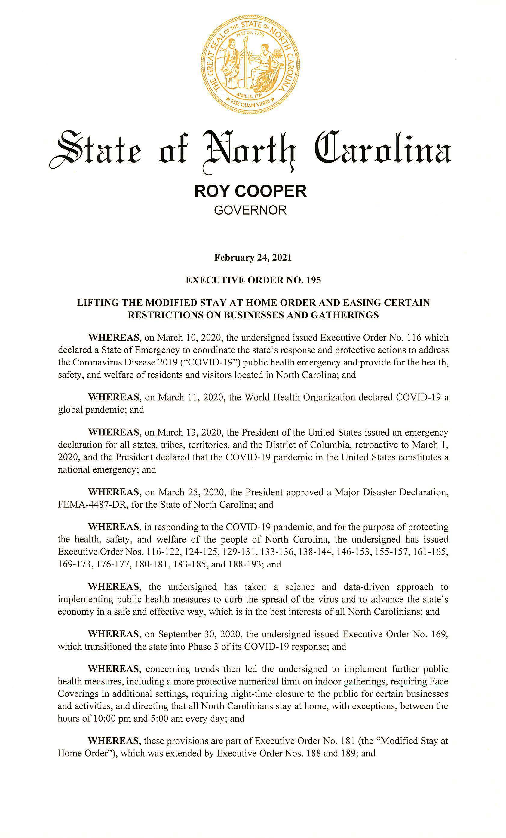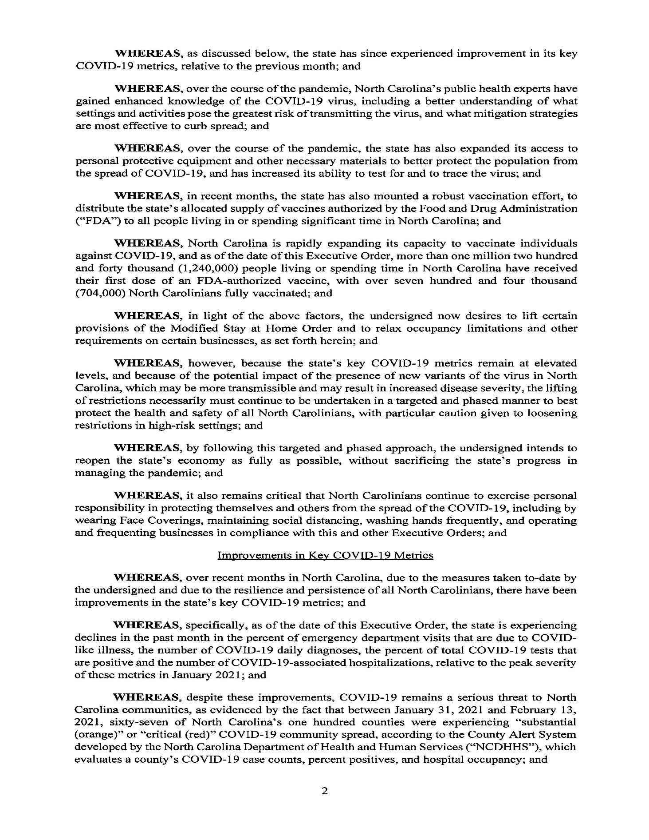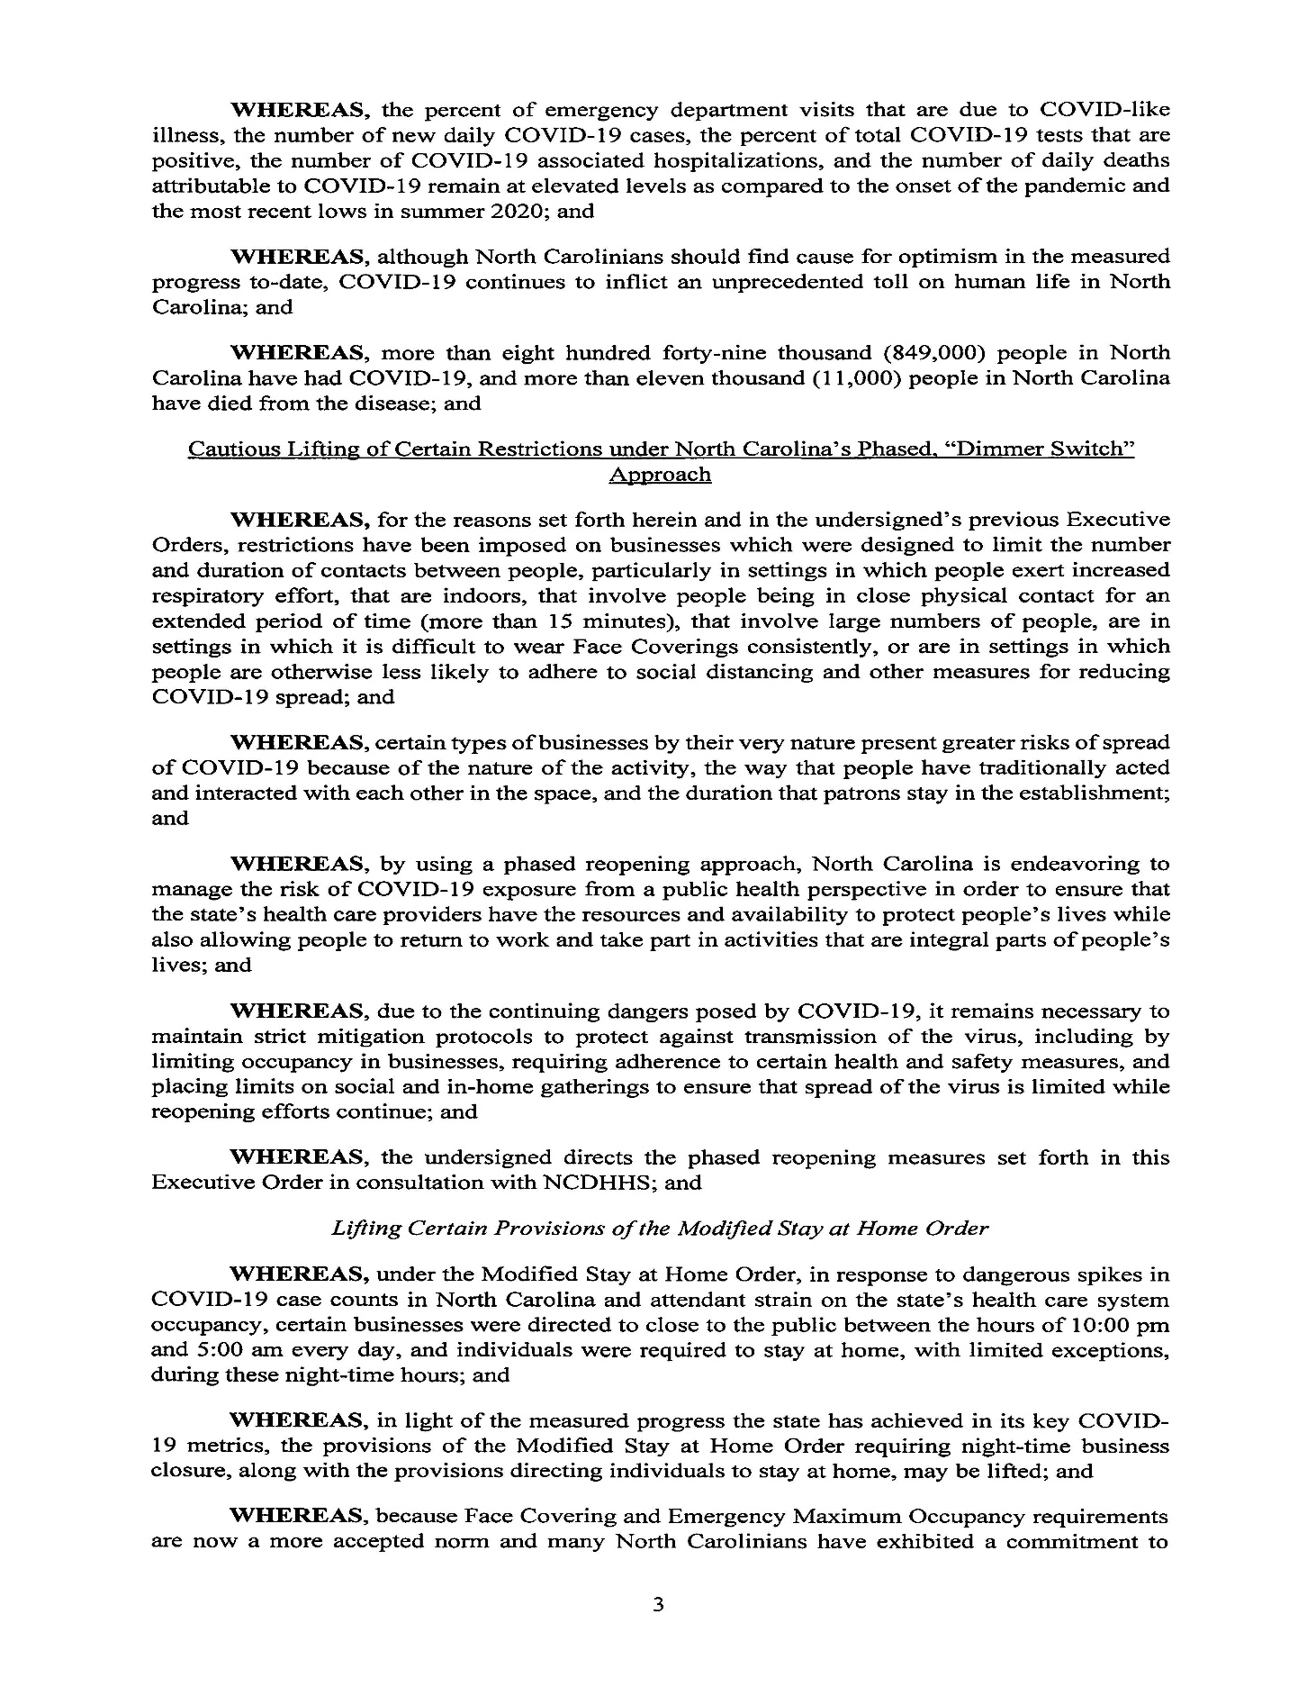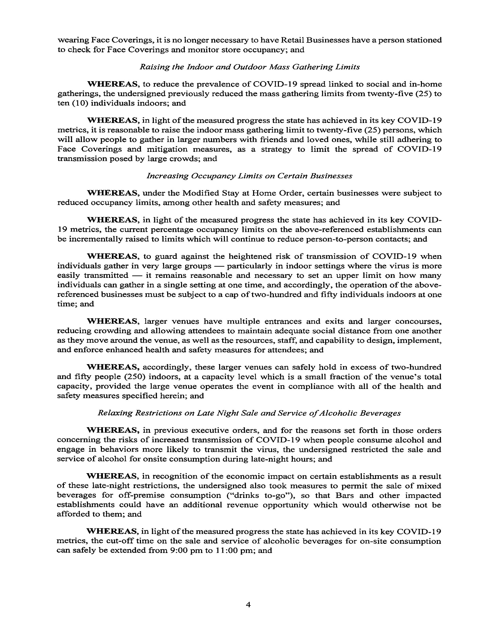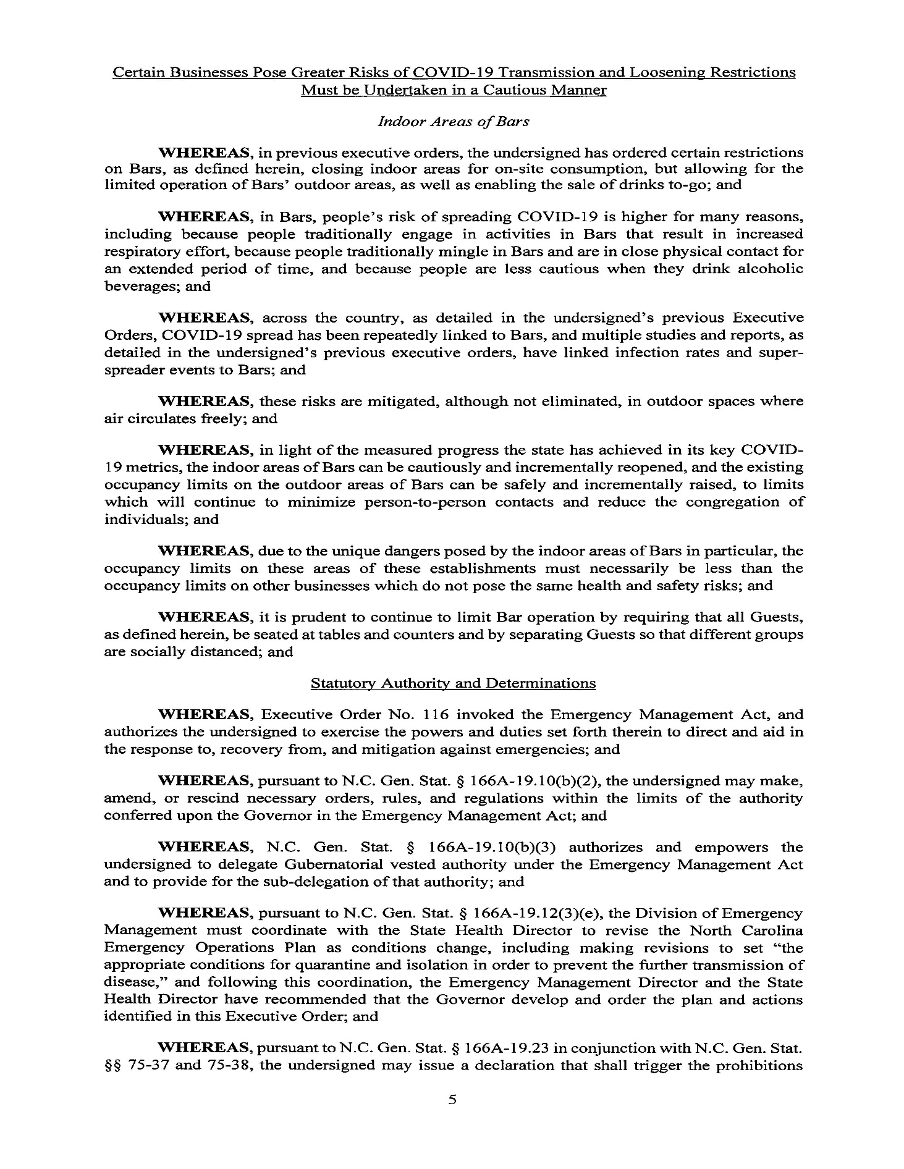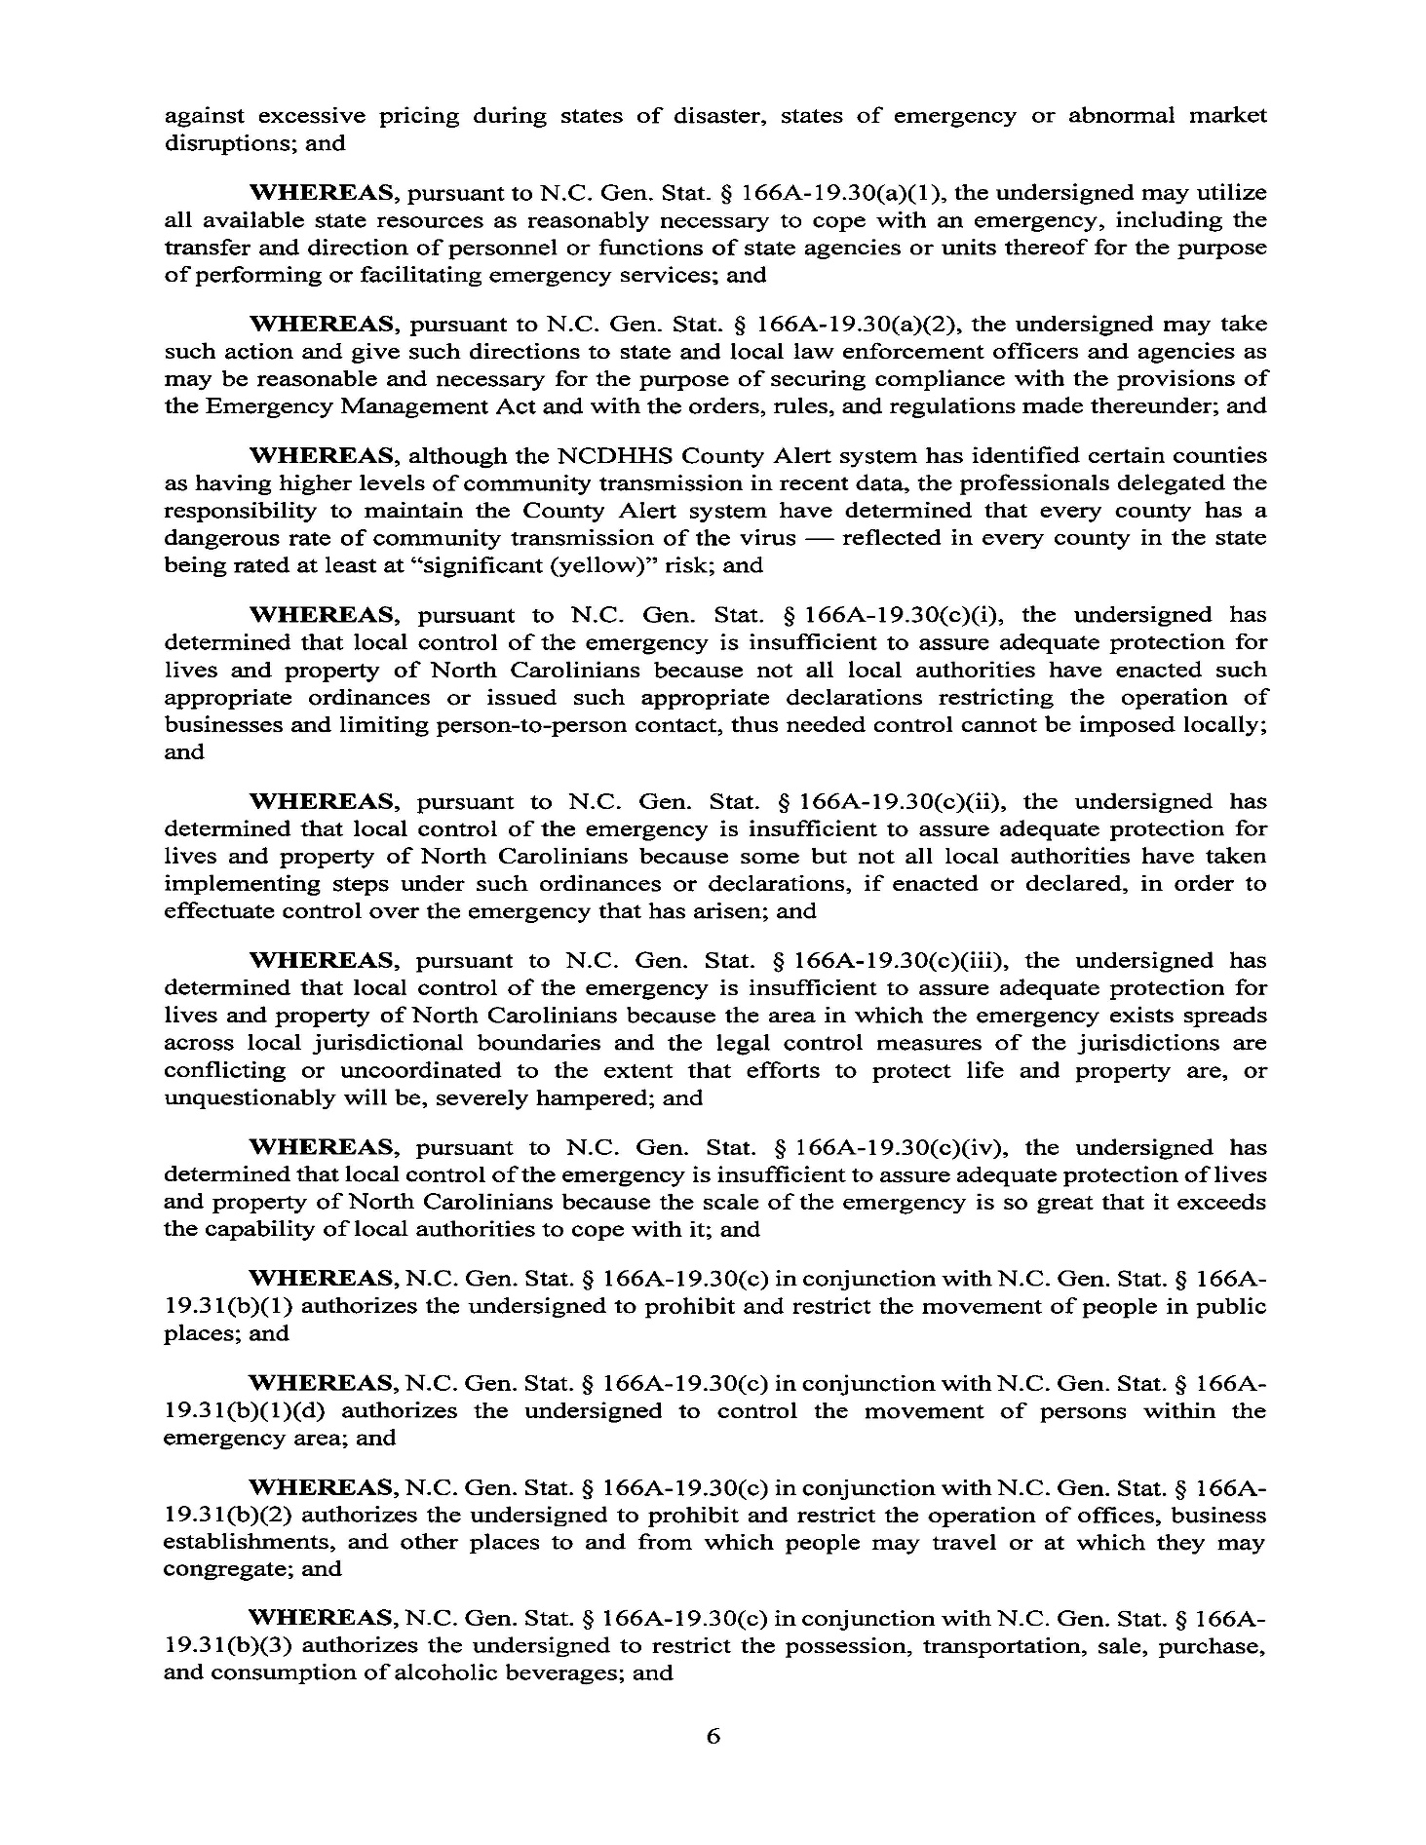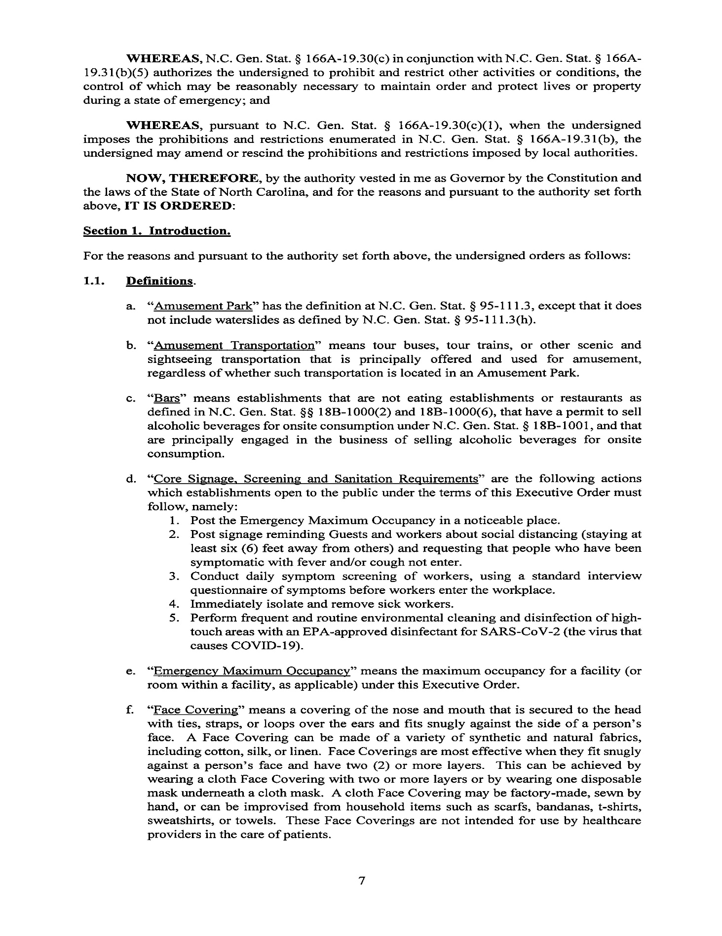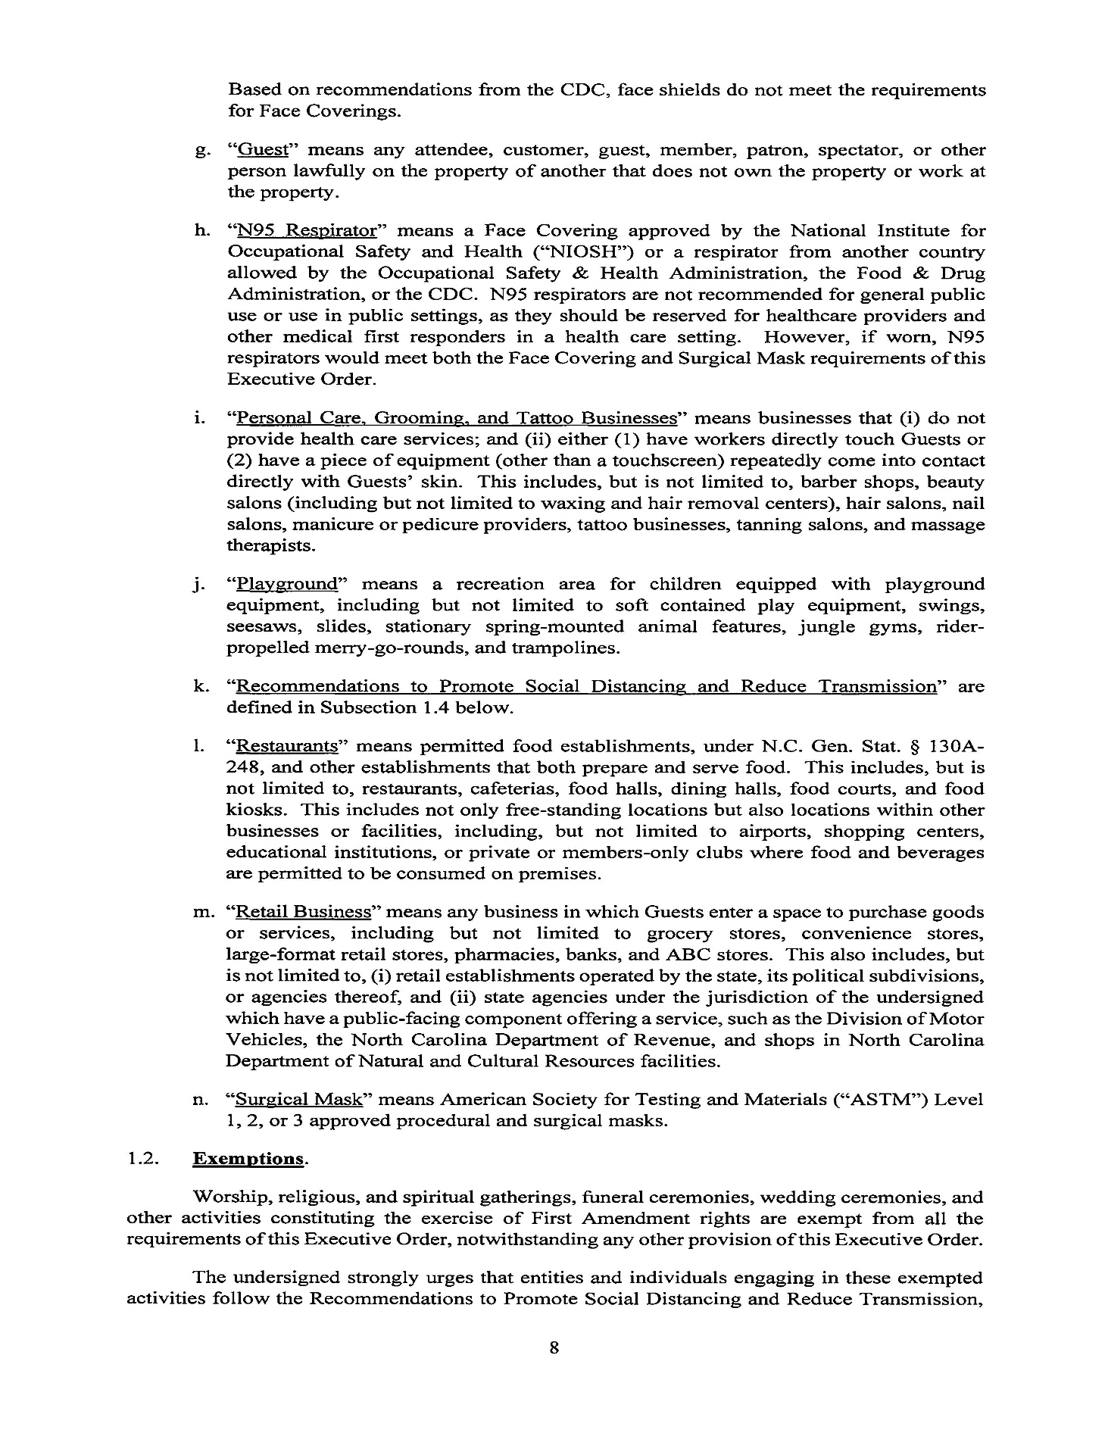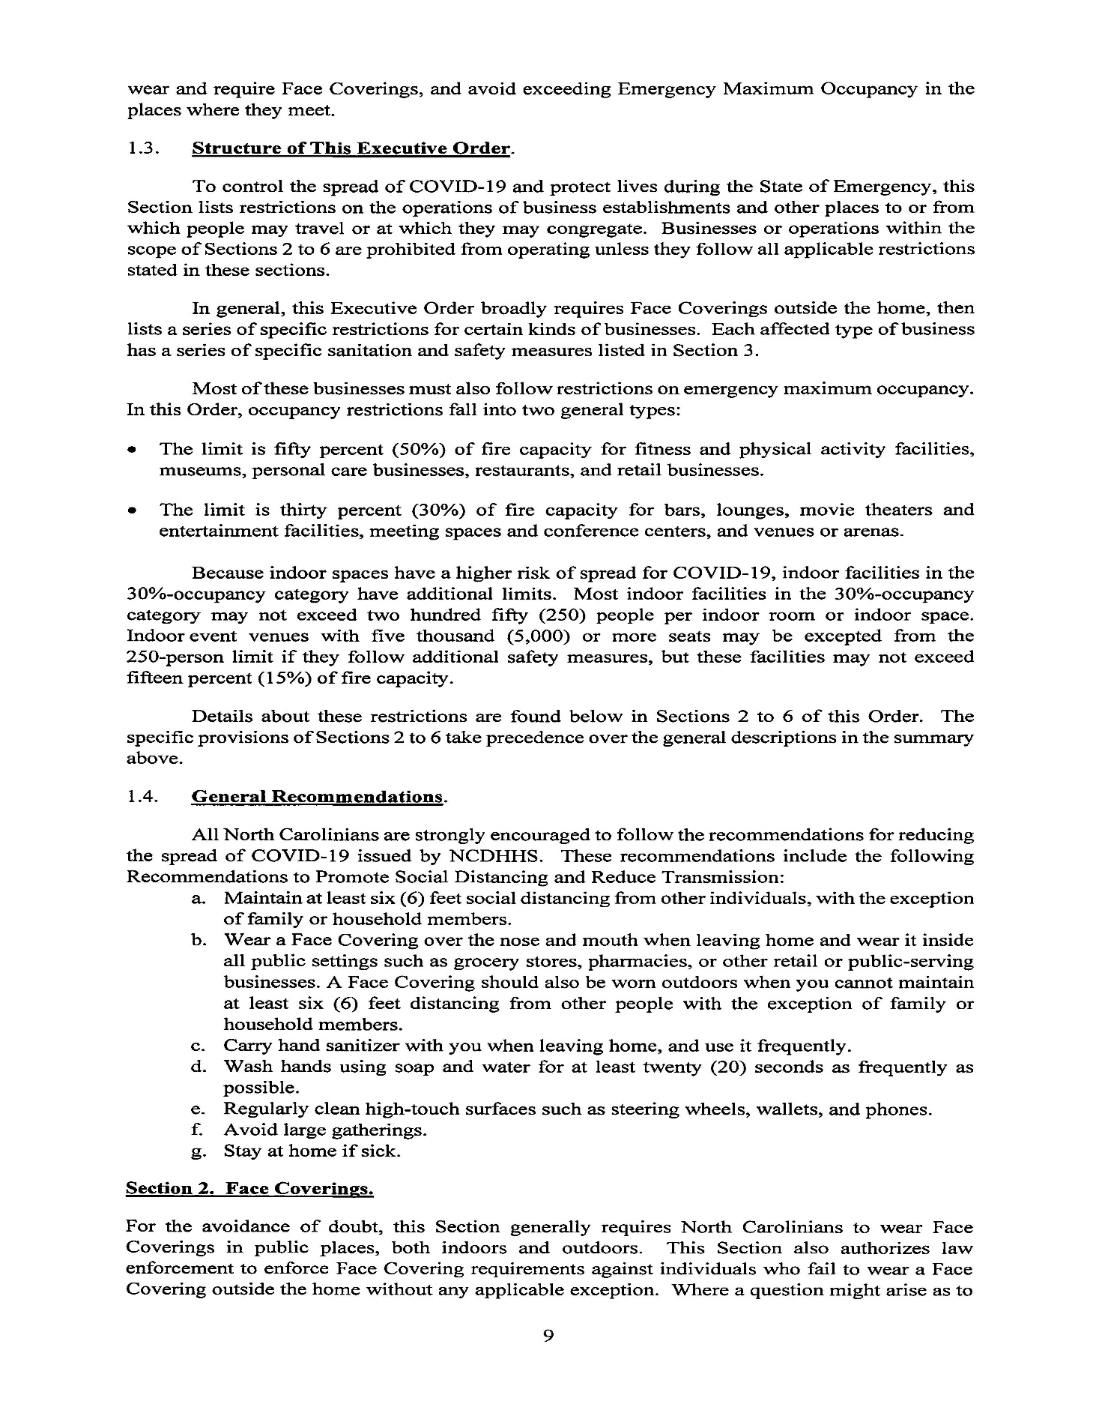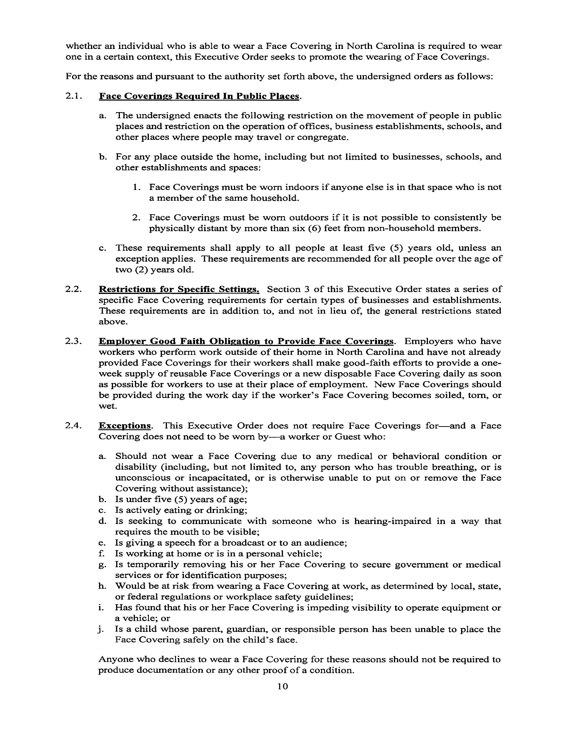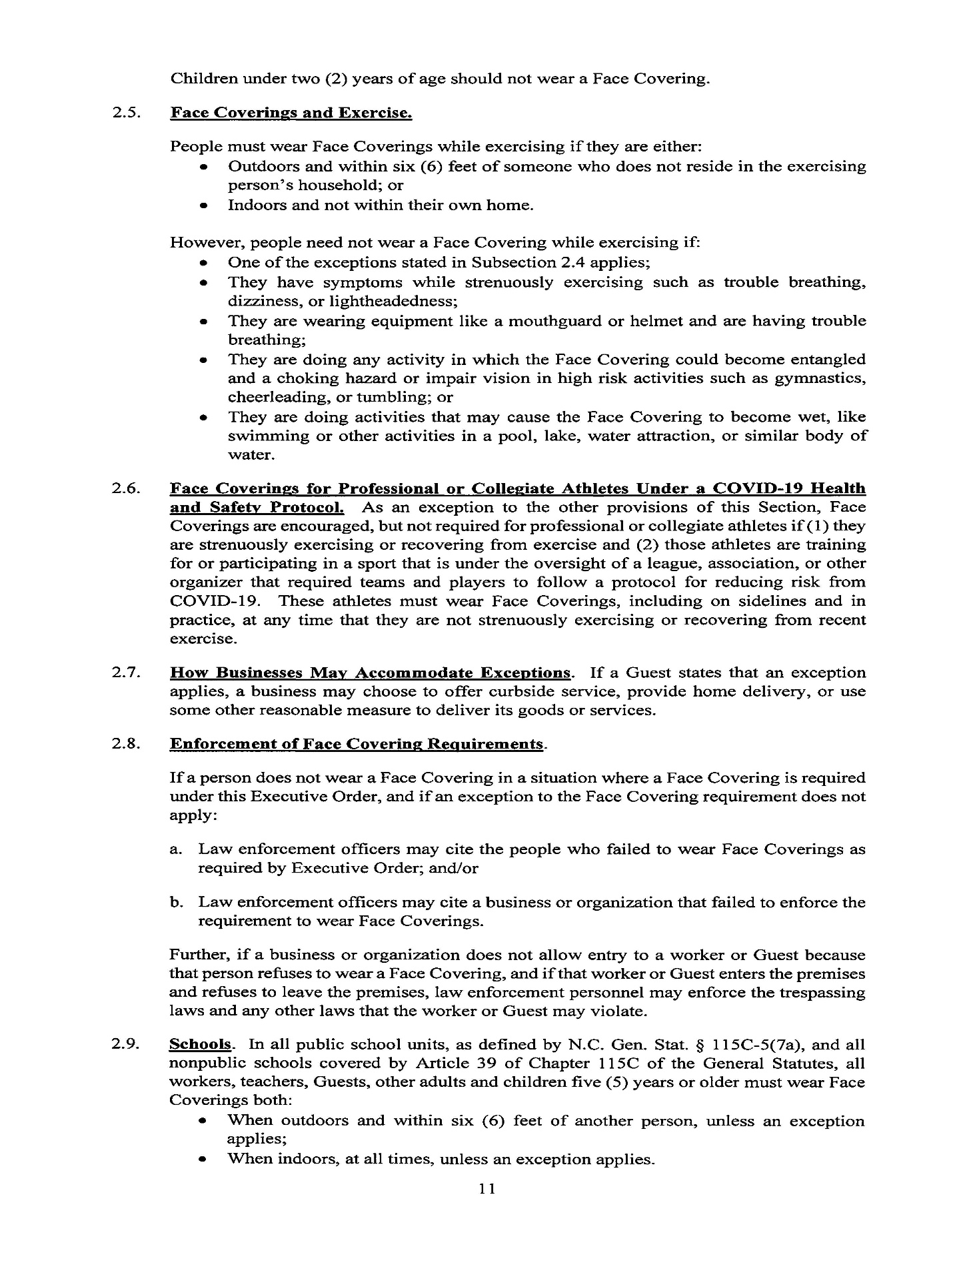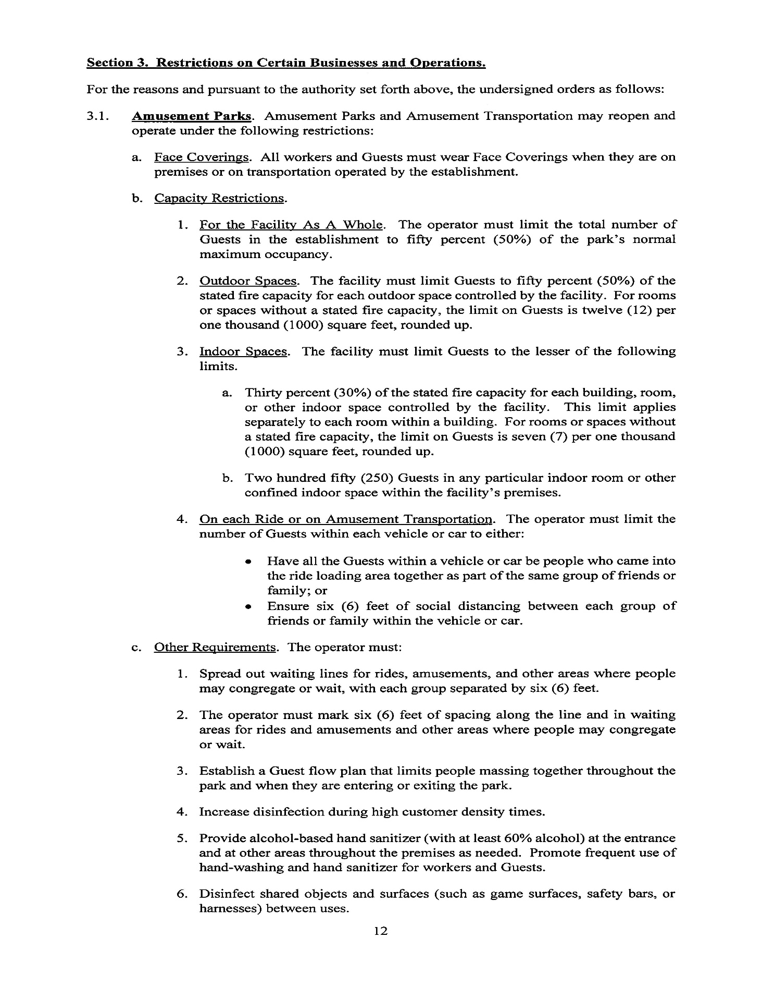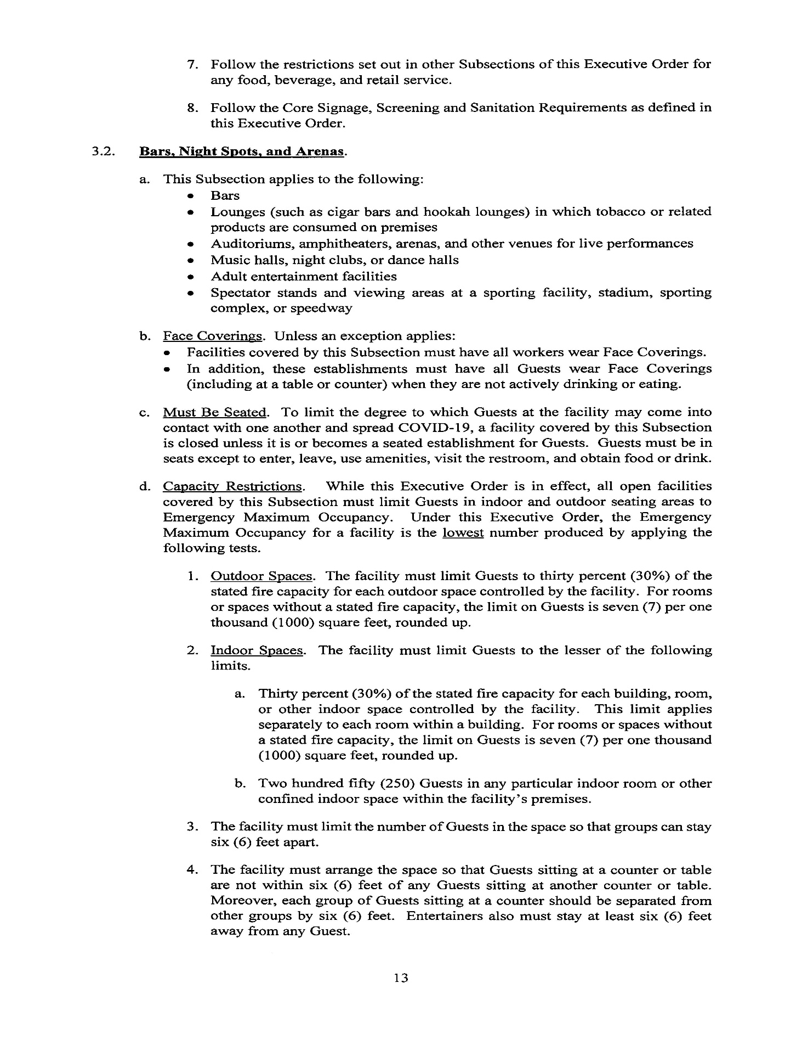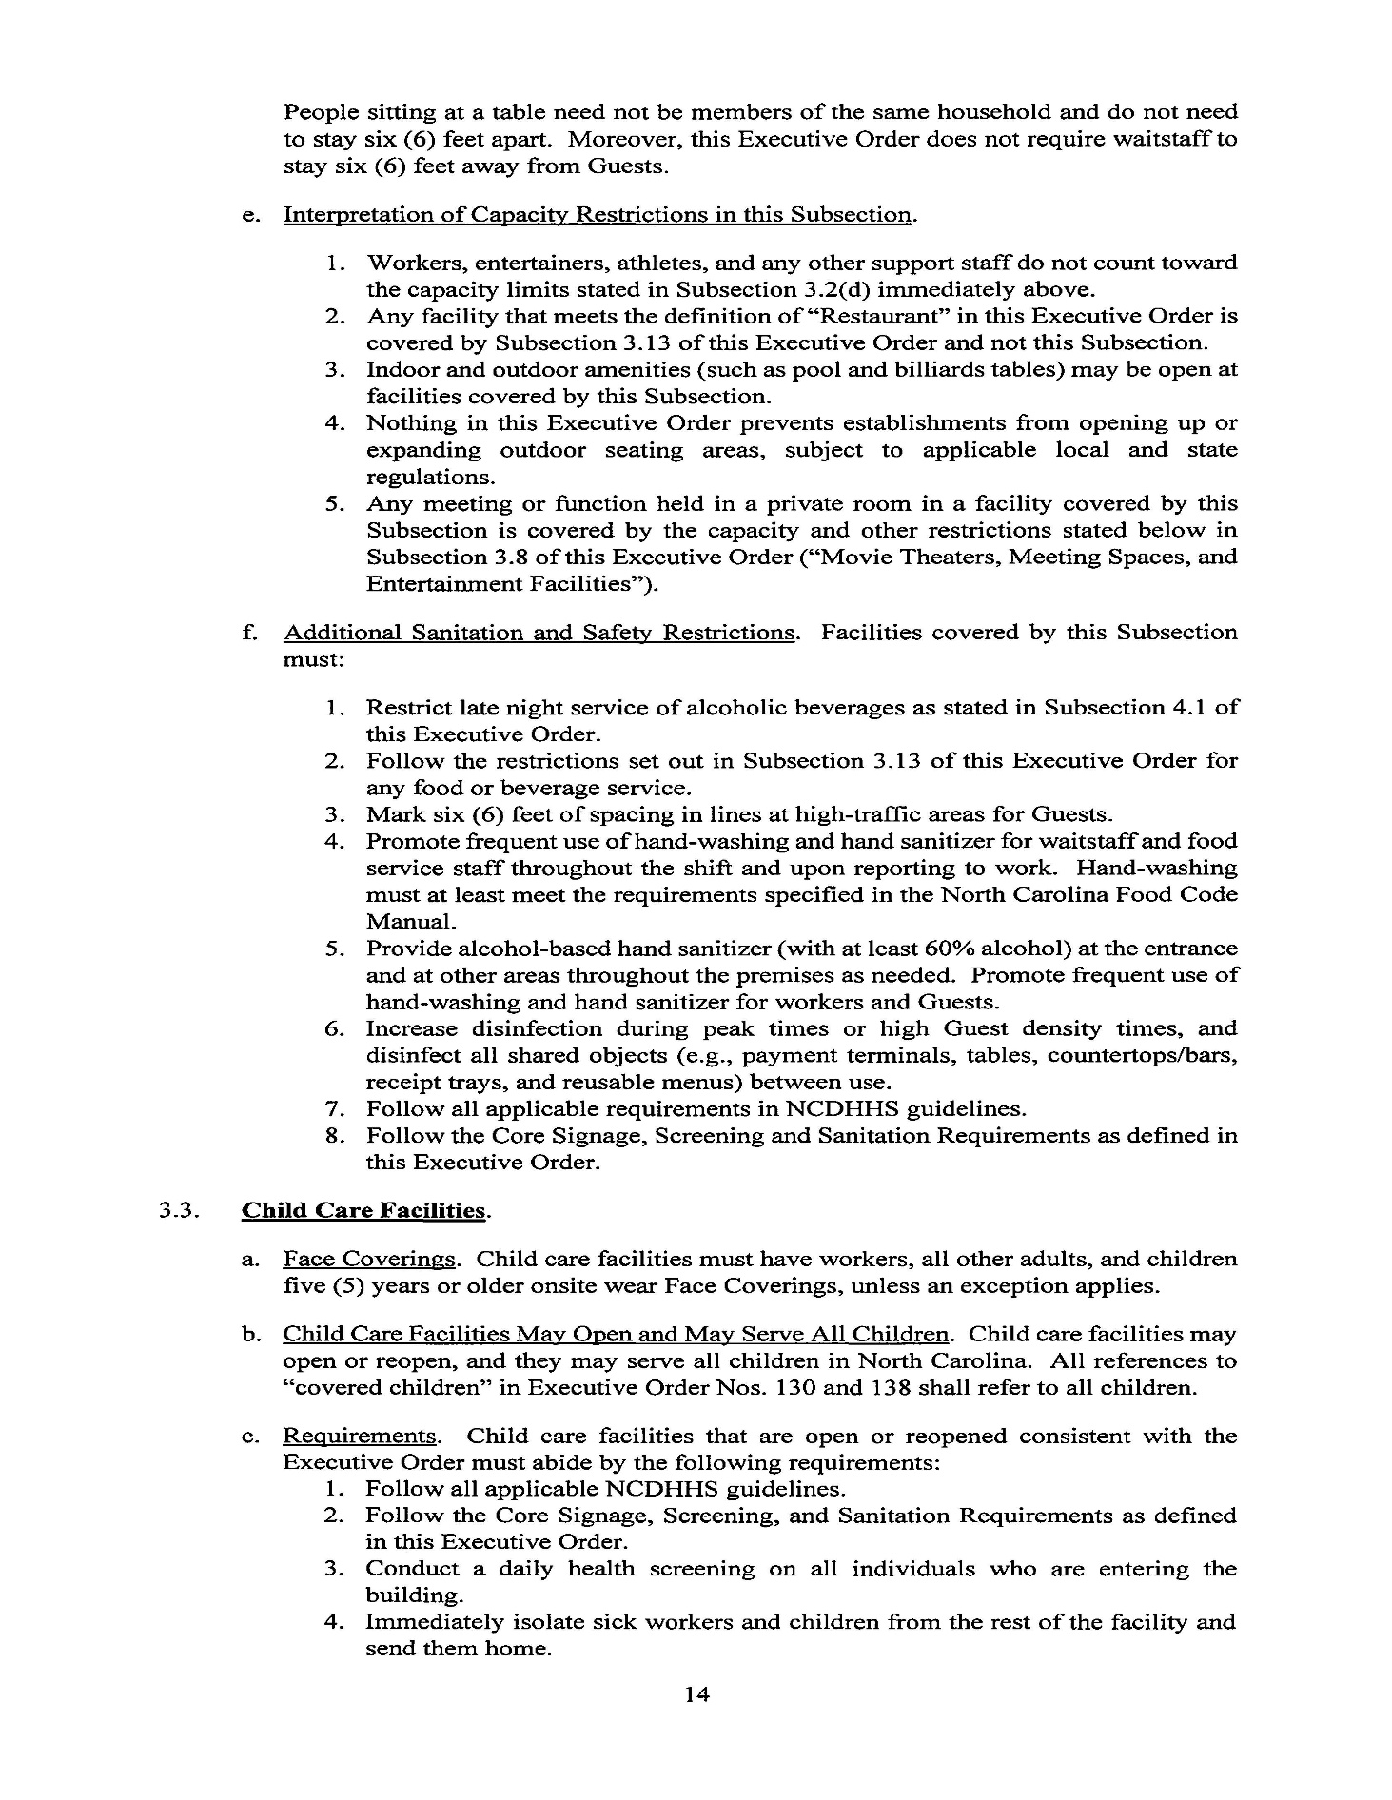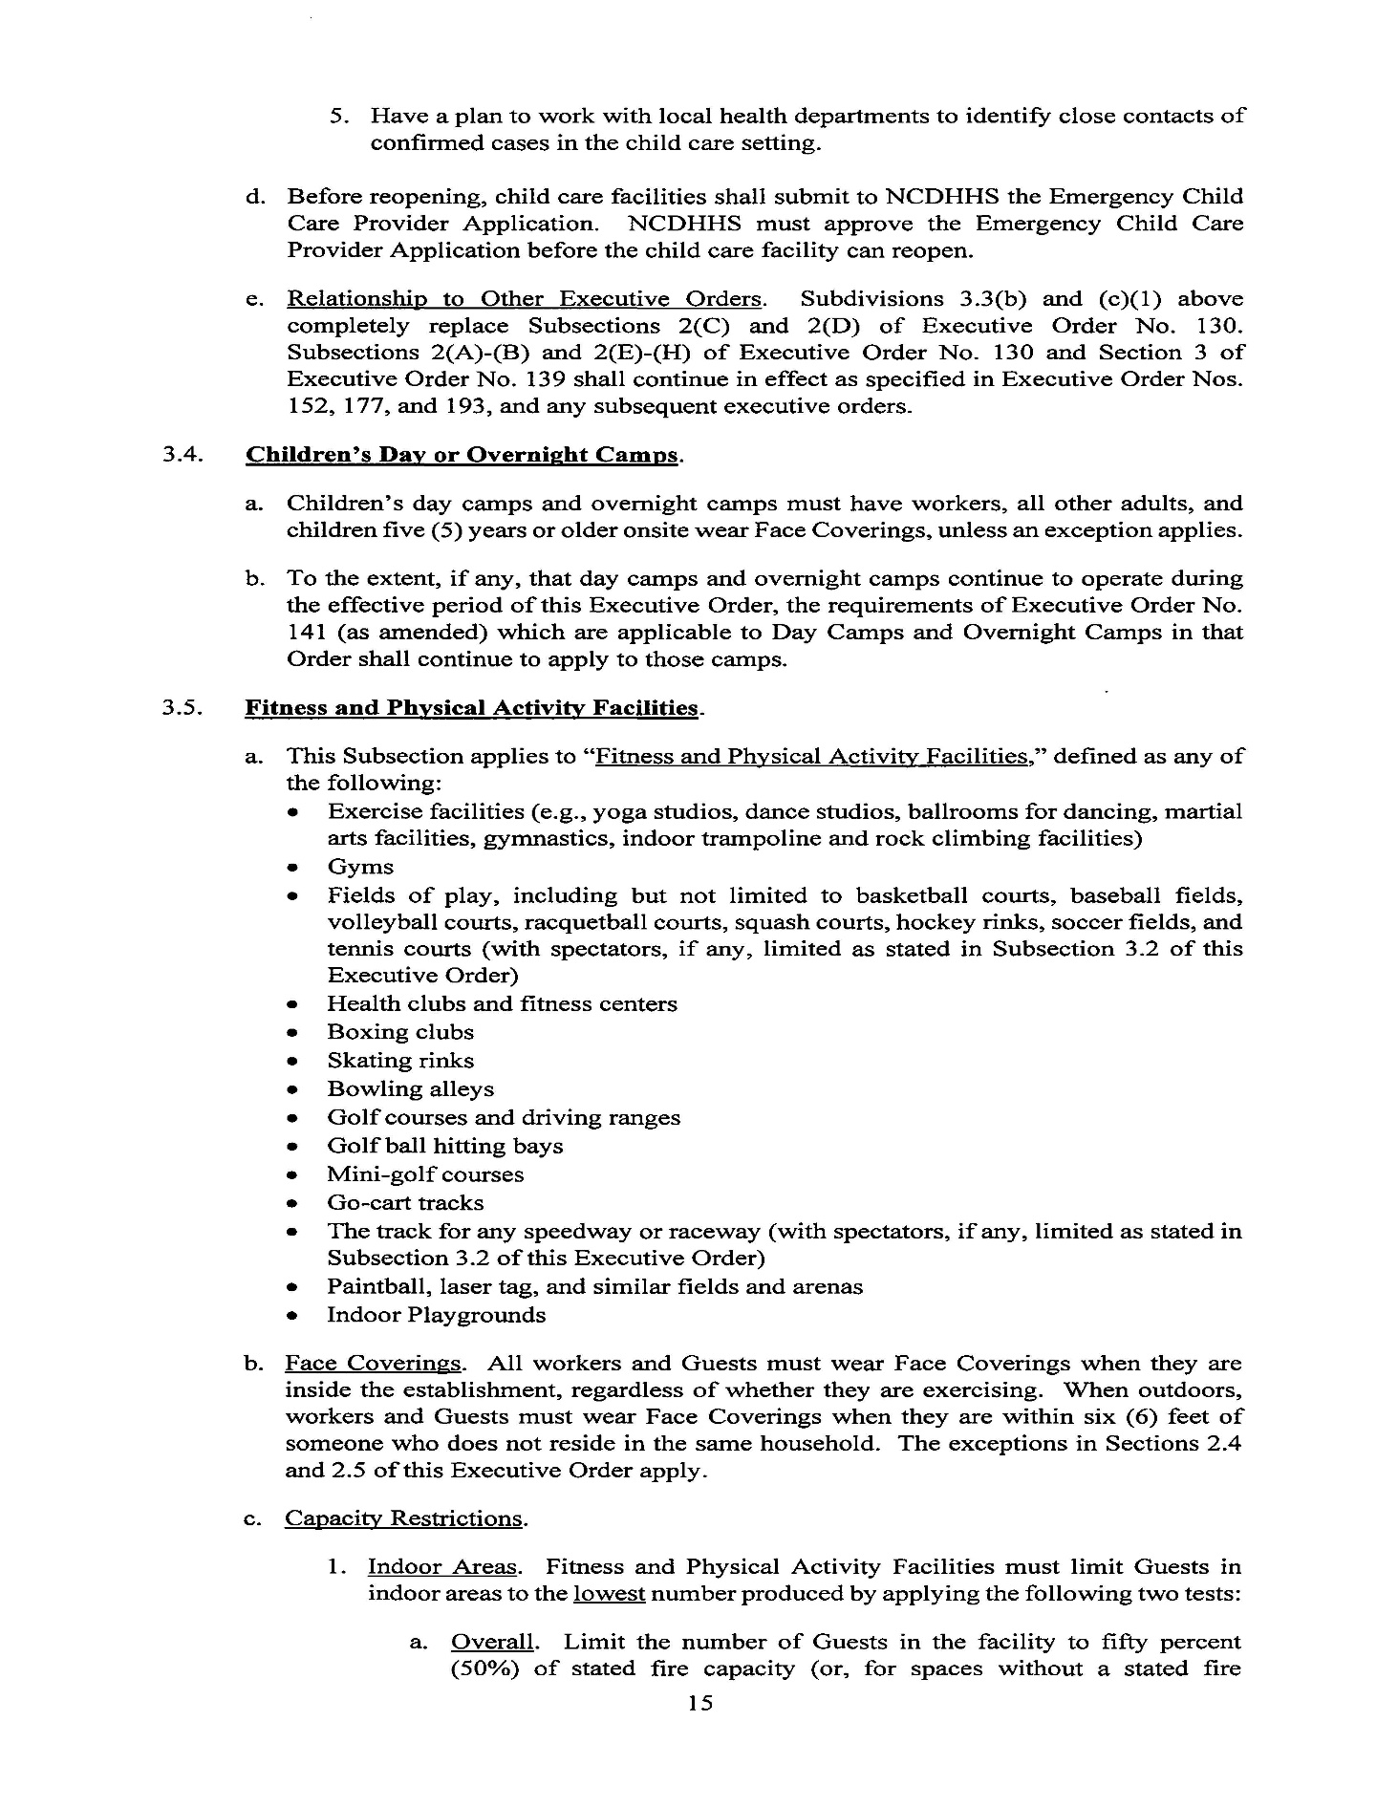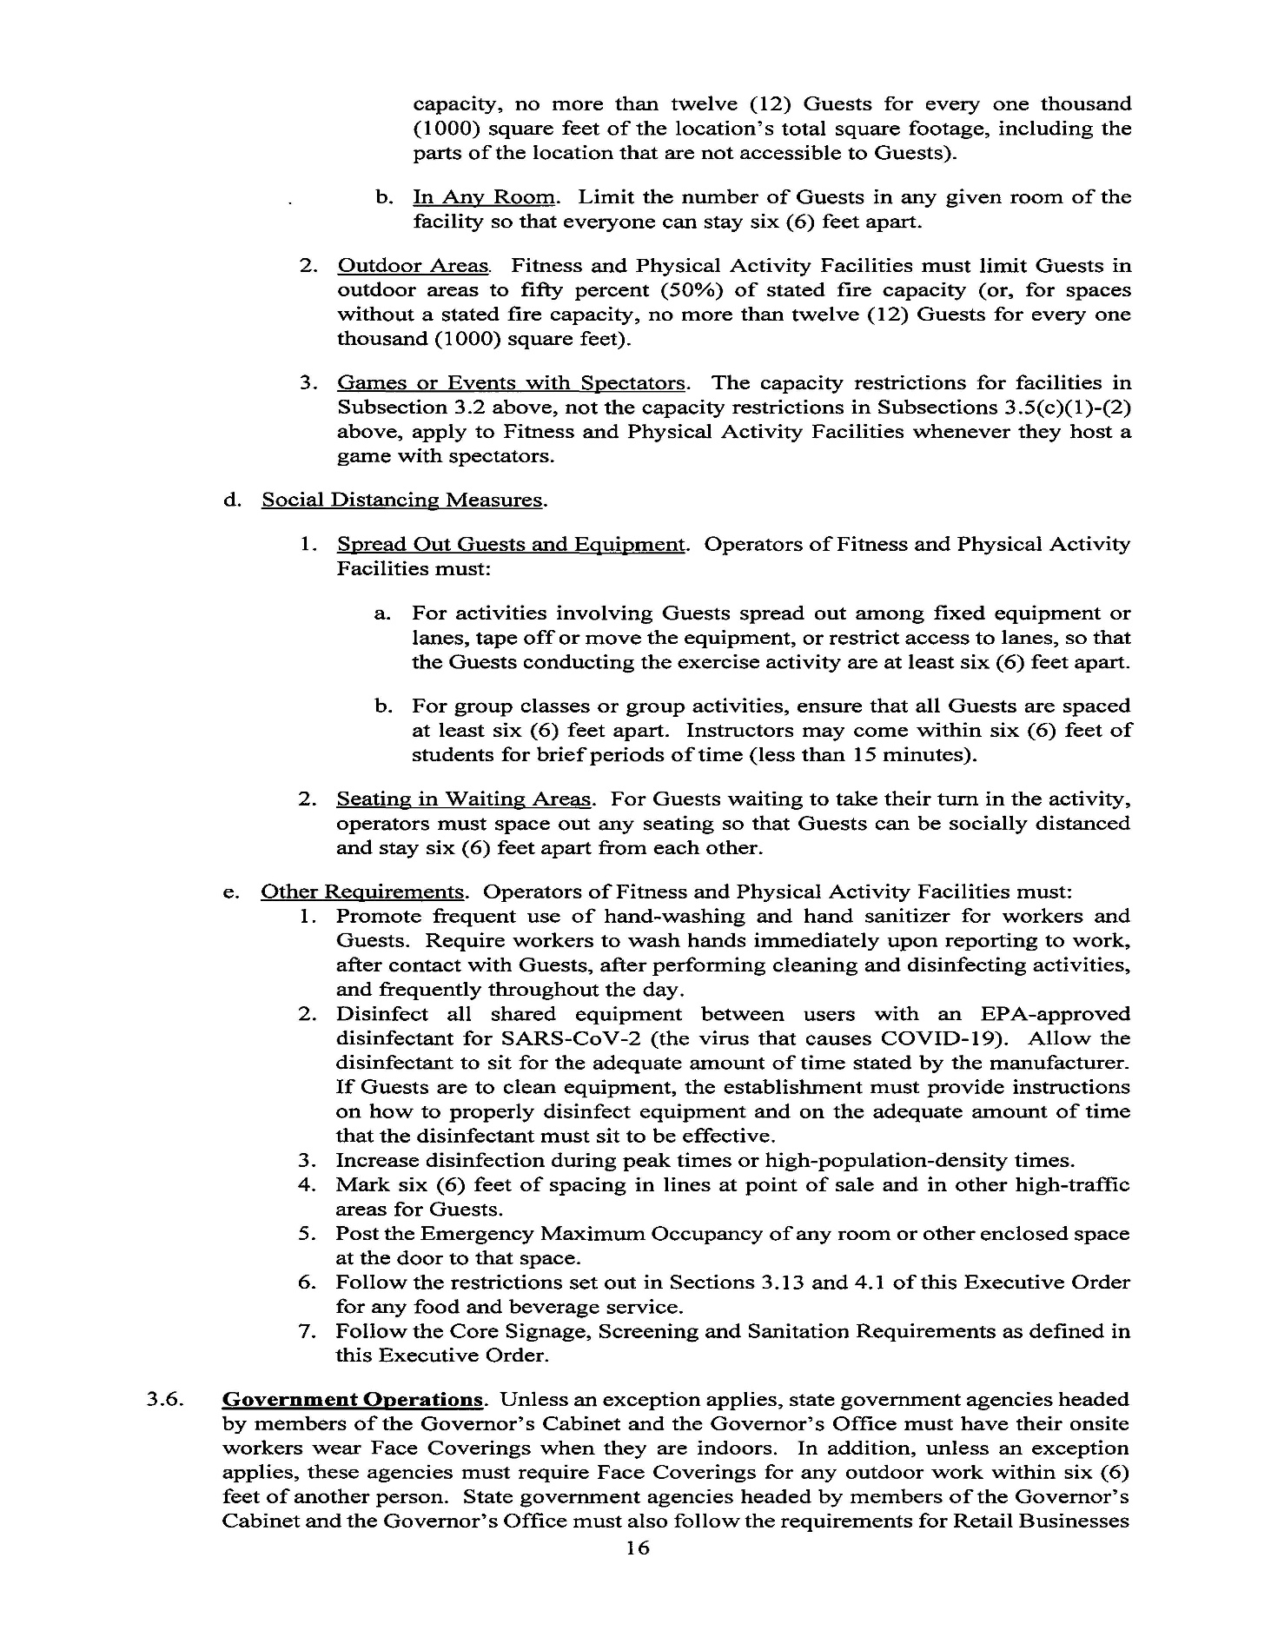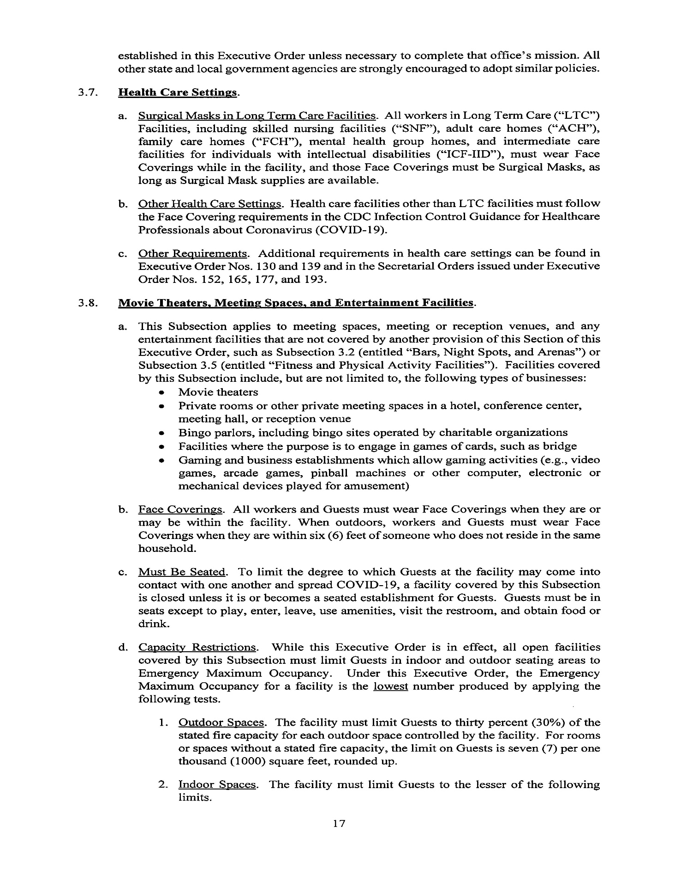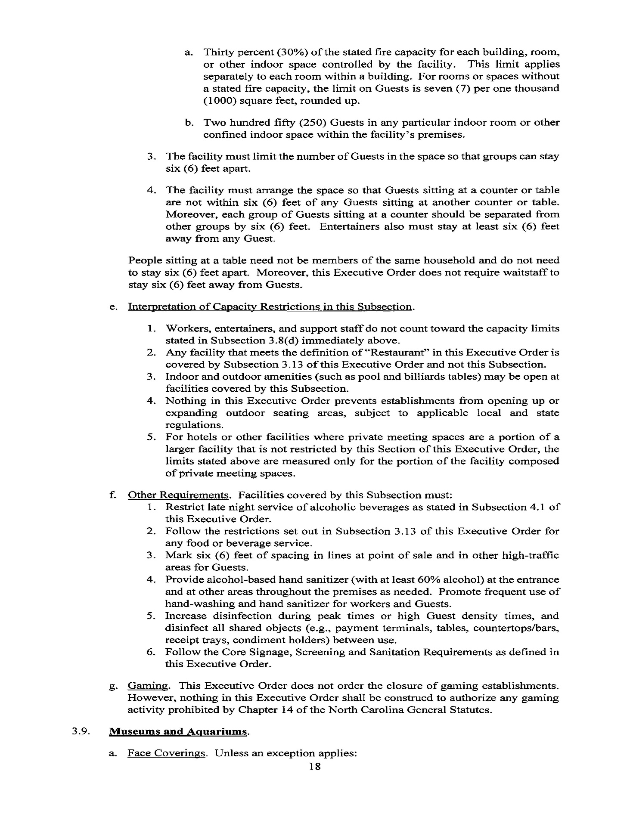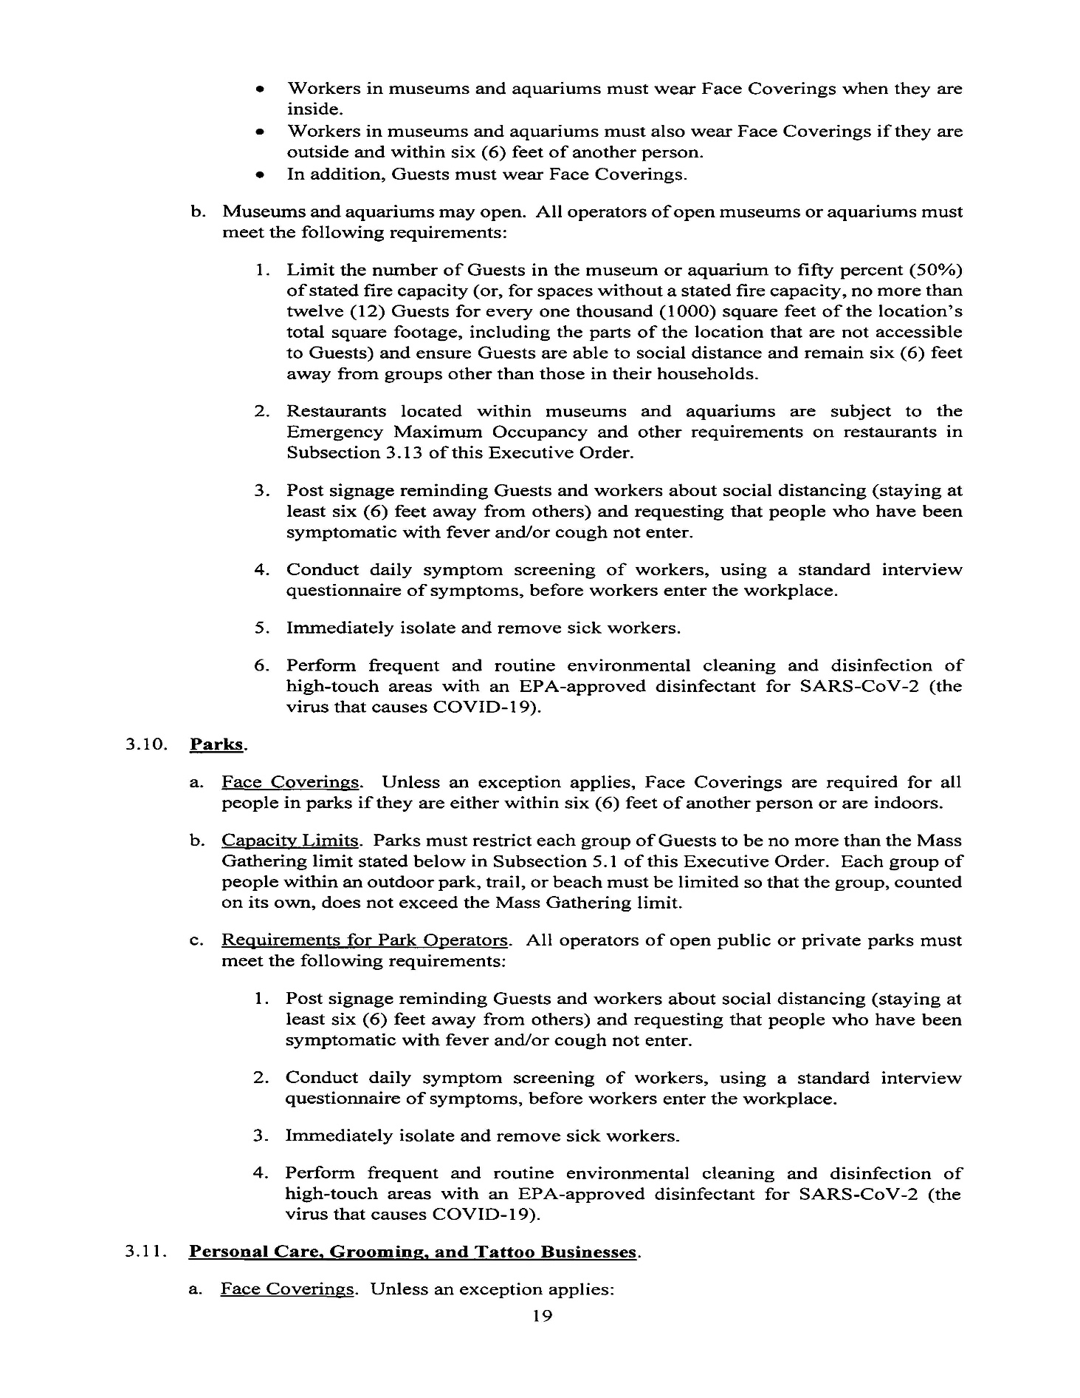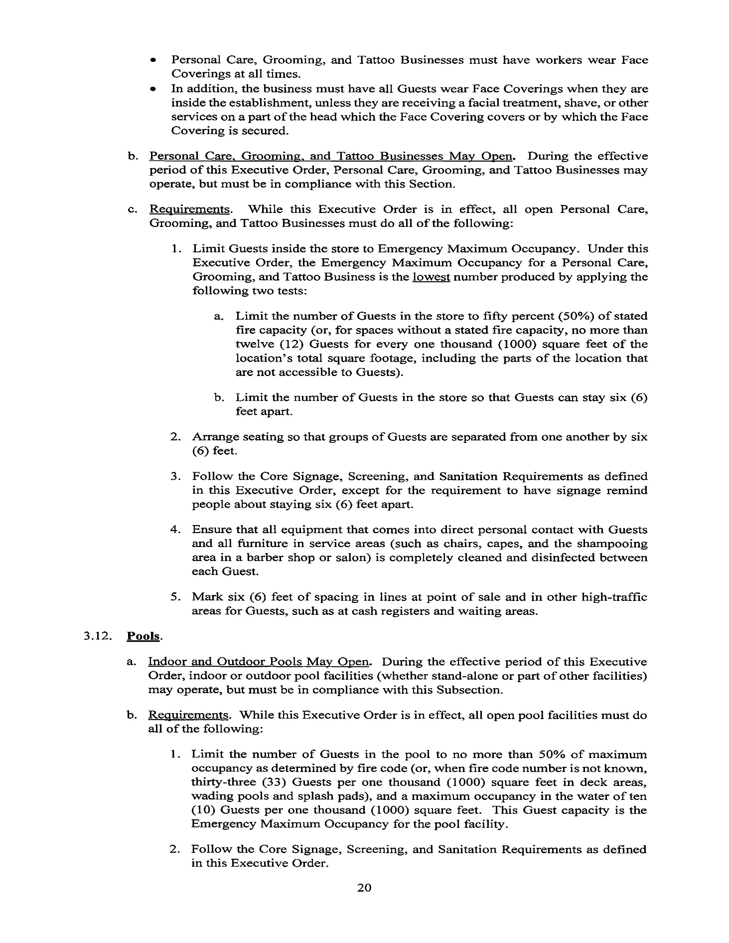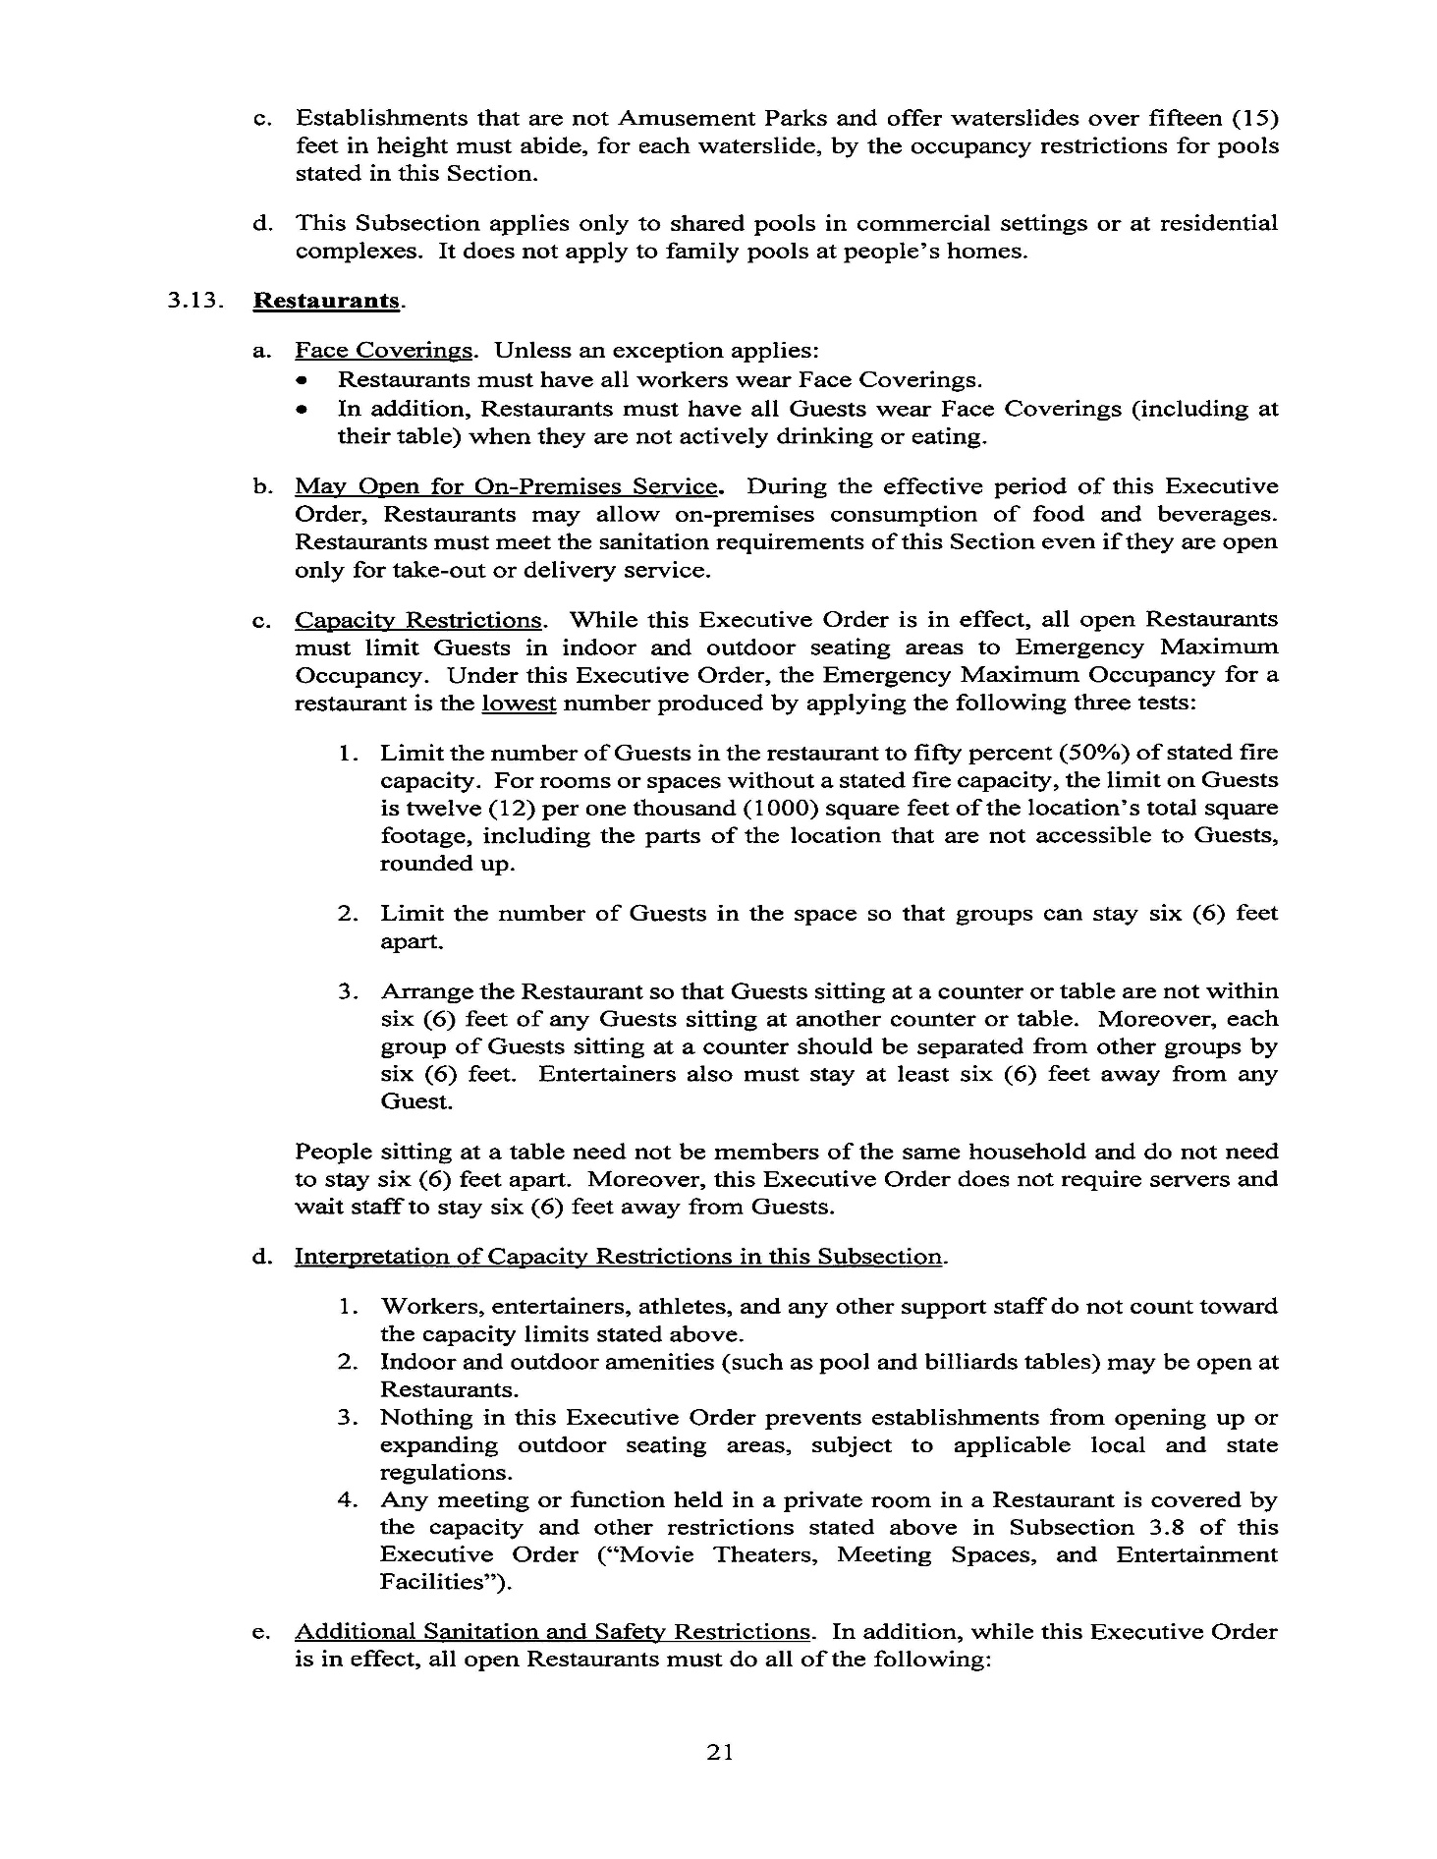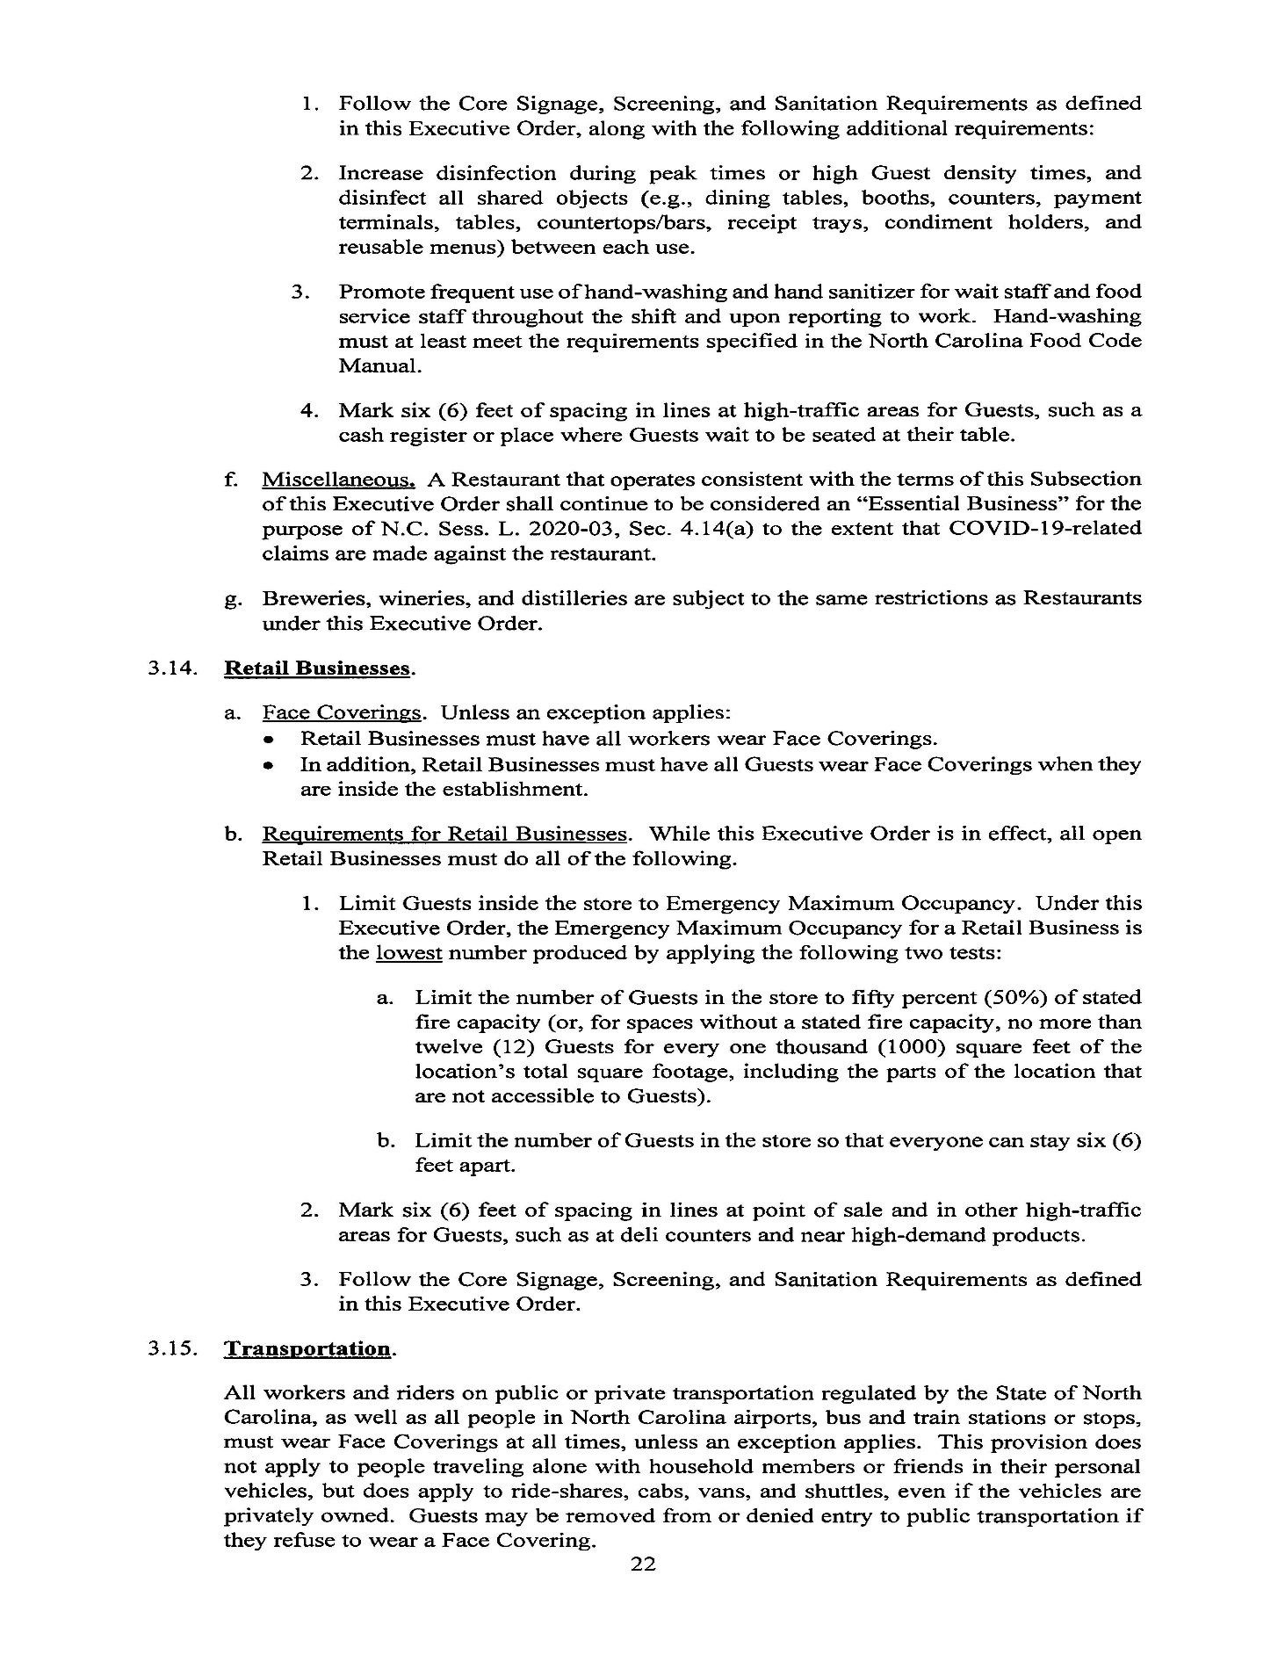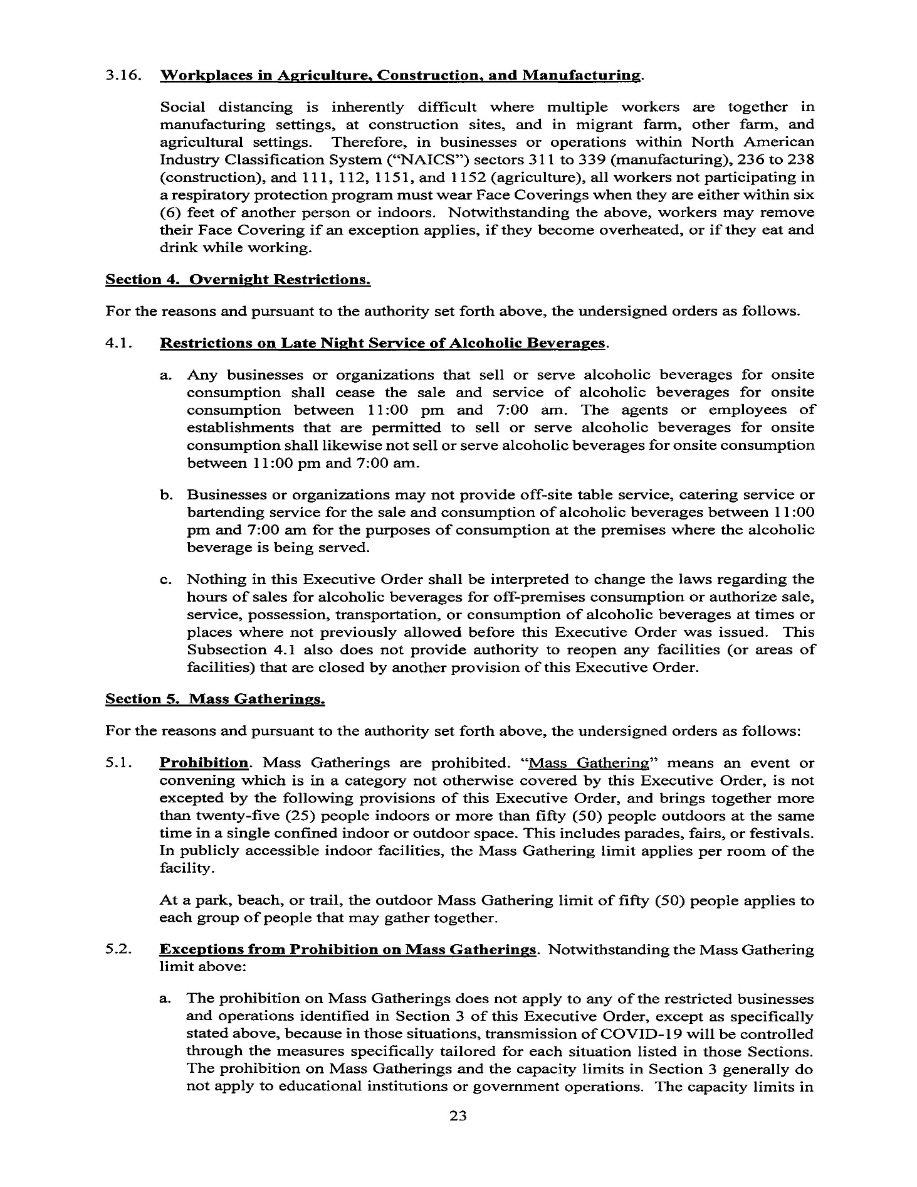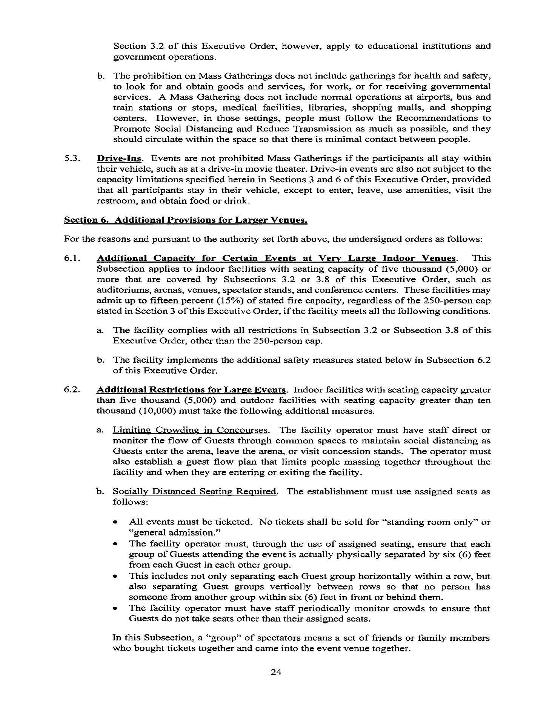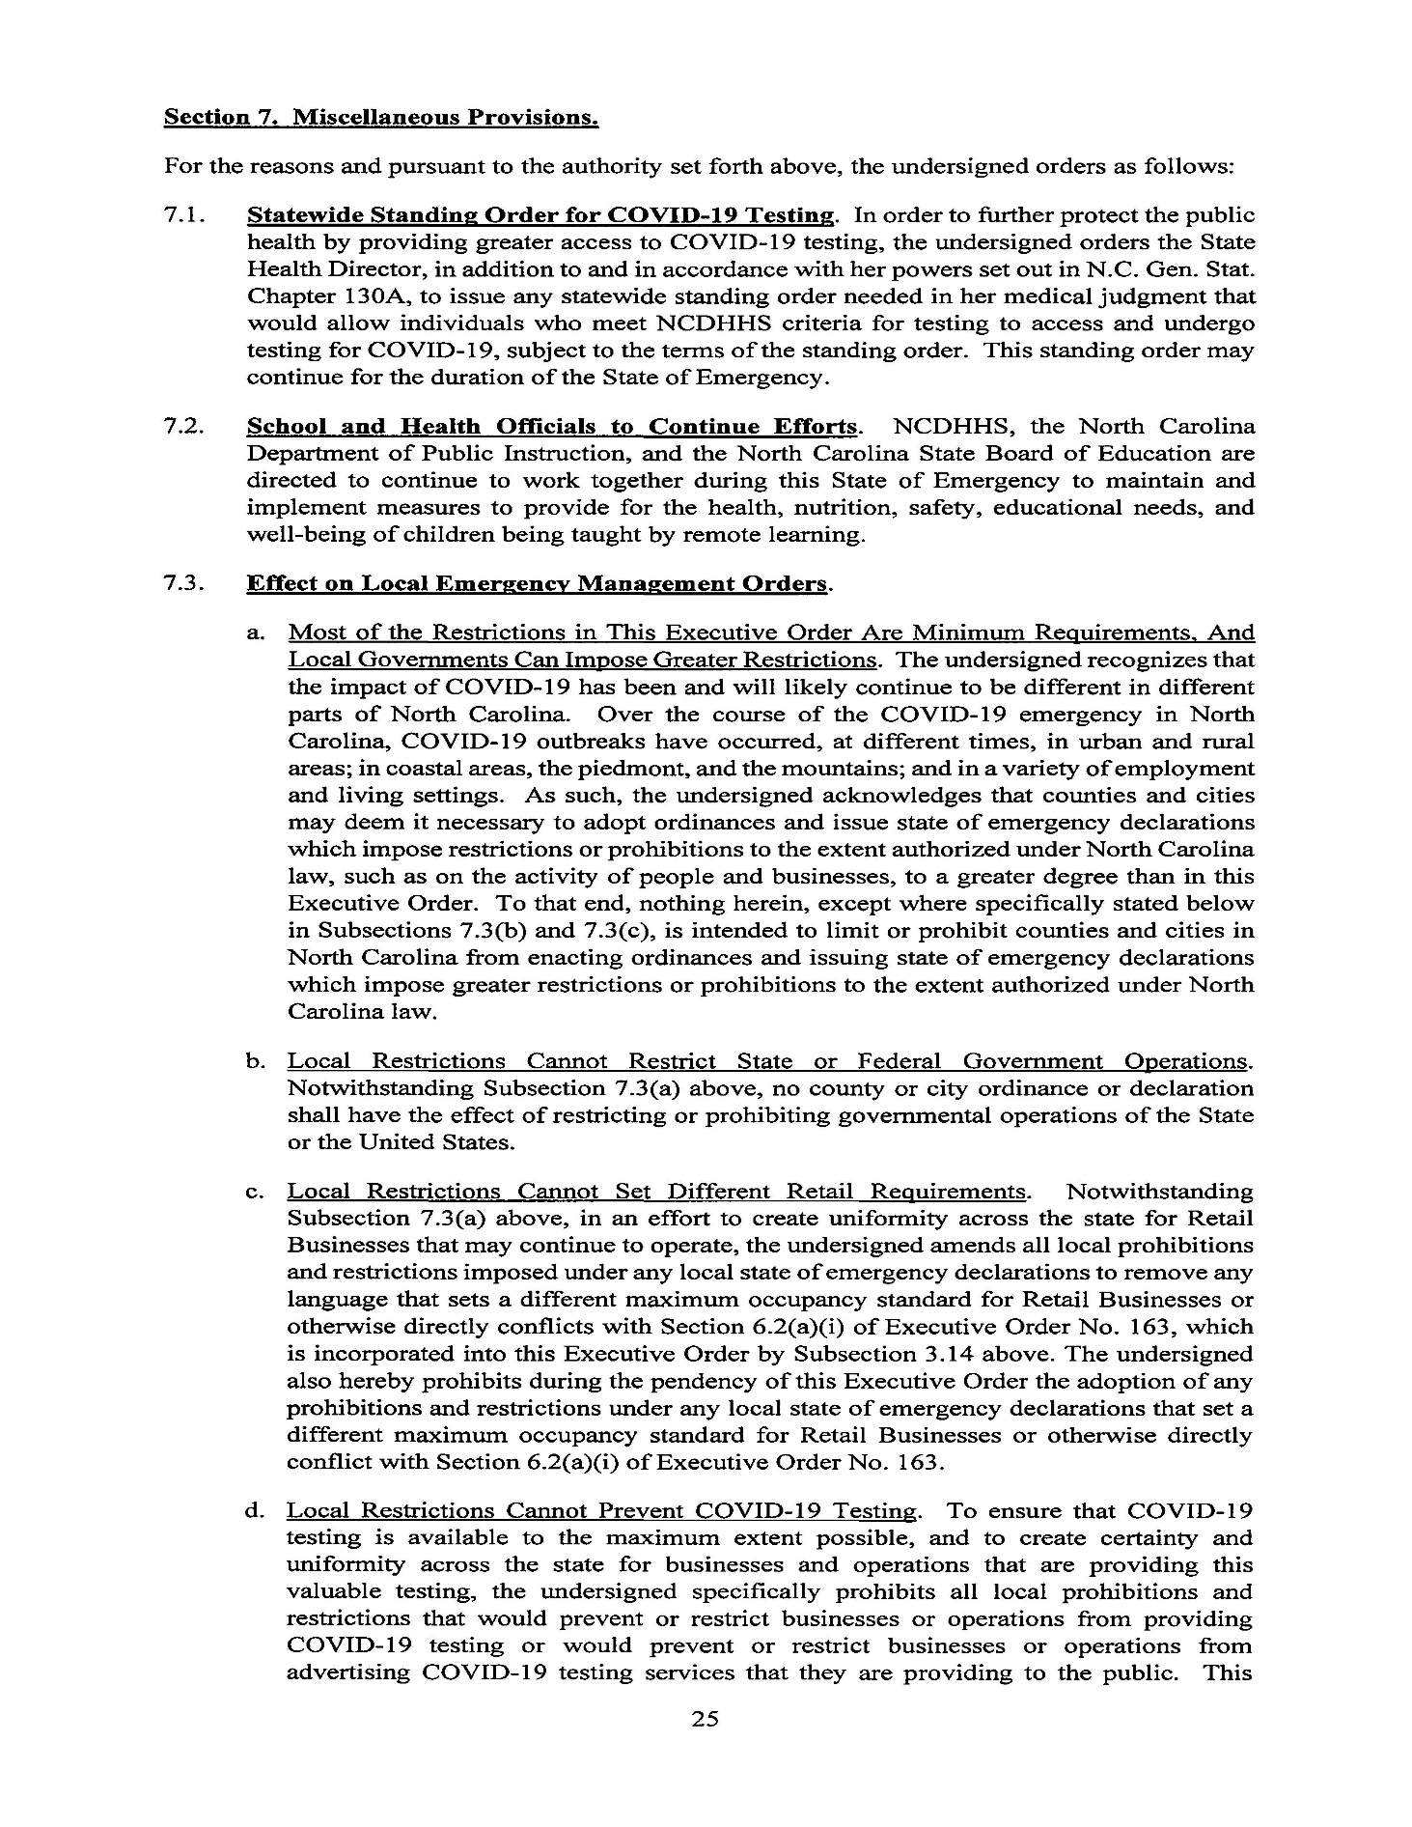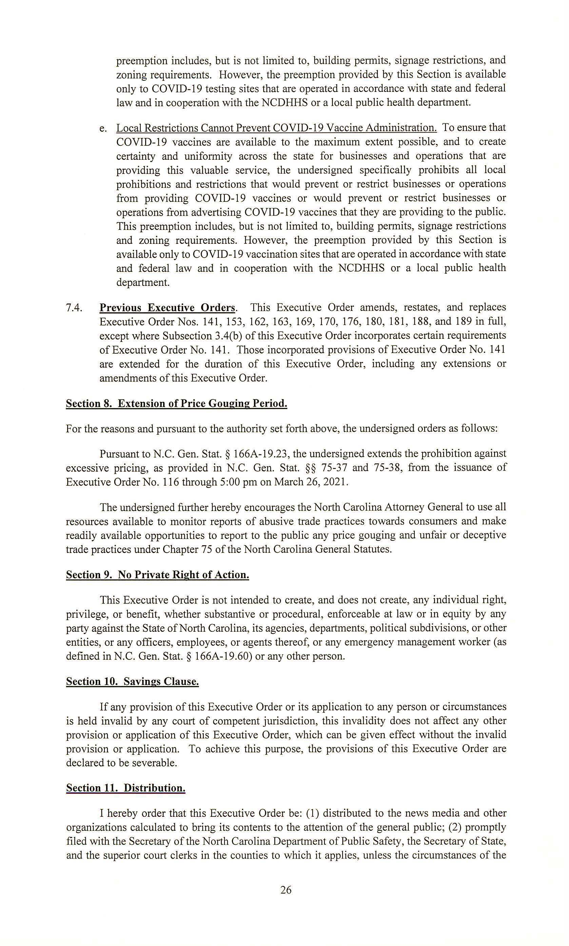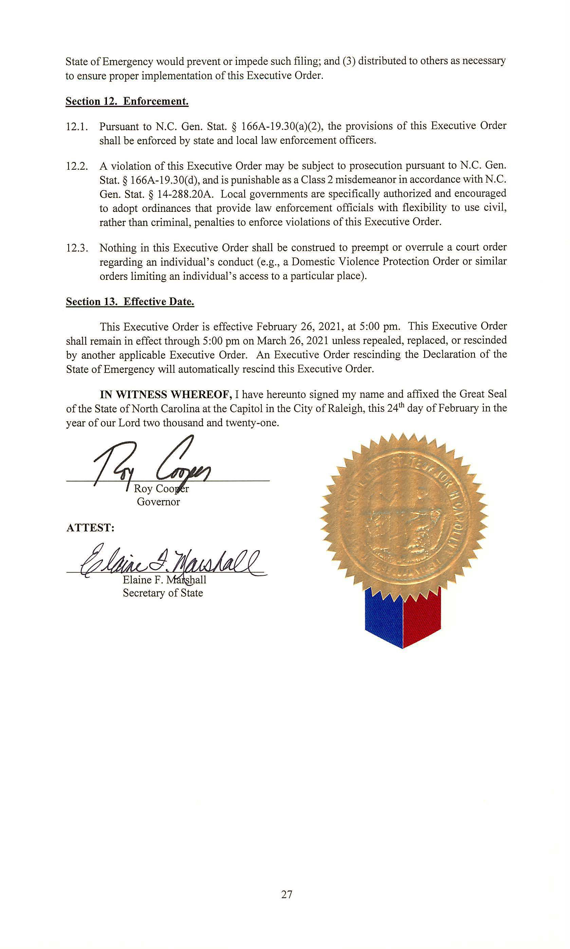
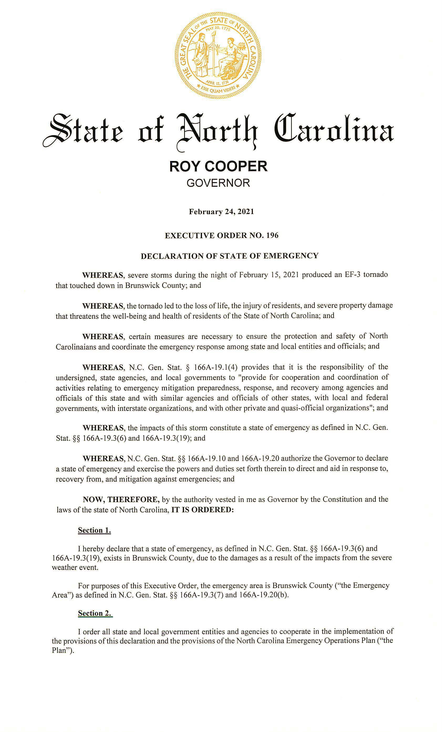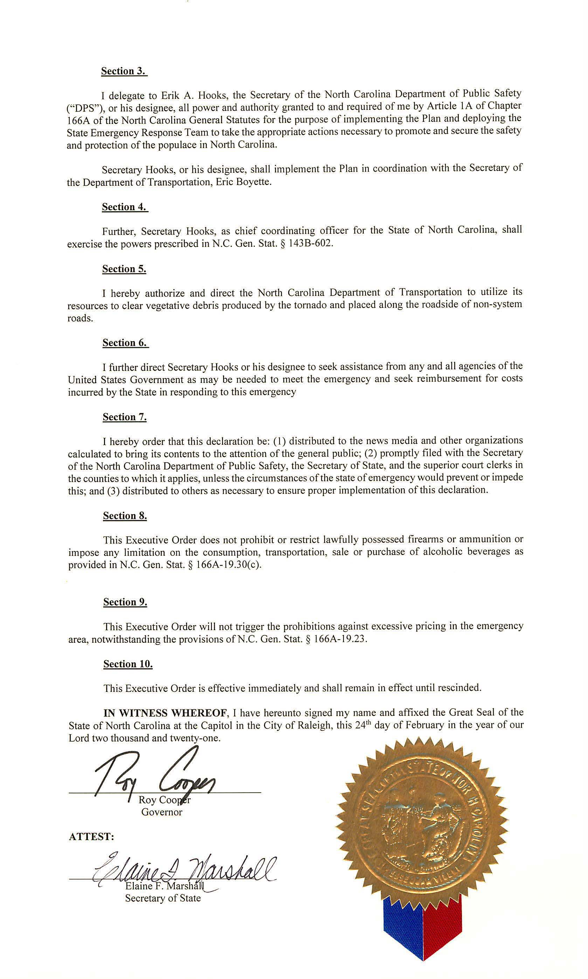
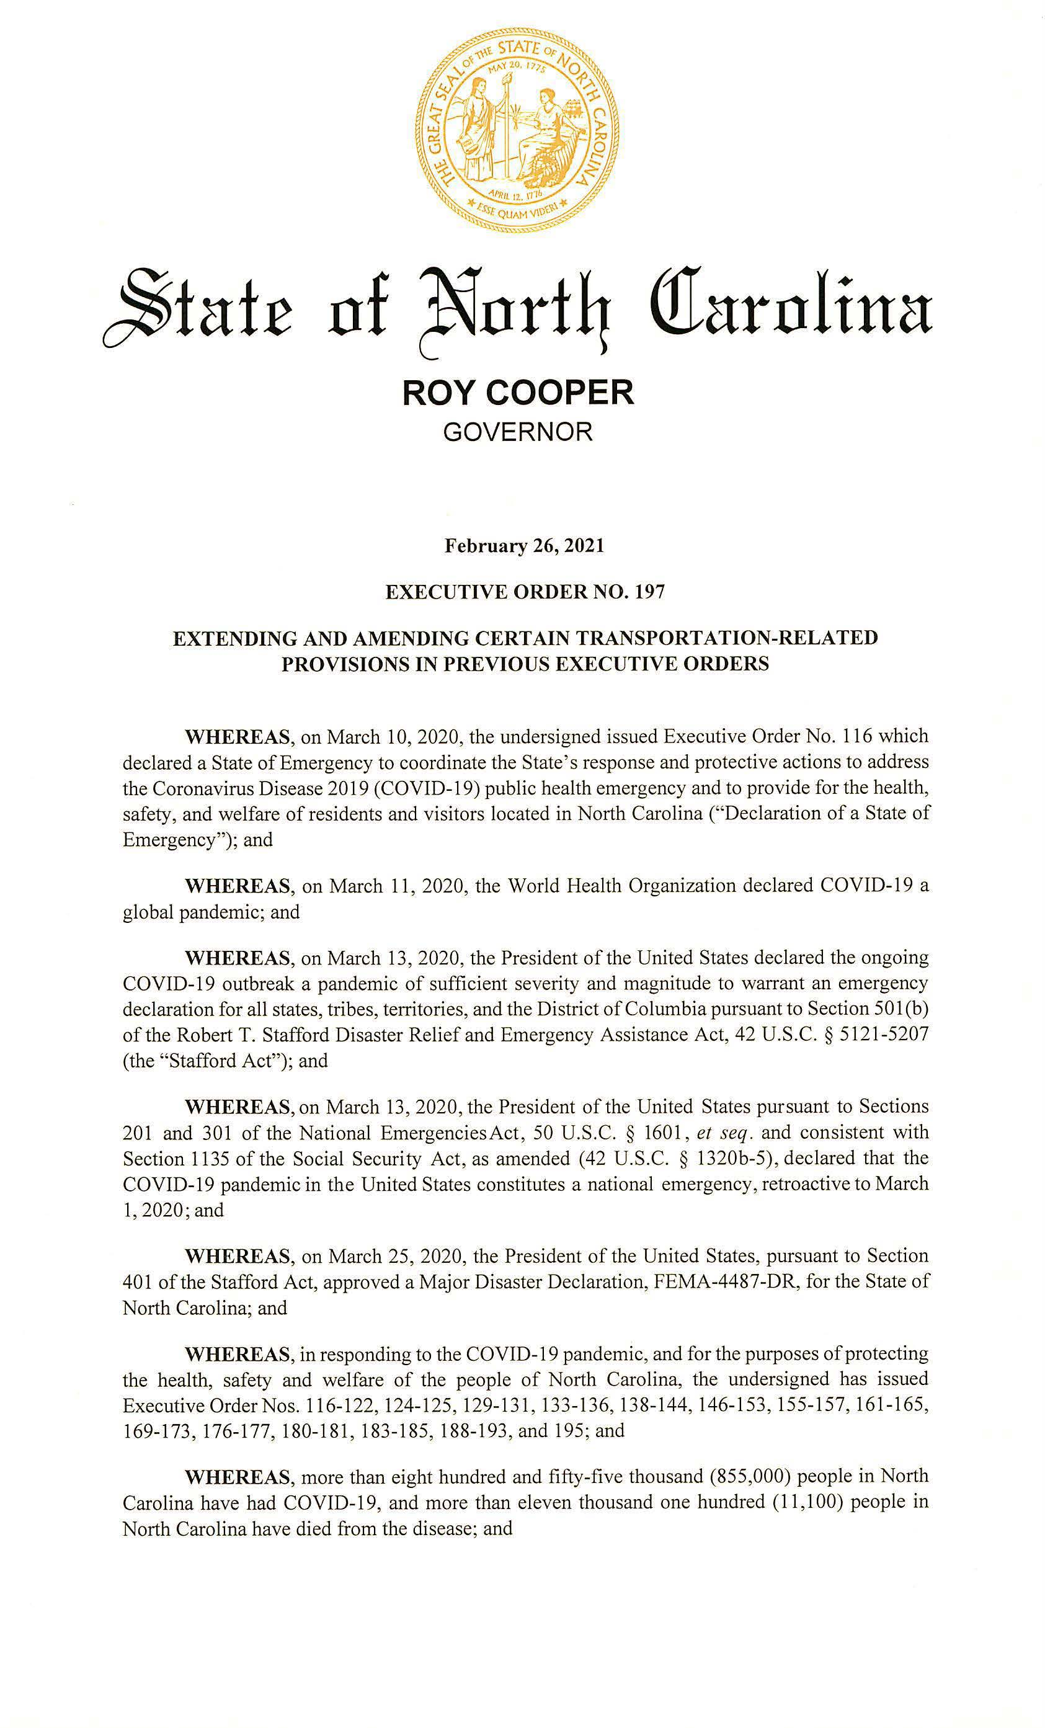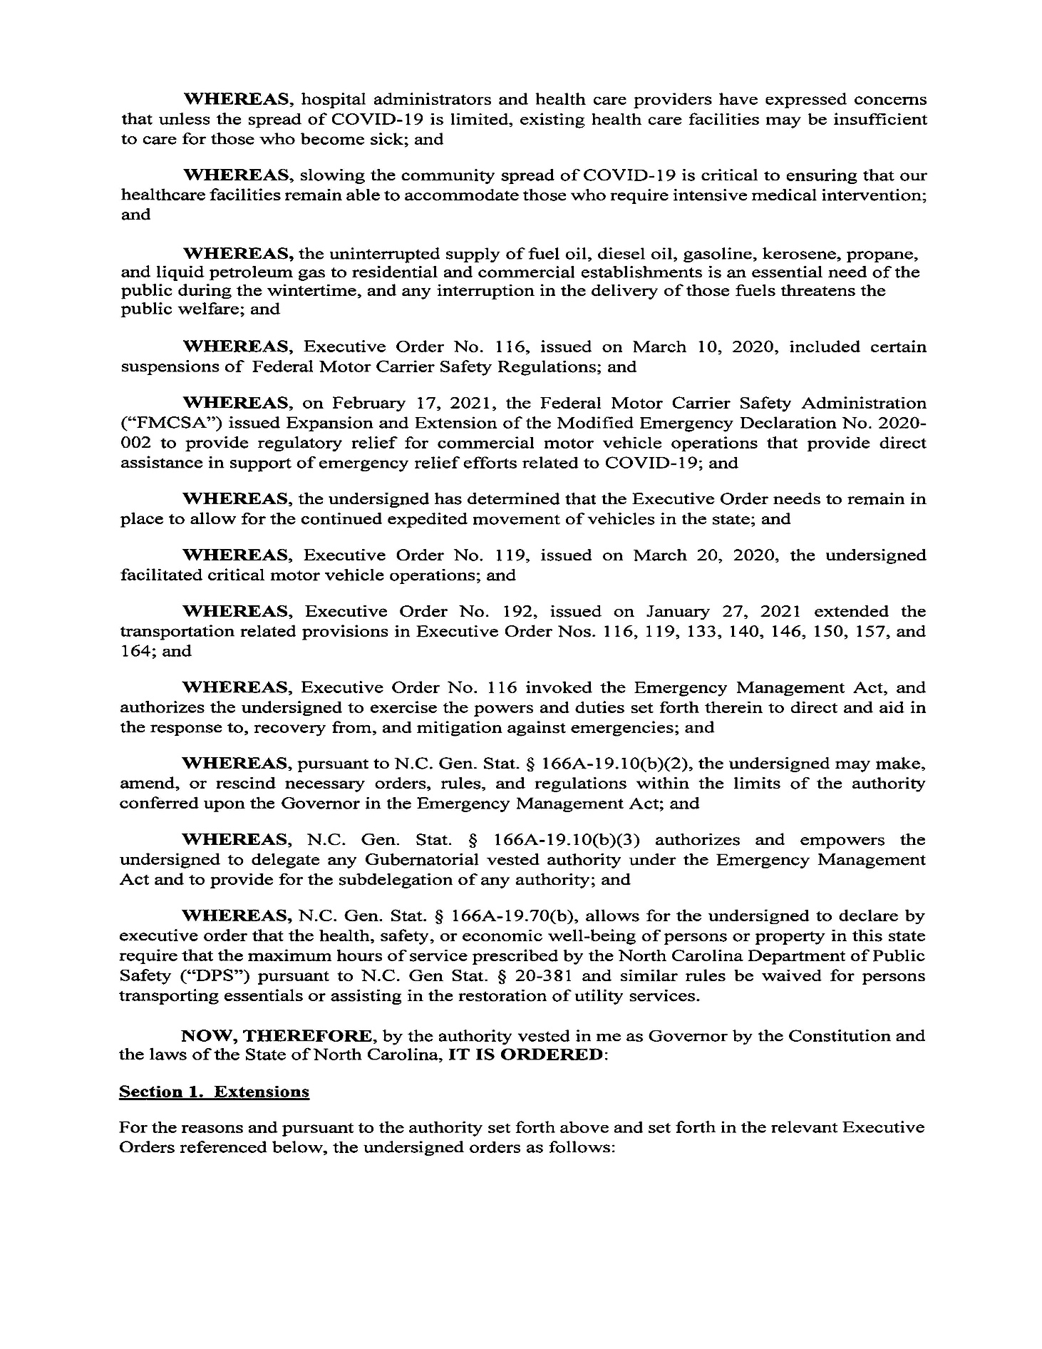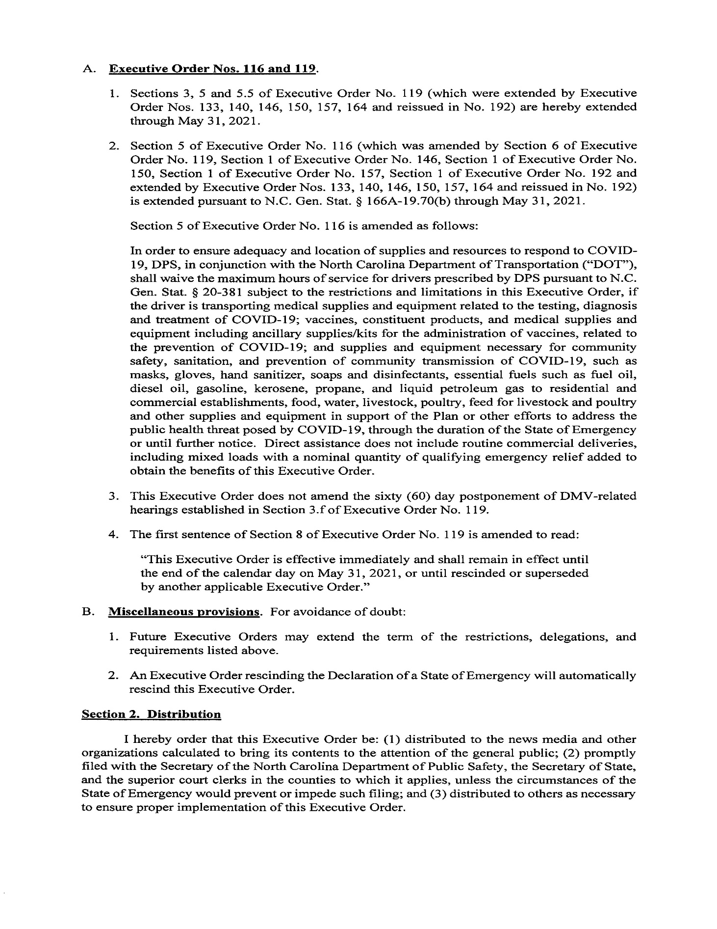
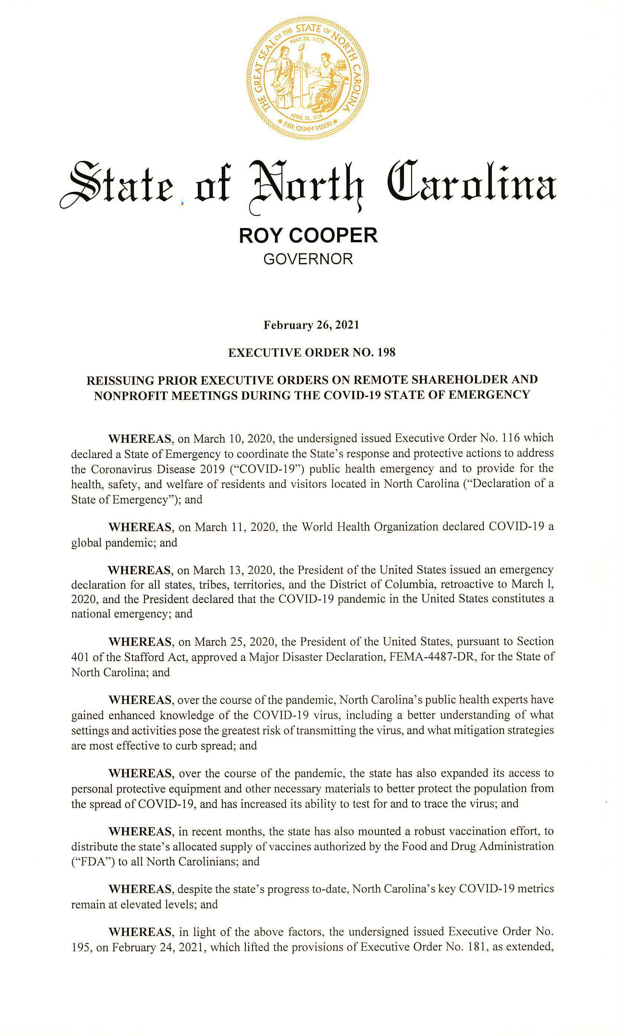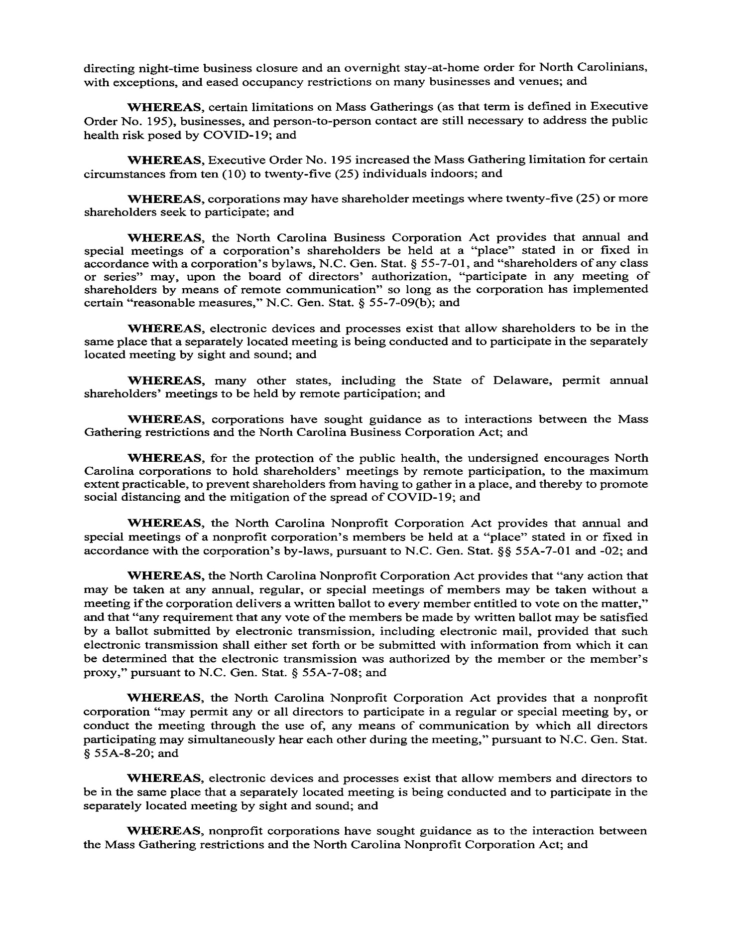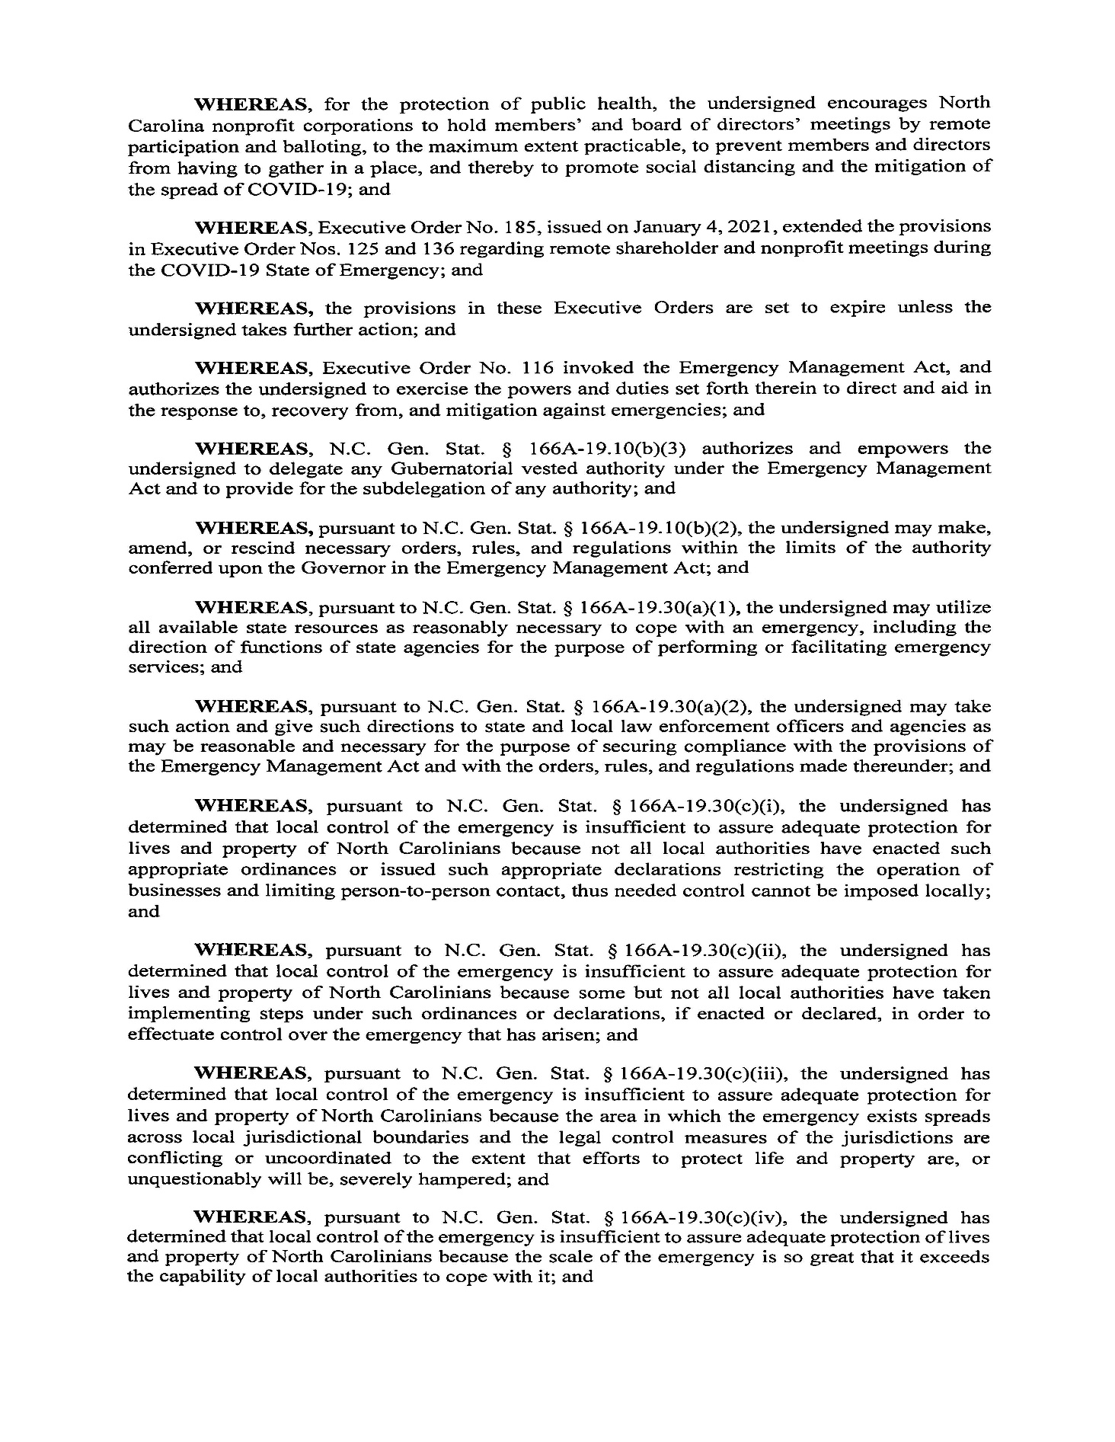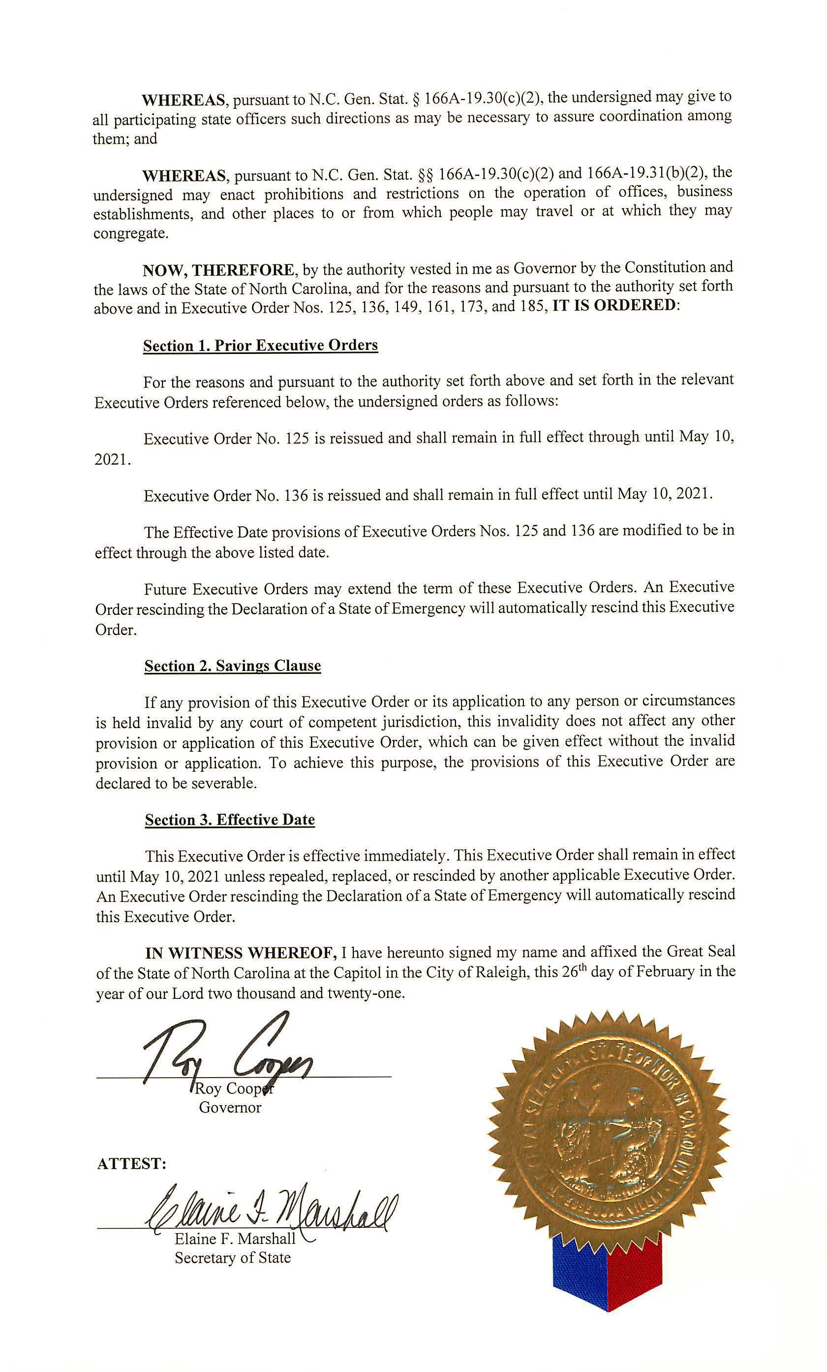
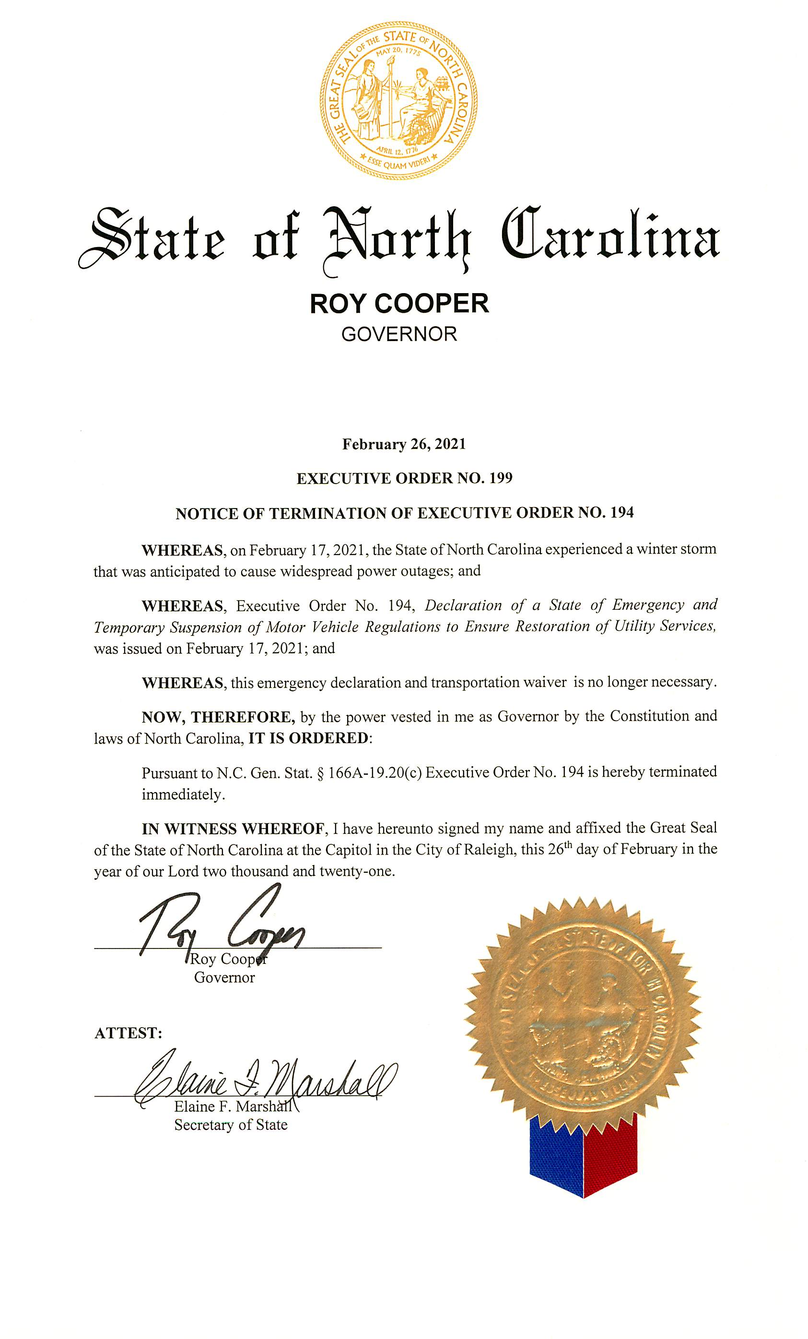
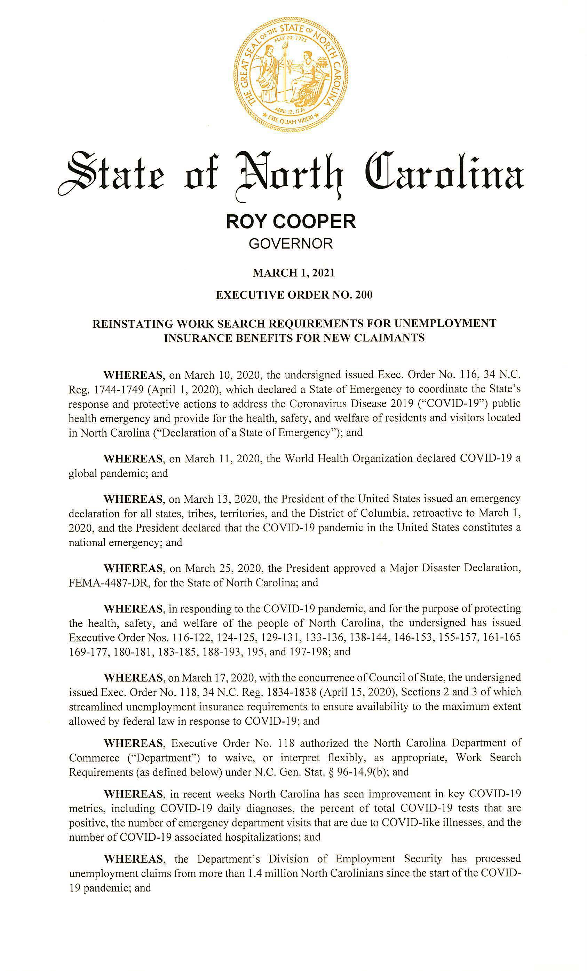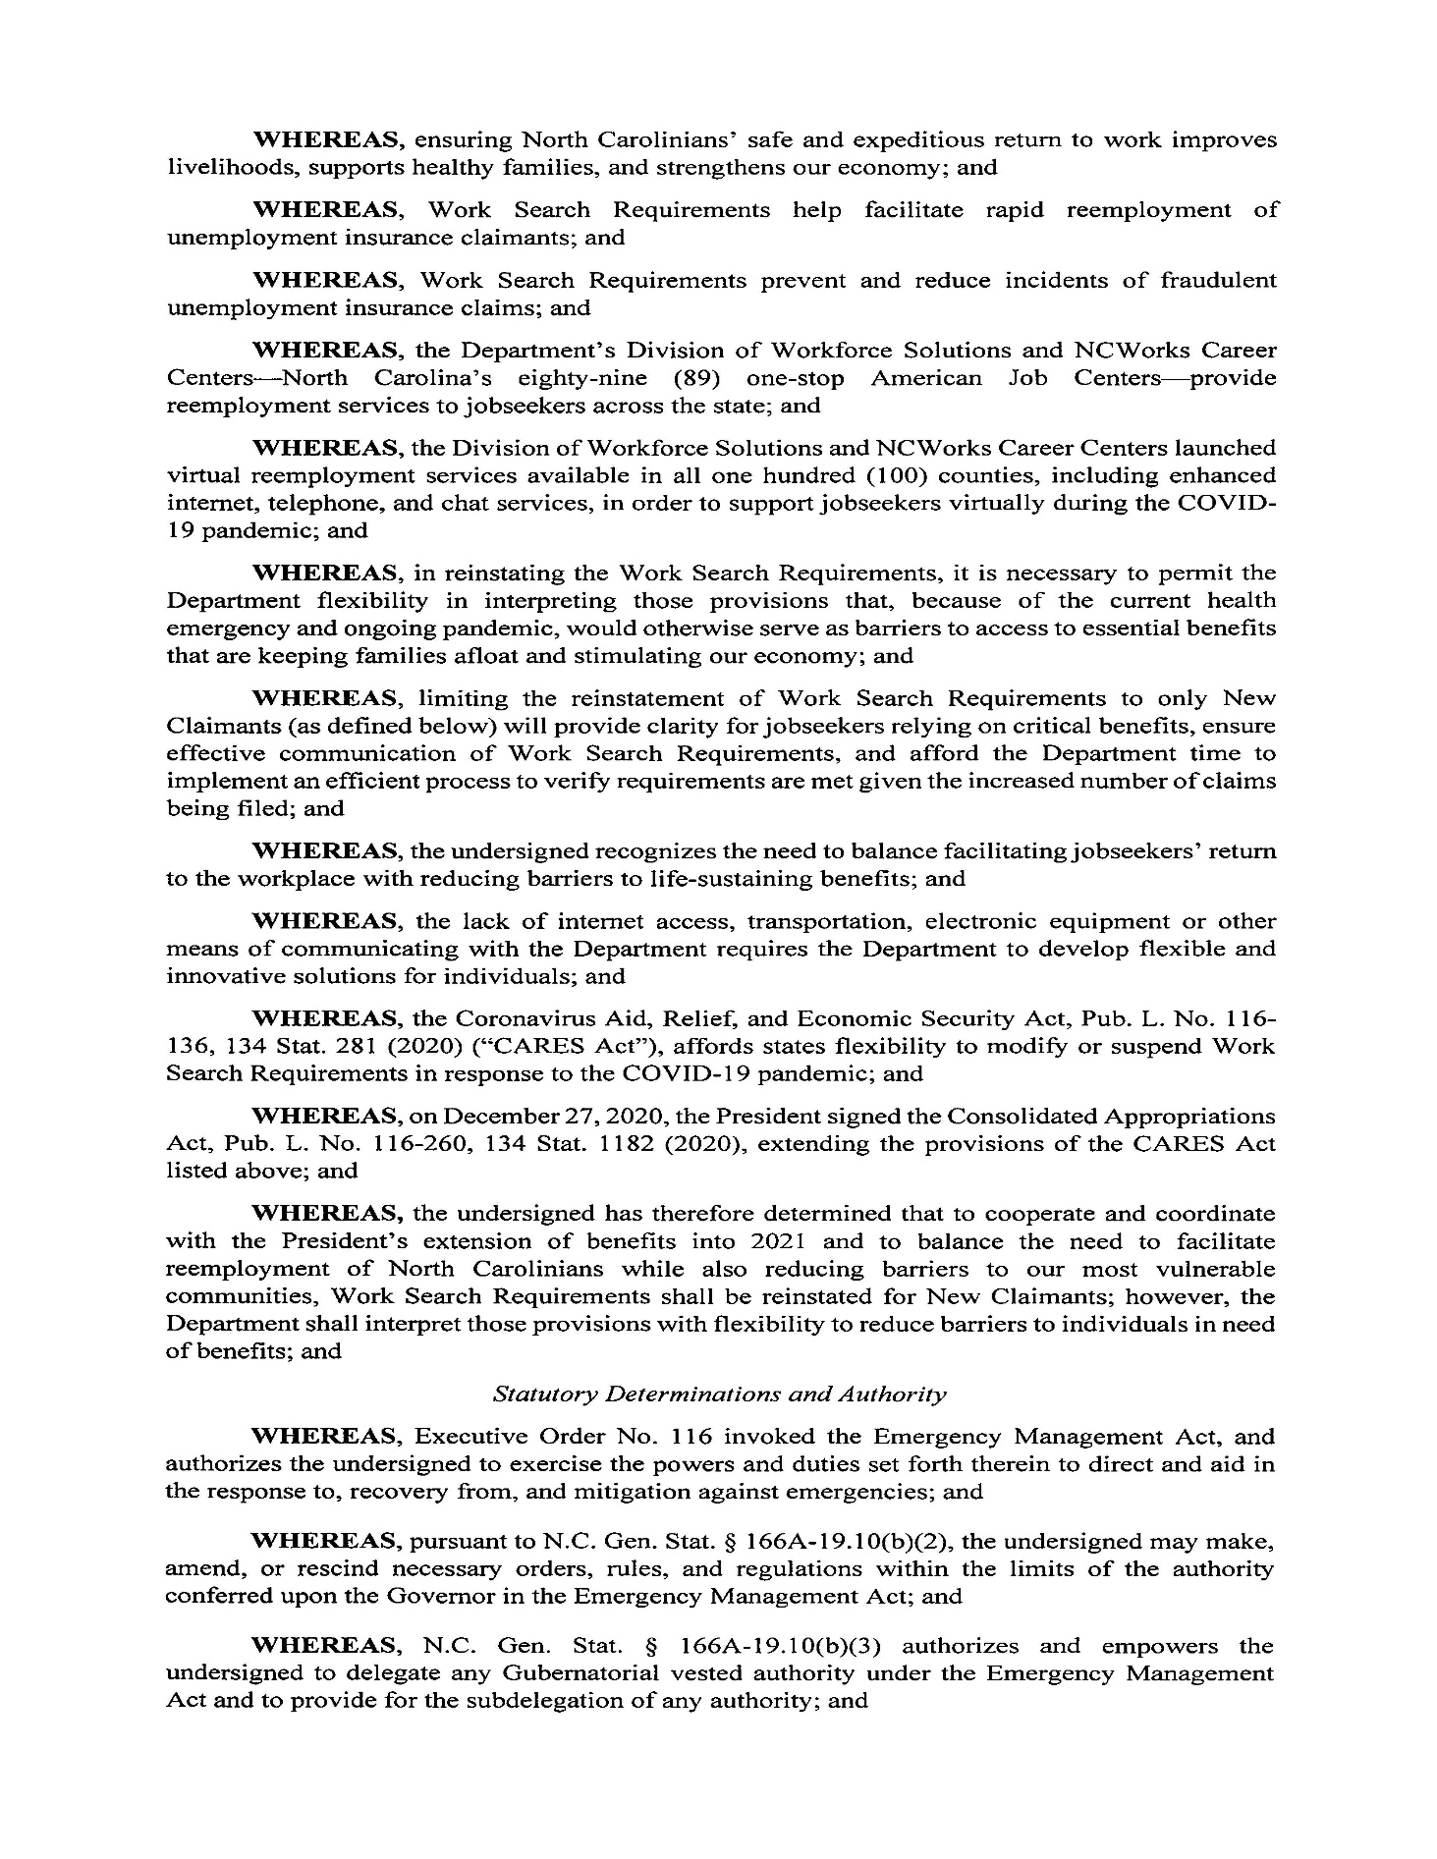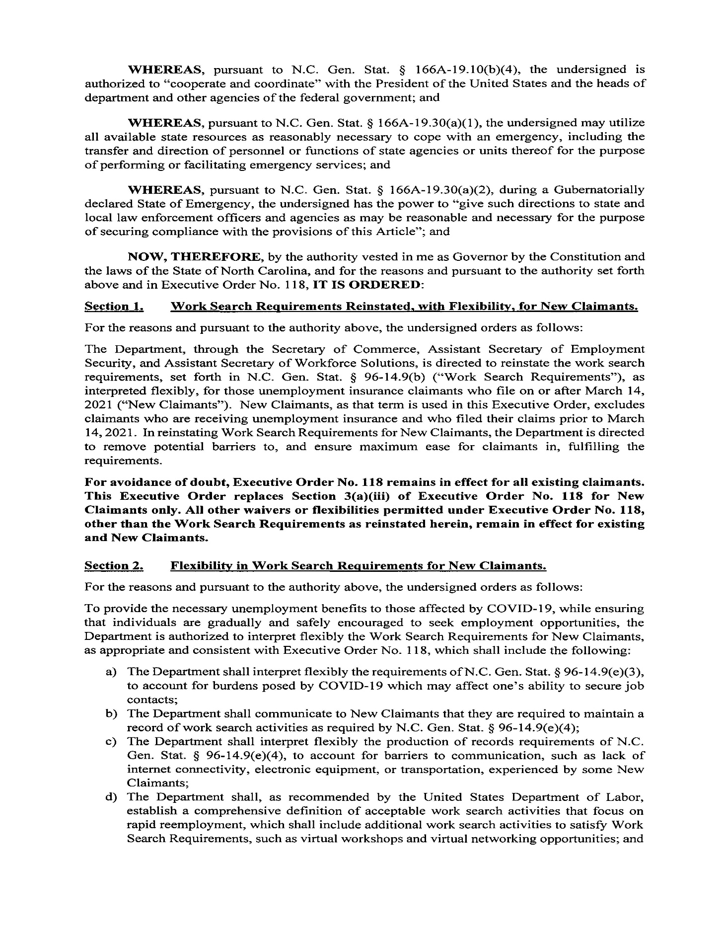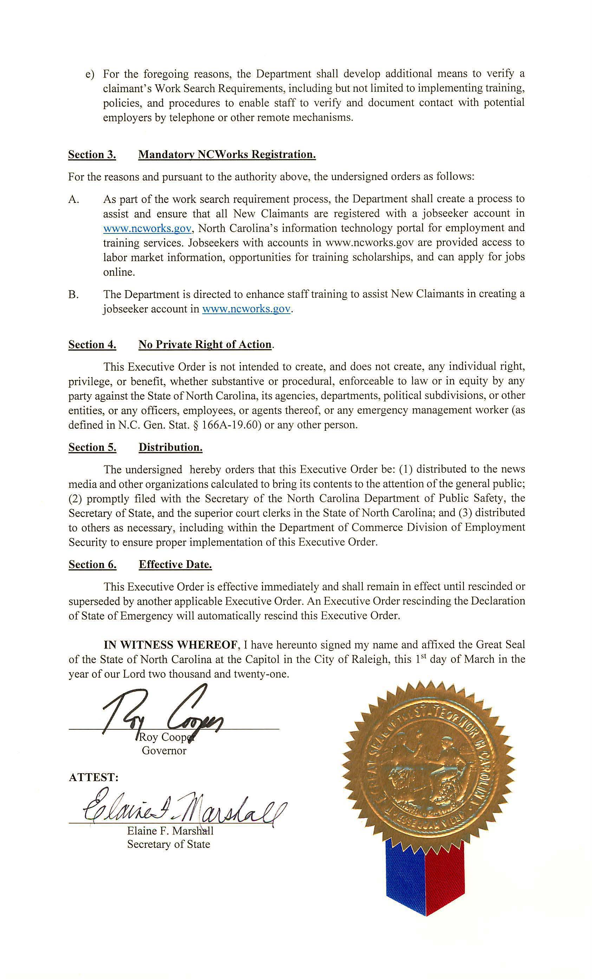
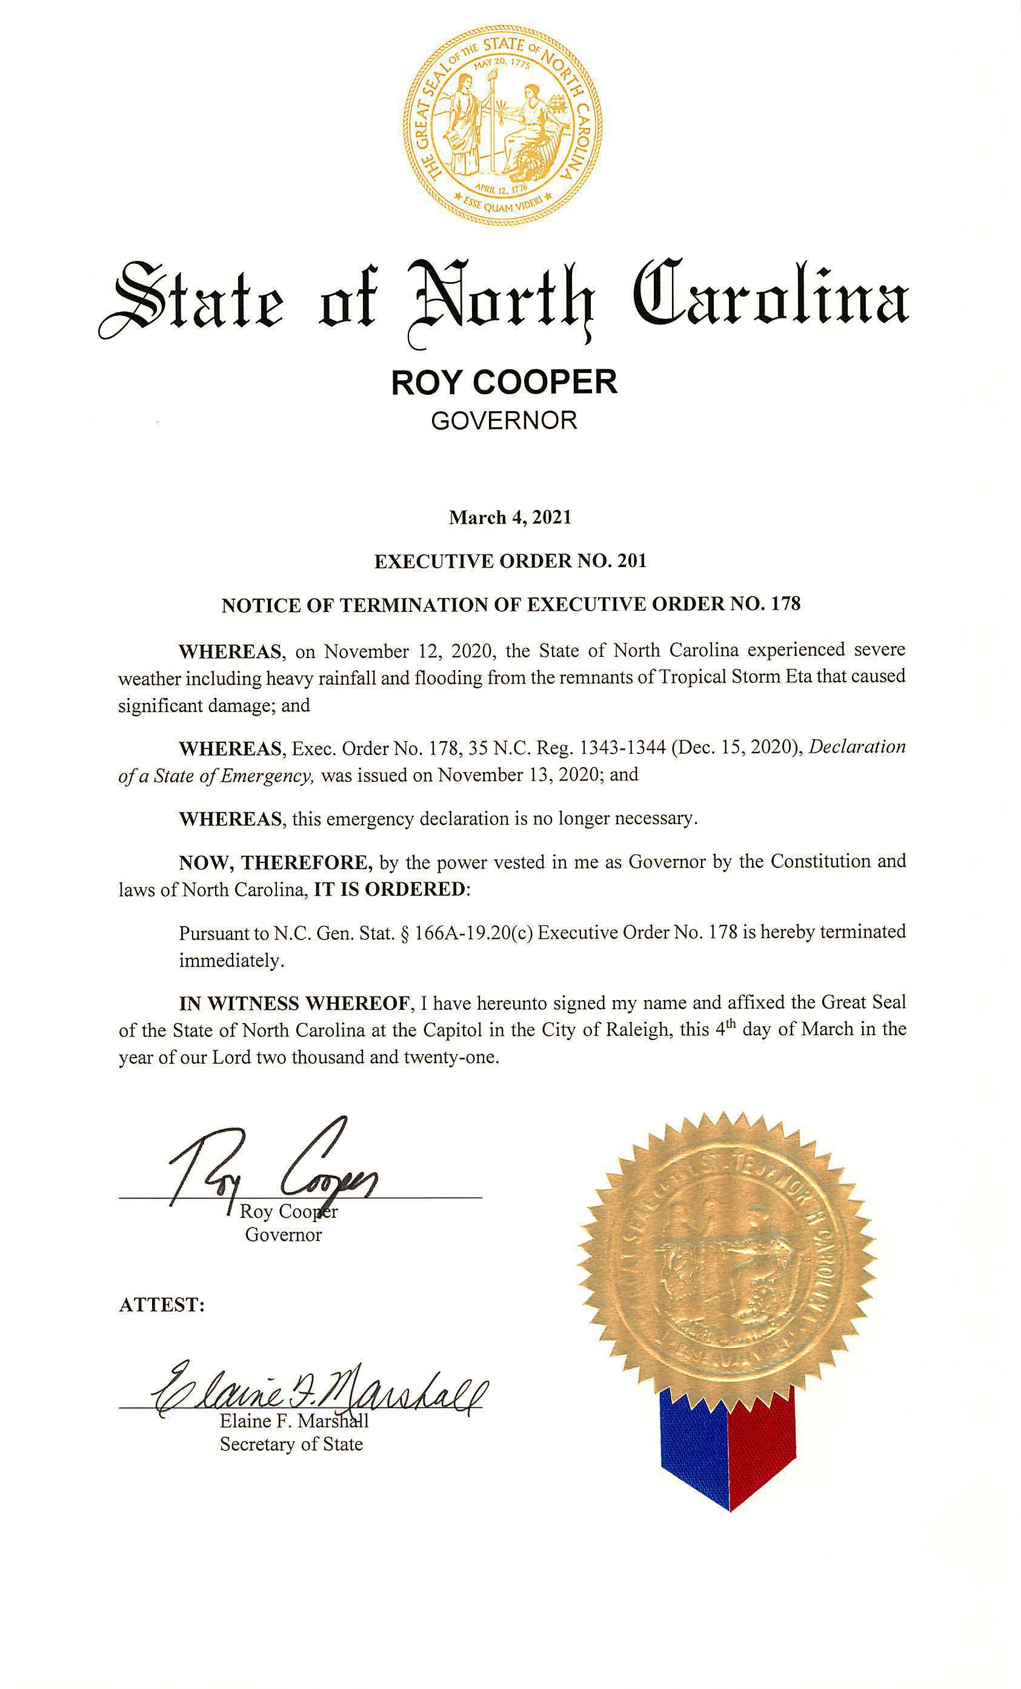

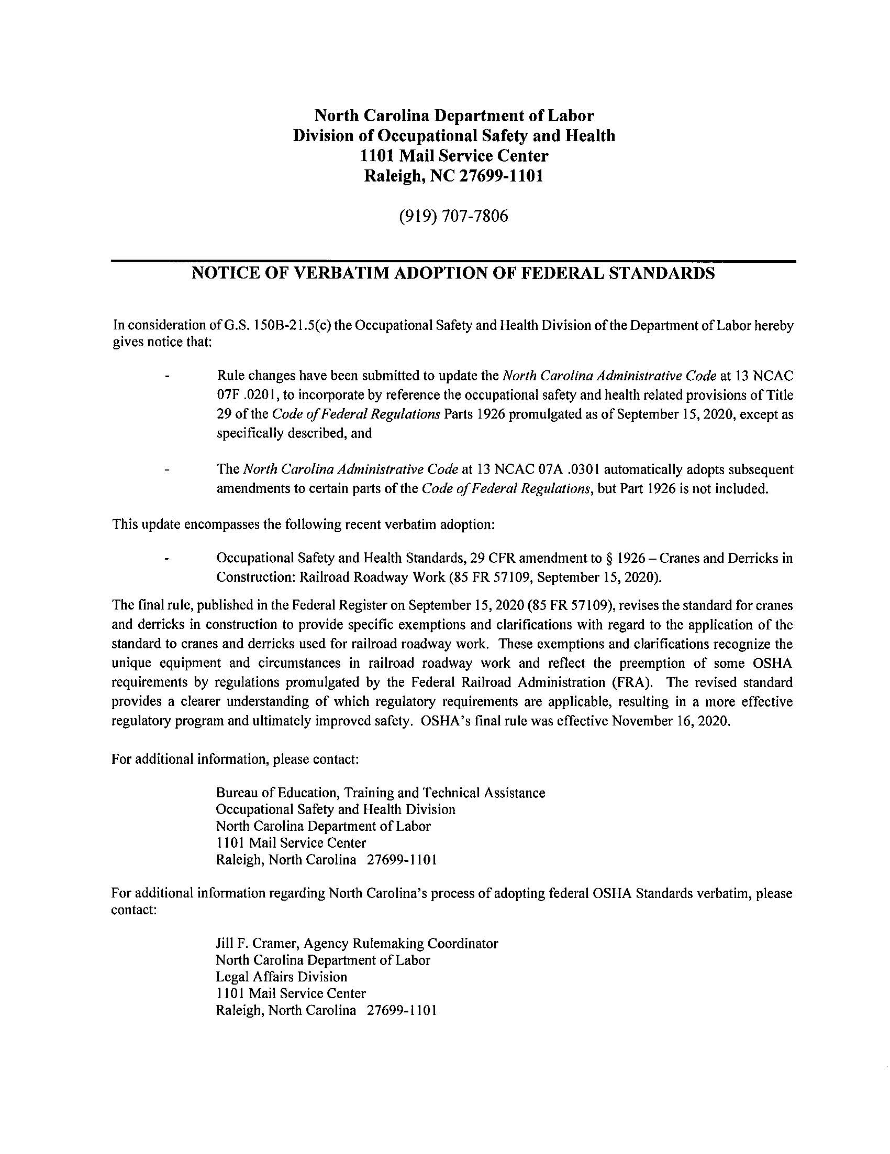
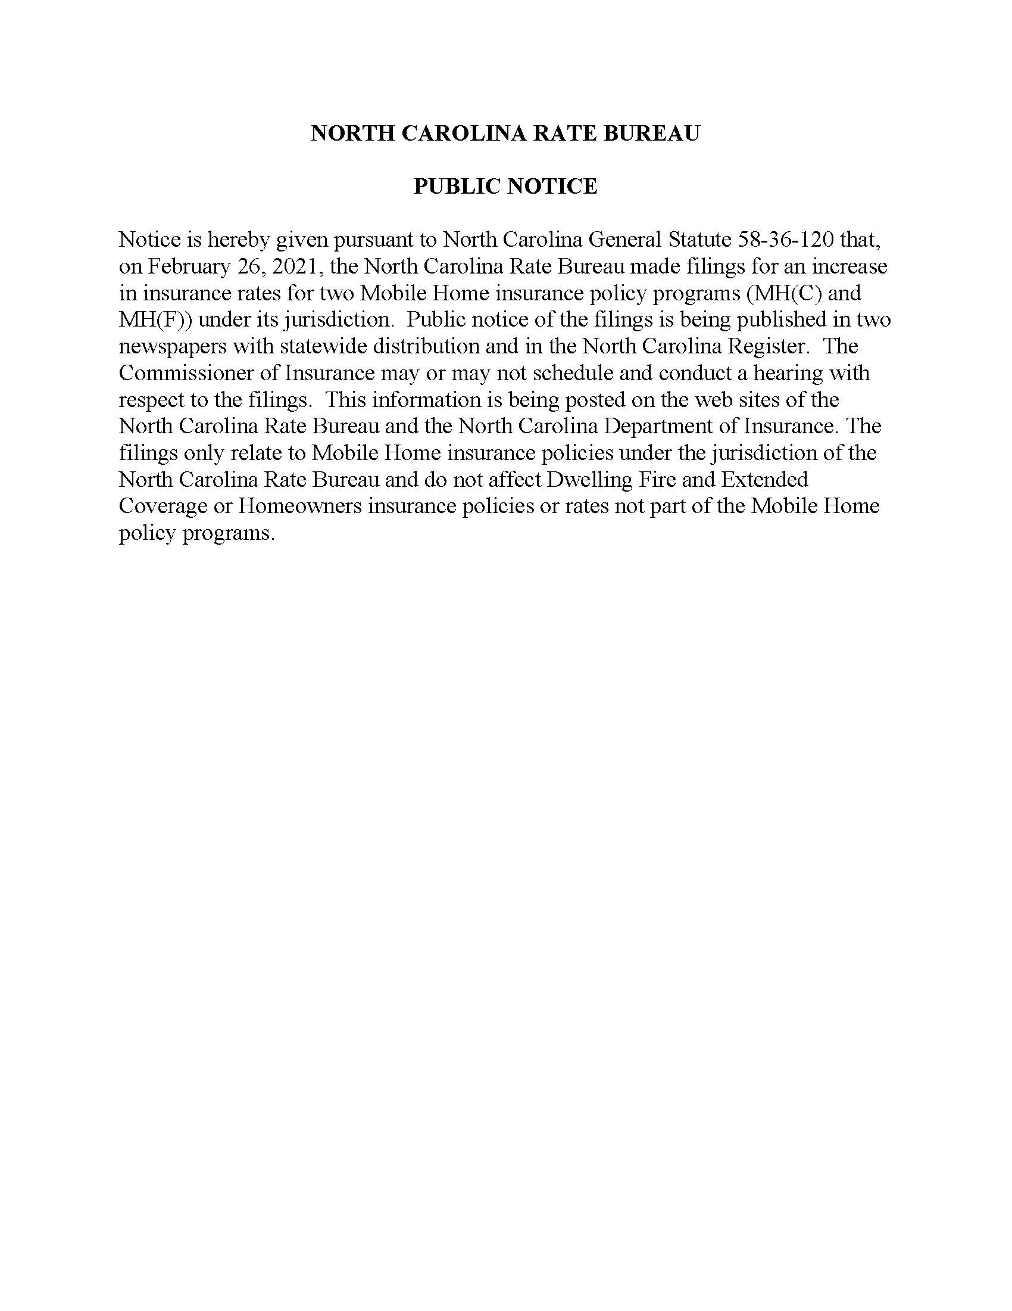

Note from the Codifier: The notices published in this Section of the NC Register include the text of proposed rules. The agency must accept comments on the proposed rule(s) for at least 60 days from the publication date, or until the public hearing, or a later date if specified in the notice by the agency. If the agency adopts a rule that differs substantially from a prior published notice, the agency must publish the text of the proposed different rule and accept comment on the proposed different rule for 60 days.
Statutory reference: G.S. 150B-21.2.

Title 08 – State Board of Elections

Notice is hereby given in accordance with G.S. 150B-21.2 that the State Board of Elections intends to adopt the rule cited as 08 NCAC 01 .0107.

Link to agency website pursuant to G.S. 150B-19.1(c): https://www.ncsbe.gov/

Proposed Effective Date: September 1, 2021

Public Hearing:
Date: May 6, 2021
Time: 1:00 p.m.
Location: https://ncgov.webex.com/ncgov/onstage/g.php?MTID=edface2783fca19ab1cd21dad70e09f0b

Reason for Proposed Action: This new rule would clarify when a political party expires and the timeline for changing the registration of voters affiliated with expired political parties. A political party would cease its legal status as a recognized political party in the state when the State Board certifies the general election in which the political party failed to poll at least 2% for its candidate for Governor or for presidential electors. If the political party submits documentation by the date of state certification that it had a nominee on the ballot in at least 70% of states in the prior presidential election, it will not cease to be a political party. Voters registered with an expired political party would be changed to unaffiliated status as required by statute on the 20th day before the opening of the filing period for the next regularly scheduled election held after the political party was terminated. Currently, the filing period for municipal elections begins on July 2, 2021, so affected voters would be changed to unaffiliated status on June 12, 2021. However, this date is subject to change if the General Assembly moves election dates as a result of the delay in receiving census data. The statute requires rulemaking but this had not previously been done.

Comments may be submitted to: Kelly Tornow, P.O. Box 27255, Raleigh, NC 27611-7255; email rules@ncsbe.gov

Comment period ends: June 1, 2021

Procedure for Subjecting a Proposed Rule to Legislative Review: If an objection is not resolved prior to the adoption of the rule, a person may also submit written objections to the Rules Review Commission after the adoption of the Rule. If the Rules Review Commission receives written and signed objections after the adoption of the Rule in accordance with G.S. 150B-21.3(b2) from 10 or more persons clearly requesting review by the legislature and the Rules Review Commission approves the rule, the rule will become effective as provided in G.S. 150B-21.3(b1). The Commission will receive written objections until 5:00 p.m. on the day following the day the Commission approves the rule. The Commission will receive those objections by mail, delivery service, hand delivery, or facsimile transmission. If you have any further questions concerning the submission of objections to the Commission, please call a Commission staff attorney at 919-431-3000.

Fiscal impact. Does any rule or combination of rules in this notice create an economic impact? Check all that apply.

State funds affected

Local funds affected

Substantial economic impact (>= $1,000,000)

Approved by OSBM

No fiscal note required

Chapter 01 - Departmental Rules

08 nCAC 01 .0107 political party formation, termination, and reinstatement

(a) Pursuant to G.S. 163-97, a political party ceases to be a political party on the date the State Board certifies the general State election in which the political party failed to poll for its candidate for Governor, or for presidential electors, at least two percent of the entire vote cast in the State for Governor or for presidential electors. Any voter registration form received after that date by a county board of elections in which the applicant chooses to affiliate with an expired political party shall be registered as "unaffiliated," except that if the person is already registered to vote in the county and that person's registration already contains a party affiliation, the county board of elections shall not change the registrant's political party affiliation.

(b) Notwithstanding Paragraph (a) of this Rule, a political party shall not cease to be a political party under G.S. 163-97 if it submits to the State Board of Elections by the date of the state canvass documentation that the group of voters had a candidate nominated by that group on the general election ballot of at least 70 percent of the states in the prior Presidential election.

(c) Voters affiliated with an expired political party shall be changed to "unaffiliated designation" as required by G.S. 163-97.1 on the 20th day before the opening of the candidate filing period for the next regularly scheduled election held after the date the political party failed to continue its legal status as provided in G.S. 163-97.

(d) The State Board shall order the county boards of elections to change the registration affiliation of all voters who are recorded on the registration books as being affiliated with an expired political party at 5:00 p.m. on the 20th day before the opening of the candidate filing period for the next regularly scheduled election held after the date of expiration. Upon making the change, the county board of elections shall send each affected voter verification of the party change by mail in accordance with G.S. 163-82.17(b). However, an expired political party that submits to the State Board one of the following prior to noon on the twentieth day before the opening of the candidate filing period for the next regularly scheduled election held after the date of expiration shall not have its affiliated voters changed to "unaffiliated designation":

(1) A successful petition under G.S. 163-96(a)(2). The political party shall comply with all other petition processes and deadlines in G.S. 163-96(a)(2), (b), and (c), including submitting the signatures to each county board of elections no later than 5:00 p.m. on the 15th day preceding the date the petitions are due to be filed with the State Board as provided in this Paragraph.

(2) Documentation that the group of voters had a candidate nominated by that group on the general election ballot of at least 70 percent of the states in the prior Presidential election.

(c) For purposes of this Rule, "expired political party" means a party that failed to continue its legal status as provided in G.S. 163-97.

(d) Documentation required under G.S. 163-96(a)(3) for the creation of a political party and under Subparagraph (b)(2) of this Rule for the reinstatement of an expired political party shall include any official State or federal government source, including but not limited to, official election results or statistics from a state or federal government website or publication.

Authority G.S. 163-22; 163-97.1.

* * * * * * * * * * * * * * * * * * * *

Notice is hereby given in accordance with G.S. 150B-21.2 that the State Board of Elections intends to amend the rules cited as 08 NCAC 09 .0106, .0107, .0109 and repeal the rule cited as 08 NCAC 09 .0108.

Pursuant to G.S. 150B-21.17, the Codifier has determined it impractical to publish the text of rules proposed for repeal unless the agency requests otherwise. The text of the rule(s) are available on the OAH website at http://reports.oah.state.nc.us/ncac.asp.

Link to agency website pursuant to G.S. 150B-19.1(c): https://www.ncsbe.gov/

Proposed Effective Date: September 1, 2021

Public Hearing:
Date: May 6, 2021
Time: 1:00 p.m.
Location: https://ncgov.webex.com/ncgov/onstage/g.php?MTID=edface2783fca19ab1cd21dad70e09f0b

Reason for Proposed Action: This proposed amendment removes references to direct record electronic voting machines (DREs) which were decertified in 2020, clarifies the conduct of recounts, and details how the county board of elections makes determinations of voter intent in hand-to-eye recounts. It would codify the voter intent principles provided to the counties in Numbered Memo 2020-32.

Comments may be submitted to: Kelly Tornow, P.O. Box 27255, Raleigh, NC 27611-7255; email rules@ncsbe.gov

Comment period ends: June 1, 2021

Procedure for Subjecting a Proposed Rule to Legislative Review: If an objection is not resolved prior to the adoption of the rule, a person may also submit written objections to the Rules Review Commission after the adoption of the Rule. If the Rules Review Commission receives written and signed objections after the adoption of the Rule in accordance with G.S. 150B-21.3(b2) from 10 or more persons clearly requesting review by the legislature and the Rules Review Commission approves the rule, the rule will become effective as provided in G.S. 150B-21.3(b1). The Commission will receive written objections until 5:00 p.m. on the day following the day the Commission approves the rule. The Commission will receive those objections by mail, delivery service, hand delivery, or facsimile transmission. If you have any further questions concerning the submission of objections to the Commission, please call a Commission staff attorney at 919-431-3000.

Fiscal impact. Does any rule or combination of rules in this notice create an economic impact? Check all that apply.

State funds affected

Local funds affected

Substantial economic impact (>= $1,000,000)

Approved by OSBM

No fiscal note required

Chapter 09 - Conduct of Vote Recounts by County Boards of Elections

08 ncac 09 .0106 GENERAL GUIDELINES

(a) Prior to each recount under G.S. 163-182.7, the county board of elections or State Board shall inform the political parties and candidates of the recount and describe to them the process of conducting recounts. A county board of elections shall notice the recount at least 48 hours prior to the start of the recount. The county board shall send notice by email to the county board's regular notice list, county party chairs, and the candidates in the contest subject to the recount.

(b) In the case of tie votes, the winner shall be determined by lot only in the case set out in G.S. 163-182.8(2). Where there are 5,000 or fewer votes cast, there shall be only one determination by lot for each tied election. There shall be no determination by lot until the time has expired for the affected candidate(s) to request a recount, unless all of the affected candidate(s) waive their right in writing to request a recount.

(c) During the conduct of recounts, ballots shall be counted in accordance with the principles in G.S. 163-182.1(a).

(d) In conducting recounts of direct record electronic machines and any other types of voting machines that require a county board member or designated official to reprint tapes and to read the totals and another board member to record the totals for each candidate such recount shall be conducted by a bi-partisan team of four: two officials (one from each of the two parties having the largest number of registered voters in the state) reading and confirming the totals per machine and two officials (one from each of the two parties having the largest number of registered voters in the state) recording the results simultaneously.

(e)(d) In conducting hand to eye recounts or recounts of paper ballots, a bi-partisan team of four shall be used: two officials (one from each of the two parties in the State with the largest number of registered voters) to relay the results of each ballot with one person reading the ballot and the other official observing the ballot and the person reading the results of the ballot, and two officials (one from each of the two parties in the State with the largest number of registered voters) each separately recording the tally of votes for each candidate on paper while stating aloud after each choice is read on the fifth tally for a particular candidate, the word "tally." If, after diligently seeking to fill the positions with voters affiliated with each of the two parties in the State with the largest number of registered voters, the county board still has an insufficient number of officials for the recount, the county board by a majority vote of its members, including at least one board member of each political party represented on the board, may appoint to the bi-partisan team an unaffiliated voter or voter affiliated with one of the other political parties. In no instance shall the county board appoint more than two members to a bi-partisan team who are unaffiliated or affiliated with one of the other political parties. Bi-partisan team members shall be registered voters in the county. County board members shall not serve on the bi-partisan team.

(f)(e) The county board of elections shall conduct recounts only as follows:

(1) the recount is mandatory under G.S. 163-182.7(b) or (c); (c) or G.S. 163-182.7A; or

(2) the recount is not mandatory but the county board of elections or the State Board of Elections determines, using its authority in G.S. 163-182.7(a), that in order to complete the canvass a recount is necessary.

(g)(f) A candidate shall have the right to call for a hand-eye recount recount, as to elections conducted by optical scan systems within 24 hours after a mandatory or discretionary recount in G.S. 163-182.7(a) or by noon on the next business day of the county board office, whichever is later, if the apparent winner is the apparent loser after the discretionary recount first recount, unless human error resulted in the vote count change. A candidate shall have the right to call for a hand-eye sample recount within 24 hours after a mandatory machine recount, pursuant to G.S. 163-182.7A.

(h)(g) Any candidate shall have the right to file an election protest within 24 hours after a recount or by noon of the next business day of the county board office, whichever is later. later, if the protest relates to the conduct of the recount. Allegations unrelated to the recount may not be included in the protest.

(i)(h) Recounts shall be performed in the presence of a quorum of county board members or in the presence of a bipartisan team of two county board members. Determinations of voter intent shall be made by at least a quorum of the board.

Authority G.S. 163-22; 163-182.7.

08 ncac 09 .0107 RECOUNT OF OPTICAL SCAN Ballots first recouNt

(a) In the first recount conducted by the county board of elections in accordance with G.S. 163-182.7, all ballots that were originally counted by the optical scan equipment shall be counted again by machine. the optical scan equipment producing another machine count. A "machine count" total is a ballot count produced by a voting system that uses machines. All ballots that are were rejected for tabulation purposes by the machines - commonly called "outstacked" or center bin ballots - shall be recounted by a bi-partisan team of four in accordance with 08 NCAC 09. 0106(f). 08 NCAC 09. 0106(e) or duplicated and counted by machine. Ballots accepted by the machines shall not be counted by hand, regardless of whether the ballot is marked, contains overvotes, or is blank.

(b) When the first recount, including absentee and provisional ballot recount totals, has been completed, the board of elections shall determine if a second recount is necessary as follows:

(1) Determine whether the first recount produces a change in the winner in accordance with the following:
(A) If the apparent winner after the initial balloting is the apparent loser after the first recount, that candidate shall be entitled to demand a second recount, by hand and eye, of all ballots; and
(B) If the apparent winner after the initial balloting remains the apparent winner after the first recount, the county board shall proceed according to Subparagraph (2) of this Paragraph;

(2) Determine whether there is a discrepancy in the machine totals between the initial balloting and the first recount in accordance with the following:
(A) If the machine totals from the initial balloting and the first recount are the same, no second recount is necessary; and
(B) If the machine totals from the initial balloting and the first recount are not the same, the county board shall proceed according to Subparagraph (3) of this Paragraph;

(3) Determine if the discrepancy in the machine total between the initial balloting and the first recount can be reconciled. The county board shall examine all outstacked or center bin ballots from the first recount, determine how each ballot shall be counted according to Rule .0106(c) of this Section, and reconcile the count with the machine count on the initial balloting in accordance with the following:
(A) If this reconciliation produces the same machine total for the first recount as the machine total in the initial balloting, no second recount is necessary; and
(B) If the reconciliation produces a different machine total for the first recount than the machine total in the initial balloting, the losing candidate is entitled to demand a second recount, by hand-to-eye, of all ballots.

Authority G.S. 163-22; 163-182.7.

08 ncac 09 .0108 REcount of DIRECT RECORD ELECTRONIC VOTING MACHINES

Authority G.S. 163-22; 163-182.7.

08 ncac 09 .0109 MANUAL HAND TO EYE RECOUNTS Guidelines for Determining Voter Intent

(a) As provided in G.S. 163-182.1(a), voter intent is the governing standard when questions arise about how to adjudicate markings on a ballot. Questions about voter intent may arise during a hand-to-eye recount if a voter marks the ballot in an inappropriate manner, places marks in the wrong location on the ballot, or otherwise marks the ballot in a manner that causes the voter's choice to be in dispute. Determinations of voter intent shall be made by the county board. If the bipartisan team of four provided for in 08 NCAC 09. 0106(e) encounters a ballot that cannot be clearly identified as a vote for one candidate or another, the ballot must be set aside. During a hand-to-eye audit or recount, all ballots with a potential overvote or undervote shall be adjudicated by the county board at the conclusion of the tallying by the bipartisan team. If the subject to the recount was left blank—meaning there are no marks in the target or candidate area for the contest—the county board shall not need to determine voter intent and the ballot shall not be counted for any candidate in that contest.

(b) For purposes of this Rule, the following definitions apply:

(1) "Target area" is the square or oval next to the candidate's name on the printed ballot;

(2) "Candidate area" is the area between the lines separating candidate names, or the area that is clearly closer to one candidate's name than another, and includes the candidate's name and party affiliation, if listed.

(c) For any printed ballot that is to be counted hand-to-eye, the following guidelines shall be used in determining voter intent:

(1) Any ballot that is properly marked in the target area for one candidate only shall be designated as a vote for that candidate.

(2) If the names of all but one candidate are stricken through, the ballot shall be counted for the one candidate whose name was not stricken through.

(3) If there are identical marks for two or more candidates, clarified by an additional or different mark or marks that appear to indicate support for one candidate, the ballot shall be counted as a vote for the candidate with the additional or different marks.

(4) Any ballot that has any other mark or marks in the target area or candidate area for one candidate only, including circling the target area and/or the candidate's name or making a mark in or around the target area or candidate's name, provided no other candidate for that office is similarly marked, shall be counted as a vote for that candidate.

(5) Any ballot that has a mark or marks in the target area or candidate area for one candidate, which extends partially into one or more other target areas or candidate areas, shall be counted as a vote for the candidate so marked only if a majority of the mark is in that candidate's area or target area, it is readily apparent that the voter intended to vote for that candidate, and no other candidate is similarly marked.

(6) Marks extending across more than one candidate's area may be counted if the lines of the "x" or the bottom point of the check mark clearly lie inside the box or on top of the name or party affiliation or candidate area of one candidate, and no other candidate is similarly marked.

(7) Any ballot that has a mark in the target area or candidate area for one candidate, and on which other marks in the target areas or candidate areas for any other candidates have been partially erased, scratched out, or otherwise obliterated, shall be counted as a vote for the candidate for which the mark was not erased, scratched out, or otherwise obliterated, provided no other candidate is similarly marked.

(8) Any ballot that has a mark that is clearly next to (either before or after) a candidate's name, or across the name, shall be recognized as a mark for that candidate. Similarly, a mark between or over the "timing marks" of the ballot, that are clearly opposite or next to one candidate's name and not near another candidate's name, shall be recognized as a mark.

(9) A mark that is between or across more than one candidate's name, candidate area, or target area shall not be recognized as a vote.

(10) Any writing or comment on the ballot (other than a write-in) that clearly indicates the voter's support for one and only one candidate for the office, and that cannot be interpreted as a comment in favor of any other candidate in that election, shall be counted as a vote for that candidate.

(11) Any ballot that is marked for more than one candidate for the office shall be deemed an overvote and no vote shall be counted for that ballot item.

(12) Any ballot on which there is no mark under the office, or any other mark or comment indicating support for a candidate for the office, is an undervote and shall not be counted as a vote for any candidate.

(13) A mark that is clearly a negative or extraneous comment, or which indicates the voter's opposition to one or more candidates, shall be considered an undervote, provided the ballot is not so marked to indicate which candidate the voter supports.

(14) If a substantial part of the candidate's name is crossed through or stricken out, the mark shall be considered an undervote and shall not be counted.

Examples of these guidelines applied to ballot markings are located in Numbered Memo 2020-32 on the State Board of Elections' website.

Authority G.S. 163-22; 163-182.7.

* * * * * * * * * * * * * * * * * * * *

Notice is hereby given in accordance with G.S. 150B-21.2 that the State Board of Elections intends to amend the rule cited as 08 NCAC 20 .0101.

Link to agency website pursuant to G.S. 150B-19.1(c): https://www.ncsbe.gov/

Proposed Effective Date: September 1, 2021.

Public Hearing:
Date: May 6, 2021
Time: 1:00 p.m.
Location: https://ncgov.webex.com/ncgov/onstage/g.php?MTID=edface2783fca19ab1cd21dad70e09f0b

Reason for Proposed Action: This proposed amendment clarifies the number of precinct-specific observers permitted and how the lists of observers are to be submitted.

Comments may be submitted to: Kelly Tornow, P.O. Box 27255, Raleigh, NC 27611-7255; email rules@ncsbe.gov

Comment period ends: June 1, 2021

Procedure for Subjecting a Proposed Rule to Legislative Review: If an objection is not resolved prior to the adoption of the rule, a person may also submit written objections to the Rules Review Commission after the adoption of the Rule. If the Rules Review Commission receives written and signed objections after the adoption of the Rule in accordance with G.S. 150B-21.3(b2) from 10 or more persons clearly requesting review by the legislature and the Rules Review Commission approves the rule, the rule will become effective as provided in G.S. 150B-21.3(b1). The Commission will receive written objections until 5:00 p.m. on the day following the day the Commission approves the rule. The Commission will receive those objections by mail, delivery service, hand delivery, or facsimile transmission. If you have any further questions concerning the submission of objections to the Commission, please call a Commission staff attorney at 919-431-3000.

Fiscal impact. Does any rule or combination of rules in this notice create an economic impact? Check all that apply.

State funds affected

Local funds affected

Substantial economic impact (>= $1,000,000)

Approved by OSBM

No fiscal note required

Chapter 20 - Election Observers

08 NCAC 20 .0101 Election Observers

(a) Observer Lists. The chair of each political party in a county may designate a total of two precinct-specific observers to attend each voting place on Election Day and each one-stop site during a primary or general election in accordance with this Rule. Alternate precinct-specific observers are not permitted. The county party chair may designate 10 additional at-large observers who may attend any voting place in the county. The list of observers for one-stop must designate the names of the observers who will be present on each day of early voting and, for precinct-specific observers, at each one-stop site. At-large observers may serve at any one-stop site. The chair of each State political party may designate up to 100 additional at-large observers who are residents of the State who may attend any voting place in the State.

(b) Submission of Lists. The county party chair shall submit a written, signed list of county at-large observers to the county director of elections, with two copies provided to the chair of the county board of elections, prior to 10:00 a.m. on the fifth day prior to Election Day. The county party chair shall submit a written, signed list of the observers appointed for each precinct to the chief judge of each precinct, with two copies provided to the chair of the county board of elections, prior to 10:00 a.m. on the fifth day prior to Election Day; the list may be delivered in care of the county director of elections. The county party chair shall submit the list of observers for one-stop before 10:00 a.m. on the fifth day before the observer is to observe. The party chair may provide the list by facsimile or email provided the letters are signed. The list of at-large observers to serve on Election Day may be amended prior to Election Day to substitute one or all of the at-large observers. The list of at-large observers who serve during early voting and the list of precinct-specific observers may not be amended after the submission deadline. The State party chair shall submit the written, signed list of State at-large observers by 10:00 a.m. on the fifth day prior to Election Day to the State Board, which shall disseminate the list to the county boards of elections. The list shall include the full name of each at-large observer and the county in which the observer is registered. Party chairs may provide the lists by facsimile or email provided the letters are signed. Scanned signatures are permissible.

(c) Observers at Voting Place. No more than two precinct-specific observers from each political party may be in the voting enclosure at any time. Only one at-large observer from each political party may be in the voting enclosure at any time, even if no precinct-specific observers are present. All observers, whether precinct-specific or at-large, may be relieved after serving no less than four hours. hours; however, the total number of observers from each party per day cannot exceed three total observers: two precinct-specific observers and one county or State at-large observer. An observer may leave the voting place without having served for four hours, but the observer cannot be replaced by a new observer until at least four hours have passed since the first observer began serving. An observer who leaves the voting place for any reason may be prohibited by the chief judge from returning if the observer's return would cause a disruption in the voting enclosure.

(d) Observer Conduct. Observers in the voting enclosure are prohibited from engaging in certain activities. Observers who engage in prohibited conduct after receiving a warning may be required by the chief judge to leave the voting enclosure. Prohibited activities by observers include:

(1) Wearing or distributing campaign material or electioneering;

(2) Impeding or disrupting the voting process or speaking with voters or election assistants;

(3) Interfering with the privacy of the voter, including positioning themselves in such a way that they can view confidential voter information on poll books or laptops or standing in such a way that they can view the contents of ballots inserted into a tabulator;

(4) Using an electronic device to film or take photographs inside the voting enclosure;

(5) Taking photographs, videos, or recording a voter without the consent of the voter and the chief judge;

(6) Entering the voting booth area or attempting to view voted ballots;

(7) Boarding a vehicle containing curbside voters; and

(8) Providing voter assistance.

(e) Eligibility. No person who is a candidate on the ballot in a primary or general election may serve as an observer or runner in that primary or that general election. No person who serves as an observer or runner in a primary or general election may serve as a precinct official or one-stop election official in that primary or that general election.

(f) Observers for unaffiliated candidates. An unaffiliated candidate or the candidate's campaign manager may appoint two observers at each voting place as set forth in this Rule.

(g) The use of the term "chief judge" includes one-stop site managers.

Authority G.S. 163A-741; 163A-821; 163A-1136; 163A-1137; 163-22; 163-45; 163-166.6; 163-166.7.

* * * * * * * * * * * * * * * * * * * *

Notice is hereby given in accordance with G.S. 150B-21.2 that the State Board of Elections intends to adopt the rules cited as 08 NCAC 21 .0107, .0202, .0203, .0401, .0501 and amend the rules cited as 08 NCAC 21 .0102-.0104.

Link to agency website pursuant to G.S. 150B-19.1(c): https://www.ncsbe.gov/

Proposed Effective Date: September 1, 2021

Public Hearing:
Date: May 6, 2021
Time: 1:00 p.m.
Location: https://ncgov.webex.com/ncgov/onstage/g.php?MTID=edface2783fca19ab1cd21dad70e09f0b

Reason for Proposed Action: The rules relating to procedures for closing a committee and the certification of threshold largely reflect current agency practices and are being proposed for adoption to ensure agency compliance with Chapter 150B. Rules related to the examination/audit process and billboards reflect new agency standards. 08 NCAC 21 .0401 will set deadlines for treasurers to respond to questions or request for documents to aid program analysts in completing examinations/audits. In the past, failure of the committee treasurer to respond has resulted in significant delays. 08 NCAC 21 .0501 will provide clarity and consistency in what signs require a disclosure legend. Historically, the agency has not had a singular definition. Instead, the definition in the Campaign Finance Manual has varied based on physical characteristics and location.

The State Board is also proposing amendments to 08 NCAC 21 .0102, .0103, .0104. These rules were adopted in 2020. In working with treasurers and representatives of Independent Expenditure Filers, it was determined that additional clarity is needed in terms of who is authorized to sign disclosure reports on behalf of an individual, person (corporation, business, etc.) or other entity.

Comments may be submitted to: Kelly Tornow, P.O. Box 27255, Raleigh, NC 27611-7255; email rules@ncsbe.gov

Comment period ends: June 1, 2021

Procedure for Subjecting a Proposed Rule to Legislative Review: If an objection is not resolved prior to the adoption of the rule, a person may also submit written objections to the Rules Review Commission after the adoption of the Rule. If the Rules Review Commission receives written and signed objections after the adoption of the Rule in accordance with G.S. 150B-21.3(b2) from 10 or more persons clearly requesting review by the legislature and the Rules Review Commission approves the rule, the rule will become effective as provided in G.S. 150B-21.3(b1). The Commission will receive written objections until 5:00 p.m. on the day following the day the Commission approves the rule. The Commission will receive those objections by mail, delivery service, hand delivery, or facsimile transmission. If you have any further questions concerning the submission of objections to the Commission, please call a Commission staff attorney at 919-431-3000.

Fiscal impact. Does any rule or combination of rules in this notice create an economic impact? Check all that apply.

State funds affected

Local funds affected

Substantial economic impact (>= $1,000,000)

Approved by OSBM

No fiscal note required

Chapter 21 – campaign finance

SECTION .0100 – FUNCTIONAL AREAS OF RESPONSIBILITY

08 NCAC 21 .0102 reporting of independent expenditures

(a) Once an individual as defined in G.S. 163-278.6(55), person as defined in G.S. 163-278.6(72), or other entity required to report independent expenditures under G.S. 163-278.12(a) has made independent expenditures with a present actual or market value in excess of one hundred dollars ($100.00) during an election as defined in G.S. 163-278.6(30), the individual, person, or entity shall report all independent expenditures, and any donations made to further independent expenditures, with the following board of elections:

(1) if the district of the candidate or ballot issue supported or opposed is within one county, and the candidate is not running for a legislative, judicial, or district attorney office, the report shall be filed with the county board of elections; or

(2) if the district of the candidate or ballot issue supported or opposed extends to more than one county, or the candidate is running for a legislative, judicial, or district attorney office, the report shall be filed with the State Board.

(b) An independent expenditure filer is the individual, person, or other entity making a reportable independent expenditure under G.S. 163-278.12(a). If the independent expenditure filer is an individual, the individual shall sign all reports. If the independent expenditure filer is a person or other entity, an authorized officer of the person or entity shall sign all reports.

(c) The independent expenditure filer shall file CRO-2210A Independent Expenditure Report Cover, CRO-2210B Donations to Further Independent Expenditures, and CRO-2210C Incurred Costs of Independent Expenditures available on the State Board's website unless the independent expenditure filer files reports electronically consistent with 08 NCAC 21 .0106. Independent expenditure reports filed with the county board of elections or the State Board shall include all of the following:

(1) the independent expenditure filer's name and mailing address;

(2) a phone number for the independent expenditure filer;

(3) if the independent expenditure filer is an individual, the filer's principal occupation as defined in G.S. 163-278.11(a)(1);

(4) if the independent expenditure filer is a person or entity, the principal place of business of the person or entity;

(5) for each independent expenditure made:
(A) The name and mailing address of the payee;
(B) The amount paid;
(C) The date the expenditure was incurred;
(D) A description of the expenditure; and
(E) The name of the candidate, candidates of an identified political party, or referendum supported or opposed by the independent expenditure;

(6) for each donation of more than one hundred dollars ($100.00) that must be reported under G.S. 163-278.12(f):
(A) the donor's name and mailing address;
(B) if the donor is an individual, the donor's principal occupation as defined in G.S. 163-278.11(a)(1);
(C) if the donor is a person or entity, the principal place of business of that person or entity;
(D) the amount of the donation; and
(E) the date of the donation; and

(7) a certification as to whether any expenditures reported were made in concert or cooperation with, or at the request or suggestion of, a candidate, a candidate campaign committee as defined in G.S. 163-278.38Z(3), a referendum committee, the agent of a candidate, the agent of a candidate campaign committee, or an agent of a referendum committee.

(d) An independent expenditure filer that makes expenditures with a present, actual, or market value in excess of five thousand dollars ($5,000.00) during an election as defined in G.S. 163-278.6(30) shall file independent expenditure reports electronically consistent with 08 NCAC 21 .0106.

(e) For each independent expenditure report filed electronically, the individual or an authorized officer of the independent expenditure filer shall sign the Independent Expenditure Report Cover and the independent expenditure filer shall file the signed original in accordance with Paragraph (g) of this Rule with the board of elections identified in Paragraph (a) of this Rule.

(f) The independent expenditure filer shall complete and file forms within the time period set forth in G.S. 163-278.12(d). An independent expenditure filer that makes a reportable independent expenditure within 10 days of an election, and has not previously reported independent expenditures during the election the independent expenditure affects, shall file reports no later than the 10th day after independent expenditures exceed one hundred dollars ($100.00). After the initial report, the independent expenditure filer shall continue to file independent expenditure reports according to the reporting schedule in G.S. 163-278.9 until the end of the election. The final report for a given election shall cover the period through the day of the election. If the independent expenditure filer makes independent expenditures in support of or in opposition to municipal candidates or municipal ballot issues, the independent expenditure filer shall report all independent expenditures according to the reporting schedule in Part 2 of Article 22A of Chapter 163 of the General Statutes.

(g) A report is considered filed either:

(1) on the date it is received by hand-delivery during regular business hours at the county board of elections or State Board of Elections;

(2) on the date it is postmarked by the United States Postal Services or marked with an equivalent marking by a delivery service authorized by G.S. 1A-1, Rule 4; or

(3) for an independent expenditure report filed electronically pursuant to Paragraph (d) of this Rule, on the date the completed report is emailed to the State Board of Elections at campaign.reporting@ncsbe.gov.

(h) A report that is missing any of the information in Paragraph (c) of this Rule shall not be considered filed in accordance with G.S. 163-278.12(d).

(i) An independent expenditure filer that makes an expenditure of five thousand dollars ($5,000) or more or receives a donation of one thousand dollars ($1,000) or more before an election but after the period covered by the last report due before that election, shall file a 48-hour report with the State Board or county board of elections using forms available on the State Board's website. An independent expenditure filer that makes a reportable independent expenditure within 10 days of an election, and has not previously reported independent expenditures during the election the independent expenditure affects, shall file 48-hour reports in accordance with this Paragraph. A 48-hour report shall be made using CRO-2210A Independent Expenditure Report Cover, CRO-2210B Donations to Further Independent Expenditures, and CRO-2210C Incurred Costs of Independent Expenditures. 48-hour reports may be filed by fax or email.

Authority G.S. 163-278.12; 163-278.21; 163-278.22.

08 NCAC 21 .0103 reporting of special contributions

(a) Once a person as defined in G.S. 163-278.6(72) or other entity required to report contributions under G.S. 163-278.12(b) has made contributions with a present, actual, or market value in excess of one hundred dollars ($100.00) during an election as defined in G.S. 163-278.6(30), the person or entity shall report all contributions made, and any donations made to further contributions, with the following board of elections:

(1) if the district of the candidate, committee, or ballot issue supported or opposed is within one county, and the candidate is not running for a legislative, judicial, or district attorney office, the report shall be filed with the county board of elections; or

(2) if the district of the candidate, committee, or ballot issue supported or opposed extends to more than one county, or the candidate is running for a legislative, judicial, or district attorney office, the report shall be filed with the State Board.

(b) A special contributor is the person or other entity making a reportable contribution under G.S. 163-278.12(b). An authorized officer of the person or entity shall sign all reports.

(c) When reporting contributions, the special contributor shall file CRO-2215A Special Contributor Report Cover, CRO-2215B Donations to Further Contributions, and CRO-2215C Contributions to Registered Committees available on the State Board's website. Special contributor reports filed with the county board of elections or the State Board of Elections shall include all of the following:

(1) the special contributor's name and mailing address;

(2) the special contributor's principal place of business;

(3) for each contribution made;
(A) the name and mailing address of the recipient committee;
(B) the amount of the contribution;
(C) the date of the contribution; and
(D) for any in-kind contribution, a description of the expenditure;

(4) for each donation of more than one hundred dollars ($100.00) that must be reported under G.S. 163-278.12(f):
(A) the donor's name and mailing address;
(B) if the donor is an individual, the donor's principal occupation as defined in G.S. 163-2778.11(a)(1);
(D) if the donor is a person, the principal place of business of that person;
(E) the amount of the donation;
(F) the date of the donation;

(d) The special contributor shall complete and file forms within the time period set forth in G.S. 163-278.12(d). A special contributor that makes a reportable contribution within 10 days of an election, and has not previously reported contributions during that election, shall file reports no later than the 10th day after contributions exceed one hundred dollars ($100.00). After the initial report, the special contributor shall continue to file special contributor reports according to the reporting schedule in G.S. 163-278.9 until the end of the election. The final report for a given election shall cover the period through the day of the election. If the special contributor makes contributions in support of or in opposition to municipal candidates or municipal ballot issues, the special contributor shall report all contributions according to the reporting schedule in Part 2 of Article 22A of Chapter 163 of the General Statutes.

(e) A report is considered filed either:

(1) on the date it is received by hand-delivery during regular business hours at the county board of elections or State Board of Elections; or

(2) on the date it is postmarked by the United States Postal Services or marked with an equivalent marking by a delivery service authorized by G.S. 1A-1, Rule 4.

(f) A report that is missing any of the information in Paragraph (c) shall not be considered filed in accordance with G.S. 163-278.12(d).

(g) A special contributor that makes a contribution of five thousand dollars ($5,000) or more or receives a donation of one thousand dollars ($1,000) or more before an election but after the period covered by the last report due before that election, shall file a 48-hour report with the State Board or county board of elections using forms available on the State Board's website. A special contributor that makes a reportable contribution within 10 days of an election, and has not previously reported contributions during that election, shall file 48-hour reports in accordance with this Paragraph. A 48-hour report shall be made using CRO-2215A Special Contributor Report Cover, CRO-2215B Donations to Further Contributions, and CRO-2215C Contributions to Registered Committees. 48-hour reports may be filed by fax or email.

Authority G.S. 163-278.12; 163-278.21; 163-278.22.

08 NCAC 21 .0104 reporting of electioneering communications

(a) Once an individual as defined in G.S. 163-278.6(55), person as defined in G.S. 163-278.6(72), or other entity required to report electioneering communications under G.S. 163-278.12C has incurred an expense for the direct cost of producing or airing electioneering communications with a present actual or market value aggregating in excess of five thousand dollars ($5,000) during an election as defined in G.S. 163-278.6(8j), the individual, person, or entity shall report all electioneering communications, and any donations made to further electioneering communications, with the following board of elections:

(1) if the district of the candidate referred to is within one county, and the candidate is not running for a legislative, judicial or district attorney office, the report shall be filed with the county board of elections; or

(2) if the district of the candidate referred to extends to more than one county, or the candidate is running for a legislative, judicial or district attorney office, the report shall be filed with the State Board.

(b) For an individual required to report electioneering communications, the individual shall sign all reports. For a person or other entity required to report electioneering communications, an authorized officer of the person or entity shall sign all reports.

(b)(c) The direct cost of producing or airing electioneering communications includes, but is not limited to, the cost of studio rental time; video or audio recording media; staff salaries; consultant fees; talent; airtime on broadcast, cable or satellite radio and television stations; and the charges for a broker to purchase the airtime.

(c)(d) When reporting electioneering communications, the individual, person, or entity shall file CRO-2310 Electioneering Communications Report Cover, CRO-2320 Controlling/Directing Entity List; CRO-2330 Receipts for Electioneering Communications, and CRO-2340 Incurred Costs for Electioneering Communications available on the State Board's website. Electioneering Communication reports filed with the county board of elections or the State Board of Elections shall include all of the following:

(1) the name and mailing address of the individual, person, or entity incurring the expense;

(2) a phone number for the individual, person, or entity incurring the expense;

(3) the name and mailing address of the custodian of the books and accounts of the individual, person, or entity incurring the expense;

(4) if the expense is incurred by an individual, the individual's principal occupation as defined in G.S. 163-278.11(a);

(5) if the expense is incurred by a person or entity, the principal place of business of the person or entity;

(6) if an individual, person, or entity is sharing or exercising direction or control over the activities of the individual, person, or entity incurring the expense with regards to the electioneering communication:
(A) the name and mailing address of the individual, person or entity sharing or exercising direction or control;
(B) if an individual, the individual's principal occupation as defined in G.S. 163-278.11(a)(1); and
(C) if a person or entity, the principal place of business of the person or entity;

(7) for each electioneering communication reported:
(A) the name and mailing address of each individual, person or entity paid to produce the electioneering communication;
(B) the amount paid to each individual, person or entity to produce the electioneering communication;
(C) the date of the electioneering communication;
(D) a description of the electioneering communication, including any title; and
(E) the name of the candidate or candidates referred to in the electioneering communication;

(8) for each donation of more than one thousand dollars ($1,000) during the reporting period made to further the electioneering communication:
(A) the donor's name and mailing address;
(B) if the donor is an individual, the individual's principal occupation as defined in G.S. 163-278.11(a)(1);
(C) if the donor is a person or entity, the principal place of business of the person or entity;
(D) the amount of the donation; and
(E) the date of the donation.

(d)(e) The individual, person, or entity required to report electioneering communications shall complete and sign file the forms within the time period set forth in G.S. 163-278.12C(b). After the initial report, the individual, person, or entity incurring the expense shall continue to file electioneering communications reports according to the reporting schedule in G.S. 163-278.9 until the end of the election. The final report for a given election shall cover the period through the day of the election.

(e)(f) A report is considered filed either:

(1) on the date it is received by hand-delivery during regular business hours at the county board of elections or State Board of Elections; or

(2) on the date it is postmarked by the United States Postal Services or marked with an equivalent marking by a delivery service authorized by G.S. 1A-1, Rule 4.

(g) A report that is missing any of the information in Paragraph (c) shall not be considered filed in accordance with G.S. 163-278.12C.

(h) A 48-hour report shall be filed with the State Board of Elections or county board of elections using forms provided by the State Board if an individual, person or entity that produces or airs an electioneering communication incurs an expense of five thousand dollars ($5,000) or more or receives a donation of one thousand dollars ($1,000) or more for making an electioneering communication before an election but after the period covered by the last report due before that election. A 48-hour report shall be made using CRO-2310 Electioneering Communications Report Cover, CRO-2320 Controlling/Directing Entity List, CRO-2330 Receipts for Electioneering Communications, and CRO-2340 Incurred Costs for Electioneering Communications. 48-hour reports may be filed by fax or email.

Authority G.S. 163-278.12C; 163-278.21; 163-278.22.

08 NCAC 21 .0107 ELECTRONIC SIGNATURE

Any political committee, referendum committee, or other filer authorized to submit reports, disclosures or certifications consistent with 08 NCAC 21 .0106 may use an electronic signature permissible under G.S. 66-58.5.

Authority G.S. 163-278.9; 163-278.21.

SECTION .0200 - NONCOMPLIANCE

08 NCAC 21 .0202 PROCEDURES FOR CLOSING A COMMITTEE

(a) A political committee may close and cease filing reports according to the schedules set forth in G.S. 163-278.9 or Article 22A, Part 2 if it stops receiving contributions or making expenditures and disposes of all assets and liabilities. In order to close, a political committee shall file all of the following with the board of elections:

(1) a certification that the political committee intends to close and cease existence and that all assets have been disposed of and reported; and

(2) a Final Report setting forth the information in G.S. 163-278.11 and covering the period since the last report filed under G.S. 163-278.9 or Article 22A, Part 2. The Final Report shall disclose no cash on hand at the end date of the reporting period; no outstanding loans, and no outstanding debts and obligations owed by the political committee.

(b) A political committee that qualifies under threshold in accordance with G.S. 163-278.10A shall only file a certification as described in Subparagraph (a)(1) of this Rule.

(c) A political committee shall file the certification and Final Report by filing forms available on the State Board of Elections website with the board of elections. The certification and Final Report are considered filed:

(1) on the date received by hand-delivery during regular business hours at the board of elections;

(2) on the date postmarked by the United States Postal Service or marked with an equivalent marking by a delivery service authorized by G.S. 1A-1, Rule 4.

(d) Notwithstanding Paragraph (c) of this Rule, a political committee required to file reports electronically pursuant to G.S. 163-278.9(i) shall complete and file a Final Report consistent with 08 NCAC 21 .0106. All other political committees may elect to file a Final Report consistent with 08 NCAC 21 .0106.

(e) The certification in Subparagraph (a)(1) of this Rule shall be filed within 15 calendar days of the Final Report.

(f) Upon receipt of the certification and Final Report, a political committee that is eligible to close shall be placed in "closed pending" status. A political committee that is closed pending is not required to file reports under G.S. 163-278.9 or Article 22A, Part 2. A political committee that is closed pending shall continue to preserve records consistent with G.S. 163-278.35. The political committee shall be closed after the board of elections completes a final examination of the political committee's reports and all potential prohibited transactions are resolved and all amended reports are filed. The State Board may order a committee closed that has not resolved potential prohibited transactions or filed amended reports.

(g) A candidate committee shall not close after the candidate supported files a notice of candidacy, or the candidate's name has been placed on the general election ballot pursuant to G.S. 163-122. A candidate committee may close after the candidate supported withdraws as a candidate pursuant to G.S. 163-106.4 or after the certificate of nomination or election is issued under G.S. 163-182.15.

(h) A political committee shall not close if:

(1) the political committee has failed to file a report required by G.S. 163-278.9 or Article 22A, Part 2; or

(2) the political committee has an unpaid penalty assessed under G.S. 163-278.34. A political committee may close after the State Board waives a penalty under G.S. 163-278.34;

(i) A closed or closed pending political committee may re-open at any time. A committee shall be re-opened upon receipt of an Organizational Report as described in G.S. 163-278.9(a)(1). A political committee shall be assigned the same ID Number issued by the board of elections upon re-opening.

Authority G.S. 163-278.6(74); 163-278.21.

08 NCAC 21 .0203 CERTIFICATION OF THRESHOLD

(a) A political committee that intends to stay within the threshold in G.S. 163-278.10A for a subsequent election cycle shall file a certification with the board of elections according to the following schedule:

(1) for a candidate committee with an election cycle ending on December 31 of an odd-numbered year, by January 31 of the next even-numbered year.

(2) for a candidate committee with an election cycle ending on December 31 of an even-numbered year, by January 31 of the next odd-numbered year.

(3) for a political party committee or affiliated party committee with an election cycle ending on December 31 of an even-numbered year, by January 31 of the next odd-numbered year.

(b) A political committee that fails to file the certification by the due date in Paragraph (a) of this Rule, shall be responsible for filing all reports required in G.S. 163-278.9 or G.S. 163-278.40B, G.S. 163-278.40C, G.S. 163-278.40D or G.S. 163-278.40E for the subsequent election cycle.

Authority G.S. 163-278.10A; 163-278.21.

section .0400 - examinations

08 NCAC 21 .0401 EXAMINATIONS BY STATE BOARD OF ELECTIONS

(a) After completing an examination of reports for a given period, State Board staff shall submit in writing to the treasurer any requests to inspect detailed accounts, requests to inspect bank records, including but not limited to checks or other written verifications of payment, or other questions related to a report's conformance to Article 22A, Article 22M or to the truth. If a candidate committee, a copy of the correspondence shall also be submitted in writing to the candidate. The treasurer or assistant treasurer shall respond with the requested records or written answers to questions within 15 business days. An extension of time may be granted for good cause. To obtain an extension of time, the treasurer or assistant treasurer shall submit the request in writing within 15 business days of receiving the request for records or written answers. For purposes of this Rule, good cause exists when:

(1) there is a death in the family of the candidate, treasurer, assistant treasurer or custodian of books;

(2) the candidate, treasurer, assistant treasurer or custodian of books, or someone in his or her family, is ill or hospitalized;

(3) the candidate, treasurer, assistant treasurer or custodian of books is unable to provide a timely response due to a state-declared natural disaster;

(4) there is any change in the name, address or email address of the treasurer within 10 calendar days preceding the submission of the written requests or questions: or

(5) due to the complexity of the response required, State Board staff determines additional time is necessary for the committee to provide a sufficient response.

(b) State Board staff shall submit any subsequent requests to inspect detailed accounts, requests to inspect bank records, or other questions in writing to the treasurer. For each subsequent submission of requests or questions, the treasurer or assistant treasurer shall respond within 15 business days. An extension of time may be granted for good cause consistent with Paragraph (a) of this Rule.

(c) After the expiration of time for all requests and questions in Paragraphs (a) and (b) of this Rule, State Board staff shall prepare a draft examination memorandum. The draft examination memorandum shall set forth any potential prohibited transactions, reporting errors, or informational items identified by State Board staff during the examination. The draft examination memorandum shall include any recommendations for corrective actions and requests that the committee amend any reports. A copy of the draft examination memorandum shall be submitted in writing to the treasurer. If a candidate committee, a copy of the draft examination memorandum shall also be submitted in writing to the candidate. The treasurer or assistant treasurer shall respond in writing within 20 business days.

(d) After the expiration of time in Paragraph (c) of this Rule, State Board staff shall finalize the examination memorandum. State Board staff shall note any amended reports filed by the treasurer prior to the expiration of time in Paragraph (c) of this Rule. State Board staff shall publish a copy of the final examination memorandum and a copy of any written response provided by the treasurer or assistant treasurer on the State Board of Elections website.

(e) Any day in which the State Board of Elections office is closed shall not be counted as a business day for the purpose of this Rule.

(f) This Rule shall not apply to any examination by a county board of elections of a committee that regularly files reports with the county board of elections.

Authority G.S. 163-278.8; 163-278.21; 163-278.24.

section .0500 – disclosure requirements for media advertisements

08 NCAC 21 .0501 BILLBOARDS

For the purpose of Chapter 163, Article 22A, Part 1A, a "billboard" is any sign, flat surface or other display greater than 2,160 square inches.

Authority G.S. 163-278.21; 163-278.39.

Title 10A – Department of Health and Human Services

Notice is hereby given in accordance with G.S. 150B-21.2 that the Medical Care Commission intends to adopt the rules cited as 10A NCAC 13F .1801, .1802; 13G .1701 and .1702.

Link to agency website pursuant to G.S. 150B-19.1(c): https://info.ncdhhs.gov/dhsr/ruleactions.html

Proposed Effective Date: October 1, 2021

Public Hearing:

Date: May 11, 2021

Time: 10:00 a.m.

Location: Being held by teleconference call using the following: Telephone number: 1-877-848-7030; Access code: 5133201

Reason for Proposed Action: On March 10, 2020, the Governor of North Carolina, by issuing Executive Order No. 116, declared a state of emergency to coordinate a response and enact protective measures to help prevent the spread of SARS-CoV-2, commonly known as COVID-19. COVID-19 is a respiratory disease that can result in serious illness or death. The World Health Organization, the Center for Disease Control and Prevention (CDC), and the United States Department of Health and Human Services have declared COVID-19 a public health threat and emergency. In order to protect the health and safety of citizens residing in adult care homes and family care homes and the healthcare workforce employed in these facilities, the N.C. Medical Care Commission adopted emergency and temporary rules made effective October 23, 2020 and December 30, 2020 respectively to save lives in adult care homes and family care homes and protect the health of the residents and staff.

North Carolina’s licensed adult care homes and family care homes, commonly known as “assisted living facilities,” serve a population consisting predominantly of individuals in the age range most at risk of contracting a communicable disease (65+), and individuals with one or more of the underlying health conditions that put them at even greater risk. Currently, there are no permanent rules governing the infection control procedures in facilities to prevent, report, and manage the spread of communicable diseases. Over the past few years, the population of residents in adult care homes has not only increased in age, but also in acuity of health status and medical conditions. It is critically important that facilities are prepared, and staff are trained to understand the basic infection prevention practices needed to protect residents from communicable diseases.

Because of the need, and to make rule adoptions permanent in the N.C. Administrative Code, the North Carolina Medical Care Commission proposes to ensure that adult care homes and family care homes are prepared for and adequately respond to communicable diseases, by requiring infection prevention and control policies and procedures, reporting of suspected communicable disease cases, and staff training to ensure safe care of residents and protection of facility staff.

Comments may be submitted to: Nadine Pfeiffer, 809 Ruggles Drive, 2701 Mail Service Center, Raleigh, NC 27699-2701; email DHSR.RulesCoordinator@dhhs.nc.gov

Comment period ends: June 1, 2021

Procedure for Subjecting a Proposed Rule to Legislative Review: If an objection is not resolved prior to the adoption of the rule, a person may also submit written objections to the Rules Review Commission after the adoption of the Rule. If the Rules Review Commission receives written and signed objections after the adoption of the Rule in accordance with G.S. 150B-21.3(b2) from 10 or more persons clearly requesting review by the legislature and the Rules Review Commission approves the rule, the rule will become effective as provided in G.S. 150B-21.3(b1). The Commission will receive written objections until 5:00 p.m. on the day following the day the Commission approves the rule. The Commission will receive those objections by mail, delivery service, hand delivery, or facsimile transmission. If you have any further questions concerning the submission of objections to the Commission, please call a Commission staff attorney at 919-431-3000.

Fiscal impact. Does any rule or combination of rules in this notice create an economic impact? Check all that apply.

State funds affected

Local funds affected

Substantial economic impact (>= $1,000,000)

Approved by OSBM

No fiscal note required

Chapter 13 - NC Medical Care Commission

SUBCHAPTER 13F – LICENSING OF ADULT CARE HOMES OF SEVEN OR MORE BEDS

SECTION .1800 - INFECTION PREVENTION AND CONTROL

10A NCAC 13F .1801 INFECTION PREVENTION AND CONTROL PROGRAM

(a) In accordance with Rule .1211(a)(4) of this Subchapter and G.S. 131D-4.4A(b)(1), the facility shall establish and implement an infection prevention and control program (IPCP) consistent with the federal Centers for Disease Control and Prevention (CDC) published guidelines on infection prevention and control.

(b) The facility shall assure the following policies and procedures are established and implemented consistent with the federal CDC published guidelines, which are hereby incorporated by reference including subsequent amendments and editions, on infection control that are accessible at no charge online at https://www.cdc.gov/infectioncontrol, and addresses the following:

(1) Standard and transmission-based precautions, for which guidance can be found on the CDC website at https://www.cdc.gov/infectioncontrol/basics, including:
(A) respiratory hygiene and cough etiquette;
(B) environmental cleaning and disinfection;
(C) reprocessing and disinfection of reusable resident medical equipment;
(D) hand hygiene;
(E) accessibility and proper use of personal protective equipment (PPE); and
(F) types of transmission-based precautions and when each type is indicated, including contact precautions, droplet precautions, and airborne precautions:

(2) When and how to report to the local health department when there is a suspected or confirmed reportable communicable disease case or condition, or communicable disease outbreak in accordance with Rule .1802 of this Section:

(3) Measures the facility should consider taking in the event of a communicable disease outbreak to prevent the spread of illness, such as isolating infected residents; limiting or stopping group activities and communal dining; limiting or restricting outside visitation to the facility; screening staff, residents and visitors for signs of illness; and use of source control as tolerated by the residents.

(4) Strategies for addressing potential staffing issues and ensuring staffing to meet the needs of the residents during a communicable disease outbreak:

(c) When a communicable disease outbreak has been identified at the facility or there is an emerging infectious disease threat, the facility shall ensure implementation of the facility's IPCP, related policies and procedures, and published guidance issued by the CDC; however, if guidance or directives specific to the communicable disease outbreak or emerging infectious disease threat have been issued in writing by the North Carolina Department of Health and Human Services or local health department, the specific guidance or directives shall be implemented by the facility.

(d) In accordance with Rule .1211 of this Subchapter and G.S. 131D-4.4A(b)(4), the facility shall ensure all staff are trained within 30 days of hire and annually on the policies and procedures listed in Subparagraphs (b)(1) through (2) of this Rule.

(e) The policies and procedures listed in Paragraph (b) of this Rule shall be maintained in the facility and accessible to staff working at the facility.

Authority G.S. 131D-2.16; 131D-4.4A; 143B-165.

10A NCAC 13F .1802 REPORTING AND NOTIFICATION OF A SUSPECTED OR CONFIRMED COMMUNICABLE DISEASE OUTBREAK

(a) The facility shall report suspected or confirmed communicable diseases and conditions within the time period and in the manner determined by the Commission for Public Health as specified in 10A NCAC 41A .0101 and 10A NCAC 41A .0102(a)(1) through (a)(3), which are hereby incorporated by reference, including subsequent amendments.

(b) The facility shall inform the residents and their representative(s) and staff within 24 hours following confirmation by the local health department of a communicable disease outbreak. The facility, in its notification to residents and their representative(s), shall:

(1) not disclose any personally identifiable information of the residents or staff;

(2) provide information on the measures the facility is taking to prevent or reduce the risk of transmission, including whether normal operations of the facility will change;

(3) provide weekly updates until the communicable illness within the facility has resolved, as determined by the local health department; and

(4) provide education to the resident(s) concerning measures they can take to reduce the risk of spread or transmission of infection.

Authority G.S. 131D-2.16; 131D-4.4B; 131D-4.5; 143B-165.

SUBCHAPTER 13G – LICENSING OF FAMILY CARE HOMES

SECTION .1700 - INFECTION PREVENTION AND CONTROL

10A NCAC 13G .1701 INFECTION PREVENTION AND CONTROL PROGRAM

(a) In accordance with Rule .1211(a)(4) of this Subchapter and G.S. 131D-4.4A(b)(1), the facility shall establish and implement an infection prevention and control program (IPCP) consistent with the federal Centers for Disease Control and Prevention (CDC) published guidelines on infection prevention and control.

(b) The facility shall assure the following policies and procedures are established and implemented consistent with the federal CDC published guidelines, which are hereby incorporated by reference including subsequent amendments and editions, on infection control that are accessible at no charge online at https://www.cdc.gov/infectioncontrol, and addresses the following:

(1) Standard and transmission-based precautions, for which guidance can be found on the CDC website at https://www.cdc.gov/infectioncontrol/basics, including:
(A) respiratory hygiene and cough etiquette;
(B) environmental cleaning and disinfection;
(C) reprocessing and disinfection of reusable resident medical equipment;
(D) hand hygiene;
(E) accessibility and proper use of personal protective equipment (PPE); and
(F) types of transmission-based precautions and when each type is indicated, including contact precautions, droplet precautions, and airborne precautions:

(2) When and how to report to the local health department when there is a suspected or confirmed reportable communicable disease case or condition, or communicable disease outbreak in accordance with Rule .1702 of this Section:

(3) Measures the facility should consider taking in the event of a communicable disease outbreak to prevent the spread of illness, such as isolating infected residents; limiting or stopping group activities and communal dining; limiting or restricting outside visitation to the facility; screening staff, residents and visitors for signs of illness; and use of source control as tolerated by the residents.

(4) Strategies for addressing potential staffing issues and ensuring staffing to meet the needs of the residents during a communicable disease outbreak:

(c) When a communicable disease outbreak has been identified at the facility or there is an emerging infectious disease threat, the facility shall ensure implementation of the facility's IPCP, related policies and procedures, and published guidance issued by the CDC; however, if guidance or directives specific to the communicable disease outbreak or emerging infectious disease threat have been issued in writing by the North Carolina Department of Health and Human Services or local health department, the specific guidance or directives shall be implemented by the facility.

(d) In accordance with Rule .1211 of this Subchapter and G.S. 131D-4.4A(b)(4), the facility shall ensure all staff are trained within 30 days of hire and annually on the policies and procedures listed in Subparagraphs (b)(1) through (2) of this Rule.

(e) The policies and procedures listed in Paragraph (b) of this Rule shall be maintained in the facility and accessible to staff working at the facility.

Authority G.S. 131D-2.16; 131D-4.4A; 143B-165.

10A NCAC 13G .1702 REPORTING AND NOTIFICATION OF A SUSPECTED OR CONFIRMED COMMUNICABLE DISEASE OUTBREAK

(a) The facility shall report suspected or confirmed communicable diseases and conditions within the time period and in the manner determined by the Commission for Public Health as specified in 10A NCAC 41A .0101 and 10A NCAC 41A .0102(a)(1) through (a)(3), which are hereby incorporated by reference, including subsequent amendments.

(b) The facility shall inform the residents and their representative(s) and staff within 24 hours following confirmation by the local health department of a communicable disease outbreak. The facility, in its notification to residents and their representative(s), shall:

(1) not disclose any personally identifiable information of the residents or staff;

(2) provide information on the measures the facility is taking to prevent or reduce the risk of transmission, including whether normal operations of the facility will change;

(3) provide weekly updates until the communicable illness within the facility has resolved, as determined by the local health department; and

(4) provide education to the resident(s) concerning measures they can take to reduce the risk of spread or transmission of infection.

Authority G.S. 131D-2.16; 131D-4.4B; 131D-4.5; 143B-165.

This Section includes a listing of rules approved by the Rules Review Commission followed by the full text of those rules. The rules that have been approved by the RRC in a form different from that originally noticed in the Register or when no notice was required to be published in the Register are identified by an * in the listing of approved rules. Statutory Reference: G.S. 150B-21.17.

Rules approved by the Rules Review Commission at its meeting on February 18, 2021 Meeting.

REGISTER CITATION TO THE
NOTICE OF TEXT
Gasoline and Oil Inspection Board
Standard Specifications | 02 | NCAC | 42 | .0201* | 34:22 NCR
Mental Health/DD/SAS, Commission for
Schedule V | 10A | NCAC | 26F | .0106 | n/a G.S. 90-88(d)
Industrial Commission
Contact Information | 11 | NCAC | 23A | .0109 | 35:09 NCR
Contact Information | 11 | NCAC | 23B | .0105 | 35:09 NCR
Duties of Parties, Representatives, and Attorneys | 11 | NCAC | 23G | .0104* | 35:09 NCR
Alcoholic Beverage Control Commission
Records Required | 14B | NCAC | 15A | .1405* | 35:09 NCR
Mixed Beverages Permit/Invoice Form | 14B | NCAC | 15A | .1802* | 35:09 NCR
Delivery of Mixed Beverages Permittee Orders | 14B | NCAC | 15A | .1903* | 35:09 NCR
Transportation of Mixed Beverages Permittee Orders | 14B | NCAC | 15A | .1904* | 35:09 NCR
Purchase Transportation Permit/Purchase Invoice Form | 14B | NCAC | 15B | .0501 | 35:09 NCR
Environmental Quality, Department of
Definitions | 15A | NCAC | 13B | .1501* | 35:09 NCR
Applicability and Application Requirements | 15A | NCAC | 13B | .1502* | 35:09 NCR
Standards for Qualification for Tax Certification | 15A | NCAC | 13B | .1503* | 35:09 NCR
Recycling Process | 15A | NCAC | 13B | .1504 | 35:09 NCR
Recycling Equipment | 15A | NCAC | 13B | .1505 | 35:09 NCR
Incidental or Supportive Facilities and Equipment | 15A | NCAC | 13B | .1506 | 35:09 NCR
Operational Requirements for Facilities and Equipment | 15A | NCAC | 13B | .1507 | 35:09 NCR
Application for Tax Certification | 15A | NCAC | 13B | .1508 | 35:09 NCR
Severability | 15A | NCAC | 13B | .1510 | 35:09 NCR
Facilities for Reducing Hazardous Waste Generated | 15A | NCAC | 13B | .1512 | 35:09 NCR
Equipment for Reducing Hazardous Waste Generated | 15A | NCAC | 13B | .1513 | 35:09 NCR
Appeals Procedure | 15A | NCAC | 13B | .1514 | 35:09 NCR
Education, State Board of
Test Administration | 16 | NCAC | 06D | .0302 | 35:07 NCR
Accountability Coordinator | 16 | NCAC | 06D | .0303 | 35:07 NCR
End-of-Course Assessments | 16 | NCAC | 06D | .0305 | 35:07 NCR
Testing Code of Ethics | 16 | NCAC | 06D | .0306 | 35:07 NCR
Test Administration in Public Schools | 16 | NCAC | 06D | .0307* | 34:13 NCR
Test Coordinators, Administrators and Proctors | 16 | NCAC | 06D | .0308* | 34:13 NCR
Interscholastic Athletics | 16 | NCAC | 06E | .0202 | 35:05 NCR
Athletic Injury Management | 16 | NCAC | 06E | .0203 | 35:05 NCR
Interscholastic Athletes | 16 | NCAC | 06E | .0204* | 34:13 NCR
Athletic Trainers | 16 | NCAC | 06E | .0206* | 34:13 NCR
Funeral Service, Board of
Waiver | 21 | NCAC | 34A | .0128 | 35:09 NCR
Renewals: Notices | 21 | NCAC | 34B | .0308* | 35:09 NCR

The following rules are subject to Legislative Review.
environmental Management Commission
Permit and Application Fees | 15A | NCAC | 02Q | .0203* | 35:07 NCR
Education, State Board of
Requirements Regarding End-of-Course Tests | 16 | NCAC | 06D | .0309* | 34:13 NCR
Testing Code of Ethics | 16 | NCAC | 06D | .0311* | 34:13 NCR
department of Transportation
Local Zoning Authorities | 19A | NCAC | 02E | .0204* | 34:13 NCR
Applications | 19A | NCAC | 02E | .0206* | 34:13 NCR
Repair/Maintenance/Alteration/Reconstruction of Signs | 19A | NCAC | 02E | .0225* | 34:13 NCR

TITLE 02 - Department of Agriculture and Consumer Services

02 NCAC 42 .0201 STANDARD SPECIFICATIONS

(a) The Board hereby adopts by reference, including subsequent amendments and editions, ASTM D 4814, "Standard Specification for Automotive Spark-Ignition Engine Fuel" as standard specification for gasoline with the following modifications:

(1) applications for temporary exceptions to vapor pressure and vapor-liquid ratio specifications as provided in this Subparagraph shall be made to the Director. Said applications shall contain evidence that outlets marketing gasoline in North Carolina cannot be supplied from bulk terminals furnishing specified volatility level gasoline or that customary sources of supply have been temporarily interrupted by product shortage and alternate sources furnishing specified volatility level gasoline are not available. Such temporary exceptions granted shall apply only until the next meeting of the Board at which time the Board shall establish the duration of the exception;

(2) the minimum lead content for gasoline registered or labeled as "leaded" shall be as defined in 02 NCAC 42 .0102;

(3) vapor pressure and vapor-liquid ratio seasonal specifications as listed in this Subparagraph may be extended for a maximum period of 15 days to allow for the disbursement of old stocks. However, new stocks of a higher volatility classification shall not be offered for retail sale prior to the effective date of the higher volatility classification.

(b) The Board hereby adopts by reference, including subsequent amendments and editions, ASTM D 4814, "Standard Specification for Automotive Spark-Ignition Engine Fuel" as standard specification for alcohol blends with the following modifications:

(1) a vapor pressure tolerance not exceeding one pound per square inch (1 psi) for ethanol blends of 9 percent to 15 percent by volume;

(2) vapor pressure seasonal specifications as listed in this Subparagraph may be extended for a maximum period of 15 days to allow for the disbursement of old stocks. However, new stocks of a higher volatility classification shall not be offered for retail sale prior to the effective date of the higher volatility classification;

(3) applications for temporary exceptions to vapor pressure specifications as provided in this Subparagraph shall be made to the Director. Said applications shall contain evidence that outlets marketing gasoline in North Carolina cannot feasibly be supplied from bulk terminals furnishing specified volatility level gasoline or that customary sources of supply have been temporarily interrupted by product shortage and alternate sources furnishing specified volatility level gasoline are not available. Such temporary exceptions granted shall apply only until the next meeting of the Board at which time the Board shall establish the duration of the exception;

(4) the minimum temperature at 50 percent evaporated shall be 150 degrees F (66 degrees C) as determined by ASTM Test Method D 86 for ethanol blends of 1 percent to 15 percent by volume;

(5) the minimum lead content for gasoline and alcohol blends registered or labeled as "leaded" shall be as defined in 02 NCAC 42 .0102;

(6) octane rating shall not be less than the octane index certified on the brand name registration as required by 02 NCAC 42 .0500;

(7) all blends, both leaded and unleaded, shall be blended according to the EPA "Substantially Similar" rule found in the Clean Air Act, CAA Section 211(f)(1)(B), or an EPA waiver for unleaded fuel;

(8) water tolerance shall be such that no phase separation occurs when subjected to a temperature equal to the temperatures specified in the table for "Maximum Temperature for Phase Separation, C," ASTM D 4814;

(9) the vapor-liquid ratio specification shall be waived for ethanol blends of up to 10 percent.

(c) The Board hereby adopts by reference, including subsequent amendments and editions, ASTM D 975, "Standard Specification for Diesel Fuel Oils" as standard specification for diesel motor fuels and renewable diesel fuels with the following modification: For diesel motor fuel grade 2-D, the minimum flash point as determined by ASTM Test Method D 56 shall be 115 degrees F (46 degrees C).

(d) The Board hereby adopts by reference, including subsequent amendments and editions, ASTM D 396, "Standard Specification for Fuel Oils" as standard specification for fuel oils and blends of biodiesel and fuel oil.

(e) The Board hereby adopts by reference, including subsequent amendments and editions, ASTM D 3699, "Standard Specification for Kerosene" as standard specification for kerosenes with the following modification: For grade 2-K, the presence or absence of coloring matter shall in no way be determinative of whether a substance meets the requirements of this grade of kerosene.

(f) The Board hereby adopts by reference, including subsequent amendments and editions, ASTM D 6751, "Standard Specification for Biodiesel (B100) Blend Stock for Distillate Fuels" as standard specification for biodiesel (B100) and for B99 (a blend of 99 percent biodiesel and one percent petroleum diesel).

(g) The Board hereby adopts by reference, including subsequent amendments and editions, ASTM D 5798, "Standard Specification for Ethanol Fuel Blends for Flexible Fuel Automotive Spark-Ignition Engines" as standard specification for Ethanol Flex Fuel.

(h) The Board hereby adopts by reference, including subsequent amendments and editions, NIST Handbook 130, "Uniform Engine Fuels, Petroleum Products and Automotive Lubricants Regulation," section 2.2.1 "Premium Diesel Fuel" as the standard specification of premium diesel fuels in addition to ASTM D 975. Copies of this document may be obtained at no cost from the NIST Web site - https://www.nist.gov/pml/weights-and-measures/publications/nist-handbooks/other-nist-handbooks/other-nist-handbooks-2-1

(i) In addition to meeting all specification requirements as set forth in this Rule, each fuel must be suitable for the intended use. Motor fuels shall not contain concentrations of methyl tertiary butyl ether (MTBE) in violation of G.S. 119-26.3.

(j) ASTM documents adopted by reference herein are available for inspection in the office of the Director of the Standards Division and may be obtained from ASTM International, 100 Barr Harbor Drive, PO Box C700, West Conshohocken, PA 19428-2959 or their Web site - www.astm.org, at the following cost for each document: D 396, fifty-eight dollars ($58.00); D 975, seventy-five dollars ($75.00); D 3699, fifty-two dollars ($52.00); D 4814, seventy-five dollars ($75.00); D 5798, fifty-two dollars ($52.00); and D 6751 fifty-eight dollars ($58.00).

History Note: Authority G.S. 119-26; 119-26.1;
Eff. December 1, 1981;
Amended Eff. September 1, 1992; May 1, 1990; March 1, 1989; June 1, 1987;
Temporary Amendment Eff. March 14, 2008;
Amended Eff. July 1, 2008;
Pursuant to G.S. 150B-21.3A, rule is necessary without substantive public interest Eff. September 19, 2015;
Amended Eff. March 1, 2021.

TITLE 10A - Department of Health and Human Services

10A NCAC 26F .0106 SCHEDULE V

(a) Schedule V shall consist of the drugs and other substances by whatever official name, common or usual name, chemical name or brand name designated and listed in either G.S. 90-93 or this Rule. Each drug or substance is set forth below with its corresponding Drug Enforcement Administration (DEA) controlled substances code number set forth in the Code of Federal Regulations, Title 21, Section 1308.l5.

(b) Narcotic drugs containing non-narcotic active medicinal ingredients. Any compound, mixture, or preparation containing any of the following narcotic drugs, or their salts calculated as the free anhydrous base or alkaloid, in limited quantities as set forth below, which shall include one or more non-narcotic active medicinal ingredients in sufficient proportion to confer upon the compound, mixture, or preparation valuable medicinal qualities other than those possessed by narcotic drugs alone:

(1) not more than 200 milligrams of codeine per 100 milliliters or per 100 grams,

(2) not more than 100 milligrams of dihydrocodeine per 100 milliliters or per 100 grams,

(3) not more than 100 milligrams of ethylmorphine per 100 milliliters or per 100 grams,

(4) not more than 2.5 milligrams of diphenoxylate and not less than 25 micrograms of atropine sulfate per dosage unit,

(5) not more than 100 milligrams of opium per 100 milliliters or per 100 grams,

(6) not more than 0.5 milligrams of difenoxin and not less than 25 micrograms atropine sulfate per dosage unit.

(c) Stimulants. Unless specifically exempted or excluded or unless listed in another schedule, any material, compound, mixture, or preparation which contains any quantity of the following substances having a stimulant effect on the central nervous system, including its salts, isomers and salts of isomers: Pyrovalerone - DEA controlled substances code number 1485.

(d) Depressants. Unless specifically exempted or excluded or unless listed in another schedule, any material, compound, mixture, or preparation which contains any quantity of the following substances having a depressant effect on the central nervous system, including its salts:

(1) Lacosamide – DEA controlled substances code number 2746; and

(2) Ezogabine – DEA controlled substances number 2779.

History Note: Authority G.S. 90-88; 90-93; 143B-147;
Eff. June 30, 1978;
Amended Eff. July 1, 2012; February 1, 2010; April 1, 1992; August 1, 1988; December 1, 1987; April 1, 1983;
Pursuant to G.S. 150B-21.3A, rule is necessary without substantive public interest Eff. February 2, 2016;
Amended Eff. March 1, 2021; January 1, 2019.

TITLE 11 - Department of Insurance

11 NCAC 23A .0109 Contact information

(a) "Contact information" for purposes of this Rule shall include telephone number, facsimile number, email address, and mailing address.

(b) All attorneys of record with matters before the Commission shall provide and maintain current contact information via the Commission's Electronic Document Filing Portal ("EDFP").

(c) All unrepresented persons or entities with matters before the Commission shall inform the Commission upon any change to their contact information in the following manner:

(1) All employees who are not represented by counsel shall inform the Commission of any change in contact information by filing a written notice via EDFP, email to contactinfo@ic.nc.gov, facsimile to (919) 715-0282, U.S. mail sent to Office of the Clerk, 1236 Mail Service Center, Raleigh North Carolina 27699-1236, private courier service in accordance with Rule .0101 of this Section, or hand delivery in accordance with Rule .0101 of this Section.

(2) All non-insured employers that are not represented by counsel shall inform the Commission of any change in contact information by filing a written notice via EDFP, email to contactinfo@ic.nc.gov, facsimile to (919) 715-0282, U.S. mail sent to Office of the Clerk, 1236 Mail Service Center, Raleigh North Carolina 27699-1236, private courier service in accordance with Rule .0101 of this Section, or hand delivery in accordance with Rule .0101 of this Section.

(d) All carriers, third party administrators, and self-insured employers shall provide the Commission, by sending an email to contactinfo@ic.nc.gov, with an email address for service of claim-related documents in cases where the Commission does not have email contact information for a specific representative assigned to the claim.

(e) Instructions on how to provide and update contact information via EDFP are available at https://www.ic.nc.gov/docfiling.html.

History Note: Authority G.S. 97-80;
Eff. January 1, 2019;
Amended Eff. March 1, 2021.

11 NCAC 23B .0105 Contact information

(a) "Contact information" for purposes of this Rule shall include telephone number, facsimile number, email address, and mailing address.

(b) All persons or entities without legal representation who have matters pending before the Commission shall inform the Commission of any change in contact information by filing a written notice via the Commission's Electronic Document Filing Portal ("EDFP"), email to contactinfo@ic.nc.gov, facsimile to (919) 715-0282, U.S. mail sent to Office of the Clerk, 1236 Mail Service Center, Raleigh North Carolina 27699-1236, private courier service in accordance with Rule .0101 of this Section, or hand delivery in accordance with Rule .0101 of this Section.

(c) A plaintiff without legal representation who was an inmate in the North Carolina Division of Adult Corrections at the time of filing his or her tort claim, shall, within 30 days of release, provide the Commission with written notice of his or her post-release contact information in any manner authorized in Paragraph (b) of this Rule. Following the initial written notice of post-release contact information, the previously incarcerated plaintiff shall continue to inform the Commission of all changes in contact information in accordance with Paragraph (b) of this Rule.

(d) All attorneys of record with matters before the Commission shall provide and maintain current contact information for the Commission's records via EDFP.

(e) Instructions on how to provide and update contact information via EDFP are available at https://www.ic.nc.gov/docfiling.html.

History Note: Authority G.S. 143-291; 143-300;
Eff. March 1, 2019;
Amended Eff. March 1, 2021.

11 NCAC 23G .0104 DUTIES OF PARTIES, REPRESENTATIVES, AND ATTORNEYS

(a) Attendance. The following persons shall attend the mediated settlement conference:

(1) all individual parties;

(2) in a workers' compensation case, a representative of the employer at the time of injury if:
(A) the employer, instead of or in addition to the insurance company or administrator, has decision-making authority with respect to settlement;
(B) the employer is offering the claimant employment and the suitability of that employment is in issue;
(C) the employer and the claimant have agreed to simultaneously mediate non-compensation issues arising from the injury; or
(D) the Commission orders the employer representative to attend the conference if the representative's attendance is necessary to resolve matters in dispute in the subject action;

(3) an officer, employee, or agent of any party that is not a natural person or a governmental entity who is not the party's outside counsel and who has the authority to decide on behalf of the party whether and on what terms to settle the action;

(4) in a workers' compensation case, an employee or agent of any party that is a governmental entity who is not the party's outside counsel or Attorney General's counsel responsible for the case and who has the authority to decide on behalf of the party and on what terms to settle the action;

(5) when the governing law prescribes that the terms of a proposed settlement may be approved only by a Board, an employee or agent who is not the party's outside counsel or Attorney General's counsel responsible for the case and who has the authority to negotiate on behalf of and to make a recommendation to the Board. Pursuant to G.S. 143-295, an employee or agent of the named governmental entity or agency is not required to attend the mediated settlement conference. The Attorney General shall attempt to make an employee or agent of the named governmental entity or agency in a State tort claim available via telecommunication, and mediation shall not be delayed due to the absence or unavailability of the employee or agent of the named governmental entity or agency;

(6) the counsels of record. Appearance by counsel does not dispense with or waive the required attendance of the parties listed in Subparagraphs (1) through (4);

(7) a representative of each defendant's primary workers' compensation or liability insurance carrier or self-insured that may be obligated to pay all or part of any claim presented in the action. Each carrier or self-insured shall be represented at the conference by an officer, employee, or agent who is not the party's outside counsel and who has the authority to decide on behalf of the carrier or self-insured whether and on what terms to settle the action, or who has been authorized to negotiate on behalf of the carrier or self-insured and can communicate during the conference with persons who have the decision making authority; and

(8) by order of the Commission, other representatives of parties, employers, or carriers, who may be obligated to pay all or part of any claim presented in the action and who are not required to attend the conference pursuant to Subparagraphs (1) through (6) of this Paragraph, if the Commission determines that the representative's attendance is necessary for purposes of resolving the matters in dispute in the subject action. Any employer or carrier who may be obligated to pay all or part of any claim presented in the action and who is not required to attend the mediated settlement conference pursuant to Subparagraphs (1) through (6) of this Paragraph or by Commission orders, may attend the conference if the employer or carrier elects to attend. If, during the conference, the mediator determines that the attendance of one or more additional persons is necessary to resolve the matters in dispute in the subject action, the mediator may recess the conference and reconvene the conference at a later date and time to allow the additional person or persons to attend.

(b) Any party or person required to attend a mediated settlement conference shall attend the conference until an agreement is reduced to writing and signed as provided in Paragraph (e) of this Rule, or until an impasse has been declared. "Attendance" shall mean in-person attendance whenever the mediation rules approved by the North Carolina Supreme Court that are in effect at the time of the mediation for use in the Superior Court division require in-person attendance. During any time that attendance means in-person attendance, any party or person, including the mediator, may have the in-person attendance requirement excused or modified by agreement of all the parties and persons required to attend the mediation conference, including the mediator, or by order of the Commission in the interests of justice upon motion of a party and notice to all parties and persons required to attend the conference, including the mediator. "Attendance" shall mean attendance using remote technology whenever the mediation rules approved by the North Carolina Supreme Court that are in effect at the time of the mediation for use in the Superior Court division require attendance through the use of remote technology. During any time that attendance means attendance through the use of remote technology, any party or person required to attend the conference, including the mediator, may have the remote technology attendance requirement excused or modified by agreement of all parties and persons required to attend the conference, including the mediator, or by order of the Commission in the interests of justice upon motion of a party and notice to all parties and persons required to attend the conference, including the mediator. All parties and persons required to attend the conference, including the mediator, shall comply with all public health and safety requirements set forth in the mediation rules approved by the North Carolina Supreme Court that are in effect at the time of the mediation for use in the Superior Court division.

(c) In appropriate cases, the Commission or the mediator, with the consent of the parties, may allow a party or insurance carrier representative who is required to attend a mediated settlement conference in person under this Rule to attend the conference by telephone, conference call, speaker telephone, or videoconferencing; the attending party or representative shall bear all costs of the telephone calls or videoconferencing. In addition, the mediator may communicate directly with the insurance representative with regard to matters discussed in mediation, and the mediator may set a subsequent mediated settlement conference at which all parties and representatives shall attend the mediated settlement conference in person, subject to Paragraph (b) of this Rule. The failure to appear by telephone or videoconferencing in accordance with this Paragraph shall subject the responsible party(ies) or representative(s) to sanctions pursuant to Rule .0105 of this Subchapter.

(d) Notice of Mediation Order. Within seven days after the receipt of an order for a mediated settlement conference, the carrier or self-insured named in the order shall provide a copy of the order to the employer and all other carriers who may be obligated to pay all or part of any claim presented in the workers' compensation case or any related third-party tortfeasor claims, and shall provide the mediator and the other parties in the action with the name, address, and telephone number of all such carriers.

(e) Finalizing Agreement. If an agreement is reached in the mediated settlement conference, the parties shall reduce the agreement to writing, specifying all terms of the agreement that bear on the resolution of the dispute before the Commission, and shall sign the agreement along with their counsel. The parties may use IC Form MSC8, Mediated Settlement Agreement, or MSC9, Mediated Settlement Agreement – Alternative Form, for this purpose. Execution by counsel of a mediated settlement agreement for an employer or carrier who does not physically attend the mediated settlement conference shall be deemed to be in compliance with this Rule and 11 NCAC 23A .0502. By stipulation of the parties and at the parties' expense, the agreement may be electronically or stenographically recorded. All agreements for payment of compensation shall be submitted for Commission approval in accordance with 11 NCAC 23A .0501 and .0502.

(f) Payment of Mediator's Fee. The mediator's fee shall be paid at the conclusion of the mediated settlement conference, unless otherwise provided by Rule .0107 of this Subchapter, or by agreement with the mediator.

(g) Related Cases. Upon application by any party or person and upon notice to all parties, the Commission may, in the interests of justice, order an attorney of record, party, or representative of an insurance carrier who may be liable for all or any part of a claim pending in a Commission case to attend a mediated settlement conference convened in another pending case, regardless of the forum in which the other case may be pending, provided that all parties in the other pending case consent to the attendance ordered pursuant to this Paragraph. Any disputed issues concerning such an order shall be addressed to the Commission's Dispute Resolution Coordinator. Unless otherwise ordered, any attorney, party, or carrier representative who attends a mediated settlement conference pursuant to this Paragraph shall not be required to pay any of the mediation fees or costs related to that conference. Requests that a party, attorney of record, or insurance carrier representative in a related case attend a mediated settlement conference in a Commission case shall be addressed to the court or agency where the related case is pending, provided that all parties in the Commission case consent to the requested attendance.

History Note: Authority G.S. 97-80; 143-296; 143-300; Rule 4 of Rules for Mediated Settlement Conferences and Other Settlement Procedures in Superior Court Civil Actions;
Eff. January 16, 1996;
Amended Eff. October 1, 1998;
Recodified from 04 NCAC 10A .0616;
Amended Eff. July 1, 2014; January 1, 2011; June 1, 2000;
Recodified from 04 NCAC 10G .0104 Eff. June 1, 2018;
Emergency Amendment Eff. June 16, 2020;
Amended Eff. August 1, 2020;
Temporary Amendment Eff. August 28, 2020;
Amended Eff. March 1, 2021.

TITLE 14B - Department of Public Safety

14B NCAC 15A .1405 RECORDS REQUIRED

(a) A record of all orders, receipts, invoices, and payments shall be maintained by local boards and be available for inspection by any representative of the Commission during the local board's normal business hours.

(b) Local boards shall retain the following records for the length of time specified in this Paragraph:

(1) sales report until the annual audit is completed;

(2) warehouse report for one year;

(3) daily store report until the annual audit is completed;

(4) stock difference report for three years;

(5) receiving report until the annual audit is completed;

(6) clerk's daily sales and cash report until the annual audit is completed;

(7) paid invoices for three years;

(8) loss and damage claim records for three years; and

(9) required records pursuant to 14B NCAC 15A .1903 and 14B NCAC 15B .0501 related to the sale of mixed beverages for three years.

History Note: Authority G.S. 18B-100; 18B-203(a)(4); 18B-205; 18B-207; 18B-702(s), (u);
Eff. January 1, 1982;
Amended Eff. May 1, 1984;
Transferred and Recodified from 04 NCAC 02R .1406 Eff. August 1, 2015;
Pursuant to G.S. 150B-21.3A, rule is necessary without substantive public interest Eff. August 22, 2015;
Amended Eff. March 1, 2021; December 1, 2019.

14B NCAC 15A .1802 MIXED beverages PERMIT/INVOICE FORM

(a) A local board in a jurisdiction where the sale of mixed beverages is lawful shall provide to a mixed beverages permittee purchasing spirituous liquor for resale in mixed beverages a Purchase-Transportation Permit/Invoice Form for every purchase of spirituous liquor by the permittee.

(b) Each Purchase-Transportation Permit/Invoice Form shall be printed in duplicate and shall show on the face of the form the information required by 14B NCAC 15B .0501. The local board shall retain one copy in its permanent records for a period of three years and shall give one copy of the Form to the mixed beverages permittee, or the mixed beverages permittee's designated employee or independent contractor, to accompany the spirituous liquor during transport.

History Note: Authority G.S. 18B-100; 18B-205(b); 18B-207; 18B-404(b); 18B-807;
Eff. January 1, 1982;
Amended Eff. November 1, 2010; May 1, 1984;
Transferred and Recodified from 04 NCAC 02R .1802 Eff. August 1, 2015;
Pursuant to G.S. 150B-21.3A, rule is necessary without substantive public interest Eff. August 22, 2015;
Amended Eff. March 1, 2021.

14B NCAC 15A .1903 delivery of mixed beverages permittee orders

(a) A local board's employee or independent contractor may deliver spirituous liquor purchased by a mixed beverage permittee to the permittee's licensed premises if all of the following conditions are met:

(1) the mixed beverages permittee paid the local board for the spirituous liquor prior to transportation to the mixed beverage permittee;

(2) alcoholic beverages are transported from the place of purchase to the permitted premises;

(3) deliveries are made by 9:30 p.m. on the date of purchase;

(4) a copy of the Purchase-Transportation/Invoice Form for the alcoholic beverages being transported is in the possession of the individual during transportation and shall be provided to the mixed beverages permittee at the time of delivery;

(5) the local board's employee or independent contractor obtains a signed acknowledgment of receipt of the alcoholic beverages delivered from the mixed beverages permittee and shall return a copy of the signed acknowledgement to the local board. The local board shall retain a copy of the signed acknowledgement of receipt pursuant to 14B NCAC 15A .1405(b)(9); and

(6) the local board is liable for any damage, breakage or theft of the alcoholic beverages being transported until possession is acknowledged by the mixed beverages permittee.

(b) A local board may contract with an independent contractor to provide delivery of spirituous liquor from an ABC store or the local board's warehouse to a mixed beverages permittee if all of the following conditions are met:

(1) the local board enters into a written contract with the independent contractor;

(2) the independent contractor furnishes proof to the local board that the independent contractor is a motor vehicle carrier with a surety bond in compliance with G.S. 18B-1115(d) and (e);

(3) the contract may be terminated at will by either party without cause;

(4) the independent contractor maintains in force an indemnity and fidelity insurance policy with the local board named as an additional insured in an amount sufficient to insure the value of the alcoholic beverages to be delivered by the independent contractor on the behalf of the local board; and

(5) the independent contractor remains in compliance with this Rule.

(c) An independent contractor may deliver spirituous liquor to a mixed beverages permittee pursuant to a contract with a local board if all of the following conditions are met:

(1) the local board issues a purchase-transportation permit to the independent contractor pursuant to G.S. 18B-403 for the spirituous liquor to be delivered; and

(2) the independent contractor assumes liability for any damage, breakage, or theft of the spirituous liquor to be delivered from the time possession is taken by the independent contractor from the local board until delivery of the spirituous liquor is acknowledged by the mixed beverages permittee that purchased the spirituous liquor.

(d) A local board may charge a mixed beverages permittee any amount of a fee for the delivery of spirituous liquor to a mixed beverages permittee by an employee of the local board. In determining the amount of the fee to be charged for the delivery of spirituous liquor to a mixed beverages permittee by an employee of the local board, the local board shall set the fee structure or rate at a public meeting. In setting the delivery fee structure or rate, the local board shall specify what cost factors the local board considered in determining the fee structure or rate.

(e) If a local board uses an independent contractor to deliver spirituous liquor to a mixed beverages permittee, the local board shall charge a mixed beverages permittee any amount of a fee for the delivery, provided that the amount of the fee covers at a minimum the actual amount paid by the local board to the independent contractor for the delivery. The fee charged pursuant to this Paragraph shall be set in accordance with Paragraph (d) of this Rule.

History Note: Authority G.S. 18B-100; 18B-207; 18B-701(a)(1) and (2); S.L. 2019-182, s. 25.(b);
Eff. March 1, 2021.

14B NCAC 15A .1904 TRANSPORT OF MIXED beverages PERMITTEE ORDERS

(a) A mixed beverages permittee may contract with an independent contractor to transport alcoholic beverages purchased by the mixed beverages permittee from a local board or from a wine wholesaler to the licensed premises of the mixed beverages permittee if all of the following conditions are met:

(1) the mixed beverages permittee enters into a written contract with the independent contractor;

(2) the independent contractor furnishes proof to the mixed beverages permittee that the independent contractor is a motor vehicle carrier with a surety bond in compliance with G.S. 18B-1115(d) and (e);

(3) the mixed beverages permittee furnishes the local board with a copy of the mixed beverages permittee's contract with the independent contractor. The mixed beverages permittee shall notify the local board within two business days of the termination of any contract the mixed beverages permittee previously had with an independent contractor pursuant to this Rule; and

(4) the independent contractor remains in compliance with this Rule.

(b) A mixed beverages permittee may authorize an independent contractor to transport alcoholic beverages on behalf of the mixed beverages permittee from a local board or a wine wholesaler if all of the following conditions are met:

(1) the independent contractor has in its possession a copy of the executed contract with the mixed beverages permittee at the time the independent contractor receives and possesses alcoholic beverages on behalf of the mixed beverages permittee from a local board or a wine wholesaler;

(2) the independent contractor possesses a purchase-transportation permit issued by the local board to the independent contractor pursuant to G.S. 18B-403 for the alcoholic beverages to be delivered;

(3) the independent contractor possesses a copy of the Purchase-Transportation/Invoice Form for the alcoholic beverages being transported during transportation to the mixed beverages permittee that shows the independent contractor as the agent for the mixed beverages permittee;

(4) the mixed beverages permittee signs an acknowledgment of receipt of the spirituous liquor delivered and a copy of the signed acknowledgement is returned by the mixed beverages permittee to the local board within two business days of the date of the delivery for retention by the local board;

(5) the mixed beverages permittee assumes liability for any damage, breakage, or theft of the spirituous liquor to be transported from the time possession is taken by the independent contractor from the local board until delivery of the spirituous liquor to the mixed beverages permittee; and

(6) the mixed beverages permittee may by contract require the independent contractor to assume liability and maintain in force an indemnity and fidelity insurance policy with the mixed beverages permittee named as an additional insured in an amount sufficient to insure the value of the alcoholic beverages to be delivered by the independent contractor on the behalf of the mixed beverages permittee. The policy may include coverage for any damage, breakage, or theft of the alcoholic beverages to be delivered from the time possession is taken by the independent contractor from the local board or wine wholesaler until delivery of the alcoholic beverages is acknowledged by the mixed beverages permittee that purchased the alcoholic beverages.

History Note: Authority G.S. 18B-100; 18B-207; 18B-701(a)(1) and (2); S.L. 2019-182, s. 25.(b);
Eff. March 1, 2021.

14b NCAC 15b .0501 PURCHASE TRANSPORTATION PERMIT/ INVOICE FORM

(a) A mixed beverages permittee, or a mixed beverages permittee's designated employee or independent contractor, shall obtain a Purchase-Transportation Permit/Invoice form from the ABC store designated by the local board as the place where spirituous liquor will be sold to mixed beverages permittees.

(b) A Purchase-Transportation Permit/Invoice form shall be completed by the local board and contain the following:

(1) the permittee's name;

(2) the trade name, address, and telephone number of the permittee's licensed premises;

(3) the permittee's Mixed Beverages Permit number;

(4) the name and driver's license number of person or persons authorized to purchase and transport spirituous liquor;

(5) the number and location of ABC store where purchase is to be made;

(6) the permittee's transaction or order number;

(7) the date of transaction;

(8) the address of the destination of the spirituous liquor;

(9) the brand, quantity, size and item code number of each spirituous liquor container purchased and transported, including the serial number of each complete case or carton sold;

(10) the signatures of persons issuing and receiving permit/invoice form;

(11) the retail price per container;

(12) the mixed beverages surcharge per container;

(13) the total price per container;

(14) the total cost of transaction; and

(15) the date of order, date of purchase, and expiration date of the permit/invoice form.

(c) The Purchase-Transportation Permit/Invoice form shall be retained by the permittee for three years.

(d) The destination for the spirituous liquor being transported pursuant to a Purchase-Transportation Permit/Invoice form shall be the address of the permittee's licensed premises.

History Note: Authority G.S. 18B-100; 18B-207; 18B-404;
Eff. January 1, 1982;
Amended Eff. July 1, 1992; May 1, 1984;
Transferred and Recodified from 04 NCAC 02S .0502 Eff. August 1, 2015;
Pursuant to G.S. 150B-21.3A, rule is necessary without substantive public interest Eff. August 20, 2016;
Amended Eff. March 1, 2021.

TITLE 15A - Department of Environmental Quality

15A NCAC 02Q .0203 PERMIT AND APPLICATION FEES

(a) The owner or operator of any facility holding a permit shall pay the following annual permit fees:

ANNUAL PERMIT FEES
(FEES FOR CALENDAR YEAR 2021)
Facility Category | Tonnage Factor | Basic Permit Fee | Nonattainment Area Added Fee

Title V | $40.00 | $8,775 | $4,056
Synthetic Minor |  | $1,500
Small |  | $250
General  General Title V ACI | 50% of the otherwise applicable fee  10% of the otherwise applicable fee

A facility, other than a Title V facility, that has been in compliance is eligible for a 25 percent discount from the annual permit fees as described in 15A NCAC 02Q .0205(a). Annual permit fees for Title V facilities in this Paragraph shall be adjusted for inflation as described in 15A NCAC 02Q .0204. Annual permit fees for Title V facilities in this Paragraph are equal to the sum of the basic permit fee, tonnage factor fee, and nonattainment area added fee, as applicable.

(b) In addition to the annual permit fees required by Paragraph (a) of this Rule, the owner or operator of a Title V facility shall pay the following annual complexity fee, as applicable:

(1) for facilities subject to at least three and no greater than six of the federal programs identified in Paragraph (c) of this Rule, the added annual complexity fee shall be two thousand five hundred dollars ($2,500); or

(2) for facilities subject to seven or greater of the federal programs identified in Paragraph (c) of this Rule, the added annual complexity fee shall be seven thousand five hundred dollars ($7,500).

Annual complexity fees for Title V facilities shall be adjusted for inflation as described in 15A NCAC 02Q .0204.

(c) For purposes of Paragraph (b) of this Rule, each of the following shall be considered a federal program for the purposes of determining annual complexity fees:

(1) the PSD program is considered one federal program for any facility that is subject to 15A NCAC 02D .0530;

(2) the Risk Management Program under Section 112r of the Clean Air Act is considered one federal program for any facility that is subject to 15A NCAC 02D .2100;

(3) each Subpart under 40 CFR Part 60, New Source Performance Standards (NSPS) is considered one federal program, with the exception of Subparts A, B, Ba, and C;

(4) each Subpart under 40 CFR Part 61, National Emission Standards for Hazardous Air Pollutants (NESHAP) is considered one federal program, with the exception of Subpart A; and

(5) each Subpart under 40 CFR Part 63, NESHAP for Source Categories, is considered one federal program, with the exception of Subparts A, B, C, D, and E.

The sum of all applicable federal programs identified in Subparagraphs (1) through (5) of this Paragraph shall be used to determine the annual complexity fee in accordance with Paragraph (b) of this Rule.

(d) In addition to the annual permit fee and any applicable annual complexity fee, a permit applicant shall pay a non-refundable permit application fee as follows:

PERMIT APPLICATION FEES
(FEES FOR CALENDAR YEAR 2021)
Facility Category |  | New or Modification | New | Significant Modification | Minor Modification | Ownership Change
Title V |  |  | $10,325 | $7,000 | $3,000 | $60
Title V (PSD or NSR/NAA) |  | $15,631 |  |  |  | $60
Title V (PSD and NSR/NAA) |  | $30,402 |  |  |  | $60
Synthetic Minor |  | $400 |  |  |  | $50
Small |  | $50 |  |  |  | $50
General |  |  | 50% of the otherwise applicable fee |  |  | $25
General Title V ACI |  |  | 10% of the otherwise applicable fee

Permit application fees for Title V facilities shall be adjusted for inflation as described in 15A NCAC 02Q .0204.

(e) The current annual permit fees, annual complexity fees, and permit application fees shall be found on the Division's website at https://deq.nc.gov/about/divisions/air-quality/air-quality-permits/modifying-applying-for-air-quality-permit.

(f) If a facility, other than a general facility, belongs to more than one facility category, the fees shall be those of the applicable category with the highest fees. If a permit application belongs to more than one type of application, the fee shall be that of the applicable permit application type with the highest fee.

(g) The tonnage factor fee shall be applicable only to Title V facilities. It shall be computed by multiplying the tonnage factor indicated in the table in Paragraph (a) of this Rule by the facility's combined total actual emissions of all regulated air pollutants, rounded to the nearest ton, contained in the latest emissions inventory that has been completed by the Division. The calculation shall not include the amount of actual emissions of each pollutant that exceeds 4,000 tons per year nor the actual emissions of the following pollutants:

(1) carbon monoxide;

(2) any pollutant that is regulated solely because it is a Class I or II substance listed pursuant to Section 602 of the federal Clean Air Act (ozone depletors);

(3) any pollutant that is regulated solely because it is subject to a regulation or standard pursuant to Section 112(r) of the federal Clean Air Act (accidental releases); and

(4) greenhouse gases.

Even though a pollutant may be classified in more than one pollutant category, the amount of pollutant emitted shall be counted only once for tonnage factor fee purposes and in a pollutant category chosen by the permittee. If a facility has more than one permit, the tonnage factor fee for the facility's combined total actual emissions as described in this Paragraph shall be paid only on the permit whose anniversary date first occurs on or after July 1.

(h) The nonattainment area added fee shall be applicable only to Title V facilities required to comply with 15A NCAC 02D .0531, Sources in Nonattainment Areas, 15A NCAC 02D .0900, Volatile Organic Compounds, or 15A NCAC 02D .1400, Nitrogen Oxides, and either:

(1) are in an area designated in 40 CFR 81.334 as nonattainment; or

(2) are covered by a nonattainment or maintenance State Implementation Plan submitted for approval or approved as part of 40 CFR Part 52, Subpart II.

(i) The facility category, Title V (PSD or NSR/NAA), in the permit application fees table in Paragraph (d) of this Rule means a facility whose application shall be subject to review pursuant to 15A NCAC 02D .0530, Prevention of Significant Deterioration, or 15A NCAC 02D .0531.

(j) The facility category, Title V (PSD and NSR/NAA), in the permit application fees table in Paragraph (d) of this Rule means a facility whose application shall be subject to review pursuant to 15A NCAC 02D .0530 and .0531.

(k) Minor modification permit applications that are group processed shall require the payment of only one permit application fee per facility included in the group.

(l) No permit application fee shall be required for renewal of an existing permit, for changes to an unexpired permit when the only reason for the changes is initiated by the Director or the Commission, for a name change with no ownership change, for a change pursuant to 15A NCAC 02Q .0523, Changes Not Requiring Permit Revisions, or for a construction date change, a test date change, a reporting procedure change, or a similar change.

(m) The permit application fee paid for modifications pursuant to 15A NCAC 02Q .0400, Acid Rain Procedures, shall be the fee for the same modification if it were subject to 15A NCAC 02Q .0500, Title V Procedures.

(n) An applicant who files permit applications pursuant to 15A NCAC 02Q .0504 shall pay an application fee equal to the application fee for the permit required pursuant to 15A NCAC 02Q .0500; this fee shall cover both applications, provided that the second application covers only what is covered under the first application. If permit terms or conditions in an existing or future permit issued pursuant to 15A NCAC 02Q .0500 are established or modified by an application for a modification and if these terms or conditions are enforceable by the Division only, then the applicant shall pay the fee under the column entitled "Minor Modification" in the table in Paragraph (d) of this Rule.

History Note: Authority G.S. 143-215.3(a)(1),(1a),(1b),(1d);
Temporary Rule Eff. March 8, 1994 for a period of 180 days or until the permanent rule is effective, whichever is sooner.
Eff. July 1, 1994;
Amended Eff. January 1, 2015; March 1, 2008; April 1, 2004; April 1, 2001; July 1, 1996;
Readopted Eff. April 1, 2018;
Amended Eff. Pending Legislative Review.

* * * * * * * * * * * * * * * * * * * *

15A NCAC 13B .1501 DEFiNITIONS

The definitions in Article 9 of Chapter 130A of the General Statutes and the following definitions shall apply to the rules of this Section.
(1) "Applicant" means a person that submits an application to the Department to request tax certification for real property or personal property. The applicant shall be a business conducting a recycling or resource recovery process or shall be a person that owns real or personal property that is being used by or leased to a business conducting a recycling or resource recovery process.
(2) "County assessor" means the county assessor established by Article 16 of Chapter 105 of the General Statutes.
(3) "Incidental or supportive equipment" means personal property that is used at any time for a purpose other than recycling or resource recovery; is not necessary for recycling or resource recovery to occur; or has a primary purpose that is not recycling or resource recovery. Incidental or supportive equipment includes personal property that is used at any time for administrative, safety, or maintenance services, even though it may be used in support of a recycling or resource recovery process, or that is used to provide comfort, safety, or convenience for employees such as:
(a) spare parts;
(b) office furniture or equipment;
(c) employee personal protective or safety equipment;
(d) kitchen or breakroom furniture, equipment, or appliances;
(e) heating or air conditioning equipment for employee comfort;
(f) fire alarms or fire suppression systems;
(g) vehicles used to transport employees, new materials, or waste for disposal at any time; and
(h) landfill gas vents or wells that are required by a permit issued by the Department.
(4) "Incidental or supportive facilities" means real property or parts thereof that is used at any time for a purpose other than recycling or resource recovery; is not necessary for recycling or resource recovery to occur; or has a primary purpose that is not recycling or resource recovery. Incidental or supportive facilities include real property that is used at any time for administrative, safety, or maintenance services, even though it may be used in support of a recycling or resource recovery process, or that is used to provide comfort, safety, or convenience for the employees such as:
(a) office space;
(b) conference rooms;
(c) bathrooms;
(d) kitchens;
(e) employee breakrooms;
(f) employee parking;
(g) maintenance sheds;
(h) maintenance areas;
(i) stormwater basins; and
(j) unused areas.
(5) "New material" means a material that has been chemically or mechanically changed through a recycling process so that it can be introduced into a production process or can be marketed for sale as a good.
(6) "Personal property" means equipment that is used by a business that is not permanently affixed to real property.
(7) "Production process" means a process by which goods are produced for sale or use from raw materials, or from new materials, or a combination of these materials.
(8) "Production scrap" means excess or unusable material that is generated during a production process and is returned to be reused in the same production process. An example of production scrap is excess metal or cardboard or textiles from a sheet of metal or cardboard or batting that remains after a portion of the sheet is cut, stamped, trimmed, or formed to make a product, and the excess material is collected and returned to the process or equipment where the original sheet or batting was created. Another example of production scrap is a material that does not meet the quality standards or customer specifications for sale or use as determined by the person or business, and are returned to the production process. Production scrap does not include excess materials that are combined with recovered materials and returned to be reused in a recycling process.
(9) "Qualifying property" means requested property that meets the standards set forth in Rule .1503(b) or (c) of this Section to qualify for certification as a recycling or resource recovery facility or as recycling or resource recovery equipment for the purpose of special tax classification or treatment in accordance with G.S. 130A-294(a)(3) to be eligible for exclusion from the tax base as set forth in G.S. 105-275(8)(b).
(10) "Real property" means land and buildings, structures, improvements, or permanent fixtures on land, or a portion thereof.
(11) "Requested property" means the real and personal property that have been included in an application for tax certification submitted in accordance with Rule .1502 of this Section because the applicant is requesting that the Department make a determination on whether the property qualifies for exclusion from the property tax base.
(12) "Spare parts" means parts of equipment that are purchased for future or speculative use, but that have not been installed in the equipment for which they were purchased.
(13) "Tax certification" means a certification issued by the Department of Environmental Quality certifying that the Department has determined that the real or personal property listed on the certification document meets the requirements of the rules of this Section to qualify for certification as a recycling or resource recovery facility or as recycling or resource recovery equipment for the purpose of special tax classifications or treatment in accordance with G.S. 130A-294(a)(3) to be eligible for exclusion from the tax base as set forth in G.S. 105-275(8)(b).

History Note: Authority G.S. 130A-294(a)(3);
Eff. June 2, 1976;
Readopted Eff. December 5, 1977;
Amended Eff. December 6, 1991;
Readopted Eff. March 1, 2021.

15A NCAC 13B .1502 applicability and APPLICATION REQUIREMENTS

(a) The rules of this Section shall apply only to the qualification of personal property, such as equipment, or for real property, such as areas within a building, land area, or portions thereof, for tax certification by the Department in accordance with G.S. 105-275(8)(b) and G.S. 130A-294(a)(3). Nothing in the rules of this Section shall interpret, establish, or supersede the requirements for tax exemption established or enforced by the county assessor, or any other requirements of Chapter 105 of the General Statutes.

(b) The rules of this Section shall not apply to the certification of real or personal property that is required for air or water pollution abatement by a permit issued by the Department, or that is used in a process that is regulated by a permit issued by the Department's Division of Water Resources or the Division of Air Quality.

(c) An applicant for a tax certification for real and personal property used in recycling or resource recovery shall submit one electronic copy of an application to the Department. The applicant shall submit a copy of the application to the county assessor in accordance with the requirements of the county assessor. The applicant shall provide a copy of the application to the person responsible for management, operation, and maintenance of the requested property. The application form may be accessed on the Department's website at https://deq.nc.gov/about/divisions/waste-management/solid-waste-section/tax-certification. The application shall be signed by the applicant and the person receiving the benefit of the tax exemption.

(d) An application for tax certification shall contain the following information:

(1) the applicant name, address, phone number, and email address;

(2) the name, address, and phone number for the location of the requested property;

(3) the name, phone number, and email address for the person responsible for management, operation, and maintenance of the requested property;

(4) the name, phone number, and email address of the person filling out the application;

(5) a description of facility operations, including the following information:
(A) the types of business conducted at the facility location, such as manufacturing, retail, solid waste management, recycling, or resource recovery;
(B) the type and source of recyclable material that is received at the facility for resource recovery, or recovered material that is received at the facility for recycling;
(C) a description of the recycling or resource recovery process showing the steps involved in the process, which may be in the form of a flow chart or a narrative; and
(D) the intended destination of any solid waste, recovered material, or new material leaving the facility;

(6) the following information for each item of personal property for which certification is requested:
(A) name, make, and model number;
(B) a unique identification number that is affixed to the personal property, such as a serial number, vehicle identification number, or asset number;
(C) the cost or value at the time of acquisition;
(D) the year of acquisition, provided as the last two-digits of a four-digit year;
(E) a description of how the personal property is used for recycling or resource recovery;
(F) the percent of time the personal property is used for recycling or resource recovery; and
(G) the vehicle registration or the invoice from the purchase of the personal property if the personal property is a vehicle, trailer, or container that will be in use off-site at the time of inspection by the Department. If an invoice is required to be submitted and the trailer or container has no serial number that can be matched to the invoice, the invoice number from the purchase of the trailer or container may be used as the unique identification number required by Part (B) of this Subparagraph;

(7) the following information for the real property for which certification is requested:
(A) a facility drawing and aerial map outlining the recycling or resource recovery areas, including the measurements of these areas;
(B) a description of the real property, including the parcel number of the land and the requested square footage of the facility space and the acreage of the land areas; and
(C) a description of how the areas are used for recycling or resource recovery;

(8) a copy of any notice of violation issued by the Department for violations of G.S. 113A, 130A, or 143, or the rules adopted under G.S. 113A, 130A, or 143 that are under the authority of the Department to administer or enforce, if the applicant has not complied with the requirements of the notice of violation at the time of application submittal;

(9) if the real or personal property is under a lease agreement, the contact information for the lessor and lessee stated in the agreement, the expiration date of the lease agreement, and a copy of the executed lease agreement and amendments signed by the lessor and lessee; and

(10) a list of permit numbers for permits issued by the Department, or a unit of local government under delegated authority by the Department, in accordance with G.S. 113A, 130A, and 143 and the rules adopted under G.S. 113A, 130A, and 143. The Department may request a copy of the permit if it is necessary to determine compliance with the rules of this Section.

(e) Requested property that is owned under a lease agreement shall be listed on a separate application from requested property that is not owned under a lease agreement. A separate application shall be required for each separate lease agreement, unless the lessor, lessee, and expiration date for the lease agreements are the same.

(f) The Department may request additional information if it is necessary to determine compliance with the rules of this Section, G.S. 105-275(8)(b), or G.S. 130A-294(a)(3). If the Department requests additional information, the Department shall request the information in writing via email at the email address provided in the application in accordance with Subparagraph (d)(4) of this Rule. The applicant shall provide the requested information within 15 days of the request.

(g) The Department shall review the application to determine if the application complies with the requirements of this Rule. If the Department determines that the application does not comply with this Rule, the Department shall return the application to the applicant, with a written statement of the reasons the application is not in compliance with this Rule. The Department shall also provide a copy of this notice to the county assessor.

History Note: Authority G.S. 130A-294(a)(3);
Eff. June 2, 1976;
Readopted Eff. March 1, 2021; December 5, 1977.

15A NCAC 13B .1503 STANDARDS FOR QUALIFICATION FOR TAX CERTIFICATION

(a) When the Department receives an application for tax certification that complies with Rule .1502 of this Section, the Department shall conduct an inspection, investigation, or verification of the requested property to confirm that it qualifies as a recycling or resource recovery facility or as recycling or resource recovery equipment for the purpose of special tax classifications or treatment in accordance with G.S. 130A-294(a)(3) and the requirements of this Rule.

(b) Real property shall qualify as a recycling or resource recovery facility in accordance with G.S. 130A-294(a)(3) if the following conditions are met:

(1) the real property was included in the application for tax certification submitted to the Department in accordance with Rule .1502 of this Section;

(2) the person that will receive the benefit of exclusion from the property tax base for the real property complies with G.S. 113A, 130A, and 143 and the rules adopted under G.S. 113A, 130A, and 143 that are under the authority of the Department to administer or enforce;

(3) the real property shall not be used at any time for a purpose other than the following:
(A) recycling or resource recovery; or
(B) transportation or storage for recycling or resource recovery;

(4) the real property shall be necessary for recycling or resource recovery to occur;

(5) the real property shall not be incidental or supportive facilities;

(6) the real property shall not be used for handling, storing, packaging, or transportation of new materials, production scrap, or solid waste intended for disposal;

(7) the buildings, structures, improvements, or permanent fixtures on land shall be constructed prior to the effective date of the tax certification; and

(8) the land itself shall not be located beneath any area of a building or structure that does not meet the requirements of Subparagraphs (1) through (7) of this Paragraph.

(c) Personal property shall qualify as recycling or resource recovery equipment in accordance with G.S. 130A-294(a)(3) if the following conditions are met:

(1) the personal property was included in the application for tax certification submitted to the Department in accordance with Rule .1502 of this Section;

(2) the unique identification number required to be included in the application in accordance with Rule .1502(d)(6)(B) of this Section can be matched to the same identification number affixed to the personal property during the inspection, unless the personal property meets the conditions of Rule .1502(d)(6)(G) of this Section;

(3) the person that will receive the benefit of exclusion from the property tax base for the personal property complies with G.S. 113A, 130A, and 143 and the rules adopted under G.S. 113A, 130A, and 143 that are under the authority of the Department to administer or enforce;

(4) the personal property shall not be used at any time for a purpose other than the following:
(A) recycling or resource recovery; or
(B) transportation or storage for recycling or resource recovery;

(5) the personal property shall be necessary for recycling or resource recovery to occur;

(6) the personal property shall not be incidental or supportive equipment;

(7) the personal property shall not be used for handling, storing, packaging, or transportation of new materials, production scrap, or solid waste intended for disposal; and

(8) the personal property shall be installed prior to the effective date of the tax certification.

(d) If the Department determines that none of the requested property in an application qualifies for exclusion from the property tax base in accordance with this Rule, the Department shall notify the applicant and the county assessor of the reasons for this determination in writing.

(e) The tax certification shall be effective upon the date of signature by the Department.

(f) The tax certification shall list the qualifying property.

(g) The Department shall provide a copy of the tax certification to the applicant and to the office of the county assessor.

(h) The applicant shall be responsible for maintaining records of all tax certifications issued to the applicant.

(i) Unless an expiration date is provided on the tax certification, the tax certification shall remain valid until there is a change in use, ownership, or lease agreement of the qualifying property.

(j) Tax certifications are not transferrable. If there is a change in ownership or lease agreement or if the facility changes locations of qualifying property after the Department issues a tax certification, then the real or personal property shall no longer qualify for exclusion from the property tax base. The new owner, lessor, or lessee of the real or personal property that was previously listed on a tax certification may apply for a new tax certification in accordance with Rule .1502 of this Section.

(k) If there is a change in the use of the qualifying property after the Department issues the tax certification, and the new use does not comply with the requirements of Paragraphs (b) or (c) of this Rule, then the real or personal property shall no longer qualify for exclusion from the property tax base.

(l) If the person receiving the benefit of exclusion from the property tax base ceases to be in compliance with G.S. 113A, 130A, or 143 or the rules adopted under G.S. 113A, 130A, or 143 that are under the authority of the Department to administer or enforce after the Department issues the tax certification, the Department may determine that the real or personal property no longer qualifies for exclusion from the property tax base and revoke the tax certification if the person does not comply by the deadline for compliance required by the Department. If the Department revises or revokes a tax certification, the Department shall notify the applicant, the person receiving the tax benefit, and the county assessor's office of the determination in writing. The applicant may submit a new application for tax certification in accordance with Rule .1502 of this Section when the person receiving the benefit complies with G.S. 113A, 130A, and 143 and the rules adopted under G.S. 113A, 130A, and 143 that are under the authority of the Department to administer or enforce.

(m) The Department may revoke a tax certification if the Department discovers that false information was provided in the application for tax certification submitted in accordance with Rule .1502 of this Section. If the Department revokes a tax certification, the Department shall notify the applicant, the person receiving the tax benefit, and the county assessor's office of the determination in writing.

(n) The Department shall not be required to verify or confirm the cost or value of requested property that is provided by the applicant. The Department may include the cost of requested personal property provided by the applicant on the tax certification for ease of reference. Any change in cost or value shall not change the qualification status of the real or personal property.

(o) Real or personal property that was listed on a tax certification issued prior to the readopted effective date of this Rule, and equivalent real or personal property purchased to replace such property within five years of the readopted effective date of this Rule, shall be deemed qualifying property for the purpose of this Section if the following conditions are met:

(1) the use of the real or personal property has not changed;

(2) the person that is receiving the benefit of exclusion from the property tax base for the real or personal property complies with G.S. 113A, 130A, and 143 and the rules adopted under G.S. 113A, 130A, and 143 that are under the authority of the Department to administer or enforce;

(3) the real or personal property has not changed ownership since the tax certification was issued; and

(4) any expiration date on the tax certification has not passed.

(p) If an application meeting the requirements of Rule .1502 of this Section is submitted within five years of the readopted effective date of this Rule for requested property that was previously certified under a lease agreement, the requested property that meets the requirements of Subparagraphs (o)(1) through (o)(3) of this Rule shall be deemed qualifying property for the purpose of this Section.

History Note: Authority G.S. 130A-294(a)(3);
Eff. June 2, 1976;
Readopted Eff. December 5, 1977;
Amended Eff. December 6, 1991;
Readopted Eff. March 1, 2021.

15A NCAC 13B .1504 RECYCLING PROCESS
15A NCAC 13B .1505 RECYCLING EQUIPMENT
15A NCAC 13B .1506 INCIDENTAL OR SUPPORTIVE FACILITIES AND EQUIPMENT
15A NCAC 13B .1507 OPERATIONAL REQUIREMENTS FOR FACILITIES AND EQUIPMENT
15A NCAC 13B .1508 APPLICATION FOR TAX CERTIFICATION

History Note: Authority G.S. 130A-294(a)(3);
Eff. June 2, 1976;
Readopted Eff. December 5, 1977;
Amended Eff. December 6, 1991; September 1, 1990; July 1, 1985;
Repealed Eff. March 1, 2021.

15A NCAC 13B .1510 SEVERABILITY

History Note: Authority G.S. 130A-294(a)(3);
Eff. June 2, 1976;
Readopted Eff. December 5, 1977;
Pursuant to G.S. 150B-21.3A, rule is necessary without substantive public interest Eff. January 9, 2018;
Repealed Eff. March 1, 2021.

15A NCAC 13B .1512 FACILITIES FOR REDUCING HAZARDOUS WASTE GENERATED
15A NCAC 13B .1513 EQUIPMENT FOR REDUCING HAZARDOUS WASTE GENERATED

History Note: Authority G.S. 130A-294(a)(3);
Eff. October 1, 1983;
Amended Eff. December 6, 1991; September 1, 1990;
Repealed Eff. March 1, 2021.

15A NCAC 13B .1514 APPEALS PROCEDURE

History Note: Authority G.S. 130A-294(a)(3);
Eff. February 1, 1987;
Amended Eff. September 1, 1990;
Repealed Eff. March 1, 2021.

Title 16 – state board of Education

16 NCAC 06D .0302 TEST ADMINISTRATION
16 NCAC 06D .0303 ACCOUNTABILITY COORDINATOR

History Note: Authority G.S. 115C-12(9)c; 115C-81(b)(4);
Eff. July 1, 1986;
Amended Eff. May 1, 2001; August 1, 1999; November 1, 1997; June 1, 1996;
Repealed Eff. March 1, 2021.

16 NCAC 06D .0305 End-of-course assessments
16 NCAC 06D .0306 TESTING CODE OF ETHICS

History Note: Authority G.S. 115C-12(9)c; 115C-81(b)(4);
Eff. November 1, 1997;
Amended Eff. October 1, 2006; January 2, 2006; April 1, 2002; September 1, 2001; August 1, 2000; July 1, 2000; August 1, 1999;
Repealed Eff. March 1, 2021.

16 NCAC 06D .0307 test administration in public schools

(a) Only current or retired professional educators as defined in G.S. 115C-270.1 or teachers who

(1) are employed by local education agencies (LEAs); and

(2) have training in the Annual Testing Program as required in Rule .0308 of this Section shall administer secure tests.

(b) "Secure test" for purposes of this Chapter means "any test developed, adopted, or provided by the State Board of Education that has not been released under G.S. 115C-174.13."

(c) "Annual Testing Program" for purposes of this Chapter means:

(1) beginning of grade 3 reading proficiency test;

(2) grades 3 through 8 end-of-grade (EOG) English language arts/reading and mathematics;

(2) grades 5 and 8 EOG science;

(3) grade 10 end-of-course (EOC) English II;

(4) grade 11 EOC assessments in NC Math 1, NC Math 3, and EOC Biology;

(5) grade 11 ACT; and

(6) grade 12 Career and Technical Education Concentrators and ACT WorkKeys.

(d) The North Carolina Department of Public Instruction (NCDPI) shall supply the secure tests to LEAs. LEAs shall:

(1) account to the NCDPI for all secure tests received;

(2) provide a secure, locked storage facility for all secure tests received;

(3) prohibit the reproduction of any or all parts of a secure test; and

(4) prohibit their employees from disclosing the content of a secure test or specific items contained in a secure except as necessary to administer the test.

(e) LEAs shall monitor test administration procedures. If a school employee discovers any violation of the rules in this Subchapter, he or she shall notify the principal, charter school director, or school test coordinator who shall notify the superintendent or the LEA test coordinator. If the superintendent or the LEA test coordinator determines that the violation affected the validity of the test for its intended purpose, he or she shall have the authority to order the affected students to be retested.

(f) If NCDPI determines that the failure to administer a test in accordance with the rules in this Subchapter produced a result which is invalid for measuring student achievement, then NCDPI may remedy the error or order the LEA to remedy the error, including requiring retesting students.

(g) LEAs shall, at the beginning of each school year, provide information to students and parents or guardians advising them of the districtwide and State-mandated tests that students will be required to take during that school year. In addition, LEAs shall advise students and parents or guardians of the dates the tests will be administered and how the results from the tests will be used. Also, information provided to parents shall include whether the State Board of Education or the local board of education requires the test(s).

(h) LEAs shall report scores resulting from the administration State-mandated tests from the Annual Testing Program to students and parents or guardians no later than 30 days after the test is administered and along with available score interpretation information within 30 days from receipt of the scores and interpretive documentation from the NCDPI.

Selected LEAs and schools, determined through stratified random samples, shall participate in field testing and other sample testing.

(i) LEAs shall participate in National Assessment of Educational Progress (NAEP) and other national or international assessments as designated by the SBE.

History Note: Authority G.S. 115C-12(9); 115C-174.10; 115C-174.11; 115C-174.12; 115C-174.13; 115C-174.16;
Emergency Adoption Eff. August 20, 2019;
Eff. March 1, 2021.

16 NCAC 06D .0308 test coordinators, aministrators and proctors

(a) The local superintendent in a local education agency (LEA) shall act as or appoint an LEA test coordinator to assist in the local administration, reporting, and interpretation of results of any "secure test," as defined in Rule .0307(b) of this Section, administered in the Annual Testing Program, as defined in Rule .0307(c) of this Section

(b) LEA test coordinators shall attend required monthly test administration training sessions provided by the North Carolina Department of Public Instruction on subjects including proper test administration, test security, appropriate use of accommodations, scanning and scoring answer sheets, and preparation of test materials for scoring at a central site.

(c) LEA test coordinators shall in turn conduct training in the Annual Testing Program for any school test coordinators.

(d) School test coordinators shall conduct training in the Annual Testing Program for any test administrators or proctors.

(e) The LEA test coordinator shall arrange for the scanning, scoring, and reporting of results for any secure test administered in the Annual Testing Program from tests adopted by the State Board of Education.

History Note: Authority G.S. 115C-12(9); 115C-174.11; 115-174.12;
Emergency Adoption Eff. August 20, 2019;
Eff. March 1, 2021.

16 NCAC 06D .0309 Requirements regarding end-of-course Tests

(a) All students enrolled in a course requiring an end-of-course test (EOC) in the Annual Testing Program defined in Rule .0307(c) of this Section shall participate in the administration of the EOC, either a standard administration with or without accommodations or an alternate assessment, as defined in G.S. 115C-83.3. Accommodations and alternative assessments shall be administered in accordance with 16 NCAC 06G .0315(c) and (d). This Rule shall apply to all public school units (PSUs).

(b) PSUs shall include each student's end-of-course (EOC) results in the student's permanent records and high school transcript.

(c) PSUs shall adopt policies and use results from all EOCs as a minimum of 20 percent of the student's final grade for each respective course with the exception of:

(1) students whose Individualized Education Programs (IEPs) created under the Individuals with Disabilities Education Act, 33 U.S.C. 1414, and regulations adopted pursuant to that Act, exclude their EOC results from their final grades;

(2) English Learner (EL) students, as defined in 25 CFR 30.101, in their first year in a United States school; or

(3) students enrolled in a course during the initial implementation year of the new EOC for that course where proficiency scores are not available due to standard setting.

(d) PSU students who are enrolled for credit in courses in which an EOC is required shall take the EOC.

(e) PSU students who are exempt from final exams by local board of education policy shall not be exempt from the required EOC.

(f) PSU students shall take the EOC the first time the student takes the course requiring the EOC.

(g) PSU students shall take the EOC at the end of the course regardless of the grade level in which the course is offered.

(h) PSU students who are identified as failing a course for which an EOC is required shall take the EOC.

(i) PSU students may drop a course with an EOC within the first 10 days of enrollment in a semester block schedule or within the first 20 days of enrollment in a yearlong traditional schedule. Students who are enrolled for credit after the 10 or 20 days shall not drop a course with a required EOC and shall participate in the EOC administration at the completion of the course.

(j) PSU students who obtain a proficient score on an EOC and retake that course may use their higher EOC score as a minimum of 20 percent of their final course grade.

History Note: Authority G.S. 115C-12(9d)a; 115C-105.20;115C-174.11; 115C-174.12; 115C-218.85(a)(3);
Emergency Adoption Eff. August 20, 2019;
Eff. Pending Legislative Review.

16 NCAC 06D .0311 Testing Code of Ethics

(a) This Rule shall apply to all public school unit (PSU) employees or agents while they are administering the Annual Testing Program defined in Rule .0307(c) of this Section.

(b) The PSU shall develop local policies and procedures to ensure maximum test security in coordination with the policies and procedures developed by the test publisher.

(c) The PSU shall require all testing coordinators, school test coordinators, test administrators and proctors to be trained as required in Rule .0308 of this Section.

(d) The PSU shall designate the personnel who are authorized to have access to secure test materials. "Access" to test materials by school personnel means handling the materials but does not include reviewing tests or analyzing test items.

(1) Persons who have access to secure test materials shall not use those materials for any purpose other than test administration.

(2) No person shall copy, reproduce, or paraphrase the test materials without the express written consent of the test publisher.

(e) The principal shall store test materials in a locked facility to which only the principal has access. The principal shall not allow anyone access to the test materials except as necessary for administration.

(f) When PSU personnel discover loss of materials, failure to account for materials, or any evidence of unauthorized access to the materials, they shall report the discovery without delay to the principal, school test coordinator, school system (LEA) test coordinator, or charter school director.

(g) PSUs shall ensure that test coordinators:

(1) plan and implement training for school test coordinators, test administrators, and proctors;

(2) ensure each school test coordinator and test administrator is trained in accordance with Rule .0308 of this Section; and

(3) in conjunction with program administrators, ensure test accommodations to students entitled to testing accommodations as defined in 16 NCAC 06G .0315; are documented and provided.

(h) The principal or the principal's designee shall serve as school test coordinator.

(i) The principal shall ensure the school test coordinator maintains test security and accountability of test materials, including taking the following actions:

(1) before each test administration, the school test coordinator shall count and distribute test materials;

(2) after each test administration, the school test coordinator shall without delay collect, count, and return all test materials to the locked storage facility;

(3) establishes procedures to assure all students participating in the Annual Testing Program have an equal opportunity to demonstrate their knowledge on the test; and

(4) identifies and trains personnel, proctors, and backup personnel for test administrations.

(j) Teachers may help students improve test-taking skills by:

(1) helping students become familiar with test formats using curricular content;

(2) teaching students test-taking strategies and providing practice sessions;

(3) helping students learn ways of preparing to take tests; and

(4) using resource materials such as test questions from test item banks and linking documents in instruction and test preparation.

(k) With respect to test administration, PSUs shall:

(1) assure each school establishes procedures to ensure all test administrators comply with test publisher guidelines;

(2) inform the local board of education of any breach of this code of ethics; and

(3) inform test coordinators and principals of their responsibilities.

(l) The school test coordinator shall:

(1) assure school personnel know the content of rules in this Section and local testing policies;

(2) implement the school system and local testing policies and procedures to assure all students participating in the Annual Testing Program have an equal opportunity to demonstrate their knowledge on the test;

(3) ensure proctors are trained; and

(4) ensure all violations of rules in this Section and local testing policies are reported to the school system (LEA) test coordinator.

(m) Test administrators shall:

(1) administer tests according to the directions in the assessment guide and any subsequent updates developed by the test publisher;

(2) administer tests to all students enrolled in a grade or course that requires a test in the Annual Testing Program;

(3) report all violations of rules in this Section and local testing policies to the school test coordinator; and

(n) Proctors shall serve as additional monitors to help the test administrator assure that students have an equal opportunity to demonstrate their knowledge on the test.

(o) Scoring. The school system test coordinator shall:

(1) ensure each test is scored according to the procedures and guidelines defined for the test by the test publisher;

(2) maintain quality control during the entire scoring process, which consists of handling and editing documents, scanning answer documents, and producing electronic files and reports. Quality control shall address scoring accuracy and scoring consistency.

(3) maintain security of tests and data files at all times, including;
(A) protecting the confidentiality of students at all times when publicizing test results; and
(B) maintaining test security of answer keys and item-specific scoring rubrics.

(p) Educators shall use test scores as one piece of information to be interpreted together with other scores and indicators when determining a student's grade. The PSU shall ensure that school personnel analyze and report test data within the limitations described in this Paragraph.

(1) Educators shall maintain the confidentiality of individual students. PSU personnel shall not publicize test scores or any written material containing personally identifiable information from the student's educational records except as permitted under the provisions of the Family Educational Rights and Privacy Act of 1974, 20 U.S.C. 1232g and regulations adopted pursuant thereto.

(2) Staff development relating to testing must enable school personnel to respond knowledgeably to questions related to testing, including the tests, scores, scoring procedures, and other interpretive materials.

(q) Unethical testing practices include the following practices:

(1) encouraging students to be absent the day of testing;

(2) encouraging students not to do their best;

(3) using secure test items or modified secure test items for instruction;

(4) changing student responses at any time;

(5) interpreting, explaining, or paraphrasing the test directions or the test items;

(6) classifying students for the purpose of avoiding State testing;

(7) not testing all students enrolled in a grade or course that requires a test in the Annual Testing Program;

(8) failing to provide required accommodations during testing to students entitled to testing accommodations as defined in 16 NCAC 06G .0315;

(9) modifying scoring programs including answer keys, equating files, and lookup tables;

(10) modifying student records for the purpose of raising test scores;

(11) using a single test score to place a student in a grade or a course; and

(12) providing inaccurate test results and interpretations to the public.

(r) In the event of a violation of this Rule, the State Board of Education may impose any one or more of the following sanctions:

(1) withhold any monetary incentive awards;

(2) file a civil action against the person or persons responsible for the violation for copyright infringement or for any other available cause of action;

(3) seek criminal prosecution of the person or persons responsible for the violation; and

(4) in accordance with the provisions of 16 NCAC 06C .0312, suspend or revoke the professional license of the person or persons responsible for the violation.
History Note: Authority G.S. 115C-12(9); 115C-174.11; 115C-174.12; 115C-218.85(a)(3);
Emergency Adoption Eff. August 20, 2019;
Eff. Pending Legislative Review.

16 ncac 06e .0202 interscholastic athletics
16 NCAC 06E .0203 Athletic Injury management

History Note: Authority 115C-12(12); 115C-47(4); G.S. 150B-19(4); N.C. Constitution, Article IX, Sec. 5;
Eff. July 1, 1986;
Amended Eff. July 1, 1994; July 1, 1990;
Codifier of Rules objected to the Findings of Need for the Temporary Rule Eff. December 9, 1994;
Temporary Amendment Eff. December 27, 1994 for a period of 180 days or until the permanent rule becomes effective, whichever is sooner;
Amended Eff. August 1, 2000; June 1, 1996; June 1, 1995;
Codifier determined that findings did not meet criteria for temporary rule on December 10, 2001;
Temporary Amendment Eff. December 31, 2001;
Amended Eff. September 30, 2002 (Executive Order No. 33);
Repealed Eff. March 1, 2021.

16 NCAC 06E .0204 INTERSCHOLASTIC ATHLETICS

(a) Local Education Agencies (LEAs) are authorized to determine whether and to what extent students in grades 6-12 may participate in interscholastic athletics; provided, however, that students in sixth grade are not eligible to participate in football.

(b) In order to qualify for participation in public school athletics, a student shall meet the following requirements:

(1) The student shall meet the residence criteria of G.S. 115C-366(a). The student shall participate only at the school to which the student is assigned by the LEA or, if over the age requirements, the school to which the student would be assigned at the next higher grade level.

(2) The student shall meet age requirements at each grade level to participate. The principal shall have evidence of the legal birth date of the student. A student who is ineligible to participate at one grade level due to age is eligible to participate at the next higher grade level only. However, no student is eligible to participate at the middle school level for a period lasting longer than six consecutive semesters, beginning with the student's entry into sixth grade. No student shall participate at the high school level for more than eight consecutive semesters, beginning with the student's first entry into grade nine or participation on a high school team, whichever occurs first.
(A) A student shall not participate on a sixth, seventh, or eighth grade team if the student becomes 15 years of age on or before August 31 of that school year.
(B) A student shall not participate on a ninth grade junior high school team if the student becomes 16 years of age on or before August 31 of that school year.
(C) A student is eligible to participate in high school athletic contests during a school year if the student does not reach his or her 19th birthday on or before August 31 of that school year.

(c) To be eligible to compete during any semester in grades 6, 7, and 8, the student shall have passed at least one less course than the number of required core courses the immediate prior semester and meet promotion standards established by the LEA. To be eligible to compete during any semester in grades 9-12, the student shall have passed at least five courses (or the equivalent for non-traditional school schedules) the immediate prior semester and meet promotion standards established by the LEA. Regardless of the school organization pattern, a student who is promoted from the fifth grade to the sixth grade automatically meets the courses passed requirement for the first semester of the sixth grade. Regardless of the school organization pattern, a student who is promoted from the eighth grade to the ninth grade automatically meets the courses passed requirement for the first semester of the ninth grade.

(d) The student shall receive a medical examination each year by a licensed physician, nurse practitioner, or physician assistant, subject to the provisions of G.S. 90-9, 90-18.1, and 90-18.2.

(e) The student shall not participate in interscholastic athletics after any of the following:

(1) graduation;

(2) becoming eligible to graduate;

(3) signing a professional athletic contract;

(4) receiving remuneration as a participant in an athletic contest; or

(5) participating on an all-star team or in an all-star game that is not sanctioned by the association of which the student's school is a member. The student is ineligible only for the specific sport involved.

(f) Each principal of a school that participates in interscholastic athletics shall certify a list of eligible students for each sport.

(g) Any student-athlete, coach, or school official in grades 6-12 who is ejected from any athletic contest shall at least be penalized as follows:

(1) for the first offense, the person shall be reprimanded and suspended for the next game at that level of play (varsity or junior varsity) and for any intervening games at either level;

(2) for a second offense, the person shall be placed on probation and suspended for the next two games at that level of play (varsity or junior varsity) and for any intervening games at either level;

(3) for a third offense, the person shall be suspended for one calendar year;

(4) a coach who is suspended at any level of grades 6-12 (middle school, junior high or high school) shall not coach in any other grade level in grades 6-12 during the period of suspension.

(5) Penalties are cumulative from sport to sport and from sport season to sport season. If no member of the school's coaching staff is present to assume an ejected coach's duties, the contest shall be terminated by a forfeit.

(h) LEAs may allow their schools to belong to the North Carolina High School Athletic Association (NCHSAA), which has established as a minimum the rules adopted by the SBE. The NCHSAA may waive any eligibility requirement contained in this Rule, except the age requirement, if it finds that the rule fails to accomplish its purpose, or it works an undue hardship on a student who has lost eligibility due to circumstances that made participation impossible such as prolonged illness or injury. The NCHSAA may enforce penalties for the violation of this Rule at the high school level.

(i) The LEA that has jurisdiction over the high school may impose additional penalties. LEAs or conferences may adopt and impose penalties at the middle and junior high school levels.

History Note: Authority G.S. 115C-12(12); 115C-12(23); 115C-47(4);
Emergency Adoption Eff. August 20, 2019;
Eff. March 1, 2021.

16 NCAC 06E .0206 Athletic Trainers

(a) Each Local Education Agency (LEA) shall designate for each high school within its jurisdiction either a licensed athletic trainer who is qualified pursuant to Article 34 of Chapter 90 of the General Statutes of North Carolina or a first responder. These persons may be employed on a full-time or part-time basis or may serve as a volunteer.

(b) If not a licensed athletic trainer, a first responder shall:

(1) have completed and continue to maintain certification in cardiopulmonary resuscitation as certified by an organization such as the American Red Cross or the American Heart Association;

(2) have completed and continue to maintain certification in first aid as certified by an organization such as the American Red Cross or the American Heart Association;

(3) have completed and continue to maintain training in concussion management as offered by an organization such as the National Federation of State High School Associations (NFHS).

(4) have completed and continue to maintain continuing education in injury prevention and management as offered by an organization such as the National Federation of State High School Associations (NFHS); and

(5) complete 10 hours total of staff development each school year specific to first aid and injury recognition and prevention. The 10 hours may include hours necessary for recertifications or renewals.

(c) The licensed athletic trainer or first responder shall not have concurrent coaching responsibilities during the time in which the person is working as a licensed athletic trainer or first responder.

(d) A licensed athletic trainer or first responder shall attend all football practices and games, unless excused by the superintendent due to emergency.

(e) Each LEA shall monitor school athletic trainer's or the first responder's compliance with this Rule.

History Note: Authority G.S. 115C-12(12); 115C-12(23);
Emergency Adoption Eff. August 20, 2019;
Eff. March 1, 2021.

TITLE 19A - Department of Transportation

19A NCAC 02E .0204 LOCAL ZONING AUTHORITIES

(a) A local zoning authority may become certified to control outdoor advertising within its jurisdiction. In accordance with 23 CFR 750.706(c), the local zoning authority must demonstrate to the Chief Engineer that it has established effective control through regulations or ordinances with respect to size, lighting and spacing of outdoor advertising signs in commercial and industrial zones as allowed under the Highway Beautification Act of 1965, Section 131 of Title 23 of the United States Code, and with customary use.

(b) Upon authorization from the Chief Engineer to the local zoning authority, the size, lighting and spacing requirements set forth in this Section shall not apply to those areas and the local zoning authority shall be authorized to issue permits for the erection and maintenance of outdoor advertising signs, subject to G.S. 136-131.2. A permit issued by a local zoning authority shall be accepted in lieu of a state permit issued by the Department of Transportation.

(c) The Chief Engineer shall notify the Federal Highway Administration in writing of those zoning jurisdictions wherein local control applies.

(d) Nothing contained herein shall relieve the State of the responsibility of limiting signs within controlled areas to commercial and industrial zones. Where a local zoning authority fails to satisfy its obligations for maintaining local control, the local zoning authority may be decertified.

(e) Outdoor advertising signs with a valid Department of Transportation permit are subject to the limitations set forth in G.S. 136-131.2.

History Note: Authority G.S. 136-130; 136-131.2; 136-138; 160D-912;
Eff. July 1, 1978;
Amended Eff. December 1, 2012; November 1, 1993;
Amended Eff. Pending Legislative Review.

19A NCAC 02E .0206 APPLICATIONS

(a) An application for an outdoor advertising structure shall be required for a new outdoor advertising structure and shall be made on NCDOT form OA-1, which may be obtained at any District Office or the NCDOT website at www.ncdot.gov. Upon completion, the application shall be submitted to the district office for the district where the proposed site is located. Applications shall include the following information:

(1) The applicant's contact information;

(2) Configuration and description of sign structure; and

(3) The applicant's signature.

(b) The application shall include the following attachments:

(1) a written lease or written proof of interest in the land where a sign is proposed to be constructed. An applicant may redact information pertaining to term and amount of lease;

(2) a right of entry form to provide the right of entry from the property owner or adjacent property owners to allow DOT personnel to enter upon property when necessary for the enforcement of the Outdoor Advertising Control Act of these Rules;

(3) if zoned, a written statement from the local zoning authority indicating the present zoning of the parcel and its effective date. Upon request of the District Engineer's Office the applicant shall submit copies of minutes from the zoning authority pertinent to the zoning action;

(4) if the area is an unzoned commercial or industrial area, a copy of the documentation confirming that the requirements Rule .0203(5)(a)(i) and (ii) of this Section have been met;

(5) a sign permit or zoning permit, if required by the local government having jurisdiction over the proposed location;

(6) a written certification from the permit applicant indicating there has been no misrepresentation of any facts regarding the permit application, or other information supplied to acquire a permit; and

(7) the initial permit fee of one hundred twenty dollars ($120.00).

(c) Any omission of attachments, information, or certification required in this Rule shall cause the rejection and return of the application and fee.

(d) The act of reconstruction or relocation of a conforming sign within the permitted parcel boundaries as authorized in Rule .0225 of this Section is not the erection of a new sign and does not require a new permit; only an alteration permit addendum to the existing permit shall be necessary.

History Note: Authority G.S. 136-130; 136-133;
Eff. July 1, 1978;
Amended Eff. August 1, 2000; November 1, 1993; December 1, 1990; June 15, 1981;
Amended Eff. Pending Legislative Review.
19a ncac 02E .0225 REPAIR/MAINTENANCE/ ALTERATION/RECONSTRUCTION OF SIGNS

(a) Signs shall not be serviced from or across the right-of-way, or the right-of-way of interstates and fully controlled access primary routes or from or across controlled access barriers or fences of controlled routes.

(b) Conforming signs may be altered in accordance with the following:

(1) A conforming sign that has been destroyed or significantly damaged may be reconstructed in accordance with this Rule and Rule .0203 of this Section.

(2) Conforming sign structures may be reconstructed so long as the reconstruction does not conflict with any applicable State rules or statutes or Federal regulations.

(3) Any alteration beyond reasonable repair and maintenance, reconstruction, or relocation of a conforming sign structure shall not commence until the District Engineer's office receives from the permit holder a written notice detailing the proposed alteration and the schedule for the alteration work. The written notice shall include the sign owner's name, the permit number, and the proposed sign configuration. This written notice shall be attached to the sign permit as an alteration permit addendum. The sign structure, except sign faces, shall be completed within 180 days from the date of the receipt of the alteration permit addendum. If the sign structure, except sign faces, is not constructed within 180 days of receipt of the alteration permit addendum then any intervening rule change shall apply to the sign structure.

(4) Any change to a sign that is not considered reasonable repair or reconstruction as defined by this Rule shall obtain local approval before receiving an alteration permit addendum if required by the local government having jurisdiction over the sign location.

(5) Conforming signs that are altered, reconstructed, or relocated shall not require a new permit unless the sign is relocated outside of the parcel boundary of the sign location. Conforming signs may be relocated within the same parcel boundary of the sign location. Conforming signs relocated on the same parcel shall have their sign location updated after the alteration, reconstruction, or relocation work is completed. The new location shall be listed on the permit addendum by Department of Transportation personnel.

(c) Subject to G.S. 136-131.2, signs not conforming to State standards shall not be altered beyond reasonable repair and maintenance, reconstructed, or relocated unless the sign structure becomes a conforming sign.

(d) The addition of lighting or illumination to existing signs not conforming to State standards is specifically prohibited as reasonable maintenance; however, the lighting may be permanently removed from such sign structure.

(e) A sign not conforming to State standards may continue to be maintained as long as it is not abandoned, destroyed, discontinued, or significantly damaged.

(f) When the combined damage to the face and support poles of a sign not conforming to State standards appears to be significant, as defined in 19A NCAC 02E .0201(28), the permit holder may request the Department to review the damaged sign, including salvageable sign components, prior to repairs being made to determine the extent or percentage of the damage. Should the permit holder perform repairs without notification to the Department, and the Department later determines the damage is greater than 50 percent of the combination of the sign face and support poles, the permit shall be revoked. To determine the percent of damage to the sign structure, the only components to be used to calculate this value are the sign face and support poles. The percent damage shall be calculated by dividing the unsalvageable sign components by the original sign structure component quantities, using the following criteria:

(1) Outdoor Advertising on Wooden Poles: The percentage of damage attributable to poles shall be 50 percent and the percentage of damage attributable to sign face shall be 50 percent;

(2) Outdoor Advertising on Steel Poles or Beams: The percentage of damage attributable to poles shall be 80 percent and the percentage of damage attributable to sign face shall be 20 percent; and

(3) Outdoor Advertising on Monopoles: The percentage of damage attributable to poles shall be 80 percent and the percentage of damage attributable to sign face shall be 20 percent.

(g) For the purposes of this Rule, the following activities are considered to be reasonable repair and maintenance:

(1) change of advertising message or copy on the sign face;

(2) replacement of border and trim;

(3) repair and replacement of a structural member, including a pole, stringer, or panel, with like material;

(4) alterations of the dimensions of painted bulletins incidental to copy change; and

(5) any net decrease in the outside dimensions of the advertising copy portion of the sign; but if the sign face or faces of a Sign Not Conforming to State Standards are reduced they shall not thereafter be increased beyond the size of the sign on the date it became a Sign Not Conforming to State Standards.

(h) For the purposes of this Rule and G.S. 136-131.2, "reconstruction" means the rebuilding of a sign and shall include the changing of an existing multipole outdoor advertising structure to a new monopole structure. "Reconstruction" shall not include the changing of a static face to an automatic changing face nor increasing the sign height.

History Note: Authority G.S. 136-89.58; 136-130; 136-131.2;
Eff. August 1, 2000;
Amended Eff. August 1, 2000;
Amended Eff. Pending Legislative Review.

TITLE 21 - Occupational Licensing Boards and Commissions

Chapter 34 – board of Funeral Service

21 NCAC 34A .0128 WAIVER

(a) The Board may waive any rule in this Chapter that is not statutorily required if a licensee, trainee, or continuing education course provider submits a written request. Factors the Board shall use in determining whether to grant the waiver are:

(1) degree of disruption to the Board;

(2) cost to the Board;

(3) degree of benefit to the public;

(4) whether the requesting party had control over the circumstances that required the requested waiver;

(5) notice to and opposition by the public;

(6) need for the waiver; and

(7) previous requests for waivers submitted from the requesting party.

(b) The Board may waive any rule in this Chapter that is not statutorily required upon its own initiative during a disaster declaration by the President of the United States or the Governor, a national emergency declaration by the President of the United States, or a state of emergency declaration issued under G.S. 166A-19.3(19), based on the factors set forth in Paragraph (a)(1), (2), (3), (5) and (6) of this Rule. If the Board wishes to waive a rule, it shall provide notice by posting a link on their website and sending out information to their interested persons mailing list.

(c) Any waiver granted by the Board in accordance with this Rule based upon a declared state of emergency shall include a date certain upon which the waiver will expire, not to exceed 12 months from the date that the waiver is granted.

History Note: Authority G.S. 90-210.23(a); 150B-19(6);
Emergency Adoption Eff. April 14, 2020;
Temporary Adoption Eff. July 24, 2020;
Eff. March 1, 2021.

21 NCAC 34B .0308 RENEWALS: NOTICES

The Executive Director of the Board shall, on or about December 1 of each year, send by electronic mail to each licensee or permit holder a written notice that the license, permit, or courtesy card shall expire as provided in G.S. 90-210.25 unless renewed. The notice shall contain instructions on how to renew said license, permit, or courtesy card online.

History Note: Authority G.S. 90-210.23(a); 90-210.25
Eff. February 1, 1976;
Readopted Eff. September 27, 1977;
Amended Eff. November 1, 1994;
Pursuant to G.S. 150B-21.3A, rule is necessary without substantive public interest Eff. August 19, 2017;
Amended Eff. March 1, 2021.

This Section contains information for the meeting of the Rules Review Commission April 15, 2021 at 1711 New Hope Church Road, RRC Commission Room, Raleigh, NC. Anyone wishing to submit written comment on any rule before the Commission should submit those comments to the RRC staff, the agency, and the individual Commissioners. Specific instructions and addresses may be obtained from the Rules Review Commission at 984-236-1850. Anyone wishing to address the Commission should notify the RRC staff and the agency no later than 5:00 p.m. of the 2nd business day before the meeting. Please refer to RRC rules codified in 26 NCAC 05.

RULES REVIEW COMMISSION MEMBERS

Appointed by Senate | Appointed by House
Jeanette Doran (Chair) | Anna Baird Choi (1st Vice Chair)
Robert A. Bryan, Jr. | Andrew P. Atkins (2nd Vice Chair)
Margaret Currin  Jeff Hyde | Paul Powell  Randy Overton
Vacant | Vacant
COMMISSION COUNSEL
Amber Cronk May 984-236-1936
Amanda Reeder 984-236-1939
Ashley Snyder 984-236-1941

RULES REVIEW COMMISSION MEETING DATES
April 15, 2021 June 17, 2021
May 20, 2021 July 15, 2021

AGENDA

RULES REVIEW COMMISSION

Thursday, April 15, 2021 9:00 A.M.

1711 New Hope Church Rd., Raleigh, NC 27609
- Ethics reminder by the chair as set out in G.S. 138A-15(e)
- Approval of the minutes from the last meeting
- Follow-up matters
- Department of Environmental Quality – 01 NCAC 41C .0101, .0201, .0202, .0203, .0204, .0205, .0206, .0207, .0208, .0209, .0210, .0211, .0301, .0302, .0303; 41D .0101, .0102, .0201, .0202, .0301, .0302, .0401 (Reeder)
- Coastal Resources Commission - 15A NCAC 07H .0401, .0404, .0405, .0406; 07J .0403, .0404, .0405, .0406, .0407, .0409, .0410; 07K .0207 (Snyder)
- State Board of Education - 16 NCAC 06G .0508 (Snyder)
- Building Code Council - Residential Code, N1101.13(R401.2) (Reeder)
IV. Review of Log of Filings (Permanent Rules) for rules filed between February 23, 2021 through March 22, 2021
- Plant Conservation Board (May)
- Department of Commerce - Division of Employment Security (Snyder)
- Criminal Justice Education and Training Standards Commission (Reeder)
- Sheriffs' Education and Training Standards Commission (Reeder)
- Marine Fisheries Commission 03O (Reeder)
- Wildlife Resources Commission (Snyder)
- Environmental Management Commission (May)
- Marine Fisheries Commission 18A (Reeder)
- Department of Transportation - Division of Motor Vehicles (May)
- Board of Environmental Health Specialist Examiners (May)
- State Human Resources Commission (May)

V. Review of Log of Filings (Temporary Rules) for any rule filed within 15 business days prior to the RRC Meeting
VI. Existing Rules Review
VII. Commission Business
      - Next meeting: May 20, 2021

Commission Review
Log of Permanent Rule Filings
February 23, 2021 through March 22, 2021

Plant Conservation Board
The rules in Chapter 48 are from the Plant Conservation Board and cover plant industry.

The rules in Subchapter 48F concern plant conservation and include the endangered and threatened plant species lists and the list of species of special concern (.0300); collection, propagation and movement of endangered and threatened plant species (.0400); and forms (.0500).
Protected Plant Species List  Amend* |  | 02 | NCAC | 48F | .0301
Commerce - Employment Security, Division of
The rules in Subchapter 24D concern tax administration including account charge protests (.0100); request for noncharging of benefits payments (.0200); adequacy (.0300); voluntary election and payments (.0400); records (.0500); reports (.0600); transfer of experience rating to related entity successor account (.0700); agreements to compromise (.0800); special tax investigations (.0900); requests and hearings to review and redetermine tax rate (.1000); treasury offset program and employer setoff debt collection (.1100); seasonal pursuits (.1200); collection methods of employer debt (.1300); and records (.1400).
Notice to Employer of Potential Charges  Amend* |  | 04 | NCAC | 24D | .0102
Requirements for Requesting Noncharging of Benefit Payments  Repeal* |  | 04 | NCAC | 24D | .0103
Time for Filing Requests for Noncharging  Repeal* |  | 04 | NCAC | 24D | .0104
Determination on Requests for Noncharging  Repeal* |  | 04 | NCAC | 24D | .0105
Appealing Denial or Request for Noncharging  Repeal* |  | 04 | NCAC | 24D | .0106
Notice of Employer Quarterly Charges  Adopt* |  | 04 | NCAC | 24D | .0201
Requirements for Filing Protests to List of Charges  Amend* |  | 04 | NCAC | 24D | .0202
Grounds for Protesting List of Charges  Amend* |  | 04 | NCAC | 24D | .0203
Time for Filing Protests and Appeals  Adopt* |  | 04 | NCAC | 24D | .0206
The rules in Subchapter 24F concern the board of review including general provisions (.0100); higher authority review of appeals decisions (.0200); and tax liability hearings (.0300).
Telephone Hearings Before the Board of Review  Repeal* |  | 04 | NCAC | 24F | .0303
In-Person Hearings  Amend* |  | 04 | NCAC | 24F | .0304
Criminal Justice Education and Training Standards Commission
The rules in Chapter 9 are from the Criminal Justice Education and Training Standards Commission. This Commission has primary responsibility for setting statewide education, training, employment, and retention standards for criminal justice personnel (not including sheriffs).

The rules in Subchapter 9B cover minimum standards for: employment (.0100); schools and training programs (.0200); criminal justice instructors (.0300); completion of training (.0400); school directors (.0500); and certification of post-secondary criminal justice education programs (.0600).
Responsibilities of the School Director  Amend* |  | 12 | NCAC | 09B | .0202
Criminal Justice Instructor Training  Amend* |  | 12 | NCAC | 09B | .0209
Evaluation for Training Waiver  Amend* |  | 12 | NCAC | 09B | .0403
The rules in Subchapter 9E relate to the law enforcement officers' in-service training program.
Minimum Training Specifications: Annual In-Service Training  Amend* |  | 12 | NCAC | 09E | .0105
The rules in Subchapter 9G are the standards for correction including scope, applicability and definitions (.0100); minimum standards for certification of correctional officers, probation/parole officers, and probation/parole officers-intermediate (.0200); certification of correctional officers, probation/parole officers, probation/parole officers intermediate and instructors (.0300); minimum standards for training of correctional officers, probation/parole officers, and probation/parole officers-intermediate (.0400); enforcement of rules (.0500); professional certification program (.0600); and forms (.0700).
Instructor Training  Amend* |  | 12 | NCAC | 09G | .0414
Sheriffs' Education and Training Standards Commission
The rules in Subchapter 10B govern the commission organization and procedure (.0100); enforcement rules (.0200); minimum standards for employment as a justice officer (deputy or jailer) (.0300); certification of justice officers (.0400); standards and accreditation for justice officers schools, training programs, and the instructors (.0500-.0900); certificate and awards programs for sheriffs, deputies, justice officers, jailers, reserve officers, and telecommunicators (.1000-.1700); in-service training (.2000); and firearms in-service training and re-qualification (.2100).
Terms and Conditions of Detention Officer Instructor Cert...  Amend* |  | 12 | NCAC | 10B | .0905
Terms and Conditions of a Limited Lecturer Certification  Amend* |  | 12 | NCAC | 10B | .0909
Terms and Conditions of Telecommunicator Instructor Certi...  Amend* |  | 12 | NCAC | 10B | .0915
Marine Fisheries Commission
The rules in Subchapter 3O cover various licenses (.0100); leases and franchises (.0200); license appeal procedures (.0300); Standard Commercial Fishing License Eligibility Board (.0400); and licenses, leases and franchises (.0500).
Standards and Requirements for Shellfish Leases and Franc...  Readopt with Changes* |  | 15A | NCAC | 03O | .0201
Shellfish Lease Applications  Readopt with Changes* |  | 15A | NCAC | 03O | .0202
Marking Shellfish Leases and Franchises  Readopt with Changes* |  | 15A | NCAC | 03O | .0204
The rules in Subchapter 3R specify boundaries for various areas (.0100); and fishery management areas (.0200).
Permanent Secondary Nursery Areas  Amend* |  | 15A | NCAC | 03R | .0104
Special Secondary Nursery Areas  Readopt with Changes* |  | 15A | NCAC | 03R | .0105
Oyster Sanctuaries  Amend* |  | 15A | NCAC | 03R | .0117
Wildlife Resources Commission
The rules in Chapter 10 are promulgated by the Wildlife Resources Commission and concern wildlife resources and water safety.

The rules in Subchapter 10A cover general WRC practices and procedures including petitions for rulemaking (.0400); declaratory rulemaking (.0500); warning tickets (.1000); waivers (.1100); emergency powers (.1200); wildlife poacher reward fund (.1300); interstate wildlife violator compact (wcv) (.1400); and evidence (.1500).
Emergency Closures and Waivers  Adopt* |  | 15A | NCAC | 10A | .1102
The rules in Subchapter 10B are hunting and trapping rules and cover general hunting and wildlife provisions (.0100), hunting specific animals (.0200), trapping (.0300), and tagging furs (.0400).
Wildlife Taken for Depredations  Amend* |  | 15A | NCAC | 10B | .0106
Attendance of Traps  Readopt with Changes* |  | 15A | NCAC | 10B | .0110
Permitted Archery Equipment  Amend* |  | 15A | NCAC | 10B | .0116
Bear  Amend* |  | 15A | NCAC | 10B | .0202
Deer (White Tailed)  Amend* |  | 15A | NCAC | 10B | .0203
Wild Quail Management Areas  Adopt* |  | 15A | NCAC | 10B | .0227
The rules in Subchapter 10C cover inland fishing including jurisdictional issues involving the Marine Fisheries Commission (.0100); general rules (.0200); game fish (.0300); non-game fish (.0400); primary nursery areas (.0500); and anadromous fish spawning areas (.0600).
Public Mountain Trout Waters  Amend* |  | 15A | NCAC | 10C | .0205
Possession of Certain Fishes  Amend* |  | 15A | NCAC | 10C | .0211
Largemouth Bass  Amend* |  | 15A | NCAC | 10C | .0305
Striped Bass  Amend* |  | 15A | NCAC | 10C | .0314
Trout  Amend* |  | 15A | NCAC | 10C | .0316
Smallmouth Bass  Amend* |  | 15A | NCAC | 10C | .0321
Alabama Bass and Spotted Bass  Amend* |  | 15A | NCAC | 10C | .0322
Manner of Taking Nongame Fishes  Amend* |  | 15A | NCAC | 10C | .0401
Taking Nongame Fishes for Bait or Personal Consumption  Readopt with Changes* |  | 15A | NCAC | 10C | .0402
The rules in Subchapter 10D are game lands rules.
General Regulations Regarding Use  Amend* |  | 15A | NCAC | 10D | .0102
Hunting on Game Lands  Amend* |  | 15A | NCAC | 10D | .0103
The rules in Subchapter 10F cover motorboats and water safety including boat registration (.0100); safety equipment and accident reports (.0200); and local water safety regulations covering speed limits, no-wake restrictions, restrictions on swimming and other activities, and placement of markers for designated counties or municipalities (.0300).
Brunswick County  Amend* |  | 15A | NCAC | 10F | .0305
The rules in Subchapter 10H concern activities regulated by the Commission including controlled hunting preserves for domestically raised game birds (.0100), holding wildlife in captivity (.0300), commercial trout ponds (.0400), fish propagation (.0700), falconry (.0800), game bird propagators (.0900), taxidermy (.1000), furbearer propagation (.1100), controlled fox hunting preserves (.1200), reptiles and amphibians (.1300), wildlife captivity and rehabilitation (.1400), wildlife and alligator control agents (.1500).
Wildlife Control Agent License Eligibility and Requirements  Adopt* |  | 15A | NCAC | 10H | .1501
Depredation Permits Issued by Wildlife Control Agents  Adopt* |  | 15A | NCAC | 10H | .1502
Manner of Take  Adopt* |  | 15A | NCAC | 10H | .1503
Records and Reporting Requirements  Adopt* |  | 15A | NCAC | 10H | .1504
Wildlife Control Agent License Renewal and Revocation  Adopt* |  | 15A | NCAC | 10H | .1505
Alligator Control Agent Certification Eligibility and Req...  Adopt* |  | 15A | NCAC | 10H | .1506
Additional Permit Requirements for Alligator Control Agents  Adopt* |  | 15A | NCAC | 10H | .1507
Alligator Control Agent Certification Eligibility and Req...  Adopt* |  | 15A | NCAC | 10H | .1508
Alligator Control Agent Certification Renewal and Revocation  Adopt* |  | 15A | NCAC | 10H | .1509
The rules in Subchapter 10J cover wildlife conservation areas.
Hunting on Wildlife Conservation Areas  Amend* |  | 15A | NCAC | 10J | .0103
Environmental Management Commission
The rules in Chapter 13 concern Solid Waste Management.

The rules in Subchapter 13B concern Solid Waste Management including general provisions (.0100); permits for solid waste management facilities (.0200); treatment and processing facilities (.0300); transfer stations (.0400); disposal sites (.0500); monitoring requirements (.0600); administrative penalty procedures (.0700); septage management (.0800); yard waste facilities (.0900); solid waste management loan program (.1000); scrap tire management (.1100); medical waste management (.1200); disposition of remains of terminated pregnancies (.1300); municipal solid waste compost facilities (.1400); standards for special tax treatment of recycling and resource recovery equipment and facilities (.1500); requirements for municipal solid waste landfill facilities (.1600); requirements for beneficial use of coal combustion products (.1700); and financial assurance requirements for solid waste management facilities (.1800).
Definitions  Readopt/Repeal* |  | 15A | NCAC | 13B | .1701
General Provisions for Structural Fill Facilities  Readopt/Repeal* |  | 15A | NCAC | 13B | .1702
Notification for Structural Fill Facilities  Readopt/Repeal* |  | 15A | NCAC | 13B | .1703
Siting for Structural Fill Facilities  Readopt/Repeal* |  | 15A | NCAC | 13B | .1704
Design, Construction, and Operation for Structural Fill F...  Readopt/Repeal* |  | 15A | NCAC | 13B | .1705
Closure of Structural Fill Facilities  Readopt/Repeal* |  | 15A | NCAC | 13B | .1706
Recordation of Structural Fill Facilities  Readopt/Repeal* |  | 15A | NCAC | 13B | .1707
Other Uses for Coal Combustion By-Products  Readopt/Repeal* |  | 15A | NCAC | 13B | .1708
Storage and Containment of Coal Combustion By-Products  Readopt/Repeal* |  | 15A | NCAC | 13B | .1709
Annual Reporting  Readopt/Repeal* |  | 15A | NCAC | 13B | .1710
Requirements for Existing Structural Fills  Adopt* |  | 15A | NCAC | 13B | .1713
Marine Fisheries Commission
The rules in Chapter 18 cover environmental aspects of health such as sanitation (18A), mosquito control (18B), water supplies (18C), and water treatment facility operators (18D). The rules in Subchapter 18A deal with sanitation and include handling, packing and shipping of crustacean meat (.0100) and shellfish (.0300 and .0400); operation of shellstock plants and reshippers (.0500); shucking and packing plants (.0600); depuration mechanical purification facilities (.0700); wet storage of shellstock (.0800); shellfish growing waters (.0900); summer camps (.1000); grade A milk (.1200); hospitals, nursing homes, rest homes, etc. (.1300); mass gatherings (.1400); local confinement facilities (.1500); residential care facilities (.1600); protection of water supplies (.1700); lodging places (.1800); sewage treatment and disposal systems (.1900); migrant housing (.2100); bed and breakfast homes (.2200); delegation of authority to enforce rules (.2300); public, private and religious schools (.2400); public swimming pools (.2500); restaurants, meat markets, and other food handling establishments (.2600); child day care facilities (.2800); restaurant and lodging fee collection program (.2900); bed and breakfast inns (.3000); lead poisoning prevention (.3100); tattooing (.3200); adult day service facilities (.3300); primitive camps (.3500); rules governing the sanitation of resident camps (.3600); and private drinking water well sampling (.3800).
Floors  Readopt without Changes* |  | 15A | NCAC | 18A | .0140
Walls and Ceilings  Readopt without Changes* |  | 15A | NCAC | 18A | .0141
Lighting  Readopt without Changes* |  | 15A | NCAC | 18A | .0142
Ventilation  Readopt without Changes* |  | 15A | NCAC | 18A | .0143
Premises  Readopt with Changes* |  | 15A | NCAC | 18A | .0146
Sewage Disposal  Readopt with Changes* |  | 15A | NCAC | 18A | .0150
Employees' Personal Articles  Readopt with Changes* |  | 15A | NCAC | 18A | .0154
Supply Storage  Readopt with Changes* |  | 15A | NCAC | 18A | .0155
Separation of Operations  Readopt with Changes* |  | 15A | NCAC | 18A | .0159
Raw Crustacea Receiving and Refrigeration  Readopt with Changes* |  | 15A | NCAC | 18A | .0160
Cooked Crustacea Refrigeration  Readopt without Changes* |  | 15A | NCAC | 18A | .0163
Delivery Window of Shelf  Readopt with Changes* |  | 15A | NCAC | 18A | .0167
Freezing  Readopt without Changes* |  | 15A | NCAC | 18A | .0169
Shipping  Readopt without Changes* |  | 15A | NCAC | 18A | .0170
Whole Crustacea or Crustacea Products  Readopt with Changes* |  | 15A | NCAC | 18A | .0171
Cooked Claw Shipping Conditions  Readopt with Changes* |  | 15A | NCAC | 18A | .0172
Recall Procedure  Readopt with Changes* |  | 15A | NCAC | 18A | .0179
Sampling and Testing  Readopt with Changes* |  | 15A | NCAC | 18A | .0180
Hazard Analysis  Readopt without Changes* |  | 15A | NCAC | 18A | .0188
HACCP Plan  Readopt with Changes* |  | 15A | NCAC | 18A | .0189
Sanitation Monitoring  Readopt with Changes* |  | 15A | NCAC | 18A | .0190
Standards for an Approved Shellfish Growing Area  Readopt/Repeal* |  | 15A | NCAC | 18A | .0431
Laboratory Procedures  Readopt with Changes* |  | 15A | NCAC | 18A | .0704
Definitions  Readopt with Changes* |  | 15A | NCAC | 18A | .0901
Classification of Shellfish Growing Waters  Readopt with Changes* |  | 15A | NCAC | 18A | .0902
Sanitary Survey  Readopt with Changes* |  | 15A | NCAC | 18A | .0903
Approved Waters  Readopt with Changes* |  | 15A | NCAC | 18A | .0904
Conditionally Approved Waters  Readopt with Changes* |  | 15A | NCAC | 18A | .0905
Restricted Areas  Readopt with Changes* |  | 15A | NCAC | 18A | .0906
Prohibited Waters  Readopt with Changes* |  | 15A | NCAC | 18A | .0907
Unsurveyed Areas  Readopt/Repeal* |  | 15A | NCAC | 18A | .0908
Buffer Zones  Readopt with Changes* |  | 15A | NCAC | 18A | .0909
Reclassification  Readopt/Repeal* |  | 15A | NCAC | 18A | .0910
Public Health Emergency  Readopt with Changes* |  | 15A | NCAC | 18A | .0913
Laboratory Procedures  Readopt with Changes* |  | 15A | NCAC | 18A | .0914
Transportation - Motor Vehicles, Division of
The rules in Chapter 3 concern the division of motor vehicles. The rules in Subchapter 3C concern vehicle registration including general provision (.0100); registrations (.0200); financial responsibility (.0300); motor vehicles operated for-hire (.0400); motor vehicles operated for hire (.0500); and international registration plan (.0600).
Purpose  Readopt/Repeal* |  | 19A | NCAC | 03C | .0101
Forms  Readopt without Changes* |  | 19A | NCAC | 03C | .0102
Function  Readopt without Changes* |  | 19A | NCAC | 03C | .0201
Titling and Registration of Branded Vehicles  Readopt without Changes* |  | 19A | NCAC | 03C | .0202
Manufacturer's Certificate of Origin  Readopt without Changes* |  | 19A | NCAC | 03C | .0220
Registration: Out-of-State Registered Vehicles  Readopt without Changes* |  | 19A | NCAC | 03C | .0221
Registration: Custom Built Motor Vehicles and Trailers  Readopt without Changes* |  | 19A | NCAC | 03C | .0222
Registration: Motor Homes: Etc.  Readopt without Changes* |  | 19A | NCAC | 03C | .0223
Purchase Information  Readopt without Changes* |  | 19A | NCAC | 03C | .0224
Class of License Plate  Readopt without Changes* |  | 19A | NCAC | 03C | .0225
Registration: Buses to be Operated for Hire  Readopt without Changes* |  | 19A | NCAC | 03C | .0226
Date First Operated  Readopt without Changes* |  | 19A | NCAC | 03C | .0227
Title Only  Readopt without Changes* |  | 19A | NCAC | 03C | .0228
Signature  Readopt without Changes* |  | 19A | NCAC | 03C | .0229
Powers of Attorney: Guardians  Readopt without Changes* |  | 19A | NCAC | 03C | .0230
Registration Information and Certified Records Fees  Readopt without Changes* |  | 19A | NCAC | 03C | .0232
Leased Vehicles  Readopt without Changes* |  | 19A | NCAC | 03C | .0233
Minors May Own Vehicles  Readopt without Changes* |  | 19A | NCAC | 03C | .0234
Application for Duplicate Title  Readopt without Changes* |  | 19A | NCAC | 03C | .0235
Penalty for Failure to Make Transfer Within 28 days  Readopt without Changes* |  | 19A | NCAC | 03C | .0236
Display of License Plate Renewal Sticker  Readopt without Changes* |  | 19A | NCAC | 03C | .0237
Van Pool License Plate  Readopt without Changes* |  | 19A | NCAC | 03C | .0403
Original Registration: Staggered Registration System  Readopt without Changes* |  | 19A | NCAC | 03C | .0404
Application for License  Readopt without Changes* |  | 19A | NCAC | 03C | .0414
Golf Carts  Readopt without Changes* |  | 19A | NCAC | 03C | .0419
Handicapped Placard  Readopt without Changes* |  | 19A | NCAC | 03C | .0420
Vehicles Used for Passenger and Property Carrying  Readopt without Changes* |  | 19A | NCAC | 03C | .0421
Self-Propelled Camping Vehicles  Readopt without Changes* |  | 19A | NCAC | 03C | .0423
Trucks and Truck-Tractors (Private Property Carrying)  Readopt without Changes* |  | 19A | NCAC | 03C | .0424
Special Mobile Equipment  Readopt without Changes* |  | 19A | NCAC | 03C | .0425
Ten Day Temporary Registration Plate  Readopt without Changes* |  | 19A | NCAC | 03C | .0426
Personalized Plates  Readopt without Changes* |  | 19A | NCAC | 03C | .0427
Application for Replacement License or Validation Stickers  Readopt without Changes* |  | 19A | NCAC | 03C | .0428
License Plate Transfer  Readopt without Changes* |  | 19A | NCAC | 03C | .0429
Purchase of Out-Of-State Vehicles: Removal of Plates  Readopt without Changes* |  | 19A | NCAC | 03C | .0431
Transporter's Registration  Readopt without Changes* |  | 19A | NCAC | 03C | .0432
Driveway Registration  Readopt without Changes* |  | 19A | NCAC | 03C | .0433
Highway Use Tax  Readopt without Changes* |  | 19A | NCAC | 03C | .0436
For Hire Operations  Readopt without Changes* |  | 19A | NCAC | 03C | .0501
For Hire Operations Defined  Readopt without Changes* |  | 19A | NCAC | 03C | .0520
Taxicab  Readopt without Changes* |  | 19A | NCAC | 03C | .0521
The rules in Subchapter 03E concern international registration plan (IRP) section including registration of rental vehicles by nonresidents (.0300); international registration plan (.0400); and safety rules and registration (.0500).
General Information  Readopt without Changes* |  | 19A | NCAC | 03E | .0401
Environmental Health Specialist Examiners, Board of
The rules in Chapter 62 are from the Board of Environmental Health Specialist Examiners including organization (.0100); rulemaking procedures (.0200); contested cases (.0300); rules of operation (.0400).
Renewal  Amend* |  | 21 | NCAC | 62 | .0407
Specialized Training  Amend* |  | 21 | NCAC | 62 | .0411
State Human Resources Commission
The rules in Chapter 1 are from the State Personnel Commission. The rules in Subchapter 1C concern personnel administration including employment (.0100); general employment policies (.0200); personnel records and reports (.0300); appointment (.0400); work schedule (.0500); competitive service (.0600); secondary employment (.0700); requirements for teleworking programs (.0800); employee recognition programs (.0900); and separation (.1000).
Temporary Appointment  Amend* |  | 25 | NCAC | 01C | .0405
The rules in Subchapter 1E cover employee benefits including general leave provisions (.0100); vacation leave (.0200); sick leave (.0300); workers compensation leave (.0700); military leave (.0800); holidays (.0900); miscellaneous leave (.1000); other types of leave without pay (.1100); community involvement (.1200); the voluntary shared leave program (.1300); family and medical leave (.1400); child involvement leave (.1500); community services leave (.1600); administrative leave (.1700) and incentive leave (.1800).
Eligibility  Amend* |  | 25 | NCAC | 01E | .0908

This Section contains a listing of recently issued Administrative Law Judge decisions for contested cases that are non-confidential. Published decisions are available for viewing on the OAH website at http://www.ncoah.com/hearings/decisions/

If you are having problems accessing the text of the decisions online or for other questions regarding contested cases or case decisions, please contact the Clerk's office by email: oah.clerks@oah.nc.gov or phone 984-236-1850.

OFFICE OF ADMINISTRATIVE HEARINGS

Chief Administrative Law Judge

JULIAN MANN, III

Senior Administrative Law Judge

FRED G. MORRISON JR.

ADMINISTRATIVE LAW JUDGES

Melissa Owens Lassiter J. Randolph Ward

J. Randall May Stacey Bawtinhimer

David Sutton Tenisha Jacobs

Selina Malherbe Michael Byrne

Karlene Turrentine

Year | Code | Number | Date  Decision  Filed | Petitioner |  | Respondent | ALJ
 |  |  |  | Published
16 | DHR | 03629 | 1/20/2021 | Community Helps Network LLC | v. | NC Department of Health and Human Services Division of Medical Assistance (DMA) and Eastepointe Human Services (Eastpointe) | May
20 | DHR | 02507 | 1/28/2021 | Orlando McCullough owner/operator Honeybees Nest Learning Center LLC | v. | NC Department of Health and Human Services, Div of Child Dev and Early Education | Lassiter
20 | DHR | 03502 | 1/22/2021 | Wayne D Joiner | v. | NC Department of Health and Human Services | Byrne
19 | DOA | 05891 | 1/14/2021 | Corvel Enterprise Comp Inc | v. | North Carolina Department of Administration Division of Purchase and Contract and the North Carolina Office of State Human Resources | Lassiter
20 | DOJ | 03444 | 1/29/2021 | Michael Douglas Wise | v. | NC Sheriffs Education and Training Standards Commission | Byrne
20 | OSP | 01100 | 1/6/2021 | Regina McLymore | v. | NC Department of Public Safety Division of Adult Correction and Juvenile Justice | Byrne
20 | OSP | 01101 | 1/29/2021 | Andrew Larcell McArthur | v. | North Carolina Central University | Lassiter
20 | SOS | 02582 | 1/22/2021 | John Finley Jr | v. | Department of the Secretary of State | Malherbe
 |  |  |  | Unpublished
20 | BOE | 02691 | 1/7/2021 | Aaron Martin | v. | NC State Board of Elections | Sutton
20 | BOE | 04155 | 1/21/2021 | Michael M Hunt Sr | v. | NCSBE | Mann
20 | CPS | 03995 | 1/21/2021 | Tiffany King | v. | Victim Compensation | Jacobs
19 | CSE | 05798 | 1/12/2021 | Rashawn Jordan | v. | NC Department of Health and Human Services, Division of Social Services, Child Support Enforcement | Jacobs
19 | CSE | 06135 | 1/22/2021 | Trudyann Brown | v. | NC Department of Health and Human Services, Division of Social Services, Child Support Enforcement Section | Malherbe
20 | CSE | 03632 | 1/26/2021 | Rodney T Tyson | v. | NC Department of Health and Human Services, Division of Social Services, Child Support Enforcement | Byrne
20 | CSE | 04136 | 1/19/2021 | Donald W Swayne | v. | NC Department of Health and Human Services, Division of Social Services, Child Support Enforcement | May
20 | CSE | 04226 | 1/11/2021 | Donald Mabe | v. | NC Department of Health and Human Services, Division of Social Services, Child Support Enforcement | Sutton
20 | CSE | 04285 | 1/11/2021 | Alexzandria Williams | v. | NC Department of Health and Human Services, Division of Social Services, Child Support Enforcement | Sutton
20 | CSE | 04319 | 1/12/2021 | Robert A Fitzgerald | v. | NC Department of Health and Human Services, Division of Social Services, Child Support Enforcement | Malherbe
20 | CSE | 04320 | 1/5/2021 | Jackson Adamczak | v. | NC Department of Health and Human Services, Division of Social Services, Child Support Enforcement | Bawtinhimer
20 | CSE | 04553 | 1/26/2021 | Roger Lee Johnson Jr | v. | NC Department of Health and Human Services, Division of Social Services, Child Support Enforcement Section | May
20 | DAG | 03080 | 1/19/2021 | Nicole Jones Loving Pup Resort | v. | North Carolina Department of Agriculture and Consumer Services Veterinary Division | May
20 | DCS | 03958 | 1/5/2021 | Nicole Mosteller | v. | NC Department of Health and Human Services, Division of Social Services, Child Support Enforcement | Sutton
20 | DHR | 03950 | 1/22/2021 | James Elbert Sutton | v. | DHHS | Mann
20 | DHR | 04975 | 1/6/2021 | Pamela R Carr | v. | Child and Adult Care Food Program Courtney Jones | Lassiter
20 | SOS | 03889 | 1/22/2021 | Craven County Partners in Education | v. | NC Department of the Secretary of State, Charitable Solicitation Licensing Division | Mann

