NORTH CAROLINA

REGISTER

VOLUME 35 ● ISSUE 18 ● Pages 2014 – 2077

March 15, 2021

I. EXECUTIVE ORDERS

Executive Order Nos. 193-194 2014 – 2026

II. PROPOSED RULES

Health and Human Services, Department of

Medical Care Commission 2027 – 2039

Insurance, Department of

Department 2039 – 2041

Justice, Department of

Criminal Justice Education and Training Standards Commission 2041 – 2049

Transportation, Department of

Motor Vehicles, Division of 2049 – 2050

Occupational Licensing Boards and Commissions

Dental Examiners, Board of 2050 – 2061

Medical Board 2061 – 2062

Funeral Service, Board of 2062 – 2063

Nursing, Board of 2063 – 2064

III. EMERGENCY RULES

Insurance, Department of

Code Officials Qualification Board 2065 – 2066

Occupational Licensing Boards and Commissions

Funeral Service, Board of 2066 – 2068

IV. RULES REVIEW COMMISSION 2069 – 2075

V. CONTESTED CASE DECISIONS

Index to ALJ Decisions 2076 – 2077

PUBLISHED BY
The Office of Administrative Hearings
Rules Division Julian Mann III, Director
6714 Mail Service Center Dana McGhee, Publications Coordinator
Raleigh, NC 27699-6714 Lindsay Silvester, Editorial Assistant
Telephone 984-236-1850 Cathy Matthews-Thayer, Editorial Assistant
Fax 984-236-1947

Contact List for Rulemaking Questions or Concerns

For questions or concerns regarding the Administrative Procedure Act or any of its components, consult with the agencies below. The bolded headings are typical issues which the given agency can address but are not inclusive.

Rule Notices, Filings, Register, Deadlines, Copies of Proposed Rules, etc.

Office of Administrative Hearings

Rules Division
1711 New Hope Church Road 984-236-1850
Raleigh, North Carolina 27609 984-236-1947 FAX

contact: Dana McGhee, Publications Coordinator dana.mcghee@oah.nc.gov 984-236-1937
Lindsay Silvester, Editorial Assistant lindsay.silvester@oah.nc.gov 984-236-1938
Cathy Matthews-Thayer, Editorial Assistant cathy.thayer@oah.nc.gov 984-236-1901

Rule Review and Legal Issues

Rules Review Commission
1711 New Hope Church Road 984-236-1850
Raleigh, North Carolina 27609 984-236-1947 FAX

contact: Amber Cronk May, Commission Counsel amber.may@oah.nc.gov 984-236-1936
Amanda Reeder, Commission Counsel amanda.reeder@oah.nc.gov 984-236-1939
Ashley Snyder, Commission Counsel ashley.snyder@oah.nc.gov 984-236-1941
Alexander Burgos, Paralegal alexander.burgos@oah.nc.gov 984-236-1940
Julie Brincefield, Administrative Assistant julie.brincefield@oah.nc.gov 984-236-1935

Fiscal Notes & Economic Analysis

Office of State Budget and Management
116 West Jones Street
Raleigh, North Carolina 27603-8005
Contact: Carrie Hollis, Economic Analyst osbmruleanalysis@osbm.nc.gov 984-236-0689

NC Association of County Commissioners
215 North Dawson Street 919-715-2893
Raleigh, North Carolina 27603
contact: Amy Bason amy.bason@ncacc.org

NC League of Municipalities 919-715-2925
424 Fayetteville Street, Suite 1900
Raleigh, North Carolina 27601
contact: Monica Jackson mjackson@nclm.org

Legislative Process Concerning Rulemaking
545 Legislative Office Building
300 North Salisbury Street 919-733-2578
Raleigh, North Carolina 27611 919-715-5460 FAX

Jason Moran-Bates, Staff Attorney
Jeremy Ray, Staff Attorney

NORTH CAROLINA REGISTER
Publication Schedule for January 2021 – December 2021

FILING DEADLINES |  |  | NOTICE OF TEXT |  | PERMANENT RULE |  |  | TEMPORARY RULES
Volume & issue number | Issue date | Last day for filing | Earliest date for public hearing | End of required comment  Period | Deadline to submit to RRC  for review at  next meeting | RRC Meeting Date | Earliest Eff.  Date of  Permanent Rule | 270th day from publication in the Register
35:13 | 01/04/21 | 12/08/20 | 01/19/21 | 03/05/21 | 03/22/21 | 04/15/21 | 05/01/21 | 10/01/21
35:14 | 01/15/21 | 12/21/20 | 01/30/21 | 03/16/21 | 03/22/21 | 04/15/21 | 05/01/21 | 10/12/21
35:15 | 02/01/21 | 01/08/21 | 02/16/21 | 04/05/21 | 04/20/21 | 05/20/21 | 06/01/21 | 10/29/21
35:16 | 02/15/21 | 01/25/21 | 03/02/21 | 04/16/21 | 04/20/21 | 05/20/21 | 06/01/21 | 11/12/21
35:17 | 03/01/21 | 02/08/21 | 03/16/21 | 04/30/21 | 05/20/21 | 06/17/21 | 07/01/21 | 11/26/21
35:18 | 03/15/21 | 02/22/21 | 03/30/21 | 05/14/21 | 05/20/21 | 06/17/21 | 07/01/21 | 12/10/21
35:19 | 04/01/21 | 03/11/21 | 04/16/21 | 06/01/21 | 06/21/21 | 07/15/21 | 08/01/21 | 12/27/21
35:20 | 04/15/21 | 03/24/21 | 04/30/21 | 06/14/21 | 06/21/21 | 07/15/21 | 08/01/21 | 01/10/22
35:21 | 05/03/21 | 04/12/21 | 05/18/21 | 07/02/21 | 07/20/21 | 08/19/21 | 09/01/21 | 01/28/22
35:22 | 05/17/21 | 04/26/21 | 06/01/21 | 07/16/21 | 07/20/21 | 08/19/21 | 09/01/21 | 02/11/22
35:23 | 06/01/21 | 05/10/21 | 06/16/21 | 08/02/21 | 08/20/21 | 09/16/21 | 10/01/21 | 02/26/22
35:24 | 06/15/21 | 05/24/21 | 06/30/21 | 08/16/21 | 08/20/21 | 09/16/21 | 10/01/21 | 03/12/22
36:01 | 07/01/21 | 06/10/21 | 07/16/21 | 08/30/21 | 09/20/21 | 10/21/21 | 11/01/21 | 03/28/22
36:02 | 07/15/21 | 06/23/21 | 07/30/21 | 09/13/21 | 09/20/21 | 10/21/21 | 11/01/21 | 04/11/22
36:03 | 08/02/21 | 07/12/21 | 08/17/21 | 10/01/21 | 10/20/21 | 11/18/21 | 12/01/21 | 04/29/22
36:04 | 08/16/21 | 07/26/21 | 08/31/21 | 10/15/21 | 10/20/21 | 11/18/21 | 12/01/21 | 05/13/22
36:05 | 09/01/21 | 08/11/21 | 09/16/21 | 11/01/21 | 11/22/21 | 12/16/21 | 01/01/22 | 05/29/22
36:06 | 09/15/21 | 08/24/21 | 09/30/21 | 11/15/21 | 11/22/21 | 12/16/21 | 01/01/22 | 06/12/22
36:07 | 10/01/21 | 09/10/21 | 10/16/21 | 11/30/21 | 12/20/21 | 01/20/22 | 02/01/22 | 06/28/22
36:08 | 10/15/21 | 09/24/21 | 10/30/21 | 12/14/21 | 12/20/21 | 01/20/22 | 02/01/22 | 07/12/22
36:09 | 11/01/21 | 10/11/21 | 11/16/21 | 01/03/22 | 01/20/22 | 02/17/22 | 03/01/22 | 07/29/22
36:10 | 11/15/21 | 10/22/21 | 11/30/21 | 01/14/22 | 01/20/22 | 02/17/22 | 03/01/22 | 08/12/22
36:11 | 12/01/21 | 11/05/21 | 12/16/21 | 01/31/22 | 02/21/22 | 03/17/22 | 04/01/22 | 08/28/22
36:12 | 12/15/21 | 11/22/21 | 12/30/21 | 02/14/22 | 02/21/22 | 03/17/22 | 04/01/22 | 09/11/22

This document is prepared by the Office of Administrative Hearings as a public service and is not to be deemed binding or controlling.

EXPLANATION OF THE PUBLICATION SCHEDULE

This Publication Schedule is prepared by the Office of Administrative Hearings as a public service and the computation of time periods are not to be deemed binding or controlling. Time is computed according to 26 NCAC 2C .0302 and the Rules of Civil Procedure, Rule 6.

GENERAL

The North Carolina Register shall be published twice a month and contains the following information submitted for publication by a state agency:
(1) temporary rules;
(2) text of proposed rules;
(3) text of permanent rules approved by the Rules Review Commission;
(4) emergency rules
(5) Executive Orders of the Governor;
(6) final decision letters from the U.S. Attorney General concerning changes in laws affecting voting in a jurisdiction subject of Section 5 of the Voting Rights Act of 1965, as required by G.S. 120-30.9H; and
(7) other information the Codifier of Rules determines to be helpful to the public.

COMPUTING TIME: In computing time in the schedule, the day of publication of the North Carolina Register is not included. The last day of the period so computed is included, unless it is a Saturday, Sunday, or State holiday, in which event the period runs until the preceding day which is not a Saturday, Sunday, or State holiday.

FILING DEADLINES

ISSUE DATE: The Register is published on the first and fifteen of each month if the first or fifteenth of the month is not a Saturday, Sunday, or State holiday for employees mandated by the State Personnel Commission. If the first or fifteenth of any month is a Saturday, Sunday, or a holiday for State employees, the North Carolina Register issue for that day will be published on the day of that month after the first or fifteenth that is not a Saturday, Sunday, or holiday for State employees.

LAST DAY FOR FILING: The last day for filing for any issue is 15 days before the issue date excluding Saturdays, Sundays, and holidays for State employees.

NOTICE OF TEXT

EARLIEST DATE FOR PUBLIC HEARING: The hearing date shall be at least 15 days after the date a notice of the hearing is published.

END OF REQUIRED COMMENT PERIOD
An agency shall accept comments on the text of a proposed rule for at least 60 days after the text is published or until the date of any public hearings held on the proposed rule, whichever is longer.

DEADLINE TO SUBMIT TO THE RULES REVIEW COMMISSION: The Commission shall review a rule submitted to it on or before the twentieth of a month by the last day of the next month.

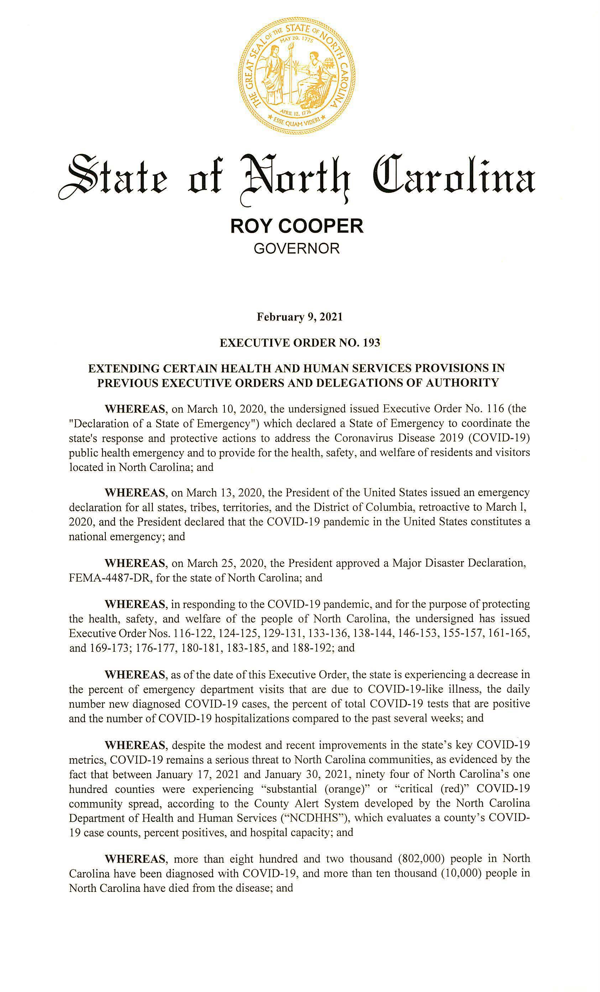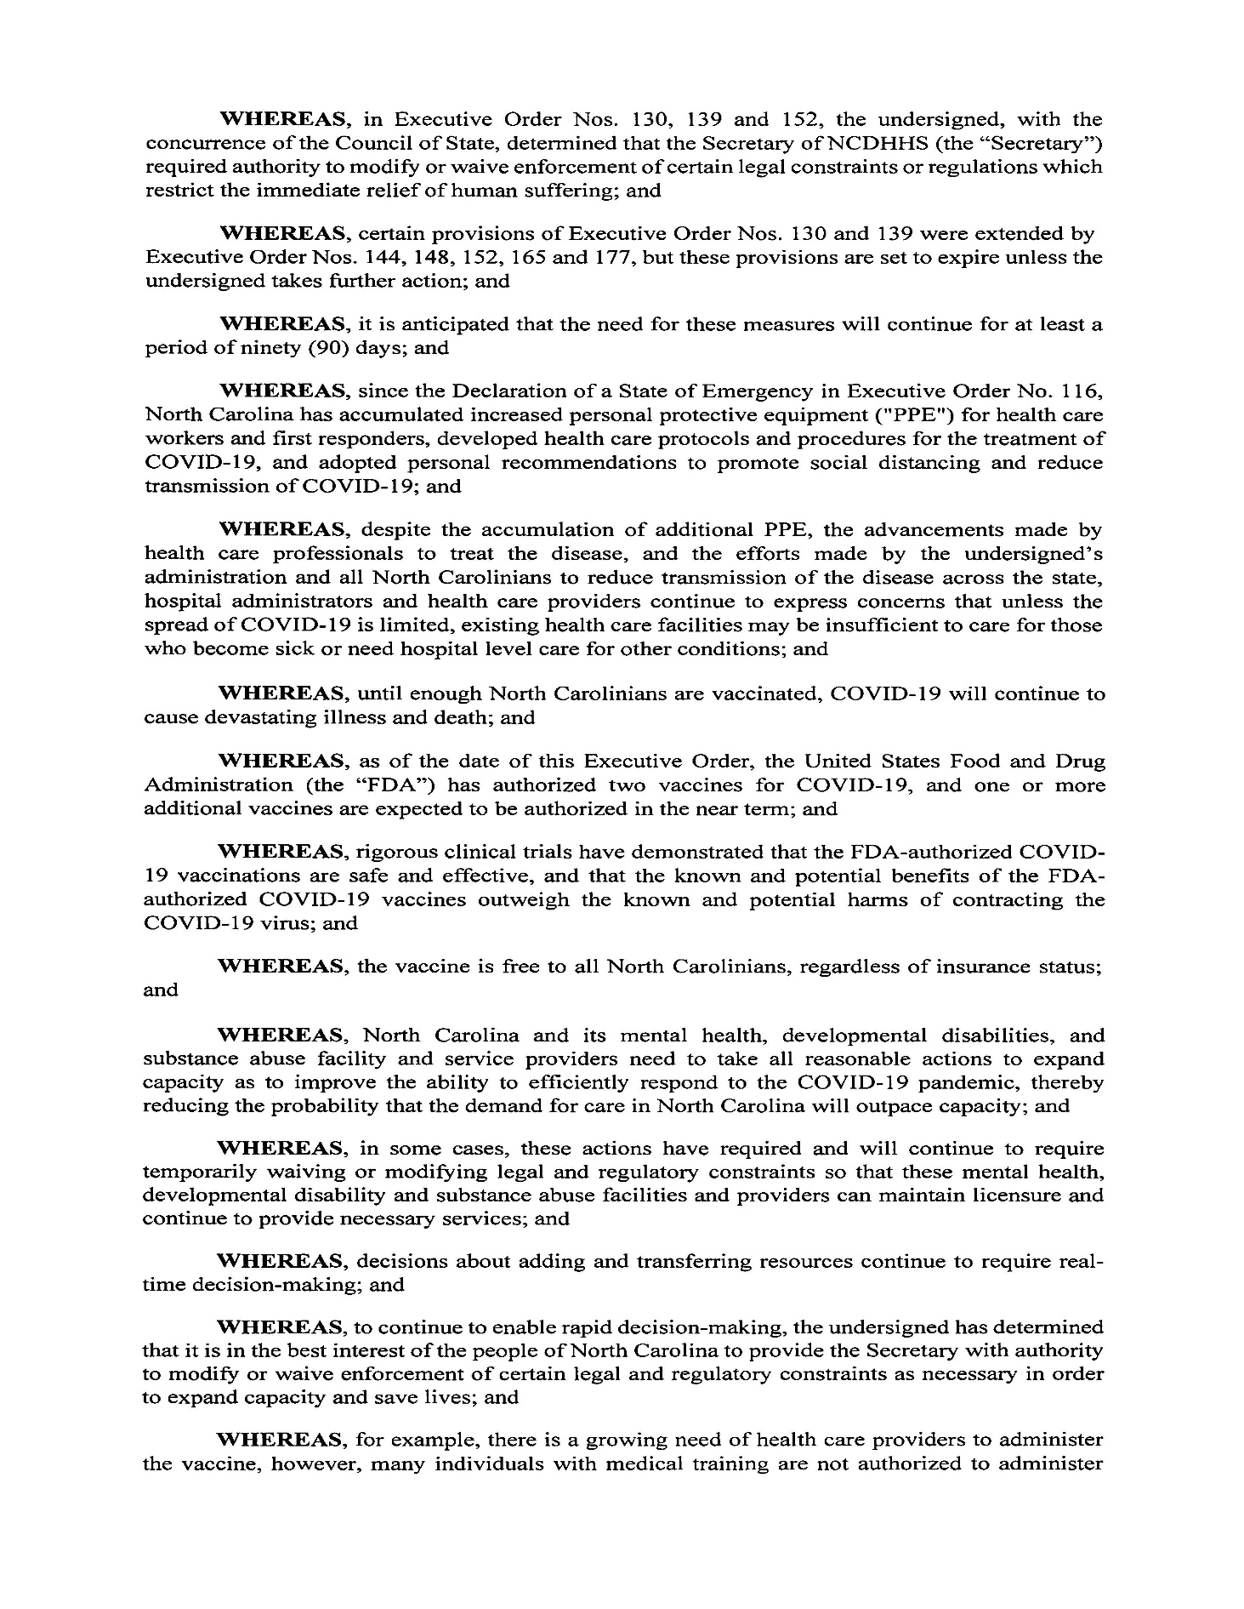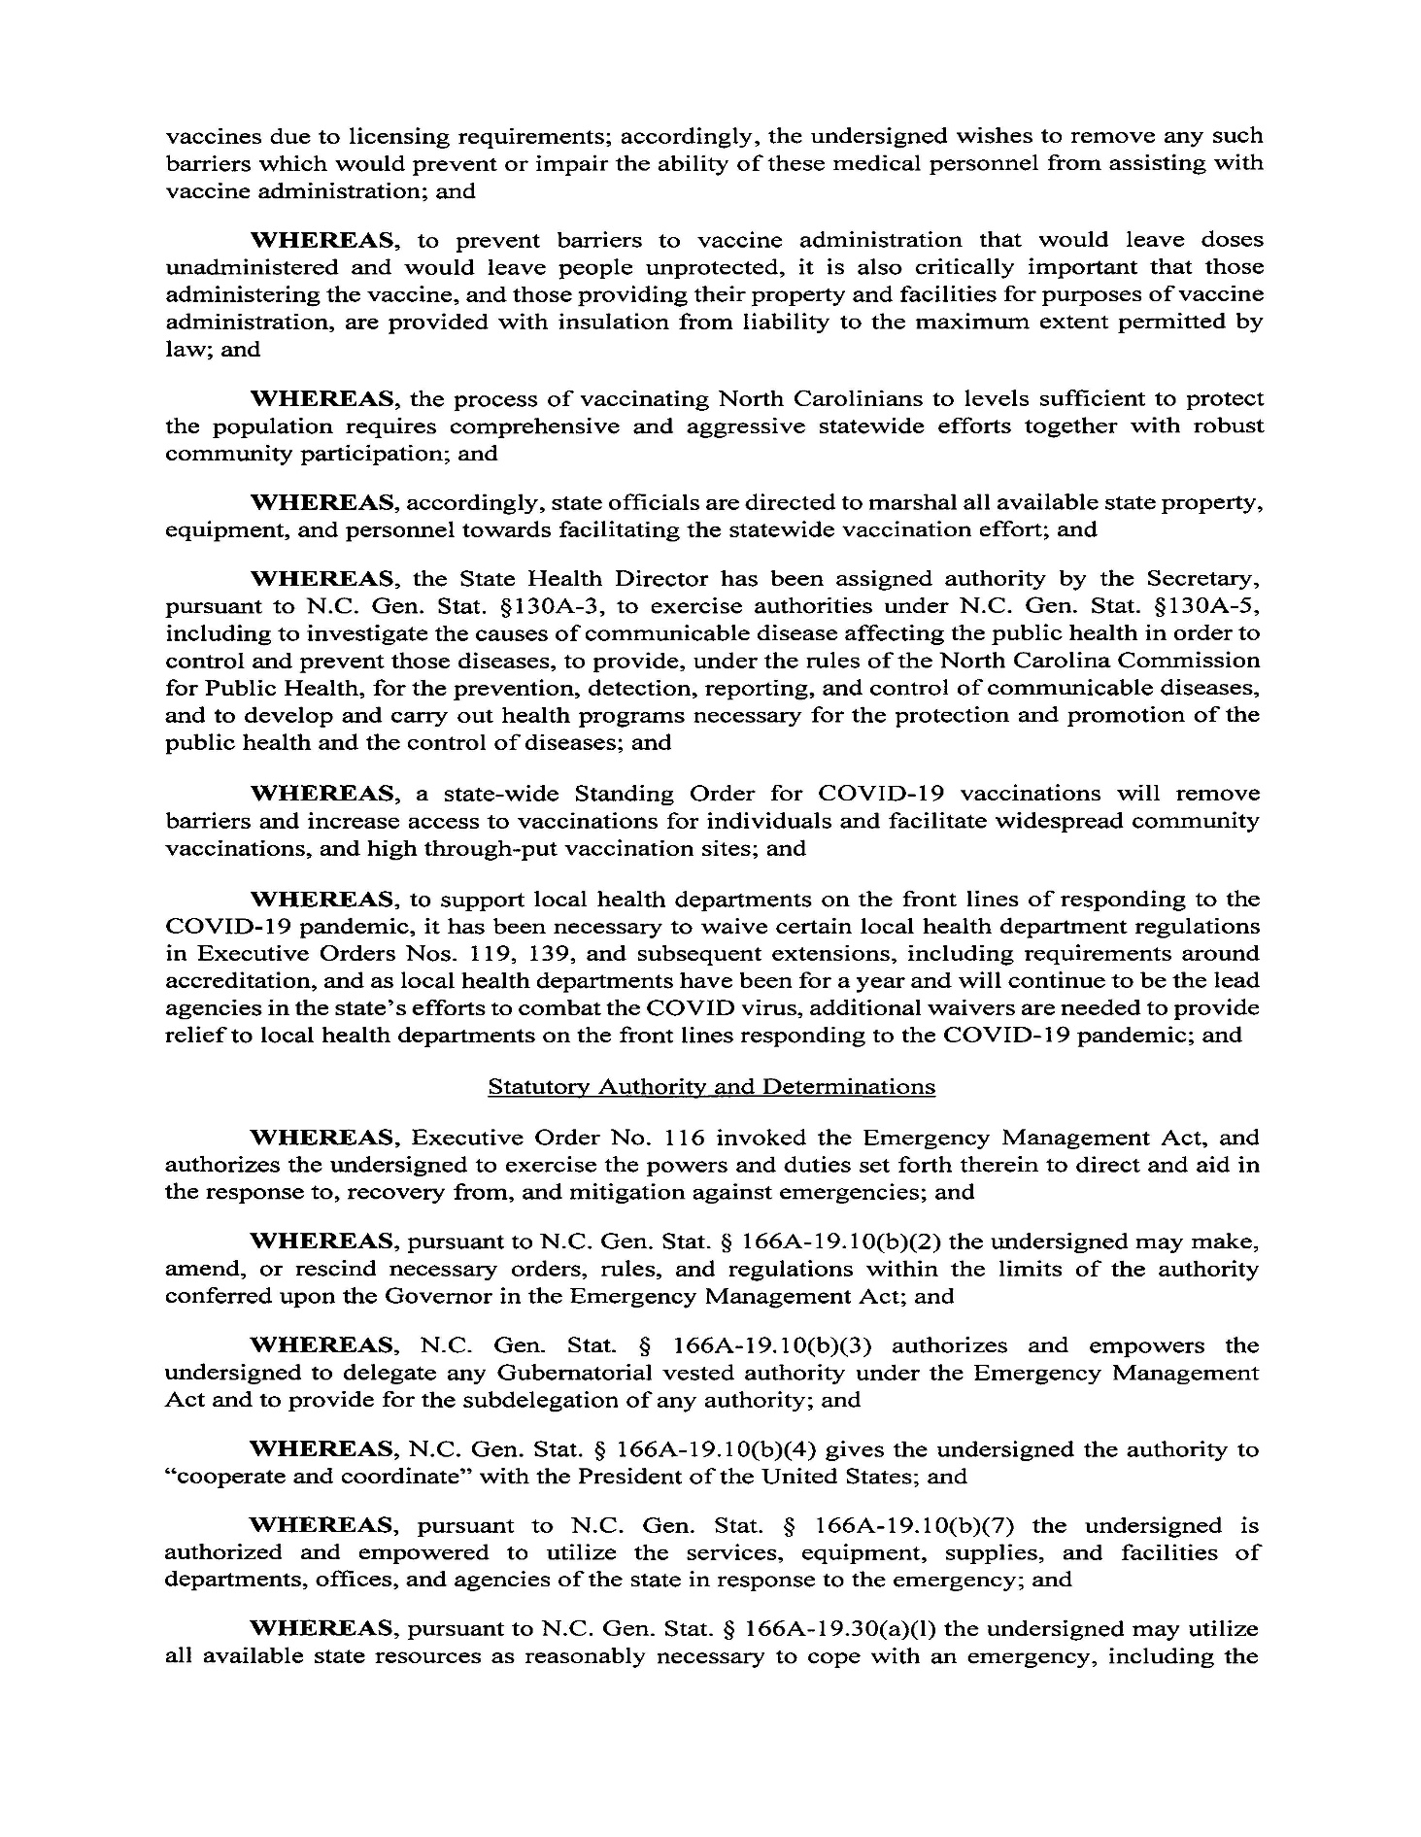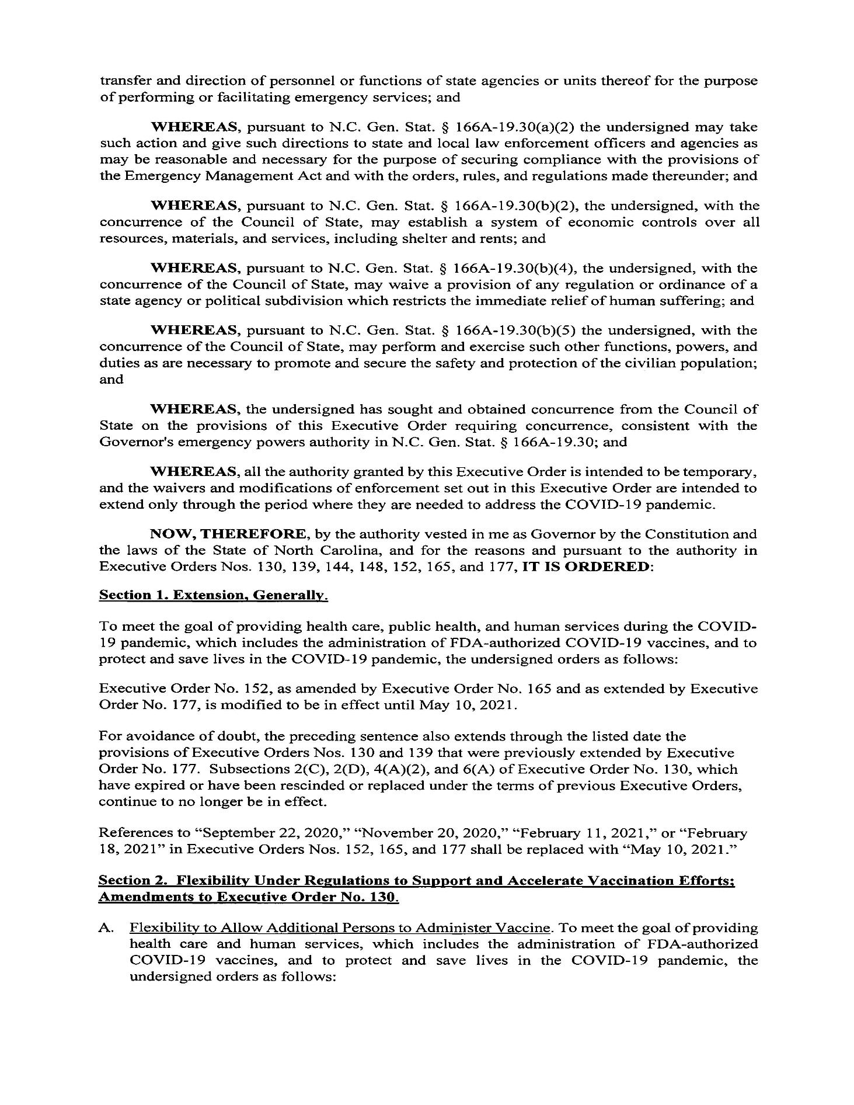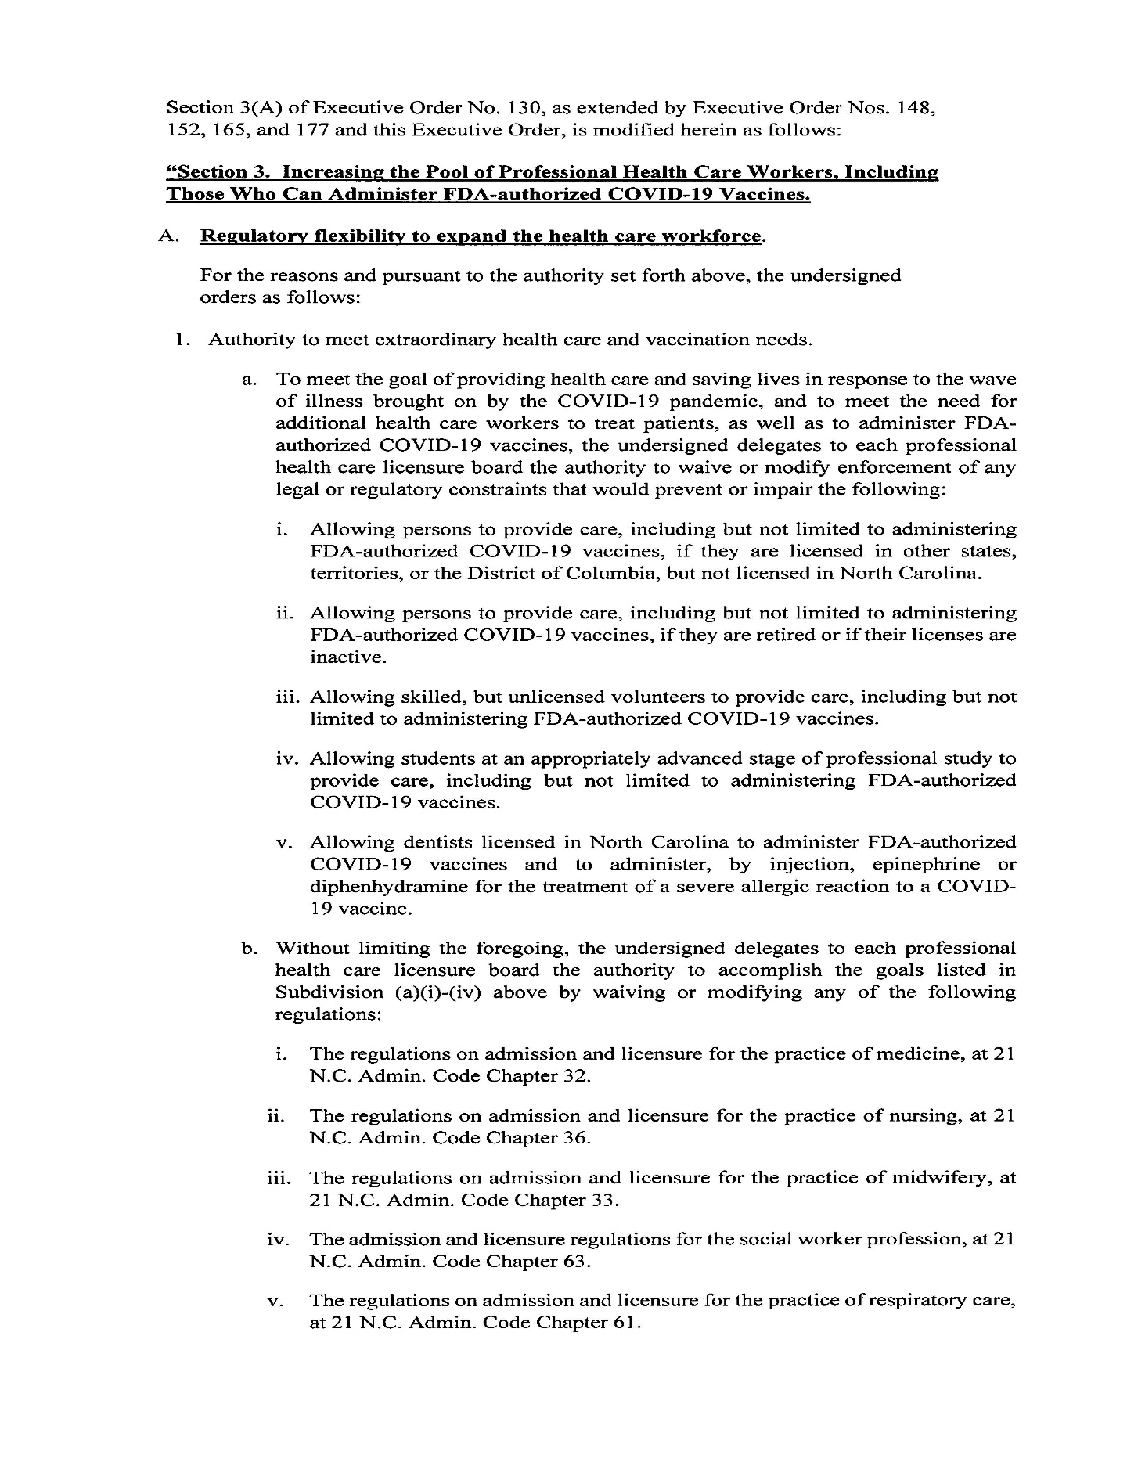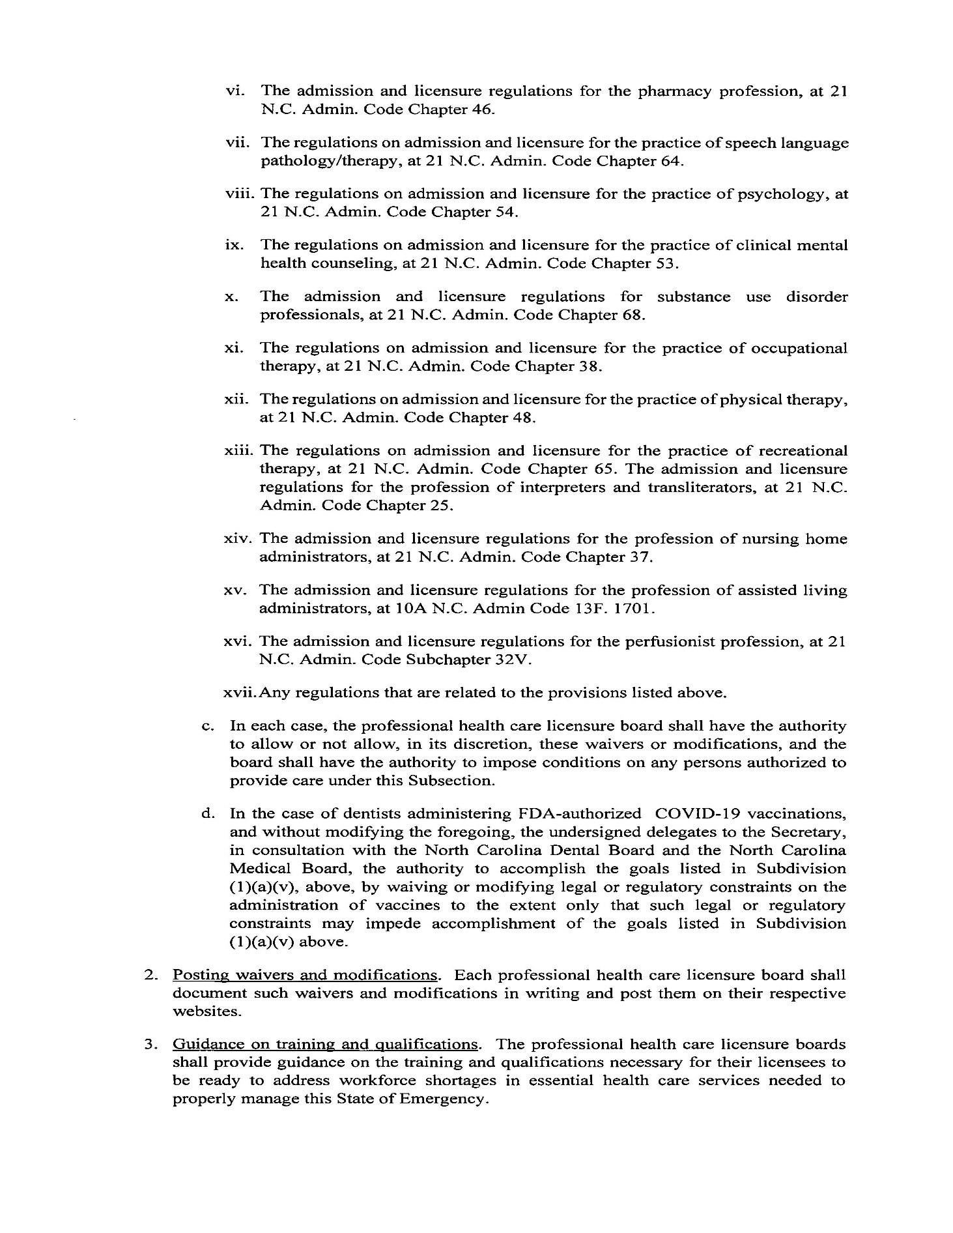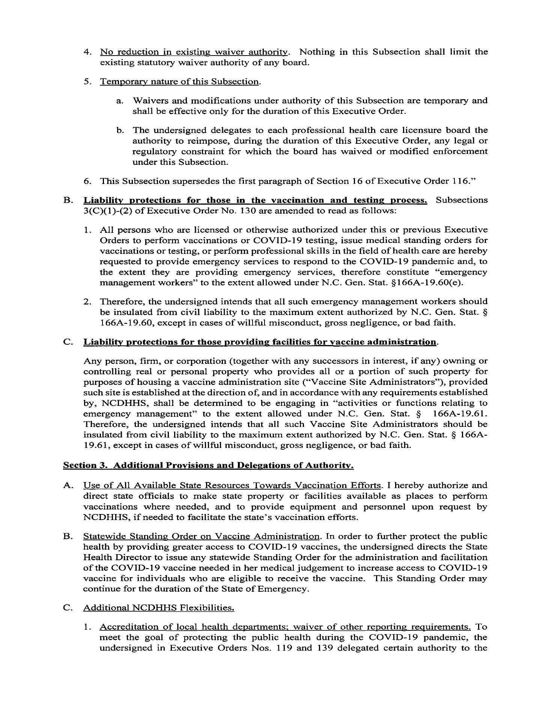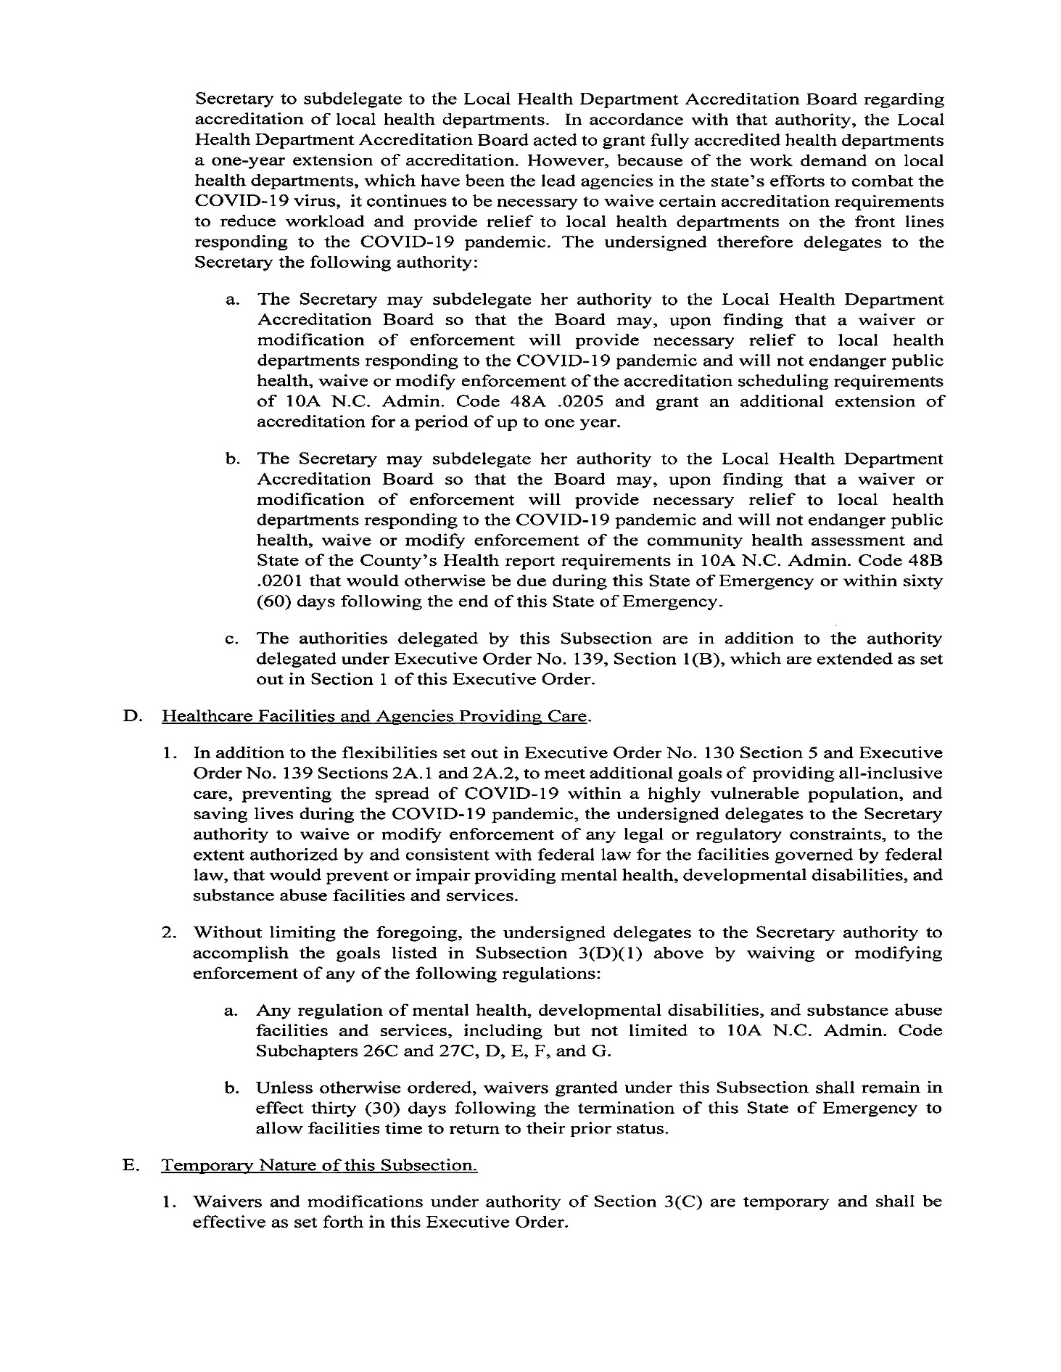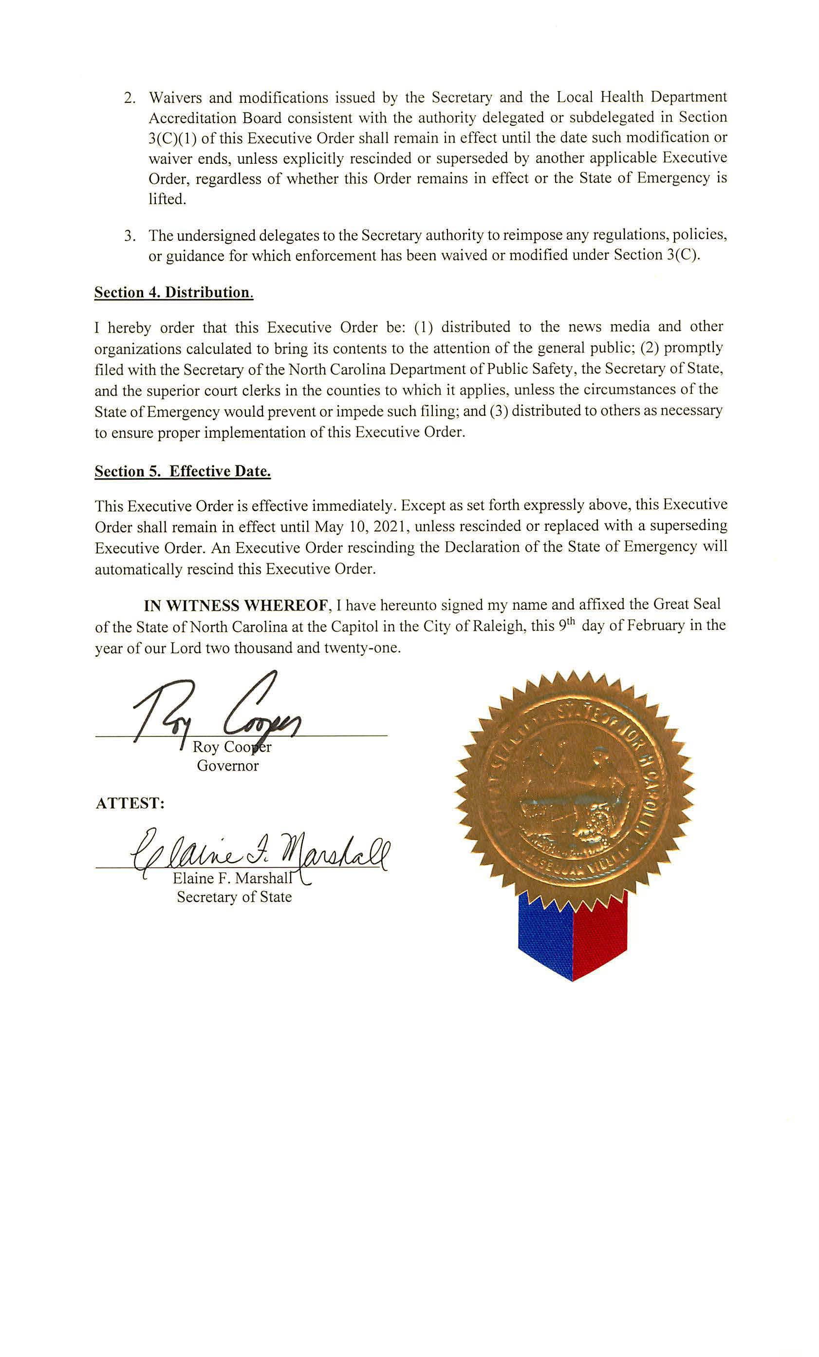
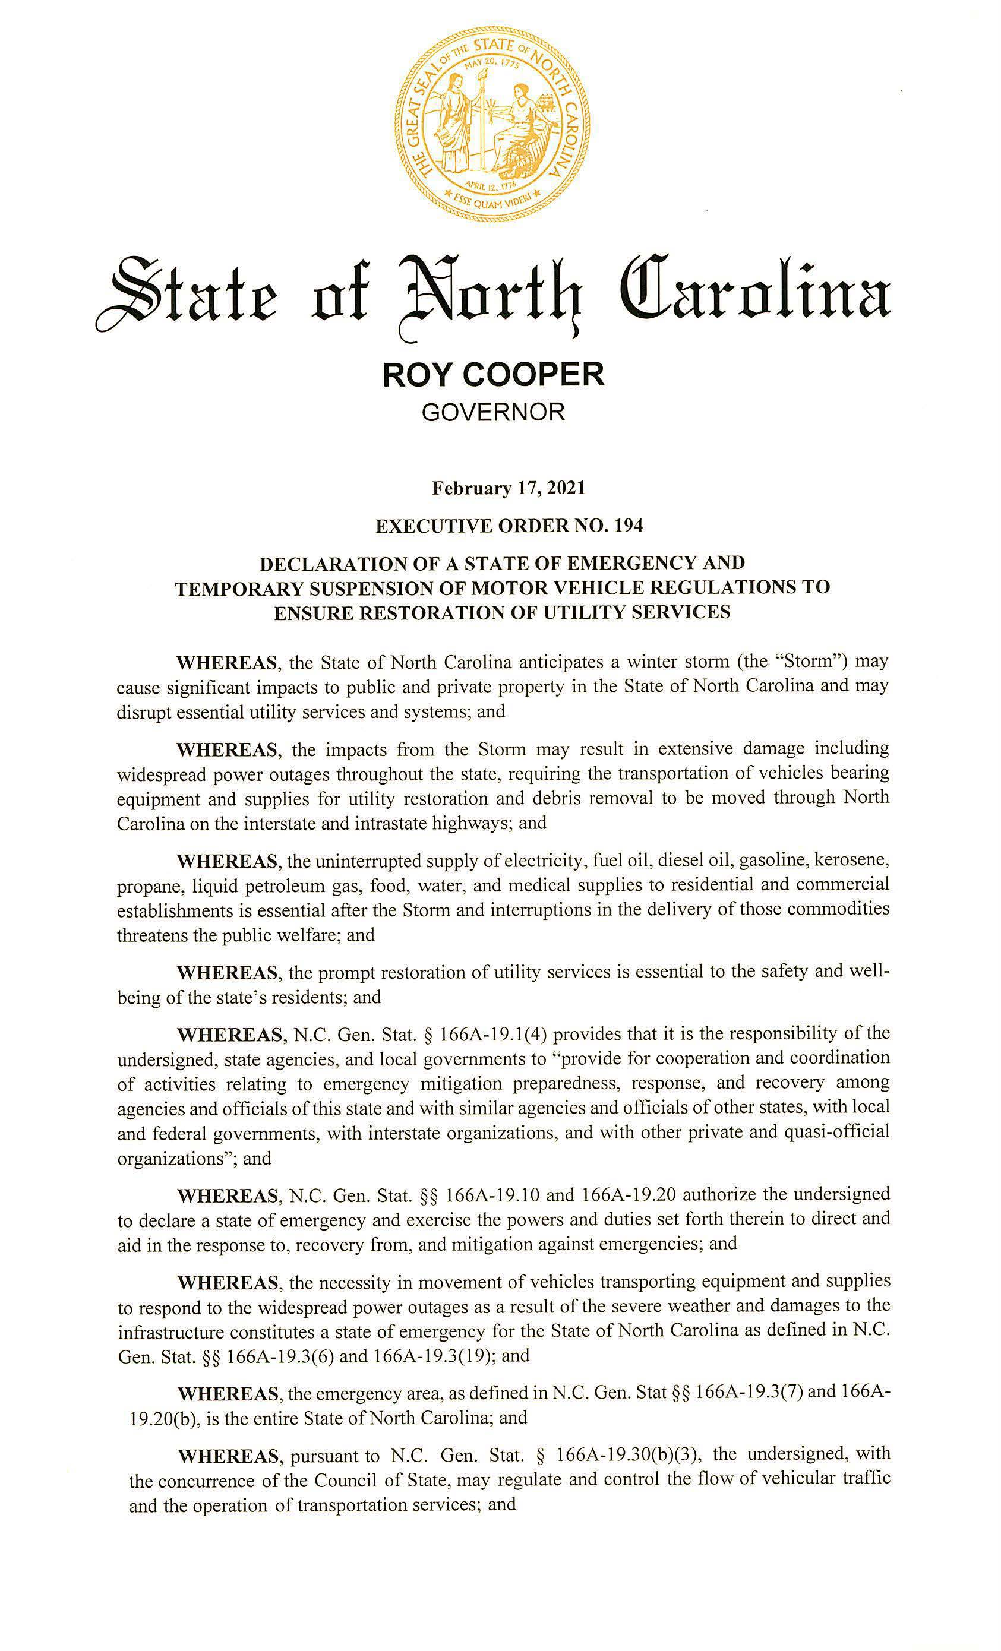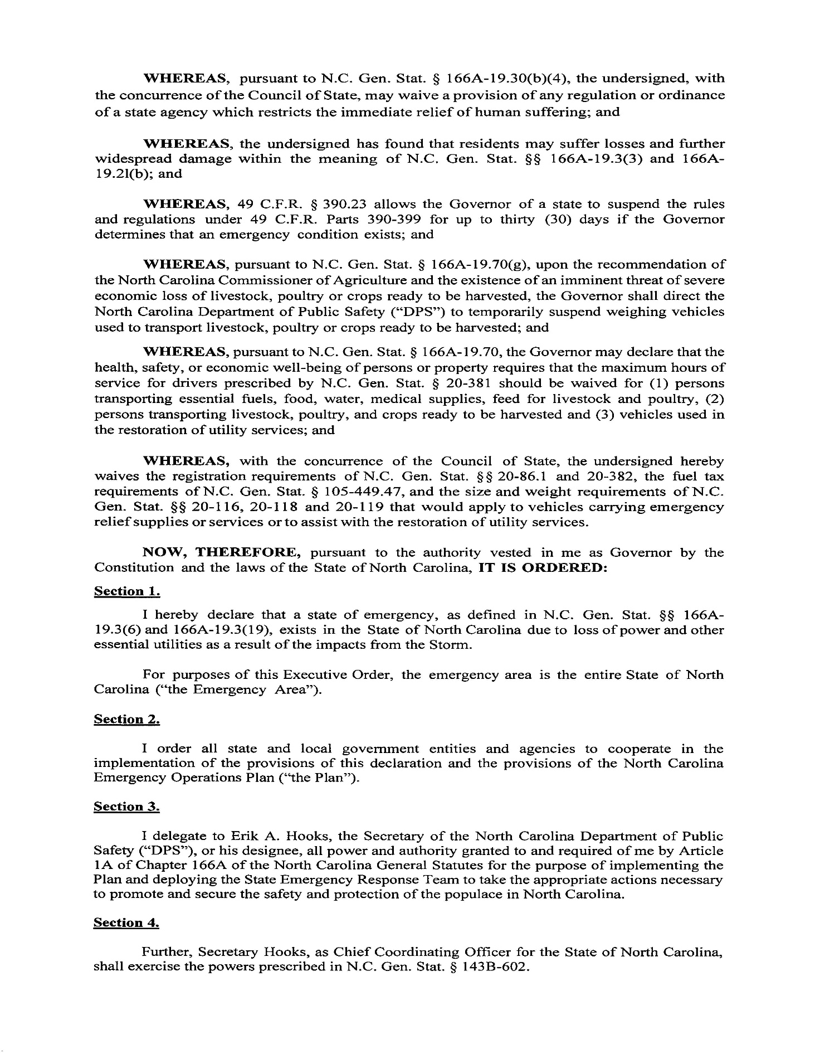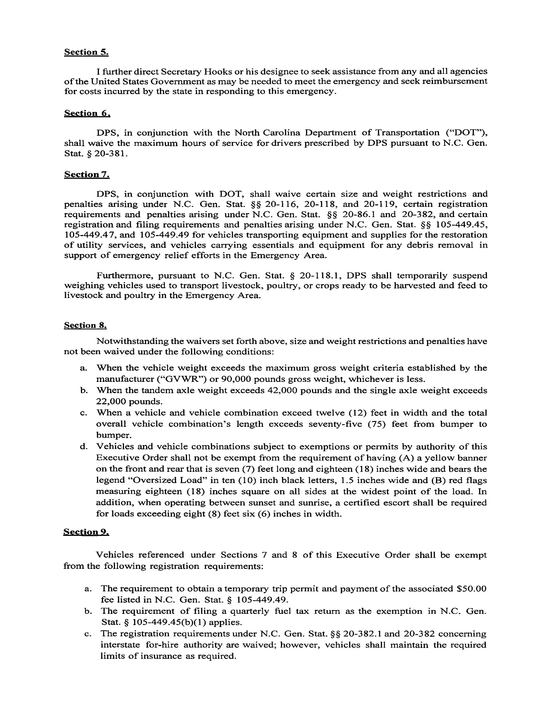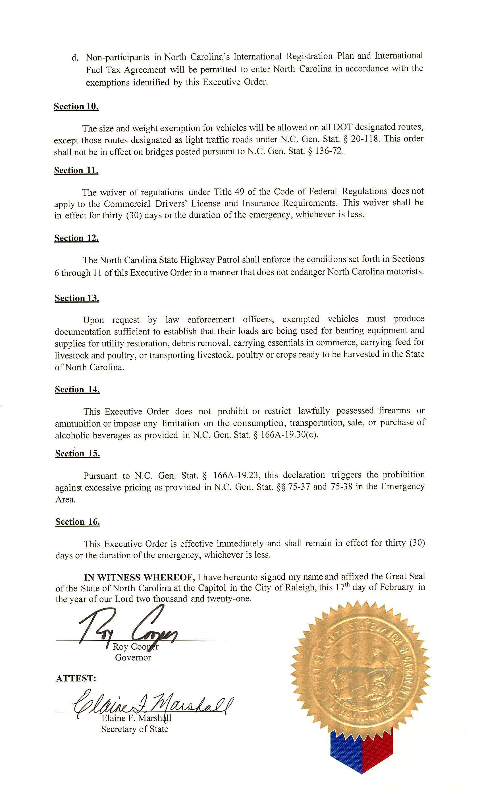

Note from the Codifier: The notices published in this Section of the NC Register include the text of proposed rules. The agency must accept comments on the proposed rule(s) for at least 60 days from the publication date, or until the public hearing, or a later date if specified in the notice by the agency. If the agency adopts a rule that differs substantially from a prior published notice, the agency must publish the text of the proposed different rule and accept comment on the proposed different rule for 60 days.
Statutory reference: G.S. 150B-21.2.

Title 10A – Department of Health and Human Services

Notice is hereby given in accordance with G.S. 150B-21.2 that the Medical Care Commission intends to amend the rule cited as 10A NCAC 13D .2001.

Link to agency website pursuant to G.S. 150B-19.1(c): https://info.ncdhhs.gov/dhsr/ruleactions.html

Proposed Effective Date: October 1, 2021

Public Hearing:
Date: April 28, 2021
Time: 10:00 a.m.
Location: Being held by teleconference call using the following: Telephone number: 1-877-848-7030; Access code: 5133201

Reason for Proposed Action: The N.C. Medical Care Commission is proposing to amend this rule in Subchapter 10A NCAC 13D with technical changes to correct language inaccuracies with the Nursing Home licensure physical plant construction definitions.

Comments may be submitted to: Nadine Pfeiffer, 809 Ruggles Drive, 2701 Mail Service Center, Raleigh, NC 27699-2701; email DHSR.RulesCoordinator@dhhs.nc.gov

Comment period ends: May 14, 2021

Procedure for Subjecting a Proposed Rule to Legislative Review: If an objection is not resolved prior to the adoption of the rule, a person may also submit written objections to the Rules Review Commission after the adoption of the Rule. If the Rules Review Commission receives written and signed objections after the adoption of the Rule in accordance with G.S. 150B-21.3(b2) from 10 or more persons clearly requesting review by the legislature and the Rules Review Commission approves the rule, the rule will become effective as provided in G.S. 150B-21.3(b1). The Commission will receive written objections until 5:00 p.m. on the day following the day the Commission approves the rule. The Commission will receive those objections by mail, delivery service, hand delivery, or facsimile transmission. If you have any further questions concerning the submission of objections to the Commission, please call a Commission staff attorney at 919-431-3000.

Fiscal impact. Does any rule or combination of rules in this notice create an economic impact? Check all that apply.

State funds affected

Local funds affected

Substantial economic impact (>= $1,000,000)

Approved by OSBM

No fiscal note required

Chapter 13 - NC Medical Care Commission

SUBCHAPTER 13D – RULES FOR THE LICENSING OF NURSING HOMES

SECTION .2000 – GENERAL INFORMATION

10A NCAC 13D .2001 DEFINITIONS

In addition to the definitions set forth in G.S. 131E-101, the following definitions shall apply throughout this Subchapter:
(1) "Abuse" means the willful infliction of injury, unreasonable confinement, intimidation or punishment with resulting physical harm, pain, or mental anguish.
(2) "Accident" means an unplanned event resulting in the injury or wounding of a patient or other individual.
(3) "Addition" means an extension or increase in floor area or height of a building.
(4) "Administrator" as defined in G.S. 90-276(4).
(5) "Alteration" means any construction or renovation to an existing structure other than repair, maintenance, or addition.
(6) "Brain injury long term care" means an interdisciplinary, intensive maintenance program for patients who have incurred brain damage caused by external physical trauma and who have completed a primary course of rehabilitative treatment and have reached a point of no gain or progress for more than three consecutive months. Brain injury long term care is provided through a medically supervised interdisciplinary process and is directed toward maintaining the individual at the optimal level of physical, cognitive, and behavioral functions.
(7) "Capacity" means the maximum number of patient or resident beds for which the facility is licensed to maintain at any given time.
(8) "Combination facility" means a combination home as defined in G.S. 131E-101.
(9) "Comprehensive, inpatient rehabilitation program" means a program for the treatment of persons with functional limitations or chronic disabling conditions who have the potential to achieve a significant improvement in activities of daily living, including bathing, dressing, grooming, transferring, eating, and using speech, language, or other communication systems. A comprehensive, inpatient rehabilitation program utilizes a coordinated and integrated, interdisciplinary approach, directed by a physician, to assess patient needs and to provide treatment and evaluation of physical, psychosocial, and cognitive deficits.
(10) "Department" means the North Carolina Department of Health and Human Services.
(11) "Director of nursing" means a registered nurse who has authority and responsibility for all nursing services and nursing care.
(12) "Discharge" means a physical relocation of a patient to another health care setting; the discharge of a patient to his or her home; or the relocation of a patient from a nursing bed to an adult care home bed, or from an adult care home bed to a nursing bed.
(13) "Existing facility" means a facility currently licensed, a proposed facility, a proposed addition to a licensed facility, or a proposed remodeled licensed facility that will be built according to design development drawings and specifications approved by the Department for compliance with the standards established in Sections .3100, .3200, and .3400 of this Subchapter, licensed and built prior to the effective date of this Rule.
(14) "Facility" means a nursing facility or combination facility as defined in this Rule.
(15) "Incident" means any accident, event, or occurrence that is unplanned, or unusual, and has caused harm to a patient, or has the potential for harm.
(16) "Inpatient rehabilitation facility or unit" means a free-standing facility or a unit (unit pertains to contiguous dedicated beds and spaces) within an existing licensed health service facility approved in accordance with G.S. 131E, Article 9 to establish inpatient, rehabilitation beds and to provide a comprehensive, inpatient rehabilitation program.
(17) "Interdisciplinary" means an integrated process involving representatives from disciplines of the health care team.
(18) "Licensee" means the person, firm, partnership, association, corporation, or organization to whom a license to operate the facility has been issued. The licensee is the legal entity that is responsible for the operation of the business.
(19) "Medication error rate" means the measure of discrepancies between medication that was ordered for a patient by the health care provider and medication that is administered to the patient. The medication error rate is calculated by dividing the number of errors observed by the surveyor by the opportunities for error, multiplied times 100.
(20) "Misappropriation of property" means the deliberate misplacement, exploitation, or wrongful, temporary or permanent use of a patient's belongings or money without the patient's consent.
(21) "Neglect" means a failure to provide goods and services necessary to avoid physical harm, mental anguish, or mental illness.
(22) "New facility" means a proposed facility, facility for which an initial license is sought, a proposed addition to an existing facility, or a proposed remodeled portion of an existing facility that will be built according to design development drawings construction documents and specifications approved by the Department for compliance with the standards established in Sections .3100, .3200, and .3400 of this Subchapter after the effective date of this Rule. Subchapter.
(23) "Nurse Aide" means a person who is listed on the N.C. Nurse Aide Registry and provides nursing or nursing-related services to patients in a nursing home. A nurse aide is not a licensed health professional. Nursing homes that participate in Medicare or Medicaid shall comply with 42 CFR 483.35, which is incorporated by reference, including subsequent amendments. The Code of Federal Regulations may be accessed at https://www.ecfr.gov.
(24) "Nursing facility" means a nursing home as defined in G.S. 131E-101.
(25) "Patient" means any person admitted for nursing care.
(26) "Remodeling" means alterations, renovations, rehabilitation work, repairs to structural systems, and replacement of building systems at a nursing or combination facility.
(27) "Repair" means reconstruction or renewal of any part of an existing building for the purpose of its maintenance.
(28) "Resident" means any person admitted for care to an adult care home part of a combination facility.
(29) "Respite care" means services provided for a patient on a temporary basis, not to exceed 30 days.
(30) "Surveyor" means a representative of the Department who inspects nursing facilities and combination facilities to determine compliance with rules, laws, and regulations as set forth in G.S. 131E-117; Subchapters 13D and 13F of this Chapter; and 42 CFR Part 483, Requirements for States and Long Term Care Facilities.
(31) "Violation" means a failure to comply with rules, laws, and regulations as set forth in G.S. 131E-117 and 131D–21; Subchapters 13D and 13F of this Chapter; or 42 CFR Part 483, Requirements for States and Long Term Care Facilities, that relates to a patient's or resident's health, safety, or welfare, or that creates a risk that death, or physical harm may occur.

Authority G.S. 131E-104.

* * * * * * * * * * * * * * * * * * * *

Notice is hereby given in accordance with G.S. 150B-21.2 and G.S. 150B-21.3A(c)(2)g. that the Medical Care Commission intends to amend the rules cited as 10A NCAC 13K .1112, .1209, .1210, and readopt with substantive changes the rules cited as 10A NCAC 13K .1109, .1113-.1116, .1201, .1204-.1208, .1211, and .1212.

Link to agency website pursuant to G.S. 150B-19.1(c): https://info.ncdhhs.gov/dhsr/ruleactions.html

Proposed Effective Date: October 1, 2021

Public Hearing:
Date: April 28, 2021
Time: 10:00 a.m.
Location: Being held by teleconference using the following: Telephone number: 1-877-848-7030; Access code: 5133201

Reason for Proposed Action: Pursuant to GS 150B-21.3A, Periodic Review and Expiration of Existing Rules, all rules are reviewed at least every 10 years, or they shall expire. As a result of the periodic review of Subchapter 10A NCAC 13K, Hospice Licensing Rules, 13 proposed rules were part of the 18 rules that were determined as “Necessary With Substantive Public Interest," requiring readoption. In addition, three rules are proposed for amendment.

Substantive changes have been made to the physical plant requirements for the proposed hospice facilities rules for hospice residential care. The revisions include resident care area requirement reorganization and clarification; clarification of the submission process of plans and specifications for construction or remodeling; reference removal to the N.C. State Building Code for plumbing and specification of the water heater capacity; clarification of the requirements for sewage and refuse disposal, and protection from vermin; clarification of physical plant application requirements; organization and clarification of the requirements for granting an equivalency, and for code or rule application when conflicts in code or rule occur. In addition, technical changes were made in the rules.

Substantive changes have been made to the physical plant requirements for the proposed hospice facilities rules for hospice inpatient care. The revisions include addition and removal of rule referral by reference exceptions; reorganization of rule requirements to be similar with the Licensing of Nursing Home Rules in 10A NCAC 13D for the patient care area, heating and air conditioning, emergency electrical service, and application of physical plant requirements; reorganization and clarification of the requirements for furnishings; requirement removal enforced by the N.C. State Building Code; requirement addition for environmental and patient safety, emergency disaster plans, policies and procedures, including emergency drills; requirement addition for life safety and protection for the life safety branch of the essential electrical system; update and clarification of the electrical requirements for circuitry and call bells; reorganization, reformat, and clarification of plumbing requirements and revision of the patient area hot water temperature range; and organization and clarification of the requirements for granting an equivalency, and for code or rule application when conflicts in code or rule occur. In addition, technical changes were made in the rules.

Comments may be submitted to: Nadine Pfeiffer, 809 Ruggles Drive, 2701 Mail Service Center, Raleigh, NC 27699-2701; email DHSR.RulesCoordinator@dhhs.nc.gov

Comment period ends: May 14, 2021

Procedure for Subjecting a Proposed Rule to Legislative Review: If an objection is not resolved prior to the adoption of the rule, a person may also submit written objections to the Rules Review Commission after the adoption of the Rule. If the Rules Review Commission receives written and signed objections after the adoption of the Rule in accordance with G.S. 150B-21.3(b2) from 10 or more persons clearly requesting review by the legislature and the Rules Review Commission approves the rule, the rule will become effective as provided in G.S. 150B-21.3(b1). The Commission will receive written objections until 5:00 p.m. on the day following the day the Commission approves the rule. The Commission will receive those objections by mail, delivery service, hand delivery, or facsimile transmission. If you have any further questions concerning the submission of objections to the Commission, please call a Commission staff attorney at 919-431-3000.

Fiscal impact. Does any rule or combination of rules in this notice create an economic impact? Check all that apply.

State funds affected

Local funds affected

Substantial economic impact (>= $1,000,000)

Approved by OSBM

No fiscal note required

SUBCHAPTER 13K – HOSPICE LICENSING RULES

SECTION .1100 - HOSPICE RESIDENTIAL CARE

10A NCAC 13K .1109 RESIDENT CARE AREAS

(a) Resident rooms shall meet the following requirements: A facility shall meet the following requirements for resident bedrooms:

(1) There shall be private or semiprivate rooms; private bedroom with not less than 100 square feet of floor area or semi-private bedroom with not less than 80 square feet of floor area per bed shall be provided;

(2) Infants infants and small children shall not be assigned to share a room bedroom with an adult resident unless requested by residents the resident and families;

(3) Each resident room each bedroom shall contain at least be furnished with a bed, a mattress protected by waterproof material, a mattress pad, a pillow, and a chair; one chair per resident;

(4) Each resident room shall have a minimum of 48 cubic feet of closet space or wardrobe for clothing and personal belongings that provides security and privacy for each resident. Each resident room shall be equipped with a towel rack for each individual; each bedroom shall be provided with one closet or wardrobe per bed. Each closet or wardrobe shall have clothing storage space of not less than 48 cubic feet per bed with one-half of this space for hanging clothes;

(5) Each resident each bedroom shall:
(A) be located at or above grade level;
(B) have provisions to ensure visual privacy for treatment or visiting; be provided with a cubicle curtain enclosing each bed to ensure visual privacy; and
(C) be equipped with a towel rack for each resident;

(6) Artificial lighting shall be provided sufficient each bedroom shall provide lighting for treatment and non-treatment needs, 50 foot candles foot-candles for treatment, treatment needs, and 35 foot candles foot-candles for non-treatment areas; needs; and

(7) A room where access is through a bathroom, kitchen or another bedroom will not be approved for a resident's bedroom. no resident bedroom shall be accessed through a bathroom, kitchen, or another bedroom.

(b) Bathrooms shall meet the following requirements: A facility shall meet the following requirements for bathrooms:

(1) Bathroom facilities bathrooms shall be conveniently directly accessible to resident rooms. each resident bedroom without going through the general corridors. One bathroom may serve up to four residents and staff. residents. Minimum size of any bathroom shall be 18 square feet. The door bathroom doorway shall be at least 32 inches wide. be a minimum 32-inch clear opening;

(2) The each bathroom shall be furnished with the following:
(A) a toilet with grab bars;
(B) lavatory with four inch wrist blade controls; a sink trimmed with valves that can be operated without hands. If the sink is equipped with blade handles, the blade handles shall not be less than four inches in length. If the sink faucet depends on the building electrical service for operation, the faucet must have an emergency power source or battery backup capability. If the faucet has battery operated sensors, the facility shall have a maintenance policy to keep extra rechargeable or non-rechargeable batteries on premises for the faucets;
(C) a mirror;
(D) soap, paper towel dispensers, and waste paper receptacle with a removable impervious liner; and
(E) water closet; and
(F)(E) a tub or shower.

(c) Space shall be provided for: Each facility shall provide:

(1) charting, storage of supplies and personal effects of staff; an area for charting;

(2) the storage of resident care equipment; storage provisions for personal effects of staff;

(3) housekeeping equipment and cleaning supplies; storage areas for supplies and resident care equipment;

(4) storage of test reagents and disinfectants distinct from medication; storage area(s) for housekeeping equipment and cleaning supplies;

(5) locked medication storage and preparation; and a medication preparation area with a counter, a sink trimmed with valves that can be operated without hands, locked medication storage, and a double locked narcotic storage area under visual control of staff. If the sink is equipped with blade handles, the blade handles shall not be less than four inches in length. If the sink faucet depends on the building electrical service for operation, the faucet must have an emergency power source or battery backup capability. If the faucet has battery operated sensors, the facility shall have a maintenance policy to keep extra rechargeable or non-rechargeable batteries on premises for the faucets;

(6) drugs requiring refrigeration. They may be stored in a separate locked box in the refrigerator or in a lockable drug-only refrigerator, capable of maintaining a temperature range of 36 degrees F (2 degrees C) to 46 degrees F (8 degrees C). The storage and accountability of controlled substances shall be in accordance with the North Carolina Controlled Substances Act, Article 5 of Chapter 90 of the General Statutes. a lockable refrigerator for drug storage only or a separate locked box in a facility refrigerator. The refrigerator must be capable of maintaining a temperature range of 36 degrees F (2 degrees C) to 46 degrees F (8 degrees C);

(7) a kitchen with:
(A) a refrigerator;
(B) a cooking appliance ventilated to the outside;
(C) a 42-inch minimum double-compartment sink and domestic dishwashing machine capable of sanitizing dishes with 160 degrees F water; and
(D) storage space for non-perishables;

(8) a separate dining area measuring not less than 20 square feet per resident bed;

(9) a recreational and social activities area with not less than 150 square feet of floor area exclusive of corridor traffic;

(10) a nurses' calling system shall be provided:
(A) in each resident bedroom for each resident bed. The call system activator shall be such that they can be activated with a single action and remain on until deactivated by staff at the point of origin. The call system activator shall be within reach of a resident lying on the bed. In rooms containing two or more call system activators, indicating lights shall be provided at each calling station;
(B) nurses' calling systems which provide two-way voice communication shall be equipped with an indicating light at each calling station which lights and remains lighted as long as the voice circuit is operating;
(C) a nurses' call emergency activator shall be proved at each residents' use toilet fixture, bath, and shower. The call system activator shall be accessible to a resident lying on the floor; and
(D) calls shall register with the floor staff and shall activate a visible signal in the corridor at the resident's door. In multi-corridor units, additional visible signals shall be installed at corridor intersections;

(11) heating and air conditioning equipment that can maintain a temperature range between 68 degrees and 80 degrees Fahrenheit, even upon loss of utility power.

(d) Kitchen and dining areas shall have:

(1) a refrigerator;

(2) a cooking unit ventilated to the outside;

(3) a 42 inch minimum double-compartment sink and domestic dishwashing machine capable of sanitizing dishes with 160 degrees F. water;

(4) dining space of 20 square feet per resident; and

(5) storage space for non-perishables.

(e) Other areas shall include:

(1) a minimum of 150 square feet exclusive of corridor traffic for recreational and social activities;

(2) an audible and accessible call system furnished in each resident's room and bathroom; and

(3) heating and air cooling equipment to maintain a comfort range between 68 degrees and 80 degrees Fahrenheit.
Authority G.S. 131E-202.

10A NCAC 13K .1112 DESIGN AND CONSTRUCTION

(a) Hospice residences and inpatient units A new facility or remodeling of an existing facility must shall meet the requirements of the North Carolina State Building Code Codes, which are incorporated by reference, including all subsequent amendments and editions, in effect at the time of licensure, construction, additions, alterations or repairs. Copies of these codes may be purchased from the International Code Council online at https://shop.iccsafe.org/ at a cost of eight hundred fifty-eight dollars ($858.00) or accessed electronically free of charge at https://codes.iccsafe.org/codes/north-carolina. Existing licensed facilities shall meet the requirements of the North Carolina State Building Codes in effect at the time of licensure, construction or remodeling.

(b) Each facility shall be planned, constructed, and equipped to support the services to be offered in the facility.

(c) Any existing building converted to a hospice facility shall meet all requirements of a new facility.

(d) The sanitation, water supply, sewage disposal, and dietary facilities must comply with the rules of the Commission for Public Health. shall meet the requirements of 15A NCAC 18A .1300, which is incorporated by reference including subsequent amendments and editions.

Authority G.S. 131E-202.

10A NCAC 13K .1113 PLANS AND SPECIFICATIONS

(a) When construction or remodeling of a facility is planned, final working drawings and specifications must one copy of construction documents and specifications shall be submitted by the owner or the owner's appointed representative to the Department of Health and Human Services, Division of Health Service Regulation for review and approval. Schematic design drawings and preliminary working design development drawings shall may be submitted by the owner prior to the required submission of final working drawings. for approval prior to the required submission of construction documents. The Department shall forward copies of each submittal to the Department of Insurance and Division of Environmental Health for review and approval. Three copies of the plans shall be provided at each submittal.

(b) Construction work shall not be commenced until written approval has been given by the Department. Approval of final plans construction documents and specifications shall be obtained from the Department prior to licensure. Approval of construction documents and specifications shall expire one year from the date granted unless a contract for the construction has been signed prior to the expiration date. after the date of approval unless a building permit for the construction has been obtained prior to the expiration date of the approval of construction documents and specifications.

(c) If an approval expires, a renewed approval shall be issued by the Department, provided revised plans construction documents and specifications meeting all current regulations, codes, and the standards established in Sections .1100 and .1200 of this Subchapter are submitted. submitted by the owner or owner's appointed representative and reviewed by the Department.

(d) Completed construction shall conform to the minimum standards established in these Rules. Any changes made during construction shall require the approval of the Department to ensure compliance with the standards established in Sections .1100 and .1200 of this Subchapter.

(e) The owner or designated agent shall notify the Department when actual construction starts and at points when construction is 75 percent and 90 percent complete and upon final completion, so that periodic and final inspections can be performed. Completed construction or remodeling shall conform to the standards established in Sections .1100 and .1200 of this Subchapter. Construction documents and building construction, including the operation of all building systems, shall be approved in writing by the Department prior to licensure or patient and resident occupancy.

(f) The owner or owner's designated agent appointed representative shall submit for approval by the Department all alterations or remodeling changes which affect the structural integrity of the building, functional operation, fire safety or which add beds or facilities over those for which the facility is licensed. notify the Department in writing either by U.S. Mail or e-mail when the construction or remodeling is complete.

Authority G.S. 131E-202.

10A NCAC 13K .1114 PLUMBING

(a) The water supply shall be designed, constructed and protected so as to assure that a safe, potable and adequate water supply is available for domestic purposes in compliance with the North Carolina State Building Code.

(b) All plumbing in the residence or unit shall be installed and maintained in accordance with the North Carolina State Plumbing Code. All plumbing shall be maintained in good repair and free of the possibility of backflow and backsiphonage, through the use of vacuum breakers and fixed air gaps, in accordance with state and local codes.

(c) For homes hospice residential facilities with five or more residents, a 50-gallon quick recovery water heater is required. For homes hospice residential facilities with fewer than five residents, a 40-gallon quick recovery water heater is required.

Authority G.S. 131E-202.

10A NCAC 13K .1115 WASTE DISPOSAL

(a) Sewage shall be discharged into a public sewer system, or if such is not available, it in the absence of a public sewer system, sewage shall be disposed of in a manner approved by the North Carolina Division of Environmental Health. Department of Health and Human Services, Division of Public Health, Environmental Health Section.

(b) Garbage and rubbish shall be stored in impervious containers in such a manner as not to become a nuisance or a health hazard. to prevent insect breeding and public health nuisances. A sufficient number of impervious Impervious containers with tight-fitting lids shall be provided and kept clean and in good repair. Refuse Garbage shall be removed from the outside storage at least once a week to a disposal site approved by the local health department. department having jurisdiction.

(c) The home facility or unit shall be maintained free of infestations of insects and rodents, and all openings to the outside shall be screened. take measures to keep insects, rodents, and other vermin out of the residential care facility. All openings to the outer air shall be protected against the entrance of flying insects by screens, closed doors, closed windows, or other means.

Authority G.S. 131E-202.

10A NCAC 13K .1116 APPLICATION OF PHYSICAL PLANT REQUIREMENTS

The physical plan plant requirements for each hospice residential facility or unit shall be applied as follows:
(1) New construction shall comply with all the requirements of Section .1100 of this Subchapter; this Section;
(2) Existing Except where otherwise specified, existing buildings shall meet the licensure and code requirements in effect at the time of licensure, construction, alteration alteration, or modification; modification.
(3) New additions, alterations, modifications, and repairs shall meet the technical requirements of Section .1100 of this Subchapter; however, where strict conformance with current requirements would be impracticable, the authority having jurisdiction may approve alternative measures where the facility can demonstrate to the Department's satisfaction that the alternative measures do not reduce the safety or operating effectiveness of the facility;
(4)(3) Rules contained in Rule .1109 of this Section are minimum requirements and are not intended to prohibit buildings, systems systems, or operational conditions that exceed minimum requirements; requirements.
(5)(4) Equivalency: Alternate methods, procedures, design criteria, and functional variations from the physical plant requirements, because of extraordinary circumstances, new programs, or unusual conditions, may be approved by the authority having jurisdiction when the facility can effectively demonstrate to the Department's satisfaction that the intent of the physical plant requirements are met and that the variation does not reduce the safety or operational effectiveness of the facility; and The Division may grant an equivalency to allow alternate methods, procedures, design criteria or functional variation from the requirements of this Rule and the rules contained in this Section. The equivalency may be granted by the Division when a governing body submits a written equivalency request to the Division that states the following:
(a) the rule citation and the rule requirement that will not be met due to strict conformance with current requirements would be impractical, extraordinary circumstances, new programs, or unusual conditions;
(b) the justification for the equivalency; and
(c) how the proposed equivalency meets the intent of the corresponding rule requirement.
(5) In determining whether to grant an equivalency request the Division shall consider whether the request will reduce the safety and operational effectiveness of the facility. The governing body shall maintain a copy of the approved equivalence issued by the Division.
(6) Where rules or codes rules, codes, or standards have any conflict, the more stringent requirement shall apply.

Authority G.S. 131E-202.

SECTION .1200 - HOSPICE INPATIENT CARE

10A NCAC 13K .1201 REQUIREMENTS FOR HOSPICE INPATIENT UNITS

(a) Hospice inpatient facilities or units must shall conform to the rules outlined in 10A NCAC 13K Sections .0100 through .1100 of this Subchapter and those in this Section. the rules of this Section.

(b) Hospice inpatient units located in a licensed hospital shall meet the requirements of 10A NCAC 13B with the exception of: 13B, which is incorporated by reference with subsequent amendments and editions except for rules: 10A NCAC 13B .1912, .1919, .1922, and .1923.

(c) Hospice inpatient units located in a licensed nursing facility shall meet the requirements of 10A NCAC 13D with the exception of: 10A NCAC 13D .0507, .0600, .0800, .0907, .1004, .1200 and .1300. 13D, which is incorporated by reference with subsequent amendments and editions.

Authority G.S. 131E-202.

10A NCAC 13K .1204 ADDITIONAL PATIENT CARE AREA REQUIREMENTS FOR HOSPICE INPATIENT UNITS

(a) The floor area of a single bedroom shall not be less than 100 square feet and the floor area of a room for more than one bed shall not be less than 80 square feet per bed. The 80 square feet and 100 square feet requirements shall be exclusive of closets, toilet rooms, vestibules or wardrobes. A facility shall meet the following requirements for patient bedrooms:

(1) private bedrooms shall be provided with not less than 100 square feet of floor area;

(2) semi-private bedrooms with not less than 80 square feet of floor area per bed; and

(3) floor space for closets, toilet rooms, vestibules, or wardrobes shall not be included in the floor areas required by this Paragraph.

(b) The total space set aside for dining, recreation and other common uses shall not be less than 30 square feet per bed. Physical therapy and occupational therapy space shall not be included in this total. A facility shall meet the following requirements for dining, recreation, and common use areas:

(1) floor space for dining, recreation, and common use shall not be less than 30 square feet per bed;

(2) the dining, recreation, and common use areas required by this Paragraph may be combined; and

(3) floor space for physical and occupational therapy shall not be included in the areas required by this Paragraph.

(c) A toilet room shall be directly accessible from each patient room and from each central bathing area without going through the general corridor. One toilet room may serve two patient rooms but not more than eight beds. The lavatory may be omitted from the toilet room if one is provided for each 15 beds not individually served. There shall be a wheelchair and stretcher accessible central bathing area for staff to bathe a patient who cannot perform this activity independently. There shall be at least one such area per each level in a multi-level facility. A facility shall meet the following requirements for toilet rooms, tubs, showers, and central bathing areas:

(1) a toilet room shall contain a toilet fixture and a sink trimmed with valves that can be operated without hands. If the sink is equipped with blade handles, the blade handles shall not be less than four inches in length. If the sink faucet depends on the building electrical service for operation, the faucet shall be connected to the essential electrical system. If the faucet has battery operated sensors, the facility shall have a maintenance policy to keep extra rechargeable or non-rechargeable batteries on premises for the faucets;

(2) if a sink is provided in each bedroom, the toilet room is not required to have a sink;

(3) a toilet room shall be accessible from each bedroom without going through the general corridors;

(4) one toilet room may serve two bedrooms, but not more than four beds; and

(5) a minimum of one central bathing area. In multi-level facilities, each patient floor shall contain a minimum of one central bathing area. Central bathing area(s) shall be provided with the following:
(A) wheelchair and stretcher accessible for staff to bathe a patient who cannot perform this activity independently;
(B) a bathtub, a manufactured walk-in bathtub, a similar manufactured bathtub designed for easy transfer of patients and residents into the tub, or a shower designed and equipped for unobstructed ease of stretcher entry and bathing on three sides. Bathtubs shall be accessible on three sides. Manufactured walk-in bathtubs or a similar manufactured bathtub shall be accessible on two sides;
(C) a roll-in shower designed and equipped for unobstructed ease of shower chair entry and use. If a bathroom with a roll-in shower designed and equipped for unobstructed ease of shower chair entry adjoins each bedroom in the facility, the central bathing area is not required to have a roll-in shower;
(D) toilet fixture and lavatory; and
(E) an individual cubicle curtain enclosing each toilet, tub, and shower. A closed cubicle curtain at one of these plumbing fixtures shall not restrict access to the other plumbing fixtures.

(d) For each nursing unit or fraction thereof on each floor, the following shall be provided:

(1) an adequate medication preparation area with counter, sink with four-inch handles, medication refrigerator, eye-level medication storage, cabinet storage, and double-locked narcotic storage room, located adjacent to the nursing station or under visual control of the nursing station; a medication preparation area with:
(A) a counter;
(B) a double locked narcotic storage area under the visual control of nursing staff;
(C) a medication refrigerator;
(D) medication storage visible by staff standing on the floor;
(E) cabinet storage; and
(F) a sink trimmed with valves that can be operated without hands. If the sink is equipped with blade handles, the blade handles shall not be less than four inches in length. If the sink faucet depends on the building electrical service for operation, the faucet shall be connected to the essential electrical system. If the faucet has battery operated sensors, the facility shall have a maintenance policy to keep extra rechargeable or non-rechargeable batteries on premises for the faucets;

(2) a clean utility room with counter, sink with four-inch handles, wall and under counter storage; a clean utility room with:
(A) a counter;
(B) storage; and
(C) a sink trimmed with valves that can be operated without hands. If the sink is equipped with blade handles, the blade handles shall not be less than four inches in length. If the sink faucet depends on the building electrical service for operation, the faucet shall be connected to the essential electrical system. If the sink has battery operated sensors, the facility shall have a maintenance policy to keep extra rechargeable or non-rechargeable batteries on premises for the faucets;

(3) a soiled utility room with counter, sink with four-inch handles, wall and under counter storage, a flush-rim clinical sink or water closet with a suitable device for cleaning bedpans and a suitable means for washing and sanitizing bedpans and other utensils; a soiled utility room with:
(A) a counter;
(B) storage; and
(C) a sink trimmed with valves that can be operated without hands. If the sink is equipped with blade handles, the blade handles shall not be less than four inches in length. If the sink faucet depends on the building electrical service for operation, the faucet shall be connected to the essential electrical system. If the faucet has battery operated sensors, the facility shall have a maintenance policy to keep extra rechargeable or non-rechargeable batteries on premises for the faucets. The soiled utility room shall be equipped for the cleaning and sanitizing of bedpans as required by 15A NCAC 18A .1312, which is incorporated by reference including subsequent amendments and editions;

(4) a nurses' toilet and locker space for personal belongings;

(5) an audiovisual nurse-patient call system arranged to ensure that a patient's call in the facility is noted at a staffed station; notifies and directs staff to the location where the call was activated;

(6) a soiled linen storage area; room with a hand sanitizing dispenser. If the soiled linen storage room is combined with the soiled utility room, a separate soiled linen storage room is not required;

(7) a clean linen storage room area; and provided in one or more of the following:
(A) a separate linen storage room;
(B) cabinets in the clean utility room; or
(C) a linen closet; and

(8) at least one a janitor's closet.

(e) Dietary and laundry each must shall have a separate janitor's closet.

(f) Stretcher and wheelchair storage shall be provided.

(g) Bulk The facility shall provide storage shall be provided at the rate of not less than five square feet of floor area per licensed bed. This storage space shall:

(1) be used by patients to store personal belongings and suitcases;

(2) be either in the facility or within 500 feet of the facility on the same site; and

(3) be in addition to the other storage space required by this Rule.

(h) Office space shall be provided for persons with administrative responsibilities for the unit. business transactions. Office space shall be provided for persons holding the following positions if these positions are provided:

(1) administrator;

(2) director of nursing;

(3) social services director;

(4) activities director; and

(5) physical therapist.

Authority G.S. 131E-202.

10A NCAC 13K .1205 FURNISHINGS FOR HOSPICE INPATIENT CARE

(a) Handgrips shall be provided for A facility shall provide handgrips at all toilet and bath facilities used by patients. Handrails shall be provided on both sides of all corridors where corridors are defined by walls and used by patients.

(b) For each nursing unit or fraction thereof on each floor, the following shall be provided:

(1) a nourishment station with work space, cabinet, and refrigerated storage, a small stove or hotplate in an area physically separated from the nurses' station; and station with:
(A) work space;
(B) cabinets;
(C) refrigerated storage;
(D) a sink trimmed with valves that can be operated without hands. If the sink is equipped with blade handles, the blade handles shall not be less than four inches in length. If the sink faucet depends on the building electrical service for operation, the faucet shall be connected to the essential electrical system. If the faucet has battery operated sensors, the facility shall have a maintenance policy to keep extra rechargeable or non-rechargeable batteries on premises for the faucets;
(E) a small stove, microwave, or hot plate; and

(2) one a nurses' station consisting of adequate desk space for writing, storage space for office supplies and storage space for patients' records. with:
(A) desk space for writing;
(B) storage space for office supplies; and
(C) storage space for patients' records.

(c) Flameproof privacy screens or curtains shall be provided A facility shall provide flame resistant cubicle curtains in multi-bedded rooms.
Authority G.S. 131E-202.

10A NCAC 13K .1206 HOSPICE INPATIENT FIRE AND SAFETY REQUIREMENTS

(a) A new facility shall meet the requirements of the current North Carolina State Building Code and the following additional requirements:

(1) Where nursing units are located on the same floor with other departments or services, the facility shall be designed to provide separation from the other departments or services with a smoke barrier.

(2) Horizontal exits are not permitted in any new facility.

(3) An addition to an existing facility shall meet the same requirements as a new facility except that in no case shall more than one horizontal exit be used to replace a required exit to the outside. For all construction, an emergency generating set, including the prime mover and generator, shall be located on the premises and shall be reserved exclusively for supplying the emergency electrical system.

(b)(a) The hospice shall establish written policies and procedures governing disaster preparedness and fire protection.

(c) The hospice shall have an acceptable written plan periodically rehearsed with staff with procedures to be followed in the event of an internal or external disaster, and for the care of casualties of patients and personnel arising from such disasters.

(b) The hospice shall have detailed written plans and procedures to meet potential emergencies and disasters, including fire and severe weather.

(c) The plans and procedures shall be made available upon request to local or regional emergency management offices.

(d) The facility shall provide training for all employees in emergency procedures upon employment and annually.

(e) The facility shall conduct unannounced drills using the emergency procedures.

(f) The facility shall ensure that:

(1) the patients' environment remains as free of accident hazards as possible; and

(2) each patient receives adequate supervision and assistance to prevent accidents.

(d)(g) The fire protection plan shall include:

(1) instruction for all personnel in use of alarms, fire fighting firefighting equipment, methods of fire containment, evacuation routes and routes, procedures for calling the fire department department, and the assignment of specific tasks to all personnel in response to an alarm; and

(2) fire drills for each shift of personnel at least quarterly.

Authority G.S. 131E-202.

10a NCAC 13K .1207 HOSPICE INPATIENT REQUIREMENTS FOR HEATING/AIR CONDITIONING

Heating and cooling systems shall meet the current American Society of Heating, Refrigeration, and Air Conditioning Engineers Guide and National Fire Protection Association Code 90A, which is hereby adopted by reference pursuant to G.S. 150B-14(c), with the following modification: A facility shall provide heating and cooling systems complying with the following:
(1) Soiled linen, bathrooms, janitor closets and soiled utility rooms must have negative pressure with relationship to adjacent areas. The American National Standards Institute and American Society of Heating, Refrigerating, and Air Conditioning Engineers Standard 170: Ventilation of Health Care Facilities, which is incorporated by reference, including all subsequent amendments and editions, and may be purchased for a cost of ninety-four dollars ($94.00) online at https://www.techstreet.com/ashrae/index.html. This incorporation does not apply to Section 9.1, Table 9-1 Design Temperature for Skilled Nursing Facility. The environmental temperature control systems shall be capable of maintaining temperatures in the facility at 71 degrees F. minimum in the heating season and a maximum of 81 degrees F. during non-heating season, even upon loss of utility power; and
(2) Clean linen, clean utility and drug rooms must have positive pressure with relationship to adjacent areas. The National Fire Protection Association 90A: Standard for the Installation of Air-Conditioning and Ventilating Systems, which is incorporated by reference, including all subsequent amendments and editions, and may be purchased at a cost of fifty dollars and fifty cents ($50.50) from the National Fire Protection Association online at http://www.nfpa.org/catalog/ or accessed electronically free of charge at http://www.nfpa.org/aboutthecodes/AboutTheCodes.asp?DocNum=90A.
(3) All areas not covered in Paragraphs (1) and (2) of this Rule must have neutral pressure.

Authority G.S. 131E-202.

10A NCAC 13K .1208 HOSPICE INPATIENT REQUIREMENTS/EMERGENCY rEQUIREMENTS FOR EMERGENCY ELECTRICAL SERVICE

Emergency electrical service shall be provided A facility shall provide an emergency electrical service for use in the event of failure of the normal electrical service. This emergency electrical service shall be made up as follows: consist of the following:
(1) In any existing facility, the following must be provided: facility:
(a) type 1 or 2 emergency lights as required by the North Carolina State Building Code; Codes: Electrical Code;
(b) additional emergency lights for all nursing stations, nurses' stations required by Rule .1205(b)(2) of this Section, drug medication preparation areas required by Rule .1204(d)(1) of this Section, and storage areas, and for the telephone switchboard, if applicable;
(c) one or more portable battery-powered lamps at each nursing station; nurses' station; and
(d) a suitable source of emergency power for life-sustaining equipment equipment, if the facility admits or cares for occupants needing such equipment, to ensure continuous operation with on-site fuel storage for a minimum of 72 hours.
(2) Any addition to an existing facility shall meet the same requirements as new construction. An emergency power generating set, including the prime mover and generator, shall be located on the premises and shall be reserved exclusively for supplying the essential electrical system. For the purposes of this Rule, the "essential electrical system" means a system comprised of alternate sources of power and all connected distribution systems and ancillary equipment, designed to ensure continuity of electrical power to designated areas and functions of a facility during disruption of normal power sources, and also to minimize disruption within the internal wiring system as defined by the North Carolina State Building Codes: Electrical Code.
(3) Any conversion of an existing building such as a hotel, motel, abandoned hospital or abandoned school, shall meet the same requirements for emergency electrical services as required for new construction. Emergency electrical services shall be provided as required by the North Carolina State Building Codes: Electric Code with the following modification: Section 517.10(B)(2) of the North Carolina State Building Codes: Electrical Code shall not apply to new facilities.
(4) Battery-powered corridor lights shall not replace the requirements for the emergency circuit nor be construed to substitute for the generator set. Sufficient fuel shall be stored for the operation of the emergency generator for a period not less than 72 hours, on a 24-hour per day operational basis. The system shall be test run for a period of not less than 15 minutes on a weekly schedule. Records of running time shall be maintained and kept available for reference.
(5) To ensure proper evaluation of design of emergency power systems, the owner or operator shall submit with final working drawings and specifications a letter describing the policy for admissions and discharges to be used when the facility begins operations. If subsequent inspections for licensure indicate the admission policies have been changed, the facility will be required to take immediate steps to meet appropriate code requirements for continued licensure.
(6) Lighting for emergency electrical services shall be provided in the following places:
(a) exit ways and all necessary ways of approach exits, including exit signs and exit direction signs, exterior of exits exit doorways, stairways, and corridors;
(b) dining and recreation rooms;
(c) nursing station and medication preparation area;
(d) generator set location, switch-gear location, and boiler room, if applicable; and
(e) elevator, if required for emergency.
(7) The following emergency equipment which is essential to life, safety, and the protection of important equipment or vital materials shall be provided: The following equipment, devices, and systems that are essential to life safety and the protection of important equipment or vital materials shall be connected to the equipment branch of the essential electrical system as follows:
(a) nurses' calling system;
(b) alarm system, including fire alarm actuated at manual stations, water flow alarm devices of sprinkler systems if electrically operated, fire detecting and smoke detecting systems, paging or speaker systems if intended for issuing instructions during emergency conditions, and alarms required for nonflammable medical gas systems, if installed;
(c)(b) fire pump, if installed;
(d)(c) sewerage or sump lift pump, if installed;
(e)(d) one elevator, where elevators are used for vertical transportation of patients;
(f)(e) equipment such as burners and pumps necessary for operation of one or more boilers and their necessary auxiliaries and controls, required for heating and sterilization, if installed; and
(g) equipment necessary for maintaining telephone service.
(f) task illumination of boiler rooms, if applicable.
(5) The following equipment, devices, and systems that are essential to life safety and the protection of important equipment or vital materials shall be connected to the life safety branch of the essential electrical system as follows:
(a) alarm system, including fire alarm actuated at manual stations, water flow alarm devices of sprinkler systems if electrically operated, fire detecting and smoke detecting systems, paging or speaker systems if intended for issuing instructions during emergency conditions, and alarms required for nonflammable medical gas systems, if installed; and
(b) equipment necessary for maintaining telephone service.
(8)(6) Where electricity is the only source of power normally used for space heating, the emergency service the heating of space, an essential electrical system shall be provided for heating of patient rooms. Emergency heating of patient rooms will shall not be required in areas where the facility is supplied by at least two separate generating sources, sources or a network distribution system with the facility feeders so routed, connected, and protected that a fault any place between the generators generating sources and the facility will not likely cause an interruption. interruption of more than one of the facility service feeders.
(9)(7) The emergency An essential electrical system shall be so controlled that after interruption of the normal electric power supply, the generator is brought to full voltage and frequency and connected within ten 10 seconds through one or more primary automatic transfer switches to all emergency lighting, alarms, nurses' call, and equipment necessary for maintaining telephone service, and receptacles in patient corridors. service. All other lighting and equipment required to be connected to the emergency essential electrical system shall either be connected through the ten 10 second primary automatic transfer switching or shall be subsequently connected through other delayed automatic or manual transfer switching. If manual transfer switching is provided, staff of the facility shall operate the manual transfer switch. Receptacles Electrical outlets connected to the emergency essential electrical system shall be distinctively marked for identification.
(8) Fuel shall be stored for the operation of the emergency power generator for a period not less than 72 hours, on a 24-hour per day operational basis with on-site fuel storage. The generator system shall be tested and maintained per National Fire Protection Association Health Care Facilities Code, NFPA 99, 2012 edition, which is incorporated by reference, including all subsequent amendments and editions. Copies of this code may be purchased at a cost of seventy-nine dollars and fifty cents ($79.50) from the National Fire Protection Association - online at http://www.nfpa.org/catalog/ or accessed electronically free of charge at http://www.nfpa.org/aboutthecodes/AboutTheCodes.asp?DocNum=99. The facility shall maintain records of the generator system tests and shall make these records available to the Division for inspection upon request.
(9) The electrical emergency service at existing facilities shall comply with the requirements established in this Section in effect at the time a license is first issued. Any remodeling of an existing facility that results in changes to the emergency electrical service shall comply with the requirements established in this Section in effect at the time of remodeling.

Authority G.S. 131E-202.

10A NCAC 13K .1209 HOSPICE INPATIENT REQUIREMENTS FOR GENERAL ELECTRICAL

(a) All main water supply shut off valves in the sprinkler system must be electronically supervised so that if any valve is closed an alarm will sound at a continuously manned central station.

(b) No two adjacent emergency life safety branch lighting fixtures shall be on the same circuit.

(c) Receptacles in bathrooms must have ground fault protection.

(d) Each patient bed location must be provided with a minimum of four eight single or two four duplex receptacles.

(e) Each patient bed location must be supplied by at least two branch circuits. circuits, one from the equipment branch and one from the normal system.

(f) The fire alarm system must be installed to transmit an alarm automatically to the fire department that is, legally committed to serve the area in which the facility is located, by the direct and reliable method approved by local ordinances.

(g) In patient areas, fire alarms shall be gongs or chimes rather than horns or bells.

Authority G.S. 131E-202.

10A NCAC 13K .1210 OTHER HOSPICE INPATIENT REQUIREMENTS

(a) In general patient areas, each room shall be served by at least one calling station and each bed shall be provided with a call button. Two call buttons serving adjacent beds may be served by one calling station. Calls shall register with the floor staff and shall activate a visible signal in the corridor at the patient's or resident's door. In multi-corridor nursing units, additional visible signals shall be installed at corridor intersections. In rooms containing two or more calling stations, indicating lights shall be provided at each station. Nurses' calling systems which provide two-way voice communication shall be equipped with an indicating light at each calling station which lights and remains lighted as long as the voice circuit is operating. A nurses' call emergency button shall be provided for patients' use at each patient toilet, bath, and shower room. A nurses' calling system shall be provided:

(1) in each patient bedroom for each patient bed. The call system activator shall be such that they can be activated with a single action and remain on until deactivated by staff at the point of origin. The call system activator shall be within reach of a patient lying on the bed. In rooms containing two or more call system activators, indicating lights shall be provided at each calling station;

(2) nurses' calling systems which provide two-way voice communication shall be equipped with an indicating light at each calling station which lights and remains lighted as long as the voice circuit is operating;

(3) a nurses' call emergency activator shall be proved at each patients' use toilet fixture, bath, and shower. The call system activator shall be accessible to a patient lying on the floor; and

(4) calls shall register with the floor staff and shall activate a visible signal in the corridor at the patient's door. In multi-corridor units, additional visible signals shall be installed at corridor intersections.

(b) At least one telephone shall be available in each area to which patients are admitted and additional telephones or extensions as are necessary to ensure availability in case of need.

(c) General outdoor lighting shall be provided adequate to illuminate walkways and drive.

Authority G.S. 131E-202.

10A NCAC 13K .1211 ADDITIONAL PLUMBING REQUIREMENTS/HOSPICE INPATIENT UNITS

For inpatient units, the hot water system shall be adequate to provide:

Patient Areas Dietary Laundry

Gallons per hour per bed 6 ½ 4 4 1/2

Temperature degrees F. 110-116 140 (min) 140 (min)

Hospice inpatient facilities or units shall provide a flow of hot water within safety ranges specified as follows:
(1) Patient Areas – 6 ½ gallons per hour per bed and at a temperature of 100 to 116 degrees F;
(2) Dietary Services – 4 gallons per hour per bed and at a minimum temperature of 140 degrees F; and
(3) Laundry Area – 4 ½ gallons per hour per bed and at a minimum temperature of 140 degrees F.

Authority G.S. 131E-202.

10A NCAC 13K .1212 APPLICATION OF PHYSICAL PLANT REQUIREMENTS

The physical plant requirements for each hospice inpatient facility or unit shall be applied as follows:
(1) New construction shall comply with all the requirements of Section .1200 of this Subchapter; this Section.
(2) Existing Except where otherwise specified, existing buildings shall meet the licensure and code requirements in effect at the time of licensure, construction, alteration, or modification; modification.
(3) New additions, alterations, modifications, and repairs shall meet the technical requirements of Section .1100 of this Subchapter; however, where strict conformance with current requirements would be impracticable, the authority having jurisdiction may approve alternative measures where the facility can demonstrate to the Department's satisfaction that the alternative measures do not reduce the safety or operating effectiveness of the facility;
(4)(3) Rules contained in Rule .1210 of this Section are minimum requirements and are not intended to prohibit buildings, systems systems, or operational conditions that exceed minimum requirements; requirements.
(5)(4) Equivalency: Alternate methods, procedures, design criteria, and functional variations from the physical plant requirements, because of extraordinary circumstances, new programs, or unusual conditions, may be approved by the authority having jurisdiction when the facility can effectively demonstrate to the Department's satisfaction, that the intent of the physical plant requirements are met and that the variation does not reduce the safety or operational effectiveness of the facility; and The Division may grant an equivalency to allow alternate methods, procedures, design criteria or functional variation from the requirements of this Rule and the rules contained in this Section. The equivalency may be granted by the Division when a governing body submits a written equivalency request to the Division that states the following:
(a) the rule citation and the rule requirement that will not be met due to strict conformance with current requirements would be impractical, extraordinary circumstances, new programs, or unusual conditions;
(b) the justification for the equivalency; and
(c) how the proposed equivalency meets the intent of the corresponding rule requirement.
(5) In determining whether to grant an equivalency request the Division shall consider whether the request will reduce the safety and operational effectiveness of the facility. The governing body shall maintain a copy of the approved equivalence issued by the Division.
(6) Where rules or codes rules, codes, or standards have any conflict, the more stringent requirement shall apply.

Authority G.S. 131E-202.

Title 11 – Department of Insurance

Notice is hereby given in accordance with G.S. 150B-21.2 that the Department of Insurance intends to amend the rules cited as 11 NCAC 06A .0402, .0501; and 11 NCAC 13 .0410.

Link to agency website pursuant to G.S. 150B-19.1(c): https://ncdoi.com/LS/Rules.aspx

Proposed Effective Date: July 1, 2021

Public Hearing:
Date: April 13, 2021
Time: 11:00 a.m.
Location: NCDOI, Albemarle Building, 325 North Street, Raleigh, NC 1st Floor Hearing Room, Room 131

Reason for Proposed Action: The rules are being proposed for amendment to make the regulations consistent with statutory authority.

Comments may be submitted to: Loretta Peace-Bunch, 325 North Salisbury St., Raleigh, NC 27603; phone (919) 807-6004; email Loretta.Peace-Bunch@ncdoi.gov

Comment period ends: May 14, 2021

Procedure for Subjecting a Proposed Rule to Legislative Review: If an objection is not resolved prior to the adoption of the rule, a person may also submit written objections to the Rules Review Commission after the adoption of the Rule. If the Rules Review Commission receives written and signed objections after the adoption of the Rule in accordance with G.S. 150B-21.3(b2) from 10 or more persons clearly requesting review by the legislature and the Rules Review Commission approves the rule, the rule will become effective as provided in G.S. 150B-21.3(b1). The Commission will receive written objections until 5:00 p.m. on the day following the day the Commission approves the rule. The Commission will receive those objections by mail, delivery service, hand delivery, or facsimile transmission. If you have any further questions concerning the submission of objections to the Commission, please call a Commission staff attorney at 919-431-3000.

Fiscal impact. Does any rule or combination of rules in this notice create an economic impact? Check all that apply.

State funds affected

Local funds affected

Substantial economic impact (>= $1,000,000)

Approved by OSBM

No fiscal note required

Chapter 06 - Agent Services Division

SUBCHAPTER 06A - AGENT SERVICES DIVISION

SECTION .0400 - LICENSING PROCEDURES

11 NCAC 06A .0402 LICENSING OF RESIDENT AGENT, LTD REPRESENTATIVE AND ADJUSTER

(a) An applicant for a resident variable life and variable annuity product shall hold a resident life license before making application for a resident variable life and variable annuity product license. An agent licensed to sell variable life and variable annuity products shall be appointed by a company authorized to sell variable annuities and variable life insurance products in North Carolina. The company shall verify that the agent has met the requirements of the NASD or its successor organization.

(b) A limited representative shall be appointed with each company for which he will solicit business for the following kinds of insurance:

(1) Dental services;

(2) Limited line credit insurance;

(3) Motor club;

(4)(3) Prearrangement insurance, as defined in G.S. 58-60-35(a)(2), when offered or sold by a preneed sales licensee licensed under Article 13D of Chapter 90 of the General Statutes; or

(5)(4) Travel, accident and baggage.

(c) Responsibility of insurance companies for forms:

(1) Companies shall have on file with the Division the address and email address of one central licensing office and the individual within such office to which all correspondence, licenses, and invoices will be forwarded.

(2) Companies shall have on file with the Division the name of the individual responsible for all agent appointments and termination of agent appointments submitted by the company to the Division.

(3) A company shall verify the licensure of an agent before the company appoints the agent.

(4) Companies shall notify the Division within 10 days after any change of address or email address of the central licensing office and of any change of the individual within such office to which all correspondence, licenses, and invoices will be forwarded.

(d) Responsibility of the agent, limited representative and adjuster:

(1) A person, after surrender or termination of a license for such period of time that he is no longer eligible for waiver of the examination, shall meet all legal requirements for previously unlicensed persons.

(2) Every licensee shall, upon demand from the Division, furnish in writing any information relating to the licensee's insurance business within 10 business days after the demand.

(e) An applicant for a resident license shall, if an electronic record is not available, obtain an original letter of clearance from his former state of residency certifying the kinds of insurance for which the applicant was licensed, that all licenses held in that state have been canceled and that the applicant was in good standing in that state at the time of the cancellation of licenses. A letter of clearance is valid for 90 days from date of issuance.

(f) Only individuals may apply for limited representative and adjuster licenses.

Authority G.S. 58-2-40; 58-2-195(a); 58-33-26; 58-33-30; 58-33-66.

SECTION .0500 - RENEWAL AND CANCELLATION OF LICENSES

11 NCAC 06A .0501 RENEWAL OF AGENT APPTS: LICENSES/LIMITED reps

(a) Annually the Division shall notify each insurance company and motor club company of dates and procedures for renewing agent appointments and limited representative licenses. Companies shall be given at least 30 days' advance notice of the last date the Division shall process terminations.

(b) On the last date to submit terminations, the Division shall cease processing all terminations and bill companies for renewals. All appointments and licenses shall automatically be billed for the appointment renewal unless the Division has received a termination request from the company within the specified time.

(c) The Division shall send each company an invoice stating the total amount of money due and a list of all appointees or licensees associated with the total due. The Division shall make this invoice and a list of all appointees or licensees associated with the total due available electronically to each company. Companies shall remit the amount stated in the invoice by electronic payment to the Commissioner or the Commissioner's designee and shall pay all associated fees for electronic processing. Any discrepancies claimed by companies shall be investigated only after full payment is received.

(d) Upon receipt of the company payment, the Division shall provide to the company an electronic list of all appointments and licenses renewed.

(e) Appointments recorded and licenses issued prior to the renewal date, but after the date specified by the Division as the last date to process termination are valid until the following year.

(f) Failure of a company to pay any invoice by the due date shall automatically result in the termination of all appointees or licensees of that company. The Commissioner shall not issue any new appointments until all outstanding invoices have been paid. Any company that has had appointments or licensees cancelled by the Commissioner pursuant to this Rule shall not process any new electronic appointments until all outstanding invoices have been paid. When the outstanding invoices are paid, the company may re-appoint agents or limited representatives and shall pay the appointment fees.

Authority G.S. 58-2-40; 58-2-250; 58-33-40(f); 58-33-56; 58-33-125(a); 58-33-125(h).

Chapter 13 - Agent Services Division - Non-Insurance Entities

SECTION .0400 - MOTOR CLUBS

11 NCAC 13 .0410 SALESMEN TO BE LICENSED INSURANCE AGENTS

Any person acting in the capacity of employee, agent or salesman who solicits or sells a motor club membership shall be a licensed insurance agent if the membership contract includes a contract of insurance to the member. Such employee, agent, or salesman shall be licensed with the same insurance company that issues such contract of insurance. As an alternative, a person who solicits or sells motor club memberships that include a contract of insurance may hold a limited license in accordance with G.S. 58-33-25(e)(6), and the motor club for which the person sells memberships shall make the application for the limited license of that person.

Authority G.S. 58-2-40; 58-69-20(5).

Title 12 – Department of Justice

Notice is hereby given in accordance with G.S. 150B-21.2 that the Criminal Justice Education and Training Standards Commission intends to amend the rules cited as 12 NCAC 09A .0206; 09B .0101, .0313, .0404; 09G .0205, .0206, .0504, and .0506.

Link to agency website pursuant to G.S. 150B-19.1(c): https://ncdoj.gov/law-enforcement-training/criminal-justice/forms-and-publications/

Proposed Effective Date: August 1, 2021

Public Hearing:
Date: May 19, 2021
Time: 10:00 a.m.
Location: Wake Technical Community College Public Safety Center, 321 Chapanoke Rd., Raleigh NC 27603

Reason for Proposed Action: To ensure that Instructors who are either in violation of their instructor certification or teaching a course in violation of Commission rules may be summarily suspended until the non-compliance can be remedied. Ensure proper pre-employment psychological screening for applicants. To bring Probation and Parole Officers more in line with Law Enforcement Officers in terms of consideration of prior commission or conviction of a crime for certification. To clarify the School Resources Officer certification and training requirements. Attendance waiver authority to the Standards Director for situations where a Specialized instructor is not able to complete the course delivery due to an accident, illness, emergency, or course cancellation.

Comments may be submitted to: Charminique D. Williams, PO Box Drawer 149, Raleigh, NC 27602; phone (919) 779-8206; email cdwilliams@ncdoj.gov

Comment period ends: May 19, 2021

Procedure for Subjecting a Proposed Rule to Legislative Review: If an objection is not resolved prior to the adoption of the rule, a person may also submit written objections to the Rules Review Commission after the adoption of the Rule. If the Rules Review Commission receives written and signed objections after the adoption of the Rule in accordance with G.S. 150B-21.3(b2) from 10 or more persons clearly requesting review by the legislature and the Rules Review Commission approves the rule, the rule will become effective as provided in G.S. 150B-21.3(b1). The Commission will receive written objections until 5:00 p.m. on the day following the day the Commission approves the rule. The Commission will receive those objections by mail, delivery service, hand delivery, or facsimile transmission. If you have any further questions concerning the submission of objections to the Commission, please call a Commission staff attorney at 919-431-3000.

Fiscal impact. Does any rule or combination of rules in this notice create an economic impact? Check all that apply.

State funds affected

Local funds affected

Substantial economic impact (>= $1,000,000)

Approved by OSBM

No fiscal note required

Chapter 09 - Criminal Justice Education and Training Standards

SUBCHAPTER 09A - CRIMINAL JUSTICE EDUCATION AND TRAINING STANDARDS COMMISSION

SECTION .0200 - ENFORCEMENT OF RULES

12 NCAC 09A .0206 SUMMARY SUSPENSIONS

(a) The Commission, by and through the Probable Cause Committee, may summarily suspend the certification of a criminal justice officer or instructor before the commencement of proceedings for suspension or revocation of the certification if the public health, safety, or welfare requires action pursuant to G.S. 150B-3. The Commission has determined that the following conditions specifically affect the public health, safety, or welfare and therefore it, by and through the Probable Cause Committee, may summarily suspend a certification of a criminal justice officer if:

(1) the person has committed or been convicted of a violation of the criminal code that would require a permanent revocation or denial of certification;

(2) the certified officer fails to satisfactorily complete the in-service training requirements as prescribed in 12 NCAC 09E; or

(3) the certified officer has produced a positive result on a urinalysis test, conducted in accordance with 12 NCAC 09B .0101(5).

(b) For the purpose of considering a summary suspension of certification, the Probable Cause Committee shall meet only upon notice given by mail, telephone, or other means not less than 48 hours in advance of the meeting.

(c) A summary suspension shall be effective on the date specified in the order of summary suspension or upon service of the certified copy of the order at the last known address of the person, whichever is later. The summary suspension shall remain effective during the proceedings.

(d) The Director, upon receipt of information showing the existence of a basis for summary suspension provided for in Subparagraph (a)(1), (2), or (3) of this Rule, shall coordinate the meeting described in Paragraph (b) of this Rule. All affected persons shall be notified, that the person may submit any pertinent matters to the Probable Cause Committee for its consideration before the Committee acts on the summary suspension issue. No person shall be allowed more than 48 hours to submit information to the Probable Cause Committee.

(e) Upon oral notification by the Director that the certification of an officer or instructor is being summarily suspended by written order, the Department Head of the Criminal Justice Agency or the executive officer of the institution shall ensure that the officer or instructor does not perform duties requiring certification by the Commission.

(f) The Commission, by and through the Director, upon determining that a Commission-certified Concealed Carry Handgun Instructor has conducted a concealed carry handgun training course as mandated by G.S. 14-415(a)(4) that is not in compliance with 12 NCAC 09F .0102 and negatively affects the public safety and welfare shall do the following until such time as the training course has been brought into compliance or reported to the Probable Cause Committee for action:

(1) summarily suspend the Concealed Carry Handgun Instructor certification, prohibiting him or her from delivering concealed carry handgun training until the Director determines the training program is brought into compliance with 12 NCAC 09F .0102 and 12 NCAC 09F .0105 of this Chapter; and

(2) inform the instructor that he or she may appeal the Director's suspension by requesting, in writing, a formal hearing before the Probable Cause Committee at the next scheduled Commission meeting.

(g) The Commission, by and through the Director, upon determining that a Commission-certified instructor has conducted a Commission approved training course in a way that was not in accordance with the requirements of this Chapter and/or has conducted a Commission approved training course while being in violation of the instructor's minimum standards as outlined in 12 NCAC 09B .0301 shall do the following until such time as the training course or their instructor certification has been brought into compliance:

(1) summarily suspend the individual's Instructor's certification, prohibiting him or her from delivering Commission approved training until the noncompliance is remedied;

(2) the Director shall send a report of all summary suspensions for a formal hearing before the Probable Cause Committee at the next scheduled Commission meeting; or

(h) The Commission, by and through the Director, upon determining a Commission-certified instructor has been alleged to have violated a certification rule as outline in this Chapter shall do the following:

(1) summarily suspend the individual's Instructor's certification, prohibiting him or her from delivering Commission approved training until the matter is resolved;

(2) the Director shall send a report of all summary suspensions for a formal hearing before the Probable Cause Committee at the next scheduled Commission meeting.

(i) A summary suspension shall be effective on the date specified in the order of summary suspension or upon service of the certified copy of the order at the last known address of the person, whichever is later. The summary suspension shall remain effective during the Final Agency Decision and appeals to the Superior and Appellate courts.

(g)(j) The Commission, by and through the Director, upon determining that a criminal justice officer who was issued a waiver of the requirements of 12 NCAC 09C .0306 has not met those requirements within 60 days of being awarded general certification by the Commission, shall summarily suspend the officer's certification until the officer meets the requirements of 12 NCAC 09C .0306.

Authority G.S. 17C-6; 17C-10; 150B-3.

SUBCHAPTER 09B - STANDARDS FOR CRIMINAL JUSTICE EMPLOYMENT: EDUCATION: AND TRAINING

SECTION .0100 - MINIMUM STANDARDS FOR CRIMINAL JUSTICE EMPLOYMENT

12 NCAC 09B .0101 MINIMUM STANDARDS FOR CRIMINAL JUSTICE OFFICERS

Every criminal justice officer who is employed in or has received a conditional offer of employment for a certified position by an agency in North Carolina shall:
(1) be a citizen of the United States;
(2) be at least 20 years of age;
(3) be of good moral character pursuant to G.S. 17C-10 as evidenced by the following:
(a) not having been convicted of a felony;
(b) not having been convicted of a misdemeanor as defined in 12 NCAC 09B .0111(1) for five years or the completion of any corrections supervision imposed by the courts, whichever is later;
(c) not having been convicted of an offense that would prohibit the possession of a firearm or ammunition, under 18 U.S.C. 922, which is hereby incorporated by reference with subsequent amendments and editions and can be found at no cost at https://www.govinfo.gov/content/pkg/USCODE-2018-title18/pdf/USCODE-2018-title18-partI-chap44.pdf;
(d) having submitted to and produced a negative result on a drug test within 60 days of employment or any in-service drug screening required by the appointing agency that meets the certification standards of the Department of Health and Human Services for Federal Workplace Drug Testing Programs. A list of certified drug testing labs that meet this requirement may be obtained, at no cost, at https://www.samhsa.gov/programs-campaigns/drug-free-workplace/guidelines-resources/drug-testing/certified-lab-list;
(e) submitting to a background investigation consisting of the verification of age and education and a criminal history check of local, state, and national files;
(f) being truthful in providing information to the appointing agency and to the Standards Division for the purpose of obtaining probationary or general certification;
(g) not having pending or outstanding felony charges that, if convicted of such charges, would disqualify the applicant from holding such certification, pursuant to G.S. 17C-13; and
(h) not having engaged in any conduct that brings into question the truthfulness or credibility of the officer, or involves "moral turpitude." "Moral turpitude" is conduct that is contrary to justice, honesty, or morality, including conduct as defined in: In re Willis 288 N.C. 1, 215 S.E. 2d 771 appeal dismissed 423 U.S. 976 (1975); State v. Harris, 216 N.C. 746, 6 S.E. 2d 854 (1940); In re Legg, 325 N.C. 658, 386 S.E. 2d 174(1989); in re Applicants for License, 143 N.C. 1, 55 S.E. 635 (1906); In re Dillingham, 188 N.C. 162, 124 S.E. 130 (1924); State v. Benbow, 309 N.C. 538, 308 S.E. 2d 647 (1983); and later court decisions that cite these cases as authority.
(4) have been fingerprinted and a search made of local, state, and national files to disclose any criminal record;
(5) have been examined and certified by a licensed surgeon, physician, physician assistant, or nurse practitioner to meet physical requirements necessary to fulfill the officer's particular responsibilities listed in the Medical Screening Guide as found at https://ncdoj.gov/law-enforcement-training/criminal-justice/forms-and-publications/ and shall have produced a negative result on a drug screen administered according to the following specifications:
(a) the drug screen shall be a urine test consisting of an initial screening test using an immunoassay method and a confirmatory test on an initial positive result using a gas chromatography/mass spectrometry (GC/MS) or other initial and confirmatory tests authorized or mandated by the Department of Health and Human Services for Federal Workplace Drug Testing Programs;
(b) a chain of custody shall be maintained on the specimen from collection to the eventual discarding of the specimen;
(c) the drug screen shall test for the presence of at least cannabis, cocaine, phencyclidine (PCP), opiates, and amphetamines or their metabolites;
(d) the test threshold values meet the requirements established by the Department of Health and Human Services for Federal Workplace Drug Testing Programs, as found in 82 FR 7920 (2017) incorporated by reference, including later amendments and editions found at no cost at https://www.federalregister.gov/documents/2017/01/23/2017-00979/mandatory-guidelines-for-federal-workplace-drug-testing-programs;
(e) the test conducted shall be not more than 60 days old, calculated from the time when the laboratory reports the results to the date of employment; and
(f) the laboratory conducting the test shall be certified for federal workplace drug testing programs, and shall adhere to applicable federal rules, regulations, and guidelines pertaining to the handling, testing, storage, and preservation of samples;
(6) have been administered a psychological screening examination by a clinical psychologist or psychiatrist licensed to practice in North Carolina or by a clinical psychologist or psychiatrist authorized to practice in accordance with the rules and regulations of the United States Armed Forces within one year prior to employment by the employing agency and upon the acceptance of a conditional offer of employment to determine the officer's mental and emotional suitability to properly fulfill the responsibilities of the position as listed in the Medical Screening Guide found at https://ncdoj.gov/law-enforcement-training/criminal-justice/forms-and-publications/, as follows:
(a) Law Enforcement Officer applicant: pre-employment psychological screenings shall at a minimum include:
(i) a pre-employment written psychological test recognized in the field, and supervised by a licensed psychologist or psychiatrist; and
(ii) a clinical interview conducted by a licensed psychiatrist or psychologist.
(b) Juvenile Justice Officer applicant, Juvenile Court Counselor applicant, Chief Court Counselor applicant, or Local Confinement Officer applicant: pre-employment psychological screenings shall at a minimum include:
(i) a pre-employment written psychological test recognized in the field, and supervised by a licensed psychologist or psychiatrist; and
(ii) a clinical interview conducted by a licensed psychiatrist or psychologist if the psychologist or psychiatrist reviewing the results of the pre-employment test identifies any issue which he/she believes needs further examination or other information is found in the pre-employment process or otherwise that raises questions about the psychological suitability of the candidate;
(7) have been interviewed personally by the department head or the department head representative or representatives to determine such things as the applicant's appearance, demeanor, attitude, and ability to communicate; and
(8) make the following notifications:
(a) within 30 days of the qualifying event notify the Standards Division and the appointing department head in writing of all criminal offenses for which the officer is charged or arrested. This shall include traffic offenses identified in the Class B Misdemeanor Manual and offenses of driving under the influence (DUI) or driving while impaired (DWI);
(b) within 30 days of the qualifying event notify the Standards Division and the appointing department head in writing of all criminal offenses for which the officer pleads no contest pleads guilty or of which the officer is found guilty. This shall include traffic offenses identified in the Class B Misdemeanor Manual and offenses of driving under the influence (DUI) or driving while impaired (DWI);
(c) within 30 days of service, officers shall notify the Standards Division of all Domestic Violence Protective Order (G.S. 50B) and Civil No Contact Orders (G.S. 50C) that are issued by a judicial official against the officer;
(d) within 30 days of the date the case was disposed of in court, the department head, provided he or she has knowledge of the officer's arrests or criminal charges and final dispositions, shall also notify the Standards Division of arrests or criminal charges and final disposition;
(e) within 30 days of the issuance of all Domestic Violence Protective Orders (G.S. 50B) and Civil No Contact Orders (G.S. 50C), the department head, provided he or she has knowledge of the order, shall also notify the Standards Division of these orders.
(9) The required notifications in this Rule shall be in writing and shall specify the nature of the offense or order, the court in which the case was handled, the date of the arrest, criminal charge, or service of the order, and the final disposition. The notification shall include a certified copy of the order or court documentation and final disposition from the Clerk of Court in the county of adjudication. The requirements of this Item shall be applicable at all times during which the officer is employed and certified by the Commission and shall also apply to all applicants for certification. Receipt by the Standards Division of a single notification, from the officer or the department head, shall be sufficient notice for compliance with this Item.
Authority G.S. 17C-6; 17C-10.

SECTION .0300 - MINIMUM STANDARDS FOR CRIMINAL JUSTICE INSTRUCTORS

12 ncac 09B .0313 Certification and training for school resource officers

(a) A "School Resource Officer (SRO)" is defined as any law enforcement officer assigned to one or more public schools within a local school administrative unit, as defined in G.S. 115C-5(6), who works in a school at least 20 hours per week for more than 12 weeks per calendar year to assist with all of the following:

(1) School safety;

(2) School security;

(3) Emergency preparedness;

(4) Emergency response; and

(5) Any additional responsibilities related to school safety or security assigned by the officer's employer while the officer is acting as a School Resource Officer.

Any written memorandum of understanding between the local school administrative unit and the law enforcement agency governing the School Resource Officer shall be consistent with this Paragraph.

(b) Law enforcement officers assigned by their agency to perform duties as a School Resource Officer shall:

(1) have been issued general certification by the North Carolina Criminal Justice Education and Training Standards Commission as a law enforcement officer; and

(2) have until December 31, 2020, to complete the Basic basic School Resource Officer Training course, if they are acting in the capacity of a School Resource Officer between October 1, 2018 and December 31, 2019. Any officer assigned as a School Resource Officer effective January 1, 2020 or later shall complete the School Resource Officer Training course pursuant to Paragraph (f) of this Rule, within one year after being assigned as a School Resource Officer. Law enforcement officers who previously completed the training pursuant to Paragraph (f)(g) of this Rule and who have been continually assigned as an SRO pursuant to Paragraph (a) of this Rule shall be credited with completion of the Basic basic School Resource Officer Training. Law enforcement officers who completed the training pursuant to Paragraph (g) of this Rule between October 1, 2018, and December 31, 2020, shall be credited with completion of the Basic School Resource Officer Training course even if they were not assigned as an SRO pursuant to Paragraph (a) of this Rule as long as they comply with the annual SRO refresher training pursuant to Paragraph (g) of this Rule.

(c) A law enforcement officer assigned to one or more public schools within a local school administrative unit, who works in a school at least 20 hours per week for more than 12 weeks per calendar year and who has not completed the initial training as established by Paragraph (f)(g) of this Rule shall not work in a school as a School Resource Officer until the officer has completed the initial training as established by Paragraph (f)(g) of this Section.

(d) The agency head shall submit to the Criminal Justice Standards Division a Form F-20 Commission School Resource Officer Assignment Form for the person(s) selected to act as a School Resource Officer for the agency. The Form F-20 is located on the agency's website: https://ncdoj.gov/getdoc/576c353c-0dcb-4c84-8cc4-c9d17985541f/SRO-form.aspx https://ncdoj.gov/law-enforcement-training/criminal-justice/forms-and-publications/#91-114-wpfd-law-enforcement and must be completed in its entirety. The Commission School Resource Officer Assignment Form consists of the following:

(1) applicants name;

(2) date of birth;

(3) social security number;

(4) name of agency and address;

(5) date awarded general certification;

(6) completion date of School Resource Officer training; and

(7) date assigned as a School Resource Officer.

(e) The term of certification as a School Resource Officer shall be indefinite, provided the School Resource Officer completes during each calendar year a one hour Basic basic School Resource Officer refresher training authored by North Carolina Justice Academy. For School Resource Officers who complete the basic SRO training requirement in 2020 or earlier, this requirement shall be effective January 1, 2021. For SROs, this requirement shall be effective the year following the officer's successful completion of the Basic basic School Resource Officer Training course. A certified School Resource Officer who has not completed the refresher training during a calendar year as established by this Rule shall not work in a school as a School Resource Officer until the officer has completed the required refresher training as established by this Rule. Any refresher training deficiency must be made up on or before January 31, of the following calendar year.

(f) Instructors who teach a basic SRO course in a traditional classroom format will receive credit toward the completion of the basic SRO course requirement as required by this Rule, provided that they pass all required tests and have their instruction documented by the Department Head or In-Service Training Coordinator once completed.

(f)(g) The Basic basic School Resource Officer Training course for law enforcement officers shall provide the trainee with the skills and knowledge to perform in the capacity of a School Resource Officer. The Basic basic School Resource Officer Training course authored by the North Carolina Justice Academy shall be used as the curriculum for this training course. Copies of this publication may be inspected at the office of the agency:
Criminal Justice Standards Division
North Carolina Department of Justice
1700 Tryon Park Drive
Post Office Drawer 149
Raleigh, North Carolina 27602

and may be obtained at the cost of printing and postage from the North Carolina Justice Academy at the following address:
North Carolina Justice Academy
Post Office Drawer 99
Salemburg, North Carolina 28385

Authority G.S. 17C-6; 17C-10.

SECTION .0400 - MINIMUM STANDARDS FOR COMPLETION OF TRAINING

12 NCAC 09B .0404 TRAINEE ATTENDANCE

(a) Each trainee enrolled in a certified Basic Law Enforcement Training Course shall attend all class sessions. The school director shall monitor the trainee's regular attendance at criminal justice training courses in which the trainee is enrolled.

(b) The school director may excuse a trainee from attendance at specific class sessions. However, in no case may excused absences exceed five percent of the total class hours for the course offering. A trainee shall not be eligible for administration of the state comprehensive examination and shall be dismissed from the course if the cumulative total of class absences exceeds five percent regardless of the prior completion of make-up work.

(c) If the school director grants an excused absence from a class session, he shall schedule make-up work and ensure the satisfactory completion of such work during the current course presentation. The school director shall schedule instructors and reimburse those instructors for the purpose of completion of the make up work. Absences which occur during the last forty hours of the training course may be made up in a subsequent delivery; however, the school director shall notify the Standards Division prior to scheduling the make up work.

(d) A school director may terminate a trainee from course participation or may deny certification of successful course completion where the trainee is tardy to or departs early from class meetings or field exercises.

(e) Where a trainee is enrolled in a program as required in 12 NCAC 09B .0212, .0213, .0214, .0215, .0218, .0219, .0220, .0221, .0222, .0237, .0238, .0239, or .0240, and the scheduled course hours exceed the requirements of the Commission, the trainee, upon the authorization of the school director, may be deemed to have satisfactorily completed the required number of hours for attendance provided the trainee's attendance is not less than 100 percent of the instructional hours as required by the Commission.

(f) A trainee enrolled in a presentation of the "Criminal Justice Instructor Training Course" under Rule .0209 of this Subchapter shall not be absent from class attendance for more than 10 percent of the total scheduled delivery period in order to receive successful course completion.

(g) A trainee, enrolled in a presentation of the "Specialized Firearms Instructor Training" course under Rule .0226 of this Subchapter, the "Specialized Driving Instructor Training" course under Rule .0227 of this Subchapter, the "Specialized Subject Control Arrest Techniques Instructor Training" course under Rule .0232 of this Subchapter, or the "Specialized Physical Fitness Instructor Training" course under Rule .0233 of this Subchapter, shall not be absent from class attendance for more than 10 percent of the total scheduled delivery period in order to receive successful course completion. Make-up work must be completed during the current course presentation for all absenteeism. The Director, Criminal Justice Standards Division may grant a waiver for completion of course requirements, in a course delivery scheduled within 12 months, for just cause based upon the circumstances that created the need for the absence. For purpose of this Rule, "just cause" includes an accident, illness, emergency, or course cancellation that precluded the student from completing the entire course in one continuous course delivery.

(h) A trainee, enrolled in a presentation of the "Radar Instructor Training Course" under Rule .0210 of this Subchapter, the "Time-Distance Speed Measurement Instrument Instructor Training Course" under Rule .0211 of this Subchapter, or the "Lidar Speed Measurement Instrument Instructor Training Course" under Rule .0235 of this Subchapter shall not be absent from class attendance for more than 10 percent of the total scheduled delivery period in order to receive successful course completion. Make-up work must be completed during the current course presentation for all absenteeism.

Authority G.S. 17C-2; 17C-6; 17C-10.

SUBCHAPTER 09G - STANDARDS FOR CORRECTIONS EMPLOYMENT, TRAINING, AND CERTIFICATION

SECTION .0200 - MINIMUM STANDARDS FOR CERTIFICATION OF CORRECTIONAL OFFICERS, PROBATION/PAROLE OFFICERS, AND PROBATION/PAROLE OFFICERS-SURVEILLANCE

12 NCAC 09G .0205 PHYSICAL AND MENTAL STANDARDS

(a) Every person employed as a correctional officer or probation/parole officer by the North Carolina Department of Public Safety, Division of Adult Correction and Juvenile Justice shall have been examined and certified within one year prior to employment with the North Carolina Department of Public Safety, Division of Adult Correction and Juvenile Justice by a physician licensed in North Carolina, physician's assistant, or nurse practitioner to meet the physical requirements to fulfill the officer's particular responsibilities as stated in the essential job functions, functions listed in the Medical Screening Guide as found at https://ncdoj.gov/law-enforcement-training/criminal-justice/forms-and-publications/.

(b) Every person employed as a correctional officer or probation/parole officer by the North Carolina Department of Public Safety, Division of Adult Correction and Juvenile Justice shall have been administered administered, within one year prior to employment with the North Carolina Department of Public Safety, Division of Adult Correction and Juvenile Justice and upon the acceptance of a conditional offer of employment, a psychological screening examination by a clinical psychologist or psychiatrist licensed to practice in North Carolina or by a clinical psychologist or psychiatrist authorized to practice in accordance with the rules and regulations of the United States Armed Forces to determine the officer's mental and emotional suitability to fulfill the officer's particular responsibilities of the position as stated in the essential job functions listed in the Medical Screening Guide as found at https://ncdoj.gov/law-enforcement-training/criminal-justice/forms-and-publications/, as follows:

(1) Correctional Officer applicant: pre-employment psychological screening shall at a minimum include:
(A) a pre-employment written psychological test recognized in the field, and supervised by a licensed psychologist or psychiatrist; and
(B) a clinical interview conducted by a licensed psychiatrist or psychologist if the psychologist or psychiatrist reviewing the results of the pre-employment test identifies any issue which he/she believes needs further examination or other information is found in the pre-employment process otherwise that raises questions about the psychological suitability of the candidate.

(2) Probation/Parole Officer applicant: pre-employment psychological screening shall at a minimum include:
(A) a pre-employment written psychological test recognized in the field, and supervised by a licensed psychologist or psychiatrist; and
(B) a clinical interview conducted by a licensed psychiatrist or psychologist.

Authority G.S. 17C-6; 17C-10.

12 NCAC 09G .0206 MORAL CHARACTER

Every person employed as a correctional officer as defined in 12 NCAC 09G .0102(3) or probation/parole officer as defined in 12 NCAC 09G. 0102(12) by the Department of Public Safety, Division of Adult Correction and Juvenile Justice shall demonstrate good moral character as evidenced by the following:
(1) for correctional officers, not having been convicted of a felony;
(2) for probation/parole officers, not having committed or having been convicted of a felony;
(2)(3) for correctional officers, not having been convicted of a misdemeanor as defined in 12 NCAC 09G .0102(10) 12 NCAC 09G .0102 for three years or the completion of any corrections supervision imposed by the courts, whichever is later;
(4) for probation/parole officers, not having committed or having been convicted of a misdemeanor as defined in 12 NCAC 09G .0102 for a three years period prior to the date of application for employment;
(3)(5) not having been convicted of an offense that, under 18 U.S.C. 922, incorporated by reference with subsequent amendments and editions (found at no cost at http://www.gpo.gov/fdsys/pkg/USCODE-2011-title18-partl-chap44-sec922.pdf), would prohibit the possession of a firearm or ammunition;
(4)(6) having submitted to and produced a negative result on a drug test within 60 days of employment or any in-service drug screening required by the Department of Public Safety, Division of Adult Correction and Juvenile Justice that meets the certification standards of the Department of Health and Human Services for Federal Workplace Drug Testing Programs. A list of certified drug testing labs that meet this requirement may be obtained, at no cost, at http://workplace.samhsa.gov/DrugTesting/Level_1_Pages/CertifiedLabs.html;
(5)(7) submitting to a background investigation consisting of the following:
(a) verification of age;
(b) verification of education; and
(c) criminal history check of local, state, and national files;
(6)(8) being truthful in providing information to the Department of Public Safety, Division of Adult Correction and Juvenile Justice and to the Standards Division for the purpose of obtaining probationary or general certification;
(7)(9) not having pending or outstanding felony charges that, if convicted of such charges, would disqualify the applicant from holding such certification, pursuant to G.S. 17C-13; and
(8)(10) not engage in any conduct that brings into question the truthfulness or credibility of the officer, or involves "moral turpitude." "Moral Turpitude" is conduct that is contrary to justice, honesty, or morality, including conduct as defined in: In: re Willis, 288 299 N.C. 1, 215 S.E. 2d 771 appeal dismissed 423 U.S. 976 (1975); in In re State v. Harris, 216 N.C. 746, 6 S.E.2d 854 (1940); in In re Legg, 325 N.C. 658, 386 S.E. 2d 174(1989); in In re Applicants for License, 143 N.C. 1, 55 S.E. 635 (1906); in In re Dillingham, 188 N.C. 162, 124 S.E. 130 (1924); State v. Benbow, 309 N.C. 538, 308 S.E. 2d 647 (1983); and later court decisions that cite these as authority.

Authority G.S. 17C-6; 17C-10.

SECTION .0500 - ENFORCEMENT OF RULES

12 NCAC 09G .0504 SUSPENSION: REVOCATION: OR DENIAL OF CERTIFICATION

(a) The Commission shall revoke the certification of a correctional officer or probation/parole officer when the Commission finds that the officer has committed or been convicted of a felony offense.

(b) The Commission shall deny the certification of a correctional officer when the Commission finds the officer has been convicted of a felony.

(c) The Commission shall deny the certification of a probation/parole officer when the Commission finds the officer has committed or been convicted of a felony offense.

(b)(d) The Commission may, based on the evidence for each case, suspend, revoke, or deny the certification of a corrections officer officer, as defined in 12 NCAC 09G .0102(4) when the Commission finds that the applicant for certification or the certified officer:

(1) has not enrolled in and completed with passing scores the required basic training course in its entirety in time periods prescribed in 12 NCAC 09G .0400 applicable to a specified position or job title;

(2) fails to meet or maintain one or more of the employment standards required by 12 NCAC 09G .0200 for the category of the officer's certification or fails to meet or maintain one or more of the training standards required by 12 NCAC 09G .0400 for the category of the officer's certification;

(3) for correctional officers as defined in 12 NCAC 09G .0102(3), who have has committed or been convicted of a misdemeanor as defined in 12 NCAC 09G .0102 after certification;

(4) for probation/parole officers as defined in 12 NCAC 09G .0102(12), who have committed or been convicted of a misdemeanor as defined in 12 NCAC 09G .0102 for a three year period prior to the date of application for employment or after certification;

(4)(5) has been discharged by the North Carolina Department of Public Safety, Division of Adult Correction and Juvenile Justice for:
(A) commission or conviction of a motor vehicle offense requiring the revocation of the officer's drivers license; or
(B) lack of good moral character as defined in 12 NCAC 09G .0206;

(5)(6) has been discharged by the North Carolina Department of Public Safety, Division of Adult Correction and Juvenile Justice because the officer lacks the mental or physical capabilities to fulfill the responsibilities of a corrections officer;

(6)(7) has knowingly made a material misrepresentation of any information required for certification or accreditation;

(7)(8) has knowingly and willfully, by any means of false pretense, deception, fraud, misrepresentation, or cheating whatsoever, obtained or attempted to obtain credit, training, or certification from the Commission;

(8)(9) has knowingly and willfully, by any means of false pretense, deception, fraud, misrepresentation, or cheating whatsoever, aided another person in obtaining or attempting to obtain credit, training, or certification from the Commission;

(9)(10) has failed to notify the Standards Division of all criminal charges or convictions as required by 12 NCAC 09G .0302;

(10)(11) has been removed from office by decree of the Superior Court in accord with the provisions of G.S. 128-16 or has been removed from office by sentence of the court in accord with the provisions of G.S. 14-230;

(11)(12) has refused to submit to an applicant drug screen as required by 12 NCAC 09G .0206; or has refused to submit to an in-service drug screen pursuant to the guidelines set forth in the Drug Screening Implementation Guide as required by the Department of Public Safety, Division of Adult Correction and Juvenile Justice;

(12)(13) has produced a positive result on a drug screen reported to the Commission as specified in 12 NCAC 09G .0206, where the positive result cannot be explained to the Commission's satisfaction. For the purposes of this Rule, "to the Commission's satisfaction" shall be determined on a case-by-case basis, and the use of a prescribed drug shall be satisfactory; or

(13)(14) has been denied certification or had such certification suspended or revoked by a previous action of the North Carolina Criminal Justice Education and Training Standards Commission, the North Carolina Company Police Program, the North Carolina Campus Police Program, the North Carolina Sheriffs' Education and Training Standards Commission, or a similar North Carolina, out of state, or federal approving, certifying, or licensing agency whose function is the same or similar to the agencies if the certification was denied, suspended, or revoked based on grounds that would constitute a violation of this Subchapter.

(c)(e) Following suspension, revocation, or denial of the person's certification, the person shall not remain employed or appointed as a corrections officer and the person shall not exercise any authority of a corrections officer during a period for which the person's certification is suspended, revoked, or denied.

Authority G.S. 17C-6; 17C-10.

12 NCAC 09G .0506 SUMMARY SUSPENSIONS

(a) The Commission, by and through the Probable Cause Committee, may summarily suspend the certification of a corrections officer or instructor before the commencement of proceedings for suspension or revocation of the certification when, in the opinion of the Probable Cause Committee, the public health, safety, or welfare requires this emergency action of summary suspension. The Commission has determined that the following condition specifically affects the public health, safety, or welfare and therefore it, by and through the Probable Cause Committee, may utilize summary suspension: when the person corrections officer has committed or been convicted of a violation of the criminal code which would require a permanent revocation or denial of certification.

(b) For the purpose of considering a summary suspension of certification, the Probable Cause Committee may meet upon notice given by mail, telephone, or other means not less than 48 hours in advance of the meeting.

(c) A summary suspension shall be effective on the date specified in the order of summary suspension or on service of the certified copy of the order at the last known address of the person, whichever is later. The summary suspension shall remain effective during the proceedings.

(d) Upon verbal notification by the Director that the certification of an officer or instructor is being summarily suspended by written order, the North Carolina Department of Correction shall take such steps as are necessary to ensure that the officer or instructor does not perform duties requiring certification by the Commission.

(e) The Commission, by and through the Director, upon determining that a Commission-certified instructor has conducted a Commission approved training course in a way that was not in accordance with the requirements of this Chapter and/or has conducted a Commission approved training course while being in violation of the instructor's minimum standards as outlined in 12 NCAC 09G .0307 shall do the following until such time as the training course or their instructor certification has been brought into compliance:

(1) summarily suspend the individual's Instructor's certification, prohibiting him or her from delivering Commission approved training until the noncompliance is remedied;

(2) the Director shall send a report of all summary suspensions for formal hearing before the Probable Cause Committee at the next scheduled Commission meeting; or

(f) The Commission, by and through the Director, upon determining a Commission-certified instructor has been alleged to have violated a certification rule as outline in this Chapter shall do the following:

(1) summarily suspend the individual's Instructor's certification, prohibiting him or her from delivering Commission approved training until the matter is resolved;

(2) the Director shall send a report of all summary suspensions for formal hearing before the Probable Cause Committee at the next scheduled Commission meeting.

(g) The Commission, by and through the Director, upon a Finding of Probable Cause by the Probable Cause Committee that an instructor has violated a certification rule outlined in this Chapter shall summary suspend the individual's instructor certification. A summary suspension shall be effective on the date specified in the order of summary suspension or upon service of the certified copy of the order at the last known address of the person, whichever is later. The summary suspension shall remain effective during the Final Agency Decision and appeals to the Superior and Appellate courts.

Authority G.S. 17C-6; 17C-10; 150B-3.

Title 19A – Department of Transportation

Notice is hereby given in accordance with G.S. 150B-21.3A(c)(2)g. that the Department of Transportation - Division of Motor Vehicles intends to readopt without substantive changes the rules cited as 19A NCAC 03B .0301, .0403, .0702-.0707, .0709, .0711, .0801 and repeal through readoption the rule cited as 19A NCAC 03B .0103.

Pursuant to G.S. 150B-21.2(c)(1), the text of the rule(s) proposed for readoption without substantive changes are not required to be published. The text of the rules are available on the OAH website: http://reports.oah.state.nc.us/ncac.asp.

Link to agency website pursuant to G.S. 150B-19.1(c): https://www.ncdot.gov/about-us/how-we-operate/policy-process/rules/Pages/default.aspx

Proposed Effective Date: July 1, 2021

Public Hearing:
Date: April 20, 2021
Time: 11:00 a.m.
Location: Register to attend and view the Virtual Meeting using a computer, tablet or smartphone: https://attendee.gotowebinar.com/register/550536879713916687. If no computer access, please call in to the meeting at 1-919-614-3221 then dial attendee access code: 285-498-279.

Reason for Proposed Action: Pursuant to G.S. 150B-21.3A, Periodic Review and Expiration of Existing Rules, all rules are reviewed at least every 10 years or they shall expire. As a result of the periodic review of Subchapters 19A NCAC 03B, 03C, 03D, 03E, 03F, 03G, 03I, and 03J these proposed rules were determined as "Necessary With Substantive Public Interest" thus necessitating readoption.

Upon review for the readoption process, the agency deemed the following rules to be necessary without substantive changes and are recommended for readoption: 19A NCAC 03B .0301, .0403, .0702-.0707, .0709, .0711, and .0801.

Upon review for the readoption process, the agency deemed the following rule to be unnecessary and is recommending repeal: 19A NCAC 03B .0103.

Comments may be submitted to: Hannah D. Jernigan, 1501 Mail Service Center, Raleigh, NC 27699-1501; email Rulemaking@ncdot.gov

Comment period ends: May 18, 2021

Procedure for Subjecting a Proposed Rule to Legislative Review: If an objection is not resolved prior to the adoption of the rule, a person may also submit written objections to the Rules Review Commission after the adoption of the Rule. If the Rules Review Commission receives written and signed objections after the adoption of the Rule in accordance with G.S. 150B-21.3(b2) from 10 or more persons clearly requesting review by the legislature and the Rules Review Commission approves the rule, the rule will become effective as provided in G.S. 150B-21.3(b1). The Commission will receive written objections until 5:00 p.m. on the day following the day the Commission approves the rule. The Commission will receive those objections by mail, delivery service, hand delivery, or facsimile transmission. If you have any further questions concerning the submission of objections to the Commission, please call a Commission staff attorney at 919-431-3000.

Fiscal impact. Does any rule or combination of rules in this notice create an economic impact? Check all that apply.

State funds affected

Local funds affected

Substantial economic impact (>= $1,000,000)

Approved by OSBM

No fiscal note required

Chapter 03 - Division of Motor Vehicles

SUBCHAPTER 03B - DRIVER LICENSE SECTION

SECTION .0100 - GENERAL INFORMATION

19A NCAC 03B .0103 FORMS

The forms used by the driver license section of the Division of Motor Vehicles are on file in the commissioner's office and are available for review during normal working hours.

Authority G.S. 20-7; 20-39.

SECTION .0300 - MEDICAL EVALUATION

19A NCAC 03B .0301 ACUTE OR CHRONIC ILLNESSES (READOPTION WITHOUT SUBSTANTIVE CHANGES)

SECTION .0400 - RECORDS

19A NCAC 03B .0403 DRIVING RECORDS (READOPTION WITHOUT SUBSTANTIVE CHANGES)

SECTION .0700 - COMMERCIAL DRIVERS' LICENSE

19A NCAC 03B .0702 DEFINITIONS (READOPTION WITHOUT SUBSTANTIVE CHANGES)

19A NCAC 03B .0703 REQUIREMENTS FOR THIRD PARTY TESTERS (READOPTION WITHOUT SUBSTANTIVE CHANGES)

19A NCAC 03B .0704 REQUIREMENTS FOR THIRD PARTY EXAMINERS (READOPTION WITHOUT SUBSTANTIVE CHANGES)

19A NCAC 03B .0705 CERTIFICATES (READOPTION WITHOUT SUBSTANTIVE CHANGES)

19A NCAC 03B .0706 APPLICATION FOR THIRD PARTY TESTER CERTIFICATION (READOPTION WITHOUT SUBSTANTIVE CHANGES)

19A NCAC 03B .0707 APPLICATION FOR THIRD PARTY EXAMINER CERTIFICATION (READOPTION WITHOUT SUBSTANTIVE CHANGES)

19A NCAC 03B .0709 ON-SITE INSPECTIONS AND AUDITS (READOPTION WITHOUT SUBSTANTIVE CHANGES)

19A NCAC 03B .0711 EVALUATION OF APPLICANTS BY THE DIVISION (READOPTION WITHOUT SUBSTANTIVE CHANGES)

SECTION .0800 - GROSS VEHICLE WEIGHT RATING (GVWR)

19A NCAC 03B .0801 DEFINITION (READOPTION WITHOUT SUBSTANTIVE CHANGES)

Title 21 - Occupational Licensing Boards and Commissions

Chapter 16 – BOARD OF Dental Examiners

Notice is hereby given in accordance with G.S. 150B-21.2 that the Board of Dental Examiners intends to adopt the rules cited as 21 NCAC 16Q .0102, .0506, .0507 and amend the rules cited as 21 NCAC 16Q .0206, .0207, .0305, .0407, .0504, and .0505.

Link to agency website pursuant to G.S. 150B-19.1(c): www.ncdentalboard.org

Proposed Effective Date: July 1, 2021

Public Hearing:
Date: April 8, 2021
Time: 6:30 p.m.
Location: 2000 Perimeter Park Drive, Suite 160, Morrisville, NC 27560

Reason for Proposed Action:

21 NCAC 16Q .0102 is proposed to list all common application requirements for all the sedation/general anesthesia permits.

21 NCAC 16Q .0506 is proposed to address minimal conscious sedation permit renewal and reinstatement, consistent with the other permits.

21 NCAC 16Q .0507 is proposed to address the procedure for evaluation or inspection, consistent with the other permits.

21 NCAC 16Q .0206 is proposed for amendment to add the required equipment and medications for itinerant permit holders.

21 NCAC 16Q .0207, 21 NCAC 16Q .0305, and 21 NCAC 16Q .0407 are proposed for amendment to add an explicit good standing requirement for permit reinstatement and to make other technical changes for consistency.

21 NCAC 16Q .0504 is proposed for amendment to cover required credentials and procedure to obtain a permit and cross-references the new Rule .0102 for the application requirements.

21 NCAC 16Q .0505 is proposed for amendment to cover the clinical requirements and equipment, as well as the content of an inspection or evaluation, consistent with the other permit levels.

Comments may be submitted to: Bobby White, 2000 Perimeter Park Drive, Suite 160, Morrisville, NC 27560

Comment period ends: May 14, 2021

Procedure for Subjecting a Proposed Rule to Legislative Review: If an objection is not resolved prior to the adoption of the rule, a person may also submit written objections to the Rules Review Commission after the adoption of the Rule. If the Rules Review Commission receives written and signed objections after the adoption of the Rule in accordance with G.S. 150B-21.3(b2) from 10 or more persons clearly requesting review by the legislature and the Rules Review Commission approves the rule, the rule will become effective as provided in G.S. 150B-21.3(b1). The Commission will receive written objections until 5:00 p.m. on the day following the day the Commission approves the rule. The Commission will receive those objections by mail, delivery service, hand delivery, or facsimile transmission. If you have any further questions concerning the submission of objections to the Commission, please call a Commission staff attorney at 919-431-3000.

Fiscal impact. Does any rule or combination of rules in this notice create an economic impact? Check all that apply.

State funds affected

Local funds affected

Substantial economic impact (>= $1,000,000)

Approved by OSBM

No fiscal note required

SUBCHAPTER 16Q - GENERAL ANESTHESIA AND SEDATION

SECTION .0100 – GENERAL

21 NCAC 16Q .0102 APPLICATION FOR GENERAL ANESTHESIA OR SEDATION PERMIT, PERMIT RENEWAL, AND PERMIT REINSTATEMENT

(a) An applicant for a general anesthesia or sedation permit shall be licensed and in good standing with the Board.

(b) All permit applications shall be made on the forms furnished by the Board at www.ncdentalboard.org and shall include:

(1) the full name;

(2) the mailing address;

(3) the North Carolina dental license number;

(4) a telephone number; and

(5) an email address.

(c) In addition to the information in Paragraph (b) of this Rule, all applications for a general anesthesia, moderate conscious sedation, moderate pediatric conscious sedation, or minimal conscious sedation permit shall include:

(1) the addresses of all dental offices where the applicant intends to use general anesthesia or sedation;

(2) dental education, including dental school name, dates attended, degree received, and any other dental post-graduate education or specialty degrees received;

(3) a resume or curriculum vitae;

(4) the names of and copies of unexpired BLS certifications for any auxiliaries that will assist the applicant with general anesthesia or sedation;

(5) a statement disclosing and explaining any instances of patient mortality or morbidity in connection with applicant's prior use of general anesthesia or sedation; and

(6) documentation of the required qualifications for the permit for which the applicant is applying, as set out in Rule .0201, .0301, .0404, or .0504 of this Subchapter.

(d) In addition to the information in Paragraph (b) of this Rule, all applications for an itinerant permit shall include:

(1) North Carolina general anesthesia or sedation permit number; and

(2) a statement of compliance with the requirements for the itinerant permit for which the applicant is applying, as set out in Rule .0206, .0304, or .0406 of this Subchapter.

(e) All applications for renewal of a general anesthesia or sedation permit shall be submitted electronically through the Board's website, www.ncdentalboard.org, and shall include:

(1) the full name;

(2) the permit number and expiration date;

(3) the addresses of all dental offices where the permit holder uses general anesthesia or sedation; and

(4) a statement disclosing and explaining any instances of patient mortality or morbidity in connection with use of general anesthesia or sedation that occurred during the calendar year preceding the application and that were not previously disclosed to the Board.

(f) All applications for reinstatement of a general anesthesia or sedation permit shall be made on forms furnished by the Board at www.ncdentalboard.org and shall include:

(1) the full name;

(2) the permit number and date of issuance;

(3) the mailing address;

(4) the North Carolina dental license number;

(5) the addresses of all dental offices where the applicant intends to use general anesthesia or sedation; and

(6) a statement disclosing and explaining any instances of patient mortality or morbidity in connection with use of general anesthesia or sedation that occurred during the calendar year preceding the application.

(g) Any permit obtained through fraud or by any false representation shall be revoked.
Authority G.S. 90-28; 90-30.1.

SECTION .0200 - GENERAL ANESTHESIA

21 NCAC 16Q .0206 ITINERANT (Mobile) GENERAL ANESTHESIA PERMIT, EQUIPMENT AND EVALUATION

(a) A dentist who holds a general anesthesia permit from the Board and who wishes to provide general anesthesia or other sedation services in the office of another practitioner shall obtain a mobile general anesthesia permit from the Board by completing the application requirements of this Rule and paying a one hundred dollar ($100.00) application fee and a two-hundred seventy-five dollar ($275.00) inspection fee. No mobile permit shall be required to administer general anesthesia in a hospital or credentialed surgery center.

(b) Before a mobile general anesthesia permit may be issued, a general anesthesia permit holder appointed by the Board shall inspect the applicant's equipment and medications to ensure that they comply with Paragraphs (c) and (d) of this Rule.

(c) The permit holder shall maintain in good working order the following equipment: equipment required by Rule .0202(a)(1) of this Section.

(1) small, medium, and large supraglottic airways devices;

(2) small, medium, and large anesthesia circuits;

(3) rebreathing device;

(4) scavenging system;

(5) intermittent compression devices;

(6) gastric suction device;

(7) endotracheal tube and pulmonary suction device;

(8) equipment for performing emergency cricothyrotomies and delivering positive pressure ventilation; and

(9) the equipment required by Rule .0202(a)(1) of this Section.

(d) The A neuromuscular blocking agent, an anti-malignant hyperthermia agent, and the unexpired medications required by Rule .0202(a)(2) of this Section shall be on site site, unexpired, and available to the permit holder.

(e) The evaluation and on-site inspection shall be conducted as set out in Rule .0204 of this Section.

(f) Prior to administering general anesthesia or sedation at another provider's office, the mobile permit holder shall inspect the host facility within 24 business hours before each procedure and shall ensure that:

(1) the operatory's size and design permit emergency management and access of emergency equipment and personnel;

(2) there is a CPR board or dental chair without enhancements suitable for providing emergency treatment;

(3) there is lighting to permit performance of all procedures planned for the facility;

(4) there is suction equipment, including non-electrical back-up suction; and

(5) the facility shall be staffed with at least two BLS certified auxiliaries, one of whom shall be dedicated to patient monitoring and recording general anesthesia or sedation data throughout the sedation procedure. This Subparagraph shall not apply if the dentist permit holder is dedicated to patient care and monitoring regarding general anesthesia or sedation throughout the sedation procedure and is not performing the surgery or other dental procedure.

(g) Upon inspection, the permit holder shall document that the facility where the general anesthesia or sedation procedure will be performed was inspected and that it met the requirements of Paragraph (f) of this Rule. The permit holder shall retain the inspection and compliance record required by this Paragraph for 10 years following the procedure and provide these records to the Board upon request.

(h) The mobile general anesthesia permit shall be displayed in the host facility where it is visible to patients receiving treatment.

(i) All applicants for mobile general anesthesia permit shall be in good standing with the Board.

Authority G.S. 90-28; 90-30.1; 90-39; 90-48.

21 NCAC 16Q .0207 ANNUAL RENEWAL OF GENERAL ANESTHESIA AND ITinERANT (Mobile) GENERAL ANESTHESIA PERMIT REQUIRED

(a) General anesthesia permits and itinerant general anesthesia permits shall be renewed by the Board annually at the same time as dental licenses by the dentist paying licenses. For each permit to be renewed, the permit holder shall pay a one-hundred dollar ($100.00) fee and completing complete the renewal application requirements of this Rule. If the completed general anesthesia and itinerant general anesthesia permit renewal application and renewal fee are not received before midnight on January 31 of each year, a fifty dollar ($50.00) late fee shall be paid. charged. The renewal application shall be submitted electronically through the Board's website, www.ncdentalboard.org, and shall include the information required by Rule .0102(e) of this Subchapter and a report of compliance with the conditions for renewal in Paragraph (d) of this Rule.

(b) Itinerant general anesthesia permits shall be renewed by the Board annually at the same time as dental licenses by paying a one hundred dollar ($100.00) fee and completing the application requirements of this Rule. The application is available on the Board's website: www.ncdentalboard.org. If the completed itinerant general sedation permit application and renewal fee are not received before January 31 of each year, a fifty dollar ($50.00) late fee shall be paid.

(c)(b) Any dentist permit holder who fails to renew a general anesthesia permit or itinerant general anesthesia permit before March 31 of each year shall complete a reinstatement application, pay the renewal fee, fee and late fee, fee set out in Paragraph (a) of this Rule, and comply with all conditions for renewal set out in this Rule. Dentists whose general anesthesia permits or itinerant general anesthesia permits have been lapsed for more than 12 calendar months shall pass an inspection and an evaluation as part of the reinstatement process. process in accordance with Rules .0202 and .0204 of this Section. All applicants for reinstatement of a permit shall be in good standing. All applications for reinstatement of a permit shall be submitted on forms furnished by the Board at www.ncdentalboard.org and shall include the information required by Rule .0102(f) of this Subchapter and a report of compliance with the conditions for renewal set out in Paragraph (d) of this Rule.

(d)(c) A dentist who administers general anesthesia in violation of this Rule shall be subject to the penalties prescribed by Rule .0701 of this Subchapter.

(e)(d) As a condition for renewal of the general anesthesia permit and itinerant general anesthesia permit, the general anesthesia permit holder shall meet the clinical equipment and requirements set out in Rule .0202 of this Section and Section, the itinerant general anesthesia permit holder shall maintain also meet the clinical equipment and requirements set out in Rule .0206 of this Section Section, and the permit holder shall document the following:

(1) six hours of continuing education each year in one or more of the following areas, which shall be counted toward fulfillment of the continuing education required each calendar year for license renewal:
(A) sedation;
(B) medical emergencies;
(C) monitoring IV sedation and the use of monitoring equipment;
(D) pharmacology of drugs and agents used in general anesthesia and IV sedation;
(E) physical evaluation, risk assessment, or behavioral management; or
(F) airway management;

(2) unexpired ACLS certification, which shall not count towards the six hours of continuing education required in Subparagraph (e)(1)(d)(1) of this Rule;

(3) that the permit holder and all auxiliaries involved in anesthesia or sedation procedures have practiced responding to dental emergencies as a team at least once every six months in the preceding year;

(4) that the permit holder and all auxiliaries involved in anesthesia or sedation procedures have read the practice's emergency manual in the preceding year; and

(5) that all auxiliaries involved in sedation procedures have completed BLS certification and three hours of continuing education annually in any of the areas set forth in Subparagraph (e)(1)(d)(1) of this Rule.

(f)(e) All Absent a Board order stating otherwise, all permit holders applying for renewal of a general anesthesia permit or itinerant general anesthesia permit shall be in good standing and their office shall be subject to inspection by the Board.

Authority G.S. 90-28; 90-30.1; 90-31; 90-39(12); 90-48.

SECTION .0300 - MODERATE CONSCIOUS SEDATION

21 NCAC 16Q .0305 ANNUAL RENEWAL of MODERATE PARENTERAL AND ENTERAL CONSCIOUS SEDATION PERMIT REQUIRED

(a) Moderate conscious sedation permits and itinerant moderate conscious sedation permits shall be renewed by the Board annually at the same time as dental licenses by the dentist paying licenses. For each permit to be renewed, the permit holder shall pay a one-hundred dollar ($100.00) fee and completing complete the renewal application requirements in this Rule. If the completed permit renewal application and renewal fee are not received before midnight on January 31 of each year, a fifty dollar ($50.00) late fee shall be paid. charged. The renewal application shall be submitted electronically through the Board's website, www.ncdentalboard.org, and shall include the information required by Rule .0102(e) of this Subchapter and a report of compliance with the conditions for renewal in Paragraph (d) of this Rule.

(b) Itinerant moderate conscious sedation permits shall be renewed by the Board annually at the same time as dental licenses by paying a one-hundred dollar ($100.00) fee and completing the application requirements in this Rule. If the completed permit renewal application and renewal fee are not received before January 31 of each year, a fifty dollar ($50.00) late fee shall be paid.

(c)(b) Any dentist permit holder who fails to renew a moderate conscious sedation permit or itinerate itinerant moderate conscious sedation permit before March 31 of each year shall complete a reinstatement application, pay the renewal fee, fee and late fee, fee set out in Paragraph (a) of this Rule, and comply with all conditions for renewal set out in this Rule. Dentists whose moderate conscious sedation permits or itinerant moderate conscious sedation permits have been lapsed for more than 12 calendar months shall pass an inspection and an evaluation as part of the reinstatement process. process in accordance with Rules .0302 and .0306 of this Section. All applicants for reinstatement of a permit shall be in good standing. All applications for reinstatement of a permit shall be submitted on forms furnished by the Board at www.ncdentalboard.org and shall include the information required by Rule .0102(f) of this Subchapter and a report of compliance with the conditions for renewal set out in Paragraph (d) of this Rule.

(d)(c) A dentist who administers moderate conscious sedation in violation of this Rule shall be subject to the penalties prescribed by Rule .0701 of this Subchapter.

(e)(d) As a condition for renewal of the moderate conscious sedation permit and itinerate itinerant moderate conscious sedation permit, the permit holder shall meet the clinical and equipment requirements of Rules set out in Rule .0302 of this Section, the itinerant moderate conscious sedation permit holder shall also meet the clinical and equipment requirements set out in Rule and .0304 of this Section Section, and the permit holder shall document the following:

(1) six hours of continuing education each year in one or more of the following areas, which shall be counted toward fulfillment of the continuing education required each calendar year for license renewal:
(A) sedation;
(B) medical emergencies;
(C) monitoring IV sedation and the use of monitoring equipment;
(D) pharmacology of drugs and agents used in IV sedation;
(E) physical evaluation, risk assessment, or behavioral management; or
(F) airway management;

(2) unexpired ACLS certification, which shall not count towards the six hours of continuing education required in Subparagraph (e)(1)(d)(1) of this Rule;

(3) that the permit holder and all auxiliaries involved in sedation procedures have practiced responding to dental emergencies as a team at least once every six months in the preceding year;

(4) that the permit holder and all auxiliaries involved in sedation procedures have read the practice's emergency manual in the preceding year; and

(5) that all auxiliaries involved in sedation procedures have completed BLS certification and three hours of continuing education annually in any of the areas set forth in Subparagraph (e)(1)(d)(1) of this Rule.

(f)(e) All Absent a Board order stating otherwise, all permit holders applying for renewal of a moderate conscious sedation permit or itinerate itinerant moderate conscious sedation permit shall be in good standing and their office shall be subject to inspection by the Board.

Authority G.S. 90-28; 90-30.1; 90-31; 90-39(12); 90-48.

SECTION .0400 - PEDIATRIC MODERATE CONSCIOUS SEDATION

21 NCAC 16Q .0407 ANNUAL RENEWAL OF MODERATE PEDIATRIC CONSCIOUS SEDATION PERMIT REQUIRED

(a) Moderate pediatric conscious sedation permits and itinerant moderate pediatric conscious sedation permits shall be renewed by the Board annually at the same time as dental licenses by the dentist paying licenses. For each permit to be renewed, the permit holder shall pay a one-hundred dollar ($100.00) fee and completing complete the renewal application requirements in this Rule. If the completed renewal application and renewal fee are not received before midnight on January 31 of each year, a fifty dollar ($50.00) late fee shall be charged. The renewal application shall be submitted electronically through the Board's website, www.ncdentalboard.org, and shall include the information required by Rule .0102(e) of this Subchapter and a report of compliance with the conditions for renewal in Paragraph (d) of this Rule.

If the completed renewal application and renewal fee are not received before January 31 of each year, a fifty ($50.00) dollar late fee shall be paid.

(b) Itinerant moderate pediatric conscious sedation permits shall be renewed by the Board annually at the same time as dental licenses by paying a one-hundred dollar ($100.00) fee and completing the application requirements in this Rule. If the completed permit renewal application and renewal fee are not received before January 31 of each year, a fifty dollar ($50.00) late fee shall be paid.

(c)(b) Any dentist permit holder who fails to renew a moderate pediatric conscious sedation permit or itinerant moderate pediatric conscious sedation permit before March 31 of each year shall complete a reinstatement application, pay the renewal fee, fee and late fee, fee set out in Paragraph (a) of this Rule, and comply with all conditions for renewal set out in Paragraphs (d) and (e) of this Rule. Dentists whose moderate pediatric conscious sedation permits or itinerant moderate pediatric conscious sedation permits have been lapsed for more than 12 calendar months shall pass an inspection and an evaluation as part of the reinstatement process. process in accordance with Rules .0405 and .0408 of this Section. All applicants for reinstatement of a permit shall be in good standing. All applications for reinstatement of a permit shall be submitted on forms furnished by the Board at www.ncdentalboard.org and shall include the information required by Rule .0102(f) of this Subchapter and a report of compliance with the conditions for renewal set out in Paragraph (d) of this Rule.

(d)(c) A dentist who administers moderate pediatric conscious sedation in violation of this Rule shall be subject to the penalties prescribed by Rule .0701 of this Subchapter.

(e)(d) As a condition for renewal of the moderate pediatric conscious sedation permit and itinerant moderate pediatric conscious sedation permit, the permit holder shall meet the clinical and equipment requirements of Rule .0405 of this Section Section, the itinerant moderate pediatric conscious sedation permit holder shall also meet the clinical and equipment requirements of Rule .0406 of this Section, and the permit holder shall document the following:

(1) six hours of continuing education each year in one or more of the following areas, which shall be counted toward fulfillment of the continuing education required each calendar year for license renewal:
(A) sedation;
(B) medical emergencies;
(C) monitoring IV sedation and the use of monitoring equipment;
(D) pharmacology of drugs and agents used in IV sedation;
(E) physical evaluation, risk assessment, or behavioral management; or
(F) airway management;

(2) unexpired PALS certification, which shall not count towards the six hours of continuing education required in Subparagraph (e)(1)(d)(1) of this rule; Rule;

(3) that the permit holder and all auxiliaries involved in sedation procedures have practiced responding to dental emergencies as a team at least once every six months in the preceding year;

(4) that the permit holder and all auxiliaries involved in sedation procedures have read the practice's emergency manual in the preceding year; and

(5) that all auxiliaries involved in sedation procedures have completed BLS certification and three hours of continuing education annually in any of the areas set forth in Subparagraph (e)(1)(d)(1) of this Rule.

(f)(e) All Absent a Board order stating otherwise, all permit holders applying for renewal of a moderate pediatric conscious sedation permit or itinerant moderate pediatric conscious sedation permit shall be in good standing and their office shall be subject to inspection by the Board.

Authority G.S. 90-28; 90-30.1; 90-31; 90-39(12); 90-48.

SECTION .0500 - ENTERAL MINIMAL CONSCIOUS SEDATION

21 NCAC 16Q .0504 MINIMAL CONSCIOUS SEDATION CREDENTIALS, EVALUATION CREDENTIALS AND PERMIT

(a) Before a dentist licensed to practice in North Carolina may administer or supervise a certified registered nurse anesthetist CRNA employed to administer or an RN employed to deliver minimal conscious sedation, the dentist shall obtain a Board-issued permit for minimal conscious sedation, moderate pediatric conscious sedation, moderate conscious sedation sedation, or general anesthesia. A permit is not required for prescription administration of DEA controlled drugs prescribed for postoperative pain control intended for home use. A dentist may obtain a minimal conscious sedation permit from the Board by completing the application requirements of this Rule and paying a fee of three-hundred seventy-five dollars ($375.00) that includes the one-hundred dollar ($100.00) application fee and the two-hundred seventy-five dollar ($275.00) inspection fee. Such The permit must shall be renewed annually and shall be displayed with the current renewal at all times in the facility of the permit holder where it is visible to patients receiving treatment.

(b) Only a dentist who holds a general anesthesia license may administer deep sedation or general anesthesia. The minimal conscious sedation permit holder shall ensure the level of the sedation administered does not exceed minimal conscious sedation as defined in Rule .0101(27) of this Subchapter.

(c) An applicant for a minimal conscious sedation permit shall be licensed and in good standing with the Board in order to be approved. For purposes of these Rules "good standing" means that the applicant is not subject to a disciplinary investigation and his or her licensee has not been revoked or suspended and is not subject to a probation or stayed suspension order. submit to the Board:

(1) a completed application form provided by the Board at www.ncdentalboard.org that includes the information and materials required by Rule .0102(b) and (c) of this Subchapter;

(2) a copy of an unexpired ACLS certification; and

(3) documentation showing completion of one of the following:
(A) an 18-hour minimal conscious sedation course from the list, available on the Board's website, of sedation courses reviewed at any public Board meeting and approved by a majority of the Board based on its collective experience; or
(B) a post-doctoral program accredited by the Commission on Dental Accreditation (CODA) that provides training in administering and managing minimal conscious sedation. A list of CODA-accredited programs is available at no cost at www.ada.org/coda and is incorporated by reference, including subsequent amendments and editions.

(d) Evaluation: Prior to issuance of a minimal conscious sedation permit, the applicant shall pass an evaluation and facility inspection in accordance with Rules .0505 and .0507 of this Section.

(1) Prior to issuance of a minimal conscious sedation permit the applicant shall pass an evaluation and a facility inspection.

(2) During an inspection or evaluation, the applicant shall demonstrate the administration of minimal conscious sedation on a patient while the evaluator observes. During the observation, the applicant shall demonstrate competency in the following areas:
(A) Monitoring of blood pressure, pulse, pulse oximetry and respiration;
(B) Drug dosage and administration;
(C) Treatment of untoward reactions including respiratory or cardiac depression (by verbal demonstration);
(D) Sterile technique;
(E) Use of BLS certified auxiliaries;
(F) Monitoring of patient during recovery; and
(G) Sufficiency of patient recovery time.

(3) During an inspection or evaluation, the applicant or permit holder shall demonstrate competency to the evaluator in the treatment of the following clinical emergencies:
(A) Laryngospasm;
(B) Bronchospasm;
(C) Emesis and aspiration;
(D) Respiratory depression and arrest;
(E) Angina pectoris;
(F) Myocardial infarction;
(G) Hypertension/Hypotension;
(H) Syncope;
(I) Allergic reactions;
(J) Convulsions;
(K) Bradycardia;
(L) Hypoglycemia;
(M) Cardiac arrest; and
(N) Airway obstruction.

(4) During the evaluation, the permit applicant shall take a written examination on the topics set forth in Subparagraphs (d)(2) and (d)(3) of this Rule. The permit applicant must obtain a passing score on the written examination by answering 80 percent of the examination questions correctly. If the permit applicant fails to obtain a passing score on the written examination that is administered during the evaluation, he or she may be re-examined in accordance with Subparagraph (d)(7) of this Rule.

(5) The evaluator shall assign a recommended grade of pass or fail and shall report his or her recommendation to the Board, setting out the basis for his conclusion. The Board is not bound by the evaluator's recommendation and shall make a final determination regarding whether the applicant has passed the evaluation. The applicant shall be notified of the Board's decision in writing.

(6) An applicant who fails an inspection or evaluation may request a re-evaluation or re-inspection within 15 days of receiving the notice of failure. The request shall be directed to the Board in writing and shall include a statement of the grounds supporting the re-evaluation or re-inspection. Except as set forth in Subparagraph (d)(7) of this Rule, the Board shall require the applicant to receive additional training prior to the re-evaluation to address the areas of deficiency determined by the evaluation. The Board shall notify the applicant in writing of the need for additional training.

(7) A permit applicant who has failed the written examination portion of the evaluation but passed all other aspects of the evaluation and inspection may retake the written examination two additional times at the Board office. The applicant must wait a minimum of 72 hours before attempting to retake a written examination. Any applicant who has failed the written portion of the examination three times shall complete an additional Board approved course of study in the area(s) of deficiency and provide the Board evidence of the additional study before written reexamination.

(8) Re-evaluations and re-inspections shall be conducted by Board-appointed evaluators not involved in the failed evaluation or inspection.

(9) An applicant must complete all the requirements of this Rule, including passing the written examination, evaluation and inspection, within 12 months of submitting the application to the Board.

(e) Educational/Professional Requirements: An applicant shall submit the fee set out in Paragraph (a) and satisfy all requirements in Paragraphs (c) and (d) of this Rule for the application to be complete. Applications that are not completed within one year of being submitted to the Board shall be disregarded without a refund of the fee.

(1) The dentist applying for a minimal conscious sedation permit shall meet one of the following criteria:
(A) completion of an ADA accredited post-doctoral training program which affords comprehensive training necessary to administer and manage minimal conscious sedation;
(B) completion of an 18-hour minimal conscious sedation course which must be approved by the Board based on whether it affords comprehensive training necessary to administer and manage minimal conscious sedation; or
(C) completion of an ADA accredited postgraduate program in pediatric dentistry;

(2) All applicants for a minimal sedation permit must document completion of an ACLS course within the 12 months prior to the date of application;

(3) The permit holder shall maintain written emergency and patient discharge protocols. The permit holder shall also provide training to familiarize auxiliaries in the treatment of clinical emergencies.

(f) Annual Permit Renewal:

(1) Minimal conscious sedation permits shall be renewed by the Board annually at the same time as dental licenses by the dentist paying a one-hundred dollar ($100.00) fee and completing the application requirements in this Rule. If the completed permit renewal application and renewal fee are not received before January 31 of each year, a fifty dollar ($50.00) late fee shall be paid.

(2) Any dentist who fails to renew a minimal conscious sedation permit before March 31 of each year shall complete a reinstatement application, pay the renewal fee, late fee, and comply with all conditions for renewal set out in this Rule. Dentists whose sedation permits have been lapsed for more than 12 calendar months shall pass an inspection and an evaluation as part of the reinstatement process.

(3) As a condition for renewal of the minimal conscious sedation permit, the permit holder shall meet the requirements of Rule .0402 of this Subchapter and shall document unexpired ACLS certification and obtain three hours of continuing education every year in one or more of the following areas, which may be counted toward fulfillment of the continuing education required each calendar year for license renewal:
(A) pediatric or adult sedation;
(B) medical emergencies;
(C) monitoring sedation and the use of monitoring equipment;
(D) pharmacology of drugs and agents used in sedation;
(E) physical evaluation, risk assessment, or behavioral management; or
(F) airway management.

(4) The minimal conscious sedation permit holder shall further document that the permit holder and all auxiliaries involved in sedation procedures have read the practice's emergency manual in the preceding year and that all auxiliaries involved in sedation procedures have completed BLS certification and, within the past two years, completed three hours of continuing education in any of the areas set forth in Parts (f)(3)(A)-(F) of this Rule.

(5) All permit holders applying for renewal of a minimal conscious sedation permit shall be in good standing and their office shall be subject to inspection by the Board.

(g)(f) A dentist who administers minimal conscious sedation in violation of this Rule shall be subject to the penalties prescribed by Rule .0701 of this Subchapter.

Authority G.S. 90-28; 90-30.1; 90-39.

21 NCAC 16Q .0505 MINIMAL CONSCIOUS SEDATION PERMIT REQUIREMENTS, CLINICAL REQUIREMENTS PROVISIONS AND EQUIPMENT

(a) Minimal conscious sedation is indicated for use only as defined in Rule .0101(15) of this Subchapter (relating to Definitions). Minimal conscious sedation shall not be used to achieve a deeper level of sedation. A permit holder administering minimal conscious sedation or supervising a CRNA employed to administer or RN employed to deliver minimal conscious sedation shall ensure that the facility where the sedation is administered meets the following requirements:

(1) The facility shall be equipped with the following:
(A) an operatory of size and design to permit access of emergency equipment and personnel and to permit emergency management;
(B) a CPR board or a dental chair without enhancements, suitable for providing emergency treatment;
(C) lighting as necessary for specific procedures and back-up lighting;
(D) suction equipment as necessary for specific procedures, including non-electrical back-up suction;
(E) positive pressure oxygen delivery system, including full face masks for small, medium, and large patients and back-up E-cylinder portable oxygen tank apart from the central system;
(F) small, medium, and large oral and nasal airways;
(G) blood pressure monitoring device;
(H) pulse oximeter;
(I) automatic external defibrillator (AED);
(J) thermometer;
(K) tonsillar suction with back-up suction; and
(L) syringes as necessary for specific procedures.

(2) The following unexpired drugs shall be maintained in the facility and with access from the operatory and recovery rooms:
(A) epinephrine;
(B) oral antihistamine;
(C) bronchodilator;
(D) antihypoglycemic agent;
(E) appropriate reversal agents; and
(F) nitroglycerine.

(3) The permit holder shall maintain written emergency and patient discharge protocols. The permit holder shall also provide training to familiarize auxiliaries in the treatment of clinical emergencies.

(4) The permit holder shall maintain the following records for at least 10 years:
(A) patient's current written medical history and pre-operative assessment;
(B) drugs administered during the procedure, including route of administration, dosage, strength, time, and sequence of administration; and
(C) a sedation record.

(5) The sedation record shall include:
(A) base line vital signs, blood pressure (unless patient behavior prevents recording), oxygen saturation, pulse and respiration rates of the patient recorded in real time at 15-minute intervals;
(B) procedure start and end times;
(C) status of patient upon discharge;
(D) documentation of complications or morbidity; and
(E) a consent form, signed by the patient or guardian, identifying the procedure, risks and benefits, level of sedation, and date signed.

(6) During a sedation procedure, the facility shall be staffed with at least two BLS certified auxiliaries, one of whom shall be directly involved in patient monitoring. This Subparagraph shall not apply if the permit holder is dedicated to patient care and monitoring regarding sedation throughout the sedation procedure and is not performing the surgery or other dental procedure.

(b) A minimal conscious sedation permit is not required for Schedule IV agents used for anxiolysis prescribed for administration outside of the dental office when a dentist determines that the patient is capable of following pre-procedure instructions. Medication administered for the purpose of minimal conscious sedation shall not exceed the maximum doses recommended by the drug manufacturer, sedation textbooks, or juried sedation journals. Except for nitrous inhalation, drugs in combination are not permitted for minimal conscious sedation. During longer periods of minimal conscious sedation, in which the amount of time of the procedures exceeds the effective duration of the sedative effect of the drug used, the incremental doses of the sedative shall not exceed total safe dosage levels based on the effective half-life of the drug used. During an inspection or evaluation, the applicant or permit holder shall demonstrate the administration of minimal sedation on a patient while the evaluator observes. During the demonstration, the applicant or permit holder shall demonstrate competency in the following areas:

(1) monitoring blood pressure, pulse, pulse oximetry, and respiration;

(2) drug dosage and administration;

(3) treatment of untoward reactions, including respiratory or cardiac depression if applicable;

(4) sterile technique;

(5) use of BLS certified auxiliaries;

(6) monitoring of patient during recovery; and

(7) sufficiency of patient recovery time.

(c) Each dentist shall: During an inspection or evaluation, the applicant or permit holder shall demonstrate competency to the evaluator in the treatment of the following clinical emergencies:

(1) adhere to the clinical requirements as detailed in Paragraph (e) of this Rule; laryngospasm;

(2) maintain under continuous direct supervision any auxiliary personnel, who shall be capable of assisting in procedures, problems, and emergencies incident to the use of minimal conscious sedation or secondary to an unexpected medical complication; bronchospasm;

(3) utilize auxiliary personnel for each procedure performed who shall document annual completion of basic life support training; and emesis and aspiration;

(4) not allow a minimal conscious sedation procedure to be performed in his or her office by a Certified Registered Nurse Anesthetist (CRNA) unless the dentist holds a permit issued by the Board for the procedure being performed. This provision addresses dentists and is not intended to address the scope of practice of persons licensed by any other agency. respiratory depression and arrest;

(5) angina pectoris;

(6) myocardial infarction;

(7) hypertension and hypotension;

(8) allergic reactions;

(9) convulsions;

(10) syncope;

(11) bradycardia;

(12) hypoglycemia;

(13) cardiac arrest; and

(14) airway obstruction.

(d) Each dentist shall meet the following requirements: During the evaluation, the applicant shall take a written examination on the topics set forth in Paragraphs (b) and (c) of this Rule. The applicant must obtain a passing score on the written examination by answering 80 percent of the examination questions correctly. If the applicant fails to obtain a passing score on the written examination that is administered during the evaluation, he or she may be reexamined in accordance with Rule .0507(h) of this Section.

(1) Patient Evaluation. Patients who are administered minimal conscious sedation must be evaluated for medical health risks prior to the start of any sedative procedure. A patient receiving minimal conscious sedation must be healthy or medically stable (ASA I, or ASA II as defined by the American Society of Anesthesiologists). An evaluation is a review of the patient's current medical history and medication use. However, for individuals who are not medically stable or who have a significant health disability Physical Status III (ASA III, as defined by the American Society of Anesthesiologists) a consultation with their primary care physician or consulting medical specialist regarding potential procedure risk is required.

(2) Pre-procedure preparation, informed consent:
(A) The patient or guardian must be advised of the procedure associated with the delivery of the minimal conscious sedation.
(B) Equipment must be evaluated and maintained for operation.
(C) Baseline vital signs shall be obtained at the discretion of the operator depending on the medical status of the patient and the nature of the procedure to be performed.
(D) Dentists administering minimal conscious sedation shall use sedative agents that he or she is competent to administer and shall administer such agents in a manner that is within the standard of care.

(e) Patient monitoring shall be conducted as follows: A minimal conscious sedation permit holder shall evaluate each patient for health risks before starting any sedation procedure as follows:

(1) Patients who have been administered minimal conscious sedation shall be monitored during waiting periods prior to operative procedures. An adult who has accepted responsibility for the patient and been given written pre-procedural instruction may provide such monitoring. The patient shall be monitored for alertness, responsiveness, breathing and skin coloration. The permit holder shall review the patient's current medical history and medication use and, if the permit holder considers it clinically necessary, by the permit holder's consultation with the patient's treating medical provider.

(2) Dentists administering minimal conscious sedation shall maintain direct supervision of the patient during the operative procedure and for such a period of time necessary to establish pharmacologic and physiologic vital sign stability. A patient who is not medically stable or who is ASA III or higher shall be evaluated further by the permit holder's consultation with the patient's treating primary care physician or medical specialist regarding the potential risks posed by the procedure the permit holder plans to perform.
(A) Oxygenation. Color of mucosa, skin or blood shall be evaluated throughout the sedation procedure. Oxygen saturation shall be evaluated continuously by pulse oximetry, except as provided in Paragraph (e)(4) of this Rule.
(B) Ventilation. Observation of chest excursions or auscultation of breath sounds or both shall be performed.
(C) Circulation. Blood pressure and pulse shall be taken and recorded initially and thereafter as appropriate except as provided in Paragraph (e)(4) of this Rule.
(D) AED. Dentists administering minimal conscious sedation shall maintain a functioning automatic external defibrillator (AED).

(3) A time oriented anesthetic record of vital signs shall be maintained in the permanent record including documentation of individual(s) administering the drug and showing the name of drug, strength and dosage used.

(4) If the dentist responsible for administering minimal conscious sedation must deviate from the requirements set out in this Rule, he or she shall document the occurrence of such deviation and the reasons for such deviation.

(f) Post-operative procedures: monitoring and discharge:

(1) Following the operative procedure, positive pressure oxygen and suction equipment shall be available in the recovery area or operatory.

(2)(1) the The permit holder or a BLS certified auxiliary under his or her direct supervision shall monitor the patient's vital signs throughout the sedation procedure until the patient is recovered as defined in Subparagraph (f)(4)(f)(2) of this Rule and is ready for discharge from the office.

(3) Patients who have adverse reactions to minimal conscious sedation shall be assisted and monitored either in an operatory chair or recovery area until stable for discharge.

(4)(2) Recovery from minimal conscious sedation shall include: include documentation of the following:
(A) cardiovascular function stable;
(B) airway patency uncompromised;
(C) patient arousable and protective reflexes intact;
(D) state of hydration within normal limits;
(E) patient can talk, if applicable;
(F) patient can sit unaided, if applicable;
(G) patient can ambulate, if applicable, with minimal assistance; and
(H) for the special needs patient who is disabled, or patient incapable of the usually expected responses, the pre-sedation level of responsiveness or the level as close as possible for that patient shall be achieved.

(5)(3) Prior to allowing the patient to leave the office, the dentist permit holder shall determine that the patient has met the recovery criteria set out in Paragraph (f)(4) Subparagraph (f)(2) of this Rule and the following discharge criteria:
(A) oxygenation, circulation, activity, skin color color, and level of consciousness are sufficient and stable and have been documented;
(B) explanation and documentation of written postoperative instructions have been provided to the patient or a person responsible for the patient at the time of discharge; and
(C) a person authorized by the patient must be is available to transport the patient and for patients for whom a motor vehicle restraint system is required, an additional individual must be available to attend to the patient. after discharge.

(g) The dentist, personnel and facility shall be prepared to treat emergencies that may arise from the administration of minimal conscious sedation, and shall have the ability to provide positive pressure ventilation with 100% oxygen with an age appropriate device.

Authority G.S. 90-28; 90-30.1.

21 NCAC 16Q .0506 ANNUAL RENEWAL of MINIMAL CONSCIOUS SEDATION PERMIT REQUIRED

(a) Minimal conscious sedation permits shall be renewed by the Board annually at the same time as dental licenses by the permit holder paying a renewal fee of one hundred dollars ($100.00) and completing the renewal application requirements of this Rule. If the completed permit renewal application and renewal fee are not received in the Board's office before midnight on January 31 of each year, a fifty dollar ($50.00) late fee shall be charged. The renewal application shall be submitted electronically through the Board's website, www.ncdentalboard.org, and shall include the information required by Rule .0102(e) of this Subchapter and a report of compliance with the conditions for renewal in Paragraph (d) of this Rule.

(b) Any permit holder who fails to renew a minimal conscious sedation permit before midnight on March 31 of each year shall complete a reinstatement application, pay the renewal fee and late fee set out in Paragraph (a), and comply with all conditions for renewal set out this Rule. Dentists whose sedation permits have been lapsed for more than 12 calendar months shall pass an inspection and an evaluation as part of the reinstatement process in accordance with Rules .0505 and .0507 of this Section. All applicants for reinstatement of a permit shall be in good standing. All applications for reinstatement of a permit shall be submitted on forms furnished by the Board at www.ncdentalboard.org and shall include the information required by Rule .0102(f) of this Subchapter and a report of compliance with the conditions for renewal set out in Paragraph (d) of this Rule.

(c) A dentist who administers minimal conscious sedation in violation of this Rule shall be subject to the penalties prescribed by Rule .0701 of this Subchapter.

(d) As a condition for renewal of the minimal conscious sedation permit, the permit holder shall meet the clinical and equipment requirements of Rule .0505 of this Section and shall document the following:

(1) three hours of continuing education each year in one or more of the following areas, which shall be counted toward fulfillment of the continuing education required each calendar year for license renewal:
(A) sedation;
(B) medical emergencies;
(C) monitoring sedation and the use of monitoring equipment;
(D) pharmacology of drugs and agents used in sedation;
(E) physical evaluation, risk assessment, or behavioral management; or
(F) airway management;

(2) unexpired ACLS certification, which shall not count towards the three hours of continuing education required in Subparagraph (d)(1) Rule;

(3) that the permit holder and all auxiliaries involved in sedation procedures have read the practice's emergency manual in the preceding year; and

(4) that all auxiliaries involved in sedation procedures have completed BLS certification and, within the past two years, completed three hours of continuing education in any of the areas set forth in Subparagraph (d)(1) of this Rule.

(e) Absent a Board order stating otherwise, all permit holders applying for renewal of a minimal conscious sedation permit shall be in good standing and their office shall be subject to inspection as set out in Rule .0507 of this Section.

Authority G.S. 90-30.1; 90-31; 90-39.
21 ncac 16q .0507 PROCEDURE FOR MINIMAL CONSCIOUS SEDATION EVALUATION OR INSPECTION and Re-INSPECTION

(a) When an evaluation or on-site inspection is required, the Board shall designate one or more persons to serve as evaluators, each of whom has administered sedation or general anesthesia in accordance with this Subchapter for at least three years preceding the inspection. Training in minimal conscious sedation or other levels of sedation shall not be counted in the three years.

(b) The inspection fee set out in Rule .0504(a) of this Section shall be paid no later than 10 days after the applicant or permit holder receives notice of the inspection for each additional location at which the applicant or permit holder administers minimal conscious sedation.

(c) Any dentist-member of the Board may observe or consult in any evaluation or inspection.

(d) Each evaluator shall determine compliance with the requirements of the rules in this Subchapter, as applicable, by assigning a recommended grade of "pass" or "fail."

(e) Each evaluator shall report his or her recommendation to the Board through the Board member serving as the Chair of the Board's Anesthesia and Sedation Committee, setting forth the details supporting his or her conclusion. The Committee Chair shall not be bound by these recommendations. The Committee Chair shall determine whether the applicant or permit holder has passed the evaluation or inspection and shall notify the applicant or permit holder in writing of its decision.

(f) An applicant who fails an inspection or evaluation shall not receive a permit to administer minimal conscious sedation. If a permit holder's facility fails an inspection, no further minimal conscious sedation procedures shall be performed at the facility until it passes a re-inspection by the Board.

(g) An applicant or permit holder who fails an inspection or evaluation may request a re-evaluation or re-inspection within 15 days of receiving the notice of failure. The request shall be directed to the Board in writing and shall include a statement of the grounds supporting the re-evaluation or re-inspection. Except as set forth in Paragraph (h) of this Rule, the Board shall require the applicant or permit holder to receive additional training prior to the re-evaluation to address the areas of deficiency determined by the evaluation. The Board shall notify the applicant in writing of the need for additional training.

(h) An applicant who failed the written examination portion of the evaluation but passed all other aspects of the evaluation and inspection may retake the written examination two additional times at the Board office. The applicant must wait a minimum of 72 hours before attempting to retake a written examination. Any applicant who failed the written portion of the examination three times shall complete an additional Board-approved course of study in the areas of deficiency and provide the Board evidence of the additional study before written reexamination.

(i) Re-evaluations and re-inspections shall be conducted by Board-appointed evaluators not involved in the failed evaluation or inspection.

(j) An applicant must satisfy all the requirements of Rule .0505, including passing the written examination, evaluation, and inspection, within 12 months of submitting the application to the Board.

Authority G.S. 90-30.1; 90-39.

* * * * * * * * * * * * * * * * * * *

Chapter 32 - Medical Board

Notice is hereby given in accordance with G.S. 150B-21.2 that the Medical Board and the Board of Nursing intend to amend the rule cited as 21 NCAC 32M .0109.

Link to agency website pursuant to G.S. 150B-19.1(c): www.ncmedboard.org/about_the_board/rule_changes

Proposed Effective Date: August 1, 2021

Public Hearing:
Date: May 14, 2021
Time: 10:00 a.m.
Location: Public Hearing will be held via teleconference: 1-919-518-9840; Conference ID: 701 831 13#

Reason for Proposed Action: In addition to technical changes related to wording, amendments to 21 NCAC 32 M .0109 remove the requirements of listing the supervising physician's name and the NP’s approval number on prescriptions issued by the nurse practitioner.

Comments may be submitted to: Wanda Long, P.O. Box 20007, Raleigh, NC 27619-0007; email rules@ncmedboard.org

Comment period ends: May 14, 2021

Procedure for Subjecting a Proposed Rule to Legislative Review: If an objection is not resolved prior to the adoption of the rule, a person may also submit written objections to the Rules Review Commission after the adoption of the Rule. If the Rules Review Commission receives written and signed objections after the adoption of the Rule in accordance with G.S. 150B-21.3(b2) from 10 or more persons clearly requesting review by the legislature and the Rules Review Commission approves the rule, the rule will become effective as provided in G.S. 150B-21.3(b1). The Commission will receive written objections until 5:00 p.m. on the day following the day the Commission approves the rule. The Commission will receive those objections by mail, delivery service, hand delivery, or facsimile transmission. If you have any further questions concerning the submission of objections to the Commission, please call a Commission staff attorney at 919-431-3000.

Fiscal impact. Does any rule or combination of rules in this notice create an economic impact? Check all that apply.

State funds affected

Local funds affected

Substantial economic impact (>= $1,000,000)

Approved by OSBM

No fiscal note required

SUBCHAPTER 32M - APPROVAL OF NURSE PRACTITIONERS
21 NCAC 32M .0109 PRESCRIBING AUTHORITY

(a) The prescribing stipulations contained in this Rule apply to writing prescriptions and ordering the administration of medications.

(b) Prescribing and dispensing stipulations are as follows:

(1) Drugs and devices that may be prescribed by the nurse practitioner in each practice site shall be included in the collaborative practice agreement as outlined in Rule .0110(2) of this Section.

(2) Controlled Substances (Schedules II, IIN, III, IIIN, IV, V) defined by the State and Federal Controlled Substances Acts may be procured, prescribed, or ordered as established in the collaborative practice agreement, providing all of the following requirements are met:
(A) the nurse practitioner has an assigned DEA number that is entered on each prescription for a controlled substance;
(B) refills may be issued consistent with Controlled Substance laws and regulations; and
(C) the primary supervising physician(s) possesses the same shall possess a schedule(s) of controlled substances as equal to or greater than the nurse practitioner's DEA registration.

(3) The nurse practitioner may prescribe a drug or device not included in the collaborative practice agreement only as follows:
(A) upon a specific written or verbal order obtained from a primary or back-up supervising physician before the prescription or order is issued by the nurse practitioner; and
(B) the written or verbal order as described in Part (b)(3)(A) of this Rule shall be entered into the patient record with a notation that it is issued on the specific order of a primary or back-up supervising physician and signed by the nurse practitioner and the physician.

(4) Each prescription shall be noted on the patient's chart and include the following information:
(A) medication and dosage;
(B) amount prescribed;
(C) directions for use;
(D) number of refills; and
(E) signature of nurse practitioner.

(5) Prescription Format:
(A) All prescriptions issued by the nurse practitioner shall contain the supervising physician(s) name, the name of the patient, and the nurse practitioner's name, name and telephone number, and approval number. number;
(B) The nurse practitioner's assigned DEA number shall be written on the prescription form when a controlled substance is prescribed as defined in Subparagraph (b)(2) of this Rule.

(6) A nurse practitioner shall not prescribe controlled substances, as defined by the State and Federal Controlled Substances Acts, for the following:
(A) nurse practitioner's own use;
(B) nurse practitioner's supervising physician;
(C) a member of the nurse practitioner's immediate family, which shall mean:
(i) spouse;
(ii) parent;
(iii) child;
(iv) sibling;
(v) parent-in-law;
(vi) son or daughter-in-law;
(vii) brother or sister-in-law;
(viii) step-parent;
(ix) step-child; or
(x) step-siblings;
(D) any other person living in the same residence as the licensee; or
(E) anyone with whom the nurse practitioner is having a sexual physical, sexual, and/or emotional intimate relationship.

(c) The nurse practitioner may obtain approval to dispense the drugs and devices other than samples included in the collaborative practice agreement for each practice site from the Board of Pharmacy, and dispense in accordance with 21 NCAC 46 .1703 that is hereby incorporated by reference including subsequent amendments.

Authority G.S. 90-18.2.

* * * * * * * * * * * * * * * * * * * *

Chapter 34 – BOARD OF Funeral Service

Notice is hereby given in accordance with G.S. 150B-21.2 that the Board of Funeral Service intends to adopt the rule cited as 21 NCAC 34A .0119 and amend the rule cited as 21 NCAC 34D .0302.

Link to agency website pursuant to G.S. 150B-19.1(c): wwww.ncbfs.org

Proposed Effective Date: August 1, 2021

Public Hearing:
Date: April 14, 2021
Time: 10:00 a.m.
Location: 1033 Wade Avenue, Suite 108, Raleigh, NC 27605

Reason for Proposed Action:

21 NCAC 34A .0119 - To set forth the process by which the Board shall deliberate and render rulings on disciplinary proceedings.

21 NCAC 34D .0302 - To remove notary requirements on the submission of preneed annual reports.

Comments may be submitted to: Stephen Davis, NC Board of Funeral Service, 1033 Wade Avenue, Suite 108, Raleigh, NC 27605

Comment period ends: May 14, 2021

Procedure for Subjecting a Proposed Rule to Legislative Review: If an objection is not resolved prior to the adoption of the rule, a person may also submit written objections to the Rules Review Commission after the adoption of the Rule. If the Rules Review Commission receives written and signed objections after the adoption of the Rule in accordance with G.S. 150B-21.3(b2) from 10 or more persons clearly requesting review by the legislature and the Rules Review Commission approves the rule, the rule will become effective as provided in G.S. 150B-21.3(b1). The Commission will receive written objections until 5:00 p.m. on the day following the day the Commission approves the rule. The Commission will receive those objections by mail, delivery service, hand delivery, or facsimile transmission. If you have any further questions concerning the submission of objections to the Commission, please call a Commission staff attorney at 919-431-3000.

Fiscal impact. Does any rule or combination of rules in this notice create an economic impact? Check all that apply.

State funds affected

Local funds affected

Substantial economic impact (>= $1,000,000)

Approved by OSBM

No fiscal note required

SUBCHAPTER 34A - BOARD FUNCTIONS

SECTION .0100 - GENERAL PROVISIONS

21 NCAC 34A. 0119 LICENSE RENEWAL FORM

(a) Immediately upon the conclusion of a disciplinary proceeding conducted pursuant to G.S. 150B-38 and upon an adopted motion by the Board, the Board shall deliberate on whether an applicant, licensee, or permit holder involved has violated a statute or rule for which the Board has the authority to enforce, and what disciplinary action, if any, should be taken against the applicant, licensee, or permit holder.

(b) If the Board reaches a decision on the issues set forth in Paragraph (a) of this Rule immediately upon the conclusion of the disciplinary proceeding, the Board shall announce the decision but shall provide the parties with an opportunity to submit proposed findings of fact and exceptions to the decision to the Board's office within 15 days, unless additional time is allowed by the Board for good cause shown or upon mutual agreement by the parties. For purposes of this Rule, "good cause" shall mean the length of the hearing, the complexity of the issues involved, and the availability of the parties.

(c) If the Board does not reach a decision on the issues set forth in Paragraph (a) of this Rule immediately upon the conclusion of the disciplinary proceeding, the Board shall provide the parties an opportunity to submit proposed findings of fact and conclusions of law to the Board's office within 15 days, unless additional time is allowed by the Board for good cause shown or upon mutual agreement by the parties. The Board shall deliberate on the issues set forth in Paragraph (a) of this Rule at its next Board meeting following the parties' deadline to submit the proposed findings of fact and conclusions of law.

(d) Following the expiration of the time allowed for the parties to submit proposed findings and exceptions, the Board shall make a written final agency decision in accordance with G.S. 150B-42.

(e) Disciplinary costs shall be assessed against an applicant, licensee, or permit holder in a written final agency decision that results in disciplinary action following a show cause hearing, as set forth in G.S. 90-210.23(d1). For purposes of this Rule, "disciplinary costs" are actual costs incurred by the Board to prosecute the case, including per diems and expenses paid to Board members and witnesses, costs for a court reporter and transcripts, and costs associated with preparing exhibits.

Authority G.S. 90-210.23(a), (d); 90-210.23(d1); 150B-11; 150B-23; 150B-27; 150B-32(a).

SUBCHAPTER 34D - PRENEED FUNERAL CONTRACTS

SECTION .0300 - OPERATIONS

21 NCAC 34D .0302 ANNUAL REPORT

Each preneed funeral establishment licensee shall file an annual report with the Board. The report shall include the following:
(1) the total number of standard and inflation-proof trust-funded and insurance-funded preneed funeral contracts maintained by the licensee;
(2) the number of contracts sold in the reporting period;
(3) the number of contracts which expired, including contracts performed, revoked and transferred, in the reporting period;
(4) the total year-end balance of all preneed trust accounts maintained at each financial institution;
(5) the total year-end balance of all insurance-funded preneed contracts written with each insurance company;
(6) for each preneed contract sold, whether the preneed contract is active, performed, cancelled, or lapsed; and
(7) for each active preneed contract, the current insurance policy value or trust account balance.

The annual report shall be verified certified as correct before a notary public by the location manager registered under G.S. 90-210.25(d)(2)a. or by a corporate officer of the preneed establishment licensee. The annual report shall be filed not later than March 31 each year by each firm holding a preneed establishment license at any time during the preceding year ending December 31.

Authority G.S. 90-210.69(a); 90-210.68(a).

* * * * * * * * * * * * * * * * * * * *

Chapter 36 – board of Nursing

Notice is hereby given in accordance with G.S. 150B-21.2 that the Board of Nursing and the Medical Board intend to amend the rule cited as 21 NCAC 36 .0809.

Link to agency website pursuant to G.S. 150B-19.1(c): www.ncbon.com

Proposed Effective Date: August 1, 2021

Public Hearing:
Date: April 29, 2021
Time: 9:00 a.m.
Location: via teleconference: +1 919-670-0362 Conference ID: 142 791 177#

Reason for Proposed Action: In addition to technical changes related to wording, amendments to 21 NCAC 36 .0809 Prescribing Authority remove the requirement of listing the supervising physician's name and the nurse practitioner's approval number on prescriptions issued by the nurse practitioner.

Comments may be submitted to: Angela Ellis, PO Box 2129, Raleigh, NC 27602-2129; email public.comment@ncbon.com

Comment period ends: May 14, 2021

Procedure for Subjecting a Proposed Rule to Legislative Review: If an objection is not resolved prior to the adoption of the rule, a person may also submit written objections to the Rules Review Commission after the adoption of the Rule. If the Rules Review Commission receives written and signed objections after the adoption of the Rule in accordance with G.S. 150B-21.3(b2) from 10 or more persons clearly requesting review by the legislature and the Rules Review Commission approves the rule, the rule will become effective as provided in G.S. 150B-21.3(b1). The Commission will receive written objections until 5:00 p.m. on the day following the day the Commission approves the rule. The Commission will receive those objections by mail, delivery service, hand delivery, or facsimile transmission. If you have any further questions concerning the submission of objections to the Commission, please call a Commission staff attorney at 919-431-3000.

Fiscal impact. Does any rule or combination of rules in this notice create an economic impact? Check all that apply.

State funds affected

Local funds affected

Substantial economic impact (>= $1,000,000)

Approved by OSBM

No fiscal note required

SECTION .0800 - APPROVAL AND PRACTICE PARAMETERS FOR NURSE PRACTITIONERS

21 NCAC 36 .0809 PRESCRIBING AUTHORITY

(a) The prescribing stipulations contained in this Rule apply to writing prescriptions and ordering the administration of medications.

(b) Prescribing and dispensing stipulations are as follows:

(1) Drugs and devices that may be prescribed by the nurse practitioner in each practice site shall be included in the collaborative practice agreement as outlined in Rule .0810(2) of this Section.

(2) Controlled Substances (Schedules II, IIN, III, IIIN, IV, V) defined by the State and Federal Controlled Substances Acts may be procured, prescribed, or ordered as established in the collaborative practice agreement, providing all of the following requirements are met:
(A) the nurse practitioner has an assigned DEA number that is entered on each prescription for a controlled substance;
(B) refills may be issued consistent with Controlled Substance laws and regulations; and
(C) the primary supervising physician(s) shall possess the same a schedule(s) of controlled substances as equal to or greater than the nurse practitioner's DEA registration.

(3) The nurse practitioner may prescribe a drug or device not included in the collaborative practice agreement only as follows:
(A) upon a specific written or verbal order obtained from a primary or back-up supervising physician before the prescription or order is issued by the nurse practitioner; and
(B) the written or verbal order as described in Part (b)(3)(A) of this Rule shall be entered into the patient record with a notation that it is issued on the specific order of a primary or back-up supervising physician and signed by the nurse practitioner and the physician.

(4) Each prescription shall be noted on the patient's chart and include the following information:
(A) medication and dosage;
(B) amount prescribed;
(C) directions for use;
(D) number of refills; and
(E) signature of nurse practitioner.

(5) Prescription Format:
(A) all prescriptions issued by the nurse practitioner shall contain the supervising physician(s) name, the name of the patient, patient and the nurse practitioner's name, name and telephone number, and approval number; number;
(B) the nurse practitioner's assigned DEA number shall be written on the prescription form when a controlled substance is prescribed as defined in Subparagraph (b)(2) of this Rule.

(6) A nurse practitioner shall not prescribe controlled substances, as defined by the State and Federal Controlled Substances Acts, for the following:
(A) nurse practitioner's own use;
(B) nurse practitioner's supervising physician;
(C) member of the nurse practitioner's immediate family, which shall mean a:
(i) spouse;
(ii) parent;
(iii) child;
(iv) sibling;
(v) parent-in-law;
(vi) son or daughter-in-law;
(vii) brother or sister-in-law;
(viii) step-parent;
(ix) step-child; or
(x) step-siblings;
(D) any other person living in the same residence as the licensee; or
(E) anyone with whom the nurse practitioner is having a physical, sexual sexual, and/or emotional intimate relationship.

(c) The nurse practitioner may obtain approval to dispense the drugs and devices other than samples included in the collaborative practice agreement for each practice site from the Board of Pharmacy, and dispense in accordance with 21 NCAC 46 .1703 that is hereby incorporated by reference including subsequent amendments.

Authority G.S. 90-8.1; 90-8.2; 90-18.2; 90-18(c)(14); 90-171.23(b)(14).

Note from the Codifier: The rules published in this Section of the NC Register are emergency rules reviewed by the Codifier of Rules and entered in the North Carolina Administrative Code. The agency must subsequently publish a proposed temporary rule on the OAH website (www.ncoah.com/rules) and submit that adopted temporary rule to the Rules Review Commission within 60 days from publication of the emergency rule or the emergency rule will expire on the 60th day from publication.
This section of the Register may also include, from time to time, a listing of emergency rules that have expired. See G.S. 150B-21.1A and 26 NCAC 02C .0600 for adoption and filing requirements.

TITLe 11 – Department of INSuraNce

Rule-making Agency: Code Officials Qualification Board

Rule Citation: 11 NCAC 08 .0735, .0736

Effective Date: February 19, 2021

Findings Reviewed and Approved by the Codifier: February 17, 2021

Reason for Action: A serious and unforeseen threat to the public health, safety or welfare. 11 NCAC 08 .0735 was first adopted as an emergency rule and then a temporary rule in response to the COVID-19 pandemic. At that time, it was unclear how long the COVID-19 global pandemic would continue to affect the ability of Code Enforcement Officials (CEO's) to take the classes, tests, or continuing education courses necessary to obtain or retain Permanent certificates in their respective trades. It was expected that conditions caused by the pandemic would improve by the first quarter of 2021, and that certification classes and continuing education testing would become more readily available by that time. The Code Officials Qualification Board meets regularly each quarter. The ongoing duration of the COVID 19 pandemic, subsequent worsening of the COVID-19 pandemic in the past few months, and delays in widespread vaccination are serious and unforeseen circumstances to the North Carolina Code Enforcement Qualifications Board and its partners in the community college system, professional associations, and code enforcement community.
It has now become apparent to the Code Officials Qualification Board that the circumstances that necessitated the initial adoption of this rule as an emergency rule, and then as a temporary rule, will remain in effect longer than reasonably expected. Due to continuing in person meeting limitations and close contact quarantine protocols, certification courses, certification tests, and continuing education classes continue to be unavailable both in number of seats and in offerings to meet the demands of the code enforcement community. Certification courses are offered to CEOs through the community college system. The community college system has also been unable to transition these courses online to offer to CEOs in a safe manner. Local inspections jurisdiction have also enacted travel restrictions on the out of jurisdiction travel of CEOs in response to the pandemic. These travel restrictions have further limited the ability of CEOs to travel to the few in person classes and tests that are available. Due to in person gathering limits and quarantine protocols, local jurisdiction, trade groups, and other organizations that routinely offer continuing education classes have continued to cancel or greatly restrict continuing education course offerings for CEOs.
In response to these serious and unforeseen circumstances, emergency and temporary action is now required to ensure that the temporary certificates that were issued under this administrative rule do not expire during the still uncertain pendency of the COVID-19 global health pandemic. Temporary amendment to 11 NCAC 08 .0735, under emergency and temporary procedures, is required to ensure that temporary certificate holders remain able to maintain their employment with their local jurisdictions performing the vital function of building and code inspections. Temporary adoption of 11 NCAC 08 .0736 is now required to ensure that CEOs have an immediate continuing education option available to them, offered in a safe online setting, to satisfy their yearly continuing education requirement to keep their permanent certificates active.

Chapter 08 - Engineering and Building Codes Division

SECTION .0700 - QUALIFICATION BOARD-STANDARD CERTIFICATE

11 NCAC 08 .0735 TEMPORARY CERTIFICATE

(a) A temporary certificate shall be issued without examination or additional application to any code enforcement official (CEO) who currently possesses a probationary certificate that expires between March 12, 2020 and August 31, 2021. The application the CEO initially submitted to obtain the probationary certificate shall provide the basis for issuing the temporary certificate.

(b) A temporary certificate shall authorize the CEO, during the effective period of the certificate, to hold the position of the type, level, and location that corresponds to the probationary certificate the applicant previously received. The certificate shall specify the type and level of code enforcement in which the CEO may engage and may be conditioned upon his or her having supervision from an official with the specified certification or qualifications included on the CEO's probationary certificate application.

(c) The temporary certificate shall be effective for the period of March 12, 2020 through December 31, 2021 and shall not be renewed. During this period of time, the official shall complete the requirements set forth in 11 NCAC 08 .0706 to qualify for the appropriate standard certificate.

(d) A CEO who is issued a temporary certificate that the CEO no longer needs or wants shall return the temporary certificate, within 30 days, to the Engineering and Codes Division of Department of Insurance for cancellation.

(e) A temporary certificate shall remain valid only so long as the person certified is employed by the State or a local government as a code enforcement official of the type and level indicated on the certificate. If the person certified leaves such employment for any reason, he or she shall return the certificate to the Board.

(f) A CEO with only a temporary certificate and no standard or limited certificate is not required to complete any continuing education courses.

Authority G.S. 143-151.12; 143-151.13;
Emergency Adoption Eff. April 20, 2020;
Temporary Adoption Eff. July 1, 2020;
Emergency Adoption Eff. February 19, 2021.

SECTION .0700 - QUALIFICATION BOARD-STANDARD CERTIFICATE

11 NCAC 08 .0736 FY 2020-2021 SPECIAL CE REQUIREMENT

Every Code Enforcement Official (CEO) is required to complete a one-hour course titled CS4424 Chapter 160D offered by the NC Department of Insurance on https://www.ncosfm.gov/ on or before June 30, 2021. A CEO who has not yet completed the continuing education hour requirement specified in 11 NCAC 08 .0713(c) for the period ending June 30, 2020 or the period ending June 30, 2021 may fully satisfy that requirement for either time period by completing CS4424 Chapter 160D. Completion of this course will satisfy the annual professional development program credit hour requirement needed for every standard certificate held by the CEO. Completion of CS4424 Chapter 160D will satisfy the continuing education hours needed by the CEO for either the fiscal year ending June 30, 2020 or June 30, 2021, but not both. Any continuing education hour credits held by the CEO prior to completion of the CS4424 Chapter 160D can be rolled over and applied towards their 2021 or 2022 continuing education hour requirement.

Authority G.S. 143-151.12; 143-151.13A;
Emergency Adoption Eff. February 19, 2021.

Title 21 - Occupational Licensing Boards and Commissions

Chapter 34 – board of Funeral Service

Rule-making Agency: Board of Funeral Service

Rule Citation: 21 NCAC 34B .0707; 34C .0202

Effective Date: February 19, 2021

Findings Reviewed and Approved by the Codifier: February 11, 2021

Reason for Action: On March 10, 2020, the Governor of North Carolina by issuing Executive Order No. 116, declared a state of emergency to coordinate a response and enact protective measures to help prevent the spread of COVID-19. The COVID-19 is a respiratory disease that can result in serious illness or death. Since January 1, 2021, the number of daily deaths in North Carolina related to COVID-19 has continued to escalate at an unprecedented rate, putting significant strain on practitioners in the death care industry to ensure that unembalmed decedents are properly stored and maintained until final disposition. Rule 21 NCAC 34B .0707 regulates a funeral establishment's use of temporary refrigeration units and off-site refrigeration units, to ensure proper protocols for a decedent's identification, care, and chain of custody. Rule 21 NCAC 34C .0202 regulates a crematory's use of temporary refrigeration units and off-site refrigeration units, to ensure proper protocols for a decedent's identification, care, and chain of custody.

SUBCHAPTER 34B - FUNERAL SERVICE

SECTION .0700 - PREPARATION OF DEAD BODIES

21 NCAC 34B .0707 REFRIGERATION

(a) Any refrigeration unit procured and maintained by a funeral establishment must satisfy the following requirements:

(1) be capable of storing at least three adult human bodies, each measuring up to seven feet in length and three hundred pounds in weight, in the holding facility;

(2) be capable of maintaining an interior temperature of 40 degrees Fahrenheit while loaded with the maximum number of bodies for which it is designed;

(3) shall have sealed concrete, stainless steel, galvanized, aluminum, or other flooring in walk-in units;

(4) shall have stainless steel, aluminum, or other non-corrosive materials for the remainder of all units; and

(5) be subject to inspection by Board inspectors at all times.

(b) Upon declaration of a state of emergency, as provided in G.S. 166A-19.20, the Board shall allow, for a period not to exceed the length of the emergency declaration, funeral establishments to procure and maintain one or more temporary refrigeration units. Any such temporary refrigeration unit must satisfy the requirements set forth in Subparagraphs (a)(2)-(5) of this Rule. Any such temporary refrigeration unit not located inside the funeral establishment shall be kept locked at all times when human remains are stored inside.

(c) Human remains stored in a refrigeration unit, as set forth in Paragraphs (a) and (b) of this Rule, must be kept in a container than complies with G.S. 90-210.121(9)(b)-(f).

(d) Prior to using a refrigeration unit that is not located on its premises, a funeral establishment shall provide the Board with a written document that sets forth the following:

(1) the name, contact information, and license number, if applicable, of the entity that owns the property on which the refrigeration unit is located;

(2) the physical address of the property on which the refrigeration unit is located;

(3) the name, contact information, and license number, if applicable, of the entity responsible for maintaining the refrigeration unit that meets the requirements of Paragraphs (a) and (b) of this Rule;

(4) certification from both the licensed manager of the funeral establishment and an officer, owner, member, or partner of the entity responsible for maintaining the refrigeration unit in compliance with Paragraphs (a) and (b) of this Rule, acknowledging that:
(A) the funeral establishment shall use the refrigeration unit for the storage of human remains;
(B) the refrigeration unit complies with Paragraphs (a) and (b) of this Rule;
(C) a log documenting the chain of possession of human remains shall be maintained, which sets forth the name of the decedent, the funeral establishment or other entity for whom the human remains are being stored, and the date and time that human remains are placed inside and removed from the refrigeration unit;
(D) the Board inspectors shall have access to the refrigeration unit at all times;
(E) any licensee or permit holder that uses or maintains a refrigeration unit that is not compliant with this Rule is subject to disciplinary action pursuant to G.S. 210.25(d)(4) and 90-210.25(e)(1)(j).

Authority G.S. 90-210.23; 90-210.27A(h), (l);
Emergency Adoption Eff. February 19, 2021.

SUBCHAPTER 34C - CREMATORIES

SECTION .0200 - EQUIPMENT AND PROCESSING

21 NCAC 34C .0202 REFRIGERATION

(a) Crematory and hydrolysis licensees shall have located on its premises a refrigeration unit that: capable of storing at least three adult human bodies, each measuring up to seven feet in length and three hundred pounds in weight, in the holding facility. Each refrigeration unit required by this Rule shall be capable of maintaining an interior temperature of 40 degrees Fahrenheit while loaded with the maximum number of bodies for which it is designed; shall be a sealed concrete, stainless steel, galvanized, aluminum, or other flooring in walk-in units; and shall be stainless steel, aluminum, or other non-corrosive materials for the remainder of all units.

(1) is capable of storing at least three adult human bodies, each measuring up to seven feet in length and three hundred pounds in weight, in the holding facility;

(2) is capable of maintaining an interior temperature of 40 degrees Fahrenheit while loaded with the maximum number of bodies for which it is designed;

(3) has sealed concrete, stainless steel, galvanized, aluminum, or other flooring in walk-in units; and

(4) has stainless steel, aluminum, or other non-corrosive materials for the remainder of all units.

(b) A refrigeration unit in compliance with Subparagraphs (a)(1)-(4) of this Rule shall satisfy a crematory or hydrolysis licensee's compliance with Paragraph (a) of this Rule if the refrigeration unit is housed in a funeral establishment, crematory, or hydrolysis licensee sharing common ownership with, and located on the same contiguous piece of property as, the crematory or hydrolysis licensee.

(b)(c) Unembalmed human remains retained in the custody of a crematory or hydrolysis licensee for more than 24 hours prior to cremation or hydrolysis shall be kept in a refrigeration unit. Human remains stored in a refrigeration unit, as set forth in Paragraphs (a) and (c) of this Rule, must be kept in a container than complies with G.S. 90-210.121(9)(a)-(f). Upon declaration of a state of emergency, as provided in G.S. 166A-19.20, the Board shall allow, for a period not to exceed the length of the emergency declaration, a crematory or hydrolysis licensee to procure and maintain one or more temporary refrigeration units. Any such temporary refrigeration unit must satisfy the requirements set forth in Subparagraphs (a)(1)-(4) of this Rule. Any such temporary refrigeration unit not located inside the crematory shall be kept locked at all times when human remains are stored inside.

(d) Prior to using a refrigeration unit that is not located on its premises, a crematory or hydrolysis licensee shall provide the Board with a written document that sets forth the following:

(1) the name, contact information, and license number, if applicable, of the entity that owns the property on which the refrigeration unit is located;

(2) the physical address of the property on which the refrigeration unit is located;

(3) the name, contact information, and license number, if applicable, of the entity responsible for maintaining the refrigeration unit that meets the requirements of Subparagraphs (a)(1)-(4) of this Rule;

(4) certification from both the manager of the crematory and an officer, owner, member, or partner of the entity responsible for maintaining the refrigeration unit in compliance with Subparagraphs (a)(1)-(4) of this Rule, acknowledging that:
(A) the crematory or hydrolysis licensee shall use the refrigeration unit for the storage of human remains;
(B) the refrigeration unit complies with Subparagraphs (a)(1)-(4) of this Rule;
(C) a log documenting the chain of possession of human remains shall be maintained, which sets forth the name of the decedent, the funeral establishment or other entity for whom the human remains are being stored, and the date and time that human remains are placed inside and removed from the refrigeration unit;
(D) the Board inspectors shall have access to the refrigeration unit at all times;
(E) any licensee or permit holder that uses or maintains a refrigeration unit that is not compliant with this Rule is subject to disciplinary action pursuant to G.S. 210.25(d)(4) and 90-210.25(e)(1)(j).

(c) The provisions of this Rule shall not be construed to require a crematory facility and hydrolysis facility that share common ownership and are located on a single contiguous piece of property to maintain more than one refrigeration unit.

Authority G.S. 90-210.121(9),(12); 90-210.123(g); 90-210.134(a); 90-210.136(d),(h);
Eff. July 1, 1991;
Recodified from Rule .0201 Eff. July 7, 1992;
Amended Eff. July 1, 2004;
Pursuant to G.S. 150B-21.3A, rule is necessary without substantive public interest Eff. August 19, 2017;
Temporary Amendment Eff. May 24, 2019;
Temporary Amendment Expired Eff. March 13, 2020;
Amended Eff. January 1, 2021;
Emergency Amendment Eff. February 19, 2021.

This Section contains information for the meeting of the Rules Review Commission February 18, 2021 at 1711 New Hope Church Road, RRC Commission Room, Raleigh, NC. Anyone wishing to submit written comment on any rule before the Commission should submit those comments to the RRC staff, the agency, and the individual Commissioners. Specific instructions and addresses may be obtained from the Rules Review Commission at 984-236-1850. Anyone wishing to address the Commission should notify the RRC staff and the agency no later than 5:00 p.m. of the 2nd business day before the meeting. Please refer to RRC rules codified in 26 NCAC 05.

RULES REVIEW COMMISSION MEMBERS

Appointed by Senate | Appointed by House
Jeanette Doran (Chair) | Anna Baird Choi (1st Vice Chair)
Robert A. Bryan, Jr. | Andrew P. Atkins (2nd Vice Chair)
Margaret Currin  Jeff Hyde | Paul Powell  Randy Overton
Vacant | Vacant
COMMISSION COUNSEL
Amber Cronk May 984-236-1936
Amanda Reeder 984-236-1939
Ashley Snyder 984-236-1941

RULES REVIEW COMMISSION MEETING DATES
March 18, 2021 May 20, 2021
April 15, 2021 June 17, 2021

RULES REVIEW COMMISSION MEETING

MINUTES

February 18, 2021

The Rules Review Commission met on Thursday, February 18, 2021 in the Commission Room at 1711 New Hope Church Road, Raleigh, North Carolina, and via WebEx. The Commissioners held a WebEx meeting to ensure compliance with Executive Orders limiting mass gatherings, and to encourage social distancing. The meeting was conducted in accordance with the provisions of G.S. 166A-19.24.

Commissioners present via WebEx were Bobby Bryan, Andrew Atkins, Anna Baird Choi, Margaret Currin, Jeanette Doran, Jeff Hyde, Randy Overton, and Paul Powell.

Staff member Alex Burgos was present in the Commission room. Commission Counsel Amber May, Amanda Reeder, and Ashley Snyder were present via WebEx.
DRAFT

The meeting was called to order at 9:00 a.m. with Chair Doran presiding.

The Chair read the notice required by G.S. 138A-15(e) and reminded the Commission members that they have a duty to avoid conflicts of interest and the appearance of conflicts of interest.

APPROVAL OF MINUTES

The Chair asked for any discussion, comments, or corrections concerning the minutes of the January 21, 2021 meeting. There were none and the minutes were approved as distributed.

Upon the call of the Chair, the minutes were approved by roll-call vote, ayes 6, noes 0 as follows: Voting in the affirmative: Andrew Atkins, Bobby Bryan, Margaret Currin, Jeff Hyde, Randy Overton, and Paul Powell – 6. Voting in the negative: None.

The Chair notified the Commissioners that the following items on the agenda would be taken up out of order at the end of the agenda: Follow-up matters for the State Board of Education Tabs C and D, and Department of Transportation Tab E.

FOLLOW UP MATTERS

Department of Public Safety

14B NCAC 19A .0101, .0102, .0103, .0104; 19B .0101, .0102, .0103, .0104, 0105, .0106, .0107; and 19C .0101 - The agency is addressing the technical change requests from the January meeting. No action was required by the Commission.

State Board of Education

16 NCAC 06B .0114 - The agency is addressing the objection from the January meeting. No action was required by the Commission.

State Board of Education

16 NCAC 06D .0307, .0308, .0311; 06E .0204, and .0206 - Upon the call of the Chair, the rules were approved by roll-call vote, ayes 7, noes 0 as follows: Voting in the affirmative: Andrew Atkins, Bobby Bryan, Anna Baird Choi, Margaret Currin, Jeff Hyde, Randy Overton, and Paul Powell – 7. Voting in the negative: None.

16 NCAC 06D .0311 - The rule received over 10 letters of objection and will be subject to legislative review and a delayed effective date in accordance with G.S. 150B-21.3.

16 NCAC 06G .0508 – In November, the Commission determined the rewritten version of 16 NCAC 06G .0508 met the Commission’s objections but the changes were substantial, and the agency would need to re-publish the rule. No action was required by the Commission.

State Board of Education

16 NCAC 06D .0309 – Upon the call of the Chair, the rule was approved by roll-call vote, ayes 7, noes 0 as follows: Voting in the affirmative: Andrew Atkins, Bobby Bryan, Anna Baird Choi, Margaret Currin, Jeff Hyde, Randy Overton, and Paul Powell – 7. Voting in the negative: None.

The rule received over 10 letters of objection and will be subject to legislative review and a delayed effective date in accordance with G.S. 150B-21.3.
DRAFT

Department of Transportation
Prior to the review of the rules from the Department of Transportation, Commissioner Bryan recused himself and did not participate in any discussion or vote concerning the rules because his family is currently involved in litigation with the Department.

Upon the call of the Chair, the Commission waived Rule 26 NCAC 05 .0103 and allowed the submission of untimely written comments regarding the rules by a roll-call vote, ayes 6, noes 0 as follows: Voting in the affirmative: Andrew Atkins, Anna Baird Choi, Margaret Currin, Jeff Hyde, Randy Overton, and Paul Powell – 6. Voting in the negative: None.

During the review of the rules from the Department of Transportation, Commissioner Choi left the meeting and did not return.
19A NCAC 02E .0204 - Upon the call of the Chair, the rule was approved contingent upon a technical change of adding G.S. 160D-912 to the history note by roll-call vote, ayes 4, noes 1 as follows: Voting in the affirmative: Andrew Atkins, Margaret Currin, Jeff Hyde, and Randy Overton – 4. Voting in the negative: Paul Powell.

The technical change was subsequently received.

19A NCAC 02E .0206 - Upon the call of the Chair, the rule was approved by roll-call vote, ayes 5, noes 0 as follows: Voting in the affirmative: Andrew Atkins, Margaret Currin, Jeff Hyde, Randy Overton, and Paul Powell – 5. Voting in the negative: None.

19A NCAC 02E .0225 - Upon the call of the Chair, the rule was approved by roll-call vote, ayes 4, noes 1 as follows: Voting in the affirmative: Andrew Atkins, Margaret Currin, Jeff Hyde, and Randy Overton – 4. Voting in the negative: Paul Powell.
The rules received over 10 letters of objection and will be subject to legislative review and a delayed effective date in accordance with G.S. 150B-21.3.

TJ Bugbee, Executive Director with the North Carolina Outdoor Advertising Association, addressed the Commission.

Craig Justus with Van Winkle, Buck, Wall, Starnes, and Davis, P.A., addressed the Commission.

Dale McKeel, Board member with Scenic North Carolina, addressed the Commission.

Tom Miller, retired from the Department of Justice, addressed the Commission.

Jack Cozort, representing the Town of Cary and City of Wilson, addressed the Commission.

Jennifer Robinson, City Council member from the Town of Cary and President of the League of Municipalities, addressed the Commission.

Karen Sindelar, Retired Senior Assistant Attorney with the City of Durham, addressed the Commission.

Ebony Pittman with the Department of Justice and representing the agency, addressed the Commission.

LOG OF FILINGS (PERMANENT RULES)
Gasoline and Oil Inspection Board
02 NCAC 42 .0201 - Upon the call of the Chair, the rule was approved by roll-call vote, ayes 7, noes 0 as follows: Voting in the affirmative: Andrew Atkins, Bobby Bryan, Anna Baird Choi, Margaret Currin, Jeff Hyde, Randy Overton, and Paul Powell – 7. Voting in the negative: None.

Commission for Mental Health, Development Disabilities, and Substance Abuse Services
10A NCAC 26F .0106 - Upon the call of the Chair, the rule was approved by roll-call vote, ayes 7, noes 0 as follows: Voting in the affirmative: Andrew Atkins, Bobby Bryan, Anna Baird Choi, Margaret Currin, Jeff Hyde, Randy Overton, and Paul Powell – 7. Voting in the negative: None.

Industrial Commission
Upon the call of the Chair, the rules were approved by roll-call vote, ayes 7, noes 0 as follows: Voting in the affirmative: Andrew Atkins, Bobby Bryan, Anna Baird Choi, Margaret Currin, Jeff Hyde, Randy Overton, and Paul Powell – 7. Voting in the negative: None.

Alcoholic Beverage Control Commission
Upon the call of the Chair, the rules were approved by roll-call vote, ayes 7, noes 0 as follows: Voting in the affirmative: Andrew Atkins, Bobby Bryan, Anna Baird Choi, Margaret Currin, Jeff Hyde, Randy Overton, and Paul Powell – 7. Voting in the negative: None.

Environmental Management Commission
DRAFT
15A NCAC 02Q .0203 - Upon the call of the Chair, the rule was approved by roll-call vote, ayes 7, noes 0 as follows: Voting in the affirmative: Andrew Atkins, Bobby Bryan, Anna Baird Choi, Margaret Currin, Jeff Hyde, Randy Overton, and Paul Powell – 7. Voting in the negative: None.

The rule received over 10 letters of objection and will be subject to legislative review and a delayed effective date in accordance with G.S. 150B-21.3.

Department of Environmental Quality
Upon the call of the Chair, the rules were approved by roll-call vote, ayes 7, noes 0 as follows: Voting in the affirmative: Andrew Atkins, Bobby Bryan, Anna Baird Choi, Margaret Currin, Jeff Hyde, Randy Overton, and Paul Powell – 7. Voting in the negative: None.

State Board of Education
Upon the call of the Chair, the rules were approved by roll-call vote, ayes 7, noes 0 as follows: Voting in the affirmative: Andrew Atkins, Bobby Bryan, Anna Baird Choi, Margaret Currin, Jeff Hyde, Randy Overton, and Paul Powell – 7. Voting in the negative: None.

Board of Funeral Service
Prior to the review of the rules from the Board of Funeral Service, Commissioner Choi recused herself and did not participate in any discussion or vote concerning the rules because her law firm provides general legal advice to the Board, including matters involving rulemaking.

Upon the call of the Chair, the rules were approved by roll-call vote, ayes 6, noes 0 as follows: Voting in the affirmative: Andrew Atkins, Bobby Bryan, Margaret Currin, Jeff Hyde, Randy Overton, and Paul Powell – 6. Voting in the negative: None.

Building Code Council
Residential Code, N1101.13(R401.2) – Upon the call of the Chair the Commission voted pursuant to G.S. 150B-21.9 to ask the Office of State Budget and Management (OSBM) to determine if the rule has a substantial economic impact and therefore requires a fiscal note. A response from OSBM to this request pursuant to G.S. 150B-21.9 will assist the Commission in determining whether the agency adopted the rule in accordance with the Administrative Procedure Act. The determination to send the rule to OSBM was approved by roll-call vote, ayes 7, noes 0 as follows: Voting in the affirmative: Andrew Atkins, Bobby Bryan, Anna Baird Choi, Margaret Currin, Jeff Hyde, Randy Overton, and Paul Powell – 7. Voting in the negative: None.

This rule will remain under the Commission’s review until after review by OSBM and subsequent action by the agency pursuant to G.S. 150B-21.12.

Upon the call of the Chair, the remaining rules were approved by roll-call vote, ayes 7, noes 0 as follows: Voting in the affirmative: Andrew Atkins, Bobby Bryan, Anna Baird Choi, Margaret Currin, Jeff Hyde, Randy Overton, and Paul Powell – 7. Voting in the negative: None.
DRAFT

COMMISSION BUSINESS

Commissioners Atkins and Bryan were appointed to review the OAH rule coming before the Commission at the March meeting.

The meeting adjourned at 11:23 a.m.

The next regularly scheduled meeting of the Commission is Thursday, March 18, 2021 at 9:00 a.m.

Alexander Burgos, Paralegal

Minutes approved by the Rules Review Commission:

Jeanette Doran, Chair

Rules Review Commission Meeting February 18, 2021

Held Via WebEx
Name | Agency
Kevin Harrison | SBOE
Ryke Longest | Duke University
Grey Vick | Grey Outdoor
Mark Stocks
Ervin Lane | DENR
Dennis Seavers | Barber Examiners
Jessica Macari | DOJ
Kim Evans | SBOE
Robert Nauseef | ABC
Pudge | BC Company
Carl Martin | SBOE
Emily Jones | DOT
Renee Metz | ABC
Chris Colvin | Lamar Advertising
Allison Meade | Meade Law
Sarah Bales | Brubaker & Associates
Chris And Robin
Deanna Townsend-Smith | SBOE
Elizabeth Ouzts
P W | NCACC
Michael Peters | Adams Outdoor
Cassie Gavin | Sierra Club
Mary Asbill | Schweitzer Engineering Laboratories
Jennifer Everett | DEQ
Amy Mull | OAH
Jessica Montie | DENR
Daniel Johnson | DOT
Tj Bugbee | NCOAA
Patrick Knowlson | DENR
Renee Metz | ABC
Stephen Benjamin | Agriculture
Robert Privott | NCHBA
John Schafer
Thomas Ziko | SBOE
Lou Martin | SBOE
Ebony Pittman | DOT
Walker Reagan | ABC
Jennifer Robinson | SAS: Analytics
Vincent Fazio
Joelle Burleson | DENR
Emily McGraw | DOT
Jack Cozort | Town of Cary and City of Wilson
Crista Cuccaro | City of Durham
Dale McKeel
Craig Justus | Van Winkle, Buck, Wall, Starnes, and Davis, P.A
Tom Miller
Karen Sindelar
Gina Cammarano | IC
Seth Kandl | ABC
Katherine Quinlan
Denise Baker | DHHS
Brandon Walker | SBOE

List of Approved Permanent Rules
February 18, 2021 Meeting
Gasoline and Oil Inspection Board
Standard Specifications | 02 | NCAC | 42 | .0201
Mental Health/DD/SAS, Commission for
Schedule V | 10A | NCAC | 26F | .0106
Industrial Commission
Contact Information | 11 | NCAC | 23A | .0109
Contact Information | 11 | NCAC | 23B | .0105
Duties of Parties, Representatives, and Attorneys | 11 | NCAC | 23G | .0104
Alcoholic Beverage Control Commission
Records Required | 14B | NCAC | 15A | .1405
Mixed Beverages Permit/Invoice Form | 14B | NCAC | 15A | .1802
Delivery of Mixed Beverages Permittee Orders | 14B | NCAC | 15A | .1903
Transportation of Mixed Beverages Permittee Orders | 14B | NCAC | 15A | .1904
Purchase Transportation Permit/Purchase Invoice Form | 14B | NCAC | 15B | .0501
Environmental Management Commission
Permit and Application Fees | 15A | NCAC | 02Q | .0203
Environmental Quality, Department of
Definitions | 15A | NCAC | 13B | .1501
Application Requirements | 15A | NCAC | 13B | .1502
Standards for Qualification for Tax Certification | 15A | NCAC | 13B | .1503
Recycling Process | 15A | NCAC | 13B | .1504
Recycling Equipment | 15A | NCAC | 13B | .1505
Incidental or Supportive Facilities and Equipment | 15A | NCAC | 13B | .1506
Operational Requirements for Facilities and Equipment | 15A | NCAC | 13B | .1507
Application for Tax Certification | 15A | NCAC | 13B | .1508
Severability | 15A | NCAC | 13B | .1510
Facilities for Reducing Hazardous Waste Generated | 15A | NCAC | 13B | .1512
Equipment for Reducing Hazardous Waste Generated | 15A | NCAC | 13B | .1513
Appeals Procedure | 15A | NCAC | 13B | .1514
Education, State Board of
Test Administration | 16 | NCAC | 06D | .0302
Accountability Coordinator | 16 | NCAC | 06D | .0303
End-of-Course Assessments | 16 | NCAC | 06D | .0305
Testing Code of Ethics | 16 | NCAC | 06D | .0306
Test Administration in Public Schools | 16 | NCAC | 06D | .0307
Role of the Testing Coordinator | 16 | NCAC | 06D | .0308
Requirements of End-of-Course Assessments | 16 | NCAC | 06D | .0309
Testing Code of Ethics | 16 | NCAC | 06D | .0311
Interscholastic Athletics | 16 | NCAC | 06E | .0202
Athletic Injury Management | 16 | NCAC | 06E | .0203
Interscholastic Athletes | 16 | NCAC | 06E | .0204
Athletic Trainers | 16 | NCAC | 06E | .0206
Transportation, Department of
Local Zoning Authorities | 19A | NCAC | 02E | .0204
Applications | 19A | NCAC | 02E | .0206
Repair/Maintenance/Alteration/Reconstruction of Signs | 19A | NCAC | 02E | .0225
Funeral Service, Board of
Waiver | 21 | NCAC | 34A | .0128
Renewals: Notices | 21 | NCAC | 34B | .0308
Building Code Council
2018 NC Building Code/Definitions | Chapter 2
2018 NC Building Code/Residential Care Homes | 428.2
2018 NC Building Code/Licensed Small Residential Care Fac... | 428.3
2018 NC Residential Code/Accessory Structures | R101.2.2
2018 NC Residential Code/Demolition | R328
2018 NC Residential Code/Retaining Walls | R404.4
2018 NC Residential Code/Drip Edge | R905.2.8.5
2018 NC Residential Code/Roof Replacement | R908.3
2018 NC Residential Code/Tying at Corners | R4603.6.1
2018 NC Residential Code/Bracing of Pilings | R4603.6.2
2018 NC Fire Code/Definitions | Chapter 2
2018 NC Fire Code/Ceiling Clearance | 315.3.1
2018 NC Fire Code and Building Code/Group A | 907.2.1
2018 NC Fire Code/Height | 2303.2.1
2018 NC Existing Building Code/Definitions | Chapter 2
2018 NC Existing Building Code/Carbon Monoxide Alarms in ... | 402.6
2018 NC Fuel Gas Code/Definitions | 202
2018 NC Mechanical Code/Definitions | Chapter 2
2018 NC Plumbing Code/Water Closets, Urinals, Lavatories ... | 405.3.1
2018 NC Administrative Code/Site Address Signage | 106.4

This Section contains a listing of recently issued Administrative Law Judge decisions for contested cases that are non-confidential. Published decisions are available for viewing on the OAH website at http://www.ncoah.com/hearings/decisions/

If you are having problems accessing the text of the decisions online or for other questions regarding contested cases or case decisions, please contact the Clerk's office by email: oah.clerks@oah.nc.gov or phone 984-236-1850.

OFFICE OF ADMINISTRATIVE HEARINGS

Chief Administrative Law Judge

JULIAN MANN, III

Senior Administrative Law Judge

FRED G. MORRISON JR.

ADMINISTRATIVE LAW JUDGES

Melissa Owens Lassiter J. Randolph Ward

J. Randall May Stacey Bawtinhimer

David Sutton Tenisha Jacobs

Selina Malherbe Michael Byrne

Karlene Turrentine

Year | Code | Number | Date  Decision  Filed | Petitioner |  | Respondent | ALJ
 |  |  |  | Published
16 | DHR | 03629 | 1/20/2021 | Community Helps Network LLC | v. | NC Department of Health and Human Services Division of Medical Assistance (DMA) and Eastepointe Human Services (Eastpointe) | May
20 | DHR | 02507 | 1/28/2021 | Orlando McCullough owner/operator Honeybees Nest Learning Center LLC | v. | NC Department of Health and Human Services, Div of Child Dev and Early Education | Lassiter
20 | DHR | 03502 | 1/22/2021 | Wayne D Joiner | v. | NC Department of Health and Human Services | Byrne
19 | DOA | 05891 | 1/14/2021 | Corvel Enterprise Comp Inc | v. | North Carolina Department of Administration Division of Purchase and Contract and the North Carolina Office of State Human Resources | Lassiter
20 | DOJ | 03444 | 1/29/2021 | Michael Douglas Wise | v. | NC Sheriffs Education and Training Standards Commission | Byrne
20 | OSP | 01100 | 1/6/2021 | Regina McLymore | v. | NC Department of Public Safety Division of Adult Correction and Juvenile Justice | Byrne
20 | OSP | 01101 | 1/29/2021 | Andrew Larcell McArthur | v. | North Carolina Central University | Lassiter
20 | SOS | 02582 | 1/22/2021 | John Finley Jr | v. | Department of the Secretary of State | Malherbe
 |  |  |  | Unpublished
20 | BOE | 02691 | 1/7/2021 | Aaron Martin | v. | NC State Board of Elections | Sutton
20 | BOE | 04155 | 1/21/2021 | Michael M Hunt Sr | v. | NCSBE | Mann
20 | CPS | 03995 | 1/21/2021 | Tiffany King | v. | Victim Compensation | Jacobs
19 | CSE | 05798 | 1/12/2021 | Rashawn Jordan | v. | NC Department of Health and Human Services, Division of Social Services, Child Support Enforcement | Jacobs
19 | CSE | 06135 | 1/22/2021 | Trudyann Brown | v. | NC Department of Health and Human Services, Division of Social Services, Child Support Enforcement Section | Malherbe
20 | CSE | 03632 | 1/26/2021 | Rodney T Tyson | v. | NC Department of Health and Human Services, Division of Social Services, Child Support Enforcement | Byrne
20 | CSE | 04136 | 1/19/2021 | Donald W Swayne | v. | NC Department of Health and Human Services, Division of Social Services, Child Support Enforcement | May
20 | CSE | 04226 | 1/11/2021 | Donald Mabe | v. | NC Department of Health and Human Services, Division of Social Services, Child Support Enforcement | Sutton
20 | CSE | 04285 | 1/11/2021 | Alexzandria Williams | v. | NC Department of Health and Human Services, Division of Social Services, Child Support Enforcement | Sutton
20 | CSE | 04319 | 1/12/2021 | Robert A Fitzgerald | v. | NC Department of Health and Human Services, Division of Social Services, Child Support Enforcement | Malherbe
20 | CSE | 04320 | 1/5/2021 | Jackson Adamczak | v. | NC Department of Health and Human Services, Division of Social Services, Child Support Enforcement | Bawtinhimer
20 | CSE | 04553 | 1/26/2021 | Roger Lee Johnson Jr | v. | NC Department of Health and Human Services, Division of Social Services, Child Support Enforcement Section | May
20 | DAG | 03080 | 1/19/2021 | Nicole Jones Loving Pup Resort | v. | North Carolina Department of Agriculture and Consumer Services Veterinary Division | May
20 | DCS | 03958 | 1/5/2021 | Nicole Mosteller | v. | NC Department of Health and Human Services, Division of Social Services, Child Support Enforcement | Sutton
20 | DHR | 03950 | 1/22/2021 | James Elbert Sutton | v. | DHHS | Mann
20 | DHR | 04975 | 1/6/2021 | Pamela R Carr | v. | Child and Adult Care Food Program Courtney Jones | Lassiter
20 | SOS | 03889 | 1/22/2021 | Craven County Partners in Education | v. | NC Department of the Secretary of State, Charitable Solicitation Licensing Division | Mann

