
NORTH CAROLINA

REGISTER

VOLUME 35 ● ISSUE 15 ● Pages 1611 – 1785

February 1, 2021

I. EXECUTIVE ORDERS

Executive Order No. 183-188 1611 – 1642

II. IN ADDITION

Department of Labor – Notice of Verbatim Adoption 1643

III. PROPOSED RULES

Justice, Department of

Sheriffs' Education and Training Standards Commission 1644 – 1645

IV. APPROVED RULES 1646 – 1778

Agriculture and Consumer Services, Department of

Agriculture, Board of

Soil and Water Conservation Commission

Governor and Lt. Governor, Office of

Department

Health and Human Services, Department of

Medical Care Commission

Health Service Regulation, Division of

Public Health, Commission for

Justice, Department of

Criminal Justice Education and Training Standards Commission

Environmental Quality, Department of

Environmental Management Commission

State Board of Education

Board

Revenue, Department of

Department

Transportation, Department of

Department

Occupational Licensing Boards and Commissions

Funeral Service, Board of

Nursing Home Administrators, Board of Examiners for

Real Estate Commission

V. RULES REVIEW COMMISSION 1779 – 1783

VI. CONTESTED CASE DECISIONS

Index to ALJ Decisions 1784 – 1785

PUBLISHED BY
The Office of Administrative Hearings
Rules Division Julian Mann III, Director
6714 Mail Service Center Dana McGhee, Publications Coordinator
Raleigh, NC 27699-6714 Lindsay Silvester, Editorial Assistant
Telephone 984-236-1850 Cathy Matthews-Thayer, Editorial Assistant
Fax 984-236-1947

Contact List for Rulemaking Questions or Concerns

For questions or concerns regarding the Administrative Procedure Act or any of its components, consult with the agencies below. The bolded headings are typical issues which the given agency can address but are not inclusive.

Rule Notices, Filings, Register, Deadlines, Copies of Proposed Rules, etc.

Office of Administrative Hearings

Rules Division
1711 New Hope Church Road 984-236-1850
Raleigh, North Carolina 27609 984-236-1947 FAX

contact: Dana McGhee, Publications Coordinator dana.mcghee@oah.nc.gov 984-236-1937
Lindsay Silvester, Editorial Assistant lindsay.silvester@oah.nc.gov 984-236-1938
Cathy Matthews-Thayer, Editorial Assistant cathy.thayer@oah.nc.gov 984-236-1901

Rule Review and Legal Issues

Rules Review Commission
1711 New Hope Church Road 984-236-1850
Raleigh, North Carolina 27609 984-236-1947 FAX

contact: Amber Cronk May, Commission Counsel amber.may@oah.nc.gov 984-236-1936
Amanda Reeder, Commission Counsel amanda.reeder@oah.nc.gov 984-236-1939
Ashley Snyder, Commission Counsel ashley.snyder@oah.nc.gov 984-236-1941
Alexander Burgos, Paralegal alexander.burgos@oah.nc.gov 984-236-1940
Julie Brincefield, Administrative Assistant julie.brincefield@oah.nc.gov 984-236-1935

Fiscal Notes & Economic Analysis

Office of State Budget and Management
116 West Jones Street
Raleigh, North Carolina 27603-8005
Contact: Carrie Hollis, Economic Analyst osbmruleanalysis@osbm.nc.gov 984-236-0689

NC Association of County Commissioners
215 North Dawson Street 919-715-2893
Raleigh, North Carolina 27603
contact: Amy Bason amy.bason@ncacc.org

NC League of Municipalities 919-715-2925
424 Fayetteville Street, Suite 1900
Raleigh, North Carolina 27601
contact: Monica Jackson mjackson@nclm.org

Legislative Process Concerning Rulemaking
545 Legislative Office Building
300 North Salisbury Street 919-733-2578
Raleigh, North Carolina 27611 919-715-5460 FAX

Jason Moran-Bates, Staff Attorney
Jeremy Ray, Staff Attorney

NORTH CAROLINA REGISTER
Publication Schedule for January 2021 – December 2021

FILING DEADLINES |  |  | NOTICE OF TEXT |  | PERMANENT RULE |  |  | TEMPORARY RULES
Volume & issue number | Issue date | Last day for filing | Earliest date for public hearing | End of required comment  Period | Deadline to submit to RRC  for review at  next meeting | RRC Meeting Date | Earliest Eff.  Date of  Permanent Rule | 270th day from publication in the Register
35:13 | 01/04/21 | 12/08/20 | 01/19/21 | 03/05/21 | 03/22/21 | 04/15/21 | 05/01/21 | 10/01/21
35:14 | 01/15/21 | 12/21/20 | 01/30/21 | 03/16/21 | 03/22/21 | 04/15/21 | 05/01/21 | 10/12/21
35:15 | 02/01/21 | 01/08/21 | 02/16/21 | 04/05/21 | 04/20/21 | 05/20/21 | 06/01/21 | 10/29/21
35:16 | 02/15/21 | 01/25/21 | 03/02/21 | 04/16/21 | 04/20/21 | 05/20/21 | 06/01/21 | 11/12/21
35:17 | 03/01/21 | 02/08/21 | 03/16/21 | 04/30/21 | 05/20/21 | 06/17/21 | 07/01/21 | 11/26/21
35:18 | 03/15/21 | 02/22/21 | 03/30/21 | 05/14/21 | 05/20/21 | 06/17/21 | 07/01/21 | 12/10/21
35:19 | 04/01/21 | 03/11/21 | 04/16/21 | 06/01/21 | 06/21/21 | 07/15/21 | 08/01/21 | 12/27/21
35:20 | 04/15/21 | 03/24/21 | 04/30/21 | 06/14/21 | 06/21/21 | 07/15/21 | 08/01/21 | 01/10/22
35:21 | 05/03/21 | 04/12/21 | 05/18/21 | 07/02/21 | 07/20/21 | 08/19/21 | 09/01/21 | 01/28/22
35:22 | 05/17/21 | 04/26/21 | 06/01/21 | 07/16/21 | 07/20/21 | 08/19/21 | 09/01/21 | 02/11/22
35:23 | 06/01/21 | 05/10/21 | 06/16/21 | 08/02/21 | 08/20/21 | 09/16/21 | 10/01/21 | 02/26/22
35:24 | 06/15/21 | 05/24/21 | 06/30/21 | 08/16/21 | 08/20/21 | 09/16/21 | 10/01/21 | 03/12/22
36:01 | 07/01/21 | 06/10/21 | 07/16/21 | 08/30/21 | 09/20/21 | 10/21/21 | 11/01/21 | 03/28/22
36:02 | 07/15/21 | 06/23/21 | 07/30/21 | 09/13/21 | 09/20/21 | 10/21/21 | 11/01/21 | 04/11/22
36:03 | 08/02/21 | 07/12/21 | 08/17/21 | 10/01/21 | 10/20/21 | 11/18/21 | 12/01/21 | 04/29/22
36:04 | 08/16/21 | 07/26/21 | 08/31/21 | 10/15/21 | 10/20/21 | 11/18/21 | 12/01/21 | 05/13/22
36:05 | 09/01/21 | 08/11/21 | 09/16/21 | 11/01/21 | 11/22/21 | 12/16/21 | 01/01/22 | 05/29/22
36:06 | 09/15/21 | 08/24/21 | 09/30/21 | 11/15/21 | 11/22/21 | 12/16/21 | 01/01/22 | 06/12/22
36:07 | 10/01/21 | 09/10/21 | 10/16/21 | 11/30/21 | 12/20/21 | 01/20/22 | 02/01/22 | 06/28/22
36:08 | 10/15/21 | 09/24/21 | 10/30/21 | 12/14/21 | 12/20/21 | 01/20/22 | 02/01/22 | 07/12/22
36:09 | 11/01/21 | 10/11/21 | 11/16/21 | 01/03/22 | 01/20/22 | 02/17/22 | 03/01/22 | 07/29/22
36:10 | 11/15/21 | 10/22/21 | 11/30/21 | 01/14/22 | 01/20/22 | 02/17/22 | 03/01/22 | 08/12/22
36:11 | 12/01/21 | 11/05/21 | 12/16/21 | 01/31/22 | 02/21/22 | 03/17/22 | 04/01/22 | 08/28/22
36:12 | 12/15/21 | 11/22/21 | 12/30/21 | 02/14/22 | 02/21/22 | 03/17/22 | 04/01/22 | 09/11/22

This document is prepared by the Office of Administrative Hearings as a public service and is not to be deemed binding or controlling.

EXPLANATION OF THE PUBLICATION SCHEDULE

This Publication Schedule is prepared by the Office of Administrative Hearings as a public service and the computation of time periods are not to be deemed binding or controlling. Time is computed according to 26 NCAC 2C .0302 and the Rules of Civil Procedure, Rule 6.

GENERAL

The North Carolina Register shall be published twice a month and contains the following information submitted for publication by a state agency:
(1) temporary rules;
(2) text of proposed rules;
(3) text of permanent rules approved by the Rules Review Commission;
(4) emergency rules
(5) Executive Orders of the Governor;
(6) final decision letters from the U.S. Attorney General concerning changes in laws affecting voting in a jurisdiction subject of Section 5 of the Voting Rights Act of 1965, as required by G.S. 120-30.9H; and
(7) other information the Codifier of Rules determines to be helpful to the public.

COMPUTING TIME: In computing time in the schedule, the day of publication of the North Carolina Register is not included. The last day of the period so computed is included, unless it is a Saturday, Sunday, or State holiday, in which event the period runs until the preceding day which is not a Saturday, Sunday, or State holiday.

FILING DEADLINES

ISSUE DATE: The Register is published on the first and fifteen of each month if the first or fifteenth of the month is not a Saturday, Sunday, or State holiday for employees mandated by the State Personnel Commission. If the first or fifteenth of any month is a Saturday, Sunday, or a holiday for State employees, the North Carolina Register issue for that day will be published on the day of that month after the first or fifteenth that is not a Saturday, Sunday, or holiday for State employees.

LAST DAY FOR FILING: The last day for filing for any issue is 15 days before the issue date excluding Saturdays, Sundays, and holidays for State employees.

NOTICE OF TEXT

EARLIEST DATE FOR PUBLIC HEARING: The hearing date shall be at least 15 days after the date a notice of the hearing is published.

END OF REQUIRED COMMENT PERIOD
An agency shall accept comments on the text of a proposed rule for at least 60 days after the text is published or until the date of any public hearings held on the proposed rule, whichever is longer.

DEADLINE TO SUBMIT TO THE RULES REVIEW COMMISSION: The Commission shall review a rule submitted to it on or before the twentieth of a month by the last day of the next month.

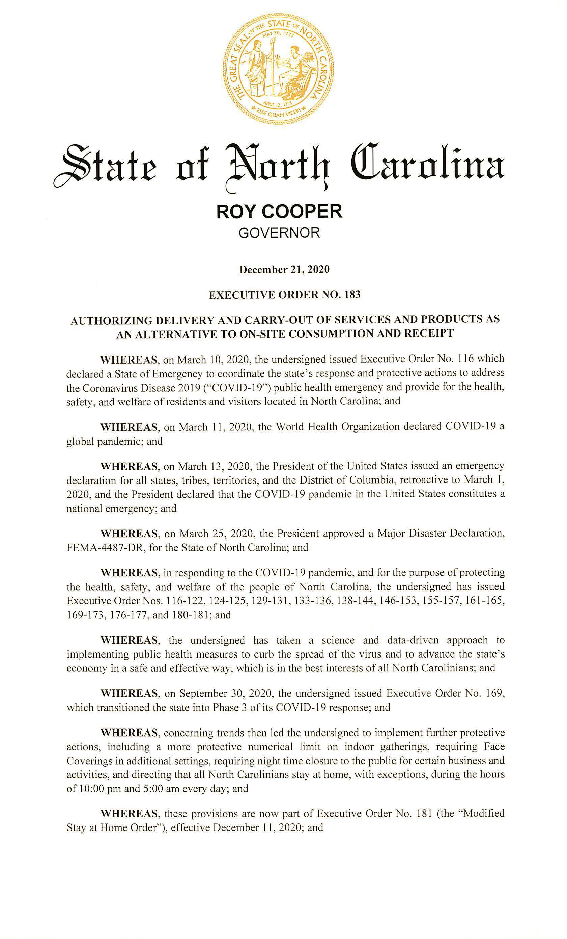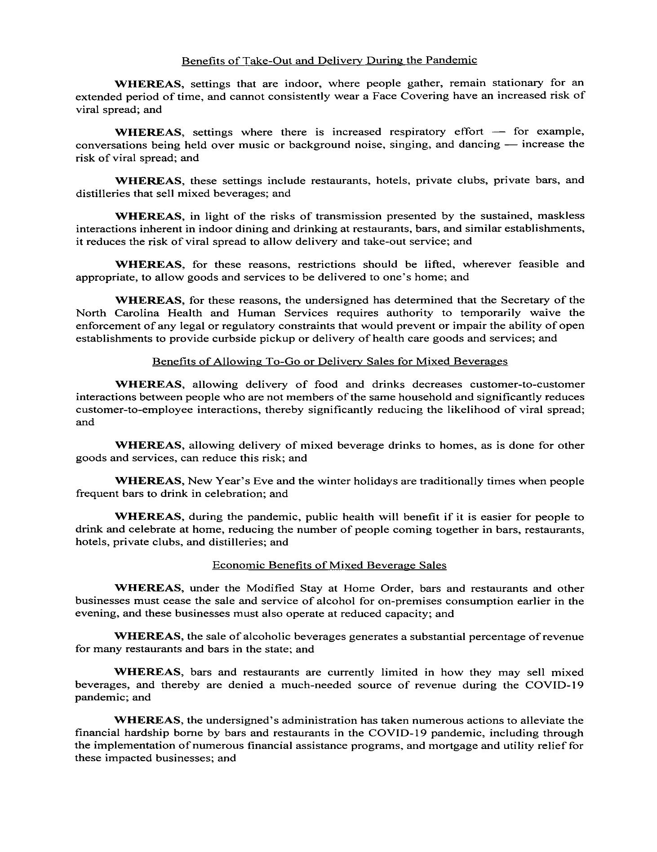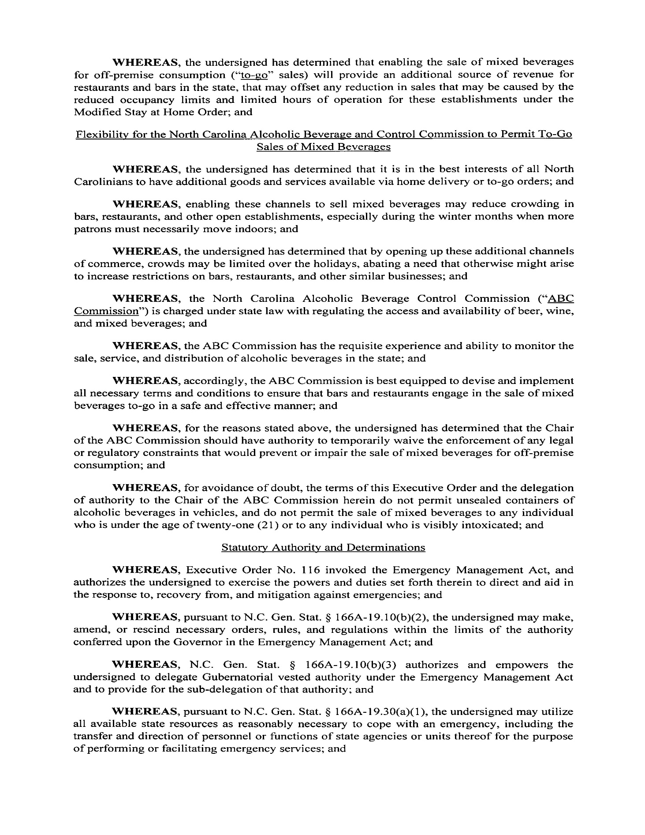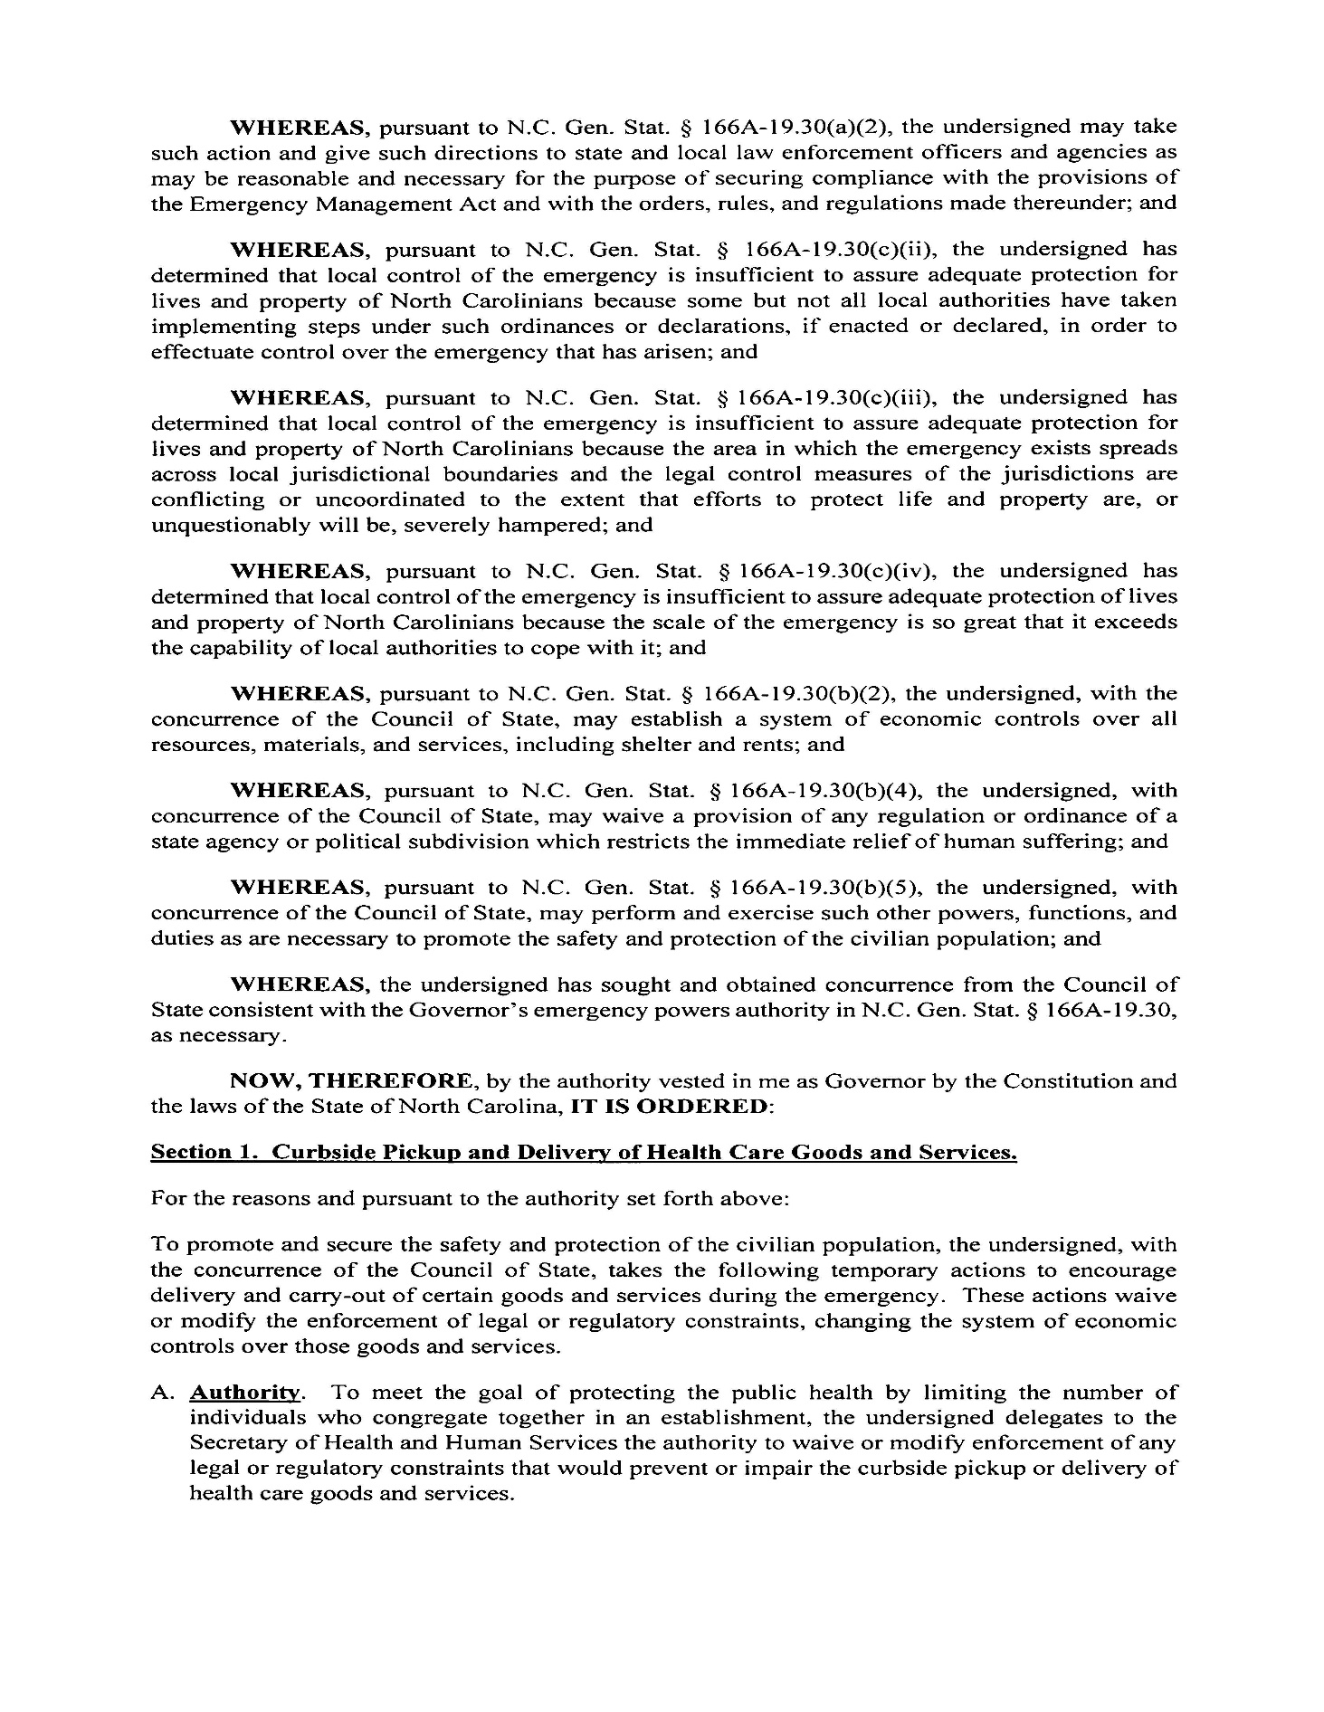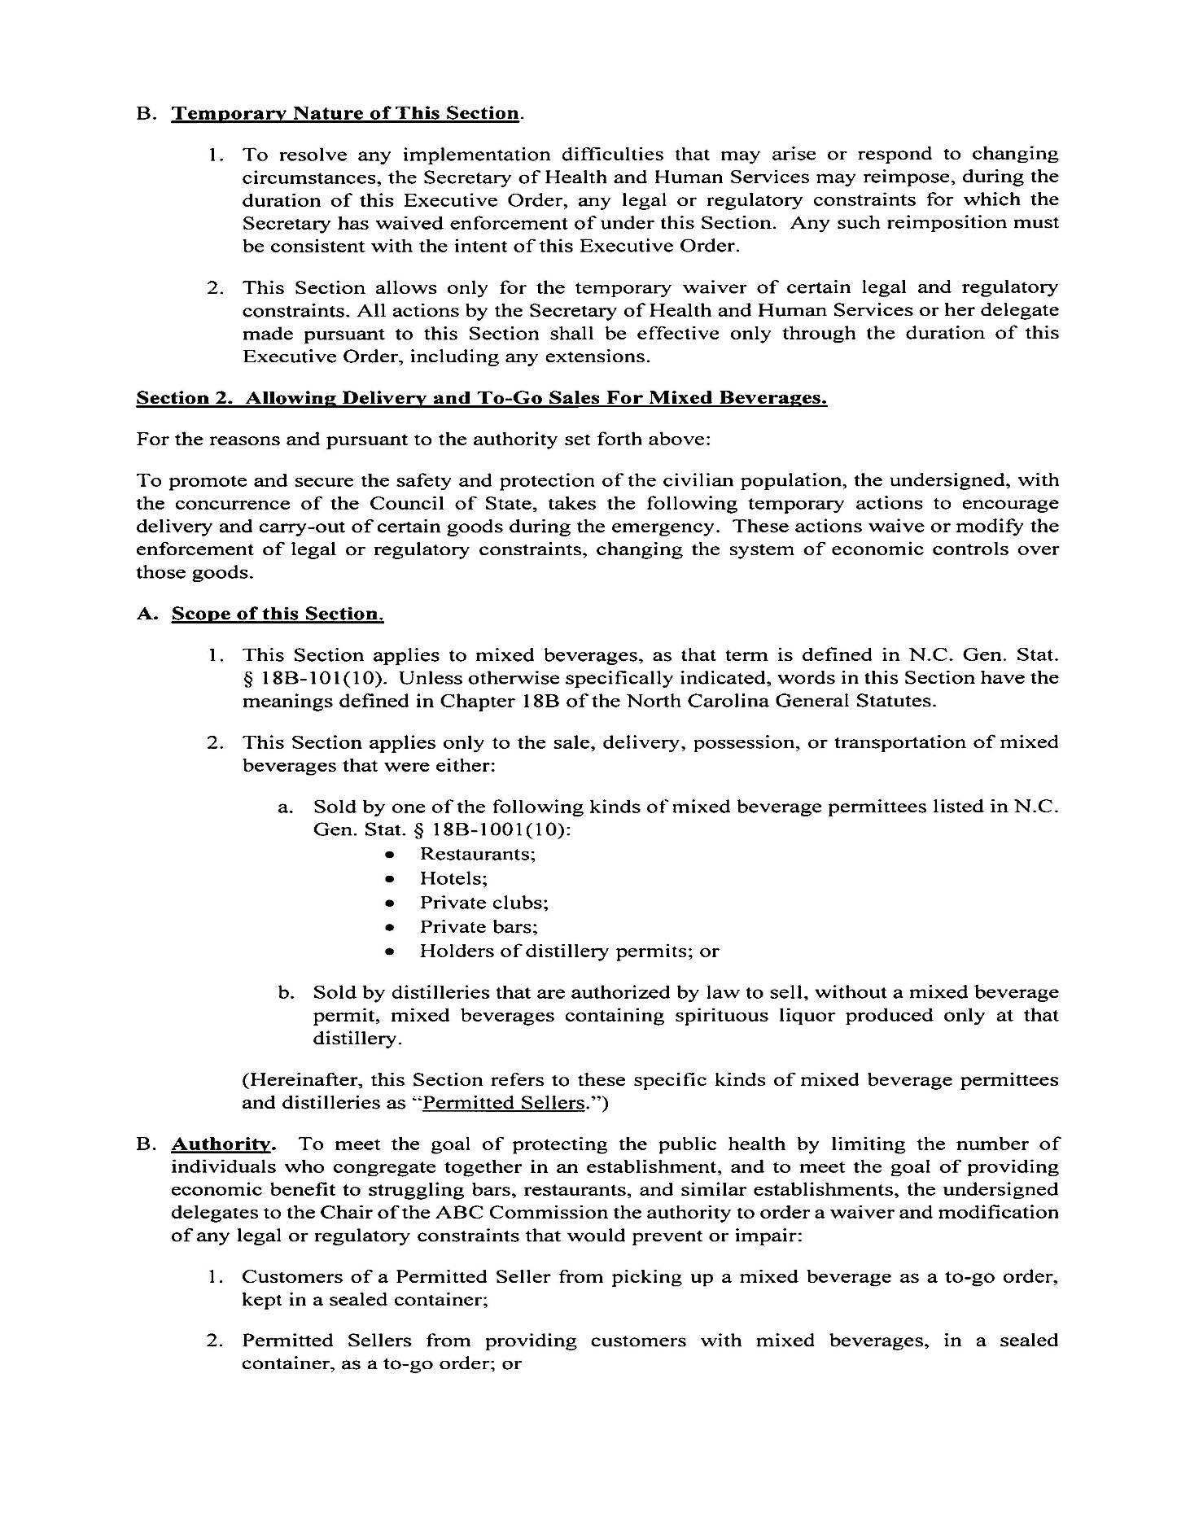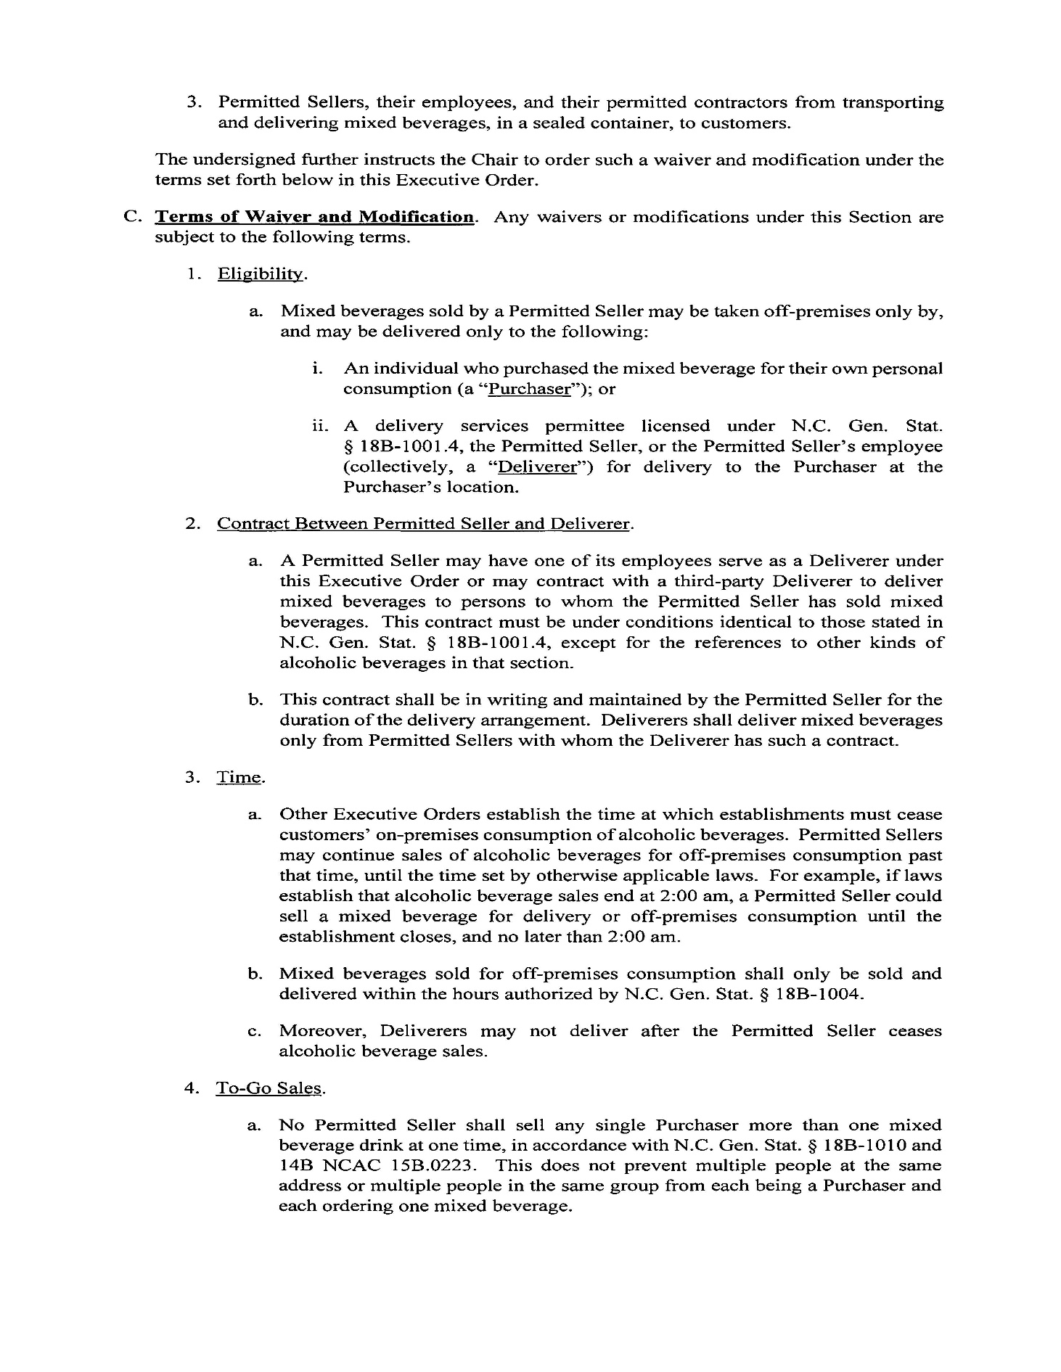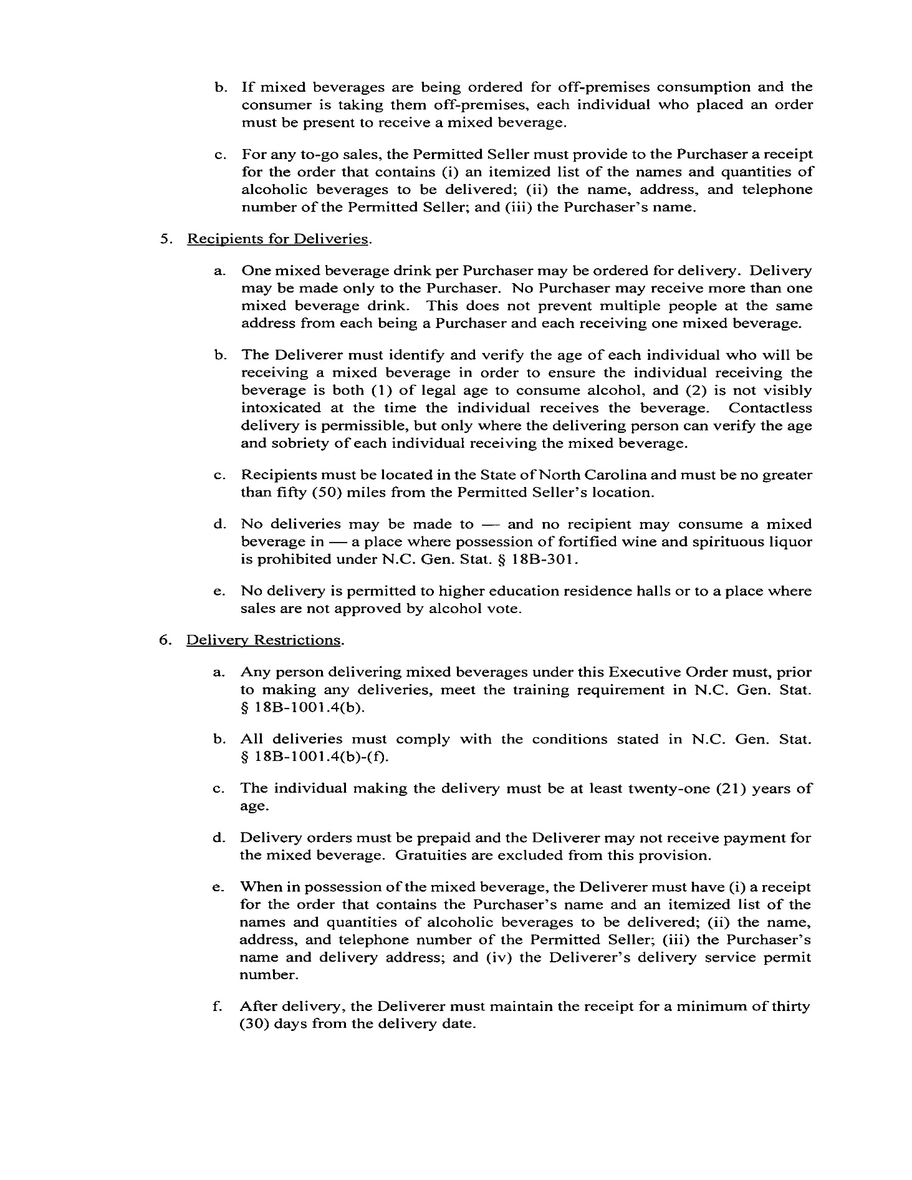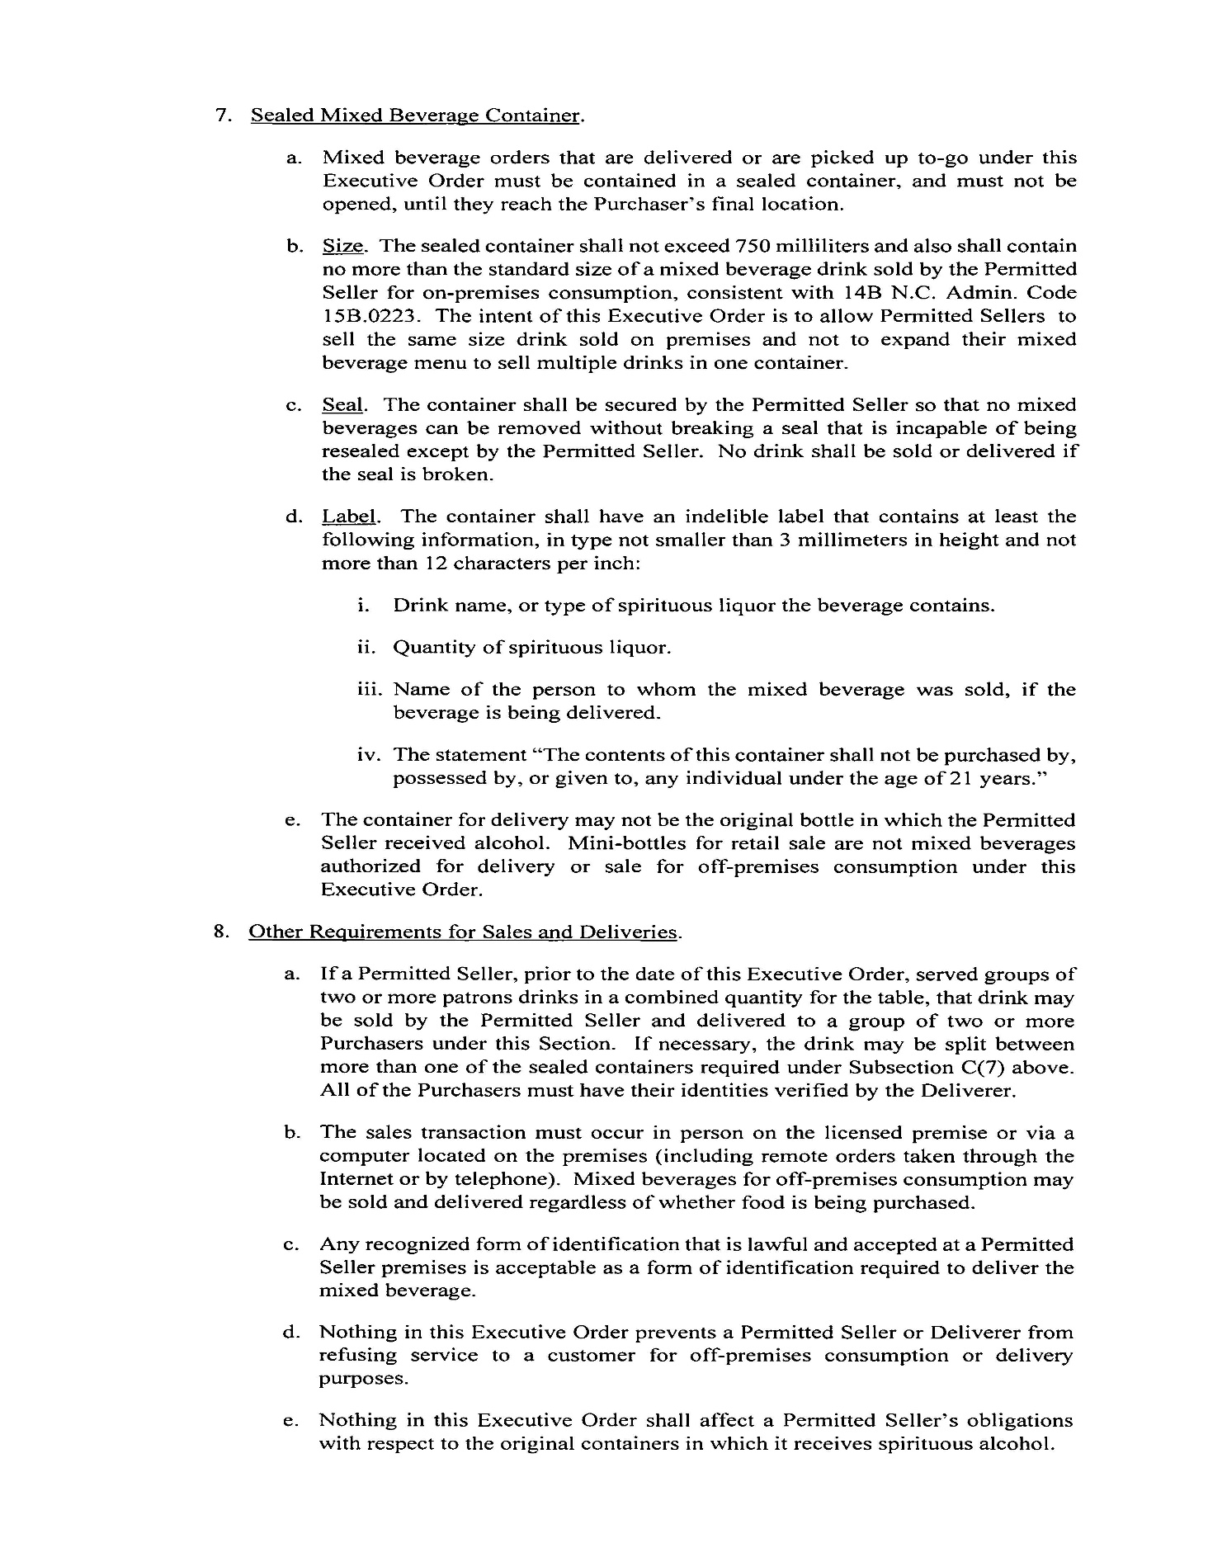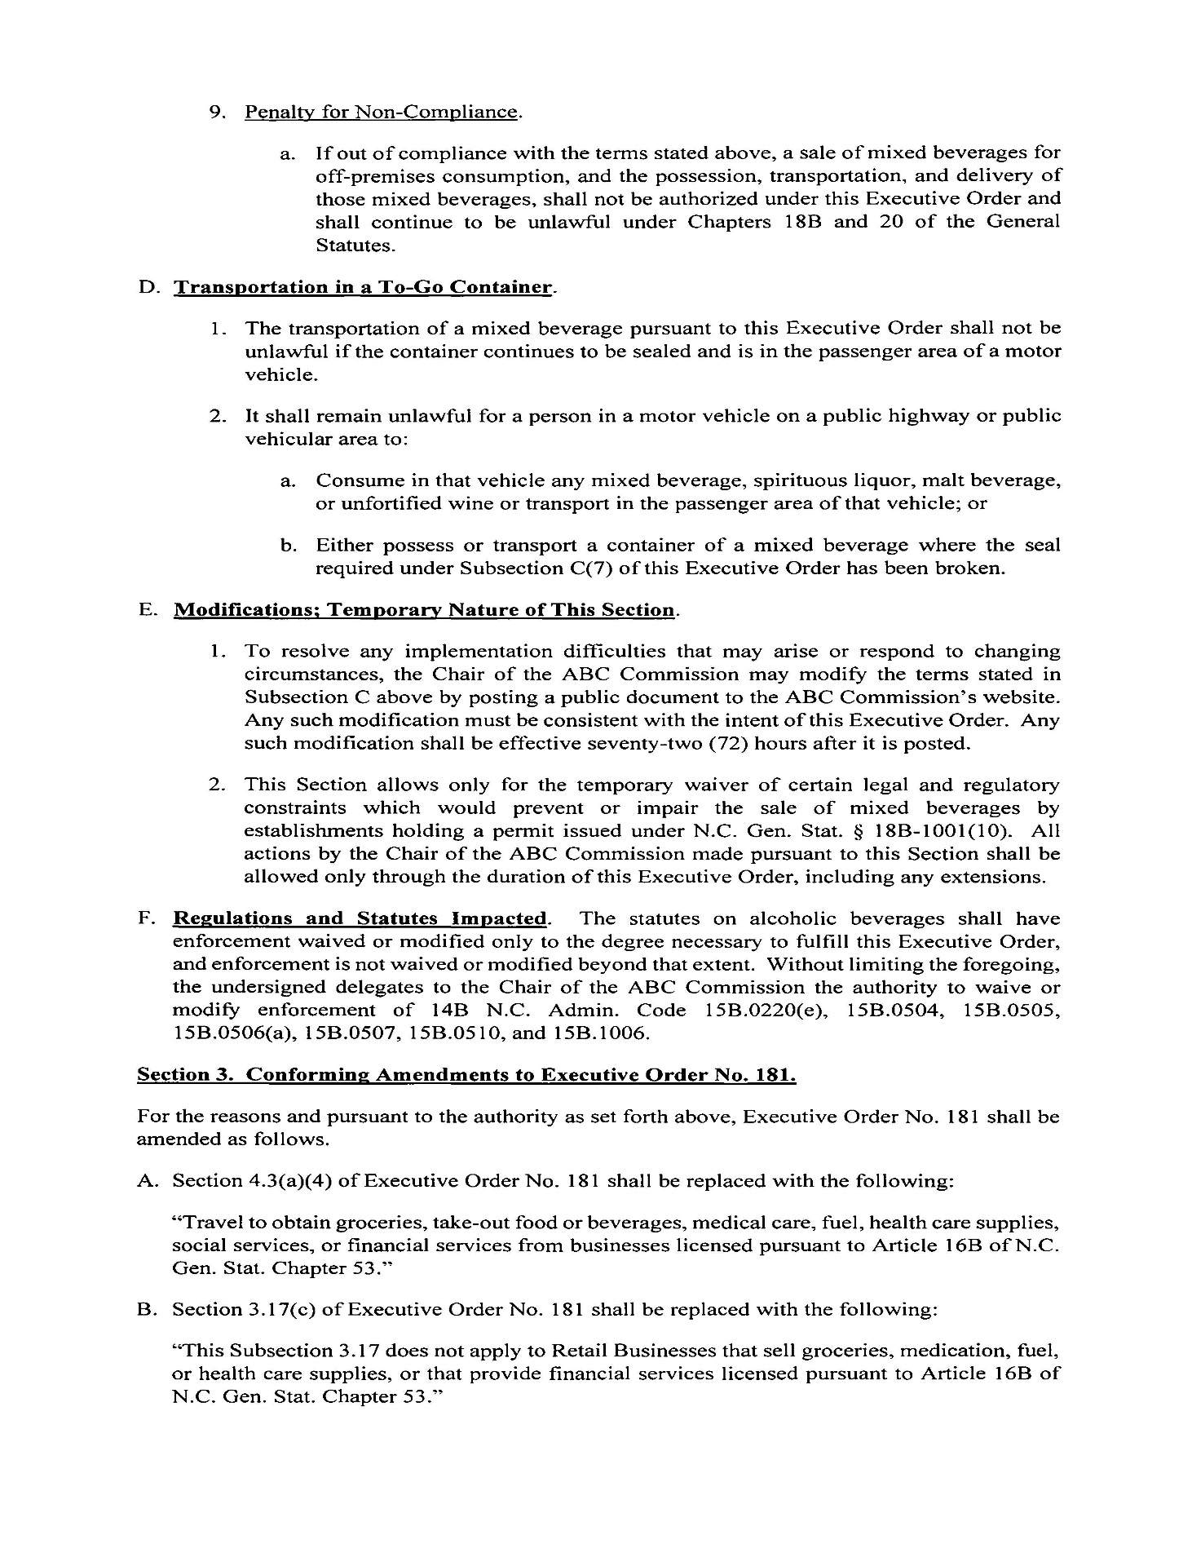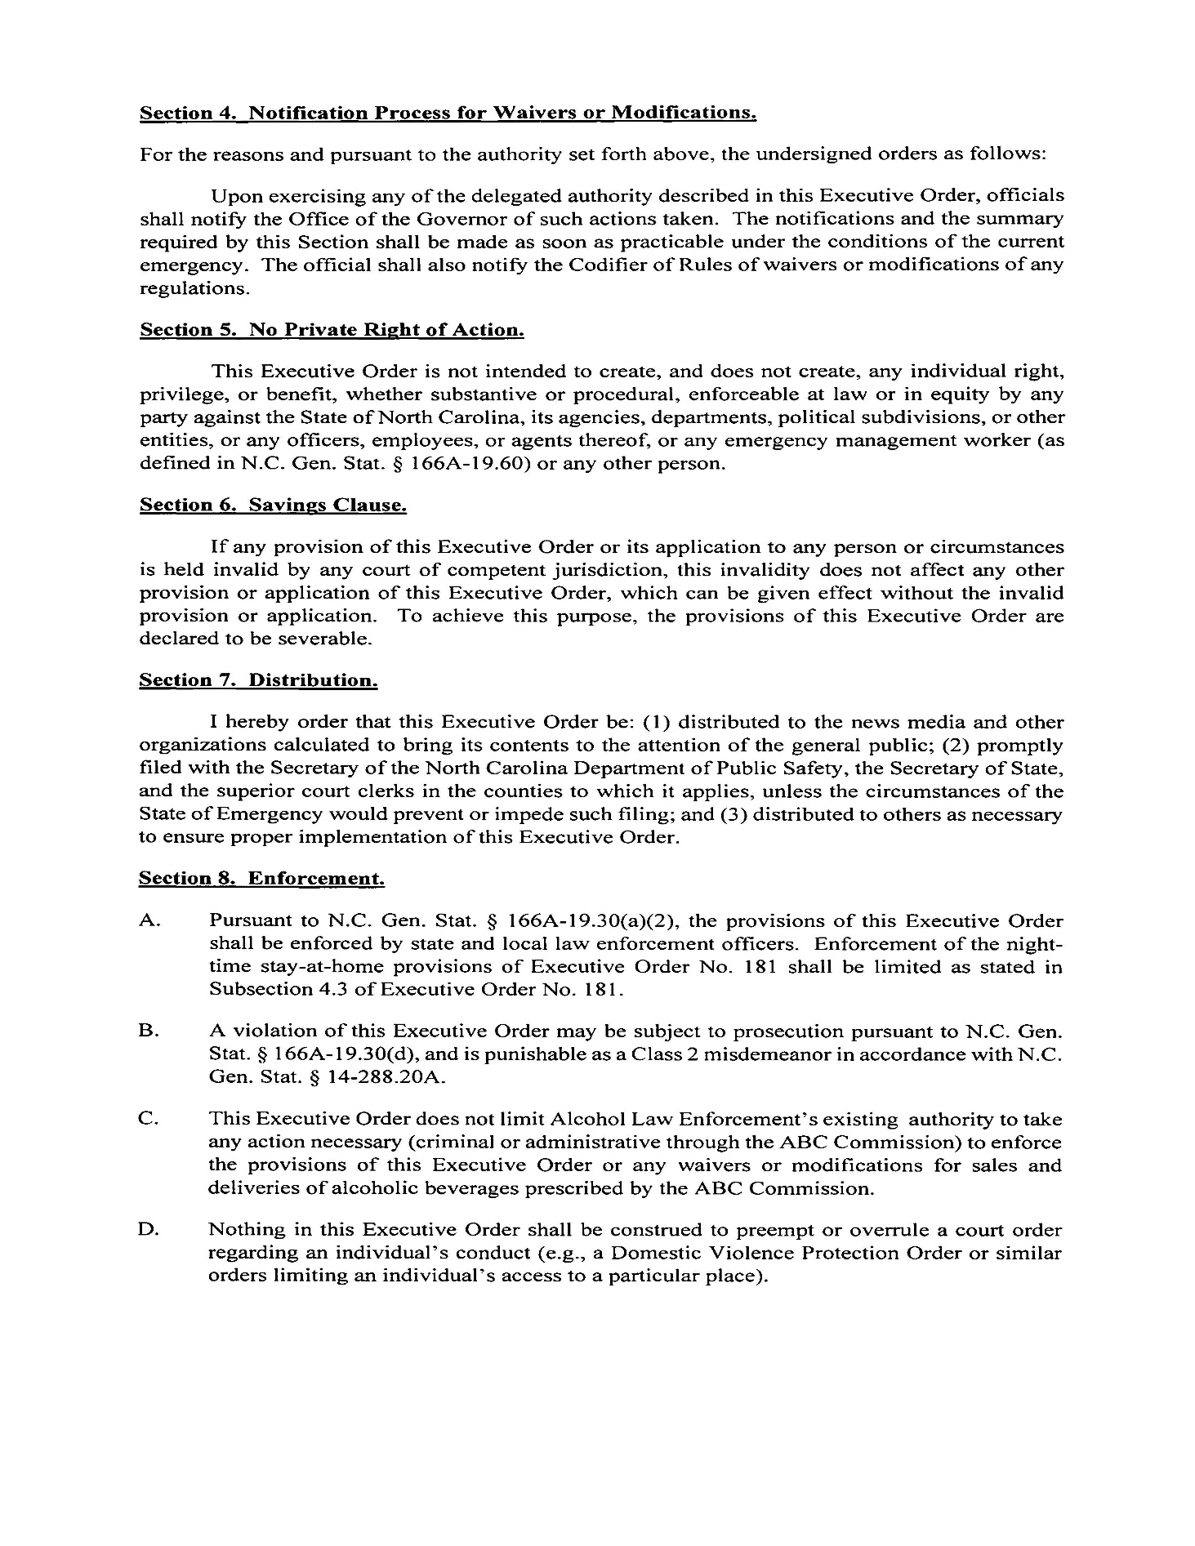
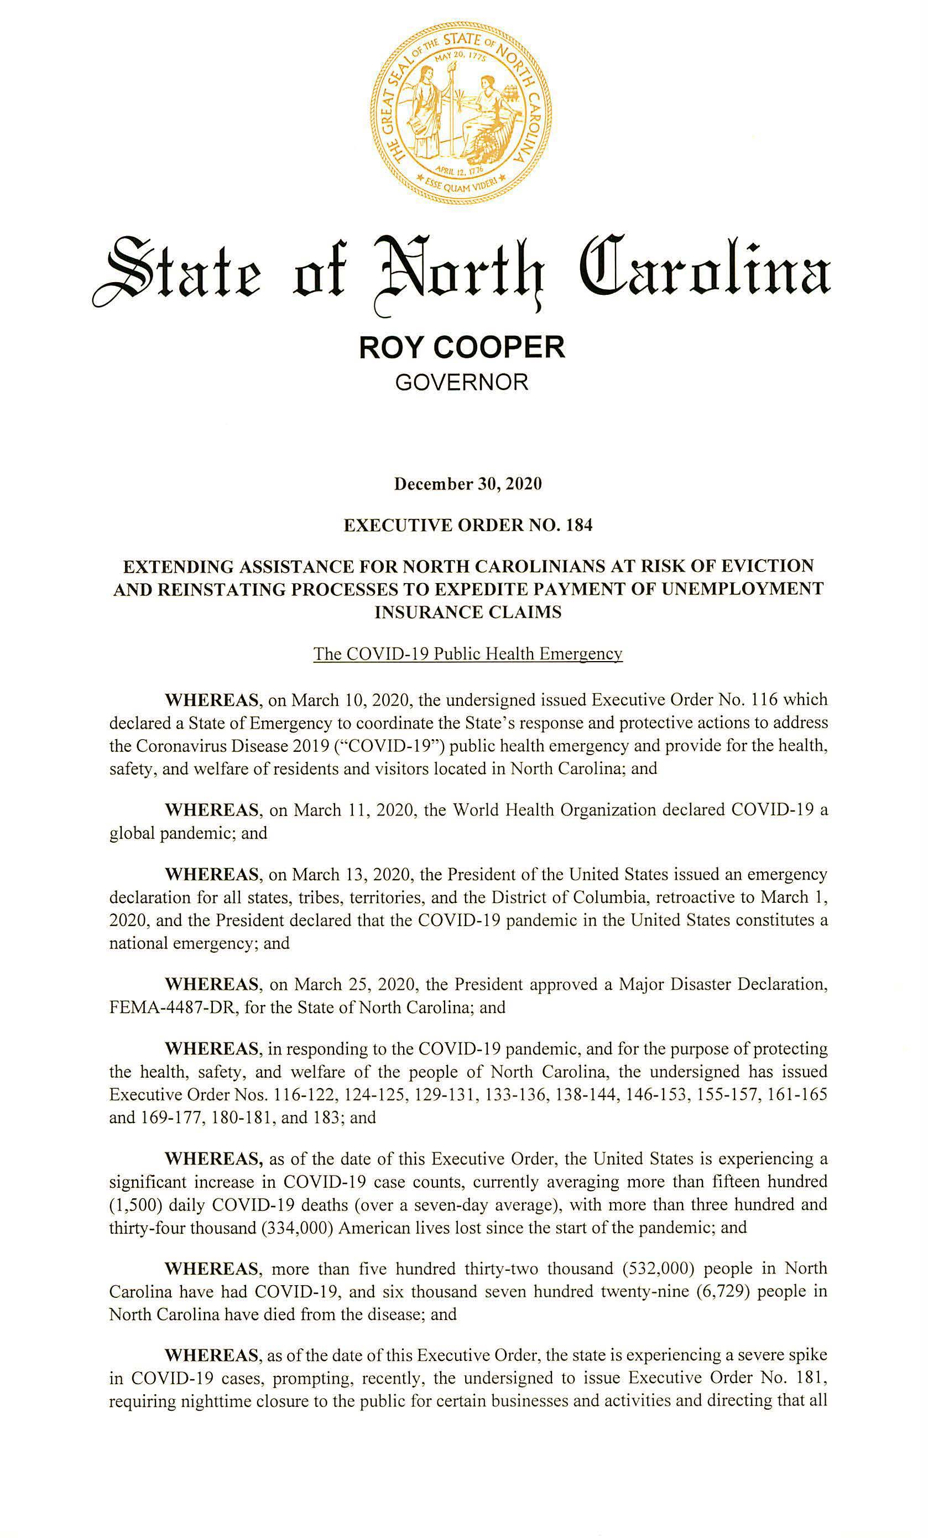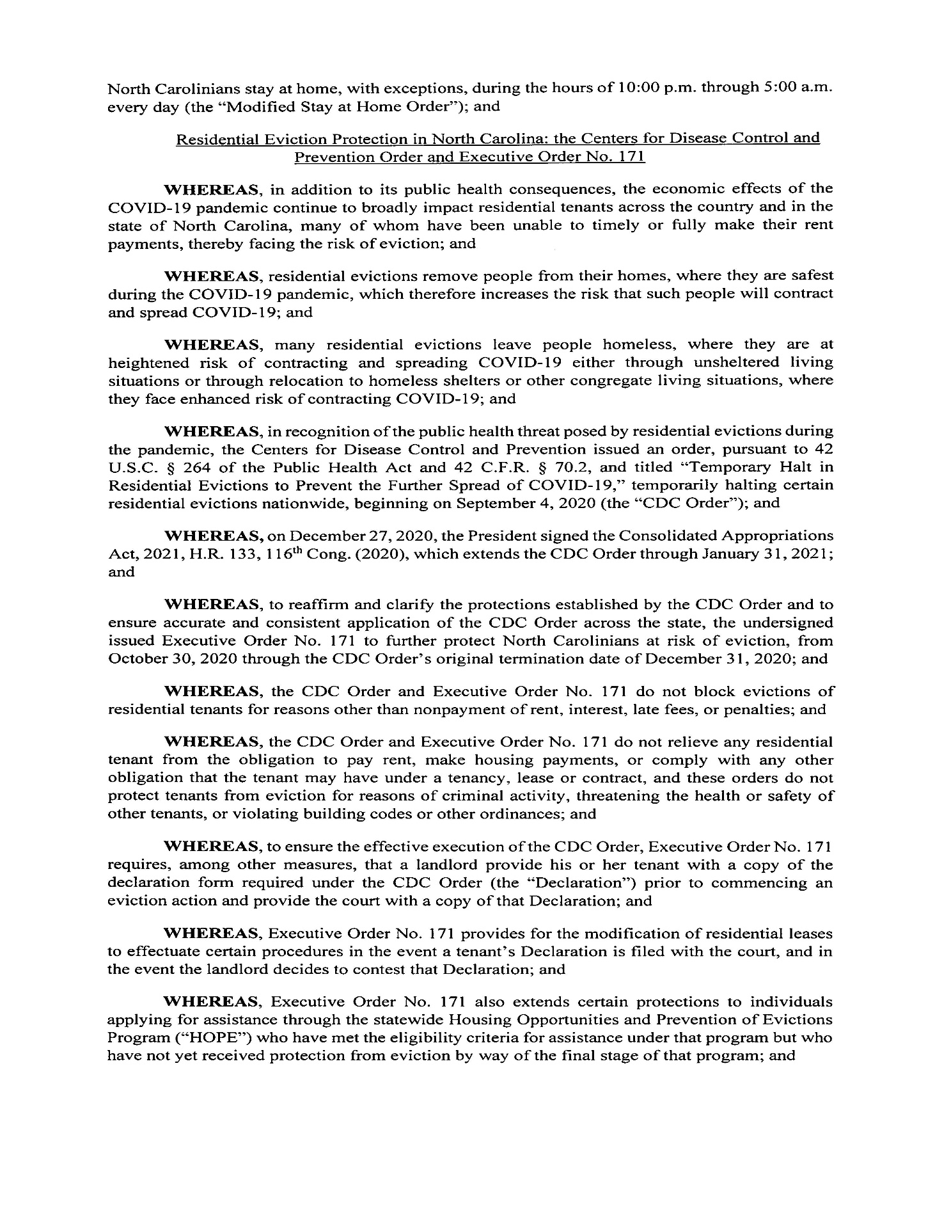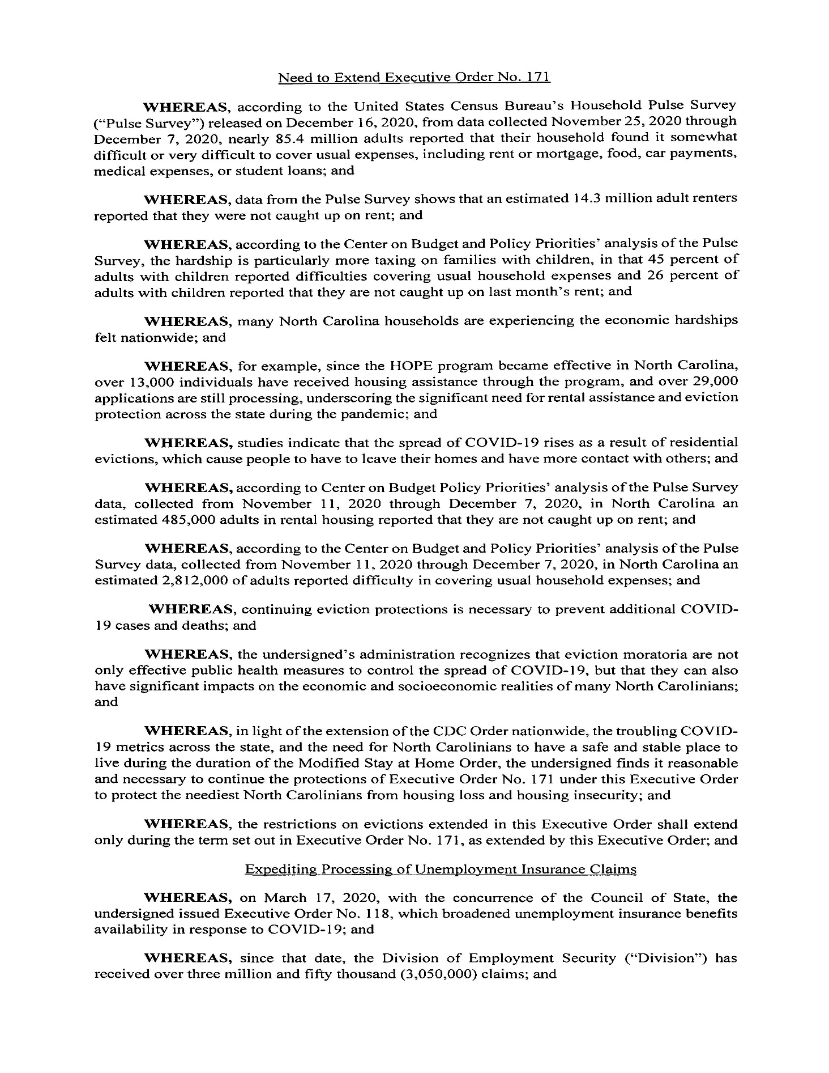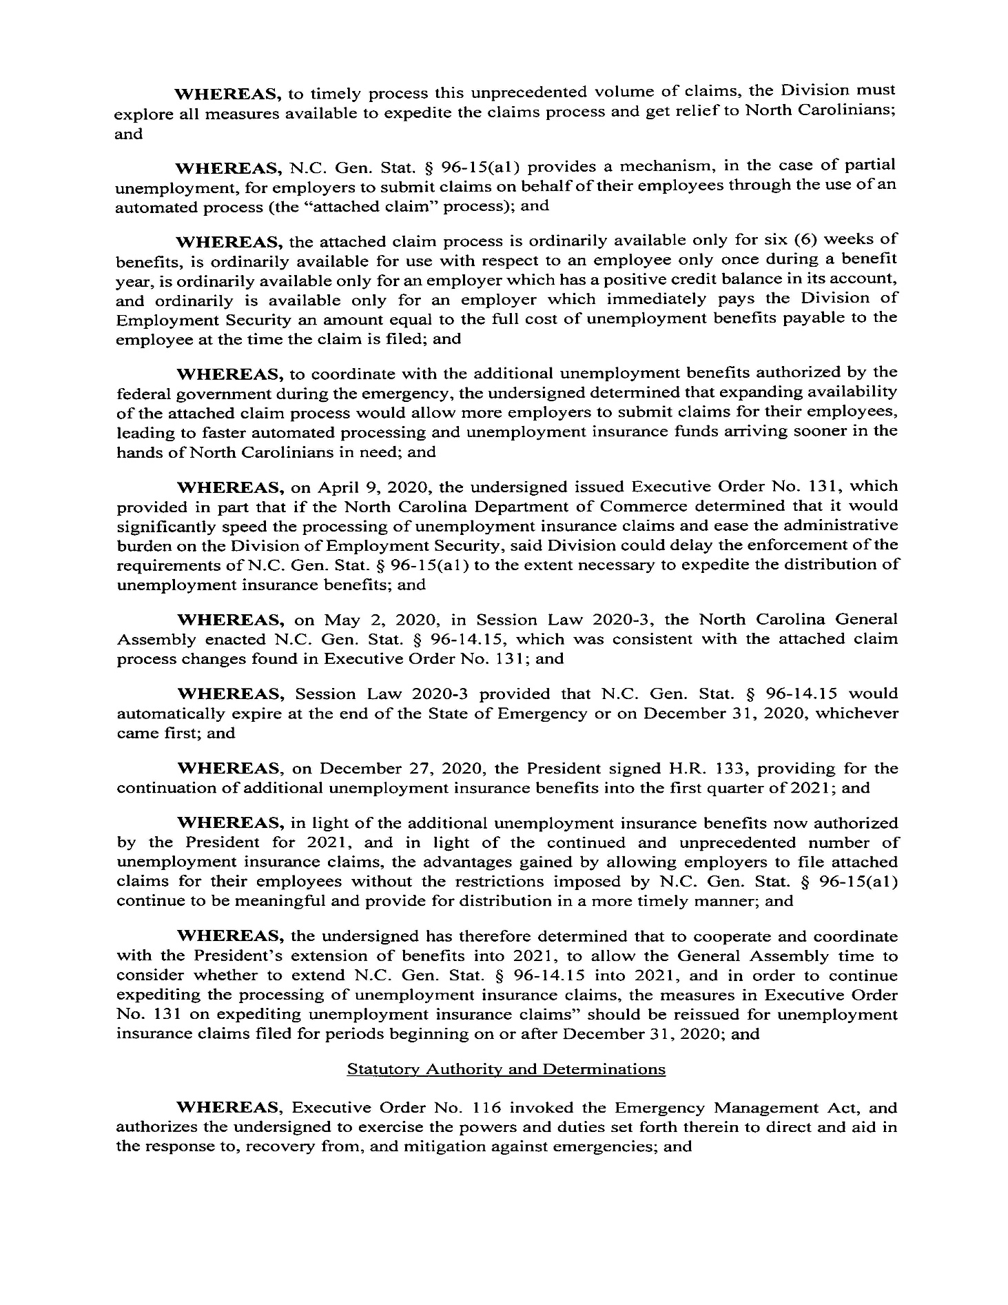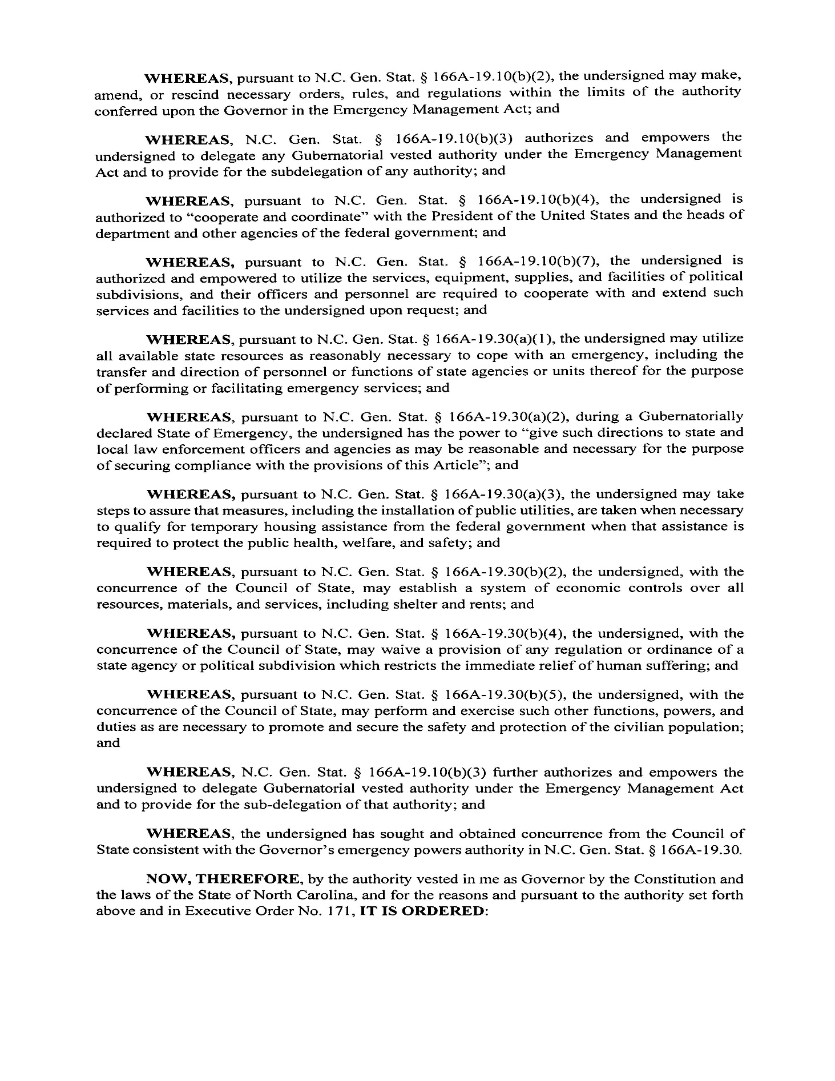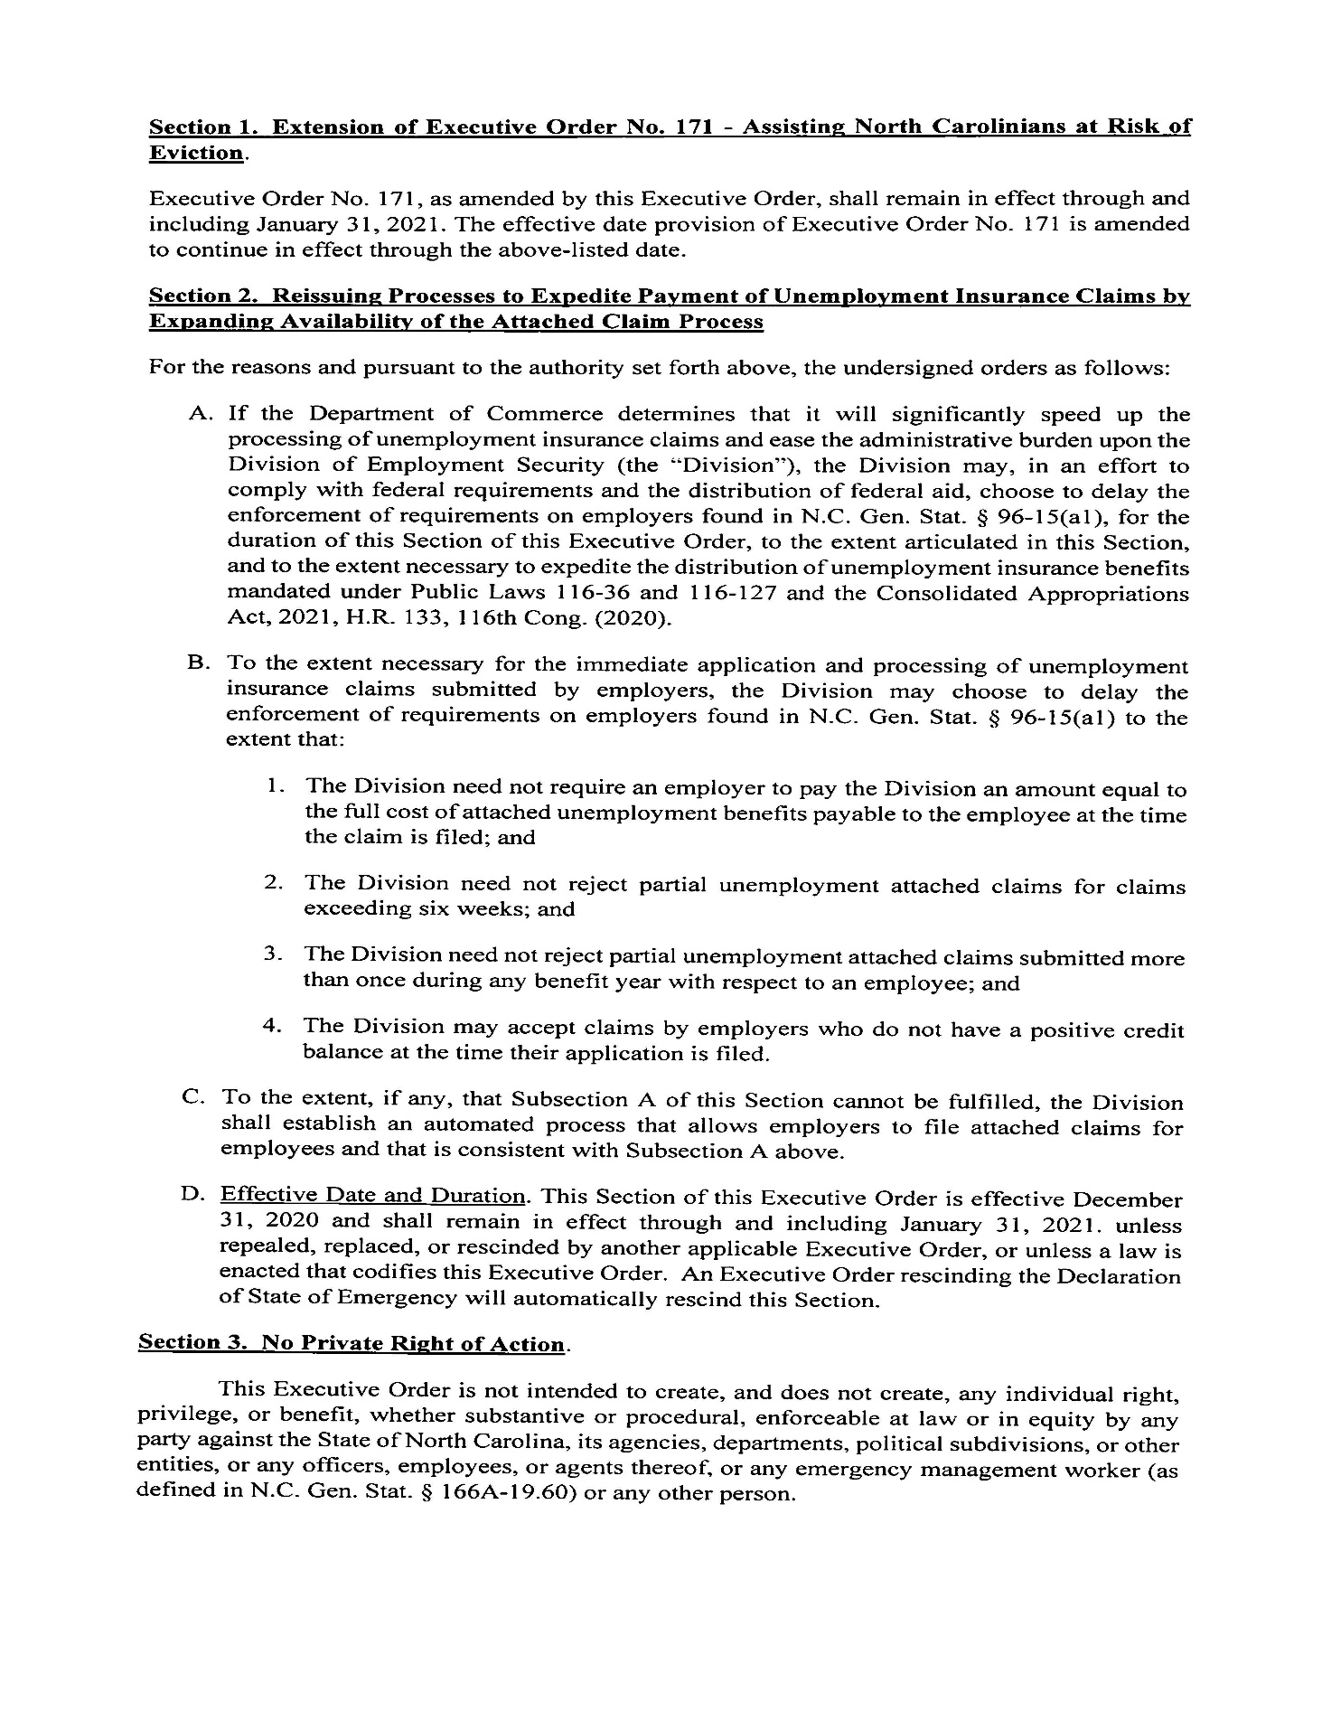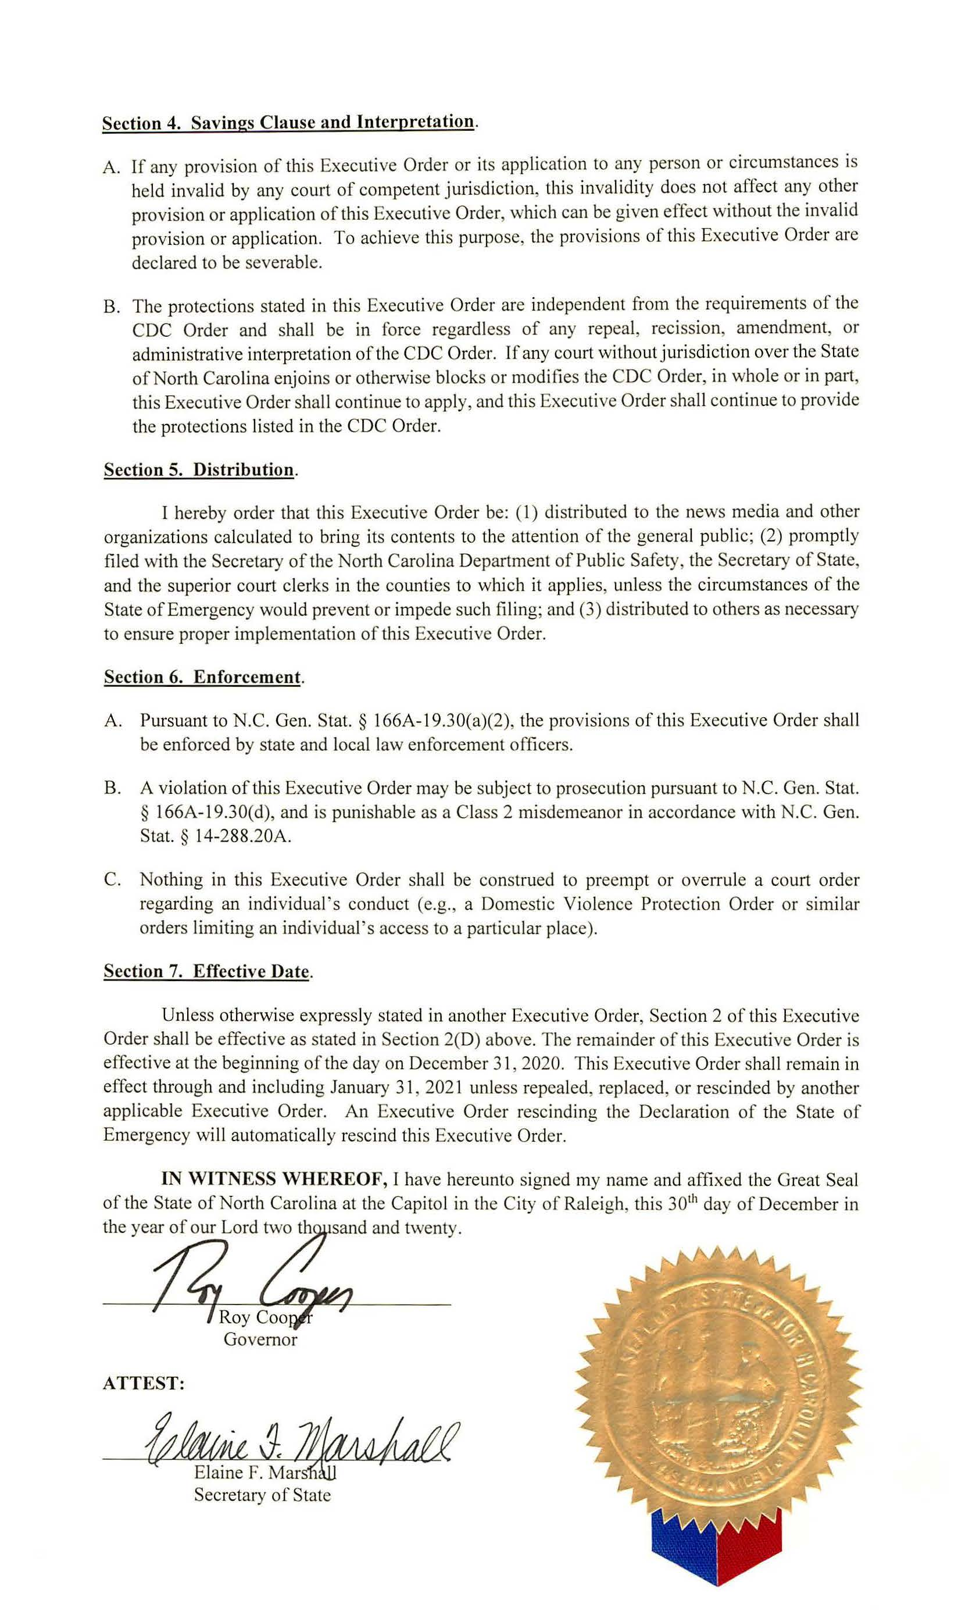
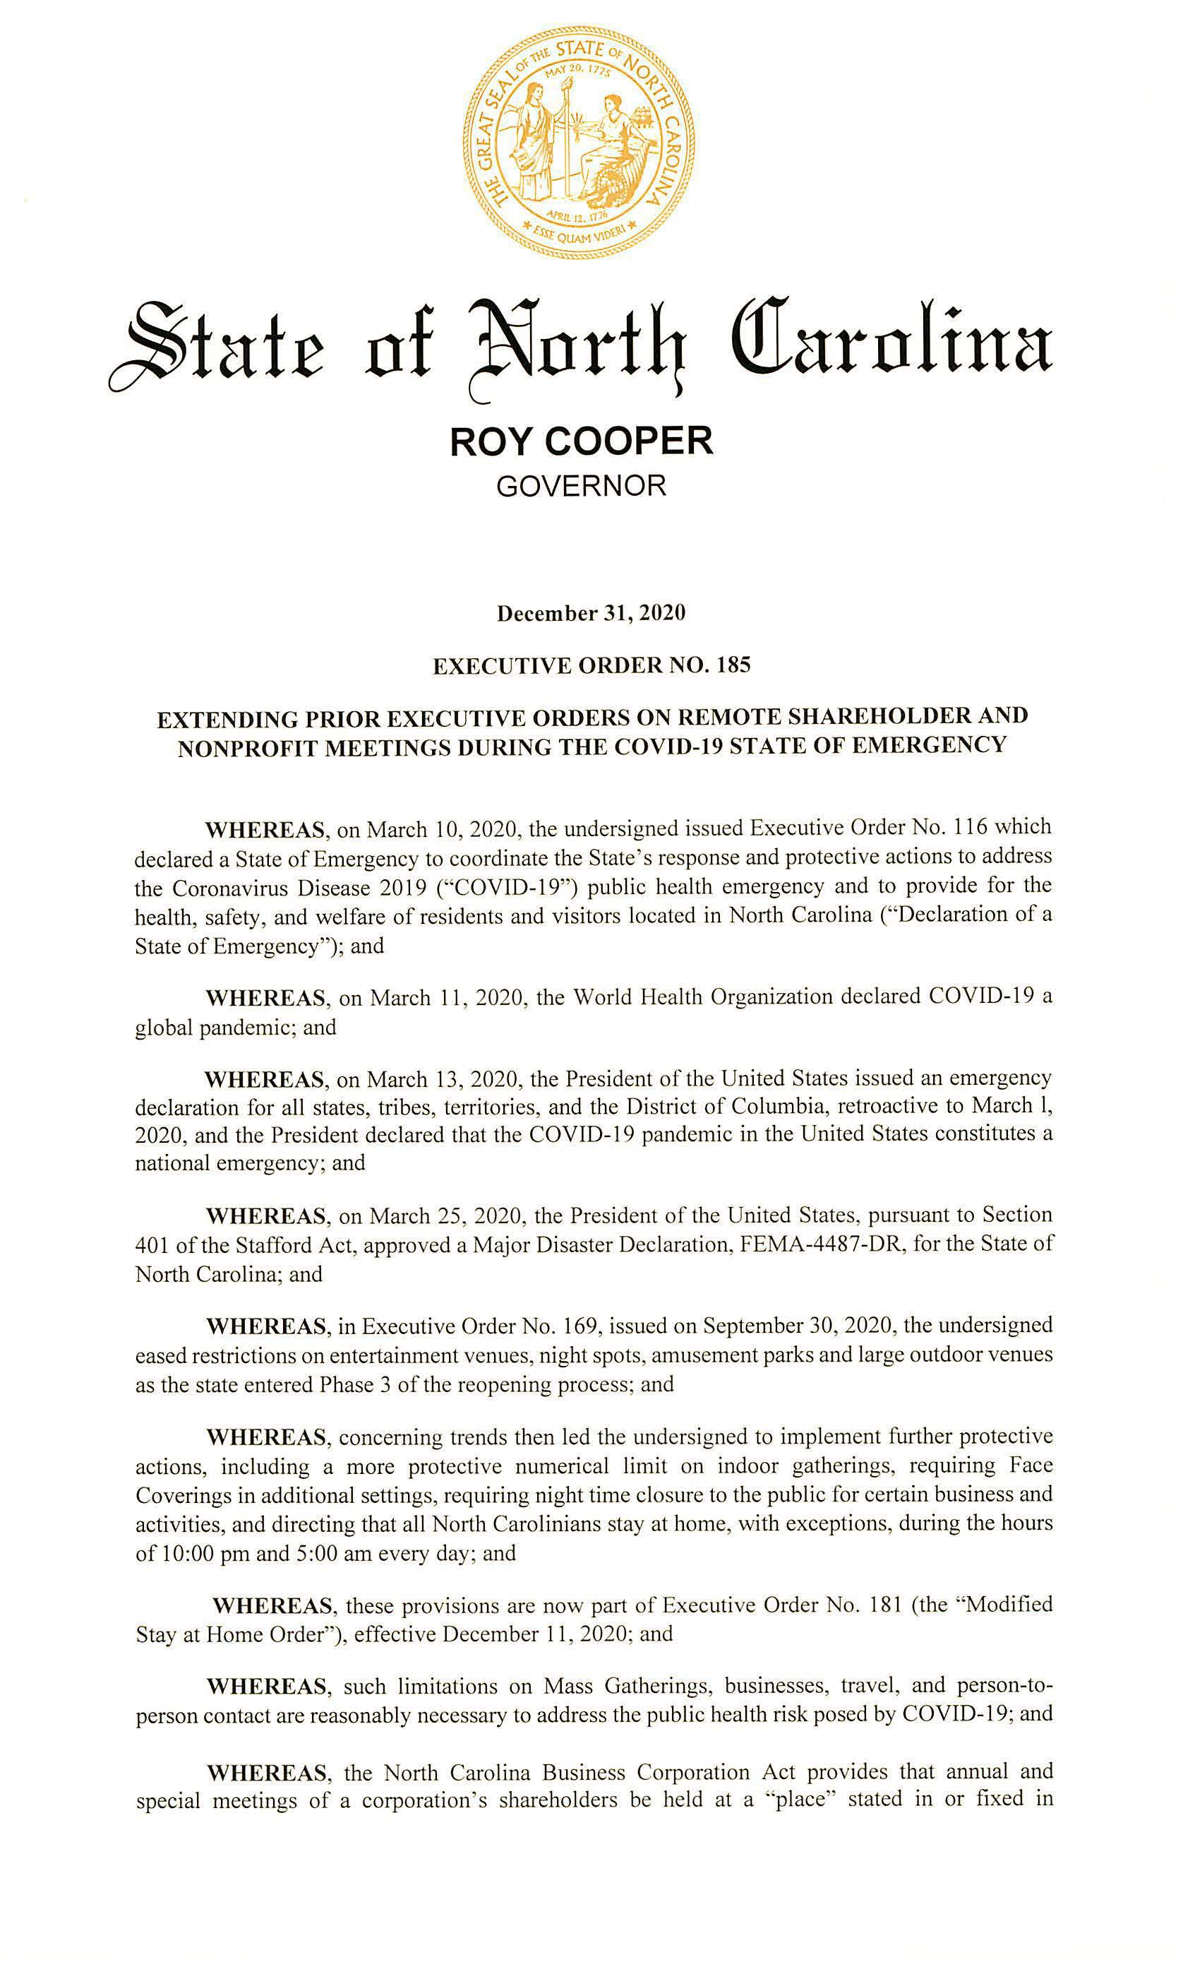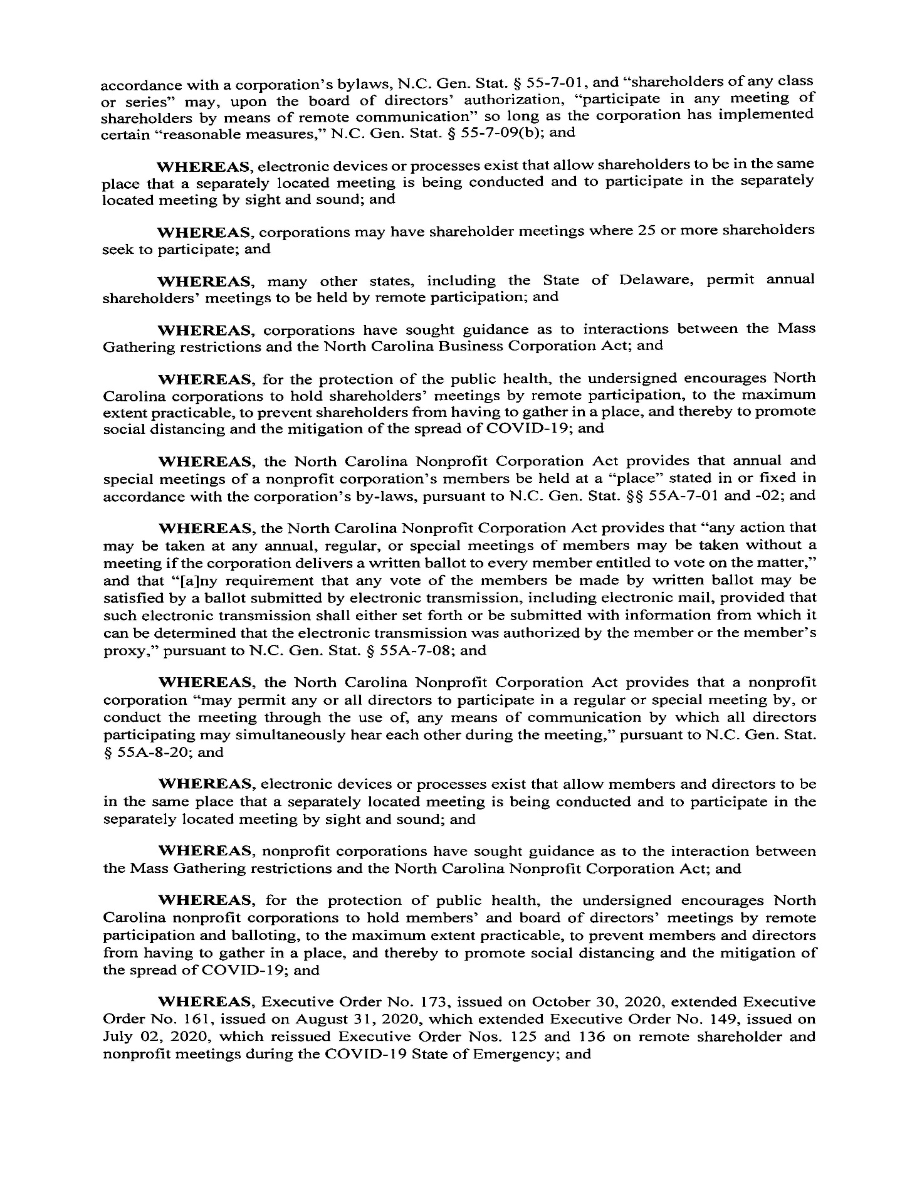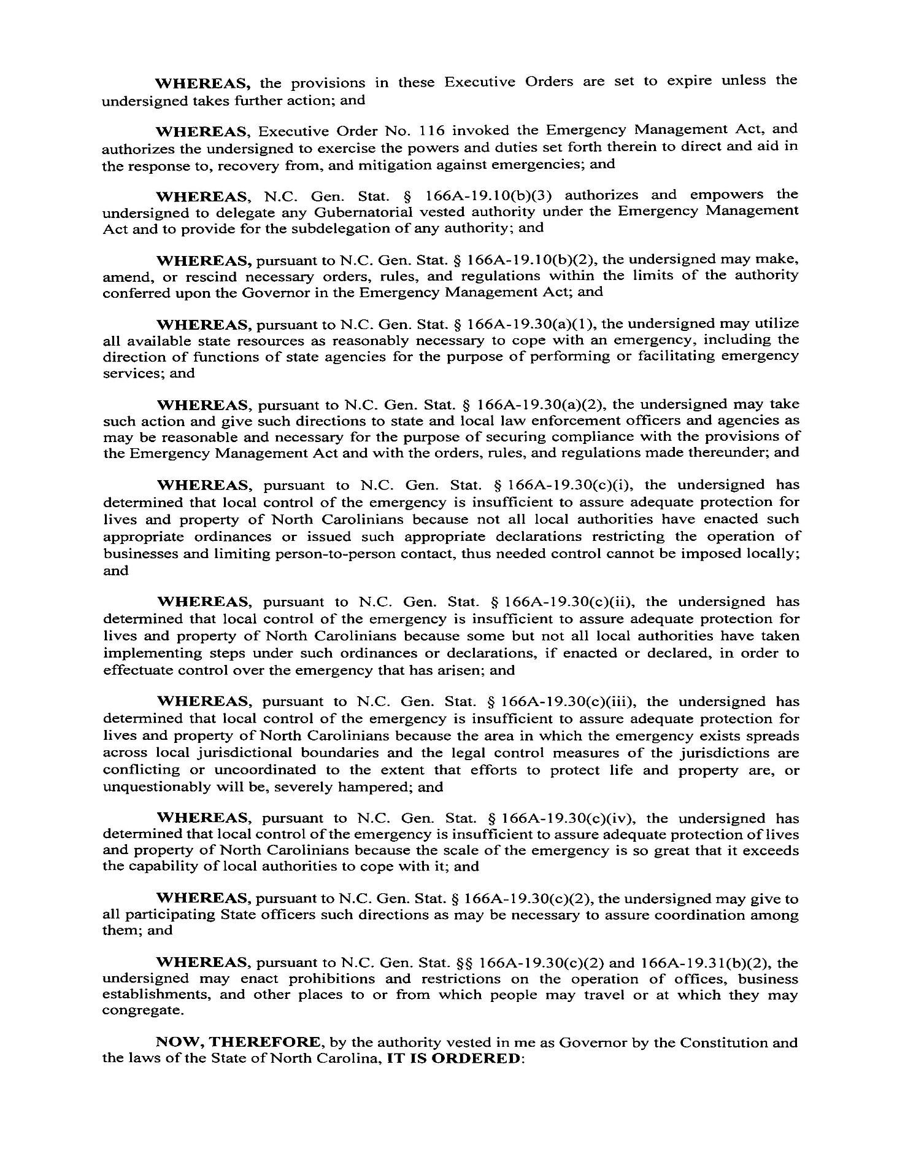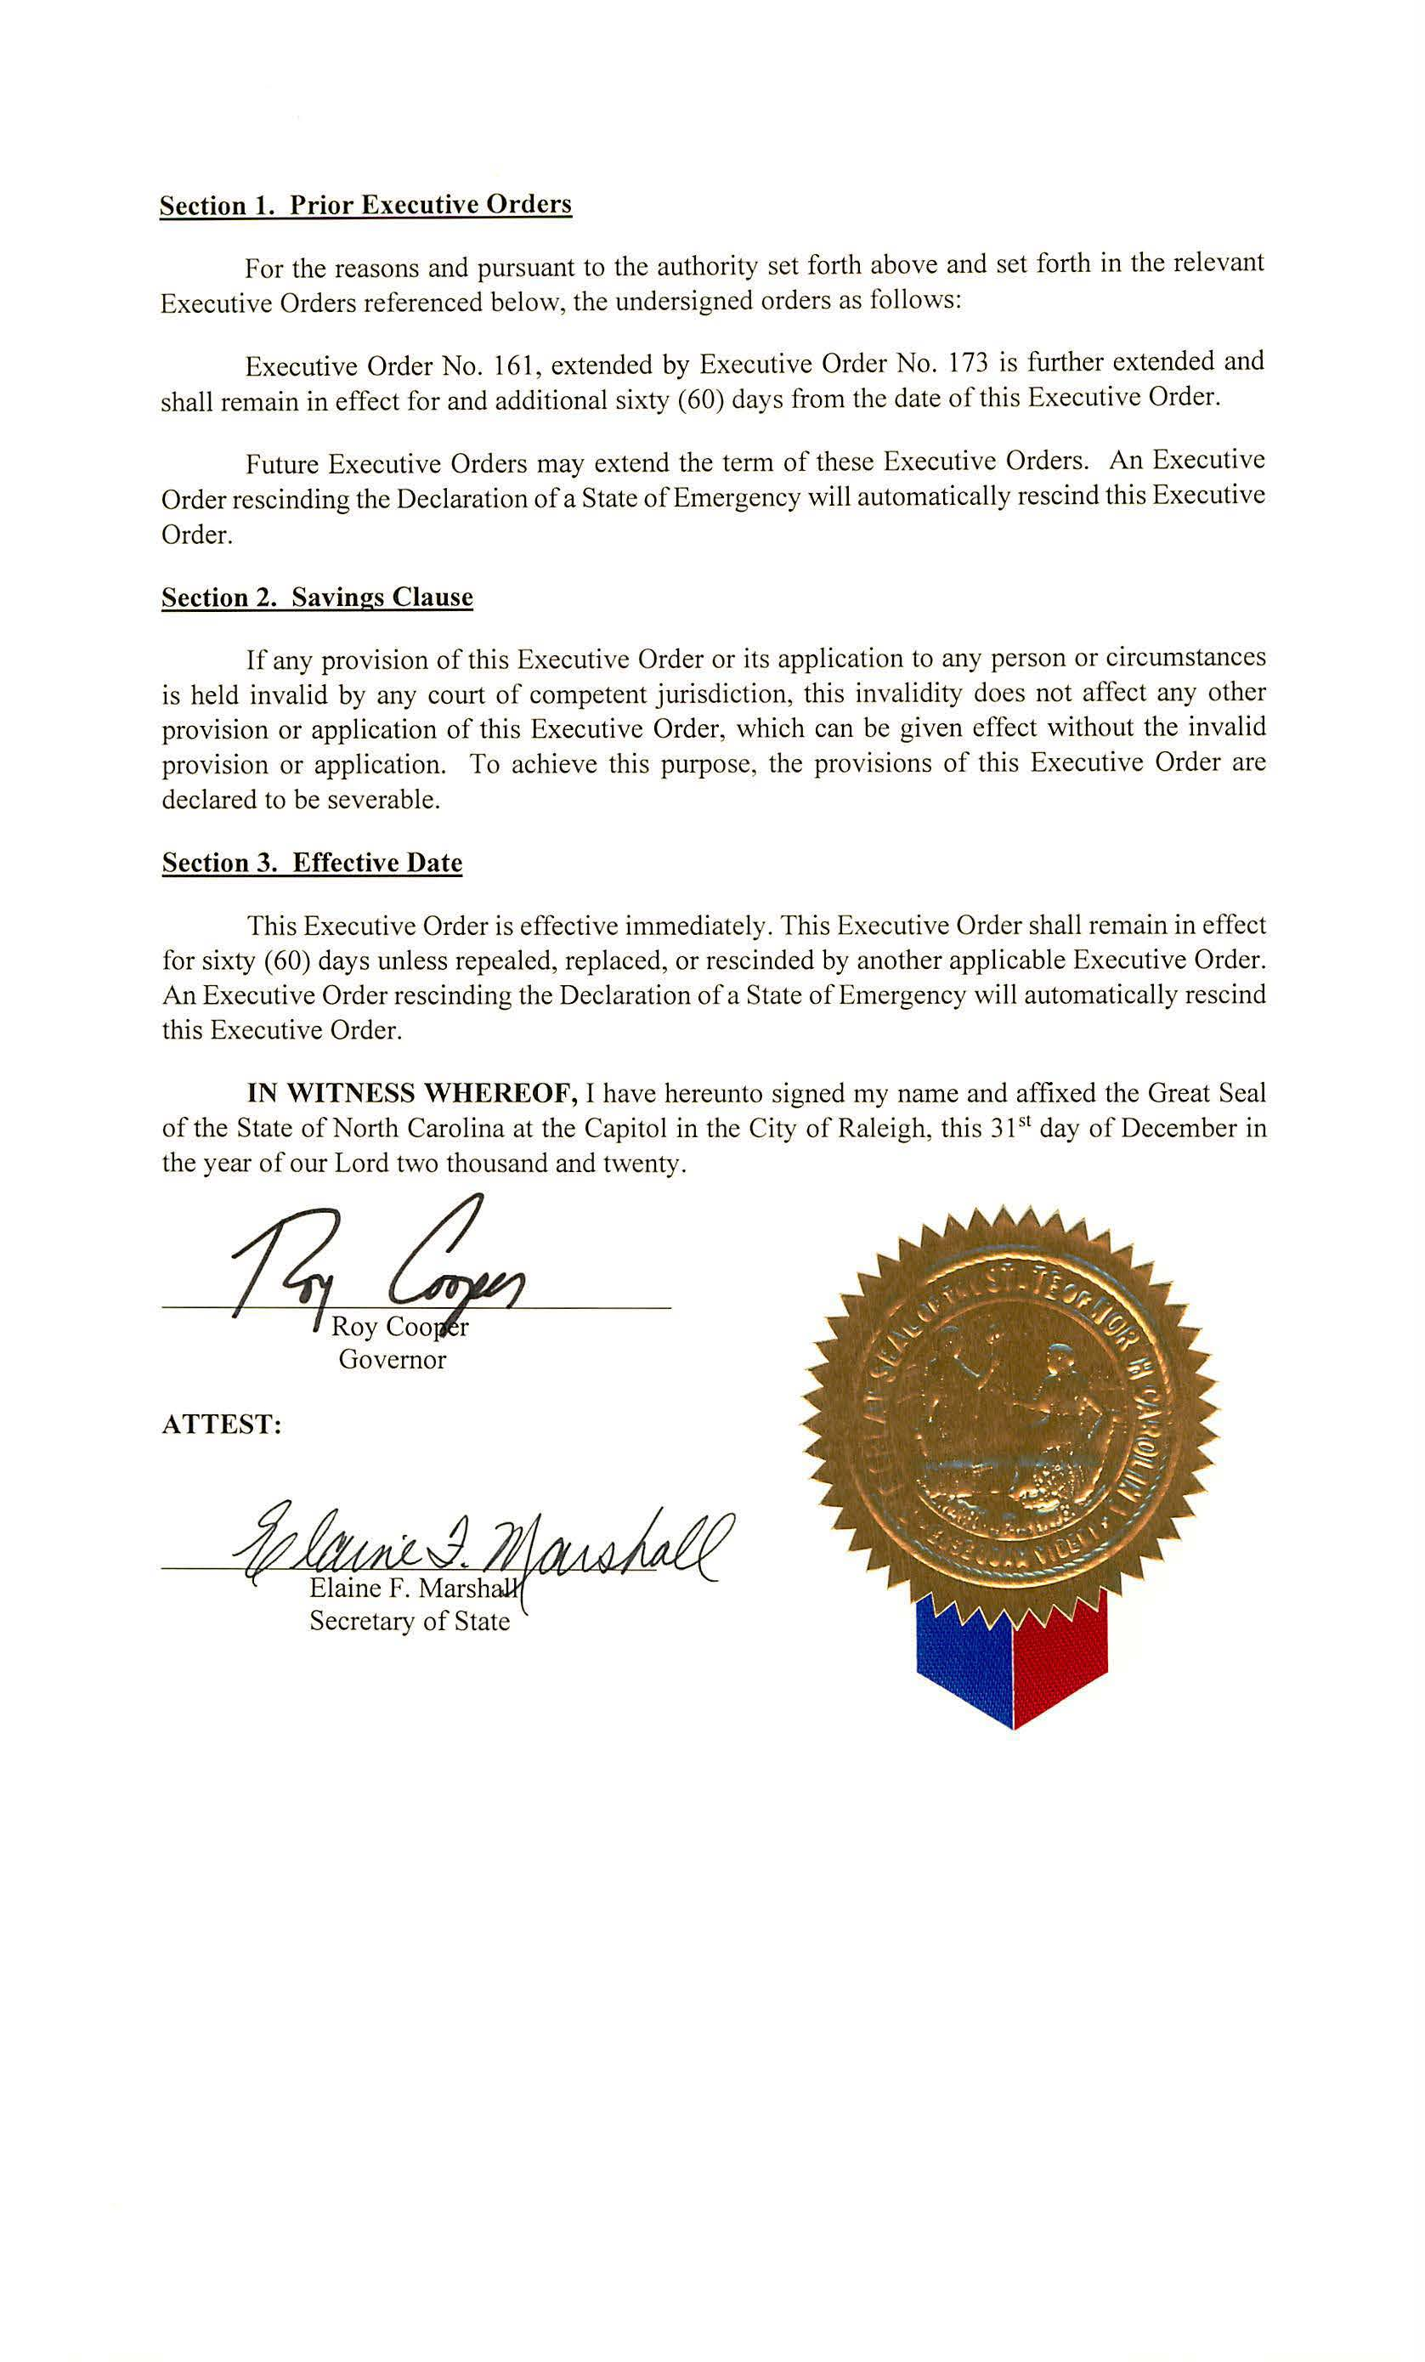
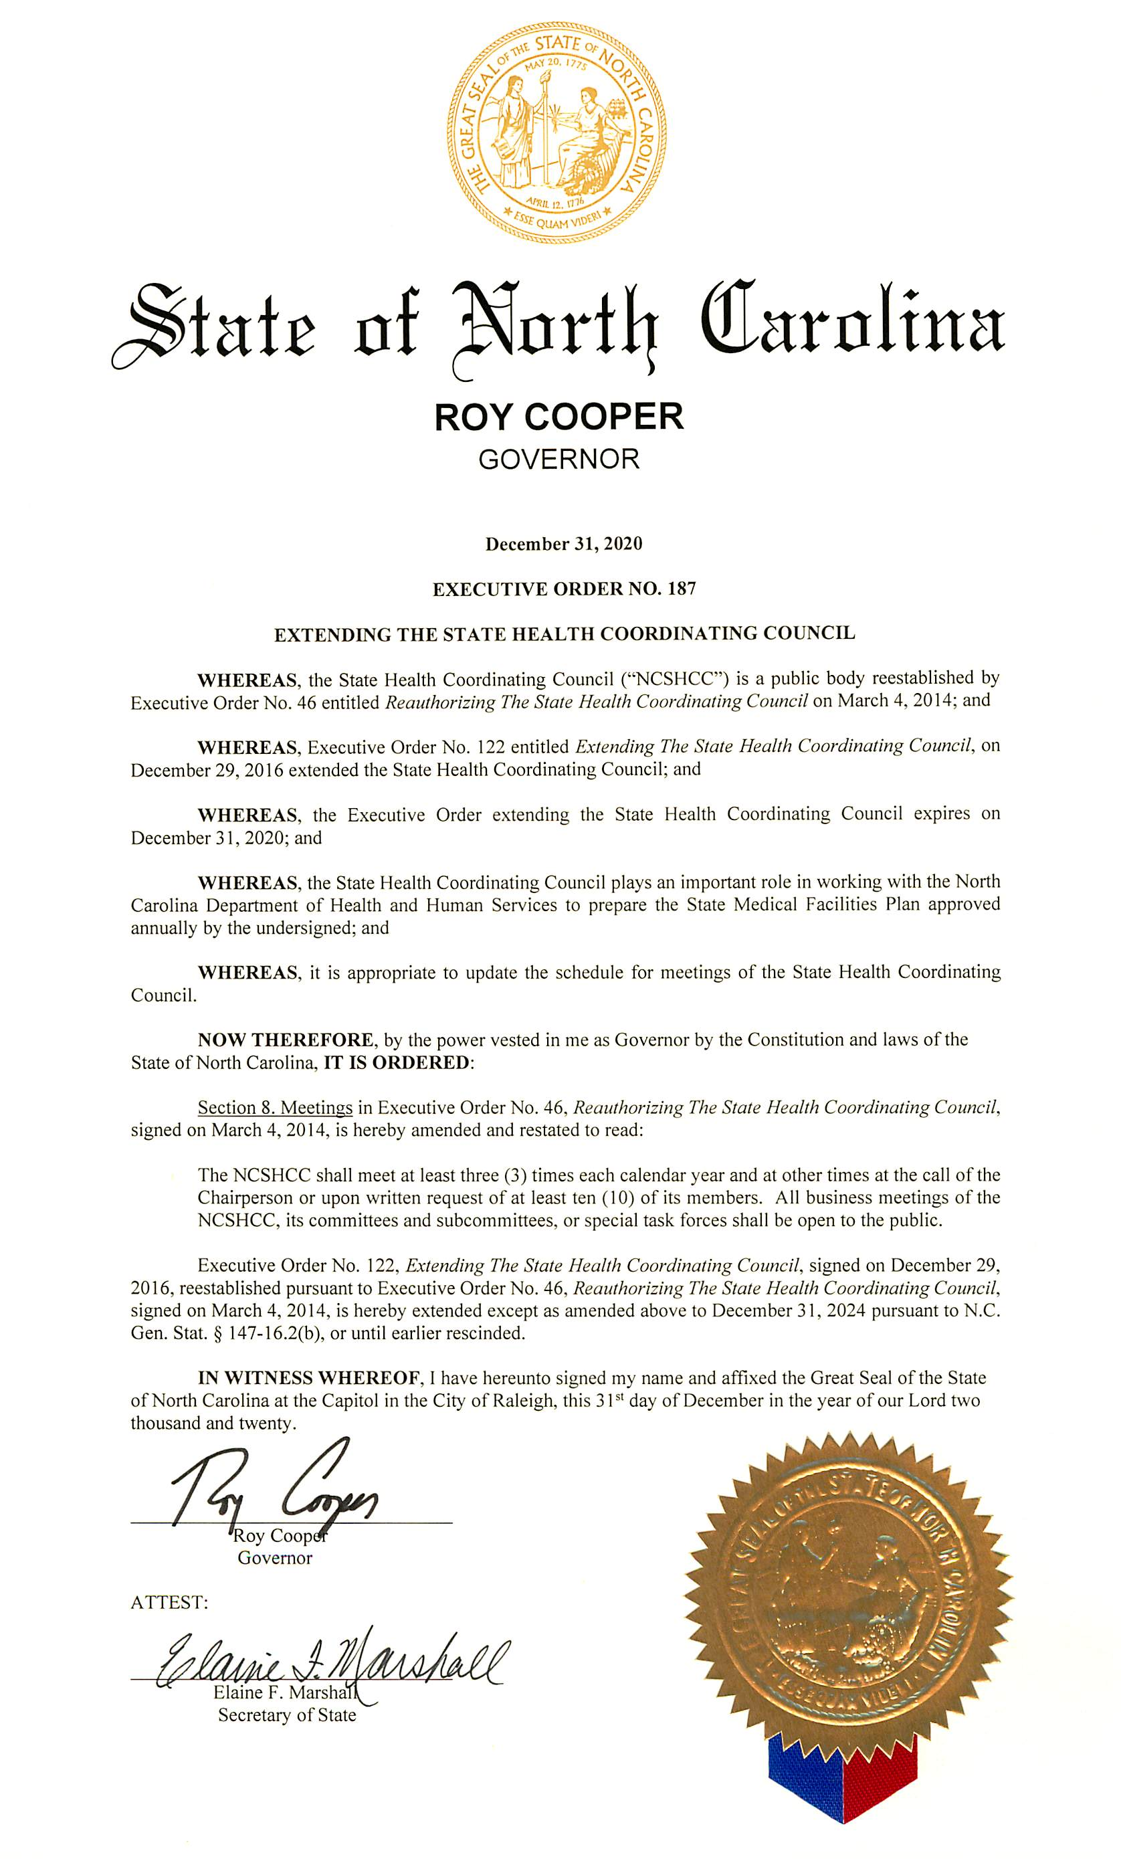
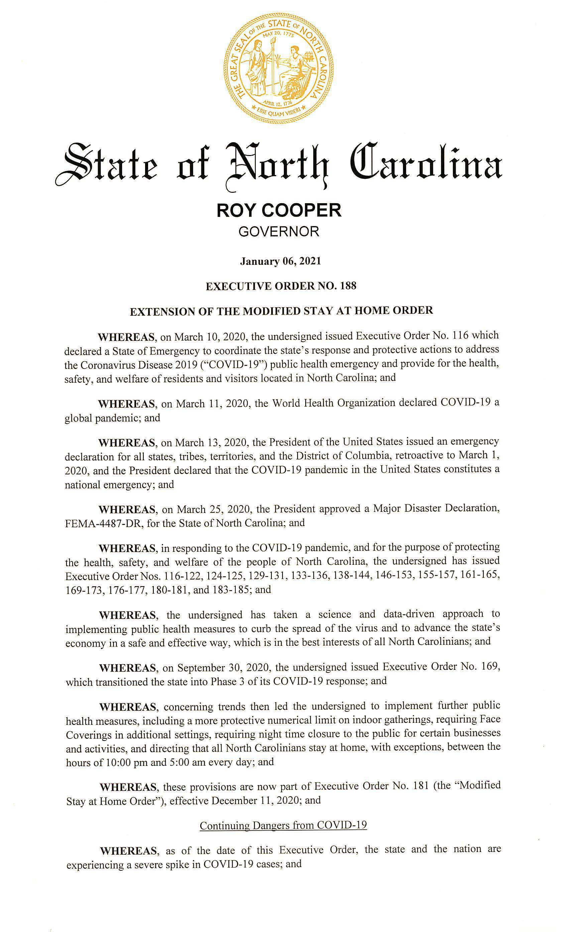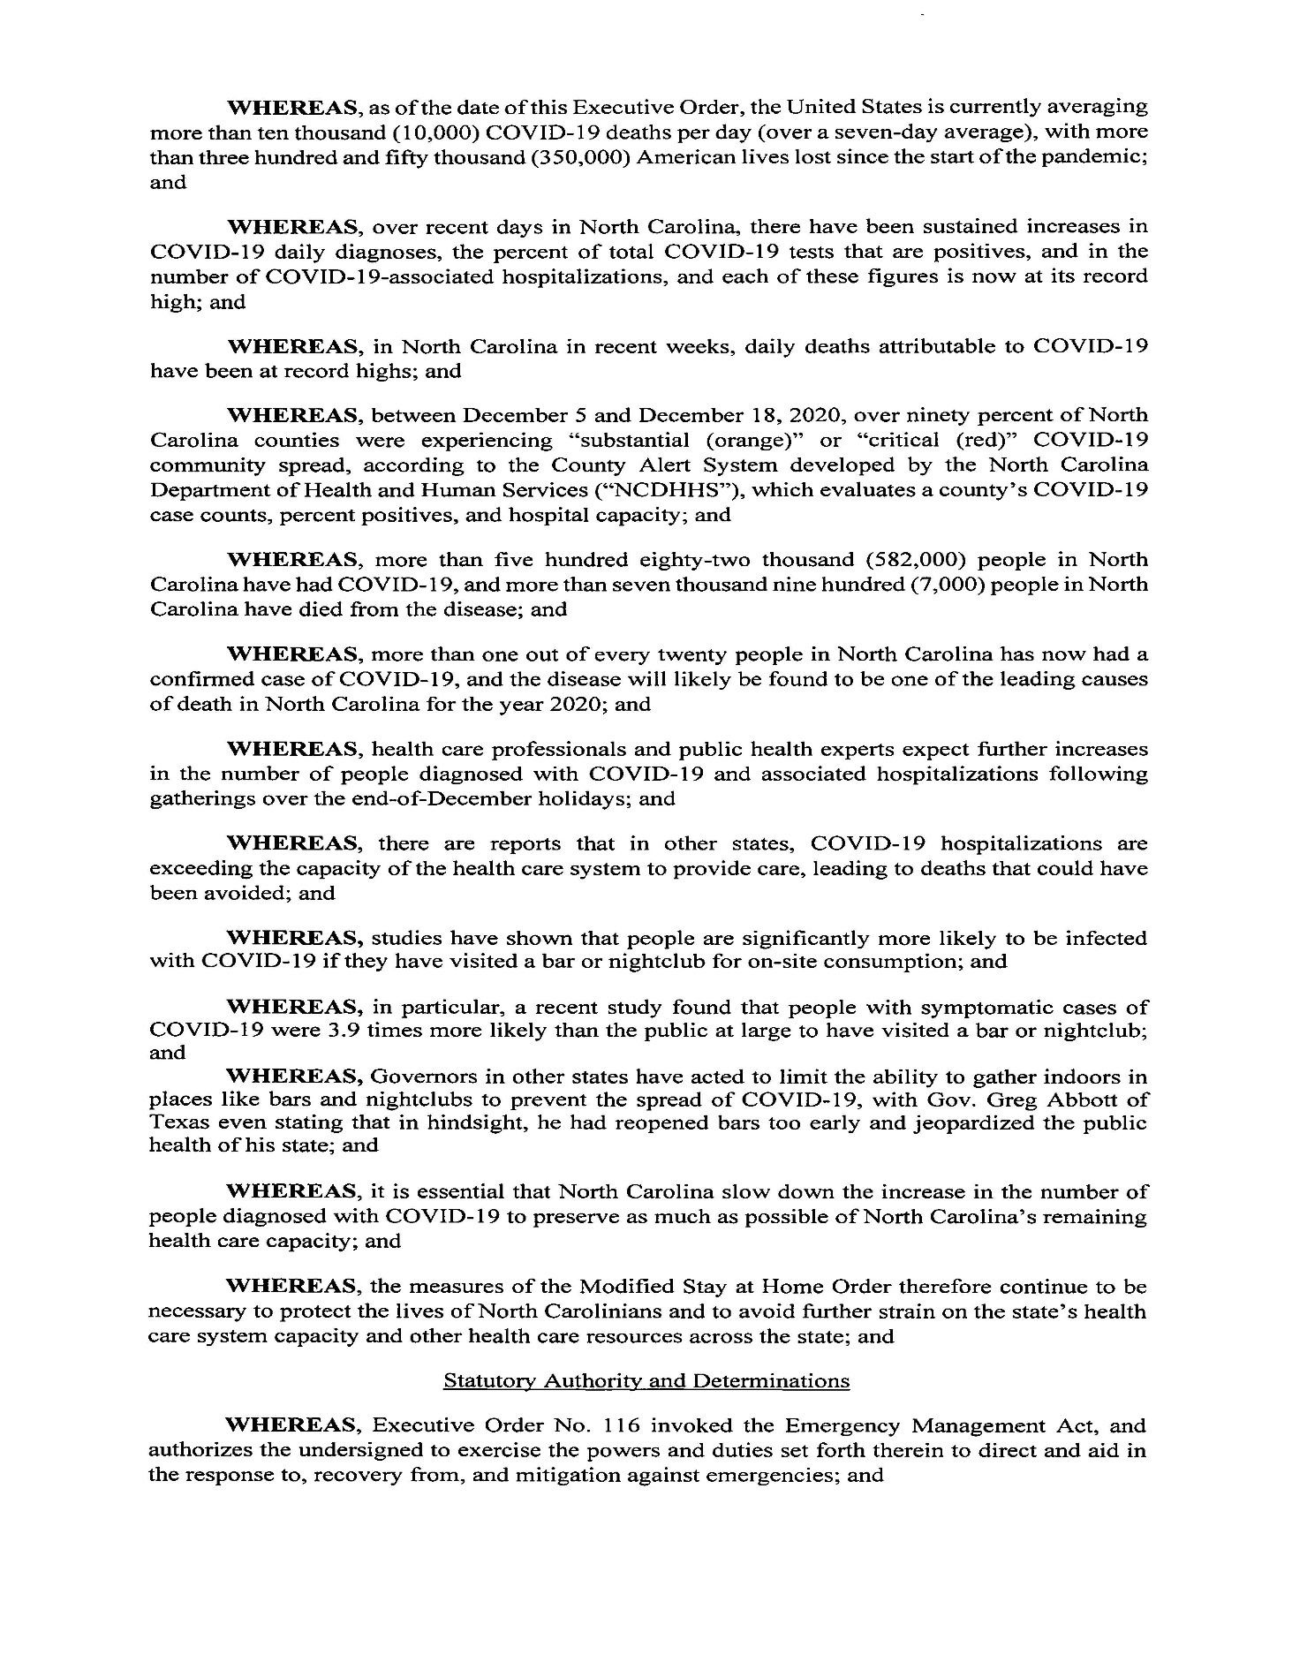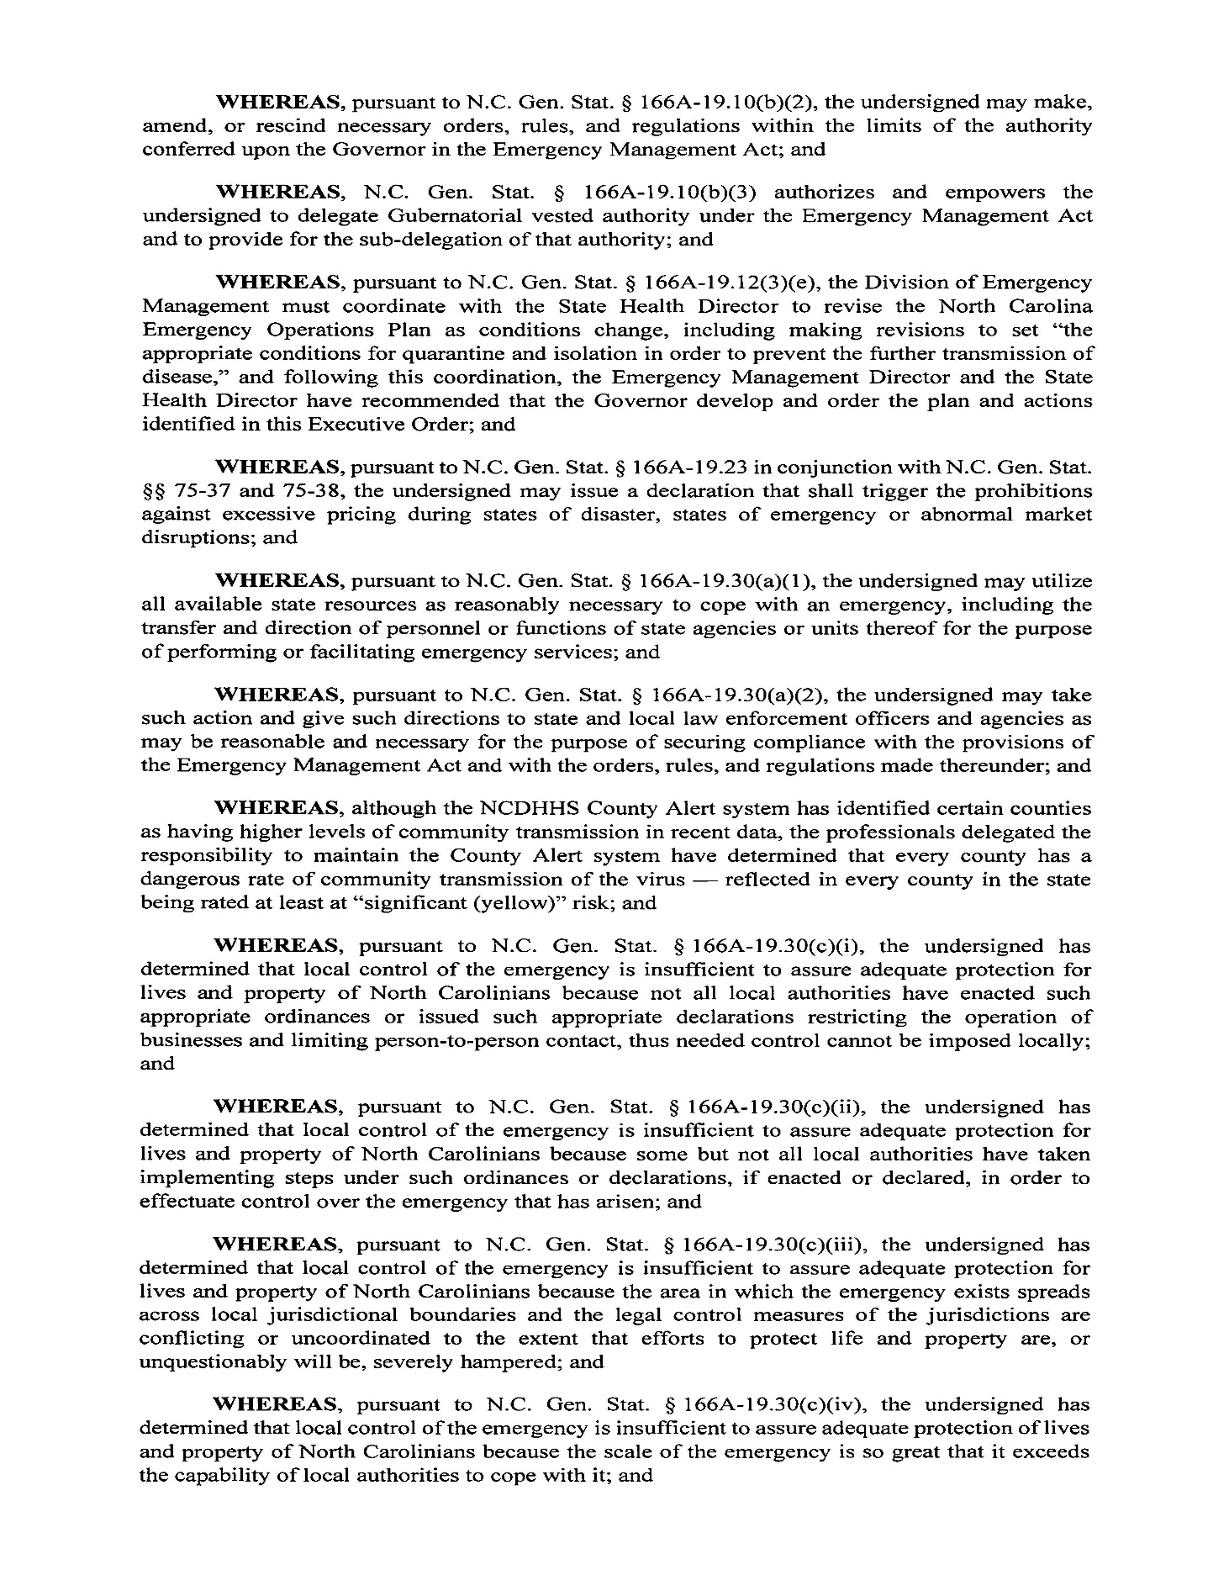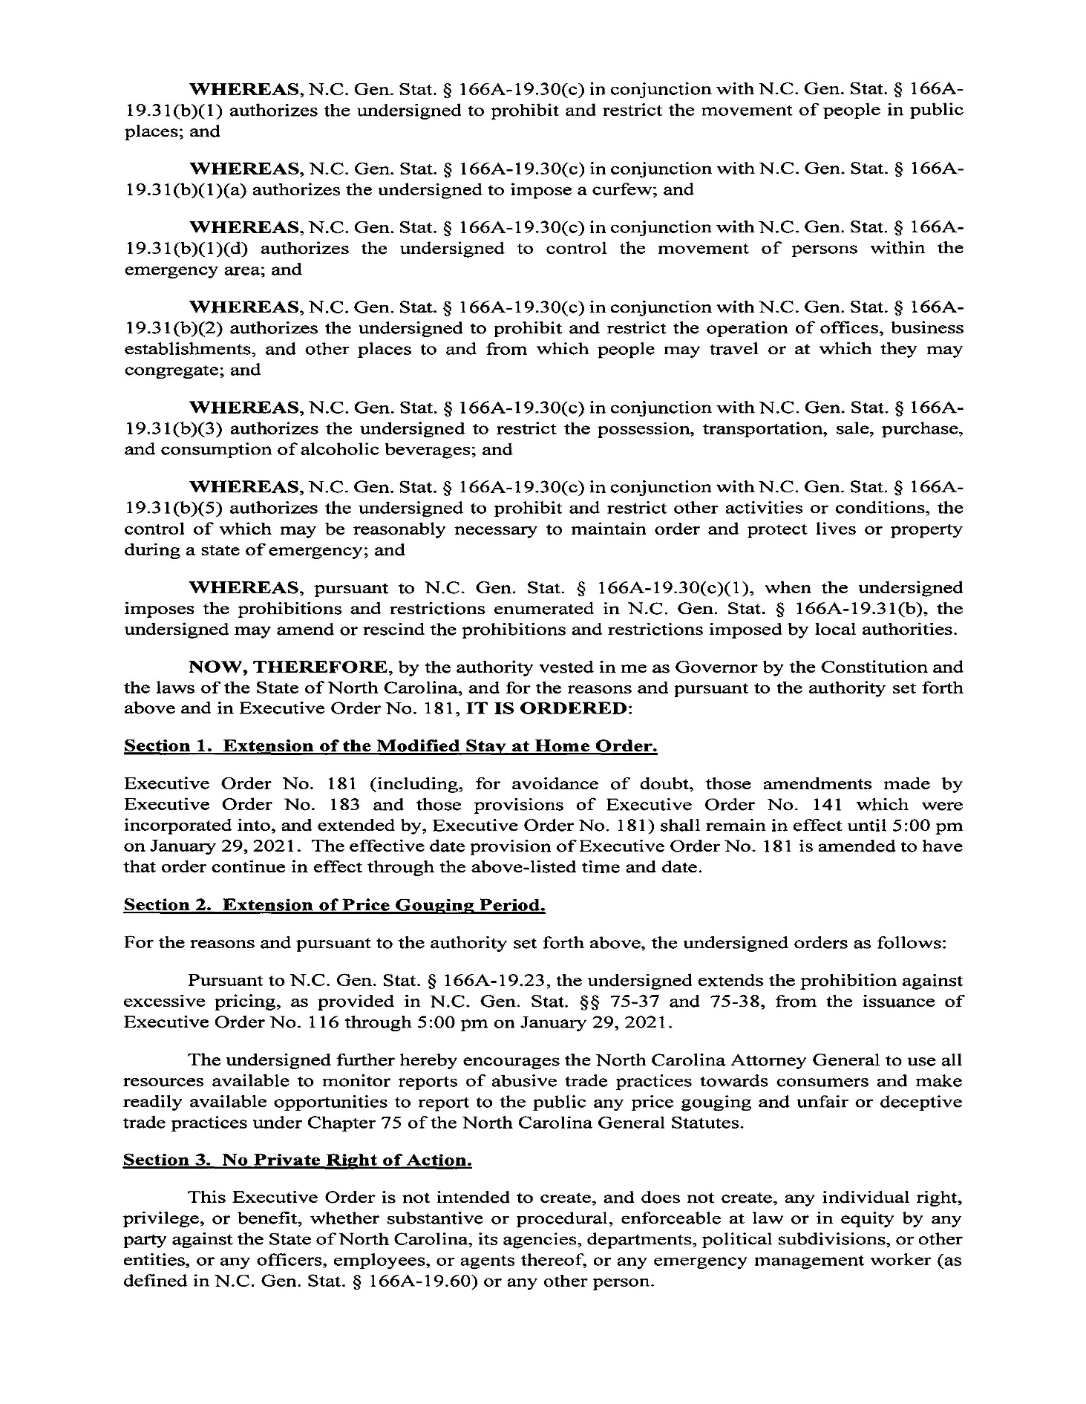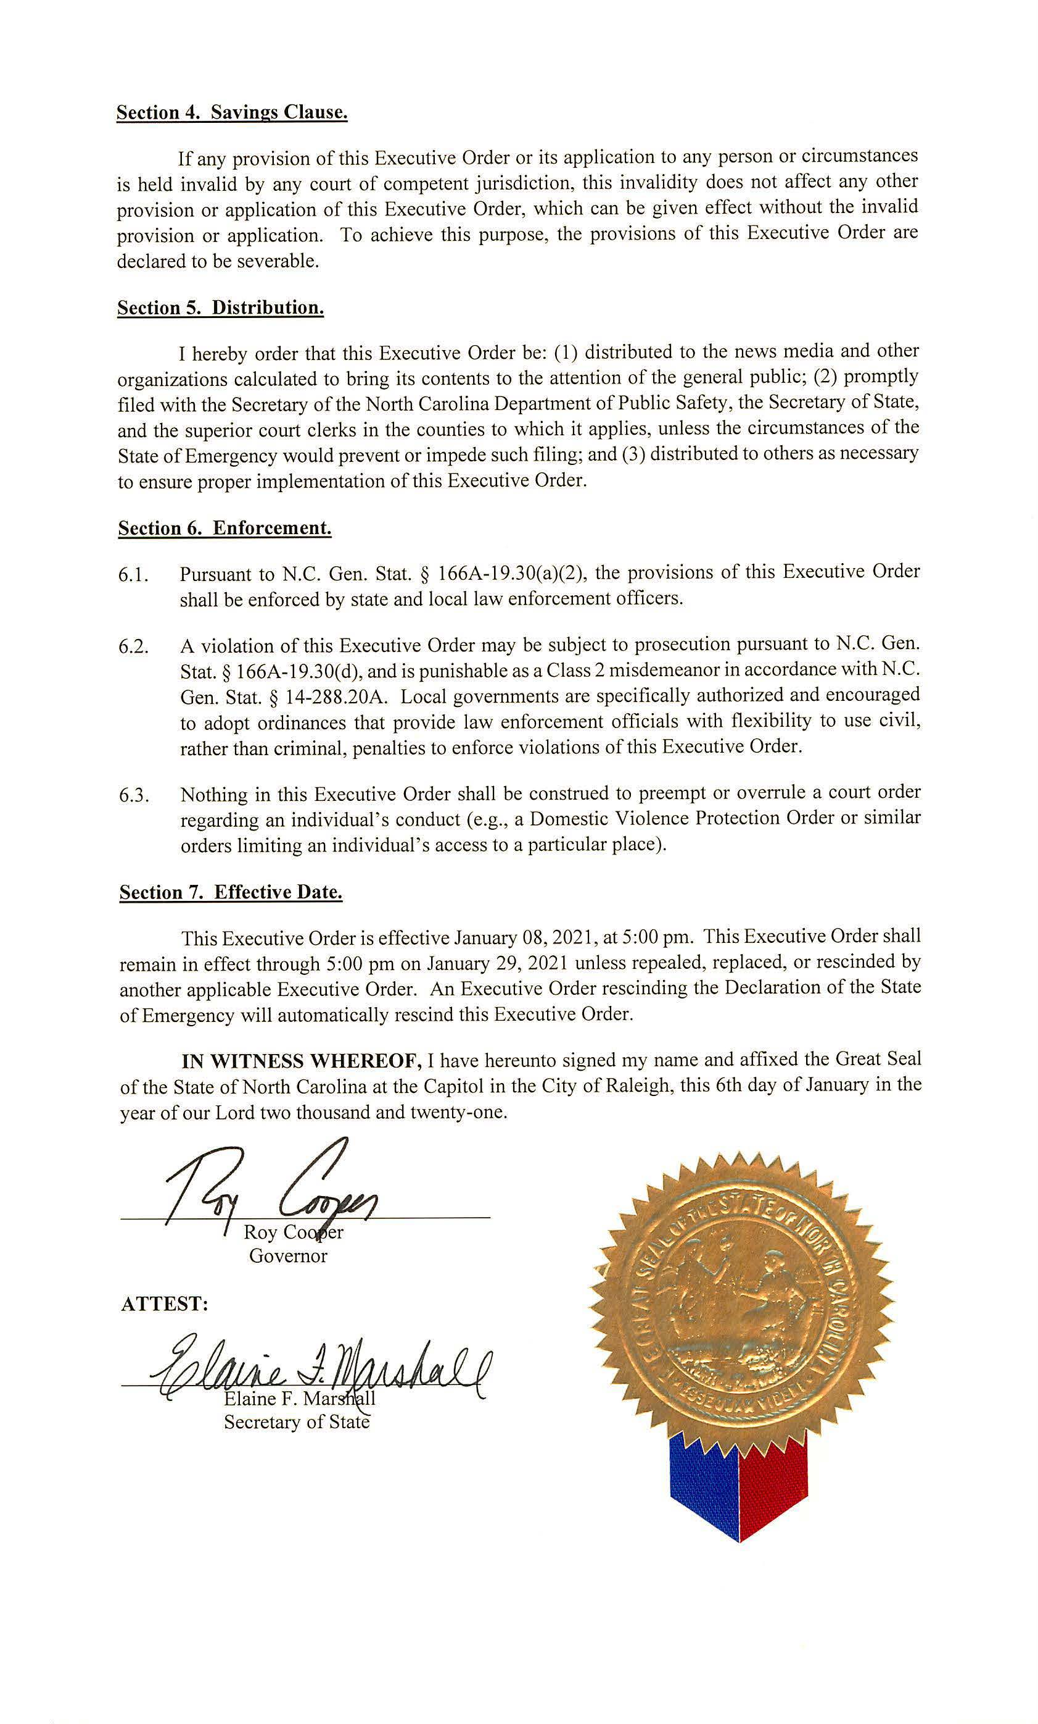

North Carolina Department of Labor
Division of Occupational Safety and Health
1101 Mail Service Center
Raleigh, NC 27699-1101

(919) 707-7806

NOTICE OF VERBATIM ADOPTION OF FEDERAL STANDARDS

In consideration of G.S. 150B-21.5(c) the Occupational Safety and Health Division of the Department of Labor hereby gives notice that:

- Rule changes have been submitted to update the North Carolina Administrative Code at 13 NCAC 07F .0101 to incorporate by reference the occupational safety and health related provisions of Title 29 of the Code of Federal Regulations Parts 1910 promulgated as of July 14, 2020, except as specifically described, and

- The North Carolina Administrative Code at 13 NCAC 07A .0301 automatically adopts subsequent amendments to certain parts of the Code of Federal Regulations. Title 29, Part 1910—General Industry Standards does not automatically include subsequent amendments.

This update encompasses the following recent verbatim adoption:

- Occupational Safety and Health Standards, Revising the Beryllium Standard for General Industry, 29 CFR § 1910 (85 FR 42582, July 14, 2020)

The final rule, published in the Federal Register on July 14, 2020 (85 FR 42582), amends the existing general industry standard for occupational exposure to beryllium and beryllium compounds to clarify certain provisions and simplify or improve compliance. The revisions in this final rule are designed to maintain or enhance worker protections overall by ensuring that the rule is well understood and compliance is more straightforward. OSHA’s final rule was effective September 14, 2020.

For additional information, please contact:

Bureau of Education, Training and Technical Assistance
Occupational Safety and Health Division
North Carolina Department of Labor
1101 Mail Service Center
Raleigh, North Carolina 27699-1101

For additional information regarding North Carolina’s process of adopting federal OSHA Standards verbatim, please contact:

Jill F. Cramer, Agency Rulemaking Coordinator
North Carolina Department of Labor
Legal Affairs Division
1101 Mail Service Center
Raleigh, North Carolina 27699-1101

Note from the Codifier: The notices published in this Section of the NC Register include the text of proposed rules. The agency must accept comments on the proposed rule(s) for at least 60 days from the publication date, or until the public hearing, or a later date if specified in the notice by the agency. If the agency adopts a rule that differs substantially from a prior published notice, the agency must publish the text of the proposed different rule and accept comment on the proposed different rule for 60 days.
Statutory reference: G.S. 150B-21.2.

Title 12 – Department of Justice

Notice is hereby given in accordance with G.S. 150B-21.2 that the Sheriffs' Education and Training Standards Commission intends to amend the rule cited as 12 NCAC 10B .0305.

Link to agency website pursuant to G.S. 150B-19.1(c): https://ncdoj.gov/law-enforcement-training/sheriffs/all-commission-forms-publications/

Proposed Effective Date: June 1, 2021

Public Hearing:
Date: February 18, 2021
Time: 10:00 a.m.
Location: 1700 Tryon Park Drive, Raleigh, NC 27610

Reason for Proposed Action: To add newly required form AOC-CR-280 to list of background documents required for certification.

Comments may be submitted to: Diane Konopka, Post Office Box 629, Raleigh, NC 27610; email dkonopka@ncdoj.gov

Comment period ends: April 5, 2021

Procedure for Subjecting a Proposed Rule to Legislative Review: If an objection is not resolved prior to the adoption of the rule, a person may also submit written objections to the Rules Review Commission after the adoption of the Rule. If the Rules Review Commission receives written and signed objections after the adoption of the Rule in accordance with G.S. 150B-21.3(b2) from 10 or more persons clearly requesting review by the legislature and the Rules Review Commission approves the rule, the rule will become effective as provided in G.S. 150B-21.3(b1). The Commission will receive written objections until 5:00 p.m. on the day following the day the Commission approves the rule. The Commission will receive those objections by mail, delivery service, hand delivery, or facsimile transmission. If you have any further questions concerning the submission of objections to the Commission, please call a Commission staff attorney at 919-431-3000.

Fiscal impact. Does any rule or combination of rules in this notice create an economic impact? Check all that apply.

State funds affected

Local funds affected

Substantial economic impact (>= $1,000,000)

Approved by OSBM

No fiscal note required

Chapter 10 - Sheriffs' Education and Training Standards Commission

SUBCHAPTER 10B - N.C. SHERIFFS' EDUCATION AND TRAINING STANDARDS COMMISSION

SECTION .0300 – MINIMUM STANDARDS FOR EMPLOYMENT AND CERTIFICATION AS A JUSTICE OFFICER

12 NCAC 10B .0305 BACKGROUND INVESTIGATION

(a) Prior to the background investigation conducted by the employing agency to determine the applicant's suitability to perform essential job functions, the applicant shall complete the Commission's Personal History Statement (F-3) to provide a basis for the investigation. The Personal History Statement (F-3) submitted to the Division shall be completed no more than 120 days prior to the applicant's date of appointment.

(b) If the Personal History Statement (F-3) was completed more than 120 days prior to the applicant's date of appointment, the Personal History Statement (F-3) shall be updated by the applicant who shall initial and date all changes or a new Personal History Statement (F-3) must be completed.

(c) The employing agency shall ensure the proper dates, signatures, and notarizations are affixed to the Personal History Statement (F-3); and shall also certify that the results of the background investigation are consistent with the information provided by the applicant on the Personal History Statement (F-3), and if not, provide the applicant the opportunity to update the F-3 prior to submission to the Division.

(d) The employing agency, prior to employment, shall examine the applicant's character traits and habits relevant to his/her performance as a justice officer and shall determine whether the applicant is of good moral character as defined in Rule .0301(a)(8). The investigator shall summarize the results of the investigation on the Commission-mandated Background Investigation Form (F-8) which shall be signed and dated by the investigator.

(e) The Background Investigation Form (F-8) shall include records checks from:

(1) a state-wide search of the Administrative Office of the Courts (AOC) computerized system;

(2) the national criminal record database accessible through the Division of Criminal Information (DCI) network;

(3) the North Carolina Division of Motor Vehicles, if the applicant has ever possessed a driver's license issued in North Carolina; and

(4) out-of-state motor vehicles check obtained through the Division of Criminal Information or obtained through the any other state's Division of Motor Vehicles if the applicant held a license in that State(s) within the 10 year period prior to the date of appointment.

(f) The Background Investigation must also include records checks from jurisdictions in which the applicant resided within the 10 year period prior to the date of appointment and where the applicant attended high school, as follows:

(1) Where the applicant resided in jurisdictions in North Carolina, Clerk of Court records checks are acceptable;

(2) Where the applicant resided in another country, an Interpol records check is acceptable provided the country is a member of Interpol; or if the applicant was in the United States military, a military records check is acceptable; or if neither, efforts shall be made and documented to attempt to obtain a records check from the country and submitted if available; and

(3) Where the applicant resided in a State other than North Carolina, a records check through the Division of Criminal Information using the IQ inquiry is acceptable provided the State will respond to that type of inquiry; or if not, then either a records check response from both the municipality, city or town where the applicant resided and the county-wide Sheriff's Office or Police Department obtained through traditional correspondence; or a records check from the appropriate county-wide or state-wide record holding agency is acceptable.

(g) If the applicant had prior military service, the Background Investigation must also include a copy of the applicant's DD214 which shows the characterization of discharge for each discharge which occurred and military discipline received, if any. If the DD214 indicates a discharge characterization of any type other than Honorable, then a military records check is also required.

(h) All records checks shall be performed on each name by which the applicant for certification has ever been known since the age of 12. If the applicant has had an official name change which occurred after the applicant had reached the age of 12 years of age, then documentation of that name change is required.

(i) The employing agency shall forward to the Division certified copies of any criminal charge(s) and disposition(s) known to the agency or listed on the applicant's Personal History Statement (F-3). The employing agency shall explain to the satisfaction of Division staff that charges or other violations which may result from the records checks required in Paragraph (e) of this Section do not pertain to the applicant for certification. This documentation shall be included with all other documentation required in 12 NCAC 10B .0408.

(j) The employing agency shall include a signed and notarized Release Authorization Form which authorizes the Division staff to obtain documents and records pertaining to the applicant for certification which may be required in order to determine whether certification may be granted.

(k) The employing agency shall provide the results of a completed and processed form AOC-CR-280, Law Enforcement Application for Verification of Expunction under G.S. 15A-145.4, G.S. 15A-145.5, G.S. 15A-145.6, G.S. 15A-145.8A or G.S.15A-146, for each applicant presented for certification.

Authority G.S. 17E-7.

This Section includes a listing of rules approved by the Rules Review Commission followed by the full text of those rules. The rules that have been approved by the RRC in a form different from that originally noticed in the Register or when no notice was required to be published in the Register are identified by an * in the listing of approved rules. Statutory Reference: G.S. 150B-21.17.

Rules approved by the Rules Review Commission at its meeting on December 17, 2020 Meeting.

REGISTER CITATION TO THE
NOTICE OF TEXT
Agriculture, Board of
Currant and Gooseberry Plants | 02 | NCAC | 48A | .0401* | 35:05 NCR
Infected Pines | 02 | NCAC | 48A | .0402* | 35:05 NCR
Cotton Stalk Destruction | 02 | NCAC | 48A | .0612* | 35:05 NCR
Soil and Water Conservation Commission
Criteria and Procedures for Granting Job Approval Authority | 02 | NCAC | 59D | .0201* | 35:05 NCR
Agriculture, Board of
Definitions | 02 | NCAC | 61 | .0101* | 35:05 NCR
Authorized Sanitizing Processes | 02 | NCAC | 61 | .0102* | 35:05 NCR
Other Methods of Sanitizing | 02 | NCAC | 61 | .0103* | 35:05 NCR
Disposal of Unclean Bedding | 02 | NCAC | 61 | .0104* | 35:05 NCR
Storage of Secondhand or Previously-Used Materials | 02 | NCAC | 61 | .0105* | 35:05 NCR
Non-Transferrable Registration | 02 | NCAC | 61 | .0106* | 35:05 NCR
Transfer of Manufacturers' and Sanitizer's Licenses | 02 | NCAC | 61 | .0107* | 35:05 NCR
License Fees and Applications | 02 | NCAC | 61 | .0108* | 35:05 NCR
Cancellation of Licenses | 02 | NCAC | 61 | .0109* | 35:05 NCR
Durable Materials for Tags | 02 | NCAC | 61 | .0110* | 35:05 NCR
Effective Date of Licenses | 02 | NCAC | 61 | .0111* | 35:05 NCR
Information Technology, Department of
Petitions for Rule-making | 09 | NCAC | 06A | .0104* | 35:04 NCR
Definitions | 09 | NCAC | 06D | .0101* | 35:04 NCR
Data Request Process | 09 | NCAC | 06D | .0102* | 35:04 NCR
Contributor Data Sharing Agreements | 09 | NCAC | 06D | .0103* | 35:04 NCR
Requestor Data Sharing Agreements and Requirements | 09 | NCAC | 06D | .0104* | 35:04 NCR
Medical Care Commission
Requirements for Issuance of a License | 10A | NCAC | 13C | .0202* | 34:24 NCR
Suspension or Revocation: Ambulatory Surgical Facility | 10A | NCAC | 13C | .0203* | 34:24 NCR
Governing Authority | 10A | NCAC | 13C | .0301 | 34:24 NCR
Providing Anesthesia Services | 10A | NCAC | 13C | .0501* | 34:24 NCR
Regulations for Performed Services | 10A | NCAC | 13C | .0702* | 34:24 NCR
Nursing Personnel | 10A | NCAC | 13C | .0902 | 34:24 NCR
Definitions | 10A | NCAC | 13D | .2001* | 34:24 NCR
Physician Services for Ventilator Dependent Patients | 10A | NCAC | 13D | .2506 | 34:24 NCR
Ventilator Assisted Care | 10A | NCAC | 13D | .3003* | 34:24 NCR
Definitions | 10A | NCAC | 13K | .0102* | 34:24 NCR
Personnel | 10A | NCAC | 13K | .0401* | 34:24 NCR
Patient's Rights and Responsibilities | 10A | NCAC | 13K | .0604* | 34:24 NCR
Care Plan | 10A | NCAC | 13K | .0701 | 34:24 NCR
Dietary Services | 10A | NCAC | 13K | .1104* | 34:24 NCR
HHS - Health Service Regulation, Division of
Definitions | 10A | NCAC | 14C | .0202* | 35:02 NCR
Filing Applications | 10A | NCAC | 14C | .0203* | 35:02 NCR
Extension of Review Period | 10A | NCAC | 14C | .0205 | 35:02 NCR
Replacement Equipment | 10A | NCAC | 14C | .0303 | 35:02 NCR
Definitions | 10A | NCAC | 14C | .2101* | 35:02 NCR
Performance Standards | 10A | NCAC | 14C | .2103* | 35:02 NCR
Definitions | 10A | NCAC | 14C | .2201* | 35:02 NCR
Performance Standards | 10A | NCAC | 14C | .2203* | 35:02 NCR
Definitions | 10A | NCAC | 14C | .3901 | 35:02 NCR
Performance Standards | 10A | NCAC | 14C | .3903 | 35:02 NCR
Public Health, Commission for
Training and Technical Assistance | 10A | NCAC | 41C | .0304 | 35:05 NCR
General | 10A | NCAC | 41C | .0601* | 35:05 NCR
Accreditation | 10A | NCAC | 41C | .0602* | 35:05 NCR
Training Course Instructor Qualifications | 10A | NCAC | 41C | .0608* | 35:05 NCR
Criminal Justice Education and Training Standards Commission
Investigation of Violation of Rules | 12 | NCAC | 09A | .0201* | 35:06 NCR
Responsibilities of the School Director | 12 | NCAC | 09B | .0202* | 35:06 NCR
Specialized Firearms Instruction Training | 12 | NCAC | 09B | .0226* | 35:06 NCR
Specialized Driver Instructor Training | 12 | NCAC | 09B | .0227 | 35:06 NCR
Specialized Subject Control Arrest Techniques Instructor ... | 12 | NCAC | 09B | .0232* | 35:06 NCR
Specialized Physical Fitness Instructor Training | 12 | NCAC | 09B | .0233* | 35:06 NCR
Certification of Diversion Investigator and Supervisors | 12 | NCAC | 09B | .0314 | 35:06 NCR
Satisfaction of Training - SMI Operators | 12 | NCAC | 09B | .0409* | 35:06NCR
Specialized Explosives and Hazardous Materials Instructor... | 12 | NCAC | 09B | .0417* | 35:06 NCR
Environmental Management Commission
Purpose and Scope | 15A | NCAC | 02J | .0101 | 35:02 NCR
Definitions | 15A | NCAC | 02J | .0102 | 35:02 NCR
Who May Assess | 15A | NCAC | 02J | .0103 | 35:02 NCR
When Assessable | 15A | NCAC | 02J | .0104 | 35:02 NCR
Standards | 15A | NCAC | 02J | .0106 | 35:02 NCR
Proposed Assessment: Assessment: Modification | 15A | NCAC | 02J | .0107 | 35:02 NCR
Payment: Hearing: Remission/Mitigation | 15A | NCAC | 02J | .0108 | 35:02 NCR
Tenders of Payment: Remission/Mitigation: Hearing Request | 15A | NCAC | 02J | .0109 | 35:02 NCR
Referral | 15A | NCAC | 02J | .0110 | 35:02 NCR
Reports to the Commission | 15A | NCAC | 02J | .0111 | 35:02 NCR
Applicability | 15A | NCAC | 02N | .0201* | 35:04 NCR
Installation Requirements for Partially Excluded UST Systems | 15A | NCAC | 02N | .0202* | 35:04 NCR
Definitions | 15A | NCAC | 02N | .0203* | 35:04 NCR
Performance Standards for UST System Installations or Rep... | 15A | NCAC | 02N | .0301* | 35:04 NCR
Upgrading of Existing UST Systems After December 22, 1988... | 15A | NCAC | 02N | .0302* | 35:04 NCR
Notification Requirements | 15A | NCAC | 02N | .0303* | 35:04 NCR
Implementation Schedule for Performance Standards for New... | 15A | NCAC | 02N | .0304* | 35:04 NCR
Spill and Overfill Control | 15A | NCAC | 02N | .0401* | 35:04 NCR
Operation and Maintenance of Corrosion Protection | 15A | NCAC | 02N | .0402* | 35:04 NCR
Compatibility | 15A | NCAC | 02N | .0403* | 35:04 NCR
Repairs Allowed | 15A | NCAC | 02N | .0404* | 35:04 NCR
Reporting and Recordkeeping | 15A | NCAC | 02N | .0405* | 35:04 NCR
Periodic Testing of Spill Prevention Equipment and Contai... | 15A | NCAC | 02N | .0406* | 35:04 NCR
General Requirements for All UST Systems | 15A | NCAC | 02N | .0501* | 35:04 NCR
Requirements for Petroleum UST Systems | 15A | NCAC | 02N | .0502* | 35:04 NCR
Requirements for Hazardous Substance UST Systems | 15A | NCAC | 02N | .0503* | 35:04 NCR
Methods of Release Detection for Tanks | 15A | NCAC | 02N | .0504* | 35:04 NCR
Methods of Release Detection for Piping | 15A | NCAC | 02N | .0505* | 35:04 NCR
Release Detection Recordkeeping | 15A | NCAC | 02N | .0506* | 35:04 NCR
Reporting of Suspected Releases | 15A | NCAC | 02N | .0601* | 35:04 NCR
Investigation Due to Off-Site Impacts | 15A | NCAC | 02N | .0602* | 35:04 NCR
Release Investigation and Confirmation Steps | 15A | NCAC | 02N | .0603* | 35:04 NCR
Reporting and Cleanup of Spills and Overfills | 15A | NCAC | 02N | .0604* | 35:04 NCR
General | 15A | NCAC | 02N | .0701* | 35:04 NCR
Initial Response | 15A | NCAC | 02N | .0702* | 35:04 NCR
Initial Abatement Measures and Site Check | 15A | NCAC | 02N | .0703* | 35:04 NCR
Initial Site Characterization | 15A | NCAC | 02N | .0704* | 35:04 NCR
Free Product Removal | 15A | NCAC | 02N | .0705* | 35:04 NCR
Investigations for Soil and Groundwater Cleanup | 15A | NCAC | 02N | .0706* | 35:04 NCR
Corrective Action Plan | 15A | NCAC | 02N | .0707* | 35:04 NCR
Public Participation | 15A | NCAC | 02N | .0708* | 35:04 NCR
Temporary Closure | 15A | NCAC | 02N | .0801* | 35:04 NCR
Permanent Closure and Changes-In-Service | 15A | NCAC | 02N | .0802* | 35:04 NCR
Assessing the Site at Closure or Change-In-Service | 15A | NCAC | 02N | .0803* | 35:04 NCR
Applicability to Previously Closed UST Systems | 15A | NCAC | 02N | .0804* | 35:04 NCR
Closure Records | 15A | NCAC | 02N | .0805* | 35:04 NCR
General Requirements | 15A | NCAC | 02N | .0901* | 35:04 NCR
Notification | 15A | NCAC | 02N | .0902 | 35:04 NCR
Tanks | 15A | NCAC | 02N | .0903* | 35:04 NCR
Piping | 15A | NCAC | 02N | .0904* | 35:04 NCR
Containment Sumps | 15A | NCAC | 02N | .0905* | 35:04 NCR
Spill Buckets | 15A | NCAC | 02N | .0906 | 35:04 NCR
National Codes of Practice and Industry Standards | 15A | NCAC | 02N | .0907* | 35:04 NCR
General | 15A | NCAC | 02O | .0101* | 35:04 NCR
Financial Responsibility | 15A | NCAC | 02O | .0102* | 35:04 NCR
Substituted Sections | 15A | NCAC | 02O | .0103 | 35:04 NCR
Applicability | 15A | NCAC | 02O | .0201 | 35:04 NCR
Compliance Dates | 15A | NCAC | 02O | .0202 | 35:04 NCR
Definitions | 15A | NCAC | 02O | .0203* | 35:04 NCR
Amount and Scope of Required Financial Responsibility | 15A | NCAC | 02O | .0204* | 35:04 NCR
Allowable Mechanisms and Combinations of Mechanisms | 15A | NCAC | 02O | .0301 | 35:04 NCR
Self Insurance | 15A | NCAC | 02O | .0302* | 35:04 NCR
Guarantee | 15A | NCAC | 02O | .0303 | 35:04 NCR
Insurance and Risk Retention Group Coverage | 15A | NCAC | 02O | .0304 | 35:04 NCR
Surety Bond | 15A | NCAC | 02O | .0305 | 35:04 NCR
Letter of Credit | 15A | NCAC | 02O | .0306 | 35:04 NCR
Standby Trust Fund | 15A | NCAC | 02O | .0307 | 35:04 NCR
Insurance Pools | 15A | NCAC | 02O | .0308* | 35:04 NCR
Local Government Bond Rating Test | 15A | NCAC | 02O | .0311 | 35:04 NCR
Local Government Financial Test | 15A | NCAC | 02O | .0312 | 35:04 NCR
Local Government Guarantee | 15A | NCAC | 02O | .0313 | 35:04 NCR
Local Government Fund | 15A | NCAC | 02O | .0314 | 35:4 NCR
Substitution of Financial Assurance Mechanisms | 15A | NCAC | 02O | .0315 | 35:4 NCR
Cancellation or Renewal by a Provider of Assurance | 15A | NCAC | 02O | .0316 | 35:4 NCR
Reporting by Owner or Operator | 15A | NCAC | 02O | .0401 | 35:4 NCR
Record Keeping | 15A | NCAC | 02O | .0402 | 35:4 NCR
Drawing on Financial Assurance Mechanisms | 15A | NCAC | 02O | .0501 | 35:4 NCR
Release from the Requirements | 15A | NCAC | 02O | .0502 | 35:4 NCR
Capacity of Owner or Operator or Provider of Assurance | 15A | NCAC | 02O | .0503* | 35:4 NCR
Replenishment | 15A | NCAC | 02O | .0504 | 35:4 NCR
Definitions | 15A | NCAC | 13B | .0101* | 35:04 NCR
Applicability | 15A | NCAC | 13B | .0102* | 35:04 NCR
General Requirements | 15A | NCAC | 13B | .0103* | 35:04 NCR
Solid Waste Storage | 15A | NCAC | 13B | .0104* | 35:04 NCR
Collection and Transportation of Solid Waste | 15A | NCAC | 13B | .0105 | 35:04 NCR
Generator of Solid Waste | 15A | NCAC | 13B | .0106 | 35:04 NCR
Permit Required | 15A | NCAC | 13B | .0201* | 35:04 NCR
Permit Application | 15A | NCAC | 13B | .0202* | 35:04 NCR
Permit Approval or Denial | 15A | NCAC | 13B | .0203* | 35:04 NCR
Recordation of Land Disposal Permits | 15A | NCAC | 13B | .0204 | 35:04 NCR
Life-of-Site Permit Issued for a Sanitary Landfill or Tra... | 15A | NCAC | 13B | .0207 | 35:04 NCR
Permit Exemptions | 15A | NCAC | 13B | .0208* | 35:04 NCR
Siting and Application Requirements | 15A | NCAC | 13B | .0301* | 35:04 NCR
Operational and Closure Requirements | 15A | NCAC | 13B | .0302* | 35:04 NCR
Purpose and Applicability | 15A | NCAC | 13B | .0401* | 35:04 NCR
General Requirements | 15A | NCAC | 13B | .0402* | 35:04 NCR
Siting and Design Requirements | 15A | NCAC | 13B | .0403* | 35:04 NCR
Application Requirements | 15A | NCAC | 13B | .0404* | 35:04 NCR
Operational Requirements | 15A | NCAC | 13B | .0405* | 35:04 NCR
Closure Requirements | 15A | NCAC | 13B | .0406* | 35:04 NCR
Approved Disposal Methods | 15A | NCAC | 13B | .0501 | 35:04 NCR
Open Dumps | 15A | NCAC | 13B | .0502 | 35:04 NCR
Siting And Design Requirements for Industrial Sold Waste ... | 15A | NCAC | 13B | .0503* | 35:04 NCR
Application Requirements for Industrial Solid Waste Landf... | 15A | NCAC | 13B | .0504* | 35:04 NCR
Operational and Closure Requirements for Industrial Solid... | 15A | NCAC | 13B | .0505* | 35:04 NCR
Siting and Application Requirements for Incinerators | 15A | NCAC | 13B | .0508* | 35:04 NCR
Operational and Closure Requirements for Incinerators | 15A | NCAC | 13B | .0509* | 35:04 NCR
Post-Closure Care Requirement for Closed C&DLF and… | 15A | NCAC | 13B | .0510 | 35:04NCR
Beneficial Fill | 15A | NCAC | 13B | .0562 | 35:04NCR
General Requirements for LICDLFS | 15A | NCAC | 13B | .0563* | 35:04 NCR
Siting Criteria for LCIDLFs | 15A | NCAC | 13B | .0564* | 35:04 NCR
Application Requirements for LCIDLFs | 15A | NCAC | 13B | .0565* | 35:04 NCR
Operational Requirements for LCIDLFs | 15A | NCAC | 13B | .0566* | 35:04 NCR
Closure and Post-Closure Care Requirements for LCIDLFs | 15A | NCAC | 13B | .0567* | 35:04 NCR
Groundwater Monitoring | 15A | NCAC | 13B | .0601* | 35:04 NCR
Surface Water Monitoring | 15A | NCAC | 13B | .0602* | 35:04 NCR
Administrative Penalties | 15A | NCAC | 13B | .0701 | 35:04 NCR
Standards | 15A | NCAC | 13B | .0702 | 35:04 NCR
Procedure for Assessment: Revocation of Permit | 15A | NCAC | 13B | .0703 | 35:04 NCR
Payments: Hearing | 15A | NCAC | 13B | .0704 | 35:04 NCR
Stay of Penalty Assessment | 15A | NCAC | 13B | .0705 | 35:04 NCR
Waiver of Administrative Hearing | 15A | NCAC | 13B | .0706 | 35:04 NCR
Manner of Disposition of Fetal Remains | 15A | NCAC | 13B | .1301 | 35:04 NCR
Education, State Board of
Textbook Publishers Registry | 16 | NCAC | 06D | .0212* | 34:13 NCR
Revenue, Department of
Government Attorneys-at-Law and Other Professionals Exemp... | 17 | NCAC | 04B | .0612 | G.S. 150B-1(d)(4)
Installment Paper Dealer Quarterly Return | 17 | NCAC | 04B | .2903 | G.S. 150B-1(d)(4)
Definitions | 17 | NCAC | 04C | .0101 | G.S. 150B-1(d)(4)
Application or Renewal Requirements for Applicants and Li... | 17 | NCAC | 04C | .0104 | G.S. 150B-1(d)(4)
Application or Renewal Requirements for a Distributor's L... | 17 | NCAC | 04C | .0201 | G.S. 150B-1(d)(4)
Interstate Cigarette Sales; Licensure | 17 | NCAC | 04C | .0504 | G.S. 150B-1(d)(4)
Invoice Requirement | 17 | NCAC | 04C | .0602 | G.S. 150B-1(d)(4)
Excise Tax Liability for Cigarette Inventory | 17 | NCAC | 04C | .0702 | G.S. 150B-1(d)(4)
Monthly Report for Resident Distributor | 17 | NCAC | 04C | .0901 | G.S. 150B-1(d)(4)
Monthly Report for Nonresident Distributors | 17 | NCAC | 04C | .0902 | G.S. 150B-1(d)(4)
Invoicing Requirements for Distributors | 17 | NCAC | 04C | .0903 | G.S. 150B-1(d)(4)
Record Requirements for Distributors | 17 | NCAC | 04C | .0904 | G.S. 150B-1(d)(4)
Refunds Only to Licensed Distributors | 17 | NCAC | 04C | .1002 | G.S. 150B-1(d)(4)
Application or Renewal Requirements for a Wholesale Deale... | 17 | NCAC | 04C | .1301 | G.S. 150B-1(d)(4)
Invoice Requirement | 17 | NCAC | 04C | .1401 | G.S. 150B-1(d)(4)
Sales to Licensed Dealers Only | 17 | NCAC | 04C | .1402 | G.S. 150B-1(d)(4)
Manufacturers Acting as Retailer | 17 | NCAC | 04C | .1403 | G.S. 150B-1(d)(4)
Monthly Report for Wholesale Dealers and Retail Dealers | 17 | NCAC | 04C | .1801 | G.S. 150B-1(d)(4)
Invoicing Requirements for Wholesale Dealers and Retail D... | 17 | NCAC | 04C | .1802 | G.S. 150B-1(d)(4)
Record Requirements for Wholesale Dealers and Retail Dealers | 17 | NCAC | 04C | .1803 | G.S. 150B-1(d)(4)
Out of State Shipments Reporting | 17 | NCAC | 04E | .0204 | G.S. 150B-1(d)(4)
Major Disaster Reporting | 17 | NCAC | 04E | .0205 | G.S. 150B-1(d)(4)
Wholesaler Buying from Wholesaler | 17 | NCAC | 04E | .0206 | G.S. 150B-1(d)(4)
Spoilage or Destruction of Nontaxpaid Beer or Wine | 17 | NCAC | 04E | .0301 | G.S. 150B-1(d)(4)
Spoilage of Taxpaid Beer or Wine | 17 | NCAC | 04E | .0302 | G.S. 150B-1(d)(4)
Destruction of Malt Beverages or Wine when in Transit | 17 | NCAC | 04E | .0303 | G.S. 150B-1(d)(4)
Receipts for Malt Beverages and Wine Delivered to Ocean-G... | 17 | NCAC | 04E | .0502 | G.S. 150B-1(d)(4)
Bond or Irrevocable Letter of Credit Required of Wholesaler and.. | 17 | NCAC | 04E | .0601 | G.S. 150B-1(d)(4)
New Wholesaler or Importer of Bond | 17 | NCAC | 04E | .0602 | G.S. 150B-1(d)(4)
Transportation, Department of
Definitions for Outdoor Advertising Control | 19A | NCAC | 02E | .0201* | 34:13 NCR
Agreement | 19A | NCAC | 02E | .0202* | 34:13 NCR
Outdoor Advertising on Controlled Routes | 19A | NCAC | 02E | .0203* | 34:13 NCR
Fees and Renewals | 19A | NCAC | 02E | .0207* | 34:13 NCR
Permit and Permit Emblem | 19A | NCAC | 02E | .0208* | 34:13 NCR
Transfer or Permit/Change of Address | 19A | NCAC | 02E | .0209* | 34:13 NCR
Revocation of Outdoor Advertising Permit | 19A | NCAC | 02E | .0210* | 34:13 NCR
Notice Given for Revoking Permit | 19A | NCAC | 02E | .0212* | 34:13 NCR
Appeal of Decision of District Engineer's Office to Sec. ... | 19A | NCAC | 02E | .0213 | 34:13 NCR
Standards For Directional Signs | 19A | NCAC | 02E | .0214* | 34:13 NCR
Permits for Directional Signs | 19A | NCAC | 02E | .0215* | 34:13 NCR
Scenic Byways | 19A | NCAC | 02E | .0224* | 34:13 NCR
Order to Stop Work on Unpermitted Outdoor Advertising | 19A | NCAC | 02E | .0226 | 34:13 NCR
Funeral Service, Board of
Form of Documents | 21 | NCAC | 34C | .0102 | 35:06 NCR
Application Form for Crematory or Hydrolysis License | 21 | NCAC | 34C | .0103 | 35:06 NCR
Crematory or Hydrolysis License Certificate | 21 | NCAC | 34C | .0104 | 35:06 NCR
Crematory or Hydrolysis Inspection Form | 21 | NCAC | 34C | .0105* | 35:06 NCR
Definitions | 21 | NCAC | 34C | .0106* | 35:06 NCR
Holding Facility; Cremation or Hydrolysis Unit; Processor | 21 | NCAC | 34C | .0201* | 35:06 NCR
Refrigeration | 21 | NCAC | 34C | .0202* | 35:06 NCR
Labels | 21 | NCAC | 34C | .0205 | 35:06 NCR
Cleanliness | 21 | NCAC | 34C | .0206* | 35:06 NCR
Removal of Pacemakers or Other Implanted Devices; Autopsi... | 21 | NCAC | 34C | .0207* | 35:06 NCR
Records of Cremation or Hydrolysis and Delivery | 21 | NCAC | 34C | .0303* | 35:06 NCR
Retention of Records | 21 | NCAC | 34C | .0306 | 35:06 NCR
Nursing Home Administrators, Board of Examiners for
Initial Licensure Fee | 21 | NCAC | 37D | .0202* | 35:06 NCR
Application to Become Administrator-In-Training (AIT) | 21 | NCAC | 37D | .0402* | 35:06 NCR
Application Contents | 21 | NCAC | 37E | .0102* | 35:06 NCR
Issuance of Temporary License | 21 | NCAC | 37F | .0102* | 35:06 NCR
Renewal Fee | 21 | NCAC | 37G | .0102 | 35:06 NCR
Verification of License | 21 | NCAC | 37G | .0402* | 35:06 NCR
Real Estate Commission
Definitions | 21 | NCAC | 58H | .0101* | 35:06 NCR
Policies and Procedures Disclosure | 21 | NCAC | 58H | .0204* | 35:06 NCR
Course Materials | 21 | NCAC | 58H | .0205* | 35:06 NCR
Course Completion Certificates and Reports | 21 | NCAC | 58H | .0207* | 35:06 NCR
Expiration and Renewal of Provider Certification | 21 | NCAC | 58H | .0209 | 35:06 NCR
Approval of a Real Estate Education Course | 21 | NCAC | 58H | .0401* | 35:06 NCR
Distance Education Courses | 21 | NCAC | 58H | .0415 | 35:06 NCR
The following rules are subject to legislative review.
Alternative Schools' Modified Accountability System | 16 | NCAC | 06G | .0314* | 34:13 NCR
Alternative Charter School - Application | 16 | NCAC | 06G | .0519* | 34:13 NCR

TITLE 02 - Department of Agriculture and Consumer Services

02 NCAC 48A .0401 CURRANT AND GOOSEBERRY PLANTS

(a) All wild and cultivated currant and gooseberry plants in North Carolina are hereby declared to be dangerous plants and are subject to destruction upon notice by the Commissioner of Agriculture or authorized agents wherever found.

(b) No person shall knowingly and willfully keep upon his or her premises any currant or gooseberry plant, or permit such plants to mature seed or otherwise multiply upon his or her land.

History Note: Authority G.S. 106-65.45; 106-65.46; 106-284.18; 106-420;
Eff. January 1, 1985;
Readopted Eff. January 1, 2021.

02 NCAC 48A .0402 INFECTED PINES

(a) All five-leafed pines infected with white pine blister rust in North Carolina are hereby declared to be dangerous plants and are subject to destruction upon notice by the Commissioner of Agriculture or authorized agents wherever found.

(b) No person shall knowingly and willfully keep upon his or her premises any five-leafed pines infected with white pine blister rust, or permit such plants to mature seed or otherwise multiply upon his or her land.

History Note: Authority G.S. 106-65.45; 106-65.46; 106-284.18; 106-420;
Eff. January 1, 1985;
Readopted Eff. January 1, 2021.

02 NCAC 48A .0612 COTTON STALK DESTRUCTION

(a) Upon notification in writing by the Commissioner of Agriculture, any farm operator may be ordered to destroy standing cotton stalks in his or her fields when it is deemed by the Plant Pest Administrator that the cotton stalks constitute a potential for harboring overwintering population of boll weevils. As determined by the Plant Pest Administrator, the cotton stalk destruction shall consist of shredding or discing as necessary to eliminate standing stalks. The notification will designate which fields are subject to stalk destruction. Designation of fields subject to stalk destruction will be based on the capturing of at least two adult boll weevils between September 15 and December 15 of a calendar year. Any field adjacent to a designated field may also be subject to stalk destruction upon notification by the Commissioner.

(b) Any farm operator subject to the provisions of Paragraph (a) of this Rule shall destroy the cotton stalks before February 1 of the following calendar year. Any cotton stalks not destroyed before February 1 shall be treated as regulated articles for the purposes of G.S. 106-65.73. Any field containing the stalks on February 1 shall be quarantined until the stalks are destroyed. Any farm operator who fails to comply with this Rule, absent a waiver as provided in Paragraph (c) of this Rule, shall be assessed a penalty fee of five dollars ($5.00) per acre.

(c) Any farm operator subject to the provisions of Paragraph (a) of this Rule who cannot destroy cotton stalks before February 1 due to emergency or hardship may apply for a waiver by submitting a letter before January 1 to the Plant Pest Administrator stating the conditions justifying the waiver. The Plant Pest Administrator shall notify the farm operator of his or her decision within two weeks after receipt of such application. The Plant Pest Administrator is located in the Plant Industry Division and can be contacted by calling the Division at 919-707-3730. Waivers shall be approved only if justified by emergency or hardship due to meteorological conditions, economic conditions, or other causes beyond the control of the farm operator.

History Note: Authority G.S. 106-65.73; 106-65.74; 106-65.77;
Eff. December 1, 1985;
Amended Eff. January 1, 1987;
Readopted Eff. January 1, 2021.

* * * * * * * * * * * * * * * * * * * *

02 NCAC 59D .0201 Criteria and procedures for granting job approval authority

(a) "Eligible individuals" means Soil and Water Conservation District employees, county employees working as staff for a Soil and Water Conservation District, and employees of the North Carolina Department of Agriculture and Consumer Services Division of Soil and Water Conservation.

(b) Eligible individuals seeking Job Approval Authority (JAA) from the Commission shall receive agreement from their immediate supervisor. District staff shall also receive agreement from the chair of the Soil and Water Conservation District for whom they are employed.

(c) Eligible individuals seeking JAA for a best management practice as defined by 02 NCAC 59D .0102(6) shall submit application to the Division for evaluation of technical competency. The application for JAA shall include:

(1) name;

(2) contact information;

(3) JAA requested;

(4) signature of District Chair or Supervisor; and

(5) proof of technical competency for the requested JAA including comparable JAA through USDA-NRCS, or applicable certification or submission of two completed practice designs.

The minimum technical competency requirements for each practice shall be listed in the applicable program's Detailed Implementation Plan (DIP) as defined in 02 NCAC 59D .0102(14).

(d) Eligible individuals who submit documentation of JAA issued by the USDA Natural Resources Conservation Service as part of the application described in Paragraph (c) of this Rule shall be granted equivalent JAA by the Commission, unless JAA has subsequently been rescinded due to factors identified in Paragraph (f) of this Rule.

(e) The Commission shall consider an eligible individual who is duly licensed as a professional engineer by the North Carolina Board of Examiners for Engineers and Surveyors as having JAA for any best management practice to which they affix their seal and signature to all designs and technical documents.

(f) The Commission may rescind an individual's JAA for any or all best management practices where the Commission determines that the individual fails to comply with the applicable practice standards, submits false data or is dishonest in the use of their JAA, taking into consideration the severity of the non-compliance, the extent and significance of any false data submitted, and the individual's history of non-compliance.

(g) Individuals no longer employed by the County, District, or Division shall have previously issued JAA reinstated if they are re-employed as an eligible individual and have subsequently complied with the requirements described in Paragraphs (b) and (c) of this Rule.

History Note: Authority G.S. 106-840; 106-850; 139-3; 139-4(d)(9) and (14);
Eff. January 1, 2021.

* * * * * * * * * * * * * * * * * * * *

02 ncac 61 .0101 DEFINITIONS

The following definitions shall apply throughout these Rules:
(1) "Chief Financial Officer" means the officer or employee with primary bookkeeping responsibility for a business that manufactures or sanitizes bedding in this State or manufactures bedding to be sold in this state.
(2) "Person" means an individual, corporation, company, partnership, or other legal entity.

History Note: Authority G.S. 106-65.107;
Eff. April 1, 1984;
Amended Eff. January 1, 1988;
Transferred from 15A NCAC 18B .0201 Eff. May 1, 2012;
Readopted Eff. January 1, 2021.

02 NCAC 61 .0102 AUTHORIZED SANITIZING PROCESSES

(a) In the dry heat process, secondhand or previously used bedding must be heated at a temperature of 230 degrees F. for a period of two hours. The chamber in which this process is performed must be insulated sufficiently to ensure maintenance of a uniform temperature of 230 degrees F. Articles to be sanitized must be placed on racks, or other devices provided therein so that a minimum space of six inches is left around each item being sanitized, and between the item and the walls, floor, ceiling, and other items. Loose materials to be sanitized must be placed on tiers or slats, or in other arrangements that permit an even distribution of heat throughout the material. A thermometer that has been checked for accuracy within one degree F. must be placed within the chamber at a point where it can be read at all times through a window for that purpose.

(b) In the washing process, the bedding shall be boiled for two hours and washed with a soap or detergent. After drying, the bedding shall be free from dirt, marks, stains, or other offensive odors or materials.

History Note: Authority G.S. 106-65.107;
Eff. April 1, 1984;
Amended Eff. January 1, 1985;
Transferred from 15A NCAC 18B .0202 Eff. May 1, 2012;
Readopted Eff. January 1, 2021.

02 NCAC 61 .0103 OTHER METHODS OF SANITIZING

Notwithstanding the provisions of Rule .0102 of this Section, other methods of sanitizing may be used after receiving the approval of the Division. The Division shall approve other methods of sanitation provided the applicant has submitted an application with data to demonstrate the effectiveness of the method in destroying pathogenic microorganisms and arthropods, and removing dirt and filth.

History Note: Authority G.S. 106-65.107;
Eff. April 1, 1984;
Amended Eff. September 1, 1990;
Transferred from 15A NCAC 18B .0203 Eff. May 1, 2012;
Readopted Eff. January 1, 2021.

02 NCAC 61 .0104 DISPOSAL OF UNCLEAN BEDDING

Secondhand bedding and previously-used materials that show evidence of contamination with feces, urine, pus, vomit, blood, mucus, or are not clean after using methods described in Rules .0102 or .0103 of this Section must be removed from use and destroyed.

History Note: Authority G.S. 106-65.107;
Eff. April 1, 1984;
Transferred from 15A NCAC 18B .0204 Eff. May 1, 2012;
Readopted Eff. January 1, 2021.

02 ncac 61 .0105 STORAGE OF SECONDHAND OR PREVIOUSLY-USED MATERIALS

When secondhand bedding or previously-used materials that have not been sanitized are stored in a bedding manufacturing establishment, a sanitizing business, a retail outlet, a distribution warehouse, or in the same room with new or sanitized bedding or bedding materials, the secondhand bedding or previously-used materials must be segregated from the new or sanitized bedding or bedding materials by partitions that are free of holes, cracks, or other openings. The top of the partitions must be at least one foot higher than the level of the unsanitized materials.

History Note: Authority G.S. 106-65.98; 106-65.107;
Eff. April 1, 1984;
Transferred from 15A NCAC 18B .0205 Eff. May 1, 2012;
Readopted Eff. January 1, 2021.

02 ncac 61 .0106 NON-TRANSFERABLE REGISTRATION

Upon receipt of the application form set forth in Rule .0108 of this Chapter, the Division shall issue a registration number to all persons manufacturing or sanitizing bedding in this State or manufacturing bedding to be sold in this State unless the person has a registration number from another state. The registration numbers shall not be transferable.

History Note: Authority G.S. 106-65.102; 106-65.107;
Eff. April 1, 1984;
Transferred from 15A NCAC 18B .0206 Eff. May 1, 2012;
Readopted Eff. January 1, 2021.

02 ncac 61 .0107 TRANSFER OF MANUFACTURERS' AND SANITIZERS' LICENSES

(a) If any person to whom a manufacturer's license or sanitizer's license has been issued shall sell his or her manufacturing or sanitizing business he or she may transfer the license with the business in accordance with Paragraph (b) of this Rule.

(b) The Division shall approve the transfer provided the purchaser has submitted the following:

(1) the name and address of the seller;

(2) the location of the establishment being purchased;

(3) the name of the establishment being purchased;

(4) the name and address of the purchaser;

(5) the effective date of sale; and

(6) whether the name of the establishment being purchased is to be changed, and if so, the name under which it is to be operated by the purchaser.

(c) The Division shall notify the purchaser in writing of the approval of the transfer.

History Note: Authority G.S. 106-65.102; 106-65.107;
Eff. April 1, 1984;
Transferred from 15A NCAC 18B .0207 Eff. May 1, 2012;
Readopted Eff. January 1, 2021.

02 ncac 61 .0108 LICENSE FEES AND APPLICATIONS

(a) Applications for a license shall be on a form provided by the Division and shall include the following information:

(1) the name of the business;

(2) the physical address for the plant or operation;

(3) the name, title, mailing address, and telephone number for the contact person for the license; and

(4) the type of bedding items the business manufactures.

(b) The applicant shall submit a verification from the applicant's chief financial officer that he has examined the records of the applicant and that the information provided in accordance with G.S. 106-65.103 correctly reflects the information contained in the records of the applicant. However, if the Division has reason to believe that the information provided is incomplete, misleading or incorrect, the Division may require the applicant to obtain a certification of the required information by an independent Certified Public Accountant licensed to practice in North Carolina.

(c) License fees, in accordance with G.S. 106-65.103, shall be paid in full on March 1 of each year or in quarterly installments on March 1, June 1, September 1, and December 1 of each year. Applicants who have not operated for a full calendar year may owe additional fees or be due a refund for the first year's operation, depending on the business volume eligible for stamp exemption fee payment. Application forms for making the determination of fee payment owed or refunded shall be furnished by the Division. When the requirements of G.S. 106-65.103(a) can be met, the option described by G.S. 106-65.103(b) will no longer be available to the applicant.
(d) Applicants who have gone out of business in the initial year of their operation and who have paid the license fee in accordance with G.S. 106-65.103 may apply for a refund for the remainder of the calendar year upon providing verified proof of the bedding units sold or manufactured in North Carolina during the operating portion of the calendar year.

(e) All forms may be obtained from the Division at www.ncagr.gov/SPCAP/Sleep/beddinglicense.htm.

History Note: Authority G.S. 106-65.103; 106-65.107;
Eff. April 1, 1984;
Amended Eff. September 1, 1990; January 1, 1988;
Transferred from 15A NCAC 18B .0208 Eff. May 1, 2012;
Readopted Eff. January 1, 2021.

02 ncac 61 .0109 CANCELLATION OF LICENSES

A license shall be issued to persons manufacturing or sanitizing bedding in this state or manufacturing bedding to be sold in this state in accordance with G.S. 106-65.103. When the person to whom the license was issued goes out of business, the license shall be canceled. Upon submission of proof to and determination by the Division that the person's initial payment was more than the amount for which the person is responsible for any remaining quarters, a refund is owed to the person going out of business shall be made by the Division in accordance with G.S. 106-65.103(b) for any remaining quarters.

History Note: Authority G.S. 106-65.103; 106-65.107;
Eff. April 1, 1984;
Amended Eff. September 1, 1990; January 1, 1988;
Transferred from 15A NCAC 18B .0209 Eff. May 1, 2012;
Readopted Eff. January 1, 2021.

02 ncac 61 .0110 DURABLE MATERIALS FOR TAGS

In addition to the requirements set forth in G.S. 106-65.99, identifying tags shall be of linen, muslin, or other durable cloth material that will not flake when abraded. Paper or plastic face tags shall not be allowed. Tags shall be printed or stamped on one side only in colorfast black letters that will not fade or wash out. Tags shall be so located that the information contained thereon is visible to the purchaser at all times and shall be sewed to the pillows, mattresses, sleeping bags, comforters, and other articles of bedding. The labeling requirements of another governmental unit may appear on the tag.

History Note: Authority G.S. 106-65.99; 106-65.107;
Eff. April 1, 1984;
Amended Eff. January 1, 1988;
Transferred from 15A NCAC 18B .0210 Eff. May 1, 2012;
Readopted Eff. January 1, 2021.

02 NCAC 61 .0111 EFFECTIVE DATE OF LICENSES

The licenses issued pursuant to these Rules shall be valid from the first day of March of any calendar year through the last day of February of the following year, except for partial year licenses issued in accordance with G.S. 106-65.103(d). If the license fee or an installment of the license fee has not been paid by the due date listed in 02 NCAC 61 .0108(c), the license shall be invalid and the Division shall prohibit sale pursuant to G.S. 106.65-105.

History Note: Authority G.S. 106-65.103; 106-65.105; 106-65.107;
Eff. April 1, 1984;
Amended Eff. January 1, 1988;
Transferred from 15A NCAC 18B .0211 Eff. May 1, 2012;
Readopted Eff. January 1, 2021.

TITLE 09 - Office of the Governor and Lt. Governor

09 NCAC 06A .0104 RIGHT TO PETITION

(a) Any person submitting a petition requesting the adoption, amendment, or repeal of a rule under this Chapter shall address the petition to the Rules Coordinator, Attn: DIT Legal Services, Mail Service Center 4101, Raleigh, North Carolina 27699-4101. Alternatively, a petition can also be emailed to DITrulesrequests@nc.gov.

(b) For petitions to adopt or amend a rule, the petition shall contain the following:

(1) a draft of the proposed rule or amendment;

(2) a statement of the effect of the requested rule change; and

(3) the name and address of the petitioner.

(c) The petition may also contain the following:

(1) the reason for the proposal;

(2) the effect of the new rule on existing rules; or

(3) any data supporting the rule proposal.

History Note: Authority G.S. 143B-1321(a)(16); 116E-4(b);
Eff. January 1, 2021.

09 NCAC 06D .0101 DEFINITIONS

In addition to the definitions set forth in G.S. 116E-1, the following definitions shall apply to the rules in this Section:
(1) "Aggregated" means the result of the collection and combination of data about a group of individuals that has been de-identified. Aggregated data can be used for the purposes of making comparisons or identifying patterns within or among groups of subjects or individuals. An example of aggregated data is the number of high school graduates from Wake County who graduated from the University of North Carolina System with a Bachelor of Science in Engineering within the past three years and their average salary.
(2) "Applicable law" means all statutes and rules of North Carolina and all relevant United States federal statutes and regulations pertaining to the protection of privacy and security of confidential data. Applicable law includes the Family Educational Rights and Privacy Act, 20 U.S.C. 1232g; the Health Insurance Portability and Accountability Act, 42 U.S.C. 300gg, 29 U.S.C 1181 et seq., and 42 USC 1320d et seq.; the Workforce Innovation and Opportunity Act, 29 U.S.C. Ch. 32; and all regulations promulgated thereunder.
(3) "Contributor" means an entity that discloses Data to the System. The Contributors may be one or more of the entities specified in G.S. 116E-5(d)(1).
(4) "Data" means early childhood data, student data as defined in G.S. 116E-1(4), workforce data as defined in G.S. 116E-1(7), or other personally identifying data disclosed by the Contributors to the System and any data released from the System in response to data requests.
(5) "Early Childhood" means the time period in an individual's life from birth to age eight.
(6) "GDAC" means the Government Data Analytics Center, which has the authority to operate and oversee the System pursuant to G.S. 116E-4.
(7) "North Carolina Education Longitudinal Data System" or "System" means the system referenced in G.S. 116E-5.
(8) "Report" means the de-identified or aggregated information, data extract, or data file generated by the System using Data on a specified group of students, workforce members, or both, to fulfill a Request.
(9) "Request" means an inquiry for a Report containing information on a specified group of students, workforce members, or both from the System by a Requestor
(10) "Requestor" means an entity or individual that makes a Request to the System for a Report. A Requestor may also be a Contributor.

History Note: Authority G.S. 143B-1321(a)(16); 116E-4(b);
Eff. January 1, 2021.

09 NCAC 06D .0102 DATA REQUEST PROCESS

(a) In order to initiate a Request for a Report from the System, a Requestor must complete an Education Longitudinal Data System Report Request Form located at: https://it.nc.gov/services/nc-gdac. The Requestor shall submit the form through the website, by emailing it to gdacadmin@nc.gov, or by mailing a hard copy to the following address: Government Data Analytics Center, 4101 Mail Service Center, Raleigh, NC 27699-4101.

(b) The Requestor shall include the following information in the Request form:

(1) the name of the Requestor individual and his or her contact information;

(2) the name of the organization for whom the Requestor is making the Request on behalf of, if applicable;

(3) whether or not the Requestor, or the organization the Requestor is making the Request on behalf of, is considered a public official as defined under 20 C.F.R. 603.2(d);

(4) the categories or types of Data needed to generate the Reports being requested, such as data pertaining to students who graduated high school in 2013 who were students in the University of North Carolina School System in 2014;

(5) the purposes for which the Requestor will utilize the Reports; and

(6) to whom or in what medium the Requestor plans to publish research based on or interpretations of the Report.

(c) Requestors who receive data shall:

(1) store Reports on servers or media utilizing safeguards based on nationally accepted standards, including those published by the National Institute of Standards and Technology (NIST);

(2) comply with all Applicable Law and the Requestor data sharing agreement in storing and using the Reports; and

(3) use a data destruction policy based on nationally accepted standards, including NIST standards, to destroy the Report after it has served the Requestor's stated purpose if the Report contains de-identified but not aggregated workforce data from the Division of Employment Security.

History Note: Authority G.S. 143B-1321(a)(16); 116E-4(b);
Eff. January 1, 2021.

09 NCAC 06D .0103 CONTRIBUTOR DATA SHARING AGREEMENTS

(a) A Contributor that plans to contribute Data to the System shall enter into a data sharing agreement with the Government Data Analytics Center and other Contributors. This data sharing agreement shall contain the following:

(1) obligations to comply with all Applicable Law when disclosing, accessing, or using Data in the System;

(2) limitations on Data access to authorized persons employed or contracted by the parties of the Memorandum of Understanding;

(3) requirements for safeguarding any Data disclosed by a Contributor; and

(4) terms regarding the relevant limitations of liability for State and local government agencies and private or non-governmental Contributors.

(b) In accordance with G.S. 143B-1385(d)(2), each Contributor shall be the sole custodian of the Data it stores and maintains that may be disclosed to the System. Each Contributor shall only disclose Data to the System and to GDAC that the Contributor is authorized to disclose in compliance with Applicable Law.

History Note: Authority G.S. 143B-1321(a)(16); 116E-4(b);
Eff. January 1, 2021.

09 NCAC 06D .0104 REQUESTOR DATA SHARING AGREEMENTS AND REQUIREMENTS

(a) Except as provided in Paragraph (b) of this Rule, all Requestors shall enter into a data sharing agreement with the Contributors that are the custodians of the Data that may be needed to generate a requested report. The requestor data sharing agreement shall be separate and distinct from the Memorandum of Understanding between the Contributors and GDAC.

(b) Requestors who are also Contributors and parties to the Contributor Memorandum of Understanding shall not be required to enter into a Requestor data sharing agreement unless one or more of the Contributors responding to the party's Request notifies the Requestor that a data sharing agreement must be entered into before Data is disclosed in order to comply with Applicable Law. An example of when a Requestor data sharing agreement may be required is an instance where a Contributor is making a Request of the NC Department of Commerce for Data that has not been Aggregated.

(c) The Requestor data sharing agreements shall contain the following:

(1) limitations on Report access to authorized persons;

(2) prohibition on the re-identification of persons included in Reports in accordance with G.S. 116E-5(e);

(3) information technology system and data security standards required by the Contributor who will be providing Data for the Report;

(4) privacy compliance standards;

(5) data breach procedures, including notification of DIT of any cybersecurity incidents as described by G.S. 143B-1320(a)(4a) or G.S. 143b-1320(a)(16a) using the incident report form available at: https://it.nc.gov/resources/cybersecurity-risk-management/statewide-cybersecurity-incident-report-form;

(6) terms regarding the disclaimer of liability as applied to Contributors pursuant to the doctrine of sovereign immunity and statutory immunity; and

(7) data retention and data removal standards.

History Note: Authority G.S. 143B-1321(a)(16); 116E-4(b);
Eff. January 1, 2021.

TITLE 10A - Department of Health and Human Services

10A ncac 13C .0202 REQUIREMENTS FOR ISSUANCE OF LICENSE

(a) Upon application for a license from a facility never before licensed, a representative of the Department shall make an inspection of that facility. Every building, institution, or establishment that has been issued a license shall be inspected for compliance with the rules found in this Subchapter. An ambulatory surgery facility shall be deemed to meet licensure requirements if the ambulatory surgery facility is accredited by The Joint Commission, AAAHC, or AAAASF. Accreditation shall not exempt a facility from statutory or rule requirements for licensure nor shall it prohibit the Department from conducting inspections as provided in this Rule to determine compliance with all requirements.

(b) If the applicant has been issued a Certificate of Need and is found to be in compliance with the rules found in this Subchapter, then the Department shall issue a license to expire on December 31 of each year.

(c) The Department shall be notified at the time of:

(1) any change of the owner or operator;

(2) any change of location;

(3) any change as to a lease; and

(4) any transfer, assignment, or other disposition or change of ownership or control of 20 percent or more of the capital stock or voting rights thereunder of a corporation that is the operator or owner of an ambulatory surgical facility, or any transfer, assignment, or other disposition of the stock or voting rights thereunder of such corporation that results in the ownership or control of more than 20 percent of the stock or voting rights thereunder of such corporation by any person.

A new application shall be submitted to the Department in the event of such a change or changes.

(d) The Department shall not grant a license until the plans and specifications that are stated in Section .1400 of this Subchapter, covering the construction of new buildings, additions, or material alterations to existing buildings are approved by the Department.

(e) The facility design and construction shall be in accordance with the licensure rules for ambulatory surgical facilities found in this Subchapter, the North Carolina State Building Code, and local municipal codes.

(f) Submission of Plans.

(1) When construction or remodeling of a facility is planned, one copy of construction documents and specifications shall be submitted by the owner or owner's appointed representative to the Department for review and approval. Schematic design drawings and design development drawings may be submitted for approval prior to the required submission of construction documents.

(2) Approval of construction documents and specifications shall be obtained from the Department prior to licensure. Approval of construction documents and specifications shall expire one year after the date of approval unless a building permit for the construction has been obtained prior to the expiration date of the approval of construction documents and specifications.

(3) The plans shall include a plot plan showing the size and shape of the entire site and the location of all existing and proposed facilities.

(g) To qualify for licensure or license renewal, each facility shall provide to the Division, with its application, an attestation statement in a form provided by the Division verifying compliance with the requirements defined in Rule .0301(d) of this Subchapter.

History Note: Authority G.S. 131E-91; 131E-147; 131E-149;
Eff. October 14, 1978;
Amended Eff. April 1, 2003;
Temporary Amendment Eff. May 1, 2014;
Amended Eff. November 1, 2014;
Readopted Eff. January 1, 2021.

10A NCAC 13C .0203 SUSPENSION OR REVOCATION: AMBULATORY SURGICAL FACILITY

License suspensions and revocations shall be governed by G.S. 131E-148.

History Note: Authority G.S. 131E-148; 131E-149; 43B-165;
Eff. October 14, 1978;
Amended Eff. November 1, 1989;
Pursuant to G.S. 150B-21.3A, rule is necessary without substantive public interest Eff. December 23, 2017;
Amended Eff. January 1, 2021.

10A NCAC 13C .0301 GOVERNING AUTHORITY

(a) The facility's governing authority shall adopt bylaws or other operating policies and procedures to assure that:

(1) a named individual is identified who is responsible for the overall operation and maintenance of the facility. The governing authority shall have methods in place for the oversight of the individual's performance;

(2) annual meetings of the governing authority shall be conducted if the governing authority consists of two or more individuals. Minutes shall be maintained of such meetings;

(3) a policy and procedure manual is created that is designed to ensure professional and safe care for the patients. The manual shall be reviewed annually and revised in accordance with facility policy. The manual shall include provisions for administration and use of the facility, compliance, personnel quality assurance, procurement of outside services and consultations, patient care policies, and services offered; and

(4) annual reviews and evaluations of the facility's policies, management, and operation are conducted.

(b) When services such as dietary, laundry, or therapy services are purchased from others, the governing authority shall be responsible for assuring the supplier meets the same local and State standards the facility would have to meet if it were providing those services using its own staff.

(c) The governing authority shall provide for the selection and appointment of the professional staff and the granting of clinical privileges and shall be responsible for the professional conduct of these persons.

(d) The governing authority shall establish written policies and procedures to assure billing and collection practices in accordance with G.S. 131E-91. These policies and procedures shall include:

(1) a financial assistance policy as defined in G.S. 131E-214.14(b)(3);

(2) how a patient may obtain an estimate of the charges for the statewide 20 most common outpatient imaging procedures and 20 most common outpatient surgical procedures based on the primary Current Procedure Terminology Code (CPT). The policy shall require that the information be provided to the patient in writing, either electronically or by mail, within three business days;

(3) how a patient or patient's representative may dispute a bill;

(4) issuance of a refund within 45 days of the patient receiving notice of the overpayment when a patient has overpaid the amount due to the facility;

(5) providing written notification to the patient or patient's representative, 30 days prior to submitting a delinquent bill to a collections agency;

(6) providing the patient or patient's representative with the facility's charity care and financial assistance policies, if the facility is required to file a Schedule H, federal form 990;

(7) the requirement that a collections agency, entity, or other assignee obtain written consent from the facility prior to initiating litigation against the patient or patient's representative;

(8) a policy for handling debts arising from the provision of care by the ambulatory surgical facility involving the doctrine of necessaries, in accordance with G.S. 131E-91(d)(5); and

(9) a policy for handling debts arising from the provision of care by the ambulatory surgical facility to a minor, in accordance with G.S. 131E-91(d)(6).

History Note: Authority G.S. 131E-91; 131E-147.1; 131E-149; 131E-214.13(f); 131E-214.14;
Eff. October 14, 1978;
Amended Eff. November 1, 1989; November 1, 1985; December 24, 1979;
Temporary Amendment Eff. May 1, 2014;
Amended Eff. November 1, 2014;
Readopted Eff. January 1, 2021.

10A NCAC 13C .0501 PROVIDING ANESTHESIA SERVICES

Only a physician, dentist, qualified anesthetist, or qualified anesthesiologist as defined in Rule .0103 of this Subchapter, shall administer anesthetic agents. Podiatrists shall administer only local anesthesia. The governing authority shall establish written policies and procedures concerning the provision of anesthesia services, including the designation of those persons authorized to administer anesthetics in accordance with State law.

History Note: Authority G.S. 131E-149;
Eff. October 14, 1978;
Readopted Eff. January 1, 2021.

10A NCAC 13c .0702 REGULATIONS FOR PERFORMED SERVICES

Radiation protection shall be provided in accordance with the rules adopted by the Radiation Protection Commission found in 10A NCAC 15. Records shall be kept of annual checks and calibration of all ionizing radiation therapy equipment used in the facility.

History Note: Authority G.S. 131E-149;
Eff. October 14, 1978;
Pursuant to G.S. 150B-21.3A, rule is necessary without substantive public interest Eff. December 23, 2017;
Amended Eff. January 1, 2021.

10A NCAC 13C .0902 NURSING PERSONNEL

(a) Licensed and ancillary nursing personnel shall be on duty to assure that staffing levels meet the nursing needs of patients in the facility and their individual nursing care needs.

(b) At least one registered nurse shall be in the facility during the hours of operation. Nursing personnel shall be assigned to duties consistent with their training and experience.

History Note: Authority G.S. 131E-149;
Eff. October 14, 1978;
Readopted Eff. January 1, 2021.

10A NCAC 13D .2001 DEFINITIONS

In addition to the definitions set forth in G.S. 131E-101, the following definitions shall apply throughout this Subchapter:
(1) "Abuse" means the willful infliction of injury, unreasonable confinement, intimidation or punishment with resulting physical harm, pain, or mental anguish.
(2) "Accident" means an unplanned event resulting in the injury or wounding of a patient or other individual.
(3) "Addition" means an extension or increase in floor area or height of a building.
(4) "Administrator" as defined in G.S. 90-276(4).
(5) "Alteration" means any construction or renovation to an existing structure other than repair, maintenance, or addition.
(6) "Brain injury long term care" means an interdisciplinary, intensive maintenance program for patients who have incurred brain damage caused by external physical trauma and who have completed a primary course of rehabilitative treatment and have reached a point of no gain or progress for more than three consecutive months. Brain injury long term care is provided through a medically supervised interdisciplinary process and is directed toward maintaining the individual at the optimal level of physical, cognitive, and behavioral functions.
(7) "Capacity" means the maximum number of patient or resident beds for which the facility is licensed to maintain at any given time.
(8) "Combination facility" means a combination home as defined in G.S. 131E-101.
(9) "Comprehensive, inpatient rehabilitation program" means a program for the treatment of persons with functional limitations or chronic disabling conditions who have the potential to achieve a significant improvement in activities of daily living, including bathing, dressing, grooming, transferring, eating, and using speech, language, or other communication systems. A comprehensive, inpatient rehabilitation program utilizes a coordinated and integrated, interdisciplinary approach, directed by a physician, to assess patient needs and to provide treatment and evaluation of physical, psychosocial, and cognitive deficits.
(10) "Department" means the North Carolina Department of Health and Human Services.
(11) "Director of nursing" means a registered nurse who has authority and responsibility for all nursing services and nursing care.
(12) "Discharge" means a physical relocation of a patient to another health care setting; the discharge of a patient to his or her home; or the relocation of a patient from a nursing bed to an adult care home bed, or from an adult care home bed to a nursing bed.
(13) "Existing facility" means a facility currently licensed, a proposed facility, a proposed addition to a licensed facility, or a proposed remodeled licensed facility that will be built according to design development drawings and specifications approved by the Department for compliance with the standards established in Sections .3100, .3200, and .3400 of this Subchapter, to the effective date of this Rule.
(14) "Facility" means a nursing facility or combination facility as defined in this Rule.
(15) "Incident" means any accident, event, or occurrence that is unplanned, or unusual, and has caused harm to a patient, or has the potential for harm.
(16) "Inpatient rehabilitation facility or unit" means a free-standing facility or a unit (unit pertains to contiguous dedicated beds and spaces) within an existing licensed health service facility approved in accordance with G.S. 131E, Article 9 to establish inpatient, rehabilitation beds and to provide a comprehensive, inpatient rehabilitation program.
(17) "Interdisciplinary" means an integrated process involving representatives from disciplines of the health care team.
(18) "Licensee" means the person, firm, partnership, association, corporation, or organization to whom a license to operate the facility has been issued. The licensee is the legal entity that is responsible for the operation of the business.
(19) "Medication error rate" means the measure of discrepancies between medication that was ordered for a patient by the health care provider and medication that is administered to the patient. The medication error rate is calculated by dividing the number of errors observed by the surveyor by the opportunities for error, multiplied times 100.
(20) "Misappropriation of property" means the deliberate misplacement, exploitation, or wrongful, temporary or permanent use of a patient's belongings or money without the patient's consent.
(21) "Neglect" means a failure to provide goods and services necessary to avoid physical harm, mental anguish, or mental illness.
(22) "New facility" means a proposed facility, a proposed addition to an existing facility, or a proposed remodeled portion of an existing facility that will be built according to design development drawings and specifications approved by the Department for compliance with the standards established in Sections .3100, .3200, and .3400 of this Subchapter after the effective date of this Rule.
(23) "Nurse Aide" means a person who is listed on the N.C. Nurse Aide Registry and provides nursing or nursing-related services to patients in a nursing home. A nurse aide is not a licensed health professional. Nursing homes that participate in Medicare or Medicaid shall comply with 42 CFR 483.35, which is incorporated by reference, including subsequent amendments. The Code of Federal Regulations may be accessed at https://www.ecfr.gov.
(24) "Nursing facility" means a nursing home as defined in G.S. 131E-101.
(25) "Patient" means any person admitted for nursing care.
(26) "Remodeling" means alterations, renovations, rehabilitation work, repairs to structural systems, and replacement of building systems at a nursing or combination facility.
(27) "Repair" means reconstruction or renewal of any part of an existing building for the purpose of its maintenance.
(28) "Resident" means any person admitted for care to an adult care home part of a combination facility.
(29) "Respite care" means services provided for a patient on a temporary basis, not to exceed 30 days.
(30) "Surveyor" means a representative of the Department who inspects nursing facilities and combination facilities to determine compliance with rules, laws, and regulations as set forth in G.S. 131E-117; Subchapters 13D and 13F of this Chapter; and 42 CFR Part 483, Requirements for States and Long Term Care Facilities.
(31) "Violation" means a failure to comply with rules, laws, and regulations as set forth in G.S. 131E-117 and 131D–21; Subchapters 13D and 13F of this Chapter; or 42 CFR Part 483, Requirements for States and Long Term Care Facilities, that relates to a patient's or resident's health, safety, or welfare, or that creates a risk that death, or physical harm may occur.

History Note: Authority G.S. 131E-104;
RRC objection due to lack of statutory authority Eff. July 13, 1995;
Eff. January 1, 1996;
Readopted Eff. July 1, 2016;
Amended Eff. January 1, 2021.

10A NCAC 13D .2506 PHYSICIAN SERVICES FOR VENTILATOR DEPENDENT PATIENTS

History Note: Authority G.S. 131E-104;
RRC objection due to lack of statutory authority and ambiguity Eff. July 13, 1995;
Eff. January 1, 1996;
Pursuant to G.S. 150B-21.3A, rule is necessary without substantive public interest Eff. March 22, 2015;
Repealed Eff. January 1, 2021.

10A NCAC 13D .3003 VENTILATOR assisted care

(a) For the purpose of this Rule, ventilator assisted individuals, means as defined in the federal State Operations Manual, Appendix PP – Guidance to Surveyors for Long Term Care Facilities, herein incorporated by reference including subsequent amendments and editions. Copies of the State Operations Manual may be accessed free of charge online at

https://www.cms.gov/Regulations-and-Guidance/Guidance/Manuals/downloads/som107ap_pp_guidelines_ltcf.pdf.

(b) Facilities having patients who are ventilator assisted individuals shall:

(1) administer respiratory care in accordance with 42 CFR Part 483.25(i), and the federal State Operations Manual F695;

(2) administer respiratory care in accordance with the scope of practice for respiratory therapists defined in G.S. 90-648; and

(3) provide pulmonary services from a physician who has training in pulmonary medicine. The physician shall be responsible for respiratory services and shall:
(A) establish with the respiratory therapist and nursing staff, ventilator policies and procedures, including emergency procedures;
(B) assess each ventilator assisted patient's status at least monthly with corresponding progress notes;
(C) respond to emergency communications 24 hours a day; and
(D) participate in individual care planning.

(c) Direct care nursing personnel staffing ratios established in Rule .2303 of this Subchapter shall not be applied to nursing services for patients who are ventilator assisted at life support settings. The minimum direct care nursing staff shall be 5.5 hours per patient day, allocated on a per shift basis as the facility chooses; however, in no event shall the direct care nursing staff fall below a registered nurse and a nurse aide I at any time during a 24-hour period.

History Note: Authority G.S. 131E-104;
RRC objection due to lack of statutory authority Eff. July 13, 1995;
Eff. January 1, 1996;
Pursuant to G.S. 150B-21.3A, rule is necessary without substantive public interest Eff. March 22, 2015;
Amended Eff. January 1, 2021.

10A NCAC 13K .0102 DEFINITIONS

In addition to the definitions set forth in G.S. 131E-201, the following definitions shall apply throughout this Subchapter:
(1) "Agency" means a licensed hospice as defined in G.S. 131E-201(3).
(2) "Care Plan" means the proposed method developed in writing by the interdisciplinary care team through which the hospice seeks to provide services that meet the patient's and family's medical, psychosocial, and spiritual needs.
(3) "Clergy Member" means an individual who has received a degree from a theological school and has fulfilled denominational seminary requirements; or an individual who, by ordination or authorization from the individual's denomination, has been approved to function in a pastoral capacity. Each hospice shall designate a clergy member responsible for coordinating spiritual care to hospice patients and families.
(4) "Coordinator of Patient Family Volunteers" means an individual on the hospice team who coordinates and supervises the activities of all patient family volunteers.
(5) "Dietary Counseling" means counseling given by a licensed dietitian/nutritionist or licensed nutritionist as defined in G.S. 90-352.
(6) "Director" means the person having administrative responsibility for the operation of the hospice.
(7) "Division" means the Division of Health Service Regulation of the North Carolina Department of Health and Human Services.
(8) "Governing Body" means the group of persons responsible for overseeing operations of the hospice, including the development and monitoring of policies and procedures related to all aspects of the operations of the hospice program. The governing body ensures that all services provided are consistent with accepted standards of hospice practice.
(9) "Hospice" means a coordinated program of services as defined in G.S. 131E-201.
(10) "Hospice Caregiver" means an individual on the hospice team who has completed hospice caregiver training as defined in Rule .0402 of this Subchapter and is assigned to a hospice residential facility or hospice inpatient unit.
(11) "Hospice Inpatient Facility or Hospice Inpatient Unit" means as defined in G.S. 131E-201(3a).
(12) "Hospice Residential Facility" means as defined in G.S. 131E-201(5a).
(13) "Hospice Team" means as defined in G.S. 131E-201(6).
(14) "Informed Consent" means the agreement to receive hospice care made by the patient and family that specifies in writing the type of care and services to be provided. The informed consent form shall be signed by the patient prior to service. If the patient's medical condition is such that a signature cannot be obtained, a signature shall be obtained from the individual having legal guardianship, applicable durable or health care power of attorney, or the family member or individual assuming the responsibility of primary caregiver.
(15) "Interdisciplinary Team" means as defined in G.S. 131E-201(6).
(16) "Licensed Practical Nurse" means as defined in G.S. 90-171.30 or G.S. 171.32.
(17) "Medical Director" means a physician licensed to practice medicine in North Carolina who directs the medical aspects of the hospice's patient care program.
(18) "Nurse Practitioner" means as defined in G.S. 90-18.2(a).
(19) "Nurse Aide" means an individual who is authorized to provide nursing care under the supervision of a licensed nurse, has completed a training and competency evaluation program or competency evaluation program and is listed on the Nurse Aide Registry, at the Division of Health Service Regulation. If the nurse aide performs Nurse Aide II tasks, the nurse aide shall also meet the requirements established by the N.C. Board of Nursing as defined in 21 NCAC 36 .0405, incorporated by reference including subsequent amendments.
(20) "Patient and Family Care Coordinator" means a registered nurse designated by the hospice to coordinate the provision of hospice services for each patient and family.
(21) "Patient Family Volunteer" means an individual who has received orientation and training as defined in Rule .0402 of this Subchapter, and provides volunteer services to a patient and the patient's family in the patient's home or in a hospice inpatient facility or hospice inpatient unit, or a hospice residential facility.
(22) "Pharmacist" means as defined in G.S. 90-85.3.
(23) "Physician" means as defined in G.S. 90-9.1 or G.S. 90-9.2.
(24) "Premises" means the location or licensed site where the agency provides hospice services or maintains patient service records or advertises itself as a hospice agency.
(25) "Primary Caregiver" means the family member or other person who assumes the overall responsibility for the care of the patient in the patient's home.
(26) "Registered Nurse" means as defined in G.S. 90-171.30 or G.S. 90-171.32.
(27) "Respite Care" means care provided to a patient for temporary relief to family members or others caring for the patient at home.
(28) "Spiritual Caregiver" means an individual authorized by the patient and family to provide for their spiritual needs.

History Note: Authority G.S. 131E-202;
Eff. November 1, 1984;
Amended Eff. February 1, 1996; February 1, 1995; June 1, 1991; November 1, 1989;
Readopted Eff. January 1, 2021.

10A NCAC 13k .0401 PERSONNEL

(a) Written policies shall be established and implemented by the agency regarding infection control and exposure to communicable diseases consistent with the rules set forth in 10A NCAC 41A, which is incorporated by reference, including subsequent amendments. These policies and procedures shall include provisions for compliance with 29 CFR 1910 Occupational Safety and Health Standards, which is incorporated by reference including subsequent amendments and editions. These editions shall include 29 CFR 1910.1030 Bloodborne Pathogens. Copies of Title 29 Part 1910 can be obtained online at no charge at https://www.osha.gov/pls/oshaweb/owadisp.show_document?p_id=10051&p_table=STANDARDS.

(b) Hands-on care team members shall have a baseline test for tuberculosis. Individuals who test positive shall demonstrate non-infectious status prior to assignment in a patient's home. Individuals who have previously tested positive for the tuberculosis test shall obtain a baseline and subsequent annual verification that they are free of tuberculosis symptoms. The verification shall be obtained from the local health department, a private physician, or health nurse employed by the agency. The Communicable Disease Branch of the North Carolina Department of Health and Human Services, Division of Public Health, 1905 Mail Service Center, Raleigh, NC 27699-1905 will provide free of charge guidelines for conducting and verification utilizing Form DHHS 3405 (Record of Tuberculosis Screening). Employees identified by agency risk assessment to be at risk for exposure shall be subsequently tested in accordance with Centers for Disease Control (CDC) guidelines, which is incorporated by reference with subsequent amendments and editions. A copy of the CDC guidelines can be obtained online at no charge at https://search.cdc.gov/search/?query=TB+testing+intervals&sitelimit=&utf8=%E2%9C%93&affiliate=cdc-main.

(c) Written policies shall be established and implemented by the agency that include personnel record content, orientation, patient family volunteer training, and in-service education. Records on the subject of in-service education and attendance shall be maintained by the agency and retained for one year.

(d) Job descriptions for every position, including volunteers involved in direct patient/family services, shall be established by the agency and shall include the position's qualifications and specific responsibilities. Hospice team member(s) shall be assigned only to duties that they are trained and competent to perform, or licensed to perform.

(e) Personnel records shall be established and maintained for hospice team members, including paid and direct patient/family services volunteers. These records shall be maintained for one year after employment or volunteer service ends. When requested by the State surveyors, the records shall be available on the agency premises for inspection by the Department. The records shall include:

(1) an application or resume that lists education, training, and previous employment, including job title;

(2) a job description with record of acknowledgment by the team member(s);

(3) reference checks or verification of previous employment;

(4) records of tuberculosis annual screening for hands-on care team members;

(5) documentation of Hepatitis B immunization or declination for hands-on care team members;

(6) bloodborne pathogen training for hands-on care team members, including annual updates, in compliance with 29 CFR 1910 and in accordance with the agency's exposure control plan;

(7) performance evaluations according to agency policy, or at least annually;

(8) verification of team member(s) credentials;

(9) records of the verification of competencies by agency supervisory personnel of skills required of hospice services personnel to carry out patient care tasks. The method of verification shall be defined in agency policy.

History Note: Authority G.S. 131E-202;
Eff. November 1, 1984;
Amended Eff. February 1, 1996; November 1, 1989;
Readopted Eff. January 1, 2021.

10a NCAC 13K .0604 PATIENT'S RIGHTS AND RESPONSIBILITIES

(a) A hospice agency shall provide each patient with a written notice of the patient's rights and responsibilities in advance of furnishing care to the patient or during the initial evaluation visit before the initiation of services. The agency shall maintain documentation showing that each patient has received a copy of his or her rights and responsibilities as defined in G.S. 131E-144.3.

(b) A hospice agency shall provide patients with a business hours telephone number for information, questions, or complaints about services provided by the agency. The agency shall also provide the Division of Health Service Regulation's complaints intake telephone numbers: within N.C. (800) 624-3004; outside of N.C. (919) 855-4500. The Division of Health Service Regulation shall investigate all allegations of non-compliance with the rules of this Subchapter.

(c) A hospice agency shall initiate an investigation within 72 hours of complaints made by a patient or his or her family. Documentation of both the existence of the complaint and the resolution of the complaint shall be maintained by the agency, for a minimum of one-year, in accordance with hospice agency policy and procedures.

History Note: Authority G.S. 131E-202;
Eff. February 1, 1996;
Readopted Eff. January 1, 2021.

10a NCAC 13K .0701 CARE PLAN

(a) The agency shall develop and implement policies and procedures that ensure a written care plan is developed and maintained for each patient and family. The plan shall be established by the interdisciplinary team in accordance with the orders of the attending physician and be based on the assessment of the patient's and family's medical, psychosocial, and spiritual needs. The patient and family care coordinator shall have the primary responsibility for assuring the implementation of the patient's care plan. The care plan shall include the following:

(1) the patient's diagnosis and prognosis;

(2) the identification of problems or needs and the establishment of goals that are appropriate for the patient;

(3) the types and frequency of services required to meet the goals; and

(4) the identification of personnel and disciplines responsible for each service.

(b) The care plan shall be reviewed by the interdisciplinary team members and updated monthly. The interdisciplinary team and other personnel shall meet at a minimum every 15 days for the purpose of care plan review and staff support. Minutes shall be kept of these meetings that include the date, names of those in attendance, and the names of the patients discussed. Additionally, entries shall be recorded in the medical records of those patients whose care plans are reviewed.

History Note: Authority G.S. 131E-202;
Eff. November 1, 1984;
Amended Eff. February 1, 1996; November 1, 1989;
Readopted Eff. January 1, 2021.

10A NCAC 13K .1104 DIETARY SERVICES

(a) The hospice shall develop and maintain written policies and procedures for dietary services.

(b) Dietary services shall be provided directly or through written agreement with a food service company. Any written agreement shall meet the provisions of Rule .0505 of this Subchapter.

(c) The hospice shall offer the residents' favorite foods in their diets.

(d) The food service shall be planned and staffed to serve at least three meals throughout the day, timed to meet the needs of the residents. No more than 14 hours shall elapse between an evening meal which shall consist of three or more menu items, including a protein, and breakfast that includes a protein.

(e) The hospice shall appoint a staff member trained or experienced in nutrition care services to:

(1) plan menus to meet the nutritional needs of the residents; and

(2) supervise meal preparation and service.

(f) Therapeutic diets shall be prescribed by the physician and planned by a licensed dietitian/nutritionist or licensed nutritionist.

(g) Between-meal snacks from the basic food groups shall be offered and be available on a 24-hour basis.

(h) The procurement, storage, and refrigeration of food, refuse handling, and pest control shall comply with 15A NCAC 18A which are hereby incorporated by reference, including subsequent amendments, promulgated by the Commission for Public Health.

History Note: Authority G.S. 131E-202;
Eff. June 1, 1991;
Readopted Eff. January 1, 2021.

* * * * * * * * * * * * * * * * * * * *

10A NCAC 14C .0202 Definitions

The following definitions shall apply throughout this Subchapter:
(1) "Applicant" means each person identified in Section A of the application forms listed in 10A NCAC 14C .0203(a).
(2) "Application deadline" means no later than 5:00 p.m. on the 15th day of the month preceding the month that the review period begins. If the 15th day of the month falls on a weekend or a State holiday as set forth in 25 NCAC 01E .0901, which is hereby incorporated by reference including subsequent amendments, the application deadline is the next business day.
(3) "Competitive review" means two or more applications submitted to begin review in the same review period proposing the same new institutional health service in the same service area and the CON Section determines that approval of one application may require denial of another application included in the same review period.
(4) "CON Section" means the Healthcare Planning and Certificate of Need Section of the Division of Health Service Regulation.
(5) "Full fiscal year" means the 12-month period used by the applicant to track and report revenues and operating expenses for the services proposed in the application.
(6) "Health service" shall have the same meaning as defined in G.S. 131E-176(9a).
(7) "New institutional health service" shall have same meaning as defined in G.S. 131E-176(16).
(8) "Person" shall have the same meaning as defined in G.S. 131E-176(19).
(9) "Proposal" means a new institutional health service that requires a certificate of need.
(10) "Related entity" means a person that:
(a) shares the same parent corporation or holding company with the applicant;
(b) is a subsidiary of the same parent corporation or holding company as the applicant; or
(c) participates with the applicant in a joint venture that provides the same type of health services proposed in the application.
(11) "Review category" means the categories described in Chapter 3 of the annual State Medical Facilities Plan.
(12) "Review period" means the 90 to 150 days that the CON Section has to review a certificate of need application and issue a decision pursuant to G.S. 131E-185 and G.S. 131E-186. There are eleven review periods each calendar year. Each review period starts on the first day of the month and the first review period starts on February 1. There is no review period beginning January 1.
(13) "State Medical Facilities Plan" shall have the same meaning as defined in G.S. 131E-176(25). For purposes of this Subchapter, the annual State Medical Facilities Plan is hereby incorporated by reference, including subsequent amendments and editions. This document is available at no cost at https://info.ncdhhs.gov/dhsr/ncsmfp/index.html.
(14) "USB flash drive" means a device used for data storage that includes a flash memory and an integrated universal serial bus interface.

History Note: Authority G.S. 131E-177;
Eff. October 1, 1981;
Amended Eff. January 1, 1990; January 1, 1987;
Temporary Amendment Eff. September 1, 1993 for a period of 180 days or until the permanent rule becomes effective, whichever is sooner;
Amended Eff. November 1, 1996; January 4, 1994;
Temporary Amendment Eff. January 1, 2000;
Amended Eff. April 1, 2001;
Readopted Eff. January 1, 2021.

10A NCAC 14C .0203 FILING APPLICATIONS

(a) "Application form" refers to one of the following:

(1) the Certificate of Need Application form; or

(2) the Dialysis or End Stage Renal Disease Services Application form.

(b) An application form may be obtained from the CON Section by:

(1) sending an email to DHSR.CON.Applications@dhhs.nc.gov; or

(2) calling (919) 855-3873.

(c) An email request for an application form shall:

(1) describe the proposal;

(2) identify the city or county where the proposal would be located; and

(3) include the estimated capital cost for the proposal.

(d) For each proposal, the CON Section shall determine based on Chapter 3 of the annual State Medical Facilities Plan in effect at the time the review begins the:

(1) review category; and

(2) review period.

(e) An application is complete for inclusion in the review period if the CON Section determines that all of the following are true:

(1) the original application is printed, placed between a front and back cover, and bound using metal paper fasteners;

(2) the original and one copy of the application were received by the CON Section on or before the application deadline for the review period;

(3) the entire application fee required by G.S. 131E-182(c) was received by the CON Section; and

(4) each applicant identified in Section A of the application form signed the certification page that asks the applicant to certify that the information in the application is correct and they intend to develop and offer the project as described in the application.

(f) The copy of the application shall be printed and bound consistent with Subparagraph (e)(1) of this Rule or in an electronic format saved on a USB flash drive. The files on the USB flash drive shall not be encrypted or password protected.

(g) No later than the fifth business day following the application deadline, the CON Section shall notify the contact individual identified in Section A of the application if the application is complete.

(h) If the application is not complete pursuant to Paragraph (e) of this Rule, the CON Section shall notify the contact individual identified in Section A of the application of what is missing or incorrect. The applicant shall only provide the items listed below in order to complete the application after the application deadline:

(1) a signed certification page; or

(2) the copy of the application.

(i) Signed certification pages or the copy of the application shall be received by the CON Section no later than 5:00 p.m. on the last business day of the month preceding the first day of the review period.

(j) The CON Section shall not include the application in the review period if it is not complete pursuant to Paragraph (e) of this Rule by 5:00 p.m. on the last business day of the month preceding the first day of the review period.

History Note: Authority G.S. 131E-177; 131E-182;
Eff. October 1, 1981;
Amended Eff. January 1, 1982;
Temporary Amendment Eff. July 15, 1983, for a Period of 118 Days, to Expire on November 10, 1983;
Amended Eff. November 1, 1990: January 1, 1990; December 1, 1989; January 1, 1987; October 1, 1984; November 10, 1983;
Temporary Amendment Eff. August 11, 1993, for a period of 180 days or until the permanent rule becomes effective, whichever is sooner;
Amended Eff. January 4, 1994;
Temporary Amendment Eff. August 12, 1994, for a period of 180 days or until the permanent rule becomes effective, whichever is sooner;
Amended Eff. December 1, 1994;
Temporary Amendment Eff. January 1, 2000;
Amended Eff. April 1, 2001;
Temporary Amendment Eff. February 16, 2004;
Amended Eff. August 1, 2004;
Temporary Amendment Eff. February 1, 2006;
Amended Eff. November 1, 2006;
Temporary Amendment Eff. January 1, 2008;
Amended Eff. July 1, 2008;
Readopted Eff. January 1, 2021.

10A NCAC 14C .0205 Extension of REVIEW PERIOD

(a) If the review is not expedited, the review may be extended for the following reasons:

(1) the total number of applications, including those in other review periods, prevents the CON Section from completing the review in 90 days;

(2) the applicant has not submitted a response to a request from the CON Section for clarifying information; or

(3) the CON Section received clarifying information from the applicant but is not able to complete the review in 90 days.

(b) The CON Section shall notify the contact individual identified in Section A of the application if the review period is extended. Failure to receive such notice prior to the last day of the review period does not entitle the applicant to a certificate of need nor authorize the applicant to proceed with the proposal in the application without a certificate of need.

History Note: Authority G.S. 131E-177; 131E-185;
Eff. October 1, 1981;
Amended Eff. January 1, 1990; January 1, 1982;
Temporary Amendment Eff. September 1, 1993 for a period of 180 days or until the permanent rule becomes effective, whichever is sooner;
Amended Eff. January 4, 1994;
Readopted Eff. January 1, 2021.

10A NCAC 14C .0303 REPLACEMENT EQUIPMENT

(a) This Rule defines the terms used in the definition of "replacement equipment" set forth in G.S. 131E-176(22a).

(b) "Currently in use" means that the equipment to be replaced has been used by the person requesting the exemption at least 10 times to provide a health service during the 12 months prior to the date the written notice required by G.S. 131E-184(a) is submitted to the CON Section.

(c) Replacement equipment is not "comparable" if:

(1) the replacement equipment to be acquired is capable of providing a health service that the equipment to be replaced cannot provide; or

(2) the equipment to be replaced was acquired less than 12 months prior to the date the written notice required by G.S. 131E-184(a) is submitted to the CON Section and it was refurbished or reconditioned when it was acquired by the person requesting the exemption.

History Note: Authority G.S. 131E-177(1);
Temporary Adoption Eff. September 1, 1993 for a period of 180 days or until the permanent rule becomes effective, whichever is sooner;
Eff. January 4, 1994;
Amended Eff. April 1, 1999; November 1, 1996;
Temporary Amendment Eff. June 3, 2002;
Amended Eff. April 1, 2003;
Readopted Eff. January 1, 2021.

10A ncac 14C .2101 DEFINITIONS

The following definitions apply to all rules in this Section:
(1) "Approved operating rooms" means those operating rooms that were approved for a certificate of need by the CON Section prior to the date on which the applicant's proposed project was submitted to the CON Section, but that have not been licensed.
(2) "Dedicated C-section operating room" means an operating room as defined in Chapter 6 in the annual State Medical Facilities Plan.
(3) "Existing operating rooms" means those operating rooms in ambulatory surgical facilities and hospitals that were reported in the Ambulatory Surgical Facility License Renewal Application Form or in the Hospital License Renewal Application Form submitted to the Acute and Home Care Licensure and Certification Section of the Division of Health Service Regulation, and that were licensed prior to the beginning of the review period.
(4) "Health System" shall have the same meaning as defined in Chapter 6 in the annual State Medical Facilities Plan.
(5) "Operating room" means a room as defined in G.S. 131E-176(18c).
(6) "Operating Room Need Methodology" means the Methodology for Projecting Operating Room Need in Chapter 6 in the annual State Medical Facilities Plan.
(7) "Service area" means the Operating Room Service Area as defined in Chapter 6 in the annual State Medical Facilities Plan.

History Note: Authority G.S. 131E-177(1); 131E-183(b);
Eff. November 1, 1990;
Amended Eff. March 1, 1993;
Temporary Amendment Eff. September 1, 1993 for a period of 180 days or until the permanent rule becomes effective, whichever is sooner;
Amended Eff. January 4, 1994;
Temporary Amendment Eff. January 1, 1999;
Temporary Eff. January 1, 1999 Expired on October 12, 1999;
Temporary Amendment Eff. January 1, 2000;
Temporary Amendment effective January 1, 2000 amends and replaces a permanent rulemaking originally proposed to be effective August 2000;
Amended Eff. April 1, 2001;
Temporary Amendment Eff. January 1, 2002; July 1, 2001;
Amended Eff. August 1, 2002;
Temporary Amendment effective January 1, 2002 amends and replaces the permanent rule effective August 1, 2002;
Amended Eff. April 1, 2003;
Temporary Amendment Eff. January 1, 2005;
Amended Eff. November 1, 2005;
Temporary Rule Eff. February 1, 2006;
Amended Eff. November 1, 2006;
Temporary Amendment Eff. February 1, 2008;
Amended Eff. November 1, 2008.
Temporary Amendment Eff. February 1, 2018;
Amended Eff. December 1, 2018;
Readopted Eff. January 1, 2021.

10A ncac 14C .2103 performance standards

(a) An applicant proposing to increase the number of operating rooms, excluding dedicated C-section operating rooms, in a service area shall demonstrate the need for the number of proposed operating rooms in addition to the existing and approved operating rooms in the applicant's health system in the applicant's third full fiscal year following completion of the proposed project based on the Operating Room Need Methodology set forth in the annual State Medical Facilities Plan in effect at the time the review began. The applicant is not required to use the population growth factor.

(b) The applicant shall provide the assumptions and methodology used for the projected utilization required by this Rule.

History Note: Authority G.S. 131E-177; 131E-183(b);
Eff. November 1, 1990;
Amended Eff. March 1, 1993;
Temporary Amendment Eff. September 1, 1993 for a period of 180 days or until the permanent rule becomes effective, whichever is sooner;
Amended Eff. January 4, 1994;
Temporary Amendment Eff. January 1, 2002; July 1, 2001;
Amended Eff. August 1, 2002;
Temporary Amendment effective January 1, 2002 amends and replaces the permanent rule effective August 1, 2002;
Amended Eff. April 1, 2003;
Temporary Amendment Eff. January 1, 2005;
Amended Eff. November 1, 2005;
Temporary Rule Eff. February 1, 2006;
Amended Eff. November 1, 2006;
Temporary Amendment Eff. February 1, 2008;
Amended Eff. November 1, 2008;
Temporary Amendment Eff. February 1, 2009;
Amended Eff. November 1, 2009;
Temporary Amendment Eff. February 1, 2010;
Amended Eff. November 1, 2010;
Temporary Amendment Eff. February 1, 2018;
Amended Eff. December 1, 2018;
Readopted Eff. January 1, 2021.

10A NCAC 14C .2201 DEFINITIONS

The following definitions shall apply to this Section:
(1) "Dialysis" means the artificially aided process of transferring body wastes from a person's blood to a dialysis fluid to permit discharge of the wastes from the body.
(2) "Dialysis facility" means a kidney disease treatment center as defined in G.S. 131E-176(14e).
(3) "Dialysis station" means the treatment area in a dialysis facility used to accommodate the equipment and supplies needed to perform hemodialysis on a single patient.
(4) "Hemodialysis" means the form of dialysis in which the blood is circulated outside the body through equipment that permits transfer of waste through synthetic membranes.
(5) "Home hemodialysis" means hemodialysis performed in a location other than a dialysis facility by the patient after the patient is trained in a dialysis facility to perform the hemodialysis.
(6) "In-center hemodialysis" means hemodialysis performed in a dialysis facility.
(7) "Peritoneal dialysis" means the form of dialysis in which a dialysis fluid is introduced into the person's peritoneal cavity and is subsequently withdrawn. This form of dialysis is performed in a location other than a dialysis facility by the patient after the patient is trained in a dialysis facility to perform the peritoneal dialysis.

History Note: Authority G.S. 131E-177(1); 131E-183(b);
Eff. September 1, 1980;
Amended Eff. November 1, 1989; November 1, 1983;
Readopted Eff. January 1, 2021.
10A ncac 14C .2203 PERFORMANCE STANDARDS

(a) An applicant proposing to establish a new dialysis facility for in-center hemodialysis services shall document the need for at least 10 dialysis stations based on utilization of 2.8 in-center patients per station per week as of the end of the first full fiscal year of operation following certification of the facility. An applicant may document the need for fewer than 10 stations if the application is submitted in response to an adjusted need determination in the State Medical Facilities Plan for fewer than 10 stations.

(b) An applicant proposing to increase the number of in-center dialysis stations in:

(1) an existing dialysis facility; or

(2) a dialysis facility that is not operational as of the date the certificate of need application is submitted but has been issued a certificate of need

shall document the need for the total number of dialysis stations in the facility based on 2.8 in-center patients per station per week as of the end of the first full fiscal year of operation following certification of the additional stations.

(c) An applicant proposing to establish a new dialysis facility dedicated to home hemodialysis or peritoneal dialysis training shall document the need for the total number of home hemodialysis stations in the facility based on training six home hemodialysis patients per station per year as of the end of the first full fiscal year of operation following certification of the facility.

(d) An applicant proposing to increase the number of home hemodialysis stations in a dialysis facility dedicated to home hemodialysis or peritoneal dialysis training shall document the need for the total number of home hemodialysis stations in the facility based on training six home hemodialysis patients per station per year as of the end of the first full fiscal year of operation following certification of the additional stations.

(e) The applicant shall provide the assumptions and methodology used for the projected utilization required by this Rule.

History Note: Authority G.S. 131E-177(1); 131E-183(b);
Temporary Adoption Eff. January 1, 2003; January 1, 2002;
Eff. April 1, 2003;
Amended Eff. August 1, 2004;
Temporary Amendment Eff. January 1, 2005;
Amended Eff. November 1, 2005;
Temporary Amendment Eff. February 1, 2006;
Amended Eff. November 1, 2006;
Temporary Amendment Eff. February 1, 2010;
Amended Eff. November 1, 2010;
Temporary Amendment Eff. February 1, 2020;
Readopted Eff. January 1, 2021.

10A ncac 14C .3901 DEFINITIONS

The following definitions shall apply to all rules in this Section:
(1) "Approved gastrointestinal (GI) endoscopy rooms" means GI endoscopy rooms that were approved for a certificate of need by the CON Section prior to the date the application was submitted but that are not licensed as of the date the application is submitted.
(2) "Existing GI endoscopy rooms" means GI endoscopy rooms that were licensed prior to the beginning of the review period.
(3) "GI endoscopy procedure" means each upper endoscopy, esophagoscopy, or colonoscopy procedure performed on a patient during a single visit to the licensed health service facility.
(4) "Licensed health service facility" means either a hospital as defined in G.S. 131E-176(13) or an ambulatory surgical facility as defined in G.S. 131E-176(1b).
(5) "New GI endoscopy room" means a GI endoscopy room that is not included in the inventory of GI endoscopy rooms in the State Medical Facilities Plan as of the date the application is submitted.
(6) "Service area" means the county where the proposed GI endoscopy room will be developed.

History Note: Authority G.S. 131E-177(1); 131E-183(b);
Temporary Adoption Eff. February 1, 2006;
Eff. November 1, 2006;
Readopted Eff. January 1, 2021.

10A ncac 14C .3903 performance standards

An applicant proposing to develop a new GI endoscopy room in a licensed health service facility shall:
(1) identify the proposed service area;
(2) identify all existing and approved GI endoscopy rooms owned or operated by the applicant or a related entity located in the proposed service area;
(3) provide projected utilization for each of the first three full fiscal years of operation following completion of the project for all GI endoscopy rooms identified in Item (2) of this Rule;
(4) project to perform an average of at least 1,500 GI endoscopy procedures per GI endoscopy room during the third full fiscal year of operation following completion of the project in the GI endoscopy rooms identified in Item (2) of this Rule; and
(5) provide the assumptions and methodology used to project the utilization required by this Rule.

History Note: Authority G.S. 131E-177; 131E-183(b);
Temporary Adoption Eff. February 1, 2006;
Eff. November 1, 2006;
Readopted Eff. January 1, 2021.

* * * * * * * * * * * * * * * * * * * *

10A NCAC 41C .0304 TRAINING AND TECHNICAL ASSISTANCE

History Note: Authority G.S. 130A-5(3);
Eff. September 15, 1980;
Repealed Eff. January 1, 2021.

10A NCAC 41C .0601 GENERAL

(a) The definitions contained in G.S. 130A-444 and the following definitions shall apply throughout this Section:

(1) "Abatement Designer" means a person who is responsible for planning all phases of an asbestos abatement design from abatement site preparation through disassembly of all abatement area barriers and who meets the requirements of Rule .0602(c) of this Section.

(2) "Abatement Project Monitoring Plan" means a written project-specific plan for conducting visual inspections and ambient and clearance air sampling.

(3) "Air Monitor" means a person who implements the abatement project monitoring plan, collects ambient and clearance air samples, performs visual inspections, or monitors and evaluates asbestos abatement, and who meets the requirements of Rule .0602(c) of this Section.

(4) "Asbestos Abatement Design" means a written or graphic plan that is prepared by an accredited abatement designer as defined in Subparagraph (a)(1) of this Rule and that specifies how an asbestos abatement project will be performed. An asbestos abatement design shall include, at minimum, the following:
(A) a scope of work and technical specifications;
(B) the asbestos abatement designer's signature; and
(C) the accreditation number.

(5) "Completion Date" means the date on which all activities on a permitted asbestos removal requiring the use of accredited workers and supervisors are complete, including the disassembly of all removal area barriers.

(6) "Emergency Renovation Operation" means the same as defined in 40 CFR Part 61.141 and as adopted in Rule .0609 of this Section.

(7) "Inspector" means a person who examines buildings or structures for the presence of asbestos containing materials, collects bulk samples, or conducts physical assessments of the asbestos containing materials, and who meets the requirements of Rule .0602(c) of this Section. A person whose asbestos inspection activities are limited to roofing products is not considered an inspector under this definition if the person is accredited as a roofing supervisor under this Section.

(8) "Installation" means any building or structure or group of buildings or structures at a single site under the control of the same owner or operator.

(9) "Management Planner" means a person who interprets inspection reports, conducts hazard assessments of asbestos containing materials, and prepares written management plans, and who meets the requirements of Rule .0602(c) of this Section.

(10) "Nonscheduled Asbestos Removal" means the same as nonscheduled renovation operation, as defined in 40 CFR Part 61.141, of asbestos containing material.

(11) "Program" means the Health Hazards Control Unit within the Division of Public Health.

(12) "Public Area" means as defined in G.S. 130A-444(7).

(13) "Regulated Asbestos Containing Material" means the same as defined in 40 CFR Part 61.141 and as adopted in Rule .0609 of this Section.

(14) "Start Date" means the date on which activities begin on an asbestos removal project that is permitted pursuant to Rule .0605 of this Section and that requires the use of workers and supervisors who are accredited pursuant to Rule .0602 of this Section, including removal area isolation and preparation or any other activity which may disturb asbestos containing materials.

(15) "Successfully complete" means that an individual has attended the initial or refresher training course and passed the course exam with a score of 70 percent or higher in accordance with Rules .0603 and .0611 of this Section and 40 C.F.R. Part 763, Subpart E, Appendix C(I)(C)(2).

(16) "Supervising Air Monitor" means a person who meets the requirements of Rule .0602(c) of this Section and who prepares a written abatement project monitoring plan and implements the plan or ensures that the plan is implemented by an air monitor working under his or her supervision. The supervising air monitor directs, coordinates, and approves all activities of air monitors working under his or her supervision. The supervising air monitor may also perform the duties of an air monitor.

(17) "Supervisor" means a person who is a "competent person" as defined in 29 CFR 1926.1101(b) and who is an "on-site representative" as defined in 40 CFR Part 61.145(c)(8) as adopted in Rule .0609 of this Section and who performs the duties specified therein.

(18) "Under the direct supervision" means working under the guidance of an individual who is accredited pursuant to Rule .0602 of this Section and who is responsible for all activities performed.

(19) "Worker" means a person who performs asbestos abatement under the direct supervision of an accredited supervisor.

(20) "Working day" means Monday through Friday, including any holidays.

(21) "Class II Asbestos Work" means as defined in 29 CFR 1926.1101(b).

(22) "Roofing Worker" means a person whose duties regarding asbestos are limited to Class II asbestos work involving the removal of roofing products that are classified as regulated asbestos containing material and who works under the direct supervision of a roofing supervisor.

(23) "Roofing Supervisor" means a supervisor as defined in Subparagraph (a)(16) of this Rule, whose duties regarding asbestos are limited to Class II asbestos work involving only roofing products that are classified as regulated asbestos containing material. This person may also perform asbestos roofing inspection activities which are limited to roofing products, including the collection of bulk samples.

(24) "Roofing Products" means bituminous built-up roofing systems, roofing membranes, asphalt shingles, cement shingles, roofing cements, mastics, coatings, panels, light weight roofing concrete, and flashings.

(b) In addition to the rules of this Section, asbestos management activities shall comply with the Asbestos Hazard Emergency Response Act (AHERA) as defined at G.S. 130A-444(1) and 40 CFR Part 763, Subpart E and Appendices, which are hereby incorporated by reference, including any subsequent amendments and editions, and available free of charge at: https://www.ecfr.gov/.

(c) For the purposes of this Section, 29 CFR 1926.1101 is hereby incorporated by reference, including any subsequent amendments and editions, and available free of charge at https://www.ecfr.gov/.

History Note: Authority G.S. 130A 5(3); 130A 451;
Temporary Amendment Eff. November 8, 1994 for a period of 180 days or until the permanent rule becomes effective, whichever is sooner;
Temporary Amendment Eff. November 1, 1989 for a period of 180 days to expire on April 30, 1990;
Temporary Rule Eff. October 28, 1988 for a period of 180 days to expire on April 26, 1989;
Eff. March 1, 1989;
Amended Eff. July 1, 1996; January 1, 1995; October 1, 1994; August 1, 1991; February 1, 1990;
Readopted Eff. January 1, 2021.

10A NCAC 41C .0602 ACCREDITATION

(a) No person shall perform asbestos management activities until that person has been accredited by the Program in the appropriate accreditation category, as set forth in Paragraphs (b) and (c) of this Rule, except as provided for in G.S. 130A-447(b) and (c).

(b) An applicant for accreditation shall meet the requirements of the "EPA Model Contractor Accreditation Plan" contained in 40 CFR Part 763, Subpart E, Appendix C and shall complete the applicable training courses approved by the Program pursuant to Rule .0603 of this Section and as set forth in this Rule for each accreditation category. An applicant applying for roofing worker or roofing supervisor accreditation shall only be required to complete the training courses as described under Rule .0611 of this Section.

(c) In addition to the requirements in Paragraph (b) of this Rule, an applicant, other than for the worker or roofing worker categories, shall meet the following:

(1) an applicant for initial accreditation shall have completed an approved initial training course for the discipline in which the applicant seeks accreditation within the 12 months immediately preceding application. If initial training was completed more than 12 months prior to application, the applicant shall have completed an approved refresher training course for the discipline in which he or she seeks accreditation at least every 24 months from the date of completion of initial training to the date of application;

(2) an inspector shall have:
(A) a high school diploma or equivalent; and
(B) at least three months of experience working as an accredited asbestos inspector or three months of experience working under the direct supervision of an accredited inspector.

(3) a management planner shall have a high school diploma or equivalent and shall be an accredited inspector, as defined in Subparagraph (c)(2) of this Rule.

(4) a supervisor or roofing supervisor shall have:
(A) a high school diploma or equivalent; except that this requirement shall not apply to supervisors that were accredited on November 1, 1989, or roofing supervisors that were accredited prior to April 1, 1997; and
(B) at least three months of experience working as an accredited asbestos supervisor or three months of experience working under the direct supervision of an accredited supervisor.

(5) an abatement designer shall have:
(A) a high school diploma or equivalent; and
(B) at least three months of experience working as an accredited asbestos designer or three months of experience working under the direct supervision of an accredited abatement designer.

(6) an air monitor shall work only under an accredited supervising air monitor or meet the provisions of Part (c)(7)(C) of this Rule. However, this requirement shall not apply to the owner or operator of a building and his employees when performing air monitoring in non-public areas. In addition, all air monitors shall meet the following requirements:
(A) Education and Work Experience:
(i) a high school diploma or equivalent; and
(ii) at least three months of experience working as an asbestos air monitor or three months of experience working under the direct supervision of an accredited air monitor.
(B) Training Requirements:
(i) complete a Program approved National Institute for Occupational Safety and Health (NIOSH) 582 or Program approved NIOSH 582 Equivalency Course and meet the initial and refresher training requirements of this Rule for supervisors; Program approved project monitor refresher course may be substituted for the supervisor refresher course; or
(ii) meet the initial and refresher training requirements of this Rule for a Program approved five-day project monitor course and a Program approved annual refresher course.

(7) a supervising air monitor shall meet the following requirements:
(A) Education and Work Experience:
(i) a high school diploma or equivalent;
(ii) at least three months of experience working as an asbestos air monitor or three months of experience working under the direct supervision of an accredited air monitor.
(B) Training Requirements:
(i) complete a Program approved NIOSH 582 or Program approved NIOSH 582 Equivalency Course and meet the initial and refresher training requirements of this Rule for supervisors; a Program approved project monitor refresher course may be substituted for the supervisor refresher course; or
(ii) meet the initial and refresher training requirements of this Rule for a Program approved five-day project monitor course and a Program approved annual refresher course.
(C) Professional Status:
(i) a supervising air monitor who was accredited as an air monitor on or after February 1, 1991, or an air monitor accredited prior to that date who has not continuously maintained accreditation, shall be a Certified Industrial Hygienist;
(ii) a supervising air monitor who was accredited as an air monitor prior to February 1, 1991, who has continuously maintained accreditation shall be a Certified Industrial Hygienist, Professional Engineer, or Registered Architect.
(D) Air monitors with a valid accreditation on January 1, 1995 supervising other accredited air monitors shall be deemed to be accredited supervising air monitors for the duration of their existing air monitor accreditation.

(d) To obtain accreditation, the applicant shall submit to the Program:

(1) a completed application on a form provided by the Program, which is available at: https://epi.dph.ncdhhs.gov/asbestos/healthaz.html. A completed application form shall include the following information:
(A) full name;
(B) address, including city, state, zip code, and telephone number;
(C) date of birth, sex, height, and weight;
(D) discipline applied for;
(E) name, address, and telephone number of employer;
(F) training agency attended;
(G) name of training course completed; and
(H) dates of course attended;

(2) one 1.25 inch x 1.25 inch color photograph of the applicant taken within the preceding six months per application with the applicant's full name printed on the back of each photograph;

(3) confirmation of completion of an approved initial or refresher training course from the training agency. The confirmation shall be in the form of an original certificate of completion of the approved training course bearing the training agency's official seal or an original letter from the training agency on training agency letterhead that includes the following information:
(A) the name of the course completed;
(B) the date of course completion;
(C) the unique certificate number; and
(D) a list of names for the individuals who successfully completed the training course, with the applicant's name included in that list;

(4) when education is a requirement in accordance with this Rule, a copy of the diploma;

(5) when work experience is a requirement in accordance with this Rule, documentation of the applicant's asbestos related work experience that includes the following:
(A) employer name;
(B) employer address and phone number;
(C) position(s) held by applicant; and
(D) dates when the applicant held each position;

(6) when applicants for initial air monitor accreditation are working under an accredited supervising air monitor pursuant to Subparagraph (c)(6) of this Rule, the accredited supervising air monitor shall submit an original, signed letter acknowledging responsibility for the applicant's air monitoring activities. The applicant shall ensure that a new letter is submitted to the Program any time the information in the letter currently on file is no longer accurate.

(e) All accreditations shall expire at the end of the 12th month following completion of required initial or refresher training. Work performed after the 12th month and prior to reaccreditation shall constitute a violation of this Rule. To be reaccredited, an applicant shall have completed the required refresher training course within 24 months after the initial or refresher training course. An applicant for reaccreditation shall also submit information specified in Subparagraphs (d)(1)-(d)(6) of this Rule. If a person fails to obtain the required training within 12 calendar months after the expiration date of accreditation, that person shall be accredited only by meeting the requirements of Paragraphs (b), (c), and (d) of this Rule.

(f) All accredited persons shall be assigned an accreditation number and issued a photo-identification card by the Program.

(g) In accordance with G.S. 130A-23, the Program may revoke accreditation or reaccreditation for any violation of G.S. 130A, Article 19 or the rules in this Section, or upon determining that its issuance was based upon incorrect or inadequate information that materially affected the decision to issue accreditation or reaccreditation. The Program shall also revoke accreditation or reaccreditation upon a finding that the accredited person has violated any requirement referenced in Rule .0605(e) of this Section. A person whose accreditation is revoked because of fraudulent misrepresentations or because of violations that create a public health hazard shall not reapply for accreditation before six months after the revocation and shall repeat the initial training course and other requirements as set out in Paragraphs (b), (c), and (d) of this Rule.
History Note: Authority G.S. 130A-5(3); 130A-23; 130A-447;
Temporary Rule Eff. October 28, 1988 for a period of 180 days to expire on April 26, 1989;
Eff. March 1, 1989;
Temporary Amendment Eff. November 1, 1989 for a period of 180 days to expire on April 30, 1990;
Amended Eff. October 1, 1994; August 1, 1991; February 1, 1990;
Temporary Amendment Eff. November 8, 1994 for a period of 180 days or until the permanent rule becomes effective, whichever is sooner;
Amended Eff. July 1, 1996; January 1, 1995;
Readopted Eff. January 1, 2021.

10A NCAC 41C .0608 TRAINING COURSE INSTRUCTOR QUALIFICATIONS

(a) Any person seeking approval as an instructor for courses covered under 40 CFR Part 763, Subpart E, Appendix C, Rule .0603(a)(3) and .0611 of this Section shall meet the applicable requirements listed in this Rule.

(b) All training course providers shall submit to the Program the following:

(1) a completed application on a form provided by the Program and available at https://epi.dph.ncdhhs.gov/asbestos/healthaz.html. A completed application form shall include the following information:
(A) name, address, and telephone number of the applicant;
(B) name, address and telephone number of the training provider that is employing the applicant;

(2) when training course completion is a requirement pursuant to Rule .0602 of this Section, confirmation of completion of an approved training course. The confirmation shall be in the form of an original certificate of completion of the approved training course or the following information:
(A) the course title;
(B) dates of the course instruction;
(C) name(s) of instructor(s); and
(D) name, address and telephone number of the training provider;

(3) when education is a requirement, a copy of the high school diploma or equivalent;

(4) when work experience is a requirement pursuant to Rule .0602 of this Section, documentation of the applicant's work history, including the following:
(A) employer name;
(B) employer address and phone number;
(C) position(s) held by applicant;
(D) dates when the applicant held each position; and
(E) copies of any licenses, registrations, certifications, or accreditations related to the subject matter to be taught; and

(5) when experience as an instructor is a requirement pursuant to Rule .0602 of this Section, documentation of instructional experience including the following:
(A) name(s) of the course(s) taught;
(B) the topic that the applicant taught for each course;
(C) the dates of the courses that the applicant taught; and
(D) the name, address, and phone number of each training organization for which experience is claimed.

(c) Training courses shall include instruction on specific topics as follows:

(1) for the worker and roofing worker courses: current best practices;

(2) for the supervisor and roofing supervisor courses: current best practices and techniques for asbestos abatement activities;

(3) for the inspector course: pre-inspection planning and review of previous inspection records, inspecting for friable and nonfriable asbestos containing materials and assessing the condition of friable asbestos containing materials, bulk sampling and documentation of asbestos in schools, recordkeeping and writing inspection reports;

(4) for the management planner course: evaluation and interpretation of survey results, hazard assessment, developing an operations and maintenance plan, recordkeeping for the management planner, and assembling and submitting the management plan;

(5) for the abatement designer course: safety system design specifications, designing abatement solutions, budgeting and cost estimation, writing abatement specifications, preparing abatement drawings and occupied buildings; and

(6) for the project monitor course: asbestos abatement contracts, specifications and drawings, response actions and abatement practices, air monitoring strategies, conducting visual inspections, and recordkeeping and report writing.

(d) Instructors for topics, hands-on exercises, workshops, or field trips covered under 40 CFR Part 763, Subpart E, Appendix C shall meet the following requirements as applicable:

(1) For the worker initial and refresher and the supervisor initial and refresher courses:
(A) the applicant shall have completed the initial and subsequent refresher training course requirements for supervisor; and
(B) the applicant shall meet at least one of the following education and asbestos work experience combinations:
(i) If the applicant does not possess either a high school diploma or equivalent, the applicant shall:
(I) have at least 1440 hours experience in a worker or supervisory capacity in a contained work area; and
(II) have at least 360 hours as an instructor in an Environmental Protection Agency-approved or Program approved worker course.
(ii) If the applicant possesses either a high school diploma or equivalent, the applicant shall:
(I) have at least 960 hours experience in a worker, supervisory, or consulting capacity in a contained work area; or
(II) have at least 240 hours as an instructor in an Environmental Protection Agency-approved or Program approved asbestos worker or supervisor course, or other courses that provide instruction on the occupational safety and health topics described in 29 CFR Parts 1910 and 1926 or environmental safety and health topics described in 40 CFR Parts 50 through 503, Parts 700 through 799, and Parts 1000 through 1099.
(iii) If the applicant possesses at least an associate degree from an accredited college or university, the applicant shall:
(I) have at least 480 hours experience in a worker, supervisory, or consulting capacity in a contained area; or
(II) have at least 120 hours as an instructor in an Environmental Protection Agency-approved or Program approved asbestos worker or supervisor course, or other courses that provide instruction on the occupational safety and health topics described in 29 CFR Parts 1910 and 1926 or environmental safety and health topics described in 40 CFR Parts 50 through 503, Parts 700 through 799, and Parts 1000 through 1099.

(2) For the inspector initial and refresher courses:
(A) the applicant shall have successfully completed the initial and subsequent refresher training course requirements for inspector; and
(B) the applicant shall meet at least one of the following education and asbestos work experience combinations:
(i) If the applicant possesses either a high school diploma or equivalent, the applicant shall:
(I) have documented experience, including asbestos inspections in at least 1,000,000 square feet of building space in the past three years; or
(II) have at least 60 hours as an instructor in an Environmental Protection Agency-approved or Program approved inspector course, or other courses that provide instruction on the occupational safety and health topics described in 29 CFR Parts 1910 and 1926 or environmental safety and health topics described in 40 CFR Parts 50 through 503, Parts 700 through 799, and Parts 1000 through 1099.
(ii) If the applicant possesses at least an associate degree from an accredited college or university, the applicant shall:
(I) have documented experience, including asbestos inspections in at least 500,000 square feet of building space in the past three years; or
(II) have at least 40 hours as an instructor in an Environmental Protection Agency-approved or Program approved inspector course, or other courses that provide instruction on the occupational safety and health topics described in 29 CFR Parts 1910 and 1926 or environmental safety and health topics described in 40 CFR Parts 50 through 503, Parts 700 through 799, and Parts 1000 through 1099.

(3) For the management planner initial and refresher courses:
(A) the applicant shall have successfully completed the initial and subsequent refresher training course requirements for management planner; and
(B) the applicant shall meet at least one of the following education and asbestos work experience combinations:
(i) If the applicant possesses either a high school diploma or equivalent, the applicant shall:
(I) have documented management planning experience showing at least 25 management plans or reinspection reports written in the past three years, or documented experience as the management consultant for at least 25 asbestos projects in the past three years, or a combination of management plans and projects managed; or
(II) have at least 48 hours as an instructor in an Environmental Protection Agency-approved or Program approved management planner course or other courses that provide instruction on the occupational safety and health topics described in 29 CFR Parts 1910 and 1926 or environmental safety and health topics described in 40 CFR Parts 50 through 503, Parts 700 through 799, and Parts 1000 through 1099.
(ii) If the applicant possesses at least an associate degree from an accredited college or university, the applicant shall:
(I) have documented management planning experience showing at least 12 management plans or reinspection reports written in the past three years, or documented experience as the management consultant for at least 12 asbestos projects in the past three years, or a combination of management plans and projects managed; or
(II) have at least 32 hours as an instructor in an Environmental Protection Agency-approved or Program approved management planner course or other courses that provide instruction on the occupational safety and health topics described in 29 CFR Parts 1910 and 1926 or environmental safety and health topics described in 40 CFR Parts 50 through 503, Parts 700 through 799, and Parts 1000 through 1099.

(4) For the project designer initial and refresher courses:
(A) the applicant shall have successfully completed the initial and subsequent refresher training course requirements for abatement project designer; and
(B) the applicant shall meet at least one of the following education and asbestos work experience combinations:
(i) If the applicant possesses either a high school diploma or equivalent, the applicant shall:
(I) have documented asbestos abatement project design experience including the design of at least 12 asbestos projects in the past three years; or
(II) have at least 30 hours as an instructor in an Environmental Protection Agency-approved or Program approved abatement project designer course or other courses that provide instruction on the occupational safety and health topics described in 29 CFR Parts 1910 and 1926 or environmental safety and health topics described in 40 CFR Parts 50 through 503, Parts 700 through 799, and Parts 1000 through 1099.
(ii) If the applicant possesses at least an associate degree from an accredited college or university, the applicant shall:
(I) have documented asbestos abatement project design experience, including the design of at least six asbestos projects in the past three years; or
(II) have at least 20 hours as an instructor in an Environmental Protection Agency-approved or Program approved abatement project designer course or other courses that provide instruction on the occupational safety and health topics described in 29 CFR Parts 1910 and 1926 or environmental safety and health topics described in 40 CFR Parts 50 through 503, Parts 700 through 799, and Parts 1000 through 1099.

(5) For the project monitor initial and refresher courses:
(A) the applicant shall meet the qualifications for project designer instructor under Subparagraph (d)(4) of this Rule or the qualifications for supervisor instructor under Subparagraph (d)(1) of this Rule to teach the work practice topics of asbestos abatement contracts, specifications and drawings or response action and abatement practices;
(B) the applicant for work practice topics of air monitoring strategies, conducting visual inspections, and recordkeeping and report writing shall:
(i) possess either a high school diploma or equivalent;
(ii) successfully complete a Program approved NIOSH 582 course, Program approved NIOSH 582 Equivalency Course or a Program approved project monitor course; and
(iii) have documented asbestos air monitoring experience on at least six asbestos removals.

(e) Instructors who teach one or more segments of a training course covered under 40 CFR Part 763, Subpart E, Appendix C, Rule .0603(a) or Rule .0611 of this Section, other than work practice topics, hands-on exercises, workshops, or field trips, shall meet the following requirements:

(1) be currently working in the field of expertise in which training is conducted; and

(2) have a minimum of a high school diploma or equivalent.

(f) Instructors for a Program approved NIOSH 582 or Program approved NIOSH 582 Equivalency Course shall meet the following requirements:

(1) have a high school diploma or equivalent;

(2) attend a NIOSH 582 training course or a Program approved NIOSH 582 Equivalency Course; and

(3) for teaching the NIOSH 7400 Method, have at least three months work experience as a microscopist performing analysis using the NIOSH 7400 Method.

(g) Instructors who teach work practice or hands-on topics in Program approved roofing worker or roofing supervisor initial or refresher courses shall meet the following requirements:

(1) have a high school diploma or equivalent;

(2) successfully complete either an initial asbestos supervisor or initial asbestos roofing supervisor course, and subsequent annual refreshers courses;

(3) successfully complete an initial asbestos inspector course; and

(4) have at least three months' experience as a roofing supervisor or asbestos supervisor.

History Note: Authority G.S. 130A-447;
Eff. October 1, 1994;
Amended Eff. July 1, 1996;
Readopted Eff. January 1, 2021.

TITLE 12 - Department of Justice

12 NCAC 09A .0201 INVESTIGATION OF VIOLATION OF RULES

(a) If any criminal justice agency, school, authorized representative acting on behalf of either, or individual is reported to be or suspected of being in violation of any of the rules in this Chapter, the Commission may take action in accordance with Rules .0202 through .0206 of this Section if necessary to correct the violation and to ensure that similar violations do not occur in the future.

(b) Before taking action against an agency, school, or individual for a violation, the Standards Division shall investigate the alleged violation and present a report of its findings to the Probable Cause Committee of the Commission.

(c) The Probable Cause Committee shall convene prior to the next regular meeting of the Commission, shall consider the report of the Standards Division, and shall make a determination as to whether or not probable cause exists that the Commission's rules have been violated.

(d) If it is determined by the Probable Cause Committee that probable cause exists, it may:

(1) direct the Standards Division to conduct a further investigation of the alleged violation;

(2) direct the Standards Division to conduct an administrative hearing in the matter, pursuant to Rule .0207 of this Subchapter; or

(3) determine the appropriate sanctions against the violator pursuant to the Commission's rules.

History Note: Authority G.S. 17C-6; 17C-10;
Eff. January 1, 1981;
Amended Eff. March 1, 2004; November 1, 1993; July 1, 1990;
Pursuant to G.S. 150B-21.3A, rule is necessary without substantive public interest Eff. May 25, 2019;
Amended Eff. January 1, 2021.

12 NCAC 09B .0202 RESPONSIBILITIES OF THE SCHOOL DIRECTOR

(a) In planning, developing, coordinating, and delivering each Commission-certified criminal justice training course, the School Director shall:

(1) Formalize and schedule the course curriculum in accordance with the curriculum standards established in this Subchapter;

(2) Select and schedule instructors who are certified by the Commission;

(3) Provide each instructor with a current Commission course outline and all necessary additional information concerning the instructor's duties and responsibilities;

(4) Notify each instructor that he or she shall comply with the Basic Law Enforcement Training Course Management Guide and provide him or her access to the most current version of the Course Management Guide;

(5) Ensure each instructor utilizes Commission approved lesson plans and instructional materials;

(6) Arrange for the availability of appropriate audiovisual aids and materials, publications, facilities, and equipment for training in all topic areas;

(7) Develop, adopt, reproduce, and distribute any supplemental rules and requirements determined by the school to be necessary or appropriate for:
(A) effective course delivery;
(B) establishing responsibilities and obligations of agencies or departments employing or sponsoring course trainees; and
(C) regulating trainee participation and demeanor, ensuring trainee attendance, and maintaining performance records;

(8) If appropriate, recommend housing and dining facilities for trainees;

(9) Administer the course delivery in accordance with Commission approved lesson plans and course management guides;

(10) Maintain direct supervision, direction, and control over the performance of all persons to whom any portion of the planning, development, presentation, or administration of a course has been delegated. The comprehensive final examination shall be administered by the Criminal Justice Education and Training Standards Commission; and

(11) Report the completion of each presentation of a Commission-certified criminal justice training course to the Commission, utilizing forms required for submission, which are located on the Agency's website: https://ncdoj.gov/law-enforcement-training/criminal-justice/forms-and-publications/.

(b) In addition to Paragraph (a) of this Rule, in planning, developing, coordinating, and delivering each Commission-certified Basic Law Enforcement Training Course, the School Director shall:

(1) Deliver training in accordance with the most current version of the Basic Law Enforcement Training Course Management Guide as published by the North Carolina Justice Academy;

(2) Schedule course presentation to include 12 hours of instruction each week during consecutive calendar weeks, except that there may be as many as three one-week breaks until course requirements are completed;

(3) Schedule only specialized instructors certified by the Commission to teach those high-liability areas as specified in Rule .0304(a) of this Subchapter as either the lead instructor or as assistant instructors or role players;

(4) With the exception of the First Responder, Physical Fitness, Explosives and Hazardous Materials, and topical areas outlined in Rule .0304(a) of this Subchapter, schedule one specialized instructor certified by the Commission for every six trainees while engaged in a practical performance exercise;

(5) Schedule one specialized instructor certified by the Commission for every eight trainees while engaged in a practical performance exercise in the topical area "Subject Control Arrest Techniques;"

(6) Schedule no single individual to instruct more than 35 percent of the total hours of the curriculum during any one delivery of the Basic Law Enforcement Training Course presentation;

(7) Not less than 30 days before commencing delivery of the Basic Law Enforcement Training Course, submit to the Commission a Pre-Delivery Report of Training Course Presentation pursuant to 12 NCAC 09C .0211. The Pre-Delivery Report (Form F-10A) shall indicate a requested date and location for the administration of the state comprehensive exam, and include the following attachments:
(A) a course schedule showing the arrangement of topical presentations and proposed instructional assignments; and
(B) a copy of any rules and requirements for the school. A copy of such rules shall also be given to each trainee and to the executive officer of each trainee's employing or sponsoring agency or department at the time the trainee enrolls in the course;

(8) Monitor, or designate an instructor certified by the Commission to monitor, a presentation of each instructor once during each three year certification period in each topic taught by the instructor and prepare a written evaluation on the instructor's performance and suitability for subsequent instructional assignments. The observations shall be of sufficient duration to ensure that the instructor is using the Instructional System Design model, and that the delivery is objective-based, documented by, and consistent with a Commission-approved lesson plan. For each topic area, the School Director's evaluation shall be based upon the course delivery observations, the instructor's use of the approved lesson plan, and the results of the student evaluations of the instructor. For probationary instructors, the evaluations conducted by another instructor shall be prepared on the Criminal Justice Instructor Evaluation (Form F-16) and forwarded to the Commission. Based on this evaluation, the School Director shall recommend approval or denial of requests for General Instructor Certification. For all other instructors, these evaluations shall be prepared on the Criminal Justice Instructor Evaluation (Form F-16), be kept on file by the school for a period of three years, and shall be made available for inspection by a representative of the Commission upon request. In the event the evaluation of an instructor indicates that his or her performance was less than acceptable, the School Director shall forward a copy of the evaluation to the Commission. Any instructor who is evaluating the instructional presentation of another instructor shall hold certification in the same instructional topic area as that for which the instructor is being evaluated;

(9) Administer or designate a staff person to administer course specific tests during course delivery:
(A) to determine and record the level of trainee comprehension and retention of instructional subject- matter;
(B) to provide a basis for a final determination or recommendation regarding the minimum degree of knowledge and skill of each trainee to function as an inexperienced law enforcement officer; and
(C) to determine subject or topic areas of deficiency for the application of Rule .0405(a)(3) of this Subchapter; and

(10) Not more than 10 days after the conclusion of a school's offering of Basic Law Enforcement Training, submit to the Commission a Post-Delivery Report of Training Course Presentation (Form F-10B) that shall include:
(A) a "Student Course Completion" form for each individual enrolled on the day of orientation;
(B) a "Certification and Test Score Release" form;
(C) the "Police Officer Physical Ability Test (POPAT) Post-Course" final form; and
(D) Orientation class enrollment roster.

(c) In addition to Paragraph (a) of this Rule, in planning, developing, coordinating, and delivering each Commission-certified "Criminal Justice Instructor Training Course," the School Director shall:

(1) Schedule course presentation pursuant to Rule .0209 of this Subchapter;

(2) Schedule at least one evaluator for every six trainees, as follows:
(A) no evaluator shall be assigned more than six trainees during a course delivery;
(B) each evaluator, as well as the instructors, shall have completed a Commission-certified instructor training course or an equivalent instructor training course utilizing the Instructional Systems Design model, an international model with applications in education, military training, and private enterprise; and
(C) each instructor and evaluator shall document successful participation in a program presented by the North Carolina Justice Academy for purposes of familiarization and supplementation relevant to delivery of the instructor training course and trainee ; evaluation.

(3) Not fewer than 30 days before commencing delivery of the course, submit to the Commission a Pre-Delivery Report of Training Course Presentation [Form F-10A(ITC)] with the following attachments:
(A) a course schedule showing the arrangement of topical presentations and proposed instructional assignments;
(B) the names and last four digits of the social security numbers of all instructors and evaluators; and
(C) a copy of any rules, and requirements for the school; and

(4) Not more than 10 days after course completion, submit to the Commission a Post-Delivery Report [Form F-10B(ITC)] containing the following:
(A) class enrollment roster;
(B) a course schedule with the designation of instructors and evaluators utilized in delivery;
(C) scores recorded for each trainee on the 70 minute skill presentation; and
(D) designation of trainees who completed the course in its entirety and whom the School Director finds to be competent to instruct.

(d) In addition to Paragraph (a) of this Rule, in planning, developing, coordinating, and delivering each Commission-certified RADAR, RADAR and Time-Distance, Time-Distance, or LIDAR speed measurement operator training course or re-certification course, the School Director shall:

(1) select and schedule speed measurement instrument instructors who are certified by the Commission as instructors for the specific speed measurement instruments in which the trainees are to receive instruction as follows:
(A) provide to the instructor the Commission form(s) for motor skill examination on each trainee;
(B) require the instructor to complete the motor skill examination form on each trainee indicating the level of proficiency obtained on each specific instrument; and
(C) require each instructor to sign each individual form and submit the original to the School Director;

(2) not fewer than 30 days before the scheduled starting date, submit to the Director of the Standards Division a Pre-Delivery Report of Speed Measuring Instrument Course Presentation [Form F-10A (SMI)] that shall contain a period of course delivery including the proposed starting date, course location, requested date and location for the administration of the state exam, and the number of trainees to be trained on each type of approved speed measurement instrument. The Director of the Standards Division shall review the request and notify the School Director within thirty business days if the request is approved or denied; and

(3) upon completing delivery of the Commission-certified course, and not more than 10 days after the conclusion of a school's offering of a certified RADAR, RADAR and Time-Distance, Time-Distance, or LIDAR speed measurement operator training course or re-certification course, the School Director shall notify the Commission regarding the progress and achievements of each trainee by submitting a Post-Delivery Report of Training Course Presentation [Form F-10B (SMI)]. This report shall include the original motor-skill examination form(s) completed and signed by the certified instructor responsible for administering the motor-skill examination to the respective trainee.

History Note: Authority G.S. 17C-6;
Eff. January 1, 1981;
Amended Eff. November 1, 1981;
Readopted w/change Eff. July 1, 1982;
Amended Eff. January 1, 2015; June 1, 2013; April 1, 2009; November 1, 2007; January 1, 2006; May 1, 2004; August 1, 2000; January 1, 1996; November 1, 1993; December 1, 1987; January 1, 1985;
Pursuant to G.S. 150B-21.3A, rule is necessary without substantive public interest Eff. May 25, 2019;
Amended Eff. January 1, 2021; July 1, 2020.

12 NCAC 09B .0226 SPECIALIZED FIREARMS INSTRUCTOR TRAINING

(a) The instructor training course for Specialized Firearms Instructor Training Certification shall consist of a minimum of 50 hours of classroom and range instruction plus time required to complete the tasks associated with Range Operations presented during a continuous period of not more than two weeks.

(b) Each Specialized Firearms Instructor Training course shall be designed to provide the trainee with the skills and knowledge to perform the function of a criminal justice firearms instructor in a Basic Law Enforcement Training (BLET) Course or a law enforcement officer in-service firearms training program.

(c) Each applicant for specialized firearms instructor training shall:

(1) have completed the criminal justice instructor training course;

(2) present a written endorsement by either
(A) a certified school director indicating the student may be utilized to instruct firearms in the Basic Law Enforcement Training Course; or
(B) a department head, certified school director, or in-service training coordinator, indicating the student may be utilized to instruct firearms in a law enforcement officer in-service firearms training program; and

(3) Once within 365 days prior to enrollment each prospective student shall demonstrate proficiency during a qualification administered by the North Carolina Justice Academy. To successfully complete this qualification each prospective student shall achieve a minimum score of 92 percent 2 out of 3 times on both the BLET Day and Night Courses of Fire while using a 'Sam Browne' type belt and security holster and agency-issued duty or ballistic-equivalent ammunition,

(d) Each Specialized Firearms Instructor Training course shall include the following identified topic areas and minimum instructional hours for each area:

(1) Orientation/Pretest 2 Hours

(2) Range Operations 2 Hours

(3) Civil Liability 4 Hours

(4) Night Firing 2 Hours

(5) Combat Shooting Classroom and

Range 8 Hours

(6) Mental Conditioning 1 Hours

(7) Shotgun Operation and Firing 4 Hours

(8) Service Handgun - Operation and Use 8 Hours

(9) Rifle - Operation and Maintenance 4 Hours

(10) Service Handgun - Maintenance

and Cleaning 2 Hours

(11) Range Medical Emergencies 2 Hours

(12) In-Service Firearms Requirements 2 Hours

(13) BLET Lesson Plan Review 1 Hour

(14) Range Drills as defined in the Specialized Firearms Instructor

Training Manual and the Specialized Firearms Instructor Training

Course Management Guide 8 Hours

(15) Completion of tasks associated with Range Operations. Completion of tasks associated with Instructor Practicums hours determined by number of students and instructors:
(A) Conduct a BLET Day Course of Fire
(B) Conduct a BLET Night Course of Fire
(C) Conduct a Long Gun Course of Fire
(D) Develop a Combat Course of Fire

(e) The "Specialized Firearms Instructor Training Manual" published by the North Carolina Justice Academy shall be the curriculum for the Specialized Firearms Instructor Training course. Copies of this publication may be inspected at the:
Criminal Justice Standards Division
North Carolina Department of Justice
1700 Tryon Park Drive
Post Office Drawer 149
Raleigh, North Carolina 27610
and may be obtained at the cost of printing and postage from the Academy at the following address:
North Carolina Justice Academy
Post Office Box 99
Salemburg, North Carolina 28385

(f) The Commission-certified school that is certified to offer the "Specialized Firearms Instructor Training" course is the North Carolina Justice Academy.

History Note: Authority G.S. 17C-6;
Eff. May 1, 1986;
Amended Eff. January 1, 2015; February 1, 2013; August 1, 2006; August 1, 2000; November 1, 1998; August 1, 1995; February 1, 1991; March 1, 1990; July 1, 1989;
Pursuant to G.S. 150B-21.3A, rule is necessary without substantive public interest Eff. May 25, 2019;
Amended Eff. January 1, 2021.

12 NCAC 09B .0227 SPECIALIZED DRIVER INSTRUCTOR TRAINING

(a) The instructor training course required for Specialized Driver Instructor Certification shall consist of a minimum of 24 hours of classroom instruction plus the time required to conduct the tasks as required in the driver practicums based on number of students, available facilities, and number of instructors.

(b) Each Specialized Driver Instructor Training course shall be designed to provide the trainee with the skills and knowledge to perform the function of a criminal justice driver instructor in a Basic Law Enforcement Training Course or a "Law Enforcement Officers' Annual In-Service Training Program."

(c) Each applicant for Specialized Driver Instructor Training shall:

(1) have completed the criminal justice general instructor training course;

(2) present a written endorsement by either
(A) a certified school director indicating the student may be utilized to instruct driving in Basic Law Enforcement Training Courses; or
(B) a department head, certified school director, or in-service training coordinator, indicating the student may be utilized to instruct driver training in the "Law Enforcement Officer's Annual In-Service Training Program";

(3) possess a valid operator driver's license;

(4) maintain a safe driving record where no more than four points have been assigned against the driving record within the past three years; and

(5) Within 365 days prior to enrollment in the Specialized Driver Instructor Training course, the prospective student shall complete a qualification administered by the North Carolina Justice Academy or the North Carolina State Highway Patrol Training Academy requiring the individual to achieve minimum scores on the following Basic Law Enforcement Training driving course exercises:
(A) minimum score of 85 percent on 2 out of 3 attempts on the Off-set Lane Maneuver, Serpentine, and Precision Exercise during daylight conditions;
(B) minimum score of 85 percent on 2 out of 3 attempts on the Precision Exercise during nighttime conditions;
(C) minimum score of 85 percent on one five-minute attempt during daytime conditions and one five-minute attempt during nighttime conditions on the Emergency Response exercise;
(D) minimum score of 85 percent on one five-minute attempt during daytime conditions and one five-minute attempt during nighttime conditions on the Pursuit Exercise; and
(E) score 100 percent on 2 out of 3 attempts on all phases of the Fixed Radius Curve and Evasive Action Exercises.

(d) Each Specialized Driver Instructor Training course shall include the following identified topic areas and instructional hours for each area:

(1) Orientation 1 Hour

(2) Lesson Plan Review (BLET) 6 Hours

(3) General Mechanical Knowledge 2 Hours

(4) Before - Operation Inspection 1 Hour

(5) Laws of Natural Force & Operating Characteristics 3 Hours

(6) Legal and Operational Considerations for the Driver Instructor 4 Hours

(7) Course Description Packet and Administrative Code Review 2 Hour

(8) Course Review 1 Hour

(9) Building Driving Courses 4 Hours

(10) Completion of tasks associated with the Driver Practicums. The number of hours required to complete this portion of the curriculum shall be based on the number of enrolled students, available facilities, and number of instructors.

(e) The "Specialized Driver Instructor Training Manual" as published by the North Carolina Justice Academy shall be the curriculum for Specialized Driver Instructor Training courses. Copies of this publication may be inspected at the:
Criminal Justice Standards Division
North Carolina Department of Justice
1700 Tryon Park Drive
Post Office Drawer 149
Raleigh, North Carolina 27610
and may be obtained at the cost of printing and postage from the Academy at the following address:
North Carolina Justice Academy
Post Office Box 99
Salemburg, North Carolina 28385

(f) Commission-certified schools that are certified to offer the "Specialized Driver Instructor Training" course are The North Carolina Justice Academy and The North Carolina State Highway Patrol Training Center.

History Note: Authority G.S. 17C-6;
Eff. May 1, 1986;
Amended Eff. August 1, 2015; January 1, 2015; February 1, 2013; August 1, 2006; February 1, 2006; August 1, 2000; November 1, 1998; August 1, 1995; February 1, 1991; March 1, 1990; July 1, 1989;
Pursuant to G.S. 150B-21.3A, rule is necessary without substantive public interest Eff. May 25, 2019;
Amended Eff. January 1, 2021.

12 NCAC 09B .0232 SPECIALIZED SUBJECT CONTROL ARREST TECHNIQUES INSTRUCTOR TRAINING

(a) The instructor training course required for Specialized Subject Control Arrest Techniques Instructor Certification shall consist of a minimum of 29 hours of classroom instruction plus time required to complete the tasks associated with Subject Control Arrest Techniques Instructional Methods and Demonstration presented during a continuous period of not more than two weeks.

(b) Each Specialized Subject Control Arrest Techniques Instructor Training course shall be designed to provide the trainee with the skills and knowledge to perform the function of a criminal justice Specialized Subject Control Arrest Techniques Instructor in a Basic Law Enforcement Training Course or a Law Enforcement Officers' Annual In-Service Training Program.

(c) Each applicant for Specialized Subject Control Arrest Techniques Instructor Training shall:

(1) have completed the Criminal Justice Instructor Training course;

(2) present a letter from a licensed physician stating the applicant's physical fitness to participate in the course;

(3) present a written endorsement by either
(A) a certified School Director indicating the student is qualified to instruct subject control arrest techniques in Basic Law Enforcement Training Courses; or
(B) a Department Head, certified School Director, or In-Service Training Coordinator indicating the student may be utilized to instruct subject control arrest techniques for the Law Enforcement Officers' Annual In-Service Training program; and

(4) Within 365 days prior to enrollment in the Subject Control Arrest Techniques Instructor Training course the prospective student shall complete the following assessments administered by the North Carolina Justice Academy:
(A) a qualification requiring the individual to demonstrate 100 percent proficiency on the Basic Law Enforcement Training Subject Control Arrest Techniques; and
(B) achieve at least the 60th percentile on a physical fitness assessment.

(d) Each Specialized Subject Control Arrest Techniques Instructor Training course shall include the following identified topic areas and minimum instructional hours for each area:

(1) Orientation 1 Hour

(2) Response to Injury 4 Hours

(3) Combat Conditioning 4 Hours

(4) Safety Guidelines/Rules 2 Hours

(5) Fundamentals of Professional

Liability 4 Hours

(6) Practical Skills Enhancement 4 Hours

(7) Student Instructional Practicum 6 Hours

(8) BLET Lesson Plan Review 4 Hours

(9) Completion of tasks associated with Subject Control Arrest Techniques Instructional Methods and Demonstrations. The number of hours required to complete this portion of the curriculum shall be based on the number of enrolled students, available facilities, and number of instructors.

(e) The "Specialized Subject Control Arrest Techniques Instructor Training Manual" as published by the North Carolina Justice Academy shall be the curriculum for the Specialized Subject Control Arrest Techniques Instructor Training course. Copies of this publication may be inspected at the:
Criminal Justice Standards Division
North Carolina Department of Justice
1700 Tryon Park Drive
Post Office Drawer 149
Raleigh, North Carolina 27610
and may be obtained at the cost of printing and postage from the Academy at the following address:
North Carolina Justice Academy
Post Office Box 99
Salemburg, North Carolina 28385

(f) The Commission-certified school that is certified to offer the "Specialized Subject Control Arrest Techniques Instructor Training" course is the North Carolina Justice Academy.

History Note: Authority G.S. 17C-6;
Eff. February 1, 1987;
Amended Eff. February 1, 2016; January 1, 2015; February 1, 2013; December 1, 2009; August 1, 2006; August 1, 2000; November 1, 1998; August 1, 1995; March 1, 1990; July 1, 1989;
Pursuant to G.S. 150B-21.3A, rule is necessary without substantive public interest Eff. May 25, 2019;
Amended Eff. January 1, 2021.

12 NCAC 09B .0233 SPECIALIZED PHYSICAL FITNESS INSTRUCTOR TRAINING

(a) The instructor training course required for Specialized Physical Fitness Instructor Certification shall consist of a minimum of 47 hours of classroom and field instruction, plus the tasks associated with Physical Fitness Assessments, Exercise Programs, and Instructional Methods, presented during a continuous period of not more than two weeks.

(b) Each Specialized Physical Fitness Instructor Training course shall be designed to provide the trainee with the skills and knowledge to perform the function of a criminal justice physical fitness instructor in a Basic Law Enforcement Training Course or a Law Enforcement Officers' Annual In-Service Training Program.

(c) Each applicant for specialized physical fitness training shall:

(1) qualify through one of the following three options:
(A) have completed the criminal justice general instructor training course;
(B) hold a current and valid North Carolina Teacher's Certificate, hold a baccalaureate degree in physical education, and be teaching in physical education topics; or
(C) be presently instructing physical education topics in a community college, college, or university and possess a baccalaureate degree in physical education;

(2) present a written endorsement by either:
(A) a certified School Director indicating the student may be utilized to instruct physical fitness in Basic Law Enforcement Training Courses; or
(B) a certified School Director, or In-Service Training Coordinator indicating the student may be utilized to instruct physical fitness for the Law Enforcement Officers' In-Service Training Program;

(3) present a letter from a physician stating fitness to participate in the course; and

(4) Within 365 days prior to enrollment complete a qualification administered by the North Carolina Justice Academy requiring the individual to:
(A) complete Scenario #1 of the Police Officer Physical Abilities Test (POPAT) in no more than six minutes;
(B) complete Scenario #2 of the POPAT in no more than three minutes; and
(C) complete a physical fitness assessment achieve at a minimum percentile score of 60.

(d) Each Specialized Physical Fitness Instructor Training course shall include the following identified topic areas and minimum instructional hours for each area:

(1) Orientation 1 Hour

(2) Physical Fitness Sessions 6 Hours

(3) Physical Fitness Assessments,

Exercise Programs, and Instructional

Methods 14 Hours

(4) Injury Care and Prevention 4 Hours

(5) Nutrition 7 Hours

(6) Civil Liability 3 Hours

(7) CVD Risk Factors 3 Hours

(8) Developing In-Service Wellness Programs and Validating Fitness Standards 4 Hours

(9) Lesson Plan Review 2 Hours

(10) Exercise Leadership 3 Hours

(11) Completion of tasks associated with Physical Fitness Assessments, Exercise Programs, and Instructional Methods. The number of hours required to complete this portion of the curriculum shall be determined by number of students, number of instructors, and available facilities.

(e) The "Physical Fitness Instructor Training Manual" as published by the North Carolina Justice Academy shall be the curriculum for specialized physical fitness instructor training courses. Copies of this publication may be inspected at the:
Criminal Justice Standards Division
North Carolina Department of Justice
1700 Tryon Park Drive
Post Office Drawer 149
Raleigh, North Carolina 27610
and may be obtained at the cost of printing and postage from the Academy at the following address:
North Carolina Justice Academy
Post Office Box 99
Salemburg, North Carolina 28385

(f) The Commission-certified school that is certified to offer the "Specialized Physical Fitness Instructor Training" course is the North Carolina Justice Academy.

History Note: Authority G.S. 17C-6;
Eff. July 1, 1989;
Amended Eff. February 1, 2016; January 1, 2015; February 1, 2013; December 1, 2009; August 1, 2006; August 1, 2002; August 1, 2000; November 1, 1998; March 1, 1990; August 1, 1985.
Pursuant to G.S. 150B-21.3A, rule is necessary without substantive public interest Eff. May 25, 2019;
Amended Eff. January 1, 2021.

12 NCAC 09B .0314 CERTIFICATION OF diversion investigators and supervisors

(a) The diversion training courses for investigators and supervisors shall provide the trainee with the skills and knowledge to perform the duties of a law enforcement Diversion Investigator or Supervisor. The diversion training course for investigators shall be 20 classroom hours. The diversion training course for supervisors shall be administered in a four hour online training course. To be certified as a Diversion Investigator or Diversion Supervisor the trainee shall complete the respective diversion training course and achieve a minimum score of 70 percent on the comprehensive written or online examination.

(b) Applications for Diversion Investigator or Diversion Investigator Supervisor Certification shall be submitted to the Standards Division within 60 days of the date the applicant passed the State comprehensive examination administered at the conclusion of the Commission-accredited diversion training program. Persons having completed the Commission-accredited diversion training course and not having submitted the application within 60 days of the date the applicant passed the State comprehensive examination shall complete a subsequent Commission-accredited diversion training course in its entirety.

(c) Only a Sheriff, deputy sheriff, or law enforcement officer certified or appointed through the North Carolina Criminal Justice Education and Training Standards or North Carolina Sheriffs' Education and Training Standards Commissions and employed by a law enforcement agency shall be enrolled in a diversion training course. A trainee shall not be certified as a Diversion Investigator or Diversion Supervisor until the Basic Law Enforcement Training course, pursuant to Rule .0205 of this Subchapter, has been completed with passing scores and probationary or general law enforcement certification has been granted. Sheriffs and appointed deputy sheriffs shall be allowed to participate in the diversion training courses on a space available basis at the discretion of the Diversion Training Course School Director without having enrolled in, or having completed with passing scores, the Basic Law Enforcement Training course, pursuant to Rule .0205 of this Subchapter and 12 NCAC 09G .0411 and without being currently certified in a probationary status or holding justice officer certification.

(d) Special Agents with the North Carolina State Bureau of Investigation deemed Diversion Investigators as of July 1, 2019, shall be automatically granted certification under this Rule for a period of three years.

(e) The "Diversion Training Courses" required for certification, authored by the North Carolina State Bureau of Investigation and published by the North Carolina Justice Academy, shall include the topic areas as outlined in G.S. 17C-6(a)(19) and is to be applied as the basic curriculum for the Diversion Training Courses for Diversion Investigator and Diversion Supervisors as administered by the Commission. Copies of this publication may be inspected at the office of the agency:
Criminal Justice Standards Division
North Carolina Department of Justice
1700 Tyron Park Drive
Post Office Drawer 149
Raleigh, North Carolina 27602

and obtained at cost from the Academy at the following address:
North Carolina Justice Academy
Post Office Box 99
Salemburg, North Carolina 28385

History Note: Authority G.S. 17C-6; 17E-4; 90-113.74E;
Eff. February 1, 2020;
Amended Eff. January 1, 2021.

12 NCAC 09B .0409 SATISFACTION OF TRAINING -- SMI OPERATORS

(a) To satisfy the training requirements for operator certification, a trainee shall complete all of the following:

(1) achieve a score of 70 percent correct answers on the comprehensive written examination, provided for in 12 NCAC 09B .0408(d);

(2) demonstrate successful completion of a certified offering of courses as prescribed under 12 NCAC 09B .0212, .0213, .0214, .0215, .0238, .0242, or .0244 as shown by the certification of the school director;

(3) demonstrate 100 percent proficiency in the motor-skill and performance subject areas as demonstrated to a certified Speed Measurement Instrument (SMI) instructor and further evidenced through documentation on the Commission's SMI forms and by the subscribing instructor's certification of trainee competence;

(4) present evidence showing prior North Carolina certification in a Commission-certified operator training course as prescribed in 12 NCAC 09B .0212 .0213, .0214, .0238, .0242, .0244 or present evidence showing prior certification that meets or exceeds North Carolina certification, or present evidence showing completion of 12 hours of supervised field practice within 90 days after completing a Commission-certified radar operator training course as prescribed in 12 NCAC 09B .0212 .0213, .0242, .0244; and

(5) Individuals applying for SMI operator certification may request an extension of the 90 day requirement to complete the 12 hours of supervised field practice required pursuant to Subparagraph (a)(4) of this Rule. The requested extension shall not exceed 12 months. The Director shall grant the extension request upon a showing of just cause. For purposes of this Rule, "just cause" means an accident, illness, emergency, course cancellation, or other exceptional circumstance that prevents the applicant from completing the required supervised field practice time.

(b) Any trainee failing to achieve 100 percent proficiency in the motor-skill area may request written permission from the Director of the Standards Division for re-examination. The trainee's request for re-examination shall be made in writing and must be received by the Standards Division within 30 days of the original examination. The trainee's request for re-examination shall include the favorable recommendation of the school director who administered the course. A trainee shall have, within 90 days of the original examination, only one opportunity for motor-skill re-examination and must satisfactorily complete each identified area of deficiency on the original motor-skill examination. The trainee shall be notified by the Standards Division staff of a place, time and date for re-examination. If the trainee fails to achieve the prescribed score on the examination, the trainee shall not be recommended for certification and shall enroll and complete a subsequent course offering in its entirety before further examination may be permitted.

(c) To satisfy the training requirements for operator re-certification, an operator seeking re-certification shall:

(1) Achieve a score of 75 percent correct answers on the comprehensive written examination provided for in 12 NCAC 09B .0408(e);

(2) Demonstrate successful completion of a certified offering of courses as prescribed under 12 NCAC 09B .0218, .0219, .0220, .0221, .0222, .0239, .0240, .0243, or .0245 as shown by the certification of the school director; and

(3) Satisfy all motor-skill requirements as required in Subparagraph (a)(3) of this Rule.

(d) At the time a trainee seeking operator re-certification fails to achieve the prescribed requirements on the comprehensive written examination as specified in 12 NCAC 09B .0409(c)(1), certification of the officer automatically and immediately terminates and that officer shall not be re-certified until successful completion of a subsequent course offering as prescribed under either 12 NCAC 09B .0212, .0213, .0214, .0238, .0242, or .0244 before further examination is permitted.

(e) At the time a trainee seeking operator re-certification fails to achieve the prescribed motor-skill requirements as specified in 12 NCAC 09B .0409(c)(3), certification of the officer automatically and immediately terminates and that officer shall not be re-certified until successful completion of the required motor-skill testing. Provided, however, such an officer may request re-examination as prescribed in Paragraph (b) of this Rule.

History Note: Authority G.S. 17C-6;
Eff. November 1, 1981;
Readopted w/change Eff. July 1, 1982;
Amended Eff. November 1, 2007; May 1, 2004; April 1, 1999; December 1, 1987; August 1, 1984; October 1, 1983; April 1, 1983;
Pursuant to G.S. 150B-21.3A, rule is necessary without substantive public interest Eff. May 25, 2019;
Emergency Amendment Eff. May 5, 2020;
Emergency Amendment Expired Eff. July 31, 2020;
Amended Eff. January 1, 2021.

12 NCAC 09B .0417 SPECIALIZED EXPLOSIVes and hazardous materials INSTRUCTOR TRAINING

(a) The instructor training course required for Specialized Explosives and Hazardous Materials Instructor Certification shall consist of a minimum of 59 hours of classroom instruction plus time required to complete Instructor Practicums presented during a continuous period of not more than two weeks.

(b) Each Specialized Explosives and Hazardous Materials Instructor Training course shall be designed to provide the trainee with the skills and knowledge to perform the function of a criminal justice explosives and hazardous materials instructor in a Basic Law Enforcement Training Course or a Law Enforcement Officers' Annual In-Service Training Program.

(c) Each applicant for Specialized Explosives and Hazardous Materials Instructor Training shall:

(1) have completed either:
(A) the criminal justice instructor training course; or
(B) the Fire Service Instructor Methodology Course or the equivalent utilizing the Instructional Systems Design model, an international model with application in education, military training, and private enterprise;

(2) present a written endorsement by either:
(A) a certified school director indicating the student will be utilized to instruct explosives and hazardous materials in Basic Law Enforcement Training Courses; or
(B) a department head, certified school director, or in-service training coordinator, indicating the student will be utilized to instruct explosives and hazardous materials training in the Law Enforcement Officer's Annual In-Service Training Program; and

(3) present a completed OSHA Respirator Medical Evaluation Questionnaire, accompanied by a statement from a licensed medical professional stating the applicant is physically fit to participate in the course.

(d) Each Specialized Explosives and Hazardous Materials Instructor Training course shall include the following identified topic areas and minimum instructional hours for each area:

(1) Orientation 2 Hours

(2) Introduction to Hazardous Materials 1 Hour

(3) Hazardous Materials Identification 2.5 Hours

(4) Awareness Level Actions at Hazardous Materials Incidents 1.5 Hours

(5) Chemical Properties and Hazardous Materials Behavior 3 Hours

(6) Incident Management 3 Hours

(7) Strategic Goals and Tactical Objectives 3.5 Hours

(8) Terrorist and Other Criminal Activity 5 Hours

(9) Personal Protective Equipment 5 Hours

(10) Decontamination 5 Hours

(11) Product Control 4 Hours

(12) Air Monitoring and Sampling 1.5 Hours

(13) Victim Rescue and Recovery 4 Hours

(14) Evidence Preservation and Sampling 3 Hours

(15) Illicit Laboratories 2 Hours

(16) Introduction to Explosive Devices 1 Hour

(17) Improvised Explosive Device Anatomy 2 Hours

(18) Packaged Improvised Explosive Devices 1 Hour

(19) Suicide/Homicide Improvised Explosive Devices 1 Hour

(20) Vehicle Borne Improvised Explosive Devices 1 Hour

(21) Radio Controlled Improvised Explosive Devices with Live Demonstration 5 Hours

(22) Improvised Explosive Device Threat Response 1 Hour

(23) Explosives and Hazardous Materials Emergencies and BLET Lesson Plan

Review 1 Hour

(24) Completion of tasks associated with Instructor Practicums. The number of required hours to complete this portion of the curriculum shall be based on the number of students and instructors.

(e) The basic curriculum for delivery of the Specialized Explosives and Hazardous Materials Instructor Training course shall be the Specialized Explosives and Hazardous Materials Instructor Training Manual," as published by the North Carolina Justice Academy. Copies of these publications may be inspected at the agency:
Criminal Justice Standards Division
North Carolina Department of Justice
1700 Tryon Park Drive
Raleigh, North Carolina 27610
and may be obtained at no cost to the student from the Academy at the following address:
North Carolina Justice Academy
Post Office Box 99
Salemburg, North Carolina 28385

(f) The North Carolina Justice Academy is certified to offer the Specialized Explosives and Hazardous Materials Instructor Training course.

History Note: Authority G.S. 17C-6; 17C-10;
Eff. June 1, 2013;
Pursuant to G.S. 150B-21.3A, rule is necessary without substantive public interest Eff. May 25, 2019;
Amended Eff. January 1, 2021.

TITLE 15A - Department of Environmental Quality

15A NCAC 02J .0101 PURPOSE AND SCOPE

History Note: Authority G.S. 143-215.3(a)(1);
Eff. February 1, 1976;
Pursuant to G.S. 150B-21.3A, rule is necessary without substantive public interest Eff. February 16, 2019;
Repealed Eff. January 1, 2021.

15A NCAC 02J .0102 DEFINITIONS
15A NCAC 02J .0103 WHO MAY ASSESS

15A NCAC 02J .0104 WHEN ASSESSABLE

History Note: Authority G.S. 87-87; 87-94, 143-212(6); 143-213(18); 143-214.2; 143-215.3(a)(1); 143-215.3(a)(4); 143-215.6(A); 143-215.17(b); 143-215.36(b); 143-215.88A; 143-215.91(a); 143-215.114(a);
Eff. February 1, 1976;
Amended Eff. May 1, 1986; November 1, 1978; September 10, 1976;
Temporary Amendment Eff. September 9, 1988 for a Period of 180 Days to Expire on March 8, 1989;
Amended Eff. August 1, 2012 (see S.L. 2012-143, s.1.(f)); January 1, 1991; March 1, 1989;
Repealed Eff. January 1, 2021.

15A NCAC 02J .0106 STANDARDS
15A NCAC 02J .0107 PROPOSED ASSESSMENT: ASSESSMENT: MODIFICATION

15A NCAC 02J .0108 PAYMENT: HEARING:

REMISSION/MITIGATION
15A NCAC 02J .0109 TENDERS OF PAYMENT: REMISSION/MITIGATION: HEARING REQUEST

15A NCAC 02J .0110 REFERRAL
15A NCAC 02J .0111 REPORTS TO THE COMMISSION

History Note: Authority G.S. 87-87; 87-94; 143-215.3(a)(1),(3); 143-215.6(a); 143-215.17(b); 143-215.36(b); 143-215.91(a); 143-215.114(a);
Eff. February 1, 1976;
Amended Eff. May 1, 1986; June 15, 1980; May 31, 1979;
Repealed Eff. January 1, 2021.

15A NCAC 02N .0201 APPLICABILITY

The regulations governing "Applicability" set forth in 40 CFR 280.10 are hereby incorporated by reference, excluding any subsequent amendments and editions, except that:
(1) underground storage tanks (UST) containing de minimis concentrations of regulated substances are also subject to the requirements for permanent closure in Rules .0802 and .0803 of this Subchapter; and
(2) UST systems that store fuel solely for use by emergency power generators installed on or after November 1, 2007 shall also meet the requirements of Section .0900 of this Subchapter.

History Note: Authority G.S. 143-215.3(a)(15); 143B-282(a)(2)(h);
Eff. January 1, 1991;
Amended Eff. June 1, 2017; November 1, 2007;
Readopted Eff. January 1, 2021.

15A NCAC 02N .0202 INSTALLATION REQUIREMENTS FOR PARTIALLY EXCLUDED UST SYSTEMS

The regulations governing "Installation requirements for partially excluded UST systems" set forth in 40 CFR 280.11 are hereby incorporated by reference, excluding any subsequent amendments and editions.

History Note: Authority G.S. 143-215.3(a)(15); 143B-282(a)(2)(h);
Eff. January 1, 1991;
Amended Eff. June 1, 2017;
Readopted Eff. January 1, 2021.

15A NCAC 02N .0203 DEFINITIONS

(a) The regulations governing "Definitions" set forth in 40 CFR 280.12 are hereby incorporated by reference, excluding any subsequent amendments and editions, except that:

(1) "UST system" shall be changed to read "'UST system' or 'Tank system' means an underground storage tank, connected underground piping, underground ancillary equipment, dispenser, and containment system, if any";

(2) "Class A operator" shall not be incorporated by reference;

(3) "Class B operator" shall not be incorporated by reference;

(4) "Class C operator" shall not be incorporated by reference;

(5) "Replaced" shall not be incorporated by reference; and

(6) "Secondary containment or secondarily contained" shall not be incorporated by reference.

(b) The following definitions shall apply throughout this Subchapter:

(1) "De minimis concentration" means the amount of a regulated substance that does not exceed one percent of the capacity of a tank, excluding piping and vent lines.

(2) "Director" and "Director of the Implementing Agency" means the "Director of the Division of Waste Management."

(3) "Division" means the "Division of Waste Management."

(4) "Expeditiously emptied after use" means the removal of a regulated substance from an emergency spill or overflow containment UST system within 48 hours after use of the UST system has ceased.

(5) "Implementing agency" means the "Division of Waste Management."

(6) "Previously closed" means:
(A) An UST system from which all regulated substances had been removed, the tank had been filled with a solid inert material, and tank openings had been sealed or capped prior to December 22, 1988; or
(B) An UST system removed from the ground prior to December 22, 1988.

(7) "Temporarily closed" means:
(A) An UST system from which the product has been removed such that not more than one inch of product and residue are present in any portion of the tank; or
(B) Any UST system in use as of December 22, 1988 that complies with the provisions of Rule .0801 of this Subchapter.

(8) "Secondary containment" means a method or combination of methods of release detection for UST systems that includes:
(A) For tank installations or replacements completed prior to November 1, 2007, double-walled construction and external liners, including vaults;
(B) For underground piping installations or replacements completed prior to November 1, 2007, trench liners and double-walled construction;
(C) For tank installations or replacements completed on or after November 1, 2007, double-walled construction and interstitial release detection monitoring that meet the requirements of Section .0900 of this Subchapter; and
(D) For all other UST system component installations or replacements completed on or after November 1, 2007, double-walled construction or containment within a liquid-tight sump and interstitial release detection monitoring that meet the requirements of Section .0900 of this Subchapter. Upon written request, the Division shall approve other methods of secondary containment for connected piping that it determines are capable of meeting the requirements of Section .0900 of this Subchapter.

(9) "Interstitial space" means the opening formed between the inner and outer wall of an UST system with double-walled construction or the opening formed between the inner wall of a containment sump and the UST system component that it contains.

(10) "Replace" means to remove an UST system or UST system component and to install another UST system or UST system component in its place.

(11) "UST system component or tank system component" means any part of an UST system.

History Note: Authority G.S. 143-215.3(a)(15);
143B-282(a)(2)(h);
Eff. January 1, 1991;
Temporary Amendment Eff. January 7, 1991 For a Period of 180 Days to Expire on July 6, 1991;
Temporary Amendment Expired July 6, 1991;
Amended Eff. June 1, 2017; November 1, 2007;
Readopted Eff. January 1, 2021.

15A NCAC 02N .0301 PERFORMANCE STANDARDS FOR UST SYSTEM INSTALLATIONS OR REPLACEMENTS COMPLETED AFTER DECEMBER 22, 1988 AND BEFORE NOVEMBER 1, 2007

(a) The regulations governing "Performance standards for new UST systems" set forth in 40 CFR 280.20 are hereby incorporated by reference, excluding any subsequent amendments and editions, except that:

(1) 40 CFR 280.20(a)(4) shall not be incorporated by reference;

(2) 40 CFR 280.20(b)(3) shall not be incorporated by reference;

(3) UST system or UST system component installations or replacements completed on or after November 1, 2007, shall also meet the requirements of Section .0900 of this Subchapter; and

(4) Note to Paragraph (d) of 40 CFR 280.20 is amended to include Petroleum Equipment Institute Publication RP1000, "Recommended Practices for the Installation of Marina Fueling Systems."

(b) No UST system shall be installed within 100 feet of a well serving a public water system, as defined in G.S. 130A-313(10), or within 50 feet of any other well supplying water for human consumption.

(c) An UST system existing on January 1, 1991, and located within the area described in Paragraph (b) of this Rule may be replaced with a new tank meeting the performance standards of 40 CFR 280.20 and the secondary containment provisions of 40 CFR 280.42(a) through (d). The replacement UST system shall not be located nearer to the water supply source than the UST system being replaced.

(d) Except as prohibited in Paragraph (b) of this Rule, an UST system shall meet the requirements for secondary containment described at 40 CFR 280.42(a) through (d):

(1) Within 500 feet of a well serving a public water supply or within 100 feet of any other well supplying water for human consumption; or

(2) Within 500 feet of any surface water classified as High Quality Waters (HQW); Outstanding Resource Waters (ORW); Water Supply I – Natural (WS-I); Water Supply II – Undeveloped (WS-II); Market Shellfishing, Salt Water (SA).

(e) An UST system or UST system component installation completed on or after November 1, 2007, to replace an UST system or UST system component located within the areas described in Paragraphs (b), (c), or (d) of this Rule shall meet the requirements of Section .0900 of this Subchapter.

History Note: Authority G.S. 143-215.3(a)(15);
143B-282(a)(2)(h);
Eff. January 1, 1991;
Amended Eff. June 1, 2017; November 1, 2007;
Readopted Eff. January 1, 2021.

15A NCAC 02N .0302 UPGRADING OF EXISTING UST SYSTEMS AFTER DECEMBER 22, 1998 AND BEFORE NOVEMBER 1, 2007

(a) The regulations governing "Upgrading of existing UST systems" set forth in 40 CFR 280.21 are hereby incorporated by reference, excluding any subsequent amendments and editions, except that:

(1) existing UST systems located within the areas described in Rule .0301(b) and (d) of this Section shall be upgraded in accordance with the provisions of 40 CFR 280.21(b) through (d) and shall be provided with secondary containment as described in 40 CFR 280.42(a) through (d). An UST system upgraded shall not be located nearer to a source of drinking water supply than its location prior to being upgraded; and

(2) 40 CFR 280.21 Note to Paragraph (b)(1)(ii)(C) shall not be incorporated by reference.

(b) Owners and operators shall submit notice of the upgrading of any UST system conducted in accordance with the requirements of 40 CFR 280.21 to the Division, within 30 days following completion of the upgrading activity. The notice shall include form "UST-8 Notification of Activities Involving Underground Storage Tank Systems," which is set forth in Rule .0303(1)(b) of this Section.

(c) UST systems upgraded in accordance with 40 CFR 280.21 prior to January 1, 1991, are in compliance with this Rule.

(d) An UST system or UST system component installation completed on or after November 1, 2007, to upgrade or replace an UST system or UST system component described in Paragraph (a) of this Rule shall meet the performance standards of Section .0900 of this Subchapter.

History Note: Authority G.S. 143-215.3(a)(15);
143B-282(a)(2)(h);
Eff. January 1, 1991;
Amended Eff. June 1, 2017; November 1, 2007;
Readopted Eff. January 1, 2021.

15A NCAC 02N .0303 NOTIFICATION REQUIREMENTS

The regulations governing "Notification requirements" set forth in 40 CFR 280.22 are hereby incorporated by reference, excluding any subsequent amendments and editions, except that:
(1) Owners and operators of an UST system shall submit to the Division, on forms provided by the Division, a notice of intent to conduct any of the following activities:
(a) notice of installation of a new UST system or UST system component shall be in accordance with Rule .0902 of this Subchapter;
(b) notice of installation of a leak detection device installed outside of the outermost wall of the tank and piping, such as vapor detection or groundwater monitoring devices, shall be given at least 30 days before the activity begins. The notice shall be provided on form "UST-8 Notification of Activities Involving Underground Storage Tank Systems," which may be accessed free of charge at http://deq.nc.gov/about/divisions/waste-management/underground-storage-tanks-section/forms. Form "UST-8 Notification of Activities Involving Underground Storage Tank Systems" shall include:
(i) the same information provided in Appendix I to 40 CFR 280, except that Sections X (2) and (3), and Section XI shall not be included on the form;
(ii) operator identification and contact information;
(iii) number of tank compartments and tank compartment identity, capacity, and product stored;
(iv) identity of tanks that are manifold together with piping;
(v) stage I Vapor Recovery equipment type and installation date;
(vi) corrosion protection methods for metal flexible connectors, submersible pumps, and riser pipes;
(vii) UST system and UST system component installation date, manufacturer, model, and leak detection monitoring method;
(viii) spill containment equipment installation date, manufacturer, model, and leak detection monitoring method;
(ix) overfill prevention equipment installation date, manufacturer, and model; and
(x) leak detection equipment manufacturer and model;
(c) notice of permanent closure or change-in-service of an UST system shall be given at least 30 days before the activity begins. The notice shall be provided on form "UST-3 Notice of Intent: UST Permanent Closure or Change-in-Service," which may be accessed free of charge at http://deq.nc.gov/about/divisions/waste-management/underground-storage-tanks-section/forms. Form "UST-3 Notice of Intent: UST Permanent Closure or Change-in-Service" shall include:
(i) owner identification and contact information;
(ii) site location information;
(iii) site contact information;
(iv) contractor and consultant identification and contact information;
(v) identity of UST systems to be permanently closed or that will undergo a change-in-service;
(vi) for permanent closure, the proposed method of UST System closure – removal or fill in-place;
(vii) for a change-in-service, the new contents to be stored;
(viii) proposed UST system closure or change-in-service date; and
(ix) signature of UST system owner;
(d) notice of a change of ownership of a UST system pursuant to 40 CFR 280.22(b) shall be provided on form "UST-15 Change of Ownership of UST System(s)," which may be accessed free of charge at http://deq.nc.gov/about/divisions/waste-management/underground-storage-tanks-section/forms. Form "UST-15 Change of Ownership of UST System(s)" shall include:
(i) the same information provided in Appendix II to 40 CFR 280;
(ii) site location information;
(iii) notarized signature of the new owner of an UST system;
(iv) name and notarized signature of the previous owner of an UST system; and
(v) appended information shall include documentation of an UST system ownership transfer such as a property deed or bill of sale. A person signing the form on behalf of another shall provide documentation they can legally sign in such capacity, such as an officer of a corporation, administrator of an estate, representative of a public agency, or as having power of attorney.
(2) Owners or operators who have not complied with the notification requirements in 40 CFR 280.22(a), shall complete the form "UST-8 Notification of Activities Involving Underground Storage Tank Systems" and submit the form to the Division.
(3) Any person who sells a tank intended to be used as an UST shall notify the purchaser of such tank of the owner's notification obligations in Sub-Item (1)(b) of this Rule.
(4) Any reference in 40 CFR Part 280 to the notification form in Appendix I shall refer to the North Carolina notification form "UST-8 Notification of Activities Involving Underground Storage Tank Systems."

History Note: Authority G.S. 143-215.3(a)(15);
143B-282(a)(2)(h);
Eff. January 1, 1991;
Amended Eff. June 1, 2017;
Readopted Eff. January 1, 2021.

15A NCAC 02N .0304 implementation schedule for PERFORMANCE standards for new ust systems and upgrading requirements for existing ust systems located in areas defined in rule .0301(d)

(a) The following implementation schedule shall apply only to owners and operators of UST systems located within areas described in Rule .0301(d) of this Section. This implementation schedule shall govern tank owners and operators in complying with the secondary containment requirements set forth in Rule .0301(d) of this Section for new UST systems and the secondary containment requirements set forth in Rule .0302(a) of this Section for existing UST systems.

(1) All new UST systems and replacements to an UST system shall be provided with secondary containment as of April 1, 2001.

(2) All steel or metal connected piping and ancillary equipment of an UST, regardless of date of installation, shall be provided with secondary containment as of January 1, 2005.

(3) All fiberglass or non-metal connected piping and ancillary equipment of an UST, regardless of date of installation, shall be provided with secondary containment as of January 1, 2008.

(4) All UST systems installed on or before January 1, 1991 shall be provided with secondary containment as of January 1, 2008.

(5) All USTs installed after January 1, 1991, and prior to April 1, 2001, shall be provided with secondary containment as of January 1, 2020. Owners of USTs located within 100 to 500 feet of a public water supply well, if the well serves only a single facility and is not a community water system, may seek a variance in accordance with Paragraphs (d) through (i) of this Rule.

(b) All owners and operators of UST systems shall implement the following enhanced leak detection monitoring as of April 1, 2001. The enhanced leak detection monitoring shall consist of the following:

(1) An automatic tank gauging system for each UST;

(2) An electronic line leak detector for each pressurized piping system;

(3) One 0.1 gallon per hour (gph) test per month or one 0.2 gph test per week on each UST system;

(4) A line tightness test capable of detecting a leak rate of 0.1 gph, once per year for each suction piping system. No release detection shall be required for suction piping that is designed and constructed in accordance with 40 CFR 280.41(b)(1)(ii)(A) through (E);

(5) If the UST system is located within 500 feet of a public water supply well or within 100 feet of any other well supplying water for human consumption, owners or operators shall sample the water supply well once per year. The sample collected from the well shall be characterized in accordance with:
(A) Standard Method 6200B, Volatile Organic Compounds Purge and Trap Capillary-Column Gas Chromatographic/Mass Spectrometric Method, which is incorporated by reference, including subsequent amendments and editions, and may be obtained at http://www.standardmethods.org/ at a cost of seventy-five dollars ($75.00);
(B) EPA Method 625.1, Base/Neutrals and Acids, which is incorporated by reference, including subsequent amendments and editions, and may be accessed free of charge at http://water.epa.gov/scitech/methods/cwa/organics/upload/2007_07_10_methods_method_ organics_625.pdf; and
(C) If a waste oil UST system is present that does not meet the requirements for secondary containment in accordance with 40 CFR 280.42(b)(1) through (4), the sample shall also be analyzed for lead and chromium using Method 6010D, Inductively Coupled Plasma-Optical Emission Spectrometry, which is incorporated by reference, including subsequent amendments and editions, and may be accessed free of charge at https://www.epa.gov/sites/production/files/2015-12/documents/6010d.pdf or Method 6020B, Inductively Coupled Plasma-Mass Spectrometry, which is incorporated by reference, including subsequent amendments and editions, and may be accessed free of charge at https://www.epa.gov/sites/production/files/2015-12/documents/6020b.pdf; and

(6) The first sample collected in accordance with Subparagraph (b)(5) of this Rule shall be collected and the results received by the Division by October 1, 2000, and yearly thereafter.

(c) An UST system or UST system component installation completed on or after November 1, 2007, to upgrade or replace an UST system or UST system component as required in Paragraph (a) of this Rule shall meet the performance standards of Section .0900 of this Subchapter.

(d) The Environmental Management Commission may grant a variance from the secondary containment requirements in Subparagraph (a)(5) of this Rule for USTs located within 100 to 500 feet of a public water supply well if the well serves only a single facility and is not a community water system. Any request for a variance shall be in writing by the owner of the UST for which the variance is sought. The request for variance shall be submitted to the Director, Division of Waste Management, 1646 Mail Service Center, Raleigh, NC 27699-1646. The Environmental Management Commission shall grant the variance if the Environmental Management Commission finds facts to support the following conclusions:

(1) The variance will not endanger human health and welfare or groundwater; and

(2) UST systems are operated and maintained in compliance with 40 CFR Part 280, Article 21A of G.S. 143B, and the rules in this Subchapter.

(e) The Environmental Management Commission may require the variance applicant to submit such information as the Environmental Management Commission deems necessary to make a decision to grant or deny the variance. Information that may be requested includes the following:

(1) Water supply well location, depth, construction specifications, and sampling results;

(2) Groundwater depth and flow direction; and

(3) Leak detection monitoring and testing results.

(f) The Environmental Management Commission may impose such conditions on a variance as the Environmental Management Commission deems necessary to protect human health and welfare and groundwater. Conditions for a variance may include the following:

(1) Increased frequency of leak detection and leak prevention monitoring and testing;

(2) Periodic water supply well sampling; and

(3) Increased reporting and recordkeeping.

(g) The findings of fact supporting any variance under this Rule shall be in writing and made part of the variance.

(h) The Environmental Management Commission may rescind a variance that was previously granted if the Environmental Management Commission discovers through inspection or reporting that the conditions of the variance are not met or that the facts no longer support the conclusions in Subparagraphs (d)(1) and (2) of this Rule.

(i) An owner of an UST system who is aggrieved by a decision of the Environmental Management Commission to deny or rescind a variance or to conditionally grant a variance may commence a contested case by filing a petition pursuant to G.S. 150B-23 within 60 days after receipt of the decision.

History Note: Authority G.S. 143-215.3(a)(15); 143B-282(a)(2)(h);
Temporary Adoption Eff. May 1, 2000;
Eff. April 1, 2001;
Amended Eff. June 1, 2017; June 1, 2015; November 1, 2007;
Readopted Eff. January 1, 2021.

15A NCAC 02N .0401 SPILL AND OVERFILL CONTROL

The regulations governing "Spill and overfill control" set forth in 40 CFR 280.30 are hereby incorporated by reference, excluding any subsequent amendments and editions.

History Note: Authority G.S. 143-215.3(a)(15);
143B-282(a)(2)(h);
Eff. January 1, 1991;
Amended Eff. June 1, 2017;
Readopted Eff. January 1, 2021.

15A NCAC 02N .0402 OPERATION AND MAINTENANCE OF CORROSION PROTECTION

The regulations governing "Operation and maintenance of corrosion protection" set forth in 40 CFR 280.31 are hereby incorporated by reference, excluding any subsequent amendments and editions.

History Note: Authority G.S. 143-215.3(a)(15); 143B-282(a)(2)(h);
Eff. January 1, 1991;
Amended Eff. June 1, 2017;
Readopted Eff. January 1, 2021.

15A NCAC 02N .0403 COMPATIBILITY

The regulations governing "Compatibility" set forth in 40 CFR 280.32 are hereby incorporated by reference, excluding any subsequent amendments and editions.

History Note: Authority G.S. 143-215.3(a)(15); 143B-282(a)(2)(h);
Eff. January 1, 1991;
Amended Eff. June 1, 2017;
Readopted Eff. January 1, 2021.

15A NCAC 02N .0404 REPAIRS ALLOWED

The regulations governing "Repairs Allowed" set forth in 40 CFR 280.33 are hereby incorporated by reference, excluding any subsequent amendments and editions, except that the first sentence of 40 CFR 280.33(d) shall be read: "Repairs to secondary containment areas of tanks and piping used for interstitial monitoring and to containment sumps used for interstitial monitoring of piping shall have the secondary containment tested for tightness as directed by the Division within 30 days following the date of completion of the repair." When determining the required test method, the Division may consider the following:
(1) installation date of the repaired UST system component;
(2) test methods that are third-party certified as being capable of detecting a 0.10 gallon per hour leak rate with a probability of detection (Pd) of at least 95 percent and a probability of false alarm (Pfa) of no more than 5 percent;
(3) codes of practice developed by a nationally recognized association;
(4) written manufacturer's guidelines for installation testing and testing after repairs are conducted; and
(5) test methods developed by an independent laboratory.

History Note: Authority G.S. 143-215.3(a)(15);
143B-282(a)(2)(h);
Eff. January 1, 1991;
Amended Eff. June 1, 2017;
Readopted Eff. January 1, 2021.

15A NCAC 02N .0405 REPORTING AND RECORDKEEPING

(a) The regulations governing "Reporting and recordkeeping" set forth in 40 CFR 280.34 are hereby incorporated by reference, excluding any subsequent amendments and editions.

(b) Owners and operators shall submit to the Division, within 30 days following completion, results of the site investigation conducted:

(1) at permanent closure or change-in-service. The results of the site investigation for permanent closure or change-in-service shall be reported in a format that includes the following:
(A) site location information;
(B) identification and contact information for the owner, operator, property owner, consultant, contractor, and analytical laboratory;
(C) the same information provided in Appendix I to 40 CFR Part 280, Section X;
(D) information about any release discovered, including discovery date, estimated quantity of petroleum or hazardous substance released, and the cause and source;
(E) information about any previous releases at the site, including owner or operator at the time of the release, source, cause, and location relative to the current release;
(F) description of site characteristics, such as use of the site and surrounding area, drinking water supplies, presence and location of water supply wells and surface water, depth to and nature of bedrock, depth to groundwater, and direction of groundwater flow;
(G) date of permanent closure or change-in-service of an UST system and last contents stored;
(H) procedures and methods used to clean an UST system prior to permanent closure or change-in-service;
(I) procedures and methods used to permanently close an UST system;
(J) description of condition of tank, piping, and dispenser;
(K) documentation of disposal of tank and its contents;
(L) description of condition of excavation, volume of soil excavation, soil type encountered, type and source of backfill used, and any groundwater, free product, or bedrock encountered in the excavation;
(M) method of temporary storage, sampling, and treatment or disposal of excavated soil;
(N) procedures and methods used for sample collection, field screening, and laboratory analysis;
(O) quality assurance and quality control procedures and methods for decontamination of field and sampling equipment and for sample handling, preservation, and transportation;
(P) field screening results and analytical results for samples collected, comparison of analytical results to standards set forth in 15A NCAC 02L, and the presence and quantity of any free product; and
(Q) maps and figures showing the site and surrounding topography, current and former UST system locations, surface water, water supply wells, monitoring wells, types and locations of samples, analytical results for samples, ground water flow direction, geologic boring logs, and monitoring well construction specifications; or

(2) to ensure compliance with the requirements for installation of vapor monitoring and groundwater monitoring devices, as specified in 40 CFR 280.43(e)(1) through (e)(4) and 280.43(f)(1) through (f)(5), respectively. The site investigation shall be conducted in accordance with Rule .0504 of this Subchapter.

(c) Owners shall submit to the Division, on forms provided by the Division and within 30 days following completion:

(1) A description of the upgrading of any UST system conducted in accordance with requirements of 40 CFR 280.21. The description of upgrading shall be provided on form "UST-8 Notification of Activities Involving Underground Storage Tank Systems," which is set forth in Rule .0303(1)(b) of this Section;

(2) Certification of the proper operation of a corrosion protection system upon completion of testing in compliance with 40 CFR 280.31; and
(A) Certification of proper operation and testing of a galvanic corrosion protection system shall be provided on form "UST-7A Cathodic Protection System Evaluation for Galvanic (Sacrificial Anode) Systems," which may be accessed free of charge at http://deq.nc.gov/about/divisions/waste-management/underground-storage-tanks-section/forms. Form "UST-7A Cathodic Protection System Evaluation for Galvanic (Sacrificial Anode) Systems" shall include:
(i) owner identification and contact information;
(ii) site location information;
(iii) reason that a corrosion protection system was evaluated, including a routine test within six months of corrosion protection system installation, a routine test every three years following corrosion protection system installation, or a test following a repair or modification;
(iv) corrosion protection tester's name, contact information, corrosion protection tester certification number, certifying organization, and certification type;
(v) corrosion protection tester's evaluation, including pass, fail, or inconclusive;
(vi) corrosion expert's name, address, contact information, National Association of Corrosion Engineers International Institute certification number, and certification type or Professional Engineer number, state, and specialty;
(vii) corrosion expert's evaluation, including pass or fail;
(viii) criteria for evaluation, including 850 millivolt on, 850 millivolt instant off, or 100 millivolt polarization;
(ix) action required as a result of the evaluation, including none, or repair and retest;
(x) description of UST system, including tank identity, product stored, tank capacity, tank and piping construction material, and presence of metal flexible connectors;
(xi) description of any repair or modification made to the corrosion protection system;
(xii) site drawing, including the UST systems, on-site buildings, adjacent streets, anodes and wires, reference electrode placement, and test stations;
(xiii) corrosion protection continuity survey, including location of fixed remote reference electrode placement, structures evaluated using fixed remote instant-off voltages or point-to-point voltage differences, and if structures are continuous or isolated; and
(xiv) corrosion protection system survey, including locations of remote reference electrode, structure evaluated, structure contact point, local reference cell placement, local voltage, remote voltage, and if tested structure passed, failed, or was inconclusive relative to the criteria for evaluation.
(B) Certification of proper operation and testing of an impressed current corrosion protection system shall be provided on form "UST-7B Cathodic Protection System Evaluation for Impressed Current Systems," which may be accessed free of charge at http://deq.nc.gov/about/divisions/waste-management/underground-storage-tanks-section/forms. Form "UST-7B Cathodic Protection System Evaluation for Impressed Current Systems" shall include:
(i) owner identification and contact information;
(ii) site location information;
(iii) reason that a corrosion protection system was evaluated, including a routine test within six months of corrosion protection system installation, a routine test every three years following corrosion protection system installation, or a test following a repair or modification;
(iv) corrosion protection tester's name, contact information, corrosion protection tester certification number, certifying organization, and certification type;
(v) corrosion protection tester's evaluation, including pass, fail, or inconclusive;
(vi) corrosion expert's name, address, contact information, National Association of Corrosion Engineers International Institute certification number, and certification type or Professional Engineer number, state, and specialty;
(vii) corrosion expert's evaluation, including pass or fail;
(viii) criteria for evaluation, including 850 millivolt instant off or 100 millivolt polarization;
(ix) action required as a result of the evaluation, including none or repair and retest;
(x) description of UST system, including tank identity, product stored, tank capacity, tank and piping construction material, and presence of metal flexible connectors;
(xi) impressed current rectifier data, including rectifier manufacturer, model, serial number, rated DC output, shunt size, shunt factor, hour meter, tap settings, DC output (gauge), and DC output (multimeter);
(xii) impressed current positive and negative circuit measurements;
(xiii) description of any repair or modifications made to the corrosion protection system;
(xiv) site drawing, including the UST systems, on-site buildings, adjacent streets, anodes and wires, reference electrode placement, and test stations;
(xv) corrosion protection continuity survey, including location of fixed remote reference electrode placement, structures evaluated using fixed remote instant-off voltages or point-to-point voltage differences, and if structures are continuous or isolated; and
(xvi) corrosion protection system survey, including structure evaluated, structure contact point, reference cell placement, on voltage, instant off voltage, 100 millivolt polarization ending voltage and voltage change, and if the tested structure passed or failed relative to the criteria for evaluation.

(3) Certification of compliance with the requirements for leak detection specified in 40 CFR 280.40, 40 CFR 280.41, 40 CFR 280.42, 40 CFR 280.43, and 40 CFR 280.44. The certification shall specify the leak detection method and date of compliance for each UST. The certification of compliance with leak detection requirements shall be provided on form "UST-8 Notification of Activities Involving Underground Storage Tank Systems," which is set forth in Rule .0303(1)(b) of this Subchapter.

History Note: Authority G.S. 143-215.3(a)(15); 143B-282(a)(2)(h);
Eff. January 1, 1991;
Amended Eff. June 1, 2017;
Readopted Eff. January 1, 2021.

15A NCAC 02N .0406 PERIODIC TESTING OF SPILL PREVENTION EQUIPMENT AND CONTAINMENT SUMPS USED FOR INTERSTITIAL MONITORING OF PIPING AND PERIODIC INSPECTION OF OVERFILL PREVENTION EQUIPMENT

The regulations governing "Periodic testing of spill prevention equipment and containment sumps used for interstitial monitoring of piping and periodic inspection of overfill prevention equipment" set forth in 40 CFR 280.35 are hereby incorporated by reference, excluding any subsequent amendments and editions, except that:
(1) UST system or UST system component installations or replacements completed on or after November 1, 2007, shall meet the requirements of Section .0900 of this Subchapter.
(2) 40 CFR 280.35(a)(1)(ii)(C) shall be rewritten as follows: (C) Requirements determined by the Division to be no less protective of human health and the environment than the requirements listed in Paragraphs (a)(1)(ii)(A) and (B) of this section.

History Note: Authority G.S. 143-215.3(a)(15);
143B-282(a)(2)(h);
Eff. June 1, 2017;
Amended Eff. January 1, 2021.

15A NCAC 02N .0501 GENERAL REQUIREMENTS FOR ALL UST SYSTEMS

The regulations governing "General requirements for all UST systems" set forth in 40 CFR 280.40 are hereby incorporated by reference, excluding any subsequent amendments and editions.

History Note: Authority G.S. 143-215.3(a)(15);
143B-282(a)(2)(h);
Eff. January 1, 1991;
Amended Eff. June 1, 2017;
Readopted Eff. January 1, 2021.

15A NCAC 02N .0502 REQUIREMENTS FOR PETROLEUM UST SYSTEMS

The regulations governing "Requirements for petroleum UST systems" set forth in 40 CFR 280.41 are hereby incorporated by reference, excluding any subsequent amendments and editions, except that UST systems located within areas described in Rule .0301(d) of this Subchapter shall meet the requirements for secondary containment described at 40 CFR 280.42(a) through (d) if the UST system installation or replacement was completed before November 1, 2007. UST system or UST system component installations or replacements completed on or after November 1, 2007, shall meet the secondary containment requirements of Section .0900 of this Subchapter.

History Note: Authority G.S. 143-215.3(a)(15); 143B-282(a)(2)(h);
Eff. January 1, 1991;
Amended Eff. June 1, 2017; November 1, 2007;
Readopted Eff. January 1, 2021.
15A NCAC 02N .0503 REQUIREMENTS FOR HAZARDOUS SUBSTANCE UST SYSTEMS

The regulations governing "Requirements for hazardous substance UST systems" set forth in 40 CFR 280.42 are hereby incorporated by reference, excluding any subsequent amendments and editions, except that hazardous substance UST systems or UST system components installed or replacements completed on or after November 1, 2007, shall meet the secondary containment requirements of Section .0900 of this Subchapter.

History Note: Authority G.S. 143-215.3(a)(15);
143B-282(a)(2)(h);
Eff. January 1, 1991;
Amended Eff. June 1, 2017; November 1, 2007;
Readopted Eff. January 1, 2021.

15A NCAC 02N .0504 METHODS OF RELEASE DETECTION FOR TANKS

(a) The regulations governing "Methods of release detection for tanks" set forth in 40 CFR 280.43 are hereby incorporated by reference, excluding any subsequent amendments and editions, except that 40 CFR 280.43(f)(3), (f)(4), and (f)(5) shall not be adopted by reference.

(b) Wells used for monitoring or testing for free product in the groundwater shall be:

(1) located in the excavation zone or as near to it as technically feasible and installed in a borehole at least four inches larger than the diameter of the casing;

(2) a minimum of two inches in diameter;

(3) installed such that a release from any portion of the UST will be detected;

(4) equipped with a screen that extends from two feet below land surface to a depth of 20 feet below land surface or two feet below the seasonal low water level, whichever is shallower. The screen shall be designed and installed to prevent the migration of natural soils or filter pack into the well while allowing the entry of regulated substances into the well under both high and low groundwater level conditions;

(5) surrounded with clean sand or gravel to the top of the screen, plugged and grouted the remaining distance to finished grade with cement grout;

(6) constructed of a permanent casing and screen material that is inert to the stored substance and is corrosion resistant;

(7) developed upon completion of installation until the water is clear and sediment free;

(8) protected with a water-tight cover and lockable cap;

(9) labeled as a liquid monitor well; and

(10) equipped with a liquid leak detection device operating on an uninterrupted basis; or
(A) For tanks storing petroleum products, tested at least once every 14 days with a device or hydrocarbon-sensitive paste capable of detecting the liquid stored; or
(B) For tanks storing hazardous substances, sampled and tested at least once every 14 days for the presence of the stored substance.

(c) Wells used for monitoring or testing for free product in the groundwater at new installations and constructed in accordance with Paragraph (b) of this Rule shall be deemed to be permitted in accordance with the requirements of 15A NCAC 02C .0105.

(d) Any person completing or abandoning any well used for testing of vapors or monitoring for free product in the groundwater shall submit the report required by 15A NCAC 02C .0114(b).

(e) Wells used for monitoring for the presence of vapors in the soil gas of the excavation zone shall be equipped with a vapor detection device operating on an uninterrupted basis or tested at least once every 14 days for vapors of the substance stored.

History Note: Authority G.S. 143-215.3(a)(15);
143B-282(a)(2)(h);
Eff. January 1, 1991;
Amended Eff. June 1, 2017;
Readopted Eff. January 1, 2021.

15A NCAC 02N .0505 METHODS OF RELEASE DETECTION FOR PIPING

The regulations governing "Methods of release detection for piping" set forth in 40 CFR 280.44 are hereby incorporated by reference, excluding any subsequent amendments and editions.

History Note: Authority G.S. 143-215.3(a)(15);
143B-282(a)(2)(h);
Eff. January 1, 1991;
Amended Eff. June 1, 2017;
Readopted Eff. January 1, 2021.

15A NCAC 02N .0506 RELEASE DETECTION RECORDKEEPING

The regulations governing "Release detection recordkeeping" set forth in 40 CFR 280.45 are hereby incorporated by reference, excluding any subsequent amendments and editions.

History Note: Authority G.S. 143-215.3(a)(15);
143B-282(a)(2)(h);
Eff. January 1, 1991;
Amended Eff. June 1, 2017;
Readopted Eff. January 1, 2021.

15A NCAC 02N .0601 REPORTING OF SUSPECTED RELEASES

The regulations governing "Reporting of suspected releases" set forth in 40 CFR 280.50 are hereby incorporated by reference, excluding any subsequent amendments and editions, except that the words "or another reasonable period specified by the implementing agency," shall be deleted from the first sentence.

History Note: Authority G.S. 143-215.3(a)(15);
143B-282(a)(2)(h);
Eff. January 1, 1991;
Amended Eff. June 1, 2017;
Readopted Eff. January 1, 2021.

15A NCAC 02N .0602 INVESTIGATION DUE TO OFF-SITE IMPACTS

The regulations governing "Investigation due to off-site impacts" set forth in 40 CFR 280.51 are hereby incorporated by reference, excluding any subsequent amendments and editions.

History Note: Authority G.S. 143-215.3(a)(15);
143B-282(a)(2)(h);
Eff. January 1, 1991;
Amended Eff. June 1, 2017;
Readopted Eff. January 1, 2021.

15A NCAC 02N .0603 RELEASE INVESTIGATION AND CONFIRMATION STEPS

The regulations governing "Release investigation and confirmation steps" set forth in 40 CFR 280.52 are hereby incorporated by reference, excluding any subsequent amendments and editions, except that in 40 CFR 280.52 the words "or another reasonable time period specified by the implementing agency" shall not be adopted by reference. Upon written request, the Division may grant additional time to investigate and confirm suspected releases as specified in 40 CFR 280.53. The request shall be made to the Division prior to the expiration of the required time period. When considering such a request, the Division may consider factors as follows:
(1) the extent to which the request for additional time is due to factors outside of the control of the tank owner or operator;
(2) the previous history of the tank owner or operator submitting the report in complying with deadlines established under the Commission's rules;
(3) the technical complications associated with investigating and confirming suspected releases; and
(4) the necessity for action to eliminate an imminent threat to public health or the environment.

History Note: Authority G.S. 143-215.3(a)(15);
143B-282(a)(2)(h);
Eff. January 1, 1991;
Amended Eff. June 1, 2017;
Readopted Eff. January 1, 2021.

15A NCAC 02N .0604 REPORTING AND CLEANUP OF SPILLS AND OVERFILLS

The regulations governing "Reporting and cleanup of spills and overfills" set forth in 40 CFR 280.53 are hereby incorporated by reference, excluding any subsequent amendments and editions, except that:
(1) in 40 CFR 280.53(a) the words "or another reasonable time period specified by the implementing agency" shall not be adopted by reference;
(2) in 40 CFR 280.53(b) the words "or another reasonable time period established by the implementing agency" shall not be adopted by reference;
(3) in 40 CFR 280.53(a)(1) and (b), the words, "or another reasonable amount specified by the implementing agency" shall not be adopted by reference; and
(4) upon written request, the Division may grant additional time to submit the reports specified in 40 CFR 280.53. The request shall be made to the Division prior to the expiration of the required time period. When considering such a request, the Division may consider factors as follows:
(a) the extent to which the request for additional time is due to factors outside of the control of the tank owner or operator;
(b) the previous history of the tank owner or operator submitting the report in complying with deadlines established under the Commission's rules;
(c) the technical complications associated with reporting and cleanup of spills and overfills; and
(d) the necessity for action to eliminate an imminent threat to public health or the environment.

History Note: Authority G.S. 143-215.3(a)(15); 143B-282(a)(2)(h);
Eff. January 1, 1991;
Amended Eff. June 1, 2017;
Readopted Eff. January 1, 2021.

15A NCAC 02N .0701 GENERAL

(a) The regulations governing "General" set forth in 40 CFR 280.60 are hereby incorporated by reference, excluding any subsequent amendments and editions.

(b) Any corrective action undertaken in accordance with this Section shall meet the requirements and standards specified in 15A NCAC 02L.

History Note: Authority G.S. 143-215.3(a)(15);
143B-282(a)(2)(h);
Eff. January 1, 1991;
Amended Eff. September 1, 1992;
Temporary Amendment Eff. January 2, 1998;
Amended Eff. June 1, 2017; October 29, 1998;
Readopted Eff. January 1, 2021.

15A NCAC 02N .0702 INITIAL RESPONSE

The regulations governing "Initial response" set forth in 40 CFR 280.61 are hereby incorporated by reference, excluding any subsequent amendments and editions, except that the words "or within another reasonable period of time determined by the implementing agency" in the first sentence shall not be adopted by reference.
History Note: Authority G.S. 143-215.3(a)(15);
143B-282(a)(2)(h);
Eff. January 1, 1991;
Amended Eff. June 1, 2017;
Readopted Eff. January 1, 2021.

15A NCAC 02N .0703 INITIAL ABATEMENT MEASURES AND SITE CHECK

The regulations governing "Initial abatement measures and site check" set forth in 40 CFR 280.62 are hereby incorporated by reference, excluding any subsequent amendments and editions, except that:
(1) 40 CFR 280.62(a)(6) shall read, "Investigate to determine the possible presence of free product and begin free product removal within 14 days in accordance with 40 CFR 280.64." Upon written request, the Division may grant additional time to begin free product removal. The request shall be made to the Division prior to the expiration of the required time period. When considering such a request, the Division may consider factors as follows:
(a) the extent to which the request for additional time is due to factors outside of the control of the tank owner or operator;
(b) the previous history of the tank owner or operator submitting the report in complying with deadlines established under the Commission's rules;
(c) the technical complications associated with free product removal; and
(d) the necessity for action to eliminate an imminent threat to public health or the environment; and
(2) In 40 CFR 280.62(b) the words, "or within another reasonable period of time determined by the implementing agency," shall not be adopted by reference.

History Note: Authority G.S. 143-215.3(a)(15);
143B-282(a)(2)(h);
Eff. January 1, 1991;
Amended Eff. June 1, 2017;
Readopted Eff. January 1, 2021.

15A NCAC 02N .0704 INITIAL SITE CHARACTERIZATION

The regulations governing "Initial site characterization" set forth in 40 CFR 280.63 are hereby incorporated by reference, excluding any subsequent amendments and editions, except that in 40 CFR 280.63(b) the words "or another reasonable period of time determined by the implementing agency" shall not be adopted by reference. Upon written request, the Division may grant additional time to submit the information collected in compliance with 40 CFR 280.63(a). The request shall be made to the Division prior to the expiration of the required time period. When considering such a request, the Division may consider factors as follows:
(1) the extent to which the request for additional time is due to factors outside of the control of the tank owner or operator;
(2) the previous history of the tank owner or operator submitting the report in complying with deadlines established under the Commission's rules;
(3) the technical complications associated with an initial site characterization; and
(4) the necessity for action to eliminate an imminent threat to public health or the environment.

History Note: Authority G.S. 143-215.3(a)(15);
143B-282(a)(2)(h);
Eff. January 1, 1991;
Amended Eff. June 1, 2017;
Readopted Eff. January 1, 2021.

15A NCAC 02N .0705 FREE PRODUCT REMOVAL

The regulations governing "Free product removal" set forth in 40 CFR 280.64 are hereby incorporated by reference, excluding any subsequent amendments and editions.

History Note: Authority G.S. 143-215.3(a)(15);
143B-282(a)(2)(h);
Eff. January 1, 1991;
Amended Eff. June 1, 2017;
Readopted Eff. January 1, 2021.

15A NCAC 02N .0706 INVESTIGATIONS FOR SOIL AND GROUNDWATER CLEANUP

The regulations governing "Investigations for soil and groundwater cleanup" set forth in 40 CFR 280.65 are hereby incorporated by reference, excluding any subsequent amendments and editions.

History Note: Authority G.S. 143-215.3(a)(15);
143B-282(a)(2)(h);
Eff. January 1, 1991;
Amended Eff. June 1, 2017;
Readopted Eff. January 1, 2021.

15A NCAC 02N .0707 CORRECTIVE ACTION PLAN

The regulations governing "Corrective action plan" set forth in 40 CFR 280.66 are hereby incorporated by reference, excluding any subsequent amendments and editions, except that 40 CFR 280.66(a) shall read: "After reviewing the information submitted in compliance with 40 CFR 280.61 through 40 CFR 280.63, the Division may require owners and operators to submit additional information or to develop and submit a corrective action plan for responding to contaminated soils and groundwater. If a plan is required, owners and operators shall prepare a plan in accordance with the requirements specified in 15A NCAC 02L."

History Note: Authority G.S. 143-215.3(a)(15);
143B-282(a)(2)(h);
Eff. January 1, 1991;
Amended Eff. September 1, 1992;
Temporary Amendment Eff. January 2, 1998;
Amended Eff. June 1, 2017; October 29, 1998;
Readopted Eff. January 1, 2021.

15A NCAC 02N .0708 PUBLIC PARTICIPATION

The regulations governing "Public participation" set forth in 40 CFR 280.67 are hereby incorporated by reference, excluding any subsequent amendments and editions.

History Note: Authority G.S. 143-215.3(a)(15);
143B-282(a)(2)(h);
Eff. January 1, 1991;
Amended Eff. June 1, 2017;
Readopted Eff. January 1, 2021.

15A NCAC 02N .0801 TEMPORARY CLOSURE

The regulations governing "Temporary closure" set forth in 40 CFR 280.70 are hereby incorporated by reference, excluding any subsequent amendments and editions.

History Note: Authority G.S. 143-215.3(a)(15);
143B-282(a)(2)(h);
Eff. January 1, 1991;
Amended Eff. June 1, 2017;
Readopted Eff. January 1, 2021.

15A NCAC 02N .0802 PERMANENT CLOSURE AND CHANGES-IN-SERVICE

The regulations governing "Permanent closure and changes-in-service" set forth in 40 CFR 280.71 are hereby incorporated by reference, excluding any subsequent amendments and editions, except that an UST system containing de minimis concentrations of a regulated substance shall meet the closure requirements of this Rule within 12 months of January 1, 1991.

History Note: Authority G.S. 143-215.3(a)(15);
143B-282(a)(2)(h);
Eff. January 1, 1991;
Amended Eff. June 1, 2017;
Readopted Eff. January 1, 2021.

15A NCAC 02N .0803 ASSESSING THE SITE AT CLOSURE OR CHANGE-IN-SERVICE

The regulations governing "Assessing the site at closure or change-in-service" set forth in 40 CFR 280.72 are hereby incorporated by reference, excluding any subsequent amendments and editions, except that:
(1) references to methods and requirements shall include all applicable references and methods listed in 15A NCAC 02N .0504; and
(2) the number and location of samples and method of their collection shall be determined in accordance with procedures established by the Division. In establishing procedures, the Division may consider factors such as:
(a) dimensions of the USTs;
(b) type of products stored in the USTs;
(c) method of closure;
(d) type of and length of associated product lines;
(e) number of associated dispensers;
(f) number of associated containment sumps;
(g) methods of field sample analysis and laboratory sample analysis;
(h) potential for vapor intrusion;
(i) proximity to surface waters; and
(j) site conditions such as site geology and hydrology.

History Note: Authority G.S. 143-215.3(a)(15);
143B-282(a)(2)(h);
Eff. January 1, 1991;
Amended Eff. June 1, 2017;
Readopted Eff. January 1, 2021.

15A NCAC 02N .0804 APPLICABILITY TO PREVIOUSLY CLOSED UST SYSTEMS

The regulations governing "Applicability to previously closed UST systems" set forth in 40 CFR 280.73 are hereby incorporated by reference, excluding any subsequent amendments and editions.

History Note: Authority G.S. 143-215.3(a)(15);
143B-282(a)(2)(h);
Eff. January 1, 1991;
Amended Eff. June 1, 2017;
Readopted Eff. January 1, 2021.

15A NCAC 02N .0805 CLOSURE RECORDS

The regulations governing "Closure records" set forth in 40 CFR 280.74 are hereby incorporated by reference, excluding any subsequent amendments and editions.

History Note: Authority G.S. 143-215.3(a)(15);
143B-282(a)(2)(h);
Eff. January 1, 1991;
Amended Eff. June 1, 2017;
Readopted Eff. January 1, 2021.

15A NCAC 02N .0901 general requirements

(a) This Section applies to a UST system or UST system component installation or replacement completed on or after November 1, 2007.

(b) A UST system or UST system component shall not be installed or replaced within an area defined in Rule .0301(b) of this Subchapter.

(c) A tank shall meet the requirements for secondary containment including interstitial release detection monitoring in accordance with this Rule.

(d) All UST system components other than tanks including connected piping, underground ancillary equipment, dispensers, line leak detectors, submersible pumps, spill buckets, siphon bars, and remote fill pipes shall meet the requirements for secondary containment including interstitial release detection monitoring in accordance with this Rule. Gravity-fed vertical fill pipes, vapor recovery, vent lines, and containment sumps are excluded from the secondary containment requirements in this Rule.

(e) A UST system design is required for installation or replacement of a UST system, UST, or connected piping. If required by G.S. 89C, UST system designs must be prepared by a Professional Engineer licensed by the North Carolina Board of Examiners for Engineers and Surveyors.

[Note: The North Carolina Board of Examiners for Engineers and Surveyors has determined via letter dated December 20, 1993, that preparation of a UST system design constitutes practicing engineering under G.S. 89C.]

(f) If required by the equipment manufacturer, persons installing, replacing or repairing UST systems or UST system components must be trained and certified by the equipment manufacturer or the equipment manufacturer's authorized representative to install, replace or repair such equipment.

(g) UST systems or UST system components shall be installed, tested, operated, and maintained in accordance with the manufacturer's specifications and the codes of practice, and industry standards described in Rule .0907 of this Section.

(h) UST systems or UST system components shall not be installed or replaced in areas where they will be in contact with contaminated soil or free product.

(i) Secondary containment systems shall be designed, constructed, installed and maintained to:

(1) detect the failure of the inner wall and outer wall for UST system components with double wall construction;

(2) contain regulated substances released from a UST system until they are detected and removed;

(3) prevent a release of regulated substances to the environment outside of the containment system;

(4) direct releases to a monitoring point or points;

(5) provide a release detection monitoring device or monitoring method for the interstitial space;

(6) on an uninterrupted basis, monitor the inner and outer walls of double-walled tanks for breaches of integrity using pressure, vacuum or hydrostatic monitoring methods or monitor the interstitial space of double-walled tanks for releases using an electronic liquid detecting sensor method along with periodic testing as specified in Rule .0903(f) of this Section;

(7) on an uninterrupted basis, monitor the inner and outer walls of double-walled non-tank components for breaches of integrity using pressure, vacuum, or hydrostatic methods, or monitor a non-tank component for releases by using an electronic liquid detecting sensor placed in a containment sump and in the interstitial space of a double-walled spill bucket along with periodic integrity testing as specified in Rules .0904(f), .0905(g) and .0906(e) of this Section; and

(8) provide a printed record of release detection monitoring results and an alarm history for each month.

(j) Electronic liquid detecting sensors used to monitor the interstitial space of double-walled tanks and non-tank components shall meet the following requirements:

(1) Electronic liquid detecting sensors used for tanks and spill buckets shall be located at the lowest point in the interstitial space. Electronic liquid detecting sensors used for containment sumps shall be located as specified in Rule .0905(d) of this Section.

(2) A tank shall have a method to verify that an electronic liquid detecting sensor is located at the lowest point of the interstitial space. Verification of the sensor location shall be available for inspection.

(3) Electronic liquid detecting sensors shall detect the presence of any liquid in the interstitial space and shall activate an alarm when any type of liquid is detected.

(4) Any liquid detected in the interstitial space must be removed within 48 hours of discovery.

(k) New or replacement dispensers shall be provided with under dispenser containment sumps and shall meet the secondary containment requirements and performance standards of this Rule.

(l) All release detection monitoring equipment shall be installed, calibrated, operated and maintained in accordance with manufacturer's instructions. All release detection monitoring equipment shall be checked annually for operability, proper operating condition and proper calibration in accordance with the manufacturer's written guidelines. The results of the last annual check must be recorded, maintained at the UST site or the tank owner or operator's place of business, and made available for inspection.

(m) Releases detected in an interstitial space shall be reported in accordance with Rule .0601 of this Subchapter and investigated in accordance with the manufacturer's written guidelines. Any changes in the original physical characteristics or integrity of a piping system or a containment sump shall also be reported in accordance with Rule .0601 of this Subchapter and investigated in accordance with the manufacturer's written guidelines.

(n) UST systems and UST system components shall also meet all of the requirements specified in 40 CFR 280.20(c), (d), and (e). In addition, overfill prevention equipment shall be checked annually for operability, proper operating condition and proper calibration in accordance with:

(1) written requirements developed by the manufacturer;

(2) a code of practice developed by a nationally recognized association or independent testing laboratory; or

(3) requirements determined by the Division to be no less protective of human health and the environment than the requirements listed in Subparagraph (1) or (2) of this Paragraph. The inspection shall ensure that overfill prevention equipment is set to activate at the correct level specified in 40 CFR 280.20(c)(1)(ii) and will activate when regulated substance reaches that level.

(4) The results of the last annual check shall be recorded, maintained at the UST site or the tank owner or operator's place of business, and made available for inspection.

History Note: Authority G.S. 143-215.3(a)(15); 143B-282(a)(2)(h);
Eff. November 1, 2007;
Amended Eff. February 1, 2010;
Readopted Eff. January 1, 2021.

15A NCAC 02N .0902 NOTIFICATION

(a) Owners and operators shall provide notification of installation or replacement of an UST system, UST, or connected piping to the Division in accordance with Rule .0303 of this Subchapter. The notice shall also include:

(1) An UST system design.

(2) Equipment to be installed including model and manufacturer and the materials of construction.

(3) Device or method to be used to allow piping to be located after it is buried underground.

(4) A site plan drawn to scale showing the proposed location of UST systems relative to buildings and other permanent structures, roadways, utilities, other UST systems, monitoring wells, and water supply wells within 500 feet used for human consumption.

(5) A schedule for UST system installation or replacement.

(b) Owners and operators shall notify the Division at least 48 hours prior to the following stages of construction so that the Division may perform an inspection of the installation:

(1) pre-installation tightness testing of tanks; and

(2) final tightness testing of piping before it is backfilled.

(c) Documents showing the following information shall be submitted to the Division within 30 days after UST system, UST, or connected piping installation or replacement is completed and shall be maintained at the UST system site or the owner's or operator's place of business for the life of the UST system. These records shall be transferred to a new tank owner at the time of a transfer of tank ownership:

(1) Certification from the UST system installer containing:
(A) the UST system installer's name, address and telephone number; training and any certification received from the manufacturer of the equipment that was installed or replaced or the equipment manufacturer's authorized representative including any certification number;
(B) an as-built diagram drawn to scale showing: the name and address of the UST system site; the date of UST system, UST, or connected piping installation or replacement; the equipment that was installed including model and manufacturer; the information described in Rule .0903(c) of this Section; the method used to anchor a tank in the ground; if the equipment has single-walled or double-walled construction; the year the piping was manufactured and any production code; and the device or method used to allow piping to be located after it is buried underground. The as-built diagram shall also show the location of the installed or replaced UST systems relative to: buildings and other permanent structures, utilities, monitoring wells and other UST systems located at the site; adjacent roadways; and water supply wells used for human consumption within 500 feet;
(C) a listing of the manufacturer's written guidelines, codes of practice, and industry standards used for installation; and
(D) a statement that the UST system was installed in accordance with the design and the manufacturer's specifications.

(2) manufacturer warranties;

(3) any equipment performance claims; and

(4) records of all tightness testing performed.

History Note: Authority G.S. 143-215.3(a)(15); 143B-282(a)(2)(h);
Eff. November 1, 2007;
Readopted Eff. January 1, 2021.

15A NCAC 02N .0903 TANKS

(a) Tanks shall be protected from external corrosion in accordance with 40 CFR 280.20(a)(1), (2), (3), or (5).

(b) Owners and operators of tanks installed in accordance with 40 CFR 280.20(a)(2) shall comply with all applicable requirements for corrosion protection systems contained in this Subchapter.

(c) The exterior surface of a tank shall bear a permanent marking, code stamp, or label showing the following information:

(1) the engineering standard used;

(2) the diameter in feet;

(3) the capacity in gallons;

(4) the materials of construction of the inner and outer walls of the tank, including any external or internal coatings;

(5) serial number or other unique identification number designated by the tank manufacturer;

(6) date manufactured; and

(7) identify of manufacturer.

(d) Tanks that will be reused shall be certified by the tank manufacturer prior to re-installation and meet all of the requirements of this Section. Tank owners and operators shall submit proof of certification to the Division along with a notice of intent in accordance with Rule .0902 of this Section.

(e) Tanks shall be tested before and after installation in accordance with the following requirements:

(1) Pre-Installation Test - Before installation, the primary containment and the interstitial space shall be tested in accordance with the manufacturers written guidelines and Petroleum Equipment Institute (PEI), PEI/RP100, "Recommended Practice for Installation of Underground Liquid Storage Systems." PEI/RP100, "Recommended Practice for Installation of Underground Liquid Storage Systems" is hereby incorporated by reference, including subsequent amendments and editions. A copy may be obtained from Petroleum Equipment Institute at https://my.pei.org/productdetails?id=a1Bf4000001yPEBEA2 at a cost of one hundred and ninety-five dollars ($195.00). The presence of soap bubbles or water droplets during a pressure test, any change in vacuum beyond the limits specified by the tank manufacturer during a vacuum test, or any change in liquid level in an interstitial space liquid reservoir beyond the limits specified by the tank manufacturer, shall be considered a failure of the integrity of the tank.

(2) Post-installation Test – The interstitial space shall be checked for a loss of pressure or vacuum, or a change in liquid level in an interstitial space liquid reservoir. Any loss of pressure or vacuum beyond the limits specified by the tank manufacturer, or a change in liquid level beyond the limits specified by the tank manufacturer, shall be considered a failure of the integrity of the tank.

(3) If a tank fails a pre-installation or post-installation test, tank installation shall be suspended until the tank is replaced or repaired in accordance with the manufacturer's specifications. Following any repair, the tank shall be re-tested in accordance with Subparagraph (1) of this Paragraph if it failed the pre-installation test and in accordance with Subparagraph (2) of this Paragraph if it failed the post-installation test.

(f) The interstitial spaces of tanks that are not monitored using vacuum, pressure, or hydrostatic methods shall be tested for tightness before UST system start-up, between six months and the first anniversary of start-up, and every three years thereafter. The interstitial space shall be tested using an interstitial tank tightness test method that is capable of detecting a 0.10 gallon per hour leak rate with a probability of detection (Pd) of at least 95 percent and a probability of false alarm (Pfa) of no more than five percent. The test method shall be evaluated by an independent testing laboratory, consulting firm, not-for-profit research organization, or educational institution using the most recent version of the United States Environmental Protection Agency's (EPA's) "Standard Test Procedures for Evaluating Release Detection Methods: Volumetric and Non-volumetric Tank Tightness Testing (EPA 510-B-19-003)." EPA's "Standard Test Procedures for Evaluating Release Detection Methods: Volumetric and Non-volumetric Tank Tightness Testing (EPA 510-B-19-003)" is hereby incorporated by reference, including subsequent amendments and additions. A copy may be obtained by visiting EPA's Office of Underground Storage Tank website: https://www.epa.gov/ust/standard-test-procedures-evaluating-various-leak-detection-methods and may be accessed free of charge. The independent testing laboratory, consulting firm, not-for-profit research organization, or educational institution shall certify that the test method can detect a 0.10 gallon per hour leak rate with a Pd of at least 95 percent and a Pfa of no more than five percent for the specific tank model being tested. If a tank fails an interstitial tank tightness test, it shall be replaced by the owner or operator or repaired by the manufacturer or the manufacturer's authorized representative in accordance with manufacturer's specifications. Tank owners and operators shall report all failed interstitial tank tightness tests to the Division within 24 hours. Failed interstitial tank tightness tests shall be reported by fax to the Division of Waste Management, Underground Storage Tank Section, at (919) 715-1117. Following any repair, the tank interstitial space shall be re-tested for tightness. The most recent interstitial tightness test record shall be maintained at the UST site or the tank owner's or operator's place of business and shall be available for inspection.

History Note: Authority G.S. 143-215.3(a)(15); 143B-282(a)(2)(h);
Eff. November 1, 2007;
Amended Eff. June 1, 2015; February 1, 2010;
Readopted Eff. January 1, 2021.

15A NCAC 02N .0904 PIPING

(a) Piping, with the exception of flexible connectors and piping connections, shall be pre-fabricated with double-walled construction. Any flexible connectors or piping connections that do not have double-walled construction shall be installed in containment sumps that meet the requirements of Rule .0905 of this Section.

(b) Piping, with the exception of metal flex connectors and piping connections, shall meet the requirements of Subparagraph (1) or (2) of this Paragraph. Metal flexible connectors and piping connections shall be installed in containment sumps that meet the requirements of Rule .0905 of this Section.

(1) Primary and secondary piping are constructed of non-corroding materials and shall comply with the Underwriters Laboratories Standard (UL) 971 standard "Nonmetallic Underground Piping for Flammable Liquids" that is in effect at the time the piping is installed. UL 971 "Standard for Nonmetallic Underground Piping for Flammable Liquids" is hereby incorporated by reference, including subsequent amendments and editions. A copy may be obtained from Underwriters Laboratories at https://www.shopulstandards.com/PurchaseProduct.aspx?UniqueKey=7936 at a cost of four hundred and two dollars ($402.00).

(2) Primary piping is constructed of stainless steel and secondary piping is constructed of non-corroding materials and shall comply with UL 971A "Outline of Investigation for Metallic Underground Fuel Pipe." UL 971A "Outline of Investigation for Metallic Underground Fuel Pipe" is hereby incorporated by reference, including subsequent amendments and editions. A copy may be obtained from Underwriters Laboratories at https://www.shopulstandards.com/PurchaseProduct.aspx?UniqueKey=15373 at a cost of two hundred and twenty-five dollars ($225.00).

(c) Piping that is buried underground shall be constructed with a device or method that allows it to be located once it is installed.

(d) Piping that conveys regulated substances under pressure shall also be equipped with an automatic line leak detector that meets the requirements of 40 CFR 280.44(a).

(e) At the time of installation, the primary containment and interstitial space of the piping shall be initially tested, monitored during construction, and finally tested in accordance with the manufacturers written guidelines and PEI/RP100, "Recommended Practice for Installation of Underground Liquid Storage Systems." The presence of soap bubbles or water droplets or any loss of pressure beyond the limits specified by the piping manufacturer during testing shall be considered a failure of the integrity of the piping. If the piping fails a tightness test, it shall be replaced by the owner or operator or repaired by the manufacturer or the manufacturer's authorized representative in accordance with the manufacturer's written specifications. Following any repair, the piping shall be re-tested for tightness in accordance with the manufacturers written guidelines and PEI/RP100, "Recommended Practice for Installation of Underground Liquid Storage Systems."

(f) Piping that is not monitored continuously for releases using vacuum, pressure, or hydrostatic methods, shall be tested for tightness every three years following installation. The primary containment shall be tested using a piping tightness test method that is capable of detecting a 0.10 gallon per hour leak rate with a probability of detection (Pd) of at least 95 percent and a probability of false alarm (Pfa) of no more than five percent. The test method shall be evaluated by an independent testing laboratory, consulting firm, not-for-profit research organization, or educational institution using the most recent version of the United States Environmental Protection Agency's (EPA's) "Standard Test Procedures for Evaluating Release Detection Methods: Pipeline Release Detection (EPA 510-B-19-005)." EPA's "Standard Test Procedures for Evaluating Release Detection Methods: Pipeline Release Detection (EPA 510-B-19-005)" is hereby incorporated by reference, including subsequent amendments and editions. A copy may be obtained by visiting EPA's Office of Underground Storage Tank website: https://nepis.epa.gov/Exe/ZyPURL.cgi?Dockey=P100WW8T.txt and may be accessed free of charge. The independent testing laboratory, consulting firm, not-for-profit research organization, or educational institution shall certify that the test method can detect a 0.10 gallon per hour leak rate with a Pd of at least 95 percent and a Pfa of no more than five percent. The interstitial space of the piping shall be tested in accordance with the manufacturer's written guidelines or a code of practice developed by a nationally recognized association or independent testing laboratory. If the piping fails a tightness test, it shall be replaced or repaired by the manufacturer or the manufacturer's authorized representative in accordance with the manufacturer's specifications. Following any repair, the piping shall be re-tested for tightness in accordance with Paragraph (f) of this Rule. The most recent periodic tightness test record shall be maintained at the UST site or the tank owner or operator's place of business and shall be available for inspection.

History Note: Authority G.S. 143-215.3(a)(15); 143B-282(a)(2)(h);
Eff. November 1, 2007;
Amended Eff. June 1, 2015;
Readopted Eff. January 1, 2021.

15A NcAC 02N .0905 CONTAINMENT SUMPS

(a) Containment sumps shall be constructed of non-corroding materials.

(b) Containment sumps shall be designed and manufactured expressly for the purpose of containing and detecting a release.

(c) Containment sumps shall be designed, constructed, installed, and maintained to prevent water infiltration.

(d) Electronic sensor probes used for release detection monitoring shall be located no more than two inches above the lowest point of the containment sump.

(e) At installation, containment sumps shall be tested for tightness after construction, but before backfilling. Tightness testing shall be conducted in accordance with the manufacturer's written guidelines and PEI/RP100, "Recommended Practice for Installation of Underground Liquid Storage Systems." Other tightness test methods may be used if they are approved by the Division. In approving a containment sump tightness testing method the Division shall consider the following factors:

(1) the inner surface of the sump is tested to at least four inches above the highest joint or penetration fitting, whichever is higher; and

(2) the method is capable of detecting a fracture, perforation or gap in the sump within the specified test period.

(f) If a containment sump fails an installation tightness test, the sump shall be replaced or repaired by the manufacturer or the manufacturer's authorized representative in accordance with the manufacturer's specifications. Following replacement or repair, the containment sump shall be re-tested for tightness in accordance with Paragraph (e) of this Rule.

(g) Containment sumps that are not monitored on an uninterrupted basis for releases using vacuum, pressure or hydrostatic interstitial monitoring methods shall be tested for tightness every three years following installation in accordance with:

(1) written requirements developed by the manufacturer;

(2) a code of practice developed by a nationally recognized association or independent testing laboratory; or

(3) requirements determined by the Division to be no less protective of human health and the environment than the requirements listed in Subparagraph (1) and (2) of this Paragraph.

If a containment sump fails a periodic tightness test, the sump shall be replaced in accordance with Paragraphs (a), (b) and (c) of this Rule or repaired by the manufacturer or the manufacturer's authorized representative in accordance with the manufacturer's specifications or a code of practice developed by a nationally recognized association or independent testing laboratory. Following replacement or repair, the containment sump shall be re-tested for tightness in accordance with Paragraph (e) of this Rule. The last periodic tightness test record shall be maintained at the UST site or the tank owner or operator's place of business and shall be available for inspection.

(h) All containment sumps shall be visually inspected at least annually in accordance with Rule .0407 of this Subchapter. Any water or regulated substance present in a sump at the time of inspection shall be removed from the sump within 48 hours of discovery. The visual inspection results shall be documented and shall be maintained for at least one year at the UST site or the tank owner's or operator's place of business and shall be available for inspection.

History Note: Authority G.S. 143-215.3(a)(15); 143B-282(2)(h);
Eff. November 1, 2007;
Readopted Eff. January 1, 2021.

15A NCAC 02N .0906 SPILL BUCKETS

(a) Spill buckets shall be pre-fabricated with double-walled construction.

(b) Spill buckets shall be protected from corrosion by being constructed of non-corroding materials.

(c) Spill buckets shall be designed, constructed, installed, and maintained to prevent water infiltration.

(d) After installation but before backfilling, the primary containment and interstitial space of the spill bucket shall be tested in accordance with the manufacturer's written guidelines or a code of practice developed by a nationally recognized association or independent testing laboratory. Any change in vacuum during a vacuum test or any change in liquid level in an interstitial space liquid reservoir beyond the limits specified by the equipment manufacturer shall be considered a failure of the integrity of the spill bucket. If the spill bucket fails a tightness test, it shall be replaced or repaired by the manufacturer or the manufacturer's authorized representative in accordance with the manufacturer's specifications. Following any repair, the spill bucket shall be re-tested for tightness in accordance with the manufacturers' written guidelines or a code of practice developed by a nationally recognized association or independent testing laboratory.

(e) Spill buckets that are not monitored on an uninterrupted basis for releases using vacuum, pressure or hydrostatic methods, shall be tested for tightness at installation and every three years following installation. The primary containment and interstitial space of the spill bucket shall be tested in accordance with:

(1) written requirements developed by the manufacturer;

(2) a code of practice developed by a nationally recognized association or independent testing laboratory; or

(3) requirements determined by the Division to be no less protective of human health and the environment than the requirements listed in Subparagraph (1) and (2) of this Paragraph.

If the spill bucket fails a tightness test, it shall be replaced and tested in accordance with Paragraphs (a) through (d) of this Rule or repaired by the manufacturer or the manufacturer's authorized representative in accordance with the manufacturer's specifications. Following any repair, the spill bucket shall be re-tested for tightness in accordance with the manufacturers' written guidelines or a code of practice developed by a nationally recognized association or independent testing laboratory. The last periodic tightness test record shall be maintained at the UST site or the tank owner or operator's place of business and shall be available for inspection.

History Note: Authority G.S. 143-215.3(a)(15); 143B-282(2)(h);
Eff. November 1, 2007;
Readopted Eff. January 1, 2021.

15A NCAC 02N .0907 NATIONAL CODES OF PRACTICE AND INDUSTRY STANDARDS

In order to comply with this Section, owners and operators shall comply with the following standards:
(1) The most recent versions of the following national codes of practice and industry standards applicable at the time of UST system installation or replacement shall be used.
(a) American Concrete Institute (ACI) International 224R-01, "Control of Cracking in Concrete Structures." ACI International 224R-01, "Control of Cracking in Concrete Structures" is hereby incorporated by reference, including subsequent amendments and editions. A copy may be obtained from ACI International at https://www.concrete.org/store/productdetail.aspx?ItemID=22401&Format=DOWNLOAD&Language=English&Units=US_AND_METRIC at a cost of seventy-nine dollars and fifty cents ($79.50).
(b) ACI International 350-06, "Code Requirements for Environmental Engineering Concrete Structures." ACI International 350-06, "Code Requirements for Environmental Engineering Concrete Structures" is hereby incorporated by reference, including subsequent amendments and editions. A copy may be obtained from ACI International at https://www.concrete.org/store/productdetail.aspx?ItemID=35006&Language=English&Units=US_Units at a cost of one hundred eighty-six dollars and fifty cents ($186.50).
(c) American Petroleum Institute (API) Standard 570, "Piping Inspection Code: In-service Inspection, Repair, Alteration of Piping Systems." API Standard 570, "Piping Inspection Code: In-service Inspection, Repair, Alteration of Piping Systems." is hereby incorporated by reference, including subsequent amendments and editions. A copy may be obtained from API Publications at https://www.techstreet.com/api/standards/api-570?product_id=1910713 at a cost of one hundred ninety-five dollars ($195.00).
(d) API Recommended Practice 1110, "Recommended Practice for the Pressure Testing of Steel Pipelines for the Transportation of Gas, Petroleum Gas, Hazardous Liquids, Highly Volatile Liquids or Carbon Dioxide." API Recommended Practice 1110, "Recommended Practice for the Pressure Testing of Steel Pipelines for the Transportation of Gas, Petroleum Gas, Hazardous Liquids, Highly Volatile Liquids or Carbon Dioxide" is hereby incorporated by reference, including subsequent amendments and editions. A copy may be obtained from API Publications at https://www.techstreet.com/api/standards/api-rp-1110-r2018?product_id=1852115 at a cost of one hundred three dollars ($103.00).
(e) API Recommended Practice 1615, "Installation of Underground Hazardous Substances or Petroleum Storage Systems." API Recommended Practice 1615, "Installation of Underground Hazardous Substances or Petroleum Storage Systems" is hereby incorporated by reference, including subsequent amendments and editions. A copy may be obtained from API Publications at https://www.techstreet.com/api/standards/api-rp-1615?product_id=1780646 at a cost of two hundred twenty-two dollars ($222.00).
(f) API Recommended Practice 1621, "Bulk Liquid Stock Control at Retail Outlets." API Recommended Practice 1621, "Bulk Liquid Stock Control at Retail Outlets" is hereby incorporated by reference, including subsequent amendments and editions. A copy may be obtained from API Publications at https://www.techstreet.com/api/standards/api-rp-1621-r2012?product_id=14616 at a cost of ninety dollars ($90.00).
(g) API Recommended Practice 1631, "Interior Lining and Periodic Inspection of Underground Storage Tanks." API Recommended Practice 1631, "Interior Lining and Periodic Inspection of Underground Storage Tanks" is hereby incorporated by reference, including subsequent amendments and editions. A copy may be obtained from API Publications at https://www.techstreet.com/api/standards/api-rp-1631?product_id=913787 at a cost of ninety-four dollars ($94.00).
(h) API Recommended Practice 1637, "Using the API Color-Symbol System to Identify Equipment, Vehicles, and Transfer Points for Petroleum Fuels and Related Products at Dispensing and Storage Facilities and Distribution Terminals." API Recommended Practice 1637, "Using the API Color-Symbol System to Identify Equipment, Vehicles, and Transfer Points for Petroleum Fuels and Related Products at Dispensing and Storage Facilities and Distribution Terminals" is hereby incorporated by reference, including subsequent amendments and editions. A copy may be obtained from API Publications at https://www.techstreet.com/api/standards/api-rp-1637?product_id=2110859 at a cost of seventy-nine dollars ($79.00).
(i) American Society of Mechanical Engineers (ASME) International: B31.4-2006, "Pipeline Transportation Systems for Liquids and Slurries." ASME International: B31.4-2006, "Pipeline Transportation Systems for Liquids and Slurries" is hereby incorporated by reference, including subsequent amendments and editions. A copy may be obtained from ASME at https://www.asme.org/codes-standards/find-codes-standards/b31-4-pipeline-transportation-systems-liquids-slurries at a cost of two hundred forty-five dollars ($245.00).
(j) National Fire Protection Association (NFPA) 30, "Flammable and Combustible Liquids Code." NFPA 30, "Flammable and Combustible Liquids Code" is hereby incorporated by reference, including subsequent amendments and editions. A copy may be obtained from National Fire Protection Association at https://catalog.nfpa.org/NFPA-30-Flammable-and-Combustible-Liquids-Code-P1164.aspx?icid=D729 at a cost of seventy-seven dollars and fifty cents ($77.50).
(k) NFPA 30A, "Code for Motor Fuel Dispensing Facilities and Repair Garages." NFPA 30A, "Code for Motor Fuel Dispensing Facilities and Repair Garages" is hereby incorporated by reference, including subsequent amendments and editions. A copy may be obtained from National Fire Protection Association at https://catalog.nfpa.org/NFPA-30A-Code-for-Motor-Fuel-Dispensing-Facilities-and-Repair-Garages-P1165.aspx?icid=D729 at a cost of fifty-two dollars ($52.00).
(l) NFPA 329, "Recommended Practice for Handling Releases of Flammable and Combustible Liquids and Gases." NFPA 329, "Recommended Practice for Handling Releases of Flammable and Combustible Liquids and Gases" is hereby incorporated by reference, including subsequent amendments and editions. A copy may be obtained from National Fire Protection Association at https://catalog.nfpa.org/NFPA-329-Recommended-Practice-for-Handling-Releases-of-Flammable-and-Combustible-Liquids-and-Gases-P1287.aspx?icid=D729 at a cost of fifty-two dollars ($52.00).
(m) PEI: PEI/RP100, "Recommended Practice for Installation of Underground Liquid Storage Systems." PEI: PEI/RP100, "Recommended Practice for Installation of Underground Liquid Storage Systems" is hereby incorporated by reference, including subsequent amendments and editions. A copy may be obtained from Petroleum Equipment Institute at https://www.techstreet.com/pei/standards/pei-rp100-20?product_id=2183374 at a cost of one hundred ninety-five dollars ($195.00).
(n) PEI: PEI/RP1200, "Recommended Practice for Testing and Verification of Spill, Overfill, Leak Detection and Secondary Containment Equipment at UST Facilities." PEI: PEI/RP1200, "Recommended Practice for Testing and Verification of Spill, Overfill, Leak Detection and Secondary Containment Equipment at UST Facilities" is hereby incorporated by reference, including subsequent amendments and editions. A copy may be obtained from Petroleum Equipment Institute at https://www.techstreet.com/pei/standards/pei-rp1200-19?product_id=2085907 at a cost of one hundred ninety-five dollars ($195.00).
(o) Steel Tank Institute (STI) ACT 100 F894, "Specifications for External Corrosion Protection of FRP Composite Steel Underground Storage Tanks." Steel Tank Institute (STI) ACT 100 F894, "Specifications for External Corrosion Protection of FRP Composite Steel Underground Storage Tanks" is hereby incorporated by reference, including subsequent amendments and editions. A copy may be obtained from Steel Tank Institute, at https://www.steeltank.com/Publications/STISPFAStore/ProductDetail/tabid/502/rvdsfpid/act-100-specification-for-external-corrosion-protection-of-frp-composite-steel-usts-f894-2/Default.aspx at a cost of sixty dollars ($60.00).
(p) STI ACT 100-U F961, "Specifications for External Corrosion Protection of Composite Steel Underground Storage Tanks." STI ACT 100-U F961, "Specifications for External Corrosion Protection of Composite Steel Underground Storage Tanks" is hereby incorporated by reference, including subsequent amendments and editions. A copy may be obtained from Steel Tank Institute at https://www.steeltank.com/Publications/STISPFAStore/ProductDetail/tabid/502/rvdsfpid/act-100u-specification-for-external-corrosion-protection-of-composite-steel-underground-storage-tanks-f961-250/Default.aspx at a cost of sixty dollars ($60.00).
(q) STI F922, "Specifications for Permatank." STI F922, "Specifications for Permatank" is hereby incorporated by reference, including subsequent amendments and editions. A copy may be obtained from Steel Tank Institute at https://www.steeltank.com/Publications/STISPFAStore/ProductDetail/tabid/502/rvdsfpid/permatank-f922-specification-for-permatank-231/Default.aspx at a cost of sixty dollars ($60.00).
(r) Underwriters UL 58, "Standard for Steel Underground tanks for Flammable and Combustible Liquids." UL 58, "Standard for Steel Underground tanks for Flammable and Combustible Liquids." is hereby incorporated by reference, including subsequent amendments and editions. A copy may be obtained from Underwriters Laboratories at https://www.shopulstandards.com/PurchaseProduct.aspx?UniqueKey=33920 at a cost of four hundred and two dollars ($402.00).
(s) UL 567, "Standard for Emergency Breakaway Fittings, Swivel Connectors and Pipe-Connection Fittings for Petroleum Products and LP Gas." UL 567, "Standard for Emergency Breakaway Fittings, Swivel Connectors and Pipe-Connection Fittings Petroleum Products and LP Gas" is hereby incorporated by reference, including subsequent amendments and editions. A copy may be obtained from Underwriters Laboratories at https://www.shopulstandards.com/PurchaseProduct.aspx?UniqueKey=27791 at a cost of seven hundred sixteen dollars ($716.00).
(t) UL 567A, "Standard for Emergency Breakaway Fittings, Swivel Connectors and Pipe-Connection Fittings for Gasoline and Gasoline/Ethanol Blends with Nominal Ethanol Concentrations up to 85 Percent (E0 – E85)." UL 567A, "Standard for Emergency Breakaway Fittings, Swivel Connectors and Pipe-Connection Fittings for Gasoline and Gasoline/Ethanol Blends with Nominal Ethanol Concentrations up to 85 Percent (E0 – E85)" is hereby incorporated by reference, including subsequent amendments and editions. A copy may be obtained from Underwriters Laboratories at https://www.shopulstandards.com/PurchaseProduct.aspx?UniqueKey=29197 at a cost of five hundred and five dollars ($505.00).
(u) UL 567B, "Standard for Emergency Breakaway Fittings, Swivel Connectors and Pipe-Connection Fittings for Diesel Fuel, Biodiesel Fuel, Diesel/Biodiesel Blends with Nominal Biodiesel Concentrations up to 20 Percent (B20), Kerosene, and Fuel Oil." UL 567B, "Standard for Emergency Breakaway Fittings, Swivel Connectors and Pipe-Connection Fittings for Diesel Fuel, Biodiesel Fuel, Diesel/Biodiesel Blends with Nominal Biodiesel Concentrations up to 20 Percent (B20), Kerosene, and Fuel Oil" is hereby incorporated by reference, including subsequent amendments and editions. A copy may be obtained from Underwriters Laboratories at
https://www.shopulstandards.com/PurchaseProduct.aspx?UniqueKey=29195 at a cost of four hundred and two dollars ($402.00).
(v) UL 971, "Standard for Nonmetallic Underground Piping for Flammable Liquids." UL 971, "Standard for Nonmetallic Underground Piping for Flammable Liquids" is hereby incorporated by reference, including subsequent amendments and editions. A copy may be obtained from UL at
https://www.shopulstandards.com/PurchaseProduct.aspx?UniqueKey=7936 at a cost of four hundred and two dollars ($402.00).
(w) UL 971A, "Outline of Investigation for Metallic Underground Fuel Pipe." UL 971A, "Outline of Investigation for Metallic Underground Fuel Pipe" is hereby incorporated by reference, including subsequent amendments and editions. A copy may be obtained from UL at https://www.shopulstandards.com/PurchaseProduct.aspx?UniqueKey=15373 at a cost of two hundred and twenty-five dollars ($225.00).
(x) UL 1316, "Standard for Fibre Reinforced Underground Tanks for Flammable and Combustible Liquids." UL 1316, "Standard for Fibre Reinforced Underground Tanks for Flammable and Combustible Liquids" is hereby incorporated by reference, including subsequent amendments and editions. A copy may be obtained from Underwriters Laboratories at
https://www.shopulstandards.com/PurchaseProduct.aspx?UniqueKey=35172 at a cost of four hundred and two dollars ($402.00).
(y) UL 1746, "Standard for External Corrosion Protection Systems for Steel Underground Storage Tanks." UL 1746, "Standard for External Corrosion Protection Systems for Steel Underground Storage Tanks." is hereby incorporated by reference, including subsequent amendments and editions. A copy may be obtained from Underwriters Laboratories at https://www.shopulstandards.com/PurchaseProduct.aspx?UniqueKey=15742 at a cost of seven hundred ninety-eight dollars ($798.00); and
(2) Other appropriate codes or standards applicable at the time of UST system installation or replacement may be used provided they are developed by ACI, American National Standards Institute (ANSI), API, ASME, ASTM International, NFPA, National Leak Prevention Association (NLPA), PEI, STI and UL.

History Note: Authority G.S. 143-215.3(a)(15); 143B-282(a)(2)(h);
Eff. November 1, 2007;
Readopted Eff. January 1, 2021.

15A NCAC 02O .0101 GENERAL

(a) Owners and operators of underground storage tank systems that are subject to regulation pursuant to 40 CFR 280.10 and located in North Carolina shall comply with the financial responsibility requirements in this Subchapter.

(b) The Department of Environmental Quality (Department), Division of Waste Management (Division) shall administer the underground storage tank financial responsibility compliance program for the State of North Carolina.

(c) Department staff may conduct inspections to ensure compliance with this Subchapter.

History Note: Authority G.S. 143-215.3(a)(15); 143-215.94H; 143B-282(a)(2)(h);
Eff. July 1, 1992;
Pursuant to G.S. 150B-21.3A, rule is necessary without substantive public interest Eff. March 6, 2018;
Amended Eff. January 1, 2021.

15A NCAC 02O .0102 Financial Responsibility

The governing Federal Regulations set forth below are hereby incorporated by reference, excluding any subsequent amendments and editions. Copies may be obtained at www.ecfr.gov/cgi-bin/ECFR?page=browse at no cost.
(1) 40 CFR 280.90, "Applicability";
(2) 40 CFR 280.91, "Compliance Dates";
(3) 40 CFR 280.94, "Allowable Mechanisms and Combinations of Mechanisms";
(4) 40 CFR 280.96, "Guarantee";
(5) 40 CFR 280.98, "Surety Bond";
(6) 40 CFR 280.99, "Letter of Credit";
(7) 40 CFR 280.102, "Trust Fund";
(8) 40 CFR 280.103, "Standby Trust Fund";
(9) 40 CFR 289.104, "Local Government Bond Rating Test";
(10) 40 CFR 280.105, "Local Government Financial Test";
(11) 40 CFR 280.106, "Local Government Guarantee";
(12) 40 CFR 280.107, "Local Government Fund";
(13) 40 CFR 280.108, "Substitution of Financial Assurance Mechanisms by Owner or Operator";
(14) 40 CFR 280.109, "Cancellation or Nonrenewal by a Provider of Financial Assurance";
(15) 40 CFR 280.110, "Reporting by Owner or Operator";
(16) 40 CFR 280.112, "Drawing on Financial Assurance Mechanisms"; and
(17) 40 CFR 290.113. "Release from the Requirements".

History Note: Authority G.S. 143-215.3(a)(15); 143B 282(a)(2)(h);
Eff. July 1, 1992;
Pursuant to G.S. 150B-21.3A, rule is necessary without substantive public interest Eff. March 6, 2018;
Amended Eff. January 1, 2021.

15A NCAC 02O .0103 SUBSTITUTED SECTIONS

History Note: Authority G.S. 143-215.94H; 143-215.94T; 150B-21.6;
Eff. July 1, 1992;
Pursuant to G.S. 150B-21.3A, rule is necessary without substantive public interest Eff. March 6, 2018;
Repealed Eff. January 1, 2021.

15A NCAC 02O .0201 APPLICABILITY
15A NCAC 02O .0202 COMPLIANCE DATES

History Note: Authority G.S. 143-215.94A; 143-215.94H; 143-215.94T; 150B-21.6;
Eff. July 1, 1992;
Repealed Eff. January 1, 2021.

15A NCAC 02O .0203 DEFINITIONS

(a) The definitions in 40 CFR 280.92 are hereby incorporated by reference, except as modified below. The federal regulation may be accessed at www.ecfr.gov/cgi-bin/ECFR?page=browse at no charge.

(1) "Director of the Implementing Agency" shall mean the Director of the Division of Waste Management.

(2) "Financial reporting year" shall be modified to allow a compilation report to be used to support a financial test. The compilation report shall be prepared by a Certified Public Accountant (CPA) or Certified Public Accounting Firm (CPA Firm) as defined in 21 NCAC 08A .0301.

(b) The following definitions shall apply throughout this Subchapter:

(1) "Independent" Certified Public Accountant or Certified Public Accounting Firm shall mean a CPA or CPA firm that examines the financial records and business transactions of an owner, operator or guarantor for whom the CPA or CPA firm is not affiliated.

(2) "Financial assurance" shall mean per occurrence and annual aggregate amounts of financial responsibility, collectively.

History Note: Authority G.S. 143-215.94A; 143-215.94H;
Eff. July 1, 1992;
Readopted Eff. January 1, 2021.

15A NCAC 02O .0204 AMOUNT AND SCOPE OF REQUIRED FINANCIAL RESPONSIBILITY

(a) Pursuant to G.S. 143-215.94H(a)(2), owners or operators shall maintain evidence of financial responsibility for taking corrective action and for compensating third parties for bodily injury and property damage caused by accidental releases arising from the operation of petroleum underground storage tanks. The minimum financial responsibility that shall be maintained per occurrence is determined by calculating the sum of the following:

(1) twenty thousand dollars ($20,000) for taking corrective action to cleanup environmental damage pursuant to G.S. 143-215.94B(b)(3);

(2) one hundred thousand dollars ($100,000) for compensating third parties for bodily injury and property damage pursuant to G.S. 143-215.94B(b)(5); and

(3) the multiple of six hundred dollars ($600.00) and the number of petroleum underground storage tanks that an owner or operator owns or operates in the state of North Carolina.

(b) The minimum financial responsibility that shall be maintained as an annual aggregate is equal to the per occurrence amount.

(c) Owners or operators shall annually review the amount of financial assurance provided. The amount of required financial assurance shall be adjusted at the time of the review.

(d) If an owner or operator uses separate mechanisms or separate combinations of mechanisms to demonstrate financial responsibility for different petroleum underground storage tanks, the amount of financial assurance required shall be based on the number of tanks covered by each such separate mechanism or combination of mechanisms.

(e) The amount of financial assurance required under this Rule exclude legal defense costs.

(f) The required amount of financial assurance does not in any way limit the liability of the owner or operator.

(g) Evidence of financial responsibility for petroleum underground storage tanks located in North Carolina shall be provided separately from that provided for petroleum underground storage tanks not located in North Carolina.

History Note: Authority G.S. 143-215.94H; 143-215.94T;
Eff. July 1, 1992;
Readopted Eff. January 1, 2021.

15A NCAC 02O .0301 ALLOWABLE MECHANISMS AND COMBINATIONS OF MECHANISMS

History Note: Authority G.S. 143-215.94H; 150B-21.6;
Eff. July 1, 1992;
Repealed Eff. January 1, 2021.

15A NCAC 02O .0302 SELF INSURANCE

(a) An owner, operator, or guarantor may meet the financial responsibility requirements by passing the financial test specified in Paragraph (b) of this Rule.

(b) An owner, operator or guarantor, individually or collectively, shall meet the following criteria based on year-end financial statements for the latest completed fiscal year.

(1) The owner, operator, or guarantor, individually or collectively shall have a total tangible net worth of at least the sum of the amounts specified in (b)(2), (b)(3), (b)(4), (b)(5), and (b)(6) of this Rule, not to exceed three million dollars ($3,000,000) and not to be less than one hundred fifty thousand dollars ($150,000):

(2) A cleanup cost factor determined by multiplying the following:
(A) the number of petroleum underground storage tanks that an owner or operator owns or operates in the state of North Carolina and that are covered by self-insurance. USTs that are manifolded together are considered separate USTs. A multi-compartment UST is considered one UST;
(B) twenty thousand dollars ($20,000) for taking corrective action to cleanup environmental damage pursuant to G.S. 143-215.94(B)(b)(3);
(C) the proportion of financial assurance required pursuant to Rule .0204 of this Subchapter being covered by self-insurance; and
(D) a constant equal to 0.05.

(3) A third party liability cost factor determined by multiplying the following:
(A) the number of petroleum underground storage tanks that an owner or operator owns or operates in the state of North Carolina and that are covered by self-insurance;
(B) one hundred thousand dollars ($100,000) for compensating third parties for bodily injury and property damage pursuant to G.S. 143-215.94(B)(b)(5); and
(C) the proportion of financial assurance required pursuant to Rule .0204 of this Subchapter being covered by self-insurance; and
(D) a constant equal to 0.02.

(4) The amount of tangible net worth used to assure financial responsibility for petroleum underground storage tanks not located in North Carolina;

(5) Ten times the sum of the corrective action cost estimates (40 CFR 264.101(b)), the closure (40 CFR 264.143 and 265.143) and post-closure care (40 CFR 264.145 and 265.145) cost estimates, and amount of liability coverage (40 CFR 264.147 and 265.147) for Hazardous Waste Management Facilities and Hazardous Waste Storage Facilities for which a financial test is used to demonstrate financial responsibility to EPA or to a State implementing agency under a State program authorized by EPA under 40 CFR 271; and

(6) Ten times the sum of current plugging and abandonment cost estimates for injection wells (40 CFR 144.63) for which a financial test is used to demonstrate financial responsibility to the EPA under 40 CFR 144.63 or to a State implementing agency under a State program authorized by EPA under 40 CFR Part 145.

(7) In addition to any other requirements of this Section, a guarantor shall have a net worth of at least two hundred thousand dollars ($200,000) greater than any tangible net worth used by the guarantor in Subparagraph (1) of this Paragraph.

(c) The owner or operator or guarantor, individually or collectively, shall each have a letter signed by the chief financial officer, worded as specified in Paragraph (g) of this Rule, and shall do one of the following:

(1) Obtain annually a compilation report issued by an independent certified public accountant or certified public accounting firm;

(2) Pursuant to 40 CFR 280.95(b)(4)(i), file financial statements annually with the U.S. Securities and Exchange Commission, the Energy Information Administration, or the Rural Electrification Administration; or

(3) Pursuant to 40 CFR 280.95(b)(4)(ii), report annually the firm's tangible net worth to Dun and Bradstreet, and Dun and Bradstreet shall have assigned the firm a financial strength rating of 4A or 5A.

(d) The firm's year-end financial statements cannot include an adverse accountant's report or a "going concern" qualification.

(e) 40 CFR 280.95(d), (e), (f) and (g) are incorporated by reference, excluding any subsequent amendments and editions except that "financial test" means the financial test specified in Paragraph (b) of this Rule. A copy of the federal code may be obtained at www.ecfr.gov/cgi-bin/ECFR?page=browse at no cost.

(f) To demonstrate that it meets the financial test under Paragraph (b) of this Rule, the chief financial officer of each owner, operator, or guarantor shall sign, within 120 days of the close of each financial reporting year, as defined by the 12-month period for which financial statements used to support the financial test are prepared, a letter worded exactly as in Paragraph (g) of this Rule, except that the instructions in brackets are to be replaced by the relevant information and the brackets deleted.

(g) LETTER FROM CHIEF FINANCIAL OFFICER

[insert: name of chief financial officer], the chief financial officer of [insert: name and address of the owner, operator or guarantor] have prepared this letter in support of the use of [insert: "the financial test of self-insurance," and/or "guarantee"] to demonstrate financial responsibility for [insert: "taking corrective action" or "compensating third parties for bodily injury and property damage"] caused by [insert: "sudden accidental releases" and/or "nonsudden accidental releases"] in the amount of at least [insert: dollar amount] per occurrence and [insert: dollar amount] annual aggregate arising from operating (an) underground storage tank(s).

Underground storage tanks at the following facilities are assured by this financial test by this [insert: "owner or operator," or "guarantor"]:

[List or attach the following information for each facility: the name and address of the facility where tanks assured by this financial test are located and facility number(s) assigned by the Department. If separate mechanisms or combinations of mechanisms are being used to assure any of the tanks at this facility, list each tank assured by this financial test.]

[When appropriate, include the following for Hazardous Waste Management Facilities, Hazardous Waste Storage Facilities, and Injection Wells:

A [insert: "financial test" or "guarantee"] is also used by this [insert: "owner, operator" or "guarantor"] to demonstrate evidence of financial responsibility in the following amounts under EPA regulations or state programs authorized by EPA under 40 CFR Parts 271 and 145:

EPA Regulations Amount

Closure (including 40 CFR 264.143 and 265-143) $____________

Post-Closure Care (including 40 CFR 264.145 and 265.145) $____________

Liability Coverage (including 40 CFR 264.147 and 265.147) $____________

Corrective Action (including 40 CFR 264.101(b)) $____________

Plugging and Abandonment (including 40 CFR 144.63) $____________

Total $____________

This [insert: "owner, operator" or "guarantor"] has not received an adverse report or a "going concern" qualification from an independent accountant on his financial statements for the latest completed fiscal year.

1. a. Number of USTs in North Carolina being covered _____________

b. Proportion covered _____________

c. Cleanup cost factor (multiply 0.05 x $20,000 x #1a and #1b) $____________

d. Third party liability cost factor (multiply 0.02 x $100,000 x #1a and #1b) $____________

2. Cleanup and third-party liability cost factor total (sum of #1c and #1d) $____________

3. Guarantor factor (enter $200,000, if guarantor) $____________

4. Net worth used to assure environmental liabilities for Hazardous Waste Management

Facilities, Hazardous Waste Storage Facilities, and Injection Wells multiplied by 10 $____________

5. Net worth used to assure environmental liabilities for USTs outside of North Carolina $____________

6. Total net worth required to self-insure or to be a guarantor (sum of #2, #3, #4 and #5) $____________

7. Total tangible assets $____________

8. Total liabilities (if any of the amount reported for #6 is included in total liabilities,

you may deduct that amount from this line and add that amount to #9) $____________

9. Tangible net worth (subtract #8 from #7) $____________ Yes No

10. Is line 9 at least [for an owner or operator: $150,000; for a guarantor: $350,000]? _____ _____

11. Is line 9 equal to or greater than line 6? _____ _____

12. Has a compilation report been issued by an independent certified public accountant or

Certified public accounting firm? _____ _____

13. Have financial statements for the latest fiscal year been filed with the Securities

and Exchange Commission? _____ _____

14. Have financial statements for the latest fiscal year been filed with the Energy

Information Administration? _____ _____

15. Have financial statements for the latest fiscal year been filed with the Rural

Electrification Administration? _____ _____

16. Has financial information been provided to Dun and Bradstreet, and has Dun and

Bradstreet provided a financial strength rating of 4A or 5A? [Answer "Yes" only if both criteria have been met] _____ _____

I hereby certify that the wording of this letter is identical to the wording specified in 15A NCAC 2O .0302, as such regulations were constituted on the date shown immediately below, and that the information contained herein is complete and accurate.

[Signature of chief financial officer]

[Name]

[Title]

[Date]

History Note: Authority G.S. 143-215.94H;
Eff. August 3, 1992;
Readopted Eff. January 1, 2021.

15A NCAC 02O .0303 GUARANTEE

History Note: Authority G.S. 143-215.94H; 150B-21.6;
Eff. July 1, 1992;
Repealed Eff. January 1, 2021.

15A NCAC 02O .0304 INSURANCE AND RISK RETENTION GROUP COVERAGE

40 CFR 280.97 entitled "Insurance and Risk Retention Group Coverage" is incorporated by reference, excluding any subsequent amendments and editions, except that "licensed to transact the business of insurance or eligible to provide insurance as an excess or surplus lines insurer in one or more states" in 40 CFR 280.97(b)(1), (b)(2), and (c) is replaced by "licensed, registered, or otherwise authorized to provide insurance in North Carolina". This document may be accessed at www.ecfr.gov/cgi-bin/ECFR?page=browse at no charge. The requirements in 40 CFR 280.97 shall be met to demonstrate financial responsibility by insurance pursuant to G.S. 143-215.94H.

History Note: Authority G.S. 143-215.94H;
Eff. July 1, 1992;
Readopted Eff. January 1, 2021.

15A NCAC 02O .0305 SURETY BOND
15A NCAC 02O .0306 LETTER OF CREDIT
15A NCAC 02O .0307 STANDBY TRUST FUND

History Note: Authority G.S. 143-215.94H; 150B-21.6;
Eff. July 1, 1992;
Repealed Eff. January 1, 2021.

15A NCAC 02O .0308 INSURANCE POOLS

(a) Insurance pools established by owners and operators may be used alone or in combination to demonstrate financial assurance in accordance with Rule .0204 of this Subchapter.

(b) To be an eligible mechanism for demonstrating financial assurance, insurance pools shall comply with the requirements of G.S. 143-215.94I.

(c) Each owner and operator providing financial assurance through an insurance pool shall maintain a certificate of insurance issued by the insurance pool that lists the following information:

(1) the name and address of the member;

(2) the location of the facilities owned by that member where underground storage tanks are being insured by the pool;

(3) the number of insured underground storage tanks at each facility;

(4) the capacity of each insured underground storage tank;

(5) the amount of insurance provided for each underground storage tank; and

(6) the name, address, and signature of the Administrator of the insurance pool.

History Note: Authority G.S. 143-215.94H; 143-215.94I;
Eff. July 1, 1992;
Readopted Eff. January 1, 2021.

15A NCAC 02O .0311 LOCAL GOVERNMENT BOND RATING TEST
15A NCAC 02O .0312 LOCAL GOVERNMENT FINANCIAL TEST

15A NCAC 02O .0313 LOCAL GOVERNMENT GUARANTEE
15A NCAC 02O .0314 LOCAL GOVERNMENT FUND
15A NCAC 02O .0315 SUBSTITUTION OF FINANCIAL ASSURANCE MECHANISMS
15A NCAC 02O .0316 CANCELLATION OR RENEWAL BY A PROVIDER OF ASSURANCE

History Note: Authority G.S. 143-215.94H; 150B-21.6;
Eff. June 1, 2017;
Repealed Eff. January 1, 2021.

15A NCAC 02O .0401 REPORTING BY OWNER OR OPERATOR

History Note: Authority G.S. 143-215.94H; 150B-21.6;
Eff. July 1, 1992;
Repealed Eff. January 1, 2021.

15A NCAC 02O .0402 RECORD KEEPING

(a) 40 CFR 280.111 entitled "Record Keeping" is incorporated by reference, excluding subsequent amendments and editions. This document may be accessed at www.ecfr.gov/cgi-bin/ECFR?page=browse at no charge.

(b) In addition to the requirements incorporated in Paragraph (a) of this Rule, an owner or operator using an Insurance Pool as a financial assurance mechanism in accordance with Rule .0308 of this Subchapter, shall maintain a copy of the signed insurance certificate as specified in Rule .0308(c) of this Subchapter.

History Note: Authority G.S. 143-215.94H;
Eff. July 1, 1992;
Readopted Eff. January 1, 2021.

15A NCAC 02O .0501 DRAWING ON FINANCIAL ASSURANCE MECHANISMS
15A NCAC 02O .0502 RELEASE FROM THE REQUIREMENTS

History Note: Authority G.S. 143-215.94H; 150B-21.6;
Eff. July 1, 1992;
Repealed Eff. January 1, 2021.

15A NCAC 02O .0503 INCAPACITY OF OWNER OR OPERATOR OR PROVIDER OF ASSURANCE

(a) 40 CFR 280.114 entitled "Bankruptcy or Other Incapacity of Owner or Operator or Provider of Financial Assurance is incorporated by reference, excluding subsequent amendments and editions. This document may be accessed at www.ecfr.gov/cgi-bin/ECFR?page=browse at no charge.

(b) Within 30 days after receipt of notification that the Commercial Leaking Petroleum Underground Storage Tank Cleanup Fund has become incapable of paying for assured corrective action or third-party compensation costs, the owner or operator shall obtain financial assurance for the full amounts specified in 40 CFR 280.93.

History Note: Authority G.S. 143-215.94H; 143-215.94T;
Eff. July 1, 1992;
Readopted Eff. January 1, 2021.

15A NCAC 02O .0504 REPLENISHMENT

(a) 40 CFR 280.115 entitled "Replenishment of Guarantees, Letters of Credit, or Surety Bonds" is incorporated by reference, excluding subsequent amendments and editions. This document may be accessed at www.ecfr.gov/cgi-bin/ECFR?page=browse at no charge.

(b) If a standby trust (40 CFR 280.103) is funded upon the instruction of the Department with funds drawn from a guarantee (40 CFR 280.96), letter of credit (40 CFR 280.99), or surety bond (40 CFR 280.98), and the amount in the standby trust is reduced to less than the amount for which the owner or operator is responsible per occurrence for third party claims, the owner or operator shall within 60 days from which the funds were drawn:

(1) replenish the value of financial assurance to equal the full amount of coverage required pursuant to Rule .0204 of this Subchapter; or

(2) acquire another financial assurance mechanism for the amount by which funds in the standby trust fund have been reduced.

History Note: Authority G.S. 143-215.94H; 143-215.94T;
Eff. July 1, 1992;
Readopted Eff. January 1, 2021.

* * * * * * * * * * * * * * * * * * * *

15A NCAC 13B .0101 DEFINITIONS

The definitions in Article 9 of Chapter 130A of the General Statutes and the following definitions shall apply throughout this Subchapter, except for Section .1500 of this Subchapter:
(1) "Aerated static pile composting" means the process in which decomposing organic material is placed in piles over an active aeration system that is used to supply oxygen and to control temperature for the purpose of producing compost.
(2) "Agricultural waste" means waste materials produced from the raising of plants and animals, including animal manures, bedding, plant stalks, hulls, and vegetable matter.
(3) "Airport" means public-use airport open to the public without prior permission and without restrictions within the physical capacities of available facilities.
(4) "Anaerobic digestion" means the biological process in which microorganisms break down biodegradable organic material in the absence of oxygen.
(5) "Backyard composting" means the on-site composting of yard waste and food residuals by the owner or tenant of a residential property. The waste material is generated only onsite, and the resulting compost is used only onsite or on the owner or tenant's property.
(6) "Backyard vermicomposting" means the on-site vermicomposting by the owner or tenant of a residential property using organic material from the residential property with the product produced used only onsite or on the owner or tenant's property.
(7) "Collection center" means a collection point for the temporary storage of solid waste for individual residential households who choose to transport solid waste generated on their own property to a facility owned or operated by a local government, rather than directly to a solid waste management facility permitted in accordance with the rules of this Subchapter. Collection centers are also known as "convenience centers" and "drop-off-centers," and are not transfer stations for the purpose of this Subchapter. A person, business, or local government facility that collects materials for the purpose of recycling, and does not collect any solid waste for the purpose of disposal, is not a collection center for the purpose of this Subchapter. A collection center shall operate in accordance with Rule .0208(a) of this Subchapter.
(8) "Compost" means a decomposed, humus-like organic matter, produced in an aerobic composting process that is designed and monitored to ensure that the product is free from pathogens, toxins, or materials harmful at the point of end use. Compost is suitable for use as a soil conditioner and may have varying nutrient values.
(9) "Compost facility" means a solid waste facility established in accordance with Section .1400 of this Subchapter that utilizes a controlled biological process of degrading non-hazardous solid waste. A compost facility may include:
(a) materials processing and hauling equipment;
(b) structures to control drainage;
(c) structures to collect and treat leachate; and
(d) storage areas for the incoming waste, the final products, and residual materials.
(10) "Composting" means the biological decomposition of organic waste by naturally occurring bacteria under an aerobic process that is designed and monitored to yield a stable, humus-like, pathogen-free compost product.
(11) "Composting pad" means a surface, whether soil or manufactured, where the process of composting takes place, and where raw and finished materials are stored.
(12) "Construction and demolition debris landfill" and "C&DLF" mean a sanitary landfill unit established in accordance with Rules .0531 through .0546 of this Subchapter for the land disposal of C&D waste.
(13) "Curing" means a continuation of the composting process after the high heat stage during which compost stability and maturity continue to increase. Curing occurs after completing the process to further reduce pathogens and the requirements for vector attraction reduction.
(14) "C&D waste" means solid waste generated solely from the construction, remodeling, repair, or demolition operations on pavement and buildings or structures. C&D waste includes municipal and industrial solid wastes that are identical to materials generated from the construction, remodeling, repair, or demolition operations on pavement and buildings or structures.
(15) "Demolition landfill" means a sanitary landfill that was limited to receiving stumps, limbs, leaves, concrete, brick, wood, uncontaminated earth or other solid wastes approved by the Division, which either ceased operation or was converted to a land clearing and inert debris landfill (LCIDLF).
(16) "Digestate" means the organic material produced during the anaerobic digestion process. The digestate is a wet mixture of solid and liquid that is rich in nutrients.
(17) "Division" means the Director of the Division of Waste Management or the Director's authorized representative.
(18) "Erosion control measure, structure, or device" means physical devices constructed, and management practices utilized, to control sedimentation and soil erosion such as silt fences, sediment basins, check dams, channels, swales, energy dissipation pads, seeding, mulching, and other similar items.
(19) "Explosive gas" means a landfill gas that will propagate a flame in air at 25 degrees Celsius and atmospheric pressure, such as methane or hydrogen sulfide.
(20) "Floodplain", "base floodplain", "one-hundred-year floodplain", or "100-year floodplain" mean "base floodplain" as defined in G.S. 143-215.52.
(21) "Foreign matter" means metals, glass, plastics, rubber, bones, and leather, but does not include sand, grit, rocks, or other similar materials.
(22) "Hazardous waste" means the term as defined in G.S. 130A-290(a)(8). The term does not include those solid wastes excluded from regulation pursuant to 40 CFR 261.4, incorporated by reference in 15A NCAC 13A .0106. The term does include hazardous waste generated by very small quantity generators as defined by 40 CFR 260.10, incorporated by reference in 15A NCAC 13A .0102(b).
(23) "Incineration" means the disposal of solid, semi-solid, or gaseous combustible wastes through a burning process designed to create a waste gas emission that complies with 15A NCAC 02D and a waste residue containing little or no combustible material; but is not open burning.
(24) "Incinerator" means a device designed to dispose of solid, semi-solid, or gaseous combustible wastes by incineration.
(25) "Industrial process waste" means any solid, semi-solid, or liquid waste generated by a manufacturing or processing plant that is a result of the manufacturing or processing process. This definition does not include packaging materials associated with such activities.
(26) "Industrial solid waste" means the term as defined in G.S. 130A-290(a)(13b). Such waste may include waste resulting from electric power generation, water treatment, and manufacturing processes for the following:
(a) fertilizer/agricultural chemicals;
(b) food and related products or byproducts;
(c) inorganic chemicals;
(d) iron and steel;
(e) leather and leather products;
(f) nonferrous metals or foundries;
(g) organic chemicals;
(h) plastics and resins;
(i) pulp and paper;
(j) rubber and miscellaneous plastic products;
(k) stone, glass, clay, and concrete products;
(l) textiles; and
(m) transportation equipment.

This term does not include mining waste or oil and gas waste.
(27) "Industrial solid waste landfill" and "ISWLF" mean a sanitary landfill unit established in accordance with Rules .0503 through .0505 of this Subchapter for the disposal of industrial solid waste, or for the exclusive disposal of scrap tires also known as a tire monofill.
(28) "Inert debris waste" means inert debris that consists solely of asphalt, cured concrete, brick, concrete block, gravel, and rock. Inert debris waste shall not contain chemical adhesives or sealants, or lead-based paint.
(29) "In-vessel composting" or "within-vessel" means the process in which decomposing organic material is enclosed in a drum, silo, bin tunnel, or other container for the purpose of producing compost under aerobic conditions.
(30) "Land clearing and inert debris landfill" or "LCIDLF" mean a landfill unit established in accordance with Rules .0563 through .0567 of this Subchapter for the disposal of yard waste and inert debris waste.
(31) "Land clearing waste" means land-clearing debris that consists solely of stumps, trees, limbs, brush, grass, and other naturally occurring vegetative material.
(32) "Landfill gas" means a gas or mixture of gases generated by the decomposition of solid waste in a landfill.
(33) "Licensed geologist" means the term as defined in G.S. 89E.
(34) "Licensed professional engineer" means "professional engineer" as defined in G.S. 89C.
(35) "Licensed professional land surveyor" means "professional land surveyor" as defined in G.S. 89C.
(36) "Licensed soil scientist" means the term as defined in G.S. 89F.
(37) "Lower explosive limit" means the lowest percent by volume of a mixture of explosive gases that will propagate a flame in air at 25 degrees Celsius and atmospheric pressure.
(38) "Microbiological waste" means cultures and stocks of etiologic agents. The term includes cultures of specimens from medical, pathological, pharmaceutical, research, commercial, and industrial laboratories.
(39) "Mulch" means a material generated from the chipping or grinding of naturally occurring wood waste such as tree stumps, limbs, and branches. Mulch shall not contain material generated from engineered, treated, or manufactured wood waste such as creosote telephone poles or railroad ties; laminated wood including flooring; painted, stained, or oiled wood; plywood; or composite boards such as particle board, medium-density fiberboard (MDF), oriented strand board (OSB), or similar products manufactured by binding or fixing the strands, particles, fibers, veneers, or boards of wood together to form a composite material. Mulch may contain material generated from the chipping or grinding of wooden pallets or skids only if the wood used in their construction is naturally occurring and has not been engineered, treated, or manufactured.
(40) "Municipal solid waste landfill" and "MSWLF" mean a sanitary landfill unit established in accordance with Section .1600 of this Subchapter for the disposal of municipal solid waste.
(41) "One-hundred-year flood", "100-year flood", or "base flood" means "base flood" as defined in G.S. 143-215.52.
(42) "Open burning" means the term as defined in 15A NCAC 02D .1902.
(43) "Pathogens" means organisms that are capable of producing infection or diseases, often found in waste materials.
(44) "Pathological waste" means the following wastes that are removed during surgery and autopsies: human tissues, organs, body parts, secretions and excretions, and blood and body fluids. It also includes the carcasses and body parts of animals that have been exposed to pathogens in research, were used in the production of biologicals or in the in vivo testing of pharmaceuticals, or that died of a known or suspected infectious disease.
(45) "Putrescible waste" and "putrescent" mean solid waste that is capable of or is generating odors and gases from the process of decomposition by microorganisms. Putrescible waste or solid waste that may become putrescent may include medical waste, kitchen and food waste, offal, and carcasses.
(46) "Regulated medical waste" means blood and body fluids in individual containers in volumes greater than 20 milliliters, microbiological waste, and pathological waste that have not been treated pursuant to Rule .1204 of this Subchapter.
(47) "Residues from agricultural products and processing" means solids, semi-solids, or liquid residues from food and beverage processing and handling, silviculture, agriculture, and aquaculture operations. The residues shall be non-toxic, non-hazardous, and shall contain no domestic wastewater.
(48) "Respondent" means the person against whom an administrative penalty has been assessed.
(49) "Sanitary landfill" means the term as defined in G.S. 130A-290(31). Landfills permitted in accordance with Rules .0503 through .0505 and .0510; Rules .0531 through .0546; and Section .1600 of this Subchapter are sanitary landfills. Land clearing and inert debris landfills are not sanitary landfills.
(50) "Sediment" means the term as defined in G.S. 113A-52.
(51) "Septage management facility" means land, personnel, and equipment used in the management of septage, including septage management firms as defined in G.S. 130A-290(a)(33), septage detention and treatment facilities, and septage land application sites established in accordance with Rules .0831 through .0846 of this Subchapter.
(52) "Silt" means sediment resulting from accelerated erosion that is settleable or removable by control measures that are designed, constructed, and maintained and has been transported from its point of origin within the site land-disturbing activity and has been deposited, or is in suspension in water.
(53) "Silviculture waste" means waste materials produced from the care and cultivation of forest trees, including bark and woodchips.
(54) "Soil" means the unconsolidated mineral and organic material of the land surface. It consists of a mixture of organic matter and of sand, silt, and clay minerals.
(55) "Solid waste collector" means any person who collects or transports solid waste by methods such as highway, rail, and navigable waterway.
(56) "Solid waste generator" means any person who produces solid waste.
(57) "Spoiled food" means any food that has been removed from sale by the United States Department of Agriculture, the N.C. Department of Agriculture and Consumer Services, or any other regulatory agency having jurisdiction in determining that food is unfit for consumption.
(58) "Temporary debris storage and reduction site" means a site that complies with the requirements of Rule .0208(b) of this Subchapter for the storage and processing of additional waste generated from the following:
(a) an incident that caused a declaration of a state of emergency or disaster in accordance with Chapter 166A, Article 1A, Part 4 of the General Statutes to assist with local and State recovery and compliance with the Robert T. Stafford Disaster Relief and Emergency Assistance Act, Public Law 93-288, as amended; or
(b) a hurricane, tornado, severe storm, ice storm, or a 100-year flood event.
(59) "Transfer station" means a permanent structure with mechanical equipment established in accordance with Section .0400 of this Subchapter that is used for the collection, consolidation, or compaction of solid waste prior to the transportation of solid waste for final disposal.
(60) "Treatment and processing facility" means a facility established in accordance with Section .0300 of this Subchapter for the treatment and processing of solid waste prior to the transportation of solid waste for final disposal or for utilization by reclaiming or recycling.
(61) "Vector" means a carrier, such as rodents, insects, and birds, that is capable of transmitting a pathogen from one organism to another.
(62) "Vermicompost" means the product of the vermicomposting process that is a dark, fertile mixture of decomposed organic waste, bedding material, and granular castings.
(63) "Vermicomposting" means the controlled and managed process by which live worms convert organic materials into vermicompost.
(64) "Vermiculture" means raising of earthworms for the purpose of vermicomposting.
(65) "Water supply watershed" means an area from which water drains to a point or impoundment, and the water is then used as a source for a public water supply.
(66) "Water table" means the term defined in 15A NCAC 02L .0102.
(67) "Windrow composting" means a process for compost production in which decomposing organic materials are placed in piles and are turned or agitated to assure all parts of the decomposing material meet the requirements of Section .1400 of this Subchapter for pathogen reduction and vector attraction reduction.
(68) "Working face" means that portion of the solid waste disposal site where solid wastes are discharged, spread, and compacted prior to the placement of cover material.
(69) "Yard waste" means land-clearing waste and yard trash.

History Note: Authority G.S. 130A-294;
Eff. April 1, 1982;
Amended Eff. August 1, 2008; October 1, 1995; January 4, 1993; December 1, 1991; February 1, 1991;
Readopted Eff. January 1, 2021.

15A NCAC 13B .0102 APPLICABILITY

(a) The management of solid waste is subject to Chapter 130A Article 1, Part 2, and Article 9 of the General Statutes, as well as the rules of this Subchapter.

(b) The rules of this Subchapter shall not apply to the management of hazardous waste, with the exception of Rule .0103(h) of this Section. 15A NCAC 13A contains requirements for hazardous waste management.

(c) The rules of this Section are applicable to the general management of solid waste by all persons in the State unless exempted by Article 9 of Chapter 130A of the General Statutes or the rules of this Subchapter.

History Note: Authority G.S. 130A-294;
Eff. April 1, 1982;
Amended Eff. February 1, 1991; October 1, 1984;
Readopted Eff. January 1, 2021.

15A NCAC 13B .0103 GENERAL requirements

(a) All solid waste shall be stored, collected, transported, separated, processed, recycled, recovered, and disposed of in a manner consistent with the requirements of the rules of this Subchapter. The Division is responsible for the enforcement of the rules of this Subchapter.

(b) No solid waste containing radioactive material as defined in G.S. 104E-5 shall be collected and transported, stored, treated, processed, disposed of, or reclaimed, except as authorized by a radioactive material license issued by the Department of Health and Human Services, Division of Health Service Regulation, Radiation Protection Section.

(c) Solid waste shall be disposed of in accordance with Article 9 of Chapter 130A of the General Statutes and the rules of this Subchapter. The disposal of solid waste shall be in accordance with the hierarchy of methods of managing solid waste in G.S. 130A-309.04(a)(1) through (6).

(d) In addition to the requirements of G.S. 130A-309.10, hazardous waste, liquid waste as defined in Rule .0532 of this Subchapter, and regulated medical waste are prohibited from disposal at a solid waste disposal site. The Division may prohibit a waste stream of a particular type or from a particular source from being accepted at solid waste management facilities or disposed of at a solid waste disposal site if the Division determines that the waste stream contains an emerging contaminant or pathogen that may pose a risk to the environment or public health through the management or disposal of such waste at a particular solid waste management facility. If the Division prohibits such a waste stream, the Division shall notify all affected facilities in writing and shall post a notice on the Division's Solid Waste Section website at https://deq.nc.gov/about/divisions/waste-management/solid-waste-section no less than 48 hours prior to the effective date of the prohibition. The notice shall contain the type or source of the prohibited waste stream, the reason for the prohibition, the effective date of the prohibition, and the ending date of the prohibition or a statement that the prohibition shall be in effect until the Division removes the prohibition.

(e) No person shall dispose or cause the disposal of solid waste in or on waters in a manner that results in solid waste's entering waters or being deposited upon lands of the State.

(f) Solid waste disposal sites including sanitary landfills, land clearing and inert debris landfills, and incinerators shall comply with the same requirements as "new solid waste disposal facilities" provided in G.S. 143-215.54(c) in accordance with the effective date of S.L. 2000-150, s. 5.

(g) All solid waste management facilities owned and operated by or on behalf of a local government shall have scales and shall weigh all solid waste when it is received at the facility.

(h) When the Division assesses an administrative penalty for violations of Article 9 of Chapter 130A of the General Statutes and the rules adopted thereunder, the penalty shall be assessed in accordance with G.S. 130A-22 and the following assessment procedures:

(1) For all violations for which a penalty is assessed, a notice of the assessment shall be sent to the respondent by US Postal Service registered or certified mail, or hand-delivered. The notice shall describe the nature of the violation, state the amount of the penalty and the costs assessed in accordance with G.S. 130A-22(j) ("investigative costs"), state when the penalty and investigative costs are due, state that each day of a continuing violation will constitute a separate violation, and advise the respondent of the right to appeal in accordance with G.S. 150B.

(2) After the notice has been issued, the respondent may request to settle the penalty assessment and violations through informal procedures as set forth in G.S. 150B-22(a). The Division may reduce the amount of the assessed penalty as a part of a settlement agreement resulting from the informal procedure process.

(3) The assessed penalty and the investigative costs shall be due and payable within 60 days of receipt of the notice issued in accordance with Subparagraph (1) of this Paragraph.

(4) The assessment of a penalty does not prevent the Division from also suspending or revoking a permit in accordance with G.S. 130A-23.

History Note: Authority G.S. 130A-294;
Eff. April 1, 1982;
Temporary Amendment Eff. October 28, 1988, for a Period of 180 Days to Expire on April 26, 1989;
Amended Eff. October 1, 1995; January 4, 1993; February 1, 1991; September 1, 1990;
Readopted Eff. January 1, 2021.

15A NCAC 13B .0104 SOLID WASTE STORAGE

(a) The owner or occupant of any property, unless exempted from the rules of this Subchapter in accordance with G.S. 130A-294(b), shall be responsible for the sanitary storage of all solid waste accumulated on the property.

(b) Unless another type of container is required by the unit of local government, garbage shall be stored in durable, rust-resistant, nonabsorbent, watertight, rodent proof, and cleanable containers with a close-fitting cover that is impervious to flies.

(c) Refuse shall be stored in durable containers that are consistent with the requirements of the unit of local government.

(d) All solid waste shall be stored using safe and sanitary practices for the preservation of the public health and welfare and the environment that prevents the generation of leachate, the attraction of vectors, the release of odors, and the release of waste or leachate to the environment.

History Note: Authority G.S. 130A-294;
Eff. April 1, 1982;
Amended Eff. February 1, 1988;
Readopted Eff January 1, 2021.

15A NCAC 13B .0105 COLLECTION AND TRANSPORTATION OF SOLID WASTE

(a) The solid waste collector shall be responsible for the collection and transportation of all solid waste to a solid waste management facility that is permitted by the Division.

(b) The solid waste collector shall transport to a solid waste disposal site or solid waste management facility only those solid wastes that are allowed by the site or facility permit.

(c) Vehicles or containers used for the collection of solid waste, and transportation by whatever means, including highway, rail, and navigable waterway, shall be constructed, operated, and maintained to be leak resistant in order to prevent the creation of a nuisance to public health from the escape of solid, semi-solid, or liquid waste. In order to meet the requirement to be leak resistant, the owner or operator of the vehicle or container shall adhere to the following standards:

(1) All surfaces that come in contact with waste shall be smooth and non-absorbent.

(2) All drain holes and valves shall be closed, plugged, or sealed.

(3) The vehicle or container shall be equipped with seals, gaskets, or other devices pursuant to manufacturer specifications in order to prevent the escape of liquids. Such seals, gaskets, and other devices shall be maintained and replaced pursuant to manufacturer specifications.

(4) The vehicle or container body, waste holding area, and hopper, if so equipped, shall be free of holes, cracks, rusting, corrosion, or other evidence of damage or weakness that may allow the escape of solid, semi-solid, or liquid waste.

(5) The waste holding area, including the hopper and around the packer blade, if so equipped, shall be clear of debris to prevent vectors or the accumulation of litter.

(6) The vehicle or container shall be loaded, transported, operated, and maintained to prevent the escape of solid, semi-solid, or liquid waste to the environment.

(7) The vehicle or container shall be serviced, repaired, and cleaned to preserve the integrity of the door seal, to prevent the accumulation of mechanical fluids, dirt, leachate, and waste particulates on the vehicle's exterior, and to prevent contamination of the environment by fluids.

History Note: Authority G.S. 130A-294(b); S.L. 2013-413;
Eff. April 1, 1982;
Amended Eff. March 16, 2017; February 1, 1988;
Readopted Eff. January 1, 2021.

15A NCAC 13B .0106 GENERATOR OF SOLID WASTE

(a) Unless exempted from the rules of this Subchapter in accordance with G.S. 130A-294(b), a solid waste generator shall be responsible for storing, collecting, and disposing of solid waste in accordance with the rules of this Subchapter.

(b) Unless exempted from the rules of this Subchapter in accordance with G.S. 130A-294(b), the solid waste generator shall ensure that his or her waste is disposed of at a solid waste disposal site or solid waste management facility that is permitted by the Division to receive such waste in accordance with the rules of this Subchapter.

History Note: Authority G.S. 130A-294;
Eff. January 1, 1985;
Readopted Eff. January 1, 2021.

15A NCAC 13B .0201 PERMIT REQUIRED

(a) No person shall treat, process, store, or dispose of solid waste or arrange for the treatment, processing, storage, or disposal of solid waste except at a solid waste management facility permitted by the Division for such activity, except as provided in G.S. 130A-294(b).

(b) No person shall cause, suffer, allow, or permit the treatment, storage, processing, or disposal of solid waste upon any real or personal property owned, operated, leased, or in any way controlled by that person without obtaining a permit for a solid waste management facility from the Division authorizing such activity, except as provided in G.S. 130A-294(b).

(c) No solid waste management facility shall be established, operated, maintained, constructed, expanded, or modified without a valid permit issued by the Division for the specified type of activity. It is the responsibility of every owner or operator of a proposed solid waste management facility to apply for a permit for the facility. The term "owner" shall include record owners of the land where the facility is located or proposed to be located and holders of any leasehold interest, however denominated, in any part of the land or structures where the facility is located or proposed to be located.

(d) The solid waste management facility permit, except for permits authorizing LCIDLFs, septage management facilities, or compost facilities, shall have two parts, as follows:

(1) A permit approval to construct a solid waste management facility or portion of a facility shall be issued by the Division after site and construction plans have been approved by the Division and it has been determined that the facility can be operated in accordance with Article 9 of Chapter 130A and the applicable rules set forth in this Subchapter, and other applicable State, federal, and local laws. An applicant shall not clear or grade land or commence construction for a solid waste management facility or a portion thereof until a permit approval to construct has been issued.

(2) A permit approval to operate a solid waste management facility shall not be issued unless it has been determined that the facility has been constructed in accordance with the construction plans, that any pre-operation conditions of the permit to construct have been met, and that the permit has been recorded, if applicable, in accordance with G.S. 130A-301.

(e) LCIDLFs, septage management facilities, and compost facilities may be issued a combined permit that includes approval to construct and operate the facility.

(f) All solid waste management facilities shall be operated in conformity with the rules of this Subchapter and shall utilize safe and sanitary practices for the preservation of the public health and welfare and the environment by preventing the generation of leachate, the attraction of vectors, the release of odors, and the release of waste or leachate to the environment.

(g) Disposal area boundaries for landfills permitted in accordance with Sections .0500 or .1600 of this Subchapter shall be delineated with stationary markers affixed to the ground. The markers shall be of height and spacing so that they are distinguishable from the surrounding landscape, and so that the adjacent markers are visible when standing at a marker.

(h) The owner or operator shall notify the Department within 30 days of a significant change in accordance with G.S. 130A-295.2(g). The owner or operator shall submit an application to amend a permit for a change in ownership or corporate structure of a permitted solid waste management facility. If the facility is required to establish financial assurance pursuant to Section .1800 of this Subchapter, then the facility shall not be released from the requirement to establish financial assurance until the Division has issued a permit to the new owner.

(i) Permits issued by the Division are subject to review by the Division to determine compliance with the rules of this Subchapter. The Division shall provide written notice to a facility no less than 180 days prior to an unscheduled review.

(j) Solid waste management facilities permitted by the Division in accordance with this Subchapter are subject to Article 1 Part 2 and Article 9 of Chapter 130A of the General Statutes, 15A NCAC 02C, 02L, 04, and the surface water quality standards in 15A NCAC 02B. [Note this list is not comprehensive, and is provided for information only.]

History Note: Authority G.S. 130A-294;
Eff. April 1, 1982;
Amended Eff. January 4, 1993; February 1, 1991; March 1, 1988;
Temporary Amendment Eff. May 19, 1993 to expire on October 9, 1993 or until the permanent rule becomes effective, whichever is sooner;
Temporary Amendment Expired Eff. October 9, 1993;
Amended Eff. September 1, 2016; August 1, 2008;
Readopted Eff. January 1, 2021.

15A NCAC 13B .0202 PERMIT APPLICATION

(a) Applications for permits required by Rule .0201 of this Section shall be submitted to the Department of Environmental Quality, Division of Waste Management, Solid Waste Section, 1646 Mail Service Center, Raleigh, North Carolina 27699-1646. Permit applications shall contain the following information:

(1) site and construction plans;

(2) an approval letter from the unit of local government having zoning authority over the area where the facility is to be located stating that the proposed facility meets all of the requirements of the local zoning ordinance, or that the site is not zoned;

(3) plans and specifications for solid waste management facilities shall be prepared and certified by a licensed professional engineer if required by G.S. 89C, and is not under the purview of another licensed professional such as a licensed professional land surveyor. Geological studies shall be certified by a licensed geologist, if required by G.S. 89E, and is not under the purview of another licensed profession such as a licensed soil scientist in accordance with G.S. 89F;

(4) any additional permit application information required to be submitted by the rules of this Subchapter based on the type of facility proposed by the applicant; and

(5) other information that the Division may request in writing for the proposed facility, if it is necessary to determine compliance with the requirements of this Subchapter.

(b) All applications for a permit approval to construct as set forth in Rule .0201(d)(1) of this Section shall also include documentation necessary to determine compliance with G.S. 130A-295.2 and G.S. 130A-295.3, such as the following:

(1) cost estimates for financial assurance if the facility is subject to Section .1800 of this Subchapter;

(2) documentation that the Division may request to determine compliance with the requirements for financial qualifications in accordance with G.S. 130A-295.2(d), if any;

(3) the environmental compliance history for the applicant as defined in G.S. 130A-295.3(a); and

(4) if the applicant is a business entity, an organizational chart showing the structure of the applicant as defined in G.S. 130A-295.3(a)(i) through (iii).

(c) All applications for a permit approval to operate as set forth in Rule .0201(d)(2) of this Section shall also include documentation necessary to determine compliance with G.S. 130A-295.2 and G.S. 130A-295.3, such as the following:

(1) updated cost estimates for financial assurance if the facility is subject to Section .1800 of this Subchapter;

(2) the executed financial assurance mechanism if the facility is subject to Section .1800 of this Subchapter;

(3) an updated environmental compliance history for the applicant as defined in G.S. 130A-295.3(a); and

(4) if the applicant is a business entity, an updated organizational chart showing the structure of the applicant as defined in G.S. 130A-295.3(a)(i) through (iii).

(d) When a permit applicant submits a complete application for a permit to the Division prior to the expiration date of the existing permit for the facility, including the payment of an annual fee and permit application fee if required by G.S. 130A-291.1 or 130A-295.8, the existing permit shall not expire until a decision on the permit application is made by the Division.

History Note: Authority G.S. 130A-294;
Eff. April 1, 1982;
Amended Eff. January 4, 1993; February 1, 1991; September 1, 1990; August 1, 1988;
Readopted Eff. January 1, 2021.

15A NCAC 13B .0203 PERMIT APPROVAL OR DENIAL

(a) Upon receipt of a permit application, the Division shall review the request to assure that all provisions of the rules of this Subchapter, Article 9 of Chapter 130A of the General Statutes, and the Federal Resource Conservation and Recovery Act of 1976, Public Law 94-580, as amended, will be met. The Division shall review permit applications in accordance with the timelines established in G.S. 130A-295.8(e). Based on its review, the Division shall either approve or deny the request in writing.

(b) When an application is approved, the applicant shall be provided a permit. If the approval is contingent upon certain conditions being met by the applicant, such as a final construction inspection or obtaining a local government franchise approval, such conditions shall be noted on the permit.

(c) Before receiving solid waste at a newly permitted facility, an inspection shall be made by a representative of the Division to assure that the site is prepared in accordance with the permit, and the permit shall be recorded in accordance with G.S. 130A-301.

(d) By receiving solid waste at a permitted facility, the permittee shall be considered by the Department to have accepted the conditions of the permit and shall comply with the conditions of the permit.

(e) When the Division denies a permit for a solid waste management facility, it shall state in writing the reason for such denial and shall also state its estimate of the changes in the applicant's proposed activities or plans that will be required for the applicant to obtain a permit. A denial shall be without prejudice to the submission of a future application for a permit after revisions are made to meet objections specified as reasons for denial. The Division shall deny a permit as set forth in G.S. 130A-294(a)(4)c, or for the following reasons:

(1) submission of incomplete information;

(2) failure to meet the requirements of this Subchapter;

(3) failure to meet a requirement or standard set forth in Article 9 of Chapter 130A of the General Statutes; or

(4) siting, design, construction, or operation plans that would prevent the solid waste management facility or site from being operated in accordance with Article 9 of Chapter 130A of the General Statutes, the rules of this Subchapter, the Federal Resource Conservation and Recovery Act of 1976, Public Law 94-580, as amended, or any applicable standards and requirements of G.S. 89C, 89E, or 89F.

(f) Appeals of permit decisions shall be in accordance with Article 3 of Chapter 150B of the General Statutes and the rules adopted thereunder.

(g) The Secretary may suspend or revoke a permit in accordance with G.S. 130A-23. If the Secretary revokes or suspends a permit, the Department shall notify the owner or operator in writing of the reasons for the permit action.

History Note: Authority G.S. 130A-294;
Eff. April 1, 1982;
Amended Eff. August 1, 2008; February 1, 1991; August 1, 1988; February 1, 1988;
Readopted Eff. January 1, 2021.

15A NCAC 13B .0204 RECORDATION OF LAND DISPOSAL PERMITS

History Note: Authority G.S. 130A-294;
Eff. April 1, 1982;
Repealed Eff. January 1, 2021.

15A NCAC 13B .0207 LIFE-OF-SITE PERMIT ISSUED FOR A SANITARY LANDFILL OR TRANSFER STATION

(a) A transfer station permit issued in accordance with Section .0400 of this Subchapter, or a sanitary landfill permit issued in accordance with Section .0500 of this Subchapter for industrial solid waste landfill facilities or construction and demolition landfill facilities or Section .1600 of this Subchapter for municipal solid waste landfill facilities shall be for the life-of-site as defined in G.S. 130A-294(a2).

(b) A permit application for a sanitary landfill for the life-of-site shall state the duration of the life-of-site in the site development or facility plan prepared in accordance with Section .0500 or .1600 of this Subchapter; and shall show the phases or progression of operation in periods of no less than five years and no greater than the life-of-site.

(c) A sanitary landfill that has an existing permit issued by the Division prior to July 1, 2016 shall be approved for a permit for the life-of-site within 90 days of submittal of the following updated permit information:

(1) a specification of the duration of the life-of-site stated in the site development or facility plan;

(2) landfill capacity in years, projected for the life-of-site;

(3) average monthly disposal rates and estimated variances; and

(4) a copy of the local government franchise agreement or approving resolution for the life-of-site.

(d) Each phase within a permit for sanitary landfills shall be designed and constructed in accordance with Sections .0500 or .1600 of this Subchapter. Site development plans shall show the phases or progression of construction and operation in periods of no less than five years and no greater than the life-of-site as stated in the site development or facility plan.

(e) A permit application for a transfer station for the life-of-site shall conform to the requirements of Section .0400 of this Subchapter. The duration of the life-of-site shall be stated in the site plan prepared in accordance with Section .0400 of this Subchapter. The site plan shall be for the life-of-site.

(f) A transfer station that has an existing permit issued by the Division prior to July 1, 2016 shall be approved for a life-of-site permit upon submittal of a written request for approval of a permit for the life of the site for the transfer station. The duration of the life-of-site shall be stated in the request.

History Note: Authority G.S. 130A-294;
Eff. March 16, 2017;
Amended Eff. January 1, 2021.

15A NCAC 13B .0208 permit exemptions

(a) A collection center shall not be required to obtain a permit from the Division for the construction or operation of these facilities if the facility operations comply with Article 9 of Chapter 130A of the General Statutes, the rules of this Subchapter, and the following conditions:

(1) Collection centers shall not receive solid waste generated from non-residential activities or by commercial waste collection services. Facilities that receive such waste shall comply with the requirements for transfer stations in accordance with Section .0400 of this Subchapter.

(2) Solid waste received at collection centers shall be stored in accordance with Rule .0104 of this Subchapter. Garbage shall not be stored at the collection center for more than seven days between the time of collection and the time of disposal at a solid waste management facility permitted in accordance with the rules of this Subchapter to accept such waste. Refuse shall not be stored at the collection center more than 90 days between the time of collection and the time of removal to a solid waste management facility permitted in accordance with the rules of this Subchapter to accept such waste.

(3) Source-separated recyclables such as paper, plastic, and electronics that would be collected by a local curbside recycling collection program but are instead being collected at the collection center for the purpose of recycling are not subject to the requirements of Subparagraph (1) of this Paragraph, and shall be managed in accordance with G.S. 130A-309.05(c).

(4) The following items shall not be accepted at collection centers for the purposes of disposal:
(A) construction, demolition, or industrial wastes from commercial or industrial sources;
(B) burning or smoldering waste;
(C) asbestos-containing materials, unless it is generated by an individual property owner and is packaged and handled to prevent the material from being friable;
(D) radioactive waste;
(E) hazardous waste;
(F) regulated medical waste;
(G) animal carcasses;
(H) liquid waste, unless it is in containers similar in size to containers found in household waste; and
(I) items banned from landfill disposal pursuant to G.S. 130A-309.10.

(5) Owners and operators of collection centers shall allow the Division to enter the collection center property to inspect any facilities, equipment, practices, or operations to determine compliance with Article 9 of Chapter 130A of the General Statutes or the rules of this Subchapter.

This Rule does not exempt collection centers and their operations from any other applicable local, State, or federal permitting and operational requirements, if such requirements exist.

(b) A temporary debris storage and reduction site (site) shall not be required to obtain a permit from the Division for the temporary operation of these sites for solid waste management after a disaster event if the operations comply with Article 9 of Chapter 130A of the General Statutes, the rules of this Subchapter, and the following conditions:

(1) A site shall accept only waste generated by a disaster event for storage, segregation, processing, and reduction. A site shall not be used for solid waste management at any time other than following a disaster event. For the purposes of this Rule, "disaster event" means one of the following:
(A) a natural or man-made event that causes a declaration of a state of emergency or disaster in accordance with Chapter 166A, Article 1A, Part 4 of the General Statutes; or
(B) a hurricane, tornado, severe storm, ice storm, or a 100-year flood event.

(2) The landowner or operator of the site shall submit notification of the proposed site to the Division on a site evaluation form, which may be found on the Division's website at https://deq.nc.gov/about/divisions/waste-management/waste-management-permit-guidance/solid-waste-section/disaster-debris, that shall include the following:
(A) site name, address, city, county, parcel identification number, and latitude and longitude in decimal degrees, driving directions to the site, and acreage of the site;
(B) primary operator contact name, telephone number, and e-mail address, and any business name;
(C) local government contact name, telephone number, and e-mail address;
(D) landowner name, mailing address, telephone number, and e-mail address;
(E) waste types proposed to be accepted;
(F) proposed site operations and procedures for waste acceptance, handling, reduction, and removal;
(G) proposed destination of waste or materials removed from the site; and
(H) an aerial photograph indicating the proposed waste handling areas at the site and the buffer areas required in accordance with this Rule.

(3) Unless a site is located at a solid waste management facility that has been permitted by the Division in accordance with the rules of this Subchapter, or that has submitted notification to the Division in accordance with Rule .1402(g)(1)(A) of this Subchapter, sites shall be owned or operated by one of the following:
(A) a county government as defined in G.S. 153A-10;
(B) a city government as defined in G.S. 160A-1;
(C) a State or federal agency or institution;
(D) a State or federally-recognized Indian tribe; or
(E) a third-party entity under contract with one of the entities in Parts (A) through (D) of this Subparagraph with authorization of the landowner.

(4) A site shall meet the following siting requirements for the acceptance, storage, and processing of yard waste and demolition debris:
(A) Waste storage, processing, and handling areas shall be located no less than 100 feet from property boundaries, on-site structures, residences, private or public wells, septic tank systems, and surface waters.
(B) Waste storage, processing, and handling areas for demolition debris shall be located no less than 250 feet from potable wells.
(C) Grinding or chipping of waste shall not occur within 300 feet of a residence or business property or publicly owned roads or properties, unless the Division states a reduced buffer in the conditional approval letter because the type of grinding equipment or procedures proposed to be utilized will reduce the impacted area.
(D) A site shall not be located in wetlands as delineated by the U.S. Fish and Wildlife Service (FWS) National Wetlands Inventory Wetlands Mapper, which can be accessed from the U.S. FWS website at https://www.fws.gov/wetlands/index.html.
(E) A site shall not be located in the floodway as defined in 44 CFR 9.4, which is incorporated by reference, including subsequent amendments and editions, and can be accessed free of charge at https://www.ecfr.gov.
(F) A site shall not be located in the 100-year floodplain as delineated by the NC Flood Risk Information System (FRIS) unless exempted from this requirement by the Division in the letter of conditional site approval. When making the determination to exempt a site, the Division shall consider the availability of other potential locations that are not in the 100-year floodplain, the need for additional sites following a disaster event, the amount and types of waste proposed to be stored at the site, and the proposed waste handling activities at the site. The NC FRIS mapping tool can be accessed from the NC Floodplain Mapping Program website at https://fris.nc.gov/fris/?ST=NC.
(G) A site shall not damage or destroy a property of archaeological or historical significance that has been listed on the National Register of Historic Places or included on the Study List for the Register pursuant to 07 NCAC 04R .0206 and .0300, which are incorporated by reference including subsequent amendments. The Division or the site operator shall obtain a site-specific survey from the State's Historic Preservation Office (SHPO) in the Department of Natural and Cultural Resources, and the Division shall include the site-specific survey response on SHPO letterhead with the letter of site pre-approval obtained in accordance with Subparagraph (8) of this Paragraph.
(H) The location, access, size, and operation of the site shall not have an adverse impact on any component included in the State Nature and Historic Preserve pursuant to G.S. 143-260.10. The Division or the site operator shall obtain a site-specific survey from the Natural Heritage Program (NHP) in the Department of Natural and Cultural Resources, and the Division shall include the site-specific survey response on NHP letterhead with the letter of site pre-approval obtained in accordance with Subparagraph (8) of this Paragraph.
(I) A site shall not jeopardize the continued existence of endangered or threatened species or result in the destruction or adverse modification of a critical habitat protected under the Federal Endangered Species Act of 1973, Public Law 93-205, as amended. The Division or the site operator shall obtain a site-specific survey from the Natural Heritage Program (NHP) in the Department of Natural and Cultural Resources, and the Division shall include the site-specific survey response on NHP letterhead with the letter of site pre-approval obtained in accordance with Subparagraph (8) of this Paragraph.
(J) The site shall comply with 15A NCAC 04 for sedimentation and erosion control. 15A NCAC 04 is incorporated by reference including subsequent amendments.

The Division may amend the buffer requirements of Parts (A) through (C) of this Subparagraph if it is necessary for the preservation of the public health and the environment, or if additional waste handling areas are necessary to expedite recovery from a disaster event. If the Division amends the buffer requirements, the Division shall notify the site owner or operator by email.

(5) A site shall not accept any waste other than yard waste and demolition debris, except that it may accept household hazardous waste, white goods, or electronics under the following conditions:
(A) the solid waste management facility that accepted the household hazardous waste, white goods, or electronics prior to the disaster event is not able to accept these wastes after the disaster event;
(B) the site operator shall submit to the Division a plan for the handling and removal of household hazardous waste, white goods, and electronics in writing prior to accepting these wastes after a disaster event;
(C) the household hazardous waste, white goods, and electronics shall be stored in containers that comply with Rules .0104 and .0105 of this Subchapter; and
(D) the household hazardous waste, white goods, and electronics shall be removed from the site within 30 days of receipt and managed in accordance with Article 9 of Chapter 130A of the General Statutes and the rules of this Subchapter.

(6) A site shall comply with any local, State, and federal siting, permitting, and operational laws, rules, and ordinances, and with the requirements of the Federal Emergency Management Act.

(7) The open burning of solid waste is prohibited at a site unless approved by the Division of Air Quality or an EPA-delegated local air program prior to burning after a disaster event. The site shall comply with 15A NCAC 02D, and any additional siting buffers that may apply to burning activities. Ash generated by the burning of solid waste at a site shall be handled in the same manner as ash generated by a solid waste management facility in accordance with G.S. 130A-309.05(b).

(8) The site operator shall obtain a letter of site pre-approval from the Division stating that the Division has determined that the site meets the conditions of Subparagraphs (1) through (6) of this Paragraph, and providing the site identification number designated by the Division. The Division may provide additional conditions for site use in the letter of site pre-approval if it is necessary to comply with the requirements of this Subchapter, or to assist with local and State recovery and compliance with the Robert T. Stafford Disaster Relief and Emergency Assistance Act, Public Law 93-288, as amended.

(9) The site operator shall notify the Division verbally or in writing that the site is accepting waste within 14 days of initial acceptance of waste after a disaster event.

(10) All solid waste shall be removed from the site for disposal, recycling, or reuse within 180 days of initial waste acceptance after a disaster event, unless the owner or operator submits a written request for an extension of time for waste removal, and the Division grants the extension in writing. In making the determination to grant the extension, the Division shall consider factors such as:
(A) the type of disaster event;
(B) the effects on the part of the State in which the disaster event occurred;
(C) the amount and types of waste stored at the site;
(D) the efforts taken by the owner or operator to remove the waste;
(E) the compliance history of the owner or operator; and
(F) any extenuating circumstances that have caused the delay provided by the owner or operator in the request.

(11) Yard waste that has been reduced or processed, such as chipped wood or mulch, and removed from a site is not subject to regulation as a solid waste or the requirements of this Subchapter if it is managed as a recovered material in accordance with G.S. 130A-309.05(c) by the person receiving the material.

(12) Within 30 days of the removal of all solid waste, the site shall be graded to prevent ponding of surface water, and vegetative groundcover shall be established.

History Note: Authority G.S. 130A-294;
Eff. January 1, 2021.

15A NCAC 13B .0301 siting and APPLICATION REQUIREMENTS

(a) A treatment and processing facility (site) shall meet the following siting requirements:

(1) Floodplain Restrictions: Any portions of the site property where storage or processing of solid waste occurs shall not be located in the 100-year floodplain.

(2) Cultural Resources Restrictions: A site shall not damage or destroy a property of archaeological or historical significance that has been listed on the National Register of Historic Places or included on the Study List for the Register pursuant to 07 NCAC 04R .0206 and .0300, which are incorporated by reference including subsequent amendments.

(3) State Nature and Historic Preserve Restrictions: The location, access, size, and operation of the site shall not have an adverse impact on any component included in the State Nature and Historic Preserve pursuant to G.S. 143-260.10.

(4) Endangered and Threatened Species Restrictions: A site shall not jeopardize the continued existence of endangered or threatened species or result in the destruction or adverse modification of a critical habitat, protected under the Federal Endangered Species Act of 1973, Public Law 93-205, as amended.

(5) Clean Water Act Requirements: A site or site operations shall:
(A) not cause a discharge of pollutants into waters of the United States, including wetlands, that violates any requirements of the Clean Water Act, including the National Pollutant Discharge Elimination System (NPDES) requirements pursuant to Section 402 of the Clean Water Act;
(B) comply with Section 404 of the Clean Water Act; and
(C) not cause the discharge of a nonpoint source of pollution to waters of the United States, including wetlands, that violates any requirement of an area-wide or Statewide water quality management plan that has been approved under Section 208 or 319 of the Clean Water Act.

(6) Buffer Requirements: Unless otherwise stated in the site permit or local zoning requires larger buffers, the waste handling, treatment, processing, and storage areas shall be:
(A) no less than 100 feet from supply wells;
(B) no less than 100 feet from property lines;
(C) no less than 50 feet from waters of the State as defined in G.S. 143-212, or wetlands as defined in 40 CFR 232.2; and
(D) surrounded by an unused and cleared area of no less than 25 feet to allow access for fire or emergency response vehicles.

(b) A permit applicant shall submit to the Division one electronic copy of a permit application, which shall contain the plans described in Paragraphs (c) and (d) of this Rule.

(c) Site Plan. An application for a permit for a site shall contain a site plan that includes the following information:

(1) an aerial photograph, representative of existing conditions, at a scale of at least one inch equals 400 feet, showing the area within one quarter mile of the proposed site's boundaries with the following identified:
(A) property lines of the entire property where the site will be located;
(B) waste treatment, processing, and storage areas;
(C) buffer areas and distances to wells, residences, wetlands and water bodies, and descriptions of any buffer requirements by local government zoning regulations;
(D) existing land use and zoning;
(E) location of all private residences, commercial and industrial buildings, public or private utilities, roads, and schools;
(F) on-site easements;
(G) location of potable wells and public water supplies;
(H) historic sites described in Subparagraph (a)(2) of this Rule;
(I) State nature and historic preserves described in Subparagraph (a)(3) of this Rule;
(J) the existing topography and features of the site including general surface water drainage patterns and watersheds, 100-year floodplains, perennial and intermittent streams, rivers, and lakes; and
(K) the classification of the surface water drainage from the site in accordance with 15A NCAC 02B .0300;

(2) a letter from the unit of government having zoning jurisdiction over the site that states that the proposed use is allowed within any existing zoning and that any necessary zoning approval or permit has been obtained, and that states the local zoning buffers that apply to the site; and

(3) letters from both the State Historic Preservation Office and the Natural Heritage Program within the Department of Natural and Cultural Resources stating whether the proposed use of the site will impact the historic sites described in Subparagraph (a)(2) of this Rule; State nature and historic preserves described in Subparagraph (a)(3) of this Rule; or the endangered or threatened species described in Subparagraph (a)(4) of this Rule located at the site.

(d) Operations Plan. An application for a permit for a site shall contain an operations plan that shall include the following information:

(1) the type and quantity of wastes that will be accepted, the anticipated sources of the waste accepted, and the intended destination of recyclables and waste removed from the site;

(2) the procedures for receiving, screening, processing, handling, salvaging, storage, treating, and removal of waste and recovered materials, including the anticipated processing, treatment, and storage times,

(3) procedures for handling recyclables, wastes banned from landfill disposal in accordance with G.S. 130A-309.10(f), and special wastes as defined in G.S. 130A-290(a)(40);

(4) the solid waste treatment, processing, and storage areas, and the buffer areas required by Subparagraph (a)(6) of this Rule;

(5) the hours of operation, staffing, parking for visitors and employees, and traffic routing;

(6) methods for vector control, dust and odor control, drainage and erosion control, fire prevention, and daily cleanup;

(7) record keeping procedures;

(8) a description of how the site will comply with the operational and closure requirements of Rule .0302 of this Section;

(9) for sites that will accept, process, or recycle construction and demolition wastes, a description of how the site will comply with 40 CFR 61, Subpart M, and G.S. 130A-444 through 452;

(10) a contingency plan that shall address planned operations in the event of loss of power, loss of communications, storm surges, scale malfunctions, and scale software malfunctions; in the event that the disposal site, haul route, or transfer equipment is not available; or during conditions exceeding design parameters. The owner or operator of the site shall provide back-up equipment, contact information to obtain the equipment, and plans to by-pass the site in case of equipment breakdown. The contingency plan shall be kept updated on-site and shall include site-specific emergency procedures and contact information in case of emergencies;

(11) additional information for activities or features that the owner or operator is proposing that are not otherwise described in this Paragraph, or that the Division may request in writing if it is necessary to determine compliance with the rules of this Subchapter;

(12) in addition to the information required in this Paragraph, sites that are proposing to accept scrap tires shall also include the information required by Rule .1106(d) of this Subchapter in the operations plan, if it is not already required to be submitted by this Rule; and

(13) in addition to the information required in this Paragraph, sites that are proposing to accept medical waste shall also include the information required by Rule .1204(b)(4) of this Subchapter in the operations plan, if it is not already required to be submitted by this Rule.

(e) The Division shall review all permit applications in accordance with Rule .0203 of this Subchapter.

(f) Plans and documents submitted in the permit application in accordance with this Rule shall be incorporated into the permit and the site shall comply with the permit in accordance with Rule .0203(d) of this Subchapter.

(g) Permits issued by the Division for treatment and processing facilities shall be valid for five years; and shall be subject to the permit fees set forth in G.S. 130A-295.8.

(h) Modifications to the plans. The owner or operator may request to modify plans that were incorporated into the permit by submitting a written request to the Division that includes the modified plan and a demonstration showing how the proposed modifications comply with the rules of this Section. The Division shall respond to the request in writing within the timeline provided in G.S. 130A-295.8(e); and the response shall either approve or deny the request as submitted or request that additional information be submitted for the Division to consider the request. The Division's approval shall be based on whether the modification complies with the rules of this Subchapter. If the Division approves the request as submitted or upon receiving the additional information requested, the Division's written approval and the revised pages of the plan shall be added to the site's operating record. The owner or operator shall not implement the modification until the Division has issued an approval.

(i) Sites that received a permit from the Division prior to the readopted effective date of this Rule shall comply with the rules of this Section with the following exceptions:

(1) buildings, structures, and waste handling areas constructed prior to the readopted effective date of this Rule shall not be required to comply with Paragraph (a) of this Rule for the permitted operational boundary of the site existing on the readopted effective date of this Rule, or any replacements or modifications within that existing permitted operational boundary; and

(2) if a building, structure, or waste handling area was constructed prior to the readopted effective date of this Rule, and is expanded beyond the existing permitted operational boundary after the readopted effective date of this Rule, the permitted operational boundary that was existing on the readopted effective date of this Rule shall not be required to comply with Paragraph (a) of this Rule, but the expansion areas shall comply with these requirements.

(j) Site buildings, structures, and waste handling areas that are exempt from the requirements of Paragraph (a) of this Rule shall continue to comply with any siting and buffer requirements stated in their permit issued prior to the readoption date of this Rule.

History Note: Authority G.S. 130A-294;
Eff. April 1, 1982;
Amended Eff. February 1, 1991;
Readopted Eff. January 1, 2021.

15A NCAC 13B .0302 OPERATIONAL and closure REQUIREMENTS

(a) The owner or operator of a treatment and processing facility (site) shall maintain and operate the site in accordance with the permit conditions and the plans incorporated into the permit in accordance with Rule .0301(f) of this Section, and the following requirements:

(1) a site shall only accept wastes that it is permitted to receive;

(2) leachate shall be contained on-site or treated prior to discharge from the site. A National Pollutant Discharge Elimination System (NPDES) permit may be required by the Department's Division of Water Resources prior to discharge to surface waters;

(3) equipment for fire control shall be available;

(4) vector control measures shall be applied to control flies, rodents, and other insects or vermin;

(5) the owner or operator shall provide equipment to operate and maintain the site using safe and sanitary practices for the preservation of the public health and welfare and the environment by preventing the generation of leachate, the attraction of vectors, the release of odors, and the release of waste or leachate to the environment;

(6) barrier methods such as fencing or diking shall be provided to confine material subject to be blown by the wind within the site. At the conclusion of each day of operation, all windblown material resulting from the operation shall be collected and disposed of or containerized by the owner or operator;

(7) sites that are permitted by the Division to accept scrap tires shall also comply with Section .1100 of this Subchapter;

(8) sites that are permitted by the Division to accept medical waste shall also comply with Section .1200 of this Subchapter;

(9) sites shall comply with 15A NCAC 02D, 02L, and the surface water quality standards in 15A NCAC 02B, as well as 15A NCAC 04;

(10) the owner or operator shall submit to the Division upon request any information or records required to be kept under the conditions of the permit or the rules of this Section; and

(11) the owner or operator shall only conduct the solid waste management activities that the site is permitted to conduct.

(b) When a site ceases the acceptance of waste, closure of the site shall comply with the following requirements:

(1) The owner or operator shall remove all waste from the site property and dispose of it at a facility permitted by the Division to receive such waste no less than 120 days after the date the site ceased the acceptance of waste.

(2) The owner or operator shall comply with the closure requirements specified in the permit issued by the Division.

(3) For a site that accepts medical waste, the owner or operator shall also meet the requirements of Section .1200 of this Subchapter.

(4) The owner or operator shall notify the Division in writing that the site has been closed in accordance with this Rule.

(5) The Division shall conduct an inspection to determine compliance with Subparagraphs (1) through (3) of this Paragraph.

(6) When a site has been closed in accordance with this Paragraph, the permit is terminated, and any future solid waste management at the site shall require a new permit.

History Note: Authority G.S. 130A-294;
Eff. April 1, 1982;
Readopted Eff. January 1, 2021.

15A NCAC 13B .0401 purpose and applicability

(a) Owners or operators of transfer stations shall comply with applicable federal, State, and local laws, rules, regulations, and ordinances, and shall comply with the rules of this Section as follows:

(1) Transfer stations that did not receive a permit to operate from the Division prior to the readopted effective date of this Rule shall comply with the rules of this Section.

(2) Transfer stations that received a permit to operate from the Division prior to the readopted effective date of this Rule shall comply with the rules of this Section with the following exceptions:
(A) buildings, structures, and waste handling areas constructed prior to the readopted effective date of this Rule shall not be required to comply with Rule .0403(a), (b)(1), or (b)(2) of this Section for the permitted operational boundary of the transfer station existing on the readopted effective date of this Rule, or any replacements or modifications within that existing permitted operational boundary; and
(B) if a building, structure, or waste handling area was constructed prior to the readopted effective date of this Rule, and is expanded beyond the existing permitted operational boundary of the transfer station after the readopted effective date of this Rule, the permitted operational boundary that was existing on the readopted effective date of this Rule shall not be required to comply with Rule .0403(a), (b)(1), or (b)(2) of this Section, but the expansion areas shall comply with these requirements.

Transfer station buildings, structures, and waste handling areas that are exempt from the requirements of Rule .0403(a), (b)(1), and (b)(2) of this Section by this Subparagraph shall continue to comply with the comparable siting, buffer, and construction requirements stated in their permit issued prior to the readopted effective date of this Rule.

(b) Transition period: Transfer stations that have an effective permit issued by the Division prior to the readopted effective date of this Rule shall submit to the Division an assessment report demonstrating compliance with the following conditions and the rules of this Section by no later than six months from the readopted effective date of this Rule:

(1) The assessment report shall include an assessment of the status of the building, access roads, parking, and leachate collection system of the current operations compared to the design of the site as stated in the site permit, the plans incorporated into the permit by Rule .0404(d) of this Section, and the rules of this Section. If required by G.S. 89C or G.S. 89E and not under the purview of another licensed profession, the assessment report or parts thereof shall be prepared by a licensed professional engineer or a licensed geologist.

(2) The assessment report shall contain recommendations for any actions necessary to comply with the rules of this Section. The Division shall notify the owner or operator of the site in writing within 12 months of receipt of the report of any changes required to comply with the rules of this Section.

(3) The site shall complete the actions required to comply with the rules of this Section within three years of receipt of the Division's notification of the required changes. The site may submit a request to extend this deadline to the Division in writing. The request shall include the reasons for the request and the anticipated date that the work will be completed. The Division shall approve an extension of the deadline in writing if the Division determines that the scope of work needed to comply with the rules of this Section cannot be completed in three years.

(c) Unless otherwise prohibited from accepting waste by local ordinance, transfer stations are not subject to service area restrictions if the receiving disposal site permit includes the origin of waste as identified by franchise or local government approval.

(d) Wastes entering the State via a transfer station are out-of-state waste to the point of disposal, regardless of any further processing, recycling, or other reduction activity.

(e) The transportation of regulated medical waste shall not be subject to the rules of this Section, but shall comply with Section .1200 of this Subchapter. Transfer stations that receive or transport solid waste by rail, roadway, or water shall be subject to the rules of this Section.

History Note: Authority G.S. 130A-294;
Eff. April 1, 1982;
Amended Eff. February 1, 1991;
Readopted Eff. January 1, 2021.

15A NCAC 13B .0402 General requirements

(a) The owner or operator of a transfer station (site) shall comply with the conditions of the permit issued by the Division. In the event of noncompliance with the permit, the owner or operator shall minimize the release of waste, leachate, or contaminants to the environment, and shall prevent adverse impacts to human health or the environment.

(b) The owner or operator shall submit to the Division upon written request any information or records required to be kept under the conditions of the permit or the rules of this Section.

(c) In an enforcement action, necessity to halt or reduce the permitted activity to maintain compliance with the conditions of the permit shall not be a defense. Notification of anticipated noncompliance does not stay any existing permit condition.

(d) The owner or operator may submit an application for a permit amendment or modification in accordance with G.S. 130A-294(a3). The filing of an application for a permit modification or amendment, or a notification of a significant change in accordance with G.S. 130A-295.2(g), does not stay any existing permit condition.

(e) The Division shall deny an application for a permit for the reasons provided in G.S. 130A-294(a)(4)c. The Division may suspend or revoke a permit in accordance with G.S. 130A-23. If the Division denies a permit application or revokes or suspends a permit, the Division shall notify the owner or operator in writing of the reasons for the permit action.

(f) If construction is not commenced within 18 months following the issuance date of the permit approval to construct, or an amendment to the permit approval to construct, then the permit shall expire.

(g) The owner or operator shall operate and maintain all sites and related appurtenances that are installed or used by the owner or operator to achieve compliance with the conditions of the permit, the plans incorporated in the permit in accordance with Rule .0404(d) of this Section, and any documents referenced in the permit and the rules of this Section.

(h) The site shall only conduct the solid waste management activities that the site is permitted to conduct. Construction and operation of additional solid waste management activities at the site shall not impede site operations.

(i) Site permits issued by the Division in accordance with this Section shall be valid for the life-of-site operations in accordance with Rule .0207 of this Subchapter, not to exceed 60 years from the date of the first permit issued for the site.

(j) Sites permitted under the rules of this Section shall be subject to the permit fees set forth in G.S. 130A-295.8.

(k) The owner or operator shall report to the Division verbally or in writing within 24 hours from the time the owner or operator becomes aware of the circumstances of any release or discharge of leachate or contaminants outside the leachate collection system or other containment component at the site.

History Note: Authority G.S. 130A-294;
Eff. April 1, 1982;
Readopted Eff. January 1, 2021.

15A NCAC 13B .0403 SITING AND DESIGN REQUIREMENTS

(a) A transfer station (site) shall meet the following siting requirements:

(1) Floodplain Restrictions: The portions of the site containing the buildings, leachate collection systems, and any areas where storage or processing of solid waste occurs shall not be located in the 100-year floodplain.

(2) Cultural Resources Restrictions: A site shall not damage or destroy a property of archaeological or historical significance that has been listed on the National Register of Historic Places or included on the Study List for the Register pursuant to 07 NCAC 04R .0206 and .0300.

(3) State Nature and Historic Preserve Restrictions: The location, access, size, and operation of the site shall not have an adverse impact on any component included in the State Nature and Historic Preserve pursuant to G.S. 143-260.10.

(4) Endangered and Threatened Species Restrictions: A site shall not jeopardize the continued existence of endangered or threatened species or result in the destruction or adverse modification of a critical habitat, protected under the Federal Endangered Species Act of 1973, Public Law 93-205, as amended.

(5) Clean Water Act Requirements: A site or site operations shall:
(A) not cause a discharge of pollutants into waters of the United States, including wetlands, that violates any requirements of the Clean Water Act, including the National Pollutant Discharge Elimination System (NPDES) requirements pursuant to Section 402 of the Clean Water Act;
(B) comply with Section 404 of the Clean Water Act; and
(C) not cause the discharge of a nonpoint source of pollution to waters of the United States, including wetlands, that violates any requirement of an area-wide or Statewide water quality management plan that has been approved under Section 208 or 319 of the Clean Water Act.

(6) Buffer Requirements: Unless otherwise stated in the site permit or local zoning requires larger buffers, the waste loading, unloading, and storage areas at the site shall be:
(A) no less than 100 feet from supply wells;
(B) no less than 100 feet from property lines;
(C) no less than 50 feet from waters of the State as defined in G.S. 143-212, or wetlands as defined in 40 CFR 232.2; and
(D) surrounded by an unused and cleared area of no less than 25 feet to allow access for fire or emergency response vehicles.

(b) Sites shall meet the following design requirements:

(1) Sites shall be designed and constructed so that all solid waste receiving, handling, transfer, and storage occurs on an impervious surface, such as concrete or asphalt, unless otherwise stated in the site permit.

(2) Tipping floors shall be located within an enclosed building or covered area to prevent precipitation from coming into contact with waste, and all waste shall be managed on the tipping floors unless otherwise stated in the site permit. For the purpose of the rules of this Section, "tipping floor" means the area where waste is offloaded from residential or commercial vehicles, and staged and consolidated for transport to its intended disposal location.

(3) All recovered materials and recyclables stored at the site shall comply with G.S. 130A-309.05(c).

(4) The site shall be designed to operate within the capacity specified in the permit to accommodate estimated waste volumes, and within schedules prescribed in the permit for removal of all waste streams and materials permitted to be handled at the site. Other activities occurring at a site shall not prohibit compliance with the operational requirements in Rule .0405 of this Section.

(5) A water supply shall be provided for cleaning site floors, walls, and equipment.

(6) Leachate, including wash water and process water, shall be collected and contained within the site's collection and containment system described in the site permit.

(7) All vehicles and containers that contain solid waste shall be staged within the perimeter of a leachate collection system or shall comply with Rule .0405(c) of this Section.

(8) Leachate collection and treatment systems shall be designed to facilitate the removal of leachate and wastewater, and may include pipes, manholes, trenches, berms, collection sumps or basins, pumps, risers, liners, and liner splices.

(9) The site design shall include barriers such as fencing and gates to prevent unauthorized entry and to minimize the escape of windblown materials off site.

(10) In accordance with G.S. 130A-295.5, sites shall be designed and operated so that traffic congestion from loading and unloading of collection and transportation vehicles is minimized beyond the site entrance onto the public road, and beyond any egress ramp approved by the N.C. Department of Transportation.

(11) An all-weather road that is accessible by the Division and loaded collection vehicles shall be provided from the entrance gate to the unloading, receiving, and tipping areas.

(12) Storage areas for waste materials shall be designed to prevent potential fires from spreading outside the storage area, to prevent vectors, and to prevent the escape of waste, leachate, odors, dust, and litter from the site.

(13) If materials banned from landfill disposal in accordance with G.S. 130A-309.10(f) or recyclable materials will be stored on site, the site design shall include a storage area for these materials that is separate from the areas used for handling of waste meant for disposal.

(14) Sites shall be designed and operated to prevent the attraction of vectors.

(15) Sites shall be designed and operated to minimize the spread of odors and fugitive dust emissions generated by solid waste over the property line to comply with 15A NCAC 02D .0540 and .1806.

(16) Sites shall be designed, operated, and maintained to direct surface water run-on and run-off to prevent ponding or collection of surface water in waste handling and storage areas.

(17) Sites that intend to accept, process, or recycle construction and demolition wastes shall be designed to comply with 40 CFR 61, Subpart M, and G.S. 130A-444 through 452.

History Note: Authority G.S. 130A-294;
Eff. January 1, 2021.

15A NCAC 13B .0404 APPLICATION REQUIREMENTS

(a) Applications for transfer station permits submitted in accordance with Paragraph (c) of this Rule shall be submitted to the Division of Waste Management Solid Waste Section for review and approval prior to commencement of construction or operation of a transfer station (site).

(b) Permit applications for transfer stations shall be subject to the permit application fees required by G.S. 130A-295.8.

(c) In accordance with Rule .0201 of this Subchapter, a permit for a transfer station shall have two parts:

(1) Permit Approval to Construct. An application for a permit approval to construct a transfer station shall meet the requirements of Paragraphs (g) through (m) of this Rule and shall be submitted to the Division prior to commencing construction of the site. A permit applicant shall submit to the Division one electronic copy of a permit application, which shall contain the plans required in Paragraphs (g) through (j) of this Rule.

(2) Permit Approval to Operate. The owner or operator shall meet the pre-operative requirements listed in the permit approval to construct to qualify for a permit approval to operate. Construction documentation as outlined in Paragraph (n) of this Rule shall be submitted to the Division prior to receiving waste at the site. The site shall not begin receiving waste until a permit approval to operate has been issued by the Division.

(d) Permits issued by the Division in accordance with this Section shall incorporate all plans approved by the Division that are required to be submitted by Paragraphs (g) through (j) of this Rule, and a Corrective Action Plan if required in accordance with Rule .0405(a)(2) of this Section.

(e) Amendment to the permit. The owner or operator shall submit an application to amend the permit for a change in ownership or corporate structure of a permitted site. The owner or operator shall notify the Division within 30 days of a change in ownership or corporate structure in accordance with G.S. 130A-295.2(g).

(f) Modifications to the plans. The owner or operator may request to modify plans that were incorporated into the permit by submitting a written request to the Division that includes the modified plan and a demonstration showing how the proposed modifications comply with the rules of this Section. The Division shall respond to the request in writing within the timeline provided in G.S. 130A-295.8(e); and the response shall either approve or deny the request as submitted or request that additional information be submitted for the Division to consider the request. The Division's approval shall be based on whether the modification complies with the rules of this Subchapter. If the Division approves the request as submitted or upon receiving the additional information requested, the Division's written approval and the revised pages of the plan shall be added to the site's operating record. The owner or operator shall not implement the modification until the Division has issued an approval.

(g) Site Plan. An application for a permit for a site shall contain a site plan that includes the following information:

(1) an aerial photograph, representative of existing conditions, at a scale of at least one inch equals 400 feet, showing the area within one quarter mile of the proposed site's boundaries with the following identified:
(A) property lines of the entire property where the site will be located;
(B) existing land use and zoning;
(C) location of all private residences, commercial and industrial buildings, public or private utilities, roads, and schools;
(D) on-site easements;
(E) location of potable wells and public water supplies;
(F) historic sites described in Rule .0403(a)(2) of this Section;
(G) State nature and historic preserves described in Rule .0403(a)(3) of this Section;
(H) the existing topography and features of the site including general surface water drainage patterns and watersheds, 100-year floodplains, perennial and intermittent streams, rivers, and lakes; and
(I) the classification of the surface water drainage from the site in accordance with 15A NCAC 02B .0300.

(2) a siting report demonstrating compliance with the siting criteria of Rule .0403(a) of this Section, including a letter from the unit of government having zoning jurisdiction over the site that states that the proposed use is allowed within any existing zoning and that any necessary zoning approval or permit has been obtained, and that states the local zoning buffers that apply to the site.

(3) letters from both the State Historic Preservation Office and the Natural Heritage Program within the Department of Natural and Cultural Resources stating whether the proposed use of the property will impact the historic sites described in Rule .0403(a)(2) of this Section; State nature and historic preserves described in Rule .0403(a)(3) of this Section; or the endangered or threatened species described in Rule .0403(a)(4) of this Section located at the site.

(h) Construction Plan. An application for a permit for a site shall contain a construction plan that includes the following items:

(1) Site construction drawings showing:
(A) existing and proposed contours;
(B) property boundaries;
(C) the location of barriers, fences, or other structures that control access to the site;
(D) buffer areas and distances to wells, residences, wetlands and water bodies, and descriptions of any buffer requirements by local government zoning regulations;
(E) the water diversion, collection, conveyance, erosion and sedimentation control, treatment, storage, and discharge facilities that will be used, such as drainage patterns and surface water drainage control structures both within the area and at the site perimeter, including berms, ditches, sedimentation basins, pumps, sumps, culverts, pipes, inlets, velocity breaks, sodding, erosion matting, or other methods of erosion control;
(F) the solid waste storage, loading, and unloading areas, including the tipping floor;
(G) buildings and facilities that will be used in the operation, including their horizontal and vertical dimensions;
(H) concrete foundations or pads and identification of all other ground cover for the site operation;
(I) location of scales and weigh stations that will be used in the operation;
(J) a survey grid with base lines and monuments that will be used for field control;
(K) access roads and traffic flow patterns to and within the site;
(L) leachate collection, control, and treatment systems including pipes, manholes, trenches, berms, collection sumps or basins, pumps, risers, liners, and liner splices; and
(M) materials management handling areas for sites that will manage pre-sorted recyclables and any materials diverted from the incoming waste stream; and

(2) a description of how the site will comply with the design requirements of Rule .0403(b) of this Section.

(i) Operations Plan. An application for a permit for a site shall contain an operations plan that shall include the following information:

(1) the type and quantity of waste that will be accepted, the anticipated sources of the waste accepted, the intended destination of waste removed from the site, and the intended destination of recovered materials if any are proposed to be removed from the site;

(2) the procedures and anticipated processing and storage times for the activities that the site is proposing to conduct, such as receiving, screening, processing, handling, salvaging, storage, and removal of waste and recovered materials including recyclables, wastes banned from landfill disposal in accordance with G.S. 130A-309.10(f), and special wastes as defined in G.S. 130A-290(a)(40);

(3) the hours of operation, staffing, parking for visitors and employees, and traffic routing;

(4) methods for vector control, dust and odor control, drainage and erosion control, fire prevention, and daily cleanup;

(5) record-keeping procedures;

(6) groundwater and surface water monitoring and corrective action, if required by the Division in accordance with Rule .0405(a)(2) of this Section;

(7) a description of how the site will comply with the operational requirements of Rule .0405 of this Section;

(8) for sites that will accept, process, or recycle construction and demolition wastes, a description of how the site will comply with 40 CFR 61, Subpart M, and G.S. 130A-444 through 452;

(9) for sites designed with a leachate collection system, a leachate management plan that includes the following information:
(A) the performance and design concepts for the leachate collection system and any storm water segregation included in the engineering design;
(B) monitoring procedures for leachate storage tanks, if present;
(C) operational control methods to ensure that surface water is diverted from the operational area, and the tipping floor is free of standing water; and
(D) a process to abandon or remove the leachate collection system upon closure of the site. The Division may allow leachate collection systems to remain in place for future use if the owner or operator provides documentation of measures taken to comply with the requirements of this Section and to protect human health and safety and the environment, such as capping or blocking of any discharge points or open-ended piping to prevent unintended collection, storage, or discharge of leachate. The Division may also require recordation and land use restrictions in accordance with Rule .0406(b)(4) of this Section;

(10) a contingency plan that shall address planned operations in the event of loss of power, loss of communications, storm surges, scale malfunctions, and scale software malfunctions; in the event that the disposal site, haul route, or transfer equipment is not available; or during conditions exceeding design parameters. The owner or operator of a site shall provide back-up equipment, and contact information to obtain the equipment, and plans to by-pass the site in case of equipment breakdown. The contingency plan shall be kept updated on-site and shall include site-specific emergency procedures and contact information in case of emergencies; and

(11) additional information for activities or features that the owner or operator is proposing that are not otherwise described in this Paragraph, or that the Division may request in writing if it is necessary to determine compliance with the rules of this Subchapter.

(j) Closure Plan. An application for a permit for a site shall contain a closure plan that describes the steps necessary to close the site at any point during the active life of the site in accordance with the requirements in Rule .0406 of this Section. The closure plan shall include the following information:

(1) a description of all activities, including the removal of any remaining solid wastes or materials from the site, activities required for the closure of the site, and abandonment of all on-site systems;

(2) a schedule for completing the closure activities as set forth in Rule .0406 of this Section;

(3) the cost estimate for closure and post-closure care activities; and

(4) a plan for retention of operating record and receipts including those from closure activities.

(k) Sites shall comply with financial responsibility requirements in accordance with G.S. 130A-295.2 and Section .1800 of this Subchapter. If the Division requires the site to conduct post-closure care in accordance with Rule .0406(c) of this Section, the site shall maintain financial assurance during the post-closure care period until released from post-closure care by the Division.

(l) Owners or operators of sites are subject to the compliance history review requirements in G.S. 130A-295.3.

(m) Sites shall comply with the traffic study requirements in G.S. 130A-295.5.

(n) Following completion of construction but prior to commencing operations, the owner or operator shall submit to the Division the as-built drawings and a final construction report that the site has been constructed in accordance with the Division-approved drawings and specifications in the permit to construct. If required by G.S. 89C, these items shall be certified by a licensed professional engineer.

History Note: Authority G.S. 130A-294;
Eff. January 1, 2021.

15A NCAC 13B .0405 OPERATIONAL REQUIREMENTS

(a) The owner or operator of a transfer station (site) shall maintain and operate the site in accordance with the operations plan incorporated into the permit by Rule .0404(d) of this Section and the following conditions:

(1) Dust and Odor Control. Fugitive dust emissions generated by site operations shall comply with 15A NCAC 02D .0540. The site shall comply with 15A NCAC 02D .1806 for odors.

(2) Groundwater and Surface Water Requirements. The site shall prevent the release of leachate and contaminants to groundwater and surface water and shall not cause an exceedance of the groundwater quality standards in 15A NCAC 02L or the surface water quality standards in 15A NCAC 02B. In the event of a release of leachate or contaminants to the environment, the site shall comply with 15A NCAC 02L.

(3) Fire Protection and Control.
(A) Open burning of solid waste is prohibited at all sites, unless approval has been obtained from the Division, and from the Division of Air Quality in accordance with 15A NCAC 02D .1900, and from the local government prior to any burning activity.
(B) Hot ashes, cinders, and waste that is smoldering, smoking, or burning shall not be accepted at a site. The waste screening procedures required in accordance with Subparagraph (8) of this Paragraph and described in the operations plan shall address identification and rejection of this waste.
(C) The operator of a site shall provide equipment on-site to control fires and make arrangements with a local fire protection agency to provide fire-fighting services.
(D) The operator shall verbally notify the Division of fires that occur at a site within 24 hours of the fire and shall submit a written report to the Division within 15 days of the fire. The report shall include the site name and permit number; the date and time of the fire; actions taken by the operator in response to the fire; the cause of the fire; the location and size of the fire; the type and amount of waste that caught fire; a plan of action to prevent fires in the future; the name and title of the person submitting the information; and the date the information is submitted.

(4) Vector Control. Owners or operators of a site shall operate and maintain the site to prevent on-site populations of vectors.

(5) Noise Control. Noise levels shall meet local ordinances if they exist. If local ordinances for noise do not exist, noise levels for site operations, except fire and safety alarms, shall not exceed 85 decibels at the property line.

(6) Erosion and Sedimentation Control Requirements. The site shall comply with 15A NCAC 04, and the owner or operator shall utilize erosion and sedimentation control measures that prevent sediment from leaving the site and prevent on-site erosion.

(7) Training. During hours of operation, an operator trained in accordance with G.S. 130A-309.25 shall be on-site. Sites shall provide all staff with no less than eight hours of training updates annually that includes a review of the operations plan and permit documents. Documentation of the training shall be placed in the operating record and provided to the Division upon written request.

(8) Waste Screening. Sites shall comply with the following waste screening requirements:
(A) Site personnel shall screen incoming loads weekly at a rate of no less than five percent of the average daily waste tonnage reported in the site's annual report for the previous year. Site personnel shall be trained annually to identify liquid waste, hazardous waste, polychlorinated biphenyl (PCB) wastes, special wastes as defined in G.S. 130A-290(a)(40), wastes banned from landfill disposal in accordance with G.S. 130A-309.10(f) if the site receiving the waste for disposal is a landfill, and wastes that the intended final disposal site is not permitted by the Division to accept. The screening shall be conducted as described in the approved operations plan prepared in accordance with Rule .0404(i) of this Section. Waste screening and rejected wastes shall be recorded in writing, and the records shall be kept on site for no less than five years and shall be made available to the Division during a site inspection or upon request.
(B) The owner or operator shall include in the operations plan a plan to manage any identified hazardous and liquid wastes. The plan shall address identification, removal, storage, and final disposal of the waste.

(9) Waste Acceptance: Sites shall not accept the following:
(A) hazardous waste unless the site is permitted by the Division in accordance with 15A NCAC 13A to receive such waste;
(B) polychlorinated biphenyl (PCB) wastes as defined in 40 CFR 761.3, which is incorporated by reference, including subsequent amendments and editions, and may be accessed at www.ecfr.gov at no cost;
(C) asbestos waste unless the waste is received and handled in compliance with the requirements of 40 CFR 61.150, which is incorporated by reference, including subsequent amendments and editions, and may be accessed at www.ecfr.gov at no cost. Bags shall be no less than six mil thick and shall be labeled with the warning required by 40 CFR 61.150(a)(1)(iv) that they contain asbestos-containing materials. Sites shall provide notice to the landfill facility receiving the asbestos waste prior to disposal;
(D) waste banned by G.S. 130A-309.10 at the disposal destination; and
(E) waste banned by local law or ordinance at the disposal destination.

(10) Windblown waste: Site staff shall conduct daily inspections for windblown waste on the site property. Windblown litter from site operations discovered during the daily inspections or observed on adjacent properties shall be picked up and containerized for disposal by the end of each operating day, unless the landowner of the adjacent property denies access to site staff. The site shall prevent waste from being blown outside the waste handling areas by the wind, using methods such as:
(A) requiring that vehicles entering and leaving the site keep waste covered;
(B) providing skirts, such as rubber belting or brushes, around the top of chutes to minimize the space between the chute and the hauling trailer at sites with chutes and hoppers; or
(C) preventing waste from leaving the site using methods such as fencing, netting, or diking.

(11) Site Cleaning and Maintenance: Unless otherwise stated in the site permit, all waste shall be removed from the tipping floor, the truck loading bays, and from behind push walls by the end of each day of operation and disposed of in accordance with this Subchapter. The tipping floor, push walls, and truck loading bays shall be cleaned with a pressure washer no less than once per month. The remaining areas of the site building including side walls and any material storage areas outside of the building shall be cleaned with a pressure washer no less than twice per year. Wash water generated from cleaning waste handling areas shall be contained and treated as leachate. Cleaning and maintenance records shall be maintained and made available to the Division upon written request.

(b) Water that comes into contact with solid waste is leachate and shall be collected from the site for disposal to an approved facility or discharged directly from the site into a sanitary sewer line. A National Pollutant Discharge Elimination System (NPDES) permit may be required prior to the discharge of leachate to surface waters, as provided by 40 CFR 258.26 and 258.27, which are incorporated by reference, including subsequent amendments and editions, and may be accessed at www.ecfr.gov at no cost.

(c) All vehicles and containers being used for the temporary storage of solid waste shall be maintained to be leak-resistant in accordance with Rule .0105 of this Subchapter, or shall be stored so that any leachate from the vehicles or containers will be collected to prevent the release of leachate to the environment.

(d) Operating Record and Recordkeeping requirements. The owner or operator of a site shall retain an operating record in electronic or hard copy format at the site, or in an alternative location stated in the permit. The records required by Subparagraphs (1) and (2) of this Paragraph shall be maintained for no less than five years. The records required by Subparagraphs (3) through (9) of this Paragraph shall be maintained for the life-of-site. The operating record shall contain the following information:

(1) records of waste inspections, monitoring results, certifications of training, and training procedures required by the rules of this Section;

(2) amounts by weight of solid waste received at the site including county and state of generation, in accordance with G.S. 130A-309.09D;

(3) demonstrations, certifications, findings, monitoring, testing, or analytical data required by the rules of this Section;

(4) closure or post-closure care monitoring, testing, or analytical data required by the rules of this Section;

(5) cost estimates and financial assurance documentation required by Section .1800 of this Subchapter;

(6) site audit records, compliance records, maintenance records, and inspection reports;

(7) a copy of the current Permit to Construct and Permit to Operate;

(8) a copy of the plans that have been incorporated into the permit in accordance with Rule .0404(d) of this Section; and

(9) a Corrective Action Plan, if required by 15A NCAC 02L .0106.

(e) Access requirements.

(1) Sites shall be secured to prevent unauthorized entry by means such as gates, chains, berms, or fences.

(2) An attendant shall always be on duty at the site while it is open for public use to ensure compliance with operational requirements.

(3) The access roads shall be of all-weather construction and maintained to be accessible by loaded collection vehicles and by the Division.

(4) Signs shall be posted at the site entrances unless otherwise stated in the site permit. The signs shall be constructed of a durable, weather-resistant material. The signs shall be clear and legible to the public. The signs shall state the name of the operator of the site, emergency contact information, the operating hours of the site, the permit number of the current permit authorizing operations at the site, the types of waste that can be accepted under the permit, and that hazardous waste and liquid waste cannot be accepted at the site.

History Note: Authority G.S. 130A-294;
Eff. January 1, 2021.

15A NCAC 13B .0406 CLOSURE REQUIREMENTS

(a) The owner or operator of a transfer station (site) shall schedule and document closure of the site in accordance with the following criteria:

(1) The owner or operator shall submit written notification of closure to the Division no less than 90 days prior to the proposed date of cessation of waste acceptance at the site.

(2) The owner or operator shall begin closure activities in Paragraph (b) of this Rule no later than 30 days after the date of the final receipt of waste at the site.

(3) The owner or operator shall complete closure activities in Paragraph (b) of this Rule within 180 days after beginning the closure activities as specified in Subparagraph (2) of this Paragraph.

(4) When the requirements of Paragraph (b) have been met, the owner or operator shall notify the Division in writing that the requirements have been met. The notification shall state how the requirements were met and shall be placed in the operating record.

(5) A final inspection for closure shall be conducted by the Division to verify that the conditions of closure in this Rule have been met.

(b) The owner or operator shall complete the following closure activities to close the site:

(1) The owner or operator shall remove all waste from the site in accordance with the requirements of this Subchapter.

(2) Leachate collection systems, if present, shall be closed in accordance with the leachate management plan incorporated into the permit by Rule .0404(d) of this Section.

(3) The owner or operator shall complete any closure activities stated in the closure plan incorporated into the permit by Rule .0404(d) of this Section.

(4) If the site has been required by the Division to conduct a corrective action program following closure of the site in accordance with this Rule, or elects to leave a leachate collection system or tank in place for future use, the owner or operator shall submit to the Division a notice for the site property that has been recorded at the county Register of Deeds office that meets the following criteria:
(A) The notice shall be discoverable during a title search for the site property deed.
(B) The notice shall be in accordance with G.S. 130A-310.71(e) or G.S. 143B-279.10.
(C) The notice shall notify any potential purchaser of the property that the land has been used as a solid waste management facility and its use may be restricted by the Division.

(c) If the Division requires groundwater or surface water monitoring or corrective action at the site in accordance with Rule .0405(a)(2) of this Section, the monitoring and corrective action at the site shall continue in a post-closure care period until the Division authorizes termination of corrective action at the site in accordance with 15A NCAC 02L .0106.

(d) The owner or operator may submit a written request to the Division after closure to remove the land-use restrictions required by Subparagraph (b)(4) of this Rule. If the Division approves removal of the land-use restrictions, the Division shall provide approval documentation to the landowner stating that the land-use restrictions at the site have been removed, and the landowner may record the approval documentation with the county Register of Deeds. The Division shall approve the removal of land-use restrictions if the following conditions are met:

(1) all post-closure care activities required by the rules of this Section have been completed;

(2) the Division authorizes termination of any corrective action program in accordance with 15A NCAC 02L .0106; and

(3) any leachate collection system has been removed.

History Note: Authority G.S. 130A-294;
Eff. January 1, 2021.

15A NCAC 13B .0501 APPROVED DISPOSAL METHODS
15A NCAC 13B .0502 OPEN DUMPS

History Note: Authority G.S. 130A-294;
Eff. April 1, 1982;
Amended Eff. August 1, 2008; October 9, 1993; January 4, 1993; December 1, 1990; September 1, 1990; August 1, 1988; February 1, 1988;
Repealed Eff. January 1, 2021.

15A NCAC 13B .0503 SITING AND DESIGN REQUIREMENTS FOR industrial solid waste landfills

(a) An industrial solid waste landfill (ISWLF) unit (site) shall comply with the following siting requirements for a permit to be issued:

(1) Floodplain Restrictions: A site shall not be located in the 100-year floodplain in accordance with G.S. 143-215.54(c) and S.L. 2000-150.

(2) Cultural Resources Restrictions: A site shall not damage or destroy a property of archaeological or historical significance that has been listed on the National Register of Historic Places or included on the Study List for the Register pursuant to 07 NCAC 04R .0206 and .0300.

(3) State Nature and Historic Preserve Restrictions: A site shall not have an adverse impact on any component included in the State Nature and Historic Preserve pursuant to G.S. 143-260.10.

(4) Endangered and Threatened Species Restrictions: A site shall not jeopardize the continued existence of endangered or threatened species or result in the destruction or adverse modification of a critical habitat, protected under the Federal Endangered Species Act of 1973, Public Law 93-205, as amended.

(5) A site disposing of putrescible wastes shall not be located within 10,000 feet of an airport runway used by turbojet aircraft or within 5,000 feet of an airport runway used by piston-type aircraft; and

(6) A site shall have available soils for cover either on-site or from off-site.

(b) A site shall comply with the following design requirements for a permit to be issued:

(1) If the site accepts waste types that are expected to generate explosive gases, the concentration of explosive gases generated by the site shall not exceed:
(A) twenty-five percent of the lower explosive limit for the explosive gases in on-site structures, excluding gas control or recovery system components; and
(B) the lower explosive limit for the explosive gases at the property boundary;

(2) A site shall be secured to prevent unauthorized entry by means such as gates, chains, berms, and fences.

(3) A site shall meet the following surface water requirements:
(A) a site shall not cause a discharge of pollutants into waters of the State that is in violation of the requirements of the National Pollutant Discharge Elimination System (NPDES), under Section 402 of the Clean Water Act, as amended, or that is in violation of 15A NCAC 02B;
(B) a site shall not cause a discharge of dredged material or fill material into waters of the State that is in violation of the requirements under Section 404 of the Clean Water Act, as amended, or G.S. 113A, 130A, or 143;
(C) a site shall not cause non-point source pollution of waters of the State that violates 15A NCAC 02B; and
(D) a site shall comply with Rule .0602 of this Subchapter.

(4) A site shall meet the following groundwater protection requirements:
(A) A site shall comply with G.S. 130A-295.6(f).
(B) A site that has not previously been permitted by the Division for an ISWLF unit, or a lateral expansion of an existing permitted site, shall be designed with a leachate collection system, a closure cap system, and a composite liner system consisting of an upper component and lower component. The upper component of the composite liner system shall consist of a flexible membrane liner (FML) no less than 30 mil thick. FML components consisting of high-density polyethylene (HDPE) shall be no less than 60 mil thick. The lower component of the composite liner system shall consist of a layer of compacted soil no less than two feet thick with a hydraulic conductivity of no more than 1 X 10⁻⁷ centimeters per second. The FML component shall be installed in direct and uniform contact with the compacted soil component.
(C) An owner or operator applying for a permit for a site that has not previously been permitted by the Division as an ISWLF unit, or a lateral expansion of an existing permitted site, may submit a request to the Division to be exempt from the requirements of Part (B) of this Subparagraph. The request shall be submitted in writing with the proposed site information required to be submitted in accordance with Rule .0504(c) of this Section. The request shall include a description of the types of waste proposed to be disposed of at the site, and a proposed site design that demonstrates that the post-settlement bottom elevation of the waste will be a minimum of four feet above both the seasonal high groundwater table, as defined in Rule .0532 of this Section, and the bedrock datum plane contours as required by G.S. 130A-295.6(f). The site design shall also demonstrate that the groundwater quality standards or interim maximum allowable contaminant levels established under 15A NCAC 02L will not be exceeded in the uppermost aquifer at the compliance boundary established by the Division in accordance with 15A NCAC 02L. The site design shall be based upon modeling methods that include the hydrogeologic characteristics of the site and surrounding lands; the climatic factors of the area; and the volume and physical and chemical characteristics of the leachate. The Division shall approve the request if the request and the proposed site design comply with Article 9 of Chapter 130A of the General Statutes and the rules of this Subchapter.
(D) A site shall comply with Rule .0601 of this Subchapter.

(5) A site shall not engage in open burning of solid waste unless approval has been obtained from the Division, and from the Division of Air Quality in accordance with 15A NCAC 02D .1900, and from the local government prior to any burning activity.

(6) A site shall meet the following buffer requirements:
(A) A site that received site study approval from the Division in accordance with Rule .0504(a)(1) of this Section prior to the readopted effective date of this Rule shall maintain a buffer of 50 feet between all property lines and disposal areas. A site that receives site study approval after the readopted effective date of this Rule shall maintain a buffer of no less than 200 feet between all property lines and disposal areas;
(B) A site shall have a buffer of no less than 500 feet between the disposal area and residential structures and supply wells existing at the time that the Division issues the site study approval in accordance with Rule .0504(a)(1) of this Section; and
(C) A site shall have a buffer of no less than 50 feet between the disposal area and any stream, river, lake, pond, or other waters of the State as defined in G.S. 143-212; and

(7) A site shall comply with the requirements in 15A NCAC 04 for sedimentation and erosion control.

History Note: Authority G.S. 130A-294;
Eff. April 1, 1982;
Amended Eff. October 1, 1995; January 4, 1993; February 1, 1991; September 1, 1990;
Readopted Eff. January 1, 2021.

15A NCAC 13B .0504 APPLICATION REQUIREMENTS FOR Industrial Solid waste landfills

(a) The permit applicant for an industrial solid waste landfill (ISWLF) unit (site) permit shall prepare a site study in accordance with Paragraph (c) of this Rule, and submit the site study to the Division. The Division shall review the site study for a proposed new site prior to consideration of an application for a permit. Following review of the site study, the Division shall notify the applicant in writing that either:

(1) the site is deemed suitable for establishing an ISWLF unit and the applicant may prepare an application for a permit in accordance with Paragraph (b) of this Rule, as well as any site-specific conditions and design requirements stated in the notification; or

(2) the site is deemed unsuitable for establishing an ISWLF unit and the reasons that prevent the ISWLF unit from being operated in accordance with Article 9 of Chapter 130A of the General Statutes, the rules of this Subchapter, and any applicable federal laws and regulations.

(b) When the site has been deemed suitable for an ISWLF unit by the Division in accordance with Subparagraph (a)(1) of this Rule, the permit applicant shall submit to the Division one electronic copy of a permit application, which shall contain the plans described in Paragraphs (d) through (f) of this Rule. A permit for a site shall be based upon a particular type and source of waste, as identified in the operation plan required by Paragraph (e) of this Rule.

(c) The site study shall contain the following information:

(1) An aerial photograph on a scale of at least one inch equals 400 feet showing the area within one-fourth mile of the proposed site's boundaries with the following identified:
(A) entire property owned or leased by the person proposing the site;
(B) land use and zoning;
(C) location of all homes, industrial buildings, public or private utilities, and roads;
(D) location of wells, watercourses, dry runs, and other details regarding the general topography; and
(E) floodplains.

(2) A map on a scale of at least one inch equals 1,000 feet showing the area within two miles of the proposed site's boundaries that identifies known groundwater users, potential or existing sources of groundwater and surface water pollution, water intakes, airports and runways, and subdivisions.

(3) A geological and hydrological study of the site that provides:
(A) soil borings for which the numbers, locations, and depths provide an understanding of the subsurface conditions and groundwater flow regime of the uppermost aquifer at the site. The number and depths of borings required will depend on the hydrogeologic characteristics of the site. The borings and lab testing of selected soil samples from the borings shall provide:
(i) standard penetration resistance;
(ii) particle size analysis;
(iii) soil classification using the Unified Soil Classification System;
(iv) geologic considerations such as slopes and solution features;
(v) undisturbed representative geologic samples of the unconfined or confined or semiconfined hydrological units within a depth of 50 feet that provide for each major lithologic unit the saturated hydraulic conductivity or by in-situ; volume percent water, and porosity; and
(vi) remolded sample of cover soils that provide the saturated hydraulic conductivity, total porosity, and atterberg limits;
(B) boring logs;
(C) stratigraphic cross sections identifying hydrogeologic and lithologic units and stabilized water table elevations;
(D) water table information, including:
(i) tabulation of water table elevations at time of boring, 24 hours after boring, and seven days after boring;
(ii) tabulations of stabilized water table elevations over time in order to develop an understanding of seasonal fluctuations in the water table;
(iii) an estimation of the seasonal high water groundwater table, as defined in Rule .0532 of this Section, based on stabilized water table readings, hydrographs of wells in the area, precipitation and other meteorological data, and any other information available; and
(iv) a description of any natural or man-made activities that have the potential for causing water table fluctuations, including tidal variations, river stage changes, flood pool changes of reservoirs, high volume production wells, and injection wells;
(E) a groundwater contour map based on the estimated long-term seasonal high water groundwater table that is superimposed on a topographic map and includes the location of all borings and rock cores and the water table elevations or potentiometric data at each location used to generate the groundwater contours;
(F) a topographic map of the site locating soil borings with horizontal and vertical controls that are tied to a permanent onsite benchmark; and
(G) a report summarizing the geological and hydrological evaluation.

(4) A conceptual design plan for the development of the facility including any special engineering features that the applicant is proposing.

(5) A copy of the franchise or local government approval from each unit of local government in whose jurisdiction the site is located in accordance with G.S 130A-294(b1). No franchise or local government approval shall be required for a site used to dispose of waste generated solely by the permit applicant.

(6) A letter from the unit of government having zoning jurisdiction over the site that states that the proposal meets all of the requirements of the local zoning ordinance, or that the site is not zoned.

(7) A description of how the site complies with the siting standards in Rule .0503(a) of this Section.

(8) A report that includes the following information:
(A) population and area to be served;
(B) type, quantity, and source of waste that will be disposed of at the site;
(C) the equipment that will be used for operating the site; and
(D) a proposed water quality monitoring plan including surface water sampling locations, well locations, and well schematics showing proposed screened interval, depth, and construction.

(9) Letters from both the State Historic Preservation Office and the Natural Heritage Program within the Department of Natural and Cultural Resources stating whether the proposed use of the property will impact the historic sites described in Rule .0503(a)(2) of this Subchapter; State nature and historic preserves described in Rule .0503(a)(3) of this Subchapter; or the endangered or threatened species described in Rule .0503(a)(4) of this Subchapter located at the site.

(10) Additional information for activities or features that the owner or operator is proposing that are not otherwise described in this Rule, or that the Division may request if it is necessary to determine compliance with the rules of this Subchapter.

(d) Construction Plan. An application for a permit for the site shall contain a construction plan that shall include the following information:

(1) a map showing existing features including existing topography of the site on a scale of at least one inch equals 200 feet with five-foot contours, benchmarks, springs, streams, potential groundwater monitoring sites, pertinent geological features, and soil boring locations;

(2) a grading plan that provides proposed excavated contours, soil boring locations, locations and elevations of dikes or trenches, designated buffer zones, diversion and controlled removal of surface water from the work areas, and proposed utilities and structures;

(3) a site development plan showing the following:
(A) phases or progression of construction and operation in increments of five years up to the life-of-site of the ISWLF;
(B) engineering design for liners and leachate collections systems;
(C) proposed final contours showing removal of surface water runoff; and
(D) locations of slope drains or other drop structures;

(4) an erosion control plan that identifies the following:
(A) locations of temporary erosion control measures such as sediment basins, stone filters, terraces, or silt fences;
(B) locations of permanent erosion control measures such as rip rap, energy dissipators, ditch stabilization, or pipe drains; earthwork calculations; calculations for temporary and permanent erosion control measures; a description of how the site complies with 15A NCAC 04 for sedimentation and erosion control; and
(C) seeding specifications and schedules;

(5) engineering diagrams showing sections of dikes, trenches, diversions, and sediment basins;

(6) two cross sections per operational area showing soil borings, original elevations, proposed excavated depths, proposed final elevations, and the seasonal high groundwater table and bedrock datum plane contours in accordance with Rule .0503(b)(4)(C) of this Section; and

(7) a description of how the site complies with the design requirements in Rule .0503(b) of this Section.

(e) Operations Plan. An application for a permit for the site shall contain an operations plan that shall include the following information:

(1) a copy of the deed for the site property, including the property owner's name, the parcel identification number, and a legal description of the property;

(2) name and emergency contact information for the individual responsible for operation, maintenance, and closure of the site;

(3) type, quantity, and source of waste that will be disposed of at the site;

(4) a description of how the site complies with the operational requirements in Rule .0505 of this Section; and

(5) a description of how the site complies with the monitoring requirements of Section .0600 of this Subchapter;

(f) Closure and Post-Closure Care Plan. An application for a permit for the site shall contain a closure and post-closure plan that shall include the following information:

(1) a description of the closure of the site, including quantification of the life-of-site, closure and final cover procedures, and projected use of the land after closure;

(2) a description of the post-closure care period of the site, including maintenance and monitoring procedures, and a description of how the site will comply with Section .0600 of this Subchapter; and

(3) the cost estimate for closure and post-closure activities as required under Section .1800 of this Subchapter.

(g) If required by G.S. 89C or 89E and not under the purview of another licensed profession, a licensed professional engineer or licensed geologist shall certify the information submitted in accordance with Paragraphs (c) through (f) of this Rule.

(h) The Division shall review all permit applications in accordance with Rule .0203 of this Subchapter.

(i) Plans and documents submitted in the permit application in accordance with this Rule shall be incorporated into the permit and the site shall comply with the permit in accordance with Rule .0203(d) of this Subchapter.

(j) Modifications to the plans. The owner or operator may request to modify plans that were incorporated into the permit by submitting a written request to the Division that includes the modified plan and a demonstration showing how the proposed modifications comply with the rules of this Section. The Division shall respond to the request in writing within the timeline provided in G.S. 130A-295.8(e); and the response shall either approve or deny the request as submitted or request that additional information be submitted for the Division to consider the request. The Division's approval shall be based on whether the modification complies with the rules of this Subchapter. If the Division approves the request as submitted or upon receiving the additional information requested, the Division's written approval and the revised pages of the plan shall be added to the site's operating record. The owner or operator shall not implement the modification until the Division has issued an approval.

History Note: Authority G.S. 130A 294;
Eff. April 1, 1982;
Amended Eff. January 1, 1985;
Temporary Amendment Eff. October 1, 1987, For a Period of 180 Days to expire on March 29, 1988;
Amended Eff. July 1, 2013; February 1, 1991; September 1, 1990; March 1, 1988;
Readopted Eff. January 1, 2021.

15A NCAC 13B .0505 OPERATIONAL and closure REQUIREMENTS FOR Industrial Solid Waste LandfillS

(a) The owner or operator of an industrial solid waste landfill unit (site) shall maintain and operate the site in conformance with the permit and the plans incorporated into the permit in accordance with Rule .0504(i) of this Section, and with Sections .0600 and .1800 of this Subchapter, and the following:

(1) Solid waste shall be managed within the disposal area throughout the life-of-site and post-closure care period to prevent the escape of waste and the attraction of vectors and scavenging, and to minimize fires and the generation of odors. The owner or operator shall comply with this requirement using either the following compaction and cover procedures, or other procedures that the owner or operator may include in the operations plan and the closure and post-closure plan required by Rule .0504 of this Section that shall be as effective as the compaction and cover procedures:
(A) Solid waste shall be compacted.
(B) Solid waste shall be covered at the end of each day of operation with a compacted layer of no less than six inches of soil.
(C) Areas that will not have additional wastes placed on them for the next 12 months, but where final termination of disposal operations has not occurred, shall be covered with no less than one foot of compacted soil.
(D) After final termination of disposal operations at the site or upon revocation of a permit, the area shall be covered with no less than two feet of compacted soil.

(2) Erosion Control Requirements:
(A) Erosion control measures shall be practiced to prevent silt from leaving the site.
(B) Erosion control measures shall be practiced to prevent on-site erosion.
(C) The site shall comply with 15A NCAC 04.

(3) Drainage Control Requirements:
(A) Surface water shall be diverted from the operational area.
(B) Surface water shall not be impounded over or in waste.
(C) Areas that have been covered in accordance with Subparagraph (1) of this Paragraph shall be sloped to allow surface water runoff in a controlled manner.

(4) Vegetation Requirements:
(A) After final termination of disposal operations at the site or upon revocation of a permit, the site shall be stabilized with native grasses within the timeframe established in the construction plan incorporated into the permit in accordance with Rule .0504(i) of this Section.
(B) Temporary seeding shall be utilized if it is necessary to stabilize the site or prevent erosion.

(5) Water Protection Requirements:
(A) The separation distance of four feet between waste and the seasonal high groundwater table as defined in Rule .0532 of this Section shall be maintained.
(B) Solid waste shall not be disposed of in water.
(C) Leachate shall be contained on site or treated prior to discharge. A National Pollutant Discharge Elimination System (NPDES) permit issued by the Department of Environmental Quality, Division of Water Resources in accordance with 15A NCAC 02B may be required prior to the discharge of leachate to surface waters.

(6) Access and Security Requirements:
(A) The site shall be secured to prevent unauthorized entry by means such as gates, chains, berms, or fences.
(B) An individual trained in landfill operations in accordance with G.S. 130A-309.25 shall be on duty at the site while the site is open for public use and during any waste management operations to ensure compliance with operational requirements.
(C) The access road to the site shall be of all-weather construction and maintained to allow access by Division staff and fire-fighting vehicles.
(D) Dust control measures shall be implemented.

(7) Sign Requirements:
(A) Signs providing information on disposal procedures, the hours during which the site is open for public use, the permit number, emergency contact information, and other information specified in the permit conditions shall be posted at the site entrance.
(B) Signs shall be posted stating the types of waste that shall not be accepted at the site, such as hazardous waste, liquid waste, construction and demolition waste, or municipal solid waste.
(C) Traffic signs or markers shall be provided to direct traffic to and from the discharge area to minimize traffic congestion.

(8) Safety Requirements:
(A) Open burning of solid waste is prohibited unless approval has been obtained from the Division, and from the Division of Air Quality in accordance with 15A NCAC 02D .1900, and from the local government prior to any burning activity.
(B) The owner or operator of the site shall maintain equipment on-site to control accidental fires and arrangements shall be made with the local fire protection agency to provide fire-fighting services.
(C) Fires that occur at the site shall be reported to the Division by verbal notice within 24 hours and a written notification shall be submitted within 15 days.
(D) The removal of solid waste from the site is prohibited unless the owner or operator approves and the removal is not performed on the working face.
(E) Containers such as tubes, barrels, drums, tanks, cans, and bottles shall not be disposed of unless they are empty and perforated to ensure that no liquid waste or hazardous waste is contained therein.

(9) Waste Acceptance and Disposal Requirements:
(A) A site shall only accept those wastes that it is permitted to receive. The site owner or operator shall notify the Division within 24 hours of attempted disposal of any waste the site is not permitted to receive, including waste from outside the area the site is permitted to serve.
(B) No hazardous waste or liquid waste shall be accepted or disposed of at a site.
(C) If the site has been permitted by the Division to receive putrescible waste, this waste shall be covered upon receipt.
(D) Asbestos waste shall be managed in accordance with 40 CFR 61, Subpart M. Asbestos waste shall be covered upon receipt with soil or compacted waste to prevent airborne conditions. Asbestos waste shall be disposed of using methods that prevent unintended exposure of asbestos by future land-disturbing activities, such as disposal in a marked area separate and apart from other solid wastes or recording the latitude and longitude coordinates of the asbestos area within the existing landfill footprint. The disposal methods shall be described in the operations plan required by Rule .0504(e) of this Section.
(E) Wastewater treatment sludges shall not be accepted for disposal, unless otherwise specified in the site permit.

(10) Other Requirements:
(A) Vector control measures shall be applied to control flies, rodents, and other insects or vermin.
(B) Barrier methods such as fencing and diking shall be provided at the site to confine solid waste subject to be blown by the wind. At the conclusion of each day of operation, all windblown material resulting from the operation shall be collected and disposed of by the owner or operator.
(C) The owner or operator of a site shall comply with the financial responsibility requirements set forth in G.S. 130A-295.2.
(D) A site that accepts scrap tires shall also comply with Section .1100 of this Subchapter.
(E) The owner or operator shall submit to the Division upon written request any information or records required to be kept under the conditions of the permit or the rules of this Section.

(b) When a site has ceased the acceptance of waste, closure of the site shall comply with the following requirements:

(1) The owner or operator shall notify the Division in writing that the site has been closed in accordance with the rules of this Section and the closure and post-closure care plan required in accordance with Rule .0504(f) of this Section.

(2) The owner or operator shall provide certification that final cover has been installed as described in the construction plan required in accordance with Rule .0504(d) of this Section.

(3) The Division shall conduct an inspection to determine compliance with closure requirements. If the site has been closed in accordance with the rules of this Section and the closure and post-closure care plan required in accordance with Rule .0504(f) of this Section, the Division shall issue a closure letter to the owner or operator that confirms closure of the site, and provides post-closure conditions for the site as set forth in Paragraph (c) of this Rule.

(c) When a site has been closed in accordance with the requirements of this Rule, post-closure maintenance and water quality monitoring shall be the responsibility of the owner or operator. The owner or operator shall comply with Section .0600 of this Subchapter. The site-specific post-closure maintenance requirements shall be specified in the closure letter issued by the Division in accordance with Subparagraph (b)(3) of this Rule.

(d) When a site has been closed in accordance with this Rule, the permit is terminated. Any future solid waste management or disposal at the site shall require a new permit.

History Note: Authority G.S. 130A-294;
Eff. April 1, 1982;
Amended Eff. January 1, 1985;
Temporary Amendment Eff. November 1, 1987, For a Period of 180 Days to Expire on April 28, 1988;
Amended Eff. September 1, 1990; February 1, 1988;
Readopted Eff. January 1, 2021.

15A NCAC 13B .0508 siting and APPLICATION REQUIREMENTS FOR INCINERATORS

(a) An incinerator (site) shall meet the following siting requirements:

(1) Floodplain Restrictions: Any portions of the site property containing the incinerator building and areas where storage or processing of solid waste occurs shall not be located in the 100-year floodplain.

(2) Cultural Resources Restrictions: A site shall not damage or destroy a property of archaeological or historical significance that has been listed on the National Register of Historic Places or included on the Study List for the Register pursuant to 07 NCAC 04R .0206 and .0300.

(3) State Nature and Historic Preserve Restrictions: The location, access, size, and operation of the site shall not have an adverse impact on any component included in the State Nature and Historic Preserve pursuant to G.S. 143-260.10.

(4) Endangered and Threatened Species Restrictions: A site shall not jeopardize the continued existence of endangered or threatened species or result in the destruction or adverse modification of a critical habitat, protected under the Federal Endangered Species Act of 1973, Public Law 93-205, as amended.

(5) Clean Water Act Requirements: A site or site operations shall:
(A) not cause a discharge of pollutants into waters of the United States, including wetlands, that violates any requirements of the Clean Water Act, including the National Pollutant Discharge Elimination System (NPDES) requirements pursuant to Section 402 of the Clean Water Act;
(B) comply with Section 404 of the Clean Water Act; and
(C) not cause the discharge of a nonpoint source of pollution to waters of the United States, including wetlands, that violates any requirement of an area-wide or Statewide water quality management plan that has been approved under Section 208 or 319 of the Clean Water Act.

(6) The permit issued by the Division for the site shall state the site-specific buffer requirements for the site. When determining the site-specific buffers, the Division shall include any buffers required by the incinerator permit issued by the Division of Air Quality for the site.

(b) A permit applicant shall submit to the Division one electronic copy of a permit application, which shall contain the plans described in Paragraphs (c) and (d) of this Rule.

(c) Site Plan. An application for a permit for a site shall contain a site plan that includes the following information:

(1) an aerial photograph, representative of existing conditions, at a scale of at least one inch equals 400 feet, showing the area within one quarter mile of the proposed site's boundaries with the following identified:
(A) property lines of the entire property where the site will be located;
(B) existing land use and zoning;
(C) location of all private residences, commercial and industrial buildings, public or private utilities, roads, and schools;
(D) on-site easements;
(E) location of potable wells and public water supplies;
(F) historic sites described in Subparagraph (a)(2) of this Rule;
(G) State nature and historic preserves described in Subparagraph (a)(3) of this Rule;
(H) the existing topography and features of the site, including general surface water drainage patterns and watersheds, 100-year floodplains, perennial and intermittent streams, rivers, and lakes; and
(I) the classification of the surface water drainage from the site in accordance with 15A NCAC 02B .0300;

(2) a letter from the unit of government having zoning jurisdiction over the site that states that the proposed use is allowed within any existing zoning and that any necessary zoning approval or permit has been obtained, and that states the local zoning buffers that apply to the site;

(3) letters from both the State Historic Preservation Office and the Natural Heritage Program within the Department of Natural and Cultural Resources stating whether the proposed use of the property will impact the historic sites described in Subparagraph (a)(2) of this Rule; State nature and historic preserves described in Subparagraph (a)(3) of this Rule; or the endangered or threatened species described in Subparagraph (a)(4) of this Rule located at the site; and

(4) a copy of the valid air quality permit for the operation of the incinerator issued by the Department of Environmental Quality, Division of Air Quality in accordance with 15A NCAC 02D.

(d) Operations Plan. An application for a permit for a site shall contain an operations plan that shall include the following information:

(1) the type and quantity of wastes that will be accepted, including the anticipated sources of the wastes accepted, and the intended destination of materials and ash removed from the site;

(2) the procedures for receiving, storing, incineration, and removal of waste and ash, including the anticipated storage and incineration times;

(3) the hours of operation and staffing;

(4) methods for daily cleanup;

(5) record-keeping procedures;

(6) a description of how the site will comply with the operational and closure requirements of Rule .0509 of this Section;

(7) a contingency plan that shall address planned operations in the event of loss of power, loss of communications, storm surges, scale malfunctions, and scale software malfunctions; in the event that the disposal site, haul route, or transfer equipment is not available; or during conditions exceeding design parameters. The owner or operator of the site shall provide back-up equipment, and contact information to obtain the equipment, and plans to by-pass the site in case of equipment breakdown. The contingency plan shall be kept updated on-site and shall include site specific emergency procedures and contact information in case of emergencies;

(8) additional information that the Division may request in writing pertaining to the site operations if it is necessary to determine compliance with the rules of this Subchapter; and

(9) in addition to the information required in this Paragraph, incinerators that are permitted by the Division to accept medical waste shall also include the information required by Rule .1204(b)(4) of this Subchapter in the operations plan.

(e) The Division shall review all permit applications in accordance with Rule .0203 of this Subchapter.

(f) Plans and documents submitted in the permit application in accordance with this Rule shall be incorporated into the permit and the site shall comply with the permit in accordance with Rule .0203(d) of this Subchapter.

(g) Permits issued by the Division for incinerators shall be valid for five years, and shall be subject to the permit fees set forth in G.S. 130A-295.8.

(h) Sites that received a permit from the Division prior to the readopted effective date of this Rule shall comply with the rules of this Section with the following exceptions:

(1) buildings, structures, and waste handling areas constructed prior to the readopted effective date of this Rule shall not be required to comply with Paragraph (a) of this Rule for the permitted operational boundary existing on the readopted effective date of this Rule, or any replacements or modifications within that existing permitted operational boundary; and

(2) if a building, structure, or waste handling area was constructed prior to the readopted effective date of this Rule, and is expanded beyond the existing permitted operational boundary after the readopted effective date of this Rule, the permitted operational boundary that was existing on the readopted effective date of this Rule shall not be required to comply with Paragraph (a) of this Rule, but the expansion areas shall comply with these requirements.

(i) Site buildings, structures, and waste handling areas that are exempt from the requirements of Paragraph (a) of this Rule shall continue to comply with any siting and buffer requirements stated in their permit issued prior to the readoption date of this Rule.

History Note: Authority G.S. 130A-294;
Eff. April 1, 1982;
Amended Eff. February 1, 1991; September 1, 1990;
Readopted Eff. January 1, 2021.

15A NCAC 13B .0509 OPERATIONAL and closure REQUIREMENTS FOR INCINERATORS

(a) An owner or operator of an incinerator (site) shall comply with the permit conditions, the plans incorporated into the permit in accordance with Rule .0508(f) of this Section, and the following requirements:

(1) All sites shall be sited, designed, operated, and maintained using safe and sanitary practices for the preservation of the public health and welfare and the environment by preventing the generation of leachate, the attraction of vectors, the release of odors, and the release of waste or leachate to the environment.

(2) The storage of solid waste at the site shall comply with Rule .0104 of this Subchapter and the conditions of the permit issued by the Division.

(3) Sites that are permitted by the Division to accept medical waste shall also comply with Section .1200 of this Subchapter.

(4) Vector control measures shall be applied to prevent or control on-site populations of flies, rodents, and other insects or vermin.

(5) The owner or operator shall provide equipment to operate and maintain the site in compliance with Subparagraph (1) of this Paragraph.

(6) All ash and waste residue from the site shall be disposed of at a solid waste management facility permitted by the Division to receive such waste.

(7) An air quality permit issued by the Department of Environmental Quality, Division of Air Quality shall be obtained prior to site operation.

(8) A site shall only accept those solid wastes that it is permitted to receive.

(9) Leachate shall be contained on-site or treated prior to discharge. A National Pollutant Discharge Elimination System (NPDES) permit issued by the Department of Environmental Quality, Division of Water Resources in accordance with 15A NCAC 02B may be required prior to discharge to surface waters.

(10) The owner or operator shall submit to the Division upon written request any information or records required to be kept under the conditions of the permit or the rules of this Section.

(b) When a site ceases the acceptance of waste, closure of the site shall comply with the following requirements:

(1) The owner or operator shall remove all waste, including ash, from the site property and dispose of the waste at a facility permitted by the Division to receive such waste within 120 days after the date the incinerator ceased the acceptance of waste.

(2) The owner or operator shall comply with any closure requirements specified in the permits issued by the Division and the Division of Air Quality.

(3) For a site that accepts medical waste, the owner or operator shall also meet the requirements of Section .1200 of this Subchapter.

(4) The owner or operator shall notify the Division in writing that the site has been closed in accordance with this Rule.

(5) The Department shall conduct an inspection to determine compliance with Subparagraphs (1) through (3) of this Paragraph.

(6) When a site has been closed in accordance with this Paragraph, the permit is terminated, and any future solid waste management at the site shall require a new permit.

History Note: Authority G.S. 130A-294;
Eff. April 1, 1982;
Amended Eff. September 1, 1990;
Readopted Eff. January 1, 2021.

15A NCAC 13B .0510 POST-CLOSURE CARE Requirements for closed C&DLF and MSWLF UNITS EXEMPTED from other C&DLF and MSWLF rules

The owner or operator of a closed construction and demolition landfill unit or municipal solid waste landfill unit that is required to comply with this Rule in accordance with Rule .0531 of this Section or Rule .1601 of this Subchapter (collectively "site") shall comply with the post-closure care requirements specified in the permit conditions, the closure plan for the site, and the closure letter or permit for closure issued by the Division to the site at the time of closure. The owner or operator shall also comply with Section .0600 of this Subchapter. The owner or operator shall submit to the Division upon written request any information or records that are required to be kept under either the permit conditions, the closure letter, or the rules of this Subchapter.

History Note: Authority G.S. 130A-294;
Eff. April 1, 1982;
Amended Eff. September 1, 1990; February 1, 1988;
Readopted Eff. January 1, 2021.

15A NCAC 13B .0562 BENEFICIAL FILL

(a) "Beneficial fill" means a fill activity to level or bring an area to grade for the beneficial purpose of stabilizing the land or improving the land use potential using only inert debris waste.

(b) A solid waste management permit is not required for beneficial fill that meets the following conditions:

(1) any soils mixed with the beneficial fill or used for cover shall meet unrestricted use standards for soils as defined in G.S. 130A-310.65;

(2) excavation shall not be conducted for the purpose of creating a beneficial fill area or expanding the footprint of the existing beneficial fill area;

(3) in the absence of local ordinances pertaining to beneficial fill, the activity shall be limited in duration to one year from the initial placement of material and no larger than one acre in size;

(4) the beneficial fill shall be setback from an adjacent property line a distance that allows for slope construction and maintenance in accordance with Subparagraph (5) of this Paragraph and any local ordinances;

(5) the beneficial fill shall be covered with a minimum of one foot of compacted soil and graded at a slope ratio that shall not exceed three horizontal to one vertical;

(6) the beneficial fill shall comply with all other applicable federal, State, and local laws, ordinances, rules, and regulations, including local zoning restrictions, flood plain regulations, wetland regulations, mining regulations, and sedimentation and erosion control regulations;

(7) the beneficial fill shall comply with the groundwater quality standards established in 15A NCAC 02L; and

(8) beneficial fill shall not be placed in waters of the State, or at or below the seasonal high groundwater table as defined in Rule .0532 of this Section.

(c) Soil generated from properties where there has been no known release of contaminants shall not be subject to regulation as a solid waste. This Rule and the solid waste permitting requirements under this Subchapter shall not apply to fill activities solely consisting of soil generated from properties where there has been no known release of contaminants.

(d) This Rule and the solid waste permitting requirements under this Subchapter shall not apply to fill activities solely consisting of soil generated from properties where there has been a release of contaminants, if the soil meets unrestricted use standards for soils as defined in G.S. 130A-310.65.

(e) Fill activities using solid waste as the fill material that do not meet the requirements of this Rule are subject to permitting as a solid waste management facility in accordance with this Subchapter.

History Note: Authority G.S. 130A-294;
Eff. January 4, 1993;
Readopted Eff. January 1, 2021.
15A NCAC 13B .0563 general requirements for LCIDLFs

The owner or operator of a land clearing and inert debris landfill (site) shall obtain a permit from the Division, unless exempted from permitting pursuant to G.S. 130A-294(a)(4)a. A site shall comply with Rules .0564 through .0567 of this Section, and the following requirements:
(1) The site shall accept only yard waste and inert debris waste for disposal.
(2) The site shall comply with all other federal, State, and local laws, ordinances, rules, regulations, and orders, including zoning regulations, flood plain regulations, wetland regulations, sedimentation and erosion control regulations, and mining regulations.
(3) Permits issued by the Division for land clearing and inert debris landfills shall be valid for five years, and shall be subject to the permit fees set forth in G.S. 130A-295.8.
(4) A permit shall not be required for a site that meets the following conditions:
(a) the site is within the right-of-way of a N.C. Department of Transportation project;
(b) the site accepts only yard waste and inert debris waste that was generated from within the same N.C. Department of Transportation project right-of-way that the site is located in;
(c) the site disposal area does not exceed two contiguous acres in size; and
(d) the site complies with Rule .0564 of this Section.
(5) Owners or operators shall not construct or operate more than one site that is exempted from permitting in accordance with G.S. 130A-294(a)(4)a. on any single parcel of land.
(6) Within five years of the readopted effective date of this Rule, the owner or operator of a notified LCIDLF that was not closed prior to the readopted effective date of this Rule shall comply with the requirements of this Rule, or shall close the notified LCIDLF in accordance with Rule .0567(b) of this Section, except that the required notification of closure is not required to be certified. For the purpose of this Rule, "notified LCIDLF" means a site that was not required to obtain a permit from the Division prior to the readopted effective date of this Rule because the site was designed and constructed to be two acres or less in size, and was required to record a notification for the site with the Register of Deeds' office and submit the notification to the Division.

History Note: Authority G.S. 130A-294; 130A-301.1;
Eff. January 4, 1993;
Readopted Eff. January 1, 2021.

15A NCAC 13B .0564 SITING CRITERIA FOR LCIDLFs

A land clearing and inert debris landfill (site) shall meet the following siting criteria:
(1) Floodplain Restrictions: A site shall not be located in the 100-year floodplain.
(2) Cultural Resources Restrictions: A site and site operations shall not damage or destroy a property of archaeological or historical significance that has been listed on the National Register of Historic Places or included on the Study List for the Register pursuant to 07 NCAC 04R .0206 and .0300.
(3) State Nature and Historic Preserve Restrictions: A site and site operations shall not have an adverse impact on any component included in the State Nature and Historic Preserve pursuant to G.S. 143-260.10.
(4) Endangered and Threatened Species Restrictions: A site and site operations shall not jeopardize the continued existence of endangered or threatened species or result in the destruction or adverse modification of a critical habitat, protected under the Federal Endangered Species Act of 1973, Public Law 93-205, as amended.
(5) Clean Water Act Requirements: A site and site operations shall:
(a) not cause a discharge of pollutants into waters of the United States, including wetlands, that violates any requirements of the Clean Water Act, including the National Pollutant Discharge Elimination System (NPDES) requirements pursuant to Section 402 of the Clean Water Act;
(b) comply with Section 404 of the Clean Water Act; and
(c) not cause the discharge of a nonpoint source of pollution to waters of the United States, including wetlands, that violates any requirement of an area-wide or Statewide water quality management plan that has been approved under Section 208 or 319 of the Clean Water Act.
(6) Buffer Requirements: A site shall maintain the following buffer requirements:
(a) 50 feet from the waste boundary to waters of the State as defined in G.S. 143-212.
(b) 100 feet from the waste boundary to property lines, residential dwellings, commercial or public buildings, and potable wells.

The Division may establish alternative site-specific buffers in the permit conditions if it is necessary for the preservation of public health and the environment.
(7) The site shall establish and maintain an access road around the waste boundary for access by emergency or fire-fighting vehicles and equipment.
(8) The site shall have soil available for cover either on site or from on or off site.
(9) The site and site operations shall comply with 15A NCAC 02L for protection of groundwater quality. The bottom elevation of the waste shall be no less than four feet above the seasonal high groundwater table as defined in Rule .0532 of this Section.

History Note: Authority G.S. 130A-294;
Eff. January 4, 1993;
Readopted Eff. January 1, 2021.

15A NCAC 13B .0565 APPLICATION REQuirements FOR LCIDLFS

(a) A permit applicant for a proposed land clearing and inert debris landfill (site) permit shall submit to the Division one electronic copy of a permit application, which shall contain the following information:

(1) a copy of the deed for the site property, including the property owner's name, the parcel identification number, and a legal description of the property;

(2) an approval letter from the unit of local government having zoning authority over the area where the site is to be located stating that the site meets the requirements of the local zoning ordinance, or that the site is not zoned;

(3) a county road map showing the location of the site;

(4) letters from both the State Historic Preservation Office and the Natural Heritage Program within the Department of Natural and Cultural Resources stating whether the proposed use of the property will impact the historic sites described in Rule .0564(a)(2) of this Section; State nature and historic preserves described in Rule .0564(a)(3) of this Section; or the endangered or threatened species described in Rule .0564(a)(4) of this Section located at the site;

(5) a description of how the site will comply with Rule .0564 of this Section;

(6) a map or aerial photograph, representative of existing conditions, with a scale of at least one inch equals 400 feet showing the following in an area within one-fourth mile of the site:
(A) the entire property or portion thereof where the site is proposed to be located;
(B) the location of all homes, buildings, public or private utilities, roads, wells, watercourses, water or other impoundments, and any other features that the Division may request in writing if it is necessary to determine compliance with this Subchapter;
(C) the 100-year floodplain boundaries, if any;
(D) boundaries of wetlands as defined in Section 404(b) of the Clean Water Act, if any;
(E) the boundaries of sites described in Rule .0564(2) and (3) of this Section, if any;

(7) development and design plans and drawings for the site, at a scale of at least one inch equals 100 feet, with specifications containing the following information:
(A) property boundaries, dimensioned with bearings and distances, tied to North Carolina grid coordinates where available;
(B) easements and rights-of-way;
(C) existing on-site and adjacent structures such as houses, buildings, wells, roads and bridges, water and sewer utilities, septic fields, and storm drainage features;
(D) proposed and existing roads, points of ingress and egress, and access controls such as gates, fences, or berms;
(E) buffer and set back lines and buffered boundaries or features;
(F) springs, streams, creeks, rivers, ponds, and other surface waters and impoundments;
(G) wetlands, if any;
(H) boundary of the proposed waste area;
(I) the proposed bottom elevation of the waste in relation to the seasonal high groundwater table as defined in Rule .0532 of this Section;
(J) existing topography with contours of five-foot intervals. A smaller interval shall be utilized if it is necessary to clarify existing topographic conditions;
(K) proposed excavation, grading, and final contours at five-foot intervals. A smaller interval shall be utilized if it is necessary to clarify proposed grading. Excavation, grading, and fill material side slopes shall not exceed a ratio of three horizontal to one vertical;
(L) where an on-site borrow pit for operational and final cover is proposed, indicate the borrow pit excavation and grading plan with contours of five-foot intervals. A smaller interval shall be utilized if it is necessary to clarify proposed grading;
(M) proposed surface water control features and devices such as slope drains, storm water pipes, inlets, culverts, and channels;
(N) information showing that the project meets the requirements of 15A NCAC 04 for sedimentation and erosion control;
(O) location of test borings or test pits, if used to determine the seasonal high groundwater table elevation; and
(P) no less than two cross-sections, one each along each major axis, per operational area showing original elevations, proposed excavation, and proposed final elevations;

(8) an operations plan addressing the requirements in Rule .0566 of this Section that shall contain the following information:
(A) the name, address, phone number, and e-mail address of the site owner and operator;
(B) a description of systematic usage of disposal area, operation, and development of the site;
(C) the type, source, and quantity of waste to be accepted; and
(D) an emergency contingency plan, including fire-fighting procedures;

(9) a closure and post-closure plan addressing the requirements in Rule .0567 of this Section that shall contain the following information:
(A) the procedures and schedule for closure of the site;
(B) the projected use of the property after closure of the site; and
(C) the procedures and schedule for post-closure care maintenance, and for post-closure groundwater, surface water, or explosive gas monitoring if it is required by the Division to determine compliance with Rule .0566(11) or (13) of this Section; and

(10) other information that the Division may request in writing if it is necessary to determine compliance with the rules of this Subchapter.

(b) If required by G.S. 89C or 89E and not under the purview of another licensed profession, a licensed professional engineer or licensed geologist shall certify the information submitted in accordance with Subparagraphs (a)(6) through (a)(10) of this Rule.

(c) The Division shall review all permit applications in accordance with Rule .0203 of this Subchapter.

(d) Plans and documents submitted in the permit application in accordance with this Rule shall be incorporated into the permit and the site shall comply with the permit in accordance with Rule .0203(d) of this Subchapter.

(e) Modifications to the plans. The owner or operator may request to modify plans that were incorporated into the permit by submitting a written request to the Division that includes the modified plan and a demonstration showing how the proposed modifications comply with the rules of this Section. The Division shall respond to the request in writing within the timeline provided in G.S. 130A-295.8(e); and the response shall either approve or deny the request as submitted or request that additional information be submitted for the Division to consider the request. The Division's approval shall be based on whether the modification complies with the rules of this Subchapter. If the Division approves the request as submitted or upon receiving the additional information requested, the Division's written approval and the revised pages of the plan shall be added to the site's operating record. The owner or operator shall not implement the modification until the Division has issued an approval.

(f) The permit issued by the Division shall be recorded with the Register of Deeds in the same manner as sanitary landfills in accordance with G.S. 130A-301.

History Note: Authority G.S. 130A-294;
Eff. January 4, 1993;
Readopted Eff. January 1, 2021.

15A NCAC 13B .0566 OPERATIONAL requirements for lcidLFS

The owner or operator of a land clearing and inert debris landfill (site) shall comply with the permit conditions, the plans incorporated into the permit in accordance with Rule .0565(d) of this Section, and the following operational requirements:
(1) The site shall only accept those solid wastes that it is permitted to receive.
(2) Solid waste in the landfill shall be compacted. Slopes shall not exceed a ratio of three horizontal to one vertical at any time.
(3) All waste shall be covered with no less than six inches of soil monthly, or when the working face reaches one acre in size, whichever occurs first. Any soils used for cover at the site shall meet unrestricted use standards for soils as defined in G.S. 130A-310.65.
(4) Areas that will not have additional wastes placed on them for three months or more, but where final termination of disposal operations has not occurred, shall be covered with no less than one foot of soil cover sloped to direct the flow of surface water from the landfill, and stabilized with vegetative ground cover or other stabilizing material. The Division may require further action to correct any condition that the Division determines may be injurious to the public health, or a nuisance to the community.
(5) erosion control measures, structures, or devices shall be utilized to prevent silt from leaving the site and to prevent on-site erosion, and shall comply with 15A NCAC 04.
(6) The site shall be secured by barriers such as gates, chains, berms, and fences to prevent unauthorized access. An operator shall be on duty at all times while the site is open for public use to assure compliance with operational requirements and to prevent acceptance of unauthorized wastes.
(7) Access roads shall be of all-weather construction and shall be maintained to allow access by vehicles transporting waste, Department staff, and fire-fighting vehicles.
(8) Surface water shall be diverted from the working face and shall not be impounded over waste.
(9) Solid waste shall not be disposed of in water.
(10) Fire Protection and Control.
(a) Open burning of solid waste is prohibited, unless approval has been obtained from the Division, the local government, and the Division of Air Quality in accordance with 15A NCAC 02D .1900 prior to any burning activity.
(b) Hot ashes, cinders, and waste that is smoldering, smoking, or burning shall not be disposed of in the landfill. The waste screening procedures described in the operations plan in accordance with this Rule shall address identification and rejection of this waste.
(c) The owner or operator shall provide equipment on-site to control fires and make arrangements with a local fire protection agency to provide fire-fighting services.
(d) The owner or operator shall provide verbal notification to the Division of fires that occur at the site within 24 hours of the fire and shall submit written notification to the Division within 15 days of the fire. The notification shall include the site name and permit number; the date and time of the fire; actions taken by the owner or operator in response to the fire; the cause of the fire; the location and size of the fire; the type and amount of waste that caught fire; a plan of action to prevent fires in the future; the name and title of the person submitting this information; and the date the information is submitted.
(11) The concentration of explosive gases generated by the site shall not exceed:
(a) twenty-five percent of the lower explosive limit for the gases in site structures; or
(b) the lower explosive limit for the gases at the property boundary.

The Division may require quarterly monitoring of explosive gases if it is necessary to determine compliance with this Item. If the Division requires monitoring, the Division shall provide written notice of the requirement to the owner or operator.
(12) Leachate shall be contained and managed on-site.
(13) The site shall comply with 15A NCAC 02L for the protection of groundwater quality, and the surface water quality standards established in 15A NCAC 02B.
(14) A sign shall be posted at the site entrance showing the site contact's name and phone number, the permit number, emergency contact information, and the waste types accepted for disposal at the site.
(15) Inert debris waste accepted at the site shall be placed within the permitted landfill footprint unless it is being processed for recycling or reuse. Inert debris waste shall not be placed as beneficial fill as defined in Rule .0562 within the site buffer areas or elsewhere on the property unless stated in the site permit.
(16) The owner or operator shall submit to the Division upon written request any information or records required to be kept under the conditions of the permit or the rules of this Section.

History Note: Authority G.S. 130A-294;
Eff. January 4, 1993;
Readopted Eff. January 1, 2021.

15A NCAC 13B .0567 CLOSURE AND POST-CLOSURE CARE REQUIREMENTS FOR LCIDLFS

(a) The owner or operator of a land clearing and inert debris landfill (site) shall implement the closure of the site in accordance with this Rule and the closure and post-closure plans incorporated into the permit in accordance with Rule .0565(d) of this Section. The owner or operator shall notify the Division no less than 90 days prior to the expected closure of the site.

(b) Closure Requirements.

(1) The owner or operator of a site shall begin closure activities no later than 30 days after the final receipt of wastes. Closure activities shall include the following:
(A) covering the disposal area with no less than one foot of soil cover sloped to direct the flow of surface water from the landfill;
(B) stabilizing the soil cover with vegetative ground cover or other stabilizing material; and
(C) any closure activities included in the closure and post-closure plan incorporated into the permit.

(2) The owner or operator of a site shall complete the closure activities within 120 days after beginning the closure activities as specified in Subparagraph (1) of this Paragraph.

(3) Within 30 days of completion of closure of the site, the owner or operator shall submit to the Division a certification verifying that closure has been completed in accordance with this Rule. If required by G.S. 89C, the certification shall be completed by a licensed professional engineer.

(4) When a site has been closed in accordance with this Rule, the permit is terminated. Any future solid waste management or disposal at the site shall require a new permit.

(c) Post-Closure Care Requirements.

(1) Following closure of the site, the owner or operator shall conduct post-closure care in accordance with the closure and post-closure care plan incorporated into the permit and the following requirements:
(A) maintenance of the cap system, including making repairs to the cover to correct the effects of settlement, subsidence, erosion, or other events, and preventing surface water run-on and run-off from eroding or otherwise damaging the cap system;
(B) maintenance of the vegetative cover of the cap, and ensuring that trees and other woody vegetation do not become established on the cap;
(C) maintenance of vehicle and fire-fighting lanes to allow access to the entire waste boundary of the site;
(D) groundwater, surface water, and explosive gas monitoring in accordance with the closure and post closure care plan, if it is required by the Division to determine compliance with Rule .0566(11) or (13) of this Section;
(E) maintenance of the operating record by the owner or operator. The operating record shall be made available to the Division for inspection upon request during the post-closure care period; and
(F) any additional actions that the Division may request in writing if the Division determines that the actions are necessary to correct any condition that may be injurious to the public health or a nuisance to the community. In making this determination, the Division shall consider the compliance history of the site, the circumstances and use of properties adjacent to the site, the use of groundwater and surface water downgradient of the site, and any groundwater, surface water, and explosive gas monitoring results.

(2) Property lines shall not be altered to result in reduction of the buffer areas set forth in Rule .0564(6) of this Section or stated in the site permit.

(3) The buffer areas set forth in Rule .0564(6) of this Section or stated in the site permit shall not be developed or utilized for residential, commercial, industrial, or institutional purposes, including above-ground or below-ground construction or improvements such as utilities, roads, parking lots, and sidewalks.

(4) Post-closure care shall be conducted for 10 years.

History Note: Authority G.S. 130A-294;
Eff. January 1, 2021.

15A NCAC 13B .0601 groundwater MONITORING

(a) This Rule shall apply to a sanitary landfill that is not subject to Rules .0531 through .0546 or Section .1600 of this Subchapter (site). This Rule shall apply for the life of the site and the post-closure care period of the site.

(b) The site shall be subject to the groundwater requirements and standards in 15A NCAC 02L .0101 through .0114 and 15A NCAC 02L .0201 through .0202. The site shall not cause an exceedance of the groundwater quality standards and interim maximum allowable concentrations established under 15A NCAC 02L .0202 in the uppermost aquifer at the review boundary or compliance boundary as established in 15A NCAC 02L .0107 and .0108.

(c) The site shall provide such groundwater monitoring capability as the Division determines to be necessary to detect the effects of the site on groundwater in the area. In making such a determination, the Division shall consider the following factors:

(1) the design of the site, the nature of the processes it will use, and the type of waste it will handle;

(2) soil and other geological conditions in the area;

(3) nearness of groundwater to the site;

(4) uses that are being or may be made of any groundwater that may be affected by the site; and

(5) any other factors that relate to the potential for groundwater effects from the site.

(d) The construction of monitoring wells shall comply with 15A NCAC 02C .0108.

(e) The owner or operator of a site shall submit a record of the monitoring well installation to the Division upon completion of the installation.

History Note: Authority G.S. 130A-294;
Eff. April 1, 1982;
Amended Eff. September 1, 1990; August 1, 1988; January 1, 1985;
Readopted Eff. January 1, 2021.

15A NCAC 13B .0602 SURFACE WATER MONITORING

(a) This Rule shall apply to a sanitary landfill that is not subject to Rules .0531 through .0546 or Section .1600 of this Subchapter (site). This Rule shall apply for the life of the site and the post-closure care period of the site.

(b) The owner or operator of the site shall provide such surface water monitoring capability as the Division determines to be necessary to detect the effects of the site on surface waters contained on or bordering the site property. In making this determination, the Division shall consider the following factors:

(1) the design of the site, the nature of the processes it will use, and the type of waste it will handle;

(2) drainage patterns and other hydrological conditions in the area;

(3) nearness of surface water to the site;

(4) uses that are being or may be made of any surface water that may be affected by the site; and

(5) any other factors that relate to the potential for surface water effects from the site.

(c) The site shall not cause an exceedance of the surface water standards established under 15A NCAC 02B .0200.

History Note: Authority G.S. 130A-294;
Eff. April 1, 1982;
Readopted Eff. January 1, 2021.

15A NCAC 13B .0701 ADMINISTRATIVE PENALTIES
15A NCAC 13B .0702 STANDARDS
15A NCAC 13B .0703 PROCEDURE FOR ASSESSMENT: REVOCATION OF PERMIT
15A NCAC 13B .0704 PAYMENTS: HEARING
15A NCAC 13B .0705 STAY OF PENALTY ASSESSMENT
15A NCAC 13B .0706 WAIVER OF ADMINISTRATIVE HEARING

History Note: Authority G.S. 130A-22(f);
Eff. April 1, 1982;
Amended Eff. September 1, 1990; February 1, 1988; May 1, 1987; October 1, 1984;
Repealed Eff. January 1, 2021.

15A NCAC 13B .1301 MANNER OF DISPOSITION OF FETAL REMAINS

History Note: Authority G.S. 130A-309.26;
Eff. October 1, 1990;
Temporary Amendment Eff. December 22, 1997;
Amended Eff. April 1, 1999;
Repealed Eff. January 1, 2021.

TITLE 16 – sTATE bOARD OF Education

16 NCAC 06D .0212 Textbook Publishers Registry

(a) Publishers who submit textbooks for adoption shall register with the Office of State Superintendent of Public Instruction. Publisher registration information shall include:

(1) the publisher's name;

(2) the publisher's president's or proprietor's name and address, including email address;

(3) the names of all agents authorized to represent the publisher in North Carolina; and

(4) the name, title, address, email address and telephone number of the publisher's preferred agent contact.

(b) Each publisher piloting textbook materials being submitted for consideration in the current adoption year shall notify the Textbook Commission, in writing, which materials are being piloted and in which local education agencies materials are being piloted. The Textbook Commission shall notify all local superintendents involved in piloting textbook materials prior to the end of the textbook selection process that the materials they are piloting may or may not be accepted by the Commission.

(c) Publishers shall not exercise undue pressure on members of the Textbook Commission, the State Board of Education, evaluation advisors, or DPI staff involved in the textbook submission, evaluation, or adoption process.

(1) For purposes of this Rule, "undue pressure" means personal contact, whether in person, by telephone, or in written form, that advocates for the selection of a particular book or series of books. "Undue pressure" does not include social contact or presentations to the Textbook Commission as a whole, and does not include written communication with Textbook Commission members or State Board of Education or DPI officials following acceptance or rejection of a submission in an effort to seek clarification or reconsideration.

(2) The State Superintendent of Public Instruction shall remove from the NC Publishers Registry any publisher whose agents exercise undue pressure upon a member of the Textbook Commission, the evaluation advisors, or DPI staff.

(3) The State Board of Education shall direct the State Superintendent of Public Instruction to remove from the NC Publishers Registry any publisher whose agents exercise undue pressure upon a member of the State Board of Education.

History Note: Authority G.S. 115C-12; 115C-89;
Eff. January 1, 2021.

16 nCAC 06G .0314 ALTERNATIVE SCHOOLS' Modified ACCOUNTABILITY System

(a) This Rule establishes the State Board of Education's (SBE) procedures for alternative schools' participation in the State's Accountability System and shall apply to all alternative schools, including charter schools approved to use the modified accountability system, that have an NCDPI-assigned local education agency (LEA) school code. Accountability indicators and results for students who attend programs or classes in a facility that does not have an LEA school code shall be reported to and included in the students' base school's accountability results.

(b) At the beginning of each school year, local public school and charter school boards shall determine the Option that each alternative school under their jurisdiction will follow for participation in the Alternative Schools' Modified Accountability System. The local board's participation decision shall be reported to the NCDPI's Director of Accountability Services by August 1 of each school year.

(c) Local public school and charter school boards shall select from the following Alternative Schools' Modified Accountability System Options:

(1) Option A. Alternative schools can participate in School Performance Grades as defined by G.S. 115C-83.15 or

(2) Option B. Alternative schools electing to participate in this Option shall be evaluated as follows:
(A) The Components used in the overall school score shall be: 20 percent Student Persistence, which is defined as the percent of alternative students who remain enrolled in any North Carolina public school; 20 percent School Achievement, which is comprised of three years of data using the following indicators: End-of-Grade (EOG) English Language Arts/Reading and Mathematics Assessments at Grades 3–8; EOG Science Assessments at Grades 5 and 8; End-of-Course (EOC) Assessments in Biology, NC Math 1, NC Math 3, and English II; ACT®; ACT WorkKeys; 4-year graduation rate; 5-year graduation rate; and math course rigor; 60 percent Growth, which will be calculated using the Education Value-Added Assessment System (EVAAS).
(B) A change rating will be assigned to schools comparing their previous year score to the current year score. All schools will receive a rating of either: "Progressing," which indicates a change in the score from the previous year by at least +3 points; "Maintaining," which indicates a change in the score from the previous year by -2.9 to +2.9 points; or, "Declining," which indicates a change in the score from the previous year by at least -3 points.

(3) Option C. Alternative schools electing to participate in this Option shall propose modifications to the Accountability System for approval by the SBE. The SBE shall approve the proposed modifications to the system if a preponderance of the evidence proves that the modifications comprise valid and reliable measures of the achievement and growth of the school's students. A request to participate in Option C must be submitted annually to the SBE for approval at its October meeting.

(d) Schools that are identified as Developmental Day Centers (as determined by the Department of Health and Human Services) and schools which are providing special education and related services in public separate settings to students with disabilities shall participate in the Accountability System by administering the appropriate assessment, based on the student's Individualized Education Program created under the Individuals with Disabilities Education Act, 33 U.S.C. 1414, and regulations adopted pursuant to that Act, to all enrolled students, and participating in either Option B or Option C as defined herein. Schools that meet the criteria in this Section shall be reviewed and approved by the Exceptional Children's Division and the Accountability Services Division of the North Carolina Department of Public Instruction before implementing these modifications to the Accountability System.

History Note: G.S. 115C-12(24); 115C-105.35; 115C-83.15;
Emergency Rule Eff. August 20, 2019;
Eff. Pending Legislative Review.

16 ncac 06g .0519 Alternative Charter School - Application

A charter school that meets the eligibility criteria set forth in 16 NCAC 06G .0518 and seeks to be designated as an "alternative school" shall submit an application to the Office of Charter Schools that includes the following:
(1) The school's mission as it relates to the request for designation as an "alternative school";
(2) A designation of which alternative accountability option, as defined 16 NCAC 06G .0314, that it is requesting, which option cannot be changed except at the time of renewal;
(3) The criteria the school plans to use that will meet the eligibility requirements, including the documentation the school will use to support its admissions process;
(4) An admission plan for recruiting at-risk students as described in the application;
(5) An explanation of how the school intends to serve its student population; and
(6) The goals the school is setting for academic achievement for its student population.

History Note: Authority G.S. 115C-12(24); 115C-218(a)(2);
Emergency Rule Eff. August 20, 2019;
Eff. Pending Legislative Review.

TITLE 17 - Department of Revenue

17 NCAC 04B .0612 GOVERNMENT ATTORNEYS-AT-LAW AND OTHER PROFESSIONALS EXEMPT from PRIVILEGE license tax

An individual practicing a profession or engaging in a business as set forth in G.S. 105-41(a) shall not be required to pay the tax as set forth in G.S. 105-41 when all the following apply:
(1) The individual exclusively acts as an employee of federal, state, or local governments when practicing the profession or engaging in the business.
(2) The individual does not hold himself or herself out to the public as a professional described in G.S. 105-41(a) unless the representation is within the scope of employment with federal, state, or local governments.
(3) The individual does not share in the fees paid to the government employing the individual.

History Note: Authority G.S. 105-41; 105-262;
Eff. February 1, 1976;
Readopted Eff. January 1, 2021.

17 NCAC 04B .2903 installment paper dealer quarterly return

(a) "Installment paper dealer" means a person required to file a return pursuant to G.S. 105-83.

(b) Installment paper dealers shall file their quarterly return using Form B-203.

(c) Form B-203 requires the following:

(1) the reporting period for the return;

(2) information required by 17 NCAC 01C .0322(b);

(3) the installment paper dealer's legal name and mailing address;

(4) the trade name or doing-business-as name, if applicable;

(5) if the installment paper dealer elects to designate a contact person, the identity of a contact person, including his or her legal name, phone number, and fax number;

(6) a designation of whether the form is an amended form;

(7) the total face value of installment paper acquired during the reporting period;

(8) the tax due on the face value of installment paper acquired during the reporting period;

(9) the penalty and interest due, if any, in accordance with G.S. 105-236 and G.S. 105-241.21;

(10) the total payment due;

(11) for the person authorized to legally bind the installment paper dealer, his or her:
(A) signature;
(B) job title;
(C) date of signature; and
(D) affirmation that the return is accurate and complete;

(12) the location where the installment paper is held; and

(13) the face value of installment paper acquired delineated by location.

(d) The installment dealer shall file a return even if the installment paper dealer did not acquire obligations described in G.S. 105-83(a) during the reporting period.

History Note: Authority G.S. 105-83; 105-262;
Eff. February 1, 1976;
Amended Eff. July 1, 2000; October 30, 1981; June 11, 1977;
Readopted Eff. January 1, 2021.

17 NCAC 04C .0101 DEFINITIONS

In addition to those definitions as set out in G.S. 105-113.4, the following terms and phrases as used in this Subchapter have the following meanings:
(1) "Article 2A" means the Tobacco Products Tax Act or Tobacco Products Tax Article, Article 2A, Chapter 105 of the General Statutes of North Carolina.
(2) "Equivalent information" means the information required by Rule .0903(c) of this Subchapter in an alternative format such as a spreadsheet, database, or other compilation.
(3) "Excise tax" means the excise tax levied under G.S. 105-113.5, G.S. 105-113.6, G.S. 105-113.35, or G.S. 105-113.35A.
(4) "In this State or within this State" means within the exterior limits of the State of North Carolina, and includes all territory within the limits owned by, leased by, or ceded to the United States of America.
(5) "Nonparticipating manufacturer" means the term as defined in G.S. 66-292(3).
(6) "Nonresident distributor" means a distributor who is licensed pursuant to G.S. 105-113.24.
(7) "Nonresident purchaser" means a person who is not a consumer and does not have a place of business in this State.
(8) "Other tobacco products" means a cigar or any other product that contains tobacco, other than a cigarette, and is intended for inhalation or oral use; and a vapor product.
(9) "Resident distributor" means a distributor who has a place of business within this State.
(10) "Roll-your-own cigarette tobacco" means the term as defined in G.S. 66-290(4).
(11) "Tax-paid cigarettes" mean cigarettes where the excise tax imposed by G.S. 105-113.5 or G.S. 105-113.6 has been paid.
(12) "Tax-paid tobacco products" mean tobacco products where the excise tax imposed by G.S. 105 113.5, G.S. 105 113.6, G.S. 105-113.35, or G.S. 105-113.35A has been paid.
(13) "Vending machine" means a dispenser or dispensing machine.

History Note: Authority G.S. 105-262;
Eff. February 1, 1976;
Amended Eff. January 1, 1994; June 1, 1992; October 30, 1981;
Readopted Eff. January 1, 2021.

17 NCAC 04C .0104 APPLICATION OR RENEWAL REQUIREMENTS FOR applicants and licensees under Article 2a

(a) A distributor obtaining, renewing, or updating a license pursuant to G.S. 105-113.12 shall use Form B-A-2.

(b) A wholesale dealer or retail dealer obtaining, renewing, or updating a license pursuant to G.S 105-113.36 shall use Form B-A-2.

(c) Form B-A-2 requires the following:

(1) a description of the transactions requested, including:
(A) a designation of whether the applicant or licensee is requesting an initial license, renewing a license, or updating information previously submitted on the form;
(B) the applicant's or licensee's business structure, such as a sole proprietorship, partnership, corporation, limited liability company, limited liability partnership;
(C) if requesting a new license or renewal of an existing license, the type of license requested;
(D) the seven digit number assigned by the North Carolina Secretary of State, if applicable; and
(E) the total payment due;

(2) the applicant's or licensee's business information, including:
(A) information required by 17 NCAC 01C .0322(b);
(B) the legal name;
(C) the date the business began operations;
(D) the trade name or doing-business-as name, if applicable;
(E) the physical location where non-tax-paid tobacco products are manufactured, received, or stored;
(F) the mailing address;
(G) the location where records are kept;
(H) the e-mail address, if available; and
(I) if the applicant or licensee elects to designate a contact person, the identity of the contact person including his or her legal name, telephone number, fax number, and e-mail address;

(3) the identity of the applicant's or licensee's owners, officers, partners, or members, and for each person identified, their:
(A) social security number, if a natural person;
(B) legal name;
(C) job title;
(D) residential address;
(E) phone number; and
(F) misdemeanor or felony convictions, if any, and a statement describing the circumstances of the conviction, including the offense, date of offense, date of conviction, case number, court jurisdiction, and any active terms of probation;

(4) the identity of persons who previously held an ownership interest in the applicant, and for each person identified:
(A) their legal name;
(B) the name of business at the time the interest was held;
(C) the address of business at the time the interest was held; and
(D) the last date of ownership in the applicant or licensee;

(5) if any person identified on the form previously owned, operated, or managed another legal entity selling, receiving, or purchasing tobacco products, the applicant or licensee shall include for each person identified:
(A) the person's legal name;
(B) the person's social security number;
(C) the person's residential address;
(D) the name of the legal entity; and
(E) the person's job title held at the legal entity;

(6) a description of the applicant's or licensee's operations, including:
(A) a designation of whether the applicant or licensee is a resident, nonresident, affiliated manufacturer, or integrated wholesaler;
(B) the percentage of operations that are associated with retail, distribution or wholesale, manufacturing, or other activities;
(C) the number of locations storing non-tax-paid tobacco products and the physical address for each location;
(D) the number of locations storing tax-paid tobacco products and the physical address for each location;
(E) the date when the applicant or licensee began or intends to begin to sell non-tax-paid tobacco products;
(F) a designation of whether a surety bond or letter of credit is included with the form;
(G) a designation of whether the applicant or licensee currently or intends to buy or sell tobacco products by Internet, telephone, catalog, or any other means that would qualify as a delivery sale;
(H) a designation of whether the applicant or licensee currently or intends to buy or sell roll-your own cigarette tobacco;
(I) a designation of whether the applicant or licensee currently or intends to import tobacco from out-of-country vendors;
(J) if the applicant or licensee is a nonresident distributor or wholesale dealer, designating whether the applicant or licensee is licensed in the applicant's or licensee's state of residence;
(K) a designation of whether the applicant or licensee currently or intends to purchase vapor products;
(L) a list of all states where the applicant or licensee holds a tobacco products license and the license number for each license;
(M) if the applicant or licensee is applying for a distributor's license:
(i) a list of all manufacturers that will sell to the applicant or licensee non-tax-paid cigarettes;
(ii) the address and phone number of all manufacturers that will sell to the applicant or licensee non-tax-paid cigarettes;
(iii) a letter from those manufacturers affirming the manufacturers intent to sell to the applicant or licensee non-tax-paid cigarettes; and
(iv) a list of all cigarette brands the applicant or licensee intends to sell;
(N) if the applicant or licensee is applying for wholesale dealer's or retail dealer's license:
(i) a list of all suppliers providing the applicant or licensee other tobacco products where the excise tax under G.S. 105-113.35 or G.S. 105-113.35A has not been paid;
(ii) the supplier's legal name;
(iii) the supplier's address;
(iv) the supplier's telephone number;
(v) for each supplier, the date the applicant or licensee first purchased other tobacco products from the supplier; and
(vi) the delivery method for each supplier not located in this State; and
(O) a list of roll-your-own cigarette tobacco brands that the applicant or licensee intends to sell, if any; and

(7) for the person authorized to legally bind the applicant or licensee, his or her:
(A) typed legal name;
(B) job title;
(C) signature;
(D) date of signature;
(E) telephone number;
(F) fax number;
(G) e-mail address; and
(H) affirmation that the form is accurate and complete.

History Note: Authority G.S. 105-113.11; 105-113.12; 105-113.36; 105-262;
Eff. January 1, 2021.

17 NCAC 04C .0201 APPLICATION or renewal requirements for a DISTRIBUTOR'S license; duty to update

(a) A distributor obtaining, renewing, or updating a license pursuant to G.S. 105-113.12 shall use Form B-A-2 as set forth in Rule .0104 of this Subchapter.

(b) A distributor shall notify the Department of any changes to the information previously provided on Form B-A-2 by submitting a revised Form B-A-2. A distributor shall notify the Department at least 30 days before changing the physical location where non-tax-paid tobacco products are manufactured, received, or stored. A distributor shall notify the Department of all other changes previously provided on Form B-A-2 within 30 days of the change.

(c) A distributor obtaining a new license or renewing an expired license shall remit the tax required by G.S. 105-113.12 with Form B-A-2.

(d) A distributor obtaining a new license shall include a bond or an irrevocable letter of credit pursuant to G.S. 105-113.13 with Form B-A-2.

(e) A distributor shall notify the manufacturers from whom cigarettes are purchased or received when the Department issues it a distributor's license or when there are changes to its distributor's license.

(f) A distributor shall submit Form B-A-2 for each place of business as defined by G.S. 105-113.12.

History Note: Authority G.S. 105-113.11; 105-113.12; 105-262;
Eff. February 1, 1976;
Amended Eff. January 1, 1994; October 30, 1981;
Readopted Eff. January 1, 2021.

17 NCAC 04C .0504 INTERSTATE CIGARETTE SALES; LICENSURE

(a) A nonresident purchaser is not required to obtain a license under G.S. 105-113.12 if it accepts delivery of non-tax-paid cigarettes in this State and all the following apply:

(1) The nonresident purchaser receives non-tax-paid cigarettes from a licensed distributor at the licensed distributor's business location in this State.

(2) The nonresident purchaser is purchasing cigarettes for the purpose of resale outside of North Carolina.

(3) The licensed distributor affixes to the cigarettes taxpaid cigarette indicia of the state of the nonresident dealer where required by the state of the nonresident dealer.

(b) A distributor who sells cigarettes outside this State or delivers cigarettes to a nonresident purchaser in this State for resale outside of this State shall affix to cigarettes taxpaid cigarette indicia of the state of the nonresident purchaser where required by the state of the nonresident purchaser.

(c) A distributor shall report sales to nonresident purchasers on Form B-A-5 as required in Rule .0901 of this Subchapter.

History Note: Authority G.S. 105-113.9; 105-262;
Eff. September 20, 1977;
Amended Eff. April 1, 2008; January 1, 1994; October 30, 1981;
Readopted Eff. January 1, 2021.

17 NCAC 04C .0602 INVOICE REQUIREMENT

History Note: Authority G.S. 105-113.10; 105-262;
Eff. February 1, 1976;
Amended Eff. October 30, 1981; June 11, 1977;
Repealed Eff. January 1, 2021.

17 NCAC 04C .0702 EXCISE TAX LIABILITY FOR CIGARETTE INVENTORY

A distributor is liable for the tax upon any non-tax-paid cigarettes that are stolen or otherwise unaccounted for.

History Note: Authority G.S. 105-113.5; 105-262;
Eff. February 1, 1976;
Amended Eff. January 1, 1994;
Readopted Eff. January 1, 2021.

17 NCAC 04C .0901 MONTHLY REPORT FOR RESIDENT DISTRIBUTORS

(a) Resident distributors filing a report pursuant to G.S. 105-113.18(1) shall file Form B-A-5 and Form B-A-7.

(b) Form B-A-5 requires the following:

(1) the reporting period for the report;

(2) information required by 17 NCAC 01C .0322(b);

(3) the distributor's legal name and mailing address;

(4) the trade name or doing-business-as name, if applicable;

(5) if the distributor elects to designate a contact person, the identity of a contact person, including his or her legal name, phone number, and fax number;

(6) the distributor's state of domicile;

(7) designation of whether the form is an amended form;

(8) an inventory of non-tax-paid cigarettes during the reporting period, designated by packs, including:
(A) the beginning inventory of non-tax-paid cigarettes possessed by the distributor on the first day of the reporting period;
(B) the number of non-tax-paid cigarettes sold to the distributor from a manufacturer, and the following information regarding these transactions to be included on Schedule C of the form:
(i) the invoice date;
(ii) the invoice number;
(iii) the name and address of the person who sold the distributor cigarettes; and
(iv) the amount of cigarettes sold to the distributor;
(C) the number of non-tax-paid cigarettes sold to the federal government, and the following information regarding these transactions to be included on Schedule B of the form:
(i) the date cigarettes were sold;
(ii) the name and address of the agency or instrumentality to whom cigarettes were sold; and
(iii) the amount of cigarettes sold;
(D) the number of non-tax-paid cigarettes sold outside North Carolina, and the following information regarding these transactions to be included on Schedule I:
(i) the date the cigarettes were shipped;
(ii) the shipping method (such as distributor truck, common or contract carrier, parcel post, or customer truck);
(iii) the name and address of the person to whom cigarettes were sold;
(iv) the identification of cigarette brands from a nonparticipating manufacturer; and
(v) the amount of cigarettes sold outside North Carolina;
(E) the number of non-tax-paid cigarettes returned to a manufacturer;
(F) other increases or decreases in non-tax paid inventory, with explanations provided with the form; and
(G) the ending physical inventory of non-tax-paid cigarettes possessed by the distributor on the last day of the reporting period;

(9) an inventory of tax-paid cigarettes during the reporting period, designated by packs, and the following information to be included on Schedule D:
(A) the beginning inventory of tax-paid cigarettes possessed by the distributor on the first day of the reporting period;
(B) tax-paid cigarettes purchased or received from other sources, and the following information regarding these transactions to be included on Schedule E:
(i) the invoice date;
(ii) the invoice number;
(iii) the name and address of the person who sold the distributor cigarettes;
(iv) the amount of cigarettes sold; and
(v) copies of all invoices containing the information listed in Rule .0903(c) of this Subchapter;
(C) non-tax-paid purchases that are paid with the submission of the form;
(D) other increases or decreases in tax paid inventory, with explanations provided with the form;
(E) the number of tax-paid cigarettes sold in North Carolina;
(F) the number of tax-paid cigarettes returned to the manufacturer; and
(G) the ending physical inventory of tax-paid cigarettes possessed by the distributor on the last day of the reporting period;

(10) the excise tax due on non-tax-paid cigarettes;

(11) the discount under G.S. 105-113.21(a1), if applicable;

(12) penalty and interest due on non-tax paid cigarettes, if any, in accordance with G.S. 105-236 and G.S. 105-241.21;

(13) total payment due; and

(14) for the person authorized to legally bind the distributor, his or her:
(A) signature;
(B) job title;
(C) date of signature; and
(D) affirmation that the form is accurate and complete.

(c) The distributor shall include a separate Schedule I for each state to which the distributor shipped cigarettes during the reporting period.

(d) When cigarettes are returned to a manufacturer, the distributor shall include the following information on Schedule J:

(1) the date the cigarettes were shipped;

(2) the shipping method (such as distributor truck, common or contract carrier, parcel post, or customer truck);

(3) the name and address of the manufacturer;

(4) the identification of cigarette brands from nonparticipating manufacturers;

(5) designating whether the cigarettes returned were non-tax paid cigarettes or tax-paid cigarettes; and

(6) the total non-tax paid cigarettes and total tax-paid cigarettes returned to the manufacturer.

(e) Form B-A-5 shall be filed each month even if no cigarettes were sold, shipped, delivered, or otherwise disposed of during the reporting period.

(f) The Department may disallow any deduction for the distributor's failure to include information on a designated schedule.

(g) Form B-A-7 requires the following:

(1) the reporting period for the report;

(2) information required by 17 NCAC 01C .0322(b);

(3) the legal name and mailing address of the person filing the form;

(4) the trade name or doing-business-as name, if applicable;

(5) if the person filing the form elects to designate a contact person, the identity of a contact person, including his or her legal name, phone number, and fax number;

(6) designation of whether the form is an amended form;

(7) for all tax-paid products from nonparticipating manufacturers, the person filing the form shall include:
(A) the brand name;
(B) the number of tax-paid cigarettes, designated by packs;
(C) the number of ounces of roll-your-own cigarette tobacco;
(D) the name and address of the nonparticipating manufacturer;
(E) the name and address of the person from whom the brand was purchased; and
(F) the name and address of the first importer of foreign manufactured brands; and

(8) for the person authorized to legally bind the person required to file the form, his or her:
(A) signature;
(B) job title;
(C) date of signature; and
(D) affirmation that the form is accurate and complete.

(h) Form B-A-7 shall be filed each month even if no tobacco products from nonparticipating manufacturers were sold, shipped, delivered, or otherwise disposed of in this State for the reporting period.

(i) Form B-A-7 shall be filed in duplicate.

History Note: Authority G.S. 105-113.4G; 105-113.18; 105-262;
Eff. February 1, 1976;
Amended Eff. January 1, 1994;
Readopted Eff. January 1, 2021.

17 NCAC 04C .0902 MONTHLY REPORT FOR NONRESIDENT DISTRIBUTORs

(a) Nonresident distributors filing a report pursuant to G.S. 105-113.18 shall file Form B-A-6 and Form B-A-7. The requirements of Form B-A-7 are provided in 17 NCAC 04C .0901(g) through (i).

(b) Form B-A-6 requires the following:

(1) the reporting period for the report;

(2) information required by 17 NCAC 01C .0322(b);

(3) the distributor's legal name and mailing address;

(4) the trade name or doing-business-as name, if applicable;

(5) if the resident distributor elects to designate a contact person, the identity of a contact person, including his or her legal name, phone number, and fax number;

(6) the distributor's state of domicile;

(7) designation of whether the form is an amended form;

(8) the number of cigarettes sold, designated by packs, in North Carolina where excise tax is due;

(9) the excise tax due on non-tax-paid cigarettes;

(10) the discount under G.S. 105-113.21(a1), if applicable;

(11) penalty and interest due on non-tax paid cigarettes, if any, in accordance with G.S. 105-236 and G.S. 105-241.21;

(12) total payment due;

(13) for the person authorized to legally bind the distributor, his or her:
(A) signature;
(B) job title;
(C) date of signature; and
(D) affirmation that the form is accurate and complete; and

(14) an inventory of tax-paid cigarettes during the reporting period, designated by packs, including the following information on Schedule B of the Form:
(A) the beginning inventory of tax-paid cigarettes possessed by the distributor on the first day of the reporting period;
(B) the number of tax-paid cigarettes purchased or received from other sources, including the following information regarding these transactions to be included on Schedule C of the form:
(i) the invoice date;
(ii) the invoice number;
(iii) name and address from where the cigarettes were purchased or received;
(iv) the amount of cigarettes purchased or received; and
(v) copies of all invoices containing the information listed in Rule .0903(c) of this Subchapter;
(C) the number of tax-paid cigarettes sold in this State;
(D) the number of cigarettes returned to a manufacturer, including information regarding these transactions to be included on Schedule J as required by Rule .0901(d) of this Section;
(E) other increases or decreases in inventory, with explanations provided with the form;
(F) the ending inventory of tax-paid cigarettes possessed by the distributor on the last day of the reporting period; and
(G) the number of non-tax-paid cigarettes, designated by packs, sold to the federal government, including the following information regarding these transactions to be included on Schedule D of the form:
(i) the date the cigarettes were sold;
(ii) the name and address of the agency or instrumentality to whom cigarettes were sold; and
(iii) the amount of cigarettes sold.

(c) Form B-A-6 shall be filed each month even if no cigarettes were sold, shipped, delivered, or otherwise disposed of in North Carolina for the reporting period.

History Note: Authority G.S. 105-113.18; 105-262;
Eff. February 1, 1976;
Readopted Eff. January 1, 2021.

17 NCAC 04C .0903 invoicing requirements for DISTRIBUTORS

(a) Except for sales to consumers, where other record keeping requirements apply, a distributor shall maintain an invoice for every cigarette it sells, ships, or delivers in this State or outside of this State. A distributor shall also maintain an invoice when it transfers cigarettes to other places of business maintained by the distributor.

(b) A distributor shall forward to the Department copies of invoices of cigarette sales or transfers required by Paragraph (a) of this Rule, or equivalent information, monthly.

(c) Invoices shall include the following information:

(1) the invoice date;

(2) the invoice number;

(3) the date of purchase, if applicable;

(4) the name and address of the purchaser and seller, if applicable;

(5) the name and address of the person from whom tobacco products were shipped;

(6) the name and address of the person to whom tobacco products were shipped;

(7) the mode of transportation;

(8) the brand and the quantity of tobacco products;

(9) the price charged for the tobacco products, if applicable; and

(10) when the excise tax has been paid, the following phrase shall appear on the invoice: "North Carolina Tobacco Products Tax Paid."

(d) Invoices addressed in Paragraph (a) of this Rule shall be maintained for three years by all persons party to cigarette sales who are required to be licensed under Article 2A. All persons party to the sale must be issued identical invoices, and the invoices shall not be altered after issuance. If the invoice requires modification, a separate document must accompany the invoice describing the change to the invoice. This document must include the date it was prepared and must be delivered to and maintained by any other party to the sale.

(e) Notwithstanding Paragraph (a) of this Rule, a distributor shall comply with the invoice requirements for delivery sales in accordance with G.S. 105-113.4F.
History Note: Authority G.S. 105-113.4G; 105 113.10; 105-262;
Eff. February 1, 1976;
Amended Eff. January 1, 1994;
Readopted Eff. January 1, 2021.

17 NCAC 04C .0904 RECORD REQUIREMENTS FOR DISTRIBUTORS

Distributors maintaining records pursuant to G.S. 105-113.4G shall segregate records of cigarette sales that are exempt from the excise tax.

History Note: Authority G.S. 105-113.4G; 105-262;
Eff. January 1, 2021.

17 NCAC 04C .1002 REFUNDS ONLY TO licensed DISTRIBUTORS

(a) A distributor filing a refund claim pursuant to G.S. 105-113.21(b) shall file Form B-A-18.

(b) Form B-A-18 requires the following:

(1) the reporting period for the refund claim;

(2) information required by 17 NCAC 01C .0322(b);

(3) the distributor's legal name and mailing address;

(4) the trade name or doing-business-as name, if applicable;

(5) if the distributor elects to designate a contact person, the identity of a contact person, including his or her legal name, phone number, and fax number;

(6) the distributor's state of domicile;

(7) designation of whether the form is an amended form;

(8) the number of tax-paid cigarettes, designated by packs, returned to the manufacturer;

(9) any discount previously allowed under G.S. 105-113.21(a1);

(10) the refund due;

(11) for the person authorized to legally bind the person required to file the form, his or her:
(A) signature;
(B) job title;
(C) date of signature; and
(D) affirmation that the form is accurate and complete; and

(12) an affidavit from the manufacturer stating the number of cigarettes returned to the manufacturer by the distributor requesting the refund.

(c) Only the licensed distributor who originally paid excise tax pursuant to G.S. 105-113.5 is eligible for the refund.

History Note: Authority G.S. 105-113.21; 105-262;
Eff. February 1, 1976;
Amended Eff. January 1, 1994;
Readopted Eff. January 1, 2021.

17 NCAC 04C .1301 APPLICATION OR RENEWAL REQUIREMENTS FOR WHOLESALE DEALER'S OR RETAIL DEALER'S LICENSE; DUTY TO UPDATE

(a) A wholesale dealer or retail dealer obtaining, renewing, or updating a license pursuant to G.S. 105-113.36 shall use Form B-A-2 as set forth in Rule .0104 of this Subchapter.

(b) A wholesale dealer or retail dealer shall notify the Department of any changes to the information previously provided on the Form B-A-2 by submitting a revised Form B-A-2. A wholesale dealer or retail dealer shall notify the Department at least 30 days before changing the physical location where non-tax-paid tobacco products are manufactured, received, or stored. A wholesale dealer or retail dealer shall notify the Department of all other changes previously provided on Form B-A-2 within 30 days of the change.

(c) A wholesale dealer or retail dealer obtaining a new license or renewing an expired license shall remit the tax required by G.S. 105-113.36 with Form B-A-2.

(d) A wholesale dealer or retail dealer obtaining a new license shall include a bond or an irrevocable letter of credit pursuant to G.S. 105-113.38.

(e) A wholesale dealer or retail dealer shall notify the manufacturers from whom other tobacco products are purchased or received when the Department issues it a wholesale dealer's license or retail dealer's license or when there are changes to its license.

(f) A wholesale dealer or retail dealer shall submit Form B-A-2 for each place of business as defined by G.S. 105-113.36.

(g) A wholesale dealer who is also a retail dealer is only subject to the license tax under G.S. 105-113.36(a)(1) and is not required to remit the license tax for its retail dealer activity.

History Note: Authority 105-113.36; 105-262;
Eff. June 1, 1992;
Amended Eff. January 1, 1994;
Readopted Eff. January 1,2021.

17 NCAC 04C .1401 INVOICE REQUIREMENT
17 NCAC 04C .1402 SALES TO LICENSED DEALERS ONLY
17 NCAC 04C .1403 MANUFACTURERS ACTING AS RETAILER

History Note: Authority G.S. 105-113.35; 105-113.37; 105 262;
Eff. June 1, 1992;
Amended Eff. January 1, 1994;
Repealed Eff. January 1, 2021.

17 NCAC 04C .1801 MONTHLY REPORT FOR WHOLESALE DEALERS AND RETAIL DEALERS

(a) Wholesale dealers and retail dealers filing a report pursuant to G.S. 105-113.37 for other tobacco products, except vapor products, shall file Form B-A-101 and Form B-A-7. The requirements of B-A-7 are provided in 17 NCAC 04C .0901(g) through (i).

(b) Form B-A-101 requires the following:

(1) the reporting period for the report;

(2) information required by 17 NCAC 01C .0322(b);

(3) the wholesale dealer or retail dealer's legal name and mailing address;

(4) the trade name or doing-business-as name, if applicable;

(5) if the wholesale dealer or retail dealer elects to designate a contact person, the identity of a contact person, including his or her legal name, phone number, and fax number;

(6) the wholesale dealer's or retail dealer's state of domicile;

(7) designation of whether the form is an amended form;

(8) the cost price of other tobacco products, except vapor products, subject to the excise tax under G.S. 105-113.35(a), sold or purchased during the reporting period, with a copy of an invoice or equivalent information for each sale or purchase;

(9) the cost price of other tobacco products, except vapor products, sold or purchased during the reporting period that were sold outside the State, with a copy of an invoice or equivalent information for each sale or purchase;

(10) the cost price of other tobacco products, except vapor products, sold or purchased during the reporting period that were sold to the federal government, with a copy of an invoice or equivalent information for each sale or purchase;

(11) the cost price of other tobacco products, except vapor products, sold or purchased during the reporting period that were exempt or subject to an excise tax reduction under G.S. 105-113.4E;

(12) any discount allowed under G.S. 105-113.39;

(13) the total excise tax due;

(14) penalty and interest due on tobacco products, if any, in accordance with G.S. 105-236 and G.S. 105-241.21;

(15) total payment due; and

(16) for the person authorized to legally bind the person required to file the form, his or her:
(A) signature;
(B) job title;
(C) date of signature; and
(D) affirmation that the form is accurate and complete.

(c) Wholesale dealers and retail dealers filing a report pursuant to G.S. 105-113.37 for vapor products shall file Form B-A-102.

(d) Form B-A-102 requires the following:

(1) the reporting period for the report;

(2) information required by 17 NCAC 01C .0322(b);

(3) the wholesale dealer or retail dealer's legal name and mailing address;

(4) the trade name or doing-business-as name, if applicable;

(5) if the wholesale dealer and retail dealer elects to designate a contact person, the identity of a contact person, including his or her legal name, phone number, and fax number;

(6) the wholesale dealer's or retail dealer's state of domicile;

(7) designation of whether the form is an amended form;

(8) the number of milliliters of vapor products sold or purchased during the reporting period, with a copy of an invoice or equivalent information for each sale or purchase;

(9) the number of milliliters of vapor products sold or purchased during the reporting period that were sold outside the State, with a copy of an invoice or equivalent information for each sale or purchase;

(10) the number of milliliters of vapor products sold or purchased during the reporting period that were sold to the federal government with a copy of an invoice or equivalent information for each sale or purchase;

(11) the number of milliliters of vapor products sold or purchased during the reporting period that were exempt or subject to an excise tax reduction under G.S. 105-113.4E;

(12) the total vapor products tax due;

(13) penalty and interest due on tobacco products, if any, in accordance with G.S. 105-236 and G.S. 105-241.21;

(14) the total payment due; and

(15) for the person authorized to legally bind the person required to file the form, his or her:
(A) signature;
(B) job title;
(C) date of signature; and
(D) affirmation that the form is accurate and complete.

(e) Invoices or equivalent information provided in accordance with Paragraphs (b) and (d) of this Rule shall contain the information required in Rule .0903(c) of this Subchapter.

(f) Wholesale dealers and retail dealers required to file Form B-A-101 shall file the form even if no other tobacco products, except vapor products, were sold, shipped, delivered, or otherwise disposed of during the reporting period. Wholesale dealers and retail dealers required to file Form B-A-102 shall file the form even if no vapor products were sold, shipped, delivered, or otherwise disposed of during the reporting period.

History Note: Authority G.S. 105-113.37; 105-262;
Eff. June 1, 1992;
Amended Eff. July 1, 2000;
Readopted Eff. January 1, 2021.

17 NCAC 04C .1802 INVOICING REQUIREMENTS for WHOLESALE DEALERS AND RETAIL DEALERS

(a) Except for sales to consumers, where other record keeping requirements apply, a wholesale dealer or retail dealer shall maintain an invoice for every other tobacco product that it sells, ships, or delivers in this State or outside this State. A wholesale dealer or retail dealer shall also maintain an invoice when it transfers other tobacco products to other places of business operated or caused to be operated by the wholesale dealer or retail dealer.

(b) A wholesale dealer or retail dealer shall forward to the Department copies of invoices of other tobacco product sales or transfers required by Paragraph (a) of this Rule, or equivalent information, monthly.

(c) Invoices shall contain the information required in Rule .0903(c) of this Subchapter.

(d) Invoices addressed in Paragraph (a) of this Rule shall be maintained for three years by all persons party to the sale of other tobacco products who are required to be licensed under Article 2A. All parties to the sale must be issued identical invoices, and the invoices shall not be altered after issuance. If the invoice requires modification, a separate document must accompany the invoice describing the change to the invoice. This document must include the date it was prepared and must be delivered to and maintained by any other party to the sale.

(e) Notwithstanding Paragraph (a) of this Rule, a wholesale dealer or retail dealer shall comply with the invoice requirements for delivery sales in accordance with G.S. 105-113.4F.

History Note: Authority G.S. 105-113.37; 105-262;
Eff. June 1, 1992;
Readopted Eff. January 1, 2021.

17 NCAC 04C .1803 RECORDS REQUIREMENTS FOR WHOLESALE DEALERS AND RETAIL DEALERS

Wholesale dealers and retail dealers maintaining records pursuant to G.S. 105-113.4G shall segregate records of other tobacco product sales that are exempt from the excise tax.

History Note: Authority G.S. 105-113.4G; 105-262;
Eff. June 1, 1992;
Readopted Eff. January 1, 2021.

17 NCAC 04E .0204 OUT-OF-STATE SHIPMENTS REPORTING

(a) For all out-of-state shipments, resident wholesalers and importers shall maintain invoices, and if using a common carrier for shipment, bills of lading.

(b) If delivered by using wholesaler's or importer's own mode of transportation, the wholesale or importer shall maintain the name, signature, and address of the person receiving malt beverages or wine from the wholesaler or importer.

History Note: Authority G.S. 105-113.81; 105-113.88; 105-262;
Eff. February 1, 1976;
Readopted Eff. January 1, 2021.

17 NCAC 04E .0205 MAJOR DISASTER REPORTING

(a) To claim a major disaster exemption pursuant to G.S. 105 -113.81(a), wholesalers and importers of malt beverages or wine must submit Form B-C-750 to the Department. If the wholesaler or importer meets the requirements of G.S. 105-113.81(a) and is therefore qualified to take the exemption, the Department will return Form B-C-750 verifying that an exemption can be claimed. If verified by the Department, the wholesalers or importers shall include Form B-C-750 with the monthly report filed pursuant to G.S. 105-113.83.

(b) Form B-C-750 requires the following:

(1) the reporting period for the report;

(2) information required by 17 NCAC 01C .0322(b);

(3) the wholesaler or importer's legal name and mailing address;

(4) the trade name or doing-business-as name, if applicable;

(5) if the wholesaler or importer elects to designate a contact person, the identity of a contact person, including his or her legal name, phone number, and fax number;

(6) the type of product subject to the major disaster;

(7) the brand name of the product subject to the major disaster;

(8) the amount of malt beverages or wine subject to the major disaster; and

(9) documentation to support that a major disaster occurred.

(c) Several small disasters cannot be accumulated and then classified as a major disaster. A major disaster shall be classified as only one event when the loss occurs, and not an accumulation of events. Any missing beverage inventory that cannot be classified as a major disaster shall be considered as malt beverage or wine sold and subject to the excise tax.

(d) Resident wholesalers or importers cannot claim an exemption or deduction for losses in their inventory unless the losses qualify for the exemption under G.S. 105-113.81(a).

History Note: Authority G.S. 105-113.81; 105-113.83; 105-262;
Eff. February 1, 1976;
Amended Eff. April 1, 1986; October 30, 1981;
Readopted Eff. January 1, 2021.

17 NCAC 04E .0206 WHOLESALER BUYING FROM WHOLESALER

History Note: Authority G.S. 105-113.83; 105-262;
Eff. February 1, 1976;
Repealed Eff. January 1, 2021.
17 NCAC 04E .0301 SPOILAGE OR DESTRUCTION OF NONTAXPAID BEER OR WINE
17 ncac 04E .0302 sPOILAGE OF TAXPAID BEER OR WINE

History Note: Authority G.S. 105-113.85; 105-262;
Eff. February 1, 1976;
Amended Eff. December 1, 2003; July 1, 2000; March 14, 1980; April 1, 1986; October 30, 1981;
Repealed Eff. January 1, 2021.

17 NCAC 04E .0303 DESTRUCTION OF MALT BEVERAGES OR WINE WHEN IN TRANSIT

Non-tax-paid malt beverages and wine that are destroyed while in the possession of a common carrier who is transporting these alcoholic beverages from the brewery or winery to the resident wholesaler or resident importer shall not be considered part of the taxable inventory of the resident wholesaler or resident importer.

History Note: Authority G.S. 105-113.83; 105-262;
Eff. February 1, 1976;
Readopted Eff. January 1, 2021.

17 NCAC 04E .0502 receipts FOR MALT BEVERAGES AND WINE delivered to oceangoing vessels

Receipt for delivery of non-tax-paid malt beverages and wine to oceangoing vessels shall be signed for by an authorized officer or agent of the vessel. The signed receipts must be retained by the wholesaler or importer for a period of three years.

History Note: Authority G.S. 105-113.81; 105-262;
Eff. February 1, 1976;
Readopted Eff. January 1, 2021.

17 NCAC 04E .0601 BOND OR IRREVOCABLE LETTER OF CREDIT REQUIRED OF wholesalers AND importers OF malt beverages or wine

(a) A bond submitted to the Department pursuant to G.S. 105-113.86 shall be filed on Form B-C-790. Form B-C-790 requires the following:

(1) the bond number;

(2) the principal's legal name;

(3) the surety's name;

(4) the written value of bond amount;

(5) the numeric value of bond amount;

(6) the bond effective date;

(7) the date the bond is executed;

(8) the authorization, printed name, and signature of the Attorney-in-Fact acting on behalf of the surety in accordance with the following:
(A) surety shall affix its seal to the form;
(B) surety shall include with the form a power of attorney authorizing the Attorney-in-Fact to sign on behalf of the surety; and
(C) surety shall prepare the power of attorney on the surety's own form executed under the surety's seal. If the power of attorney submitted with the form is other than a manually signed original, it shall be accompanied by a certification from the surety that the power of attorney is valid; and

(9) the authorization, printed name, signature, and title of the person authorized to legally bind the principal in accordance with the following:
(A) if the principal has a seal, the principal shall affix its seal to the form;
(B) if the principal does not have a seal, the person signing the form shall have his or her signature notarized on the form; and
(C) the principal shall include documentation (such as the principal's bylaws, operating agreement, or resolution) showing that the person signing the form has the authority to bind the principal.

(b) An irrevocable letter of credit submitted to the Department pursuant to G.S. 105-113.86 shall be issued on the financial institution's letterhead and include the following:

(1) the irrevocable letter of credit number;

(2) the North Carolina Department of Revenue designated as the beneficiary;

(3) the principal name and address;

(4) the irrevocable letter of credit is issued for alcoholic beverage taxes imposed under G.S. 105-113.80;

(5) the coverage period, including effective and expiration dates;

(6) the liability release date, which shall be three years after the expiration date;

(7) the credit amount;

(8) the issuing financial institution's name, address, telephone number, and fax number; and

(9) the signature, printed name, and title of authorized person issuing the irrevocable letter of credit on behalf of the issuing financial institution.

(c) The amount of the bond or irrevocable letter of credit submitted to the Department pursuant to G.S. 105-113.86(a) or (c) in response to a periodic review shall be as follows:

(1) where the combined tax due for any three months of the previous 12 months exceeds forty thousand dollars ($40,000), the amount of the bond shall be fifty thousand dollars ($50,000);

(2) where the combined tax due for any three months of the previous 12 months exceeds twenty-five thousand dollars ($25,000) but does not exceed forty thousand dollars ($40,000), the amount of the bond shall be forty thousand dollars ($40,000);

(3) where the combined tax due for any three months of the previous 12 months exceeds twelve thousand five hundred dollars ($12,500) but does not exceed twenty-five thousand dollars ($25,000), the amount of the bond shall be twenty-five thousand dollars ($25,000);

(4) where the combined tax due for any three months of the previous 12 months exceeds five thousand dollars ($5,000) but does not exceed twelve thousand five hundred dollars ($12,500), the amount of the bond shall be twelve thousand five hundred dollars ($12,500); and

(5) where the combined tax due for any three months of the previous 12 months does not exceed five thousand dollars ($5,000), the amount of the bond shall be five thousand dollars ($5,000).

(d) The amount of the bond or irrevocable letter of credit submitted to the Department pursuant to G.S. 105-113.86(b) shall be two thousand dollars ($2,000).

History Note: Authority G.S. 105-113.86; 105-262;
Eff. February 1, 1976;
Amended Eff. April 1, 2008; January 1, 1994; April 1, 1986;
Readopted Eff. January 1, 2021.

17 NCAC 04E .0602 NEW WHOLESALER OR IMPORTER BOND

History Note: Authority G.S. 105-113.86; 105-262;
Eff. February 1, 1976;
Amended Eff. January 1, 1994;
Repealed Eff. January 1, 2021.

TITLE 19A - Department of Transportation

19A NCAC 02E .0201 DEFINITIONS FOR OUTDOOR ADVERTISING CONTROL

In addition to the definitions set forth in G.S. 136-128, of Article 11 of North Carolina General Statutes, also known as the Outdoor Advertising Act, the following definitions shall apply for purposes of the Rules of this Section:
(1) Abandoned Sign: An outdoor advertising sign structure shall be considered abandoned if it has no lease or meets one of the following criteria for a period of 12 months:
(a) is not maintained in accordance with the Rules of this Section; or
(b) is without a message, contains out-of-date advertising matter, or is significantly damaged.
(2) Automatic Changeable Facing Sign: A sign, display, or device that changes the message or copy on the sign facing electronically by digital means or movement or rotation of panels or slats.
(3) Blank Sign: A sign structure that contains no message or only a telephone number advertising its availability.
(4) Comprehensive Zoning: Zoning by local zoning authorities of each parcel of land under the jurisdiction of the local zoning authority placed in a zoning classification pursuant to a comprehensive plan, or reserved for future classification. A comprehensive plan means a development plan that guides decisions of the local zoning authority relating to zoning and the growth and development of the area. Even if comprehensively enacted, the following criteria shall determine whether a zoning is enacted to permit outdoor advertising:
(a) the zoning classification provides for commercial or industrial activity only incidental to other primary land uses;
(b) the commercial or industrial activities are permitted only by variance or special exceptions; or
(c) the zoning constitutes spot or strip zoning. "Spot zoning" or "strip zoning" is zoning designed primarily for the purpose of permitting outdoor advertising signs in an area that would not otherwise permit outdoor advertising.
(5) Conforming Sign: A sign legally erected in a zoned or unzoned commercial or industrial area that meets all requirements of the rules of this Section and Article 11 of Chapter 136 of NC General Statutes.
(6) Controlled Access Highway: A highway on which entrance and exit accesses are allowed only at designated points.
(7) Controlled Route: Any interstate or federal-aid primary highway as it existed on June 1, 1991, and any highway that is or becomes a part of the National Highway System (NHS).
(8) Destroyed or Significantly Damaged Sign: A sign that has sustained damage by more than 50 percent as determined by the criteria set forth in Rule .0225(f) of this Section by factors other than tortious or criminal acts, including vandalism. An example of a destroyed sign includes a sign damaged by wind.
(9) Dilapidated Sign: A sign that fails to be in the same form as originally constructed, or that fails to perform its intended function of conveying a message. Characteristics of a dilapidated sign include structural support failure, a sign not supported as originally constructed, panels or borders missing or falling off, intended messages cannot be interpreted by the motoring public, or a sign that is blocked by overgrown vegetation outside the highway right of way.
(10) Directional Sign: A sign that contains navigational information about public places owned or operated by federal, State, or local governments or their agencies; publicly or privately owned natural phenomena, historic, cultural, scientific, educational, and religious sites; and areas of natural scenic beauty or naturally suited for outdoor recreation. Directional and other official signs and notices include:
(a) Public Service Sign: A sign located on a school bus stop shelter that meets all the following requirements:
(i) identifies the donor, sponsor or contributor of a shelter;
(ii) is located on a school bus shelter that is authorized or approved by city, county, or state law, regulation, or ordinance, and at places approved by the city, county, or state agency controlling the highway involved;
(iii) contains only safety slogans that shall occupy not less than 60 percent of the area of the sign;
(iv) does not exceed 32 square feet in area; and
(v) contains not more than one sign facing in any one direction.
(b) Public Utility Sign: A warning sign, informational sign, notice or other marker erected and maintained by publicly or privately owned utilities.
(c) Service Club and Religious Notices: Any sign or notice that relates to meetings of nonprofit service clubs, charitable associations, or religious services. These signs shall not exceed eight square feet in area.
(11) Discontinued Sign: A sign no longer in existence or a sign of which any part of a sign face is missing more than 180 days. In some cases, a sign may be both discontinued and dilapidated.
(12) Fully Controlled Access Highway: A divided highway for through traffic that persons, including the owners or occupants of abutting lands have no right of access except at the points and in the manner determined by the Department of Transportation.
(13) Highway: A highway that is designated as a part of the interstate or federal-aid primary highway system as of June 1, 1991, or any highway which is or becomes a part of the National Highway System. A highway shall be a part of the National Highway System on the date the location of the highway has been approved by federal authorities.
(14) Lease: An agreement by which possession or use of land or interests therein is given for a specified purpose and period of time, and which is a contract under North Carolina laws.
(15) Main Traveled Way or Traveled Way: Part of a highway on which through traffic is carried, exclusive of paved shoulders. In the case of a divided highway, the traveled way of each of the separated roadways for traffic in opposite directions is a traveled way. It does not include frontage roads, turning roadways, or parking areas.
(16) Nonconforming Sign: A non-conforming sign means as defined in G.S. 136-128(2a).
(17) Official Sign or Notice: A sign or notice erected and maintained by public officers or public agencies within their territorial or zoning jurisdictions and pursuant to and in accordance with federal, State or local law for the purpose of carrying out an official duty or responsibility. Official signs and notices include historical markers authorized by state law and erected by state or local government agencies or nonprofit historical societies.
(18) On-premise Sign: A sign that advertises the sale or lease of property upon which it is located or that advertises an activity conducted or product for sale on the property upon which it is located. An on-premise sign may not be converted to a permitted outdoor advertising sign unless it meets all rules in effect at the time of the conversion request. An on-premise sign shall be located on property contiguous to the property on which the activity is located. Tracts not considered to be contiguous include:
(a) tracts of land separated by a federal, State, city, or public access maintained road;
(b) tracts of land not under common ownership; or
(c) tracts of land held in different estates or interests.
(19) Parkland: Any publicly-owned land that is designated or used as a public park, recreation area, wildlife or waterfowl refuge or historic site.
(20) Permit Holder: A permit holder is the sign owner and the entity whose name is on the approved outdoor advertising permit application as "Permit Holder or Sign Owner".
(21) Salvageable Sign Components: Components of the original sign structure prior to the damage that can be repaired or replaced on site by the use of labor only. If any materials, other than nuts, bolts, nails or similar hardware, are required in order to repair a component, the component is not considered to be salvageable.
(22) Scenic Area: Any area of particular beauty or historical significance as determined by the federal, State, or local official having jurisdiction thereof, and includes interests in land which have been acquired for the restoration, preservation and enhancement of beauty.
(23) Scenic Byway: A scenic byway designated by the Board of Transportation, regardless of whether the route so designated was part of the interstate or federal-aid primary highway system as of June 1, 1991, or any highway that is or becomes a part of the National Highway System.
(24) Sign: Any outdoor sign, sign structure, display, light, device, figure, painting, drawing, message, placard, poster, billboard, or other object which is designed, intended, or used to advertise or inform. A sign includes any of the parts or material of the structure, such as beams, poles, posts, and stringers, the only eventual purpose of which is to display a message or other information for public view. For purposes of these rules, the term "sign" and its definition shall be interchangeable with the following terms: outdoor advertising, outdoor advertising sign, outdoor advertising structure, outdoor advertising sign structure, sign structure, and structure.
(25) Sign Not Conforming to State Standards: a sign which was legally erected but does not conform to the zoning, size, lighting, and spacing criteria established in Rule .0203 of this Section promulgated at a later date, or a sign which was legally erected but later fails to conform to the zoning, size, lighting, and spacing criteria established in Rule .0203 of this Section.
(26) Sign Face: The part of the sign, including trim and background, that contains the message or informative contents.
(27) Sign Location: A sign location is the latitude and longitude as determined by recreational grade global position system (GPS) equipment with imagery reference. The location shall be determined and listed on each outdoor advertising permit application by DOT personnel.
(28) Sign Owner: A sign owner is the owner of the physical sign structure.
(29) Unzoned Commercial or Industrial Area: An area that is not zoned by State or local law, regulation, or ordinance, and that is within 660 feet of the nearest edge of the right of way of the interstate or federal-aid primary system or NHS, in which there is at least one commercial or industrial activity that meets all requirements specified in Rule .0203(5) of this Section.
(30) Zoned Commercial or Industrial Area: An area that is zoned for business, industry, commerce, or trade pursuant to a State or local zoning ordinance or regulation. Local zoning action shall be taken pursuant to the state's zoning enabling statute or constitutional authority. Zoning that is not part of comprehensive zoning or that is created to permit outdoor advertising structures shall not be recognized as valid zoning for purposes of the Outdoor Advertising Control Act and the rules promulgated thereunder, unless the land is developed for commercial or industrial activity as defined in Rule .0203(5) of this Section.

History Note: Authority G.S. 136-130;
Eff. July 1, 1978;
Amended Eff. August 1, 2000; December 1, 1993; March 1, 1993; December 1, 1990; January 1, 1984;
Readopted Eff. January 1, 2021.

19A NCAC 02E .0202 AGREEMENT

The Department of Transportation has entered into an agreement with the United States Department of Transportation relating to the control of outdoor advertising in areas adjacent to the interstate and federal-aid primary highway systems or NHS in accordance with Section 131 (b) of Title 23 of the United States Code and Part 750 of Title 23 of the Code of Federal Regulations. To the extent that these federal regulations and subsequent amendments and editions are more restrictive than North Carolina Department of Transportation rules, these federal regulations control and are expressly incorporated by reference as part of this section. A copy of this agreement may be obtained from the Office of the Chief Engineer free of charge. Copies of Title 23 of the United States Code of Federal Regulations are available at the following website: https://www.ecfr.gov.

History Note: Authority G.S. 136-138; 143B-350(f); 150B-21.6;
Eff. July 1, 1978;
Amended Eff. December 1, 2012; August 1, 2000; November 1, 1993; December 1, 1990; June 15, 1981;
Readopted Eff. January 1, 2021.

19A NCAC 02E .0203 OUTDOOR ADVERTISING ON CONTROLLED ROUTES

Except for those signs set forth in G.S. 136-129(1), (2), (2a), and (3), this Rule shall apply to the erection and maintenance of outdoor advertising signs in all zoned and unzoned commercial and industrial areas located within 660 feet of the nearest edge of the right of way of the controlled route.
(1) Signs shall be configured and sized as follows:
(a) the maximum area for any one sign shall be 1,200 square feet with a maximum height of 30 feet and maximum length of 60 feet. All measurements shall include any border and trim, but shall exclude the base or apron, embellishments, embellished advertising space, supports, and other structural members;
(b) the maximum size limitations shall apply to each side of a sign structure. Signs placed back-to-back, side-to-side, or in V-type construction with no more than two displays to each facing shall be considered as one sign. The maximum size limitations shall apply to each facing of a sign structure;
(c) Side-by-side signs shall be structurally tied together to be considered as one sign structure;
(d) V-type and back-to-back signs shall not be considered as one sign if located more than 15 feet apart at their nearest points;
(e) the height of any portion of the sign structure, excluding cutouts or embellishments, as measured vertically from the adjacent edge of pavement of the main traveled way shall not exceed 50 feet; and
(f) Double-decking of sign faces so that one is on top of the other is prohibited.
(2) Signs shall be spaced as follows:
(a) Signs shall not be located in a manner to obscure, or otherwise physically interfere with the effectiveness of any traffic sign, signal, or device, or to obstruct or physically interfere with a driver's view of approaching, merging, or intersecting traffic;
(b) Controlled Routes with Fully Controlled Access:
(i) No two structures shall be spaced less than 500 feet apart;
(ii) Outside the corporate limits of towns and cities, no structure may be located within 500 feet of an interchange, collector distributor, safety rest area or information center regardless of whether the main traveled way is within or outside the town or city limits. The 500 feet spacing shall be measured from the point at which the pavement widens for a ramp and the direction of measurement shall be along the edge of pavement away from the interchange, collector distributor, safety rest area or information center. In those interchanges where a quadrant does not have a ramp, the 500 feet for the quadrant without a ramp shall be measured along the outside edge of main traveled way for highways as follows:
(A) Where a route is bridged over a fully controlled access highway, the 500 foot measurement shall begin on the outside edge of pavement of the fully controlled access highway at a point below the edge of the bridge. The direction of measurement shall be along the edge of pavement away from the interchange;
(B) Where a fully controlled access highway is bridged over another route, the 500 foot measurement shall be made from the end of the bridge in the quadrant. The direction of measurement shall be along the edge of main traveled way away from the bridge; and
(C) Where the routes involved are both fully controlled access highways, measurements on both routes shall be made according to (A) or (B) of this Subitem, whichever applies. Should there be a situation where there is more than one point at which the pavement widens along each road within a quadrant, the measurement shall be made from the pavement widening which is farthest from the intersecting roadways.
(c) Controlled Routes Without Fully Controlled Access:
(i) outside of incorporated towns and cities no two structures shall be spaced less than 300 feet apart; and
(ii) within incorporated towns and cities no two structures shall be spaced less than 100 feet apart.
(d) The rules of this Section regarding spacing between sign structures shall not apply to structures separated by buildings or other obstructions where only one sign facing located within the distances set forth in the rules of this Section is visible from the highway at any one time;
(e) Official signs, on-premise signs, or structures that are not lawfully maintained shall not be included, nor shall measurements be made from them for purposes of determining compliance with spacing requirements; and
(f) The minimum distance between structures shall be measured along the nearest edge of the main traveled way between points opposite the signs along each side of the highway and shall apply only to structures located on the same side of the highways.
(3) Signs shall meet the following lighting requirements:
(a) No sign shall contain, include, or be illuminated by any flashing, intermittent, or moving light or lights, including animated or scrolling advertising except as allowed by Item (4) of this Rule or it is giving public service information, such as time, date, temperature, or weather;
(b) No light emitted or reflected off of a sign shall be of an intensity or brilliance as to cause glare or to impair the vision of a driver, or which otherwise interfere with the operation of a motor vehicle;
(c) No sign shall be so illuminated that it interferes with the effectiveness of, or obscures an official traffic sign, device, or signal; and
(d) All sign lighting shall be subject to any other provisions relating to lighting of signs applicable to all highways under the jurisdiction of the State, including G.S. 136-32.2.
(4) Automatic changeable facing signs shall meet the following requirements:
(a) the sign does not contain or display flashing, intermittent, or moving lights, including animated or scrolling advertising;
(b) the changeable facing remains in a fixed position for at least eight seconds;
(c) if a message is changed electronically, it must be accomplished within an interval of two seconds or less;
(d) the sign is not placed within 1,000 feet of another automatic changeable facing sign on the same side of the highway;
(e) the 1000-foot distance is measured along the nearest edge of the pavement and between points opposite the signs along each side of the highway;
(f) a legally conforming structure may be modified to an automatic changeable facing structure as set forth in Rule .0225 of this Section. Signs not conforming to State standards shall not be modified to an automatic changeable facing:
(g) the sign must contain a default design that will freeze the sign in one position if a malfunction occurs; and
(h) the sign application meets all permitting requirements as set forth in Rule .0206 of this Section.
(5) Unzoned commercial or industrial area qualification for signs shall meet the following requirements:
(a) To qualify an area unzoned commercial or industrial for the purpose of outdoor advertising control, one or more commercial or industrial activities shall meet all of the following criteria prior to submitting an outdoor advertising permit application:
(i) The activity shall maintain all necessary business licenses as may be required by applicable state, county, or local law or ordinances;
(ii) The property used for the activity shall be listed for ad valorem taxes with the county and municipal taxing authorities as required by law;
(iii) The activity shall be connected to utilities, including power, telephone, water, and sewer, or septic service;
(iv) The activity shall have vehicular access and generate traffic:
(v) The activity shall have a building designed with a permanent foundation, built or modified for its current commercial or industrial use, and the building must be located within 660 feet from the nearest edge of the right of way of the controlled route. Where a mobile home or recreational vehicle is used as a business or office, the following conditions and requirements also apply;
(A) the mobile home unit or recreational vehicle shall meet the North Carolina State Building Code criteria for commercial or business use;
(B) a self-propelled vehicle shall not qualify for use as a business or office for the purpose of these rules;
(C) all wheels, axles, and springs shall be removed;
(D) the unit shall be permanently secured on piers, pad, or foundation; and
(E) the unit shall be tied down in accordance with local, state, or county requirements.
(vi) The commercial or industrial activity must be in operation a minimum of six months prior to the date of submitting an application for an outdoor advertising permit;
(vii) The activity shall be open to the public during hours for that type of activity, but not less than 20 hours per week;
(viii) One or more employees shall be available to serve customers whenever the activity is open to the public; and
(ix) The activity shall be visible and recognizable as commercial or industrial from the main travel way in a vehicle traveling at the posted speed of the controlled route for 12 months of a year.
(b) Each side of the controlled route shall be considered separately. All measurements shall begin from the outer edges of buildings where business is conducted including parking lots, storage, or processing areas of the commercial or industrial activity, not from the property line of the activity, and shall be along the nearest edge of the main traveled way of the controlled route.
(c) The proposed sign location must be within 600 feet of the activity.
(d) To qualify an area as unzoned commercial or industrial for the purpose of outdoor advertising control, none of the following activities shall be recognized:
(i) outdoor advertising structures;
(ii) on-premise or on-property signs defined by Rule .0201(18) of this Section if the on-premise sign is the only part of the commercial or industrial activity that is visible from the main-traveled way;
(iii) agricultural, forestry, ranching, grazing, farming, and related activities, including temporary wayside fresh produce stands;
(iv) transient or temporary activities;
(v) activities more than 660 feet from the nearest edge of the right of way;
(vi) activities conducted in a building used as a residence;
(vii) railroad tracks and minor sidings;
(viii) any outdoor advertising activity or any other business or commercial activity carried on in connection with an outdoor advertising activity; and
(ix) illegal junkyards, as defined in G.S. 136-146, and nonconforming junkyards as set out in G.S. 136-147.

History Note: Authority G.S. 136-130;
Eff. July 1, 1978;
Amended Eff. August 1, 2000; November 1, 1993; December 1, 1990; November 1, 1988;
Readopted Eff. January 1, 2021.

19A NCAC 02E .0207 FEES AND RENEWALS

(a) All applicable fees shall be paid by the permit holders for each permit requested.

(b) An initial nonrefundable fee of one hundred twenty dollars ($120.00) per outdoor advertising structure shall be submitted with each new permit application.

(c) An annual non-refundable renewal fee of sixty dollars ($60.00) per sign structure shall be paid by the permit holders on or before April 15 of each year.

(d) The Division of Highways of the Department of Transportation shall send an invoice for the annual renewal fee to each permit holder with a permit. For a renewal to be approved, the permit holder must submit the signed invoice along with the renewal fee. If requested, the permit holder shall provide a valid lease or other proof of interest in the land where the sign is located. Failure to submit this documentation within 30 days of written request from the District Engineer's office by certified mail shall subject the permit to revocation under 19A NCAC 02E .0210(4).

History Note: Authority G.S. 136-130; 136-133;
Eff. July 1, 1978;
Amended Eff. November 1, 1993; October 1, 1991; December 1, 1990; July 1, 1986;
Temporary Amendment Eff. November 16, 1999;
Amended Eff. August 1, 2000;
Readopted Eff. January 1, 2021.

19A NCAC 02E .0208 PERMIT AND PERMIT EMBLEM

(a) Permits shall be issued for signs that are in compliance with all federal, State, or local laws pertaining to outdoor advertising structures by the Division of Highways of the Department of Transportation upon application, approval, and the payment of the initial permit fee as defined in Rule .0207 of this Section.

(b) The erection of new outdoor advertising structures shall not commence until a permit has been approved and the emblem issued. All construction of the outdoor advertising structure, except sign faces, shall be completed within 180 days of the approval of the permit. If the outdoor advertising structure, except sign faces, is not constructed within 180 days from the date of approval of the permit and issuance of the emblem then any intervening rule change shall apply to the sign structure. During the 180 day period, the new outdoor advertising structure shall be considered in existence for the purpose of spacing of adjacent signs as set out in Rule .0203 of this Section.

(c) The permit holder shall notify the appropriate office as provided in the permit by certified mail, return receipt requested, within 10 days after the outdoor advertising structure is completed. Upon completion of the construction and prior to notifying the appropriate District Engineer's Office, the permit holder shall affix the following information to the outdoor advertising structure in a position as to be visible from the main-traveled way of the controlled route:

(1) the emblem, with a Department-issued identification number; and

(2) the name of the person, firm or corporation owning or maintaining the outdoor advertising structure.

(d) Within 90 days after receiving notice that an outdoor advertising structure is complete, the appropriate District Engineer's office shall inspect the structure. If the structure fails to comply with the Outdoor Advertising Control Act or the rules in this Section, the District Engineer's office shall advise the permit holder by certified mail of the manner in which the structure fails to comply. The permit holder shall have 30 days from receipt of the notice to either bring the structure into compliance or have it removed.

(e) Replacements for emblems that are missing or illegible may be obtained from the district engineer's office by submitting a written request accompanied by a copy of the permit application that approved the original emblem.

History Note: Authority G.S. 136-130; 136-133;
Eff. July 1, 1978;
Amended Eff. August 1, 2000; November 1, 1993; December 1, 1990;
Readopted Eff. January 1, 2021.

19A NCAC 02E .0209 TRANSFER OF PERMIT/CHANGE OF ADDRESS

(a) Within 30 days after ownership of a permitted outdoor advertising sign is transferred, the previous or new owner shall submit a written notice, signed by the transferring owner and notarized, to the District Engineer's office for the county in which the sign is located.

(b) A permit holder must provide the appropriate District Engineer's office with written notice of any change of address within 30 days of the address change.

(c) Should a permit holder fail to provide written notice of a transfer of permit or change of address, a revocation of a permit for one of the reasons specified in Rule .0210 of this Section shall stand and shall not be affected by failure to notify the District Engineer's office of the changes.

History Note: Authority G.S. 136-130;
Eff. July 1, 1978;
Amended Eff. August 1, 2000; November 1, 1993;
Readopted Eff. January 1, 2021.

19A NCAC 02E .0210 REVOCATION OF OUTDOOR ADVERTISING PERMIT

The appropriate District Engineer's office shall revoke a permit for a lawful outdoor advertising structure based on any of the following:
(1) mistake of facts by the issuing District Engineer's office for which had the correct facts been known, he or she would not have issued the outdoor advertising permit;
(2) misrepresentations of any facts made by the permit holder and on which the District Engineer's office relied in approving the outdoor advertising permit application;
(3) misrepresentation of facts to any regulatory authority with jurisdiction over the sign by the permit holder, the permit applicant, or the owner of property on which the outdoor advertising structure is located;
(4) failure to pay annual renewal fees or provide the documentation requested under Rule .0207 of this Section;
(5) failure to construct the outdoor advertising structure, except all sign faces, within 180 days from the date of issuance of the outdoor advertising permit in accordance with Rule .0208 of this Section;
(6) a determination upon inspection of an outdoor advertising structure that it fails to comply with the Outdoor Advertising Control Act or the rules in this Section;
(7) any alteration of an outdoor advertising structure for which a permit has previously been issued which would cause that outdoor advertising structure to fail to comply with the provisions of the Outdoor Advertising Control Act or the rules of this Section;
(8) alterations to a sign not conforming to State standards other than reasonable repair and maintenance as defined in Rule .0225(c) of this Section. For purposes of this Rule, alterations include:
(a) enlarging a dimension of the sign facing or raising the height of the sign;
(b) changing the material of the sign structure's support;
(c) adding a pole or poles; or
(d) adding illumination;
(9) failure to affix the emblem as required by Rule .0208 of this Section or failure to maintain the emblem so that it is visible from the main-traveled way or controlled route;
(10) failure to affix the name of the person, firm, or corporation owning or maintaining the outdoor advertising sign to the sign structure in sufficient size to be visible as required by Rule .0208 of this Section;
(11) unlawful destruction or illegal cutting of trees, shrubs or other vegetation within the right-of-way of any State-owned or State-maintained highway as specified in G.S. 136-133.1(i);
(12) unlawful use of a controlled access facility for purposes of repairing, maintaining, or servicing an outdoor advertising sign where the unlawful violation was conducted actually or by design by the permit holder, the lessee or advertiser employing the sign, the owner of the property upon which the sign is located, or any of their employees, agents, or assigns, including independent contractors hired by any of the above and meets either of the following:
(a) involved the use of highway right of way for the purpose of repairing, servicing, or maintaining a sign including stopping, parking, or leaving any vehicle whether attended or unattended, on any part or portion of the right of way except as authorized by the Department of Transportation, including activities authorized by the Department for selective vegetation removal pursuant to G.S. 136-131.1, G.S. 136-131.2 and G.S. 136-133.4. Access from the highway main travel way shall be allowed only for surveying or delineation work in preparation for and in the processing of an application for a selective vegetation removal permit; or
(b) involved crossing the control of access fence to reach the sign structure, except as authorized by the Department, including those activities referenced in Sub-Item (a) of this Item;
(13) maintaining a blank sign for a period of 12 consecutive months;
(14) maintaining an abandoned, dilapidated, or discontinued sign;
(15) a sign that has been destroyed or significantly damaged as determined by Rule .0201(8) and (29) of this Section;
(16) moving or relocating a sign not conforming to State standards that changes the location of the sign;
(17) failure to erect, maintain, or alter an outdoor advertising sign structure in accordance with the North Carolina Outdoor Advertising Control Act, codified in G.S. 136, Article 11, or the rules of this Section; and
(18) failure to comply with all the requirements specified in a vegetation removal permit if such failure meets the standards of G.S. 136-133.1(i).

History Note: Authority G.S. 136-93; 136-130; 136-133; 136-133.1(i); 136-133.4(e);
Eff. July 1, 1978;
Amended Eff. August 1, 2000; May 1, 1997; November 1, 1993; March 1, 1993; October 1, 1991; December 1, 1990;
Temporary Amendment Eff. March 1, 2012;
Amended Eff. November 1, 2012;
Readopted Eff. January 1, 2021.

19 NCAC 02E .0212 NOTICE GIVEN FOR REVOKING PERMIT

(a) Prior to the revocation of an outdoor advertising permit, the District Engineer's office shall send the permit holder a notice of violation by certified mail of the alleged violation under Rule .0210 of this Section. The permit holder shall bring the sign into compliance, if permissible by these Rules, within 30 days of receipt of the notification, or provide information concerning the alleged violation to the District Engineer's office to be considered prior to the revocation. The District Engineer's office shall consider the information provided by the permit holder prior to any revocation of a permit.

(b) If the permit holder does not bring the sign into compliance after 30 days, if permissible by these Rules, and the District Engineer determines that a violation has occurred as set forth in Rule .0210 of this Section, he or she shall send the permit holder a notice of revocation by certified mail, return receipt requested. The notification shall include the following information:

(1) the factual and statutory or regulatory basis for the revocation;

(2) a copy of the rules of this Section; and

(3) a statement that is unlawful and a nuisance in accordance with G.S. 136-134.

(c) Upon receipt of the notice of revocation, the permit holder shall either remove or bring the outdoor advertising structure into compliance with the Outdoor Advertising Act and rules of this Section within 30 days. If the permit holder or site owner fails to do so, the Department shall remove the outdoor advertising structure at the expense of the permit holder.

(d) An outdoor advertising structure cannot be made to conform to the Outdoor Advertising Control Act or these Rules when the permit is revoked under 19A NCAC 02E .0210(2), (3), (11), or (12).

History Note: Authority G.S. 136-130; 136-134;
Eff. July 1, 1978;
Amended Eff. August 1, 2000; November 1, 1993; December 1, 1990; June 15, 1981;
Readopted Eff. January 1, 2021.

19A NCAC 02E .0213 APPEAL OF DECISION OF DISTRICT ENGINEER'S OFFICE TO SEC. OF TRANS.

(a) Should any permit applicant, permit holder, or sign owner disagree with a decision of the appropriate District Engineer's office pertaining to the denial or revocation of a permit for outdoor advertising or the determination that an outdoor advertising structure is illegal, the permit applicant, permit holder, or sign owner may appeal to the Secretary of Transportation in accordance with this Rule.

(b) Within 30 days from the time of the receipt of the decision of the District Engineer's office, the permit applicant, permit holder, or sign owner shall submit a written appeal to the Secretary of Transportation setting forth the facts and arguments upon which the appeal is based. The appeal shall be sent to the Secretary by certified mail, return receipt requested, with a copy to the District Engineer's office.

(c) Upon receipt of the written appeal, the Secretary of Transportation shall review the written appeal and the District Engineer's office's decision, as well as any available documents, exhibits, or other evidence bearing on the appeal, and shall render the final agency decision, supported by findings of fact and conclusions of law. The final agency decision shall be served upon the appealing party by certified mail, return receipt requested, no later than 90 days after the Secretary receives the written appeal. A copy of the final agency decision shall also be mailed to the District Engineer's office.

(d) Judicial review of the final agency decision is governed by G.S. 136-134.1.

History Note: Authority G.S. 136-130; 136-133; 136-134;
Eff. July 1, 1978;
Amended Eff. August 1, 2000; November 1, 1993; November 1, 1991; June 15, 1981;
Readopted Eff. January 1, 2021.

19A NCAC 02E. 0214 STANDARDS FOR DIRECTIONAL SIGNS

(a) For the purposes of this Section, the following directional signs shall be prohibited:

(1) signs that are erected or maintained upon trees or painted or drawn upon rocks or other natural features;

(2) signs that move or have any animated or moving parts;

(3) signs located in rest areas, parklands, or scenic areas.

(b) For the purposes of this Section, the following size requirements shall be permissible:

(1) No directional sign shall exceed the following limits:
(A) maximum area 150 square feet;
(B) maximum height 20 feet; and
(C) maximum length 20 feet.

(2) all dimensions include border and trim, but exclude supports.

(c) Directional signs may be illuminated, subject to the following:

(1) signs that contain, include, or are illuminated by any flashing, intermittent, or moving light or lights shall be prohibited;

(2) signs that are not shielded so as to prevent beams or rays of light from being directed at any portion of the traveled way of an interstate or primary highway or National Highway System (NHS) route or that are of such intensity or brilliance as to cause glare or to impair the vision of the driver of any motor vehicle, or that otherwise interfere with the operation of a motor vehicle shall be prohibited; and

(3) no sign may be so illuminated as to interfere with the effectiveness of or obscure an official traffic sign, device, or signal.

(d) The spacing of signs shall be determined as follows:

(1) each location of a directional sign must be approved by the District Engineer's office;

(2) no directional sign may be located within 2,000 feet of an interchange, or intersection at grade along the interstate system or other controlled access highways (measured along the highway from the nearest point of the beginning or ending of pavement widening at the exit from or entrance to the main-traveled way);

(3) no directional sign may be located within 2,000 feet of a rest area, parkland, or scenic area;

(4) no two directional signs facing the same direction of travel shall be spaced less than one mile apart;

(5) No more than three directional signs pertaining to the same activity and facing the same direction of travel may be erected along a single route approaching the activity;

(6) directional signs located adjacent to the interstate system shall be within 75 air miles of the activity; and

(7) directional signs located adjacent to the primary system shall be within 50 air miles of the activity.

(e) The message on directional signs shall be limited to the identification of the attraction or activity and directional information useful to the traveler in locating the attraction, such as mileage, route number, or exit numbers.

(f) For directional signs for privately-owned activities, the activity shall meet both of the following criteria:

(1) privately-owned activities or attractions eligible for directional signing are limited to the following: natural phenomena, scenic attractions; historic, educational, cultural, scientific, and religious sites; and outdoor recreational areas: and

(2) privately-owned attractions or activities must be nationally or regionally known. For purposes of this Rule, the following meanings shall apply:
(A) national known means the attraction has drawn attention through various forms of media within the continental United States; and
(B) regionally known means the attraction is known in a specific region of the State such as the mountains, piedmont, or coastal region, through published articles or paid advertisements available to a regional audience.

History Note: Authority G.S. 136-129; 136-130;
Eff. July 1, 1978;
Amended Eff. August 1, 2000; November 1, 1993;
Readopted Eff. January 1, 2021.

19a ncac 02E .0215 PERMITS FOR DIRECTIONAL SIGNS

(a) A permit shall be required for the construction or maintenance of any directional sign permitted by Rule .0214 of this Section, except that no permit shall be required to erect or maintain directional signs to religious sites or for the construction and maintenance of official signs and notices, public utility signs, service club and religious notices, and public service signs, as defined by Rule .0201 (10)(a), (b), (c), and (18) of this Section.

(b) An application for a directional sign shall be made according to Rule .0206 of this Section with the exception the initial fee shall be forty dollars ($40.00) paid with each application for a permit.

(c) An annual renewal of each permit shall be made according to Rule .0207 of this Section with the exception the renewal fee shall be thirty dollars ($30.00) and shall be required to maintain such directional signs.

History Note: Authority G.S. 136-130; 136-133;
Eff July 1, l978;
Amended Eff. November 1, 1993; July 1, 1986, March 1, 1983, June 15, 1981;
Temporary Amendment Eff. November 1, 1999;
Amended Eff. August 1, 2000;
Readopted Eff. January 1, 2021.

19A NCAC 02E .0224 SCENIC BYWAYS

(a) Outdoor advertising is prohibited adjacent to any highway designated as a scenic byway by the Board of Transportation after the date of the designation as scenic, regardless of the highway classification, except for outdoor advertising permitted in G.S. 136-129 (1), (2), (2a) or (3).

(b) All lawfully erected outdoor advertising signs adjacent to a Scenic Byway that is on a controlled route for outdoor advertising shall become signs not conforming to State standards and shall be subject to all applicable outdoor advertising regulations provided in this Section. Any sign erected on a controlled route adjacent to a Scenic Byway after the date of official designation shall be an illegal sign as defined in G.S. 136-128 and G.S. 136-134.

(c) Permits shall not be required for signs adjacent to scenic byways that were not on a controlled route for outdoor advertising. The department shall maintain an inventory of signs that were in existence at the time the route was designated a Scenic byway. Any sign erected after its designation as a Scenic Byway, except for outdoor advertising permitted in G.S. 136-129(1), (2), or (3), shall be an illegal sign as defined by G.S. 136-128 and G.S. 136-134.

(d) Outdoor advertising signs adjacent to Scenic Byways that are not required to obtain permits shall comply with the rules in this section.

History Note: Authority G.S. 136-129.2;
Eff. August 1, 2000;
Readopted Eff. January 1, 2021.

19a ncac 02E .0226 ORDER TO STOP WORK ON UNPERMITTED OUTDOOR ADVERTISING

History Note: Authority G.S. 136-130; 136-133;
Temporary Adoption Eff. November 16, 1999;
Eff. August 1, 2000;
Repealed Eff. January 1, 2021.

TITLE 21 - Occupational Licensing Boards and Commissions

Chapter 34 - BOARD OF Funeral Service

21 NCAC 34C .0102 FORM OF DOCUMENTS

When any provision of Article 13F, Chapter 90, of the North Carolina General Statutes or any rule in this Subchapter requires a crematory or hydrolysis licensee to obtain any death certificate, report, authorization, waiver, statement or other document prior to cremation or hydrolysis, the crematory or hydrolysis licensee may accept the document in the form of the original, a photocopy, or by electronic or facsimile transmission.

History Note: Authority G.S. 90-210.127; 90-210.134(a); 90-210.136(d),(h);
Eff. July 1, 1991;
Amended Eff. July 1, 2004;
Pursuant to G.S. 150B-21.3A, rule is necessary without substantive public interest Eff. August 19, 2017;
Temporary Amendment Eff. May 24, 2019;
Temporary Amendment Expired Eff. March 13, 2020;
Amended Eff. January 1, 2021.

21 NCAC 34C .0103 APPLICATION FORM FOR CREMATORY or hydrolysis LICENSE

All applications for a crematory or hydrolysis license shall be made on forms provided by the Board. The application shall state the following information:
(1) the name of the applicant;
(2) address;
(3) type of business entity;
(4) location of crematory or hydrolysis facility;
(5) description of crematory or hydrolysis facilities and equipment;
(6) name and address of each crematory or hydrolysis technician;
(7) name and address of the crematory or hydrolysis manager; and
(8) any criminal convictions of the applicant and manager.

History Note: Authority G.S. 90-210.123; 90-210.134(a); 90-210.36(d),(h);
Eff. July 1, 1991;
Amended Eff. August 1, 2004;
Pursuant to G.S. 150B-21.3A, rule is necessary without substantive public interest Eff. August 19, 2017;
Temporary Amendment Eff. May 24, 2019;
Temporary Amendment Expired Eff. March 13, 2020;
Amended Eff. January 1, 2021.

21 NCAC 34C .0104 CREMATORY or hydrolysis LICENSE CERTIFICATE

The Board shall issue each crematory or hydrolysis licensee a certificate to operate a crematory or hydrolysis facility upon a finding that the licensee has complied with the rules of this Chapter.

History Note: Authority G.S. 90-210.123; 90-210.134(a); 90-210.136(d),(h);
Eff. July 1, 1991;
Amended Eff. August 1, 2004;
Pursuant to G.S. 150B-21.3A, rule is necessary without substantive public interest Eff. August 19, 2017;
Temporary Amendment Eff. May 24, 2019;
Temporary Amendment Expired Eff. March 13, 2020;
Amended Eff. January 1, 2021.

21 NCAC 34C .0105 CREMATORY or hydrolysis INSPECTION FORM

History Note: Authority G.S. 90-210.123; 90-210.134(a); 90-210.136(d),(h);
Eff. July 1, 1991;
Amended Eff. August 1, 2004;
Pursuant to G.S. 150B-21.3A, rule is necessary without substantive public interest Eff. August 19, 2017;
Temporary Amendment Eff. May 24, 2019;
Temporary Amendment Expired Eff. March 13, 2020;
Repealed Eff. January 1, 2021.

21 NCAC 34C .0106 DEFINITIONS

The following definitions shall apply for purposes of complying with the provisions of Article 13F, Chapter 90, of the North Carolina General Statutes and any rule in this Chapter:
(1) "Hydrolysis operator" shall have the same meaning as the term "hydrolysis licensee" as defined by G.S. 90-210.136(a)(3).
(2) "Aquamation" shall have the same meaning as "alkaline hydrolysis" as defined by G.S. 90-210.136(a)(1).
(3) "Certificate of hydrolysis" means a certificate provided by the hydrolysis manager who performed the hydrolysis that meets the same minimum requirements for a "certificate of cremation" as set forth in G.S. 90-210.121(5).
(4) "Cremation center" shall have the same meaning as "crematory" or "crematorium" as defined by G.S. 90-210.121(11).
(5) "Final disposition" of human remains that have been hydrolyzed means the hydrolysis and the ultimate interment, entombment, inurnment, or scattering of the hydrolyzed remains or the return of the hydrolyzed remains by the hydrolysis licensee to the authorizing agent or such agent's designee as provided by Article 13F, Chapter 90, of the North Carolina General Statutes. Upon the written direction of the authorizing agent, hydrolyzed remains may take various forms.
(6) "Hydrolysis container," as defined by G.S. 90-210.136(a)(2), shall be made of biodegradable material and also shall comply with the provisions of G.S. 90-210.121(9)f.
(7) "Hydrolysis chamber," "hydrolysis unit," or "hydrolysis vessel" means the enclosed space within which the hydrolysis process occurs. Hydrolysis chambers regulated by Article 13F, Chapter 90, of the North Carolina General Statutes shall be used exclusively for the hydrolysis of human remains.
(8) "Hydrolyzed remains" means all human remains recovered after the completion of the hydrolysis process, including pulverization, that leaves only bone fragments reduced to unidentifiable dimensions.
(9) "Hydrolysis facility" or "hydrolysis center" means the building or buildings, or portion of a building or buildings, on a contiguous piece of property that houses the hydrolysis equipment, the holding and processing facilities, the business offices, and any other components of the hydrolysis business.
(10) "Hydrolysis interment container" means a rigid outer container composed of concrete, steel, fiberglass, or some similar material in which an urn is placed prior to being interred in the ground and which is designed to withstand prolonged exposure to the elements and to support the earth above the urn.
(11) "Hydrolysis manager" means the person who is responsible for the management and operation of the hydrolysis facility. A hydrolysis manager shall meet the same minimum requirements for a "crematory manager" as set forth in G.S. 90-210.121(13).
(12) "Hydrolysis society" means any person, firm, corporation, or organization that is affiliated with a hydrolysis licensee licensed under Article 13F, Chapter 90, of the North Carolina General Statutes and provides hydrolysis information to consumers.
(13) "Hydrolysis technician" means any employee of a hydrolysis licensee who has a certificate confirming that the hydrolysis technician has attended a training course approved by the Board.
(14) "Resomation" shall have the same meaning as "alkaline hydrolysis" as defined by G.S. 90-210.136(a)(1).

History Note: Authority G.S. 90-210.136;
Temporary Adoption Eff. May 24, 2019;
Temporary Adoption Expired Eff. March 13, 2020;
Readopted Eff. January 1, 2021.

21 NCAC 34C .0201 HOLDING FACILITY; CREMATION or hydrolysis UNIT; PROCESSORS

(a) Every crematory licensee shall have the following:

(1) a holding facility of suitable size to accommodate all human remains which are retained and awaiting cremation;

(2) a commercially-manufactured cremation unit, within the crematory facility, made for the cremation of human remains, meeting the following minimum standards:
(A) an ash collection pan that is designed for the purpose of removing cremated remains from the cremation unit and to minimize the commingling of cremated remains of one human remains with another;
(B) a hearth or floor that has been maintained in accordance with recommended maintenance requirements specified by the machine's manufacturer or other maintenance service representative;
(C) a door safety switch to stop the burner operation when the front charging door is opened;
(D) a pollution monitoring system to monitor and detect smoke when the density exceeds applicable federal and state standards, whereupon the system will automatically stop the burner operation on a time setting of not less than three minutes; and
(E) approval by a testing agency such as Underwriters Laboratory.

(3) a commercially-manufactured processor, within the crematory facility, made for the pulverization of cremated or hydrolyzed remains, meeting the following minimum standards:
(A) capable of processing cremated or hydrolyzed remains to unidentifiable dimensions;
(B) a dust-resistant processing chamber; and
(C) an exterior surface made of non-porous, non-corrosive material.

(b) Every hydrolysis licensee shall have the following:

(1) a holding facility of suitable size to accommodate all human remains which are retained and awaiting hydrolysis;

(2) a commercially-manufactured hydrolysis unit, within the hydrolysis facility, made for hydrolyzing human remains, and which meets the following minimum standards:
(A) a collection pan, tray, or other device that is designed for the purpose of removing hydrolyzed remains from the hydrolysis unit and to minimize the commingling of hydrolyzed remains of one human remains with another; and
(B) approval by a testing company, such as Underwriters Laboratory.

(3) a commercially-manufactured processor, within the hydrolysis facility, that shall meet the same minimum standards set forth in Subparagraph (a)(3) of this Rule.

History Note: Authority G.S. 90-210.121(11); 90-210.129(i),(j), 90-210.124(a); 90-210-136(d),(h);
Eff. July 1, 1991;
Recodified from Rule .0202 Eff. July 7, 1992;
Pursuant to G.S. 150B-21.3A, rule is necessary without substantive public interest Eff. August 19, 2017;
Temporary Amendment Eff. May 24, 2019;
Temporary Amendment Expired Eff. March 13, 2020;
Amended Eff. January 1, 2021.

21 NCAC 34C .0202 REFRIGERATION

(a) Crematory and hydrolysis licensees shall have a refrigeration unit capable of storing at least three adult human bodies, each measuring up to seven feet in length and three hundred pounds in weight, in the holding facility. Each refrigeration unit required by this Rule shall be capable of maintaining an interior temperature of 40 degrees Fahrenheit while loaded with the maximum number of bodies for which it is designed; shall be a sealed concrete, stainless steel, galvanized, aluminum, or other flooring in walk-in units; and shall be stainless steel, aluminum, or other non-corrosive materials for the remainder of all units.

(b) Unembalmed human remains retained in the custody of a crematory or hydrolysis licensee for more than 24 hours prior to cremation or hydrolysis shall be kept in a refrigeration unit.

(c) The provisions of this Rule shall not be construed to require a crematory facility and hydrolysis facility that share common ownership and are located on a single contiguous piece of property to maintain more than one refrigeration unit.

History Note: Authority G.S. 90-210.121(9),(12); 90-210.134(a); 90-210.136(d),(h);
Eff. July 1, 1991;
Recodified from Rule .0201 Eff. July 7, 1992;
Amended Eff. July 1, 2004;
Pursuant to G.S. 150B-21.3A, rule is necessary without substantive public interest Eff. August 19, 2017;
Temporary Amendment Eff. May 24, 2019;
Temporary Amendment Expired Eff. March 13, 2020;
Amended Eff. January 1, 2021.

21 NCAC 34C .0205 LABELS

In addition to the requirements of G.S. 90-210.29A, the crematory or hydrolysis licensee shall attach a typed or printed label to the initial container, urn or other permanent container at the time the cremated or hydrolyzed remains are placed therein. If an inside and outside container are used, then both shall be labelled. The label shall contain the name of the decedent, the date of cremation or hydrolysis, and the name of the crematory or hydrolysis licensee.

History Note: Authority G.S. 90-210.126; 90-210.134(a); 90.210.136(d),(h);
Eff. July 1, 1991;
Amended Eff. July 1, 2004;
Pursuant to G.S. 150B-21.3A, rule is necessary without substantive public interest Eff. August 19, 2017;
Temporary Amendment Eff. May 24, 2019;
Temporary Amendment Expired Eff. March 13, 2020;
Amended Eff. January 1, 2021.

21 NCAC 34C .0206 CLEANLINESS

All areas of the crematory or hydrolysis licensee facilities devoted to the reception, storage and cremation or hydrolysis of human remains and to the pulverization and delivery of cremated or hydrolyzed remains, and all equipment located therein, shall be kept free of stains, disintegration, debris, and uncontained fluids and subject to inspection by the Board or its agents at all times.

History Note: Authority G.S. 90-210.121(11); 90-210.129(i),(j); 90-210.124(a); 90.210.136(d),(h);
Eff. July 1, 1991;
Pursuant to G.S. 150B-21.3A, rule is necessary without substantive public interest Eff. August 19, 2017;
Temporary Amendment Eff. May 24, 2019;
Temporary Amendment Expired Eff. March 13, 2020;
Amended Eff. January 1, 2021.

21 NCAC 34C .0207 REMOVAL OF PACEMAKERS OR OTHER IMPLANTED DEVICES; AUTOPSIED REMAINS; COMMUNICABLE DISEASES

(a) No person other than an individual who is licensed by the Board as either an embalmer or funeral service licensee shall remove a pacemaker, defibrillator, or any other implanted device or material that must be removed from human remains prior to cremation or hydrolysis as set forth in G.S. 90-210.129(d). Any such device or material that must be removed pursuant to G.S. 90-210.129(d) shall be removed in accordance with the guidelines set by the manufacturer thereof.

(b) No person other than an individual who is licensed by the Board as either an embalmer or funeral service licensee shall handle, treat, or otherwise prepare for cremation or hydrolysis the viscera removed from human remains as the result of an autopsy.

(c) An hydrolysis licensee shall not remove from the outer case required by G.S. 130A-395(b) and 10A NCAC 41A .0212, or to hydrolyze, any decedent who is known or suspected to have been infected with the plague, smallpox, COVID-19, or severe acute respiratory syndrome (SARS), without first obtaining the written consent of the local health director.

History Note: Authority G.S. 90-210.125; 90-210.129; 90-210.134; 90-210.136(d),(h);
Temporary Adoption Eff. May 24, 2019;
Temporary Adoption Expired Eff. March 13, 2020;
Readopted Eff. January 1, 2021.

21 NCAC 34C .0303 RECORDS OF CREMATION or hydrolysis AND DELIVERY

(a) All crematory or hydrolysis licensees shall complete receipts for human remains on Board forms and shall include the following information:

(1) name of the crematory or hydrolysis licensee;

(2) first, middle, and last name of the decedent;

(3) date and time of death;

(4) date and time the human remains were delivered to the crematory or hydrolysis licensee;

(5) any affiliation by the person delivering remains with a funeral establishment or an individual licensed to practice funeral service under the provisions of G.S. 90-210.25(a2)(2), or crematory;

(6) any affiliation with the crematory or hydrolysis licensee; and

(7) first, middle, and last name and signature of the employee or agent of the crematory or hydrolysis licensee who received the human remains.

Every crematory or hydrolysis licensee shall furnish this receipt to the person who delivers the human remains to the crematory or hydrolysis licensee.

(b) All records documenting the release of human remains from a crematory or hydrolysis licensee to the person who receives the cremated or hydrolyzed remains shall be completed on Board forms and shall include the following information:

(1) name of the crematory or hydrolysis licensee;

(2) first, middle, and last name of the decedent;

(3) date and time of release;

(4) first, middle, and last name of the person who received the cremated or hydrolyzed remains;

(5) place where cremated or hydrolyzed remains were received;

(6) any affiliation by the person receiving remains with a funeral establishment or an individual licensed to practice funeral service under the provisions of G.S. 90-210.25(a2)(2) or other entity; and

(7) signatures of the person delivering the remains and recipient of remains, and any mailing or handling instructions.

Crematory and hydrolysis licensees must provide evidence by signature or shipping receipt upon delivery of the cremated or hydrolyzed remains.

(c) All records documenting the release of human remains from a funeral establishment or an individual licensed to practice funeral service under the provisions of G.S. 90-210.25(a2)(2) ("unaffiliated practitioner") to the person who receives the cremated or hydrolyzed remains shall be completed on Board forms and shall include the following information:

(1) name of the funeral establishment or unaffiliated practitioner;

(2) first, last, and middle name of the decedent;

(3) date and time of release;

(4) person to whom the remains were released;

(5) type of container in which the remains were released;

(6) signatures of the parties delivering and receiving remains; and

(7) any shipping or special handling instructions.

Funeral establishments must provide evidence by signature or shipping receipt upon delivery of the cremated or hydrolyzed remains. The provisions of this Paragraph shall not apply when the funeral establishment and crematory or hydrolysis licensee share common ownership and are physically located within one or more buildings on a contiguous piece of property that would qualify the funeral establishment to use "crematory," "crematorium," "cremation center," "hydrolysis facility," or "hydrolysis center" in its operating name; provided, however, that the crematory or hydrolysis licensee shall comply with Paragraphs (a), (b), and (d) or (e) of this Rule.

(d) All records documenting the process of cremation or hydrolysis from the time the remains are received at the crematory or hydrolysis licensee facility until the cremated or hydrolyzed remains are delivered, all crematory or hydrolysis licensees shall keep records on Board forms and shall include the following information:

(1) first, middle, and last name of the crematory or hydrolysis licensee;

(2) first, middle, and last name of the decedent;

(3) description of the cremation or hydrolysis container used;

(4) time and date the decedent was placed into the cremation or hydrolysis unit;

(5) first, middle, and last name of person who placed the deceased in the cremation or hydrolysis unit;

(6) time and date the cremated or hydrolyzed remains were removed from the cremation or hydrolysis unit;

(7) type of container in which the cremated or hydrolyzed remains were placed;

(8) time and date the cremated or hydrolyzed remains were processed; and

(9) first, middle, and last name and signature of the person who processed the cremated or hydrolyzed remains and placed them into a container.

The crematory or hydrolysis licensee shall furnish this information to a funeral establishment, an individual licensed to practice funeral service under the provisions of G.S. 90-210.25(a2)(2), authorizing agent, or other person or entity authorized to receive the cremated or hydrolyzed remains from the crematory or hydrolysis licensee.

(e) In lieu of the separate forms required by Paragraphs (a), (b), and (d) of this Rule, a crematory or hydrolysis licensee may use a form prescribed by the Board that combines all information required by Paragraphs (a), (b), and (d) of this Rule.

(f) The crematory or hydrolysis licensee shall retain the completed forms required by this Rule for a period of three years and shall produce all cremation or hydrolysis forms for inspection or copying by the Board or its agents upon request. Unless otherwise permitted by this Rule, the funeral establishment or individual licensed to practice funeral service under the provisions of G.S. 90-210.25(a2)(2) shall retain a completed copy of each form required by this Rule and shall produce the forms for inspection or copying to the Board or its agents upon request.

History Note: Authority G.S. 90-210.127; 90-210.134(a); 90.210.136(d),(h);
Eff. July 1, 1991;
Amended Eff. September 1, 2009; August 1, 2004;
Pursuant to G.S. 150B-21.3A, rule is necessary without substantive public interest Eff. August 19, 2017;
Temporary Amendment Eff. May 24, 2019;
Temporary Amendment Expired Eff. March 13, 2020;
Amended Eff. January 1, 2021.

21 NCAC 34C .0306 RETENTION OF RECORDS

A copy of all death certificates, cremation or hydrolysis authorizations, waivers, statements, reports and other documents required by G.S. 90-210.120 through G.S. 90-210.134 and by the rules in this Subchapter shall be retained by the crematory or hydrolysis licensee and the funeral establishment or individual licensed to practice funeral service under the provisions of G.S. 90-210.25(a2)(2) for a period of three years and shall, during that period, be subject to inspection by the Board or its agents.

History Note: Authority G.S. 90-210.127; 90-210.134(a); 90.210.136(d),(h);
Eff. July 1, 1991;
Amended Eff. January 1, 2009; July 1, 2004;
Pursuant to G.S. 150B-21.3A, rule is necessary without substantive public interest Eff. August 19, 2017;
Temporary Amendment Eff. May 24, 2019;
Temporary Amendment Expired Eff. March 13, 2020;
Amended Eff. January 1, 2021.

* * * * * * * * * * * * * * * * * * * *

Chapter 37 – BOARD OF EXAMINERS FOR Nursing Home Administrator

21 NCAC 37D .0202 INITIAL LICENSURE FEE

Prior to licensure, the applicant shall send an initial licensure non-refundable fee of six hundred dollars ($600.00) when the applicant has passed the examinations required by the Board under Sections .0600 and .0700 of this Subchapter.

History Note: Authority G.S. 90-280;
Eff. February 1, 1976;
Amended Eff. August 1, 1977;
Readopted Eff. October 1, 1981; December 15, 1977;
Amended Eff. December 30, 1981;
Temporary Amendment Eff. July 13, 1982 for a period of 120 days to expire on November 9, 1982;
Amended Eff. February 1, 1991; October 1, 1982;
Transferred and Recodified from 21 NCAC 37A .0302 Eff. April 1, 1996;
Amended Eff. August 1, 1996;
Temporary Amendment Eff. August 15, 1996;
Amended Eff. July 1, 1998;
Temporary Amendment Eff. August 15, 1999;
Amended Eff. January 1, 2021; July 1, 2014; September 1, 2004; July 1, 2000.

21 NCAC 37D .0402 APPLICATION TO BECOME ADMINISTRATOR-IN-TRAINING (AIT)

(a) The applicant shall submit to the Board an application containing:

(1) name;

(2) education;

(3) employment history;

(4) questions pertaining to moral character;

(5) criminal history; and

(6) an affidavit stating that the applicant if granted a license, shall obey the laws of the state and the rules of the Board, and shall maintain the honor and dignity of the profession.

(b) The applicant shall submit a resume.

(c) The applicant shall submit three reference forms (one employer and two character) as set forth in Rule .0203 of this Subchapter:

(1) the Employer Reference Form shall include the address of employment and duties assigned; and

(2) the Character Reference Form shall include how this individual knows the applicant and whether the applicant is capable to supervise the care of residents of a skilled facility. No character reference shall be from a relative of the applicant.

(d) The applicant shall submit an official transcript issued by the institution indicating the courses completed and hours earned, specifying whether semester or quarter hours. The applicant shall supply documentation of his or her supervisory experience in a nursing home if the applicant is utilizing the experience substitute for the education requirement as allowed by G.S. 90-278(1)b.

(e) The applicant and the preceptor shall appear before the Board for a personal interview.

(f) The preceptor shall submit to the Board three weeks prior to the personal interview:

(1) a Facility Survey Form stating the facility license number, address, and the number of beds;

(2) a letter accepting the individual as an AIT;

(3) a Preceptor Disclosure Form stating number of years the individual has served as an administrator and number of AITs precepted;

(4) a curriculum outline for the AIT program that provides the AIT with job experience in each department. A curriculum outline shall include each department in the facility and the information that will be covered, including the recommended number of weeks in the program as outlined on the AIT Curriculum Request and Rationale Form;

(5) an AIT Curriculum Request and Rationale Form shall be based on education and experience of the AIT applicant. The preceptor shall be responsible for providing a rationale for all subject areas with the recommended number of weeks for the AIT; and

(6) the directions to the facility.

(g) The owner or governing board of the facility shall submit to the Board three weeks prior to the personal interview a letter of approval for the AIT applicant to train in the facility.

(h) A non-refundable processing fee of three hundred dollars ($300.00) shall be submitted with the application.

(i) An AIT applicant shall maintain at all times a current residential mailing address with the Board office.

(j) The applicant may obtain an application and forms from the Board's website or from the Board office.

History Note: Authority G.S. 90-278; 90-280; 90-285; 90-288.01;
Eff. February 1, 1976;
Amended Eff. August 1, 1977; April 8, 1977;
Readopted Eff. December 15, 1977;
Amended Eff. February 1, 1980;
Readopted Eff. October 1, 1981;
Amended Eff. August 1, 1995; August 2, 1993; February 1, 1991; May 1, 1989;
Transferred and Recodified from 21 NCAC 37A .0502 Eff. April 1, 1996;
Amended Eff. July 1, 2014; July 1, 2004; April 1, 1996;
Readopted Eff. October 1, 2015;
Amended Eff. January 1, 2021.

21 NCAC 37E .0102 APPLICATION CONTENTS

An applicant for reciprocity endorsement shall submit the following items that shall be received by the Board three weeks prior to the next scheduled Board Meeting posted on the Board's website:
(1) a completed application;
(2) a resume;
(3) certified college transcript(s);
(4) three reference forms (one employer and two character) located on the Board's website as set forth in Rule 21 NCAC 37D .0203:
(a) the Employer Reference Form shall include the address of employment and duties assigned; and
(b) the Character Reference Form shall include how the individual knows the applicant and whether the applicant is capable of supervising the care of residents of a skilled facility. No character reference shall be from a relative of the applicant.
(5) a licensing questionnaire(s) from every state where the applicant held a license. The questionnaire is available on the Board's website;
(6) a non-refundable processing fee of three hundred dollars ($300.00); and
(7) a fingerprint card, necessary forms, and required fee for criminal background check. The forms and fees for the criminal background check is available in the Board office and on the Board's website.

History Note: Authority G.S. 90-280; 90-285; 90-287; 90-288.01;
Eff. February 1, 1976;
Readopted Eff. December 15, 1977;
Amended Eff. February 1, 1980;
Readopted Eff. October 1, 1981;
Amended Eff. August 1, 1995; August 2, 1993; February 1, 1991; May 1, 1989;
Transferred and Recodified from 21 NCAC 37A .0912(b) Eff. April 1, 1996;
Amended Eff. April 1, 1996;
Temporary Amendment Eff. August 15, 1999;
Amended Eff. July 1, 2014; July 1, 2004; July 1, 2000;
Readopted Eff. October 1, 2015;
Amended Eff. January 1, 2021.

21 NCAC 37F .0102 ISSUANCE OF TEMPORARY LICENSE

(a) An applicant for a temporary license shall submit the following items:

(1) a completed application;

(2) a resume;

(3) three reference forms (one employer and two character) located on the Board's website as set forth in Rule 21 NCAC 37D .0203:
(A) the Employer Reference Form shall include the address of employment and duties assigned; and
(B) the Character Reference Form shall include how the individual knows the applicant and whether the applicant is capable of supervising the care of residents of a skilled facility. No character reference shall be from a relative of the applicant;

(4) a letter from the owner or regional manager requesting the issuance of a Temporary License for the facility stating the circumstances necessitating the issuance of the license; and

(5) the processing fee of five hundred dollars ($500.00).

(b) After an applicant is issued a temporary license he or she shall submit a fingerprint card, necessary forms, and the required fee for a criminal background check, and pass the state examination administered by the Board at the next exam date to retain the temporary license. The forms and fees for the criminal background check is available in the Board office and on the Board's website.

(c) A temporary license may be extended at the discretion of the Board in accordance with the requirements of Rule .0101(d) of this Section.

(d) A temporary license shall be issued to the applicant to permit him or her to practice only in the nursing home to which the applicant is assigned on the date of issuance.

(e) If the Board extends the temporary license, no further fee shall be required.

History Note: Authority G.S. 90-278; 90-280; 90-285; 90-288.01;
Eff. February 1, 1980;
Amended Eff. April 15, 1980;
Readopted Eff. October 1, 1981;
Amended Eff. May 1, 1989; December 1, 1983; October 1, 1982;
Transferred and Recodified from 21 NCAC 37A .1003 Eff. April 1, 1996;
Amended Eff. April 1, 1996;
Temporary Amendment Eff. August 15, 1999;
Amended Eff. July 1, 2014; July 1, 2000;
Readopted Eff. October 1, 2015;
Amended Eff. January 1, 2021.

21 NCAC 37G .0102 RENEWAL FEE

Upon making application for renewal, a licensee shall pay a biennial licensure fee of six hundred dollars ($600.00).

History Note: Authority G.S. 90-280; 90-285; 90-286;
Eff. February 1, 1976;
Amended Eff. August 1, 1977; April 8, 1977;
Readopted Eff. December 15, 1977;
Readopted w/change Eff. October 1, 1981;
Temporary Amendment Eff. July 13, 1982 for a period of 120 days to expire on November 9, 1982;
Amended Eff. February 1, 1991; May 1, 1989; December 1, 1983; October 1, 1982;
Transferred and Recodified from 21 NCAC 37A .0904 Eff. April 1, 1996;
Amended Eff. August 1, 1996;
Temporary Amendment Eff. August 15, 1996;
Amended Eff. July 1, 1998;
Temporary Amendment Eff. August 15, 1999;
Amended Eff. July 1, 2014; September 1, 2004; July 1, 2000;
Readopted Eff. October 1, 2015;
Amended Eff. January 1, 2021.

21 NCAC 37G .0402 VERIFICATION OF LICENSE

Any licensee requesting verification of a license shall submit to the Board the following:
(1) A written request, including the contact information and jurisdiction that the Board is to send the verification; and
(2) A non-refundable fee of fifty dollars ($50.00)

History Note: Authority G.S. 90-280(d);
Eff. January 1, 2021.

* * * * * * * * * * * * * * * * * * * *

Chapter 58 - Real Estate Commission

21 NCAC 58H .0101 definitions

The following definitions apply throughout this Subchapter and to all forms prescribed pursuant to this Chapter:
(1) "Assessment" means a quiz or evaluation that tests a student's mastery of the learning objective.
(2) "Blended learning" means any combination of distance education, synchronous distance learning, and in-person methods of instruction.
(3) "Branch location" means any location in addition to the principal address of an education provider that offers Prelicensing or Postlicensing Courses.
(4) "Continuing education" means a continuing education elective or Update Course.
(5) "Distance education" means a method of instruction accomplished through the use of media whereby teacher and student are separated by distance and time.
(6) "End-of-course examination" means an examination administered at the conclusion of a course that tests students' knowledge and mastery of all course subjects mandated by the Commission prescribed course syllabus.
(7) "Instructional hour" means 50 minutes of instruction and 10 minutes of break time.
(8) "Instructor development program" means courses of instruction designed to assist real estate instructors in the performance of Prelicensing, Postlicensing, or continuing education instructor duties or in the development of teaching skills.
(9) "Learning objective" means a statement of what a student will be able to do after completing a unit or course. A learning objective shall be structured in accordance with Bloom's Taxonomy.
(10) "License Examination Performance Record" means the percentage of an instructor's or education provider's students who, within 30 days of completing a Prelicensing course pursuant to 21 NCAC 58H .0207(a), take and pass the license examination, as defined in 21 NCAC 58A .0402, on their first attempt.
(11) "Postlicensing course" means any one of the courses comprising the 90 hour Postlicensing education program pursuant to G.S. 93A-4(a1) and 21 NCAC 58A .1902.
(12) "Prelicensing course" means a single course consisting of at least 75 hours of instruction on subjects prescribed by the Commission pursuant to G.S. 93A-4(a).
(13) "Public education provider" means any proprietary business or trade school licensed by the State Board of Community Colleges under G.S. 115D-90 or approved by the Board of Governors of the University of North Carolina that conducts approved real estate courses.
(14) "Syllabus" means a document that includes each topic and subtopic addressed during the course and for each topic and subtopic describes the scope and depth of coverage, timing, and references to course materials, and also demonstrates opportunities for student interactions throughout the course, such as discussion boards, chat areas, group activities, and quizzes.
(15) "Synchronous distance learning" means the instructor and students are separated only by distance and not time, allowing for real-time monitoring of student participation.
(16) "Update Courses" means the General Update Course and the Broker-in-Charge Update Course.
(17) "Unit" means a segment of distance education that is based upon a topic or subtopic in the course syllabus that lasts no longer than one hour.

History Note: Authority G.S. 93A-4; 93A-32; 93A-33; 93A-38.5;
Eff. July 1, 2017;
Amended Eff. January 1, 2021; July 1, 2020.
21 NCAC 58H .0204 Policies and PRocedures Disclosure

(a) An education provider shall publish to prospective students and provide to all students upon enrollment a Policies and Procedures Disclosure.

(b) In addition to the information required by G.S. 93A-34(c)(5), an education provider's Policies and Procedures Disclosure shall include:

(1) the name and address of the Commission, along with a statement that any complaints concerning the education provider or its instructors should be directed to the Commission;

(2) a statement that the education provider shall not discriminate in its admissions policy or practice against any person on the basis of age, sex, race, color, national origin, familial status, handicap status, or religion;

(3) the education provider's most recent annual License Examination Performance Record and the Annual Summary Report data as published by the Commission;

(4) the all-inclusive tuition and fees for each particular course;

(5) a written course cancellation and refund policy;

(6) a list of all course and reference materials required;

(7) the course completion requirements pursuant to Rule .0207 of this Section and 21 NCAC 58A .1705; and

(8) a signed certification acknowledging the student's receipt of the Policies and Procedures Disclosure prior to payment of any portion of tuition or registration fee without the right to a full refund.

(c) In addition to the information required in Paragraph (b) of this Rule and G.S. 93A-34(c)(5), an education provider offering distance education, synchronous distance learning, or blended learning courses shall include:

(1) a list of hardware and software or other equipment necessary to offer and complete the course;

(2) the contact information for technical support; and

(3) a description of how the end-of-course examination shall be administered to the student.

History Note: Authority G.S. 93A-4; 93A-33; 93A-34;
Eff. July 1, 2017;
Amended Eff. January 1, 2021; July 1, 2020.

21 NCAC 58H .0205 course materials

(a) All courses shall have course materials that cover current North Carolina real estate related laws, rules, and practices. The nature and depth of subject matter coverage shall be consistent with the competency and instructional levels prescribed by the syllabus for the course for which approval is sought.

(b) Postlicensing courses shall utilize the current edition of the North Carolina Real Estate Manual. The North Carolina Real Estate Manual may be purchased on the Commission's website in electronic format for twenty five dollars ($25.00) per license year and as a print publication for fifty dollars ($50.00).

(c) Education providers shall verify each student has the course materials no later than the first class session.

History Note: Authority G.S. 93A-4(d); 93A-33; 93A-34;
Eff. July 1, 2017;
Amended Eff. January 1, 2021; July 1, 2020.

21 NCAC 58H .0207 course completion certificates and reports

(a) For each Prelicensing course taught, an education provider shall provide a course completion certificate within 180 days of enrollment that is signed by the education director to each student that:

(1) in synchronous distance learning and in-person courses attend at least 80 percent of all scheduled instructional hours or in distance education completes all units and assessments; and

(2) obtains a grade of at least a 75 percent on the end-of-course examination.

(b) For each Postlicensing course taught, an education provider shall provide a course completion certificate within 180 days of enrollment that is signed by the education director to each student that:

(1) in synchronous distance learning and in-person courses attend at least 90 percent of all scheduled instructional hours or in distance education completes all units and assessments; and

(2) obtains a grade of at least a 75 percent on the end-of-course examination.

(c) The end-of-course examination shall be proctored and students shall not use textbooks or other materials on the end-of-course examination. End-of-course examinations administered in a distance education, blended learning, or synchronous distance learning course shall include proctoring or other security measures designed to verify the identity of the student taking the examination and ensure that students are not using textbooks or other materials on the end-of-course examination.

(d) For each continuing education course taught, an education provider shall provide a course completion certificate signed by the education director to each student that meets the requirements of 21 NCAC 58A .1705.

(e) The course completion certificate shall identify the course, date of completion, student, and instructor.

(f) An education director shall submit a Course Completion Report within seven calendar days of any student completing any real estate course pursuant to the education provider's Policies and Procedures Disclosure. The Course Completion Report shall include:

(1) each student's legal name;

(2) each student's email address and telephone number;

(3) each student's unique identification number, if reporting a Prelicensing course;

(4) each student's real estate broker license number, if applicable;

(5) the course completion date;

(6) the education provider's name and number;

(7) the course number; and

(8) the instructor's name and number.

(g) For each Prelicensing or Postlicensing course taught, an education director shall submit a Summary Report no later than the fifth day of the month. The Summary Report shall contain the previous month's data. The Summary Report shall include the:

(1) name of the instructor(s);

(2) title of course(s);

(3) number of students who paid tuition in each course and did not receive a refund;

(4) number of students who met all course requirements pursuant to Paragraph (a) and (b) of this Rule; and

(5) number of students who satisfied Subparagraphs (a)(1) and (b)(1) of this Rule but did not satisfy Subparagraphs (a)(2) and (b)(2) of this Rule.

(h) Education providers shall electronically submit the per student fee prescribed by G.S. 93A-4(a2) and G.S. 93A-38.5(d). No fee shall be required for public education providers or an agency of federal, state, or local government.

History Note: Authority G.S. 93A-4(d); 93A-33; 93A-34;
Eff. July 1, 2017;
Amended Eff. January 1, 2021; July 1, 2020.

21 NCAC 58H .0209 EXPIRATION AND RENEWAL of education provider certification

(a) All education provider and public education provider certifications shall expire annually on June 30 following certification.

(b) An education provider or public education provider seeking renewal of its certification shall submit an electronic application which shall include the following information:

(1) the education provider or public education provider's:
(A) name;
(B) number;
(C) mailing address;
(D) telephone number; and
(E) website address, if applicable; and

(2) the education director's name and signature;

(3) all approved real estate courses offered;

(4) a copy of the education provider's Policies and Procedures Disclosure, if applicable;

(5) proof of bond as required in G.S. 93A-36, if applicable; and

(6) a certification that the course meets the requirements of this Subchapter.

(c) Public education providers shall not be charged any fees to renew the education provider certification or course renewal.

(d) The education provider certification renewal fee shall be one hundred dollars ($100.00) for each education provider location.

(e) The renewal fee for an education provider to offer a Prelicensing or Postlicensing course at any of its locations during the licensed period shall be twenty-five dollars ($25.00) per Prelicensing or Postlicensing course.

(f) The renewal fee for an education provider to renew an approved continuing education elective course shall be fifty dollars ($50.00) per elective course.

(g) The materials fee for an education provider to renew an Update course approval shall be one hundred dollars ($100.00).

(h) If an education provider or public education provider certification has expired, the education provider shall submit an application for original certification pursuant to Rule .0202 of this Subchapter.

(i) Commission approval of all continuing education courses shall expire on June 30. In order to obtain approval for an expired continuing education course, an education provider shall submit an original application pursuant to Rule .0401 of this Subchapter.

(j) If an education provider transfers an aggregate of 50 percent or more of the ownership interest, the education provider shall notify the Commission in writing within 10 days of the transfer.

(k) On or before July 1, 2021, all education providers shall modify approved courses to comply with this Subchapter.

History Note: Authority G.S. 93A-3(f); 93A-4; 93A-33; 93A-34(b); 93A-35(b); 93A-36; 93A-38.5(d);
Eff. July 1, 2017;
Amended Eff. January 1, 2021; July 1, 2020; July 1, 2019.

21 NCAC 58H .0401 APPROVAL of A REal Estate EDucation course

(a) Prior to obtaining the Commission's written approval of a real estate education course, education providers shall not offer, advertise, or otherwise represent that any real estate education course is, or may be, approved for credit in North Carolina.

(b) An education provider seeking original approval of a proposed course shall complete an application on a form available on the Commission's website that requires the applicant to set forth:

(1) the title of the proposed course;

(2) the education provider's legal name, address, and telephone number;

(3) the education director's legal name and signature;

(4) the education provider's number;

(5) the credit hours awarded for completing the course;

(6) the subject matter of the course;

(7) the identity of the course owner;

(8) the written permission of the course owner, if other than the applicant;

(9) the identity of prospective instructors;

(10) a description of the method by which the education provider will proctor the end-of-course examination for Prelicensing and Postlicensing courses;

(11) a description of the mechanism used for verification of possession of required course materials; and

(12) a copy of the course guide, which shall include:
(A) course objectives;
(B) learning objectives for each topic;
(C) a course syllabus;
(D) instructional methods and aids to be employed; and
(E) all course materials that will be provided to students.

(c) An applicant seeking approval to offer a distance education course shall submit an application for original approval pursuant to Paragraph (b) of this Rule as well as:

(1) a full copy of the course on the medium to be utilized for instruction;

(2) a description of the method by which the education provider will verify and record student attendance;

(3) a list of hardware and software or other equipment necessary to both offer and complete the course;

(4) the contact information for the technical support service for the course;

(5) all hardware and software necessary to review the submitted course at the expense of the applicant; and

(6) an outline demonstrating the course meets the minimum course hours measured by a reading speed of 225 words per minute and the actual duration of audio and video files.

(d) An applicant seeking approval to offer a synchronous distance learning course shall submit an application for original approval pursuant to Paragraph (b) of this Rule as well as:

(1) a description of the method by which the education provider will verify and record student attendance;

(2) a list of hardware and software or other equipment necessary to both offer and complete the course; and

(3) the contact information for the technical support service for the course.

(e) An applicant seeking approval to offer a blended learning course shall submit an application for original approval pursuant to Paragraph (b) of this Rule as well as the additional information pursuant to Paragraphs (c) and (d) of this Rule, as applicable, for each instructional method.

(f) An application pursuant to Paragraph (c) of this Rule shall not be approved by the Commission if:

(1) the course cannot be reviewed in its entirety; or

(2) the course does not meet the minimum course hours pursuant to G.S. 93A-4 and 21 NCAC 58A .1702 measured by a reading speed of 225 words per minute and the actual duration of audio and video files.

(g) An education provider seeking approval to offer a currently approved course shall complete an application on a form available on the Commission's website that requires the applicant to set forth the:

(1) title of the course;

(2) applicant's legal name, address, and telephone number;

(3) applicant's education director's legal name;

(4) applicant's education provider number;

(5) identity of the course owner;

(6) written permission of the course owner, if other than the applicant;

(7) identity of prospective instructors;

(8) certification that the originally approved course will not be altered;

(9) a description of the mechanism used for verification of possession of required course materials;

(10) a description of the method by which the education provider will proctor the end-of-course examination for Prelicensing and Postlicensing courses;

(11) a description of the method by which the education provider will verify and record student attendance;

(12) education director's signature; and

(13) for synchronous distance learning courses:
(A) a list of hardware and software or other equipment necessary to both offer and complete the course; and
(B) the contact information for the technical support service for the course.

(f) An education provider shall submit a one hundred dollar ($100.00) fee for each application submitted pursuant to Paragraph (g) of this Rule for any continuing education course. The application shall be deemed approved ten business days after the Commission has received the application and fee, unless the Commission notifies the applicant otherwise.

(g) An education provider shall submit a forty dollar ($40.00) fee per Prelicensing or Postlicensing course offered at any of its branch locations. No fee shall be required for public education providers or an agency of federal, state, or local government.

(h) An education provider shall submit a one hundred dollar ($100.00) fee per elective course. No fee shall be required for public education providers or an agency of federal, state, or local government.

History Note: Authority G.S. 93A-3(c); 93A-4; 93A-33; 93A-34; 93A-38.5;
Eff. July 1, 2017;
Amended Eff. January 1, 2021; July 1, 2020.

21 NCAC 58H .0415 distance education courses

(a) At the beginning of a course, distance education courses shall include an orientation that:

(1) explains the course syllabus;

(2) identifies all required materials and resources, if any;

(3) states the maximum time a student is allowed to complete the course; and

(4) instructs students on how to navigate within the course.

(b) Distance education courses shall include a navigation menu within the course platform that allows students to access the:

(1) instructor's name and contact information;

(2) course syllabus and schedule;

(3) course materials, if any;

(4) Policies and Procedures Disclosure pursuant to Rule .0204 of this Section; and

(5) contact information for the course's technical support.

(c) Distance education courses shall be divided into units and students shall complete an assessment for each unit prior to beginning the subsequent unit.

History Note: Authority G.S. 93A-3(c); 93A-4; 93A-33; 93A-34; 93A-38.5;
Eff. January 1, 2021.

This Section contains information for the meeting of the Rules Review Commission February 18, 2021 at 1711 New Hope Church Road, RRC Commission Room, Raleigh, NC. Anyone wishing to submit written comment on any rule before the Commission should submit those comments to the RRC staff, the agency, and the individual Commissioners. Specific instructions and addresses may be obtained from the Rules Review Commission at 984-236-1850. Anyone wishing to address the Commission should notify the RRC staff and the agency no later than 5:00 p.m. of the 2nd business day before the meeting. Please refer to RRC rules codified in 26 NCAC 05.

RULES REVIEW COMMISSION MEMBERS

Appointed by Senate | Appointed by House
Jeanette Doran (Chair) | Anna Baird Choi (1st Vice Chair)
Robert A. Bryan, Jr. | Andrew P. Atkins (2nd Vice Chair)
Margaret Currin  Jeff Hyde | Paul Powell
Randy Overton
COMMISSION COUNSEL
Amber Cronk May 984-236-1936
Amanda Reeder 984-236-1939
Ashley Snyder 984-236-1941

RULES REVIEW COMMISSION MEETING DATES
February 18, 2021 March 18, 2021
April 15, 2021 May 20, 2021

AGENDA

RULES REVIEW COMMISSION

Thursday, February 18, 2021 9:00 A.M.

1711 New Hope Church Rd., Raleigh, NC 27609
- Ethics reminder by the chair as set out in G.S. 138A-15(e)
- Approval of the minutes from the last meeting
- Follow-up matters
- Department of Public Safety – 14B NCAC 19A .0101, .0102, .0103, .0104; 19B .0101, .0102, .0103, .0104, 0105, .0106, .0107; 19C .0101 (Reeder)
- State Board of Education - 16 NCAC 06B .0114 (Snyder)
- State Board of Education - 16 NCAC 06D .0307, .0308, .0311; 06E .0204, .0206; 06G .0508 (Snyder)
- State Board of Education – 16 NCAC 06D .0309 (Snyder)
- Department of Transportation – 19A NCAC 02E .0204, .0206, .0225 (May)

IV. Review of Log of Filings (Permanent Rules) for rules filed between December 22, 2020 through January 20, 2021
- Gasoline and Oil Inspection Board (Snyder)
- Commission for Mental Health, Development Disabilities, and Substance Abuse Services (Snyder)
- Industrial Commission (Reeder)
- Alcoholic Beverage Control Commission (May)
- Environmental Management Commission (May)
- Department of Environmental Quality (Reeder)
- State Board of Education (Snyder)
- Board of Funeral Service (May)
- Building Code Council (Reeder)

V. Review of Log of Filings (Temporary Rules) for any rule filed within 15 business days prior to the RRC Meeting
VI. Existing Rules Review
VII. Commission Business
      - Next meeting: Thursday, March 18, 2021

Commission Review
Log of Permanent Rule Filings
December 22, 2020 through January 20, 2021

Gasoline and Oil Inspection Board
The rules in Chapter 42 concern the gasoline and oil inspection board including purpose and definitions (.0100); quality of liquid fuel products (.0200); sale of gasoline (.0300); dispensing devices and pumps (.0400); registration and branding (.0500); condemned motor fuels and liquid fuels (.0600); and oxygenated gasoline.
Standard Specifications  Amend* |  | 02 | NCAC | 42 | .0201
Mental Health, Developmental Disabilities and Substance Abuse Services, Commission for
The rules in Subchapter 26F concern controlled substances including schedules of controlled substances (.0100).
Schedule V  Amend* |  | 10A | NCAC | 26F | .0106
Industrial Commission
The rules in Subchapter 23A concern workers' compensation rules including administration (.0100); notice of act (.0200); insurance (.0300); disability, compensation, fees (.0400); agreements (.0500); claims administration and procedures (.0600); appeals (.0700); rules of the commission (.0800); report of earnings (.0900); and preauthorization for medical treatment (.1000).
Contact Information  Amend* |  | 11 | NCAC | 23A | .0109
The rules in Subchapter 23B concern tort claims including administration (.0100); claims procedures (.0200); appeals to full commission (.0300); appeals to the court of appeals (.0400); and rules of the commission (.0500).
Contact Information  Amend* |  | 11 | NCAC | 23B | .0105
The rules in Subchapter 23G concern the North Carolina Industrial Commission rules for mediated settlement and neutral evaluation conferences.
Duties of Parties, Representatives, and Attorneys  Amend* |  | 11 | NCAC | 23G | .0104
Alcoholic Beverage Control Commission
The rules in Subchapter 15A concern organization rules: policies and procedures including general provisions (.0100); structure (.0200); publications, records, copies (.0300); rule-making (.0400); emergency rules (.0500); declaratory rulings (.0600); personnel policies: commission (.0700); adjudication: contested cases (.0800); fiscal rules for local boards (.0900); local abc board: personnel policies (.1000); local abc boards: relationship with state commission (.1100); openings and discontinuance of stores (.1200); storage and distribution of spirituous liquors: commercial transportation (.1300); purchase of alcoholic beverages by local boards (.1400); pricing of spirituous liquor (.1500); warehouse storage of spirituous liquors (.1600); retail sales of alcoholic beverages (.1700); purchase transportation permits for individuals and mixed beverages permittees (.1800); sales of liquor to mixed beverages permittees (.1900); local board training (.2000); distillery permit holders' sale of spirituous liquor distilled on premises to visitors of the distillery for consumption off the premises (.2100); special one-time permits (.2200); and homemade wine and malt beverage events (.2300).
Records Required  Amend* |  | 14B | NCAC | 15A | .1405
Mixed Beverages Permit/Invoice Form  Amend* |  | 14B | NCAC | 15A | .1802
Delivery of Mixed Beverages Permittee Orders  Adopt* |  | 14B | NCAC | 15A | .1903
Transportation of Mixed Beverages Permittee Orders  Adopt* |  | 14B | NCAC | 15A | .1904
The rules in Subchapter 15B concern retail beer, wine, mixed beverages, brownbagging, advertising, and special permits. The rules include definitions and permit application procedures (.0100); general rules affecting retailers and brownbagging permittees (.0200); malt beverages and the wine retailer/wholesaler relationship (.0300); additional requirements for brownbagging permittees (.0400); additional requirements for mixed beverages permittees (.0500); special requirements for convention centers, community theatres, sports clubs, and nonprofit and political organizations (.0600); special occasions permits (.0700); culinary permits (.0800); wine and beer tastings (.0900); advertising (.1000); and effect of administrative action, fines, and offers in compromise (.1100).
Purchase Transportation Permit/Purchase Invoice Form  Amend* |  | 14B | NCAC | 15B | .0501
Environmental Management Commission
The rules in Subchapter 2Q are from the EMC and relate to applying for and obtaining air quality permits and include general information (.0100); fees (.0200); application requirements (.0300); acid rain program requirements (.0400); establishment of an air quality permitting program (.0500); transportation facility requirements (.0600); toxic air pollutant procedures (.0700); exempt categories (.0800); and permit exemptions (.0900).
Permit and Application Fees  Amend* |  | 15A | NCAC | 02Q | .0203
Environmental Quality, Department of
The rules in Chapter 13 concern Solid Waste Management.

The rules in Subchapter 13B concern Solid Waste Management including general provisions (.0100); permits for solid waste management facilities (.0200); treatment and processing facilities (.0300); transfer stations (.0400); disposal sites (.0500); monitoring requirements (.0600); administrative penalty procedures (.0700); septage management (.0800); yard waste facilities (.0900); solid waste management loan program (.1000); scrap tire management (.1100); medical waste management (.1200); disposition of remains of terminated pregnancies (.1300); municipal solid waste compost facilities (.1400); standards for special tax treatment of recycling and resource recovery equipment and facilities (.1500); requirements for municipal solid waste landfill facilities (.1600); requirements for beneficial use of coal combustion by-products (.1700); and financial assurance requirements for solid waste management facilities (.1800).
Definitions  Readopt with Changes* |  | 15A | NCAC | 13B | .1501
Application Requirements  Readopt with Changes* |  | 15A | NCAC | 13B | .1502
Standards for Qualification for Tax Certification  Readopt with Changes* |  | 15A | NCAC | 13B | .1503
Recycling Process  Readopt/Repeal* |  | 15A | NCAC | 13B | .1504
Recycling Equipment  Readopt/Repeal* |  | 15A | NCAC | 13B | .1505
Incidental or Supportive Facilities and Equipment  Readopt/Repeal* |  | 15A | NCAC | 13B | .1506
Operational Requirements for Facilities and Equipment  Readopt/Repeal* |  | 15A | NCAC | 13B | .1507
Application for Tax Certification  Readopt/Repeal* |  | 15A | NCAC | 13B | .1508
Severability  Repeal* |  | 15A | NCAC | 13B | .1510
Facilities for Reducing Hazardous Waste Generated  Readopt/Repeal* |  | 15A | NCAC | 13B | .1512
Equipment for Reducing Hazardous Waste Generated  Readopt/Repeal* |  | 15A | NCAC | 13B | .1513
Appeals Procedure  Readopt/Repeal* |  | 15A | NCAC | 13B | .1514
Education, State Board of
The rules in Subchapter 6D cover instruction including curriculum (.0100), textbooks (.0200), testing programs (.0300), and accountability standards and graduation requirements (.0500).
Test Administration  Repeal* |  | 16 | NCAC | 06D | .0302
Accountability Coordinator  Repeal* |  | 16 | NCAC | 06D | .0303
End-of-Course Assessments  Repeal* |  | 16 | NCAC | 06D | .0305
Testing Code of Ethics  Repeal* |  | 16 | NCAC | 06D | .0306
The rules in Subchapter 6E concern students including attendance (.0100); school athletics and sports medicine (.0200); and driver training (.0300);
Interscholastic Athletics  Repeal* |  | 16 | NCAC | 06E | .0202
Athletic Injury Management  Repeal* |  | 16 | NCAC | 06E | .0203
Funeral Service, Board of
The rules in Subchapter 34A concern board functions including general provisions (.0100); and fees and other payments (.0200).
Waiver  Adopt* |  | 21 | NCAC | 34A | .0128
The rules in Subchapter 34B are funeral service rules including rules relating to resident trainees (.0100); examinations (.0200); licensing (.0300); continuing education (.0400); out-of-state licensees (.0500); funeral establishments (.0600); and preparation of dead bodies (.0700).
Renewals: Notices  Amend* |  | 21 | NCAC | 34B | .0308
Building Code Council
2018 NC Building Code/Definitions  Amend* |  | Chapter 2
2018 NC Building Code/Residential Care Homes  Amend* |  | 428.2
2018 NC Building Code/Licensed Small Residential Care Fac...  Amend* |  | 428.3
2018 NC Residential Code/Accessory Structures  Amend* |  | R101.2.2
2018 NC Residential Code/Demolition  Adopt* |  | R328
2018 NC Residential Code/Retaining Walls  Amend* |  | R404.4
2018 NC Residential Code/Drip Edge  Amend* |  | R905.2.8.5
2018 NC Residential Code/Roof Replacement  Amend* |  | R908.3
2018 NC Residential Code/Tying at Corners  Amend* |  | R4603.6.1
2018 NC Residential Code/Bracing of Pilings  Amend* |  | R4603.6.2
2018 NC Residential Code/Compliance  Amend* |  | N1101.13 (R401.2)
2018 NC Fire Code/Definitions  Amend* |  | Chapter 2
2018 NC Fire Code/Ceiling Clearance  Amend* |  | 315.3.1
2018 NC Fire Code and Building Code/Group A  Amend* |  | 907.2.1
2018 NC Fire Code/Height  Adopt* |  | 2303.2.1
2018 NC Existing Building Code/Definitions  Amend* |  | Chapter 2
2018 NC Existing Building Code/Carbon Monoxide Alarms in ...  Amend* |  | 402.6
2018 NC Fuel Gas Code/Definitions  Amend* |  | 202
2018 NC Mechanical Code/Definitions  Amend* |  | Chapter 2
2018 NC Plumbing Code/Water Closets, Urinals, Lavatories ...  Amend* |  | 405.3.1
2018 NC Administrative Code/Site Address Signage  Adopt* |  | 106.4

This Section contains a listing of recently issued Administrative Law Judge decisions for contested cases that are non-confidential. Published decisions are available for viewing on the OAH website at http://www.ncoah.com/hearings/decisions/

If you are having problems accessing the text of the decisions online or for other questions regarding contested cases or case decisions, please contact the Clerk's office by email: oah.clerks@oah.nc.gov or phone 984-236-1850.

OFFICE OF ADMINISTRATIVE HEARINGS

Chief Administrative Law Judge

JULIAN MANN, III

Senior Administrative Law Judge

FRED G. MORRISON JR.

ADMINISTRATIVE LAW JUDGES

Melissa Owens Lassiter J. Randolph Ward

J. Randall May Tenisha Jacobs

David Sutton Michael Byrne

Selina Malherbe Stacey Bawtinhimer

Karlene Turrentine

Year | Code | Number | Date  Decision Filed | Petitioner |  | Respondent | ALJ
 |  |  |  | Published
20 | ABC | 03351 | 11/19/2020 | NC Alcoholic Beverage Control Commission | v. | Brian Frederick Kee T/A Legends Private Club | Malherbe
20 | CPS | 03788 | 11/18/2020 | Jennifer Escobar | v. | North Carolina Department of Public Safety Victim Services | Byrne
20 | DHR | 02366; 02367 | 11/4/2020 | Bio-Medical Application of North Carolina Inc d/b/a BMA of South Greensboro; Bio-Medical Applications of North Carolina Inc d/b/a Fresenius Kidney Care West Johnston | v. | NC Department of Health and Human Services, Division of Health Service Regulation, Health Care Planning & Certificate of Need Section | Bawtinhimer
19 | DOJ | 06637 | 11/9/2020; 11/25/2020 | Joseph Styons | v. | NC Sheriffs Education and Training Standards Commission | Ward
20 | DOJ | 01368 | 11/13/2020; 11/19/2020 | Southeastern Public Safety Group Inc d/b/a Southeastern Company Police | v. | North Carolina Department of Justice, Criminal Standards Division Office of Company Police Administrator | Malherbe
20 | DOJ | 01662 | 11/18/2020 | William Scherr | v. | NC Sheriffs Education and Training Standards Commission | Byrne
20 | DOJ | 01745 | 11/3/2020 | Xzabein LaNique Carter | v. | NC Criminal Justice Education and Training Standards Commission | Lassiter
20 | DOJ | 01747 | 11/20/2020 | Ryan Patrick Stotts | v. | NC Criminal Justice Education and Training Standards Commission | Sutton
20 | DOJ | 03842 | 11/25/2020 | Dennis Gordon | v. | NC Private Protective Services Board | Ward
19 | EHR | 04806 | 11/25/2020 | Sunset South Owners Association | v. | NC Department of Environmental Quality, Div of Energy Mineral & Land Resources | Lassiter
20 | INS | 01073 | 11/10/2020 | Larry Wilson Wade | v. | North Carolina State Health Plan/ Dept of State Treasurer | Lassiter
19 | SOS | 04857 | 11/12/2020 | Matthew Wayne Webber | v. | Department of the Secretary of State | Mann
 |  |  |  | Unpublished
20 | BAR | 03637 | 11/5/2020 | Kareem Abdullah Kirk | v. | North Carolina State Bar | Malherbe
20 | CRA | 01104 | 11/13/2020 | Dustin Jones | v. | NC Department of Health and Human Services, Division of Social Services, Child Support Enforcement | May
20 | CSE | 03220 | 11/13/2020 | Randall L Foxx | v. | NC Department of Health and Human Services, Division of Social Services, Child Support Enforcement | May
20 | DHR | 00815 | 11/3/2020 | Monique Brown Parham | v. | DHHS | Bawtinhimer
20 | DHR | 03015 | 11/25/2020 | Natasha Burnette | v. | Department of Health and Human Services, Div of Health Service Reg | Bawtinhimer
20 | DOJ | 00888 | 11/19/2020 | Omar Dashajuan Knight | v. | NC Private Protective Services Board | Byrne
20 | OSP | 03553 | 11/20/2020 | Ricardo Peralta | v. | Wake County Public Schools Systems | Jacobs
20 | UNC | 03197 | 11/23/2020 | Jackquelyn Piggott | v. | University of North Carolina Hospitals | Mann

