NORTH CAROLINA

REGISTER

VOLUME 35 ● ISSUE 10 ● Pages 1032 – 1081

November 16, 2020

I. EXECUTIVE ORDERS

Executive Order No. 170 1032 – 1036

II. IN ADDITION

Building Code Council-Notice of Rulemaking Proceedings and

Public Hearing 1037 – 1053

III. PROPOSED RULES

Environmental Quality, Department of

Wildlife Resources Commission 1054 – 1059

Occupational Licensing Boards and Commissions

Medical Board 1059 – 1060

IV. EMERGENCY RULES

Health and Human Services, Department of

Medical Care Commission 1061 – 1063

Environmental Quality, Department of

Wildlife Resources Commission 1063 – 1064

Occupational Licensing Boards and Commissions

Dental Examiners, Board of 1064 – 1067

V. TEMPORARY RULES

Health and Human Services, Department of

Child Care Commission 1068 – 1069

VI. RULES REVIEW COMMISSION 1070 – 1078

VII. CONTESTED CASE DECISIONS

Index to ALJ Decisions 1079 – 1081

PUBLISHED BY
The Office of Administrative Hearings
Rules Division Julian Mann III, Director
6714 Mail Service Center Molly Masich, Codifier of Rules
Raleigh, NC 27699-6714 Dana McGhee, Publications Coordinator
Telephone 984-236-1850 Lindsay Silvester, Editorial Assistant
Fax 984-236-1947 Cathy Matthews-Thayer, Editorial Assistant

Contact List for Rulemaking Questions or Concerns

For questions or concerns regarding the Administrative Procedure Act or any of its components, consult with the agencies below. The bolded headings are typical issues which the given agency can address but are not inclusive.

Rule Notices, Filings, Register, Deadlines, Copies of Proposed Rules, etc.

Office of Administrative Hearings

Rules Division
1711 New Hope Church Road 984-236-1850
Raleigh, North Carolina 27609 984-236-1947 FAX

contact: Molly Masich, Codifier of Rules molly.masich@oah.nc.gov 984-236-1934
Dana McGhee, Publications Coordinator dana.mcghee@oah.nc.gov 984-236-1937
Lindsay Silvester, Editorial Assistant lindsay.silvester@oah.nc.gov 984-236-1938
Cathy Matthews-Thayer, Editorial Assistant cathy.thayer@oah.nc.gov 984-236-1901

Rule Review and Legal Issues

Rules Review Commission
1711 New Hope Church Road 984-236-1850
Raleigh, North Carolina 27609 984-236-1947 FAX

contact: Amber Cronk May, Commission Counsel amber.may@oah.nc.gov 984-236-1936
Amanda Reeder, Commission Counsel amanda.reeder@oah.nc.gov 984-236-1939
Ashley Snyder, Commission Counsel ashley.snyder@oah.nc.gov 984-236-1941
Karlene Turrentine, Commission Counsel karlene.turrentine@oah.nc.gov 984-236-1948
Alexander Burgos, Paralegal alexander.burgos@oah.nc.gov 984-236-1940
Julie Brincefield, Administrative Assistant julie.brincefield@oah.nc.gov 984-236-1935

Fiscal Notes & Economic Analysis

Office of State Budget and Management
116 West Jones Street
Raleigh, North Carolina 27603-8005
Contact: Carrie Hollis, Economic Analyst osbmruleanalysis@osbm.nc.gov 984-236-0689

NC Association of County Commissioners
215 North Dawson Street 919-715-2893
Raleigh, North Carolina 27603
contact: Amy Bason amy.bason@ncacc.org

NC League of Municipalities 919-715-2925
424 Fayetteville Street, Suite 1900
Raleigh, North Carolina 27601
contact: Monica Jackson mjackson@nclm.org

Legislative Process Concerning Rulemaking
545 Legislative Office Building
300 North Salisbury Street 919-733-2578
Raleigh, North Carolina 27611 919-715-5460 FAX

Jason Moran-Bates, Staff Attorney
Jeremy Ray, Staff Attorney

NORTH CAROLINA REGISTER
Publication Schedule for January 2020 – December 2020

FILING DEADLINES |  |  | NOTICE OF TEXT |  | PERMANENT RULE |  |  | TEMPORARY RULES
Volume & issue number | Issue date | Last day for filing | Earliest date for public hearing | End of required comment  Period | Deadline to submit to RRC  for review at  next meeting | RRC Meeting Date | Earliest Eff.  Date of  Permanent Rule | 270th day from publication in the Register
34:13 | 01/02/20 | 12/06/19 | 01/17/20 | 03/02/20 | 03/20/20 | 04/16/20 | 05/01/20 | 09/28/20
34:14 | 01/15/20 | 12/19/19 | 01/30/20 | 03/16/20 | 03/20/20 | 04/16/20 | 05/01/20 | 10/11/20
34:15 | 02/03/20 | 01/10/20 | 02/18/20 | 04/03/20 | 04/20/20 | 05/21/20 | 06/01/20 | 10/30/20
34:16 | 02/17/20 | 01/27/20 | 03/03/20 | 04/17/20 | 04/20/20 | 05/21/20 | 06/01/20 | 11/13/20
34:17 | 03/02/20 | 02/10/20 | 03/17/20 | 05/01/20 | 05/20/20 | 06/18/20 | 07/01/20 | 11/27/20
34:18 | 03/16/20 | 02/24/20 | 03/31/20 | 05/15/20 | 05/20/20 | 06/18/20 | 07/01/20 | 12/11/20
34:19 | 04/01/20 | 03/11/20 | 04/16/20 | 06/01/20 | 06/22/20 | 07/16/20 | 08/01/20 | 12/27/20
34:20 | 04/15/20 | 03/24/20 | 04/30/20 | 06/15/20 | 06/22/20 | 07/16/20 | 08/01/20 | 01/10/21
34:21 | 05/01/20 | 04/09/20 | 05/16/20 | 06/30/20 | 07/20/20 | 08/20/20 | 09/01/20 | 01/26/21
34:22 | 05/15/20 | 04/24/20 | 05/30/20 | 07/14/20 | 07/20/20 | 08/20/20 | 09/01/20 | 02/09/21
34:23 | 06/01/20 | 05/08/20 | 06/16/20 | 07/31/20 | 08/20/20 | 09/17/20 | 10/01/20 | 02/26/21
34:24 | 06/15/20 | 05/22/20 | 06/30/20 | 08/14/20 | 08/20/20 | 09/17/20 | 10/01/20 | 03/12/21
35:01 | 07/01/20 | 06/10/20 | 07/16/20 | 08/31/20 | 09/21/20 | 10/15/20 | 11/01/20 | 03/28/21
35:02 | 07/15/20 | 06/23/20 | 07/30/20 | 09/14/20 | 09/21/20 | 10/15/20 | 11/01/20 | 04/11/21
35:03 | 08/03/20 | 07/13/20 | 08/18/20 | 10/02/20 | 10/20/20 | 11/19/20 | 12/01/20 | 04/30/21
35:04 | 08/17/20 | 07/27/20 | 09/01/20 | 10/16/20 | 10/20/20 | 11/19/20 | 12/01/20 | 05/14/21
35:05 | 09/01/20 | 08/11/20 | 09/16/20 | 11/02/20 | 11/20/20 | 12/17/20 | 01/01/21 | 05/29/21
35:06 | 09/15/20 | 08/24/20 | 09/30/20 | 11/16/20 | 11/20/20 | 12/17/20 | 01/01/21 | 06/12/21
35:07 | 10/01/20 | 09/10/20 | 10/16/20 | 11/30/20 | 12/21/20 | 01/21/21 | 02/01/21 | 06/28/21
35:08 | 10/15/20 | 09/24/20 | 10/30/20 | 12/14/20 | 12/21/20 | 01/21/21 | 02/01/21 | 07/12/21
35:09 | 11/02/20 | 10/12/20 | 11/17/20 | 01/04/21 | 01/20/21 | 02/18/21 | 03/01/21 | 07/30/21
35:10 | 11/16/20 | 10/23/20 | 12/01/20 | 01/15/21 | 01/20/21 | 02/18/21 | 03/01/21 | 08/13/21
35:11 | 12/01/20 | 11/05/20 | 12/16/20 | 02/01/21 | 02/22/21 | 03/18/21 | 04/01/21 | 08/28/21
35:12 | 12/15/20 | 11/20/20 | 12/30/20 | 02/15/21 | 02/22/21 | 03/18/21 | 04/01/21 | 09/11/21

This document is prepared by the Office of Administrative Hearings as a public service and is not to be deemed binding or controlling.

EXPLANATION OF THE PUBLICATION SCHEDULE

This Publication Schedule is prepared by the Office of Administrative Hearings as a public service and the computation of time periods are not to be deemed binding or controlling. Time is computed according to 26 NCAC 2C .0302 and the Rules of Civil Procedure, Rule 6.

GENERAL

The North Carolina Register shall be published twice a month and contains the following information submitted for publication by a state agency:
(1) temporary rules;
(2) text of proposed rules;
(3) text of permanent rules approved by the Rules Review Commission;
(4) emergency rules
(5) Executive Orders of the Governor;
(6) final decision letters from the U.S. Attorney General concerning changes in laws affecting voting in a jurisdiction subject of Section 5 of the Voting Rights Act of 1965, as required by G.S. 120-30.9H; and
(7) other information the Codifier of Rules determines to be helpful to the public.

COMPUTING TIME: In computing time in the schedule, the day of publication of the North Carolina Register is not included. The last day of the period so computed is included, unless it is a Saturday, Sunday, or State holiday, in which event the period runs until the preceding day which is not a Saturday, Sunday, or State holiday.

FILING DEADLINES

ISSUE DATE: The Register is published on the first and fifteen of each month if the first or fifteenth of the month is not a Saturday, Sunday, or State holiday for employees mandated by the State Personnel Commission. If the first or fifteenth of any month is a Saturday, Sunday, or a holiday for State employees, the North Carolina Register issue for that day will be published on the day of that month after the first or fifteenth that is not a Saturday, Sunday, or holiday for State employees.

LAST DAY FOR FILING: The last day for filing for any issue is 15 days before the issue date excluding Saturdays, Sundays, and holidays for State employees.

NOTICE OF TEXT

EARLIEST DATE FOR PUBLIC HEARING: The hearing date shall be at least 15 days after the date a notice of the hearing is published.

END OF REQUIRED COMMENT PERIOD
An agency shall accept comments on the text of a proposed rule for at least 60 days after the text is published or until the date of any public hearings held on the proposed rule, whichever is longer.

DEADLINE TO SUBMIT TO THE RULES REVIEW COMMISSION: The Commission shall review a rule submitted to it on or before the twentieth of a month by the last day of the next month.

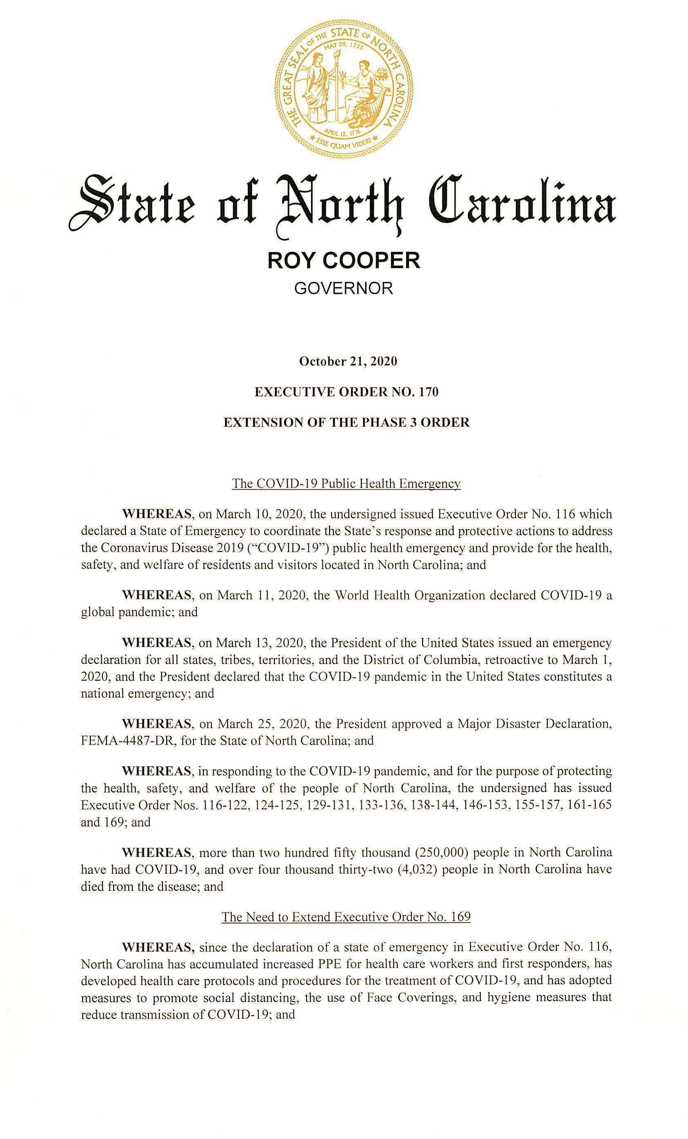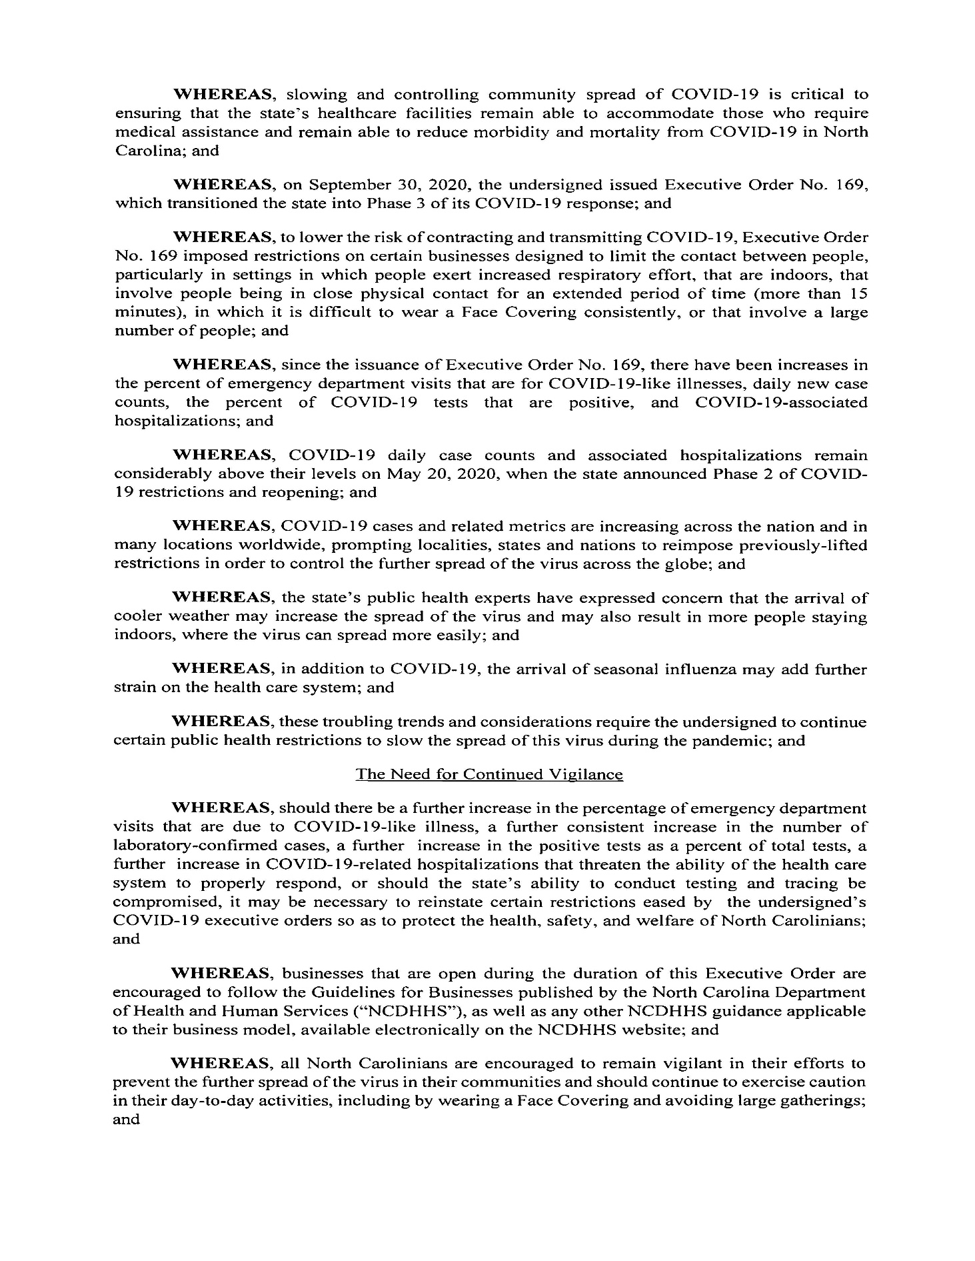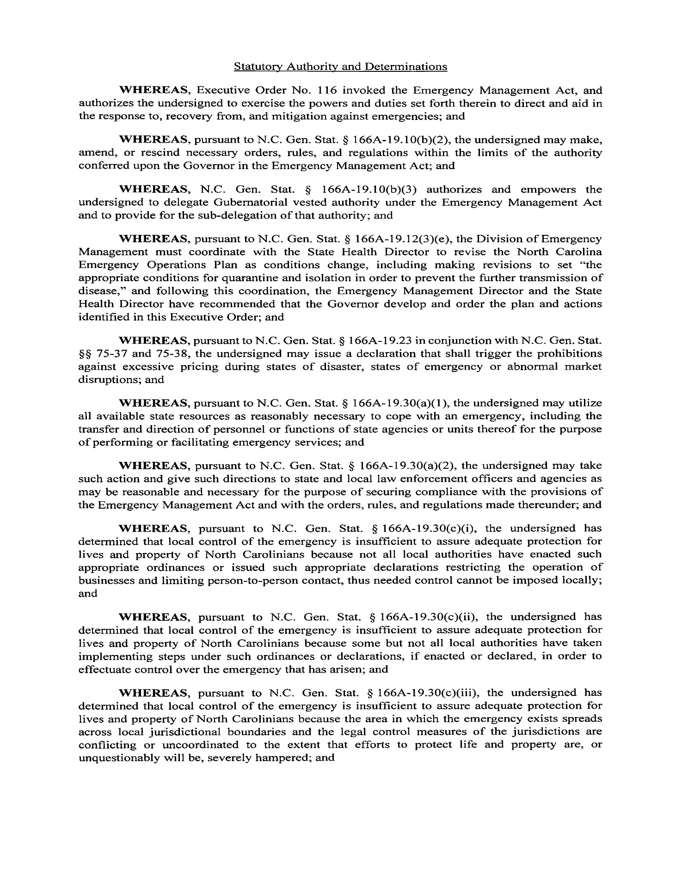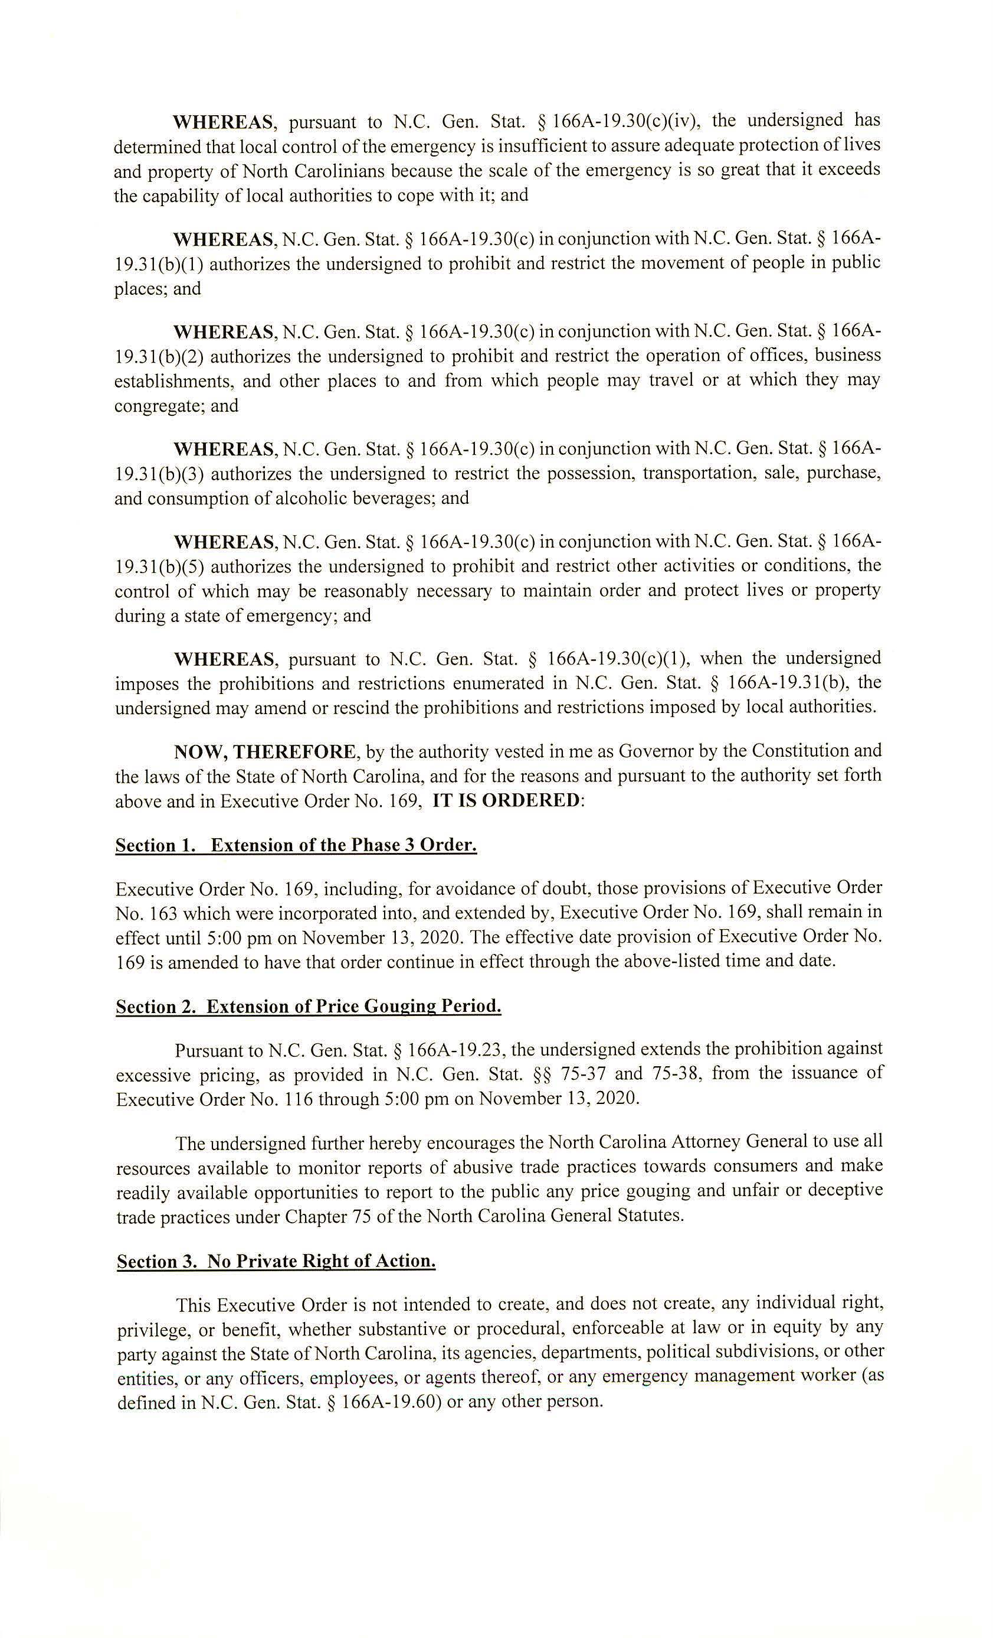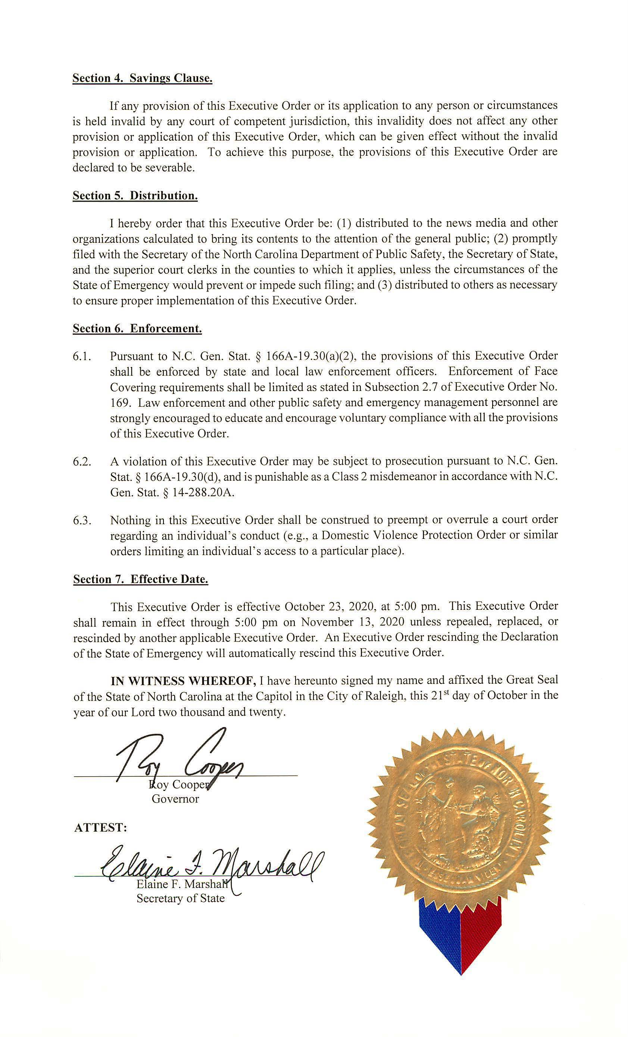

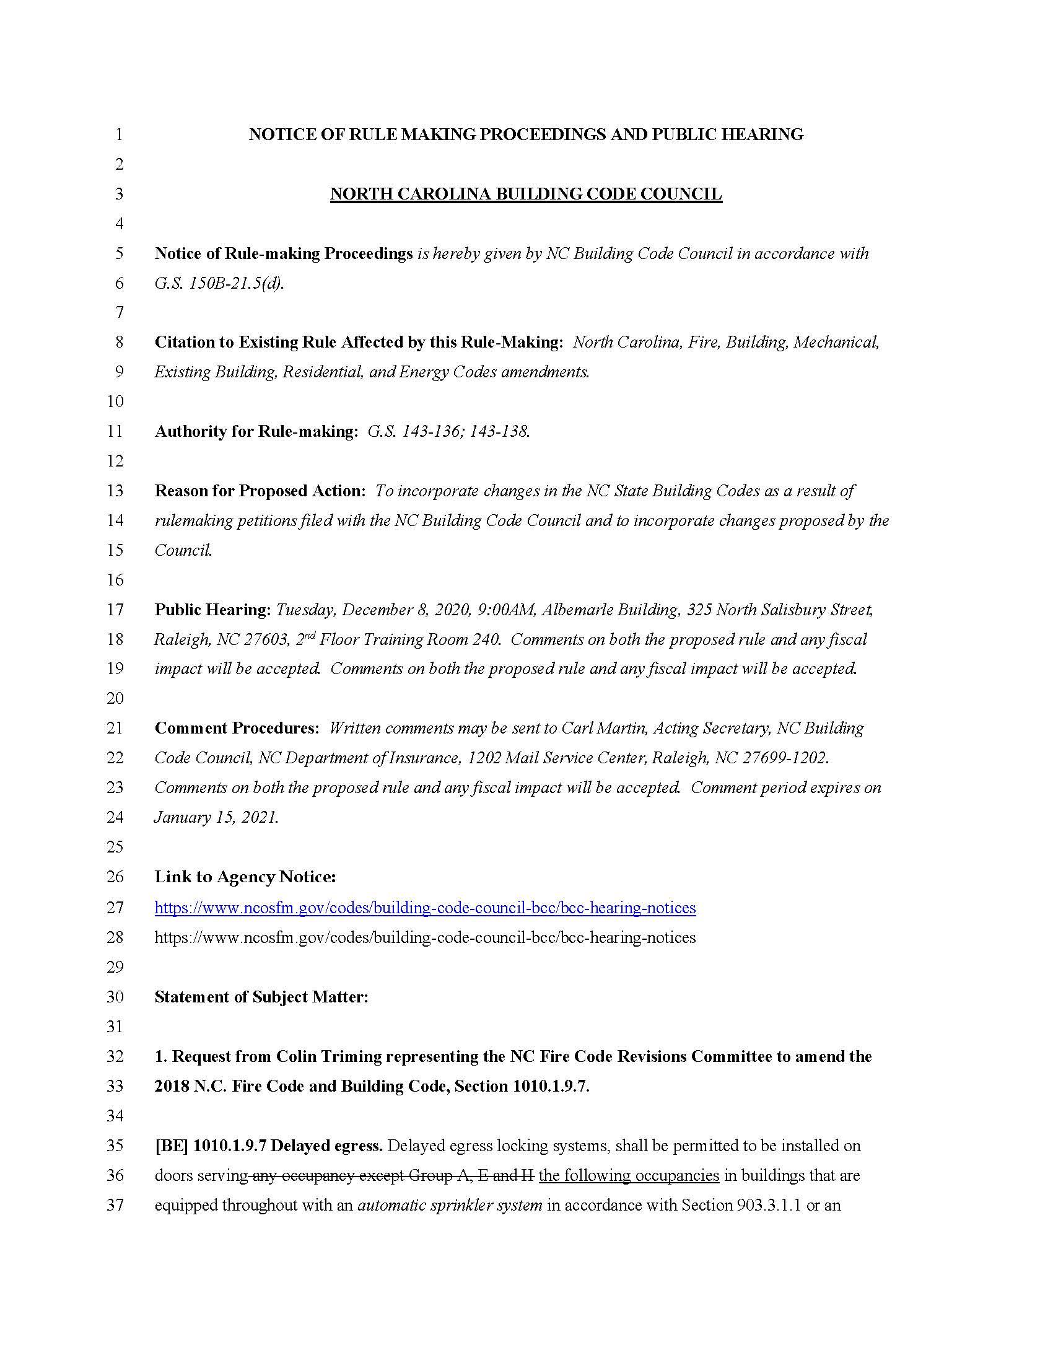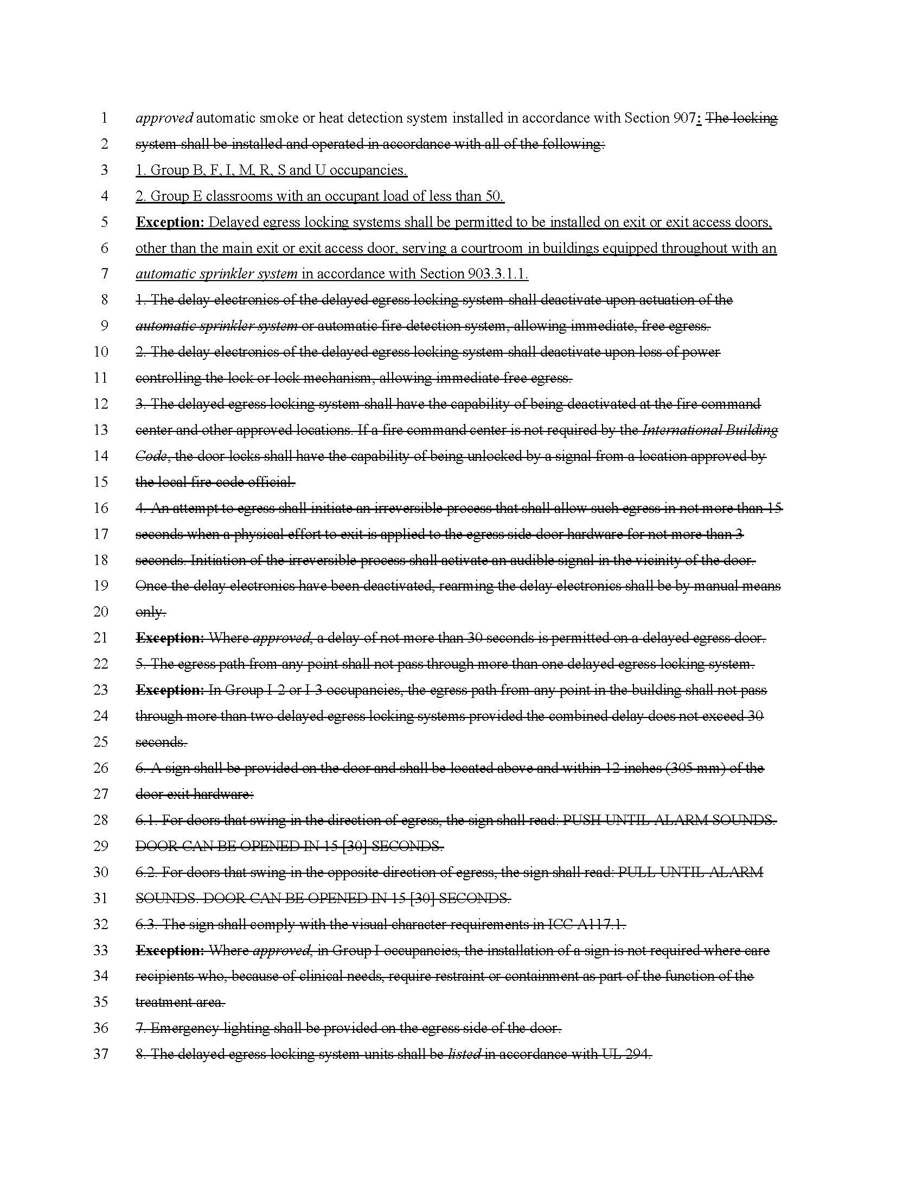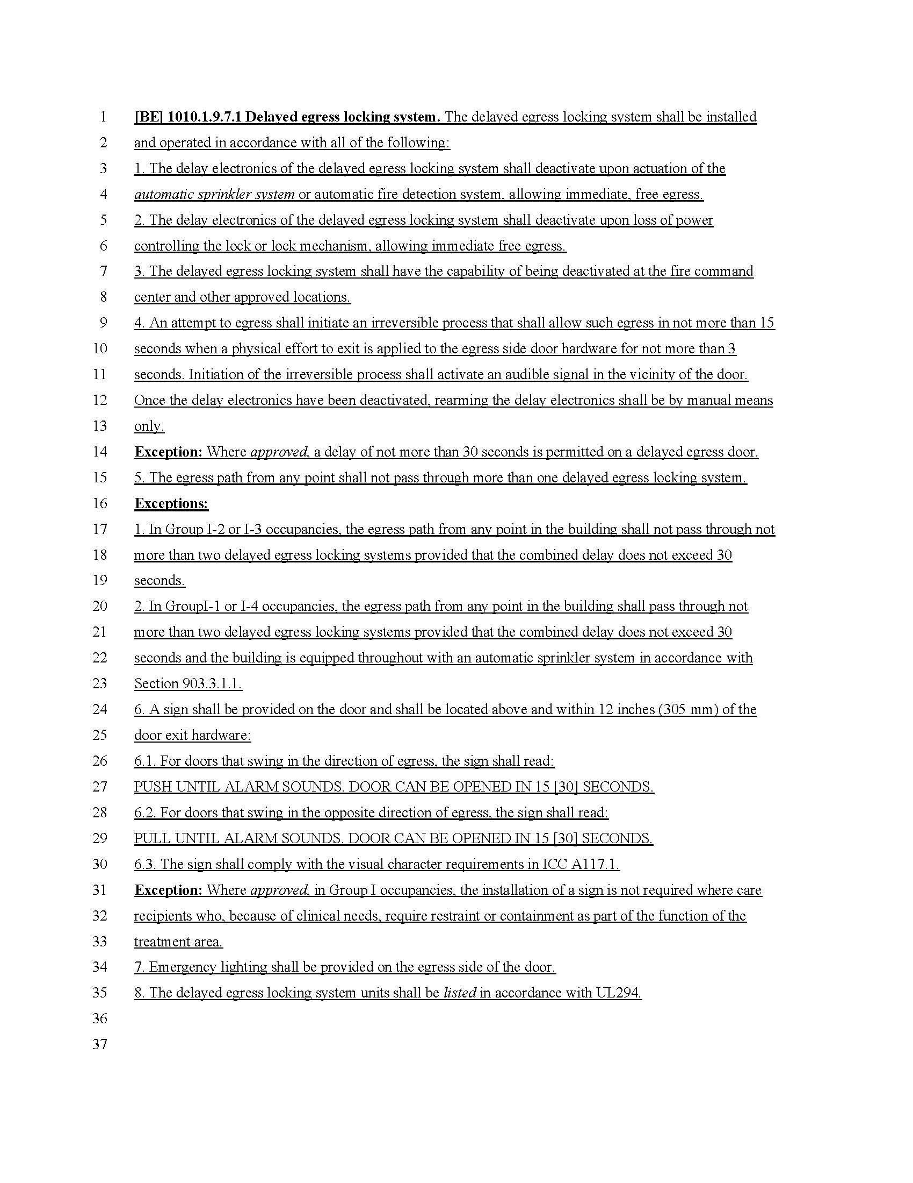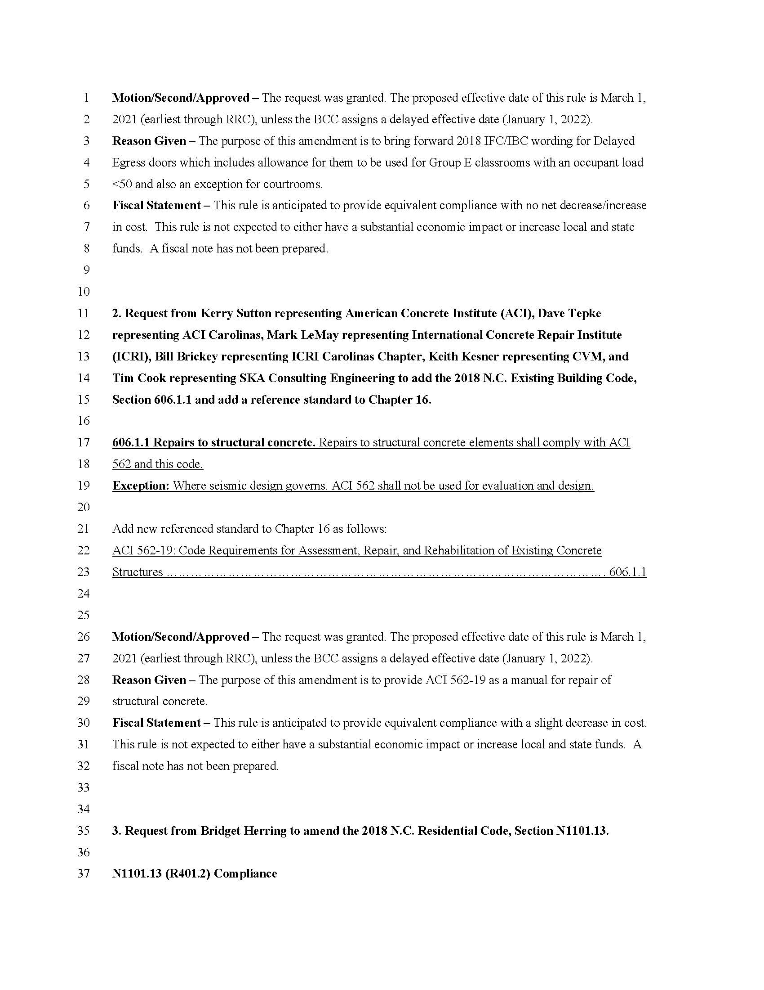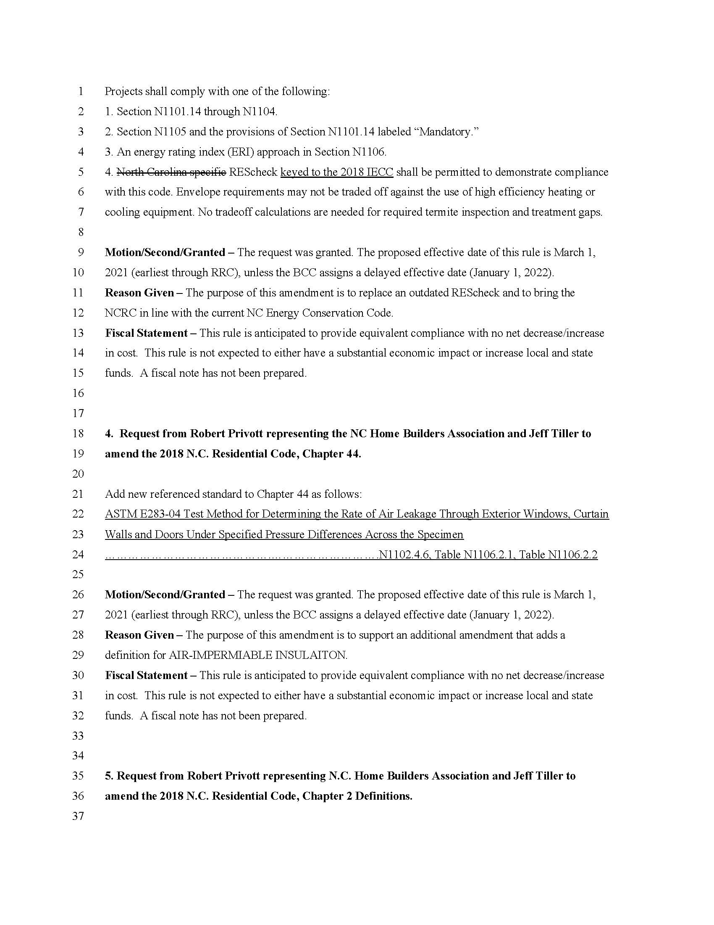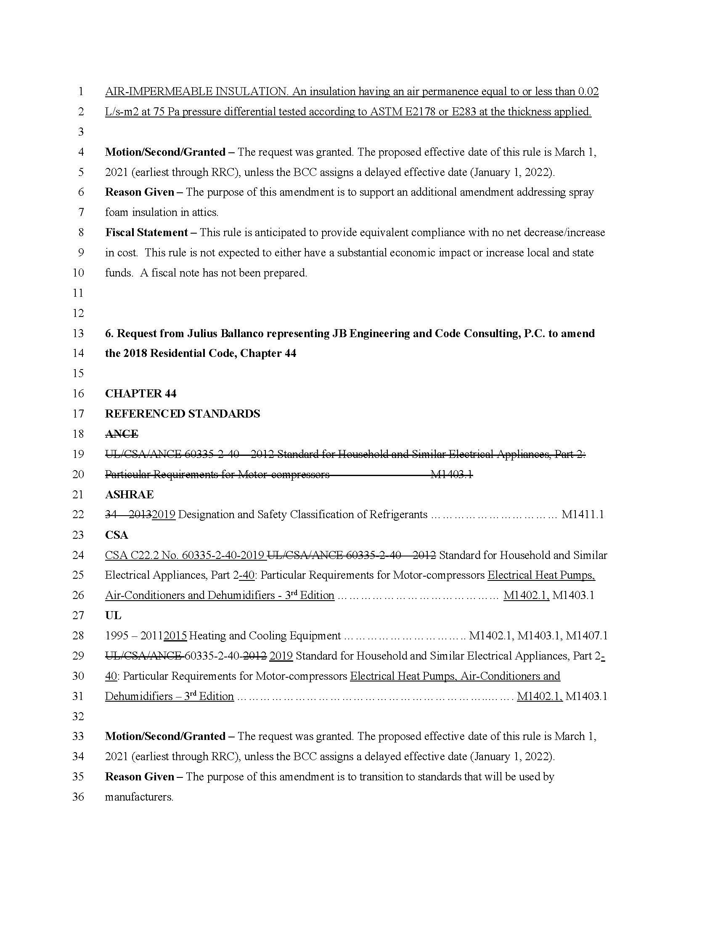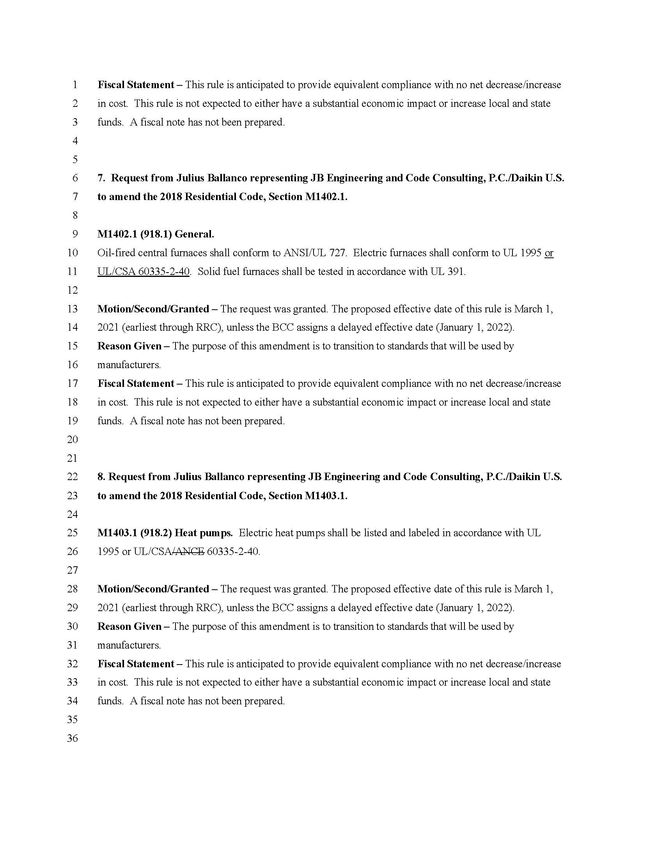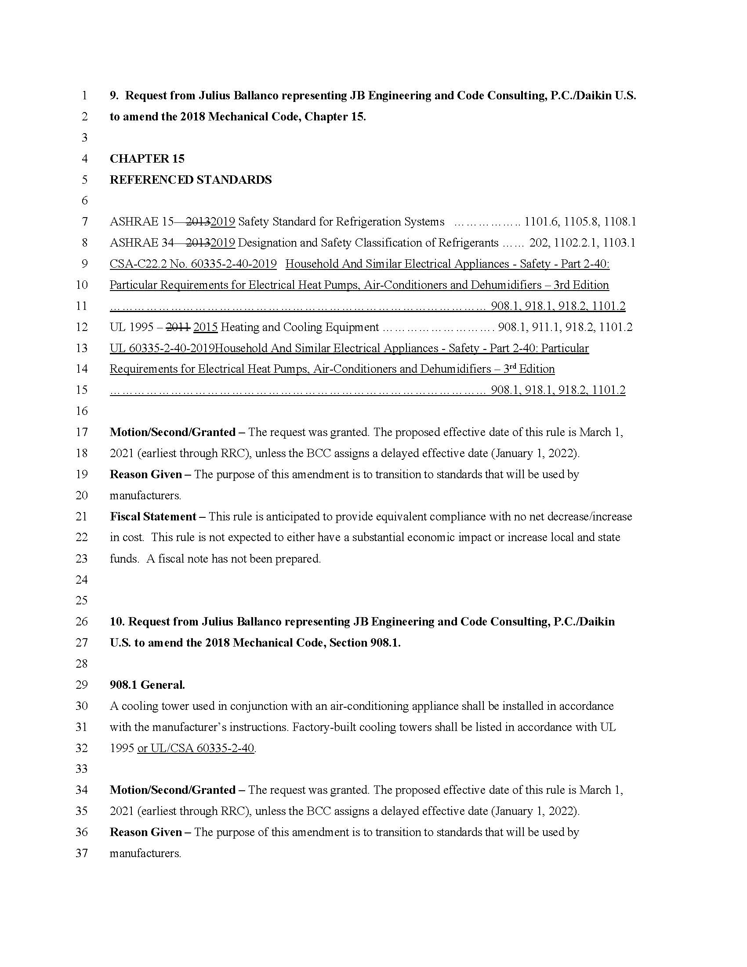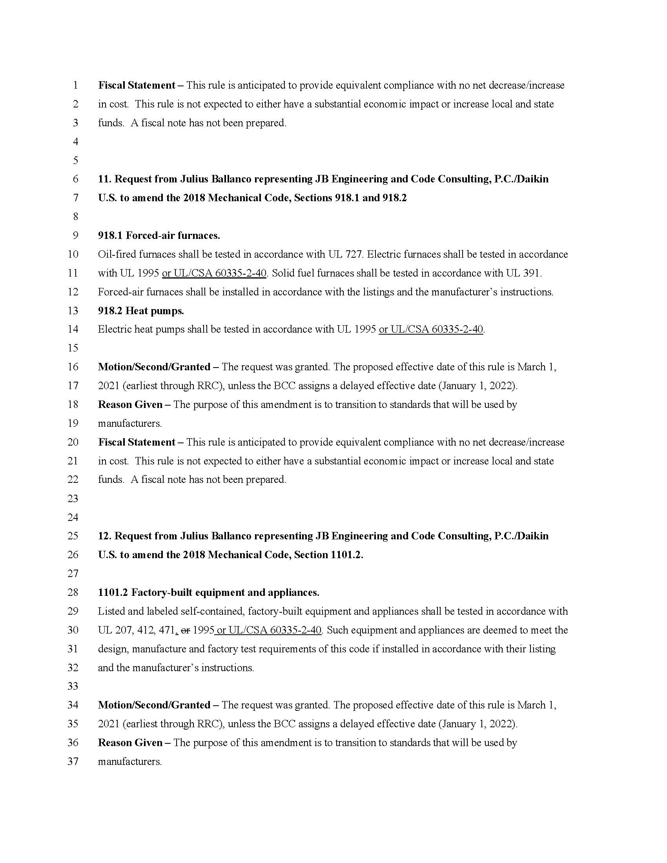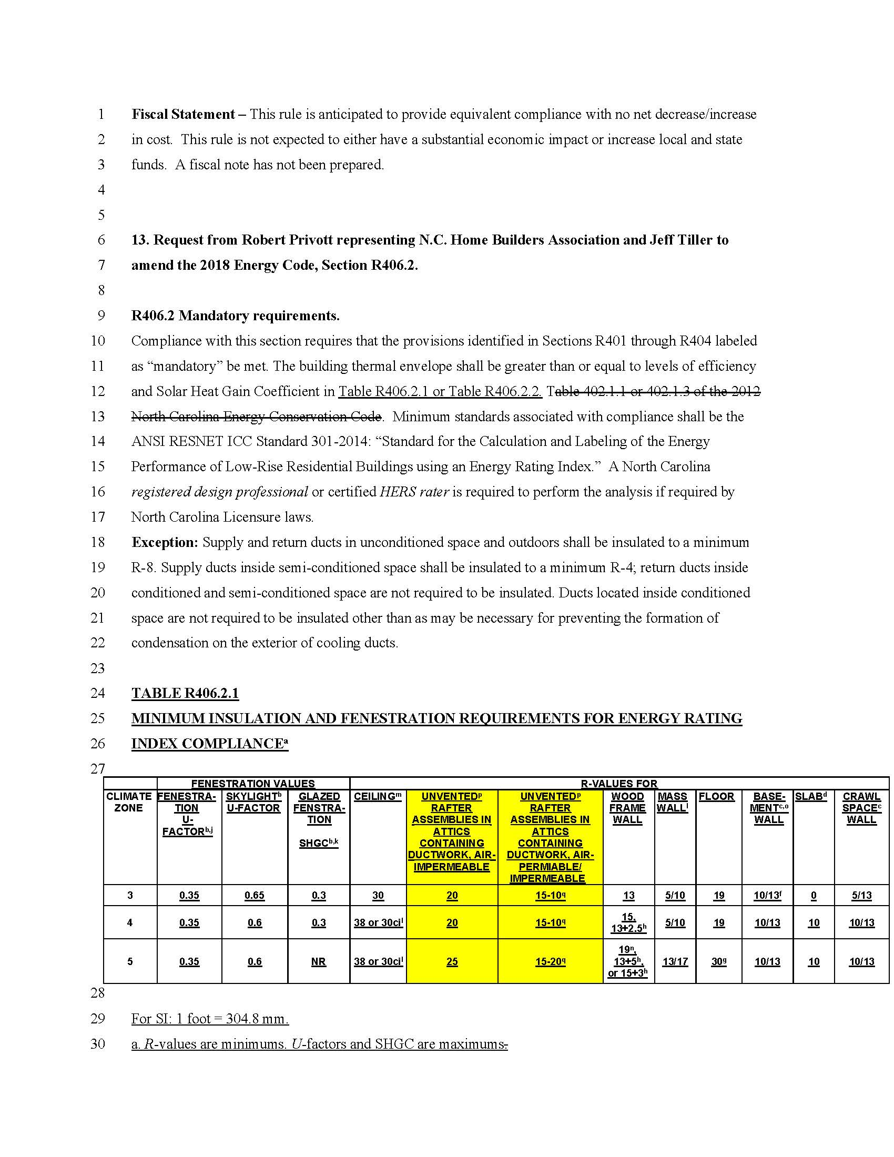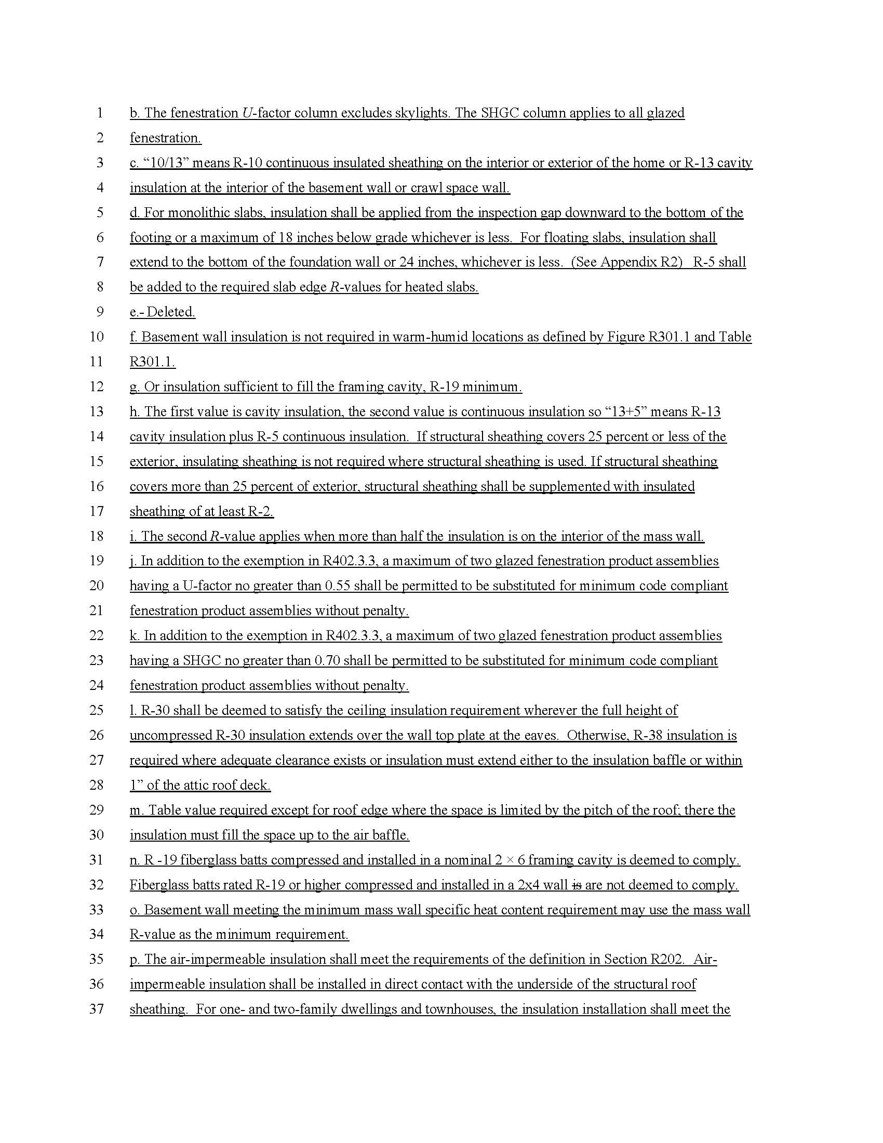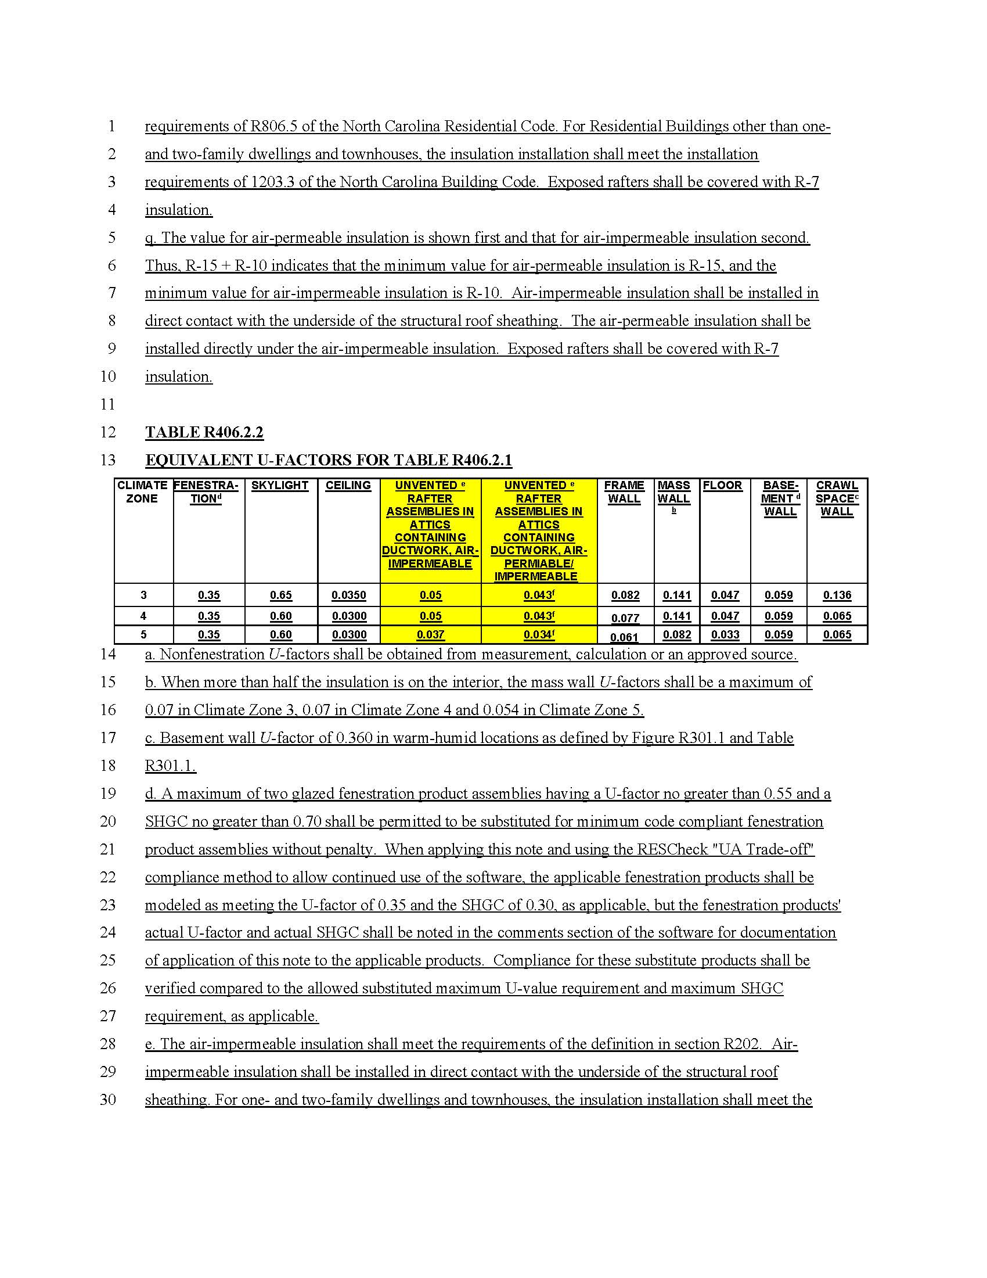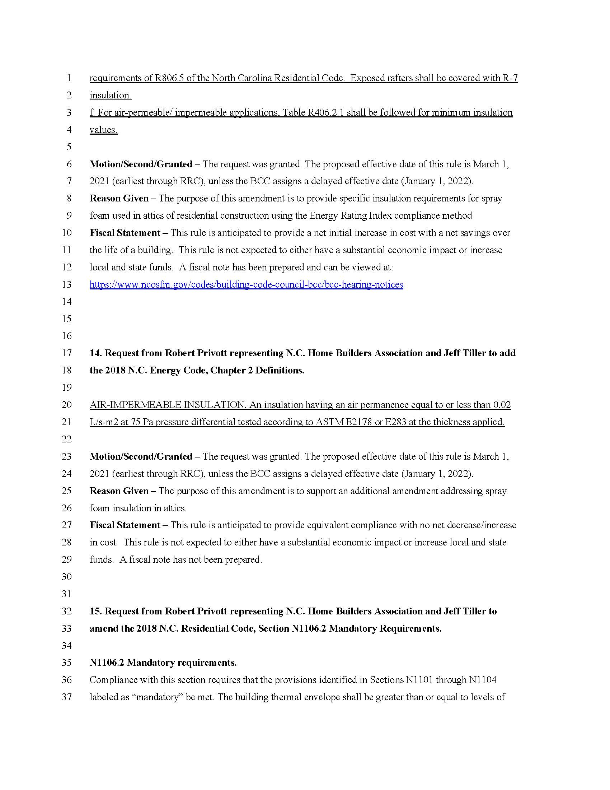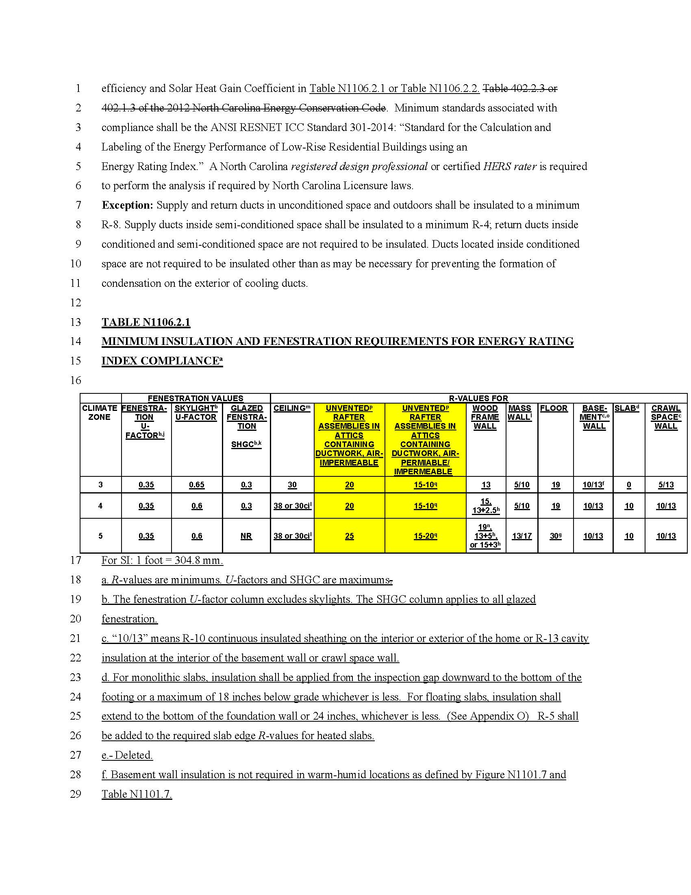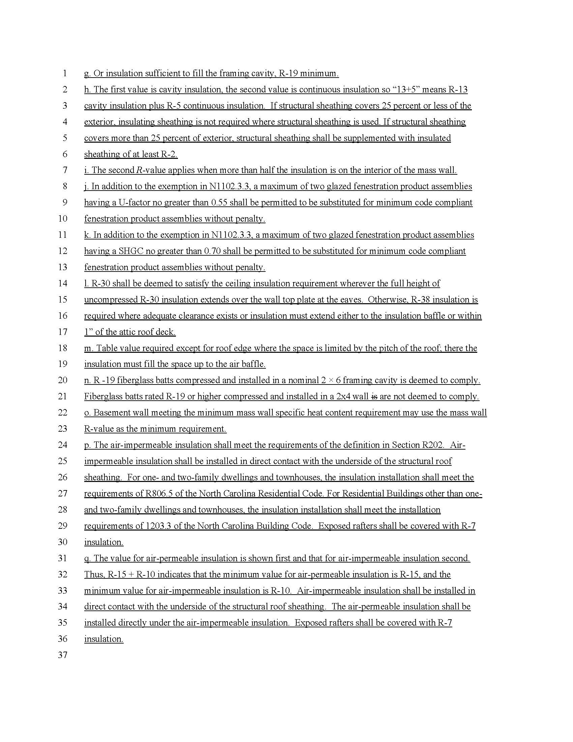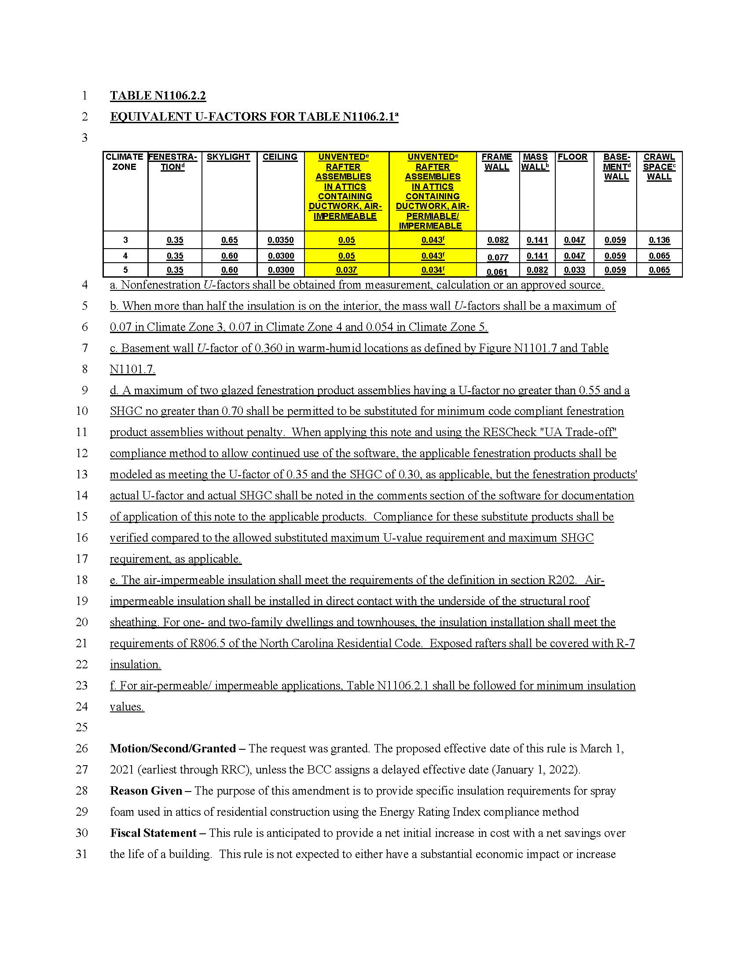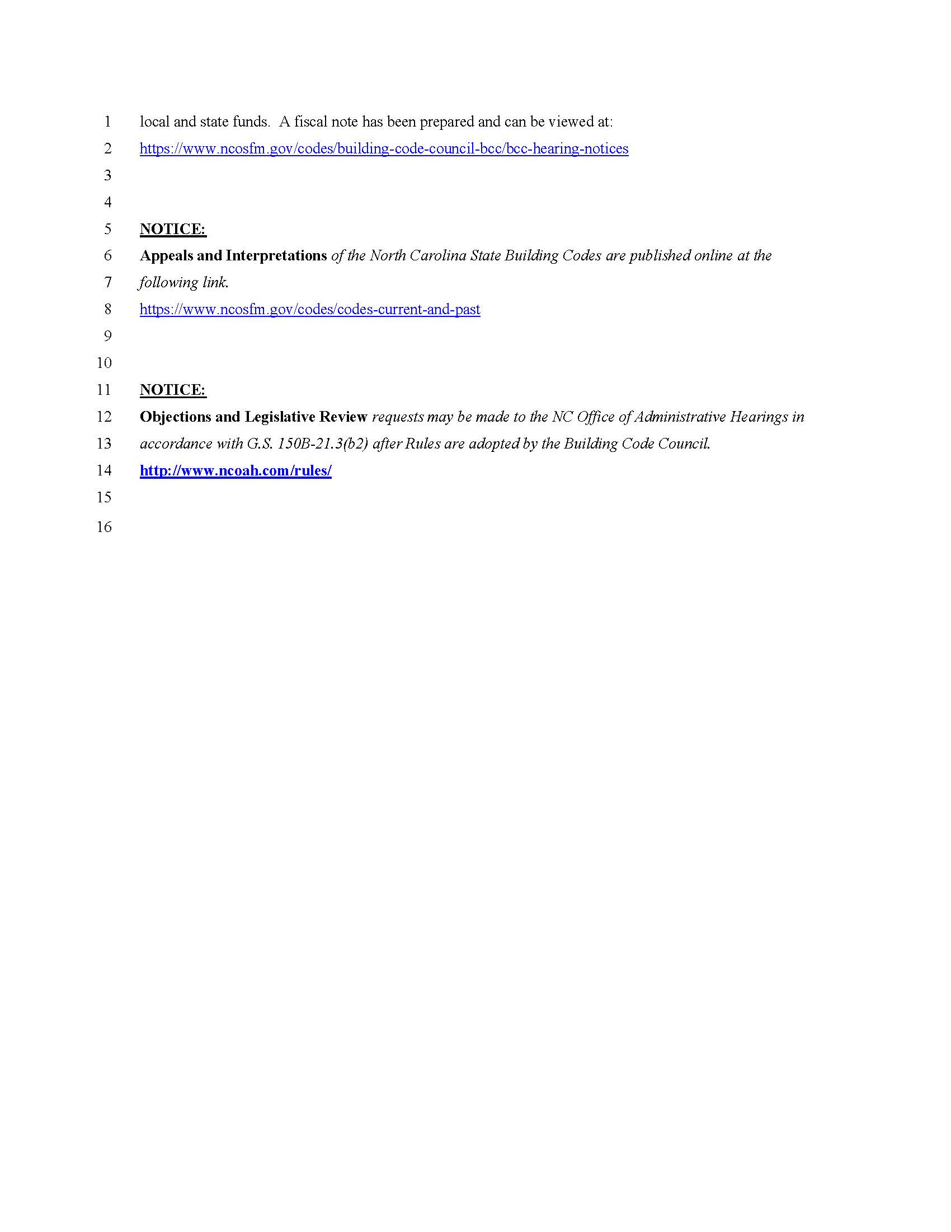

Note from the Codifier: The notices published in this Section of the NC Register include the text of proposed rules. The agency must accept comments on the proposed rule(s) for at least 60 days from the publication date, or until the public hearing, or a later date if specified in the notice by the agency. If the agency adopts a rule that differs substantially from a prior published notice, the agency must publish the text of the proposed different rule and accept comment on the proposed different rule for 60 days.
Statutory reference: G.S. 150B-21.2.

Title 15A – Department of Environmental Quality

Notice is hereby given in accordance with G.S. 150B-21.2 that the Wildlife Resources Commission intends to adopt the rules cited as 15A NCAC 10H .1501-.1509 and amend the rule cited as 15A NCAC 10B .0106.

Link to agency website pursuant to G.S. 150B-19.1(c): https://www.ncwildlife.org/Proposed-Regulations

Proposed Effective Date: May 1, 2021

Public Hearing:
Date: December 8, 2020
Time: 6:00 p.m.
Location: Register in advance for this webinar:
https://ncwildlife.zoom.us/webinar/register/WN_aXViRwRsTnGAPbHLaT3RZA or join by phone: (877-853-5247 or 888-788-0099) using Webinar ID: 928 5632 3468

Reason for Proposed Action: Session Law 2019-204 established the Wildlife Control Agent License and Alligator Control Agent Certification in statute. The rules proposed for adoption in this Section 10H .1500 will replace current agency rules for the Wildlife Damage Control Agent Program found in 10B .0106.

Because Wildlife and Alligator Control Agent Rules have been proposed, Rule 10B .0106 requires updates to remove the Wildlife Damage Control Agent Certification and requirements.

Comments may be submitted to: Rule-making Coordinator, 1701 Mail Service Center, Raleigh, NC 27699; email regulations@ncwildlife.org

Comment period ends: January 15, 2021

Procedure for Subjecting a Proposed Rule to Legislative Review: If an objection is not resolved prior to the adoption of the rule, a person may also submit written objections to the Rules Review Commission after the adoption of the Rule. If the Rules Review Commission receives written and signed objections after the adoption of the Rule in accordance with G.S. 150B-21.3(b2) from 10 or more persons clearly requesting review by the legislature and the Rules Review Commission approves the rule, the rule will become effective as provided in G.S. 150B-21.3(b1). The Commission will receive written objections until 5:00 p.m. on the day following the day the Commission approves the rule. The Commission will receive those objections by mail, delivery service, hand delivery, or facsimile transmission. If you have any further questions concerning the submission of objections to the Commission, please call a Commission staff attorney at 919-431-3000.

Fiscal impact. Does any rule or combination of rules in this notice create an economic impact? Check all that apply.

State funds affected

Local funds affected

Substantial economic impact (>= $1,000,000)

Approved by OSBM

No fiscal note required

Chapter 10 - Wildlife Resources and Water Safety

SUBCHAPTER 10B - HUNTING AND TRAPPING

SECTION .0100 - GENERAL REGULATIONS

15A NCAC 10B .0106 WILDLIFE TAKEN FOR DEPREDATIONS

(a) Depredation permits allow the taking of undesirable or excess wildlife resources as described in Subparagraphs (b)(1) and (b)(2) of this Paragraph. Only employees of the Wildlife Resources Commission (Commission) and Wildlife Damage Control Agents (WDCA) may issue depredation permits. Only depredation permits prepared on a form supplied by the Commission shall be valid. No permit is needed for the owner or lessee of a property to take wildlife while committing depredations on that property; however, the manner of taking, disposition of dead wildlife, and reporting requirements as described in this Rule still apply.

(a) Depredation permits shall authorize the taking, destruction, transfer, removal, transplanting, or driving away of undesirable, destructive, or excess wildlife or wildlife resources as specified in Paragraph (d) of this Rule.

(b) The following conditions shall apply to depredation permits:

(1) depredation permits shall be prepared on a form supplied by the Commission; and

(2) depredation permits shall only be issued by authorized employees of the Commission or licensed Wildlife Control Agents (WCA).

(c) Depredation permits shall not be required for the owner or lessee of a property to take wildlife while committing depredations on that property; however, the manner of take, disposition of dead wildlife, and reporting requirements specified in this Rule shall apply.

(b)(d) No permit shall be issued to take any endangered or threatened species of wildlife listed under 15A NCAC 10I, except alligators, by reason of depredations to property. Only the The Executive Director or his or her designee may issue depredation permits for Special Concern species listed in 15A NCAC 10I .0105 and for alligators. An individual may take an endangered or threatened species in immediate defense of his or her own life or of the lives of others without a permit. Any endangered or threatened species that may constitute a demonstrable but non-immediate threat to human safety shall be reported to a federal or Commission wildlife enforcement officer, who, upon verification of the report, may take or remove the specimen as provided by 15A NCAC 10I .0102. Depredation permits for other species may be issued under the following conditions:

(1) for taking wildlife that is or has been damaging or destroying property, provided there is evidence of property damage. No permit may be issued for the taking of migratory birds and other federally-protected animals unless a corresponding, valid U.S. Fish and Wildlife Service depredation permit(s), if required, has been issued. A permit issued pursuant to this Rule shall name the species allowed to be taken and may include limitations as to age, sex, type of depredation, location of animal or damage, and local laws. The permit shall be issued to a landholder or an authorized representative of a unit of local government for depredations on public property. The permit shall be used only by individuals named on the permit.

(2) for taking of wildlife resources in circumstances of overabundance or when the wildlife resources present a danger to human safety. Cities, as defined in G.S. 160A-1(2), seeking a depredation permit pursuant to these circumstances shall apply to the Commission using an application available from the Commission. The application shall include the following information:
(A) the name and location of the city;
(B) the acreage of the affected property;
(C) a map of the affected property;
(D) the signature of an authorized city representative;
(E) the nature of the overabundance or the threat to public safety; and
(F) a description of previous actions taken by the city to ameliorate the problem.

(c) Wildlife Damage Control Agents. Individuals meeting the following eligibility requirements may apply to become a Wildlife Damage Control Agent (WDCA):

(1) Successful completion of a training course that is designed to:
(A) review wildlife laws;
(B) review safe, humane wildlife handling techniques.

(2) No wildlife misdemeanor conviction, as specified in G.S. 113-294 that resulted in a license suspension or revocation, within the last five hears prior to application to become a WDCA.

Those individuals who demonstrate knowledge of wildlife laws and safe, humane wildlife handling techniques by a passing score of 80 percent or better on a written examination provided by a representative of the Commission, in cooperation with the training course provider, shall be approved. Those individuals failing to obtain a passing score shall be given one chance for re-testing without re-taking the course. Those individuals approved as agents by the Commission may then issue depredation permits for depredation as defined in Subparagraph (a)(1) of this Rule to landholders and be listed as a second party to provide the control service. WDCAs may not issue depredation permits for coyotes in the counties of Beaufort, Dare, Hyde, Tyrrell, Washington; big game animals; bats; or any species listed as endangered, threatened, or special concern under 15A NCAC 10I .0103, .0104, and .0105 of this Chapter. WDCAs shall annually report to the Commission the number and disposition of animals by county. Records shall be available for inspection by a wildlife enforcement officer at any time during the posted business hours of the Commission at ncwildlife.org. The Executive Director shall revoke WDCA status when there is evidence of violations of wildlife laws, failure to report, or inhumane treatment of animals by the WDCA. A WDCA may not charge for the permit, but may charge for his or her investigations and control services. Each WDCA shall renew his or her agent status every three years by showing proof of having attended at least one training course provided for the purpose of reviewing and updating information on wildlife laws and safe, humane wildlife handling techniques within the previous 12 months or agency approved continuing education credits.

(d)(e) Each depredation permit shall have an expiration date or time after which the depredation permit is no longer valid. date. The A depredation permit authorizes the possession of any wildlife resources taken under the authority of the permit permit. and Depredation permits shall be retained as long as the wildlife resource is in the permittee's authorized individual's possession. All individuals Individuals taking wildlife resources under the authority of a depredation permit shall comply with the conditions written on of the permit and the requirements specified in this Rule.

(e)(f) Manner of Taking:

(1) Taking Without a Permit. Wildlife taken without a permit while committing depredations to property may, during the open season on the species, be taken by the landholder by any lawful method. During the closed season, such depredating wildlife may be taken without a permit only by the use of firearms or archery equipment as defined in 15A NCAC 10B .0116.

(2) Taking With a Permit. Wildlife taken under a depredation permit may be taken only by the method or methods authorized by the permit. When trapping is authorized, in order to limit the taking to the intended purpose, the permit may specify a reasonable distance from the property sought to be protected, within which the traps shall be set. The Executive Director, Commission employee, or agent WCA may also state in a permit authorizing trapping whether or not bait or lure may be used and the type of bait or lure that is authorized based upon factors such as type of depredation, locations of animal or damage, and local laws. In addition to any trapping restrictions that may be contained in the permit, the method of trapping shall be in accordance with the requirements and restrictions imposed by G.S. 113-291.6 and other local laws passed by the General Assembly. No depredation permit shall authorize the use of poisons or pesticides in taking wildlife except in accordance with the provisions of the North Carolina Pesticide Law of 1971, G.S. 143, Article 52, the Structural Pest Control Act of 1955, G.S. 106, Article 4C, and G.S. 113, Article 22A. No depredation permit shall authorize the taking of wildlife by any method by any landholder upon the lands of another except when the individual is listed as a second party on a depredation permit.

(3) Intentional Wounding. It is unlawful for any landholder, with or without a depredation permit, to intentionally wound a wild animal in a manner so as not to cause its immediate death as suddenly and humanely as the circumstances permit.

(f)(g) Disposition of Wildlife Taken:

(1) Generally. Except as provided by Subparagraphs (2) through (5) of this Paragraph, any wildlife killed without a permit while committing depredations shall be buried or disposed of in a safe and sanitary manner on the property where taken. Wildlife killed under a depredation permit may be transported to an alternate disposal site if desired. Anyone in possession of carcasses of animals being transported under a depredation permit shall have the depredation permit in his or her possession. Except as provided by Subparagraphs (f)(2) through (5) of this Rule, (2) through (5) of this Paragraph, all wildlife killed under a depredation permit shall be buried or otherwise disposed of as stated on the permit.

(2) Deer and feral swine. The edible portions of feral swine and deer may be retained by the landholder for consumption but shall not be transported from the property where the depredations took place without a valid depredation permit. The landholder may give a second party the edible portions of feral swine or deer taken under a depredation permit. The receiver of the edible portions shall hold a copy of the depredation permit. The nonedible portions of any deer carcass, including head, hide, feet, and antlers, shall be disposed of as specified in Subparagraph (1) of this Paragraph or turned over to a wildlife enforcement officer for disposition.

(3) Fox. Any fox killed under a depredation permit may be disposed of as described in Subparagraph (1) of this Paragraph or, upon compliance with the fur tagging requirements of 15A NCAC 10B .0400, the carcass or pelt thereof may be sold to a licensed fur dealer.

(4) Furbearing Animals. The carcass or pelt of any furbearing animal killed during the open season for taking such furbearing animal for control of depredations to property, whether with or without a permit, may be sold to a licensed fur dealer provided that the person offering such carcass or pelt for sale has a valid hunting or trapping license; provided further that bobcats and otters may only be sold upon compliance with any required fur tagging requirement set forth in 15A NCAC 10B .0400.

(5) Animals Taken Alive. Wild animals in the order Carnivora, armadillos, groundhogs, nutria, and beaver shall be humanely euthanized either at the site of capture or at a facility designed to humanely handle the euthanasia, or such wild animals must be released on the property where captured. Feral swine shall be euthanized while still in the trap in accordance with G.S. 113-291.12. For all other animals taken alive, the animal shall be euthanized or released on property with permission of the landowner. When the relocation site is public property, written permission shall be obtained from the local, state, or federal official authorized to manage the property before any animal may be released. Animals transported or held for euthanasia shall be euthanized within 12 hours of capture. possession. Anyone in possession of live animals being transported for relocation or euthanasia under a depredation permit shall have the depredation permit in his or her possession.

(g)(h) Reporting Requirements. Any landholder who kills an alligator; coyote in the counties of Beaufort, Dare, Hyde, Tyrrell, or Washington; deer; Canada goose; bear; elk; or wild turkey under a valid depredation permit shall report the kill on the form provided with the permit, including the number and species of animal(s) killed, and submit the form upon the expiration date of the depredation permit to the Commission. Any landowner who kills a coyote in the counties of Beaufort, Dare, Hyde, Tyrrell, and Washington shall report the kill, including the number of coyotes killed, on the form provided with the depredation permit. The killing and method of disposition of every alligator; coyote in the counties of Beaufort, Dare, Hyde, Tyrrell, and Washington; bear; or elk taken without a permit shall be reported to the Wildlife Resources Commission within 24 hours following the time of such killing.

(i) Exemption for Animal Control Officers. Animal Control Officers, as defined by G.S. 130A-184(1) when in the performance of official duties, shall be exempt from obtaining a depredation permit when taking wild animals that:

(1) Exhibit visible signs of rabies;

(2) Exhibit unprovoked aggression that may be associated with rabies;

(3) Are suspected to be rabid; or

(4) Have or may have exposed humans, pets, or livestock to rabies.

Authority G.S. 113-134; 113-273; 113-274; 113-291.4; 113-291.6; 113-300.1; 113-300.2; 113-307; 113-331; 113-333; 113-334(a); 113-337.

SUBCHAPTER 10H – REGULATED ACTIVITIES

SECTION .1500 - WILDLIFE AND ALLIGATOR CONTROL AGENTS

15A NCAC 10H .1501 Wildlife Control Agent License Eligibility and Requirements

(a) The following definitions shall apply in this Section:

(1) "Wildlife control agent" or "WCA" means an individual that holds a current and valid wildlife control agent license issued by the Commission.

(2) "Wildlife control agent license" or "WCA license" means a license issued by the Commission that authorizes an individual to engage in wildlife damage control or wildlife removal activities by means of a depredation permit.

(b) It shall be unlawful to engage in wildlife damage control or wildlife removal activities for compensation, including eviction or exclusion activities, without first obtaining a wildlife control agent (WCA) license from the Commission, except that licensed trappers taking wild animals during the applicable open trapping season for that species shall not be required to obtain a WCA license.

(c) Individuals meeting the following requirements shall qualify for a WCA license:

(1) completion of a Commission-approved, WCA training course, that reviews the following:
(A) wildlife laws and rules, including methods of take, trapping, and depredation; and
(B) safe, humane wildlife handling techniques.

(2) a passing score of at least 80 percent on the WCA examination as specified in Paragraph (e) of this Rule.

(3) no wildlife misdemeanor convictions, as specified in G.S. 113-294 or G.S. 14, Article 47, that resulted in a license suspension or revocation within the five years preceding completion of the WCA training course.

(d) Individuals may register for a Commission-approved training course at www.ncwildlife.org/wca. Required information shall include the following:

(1) the applicant's name, mailing address, email address, residence address, telephone number, driver's license number, and date of birth; and

(2) organizational affiliation, if applicable.

(e) Individuals scoring at least an 80 percent on the WCA examination provided by the Commission shall be deemed to have received a passing score and to have successfully demonstrated knowledge of wildlife laws and safe, humane wildlife handling techniques. Individuals failing to obtain a passing score on the WCA examination shall receive one opportunity to re-take the examination and receive a passing score without being required to retake the WCA training course.

(f) A WCA license shall not be transferable between individuals.

Authority G.S. 113-134; 113-273; 113-274.

15A NCAC 10H .1502 Depredation Permits Issued by Wildlife Control Agents

(a) WCAs may issue depredation permits to landholders and may be listed as a second party on the permit to provide wildlife damage control or wildlife removal services. Depredation permits shall be issued and administered in accordance with the applicable provisions and requirements of 15A NCAC 10B .0106.

(b) WCAs shall not issue depredation permits for the following:

(1) any endangered, threatened, or special concern species listed in 15A NCAC 10I .0103 - .0105;

(2) coyotes in Beaufort, Dare, Hyde, Tyrrell, or Washington counties;

(3) big game animals, including Black Bear, White-tail Deer, and Wild Turkey;

(4) elk; and

(5) bats.

(c) WCAs shall be authorized to issue depredation permits for the taking of wildlife not prohibited in Paragraph (b) of this Rule, provided there is evidence that the wildlife is or has been damaging or destroying property.

(d) Depredation permits shall not be issued for the taking of migratory birds unless a corresponding, valid U.S. Fish and Wildlife Service depredation permit, as required by 50 CFR 21.41, has been obtained, if required.

(e) WCAs shall not receive compensation for the issuance of depredation permits; however, nothing in this Section shall be construed to limit the ability of a WCA to receive compensation for investigations or wildlife damage control and removal services.

Authority G.S. 113-134; 113-273; 113-274.

15A NCAC 10H .1503 Manner of Take

(a) WCAs shall comply with applicable manner of taking and disposition of wildlife requirements specified in 15A NCAC 10B .0106.

(b) A WCA license number shall be equivalent to a trapper identification number for the purpose of meeting trap identification requirements specified in G.S. 113-291.6(b)(4) for all trap types used.

(c) WCAs may only engage in bat eviction and exclusion activities from August 1 through April 30 of the next calendar year unless otherwise approved by the Commission, on a case-by-case basis, for reasons of public health and safety, species conservation, or animal health.

Authority G.S. 113-134; 113-273; 113-274.

15A NCAC 10H .1504 Records and Reporting Requirements

(a) WCAs shall maintain the following records:

(1) a copy of each depredation permit issued; and

(2) the species, number, and disposition of each animal taken, organized by county.

(b) WCAs shall submit the following information to the Commission each calendar quarter for each animal taken pursuant to a depredation permit:

(1) depredation permit number and date of issue of the permit that authorized take;

(2) WCA license number;

(3) county where permit issued;

(4) type of damage;

(5) species;

(6) number of animals estimated to be taken;

(7) number of animals taken;

(8) method of take; and

(9) disposition of animal.

(c) Records shall be available for inspection by representatives of the Commission upon request or during the Commission's business hours.

(d) Records shall be retained by the WCA for 12 months following expiration of the WCA license.

Authority G.S. 113-134; 113-273; 113-274.

15A NCAC 10H .1505 Wildlife Control Agent License Renewal and Revocation

(a) A WCA may renew his or her WCA license by completing at least one Commission-approved continuing education course within the previous year. A list of Commission-approved continuing education courses may be found at www.ncwildlife.org/wca.

(b) WCAs that do not renew their license for two consecutive calendar years shall be ineligible for renewal and shall be required to repeat the requirements specified in 15A NCAC 10H .1501, prior to obtaining a new WCA license.

(c) The Executive Director or his or her designee, may warn, cite, or revoke a WCA's license, if the WCA violates any provision of G.S. 14, Article 47; G.S. 113, Subchapter IV; any rules promulgated by the Commission; conditions of the WCA license; or standards taught in a Commission-approved WCA training course. The determination whether to warn, cite, or revoke a WCA's wildlife control agent license shall be based upon the seriousness of the violation.

Authority G.S. 113-134; 113-273; 113-274.

15A NCAC 10H .1506 Alligator Control Agent Certification Eligibility and Requirements

(a) The following definitions shall apply in this Section:

(1) "Alligator control agent" or "ACA" means a licensed Wildlife Control Agent that holds a current and valid alligator control agent certification issued by the Commission.

(2) "Alligator control agent certification" or "ACA certification" means a certification issued by the Commission that authorizes a Wildlife Control Agent to engage in alligator damage control or alligator removal activities by means of a Commission-issued depredation permit.

(b) It shall be unlawful to engage in alligator damage control or alligator removal activities for compensation without first obtaining an alligator control agent (ACA) certification from the Commission.

(c) Only individuals with a valid WCA license shall be eligible for ACA certification.

(d) WCAs meeting the following requirements shall qualify for ACA certification:

(1) completion of a Commission-approved ACA training course that reviews the following:
(A) alligator regulations;
(B) procedures for alligator data collection activities; and
(C) safe, humane alligator capture, handling, and transporting techniques.

(2) a passing score on the ACA written examination as specified in Paragraph (d) of this Rule.

(3) demonstration to the Commission of necessary equipment to safely and humanely capture and relocate alligators, including ropes, cables, snares, poles, passive integrated transponder (PIT) tag reader, and an alligator transport device.

(e) WCAs may register for a Commission-approved ACA training course at www.ncwildlife.org/wca

(f) WCAs scoring at least an 80 percent on the ACA examination provided by the Commission shall be deemed to have received a passing score. WCAs failing to obtain a passing score on the examination shall receive one opportunity to re-take the examination and receive a passing score without being required to retake the ACA training course.

(g) An ACA certification shall not be transferable between individuals.

Authority G.S. 113-134; 113-273; 113-274.

15A NCAC 10H .1507 Additional Permit Requirements for Alligator Control Agents

(a) ACAs shall obtain an endangered species permit from the Commission each calendar year prior to conducting any alligator handling and relocation activities.

(b) ACAs shall only handle alligators after a separate depredation permit for each alligator has been issued from a representative of the Commission.

(c) In emergency situations, where an alligator must be moved without delay due to a current or imminent threat to human safety, the safety of the alligator, or disruption of traffic, ACAs shall obtain an authorization code from a representative of the Commission prior to conducting any alligator handling and relocation activities. Authorization codes may be obtained from Commission District Biologists or by contacting the Commission's communications center at 1-800-662-7137 to be directed to an appropriate Commission representative.

Authority G.S. 113-134; 113-273; 113-274.

15A NCAC 10H .1508 Alligator Control Agent Records and Reporting Requirements

(a) ACAs shall maintain alligator datasheets for each alligator handled or relocated, which shall include the following information:
(1) dates and times of capture and release;
(2) the GPS locations of the capture and release sites;
(3) PIT tag number inserted or found upon scanning;
(4) scute numbers removed;
(5) total length and snout-to-vent length measurements;
(6) gender as determined by cloacal examination;
(7) general observations on physical condition including any injuries observed; and
(8) the Commission-issued depredation permit number or authorization code.

(b) ACAs shall follow the reporting requirements on the endangered species permit.

(c) Records shall be available for inspection by representatives of the Commission upon request or during the Commission's business hours.

(d) Records shall be retained by the ACA for 12 months following expiration of the ACA certification.

Authority G.S. 113-134; 113-273; 113-274.

15A NCAC 10H .1509 Alligator Control Agent Certification Renewal and Revocation

(a) An ACA may renew his or her alligator control agent certification by certifying proof of attending at least one Commission-approved alligator-specific continuing education course within the previous year. A list of Commission-approved renewal courses may be found at www.ncwildlife.org.

(b) ACAs shall maintain a valid WCA license at all times.

(c) The Executive Director or his or her designee may warn, cite, suspend, or revoke an ACA's certification, if the ACA violates any provision of G.S. 14, Article 47, or G.S. 113, Subchapter IV, or any rules promulgated by the Commission; conditions of the certification; or standards taught in a Commission-approved ACA training course. The determination whether to warn, cite, suspend, or revoke an ACA's certification shall be based upon the seriousness of the violation.

Authority G.S. 113-134; 113-273; 113-274.

Title 21 - Occupational Licensing Boards and Commissions

Chapter 32 - North Carolina Medical Board

Notice is hereby given in accordance with G.S. 150B-21.2 that the Medical Board intends to adopt the rules cited as 21 NCAC 32B .1708; and 32M .0119.

Link to agency website pursuant to G.S. 150B-19.1(c): www.ncmedboard.org/about_the_board/rule_changes

Proposed Effective Date: April 1, 2021

Public Hearing:
Date: January 15, 2021
Time: 10:00 am
Location: Public Hearing will be held via teleconference: 1-919-518-9840;Conference ID: 932 383 181#

Reason for Proposed Action: On March 10, 2020, the Governor of North Carolina, by issuing Executive Order No. 116, declared a state of emergency to coordinate a response and enact protective measures to help prevent the spread of COVID-19. COVID-19 is respiratory disease that can result in serious illness or death. COVID-19, previously unidentified in humans, spreads easily from person to person. Once an outbreak of COVID-19 begins, it is difficult to contain. The World Health Organization, the Center for Disease Control and Prevention, and the United States Department of Health and Human Services have declared COVID-19 a public health threat and emergency. The search for potential treatments for COVID-19 has caused shortages and threatens to cause further shortages in certain drugs. On March 24, 2020, the North Carolina State Health Director requested that the Medical Board, the Board of Nursing and the Board of Pharmacy adopt the COVID-19 Drug Preservation Rule in order to alleviate shortages and ensure that these drugs are available to patients who need them. This rule was adopted as an emergency and then a temporary rule. The State Health Director has requested that the rule be adopted as a permanent rule because the state of emergency and corresponding potential drug shortages now may potentially extend beyond the expiration of the temporary rule. The Board intends to repeal the rule upon the conclusion of the state of emergency. The State Health Director has determined that the State is unlikely to suffer future shortages of two of the drugs previously listed in the temporary and emergency rule, and that those drugs may be removed from the list, while the others should remain.

Note: The underlined and struck through text are changes from the temporary rule currently in effect, to the proposed permanent rule.

Comments may be submitted to: Wanda Long, P.O. Box 20007, Raleigh, NC 27619-0007; email rules@ncmedboard.org

Comment period ends: January 15, 2021

Procedure for Subjecting a Proposed Rule to Legislative Review: If an objection is not resolved prior to the adoption of the rule, a person may also submit written objections to the Rules Review Commission after the adoption of the Rule. If the Rules Review Commission receives written and signed objections after the adoption of the Rule in accordance with G.S. 150B-21.3(b2) from 10 or more persons clearly requesting review by the legislature and the Rules Review Commission approves the rule, the rule will become effective as provided in G.S. 150B-21.3(b1). The Commission will receive written objections until 5:00 p.m. on the day following the day the Commission approves the rule. The Commission will receive those objections by mail, delivery service, hand delivery, or facsimile transmission. If you have any further questions concerning the submission of objections to the Commission, please call a Commission staff attorney at 919-431-3000.

Fiscal impact. Does any rule or combination of rules in this notice create an economic impact? Check all that apply.

State funds affected

Local funds affected

Substantial economic impact (>= $1,000,000)

Approved by OSBM

No fiscal note required

SUBCHAPTER 32B – LICENSE TO PRACTICE MEDICINE

SECTION .1700 – OTHER LICENSES

21 NCAC 32B .1708 COVID-19 DRUG PRESERVATION RULE

(a) The following drugs are "Restricted Drugs" as that term is used in this Rule:

(1) Hydroxychloroquine;

(2) Chloroquine;

(3) Lopinavir-ritonavir;

(4) Ribavirin; and

(5) Darunavir. Oseltamivir;

(6) Darunavir; and

(7) Azithromycin.

(b) A physician or physician assistant shall prescribe a Restricted Drug only if that prescription bears a written diagnosis from the prescriber consistent with the evidence for its use.

(c) When a patient has been diagnosed with COVID-19, any prescription of a Restricted Drug for the treatment of COVID-19 shall:

(1) Indicate on the prescription that the patient has been diagnosed with COVID-19;

(2) Be limited to no more than a 14-day supply; and

(3) Not be refilled, unless a new prescription is issued in conformance with this Rule, including not being refilled through an emergency prescription refill.

(d) A physician or physician assistant shall not prescribe a Restricted Drug for the prevention of, or in anticipation of, the contraction of COVID-19 by someone who has not yet been diagnosed.

(e) A prescription for a Restricted Drug may be transmitted orally only if all information required by this Rule is provided to the pharmacy by the physician or the physician's physician, physician assistant, or either of their agent, and that information is recorded in writing in accordance with 21 NCAC 46 .1819(e).

(f) This Rule does not affect orders for administration to inpatients of health care facilities.

(g) This Rule does not apply to prescriptions for a Restricted Drug for a patient previously established on that particular Restricted Drug on or before March 10, 2020.

Authority G.S. 90-5.1(a)(3).

SUBCHAPTER 32M - APPROVAL OF NURSE PRACTITIONERS

21 NCAC 32M .0119 COVID-19 DRUG PRESERVATION RULE

(a) The following drugs are "Restricted Drugs" as that term is used in this Rule:

(1) Hydroxychloroquine;

(2) Chloroquine;

(3) Lopinavir-ritonavir;

(4) Ribavirin; and

(5) Darunavir. Oseltamivir;

(6) Darunavir; and

(7) Azithromycin.

(b) A nurse practitioner shall prescribe a Restricted Drug only if that prescription bears a written diagnosis from the prescriber consistent with the evidence for its use.

(c) When a patient has been diagnosed with COVID-19, any prescription of a Restricted Drug for the treatment of COVID-19 shall:

(1) Indicate on the prescription that the patient has been diagnosed with COVID-19;

(2) Be limited to no more than a 14-day supply; and

(3) Not be refilled, unless a new prescription is issued in conformance with this Rule, including not being refilled through an emergency prescription refill.

(d) A nurse practitioner shall not prescribe a Restricted Drug for the prevention of, or in anticipation of, the contraction of COVID-19 by someone who has not yet been diagnosed.

(e) A prescription for a Restricted Drug may be transmitted orally only if all information required by this Rule is provided to the pharmacy by the nurse practitioner or nurse practitioner's agent, and that information is recorded in accordance with 21 NCAC 46 .1819(e).

(f) This Rule does not affect orders for administration to inpatients of health care facilities.

(g) This Rule does not apply to prescriptions for a Restricted Drug for a patient previously established on that particular Restricted Drug on or before March 10, 2020.

Authority G.S. 90-5.1(a)(3); 90-18.2.

Note from the Codifier: The rules published in this Section of the NC Register are emergency rules reviewed by the Codifier of Rules and entered in the North Carolina Administrative Code. The agency must subsequently publish a proposed temporary rule on the OAH website (www.ncoah.com/rules) and submit that adopted temporary rule to the Rules Review Commission within 60 days from publication of the emergency rule or the emergency rule will expire on the 60th day from publication.
This section of the Register may also include, from time to time, a listing of emergency rules that have expired. See G.S. 150B-21.1A and 26 NCAC 02C .0600 for adoption and filing requirements.

Title 10A - Department of Health and Human Services

Rule-making Agency: Medical Care Commission

Rule Citation: 10A NCAC 13F .1801, .1802; 13G .1701, and .1702

Effective Date: October 23, 2020

Findings Reviewed and Approved by the Codifier: October 15, 2020

Reason for Action: On March 10, 2020, the Governor of North Carolina, by issuing Executive Order No. 116, declared a state of emergency to coordinate a response and enact protective measures to help prevent the spread of SARS-CoV-2, commonly known as COVID-19. COVID-19 is a respiratory disease that can result in serious illness or death. The World Health Organization, the Center for Disease Control and Prevention (CDC), and the United States Department of Health and Human Services have declared COVID-19 a public health threat and emergency. In order to protect the health and safety of citizens residing in adult care homes and family care homes and the healthcare workforce employed in these facilities, the NC Medical Care Commission seeks to adopt 10A NCAC 13F .1801, .1802; 13G .1701 and .1702 under emergency procedures. These regulations are needed to save lives in adult care homes and family care homes and protect the health of the residents and staff.

Chapter 13 - NC Medical Care Commission

SUBCHAPTER 13F – LICENSING OF ADULT CARE HOMES OF SEVEN OR MORE BEDS

SECTION .1800 - INFECTION PREVENTION AND CONTROL

10A NCAC 13F .1801 INFECTION PREVENTION AND CONTROL PROGRAM

(a) In accordance with Rule .1211 of this Subchapter and G.S. 131D-4.4A(b)(1), the facility shall establish and implement a comprehensive infection prevention and control program (IPCP) consistent with the federal Centers for Disease Control and Prevention (CDC) guidelines on infection prevention and control.

(b) The facility shall ensure implementation of the facility's IPCP, related policies and procedures, and guidance or directives issued by the CDC, the local health department, and/or the North Carolina Department of Health and Human Services.

(c) The facility shall assure the following policies and procedures are established and implemented consistent with the federal CDC guidelines on infection control and addresses at least the following:

(1) Standard and transmission-based precautions, for which guidance can be found on the CDC website at https://www.cdc.gov/infectioncontrol/basics, including:
(A) respiratory hygiene and cough etiquette;
(B) environmental cleaning and disinfection;
(C) reprocessing and disinfection of reusable resident medical equipment;
(D) hand hygiene;
(E) accessibility and proper use of personal protective equipment (PPE);
(F) types of transmission-based precautions and when each type is indicated, including contact precautions, droplet precautions, and airborne precautions:

(2) When and how to report to the local health department when there is a suspected or confirmed reportable communicable disease case or condition, or communicable disease outbreak in accordance with Rule .1802 of this Section:

(3) Resident care when there is suspected or confirmed communicable disease in the facility, including, when indicated, isolation of infected residents, limiting or stopping group activities and communal dining, and based on the mode of transmission, use of source control by the residents. Source control includes the use of face coverings for residents when the mode of transmission is through a respiratory pathogen:

(4) Procedures for screening visitors to the facility and criteria for restricting visitors who exhibit signs of illness, as well as posting signage for visitors regarding screening and restriction procedures;

(5) Procedures for screening facility staff and criteria for restricting staff who exhibit signs of illness from working;

(6) Procedures and strategies for addressing staffing issues and ensuring staffing to meet the needs of the residents during a communicable disease outbreak:

(7) The annual review of the facility's IPCP and update of the IPCP as necessary; and

(8) a process for updating policies and procedures to reflect guidelines and recommendations by the CDC, local health department, and North Carolina Department of Health and Human Services during a public health emergency as declared by the United States and that applies to North Carolina or a public health emergency declared by the State of North Carolina.

(d) In accordance with Rule .1211 of this Subchapter, the facility shall ensure all staff are trained within 30 days of hire and annually on the policies and procedures listed in Subparagraphs (c)(1) through (5) of this Rule. Training on Parts (c)(1)(D) and (E) of this Rule shall include hands-on demonstration by a trained instructor and return demonstration by the staff person.

(e) The facility shall ensure that, prior to administration, all staff responsible for administering tests to residents for the diagnosis of a communicable disease or condition shall be trained on the proper use of testing devices and materials consistent with manufacturer's specifications.

(f) The facility shall ensure staff employed in a management or supervisory role in the facility are trained within 30 days of hire and annually on the policies and procedures listed in Subparagraphs (c)(1) through (6) of this Rule.

(g) The policies and procedures listed in Paragraph (c) of this Rule shall be maintained in the facility and accessible to staff working at the facility.

(h) The facility shall ensure that the IPCP is incorporated into the facility's emergency preparedness disaster plan and updated as needed to address any emerging infectious disease threats to protect the residents during a shelter-in-place or emergency evacuation event.

History Note: Authority G.S. 131D-2.16; 131D-4.4A; 131D-4.5; 143B-165;
Emergency Adoption Eff. October 23, 2020.

10A NCAC 13F .1802 REPORTING AND NOTIFICATION OF A SUSPECTED OR CONFIRMED COMMUNICABLE DISEASE OUTBREAK

(a) The facility shall report suspected or confirmed communicable diseases and conditions within the time period and in the manner determined by the Commission for Public Health as specified in Rules 10A NCAC 41A .0101 and 10A NCAC 41A .0102(a)(1) through (a)(3), including subsequent amendments and editions.

(b) The facility shall implement recommendations to the greatest extent practicable provided by the local health department in response to a suspected or confirmed communicable disease case or condition or communicable disease outbreak.

(c) The facility shall inform the residents and their representative(s) within 24 hours following confirmation by the local health department of a communicable disease outbreak, or one or more confirmed cases of COVID-19 among any resident or staff person. The facility, in its notification to residents and their representative(s), shall:

(1) not disclose any personally identifiable information of the residents or staff;

(2) provide information on the measures the facility is taking to prevent or reduce the risk of transmission, including whether normal operations of the facility will change;

(3) provide weekly updates until the communicable illness within the facility has resolved, as determined by the local health department; and

(4) provide education to the resident(s) concerning measures they can take to reduce the risk of spread or transmission of infection.

History Note: Authority G.S. 131D-2.16; 131D-4.4B; 131D-4.5; 143B-165;
Emergency Adoption Eff. October 23, 2020.

SUBCHAPTER 13G – LICENSING OF FAMILY CARE HOMES

SECTION .1700 - INFECTION PREVENTION AND CONTROL

10A NCAC 13G .1701 INFECTION PREVENTION AND CONTROL PROGRAM

(a) In accordance with Rule .1211 of this Subchapter and G.S. 131D-4.4A(b)(1), the facility shall establish and implement a comprehensive infection prevention and control program (IPCP) consistent with the federal Centers for Disease Control and Prevention (CDC) guidelines on infection prevention and control.

(b) The facility shall ensure implementation of the facility's IPCP, related policies and procedures, and guidance or directives issued by the CDC, the local health department, and/or the North Carolina Department of Health and Human Services.

(c) The facility shall assure the following policies and procedures are established and implemented consistent with the federal CDC guidelines on infection control and addresses at least the following:

(1) Standard and transmission-based precautions, for which guidance can be found on the CDC website at https://www.cdc.gov/infectioncontrol/basics, including:
(A) respiratory hygiene and cough etiquette;
(B) environmental cleaning and disinfection;
(C) reprocessing and disinfection of reusable resident medical equipment;
(D) hand hygiene;
(E) accessibility and proper use of personal protective equipment (PPE);
(F) types of transmission-based precautions and when each type is indicated, including contact precautions, droplet precautions, and airborne precautions:

(2) When and how to report to the local health department when there is a suspected or confirmed reportable communicable disease case or condition, or communicable disease outbreak in accordance with Rule .1702 of this Section:

(3) Resident care when there is suspected or confirmed communicable disease in the facility, including, when indicated, isolation of infected residents, limiting or stopping group activities and communal dining, and based on the mode of transmission, use of source control by the residents. Source control includes the use of face coverings for residents when the mode of transmission is through a respiratory pathogen:

(4) Procedures for screening visitors to the facility and criteria for restricting visitors who exhibit signs of illness, as well as posting signage for visitors regarding screening and restriction procedures;

(5) Procedures for screening facility staff and criteria for restricting staff who exhibit signs of illness from working;

(6) Procedures and strategies for addressing staffing issues and ensuring staffing to meet the needs of the residents during a communicable disease outbreak:

(7) The annual review of the facility's IPCP and update of the IPCP as necessary; and

(8) a process for updating policies and procedures to reflect guidelines and recommendations by the CDC, local health department, and North Carolina Department of Health and Human Services during a public health emergency as declared by the United States and that applies to North Carolina or a public health emergency declared by the State of North Carolina.

(d) In accordance with Rule .1211 of this Subchapter, the facility shall ensure all staff are trained within 30 days of hire and annually on the policies and procedures listed in Subparagraphs (c)(1) through (5) of this Rule. Training on Parts (c)(1)(D) and (E) of this Rule shall include hands-on demonstration by a trained instructor and return demonstration by the staff person.

(e) The facility shall ensure that, prior to administration, all staff responsible for administering tests to residents for the diagnosis of a communicable disease or condition shall be trained on the proper use of testing devices and materials consistent with manufacturer's specifications.

(f) The facility shall ensure staff employed in a management or supervisory role in the facility are trained within 30 days of hire and annually on the policies and procedures listed in Subparagraphs (c)(1) through (6) of this Rule.

(g) The policies and procedures listed in Paragraph (c) of this Rule shall be maintained in the facility and accessible to staff working at the facility.

(h) The facility shall ensure that the IPCP is incorporated into the facility's emergency preparedness disaster plan and updated as needed to address any emerging infectious disease threats to protect the residents during a shelter-in-place or emergency evacuation event.

History Note: Authority G.S. 131D-2.16; 131D-4.4A; 131D-4.5; 143B-165;
Emergency Adoption Eff. October 23, 2020.
10A NCAC 13G .1702 REPORTING AND NOTIFICATION OF A SUSPECTED OR CONFIRMED COMMUNICABLE DISEASE OUTBREAK

(a) The facility shall report suspected or confirmed communicable diseases and conditions within the time period and in the manner determined by the Commission for Public Health as specified in Rules 10A NCAC 41A .0101 and 10A NCAC 41A .0102(a)(1) through (a)(3), including subsequent amendments and editions.

(b) The facility shall implement recommendations to the greatest extent practicable provided by the local health department in response to a suspected or confirmed communicable disease case or condition or communicable disease outbreak.

(c) The facility shall inform the residents and their representative(s) within 24 hours following confirmation by the local health department of a communicable disease outbreak, or one or more confirmed cases of COVID-19 among any resident or staff person. The facility, in its notification to residents and their representative(s), shall:

(1) not disclose any personally identifiable information of the residents or staff;

(2) provide information on the measures the facility is taking to prevent or reduce the risk of transmission, including whether normal operations of the facility will change;

(3) provide weekly updates until the communicable illness within the facility has resolved, as determined by the local health department; and

(4) provide education to the resident(s) concerning measures they can take to reduce the risk of spread or transmission of infection.

History Note: Authority G.S. 131D-2.16; 131D-4.4B; 131D-4.5; 143B-165;
Emergency Adoption Eff. October 23, 2020.

Title 15A - Department of Environmental Quality

Rule-making Agency: Wildlife Resources Commission

Rule Citation: 15A NCAC 10F .0323

Effective Date: November 2, 2020

Findings Reviewed and Approved by the Codifier: October 23, 2020

Reason for Action: A pedestrian bridge is being constructed over Mill Creek on Lake James in connection with the New Lake James Visitor Center and Fonta Flora Trail. Construction will begin in mid-November 2020. During this time, the construction company will have equipment in the water and on the land. The temporary restriction of access to this area is necessary to ensure the safety of the public and construction crew, and to ensure that the construction company complies with OSHA standards.

Chapter 10 - Wildlife Resources and Water Safety

SUBCHAPTER 10F - MOTORBOATS AND WATER SAFETY

SECTION .0300 - LOCAL WATER SAFETY REGULATIONS

15A ncac 10f .0323 burke county

(a) Regulated Areas. This Rule applies only to the following waters or portions of waters in Burke County:

(1) Lake Hickory;

(2) Lake James, delineated by markers consistent with Paragraph (e) of this Rule, at the following locations:
(A) Holiday Shores Subdivision;
(B) Lake James Campground;
(C) Laurel Pointe Subdivision;
(D) The waters of Boyd Moore Cove shore to shore, north of a line from a point on the northwest shore at 35.76667 N, 81.82337 W to a point on the southeast shore at 35.76558 N, 81.82245 W;
(E) East Shores development;
(F) Eastern shore of Lake James at Mallard Cove;
(G) That portion of Lake James shore to shore, beginning 50 yards northeast of the NC Highway 126 bridge at a line from a point on the north shore at 35.74398 N, 81.88426 W, to a point on the south shore at 35.74334 N, 81.88383 W, and ending at a line 215 yards southwest of the NC Highway 126 bridge, from a point on the northwest shore at 35.74257 N, 81.88679 W to a point on the southeast shore at 35.74160 N, 81.88516 W;
(H) Within 50 yards of the Canal Bridge Boating Access area dock;
(I) The waters within 50 yards of the end of the South Pointe Subdivision peninsula from a point east of the peninsula at 35.76399 N, 81.83768 W, and surrounding the peninsula from a point east of the peninsula at 35.76399 N, 81.83768 W, and surrounding the peninsula to a point west of the peninsula at 35.76307 N, 81.83648 W; and
(J) The waters of Sherman's Hollow Cove shore to shore, and contiguous with those waters beginning at a point on the west shore of the mouth of Sherman's Hollow Cove at 35.76423 N, 81.82748 W, extending northeast within 50 yards of Linville Point to a point on the northeast shore of Linville Point at 35.76596 N, 81.82432 W.

(3) Lake Rhodhiss.

(b) Speed Limit. No person shall operate a vessel at greater than no-wake speed within 50 yards of any designated public boat launching ramp, bridge, marina, boat storage structure, boat service area, dock, or pier; or while on designated waters of the areas described in Paragraph (a) of this Rule.

(c) Speed Limit in Mooring Areas. No person shall operate a vessel at greater than no-wake speed while within a marked mooring area on the regulated areas described in Paragraph (a) of this Rule.

(d) Restricted Swimming Areas. No person operating or responsible for the operation of a vessel shall permit it to enter any marked public swimming area on the regulated areas described in Paragraph (a) of this Rule.

(e) Placement of Markers. The Board of Commissioners of Burke County is the designated agency for placement of the markers implementing this Rule, subject to the approval of the United States Coast Guard and the United States Army Corps of Engineers.

(f) Notwithstanding Paragraphs (a) through (e) of this Rule, no person shall operate a vessel at greater than no-wake speed in the waters known as Mill Creek at Lake James State Park, on Lake James shore to shore, beginning 345 yards northwest of a line from a point on the southwest shore at 35.76016 N, 81.87322 W to a point on the northeast shore at 35.762040 N, 81.87150 W, and ending at a line from a point on the southwest shore at 35.76215 N, 81.87624 W to a point on the northeast shore at 35.76343 N, 81.87442 W. Vessel entry not authorized by the North Carolina Wildlife Resources Commission shall be prohibited by establishment of a safety zone in the waters of Mill Creek on Lake James, northeast and northwest of a line from a point on the southwest shore at 35.76215 N, 81.87624 W to a point on the northeast shore at 35.76343 N, 81.87442 W. The North Carolina Wildlife Resources Commission shall be the designated agency for placement and maintenance of markers for this regulated area.

History Note: Authority G.S. 75A-3; 75A-15; 102-1.1.
Eff. July 1, 1976;
Amended Eff. December 1, 1995; December 1, 1994; December 1, 1992; March 1, 1992;
Temporary Amendment Eff. April 1, 1999;
Amended Eff. July 1, 2000;
Temporary Amendment Eff. August 15, 2001;
Amended Eff. July 1, 2009; May 1, 2009; August 1, 2002;
Pursuant to G.S. 150B-21.3A, rule is necessary without substantive public interest Eff. December 6, 2016;
Amended Eff. November 1, 2017;
Emergency Amendment Eff. November 2, 2020.

Title 21 - Occupational Licensing Boards and Commissions

Chapter 16 – board of Dental Examiners

Rule-making Agency: Board of Dental Examiners

Rule Citation: 21 NCAC 16B .0318 and 16C .0312

Effective Date: October 22, 2020

Findings Reviewed and Approved by the Codifier: October 14, 2020

Reason for Action: On May 4, 2020, S.L. 2020-3, the COVID-19 Recovery Act, became law. Section 4.38.(b) of S.L. 2020-3 states that, "Notwithstanding any other provisions of State law, if a State agency determines that, due to the impacts of the coronavirus, it is in the public interest, including the public health, safety, and welfare and the economic well-being of the citizens and businesses of the State, the agency shall: . . . (3) Delay or modify any educational or examination requirements implemented by the agency pursuant to its statutes." Section 4.38.(e) permits State agencies to adopt emergency rules to implement this section, which shall expire August 1, 2020. Section 4.38.(a) defines a "State agency" as an agency in the executive branch of the government of this State, including a "board." S.L. 2020-97, Section 3.20 was signed into law on September 4, 2020, and reauthorizes such agency adoption of emergency rules effective until the earlier of March 31, 2021, or 30 days after Executive Order No. 116 is rescinded. In addition, the COVID-19 Recovery Act enacted G.S. 90-28.5, which authorizes the North Carolina State Board of Dental Examiners to waive requirements of Article 2 and Article 16 of Chapter 90 of the General Statutes to permit the provision of dental and dental hygiene services to the public during a state of emergency. Pursuant to the authority of S.L. 2020-3 s. 4.38, S.L. 2020-97 s. 3.20, and G.S. 90-28.5, the Dental Board has determined that, due to the impacts of the coronavirus, it is in the public interest to delay or modify examination requirements implemented by the Dental Board pursuant to its statutes. Applicants for dental licenses and dental hygiene licenses are unable to complete the clinical examination requirements for licensure because of test limitations due to social distancing and protective measures. The Dental Board seeks to assist applicants by granting a temporary limited license to applicants that satisfy all other application requirements and conditions, thereby enabling applicants to practice under the supervision of a North Carolina licensed dentist until such time as they are able to complete the necessary clinical examinations for licensure, and protecting the public health, safety, and welfare and the economic well-being of the citizens and businesses of the State.

SUBCHAPTER 16B - LICENSURE DENTISTS

SECTION .0300 - APPLICATION FOR LICENSURE

21 NCAC 16B .0318 TEMPORARY LIMIted LICENSE during state of emergency

(a) An individual shall be eligible for a temporary limited dental license during a state of emergency, subject to the requirements and limitations set out in this Rule, if he or she:

(1) is a graduate of and has a DMD or DDS degree from a dental school or program accredited by the Commission on Dental Accreditation of the American Dental Association;

(2) satisfies the requirements set out in Rules .0301(a), (b), and (c)(1) - (2) of this Subchapter;

(3) satisfies the examination requirements in Rule .0303(a) of this Subchapter; and

(4) achieves a passing score on the examination administered by the Joint Commission on National Dental Examinations as set out in Rule .0303(b) of this Subchapter.

(b) A temporary limited dental license shall not be granted to an individual who:

(1) is licensed to practice dentistry in any jurisdiction;

(2) lacks good moral character;

(3) has been disciplined by any dental board or other licensing body in another state or country; or

(4) has completed and failed the clinical examinations required by Rule .0303(b) of this Subchapter or any other clinical examinations accepted by another jurisdiction.

(c) An applicant for a temporary limited dental license under this Rule shall submit to the Board:

(1) a notarized application form provided by the Board at www.ncdentalboard.org that includes the information and materials required by Rule .0301(a) of this Subchapter;

(2) the nonrefundable application fee set forth in 21 NCAC 16M .0101;

(3) a letter from the dean of the dental school or program satisfying the requirements of Subparagraph (a)(1) of this Rule, confirming:
(A) the applicant is a graduate of the dental school or program; and
(B) the applicant is competent to practice dentistry under the supervision of a North Carolina licensed dentist; and

(4) a statement disclosing and explaining any investigations, malpractice claims, or state or federal agency complaints, judgments, or settlements that are related to licensure and are not disclosed elsewhere in the application.

(d) In addition to the requirements of Paragraph (c) of this Rule, an applicant for a temporary limited dental license shall request the applicable entity to provide the following required information or documents to the Board office, with each document in an unopened envelope sealed by the entity involved:

(1) the information or documents as set out in Rule .0301(c)(1) and (2) of this Subchapter;

(2) examination scores on the examination administered by the Joint Commission on National Dental Examinations as set out in Rule .0303(b) of this Subchapter; and

(3) examination scores on the clinical examinations required by Rule .0303(b) of this Subchapter or any other clinical examinations accepted by another jurisdiction if the applicant has taken all or any portion of a clinical examination prior to submitting the application.

(e) The Board shall receive all information and documentation set forth in Paragraphs (c) and (d) of this Rule and the applicant's passing scores on all examinations required by Rule .0303(a) of this Subchapter for the application to be complete. Applications that are not completed within one year of being submitted to the Board shall be disregarded as expired without a refund of the application fee.

(f) The licensee practicing pursuant to a temporary limited dental license granted under this Rule shall practice under the direct supervision of a North Carolina licensed dentist, who shall:

(1) supervise the functions performed by the licensee;

(2) employ and supervise no more than two temporary licensee dentists at the same time; and

(3) be responsible for all consequences or results arising from the temporary licensee's practice of dentistry.

The temporary limited dental license shall not take effect until the Board receives a letter from a North Carolina licensed dentist stating he or she will supervise and be responsible for the licensee in accordance with this Paragraph. The temporary licensee shall maintain documentation of any additional dentists under whose supervision the licensee practices, including a signed statement from each dentist agreeing to supervise the licensee and be responsible for all consequences or results arising from the temporary licensee's practice of dentistry. The licensee shall provide the documentation to the Board at its request.

(g) A temporary limited dental license granted under this Rule shall be in effect until the earlier of:

(1) the applicant completes the clinical examinations required by Rule .0303(b) of this Subchapter and receives passing scores, in which event the applicant's temporary dental license shall be converted to a dental license under Rule .0301 of this Subchapter as of the date the passing scores are provided to the Board by the testing agency;

(2) the applicant completes the clinical examinations required by Rule .0303(b) of this Subchapter or any other clinical examinations accepted by another jurisdiction and receives failing scores, in which event the applicant shall promptly notify the Board and the applicant's temporary dental license shall expire as of the date the failing scores are issued; or

(3) one year from the date the temporary limited dental license is issued.

(h) Any applicant who changes his or her address shall notify the Board office in writing within 10 business days.

(i) Any license obtained through fraud or by any false representation shall be revoked.

History Note: Authority G.S. 90-28; 90-28.5; 90-30; 90-39; S.L. 2020-3, s. 4.38; S.L. 2020-97, s. 3.20;
Emergency Adoption Eff. May 22, 2020 to expire pursuant to S.L. 2020-3, s. 4.38.(e);
Emergency Adoption Expired Eff. August 1, 2020 pursuant to S.L. 2020-3, s. 4.38.(e);
Emergency Adoption Eff. October 22, 2020 to expire pursuant to S.L. 2020-97, s. 3.20.

SUBCHAPTER 16C - LICENSURE DENTAL HYGIENISTS

SECTION .0300 - APPLICATION

21 NCAC 16C .0312 TEMPORARY LIMIted LICENSE during state of emergency

(a) An individual shall be eligible for a temporary limited dental hygiene license during a state of emergency, subject to the requirements and limitations set out in this Rule, if he or she:

(1) is a graduate of a dental hygiene program accredited by the Commission on Dental Accreditation of the American Dental Association;

(2) satisfies the requirements set out in Rules .0301(a), (b), and (c)(1) - (3) of this Subchapter; and

(3) satisfies the examination requirements in Rule .0303(a) of this Subchapter.

(b) A temporary limited dental hygiene license shall not be granted to an individual who:

(1) is licensed to practice dental hygiene in any jurisdiction;

(2) lacks good moral character;

(3) has been disciplined by any dental board or other licensing body in another state or country; or

(4) has failed the clinical examinations required by Rule .0303(b) of this Subchapter or any other clinical examinations accepted by another jurisdiction.

(c) An applicant for a temporary limited dental hygiene license under this Rule shall submit to the Board:

(1) a notarized application form provided by the Board at www.ncdentalboard.org that includes the information and materials required by Rule .0301(a) of this Subchapter;

(2) the nonrefundable application fee set forth in 21 NCAC 16M .0102;

(3) a letter from the dean of the dental hygiene program satisfying the requirements of Subparagraph (a)(1) of this Rule, confirming:
(A) the applicant is a graduate of the dental hygiene program; and
(B) the applicant is competent to practice dental hygiene under the supervision of a North Carolina licensed dentist; and

(4) a statement disclosing and explaining any investigations, malpractice claims, or state or federal agency complaints, judgments, or settlements that are related to licensure and are not disclosed elsewhere in the application.

(d) In addition to the requirements of Paragraph (c) of this Rule, an applicant for a temporary limited dental hygiene license shall request the applicable entity to provide the following required information or documents to the Board office, with each document in an unopened envelope sealed by the entity involved:

(1) the information or documents as set out in Rule .0301(c)(1) - (3) of this Subchapter;

(2) examination scores on the examination administered by the Joint Commission on National Dental Examinations required by Rule .0303(b) of this Subchapter if the applicant has taken the examination prior to submitting the application; and

(3) examination scores on the clinical examinations required by Rule .0303(b) of this Subchapter or any other clinical examinations accepted by another jurisdiction if the applicant has taken all or any portion of a clinical examination prior to submitting the application.

(e) The Board shall receive all information and documentation set forth in Paragraphs (c) and (d) of this Rule and the applicant's passing scores on all examinations required by Rule .0303(a) of this Subchapter for the application to be complete. Applications that are not completed within one year of being submitted to the Board shall be disregarded as expired without a refund of the application fee.

(f) The temporary limited dental hygiene license shall not take effect until the Board receives a letter from a North Carolina licensed dentist stating he or she will supervise the licensee and be responsible for all consequences or results arising from the temporary licensee's practice of dental hygiene. The temporary licensee shall maintain documentation of any additional dentists under whose supervision the licensee practices, including a signed statement from each dentist agreeing to supervise the licensee and be responsible for all consequences or results arising from the temporary licensee's practice of dental hygiene. The licensee shall provide the documentation to the Board at its request.

(g) A temporary limited dental hygiene license granted under this Rule shall be in effect until the earlier of:

(1) the applicant completes the written and clinical examinations required by Rule .0303(b) of this Subchapter and receives passing scores, in which event the applicant's temporary dental hygiene license shall be converted to a dental hygiene license under Rule .0301 of this Subchapter as of the date the passing scores are provided to the Board by the testing agencies;

(2) the applicant completes the written examination administered by the Joint Commission on National Dental Examinations required by Rule .0303(b) of this Subchapter and receives failing scores three times, thereby requiring additional study pursuant to Rule .0311(c) of this Subchapter, in which event the applicant shall promptly notify the Board of the third failing score and the applicant's temporary dental hygiene license shall expire as of the date the third failing score is issued;

(3) the applicant completes the clinical examinations required by Rule .0303(b) of this Subchapter or any other clinical examinations accepted by another jurisdiction and receives failing scores, in which event the applicant shall promptly notify the Board and the applicant's temporary dental hygiene license shall expire as of the date the failing scores are issued; or

(4) one year from the date the temporary limited dental hygiene license is issued.

(h) Any applicant who changes his or her address shall notify the Board office in writing within 10 business days.

(i) Any license obtained through fraud or by any false representation shall be revoked.

History Note: Authority G.S. 90-28.5; 90-223; 90-224; S.L. 2020-3, s. 4.38; S.L. 2020-97, s. 3.20;
Emergency Adoption Eff. May 22, 2020 to expire pursuant to S.L. 2020-3, s. 4.38.(e);
Emergency Adoption Expired Eff. August 1, 2020 pursuant to S.L. 2020-3, s. 4.38.(e);
Emergency Adoption Eff. October 22, 2020 to expire pursuant to S.L. 2020-97, s. 3.20.

Note from the Codifier: The rules published in this Section of the NC Register are temporary rules reviewed and approved by the Rules Review Commission (RRC) and have been delivered to the Codifier of Rules for entry into the North Carolina Administrative Code. A temporary rule expires on the 270th day from publication in the Register unless the agency submits the permanent rule to the Rules Review Commission by the 270th day.
This section of the Register may also include, from time to time, a listing of temporary rules that have expired. See G.S. 150B-21.1 and 26 NCAC 02C .0500 for adoption and filing requirements.

Title 10A - Department of Health and Human Services

Rule-making Agency: Child Care Commission

Rule Citation: 10A NCAC 09 .3101-.3104

Effective Date: October 23, 2020

Date Approved by the Rules Review Commission: October 15, 2020

Reason for Action: These rules were previously adopted as emergency rules effective August 13, 2020. The NC Child Care Commission has now adopted these rules as temporary rules to comply with the Governor's declaration of a state of emergency due to the Coronavirus Disease (COVID-19) to enact protective measures to help prevent the spread of the disease. This disease can result in serious illness or death to the public. The public health emergency, and the resulting closure of public schools, has impacted North Carolina school-age children and their families. To the degree that it is able, the North Carolina Child Care Commission is implementing temporary rules in order to give public schools options to provide care outside, or in addition to the traditional school building, as well as give licensed facilities some flexibility to create and fill additional slots for school-age children to receive care while attending remote/online learning programs.

Chapter 09 - Child Care Rules

Section .3100 – CARE FOR SCHOOL-AGE CHiLDREN DURING STATE OF EMERGENCY

10A NCAC 09 .3101 SCOPE

The rules in this Section apply to care for school-age children, as defined by 10A NCAC 09 .0102(41), during the declared State of Emergency to coordinate the State's response and protective actions to address the Coronavirus Disease 2019 (COVID-19) public health emergency and to provide for the health, safety, and welfare of residents and visitors located in North Carolina ("Declaration of a State of Emergency"). All rules in Section .2500 of this Chapter apply except as provided in this Section.

History Note: Authority G.S. 110-85; 110-86; 110-88; 110-91;
Emergency Adoption Eff. August 13, 2020;
Temporary Adoption Eff. October 23, 2020.

10A NCAC 09 .3102 DEFINITIONS

The terms and phrases used in this Chapter are defined as follows except when the context of the rule requires a different meaning.
(1) "Public schools" means:
(a) any building that is approved for school occupancy and which houses school-age children as part of the public school system during the school year; or
(b) a remote learning facility.
(2) "Remote learning facility" means any building that is used by a public school system, pursuant to a Contractual Arrangement, contractual arrangement, to house school-age children enrolled in that public school system during the school year for the purpose of facilitating online or remote learning programs, and that follows any and all guidance or considerations offered by the Centers for Disease Control and Prevention related to mitigation strategies, the protection of students, teachers, and staff, or slowing the spread of COVID-19 in K-12 schools. The information and documents are hereby incorporated by reference, including subsequent amendments and editions, and may be accessed at https://www.cdc.gov/coronavirus/2019-ncov/community/schools-childcare/schools.html at no cost.
(3) "Contractual arrangement" means a written agreement wherein the public school unit, as defined in G.S. 115C-5(7A), agrees as follows:
(a) to be responsible for the enrollment and attendance of school-age children at a remote learning facility; and
(b) that it shall be liable for any incidents or occurrences at the remote learning facility in the same way it would be liable if the school-age child(ren) were in a building that is approved for school occupancy and which houses any part of the public school system. Notwithstanding the foregoing, this provision shall not prohibit the public school unit from obtaining liability insurance or from contracting with the remote learning facility regarding indemnification or other terms regarding the apportionment of liability between themselves for incidents or occurrences.

History Note: Authority G.S. 110-85; 110-86; 110-88; 110-91;
Emergency Adoption Eff. August 13, 2020;
Temporary Adoption Eff. October 23, 2020.

10A NCAC 09 .3103 PUBLIC SCHOOLS

Pursuant to G.S. 110-86(2)(e), public schools are not child care and are, therefore, exempt from licensure. Notwithstanding any other provision of this Section, all NC Pre-K programs, as defined in Section .3000 of this Chapter, and Developmental Day Services, as defined in Section .2900 of this Chapter, and any program or arrangement housed in a public school that is not operated by the public school unit and provides care to three or more infants, toddlers, or preschoolers on a regular basis of at least once per week for more than four hours from persons other than their guardians or full time custodians or from persons not related to them by birth, marriage, or adoption are child care as defined in G.S. 110-86(2) and requires a child care license.

History Note: Authority G.S. 110-85; 110-86; 110-88; 110-91;
Emergency Adoption Eff. August 13, 2020;
Temporary Adoption Eff. October 23, 2020.

10A NCAC 09 .3104 ADDING SPACE AT LICENSED CENTERS FOR CARE OF SCHOOL-AGE CHILDREN

If an operator of a licensed child care center wishes to use additional space not previously approved for child care, regardless of location, to care for school-age children during the Declaration of a State of Emergency, the operator shall notify the Division of the desired change pursuant to 10A NCAC 09 .0204, but shall have six months to obtain any required inspections of the additional space by the local health, building, and fire inspections in accordance with G.S. 110-91(1), (4), and (5). If all other standards set forth in G.S. 110-91 and this Chapter are met, the operator may provide care to school-age children in the additional space and the Division shall document the same in a manner that will notify parents and the public of the change. Once the operator provides documentation that the additional space conforms to all applicable sanitation, building, and fire standards, and if all applicable requirements of G.S. 110, Article 7 and this Chapter are met, the Division shall issue a new license pursuant to 10A NCAC 09 .0204. If a health, building, or fire inspection reveals that the additional space does not conform to the required standards, the Division may issue a provisional license as set forth in 10A NCAC 09 .2204. Any space that the operator desires to use as additional space for care of school-age children, which is not located within the currently licensed facility, shall not be required to meet the outdoor space and fencing requirements of G.S. 110-91(6). If there is no outdoor space at the additional space to be used for care of school-age children, that is not located within the currently licensed facility, operators shall not be required to meet the requirements of 10A NCAC 09 .0508(c). Notwithstanding any other provision in this Section, operators shall provide indoor space for daily gross motor activities when outdoor space is not available.

History Note: Authority G.S. 110-85; 110-86; 110-88; 110-91;
Emergency Adoption Eff. August 13, 2020;
Temporary Adoption Eff. October 23, 2020.

This Section contains information for the meeting of the Rules Review Commission October 15, 2020 at 1711 New Hope Church Road, RRC Commission Room, Raleigh, NC. Anyone wishing to submit written comment on any rule before the Commission should submit those comments to the RRC staff, the agency, and the individual Commissioners. Specific instructions and addresses may be obtained from the Rules Review Commission at 984-236-1850. Anyone wishing to address the Commission should notify the RRC staff and the agency no later than 5:00 p.m. of the 2nd business day before the meeting. Please refer to RRC rules codified in 26 NCAC 05.

RULES REVIEW COMMISSION MEMBERS

Appointed by Senate | Appointed by House
Jeanette Doran (Chair) | Anna Baird Choi (1st Vice Chair)
Robert A. Bryan, Jr. | Andrew P. Atkins (2nd Vice Chair)
Margaret Currin  Jeff Hyde | Paul Powell  Garth Dunklin
Randy Overton
COMMISSION COUNSEL
Amber Cronk May 984-236-1936
Amanda Reeder 984-236-1939
Ashley Snyder 984-236-1941
Karlene Turrentine 984-236-1948

RULES REVIEW COMMISSION MEETING DATES
November 19, 2020 December 17, 2020
January 21, 2021 February 18, 2021

RULES REVIEW COMMISSION MEETING

MINUTES

October 15, 2020

The Rules Review Commission met on Thursday, October 15, 2020 in the Commission Room at 1711 New Hope Church Road, Raleigh, North Carolina, and via WebEx. The Commissioners held a WebEx meeting to ensure compliance with Executive Orders limiting mass gatherings, and to encourage social distancing. The meeting was conducted in accordance with the provisions of G.S. 166A-19.24.
DRAFT
Commissioners present via teleconference were Andrew Atkins, Bobby Bryan, Anna Baird Choi, Margaret Currin, Jeanette Doran, Garth Dunklin, Jeff Hyde, Randy Overton, and Paul Powell.

Staff members present were Commission Counsel Ashley Snyder and Amanda Reeder, and Alex Burgos. Commission Counsel Amber Cronk May and Karlene Turrentine were present via WebEx.

The meeting was called to order at 9:00 a.m. with Chair Doran presiding.

The Chair recognized former Commissioner, Senator Tommy Tucker, for his service with the Commission.

The Chair read the notice required by G.S. 138A-15(e) and reminded the Commission members that they have a duty to avoid conflicts of interest and the appearance of conflicts of interest.

APPROVAL OF MINUTES

The Chair asked for any discussion, comments, or corrections concerning the minutes of the September 17, 2020 meeting. There were none and the minutes were approved as distributed.

Upon the call of the Chair, the minutes were approved by roll-call vote, ayes 8, noes 0 as follows: Voting in the affirmative: Andrew Atkins, Bobby Bryan, Anna Baird Choi, Margaret Currin, Garth Dunklin, Jeff Hyde, Randy Overton, and Paul Powell – 8. Voting in the negative: None.

FOLLOW UP MATTERS
Crime Victims Compensation Commission
14B NCAC 09 .0303 and .0304 – Upon the call of the Chair, the rules were approved by roll-call vote, ayes 8, noes 0 as follows: Voting in the affirmative: Andrew Atkins, Bobby Bryan, Anna Baird Choi, Margaret Currin, Garth Dunklin, Jeff Hyde, Randy Overton, and Paul Powell – 8. Voting in the negative: None.

Environmental Management Commission
15A NCAC 02D .0403, .0501, .0502, .0503, .0504, .0506, .0507, .0508, .0509, .0510, .0511, .0512, .0513, .0514, .0515, .0516, .0517, .0519, .0521, .0524, .0527, .0528, .0529, .0531, .0532, .0533, .0534, .0535, .0536, .0537, .0538, .0539, .0541, .0542, .0543, .0544, and .0615 - Upon the call of the Chair, the rules were approved by roll-call vote, ayes 8, noes 0 as follows: Voting in the affirmative: Andrew Atkins, Bobby Bryan, Anna Baird Choi, Margaret Currin, Garth Dunklin, Jeff Hyde, Randy Overton, and Paul Powell – 8. Voting in the negative: None.

Environmental Management Commission
15A NCAC 02D .0901, .0902, .0903, .0906, .0909, .0912, .0918, .0919, .0922, .0923, .0924, .0925, .0926, .0927, .0928, .0930, .0931, .0933, .0935, .0937, .0943, .0944, .0945, .0947, .0948, .0949, .0951, .0952, .0955, .0956, .0957, .0958, .0959, .0961, .0962, .0963, .0964, .0965, .0966, .0967, and .0968 - Upon the call of the Chair, the rules were approved by roll-call vote, ayes 8, noes 0 as follows: Voting in the affirmative: Andrew Atkins, Bobby Bryan, Anna Baird Choi, Margaret Currin, Garth Dunklin, Jeff Hyde, Randy Overton, and Paul Powell – 8. Voting in the negative: None.
DRAFT

Coastal Resources Commission
15A NCAC 07H .0301, .0302, .0303, .0304, .0305, .0306, .0308, .0309, .0310, .0311, and .0312 - The agency is addressing the technical change requests from the September meeting. No action was required by the Commission.

Environmental Management Commission
15A NCAC 13B .0531, .0532, .0533, .0534, .0535, .0536, .0537, .0538, .0539, .0540, .0541,.0542, .0543, .0544, .0545, .0547, .1601, .1602, .1603, .1604, .1617, .1618, .1619, .1620, .1621, .1622, .1623, .1624, .1625, .1626, .1627, .1629, .1630, .1631, .1632, .1633, .1634, .1635, .1636, .1637, and .1680 - Upon the call of the Chair, the rules were approved by roll-call vote, ayes 8,noes 0 as follows: Voting in the affirmative: Andrew Atkins, Bobby Bryan, Anna Baird Choi, Margaret Currin, Garth Dunklin, Jeff Hyde, Randy Overton, and Paul Powell – 8. Voting in the negative: None.

The Commission received over 10 letters of objection in accordance with G.S. 150B-21.3(b2), requesting a delayed effective date and legislative review of 15A NCAC 13B .0532, .0534, .0535, .0545, .1602, .1603, .1604, .1617, .1626, and .1631.

State Board of Education
16 NCAC 06B .0112, .0113, and .0114 - The agency is addressing the objections from the September meeting. No action was required by the Commission.

State Board of Education
16 NCAC 06D .0211, .0212, .0307, .0308, .0309, .0310, .0311; 06E .0107, .0204, .0206; 06G .0314, .0315, .0316, .0503, .0505, .0506, .0507, .0508, .0509, .0514, .0517, .0518, .0519, .0520, .0521, and .0522 - The agency is addressing the objections from the August and September meetings. No action was required by the Commission.

State Board of Education
16 NCAC 06H .0113, .0115, .0116, .0117; 06K .0101, .0103, .0104, and .0105 - The agency is addressing the objections from the September meeting. No action was required by the Commission.

Addictions Specialist Professional Practice Board
21 NCAC 68 .0216, .0227, .0228, and .0708 – The agency is addressing the objections from the September meeting. No action was required by the Commission.

LOG OF FILINGS (PERMANENT RULES)
Alcoholic Beverage Control Commission
Upon the call of the Chair, the rules were approved by roll-call vote, ayes 8, noes 0 as follows: Voting in the affirmative: Andrew Atkins, Bobby Bryan, Anna Baird Choi, Margaret Currin, Garth Dunklin, Jeff Hyde, Randy Overton, and Paul Powell – 8. Voting in the negative: None.

Environmental Management Commission
Upon the call of the Chair, the rules were approved by roll-call vote, ayes 8, noes 0 as follows: Voting in the affirmative: Andrew Atkins, Bobby Bryan, Anna Baird Choi, Margaret Currin, Garth Dunklin, Jeff Hyde, Randy Overton, and Paul Powell – 8. Voting in the negative: None.

Department of Transportation
Upon the call of the Chair, the period of review was extended by roll-call vote, ayes 7, noes 0 as follows: Voting in the affirmative: Andrew Atkins, Anna Baird Choi, Margaret Currin, Garth Dunklin, Jeff Hyde, Randy Overton, and Paul Powell – 7. Voting in the negative: None.

Prior to the review of the rules from the Department of Transportation, Commissioner Bryan recused himself and did not participate in any discussion or vote concerning the rules because of a conflict.

Local Government Commission
Upon the call of the Chair, the rules were approved by roll-call vote, ayes 8, noes 0 as follows: Voting in the affirmative: Andrew Atkins, Bobby Bryan, Anna Baird Choi, Margaret Currin, Garth Dunklin, Jeff Hyde, Randy Overton, and Paul Powell – 8. Voting in the negative: None.
DRAFT

Board of Funeral Service
Upon the call of the Chair, 21 NCAC 34B .0110 was approved by roll-call vote, ayes 7, noes 0 as follows: Voting in the affirmative: Andrew Atkins, Bobby Bryan, Margaret Currin, Garth Dunklin, Jeff Hyde, Randy Overton, and Paul Powell – 7. Voting in the negative: None.

Prior to the review of the rule from the Board of Funeral Service, Commissioner Choi recused herself and did not participate in any discussion or vote concerning the rule because her law firm provides legal representation to the Board.

Board of Nursing
Upon the call of the Chair, the rules were approved by roll-call vote, ayes 7, noes 0 as follows: Voting in the affirmative: Andrew Atkins, Bobby Bryan, Margaret Currin, Garth Dunklin, Jeff Hyde, Randy Overton, and Paul Powell – 7. Voting in the negative: None.

Prior to the review of the rules from the Board of Nursing, Commissioner Choi recused herself and did not participate in any discussion or vote concerning the rules because her law firm provides legal representation to the Board.

State Board of Opticians
Upon the call of the Chair, the rules were approved by roll-call vote, ayes 7, noes 0 as follows: Voting in the affirmative: Andrew Atkins, Bobby Bryan, Margaret Currin, Garth Dunklin, Jeff Hyde, Randy Overton, and Paul Powell – 7. Voting in the negative: None.

Prior to the review of the rules from the State Board of Opticians, Commissioner Choi recused herself and did not participate in any discussion or vote concerning the rules because her law firm provides legal representation to the Board.

State Human Resources Commission
Upon the call of the Chair, the rules were approved by roll-call vote, ayes 8, noes 0 as follows: Voting in the affirmative: Andrew Atkins, Bobby Bryan, Anna Baird Choi, Margaret Currin, Garth Dunklin, Jeff Hyde, Randy Overton, and Paul Powell – 8. Voting in the negative: None.

LOG OF FILINGS (TEMPORARY RULES

Child Care Commission

10A NCAC 09 .3101, .3102, .3103, and .3104 - Upon the call of the Chair, the rules were approved by roll-call vote, ayes 8, noes 0 as follows: Voting in the affirmative: Andrew Atkins, Bobby Bryan, Anna Baird Choi, Margaret Currin, Garth Dunklin, Jeff Hyde, Randy Overton, and Paul Powell – 8. Voting in the negative: None.

COMMISSION BUSINESS

The meeting adjourned at 9:23 a.m.

The next regularly scheduled meeting of the Commission is Thursday, November 19, 2020 at 9:00 a.m.

Alexander Burgos, Paralegal

Minutes approved by the Rules Review Commission:

Jeanette Doran, Chair
DRAFT

Rules Review Commission Meeting October 15, 2020

Held Via WebEx

First Name | Last Name | Agency/Company
Will | Polk | DPS
Craig | Justus | NCOAA
TJ | Bugbee | NCOAA
Laura | Rowe | Treasurer
Amber | Davis | DOJ
Debbie | Tomasko | Treasurer
Jennifer | Everett | DEQ
Carrie | Pickett | DEQ
Amy | Fitzhugh | Nursing  DRAFT
Bradley | Nelson | DEQ
Rahatul | Ashique | Air Quality
Cindy | Aiken | Treasurer
Jessica | Montie | DEQ
Sharon | Edmundson
Patrick | Knowlson | DEQ
Angela | Ellis | Nursing
Christine | Ryan | OSHR
Melaine | Mabrey | Nursing
Danice | Henderson | Kinetic Minds
Perry | Sugg | DEQ
Ebony | Pittman | DOT
Walker | Reagan | ABC Commission
Alison | Keisler | DHHS
Jonathan | Puryear | Revenue
Catherine | Lee | DPS
Jeff | Vernon
Joelle | Burleson | DEQ
Kerru | Yoakum
Eskabonna | Henderson | Kinetic Minds
Anna | Szamosi | DIT

List of Approved Permanent Rules
October 15, 2020 Meeting
Crime Victims Compensation Commission
Meetings of the Commission | 14B | NCAC | 09 | .0303
Contested Cases | 14B | NCAC | 09 | .0304
Alcoholic Beverage Control Commission
Definitions | 14B | NCAC | 15C | .1301
Tastings Held for Consumers | 14B | NCAC | 15C | .1303
Special Event Compliance Procedure | 14B | NCAC | 15C | .1304
Special Event Sale of Branded Merchandise, Point-of-Sale ... | 14B | NCAC | 15C | .1305
ABC Store Spirituous Liquor Tastings | 14B | NCAC | 15C | .1307
Environmental Management Commission
Total Suspended Particulates | 15A | NCAC | 02D | .0403
Compliance with Emission Control Standards | 15A | NCAC | 02D | .0501
Purpose | 15A | NCAC | 02D | .0502
Particulates from Fuel Burning Indirect Heat Exchangers | 15A | NCAC | 02D | .0503
Particulates from Wood Burning Indirect Heat Exchangers | 15A | NCAC | 02D | .0504
Particulates from Hot Mix Asphalt Plants | 15A | NCAC | 02D | .0506
Particulates from Chemical Fertilizer Manufacturing Plants | 15A | NCAC | 02D | .0507
Particulates from Pulp and Paper Mills | 15A | NCAC | 02D | .0508
Particulates from MICA or Feldspar Processing Plants | 15A | NCAC | 02D | .0509
Particulates from Sand, Gravel, or Crushed Stone Operations | 15A | NCAC | 02D | .0510
Particulates from Lightweight Aggregate Processes | 15A | NCAC | 02D | .0511
Particulates from Wood Products Finishing Plants | 15A | NCAC | 02D | .0512
Particulates from Portland Cement Plants | 15A | NCAC | 02D | .0513
Particulates from Ferrous Jobbing Foundries | 15A | NCAC | 02D | .0514
Particulates from Miscellaneous Industrial Processes | 15A | NCAC | 02D | .0515
Sulfur Dioxide Emissions from Combustion Sources | 15A | NCAC | 02D | .0516
Emissions from Plants Producing Sulfuric Acid | 15A | NCAC | 02D | .0517
Control of Nitrogen Dioxide and Nitrogen Oxides | 15A | NCAC | 02D | .0519
Control of Visible Emissions | 15A | NCAC | 02D | .0521
New Source Performance Standards | 15A | NCAC | 02D | .0524
Emissions from Spodumene Ore Roasting | 15A | NCAC | 02D | .0527
Total Reduced Sulfur from Kraft Pulp Mills | 15A | NCAC | 02D | .0528
Fluoride Emissions from Primary Aluminum Reduction Plants | 15A | NCAC | 02D | .0529
Sources in Nonattainment Areas | 15A | NCAC | 02D | .0531
Sources Contributing to an Ambient Violation | 15A | NCAC | 02D | .0532
Stack Height | 15A | NCAC | 02D | .0533
Flouride Emissions from Phosphate Fertilizer Industry | 15A | NCAC | 02D | .0534
Excess Emissions Reporting and Malfunctions | 15A | NCAC | 02D | .0535
Particulate Emissions from Electric Utility Boilers | 15A | NCAC | 02D | .0536
Control of Mercury Emissions | 15A | NCAC | 02D | .0537
Control of Ethylene Oxide Emissions | 15A | NCAC | 02D | .0538
Odor Control of Feed Ingredient Manufacturing Plants | 15A | NCAC | 02D | .0539
Control of Emissions from Abrasive Blasting | 15A | NCAC | 02D | .0541
Control of Particulate Emissions from Cotton Ginning Oper... | 15A | NCAC | 02D | .0542
Best Available Retrofit Technology | 15A | NCAC | 02D | .0543
Prevention of Significant Deterioration Requirements for ... | 15A | NCAC | 02D | .0544
Control of Emissions from Log Fumigation | 15A | NCAC | 02D | .0546
Delegation | 15A | NCAC | 02D | .0615
Definitions | 15A | NCAC | 02D | .0901
Applicability | 15A | NCAC | 02D | .0902
Recordkeeping: Reporting: Monitoring | 15A | NCAC | 02D | .0903
Circumvention | 15A | NCAC | 02D | .0906
Compliance Schedules for Sources In Ozone Nonattainment a... | 15A | NCAC | 02D | .0909
General Provisions on Test Methods and Procedures | 15A | NCAC | 02D | .0912
Can Coating | 15A | NCAC | 02D | .0918
Coil Coating | 15A | NCAC | 02D | .0919
Metal Furniture Coatings | 15A | NCAC | 02D | .0922
Surface Coating of Large Appliance Parts | 15A | NCAC | 02D | .0923
Magnet Wire Coating | 15A | NCAC | 02D | .0924
Petroleum Liquid Storage in Fixed Roof Tanks | 15A | NCAC | 02D | .0925
Bulk Gasoline Plants | 15A | NCAC | 02D | .0926
Bulk Gasoline Terminals | 15A | NCAC | 02D | .0927
Gasoline Service Stations Stage 1 | 15A | NCAC | 02D | .0928
Solvent Metal Cleaning | 15A | NCAC | 02D | .0930
Cutback Asphalt | 15A | NCAC | 02D | .0931
Petroleum Liquid Storage in External Floating Roof Tanks | 15A | NCAC | 02D | .0933
Factory Surface Coating of Flat Wood Paneling | 15A | NCAC | 02D | .0935
Manufacture of Pneumatic Rubber Tires | 15A | NCAC | 02D | .0937
Synthetic Organic Chemical and Polymer Manufacturing | 15A | NCAC | 02D | .0943
Manufacture of Polyethylene: Polypropylene and Polystyrene | 15A | NCAC | 02D | .0944
Petroleum Dry Cleaning | 15A | NCAC | 02D | .0945
Manufacture of Synthesized Pharmaceutical Products | 15A | NCAC | 02D | .0947
VOC Emissions from Transfer Operations | 15A | NCAC | 02D | .0948
Storage of Miscellaneous Volatile Organic Compounds | 15A | NCAC | 02D | .0949
RACT for Sources of Volatile Organic Compounds | 15A | NCAC | 02D | .0951
Petition for Alternative Controls for RACT | 15A | NCAC | 02D | .0952
Thread Bonding Manufacturing | 15A | NCAC | 02D | .0955
Glass Christmas Ornament Manufacturing | 15A | NCAC | 02D | .0956
Commercial Bakeries | 15A | NCAC | 02D | .0957
Work Practices for Sources of Volatile Organic Compounds | 15A | NCAC | 02D | .0958
Petition for Superior Alternative Controls | 15A | NCAC | 02D | .0959
Offset Lithographic Printing and Letterpress Printing | 15A | NCAC | 02D | .0961
Industrial Cleaning Solvents | 15A | NCAC | 02D | .0962
Fiberglass Boat Manufacturing Materials | 15A | NCAC | 02D | .0963
Miscellaneous Industrial Adhesives | 15A | NCAC | 02D | .0964
Flexible Package Printing | 15A | NCAC | 02D | .0965
Paper, Film and Foil Coatings | 15A | NCAC | 02D | .0966
Miscellaneous Metal and Plastic Parts Coatings | 15A | NCAC | 02D | .0967
Automobile and Light Duty Truck Assembly Coatings | 15A | NCAC | 02D | .0968
Toxic Air Pollutant Guidelines | 15A | NCAC | 02D | .1104
Purpose and Applicability for Construction and Demolition... | 15A | NCAC | 13B | .0531
Definitions for C&DLF Facilities | 15A | NCAC | 13B | .0532
General Application Requirements and Processing for C&DLF... | 15A | NCAC | 13B | .0533
General Requirements for C&DLF Facilities and Units | 15A | NCAC | 13B | .0534
Application Requirements for C&DLF Facilities | 15A | NCAC | 13B | .0535
Site Study for C&DLF Facilities | 15A | NCAC | 13B | .0536
Facility Plan for C&DLFs | 15A | NCAC | 13B | .0537
Geologic and Hydrogeologic Investigations for C&DLF Facil... | 15A | NCAC | 13B | .0538
Engineering Plan for C&DLF Facilities | 15A | NCAC | 13B | .0539
Construction Requirements for C&DLF Facilities | 15A | NCAC | 13B | .0540
Construction Quality Assurance for C&DLF Facilities | 15A | NCAC | 13B | .0541
Operation Plan and Requirements for C&DLF Facilities | 15A | NCAC | 13B | .0542
Closure and Post-Closure Requirements for C&DLF Facilities | 15A | NCAC | 13B | .0543
Monitoring Plans and Requirments for C&DLF Facilities | 15A | NCAC | 13B | .0544
Assessment and Corrective Action Program for C&DLF Facili... | 15A | NCAC | 13B | .0545
Existing C&DLF Units as of January 1, 2007 | 15A | NCAC | 13B | .0547
Purpose and Applicability | 15A | NCAC | 13B | .1601
Definitions | 15A | NCAC | 13B | .1602
General Application and Requirements and Processing | 15A | NCAC | 13B | .1603
General Requirements for MSWLF Facilities | 15A | NCAC | 13B | .1604
Application Requirements for MSWLF Facilities | 15A | NCAC | 13B | .1617
Site Study for MSWLF Facilities | 15A | NCAC | 13B | .1618
Facility Plan | 15A | NCAC | 13B | .1619
Engineering Plan | 15A | NCAC | 13B | .1620
Construction Quality Assurance Plan | 15A | NCAC | 13B | .1621
Location Restrictions for MSWLF Facility Siting | 15A | NCAC | 13B | .1622
Geologic and Hydrogeologic Investigations for MSWLF Facil... | 15A | NCAC | 13B | .1623
Construction Requirements for SMWLF Facilities | 15A | NCAC | 13B | .1624
Operation Plan for MSWLF Facilities | 15A | NCAC | 13B | .1625
Operational Requirements for MSWLF Facilities | 15A | NCAC | 13B | .1626
Closure and Post-Closure Requirements for MSWLF Facilities | 15A | NCAC | 13B | .1627
Closure and Post-Closure Plan | 15A | NCAC | 13B | .1629
Applicability of Groundwater Monitoring Requirements | 15A | NCAC | 13B | .1630
Groundwater Monitoring Systems | 15A | NCAC | 13B | .1631
GroundWater Sampling and Analysis Requirements | 15A | NCAC | 13B | .1632
Detection Monitoring Program | 15A | NCAC | 13B | .1633
Assessment Monitoring Program | 15A | NCAC | 13B | .1634
Assessment of Corrective Measures | 15A | NCAC | 13B | .1635
Selection of Remedy | 15A | NCAC | 13B | .1636
Implementation of the Corrective Action Program | 15A | NCAC | 13B | .1637
Leachate Storage Requirements | 15A | NCAC | 13B | .1680
Local Government Commission
Audit Contract | 20 | NCAC | 03 | .0502
Audit Billings | 20 | NCAC | 03 | .0505
Response to the Independent Auditor's Findings, Recommend... | 20 | NCAC | 03 | .0508
Funeral Service, Board of
Work Reports and Checklists | 21 | NCAC | 34B | .0110
Nursing, Board of
Petitioning for Rulemaking | 21 | NCAC | 36 | .0121
Petitions for Declaratory Rulings | 21 | NCAC | 36 | .0122
Clinical Nurse Specialist Practice | 21 | NCAC | 36 | .0228
Records and Reports | 21 | NCAC | 36 | .0323
Opticians, State Board of
Registration Optical Place of Business and Optician in Ch... | 21 | NCAC | 40 | .0202
Professional Responsibility; Continuing Education | 21 | NCAC | 40 | .0206
State Human Resources Commission
Purpose | 25 | NCAC | 01E | .1601
Definitions | 25 | NCAC | 01E | .1602
Uses of Volunteer Service and Child Involvement Leave | 25 | NCAC | 01E | .1604
Leave Administration | 25 | NCAC | 01E | .1605
Special Leave Provisions | 25 | NCAC | 01E | .1607

List of Approved Temporary Rules
October 15, 2020 Meeting
Child Care Commission
Scope | 10A | NCAC | 09 | .3101
Definitions | 10A | NCAC | 09 | .3102
Public Schools | 10A | NCAC | 09 | .3103
Adding Space at Licensed Centers for Care of School-Age C... | 10A | NCAC | 09 | .3104

This Section contains a listing of recently issued Administrative Law Judge decisions for contested cases that are non-confidential. Published decisions are available for viewing on the OAH website at http://www.ncoah.com/hearings/decisions/

If you are having problems accessing the text of the decisions online or for other questions regarding contested cases or case decisions, please contact the Clerk's office by email: oah.clerks@oah.nc.gov or phone 984-236-1850.

OFFICE OF ADMINISTRATIVE HEARINGS

Chief Administrative Law Judge

JULIAN MANN, III

Senior Administrative Law Judge

FRED G. MORRISON JR.

ADMINISTRATIVE LAW JUDGES

Melissa Owens Lassiter Selina Malherbe

Don Overby J. Randolph Ward

J. Randall May Stacey Bawtinhimer

David Sutton Tenisha Jacobs

Year | Code | Number | Date Decision  Filed | Petitioner |  | Respondent | ALJ
 |  |  |  | Published
20 | BLC | 00366 | 9/28/2020 | North Carolina Landscape Contractors Licensing Board | v. | Jason Lee Atkins and Natural Choice Contracting LLC f/k/a ALM Contracting LLC | Ward
20 | CTY | 00292 | 9/18/2020 | Mohamad Kodaimati | v. | Town of Mint Hill | Malherbe
19 | DOJ | 05371 | 9/22/2020; 9/23/2020 | William Donald Britt | v. | NC Sheriffs Education and Training Standards Commission | Lassiter
19 | DOJ | 06179 | 9/11/2020 | Donald Ray McGlamery | v. | NC Sheriffs Education and Training Standards Commission | May
19 | DOJ | 06469 | 9/11/2020 | Paul J Eagle | v. | North Carolina Sheriffs Education and Training Standards Commission | May
19 | DOJ | 06638 | 9/23/2020 | Scott McCoy | v. | NC Sheriffs Education and Training Standards Commission | Sutton
19 | DOJ | 06927 | 9/14/2020 | Jacqueline Deneen Coefield | v. | North Carolina Criminal Justice Education and Training Standards Commission | Ward
20 | DOJ | 00518 | 9/9/2020 | Alicia Micole Smith | v. | NC Criminal Justice Education and Training Standards Commission | Bawtinhimer
20 | DOJ | 00742 | 9/10/2020 | David Scott Sutton Jr. | v. | NC Criminal Justice Education and Training Standards Commission | Bawtinhimer
20 | DOJ | 02155 | 9/16/2020 | William Thomas Whiting | v. | NC Private Protective Services Board | Bawtinhimer
20 | OSP | 01463 | 9/28/2020 | Velma Sharpe-Johnson | v. | NC Department of Public Instruction Eastern North Carolina School for the Deaf | Culpepper
 |  |  |  | Unpublished
20 | ABC | 02585 | 9/14/2020 | NC Alcoholic Beverage Control Commission | v. | Vinayak Stores Inc T/A Triangle Food Mart | May
20 | CPS | 01750 | 9/1/2020 | Tawanda S McKinney | v. | NC Crime Victims Compensation Commission | Mann
20 | CPS | 01834 | 9/9/2020 | Clotene Freeman(for Husband) Michael Freeman | v. | Department of Public Safety Victims Services | Bawtinhimer
20 | CPS | 02330 | 9/15/2020 | Russell C Rowe | v. | NC Department of Public Safety Victim Services | Overby
19 | CSE | 05959 | 9/15/2020 | Alvin V Brookins | v. | NC Department of Health and Human Services, Division of Social Services, Child Support Enforcement | Culpepper
19 | CSE | 06118 | 9/15/2020 | Jason Addams | v. | NC Department of Health and Human Services, Division of Social Services, Child Support Enforcement | Lassiter
19 | CSE | 06583 | 9/23/2020 | Lamont Fagan | v. | NC Department of Health and Human Services, Division of Social Services, Child Support Enforcement Section | Overby
20 | CSE | 00323 | 9/2/2020 | Douglas A Gibson | v. | NC Department of Health and Human Services, Division of Social Services, Child Support Enforcement | Overby
20 | CSE | 01804 | 9/16/2020 | Christopher R Santana | v. | NC Department of Health and Human Services, Division of Social Services, Child Support Enforcement | Sutton
20 | CSE | 01833 | 9/10/2020 | Jonathan F Hall | v. | NC Department of Health and Human Services, Division of Social Services, Child Support Enforcement | Overby
20 | CSE | 01911 | 9/8/2020 | Teresa Myers | v. | NC Department of Health and Human Services, Division of Social Services, Child Support Enforcement | Overby
20 | CSE | 02071 | 9/14/2020 | Chris Newman | v. | NC Department of Health and Human Services, Division of Social Services, Child Support Enforcement | Mann
20 | CSE | 02102 | 9/22/2020 | Reginald J Lise | v. | NC Department of Health and Human Services, Division of Social Services, Child Support Enforcement | Byrne
20 | CSE | 02348 | 9/15/2020 | Frank J Rush | v. | NC Department of Health and Human Services, Division of Social Services, Child Support Enforcement | May
20 | CSE | 02369 | 9/15/2020 | Olis Ray Bryant | v. | NC Department of Health and Human Services, Division of Social Services, Child Support Enforcement | May
20 | CSE | 02409 | 9/4/2020 | Corshaun Williams | v. | NC Department of Health and Human Services, Division of Social Services, Child Support Enforcement | Lassiter
20 | CSE | 02603 | 9/17/2020 | Leonardo Chavez | v. | NC Department of Health and Human Services, Division of Social Services, Child Support Enforcement | Malherbe
20 | CSE | 02835 | 9/23/2020 | Joe Nathan Sikes II | v. | NC Department of Health and Human Services, Division of Social Services, Child Support Enforcement | Bawtinhimer
20 | CSE | 02991 | 9/23/2020 | James M Redmond | v. | NC Department of Health and Human Services, Division of Social Services, Child Support Enforcement | Bawtinhimer
19 | DCS | 06464 | 9/21/2020 | Crystal M Humphrey | v. | NC Department of Health and Human Services, Division of Social Services, Child Support Enforcement | Ward
19 | DHR | 06737 | 7/29/2020; 9/1/2020 | Kenesha Lofton | v. | NC Department of Health Human Services | Jacobs; Lassiter
20 | DHR | 02051 | 9/25/2020 | Christopher Hilliard | v. | Department of Health and Human Services | Byrne
20 | DHR | 02368 | 9/15/2020 | Renee J Williams | v. | NC Dept of Health and Human Serv Div of Child Development and Early Ed | Lassiter
20 | DHR | 02386 | 9/11/2020 | Tyra Whitaker | v. | NCDON (OAH) | Lassiter
20 | DHR | 02583 | 9/4/2020 | Theddies Lewis Butler/Butler's Day Care Center | v. | Division of Child Development and Early Education | Lassiter
20 | DHR | 02628 | 9/10/2020 | Kingshuk Roy Choudhury | v. | Orange County Board of County Commissioners | Jacobs
20 | DHR | 02916 | 9/23/2020 | Micah Glenn Smith Sr | v. | DHHS | Lassiter
20 | DOT | 01985 | 9/1/2020 | Trent Demond Bellamy | v. | NC Department of Transportation | Mann
20 | EDC | 02795 | 9/11/2020 | Kinetic Minds Inc and Kinetic Minds Inspire LLC | v. | NC Department of Public Instruction | Byrne
20 | INS | 01520 | 9/4/2020 | Mary Elizabeth Franklin Tanner | v. | North Carolina State Health Plan | Overby
20 | INS | 01658 | 9/15/2020 | Lisa Bass | v. | North Carolina State Health Plan | Overby
20 | MIS | 01515 | 5/26/2020; 9/4/2020 | Demetrius Marwin Holder | v. | Gaston County Sheriff's Dept Gaston County Police Department Gaston County Clerk of Superior Court | Malherbe
19 | OSP | 06219 | 9/3/2020 | Lailtrice Graham Biteye | v. | Guilford County Department of Health and Human Services CWS | May
20 | OSP | 00418 | 9/18/2020 | Laquannah N Hester | v. | North Carolina Department of Public Safety | Culpepper
20 | SOS | 00931 | 9/1/2020 | Raleigh Police Memorial Foundation Inc | v. | NC Department of the Secretary of State, Charitable Solicitation Licensing Division | Mann
20 | UNC | 01561 | 9/1/2020 | Lyndon Melvin Whitfield | v. | UNC Health Care Collections | Mann

