NORTH CAROLINA

REGISTER

VOLUME 35 ● ISSUE 09 ● Pages 893 – 1031

November 2, 2020

I. EXECUTIVE ORDERS

Executive Order No. 166-169 893 – 920

II. IN ADDITION

Secretary of State-Notice of Rescheduled Public Hearing 921

III. PROPOSED RULES

Insurance, Department of

Industrial Commission 922 – 925

Public Safety, Department of

Alcoholic Beverage Control Commission 925 – 928

Environmental Quality, Department of

Department 928 – 933

Occupational Licensing Boards and Commissions

Funeral Service, Board of 933 – 934

Veterinary Medical Board 934 – 935

IV. EMERGENCY RULES

Occupational Licensing Boards and Commissions

Appraisal Board 936 – 937

V. APPROVED RULES 938 – 1025

Health and Human Services, Department of

Radiation Protection Commission

Public Health, Commission for

Justice, Department of

Criminal Justice Education and Training Standards Commission

Public Safety, Department of

Private Protective Services Board

Environmental Quality, Department of

Environmental Management Commission

Wildlife Resources Commission

Public Health, Commission for

State Board of Education

Education, State Board of

Occupational Licensing Boards and Commissions

Barber Examiners, Board of

Pastoral Counselors, Board of Examiners of Fee-based Practicing

Addictions Specialist Professional Practice Board

VI. RULES REVIEW COMMISSION 1026 – 1028

VII. CONTESTED CASE DECISIONS

Index to ALJ Decisions 1029 – 1031

Contact List for Rulemaking Questions or Concerns

For questions or concerns regarding the Administrative Procedure Act or any of its components, consult with the agencies below. The bolded headings are typical issues which the given agency can address but are not inclusive.

Rule Notices, Filings, Register, Deadlines, Copies of Proposed Rules, etc.

Office of Administrative Hearings

Rules Division
1711 New Hope Church Road 984-236-1850
Raleigh, North Carolina 27609 984-236-1947 FAX

contact: Molly Masich, Codifier of Rules molly.masich@oah.nc.gov 984-236-1934
Dana McGhee, Publications Coordinator dana.mcghee@oah.nc.gov 984-236-1937
Lindsay Silvester, Editorial Assistant lindsay.silvester@oah.nc.gov 984-236-1938
Cathy Matthews-Thayer, Editorial Assistant cathy.thayer@oah.nc.gov 984-236-1901

Rule Review and Legal Issues

Rules Review Commission
1711 New Hope Church Road 984-236-1850
Raleigh, North Carolina 27609 984-236-1947 FAX

contact: Amber Cronk May, Commission Counsel amber.may@oah.nc.gov 984-236-1936
Amanda Reeder, Commission Counsel amanda.reeder@oah.nc.gov 984-236-1939
Ashley Snyder, Commission Counsel ashley.snyder@oah.nc.gov 984-236-1941
Karlene Turrentine, Commission Counsel karlene.turrentine@oah.nc.gov 984-236-1948
Alexander Burgos, Paralegal alexander.burgos@oah.nc.gov 984-236-1940
Julie Brincefield, Administrative Assistant julie.brincefield@oah.nc.gov 984-236-1935

Fiscal Notes & Economic Analysis

Office of State Budget and Management
116 West Jones Street
Raleigh, North Carolina 27603-8005
Contact: Carrie Hollis, Economic Analyst osbmruleanalysis@osbm.nc.gov 984-236-0689

NC Association of County Commissioners
215 North Dawson Street 919-715-2893
Raleigh, North Carolina 27603
contact: Amy Bason amy.bason@ncacc.org

NC League of Municipalities 919-715-2925
424 Fayetteville Street, Suite 1900
Raleigh, North Carolina 27601
contact: Monica Jackson mjackson@nclm.org

Legislative Process Concerning Rulemaking
545 Legislative Office Building
300 North Salisbury Street 919-733-2578
Raleigh, North Carolina 27611 919-715-5460 FAX

Jason Moran-Bates, Staff Attorney
Jeremy Ray, Staff Attorney

NORTH CAROLINA REGISTER
Publication Schedule for January 2020 – December 2020

FILING DEADLINES |  |  | NOTICE OF TEXT |  | PERMANENT RULE |  |  | TEMPORARY RULES
Volume & issue number | Issue date | Last day for filing | Earliest date for public hearing | End of required comment  Period | Deadline to submit to RRC  for review at  next meeting | RRC Meeting Date | Earliest Eff.  Date of  Permanent Rule | 270th day from publication in the Register
34:13 | 01/02/20 | 12/06/19 | 01/17/20 | 03/02/20 | 03/20/20 | 04/16/20 | 05/01/20 | 09/28/20
34:14 | 01/15/20 | 12/19/19 | 01/30/20 | 03/16/20 | 03/20/20 | 04/16/20 | 05/01/20 | 10/11/20
34:15 | 02/03/20 | 01/10/20 | 02/18/20 | 04/03/20 | 04/20/20 | 05/21/20 | 06/01/20 | 10/30/20
34:16 | 02/17/20 | 01/27/20 | 03/03/20 | 04/17/20 | 04/20/20 | 05/21/20 | 06/01/20 | 11/13/20
34:17 | 03/02/20 | 02/10/20 | 03/17/20 | 05/01/20 | 05/20/20 | 06/18/20 | 07/01/20 | 11/27/20
34:18 | 03/16/20 | 02/24/20 | 03/31/20 | 05/15/20 | 05/20/20 | 06/18/20 | 07/01/20 | 12/11/20
34:19 | 04/01/20 | 03/11/20 | 04/16/20 | 06/01/20 | 06/22/20 | 07/16/20 | 08/01/20 | 12/27/20
34:20 | 04/15/20 | 03/24/20 | 04/30/20 | 06/15/20 | 06/22/20 | 07/16/20 | 08/01/20 | 01/10/21
34:21 | 05/01/20 | 04/09/20 | 05/16/20 | 06/30/20 | 07/20/20 | 08/20/20 | 09/01/20 | 01/26/21
34:22 | 05/15/20 | 04/24/20 | 05/30/20 | 07/14/20 | 07/20/20 | 08/20/20 | 09/01/20 | 02/09/21
34:23 | 06/01/20 | 05/08/20 | 06/16/20 | 07/31/20 | 08/20/20 | 09/17/20 | 10/01/20 | 02/26/21
34:24 | 06/15/20 | 05/22/20 | 06/30/20 | 08/14/20 | 08/20/20 | 09/17/20 | 10/01/20 | 03/12/21
35:01 | 07/01/20 | 06/10/20 | 07/16/20 | 08/31/20 | 09/21/20 | 10/15/20 | 11/01/20 | 03/28/21
35:02 | 07/15/20 | 06/23/20 | 07/30/20 | 09/14/20 | 09/21/20 | 10/15/20 | 11/01/20 | 04/11/21
35:03 | 08/03/20 | 07/13/20 | 08/18/20 | 10/02/20 | 10/20/20 | 11/19/20 | 12/01/20 | 04/30/21
35:04 | 08/17/20 | 07/27/20 | 09/01/20 | 10/16/20 | 10/20/20 | 11/19/20 | 12/01/20 | 05/14/21
35:05 | 09/01/20 | 08/11/20 | 09/16/20 | 11/02/20 | 11/20/20 | 12/17/20 | 01/01/21 | 05/29/21
35:06 | 09/15/20 | 08/24/20 | 09/30/20 | 11/16/20 | 11/20/20 | 12/17/20 | 01/01/21 | 06/12/21
35:07 | 10/01/20 | 09/10/20 | 10/16/20 | 11/30/20 | 12/21/20 | 01/21/21 | 02/01/21 | 06/28/21
35:08 | 10/15/20 | 09/24/20 | 10/30/20 | 12/14/20 | 12/21/20 | 01/21/21 | 02/01/21 | 07/12/21
35:09 | 11/02/20 | 10/12/20 | 11/17/20 | 01/04/21 | 01/20/21 | 02/18/21 | 03/01/21 | 07/30/21
35:10 | 11/16/20 | 10/23/20 | 12/01/20 | 01/15/21 | 01/20/21 | 02/18/21 | 03/01/21 | 08/13/21
35:11 | 12/01/20 | 11/05/20 | 12/16/20 | 02/01/21 | 02/22/21 | 03/18/21 | 04/01/21 | 08/28/21
35:12 | 12/15/20 | 11/20/20 | 12/30/20 | 02/15/21 | 02/22/21 | 03/18/21 | 04/01/21 | 09/11/21

This document is prepared by the Office of Administrative Hearings as a public service and is not to be deemed binding or controlling.

EXPLANATION OF THE PUBLICATION SCHEDULE

This Publication Schedule is prepared by the Office of Administrative Hearings as a public service and the computation of time periods are not to be deemed binding or controlling. Time is computed according to 26 NCAC 2C .0302 and the Rules of Civil Procedure, Rule 6.

GENERAL

The North Carolina Register shall be published twice a month and contains the following information submitted for publication by a state agency:
(1) temporary rules;
(2) text of proposed rules;
(3) text of permanent rules approved by the Rules Review Commission;
(4) emergency rules
(5) Executive Orders of the Governor;
(6) final decision letters from the U.S. Attorney General concerning changes in laws affecting voting in a jurisdiction subject of Section 5 of the Voting Rights Act of 1965, as required by G.S. 120-30.9H; and
(7) other information the Codifier of Rules determines to be helpful to the public.

COMPUTING TIME: In computing time in the schedule, the day of publication of the North Carolina Register is not included. The last day of the period so computed is included, unless it is a Saturday, Sunday, or State holiday, in which event the period runs until the preceding day which is not a Saturday, Sunday, or State holiday.

FILING DEADLINES

ISSUE DATE: The Register is published on the first and fifteen of each month if the first or fifteenth of the month is not a Saturday, Sunday, or State holiday for employees mandated by the State Personnel Commission. If the first or fifteenth of any month is a Saturday, Sunday, or a holiday for State employees, the North Carolina Register issue for that day will be published on the day of that month after the first or fifteenth that is not a Saturday, Sunday, or holiday for State employees.

LAST DAY FOR FILING: The last day for filing for any issue is 15 days before the issue date excluding Saturdays, Sundays, and holidays for State employees.

NOTICE OF TEXT

EARLIEST DATE FOR PUBLIC HEARING: The hearing date shall be at least 15 days after the date a notice of the hearing is published.

END OF REQUIRED COMMENT PERIOD
An agency shall accept comments on the text of a proposed rule for at least 60 days after the text is published or until the date of any public hearings held on the proposed rule, whichever is longer.

DEADLINE TO SUBMIT TO THE RULES REVIEW COMMISSION: The Commission shall review a rule submitted to it on or before the twentieth of a month by the last day of the next month.

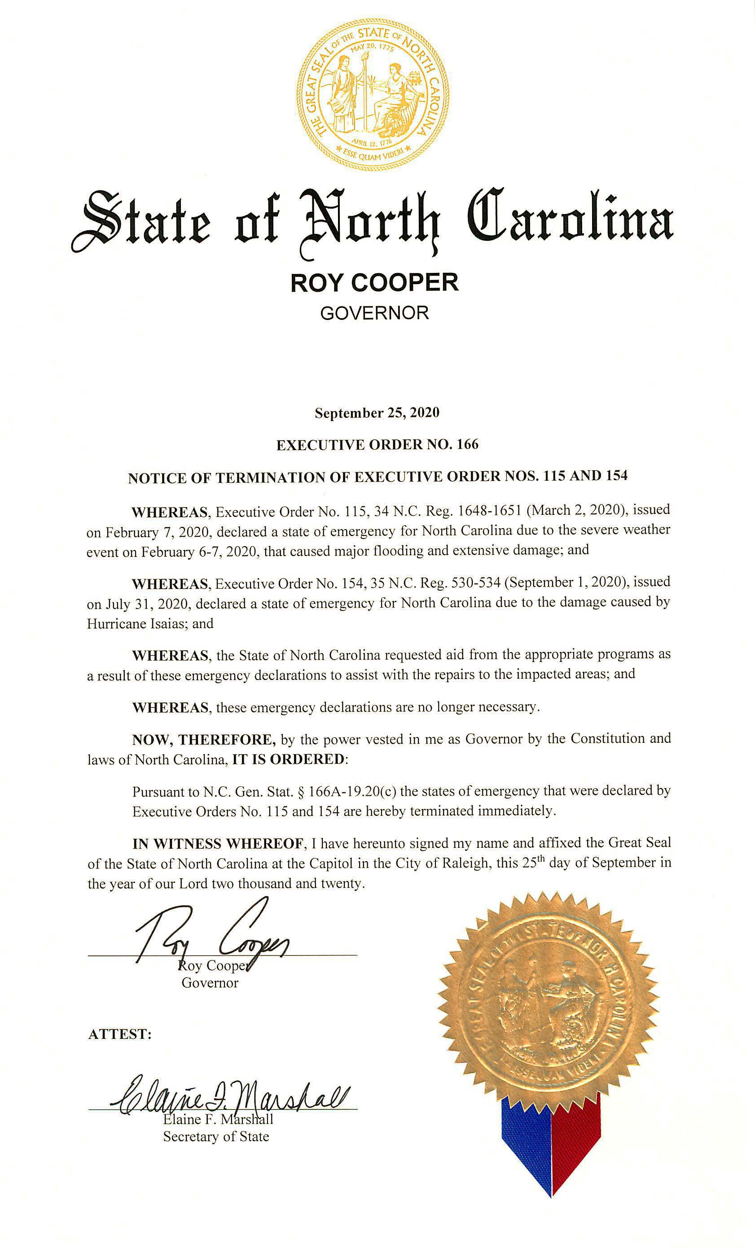
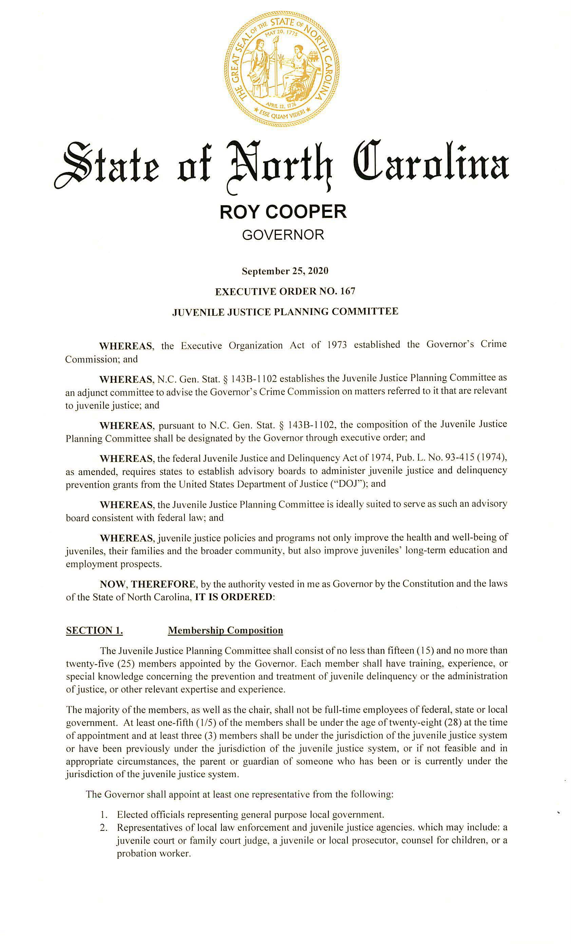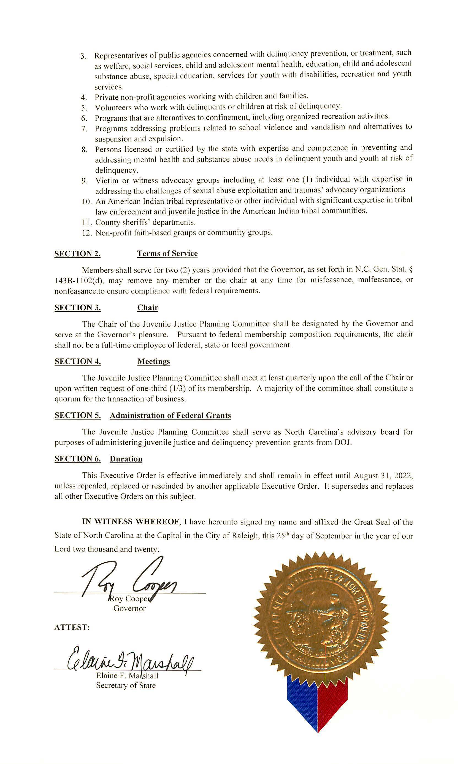
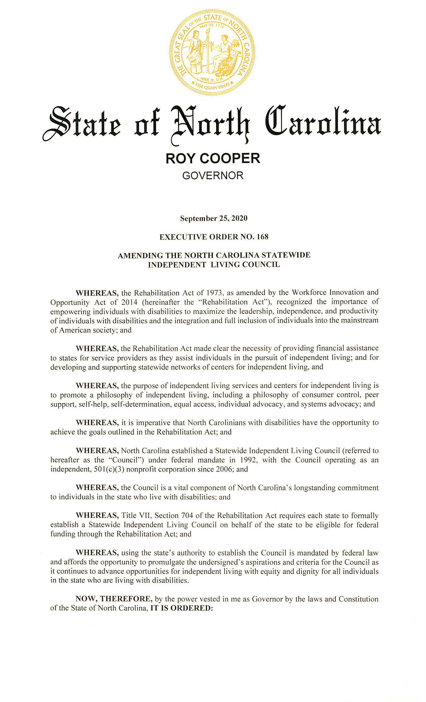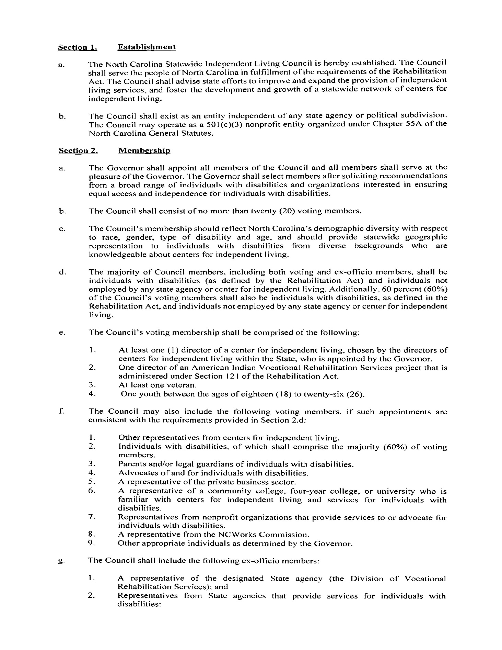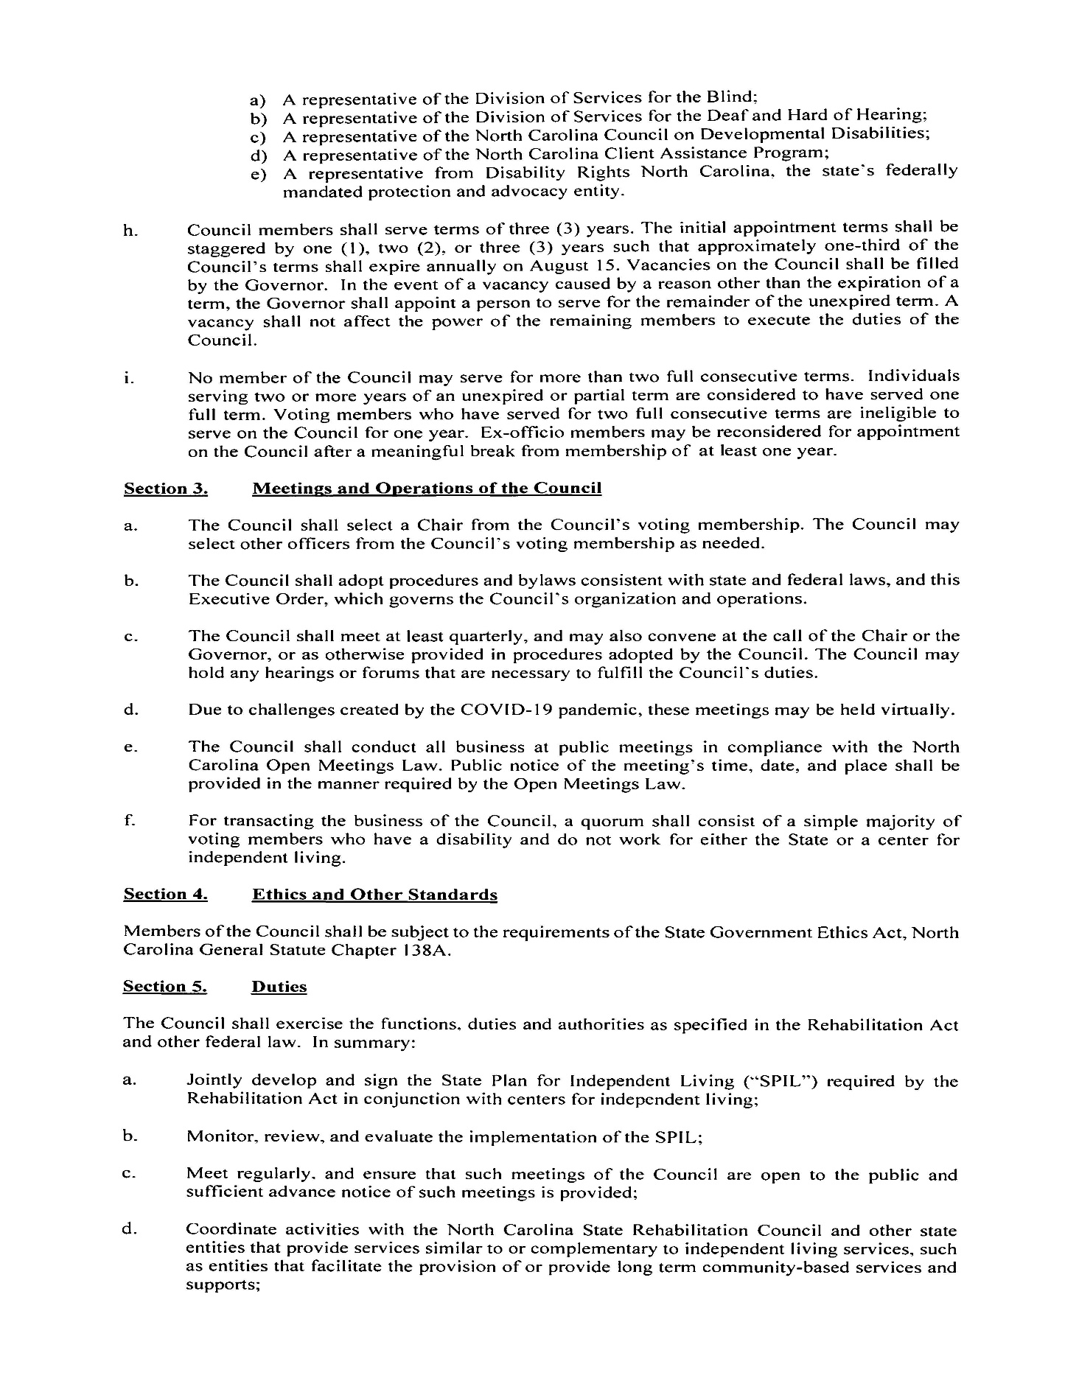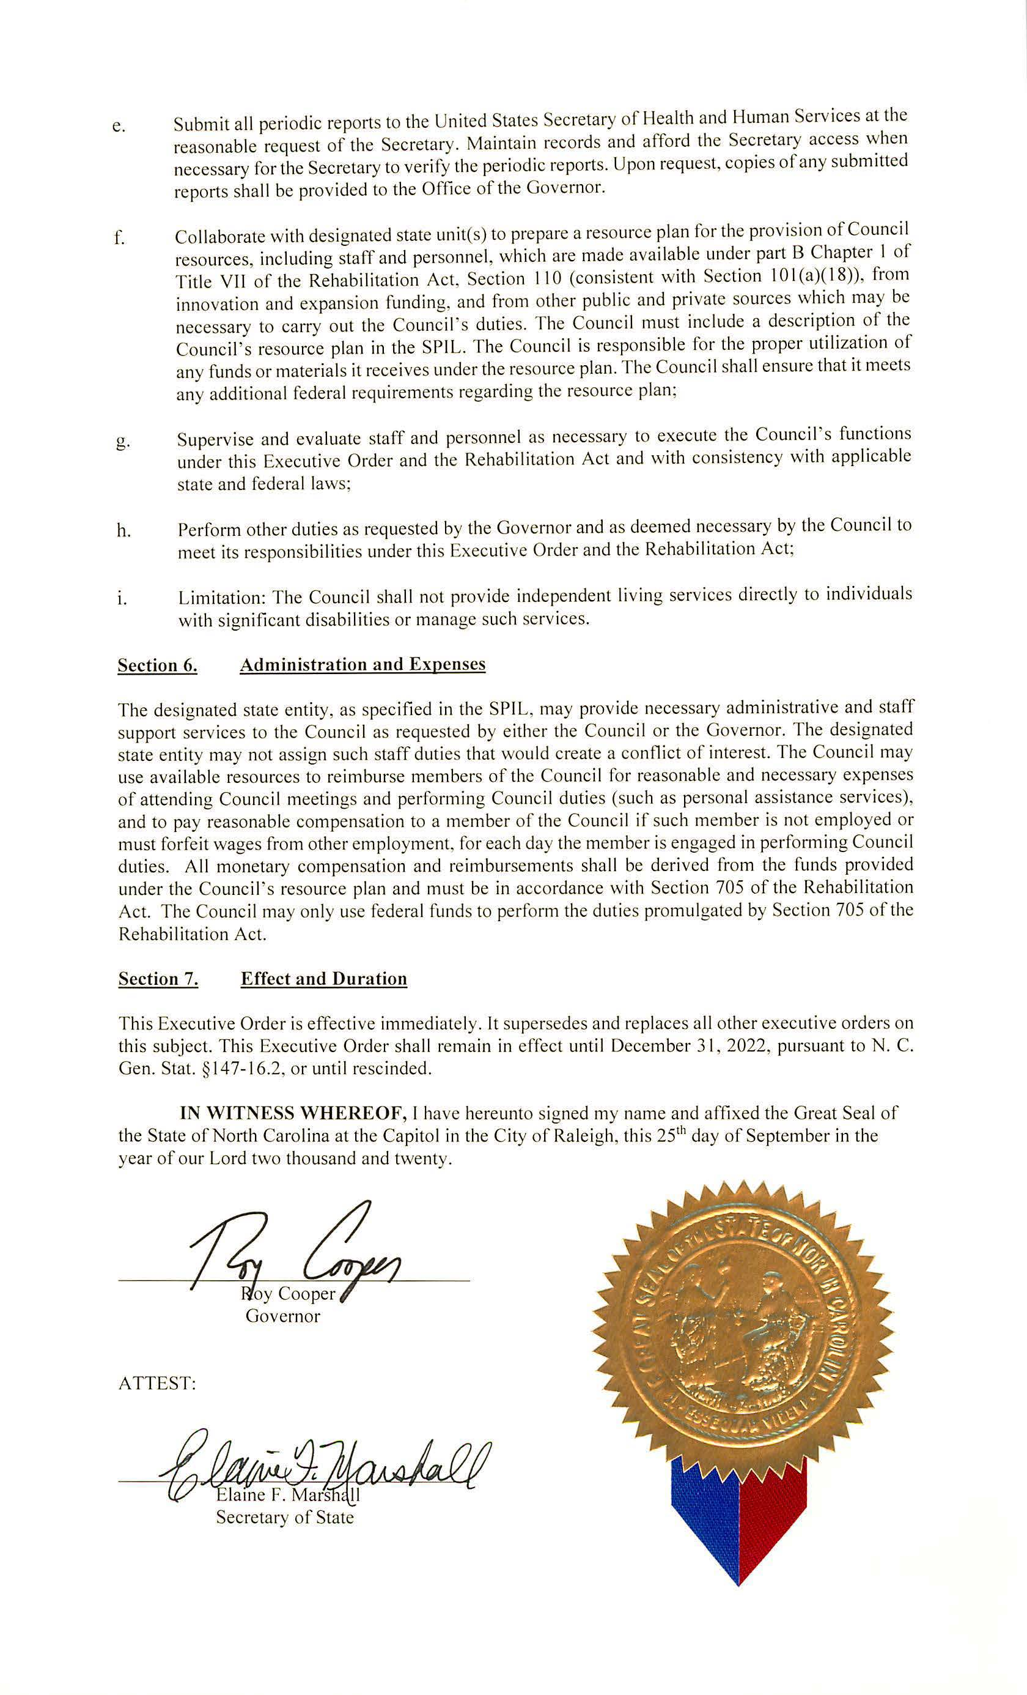

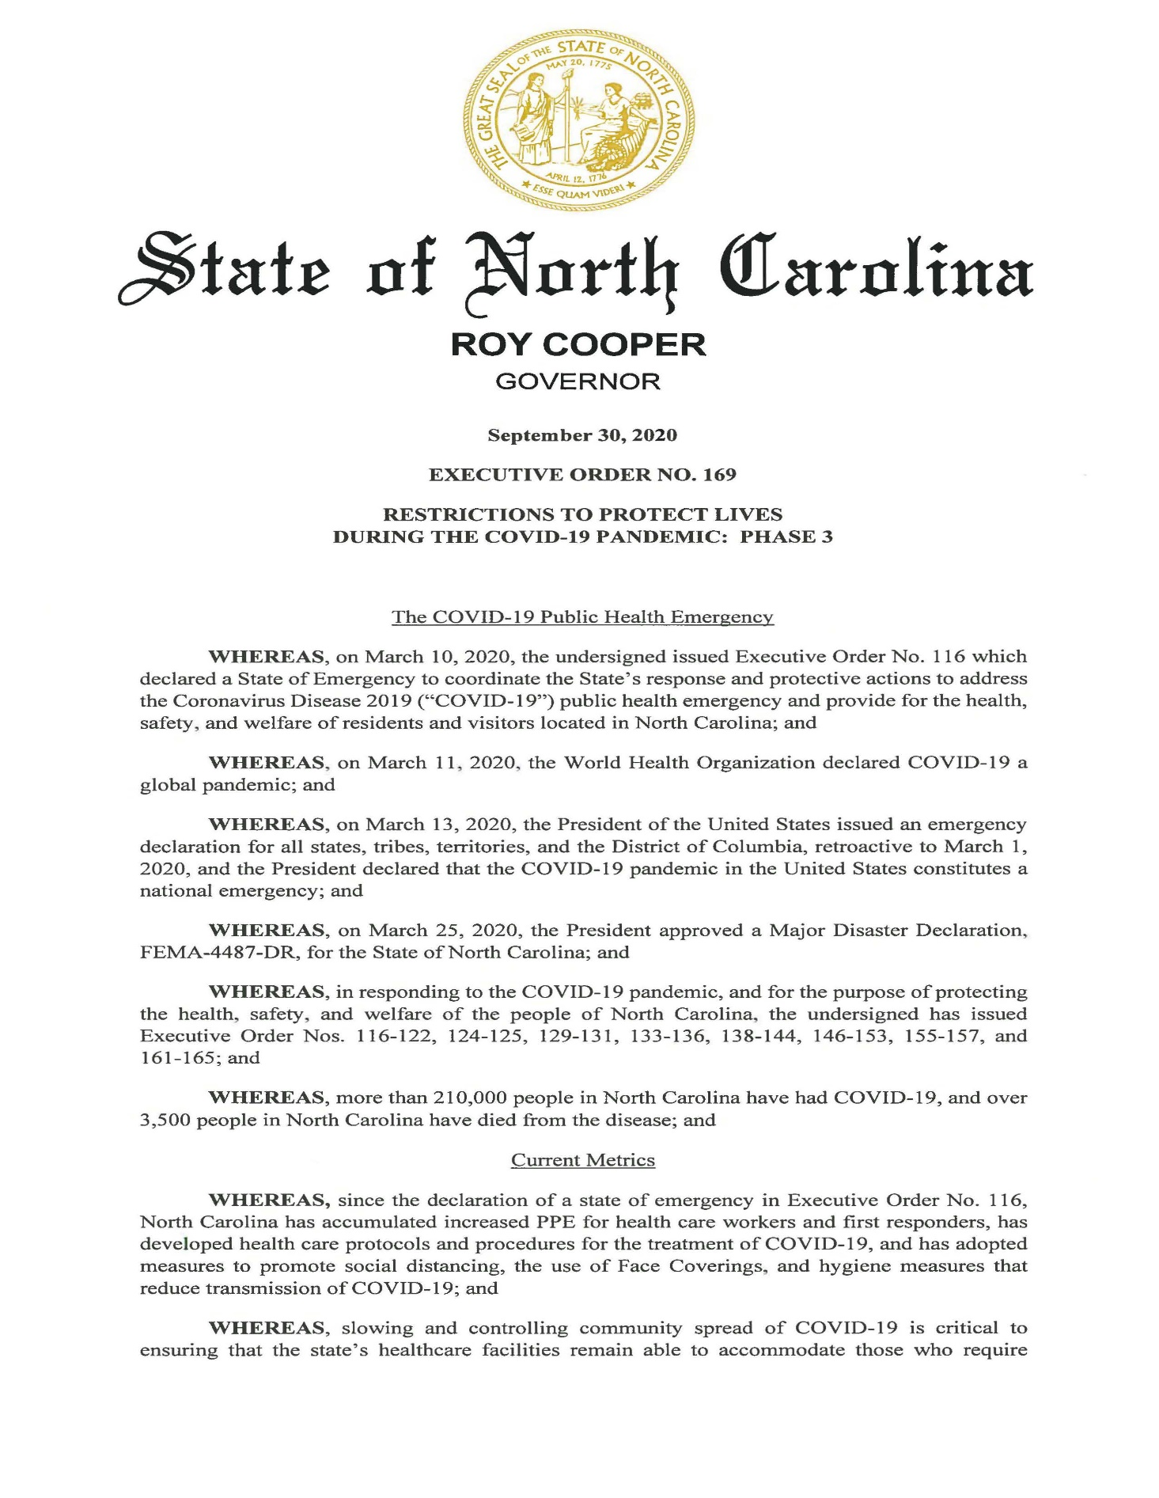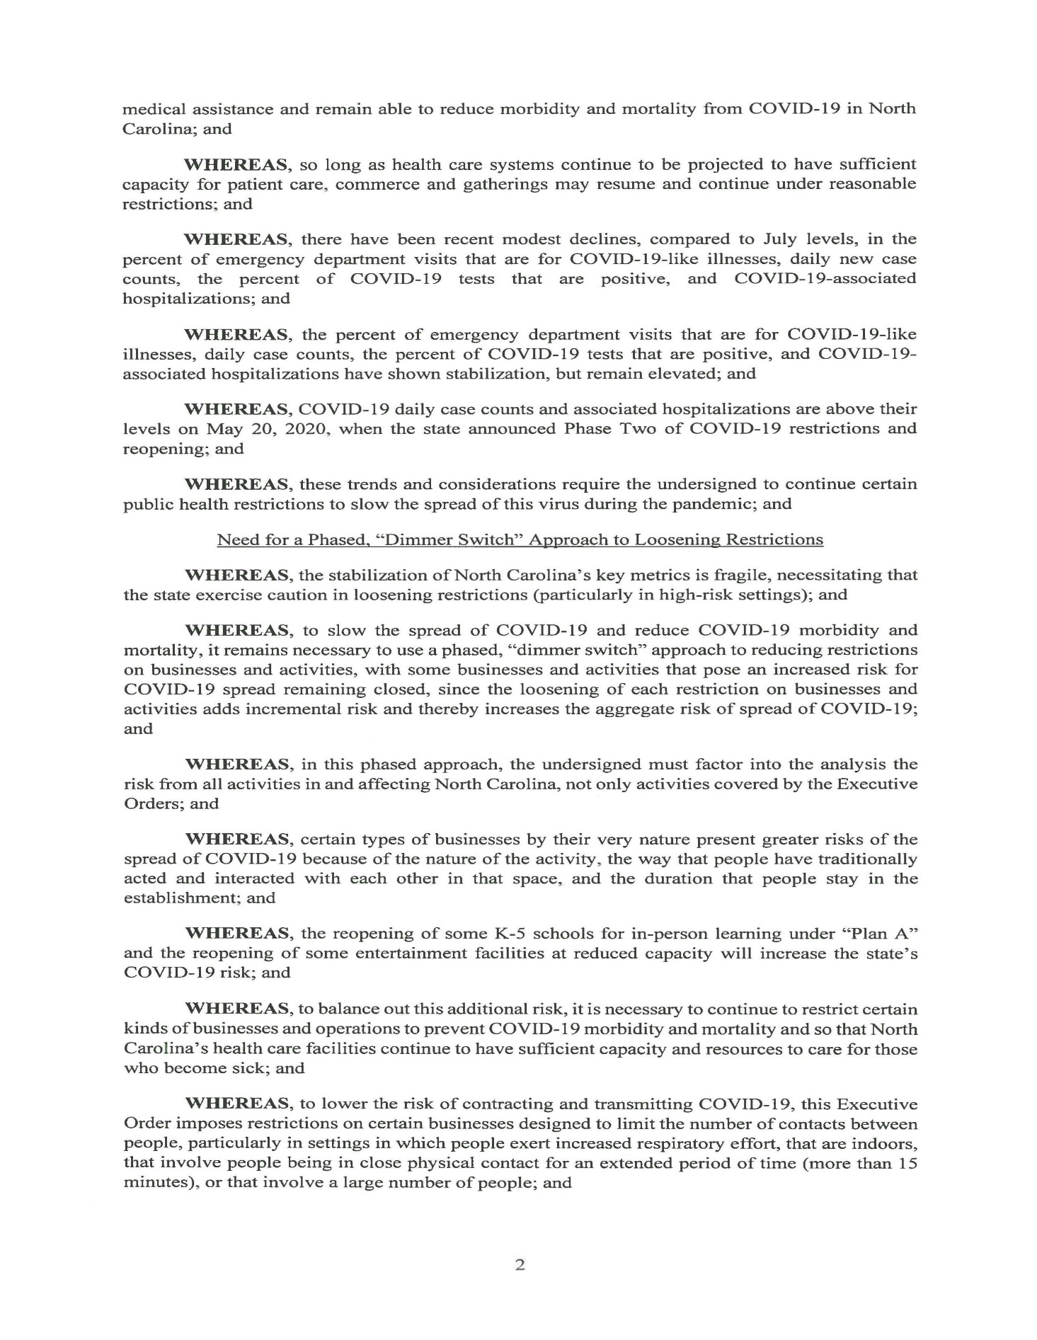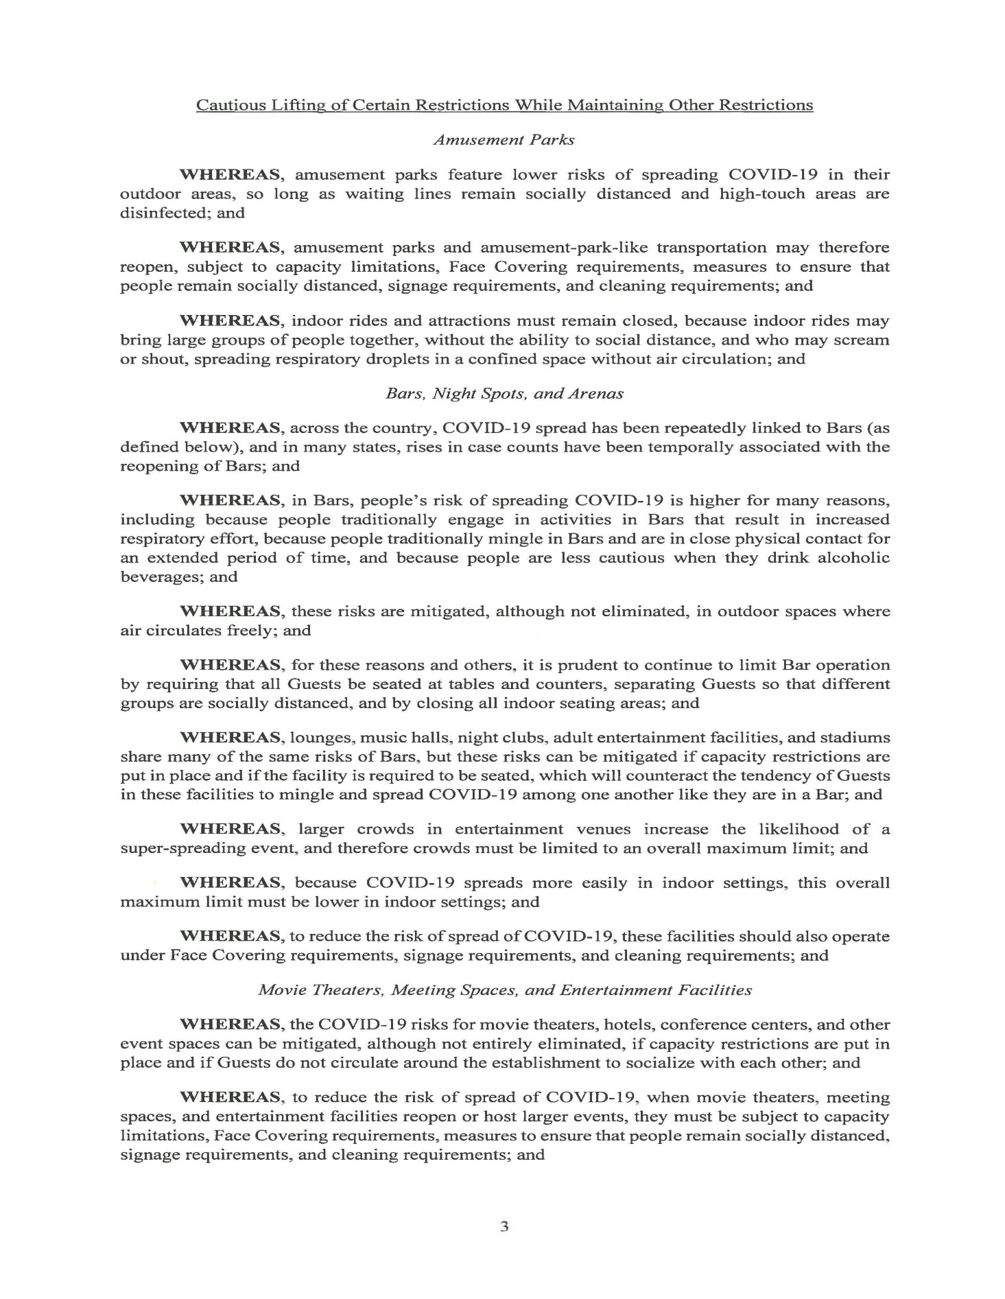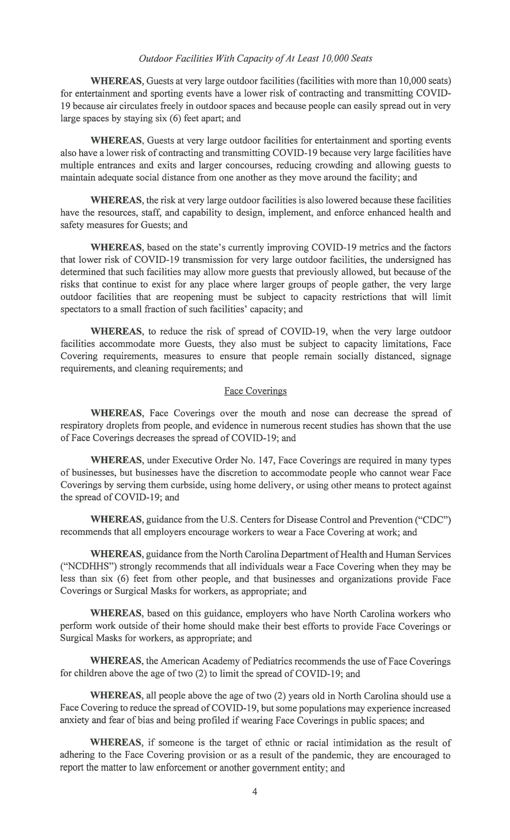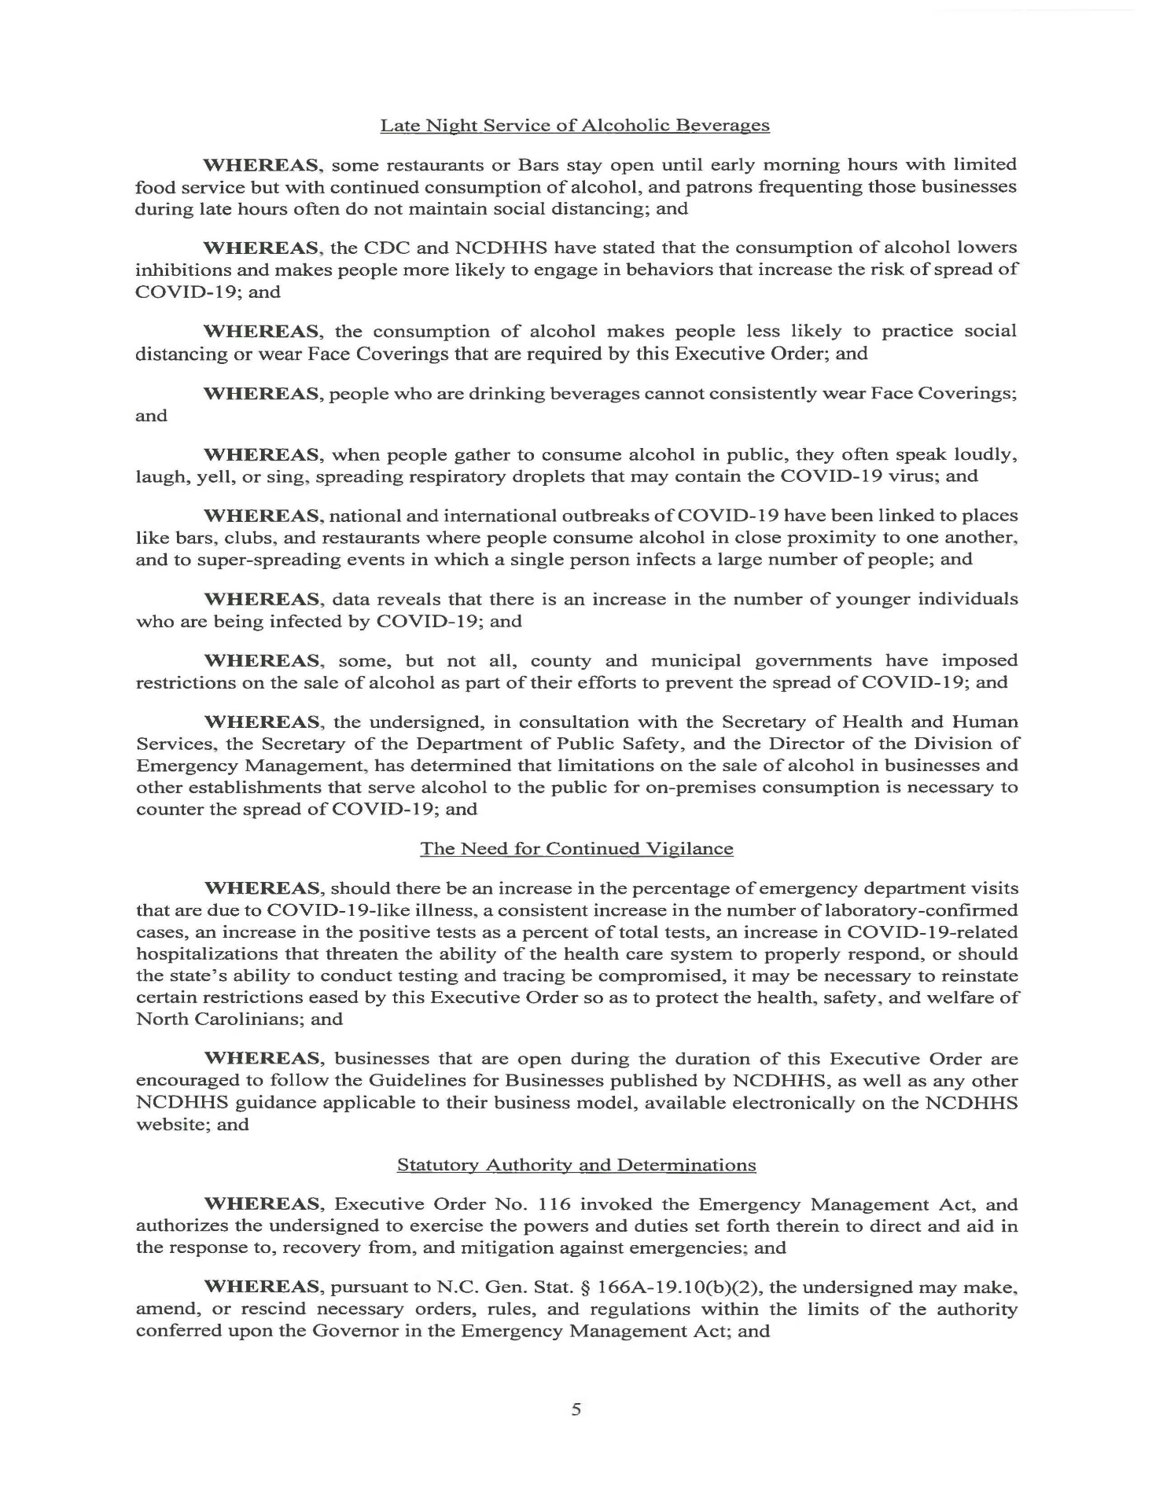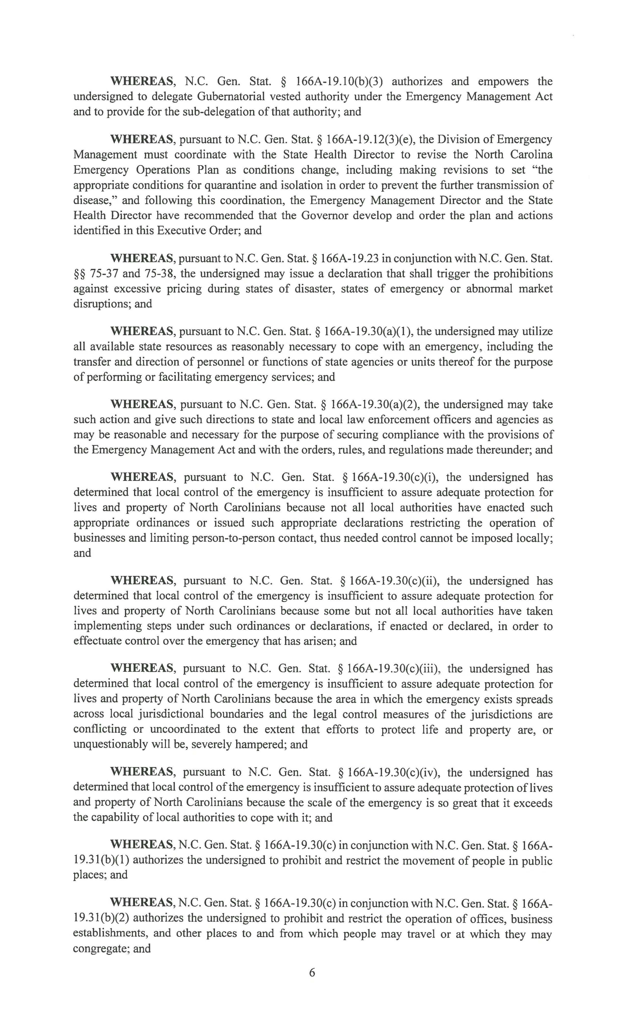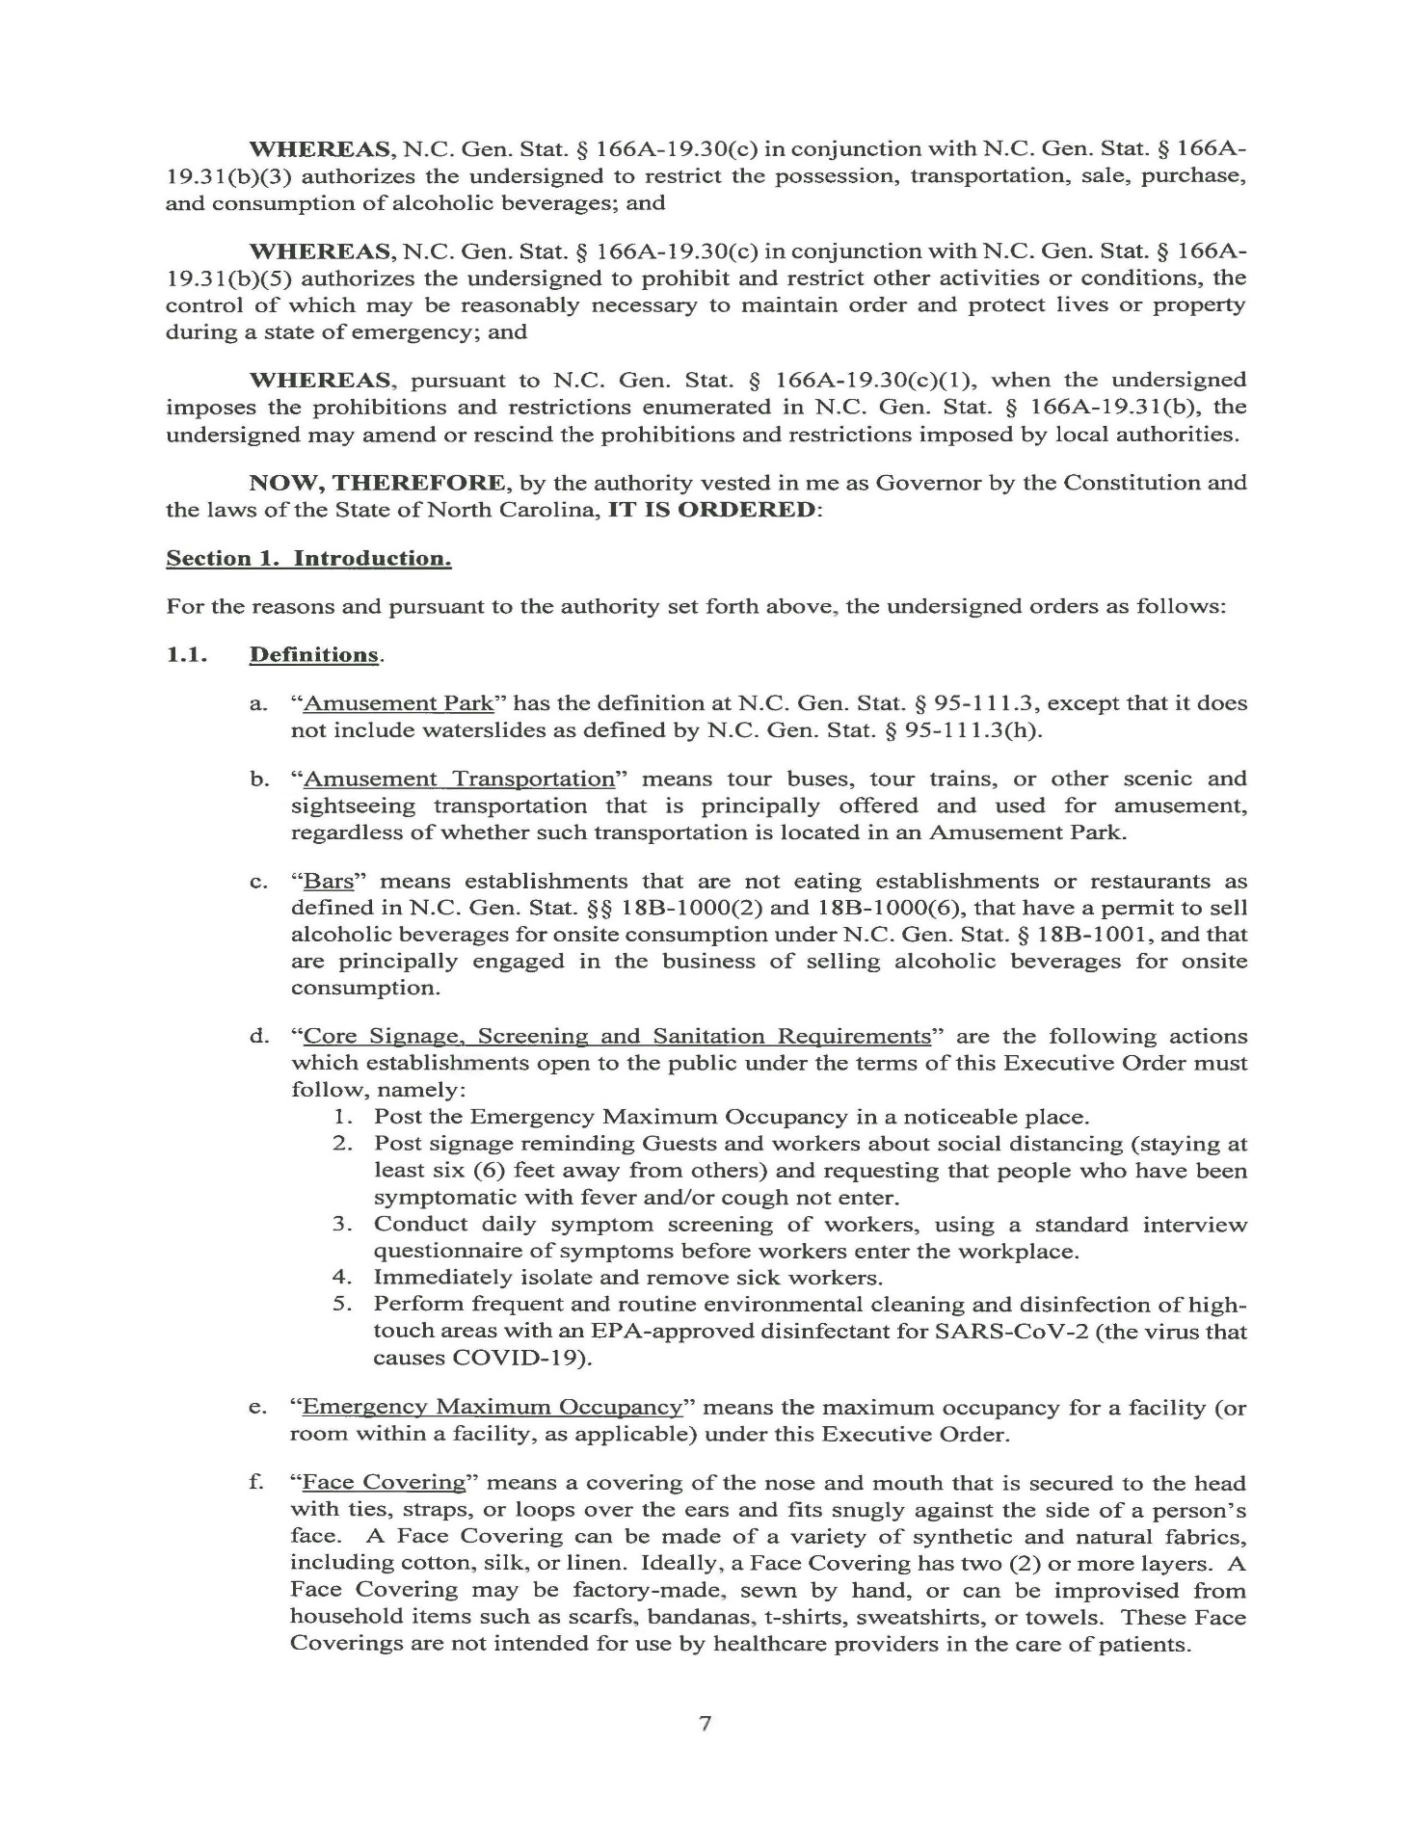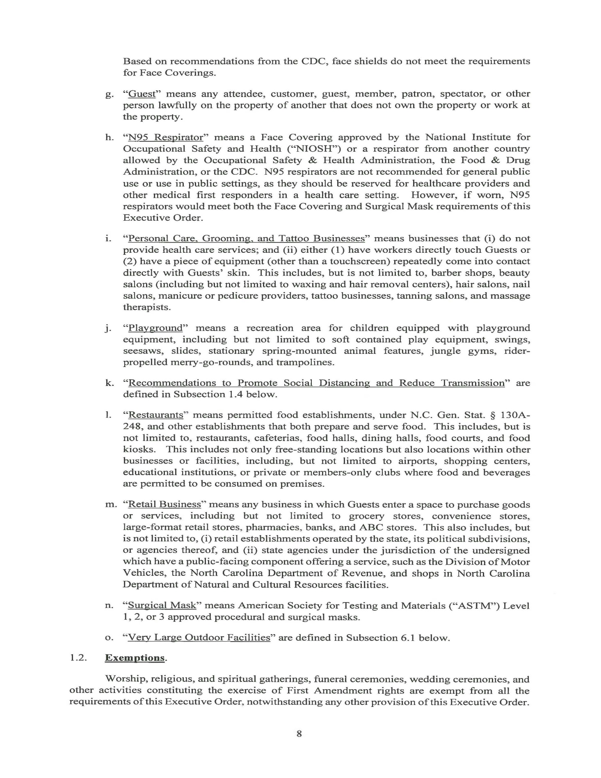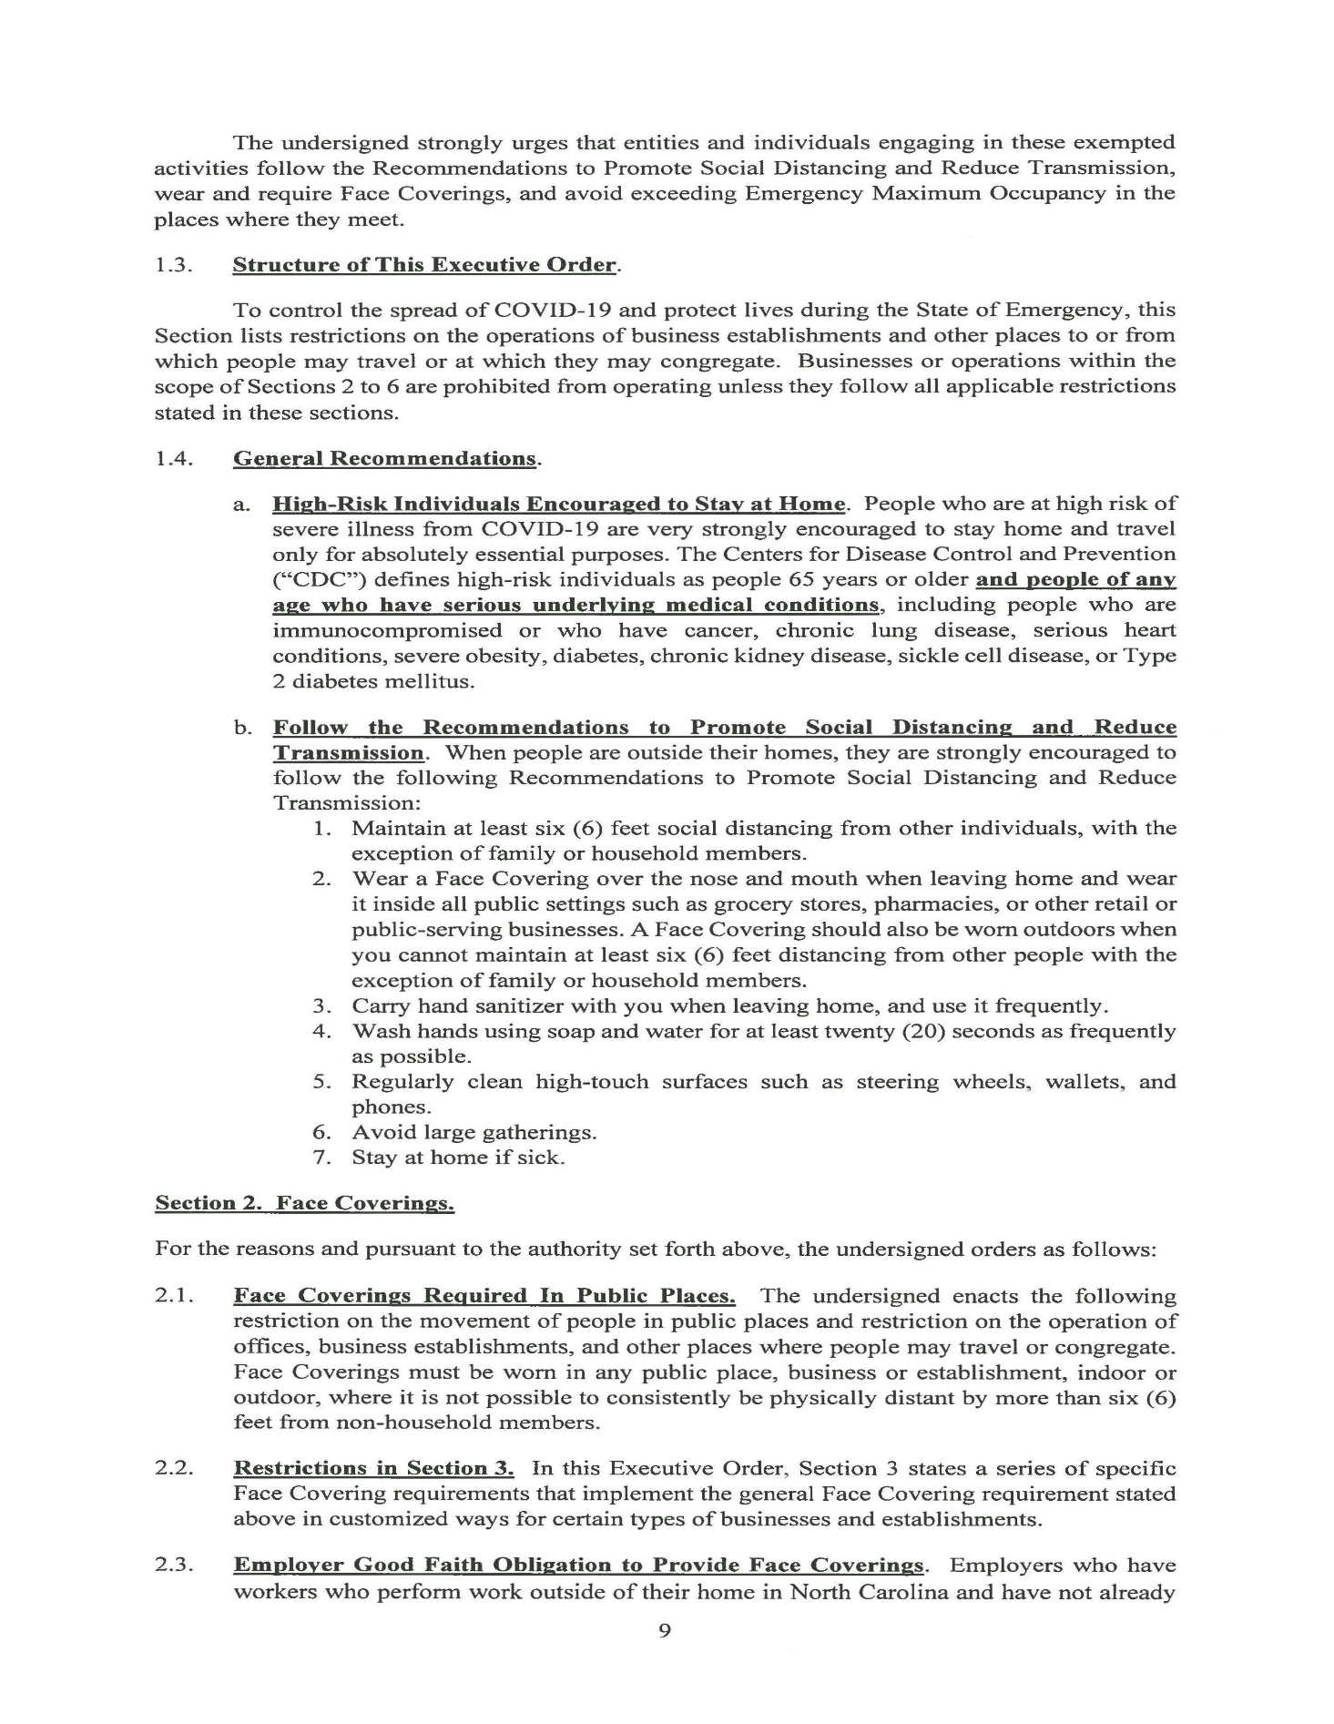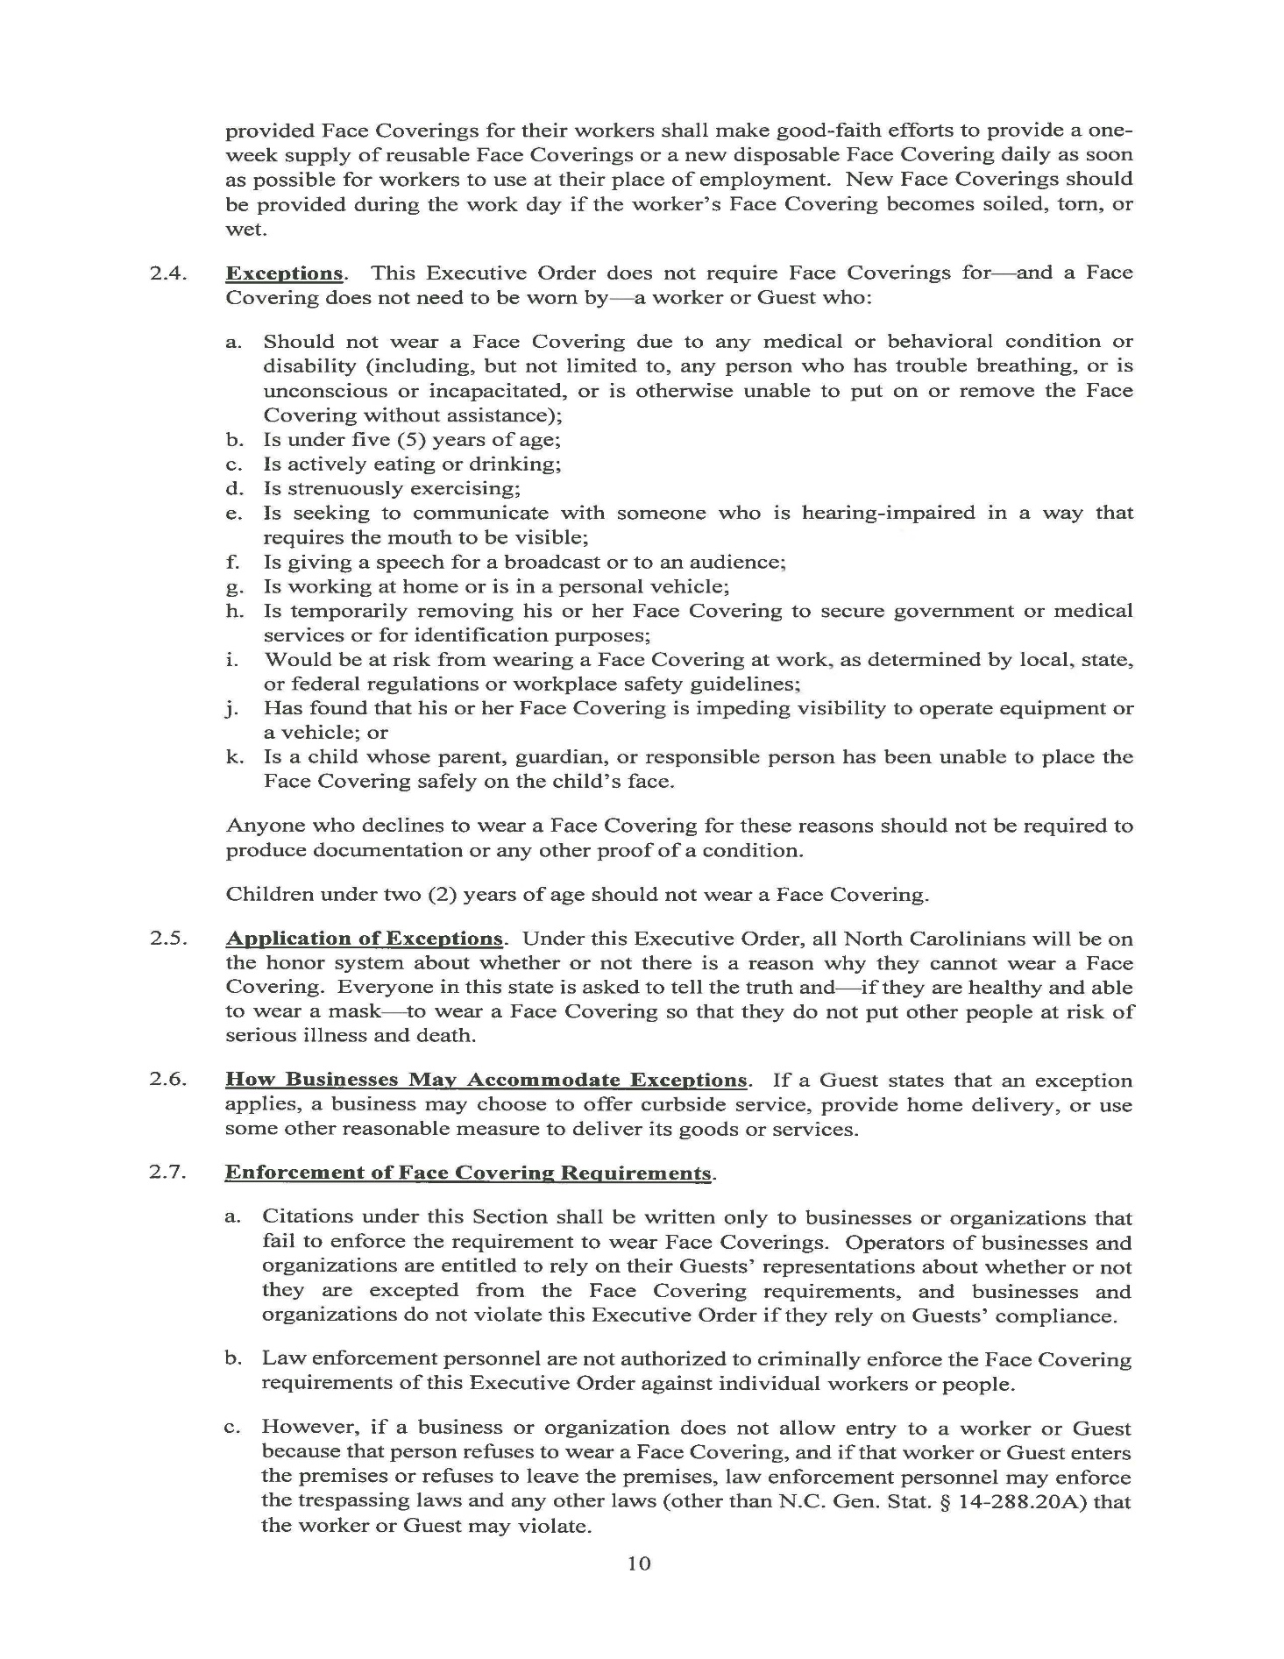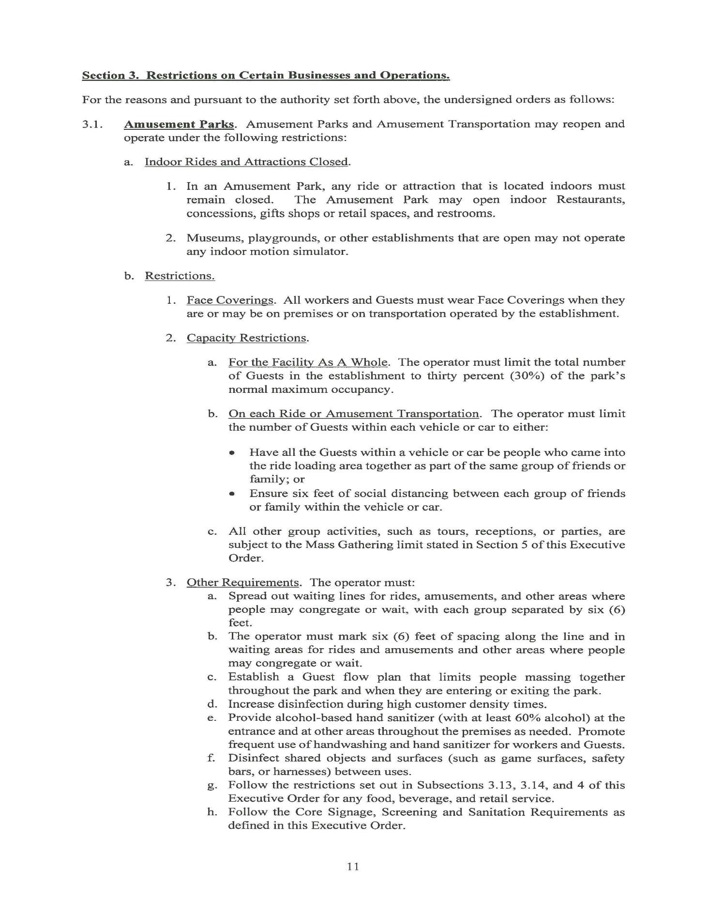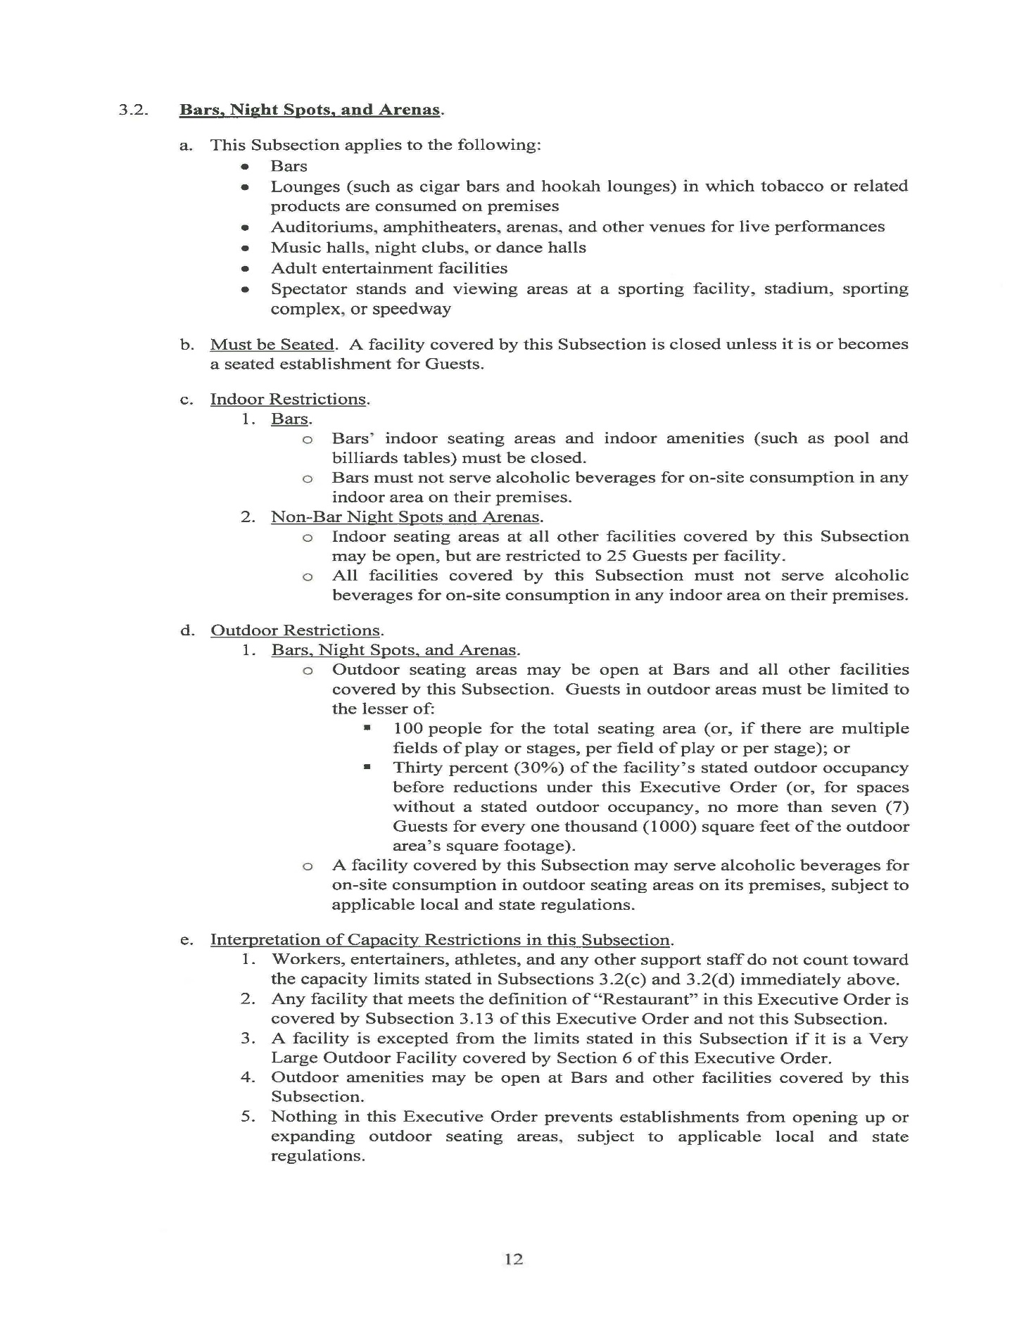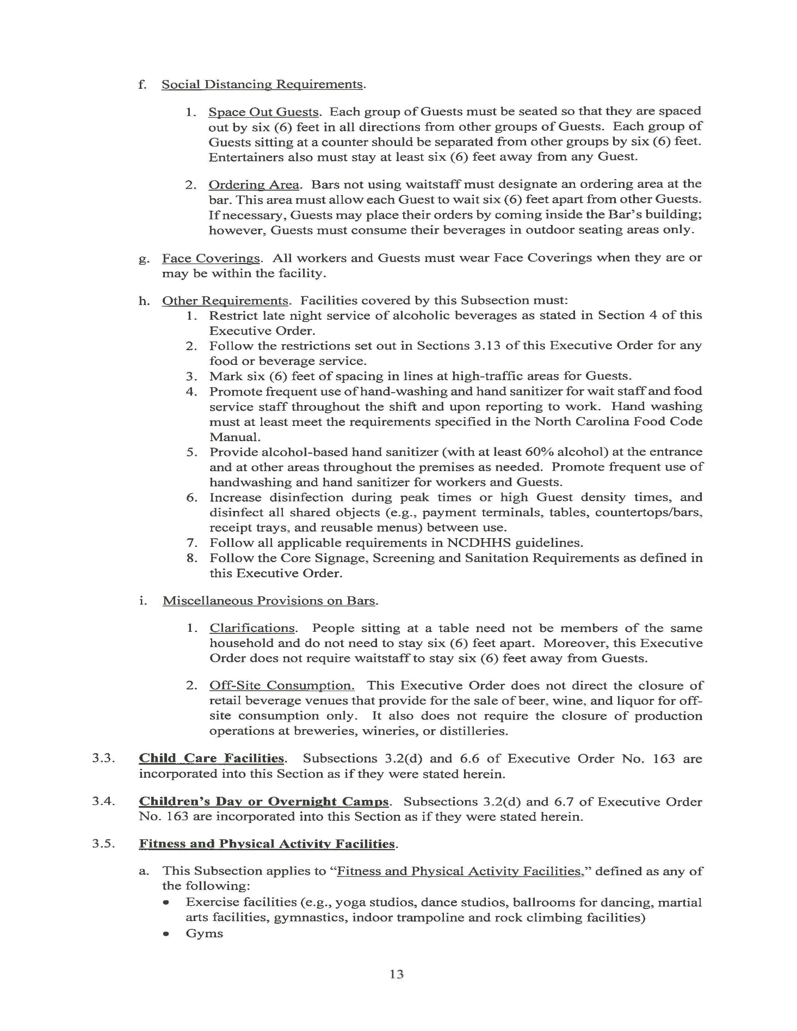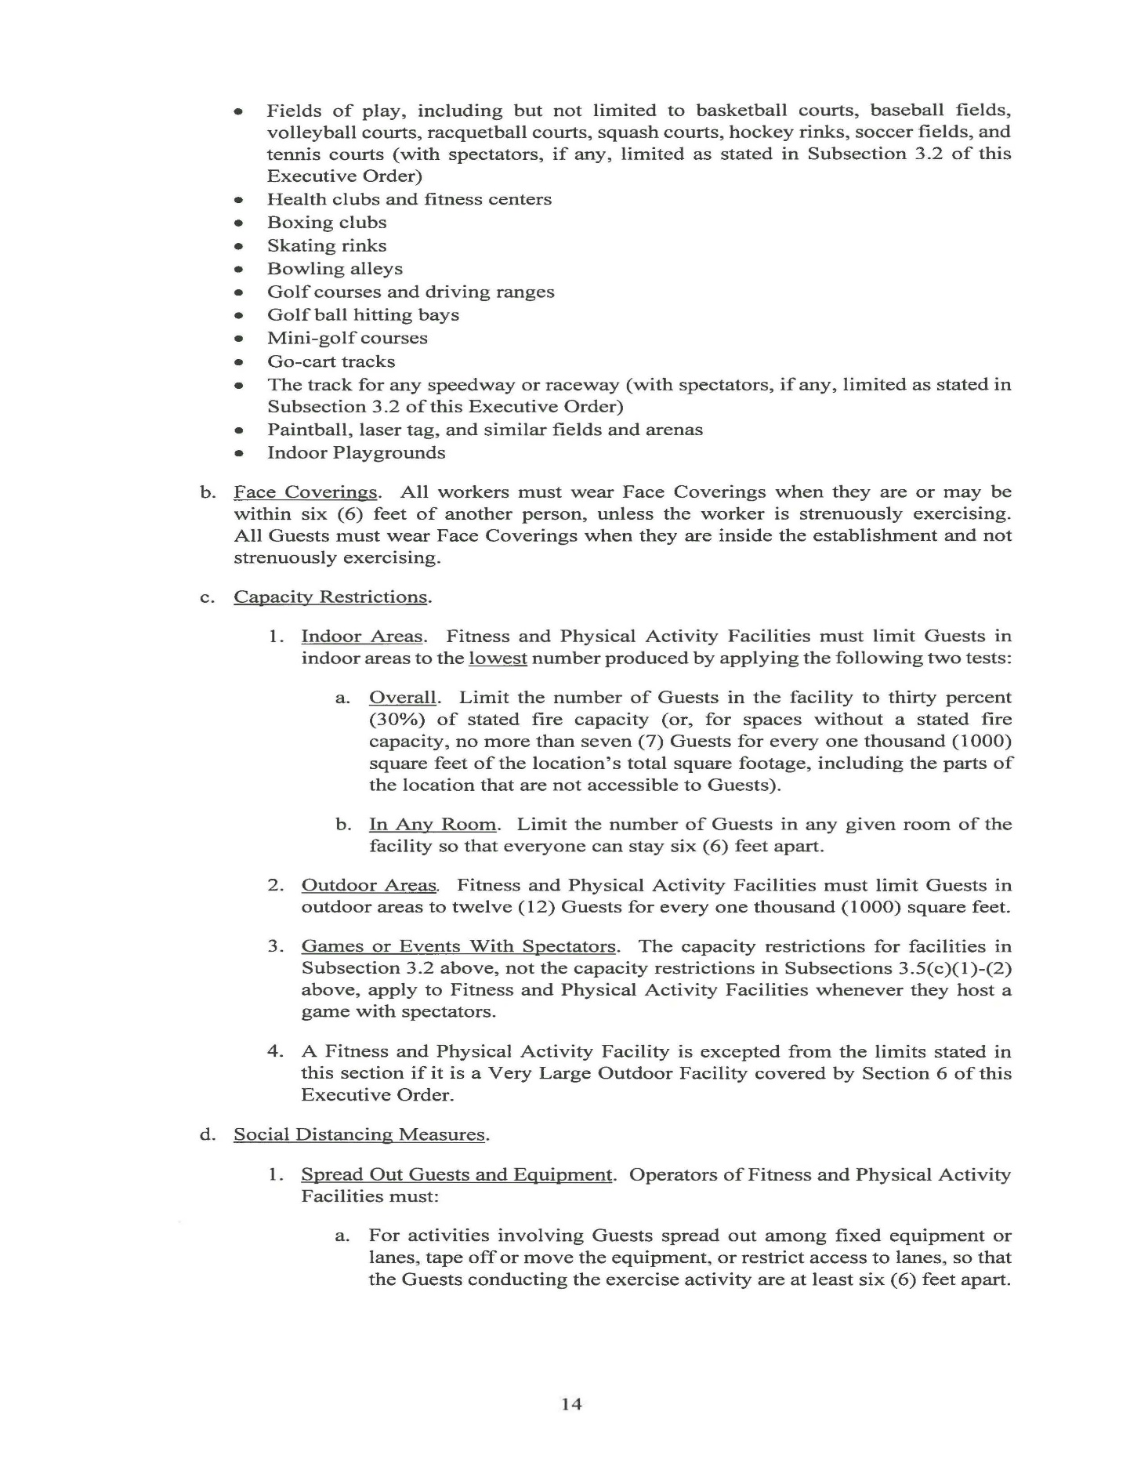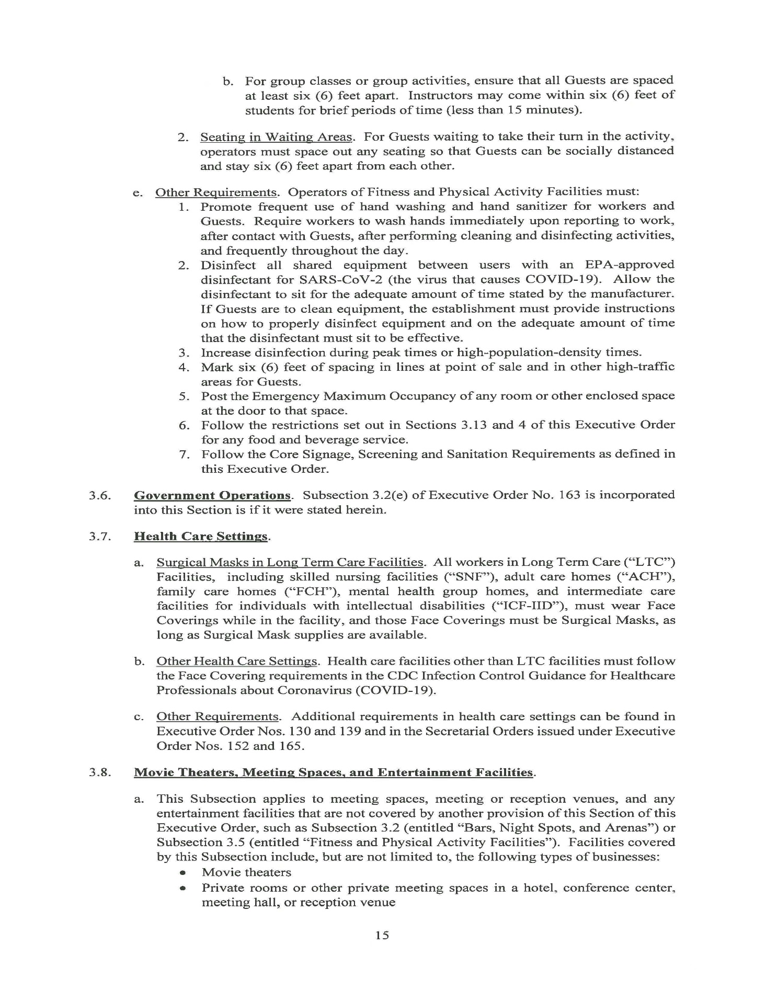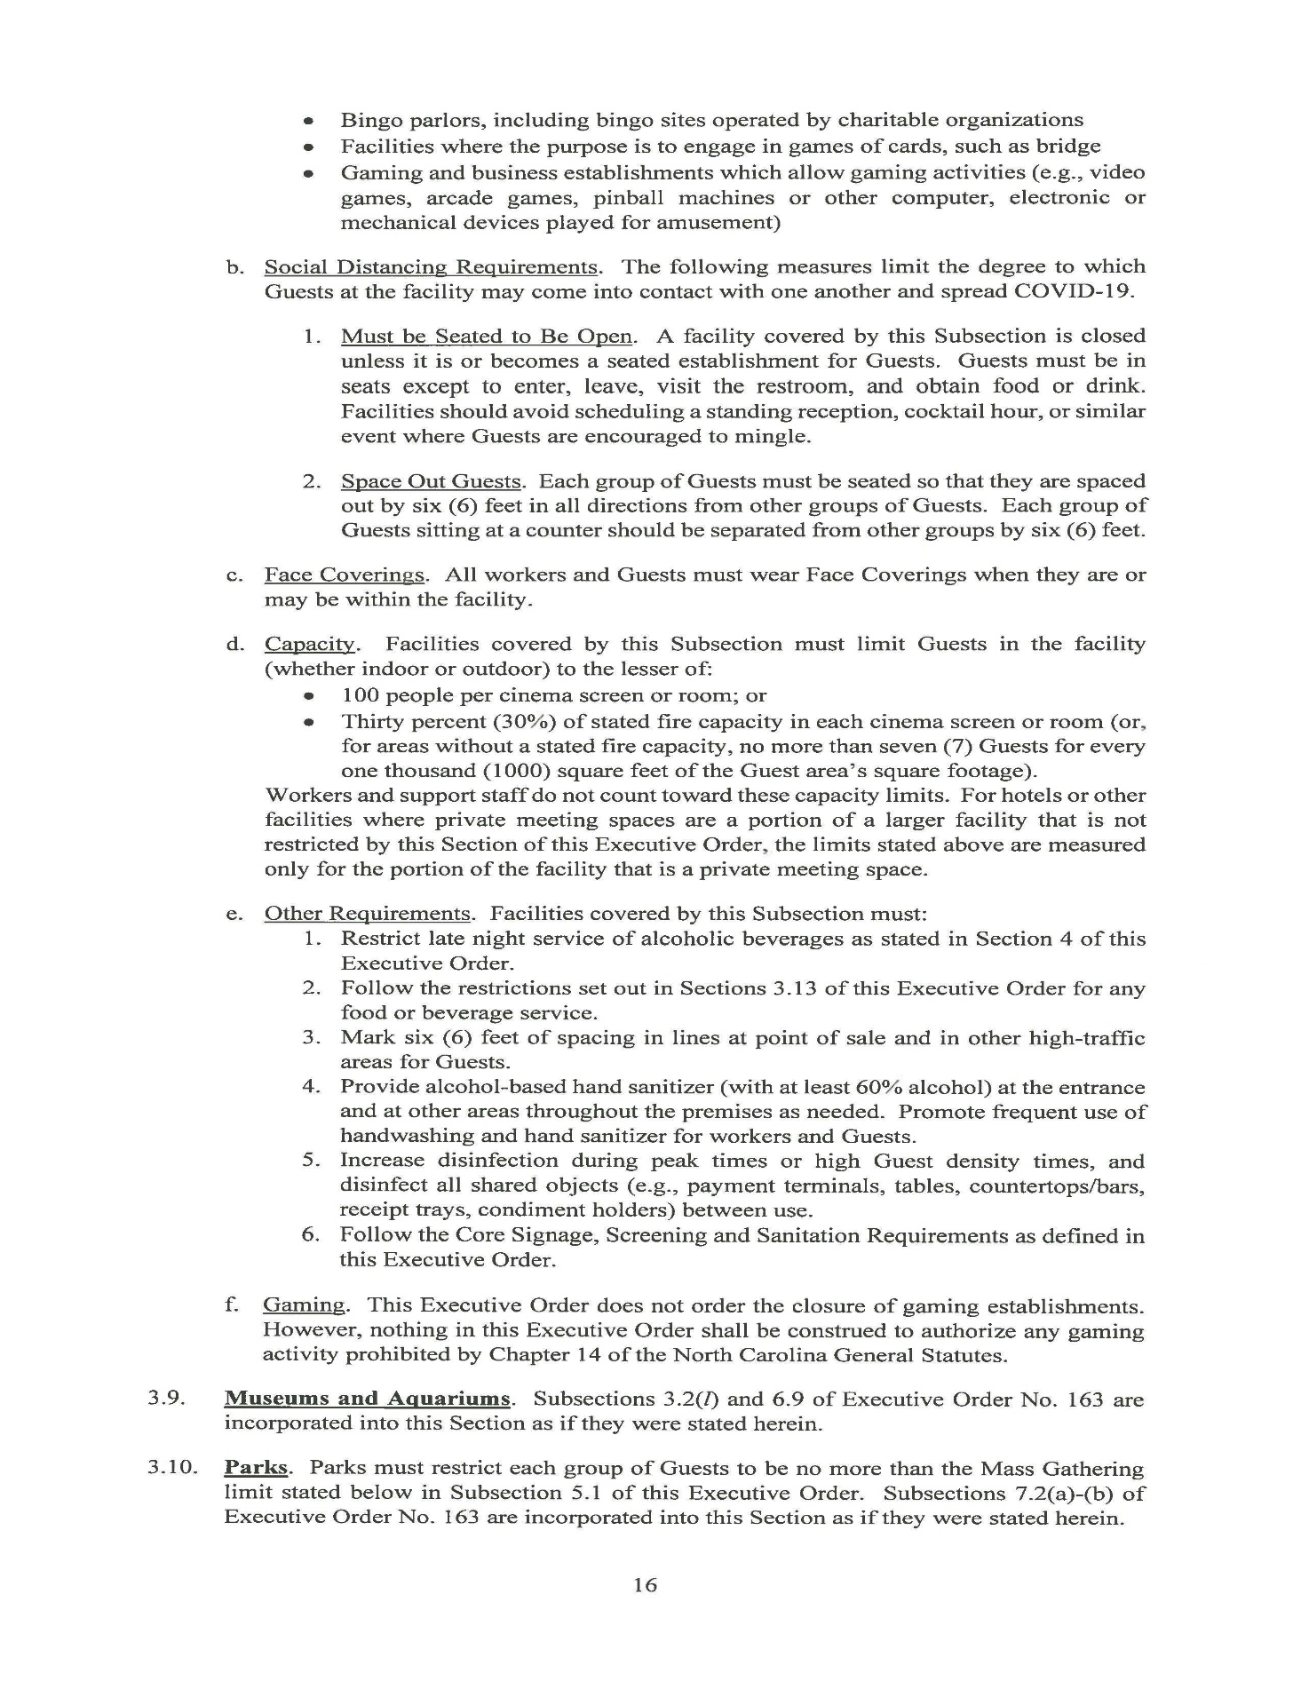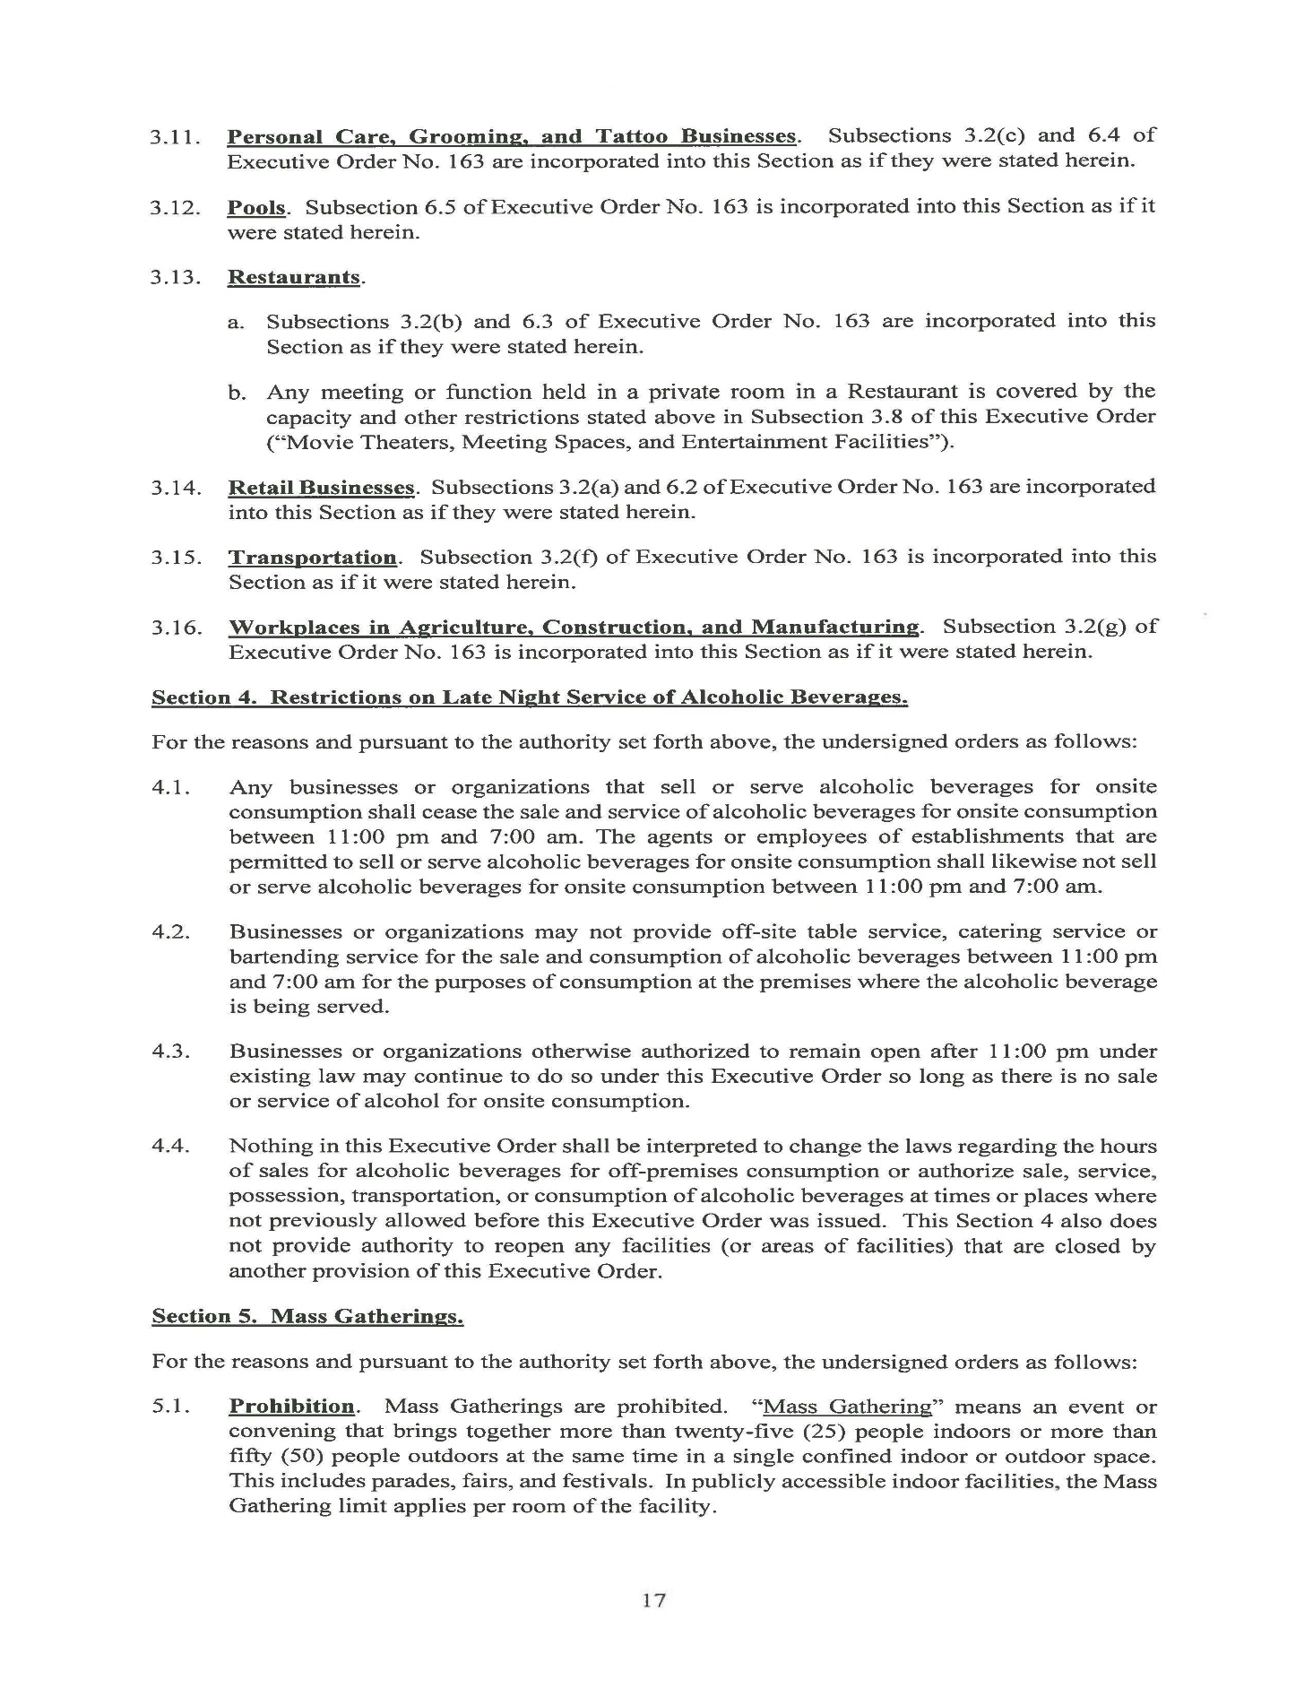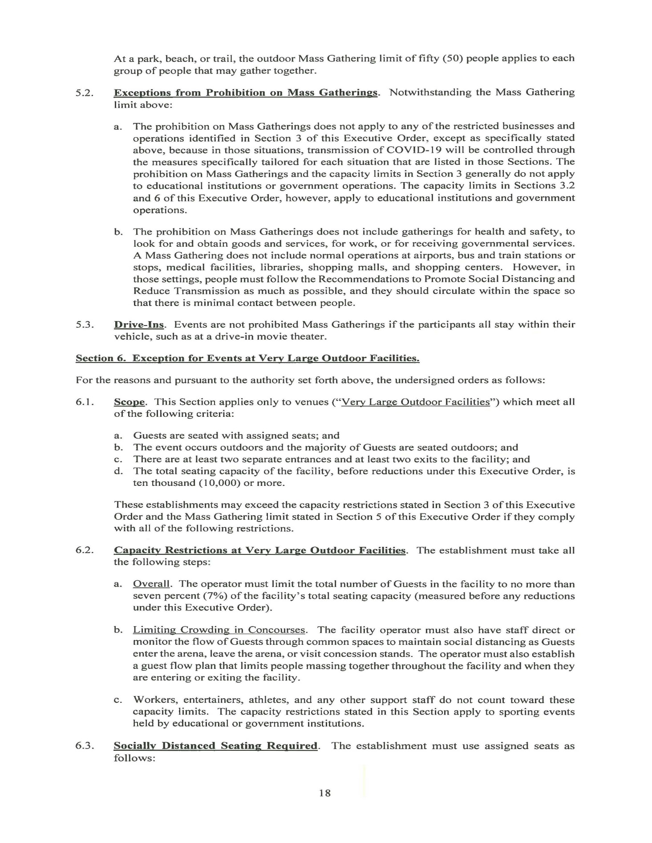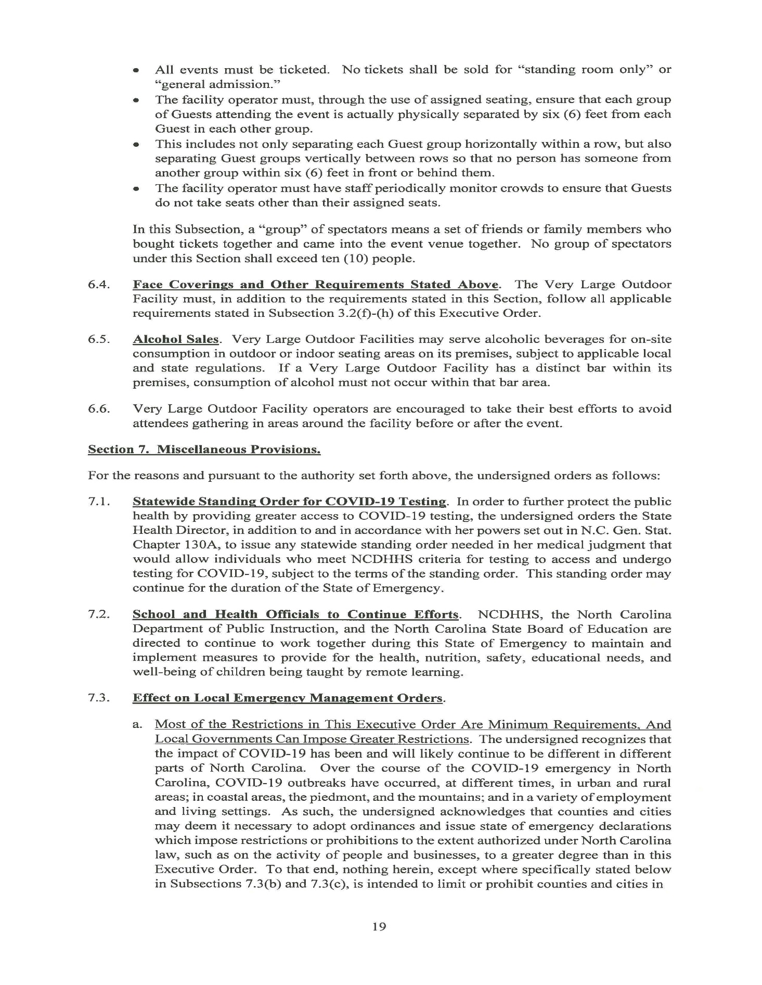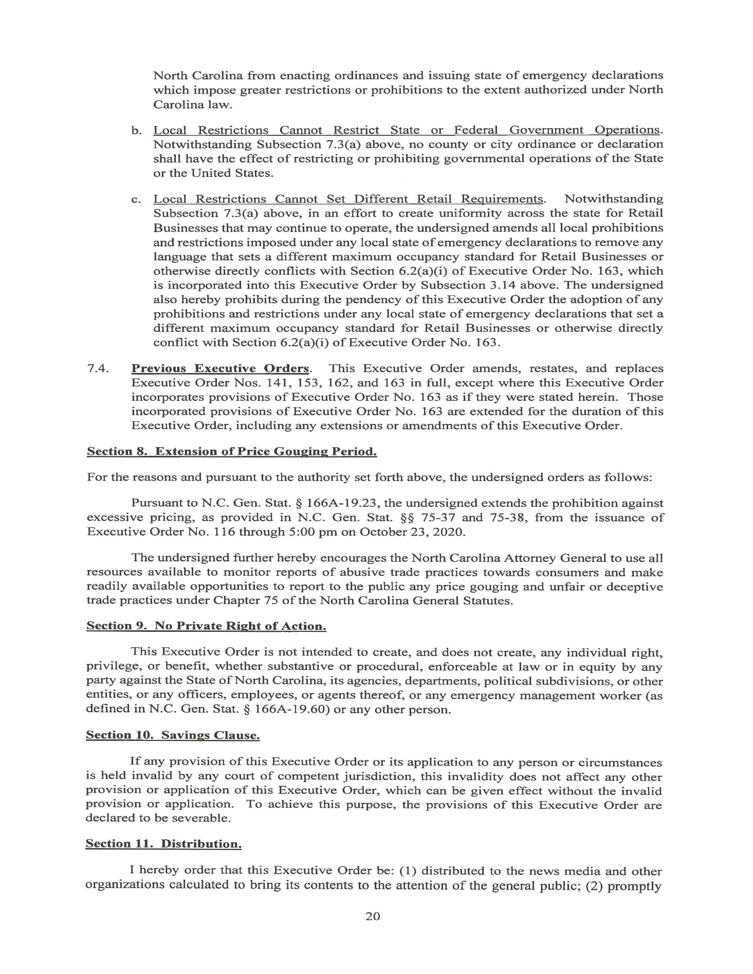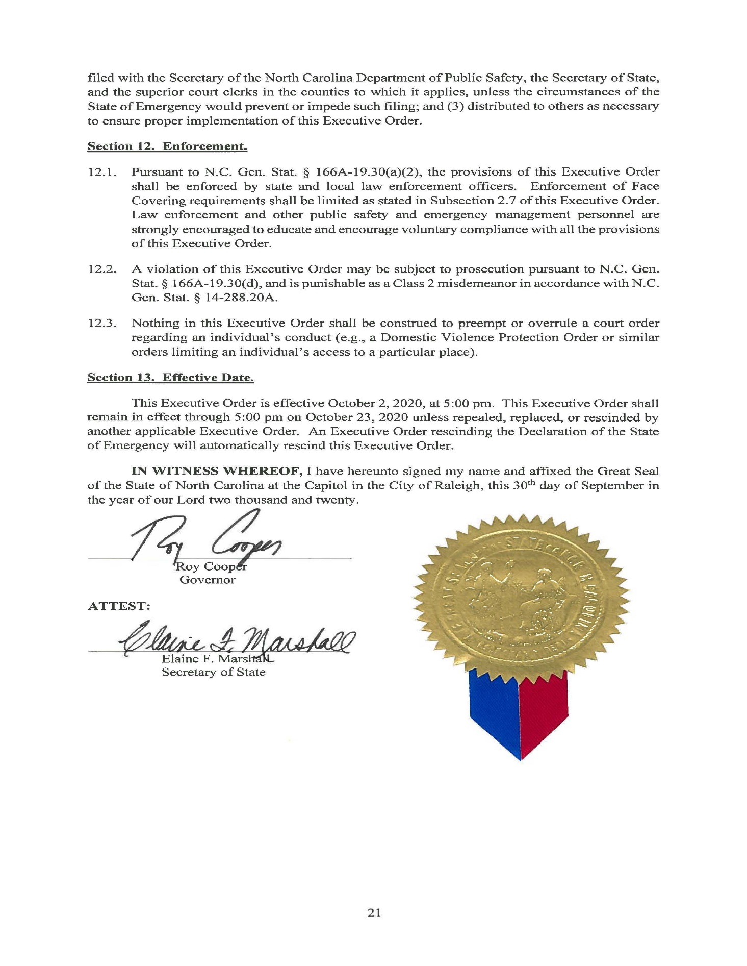

Notice of Rescheduled Public Hearing

In the October 1, 2020, North Carolina Register, Volume 35, Issue 07, at pages 783-784, the Department of the Secretary of State published a proposed amendment to 18 NCAC 06A .2120, including notice of a public hearing on October 21, 2020.

The hearing on proposed amendment to 18 NCAC 06A .2120 has been rescheduled as follows:

Public Hearing: Date: November 18, 2020
Time: 10:00 a.m.-10:30 a.m.
Location: (978) 990-5311 Access code: 482848

Note from the Codifier: The notices published in this Section of the NC Register include the text of proposed rules. The agency must accept comments on the proposed rule(s) for at least 60 days from the publication date, or until the public hearing, or a later date if specified in the notice by the agency. If the agency adopts a rule that differs substantially from a prior published notice, the agency must publish the text of the proposed different rule and accept comment on the proposed different rule for 60 days.
Statutory reference: G.S. 150B-21.2.

Title 11 – Department of Insurance

Notice is hereby given in accordance with G.S. 150B-21.2 that the Industrial Commission intends to amend the rules cited as 11 NCAC 23A .0109; 23B .0105; and 23G .0104.

Link to agency website pursuant to G.S. 150B-19.1(c): https://www.ic.nc.gov/A109B105G104.html

Proposed Effective Date: March 1, 2021

Public Hearing:
Date: December 10, 2020
Time: 2 p.m.
Location: Via Teleconference only. Teleconference Line#: 1-888-363-4735; Access Code#: 4465746

Reason for Proposed Action: The Industrial Commission (hereinafter "Commission") has deemed it necessary to permanently amend the rules cited as 11 NCAC 23A .0109 and 11 NCAC 23B .0105 in order to enable the most efficient processing and maintenance of the contact information of the regulated parties who are involved in cases before the Industrial Commission. The Commission has deemed it necessary to permanently amend the rule cited as 11 NCAC 23G .0104 to ensure that this mediation rule of the Commission is "substantially similar" to the mediation rules approved by the North Carolina Supreme Court for use in the Superior Court division, as required by G.S. 97-80(c). Please note that the text in italics in 11 NCAC 23A .0109 and 11 NCAC 23B .0105 is pending approval by the Rules Review Commission at its November 19, 2020 meeting.

Comments may be submitted to: Gina Cammarano, 1240 Mail Service Center, Raleigh, NC 27699-1240; phone (919) 807-2524; email gina.cammarano@ic.nc.gov. Please submit written comments via email to gina.cammarano@ic.nc.gov, if possible.

Comment period ends: January 4, 2021

Procedure for Subjecting a Proposed Rule to Legislative Review: If an objection is not resolved prior to the adoption of the rule, a person may also submit written objections to the Rules Review Commission after the adoption of the Rule. If the Rules Review Commission receives written and signed objections after the adoption of the Rule in accordance with G.S. 150B-21.3(b2) from 10 or more persons clearly requesting review by the legislature and the Rules Review Commission approves the rule, the rule will become effective as provided in G.S. 150B-21.3(b1). The Commission will receive written objections until 5:00 p.m. on the day following the day the Commission approves the rule. The Commission will receive those objections by mail, delivery service, hand delivery, or facsimile transmission. If you have any further questions concerning the submission of objections to the Commission, please call a Commission staff attorney at 919-431-3000.

Fiscal impact. Does any rule or combination of rules in this notice create an economic impact? Check all that apply.

State funds affected

Local funds affected

Substantial economic impact (>= $1,000,000)

Approved by OSBM

No fiscal note required

Chapter 23 - Industrial Commission

SUBCHAPTER 23A - WORKERS' COMPENSATION RULES

SECTION .0100 – ADMINISTRATION

Note: The text in italics is pending approval by the Rules Review Commission at its November 19, 2020 meeting.

11 NCAC 23A .0109 Contact information

(a) "Contact information" for purposes of this Rule shall include telephone number, facsimile number, email address, and mailing address.

(b) All attorneys of record with matters before the Commission shall inform the Commission in writing of any change in the attorney's contact information via email to dockets@ic.nc.gov. provide and maintain current contact information for the Commission's records via the Commission's Electronic Document Filing Portal ("EDFP").

(c) All unrepresented persons or entities with matters before the Commission shall inform the Commission upon any change to their contact information in the following manner:

(1) All employees who are not represented by counsel shall inform the Commission of any change in contact information by filing a written notice via EDFP, the Commission's Electronic Document Filing Portal ("EDFP"), email to forms@ic.nc.gov, contactinfo@ic.nc.gov, facsimile, facsimile to (919) 715-0282, U.S. Mail, U.S. mail sent to Office of the Clerk, 1236 Mail Service Center, Raleigh North Carolina 27699-1236, private courier service, private courier service in accordance with Rule .0101 of this Section, or hand delivery. hand delivery in accordance with Rule .0101 of this Section.

(2) All non-insured employers that are not represented by counsel shall inform the Commission of any change in contact information by filing a written notice via EDFP, email to dockets@ic.nc.gov, contactinfo@ic.nc.gov , facsimile, facsimile to (919) 715-0282, U.S. Mail, U.S. mail sent to Office of the Clerk, 1236 Mail Service Center, Raleigh North Carolina 27699-1236, private courier service, private courier service in accordance with Rule .0101 of this Section, or hand delivery. hand delivery in accordance with Rule .0101 of this Section.

(d) All carriers, third party administrators, and self-insured employers shall provide the Commission, by sending an email to contactinfo@ic.nc.gov, with an email address for service of claim-related documents in cases where the Commission does not have email contact information for a specific representative assigned to the claim.

(e) Instructions on how to provide and update contact information via EDFP are available at https://www.ic.nc.gov/docfiling.html.

Authority G.S. 97-80.

SUBCHAPTER 23B – TORT CLAIMS RULES

SECTION .0100 – ADMINISTRATION

Note: The text in italics is pending approval by the Rules Review Commission at its November 19, 2020 meeting.

11 NCAC 23B .0105 Contact information

(a) "Contact information" for purposes of this Rule shall include telephone number, facsimile number, email address, and mailing address.

(b) All persons or entities without legal representation who have matters pending before the Commission shall advise the Commission upon any change in contact information by filing a written notice via the Commission's Electronic Document Filing Portal ("EDFP"), electronic mail, [mail (dockets@ic.nc.gov),] mail (contactinfo@ic.nc.gov), facsimile, facsimile to (919) 715-0282, U.S. Mail, U.S. mail sent to Office of the Clerk, 1236 Mail Service Center, Raleigh, North Carolina 27699-1236, private courier service, private courier service in accordance with Rule .0101 of this Section, or hand delivery. hand delivery in accordance with Rule .0101 of this Section.

(c) A plaintiff without legal representation who was an inmate in the North Carolina Division of Adult Corrections at the time of filing his or her tort claim, shall, within thirty (30) days of release, provide the Commission with written notice of his or her post-release contact information in any manner authorized in Paragraph (b) of this Rule. Following the initial written notice of post-release contact information, the previously incarcerated plaintiff shall continue to advise the Commission upon all changes in contact information in accordance with Paragraph (b) of this Rule.

(d) All attorneys of record with matters before the Commission shall inform the Commission in writing of any change in the attorney's or the represented party's contact information provide and maintain current contact information for the Commission's records via email to dockets@ic.nc.gov. EDFP.

(e) Instructions on how to provide and update contact information via EDFP are available at https://www.ic.nc.gov/docfiling.html.

Authority G.S. 143-291; 143-300.

SUBCHAPTER 23G – NORTH CAROLINA INDUSTRIAL COMMISSION RULES FOR MEDIATED SETTLEMENT AND NEUTRAL EVALUATION CONFERENCES

SECTION .0100 – MEDIATION AND SETTLEMENT

11 NCAC 23G .0104 DUTIES OF PARTIES, REPRESENTATIVES, AND ATTORNEYS

(a) Attendance. The following persons shall physically attend the mediated settlement conference:

(1) all individual parties;

(2) in a workers' compensation case, a representative of the employer at the time of injury if:
(A) the employer, instead of or in addition to the insurance company or administrator, has decision-making authority with respect to settlement;
(B) the employer is offering the claimant employment and the suitability of that employment is in issue;
(C) the employer and the claimant have agreed to simultaneously mediate non-compensation issues arising from the injury; or
(D) the Commission orders the employer representative to attend the conference if the representative's physical attendance is necessary to resolve matters in dispute in the subject action;

(3) an officer, employee employee, or agent of any party that is not a natural person or a governmental entity who is not such the party's outside counsel and who has the authority to decide on behalf of such the party whether and on what terms to settle the action;

(4) in a workers' compensation case, an employee or agent of any party that is a governmental entity who is not such the party's outside counsel or Attorney General's counsel responsible for the case and who has the authority to decide on behalf of such the party and on what terms to settle the action.

(5) when the governing law prescribes that the terms of a proposed settlement may be approved only by a Board, an employee or agent who is not such the party's outside counsel or Attorney General's counsel responsible for the case and who has the authority to negotiate on behalf of and to make a recommendation to the Board. Because G.S. 143-295 provides the Attorney General with settlement authority on behalf of governmental entities and agencies for state tort claims, Pursuant to G.S. 143-295, an employee or agent of the named governmental entity or agency is not required to attend the mediated settlement conference; conference. The the Attorney General shall attempt to make an employee or agent of the named governmental entity or agency in a state State tort claim available via telecommunication, and mediation shall not be delayed due to the absence or unavailability of the employee or agent of the named governmental entity or agency.

(6) The counsels of record; provided, that appearance the counsels of record. Appearance by counsel does not dispense with or waive the required attendance of the parties listed in Subparagraphs (1) through (4);

(7) a representative of each defendant's primary workers' compensation or liability insurance carrier or self-insured that may be obligated to pay all or part of any claim presented in the action. Each carrier or self-insured shall be represented at the conference by an officer, employee employee, or agent who is not such the party's outside counsel and who has the authority to decide on behalf of the carrier or self-insured whether and on what terms to settle the action, or who has been authorized to negotiate on behalf of such the carrier or self-insured and can communicate during the conference with persons who have such the decision making authority; and

(8) by order of the Commission, other representatives of parties, employers employers, or carriers, who may be obligated to pay all or part of any claim presented in the action and who are not required to attend the conference pursuant to Subparagraphs (1) through (6) of this Rule, Paragraph, if the Commission determines that the representative's attendance is necessary for purposes of resolving the matters in dispute in the subject action. Any employer or carrier who may be obligated to pay all or part of any claim presented in the action and who is not required to physically attend the mediated settlement conference pursuant to Subparagraphs (1) through (6) of this Rule Paragraph or by Commission orders, may attend the conference if the employer or carrier elects to attend. If, during the conference, the mediator determines that the physical attendance of one or more additional persons is necessary to resolve the matters in dispute in the subject action, the mediator may recess the conference and reconvene the conference at a later date and time to allow the additional person or persons to physically attend.

(b) Any party or person required to attend a mediated settlement conference shall physically attend the conference until an agreement is reduced to writing and signed as provided in Paragraph (e) of this Rule, or until an impasse has been declared. Any such party or person may have the physical attendance requirement excused or modified by agreement of all parties and persons required to attend the conference and the mediator, or by order of the Commission in the interests of justice upon motion of a party and notice to all parties and persons required to attend the conference. "Attendance" shall mean in-person attendance whenever the mediation rules approved by the North Carolina Supreme Court that are in effect at the time of the mediation for use in the Superior Court division require in-person attendance. During any time that attendance means in-person attendance, any party or person, including the mediator, may have the in-person attendance requirement excused or modified by agreement of all the parties and persons required to attend the mediation conference, including the mediator, or by order of the Commission in the interests of justice upon motion of a party and notice to all parties and persons required to attend the conference, including the mediator. "Attendance" shall mean attendance using remote technology whenever the mediation rules approved by the North Carolina Supreme Court that are in effect at the time of the mediation for use in the Superior Court division require attendance through the use of remote technology. During any time that attendance means attendance through the use of remote technology, any party or person required to attend the conference, including the mediator, may have the remote technology attendance requirement excused or modified by agreement of all parties and persons required to attend the conference, including the mediator, or by order of the Commission in the interests of justice upon motion of a party and notice to all parties and persons required to attend the conference, including the mediator. All parties and persons required to attend the conference, including the mediator, shall comply with all public health and safety requirements set forth in the mediation rules approved by the North Carolina Supreme Court that are in effect at the time of the mediation for use in the Superior Court division.

(c) In appropriate cases cases, the Commission or the mediator, with the consent of the parties, may allow a party or insurance carrier representative who is required to physically attend a mediated settlement conference in person under this Rule to attend the conference by telephone, conference call, speaker telephone telephone, or videoconferencing; provided that, the party or representative so attending the attending party or representative shall bear all costs of such the telephone calls or videoconferencing. videoconferencing, In addition, the mediator may communicate directly with the insurance representative with regard to matters discussed in mediation, and the mediator may set a subsequent mediated settlement conference at which all parties and representatives shall physically attend. attend the mediated settlement conference in person, subject to the requirements and provisions of Paragraph (b) of this Rule. The failure to properly appear by telephone or videoconferencing in accordance with this Paragraph shall subject the responsible party(ies) or representative(s) to sanctions pursuant to Rule .0105 of this Subchapter.

(d) Notice of Mediation Order. Within seven days after the receipt of an order for a mediated settlement conference, the carrier or self-insured named in the order shall provide a copy of the order to the employer and all other carriers who may be obligated to pay all or part of any claim presented in the workers' compensation case or any related third-party tortfeasor claims, and shall provide the mediator and the other parties in the action with the name, address and telephone number of all such carriers.

(e) Finalizing Agreement. If an agreement is reached in the mediated settlement conference, the parties shall reduce the agreement to writing, specifying all terms of the agreement that bear on the resolution of the dispute before the Commission, and shall sign the agreement along with their counsel. The parties may use IC Form MSC8, Mediated Settlement Agreement, or MSC9, Mediated Settlement Agreement – Alternative Form, for this purpose. Execution by counsel of a mediated settlement agreement for an employer or carrier who does not physically attend the mediated settlement conference shall be deemed to be in compliance with this Rule and 11 NCAC 23A .0502. By stipulation of the parties and at the parties' expense, the agreement may be electronically or stenographically recorded. All agreements for payment of compensation shall be submitted for Commission approval in accordance with 11 NCAC 23A .0501 and .0502.

(f) Payment of Mediator's Fee. The mediator's fee shall be paid at the conclusion of the mediated settlement conference, unless otherwise provided by Rule .0107 of this Subchapter, or by agreement with the mediator.

(g) Related Cases. Upon application by any party or person and upon notice to all parties, the Commission may, in the interests of justice, order an attorney of record, party party, or representative of an insurance carrier who may be liable for all or any part of a claim pending in a Commission case to attend a mediated settlement conference that may be convened in another pending case, regardless of the forum in which the other case may be pending, provided that all parties in the other pending case consent to the attendance ordered pursuant to this Paragraph. Any disputed issues concerning such an order shall be addressed to the Commission's Dispute Resolution Coordinator. Unless otherwise ordered, any attorney, party party, or carrier representative who attends a mediated settlement conference pursuant to this Paragraph shall not be required to pay any of the mediation fees or costs related to that conference. Requests that a party, attorney of record, or insurance carrier representative in a related case attend a mediated settlement conference in a Commission case shall be addressed to the court or agency in which the related case is pending, provided that all parties in the Commission case consent to the requested attendance.

Authority G.S. 97-80(a), (c); 97-80; 143-295; 143-296; 143-300; Rule 4 of Rules for Mediated Settlement Conferences and Other Settlement Procedures in Superior Court Civil Actions.

Title 14B – Department of Public Safety

Notice is hereby given in accordance with G.S. 150B-21.2 that the Alcoholic Beverage Control Commission intends to adopt the rules cited as 14B NCAC 15A .1903, .1904 and amend the rules cited as 14B NCAC 15A .1405, .1802; and 15B .0501.

Link to agency website pursuant to G.S. 150B-19.1(c): https://abc.nc.gov/

Proposed Effective Date: March 1, 2021

Public Hearing:
Date: December 9, 2020
Time: 10:00 a.m.
Location: ABC Commission Hearing Room, 400 East Tryon Road, Raleigh, NC 27610

Reason for Proposed Action: To adopt a rule to define the process and conditions under which a local ABC board may deliver orders of spirituous liquor to a mixed beverage permittee using local board employees or independent contractors. This rule also establishes the process the local board shall following in establishing the fee to be charged by the local board for deliveries made by the local board to mixed beverage permittees. Additionally, to adopt a rule to define the process and conditions under which a mixed beverage permittee may hire an independent contractor to pick up the permittee's orders of spirituous liquor from the local board, and fortified wine from a wine wholesaler. 14B NCAC 15A .1405 is to be amended to require that records of local board deliveries to mixed beverage permittees be retained for three years. 14B NCAC 15A .1802 is to be amended to add mixed beverage permittee's independent contractors to the list of individuals the local board shall give a copy of the Purchase-Transportation Permit/Invoice Form to that shall accompany the transport of spirituous liquor. 14B NCAC 15B .0501 is to be amended to add the mixed beverage permittee's independent contractor to the list of individuals required to have a copy of the Purchase-Transportation Permit/Invoice Form for spirituous liquor sold to a mixed beverage permittee.

Comments may be submitted to: Walker Reagan, 400 East Tryon Road, Raleigh, NC 27610; phone (919) 779-8367; fax (919) 661-6765; email walker.reagan@abc.nc.gov

Comment period ends: January 4, 2021

Procedure for Subjecting a Proposed Rule to Legislative Review: If an objection is not resolved prior to the adoption of the rule, a person may also submit written objections to the Rules Review Commission after the adoption of the Rule. If the Rules Review Commission receives written and signed objections after the adoption of the Rule in accordance with G.S. 150B-21.3(b2) from 10 or more persons clearly requesting review by the legislature and the Rules Review Commission approves the rule, the rule will become effective as provided in G.S. 150B-21.3(b1). The Commission will receive written objections until 5:00 p.m. on the day following the day the Commission approves the rule. The Commission will receive those objections by mail, delivery service, hand delivery, or facsimile transmission. If you have any further questions concerning the submission of objections to the Commission, please call a Commission staff attorney at 919-431-3000.

Fiscal impact. Does any rule or combination of rules in this notice create an economic impact? Check all that apply.

State funds affected

Local funds affected

Substantial economic impact (>= $1,000,000)

Approved by OSBM

No fiscal note required

Chapter 15 - Alcoholic Beverage Control Commission

SUBCHAPTER 15A - ORGANIZATIONAL RULES: POLICIES AND PROCEDURES

SECTION .1400 - PURCHASE OF ALCOHOLIC BEVERAGES BY LOCAL BOARDS

14B NCAC 15A .1405 RECORDS REQUIRED

(a) A record of all orders, receipts, invoices, and payments shall be maintained by local boards and be available for inspection by any representative of the Commission during the local board's normal business hours.

(b) Local boards shall retain the following records for the length of time specified in this Paragraph:

(1) sales report until the annual audit is completed,

(2) warehouse report for one year,

(3) daily store report until the annual audit is completed,

(4) stock difference report for three years,

(5) receiving report until the annual audit is completed,

(6) clerk's daily sales and cash report until the annual audit is completed,

(7) paid invoices for three years,

(8) loss and damage claim records for three years, and

(9) required records pursuant to 14B NCAC 15A .1903 and 14B NCAC 15B .0501 related to the sale of mixed beverages for three years.

Authority G.S. 18B-100; 18B-203(a)(4); 18B-205; 18B-207; 18B-702(s), (u).

SECTION .1800 - PURCHASE-TRANSPORTATION PERMITS FOR INDIVIDUALS AND MIXED BEVERAGES PERMITTEES

14B NCAC 15A .1802 MIXED BEVERAGE beverages PERMIT/INVOICE FORM

(a) Providing Form. A local board in a jurisdiction in which where the sale of mixed beverages is lawful shall provide to a mixed beverages permittee ordering and purchasing spirituous liquor for resale in mixed beverages a Purchase-Transportation Permit/Invoice Form for every purchase of spirituous liquor by the permittee.

(b) Contents of Form; Copies. Each Purchase-Transportation Permit/Invoice Form shall be printed in duplicate and shall show on the face of the form the information required by 14B NCAC 15B .0501. The local board shall retain one copy in its permanent records for a period of three years and shall give one copy of the permit/invoice Form to the mixed beverages permittee permittee, or the mixed beverages permittee's designated employee or independent contractor, to accompany the spirituous liquor during transport.
Authority G.S. 18B-100; 18B-205; 18B-205(b); 18B-207; 18B-404(b); 18B-807.

SECTION .1900 - SALES OF LIQUOR TO MIXED BEVERAGES PERMITTEES

14B NCAC 15A .1903 delivery of mixed beverages permittee orders

(a) A local board's employee or independent contractor may deliver spirituous liquor purchased by a mixed beverage permittee to the permittee's licensed premises if all of the following conditions are met:

(1) The mixed beverages permittee paid the local board for the spirituous liquor prior to transportation to the mixed beverage permittee.

(2) Alcoholic beverages shall be transported from the place of purchase to the permitted premises.

(3) Deliveries shall be made by 9:30 p.m. on the date of purchase.

(4) A copy of the Purchase-Transportation/Invoice Form for the alcoholic beverages being transported shall be in the possession of the individual during transportation and shall be provided to the mixed beverages permittee at the time of delivery.

(5) The local board's employee or independent contractor shall obtain a signed acknowledgment of receipt of the alcoholic beverages delivered from the mixed beverages permittee and shall return a copy of the signed acknowledgement to the local board. The local board shall retain a copy of the signed acknowledgement of receipt pursuant to 14B NCAC 15A .1405(b)(9).

(6) The local board shall be liable for any damage, breakage or theft of the alcoholic beverages being transported until possession is acknowledged by the mixed beverages permittee.

(b) A local board may contract with an independent contractor to provide delivery of spirituous liquor from an ABC store or the local board's warehouse to a mixed beverages permittee if all of the following conditions are met:

(1) The local board enters into a written contract with the independent contractor.

(2) The independent contractor furnishes proof to the local board that the independent contractor is a motor vehicle carrier with a surety bond in compliance with G.S. 18B-1115(d) and (e).

(3) The contract may be terminated at will by either party without cause.

(4) The independent contractor maintains in force an indemnity and fidelity insurance policy with the local board named as an additional insured in an amount sufficient to insure the value of the alcoholic beverages to be delivered by the independent contractor on the behalf of the local board.

(5) The independent contractor remains in compliance with this Rule.

(c) An independent contractor may deliver spirituous liquor to a mixed beverages permittee pursuant to a contract with a local board if all of the following conditions are met:

(1) The local board issues a purchase-transportation permit to the independent contractor pursuant to G.S. 18B-403 for the spirituous liquor to be delivered.

(2) The independent contractor assumes liability for any damage, breakage, or theft of the spirituous liquor to be delivered from the time possession is taken by the independent contractor from the local board until delivery of the spirituous liquor is acknowledged by the mixed beverages permittee that purchased the spirituous liquor.

(d) A local board may charge a mixed beverages permittee any amount of a fee for the delivery of spirituous liquor to a mixed beverages permittee by an employee of the local board. In determining the amount of the fee to be charged for the delivery of spirituous liquor to a mixed beverages permittee by an employee of the local board, the local board shall set the fee structure or rate at a public meeting. In setting the delivery fee structure or rate, the local board shall specify what cost factors the local board considered in determining the fee structure or rate.

(e) If a local board uses an independent contractor to deliver spirituous liquor to a mixed beverages permittee, the local board shall charge a mixed beverages permittee any amount of a fee for the delivery, provided that the amount of the fee covers at a minimum the actual amount paid by the local board to the independent contractor for the delivery. The fee charged pursuant to this Paragraph shall be set in accordance with Paragraph (d) of this Rule.

Authority G.S. 18B-100; 18B-207; 18B-701(a)(1) and (2); S.L. 2019-182, Sec. 25.(b).

14B NCAC 15A .1904 TRANSPORT OF MIXED BEVERAGE PERMITTEE ORDERS

(a) A mixed beverages permittee may contract with an independent contractor to transport alcoholic beverages purchased by the mixed beverages permittee from a local board or from a wine wholesaler to the licensed premises of the mixed beverages permittee if all of the following conditions are met:

(1) The mixed beverages permittee enters into a written contract with the independent contractor.

(2) The independent contractor furnishes proof to the mixed beverages permittee that the independent contractor is a motor vehicle carrier with a surety bond in compliance with G.S. 18B-1115(d) and (e).

(3) The mixed beverages permittee furnishes the local board with a copy of the mixed beverages permittee's contract with the independent contractor. The mixed beverages permittee shall notify the local board within two business days of the termination of any contract the mixed beverages permittee previously had with an independent contractor pursuant to this Rule.

(4) The independent contractor remains in compliance with this Rule.

(b) A mixed beverages permittee may authorize an independent contractor to transport alcoholic beverages on behalf of the mixed beverages permittee from a local board or a wine wholesaler if all of the following conditions are met:

(1) The independent contractor has in its possession a copy of the executed contract with the mixed beverages permittee at the time the independent contractor receives and possesses alcoholic beverages on behalf of the mixed beverages permittee from a local board or a wine wholesaler.

(2) The independent contractor possesses a purchase-transportation permit issued by the local board to the independent contractor pursuant to G.S. 18B-403 for the alcoholic beverages to be delivered.

(3) The independent contractor possesses a copy of the Purchase-Transportation/Invoice Form for the alcoholic beverages being transported during transportation to the mixed beverages permittee that shows the independent contractor as the agent for the mixed beverages permittee.

(4) The mixed beverages permittee signs an acknowledgment of receipt of the spirituous liquor delivered and a copy of the signed acknowledgement is returned by the mixed beverages permittee to the local board within two business days of the date of the delivery for retention by the local board.

(5) The mixed beverages permittee assumes liability for any damage, breakage, or theft of the spirituous liquor to be transported from the time possession is taken by the independent contractor from the local board until delivery of the spirituous liquor to the mixed beverages permittee.

(6) The mixed beverages permittee may by contract require the independent contractor to assume liability and maintain in force an indemnity and fidelity insurance policy with the mixed beverages permittee named as an additional insured in an amount sufficient to insure the value of the alcoholic beverages to be delivered by the independent contractor on the behalf of the mixed beverages permittee. The policy may include coverage for any damage, breakage, or theft of the alcoholic beverages to be delivered from the time possession is taken by the independent contractor from the local board or wine wholesaler until delivery of the alcoholic beverages is acknowledged by the mixed beverages permittee that purchased the alcoholic beverages.

Authority G.S. 18B-100; 18B-207; 18B-701(a)(1) and (2); S.L. 2019-182, Sec. 25.(b).

SUBCHAPTER 15B - RETAIL BEER: WINE: MIXED BEVERAGES: BROWNBAGGING: ADVERTISING: SPECIAL PERMITS

SECTION .0500 - ADDITIONAL REQUIREMENTS FOR MIXED BEVERAGES PERMITTEES

14b NCAC 15b .0501 PURCHASE TRANSPORTATION PERMIT/ PURCHASE INVOICE FORM

(a) A mixed beverages permittee permittee, or a mixed beverages permittee's designated employee or independent contractor, shall obtain a Purchase-Transportation Permit/Invoice form from the ABC store designated by the local board as the place where spirituous liquor will be sold to mixed beverages permittees.

(b) A Purchase-Transportation Permit/Invoice form, which form shall be completed by the local ABC board, board and shall contain the following:

(1) the permittee's name;

(2) the trade name, address address, and telephone number of the permittee's licensed premises;

(3) the permittee's Mixed Beverages Permit number;

(4) the name and driver's license number of person or persons authorized to purchase and transport spirituous liquor;

(5) the number and location of ABC store where purchase is to be made;

(6) the permittee's transaction or order number;

(7) the date of transaction;

(8) the address of the destination of the spirituous liquor which shall be the address given in Subparagraph (b)(2) of this Rule; liquor;

(9) the brand, quantity, size and item code number of each spirituous liquor container purchased and transported, including the serial number of each complete case or carton sold;

(10) the signatures of persons issuing and receiving permit/invoice form;

(11) the regular retail price per container;

(12) the mixed beverages tax surcharge per container;

(13) the total price per container;

(14) the total cost of transaction; and

(15) the date of order, date of purchase, and expiration date. date of the permit/invoice form.

(c) The Purchase-Transportation Permit/Invoice form shall be retained by the permittee for three years.

(d) The destination for the spirituous liquor being transported pursuant to a Purchase-Transportation Permit/Invoice form shall be the address of the permittee's licensed premises.

Authority G.S. 18B-100; 18B-207; 18B-403(d); 18B-404.

Title 15A – Department of Environmental Quality

Notice is hereby given in accordance with G.S. 150B-21.2 and G.S. 150B-21.3A(c)(2)g. that the Department of Environmental Quality intends to repeal the rule cited as 15A NCAC 13B .1510, readopt with substantive changes the rules cited as 15A NCAC 13B .1501-.1503, and repeal through readoption the rules cited as 15A NCAC 13B .1504-.1508, and .1512-.1514.

Pursuant to G.S. 150B-21.17, the Codifier has determined it impractical to publish the text of rules proposed for repeal unless the agency requests otherwise. The text of the rule(s) are available on the OAH website at http://reports.oah.state.nc.us/ncac.asp.

Link to agency website pursuant to G.S. 150B-19.1(c): https://deq.nc.gov/permits-regulations/rules-regulations/proposed-main

Proposed Effective Date: March 1, 2021

Public Hearing:
Date: December 3, 2020
Time: 4:00 p.m.
Location: A virtual public hearing will be held by webinar as follows:
WebEx Events meeting link:
https://ncdenrits.webex.com/ncdenrits/onstage/g.php?MTID=ee5e682c55c8333e69aed28243d4aad3f
Event number (access code): 171 691 8436
Event password: DWM1203
Call +1-415-655-0003 US TOLL, enter access code
If you wish to attend the hearing, you must register before 5:00 pm on Wednesday, December 2, 2020.
Registration information can be found on the DEQ Proposed Rule webpage at the following link: https://deq.nc.gov/documents/15a-ncac-13b-1500-recycling-tax-certifications

Reason for Proposed Action: Rules .1501-.1503 are proposed for readoption in accordance with G.S. 150B-21.3A, with amendments to update these rules to consolidate the requirements of this Section, to provide clarification, and to incorporate into rule current policies and guidance. Rules .1504-.1508, .1510, and .1512-.1514 are proposed for repeal because the requirements of these rules have been moved to Rules .1501-.1503, can be found in the general statutes, or are no longer necessary.

Comments may be submitted to: Jessica Montie, 1646 Mail Service Center, Raleigh, NC 27699-1646; phone (919) 707-8247; fax (919) 707-8247; email dwm.publiccomments@ncdenr.gov (please include “Solid Waste Rule Readoption” in the subject line)

Comment period ends: January 4, 2021

Procedure for Subjecting a Proposed Rule to Legislative Review: If an objection is not resolved prior to the adoption of the rule, a person may also submit written objections to the Rules Review Commission after the adoption of the Rule. If the Rules Review Commission receives written and signed objections after the adoption of the Rule in accordance with G.S. 150B-21.3(b2) from 10 or more persons clearly requesting review by the legislature and the Rules Review Commission approves the rule, the rule will become effective as provided in G.S. 150B-21.3(b1). The Commission will receive written objections until 5:00 p.m. on the day following the day the Commission approves the rule. The Commission will receive those objections by mail, delivery service, hand delivery, or facsimile transmission. If you have any further questions concerning the submission of objections to the Commission, please call a Commission staff attorney at 919-431-3000.

Fiscal impact. Does any rule or combination of rules in this notice create an economic impact? Check all that apply.

State funds affected

Local funds affected

Substantial economic impact (>= $1,000,000)

Approved by OSBM

No fiscal note required

Chapter 13 - Solid Waste Management

SUBCHAPTER 13B - SOLID WASTE MANAGEMENT

SECTION .1500 - STANDARDS FOR SPECIAL TAX TREATMENT OF RECYCLING AND RESOURCE RECOVERY EQUIPMENT AND FACILITIES

15A NCAC 13B .1501 RESOURCE RECOVERING FACILITIES DEFiNITIONS

The definitions in Article 9 of Chapter 130A of the General Statutes and the following definitions shall apply to the rules of this Section.
(1) "Applicant" means a person that submits an application to the Department to request tax certification for real property or personal property. The applicant shall be a business conducting a recycling or resource recovery process or shall be a person that owns real or personal property that is being used by or leased to a business conducting a recycling or resource recovery process.
(2) "Incidental or supportive equipment" means personal property that is used at any time for a purpose other than recycling or resource recovery; is not necessary for recycling or resource recovery to occur; or has a primary purpose that is not recycling or resource recovery. Incidental or supportive equipment includes personal property that is used at any time for administrative, safety, or maintenance services, even though it may be used in support of a recycling or resource recovery process, or that is used to provide comfort, safety, or convenience for employees such as:
(a) spare parts;
(b) office furniture or equipment;
(c) employee personal protective or safety equipment;
(d) kitchen or breakroom furniture, equipment, or appliances;
(e) heating or air conditioning equipment for employee comfort;
(f) fire alarms or fire suppression systems;
(g) vehicles used to transport employees, new materials, or waste for disposal at any time; and
(h) landfill gas vents or wells that are required by a permit issued by the Department.
(3) "Incidental or supportive facilities" means real property or parts thereof that is used at any time for a purpose other than recycling or resource recovery; is not necessary for recycling or resource recovery to occur, or has a primary purpose that is not recycling or resource recovery. Incidental or supportive facilities include real property that is used at any time for administrative, safety, or maintenance services, even though it may be used in support of a recycling or resource recovery, or that is used to provide comfort, safety, or convenience for the employees such as:
(a) office space;
(b) conference rooms;
(c) bathrooms;
(d) kitchens;
(e) employee breakrooms;
(f) employee parking;
(g) maintenance sheds;
(h) maintenance areas;
(i) stormwater basins; and
(j) unused areas.
(4) "Manufacturing process" means a process by which goods are produced for sale or use from raw materials or from new materials resulting from a recycling or resource recovery process, or a combination of these materials.
(5) "New material" means a material that was generated from a recycling or resource recovery process that can be used without further processing in the same way as a raw material in a manufacturing process.
(6) "Production scrap" means excess or unusable material that is generated during a manufacturing process and is returned to be reused in the same manufacturing process. An example of production scrap is excess metal or cardboard or textiles from a sheet of metal or cardboard or batting that remains after a portion of the sheet is cut, stamped, trimmed, or formed to make a product, and the excess material is collected and returned to the process or equipment where the original sheet or batting was created. Another example of production scrap is a material that does not meet the quality standards or customer specifications for sale or use as determined by the person or business; and are returned to the manufacturing process. Production scrap does not include excess materials that are combined with recovered materials and returned to be reused in a recycling process.
(7) "Qualifying property" means requested property that meets the standards set forth in Rule .1503(c) or (d) of this Section to qualify for certification as a recycling or resource recovery facility or as recycling or resource recovery equipment for the purpose of special tax classification or treatment in accordance with G.S. 130A-294(a)(3) to be eligible for exclusion from the tax base as set forth in G.S. 105-275(8)(b).
(8) "Real property" means land and buildings, structures, improvements, or permanent fixtures on land, or a portion thereof.
(9) "Recycling" means the term defined in G.S. 130A-290. Recycling ends when a new material has been created from the recovered material. The term does not include the subsequent manufacturing process that utilizes the new material.
(10) "Requested property" means the real and personal property that have been included in an application for tax certification submitted in accordance with Rule .1502 of this Section because the applicant is requesting that the Department make a determination on whether these items qualify for exclusion from the property tax base.
(11) "Resource recovery" means the term defined in G.S. 130A-290. The term includes the transportation and storage of recyclable materials and recovered materials.
(12) "Spare parts" means parts of equipment that are purchased for future or speculative use, but that have not been installed in the equipment for which they were purchased.
(13) "Personal property" means equipment that is used by a business that is not permanently affixed to real property.
(14) "Tax certification" means a certification issued by the Department of Environmental Quality certifying that the Department has determined that the real or personal property listed on the certification document meet the requirements of the rules of this Section to qualify for certification as a recycling or resource recovery facility or as recycling or resource recovery equipment for the purpose of special tax classifications or treatment in accordance with G.S. 130A-294(a)(3) to be eligible for exclusion from the tax base as set forth in G.S. 105-275(8)(b).
(15) "Tax collector" means the tax collector for the taxing unit as defined in G.S. 105-273 for the requested property.

(a) A resource recovering facility is a building, or buildings, or parts thereof, and includes any equipment exclusively and integrally used therein for obtaining material or energy resources from solid waste. The facility also includes land occupied by the buildings and equipment.

(b) Facilities used to collect, sort, or otherwise prepare solid waste for reuse or recycling are resource recovering facilities.

(c) Incidental or supportive facilities and equipment as defined in .1506(a) of this Section do not qualify for special tax treatment as resource recovering facilities.

Authority G.S. 130A-294(a)(3).

15A NCAC 13B .1502 RESOURCE RECOVERING EQUIPMENT APPLICATION REQUIREMENTS

(a) An applicant for a tax certification for real and personal property used in recycling or resource recovery shall submit one electronic copy of an application to the Department. The applicant shall submit a copy of the application to the tax collector in accordance with the requirements of the tax collector. The applicant shall provide a copy of the application to the person responsible for management, operation, and maintenance of the requested property. The application form may be obtained from the Department's website at https://deq.nc.gov/about/divisions/waste-management/solid-waste-section/tax-certification. An application for tax certification shall contain the following information:

(1) the applicant name, address, phone number, and e-mail address;

(2) the name, address, and phone number for the location of the requested property;

(3) the name, phone number, and email address for the person responsible for management, operation, and maintenance of the requested property;

(4) the name, phone number, and email address of the person filling out the application;

(5) a description of facility operations, including the following information:
(A) the types of business conducted at the facility location, such as manufacturing, retail, solid waste management, recycling, or resource recovery;
(B) the type and source of recyclable material that is received at the facility for resource recovery, or recovered material that is received at the facility for recycling;
(C) a description of the recycling or resource recovery process showing the steps involved the process, which may be in the form of a flow chart or a narrative; and
(D) the intended destination of any solid waste, recovered material, or new material leaving the facility;

(6) the following information for each item of personal property for which certification is requested:
(A) name, make, and model number;
(B) a unique identification number that is affixed to the personal property such as a serial number, vehicle identification number, or asset number;
(C) the cost or value at the time of acquisition;
(D) the year of acquisition, provided as the last two-digits of a four-digit year;
(E) a description of how the personal property is used for recycling or resource recovery;
(F) the percent of time the personal property is used for recycling or resource recovery; and
(G) the vehicle registration or the invoice from the purchase of the personal property if the personal property is a vehicle, trailer, or container that will be in use off site at the time of inspection by the Department. If an invoice is required to be submitted and the trailer or container has no serial number that can be matched to the invoice, the invoice number from the purchase of the trailer or container may be used as the unique identification number required by Part (B) of this Subparagraph;

(7) the following information for the real property for which certification is requested:
(A) a facility drawing and aerial map outlining the recycling or resource recovery areas, including the measurements of these areas;
(B) a description of the real property, including the parcel number of the land and the requested square footage of the facility space and the acreage of the land areas; and
(C) a description of how the areas are used for recycling or resource recovery;

(8) a copy of any notice of violation issued by the Department for violations of G.S. 113A, 130A, or 143, or the rules adopted under G.S. 113A, 130A, or 143 that are under the authority of the Department to administer or enforce, that have not been resolved at the time of application submittal;

(9) if the real or personal property is under a lease agreement, the contact information for the lessor and lessee stated in the agreement, the expiration date of the lease agreement, and a copy of the executed lease agreement and amendments signed by the lessor and lessee; and

(10) a list of permit numbers for permits issued by the Department, or a unit of local government under delegated authority by the Department, in accordance with G.S. 113A, 130A, and 143 and the rules adopted under G.S. 113A, 130A, and 143. The Department may request a copy of the permit if it is necessary to determine compliance with the rules of this Section.

(b) The application shall be signed by the applicant and the person receiving the benefit of the tax exemption.

(c) The rules of this Section shall not apply to the certification of real and personal property that is required by a permit issued by the Department's Division of Water Resources or the Division of Air Quality or the Division of Energy, Mining, and Land Resources for the purpose of pollution abatement.

(d) The Department's Division of Waste Management may return an application if the Department determines that the real or personal property is required to be submitted in an application for pollution abatement property to the Division of Water Resources because the real or personal property is located at a facility where the majority of the feedstock accepted at the facility is excluded from the definition of a solid waste pursuant to G.S. 130A-290(35).

(e) Requested property that is owned under a lease agreement shall be listed on a separate application from requested property that is not owned under a lease agreement. A separate application shall be required for each separate lease agreement, unless the lessor, lessee, and expiration date for the lease agreements are the same.

(f) The Department may request additional information if it is necessary to determine compliance with the rules of this Section, G.S. 105-275(8)(b), or G.S. 130A-294(a)(3). If the Department requests additional information, the Department shall request the information in writing via e-mail at the e-mail address provided in the application in accordance with Subparagraph (a)(4) of this Rule. The applicant shall provide the requested information within 15 days of the request.

(g) The Department shall review the application to determine if the application complies with the requirements of this Rule. If the Department determines that the application does not comply with this Rule, the Department shall return the application to the applicant; and shall state in writing the reasons why the application is not in compliance with this Rule, and shall also provide a copy of this notice to the county tax collector.

Resource recovering equipment is equipment exclusively and integrally used in the actual process of recovering material or energy resources from solid waste. To qualify, the equipment need not be specially designed for the resource recovery process.

Authority G.S. 130A-294(a)(3).

15A NCAC 13B .1503 RECYCLING FACILITIES STANDARDS FOR QUALIFICATION FOR TAX CERTIFICATION

(a) This Rule establishes only qualification for tax certification by the Department. Nothing in this Rule shall establish or supersede requirements for tax exemption application established or enforced by the tax collector.

(b) When the Department receives an application for tax certification that complies with Rule .1502 of this Section, the Department shall conduct an inspection, investigation, or verification of the requested property to confirm that it qualifies as a recycling or resource recovery facility or as recycling or resource recovery equipment for the purpose of special tax classifications or treatment in accordance with G.S. 130A-294(a)(3) and the requirements of this Rule.

(c) Real property shall qualify as a recycling or resource recovery facility in accordance with G.S. 130A-294(a)(3) if the following conditions are met:

(1) the real property was included in the application for tax certification submitted to the Department in accordance with Rule .1502 of this Section;

(2) the person that will receive the benefit of exclusion from the property tax base for the real property complies with G.S. 113A, 130A, and 143 and the rules adopted under G.S. 113A, 130A, and 143 that are under the authority of the Department to administer or enforce;

(3) the real property shall not be used at any time for a purpose other than recycling or resource recovery;

(4) the real property shall be necessary for recycling or resource recovery to occur;

(5) the real property shall not be incidental or supportive facilities;

(6) the real property shall not be used for handling or storing production scrap;

(7) the buildings, structures, improvements, or permanent fixtures on land shall be constructed prior to the effective date of the tax certification; and

(8) the land itself shall not be located beneath any area of a building or structure that does not meet the requirements of Subparagraphs (1) through (7) of this Paragraph.

(d) Personal property shall qualify as recycling or resource recovery equipment in accordance with G.S. 130A-294(a)(3) if the following conditions are met:

(1) the personal property was included in the application for tax certification submitted to the Department in accordance with Rule .1502 of this Section;

(2) the unique identification number required to be included in the application in accordance with Rule 1502(a)(6)(B) of this Section can be matched to the same identification number affixed to the personal property during the inspection, unless the personal property meets the conditions of Rule .1502(a)(6)(G) of this Section;

(3) the person that will receive the benefit of exclusion from the property tax base for the equipment shall comply with G.S. 113A, 130A, and 143 and the rules adopted under G.S. 113A, 130A, and 143 that are under the authority of the Department to administer or enforce;

(4) the personal property shall not be used at any time for a purpose other than recycling or resource recovery;

(5) the personal property shall be necessary for recycling or resource recovery to occur;

(6) the personal property shall not be incidental or supportive equipment;

(7) the personal property shall not be used for handling or storing production scrap; and

(8) the personal property shall be installed prior to the effective date of the tax certification.

(e) If the Department determines that none of the requested property in an application qualifies for exclusion from the property tax base in accordance with this Rule, the Department shall notify the applicant and the county tax collector of the reasons for this determination in writing.

(f) The tax certification shall be effective upon the date of signature by the Department.

(g) The tax certification shall list the qualifying property.

(h) The Department shall provide a copy of the tax certification to the applicant and to the office of the county tax collector.

(i) The applicant shall be responsible for maintaining records of all tax certifications issued to the applicant.

(j) Unless an expiration date is provided on the tax certification, the tax certification shall remain valid until there is a change in use, ownership, or lease agreement of the qualifying property.

(k) Tax certifications are not transferrable. If there is a change in ownership or lease agreement or if the facility changes locations of qualifying property after the Department issues a tax certification, then the real or personal property shall no longer qualify for exclusion from the property tax base. The new owner, lessor, or lessee of the real or personal property that was previously listed on a tax certification may apply for a new tax certification in accordance with Rule .1502 of this Section.

(l) If there is a change in the use of the qualifying property after the Department issues the tax certification, and the new use does not comply with the requirements of Paragraphs (c) or (d) of this Rule, then the real or personal property shall no longer qualify for exclusion from the property tax base.

(m) If the person receiving the benefit of exclusion from the property tax base ceases to be in compliance with G.S. 113A, 130A, or 143 or the rules adopted under G.S. 113A, 130A, or 143 that are under the authority of the Department to administer or enforce after the Department issues the tax certification, the Department may determine that the real or personal property no longer qualifies for exclusion from the property tax base and revoke the tax certification if the person does not comply by the deadline for compliance required by the Department. If the Department revises or revokes a tax certification, the Department shall notify the applicant, the person receiving the tax benefit, and the county tax collector's office of the determination in writing. The applicant may submit a new application for tax certification in accordance with Rule .1502 of this Section when the person receiving the benefit complies with G.S. 113A, 130A, and 143 and the rules adopted under G.S. 113A, 130A, and 143 that are under the authority of the Department to administer or enforce.

(n) The Department may revoke a tax certification if the Department discovers that false information was provided in the application for tax certification submitted in accordance with Rule .1502 of this Section. If the Department revokes a tax certification, the Department shall notify the applicant, the person receiving the tax benefit, and the county tax collector's office of the determination in writing.

(o) The Department shall not be required to verify or confirm the cost or value of requested property that is provided by the applicant. The Department may include the cost of requested personal property provided by the applicant on the tax certification for ease of reference. Any change in cost or value shall not change the qualification status of the real or personal property.

(p) Real or personal property that was listed on a tax certification issued prior to the readopted effective date of this Rule, and equivalent real or personal property purchased to replace such property within five years of the readopted effective date of this Rule, shall be deemed qualifying property for the purpose of this Section if the following conditions are met:

(1) the use of the real or personal property has not changed;

(2) the person that is receiving the benefit of exclusion from the property tax base for the real property complies with G.S. 113A, 130A, and 143 and the rules adopted under G.S. 113A, 130A, and 143 that are under the authority of the Department to administer or enforce;

(3) the real or personal property has not changed ownership since the tax certification was issued; and

(4) any expiration date on the tax certification has not passed.

(q) If an application meeting the requirements of Rule .1502 of this Section is submitted within five years of the readopted effective date of this Rule for requested property that was previously certified under a lease agreement, the requested property that meets the requirements of Paragraph (p) of this Rule, except Subparagraph (p)(4) of this Rule, shall be deemed qualifying property for the purpose of this Section.

(a) A recycling facility is a building, or buildings, or parts thereof, and includes any equipment exclusively and integrally used in a process by which recovered resources are transformed into new products in such a manner that the original materials lose their identity. Recovered resources are materials that have been recovered from solid waste. The facility also includes the land occupied by the buildings and equipment.

(b) Incidental or supportive facilities and equipment as defined in .1506(a) of this Section do not qualify for special tax treatment as recycling facilities.

Authority G.S. 130A-294(a)(3).

15A NCAC 13B .1504 RECYCLING PROCESS
15A NCAC 13B .1505 RECYCLING EQUIPMENT
15A NCAC 13B .1506 INCIDENTAL OR SUPPORTIVE FACILITIES AND EQUIPMENT
15A NCAC 13B .1507 OPERATIONAL REQUIREMENTS FOR FACILITIES AND EQUIPMENT
15A NCAC 13B .1508 APPLICATION FOR TAX CERTIFICATION

Authority G.S. 130A-294(a)(3).

15A NCAC 13B .1510 SEVERABILITY

Authority G.S. 130A-294(a)(3).

15A NCAC 13B .1512 FACILITIES FOR REDUCING HAZARDOUS WASTE GENERATED
15A NCAC 13B .1513 EQUIPMENT FOR REDUCING HAZARDOUS WASTE GENERATED

Authority G.S. 130A-294(a)(3).

15A NCAC 13B .1514 APPEALS PROCEDURE

Authority G.S. 130A-294(a)(3).

Title 21 - Occupational Licensing Boards and Commissions

Chapter 34 – BOARD OF Funeral Service

Notice is hereby given in accordance with G.S. 150B-21.2 that the Board of Funeral Service intends to adopt the rule cited as 21 NCAC 34A .0128 and amend the rule cited as 21 NCAC 34B .0308.

Link to agency website pursuant to G.S. 150B-19.1(c): www.ncbfs.org

Proposed Effective Date: March 1, 2021

Public Hearing:
Date: December 9, 2020
Time: 10:00 a.m.
Location: 1033 Wade Ave., Suite 108, Raleigh, NC 27605

Reason for Proposed Action:

21 NCAC 34A .0128 - Provides a process by which a member of the regulated public can seek relief from a rule promulgated by the Board.

21 NCAC 34B .0308 - The proposed amendments update the process by which the Board will send annual reminders to licensees of the deadline and manner by which licensure must be renewed.

Comments may be submitted to: Stephen E. Davis, NC Board of Funeral Service, 1033 Wade Ave., Suite 108, Raleigh, NC 27605

Comment period ends: January 4, 2021

Procedure for Subjecting a Proposed Rule to Legislative Review: If an objection is not resolved prior to the adoption of the rule, a person may also submit written objections to the Rules Review Commission after the adoption of the Rule. If the Rules Review Commission receives written and signed objections after the adoption of the Rule in accordance with G.S. 150B-21.3(b2) from 10 or more persons clearly requesting review by the legislature and the Rules Review Commission approves the rule, the rule will become effective as provided in G.S. 150B-21.3(b1). The Commission will receive written objections until 5:00 p.m. on the day following the day the Commission approves the rule. The Commission will receive those objections by mail, delivery service, hand delivery, or facsimile transmission. If you have any further questions concerning the submission of objections to the Commission, please call a Commission staff attorney at 919-431-3000.

Fiscal impact. Does any rule or combination of rules in this notice create an economic impact? Check all that apply.

State funds affected

Local funds affected

Substantial economic impact (>= $1,000,000)

Approved by OSBM

No fiscal note required

SUBCHAPTER 34A - BOARD FUNCTIONS

SECTION .0100 - GENERAL PROVISIONS

21 NCAC 34A .0128 WAIVER

(a) The Board may waive any rule in this Chapter that is not statutorily required if a licensee, trainee, or continuing education course provider submits a written request. Factors the Board shall use in determining whether to grant the waiver are:

(1) degree of disruption to the Board;

(2) cost to the Board;

(3) degree of benefit to the public;

(4) whether the requesting party had control over the circumstances that required the requested waiver;

(5) notice to and opposition by the public;

(6) need for the waiver; and

(7) previous requests for waivers submitted from the requesting party.

(b) The Board may waive any rule in this Chapter that is not statutorily required upon its own initiative during a disaster declaration by the President of the United States or the Governor, a national emergency declaration by the President of the United States, or a state of emergency declaration issued under G.S. 166A-19.3(19), based on the factors set forth in Subparagraphs (a)(1), (2), (3), (5) and (6) of this Rule. If the Board wishes to waive a rule, it shall provide notice by posting a link on their website and sending out information to their interested persons mailing list.

(c) Any waiver granted by the Board in accordance with this Rule based upon a declared state of emergency shall include a date certain upon which the waiver will expire, not to exceed 12 months from the date that the waiver is granted.

Authority G.S. 90-210.23(a); 150B-19(6).

SUBCHAPTER 34B - FUNERAL SERVICE

SECTION .0300 - LICENSING

21 NCAC 34B .0308 RENEWALS: NOTICES

The Executive Director of the Board shall, on or about December 1 of each year, send by electronic mail to each licensee, to each holder of a funeral establishment permit and to each holder of a courtesy card licensee or permit holder a written notice that said license, permit permit, or courtesy card shall expire as provided by law unless renewed. The notice shall contain instructions on how to renew said license, permit, or courtesy card online.

Authority G.S. 90-210.23(a).

* * * * * * * * * * * * * * * * * * * *

Chapter 66 - Veterinary Medical Board

Notice is hereby given in accordance with G.S. 150B-21.2 that the Veterinary Medical Board intends to adopt the rule cited as 21 NCAC 66 .0211 and amend the rule cited as 21 NCAC 66 .0309.

Link to agency website pursuant to G.S. 150B-19.1(c): www.ncvmb.org

Proposed Effective Date: March 1, 2021

Instructions on How to Demand a Public Hearing: (must be requested in writing within 15 days of notice): Contact the NC Veterinary Medical Board via email at keith@ncvmb.org.

Reason for Proposed Action:

21 NCAC 66 .0211 - Clarify the use of Telemedicine within the practice of veterinary medicine.

21 NCAC 66 .0309 – To allow Registered Veterinary Technicians to request and in active status.

Comments may be submitted to: Keith West, 1611 Jones Franklin Road Suite 106, Raleigh, NC 27606; phone (919) 854-5601; email keith@ncvmb.org

Comment period ends: January 4, 2021

Procedure for Subjecting a Proposed Rule to Legislative Review: If an objection is not resolved prior to the adoption of the rule, a person may also submit written objections to the Rules Review Commission after the adoption of the Rule. If the Rules Review Commission receives written and signed objections after the adoption of the Rule in accordance with G.S. 150B-21.3(b2) from 10 or more persons clearly requesting review by the legislature and the Rules Review Commission approves the rule, the rule will become effective as provided in G.S. 150B-21.3(b1). The Commission will receive written objections until 5:00 p.m. on the day following the day the Commission approves the rule. The Commission will receive those objections by mail, delivery service, hand delivery, or facsimile transmission. If you have any further questions concerning the submission of objections to the Commission, please call a Commission staff attorney at 919-431-3000.

Fiscal impact. Does any rule or combination of rules in this notice create an economic impact? Check all that apply.

State funds affected

Local funds affected

Substantial economic impact (>= $1,000,000)

Approved by OSBM

No fiscal note required

SECTION .0200 - PRACTICE OF VETERINARY MEDICINE

21 NCAC 66 .0211 VETERINARY TELEMEDICINE

(a) A veterinarian may provide veterinary care via telemedicine to any patient(s) located in the State after establishing a Veterinary-Client-Patient-Relationship (VCPR). No person shall practice veterinary telemedicine except a veterinarian within the context of a VCPR. A VCPR cannot be established by any electronic means.

(b) The delivery of veterinary medical services through telemedicine is the practice of veterinary medicine. The practice of veterinary medicine occurs where the patient(s) is located at the time telemedicine technologies are used.

(c) Veterinarians practicing telemedicine shall be held to the same standard of care as veterinarians providing in-person medical care. There is not a separate standard of care applicable to telemedicine.

Authority G.S. 90-186(10).

SECTION .0300 - EXAMINATION AND LICENSING PROCEDURES

21 NCAC 66 .0309 petition for inactive status

(a) Any licensed veterinarian or registrant who is in good standing with the Board and who has ceased the practice of veterinary medicine practicing veterinary medicine may apply for inactive status. The Board, in its discretion, may place the licensed veterinarian or registrant on an inactive list of members and thereafter the licensed veterinarian or registrant who has obtained the inactive status shall not practice veterinary medicine or be required to pay the annual license or registrant renewal as prescribed in G.S. 90-187.5 and Board Rule .0302 or required to earn continuing education credits.

(b) Any veterinarian or registrant who has been placed on inactive status and who desires to be reinstated or to resume the practice of veterinary medicine practicing veterinary medicine may be reinstated within the discretion of the Board upon the determination by the Board that the inactive veterinarian or registrant is competent to practice veterinary medicine; that the veterinarian or registrant pay the required license renewal fee for the current year in which the application is filed; and that the veterinarian or registrant earn the required continuing education credits in the year preceding reinstatement.

Authority G.S. 90-185(2); 90-185(6).

Note from the Codifier: The rules published in this Section of the NC Register are emergency rules reviewed by the Codifier of Rules and entered in the North Carolina Administrative Code. The agency must subsequently publish a proposed temporary rule on the OAH website (www.ncoah.com/rules) and submit that adopted temporary rule to the Rules Review Commission within 60 days from publication of the emergency rule or the emergency rule will expire on the 60th day from publication.
This section of the Register may also include, from time to time, a listing of emergency rules that have expired. See G.S. 150B-21.1A and 26 NCAC 02C .0600 for adoption and filing requirements.

Title 21 - Occupational Licensing Boards and Commissions

Chapter 57 - Appraisal Board

Rule-making Agency: Appraisal Board

Rule Citation: 21 NCAC 57B .0615

Effective Date: October 19, 2020

Findings Reviewed and Approved by the Codifier: October 9, 2020

Reason for Action: On September 4, 2020, the Governor of North Carolina, signed into law Session Law 2020-97, entitled "An Act to Provide Additional and Revised Uses for Federal Coronavirus Relief Funds, to Provide Funding for Disaster Recovery, and To Make Other Revisions of Law." Section 3.20 of SL 2020-97, entitled "Reauthorize State Agencies to Exercise Regulatory Flexibility During the Coronavirus Emergency in Order to Protect the Economic Well-Being of the Citizens and Businesses of the State," requires that if a State agency determines that, due to the impacts of the coronavirus, it is in the public interest, including the public health, safety, and welfare and economic well-being of the citizens and businesses of the State, the agency shall take certain steps, as set forth in Section 3.20(b). The NC Appraisal Board has made the determination that due to the impacts of the coronavirus, it is in the public interest, including public health, safety, and welfare and the economic well-being of its licensees to take the steps set forth in this emergency rule to modify continuing education and qualifying education requirements and allow for extensions of time to take the licensing examination. Section 3.20(e) authorizes the Board to adopt this emergency rule without commencing temporary rule making.

SUBCHAPTER 57B - REAL ESTATE APPRAISAL EDUCATION

SECTION .0600 - CONTINUING EDUCATION COURSES

21 NCAC 57B .0615 Emergency Provisions for EXTENSION for remote learning for Qualifying Education, Continuing Education and taking of licensing examination

Due to the current State of Emergency in North Carolina and the United States, the North Carolina Appraisal Board is taking the following action:
(1) Until March 31, 2021, schools and course sponsors may offer remote distance learning for continuing education courses. In order to offer remote distance learning, the school shall provide to the Board documentation that it has met the following requirements prior to the course taking place:
(a) The educational offering under consideration is currently approved for traditional classroom presentation;
(b) The platform utilized for distance education is live and interactive;
(c) The instructor verifies photo identification of the students; and
(d) The instructor maintains an attendance roster, which includes verifying 100 percent classroom attendance by, for example, taking attendance at various established times during the course.
(2) Until March 31, 2021, qualifying education course offerings that are approved to be presented in a traditional live in person classroom setting, may be offered as synchronous delivery without the required approval set forth in Item (4) of this Rule. The school shall provide to the Board documentation that it has met the following requirements prior to the course taking place:
(a) The educational offering under consideration is currently approved for traditional classroom presentation;
(b) The platform utilized for distance education is live and interactive;
(c) The instructor verifies photo identification of the students;
(d) The instructor maintains an attendance roster, which includes verifying 100 percent classroom attendance by, for example, taking attendance at various established times during the course; and
(e) The examination required for qualifying education under Section III.E.7. of the AQB criteria remains in effect.
(3) Until March 31, 2021, schools shall allow students to make-up qualifying education course hours by attending another course that is equivalent to the original course offered by the same school. The make-up hours attended by the student shall be for the same content that the student missed.
(4) Until March 31, 2021, schools and course sponsors may offer remote asynchronous distance learning for qualifying education courses, as long as the qualifying education courses are approved in accordance with Sections III D.3 and III.F.6 of the AQB criteria.
(5) All other Board rules that apply to continuing education or qualifying education that do not conflict with this rule are in effect and enforced by the Board.
(6) An appraiser licensee applicant who is unable to take the licensing examination within one year pursuant to 21 NCAC 57A .0301, due to illness or the testing service locations being closed shall make a written request to the Board. The Board shall grant appraiser licensee applicants an extension to take the licensing examination.

History Note: Authority G.S. 93E-1-6; 93E-1-7; 93E-1-8; 93E-2-6; S.L. 2020-97. s. 3.20;
Emergency Adoption Eff. April 1, 2020;
Emergency Adoption Eff. May 21, 2020 to expire pursuant to S.L. 2020-3, s. 4.38 (e);
Emergency Adoption Expired Eff. August 1, 2020 pursuant to S.L. 2020-3, s. 4.38 (e);
Emergency Adoption Eff. October 19, 2020 to expire pursuant to S.L. 2020-97, s. 3.20(e).

This Section includes a listing of rules approved by the Rules Review Commission followed by the full text of those rules. The rules that have been approved by the RRC in a form different from that originally noticed in the Register or when no notice was required to be published in the Register are identified by an * in the listing of approved rules. Statutory Reference: G.S. 150B-21.17.

Rules approved by the Rules Review Commission at its meeting on September 17, 2020 Meeting.

REGISTER CITATION TO THE
NOTICE OF TEXT
Radiation Protection Commission
Records: Reports and Operating Requirements | 10A | NCAC | 15 | .1418* | 34:22 NCR
Public Health, Commission for
Newborn Screening | 10A | NCAC | 42B | .0102* | 34:23 NCR
Fees | 10A | NCAC | 42B | .0108 | 34:23 NCR
Submission Of Blood Specimens For Screening of Newborns | 10A | NCAC | 43H | .0314* | 34:23 NCR
Criminal Justice Education and Training Standards Commission
Minimum Standards for Criminal Justice Officers | 12 | NCAC | 09B | .0101* | 34:19 NCR
Responsibilities of the School Director | 12 | NCAC | 09B | .0202* | 34:19 NCR
Criminal Justice Instructor Training | 12 | NCAC | 09B | .0209* | 34:19 NCR
Certification of Instructors | 12 | NCAC | 09B | .0301* | 34:19 NCR
Criminal Justice Instructor Training Course | 12 | NCAC | 09B | .0410* | 34:19 NCR
Notification of Criminal Charges/Convictions | 12 | NCAC | 09G | .0302* | 34:19 NCR
Certification of Instructors | 12 | NCAC | 09G | .0307* | 34:19 NCR
Corrections Instructor Training Course | 12 | NCAC | 09G | .0313* | 34:19 NCR
Instructor Training | 12 | NCAC | 09G | .0414* | 34:19 NCR
Private Protective Services Board
Definitions | 14B | NCAC | 16 | .1001* | 33:15 NCR
Petition for Hearing/Application for Relief | 14B | NCAC | 16 | .1002* | 33:15 NCR
Processing Applications | 14B | NCAC | 16 | .1003* | 33:15 NCR
Credit for CE Courses | 14B | NCAC | 16 | .1207* | 33:15 NCR
Investigation for Unarmed Armored Car Service Guard Regis... | 14B | NCAC | 16 | .1304* | 33:15 NCR
Investigation/Armed Armored Car Service Guard Firearm Reg... | 14B | NCAC | 16 | .1404* | 33:15 NCR
Environmental Management Commission
Prevention of Significant Deterioration | 15A | NCAC | 02D | .0530* | 34:16 NCR
Gasoline Truck Tanks and Vapor Collection Systems | 15A | NCAC | 02D | .0932* | 34:16 NCR
Cargo Tank Leak Tester Report | 15A | NCAC | 02D | .0960* | 34:16 NCR
Definitions | 15A | NCAC | 02D | .1401* | 34:16 NCR
Applicability | 15A | NCAC | 02D | .1402* | 34:16 NCR
Compliance Schedules | 15A | NCAC | 02D | .1403* | 34:16 NCR
Recordkeeping: Reporting: Monitoring | 15A | NCAC | 02D | .1404* | 34:16 NCR
Circumvention | 15A | NCAC | 02D | .1405* | 34:16 NCR
Boilers and Indirect-Fired Process Heaters | 15A | NCAC | 02D | .1407* | 34:16 NCR
Stationary Combustion Turbines | 15A | NCAC | 02D | .1408* | 34:16 NCR
Stationary Internal Combustion Engines | 15A | NCAC | 02D | .1409* | 34:16 NCR
Emissions Averaging | 15A | NCAC | 02D | .1410* | 34:16 NCR
Seasonal Fuel Switching | 15A | NCAC | 02D | .1411* | 34:16 NCR
Petition for Alternative Limitations | 15A | NCAC | 02D | .1412* | 34:16 NCR
Sources not Otherwise Listed in this Section | 15A | NCAC | 02D | .1413* | 34:16 NCR
Tune-Up Requirement | 15A | NCAC | 02D | .1414* | 34:16 NCR
Test Methods and Procedures | 15A | NCAC | 02D | .1415 | 34:16 NCR
New Electric Generating Units, Boilers, Combustion Turbin... | 15A | NCAC | 02D | .1418* | 34:16 NCR
Large Internal Combustion Engines | 15A | NCAC | 02D | .1423* | 34:16 NCR
Definitions | 15A | NCAC | 02D | .1701* | 34:16 NCR
Applicability | 15A | NCAC | 02D | .1702* | 34:16 NCR
Emission Standards | 15A | NCAC | 02D | .1703* | 34:16 NCR
Test Methods and Procedures | 15A | NCAC | 02D | .1704 | 34:16 NCR
Operational Standards | 15A | NCAC | 02D | .1705 | 34:16 NCR
Compliance Provisions | 15A | NCAC | 02D | .1706 | 34:16 NCR
Monitoring Provisions | 15A | NCAC | 02D | .1707 | 34:16 NCR
Reporting Requirements | 15A | NCAC | 02D | .1708* | 34:16 NCR
Recordkeeping Requirements | 15A | NCAC | 02D | .1709* | 34:16 NCR
Compliance Schedule | 15A | NCAC | 02D | .1710* | 34:16 NCR
Determination of Leak Tightness and Vapor Leaks | 15A | NCAC | 02D | .2615* | 34:16 NCR
Wildlife Resources Commission
Dog Training and Field Trials | 15A | NCAC | 10B | .0114* | 34:19 NCR
Totally Disabled License Eligibility | 15A | NCAC | 10G | .0601 | 34:19 NCR
Records | 15A | NCAC | 10H | .1003 | 34:19 NCR
Wildlife Conservation Land | 15A | NCAC | 10L | .0101* | 34:19 NCR
Protection of Species on the Protected Animal List | 15A | NCAC | 10L | .0102* | 34:19 NCR
Conservation of Priority Wildlife Habits | 15A | NCAC | 10L | .0103* | 34:19 NCR
Wildlife Reserve | 15A | NCAC | 10L | .0104* | 34:19 NCR
Public Health, Commission for
Definitions | 15A | NCAC | 18A | .2508* | 34:23 NCR
Water Recreation Attractions | 15A | NCAC | 18A | .2543* | 34:23 NCR
Education, State Board of
School Bus Passengers | 16 | NCAC | 06B | .0111* | 34:13 NCR
Definitions | 16 | NCAC | 06C | .0334* | 34:13 NCR
NC Educator License for Area of Assignment | 16 | NCAC | 06C | .0335* | 34:13 NCR
License Levels for a NC Educator License | 16 | NCAC | 06C | .0336 | 34:13 NCR
Basic Entity Data to Apply for a NC Educator License | 16 | NCAC | 06C | .0337* | 34:13 NCR
Licensure Transaction Checklist to Apply for a NC Educato... | 16 | NCAC | 06C | .0338* | 34:13 NCR
Requirements to be Issued a Continuing Professional Licen... | 16 | NCAC | 06C | .0339* | 34:13 NCR
Requirements to Add a Provisional Teaching Area to a Nort... | 16 | NCAC | 06C | .0342* | 34:13 NCR
Comparability for Out-of-State Licensure Exams | 16 | NCAC | 06C | .0349* | 34:13 NCR
Duration of an Initial Professional License | 16 | NCAC | 06C | .0350* | 34:13 NCR
Testing Requirements to Convert an Expired License | 16 | NCAC | 06C | .0351* | 34:13 NCR
Testing Requirements to Convert a Lateral Entry License | 16 | NCAC | 06C | .0352 | 34:13 NCR
Deadline for Licensure Testing Requirements | 16 | NCAC | 06C | .0353* | 34:13 NCR
Effectiveness Data Requirements to Qualify for a Continui... | 16 | NCAC | 06C | .0354* | 34:13 NCR
Teaching Experience Requirements to be Issued a NC Educat... | 16 | NCAC | 06C | .0355* | 34:13 NCR
Requirements to be Issued an International Faculty License | 16 | NCAC | 06C | .0357* | 34:13 NCR
Restrictions to be Issued an Alternative License | 16 | NCAC | 06C | .0358* | 34:13 NCR
Restrictions for an Emergency License | 16 | NCAC | 06C | .0359* | 34:13 NCR
Application Eligibility to be Issued a Lifetime License | 16 | NCAC | 06C | .0360* | 34:13 NCR
Requirements for an Educator to be Placed on a Mandatory ... | 16 | NCAC | 06C | .0361* | 34:13 NCR
Non-Teaching Work Experience Credit Requirements for Nort... | 16 | NCAC | 06C | .0365* | 34:13 NCR
Experience Credit Requirements for Career and Technical E... | 16 | NCAC | 06C | .0366* | 34:13 NCR
Experience Credit Requirements for Junior Reserve Officer... | 16 | NCAC | 06C | .0367* | 34:13 NCR
Requirements for an Educator to be Granted Master's Degre... | 16 | NCAC | 06C | .0369* | 34:13 NCR
Experience Credit Restrictions Enforced by the Appeals Panel | 16 | NCAC | 06C | .0370* | 34:13 NCR
Licensure Fees for North Carolina Educators | 16 | NCAC | 06C | .0371* | 34:13 NCR
Denying a License Application or Suspension or Revocation... | 16 | NCAC | 06C | .0372* | 34:13 NCR
Reporting Requirements for Suspected Child Abuse by a Loc... | 16 | NCAC | 06C | .0373* | 34:13 NCR
Investigation Requirements to Determine Reasonable Cause ... | 16 | NCAC | 06C | .0374* | 34:13 NCR
Voluntary Surrender of an Educator License | 16 | NCAC | 06C | .0375* | 34:13 NCR
Reinstatement or Issuance for an Educator with a Suspende... | 16 | NCAC | 06C | .0376* | 34:13 NCR
Procedure for Seeking Exception from Licensure Requirements | 16 | NCAC | 06C | .0378* | 34:13 NCR
Decision of the State Board of Education for a Requested ... | 16 | NCAC | 06C | .0380* | 34:13 NCR
Beginning Teacher Support Requirements | 16 | NCAC | 06C | .0382* | 34:13 NCR
Beginning Teacher Professional Development Plan | 16 | NCAC | 06C | .0383* | 34:13 NCR
Mentor Program Requirements | 16 | NCAC | 06C | .0384* | 34:13 NCR
Standards that Determine Teacher Ratings | 16 | NCAC | 06C | .0385* | 34:13 NCR
School Administrator Preparation Program Coursework Requi... | 16 | NCAC | 06C | .0386* | 34:13 NCR
School Administrator Preparation Program Curriculum Requi... | 16 | NCAC | 06C | .0387* | 34:13 NCR
School Administrator Preparation Program Internship Requi... | 16 | NCAC | 06C | .0388* | 34:13 NCR
School Administrator Preparation Program Internship Site ... | 16 | NCAC | 06C | .0389* | 34:13 NCR
School Administrators Preparation Program Requirements | 16 | NCAC | 06C | .0390* | 34:13 NCR
Testing Exemptions for Admission into an Educator Prepara... | 16 | NCAC | 06C | .0391* | 34:13 NCR
Testing Requirements for Admission into an Educator Prepa... | 16 | NCAC | 06C | .0392* | 34:13 NCR
Mathematics Instructional Requirements for Educator Prepa... | 16 | NCAC | 06C | .0393* | 34:13 NCR
Standards of Practice for Innovative or Experimental Prog... | 16 | NCAC | 06C | .0394* | 34:13 NCR
Process for Filing a Complaint Against and Educator Prepa... | 16 | NCAC | 06C | .0395* | 34:13 NCR
Restrictions on the Authority of the State Board of Educa... | 16 | NCAC | 06C | .0396* | 34:13 NCR
Educator Preparation Program Coursework Requirements for ... | 16 | NCAC | 06C | .0397* | 34:13 NCR
Virtual Charter Schools Attendance and Membership - Appli... | 16 | NCAC | 06G | .0516* | 34:13 NCR
Charter Schools Process for Assumption of Inadequately Pe... | 16 | NCAC | 06G | .0524* | 34:13 NCR
Dispute Resolution Process for Homeless Students - Defini... | 16 | NCAC | 06H | .0114* | 34:13 NCR
Barber Examiners, Board of
Form Bar-1 | 21 | NCAC | 06N | .0102 | 34:22 NCR
Form Bar-3 | 21 | NCAC | 06N | .0104 | 34:22 NCR
Form Bar-4 | 21 | NCAC | 06N | .0105 | 34:22 NCR
Form Bar-5 | 21 | NCAC | 06N | .0106 | 34:22 NCR
Form Bar-6 | 21 | NCAC | 06N | .0107 | 34:22 NCR
Form Bar-8 | 21 | NCAC | 06N | .0109 | 34:22 NCR
Farm Bar-9 | 21 | NCAC | 06N | .0110 | 34:22 NCR
Form Bar-11 | 21 | NCAC | 06N | .0112 | 34:22 NCR
Form Bar-12 | 21 | NCAC | 06N | .0113 | 34:22 NCR
Pastoral Counselors, Board of Examiners of Fee-Based Practicing
Address | 21 | NCAC | 45 | .0101* | 34:23 NCR
Review Procedure | 21 | NCAC | 45 | .0202 | 34:23 NCR
Types | 21 | NCAC | 45 | .0301 | 34:23 NCR
Certification Renewal Form | 21 | NCAC | 45 | .0401 | 34:23 NCR
Reinstatement After Suspension | 21 | NCAC | 45 | .0403 | 34:23 NCR
Continuing Education Requirements | 21 | NCAC | 45 | .0501* | 34:23 NCR
Equivalency | 21 | NCAC | 45 | .0601* | 34:23 NCR
Issuance of Temporary Certificate | 21 | NCAC | 45 | .0701 | 34:23 NCR
Approved Supervision | 21 | NCAC | 45 | .0801* | 34:23 NCR
Addictions Specialist Professional Practice Board
Definitions | 21 | NCAC | 68 | .0101* | 34:24 NCR
Board Address | 21 | NCAC | 68 | .0102 | 34:24 NCR
Application for Registration | 21 | NCAC | 68 | .0201* | 34:24 NCR
Registration Process for Board Credential | 21 | NCAC | 68 | .0202* | 34:24 NCR
Supervised Practicum for Certified Alcohol and Drug Couns... | 21 | NCAC | 68 | .0204* | 34:24 NCR
Reciprocity | 21 | NCAC | 68 | .0209* | 34:24 NCR
Continuing Education Approval Policy | 21 | NCAC | 68 | .0213 | 34:24 NCR
University Substance Abuse Specialty Curricula | 21 | NCAC | 68 | .0214* | 34:24 NCR
Verification | 21 | NCAC | 68 | .0215 | 34:24 NCR
Supervised Practicum for Criminal Justice Addictions Prof... | 21 | NCAC | 68 | .0217 | 34:24 NCR
Notice to Applicant of Failure to Satisfy Board | 21 | NCAC | 68 | .0220 | 34:24 NCR
Applicant Hearing | 21 | NCAC | 68 | .0221* | 34:24 NCR
Ethics and Quality Assurance Inquiry | 21 | NCAC | 68 | .0222* | 34:24 NCR
Standards and Quality Assurance Committee Actions | 21 | NCAC | 68 | .0223* | 34:24 NCR
Credentialing Status Denied if Serving Sentence | 21 | NCAC | 68 | .0224* | 34:24 NCR
Suspension of Authority and Escrow of Funds | 21 | NCAC | 68 | .0225* | 34:24 NCR
Armed Services Extension for Credential | 21 | NCAC | 68 | .0226* | 34:24 NCR
Scope | 21 | NCAC | 68 | .0301 | 34:24 NCR
Application for Deemed Status by Professional Discipline | 21 | NCAC | 68 | .0303* | 34:24 NCR
Three-Year Standards Review of Deemed Status Standing | 21 | NCAC | 68 | .0304* | 34:24 NCR
Revocation of Credential When Change in Status | 21 | NCAC | 68 | .0307* | 34:24 NCR
Educational Approval Policy | 21 | NCAC | 68 | .0401* | 34:24 NCR
General Training Pre-Approval Guidelines | 21 | NCAC | 68 | .0402* | 34:24 NCR
In-Service Training Event | 21 | NCAC | 68 | .0403* | 34:24 NCR
Credit Denial or Limitation | 21 | NCAC | 68 | .0404* | 34:24 NCR
Sponsor Guidelines | 21 | NCAC | 68 | .0405* | 34:24 NCR
Procedures for Approval of Self-Study Courses | 21 | NCAC | 68 | .0406 | 34:24 NCR
Education Submission Guidelines | 21 | NCAC | 68 | .0407* | 34:24 NCR
Purpose and Scope | 21 | NCAC | 68 | .0501* | 34:24 NCR
Non-Discrimination | 21 | NCAC | 68 | .0502* | 34:24 NCR
Competence | 21 | NCAC | 68 | .0503* | 34:24 NCR
Legal Standards and Ethical Standards | 21 | NCAC | 68 | .0504* | 34:24 NCR
Education and Training Standards | 21 | NCAC | 68 | .0505* | 34:24 NCR
Publication Credit | 21 | NCAC | 68 | .0506* | 34:24 NCR
Client Welfare | 21 | NCAC | 68 | .0507* | 34:24 NCR
Confidentiality | 21 | NCAC | 68 | .0508* | 34:24 NCR
Client Relationships | 21 | NCAC | 68 | .0509* | 34:24 NCR
Interprofessional Relationships | 21 | NCAC | 68 | .0510* | 34:24 NCR
Remuneration | 21 | NCAC | 68 | .0511* | 34:24 NCR
Responsibilities of Supervisor to Supervisee | 21 | NCAC | 68 | .0512* | 34:24 NCR
Grounds for Professional Discipline | 21 | NCAC | 68 | .0601* | 34:24 NCR
Complaint Procedures | 21 | NCAC | 68 | .0602* | 34:24 NCR
Investigation of Complaint | 21 | NCAC | 68 | .0603* | 34:24 NCR
Hearing Before Board | 21 | NCAC | 68 | .0604* | 34:24 NCR
Method of Discipline | 21 | NCAC | 68 | .0605* | 34:24 NCR
Effect of Court or of Other Professional Groups | 21 | NCAC | 68 | .0606* | 34:24 NCR
Discretion of the Board | 21 | NCAC | 68 | .0607* | 34:24 NCR
Confidentiality | 21 | NCAC | 68 | .0608* | 34:24 NCR
Petition for Reopening Case | 21 | NCAC | 68 | .0609* | 34:24 NCR
Awarding the Credential Following Denial | 21 | NCAC | 68 | .0610* | 34:24 NCR
Proof of Rehabilitation | 21 | NCAC | 68 | .0611* | 34:24 NCR
Informal Proceedings | 21 | NCAC | 68 | .0615* | 34:24 NCR
Publication of Ethics Sanctions | 21 | NCAC | 68 | .0620* | 34:24 NCR
Hearing Before Board: Time Requirement | 21 | NCAC | 68 | .0701* | 34:24 NCR
Right to Hearing | 21 | NCAC | 68 | .0702* | 34:24 NCR
Request for Hearing | 21 | NCAC | 68 | .0703* | 34:24 NCR
Hearing Requests | 21 | NCAC | 68 | .0704* | 34:24 NCR
Notice of Hearing | 21 | NCAC | 68 | .0705* | 34:24 NCR
Who Shall Hear Contested Cases | 21 | NCAC | 68 | .0706* | 34:24 NCR
Petition for Intervention | 21 | NCAC | 68 | .0707* | 34:24 NCR
Disqualification of Board Member | 21 | NCAC | 68 | .0709* | 34:24 NCR

The following rules are subject to Legislative Review.
Education, State Board of
Requirements to be Issued an Initial Professional License... | 16 | NCAC | 06C | .0340* | 34:13 NCR
Requirements to be Issued a Residency License | 16 | NCAC | 06C | .0341* | 34:13 NCR
Requirements to be Issued a Provisional Student Services ... | 16 | NCAC | 06C | .0344* | 34:13 NCR
Requirements to be Issued a Permit to Teach | 16 | NCAC | 06C | .0346* | 34:13 NCR
Renewal Credit Requirements to Renew a Continuing Profess... | 16 | NCAC | 06C | .0362* | 34:13 NCR
Renewal Credit Requirements to Renew a Continuing Profess... | 16 | NCAC | 06C | .0363* | 34:13 NCR
Experience/Degree Credit for Salary Purposes | 16 | NCAC | 06C | .0364* | 34:13 NCR
One-Year Extension Process for Coursework Requirements to... | 16 | NCAC | 06C | .0379* | 34:13 NCR
Beginning Teacher Support Program Requirements | 16 | NCAC | 06C | .0381* | 34:13 NCR
Charter Schools Student Admissions | 16 | NCAC | 06G | .0504 | 34:13 NCR
Charter Amendments for Existing Public Charter Schools - ... | 16 | NCAC | 06G | .0510* | 34:13 NCR
Charter Amendments for Existing Public Charter Schools - ... | 16 | NCAC | 06G | .0511* | 34:13 NCR
Fast Track Replication of High Quality Charter Schools - ... | 16 | NCAC | 06G | .0512* | 34:13 NCR
Fast Track Replication of High Quality Charter Schools - ... | 16 | NCAC | 06G | .0513* | 34:13 NCR
Fast Track Replication of High Quality Charter Schools - ... | 16 | NCAC | 06G | .0515* | 34:13 NCR
Management Organizations and Support Organizations | 16 | NCAC | 06G | .0523* | 34:13 NCR

TITLE 10A - Department of Health and Human Services

10A NCAC 15 .1418 RECORDS: REPORTS AND OPERATING REQUIREMENTS

(a) Prior to initial exposure, the registrant shall provide each consumer the opportunity to read a copy of the warning specified in Rule .1414(b) of this Section and have the consumer sign a statement that the information has been read and understood. For illiterate or visually impaired persons unable to read, the warning statement shall be read aloud by the operator to that individual, in the presence of a witness, and the witness and the operator shall sign the statement.

(b) The registrant shall maintain a record of each consumer's total number of tanning visits, including dates and durations of tanning exposures.

(c) The registrant shall determine each consumer's skin type using a method that distinguishes between six skin types and record the skin type on the client tan record.

(d) The registrant shall submit a written report of injury for which medical attention was sought or obtained from the use of registered tanning equipment to the Radiation Protection Section within five business days after occurrence. The report shall include:

(1) the name of the affected individual;

(2) the name and location of the tanning facility involved;

(3) the nature of the actual or alleged injury; and

(4) any other information relevant to the actual or alleged injury, including the date and duration of exposure and any documentation of medical attention sought or obtained.

(e) The registrant shall not allow individuals under the age of 18 to use tanning equipment.

(f) The registrant shall verify by checking legal identification that includes a driver's license, a passport, or military identification, each consumer is 18 years of age or older.

(g) The registrant shall not allow minors to remain in the tanning room while the tanning equipment is in operation.

(h) The registrant shall replace defective or burned out lamps, bulbs, or filters with a type intended for use in the affected tanning equipment as specified by the manufacturer's product label and having the same spectral distribution (certified equivalent lamp).

(i) The registrant shall replace ultraviolet lamps and bulbs that are not otherwise defective or damaged at such frequency or after such duration of use as is recommended by the manufacturer of such lamps and bulbs.

(j) The registrant shall maintain a record for inspection by authorized representatives of the agency of the number of hours that ultraviolet lamps and bulbs are used.

(k) The registrant shall certify that all tanning equipment operators are trained in the following:

(1) the requirements of this Section;

(2) procedures for correct operation of the tanning facility and tanning equipment;

(3) recognition of injury or overexposure to ultraviolet radiation;

(4) the tanning equipment manufacturer's procedures for operation and maintenance of the tanning equipment;

(5) the determination of skin type of customers and determination of duration of exposure to registered tanning equipment; and

(6) emergency procedures to be followed in case of injury.

(l) The registrant shall allow operation of tanning equipment only by and in the physical presence of persons who have completed formal training courses that meet the requirements of Paragraph (k) of this Rule.

(m) The registrant shall maintain a record of operator training required in Paragraph (k) of this Rule for inspection by authorized representatives of the agency.

(n) No registrant shall possess, use, operate, or transfer tanning equipment or his or her ultraviolet radiation sources in such a manner as to cause any individual under 18 years of age to be exposed to radiation emissions from such equipment.

(o) Each registrant shall make available to all employees current copies of the following documents:

(1) the facility's certificate of registration with the Radiation Protection Section; and

(2) conditions or documents incorporated into the registration by reference and amendments thereto.

History Note: Authority G.S. 104E-7(a)(7); 104E-9; 104E-9.1; 104E-12;
Eff. June 1, 1989;
Amended Eff. August 1, 2002; May 1, 1993; May 1, 1992;
Transferred and Recodified from 15A NCAC 11 .1418 Eff. February 1, 2015;
Amended Eff. May 1, 2016;
Readopted Eff. October 1, 2020.

* * * * * * * * * * * * * * * * * * * *

10A NCAC 42B .0102 NEWBORN SCREENING

(a) The State Laboratory of Public Health will conduct screening for the core conditions listed on the Recommended Uniform Screening Panel developed by the Secretary of the United States Department of Health and Human Services and the Advisory Committee on Heritable Disorders of Newborns and Children (the "RUSP"), which is hereby incorporated by reference, including any subsequent editions and amendments, and available free of charge at https://www.hrsa.gov/advisory-committees/heritable-disorders/rusp/index.html. Specimens shall be submitted to this laboratory for screening in accordance with the procedures set forth in 10A NCAC 43H .0314.

(b) The process to develop and implement new screening for the conditions described in Paragraph (a) of this Rule shall begin after:

(1) the screening fee set out in Rule .0108 of this Section is adjusted, as permitted by G.S. 130A-125(c);

(2) funds exist to acquire instrumentation, equipment, Program supplies, and Program personnel; and

(3) the Program performs assay validations, implements preventative follow-up interventions, secures necessary infrastructure, and meets all federal, State, and local requirements.

History Note: Authority G.S. 130A-88; 130A-125;
Eff. October 1, 1985;
Amended Eff. September 1, 1990;
Pursuant to G.S. 150B-21.3A, rule is necessary without substantive public interest Eff. December 23, 2017;
Amended Eff. January 1, 2021.

10A NCAC 42B .0108 FEES

(a) The State Laboratory of Public Health shall charge a fee of one hundred thirty-two dollars ($132.00) to cover the programmatic costs of the newborn screening performed by the State Laboratory of Public Health under 10A NCAC 42B .0102(a).

(b) In accordance with G.S. 130A-125, the Commission for Public Health, in consultation with the Secretary of the North Carolina Department of Health and Human Services, has determined that the fee listed in Paragraph (a) of this Rule is necessary to offset the cost of incorporating the conditions identified in 10A NCAC 42B .0102(a) in the Newborn Screening Program.

History Note: Authority G.S. 130A-125;
Eff. January 1, 2021.

* * * * * * * * * * * * * * * * * * * *

10A NCAC 43H .0314 SUBMISSION OF BLOOD SPECIMENS FOR SCREENING OF NEWBORNS

(a) The attending physician shall collect or ensure the collection of a blood specimen for each infant born in North Carolina and shall submit such specimens to the North Carolina State Laboratory of Public Health for testing as set forth in 10A NCAC 42B .0102.

(b) Notwithstanding Paragraph (a) of this Rule, parents or guardians may object to screening in accordance with G.S. 130A-125(b).

(c) The hearing screening component of the Department's Newborn Screening Program is found in 10A NCAC 43F .1200.

History Note: Authority G.S. 130A-125;
Eff. April 1, 1992;
Transferred and Recodified from 15A NCAC 21E .0501 Eff. February 10, 1993;
Amended Eff. April 1, 1994;
Temporary Amendment Eff. October 1, 1999;
Amended Eff. August 1, 2000;
Pursuant to G.S. 150B-21.3A, rule is necessary without substantive public interest Eff. December 6, 2016;
Amended Eff. January 1, 2021.

TITLE 12 - Department of Justice

12 NCAC 09B .0101 MINIMUM STANDARDS FOR CRIMINAL JUSTICE OFFICERS

Every criminal justice officer who is employed in or has received a conditional offer of employment for a certified position by an agency in North Carolina shall:
(1) be a citizen of the United States;
(2) be at least 20 years of age;
(3) be of good moral character pursuant to G.S. 17C-10 as evidenced by the following:
(a) not having been convicted of a felony;
(b) not having been convicted of a misdemeanor as defined in 12 NCAC 09B .0111(1) for five years or the completion of any corrections supervision imposed by the courts, whichever is later;
(c) not having been convicted of an offense that would prohibit the possession of a firearm or ammunition, under 18 U.S.C. 922, which is hereby incorporated by reference with subsequent amendments and editions and can be found at no cost at https://www.govinfo.gov/content/pkg/USCODE-2018-title18/pdf/USCODE-2018-title18-partI-chap44.pdf;
(d) having submitted to and produced a negative result on a drug test within 60 days of employment or any in-service drug screening required by the appointing agency that meets the certification standards of the Department of Health and Human Services for Federal Workplace Drug Testing Programs. A list of certified drug testing labs that meet this requirement may be obtained, at no cost, at https://www.samhsa.gov/programs-campaigns/drug-free-workplace/guidelines-resources/drug-testing/certified-lab-list;
(e) submitting to a background investigation consisting of the verification of age and education and a criminal history check of local, state, and national files;
(f) being truthful in providing information to the appointing agency and to the Standards Division for the purpose of obtaining probationary or general certification;
(g) not having pending or outstanding felony charges that, if convicted of such charges, would disqualify the applicant from holding such certification, pursuant to G.S. 17C-13; and
(h) not having engaged in any conduct that brings into question the truthfulness or credibility of the officer, or involves "moral turpitude." "Moral turpitude" is conduct that is contrary to justice, honesty, or morality, including conduct as defined in: In re Willis 288 N.C. 1, 215 S.E. 2d 771 appeal dismissed 423 U.S. 976 (1975); State v. Harris, 216 N.C. 746, 6 S.E. 2d 854 (1940); In re Legg, 325 N.C. 658, 386 S.E. 2d 174(1989); in re Applicants for License, 143 N.C. 1, 55 S.E. 635 (1906); In re Dillingham, 188 N.C. 162, 124 S.E. 130 (1924); State v. Benbow, 309 N.C. 538, 308 S.E. 2d 647 (1983); and later court decisions that cite these cases as authority.
(4) have been fingerprinted and a search made of local, state, and national files to disclose any criminal record;
(5) have been examined and certified by a licensed surgeon, physician, physician assistant, or nurse practitioner to meet physical requirements necessary to fulfill the officer's particular responsibilities and shall have produced a negative result on a drug screen administered according to the following specifications:
(a) the drug screen shall be a urine test consisting of an initial screening test using an immunoassay method and a confirmatory test on an initial positive result using a gas chromatography/mass spectrometry (GC/MS) or other initial and confirmatory tests authorized or mandated by the Department of Health and Human Services for Federal Workplace Drug Testing Programs;
(b) a chain of custody shall be maintained on the specimen from collection to the eventual discarding of the specimen;
(c) the drug screen shall test for the presence of at least cannabis, cocaine, phencyclidine (PCP), opiates, and amphetamines or their metabolites;
(d) the test threshold values meet the requirements established by the Department of Health and Human Services for Federal Workplace Drug Testing Programs, as found in 82 FR 7920 (2017) incorporated by reference, including later amendments and editions found at no cost at https://www.federalregister.gov/documents/2017/01/23/2017-00979/mandatory-guidelines-for-federal-workplace-drug-testing-programs;
(e) the test conducted shall be not more than 60 days old, calculated from the time when the laboratory reports the results to the date of employment; and
(f) the laboratory conducting the test shall be certified for federal workplace drug testing programs, and shall adhere to applicable federal rules, regulations, and guidelines pertaining to the handling, testing, storage, and preservation of samples;
(6) have been administered a psychological screening examination by a clinical psychologist or psychiatrist licensed to practice in North Carolina or by a clinical psychologist or psychiatrist authorized to practice in accordance with the rules and regulations of the United States Armed Forces within one year prior to employment by the employing agency to determine the officer's mental and emotional suitability to properly fulfill the responsibilities of the position;
(7) have been interviewed personally by the department head or the department head representative or representatives to determine such things as the applicant's appearance, demeanor, attitude, and ability to communicate; and
(8) make the following notifications:
(a) within 30 days of the qualifying event notify the Standards Division and the appointing department head in writing of all criminal offenses for which the officer is charged or arrested. This shall include traffic offenses identified in the Class B Misdemeanor Manual and offenses of driving under the influence (DUI) or driving while impaired (DWI);
(b) within 30 days of the qualifying event notify the Standards Division and the appointing department head in writing of all criminal offenses for which the officer pleads no contest pleads guilty or of which the officer is found guilty. This shall include traffic offenses identified in the Class B Misdemeanor Manual and offenses of driving under the influence (DUI) or driving while impaired (DWI);
(c) within 30 days of service, officers shall notify the Standards Division of all Domestic Violence Protective Order (G.S. 50B) and Civil No Contact Orders (G.S. 50C) that are issued by a judicial official against the officer;
(d) within 30 days of the date the case was disposed of in court, the department head, provided he or she has knowledge of the officer's arrests or criminal charges and final dispositions, shall also notify the Standards Division of arrests or criminal charges and final disposition;
(e) within 30 days of the issuance of all Domestic Violence Protective Orders (G.S. 50B) and Civil No Contact Orders (G.S. 50C), the department head, provided he or she has knowledge of the order, shall also notify the Standards Division of these orders.
(9) The required notifications in this Rule shall be in writing and shall specify the nature of the offense or order, the court in which the case was handled, the date of the arrest, criminal charge, or service of the order, and the final disposition. The notification shall include a certified copy of the order or court documentation and final disposition from the Clerk of Court in the county of adjudication. The requirements of this Item shall be applicable at all times during which the officer is employed and certified by the Commission and shall also apply to all applicants for certification. Receipt by the Standards Division of a single notification, from the officer or the department head, shall be sufficient notice for compliance with this Item.

History Note: Authority G.S. 17C-6; 17C-10;
Eff. January 1, 1981;
Amended Eff. April 1, 2018; October 1, 2017; September 1, 2001; April 1, 1999; January 1, 1995; November 1, 1993; July 1, 1990;
Pursuant to G.S. 150B-21.3A, rule is necessary without substantive public interest Eff. May 25, 2019;
Amended Eff. October 1, 2020.

12 NCAC 09B .0202 RESPONSIBILITIES OF THE SCHOOL DIRECTOR

(a) In planning, developing, coordinating, and delivering each Commission-certified criminal justice training course, the School Director shall:

(1) Formalize and schedule the course curriculum in accordance with the curriculum standards established in this Subchapter;

(2) Select and schedule instructors who are certified by the Commission;

(3) Provide each instructor with a current Commission course outline and all necessary additional information concerning the instructor's duties and responsibilities;

(4) Notify each instructor that he or she shall comply with the Basic Law Enforcement Training Course Management Guide and provide him or her access to the most current version of the Course Management Guide;

(5) Review each instructor's lesson plans and other instructional materials for conformance to Commission standards and to minimize repetition and duplication of subject matter;

(6) Arrange for the availability of appropriate audiovisual aids and materials, publications, facilities, and equipment for training in all topic areas;

(7) Develop, adopt, reproduce, and distribute any supplemental rules and requirements determined by the school to be necessary or appropriate for:
(A) effective course delivery;
(B) establishing responsibilities and obligations of agencies or departments employing or sponsoring course trainees; and
(C) regulating trainee participation and demeanor, ensuring trainee attendance, and maintaining performance records;

(8) If appropriate, recommend housing and dining facilities for trainees;

(9) Administer the course delivery in accordance with Commission standards, give consideration to advisory guidelines issued by the Commission;

(10) Maintain supervision, direction, and control over the performance of all persons to whom any portion of the planning, development, presentation, or administration of a course has been delegated. The comprehensive final examination shall be administered by the Criminal Justice Education and Training Standards Commission; and

(11) Report the completion of each presentation of a Commission-certified criminal justice training course to the Commission.

(12) All forms required for submission to the Commission are located on the Agency's website: http://www.ncdoj.gov/About-DOJ/Law-Enforcement-Training-and-Standards/Criminal-Justice-Education-and-Training-Standards/Forms-and-Publications.aspx.

(b) In addition to Paragraph (a) of this Rule, in planning, developing, coordinating, and delivering each Commission-certified Basic Law Enforcement Training Course, the School Director shall:

(1) Deliver training in accordance with the most current version of the Basic Law Enforcement Training Course Management Guide as published by the North Carolina Justice Academy;

(2) Schedule course presentation to include 12 hours of instruction each week during consecutive calendar weeks, except that there may be as many as three one-week breaks until course requirements are completed;

(3) Schedule only specialized instructors certified by the Commission to teach those high-liability areas as specified in Rule .0304(a) of this Subchapter as either the lead instructor or as assistant instructors or role players;

(4) With the exception of the First Responder, Physical Fitness, Explosives and Hazardous Materials, and topical areas outlined in Rule .0304(a) of this Subchapter, schedule one specialized instructor certified by the Commission for every six trainees while actively engaged in a practical performance exercise;

(5) Schedule one specialized instructor certified by the Commission for every eight trainees while engaged in a practical performance exercise in the topical area "Subject Control Arrest Techniques;"

(6) Schedule no single individual to instruct more than 35 percent of the total hours of the curriculum during any one delivery of the Basic Law Enforcement Training Course presentation;

(7) Not less than 30 days before commencing delivery of the Basic Law Enforcement Training Course, submit to the Commission a Pre-Delivery Report of Training Course Presentation pursuant to 12 NCAC 09C .0211. The Pre-Delivery Report (Form F-10A) shall indicate a requested date and location for the administration of the state comprehensive exam, and include the following attachments:
(A) a course schedule showing the arrangement of topical presentations and proposed instructional assignments; and
(B) a copy of any rules and requirements for the school. A copy of such rules shall also be given to each trainee and to the executive officer of each trainee's employing or sponsoring agency or department at the time the trainee enrolls in the course;

(8) Monitor, or designate an instructor certified by the Commission to monitor, a presentation of each instructor once during each three year certification period in each topic taught by the instructor and prepare a written evaluation on the instructor's performance and suitability for subsequent instructional assignments. The observations shall be of sufficient duration to ensure that the instructor is using the Instructional System Design model, and that the delivery is objective-based, documented by, and consistent with a Commission-approved lesson plan. For each topic area, the School Director's evaluation shall be based upon the course delivery observations, the instructor's use of the approved lesson plan, and the results of the student evaluations of the instructor. For probationary instructors, the evaluations conducted by another instructor shall be prepared on the Criminal Justice Instructor Evaluation (Form F-16) and forwarded to the Commission. Based on this evaluation, the School Director shall recommend approval or denial of requests for General Instructor Certification. For all other instructors, these evaluations shall be prepared on the Criminal Justice Instructor Evaluation (Form F-16), be kept on file by the school for a period of three years, and shall be made available for inspection by a representative of the Commission upon request. In the event the evaluation of an instructor indicates that his or her performance was less than acceptable, the School Director shall forward a copy of the evaluation to the Commission. Any instructor who is evaluating the instructional presentation of another instructor shall hold certification in the same instructional topic area as that for which the instructor is being evaluated;

(9) Administer or designate a staff person to administer appropriate tests during course delivery:
(A) to determine and record the level of trainee comprehension and retention of instructional subject- matter;
(B) to provide a basis for a final determination or recommendation regarding the minimum degree of knowledge and skill of each trainee to function as an inexperienced law enforcement officer; and
(C) to determine subject or topic areas of deficiency for the application of Rule .0405(a)(3) of this Subchapter; and

(10) Not more than 10 days after the conclusion of a school's offering of Basic Law Enforcement Training, submit to the Commission a Post-Delivery Report of Training Course Presentation (Form F-10B) that shall include:
(A) a "Student Course Completion" form for each individual enrolled on the day of orientation;
(B) a "Certification and Test Score Release" form;
(C) the "Police Officer Physical Ability Test (POPAT) Post-Course" final form; and
(D) Orientation class enrollment roster.

(c) In addition to Paragraph (a) of this Rule, in planning, developing, coordinating, and delivering each Commission-certified "Criminal Justice Instructor Training Course," the School Director shall:

(1) Schedule course presentation to include a minimum of 78 hours of instruction during the time period the class is taught until course requirements are completed.

(2) Schedule at least one evaluator for each six trainees, as follows:
(A) no evaluator shall be assigned more than six trainees during a course delivery;
(B) each evaluator, as well as the instructors, shall have completed a Commission-certified instructor training course or an equivalent instructor training course utilizing the Instructional Systems Design model, an international model with applications in education, military training, and private enterprise; and
(C) each instructor and evaluator shall document successful participation in a program presented by the North Carolina Justice Academy for purposes of familiarization and supplementation relevant to delivery of the instructor training course and trainee evaluation.

(3) Not fewer than 30 days before commencing delivery of the course, submit to the Commission a Pre-Delivery Report of Training Course Presentation [Form F-10A(ITC)]with the following attachments:
(A) a course schedule showing the arrangement of topical presentations and proposed instructional assignments;
(B) the names and last four digits of the social security numbers of all instructors and evaluators; and
(C) a copy of any rules, and requirements for the school; and

(4) Not more than 10 days after course completion, submit to the Commission a Post-Delivery Report [Form F-10B(ITC)] containing the following:
(A) class enrollment roster;
(B) a course schedule with the designation of instructors and evaluators utilized in delivery;
(C) scores recorded for each trainee on the 70 minute skill presentation; and
(D) designation of trainees who completed the course in its entirety and whom the School Director finds to be competent to instruct.

(d) In addition to Paragraph (a) of this Rule, in planning, developing, coordinating, and delivering each Commission-certified RADAR, RADAR and Time-Distance, Time-Distance, or LIDAR speed measurement operator training course or re-certification course, the School Director shall:

(1) select and schedule speed measurement instrument instructors who are certified by the Commission as instructors for the specific speed measurement instruments in which the trainees are to receive instruction as follows:
(A) provide to the instructor the Commission form(s) for motor skill examination on each trainee;
(B) require the instructor to complete the motor skill examination form on each trainee indicating the level of proficiency obtained on each specific instrument; and
(C) require each instructor to sign each individual form and submit the original to the School Director;

(2) not fewer than 30 days before the scheduled starting date, submit to the Director of the Standards Division a Pre-Delivery Report of Speed Measuring Instrument Course Presentation [Form F-10A (SMI)] that shall contain a period of course delivery including the proposed starting date, course location, requested date and location for the administration of the state exam, and the number of trainees to be trained on each type of approved speed measurement instrument. The Director of the Standards Division shall review the request and notify the School Director within thirty business days if the request is approved or denied; and

(3) upon completing delivery of the Commission-certified course, and not more than 10 days after the conclusion of a school's offering of a certified RADAR, RADAR and Time-Distance, Time-Distance, or LIDAR speed measurement operator training course or re-certification course, the School Director shall notify the Commission regarding the progress and achievements of each trainee by submitting a Post-Delivery Report of Training Course Presentation [Form F-10B (SMI)]. This report shall include the original motor-skill examination form(s) completed and signed by the certified instructor responsible for administering the motor-skill examination to the respective trainee.

History Note: Authority G.S. 17C-6;
Eff. January 1, 1981;
Amended Eff. November 1, 1981;
Readopted w/change Eff. July 1, 1982;
Amended Eff. January 1, 2015; June 1, 2013; April 1, 2009; November 1, 2007; January 1, 2006; May 1, 2004; August 1, 2000; January 1, 1996; November 1, 1993; December 1, 1987; January 1, 1985;
Pursuant to G.S. 150B-21.3A, rule is necessary without substantive public interest Eff. May 25, 2019;
Amended Eff. January 1, 2021; July 1, 2020.

12 NCAC 09B .0209 CRIMINAL JUSTICE INSTRUCTOR TRAINING

(a) The Instructor Training course required for General Instructor certification shall consist of a minimum of 90 hours of instruction, as defined in Paragraph (c) of this Rule, within 15-business days.

(b) Each Instructor Training course shall be designed to provide the trainee with the skills and knowledge to perform the functions of a criminal justice instructor.

(c) Each Instructor Training course shall include the following identified topic areas and minimum instructional hours for each area:

(1) Orientation and Pre-Test 4 Hours

(2) Instructional Systems Design (ISD) 8 Hours

(3) Law Enforcement Instructor Liabilities and Legal Responsibilities 3 Hours

(4) Criminal Justice Instructional Leadership 4 Hours

(5) Lesson Plan Preparation: Professional Resources 3 Hours

(6) Lesson Plan Development and Formatting 4 Hours

(7) Adult Learning 4 Hours

(8) Instructional Styles and Platform Skills 8 Hours

(9) Classroom Management 4 Hours

(10) Active Learning: Demonstration and Practical Exercises 8 Hours

(11) The Evaluation Process of Learning 5 Hours

(12) Audio Visual Aids 6 Hours

(13) Student 8-Minute Introductions and Video Critique 5 Hours

(14) Student Performance: First 35-Minute Presentation 6 Hours

Second 35-Minute Presentation 6 Hours

Final 70-Minute Presentation and Review 8 Hours

(15) Course Closing and Post-test 4 Hours

(d) The "Instructor Training" manual published by the North Carolina Justice Academy shall be the curriculum for instructor training courses. Copies of this publication may be inspected at the agency:
Criminal Justice Standards Division
North Carolina Department of Justice
1700 Tryon Park Drive
Post Office Drawer 149
Raleigh, North Carolina 27602

and may be purchased at the cost of printing and postage from the Academy at the following address:
North Carolina Justice Academy
Post Office Drawer 99
Salemburg, North Carolina 28385

History Note: Authority G.S. 17C-6;
Eff. January 1, 1981;
Amended Eff. July 1, 2018; April 1, 2018; January 1, 2018; January 1, 2015; December 1, 2009; August 1, 2005; November 1, 1998; January 1, 1995; March 1, 1990; July 1, 1989; January 1, 1985;
Pursuant to G.S. 150B-21.3A, rule is necessary without substantive public interest Eff. May 25, 2019;
Amended Eff. January 1, 2021.

12 NCAC 09B .0301 CERTIFICATION OF INSTRUCTORS

(a) A person participating in a Commission-certified criminal justice training course or program as an instructor, teacher, professor, lecturer, or other participant making presentations to the class shall first be certified by the Commission as an instructor.

(b) The Commission shall certify instructors under the following categories: General Instructor Certification, Specialized Instructor Certification, or Professional Lecturer Certification as outlined in Rules .0302, .0304 and .0306 of this Section. Instructor certification shall be granted on the basis of documented qualifications of experience, education, and training in accordance with the requirements of this Section and as stated on the applicant's Request for Instructor Certification Form.

(c) In addition to all other requirements of this Section, each instructor certified by the Commission to teach in a Commission-certified course shall remain competent in his or her specialized areas. Such competence shall include remaining current in the instructor's area of expertise, which shall be demonstrated by attending and completing all updated instructor training courses required by the Commission.

(d) If a person certified as an instructor by the Commission is found to have knowingly and willfully violated any provision or requirement of the rules in this Subchapter, the Commission shall take action to correct the violation and to ensure that the violation does not recur, including:

(1) issuing an oral warning and request for compliance;

(2) issuing a written warning and request for compliance;

(3) issuing an official written reprimand;

(4) suspending the individual's certification for a specified period of time or until acceptable corrective action is taken by the individual; and

(5) revoking the individual's certification.

(e) The Commission shall deny, suspend, or revoke an instructor's certification when the Commission finds that the person:

(1) has failed to meet and maintain any of the requirements for qualification;

(2) has failed to remain competent in the person's areas of expertise;

(3) has failed to deliver training in a manner consistent with the instructor lesson plans outlined in the "Instructor Training Manual" as found in Rule .0209 of this Subchapter;

(4) has failed to follow specific guidelines outlined in the "Basic Law Enforcement Training Course Management Guide" as found in Rule .0205 of this Subchapter;

(5) has demonstrated "unprofessional personal" conduct in the delivery of Commission approved or mandated training. For the purposes of this Subparagraph, unprofessional personal conduct is identified as:
(A) job-related conduct that constitutes a violation of state or federal law;
(B) a conviction or commission of a criminal offense, as set out in 12 NCAC 09A .0204;
(C) the willful violation of rules of this Chapter;
(D) conduct that is detrimental to instruction in the Commission's mandated courses. Conduct is "detrimental to instruction" if the conduct is demeaning or disruptive to the learning environment;
(E) the physical or verbal abuse of a client or student who the instructor is teaching or supervising; or
(F) falsification of an instructor application or other employment documentation;

(6) is an instructor, School Director, or Qualified Assistant and is involved in the instruction of (for instructors) or oversight of (for School Directors and Qualified Assistants) a student with whom the instructor, School Director, or Qualified Assistant has a close personal relationship such as, familial, financial, dating, or sexual, even if consensual; and fails to take immediate and appropriate corrective action. Appropriate corrective action requires the instructor, School Director, or Qualified Assistant to notify his or her managing personnel in writing of the relationship and requires the instructor, School Director, or Qualified Assistant to stop instructing or overseeing the student with whom the relationship exists:
(A) the written notice to managing personnel shall include:
(i) school/agency name;
(ii) name of course;
(iii) name of the instructor, School Director, or Qualified Assistant;
(iv) name of student;
(v) name of managing peronnel; and
(vi) nature of the relationship;
(B) the written notice from the school/agency managing personnel to the Standards Division shall be submitted within 10 days of receipt of notice from the instructor, School Director, or Qualified Assistant and shall include:
(i) school/agency name;
(ii) name of course;
(iii) name of the instructor, School Director, or Qualified Assistant;
(iv) name of student;
(v) name of managing personnel;
(vi) nature of the relationship; and
(vii) explanation of action taken to ensure the named instructor, School Director, or Qualified Assistant is not in violation of this Rule;

(7) has demonstrated instructional incompetence;

(8) has knowingly and willfully obtained or attempted to obtain instructor certification by deceit, fraud, or misrepresentation;

(9) has failed to meet or maintain good moral character as defined in: In re Willis, 288 N.C. 1, 215 S.E.2d 771, appeal dismissed, 423 U.S. 976 (1975); State v. Harris, 216 N.C. 746, 6 S.E.2d 854 (1940); In re Legg, 325 N.C. 658, 386 S.E. 2d 174 (1989); In re Applicants for License, 143 N.C. 1, 55 S.E. 635 (1906); In re Dillingham, 188 N.C. 162, 124 S.E. 130 (1924); State v. Benbow, 309 N.C. 538, 308 S.E.2d 647 (1983); and later court decisions that cite these cases as authority, and as required to discharge the duties of a criminal justice instructor;

(10) has failed to deliver training in a manner consistent with the Qualified Retired Law Enforcement Officers Firearms Qualification Certification Program as found in 12 NCAC 09H .0102;

(11) has knowingly and willfully aided or attempted to aid any person in obtaining qualification or certification under the Qualified Retired Law Enforcement Officers Firearms Qualification Certification Program by deceit, fraud, or misrepresentation;

(12) has committed or been convicted of an offense that could result in the denial, suspension, or revocation of an officer's law enforcement certification, pursuant to 12 NCAC 09G .0504; or

(13) has knowingly made a material misrepresentation of any information required for certification or accreditation.

(f) When a person certified as a law enforcement officer by the North Carolina Criminal Justice Education and Training Standards Commission (Commission), the North Carolina Sheriffs Education and Training Standards Commission (Sheriffs' Commission), the North Carolina Department of Insurance, Office of State Fire Marshal, Fire Rescue Commission (Fire Commission), Office of Emergency Medical Services North Carolina Company/Campus Police Program; or a North Carolina, out of state or federal approving, certifying or licensing agency; has been denied certification or had his or her certification suspended or revoked by their respective Commission, or agency the State or local law enforcement officer shall report the suspension or revocation to the Criminal Justice Standards Division within five days. The General Instructor Certification (if applicable) shall be automatically suspended or revoked for the same time period as his or her respective Commission certification in accordance with the following:

(1) this suspension or revocation of the General Instructor certification shall also include suspension or revocation to any Commission recognized specialized or additional instructor certification, as outlined in Rule .0304 of this Section;

(2) if the term of suspension or revocation exceeds the expiration date of the instructor's initial certification expiration date, he or she shall forfeit their certifications as a General Instructor and Specialized Instructor and shall be required to obtain certification pursuant to the requirements of Rule .0302 of this Section before any instruction may be delivered in any Commission-approved or mandated training, including the completion of a subsequent General Instructor's training course in its entirety; and

(3) if the term of suspension or revocation does not exceed the expiration date of the instructor's initial certification expiration date, the instructor shall be reinstated as a General Instructor only upon reinstatement of his or her law enforcement officer certification by the Commission. The terms of renewal for the existing General Instructor and Specialized Instructor certifications shall remain subject to all renewal requirements pursuant to Rule .0303(d) of this Section by the next expiration date.

History Note: Authority G.S. 17C-6;
Eff. January 1, 1981;
Amended Eff. December 1, 2018; October 1, 2017; October 1, 2009; August 1, 2004; April 1, 1999; July 1, 1991; January 1, 1985;
Pursuant to G.S. 150B-21.3A, rule is necessary without substantive public interest Eff. May 25, 2019;
Amended Eff. October 1, 2020; August 1, 2019.

12 NCAC 09B .0410 CRIMINAL JUSTICE INSTRUCTOR TRAINING COURSE

(a) To successfully complete the "Criminal Justice Instructor Training Course" the trainee shall:

(1) complete all of the required course work pursuant to 12 NCAC 09B .0209. All trainee presentations shall have met the criteria and conditions specified in the course orientation of the "Instructor Training Manual" as published by the North Carolina Justice Academy; and

(2) attain the passing score on each performance area as specified in the course abstract of the "Instructor Manual" for the final written lesson plan and final 70-minute presentation.

(b) Should a trainee fail to meet the minimum criteria on the final lesson plan or the final 70-minute presentation, he or she shall be authorized one opportunity to correct either of these deficiencies by the end of the course.

History Note: Authority G.S. 17C-6; 17C-10;
Eff. January 1, 1985;
Amended Eff. January 1, 2018; January 1, 1995; February 1, 1987;
Pursuant to G.S. 150B-21.3A, rule is necessary without substantive public interest Eff. May 25, 2019;
Amended Eff. January 1, 2021.

12 NCAC 09G .0302 NOTIFICATION OF CRIMINAL CHARGES/CONVICTIONS

(a) Every person employed and certified as a correctional officer or probation/parole officer shall make the following notifications:

(1) within 30 days of the qualifying event notify the Standards Division and the appointing department head in writing of all criminal offenses for which the officer is charged or arrested;

(2) within 30 days of the qualifying event notify the Standards Division and the appointing department head in writing of all criminal offenses for which the officer pleads no contest, pleads guilty, or of which the officer is found guilty. This shall include traffic offenses identified in the Class B Misdemeanor Manual and offenses of driving under the influence (DUI) or driving while impaired (DWI);

(3) within 30 days of service, officers shall notify the Standards Division of all Domestic Violence Protective Order (G.S. 50B) and Civil No Contact Orders (G.S. 50C) that are issued by a judicial official against the officer;

(b) The Department Head shall make the following notifications:

(1) within 30 days of the date the case was disposed of in court, the department head, provided he or she has knowledge of the officer's arrests or criminal charges and final dispositions, shall also notify the Standards Division of arrests or criminal charges and final disposition; and

(2) within 30 days of the issuance of a Domestic Violence Protective Orders (G.S. 50B) and Civil No Contact Orders (G.S. 50C), the department head, provided he or she has knowledge of the order, shall also notify the Standards Division of these orders.

(c) The required notifications in this Rule shall be in writing and shall specify the nature of the offense or order, the

court in which the case was handled, the date of the arrest, criminal charge, or service of the order, and the final

disposition. The notification shall include a certified copy of the order or court documentation and final disposition

from the Clerk of Court in the county of adjudication. The requirements of this subparagraph shall be applicable at

all times during which the officer is employed and certified by the Commission and shall also apply to all applicants

for certification. Receipt by the Standards Division of a single notification, from the officer or the department head,

shall be sufficient notice for compliance with this Rule.

History Note: Authority G.S. 17C-6;
Temporary Adoption Eff. January 1, 2001;
Eff. August 1, 2002;
Amended Eff. January 1, 2015; August 1, 2004;
Pursuant to G.S. 150B-21.3A, rule is necessary without substantive public interest Eff. May 25, 2019;
Amended Eff. October 1, 2020.

12 NCAC 09G .0307 CERTIFICATION OF INSTRUCTORS

(a) A person participating in a Commission-accredited corrections training course or program as an instructor, teacher, professor, lecturer, or other participant making presentations to the class shall first be certified by the Commission as an instructor.

(b) The Commission shall certify instructors under the following categories: General Instructor Certification, Specialized Instructor Certification or Professional Lecturer Certification as outlined in Rules .0308, .0310, and .0311 of this Section. Instructor certification shall be granted on the basis of documented qualifications of experience, education, and training in accord with the requirements of this Section and as stated on the applicant's Request for Instructor Certification Form.

(c) In addition to all other requirements of this Section each instructor certified by the Commission to teach in a Commission-certified course shall remain competent in his or her specific or specialty areas. Such competence includes remaining current in the instructor's area of expertise, which may be demonstrated by attending and completing any instructor all updated instructor training courses required by the Commission.

(d) If a person certified as an instructor by the Commission is found to have knowingly and willfully violated any provision or requirement of the rules in this Subchapter, the Commission shall take action to correct the violation and to ensure that the violation does not recur, including:

(1) issuing an oral warning and request for compliance;

(2) issuing a written warning and request for compliance;

(3) issuing an official written reprimand;

(4) suspending the individual's certification for a specified period of time or until acceptable corrective action is taken by the individual; or

(5) revoking the individual's certification.

(e) The Commission shall deny, suspend, or revoke an instructor's certification when the Commission finds that the person:

(1) has failed to meet and maintain any of the requirements for qualification;

(2) has failed to remain currently knowledgeable in the person's areas of expertise by failing to attend trainings as required by the rules in this Chapter;

(3) has failed to deliver training in a manner consistent with the instructor lesson plans outlined in the "Basic Instructor Training Manual" as found in Rule .0414 of this Subchapter;

(4) has failed to follow specific guidelines outlined in the basic corrections officers' training manual set out in Rules .0411 through .0416 of this Subchapter;

(5) has demonstrated unprofessional personal conduct in the delivery of Commission approved or mandated training. For the purposes of this Subparagraph "unprofessional personal conduct" is identified as:
(A) job-related conduct that constitutes a violation of state or federal law;
(B) conviction or commission of a criminal offense as set out in Rule .0504 of this Subchapter;
(C) the willful violation of rules of this Chapter;
(D) conduct that is detrimental to instruction in the Commission's mandated courses. For purposes of this Chapter, conduct is "detrimental to instruction" if the conduct is demeaning or disruptive to the learning environment;
(E) the physical or verbal abuse of a client or student who the instructor is teaching or supervising; or
(F) falsification of an instructor application or other employment documentation;

(6) is an instructor, School Director, or Qualified Assistant and is involved in the instruction of (for instructors) or oversight of (for School Directors and Qualified Assistants) a student with whom the instructor, School Director, or Qualified Assistant has a close personal relationship such as, familial, financial, dating, or sexual even if consensual; and fails to take immediate and appropriate corrective action. Appropriate corrective action requires the instructor, School Director, or Qualified Assistant to notify his or her managing personnel in writing of the relationship and requires the instructor, School Director, or Qualified Assistant to stop instructing or overseeing the student with whom the relationship exists and
(A) the written notice to managing personnel shall include:
(i) school/agency name;
(ii) name of course;
(iii) name of the instructor, School Director, or Qualified Assistant;
(iv) name of student;
(v) name of managing peronnel; and
(vi) nature of the relationship;
(B) the written notice from the school/agency managing personnel to the Standards Division shall be submitted within 10 days of receipt of notice from the instructor, School Director, or Qualified Assistant and shall include:
(i) school/agency name;
(ii) name of course;
(iii) name of the instructor, School Director, or Qualified Assistant;
(iv) name of student;
(v) name of managing personnel;
(vi) nature of the relationship; and
(vii) explanation of action taken to ensure the named instructor, School Director, or Qualified Assistant is not in violation of this Rule;

(7) has demonstrated instructional incompetence;

(8) has knowingly and willfully obtained, or attempted to obtain instructor certification by deceit, fraud, or misrepresentation;

(9) has failed to meet or maintain good moral character as defined in: In re Willis, 288 N.C. 1, 215 S.E.2d 771, appeal dismissed, 423 U.S. 976 (1975); State v. Harris, 216 N.C. 746, 6 S.E.2d 854 (1940); In re Legg, 325 N.C. 658, 386 S.E. 2d 174 (1989); In re Applicants for License, 143 N.C. 1, 55 S.E. 635 (1906); In re Dillingham, 188 N.C. 162, 124 S.E. 130 (1924); State v. Benbow, 309 N.C. 538, 308 S.E.2d 647 (1983); and later court decisions that cite these cases as authority, and as required to discharge the duties of a criminal justice instructor;

(10) has committed or been convicted of an offense that could result in the denial, suspension, or revocation of an officers certification pursuant to Rules .0204 or .0504 of this Subchapter;

(11) has knowingly made a material misrepresentation of any information required for certification or accreditation.

(f) When a person certified as an officer by the North Carolina Criminal Justice Education and Training Standards Commission (Commission), the North Carolina Sheriffs Education and Training Standards Commission (Sheriffs' Commission), the North Carolina Department of Insurance, Office of State Fire Marshal, Fire Rescue Commission (Fire Commission), Office of Emergency Medical Services and the North Carolina Company/Campus Police Program; or a similar North Carolina, out of state or federal approving, certifying or licensing agency has been denied certification or had his or her certification suspended or revoked by their respective Commission or agency the officer shall report the suspension or revocation to the Criminal Justice Standards Division within five days. The General Instructor certification shall be (if applicable) suspended or revoked for the same time period as their respective Commission in accordance with the following:

(1) this suspension or revocation of the General Instructor certification shall also include suspension or revocation to any Commission recognized specialized or additional instructor certification, as outlined in Rule .0310 of this Section;

(2) if the term of suspension or revocation exceeds the expiration date of the instructor's initial certification expiration date, they shall forfeit their certifications as a General Instructor and Specialized Instructor and shall be required to obtain certification pursuant to the requirements of Rule .0304 of this Section before any instruction may be delivered in any Commission-approved or mandated training, including the completion of a subsequent General Instructor's training course in its entirety; and

(3) if the term of suspension or revocation does not exceed the expiration date of the instructor's initial certification expiration date, the instructor shall be reinstated as a General Instructor only upon reinstatement of his or her law enforcement officer certification by the Commission. The terms of renewal for the existing General Instructor and Specialized Instructor certifications shall remain subject to all renewal requirements pursuant to Rule .0309(c) of this Section by the next expiration date.

History Note: Authority G.S. 17C-6; 17C-10;
Temporary Adoption Eff. January 1, 2001;
Eff. August 1, 2002;
Pursuant to G.S. 150B-21.3A, rule is necessary without substantive public interest Eff. May 25, 2019;
Amended Eff. October 1, 2020; August 1, 2019.

12 NCAC 09G .0313 CORRECTIONS INSTRUCTOR TRAINING COURSE

(a) To successfully complete Corrections Instructor Training, the trainee shall:

(1) complete all of the required course work pursuant to 12 NCAC 09B .0209. All trainee presentations shall have met the criteria and conditions specified in the course orientation of the "Instructor Training Manual", as published by the North Carolina Justice Academy; and

(2) attain the passing score on each performance area as specified in the course abstract of Instructor Training Manual for the final written lesson plan and final 70-minute presentation.

(b) If a trainee fails to meet the minimum criteria on the final lesson plan or the final 70-minute presentation, he or she shall be authorized one opportunity to correct either of these deficiencies by the end of the course.

History Note: Authority G.S. 17C-6;
Temporary Adoption Eff. January 1, 2001;
Eff. January 1, 2018; August 1, 2002;
Pursuant to G.S. 150B-21.3A, rule is necessary without substantive public interest Eff. May 25, 2019;
Amended Eff. January 1, 2021.

12 NCAC 09G .0414 INSTRUCTOR TRAINING

(a) The Instructor Training course required for General Instructor certification shall consist of a minimum of 90 hours of instruction as defined in 12 NCAC 09B .0209(c) to be completed within 15 business days.

(b) Each Instructor Training course shall be designed to provide the trainee with the skills and knowledge to perform the functions of a criminal justice instructor.

(c) The "Instructor Training Manual" published by the North Carolina Justice Academy shall be applied as the basic curriculum for instructor training courses. Copies of this publication may be inspected at the agency:
Criminal Justice Standards Division
North Carolina Department of Justice
1700 Tryon Park Drive Post Office Drawer 149
Raleigh, North Carolina 27602

and may be purchased at the cost of printing and postage from the North Carolina Justice Academy at the following address:
North Carolina Justice Academy
Post Office Drawer 99
Salemburg, North Carolina 28385

History Note: Authority G.S. 17C-6;
Temporary Adoption Eff. January 1, 2001;
Eff. August 1, 2002;
Amended Eff. July 1, 2018; April 1, 2018; January 1, 2018; January 1, 2015;
Pursuant to G.S. 150B-21.3A, rule is necessary without substantive public interest Eff. May 25, 2019;
Amended Eff. January 1, 2021.

TITLE 14B - Department of Public Safety

14b NCAC 16 .1001 DEFINITIONS
14b NCAC 16 .1002 PETITION FOR HEARING/APPLICATION FOR RELIEF
14B NCAC 16 .1003 PROCESSING APPLICATIONS

History Note: Authority G.S. 74C-31;
Eff. June 1, 1989;
Transferred and Recodified from 12 NCAC 07D .1001-.1003 Eff. July 1, 2015;
Repealed Eff. October 1, 2020.

14B NCAC 16 .1207 CREDIT FOR CE COURSES

History Note: Authority G.S. 74C-2; 74C-4; 74C-5; 74C-22;
Eff. February 1, 2010;
Transferred and Recodified from 12 NCAC 07D .1307 Eff. July 1, 2015;
Repealed Eff. October 1, 2020.

14B NCAC 16 .1304 INVESTIGATION FOR UNARMED armored car service GUARD REGISTRATION

History Note: Authority G.S. 74C-3; 74C-5;
Eff. January 1, 2013;
Transferred and Recodified from 12 NCAC 07D .1404 Eff. July 1, 2015;
Repealed Eff. October 1, 2020.

14b NCAC 16 .1404 INVESTIGATION/ARMED ARMORED CAR service guard FIREARM REGISTRATION PERMIT

History Note: Authority G.S. 74C-3; 74C-5; 74C-13;
Eff. January 1, 2013;
Transferred and Recodified from 12 NCAC 07D .1504 Eff. July 1, 2015;
Repealed Eff. October 1, 2020.

TITLE 15A - Department of Environmental Quality

15A NCAC 02D .0530 PREVENTION OF SIGNIFICANT DETERIORATION

(a) The purpose of the Rule is to implement a program for the prevention of significant deterioration of air quality as required by 40 CFR 51.166. The minimum requirements described in the portions of 40 CFR 51.166 are hereby adopted as requirements under this Rule, except as otherwise provided in this Rule. Wherever the language of the portions of 40 CFR 51.166 adopted in this Rule speaks of the "plan," the requirements described therein shall apply to the source to which they pertain, except as otherwise provided in this Rule. Whenever the portions of 40 CFR 51.166 adopted in this Rule provide that the State plan may exempt or not apply certain requirements in certain circumstances, those exemptions and provisions of non-applicability are also hereby adopted under this Rule. However, this provision shall not be interpreted so as to limit information that may be requested from the owner or operator by the Director as specified in 40 CFR 51.166(n)(2).

(b) For the purposes of this Rule, the definitions contained in 40 CFR 51.166(b) and 40 CFR 51.301 shall apply, except the following:

(1) "Baseline actual emissions" means the rate of emissions, in tons per year, of a regulated new source review (NSR) pollutant, as determined in accordance with Parts (A) through (C) of this Subparagraph:
(A) For an existing emissions unit, baseline actual emissions means the average rate, in tons per year, at which the emissions unit actually emitted the pollutant during any consecutive 24-month period selected by the owner or operator within the five year period immediately preceding the date that a complete permit application is received by the Division for a permit required under this Rule. The Director shall allow a different time period, not to exceed 10 years immediately preceding the date that a complete permit application is received by the Division, if the owner or operator demonstrates that it is more representative of normal source operation. For the purpose of determining baseline actual emissions, the following apply:
(i) The average rate shall include fugitive emissions to the extent quantifiable and emissions associated with startups, shutdowns, and malfunctions;
(ii) The average rate shall be adjusted downward to exclude any non-compliant emissions that occurred while the source was operating above any emission limitation that was legally enforceable during the consecutive 24-month period;
(iii) For an existing emission unit (other than an electric utility steam generating unit), the average rate shall be adjusted downward to exclude any emissions that would have exceeded an emission limitation with which the major stationary source must currently comply. However, if the State has taken credit in an attainment demonstration or maintenance plan consistent with the requirements of 40 CFR 51.165(a)(3)(ii)(G) for an emission limitation that is part of a maximum achievable control technology standard that the Administrator proposed or promulgated under Part 63 in Title 40 of the Code of Federal Regulations, the baseline actual emissions shall be adjusted to account for such emission reductions;
(iv) For an electric utility steam generating unit, the average rate shall be adjusted downward to reflect any emissions reductions under G.S. 143-215.107D and for which cost recovery is sought pursuant to G.S. 62-133.6;
(v) For a regulated NSR pollutant, if a project involves multiple emissions units, only one consecutive 24-month period shall be used to determine the baseline actual emissions for all the emissions units being changed. A different consecutive 24-month period for each regulated NSR pollutant may be used for each regulated NSR pollutant; and
(vi) The average rate shall not be based on any consecutive 24-month period for which there is inadequate information for determining annual emissions, in tons per year, and for adjusting this amount if required by Subparts (ii) and (iii) of this Part;
(B) For a new emissions unit, the baseline actual emissions for purposes of determining the emissions increase that will result from the initial construction and operation of such unit shall equal zero and thereafter, for all other purposes, shall equal the unit's potential to emit; and
(C) For a plantwide applicability limit (PAL) for a stationary source, the baseline actual emissions shall be calculated for existing emissions units in accordance with the procedures contained in Part (A) of this Subparagraph and, for a new emissions unit, in accordance with the procedures contained in Part (B) of this Subparagraph;

(2) In the definition of "net emissions increase," the reasonable period specified in 40 CFR 51.166(b)(3)(ii) shall be seven years;

(3) The limitation specified in 40 CFR 51.166(b)(15)(ii) shall not apply;

(4) PM2.5 significant levels set forth in 40 CFR 51.166(b)(23)(i) are incorporated by reference. Sulfur dioxide (SO₂) and nitrogen oxides (NO_{x}) are precursors to PM2.5 in all attainment and unclassifiable areas. Volatile organic compounds are not significant precursors to PM2.5; and

(5) In 40 CFR 51.166(b)(49)(i)(a), starting January 1, 2011, in addition to PM10 and PM2.5, for particulate matter (PM), condensable particulate matter shall be accounted for in applicability determinations and in establishing emissions limitations for each of these regulated NSR pollutants in PSD permits.

(c) All areas of the State are classified as Class II, except the following areas, which are designated as Class I:

(1) Great Smoky Mountains National Park;

(2) Joyce Kilmer Slickrock National Wilderness Area;

(3) Linville Gorge National Wilderness Area;

(4) Shining Rock National Wilderness Area; and

(5) Swanquarter National Wilderness Area.

(d) Redesignations of areas to Class I or II may be submitted as state proposals to the Administrator of the Environmental Protection Agency (EPA) if the requirements of 40 CFR 51.166(g)(2) are met. Areas may be proposed to be redesignated as Class III if the requirements of 40 CFR 51.166(g)(3) are met. Redesignations may not, however, be proposed which would violate the restrictions of 40 CFR 51.166(e). Lands within the boundaries of Indian Reservations may be redesignated only by the appropriate Indian Governing Body.

(e) In areas designated as Class I, II, or III, increases in pollutant concentration over the baseline concentration shall be limited to the values set forth in 40 CFR 51.166(c). However, concentration of the pollutant shall not exceed standards set forth in 40 CFR 51.166(d).

(f) Concentrations attributable to the conditions described in 40 CFR 51.166(f)(1) shall be excluded in determining compliance with a maximum allowable increase. However, the exclusions referred to in 40 CFR 51.166(f)(1)(i) or (ii) shall be limited to five years as described in 40 CFR 51.166(f)(2).

(g) Major stationary sources and major modifications shall comply with the requirements contained in 40 CFR 51.166 (a)(7) and (i) and in 40 CFR 51.166(j) through (r) and (w). The transition provisions allowed by 40 CFR 52.21(i)(11)(i) and (ii) and (m)(1)(vii) and (viii) are hereby adopted under this Rule.

(h) New natural gas-fired electrical utility generating units for which cost recovery is sought pursuant to G.S. 62-133.6 shall install best available control technology for NO_{X} and SO₂, regardless of the applicability of the rest of this Rule.

(i) For the purposes of this Rule, 40 CFR 51.166(w)(10)(iv)(a) shall read: "If the emissions level calculated in accordance with Paragraph (w)(6) of this Section is equal to or greater than 80 percent of the PAL level, the Director shall renew the PAL at the same level." 40 CFR 51.166(w)(10)(iv)(b) is not incorporated by reference.

(j) 15A NCAC 02Q .0102 shall not be applicable to any source to which this Rule applies. The owner or operator of the sources to which this Rule applies shall apply for and receive a permit as required in 15A NCAC 02Q .0300 or .0500.

(k) When a particular source or modification becomes a major stationary source or major modification solely by virtue of a relaxation in any enforceable limitation which was established after August 7, 1980, on the capacity of the source or modification to emit a pollutant, such as a restriction on hours of operation, then the provisions of this Rule shall apply to the source or modification as though construction had not yet begun on the source or modification.

(l) For the purposes of this Rule, the provisions of 40 CFR 52.21(r)(2) regarding the period of validity of approval to construct are incorporated by reference except that the term "Administrator" shall be replaced with "Director".

(m) Volatile organic compounds exempted from coverage in 40 CFR 51.100(s) shall be exempted when calculating source applicability and control requirements under this Rule.

(n) The degree of emission limitation required for control of any air pollutant under this Rule shall not be affected by:

(1) that amount of a stack height, not in existence before December 31, 1970, that exceeds good engineering practice; or

(2) any other dispersion technique not implemented before December 31, 1970.

(o) A substitution or modification of a model as provided in 40 CFR 51.166(l) is subject to public comment procedures in accordance with the requirements of 40 CFR 51.102.

(p) Permits may be issued on the basis of innovative control technology as set forth in 40 CFR 51.166(s)(1) if the requirements of 40 CFR 51.166(s)(2) have been met, subject to the condition of 40 CFR 51.166(s)(3), and with the allowance set forth in 40 CFR 51.166(s)(4).

(q) If a source to which this Rule applies impacts an area designated Class I by requirements of 40 CFR 51.166(e), notice to EPA shall be provided as set forth in 40 CFR 51.166(p)(1). If the Federal Land Manager presents a demonstration described in 40 CFR 51.166(p)(3) during the public comment period or public hearing to the Director and if the Director concurs with this demonstration, the permit application shall be denied. Permits may be issued on the basis that the requirements for variances as set forth in 40 CFR 51.166(p)(4), (p)(5) and (p)(7), or (p)(6) and (p)(7) have been satisfied.

(r) A permit application subject to this Rule shall be processed in accordance with the procedures and requirements of 40 CFR 51.166(q). Within 30 days of receipt of the application, applicants shall be notified if the application is complete as to the initial information submitted. Commencement of construction before full prevention of significant deterioration approval is obtained shall constitute a violation of this Rule.

(s) Approval of an application with regard to the requirements of this Rule shall not relieve the owner or operator of the responsibility to comply with applicable provisions of other rules of this Subchapter, Subchapter 02Q of this Title, or any other requirements under local, state, or federal law.

(t) When a source or modification is subject to this Rule the following procedures apply:

(1) Notwithstanding any other provisions of this Paragraph, the Director shall, no later than 60 days after receipt of an application, notify the Federal Land Manager with the U.S. Department of Interior and U.S. Department of Agriculture of an application from a source or modification subject to this Rule;

(2) If a source or modification may affect visibility of a Class I area, the Director shall provide written notification to all affected Federal Land Managers within 30 days of receiving the permit application or within 30 days of receiving advance notification of an application. The notification shall be given at least 30 days prior to the publication of notice for public comment on the application. The notification shall include a copy of all information relevant to the permit application, including an analysis provided by the source of the potential impact of the proposed source on visibility;

(3) The Director shall consider any analysis concerning visibility impairment performed by the Federal Land Manager if the analysis is received within 30 days of notification. If the Director finds that the analysis of the Federal Land Manager fails to demonstrate that an adverse impact on visibility will result in the Class I area, the Director shall follow the public hearing process described in 40 CFR 51.307(a)(3) on the application and include an explanation of the Director's decision or notice as to where the explanation can be obtained; and

(4) The Director may require monitoring of visibility in or around any Class I area by the proposed new source or modification if the visibility impact analysis indicates possible visibility impairment, pursuant to 40 CFR 51.307.

(u) In lieu of the requirements in 40 CFR 51.166(r)(6) and (7), this Paragraph shall apply. If the owner or operator of a source is using projected actual emissions to determine applicability with prevention of significant deterioration requirements, the owner or operator shall notify the Director of the modification before beginning actual construction. The notification shall include:

(1) a description of the project;

(2) identification of sources whose emissions could be affected by the project;

(3) the calculated projected actual emissions and an explanation of how the projected actual emissions were calculated, including identification of emissions excluded by 40 CFR 51.166(b)(40)(ii)(c);

(4) the calculated baseline actual emissions in Subparagraph (b)(1) of this Rule and an explanation of how the baseline actual emissions were calculated; and

(5) any netting calculations, if applicable.

If, upon reviewing the notification, the Director finds that the project will require a prevention of significant deterioration evaluation, the Director shall notify the owner or operator of his or her findings and the owner or operator shall not make the modification until a prevention of significant deterioration permit has been issued pursuant to this Rule. If the Director finds that the project will not require a prevention of significant deterioration evaluation and the projected actual emissions, calculated pursuant to 40 CFR 51.166(b)(40)(ii)(a) and (b), minus baseline actual emissions, is 50 percent or greater of the amount that is a significant emissions increase, without reference to the amount that is a significant net emissions increase, for the regulated NSR pollutant, then the Director shall require a permit application to include a permit condition for monitoring, recordkeeping and reporting of the annual emissions related to the project in tons per year, for 10 years following resumption of regular operations after the change if the project involves increasing the emissions unit's design capacity or its potential to emit for the regulated NSR pollutant; otherwise, these records shall be maintained for five years following resumption of regular operations after the change. The owner or operator shall submit a report to the Director within 60 days after the end of each year during which these records must be generated. The report shall contain the items listed in 40 CFR 51.166(r)(6)(v)(a) through (c). The owner or operator shall make the information documented and maintained under this Paragraph available to the Director and the general public, pursuant to the requirements in 40 CFR 70.4(b)(3)(viii). The monitoring, recordkeeping and reporting requirements in this Paragraph shall not apply if the projected actual emissions, calculated pursuant to 40 CFR 51.166(b)(40)(ii)(a) and (b), minus the baseline actual emissions is less than 50 percent of the amount that is a significant emissions increase, without reference to the amount that is a significant net emissions increase, for the regulated NSR pollutant.

(v) Portions of the regulations in the Code of Federal Regulations (CFR) that are referred to in this Rule are incorporated by reference unless a specific reference states otherwise. The version of the CFR incorporated in this Rule, with respect to 40 CFR 51.166, is that as of July 1, 2019 at https://www.govinfo.gov/content/pkg/CFR-2019-title40-vol2/pdf/CFR-2019-title40-vol2-sec51-166.pdf and does not include any subsequent amendments or editions. Federal regulations referenced in 40 CFR 51.166 shall include subsequent amendments and editions. The publication may be accessed free of charge.

History Note: Authority G.S. 143-215.3(a)(1); 143-215.107(a)(3); 143-215.107(a)(5); 143-215.107(a)(7); 143-215.108(b);
Eff. June 1, 1981;
Amended Eff. December 1, 1992; August 1, 1991; October 1, 1989; July 1, 1988; October 1, 1987; June 1, 1985; January 1, 1985; February 1, 1983;
Temporary Amendment Eff. March 8, 1994, for a period of 180 days or until the permanent rule is effective, whichever is sooner;
Amended Eff. September 1, 2017; September 1, 2013; January 2, 2011; September 1, 2010; May 1, 2008; July 28, 2006; July 1, 1997; February 1, 1995; July 1, 1994;
Readopted Eff. October 1, 2020.

15A NCAC 02D .0932 GASOLINE CARGO TANKS AND VAPOR COLLECTION SYSTEMS

(a) For the purposes of this Rule, the following definitions apply:

(1) "Bottom filling" means the filling of a cargo tank or stationary storage tank through an opening flush with the tank bottom.

(2) "Bulk gasoline plant" means a gasoline storage and distribution facility with an average daily throughput of less than 20,000 gallons of gasoline and that typically receives gasoline from bulk terminals by trailer transport, stores it in tanks, and subsequently dispenses it via account cargo tanks to local farms, businesses, and service stations.

(3) "Bulk gasoline terminal" means:
(A) a pipeline breakout station of an interstate oil pipeline facility; or
(B) a gasoline storage facility that typically receives gasoline from refineries primarily by pipeline, ship, or barge; delivers gasoline to bulk gasoline plants or to commercial or retail accounts primarily by cargo tank; and has an average daily throughput of more than 20,000 gallons of gasoline.

(4) "Cargo tank" means the storage vessels of freight trucks or trailers used to transport gasoline from sources of supply to stationary storage tanks of bulk gasoline terminals, bulk gasoline plants, gasoline dispensing facilities, and gasoline service stations.

(5) "Cargo tank testing facility" means any facility complying with registration in 49 CFR Part 107, Subpart F.

(6) "Cargo tank vapor collection equipment" means any piping, hoses, and devices on the cargo tank used to collect and route gasoline vapors in the tank to or from the bulk gasoline terminal, bulk gasoline plant, gasoline dispensing facility, or gasoline service station vapor control system or vapor balance system.

(7) "Gasoline" means any petroleum distillate having a Reid Vapor Pressure (RVP) of 4.0 psi or greater.

(8) "Gasoline dispensing facility" means any site where gasoline is dispensed to motor vehicle gasoline tanks from stationary storage tanks.

(9) "Gasoline service station" means any gasoline dispensing facility where gasoline is sold to the motoring public from stationary storage tanks.

(10) "Vapor balance system" means a combination of pipes or hoses that create a closed system between the vapor spaces of an unloading tank and a receiving tank such that vapors displaced from the receiving tank are transferred to the tank being unloaded.

(11) "Vapor collection system" means a vapor balance system or any other system used to collect and control emissions of volatile organic compounds.

(b) This Rule applies to gasoline cargo tanks that are equipped for vapor collection and to vapor control systems at bulk gasoline terminals, bulk gasoline plants, gasoline dispensing facilities, and gasoline service stations equipped with vapor balance or vapor control systems.

(c) For cargo tanks, the following requirements shall apply:

(1) Gasoline cargo tanks and their vapor collection systems shall be tested annually by a cargo tank testing facility. The facility shall follow the test procedure as defined by 15A NCAC 02D .2615 to certify the gasoline cargo tank leak tight. The gasoline cargo tank shall not be used unless it is certified leak tight.

(2) Each gasoline cargo tank that has been certified leak tight according to Subparagraph (1) of this Paragraph shall display a sticker near the Department of Transportation certification plate required by 49 CFR 180.415.

(3) There shall be no liquid leaks from any gasoline cargo tank.

(4) Any cargo tank with a leak equal to or greater than 100 percent of the lower explosive limit, as detected by a combustible gas detector using the test procedure described in 15A NCAC 02D .2615 shall not be used beyond 15 days after the leak has been discovered, unless the leak has been repaired and the cargo tank has been certified to be leak tight according to Subparagraph (1) of this Paragraph.

(5) The owner or operator of a gasoline cargo tank with a vapor collection system shall maintain records of all leak testing and repairs. The records shall identify the gasoline cargo tank, the date of the test or repair, and, if applicable, the type of repair and the date of retest. The records of leak tests shall include:
(A) the name, address, and telephone number of cargo tank testing facility performing the leak test;
(B) the name and signature of the individual performing the leak test;
(C) the name and address of the owner of the tank;
(D) the identification number of the tank;
(E) the documentation of tests performed including the date and summary of results;
(F) the continued qualification statement and returned to service status; and
(G) a list or description of identified corrective repairs to the tank. If none are performed then the report shall state "no corrective repairs performed."

(6) A copy of the most recent leak testing report shall be kept with the cargo tank. The owner or operator of the cargo tank shall also file a copy of the most recent leak testing report with each bulk gasoline terminal that loads the cargo tank. The records shall be maintained for at least two years after the date of the testing or repair, and copies of such records shall be made available within a reasonable time to the Director upon written request.

(d) For bulk gasoline terminals and bulk gasoline plants equipped with vapor balance or vapor control systems, the following requirements shall apply:

(1) The vapor collection system and vapor control system shall be designed and operated to prevent gauge pressure in the cargo tank from exceeding 18 inches of water and to prevent a vacuum of greater than six inches of water.

(2) During loading and unloading operations there shall be:
(A) no vapor leakage from the vapor collection system such that a reading equal to or greater than 100 percent of the lower explosive limit at one inch around the perimeter of each potential leak source as detected by a combustible gas detector using the test procedure described in 15A NCAC 02D .2615; and
(B) no liquid leaks.

(3) If a leak is discovered that exceeds the limit in Subparagraph (2) of this Paragraph:
(A) For bulk gasoline plants, the vapor collection system or vapor control system shall not be used beyond 15 days after the leak has been discovered, unless the leak has been repaired and the system has been retested and found to comply with Subparagraph (2) of this Paragraph;
(B) For bulk gasoline terminals, the vapor collection system or vapor control system shall be repaired following the procedures in 15A NCAC 02D .0927.

(4) The owner or operator of a vapor collection system at a bulk gasoline plant or a bulk gasoline terminal shall test, according to 15A NCAC 02D .0912, the vapor collection system at least once per year. If after two complete annual checks no more than 10 leaks are found, the Director shall allow less frequent monitoring. If more than 20 leaks are found, the Director shall require the frequency of monitoring be increased.

(5) The owner or operator of vapor control systems at bulk gasoline terminals, bulk gasoline plants, gasoline dispensing facilities, and gasoline service stations equipped with vapor balance or vapor control systems shall maintain records of all certification testing and repairs. The records shall identify each vapor collection system, or vapor control system; the date of the test or repair; and, if applicable, the type of repair and the date of retest.

History Note: Authority G.S. 143-215.3(a)(1); 143-215.107(a)(5);
Eff. July 1, 1980;
Amended Eff. August 1, 2008; June 1, 2008; January 1, 2007; April 1, 2003; August 1, 2002; July 1, 1994; December 1, 1989; January 1, 1985;
Readopted Eff. October 1, 2020.

15a ncac 02d .0960 cargo tank leak tester report

(a) Purpose. The purpose of this Rule is to establish procedures for cargo tank testing facilities to perform leak tightness tests on gasoline cargo tanks as defined in 15A NCAC 02D .0932.

(b) Leak testing report. The certified facility performing the test shall give a copy of the leak testing report to the cargo tank owner and shall retain a copy of the leak testing report. The leak testing report shall contain the following information:

(1) the name, address, and telephone number of cargo tank testing facility performing the leak test;

(2) the name and signature of the individual performing the leak test;

(3) the name and address of the owner of the tank;

(4) the identification number of the tank;

(5) documentation of tests performed including the date and summary or results;

(6) continued qualification statement and returned to service status; and

(7) a list or description of identified corrective repairs to the tank. If none are performed then the report shall state "no corrective repairs performed."

(c) Record retention. The cargo tank testing facility performing the test and the owner of the cargo tank shall keep the leak testing report for at least two years. Leak testing reports shall be made available to the Division upon request.

(d) Verification of leak tightness. The Division may use Method 21 of Appendix A to 40 CFR Part 60 to verify the leak tightness of a tank.

History Note: Authority G.S. 143-215.3(a)(1); 143-215.107(a)(5), (13);
Eff. April 1, 2003;
Amended Eff. July 1, 2007;
Readopted Eff. October 1, 2020.

15A NCAC 02D .1401 DEFINITIONS

(a) For the purpose of this Section, in addition to the definitions in G.S. 143-212, G.S. 143-213, and 15A NCAC 02D .0101, the following definitions shall apply. If a term in this Rule is also defined at 15A NCAC 02D .0101, then the definition in this Rule controls.

(1) "Acid Rain Program" means the federal program for the reduction of acid rain including 40 CFR Parts 72, 75, 76, and 77.

(2) "Actual emissions" means for 15A NCAC 02D .1418, emissions of NOx as measured and calculated pursuant to 40 CFR Part 75, Subpart H.

(3) "Actual heat input" means for 15A NCAC 02D .1418, heat input as measured and calculated pursuant to 40 CFR Part 75, Subpart H.

(4) "Averaging set of sources" means all the stationary sources included in an emissions averaging plan pursuant to 15A NCAC 02D .1410.

(5) "Averaging source" means a stationary source that is included in an emissions averaging plan pursuant to 15A NCAC 02D .1410.

(6) "Boiler" means an enclosed fossil or other fuel-fired combustion device used to produce heat and to transfer heat to recirculating water, steam, or other medium.

(7) "Combined cycle system" means a system consisting of one or more combustion turbines, heat recovery steam generators, and steam turbines configured to improve overall efficiency of electricity generation or steam production.

(8) "Combustion turbine" means an enclosed fossil or other fuel-fired device that is comprised of a compressor, a combustor, and a turbine, and in which the flue gas resulting from the combustion of fuel in the combustor passes through the turbine, rotating the turbine.

(9) "Diesel engine" means a compression ignited two- or four-stroke engine in which liquid fuel injected into the combustion chamber ignites when the air charge has been compressed to a temperature sufficiently high for auto-ignition.

(10) "Dual fuel engine" means a compression ignited stationary internal combustion engine that is burning liquid fuel and gaseous fuel simultaneously.

(11) "Emergency generator" means a stationary internal combustion engine used to generate electricity only during:
(A) the loss of primary power at the facility that is beyond the control of the owner or operator of the facility; or
(B) maintenance when maintenance is being performed on the power supply to equipment that is essential in protecting the environment or to such equipment itself.
An emergency generator may be operated periodically to ensure that it will operate.

(12) "Emergency use internal combustion engines" means stationary internal combustion engines used to drive pumps, aerators, and other equipment only during:
(A) the loss of primary power at the facility that is beyond the control of the owner or operator of the facility; or
(B) maintenance when maintenance is being performed on the power supply to equipment that is essential in protecting the environment or to such equipment itself.
An emergency use internal combustion engine may be operated periodically to ensure that it will operate.

(13) "Excess emissions" means an emission rate that exceeds the applicable limitation or standard; for the purposes of this definition, NOx emitted by a source regulated by 15A NCAC 02D .1418 during the ozone season above its allocation are not considered excess emissions.

(14) "Fossil fuel fired" means:
(A) For sources that began operation before January 1, 1996, where fossil fuel combusted either alone or in combination with any other fuel, comprises more than 50 percent of the annual heat input on a Btu basis during 1995, or, if a source had no heat input in 1995, during the last year of operation of the unit before 1995;
(B) For sources that began operation on or after January 1, 1996 and before January 1, 1997, where fossil fuel combusted either alone or in combination with any other fuel, comprises more than 50 percent of the annual heat input on a Btu basis during 1996; or
(C) For sources that began operation on or after January 1, 1997:
(i) Where fossil fuel combusted either alone or in combination with any other fuel, comprises more than 50 percent of the annual heat input on a Btu basis during any year; or
(ii) Where fossil fuel combusted either alone or in combination with any other fuel, is projected to comprise more than 50 percent of the annual heat input on a Btu basis during any year, provided that the unit shall be "fossil fuel-fired" as of the date, during such year, on which the source begins combusting fossil fuel.

(15) "Indirect-fired process heater" means an enclosed device using controlled flame where the device's primary purpose is to transfer heat by indirect heat exchange to a process fluid, a process material that is not a fluid, or a heat transfer material, instead of steam, for use in a process.

(16) "Lean-burn internal combustion engine" means a spark ignition internal combustion engine originally designed and manufactured to operate with an exhaust oxygen concentration greater than one percent.

(17) "NOx" means nitrogen oxides.

(18) "Ozone season" means the period beginning May 31 and ending September 30 for 2004 and beginning May 1 and ending September 30 for all other years.

(19) "Potential emissions" means the quantity of NOx that would be emitted at the maximum capacity of a stationary source to emit NOx under its physical and operational design. Any physical or operational limitation on the capacity of the source to emit NOx shall be treated as a part of its design if the limitation is federally enforceable. Such physical or operational limitations include air pollution control equipment and restrictions on hours of operation or on the type or amount of material combusted, stored, or processed.

(20) "Projected seasonal energy input" means the maximum design heat input per hour times 3300 hours.

(21) "Projected seasonal energy output" means the maximum design energy output per hour times 3300 hours.

(22) "Reasonable assurance" means a demonstration to the Director that a method, procedure, or technique is possible and practical for a source or facility under the expected operating conditions.

(23) "Reasonably Available Control Technology" or "RACT" means the lowest emission limitation for NOx that a particular source can meet by the application of control technology that is reasonably available considering technological and economic feasibility.

(24) "Reasonable effort" means the proper installation of technology designed to meet the requirements of 15A NCAC 02D .1407, .1408, or .1409 and the utilization of this technology according to the manufacturer's recommendations or other similar guidance for not less than six months, in an effort to meet the applicable limitation for a source.

(25) "Rich-burn internal combustion engine" means a spark ignition internal combustion engine originally designed and manufactured to operate with an exhaust oxygen concentration less than or equal to one percent.

(26) "Seasonal energy input" means the total energy input of a combustion source during the period beginning May 1 and ending September 30.

(27) "Seasonal energy output" means the total energy output of a combustion source during the period beginning May 1 and ending September 30.

(28) "Shutdown" means the cessation of operation of a source or its emission control equipment.

(29) "Source" means a stationary boiler, combustion turbine, combined cycle system, reciprocating internal combustion engine, indirect-fired process heater, or a stationary article, machine, process equipment, or other contrivance, or combination thereof, from which NOx emanate or are emitted.

(30) "Startup" means the commencement of operation of any source that has shutdown or ceased operation for a period sufficient to cause temperature, pressure, process, chemical, or pollution control device imbalance that would result in excess emissions.

(31) "Stationary internal combustion engine" means a reciprocating internal combustion engine that is not self-propelled; however, it may be mounted on a vehicle for portability.

(b) Whenever reference is made to the Code of Federal Regulations in this Section, the definitions in the Code of Federal Regulations shall apply unless specifically stated otherwise in a particular rule in this Section.

History Note: Authority G.S. 143-215.3(a)(1); 143-215.107(a)(5); 143-215.107(a)(7); 143-215.107(a)(10);
Eff. April 1, 1995;
Temporary Amendment Eff. August 1, 2001; November 1, 2000;
Amended Eff. July 18, 2002;
Readopted Eff. October 1, 2020.

15A NCAC 02D .1402 APPLICABILITY

(a) The rules in this Section do not apply except as specifically set out in this Rule.

(b) The requirements of this Section apply to all sources May 1 through September 30 of each year.

(c) Rules 15A NCAC 02D .1409(c), .1418 and .1423 apply Statewide.

(d) Rules 15A NCAC 02D .1407 through .1409(b) and .1413 apply to facilities with potential emissions of NOx greater than or equal to 100 tons per year or 560 pounds per calendar day beginning May 1 through September 30 of any year in the following areas:

(1) Cabarrus County;

(2) Gaston County;

(3) Lincoln County;

(4) Mecklenburg County;

(5) Rowan County;

(6) Union County; and

(7) Davidson Township and Coddle Creek Township in Iredell County.

(e) If a violation of the ambient air quality standard for ozone is measured according to 40 CFR 50.9 in Davidson, Forsyth, or Guilford County or that part of Davie County bounded by the Yadkin River, Dutchmans Creek, North Carolina Highway 801, Fulton Creek and back to Yadkin River, the Director shall initiate analysis to determine the control measures needed to attain and maintain the ambient air quality standard for ozone. By the following May 1, the Director shall implement the specific stationary source control measures contained in this Section that are required as part of the control strategy necessary to bring the area into compliance and to maintain compliance with the ambient air quality standard for ozone. The Director shall implement the rules in this Section identified as necessary by the analysis by notice in the North Carolina Register. The notice shall identify the rules that are to be implemented and shall identify whether the rules implemented are to apply in Davidson, Forsyth, or Guilford County or that part of Davie County bounded by the Yadkin River, Dutchmans Creek, North Carolina Highway 801, Fulton Creek and back to Yadkin River or any combination thereof. At least one week before the scheduled publication date of the North Carolina Register containing the Director's notice implementing rules in this Section, the Director shall send written notification to all permitted facilities within the county where the Rules are being implemented that are or may be subject to the requirements of this Section, informing them that they are or may be subject to the requirements of this Section. For the purposes of notifying permitted facilities in Forsyth County, "Director" means the Director of the Forsyth County local air pollution control program. Compliance shall be determined by 15A NCAC 02D .1403.

(f) If a violation of the ambient air quality standard for ozone is measured according to 40 CFR 50.9 in Durham County, Wake County, or Dutchville Township in Granville County, the Director shall initiate analysis to determine the control measures needed to attain and maintain the ambient air quality standard for ozone. By the following May 1, the Director shall implement the specific stationary source control measures contained in this Section that are required as part of the control strategy necessary to bring the area into compliance and to maintain compliance with the ambient air quality standard for ozone. The Director shall implement the rules in this Section identified as necessary by the analysis by notice in the North Carolina Register. The notice shall identify the rules that are to be implemented and shall identify whether the rules implemented are to apply in Durham County, Wake County, or Dutchville Township in Granville County or any combination thereof. At least one week before the scheduled publication date of the North Carolina Register containing the Director's notice implementing 15A NCAC 02D .1407 through .1409(b) and 15A NCAC 02D .1413, the Director shall send written notification to all permitted facilities within the county where the Rules are being implemented that are or may be subject to the requirements of this Section, informing them that they are or may be subject to the requirements of this Section. Compliance shall be according to 15A NCAC 02D .1403.

(g) If the State nonattainment plan for ozone has failed to attain the ambient air quality standard for ozone in 40 CFR 50.9 and does not qualify for an extension of the attainment date in the Charlotte-Gastonia-Rock Hill ozone nonattainment area, the rules in this Section shall apply to facilities in Cabarrus, Gaston, Lincoln, Mecklenburg, Rowan, and Union Counties and Davidson and Coddle Creek townships in Iredell County with the potential to emit at least 50 tons of NOx per year. Once the nonattainment plan for ozone has failed and the area does not qualify for an extension of the attainment date, the Director shall notice the applicability of these Rules to those sources in the North Carolina Register and shall send written notification to all permitted facilities within the counties where the Rules are being implemented that are or may be subject to the requirements of this Section, informing them that they are or may be subject to the requirements of this Section. For the purposes of notifying permitted facilities in Mecklenburg County, "Director" means the Director of the Mecklenburg County local air pollution control program. Compliance shall be according to 15A NCAC 02D .1403.

(h) Regardless of any other statement of applicability of this Section, this Section does not apply to any:

(1) source not required to obtain an air permit pursuant to 15A NCAC 02Q .0102 or is an insignificant activity as defined in 15A NCAC 02Q .0103;

(2) incinerator or thermal or catalytic oxidizer used primarily for the control of air pollution;

(3) emergency generator;

(4) emergency use internal combustion engine; or

(5) stationary internal combustion engine less than 2400 brake horsepower that operates no more than the following hours between May 1 and September 30:
(A) for diesel engines:
$t=\frac{833,333}{ES}$
(B) for natural gas-fired engines:
$t=\frac{700,280}{ES}$
where t equals time in hours and ES equals engine size in horsepower.

History Note: Authority G.S. 143-215.3(a)(1); 143.215.107(a)(5); 143.215.107(a)(7); 143.215.107(a)(10);
Eff. April 1, 1995;
Amended Eff. April 1, 1997; July 1, 1995; April 1, 1995;
Temporary Amendment Eff. November 1, 2000;
Amended Eff. April 1, 2001;
Temporary Amendment Eff. August 1, 2001;
Amended Eff. June 1, 2008; July 1, 2007; March 1, 2007; July 18, 2002;
Temporary Amendment Eff. December 31, 2008;
Temporary Amendment expired September 29, 2009;
Amended Eff. January 1, 2010;
Readopted Eff. October 1, 2020.

15A NCAC 02D .1403 COMPLIANCE SCHEDULES

(a) Applicability. This Rule applies to sources regulated by 15A NCAC 02D .1402(d), (e), (f), or (g).

(b) Maintenance area and Charlotte ozone nonattainment area contingency plan. The owner or operator of a source subject to this Rule because of the applicability of 15A NCAC 02D .1402(d), (e), (f), or (g) shall adhere to the following increments of progress and schedules:

(1) If compliance with this Section is to be achieved through a demonstration to certify compliance without source modification:
(A) The owner or operator shall notify the Director in writing within six months after the Director's notice in the North Carolina Register that the source is in compliance with the applicable limitation or standard;
(B) The owner or operator shall perform any required testing, pursuant to 15A NCAC 02D .1415, within 12 months after the Director's notice in the North Carolina Register to demonstrate compliance with the applicable limitation; and
(C) The owner or operator shall implement any required recordkeeping and reporting requirements pursuant to 15A NCAC 02D .1404, within 12 months after the Director's notice in the North Carolina Register to demonstrate compliance with the applicable limitation.

(2) If compliance with this Section is to be achieved through the installation of combustion modification technology or other source modification:
(A) The owner or operator shall submit a permit application and a compliance schedule within six months after the Director's notice in the North Carolina Register.
(B) The compliance schedule shall contain the following increments of progress:
(i) a date by which contracts for installation of the modification shall be awarded or orders shall be issued for purchase of component parts;
(ii) a date by which installation of the modification shall begin;
(iii) a date by which installation of the modification shall be completed; and
(iv) if the source is subject to a limitation, a date by which compliance testing shall be completed.
(C) Final compliance shall be achieved within three years after the Director's notice in the North Carolina Register unless the owner or operator of the source petitions the Director for an alternative limitation pursuant to 15A NCAC 02D .1412. If a petition has been submitted and approved, final compliance shall be achieved within four years after the Director's notice in the North Carolina Register.

(3) If compliance with this Section is to be achieved through the implementation of an emissions averaging plan pursuant to 15A NCAC 02D .1410;
(A) The owner or operator shall abide by the applicable requirements of Subparagraphs (1) or (2) of this Paragraph for certification or modification of each source to be included under the averaging plan.
(B) The owner or operator shall submit a plan to implement an emissions averaging plan pursuant to 15A NCAC 02D .1410 within six months after the Director's notice in the North Carolina Register.
(C) Final compliance shall be achieved within one year after the Director's notice in the North Carolina Register unless implementation of the emissions averaging plan requires the modification of one or more of the averaging sources. If modification of one or more of the averaging sources is required, final compliance shall be achieved within three years.

(4) If compliance with this Section is to be achieved through the implementation of a seasonal fuel switching program pursuant to 15A NCAC 02D .1411:
(A) The owner or operator shall make all necessary modifications according to Subparagraph (2) of this Paragraph.
(B) The owner or operator shall include a plan for complying with the requirements of 15A NCAC 02D .1411 with the permit application required under Part (2)(A) of this Subparagraph.
(C) Final compliance shall be achieved within three years after the Director's notice in the North Carolina Register.

(5) Increments of progress certification. The owner or operator shall certify to the Director, within five days after each increment deadline of progress in this Paragraph, whether the required increment of progress has been met.

(c) Nonattainment areas. The owner or operator of a source subject to this Rule because of the applicability of 15A NCAC 02D .1402(d), shall adhere to the following:

(1) If compliance with this Section is to be achieved through a demonstration to certify compliance without source modification:
(A) The owner or operator shall notify the Director in writing by August 1, 2007;
(B) The owner or operator shall perform any required testing, according to 15A NCAC 02D .1415, by January 1, 2008; and
(C) The owner or operator shall implement any required recordkeeping and reporting requirements, according to 15A NCAC 02D .1404, by January 1, 2008.

(2) If compliance with this Section is to be achieved through the installation of combustion modification technology or other source modification:
(A) The owner or operator shall submit a permit application and a compliance schedule by August 1, 2007.
(B) The compliance schedule shall contain a date by which contracts for installation of the modification shall be awarded or orders shall be issued for purchase of component parts.
(C) The compliance schedule shall contain a date by which installation of the modification shall begin.
(D) The compliance schedule shall contain a date by which installation of the modification shall be completed.
(E) If the source is subject to a limitation, the compliance schedule shall contain, a date by which compliance testing shall be completed.
(F) Final compliance shall be achieved no later than April 1, 2009.

(3) If compliance with this Section is to be achieved through the implementation of an emissions averaging plan as provided for in 15A NCAC 02D .1410:
(A) The owner or operator shall abide by the applicable requirements of Subparagraph (1) or (2) of this Paragraph for certification or modification of each source to be included under the averaging plan.
(B) The owner or operator shall submit a plan to implement an emissions averaging plan according to 15A NCAC 02D .1410 by August 1, 2007.
(C) Final compliance shall be achieved within one year no later than January 1, 2008.

(4) If compliance with this Section is to be achieved through the implementation of a seasonal fuel switching program as provided for in 15A NCAC 02D .1411:
(A) The owner or operator shall make all necessary modifications according to Subparagraph (2) of this Paragraph.
(B) The owner or operator shall include a plan for complying with the requirements of 15A NCAC 02D .1411 with the permit application required under Part (2)(A) of this Subparagraph.
(C) Final compliance shall be achieved no later than April 1, 2009.

(5) Increments of progress certification. The owner or operator shall certify to the Director, within five days after the deadline for each increment of progress in this Paragraph, whether the required increment of progress has been met.

(d) Sources already in compliance.

(1) Maintenance area and Charlotte ozone nonattainment area contingency plan. Paragraph (b) of this Rule shall not apply to sources that are in compliance with the applicable rules of this Section when the Director notices the implementation of rules in the North Carolina Register that resolves a violation of the ambient air quality standard for ozone and that has determined and certified compliance to the Director within six months after the Director notices the implementation of rules in the North Carolina Register that resolves a violation of the ambient air quality standard for ozone.

(2) Nonattainment areas. Paragraph (c) of this Rule shall not apply to sources in an area named in 15A NCAC 02D .1402(d) that are in compliance with applicable rules of this Section on March 1, 2007.

(e) New sources.

(1) Maintenance area and Charlotte ozone nonattainment area contingency plan. The owner or operator of any new source of nitrogen oxides not permitted before the date the Director notices in the North Carolina Register according to 15A NCAC 02D .1402(e), (f), or (g) shall comply with all applicable rules in this Section upon start-up of the source. The owner or operator of any new source covered by 15A NCAC 02D .1407, .1408, .1409, .1413, or .1418 shall comply with all applicable rules in this Section upon start-up of the source.

(2) Nonattainment areas. The owner or operator of any new source of nitrogen oxides not permitted before March 1, 2007 in an area identified in 15A NCAC 02D .1402(d) shall comply with all applicable rules in this Section upon start-up of the source.

History Note: Authority G.S. 143-215.3(a)(1); 143-215.65; 143.215.107(a)(5); 143.215.107(a)(7); 143.215.107(a)(10);
Eff. April 1, 1995;
Amended Eff. April 1, 1997;
Temporary Amendment Eff. November 1, 2000;
Amended Eff. April 1, 2001;
Temporary Amendment Eff. August 1, 2001;
Amended Eff. July 1, 2007; March 1, 2007; July 18, 2002;
Readopted Eff. October 1, 2020.

15A NCAC 02D .1404 RECORDKEEPING: REPORTING: MONITORING:

(a) General requirements. The owner or operator of any source shall comply with the monitoring, recordkeeping and reporting requirements in 15A NCAC 02D .0600 and shall maintain all records necessary for determining compliance with all applicable limitations and standards of this Section for five years.

(b) Submittal of information to show compliance status. The owner or operator of any source shall maintain, and when requested by the Director, submit any information required by this Section to determine the compliance status of an affected source.

(c) Excess emissions reporting. The owner or operator shall report excess emissions following the procedures in 15A NCAC 02D .0535.

(d) Continuous emissions monitors.

(1) The owner or operator shall install, operate, and maintain a continuous emission monitoring system according to 40 CFR Part 75, Subpart H, with such exceptions as may be allowed under 40 CFR Part 75, Subpart H or 40 CFR Part 96 if the source is covered by 15A NCAC 02D .1418, with the exception of internal combustion engines.

(2) The owner or operator of a source that is subject to the requirements of this Section but not covered under Subparagraph (1) of this Paragraph and uses a continuous emissions monitoring system to measure emissions of nitrogen oxides shall operate and maintain the continuous emission monitoring system according to 40 CFR Part 60, Appendix B, Performance Specification 2, and Appendix F or 40 CFR Part 75, Subpart H. If diluent monitoring is required, 40 CFR Part 60, Appendix B, Performance Specification 3, shall be used. If flow monitoring is required, 40 CFR Part 60, Appendix B, Performance Specification 6, shall be used.

(3) The owner or operator of the following sources are not required to use continuous emission monitors unless the Director determines that a continuous emission monitor is necessary pursuant to 15A NCAC 02D .0611 to show compliance with this Section:
(A) a boiler or indirect-fired process heater regulated by 15A NCAC 02D .1407 with a maximum heat input less than or equal to 250 million Btu per hour;
(B) stationary internal combustion engines regulated by 15A NCAC 02D .1409 except for those engines regulated by 15A NCAC 02D .1409(b) and .1418.

(e) Missing data.

(1) If data from continuous emission monitoring systems required to meet the requirements of 40 CFR Part 75 are not available at a time that the source is operated, the procedures in 40 CFR Part 75, Subpart D shall be used to supply the missing data.

(2) For continuous emissions monitors not covered under Subparagraph (1) of this Paragraph, data shall be available for at least 95 percent of the emission source's operating hours for the applicable averaging period, where four equally spaced readings constitute a valid hour. If data from continuous emission monitoring systems are not available for at least 95 percent of the time that the source is operated, the owner or operator of the monitor shall:
(A) use the procedures in 40 CFR 75.33 through 75.37 to supply the missing data; or
(B) document that the combustion source or process equipment and the control device were being properly operated when the monitoring measurements were missing. For purposes of this Rule, "properly operated" means that operating and maintenance procedures being used complied with permit conditions, operating and maintenance procedures, preventative maintenance procedures, monitoring results, and compliance history.

(f) Quality assurance for continuous emissions monitors.

(1) The owner or operator of a continuous emission monitor required to meet 40 CFR Part 75, Subpart H, shall follow the quality assurance and quality control requirements of 40 CFR Part 75, Subpart H.

(2) For a continuous emissions monitor not covered under Subparagraph (1) of this Paragraph, the owner or operator of the continuous emissions monitor shall follow the quality assurance and quality control requirements of 40 CFR Part 60, Appendix F, if the monitor is required to be operated annually under another rule. If the continuous emissions monitor is being operated only to satisfy the requirements of this Section, then the quality assurance and quality control requirements of 40 CFR Part 60, Appendix F, shall apply except that:
(A) A relative accuracy test audit shall be conducted after January 1 and before May 1 of each year;
(B) One of the following shall be conducted at least once between May 1 and September 30 of each year:
(i) a linearity test, in accordance with 40 CFR Part 75, Appendix A, Section 3.2, 6.2, and 7.1;
(ii) a relative accuracy audit, in accordance with 40 CFR Part 60, Appendix F, Section 5 and 6; or
(iii) a cylinder gas audit in accordance with 40 CFR Part 60, Appendix F, Section 5.0 and 6.0; and
(C) A daily calibration drift test shall be conducted in accordance with 40 CFR Part 60, Appendix F, Section 4.0.

(g) Averaging time for continuous emissions monitors. When compliance with a limitation established for a source subject to the requirements of this Section is determined using a continuous emissions monitoring system, a 24-hour block average as described in 15A NCAC 02D .0606 shall be recorded for each day beginning May 1 through September 30, unless a specific rule requires a different averaging time or procedure. A 24-hour block average as defined in 15A NCAC 02D .0606 shall be used when a continuous emissions monitoring system is used to determine compliance with a short-term pounds per million Btu standard in 15A NCAC 02D .1418.

(h) Heat input. Heat input shall be determined:

(1) for sources required to use a monitoring system meeting the requirements of 40 CFR Part 75, using the procedures in 40 CFR Part 75; or

(2) for sources not required to use a monitoring system meeting the requirements of 40 CFR Part 75 using:
(A) 40 CFR Part 75;
(B) a method in 15A NCAC 02D .0501; or
(C) the best available heat input data if approved by the Director. The Director shall grant approval on a case-by-case basis if he or she finds that the heat input data is the best available.

(i) Source testing. When compliance with a limitation established for a source subject to the requirements of this Section is determined using source testing, the source testing shall follow the procedures in 15A NCAC 02D .1415.

(j) Alternative monitoring and reporting procedures. The owner or operator of a source covered under this Rule may request alternative monitoring or reporting procedures pursuant to 15A NCAC 02D .0612.

History Note: Authority G.S. 143-215.3(a)(1); 143-215.65; 143-215.66; 143.215.107(a)(5); 143.215.107(a)(7); 143.215.107(a)(10);
Eff. April 1, 1995;
Amended Eff. April 1, 1999;
Temporary Amendment Eff. November 1, 2000;
Amended Eff. April 1, 2001;
Temporary Amendment Eff. August 1, 2001;
Amendment Eff. December 1, 2005; January 1, 2005; May 1, 2004; July 15, 2002;
Temporary Amendment Eff. December 31, 2008(this amendment replaces the amendment approved by RRC on May 15, 2008);
Amended Eff. September 29, 2009(amendment approved by RRC on May 15, 2008);
Readopted Eff. October 1, 2020.

15A NCAC 02D .1405 CIRCUMVENTION

(a) An owner or operator subject to this Section shall not build, erect, install or use any article, machine, equipment, process, or method that conceals an emission that would otherwise constitute a violation of a rule in this Section.

(b) Paragraph (a) of this Rule includes the use of gaseous dilutants to achieve compliance and the piecemeal carrying out of an operation to avoid coverage by a rule that applies only to operations larger than a specified size.

History Note: Authority G.S. 143-215.3(a)(1); 143-215.107(a)(5);
Eff. April 1, 1995;
Readopted Eff. October 1, 2020.

15A NCAC 02D .1407 BOILERS AND INDIRECT-FIRED PROCESS HEATERS

(a) This Rule applies geographically pursuant to 15A NCAC 02D .1402.

(b) The owner or operator of a boiler or indirect-fired process heater with a maximum heat input rate of less than or equal to 50 million Btu per hour shall comply with the annual tune-up requirements of 15A NCAC 02D .1414. The owner or operator of a boiler or indirect-fired process heater subject to the requirements of this Paragraph shall maintain records of all tune-ups performed for each source as required by 15A NCAC 02D .1404.

(c) The owner or operator of a fossil fuel-fired boiler with a maximum heat input rate less than or equal to 250 million Btu per hour but greater than 50 million Btu per hour, a boiler with a maximum heat input greater than 50 million Btu per hour that is not a fossil fuel-fired boiler, or an indirect-fired process heater with a maximum heat input greater than 50 million Btu per hour shall comply by:

(1) installation of, if necessary, combustion modification technology or other NO_{x} control technology and maintenance, including annual tune-ups and recordkeeping; and

(2) compliance through source testing or continuous emission monitoring that the source complies with the following applicable limitation:

MAXIMUM ALLOWABLE NO_{X} EMISSION RATES FOR BOILERS AND INDIRECT PROCESS HEATERS

(POUNDS PER MILLION BTU)

Firing Method

Fuel/Boiler Type Tangential Wall Stoker or Other

Coal (Wet Bottom) 1.0 1.0 N/A

Coal (Dry Bottom) 0.45 0.50 0.40

Wood or Refuse 0.20 0.30 0.20

Oil 0.30 0.30 0.30

Gas 0.20 0.20 0.20

(d) If the emissions are greater than the applicable limitation in Paragraph (c) of this Rule after reasonable effort as defined in 15A NCAC 02D .1401, or if the requirements of this Rule are not RACT, the owner or operator may petition the Director for an alternative limitation or standard pursuant to 15A NCAC 02D .1412.

(e) Compliance with the limitation established for a boiler or indirect-fired process heater under this Rule shall be determined:

(1) using a continuous emission monitoring system if the boiler or indirect-fired process heater is required to use a continuous emissions monitoring system as required by 15A NCAC 02D .0524 or 40 CFR Part 60 to measure emissions of nitrogen oxides; or

(2) using annual source testing pursuant to 15A NCAC 02D .1415 for boilers or indirect-fired process heaters with a maximum heat input rate less than or equal to 250 million Btu per hour but greater than 50 million Btu per hour with the exception allowed under Paragraph (f) of this Rule.

(f) If a source covered under this Rule can burn more than one fuel, the owner or operator of the source may choose not to burn one or more of these fuels during the ozone season. If the owner or operator chooses not to burn a particular fuel, the sources testing required under Subparagraph (e)(2) this Rule shall not be required for that fuel.

(g) If two consecutive annual source tests show compliance, the Director may reduce the frequency of testing up to once every five years. In years that a source test is not done, the boiler or indirect-fired process heater shall comply with the annual tune-up requirements of 15A NCAC 02D .1414. If after the Director reduces the frequency of testing, a source test shows that the emission limit in this Rule is exceeded, the Director shall require the boiler or indirect-fired process heater to be tested annually until two consecutive annual tests show compliance. Then the Director may again reduce the frequency of testing up to once every five years.

History Note: Authority G.S. 143-215.3(a)(1); 143-215.66; 143.215.107(a)(5); 143.215.107(a)(7); 143.215.107(a)(10);
Eff. April 1, 1995;
Temporary Amendment Eff. August 1, 2001; November 1, 2000;
Amended Eff. June 1, 2008; July 18, 2002;
Temporary Amendment Eff. December 31, 2008;
Temporary Amendment expired September 29, 2009;
Readopted Eff. October 1, 2020.

15A NCAC 02D .1408 STATIONARY COMBUSTION TURBINES

(a) This Rule applies geographically pursuant to 15A NCAC 02D .1402.

(b) Unless the owner or operator chooses the option of emission averaging in 15A NCAC 02D .1410, the owner or operator of a stationary combustion turbine with a heat input rate greater than 100 million Btu per hour but less than or equal to 250 million Btu per hour shall comply with the following limitations:

(1) Emissions of NOx shall not exceed 75 ppm by volume corrected to 15 percent oxygen for gas-fired turbines; or

(2) Emissions of NOx shall not exceed 95 ppm by volume corrected to 15 percent oxygen for oil-fired turbines.

If necessary, the owner or operator shall install combustion modification technology or other NOx control technology to comply with the applicable limitation set forth in this Paragraph.

(c) If the emissions are greater than the applicable limitation in Paragraph (b) of this Rule after reasonable effort as defined in 15A NCAC 02D .1401, or if the requirements of this Rule are not RACT for the particular stationary combustion turbine, the owner or operator may petition the Director for an alternative limitation or standard in accordance with 15A NCAC 02D .1412.

(d) Compliance with the limitation established for a stationary combustion turbine under this Rule shall be determined by using:

(1) a continuous emissions monitoring system; or

(2) annual source testing in accordance with 15A NCAC 02D .1415.

(e) If a source covered under this Rule can burn more than one fuel, the owner or operator of the source may choose not to burn one or more of these fuels during the ozone season. If the owner or operator chooses not to burn a particular fuel, the sources testing required under this Rule is not required for that fuel.

History Note: Authority G.S. 143-215.3(a)(1); 143-215.66; 143.215.107(a)(5); 143.215.107(a)(7); 143.215.107(a)(10);
Eff. April 1, 1995;
Temporary Amendment Eff. August 1, 2001; November 1, 2000;
Amended Eff. June 1, 2008; July 18, 2002;
Temporary Amendment Eff. December 31, 2008;
Temporary Amendment expired September 29, 2009;
Readopted Eff. October 1, 2020.

15A NCAC 02D .1409 STATIONARY INTERNAL COMBUSTION ENGINES

(a) This Rule applies geographically pursuant to 15A NCAC 02D .1402.

(b) The owner or operator of a stationary internal combustion engine with a rated capacity of greater than or equal to 650 horsepower that is not covered under Paragraph (c) of this Rule or 15A NCAC 02D .1418 shall not allow emissions of NOx from the stationary internal combustion engine to exceed the following limitations:

MAXIMUM ALLOWABLE NOx EMISSION RATES FOR
STATIONARY INTERNAL COMBUSTION ENGINES
(GRAMS PER HORSEPOWER HOUR)

Engine Type Fuel Type Limitation

Rich-burn Gaseous 2.5

Lean-burn Gaseous 2.5

Compression Ignition Liquid 8.0

(c) Engines identified in the table in this Paragraph shall not exceed the emission limit in the table during the ozone season.

SUM OF MAXIMUM ALLOWABLE OZONE SEASON NOx EMISSIONS
(tons per ozone season)
FACILITY | REGULATED SOURCES |  |  | ALLOWABLE EMISSIONS
Transcontinental Gas Pipeline Station 150 | Mainline engines #12, 13, 14, and 15 |  |  | 76
Transcontinental Gas Pipeline Station 155 | Mainline engines #2, 3, 4, 5, and 6 |  |  | 127
Transcontinental Gas Pipeline Station 160 | Mainline engines #11, 12, 13, 14, and 15 |  |  | 149

Compliance shall be determined by summing the actual emissions from the engines listed in the table at each facility for the ozone season and comparing those sums to the limits in the table. Compliance may be achieved through trading under Paragraph (h) of this Rule if the trades are approved before the ozone season.

(d) If the emissions from a stationary internal combustion engine are greater than the applicable limitation in Paragraph (b) of this Rule after applying a reasonable effort as defined in 15A NCAC 02D .1401, or if the requirements of this Rule are not RACT for the particular stationary internal combustion engine, the owner or operator may petition the Director for an alternative limitation or standard pursuant to 15A NCAC 02D .1412.

(e) For the engines identified in Paragraph (c) of this Rule and any engine involved in emissions trading with one or more of the engines identified in Paragraph (c) of this Rule, the owner or operator shall determine compliance using:

(1) a continuous emissions monitoring system that meets the applicable requirements of Appendices B and F of 40 CFR part 60 and 15A NCAC 02D .1404; or

(2) an alternate monitoring and recordkeeping procedure based on actual emissions testing and correlation with operating parameters.

The installation, implementation, and use of an alternate procedure allowed under Subparagraph (2) of this Paragraph shall be approved by the Director before it may be used. The Director shall approve the alternative procedure if he or she finds that it can show the compliance status of the engine.

(f) If a stationary internal combustion engine is permitted to operate more than 475 hours during the ozone season, compliance with the limitation established for a stationary internal combustion engine under Paragraph (b) of this Rule shall be determined using annual source testing pursuant to 15A NCAC 02D .1415. If a source covered under this Rule can burn more than one fuel, then the owner or operator of the source may choose not to burn one or more of these fuels during the ozone season. If the owner or operator chooses not to burn a particular fuel, the source testing required under this Rule is not required for that fuel.

(g) If a stationary internal combustion engine is permitted to operate no more than 475 hours during the ozone season, the owner or operator of the stationary internal combustion engine shall show compliance with the limitation under Paragraph (b) of this Rule with source testing during the first ozone season of operation pursuant to 15A NCAC 02D .1415. Each year after that, the owner or operator of the stationary internal combustion engine shall comply with the annual tune-up requirements of 15A NCAC 02D .1414.

(h) The owner or operator of a source covered under Paragraph (c) of this Rule may offset part or all of the emissions of that source by reducing the emissions of another stationary internal combustion engine at that facility by an amount equal to or greater than the emissions being offset. Only actual decreased emissions that have not previously been relied on to comply with 15A NCAC 02D or 02Q or Title 40 of the Code of Federal Regulations may be used to offset the emissions of another source. The person requesting the offset shall submit the following information to the Director:

(1) identification of the source, including permit number, providing the offset and what the new allowable emission rate for the source will be;

(2) identification of the source, including permit number, receiving the offset and what the new allowable emission rate for the source will be;

(3) the amount of allowable emissions in tons per ozone season being offset;

(4) a description of the monitoring, recordkeeping, and reporting that shall be used to show compliance; and

(5) documentation that the offset is an actual decrease in emissions that has not previously been relied on to comply with 15A NCAC 02D or 02Q or Title 40 of the Code of Federal Regulations.

The Director may approve the offset if he or she finds that all the information required by this Paragraph has been submitted and that the offset is an actual decrease in emissions that have not previously been relied on to comply with 15A NCAC 02D or 02Q or Title 40 of the Code of Federal Regulations. If the Director approves the offset, he or she shall put the new allowable emission rates in the respective permits.

History Note: Authority G.S. 143-215.3(a)(1); 143-215.66; 143.215.107(a)(5); 143.215.107(a)(7); 143.215.107(a)(10);
Eff. April 1, 1995;
Temporary Amendment Eff. August 1, 2001; November 1, 2000;
Amended Eff. June 1, 2008; June 1, 2004; July 18, 2002;
Temporary Amendment Eff. December 31, 2008;
Temporary Amendment expired September 29, 2009;
Readopted Eff. October 1, 2020.

15a ncac 02d .1410 EMISSIONS AVERAGING

(a) This Rule shall not apply to sources regulated by 15A NCAC 02D .1418. Sources that have obtained an alternative limitation pursuant to 15A NCAC 02D .1412 or that apply seasonal fuel switching pursuant to 15A NCAC 02D .1411 are not eligible to participate in an emissions averaging plan under this Rule.

(b) With the exceptions in Paragraph (a) of this Rule, the owner or operator of a facility with two or more sources with comparable plume rise and subject to the requirements of this Section for all such sources as determined by 15A NCAC 02D .1402 may elect to apply an emissions averaging plan according to Paragraph (c) of this Rule. An emissions averaging plan may be used if the total NOx emissions from the averaged set of sources based on the total heat input are equal to or less than the NOx emissions that would have occurred if each source complied with the applicable limitation.

(c) To request approval of an emissions averaging plan to comply with the requirements of this Section, the owner or operator of a facility shall submit a written request to the Director including the following information:

(1) the name and location of the facility;

(2) information identifying each source to be included under the averaging plan;

(3) the maximum heat input rate for each source;

(4) the fuel or fuels combusted in each source;

(5) the maximum allowable NOx emission rate proposed for each averaging source;

(6) a demonstration that the nitrogen oxide emissions of the sources being averaged, when operated together at the maximum daily heat input rate, will be less than or equal to the total NOx emissions if each source complied with the applicable limitation of this Section individually;

(7) an operational plan to provide reasonable assurance that the sources being averaged will satisfy Subparagraph (5) of this Paragraph when the combined maximum daily heat input rate is less than the permitted maximum heat input rate; and

(8) the method to be used to determine the actual NOx emissions from each source.

History Note: Authority G.S. 143-215.3(a)(1); 143-215.65; 143.215.107(a)(5); 143.215.107(a)(7); 143.215.107(a)(10);
Eff. April 1, 1995;
Temporary Amendment Eff. August 1, 2001; November 1, 2000;
Amended Eff. July 18, 2002;
Temporary Amendment Eff. December 31, 2008(this amendment replaces the amendment approved by RRC on May 15, 2008);
Amended Eff. September 29, 2009(amendment approved by RRC on May 15, 2008);
Readopted Eff. October 1, 2020.
15A NCAC 02D .1411 SEASONAL FUEL SWITCHING

(a) This Rule shall not apply to sources regulated by 15A NCAC 02D .1418.

(b) The owner or operator of a coal-fired or oil-fired boiler subject to the requirements of 15A NCAC 02D .1407 may elect to comply by applying seasonal combustion of natural gas according to Paragraph (c) of this Rule. This option is not available to a boiler that used natural gas as its primary fuel beginning in 1990. Compliance with this Section according to this Rule does not remove or reduce any applicable requirement of the Acid Rain Program.

(c) The owner or operator electing to comply with the requirements of this Section through the seasonal combustion of natural gas shall establish a NOx emission limit beginning October 1 and ending April 30 that will result in annual NOx emissions of less than or equal to the NOx that would have been emitted if the source complied with the applicable limitation for the combustion of coal for the entire calendar year. Compliance with this Section according to this Rule does not remove or reduce any applicable requirement of the Acid Rain Program.

(d) To comply with the requirements of this Section through the seasonal combustion of natural gas, the owner or operator shall submit to the Director the following information:

(1) the name and location of the facility;

(2) information identifying the source to use seasonal combustion of natural gas for compliance;

(3) the maximum heat input rate for each source;

(4) a demonstration that the source will comply with the applicable limitation for the combustion of coal during the ozone season;

(5) a demonstration that the source will comply with the NOx emission limitation established under Paragraph (c) of this Rule beginning October 1 and ending April 30; and

(6) a written statement from the natural gas supplier providing reasonable assurance that the fuel will be available throughout the ozone season.

History Note: Authority G.S. 143-215.3(a)(1) 143-215.65; 143.215.107(a)(5); 143.215.107(a)(7); 143.215.107(a)(10);
Eff. April 1, 1995;
Temporary Amendment Eff November 1, 2000;
Amended Eff. April 1, 2001;
Temporary Amendment Eff August 1, 2001;
Amended Eff. June 1, 2008; July 18, 2002;
Temporary Amendment Eff. December 31, 2008;
Temporary Amendment expired September 29, 2009;
Readopted Eff. October 1, 2020.

15A NCAC 02D .1412 PETITION FOR ALTERNATIVE LIMITATIONS

(a) The owner or operator may petition the Director for an alternative limitation according to Paragraph (b) or (c) of this Rule if the owner or operator of a source subject to the requirements of 15A NCAC 02D .1407, .1408, or .1409(b):

(1) cannot achieve compliance with the applicable limitation after reasonable effort to satisfy the requirements of 15A NCAC 02D .1407, .1408, or .1409(b) or if the requirements in these Rules are not RACT for the particular source; and

(2) cannot provide reasonable assurance for overall compliance at a facility through the implementation of an emissions averaging plan pursuant to 15A NCAC 02D .1410.

(b) To petition the Director for an alternative limitation, the owner or operator of the source shall submit:

(1) the name and location of the facility;

(2) information identifying the source for which an alternative limitation is being requested;

(3) the maximum heat input rate for the source;

(4) the fuel or fuels combusted in the source;

(5) the maximum allowable NOx emission rate proposed for the source for each fuel;

(6) a demonstration that the source has satisfied the requirements to apply for an alternative limitation under Paragraph (a) of this Rule; and

(7) a demonstration that the proposed alternative limitation is RACT for that source.

(c) If the source is required to comply with best achievable control technology pursuant to 15A NCAC 02D .0530, the owner or operator of the source shall provide the information required under Subparagraphs (b)(1) through (6) of this Rule and documentation that the source is required to use best available control technology and is complying with that requirement. For this source, its best available control technology shall be considered RACT without any further demonstrations.

(d) The Director shall approve the alternative limitation if he or she finds that:

(1) all the information required by Paragraph (b) of this Rule has been submitted;

(2) the requirements of Paragraph (a) of this Rule have been satisfied; and

(3) the proposed alternative limitation is RACT for that source.

History Note: Authority G.S. 143-215.3(a)(1); 143-215.65; 143.215.107(a)(5); 143.215.107(a)(7); 143.215.107(a)(10);
Eff. April 1, 1995;
Temporary Amendment Eff. August 1, 2001; November 1, 2000;
Amended Eff. June 1, 2008; July 18, 2002;
Readopted Eff. October 1, 2020.

15A NCAC 02D .1413 SOURCES NOT OTHERWISE LISTED IN THIS SECTION

(a) The owner or operator of any source of NOx, except boilers, indirect-fired process heaters, stationary combustion turbines, or stationary internal combustion engines, at a facility that has the potential to emit 100 tons per year or more of NOx or 560 pounds per calendar day or more of NOx from May 1 through September 30, shall apply RACT pursuant to Paragraph (b) of this Rule.

(b) To apply RACT to a source of NOx regulated pursuant to this Rule, the owner or operator of the source shall submit;

(1) the name and location of the facility;

(2) information identifying the source for which RACT is being proposed;

(3) a demonstration that shows the proposed limitation is RACT for the source; and

(4) a proposal for demonstrating compliance with the proposed RACT.

(c) The Director shall approve the proposed limitation if he or she finds that:

(1) the owner or operator of the source has submitted all the information required under Paragraph (b) of this Rule;

(2) the source is regulated under this Rule; and

(3) the proposed limitation is RACT for this source.

History Note: Authority G.S. 143-215.3(a)(1); 143-215.65; 143-215.66; 143.215.107(a)(5); 143.215.107(a)(7); 143.215.107(a)(10);
Eff. April 1, 1995;
Temporary Amendment Eff. August 1, 2001; November 1, 2000;
Amended Eff. July 18, 2002;
Readopted Eff. October 1, 2020.

15a ncac 02d .1414 TUNE-UP REQUIREMENTS

(a) This Rule applies to boilers and indirect-fired process heaters subject to the requirements of 15A NCAC 02D .1407 or stationary internal combustion engines subject to the requirements of 15A NCAC 02D .1409 that are complying with the annual tune-up requirement.

(b) When a tune-up to a boiler or indirect-fired process heater is required for compliance with this Section, the owner or operator shall at least annually and according to the manufacturer's recommendations:

(1) inspect each burner and clean or replace any component of the burner as required;

(2) inspect the flame pattern and make any adjustments to the burner, or burners, necessary to optimize the flame pattern to minimize total emissions of NOx and carbon monoxide;

(3) inspect the combustion control system to ensure proper operation and correct calibration of components that control the air to fuel ratio and adjust components to meet the manufacturer's established operating parameters; and

(4) inspect any other component of the boiler or indirect-fired process heater and make adjustments or repairs as necessary to improve combustion efficiency.

The owner or operator shall perform the tune-up according to a unit-specific protocol approved by the Director. The Director shall approve the protocol if it meets the requirements of this Rule.

(c) When a tune-up to a stationary internal combustion engine is required for compliance with this Section, the owner or operator shall at least annually inspect, adjust, and repair or replace according to the manufacturer's recommendation, the following, as equipped:

(1) engine air cleaners, fuel filters, and water traps;

(2) turbochargers and superchargers;

(3) spark plugs;

(4) valve lash;

(5) ignition systems, including ignition coils and wiring;

(6) aftercooler cores;

(7) any other component of the engine as necessary to improve engine efficiency; and

(8) emission control systems.

The owner or operator shall perform the tune-up according to a unit-specific protocol, including inspection, maintenance, and performance procedures as recommended by the manufacturer and approved by the Director. The Director shall approve the protocol if it meets the requirements of this Rule.

(d) The owner or operator shall maintain records of tune-ups performed to comply with this Section pursuant to 15A NCAC 02D .1404. The following information shall be included for each source:

(1) identification of the source;

(2) the date and time the tune-up started and ended;

(3) the person responsible for performing the tune-up;

(4) for boilers and indirect-fired process heaters, the checklist for inspection of the burner, flame pattern, combustion control system, and all other components of the boiler or indirect-fired process heater identified in the protocol, noting any repairs or replacements made;

(5) for stationary internal combustion engines, the checklist for engine air cleaners, turbochargers, sparkplugs, valve lash, ignition coils and wiring, aftercooler cores, and all other components of the engine identified in the protocol, noting any repairs or replacements made;

(6) any stack gas analyses performed after the completion of all adjustments to show that the operating parameters of the boiler, indirect-fired process heater, or stationary internal combustion engine have been optimized with respect to fuel consumption and output. These parameters shall be within the range established by the equipment manufacturer to ensure that the emission limitation for nitrogen oxides has not been exceeded; and

(7) any other information requested by the Director to show that the boiler, indirect-fired process heater, or stationary internal combustion engine is being operated and maintained in a manner to minimize the emissions of nitrogen oxides.

History Note: Authority G.S. 143-215.3(a)(1); 143-215.65; 143-215.66; 143.215.107(a)(5); 143.215.107(a)(7); 143.215.107(a)(10);
Eff. April 1, 1995;
Temporary Amendment Eff. August 1, 2001; November 1, 2000;
Amended Eff. July 18, 2002;
Readopted Eff. October 1, 2020.

15A NCAC 02D .1415 TEST METHODS AND PROCEDURES

(a) When source testing is used to determine compliance with rules in this Section, the methods and procedures in 15A NCAC 02D .2600 shall be used.

(b) The owner or operator shall maintain records of tests performed to demonstrate compliance with this Section as required by 15A NCAC 02D .1404.

History Note: Authority G.S. 143-215.3(a)(1); 143-215.65; 143-215.66; 143.215.107(a)(5); 143.215.107(a)(7); 143.215.107(a)(10);
Eff. April 1, 1995;
Temporary Amendment Eff. August 1, 2001; November 1, 2000;
Amended Eff. June 1, 2008; July 18, 2002;
Readopted Eff. October 1, 2020.

15A NCAC 02D .1418 NEW ELECTRIC GENERATING UNITS, BOILERS, COMBUSTION TURBINES, AND I/C ENGINES

(a) Electric generating units. Emissions of NOx from any fossil fuel-fired stationary boiler, combustion turbine, or combined cycle system permitted after October 31, 2000, serving a generator with a nameplate capacity greater than 25 megawatts electrical and selling any amount of electricity shall meet the applicable requirement:

(1) 0.15 pounds per million Btu for gaseous and solid fuels and 0.18 pounds per million Btu for liquid fuels if it is not regulated by 15A NCAC 02D .0530 or .0531;

(2) if regulated by 15A NCAC 02D .0530, meet the best available control technology requirements in 15A NCAC 02D .0530 or 0.15 pounds per million Btu for gaseous and solid fuels and 0.18 pounds per million Btu for liquid fuels, whichever requires the greater degree of reduction; or

(3) if regulated by 15A NCAC 02D .0531, meet the lowest available emission rate technology requirements in 15A NCAC 02D .0531.

(b) Boilers and combustion turbines. Emissions of NOx from any fossil fuel-fired stationary boiler, combustion turbine, or combined cycle system having a maximum design heat input greater than 250 million Btu per hour permitted after October 31, 2000, and not regulated under Paragraph (a) of this Rule, shall meet the applicable requirement:

(1) 0.17 pounds per million Btu for gaseous and solid fuels and 0.18 pounds per million Btu for liquid fuels if it is not regulated by 15A NCAC 02D .0530 or .0531;

(2) if regulated by 15A NCAC 02D .0530, meet the best available control technology requirements in 15A NCAC 02D .0530 or 0.17 pounds per million Btu for gaseous and solid fuels and 0.18 pounds per million Btu for liquid fuels, whichever requires the greater degree of reduction; or

(3) if regulated by 15A NCAC 02D .0531, meet the lowest available emission rate technology requirements in 15A NCAC 02D .0531.

(c) Internal combustion engines. The following reciprocating internal combustion engines permitted after October 31, 2000, shall comply with the applicable requirements in 15A NCAC 02D .1423 if the engine is not regulated by 15A NCAC 02D .0530 or .0531:

(1) rich burn stationary internal combustion engines rated at greater than or equal to 2,400 brake horsepower;

(2) lean burn stationary internal combustion engines rated at greater than or equal to 2,400 brake horsepower;

(3) diesel stationary internal combustion engines rated at greater than or equal to 3,000 brake horsepower; or

(4) dual fuel stationary internal combustion engines rated at greater than or equal to 4,400 brake horsepower.

If the engine is regulated by 15A NCAC 02D .0530, it shall comply with the requirements of 15A NCAC 02D .1423 or the best available control technology requirements of 15A NCAC 02D .0530, whichever requires the greater degree of reduction. If the engine is regulated by 15A NCAC 02D .0531, it shall comply with lowest available emission rate technology requirements of 15A NCAC 02D .0531.

(d) Monitoring. The owner or operator of a source subject to this Rule, except for internal combustion engines, shall show compliance using a continuous emission monitor that meets the requirements of 15A NCAC 02D .1404(d). Internal combustion engines shall comply with the monitoring requirements in 15A NCAC 02D .1423. Monitors shall be installed before the first ozone season in which the source will operate and shall be operated each day during the ozone season that the source operates.
History Note: Authority G.S. 143-215.3(a)(1); 143.215.107(a)(5); 143.215.107(a)(7); 143.215.107(a)(10);
Temporary Adoption Eff. August 1, 2001; November 1, 2000;
Eff. July 18, 2002;
Amended Eff. June 1, 2004;
Temporary Amendment Eff. December 31, 2008(this amendment replaces the amendment approved by RRC on May 15, 2008);
Amended Eff. September 29, 2009(amendment approved by RRC on May 15, 2008);
Readopted Eff. October 1, 2020.

15A ncac 02d .1423 LARGE INTERNAL COMBUSTION ENGINES

(a) Applicability. This Rule applies to the following internal combustion engines permitted after October 30, 2000 that are subject to 15A NCAC 02D .1418 but are not subject to 15A NCAC 02D .0530 or .0531:

(1) rich burn stationary internal combustion engines rated at greater than or equal to 2,400 brake horsepower;

(2) lean burn stationary internal combustion engines rated at greater than or equal to 2,400 brake horsepower;

(3) diesel stationary internal combustion engines rated at greater than or equal to 3,000 brake horsepower; or

(4) dual fuel stationary internal combustion engines rated at greater than or equal to 4,400 brake horsepower.

(b) Emission limitation. The owner or operator of a stationary internal combustion engine shall not cause to be emitted into the atmosphere NOx in excess of the following applicable limit, expressed as NOx in parts per million by volume corrected to 15 percent oxygen on a dry basis, averaged over a rolling 30-day period, as may be adjusted pursuant to Paragraph (c) of this Rule:

MAXIMUM ALLOWABLE NOx EMISSION CONCENTRATION FOR
STATIONARY INTERNAL COMBUSTION ENGINES
(parts per million)
Engine Type | Limitation
Rich-burn | 110
Lean-burn | 125
Diesel | 175
Dual fuel | 125

(c) Adjustment. Each emission limit expressed in Paragraph (b) of this Rule may be multiplied by X, where X equals the engine efficiency (E) divided by a reference efficiency of 30 percent. Engine efficiency (E) shall be determined using one of the methods specified in Subparagraphs (1) or (2) of this Paragraph, whichever provides a higher value. However, engine efficiency (E) shall not be less than 30 percent. An engine with an efficiency lower than 30 percent shall be assigned an efficiency of 30 percent.

(1) $E= \frac{\left(Engine output\right)*(100)}{Energy input}$

where energy input is determined by a fuel measuring device accurate to plus or minus 5 percent and is based on the higher heating value (HHV) of the fuel. Percent efficiency (E) shall be averaged over 15 consecutive minutes and measured at peak load for the applicable engine.

(2) $E= \frac{\left(Manufacturer^{'}s rated efficiency at LHV\right)*\left(LHV\right)}{HHV}$

where LHV is the lower heating value of the fuel; and HHV is the higher heating value of the fuel.

(d) Compliance determination and monitoring. The owner or operator of an internal combustion engine subject to the requirements of this Rule shall determine compliance using:

(1) a continuous emissions monitoring system that meets the applicable requirements of 40 CFR part 60, Appendices B and F, excluding data obtained during periods specified in Paragraph (g) of this Rule and 15A NCAC 02D .1404; or

(2) an alternate calculated and recordkeeping procedure based on actual emissions testing and correlation with operating parameters. The installation, implementation, and use of this alternate procedure shall be approved by the Director before it may be used. The Director shall approve the alternative procedure if he or she finds that it can show the compliance status of the engine.

(e) Reporting requirements. The owner or operator of a stationary internal combustion engine subject to this Rule shall submit:

(1) a report documenting the engine's total nitrogen oxide emissions beginning May 1 and ending September 30 of each year to the Director by October 31 of each year, beginning with the year of first ozone season that the engine operates; and

(2) an excess emissions and monitoring systems performance report, according to the requirements of 40 CFR 60.7(c) and 60.13, if a continuous emissions monitoring system is used.

(f) Recordkeeping requirements. The owner or operator of a stationary internal combustion engine subject to this Rule shall maintain all records necessary to demonstrate compliance with the Rule for two calendar years at the facility at which the engine is located. The records shall be made available to the Director upon request. The owner or operator shall maintain records of the following information for each day the engine operates:

(1) identification and location of the engine;

(2) calendar date of record;

(3) the number of hours the engine operated during each day, including startups, shutdowns, and malfunctions, and the type and duration of any maintenance and repairs;

(4) the date and results of each emissions inspection;

(5) a summary of any emissions corrective maintenance taken;

(6) the results of all compliance tests; and

(7) if a unit is equipped with a continuous emission monitoring system:
(A) identification of time periods during which nitrogen oxide standards were exceeded, the reason for the excess emissions, and action taken to correct the excess emissions and to prevent similar future excess emissions; and
(B) identification of the time periods for which operating conditions and pollutant data were not obtained, including reasons for not obtaining sufficient data and a description of corrective actions taken.

(g) Exemptions. The emission standards of this Rule shall not apply to the following periods of operation:

(1) start-up and shut-down periods and periods of malfunction, not to exceed 36 consecutive hours; and

(2) regularly scheduled maintenance activities.

History Note: Authority G.S. 143-215.3(a)(1); 143-215.65; 143-215.66; 143.215.107(a)(5); 143.215.107(a)(7); 143.215.107(a)(10);
Temporary Adoption Eff. August 1, 2001;
Eff. July 18, 2002;
Readopted Eff. October 1, 2020.

15A NCAC 02D .1701 DEFINITIONS

The definitions in 40 CFR 60.751 apply to this Section.

History Note: Authority G.S. 143-215.3(a)(1);
Eff. July 1, 1998;
Readopted Eff. October 1, 2020.

15A NCAC 02D .1702 APPLICABILITY

(a) All existing MSW landfills that meet the following conditions are subject to this Section:

(1) The landfill has accepted waste at any time since November 8, 1987, or has additional permitted capacity available for future waste deposition and has not been documented by the Division as being permanently closed; and

(2) The landfill was in operation, or construction, reconstruction, or modification was commenced before July 17, 2014.

(b) Physical or operational changes made to an existing MSW landfill solely to comply with an emission standard under this Section are not considered a modification or reconstruction, and do not subject an existing MSW landfill to the requirements of 40 CFR 60, Subpart XXX or 15A NCAC 02D .0524.

History Note: Authority 143-215.3(a)(1); 143-215.107(a)(5); 143-215.107(a)(10);
Eff. July 1, 1998;
Readopted Eff. October 1, 2020.

15A NCAC 02D .1703 EMISSION STANDARDS

(a) Any MSW landfill subject to this Section and meeting the following two conditions shall meet the gas collection and control requirements of Paragraph (b) of this Rule:

(1) The landfill has a design capacity greater than or equal to 2.75 million tons and 2.5 million cubic meters. The owner or operator of the landfill may calculate the design capacity in either tons or cubic meters for comparison with the exemption values. Any density conversion shall be documented and submitted along with the initial reporting requirements of 15A NCAC 02D .1708(a); and

(2) The landfill has a non-methane organic compound (NMOC) emission rate of 55 tons per year or more. The NMOC emission rate shall be calculated by following the procedures outlined in 40 CFR 60.754.

(b) Each owner or operator of a MSW landfill meeting the conditions of Paragraph (a) of this Rule shall:

(1) submit to the Director a site-specific design plan for the gas collection and control system that meets the requirements of 40 CFR 60.752(b)(2)(i);

(2) install a gas collection system that meets the requirements of 40 CFR 60.752(b)(2)(ii); and

(3) control the collected emissions of MSW landfill gas through the use of one or more of the following control options:
(A) An open flare designed and operated in accordance with the parameters established in 40 CFR 60.18;
(B) A control system designed and operated to reduce NMOC by 98 weight percent;
(C) An enclosed combustor designed and operated to reduce the outlet NMOC concentration to 20 parts per million as hexane by volume, on a dry basis at three percent oxygen, or less; or
(D) A treatment system that processes the collected gas for subsequent sale or use in accordance with 40 CFR 60.752(b)(2)(iii)(C).

(c) The gas collection and control system required by this Rule may be capped or removed provided that all the conditions of 40 CFR 60.752(b)(2)(v)(A), (B), and (C) are met.

History Note: Authority G.S. 143-215.3(a)(1); 143-215.107(a)(5); 143-215.107(a)(10);
Eff. July 1, 1998;
Amended Eff. July 1, 2000;
Readopted Eff. October 1, 2020.

15A NCAC 02D .1704 TEST METHODS AND PROCEDURES

The MSW landfill NMOC emission rate shall be calculated by following the procedures in 40 CFR 60.754, as applicable, in order to determine whether the landfill meets the conditions of 15A NCAC 02D .1703(a)(2).

History Note: Authority G.S. 143-215.3(a)(1); 143-215.66; 143-215.107(a)(5); 143-215.107(a)(10);
Eff. July 1, 1998;
Readopted Eff. October 1, 2020.

15A NCAC 02D .1705 OPERATIONAL STANDARDS

The owner and operator of a MSW landfill required to install a landfill gas collection and control system to comply with 15A NCAC 02D .1703(b) shall:
(1) operate the collection system in accordance with 40 CFR 60.753(a);
(2) operate the collection system with negative pressure at each wellhead in accordance with 40 CFR 60.753(b);
(3) operate each interior wellhead in the collection system in accordance with 40 CFR 60.753(c);
(4) operate the collection system so that the methane concentration is less than 500 parts per million above background at the surface of the landfill. To determine if this level is exceeded, the owner and operator shall follow the procedures given in 40 CFR 60.753(d);
(5) operate the collection system such that all collected gases are vented to a control system designed and operated in compliance with 15A NCAC 02D .1703(b)(3). In the event that the gas collection and control system is inoperable, measures shall be taken as outlined in 40 CFR 60.753(e);
(6) operate the control system at all times when the collected gas is routed to the control system;
(7) take corrective action as specified in 40 CFR 60.755(c) if monitoring demonstrates that the operation standards and requirements of Items (2), (3), and (4) of this Rule are not met. If the required corrective actions are taken, the emissions monitored shall not be considered a violation of the operational standards of this Rule.

History Note: Authority G.S. 143-215.3(a)(1); 143-215.107(a)(5); 143-215.107(a)(10);
Eff. July 1, 1998;
Readopted Eff. October 1, 2020.

15A NCAC 02D .1706 COMPLIANCE PROVISIONS

(a) Compliance with 15A NCAC 02D .1703(b) shall be determined using the provisions of 40 CFR 60.755(a).

(b) Compliance with 15A NCAC 02D .1705(1) shall be determined using the provisions of 40 CFR 60.755(b).

(c) Compliance with the surface methane operational standards of 15A NCAC 02D .1705(4) shall be achieved using the procedures of 40 CFR 60.755(c) and (d).

(d) The provisions of this Rule apply at all times, except during periods of start-up, shutdown, or malfunction, provided that the duration of start-up, shutdown, or malfunction shall not exceed five days for collection systems and shall not exceed one hour for treatment or control devices.

History Note: Authority G.S. 143-215.3(a)(1); 143-215.66; 143-215.107(a)(5); 143-215.107(a)(10);
Eff. July 1, 1998;
Readopted Eff. October 1, 2020.

15A NCAC 02D .1707 MONITORING PROVISIONS

(a) The owner or operator of a MSW landfill who is required to comply with 15A NCAC 02D .1703(b)(2) for an active gas collection system shall perform the monitoring requirements as outlined in 40 CFR 60.756(a).

(b) The owner or operator of an MSW landfill seeking to comply with the provisions of 15A NCAC 02D .1703(b)(3)(C) using an enclosed combustor shall perform the monitoring requirements as outlined in 40 CFR 60.756(b).

(c) The owner or operator of an MSW landfill seeking to comply with the provisions of 15A NCAC 02D .1703(b)(3)(A) using an open flare shall perform the monitoring requirements as outlined in 40 CFR 60.756(c).

(d) The owner or operator of an MSW landfill seeking to comply with the provisions of 15A NCAC 02D .1703(b)(3) using a device other than an open flare or an enclosed combustor shall comply with the provisions of 40 CFR 60.756(d).

(e) The owner or operator of an MSW landfill seeking to comply with the provisions of 15A NCAC 02D .1703(b)(3)(B) using an active collection system or seeking to monitor alternative parameters to those required by 15A NCAC 02D .1704 through .1707 shall comply with the provisions of 40 CFR 60.756(e).

(f) The owner or operator of an MSW landfill seeking to comply with the provisions of 15A NCAC 02D .1706(c) shall do so in accordance with 40 CFR 60.756(f).

History Note: Authority G.S. 143-215.3(a)(1); 143-215.66; 143-215.107(a)(5); 143-215.107(a)(10);
Eff. July 1, 1998;
Readopted Eff. October 1, 2020.

15A NCAC 02D .1708 REPORTING REQUIREMENTS

(a) The owner or operator of a MSW landfill subject to this Rule according to 15A NCAC 02D .1702 shall submit a design capacity report to the Director in accordance with the following:

(1) The initial design capacity report shall fulfill the requirements of the notification of the date construction is commenced as required under 40 CFR 60.7(a)(1) and shall be submitted no later than the earliest of the day from the dates given in 40 CFR 60.757(a)(1)(i) t and 40 CFR 60.757(a)(1)(ii);

(2) The initial design capacity report shall contain the information given in 40 CFR 60.757(a)(2)(i) and 40 CFR 60.757(a)(2)(ii); and

(3) An amended design capacity report shall be submitted to the Director in accordance with 40 CFR 60.757(a)(3) whenever an increase in the design capacity of the landfill results in the design capacity of the landfill to exceed 2.5 million cubic meters and 2.75 million tons.

(b) The owner or operator of a MSW landfill subject to this Rule shall submit a NMOC emission report to the Director initially and annually thereafter, except as provided for in 40 CFR 60.757(b)(1)(ii) or (b)(3). The initial NMOC emission rate report shall be submitted within 90 days of the day waste acceptance commences and may be combined with the initial design capacity report required in Paragraph (a) of this Rule. The NMOC emission rate report shall:

(1) contain an annual or five-year estimate of the NMOC emission rate calculated using the formula and procedures provided in 40 CFR 60.754(a) or (b), as applicable; and

(2) include all the data, calculations, sample reports, and measurements used to estimate the annual or five-year emissions.

(c) The owner or operator of a MSW landfill subject to 15A NCAC 02D .1703 shall submit a collection and control system design plan to the Director within one year of the first report, required under Paragraph (b) of this Rule, in which the emission rate exceeds 55 tons per year, except as provided for in 40 CFR 60.757(c)(1) and (c)(2).

(d) The owner or operator of a controlled landfill shall submit a closure report to the Director within 30 days of cessation of waste acceptance. If a closure report has been submitted to the Director, no additional waste shall be placed into the landfill without first filing a notification of modification as described under 40 CFR 60.7(a)(4). The Director may request such additional information as may be necessary to verify that permanent closure of the MSW landfill has taken place in accordance with the requirements of 40 CFR 258.60.

(e) The owner or operator of a controlled MSW landfill shall submit an equipment removal report 30 days prior to removal or cessation of operation of the control equipment according to 15A NCAC 02D .1703(c). The report shall contain the items listed in 40 CFR 60.757(e)(1). The Director may request such additional information as may be necessary to verify that all the conditions for removal in 40 CFR 60.752(b)(2)(v) have been met.

(f) The owner or operator of a MSW landfill seeking to comply with 15A NCAC 02D .1703(b)(2) using an active collection system designed in accordance with 40 CFR 60.752(b)(2)(ii) shall submit annual reports of the recorded information in 40 CFR 60.757(f)(1) through (f)(6). The initial annual report shall be submitted within 180 days of installation and start-up of the collection and control system, and shall include the initial performance test report required under 40 CFR 60.8.

(g) The owner or operator of a MSW landfill seeking to comply with 15A NCAC 02D .1703(b)(3) using an enclosed combustion device or flare shall report the excess as defined in 40 CFR 60.758(c)(1).

(h) The owner or operator of a MSW landfill required to comply with 15A NCAC 02D .1703(b)(1) shall include the information given in 40 CFR 60.757(g)(1) through (g)(6) with the initial performance test report required under 40 CFR 60.8.

History Note: Authority G.S. 143-215.3(a)(1); 143-215.65; 143-215.66; 143-215.107(a)(5); 143-215.107(a)(10);
Eff. July 1, 1998;
Amended Eff. July 1, 2000;
Readopted Eff. October 1, 2020.

15A NCAC 02D .1709 RECORDKEEPING REQUIREMENTS

(a) The owner or operator of a MSW landfill subject to this Section and having a maximum design capacity equal to or greater than 2.5 million cubic meters and 2.75 million tons shall keep on-site for at least five years records of the information listed in 40 CFR 60.758(a). Off-site records may be maintained if they are retrievable within four hours. Either paper copy or electronic formats of the records shall be acceptable.

(b) The owner or operator of a controlled landfill shall keep up-to-date records pursuant to 40 CFR 60.768(b) for the life of the control equipment of the data listed in 40 CFR 60.758(b)(1) through (b)(4) as measured during the initial performance test or compliance determination. Records of subsequent tests or monitoring shall be maintained for a minimum of five years. Records of the control device vendor specifications shall be maintained until removal.

(c) Each owner or operator of a MSW landfill subject to this Section shall keep for five years up-to-date records pursuant to 40 CFR 60.768(c) of the equipment operating parameters specified to be monitored in 15A NCAC 02D .1707 and records for periods of operation during which the parameter boundaries established during the most recent performance test are exceeded. The parameter boundaries considered in excess of those established during the performance test are defined in 40 CFR 60.758(c)(1)(i) and (ii) and are also required to be reported pursuant to 15A NCAC 02D .1708(g).

(d) The owner or operator of a MSW landfill subject to 15A NCAC 02D .1703(b) shall keep for the life of the collection system an up-to-date plot map pursuant to 40 CFR 60.768(d) showing existing and planned collectors in the system and provide unique identification location labels for each collector. Records of newly installed collectors shall be maintained in accordance with 40 CFR 60.758(d)(1) and documentation of asbestos-containing or nondegradable waste excluded from collection shall be kept in accordance with 40 CFR 60.758(d)(2).

(e) The owner or operator of a MSW landfill subject to 15A NCAC 02D .1703(b) shall keep for at least five years records of emissions from the collection and control system exceeding the emission standards in accordance with 40 CFR 60.758(e).

(f) The owner or operator of MSW landfill subject to 15A NCAC 02D .1703(b) shall keep up-to-date records pursuant to 40 CFR 60.758(c)(2) of the indication of flow to the control device or the indication of bypass flow or records of monthly inspections of car-seals or lock-and-key configurations used to seal bypass lines, specified pursuant to 40 CFR 60.756.

(g) The owner or operator of MSW landfill subject to 15A NCAC 02D .1703(b) who uses a boiler or process heater with a design heat input capacity of 44 megawatts or greater to comply with 40 CFR 60.752(b)(2)(iii) shall keep an up-to-date record pursuant to 40 CFR 60.758(c)(3) of all periods of operation of the boiler or process heater.

(h) The owner or operator of MSW landfill seeking to comply with the provisions of 15A NCAC 02D .1703(b) by use of an open flare shall keep up-to-date records of the flame or flare pilot flame monitoring specified pursuant to 40 CFR 60.756(c), and up-to-date records of all periods of operation in which the flame or flare pilot flame in absent.

History Note: Authority G.S. 143-215.3(a)(1); 143-215.65; 143-215.66; 143-215.107(a)(4), 143-215.107(a)(5), 143-215.107(a)(10);
Eff. July 1, 1998;
Amended Eff. July 1, 2000;
Readopted Eff. October 1, 2020.

15A NCAC 02D .1710 COMPLIANCE SCHEDULES

For each existing MSW landfill subject to this Section as specified in 15A NCAC 02D .1702 and meeting the design capacity condition of 15A NCAC 02D .1703(a)(1) whose NMOC emission rate is less than 55 tons per year on or after July 1, 1998, shall:
(1) submit a site-specific design plan for the gas collection and control system to the Director within 12 months of first exceeding the NMOC emission rate of 55 tons per year; and
(2) plan, award contracts, and install MSW landfill air emission collection and control system capable of meeting the emission standards established pursuant to 15A NCAC 02D .1703 within 30 months of the date when the conditions in 15A NCAC 02D .1703(a)(2) are met.

History Note: Authority G.S. 143-215.3(a)(1); 143-215.107(a)(4); 143-215.107(a)(5);
Eff. July 1, 1998;
Readopted Eff. October 1, 2020.

15A NCAC 02D .2615 DETERMINATION OF LEAK TIGHTNESS AND VAPOR LEAKS

(a) Leak Detection Procedures. One of the following test methods from the EPA document "Control of Volatile Organic Compound Leaks from Gasoline Tank Trucks and Vapor Collection System," EPA-450/2-78-051, published by the U.S. Environmental Protection Agency, December 1978, shall be used to determine compliance with 15A NCAC 02D .0932, Gasoline Cargo Tanks And Vapor Collector Systems:

(1) The gasoline vapor leak detection procedure by combustible gas detector described in Appendix B to EPA-450/2-78-051 shall be used to determine leakage from gasoline cargo tanks and vapor control systems.

(2) The leak detection procedure for bottom-loaded cargo tanks by bag capture method described in Appendix C to EPA-450/2-78-051 shall be used to determine the leak tightness of cargo tanks during bottom loading.

(b) Annual Testing. The pressure-vacuum test procedures for leak tightness of cargo tanks described in Method 27 of Appendix A to 40 CFR Part 60 or 49 CFR 180.407 shall be used to determine the leak tightness of gasoline cargo tanks in use and equipped with vapor collection equipment. Method 27 of Appendix A to 40 CFR Part 60 is changed for fugitive emissions leak prevention to read:

(1) 8.2.1.2 "Connect static electrical ground connections to tank."

(2) 8.2.1.3 "Attach test coupling to vapor return line."

(3) 16.0 No alternative procedure is applicable.

(c) Copies of Appendix B and C of the EPA document, "Control of Volatile Organic Compound Leaks from Gasoline Tank Trucks and Vapor Collection System," EPA-450/2-78-051, cited in this Rule, are hereby incorporated with subsequent amendments and editions by reference and are available on the Division's website at http://deq.nc.gov/about/divisions/air-quality/air-quality-enforcement/emission-measurement.

History Note: Authority G.S. 143-215.3(a)(1); 143-215.107(a)(5);
Eff. June 1, 2008;
Readopted Eff. October 1, 2020.

* * * * * * * * * * * * * * * * * * * *

15A NCAC 10B .0114 DOG TRAINING AND FIELD TRIALS

(a) For purposes of 15A NCAC 10B and 10D, the following definitions apply:

(1) "Commission-sanctioned field trial" means a field trial that has been authorized by the Wildlife Resources Commission and for which a Field Trial Permit has been issued.

(2) "Active participant" means an individual participating in a field trial who handles dogs or uses a firearm.

(3) "Field Trial Permit" means the permit issued by the Wildlife Resources Commission that authorizes an individual to hold a commission-sanctioned field trial for dogs.

(b) Individuals desiring to conduct a commission-sanctioned field trial shall obtain a Field Trial Permit from the Wildlife Resources Commission at www.ncwildlife.org or at the Commission headquarters located at 1751 Varsity Drive, Raleigh, NC 27606.

(c) Individuals using wildlife to train or run dogs shall possess a North Carolina hunting license.

(d) An individual who is serving as a judge of a commission-sanctioned field trial shall be exempt from any license requirements. An individual who is serving as a judge of a non-sanctioned field trial using wildlife shall possess a North Carolina hunting license.

(e) Except as provided in Paragraph (f) of this Rule, the following license requirements shall apply to active participants in field trials:

(1) North Carolina residents participating in any field trial that uses wildlife shall have a N.C. hunting license;

(2) non-residents participating in a commission-sanctioned field trial that uses wildlife shall possess a N.C. hunting license or a hunting license from his or her state of residence; and

(3) non-residents participating in other types of field trials that use wildlife shall possess a N.C. hunting license

(f) Notwithstanding Paragraph (e) of this Rule, an individual without a license may participate in commission-sanctioned field trials for beagles conducted without firearms on private field trial areas that meet the fencing requirements specified in G.S. 113-276(k).

(g) It shall be unlawful to carry axes, saws, or climbing irons while training or running dogs during any closed season for game animals.

(h) The following conditions shall apply to commission-sanctioned field trials for retrievers or bird dogs:

(1) shotguns containing live ammunition or firearms using only blank ammunition shall be prohibited unless specifically authorized by a Field Trial Permit;

(2) no wild waterfowl, wild quail, or wild pheasant shall be used in field trials when shotguns with live ammunition are permitted;

(3) only waterfowl, quail, or pheasants lawfully obtained from a licensed game bird propagator shall be authorized for use in field trials where shotguns with live ammunition are permitted.

(4) waterfowl obtained from licensed game bird propagators for use in field trials when shotguns with live ammunition are authorized shall be marked by one of the methods specified in 50 C.F.R. 21.13, including subsequent amendments and editions, found free of charge at https://ecfr.federalregister.gov/; and

(5) pheasants or quail obtained from licensed game bird propagators for use in field trials where shotguns with live ammunition are authorized shall be banded by the propagator prior to delivery with a leg band that is imprinted with the number of his or her propagation license. The purchaser of the birds shall obtain a copy of the receipt from the propagator showing the date, number of birds purchased, propagator license number, and species of birds purchased. A copy of the receipt shall be available for inspection by representatives of the Wildlife Resources Commission during the time and at the place where the trial is being held.

(i) The following conditions shall apply during the closed season for waterfowl and game birds when training dogs with domestically raised waterfowl and domestically raised game birds:

(1) only shotguns with number four size shot or smaller shall be used;

(2) nontoxic shot shall be used when training dogs using domestically raised waterfowl;

(3) all domestically raised waterfowl shall be individually tagged on one leg with a seamless band stamped with the propagation license number of the facility from which the domestically raised waterfowl originated; and

(4) all other domestically raised game birds shall be individually tagged on one leg with a band indicating the propagation license number of the facility from which the birds originated.

History Note: Authority G.S. 113-134; 113-273; 113-276; 113-291.1; 113-291.5; 50 C.F.R. 21.13;
Eff. February 1, 1976;
Amended Eff. May 1, 2015; January 1, 2013; January 1, 2012; May 1, 2006; July 1, 1995; July 1, 1994; July 1, 1991; May 1, 1990;
Readopted Eff. October 1, 2020.

15A NCAC 10G .0601 TOTALLY DISABLED LICENSE ELIGIBILiTY

(a) North Carolina residents that are totally and permanently disabled shall be eligible for the totally disabled lifetime licenses described in G.S. 113-270.1C, 113-270.1D, 113-271, and 113-351.

(b) Written certification of a resident's total and permanent disability as specified in Paragraphs (c) and (d) of this Rule shall be required and submitted to the Wildlife Resources Commission prior to the issuance of a totally disabled lifetime license.

(c) Written certification of a resident's total and permanent disability from the following institutions shall be accepted for the purposes of qualifying for the totally disabled lifetime licenses specified in Paragraph (a) of this Rule:

(1) The Social Security Administration;

(2) The Civil Service Retirement System;

(3) The Railroad Retirement Board; and

(4) The North Carolina State Retirement System.

(d) Residents not receiving or qualifying for benefits from the institutions specified in Paragraph (c) of this Rule may submit written certification from a licensed physician, licensed physician assistant, or certified nurse practitioner that the resident's impairment qualifies under the categories set forth by the Social Security Administration in 20 C.F.R. 416.934 for presumptive disability or presumptive blindness, excluding the impairment categories specifically applying to infants. 20 C.F.R. 416.934 is hereby incorporated by reference, including subsequent amendments and editions. This regulation may be accessed free of charge at www.ecfr.gov.

History Note: Authority G.S. 113-134; 113-270.1C; 113-270.1D; 113-271; 113-351;
Eff. August 1, 2014;
Amended Eff. October 1, 2020.

15A NCAC 10H .1003 RECORDS and Reporting requirements

(a) Licensed taxidermists shall keep records of each wildlife specimen delivered and contained within his or her place of business. Records shall include:

(1) the species and sex of the specimen;

(2) the date the specimen was delivered;

(3) the name and address of the person delivering the specimen;

(4) the name and address of the person responsible for take of the specimen, if different;

(5) the date and location of the take;

(6) the big game harvest authorization number, if applicable; and

(7) the date and disposition of the mounted specimen.

Records shall be maintained chronologically by the date the specimen was delivered. Records shall be retained by the taxidermist for one year following expiration of the taxidermy license and shall be made available for inspection by any agent of the Wildlife Resources Commission.

(b) The records required by the United States Fish and Wildlife Service under its taxidermy permit regulations for migratory game birds, as set forth in 50 CFR 21.24, which is hereby incorporated by reference including subsequent amendments and editions, shall satisfy this Rule, and can be accessed at no cost at www.ecfr.gov.

(c) Licensed taxidermists required by G.S. 113-273(k) to obtain the taxidermy cervid certification shall report the following information of each wildlife specimen of the family Cervidae delivered and contained within his or her place of business to the Wildlife Resources Commission on a form available at www.ncwildlife.org:

(1) the county or parish, state, Canadian province, or foreign country where the take occurred;

(2) the big game harvest authorization number or equivalent out-of-state number; and

(3) the species of each cervid.

(d) The information required to be reported in Paragraph (c) of this Rule shall be received by the Commission prior to the renewal of a taxidermy cervid certification.

History Note: Authority G.S. 113-134; 113-273;
Eff. March 1, 1981;
Amended Eff. September 1, 1989;
Pursuant to G.S. 150B-21.3A, rule is necessary without substantive public interest Eff. December 6, 2016;
Amended Eff. November 1, 2020; February 1, 2018.

15A NCAC 10L .0101 WILDLIFE Conservation Land

(a) Wildlife Conservation Land is a classification of land that meets the size and ownership requirements specified in G.S. 105-277.15 and on which one or more of the use requirements in Subparagraphs (b)(1) through (b)(3) of this Rule are met and maintained by the owner under a written Wildlife Habitat Conservation Agreement with the NC Wildlife Resources Commission that is submitted by the landowner to the county where an application for reduced property tax assessment is requested.

(b) Use Requirements of Wildlife Conservation Land shall include the following:

(1) Protection of species on the protected animal list;

(2) Conservation of priority wildlife habitats; or

(3) Land managed and actively used as a wildlife reserve.

History Note: Authority G.S. 105-277.15;
Temporary Adoption Eff. December 3, 2019;
Eff. October 1, 2020.

15A NCAC 10L .0102 Protection of species on The Protected ANimal List

(a) As specified in G.S. 105-277.15(c) and Rule .0101 of this Section the protection of species on the protected animal list shall be a qualifying land use for Wildlife Conservation Land. Eligible species shall be those designated by the Commission in Section 15A NCAC 10I .0100 as endangered, threatened, or special concern.

(b) The following conditions shall apply to the qualification of land as Wildlife Conservation Land under the protection of species on the protected animal list use requirement:

(1) at least one protected wildlife species shall have been identified on the land;

(2) the landowner shall be required to manage the land to protect the species through established strategies identified in the Wildlife Habitat Conservation Agreement; and

(3) the land shall meet the prior use requirements specified in G.S. 105-277.15(c)(3)(b).

History Note: Authority G.S. 105-277.15;
Eff. October 1, 2020.

15A NCAC 10L .0103 Conservation of priority wildlife habitats

(a) As specified in G.S. 105-277.15(c)(3) and Rule .0101 of this Section, the conservation of priority wildlife habitats shall be a qualifying land use for Wildlife Conservation Land. Priority wildlife habitats shall mean those habitats specified in G.S.105-277.15(c)(3)(a)(2).

(b) The following conditions shall apply to the qualification of land as Wildlife Conservation Land under the conservation of priority wildlife habitat land use requirement:

(1) at least one of the priority wildlife habitats specified in G.S. 105-277.15(c)(3)(a)(2) shall have been identified on the land or planned for establishment;

(2) the management strategies identified for the continued existence of the priority wildlife habitat shall be in place or planned for as specified in the Wildlife Habitat Conservation Agreement; and

(3) the land shall meet the prior use requirements specified in G.S. 105-277.15(c)(3)(b).

History Note: Authority G.S. 105-277.15;
Eff. October 1, 2020.

15A NCAC 10L .0104 WILDLIFE reserve

(a) As specified in G.S. 105-277.15(c) and Rule .0101 of this Section, land that is managed and actively used as a wildlife reserve shall be a qualifying land use for Wildlife Conservation Land. Wildlife reserve shall mean a type of wildlife conservation land that meets the requirements set forth in G.S. 105-277.15(c)3.a. Land managed and maintained primarily for human uses such as large lawns, golf courses, horse pastures, production agricultural fields, monoculture hayfields, solar energy, and commercial timber stands shall not qualify as wildlife reserve land.

(b) As specified in G.S. 105-277.15(c)(3)a.3., to qualify as Wildlife Conservation Land under the wildlife reserve land use requirement, at least three of the following activities shall be maintained on the land as agreed upon in the written Wildlife Habitat Conservation Agreement:

(1) "supplemental food" shall mean annual or perennial noninvasive plantings that provide a direct or indirect source of food or nutrition for wildlife resources.

(2) "supplemental water" shall mean artificial water features or sources that are created or installed for the benefit of wildlife resources.

(3) "supplemental shelter" shall mean natural or artificial structures that are created or installed to provide shelter from the weather, nesting sites, or escape cover from predators. Supplemental shelter may include the addition of natural or artificial structures into aquatic habitats.

(4) "habitat control" shall mean the implementation of practices to establish, restore, enhance, or maintain upland, wetland, riparian, or aquatic vegetation or physical aquatic habitat.

(5) "erosion control" shall mean the implementation of practices to prevent, reduce, or minimize soil erosion. Practices may include streambank and in-stream channel stabilization. Practices established for erosion control shall not be known to harm wildlife or include invasive plant species.

(6) "predator control" shall mean a practice implemented to reduce the abundance of a species or suite of species that preys on any life stage of wildlife species for which the land is managed. Predator control includes removal of invasive animal species to manage or protect wildlife or wildlife habitats.

(7) "census of animal population on the land" shall mean conducting or participating in periodic surveys and inventories to determine the presence, number, composition, biological condition, or human use of wildlife.

(c) Qualifying land shall be inspected at least once every five years following the date that the conservation agreement is signed to ensure that at least three of the seven activities specified in Subparagraphs (b)(1) through (b)(7) of this Rule are maintained. The following conditions shall apply to the required inspection:

(1) a wildlife biologist employed by a state or federal agency, a Certified Wildlife Biologist® credentialed by the Wildlife Society, or a Certified Fisheries Professional credentialed by the American Fisheries Society shall perform the inspection of qualifying land; and

(2) inspections shall be recorded by the wildlife biologist on a form provided by the Commission. The landowner shall submit the completed form to the county tax assessor's office during the open enrollment period for the year that the inspection is due.

History Note: Authority G.S. 105-277.15;
Eff. October 1, 2020.

* * * * * * * * * * * * * * * * * * * *

15a ncac 18a .2508 DEFINITIONS

The following definitions apply throughout this Section:
(1) "Department" means North Carolina Department of Health and Human Services.
(2) "Equipment replacement" means replacement of individual components of the hydraulic and disinfection systems such as pumps, filters, and automatic chemical feeders.
(3) "Public swimming pool" means public swimming pool as defined in G.S. 130A-280. Public swimming pools are divided into five types:
(a) "Swimming pools" are public swimming pools used primarily for swimming.
(b) "Spas" are public swimming pools designed for recreational and therapeutic use that are not drained, cleaned, or refilled after each individual use. Spas may include units designed for hydrojet circulation, hot water, cold water mineral bath, air induction bubbles, or any combination thereof. Common terminology for spas includes "therapeutic pool," "hydrotherapy pool," "whirlpool," "hot spa," and "hot tub."
(c) "Wading pools" are public swimming pools designed for use by children, including wading pools for toddlers and children's activity pools designed for casual water play ranging from splashing activity to the use of interactive water features placed in the pool.
(d) "Water recreation attractions" are pools designed for special purposes that differentiate them from swimming pools, wading pools, and spas. They include:
(i) water slide plunge pools and run out lanes, which transfer the kinetic energy of the users' velocity through friction to the slide;
(ii) wave pools;
(iii) rapid rides;
(iv) lazy rivers;
(v) interactive play attractions that incorporate devices using sprayed, jetted, or other water sources contacting the users and that do not incorporate standing or captured water as part of the user activity area;
(vi) training pools deeper than a 24 inch deep wading pool and shallower than a 36 inch deep swimming pool; and
(vii) artificial swimming lagoons as defined in G.S. 130A-280.
(e) "Special purpose and therapy pools" are pools designed and used for therapeutic treatments or physical training and fitness outside of a licensed medical facility or practice of a licensed physical therapist. They include:
(i) float tanks used for float therapy in a salt brine solution;
(ii) swim spa training pools which use jetted water for stationary swimming against a water current;
(iii) exercise therapy and treadmill pools equipped for water resistance exercise therapy; and
(iv) scuba pools designed and used for training swimmers to use self-contained underwater breathing apparatus.
(4) "Registered Design Professional" means an individual who is registered or licensed to practice engineering as defined by G.S. 89C or architecture as defined by G.S. 83A.
(5) "Remodeled" means renovated in a manner requiring disruption of the majority of the pool shell or deck, changes in the pool profile, or redesign of the pool hydraulic system.
(6) "Repair" means returning existing equipment to working order, replastering or repainting of the pool interior, replacement of tiles or coping, and similar maintenance activities. This term includes replacement of pool decks where the Department has determined that no changes are needed to underlying pipes or other pool structures.
(7) "Safety vacuum release system" means a system or device capable of providing vacuum release at a suction outlet caused by a high vacuum occurrence due to suction outlet flow blockage.
(8) "Splash zone" means the area of an interactive play attraction that sheds water to a surge tank or container to be recirculated.
(9) "Unblockable drain" means a drain of any size and shape that a human body cannot sufficiently block to create a suction entrapment hazard.
(10) "Water feature" means any component within a public swimming pool that pumps, jets, or sprays water above the waterline.

History Note: Authority G.S. 130A-280; 130A-282; S.L. 2019-88;
Eff. May 1, 1991;
Temporary Amendment Eff. June 1, 1994 for a period of 180 days or until the permanent rule becomes effective, whichever is sooner;
Amended Eff. April, 1, 2013; May 1, 2010; March 1, 2004; April 1, 1999; January 1, 1996; October 1, 1994;
Pursuant to G.S. 150B-21.3A, rule is necessary without substantive public interest Eff. July 20, 2019;
Temporary Amendment Eff. December 3, 2019;
Amended Eff. October 1, 2020.

15A NCAC 18A .2543 WATER RECREATION ATTRACTIONS

(a) Upon written request and approval by the Department, water recreation attractions including water slides, wave pools, rapid rides, lazy rivers, artificial swimming lagoons, and other similar features may deviate from the requirements of this Section with respect to pool profile, depth, freeboard, flow dynamics and surface skimming systems. The Department shall approve the request upon a showing that such deviation performs in a manner equally to or more protective of public health than the requirements of this Section based upon design plans and technical specifications by the designing engineer or equipment manufacturer. Water recreation attractions shall meet all other requirements of this Section.

(b) Water slide landing pools with a capacity of less than 60,000 gallons shall have a circulation and filtration system capable of turning over the entire pool capacity every two hours. Where automatic chemical controllers are used the turnover time shall be no more than three hours. Landing pool dimensions shall be consistent with the slide manufacturer's recommendation.

(c) When waterfalls are incorporated in water recreation attractions, they shall be constructed with no handholds or footholds to a height of four feet to discourage climbing.

(d) Interactive play attractions shall be constructed and operated in accordance with the rules of this Section and shall comply with the following:

(1) The recirculation system shall contain a water capacity equal to at least three minutes of maximum flow of all feature pumps and filter circulation pumps combined and shall not be less than 1,000 gallons. Where the water capacity exceeds 10,000 gallons, the minimum capacity shall be based on the lesser of three minutes of maximum feature flow or 7.5 gallons per square foot of splash zone watershed drained to the surge container.

(2) Access shall be provided to the surge water container.

(3) A filter circulation system shall be provided and shall be separate from the feature pump system except that both systems can draw water from a common drain pipe if the drain and pipe are sized to handle the flow of all pumps without exceeding the flow velocities specified in Rule .2518 of this Section.

(4) The filter circulation system shall draw water from the surge container through a variable height surface skimmer and a bottom drain located no more than 6 inches from the bottom of the container.

(5) The filter circulation system shall filter and return the entire water capacity in no more than 30 minutes and shall operate 24 hours a day.

(6) Automatic chemical controllers shall be provided to monitor and adjust the disinfectant residual and pH of the water contained in the system.

(7) The disinfectant residual in interactive play attractions shall be maintained at a level of at least two parts per million of free chlorine. Chlorine feeders shall be capable of producing 12 parts per million of free chlorine in the filter circulation piping.

(8) Valves shall be provided to control water flow to the features in accordance with the manufacturers' specifications.

(9) Splash zones shall be sloped to drains sized and located to remove all feature water to the surge tank without water accumulating on the surface.

(10) Deck or walkway space is not required outside the splash zone.

(11) Dressing and sanitary facilities shall not be required.

(12) Interactive play features shall not be required to have a fence except the wading pool fence requirements shall apply to interactive play features located inside a swimming pool enclosure.

(13) The safety provisions of Rule .2530 of this Section shall not apply except a sign shall be posted prohibiting pets and glass containers.

(14) Interactive play attractions built prior to April 1, 2004, that do not comply with these design and construction requirements shall be permitted to operate as built if no water quality or safety violations occur under Rules .2535 and .2537 of this Section.

(e) Training pools shall meet the requirements for swimming pools with the following exceptions:

(1) Training pools shall be equipped with a filter circulation system that filters and returns the entire pool capacity in no more than two hours.

(2) The free chlorine residual in training pools shall be maintained at no less than two parts per million.

(f) Artificial swimming lagoons shall meet the requirements for public swimming pools except as specified in this Rule:

(1) Pool shells shall not be required. Liners shall meet the requirements of Rule .2514 of this Section.

(2) Underwater components of the artificial swimming lagoon or float lines with openings greater than one-half inch shall not be allowed in swimming zones.

(3) All swimming zone float rope components shall be a color contrasting with the pool liner. Artificial swimming lagoons are not required to meet the float rope location requirements of Rule .2523(e) of this Section regarding breakpoint and slope. A contrasting color band shall not be required on the liner under the rope.

(4) Each swimming zone and water feature shall meet water quality standards as required in Rule .2535 of this Section. If the water quality of a swimming zone or water feature does not meet the requirements of Rule .2535 of this Section, the operator shall close the swimming zone or water feature and post a sign at the entrance of the swimming zone with legible letters of at least four inches (10 cm) in height stating "ATTENTION: THE SWIMMING ZONE IS CLOSED. SWIMMING IN THIS AREA IS NOT PERMITTED AT THIS TIME." The swimming zone or water feature shall remain closed until the water quality in the swimming zone or water feature complies with the requirements of Rule .2535 of this Section.

(5) All non-swimming zones shall be maintained so the bottom of the lagoon is visible in all areas.

(6) A sign shall be posted at all entrances to the artificial swimming lagoon with legible letters of at least four inches (10 cm) in height stating "NOTICE – NO SWIMMING ALLOWED OUTSIDE OF DESIGNATED SWIMMING ZONES."

(7) Signage shall be posted indicating swimming zones.

(8) Depth markings and no diving markers shall be provided on decks in swimming zones as required in Rule .2523 of this Section. Signs shall be posted at all entrances to swimming zones with legible letters of at least four inches (10cm) in height stating "NO DIVING" and stating the maximum depth of the swimming zone in Arabic numerals and shall include the word "feet" or the symbol "ft" to indicate the unit of measure.

(9) Decks at zero entry areas located within swimming zones are not required to meet the minimum deck area requirements in Rule .2522 of this Section. Access to swimming zones shall be provided for emergency vehicles and personnel. No decks shall be required in non-swimming zones. The requirements of Rule .2515(g)(1) of this Section shall not apply to swimming zones and Rule .2515(g) of this Section shall not apply to non-swimming zones.

(10) Swimming zones shall meet all safety provisions as set out in Rule .2530 of this Section. Where swimming zones are separated by more than 75 feet, each swimming zone shall separately meet all safety provisions. Non-swimming zones are exempt from the requirements in Rule .2530 of this Section.

(11) A water treatment system that does not meet the requirements of Rules .2518 and .2519 of this Section shall be approved by the Environmental Health Section of the Department's Division of Public Health when the treatment system performs in a manner equal or superior to the systems described in Rules .2518 and .2519 of this Section in terms of water clarification, disinfection, and removal of debris, and results in a disinfectant residual and pH level as required in Subparagraph (f)(4) of this Rule.

(12) The requirements of Rule .2529 of this Section and Rule .2526(e)–(h) of this Section shall not apply. Sanitary facility requirements shall comply with the 2018 North Carolina State Building Code: Plumbing Code, which is incorporated by reference, including any subsequent amendments or editions and available free of charge at: https://codes.iccsafe.org/content/NCPC2018.

(13) Bacteriological samples shall be collected by the operator in non-swimming zones and tested weekly. One sample shall be collected for every 250 feet of shoreline, with no more than 300 feet and no less than 25 feet between any two sampling locations. The samples shall be collected at least one foot below the surface, in at least three feet of water. The samples shall be analyzed by a laboratory accredited by the North Carolina Drinking Water Laboratory Certification Program, the North Carolina Wastewater/Groundwater Laboratory Certification Program, or the National Environmental Laboratory Accreditation Program. The test results shall be maintained as part of the records required in Rule .2535(11) of this Section.

(14) When the result of any test required by Subparagraph (f)(13) of this Rule exceeds the standards in Rule .3402(a) of this Subchapter, the operator shall:
(A) notify the local health department that permitted the artificial swimming lagoon and resample the water within 24 hours of receipt of the result from the laboratory; and
(B) close all non-swimming zones and post a sign at all non-swimming zone entrances with legible letters of at least four inches (10 cm) in height stating "ATTENTION: ALL NON-SWIMMING ZONES ARE CLOSED. RECREATIONAL ACTIVITIES IN THIS AREA ARE NOT PERMITTED AT THIS TIME." This sign shall remain posted until resampling determines that bacterial levels do not exceed the standards in Rule .3402(a) of this Subchapter.

(15) Non-swimming zones shall not be required to comply with the lighting requirements of Rule .2524 of this Section. When night swimming is allowed, the operator shall provide lighting in swimming zones as required for public swimming pools.

(16) The requirements of Rule .2537(b)(16) of this Section shall not apply. Submersible pumps or mechanical pool cleaning equipment shall not be used in swimming zones or within 25 feet of swimming zones when a swimming zone is open to bathers. If submersible pumps or mechanical pool cleaning equipment are used in non-swimming zones when a non-swimming zone is open to users, the following conditions shall apply:
(A) A registered design professional shall provide design plans or technical specifications that demonstrate that any underwater suction outlets perform in a manner that is equally protective or more protective than the Pool and Hot Tub Alliance's ANSI/APSP/ICC-7 2013 Standard for Suction Entrapment Avoidance in Swimming Pools, which is incorporated by reference, including any subsequent amendments or editions, and available for a fee of one hundred sixty-five dollars ($165.00) at https://www.apsp.org/store1; and
(B) All floating components of submersible pumps or mechanical pool cleaning equipment shall be labeled with a sign above the water line with legible letters of at least four inches (10 cm) in a contrasting color stating: "DANGER: MECHANICAL EQUIPMENT IN USE. STAY BACK 25 FEET."

(17) The requirements of Rules .2521 and .2516(f)(1) of this Section shall not apply to non-swimming zones.

History Note: Authority G.S. 130A-280; 130A-282; S.L. 2011-39; S.L. 2019-88;
Eff. April 1, 1999;
Amended Eff. March 1, 2004;
Pursuant to G.S. 150B-21.3A, rule is necessary without substantive public interest Eff. July 20, 2019;
Temporary Amendment Eff. December 3, 2019;
Amended Eff. October 1, 2020.

TITLE 16 – state board of education

16 NCAC 06B .0111 School Bus Passengers

(a) Local education agencies (LEAs) shall provide instruction in school bus safety to all students during the first five days of each new school year and at least once during each semester thereafter. LEAs shall document the date on which training was provided to each student. This instruction shall include:

(1) basic skills in and knowledge of safe behaviors in and around school buses and bus stops, including how to safely walk to school bus stops, wait at bus stops, load and unload from buses, ride in buses, cross streets at a bus stop, and recognize and obey the following North Carolina crossing signals:
(A) bus driver's extended arm with palm up to signal to students crossing a street to wait; and
(B) bus driver's arm extended with "thumbs up" followed by pointing with the index finger in the direction students are waiting to walk to indicate it is safe to cross the street in that direction; and

(2) instruction in the location and operation of emergency exits for the vehicle on which they are riding for any specific trip.

(b) LEAs shall adhere to and enforce the following rules when operating school buses, activity buses, commercial buses, or other contracted vehicles.

(1) LEAs shall not allow the number of passengers being transported to exceed the official rated capacity for the specific vehicle being used.

(2) LEAs shall ensure that all passengers are seated within the seating compartment, when any bus or other vehicle is in motion.

(3) LEAs shall ensure that no passenger is standing or sitting in the aisle or stepwell when any bus or other vehicle is in motion.

(c) LEAs shall require school bus drivers to utilize the North Carolina crossing signals described in Parts (a)(1)(A) and (B) of this Rule to communicate to students when it is safe to cross the street to board the bus and when it is safe to cross the street after exiting the bus.

(d) LEAs shall provide safety instruction to students riding in activity buses or commercial buses, including instruction and demonstration of emergency exit operation for the specific vehicle in which they are riding.

History Note: Authority G.S. 115C-12; 115C-240;
Emergency Adoption Eff. August 20, 2019;
Eff. October 1, 2020.

16 NCAC 06C .0334 Definitions

The following definitions apply throughout this Section unless the context indicates otherwise:
(1) Ratings on the domains of the North Carolina Educator Evaluation System (NCEES) are in order of quality (lowest to highest) as follows: Not Demonstrated, Developing, Proficient, Accomplished, and Distinguished.
(2) "Accomplished" means a teacher who, on the most recent summative evaluation, has received ratings of accomplished or higher on three of the five standards or accomplished on one standard of an abbreviated evaluation, which must include Standard 4.
(3) "Accredited" or "Regionally Accredited" means an EPP has received accreditation from a national accrediting body (the Council for the Accreditation of Educator Preparation (CAEP) or the Association for Advancing Quality in Educator Preparation (AAQEP)) or received accreditation from a regional accrediting body (Higher Learning Commission (HLC), Middle States Commission on Higher Education (MSCHE), New England Commission of Higher Education (NECHE), Northwest Commission on Colleges and Universities (NWCCU), Southern Association of Colleges and Schools Commission on Colleges (SACSCOC), WASC Senior College and University Commission (WSCUC)
(4) "Beginning Teacher Support Program" means a program that provides ongoing support for teachers entering the profession.
(5) "Beginning teacher" means a teacher who is within his or her first three years of teaching.
(6) "Career and Technical Education (CTE) Restricted License" means a three year license that requires educators to have related work experience for the CTE program area as well as a related degree from a regionally accredited college or university unless it is a high school diploma level license. CTE Restricted License holders are restricted to teaching only in the area of licensure and additional non-CTE license areas may not be added to the license.
(7) "CPL" means a Continuing Professional License.
(8) "Distinguished" means a teacher who, on the most recent summative evaluation, has received ratings of distinguished on three of the five standards or on one of distinguished on one for abbreviated evaluations, which must include Standard 4.
(9) "ECGC" means Exceptional Children General Curriculum.
(10) "ELED" means Elementary Education.
(11) "EPP" means an Educator Preparation Program.
(12) "In-State Applicant" means an applicant for licensure who received training and a recommendation from a North Carolina approved Educator Preparation Program (EPP).
(13) "IPL" means an Initial Professional License.
(14) "Junior Reserve Officer Training Corps (JROTC) License" means a license that is issued to a former military service person to teach the federally sponsored school program which is designed to instill in students the values of citizenship, service to the United States, personal responsibility and a sense of accomplishment.
(15) "NCDPI" or "DPI" means the North Carolina Department of Public Instruction.
(16) "NCEES" means the North Carolina Educator Evaluation System.
(17) "NCSBE" or "SBE" means the North Carolina State Board of Education.
(18) "Out-of-State Applicant" means an applicant for licensure who receives training and a recommendation from an approved Educator Preparation Program (EPP) in another state or country regardless of residency.
(19) "PEPSC" means the Professional Educator Preparation and Standards Commission.
(20) "Permit to Teach License" means a one-year nonrenewable license issued to individuals who do not qualify for any other type of license.
(21) "Praxis" means the Praxis Core Academic Skills for Educators assessment.
(22) "Proficient" means a teacher has received ratings of proficient or higher on three of the five standards on the most recent summative evaluation, or on Standards 1 and 4 for teachers on an Abbreviated Evaluation.
(23) "Provisional License" means an educator license that is valid for one year and can be extended for up to five years for a teaching and student services licensure area or three years for school counseling and assistant principals at the request of an LEA.
(24) "Regional Assistance Licensing Center" or "RALC" is a State Board of Education authorized educational entity that serves as an extension of the Department of Public Instruction licensure section to review transcripts and prescribe plans of study leading to licensure for lateral entry, CTE restricted, and provisional license holders.
(25) "Student Services" means any non-instructional personnel providing specialized assistance to students, teachers, administrators, or the education program in general Student services personnel include individuals employed in school counseling, school social work, school psychology, audiology, speech-language pathology, and media coordination.

History Note: Authority G.S. 115C-12; 115C-268.1; 115C-268.5; 115C-270.5;
Emergency Adoption Eff. August 20, 2019;
Eff. October 1, 2020.

16 NCAC 06c .0335 North Carolina Educator License for Area of Assignment

An individual employed as an educator in a North Carolina public school shall hold an educator's license in the licensure area of his or her assignment.

History Note: Authority G.S. 115C-12; 115C-268.1; 115C-268.5; 115C-270.5; 115C-270.20; 115C-295;
Emergency Adoption Eff. August 20, 2019;
Eff. October 1, 2020.

16 NCAC 06C .0336 License Levels for a North Carolina Educator License

(a) In order to qualify for a North Carolina educator license, an applicant must meet all educational requirements appropriate for the license level issued, as prescribed by a North Carolina State Board of Education-approved Educator Preparation Program, and must hold a diploma or degree at the designated level or higher.

(b) The five levels of professional educator licenses available in North Carolina are as follows:

(1) "V" which requires a High School Diploma or Associates Degree and is only appropriate for Career and Technical Education (CTE) and Junior Reserve Officer Training Corps (JROTC) licenses;

(2) "A" which requires a Bachelor's Degree;

(3) "M" which requires a Master's Degree;

(4) "S" which requires a Specialist or Advanced Degree; and

(5) "D" which requires a Doctorate Degree.

History Note: Authority G.S. 115C-12; 115C-268.1; 115C-268.5; 115C-270.5; 115C-270.20; 115C-295;
Emergency Adoption Eff. August 20, 2019;
Eff. October 1, 2020.

16 NCAC 06C .0337 Basic Entity Data to Apply for a North Carolina Educator License

All applicants for a North Carolina educator license shall provide the following basic entity data through the North Carolina Department of Public Instruction's secure, online licensure system:
(1) Social Security Number;
(2) Full legal name;
(3) Date of birth;
(4) Mailing address;
(5) Telephone number; and
(6) Non-school email address.

History Note: Authority G.S. 115C-12; 115C-268.1; 115C-268.5; 115C-270.5; 115C-270.20;
Emergency Adoption Eff. August 20, 2019;
Eff. October 1, 2020.

16 NCAC 06C .0338 Licensure Transaction Checklist to Apply for a North Carolina Educator License

In addition to basic entity data required by Rule .0337 of this Section, any applicant applying for a North Carolina educator license shall provide documentation to complete the licensure transaction checklist, which includes the following:
(1) Statement of applicant, which is an attestation of applicant regarding previous criminal conviction or adverse action taken against a professional license, and supporting documents if applicable;
(2) Education as provided by Rule .0336 of this Section;
(3) File attachments to support statements made on the licensure application;
(4) All official degree dated transcripts;
(5) Verification by institution form and any applicable valid and current out-of-state educator license;
(6) Work Authorization, if applicable;
(7) National Board Certification, if applicable;
(8) Effectiveness data as defined by Rule .0354 of this Section, if applicable;
(9) Experience forms, if applicable;
(10) Test scores, if applicable; and
(11) Licensure Fees as provided for by Rule .0371 of this Section.

History Note: Authority G.S. 115C-12; 115C-268.1; 115C-268.5; 115C-270.5; 115C-270.10; 115C-270.15; 115C-270.20; 115C-270.25;
Emergency Adoption Eff. August 20, 2019;
Eff. October 1, 2020.

16 NCAC 06C .0339 Requirements to be Issued a Continuing Professional License for an Educator

In addition to the requirements set forth in G.S. 115C-270.20(a)(1), an applicant seeking a Continuing Professional License (CPL) shall:
(1) hold a current teaching license in North Carolina or another state;
(2) pass the North Carolina licensure exam(s) associated with the license area or a comparable exam if from another state; and
(3) Submit effectiveness data as described in Rule .0354 of this Section, if the applicant is from out-of-state.

History Note: Authority G.S. 115C-12; 115C-268.1; 115C-268.5; 115C-270.5; 115C-270.20; 115C-270.25;
Emergency Adoption Eff. August 20, 2019;
Eff. October 1, 2020.

16 NCAC 06C .0340 Requirements to be Issued an Initial Professional License for an Educator

In addition to the requirements set forth in G.S. 115C-270.20(a)(3), to be issued an Initial Professional License (IPL), an applicant shall submit the following information:
(1) official degree dated transcripts;
(2) recommendation by the EPP or approval by the SBE; and
(3) any applicable valid and current out-of-state educator license.

If an applicant is seeking direct approval from the SBE, the hiring or employing Local Education Agency shall submit an application. The SBE shall approve the applicant if he or she has completed all the academic, field, clinical, and professional requirements for licensure as prescribed for program completion by his or her cooperating EPP, except passing licensure exams.

History Note: Authority G.S. 115C-12; 115C-268.1; 115C-268.5; 115C-270.5; 115C-270.15; 115C-270.20;
Emergency Adoption Eff. August 20, 2019;
Eff. Pending Legislative Review.

16 NCAC 06C .0341 Requirements to be Issued a Residency License

(a) To be issued a Residency License (RL) at the request of a local board of education pursuant to G.S. 115C-270.20(a)(5), an applicant must meet all SBE requirements appropriate for the license as follows:

(1) Submit official degree dated transcripts;

(2) Be employed by a LEA;

(3) Have either completed 24 hours of coursework relevant to the requested licensure area or passed the content area examination relevant to the requested licensure area that has been approved by the SBE; and

(4) Be enrolled in a SBE approved EPP.

(b) The information required by Paragraph (a) of this Rule, other than the official degree dated transcripts, must be verified on the Residency License form by the LEA and EPP.

History Note: Authority G.S. 115C-12; 115C-268.1; 115C-268.5; 115C-270.5; 115C-270.20;
Emergency Adoption Eff. August 20, 2019;
Eff. Pending Legislative Review.

16 NCAC 06C .0342 Requirements to Add a Provisional Teaching Area to a North Carolina Educator License

(a) A provisional license to teach in a licensure area may be added as described in Rule .0344 of this Section to a Continuing Professional License (CPL), Initial Professional License (IPL), and Career and Technical Education (CTE) Restricted license issued at the license levels A, M, S, or D as described in Rule .0336 of this Section.

(b) To "clear" a teaching provisional license, an educator must pass required licensure exams or complete 24 coursework hours for the licensure area.

(c) To "clear" a student services or assistant principal provisional license, an educator must complete an approved licensure program.

(d) CTE Restricted licensees must clear provisionally added license area(s) by meeting State Board of Education requirements.

History Note: Authority G.S. 115C-12; 115C- 68.1; 115C-268.5; 115C-270.5; 115C-270.20;
Emergency Adoption Eff. August 20, 2019;
Eff. October 1, 2020.

16 NCAC 06C .0344 Requirements to be Issued a Provisional License For Student Services Personnel and Teachers

(a) To be issued a Provisional License, an applicant shall complete all State Board of Education (SBE) requirements for the license areas as follows:

(1) School Counselor Licensee shall:
(a) Be enrolled in an accredited school counselor preparation program and have completed a minimum of 24 graduate semester hours of that program with completion of remaining requirements within three years; or have completed a master's degree in addiction; career; clinical mental health; clinical rehabilitation; college counseling and student affairs; marriage, couple, and family counseling; or rehabilitation counseling from a regionally accredited college or university and be enrolled in an accredited school counselor preparation program to complete additional master's level courses needed to add school counseling specialization with completion of remaining requirements within three years;
(b) Submit official degree dated transcripts to document verification of a bachelor's degree; and
(c) Be employed by an LEA.

(2) School Social Work Licensee shall:
(a) Be employed by an LEA;
(b) Have completed a bachelor's, master's, specialist, or doctoral degree in social work; and
(c) Submit official degree dated transcripts.

(3) Media Coordinator Licensee shall:
(a) Be employed by an LEA;
(b) Obtain an "A" level teaching license or bachelor's degree in media or have completed 18 graduate semester hours applicable toward a school media coordinator program; and
(c) Submit official degree dated transcripts.

(4) School Psychology Licensee shall:
(a) Be employed by an LEA;
(b) Have completed all program requirements at the graduate level except for the thesis or internship and submit written confirmation from the college or university at which the individual has matriculated concurrent with the individual's employment; and
(c) Submit official degree dated transcripts.

(5) Curriculum and Instructional Specialist Licensee shall:
(a) Be employed by an LEA;
(b) Obtain a Master's level teaching license and have a minimum of five years of teaching experience in that license area
(c) Submit official degree dated transcripts.

(6) Exceptional Children Program Administrator Licensee shall:
(a) Be employed by an LEA;
(b) Obtain a Master's level license in an exceptional children's area, curriculum instruction, or school administration, or graduate level license in school psychology; and
(c) Submit official degree dated transcripts.

(7) Teaching Area Licensee shall be employed by an LEA.

(b) A Provisional license for a Student Services Licensee may be issued at a degree level other than that required for the Educator Preparation Program (EPP) recommendation.

History Note: Authority G.S. 115C-12; 115C-268.1; 115C-268.5; 115C-270.5; 115C-270.20;
Emergency Adoption Eff. August 20, 2019;
Eff. Pending Legislative Review.

16 NCAC 06C .0346 Requirements to be Issued a Permit to Teach

To be issued a Permit to Teach, which is a one-year nonrenewable license, an applicant must complete all requirements as follows:
(1) Be employed by a local education agency (LEA);
(2) Submit documentation from the LEA that no appropriately licensed professionals or persons who are eligible for a residency license are available to accept the position; and
(3) Hold a bachelor's degree and do not qualify for a license under any other pathway.

History Note: Authority G.S. 115C-12; 115C-268.1; 115C-268.5; 115C-270.5; 115C-270.20;
Emergency Adoption Eff. August 20, 2019;
Eff. Pending Legislative Review.

16 NCAC 06C .0349 Comparability for Out-of-State Licensure Exams

(a) An out-of-state licensure exam shall be considered comparable to the North Carolina State Board of Education (SBE) approved licensure exam if:

(1) The out-of-state licensure exam satisfied one component of the licensure process in that state at the time the exam was taken; and

(2) The out-of-state applicant demonstrates a score on the exam that meets or exceeds the passing score, or range of scores, established by the test developer.

(b) An out-of-state applicant for the initial professional license (IPL) or continuing professional license (CPL) shall meet the SBE required exam score when comparable testing is the same test code and produced by the same test developer.

History Note: Authority G.S. 115C-12; 115C-268.1; 115C-268.5; 115C-270.5; 115C-270.15; 115C-270.20;
Emergency Adoption Eff. August 20, 2019;
Eff. October 1, 2020.

16 NCAC 06C .0350 Duration of an Initial Professional License

(a) An IPL issued pursuant to G.S. 115C-270.20(a)(3) and Rule .0340 of this Section shall begin July 1 of the fiscal year the license is issued and end June 30 of the third year following.

(b) An IPL may be extended to allow an individual to accrue sufficient teaching experience to convert to a CPL, provided that all testing requirements for converting to a CPL have been met as referenced in Rule .0339 of this Section.

History Note: Authority G.S. 115C-12; 115C-268.1; 115C-268.5; 115C-270.5; 115C-270.20;
Emergency Adoption Eff. August 20, 2019;
Eff. October 1, 2020.

16 NCAC 06C .0351 Testing Requirements to Convert an Expired License

If a license expires due to failure to pass the licensure exams required by the SBE for the license area, an individual may still convert to a CPL once he or she has passed the licensure exam(s), provided that all requirements as referenced in Rule .0339 of this Section are met.

History Note: Authority G.S. 115C-12; 115C-268.1; 115C-268.5; 115C-270.5; 115C-270.20;
Emergency Adoption Eff. August 20, 2019;
Eff. October 1, 2020.

16 NCAC 06C .0352 Testing Requirements to Convert a Lateral Entry License

If a current Lateral Entry License expires due to the holder's failure to pass a State Board of Education required licensure exam, an individual may still convert the license until June 30, 2022 once testing requirements are met, and upon recommendation by a state-approved Educator Preparation Program or the Regional Assistance Licensing Center (RALC).

History Note: Authority G.S. 115C-12; 115C-268.1; 115C-268.5; 115C-270.5; 115C-270.20;
Emergency Adoption Eff. August 20, 2019;
Eff. October 1, 2020.

16 NCAC 06C .0353 Deadline for Licensure Testing Requirements

The deadline for an individual to complete State Board of Education licensure testing requirements is June 30 of the third year of the license.

History Note: Authority G.S. 115C-12; 115C-268.1; 115C-268.5; 115C-270.5; 115C-270.20;
Emergency Adoption Eff. August 20, 2019;
Eff. October 1, 2020.

16 NCAC 06C .0354 Evidence of Teacher Effectiveness for an Out-of-State Applicant Seeking a Continuing Professional License

An applicant who possesses three or more years of teaching experience and holds an IPL or its equivalent in a state other than North Carolina shall be eligible for a continuing professional license, provided that he or she submits to the Department of Public Instruction evidence of his or her effectiveness, which shall include the following:
(1) a copy of a current, valid out-of-state teaching license in good standing;
(2) information identifying all of the schools and school systems in which the applicant is teaching or has taught;
(3) documentation of effective instructional practice in the form of a written classroom observation evaluation; and
(4) documentation of teacher effectiveness:
(a) documentation of teacher effectiveness as measured by the evaluation system used in that applicant's state of current licensure at the time of application, including any growth measures included in that state or school district's evaluation system, along with relevant documentation corresponding to each submitted item of evidence indicating the scale by which effectiveness is measured affirming that the applicant was deemed effective; or
(b) a notarized letter from the State Education Agency (SEA) affirming that the teacher was deemed effective according to that state's educator effectiveness model.

History Note: Authority G.S. 115C-12; 115C-268.1; 115C-268.5; 115C-270.5; 115C-270.20; 115C-270.25;
Emergency Adoption Eff. August 20, 2019;
Eff. October 1, 2020.

16 NCAC 06C .0355 Licensure Testing Requirements for Out-of-State Applicants With Fewer Than Three Years of Teaching Experience

An out-of-state applicant with fewer than three years of teaching experience must pass the North Carolina State Board of Education approved licensure examinations, provided, if the applicant is seeking an IPL in a teaching area other than ELED or ECGC, he or she can submit his or her score on a different examination in a comparable teaching area if that score meets or exceeds the test developer's recommended cut score for that examination in the year administered.

History Note: Authority G.S. 115C-12; 115C-268.1; 115C-268.5; 115C-270.5; 115C-270.20;
Emergency Adoption Eff. August 20, 2019;
Eff. October 1, 2020.

16 NCAC 06C .0357 Requirements to be Issued an International Faculty License

(a) An applicant for an International Faculty License must complete all requirements as follows:

(1) hold a cultural exchange visa;

(2) hold a baccalaureate degree from an institution with accreditation comparable to regional accreditation in the United States;

(3) meet the requirements to teach in a country in which he or she has resided during the past three years; and

(4) have two years of classroom teaching experience.

(b) The applicant may extend the license for an additional two years at the request of the employing LEA or charter school and submission of documentation of an extension of the visa from the U.S. Department of State.

(c) The International Faculty license holder shall qualify for the standard Initial Professional License (IPL), Continuing Professional License (CPL), Residency License, and Career Technical Education (CTE) Restricted License upon meeting all license requirements and providing U.S. Department of State. work authorization.

(d) International Faculty License holders must provide an evaluation of an international transcript for education equivalency from a professional evaluation agency such as International Education Evaluation, LLC, and members of the National Association for Credential Evaluation Services.

(e) An International Faculty License is issued at the A Level with zero years of experience and remains at that level for the duration of that license.

History Note: Authority G.S. 115C-12; 115C-268.1; 115C-268.5; 115C-270.5; 115C-270.20;
Emergency Adoption Eff. August 20, 2019;
Eff. October 1, 2020.

16 NCAC 06C .0358 Restrictions to be Issued an Alternative License

Once an individual holds a Residency License the individual may not hold a Permit to Teach or Emergency License.

History Note: Authority G.S. 115C-12; 115C-268.1; 115C-268.5; 115C-270.5; 115C-270.20;
Emergency Adoption Eff. August 20, 2019;
Eff. October 1, 2020.

16 NCAC 06C .0359 Restrictions for an Emergency License

(a) The issuance of an Emergency License pursuant to G.S. 115C-270.20(a)(2) to an individual shall not guarantee that the license holder will qualify for any other type of licensure.

(b) The Emergency License shall be issued only at the A-level but may qualify for experience credit as referenced in Rules .0364 and .0365 of this Section.

(c) An Emergency License shall not be granted an extension.

History Note: Authority G.S. 115C-12; 115C-268.1; 115C-268.5; 115C-270.5; 115C-270.20;
Emergency Adoption Eff. August 20, 2019;
Eff. October 1, 2020.

16 NCAC 06C .0360 Applicant Eligibility to be Issued a Lifetime License

Administrator and student-support licenses are not eligible for the Lifetime License; however, administrators and other student-support professionals are eligible for a Lifetime License in an approved teaching area provided they have met the 30-year requirement pursuant to G.S. 115C-270.20(a)(4).

History Note: Authority G.S. 115C-12; 115C-268.1; 115C-268.5; 115C-270.5; 115C-270.20;
Emergency Adoption Eff. August 20, 2019;
Eff. October 1, 2020.

16 NCAC 06C .0361 Renewal Requirements for an Educator Who has not Demonstrated Proficiency on the Annual Evaluation

(a) An educator whose Continuing Professional License (CPL) expires due to performance issues in the license renewal year may be placed on a mandatory improvement plan by the employing Local Education Agency (LEA).

(b) An educator whose Continuing Professional License (CPL) expires due to performance issues in the license renewal year and who is placed on a mandatory improvement plan may be eligible to receive an Initial Professional License (IPL) provided all other licensure requirements are met.

(c) The term of the mandatory improvement plan shall be 90 instructional days or before the beginning of the next school year for teachers in schools identified as low performing and at least 60 instructional days for teachers in schools not identified as low performing.

(d) An educator whose Continuing Professional License (CPL) expires due to performance issues in the license renewal year and who is not placed on a mandatory improvement plan shall be deemed to have an “expired” teaching license.

(e) An educator whose license has expired pursuant to Paragraph (d) of this Rule shall be eligible to apply for an IPL after a 30-day waiting period.

History Note: Authority G.S. 115C-12; 115C-268.1; 115C-268.5; 115C-270.5; 115C-270.20; 115C-270.30; 115C-333; 115C-333.1;
Emergency Adoption Eff. August 20, 2019;
Eff. October 1, 2020.

16 ncac 06C .0362 Renewal Credit Requirements to Renew a Continuing Professional License for Teachers and Support Service Personnel

A teacher or student services personnel who holds a Continuing Professional License (CPL) shall meet the following renewal credit requirements:
(1) A teacher with a K-12 license must meet the licensure renewal requirements as set forth in this Rule for the grade-span corresponding to their teaching assignment.
(2) A teacher of grades K-5 must complete 8.0 renewal credits during the term of his or her license that meet the following requirements:
(a) 3 renewal credits in their academic subject area;
(b) 3 renewal credits addressing literacy pursuant to G.S. 115C-270.30(b)(2); and
(c) 2 renewal credits addressing the Digital Learning Competencies.
(3) A teacher of grades 6-12 must complete 8.0 renewal credits during the term of his or her license that meet the following requirements:
(a) 3 renewal credits in their academic subject areas;
(b) 2 renewal credits addressing the Digital Learning Competencies; and
(c) 3 general credits at the discretion of the employing LEA, other than credit for teaching experience.
(4) Student services personnel must complete 8.0 renewal credits during each five-year renewal cycle that meet the following requirements:
(a) 3 renewal credits that align with the expectations of the North Carolina standards for their professional discipline area;
(b) 2 renewal credits addressing the Digital Learning Competencies; and
(c) 3 general credits at the discretion of the employing LEA, other than credit for teaching experience.
(5) Educators completing the National Board for Professional Teaching Standards certification process shall earn all 8.0 renewal credits for completion of the process and certification. Educators who are in the national board renewal cycle shall earn two credits.

History Note: Authority G.S. 115C-12; 115C-268.1; 115C-268.5; 115C-270.1; 115C-270.5; 115C-270.20; 115C-270.30;
Emergency Adoption Eff. August 20, 2019;
Eff. Pending Legislative Review.

16 NCAC 06C .0363 Renewal Credit Requirements to Renew a Continuing Professional License for School Administrators

School administrators must complete 8.0 renewal credits during the term of the license that meet the following requirements:

(1) 3 renewal credits that focus on the school executive’s role as instructional, human resources, and managerial leader;

(2) 2 renewal credits addressing the Digital Learning Competencies; and

(3) 3 general credits at the discretion of the employing LEA, not to include years of work experience.

History Note: Authority G.S. 115C-12; 115C-268.1; 115C-268.5; 115C-270.5; 115C-270.20; 115C-270.30; 115C-284;
Emergency Adoption Eff. August 20, 2019;
Eff. Pending Legislative Review.

16 NCAC 06C .0364 Experience Credit for Salary Purposes

(a) For the purposes of establishing teaching experience credit requirements as a North Carolina educator to meet G.S. 115C-302.1, an educator must work for at least 15 hours per week in order for the experience to be considered for receiving teaching experience on an educator license in a local education agency (LEA) on a prorated basis.

(b) An educator in an LEA or college may combine full-time experience of less than six calendar months in one fiscal year with another fiscal year of part-time or full-time experience to equal one year of experience credit to receive teaching experience.

(c) An educator may receive teaching experience on their license for college teaching based on the number of clock hours spent in the classroom teaching per week. Six class hours per week shall be considered half-time teaching and twelve class hours per week shall be considered full-time teaching.

(d) With a recommendation from the employing LEA, an educator may establish non-teaching experience working as a tutor, clerical paraprofessional, or substitute teacher.

(e) For purposes of this Rule, "full-time" means 30 hours of work per week and "part-time" means at least 15 hours of work per week.

History Note: Authority G.S. 115C-12; 115C-268.1; 115C-268.5; 115C-270.5; 115C-270.20;115C-302.1;
Emergency Adoption Eff. August 20, 2019;
Eff. Pending Legislative Review.

16 NCAC 06C .0365 Non-Teaching Work Experience Credit Requirements for North Carolina Educators

(a) An educator may receive credit for non-teaching work experience when it is determined to be relevant and directly related to the educator's work assignment and license held.

(b) For the purposes of this Rule, "non-teaching work experience" means professional work experience in public or private sectors that is directly related to an individual's area of licensure and work assignment, including the following:

(1) work experience earned while self-employed if it is verified by a tax attorney or an accountant who prepared the educator's tax returns or by a company co-owner; or

(2) full-time non-teaching work experience of less than six calendar months in one fiscal year if when combined with another fiscal year of part-time or full-time non-teaching work experience equals at least one year of experience credit.

(c) Credit for non-teaching work experience is not transferable to other licensure areas for which the experience is not relevant.

(d) To be eligible for credit, the non-teaching work experience must meet the following criteria:

(1) was at least half-time, which is defined as 20 hours or more per week or full time, which is defined as 40 hours or more per week;

(2) was completed after age 18;

(3) did not include on-the-job training; and

(4) was paid and documented.

(e) An educator may receive credit for one year of work experience for every two years of full-time relevant work experience completed prior to earning a bachelor's degree or may receive credit for one year of experience for each year of full-time relevant non-teaching work experience completed after earning a bachelor's degree.

History Note: Authority G.S. 115C-12; 115C-268.1; 115C-268.5; 115C-270.5; 115C-302.1; 115C-302.3;
Emergency Adoption Eff. August 20, 2019;
Eff. October 1, 2020.

16 NCAC 06C .0366 Experience Credit Requirements for Career and Technical Education Teachers

For purposes of calculating salary, Career and Technical Education (CTE) license holders shall receive one year of teaching experience credit for each year of experience in CTE trade or industry relevant to their licensure area prior to becoming a teacher.

History Note: Authority G.S. 115C-12; 115C-151; 115C-153; 115C-154; 115C-156; 115C-268.1; 115C-268.5; 115C-270.5; 115C-302.1; 115C-302.3;
Emergency Adoption Eff. August 20, 2019;
Eff. October 1, 2020.

16 NCAC 06C .0367 Experience Credit Requirements for Junior Reserve Officers' Training Corps Instructors

Junior Reserve Officers' Training Corps (JROTC) instructors who completed partial service in both active duty and the Military Reserve that totals at least 20 years shall receive 10 years of teaching experience credit for the purposes of calculating salary, provided the service member retired honorably.

History Note: Authority G.S. 115C-12; 115C-268.1; 115C-268.5; 115C-270.5; 115C-302.1; 115C-302.3;
Emergency Adoption Eff. August 20, 2019;
Eff. October 1, 2020.

16 NCAC 06C .0369 Requirements for an Educator to be Granted Master's Degree Level Pay

(a) The North Carolina Department of Public Instruction (NCDPI) shall authorize salary on the master's degree level salary schedule for professional educators who hold master's degrees or advanced degrees that do not lead to a professional educator license if the following criteria are met:

(1) the master's or higher-level degree is from a regionally accredited Educator Preparation Program (EPP);

(2) the master's or higher-level degree is in an education or subject area directly related to an existing area of licensure and current teaching assignment or instructional support responsibilities; and

(3) the educator's assignment for 50 percent or more of the school day is in the area for which the master's or higher-level degree applies.

(b) Teachers and student services personnel who complete a degree at the master's, six-year, or doctoral degree level must have:

(1) completed at least one course toward that degree prior to August 1, 2013; or

(2) met the requirements of Paragraph (a) of this Rule for the salary supplement on or before June 30, 2013.

(c) The recognized regional accreditation bodies include the Middle States Association of Colleges and Schools, the New England Association of Schools and Colleges, the North Central Association of Colleges and Schools, the Northwest Commission on Colleges and Universities, the Southern Association of Colleges and Schools, and the Western Association of Schools and Colleges.

History Note: Authority G.S. 115C-12; 115C-268.1; 115C-268.5; 115C-270.5; 115C-302.1; S.L. 2014-100, s. 8.22;
Emergency Adoption Eff. August 20, 2019;
Eff. October 1, 2020.

16 NCAC 06C .0370 Experience Credit and Graduate Pay Restrictions Enforced by the Appeals Panel

An educator shall not be awarded experience credit if the Appeals Panel deems the experience or degree not to be related to the areas of licensure and work assignment. An educator shall not be awarded graduate pay if the Appeals Panel deems the master's or higher level degree to be not directly related to the areas of work assignment for 50 percent or more of the school day. Should an educator disagree with a decision regarding an experience credit or graduate pay, he or she can appeal to Office of Administrative Hearings by 60 days after the denial of the request for the credit.

History Note: Authority G.S. 115C-12; 115C-268.1; 115C-268.5; 115C-270.5; 115C-302.1;
Emergency Adoption Eff. August 20, 2019;
Eff. October 1, 2020.

16 NCAC 06C .0371 Licensure Fees for North Carolina Educators

(a) At the time an educator submits an application requesting one or more of the licensure services listed below, the educator must pay either the fee specified for the single service requested or the highest of the fees specified for each of several services requested:

(1) Issue an In-State Initial Professional License - $70.00

(2) Issue an Out-of-State Initial Professional License - $100.00

(3) Extend Provisional License Area - $60.00

(4) Delete License Area - $60.00

(5) Change Work Authorization - $60.00

(6) Add Area by Program Completion - $60.00

(7) Add Experience - $60.00

(8) Add Area by Test or 24 Semester Hours - $60.00

(9) Add National Board Certification - $60.00

(10) Clear Validation - $60.00

(11) Upgrade or Clear License Area - $60.00

(12) Issue a Late Renewal - $35.00

(13) Change Name on a License - $60.00

(14) Update Contact Information – No fee

(15) Correct an Education Record – No fee

(16) Issue Verification of a North Carolina License - $30.00

(17) Provide a Copy of Files or Test Scores - $30.00

(18) Add Research Experience - $30.00

(19) Issue Initial Alternative License - $100.00

(20) Validate an Expired Continuing Professional License - $60.00

(21) Extend an Initial Professional License - $60.00

(22) Recommend Converting an Initial Professional License to a Continuing Professional License - $60.00

(23) Convert to Lateral Entry License - $60.00

(24) Convert to Career and Technical Education Restricted License - $60.00

(25) Add Alternative Area - $60.00

(26) Authorize Masters Pay - $60.00

(27) Renew a License - $35.00

(28) Upgrade of Clear License Area - $60.00

(29) Convert to Initial Professional License - $60.00

(30) Convert to Continuing Professional License - $60.00

(b) All licensure fees are non-refundable and non-transferrable.

(c) An educator shall not submit an application for any service for which they do not currently qualify, provided, an educator may submit an application for a service pending notification of a nondiscretionary act of a third party.

History Note: Authority G.S. 115C-12; 115C-268.1; 115C-268.5; 115C-270.5; 115C-270.10;
Emergency Adoption Eff. August 20, 2019;
Eff. October 1, 2020.

16 NCAC 06C .0372 Denying a License Application or Suspension or Revocation of a License Issued by the North Carolina Department of Public Instruction

(a) The State Board of Education (SBE), with regard to a license issued by the North Carolina Department of Public Instruction (DPI), may deny an application, suspend a license pending an investigation, or revoke a license due to findings of fact related to such an investigation for the following reasons:

(1) fraud, material misrepresentation, or concealment in the application for the license;

(2) changes in or corrections of the license documentation that make the individual ineligible to hold a license;

(3) conviction or entry of a plea of no contest, as an adult, to a crime if there is reasonable and adverse relationship between the underlying crime and the continuing ability of the person to perform any of their professional functions;

(4) final dismissal of a person by a local board pursuant to G.S. 115C.325(e)(1)b if there is a reasonable and adverse relationship between the underlying misconduct and the continuing ability of the person to perform any of their professional functions;

(5) final dismissal of a person by a Local Education Agency (LEA) due to physical or mental incapacity under G.S.115C.325(e)(1)e;

(6) resignation from employment with an LEA without thirty calendar days’ notice, except with the prior consent of the local superintendent;

(7) revocation of a license by another state;

(8) any other illegal, unethical, or lascivious conduct by a person if there is a reasonable and adverse relationship between the underlying conduct and the continuing ability of the person to perform any of their professional functions in an effective manner; and

(9) failure to report revocable conduct as required by law as referenced in Rule .0373 of this Section.

(b) When deciding to deny, suspend, or revoke a license, the SBE shall consider, among other factors, the severity of the infraction; the impact of misconduct on students, teachers, and school community; the degree of culpability; the degree of remorse; the evidence of reformed behavior; subsequent incidents of misconduct; the probability of recidivism; and the continuing effect of the infraction on ability to perform duties.

History Note: Authority G.S. 115C-12; 115C-268.1; 115C-268.5; 115C-270.5; 115C-270.20; 115C-270.35; 115C-325;
Emergency Adoption Eff. August 20, 2019;
Eff. October 1, 2020.

16 NCAC 06C .0373 Reporting Requirements for Suspected Child Abuse by a Local Education Agency Administrator to the Superintendent of Public Instruction

(a) In addition to any duty to report suspected child abuse pursuant to G.S. 115C-400, any superintendent, assistant superintendent, associate superintendent, personnel administrator or principal, who knows or has reason to believe that a licensed employee of the local education agency has engaged in behavior that would justify automatic revocation of the employee’s license pursuant to G.S. 115C-270.35(b) or involves physical or sexual abuse of a child, shall report that information to the Superintendent of Public Instruction no later than five working days after the date of a dismissal or other disciplinary action or the acceptance of a resignation based upon that conduct.

(b) For purposes of this section, the term “physical abuse” shall mean the infliction of physical injury other than by accidental means and other than in self-defense. The term “sexual abuse” shall mean the commission of any sexual act upon a student or causing a student to commit a sexual act, regardless of age of the student and regardless of the presence or absence of consent.

History Note: Authority G.S. 115C-12; 115C-268.1; 115C-268.5; 115C-270.5; 115C-270.20; 115C-270.35; 115C-400;
Emergency Adoption Eff. August 20, 2019;
Eff. October 1, 2020.

16 NCAC 06C .0374 Investigation Requirements to Determine Reasonable Cause to Suspend or Revoke an Educator License

(a) Upon the receipt of a written request and substantiating information from anyone in a position to present credible information as a basis for the suspension or revocation of a person’s license, the Superintendent of Public Instruction shall conduct an investigation sufficient to determine whether cause exists to believe that the person’s license should be suspended or revoked.

(b) If the Superintendent determines that cause exists to believe that the person’s license should be suspended or revoked on one or more of the grounds specified in Rule .0372 of this Section, the Superintendent shall prepare written charges on behalf of the State Board of Education (SBE).

(c) The SBE shall provide the person with a copy of the written charges, and notify the person that it will revoke the person's license unless the person, within 60 days of receipt of notice, initiates administrative proceedings under Article 3, Chapter 150B of the General Statutes. The notice will be sent certified mail, return receipt requested.

(d) If the person initiates administrative proceedings, the SBE shall defer action on the matter until receipt of a final decision as provided for in G.S. 150B-34. If the person does not initiate administrative proceedings or voluntarily surrender his or her license within 60 days of receipt of notice, the decision of the SBE to suspend or revoke becomes effective at the expiration of the 60 day period for initiating an administrative proceeding.

(e) The SBE may suspend an individual’s license for a stated period of time or may revoke the license, depending upon such factors as: the severity of the infraction, the impact of the infraction on the individual’s ability to perform duties, and rehabilitation efforts and activities.

History Note: Authority G.S. 115C-12; 115C-268.1; 115C-268.5; 115C-270.5; 115C-270.20; 115C-270.35; 115C-325;
Emergency Adoption Eff. August 20, 2019;
Eff. October 1, 2020.

16 NCAC 06C .0375 Voluntary Surrender of an Educator License

The State Board of Education (SBE) may accept the voluntary surrender of a license in lieu of seeking revocation of the license, if, following an investigation in accordance with Rule .0374 of this Section or G.S. 115C-325.9(a)(3), the SBE determines that the surrender of a license will not compromise public safety or security. As a result of the voluntary surrender of a license, the SBE shall make findings of fact regarding the circumstances surrounding the voluntary surrender to demonstrate that grounds existed under which the SBE could have initiated license revocation proceedings. If circumstances associated with the reason for voluntary surrender meet Rule .0376 of this Section, the applicant shall not be eligible for reinstatement of a license. The SBE shall treat a voluntary surrender the same as a revocation for the purposes of reporting as referenced in Rule .0377 of this Section.

History Note: Authority G.S. 115C-12; 115C-268.1; 115C-268.5; 115C-270.5; 115C-270.20; 115C-270.35; 115C-325.9;
Emergency Adoption Eff. August 20, 2019;
Eff October 1, 2020.

16 NCAC 06C .0376 Reinstatement or Issuance of a Suspended, Revoked, or Denied License

The SBE shall reinstate a suspended or revoked license or shall grant a new license after denial of a license upon an individual's application submitted no sooner than six months after the suspension, revocation, or denial and a determination that:
(1) the action that resulted in suspension, revocation or denial of the license did not involve abuse of minors, acts of moral turpitude, or grounds listed in G.S. 115C-325(e)(1)b.,f.,h., or the grounds listed in Rule .0372(1), (3), or (8) of this Section;
(2) the individual has no record of subsequent behavior that could have resulted in license revocation as referenced in G.S.115C-270.35 and Rule .0372 of this Section; and
(3) there is no court order or judicial determination that would prohibit the individual from returning to or holding a licensed position.

History Note: Authority G.S. 115C-12; 115C-268.1; 115C-268.5; 115C-270.5; 115C-270.20; 115C-270.35; 115C-325;
Emergency Adoption Eff. August 20, 2019;
Eff October 1, 2020.

16 NCAC 06C .0378 Circumstances for Seeking Exception from Licensure Requirements

(a) The SBE shall, upon request, grant one year extensions of time to satisfy licensure requirements upon a showing of "extenuating circumstances" for individuals who:

(1) Following initial licensure, have not completed the course work required to maintain a license; or

(2) Have not met other licensure requirements.

(b) "Extenuating circumstances" shall be defined as the unpredictable illness or disability of the teacher, the death, disability, or illness of a member of the teacher's family, or other unforeseeable emergencies beyond the control of the teacher, provided that the emergency had a direct and immediate impact on the teacher's ability to complete the licensure requirements.

(c) The process for requesting an extension is outlined in Rule .0379 of this Section.

History Note: Authority G.S. 115-12; 115C-268.1; 115C-268.5; 115C-270.5; 115C-270.20;
Emergency Adoption Eff. August 20, 2019;
Eff. October 1, 2020.

16 NCAC 06C .0379 One-Year Extension Process for Coursework Requirements to Fulfill Licensure Requirements

A Local Education Agency (LEA) may apply to the State Board of Education for a one-year extension of time to satisfy State licensure requirements for an individual who, due to extenuating circumstances, has not completed the course work required to maintain a license. The application for this extenuating circumstance shall include the documentation set forth in this Rule.
(1) A document, signed by the individual, which includes:
(a) a description of the extenuating circumstances that the teacher claims prevented him or her from satisfying the requirements for licensure;
(b) a request for an extension of his or her license for one additional year to complete the course work required to maintain a license; and
(c) an acknowledgment that the teacher understands that the materials submitted to the State Board of Education in support of his or her request are public records subject to disclosure under Chapter 132 of the North Carolina General Statutes.

(2) Copies of medical or other documentation to support the individual's claim of extenuating circumstances.

(3) A document, signed by the North Carolina principal who most recently supervised the individual, which includes:
(a) the dates the principal supervised the teacher;
(b) evidence of the individual's academic and professional preparation showing that the individual is competent to teach the standard course of study and has demonstrated the ability to implement effective educational methods that provide differentiated, individualized instruction, assessment and remediation to all his or her students;
(c) a statement that in the principal’s opinion the teacher is competent to teach the standard course of study and has demonstrated the ability to implement effective educational methods that provide differentiated, individualized instruction, assessment and remediation to the students in his or her classroom; and
(d) a copy of any of the individual's summative annual evaluations for the past three years.
(4) A document, signed by the superintendent of the local school system, which includes:
(a) a statement certifying that, based upon a review of the individual's and the principal's documentation and evidence, the superintendent believes the individual is competent to teach the standard course of study and has demonstrated the ability to implement effective educational methods that provide differentiated, individualized instruction, assessment and remediation to the students in his or her classroom;
(b) a list of the required course work that the applicant has completed;
(c) a description of the efforts that the local school administrative unit has made to assist the teacher to complete the required course work;
(d) a list of the required course work that the applicant must complete to qualify for a license;
(e) a description of the efforts that the local school administrative unit will make to assist the teacher to complete the required course work during the next year of teaching; and
(f) a statement that the superintendent believes that the applicant is likely to complete the required course work within the one-year extension.
(5) a document, signed by the chair of the local board of education, which includes:
(a) a certification that the local board of education has investigated the extenuating circumstances that the teacher claims prevented him or her from completing the required coursework for a license without undue hardship;
(b) a statement that the local board of education is satisfied that the teacher's description of the circumstances is true;
(c) a statement that the local board of education is satisfied that, due to extenuating circumstances, the teacher could not have completed the required coursework for a license without undue hardship; and
(d) a certification that the local board of education has approved the employment of the teacher for the next school year, subject only to the State Board of Education's decision to grant the requested one-year extension of the teacher’s provisional license.

History Note: Authority G.S. 115C-12; 115C-268.1; 115C-268.5; 115C-270.5; 115C-270.20;
Emergency Adoption Eff. August 20, 2019;
Eff. Pending Legislative Review.

16 NCAC 06C .0380 Decision of the State Board of Education for a Requested Extension for an Educator's License

(a) An IPL holder may request of the State Board of Education an extension of time to complete licensure requirements for the purposes of converting an IPL to a CPL. The State Board of Education shall make a decision whether to grant the requested extension based on the IPL holder's extenuating circumstances unless otherwise prohibited by state or federal law.

(b) "Extenuating circumstances" means the illness or physical disability of the teacher; the death or catastrophic illness of a member of the teacher's immediate family; or other unforeseeable emergencies, beyond the reasonable control of the teacher, that have a direct and immediate impact on the teacher's ability to complete the licensure requirements.

History Note: Authority G.S. 115-12; 115C-268.1; 115C-268.5; 115C-270.5; 115C-270.20;
Emergency Adoption Eff. August 20, 2019;
Eff. October 1, 2020.

16 NCAC 06C .0381 Beginning Teacher Support Program Requirements

(a) All public school units must have a Beginning Teacher Support Program (BTSP) and a Beginning Teacher Support Program Plan (BTSP Plan) that has been approved by the public school unit and by NCDPI. The requirements for a BTSP Plan are the following:

(1) Align with BTSP Standards, which include:
(A) promoting the commitment of all stakeholders in seeing mentoring and induction programs succeed;
(B) articulating the process and criteria for mentor selection, discusses mentor roles and responsibilities and delineates foundational mentor training;
(C) providing protected time to Beginning Teachers (BT) with support to achieve success in the areas set forth by the North Carolina Professional Teaching Standards as described in Rule .0385;
(D) providing BTs professional development that orients them in their new career and supports their efforts to meet the North Carolina Professional Teaching Standards as described in Rule .0385; and
(E) monitoring and supporting BTs and mentoring programs using a formative assessment system to guide their work.

(2) Document a process to identify and verify all BTs, which includes:
(A) completing the Recent Graduate Survey by the BT and the Employer Survey by the principal of the school by the end of the first year of teaching as required in G.S. 115C-269.35;
(B) supporting the licensure process for the BT to convert the IPL to a CPL;
(C) identifying teachers with fewer than three years of experience;
(D) collecting BT data as explained in this Rule for the annual State of the Teaching Profession report as stated in G.S. 115C-12(22) for LEAs only.

(3) Provide an orientation for every BT within the first two weeks of work for the BT;

(4) Develop a professional development plan (PDP) for each BT as reviewed in Rule .0383 of this Section;

(5) Assign every BT a mentor who meets the requirements set forth in Rule .0384 of this Section;

(6) Provide support and training to mentors;

(7) Complete any required or prescribed professional development for BTs;

(8) Provide a recognized process for conducting observations and summative evaluations for all BTs;

(9) Plan for participation and demonstration of proficiency in BTSP monitoring based on the requirements in this Rule; and

(10) Plan for participation in the annual BTSP Peer Review Process;

(11) Provide written statement on how personnel files for BTs are filed and secured;

(12) Plan for a transfer of BT files to subsequent employing public school units and non-public institutions in North Carolina;

(13) Document local board of education approval of the BTSP Plan; and

(14) Provide evidence and documentation to establish the validity and instrument crosswalk for public school units that are using an alternative evaluation system to identify mentors.

(b) All full-time BTs who are pursuing a continuing professional license must participate in a BTSP for three years. A full-time BT is a person employed to fill a vacancy whose regular work week is the number of hours established as full-time for the class of work assigned, but not less than 30 hours per week. For the purposes of this Rule, a "year" is defined as working in a full-time permanent position for six or more calendar months during a North Carolina fiscal year.

(c) The Regional Education Facilitator (REF) team shall monitor the implementation of the BTSP Plan over a five year cycle. If any areas of noncompliance arise, the public school unit must submit a work plan to address those areas, including strategies and timeline. The REF team must review the work plan and approve the plan if all areas of noncompliance are addressed. The REF team must conduct a technical assistance visit one year after monitoring the BTSP Plan to see if the public school unit has implemented and completed their work plan.

History Note: Authority G.S. 115C-12; 115C-268.1; 115C-268.5; 115C-270.5; 115C-300.1;
Emergency Adoption Eff. August 20, 2019;
Eff. Pending Legislative Review.

16 NCAC 06C .0382 Beginning Teacher Support Requirements

All public school units must limit the number of children with disabilities as defined in G.S. 115C-106.3 assigned to a BT.

History Note: Authority G.S. 115C-12; 115C-268.1; 115C-268.5; 115C-270.5; 115C-300.1; 115C-106.3;
Emergency Adoption Eff. August 20, 2019;
Eff. October 1, 2020.

16 NCAC 06C .0383 Beginning Teacher Professional Development Plan

(a) All beginning teachers must create a Professional Development Plan (PDP) annually in collaboration with their mentor and the principal or principal's designee.

(b) The PDP must be based on the North Carolina Professional Teaching Standards as described in Rule .0384 of this Section and must include goals, strategies, and assessment of the beginning teacher's progress in improving professional skills.

(c) The beginning teacher, mentor, and principal must meet at the beginning, middle, and end of each year to conduct formative assessment conferences to monitor the progress of the beginning teacher in meeting the goals established by the PDP. Signatures of the beginning teacher, mentor, and principal are required for each formative assessment conference.

(d) All beginning teachers must complete any professional development assigned by the public school unit annually.

(e) All beginning teachers shall be evaluated in the manner outlined in G.S.115C-333.1 using the North Carolina Board of Education approved North Carolina Educator Evaluation System for measuring teacher performance on the North Carolina Professional Teaching Standards.

(f) Public school units with approved BTSP plans must participate in an annual review to evaluate the beginning teacher's performance on the North Carolina Professional Teaching Standards, which includes a beginning teacher self-assessment along with an assessment of the beginning teacher by a co-teacher. This review shall be filed annually with the North Carolina Department of Public Instruction. Data from the annual reviews shall be summarized and analyzed by NCDPI on a five-year cycle.

History Note: Authority G.S. 115C-12; 115C-268.1; 115C-268.5; 115C-270.5; 115C-300.1;
Emergency Adoption Eff. August 20, 2019;
Eff. October 1, 2020.

16 NCAC 06C .0384 MENTOR PROGRAM REQUIREMENTS

(a) All local boards shall have a mentor program to provide ongoing support for new teachers entering the profession.

(b) Public school units shall select qualified teachers to serve as mentors using the North Carolina Professional Teaching Standards and North Carolina Educator Evaluation System to evaluate teachers unless the public school unit develops an alternative evaluation system that measures teacher performance on standards and criteria similar to those in the North Carolina Professional Teaching Standards and North Carolina Educator Evaluation System.

(c) For the purposes of mentor selection outlined in G.S. 115C-300.1(c), public school units may use the most recently available evaluation for teachers who lack an evaluation from the prior year. Teachers without evaluation data for two or more consecutive years shall not be eligible to serve as mentor teachers, unless the mentor is a retired teacher.

(d) Any teacher who is assigned to be a mentor to a beginning teacher shall continuously meet eligibility requirements outlined in G.S. 115C-300.1(c).

(e) Mentor assignments and guidelines shall comply with the following expectations:

(1) mentor selection criteria shall include input from educators, parents, educator preparation program faculty, education nonprofits;

(2) mentor selection criteria are articulated by program Leadership;

(3) the process for mentor application and selection is publicly displayed;

(4) mentors support beginning teacher orientation and provide logistical and emotional support;

(5) mentors focus their primary support on improving instruction and learning;

(6) Mentors mentors provide ongoing support and encouragement for the beginning teacher;

(7) mentors receive initial training regarding their role as mentors and their responsibilities in the induction program;

(8) mentors receive ongoing training to advance their knowledge and skills; and

(9) mentors have opportunities to participate in professional learning communities of mentoring practice.

History Note: Authority G.S. 115C-12; 115C-268.1; 115C-268.5; 115C-270.5; 115C-300.1; 115C-333.1;
Emergency Adoption Eff. August 20, 2019;
Eff. October 1, 2020.

16 NCAC 06C .0385 The North Carolina Professional Teaching Standards

LEAs shall use the North Carolina Professional Teaching Standards set forth in this Rule to determine teacher proficiency as a part of the North Carolina Educator Evaluation System (NCEES).
(1) A teacher shall demonstrate leadership and shall:
(a) lead in his or her classroom;
(b) demonstrate leadership in the school;
(c) lead the teaching profession;
(d) advocate for schools and students; and
(e) demonstrate high ethical standards.
(2) A teacher shall establish a respectful environment for a diverse population of students and shall:
(a) provide an environment in which each child has a positive, nurturing relationship with caring adults.
(b) embrace diversity in the school community and in the world;
(c) treat students as individuals;
(d) adapt their teaching for the benefit of students with special needs; and
(e) work collaboratively with the families and adults in the lives of his or her students.
(3) A teacher shall understand the content they teach and shall:
(a) align his or her instruction with the North Carolina Standard Course of Study;
(b) know the content appropriate to their teaching specialty;
(c) recognize the interconnectedness of content areas and disciplines; and
(d) make instruction relevant to students.
(4) A teacher shall facilitate learning for his or her students and shall:
(a) know the ways in which learning takes place, and know the appropriate levels of intellectual, physical, social, and emotional development of his or her students;
(b) plan instruction appropriate for his or her students;
(c) use a variety of instructional methods;
(d) integrate and utilize technology in his or her instruction;
(e) help students develop critical-thinking and problem-solving skills;
(f) help students work in teams and develop leadership qualities;
(g) communicate effectively; and
(h) use a variety of methods to assess what each student has learned.
(5) A teacher shall reflect on his or her practice and shall engage in the following:
(a) analyze student learning;
(b) link professional growth to his or her professional goals;
(c) function effectively in the teaching environment; and
(d) contribute to the academic success of students.

History Note: Authority G.S. 115C-12(22); 115C-268.1; 115C-268.5; 115C-299.5; 115C-333; 115C-333.1; 115C-335;
Emergency Adoption Eff. August 20, 2019;
Eff. October 1, 2020.

16 NCAC 06C .0386 School Administrator Preparation Program Coursework Requirements

All School Administrator Preparation Programs shall incorporate coursework addressing the North Carolina Standards for School Executives including:
(1) understanding state and federal laws, regulations, and case law that affects North Carolina public schools;
(2) using technology for effective teaching and learning and administrative duties;
(3) determining how a child responds to research-based interventions to screen students who may be at risk of academic failure, monitoring the effectiveness of instruction proposed for students identified as at-risk, and modifying instruction as needed to meet the needs of each student;
(4) applying skills to observe and analyze the teaching of literacy and numeracy across content areas using developmentally appropriate and differentiated instructional strategies to meet the needs of all learners;
(5) understanding the importance of creating and promoting an engaging, safe school climate;
(6) understanding and using processes to evaluate licensed staff; and
(7) using effective leadership and implementation strategies to facilitate professional practices and manage change.

History Note: Authority G.S. 115C-12; 115C-268.1; 115C-268.5; 115C-269.5; 115C-284;
Emergency Adoption Eff. August 20, 2019;
Eff. October 1, 2020.

16 NCAC 06C .0387 School Administrator Preparation Program CURRICULUM REQUIREMENTS

All School Administrator Preparation Programs shall offer curriculum aligned with the North Carolina Standards for School Executives described in Rule .0386 of this Section that addresses student learning and school improvement and focuses on the following:
(1) all grade levels from preschool through grade 12;
(2) the role of kindergarten through grade 12 instruction, emphasizing literacy and numeracy, curriculum, assessment and the needs of the school or district in improving learning;
(3) all students, with specific attention to students with special needs, such as specific learning disabilities, English language learners, gifted students, and students in early childhood programs; and
(4) collaborative relationships with all members of the school community, such as parents, school board members, local school councils or other governing councils, and community partners; and
(5) the role of instructional and student services personnel.

History Note: Authority G.S. 115C-12; 115C-268.1; 115C-268.5; 115C-269.5; 115C-284;
Emergency Adoption Eff. August 20, 2019;
Eff. October 1, 2020.

16 NCAC 06C .0388 School Administrator Preparation Program internship Requirements

(a) All School Administrator Preparation Programs must include an internship as part of its curriculum. The internship shall be conducted at one or more public or nonpublic schools to expose the candidate to a variety of school leadership situations in settings that represent diverse economic and cultural conditions, including interaction with various members of the school community. The internship shall include the following components:

(1) engagement in instructional activities that involve teachers in a variety of disciplines and grade levels, including general education, special education, bilingual education and gifted education classroom settings;

(2) observation of the hiring and supervision of teachers, other licensed staff, and non-licensed staff, which includes the development of a professional development plan for teachers; and

(3) participation in leadership opportunities.

(b) Each program shall assign a faculty member to serve as faculty supervisor for the internship portion of the program. All programs shall ensure that each candidate completes the internship.

History Note: Authority G.S. 115C-12; 115C-268.1; 115C-268.5; 115C-269.5; 115C-284;
Emergency Adoption Eff. August 20, 2019;
Eff. October 1, 2020.

16 NCAC 06C .0389 School Administrator Preparation Program internship site Requirements

To serve as an internship site for a School Administrator Preparation Program, a public or nonpublic school shall fulfill the following requirements:
(1) the principal of the school shall hold a valid and current North Carolina principal license or, if the internship site is located in another state, the principal shall hold a valid and current administrator license in that state; and
(2) the principal shall have two years of experience supervising all certified/licensed and classified staff within a school building. Local Education Agencies (LEAs) and other public-school governing bodies shall ensure that the cooperating principal meets the experience requirement prior to placement of the intern.
History Note: Authority G.S. 115C-12; 115C-268.1; 115C-268.5; 115C-269.5; 115C-284;
Emergency Adoption Eff. August 20, 2019;
Eff. October 1, 2020.

16 NCAC 06C .0390 School Administrator Preparation Program Requirements

In order for a School Administrator Preparation Program to recommend candidates for licensure, the program must meets the following requirements:
(1) The program shall be jointly established by one or more institutions of higher education, not-for-profit entities, or for-profit entities, and a local education agency or nonpublic school.
(2) The responsibilities and roles of each partner in the design, implementation and administration of the program shall be set forth in a memorandum of understanding (MOU) signed by each partner.
(3) The MOU must address at least the following:
(a) the process and responsibilities of each partner for the selection and assessment of candidates;
(b) the establishment of the internship and any field experiences, and the specific roles of each partner in providing those experiences, as applicable;
(c) the development and implementation of a training program for mentors and faculty supervisors that supports candidates' progress during their internships in observing, participating, and demonstrating leadership;
(d) names and locations of non-partnering school districts and nonpublic schools where the internship and any field experiences may occur; and
(e) the process to evaluate the program, including the partnership, and the role of each partner in making improvements based on the results of the evaluation.
(4) The partners must review the MOU every three years.
(5) Each School Administrator Preparation Program shall comply with the requirements of Rules .0386, .0387, .0388, and .0389 of this Section.
(6) Each School Administrator Preparation Program shall:
(a) provide multiple opportunities for school leader candidates to be observed and coached by program faculty and staff;
(b) facilitate the evaluation of school leader candidates during and at the end of the internship based on the North Carolina School Executive Evaluation Rubric;
(c) provide expectations for and firm commitment from school leaders and faculty members who will oversee the internship of candidates; and
(d) provide faculty supervisors to work in collaboration with site mentors to complete the assessment of the candidate's performance during the internship.
(7) A portion of the required coursework shall include "field experiences", i.e., multiple experiences that are embedded in a school setting and relate directly to the core subject matter of the course. The preparation program shall determine the courses for which completion of field experiences will be required and the time allotted to field experiences across all courses in the curriculum.

History Note: Authority G.S. 115C-12; 115C-268.1; 115C-268.5; 115C-269.5; 115C-284;
Emergency Adoption Eff. August 20, 2019;
Eff. October 1, 2020.

16 NCAC 06C .0391 TESTING EXEMPTIONS FOR ADMISSION INTO AN EDUCATOR PREPARATION PROGRAM

(a) A student seeking admission to an Educator Preparation Program (EPP) shall be exempt from taking and passing the preprofessional skills test described in Rule .0392 of this Section if he or she meets one of the following conditions:

(1) If a student takes the SAT prior to March 2016, the scores must meet the following:
(A) Individuals with a total SAT score of 1100 are exempt from Praxis Core testing requirements;
(B) Individuals with a total SAT score of less than 1100 but a score of at least 550 on the Verbal test are exempt from the Preprofessional Skills Tests in Reading and Writing; and
(C) Individuals with a total SAT score of less than 1100 but a score of at least 550 on the Math test are exempt from the Preprofessional Skills Test in Mathematics.

(2) If a student takes the SAT after March 2016, the scores must meet the following:
(A) Individuals with a total SAT score of 1170 are exempt from Praxis Core testing requirements;
(B) Individuals with a total SAT score of less than 1170, but a score of at least 600 on the evidence-based reading and writing test are exempt from the Preprofessional Skills Tests in Reading and Writing; and
(C) Individuals with a total SAT score of less than 1170 but a score of at least 570 on the Math test are exempt from the Preprofessional Skills Test in Mathematics.

(3) If a student takes the ACT, the scores must meet the following:
(A) Individuals with a composite ACT score of 24 or higher are exempt from Praxis Core testing requirements;
(B) Individuals with a composite ACT score of less than 24, but with a score of at least 24 on the English test are exempt from the Preprofessional Skills Tests in Reading and Writing; and
(C) Individuals with a composite ACT score of less than 24, but a score of at least 24 on the Math test are exempt from the Preprofessional Skills Test in Mathematics.

(b) In the event that either the College Board or ACT changes the scaling of their respective assessments, the SBE shall use concordance information from the testing vendor to establish new cut scores for exemption from the Praxis assessments.

History Note: Authority G.S. 115C-12; 115C-268.1; 115C-268.5; 115C-269.5; 115C-269.15;
Emergency Adoption Eff. August 20, 2019;
Eff. October 1, 2020.

16 NCAC 06C .0392 TESTING REQUIREMENTS FOR ADMISSION TO AN EDUCATOR PREPARATION PROGRAM

(a) For purposes of G.S. 115C-269.15, the pre-professional skills test shall be the Praxis Core Academic Skills Educators Assessment.

(b) Each student seeking admission to an Educator Preparation Program shall pass the Praxis Core Academic Skills Educators Assessment unless an exemption is permitted under G.S. 115C-269.15 or Rule .0391 of this Section.

(c) Passing scores for the Praxis assessment are enacted by the State Board of Education using validity and reliability studies provided by the vendor and the recommendations of both the vendor and Department of Public Instruction staff.

History Note: Authority G.S. 115C-12; 115C-268.1; 115C-268.5; 115C-269.5; 115C-269.15;
Emergency Adoption Eff. August 20, 2019;
Eff. October 1, 2020.

16 NCAC 06C .0393 Mathematics Instructional Requirements for Educator Preparation Programs Training Elementary and Exceptional Children General Curriculum TeacherS

In addition to the minimum requirements set forth in G.S. 115C-269.20(1) and (2), all Educator Preparation Programs that provide training for elementary and exceptional children general curriculum teachers shall include coursework in the following areas:
(1) Instruction in the teaching of mathematics with attention to the following:
(a) content, which includes number and operations, early algebra, measurement; and
(b) pedagogical issues, which includes high quality tasks, classroom discourse, instructional moves.
(2) Instruction in evidence-based learning trajectories, how to identify what students are able to do, and what is needed to address their needs including:
(a) how to identify which mathematical concepts or skills students have and have not demonstrated, and
(b) how to plan for instruction based on student strengths and needs as determined by the evidence.
(3) Instruction in understanding the strengths and weaknesses of instructional supports and how to adapt and utilize mathematical resources to advance instruction; and
(4) Instruction in designing learning experiences to align with specific learning goals.

History Note: Authority G.S. 115C-12; 115C-268.1; 115C-268.5; 115C-269.5; 115C-269.20;
Emergency Adoption Eff. August 20, 2019;
Eff. October 1, 2020.

16 NCAC 06C .0394 Standards of Practice for Innovative or Experimental Programs for School Administrator Preparation

Innovative or experimental school administration preparation programs that received grants under G.S. 116-74.46 shall be reviewed by the PEPSC annually, which shall use the following standards:
(1) the program is organized and administered, showing a structure for the oversight and management of the program which ensures flexibility and accountability;
(2) the program provides documentation of human, fiscal, and physical resources;
(3) the program addresses the needs of the students;
(4) the program includes exit levels of competency, a procedure for recommending licensure, and a follow up process; and
(5) the program has defined and measurable expected outcomes and results as measured by the annual Educator Preparation Program Report Card pursuant to G.S. 115-269.50.

History Note: Authority G.S. 115C-12; 115C-268.1; 115C-268.5; 115C-269.5; 115C-269.35; 115C-269.50; 115C-284; 115C-284.1;
Emergency Adoption Eff. August 20, 2019;
Eff. October 1, 2020.
16 NCAC 06C .0395 Process for Filing a Complaint Against an Educator Preparation Program (EPP)

(a) Complaints against an EPP must be made in writing to the State Board of Education. The written complaint may be filed by an individual or entity through the following means:

(1) filling out and submitting the complaint form online;

(2) mailing a hard copy of the complaint to the physical address on the form; or

(3) faxing a hard copy of the complaint to the fax number on the form.

(b) The complaint form, at a minimum, shall include:

(1) a description of the process and contact information for assistance;

(2) a section to collect the complainant's contact information and EPP they attend;

(2) a section to collect a description of the alleged violation;

(3) a section to collect the dates of the incident(s);

(4) a means to collect supporting documentation/evidence to support the described facts where available; and

(5) a section to collect what efforts were made to date to resolve the complaint.

History Note: Authority G.S. 115C-12; 115C-268.1; 115C-268.5; 115C-269.5; 115C-269.55;
Emergency Adoption Eff. August 20, 2019;
Eff. October 1, 2020.

16 NCAC 06C .0396 Restrictions on the authority of the state board of education on complaints against an educator preparation program (epp)

The SBE shall not mediate, arbitrate, or otherwise resolve any issue between an EPP and a student regarding contractual or commercial issues such as the following:
(1) contractual arrangements with an EPP, such as program removal due to not meeting a program requirement or being noncompliant with the EPP on the university level;
(2) commercial issues including any type of business transaction with the EPP or university, such as financial enrollment, bankruptcy, closing of institution, and program fidelity;
(3) grade issues such as requesting a change in grade for a course or gaining credit for a course or requirement in the program; and
(4) seeking readmittance to an EPP.

History Note: Authority G.S. 115C-12; 115C-268.1; 115C-268.5; 115C-269.5; 115C-269.55;
Emergency Adoption Eff. August 20, 2019;
Eff. October 1, 2020.

16 NCAC 06C .0397 Educator Preparation Program Coursework Requirements for All Programs

In addition to the minimum requirements set forth in G.S. 115C-269.20(a)(1), all Educator Preparation Programs shall include instruction in the following areas:
(1) The identification of academically or intellectually gifted children;
(2) Evidence based practices as defined by the Every Student Succeeds Act (P.L. No 114-95, 129, Stat. 1801, S. 1177-2 Part F- General Provisions, Title II, Sec. 2002);
(3) The teaching of diverse populations of students; and
(4) Classroom management.

History Note: Authority G.S. 115C-12; 115C-268.1; 115C-268.5; 115C-269.5; 115C-269.10; 115C-269.20;
Emergency Adoption Eff. August 20, 2019;
Eff. October 1, 2020.

16 NCAC 06G .0504 Charter Schools Student Admission

All charter schools admission procedures and policies shall comply with G.S. 115C-118.45. Open enrollment for a charter school shall follow the mission statement and targeted population in the State Board of Education approved application. The admissions period shall be no less than 30 consecutive calendar days. If there are more applications than seats available, the charter school shall determine a date, time, and location to hold the lottery required by G.S. 115C-218.45(h). The lottery shall occur during an official meeting that shall be open to the public and subject to Article 33C of Chapter 143 of the General Statutes.

History Note: Authority G.S. 115C-12; 115C-218.45;
Emergency Adoption Eff. August 20, 2019;
Eff. Pending Legislative Review.

16 ncac 06g .0510 Charter Amendments for Existing Public Charter Schools - Approval Process

(a) The following constitute material charter amendments that require the State Board of Education's ("SBE") approval prior to implementation:

(1) Grade expansion beyond increases contemplated in G.S. 115C-218.8(3);

(2) Relocation outside a 5-mile radius or outside of the Local Education Agency (LEA) identified in the charter;

(3) Transferring the charter to another non-profit entity;

(4) Altering the mission or targeted student population;

(5) Employing or terminating a management company;

(6) Change to the charter application with respect to the National School Lunch program;

(7) Enrollment growth, consistent with requirements in G.S. 115C-218.7.

(b) In determining whether to approve a material charter amendment, the SBE shall consider:

(1) Demonstrated need for the amendment by the charter school;

(2) Impact of the amendment on the student population, governing board of directors, and staff; and

(3) Impact on the LEA.

(c) The following constitute charter amendments that require Department of Public Instruction staff approval prior to implementation, but do not require further approval from the SBE:

(1) Bylaws;

(2) The name of the charter school;

(3) The Articles of Incorporation;

(4) Relocation within a 5-mile radius or outside of the Local Education Agency (LEA) identified in the approved charter application;

(5) Class sizes as stated in the approved charter application;

(6) Length of school day;

(7) Length of academic year;

(8) Curriculum changes;

(9) Change to the charter application with respect to student transportation;

(10) Change to the charter application with respect to changing its food service plan;

(11) Requests to delay the opening of the school by one year; and

(12) Enrollment changes due to an approved one year delay.

(d) In determining whether to approve a material charter amendment, Office of Charter Schools staff shall consider:

(1) Demonstrated need for the amendment by the charter school;

(2) Impact of the amendment on the student population, governing board of directors, and staff; and

(3) Impact on the LEA.

(e) Notwithstanding the foregoing, the Department of Public Instruction may submit any proposed amendment to the SBE for its review and approval or denial.

History Note: Authority G.S. 115C-12; 115C-218.5; 115C-218.7, 115C-218.8;
Emergency Adoption Eff. August 20, 2019;
Eff. Pending Legislative Review.

16 ncac 06g .0511 Charter Amendments for Existing Public Charter Schools – Required Documentation

(a) A charter holder shall submit the following documentation to the State Board of Education when it seeks to amend its approved charter application:

(1) Board meeting minutes reflecting the vote of the Board of Directors for the charter school;

(2) A cover letter explaining the request signed by the nonprofit board chair and lead administrator of the charter school;

(3) A version of the charter application showing proposed amendments as strikethroughs and underlines; and

(4) The proposed amended text to the charter application without strikethroughs or underlines.

(b) If the charter holder does not provide the required documentation, its amendment proposal shall not be processed.

History Note: Authority G.S. 115C-218.7; 115C-218.8;
Emergency Adoption Eff. August 20, 2019;
Eff. Pending Legislative Review.

16 ncac 06g .0512 Fast Track Replication of High Quality Charter Schools – Purpose and Definitions

(a) The State Board of Education (SBE) may grant permission for a non-profit corporation board of directors (board) to replicate either its own successful model, or to employ an educational management company (EMO) or a charter management organization (CMO) as defined Rule .0523 of this Section to replicate a successful model currently being operated under the management of the EMO or CMO. The SBE may also grant permission for a non-profit corporation board to "fast-track" such a replication by foregoing the planning year normally required for approved charter applicants. Rules .0512 through 0515 outline the criteria and process by which the SBE may authorize fast-track replication.

(b) Nothing in these Rules shall be construed to prohibit a North Carolina non-profit corporation board from applying to replicate another charter school through the regular application process in Rule .0508 of this Section and, upon approval, receive the planning year trainings from NCDPI.

(c) Definitions for terms used in Rules .0512 through .0515 of this Section.

(1) "Charter school model" or "model" mean the mission as defined in the charter application and function of a charter school, including its governance, its curriculum, its organizational structure, its targeted population, and other key characteristics of the school, such as small class size, thematic academics, and extended day.

(2) "Successful model" means a charter school model that meets the eligibility requirements in Rule .0513 of this Section.

(3) "Replication" means the act of copying, recreating, or repeating, a successful charter school model. A "replication" requires the utilization of one charter school "model" to form the creation of a new charter school.

(4) "Fast-Track Replication" is a special form of replication in which the approved applicant foregoes the planning year required of new charter school applicants.

(d) The "fast-track" applicant shall participate in a one-day basic training workshop that will be provided by the Department of Public Instruction. The State Board of Education shall make final decisions regarding "fast-track" replication applications in less than 120 days from the application submission.
History Note: Authority G.S. 115C-218.3;
Emergency Adoption Eff. August 20, 2019;
Eff. Pending Legislative Review.

16 ncac 06g .0513 Fast Track Replication of High Quality Charter Schools – Eligibility

(a) A non-profit corporation board that operates a charter school in North Carolina is eligible to apply to fast-track replicate its existing model only if the non-profit corporation board's current school or schools demonstrate a consistent track record of academic, financial, and operational success. If the board operates more than one school, each school shall meet this standard. To meet this standard, the non-profit corporation board shall meet each of the following conditions at all times while its application is pending:

(1) Each school operated by the non-profit corporation shall:
(A) have academic outcomes comparable to or better than those of the students enrolled in the LEAs in which the charter schools are located; or
(B) meet or exceed growth for the three years preceding the application at issue, by measures contemplated by G.S. 115C-83.15;

(2) Each school operated by the non-profit corporation shall have unqualified audits for the three years preceding the application.

(3) Each school operated by the non-profit corporation shall have resolved any failures to comply with obligations in statute, rules, or the charter agreement cited by the Department of Public Instruction during the three years preceding the application.

(4) A majority of the non-profit corporation board members and a majority of the board officers shall be North Carolina residents.

(b) A non-profit corporation board that does not operate a charter school in North Carolina is eligible to apply to replicate through fast-track replication an existing model operated by an EMO or CMO. The non-profit corporation board is eligible to apply only if the schools operated by the EMO or CMO have a consistent track record of academic, financial, and operational success. The non-profit corporation board is eligible to replicate an existing model operated by the EMO or CMO only if the non-profit corporation board shows that each of the following conditions at all times while its application is pending:

(1) The non-profit corporation board shall demonstrate that each school managed by the EMO or CMO:
(A) have academic outcomes at least comparable to or better than those of the students enrolled in the LEAs in which the charter schools are located; or
(B) meets or exceeds growth for the three years preceding the application at issue based on the growth scores calculated using NC Accountability data.

(2) The non-profit corporation board shall demonstrate that the schools operated in other states by the EMO or CMO meet similarly rigorous standards for academic performance through the presentation of academic performance data from the respective state board of education.

(3) The non-profit corporation board shall demonstrate that each school managed by the EMO or CMO have unqualified audits for three years immediately preceding the application.

(4) The non-profit corporation board shall demonstrate that the schools operated in other states by the EMO or CMO meet similarly rigorous standards for financial performance through the presentation of annual audit data.

(5) A majority of the non-profit corporation board members and at least 50 percent of the board officers shall be North Carolina residents.

(c) "Comparable" means a proficiency score that is no more than five points below the LEA's Grade-Level Proficiency (GLP) score based on NC Accountability data as described in G.S. 115C-83.15, 83.16 and 83.17.

History Note: Authority G.S. 115C-218.3;
Emergency Adoption Eff. August 20, 2019;
Eff. Pending Legislative Review.

16 ncac 06g .0515 Fast Track Replication of High Quality Charter Schools – Accountability

(a) A "network" means one or more charter schools operated by a single non-profit corporation board or a single EMO or CMO."

(b) Each school within a network of schools operated by a single non-profit corporation board or a single EMO or CMO is a separate and distinct charter school and shall be assessed based upon its own separate academic, financial, and operational performance.

(c) The strengths or weaknesses of other schools are not factors in determining whether the State Board of Education ("SBE") shall take action against an individual school; however, the strengths and weaknesses of all schools in a network may influence the SBE's decision regarding whether or not to allow fast track replication of a school in that network.

(d) Replicated charter schools shall be subject to the same requirements as other charter schools.

History Note: Authority G.S. 115C-12; 115C-218.3;
Emergency Adoption Eff. August 20, 2019;
Eff. Pending Legislative Review.

16 ncac 06g .0516 Virtual Charter Schools Attendance and Membership - Applicability

(a) A pilot virtual charter school established pursuant to S.L. 2014-100 and approved by the State Board of Education (SBE) through the charter application process is not required to record and report daily attendance to the Department of Public Instruction.

(b) A pilot virtual charter school established pursuant to S.L. 2014-100 as amended by S.L. 2016-94, s. 8.13(a), S.L. 2018-5, s. 7.13, and G.S. 115C-218 et. seq. and approved by the State Board of Education (SBE) through the charter application process is required to keep records of student activity by course and shall report that information to the Department of Public Instruction within 15 days of the end of each school month. The virtual charter school's measurements of student activity shall be defined by the school in a manner consistent with its SBE-approved charter.

(c) A virtual charter school shall define a full instructional course load for each grade level it offers. A student shall be enrolled for at least half of the instructional course load to be considered in membership at the virtual charter school.

(d) A student shall not be counted in the virtual charter school's average daily membership until the school has evidence of student activity in each of his or her courses.

(e) When a student who has no evidence of student activity for 10 consecutive calendar days, excluding holidays, the virtual charter school shall remove the student from the school's enrollment and take the actions required in G.S. 115C-378(e). Upon a determination that the student is not returning to the school, the virtual charter school shall withdraw the student's enrollment and take any actions required in G.S. 115C-378(f). The effective date of withdrawal reported to the Department of Public Instruction shall be the first day after the last day for which there is evidence of student activity.

(f) Virtual schools shall use the statewide student information management system to record and report school and student data.

History Note: Authority G.S. 115C-12(18); 115C-218; 115C-218.30; S.L. 2014-101, s. 8.35; S.L. 2016-94, s. 8.13(a); S.L. 2018-5, s. 7.13;
Emergency Adoption Eff. August 20, 2019;
Eff. October 1, 2020.

16 ncac 06g .0523 APPROVAL AND DISCLOSURE OF Management Organizations and Support Organizations

(a) When used in this Section, "Management Organization" means an entity that meets one of the following definitions:

(1) A "Charter Management Organization" (CMO) is a non-profit organization that operates or manages one or multiple charter schools by centralizing support and operations.

(2) An "Education Management Organization" (EMO) is a for-profit organization that contracts with new or existing public-school districts, charter school districts, and charter schools to operate and manage one or multiple charter schools by centralizing support and operations.

(3) A "Charter Support Organization" (CSO) is a for-profit or non-profit, nongovernmental entity that provides:
(A) assistance to developers during the application, planning, program design, and initial implementation of a charter school, or
(B) technical assistance to operating charter schools, including specific and limited services such as professional development, non-profit board development, payroll, and curriculum development.

(b) All applicants for a charter school shall receive SBE approval before partnering with a Management Organization. This approval may be sought as part of the application or renewal processes or through the amendment process. In determining whether to grant approval, the SBE shall consider whether the partnership with the Management Organization is in the best interest of the school, its staff, and its students.
(c) All applicants for a charter school shall disclose existing or contingent partnerships with Charter Support Organizations as part of the applicant's charter application.

History Note: Authority G.S. 115C-218, 115C-218.1, 115C-218.5;
Emergency Adoption Eff. August 20, 2019;
Eff. Pending Legislative Review.

16 NCAC 06G .0524 Charter schools process for assumption of inadequately performing charter schools

(a) In determining whether a different non-profit entity may assume a charter of an existing charter school the SBE shall comply with the provisions of S.L. 2014-101, s. 6 and consider all factors, including:

(1) Factors relevant to the existing charter school whose charter may be eligible for assumption include:
(A) academic performance;
(B) financial status of the existing school, including outstanding debts;
(C) compliance with all applicable laws and rules;
(D) status of the school facility;
(E) feedback from the school community, including the parents, staff and students; and
(F) any other relevant factor.

(2) Factors Relevant to the non-profit entity seeking to assume the charter of an existing charter school include:
(A) overall financial viability;
(B) academic performance;
(C) geographic location;
(D) existence of any financial and governance compliance issues;
(E) ability of the assuming school to retain existing students; and
(F) any other relevant factor.

(b) No single factor is determinative.

(c) The State Board of Education shall make its decision based on the best interests of the students in the existing charter school.

History Note: Authority G.S. 115C-12; 115C-218.95;
Emergency Adoption Eff. August 20, 2019;
Eff. October 1, 2020.

16 NCAC 06H .0114 Dispute Resolution Process for Homeless Students - Definitions

As used in this Section, the following terms shall have the following definitions:
(1) "Homeless," "homeless child," and "homeless student" shall mean the same as the term "homeless children and youths" as defined by 42 U.S.C. 11434a(2). These terms shall also be deemed to include the term "unaccompanied youth."
(8) "Unaccompanied youth" shall mean the same as defined by 42 U.S.C. 11434a(6).
(3) "Local educational agency" (LEA) includes local school administrative units, charter schools, laboratory schools, regional schools, Innovative School District schools, and Innovation Zone schools.
(2) "LEA dispute resolution process" shall refer to the LEA's policy on resolving complaints brought by parents, guardians, or unaccompanied youth regarding students experiencing homelessness. The term shall refer to appeals processes within the LEA, prior to any appeal by the parent, guardian, or unaccompanied youth appeals to the State Coordinator.
(4) "Local liaison" shall refer to the official at each LEA, who ensures the LEA dispute resolution process for homeless children and youth is mediated in accordance with local, State, and federal policy as required by 42 U.S.C. 11432(g)(6)(A)(vii).
(5) "School business day" means days when students are scheduled to be in attendance at school, according to the academic calendar adopted by the LEA.
(7) "State Coordinator" shall refer to the Department of Public Instruction staff person who carries out federally mandated duties regarding students experiencing homelessness as required by 42 U.S.C. 11432(d)(3).
(6) "State appeal process" shall refer to the policies the State Coordinator, LEAs, parents, guardians, and unaccompanied youth must follow when a parent, guardian, or unaccompanied youth seeks to appeal a dispute to the State Coordinator.

History Note: Authority G.S. 115C-12; 115C-366; 42 U.S.C. 11431; 42 U.S.C. 11432;
Emergency Adoption Eff. August 20, 2019;
Eff. October 1, 2020.

TITLE 21 - Occupational Licensing Boards and Commissions

Chapter 06 – board of Barber Examiners

21 NCAC 06N .0102 FORM BAR-1

(a) The Form BAR-1 shall be filed when one applies to open or manage a new barber shop. It requests the following:

(1) the name and address of the shop;

(2) the name, address, and certificate number of the manager;

(3) the name and address of the shop owner;

(4) the physical dimensions of the shop;

(5) for a new or renovated shop, a copy of the certificate of occupancy;

(6) the shop business hours;

(7) the type of fixtures installed; and

(8) the date the shop will be ready for inspection.

(b) The fee required by Rule .0101(a)(19) of this Section shall accompany this form.

(c) The Form BAR-1 shall include the applicant's attestation that the information in the form is correct.

History Note: Authority G.S. 86A-1; 86A-13; 86A-15; 86A-25;
Eff. February 1, 1976;
Readopted Eff. February 8, 1978;
Amended Eff. March 1, 1983;
Legislative Objection Lodged Eff. March 7, 1983;
Curative Amended Eff. April 6, 1983;
Amended Eff. May 1, 1989;
Readopted Eff. July 1, 2016;
Amended Eff. October 1, 2020.

21 NCAC 06N .0104 FORM BAR-3

(a) The Form BAR-3 shall be filed for permission to enroll in barber school. It requires the following:

(1) the name, address, social security number, and birth date of the applicant;

(2) the applicant's prior barber school attendance, if any;

(3) the name of the school enrolled;

(4) the date of enrollment; and

(5) the school manager's attestation that the information in the form is correct.

(b) The fee in 21 NCAC 06N .0101(a)(12) shall accompany this form.

History Note: Authority G.S. 86A-18; 86A-22; 86A-25; 93B-14;
Eff. February 1, 1976;
Readopted Eff. February 8, 1978;
Amended Eff. March 1, 1983;
Legislative Objection Lodged Eff. March 7, 1983;
Curative Amended Eff. April 6, 1983;
Amended Eff. September 1, 2013; May 1, 1989;
Readopted Eff. October 1, 2016;
Amended Eff. October 1, 2020.

21 NCAC 06N .0105 FORM BAR-4

(a) The Form BAR-4 shall be filed by one applying to take the examination to receive a registered apprentice certificate. It requires the following:

(1) the name, address, social security number, and birthdate of the applicant;

(2) the name of any barber school attended and the date of enrollment and graduation; and

(3) the place of proposed employment as an apprentice barber.

(b) The fee in Rule .0101(a)(5) of this Section shall be submitted with the application.

(c) The Form BAR-4 shall include the applicant's attestation that the information in the form is correct.

History Note: Authority G.S. 86A-1; 86A-10; 86A-24; 86A-25; 93B-14;
Eff. February 1, 1976;
Readopted Eff. February 8, 1978;
Amended Eff. March 1, 1983;
Legislative Objection Lodged Eff. March 7, 1983;
Curative Amended Eff. April 6, 1983;
Amended Eff. September 1, 2013; May 1, 1989;
Readopted Eff. July 1, 2016;
Amended Eff. October 1, 2020; January 1, 2017.

21 NCAC 06N .0106 FORM BAR-5

(a) The Form BAR-5 shall be filed by one applying to take the examination to receive a registered barber certificate. It requires the following:

(1) the name, address, social security number, and birthdate of the applicant;

(2) barber school training; and

(3) the length of barbering experience.

(b) The Form BAR-5 shall include the applicant's attestation that the information in the form is correct.

(c) The fee in 21 NCAC 06N .0101(a)(4) shall accompany this form.

History Note: Authority G.S. 86A-1; 86A-3; 86A-10; 86A-25; 93B-14;
Eff. February 1, 1976;
Readopted Eff. February 8, 1978;
Amended Eff. March 1, 1983;
Legislative Objection Lodged Eff. March 7, 1983;
Curative Amended Eff. April 6, 1983;
Amended Eff. September 1, 2013; May 1, 1989;
Readopted Eff. October 1, 2016;
Amended Eff. October 1, 2020.

21 NCAC 06N .0107 FORM BAR-6

(a) The Form BAR-6 shall be filed by one applying to take an examination as a barber school instructor. It requires the following:

(1) the name, address, social security number, and birthdate of the applicant;

(2) the current registered certificate number;

(3) the name of barber school attended; and

(4) the proposed place of employment, if any.

(b) The fee in Rule .0101(a)(11) of this Section shall accompany this form.

(c) The Form BAR-6 shall include the applicant's attestation that the information in the form is correct.

History Note: Authority G.S. 86A-23; 86A-25; 93B-14;
Eff. February 1, 1976;
Readopted Eff. February 8, 1978;
Amended Eff. March 1, 1983;
Legislative Objection Lodged Eff. March 7, 1983;
Curative Amended Eff. April 6, 1983;
Amended Eff. May 1, 1989;
Readopted Eff. July 1, 2016;
Amended Eff. October 1, 2020.

21 NCAC 06N .0109 FORM BAR-8

(a) The Form BAR-8 shall be filed by one who has practiced as a barber in a state other than North Carolina for three years or more and is applying to obtain a certificate as a registered barber in North Carolina. It requires the following:

(1) the name, address, social security number, and birthdate of the applicant;

(2) the name and address of any barber school attended in another state; and

(3) barbering experience and the status of each barber license in another state.

(b) The fee in Rule .0101(a)(21) of this Section shall accompany this form.

(c) The Form BAR-8 shall include the applicant's attestation that the information in the form is correct.

(d) The Form BAR-8 shall be accompanied by verification from the applicant's out-of-state agency of the applicant's licensure in that state.

History Note: Authority G.S. 86A-1; 86A-12; 86A-25;
Eff. March 1, 1983;
Legislative Objection Lodged Eff. March 7, 1983;
Curative Eff. April 6, 1983;
Amended Eff. September 1, 2013; May 1, 1989;
Readopted Eff. July 1, 2016;
Amended Eff. October 1, 2020; January 1, 2017.

21 NCAC 06N .0110 FORM BAR-9

(a) The Form BAR-9 shall be filed when one applies to open a new barber school. It requires the following:

(1) the date the barber school will be ready for the Board inspection;

(2) the name and address of the barber school;

(3) the name and address of the owner;

(4) the name and address of the manager;

(5) the names, instructor certificate numbers, and address of the instructors;

(6) the physical dimensions of the barber school;

(7) the number of barber chairs, tool cabinets, towel cabinets, and lavatories; and

(8) a copy of the bond or alternative to a bond required by G.S. 86A-22(7)(a) or a request for waiver under G.S. 86A-22(7)(c).

(b) The Form BAR-9 shall include the applicant's attestation that the information in the form is correct.

(c) The Form BAR-9 shall be accompanied by the fee in 21 NCAC 06N .0101(a)(20).

History Note: Authority G.S. 86A-1; 86A-22;
Eff. March 1, 1983;
Amended Eff. May 1, 1989;
Readopted Eff. August 1, 2016;
Amended Eff. October 1, 2020.

21 NCAC 06N .0112 FORM BAR-11

(a) The Form BAR-11 shall be filed by an individual who has military training and expertise and who wants to apply to become a registered barber pursuant to 21 NCAC 06K .0112. It requires the following:

(1) the name, address, social security number, and birthdate of the applicant; and

(2) copies of the military service records showing the applicant's military certification and experience in barbering.

(b) The applicant shall submit with the Form BAR-11 a certification letter from the applicant's out-of-state agency of the applicant's licensure if the conditions set forth in 21 NCAC 06K .0112(b) apply.

(c) The Form BAR-11 shall include the applicant's attestation that the information in the form is correct.

History Note: Authority G.S. 86A-1; 86A-12; 93B-14; 93B-15.1;
Eff. May 1, 1989;
Amended Eff. September 1, 2013;
Readopted Eff. July 1, 2016;
Amended Eff. October 1, 2020; April 1, 2017.

21 NCAC 06N .0113 FORM BAR-12

(a) The Form BAR-12 shall be filed by an individual who has practiced as a barber pursuant to Rule 21 NCAC 06K .0113. It requires the following:

(1) the name, address, social security number, and birthdate of the applicant; and

(2) copies of the military service records showing that the applicant's spouse is serving in the military, along with evidence of the marriage, such as a copy of the marriage license.

(b) The applicant shall submit with the Form BAR-12 a certification letter from the applicant's out-of-state agency of the applicant's licensure.

(c) The Form BAR-12 shall include the applicant's attestation that the information in the form is correct.

History Note: Authority G.S. 86A-1; 86A-25; 93B-14; 93B-15.1;
Eff. April 1, 2017;
Amended Eff. October 1, 2020.

* * * * * * * * * * * * * * * * * * * *

Chapter 45 – board of examiners of Fee-Based Practicing Pastoral Counselors

21 NCAC 45 .0101 ADDRESS

(a) The mailing address for the North Carolina State Board of Fee-Based Practicing Pastoral Counselors ("Board") is P.O. Box 447, Kernersville, NC 27285-0447.

(b) The website address for the Board is www.ncpastoralcounseling.org.

History Note: Authority G.S. 90-385;
Eff. March 1, 1996;
Amended Eff. February 1, 2016;
Pursuant to G.S. 150B-21.3A rule is necessary without substantive public interest Eff. March 1, 2016;
Amended Eff. October 1, 2020.

21 NCAC 45 .0202 REVIEW PROCEDURE

(a) The applicant shall submit the information required in Rule .0201(a) of this Section to the Board. The Board shall review the information submitted at a Board meeting to determine compliance with G.S. 90-387.

(b) The Board shall publish information on its website about the exam that the applicant may use as assistance in preparing for it.

(c) The Board shall notify an applicant if the credentials are denied and explain the area(s) that do not meet G.S. 90-387. Applicants may remedy deficiencies within one year from the date of notification without having to reapply.

History Note: Authority G.S. 90-385(f); 90-387(a)(4); 90-387(b)(4);
Eff. March 1, 1996;
Pursuant to G.S. 150B-21.3A rule is necessary without substantive public interest Eff. March 1, 2016;
Amended Eff. October 1, 2020.

21 NCAC 45 .0301 TYPES

(a) The Board shall administer a written and oral examination to test an applicant's knowledge in the following areas:

(1) Code of Ethics as set forth in G.S. 90-390(a)(7);

(2) Fee-Based Practicing Pastoral Counselors Certification G.S. 90, Article 26;

(3) Individual Pastoral Counseling and Psychotherapy;

(4) Marriage, Family, or Group Counseling and Psychotherapy; and

(5) Religion, Theology, and Ethics of Pastoral Counseling.

(b) A passing score shall consist of 70% correct responses on the written exam.

(c) The Board shall administer the oral examination at a Board meeting. A passing score on the oral examination shall be determined by the applicant's ability to satisfy G.S. 90-387, including the applicant's ability to articulate his or her theory of pastoral counseling and psychotherapy as defined in G.S. 90-382, and elaborate on written exam portions set forth in Subparagraphs (a)(3) through (a)(5) of this Rule.

History Note: Authority G.S. 90-385(f); 90-387;
Eff. May 1, 1996;
Pursuant to G.S. 150B-21.3A rule is necessary without substantive public interest Eff. March 1, 2016;
Amended Eff. October 1, 2020.

21 NCAC 45 .0401 CERTIFICATION RENEWAL FORM

The Board shall make renewal forms accessible through its website to each licensee each year. The licensee shall return the completed form on or before January 1 of the following year. The form shall ask for current home and business addresses, telephone numbers, and an email address. Pastoral Counseling Associates shall submit an additional form documenting required supervision as stated in Rule .0801 of this Chapter.

History Note: Authority G.S. 90-385(f); 90-389;
Eff. March 1, 1996;
Amended Eff. March 1, 2016;
Pursuant to G.S. 150B-21.3A rule is necessary without substantive public interest Eff. March 1, 2016;
Amended Eff. October 1, 2020.

21 NCAC 45 .0403 Reinstatement after suspension

(a) A license that is suspended pursuant to G.S. 90-390(b) may be reinstated if, within two years of suspension date, the renewal fees are paid and evidence of completing continuing education requirements is submitted. The continuing education requirements documented at the time of reinstatement must equal the hours required had the license not expired.

(b) A license that has been suspended for nonpayment of renewal fees or failure to comply with continuing education requirements for a period of more than two years shall not be reinstated. A new license may be granted pursuant to paying the applicable license application fees and meeting the licensing requirements under Sections .0200 and .0300 of this Chapter.

History Note: Authority G.S. 90-390(b); 90-390(d);
Eff. October 1, 2020.

21 NCAC 45 .0501 CONTINUING EDUCATION REQUIREMENTS

(a) A certified person shall submit a form with continuing education requirements with his or her annual renewal form, which the Board will make accessible through its website. Each Fee-Based Practicing Pastoral Counselor and Pastoral Counseling Associate shall complete a total of 50 hours of continuing education each year in the following areas:

(1) Category I - Pastoral Theology;

(2) Category II - Clinical Theory and Practice;

(3) Category III - Pastoral, Psychological, and Psychiatric Diagnosis;

(4) Category IV - Consultation and Supervision; and

(5) Category V - Reading Books and Professional Journals in the field of Pastoral Counseling and Psychotherapy.

(b) In a continuing education year, 20 hours of the 50 hours required shall be hours in Category I, II, and III.

(c) A continuing education year shall be defined as January 1 through December 31.

(d) A member of the armed forces whose license is in good standing and to whom G.S. 105-249.2 grants an extension of time to file a tax return shall receive that same extension of time to pay the license renewal fee and complete any continuing education requirements prescribed by the Board. A copy of the military order or the extension approval by the Internal Revenue Service or by the North Carolina Department of Revenue shall be furnished to the Board.

History Note: Authority G.S. 90-385(f); 90-389;
Eff. May 1, 1996;
Pursuant to G.S. 150B-21.3A rule is necessary without substantive public interest Eff. March 1, 2016;
Amended Eff. October 1, 2020.

21 NCAC 45 .0601 EQUIVALENCY

(a) For the purposes of G.S. 90-387(a)(4)(c), (d), (f), and (g), as well as G.S. 90-387(b)(4)(c), (e), (f), and (h), "equivalency" shall be determined by the Board on a case-by-case basis as set forth in this Rule.

(b) Candidates wishing to establish equivalent experience, education, or training shall submit a written request to the Board. The request shall be addressed by the Board based on equivalent standards to education, experience, and training set forth in G.S. 90-387 and a written response shall be sent to the candidate. For any experience, education, or training involved in their request, candidates shall submit documentation of completion with their application.

History Note: Authority G.S. 90-385(f); 90-387;
Eff. May 1, 1996;
Pursuant to G.S. 150B-21.3A rule is necessary without substantive public interest Eff. March 1, 2016;
Amended Eff. October 1, 2020.

21 NCAC 45 .0701 ISSUANCE OF TEMPORARY CERTIFICATE

(a) A person who requests a temporary certification as a Fee-Based Practicing Pastoral Counselor or a Fee-Based Practicing Pastoral Counseling Associate shall:

(1) Submit an application to take the next examination offered by the Board and pay the non-refundable application fee set forth in G.S. 90-387;

(2) Pay the non-refundable examination fee of four hundred dollars ($400.00) for Fee-Based Practicing Pastoral Counselor or the non-refundable examination fee of two hundred and fifty dollars ($250.00) for Fee-Based Practicing Pastoral Counseling Associate;

(3) Submit the information required in Rule .0201 of this Chapter to the Board; and

(4) Pass the portions of the written exam set forth in Rule .0301(a)(1) and (a)(2) of this Chapter.

(b) Temporary certificates shall be valid for no longer than one year and shall be automatically terminated at the time of the next examination given by the Board.
History Note: Authority G.S. 90-384; 90-385(f);
Eff. May 1, 1996;
Pursuant to G.S. 150B-21.3A rule is necessary without substantive public interest Eff. March 1, 2016;
Amended Eff. October 1, 2020.

21 NCAC 45 .0801 APPROVED SUPERVISION

The hours of supervision required for certification as a Fee-Based Practicing Pastoral Counselor and a Fee-Based Practicing Pastoral Counseling Associate set forth in G.S. 90-387 shall be documented as provided by a:
(1) North Carolina Certified Fee-Based Practicing Pastoral Counselor;
(2) A mental health professional licensed or certified to practice in North Carolina, which is defined as a Licensed Clinical Mental Health Counselor (LCMHC); Licensed Clinical Mental Health Counselor Supervisor (LCMHCS); Licensed Marriage and Family Therapist (LMFT); Licensed Clinical Social Worker (LCSW); Licensed Psychologist; Licensed Medical Doctor with a Medical Board certification in psychiatry; or Psychiatric Nurse Practitioner; or
(3) An individual with equal or greater clinical qualifications to one of these professionals that is approved by the Board through written equivalency request submitted to the Board.

History Note: Authority G.S. 90-385(f); 90-387;
Eff. October 1, 1996;
Pursuant to G.S. 150B-21.3A rule is necessary without substantive public interest Eff. March 1, 2016;
Amended Eff. October 1, 2020.

* * * * * * * * * * * * * * * * * * * *

Chapter 68 – addiction specialist Professional Practice Board

21 NCAC 68 .0101 DEFINITIONS

As used in the General Statutes or this Chapter, the following terms mean:
(1) "Applicant" means a person who submits documentation seeking Board status for registration, certification, or licensure.
(2) "Approved supervisor " means a person who monitors and directs the activities of a substance use disorder professional in the role of a supervisor or a practice supervisor as set out in G.S. 90-113.31A. This is a person who fulfills or is in the process of fulfilling the requirements for this Board designation of approved supervisor pursuant to Rule .0211 of this Chapter by completing its academic, didactic, and experiential requirements.
(3) "Assessment" means identifying and evaluating an individual's strengths, weaknesses, problems, and needs for the development of a treatment or service plan for a substance use disorder.
(4) "Clinical application" means the assumption of professional and ethical responsibilities in the form of clinical supervision defined in Item (7) of this Rule in a clinical setting for 300 hours as well as the utilization of practice dimensions that include:
(a) clinical evaluation;
(b) treatment planning;
(c) referral;
(d) service coordination;
(e) counseling;
(f) education for the individual client, family, or community; and
(g) documentation.
(5) "Clinical setting" means a location where the primary purpose is the delivery of behavioral health care to clients, patients, and consumers.
(6) "Clinical supervision" means clinical oversight required for all credentials with 50 percent clinical supervision that shall accrue in person and face-to-face while in the same room. The balance of this requirement may be fulfilled electronically via video, face-to-face, if performed in real time.
(7) "Clinical supervision specific education" means training that covers the aspects of clinical supervision of a substance use disorder professional or any of the core functions of addictions counseling in their clinical application.
(8) "Client" means an individual who is in receipt of substance use disorder counseling.
(9) "Complainant" means a person who has filed an ethical complaint pursuant to these Rules.
(10) "Consultation" means a meeting for discussion, decision-making, and planning with other service providers for the purpose of providing substance use disorder counseling services.
(11) "Crisis" means a radical change of status event in the course of treatment related to alcohol or drug use that threatens to compromise or destroy the rehabilitation effort.
(12) "Deemed status group" means those persons who are credentialed as clinical addictions specialists because of their membership in a deemed status as defined in G.S. 90-113.31A(15).
(13) "Education" means a service that is designed to inform and teach various groups including clients, families, schools, businesses, churches, industries, civic, and other community groups about the nature of substance use disorders and about available community resources. It also serves to improve the social functioning of recipients by increasing awareness of human behavior and providing alternative cognitive or behavioral responses to life's problems.
(14) "Full-time" means 2,000 hours of substance use disorder professional experience per year.
(15) "General professional skill building" means education provided to enhance the general skills of a substance use disorder professional.
(16) "Hearing panel" means members of a committee designated by the chairperson of the committee to conduct an informal hearing to determine whether the applicant meets the standards required to be maintained for or awarded a credential.
(17) "Impairment" means a mental illness, substance use disorder, chemical dependency, or physical illness that inhibits the ability of the professional to meet the treatment needs of the client and his or her family.
(18) "Letter of reference" means a letter that recommends a person for credentialing.
(19) "Membership in good standing" means a member's credential is not in a state of revocation, lapse, or suspension. However, an individual whose credential is suspended and the suspension is stayed is a member in good standing during the period of the stay.
(20) "Passing score" means the score set and provided by the entity administering the exam.
(21) "Person served" means an individual who is not a client but is in receipt of substance use disorder prevention counseling.
(22) "Personal service" means the delivery of a document into the hands of the person to whom it is addressed.
(23) "Prevention consultation" means a service provided to other mental health, human service, community planning, development organization, or to individual practitioners in other organizations to assist in the development of insights and skills of the practitioner necessary for prevention of alcohol and drug misuse.
(24) "Prevention performance domains" means areas of professional activities to include:
(a) planning and evaluations;
(b) education and skill development;
(c) community organization;
(d) public and organizational policy; and
(e) professional growth and responsibility.
(25) "Referral" means identifying the needs of an individual that cannot be met by the counselor or agency and assisting the individual in utilizing the support systems and community resources available to transfer services.
(26) "Rehabilitation" means re-establishing the functioning needed for professional competency.
(27) "Reinstatement" means an action where the Board restores registration, certification, or licensure to an applicant after the applicant completes the requirements imposed by the Board.
(28) "Relapse" means a return to the pattern of substance misuse as well as the process during which indicators appear prior to the person's return to the pattern of substance misuse or a re-appearance or exacerbation of physical, psychological, or emotional symptoms of impairment.
(29) "Renewal" means an action by the Board granting a substance use disorder professional a consecutive registration, certification, or licensure based upon the completion of requirements for renewal as prescribed by statute and the rules of the Board.
(30) "Revival" means an action by the Board granting a substance use disorder professional a registration, certification, or licensure following a lapse of registration, certification, or licensure wherein the professional must also meet the requirements for renewal.
(31) "Respondent" means a person who is making application for registration, certification, or licensure by the Board or is registered, certified, or licensed by the Board against whom a complaint has been filed.
(32) "Sexual activity" or "sexual contact" means soliciting or engaging in any activities of a sexual nature, including kissing, fondling, or touching of the body, specifically to the genitals but may include other parts of the body meant to cause sexual arousal.
(33) "Substance use disorder counseling experience " means approved supervised experience that may be full-time, part-time, paid or voluntary, and shall include all of the core functions of addiction counseling as set forth in Rule .0204 of this Chapter as documented by a job description and a supervisor's evaluation.
(34) "Substance use disorder prevention consultant experience" means approved supervised experience that may be full-time, part-time, paid, or voluntary, and shall include the prevention domains referenced by Rule .0206 of this Chapter and as documented by a job description and supervisor's evaluation.
(35) "Substance use disorder specific" means education focused upon alcohol and other drugs and the substance using population and is provided for a substance use disorder professional by an individual whose education and experience is in the field of alcohol and other drugs.
(36) "Supervised practice" means supervision of the applicant in the knowledge and skills related to substance use disorder professionals.
(37) "Supervisor of record" means the substance use disorder professional primarily responsible for providing applicant or practice supervision to a supervisee.
(38) "Suspension" means a loss of registration, certification, or licensure by a substance use disorder professional or the privilege of making application for registration, certification, or licensure by an applicant for one of these credentials.

History Note: Authority G.S. 90-113.30; 90-113.31A; 90-113.31B; 90-113.33; 90-113.40; 90-113.41; 90-113.41A;
Eff. August 1, 1996;
Temporary Amendment Eff. November 15, 1997;
Amended Eff. August 1, 2015; January 1, 2014; June 1, 2011; April 1, 2011; April 1, 2003; August 1, 2002; April 1, 2001; August 1, 2000; August 1, 1998;
Readopted Eff. October 1, 2020.

21 NCAC 68 .0102 BOARD ADDRESS

(a) Unless otherwise directed, all correspondence shall be mailed to the following address:

North Carolina Addiction Specialist

Professional Practice Board

P.O. Box 10126

Raleigh, NC 27605.

(b) The Board website shall be located at www.ncsappb.org.

History Note: Authority G.S. 90-113.30; 90-113.33;
Eff. August 1, 1996;
Amended Eff. August 1, 1998;
Readopted Eff. October 1, 2020.

21 NCAC 68 .0201 APPLICATION FOR REGISTRATION

(a) Applications, inquires, and forms shall be obtained from the Board's website, www.ncsappb.org and submitted to the Board for review and approval.

(b) To obtain an application packet, the applicant shall pay a non-refundable fee in the amount of twenty-five dollars ($25.00) through the Board's application found on the website.

History Note: Authority G.S. 90-113.30; 90-113.33; 90-113.38; 90-113.39; 90-113.40;
Eff. August 1, 1996;
Amended Eff. August 1, 2002;
Readopted Eff. October 1, 2020.

21 ncac 68 .0202 REGISTRATION PROCESS FOR BOARD Credential

(a) To register, the applicant shall submit the following to the Board:

(1) Completed application provided by the Board;

(2) Documentation of the degree required for a credential;

(3) A signed supervision agreement provided by the Board documenting the proposed supervision process by an applicant supervisor;

(4) An attestation or otherwise signed adherence by the applicant to the ethical standards of the Board;

(5) Documentation of three hours of educational training in ethics;

(6) Completed criminal history record;

(7) Job description evidencing applicant is practicing under the scope of practice for the credential sought;

(8) Current resume;

(9) Completed special needs statement revealing special testing needs on a form provided by the Board if applicable; and

(10) Payment in the amount as set in Rule .0205 that is non-refundable and made payable to the Board.

(b) Once the materials are determined by the Board to be in order the applicant shall be granted registration status.

(c) Registration with the Board shall be for a period as set out in G.S. 90-113.40A.

(d) An applicant shall become a Registrant upon receipt of notification from the Board.

History Note: Authority G.S. 90-113.30; 90-113.33; 90-113.38; 90-113.39; 90-113.40; 90-113.40A; 90-113.46A;
Eff. August 1, 1996;
Amended Eff. January 1, 2010; April 1, 2003; August 1, 2002;
Readopted Eff. October 1, 2020.

21 NCAC 68 .0204 SUPERVISED PRACTICUM FOR cERTIFIED Alcohol and Drug Counselor AND LICENSED CLINICAL ADDICTIONS SPECIALIST

(a) All applicants for the certified alcohol and drug counselor or the clinical addictions specialist credential shall complete a 300 hour practicum supervised by an applicant supervisor and the practicum shall cover all core functions of addictions counseling as set forth by the International Certification and Reciprocity Consortium which is hereby incorporated by reference and available in the Candidate Guides including subsequent amendments or additions at internationalcredentialing.org. The practicum shall be supervised at a ratio of one hour of supervision for every 10 hours of practice.

(b) The remaining 180 hours of this practicum shall be in any of the core function areas.

(c) Upon completion of the 300 hours, the supervisor shall complete an evaluation reviewing the certified alcohol and drug counselor's or clinical addictions specialist professional's development and provide it to the Board, documenting the 300 hours of practice.

(d) Pursuant to G.S. 90-113.40(a)(7), the practicum may be completed as part of an academic course of study in a regionally accredited college or university or it may be developed in the work setting as long as it is supervised by an applicant supervisor.

(e) Pursuant to G.S. 90-113.40(c)(1), the 300 hours of practical training provided by an applicant supervisor shall be completed as part of the required two years postgraduate supervised clinical addictions counseling experience.

History Note: Authority G.S. 90-113.30; 90-113.31; 90-113.33; 90-113.34; 90-113.39; 90-113.40;
Eff. August 1, 1996;
Amended Eff. June 1, 2011; April 1, 2011; January 1, 2010; August 1, 2002;
Readopted Eff. October 1, 2020.

21 NCAC 68 .0209 RECIPROCITY

(a) If a counselor, prevention consultant, clinical supervisor, or clinical addictions specialist holds a credential issued by a member board or a successor organization of the International Certification and Reciprocity Consortium (IC&RC) as a certified alcohol and drug counselor, certified prevention consultant, certified clinical supervisor or licensed clinical addictions specialist, the person may transfer this credential to North Carolina by applying a transfer fee paid to the IC&RC or its successor organization.

(b) The reciprocal credential effective date shall remain the same as in the previous state.

(c) At the time when re-credentialing is required, it will be the individual's responsibility to submit an application for re-credentialing.

(d) In the event that the individual's IC&RC member board does not administer the same IC&RC exam required for reciprocal certification or licensing in North Carolina, the applicant shall be required to complete and pass the exam required by the rules of this Chapter and the G.S. 90-113.41.

History Note: Authority G.S. 90-113.30; 90-113.33; 90-113.36; 90-113.37A;
Eff. August 1, 1996;
Amended Eff. January 1, 2014; August 1, 2000;
Readopted Eff. October 1, 2020.

21 NCAC 68 .0213 CONTINUING EDUCATION APPROVAL POLICY

History Note: Authority G.S. 90-113.30; 90-113.33; 90-113.38; 90-113.39; 90-113.40; 90-113.37A;
Eff. August 1, 1996;
Amended Eff. January 1, 2010; August 1, 2000;
Repealed Eff. October 1, 2020.

21 NCAC 68 .0214 COLLEGE AND UNIVERSITY SUBSTAnCE USE DISORDER SPECIALTY CURRICULA

(a) A college or university program shall notify the Board of its intent to provide a substance use disorder specialty curricula. Persons completing master's level substance use disorder specialty curricula shall be considered "Criteria C" applicants as defined in G.S. 90-113.40 (c)(3).

(b) Upon notification of the school's intent to provide a substance use disorder specialty curriculum, the Board shall inform the school that the following information shall be needed from the applicant school:

(1) curricula description including number of hours of substance use disorder specific credits;

(2) information as to how the educational requirements for substance use disorder specialty shall be met within the curricula pursuant to G.S. 90-113.41A(a)(2) a.-k.;

(3) names and resume of any faculty who shall be teaching the substance use disorder curricula;

(4) name of the school or college in which the substance use disorder curricula shall be housed and organizational contact information; and

(5) specific guidelines and information on the field experience that shall be required of students including current substance use disorder specific field placements and supervision. A clinical supervisor intern or certified clinical supervisor shall supervise the students enrolled in the substance use disorder specialty curricula described in Rule .0204 of this Section.

(c) The Standards Committee shall review curricula to determine if the proposal meets educational, hour, substance use disorder specific and supervised experience qualifications.

(d) The Standards Committee shall present recommendations to the Board.

(e) The Board shall notify the school of the status of its request and any recommendation.

(f) The curricula shall be submitted for review every three years. A previously approved substance use disorder specialty curricula school may forgo review by notifying the Board that there have been no changes to the course content of the approved curricula.

History Note: Authority G.S. 90-113.30; 90-113.33; 90-113.39; 90-113.40;
Eff. August 1, 2002;
Amended Eff. April 1, 2011; January 1, 2010;
Readopted Eff. October 1, 2020.

21 NCAC 68 .0215 VERIFICATION

History Note: Authority G.S. 90-113.30; 90-113.33; 90-113.38; 90-113.40;
Eff. August 1, 2002;
Amended Eff. January 1, 2010;
Repealed Eff. October 1, 2020.

21 NCAC 68 .0217 SUPERVISED PRACTICUM FOR CRIMINAL JUSTICE ADDICTIONS PROFESSIONAL CERTIFICATION

(a) All applicants for the criminal justice addictions professional certification shall complete 300 hours practicum as set forth in G.S. 90-113.40(d1)(2).

(b) The practicum may be completed as part of an academic course of study in a regionally accredited college or university or it may be developed in the work setting as a substance use disorder professional as long as it is supervised by an applicant supervisor. The practicum shall take place within a criminal justice addiction professional setting to include a workplace for law enforcement, the judiciary, or corrections.

History Note: Authority G.S. 90-113.31A; 90-113.31B(6); 90-113.40; 90-113.40B;
Eff. January 1, 2010;
Amended Eff. June 1, 2011; April 1, 2011;
Readopted Eff. October 1, 2020.

21 NCAC 68 .0220 NOTICE TO APPLICANT OF FAILURE TO SATISFY BOARD

When the Board has determined that an application is deficient, the Board shall notify the applicant of its decision and indicate in what respect the applicant has failed to satisfy the Board. The applicant may inquire with the Board if more information is needed to clarify the nature of the deficiency.

History Note: Authority G.S. 90-113.33; 90-113.39; 90-113.40;
Eff. April 1, 2001;
Amended Eff. January 1, 2010;
Readopted Eff. October 1, 2020.

21 NCAC 68 .0221 Applicant Hearing

Upon denial, suspension, or revocation of a credential, an applicant may request a hearing upon submission of a written statement detailing the reason for the request. The applicant shall be given a formal hearing before the Board. Notice of the time and place of the public hearing shall be provided to the applicant. The burden of satisfying the Board of the applicant's qualifications for a credential shall be upon the applicant.

History Note: Authority G.S. 90-113.30; 90-113.33; 90-113.39; 90-113.40;
Eff. April 1, 2001;
Amended Eff. January 1, 2010;
Readopted Eff. October 1, 2020.

21 NCAC 68 .0222 Ethics AND QUality Assurance inquiry

(a) Information that is the basis for an inquiry into the issue of whether the applicant meets the ethical standards of the Board may be referred to the Chairperson of the Quality Assurance Committee for review and further investigation. The Chairperson may pursue the investigation of this matter pursuant to the procedures used to investigate ethics complaints as defined in Rule .0603 of this Section.

(b) Information that is the basis for an inquiry into the issue of whether the credentialed professional meets the ethical standards of the Board shall be referred to the Chairperson of the Ethics Committee for review and further investigation. The Chairperson shall pursue the investigation of this matter pursuant to the procedures used to investigate ethics complaints as defined in Rule .0603 of this Section.

History Note: Authority G.S. 90-113.30; 90-113.33; 90-113.39; 90-113.40; 90-113.44;
Eff. April 1, 2001;
Amended Eff. January 1, 2010;
Readopted Eff. October 1, 2020.

21 NCAC 68 .0223 Standards AND Quality ASsurance Committee Actions

(a) The Quality Assurance Committee shall take any of the following actions:

(1) review applications for credentialing and re-credentialing; and

(2) recommend or deny candidates for credentialing and re-credentialing.

(b) The Standards Committee shall take any of the following actions:

(1) review curricula requirements for Board approved training events;

(2) review curricula requirements for Board approval of college or university courses; and

(3) recommend changes to curricula to reflect best practices and current trends in substance use disorder treatment and prevention.

History Note: Authority G.S. 90-113.30; 90-113.33; 90-113.39; 90-113.40;
Eff. April 1, 2001;
Amended Eff. January 1, 2010;
Readopted Eff. October 1, 2020.

21 NCAC 68 .0224 cREDENTIALING Status Denied If Serving Sentence

An individual making application for a credential who is serving any part of a court-ordered sentence, including community service, supervised or unsupervised probation, or making restitution, shall be administratively removed from the credentialing process for additional review. If any person is serving or begins serving such sentence during the course of the credentialing process, this person shall notify the Board. If a driver license revocation or suspension period results from a conviction for a DWI offense or refusal to submit to breathalyzer or blood testing, this period shall not be considered an aspect of an applicant's sentence required to be completed prior to the awarding of a credential.

History Note: Authority G.S. 90-113.30; 90-113.33; 90-113.39; 90-113.40; 90-113.44;
Eff. April 1, 2001;
Amended Eff. January 1, 2010;
Readopted Eff. October 1, 2020.

21 NCAC 68 .0225 SUSPENSION OF AUTHORITY AND ESCROW OF FUNDS

In the event the Board fails to file the reports as required by G.S. 93B-2 and the Board's authority to expend any funds is suspended until such time as the Board files the required reports, the Board shall deposit any fees or funds received during the period of suspension into an escrow account established by the Board solely for this purpose.

History Note: Authority G.S. 90-113.30; 90-113.33; 93B-2;
Eff. April 1, 2011;
Readopted Eff. October 1, 2020.

21 NCAC 68 .0226 ARMED SERVICES EXTENSION FOR CREDENTIAL

Upon receipt of a written request by or on behalf of a credentialed substance use disorder professional who is currently in good standing with the Board, is serving in the Armed Forces of the United States, and to whom G.S. 105-249.2 authorizes an extension of time to file a tax return, the Board shall postpone renewal fees, renewal application deadlines, continuing education requirements, and any other requirements or conditions related to the maintenance of the credential issued by the Board or to the renewal thereof for the same period of time as the extended period of time to file a tax return that is granted pursuant to G.S. 93B-15.

History Note: Authority G.S. 90-113.30; 90-113.33; 93B-15;
Eff. April 1, 2011;
Amended Eff. June 1, 2011;
Readopted Eff. October 1, 2020.

21 NCAC 68 .0301 SCOPE

The rules in this Section apply to a person seeking licensure as a clinical addictions specialist and a credentialing body of a professional discipline seeking deemed status.

History Note: Authority G.S. 90-113.30; 90-113.33; 90-113.36; 90-113.40; 90-113.41A;
Temporary Adoption Eff. November 15, 1997;
Eff. August 1, 1998;
Amended Eff. January 1, 2014;
Readopted Eff. October 1, 2020.

21 NCAC 68 .0303 APPLICATION FOR DEEMED STATUS BY PROFESSIONAL DISCIPLINE

(a) Any credentialing body of a professional discipline seeking deemed status shall forward to the board a letter of intent with a request to become a deemed status organization.

(b) The credentialing body shall provide the following:

(1) documentation that it meets the requirements of G.S. 90-113.41A;

(2) a copy of the ethical code and statement, if any, it requires its members to sign indicating that the member will comply with the discipline's code of ethics and any substantiating data that supports the ethical process of the professional discipline;

(3) if an examination is required by the credentialing body, documentation describing the exam process each applicant shall pass in order to be awarded the professional group's substance use disorder specialty credential. If the examination for the specialty is not administered by the professional group, the applicant shall pass the Board's exam for licensure.

(c) A professional discipline granted deemed status shall provide the name of any member whose credential is revoked, suspended, or denied within 60 days from the date of action.

(d) The professional discipline, to the extent allowed by its governing law, shall provide any information requested by the Board that has been submitted to the professional discipline regarding the complaint against its member, subsequent to the disposition of the complaint.

(e) If no information has been received by the Board within six months, or the Board is not satisfied with the disposition of the complaint, the Board may initiate its own ethics investigation and may impose disciplinary action.

History Note: Authority G.S. 90-113.33; 90-113.41; 90-113.41A;
Temporary Adoption Eff. November 15, 1997;
Eff. August 1, 1998;
Amended Eff. January 1, 2014;
Readopted Eff. October 1, 2020.

21 NCAC 68 .0304 THREE-YEAR STANDARDS REVIEW OF DEEMED STATUS STANDING

(a) The Standards Committee shall review the standards of each professional discipline every third year as required in G.S. 90-113.41A.

(b) The Standards Committee shall send notice to the professional discipline 90 days in advance of the end of the three-year period following the date deemed status was granted or renewed.

(c) The professional discipline shall report current standards, including an update of all information originally provided to meet the requirements of Rule .0303 of this Section.

(d) The Standards Committee may request further substantiation and explanation of the information provided by the professional discipline if the Committee's review determines it no longer meets the requirements set forth in G.S. 90-113.41A.

History Note: Authority G.S. 90-113.33; 90-113.41A;
Temporary Adoption Eff. November 15, 1997;
Eff. January 1, 2014; August 1, 1998;
Amended Eff. January 1, 2014;
Readopted Eff. October 1, 2020.

21 NCAC 68 .0307 REVOCATION OF CREDENTIAL WHEN CHANGE IN STATUS

(a) Any clinical addictions specialist credentialed pursuant to deemed status who is no longer a member in good standing of their professional discipline may be subject to revocation of the credential following an investigation by the Ethics Committee of the Board.

(b) Any clinical addictions specialist who is credentialed pursuant to the deemed status criteria may lose this credential if the professional discipline loses its deemed status standing.

History Note: Authority G.S. 90-113.30; 90-113.40; 90-113.41; 90-113.41A;
Temporary Adoption Eff. November 15, 1997;
Eff. August 1, 1998;
Readopted Eff. October 1, 2020.

21 NCAC 68 .0401 EDUCATION APPROVAL POLICY

(a) The Board shall approve educational events for professional credentialing. One "approved educational hour" is defined as one contact hour of participation in an organized continuing education experience. Continuing education used to meet the credentialing requirements shall be reviewed and approved according to the rules of this Section. If the sponsor does not obtain approval from the Board, the individual participants shall be responsible for supplying all of the required information for each continuing education session at the time of request for credentialing or re-credentialing. Submission of approval requests shall be received 45 days prior to opening day of the event.

(b) Any applicant for training approval shall submit a training approval request form including:

(1) title of course, date, location, individual or organization sponsor, and whether it will be held only once or recurring.

(2) presenter(s) who shall attach a resume outlining expertise in the subject area and content of the session.

(3) a description of the contents of a track, course, seminar, and the type of credit hours being requested to indicate if it is substance use disorder specific, general skill building, or required training pursuant to other specialized credentials including Criminal Justice Addictions Professionals, Clinical Supervisors, or Prevention Specialists.

(4) agenda, to include the breakdown of time including a 15 minute break for every two hours of education and amount of time allowed for meals; and

(5) the sponsor or individual seeking approval shall pay an annual fee as follows:
(A) twenty five dollars ($25.00) for up to 10 hours;
(B) fifty dollars ($50.00) for more than 10 hours and up to 20 hours;
(C) seventy five dollars ($75.00) for more than 20 hours and up to 30 hours;
(D) one hundred dollars ($100.00) for more than 30 hours and up to 40 hours;
(E) one hundred twenty five dollars ($125.00) for more than 40 hours.

(c) Training approved by IC&RC and its member boards and organizations granted deemed status shall be accepted with documentation of completion.

(d) In-service training shall meet the same requirements as set out in Paragraphs (b) and (c) of this Rule. However, if persons who are non-employees of the sponsoring and presenting agency are invited to participate, then it is not considered in-service and Board pre-approval shall be required. The presenting agency or organization may contract with outside trainers to present to their employees and this shall be considered in-service training.

(e) Presenters shall be given one hour of credit for every one hour presented. However, if the original presentation is repeated, hours can only be credited for the original presentation.

(f) The Board may revise or rescind credit hours if information is received documenting that a previously approved event was not presented as it was approved.

(g) In accordance with G.S. 90-113.40(a)(6), the Board shall only grant education hours for college courses in the subject areas of human services, counseling, mental health, and addictions. The Board shall grant 15 contact hours of education for each college or university semester credit; the standard 3 credit semester course shall be equal to 45 contact hours of education.

History Note: Authority G.S. 90-113.30; 90-113.40;
Eff. August 1, 1996;
Readopted Eff. October 1, 2020.

21 NCAC 68 .0402 GENERAL TRAINING PRE-APPROVAL GUIDELINES

(a) The rules of this Section shall apply to each approval request for obtaining credit for didactic and academic hours for course, curricula, and training events seeking pre-approval from the Board for professionals to use to meet their educational requirements for initial credentialing or renewal.

(b) The Board shall have the right to review programs by sending a Board member or designee to monitor the event or a portion of the event. When fulfilling this quality assurance role, the designated person shall notify the presenter or training sponsor in writing.

(c) Education hours shall be awarded only for actual hours attended.

(d) Providers of Board approved events shall be required to document attendance at individual events for schools, courses, curricula, and conferences.

(e) Event sponsors shall maintain attendance and evaluation records for a minimum of three years.

History Note: Authority G.S. 90-113.30; 90-113.40;
Eff. August 1, 1996;
Readopted Eff. October 1, 2020.

21 NCAC 68 .0403 IN-SERVICE TRAINING EVENT

(a) An in-service event shall be a training session that shall be provided by the applicant's employer for the purpose of professional credentialing and limited to the employees of that agency. The Board shall accept in-service training for professional credentialing and renewal but reserves the right to attend and evaluate the in-service training as described in Rule .0402 of this Section.

(b) An applicant's training in substance use disorder and prevention provided as part of military employment shall be considered in-service training.

History Note: Authority G.S. 90-113.30; 90-113.40;
Eff. August 1, 1996;
Readopted Eff. October, 1, 2020.

21 NCAC 68 .0404 CREDIT DENIAL OR LIMITATION

The Board may deny credit approval based on failure to provide accurate information to the Board as part of the credit approval application.

History Note: Authority G.S. 90-113.30; 90-113.40;
Eff. August 1, 1996;
Readopted Eff. October 1, 2020.

21 NCAC 68 .0405 SPONSOR GUIDELINES

(a) Sponsors or presenters shall submit requests for approval prior to the event and shall allow the Board 45 days for review and approval. Requests by sponsors or presenters submitted after the event has taken place may not be reviewed or approved by the Board.

(b) All approvals from the Board shall include the event approval number.

(c) Sponsors shall be responsible for providing a certificate of attendance which includes the approval number and number of approved education hours.

(d) Any event given on a recurring basis, as in the example of college courses, shall be given approval on a yearly basis. Renewal of credit approval shall be based on notification by the sponsor or presenter documenting no change in course content. Any changes in content or method shall be submitted for review and approval in order to maintain prior approval. When changes have been made in content, method or agenda, the fee shall be the same as for a new event.

History Note: Authority G.S. 90-113.30; 90-113.38; 90-113.40;
Eff. August 1, 1996;
Readopted Eff. October 1, 2020.

21 NCAC 68 .0406 PROCEDURES FOR APPROVAL OF SELF STUDY COURSES

History Note: Authority G.S. 90-113.30; 90-113.37; 90-113.38; 90-113.39; 90-113.40;
Eff. August 1, 1996;
Amended Eff. April 1, 2003;
Repealed Eff. October 1, 2020.

21 NCAC 68 .0407 EDUCATION SUBMISSION GUIDELINES

(a) The applicant shall provide the event approval number and proper documentation of attendance which includes:

(1) certificate of attendance; or

(2) training cards or sheets signed by a sponsor or presenter.

(b) Documents not acceptable to establish that an applicant has received continuing education are as follows:

(1) canceled checks;

(2) receipts;

(3) letters from supervisors who were non-participants in the course; or

(4) program schedules.

History Note: Authority G.S. 90-113.30; 90-113.33; 90-113.40;
Eff. August 1, 1996;
Readopted Eff. October 1, 2020.

21 NCAC 68 .0501 PURPOSE AND SCOPE

(a) The Board may deem violation of these ethical principles of the Board, malpractice, negligence, incompetence, or engaging in conduct that could result in harm or injury to the public, as stated in G.S. 90-113.44(a)(9).

(b) Ethical principles shall provide a standard for the substance use disorder professional in his or her professional roles, relationships, and responsibilities.

(c) Upon submission of an application for a credential, each applicant shall review the ethical principles in these Rules, and agree to uphold the ethical principles of of this Section.
History Note: Authority G.S. 90-113.30; 90-113.33; 90-113.39; 90-113.40;
Temporary Adoption Eff. October 23, 1995 for a period of 180 days or until the permanent rule becomes effective, whichever is sooner;
Eff. February 1, 1996;
Amended Eff. January 1, 2010;
Readopted Eff. October 1, 2020.

21 NCAC 68 .0502 NON-DISCRIMINATION

The substance use disorder professional shall not discriminate against clients or other professionals based on race, religion, age, sex, handicaps, national ancestry, sexual orientation, or economic condition.

History Note: Authority G.S. 90-113.30; 90-113.33; 90-113.40;
Temporary Adoption Eff. October 23, 1995 for a period of 180 days or until the permanent rule becomes effective, whichever is sooner;
Eff. February 1, 1996;
Readopted Eff. October 1, 2020.

21 NCAC 68 .0503 COMPETENCE

(a) The substance use disorder professional shall employ their knowledge, skill and proficiencies within their scope of practice.

(b) The substance use disorder professional shall respect cultural and ethnic values in order to provide the highest level of care for a client who possesses a diverse or unfamiliar cultural or ethnic background.

(c) The substance use disorder professional shall provide the interpretive services to any client or refer the person for services.

(d) The substance use disorder professional shall assist in eliminating prevention, intervention, treatment, and supervision practices by persons unqualified or unauthorized to practice in the field.

(e) The substance use disorder professional who knows of unethical conduct, as defined by the rules of this Chapter, by a substance use disorder professional shall report such violations to the Board.

(f) The substance use disorder professional shall recognize boundaries and limitations of his or her competencies and not offer services or use techniques outside of his or her professional competencies and scope of practice.

(g) The substance use disorder professional who identifies a need for services outside his or her skill, training or experience shall refer the client to an appropriate professional or shall seek supervision and training to provide the required services for the individual.

(h) The substance use disorder professional shall complete reports and record keeping functions in a manner that supports the client's treatment experience and welfare.

(i) The substance use disorder professional shall recognize the negative impact impairment has on his or her functioning in public and professional performance and shall report the impairment to the Board for investigation and review, which may result in disciplinary or non-disciplinary action.

History Note: Authority G.S. 90-113.30; 90-113.36; 90-113.39; 90-113.40; 90-113.43; 90-113.44;
Temporary Adoption Eff. October 23, 1995 for a period of 180 days or until the permanent rule becomes effective, whichever is sooner;
Eff. February 1, 1996;
Amended Eff. January 1, 2010; April 1, 2001; August 1, 2000;
Readopted Eff. October 1, 2020.

21 NCAC 68 .0504 LEGAL STANDARDS AND ethical STANDARDS

(a) The substance use disorder professional shall not claim or imply educational, experiential, or professional qualifications or affiliations that the substance use disorder professional does not possess.

(b) The substance use disorder professional shall not use membership on the Board for purposes that are not consistent with the rules of this Chapter. No Board member shall advertise, promise, or provide special treatment to any individual because of membership on the Board or its committees.

(c) The substance use disorder professional shall not lend his or her name to or participate in any professional or business relationship that may knowingly mislead the public.

(d) The substance use disorder professional shall follow all state and federal laws on research with human subjects when he or she engages in such research.

History Note: Authority G.S. 90-113.30; 90-113.33; 90-113.43; 90-113.44; 90-113.45;
Temporary Adoption Eff. October 23, 1995 for a period of 180 days or until the permanent rule becomes effective, whichever is sooner;
Eff. February 1, 1996;
Amended Eff. January 1, 2010; April 1, 2001;
Readopted Eff. October 1, 2020.

21 NCAC 68 .0505 EDUCATION AND training standards

(a) The substance use disorder professional shall be prepared to provide the source for any materials or techniques used when making either public statements or providing education and training.

(b) The substance use disorder professional shall not knowingly make false, deceptive, or fraudulent statements concerning their services, fees, clinical research, or degree of success of their professional services.

History Note: Authority G.S. 90-113.30; 90-113.33; 90-113.44;
Temporary Adoption Eff. October 23, 1995 for a period of 180 days or until the permanent rule becomes effective, whichever is sooner;
Eff. February 1, 1996;
Amended Eff. January 1, 2010; April 1, 2001;
Readopted Eff. October 1, 2020.

21 NCAC 68 .0506 PUBLICATION CREDIT

The substance use disorder professional shall assign credit to all who have contributed to the published material and for the work upon which the publication is based.
(1) The substance use disorder professional shall recognize joint authorship contributions made by several persons to a common project. The author who has made the principal contribution to a publication shall be identified as a first listed.
(2) The substance use disorder professional shall acknowledge, through specific citations, unpublished, as well as published material, that has influenced the research or writing.
(3) The substance use disorder professional who compiles and edits for publication the contributions of others shall list oneself as editor, along with the names of those others who have contributed.

History Note: Authority G.S. 90-113.30; 90-113.33; 90-113.44;
Temporary Adoption Eff. October 23, 1995 for a period of 180 days or until the permanent rule becomes effective, whichever is sooner;
Eff. February 1, 1996;
Amended Eff. October 1, 2020.

21 NCAC 68 .0507 CLIENT WELFARE

(a) The substance use disorder professional shall protect the safety and welfare of the client.

(b) The substance use disorder professional shall inform clients of the nature and direction of loyalties and responsibilities and keep all parties participating in the client's care informed of these commitments.

(c) The substance use disorder professional, in the presence of professional conflict, shall be concerned primarily with the welfare of the client.

(d) The substance use disorder professional shall withdraw services only after giving consideration to all factors in the situation and taking care to minimize adverse actual or possible effects.

(e) The substance use disorder professional shall, after minimizing any adverse impact, end a counseling or consulting relationship when the professional knows or should know that the client is not benefiting from services.

(f) The substance use disorder professional who anticipates the cessation or interruption of service to a client shall notify the client and seek the cessation, transfer, referral, or continuation of service in relation to the client's needs and preferences.

(g) The substance use disorder professional shall not use a client in a demonstration that would violate the confidentiality of the client.

(h) The substance use disorder professional shall deliver services in a setting that respects client confidentiality.

(i) The substance use disorder professional shall collaborate with other health care professionals providing treatment or support services to a client.

History Note: Authority G.S. 90-113.30; 90-113.33; 90-113.39; 90-113.40; 90-113.43; 90-113.44;
Temporary Adoption Eff. October 23, 1995 for a period of 180 days or until the permanent rule becomes effective, whichever is sooner;
Eff. February 1, 1996;
Amended Eff. January 1, 2010; April 1, 2001; August 1, 2000;
Readopted Eff. October 1, 2020.

21 NCAC 68 .0508 CONFIDENTIALITY

(a) The substance use disorder professional shall protect the privacy of current and former clients and shall not disclose confidential information without prior consent.

(b) The substance use disorder professional shall inform the client and obtain written permission for the use of interview material for training purposes and observation of an interview.

(c) The substance use disorder professional shall make provisions for the maintenance of confidentiality and the ultimate disposition of confidential records.

(d) The substance use disorder professional shall disclose confidential information only in accordance with state confidentiality rules found in 10A NCAC 26B and in 42 CFR Part 2.

(e) With prior written consent the substance use disorder professional shall discuss the information obtained in a clinical or consulting relationship only in a professional setting and only for a professional purpose concerned with the case. Written and oral reports shall present only data germane to the purpose of the evaluation.

(f) The substance use disorder professional shall use material in classroom teaching and writing only when the identity of the person involved is disguised to prevent disclosure or documented permission is given by the party or the information is in the public domain.

History Note: Authority G.S. 90-113.30; 90-113.43; 90-113.44;
Temporary Adoption Eff. October 23, 1995 for a period of 180 days or until the permanent rule becomes effective, whichever is sooner;
Eff. February 1, 1996;
Amended Eff. January 1, 2010; April 1, 2001;
Readopted Eff. October 1, 2020.

21 NCAC 68 .0509 CLIENT RELATIONSHIPS

(a) The substance use disorder professional shall not enter into a client-professional relationship with members of the professional's immediate family. For the purpose of this Rule "immediate family" means spouse, parent, sibling, child, grandparent, grandchild, stepchild, stepparent, parent-in-law, and child-in-law.

(b) The professional shall avoid dual relationships that could impair professional judgment or increase the risk of exploitation of a client. For the purpose of this Rule "dual relationships" includes relationships in a social media setting where the professional and client have access to privileged information including relationships, photographs, and personal thoughts and opinions of the professional and the client.

(c) Sexual activity or sexual contact of a substance use disorder professional with a client shall be restricted as follows:

(1) The substance use disorder professional shall not engage in or solicit sexual activity or sexual contact with a current client.

(2) The substance use disorder professional shall not engage in or solicit sexual activity or sexual contact with a former client for five years after the termination of the counseling or consulting relationship.

(3) The substance use disorder professional shall not engage in or solicit sexual activity or sexual contact with any client the professional knows to be currently in treatment at their own agency or place of professional employment.

(4) The substance use disorder professional shall not knowingly engage in or solicit sexual activity or sexual contact with any identified former client of their own agency or place of professional employment for five years after the termination of the counseling or consulting relationship if both the professional was employed at the agency and the former client was a client of the agency during the same time period.

(5) Because sexual activity with a client is harmful to the client, a substance use disorder professional shall not engage in sexual activities with a former client even after a five-year interval unless the substance use disorder professional who engages in such activity after the five years following cessation or termination of treatment bears the burden of demonstrating that there has been no harm to the client in light of all relevant factors, including the following:
(A) the amount of time that has passed since treatment services were terminated;
(B) the nature and duration of the treatment services;
(C) the circumstances of termination;
(D) the client's personal history;
(E) the client's current mental status;
(F) the likelihood of adverse impact on the client and others; and
(G) any statement made or action taken by the substance use disorder professional during the course of treatment suggesting or inviting the possibility of a post-termination sexual or romantic relationship with the client.

(d) The substance use disorder professional shall not misuse their professional relationship for sexual, financial, or any other personal advantage.

History Note: Authority G.S. 90-113.30; 90-113.33; 90-113.44;
Temporary Adoption Eff. October 23, 1995 for a period of 180 days or until the permanent rule becomes effective, whichever is sooner;
Eff. February 1, 1996;
Amended Eff. February 1, 2010; April 1, 2001; August 1, 2000;
Readopted Eff. October 1, 2020.

21 NCAC 68 .0510 INTERPROFESSIONAL RELATIONSHIPS

(a) The substance use disorder professional shall treat colleagues with respect, courtesy, and fairness and shall afford the same professional courtesy to other professionals.

(b) The substance use disorder professional shall not offer professional services to a client in counseling or consulting with another professional except with the knowledge of the other professional or after the termination of the client's relationship with the other professional.

(c) The substance use disorder professional shall cooperate with the committees of the board and supply requested information unless prohibited by law.

History Note: Authority G.S. 90-113.30; 90-113.33; 90-113.44;
Temporary Adoption Eff. October 23, 1995 for a period of 180 days or until the permanent rule becomes effective, whichever is sooner;
Eff. February 1, 1996;
Amended Eff. April 1, 2001;
Readopted Eff. October 1, 2020.

21 NCAC 68 .0511 REMUNERATION

(a) The substance use disorder professional shall establish financial arrangements to protect against fraud and deceptive business practices in professional practice and in accord with the best interests of the client or person served, the professional, and of the profession.

(b) The substance use disorder professional shall not send or receive any commission, rebate, or any other form of remuneration for referral of a client or a person served for professional services.

(c) The substance use disorder professional shall not accept a private fee or any other gift or gratuity having a cumulative value of twenty-five dollars ($25.00) or more for professional work with a person who is receiving such services with the professional or through the professional's institution or agency.

(d) The substance use disorder professional shall make available written policies and procedures available to their clients or persons serviced. The substance use disorder professional shall present referral options to the client or person served if available.

(e) A substance use disorder professional shall not use their employer's organization to solicit clients or persons served for one's private practice without written authorization from the employer.

History Note: Authority G.S. 90-113.30; 90-113.33; 90-113.44;
Temporary Adoption Eff. October 23, 1995 for a period of 180 days or until the permanent rule becomes effective, whichever is sooner;
Eff. February 1, 1996;
Amended Eff. February 1, 2010; April 1, 2001; August 1, 2000;
Readopted Eff. October 1, 2020.

21 ncac 68 .0512 responsibilities OF SUPERVISOR and SUPERVISEE

(a) A professional who has received a credential from the Board and who is serving as a clinical or practice supervisor shall:

(1) be aware of their position with respect to supervisees and therefore not exploit the trust and reliance of such persons;

(2) avoid dual relationships that could impair professional judgment, increase the risk of exploitation, or cause harm to the supervisee. To implement this standard the supervisor shall not:
(A) instruct or supervise a person with whom the supervisor has participated in a sexual activity; a person living in the supervisor's household; or an immediate family member. For the purpose of this Rule, "immediate family member" means spouse, parent, sibling, child, grandparent, grandchild, stepchild, stepparent, parent-in-law, and child-in-law;
(B) provide therapy or therapeutic counseling services to supervisees; or
(C) solicit or engage in sexual activity or contact with supervisees during the period of supervision.

(3) trained in and knowledgeable about supervision methods and techniques;

(4) supervise or consult only within their knowledge, training, and competency; and

(5) guide their supervisee to perform services in accordance with the ethical principles of this Chapter. As authorized by the supervisee's employer, the supervisor shall assign to their supervisees only those tasks or duties that these individuals can be expected to perform, based on the supervisee's education, experience, or training, either independently or with the level of supervision being provided;

(6) withhold confidential information provided by a supervisee except:
(A) as mandated by law;
(B) to prevent harm to a client or other person involved with the supervision;
(C) in educational or training settings where there are multiple supervisors, and then only to other supervisors who share responsibility for the performance or training of the supervisee; or
(D) if consent is obtained.

(7) establish and facilitate a process for providing evaluation of performance and feedback to a supervisee. To implement this process the supervisee shall be informed of the timing of evaluations, methods, and levels of competency expected. Supervision documentation shall be signed by the supervisor and supervisee and include the date, time, duration, method, and topic of the supervision session;

(8) withhold endorsement of supervisees for credentialing, employment, or completion of an academic training program if they believe the supervisees are not qualified for the endorsement. A supervisor shall develop a plan to assist a supervisee who is not qualified for endorsement to become qualified;

(9) make financial arrangements for any remuneration with supervisees and organizations only if these arrangements are in writing. All fees shall be disclosed to the supervisee prior to the beginning of supervision; and

(10) review documentation of previously supervised work experience, provided by the supervisee, for the purpose of credentialing by the Board. The supervisor may verify these hours to the Board if the supervisor deems that the supervision was performed and may include these verified hours in their evaluation to the Board.

(b) The supervisor of record shall provide notice to the office of the Board within 30 days from the date of the last session of clinical supervision that supervision has terminated. Upon receipt of this notice, the Board shall notify the supervisee that they have 30 days to obtain a supervisor to retain the current credential. The supervisee shall add a new supervisor or otherwise update their supervision contract signed and dated by the supervisor and supervisee on file with the Board.

History Note: Authority G.S. 90-113.30; 90-113.33; 90-113.38; 90-113.39; 90-113.40;
Eff. April 1, 2003;
Amended Eff. January 1, 2014; January 1, 2010;
Readopted Eff. October 1, 2020.

21 NCAC 68 .0601 GROUNDS FOR PROFESSIONAL DISCIPLINE

The following are grounds for discipline:
(1) fraud or misrepresentation in procuring or maintaining a credential:
(a) acting as to practice, attempt to practice, or to supervise others while representing oneself to be a credentialed substance use disorder professional without being duly credentialed;
(b) falsely representing material fact to procure or maintain a credential, whether by word or conduct;
(c) concealing requested information contained in the application;
(d) attempting to file or filing any false or forged diploma, certificate, affidavit, transcript, identification or qualification;
(e) submitting material which is not the work product of the applicant;
(f) knowlingly assisting another to procure or maintain their credential on the basis of fraud; or
(g) assisting any uncredentialed person to practice as a credentialed substance use disorder professional in violation of this code.
(2) fraud or misrepresentation to the public:
(a) knowlingly make misleading, deceptive, false, or fraudulent misrepresentations in the practice of the profession;
(b) advertising or holding oneself out to the public to provide professional services for which he or she is not credentialed; or
(c) pursuing an illegal practice as set forth in G.S. 90-113.43.
(3) knowlingly make misleading, deceptive, false, or fraudulent representations to the Board;
(4) exploitation of a relationship with client or person served:
(a) entering into a professional relationship in violation of Rule .0509 of this Chapter;
(b) participating in or soliciting sexual activity or sexual contact with a current or former client or client of one's agency in violation of Rule .0509 of this Chapter; and
(c) entering into personal financial arrangements with a client or person served in violation of Rule .0511 of this Chapter.
(5) illegal acts or practices:
(a) violation of Rule .0508 of this Chapter;
(b) conviction for violating any controlled substances law or any driving while impaired law; or
(c) being an accessory to or participating in dishonesty, fraud, misrepresentation, or any other illegal act involving a client or person served.
(6) professional incompetency or failure to meet standards of practice:
(a) failure to follow the standards of skill and competence possessed and applied by professional peers credentialed in this State acting in the same or similar circumstances;
(b) practicing outside their scope of practice.
(c) use of drugs including alcohol to the extent that professional competency is affected or that the professional suffers impairment; or
(d) refusal to seek treatment for chemical dependency or mental health problems which impair professional performance.
(7) In professional relationships, the following are prohibited:
(a) knowingly offering professional services to a client in a professional relationship with another substance use disorder professional except with the knowledge of the other professional or after the termination of the client's relationship by the other professional;
(b) sending or receiving any form of remuneration for referral of clients or persons served for substance use disorder treatment services from the professional to whom the referral was made;
(c) accepting from or charging the client a fee for a referral to another substance use disorder professional;
(d) accepting or charging a fee when no substance use disorder professional services are actually provided; except actual costs for copies and administrative services may be recovered; or
(e) failing to cooperate with the investigations and proceedings of any professional ethics committee unless the failure is within the exercise of the professional's constitutional rights.

History Note: Authority G.S. 90-113.33; 90-113.39; 90-113.40; 90-113.42; 90-113.43; 90-113.44; 90-113.45;
Temporary Adoption Eff. October 23, 1995 for a period of 180 days or until the permanent rule becomes effective, whichever is sooner;
Eff. February 1, 1996;
Amended Eff. April 1, 2011; August 1, 2000;
Readopted Eff. October 1, 2020.

21 NCAC 68 .0602 COMPLAINT PROCEDURES

(a) Initiation. Any individual with personal knowledge that any person has violated the code of ethics, any other rules of the Board, or G.S. 90, Article 5C may file a complaint against the substance use disorder professional by submitting a complaint through the Ethics Complaint Form found on the Board's website.

(b) Form. The complaint shall be in written or typed format stating the nature of the alleged offense and signed or attested to be true by the complainant. The complaint shall include:

(1) the name, address, and telephone number of the complainant;

(2) the name and address of the person against whom the complaint is made; and

(3) a statement of the facts that describes the allegations against the person.

(c) The complaint shall be investigated as set out in Rule .0603.

(d) Following an investigation of the complaint, the ethics chairperson shall try to reach a settlement through informal procedures pursuant to G.S. 150B-22.

(e) Once the ethics committee concludes there is a basis to schedule a disciplinary hearing before the Board, the committee chairperson shall notify the person against whom the complaint is made. The notice to the respondent shall include the following:

(1) state the section(s) of the code of ethics, other rules of the Board, or G.S. 90, Article 5C which the complaint alleges has been violated;

(2) direct that the respondent reply in writing and by certified mail within 15 days of receipt of this notice; and

(3) inform the respondent that failure to respond in writing within 15 days may result in revocation of credential.

(f) Notice shall be given by regular postage mail, certified mail, or personal service at the last known address of the respondent. If given by certified mail, notice shall be deemed to have been given on the delivery date appearing on the return receipt.

(g) The Board may receive official correspondence in an ethics case through e-mail in order to further the investigation or when the subject of an investigation is unable to use or has been unresponsive to certified mail or other methods of delivery. The Board may use local law enforcement or a private investigator licensed by Private Protective Services Board to personally serve a respondent.

(h) If notice cannot be given either by personal service or by certified mail, a notice that a complaint has been brought against the respondent shall then be given by publication. A party that cannot with due diligence be served by personal delivery or certified mail may be given notice to respond to a complaint by publication. Service of notice by publication shall consist of publishing a notice by publication once a week for three successive weeks in a newspaper that is qualified for legal advertising in accordance with G.S. 1-597 and G.S. 1-598 and circulated in the area where the party to be served is believed by the serving party to be located, or if there is no reliable information concerning the location of the party then in a newspaper circulated in the county of respondent's last address provided to the Board by the respondent. There shall be mailed to the party at or prior to the first publication a copy of the notice to respond by publication to the respondent's last known address. Upon completion of service there shall be filed with the Board by the ethics committee chairperson an affidavit showing the publication and mailing substantially in accordance with the requirement of G.S. 1-75.10(2), the circumstances warranting the use of service by publication, and information, if any, regarding the location of the party served. The notice shall include a statement by the Board that a complaint has been made against the respondent that is scheduled to be heard by the Board within 90 days. The notice shall inform respondent that respondent shall be given 30 days from the date of the last date of publication in which to respond to the service by publication for the purpose of notifying the Board of respondent's whereabouts. Response shall be made in writing to the Board at the address provided by the Board in its notice. If respondent provides the Board with information whereby respondent can be served by the deadline specific in the notice, the Board shall provide notice either personally or by certified mail as provided in Paragraph (g) of this Rule. Failure of respondent notified by publication of a complaint brought by the Board shall be treated as a failure of respondent to reply to the charges.

(i) Failure of the respondent to reply to the charges, including each specific allegation, may be considered an admission of the facts contained in the allegation(s).

History Note: Authority G.S. 90-113.30; 90-113.33; 90-113.44; 113.45;
Temporary Adoption Eff. October 23, 1995 for a period of 180 days or until the permanent rule becomes effective, whichever is sooner;
Eff. February 1, 1996;
Amended Eff. April 1, 2011; August 1, 1998;
Readopted Eff. October 1, 2020.

21 NCAC 68 .0603 INVESTIGATION OF COMPLAINT

(a) The Ethics Committee chairperson, in consultation with the executive director or their designee and legal counsel, shall investigate the allegations in the complaint. The chairperson may appoint any person(s) or name a subcommittee to serve as the investigating entity to prepare an investigative report.

(b) The investigating entity may contact the complainant and person against whom the complaint is made.

(c) Upon completion of the investigation, the ethics committee chairperson in consultation with the investigating entity may determine that:

(1) the complaint is without merit. The chairperson shall notify the complainant that the complaint is dismissed and shall notify the respondent of the dismissal; and

(2) upon completion of an investigation wherein the complaint is not dismissed, the Ethics Committee chairperson may:
(A) offer an informal resolution pursuant to G.S. 150B-22;
(B) schedule a meeting with the respondent;
(C) refer the report to the ethics committee or its hearing panel;
(D) schedule a hearing before the Board; or
(E) the chairperson may take a voluntary dismissal of the case where the respondent relinquishes his or her credential for an agreed upon period of time.

(d) The Ethics Committee members or its subcommittees shall review a report referred by the Ethics Committee chairperson and may take any of the following actions:

(1) dismiss the complaint;

(2) remand the matter to the investigating entity in order to obtain additional evidence sufficient upon which to base a decision;

(3) make a written offer of informal resolution;

(4) schedule a meeting with the respondent whereby the dispute may be settled through informal procedures; or

(5) schedule a disciplinary hearing before the Board.

History Note: Authority G.S. 90-113.33; 90-113.34; 90-113.44;
Temporary Adoption Eff. October 23, 1995 for a period of 180 days or until the permanent rule becomes effective, whichever is sooner;
Eff. February 1, 1996;
Amended Eff. April 1, 2011; August 1, 1998;
Readopted Eff. October 1, 2020.

21 NCAC 68 .0604 HEARING BEFORE BOARD

(a) A hearing shall be initiated:

(1) at the call of the Ethics Committee chairperson, Ethics Committee, or Ethics Committee hearing panel in the case of a complaint against a credentialed professional; or

(2) by any person pursuant to G.S. 150B, Article 3A on appeal of an agency decision.

(b) The hearing shall be conducted pursuant to G.S. 150B, Article 3A.

History Note: Authority G.S. 90-113.30; 90-113.33; 90-113.44; 90-113.45;
Temporary Adoption Eff. October 23, 1995 for a period of 180 days or until the permanent rule becomes effective, whichever is sooner;
Eff. February 1, 1996;
Amended Eff. April 1, 2011;
Readopted Eff. October 1, 2020.

21 NCAC 68 .0605 METHOD OF DISCIPLINE

(a) In the course of the disciplinary investigation or hearing the Board may:

(1) deny a credential;

(2) revoke a credential;

(3) suspend a credential until further order of the Board or for a specified period of time;

(4) admonish, reprimand, or censure the Respondent; or

(5) take other actions not to be considered a disciplinary action, including a letter of caution or letter of warning without the consent of the Respondent.

(b) Disciplinary or other actions by the Board with the Respondent's consent may be stayed while the Respondent satisfies all of the conditions of the consent order.

(c) For the purposes of this Chapter:

(1) "Admonish" means a written warning from the Board to a person making application for certification or licensure by the Board or registered, certified, or licensed by the Board. An admonishment is more severe than a reprimand and less severe than a censure.

(2) "Reprimand" means a written warning from the Board to a person making application for certification or licensure by the Board or registered, certified, or licensed by the Board. A reprimand is more less severe than an admonishment.

(3) "Censure" means a written warning from the Board to a person making application for certification or licensure by the Board or registered, certified, or licensed by the Board. A censure is the most severe level of discipline that allows the professional to continue to practice.

History Note: Authority G.S. 90-113.30; 90-113.33; 90-113.34; 90-113.43; 90-113.44; 90-113.45;
Temporary Adoption Eff. October 23, 1995 for a period of 180 days or until the permanent rule becomes effective, whichever is sooner;
Eff. February 1, 1996;
Amended Eff. April 1, 2011;
Readopted Eff. October 1, 2020.

21 ncac 68 .0606 EFFECT OF ACTIONS OF COURT OR OF OTHER PROFESSIONAL GROUPS

(a) If a person credentialed or applying for a credential from the Board has been disciplined by another professional organization or convicted of a felony or a misdemeanor, the Ethics Committee or the Board may take this prior record into consideration when imposing disciplinary sanctions.

(b) When prior discipline is discovered, it shall be referred to the Ethics Committee and shall be treated by the Ethics Committee in the same manner as a complaint, unless previously addressed by the Board or committee of the Board.

(c) The substance use disorder professional shall notify the Board within 30 days from the date of any charges, conviction or finding of guilt, or pleading of nolo contendere for all criminal convictions. This reporting shall include DWI charges, arrests, and convictions but exclude all other traffic convictions pursuant to G.S. 20.

(d) Failure to report these criminal convictions shall be considered a violation of the ethical principles of the Board.

History Note: Authority G.S. 90-113.30; 90-113.33; 90-113.39; 90-113.40; 90-113.43; 90-113.44; 90-113.45;
Temporary Adoption Eff. October 23, 1995 for a period of 180 days or until the permanent rule becomes effective, whichever is sooner;
Eff. February 1, 1996;
Amended Eff. April 1, 2011; April 1, 2003;
Readopted Eff. October 1, 2020.

21 NCAC 68 .0607 DISCRETION OF BOARD

The following factors may be considered by the Board in determining the nature and severity of the disciplinary sanctions to be imposed:
(1) the relative seriousness of the violation as it relates to assuring the citizens of North Carolina a consistently high standard of professional service and care;
(2) the facts of the particular violation;
(3) any extenuating circumstances or other countervailing considerations;
(4) the number and seriousness of prior violations or complaints:
(5) whether remedial action has previously been taken;
(6) likelihood of reoccurrence; and
(7) other factors which may reflect upon the competency, ethical standards, and professional conduct of the individual.

History Note: Authority G.S. 90-113.33; 90-113.43; 90-113.44;
Temporary Adoption Eff. October 23, 1995 for a period of 180 days or until the permanent rule becomes effective, whichever is sooner;
Eff. February 1, 1996;
Readopted Eff. October 1, 2020.

21 NCAC 68 .0608 CONFIDENTIALITY

Except to pursue notification of respondent of a complaint as set out in Rule .0602 of this Section and to share information with the complainant and others involved in the investigation, at no time prior to the release of the final decision by the Board shall any portion of the action or the whole thereof, be made public or be distributed to any persons other than the members and chairperson of the involved committees, the Ethics Committee, and its staff.

History Note: Authority G.S. 90-113.30; 90-113.33; 90-113.34;
Temporary Adoption Eff. October 23, 1995 for a period of 180 days or until the permanent rule becomes effective, whichever is sooner;
Eff. February 1, 1996;
Amended Eff. August 1, 1998;
Readopted Eff. October 1, 2020.

21 NCAC 68 .0609 PETITION FOR REOPENING CASE

(a) If a party fails to appear, the hearing may proceed without the party. However, if the inquiry is conducted or a decision is reached in an administrative hearing in the absence of a party, or if a dismissal is entered prior to the granting of one continuance to the person petitioning for reopening the case, that party may file a written petition with the Board for a reopening of the case. The petition caption shall be entitled: "Petition for Reopening Hearing of Respondent."

(b) Petitions for reopening a contested case shall not be granted unless the petitioner can show that their failure to appear was due to personal or family medical emergency.

(c) The decision of the Board to grant or deny the petition to reopen shall be in writing and a copy shall be sent to the petitioner and made a part of the record of the hearing.

History Note: Authority G.S. 90-113.30; 90-113.33; 90-113.34; 90-113.40; 90-113.44; 90-113.45;
Temporary Adoption Eff. October 23, 1995 for a period of 180 days or until the permanent rule becomes effective, whichever is sooner;
Eff. February 1, 1996;
Readopted Eff. October 1, 2020.

21 NCAC 68 .0610 Awarding the Credential following denial

(a) Upon a showing that there are circumstances that could establish a basis for reinstatement of a credential following its denial, the Board may reinstate or credential the respondent.

(b) A request for reinstatement of the credential following its denial shall be initiated by the respondent.

(c) To determine that there is a basis reinstating or awarding a credential, the Board may consider:

(1) the nature of the offense;

(2) the severity of the offense;

(3) any resulting harm or injury to the public and its extent;

(4) the length of time since the punishment was imposed; and

(5) restitution made.

History Note: Authority G.S. 90-113.30; 90-113.33; 90-113.39; 90-113.40; 90-113.44; 90-113.45;
Temporary Adoption Eff. October 23, 1995 for a period of 180 days or until the permanent rule becomes effective, whichever is sooner;
Eff. February 1, 1996;
Amended Eff. April 1, 2011;
Readopted Eff. October 1, 2020.

21 NCAC 68 .0611 proof of rehabilitation

(a) As used in G.S. 90-113.44 and in the rules of this Chapter, rehabilitation from impairment shall be sustained and continuous for at least six months.

(b) Upon consideration of the evidence evaluated as set forth in Paragraph (c) of this Rule, the required six month period of rehabilitation may be extended pursuant to the treatment recommendations from a Board-approved assessor, and as approved by the Board.

(c) Evidence for consideration shall include:

(1) documentation of treatment history including all assessments, evaluations, treatment, counseling, and group experiences;

(2) complete criminal record;

(3) a comprehensive biopsychosocial and medical assessment that includes evidence of physical, mental, psychological, and social functioning;

(4) medical diagnosis, treatment history and functioning prognosis;

(5) Return to substance use; and

(6) whether or not the respondent cooperated with the Board's investigation, to include self-reporting the violation.

History Note: Authority G.S. 90-113.30; 90-113.33; 90-113.39; 90-113.40;
Eff. August 1, 2002;
Amended Eff. April 1, 2011;
Readopted Eff. October 1, 2020.

21 NCAC 68 .0615 INFORMAL PROCEEDINGS

(a) In addition to formal hearings pursuant to G.S. 90-113.33 and G.S. 90-113.34, the Board may conduct informal proceedings in order to settle certain matters of dispute. A substance use disorder professional practicing pursuant to a credential or other authority granted by the Board may be invited to attend a meeting with the Board or a committee of the Board on an informal basis to discuss matters as the Board may advise in its communication to the person. No public record of such proceeding shall be made nor shall any individual be placed under oath to give testimony. Information discussed by a person in an informal hearing before the Board may be used in a formal hearing against the Respondent if initiated.

(b) Attendance at such an informal meeting shall not be required and is at the discretion of the person so invited. A person invited to attend an informal meeting shall be entitled to have counsel present.

(c) As a result of such informal meeting, the Board may recommend:

(1) actions to be taken by a person;

(2) the person be offered the opportunity to enter into a consent order;

(3) that it institute a formal public hearing concerning a person; or

(4) that it take other public or non-public action, to include disciplinary and non-disciplinary actions.

History Note: Authority G.S. 90-113.33; 150B-22; 150B-38(h);
Eff. April 1, 2001;
Amended Eff. April 1, 2011;
Readopted Eff. October 1, 2020.

21 NCAC 68 .0620 PUBLICATION OF ETHICS SANCTIONS

Sanctions of admonition, reprimand, censure, suspension, or revocation of a credential shall be published by the Board.

History Note: Authority G.S. 90-113.30; 90-113.33; 90-113.42; 90-113.43; 90-113.44;
Eff. August 1, 2002;
Amended Eff. April 1, 2011;
Readopted Eff. October 1, 2020.

21 NCAC 68 .0701 HEARING BEFORE BOARD: TIME REQUIREMENT

(a) Upon denial, suspension, or revocation of a credential, the applicant may request a hearing before the Board which will serve as the appeals hearing body.

(b) Requests for an appeals hearing shall be made in writing to the President of the Board within 30 days after receipt of the notification that a credential had been denied or revoked.
History Note: Authority G.S. 90-113.30; 90-113.39; 90-113.40;
Eff. August 1, 1996;
Amended Eff. August 1, 2000;
Readopted Eff. October 1, 2020.

21 NCAC 68 .0702 RIGHT TO HEARING

(a) When the Board proposes to deny, suspend, or revoke a credential, it shall give notice to the person(s) affected of the right to an administrative hearing.

(b) The notice shall be mailed by certified mail to the person at his or her last known address.

(c) The person affected may assert his or her right to a hearing by mailing to the Board a request for an Administrative Hearing pursuant to Rule .0703 of this Section.

History Note: Authority G.S. 90-113.30; 90-113.39; 90-113.40;
Eff. August 1, 1996;
Readopted Eff. October 1, 2020.

21 NCAC 68 .0703 REQUEST FOR HEARING

(a) Any applicant to be credentialed by this Board who believes their rights, duties or privileges have been affected by the Board's administrative action but who has not received notice of a right to an administrative hearing, may file a formal request for a hearing to determine eligibility to be credentialed.

(b) Before an applicant or credentialed individual may file a request, they shall attempt to resolve the issue informally with the Board.

(c) The chairperson of the Ethics Committee or their designee may meet with the person accused of an ethical violation, if the accused so chooses, prior to requesting additional information from the complainant.

(d) Subsequent to such informal action, if still dissatisfied, the person affected shall submit a written request to the Board in an envelope bearing the notation "REQUEST FOR ADMINISTRATIVE HEARING." That request shall contain the following information:

(1) name and address of the applicant or credentialed individual;

(2) statement of the action taken by the Board which is challenged;

(3) statement of the way in which the applicant or credentialed individual has been aggrieved; and

(4) statement of request for a hearing.

(e) A request for a hearing shall be acknowledged and a hearing shall be scheduled.

History Note: Authority G.S. 90-113.30; 90-113.39; 90-113.40;
Eff. August 1, 1996;
Readopted Eff. October 1, 2020.

21 NCAC 68 .0704 HEARING REQUESTS

(a) The Board shall decide whether to grant a request for a hearing at its next regularly scheduled meeting following receipt of the request.

(b) A denial of a request for a hearing shall be issued following a decision by the Board. Such denial shall contain a statement supporting Board denial of the request.

(c) Approval of a request for a hearing shall be signified by the issuing of a notice pursuant to Rule .0705 of this Section.

History Note: Authority G.S. 90-113.30; 90-113.39; 90-113.40;
Eff. August 1, 1996;
Readopted Eff. October 1, 2020.

21 NCAC 68 .0705 NOTICE OF HEARING

Notices of administrative hearings of the Board shall include the following:
(1) the name, position, address, and telephone number of a member, employee, or agent of the Board to contact for further information or discussion;
(2) a statement that failure to inform the office of the Board, within 10 days after notice is received of intent to appear at any hearing or prehearing conference scheduled in the hearing notice shall be deemed a waiver of the right to a hearing;
(3) notice of the date and place of a prehearing conference, if any;
(4) notice of the date of the hearing; and
(5) any other information relevant to informing the party or parties as to the procedure of the hearing.

History Note: Authority G.S. 90-113.30; 90-113.39; 90-113.40;
Eff. August 1, 1996;
Readopted Eff. October 1, 2020.

21 NCAC 68 .0706 WHO SHALL HEAR CONTESTED CASES

Administrative hearings shall be heard by the Board or, upon determination by the Board, the Office of Administrative Hearings in accordance with G.S. 150B-40(e). The Chair or their designee shall be responsible for the conduct of a Board hearing.

History Note: Authority G.S. 90-113.30; 90-113.39; 90-113.40;
Eff. August 1, 1996;
Amended Eff. August 1, 2000;
Readopted Eff. October 1, 2020.

21 NCAC 68 .0707 PETITION FOR INTERVENTION

(a) Any person seeking to intervene in a contested case shall file a written petition with the Board. The envelope of such request shall bear the notation "PETITION TO INTERVENE IN THE CASE OF (NAME OF CASE)."

(b) The petition shall include the following information:

(1) name and address of petitioner;

(2) business or occupation of petitioner, where relevant;

(3) full identification of the hearing in which petitioner is seeking to intervene;

(4) statutory or non-statutory grounds for intervention or if none, so state;

(5) any claim or defense, in respect of which intervention is sought; and

(6) summary of the arguments or evidence petitioner seeks to present.

(c) The Board shall mail copies of the petition to the parties to the case, with the costs, at the rate of twenty-five cents (0.25) per page, chargeable to the petitioner.

(d) Upon the determination of the Board to allow intervention, notice of that decision shall be issued to all parties as to the petitioner. In cases of discretionary intervention, such notification shall include a statement of any limitations of time, subject matter, or evidence, which are imposed on the intervenor.

(e) Upon the Board's decision to deny intervention, the petitioner shall be notified. Such notice shall be in writing, shall state all reasons for the decision and shall be issued to the petitioner and to all parties.

History Note: Authority G.S. 90-113.30; 90-113.39; 90-113.40;
Eff. August 1, 1996;
Readopted Eff. October 1, 2020.

21 NCAC 68 .0709 DISQUALIFICATION OF BOARD MEMBER

(a) Self-disqualification of Board Member. If for any reason the Board member determines that factors render them unable to conduct or participate in the hearing and perform all duties in an impartial manner, they shall notify the Board Chair of their disqualification.

(b) Petition for Disqualification. If for any reason any party in a contested case believes that the Board member personally is biased or otherwise unable to conduct or participate in the hearing and perform all duties in an impartial manner, the party may file a sworn, notarized affidavit with the Board. The envelope of such affidavit shall bear the notation: "AFFIDAVIT OF DISQUALIFICATION OF BOARD MEMBER IN THE CASE OF (NAME OF CASE)."

(c) Contents of Affidavit. The affidavit shall state all facts the party deems relevant to the disqualification of the Board member.

(d) Timeliness of Affidavit. An affidavit of disqualification shall be considered timely if filed at least 10 days before commencement of the hearing. Any other affidavit shall be considered timely provided it is filed at the first opportunity after the party becomes aware of the facts which give rise to a reasonable belief that the Board member may be disqualified pursuant to this Rule.

(e) Procedure for Determining Disqualification is as follows:

(1) The Chair of the Board may appoint a member of the Board to investigate the allegations of the affidavit and report his or her findings and recommendations to the Board.

(2) The Board shall decide whether to disqualify the challenged individual.

(3) The person whose disqualification is to be determined shall not participate in the decision but will have the right to furnish information to the Board.

(4) A record of proceedings and the reasons for decisions reached shall be maintained as part of the contested case.

(f) Disqualification or withdrawal of a Board member because of personal bias or otherwise shall not cause the hearing to be postponed unless a quorum is not available.

History Note: Authority G.S. 90-113.30; 90-113.39; 90-113.40;
Eff. August 1, 1996;
Readopted Eff. October 1, 2020.

This Section contains information for the meeting of the Rules Review Commission November 19, 2020 at 1711 New Hope Church Road, RRC Commission Room, Raleigh, NC. Anyone wishing to submit written comment on any rule before the Commission should submit those comments to the RRC staff, the agency, and the individual Commissioners. Specific instructions and addresses may be obtained from the Rules Review Commission at 984-236-1850. Anyone wishing to address the Commission should notify the RRC staff and the agency no later than 5:00 p.m. of the 2nd business day before the meeting. Please refer to RRC rules codified in 26 NCAC 05.

RULES REVIEW COMMISSION MEMBERS

Appointed by Senate | Appointed by House
Jeanette Doran (Chair) | Anna Baird Choi (1st Vice Chair)
Robert A. Bryan, Jr. | Andrew P. Atkins (2nd Vice Chair)
Margaret Currin  Jeff Hyde | Paul Powell  Garth Dunklin
 | Randy Overton
COMMISSION COUNSEL
Amber Cronk May 984-236-1936
Amanda Reeder 984-236-1939
Ashley Snyder 984-236-1941
Karlene Turrentine 984-236-1948

RULES REVIEW COMMISSION MEETING DATES
November 19, 2020 December 17, 2020
January 21, 2021 February 18, 2021

AGENDA

RULES REVIEW COMMISSION

Thursday, November 19, 2020 9:00 A.M.

1711 New Hope Church Rd., Raleigh, NC 27609
- Ethics reminder by the chair as set out in G.S. 138A-15(e)
- Approval of the minutes from the last meeting
- Follow-up matters
- Coastal Resources Commission – 15A NCAC 07H .0301, .0302, .0303, .0304, .0305, .0306, .0308, .0309, .0310, .0311, .0312 (May)
- State Board of Education - 16 NCAC 06B .0112, .0113, .0114 (Snyder)
- State Board of Education - 16 NCAC 06D .0211, .0212, .0307, .0308, .0309, .0310, .0311; 06E .0107, .0204, .0206; 06G .0314, .0315, .0316, .0503, .0505, .0506, .0507, .0508, .0509, .0514, .0517, .0518, .0519, .0520, .0521, .0522 (Snyder)
- State Board of Education - 16 NCAC 06H .0113, .0115, .0116, .0117; 06K .0101, .0103, .0104, .0105 (Reeder)
- Department of Transportation - 19A NCAC 02E .0201, .0202, .0203, .0204, .0206, .0207, .0208, .0209, .0210, .0212, .0213, .0214, .0215, .0224, .0225, and .0226 (May)
- Addictions Specialist Professional Practice Board - 21 NCAC 68 .0216, .0227, .0228, .0708 (Snyder)

IV. Review of Log of Filings (Permanent Rules) for rules filed between September 22, 2020 through October 20, 2020
- Industrial Commission (Reeder)
- Sheriffs' Education and Training Standards Commission (May)
- Department of Labor (Snyder)
- Building Code Council (Reeder)

V. Review of Log of Filings (Temporary Rules) for any rule filed within 15 business days prior to the RRC Meeting
VI. Existing Rules Review

VII. Commission Business
- Review of 2021 RRC meeting dates
      - Next meeting: Thursday, December 17, 2020

Commission Review
Log of Permanent Rule Filings
September 22, 2020 through October 20, 2020
Industrial Commission
The rules in Subchapter 23A concern workers' compensation rules including administration (.0100); notice of act (.0200); insurance (.0300); disability, compensation, fees (.0400); agreements (.0500); claims administration and procedures (.0600); appeals (.0700); rules of the commission (.0800); report of earnings (.0900); and preauthorization for medical treatment (.1000).
Employer's Requirement to File First Report of Injury  Amend* |  | 11 | NCAC | 23A | .0104
Electronic Filings with the Commission; How to File  Amend* |  | 11 | NCAC | 23A | .0108
Contact Information  Amend* |  | 11 | NCAC | 23A | .0109
Required Contact Information from Carriers  Amend* |  | 11 | NCAC | 23A | .0302
Application for or Stipulation to Additional Medical Comp...  Amend* |  | 11 | NCAC | 23A | .0408
Claims for Death Benefits  Amend* |  | 11 | NCAC | 23A | .0409
Agreements for Prompt Payment of Compensation  Amend* |  | 11 | NCAC | 23A | .0501
Employee's Obligation to Report Earnings  Amend* |  | 11 | NCAC | 23A | .0903
The rules in Subchapter 23B concern tort claims including administration (.0100); claims procedures (.0200); appeals to full commission (.0300); appeals to the court of appeals (.0400); and rules of the commission (.0500).
Electronic Filings with the Commission, How to File  Amend* |  | 11 | NCAC | 23B | .0104
Contact Information  Amend* |  | 11 | NCAC | 23B | .0105
Notice by the Commission  Adopt* |  | 11 | NCAC | 23B | .0106
The rules in Subchapter 23E concern the administrative rules of the Industrial Commission including administration (.0100); fees (.0200); and the rules of the commission (.0300).
Secure Leave Periods for Attorneys  Amend* |  | 11 | NCAC | 23E | .0104
The rules in Subchapter 23L concern workers' compensation forms.
Form 21 - Agreement for Compensation for Disability  Amend* |  | 11 | NCAC | 23L | .0101
Form 26 - Supplemental Agreement as to Payment of Compens...  Amend* |  | 11 | NCAC | 23L | .0102
Form 26A - Employer's Admission of Employee's Right to Pe...  Amend* |  | 11 | NCAC | 23L | .0103
Form 26A - Employer's Admission of Employee's Right to Pe...  Amend* |  | 11 | NCAC | 23L | .0103
Form T-42 - Application for Appointment of Guardian Ad Litem  Amend* |  | 11 | NCAC | 23L | .0105
Sheriffs' Education and Training Standards Commission
The rules in Subchapter 10B govern the commission organization and procedure (.0100); enforcement rules (.0200); minimum standards for employment as a justice officer (deputy or jailer) (.0300); certification of justice officers (.0400); standards and accreditation for justice officers schools, training programs, and the instructors (.0500-.0900); certificate and awards programs for sheriffs, deputies, justice officers, jailers, reserve officers, and telecommunicators (.1000-.1700); in-service training (.2000); and firearms in-service training and re-qualification (.2100).
Minimum Training Requirements  Amend* |  | 12 | NCAC | 10B | .2005
Labor, Department of
The rules in Chapter 15 pertain to elevators and amusement devices and include general provisions (.0100); various industry codes and standards (.0200); elevators and related equipment (.0300); amusement devices (.0400); penalties (.0500); forms (.0600); and fees (.0700).
Tramway Requirements  Amend* |  | 13 | NCAC | 15 | .0205
Responsibility for Compliance  Amend* |  | 13 | NCAC | 15 | .0402
Elevator, Escalator, Dumbwaiter, and Special Equipment An...  Amend* |  | 13 | NCAC | 15 | .0702
Amusement Device Inspection Fee Schedule  Amend* |  | 13 | NCAC | 15 | .0703
Special Amusement Device Inspection Fee  Amend* |  | 13 | NCAC | 15 | .0704
Passenger Tramway Inspection Fee Schedule  Amend* |  | 13 | NCAC | 15 | .0705
Building Code Council
2018 NC Building Code/Soffit in Group R  Amend* |  | 705.12
2018 NC Residential Code/Definitions Family  Amend* |  | R202
2018 NC Residential Code/Soffit Protection  Amend* |  | R302.1.1
2018 NC Residential Code/Tables  Amend* |  | R602
2018 NC Fire Code/Definitions Valet Trash Collection Service  Amend* |  | 202
2018 Fire Code/Valet Trash Collection Services For R-2 Ap...  Amend* |  | 304
2018 Fire Code/Commercial Kitchen Hoods  Amend* |  | 609.2

This Section contains a listing of recently issued Administrative Law Judge decisions for contested cases that are non-confidential. Published decisions are available for viewing on the OAH website at http://www.ncoah.com/hearings/decisions/

If you are having problems accessing the text of the decisions online or for other questions regarding contested cases or case decisions, please contact the Clerk's office by email: oah.clerks@oah.nc.gov or phone 984-236-1850.

OFFICE OF ADMINISTRATIVE HEARINGS

Chief Administrative Law Judge

JULIAN MANN, III

Senior Administrative Law Judge

FRED G. MORRISON JR.

ADMINISTRATIVE LAW JUDGES

Melissa Owens Lassiter Selina Malherbe

Don Overby J. Randolph Ward

J. Randall May Stacey Bawtinhimer

David Sutton Tenisha Jacobs

Year | Code | Number | Date Decision  Filed | Petitioner |  | Respondent | ALJ
 |  |  |  | Published
19 | DOJ | 06923 | 8/28/2020 | Scott Thomas Pitts | v. | North Carolina Criminal Justice Education and Training Standards Commission | Sutton
20 | DOJ | 01467 | 8/31/2020 | Trent Lackey | v. | North Carolina Sheriffs Education and Training Standards Commission | Sutton
19 | DST | 06915 | 8/6/2020 | Dr. Robin P Gardner | v. | State of North Carolina Department of State Treasurer, Retirement Systems Division | Byrne
20 | EHR | 01275 | 8/19/2020 | William C Hiatt | v. | NC Department of Environmental Quality Division of Water Resources | Sutton
20 | INS | 01234 | 8/3/2020 | Scott R Lassiter | v. | North Carolina State Health Care Plan for Teachers and State Employees | Bawtinhimer
19 | WTO | 07049 | 8/27/2020 | Travis Clarke | v. | North Carolina Water Treatment Facility Operators Certification Board | Byrne
 |  |  |  | Unpublished
20 | ABC | 02228 | 8/4/2020 | NC Alcoholic Beverage Control Commission | v. | Moefo Inc T/A E Z Pass Tobacco and Vape | Lassiter
19 | CSE | 05908 | 8/14/2020 | William Glasson | v. | NC Department of Health and Human Services, Division of Social Services, Child Support Enforcement | Ward
19 | CSE | 05932 | 8/18/2020 | Timothy James | v. | NC Department of Health and Human Services, Division of Social Services, Child Support Enforcement Section | Culpepper
19 | CSE | 05966 | 8/18/2020 | Robert R Abrams | v. | NC Department of Health and Human Services, Division of Social Services, Child Support Enforcement | Culpepper
19 | CSE | 06125 | 8/11/2020 | Norman S Bowers | v. | NC Department of Health and Human Services, Division of Social Services, Child Support Enforcement | May
19 | CSE | 06362 | 8/14/2020 | Robert Daniels | v. | NC Department of Health and Human Services, Division of Social Services, Child Support Enforcement | Ward
19 | CSE | 06590 | 8/21/2020 | Richard E Stewart | v. | NC Department of Health and Human Services, Division of Social Services, Child Support Enforcement Section | Lassiter
20 | CSE | 00138 | 8/13/2020 | George Lorenzo Gilmore | v. | NC Department of Health and Human Services, Division of Social Services, Child Support Enforcement Section | Overby
20 | CSE | 01217 | 8/24/2020 | Edward L Brooks | v. | NC Department of Health and Human Services, Division of Social Services, Child Support Enforcement | Sutton
20 | CSE | 01429 | 8/3/2020 | Corderro Antonio Cephas | v. | NC Department of Health and Human Services, Division of Social Services, Child Support Enforcement | Lassiter
20 | CSE | 01585 | 8/27/2020 | Brian Iversen | v. | NC Department of Health and Human Services, Division of Social Services, Child Support Enforcement | Malherbe
20 | CSE | 01762 | 8/14/2020 | Phillip Wynne Raulston | v. | NC Department of Health and Human Services, Division of Social Services, Child Support Enforcement | Malherbe
20 | CSE | 01832 | 8/10/2020 | Mavin D Williams | v. | NC Department of Health and Human Services, Division of Social Services, Child Support Enforcement | May
20 | CSE | 01912 | 8/11/2020 | Larry Deron Smith( AR) | v. | NC Department of Health and Human Services, Division of Social Services, Child Support Enforcement | Overby
20 | CSE | 02007 | 8/31/2020 | Raymond A Gibson Jr. | v. | NC Department of Health and Human Services, Division of Social Services, Child Support Enforcement | Ward
20 | CSE | 02229 | 8/12/2020 | Antonio D Mock | v. | NC Department of Health and Human Services, Division of Social Services, Child Support Enforcement | May
20 | CSE | 02245 | 8/10/2020 | Christopher T Charles | v. | NC Department of Health and Human Services, Division of Social Services, Child Support Enforcement | Jacobs
20 | CSE | 02268 | 8/10/2020 | Albert Bracey Jr | v. | NC Department of Health and Human Services, Division of Social Services, Child Support Enforcement | Jacobs
19 | DHR | 06865 | 8/27/2020 | Alpha Concord of Greensboro HAL-041-082 | v. | NC Dept of Health and Human Services, Division of Health Service Regulation, AdultCare Licensure Section | Byrne
19 | DHR | 06866 | 8/27/2020 | Alpha Concord Plantation HAL-080-027 | v. | NC Dept of Health and Human Services, Division of Health Service Regulation Adult Care Licensure Section | Byrne
20 | DHR | 01773 | 8/21/2020 | Keira Hinson | v. | NC Department of Health and Human Services | Lassiter
20 | DHR | 02026 | 8/10/2020 | Sanida Pajic Sabanija | v. | NC Department of Health and Human Services | Malherbe
20 | DHR | 02031 | 8/21/2020 | Kids-R-Us Preschool & Childcare Center LLC Wendy Kaye Mitchell | v. | NC Department of Health and Human Services, Division of Child Development and Early Education | Mann
20 | DHR | 02690 | 8/28/2020 | Sherrie Lewis Young | v. | North Carolina Division of Child Development & Early Education | Jacobs
20 | DOJ | 01468 | 8/26/2020 | Steven C Whiteman | v. | North Carolina Sheriffs Education and Training Standards Commission | Sutton
20 | DOT | 02246 | 8/21/2020 | Jameon Sheffield | v. | NC Department of Transportation | Mann
20 | OSP | 01071 | 8/11/2020; 8/20/2020 | Yolanda Bullock | v. | North Carolina Department of Health and Human Services | Byrne
20 | OSP | 02329; 02347 | 8/10/2020 | Richard Hilton Nowack | v. | NC Department of Public Safety;  North Carolina Department of Public Safety | Ward
20 | UNC | 02159 | 8/21/2020 | Teresa Truill | v. | University of North Carolina Hospitals | Mann

