
NORTH CAROLINA

REGISTER

VOLUME 35 ● ISSUE 06 ● Pages 641 – 701

September 15, 2020

I. EXECUTIVE ORDERS

Executive Order No. 156-158 641 – 651

II. PROPOSED RULES

Health and Human Services, Department of

Medical Care Commission 652 – 653

Justice, Department of

Criminal Justice Education and Training Standards Commission 653 – 664

Public Safety, Department of

Alcoholic Beverage Control Commission 664 – 668

Environmental Quality, Department of

Wildlife Resources Commission 668 – 670

Occupational Licensing Boards and Commissions

Funeral Service, Board of 670 – 675

Nursing Home Administrators, Board of Examiners for 675 – 677

Real Estate Commission 677 – 682

III. TEMPORARY RULES

Insurance, Department of

Manufactured Housing Board 683

Industrial Commission 683 – 685

Public Safety, Department of

Alarm Systems Licensing Board 685 – 686

Environmental Quality, Department of

Wildlife Resources Commission 686 – 687

Occupational Licensing Boards and Commissions

Landscape Architects, Board of 688

IV. RULES REVIEW COMMISSION 689 – 698

V. CONTESTED CASE DECISIONS

Index to ALJ Decisions 699 – 701

PUBLISHED BY
The Office of Administrative Hearings
Rules Division Julian Mann III, Director
6714 Mail Service Center Molly Masich, Codifier of Rules
Raleigh, NC 27699-6714 Dana McGhee, Publications Coordinator
Telephone 984-236-1850 Lindsay Silvester, Editorial Assistant
Fax 984-236-1947 Cathy Matthews-Thayer, Editorial Assistant

Contact List for Rulemaking Questions or Concerns

For questions or concerns regarding the Administrative Procedure Act or any of its components, consult with the agencies below. The bolded headings are typical issues which the given agency can address but are not inclusive.

Rule Notices, Filings, Register, Deadlines, Copies of Proposed Rules, etc.

Office of Administrative Hearings

Rules Division
1711 New Hope Church Road 984-236-1850
Raleigh, North Carolina 27609 984-236-1947 FAX

contact: Molly Masich, Codifier of Rules molly.masich@oah.nc.gov 984-236-1934
Dana McGhee, Publications Coordinator dana.mcghee@oah.nc.gov 984-236-1937
Lindsay Silvester, Editorial Assistant lindsay.silvester@oah.nc.gov 984-236-1938
Cathy Matthews-Thayer, Editorial Assistant cathy.thayer@oah.nc.gov 984-236-1901

Rule Review and Legal Issues

Rules Review Commission
1711 New Hope Church Road 984-236-1850
Raleigh, North Carolina 27609 984-236-1947 FAX

contact: Amber Cronk May, Commission Counsel amber.may@oah.nc.gov 984-236-1936
Amanda Reeder, Commission Counsel amanda.reeder@oah.nc.gov 984-236-1939
Ashley Snyder, Commission Counsel ashley.snyder@oah.nc.gov 984-236-1941
Karlene Turrentine, Commission Counsel karlene.turrentine@oah.nc.gov 984-236-1948
Alexander Burgos, Paralegal alexander.burgos@oah.nc.gov 984-236-1940
Julie Brincefield, Administrative Assistant julie.brincefield@oah.nc.gov 984-236-1935

Fiscal Notes & Economic Analysis

Office of State Budget and Management
116 West Jones Street
Raleigh, North Carolina 27603-8005
Contact: Carrie Hollis, Economic Analyst osbmruleanalysis@osbm.nc.gov 984-236-0689

NC Association of County Commissioners
215 North Dawson Street 919-715-2893
Raleigh, North Carolina 27603
contact: Amy Bason amy.bason@ncacc.org

NC League of Municipalities 919-715-4000
150 Fayetteville Street, Suite 300
Raleigh, North Carolina 27601
contact: Sarah Collins scollins@nclm.org

Legislative Process Concerning Rulemaking
545 Legislative Office Building
300 North Salisbury Street 919-733-2578
Raleigh, North Carolina 27611 919-715-5460 FAX

Jason Moran-Bates, Staff Attorney
Jeremy Ray, Staff Attorney

NORTH CAROLINA REGISTER
Publication Schedule for January 2020 – December 2020

FILING DEADLINES |  |  | NOTICE OF TEXT |  | PERMANENT RULE |  |  | TEMPORARY RULES
Volume & issue number | Issue date | Last day for filing | Earliest date for public hearing | End of required comment  Period | Deadline to submit to RRC  for review at  next meeting | RRC Meeting Date | Earliest Eff.  Date of  Permanent Rule | 270th day from publication in the Register
34:13 | 01/02/20 | 12/06/19 | 01/17/20 | 03/02/20 | 03/20/20 | 04/16/20 | 05/01/20 | 09/28/20
34:14 | 01/15/20 | 12/19/19 | 01/30/20 | 03/16/20 | 03/20/20 | 04/16/20 | 05/01/20 | 10/11/20
34:15 | 02/03/20 | 01/10/20 | 02/18/20 | 04/03/20 | 04/20/20 | 05/21/20 | 06/01/20 | 10/30/20
34:16 | 02/17/20 | 01/27/20 | 03/03/20 | 04/17/20 | 04/20/20 | 05/21/20 | 06/01/20 | 11/13/20
34:17 | 03/02/20 | 02/10/20 | 03/17/20 | 05/01/20 | 05/20/20 | 06/18/20 | 07/01/20 | 11/27/20
34:18 | 03/16/20 | 02/24/20 | 03/31/20 | 05/15/20 | 05/20/20 | 06/18/20 | 07/01/20 | 12/11/20
34:19 | 04/01/20 | 03/11/20 | 04/16/20 | 06/01/20 | 06/22/20 | 07/16/20 | 08/01/20 | 12/27/20
34:20 | 04/15/20 | 03/24/20 | 04/30/20 | 06/15/20 | 06/22/20 | 07/16/20 | 08/01/20 | 01/10/21
34:21 | 05/01/20 | 04/09/20 | 05/16/20 | 06/30/20 | 07/20/20 | 08/20/20 | 09/01/20 | 01/26/21
34:22 | 05/15/20 | 04/24/20 | 05/30/20 | 07/14/20 | 07/20/20 | 08/20/20 | 09/01/20 | 02/09/21
34:23 | 06/01/20 | 05/08/20 | 06/16/20 | 07/31/20 | 08/20/20 | 09/17/20 | 10/01/20 | 02/26/21
34:24 | 06/15/20 | 05/22/20 | 06/30/20 | 08/14/20 | 08/20/20 | 09/17/20 | 10/01/20 | 03/12/21
35:01 | 07/01/20 | 06/10/20 | 07/16/20 | 08/31/20 | 09/21/20 | 10/15/20 | 11/01/20 | 03/28/21
35:02 | 07/15/20 | 06/23/20 | 07/30/20 | 09/14/20 | 09/21/20 | 10/15/20 | 11/01/20 | 04/11/21
35:03 | 08/03/20 | 07/13/20 | 08/18/20 | 10/02/20 | 10/20/20 | 11/19/20 | 12/01/20 | 04/30/21
35:04 | 08/17/20 | 07/27/20 | 09/01/20 | 10/16/20 | 10/20/20 | 11/19/20 | 12/01/20 | 05/14/21
35:05 | 09/01/20 | 08/11/20 | 09/16/20 | 11/02/20 | 11/20/20 | 12/17/20 | 01/01/21 | 05/29/21
35:06 | 09/15/20 | 08/24/20 | 09/30/20 | 11/16/20 | 11/20/20 | 12/17/20 | 01/01/21 | 06/12/21
35:07 | 10/01/20 | 09/10/20 | 10/16/20 | 11/30/20 | 12/21/20 | 01/21/21 | 02/01/21 | 06/28/21
35:08 | 10/15/20 | 09/24/20 | 10/30/20 | 12/14/20 | 12/21/20 | 01/21/21 | 02/01/21 | 07/12/21
35:09 | 11/02/20 | 10/12/20 | 11/17/20 | 01/04/21 | 01/20/21 | 02/18/21 | 03/01/21 | 07/30/21
35:10 | 11/16/20 | 10/23/20 | 12/01/20 | 01/15/21 | 01/20/21 | 02/18/21 | 03/01/21 | 08/13/21
35:11 | 12/01/20 | 11/05/20 | 12/16/20 | 02/01/21 | 02/22/21 | 03/18/21 | 04/01/21 | 08/28/21
35:12 | 12/15/20 | 11/20/20 | 12/30/20 | 02/15/21 | 02/22/21 | 03/18/21 | 04/01/21 | 09/11/21

This document is prepared by the Office of Administrative Hearings as a public service and is not to be deemed binding or controlling.

EXPLANATION OF THE PUBLICATION SCHEDULE

This Publication Schedule is prepared by the Office of Administrative Hearings as a public service and the computation of time periods are not to be deemed binding or controlling. Time is computed according to 26 NCAC 2C .0302 and the Rules of Civil Procedure, Rule 6.

GENERAL

The North Carolina Register shall be published twice a month and contains the following information submitted for publication by a state agency:
(1) temporary rules;
(2) text of proposed rules;
(3) text of permanent rules approved by the Rules Review Commission;
(4) emergency rules
(5) Executive Orders of the Governor;
(6) final decision letters from the U.S. Attorney General concerning changes in laws affecting voting in a jurisdiction subject of Section 5 of the Voting Rights Act of 1965, as required by G.S. 120-30.9H; and
(7) other information the Codifier of Rules determines to be helpful to the public.

COMPUTING TIME: In computing time in the schedule, the day of publication of the North Carolina Register is not included. The last day of the period so computed is included, unless it is a Saturday, Sunday, or State holiday, in which event the period runs until the preceding day which is not a Saturday, Sunday, or State holiday.

FILING DEADLINES

ISSUE DATE: The Register is published on the first and fifteen of each month if the first or fifteenth of the month is not a Saturday, Sunday, or State holiday for employees mandated by the State Personnel Commission. If the first or fifteenth of any month is a Saturday, Sunday, or a holiday for State employees, the North Carolina Register issue for that day will be published on the day of that month after the first or fifteenth that is not a Saturday, Sunday, or holiday for State employees.

LAST DAY FOR FILING: The last day for filing for any issue is 15 days before the issue date excluding Saturdays, Sundays, and holidays for State employees.

NOTICE OF TEXT

EARLIEST DATE FOR PUBLIC HEARING: The hearing date shall be at least 15 days after the date a notice of the hearing is published.

END OF REQUIRED COMMENT PERIOD
An agency shall accept comments on the text of a proposed rule for at least 60 days after the text is published or until the date of any public hearings held on the proposed rule, whichever is longer.

DEADLINE TO SUBMIT TO THE RULES REVIEW COMMISSION: The Commission shall review a rule submitted to it on or before the twentieth of a month by the last day of the next month.

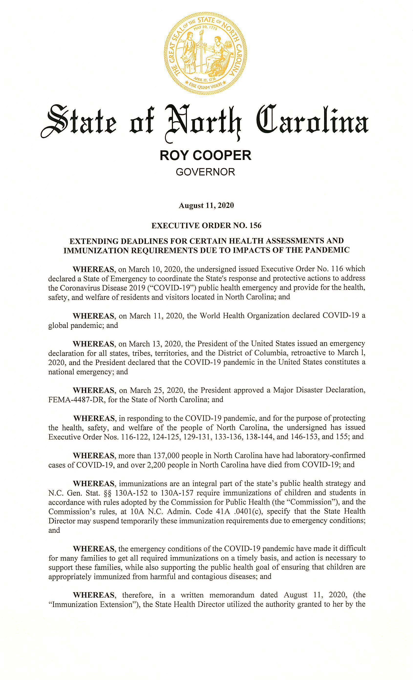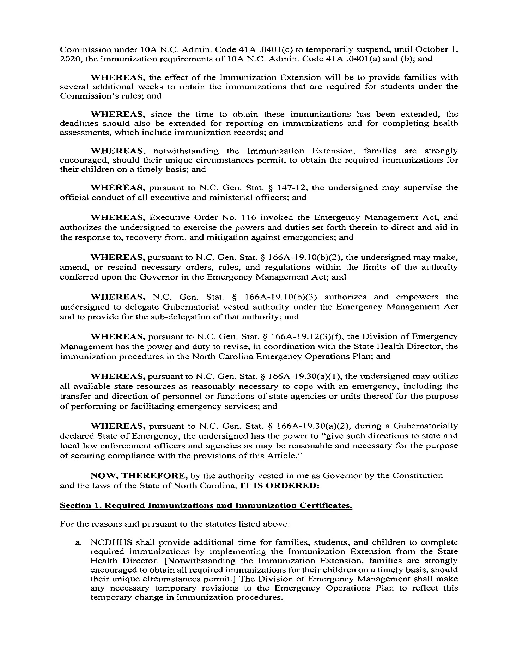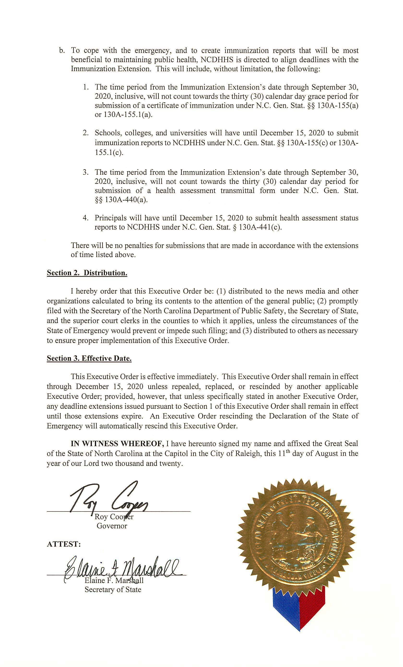
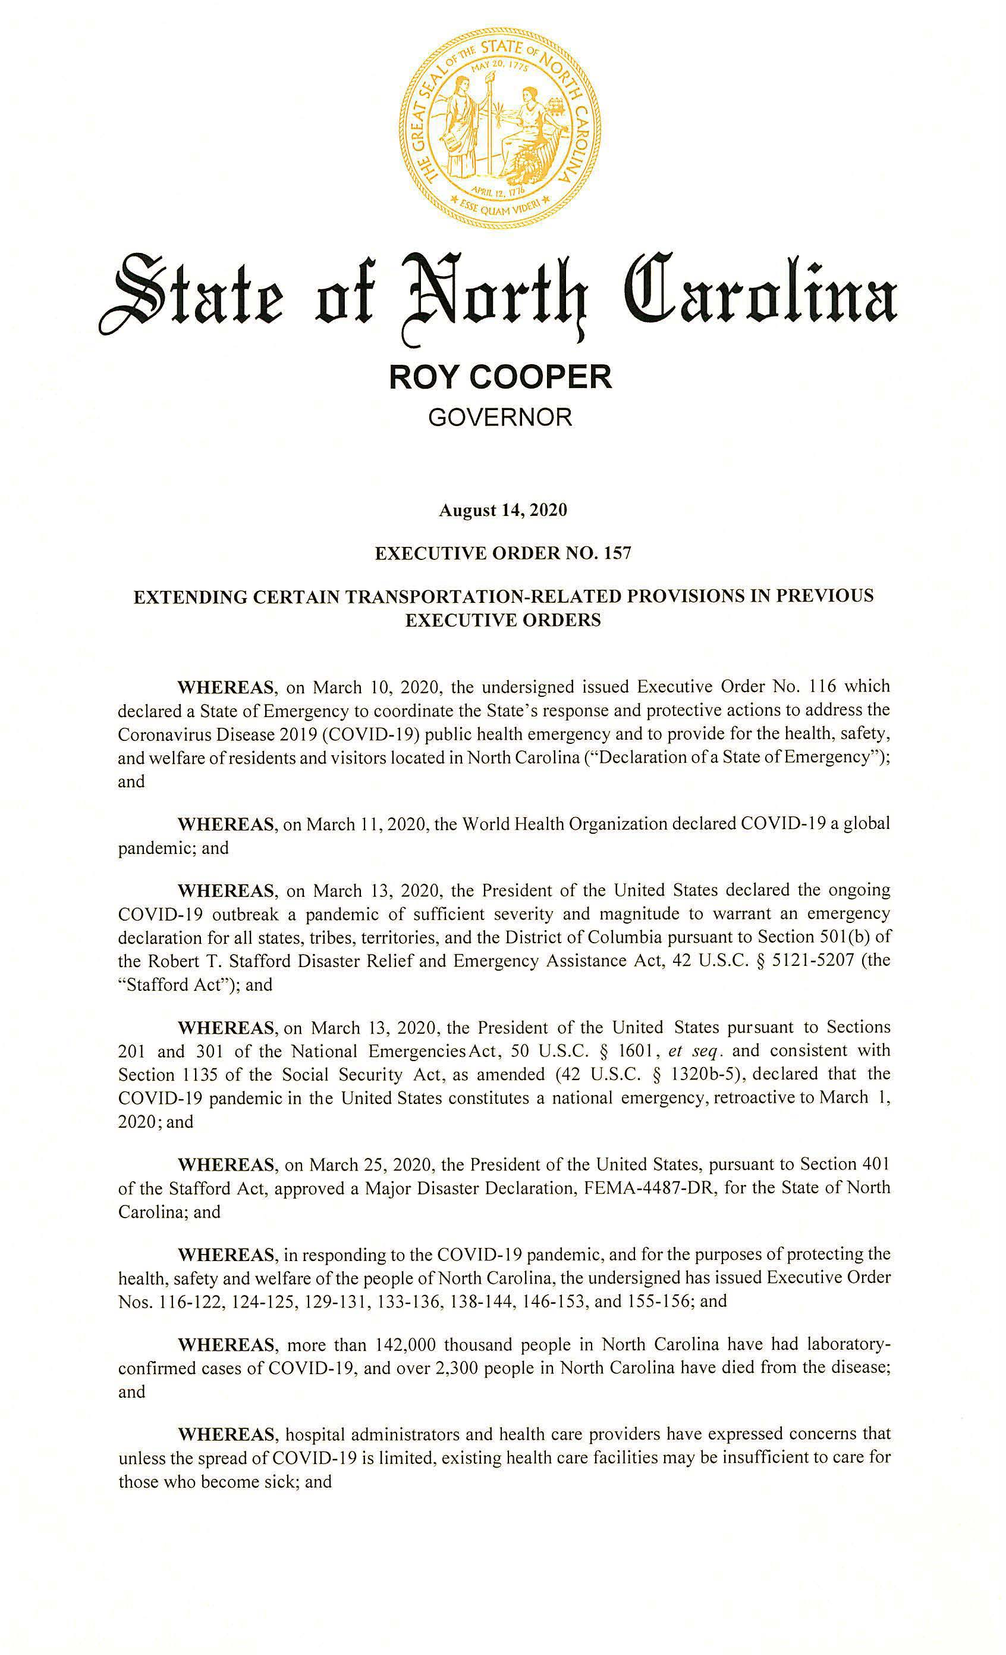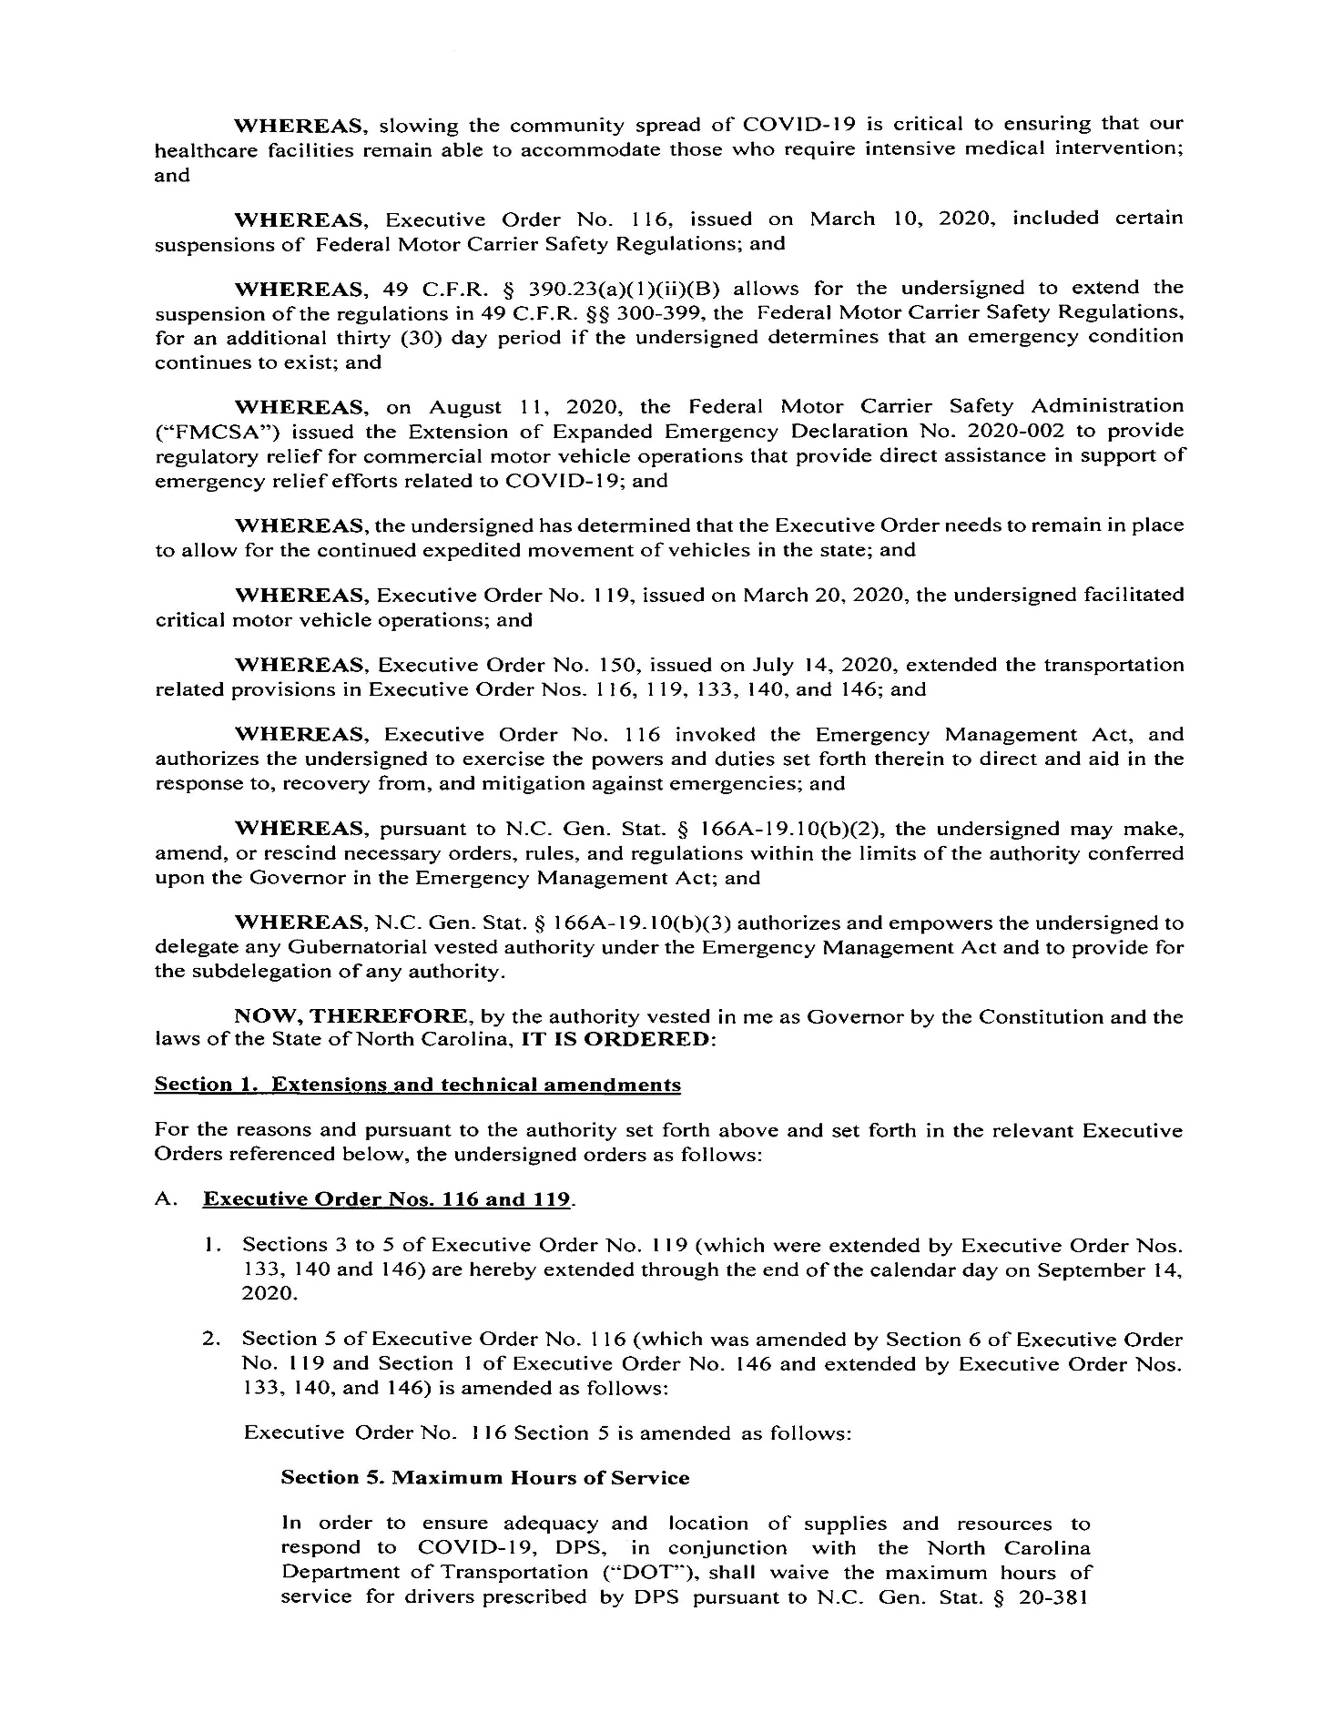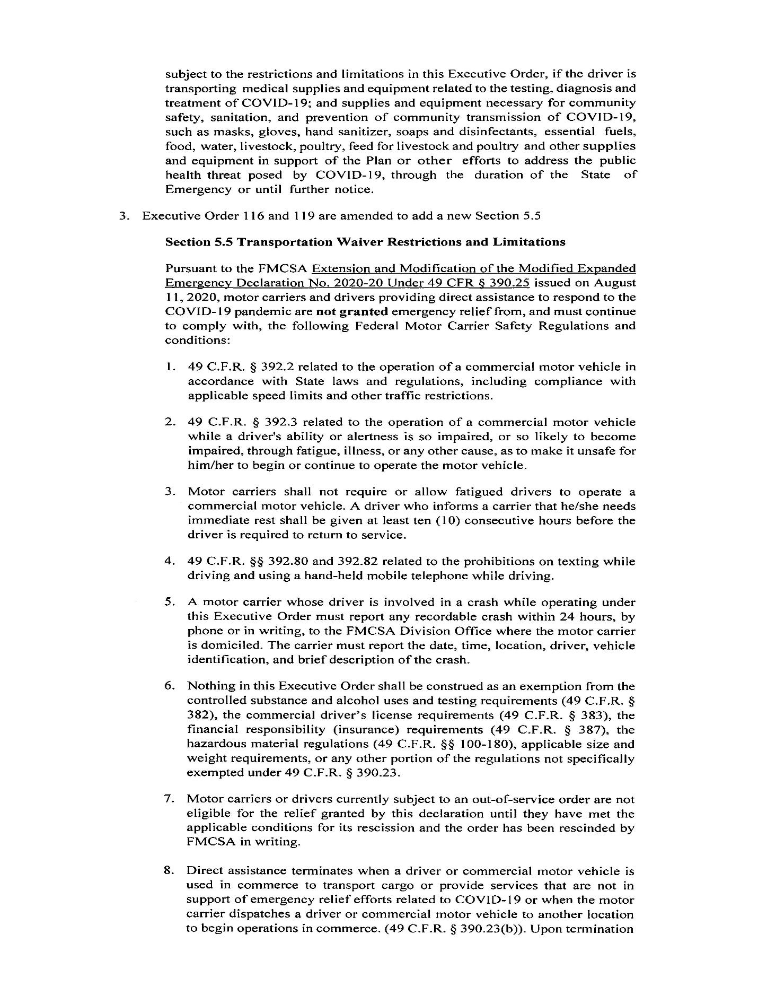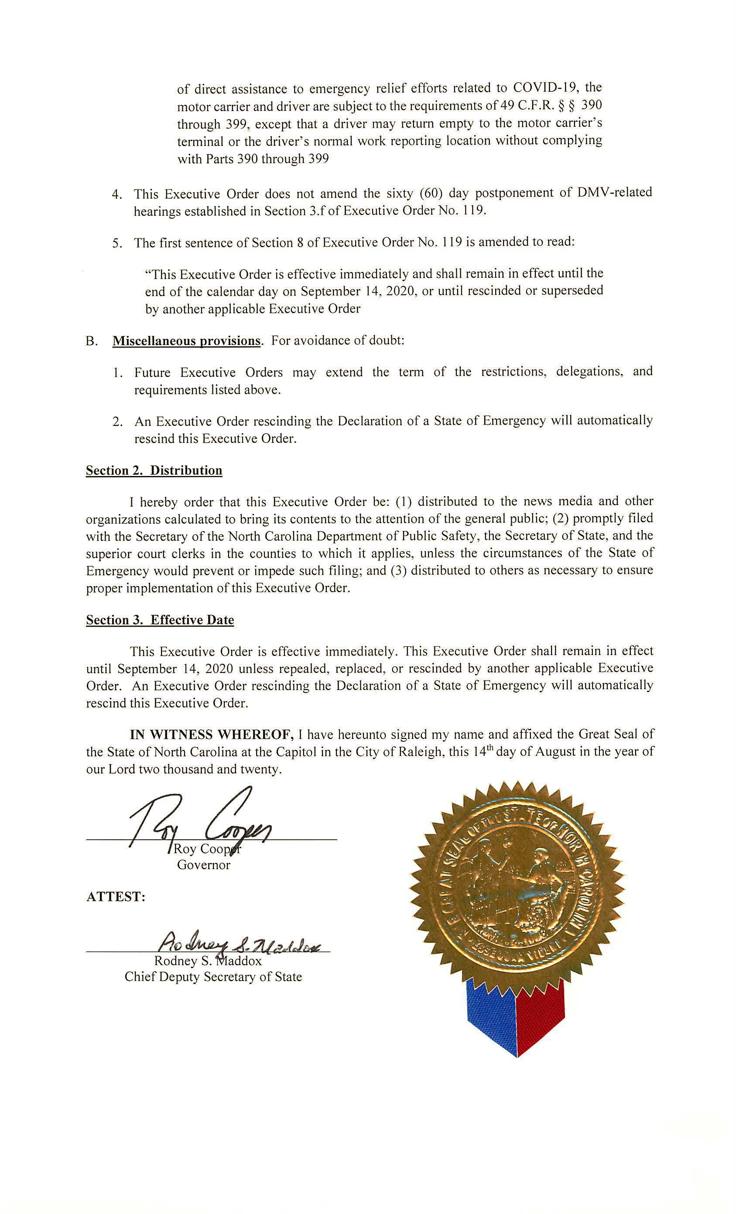
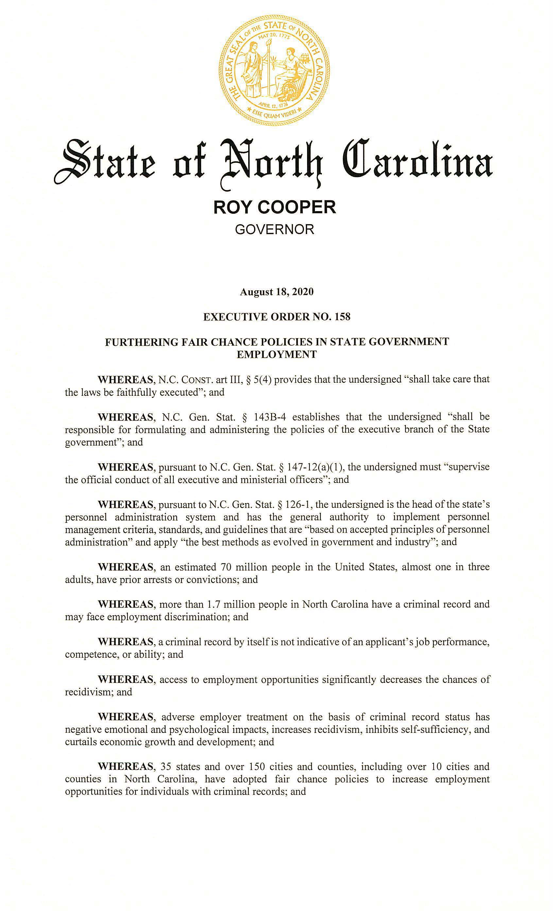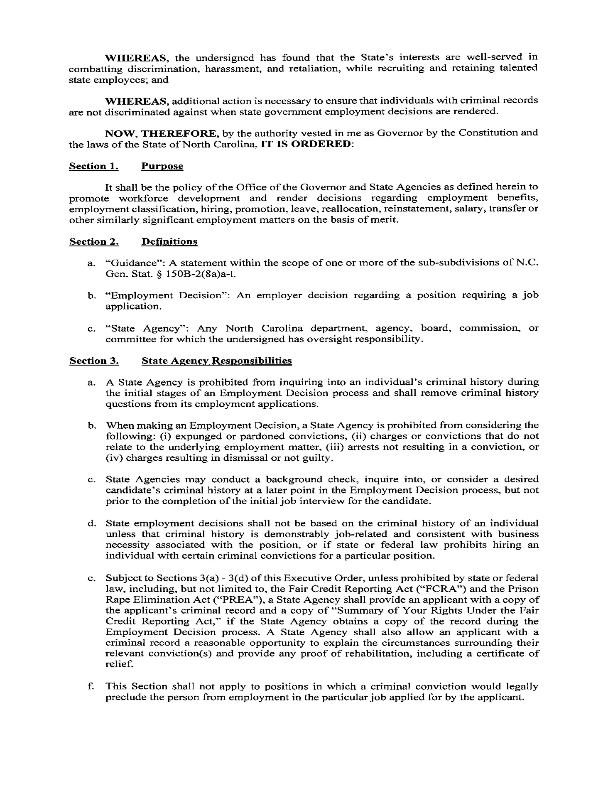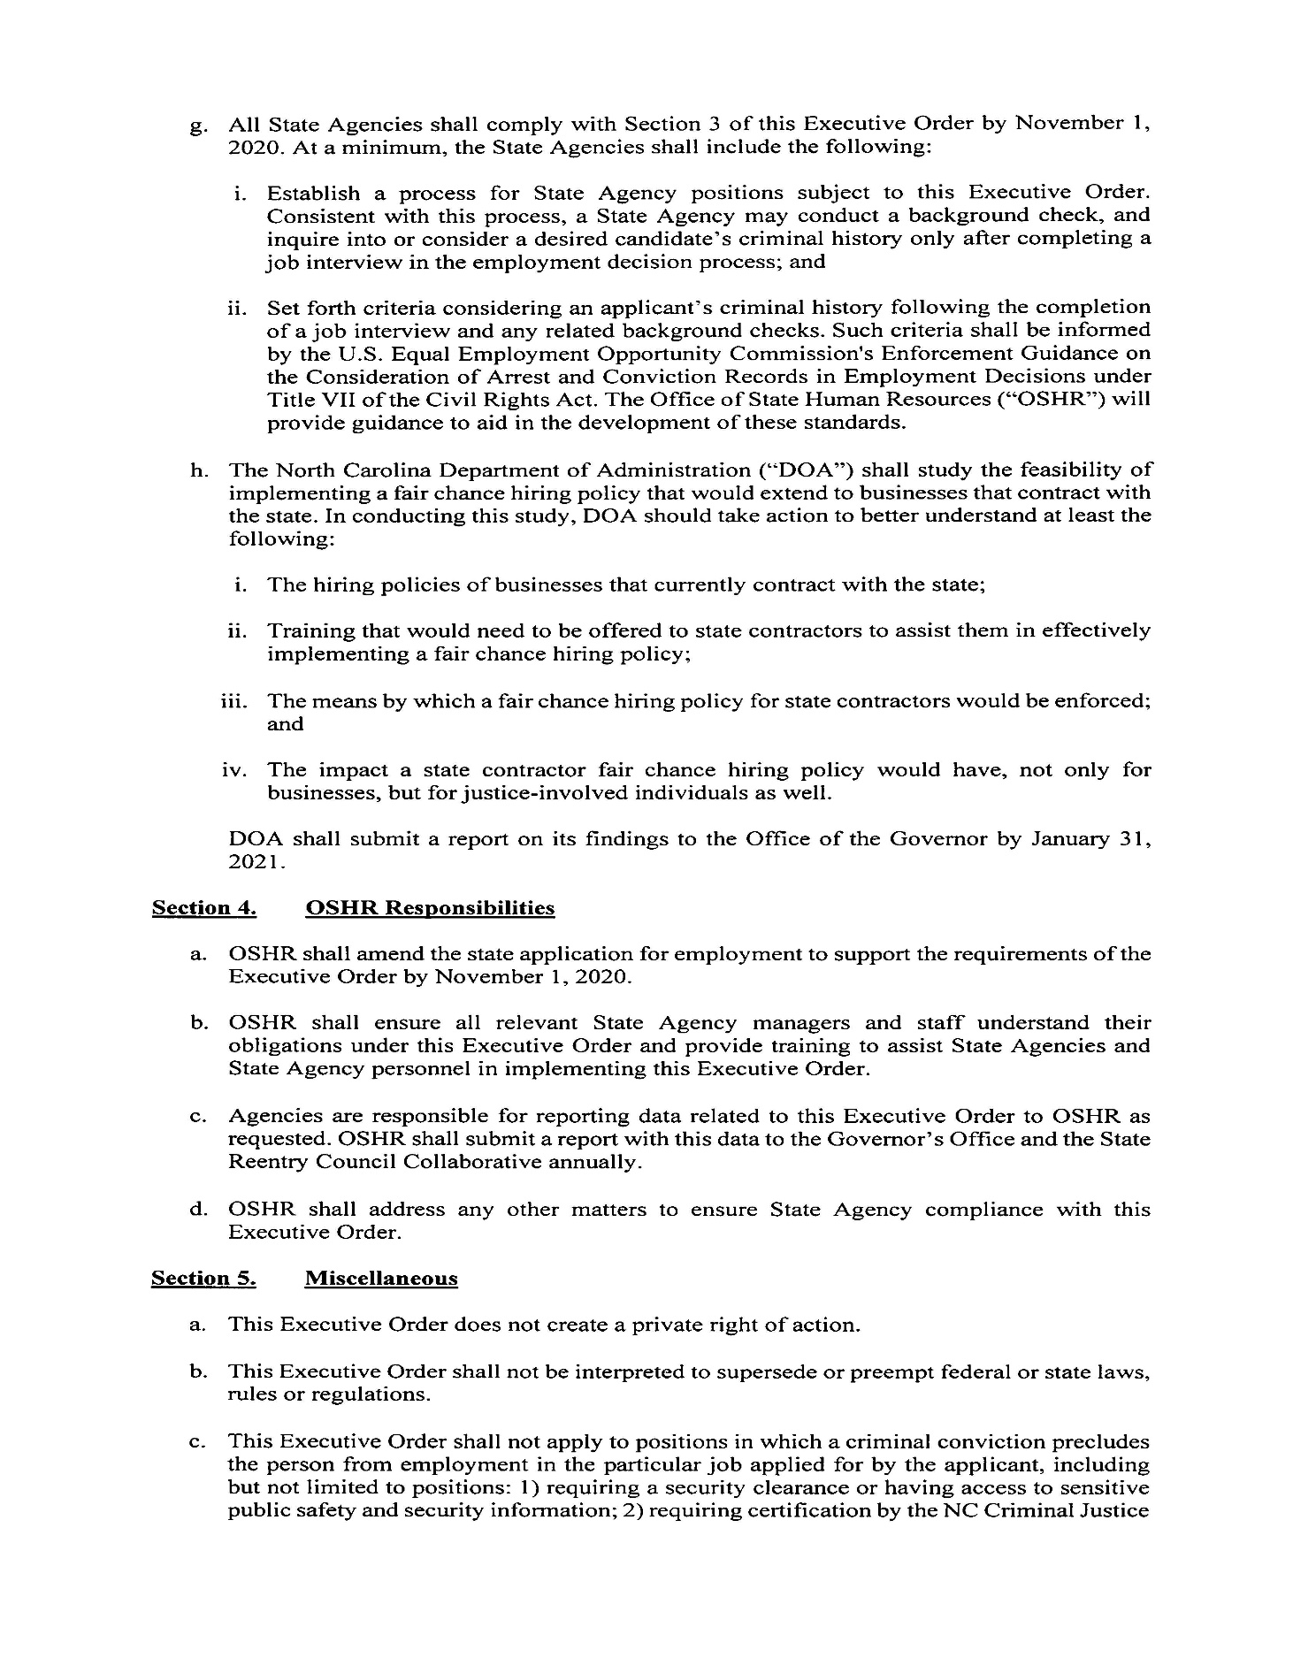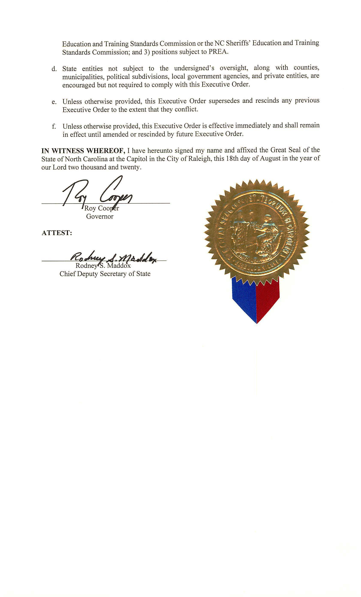

Note from the Codifier: The notices published in this Section of the NC Register include the text of proposed rules. The agency must accept comments on the proposed rule(s) for at least 60 days from the publication date, or until the public hearing, or a later date if specified in the notice by the agency. If the agency adopts a rule that differs substantially from a prior published notice, the agency must publish the text of the proposed different rule and accept comment on the proposed different rule for 60 days.
Statutory reference: G.S. 150B-21.2.

Title 10A – Department of Health and Human Services

Notice is hereby given in accordance with G.S. 150B-21.2 that the Medical Care Commission intends to amend the rule cited as 10A NCAC 13O .0301.

Link to agency website pursuant to G.S. 150B-19.1(c): https://info.ncdhhs.gov/dhsr/ruleactions.html

Proposed Effective Date: April 1, 2021

Public Hearing:
Date: October 20, 2020
Time: 10:00 a.m.
Location: Dorothea Dix Park, Brown Building, Room 104, 801 Biggs Drive, Raleigh, NC 27603

Reason for Proposed Action: On March 10, 2020, the Governor of North Carolina, issued Executive Order No. 116, declaring a state of emergency to coordinate a response and enact protective measures to help prevent the spread of COVID-19, a respiratory disease that can result in serious illness or death. Because the vendor for nurse aide testing in North Carolina suspended operations in the State until conditions were deemed safe to reopen, an emergency and temporary rule amendment for this rule were made effective April 20, 2020 and June 26, 2020, respectively. Because of the continued need and to make this rule amendment permanent in the N.C. Administrative Code, the North Carolina Medical Care Commission proposes to assist the State's healthcare workforce and the citizens of North Carolina who need medical care by allowing the requesting of reciprocity for the N.C. Nurse Aide I Registry for out-of-state nurse aides who are active and in good standing on another State’s Nurse Aide I Registry.

Comments may be submitted to: Nadine Pfeiffer, 809 Ruggles Drive, 2701 Mail Service Center, Raleigh, NC 27699-2701

Comment period ends: November 16, 2020

Procedure for Subjecting a Proposed Rule to Legislative Review: If an objection is not resolved prior to the adoption of the rule, a person may also submit written objections to the Rules Review Commission after the adoption of the Rule. If the Rules Review Commission receives written and signed objections after the adoption of the Rule in accordance with G.S. 150B-21.3(b2) from 10 or more persons clearly requesting review by the legislature and the Rules Review Commission approves the rule, the rule will become effective as provided in G.S. 150B-21.3(b1). The Commission will receive written objections until 5:00 p.m. on the day following the day the Commission approves the rule. The Commission will receive those objections by mail, delivery service, hand delivery, or facsimile transmission. If you have any further questions concerning the submission of objections to the Commission, please call a Commission staff attorney at 919-431-3000.

Fiscal impact. Does any rule or combination of rules in this notice create an economic impact? Check all that apply.

State funds affected

Local funds affected

Substantial economic impact (>= $1,000,000)

Approved by OSBM

No fiscal note required

Chapter 13 - NC Medical Care Commission

SUBCHAPTER 13O – HEALTHCARE PERSONNEL REGISTRY

SECTION .0300 - NURSE AIDE I REGISTRY

10A NCAC 13O .0301 NURSE AIDE I TRAINING AND COMPETENCY EVALUATION

(a) To be eligible to be listed on the NC Nurse Aide I Registry by the Health Care Personnel Education and Credentialing Section, a person shall shall:

(1) pass a Nurse Aide I training program approved by the Department in accordance with 42 CFR Part 483.151 through Part 42 CFR 483.152 and the State of North Carolina's Nurse Aide I competency exam. exam; or

(2) apply to the Department for approval to be listed on the NC Nurse Aide I Registry by reciprocity of a nurse aide certification or registration from another State to North Carolina.

(b) In applying for reciprocity of a nurse aide certification or registration to be listed on the NC Nurse Aide I Registry pursuant to Subparagraph (a)(2) of this Rule, the applicant shall:

(1) submit a completed application to the Department that includes the following:
(A) first, middle, and last name;
(B) the applicant's prior name(s), if any;
(C) mother's maiden name;
(D) gender;
(E) social security number;
(F) date of birth;
(G) mailing address;
(H) email address;
(I) home telephone number;
(J) any other State registries of nurse aides upon which the applicant is listed;
(K) certification or registration numbers for any State nurse aide registries identified in Part (b)(1)(J) of this Rule;
(L) original issue dates for any certifications or registrations identified in Part (b)(1)(K) of this Rule;
(M) expiration dates for any certifications or registrations identified in Part (b)(1)(K) of this Rule; and
(N) employment history;

(2) provide documentation verifying that his or her registry listing is active and in good standing in the State(s) of reciprocity, dated no older than 30 calendar days prior to the date the application is received by the Department; and

(3) provide a copy of his or her Social Security card and an unexpired government-issued identification containing a photograph and signature.

(c) For the applicant to be approved for reciprocity of a nurse aide certification or registration and be listed on the NC Nurse Aide I Registry, the Department shall verify the following:

(1) the applicant has completed an application in accordance with Subparagraph (b)(1) of this Rule;

(2) the applicant is listed on another State's registry of nurse aides as active and in good standing;

(3) the applicant has no pending or substantiated findings of abuse, neglect, exploitation, or misappropriation of resident or patient property recorded on other State registries of nurse aides;

(4) if the applicant has been employed as a nurse aide for monetary compensation consisting of at least a total of eight hours of time worked performing nursing or nursing-related tasks delegated and supervised by a Registered Nurse, then the applicant shall provide the employer name, employer address, and dates of employment for the previous 24 consecutive months;

(5) the name listed on the Social Security card and government-issued identification containing a photograph and signature submitted with the application matches the name listed on another State's registry of nurse aides or that the applicant has submitted additional documentation verifying any name changes; and

(6) the applicant completed a State-approved nurse aide training and competency evaluation program that meets the requirements of 42 CFR 483.152 or a State-approved competency evaluation program that meets the requirements of 42 CFR 483.154.

(d) The Department shall within 10 business days of receipt of an application for reciprocity of a nurse aide certification or registration or receipt of additional information from the applicant:

(1) inform the applicant by letter whether he or she has been approved; or

(2) request additional information from the applicant.

The applicant shall be added to the NC Nurse Aide I Registry within three business days of Department approval.

(b)(e) This Rule incorporates 42 CFR Part 483 Subpart D by reference, including all subsequent amendments and editions. Copies of the Code of Federal Regulations may be accessed electronically free of charge from www.gpo.gov/fdsys/browse/collectionCfr.action?collectionCode=CFR.

(c)(f) The State of North Carolina's Nurse Aide I competency exam shall include each course requirement specified in the Department-approved Nurse Aide I training program as provided for in 42 CFR Part 483.152.

(d)(g) The State of North Carolina's Nurse Aide I competency exam shall be administered and evaluated only by the Department or its contracted testing agent as provided for in 42 CFR Part 483.154.

(e)(h) The Department shall include a record of completion of the State of North Carolina's Nurse Aide I competency exam in the NC Nurse Aide I Registry within 30 business days of passing the written or oral exam and the skills demonstration as provided for in 42 CFR Part 483.154.

(f)(i) If the State of North Carolina's Nurse Aide I competency exam candidate does not pass the written or oral exam and the skills demonstration as provided for in 42 CFR Part 483.154, the candidate shall be advised by the Department of the areas that the individual did not pass.

(g)(j) Every North Carolina's Nurse Aide I competency exam candidate shall have, as provided for in 42 CFR Part 483.154, have the opportunity to take the exam at maximum three times before being required to retake and pass a Nurse Aide I training program.

(h) A person who is currently listed on any state's Nurse Aide I Registry shall not be required to take the Department-approved Nurse Aide I training program to be listed or, if his or her 24-month listing period has expired, relisted on the NC Nurse Aide I Registry, unless the person fails to pass the State of North Carolina's Nurse Aide I competency exam after three attempts.

(i)(k) U.S. military personnel who have completed medical corpsman training and retired or non-practicing nurses shall not be required to take the Department-approved Nurse Aide I training program to be listed or relisted on the Nurse Aide I Registry, unless the person fails to pass the State of North Carolina's Nurse Aide I competency exam after three attempts.

Authority G.S. 131E-255; 42 CFR Part 483; 483.150; 42 CFR 483.151; 42 CFR 483 .152; 42 CFR 483.154; 42 CFR 483.156; 42 CFR 483.158.

Title 12 – Department of Justice

Notice is hereby given in accordance with G.S. 150B-21.2 that the Criminal Justice Education and Training Standards Commission intends to amend the rules cited as 12 NCAC 09A .0201; 09B .0202, .0209, .0226, .0227, .0232, .0233, .0314, .0409, .0417; and 09G .0414.

Link to agency website pursuant to G.S. 150B-19.1(c): https://ncdoj.gov/law-enforcement-training/criminal-justice/forms-and-publications/

Proposed Effective Date: January 1, 2021

Public Hearing:
Date: November 18, 2020
Time: 10:00 a.m.
Location: Wake Technical Community College, 321 Chapanoke Rd., Raleigh NC 27502

Reason for Proposed Action: To remove language about the Attorney General authorizing the SBI to investigate, given that the SBI is no longer under the Department of Justice. To provide language respective of the various instructor curriculum specialized training and practical needs. To update the instructional hours for the Drug Diversion Investigator course and establish application submission guidelines for the Drug Diversion Investigator and the Drug Diversion Investigator Supervisor. To modify the supervised field practice hours due to the limited resources of smaller agencies.

Comments may be submitted to: Charminique D. Williams, PO Box Drawer 149, Raleigh, NC 27602; phone (919) 779-8206; email cdwilliams@ncdoj.gov

Comment period ends: November 18, 2020

Procedure for Subjecting a Proposed Rule to Legislative Review: If an objection is not resolved prior to the adoption of the rule, a person may also submit written objections to the Rules Review Commission after the adoption of the Rule. If the Rules Review Commission receives written and signed objections after the adoption of the Rule in accordance with G.S. 150B-21.3(b2) from 10 or more persons clearly requesting review by the legislature and the Rules Review Commission approves the rule, the rule will become effective as provided in G.S. 150B-21.3(b1). The Commission will receive written objections until 5:00 p.m. on the day following the day the Commission approves the rule. The Commission will receive those objections by mail, delivery service, hand delivery, or facsimile transmission. If you have any further questions concerning the submission of objections to the Commission, please call a Commission staff attorney at 919-431-3000.

Fiscal impact. Does any rule or combination of rules in this notice create an economic impact? Check all that apply.

State funds affected

Local funds affected

Substantial economic impact (>= $1,000,000)

Approved by OSBM

No fiscal note required

Chapter 09 - Criminal Justice Education and Training Standards

SUBCHAPTER 09A - CRIMINAL JUSTICE EDUCATION AND TRAINING STANDARDS COMMISSION

SECTION .0200 - ENFORCEMENT OF RULES

12 NCAC 09A .0201 INVESTIGATION OF VIOLATION OF RULES

(a) If any criminal justice agency, school, authorized representative acting on behalf of either, or individual is reported to be or suspected of being in violation of any of the rules in this Chapter, the Commission may take action to correct the violation and to ensure that similar violations do not occur.

(b) Before taking action against an agency, school, or individual for a violation, the Standards Division shall investigate the alleged violation and present a report of its findings to the Probable Cause Committee of the Commission.

(c) The Probable Cause Committee shall convene prior to the next regular meeting of the Commission, shall consider the report of the Standards Division, and shall make a determination as to whether or not probable cause exists that the Commission's rules have been violated.

(d) The Probable Cause Committee may:

(1) direct the Standards Division to conduct a further investigation of the alleged violation;

(2) request the Attorney General to authorize an investigation by the State Bureau of Investigation of the alleged violation;

(2)(3) direct the Standards Division to conduct an administrative hearing in the matter, pursuant to Rule .0107 of this Subchapter and 26 NCAC 03; or

(3)(4) determine the appropriate sanctions against the violator pursuant to the Commission's rules.

Authority G.S. 17C-6; 17C-10.

SUBCHAPTER 09B - STANDARDS FOR CRIMINAL JUSTICE EMPLOYMENT: EDUCATION: AND TRAINING

SECTION .0200 – MINIMUM STANDARDS FOR CRIMINAL JUSTICE SCHOOLS AND CRIMINAL JUSTICE TRAINING PROGRAMS OR COURSES OF INSTRUCTION

Note: The text in italics is pending review by the RRC at the September 17, 2020 meeting.

12 NCAC 09B .0202 RESPONSIBILITIES OF THE SCHOOL DIRECTOR

(a) In planning, developing, coordinating, and delivering each Commission-certified criminal justice training course, the School Director shall:

(1) Formalize and schedule the course curriculum in accordance with the curriculum standards established in this Subchapter;

(2) Select and schedule instructors who are certified by the Commission;

(3) Provide each instructor with a current Commission course outline and all necessary additional information concerning the instructor's duties and responsibilities;

(4) Notify each instructor that he or she shall comply with the Basic Law Enforcement Training Course Management Guide and provide him or her access to the most current version of the Course Management Guide;

(5) Review each instructor's lesson plans and other instructional materials for conformance to Commission standards and to minimize repetition and duplication of subject matter;

(6) Arrange for the availability of appropriate audiovisual aids and materials, publications, facilities, and equipment for training in all topic areas;

(7) Develop, adopt, reproduce, and distribute any supplemental rules and requirements determined by the school to be necessary or appropriate for:
(A) effective course delivery;
(B) establishing responsibilities and obligations of agencies or departments employing or sponsoring course trainees; and
(C) regulating trainee participation and demeanor, ensuring trainee attendance, and maintaining performance records;

(8) If appropriate, recommend housing and dining facilities for trainees;

(9) Administer the course delivery in accordance with Commission procedures and standards, give consideration to advisory guidelines issued by the Commission, and ensure that the training offered is safe and effective;

(10) Maintain direct supervision, direction, and control over the performance of all persons to whom any portion of the planning, development, presentation, or administration of a course has been delegated. The comprehensive final examination shall be administered by the Criminal Justice Education and Training Standards Commission; and

(11) Report the completion of each presentation of a Commission-certified criminal justice training course to the Commission.

(12) All forms required for submission to the Commission are located on the Agency's website: http://www.ncdoj.gov/About-DOJ/Law-Enforcement-Training-and-Standards/Criminal-Justice-Education-and-Training-Standards/Forms-and-Publications.aspx.

(b) In addition to Paragraph (a) of this Rule, in planning, developing, coordinating, and delivering each Commission-certified Basic Law Enforcement Training Course, the School Director shall:

(1) Deliver training in accordance with the most current version of the Basic Law Enforcement Training Course Management Guide as published by the North Carolina Justice Academy;

(2) Schedule course presentation to include 12 hours of instruction each week during consecutive calendar weeks, except that there may be as many as three one-week breaks until course requirements are completed;

(3) Schedule only specialized instructors certified by the Commission to teach those high-liability areas as specified in Rule .0304(a) of this Subchapter as either the lead instructor or as assistant instructors or role players;

(4) With the exception of the First Responder, Physical Fitness, Explosives and Hazardous Materials, and topical areas outlined in Rule .0304(a) of this Subchapter, schedule one specialized instructor certified by the Commission for every six trainees while actively engaged in a practical performance exercise;

(5) Schedule one specialized instructor certified by the Commission for every eight trainees while actively engaged in a practical performance exercise in the topical area "Subject Control Arrest Techniques;"

(6) Schedule no single individual to instruct more than 35 percent of the total hours of the curriculum during any one delivery of the Basic Law Enforcement Training Course presentation;

(7) Not less than 30 days before commencing delivery of the Basic Law Enforcement Training Course, submit to the Commission a Pre-Delivery Report of Training Course Presentation pursuant to 12 NCAC 09C .0211. The Pre-Delivery Report (Form F-10A) shall indicate a requested date and location for the administration of the state comprehensive exam, and include the following attachments:
(A) a course schedule showing the arrangement of topical presentations and proposed instructional assignments; and
(B) a copy of any rules and requirements for the school. A copy of such rules shall also be given to each trainee and to the executive officer of each trainee's employing or sponsoring agency or department at the time the trainee enrolls in the course;

(8) Monitor, or designate an instructor certified by the Commission to monitor, a presentation of each instructor once during each three year certification period in each topic taught by the instructor and prepare a written evaluation on the instructor's performance and suitability for subsequent instructional assignments. The observations shall be of sufficient duration to ensure that the instructor is using the Instructional System Design model, and that the delivery is objective-based, documented by, and consistent with a Commission-approved lesson plan. For each topic area, the School Director's evaluation shall be based upon the course delivery observations, the instructor's use of the approved lesson plan, and the results of the student evaluations of the instructor. For probationary instructors, the evaluations conducted by another instructor shall be prepared on the Criminal Justice Instructor Evaluation (Form F-16) and forwarded to the Commission. Based on this evaluation, the School Director shall recommend approval or denial of requests for General Instructor Certification. For all other instructors, these evaluations shall be prepared on the Criminal Justice Instructor Evaluation (Form F-16), be kept on file by the school for a period of three years, and shall be made available for inspection by a representative of the Commission upon request. In the event the evaluation of an instructor indicates that his or her performance was less than acceptable, the School Director shall forward a copy of the evaluation to the Commission. Any instructor who is evaluating the instructional presentation of another instructor shall hold certification in the same instructional topic area as that for which the instructor is being evaluated;

(9) Administer or designate a staff person to administer appropriate tests during course delivery:
(A) to determine and record the level of trainee comprehension and retention of instructional subject- matter;
(B) to provide a basis for a final determination or recommendation regarding the minimum degree of knowledge and skill of each trainee to function as an inexperienced law enforcement officer; and
(C) to determine subject or topic areas of deficiency for the application of Rule .0405(a)(3) of this Subchapter; and

(10) Not more than 10 days after the conclusion of a school's offering of Basic Law Enforcement Training, submit to the Commission a Post-Delivery Report of Training Course Presentation (Form F-10B) that shall include:
(A) a "Student Course Completion" form for each individual enrolled on the day of orientation; and
(B) a "Certification and Test Score Release" form. form;
(C) the "Police Office Physical Ability Test (POPAT) Post-Course" final form; and
(D) Orientation class enrollment roster.

(c) In addition to Paragraph (a) of this Rule, in planning, developing, coordinating, and delivering each Commission-certified "Criminal Justice Instructor Training Course," the School Director shall:

(1) Schedule course presentation pursuant to Rule .0209 of this Subchapter; include a minimum of 78 hours of instruction during the time period the class is taught until course requirements are completed.

(2) Schedule at least one evaluator for each six trainees, as follows:
(A) no evaluator shall be assigned more than six trainees during a course delivery;
(B) each evaluator, as well as the instructors, shall have completed a Commission-certified instructor training course or an equivalent instructor training course utilizing the Instructional Systems Design model, an international model with applications in education, military training, and private enterprise; and
(C) each instructor and evaluator shall document successful participation in a program presented by the North Carolina Justice Academy for purposes of familiarization and supplementation relevant to delivery of the instructor training course and trainee evaluation.

(3) Not fewer than 30 days before commencing delivery of the course, submit to the Commission a Pre-Delivery Report of Training Course Presentation [Form F-10A(ITC)] with the following attachments:
(A) a course schedule showing the arrangement of topical presentations and proposed instructional assignments;
(B) the names and last four digits of the social security numbers of all instructors and evaluators; and
(C) a copy of any rules, and requirements for the school; and

(4) Not more than 10 days after course completion, submit to the Commission a Post-Delivery Report [Form F-10B(ITC)] containing the following:
(A) class enrollment roster;
(B) a course schedule with the designation of instructors and evaluators utilized in delivery;
(C) scores recorded for each trainee on the 70 minute skill presentation; and
(D) designation of trainees who completed the course in its entirety and whom the School Director finds to be competent to instruct.

(d) In addition to Paragraph (a) of this Rule, in planning, developing, coordinating, and delivering each Commission-certified RADAR, RADAR and Time-Distance, Time-Distance, or LIDAR speed measurement operator training course or re-certification course, the School Director shall:

(1) select and schedule speed measurement instrument instructors who are certified by the Commission as instructors for the specific speed measurement instruments in which the trainees are to receive instruction as follows:
(A) provide to the instructor the Commission form(s) for motor skill examination on each trainee;
(B) require the instructor to complete the motor skill examination form on each trainee indicating the level of proficiency obtained on each specific instrument; and
(C) require each instructor to sign each individual form and submit the original to the School Director;

(2) not fewer than 30 days before the scheduled starting date, submit to the Director of the Standards Division a Pre-Delivery Report of Speed Measuring Instrument Course Presentation [Form F-10A (SMI)] that shall contain a period of course delivery including the proposed starting date, course location, requested date and location for the administration of the state exam, and the number of trainees to be trained on each type of approved speed measurement instrument. The Director of the Standards Division shall review the request and notify the School Director within thirty business days if the request is approved or denied; and

(3) upon completing delivery of the Commission-certified course, and not more than 10 days after the conclusion of a school's offering of a certified RADAR, RADAR and Time-Distance, Time-Distance, or LIDAR speed measurement operator training course or re-certification course, the School Director shall notify the Commission regarding the progress and achievements of each trainee by submitting a Post-Delivery Report of Training Course Presentation [Form F-10B (SMI)]. This report shall include the original motor-skill examination form(s) completed and signed by the certified instructor responsible for administering the motor-skill examination to the respective trainee.

Authority G.S. 17C-6.

12 NCAC 09B .0209 CRIMINAL JUSTICE INSTRUCTOR TRAINING

(a) The instructor training Instructor Training course required for general instructor General Instructor certification shall consist of a minimum of 90 hours of instruction, as defined in subsection (c), within a 15-day period. 36 hours of classroom instruction plus the time required to conduct practical exercises, student presentations, and post testing presented during a continuous period of not more than two weeks.

(b) Each instructor training Instructor Training course shall be designed to provide the trainee with the skills and knowledge to perform the function functions of a criminal justice instructor.

(c) Each instructor training Instructor Training course shall include the following identified topic areas and minimum instructional hours for each area:

(1) Orientation and Pre-Test 4 1 Hours

(2) Instructional Systems Design (ISD) 8 5 Hours

(3) Law Enforcement Instructor Liabilities and Legal Responsibilities 3 2 Hours

(4) Criminal Justice Instructional Leadership 4 Hours

(5) Lesson Plan Preparation: Professional Resources 3 2 Hours

(6) Lesson Plan Development and Formatting 4 3 Hours

(7) Adult Learning 4 2 Hours

(8) Instructional Styles and Platform Skills 8 5 Hours

(9) Classroom Management 4 3 Hours

(10) Active Learning: Demonstration and Practical Exercises 8 Hours

(11)(10) The Evaluation Process of Learning 5 4 Hours

(12)(11) Audio Visual Aids 6 5 Hours

(13) Student 8-Minute Introductions and Video Critique 5 Hours

(14) Student Performance: First 35-Minute Presentation 6 Hours

Second 35-Minute Presentation 6 Hours

Final 70-Minute Presentation and Review 8 Hours

(12) Completion of tasks associated with Practical Exercises and Student Presentations. The number of hours required to complete this portion of the curriculum shall be based on the number of enrolled students, available facilities, and number of instructors.

(15) Course Closing and Post-test 4 Hours

(d) The "Instructor Training" manual published by the North Carolina Justice Academy shall be the curriculum for instructor training courses. Copies of this publication may be inspected at the agency:
Criminal Justice Standards Division
North Carolina Department of Justice
1700 Tryon Park Drive
Post Office Drawer 149
Raleigh, North Carolina 27602

and may be purchased at the cost of printing and postage from the Academy at the following address:
North Carolina Justice Academy
Post Office Drawer 99
Salemburg, North Carolina 28385

Authority G.S. 17C-6.

12 NCAC 09B .0226 SPECIALIZED FIREARMS INSTRUCTOR TRAINING

(a) The instructor training course for specialized firearms instructor certification Specialized Firearms Instructor Training Certification shall consist of a minimum of 81 50 hours of classroom and range instruction plus time required to complete the tasks associated with Range Operations presented during a continuous period of not more than two weeks.

(b) Each specialized firearms instructor training Specialized Firearms Instructor Training course shall be designed to provide the trainee with the skills and knowledge to perform the function of a criminal justice firearms instructor in a Basic Law Enforcement Training (BLET) Course or a law enforcement officer in-service firearms training program.

(c) Each applicant for specialized firearms instructor training shall:

(1) have completed the criminal justice general instructor training course; and

(2) present a written endorsement by either
(A) a certified school director indicating the student may be utilized to instruct firearms in the Basic Law Enforcement Training Course; or
(B) a department head, certified school director, or in-service training coordinator, indicating the student may be utilized to instruct firearms in a law enforcement officer in-service firearms training program. program; and

(3) Once within 365 days prior to enrollment each prospective student shall demonstrate proficiency during a qualification administered by the North Carolina Justice Academy. To successfully complete this qualification each prospective student shall achieve a minimum score of 92 percent 2 out of 3 times on both the BLET Day and Night Courses of Fire while using a 'Sam Browne' type belt and security holster and agency-issued duty or ballistic-equivalent ammunition.

(d) Each specialized firearms instructor training Specialized Firearms Instructor Training course shall include the following identified topic areas and minimum instructional hours for each area:

(1) Orientation/Pretest 8 2 Hours

(2) Range Operations 38 2 Hours

(3) Civil Liability 4 Hours

(4) Night Firing 2 Hours

(5) Combat Shooting Classroom and Range 8 Hours

(6) Mental Conditioning 1 Hours

(7) Shotgun Operation and Firing 4 Hours

(8) Service Handgun - Operation and Use 5 8 Hours

(9) Rifle - Operation and Maintenance 4 Hours

(10) Service Handgun - Maintenance and Cleaning 2 Hours

(11) Range Medical Emergencies 2 Hours

(12) In-Service Firearms Requirements 2 Hours

(13) BLET Lesson Plan Review 1 Hour

(14) Range Drills (as defined in the Specialized Firearms Instructor Training Manual and the Specialized Firearms Instructor Training Course Management Guide) 8 Hours

(15) Completion of tasks associated with Range Operations. Completion of tasks associated with Instructor Practicums (hours determined by number of students and instructors):
(A) Conduct a BLET Day Course of Fire
(B) Conduct a BLET Night Course of Fire
(C) Conduct a Long Gun Course of Fire
(D) Develop a Combat Course of Fire

(e) The "Specialized Firearms Instructor Training Manual" published by the North Carolina Justice Academy shall be the curriculum for specialized firearms instructor training courses. the Specialized Firearms Instructor Training course. Copies of this publication may be inspected at the:
Criminal Justice Standards Division
North Carolina Department of Justice
1700 Tryon Park Drive
Post Office Drawer 149
Raleigh, North Carolina 27610
and may be obtained at the cost of printing and postage from the Academy at the following address:
North Carolina Justice Academy
Post Office Box 99
Salemburg, North Carolina 28385

(f) The Commission-certified school that is certified to offer the "Specialized Firearms Instructor Training" course is the North Carolina Justice Academy.

Authority G.S. 17C-6.

12 NCAC 09B .0227 SPECIALIZED DRIVER INSTRUCTOR TRAINING

(a) The instructor training course required for specialized driver instructor certification Specialized Driver Instructor Certification shall consist of a minimum of 48 24 hours of instruction. classroom instruction plus the time required to conduct the tasks as required in the driver practicums based on number of students, available facilities, and number of instructors.

(b) Each specialized driver instructor training Specialized Driver Instructor Training course shall be designed to provide the trainee with the skills and knowledge to perform the function of a criminal justice driver instructor in a Basic Law Enforcement Training Course or a "Law Enforcement Officers' Annual In-Service Training Program."

(c) Each applicant for specialized driver instructor training Specialized Driver Instructor Training shall:

(1) have completed the criminal justice general instructor training course;

(2) present a written endorsement by either
(A) a certified school director indicating the student may be utilized to instruct driving in Basic Law Enforcement Training Courses; or
(B) a department head, certified school director, or in-service training coordinator, indicating the student may be utilized to instruct driver training in the "Law Enforcement Officer's Annual In-Service Training Program";

(3) possess a valid operator driver's license; and

(4) maintain a safe driving record where no more than four points have been assigned against the driving record within the past three years. years; and

(5) Within 365 days prior to enrollment in the Specialized Driver Instructor Training course, the prospective student shall complete a qualification administered by the North Carolina Justice Academy or the North Carolina State Highway Patrol Training Academy requiring the individual to achieve minimum scores on the following Basic Law Enforcement Training driving course exercises:
(A) minimum score of 85 percent on 2 out of 3 attempts on the Off-set Lane Maneuver, Serpentine, and Precision Exercise during daylight conditions;
(B) minimum score of 85 percent on 2 out of 3 attempts on the Precision Exercise during nighttime conditions;
(C) minimum score of 85 percent on one 5-minute attempt during daytime conditions and one 5-minute attempt during nighttime conditions on the Emergency Response exercise;
(D) minimum score of 85 percent on one 5-minute attempt during daytime conditions and one 5-minute attempt during nighttime conditions on the Pursuit Exercise; and
(E) score 100 percent on 2 out of 3 attempts on all phases of the Fixed Radius Curve and Evasive Action Exercises.

(d) Each specialized driver instructor training Specialized Driver Instructor Training course shall include the following identified topic areas and instructional hours for each area:

(1) Orientation 1 Hour

(2) Lesson Plan Review (BLET) 4 6 Hours

(3) General Mechanical Knowledge 2 Hours

(4) Before - Operation Inspection 1 Hour

(5) Laws of Natural Force & Operating Characteristics 2 3 Hours

(6) Driver Practicum/Pre-Qualification 32 Hours

(7)(6) Legal and Operational Considerations for the Driver Instructor 4 Hours

(8)(7) Course Description Packet and Administrative Code Review 1 2 Hour

(9)(8) Course Review 1 Hour

(9) Building Driving Courses 4 Hours

(10) Completion of tasks associated with the Driver Practicums. The number of hours required to complete this portion of the curriculum shall be based on the number of enrolled students, available facilities, and number of instructors.

(e) The "Specialized Driver Instructor Training Manual" as published by the North Carolina Justice Academy shall be the curriculum for specialized driver instructor training Specialized Driver Instructor Training courses. Copies of this publication may be inspected at the:
Criminal Justice Standards Division
North Carolina Department of Justice
1700 Tryon Park Drive
Post Office Drawer 149
Raleigh, North Carolina 27610
and may be obtained at the cost of printing and postage from the Academy at the following address:
North Carolina Justice Academy
Post Office Box 99
Salemburg, North Carolina 28385

(f) Commission-certified schools that are certified to offer the "Specialized Driver Instructor Training" course are The North Carolina Justice Academy and The North Carolina State Highway Patrol Training Center.

Authority G.S. 17C-6.

12 NCAC 09B .0232 SPECIALIZED SUBJECT CONTROL ARREST TECHNIQUES INSTRUCTOR TRAINING

(a) The instructor training course required for specialized subject control arrest techniques instructor certification Specialized Subject Control Arrest Techniques Instructor Certification shall consist of a minimum of 75 29 hours of classroom instruction plus time required to complete the tasks associated with Subject Control Arrest Techniques Instructional Methods and Demonstration presented during a continuous period of not more than two weeks.

(b) Each specialized subject control arrest techniques instructor training Specialized Subject Control Arrest Techniques Instructor Training course shall be designed to provide the trainee with the skills and knowledge to perform the function of a criminal justice subject control arrest techniques instructor Specialized Subject Control Arrest Techniques Instructor in a Basic Law Enforcement Training Course or a Law Enforcement Officers' Annual In-Service Training Program.

(c) Each applicant for specialized subject control arrest techniques instructor training Specialized Subject Control Arrest Techniques Instructor Training shall:

(1) have completed the criminal justice general instructor training Criminal Justice Instructor Training course;

(2) present a letter from a licensed physician stating the applicant's physical fitness to participate in the course; and

(3) present a written endorsement by either
(A) a certified School Director indicating the student is qualified to instruct subject control arrest techniques in Basic Law Enforcement Training Courses; or
(B) a Department Head, certified School Director, or In-Service Training Coordinator indicating the student may be utilized to instruct subject control arrest techniques for the Law Enforcement Officers' Annual In-Service Training Program. program; and

(4) Within 365 days prior to enrollment in the Subject Control Arrest Techniques Instructor Training course the prospective student shall complete the following assessments administered by the North Carolina Justice Academy:
(A) a qualification requiring the individual to demonstrate 100 percent proficiency on the Basic Law Enforcement Training Subject Control Arrest Techniques, and
(B) achieve at least the 60th percentile on a physical fitness assessment,

(d) Each specialized subject control arrest techniques instructor training Specialized Subject Control Arrest Techniques Instructor Training course shall include the following identified topic areas and minimum instructional hours for each area:

(1) Pre-Qualification Testing 4 Hours

(2)(1) Orientation 1 Hour

(3)(2) Response to Injury 4 Hours

(4)(3) Combat Conditioning 4 Hours

(5)(4) Safety Guidelines/Rules 2 Hours

(6) SC/AT Techniques and Instructional Methods 42 Hours

(7)(5) Fundamentals of Professional Liability 4 Hours

(8)(6) Practical Skills Enhancement 4 Hours

(9)(7) Student Instructional Practicum 6 Hours

(10)(8) BLET Lesson Plan Review 4 Hours

(9) Completion of tasks associated with Subject Control Arrest Techniques Instructional Methods and Demonstrations. The number of hours required to complete this portion of the curriculum shall be based on the number of enrolled students, available facilities, and number of instructors.

TOTAL 75 Hours

(e) The "Specialized Subject Control Arrest Techniques Instructor Training Manual" as published by the North Carolina Justice Academy shall be the curriculum for specialized subject control arrest techniques instructor training courses. the Specialized Subject Control Arrest Techniques Instructor Training course. Copies of this publication may be inspected at the:
Criminal Justice Standards Division
North Carolina Department of Justice
1700 Tryon Park Drive
Post Office Drawer 149
Raleigh, North Carolina 27610
and may be obtained at the cost of printing and postage from the Academy at the following address:
North Carolina Justice Academy
Post Office Box 99
Salemburg, North Carolina 28385

(f) The Commission-certified school that is certified to offer the "Specialized Subject Control Arrest Techniques Instructor Training" course is the North Carolina Justice Academy.

Authority G.S. 17C-6.

12 NCAC 09B .0233 SPECIALIZED PHYSICAL FITNESS INSTRUCTOR TRAINING

(a) The instructor training course required for specialized physical fitness instructor certification Specialized Physical Fitness Instructor Certification shall consist of a minimum of 58 47 hours of instruction classroom and field instruction, plus the tasks associated with Physical Fitness Assessments, Exercise Programs, and Instructional Methods, presented during a continuous period of not more than two weeks.

(b) Each specialized physical fitness instructor training Specialized Physical Fitness Instructor Training course shall be designed to provide the trainee with the skills and knowledge to perform the function of a criminal justice physical fitness instructor in a Basic Law Enforcement Training Course or a Law Enforcement Officers' Annual In-Service Training Program.

(c) Each applicant for specialized physical fitness training shall:

(1) qualify through one of the following three options:
(A) have completed the criminal justice general instructor training course;
(B) hold a current and valid North Carolina Teacher's Certificate, hold a baccalaureate degree in physical education, and be teaching in physical education topics; or
(C) be presently instructing physical education topics in a community college, college, or university and possess a baccalaureate degree in physical education; and

(2) present a written endorsement by either:
(A) a certified School Director indicating the student may be utilized to instruct physical fitness in Basic Law Enforcement Training Courses; or
(B) a certified School Director, or In-Service Training Coordinator indicating the student may be utilized to instruct physical fitness for the Law Enforcement Officers' In-Service Training Program; and

(3) present a letter from a physician stating fitness to participate in the course. course; and

(4) Within 365 days prior to enrollment complete a qualification administered by the North Carolina Justice Academy requiring the individual to:
(A) complete Scenario #1 of the Police Officer Physical Abilities Test (POPAT) in no more than six minutes;
(B) complete Scenario #2 of the POPAT in no more than three minutes;
(C) complete a physical fitness assessment achieve at a minimum percentile score of 60.

(d) Each specialized physical fitness instructor training Specialized Physical Fitness Instructor Training course shall include the following identified topic areas and minimum instructional hours for each area:

(1) Pre-Qualification Testing 5 Hours

(2)(1) Orientation 1 Hour

(3)(2) Physical Fitness Sessions 6 Hours

(4)(3) Physical Fitness Assessments, Exercise Programs, and Instructional Methods 20 14 Hours

(5)(4) Injury Care and Prevention 4 Hours

(6)(5) Nutrition 7 Hours

(7)(6) Civil Liability 3 Hours

(8)(7) CVD Risk Factors 3 Hours

(9)(8) Developing In-Service Wellness Programs and Validating Fitness Standards 4 Hours

(10)(9) Lesson Plan Review 2 Hours

(11)(10) Exercise Leadership 3 Hours

(11) Completion of tasks associated with Physical Fitness Assessments, Exercise Programs, and Instructional Methods (number of hours determined by number of students, number of instructors, and available facilities).

TOTAL 58 Hours

(e) The "Physical Fitness Instructor Training Manual" as published by the North Carolina Justice Academy shall be the curriculum for specialized physical fitness instructor training courses. Copies of this publication may be inspected at the:
Criminal Justice Standards Division
North Carolina Department of Justice
1700 Tryon Park Drive
Post Office Drawer 149
Raleigh, North Carolina 27610
and may be obtained at the cost of printing and postage from the Academy at the following address:
North Carolina Justice Academy
Post Office Box 99
Salemburg, North Carolina 28385

(f) The Commission-certified school that is certified to offer the "Specialized Physical Fitness Instructor Training" course is the North Carolina Justice Academy.

Authority G.S. 17C-6.

SECTION .0300 - MINIMUM STANDARDS FOR CRIMINAL JUSTICE INSTRUCTORS

12 NCAC 09B .0314 CERTIFICATION OF diversion investigators and supervisors

(a) The diversion training courses for investigators and supervisors shall provide the trainee with the skills and knowledge to perform the duties of a law enforcement Diversion Investigator or Supervisor. The diversion training course for investigators shall be 20 24 classroom hours. The diversion training course for supervisors shall be administered in a four hour online training course. To be certified as a Diversion Investigator or Diversion Supervisor the trainee shall complete the respective diversion training course and achieve a minimum score of 70 percent on the comprehensive written or online examination.

(b) Applications for Diversion Investigator or Diversion Investigator Supervisor Certification shall be submitted to the Standards Division within 60 days of the date the applicant passed the State comprehensive examination administered at the conclusion of the Commission-accredited diversion training program. Persons having completed the Commission-accredited diversion training course and not having submitted the application within 60 days of the date the applicant passed the State comprehensive examination shall complete a subsequent Commission-accredited diversion training course in its entirety.

(c)(b) Only a Sheriff, deputy sheriff, or law enforcement officer certified or appointed through the North Carolina Criminal Justice Education and Training Standards or North Carolina Sheriffs' Education and Training Standards Commissions and employed by a law enforcement agency shall be enrolled in a diversion training course. A trainee shall not be certified as a Diversion Investigator or Diversion Supervisor until the Basic Law Enforcement Training course, pursuant to Rule .0205 of this Subchapter, has been completed with passing scores and probationary or general law enforcement certification has been granted. Sheriffs and appointed deputy sheriffs shall be allowed to participate in the diversion training courses on a space available basis at the discretion of the Diversion Training Course School Director without having enrolled in, or having completed with passing scores, the Basic Law Enforcement Training course, pursuant to Rule .0205 of this Subchapter and 12 NCAC 09G .0411 and without being currently certified in a probationary status or holding justice officer certification.

(d)(c) Special Agents with the North Carolina State Bureau of Investigation deemed Diversion Investigators as of July 1, 2019, shall be automatically granted certification under this Rule for a period of three years.

(e)(d) The "Diversion Training Courses" required for certification, authored by the North Carolina State Bureau of Investigation and published by the North Carolina Justice Academy, shall include the topic areas as outlined in G.S. 17C-6(a)(19) and is to be applied as the basic curriculum for the Diversion Training Courses for Diversion Investigator and Diversion Supervisors as administered by the Commission. Copies of this publication may be inspected at the office of the agency:
Criminal Justice Standards Division
North Carolina Department of Justice
1700 Tyron Park Drive
Post Office Drawer 149
Raleigh, North Carolina 27602

and obtained at cost from the Academy at the following address:
North Carolina Justice Academy
Post Office Box 99
Salemburg, North Carolina 28385

Authority G.S. 17C-6; 17E-4; 90-113.74E.

SECTION .0400 - MINIMUM STANDARDS FOR COMPLETION OF TRAINING

12 NCAC 09B .0409 SATISFACTION OF TRAINING -- SMI OPERATORS

(a) To satisfy the training requirements for operator certification, a trainee shall complete all of the following:

(1) achieve a score of 70 percent correct answers on the comprehensive written examination, provided for in 12 NCAC 09B .0408(d).

(2) demonstrate successful completion of a certified offering of courses as prescribed under 12 NCAC 09B .0212, .0213, .0214, .0215, .0238, .0242, or .0244 as shown by the certification of the school director.

(3) demonstrate 100 percent proficiency in the motor-skill and performance subject areas as demonstrated to a certified Speed Measurement Instrument (SMI) instructor and further evidenced through documentation on the Commission's SMI forms and by the subscribing instructor's certification of trainee competence.

(4) present evidence showing prior North Carolina certification in a Commission-certified operator training course as prescribed in 12 NCAC 09B .0212 .0213, .0214, .0238, .0242, .0244 or present evidence showing prior certification which meets or exceeds North Carolina certification, or present evidence showing completion of 16 12 hours of supervised field practice within 90 days after completing a Commission-certified radar operator training course as prescribed in 12 NCAC 09B .0212 .0213, .0242, .0244.

(5) Individuals who are applying for SMI operator certification may, for just cause, be granted an extension of the 90 day requirement period to complete the 16 12 hours of supervised field practice, pursuant to Subparagraph (a)(4) of this Rule, by the Director, on a one-time basis only not to exceed 12 months. For purposes of this Rule, just cause means accident, illness, emergency, course cancellation, or other exceptional circumstances which precluded the applicant from completing the required supervised field practice time.

(b) Any trainee failing to achieve 100 percent proficiency in the motor-skill area may request written permission from the Director of the Standards Division for re-examination. The trainee's request for re-examination shall be made in writing and must be received by the Standards Division within 30 days of the original examination. The trainee's request for re-examination shall include the favorable recommendation of the school director who administered the course. A trainee shall have, within 90 days of the original examination, only one opportunity for motor-skill re-examination and must satisfactorily complete each identified area of deficiency on the original motor-skill examination. The trainee shall be notified by the Standards Division staff of a place, time and date for re-examination. If the trainee fails to achieve the prescribed score on the examination, the trainee shall not be recommended for certification and shall enroll and complete a subsequent course offering in its entirety before further examination may be permitted.

(c) To satisfy the training requirements for operator re-certification, an operator seeking re-certification shall:

(1) Achieve a score of 75 percent correct answers on the comprehensive written examination provided for in 12 NCAC 09B .0408(e).

(2) Demonstrate successful completion of a certified offering of courses as prescribed under 12 NCAC 09B .0218, .0219, .0220, .0221, .0222, .0239, .0240, .0243, or .0245 as shown by the certification of the school director.

(3) Satisfy all motor-skill requirements as required in Subparagraph (a)(3) of this Rule.

(d) At the time a trainee seeking operator re-certification fails to achieve the prescribed requirements on the comprehensive written examination as specified in 12 NCAC 09B .0409(c)(1), certification of the officer automatically and immediately terminates and that officer shall not be re-certified until successful completion of a subsequent course offering as prescribed under either 12 NCAC 09B .0212, .0213, .0214, .0238, .0242, or .0244 before further examination is permitted.

(e) At the time a trainee seeking operator re-certification fails to achieve the prescribed motor-skill requirements as specified in 12 NCAC 09B .0409(c)(3), certification of the officer automatically and immediately terminates and that officer shall not be re-certified until successful completion of the required motor-skill testing. Provided, however, such an officer may request re-examination as prescribed in Paragraph (b) of this Rule.

Authority G.S. 17C-6.

12 NCAC 09B .0417 SPECIALIZED EXPLOSIVes and hazardous materials INSTRUCTOR TRAINING

(a) The instructor training course required for Specialized Explosives and Hazardous Materials Instructor certification Certification shall consist of a minimum of 68 59 hours of classroom instruction plus time required to complete Instructor Practicums presented during a continuous period of not more than two weeks.

(b) Each Specialized Explosives and Hazardous Materials Instructor Training course shall be designed to provide the trainee with the skills and knowledge to perform the function of a criminal justice explosives and hazardous materials instructor in a Basic Law Enforcement Training Course or a Law Enforcement Officers' Annual In-Service Training Program.

(c) Each applicant for specialized explosives and hazardous materials instructor training Specialized Explosives and Hazardous Materials Instructor Training shall:

(1) have completed either:
(A) the criminal justice general instructor training course; or
(B) the Fire Service Instructor Methodology Course or the equivalent utilizing the Instructional Systems Design model, an international model with application in education, military training, and private enterprise;

(2) present a written endorsement by either:
(A) a certified school director indicating the student will be utilized to instruct explosives and hazardous materials in Basic Law Enforcement Training Courses; or
(B) a department head, certified school director, or in-service training coordinator, indicating the student will be utilized to instruct explosives and hazardous materials training in the Law Enforcement Officer's Annual In-Service Training Program; and

(3) present a completed OSHA Respirator Medical Evaluation Questionnaire, accompanied by a statement from a licensed medical professional stating the applicant is physically fit to participate in the course.

(d) Each Specialized Explosives and Hazardous Materials Instructor Training course shall include the following identified topic areas and minimum instructional hours for each area:

(1) Orientation 2 Hours

(2) Introduction to Hazardous Materials 1 Hour

(3) Hazardous Materials Identification 2.5 Hours

(4) Awareness Level Actions at Hazardous Materials Incidents 1.5 Hours

(5) Chemical Properties and Hazardous Materials Behavior 3 Hours

(6) Incident Management 3 Hours

(7) Strategic Goals and Tactical Objectives 3.5 Hours

(8) Terrorist and Other Criminal Activity 5 Hours

(9) Personal Protective Equipment 5 Hours

(10) Decontamination 5 Hours

(11) Product Control 4 Hours

(12) Air Monitoring and Sampling 1.5 Hours

(13) Victim Rescue and Recovery 4 Hours

(14) Evidence Preservation and Sampling 3 Hours

(15) Illicit Laboratories 2 Hours

(16) Introduction to Explosive Devices 1 Hour

(17) Improvised Explosive Device Anatomy 2 Hours

(18) Packaged Improvised Explosive Devices 1 Hour

(19) Suicide/Homicide Improvised Explosive Devices 1 Hour

(20) Vehicle Borne Improvised Explosive Devices 1 Hour

(21) Radio Controlled Improvised Explosive Devices with Live Demonstration 5 Hours

(22) Improvised Explosive Device Threat Response 1 Hour

(23) Explosives and Hazardous Materials Emergencies and BLET Lesson Plan

Review 10 Hours 1 Hour

(24) Completion of tasks associated with Instructor Practicums (hours determined by number of students and instructors)

(e) The texts and publications utilized in the Specialized Explosives and Hazardous Materials Specialized Instructor Training course shall be those approved by the Education and Training Committee of the Criminal Justice Education and Training Standards Commission. The basic curriculum for delivery of the Specialized Explosives and Hazardous Materials Instructor Training course shall be the current "Explosives and Hazardous Materials Emergencies Basic Law Enforcement Training Manual" Specialized Explosives and Hazardous Materials instructor Training Manual," as published by the North Carolina Justice Academy Academy. including all subsequent amendments and editions. Copies of these publications may be inspected at the agency:
Criminal Justice Standards Division
North Carolina Department of Justice
1700 Tryon Park Drive
Raleigh, North Carolina 27610
and may be obtained at no cost to the student from the Academy at the following address:
North Carolina Justice Academy
Post Office Box 99
Salemburg, North Carolina 28385

(f) The North Carolina Justice Academy is certified to offer the Specialized Explosives and Hazardous Materials Instructor Training course.

Authority G.S. 17C-6; 17C-10.

SUBCHAPTER 09G - STANDARDS FOR CORRECTIONS EMPLOYMENT, TRAINING, AND CERTIFICATION

SECTION .0400 – MINIMUM STANDARDS FOR TRAINING OF CORRECTIONAL OFFICERS, PROBATION/PAROLE OFFICER, AND PROBATION/PAROLE OFFICERS-SURVEILLANCE

12 NCAC 09G .0414 INSTRUCTOR TRAINING

(a) The instructor training Instructor Training course required for general instructor General Instructor certification shall consist of a at least the minimum number of 78 hours of instruction presented during a continuous period of not more than two weeks. pursuant to 12 NCAC 09B .0209.

(b) Each instructor training course shall be designed to provide the trainee with the skills and knowledge to perform the function of a criminal justice instructor.

(c) Each instructor training course shall include the following identified topic areas and minimum instructional hours for each area:

(1) Orientation and Pre-test; 3 hours

(2) Instructional Systems Design (ISD); 6 hours

(3) Law Enforcement Instructor Liabilities and Legal Responsibilities; 3 hours

(4) Criminal Justice Instructional Leadership 4 hours

(5) Lesson Plan Preparation: Professional Resources; 3 hours

(6) Lesson Plan Development and Formatting 4 hours

(7) Adult Learning; 6 hours

(8) Instructional Style and Platform Skills; 5 hours

(9) Classroom Management; 3 hours

(10) Active Learning: Demonstration and Practical Exercises; 6 hours

(11) The Evaluation Process of Learning ; 4 hours

(12) Principles of Instruction: Audio-Visual Aids; 4 hours

(13) Student 8-Minute Introduction and Video Critique; and 5 hours

(14) Student Performance:

First 35-Minute Presentation; 6 hours

Second 35-Minute Presentation; and 6 hours

Final 70-Minute Presentation and Review; 8 hours

(15) Course Closing and Post Test 2 hours

(d) The "Instructor Training Manual" published by the North Carolina Justice Academy shall be applied as the basic curriculum for instructor training courses. Copies of this publication may be inspected at the agency:
Criminal Justice Standards Division
North Carolina Department of Justice
1700 Tryon Park Drive Post Office Drawer 149
Raleigh, North Carolina 27602

and may be purchased at the cost of printing and postage from the North Carolina Justice Academy at the following address:
North Carolina Justice Academy
Post Office Drawer 99
Salemburg, North Carolina 28385

Authority G.S. 17C-6.

Title 14B – Department of Public Safety

Notice is hereby given in accordance with G.S. 150B-21.2 that the Alcoholic Beverage Control Commission intends to adopt the rule cited as 14B NCAC 15A .1305 and amend the rules cited as 14B NCAC 15A .1304 and .1403.

Link to agency website pursuant to G.S. 150B-19.1(c): https://abc.nc.gov/

Proposed Effective Date: February 1, 2021

Public Hearing:
Date: November 4, 2020
Time: 10:00 a.m.
Location: ABC Commission Hearing Room, 400 East Tryon Road, Raleigh, NC 27610

Reason for Proposed Action: To adopt and amend rules to implement S.L. 2019-182, Sec. 3 allowing certain orders of eligible distillery products. Rule 14B NCAC 15A .1304 is amended to implement the new law applicable to direct shipments of spirituous liquor from the supplier to a local board. Rule 14B NCAC 15A .1305 is adopted to authorize distiller, brokerage and supplier representatives to transport spirituous liquor owned by a local board to another local board that acquires the spirituous liquor. Rule 14B NCAC 15A .1403 is amended to implement G.S. 18B-800(c1) with regards to sales of single bottles of spirituous liquor off the Special Order Price List and to amend the rule with regards to requiring prepayment by the consumer before orders are placed for special order products. Paragraphs (e) through (j) of Rule 14B NCAC 15A .1403 is being recodified, as amended, as new Rule 14B NCAC 15A .1407.

Comments may be submitted to: Walker Reagan, 400 East Tryon Road, Raleigh, NC 27610; phone (919) 779-8367; fax (919) 661-6765; email walker.reagan@abc.nc.gov

Comment period ends: November 16, 2020

Procedure for Subjecting a Proposed Rule to Legislative Review: If an objection is not resolved prior to the adoption of the rule, a person may also submit written objections to the Rules Review Commission after the adoption of the Rule. If the Rules Review Commission receives written and signed objections after the adoption of the Rule in accordance with G.S. 150B-21.3(b2) from 10 or more persons clearly requesting review by the legislature and the Rules Review Commission approves the rule, the rule will become effective as provided in G.S. 150B-21.3(b1). The Commission will receive written objections until 5:00 p.m. on the day following the day the Commission approves the rule. The Commission will receive those objections by mail, delivery service, hand delivery, or facsimile transmission. If you have any further questions concerning the submission of objections to the Commission, please call a Commission staff attorney at 919-431-3000.

Fiscal impact. Does any rule or combination of rules in this notice create an economic impact? Check all that apply.

State funds affected

Local funds affected

Substantial economic impact (>= $1,000,000)

Approved by OSBM

No fiscal note required

Chapter 15 - Alcoholic Beverage Control Commission

SUBCHAPTER 15A - ORGANIZATIONAL RULES: POLICIES AND PROCEDURES

SECTION .1300 - STORAGE AND DISTRIBUTION OF SPIRITUOUS LIQUORS: COMMERCIAL TRANSPORTATION
14B NCAC 15A .1304 DIRECT SHIPMENTS

(a) A "direct shipment" means a shipment from the distiller or a warehouse of spirituous liquors, or from an antique spirituous liquor seller of antique spirituous liquor, seller, directly to a local board without passing through the State ABC warehouse.

(b) Direct In addition to direct shipments authorized pursuant to G.S. 18B-800(c2), direct shipments shall be allowed by the Commission in emergency situations when the State ABC warehouse is closed due to natural or other disasters or in a situation where where, for transportation reasons reasons, it is mutually advantageous to local boards, the Commission, or boards and the operator of the State ABC warehouse.

(c) Direct shipment shall have prior written approval from the Commission. Merchandise authorized to be shipped by direct shipment shall be consigned by the State ABC warehouse to the distiller's account in care of the local board. The local board shall acknowledge receipt of the merchandise on the shipping documents and forward them to the Contractor for processing through the accounting system as though the merchandise were shipped from the State ABC warehouse.

(d) Upon compliance with 14B NCAC 15A .1403 and obtaining a transportation permit as required by G.S. 18B-403, 14B NCAC 15A .1403, an antique spirituous liquor seller may deliver antique spirituous liquor listed in its inventory directly to the local board that placed the special order for that inventory.

Authority G.S. 18B-100; 18B-204; 18B-207; 18B-403; 18B-701(a)(1).

14b ncac 15a .1305 transportation between abc boards

(a) A local board may authorize a distiller representative, brokerage representative, or supplier representative, on its behalf, to transport spirituous liquor owned by the local board to another local board that has purchased, exchanged, or otherwise obtained the spirituous liquor pursuant to 14B NCAC 15A .1301(e). The authorization shall be in writing and shall be accompanied by an invoice for the spirituous liquor being transported.

(b) A copy of the authorization to transport the spirituous liquor and the invoice for the spirituous liquor shall be in the possession of the distiller representative, brokerage representative, or supplier representative during the transportation.

(c) The transferring local board shall be responsible for any damage, breakage, or theft of the spirituous liquor being transferred until receipt of the delivery is acknowledged in writing by the receiving local board.

(d) A copy of the acknowledgement of receipt signed by the receiving local board shall be sent by the receiving local board to the transferring local board together with any applicable payment in accordance with 14B NCAC 15A .1406.

(e) A distiller representative, brokerage representative, or supplier representative transporting spirituous liquor pursuant to this Rule shall be exempt from the provisions of G.S. 18B-1115 pursuant to G.S. 18B-1115(g).

Authority G.S. 18B-100; 18B-204; 18B-207, 18B-1115(g).

SECTION .1400 - PURCHASE OF ALCOHOLIC BEVERAGES BY LOCAL BOARDS
14B NCAC 15A .1403 Special Orders

(a) Spirituous liquor products shall be approved for purchase from the Special Orders Price List as follows:

(1) When requested by a customer, a local board shall request that the Commission consider approval for inclusion on the Special Orders Price List any spirituous liquor brand or container size that is not otherwise approved.

(2) The Commission shall consider the local board's request, and approve, in accordance with 14B NCAC 15C .0203 and .0204, any brand or product for special order and the addition to the Special Orders Price List, including the special item case size requirement as required established by the vendor of at least one case. vendor.

(b) When requested by a customer, a local board may shall place an order with the Commission for any product special item case on the Special Orders Price List. All customer orders shall be prepaid by the customer prior to the order being placed with the Commission. Any order must meet the minimum order quantity requirements set by the Commission. A local board is not required to place an order on behalf of a customer for a quantity less than the case size requirement established by the vendor. If a customer desires to purchase a quantity less than the special item case size of any product, a local board may purchase any unsold bottles in the special item case for public sale. Any bottles purchased by the local board in excess of the quantity ordered by customers shall not be eligible to be sold below the uniform price pursuant to 14B NCAC 15A .1702.

(c) All customer orders shall be prepaid by the customer prior to the order being placed with the Commission. However, a local board may waive the requirement for the customer to prepay for the order if the local board elects to purchase the portion of the special item case in excess of the quantity ordered by the customer.

(d) Upon receipt of the special order from the local board, the Commission shall place the order with the vendor for shipment to the State ABC warehouse for delivery to the local board by the State ABC warehouse Contractor with the Contractor's next regularly scheduled shipment to the local board.

(d)(e) After completing the special order transaction with the customer, the local board shall report the sale of merchandise sold pursuant to this Rule on its next monthly report to the Commission.

For purposes of this Section and implementation of G.S. 18B-800(c1), the following terms mean:

(1) "Special item case" means the vendor's minimum bottle case size for special item products.

(2) "Special item list" means Special Order Price List.

(3) "Special Order Price List" means the list of spirituous liquor products approved by the Commission for sale in the State that are not available through the State ABC warehouse, but are available by special order in accordance with this Rule and 14B NCAC 15A .1407.

Authority G.S. 18B-100; 18B-101; 18B-207; 18B-800(c); 18B-804; 18B-807; 18B-1001; 18B-1002(a)(4).

Note: Paragraphs (e) through (j) of 14B NCAC 15A .1403 will be recodified as 14B NCAC 15A .1407.

14B NCAC 15A .1407 aNTIQUE SPIRITUOUS LIQuOR SPECIAL ORDERS

(e)(a) In addition to the provisions set forth in Paragraph (a) of this Rule, Rule .1402 of this Section, antique spirituous liquor products shall be approved for purchase from the Special Orders Price List as follows:

(1) Upon receipt of a request for inclusion of an antique spirituous liquor on the Special Orders Price List from either a local board at the request of the owner of antique spirituous liquor, the owner of antique spirituous liquor, a local board at the request of the owner of antique spirituous liquor, or a mixed beverages permittee, the Commission shall consider the request. Any antique spirituous liquor brand or product approved by the Commission for sale pursuant to 14B NCAC 15C .0203 and .0204 shall be added to the Special Orders Price List. The Commission shall determine the retail price for each product based on the markup formula pursuant to G.S. 18B-804, set up each product in its pricing system, assign code numbers for each product, and notify the local board and the State ABC warehouse of the price and product code number of each product.

(2) The seller of the antique spirituous liquor shall provide to the Commission an inventory of each product to be sold, the seller's selling price per bottle, and a picture or copy of the label of each product legible to the Commission sufficient that allows it to identify the product to be sold.

(3) Any antique spirituous liquor brand or product approved by the Commission for sale shall be added to the Special Orders Price List, listed by seller. The Commission shall determine the retail price for each product based on the markup formula pursuant to G.S. 18B-804, set up each product in its pricing system, assign code numbers for each product, and notify the local board and the State ABC warehouse of the price and product code number of each product.

(f)(b) An owner of antique spirituous liquor who desires wants to sell antique spirituous liquor shall obtain a special one-time permit pursuant to G.S. 18B-1002(a)(4) prior to the sale.

(g)(c) A mixed beverages permittee who wants to order antique spirituous liquor from the Special Orders Price List from a permittee authorized to sell an antique spirituous liquor pursuant to G.S. 18B-1002(a)(4) seller shall first obtain an antique spirituous liquor permit pursuant to G.S. 18B-1001(20).

(h)(d) When requested by an antique spirituous liquor permittee, a local board shall place an order from the special one-time permittee selling the antique spirituous liquor seller for spirituous liquor on the Special Orders Price list. All orders shall be prepaid by the antique spirituous liquor permittee to the local board prior to the order being placed with the special one-time permittee.

(i)(e) Upon delivery of the antique spirituous liquor to the local board by the special one-time permittee, antique spirituous liquor seller, the local board shall pay the seller's price to the special one-time permittee and notify the antique spirituous liquor permittee the order is available for pick up, pickup and the location where it may be picked up. The local board shall collect payment for the antique spirituous liquor from the antique spirituous liquor permittee at the time of the pickup and shall pay the seller's price to the antique spirituous liquor seller from the proceeds of the sale.

(j)(f) Once the local board has possession of the antique spirituous liquor to be sold, the local board shall notify the Commission and the State ABC warehouse, warehouse and forward the invoice bill of lading for the product to the State ABC warehouse. The State ABC warehouse shall bill the local board for the bailment and bailment surcharge for the product. The local board shall pay the bailment and bailment surcharge to the Commission.

Authority G.S. 18B-100; 18B-101; 18B-207; 18B-800(c); 18B-804; 18B-807; 18B-1001; 18B-1002(a)(4).

* * * * * * * * * * * * * * * * * * * *

Notice is hereby given in accordance with G.S. 150B-21.2 that the Alcoholic Beverage Control Commission intends to adopt the rule cited as 14B NCAC 15A .2104, amend the rule cited as 14B NCAC 15A .1801, and repeal the rules cited as 14B NCAC 15A .1706 and .2103.

Link to agency website pursuant to G.S. 150B-19.1(c): https://abc.nc.gov/

Proposed Effective Date: February 1, 2021

Public Hearing:
Date: November 4, 2020
Time: 10:00 a.m.
Location: ABC Commission Hearing Room, 400 East Tryon Road, Raleigh, NC 27610

Reason for Proposed Action: To implement changes in the rules necessitated by S.L. 2019-182, Secs. 4 and 5 related to the law authorizing distilleries to sell spirituous liquor distilled by the distiller for consumption off the premises, and the law to allow distilleries to issue purchase-transportation permits for spirituous liquor sold by the distillery. 14B NCAC 15A .1706 is repealed as duplicative of another rule. 14B NCAC 15A .1801 is being amended to include purchase-transportation permits issued by distilleries. 14B NCAC 15A .2103 is repealed as the record keeping requirement in the statute has been repealed. 14B NCAC 15A .2104 is being adopted to define the process for owner of a distillery to designate an employee of the distillery to issue purchase-transportation permits on behalf of the distillery.

Comments may be submitted to: Walker Reagan, 400 East Tryon Road, Raleigh, NC 27610; phone (919) 779-8367; fax (919) 661-6765; email walker.reagan@abc.nc.gov

Comment period ends: November 16, 2020

Procedure for Subjecting a Proposed Rule to Legislative Review: If an objection is not resolved prior to the adoption of the rule, a person may also submit written objections to the Rules Review Commission after the adoption of the Rule. If the Rules Review Commission receives written and signed objections after the adoption of the Rule in accordance with G.S. 150B-21.3(b2) from 10 or more persons clearly requesting review by the legislature and the Rules Review Commission approves the rule, the rule will become effective as provided in G.S. 150B-21.3(b1). The Commission will receive written objections until 5:00 p.m. on the day following the day the Commission approves the rule. The Commission will receive those objections by mail, delivery service, hand delivery, or facsimile transmission. If you have any further questions concerning the submission of objections to the Commission, please call a Commission staff attorney at 919-431-3000.

Fiscal impact. Does any rule or combination of rules in this notice create an economic impact? Check all that apply.

State funds affected

Local funds affected

Substantial economic impact (>= $1,000,000)

Approved by OSBM

No fiscal note required

Chapter 15 - Alcoholic Beverage Control Commission

SUBCHAPTER 15A - ORGANIZATIONAL RULES: POLICIES AND PROCEDURES

SECTION .1700 - RETAIL SALES OF ALCOHOLIC BEVERAGES

14B NCAC 15A .1706 PURCHASE-TRANSPORTATION PERMITS

A copy of all Purchase-Transportation Permits shall be maintained by local boards for a period of one year following issuance. A copy of all Mixed Beverages Purchase-Transportation Permit/Invoice forms shall be retained by the local board for a period of at least three years.

Authority G.S. 18B-100; 18B-207; 18B-403; 18B-403.1; 18B-404; 18B-807.

SECTION .1800 - PURCHASE-TRANSPORTATION PERMITS FOR INDIVIDUALS AND MIXED BEVERAGES PERMITTEES

14B NCAC 15A .1801 PURCHASE-TRANSPORTATION PERMITS: WINE: LIQUOR: PERMITS FOR WINE AND LIQUOR

(a) Form. The Purchase-Transportation Permit shall be issued on a printed three-part form in triplicate and shall specify the following information on the face of the permit:

(1) the name and location of the store ABC store, retail store, or distillery from which the purchase is to be made;

(2) whether the purchase is for unfortified wine, fortified wine wine, or spirituous liquor;

(3) the destination of the alcoholic beverages beverages, including name and the address of location; the location and name of business, if applicable;

(4) the Special Occasions Permit number of a location, if alcoholic beverages are purchased for a special occasion; occasion at a non-residence;

(5) the time and date of commencement and conclusion of the special occasion, if any;

(6) the quantity and type of alcoholic beverages purchased;

(7) the signature and printed name of local ABC official official, distillery owner, or designated employee of the owner issuing the permit; and

(8) the name, address address, and driver's license number of the purchaser.

(b) The form Purchase-Transportation permit shall contain a statement that the following statements:

(1) the The permit is valid for only one purchase transaction on the date shown and shown.

(2) The permit will expire at 9:30 p.m. on the date of purchase and a further statement that the purchase.

(3) The permit shall accompany the beverages during transport and storage and storage.

(4) The permit shall be exhibited to any law enforcement officer upon request.

(b)(c) A local board or distillery issuing a Purchase-Transportation Permit shall retain one copy of the permit in its files for a period of one year and year. For Purchase-Transportation Permits issued by a local board for the purchase of fortified and unfortified wine, the local board shall give the purchaser two copies, copies of the permit, one of which the purchaser shall give the store from which the alcoholic beverages are purchased.

Authority G.S. 18B-100; 18B-207; 18B-403.

SECTION .2100 – DISTILLERY PERMIT HOLDERS' SALE OF SPIRITUOUS LIQUOR DISTILLED ON PREMISES TO VISITORS OF THE DISTILLERY FOR CONSUMPTION OFF THE PREMISES

14B NCAC 15A .2103 DISTILLERY RECORD-KEEPING

The distillery permittee's electronic records, as required by G.S. 18B-1105(a)(4), shall be available for inspection by alcohol law enforcement officers and employees of the Commission at any time an employee of the permittee is present on the permitted premises.

Authority G.S. 18B-100; 18B-207; 18B-502; 18B-1105.

14B ncac 15a .2104 distillery issued purchase-transportation permits

The owner of a distillery shall designate in writing any employee of the distillery authorized to issue purchase-transportation permits on behalf of the distillery pursuant to G.S. 18B-403(b)(5). The authority shall remain in effect until it is revoked or the employee is no longer employed by the distillery. The authorization shall be acknowledged in writing by the employee. A copy of the authorization and the signed acknowledgement shall be retained by the permittee while the authorization is effective and for one year after the authority is terminated. A copy of the signed authorization shall be made available by the permittee to the Commission and law enforcement officers upon request.

Authority G.S. 18B-100; 18B-207; 18B-403.

Title 15A – Department of Environmental Quality

Notice is hereby given in accordance with G.S. 150B-21.2 that the Wildlife Resources Commission intends to amend the rules cited as 15A NCAC 10F .0308, .0317 and .0323.

Link to agency website pursuant to G.S. 150B-19.1(c): https://www.ncwildlife.org/Proposed-Regulations

Proposed Effective Date: February 1, 2021

Public Hearing:
Date: October 8, 2020
Time: 10:00 a.m.
Location: Please use this link to join the webinar: https://ncwildlife.zoom.us/j/99451782337 or join by telephone 888 788 0099 (Toll Free) or 877 853 5247 (Toll Free) Webinar ID: 994 5178 2337

Reason for Proposed Action:

15A NCAC 10F .0308 Clay County submitted applications and Resolutions requesting rulemaking for no-wake zones in three sections of Lake Chatuge to mitigate boating safety hazards, by extending the no-wake zone in all of Gibson Cove where a boating access area and swim area are located (10F .0308(a)(3), to create a no-wake zone within 50 yards of the peninsula at Clay County Recreational Park (10F .0308(a)(8) where swimming and other recreational activities are held, and by separate application to create a no-wake zone shore to shore in Dayton Cove to mitigate hazards caused by boats and other water recreationists. A Fiscal Note was submitted to OSBM for Clay County to incur expense for no-wake markers at Gibson Cove and the peninsula at Clay County Recreational Park and was approved by the WRC on 7-23-2020. Buoys at Dayton Cove will be purchased and placed by individuals at no expense to Clay County. The Tennessee Valley Authority concurs with rulemaking for no-wake buoys in these sections of Lake Chatuge.

15A NCAC 10F .0317 – Stanly County submitted an application and Resolution requesting rulemaking for a no-wake zone within 50 yards of the Boathouse and Marina on Lake Tillery in Norwood, to mitigate hazards caused by the fueling dock. Private individuals will purchase and place the buoys and no Fiscal Note is required. Additionally, 10F .0317 currently includes temporary amendments effective June 1, 2020. The proposed amendments included in this Notice of Text in Paragraph (a) are the same as included in the temporary amendments, but the agency desires to make them permanent. However, Paragraph (f) of this rule, italicized in this Notice of Text, is also part of the temporary amendments effective June 1, 2020, but the agency desires to keep this Paragraph as temporary, with it expiring next summer.

15A NCAC 10F .0323 Burke County submitted an application and Resolution for rulemaking to extend and combine two no wake zones shore to shore on Lake James, beginning northeast of the NC Highway 126 bridge shore to shore to protect non-motorized vessels at the Lake James State Park, southward to protect new facilities and docks at the Lake James Marina, and ending shore to shore southwest of the Canal Bridge Boating Access Area to mitigate hazards caused by increased boat traffic at that boating access area. Markers will be purchased and placed by individuals at no expense to the County. No Fiscal Note is required.

Comments may be submitted to: Rule-making Coordinator, 1701 Mail Service Center, Raleigh, NC 27699; email regulations@ncwildlife.org

Comment period ends: November 16, 2020

Procedure for Subjecting a Proposed Rule to Legislative Review: If an objection is not resolved prior to the adoption of the rule, a person may also submit written objections to the Rules Review Commission after the adoption of the Rule. If the Rules Review Commission receives written and signed objections after the adoption of the Rule in accordance with G.S. 150B-21.3(b2) from 10 or more persons clearly requesting review by the legislature and the Rules Review Commission approves the rule, the rule will become effective as provided in G.S. 150B-21.3(b1). The Commission will receive written objections until 5:00 p.m. on the day following the day the Commission approves the rule. The Commission will receive those objections by mail, delivery service, hand delivery, or facsimile transmission. If you have any further questions concerning the submission of objections to the Commission, please call a Commission staff attorney at 919-431-3000.

Fiscal impact. Does any rule or combination of rules in this notice create an economic impact? Check all that apply.

State funds affected

Local funds affected

Substantial economic impact (>= $1,000,000)

Approved by OSBM

No fiscal note required

Chapter 10 - Wildlife Resources and Water Safety

SUBCHAPTER 10F - MOTORBOATS AND WATER SAFETY

SECTION .0300 - LOCAL WATER SAFETY REGULATIONS

15A NCAC 10F .0308 CLAY COUNTY

(a) Regulated Areas. This Rule shall apply to the following waters in Chatuge Lake:

(1) within 50 yards of the boat ramp at Ho Hum Campground;

(2) the waters of Shooting Creek, from a line shore to shore 50 yards west of the High Bridge on NC Highway 175, to a line at the southeast end of Shooting Creek shore to shore, from a point at 35.01960 N, 83.72752 W; to a point at 35.01979 N, 83.72638 W;

(3) within 50 yards of the waters of Gibson Cove access area; Cove, west of a line at the mouth from a point on the north shore at 35.01424 N, 83.79614 W to a point on the south shore at 35.01022 N, 83.79533 W;

(4) within 50 yards of the Chatuge Cove Marina;

(5) the portion of the cove shore to shore, west of Cottage Court off of NC Highway 175, northeast of a line from a point on the east shore at 35.02576 N, 83.73784 W; to a point on the northwest shore at 35.02609 N, 83.73945 W;

(6) within 50 yards of the Chatuge Dam Spillway access area; and area;

(7) the waters of McCracken Cove. Cove;

(8) within 50 yards of the peninsula at Clay County Recreational Park, from a point on the north shore at 35.00859 N. 83.79303 W, east to a point in the water at 35.00894 N, 83.79168 W, south to a point in the water at 35.00778 N, 83.79096 W, southwest to a point in the water at 35.00655 N, 83.79192 W, west to a point on the shore at 35.00678 N, 83.79261 W; and

(9) the waters of Dayton Cove, north of a line at the mouth from a point on the west shore at 34.99033 N, 83.80840 W to a point on the east shore at 34.99072 N, 83.80555 W.

(b) Speed Limit. It shall be unlawful to operate a vessel at greater than no-wake speed within any of the regulated areas identified in Paragraph (a) of this Rule.

(c) Swimming Areas. No person operating or responsible for the operation of a vessel shall permit it to enter a marked public swimming area.

(d) Placement of Markers. The Board of Commissioners of Clay County shall be the designated agency for placement of the markers implementing this Rule, subject to the approval of the Tennessee Valley Authority and the United States Army Corps of Engineers.

Authority G.S. 75A-3; 75A-15.

15A NCAC 10F .0317 STANLY COUNTY

(a) Regulated Areas. This Rule shall apply to the following waters and portions of waters described as follows:

(1) Narrows Reservoir, otherwise known as Badin Lake; and Badin Lake.

(2) Lake Tillery: Turner Beach Cove shore to shore, south of a point at 35.22529 N, 80.09318 W.

(2) Lake Tillery.
(A) Turner Beach Cove shore to shore, south of a point at 35.22529 N, 80.09318 W.
(B) The waters within 50 yards of the fuel docks at the Boathouse and Marina at 712 Berry Hill Drive in Norwood.

(b) Speed Limit Near Ramps. No person shall operate a vessel at greater than no-wake speed within 50 yards of any public boat launching ramp while on the waters of a regulated area described in Paragraph (a) of this Rule.

(c) Swimming Areas. No person operating or responsible for the operation of a vessel shall permit it to enter any marked public swimming area on the waters of a regulated area described in Paragraph (a) of this Rule.

(d) Speed Limit. No person shall operate a vessel at greater than no-wake speed within any of the regulated area described in Paragraph (a) of this Rule:

(e) Placement of Markers. The Board of Commissioners of Stanly County shall be the designated agency for placement of markers implementing this Rule.

(f) Notwithstanding Paragraphs (a) through (e) of this Rule, no person shall operate a vessel at greater than no-wake speed in the waters of Lake Tillery shore to shore, within 85 yards north and 85 yards south of the NC Hwy 24/27/73 bridge eastbound and westbound spans, otherwise known as the James B. Garrison Bridge. The North Carolina Wildlife Resources Commission shall be the designated agency for placement and maintenance of markers for this regulated area.

Authority G.S. 75A-3; 75A-15.

15A ncac 10f .0323 burke county

(a) Regulated Areas. This Rule applies only to the following waters or portions of waters in Burke County:

(1) Lake Hickory;

(2) Lake James, delineated by markers consistent with Paragraph (e) of this Rule, at the following locations:
(A) Holiday Shores Subdivision;
(B) Lake James Campground;
(C) Laurel Pointe Subdivision;
(D) The waters of Boyd Moore Cove shore to shore, north of a line from a point on the northwest shore at 35.76667 N, 81.82337 W to a point on the southeast shore at 35.76558 N, 81.82245 W;
(E) East Shores development;
(F) Eastern shore of Lake James at Mallard Cove;
(G) That portion of Lake James shore to shore, beginning 50 yards northeast of the NC Highway 126 bridge at a line from a point on the north shore at 35.74398 N, 81.88426 W, to a point on the south shore at 35.74334 N, 81.88383 W, and ending at a line 215 yards southwest of the NC Highway 126 bridge, from a point on the northwest shore at 35.74257 N, 81.88679 W to a point on the southeast shore at 35.74160 N, 81.88516 W; 385 yards northeast of the NC Highway 126 bridge at a line from a point on the north shore at 35.74652 N, 81.88231 W to a point on the south shore at 35.74440 N, 81.88017 W, and ending at a line 550 yards southwest of the NC Highway 126 bridge and 50 yards south of the Canal Bridge Boating Access Area dock from a point on the northwest shore at 35.74163 N, 81.88943 W to a point on the southeast shore at 35.73869 N, 81.88652 W;
(H) Within 50 yards of the Canal Bridge Boating Access area dock;
(I)(H) The waters within 50 yards of the end of the South Pointe Subdivision peninsula from a point east of the peninsula at 35.76399 N, 81.83768 W, and surrounding the peninsula from a point east of the peninsula at 35.76399 N, 81.83768 W, and surrounding the peninsula to a point west of the peninsula at 35.76307 N, 81.83648 W; and
(J)(I) The waters of Sherman's Hollow Cove shore to shore, and contiguous with those waters beginning at a point on the west shore of the mouth of Sherman's Hollow Cove at 35.76423 N, 81.82748 W, extending northeast within 50 yards of Linville Point to a point on the northeast shore of Linville Point at 35.76596 N, 81.82432 W.

(3) Lake Rhodhiss.

(b) Speed Limit. No person shall operate a vessel at greater than no-wake speed within 50 yards of any designated public boat launching ramp, bridge, marina, boat storage structure, boat service area, dock, or pier; or while on designated waters of the areas described in Paragraph (a) of this Rule.

(c) Speed Limit in Mooring Areas. No person shall operate a vessel at greater than no-wake speed while within a marked mooring area on the regulated areas described in Paragraph (a) of this Rule.

(d) Restricted Swimming Areas. No person operating or responsible for the operation of a vessel shall permit it to enter any marked public swimming area on the regulated areas described in Paragraph (a) of this Rule.

(e) Placement of Markers. The Board of Commissioners of Burke County is the designated agency for placement of the markers implementing this Rule, subject to the approval of the United States Coast Guard and the United States Army Corps of Engineers.

Authority G.S. 75A-3; 75A-15; 102-1.1.

Title 21 - Occupational Licensing Boards and Commissions

Chapter 34 – board of Funeral Service

Notice is hereby given in accordance with G.S. 150B-21.2 that the Board of Funeral Service intends to adopt the rules cited as 21 NCAC 34C .0106 and .0207, and amend the rules cited as 21 NCAC 34C .0102-.0105, .0201, .0202, .0205, .0206, .0303, and .0306.

Link to agency website pursuant to G.S. 150B-19.1(c): www.ncbfs.org

Proposed Effective Date: January 1, 2021

Public Hearing:
Date: October 14, 2020
Time: 10:00 a.m.
Location: 1033 Wade Avenue, Suite 108, Raleigh, NC 27605

Reason for Proposed Action:

21 NCAC 34C .0102 Makes rule applicable to alkaline hydrolysis facilities.

21 NCAC 34C .0103 Makes rule applicable to alkaline hydrolysis facilities and updates requirements for licensure applications.

21 NCAC 34C .0104 Makes rule applicable to alkaline hydrolysis facilities.

21 NCAC 34C .0105 Makes rule applicable to alkaline hydrolysis facilities.

21 NCAC 34C .0106 Provides definitions to statutory terms related to alkaline hydrolysis facilities.

21 NCAC 34C .0201 Updates minimum standards for cremation units and processors and implements minimum standards for alkaline hydrolysis units and processors.

21 NCAC 34C .0202 Updates refrigeration requirements for crematories and alkaline hydrolysis licensees.

21 NCAC 34C .0205 Makes rule applicable to alkaline hydrolysis facilities.

21 NCAC 34C .0206 Makes rule applicable to alkaline hydrolysis facilities.

21 NCAC 34C .0207 Updates requirements for removal of pacemakers or other implanted devices to be consistent with guidelines from manufacturers or other regulating agencies; updates requirements for handling of autopsied remains or remains that may have been infected with certain communicable diseases.

21 NCAC 34C .0303 Makes rule applicable to alkaline hydrolysis/unaffiliated practitioners and updates requirements for forms related to receipt/release for human remains.

21 NCAC 34C .0306 Makes rule applicable to alkaline hydrolysis/unaffiliated practitioners.

Comments may be submitted to: Stephen E. Davis, North Carolina Board of Funeral Service, 1033 Wade Avenue, Suite 108, Raleigh, NC 27605

Comment period ends: November 16, 2020

Procedure for Subjecting a Proposed Rule to Legislative Review: If an objection is not resolved prior to the adoption of the rule, a person may also submit written objections to the Rules Review Commission after the adoption of the Rule. If the Rules Review Commission receives written and signed objections after the adoption of the Rule in accordance with G.S. 150B-21.3(b2) from 10 or more persons clearly requesting review by the legislature and the Rules Review Commission approves the rule, the rule will become effective as provided in G.S. 150B-21.3(b1). The Commission will receive written objections until 5:00 p.m. on the day following the day the Commission approves the rule. The Commission will receive those objections by mail, delivery service, hand delivery, or facsimile transmission. If you have any further questions concerning the submission of objections to the Commission, please call a Commission staff attorney at 919-431-3000.

Fiscal impact. Does any rule or combination of rules in this notice create an economic impact? Check all that apply.

State funds affected

Local funds affected

Substantial economic impact (>= $1,000,000)

Approved by OSBM

No fiscal note required

SUBCHAPTER 34C - CREMATORIES

SECTION .0100 – GENERAL PROVISIONS

21 NCAC 34C .0102 FORM OF DOCUMENTS

When any provision of Article 13F, Chapter 90, of the North Carolina General Statutes or any rule in this Subchapter requires a crematory or hydrolysis licensee to obtain any death certificate, report, authorization, waiver, statement or other document prior to cremation, cremation or hydrolysis, it shall be deemed that such requirements are complied with if the crematory or hydrolysis licensee receives the applicable document or documents, in the time specified, may accept the document in the form of the original, a photocopy photocopy, or by electronic or facsimile transmission.

Authority G.S. 90-210.127; 90-210.134(a); 90-210.136(d),(h).

21 NCAC 34C .0103 APPLICATION FORM FOR CREMATORY or hydrolysis LICENSE

All applications for a crematory or hydrolysis license shall be made on forms provided by the Board. The application shall state the following information: name of the applicant; address; type of business entity; location of crematory; description of crematory, facilities and equipment; name and address of each crematory technician; name and address of the crematory manager; any criminal convictions of the applicant and manager; and other information the Board deems necessary as required by law. Three affidavits of the moral character of the owners, partners, or officers and of the manager in compliance with G.S. 90-210.26 shall accompany the application.
(1) the name of the applicant;
(2) address;
(3) type of business entity;
(4) location of crematory or hydrolysis facility;
(5) description of crematory or hydrolysis facilities and equipment;
(6) name and address of each crematory or hydrolysis technician;
(7) name and address of the crematory or hydrolysis manager; and
(8) any criminal convictions of the applicant and manager.

Authority G.S. 90-210.123; 90-210.134(a); 90-210.36(d),(h).

21 NCAC 34C .0104 CREMATORY or hydrolysis LICENSE CERTIFICATE

The Board shall issue each crematory or hydrolysis licensee a certificate for to operate a crematory or hydrolysis facility upon demonstrating that all requirements for a crematory license have been satisfied. All crematory license certificates shall be issued on certificate forms provided by the Board. a finding that the licensee has complied with the rules of this Chapter.

Authority G.S. 90-210.123; 90-210.134(a); 90-210.136(d),(h).

21 NCAC 34C .0105 CREMATORY or hydrolysis INSPECTION FORM

The findings of all crematory or hydrolysis facility inspections shall be recorded and filed on report forms provided by the Board. The crematory licensee shall furnish the name and address of the crematory, names of the owner and manager, acknowledgement of the findings of the inspector, the date for compliance, verification by the crematory licensee that any violations have been corrected, the date of the verification, and other information the Board deems necessary as required by law. Verifications by the crematory licensee that any violations have been corrected must be received by the Board no later than seven days after the date for compliance.

Authority G.S. 90-210.123; 90-210.134(a); 90-210.136(d),(h).

21 NCAC 34C .0106 DEFINITIONS

The following definitions shall apply for purposes of complying with the provisions of Article 13F, Chapter 90, of the North Carolina General Statutes and any rule in Chapter 34, Title 21 of the North Carolina Administrative Code:
(1) "Hydrolysis operator" shall have the same meaning as the term "hydrolysis licensee" as defined by G.S. 90-210.136(a)(3).
(2) "Aquamation" and "resomation" shall have the same meaning as "alkaline hydrolysis" as defined by G.S. 90-210.136(a)(1).
(3) "Certificate of hydrolysis" means a certificate provided by the hydrolysis manager who performed the hydrolysis that meets the same minimum requirements for a "certificate of cremation" as set forth in G.S. 90-210.121(5).
(4) "Cremation center" shall have the same meaning as "crematory" or "crematorium" as defined by G.S. 90-210.121(11).
(5) "Final disposition" of human remains that have been hydrolyzed means the hydrolysis and the ultimate interment, entombment, inurnment, or scattering of the hydrolyzed remains or the return of the hydrolyzed remains by the hydrolysis licensee to the authorizing agent or such agent's designee as provided by Article 13F, Chapter 90, of the North Carolina General Statutes. Upon the written direction of the authorizing agent, hydrolyzed remains may take various forms.
(6) "Hydrolysis container," as defined by G.S. 90-210.136(a)(2), is one made of biodegradable material and also shall comply with the provisions of G.S. 90-210.121(9)f.
(7) "Hydrolysis chamber," "hydrolysis unit," or "hydrolysis vessel" means the enclosed space within which the hydrolysis process occurs. Hydrolysis chambers regulated by Article 13F, Chapter 90, of the North Carolina General Statutes shall be used exclusively for the hydrolysis of human remains.
(8) "Hydrolyzed remains" means all human remains recovered after the completion of the hydrolysis process, including pulverization, that leaves only bone fragments reduced to unidentifiable dimensions.
(9) "Hydrolysis facility" or "hydrolysis center" means the building or buildings, or portion of a building or buildings, on a contiguous piece of property that houses the hydrolysis equipment, the holding and processing facilities, the business offices, and any other components of the hydrolysis business.
(10) "Hydrolysis interment container" means a rigid outer container composed of concrete, steel, fiberglass, or some similar material in which an urn is placed prior to being interred in the ground and which is designed to withstand prolonged exposure to the elements and to support the earth above the urn.
(11) "Hydrolysis manager" means the person who is responsible for the management and operation of the hydrolysis facility. A hydrolysis manager shall meet the same minimum requirements for a "crematory manager" as set forth in G.S. 90-210.121(13).
(12) "Hydrolysis society" means any person, firm, corporation, or organization that is affiliated with a hydrolysis licensee licensed under Article 13F, Chapter 90, of the North Carolina General Statutes and provides hydrolysis information to consumers.
(13) "Hydrolysis technician" means any employee of a hydrolysis licensee who has a certificate confirming that the hydrolysis technician has attended a training course approved by the Board.

Authority G.S. 90-210.136.

SECTION .0200 - EQUIPMENT AND PROCESSING

21 NCAC 34C .0201 HOLDING FACILITY; CREMATION or hydrolysis UNIT; PROCESSOR PROCESSORS

(a) Every crematory licensee shall have the following:

(1) A holding facility of suitable size to accommodate all human remains which are retained and awaiting cremation. cremation;

(2) A commercially-manufactured cremation unit, within the crematory, crematory facility, made specifically for the cremation of human remains, meeting the following minimum standards:
(a)(A) An ash collection pan that is designed for the purpose of removing cremated remains from the cremation unit and to minimize the commingling of cremated remains of one human remains with another. another;
(b)(B) A hearth or floor that has been maintained in accordance with recommended maintenance requirements specified by the machine's manufacturer or other qualified maintenance service representative; without depressions so as to minimize commingling of cremated remains of one human remains with another.
(c)(C) A door safety switch to stop the burner operation when the front charging door is opened. opened;
(d)(D) A pollution monitoring system to monitor and detect smoke when the density exceeds applicable federal and state standards, whereupon the system will automatically stop the burner operation on a time setting of not less than three minutes. minutes; and
(e)(E) Approval by a testing agency such as Underwriters Laboratory or a comparable testing agency. Laboratory.

(3) A commercially-manufactured processor, within the crematory, crematory facility, made specifically for the pulverization of cremated or hydrolyzed remains, meeting the following minimum standards:
(a)(A) Capable of consistently processing cremated and/or hydrolyzed remains to unidentifiable dimensions. dimensions;
(b)(B) A dust-resistant processing chamber. chamber; and
(c)(C) An exterior surface made of easily cleaned, non-corrosive material.

(b) Every hydrolysis licensee shall have the following:

(1) A holding facility of suitable size to accommodate all human remains which are retained and awaiting hydrolysis;

(2) A commercially-manufactured hydrolysis unit, within the hydrolysis facility, made for hydrolyzing human remains, and which meets the following minimum standards:
(A) A collection pan, tray, or other device that is designed for the purpose of removing hydrolyzed remains from the hydrolysis unit and to minimize the commingling of hydrolyzed remains of one human remains with another; and
(B) Approval by Underwriters Laboratory or a comparable testing agency.

(3) A commercially-manufactured processor, within the hydrolysis facility, that shall meet the same minimum standards set forth in Subparagraph (a)(3) of this Rule.

Authority G.S. 90-210.41(9),(12); 90-210.45(d),(e); 90-210.50(a); 90-210-136(d),(h).

21 NCAC 34C .0202 REFRIGERATION

(a) Crematory and hydrolysis licensees shall have a refrigeration unit capable of storing at least three adult human bodies in the holding facility. Each refrigeration unit required by this Rule shall be capable of maintaining an interior temperature of 40 degrees Fahrenheit while loaded with the maximum number of bodies for which it is designed; shall be a sealed concrete, stainless steel, galvanized, aluminum, or other flooring in walk-in units; and shall be stainless steel, aluminum, or other non-corrosive materials for the remainder of all units.

(b) Unembalmed human remains retained in the custody of a crematory or hydrolysis licensee for more than 24 hours prior to cremation or hydrolysis shall be kept in a refrigeration unit. Crematory licensees shall have a refrigeration unit, capable of storing at least three adult human bodies, in the holding facility. Each refrigeration unit required by this Rule shall meet the following minimum standards:

(1) Capable of maintaining an interior temperature of 40 degrees Fahrenheit while loaded with the maximum number of bodies for which it is designed.

(2) Sealed concrete, stainless steel, galvanized, aluminum or other easily cleaned flooring in walk-in units.

(3) Stainless steel, aluminum or other non-corrosive and easily cleaned materials for the remainder of the interior of all units.

(c) The provisions of this Rule shall not be construed to require a crematory facility and hydrolysis facility that share common ownership and are located on a single contiguous piece of property to maintain more than one refrigeration unit.

Authority G.S. 90-210.121(9),(12); 90-210.134(a); 90-210.136(d),(h).

21 NCAC 34C .0205 LABELS

In addition to the requirements of G.S. 90-210.29A, the crematory or hydrolysis licensee shall attach a typed or printed label to the temporary initial container, urn or other permanent container at the time the cremated or hydrolyzed remains are placed therein. If an inside and outside container are used, then both shall be labelled. The label shall contain the name of the decedent, the date of cremation or hydrolysis, and the name of the crematory. crematory or hydrolysis licensee.

Authority G.S. 90-210.126; 90-210.134(a); 90.210.136(d),(h).

21 NCAC 34C .0206 CLEANLINESS

All areas of the crematory and holding facility or hydrolysis licensee facilities devoted to the reception, storage and cremation or hydrolysis of human remains and to the pulverization and delivery of cremated or hydrolyzed remains, and all equipment located therein, shall be kept in good repair and in a sanitary condition and subject to inspection by the Board or its agents at all times.

Authority G.S. 90-210.41(9),(12); 90-210.50(a); 90.210.136(d),(h).

21 NCAC 34C .0207 REMOVAL OF PACEMAKERS OR OTHER IMPLANTED DEVICES; AUTOPSIED REMAINS; COMMUNICABLE DISEASES

(a) No person other than an individual who is licensed by the Board as either an embalmer or funeral service licensee shall remove a pacemaker, defibrillator, or any other implanted device or material that must be removed from human remains prior to cremation or hydrolysis as set forth in G.S. 90-210.129(d); provided, however, that any such device or material deemed hazardous shall be removed in accordance with the guidelines set by the manufacturer thereof and any statutes or rules enforced by any proper regulating agency.

(b) It shall not be permissible for any person other than an individual who is licensed by the Board as either an embalmer or funeral service licensee to handle, treat, or otherwise prepare for cremation or hydrolysis the viscera removed from human remains as the result of an autopsy.

(c) An hydrolysis licensee shall not remove from the outer case required by G.S. 130A-395(b) and 10A NCAC 41A .0212, or to hydrolyze, any decedent who is known or suspected to have been infected with the plague, smallpox, or severe acute respiratory syndrome (SARS), without first obtaining the written consent of the local health director.

Authority G.S. 90-210.125; 90-210.129; 90-210.134; 90-210.136(d),(h).

SECTION .0300 - AUTHORIZATIONS, REPORTS, RECORDS

21 NCAC 34C .0303 RECORDS OF CREMATION or hydrolysis AND DELIVERY

(a) All crematory or hydrolysis licensees shall complete receipts for human remains on Board forms. The crematory or hydrolysis licensee shall furnish the following information: name of the crematory licensee, full name of the decedent, date and time of death, date and time the human remains was delivered to the crematory licensee, any affiliation by the person delivering remains with a funeral establishment or crematory, the name and signature of the employee or agent of the crematory who received the human remains, and any other information the Board deems necessary as required by law. Every crematory licensee shall furnish this receipt to the person who delivers the human remains to the crematory licensee.

(1) name of the crematory or hydrolysis licensee;

(2) first, middle, and last name of the decedent;

(3) date and time of death;

(4) date and time the human remains were delivered to the crematory or hydrolysis licensee;

(5) any affiliation by the person delivering remains with a funeral establishment or an individual licensed to practice funeral service under the provisions of G.S. 90-210.25(a2)(2), or crematory;

(6) any affiliation with the crematory or hydrolysis licensee; and

(7) first, middle, and last name and signature of the employee or agent of the crematory or hydrolysis licensee who received the human remains.

Every crematory or hydrolysis licensee shall furnish this receipt to the person who delivers the human remains to the crematory or hydrolysis licensee.

(b) All records documenting the release of human remains from a crematory or hydrolysis licensee to the person who receives the cremated or hydrolyzed remains shall be completed on Board forms. The crematory or hydrolysis licensee shall furnish the following information: name of the crematory licensee, the full name of the decedent, the date and time of release, the name of the person who received the cremated remains, the place where cremated remains were received, any affiliation by the person receiving remains with a funeral establishment or other entity, the signatures of the person delivering the remains and the recipient of remains, any mailing or handling instructions, and any other information the Board deems necessary as required by law. Crematory licensees must provide evidence by signature, postal receipt or its equivalent, of the receipt of the cremated or hydrolyzed remains.

(1) name of the crematory or hydrolysis licensee;

(2) first, middle, and last name of the decedent;

(3) date and time of release;

(4) first, middle, and last name of the person who received the cremated or hydrolyzed remains;

(5) place where cremated or hydrolyzed remains were received;

(6) any affiliation by the person receiving remains with a funeral establishment or an individual licensed to practice funeral service under the provisions of G.S. 90-210.25(a2)(2) or other entity; and

(7) signatures of the person delivering the remains and recipient of remains, and any mailing or handling instructions.

Crematory and hydrolysis licensees must provide evidence by signature, or shipping receipt upon delivery of the cremated or hydrolyzed remains.

(c) All records documenting the release of human remains from a funeral establishment or an individual licensed to practice funeral service under the provisions of G.S. 90-210.25(a2)(2)("unaffiliated practitioner") to the person who receives the cremated or hydrolyzed remains shall be completed on Board forms. The funeral establishment or unaffiliated practitioner shall furnish the following information: name of the funeral establishment, the full name of the decedent, the date and time of release, the person to whom the remains were released, the type of container in which the remains were released, the signatures of the parties delivering and receiving remains, any shipping or special handling instructions, and any other information the Board deems necessary as required by law. Funeral establishments must provide evidence by signature, postal receipt or its equivalent, of the receipt of the cremated remains.

(1) name of the funeral establishment or unaffiliated practitioner;

(2) first, last, and middle name of the decedent;

(3) date and time of release;

(4) person to whom the remains were released;

(5) type of container in which the remains were released;

(6) signatures of the parties delivering and receiving remains; and

(7) any shipping or special handling instructions.

Funeral establishments must provide evidence by signature, or shipping receipt upon delivery of the cremated or hydrolyzed remains. The provisions of this Paragraph shall not apply when the funeral establishment and crematory or hydrolysis licensee share common ownership and are physically located within one or more buildings on a contiguous piece of property that would qualify the funeral establishment to use "crematory," "crematorium," "cremation center," "hydrolysis facility," or "hydrolysis center" in its operating name; provided, however, that the crematory or hydrolysis licensee shall comply with Paragraphs (a), (b), and (d) or (e) of this Rule.

(d) In order to track the human remains through the cremation or hydrolysis process from the time the remains are received at the crematory or hydrolysis licensee facility until the cremated or hydrolyzed remains are delivered, all crematory or hydrolysis licensees shall keep records on Board forms. The crematory or hydrolysis licensee shall furnish the following information to a funeral establishment, an individual licensed to practice funeral service under the provisions of G.S. 90-210.25(a2)(2), authorizing agent, or other person or entity authorized to receive the cremated or hydrolyzed remains from the crematory or hydrolysis licensee: name of the crematory licensee, full name of the decedent, description of the cremation container used, time and date the decedent was placed into the crematory, person who placed the deceased in the crematory, time and date the cremated remains were removed from the crematory, type of container in which the cremated remains were placed, time and date the cremated remains were processed, the name and signature of the person who processed the cremated remains and placed them into a container, and any other information the Board deems necessary as required by law.

(1) first, middle, and last name of the crematory or hydrolysis licensee;

(2) first, middle, and last name of the decedent;

(3) description of the cremation or hydrolysis container used;

(4) time and date the decedent was placed into the cremation or hydrolysis unit;

(5) first, middle, and last name of person who placed the deceased in the cremation or hydrolysis unit;

(6) time and date the cremated or hydrolyzed remains were removed from the cremation or hydrolysis unit;

(7) type of container in which the cremated or hydrolyzed remains were placed;

(8) time and date the cremated or hydrolyzed remains were processed; and

(9) first, middle, and last name and signature of the person who processed the cremated or hydrolyzed remains and placed them into a container.

(e) In lieu of the separate forms required by Paragraphs (a), (b), and (d) of this Rule, a crematory or hydrolysis licensee may use a form prescribed by the Board that combines all information required by Paragraphs (a), (b), and (d) of this Rule.

(f) The crematory or hydrolysis licensee shall retain the completed forms required by this Rule for a period of three years and shall produce all crematory cremation or hydrolysis forms for inspection or copying by the Board or its agents upon request. The Unless otherwise permitted by this Rule, the funeral establishment or individual licensed to practice funeral service under the provisions of G.S. 90-210.25(a2)(2) shall retain the a completed copy of each form required by Paragraph (c) of this Rule and shall produce the form forms for inspection or copying to the Board or its agents upon request.

Authority G.S. 90-210.127; 90-210.134(a); 90.210.136(d),(h).

21 NCAC 34C .0306 RETENTION OF RECORDS

A copy of all death certificates, cremation or hydrolysis authorizations, waivers, statements, reports and other documents required by G.S. 90-210.120 through G.S. 90-210.134 and by the rules in this Subchapter shall be retained by the crematory or hydrolysis licensee and the funeral establishment or individual licensed to practice funeral service under the provisions of G.S. 90-210.25(a2)(2) for a period of three years and shall, during that period, be subject to inspection by the Board or its agents.

Authority G.S. 90-210.127; 90-210.134(a); 90.210.136(d),(h).

* * * * * * * * * * * * * * * * * * * *

Chapter 37 – BOARD OF EXAMINERS FOR Nursing Home AdministratorS

Notice is hereby given in accordance with G.S. 150B-21.2 that the Board of Examiners for Nursing Home Administrators intends to adopt the rule cited as 21 NCAC 37G .0402 and amend the rules cited as 21 NCAC 37D .0202, .0402; 37E .0102; 37F .0102; and 37G .0102.

Link to agency website pursuant to G.S. 150B-19.1(c): www.ncbenha.org

Proposed Effective Date: January 1, 2021

Public Hearing:
Date: October 7, 2020
Time: 10:00 a.m.
Location: 3733 National Drive, Suite 110, Raleigh, NC 27612

Reason for Proposed Action: The Board is self-sustaining; therefore, fee increases are needed to ensure the fiscal integrity of the Board. Fees have not increased since 2014.

Comments may be submitted to: Jane A. Baker, 3733 National Drive, Suite 110, Raleigh, NC 27612; email nhaboard@ncbenha.org

Comment period ends: November 16, 2020

Procedure for Subjecting a Proposed Rule to Legislative Review: If an objection is not resolved prior to the adoption of the rule, a person may also submit written objections to the Rules Review Commission after the adoption of the Rule. If the Rules Review Commission receives written and signed objections after the adoption of the Rule in accordance with G.S. 150B-21.3(b2) from 10 or more persons clearly requesting review by the legislature and the Rules Review Commission approves the rule, the rule will become effective as provided in G.S. 150B-21.3(b1). The Commission will receive written objections until 5:00 p.m. on the day following the day the Commission approves the rule. The Commission will receive those objections by mail, delivery service, hand delivery, or facsimile transmission. If you have any further questions concerning the submission of objections to the Commission, please call a Commission staff attorney at 919-431-3000.

Fiscal impact. Does any rule or combination of rules in this notice create an economic impact? Check all that apply.

State funds affected

Local funds affected

Substantial economic impact (>= $1,000,000)

Approved by OSBM

No fiscal note required

SUBCHAPTER 37D - NEW LICENSES

SECTION .0200 - APPLICATION FOR LICENSE
21 NCAC 37D .0202 INITIAL LICENSURE FEE

Prior to licensure, the applicant shall send an initial licensure non-refundable fee of five hundred dollars ($500.00) six hundred dollars ($600.00) when the applicant has successfully passed the examinations required by the Board under Sections .0600 and .0700 of this Subchapter.

Authority G.S. 90-280.

SECTION .0400 - ADMINISTRATOR-IN-TRAINING

21 NCAC 37D .0402 APPLICATION TO BECOME ADMINISTRATOR-IN-TRAINING (AIT)

(a) The applicant shall submit to the Board an application containing:

(1) name;

(2) education;

(3) employment history;

(4) questions pertaining to moral character;

(5) criminal history; and

(6) an affidavit stating that the applicant if granted a license, shall obey the laws of the state and the rules of the Board, and shall maintain the honor and dignity of the profession.

(b) The applicant shall submit a resume.

(c) The applicant shall submit three reference forms (one employer and two character) as set forth in Rule .0203 of this Subchapter:

(1) the Employer Reference Form shall include the address of employment and duties assigned; and

(2) the Character Reference Form shall include how this individual knows the applicant and whether the applicant is capable to supervise the care of residents of a skilled facility. No character reference shall be from a relative of the applicant.

(d) The applicant shall submit an official transcript issued by the institution indicating the courses completed and hours earned, specifying whether semester or quarter hours. The applicant shall supply documentation of his or her supervisory experience in a nursing home if the applicant is utilizing the experience substitute for the education requirement as allowed by G.S. 90-278(1)b.

(e) The applicant and the preceptor shall appear before the Board for a personal interview.

(f) The preceptor shall submit to the Board three weeks prior to the personal interview:

(1) a Facility Survey Form stating the facility license number, address and the number of beds;

(2) a letter accepting individual as an AIT;

(3) a Preceptor Disclosure Form stating number of years the individual has served as an administrator and number of AITs precepted;

(4) a curriculum outline for the AIT program that provides the AIT with job experience in each department. A curriculum outline shall include each department in the facility and the information that will be covered, including the recommended number of weeks in the program as outlined on the AIT Curriculum Request and Rationale Form;

(5) an AIT Curriculum Request and Rationale Form shall be based on education and experience of the AIT applicant. The preceptor shall be responsible for providing a rationale for all subject areas with the recommended number of weeks for the AIT; and

(6) the directions to the facility.

(g) The owner or governing board of the facility shall submit to the Board three weeks prior to the personal interview a letter of approval for the AIT applicant to train in the facility.

(h) A non-refundable processing fee of two hundred fifty dollars ($250.00) three hundred dollars ($300.00) shall be submitted with the application.

(i) An AIT applicant shall maintain at all times a current residential mailing address with the Board office.

(j) The applicant may obtain an application and forms from the Board's website or from the Board office.

Authority G.S. 90-278; 90-280; 90-285; 90-288.01.

SUBCHAPTER 37E – RECIPROCITY/ENDORsEMENT

SECTION .0100 – GENERAL PROVISIONS

21 NCAC 37E .0102 APPLICATION CONTENTS

An applicant for reciprocity/endorsement shall submit the following items that shall be received by the Board three weeks prior to the next scheduled Board Meeting posted on the Board's website:
(1) a completed application;
(2) a resume;
(3) certified college transcript(s);
(4) three reference forms (one employer and two character) located on the Board's website as set forth in Rule 21 NCAC 37D .0203:
(a) the Employer Reference Form shall include the address of employment and duties assigned; and
(b) the Character Reference Form shall include how the individual knows the applicant and whether the applicant is capable of supervising the care of residents of a skilled facility. No character reference shall be from a relative of the applicant.
(5) a licensing questionnaire(s) from every state where the applicant held a license. The questionnaire is available on the Board's website;
(6) a non-refundable processing fee of two hundred fifty dollars ($250.00); three hundred dollars ($300.00); and
(7) a fingerprint card, necessary forms, and required fee for criminal background check. Information regarding the forms and fees for the criminal background check is available in the Board office.

Authority G.S. 90-280; 90-285; 90-287; 90-288.01.

SUBCHAPTER 37F – TEMPORARY LICENSES

SECTION .0100 – TEMPORARY LICENSE REQUIREMENTS

21 NCAC 37F .0102 ISSUANCE OF TEMPORARY LICENSE

(a) An applicant for a temporary license shall submit the following items:

(1) a completed application;

(2) a resume;

(3) three reference forms (one employer and two character) located on the Board's website as set forth in Rule 21 NCAC 37D .0203:
(A) the Employer Reference Form shall include the address of employment and duties assigned; and
(B) the Character Reference Form shall include how the individual knows the applicant and whether the applicant is capable of supervising the care of residents of a skilled facility. No character reference shall be from a relative of the applicant;

(4) a letter from the owner or regional manager requesting the issuance of a Temporary License for the facility stating the circumstances necessitating the issuance of the license; and

(5) the processing fee of three hundred dollars ($300.00). five hundred dollars ($500.00).

(b) After an applicant is issued a temporary license he or she shall submit a fingerprint card, necessary forms, and the required fee for a criminal background check, and successfully pass the state examination administered by the Board at the next exam date to retain the temporary license. Information regarding the forms and fees for the criminal background check is available in the Board office.

(c) A temporary license may be extended at the discretion of the Board in accordance with the requirements of Rule .0101(d) of this Section.

(d) A temporary license shall be issued to the applicant to permit him or her to practice only in the nursing home to which the applicant is assigned on the date of issuance.

(e) If the Board extends the temporary license, no further fee shall be required.

Authority G.S. 90-278; 90-280; 90-285; 90-288.01.

SUBCHAPTER 37G – RENEWAL, INACTIVE, RESTORATION, REINSTATEMENT, DUPLICATE AND VERIFICATION OF LICENSE

SECTION .0100 - RENEWAL REQUIREMENTS

21 NCAC 37G .0102 RENEWAL FEE

Upon making application for renewal, a licensee shall pay a biennial licensure fee of five hundred dollars ($500.00). six hundred dollars ($600.00).

Authority G.S. 90-280; 90-285; 90-286.

SECTION .0400 – DUPLICATE LICENSES AND VERIFICATION OF LICENSE

21 NCAC 37G .0402 VERIFICATION OF LICENSE

The Board shall verify a license upon receipt of a written request from the licensee specifying the jurisdiction to which it is to be sent including contact information and the non-refundable fee of fifty dollars ($50.00).

Authority G.S. 90-280(d).

* * * * * * * * * * * * * * * * * * * *

Chapter 58 - Real Estate Commission

Notice is hereby given in accordance with G.S. 150B-21.2 that the Real Estate Commission intends to adopt the rule cited as 21 NCAC 58H .0415 and amend the rules cited as 21 NCAC 58H .0101, .0204, .0205, .0207, .0209 and .0401.

Link to agency website pursuant to G.S. 150B-19.1(c): www.ncrec.gov

Proposed Effective Date: January 1, 2021

Public Hearing:
Date: October 21, 2020
Time: 9:00 a.m.
Location: In an abundance of caution and to address protective measures to help prevent the spread of COVID-19, this public hearing will be held by webinar only. https://ncrec.zoom.us/j/99151235905?pwd=emxKeFI5ZFV2ckZMb2tsQTFScHllQT09

Reason for Proposed Action:

21 NCAC 58H .0101 – DEFINITIONS

Amend this Rule to define and clarify terms within Subchapter 58H.

21 NCAC 58H .0204 - POLICIES AND PROCEDURES DISCLOSURE

Amend this Rule to require an education provider’s Policies and Procedures Disclosure include a list of all course and reference materials, course completion requirements, and if an education provider is offering distance education, synchronous distance learning, or blended learning courses, to also include a list of hardware and software for the course, the contact information for technical support, and a description of how the end-of-course examination shall be administered to the student.

21 NCAC 58H .0205 - COURSE MATERIALS

Amend this Rule to require courses utilize course materials and that education providers must verify each student has the course materials no later than the first class session.

21 NCAC 58H .0207 – COURSE COMPLETION CERTIFICATES AND REPORTS

Amend this Rule to clarify that Prelicensing and Postlicensing courses offered as synchronous distance learning and in-person courses must attend at least 80% of scheduled hours and distance education courses must complete all units and assessments before issuance of a course completion certificate. Amend this Rule to also clarify that an education provider must provide a course completion certificate within 180 days of enrollment to students successfully completing a Postlicensing course and clarify that no per student fee shall be charged to public education providers.

21 NCAC 58H .0209 – EXPIRATION AND RENEWAL OF EDUCATION PROVIDER CERTIFICATION

Amend this Rule to require all education providers certify that the course meets the requirements of Subchapter 58H on the certification renewal application. Amend this Rule to also require education providers to modify approved courses to comply with Subchapter 58H on or before July 1, 2021.

21 NCAC 58H .0401 – APPROVAL OF A REAL ESTATE COURSE

Amend this Rule to require education providers applying for original course approval to submit a description of the mechanism for verifying course materials and a copy of the course guide. Amend this Rule to require education providers applying for distance education courses to also submit a timed outline with the original course approval application. Amend this Rule to require education providers applying for synchronous distance learning to also submit a description of the mechanism for verifying course materials, a list of necessary hardware and software, and the technical support contact information with the original course approval application. Amend this Rule to deny course approval if the course cannot be reviewed or does not meet the minimum course hours. Amend this Rule to require education providers applying for a currently approved course to submit a description of the mechanism for verifying course materials, end-of-course examination proctoring, and method for verification of student attendance, a list of necessary hardware and software, and the technical support contact information with the original course approval application.

21 NCAC 58H .0415 – DISTANCE EDUCATION COURSES

Adopt this Rule to set distance education course requirements.

Comments may be submitted to: Melissa A. Vuotto, PO Box 17100, Raleigh, NC 27619; email Public.Comment@ncrec.gov

Comment period ends: November 16, 2020

Procedure for Subjecting a Proposed Rule to Legislative Review: If an objection is not resolved prior to the adoption of the rule, a person may also submit written objections to the Rules Review Commission after the adoption of the Rule. If the Rules Review Commission receives written and signed objections after the adoption of the Rule in accordance with G.S. 150B-21.3(b2) from 10 or more persons clearly requesting review by the legislature and the Rules Review Commission approves the rule, the rule will become effective as provided in G.S. 150B-21.3(b1). The Commission will receive written objections until 5:00 p.m. on the day following the day the Commission approves the rule. The Commission will receive those objections by mail, delivery service, hand delivery, or facsimile transmission. If you have any further questions concerning the submission of objections to the Commission, please call a Commission staff attorney at 919-431-3000.

Fiscal impact. Does any rule or combination of rules in this notice create an economic impact? Check all that apply.

State funds affected

Local funds affected

Substantial economic impact (>= $1,000,000)

Approved by OSBM

No fiscal note required

SUBCHAPTER 58H - REAL ESTATE EDUCATION

SECTION .0100 – GENERAL

21 NCAC 58H .0101 definitions

The following definitions apply throughout this Subchapter and to all forms prescribed pursuant to this Chapter:
(1) "Assessment" means a quiz or evaluation that tests a student's mastery of the learning objective.
(1)(2) "Blended learning" means a any combination of Distance education and distance education, synchronous distance learning, and in-person methods of instruction.
(2)(3) "Branch location" means any location in addition to the principal address of an education provider that offers Prelicensing or Postlicensing Courses.
(3)(4) "Continuing Education" education" means a continuing education elective or Update Course.
(4)(5) "Distance education" means a method of instruction accomplished through the use of media whereby teacher and student are separated by distance and time.
(5)(6) "End-of-course examination" means an examination administered at the conclusion of a course that tests students' knowledge and mastery of all course subjects mandated by the Commission prescribed course syllabus.
(6)(7) "Instructional hour" means 50 minutes of instruction and 10 minutes of break time.
(7)(8) "Instructor development program" means courses of instruction designed to assist real estate instructors in the performance of Prelicensing, Postlicensing, or Continuing Education continuing education instructor duties or in the development of teaching skills.
(9) "Learning objective" means a brief statement of what a student will be able to do after completing a unit or course. A learning objective shall be structured in accordance with Bloom's Taxonomy.
(8)(10) "License Examination Performance Record" means the percentage of an instructor's or school's education provider's students who, within 30 days of completing a Prelicensing course pursuant to 21 NCAC 58H .0210(a), 21 NCAC 58H .0207(a), take and pass the license examination, as defined in 21 NCAC 58A .0402, on their first attempt.
(9)(11) "Postlicensing course" means any one of the courses comprising the 90 hour Postlicensing education program pursuant to G.S. 93A-4(a1) and 21 NCAC 58A .1902.
(10)(12) "Prelicensing course" means a single course consisting of at least 75 hours of instruction on subjects prescribed by the Commission pursuant to G.S. 93A-4(a).
(11)(13) "Public education provider" means any proprietary business or trade school licensed by the State Board of Community Colleges under G.S. 115D-90 or approved by the Board of Governors of the University of North Carolina that conducts approved real estate courses.
(14) "Syllabus" means a document that includes each topic and subtopic addressed during the course and for each topic and subtopic describes the scope and depth of coverage, timing, and references to course materials, and also demonstrates opportunities for student interactions throughout the course, such as discussion boards, chat areas, group activities, and quizzes.
(12)(15) "Synchronous distance-learning" distance learning" means the instructor and students are separated only by distance and not time, allowing for real-time monitoring of student participation.
(13)(16) "Update Courses" mean means the General Update Course and the Broker-in-Charge Update Course.
(17) "Unit" means a segment of distance education that is based upon a topic or subtopic in the course syllabus that lasts no longer than one hour.

Authority G.S. 93A-4; 93A-32; 93A-33; 93A-38.5.

SECTION .0200 - REAL ESTATE EDUCATION PROVIDERS

21 NCAC 58H .0204 Policies and PRocedures Disclosure

(a) An education provider shall publish to prospective students a Policies and Procedures Disclosure.

(b) In addition to the information required by G.S. 93A-34(c)(5), an education provider's Policies and Procedures Disclosure shall include:

(1) the name and address of the Commission, along with a statement that any complaints concerning the education provider or its instructors should be directed to the Commission;

(2) a statement that the education provider shall not discriminate in its admissions policy or practice against any person on the basis of age, sex, race, color, national origin, familial status, handicap status, or religion;

(3) the education provider's most recent annual License Examination Performance Record and the Annual Summary Report data as published by the Commission;

(4) the all-inclusive tuition and fees for a each particular course;

(5) a written course cancellation and refund policy; and

(6) a list of all course and reference materials required;

(7) the course completion requirements pursuant to Rule .0207 of this Section and 21 NCAC 58A .1705; and

(6)(8) a signed certification acknowledging the student's receipt of the Policies and Procedures Disclosure prior to payment of any portion of tuition or registration fee without the right to a full refund.

(c) In addition to the information required in Paragraph (b) of this Rule and G.S. 93A-34(c)(5), an education provider offering distance education, synchronous distance learning, or blended learning courses shall include:

(1) a list of hardware and software or other equipment necessary to offer and complete the course;

(2) the contact information for technical support; and

(3) a description of how the end-of-course examination shall be administered to the student.

Authority G.S. 93A-4; 93A-33; 93A-34.

21 NCAC 58H .0205 course materials

(a) Course materials shall All courses shall be required to have course materials that cover current North Carolina real estate related laws, rules, and practices. The nature and depth of subject matter coverage shall be consistent with the competency and instructional levels prescribed by the syllabus for the course for which approval is sought.

(b) Postlicensing courses shall utilize the current edition of the North Carolina Real Estate Manual. The North Carolina Real Estate Manual may be purchased on the Commission's website in electronic format for twenty five dollars ($25.00) per license year and as a print publication for fifty dollars ($50.00).

(c) Education providers shall verify each student has the course materials no later than the first class session.

Authority G.S. 93A-4(d); 93A-33; 93A-34.

21 NCAC 58H .0207 course completion certificates and reports

(a) For each Prelicensing course taught, an education provider shall provide a course completion certificate within 180 days of enrollment that is signed by the education director to each student that:

(1) in synchronous distance learning and in-person courses attends attend at least 80 percent of all scheduled instructional hours; and or

(2) in distance education completes all units and assessments; and

(2)(3) obtains a grade of at least a 75 percent on the end-of-course examination.

(b) For each Postlicensing course taught, an education provider shall provide a course completion certificate within 180 days of enrollment that is signed by the education director to each student that:

(1) in synchronous distance learning and in-person courses attends attend at least ninety 90 percent of all scheduled instructional hours; and or

(2) in distance education completes all units and assessments; and

(2)(3) obtains a grade of at least a 75 percent on the end-of-course examination.

(c) The end-of-course examination shall be proctored and students shall not use textbooks or other materials on the end-of-course examination. End-of-course examinations administered in a distance education, blended learning, or synchronous distance-learning distance learning course shall include proctoring or other security measures designed to verify the identity of the student taking the examination and ensure that students are not using textbooks or other materials on the end-of-course examination.

(d) For each Continuing Education continuing education course taught, an education provider shall provide a course completion certificate signed by the education director to each student that meets the requirements of 21 NCAC 58A .1705.

(e) The course completion certificate shall identify the course, date of completion, student, and instructor.

(f) An education director shall submit a Course Completion Report within seven calendar days of any student completing any real estate course pursuant to the education provider's Policies and Procedures Disclosure. The Course Completion Report shall include:

(1) each student's legal name;

(2) each student's email address and telephone number;

(3) each student's unique identification number, if reporting a Prelicensing course;

(4) each student's real estate broker license number, if applicable;

(5) the course completion date;

(6) the education provider's name and number;

(7) the course number; and

(8) the instructor's name and number;

(g) For each Prelicensing or Postlicensing course taught, an education director shall submit a Summary Report no later than the fifth day of the month. The Summary Report shall contain the previous month's data. The Summary Report shall include the:

(1) name of the instructor(s);

(2) title of course(s);

(3) number of students who paid tuition in each course and did not receive a refund;

(4) number of students who met all course requirements pursuant to Paragraph (a) and (b) of this Rule; and

(5) number of students who satisfied Subparagraph Subparagraphs (a)(1) or (a)(2) and (b)(1) or (b)(2) of this Rule but did not satisfy Subparagraph (a)(2) and (b)(2)(a)(3) and (b)(3) of this Rule.

(h) Education providers shall electronically submit the per student fee prescribed by G.S. 93A-4(a2) and G.S. 93A-38.5(d). No fee shall be required for public education providers or an agency of federal, state, or local government.

Authority G.S. 93A-4(d); 93A-33; 93A-34.

21 NCAC 58H .0209 EXPIRATION AND RENEWAL of education provider certification

(a) All education provider and public education provider certifications shall expire annually on June 30 following certification.

(b) An education provider or public education provider seeking renewal of its certification shall submit an electronic application which shall include the following information:

(1) the education provider or public education provider's:
(A) name;
(B) number;
(C) mailing address;
(D) telephone number; and
(E) website address, if applicable; and

(2) the education director's name and signature;

(3) all approved real estate courses offered;

(4) a copy of the education provider's Policies and Procedures Disclosure, if applicable; and

(5) proof of bond as required in G.S. 93A-36, if applicable. applicable; and

(6) a certification that the course meets the requirements of this Subchapter.

(c) Public education providers shall not be charged any fees to renew the education provider certification or course renewal.

(d) The education provider certification renewal fee shall be one hundred dollars ($100.00) for each education provider location.

(e) The renewal fee for an education provider to offer a Prelicensing or Postlicensing course at any of its locations during the licensed period shall be twenty-five dollars ($25.00) per Prelicensing or Postlicensing course.

(f) The renewal fee for an education provider to renew an approved continuing education elective course shall be fifty dollars ($50.00) per elective course.

(g) The materials fee for an education provider to renew an Update course approval shall be one hundred dollars ($100.00).

(h) If an education provider or public education provider certification has expired, the education provider shall submit an application for original certification pursuant to Rule .0202 of this Subchapter.

(i) Commission approval of all Continuing Education continuing education courses shall expire on June 30. In order to obtain approval for an expired Continuing Education continuing education course, an education provider shall submit an original application pursuant to Rule .0401 of this Subchapter.

(j) If an education provider transfers an aggregate of 50 percent or more of the ownership interest, the education provider shall notify the Commission in writing within 10 days of the transfer.

(k) On or before July 1, 2021, all education providers shall modify approved courses to comply with this Subchapter.

Authority G.S. 93A-3(f); 93A-4; 93A-33; 93A-34(b); 93A-35(b); 93A-36; 93A-38.5(d).

SECTION .0400 - REAL ESTATE COURSES

21 NCAC 58H .0401 APPROVAL of A REal Estate EDucation course

(a) Prior to obtaining the Commission's written approval of a real estate education course, education providers shall not offer, advertise, or otherwise represent that any real estate education course is, or may be, approved for credit in North Carolina.

(b) An education provider seeking original approval of a proposed course shall complete an application on a form available on the Commission's website that requires the applicant to set forth the: forth:

(1) the title of the proposed course;

(2) the education provider's legal name, address, and telephone number;

(3) the education director's legal name; name and signature;

(4) the education provider's number;

(5) the credit hours awarded for completing the course;

(6) the subject matter of the course;

(7) the identity of the course owner;

(8) the written permission of the course owner, if other than the applicant;

(9) the identity of prospective instructors;

(10) a description of the method by which the education provider will proctor the end-of-course examination for Prelicensing and Postlicensing courses; and

(11) education director's signature.

(11) a description of the mechanism used for verification of possession of required course materials; and

(12) a copy of the course guide, which shall include:
(A) course objectives;
(B) learning objectives for each topic;
(C) a course syllabus;
(D) instructional methods and aids to be employed; and
(E) all course materials that will be provided to students.

(c) The application for original approval shall be accompanied by a copy of the course guide, which shall include:

(1) course objectives;

(2) learning objectives for each topic;

(3) a timed outline;

(4) instructional methods and aids to be employed; and

(5) all materials that will be provided to students.

(d)(c) An applicant seeking approval to offer a distance education, synchronous distance-learning, or blended learning education course shall submit an application for original approval pursuant to Paragraph (b) of this Rule as well as:

(1) a full copy of the course on the medium to be utilized for instruction, except for synchronous distance-learning; instruction;

(2) a description of the method by which the education provider will verify and record student attendance;

(3) a list of hardware and software or other equipment necessary to both offer and complete the course;

(4) the contact information for the technical support service for the course;

(5) a copy of the student orientation and course tutorial information; and

(6)(5) all hardware and software necessary to review the submitted course at the expense of the applicant, except for synchronous distance-learning; applicant; and

(6) an outline demonstrating the course meets the minimum course hours measured by a reading speed of 225 words per minute and the actual duration of audio and video files.

(d) An applicant seeking approval to offer a synchronous distance learning course shall submit an application for original approval pursuant to Paragraph (b) of this Rule as well as:

(1) a description of the method by which the education provider will verify and record student attendance;

(2) a list of hardware and software or other equipment necessary to both offer and complete the course; and

(3) the contact information for the technical support service for the course.

(e) An applicant seeking approval to offer a blended learning course shall submit an application for original approval pursuant to Paragraph (b) of this Rule as well as the additional information pursuant to Paragraphs (c) and (d) of this Rule, as applicable, for each instructional method.

(f) An application pursuant to Paragraph (c) of this Rule shall not be approved by the Commission if:

(1) the course cannot be reviewed in its entirety; or

(2) the course does not meet the minimum course hours pursuant to G.S. 93A-4 and 21 NCAC 58A .1702 measured by a reading speed of 225 words per minute and the actual duration of audio and video files.

(e)(g) An education provider seeking approval to offer an already a currently approved course shall complete an application on a form available on the Commission's website that requires the applicant to set forth the:

(1) title of the course;

(2) applicant's legal name, address, and telephone number;

(3) applicant's education director's legal name;

(4) applicant's education provider number;

(5) identity of the course owner;

(6) written permission of the course owner, if other than the applicant;

(7) identity of prospective instructors, if applicable; instructors;

(8) certification that the originally approved course will not be altered; and

(9) a description of the mechanism used for verification of possession of required course materials;

(10) a description of the method by which the education provider will proctor the end-of-course examination for Prelicensing and Postlicensing courses;

(11) a description of the method by which the education provider will verify and record student attendance;

(9)(12) education director's signature. signature; and

(13) for synchronous distance learning courses:
(A) a list of hardware and software or other equipment necessary to both offer and complete the course; and
(B) the contact information for the technical support service for the course.

(f)(h) An education provider shall submit a one hundred dollar ($100.00) fee for each application submitted pursuant to Paragraph (e)(g) of this Rule for any continuing education course. The application shall be deemed approved ten business days after the Commission has received the application and fee, unless the Commission notifies the applicant otherwise.

(g)(i) An education provider shall submit a forty dollar ($40.00) fee per Prelicensing or Postlicensing course offered at any of its branch locations. No fee shall be required for public education providers or an agency of federal, state, or local government.

(h)(j) An education provider shall submit a one hundred dollar ($100.00) fee per elective course. No fee shall be required for public education providers or an agency of federal, state, or local government.

Authority G.S. 93A-3(c); 93A-4; 93A-33; 93A-34; 93A-38.5.

21 NCAC 58H .0415 distance education courses

(a) At the beginning of a course, distance education courses shall include an orientation that:

(1) explains the course syllabus;

(2) identifies all required materials and resources, if any;

(3) states the maximum time a student is allowed to complete the course; and

(4) instructs students on how to navigate within the course.

(b) Distance education courses shall include a navigation menu within the course platform that allows students to access the:

(1) instructor's name and contact information;

(2) course syllabus and schedule;

(3) course materials, if any;

(4) Policies and Procedures Disclosure pursuant to Rule .0204 of this Section; and

(5) contact information for the course's technical support.

(c) Distance education courses shall be divided into units and students shall complete an assessment for each unit prior to beginning the subsequent unit.

Authority G.S. 93A-3(c); 93A-4; 93A-33; 93A-34; 93A-38.5.

Note from the Codifier: The rules published in this Section of the NC Register are temporary rules reviewed and approved by the Rules Review Commission (RRC) and have been delivered to the Codifier of Rules for entry into the North Carolina Administrative Code. A temporary rule expires on the 270th day from publication in the Register unless the agency submits the permanent rule to the Rules Review Commission by the 270th day.
This section of the Register may also include, from time to time, a listing of temporary rules that have expired. See G.S. 150B-21.1 and 26 NCAC 02C .0500 for adoption and filing requirements.

Title 11 - Department of Insurance

Rule-making Agency: Manufactured Housing Board

Rule Citation: 11 NCAC 08 .0913

Effective Date: August 28, 2020

Date Approved by the Rules Review Commission: August 20, 2020

Reason for Action: A serious and unforeseen threat to the public health, safety or welfare. On March 10, 2020, the Governor of North Carolina, by issuing Executive Order No. 116, declared a state of emergency to coordinate a response and enact protective measures to help prevent the spread of COVID-19. The COVID-19 is a respiratory disease that can result in serious illness or death. The COVID-19, previously unidentified in humans, spreads easily from person to person. Once an outbreak of the COVID-19 begins, it is difficult to contain. The World Health Organization, the Center for Disease Control and Prevention, and the United States Department of Health and Human Services have declared COVID-19 a public health threat and emergency. On March 12, 2020, the Governor of North Carolina and the NC Department of Health and Human Services recommended high risk persons stay at home, that schools implement plans for distance or e-learning, that employers and employees use teleworking technologies, and that mass gatherings should cancel, postpone, and modify these events or offer online streaming services.

Chapter 08 - Engineering and Building Codes Division

SECTION .0900 - MANUFACTURED HOUSING BOARD

11 NCAC 08 .0913 EXTENSION OF TEMPORARY LICENSE FOR MANUFACTURED HOUSING SALESPERSON

(a) A temporary manufactured housing salesperson's license issued by the North Carolina Manufactured Housing Board that would otherwise expire 90 days after issuance pursuant to 11 NCAC 08 .0911(b) shall not expire until 90 days after the resumption of the Residential Housing Specialist class conducted by the North Carolina Manufactured and Modular Homebuilders Association. The applicant shall take the Manufactured Salesperson's License exam in accordance with 11 NCAC 08 .0911(a) within the 90-day period after the resumption of the class.

(b) In the event an applicant whose temporary license has been extended by this Rule fails to attain a passing grade of 70 percent of a possible 100 percent within the 90-day period in Paragraph (a) of this Rule, the temporary salesperson's license shall expire.

History Note: Authority G.S. 143-143.10(b)(1); 143-143.10(b)(4); 143-143.11;
Emergency Adoption Eff. April 20, 2020;
Emergency Adoption Expired June 30, 2020;
Temporary Adoption Eff. August 28, 2020.

* * * * * * * * * * * * * * * * * * * *

Rule-making Agency: Industrial Commission

Rule Citation: 11 NCAC 23G .0104

Effective Date: August 28, 2020

Date Approved by the Rules Review Commission: August 20, 2020

Reason for Action: Adhering to the notice and hearing requirements of G.S. 150B-21.2 would be contrary to the public interest because doing so would result in a significant period of time during which (1) participants in workers' compensation mediations would be at risk for contracting and spreading COVID-19; and (2) Rule 11 NCAC 23G .0104 would not be "substantially similar" to Rule 4 of the Rules for Mediated Settlement Conferences and Other Settlement Procedures in Superior Court Civil Actions, as mandated by G.S. 97-80(c) (which requires the Industrial Commission's mediation rules to be "substantially similar" to the mediation rules approved by the Supreme Court for use in the Superior Court division). Immediate adoption of the rule (which changes the presumptive physical in-person attendance requirement to a presumptive remote attendance requirement whenever the mediation rules approved by the Supreme Court for use in the Superior Court division do so) is required by a serious and unforeseen threat to the public health, safety, or welfare and is required by a recent court order, namely the June 3, 2020 Supreme Court Order Amending the Rules for Mediated Settlement Conferences and Other Settlement Procedures in Superior Court Civil Actions.

Chapter 23 - Industrial Commission

SUBCHAPTER 23G – NORTH CAROLINA INDUSTRIAL COMMISSION RULES FOR MEDIATED SETTLEMENT AND NEUTRAL EVALUATION CONFERENCES

SECTION .0100 – MEDIATION AND SETTLEMENT

11 NCAC 23G .0104 DUTIES OF PARTIES, REPRESENTATIVES, AND ATTORNEYS

(a) Attendance. The following persons shall physically attend the mediated settlement conference:

(1) all individual parties;

(2) in a workers' compensation case, a representative of the employer at the time of injury if:
(A) the employer, instead of or in addition to the insurance company or administrator, has decision-making authority with respect to settlement;
(B) the employer is offering the claimant employment and the suitability of that employment is in issue;
(C) the employer and the claimant have agreed to simultaneously mediate non-compensation issues arising from the injury; or
(D) the Commission orders the employer representative to attend the conference if the representative's physical attendance is necessary to resolve matters in dispute in the subject action;

(3) an officer, employee or agent of any party that is not a natural person or a governmental entity who is not such party's outside counsel and who has the authority to decide on behalf of such party whether and on what terms to settle the action;

(4) in a workers' compensation case, an employee or agent of any party that is a governmental entity who is not such party's outside counsel or Attorney General's counsel responsible for the case and who has the authority to decide on behalf of such party and on what terms to settle the action.

(5) when the governing law prescribes that the terms of a proposed settlement may be approved only by a Board, an employee or agent who is not such party's outside counsel or Attorney General's counsel responsible for the case and who has the authority to negotiate on behalf of and to make a recommendation to the Board. Because G.S. 143-295 provides the Attorney General with settlement authority on behalf of governmental entities and agencies for state tort claims, an employee or agent of the named governmental entity or agency is not required to attend the mediated settlement conference; the Attorney General shall attempt to make an employee or agent of the named governmental entity or agency in a state tort claim available via telecommunication, and mediation shall not be delayed due to the absence or unavailability of the employee or agent of the named governmental entity or agency.

(6) The counsels of record; provided, that appearance by counsel does not dispense with or waive the required attendance of the parties listed in Subparagraphs (1) through (4);

(7) a representative of each defendant's primary workers' compensation or liability insurance carrier or self-insured that may be obligated to pay all or part of any claim presented in the action. Each carrier or self-insured shall be represented at the conference by an officer, employee or agent who is not such party's outside counsel and who has the authority to decide on behalf of the carrier or self-insured whether and on what terms to settle the action, or who has been authorized to negotiate on behalf of such carrier or self-insured and can communicate during the conference with persons who have such decision making authority; and

(8) by order of the Commission, other representatives of parties, employers or carriers, who may be obligated to pay all or part of any claim presented in the action and who are not required to attend the conference pursuant to Subparagraphs (1) through (6) of this Rule, if the Commission determines that the representative's attendance is necessary for purposes of resolving the matters in dispute in the subject action. Any employer or carrier who may be obligated to pay all or part of any claim presented in the action and who is not required to physically attend the mediated settlement conference pursuant to Subparagraphs (1) through (6) of this Rule or by Commission orders, may attend the conference if the employer or carrier elects to attend. If, during the conference, the mediator determines that the physical attendance of one or more additional persons is necessary to resolve the matters in dispute in the subject action, the mediator may recess the conference and reconvene the conference at a later date and time to allow the additional person or persons to physically attend.

(b) Any party or person required to attend a mediated settlement conference shall physically attend the conference until an agreement is reduced to writing and signed as provided in Paragraph (e) of this Rule, or until an impasse has been declared. Any such party or person may have the physical attendance requirement excused or modified by agreement of all parties and persons required to attend the conference and the mediator, or by order of the Commission in the interests of justice upon motion of a party and notice to all parties and persons required to attend the conference. "Attendance" shall mean in-person attendance whenever the mediation rules approved by the North Carolina Supreme Court that are in effect at the time of the mediation for use in the Superior Court division require in -person attendance. During any time that attendance means in-person attendance, any party or person, including the mediator, may have the in-person attendance requirement excused or modified by agreement of all parties and persons, including the mediator, required to attend the conference, or by order of the Commission in the interests of justice upon motion of a party and notice to all parties and persons, including the mediator, required to attend the conference. "Attendance" shall mean attendance using remote technology whenever the mediation rules approved by the North Carolina Supreme Court that are in effect at the time of the mediation for use in the Superior Court division require attendance through the use of remote technology. During any time that attendance means attendance through the use of remote technology, any party or person, including the mediator, may have the remote technology attendance requirement excused or modified by agreement of all parties and persons, including the mediator, required to attend the conference, or by order of the Commission in the interests of justice upon motion of a party and notice to all parties and persons, including the mediator, required to attend the conference. All parties and persons, including the mediator, shall comply with all public health and safety requirements set forth in the mediation rules approved by the North Carolina Supreme Court that are in effect at the time of the mediation for use in the Superior Court division.

(c) In appropriate cases the Commission or the mediator, with the consent of the parties, may allow a party or insurance carrier representative who is required to physically attend a mediated settlement conference in person under this Rule to attend the conference by telephone, conference call, speaker telephone or videoconferencing; provided that, the party or representative so attending shall bear all costs of such telephone calls or videoconferencing, the mediator may communicate directly with the insurance representative with regard to matters discussed in mediation, and the mediator may set a subsequent mediated settlement conference at which all parties and representatives shall physically attend the mediated settlement conference in person, subject to the requirements and provisions of Paragraph (b) of this Rule. The failure to properly appear by telephone or videoconferencing in accordance with this Paragraph shall subject the responsible party(ies) or representative(s) to sanctions pursuant to Rule .0105 of this Subchapter.

(d) Notice of Mediation Order. Within seven days after the receipt of an order for a mediated settlement conference, the carrier or self-insured named in the order shall provide a copy of the order to the employer and all other carriers who may be obligated to pay all or part of any claim presented in the workers' compensation case or any related third-party tortfeasor claims, and shall provide the mediator and the other parties in the action with the name, address and telephone number of all such carriers.

(e) Finalizing Agreement. If an agreement is reached in the mediated settlement conference, the parties shall reduce the agreement to writing, specifying all terms of the agreement that bear on the resolution of the dispute before the Commission, and shall sign the agreement along with their counsel. The parties may use IC Form MSC8, Mediated Settlement Agreement, or MSC9, Mediated Settlement Agreement – Alternative Form, for this purpose. Execution by counsel of a mediated settlement agreement for an employer or carrier who does not physically attend the mediated settlement conference shall be deemed to be in compliance with this Rule and 11 NCAC 23A .0502. By stipulation of the parties and at the parties' expense, the agreement may be electronically or stenographically recorded. All agreements for payment of compensation shall be submitted for Commission approval in accordance with 11 NCAC 23A .0501 and .0502.

(f) Payment of Mediator's Fee. The mediator's fee shall be paid at the conclusion of the mediated settlement conference, unless otherwise provided by Rule .0107 of this Subchapter, or by agreement with the mediator.

(g) Related Cases. Upon application by any party or person and upon notice to all parties, the Commission may, in the interests of justice, order an attorney of record, party or representative of an insurance carrier who may be liable for all or any part of a claim pending in a Commission case to attend a mediated settlement conference that may be convened in another pending case, regardless of the forum in which the other case may be pending, provided that all parties in the other pending case consent to the attendance ordered pursuant to this Paragraph. Any disputed issues concerning such an order shall be addressed to the Commission's Dispute Resolution Coordinator. Unless otherwise ordered, any attorney, party or carrier representative who attends a mediated settlement conference pursuant to this Paragraph shall not be required to pay any of the mediation fees or costs related to that conference. Requests that a party, attorney of record, or insurance carrier representative in a related case attend a mediated settlement conference in a Commission case shall be addressed to the court or agency in which the related case is pending, provided that all parties in the Commission case consent to the requested attendance.

History Note: Authority G.S. 97-80(a),(c); 143-295; 143-296; 143-300; Rule 4 of Rules for Mediated Settlement Conferences and Other Settlement Procedures in Superior Court Civil Actions;
Eff. January 16, 1996;
Amended Eff. October 1, 1998;
Recodified from 04 NCAC 10A .0616;
Amended Eff. July 1, 2014; January 1, 2011; June 1, 2000;
Recodified from 04 NCAC 10G .0104 Eff. June 1, 2018;
Emergency Amendment Eff. June 16, 2020;
Amended Eff. August 1, 2020;
Temporary Amendment Eff. August 28, 2020.

Title 14B - Department of Public Safety

Rule-making Agency: Alarm Systems Licensing Board

Rule Citation: 14B NCAC 17 .0201

Effective Date: August 28, 2020

Date Approved by the Rules Review Commission: August 20, 2020

Reason for Action: On March 10, 2020, the Governor of North Carolina, by issuing Executive Order No. 116, declared a state of emergency to coordinate a response and enact protective measures to help prevent the spread of COVID-19. The COVID-19 is a respiratory disease that can result in serious illness or death. The COVID-19, previously unidentified in humans, spreads easily from person to person. Once an outbreak of the COVID-19 begins, it is difficult to contain. The World Health Organization, the Center for Disease Control and Prevention, and the United States Department of Health and Humans Services have declared COVID-19 a public health threat and emergency. On March 12, 2020, the Governor of North Carolina and the NC Department of Health and Humans Services recommended high risk persons stay at home, that schools implement plans for distance or e-learning, that employers and employees use teleworking technologies, and that mass gatherings should cancel, postpone, and modify these events or offer online streaming services. On March 14, 2020, the Governor issued Executive Order No. 117 that prohibited mass gatherings, closed schools, and urged social distancing. On May 20, 2020, the Governor issued Executive Order No. 141 which relaxed some restrictions, but citizens were still dissuaded from travel and "social distancing" still encouraged. These various Orders, as well as similar orders in other states, have limited travel.

Chapter 17 - Alarm Systems Licensing Board

SECTION .0200 – PROVISIONS FOR LICENSEES

14B NCAC 17 .0201 APPLICATION FOR LICENSE

(a) Each applicant for a license shall submit an online application on the website provided by the Board. When this

online application is submitted, it shall be accompanied by:

(1) electronic submission of fingerprints from a Live Scan or similar system approved by the State Bureau of Investigation or one set of classifiable fingerprints on an F.B.I. fingerprint card provided by the Board and mailed separately to the Board's office;

(2) one head and shoulders digital photograph of the applicant in JPG format of sufficient quality for identification, taken within six months prior to the online submission, and uploaded with the application submission;

(3) statements of the results of a statewide criminal history records search by the reporting service designated by the Board pursuant to G.S. 74D-2.1(a) for any state where the applicant has resided within the preceeding 60 months; and

(4) the applicant's application fee, along with a four dollar ($4.00) convenience fee charged by the third-party vendor and credit card transaction fee charged by the applicant's credit card provider and collected online.

(b) Each applicant shall upload evidence of high school graduation either by diploma, G.E.D. certificate, or other equivalent documentation.

(c) Each applicant for a license shall meet personally with either a Board investigator, the Screening Committee, the Director, or a Board representative designated by the Director prior to being issued a license. The applicant shall discuss the provisions of G.S. 74D and the administrative rules in this Chapter during the personal meeting. The applicant shall sign a form provided by the Board stating that the applicant has reviewed the information with the Board's representative and that the applicant understands G.S. 74D and the administrative rules in this Chapter. During a national or State declared state of emergency that restricts or prohibits travel, the personal meeting requirement may be waived if requested by the applicant in lieu of alternative means of communication.

(d) Each applicant for a branch office license shall submit an online application on the website provided by the Board. This online application shall be accompanied by the branch office application fee.

History Note: Authority G.S. 74D-2; 74D-2.1; 74D-3; 74D-5; 74D-7; 74D-8;
Temporary Rule Eff. January 9, 1984, for a period of 120 days to expire on May 7, 1984;
Eff. May 1, 1984;
Amended Eff. December 1, 2012; February 1, 2012; January 1, 2007; September 1, 2006; March 1, 1993; July 1, 1987; January 1, 1986;
Transferred and Recodified from 12 NCAC 11 .0201 Eff. July 1, 2015;
Amended Eff. December 1, 2017;
Readopted Eff. June 1, 2018;
Amended Eff. September 1, 2019;
Emergency Amendment Eff. June 9, 2020;
Amended Eff. August 1, 2020;
Temporary Amendment Eff. August 28, 2020.

Title 15A - Department of Environmental Quality

Rule-making Agency: Wildlife Resources Commission

Rule Citation: 15A NCAC 10B .0202

Effective Date: September 1, 2020

Date Approved by the Rules Review Commission: August 20, 2020

Reason for Action: The WRC has statutory authority (G.S. 150B-21.1(a)(7)) to establish hunting seasons. Due to the convention for how seasons of take are established in rule, this year when November 1 falls on a Sunday, the first segment of the bear season in Camden, Chowan, and Pasquotank counties begins a week and one day earlier than intended. Allowing this would be counter to bear management objectives and detrimental to the bear population, a public resource of the people of North Carolina.

Chapter 10 - Wildlife Resources and Water Safety

SUBCHAPTER 10B - HUNTING AND TRAPPING

SECTION .0200 - HUNTING

15A NCAC 10B .0202 BEAR

(a) Open Seasons for hunting bear shall be from the:

(1) Monday on or nearest October 15 through the Saturday before Thanksgiving and the third Monday after Thanksgiving through January 1 in and west of Surry, Wilkes, Caldwell, Burke, and Cleveland counties;

(2) Second Monday in November through January 1 in Bladen, Brunswick, Carteret, Columbus, Cumberland, Duplin, New Hanover, Onslow, Pamlico, Pender, Robeson, and Sampson counties;

(3) Second Saturday in November through the second Sunday thereafter and the third Saturday after Thanksgiving through the fifth Sunday after Thanksgiving in Beaufort, Bertie, Craven, Hertford, Jones, Martin, and Washington counties;

(4) Second Saturday in November through the third Sunday thereafter and the third Saturday after Thanksgiving through the fifth Sunday after Thanksgiving in Dare, Hyde, and Tyrrell counties;

(5) Second Saturday in November through the second Sunday thereafter and the third Saturday after Thanksgiving through the fifth Sunday after Thanksgiving in Currituck, Gates, and Perquimans counties;

(6) Second Sunday in November through the following Sunday Sunday, when November 1 falls on a Sunday the season shall be from the third Sunday in November through the following Sunday, and the third Saturday after Thanksgiving through the fifth Sunday after Thanksgiving in Camden, Chowan, and Pasquotank counties;

(7) Third Saturday in November though the fifth Sunday thereafter in Edgecombe, Greene, Halifax, Lenoir, Nash, Northampton, Pitt, Wayne, and Wilson counties; and

(8) Concurrent with the open season for all lawful weapons for hunting deer as specified in 15A NCAC 10B .0203(a)(1) in Alamance, Alexander, Anson, Cabarrus, Caswell, Catawba, Chatham, Davie, Davidson, Durham, Franklin, Forsyth, Gaston, Granville, Guilford, Harnett, Hoke, Iredell, Johnston, Lee, Lincoln, Mecklenburg, Montgomery, Moore, Orange, Person, Randolph, Richmond, Rockingham, Rowan, Scotland, Stanly, Stokes, Union, Vance, Wake, Warren, and Yadkin counties.

(b) Restrictions

(1) For purposes of this Paragraph, "bait" means any natural, unprocessed food product that is a grain, fruit, nut, vegetable, or other material harvested from a plant crop that is not modified from its raw components.

(2) Bears shall not be taken with the use or aid of:
(A) any processed food product as defined in G.S. 113-294(r), any animal, animal part or product, salt, salt lick, honey, sugar, sugar-based material, syrups, candy, pastry, gum, candy block, oils, spices, peanut butter, or grease;
(B) any extracts of substances identified in Part (A) of this Subparagraph;
(C) any substances modified by substances identified in Part (A) of this Subparagraph, including any extracts of those substances; or
(D) any bear bait attractant, including sprays, aerosols, scent balls, and scent powders.

(3) Bears may be taken with the aid of bait from the Monday on or nearest October 15 to the Saturday before Thanksgiving in the counties in Subparagraph (a)(1) of this Rule.

(4) Bears may be taken with the aid of bait during the entire open season in the counties identified in Subparagraphs (a)(2) through (a)(6) of this Rule.

(5) Bears shall not be taken while in the act of consuming bait.

(6) Hunters shall not take bears using dogs in the following counties: Alamance south of Interstate 85, Anson west of N.C. Hwy 742, Cabarrus, Chatham, Davie, Davidson, Franklin, Forsyth, Gaston, Guilford, Lee, Lincoln, Mecklenburg, Montgomery, Orange south of Interstate 85, Randolph, Rockingham, Rowan, Stanly, Union, and Wake south of N.C. Hwy 98. In all other counties and parts of counties, hunters may take bears using dogs and may release dogs in the vicinity of bait.

(c) No Open Season. It shall be unlawful to take bear on posted bear sanctuaries except when authorized by permit issued by the Commission. See 15A NCAC 10D .0106 for posted bear sanctuaries.

(d) The daily bag limit for bear is one, the possession limit is one, and the season limit is one.

History Note: Authority G.S. 113-134; 113-291.1; 113-291.2; 113-291.7; 113-305;
Eff. February 1, 1976;
Amended Eff. July 1, 1998; September 1, 1995; July 1, 1995; July 1, 1994; April 14, 1992;
Temporary Amendment Eff. July 1, 1999;
Amended Eff. July 1, 2000;
Temporary Amendment Eff. July 1, 2002;
Amendment Eff. August 1, 2002;
Temporary Amendment Eff. September 1, 2003;
Temporary Amendment Expired Eff. December 27, 2003;
Amended Eff. August 1, 2015; August 1, 2014; August 1, 2012; August 1, 2010; May 1, 2009; May 1, 2008; May 1, 2007; May 1, 2006; June 1, 2005;
Temporary Amendment Eff. May 31, 2016;
Amended Eff. August 1, 2018; August 1, 2017; August 1, 2016;
Temporary Amendment Eff. August 1, 2018;
Amended Eff. August 1, 2019. 2019;
Temporary Amendment Eff. September 1, 2020.

Title 21 - Occupational Licensing Boards and Commissions

Chapter 26 – board of Landscape Architects

Rule-making Agency: Board of Landscape Architects

Rule Citation: 21 NCAC 26 .0309

Effective Date: August 28, 2020

Date Approved by the Rules Review Commission: August 20, 2020

Reason for Action: On March 10, 2020, the Governor of North Carolina, by issuing Executive Order No. 116, declared a state of emergency to coordinate a response and enact protective measures to help prevent the spread of COVID-19. The COVID-19 is a respiratory disease that can result in serious illness or death. The COVID-19, previously unidentified in humans, spreads easily from person to person. Once an outbreak of the COVID-19 begins, it is difficult to contain. The World Health Organization, the Center for Disease Control and Prevention, and the United States Department of Health and Human Services have declared COVID-19 a public health threat and emergency. On March 12, 2020, the Governor of North Carolina and the NC Department of Health and Human Services recommended high risk persons stay at home, that schools implement plans for distance or e-learning, that employers and employees use teleworking technologies, and that mass gatherings should cancel, postpone, and modify these events or offer online streaming services. On March 14, 2020, the Governor of North Carolina issued Executive Order No. 117 that prohibited mass gatherings, closed schools, and urged social distancing. On April 23, 2020 the Governor extended the effective date on these various Executive Orders through at least May 8, 2020. This rule amendment will extend the continuing education deadline for license renewal since most course offerings would not be in compliance with the Governor's Executive Orders.

SECTION .0300 - EXAMINATION AND LICENSING PROCEDURES
21 NCAC 26 .0309 EXemptions AND EXTENSION OF TIME

(a) A registrant shall be exempt from the continuing education requirements for any of the following reasons:

(1) New registrants by way of examination or comity for the current registration year.

(2) A licensee serving on temporary active duty in the armed forces of the United States for a period of time exceeding 90 consecutive days in a year or as provided by G.S. 93B-15(b), whichever is greater.

(3) A licensee experiencing physical disability or illness if supporting documentation is approved by the Board. Such documentation shall be in the form of a sworn statement by the registrant, a statement from a physician, or medical records which show that the disability or illness, prevented registrant's participation in a course that the registrant had enrolled, or prevented registrant's participation in the continuing education program for at least 90 consecutive days in a year.

(4) A licensee with emeritus status from the Board.

(b) In order to return to active practice, registrants who have received an exemption shall complete continuing education requirements for each exempted year, not to exceed two years.

(c) During a national or State declared state of emergency that restricts or prohibits a licensee from obtaining by active participation in Board approved continuing education, the Board may extend the compliance period if requested by the licensee up to 90 days beyond the effective period of the state of emergency. Any license renewed in reliance on this exemption shall be issued conditionally and shall automatically expire on September 30, 2020 or on the 90th day, whichever is later, if compliance is not documented in the licensee's secure online portal by that date.

History Note: Authority G.S. 89A-3.1(6); 89A-5; 93B-15;
Eff. March 1, 2015;
Emergency Amendment Eff. May 6, 2020;
Temporary Amendment Eff. August 28, 2020.

This Section contains information for the meeting of the Rules Review Commission August 20, 2020 at 1711 New Hope Church Road, RRC Commission Room, Raleigh, NC. Anyone wishing to submit written comment on any rule before the Commission should submit those comments to the RRC staff, the agency, and the individual Commissioners. Specific instructions and addresses may be obtained from the Rules Review Commission at 984-236-1850. Anyone wishing to address the Commission should notify the RRC staff and the agency no later than 5:00 p.m. of the 2nd business day before the meeting. Please refer to RRC rules codified in 26 NCAC 05.

RULES REVIEW COMMISSION MEMBERS

Appointed by Senate | Appointed by House
Jeff Hyde (Chair) | Anna Baird Choi (2nd Vice Chair)
Jeanette Doran (1st Vice Chair) | Andrew P. Atkins
Robert A. Bryan, Jr. | Paul Powell
Margaret Currin | Garth Dunklin
W. Tommy Tucker, Sr. | Randy Overton
COMMISSION COUNSEL
Amber Cronk May 984-236-1936
Amanda Reeder 984-236-1939
Ashley Snyder 984-236-1941
Karlene Turrentine 984-236-1948

RULES REVIEW COMMISSION MEETING DATES
September 17, 2020 October 15, 2020
November 19, 2020 December 17, 2020

RULES REVIEW COMMISSION MEETING

MINUTES

August 20, 2020

The Rules Review Commission met on Thursday, August 20, 2020 in the Commission Room at 1711 New Hope Church Road, Raleigh, North Carolina, and via WebEx. The Commissioners held a WebEx meeting to ensure compliance with Executive orders limiting mass gatherings, and to encourage social distancing. The meeting was conducted in accordance with the provisions of G.S. 166A-19.24.

Commissioners Jeff Hyde, Randy Overton, and Tommy Tucker were present in the Commission room, and Commissioners present via teleconference were Andrew Atkins, Bobby Bryan, Anna Baird Choi, Margaret Currin, Jeanette Doran, Garth Dunklin, and Paul Powell.
DRAFT

Staff members present were Commission Counsel Ashley Snyder and Amanda Reeder; and Alex Burgos. Commission Counsel Amber Cronk May and Karlene Turrentine were present via WebEx.

The meeting was called to order at 9:04 a.m. with Chairman Hyde presiding.

Chairman Hyde read into the record the letter of appreciation to former Commissioner Brian LiVecchi.

Chairman Hyde read into the record the statement of economic interest for Randy Overton, which stated there was no actual conflict of interest or likelihood of conflict of interest.

The Chair read the notice required by G.S. 138A-15(e) and reminded the Commission members that they have a duty to avoid conflicts of interest and the appearance of conflicts of interest.

APPROVAL OF MINUTES

The Chair asked for any discussion, comments, or corrections concerning the minutes of the July 16, 2020 meeting. There were none and the minutes were approved as distributed.

Upon the call of the Chair, the minutes were approved by roll-call vote, ayes 8, noes 0 as follows: Voting in the affirmative: Atkins, Bryan, Choi, Currin, Doran, Dunklin, Overton, and Powell – 8. Voting in the negative: None.

FOLLOW UP MATTERS
Pesticide Board
02 NCAC 09L .0101, .0515, and .0529 - Upon the call of the Chair, the rules were approved by roll-call vote, ayes 8, noes 0 as follows: Voting in the affirmative: Atkins, Bryan, Choi, Currin, Doran, Dunklin, Overton, and Powell – 8. Voting in the negative: None.

Crime Victims Compensation Commission
14B NCAC 09 .0301, .0302, and .0305 – Upon the call of the Chair, the rules were approved by roll-call vote, ayes 8, noes 0 as follows: Voting in the affirmative: Atkins, Bryan, Choi, Currin, Doran, Dunklin, Overton, and Powell – 8. Voting in the negative: None.

14B NCAC 09 .0303 and .0304 - The agency is addressing the objections from the June meeting. No action was required by the Commission.
DRAFT

Private Protective Services Board
14B NCAC 16 .1001, .1002, .1003, .1207, .1304, and .1404 - The agency is addressing the objections from the June meeting. No action was required by the Commission.

State Board of Education

16 NCAC 06B .0111, .0112, .0113, and .0114 - The agency is addressing the technical change requests from the July meeting. No action was required by the Commission.

State Board of Education

16 NCAC 06C .0334, .0335, .0336, .0337, .0338, .0339, .0340, .0341, .0342, .0343, .0344, .0345, .0346, .0347, .0348, .0349, .0350, .0351., .0352, .0353, .0354, .0355, .0356, .0357, .0358, .0359, .0360, .0361, .0362, .0363, .0364, .0365, .0366, .0367, .0368, .0369, .0370, .0371. .0372, .0373, .0374, .0375, .0376, .0377, .0378, .0379, .0380, .0381, .0382, .0383, .0384, .0385, .0386, .0387, .0388, .0389, .0390, .0391, .0392, .0393, .0394, .0395, .0396, .0397, and .0701 - The agency is addressing the technical change requests from the July meeting. No action was required by the Commission.

State Board of Education

Upon the call of the Chair, the Commission approved 16 NCAC 06E .0106 by roll-call vote, ayes 8, noes 0 as follows: Atkins, Bryan, Choi, Currin, Doran, Dunklin, Overton, and Powell – 8. Voting in the negative: None.

Upon the call of the Chair, the Commission objected to 16 NCAC 06E .0204 and .0206 by roll-call vote, ayes 8, noes 0 as follows: Atkins, Bryan, Choi, Currin, Doran, Dunklin, Overton, and Powell – 8. Voting in the negative: None.

The Commission objected to 16 NCAC 06E .0204 for lack of clarity, necessity, and statutory authority. The Commission objected for lack of clarity and necessity because the rule repeats or conflicts with the requirements of 16 NCAC 06E .0202. The Commission objected to the rule for lack of statutory authority because the State Board did not cite authority to regulate the athletics of charter schools absent a provision to do so in the school’s charter. Generally, charter schools are exempt from statutes and rules applicable to local boards of education. G.S. 115C-218.10. The State Board’s authority to regulate participation in athletics applies to “interscholastic athletic activities conducted by local boards of education.” As written, the rule applies to all charter schools and therefore exceeds the agency’s statutory authority.

The Commission objected to 16 NCAC 06E .0206 for lack of necessity and clarity. The rule is unnecessary because it repeats portions of 16 NCAC 06E .0203 and is unclear because it differs from portions of 16 NCAC 06E .0203.

16 NCAC 06E .0205 was withdrawn at the request of the agency. No action was required by the Commission. Pursuant to S.L. 2019-154, Sec. 27, the emergency rule will expire and be removed from the Code.

16 NCAC 06D .0211, .0212, .0307, .0308, .0309, .0310, .0311, .0313; 06E .0107; 06G .0314, .0315, .0316, .0503, .0504, .0505, .0506, .0507, .0508, .0509, .0510, .0511, .0512, .0513, .0514, .0515, .0516, .0517, .0518, .0519, .0520, .0521, .0522, .0523, and .0524 - The agency is addressing the technical change requests from the July meeting. No action was required by the Commission.

State Board of Education

16 NCAC 06H .0113. .0114, .0115, .0116, .0117; 06K .0101, .0103, .0104, and .0105 - The agency is addressing the technical change requests from the July meeting. No action was required by the Commission.

LOG OF FILINGS (PERMANENT RULES)

Department of Natural and Cultural Resources
Upon the call of the Chair, the rule was approved by roll-call vote, ayes 8, noes 0 as follows: Voting in the affirmative: Atkins, Bryan, Choi, Currin, Doran, Dunklin, Overton, and Powell – 8. Voting in the negative: None.

Environmental Management Commission 15A NCAC 02B
Upon the call of the Chair, the rule was approved by roll-call vote, ayes 8, noes 0 as follows: Voting in the affirmative: Atkins, Bryan, Choi, Currin, Doran, Dunklin, Overton, and Powell – 8. Voting in the negative: None.

Environmental Management Commission 15A NCAC 02D .0400, .0500, .0600
Upon the call of the Chair, the period of review was extended by roll-call vote, ayes 8, noes 0 as follows: Voting in the affirmative: Atkins, Bryan, Choi, Currin, Doran, Dunklin, Overton, and Powell – 8. Voting in the negative: None.
DRAFT

Environmental Management Commission 15A NCAC 02D .0900, .1400, .1700, .2600
Upon the call of the Chair, the period of review was extended by roll-call vote, ayes 8, noes 0 as follows: Voting in the affirmative: Atkins, Bryan, Choi, Currin, Doran, Dunklin, Overton, and Powell – 8. Voting in the negative: None.

Environmental Management Commission 15A NCAC 13B
Upon the call of the Chair, the period of review was extended by roll-call vote, ayes 8, noes 0 as follows: Voting in the affirmative: Atkins, Bryan, Choi, Currin, Doran, Dunklin, Overton, and Powell – 8. Voting in the negative: None.

Licensing Board for General Contractors
Upon the call of the Chair, the rules were approved by roll-call vote, ayes 7, noes 0 as follows: Voting in the affirmative: Atkins, Bryan, Currin, Doran, Dunklin, Overton, and Powell – 7. Voting in the negative: None.

Prior to the review of the rules from the Licensing Board for General Contractors, Commissioner Choi recused herself and did not participate in any discussion or vote concerning the rules because her law firm provides legal representation to the Board. Additionally, she is the rulemaking coordinator for the Board.

Board of Cosmetic Art Examiners
Upon the call of the Chair, the rules were approved by roll-call vote, ayes 7, noes 0 as follows: Voting in the affirmative: Bryan, Choi, Currin, Doran, Dunklin, Overton, and Powell – 7. Voting in the negative: None.

Prior to the review of the rules from the Board of Cosmetic Art Examiners, Commissioner Atkins recused himself and did not participate in any discussion or vote concerning the rules because of a conflict.

Following the approval of the rules from the Board of Cosmetic Art Examiners, Commissioner Tucker joined the meeting.

Board of Dental Examiners
Upon the call of the Chair, the rules were approved by roll-call vote, ayes 9, noes 0 as follows: Voting in the affirmative: Atkins, Bryan, Choi, Currin, Doran, Dunklin, Overton, Tucker, and Powell – 9. Voting in the negative: None.

Medical Board
Upon the call of the Chair, the rule was approved by roll-call vote, ayes 8, noes 0 as follows: Voting in the affirmative: Bryan, Choi, Currin, Doran, Dunklin, Overton, Tucker, and Powell – 8. Voting in the negative: None.

Prior to the review of the rule from the Medical Board, Commissioner Atkins recused himself and did not participate in any discussion or vote concerning the rule because of a conflict.

State Human Resources Commission
Upon the call of the Chair, the rule was approved by roll-call vote, ayes 9, noes 0 as follows: Voting in the affirmative: Atkins, Bryan, Choi, Currin, Doran, Dunklin, Overton, Tucker, and Powell – 9. Voting in the negative: None.

LOG OF FILINGS (TEMPORARY RULES)

Department of Commerce/Division of Employment Security

04 NCAC 24G .0104 was withdrawn at the request of the agency. No action was required by the Commission.

Manufactured Housing Board

11 NCAC 08 .0913 - Upon the call of the Chair, the rule was approved by roll-call vote, ayes 9, noes 0 as follows: Voting in the affirmative: Atkins, Bryan, Choi, Currin, Doran, Dunklin, Overton, Tucker, and Powell – 9. Voting in the negative: None.

Industrial Commission
11 NCAC 23G .0104 - Upon the call of the Chair, the rule was approved by roll-call vote, ayes 9, noes 0 as follows: Voting in the affirmative: Atkins, Bryan, Choi, Currin, Doran, Dunklin, Overton, Tucker, and Powell – 9. Voting in the negative: None.

Alarm Systems Licensing Board
14B NCAC 17 .0201 - Upon the call of the Chair, the rule was approved by roll-call vote, ayes 9, noes 0 as follows: Voting in the affirmative: Atkins, Bryan, Choi, Currin, Doran, Dunklin, Overton, Tucker, and Powell – 9. Voting in the negative: None.

Wildlife Resources Commission
DRAFT
15N NCAC 10B .0202 - Upon the call of the Chair, the rule was approved by roll-call vote, ayes 9, noes 0 as follows: Voting in the affirmative: Atkins, Bryan, Choi, Currin, Doran, Dunklin, Overton, Tucker, and Powell – 9. Voting in the negative: None.

Board of Landscape Architects
21 NCAC 26 .0309 - Upon the call of the Chair, the rule was approved by roll-call vote, ayes 9, noes 0 as follows: Voting in the affirmative: Atkins, Bryan, Choi, Currin, Doran, Dunklin, Overton, Tucker, and Powell – 9. Voting in the negative: None.

EXISTING RULES REVIEW

Environmental Management Commission
15A NCAC 02E – Upon the call of the Chair, the Commission voted to schedule the readoption of the rules no later than May 31, 2023 by roll-call vote, ayes 9, noes 0 as follows: Voting in the affirmative: Atkins, Bryan, Choi, Currin, Doran, Dunklin, Overton, Tucker, and Powell – 9. Voting in the negative: None.

Social Services Commission

10A NCAC 70,71 – The request to reschedule the readoption date was withdrawn at the request of the agency. No action was required by the Commission.

Raj Premakumar, with the Department of Justice and representing the agency, addressed the Commission.

Penny Paris, the rulemaking coordinator with the agency, addressed the Commission.

Department of Insurance

11 NCAC 04 – The request to reschedule the readoption date was withdrawn at the request of the agency. No action was required by the Commission.

John Hoomani, with the agency, addressed the Commission.

COMMISSION BUSINESS

The Chair reminded the Commissioners that in accordance with the RRC bylaws, the RRC will be holding its Elections of Officers at the September meeting.

The meeting adjourned at 10:26 a.m.

The next regularly scheduled meeting of the Commission is Thursday, September 17, 2020 at 9:00 a.m.

Alexander Burgos, Paralegal

Minutes approved by the Rules Review Commission:

Jeff Hyde, Chair

Rules Review Commission Meeting August 20, 2020

Held Via WebEx

Name Agency

Paris Penny Department of Health and Human Services

Raj Premakumar Department of Health and Human Services

Rebecca Stevens

Sharnese Ransome NC Association of County Directors of Social Services

Drew Pledger Social Services Commission

Adriene Weaver EMC

Allen Hardison EMC

Burt Jenkins State Board of Education

Carrie Pickett Division of Air Quality

Chris Ventaloro Division of Water Resources

Christine Ryan SHRC

Danice Henderson

Tom Ziko State Board of Education

Eskabonna Henderson

James Baker Manufactured Housing Board

John Hoomani Department of Insurance

Kathy Shortt Department of Insurance

Kjirsten Durand-Johnson

Loretta Peace Bunch Department of Insurance

Natt Wilson

Joe Sadler Department of Insurance

Gina Cammarano Industrial Commission

Jennifer Everett DEQ

List of Approved Temporary Rules
August 20, 2020 Meeting
Manufactured Housing Board
Emergency Extension of Temporary License for Manufactured... | 11 | NCAC | 08 | .0913
Industrial Commission
Duties of Parties, Representatives, and Attorneys | 11 | NCAC | 23G | .0104
Alarm Systems Licensing Board
Application for License | 14B | NCAC | 17 | .0201
Wildlife Resources Commission
Bear | 15A | NCAC | 10B | .0202
Landscape Architects, Board of
Exemptions | 21 | NCAC | 26 | .0309

List of Approved Permanent Rules
August 20, 2020 Meeting
Pesticide Board
Duties of Pesticide Section | 02 | NCAC | 09L | .0101
Re-Examinations | 02 | NCAC | 09L | .0515
Soil and Growing Media Fumigation Examination Waver | 02 | NCAC | 09L | .0529
Natural and Cultural Resources, Department of
Alcoholic Beverages and Controlled Substances | 07 | NCAC | 13B | .1003
Crime Victims Compensation Commission
Administration | 14B | NCAC | 09 | .0301
Processing and Payment of Claims | 14B | NCAC | 09 | .0302
Awards | 14B | NCAC | 09 | .0305
Environmental Management Commission
French Broad River Basin | 15A | NCAC | 02B | .0304
Education, State Board of
Definition of Student Chronic Absenteeism Rate | 16 | NCAC | 06E | .0106
General Contractors, Licensing Board for
Fees | 21 | NCAC | 12A | .0304
Renewal of License | 21 | NCAC | 12A | .0503
General | 21 | NCAC | 12B | .0101
Continuing Education Credit | 21 | NCAC | 12B | .0102
Continuing Education Records; Audit | 21 | NCAC | 12B | .0103
Extension of Time | 21 | NCAC | 12B | .0104
Inactive Status | 21 | NCAC | 12B | .0105
Application for Initial Approval of Continuing Education ... | 21 | NCAC | 12B | .0201
Expiration and Renewal of Provider Approval | 21 | NCAC | 12B | .0202
Denial or Withdrawal of Provider Approval | 21 | NCAC | 12B | .0203
Attendance; Roster Reports and Certificates | 21 | NCAC | 12B | .0204
Course Scheduling | 21 | NCAC | 12B | .0205
Records and Board Review | 21 | NCAC | 12B | .0206
Course Requirements | 21 | NCAC | 12B | .0301
Approval and Renewal of Elective Course | 21 | NCAC | 12B | .0302
Mandatory Course | 21 | NCAC | 12B | .0303
Application Criteria for Initial Instructor Approval | 21 | NCAC | 12B | .0401
Renewal and Expiration of Instructor Approval | 21 | NCAC | 12B | .0402
Denial or Withdrawal of Instructor Approval | 21 | NCAC | 12B | .0403
Cosmetic Art Examiners, Board of
Licensees and Students | 21 | NCAC | 14H | .0401
Disinfection Procedures | 21 | NCAC | 14H | .0403
First Aid | 21 | NCAC | 14H | .0404
Cosmetology and Apprentice Student Equipment | 21 | NCAC | 14T | .0401
Permanent Records, Forms and Documentation | 21 | NCAC | 14T | .0502
Cosmetology Curriculum | 21 | NCAC | 14T | .0602
Apprentice Cosmetology Curriculum | 21 | NCAC | 14T | .0603
Esthetics Curriculum | 21 | NCAC | 14T | .0604
Manicuring Curriculum | 21 | NCAC | 14T | .0605
Natural Hair Care Curriculum | 21 | NCAC | 14T | .0606
Field Trips | 21 | NCAC | 14T | .0615
Dental Examiners, Board of
Application for Reinstatement and Proof of Competency | 21 | NCAC | 16B | .1101
Board Approved Examinations | 21 | NCAC | 16C | .0303
Application for Reinstatement and Proof of Competency | 21 | NCAC | 16C | .0601
Certificate of Registration | 21 | NCAC | 16F | .0104
Application for Renewal | 21 | NCAC | 16F | .0105
Procedures Prohibited | 21 | NCAC | 16G | .0103
Approved Education and Training Programs | 21 | NCAC | 16H | .0104
Applications | 21 | NCAC | 16I | .0101
Disposition of Requests | 21 | NCAC | 16N | .0403
Applications | 21 | NCAC | 16R | .0101
Fee for Late Filing and Duplicate License | 21 | NCAC | 16R | .0102
License Void Upon Failure to Timely Renew | 21 | NCAC | 16R | .0108
Medical Board
Approved Categories of CME | 21 | NCAC | 32R | .0102
State Human Resources Commission
Covered Employees | 25 | NCAC | 01C | .0802

This Section contains a listing of recently issued Administrative Law Judge decisions for contested cases that are non-confidential. Published decisions are available for viewing on the OAH website at http://www.ncoah.com/hearings/decisions/

If you are having problems accessing the text of the decisions online or for other questions regarding contested cases or case decisions, please contact the Clerk's office by email: oah.clerks@oah.nc.gov or phone 984-236-1850.

OFFICE OF ADMINISTRATIVE HEARINGS

Chief Administrative Law Judge

JULIAN MANN, III

Senior Administrative Law Judge

FRED G. MORRISON JR.

ADMINISTRATIVE LAW JUDGES

Melissa Owens Lassiter Selina Malherbe

Don Overby J. Randolph Ward

J. Randall May Stacey Bawtinhimer

David Sutton Tenisha Jacobs

Year | Code | Number | Date Decision  Filed | Petitioner |  | Respondent | ALJ
 |  |  |  | Published
20 | ABC | 01878 | 7/30/2020 | NC Alcoholic Beverage Control Commission | v. | H and M Citgo LLC T/A Lawson Park Citgo | Overby
19 | DHR | 02914 | 7/1/2020; 8/17/2020 | Joseph L Pomranky | v. | NC Dept. of Health and Human Services | Jacobs
19 | DHR | 03768 | 7/13/2020 | Arimeta Portee (Sunrise Residential Care) | v. | NC Department of Health Service Regulation | Overby
20 | DHR | 01298 | 7/24/2020 | Vine & Branch Homecare d/b/a Vine and Branch Homecare | v. | NC Department of Health and Human Services | Malherbe
20 | DOJ | 00887 | 7/9/2020 | Jessica Chambers | v. | NC Private Protective Services Board | Byrne
20 | DOJ | 00890 | 7/9/2020 | Dionne Maurice Gretsinger | v. | NC Private Protective Services Board | Byrne
19 | DST | 05261 | 7/30/2020 | Kirk Justin Barefoot | v. | NC Retirement Systems Division | Jacobs
 |  |  |  | Unpublished
20 | ABC | 02025 | 7/30/2020 | NC Alcoholic Beverage Control Commission | v. | AMHART Corp T/A Samuel C Hart American Legion Post 14 | May
17; 19 | CSE | 07718; 05797 | 7/20/2020 | Calvin Tyrone Norton | v. | NC Department of Health and Human Services, Division of Social Services, Child Support Enforcement | Overby
18 | CSE | 06413 | 7/1/2020 | Leonardo R Chavez | v. | NC Department of Health and Human Services, Division of Social Services, Child Support Enforcement | Malherbe
19 | CSE | 05802 | 7/10/2020 | David F Janney | v. | NC Department of Health and Human Services, Division of Social Services, Child Support Enforcement | Lassiter
19 | CSE | 06028 | 7/17/2020 | John W Ivey | v. | NC Department of Health and Human Services, Division of Social Services, Child Support Enforcement | Culpepper
19 | CSE | 06056 | 7/16/2020 | Devon J Calhoun | v. | NC Department of Health and Human Services, Division of Social Services, Child Support Services | Culpepper
19 | CSE | 06237 | 7/9/2020 | Ephraim C Davis | v. | NC Department of Health and Human Services, Division of Social Services, Child Support Services | May
19 | CSE | 06432 | 7/20/2020 | Michael W Palm | v. | NC Department of Health and Human Services, Division of Social Services, Child Support Enforcement | Ward
19 | CSE | 06535 | 7/20/2020 | Stanley N Simons | v. | NC Department of Health and Human Services, Division of Social Services, Child Support Enforcement Section | Ward
19 | CSE | 06640 | 7/8/2020 | Nathan A Durfee | v. | NC Department of Health and Human Services, Division of Social Services, Child Support Services | Lassiter
19 | CSE | 06656 | 7/21/2020 | June Pressley | v. | NC Department of Health and Human Services, Division of Social Services, Child Support Enforcement | Ward
20 | CSE | 00406 | 7/14/2020 | Loc T Duong | v. | NC Department of Health and Human Services, Division of Social Services, Child Support Enforcement | Bawtinhimer
20 | CSE | 00534 | 7/14/2020 | Rexie Andrade | v. | NC Department of Health and Human Services, Division of Social Services, Child Support Enforcement Section | Bawtinhimer
20 | CSE | 00630 | 7/14/2020 | Edward E Gordon Jr | v. | NC Department of Health and Human Services, Division of Social Services, Child Support Services | Bawtinhimer
20 | CSE | 01881 | 7/28/2020 | Mateo Friend | v. | NC Department of Health and Human Services, Division of Social Services, Child Support Enforcement | May
20 | DCS | 01946 | 7/30/2020 | Tamekia Williams | v. | NC Department of Health and Human Services, Division of Social Services, Child Support Enforcement | Malherbe
20 | DHR | 00204 | 7/29/2020 | Teresa Carlisle | v. | NC Division of Childcare | Jacobs
20 | DHR | 00954 | 7/29/2020 | David M Brandmahl | v. | NC Department of Health and Human Services, Environmental Health Section | Bawtinhimer
20 | DHR | 01490 | 7/24/2020 | Mary Vernon | v. | DHHS | Mann
20 | DHR | 01552 | 7/10/2020 | Niya Wilson | v. | Department of Health and Human Services | Sutton
20 | DHR | 01651 | 7/1/2020 | Kaylee Ray Smith - Nurse Aid 1 #524069 | v. | NC Department of Health and Human Services, Division of Health Service Regulation | May
20 | DHR | 01851 | 7/23/2020 | Carolina Regional Homecare Kathy McKinney | v. | NC Department of Health and Human Services | Sutton
20 | DHR | 02050 | 7/23/2020 | Melissa A Matzko | v. | Department of Health and Human Services | Sutton
20 | DHR | 02109 | 7/23/2020 | Kathy McKinney | v. | NCDHHS | Sutton
20 | DOA | 02604 | 7/29/2020 | Amy Betts | v. | DHHS NC Department of Administration et al | Malherbe
20 | DOJ | 00256 | 7/31/2020 | Corey Nathan McDuffie | v. | NC Private Protective Services Board | Bawtinhimer
20 | DOT | 01825 | 7/7/2020 | Lucillie Basnight Spencer | v. | NC Department of Transportation | Bawtinhimer
20 | INS | 00863 | 7/1/2020 | Jackie Renee Everhart | v. | North Carolina State Health Plan | May

