NORTH CAROLINA

REGISTER

VOLUME 35 ● ISSUE 05 ● Pages 523 – 640

September 1, 2020

I. EXECUTIVE ORDERS

Executive Order No. 153-155 523 – 539

II. IN ADDITION

Environmental Quality, Department of/Division of Water Resources-

Permit Notices 540 – 559

III. PROPOSED RULES

Agriculture and Consumer Services, Department of

Agriculture, Board of 560 – 561

Soil and Water Conservation Commission 561 – 562

Health and Human Services, Department of

Public Health, Commission for 562 – 571

Public Safety, Department of

Alarm Systems Licensing Board 571 – 572

Environmental Quality, Department of

Environmental Management Commission 572 – 576

Public Instruction, Department of

Education, State Board of 576 – 577

IV. EMERGENCY RULES

Health and Human Services, Department of

Child Care Commission 578 – 579

V. TEMPORARY RULES

VI. APPROVED RULES 580 – 627

Agriculture and Consumer Services, Department of

Pesticide Board

Commerce, Department of

Employment Security, Division of

Elections, State Board of

Board

Health and Human Services, Department of

Blind, Commission for the

Insurance, Department of

Code Officials Qualification Board

Public Safety, Department of

Alarm Systems Licensing Board

Occupational Licensing Boards and Commissions

Medical Board/Perfusion Advisory Committee

Funeral Service, Board of

Pharmacy, Board of

VII. RULES REVIEW COMMISSION 628 – 637

VIII. CONTESTED CASE DECISIONS

Index to ALJ Decisions 638 – 640

Contact List for Rulemaking Questions or Concerns

For questions or concerns regarding the Administrative Procedure Act or any of its components, consult with the agencies below. The bolded headings are typical issues which the given agency can address but are not inclusive.

Rule Notices, Filings, Register, Deadlines, Copies of Proposed Rules, etc.

Office of Administrative Hearings

Rules Division
1711 New Hope Church Road 984-236-1850
Raleigh, North Carolina 27609 984-236-1947 FAX

contact: Molly Masich, Codifier of Rules molly.masich@oah.nc.gov 984-236-1934
Dana McGhee, Publications Coordinator dana.mcghee@oah.nc.gov 984-236-1937
Lindsay Silvester, Editorial Assistant lindsay.silvester@oah.nc.gov 984-236-1938
Cathy Matthews-Thayer, Editorial Assistant cathy.thayer@oah.nc.gov 984-236-1901

Rule Review and Legal Issues

Rules Review Commission
1711 New Hope Church Road 984-236-1850
Raleigh, North Carolina 27609 984-236-1947 FAX

contact: Amber Cronk May, Commission Counsel amber.may@oah.nc.gov 984-236-1936
Amanda Reeder, Commission Counsel amanda.reeder@oah.nc.gov 984-236-1939
Ashley Snyder, Commission Counsel ashley.snyder@oah.nc.gov 984-236-1941
Karlene Turrentine, Commission Counsel karlene.turrentine@oah.nc.gov 984-236-1948
Alexander Burgos, Paralegal alexander.burgos@oah.nc.gov 984-236-1940
Julie Brincefield, Administrative Assistant julie.brincefield@oah.nc.gov 984-236-1935

Fiscal Notes & Economic Analysis

Office of State Budget and Management
116 West Jones Street
Raleigh, North Carolina 27603-8005
Contact: Carrie Hollis, Economic Analyst osbmruleanalysis@osbm.nc.gov 984-236-0689

NC Association of County Commissioners
215 North Dawson Street 919-715-2893
Raleigh, North Carolina 27603
contact: Amy Bason amy.bason@ncacc.org

NC League of Municipalities 919-715-4000
150 Fayetteville Street, Suite 300
Raleigh, North Carolina 27601
contact: Sarah Collins scollins@nclm.org

Legislative Process Concerning Rulemaking
545 Legislative Office Building
300 North Salisbury Street 919-733-2578
Raleigh, North Carolina 27611 919-715-5460 FAX

Jason Moran-Bates, Staff Attorney
Jeremy Ray, Staff Attorney

NORTH CAROLINA REGISTER
Publication Schedule for January 2020 – December 2020

FILING DEADLINES |  |  | NOTICE OF TEXT |  | PERMANENT RULE |  |  | TEMPORARY RULES
Volume & issue number | Issue date | Last day for filing | Earliest date for public hearing | End of required comment  Period | Deadline to submit to RRC  for review at  next meeting | RRC Meeting Date | Earliest Eff.  Date of  Permanent Rule | 270th day from publication in the Register
34:13 | 01/02/20 | 12/06/19 | 01/17/20 | 03/02/20 | 03/20/20 | 04/16/20 | 05/01/20 | 09/28/20
34:14 | 01/15/20 | 12/19/19 | 01/30/20 | 03/16/20 | 03/20/20 | 04/16/20 | 05/01/20 | 10/11/20
34:15 | 02/03/20 | 01/10/20 | 02/18/20 | 04/03/20 | 04/20/20 | 05/21/20 | 06/01/20 | 10/30/20
34:16 | 02/17/20 | 01/27/20 | 03/03/20 | 04/17/20 | 04/20/20 | 05/21/20 | 06/01/20 | 11/13/20
34:17 | 03/02/20 | 02/10/20 | 03/17/20 | 05/01/20 | 05/20/20 | 06/18/20 | 07/01/20 | 11/27/20
34:18 | 03/16/20 | 02/24/20 | 03/31/20 | 05/15/20 | 05/20/20 | 06/18/20 | 07/01/20 | 12/11/20
34:19 | 04/01/20 | 03/11/20 | 04/16/20 | 06/01/20 | 06/22/20 | 07/16/20 | 08/01/20 | 12/27/20
34:20 | 04/15/20 | 03/24/20 | 04/30/20 | 06/15/20 | 06/22/20 | 07/16/20 | 08/01/20 | 01/10/21
34:21 | 05/01/20 | 04/09/20 | 05/16/20 | 06/30/20 | 07/20/20 | 08/20/20 | 09/01/20 | 01/26/21
34:22 | 05/15/20 | 04/24/20 | 05/30/20 | 07/14/20 | 07/20/20 | 08/20/20 | 09/01/20 | 02/09/21
34:23 | 06/01/20 | 05/08/20 | 06/16/20 | 07/31/20 | 08/20/20 | 09/17/20 | 10/01/20 | 02/26/21
34:24 | 06/15/20 | 05/22/20 | 06/30/20 | 08/14/20 | 08/20/20 | 09/17/20 | 10/01/20 | 03/12/21
35:01 | 07/01/20 | 06/10/20 | 07/16/20 | 08/31/20 | 09/21/20 | 10/15/20 | 11/01/20 | 03/28/21
35:02 | 07/15/20 | 06/23/20 | 07/30/20 | 09/14/20 | 09/21/20 | 10/15/20 | 11/01/20 | 04/11/21
35:03 | 08/03/20 | 07/13/20 | 08/18/20 | 10/02/20 | 10/20/20 | 11/19/20 | 12/01/20 | 04/30/21
35:04 | 08/17/20 | 07/27/20 | 09/01/20 | 10/16/20 | 10/20/20 | 11/19/20 | 12/01/20 | 05/14/21
35:05 | 09/01/20 | 08/11/20 | 09/16/20 | 11/02/20 | 11/20/20 | 12/17/20 | 01/01/21 | 05/29/21
35:06 | 09/15/20 | 08/24/20 | 09/30/20 | 11/16/20 | 11/20/20 | 12/17/20 | 01/01/21 | 06/12/21
35:07 | 10/01/20 | 09/10/20 | 10/16/20 | 11/30/20 | 12/21/20 | 01/21/21 | 02/01/21 | 06/28/21
35:08 | 10/15/20 | 09/24/20 | 10/30/20 | 12/14/20 | 12/21/20 | 01/21/21 | 02/01/21 | 07/12/21
35:09 | 11/02/20 | 10/12/20 | 11/17/20 | 01/04/21 | 01/20/21 | 02/18/21 | 03/01/21 | 07/30/21
35:10 | 11/16/20 | 10/23/20 | 12/01/20 | 01/15/21 | 01/20/21 | 02/18/21 | 03/01/21 | 08/13/21
35:11 | 12/01/20 | 11/05/20 | 12/16/20 | 02/01/21 | 02/22/21 | 03/18/21 | 04/01/21 | 08/28/21
35:12 | 12/15/20 | 11/20/20 | 12/30/20 | 02/15/21 | 02/22/21 | 03/18/21 | 04/01/21 | 09/11/21

This document is prepared by the Office of Administrative Hearings as a public service and is not to be deemed binding or controlling.

EXPLANATION OF THE PUBLICATION SCHEDULE

This Publication Schedule is prepared by the Office of Administrative Hearings as a public service and the computation of time periods are not to be deemed binding or controlling. Time is computed according to 26 NCAC 2C .0302 and the Rules of Civil Procedure, Rule 6.

GENERAL

The North Carolina Register shall be published twice a month and contains the following information submitted for publication by a state agency:
(1) temporary rules;
(2) text of proposed rules;
(3) text of permanent rules approved by the Rules Review Commission;
(4) emergency rules
(5) Executive Orders of the Governor;
(6) final decision letters from the U.S. Attorney General concerning changes in laws affecting voting in a jurisdiction subject of Section 5 of the Voting Rights Act of 1965, as required by G.S. 120-30.9H; and
(7) other information the Codifier of Rules determines to be helpful to the public.

COMPUTING TIME: In computing time in the schedule, the day of publication of the North Carolina Register is not included. The last day of the period so computed is included, unless it is a Saturday, Sunday, or State holiday, in which event the period runs until the preceding day which is not a Saturday, Sunday, or State holiday.

FILING DEADLINES

ISSUE DATE: The Register is published on the first and fifteen of each month if the first or fifteenth of the month is not a Saturday, Sunday, or State holiday for employees mandated by the State Personnel Commission. If the first or fifteenth of any month is a Saturday, Sunday, or a holiday for State employees, the North Carolina Register issue for that day will be published on the day of that month after the first or fifteenth that is not a Saturday, Sunday, or holiday for State employees.

LAST DAY FOR FILING: The last day for filing for any issue is 15 days before the issue date excluding Saturdays, Sundays, and holidays for State employees.

NOTICE OF TEXT

EARLIEST DATE FOR PUBLIC HEARING: The hearing date shall be at least 15 days after the date a notice of the hearing is published.

END OF REQUIRED COMMENT PERIOD
An agency shall accept comments on the text of a proposed rule for at least 60 days after the text is published or until the date of any public hearings held on the proposed rule, whichever is longer.

DEADLINE TO SUBMIT TO THE RULES REVIEW COMMISSION: The Commission shall review a rule submitted to it on or before the twentieth of a month by the last day of the next month.

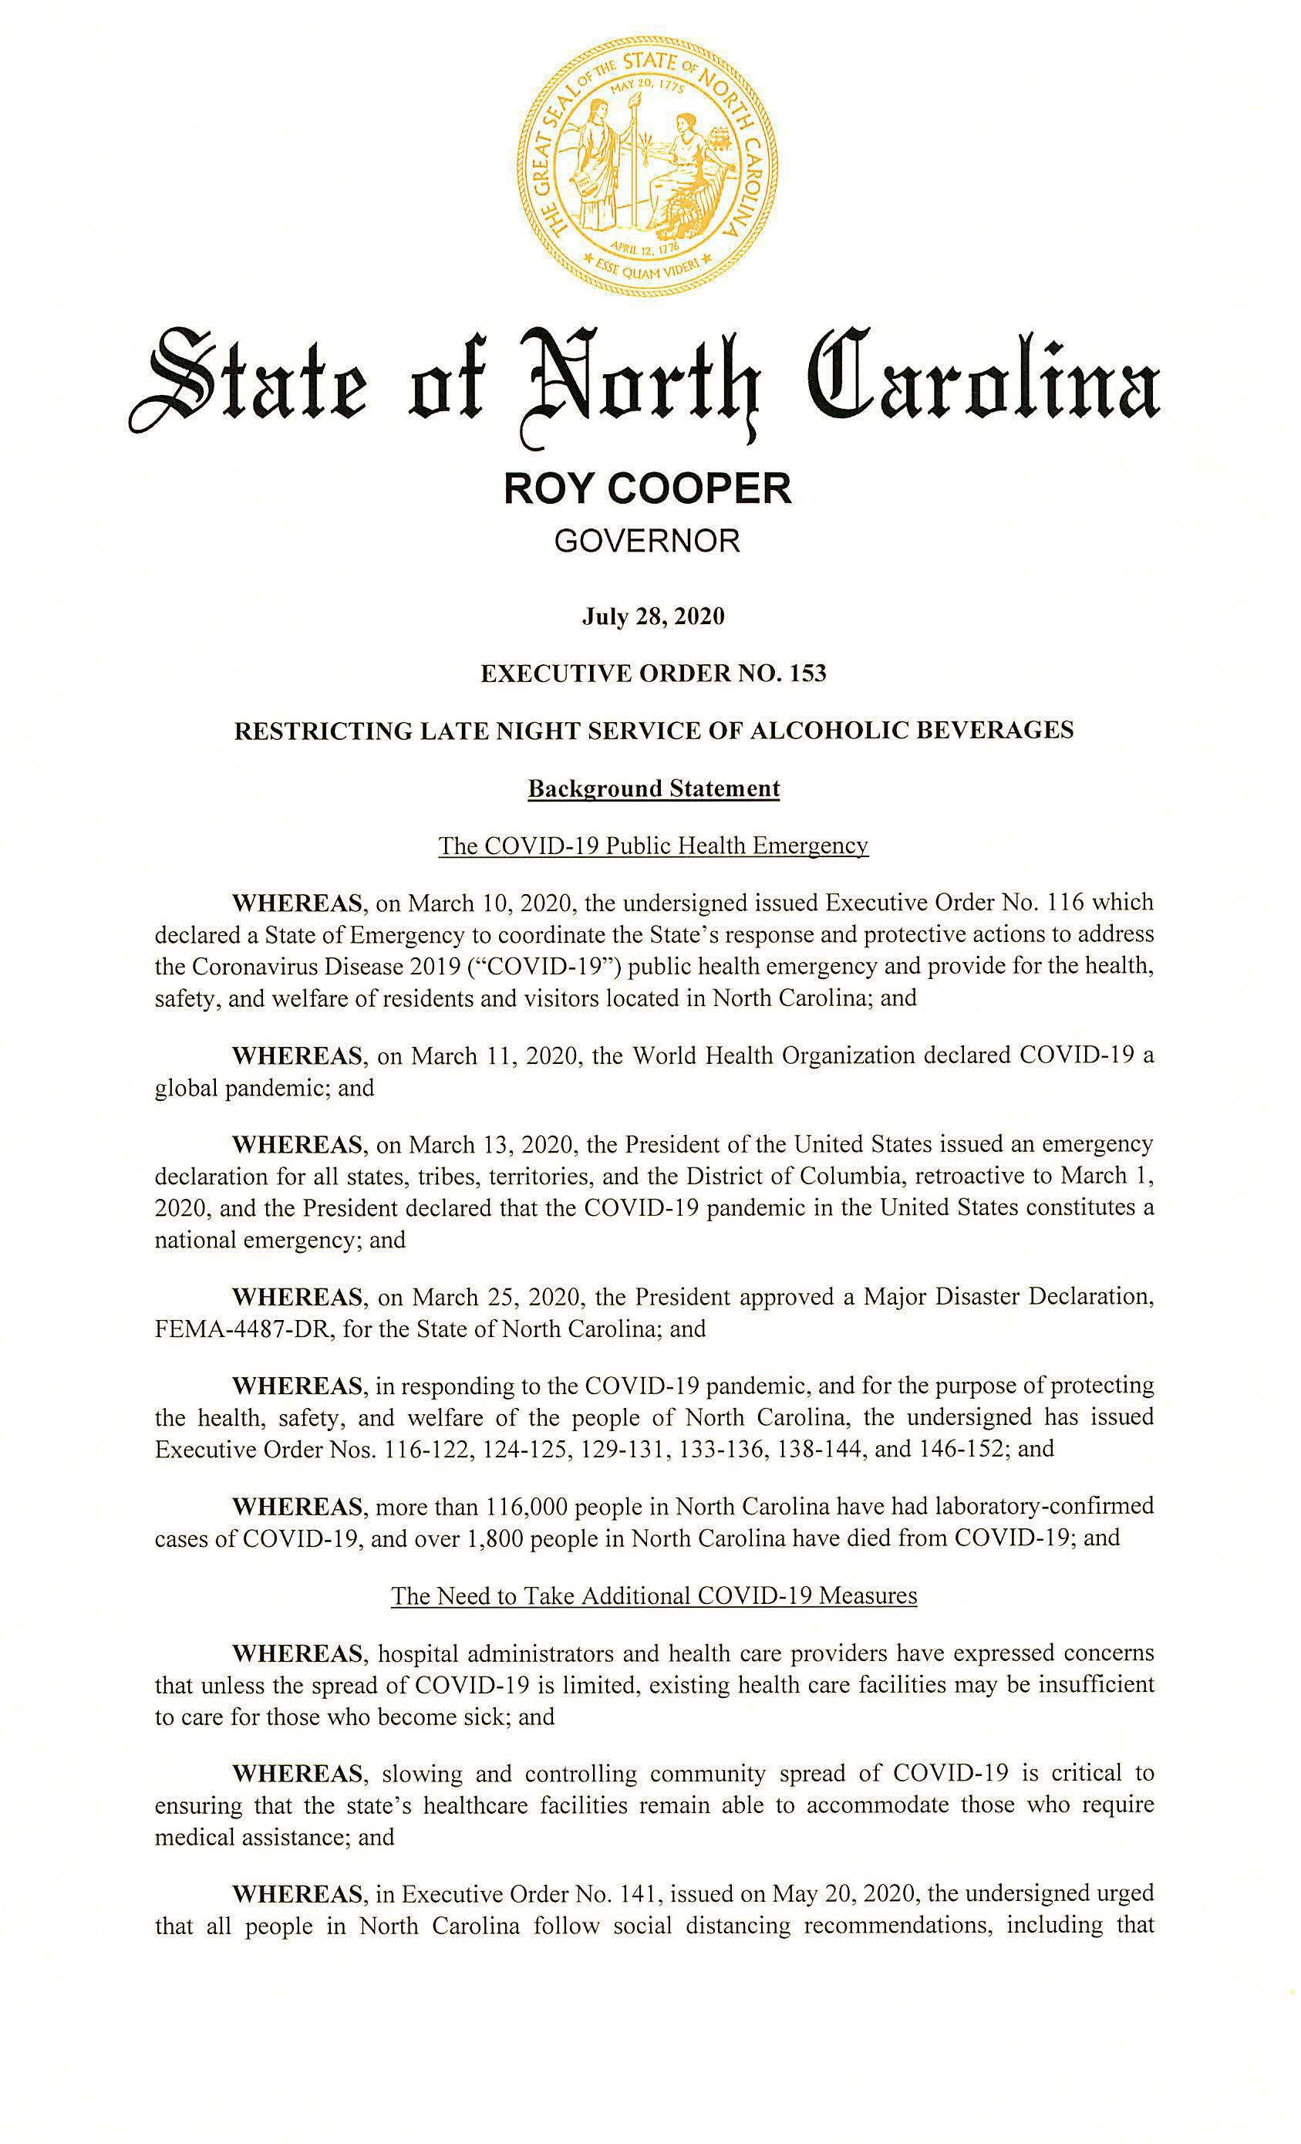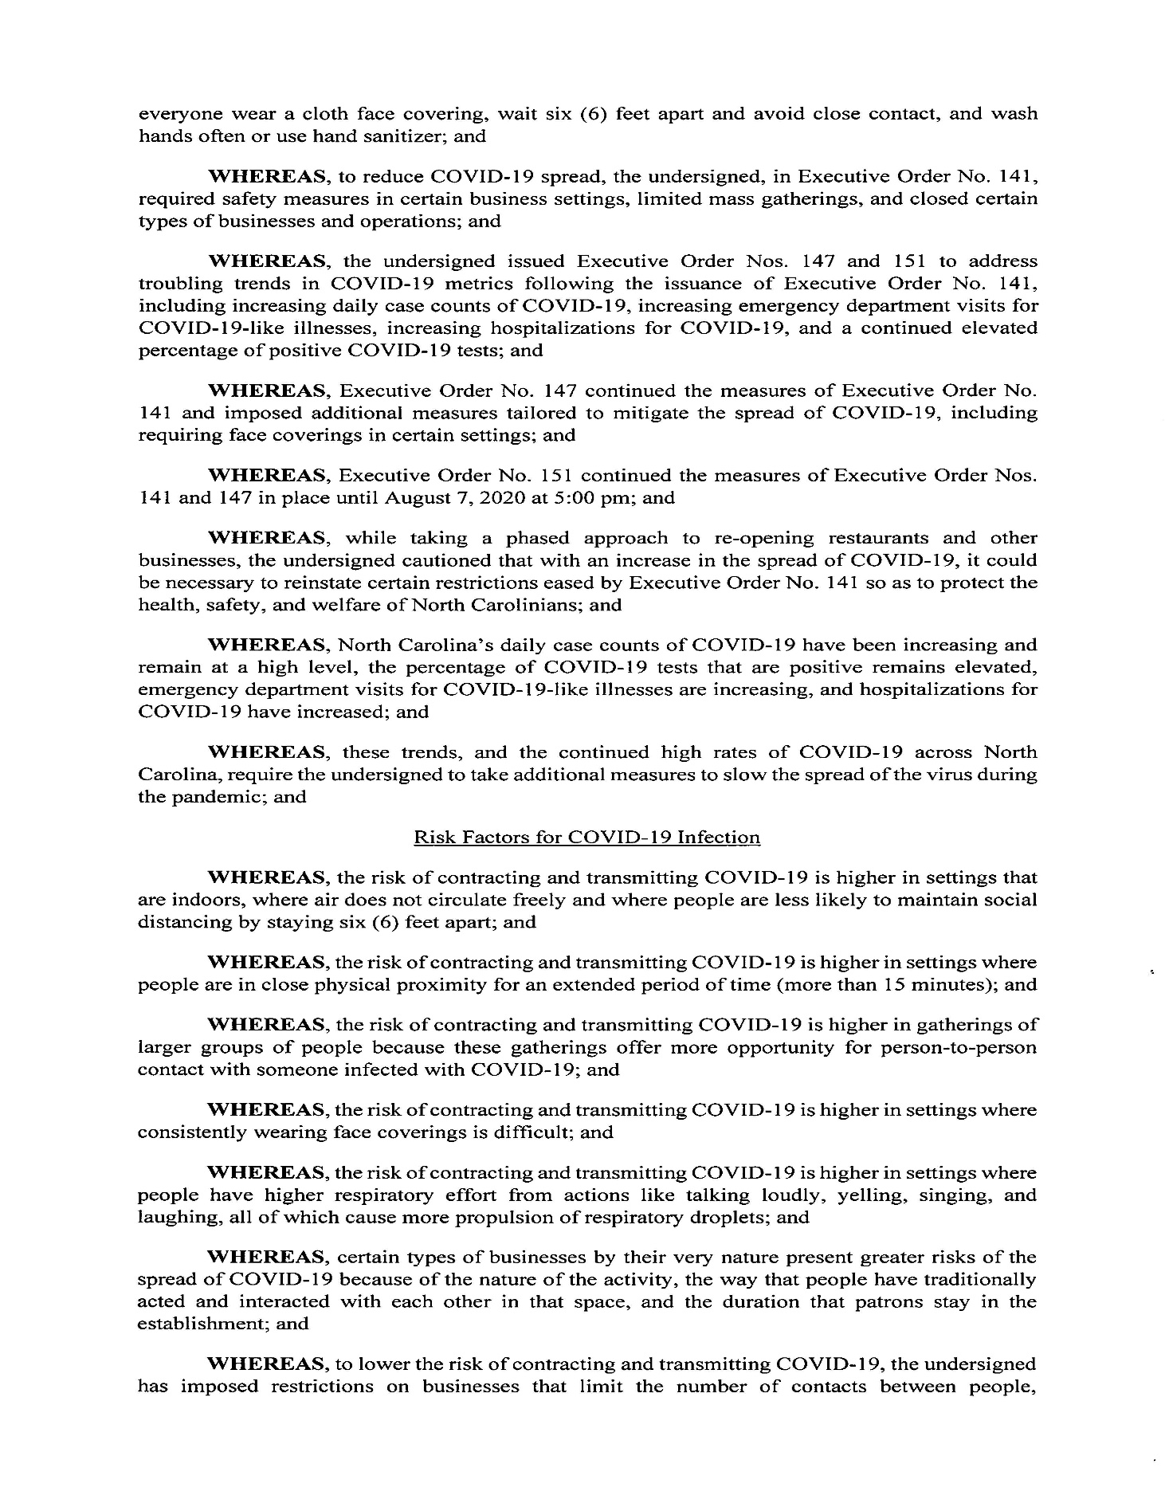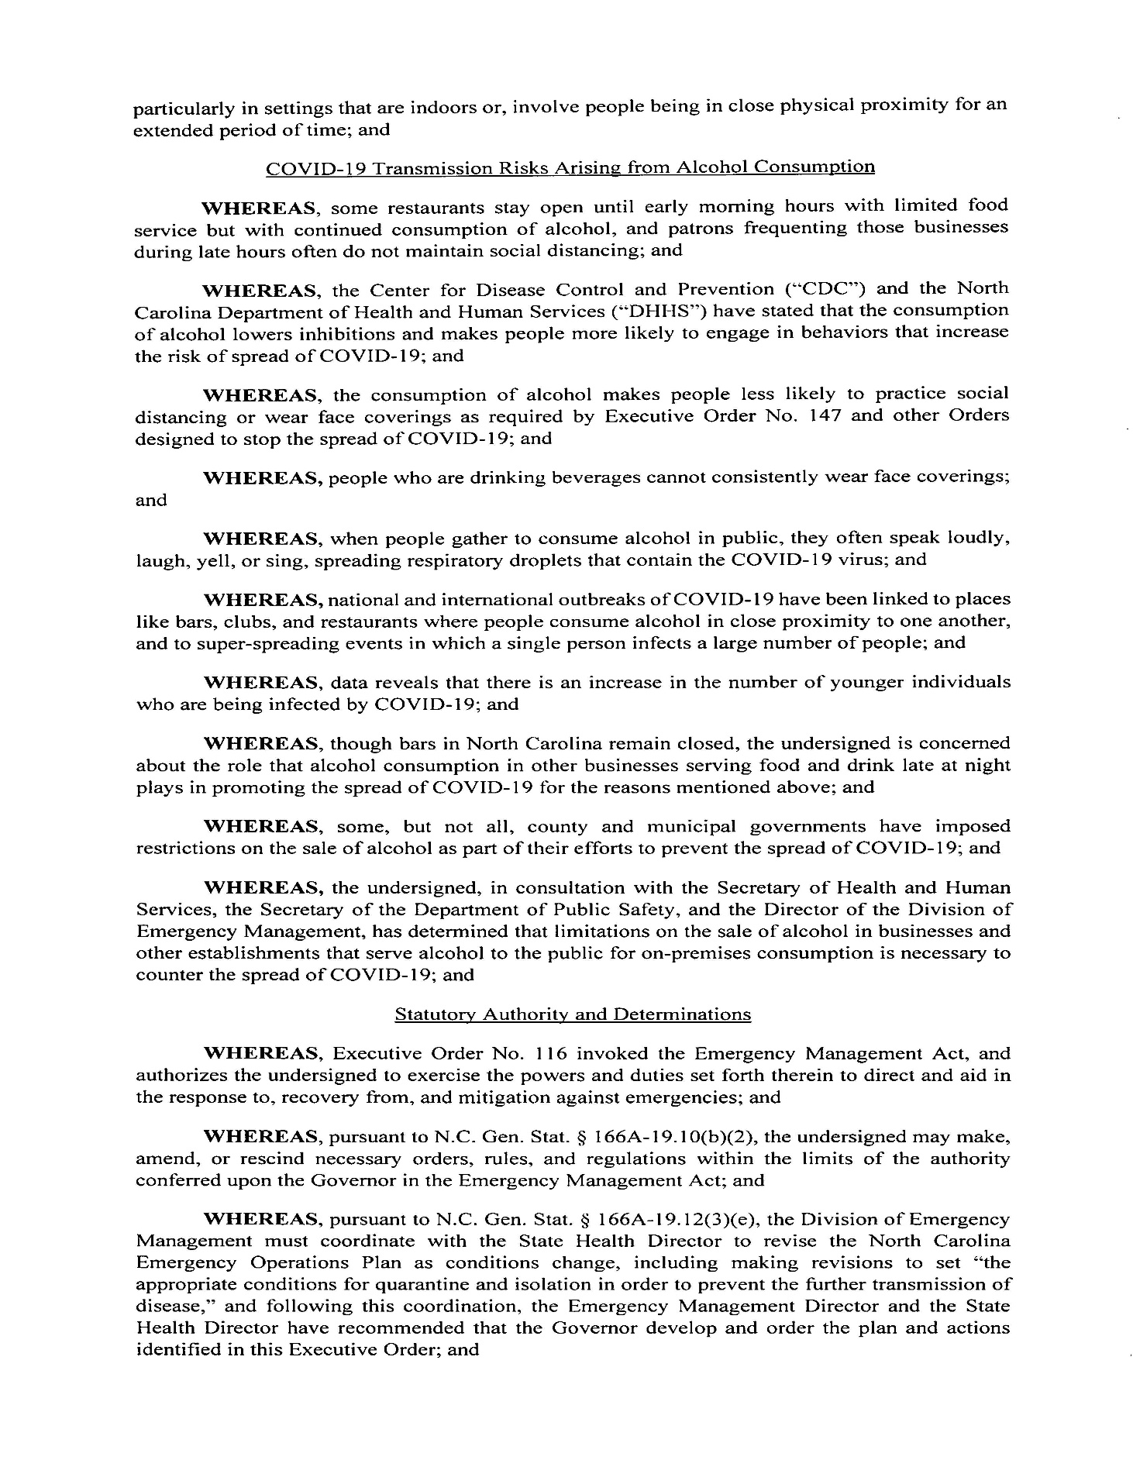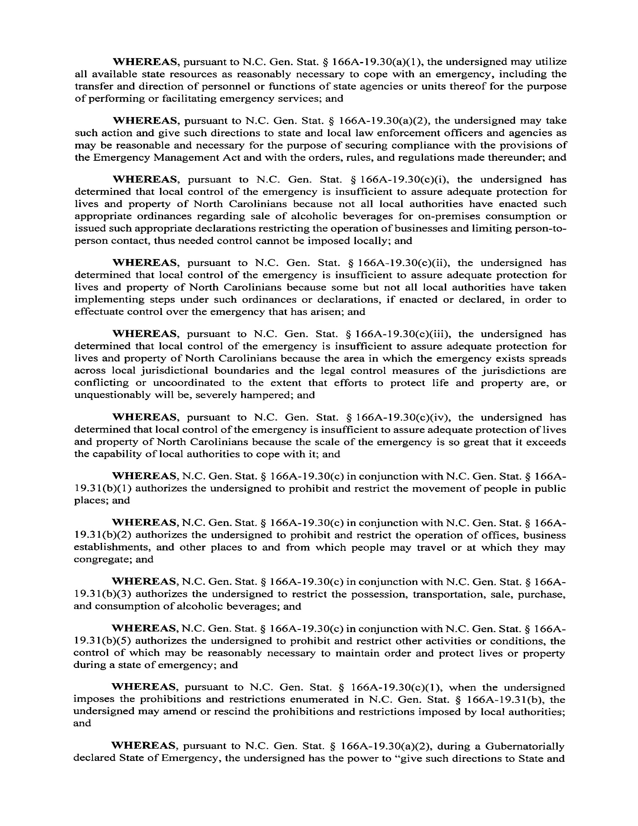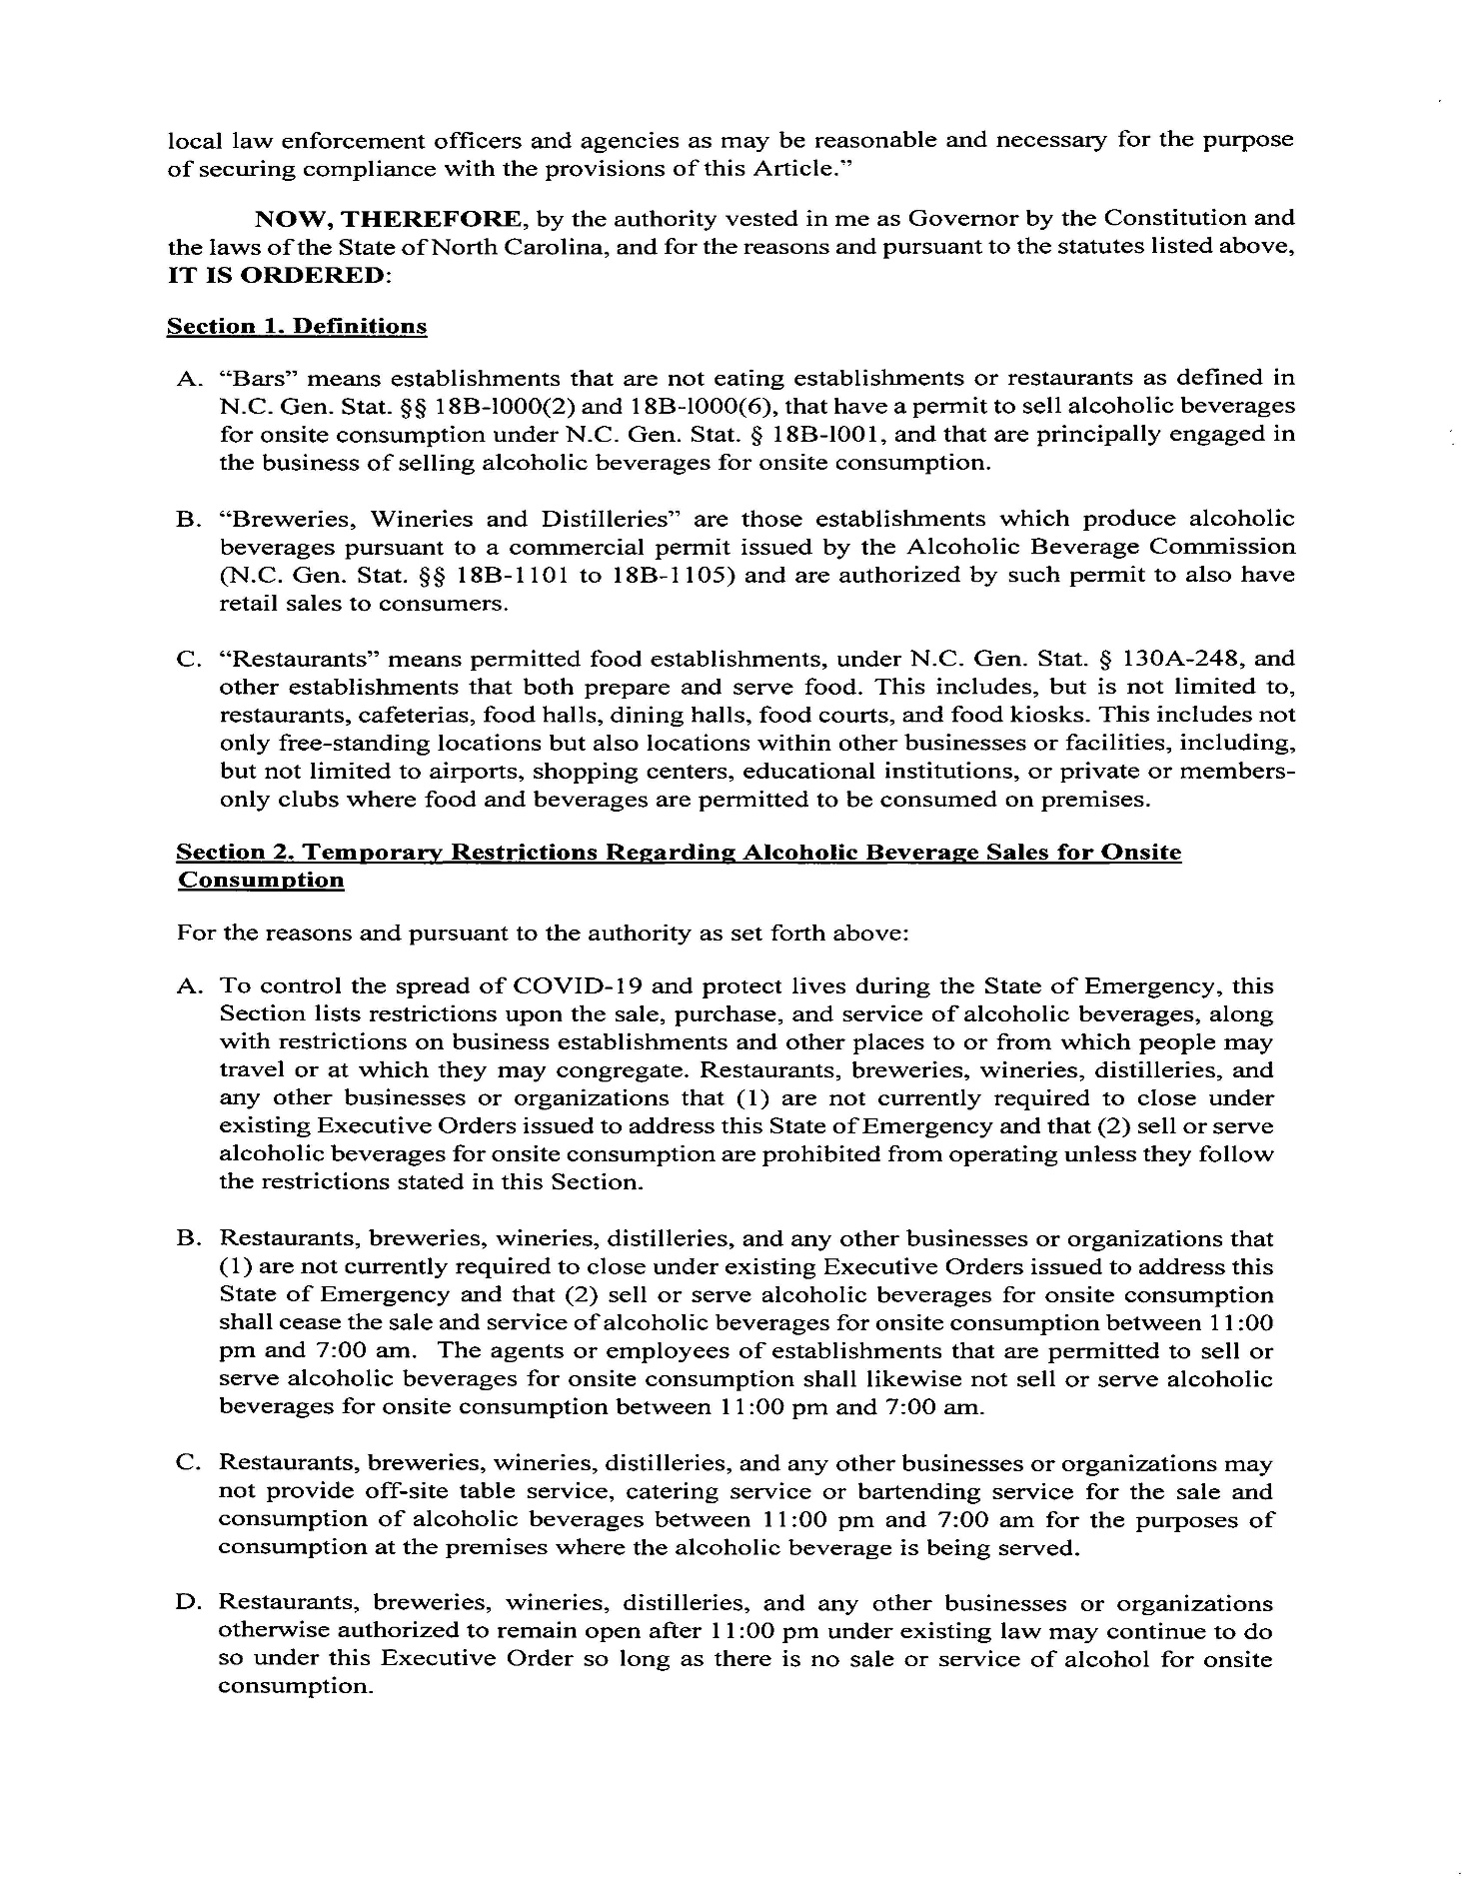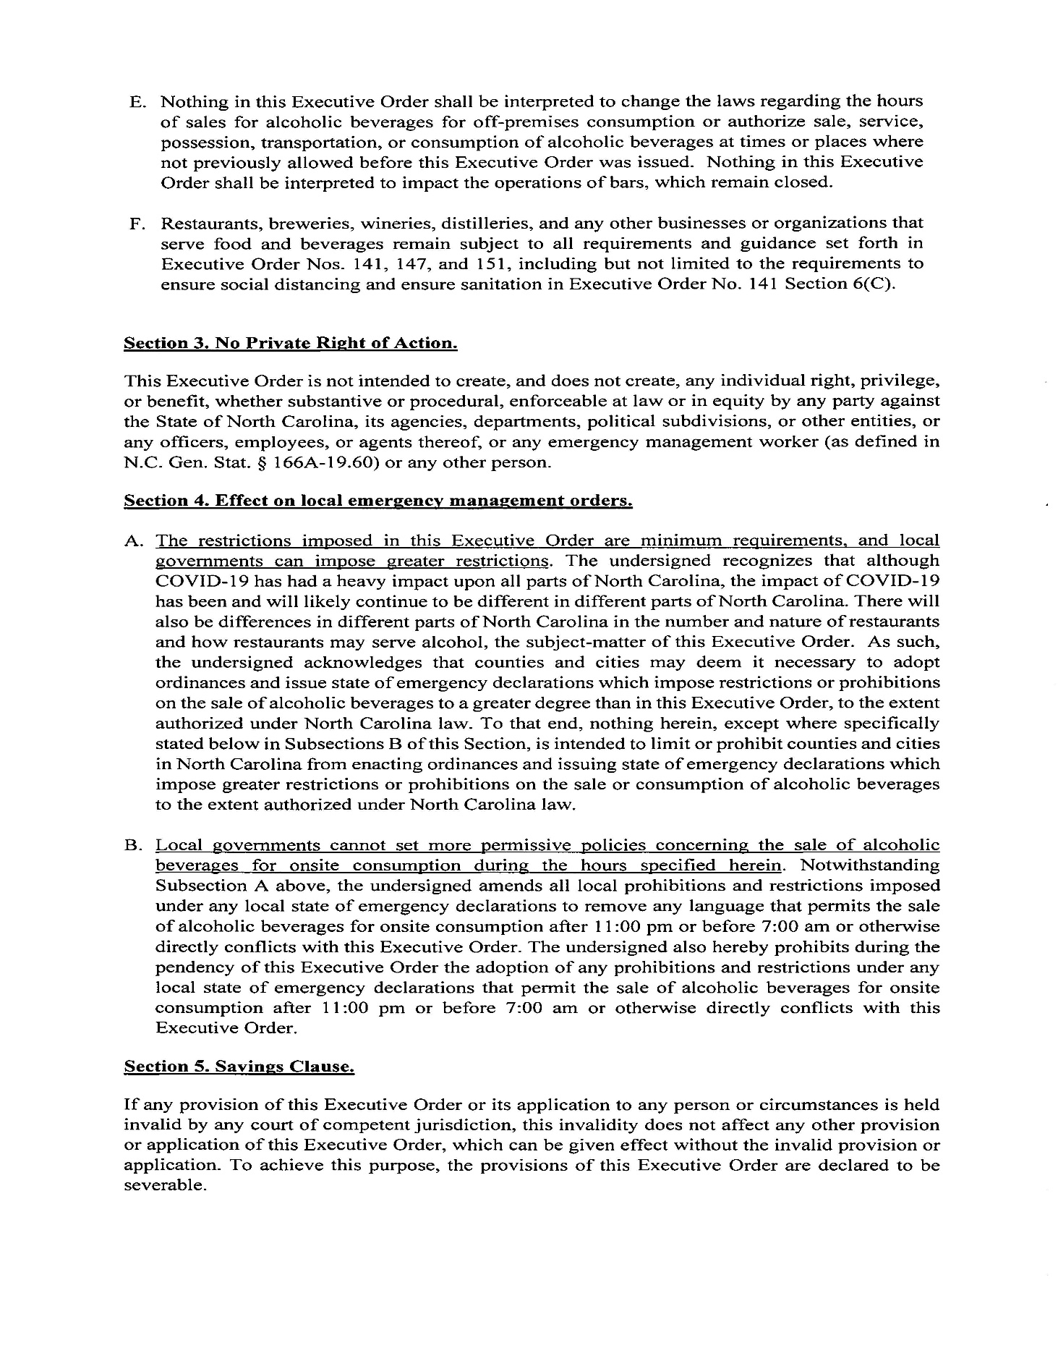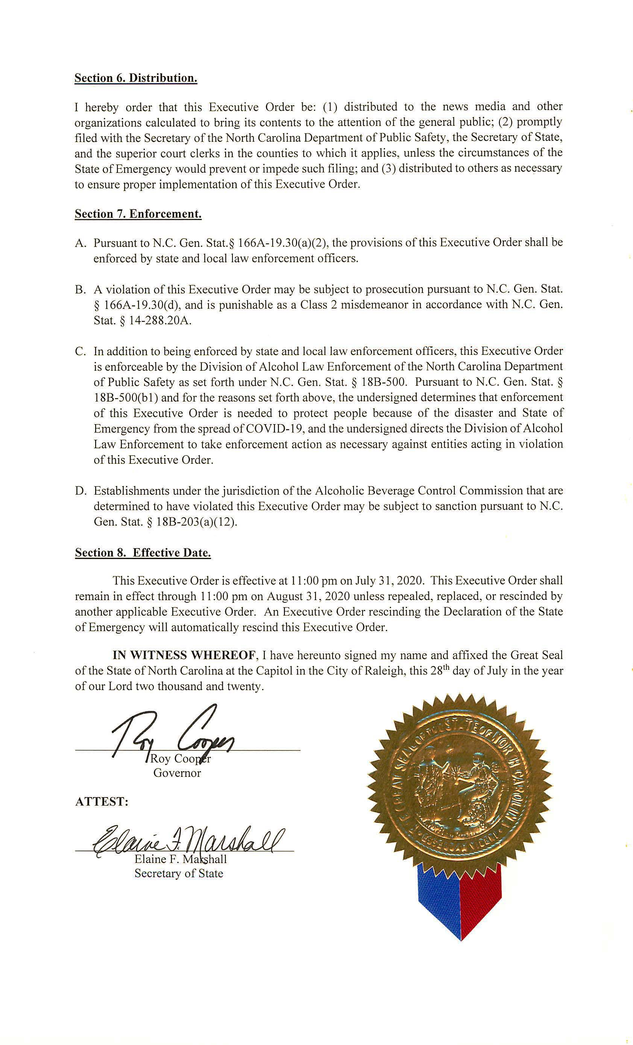
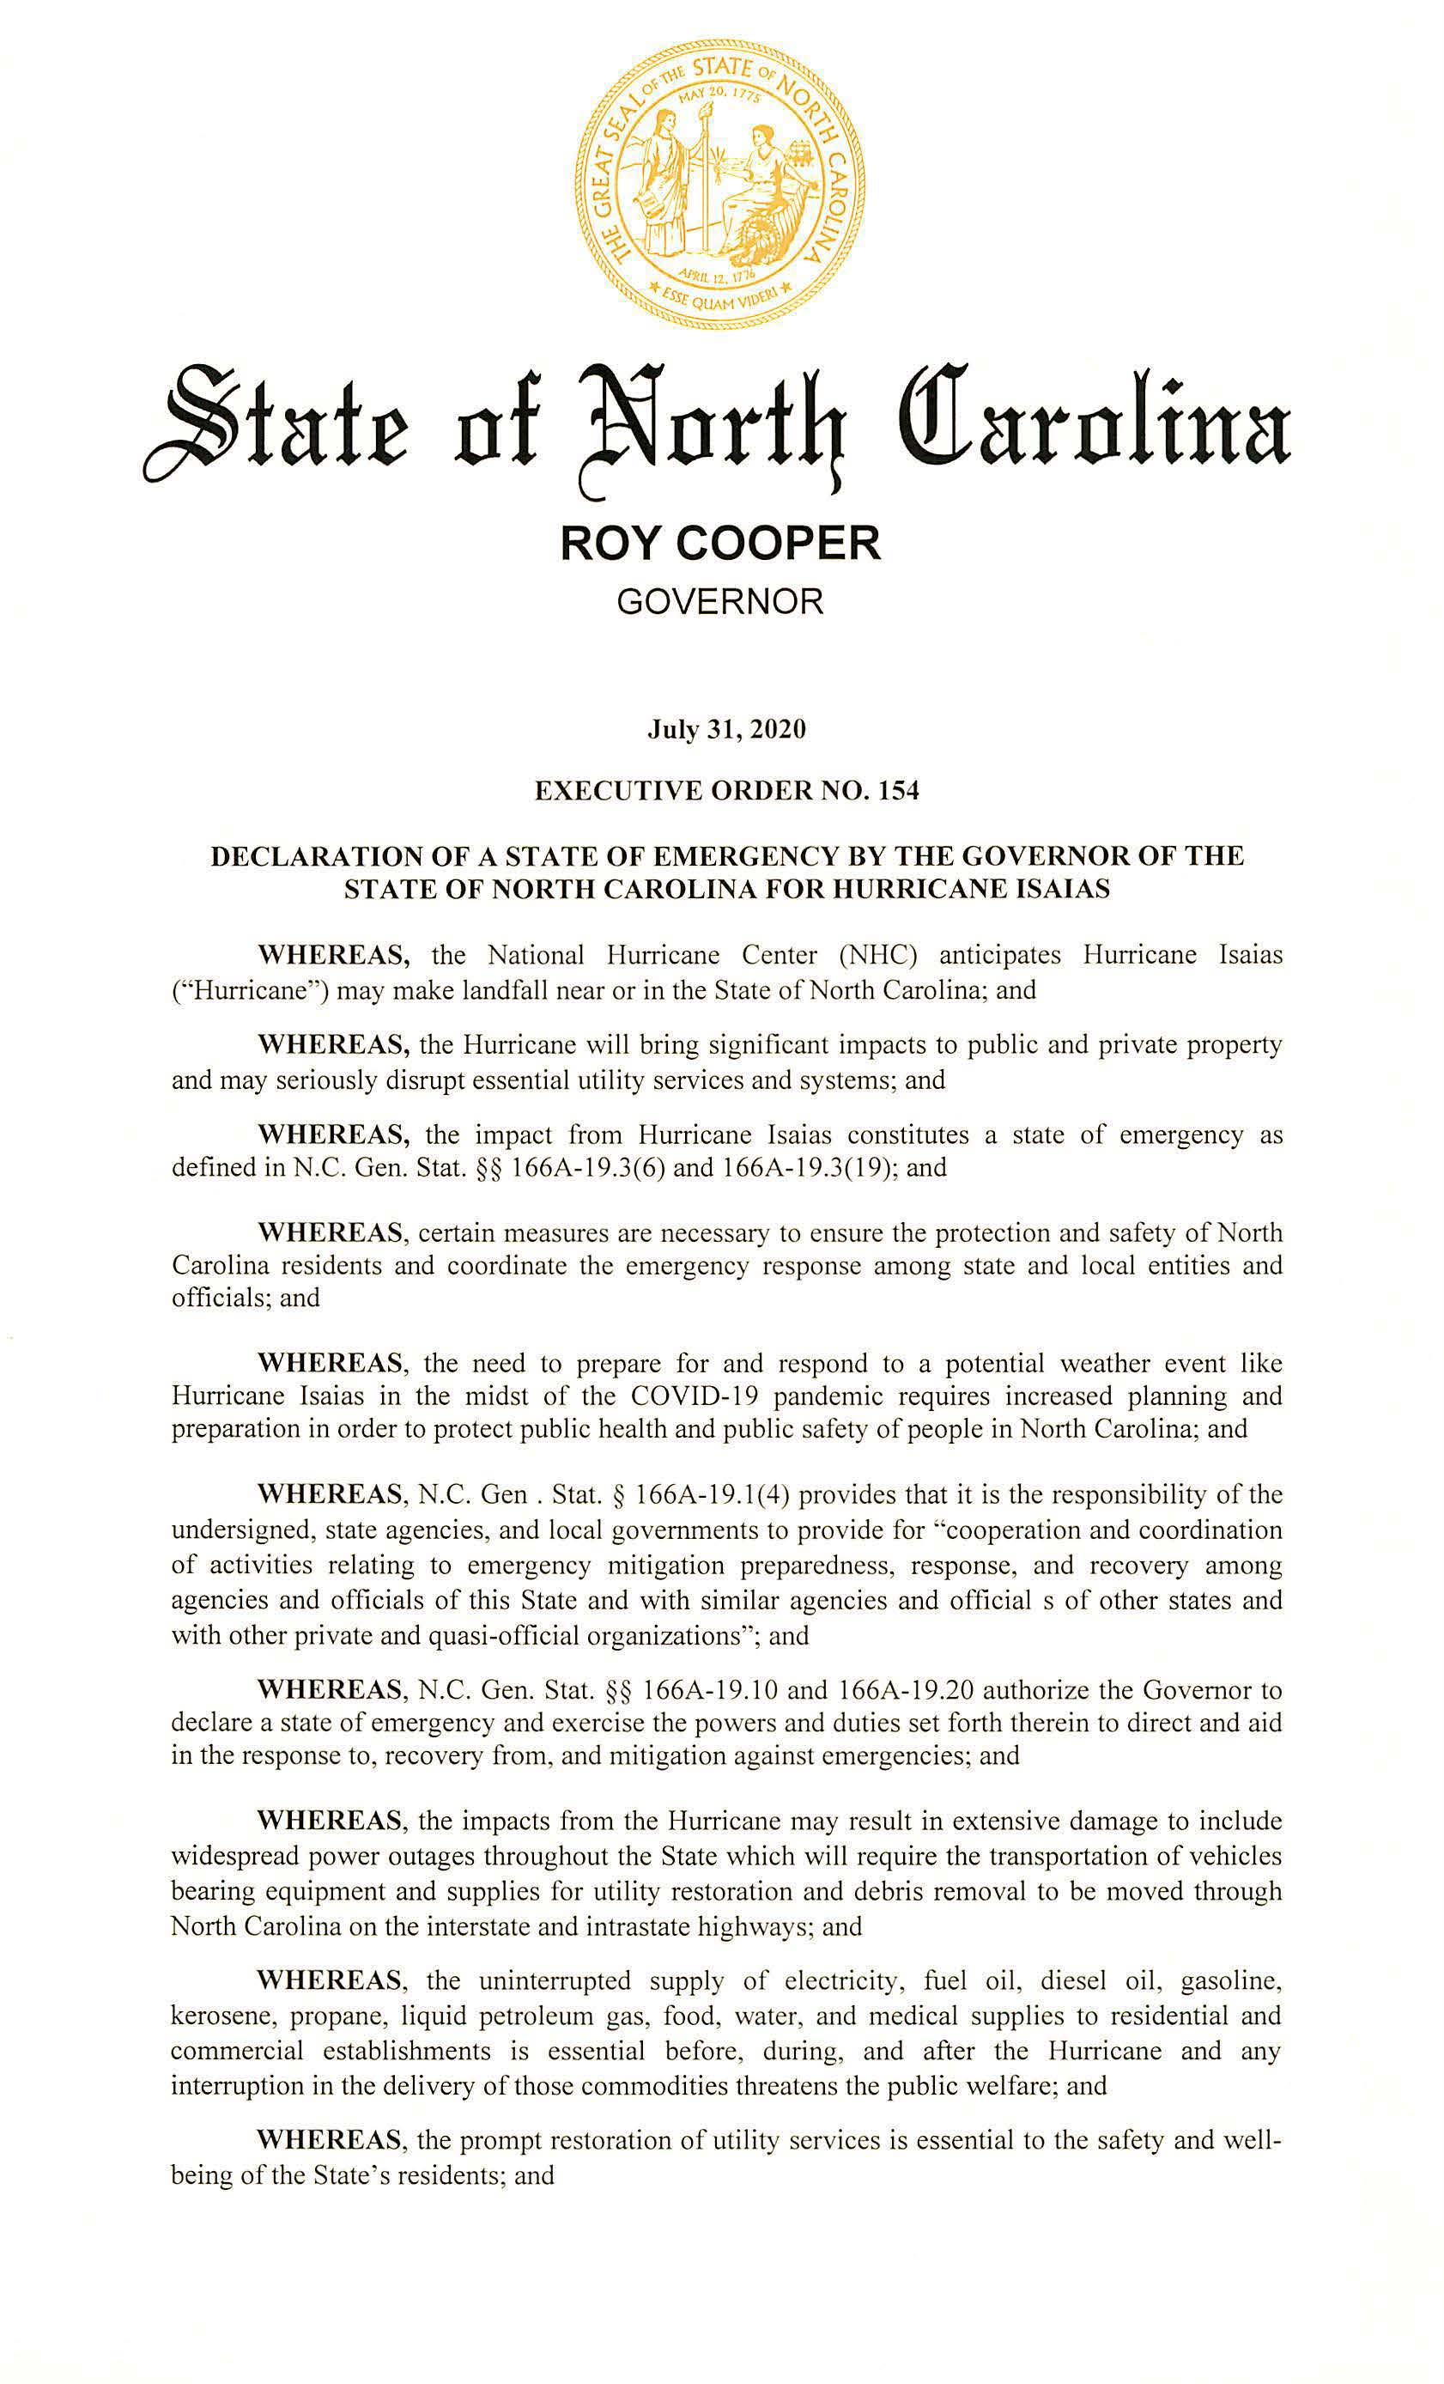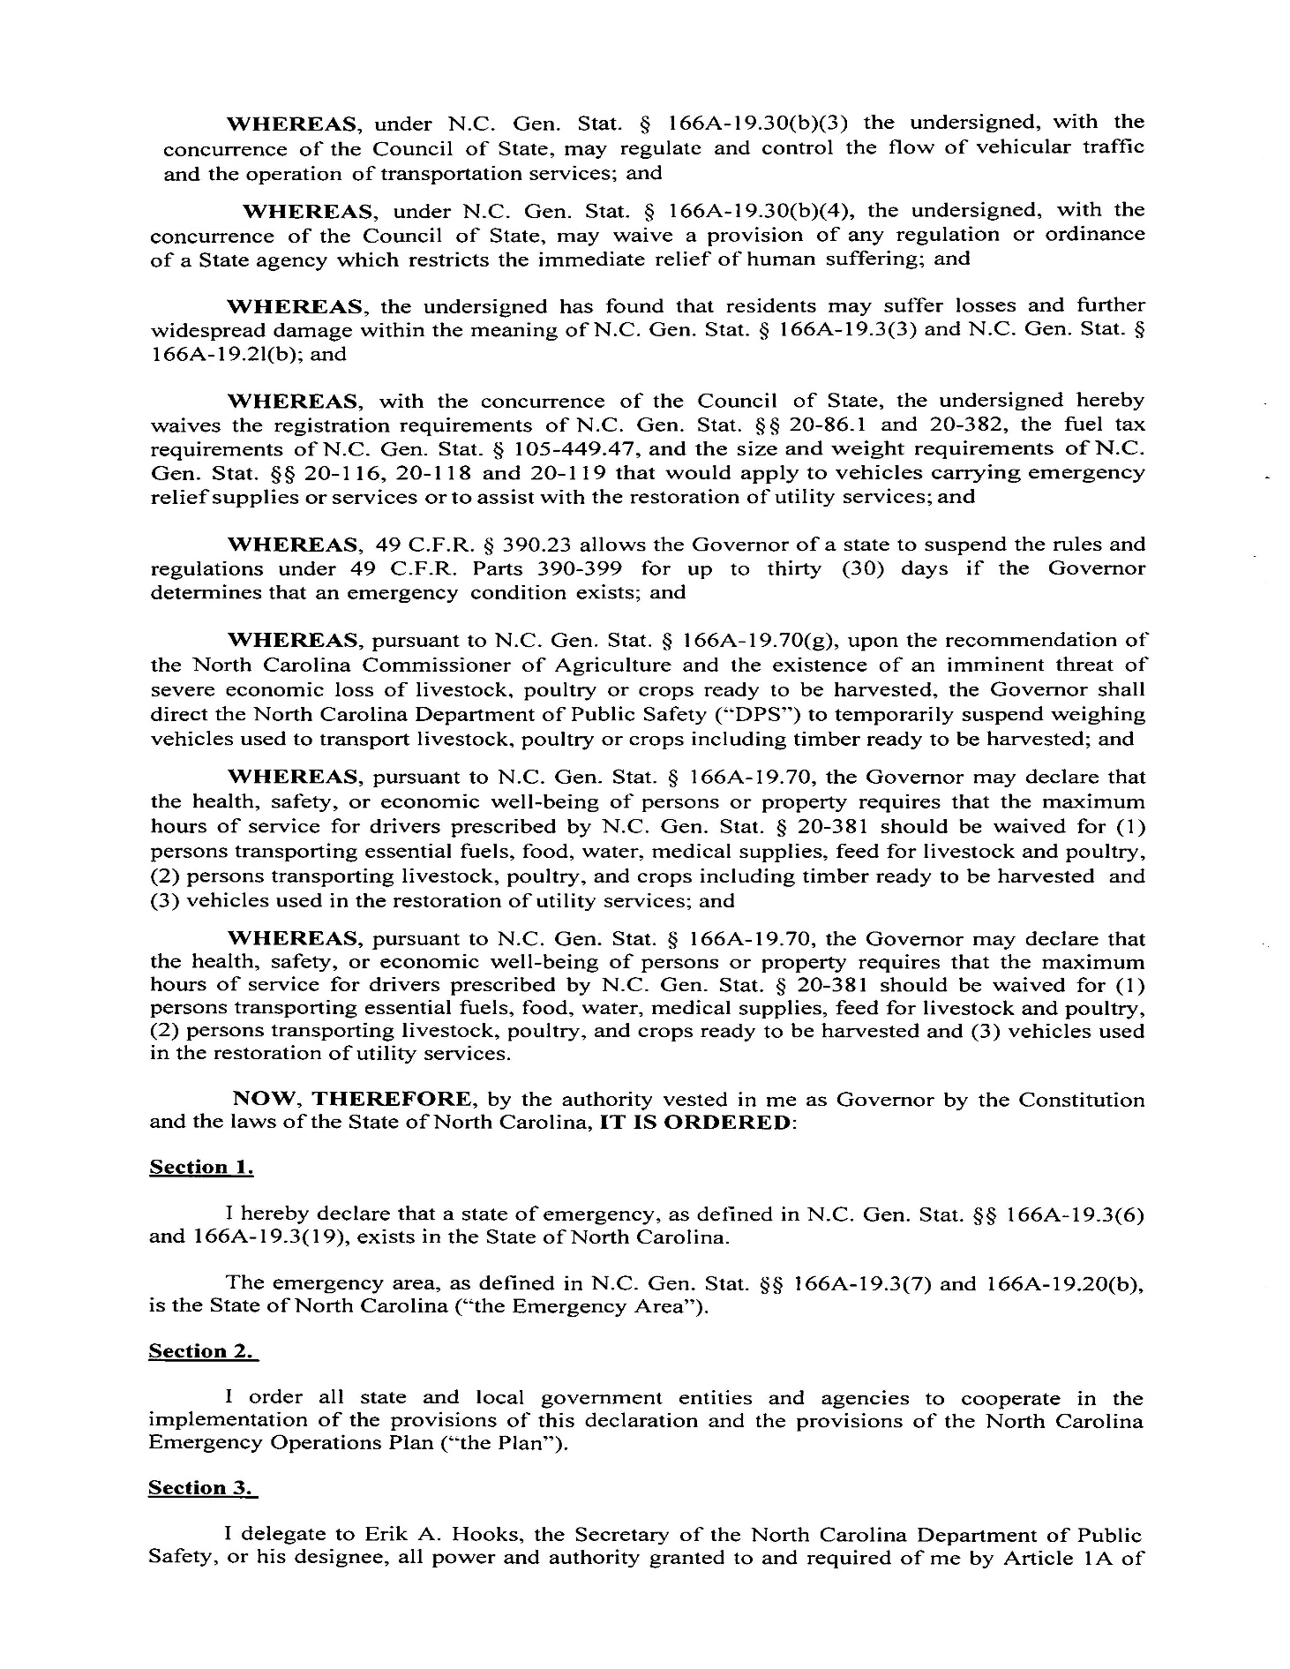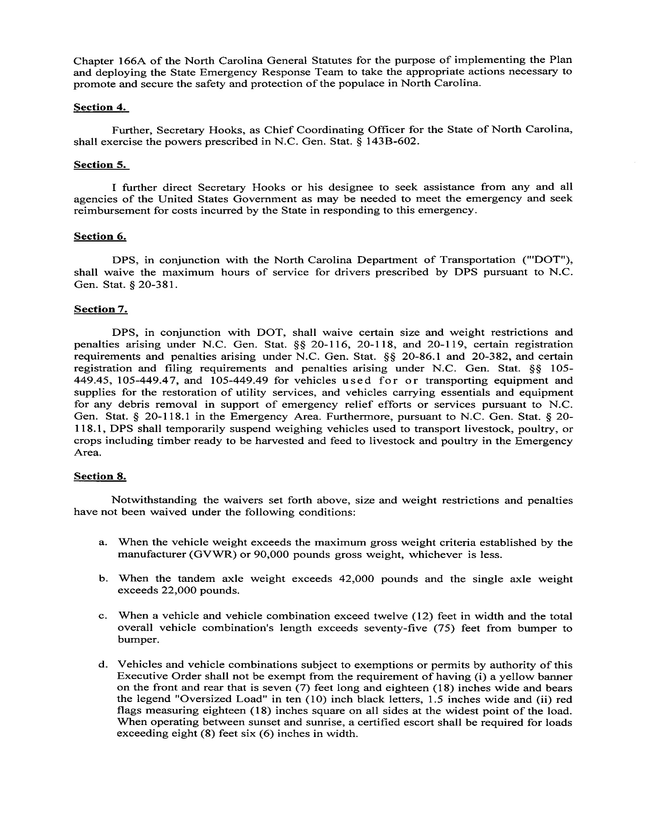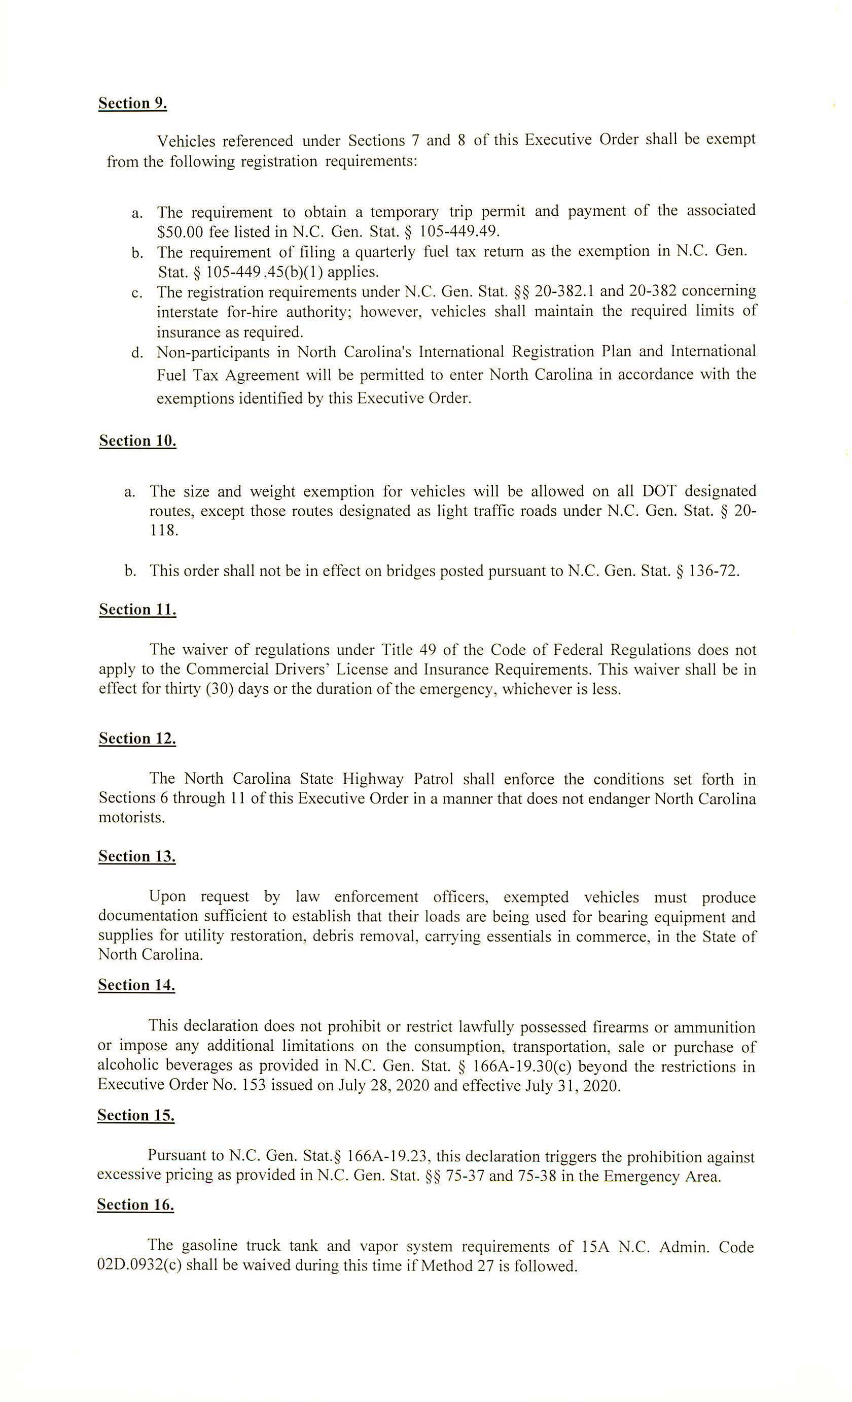
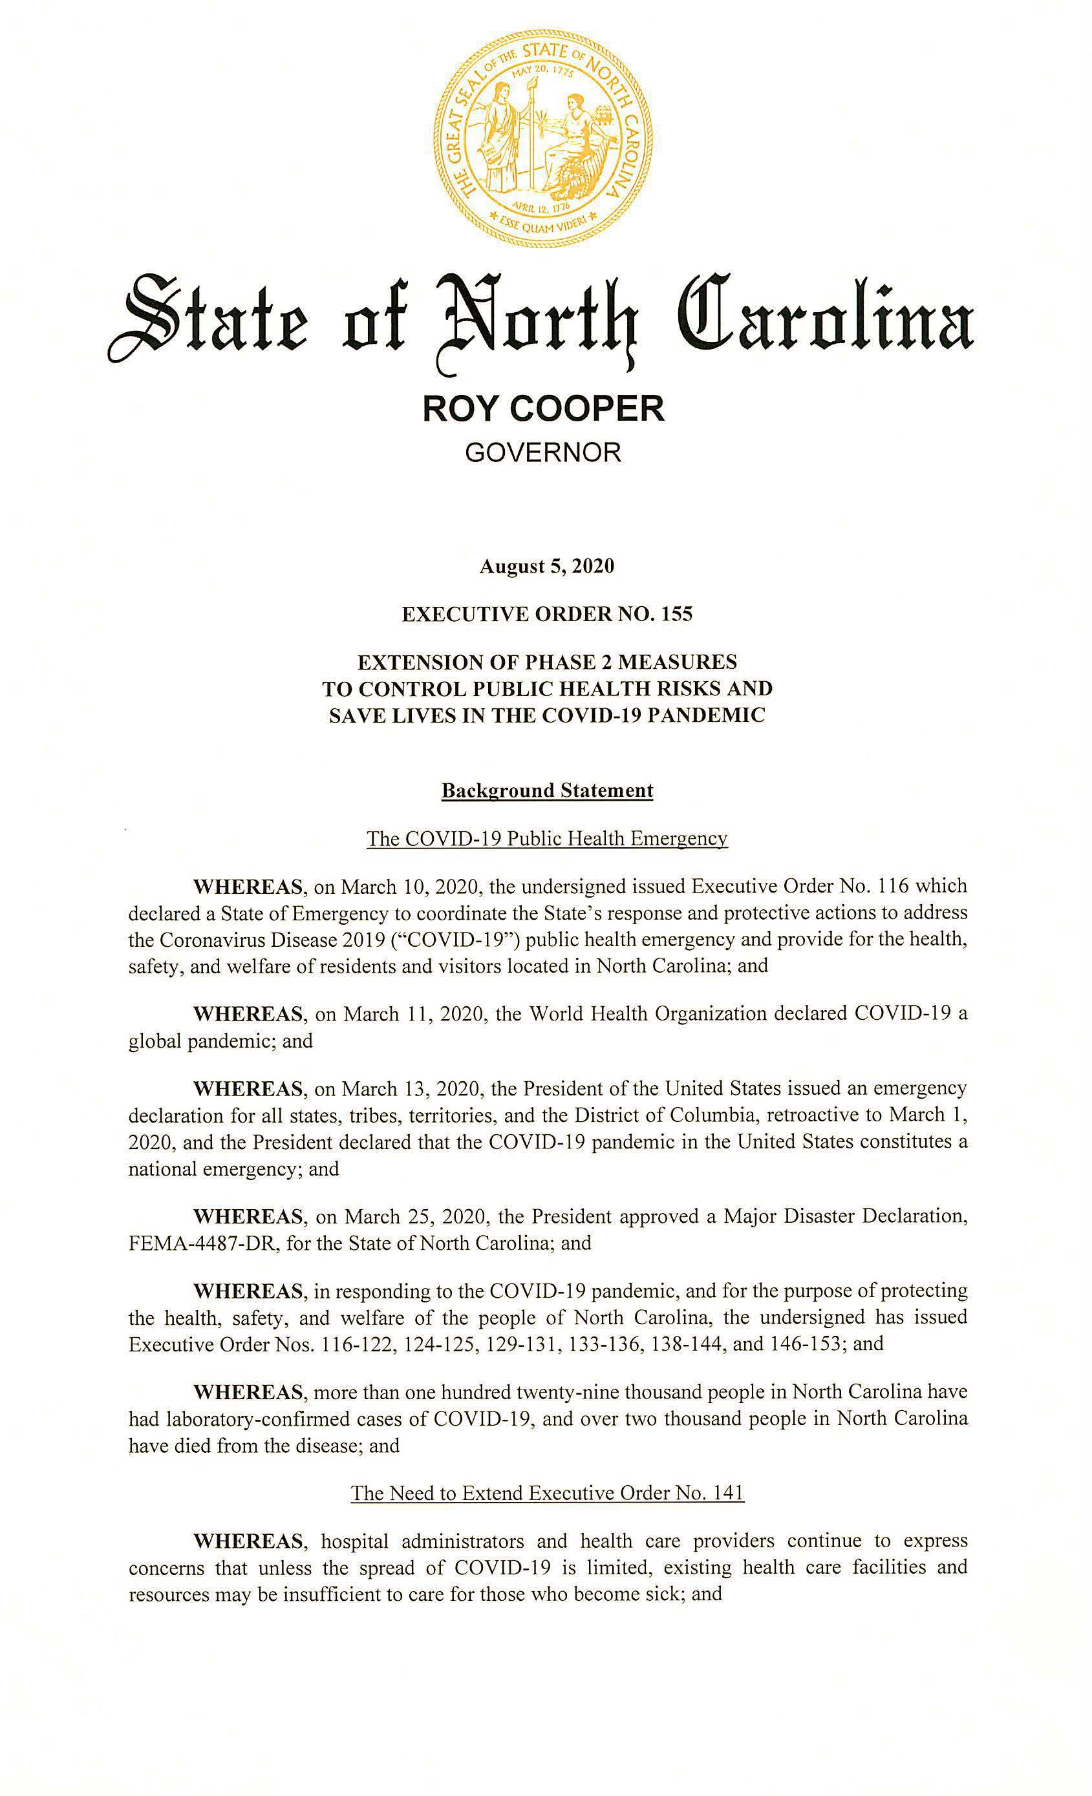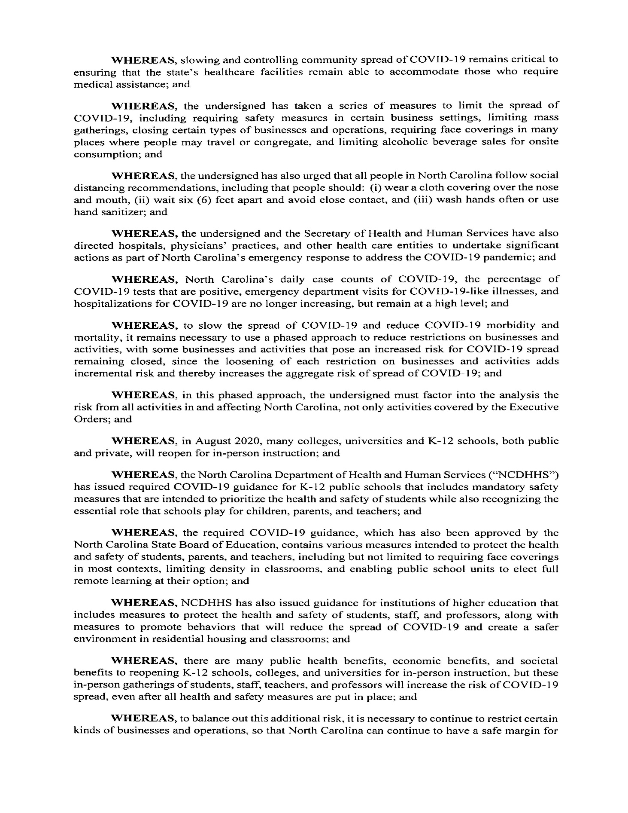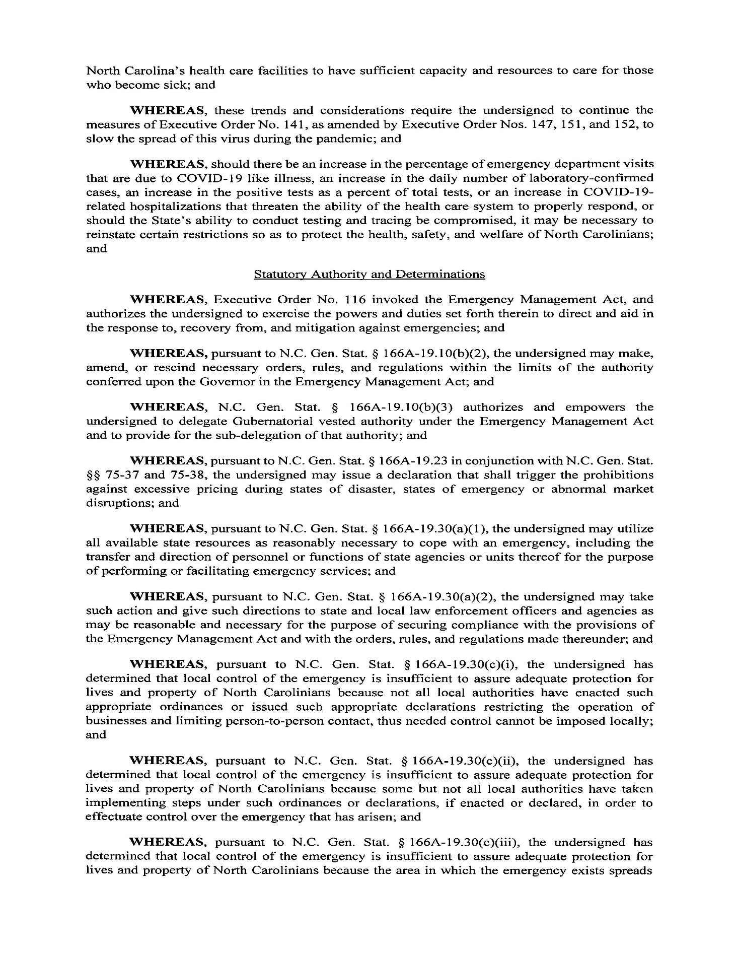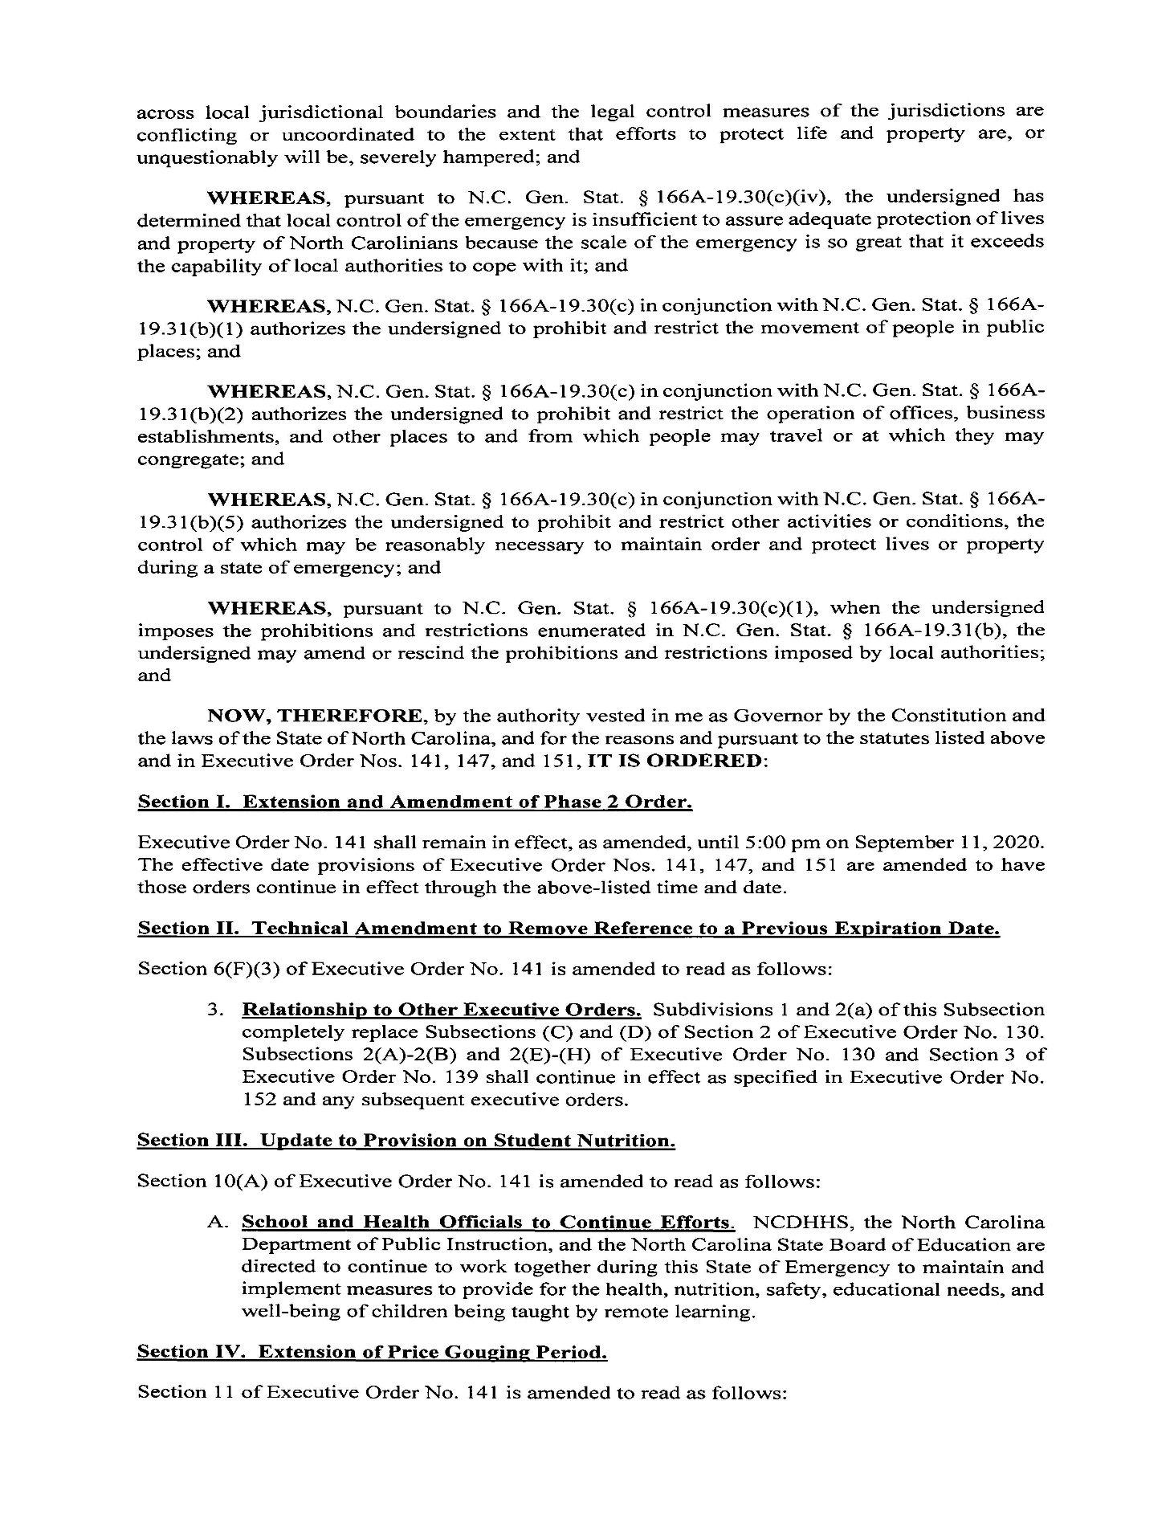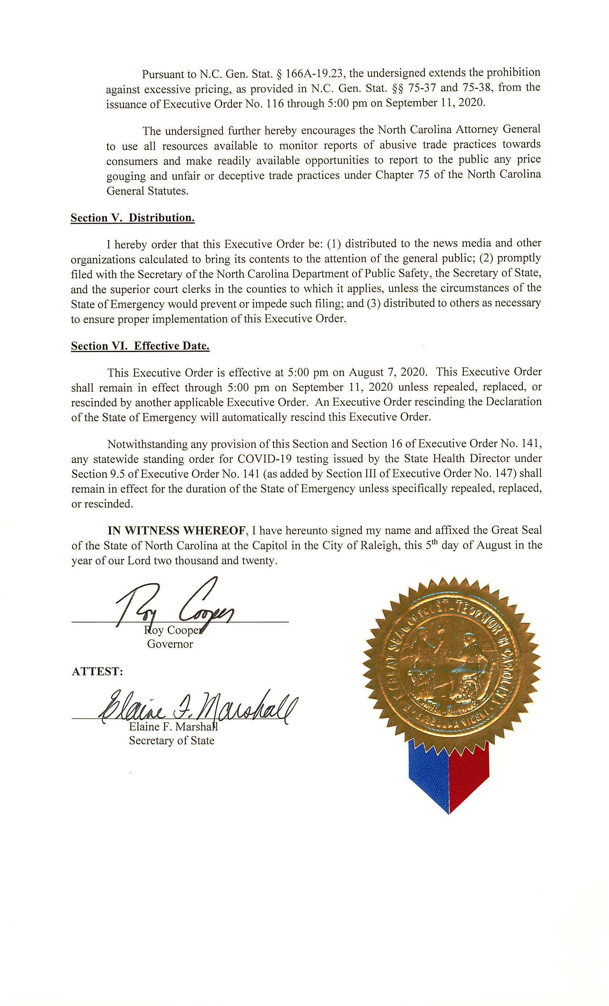

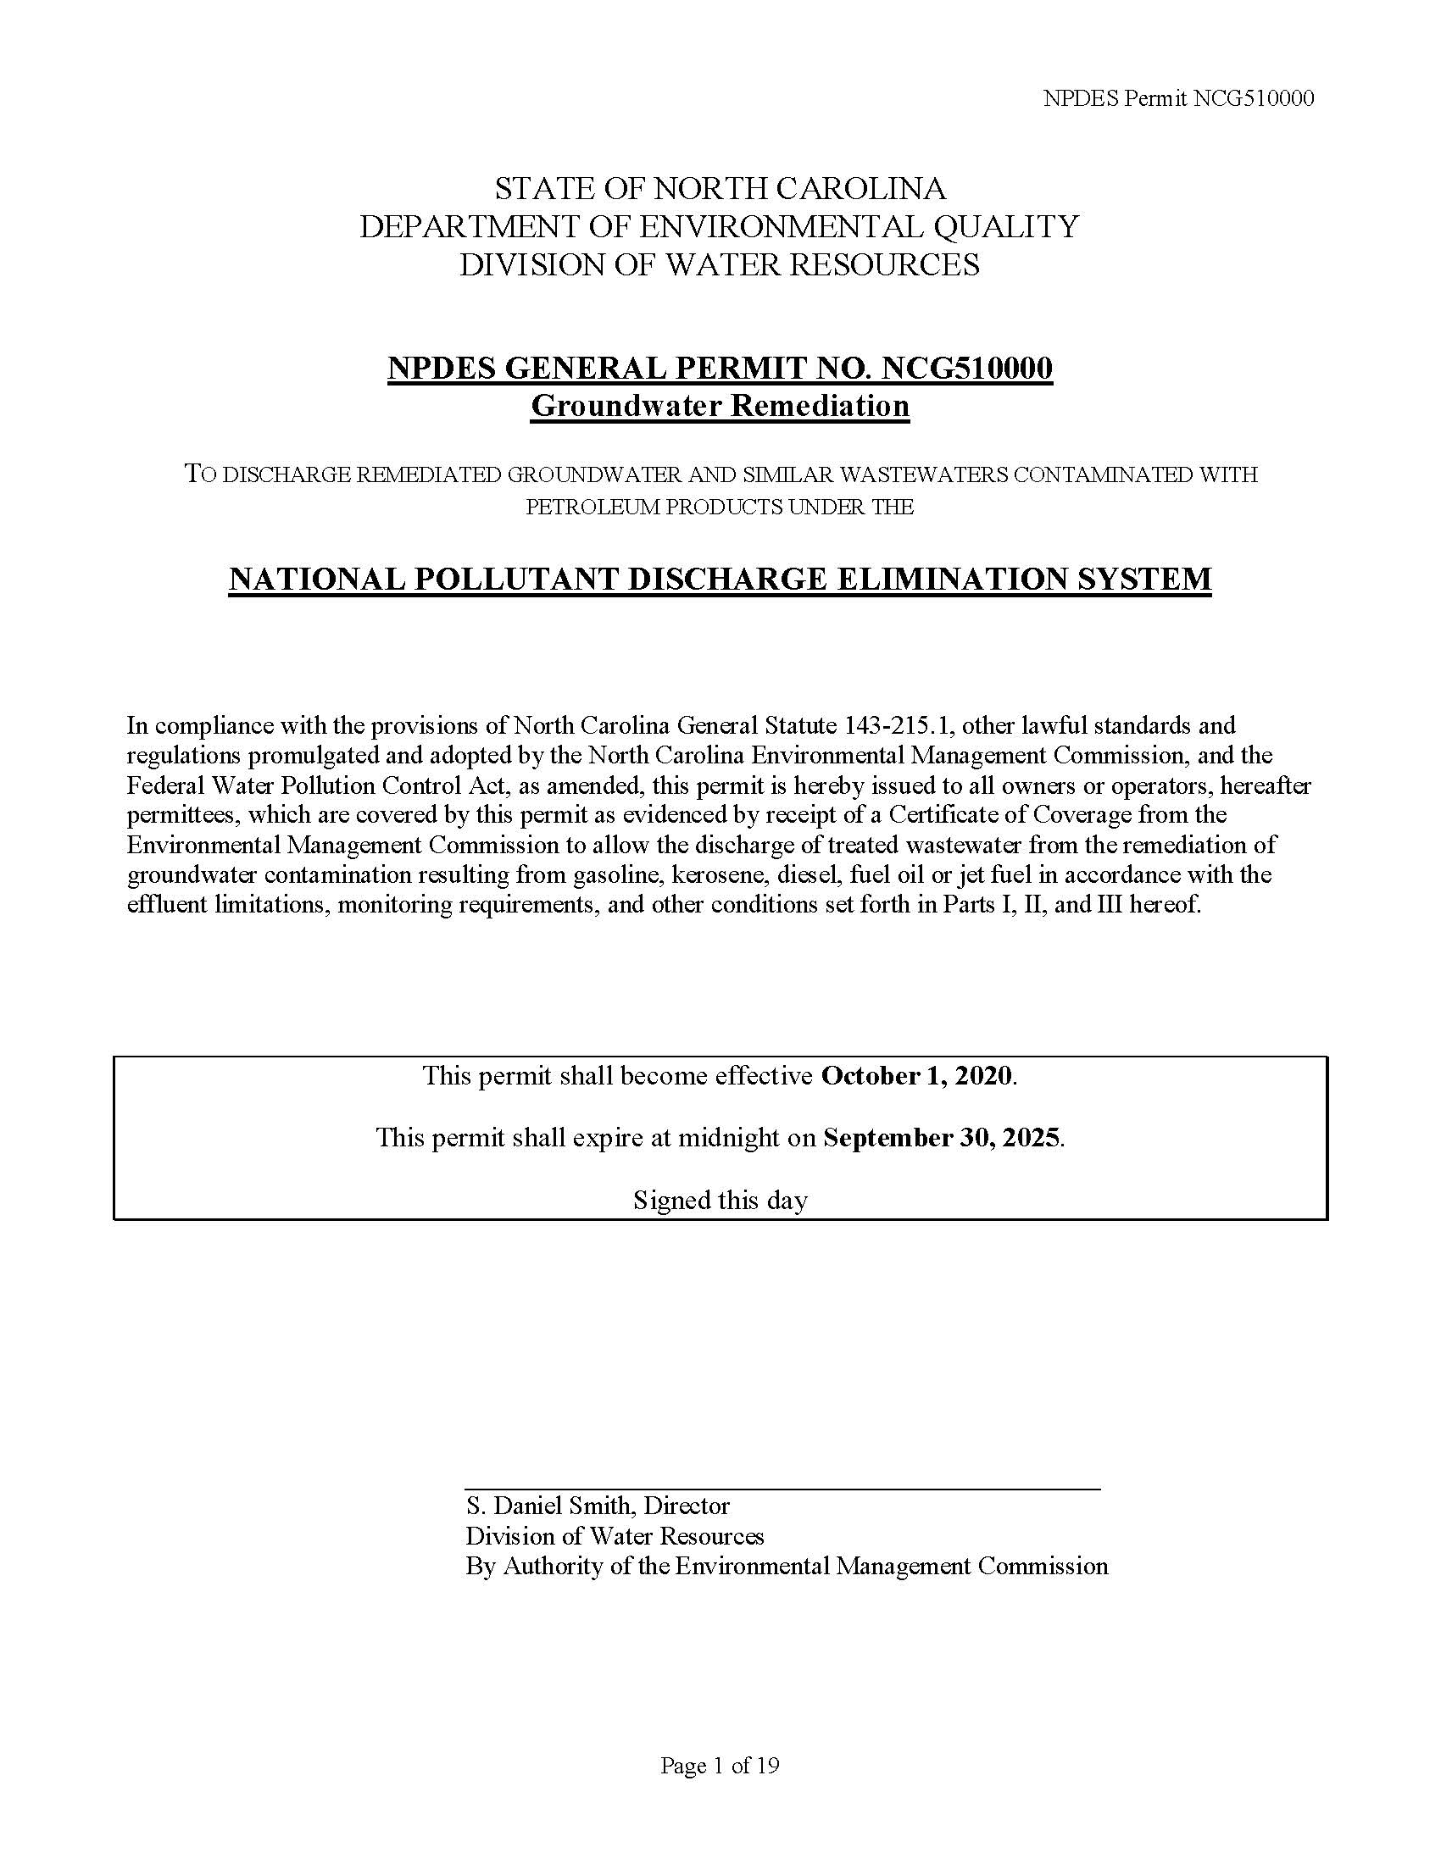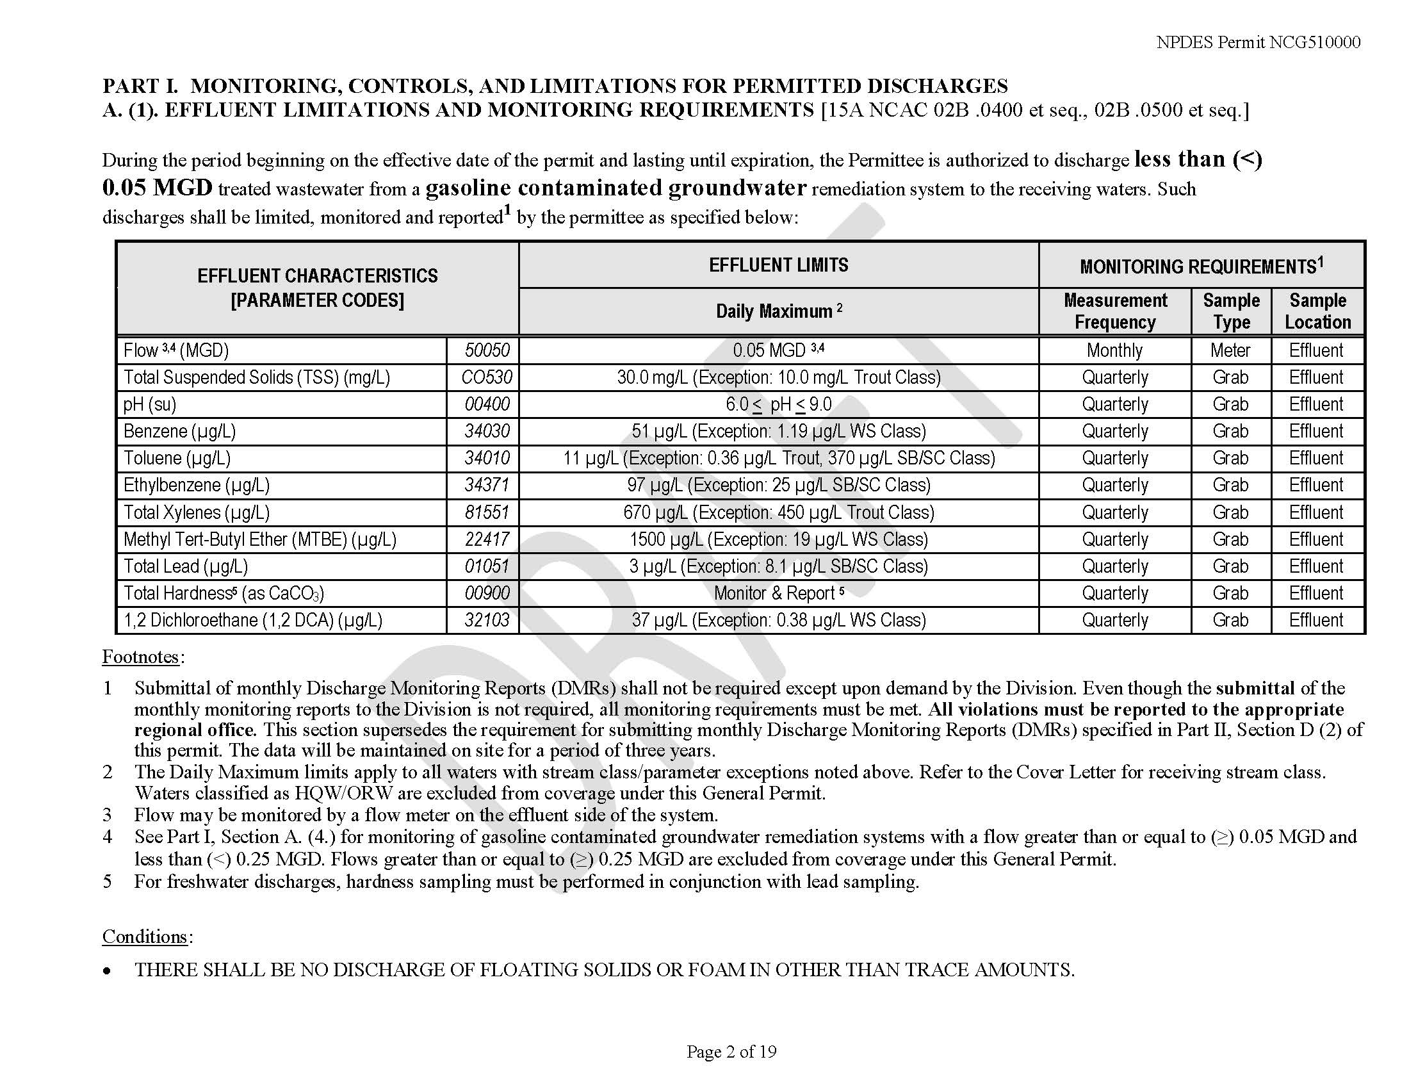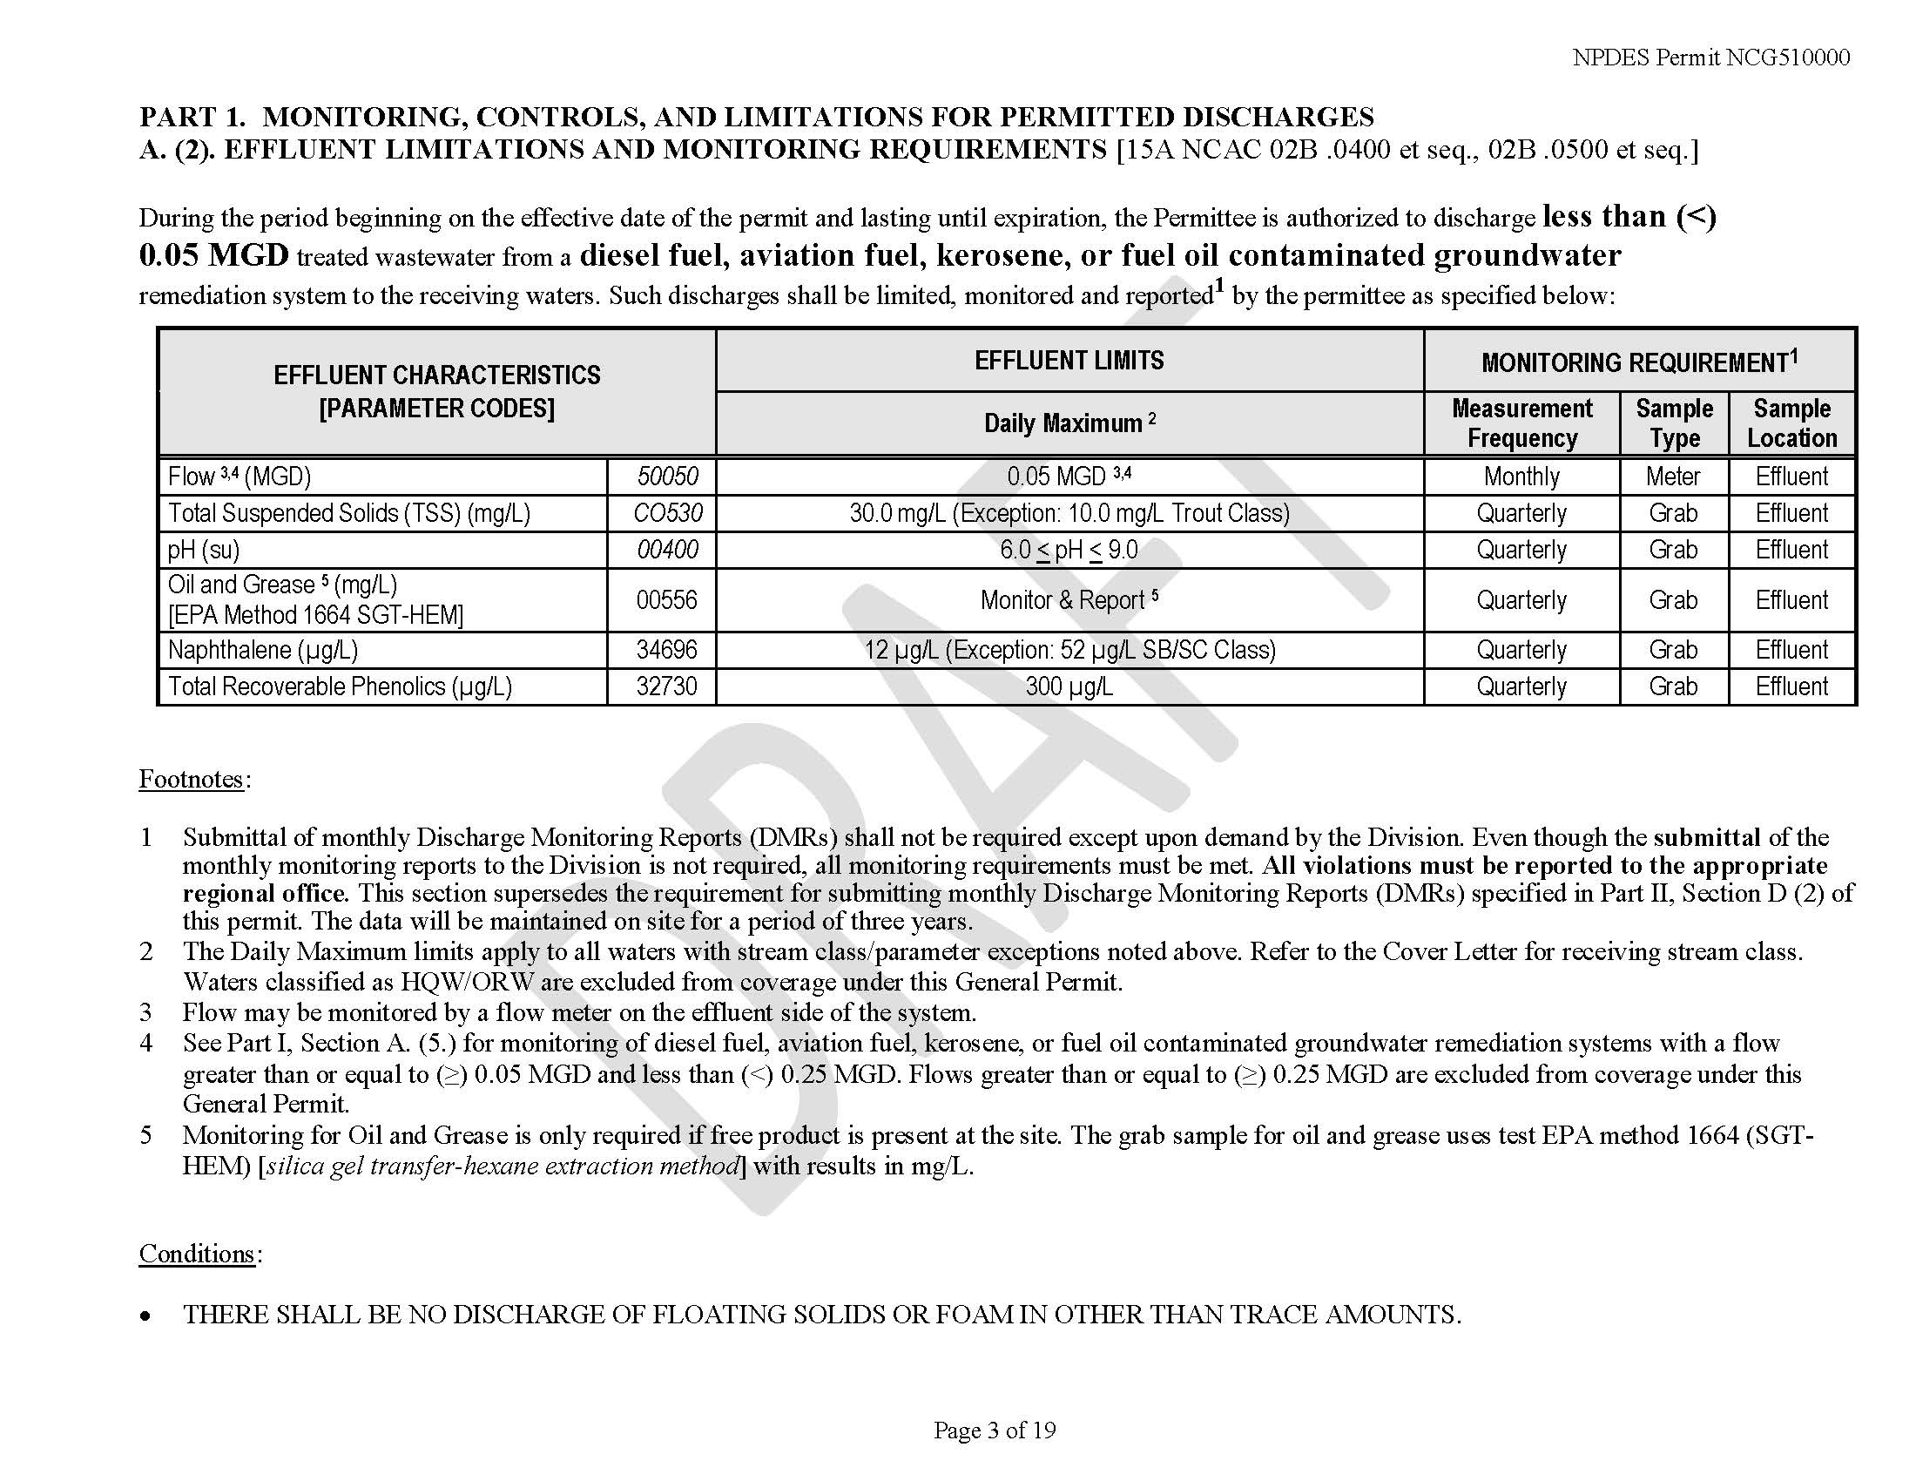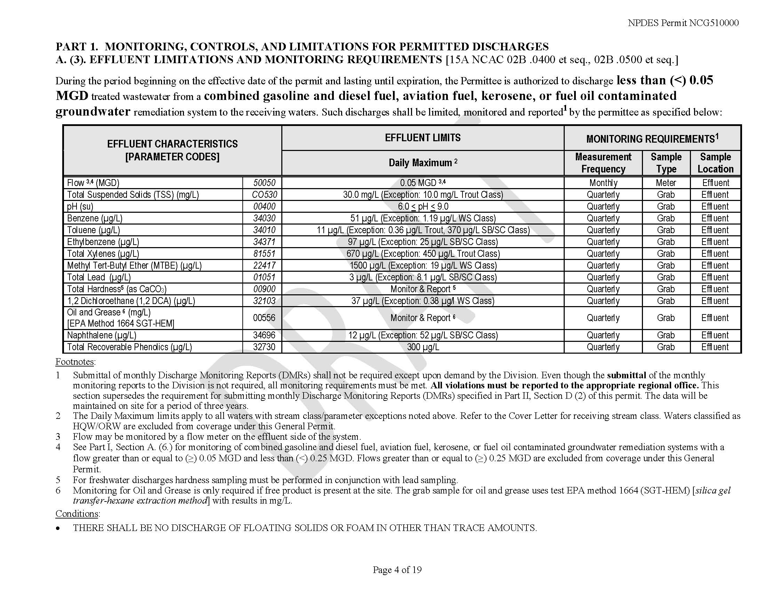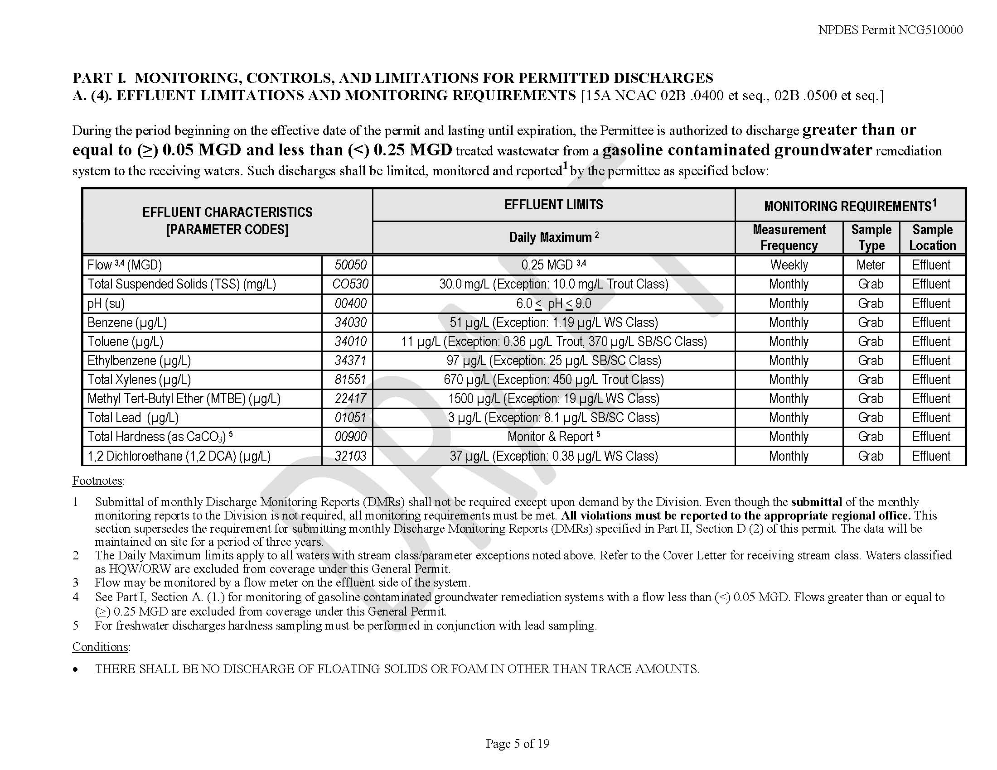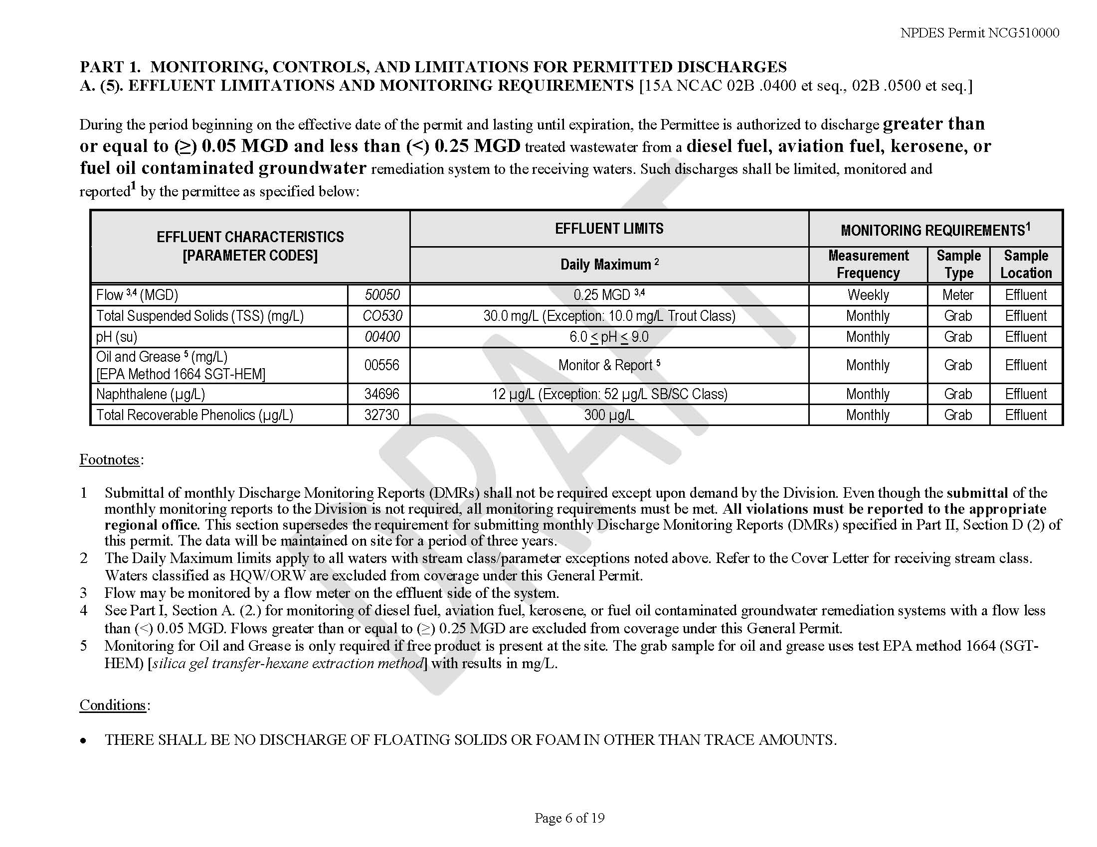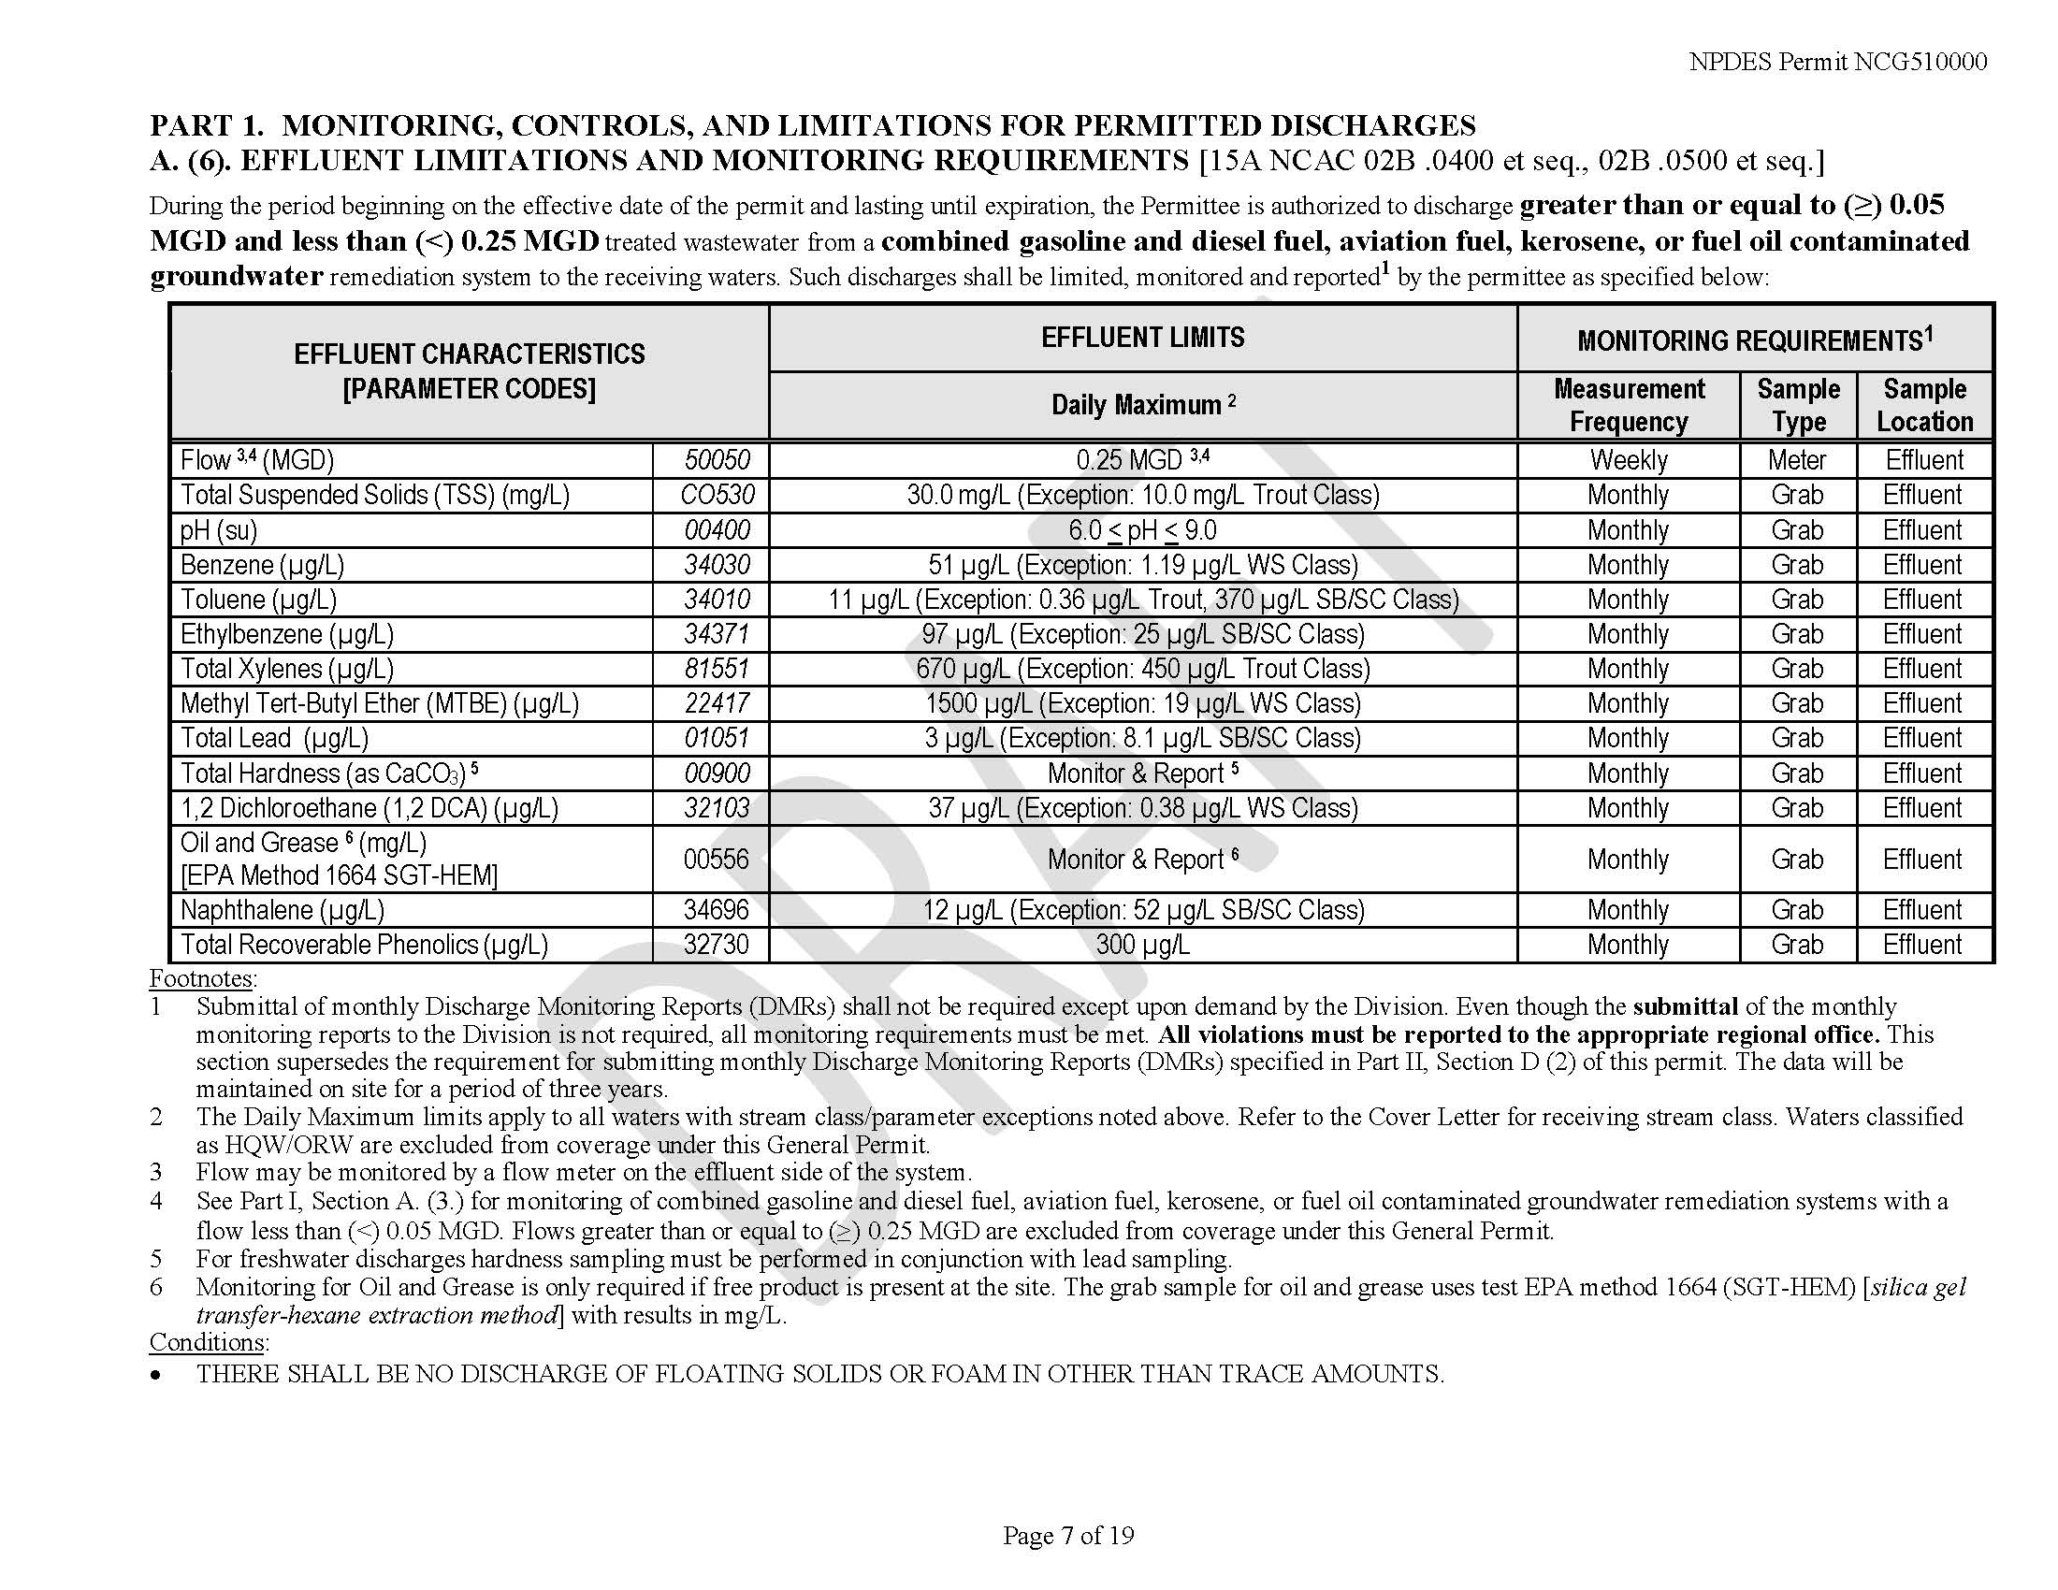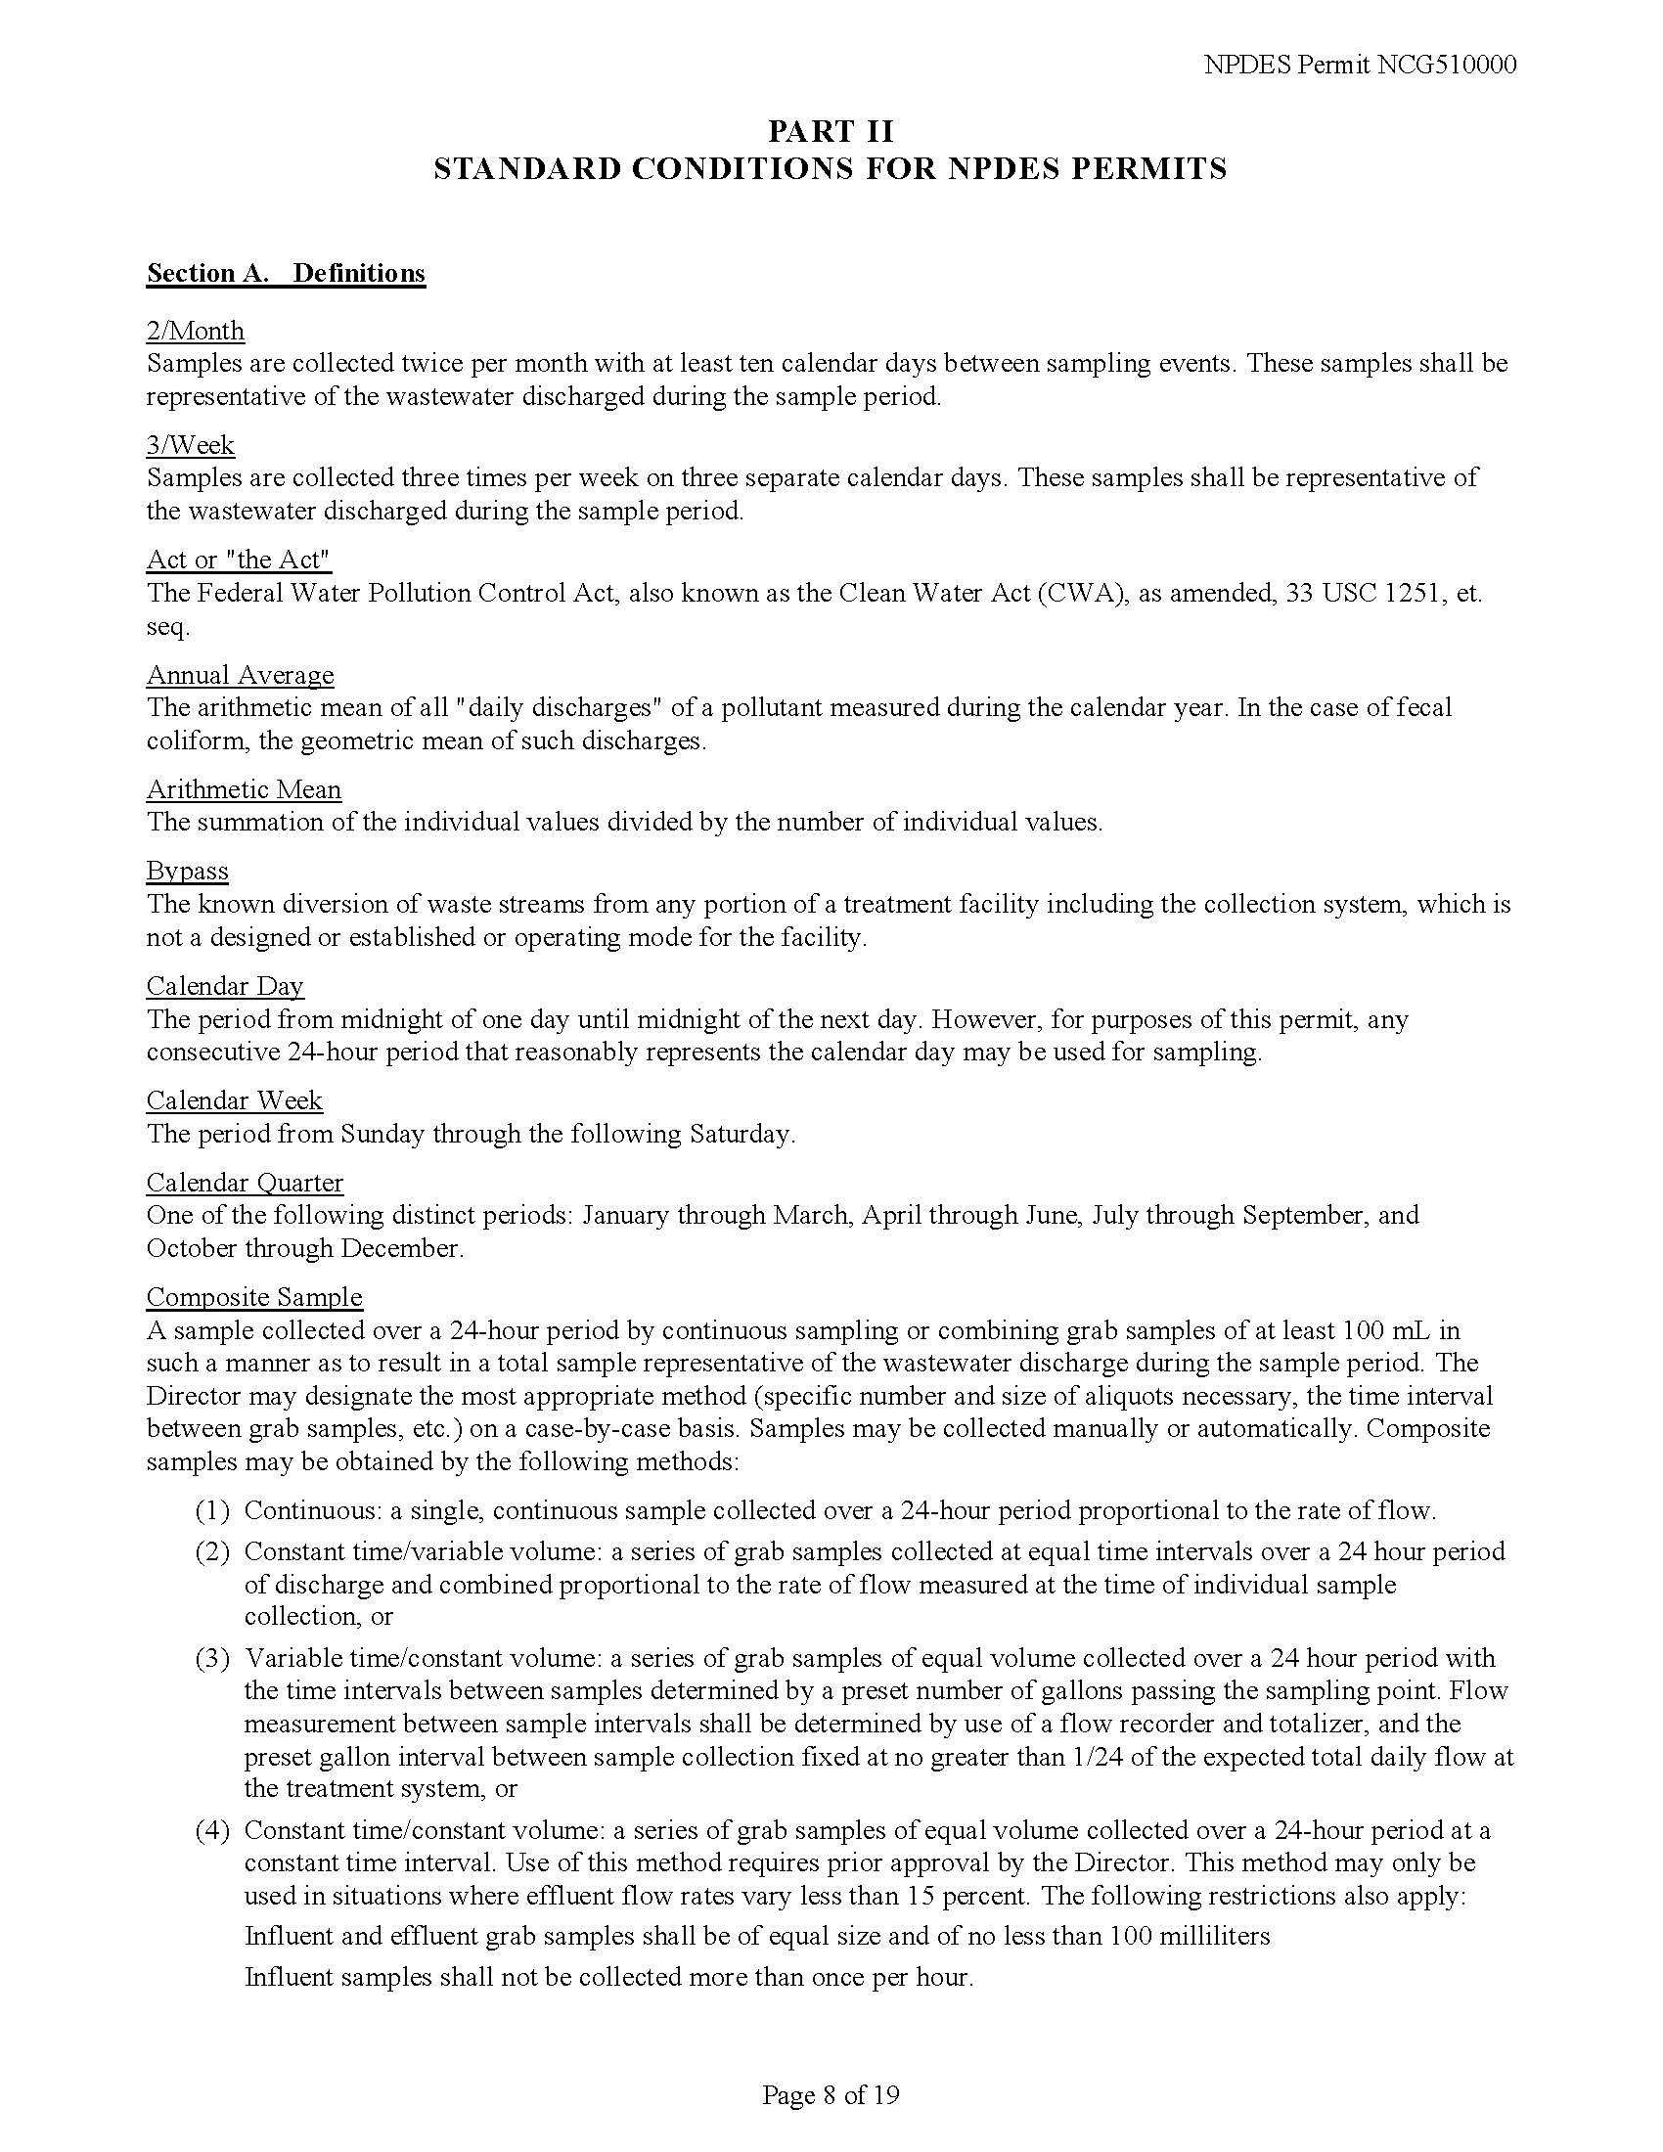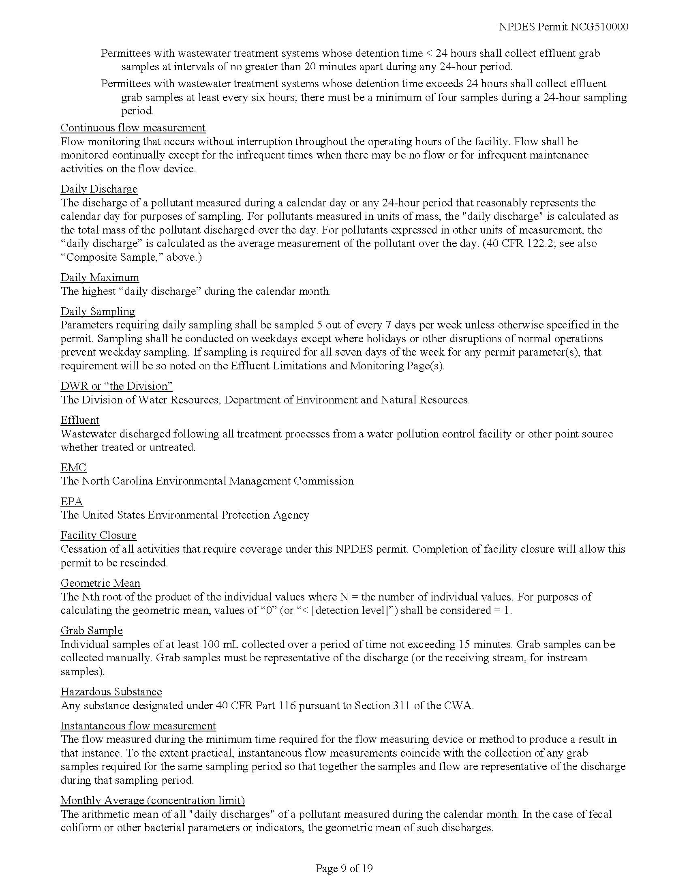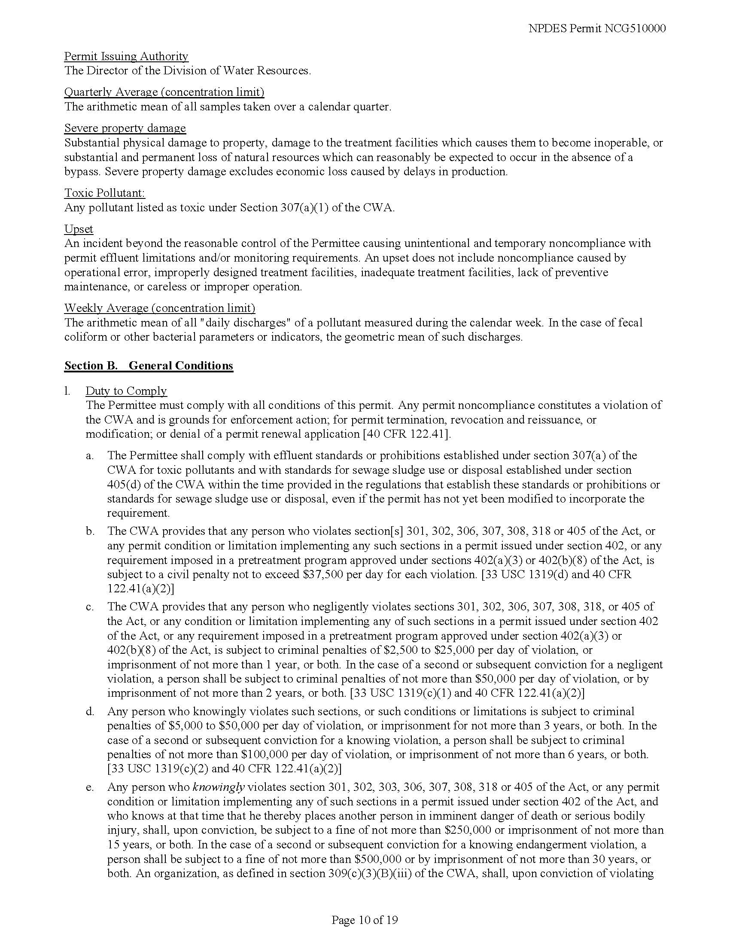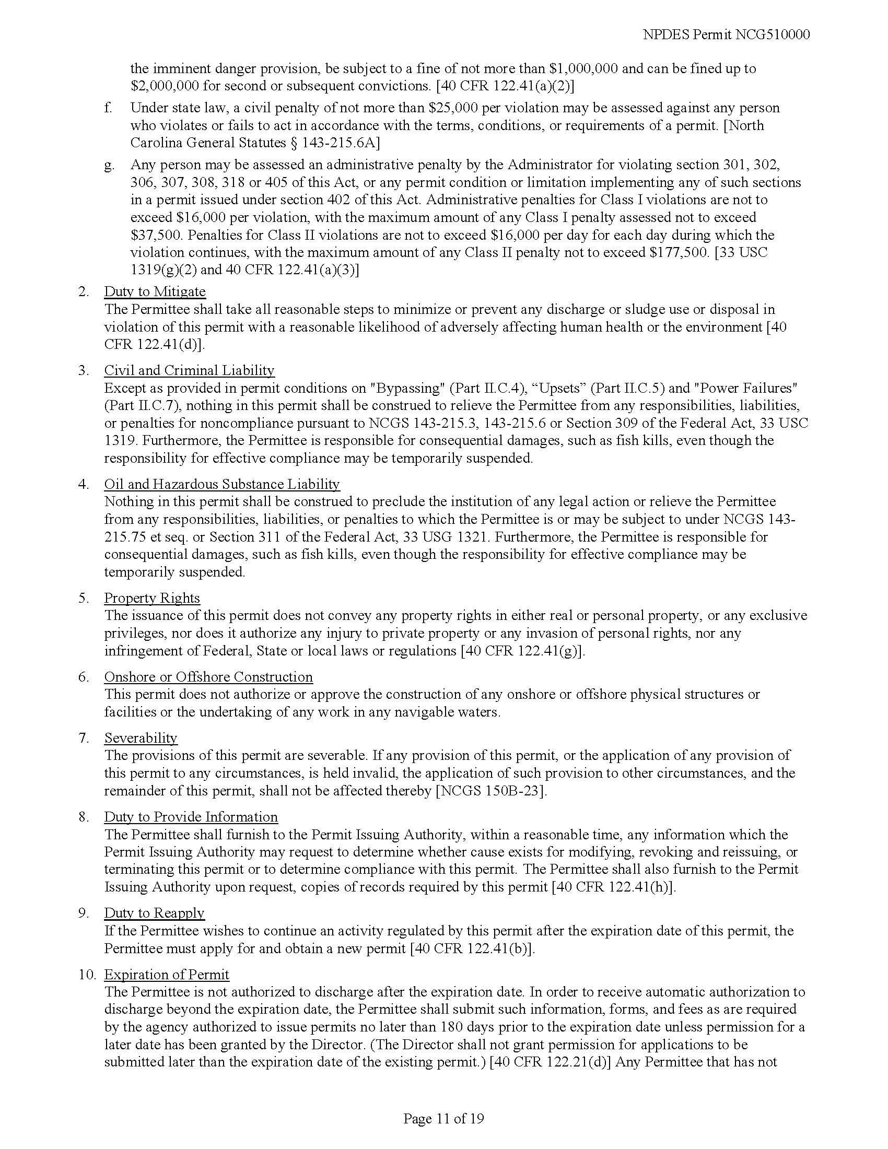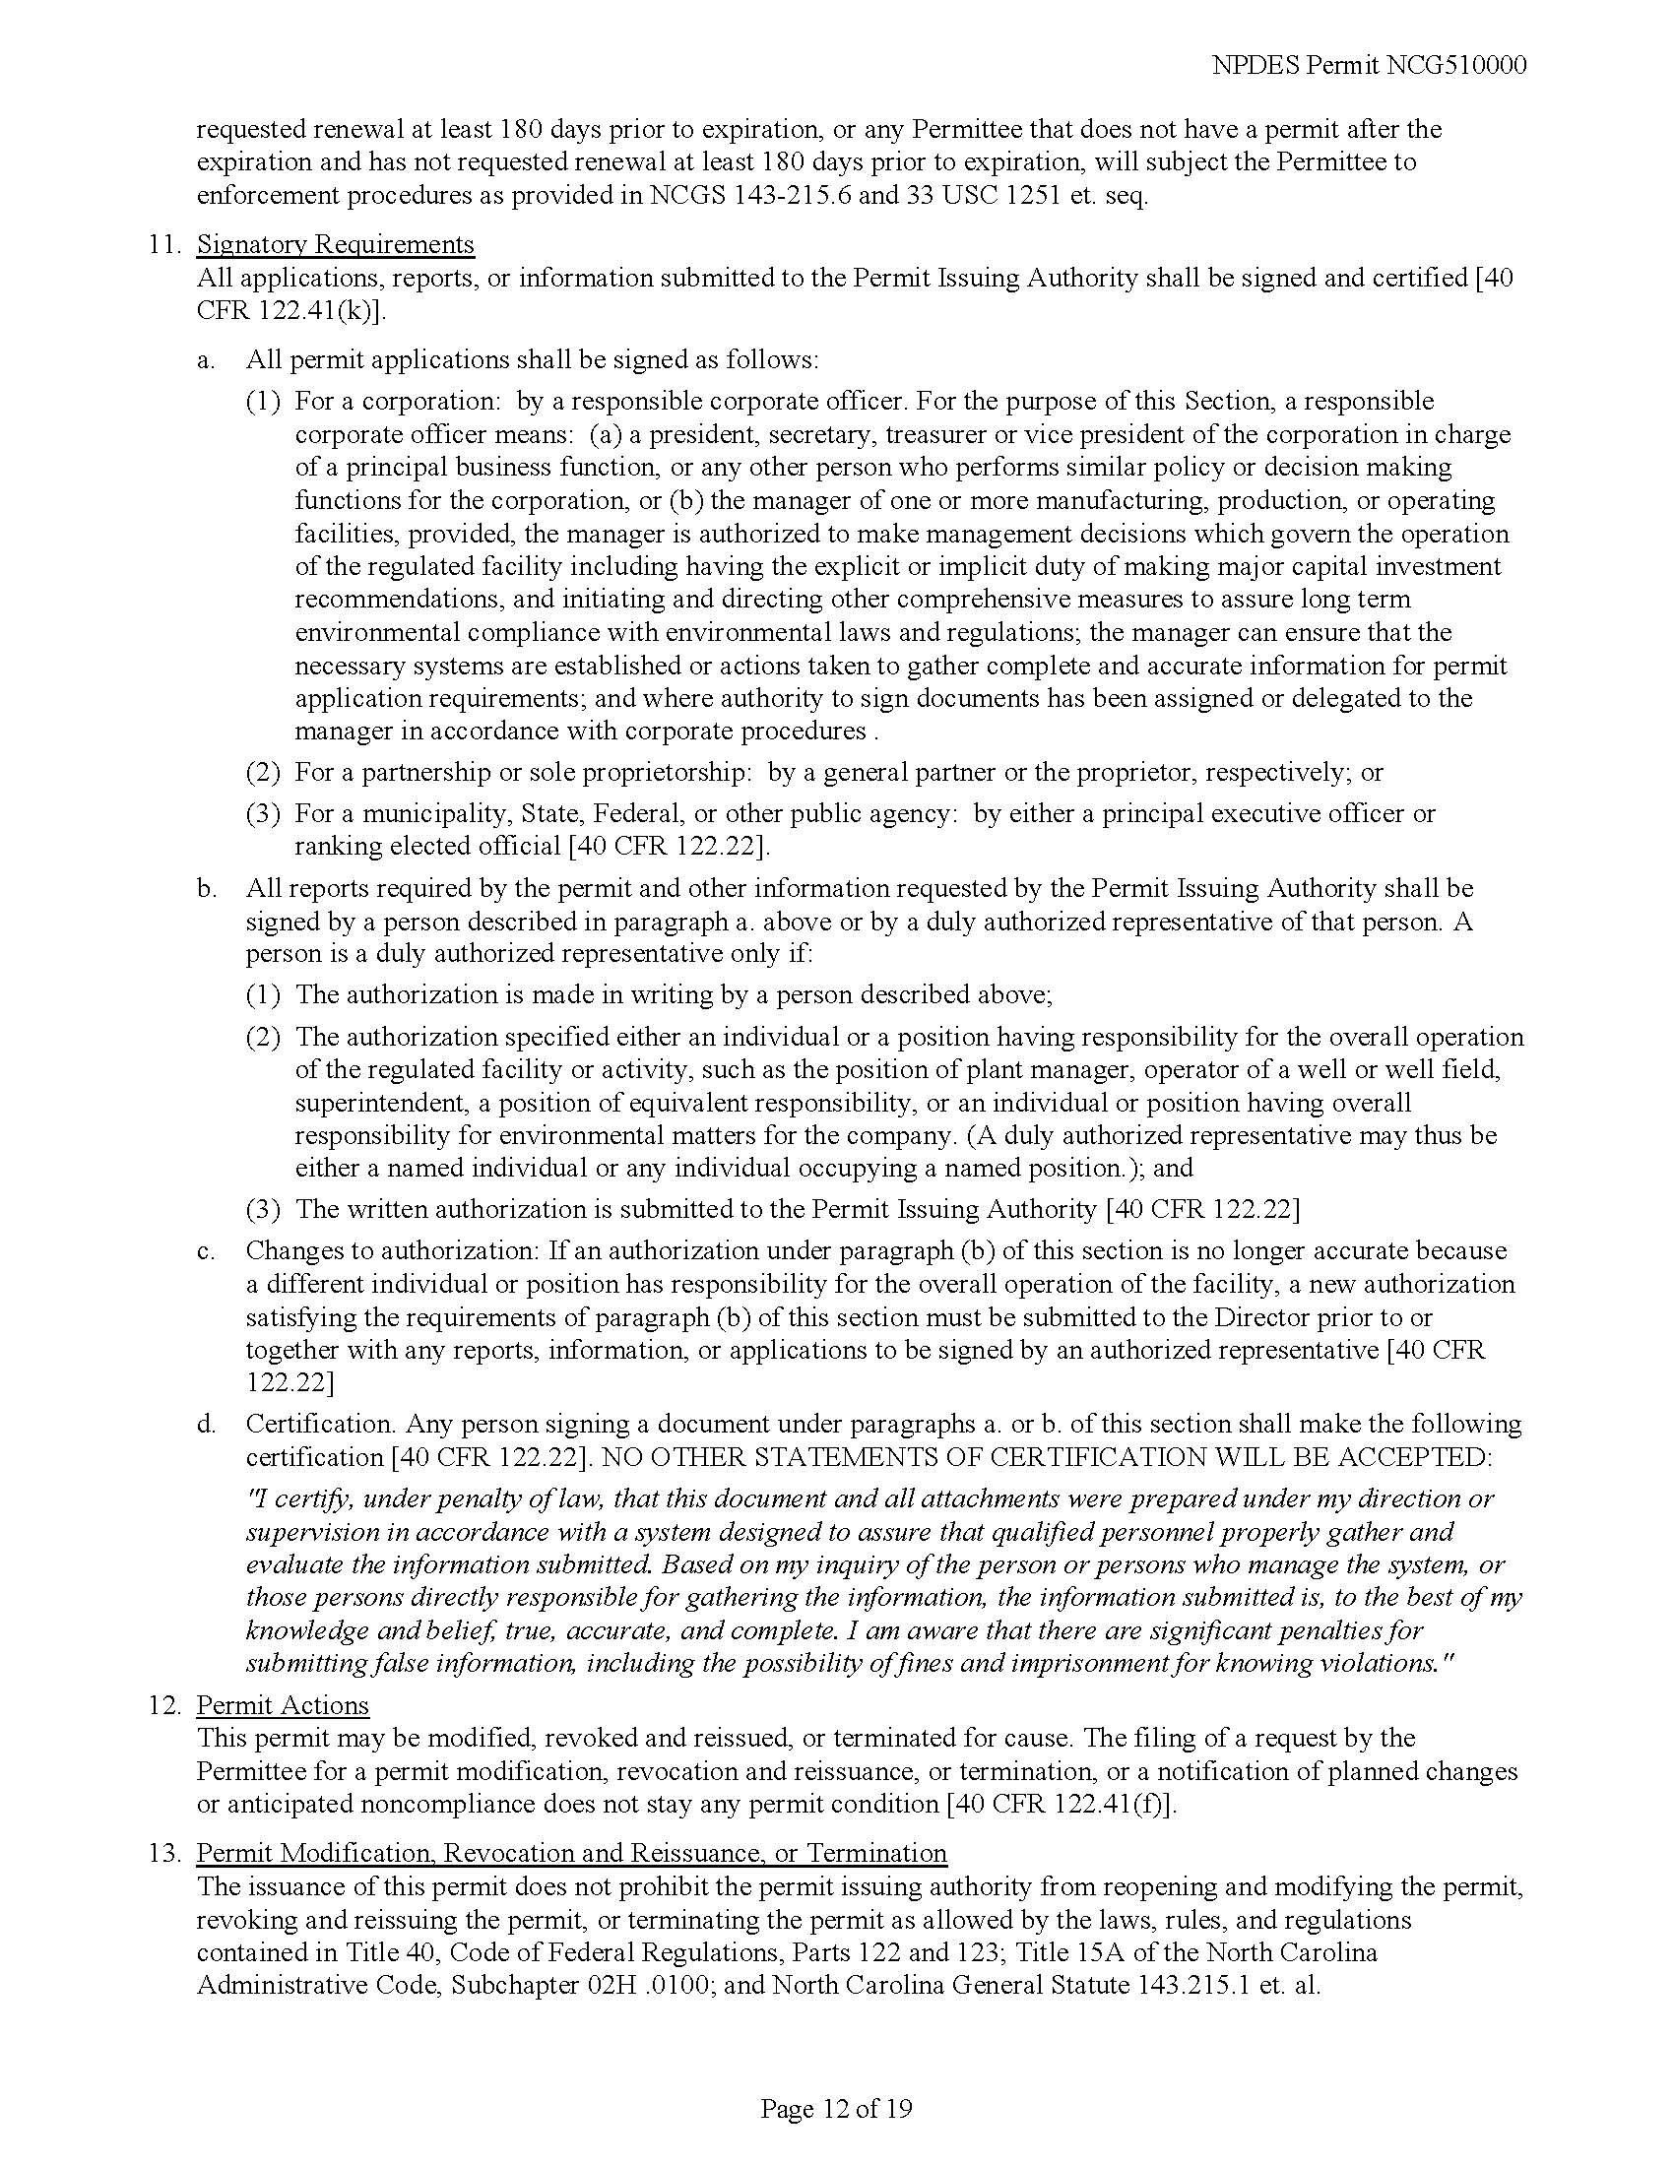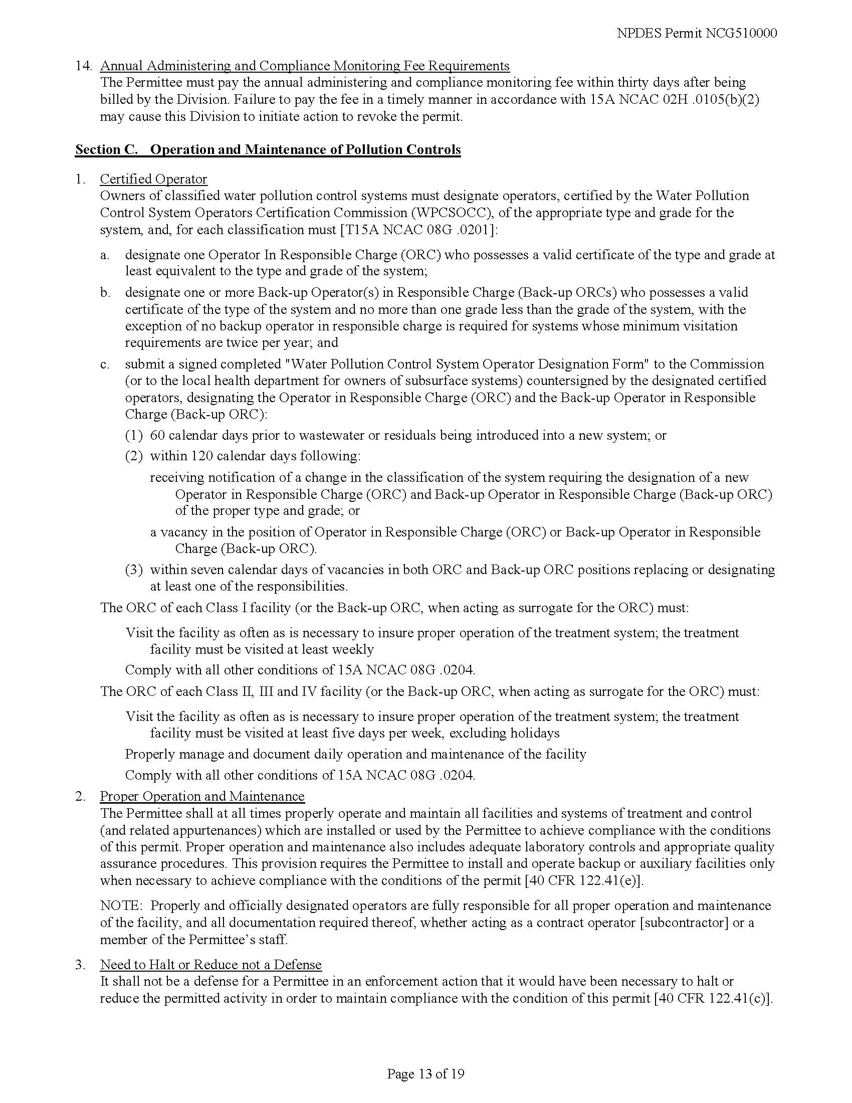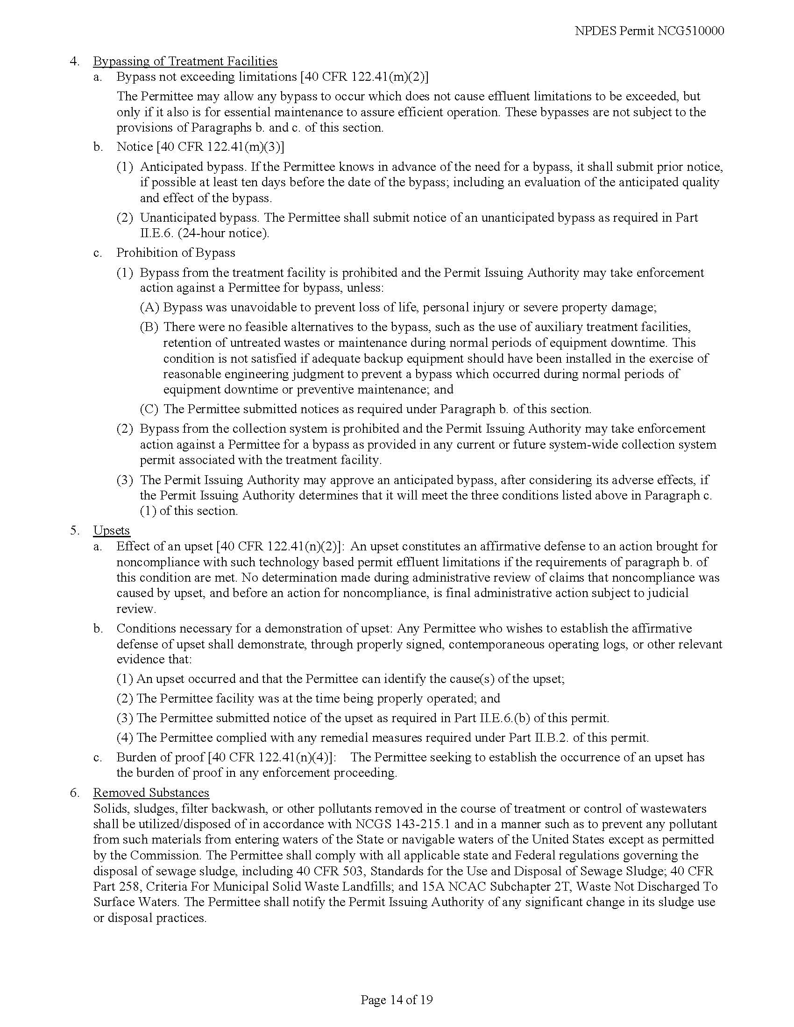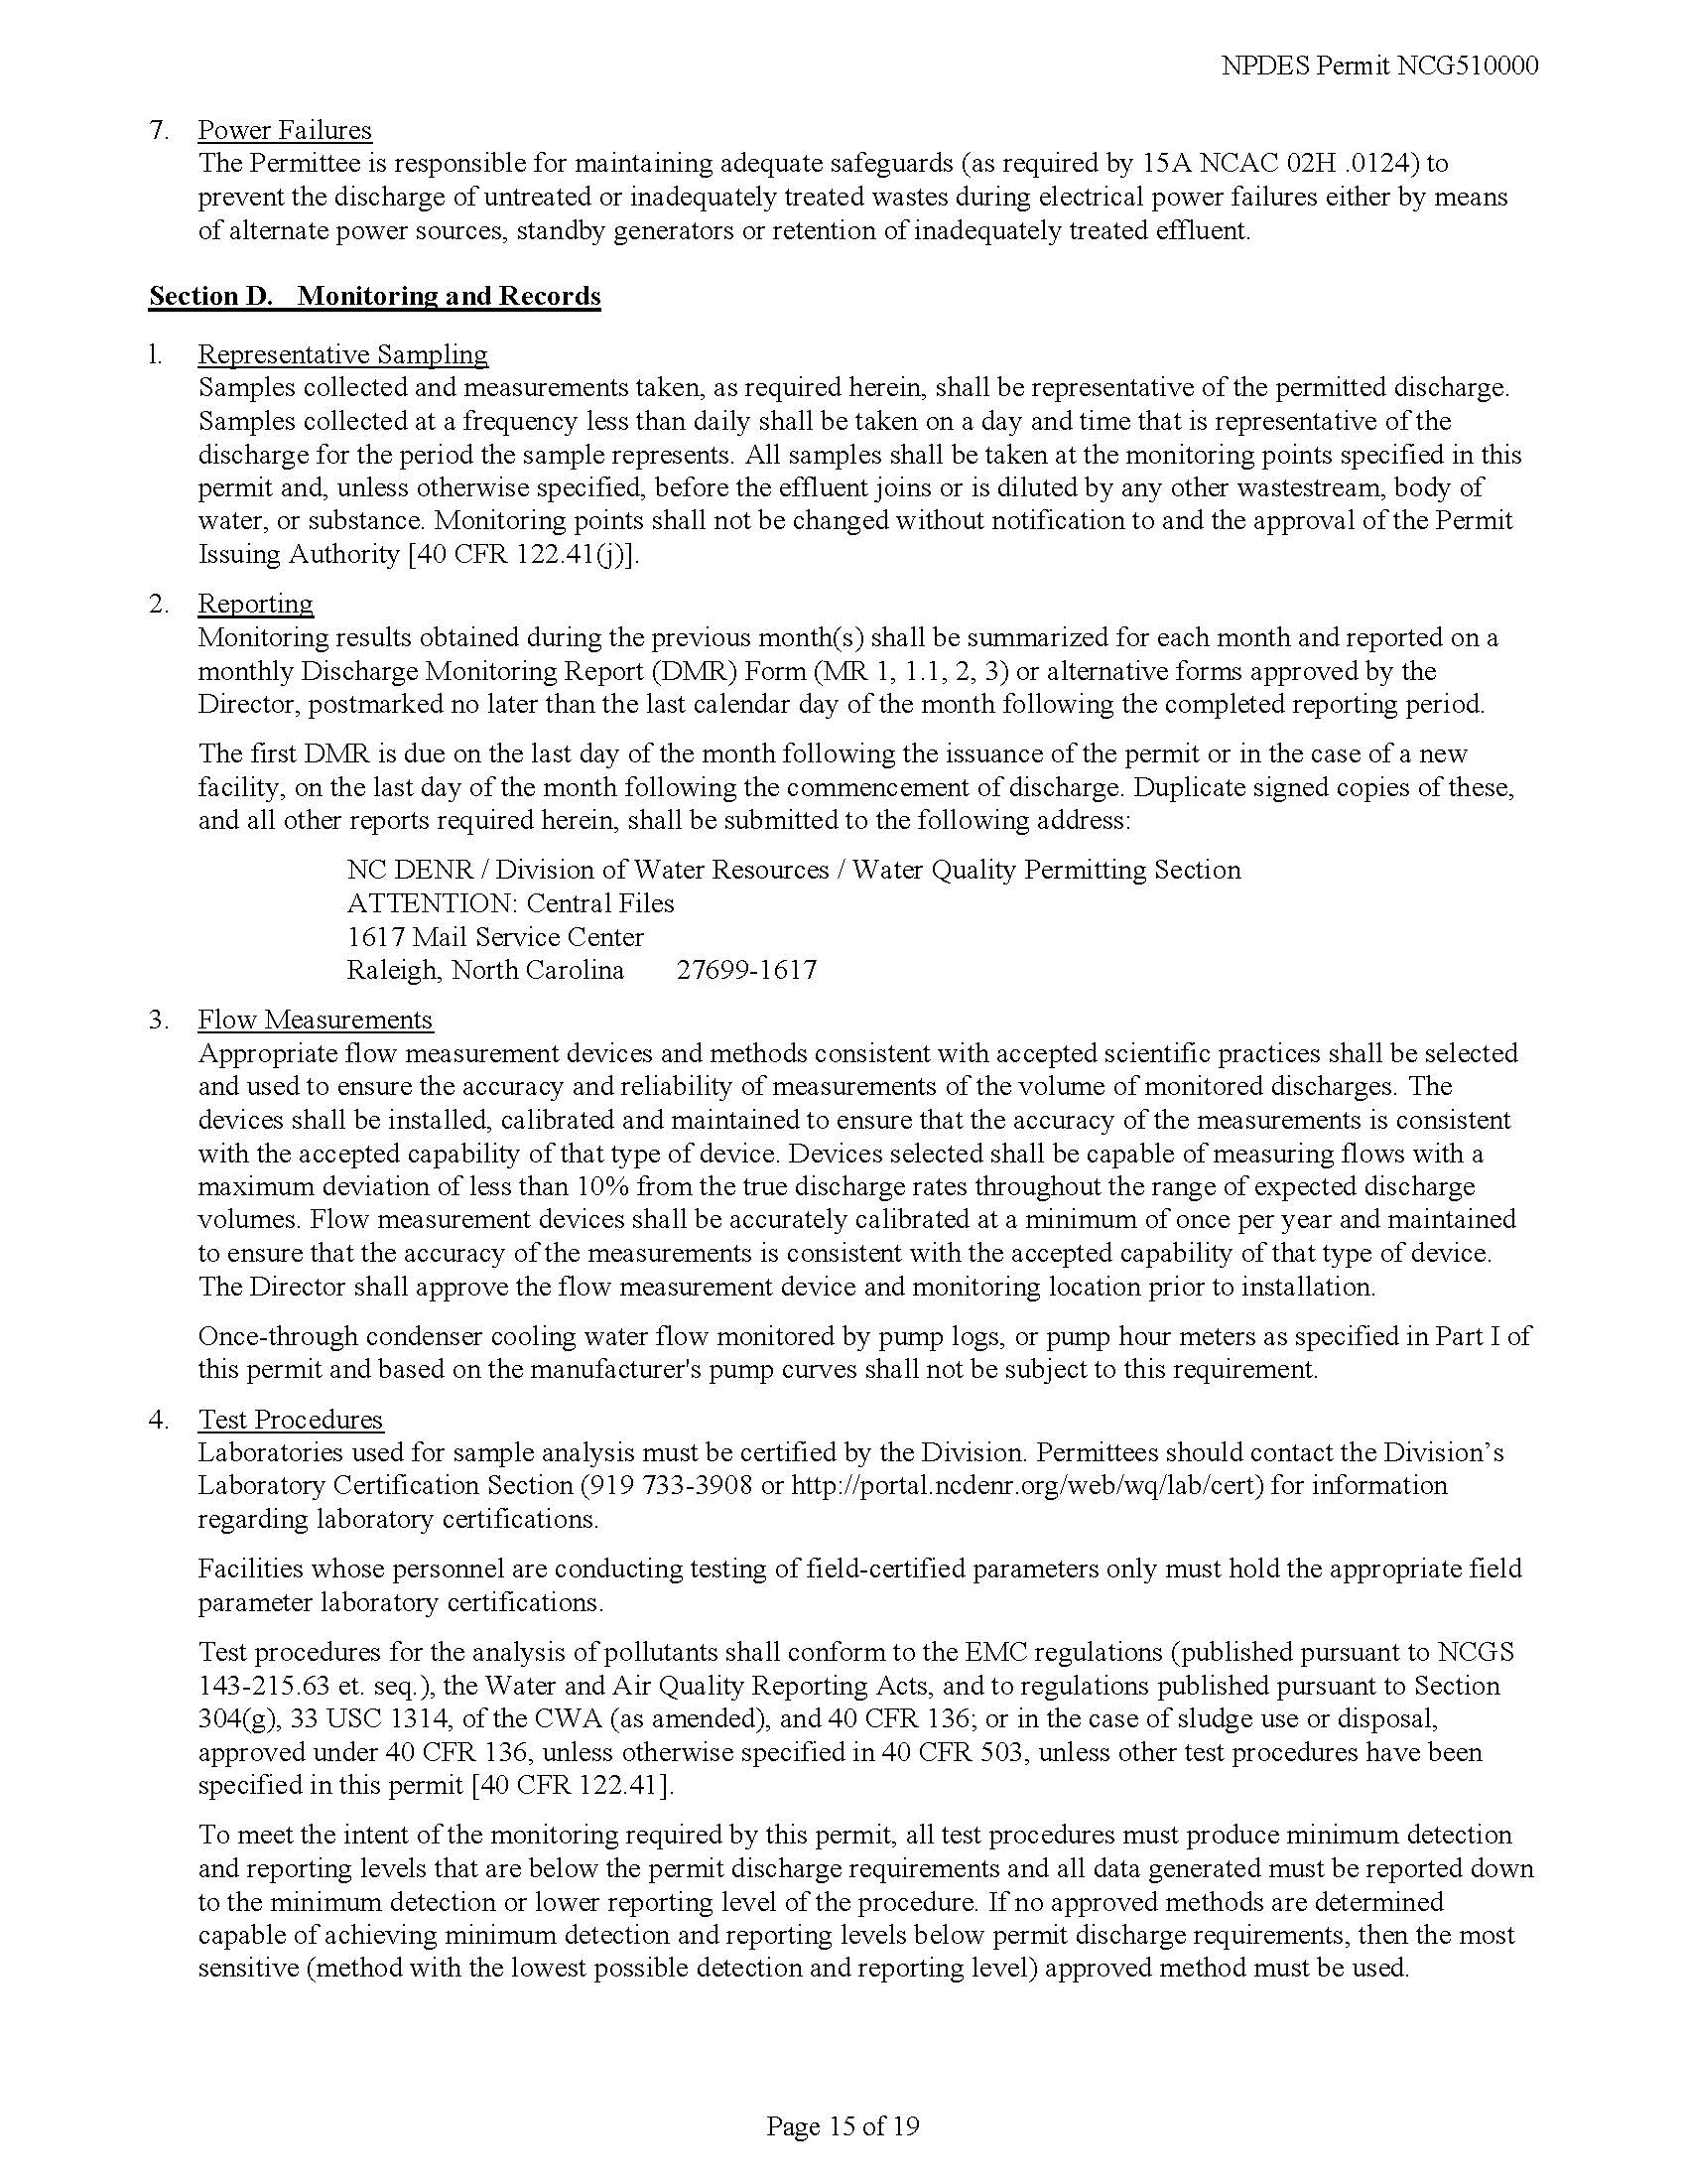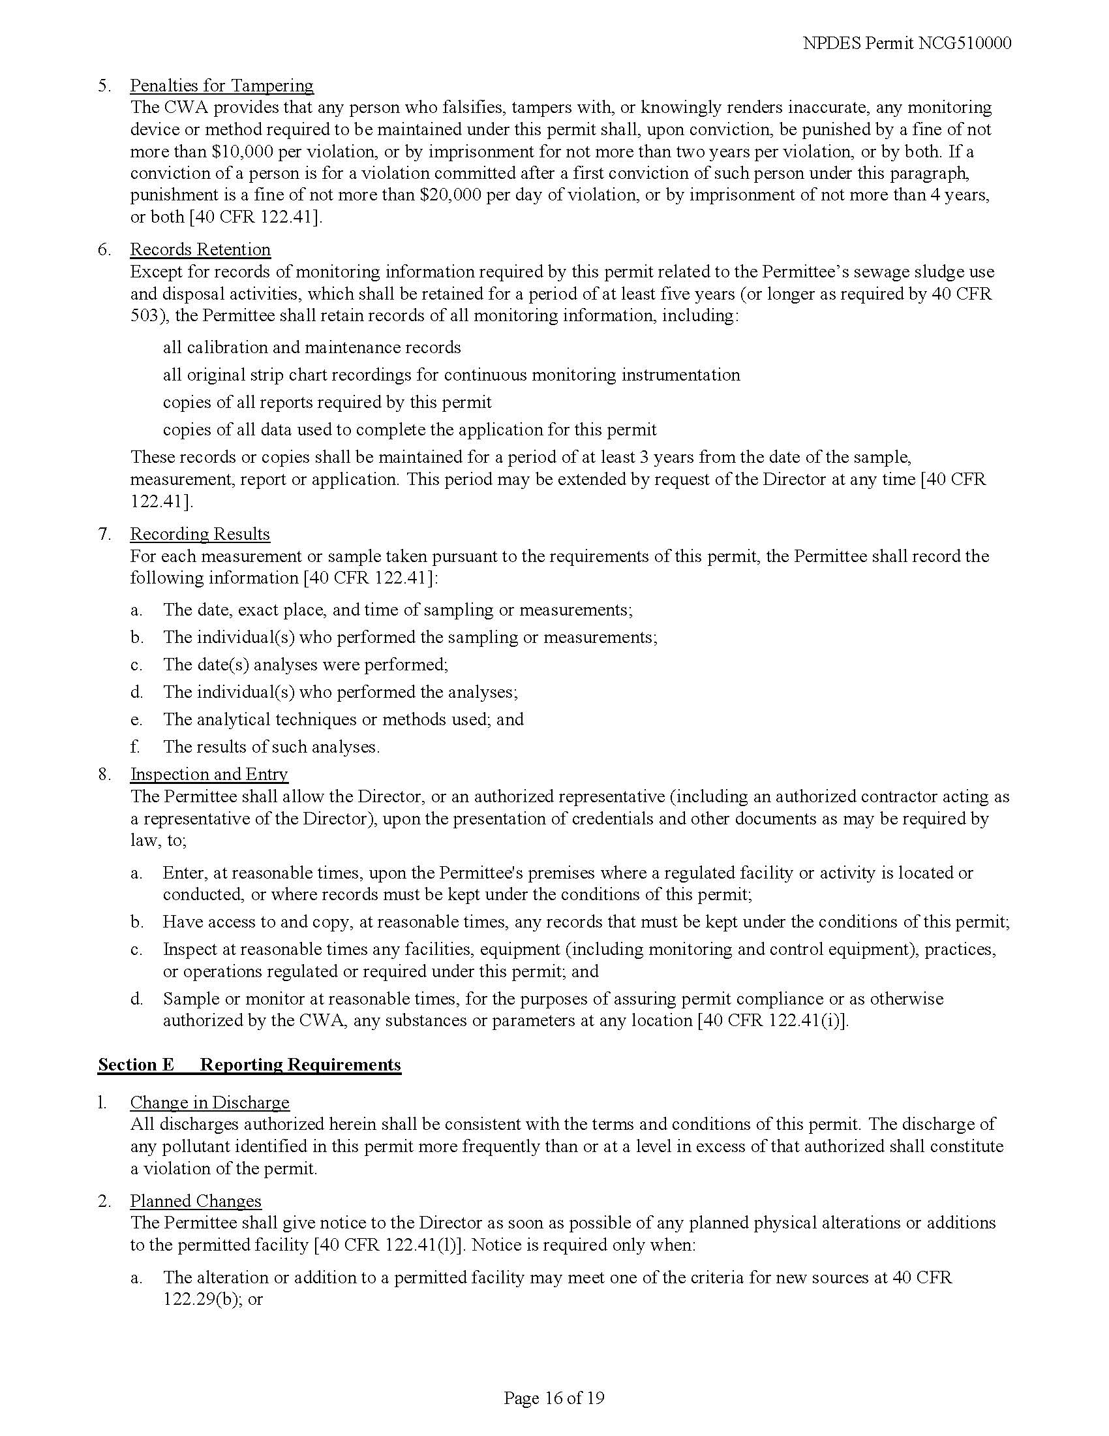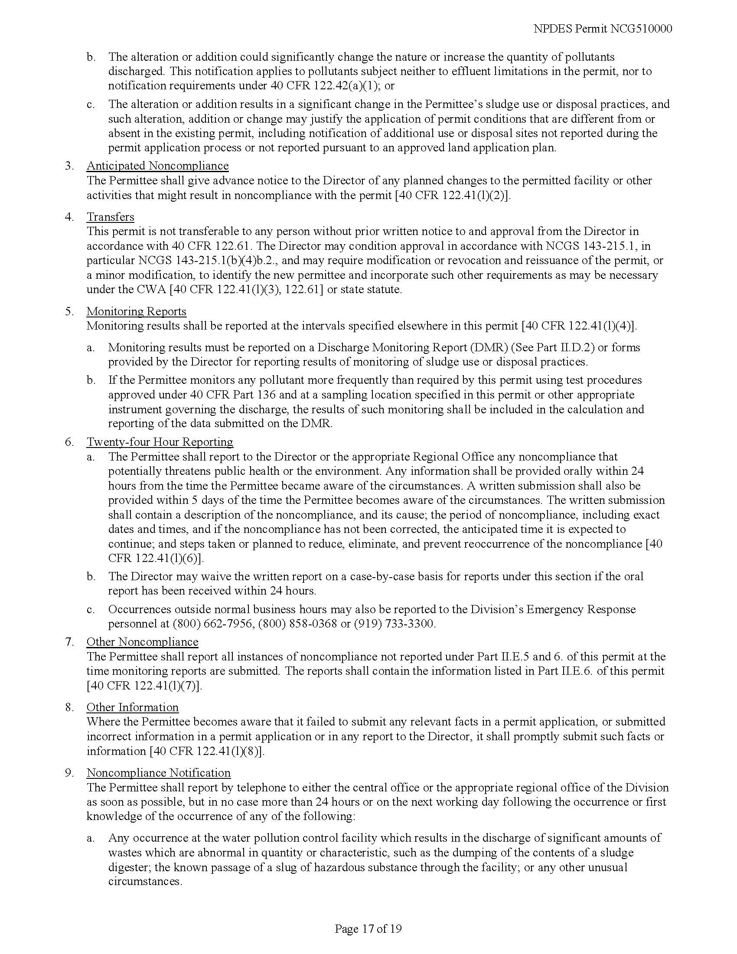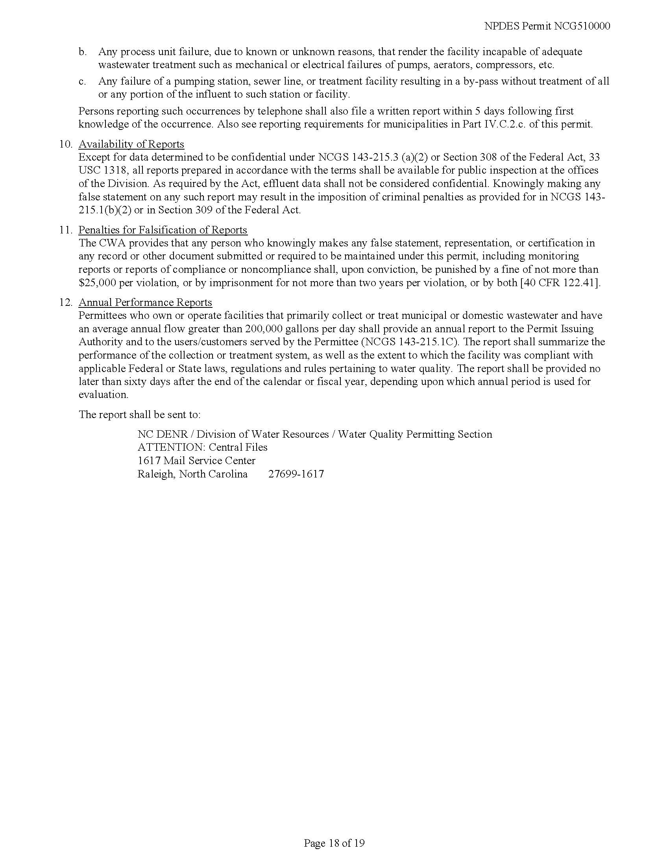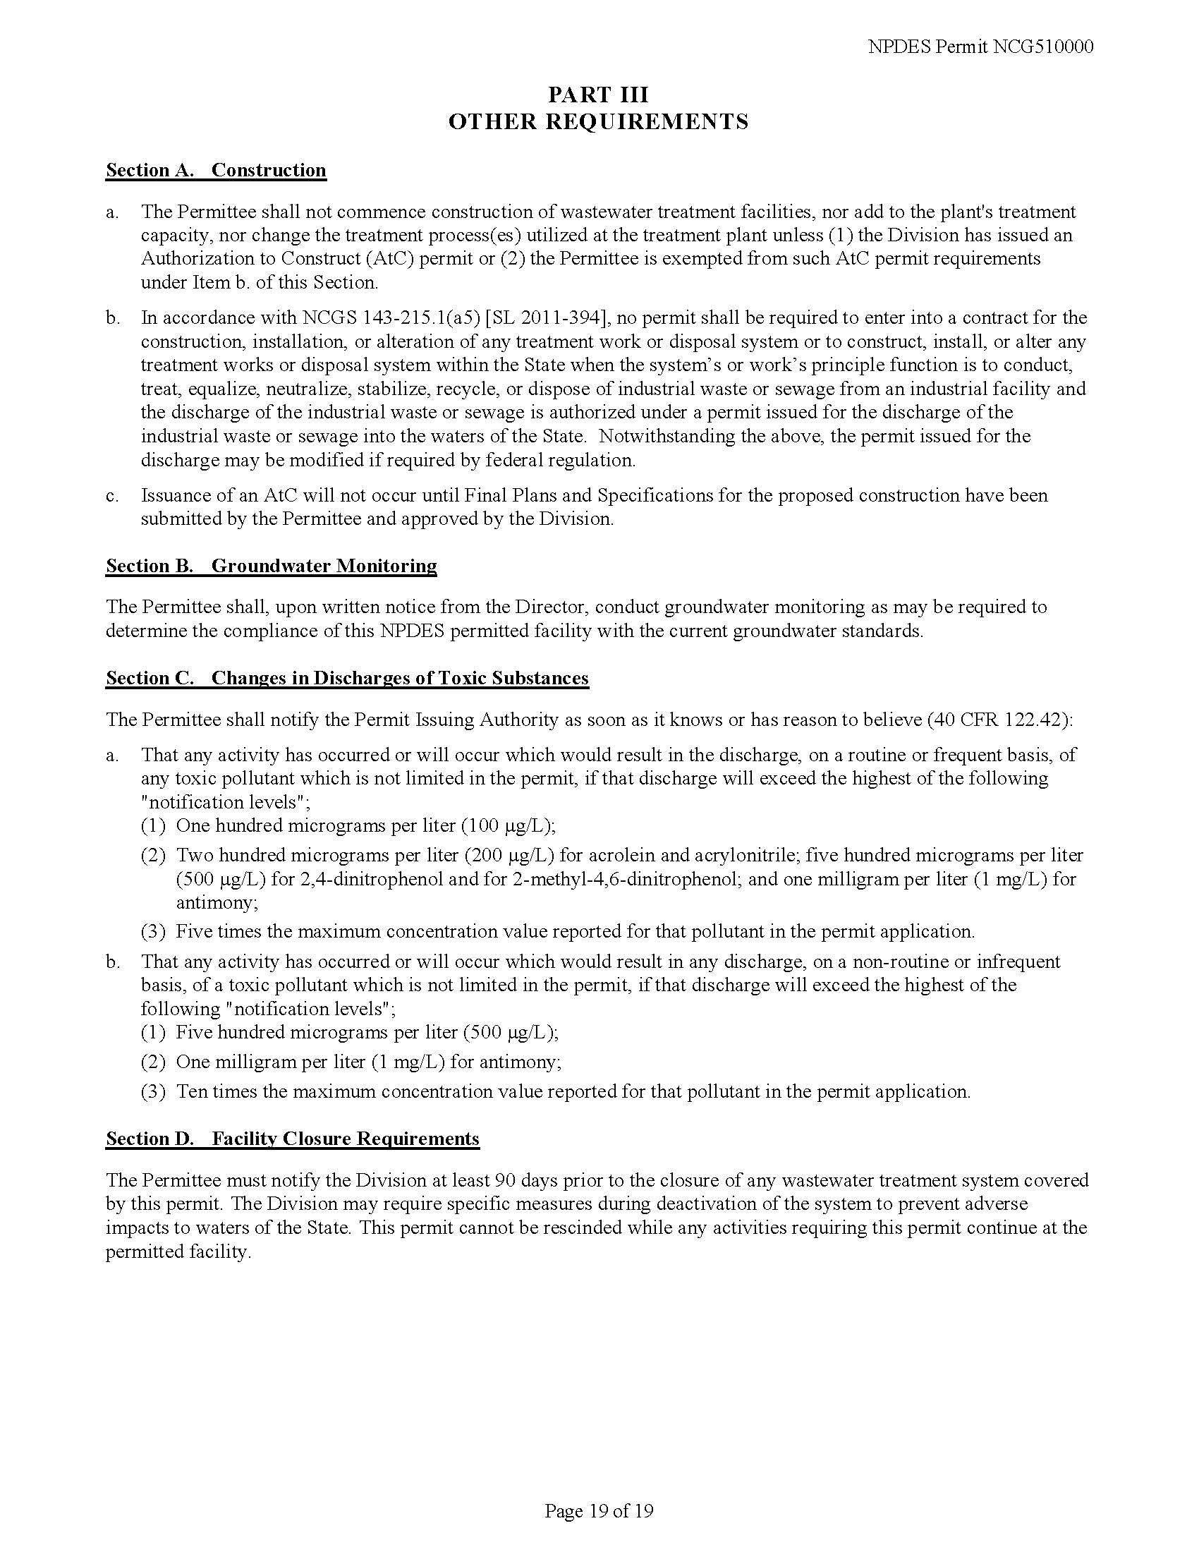
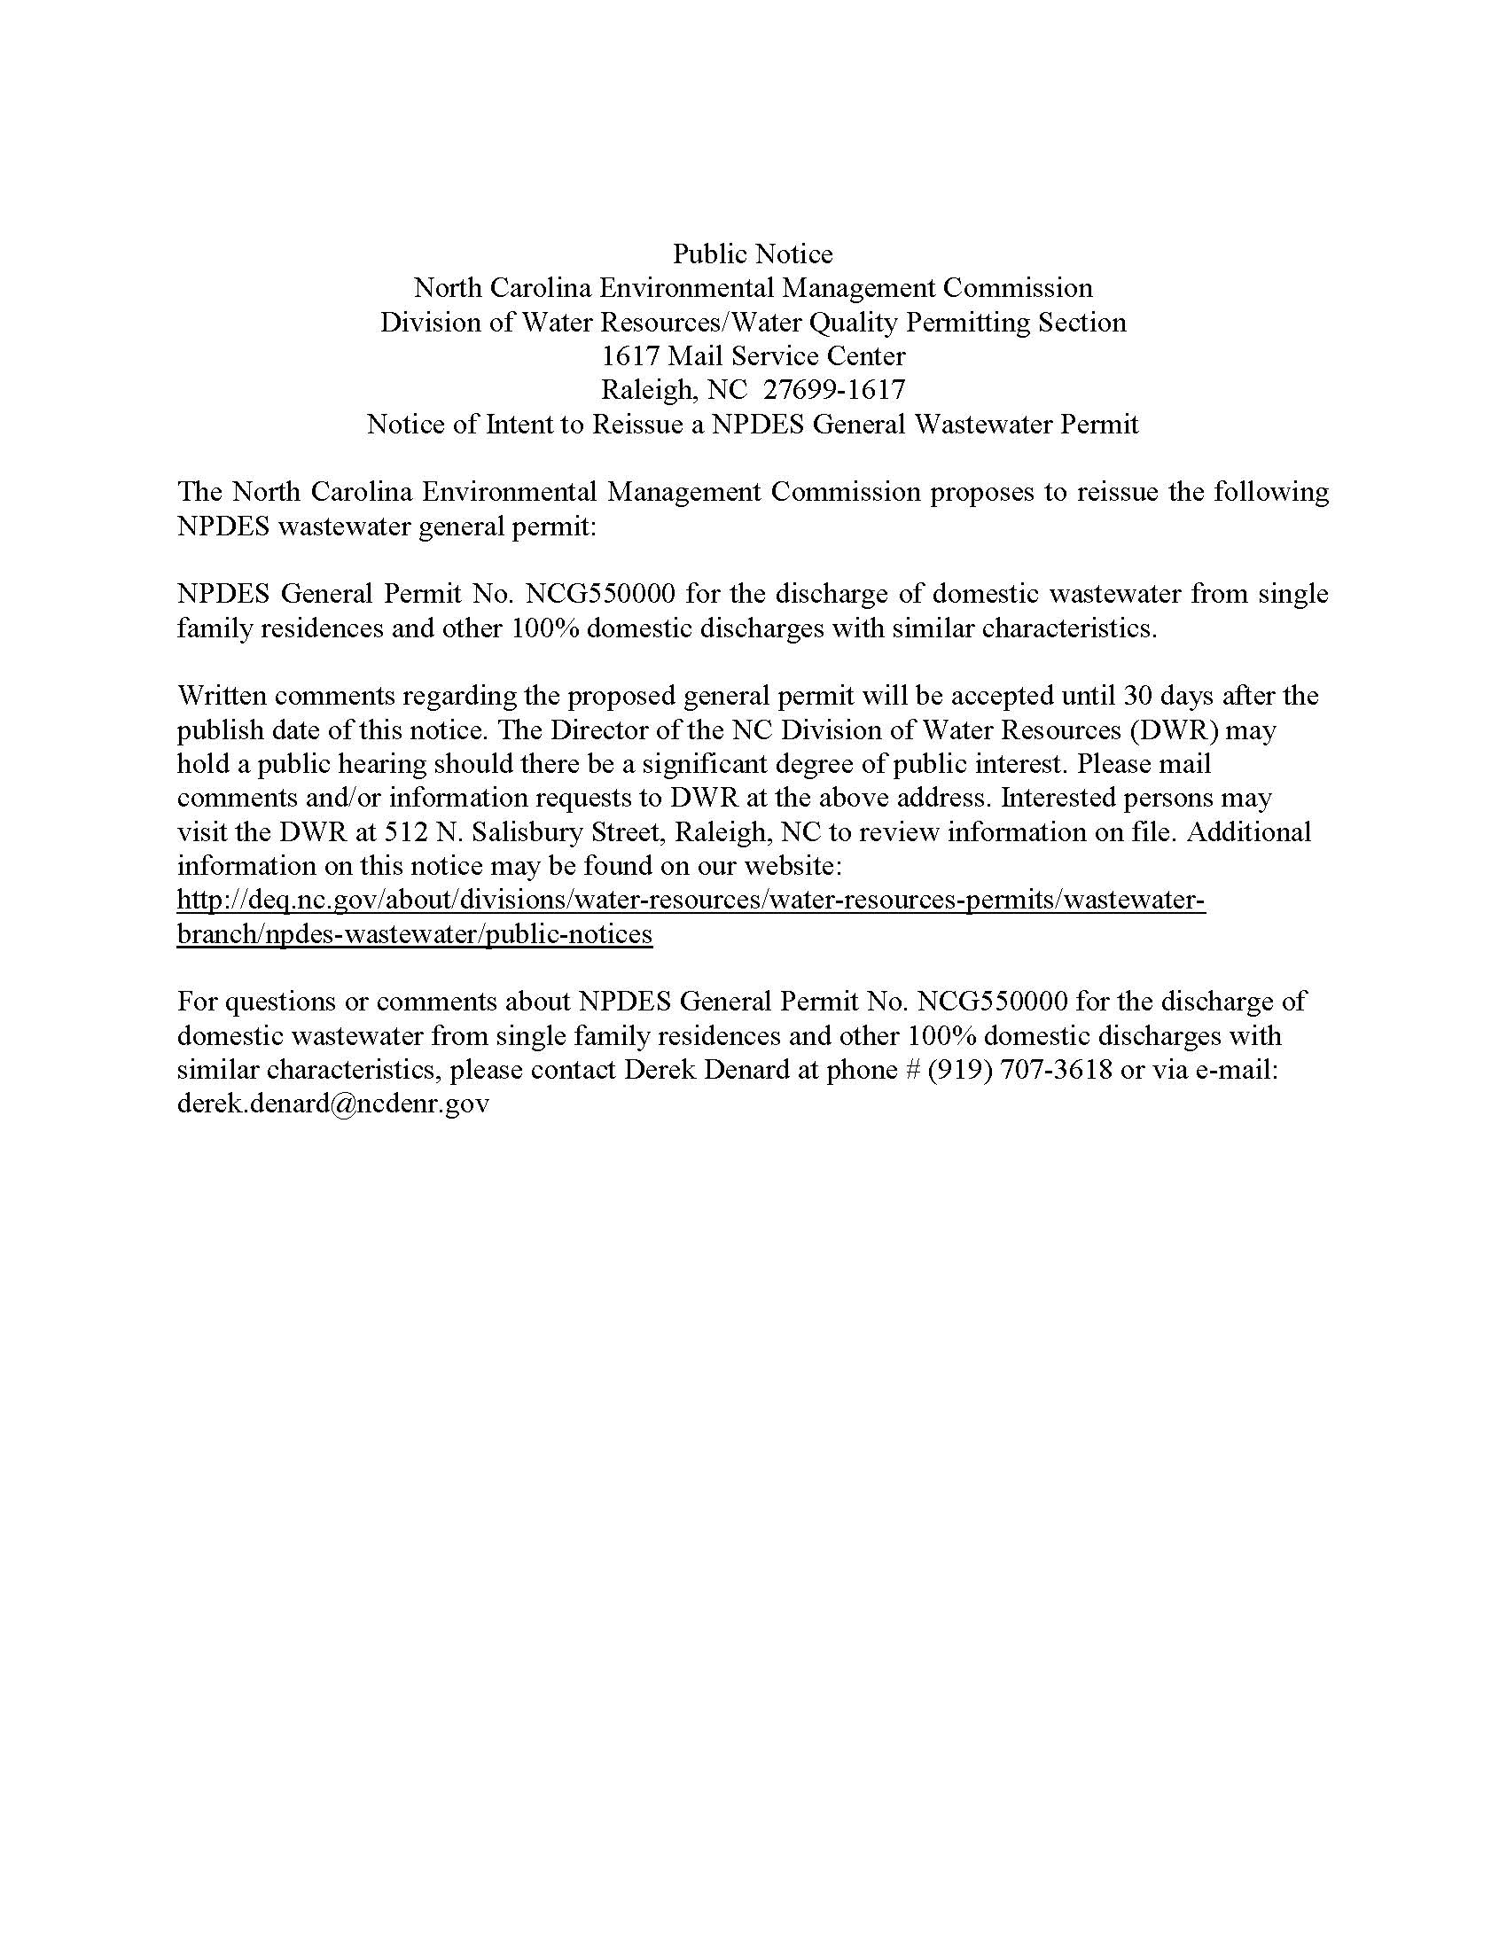

Note from the Codifier: The notices published in this Section of the NC Register include the text of proposed rules. The agency must accept comments on the proposed rule(s) for at least 60 days from the publication date, or until the public hearing, or a later date if specified in the notice by the agency. If the agency adopts a rule that differs substantially from a prior published notice, the agency must publish the text of the proposed different rule and accept comment on the proposed different rule for 60 days.
Statutory reference: G.S. 150B-21.2.

Title 02 – Department of Agriculture and Consumer Services

Notice is hereby given in accordance with G.S. 150B-21.3A(c)(2)g. that the Board of Agriculture intends to readopt without substantive changes the rules cited as 02 NCAC 48A .0401, .0402, .0612; and 61 .0101-.0112.

Pursuant to G.S. 150B-21.2(c)(1), the text of the rule(s) proposed for readoption without substantive changes are not required to be published. The text of the rules are available on the OAH website: http://reports.oah.state.nc.us/ncac.asp.

Link to agency website pursuant to G.S. 150B-19.1(c): http://www.ncagr.gov/AdministrativeRules/ProposedRules/index.htm

Proposed Effective Date: January 1, 2021

Instructions on How to Demand a Public Hearing: (must be requested in writing within 15 days of notice): Any person may request a public hearing on the proposed rules by submitting a request in writing no later than 9/16/2020, to Tina Hlabse, Secretary, NC Board of Agriculture, 1001 Mail Service Center, Raleigh, NC 27699-1001.

Reason for Proposed Action: All of these rules were classified as "necessary with substantive public interest" and are now being readopted. Each rule is necessary but is not being changed from how it is currently in the Administrative Code.

Comments may be submitted to: Tina Hlabse, 1001 Mail Service Center, Raleigh, NC 27699-1001; email tina.hlabse@ncagr.gov

Comment period ends: November 2, 2020

Procedure for Subjecting a Proposed Rule to Legislative Review: If an objection is not resolved prior to the adoption of the rule, a person may also submit written objections to the Rules Review Commission after the adoption of the Rule. If the Rules Review Commission receives written and signed objections after the adoption of the Rule in accordance with G.S. 150B-21.3(b2) from 10 or more persons clearly requesting review by the legislature and the Rules Review Commission approves the rule, the rule will become effective as provided in G.S. 150B-21.3(b1). The Commission will receive written objections until 5:00 p.m. on the day following the day the Commission approves the rule. The Commission will receive those objections by mail, delivery service, hand delivery, or facsimile transmission. If you have any further questions concerning the submission of objections to the Commission, please call a Commission staff attorney at 919-431-3000.

Fiscal impact. Does any rule or combination of rules in this notice create an economic impact? Check all that apply.

State funds affected

Local funds affected

Substantial economic impact (>= $1,000,000)

Approved by OSBM

No fiscal note required

Chapter 48 - Plant Industry

SUBCHAPTER 48A - PLANT PROTECTION

SECTION .0400 - WHITE PINE BLISTER RUST

02 NCAC 48A .0401 CURRANT AND GOOSEBERRY PLANTS (READOPTION WITHOUT SUBSTANTIVE CHANGES)

02 NCAC 48A .0402 INFECTED PINES (READOPTION WITHOUT SUBSTANTIVE CHANGES)

SECTION .0600 - BOLL WEEVIL

02 NCAC 48A .0612 COTTON STALK DESTRUCTION (READOPTION WITHOUT SUBSTANTIVE CHANGES)

Chapter 61 - Sanitation of Bedding

02 NCAC 61 .0101 (READOPTION WITHOUT SUBSTANTIVE CHANGES)

02 NCAC 61 .0102 (READOPTION WITHOUT SUBSTANTIVE CHANGES)

02 NCAC 61 .0103 (READOPTION WITHOUT SUBSTANTIVE CHANGES)

02 NCAC 61 .0104 (READOPTION WITHOUT SUBSTANTIVE CHANGES)

02 NCAC 61 .0105 (READOPTION WITHOUT SUBSTANTIVE CHANGES)

02 NCAC 61 .0106 (READOPTION WITHOUT SUBSTANTIVE CHANGES)

02 NCAC 61 .0107 (READOPTION WITHOUT SUBSTANTIVE CHANGES)

02 NCAC 61 .0108 (READOPTION WITHOUT SUBSTANTIVE CHANGES)

02 NCAC 61 .0109 (READOPTION WITHOUT SUBSTANTIVE CHANGES)

02 NCAC 61 .0110 (READOPTION WITHOUT SUBSTANTIVE CHANGES)

02 NCAC 61 .0111 (READOPTION WITHOUT SUBSTANTIVE CHANGES)

02 NCAC 61 .0112 (READOPTION WITHOUT SUBSTANTIVE CHANGES)

* * * * * * * * * * * * * * * * * * * *

Notice is hereby given in accordance with G.S. 150B-21.2 that the Soil and Water Conservation Commission intends to adopt the rule cited as 02 NCAC 59D .0201.

Link to agency website pursuant to G.S. 150B-19.1(c): http://www.ncagr.gov/AdministrativeRules/ProposedRules/index.htm

Proposed Effective Date: January 1, 2021

Public Hearing:
Date: September 17, 2020
Time: 1:00 p.m.
Location: https://ncagr.webex.com/ncagr/j.php?MTID=mcd1c926e2118ab0e5c71c5b64a5cb88c Meeting number (access code): 171 780 3338; Meeting password: JAA4me Phone Access: (415) 655-003

Reason for Proposed Action: Session Law 2020-18 expands the powers and duties of the Soil and Water Conservation Commission to develop and implement a program for granting job approval authority to Soil and Water Conservation District staff and employees of the Division of Soil and Water Conservation of the Department of Agriculture and Consumer Services to plan, design, and certify the installation of best management practices approved for cost-share funding pursuant to programs identified in G.S. 139-4(d)(9).

Comments may be submitted to: Vernon Cox, 1614 Mail Service Center, Raleigh, NC 27699-1614; phone (919) 707-3771; email vernon.cox@ncagr.gov

Comment period ends: November 2, 2020

Procedure for Subjecting a Proposed Rule to Legislative Review: If an objection is not resolved prior to the adoption of the rule, a person may also submit written objections to the Rules Review Commission after the adoption of the Rule. If the Rules Review Commission receives written and signed objections after the adoption of the Rule in accordance with G.S. 150B-21.3(b2) from 10 or more persons clearly requesting review by the legislature and the Rules Review Commission approves the rule, the rule will become effective as provided in G.S. 150B-21.3(b1). The Commission will receive written objections until 5:00 p.m. on the day following the day the Commission approves the rule. The Commission will receive those objections by mail, delivery service, hand delivery, or facsimile transmission. If you have any further questions concerning the submission of objections to the Commission, please call a Commission staff attorney at 919-431-3000.

Fiscal impact. Does any rule or combination of rules in this notice create an economic impact? Check all that apply.

State funds affected

Local funds affected

Substantial economic impact (>= $1,000,000)

Approved by OSBM

No fiscal note required

Chapter 59 - Soil and Water Conservation Commission

SUBCHAPTER 59D - AGRICULTURE COST SHARE PROGRAM FOR NONPOINT SOURCE POLLUTION CONTROL

SECTION .0200 – JOB APPROVAL AUTHORITY

02 NCAC 59D .0201 Criteria and procedures for granting job approval authority

(a) "Eligible individuals" means Soil and Water Conservation District employees, county employees working as staff for a Soil and Water Conservation District and employees of the North Carolina Department of Agriculture and Consumer Services Division of Soil and Water Conservation.

(b) Eligible individuals seeking Job Approval Authority (JAA) from the Commission shall receive agreement from their immediate supervisor. District staff shall also receive agreement from the chair of the Soil and Water Conservation District for whom they are employed.

(c) Eligible individuals seeking JAA for a best management practice as defined by 02 NCAC 59D .0102(6) shall submit application to the Division for evaluation of technical competency. The minimum technical competency requirements for each practice shall be listed in the applicable program's Detailed Implementation Plan (DIP) as defined in 02 NCAC 59D .0102(14).

(d) Eligible individuals who submit documentation of JAA issued by the USDA Natural Resources Conservation Service as part of the application described in Paragraph (c) of this Rule shall be granted equivalent JAA by the Commission, unless JAA has subsequently been rescinded due to factors identified in Paragraph (f) of this Rule.

(e) The Commission shall consider an eligible individual who is duly licensed as a professional engineer by the North Carolina Board of Examiners for Engineers and Surveyors as having JAA for any best management practice to which they affix their seal and signature to all designs and technical documents.

(f) The Commission may rescind an individual's JAA for any or all best management practices if the individual fails to comply with the associated technical standards, submits false data or is dishonest in the use of their JAA, taking into consideration the severity of the non-compliance, the extent and significance of any false data submitted, and the individual's history of non-compliance.

(g) Individuals no longer employed by the County, District, or Division shall have previously issued JAA reinstated if they are re-employed as an eligible individual and have subsequently complied with the requirements described in Paragraphs (b) and (c) of this Rule.
Authority G.S. 106-840; 106-850; 139-3; 139-4(d)(9) and 14.

Title 10A – Department of Health and Human Services

Notice is hereby given in accordance with G.S. 150B-21.3A(c)(2)g. that the Commission for Public Health intends to readopt with substantive changes the rules cited as 10A NCAC 41C .0601, .0602, .0608 and repeal through readoption the rule cited as 10A NCAC 41C .0304.

Pursuant to G.S. 150B-21.17, the Codifier has determined it impractical to publish the text of rules proposed for repeal unless the agency requests otherwise. The text of the rule(s) are available on the OAH website at http://reports.oah.state.nc.us/ncac.asp.

Link to agency website pursuant to G.S. 150B-19.1(c): https://cph.publichealth.nc.gov/

Proposed Effective Date: January 1, 2021

Public Hearing:
Date: September 25, 2020
Time: 10:00 a.m.
Location: In an abundance of caution and to address protective measures to help prevent the spread of COVID-19, this public hearing will be held by teleconference at 919-715-0769 (no access code).

Reason for Proposed Action: Pursuant to G.S. 150B-21.3A, periodic review and expiration of existing rules, the Commission for Public Health is proposing to readopt 10A NCAC 41C .0601, .0602, and .0608 with substantive changes to update these rules to reflect current requirements and processes and repeal through readoption 10A NCAC 41C .0304.

Comments may be submitted to: Virginia Niehaus, CPH Rulemaking Coordinator, 1931 Mail Service Center, Raleigh, NC 27699-1931; email cphcomment@lists.ncmail.net

Comment period ends: November 2, 2020

Procedure for Subjecting a Proposed Rule to Legislative Review: If an objection is not resolved prior to the adoption of the rule, a person may also submit written objections to the Rules Review Commission after the adoption of the Rule. If the Rules Review Commission receives written and signed objections after the adoption of the Rule in accordance with G.S. 150B-21.3(b2) from 10 or more persons clearly requesting review by the legislature and the Rules Review Commission approves the rule, the rule will become effective as provided in G.S. 150B-21.3(b1). The Commission will receive written objections until 5:00 p.m. on the day following the day the Commission approves the rule. The Commission will receive those objections by mail, delivery service, hand delivery, or facsimile transmission. If you have any further questions concerning the submission of objections to the Commission, please call a Commission staff attorney at 919-431-3000.

Fiscal impact. Does any rule or combination of rules in this notice create an economic impact? Check all that apply.

State funds affected

Local funds affected

Substantial economic impact (>= $1,000,000)

Approved by OSBM

No fiscal note required

Chapter 41 - Epidemiology Health

SUBCHAPTER 41C - OCCUPATIONAL HEALTH

SECTION .0300 - INDUSTRIAL HYGIENE CONSULTATION PROGRAM

10A NCAC 41C .0304 TRAINING AND TECHNICAL ASSISTANCE

Authority G.S. 130A-5(3).

SECTION .0600 - ASBESTOS HAZARD MANAGEMENT PROGRAM

10A NCAC 41C .0601 GENERAL

(a) The definitions contained in G.S. 130A-444 and the following definitions shall apply throughout this Section:

(1) "Abatement Designer" means a person who is directly responsible for planning all phases of an asbestos abatement design from abatement site preparation through complete disassembly of all abatement area barriers and who meets the barriers. In addition to meeting the accreditation requirements of Rule .0602(c)(5) .0602(c) of this Section. Section, the abatement designer may be subject to the licensure requirements for a Registered Architect as defined in G.S. 83A or a Professional Engineer as defined in G.S. 89C.

(2) "Abatement Project Monitoring Plan" means a written project-specific plan for conducting visual inspections and ambient and clearance air sampling.

(3) "Air Monitor" means a person who implements the abatement project monitoring plan, collects ambient and clearance air samples, performs visual inspections, or monitors and evaluates asbestos abatement projects. abatement, and who meets the requirements of Rule .0602(c) of this Section.

(4) "Asbestos Abatement Design" means a written or graphic plan that is prepared by an accredited abatement designer as defined in Subparagraph (a)(1) of this Rule and that specifies specifying how an asbestos abatement project will be performed. performed, and includes, but is not limited to, scope of work and technical specifications. The An asbestos abatement design designer's signature and accreditation number shall be on all such abatement designs. include, at minimum, the following:
(A) a scope of work and technical specifications;
(B) the asbestos abatement designer's signature; and
(C) the accreditation number.

(5) "Completion Date" means the date on which all activities on a permitted asbestos removal requiring the use of accredited workers and supervisors are complete, including the complete disassembly of all removal area barriers.

(6) "Emergency Renovation Operation" means the same as defined in 40 CFR Part 61.141 and as adopted in Rule .0609 of this Section.

(7) "Inspector" means a person who examines buildings or structures for the presence of asbestos containing materials, collects bulk samples samples, or conducts physical assessments of the asbestos containing materials. materials, and who meets the requirements of Rule .0602(c) of this Section. A person whose asbestos inspection activities are limited to roofing products is not considered an inspector under this definition if the person is accredited as a roofing supervisor under this Section.

(8) "Installation" means any building or structure or group of buildings or structures at a single site under the control of the same owner or operator.

(9) "Management Planner" means a person who interprets inspection reports, conducts hazard assessments of asbestos containing materials materials, or and prepares written management plans. plans, and who meets the requirements of Rule .0602(c) of this Section.

(10) "Nonscheduled Asbestos Removal" means as defined in 40 CFR Part 61.141. an asbestos removal required by the routine failure of equipment, which is expected to occur within a given period based on past operating experience, but for which an exact date cannot be predicted.

(11) "Program" means the Health Hazards Control Branch Unit within the Division of Public Health.

(12) "Public Area" means as defined in G.S. 130A-444(7). Any area to which access by the general public is usually prohibited, or is usually limited to access by escort only, shall not constitute a "public area."

(13) "Regulated Asbestos Containing Material" means the same as defined in 40 CFR Part 61.141 and as adopted in Rule .0609 of this Section.

(14) "Start Date" means the date on which activities begin on a permitted an asbestos removal project that is permitted pursuant to Rule .0605 of this Section and that requires requiring the use of accredited workers and supervisors begin, who are accredited pursuant to Rule .0602 of this Section, including removal area isolation and preparation or any other activity which may disturb asbestos containing materials.

(15) "Supervising Air Monitor" means a person who meets the requirements of Rule .0602(c) of this Section and who prepares a written abatement project monitoring plan and implements the plan or ensures that the plan is implemented by an air monitor working under his or her supervision. The supervising air monitor directs, coordinates and approves all activities of air monitors working under his or her supervision. The supervising air monitor may also perform the duties of an air monitor.

(16) "Supervisor" means a person who is a "competent person" as defined in 29 CFR 1926.1101(b) and adopted by 13 NCAC 07F .0201 and amendments or recodifications as adopted by the North Carolina Department of Labor, and who is an "on-site representative" as defined in 40 CFR Part 61.145(c)(8) as adopted in Rule .0609 of this Section, Section and who performs the duties specified therein.

(17) "Under the direct supervision" means working under the immediate guidance of an accredited individual who is accredited pursuant to Rule .0602 of this Section and who is responsible for all activities performed.

(18) "Worker" means a person who performs asbestos abatement under the direct supervision of an accredited supervisor.

(19) "Working day" means Monday through Friday. Friday, including any holidays. Holidays falling on any of these days are included in the definition.

(20) "Class II Asbestos Work" means as defined in 29 CFR 1926.1101(b) 1926.1101(b). which is incorporated by reference in Paragraph (c) of this Rule.

(21) "Roofing Worker" means a person whose duties regarding asbestos are limited to Class II asbestos work involving the removal of roofing products that are classified as regulated asbestos containing material. material and who works under the direct supervision of a roofing supervisor.

(22) "Roofing Supervisor" means a supervisor as defined in Subparagraph (a)(16) of this Rule, whose duties regarding asbestos are limited to Class II asbestos work involving only roofing products that are classified as regulated asbestos containing material. This person may also perform asbestos roofing inspection activities which are limited to roofing products, including the collection of bulk samples.

(23) "Roofing Products" means bituminous built-up roofing systems, roofing membranes, asphalt shingles, cement shingles, roofing cements, mastics, coatings, panels, light weight roofing concrete, and flashings.

(b) In addition to the rules of this Section and the Asbestos Hazard Emergency Response Act (AHERA) as defined at G.S. 130A-444(1), Asbestos asbestos management activities conducted pursuant to this Section shall comply with the following: "AHERA" as defined in G.S. 130A-444(1) and 40 CFR Part 763, Subpart E and Appendices, as applicable. 40 CFR Part 763, Subpart E is hereby incorporated by reference, including any subsequent amendments and editions. This document is available for inspection at the Division of Public Health, 1915 Mail Service Center, Raleigh, North Carolina 27699-1915. Copies may be obtained from the Government Printing Office by writing to the Superintendent of Documents, Government Printing Office, PO Box 371954, Pittsburgh, PA 15250-7954, at a cost of twenty-six dollars ($26.00).

(1) 40 CFR Part 763, Subpart E and Appendices, which are hereby incorporated by reference, including any subsequent amendments and editions, and available free of charge at: https://www.ecfr.gov/.

(2) 29 CFR 1926.1101, which is hereby incorporated by reference, including and subsequent amendments and editions, and available free of charge at https://www.ecfr.gov/.

(c) 29 CFR 1926.1101 is hereby incorporated by reference, including any subsequent amendments and editions. This document is available for inspection at the Division of Public Health, 1915 Mail Service Center, Raleigh, North Carolina 27699-1915. Copies may be obtained from the Government Printing Office by writing to the Superintendent of Documents, Government Printing Office, PO Box 371954, Pittsburgh, PA 15250-7954, at a cost of twenty-six dollars ($26.00).

Authority G.S. 130A-5(3); 130A-451.

10A NCAC 41C .0602 ACCREDITATION

(a) No person shall perform asbestos management activities until that person has been accredited by the Program in the appropriate accreditation category, as set forth in Paragraphs (b) and (c) of this Rule, except as provided for in G.S. 130A-447, (b) 130A-447(b) and (c).

(b) An applicant for accreditation shall meet the provisions requirements of the "EPA Model Contractor Accreditation Plan" contained in 40 CFR Part 763, Subpart E, Appendix C and shall successfully complete the applicable training courses approved by the Program pursuant to Rule .0603 of this Section. Section and as set forth in this Rule for each accreditation category. However, an An applicant applying for roofing worker or roofing supervisor accreditation shall only be required to successfully complete the applicable training courses as described under Rule .0611 of this Section.

(c) In addition to the requirements in Paragraph (b) of this Rule, an applicant, other than for the worker or roofing worker categories, shall meet the following:

(1) an applicant for initial accreditation shall have successfully completed an approved initial training course for the specific discipline in which the applicant seeks accreditation within the 12 months immediately preceding application. If initial training was completed more than 12 months prior to application, the applicant shall have successfully completed an approved refresher training course for the specific discipline in which he or she seeks accreditation at least every 24 months from the date of completion of initial training to the date of application;

(2) an inspector shall have:
(A) a high school diploma or equivalent; and
(B) at least three months of experience working as an accredited asbestos inspector related experience as, or three months of experience working under the direct supervision of, of an accredited inspector, or equivalent experience; inspector.

(3) a management planner shall have a high school diploma or equivalent and shall be an accredited inspector; inspector, as defined in Subparagraph (c)(2) of this Rule.

(4) a supervisor or roofing supervisor shall have:
(A) a high school diploma or equivalent; except that this requirement shall not apply to supervisors that were accredited on November 1, 1989, or roofing supervisors that were accredited prior to April 1, 1997; and
(B) at least three months of experience working as an accredited asbestos supervisor related experience as, or three months of experience working under the direct supervision of, of an accredited supervisor, or equivalent experience; supervisor.

(5) an abatement designer shall have:
(A) a high school diploma or equivalent; and
(B) at least three months of experience working as an accredited asbestos designer related experience as, or three months of experience working under the direct supervision of, of an accredited abatement designer, or equivalent experience; designer.

(6) an air monitor shall work only under an accredited supervising air monitor or meet the provisions of Part (c)(7)(C) of this Rule. However, this requirement shall not apply to the owner or operator of a building and his permanent employees when performing air monitoring in non-public areas. In addition, all air monitors shall meet the following requirements:
(A) Education and Work Experience:
(i) a high school diploma or equivalent; and
(ii) at least three months of experience working as an asbestos air monitor monitoring experience as, or three months of experience working under the direct supervision of, of an accredited air monitor or equivalent within 12 months prior to applying for accreditation; monitor.
(B) Training Requirements:
(i) complete a Program approved NIOSH National Institute for Occupational Safety and Health (NIOSH) 582 or Program approved NIOSH 582 equivalent Equivalency Course and meet the initial and refresher training requirements of this Rule for supervisors; Program approved project monitor refresher course may be substituted for the supervisor refresher course; or
(ii) meet the initial and refresher training requirements of this Rule for a Program approved five-day project monitor course and a Program approved annual refresher course; course.
(iii) air monitors with a valid accreditation on October 1, 1994 shall have until October 1, 1995 to meet the training requirements for air monitors set forth in this Paragraph;

(7) a supervising air monitor shall meet the following requirements:
(A) Education and Work Experience:
(i) a high school diploma or equivalent;
(ii) at least three months of experience working as an asbestos air monitoring experience as, monitor or three months of experience working under the direct supervision of, of an accredited air monitor monitor. or equivalent within 12 months prior to applying for accreditation;
(B) Training Requirements:
(i) complete a Program approved NIOSH 582 or Program approved NIOSH 582 equivalent Equivalency Course and meet the initial and refresher training requirements of this Rule for supervisors; a Program approved project monitor refresher course may be substituted for the supervisor refresher course; or
(ii) meet the initial and refresher training requirements of this Rule for a Program approved five-day project monitor course and a Program approved annual refresher course; course.
(iii) supervising air monitors with a valid accreditation on October 1, 1994 shall have until October 1, 1995 to meet the training requirements for supervising air monitors set forth in this Paragraph;
(C) Professional Status:
(i) a supervising air monitor who was accredited as an air monitor on or after February 1, 1991, or an air monitor accredited prior to that date who has not continuously maintained accreditation, shall be a Certified Industrial Hygienist;
(ii) a supervising air monitor who was accredited as an air monitor prior to February 1, 1991, who has continuously maintained accreditation shall be a Certified Industrial Hygienist, Professional Engineer, or Registered Architect; Architect.
(D) Air monitors with a valid accreditation on January 1, 1995 supervising other accredited air monitors shall be deemed to be accredited supervising air monitors for the duration of their existing air monitor accreditation.

(d) To obtain accreditation, the applicant shall submit submit, or cause to be submitted, to the Program:

(1) a completed application on a form provided by the Program Program, which is available at: https://epi.dph.ncdhhs.gov/asbestos/healthaz.html. A completed application form shall include with the following information:
(A) full name; name and social security number of applicant;
(B) address, including city, state, zip code, and telephone number;
(C) date of birth, sex, height, and weight;
(D) discipline applied for;
(E) name, address, and telephone number of employer;
(F) training agency attended;
(G) name of training course completed; and
(H) dates of course attended;

(2) one two current 1.25 13 inch x 1.25 13 inch color photograph photographs of the applicant per application with the applicant's full name and social security number printed on the back; back of each photograph;

(3) confirmation confirmation of completion of an approved initial or refresher training course from the training agency; agency. The the confirmation shall be in the form of an original certificate of completion of the approved training course bearing the training agency's official seal, seal or an original letter from the training agency on training agency letterhead that confirming completion of the course on training agency letterhead, or an original letter from the training agency listing names of persons who have successfully completed the training course, with the applicant's name included, on the training agency letterhead; includes the following information:
(A) the name of the course completed;
(B) the date of course completion;
(C) the unique certificate number; and
(D) a list of names for the individuals who successfully completed the training course, with the applicant's name included in that list;

(4) when education is a requirement, requirement in accordance with this Rule, a copy of the diploma diploma; or other written documentation;

(5) when work experience is a requirement, requirement in accordance with this Rule, documentation of the applicant's asbestos related work experience that includes the following: work history documenting asbestos related experience, including employer name, address and phone number; positions held; and dates when the positions were held; and
(A) employer name;
(B) employer address and phone number;
(C) position(s) held by applicant; and
(D) dates when the applicant held each position;

(6) when applicants for initial air monitor accreditation are working under an accredited supervising air monitor pursuant to Subparagraph (c)(6) of this Rule, the accredited supervising air monitor shall submit an original, signed letter acknowledging responsibility for the applicant's air monitoring activities. The applicant shall ensure that a new letter is submitted to the Program any time the information in the letter currently on file is no longer accurate.

(e) All accreditations shall expire at the end of the 12th month following completion of required initial or refresher training. Work performed after the 12th month and prior to reaccreditation shall constitute a violation of this Rule. To be reaccredited, an applicant shall have successfully completed the required refresher training course within 24 months after the initial or refresher training course. An applicant for reaccreditation shall also submit information specified in Subparagraphs (d)(1)-(d)(6) of this Rule. If a person fails to obtain the required training within 12 calendar months after the expiration date of accreditation, that person may shall be accredited only by meeting the requirements of Paragraphs (b), (c), and (d) of this Rule.

(f) All accredited persons shall be assigned an accreditation number and issued a photo-identification card by the Program.

(g) In accordance with G.S. 130A-23, the Program may revoke accreditation or reaccreditation for any violation of G.S. 130A, Article 19 or the rules in this Section, or upon determining finding that its issuance was based upon incorrect or inadequate information that materially affected the decision to issue accreditation or reaccreditation. The Program shall may also revoke accreditation or reaccreditation upon a finding that the accredited person has violated any requirement referenced in Rule .0605(e) of this Section. A person whose accreditation is revoked because of fraudulent misrepresentations or because of violations that create a significant public health hazard shall not reapply for accreditation before six months after the revocation and shall repeat the initial training course and other requirements as set out in Paragraphs (b), (c), and (d) of this Rule.

Authority G.S. 130A-5(3); 130A-23; 130A-447.

10A NCAC 41C .0608 TRAINING COURSE INSTRUCTOR QUALIFICATIONS

(a) Any person seeking approval as an instructor for courses covered under 40 CFR Part 763, Subpart E, Appendix C, Rule .0603(a)(3) and .0611 of this Section shall meet the applicable requirements listed in this Rule.

(b) All training course providers shall submit submit, or cause to be submitted, to the Program the following:

(1) a completed application on a form provided by the Program and available at https://epi.dph.ncdhhs.gov/asbestos/healthaz.html. A completed application form shall include with the following information:
(A) name, address, and telephone number of the applicant;
(B) name, address and telephone number of the training provider that is employing the applicant;

(2) when training course completion is a requirement, requirement pursuant to Rule .0602 of this Section, confirmation of completion of an approved training course. course; the The confirmation shall be in the form of an original certificate of completion of the approved training course or the following information: the course title, dates of instruction, names of instructors, name, address and telephone number of the training provider;
(A) the course title;
(B) dates of the course instruction;
(C) name(s) of instructor(s); and
(D) name, address and telephone number of the training provider;

(3) when education is a requirement, a copy of the high school diploma or other written documentation; equivalent;

(4) when work experience is a requirement, requirement pursuant to Rule .0602 of this Section, documentation of the applicant's relevant work history, including the following: employer name, address and telephone number, positions held, dates when positions were held, and copies of any licenses, registrations, certifications or accreditations that are relevant to the subject matter to be taught; and
(A) employer name;
(B) employer address and phone number;
(C) position(s) held by applicant;
(D) dates when the applicant held each position; and
(E) copies of any licenses, registrations, certifications, or accreditations related to the subject matter to be taught; and

(5) when experience as an instructor is a requirement, requirement pursuant to Rule .0602 of this Section, documentation of relevant instructional experience including the following: name of training courses taught, topics taught for each course, inclusive dates of each training course, and name, address and telephone number of each training organization for which experience is claimed.
(A) name(s) of the course(s) taught;
(B) the topic that the applicant taught for each course;
(C) the dates of the courses that the applicant taught; and
(D) the name, address, and phone number of each training organization for which experience is claimed.

(c) Work practice topics for each Training courses shall include: include instruction on specific topics as follows:

(1) for the worker and roofing worker courses: state-of-the-art work current best practices;

(2) for the supervisor and roofing supervisor courses: state-of-the-art work current best practices practices, and techniques for asbestos abatement activities;

(3) for the inspector course: pre-inspection planning and review of previous inspection records, inspecting for friable and nonfriable asbestos containing materials and assessing the condition of friable asbestos containing materials, bulk sampling/documentation sampling and documentation of asbestos in schools, recordkeeping and writing inspection reports;

(4) for the management planner course: evaluation/interpretation evaluation and interpretation of survey results, hazard assessment, developing an operations and maintenance plan, recordkeeping for the management planner, and assembling and submitting the management plan;

(5) for the abatement designer course: safety system design specifications, designing abatement solutions, budgeting/cost budgeting and cost estimation, writing abatement specifications, preparing abatement drawings and occupied buildings; and

(6) for the project monitor course: asbestos abatement contracts, specifications and drawings, response actions and abatement practices, air monitoring strategies, conducting visual inspections, and recordkeeping and report writing.

(d) Instructors for work practice topics, hands-on exercises, workshops, or field trips where required for courses covered under 40 CFR Part 763, Subpart E, Appendix C shall meet the following requirements as applicable:

(1) For the worker initial and refresher and the supervisor initial and refresher courses:
(A) the applicant shall have successfully completed the initial and subsequent refresher training course requirements for supervisor; and
(B) the applicant shall meet at least one of the following education and asbestos work experience combinations:
(i) If the applicant does not possess either a high school diploma or equivalent, the applicant shall:
(I) have at least 1440 hours experience in a worker or supervisory capacity in a contained work area; and
(II) have at least 360 hours as an instructor in an Environmental Protection Agency-approved or Environmental Protection Agency state Program approved worker course.
(ii) If the applicant possesses either a high school diploma or equivalent, the applicant shall:
(I) have at least 960 hours experience in a worker, supervisory, or consulting capacity in a contained work area; or
(II) have at least 240 hours as an instructor in an Environmental Protection Agency-approved or Environmental Protection Agency state Program approved asbestos worker or supervisor course course, or other courses that provide instruction on the occupational safety and health topics described in 29 CFR or environmental safety and health topics described in 40 CFR. courses required to meet federal and state regulations.
(iii) If the applicant possesses at least an associate degree from a regionally an accredited college or university, the applicant shall:
(I) have at least 480 hours experience in a worker, supervisory, or consulting capacity in a contained area; or
(II) have at least 120 hours as an instructor in an Environmental Protection Agency-approved or Environmental Protection Agency state Program approved asbestos worker or supervisor course course, or other courses that provide instruction on the occupational safety and health topics described in 29 CFR or environmental safety and health topics described in 40 CFR. courses required to meet federal and state regulations.

(2) For the inspector initial and refresher courses:
(A) the applicant shall have successfully completed the initial and subsequent refresher training course requirements for inspector; and
(B) the applicant shall meet at least one of the following education and asbestos work experience combinations:
(i) If the applicant possesses either a high school diploma or equivalent, the applicant shall:
(I) have documented experience, including asbestos inspections in at least 1,000,000 square feet of building space in the past three years; or
(II) have at least 60 hours as an instructor in an Environmental Protection Agency-approved or Environmental Protection Agency state Program approved inspector course course, or other courses that provide instruction on the occupational safety and health topics described in 29 CFR or environmental safety and health topics described in 40 CFR. courses required to meet federal and state regulations.
(ii) If the applicant possesses at least an associate degree from a regionally an accredited college or university, the applicant shall:
(I) have documented experience, including asbestos inspections in at least 500,000 square feet of building space in the past three years; or
(II) have at least 40 hours as an instructor in an Environmental Protection Agency-approved or Environmental Protection Agency state Program approved inspector course course, or other courses that provide instruction on the occupational safety and health topics described in 29 CFR or environmental safety and health topics described in 40 CFR. courses required to meet federal and state regulations.

(3) For the management planner initial and refresher courses:
(A) the applicant shall have successfully completed the initial and subsequent refresher training course requirements for management planner; and
(B) the applicant shall meet at least one of the following education and asbestos work experience combinations:
(i) If the applicant possesses either a high school diploma or equivalent, the applicant shall:
(I) have documented management planning experience showing at least 25 management plans or reinspection reports written in the past three years, or documented experience as the management consultant for at least 25 asbestos projects in the past three years, or a combination of management plans and projects managed; or
(II) have at least 48 hours as an instructor in an Environmental Protection Agency-approved or Environmental Protection Agency state Program approved management planner course or other courses that provide instruction on the occupational safety and health topics described in 29 CFR or environmental safety and health topics described in 40 CFR. courses required to meet federal and state regulations.
(ii) If the applicant possesses at least an associate degree from a regionally an accredited college or university, the applicant shall:
(I) have documented management planning experience showing at least 12 management plans or reinspection reports written in the past three years, or documented experience as the management consultant for at least 12 asbestos projects in the past three years, or a combination of management plans and projects managed; or
(II) have at least 32 hours as an instructor in an Environmental Protection Agency-approved or Environmental Protection Agency state Program approved management planner course or other courses that provide instruction on the occupational safety and health topics described in 29 CFR or environmental safety and health topics described in 40 CFR. courses required to meet federal and state regulations.

(4) For the project designer initial and refresher courses:
(A) the applicant shall have successfully completed the initial and subsequent refresher training course requirements for abatement project designer; and
(B) the applicant shall meet at least one of the following education and asbestos work experience combinations:
(i) If the applicant possesses either a high school diploma or equivalent, the applicant shall:
(I) have documented asbestos abatement project design experience including the design of at least 12 asbestos projects in the past three years; or
(II) have at least 30 hours as an instructor in an Environmental Protection Agency-approved or Environmental Protection Agency state Program approved abatement project designer course or other courses that provide instruction on the occupational safety and health topics described in 29 CFR or environmental safety and health topics described in 40 CFR. courses required to meet federal and state regulations.
(ii) If the applicant possesses at least an associate degree from a regionally an accredited college or university, the applicant shall:
(I) have documented asbestos abatement project design experience, including the design of at least six asbestos projects in the past three years; or
(II) have at least 20 hours as an instructor in an Environmental Protection Agency-approved or Environmental Protection Agency state Program approved abatement project designer course or other courses that provide instruction on the occupational safety and health topics described in 29 CFR or environmental safety and health topics described in 40 CFR. courses required to meet federal and state regulations.

(5) For the project monitor initial and refresher courses:
(A) the applicant shall meet the qualifications for project designer instructor under Subparagraph (d)(4) of this Rule or the qualifications for supervisor instructor under Subparagraph (d)(1) of this Rule to teach the work practice topics of asbestos abatement contracts, specifications and drawings or response action and abatement practices;
(B) the applicant for work practice topics of air monitoring strategies, conducting visual inspections, and recordkeeping and report writing shall:
(i) possess either a high school diploma or equivalent;
(ii) successfully complete a Program approved NIOSH 582 course, course or Program approved NIOSH 582 Equivalency Course equivalent, or a Program approved project monitor course; and
(iii) have documented asbestos air monitoring experience on at least six asbestos removals.

(6) All instructors approved under Paragraph (d) of this Rule shall take a refresher training in at least one discipline from a training provider other than their employer every other year.

(e) Instructors who teach one or more segments of a training course covered under 40 CFR Part 763, Subpart E, Appendix C, Rule .0603(a) or Rule .0611 of this Section (other Section, other than work practice topics, hands-on exercises, workshops, or field trips) trips, shall meet the following requirements:

(1) be actively currently working in the field of expertise in which training is conducted; and

(2) have a minimum of a high school diploma or equivalent.

(f) Instructors for a Program approved NIOSH 582 or Program approved NIOSH 582 Equivalency Course equivalent shall meet the following requirements:

(1) have a high school diploma or equivalent;

(2) attend a the National Institute for Occupational Safety and Health's NIOSH 582 training course or a Program approved approved NIOSH 582 Equivalency Course equivalent course; and

(3) for teaching the NIOSH 7400 Method, have at least three months work experience as a microscopist performing analysis using the NIOSH 7400 Method.

(g) Instructors who teach work practice or hands-on topics in Program approved roofing worker or roofing supervisor initial or refresher courses shall meet the following requirements:

(1) have a high school diploma or equivalent;

(2) successfully complete either an initial asbestos supervisor or initial asbestos roofing supervisor course, and subsequent annual refreshers courses;

(3) successfully complete an initial asbestos inspector course; and

(4) have at least three months' experience as a roofing supervisor or foreman or asbestos supervisor.

Authority G.S. 130A-447. P.L. 99-519.

Title 14B – Department of Public Safety

Notice is hereby given in accordance with G.S. 150B-21.2 that the Alarm Systems Licensing Board intends to amend the rule cited as 14B NCAC 17 .0202.

Link to agency website pursuant to G.S. 150B-19.1(c): https://ncdps.gov/dps-services/permits-licenses/alarm-system-licensing-board

Proposed Effective Date: January 1, 2021

Public Hearing:
Date: October 6, 2020
Time: 2:00 p.m.
Location: Conference Room, ASLB Office, 3101 Industrial Drive, Suite 104, Raleigh, NC 27609

Reason for Proposed Action: The amendment adds an additional source for minimum training.

Comments may be submitted to: Paul Sherwin, 3101 Industrial Drive, Suite 104, Raleigh, NC 27609; phone (919) 788-5320; email paul.sherman@ncdps.gov

Comment period ends: November 2, 2020

Procedure for Subjecting a Proposed Rule to Legislative Review: If an objection is not resolved prior to the adoption of the rule, a person may also submit written objections to the Rules Review Commission after the adoption of the Rule. If the Rules Review Commission receives written and signed objections after the adoption of the Rule in accordance with G.S. 150B-21.3(b2) from 10 or more persons clearly requesting review by the legislature and the Rules Review Commission approves the rule, the rule will become effective as provided in G.S. 150B-21.3(b1). The Commission will receive written objections until 5:00 p.m. on the day following the day the Commission approves the rule. The Commission will receive those objections by mail, delivery service, hand delivery, or facsimile transmission. If you have any further questions concerning the submission of objections to the Commission, please call a Commission staff attorney at 919-431-3000.

Fiscal impact. Does any rule or combination of rules in this notice create an economic impact? Check all that apply.

State funds affected

Local funds affected

Substantial economic impact (>= $1,000,000)

Approved by OSBM

No fiscal note required

Chapter 17 - Alarm Systems Licensing Board

SECTION .0200 – PROVISIONS FOR LICENSEES

14B NCAC 17 .0202 EXPERIENCE REQUIREMENTS FOR LICENSE

(a) Applicants for an alarm system license shall meet the following requirements, which are additional in addition to those specified in G.S. 74D:

(1) establish two year's experience within the past five years in alarm systems installation or service, or alarm systems business management; management; or

(2) no longer than one year prior to the application date, successfully pass an oral or written examination required by the Board to measure an individual's knowledge and competence in the alarm systems business; or

(3)(2) no longer than one year prior to the application date, successfully complete the Certified Alarm Technician Level I Course offered by the National Electronic Security Association or Association, Elite CEU's on-line training course. course, or Complete Electrical Academy's Level I training course.

(b) An applicant who takes the examination required by the Board under Subparagraph (a)(2) of this Rule and who does not successfully complete said examination after two attempts shall wait six months before being allowed to take the examination again.

Authority G.S. 74D-5.

Title 15A – Department of Environmental Quality

Notice is hereby given in accordance with G.S. 150B-21.2 that the Environmental Management Commission intends to amend the rules cited as 15A NCAC 02B .0227 and .0311.

Link to agency website pursuant to G.S. 150B-19.1(c): https://deq.nc.gov/news/events/public-notices-hearings

Proposed Effective Date: July 1, 2021

Public Hearing:
Date: October 20, 2020
Time: 6:00 p.m.
Location: In the abundance of caution, and to address protective measures to help prevent the spread of COVID-19, the NC Division of Water Resources is holding an online public hearing that can be joined starting at 5:45 pm via WebEx link https://tinyurl.com/yxo91csz, password bpKhm8bjP32, phone number 1-415-655-0003 and access code 161 082 1972.

To register for the hearing and provide your preference regarding speaking at the hearing, please visit https://tinyurl.com/y6g9hf7a; registration must be completed by 12:00 pm on October 20, 2020. If you have any problems registering online, please call 919-707-9011 by the registration deadline of 12:00 pm on October 20, 2020.

The Division of Water Resources highly recommends testing your computer's WebEx capabilities prior to the hearing at https://www.webex.com/test-meeting.html. For instructions about digital ways to join the public hearing, please refer to the WebEx Help Center online at https://help.webex.com/en-us/.

To comment during the hearing after your name is called as a registered speaker and/or after the hearing officer asks if any people wish to comment following the registered speakers:
- If you join the hearing by phone, press *3 to “raise your hand,” speak once called upon to do so, and press *3 again to “lower your hand.”
- If you join the hearing online, press the hand icon to “raise your hand,” speak once called upon to do so, and press the hand icon again to “lower your hand.”
- The Hearing Officer may limit the length of time that you may speak, so that all those who wish to speak may do so.

Reason for Proposed Action: In 2014, the Lower Cape Fear River Program had requested that a segment of the lower Cape Fear River in New Hanover and Brunswick Counties be reclassified from Class SC to Class SC Swamp. The DO standard and pH standard for the Class SC classification is 5 mg/l, and a range between 6.8 – 8.5, respectively. The Sw classification allows, if caused by natural conditions, the pH of the subject waters to reach as low as 4.3 and the DO to be lower than 5 mg/l. A water quality management plan was proposed along with the Swamp classification to help implement the current permitting policy for new wastewater discharges and expansions of existing wastewater discharges to the subject waters, with effluent limits for oxygen consuming wastes that are similar to the same limits for High Quality Waters (HQWs). The Swamp classification and management plan became effective in 2017 in the North Carolina Administrative Code, providing a path forward for discharges and local communities.

In 2018, the U.S. Environmental Protection Agency (EPA) disapproved the Swamp classification and a part of the associated management plan for the above-mentioned portion of the lower Cape Fear River. In 2019, the Environmental Management Commission (EMC) received a petition for rulemaking from the Cape Fear River Watch and Waterkeeper Alliance in care of the Southern Environmental Law Center. The petition requested that the EMC “…remove the supplemental swamp waters classification from the lower Cape Fear River.” At its July 2019 meeting, the EMC granted the petition and approved the initiation of rulemaking to remove the EPA-disapproved Swamp classification and to remove the EPA-disapproved portion of the management plan from the lower Cape Fear River.

The subject waters are comprised of a portion of the Cape Fear River from the upstream mouth of Toomers Creek to a line across the river between Lilliput Creek and Snows Cut, where the Intracoastal Waterway (ICW) meets the river. Wetlands, mixed with developed lands, other open waters, forest lands, shrub/scrub lands, and primarily Swamp classified tributaries exist directly adjacent to the proposed waters. In these waters, there are several tidal saltwater species, including the federally endangered shortnose sturgeon and Atlantic sturgeon, and the Marine Fisheries Commission designation of Primary Nursery Area, or PNA, which received the HQW classification. In addition, during the rulemaking for the reclassification and management plan, there were eight NPDES permitted wastewater discharges, no known planned new NPDES wastewater discharges, and one planned expansion of an existing NPDES wastewater discharge that met the requirements of the classification and management plan but had not been permitted; since then, the one planned expansion got permitted, and currently there are eight NPDES permitted wastewater discharges and no known planned new NPDES wastewater discharges to these waters. Lastly, there are no plans for expansions of existing NPDES wastewater discharges that require permitting.

Comments may be submitted to: Elizabeth Kountis, DEQ-DWR Planning Section, 1611 Mail Service Center, Raleigh, NC 27699-1611; phone (919) 707-3685; email elizabeth.kountis@ncdenr.gov

Comment period ends: November 2, 2020

Procedure for Subjecting a Proposed Rule to Legislative Review: If an objection is not resolved prior to the adoption of the rule, a person may also submit written objections to the Rules Review Commission after the adoption of the Rule. If the Rules Review Commission receives written and signed objections after the adoption of the Rule in accordance with G.S. 150B-21.3(b2) from 10 or more persons clearly requesting review by the legislature and the Rules Review Commission approves the rule, the rule will become effective as provided in G.S. 150B-21.3(b1). The Commission will receive written objections until 5:00 p.m. on the day following the day the Commission approves the rule. The Commission will receive those objections by mail, delivery service, hand delivery, or facsimile transmission. If you have any further questions concerning the submission of objections to the Commission, please call a Commission staff attorney at 919-431-3000.

Fiscal impact. Does any rule or combination of rules in this notice create an economic impact? Check all that apply.

State funds affected

Local funds affected

Substantial economic impact (>= $1,000,000)

Approved by OSBM

No fiscal note required

Chapter 02 - Environmental Management

SUBCHAPTER 02B - SURFACE WATER AND WETLAND STANDARDS

SECTION .0200 - CLASSIFICATIONS AND WATER QUALITY STANDARDS APPLICABLE TO SURFACE WATERS AND WETLANDS OF NORTH CAROLINA

15A NCAC 02B .0227 WATER QUALITY MANAGEMENT PLANS

(a) In implementing the water quality standards to protect the "existing uses" [as defined by Rule .0202 of this Section] of the waters of the State or the water quality that supports those uses, the Commission shall develop water quality management plans on a priority basis to attain, maintain or enhance water quality throughout the State. Additional specific actions deemed necessary by the Commission to protect the water quality or the existing uses of the waters of the State shall be specified in Paragraph (b) of this Rule. These actions may include anything within the powers of the Commission, as set forth in G.S. 143-21 and G.S. 143B-282. The Commission may also consider local actions that have been taken to protect a waterbody in determining the appropriate protection options to be incorporated into the water quality management plan.

(b) All waters determined by the Commission to be protected by a water quality management plan are listed with specific actions either in Rules .0601 - .0608 of this Subchapter that address the Goose Creek watershed (Yadkin Pee-Dee River Basin) or as follows:

(1) The Lockwoods Folly River Area (Lumber River Basin), which includes all waters of the lower Lockwoods Folly River in an area extending north from the Intracoastal Waterway to a line extending from Genoes Point to Mullet Creek, shall be protected by the specific actions described in Parts (A) through (D) of this Subparagraph.
(A) New development activities within 575' of the mean high water line that require a Sedimentation Erosion Control Plan or a CAMA major development permit shall comply with the low density option of the coastal stormwater requirements as specified in 15A NCAC 02H .1005(3)(a).
(B) New or expanded NPDES permits shall be issued only for non-domestic, non-industrial process type discharges, such as non-industrial process cooling or seafood processing discharges. Pursuant to 15A NCAC 02H .0111, a public hearing shall be mandatory for any proposed (new or expanded) NPDES permit to this protected area.
(C) New or expanded marinas shall be located in upland basin areas.
(D) No dredge or fill activities shall be allowed if those activities would result in a reduction of the beds of "submerged aquatic vegetation habitat" or "shellfish producing habitat" that are defined in 15A NCAC 03I .0101, except for maintenance dredging, such as that required to maintain access to existing channels and facilities located within the protected area or maintenance dredging for activities such as agriculture.

(2) A part of the Cape Fear River (Cape Fear River Basin) comprised of a section of Index No.18-(71) from upstream mouth of Toomers Creek to a line across the river between Lilliput Creek and Snows Cut shall be protected by the Class SC Sw standards as well as the following site-specific action: All new individual NPDES wastewater discharges and expansions of existing individual NPDES wastewater discharges shall be required to provide treatment for oxygen consuming wastes as described in Parts (A) through (C) and (B) of this Subparagraph.
(A) Effluent limitations shall be as follows: BOD₅ = 5 mg/l, NH₃-N = 1 mg/l and DO = 6 mg/l, or utilize site-specific best available technology on a case-by-case basis for industrial discharges in accordance with Rule .0406 (e) of this Subchapter.
(B) Seasonal effluent limits for oxygen consuming wastes shall be considered in accordance with Rule .0404 of this Subchapter.
(C) Any new or expanded permitted pollutant discharge of oxygen consuming waste shall not cause the dissolved oxygen of the receiving water to drop more than 0.1 mg/l below the modeled in-stream dissolved oxygen at total permitted capacity for all discharges.

Authority G.S. 143-214.1; 143-215.8A.

SECTION .0300 - ASSIGNMENT OF STREAM CLASSIFICATIONS

15A NCAC 02B .0311 CAPE FEAR RIVER BASIN

(a) Classifications assigned to the waters within the Cape Fear River Basin are set forth in the Cape Fear River Basin Classification Schedule, which may be inspected at the following places:

(1) the Internet at https://deq.nc.gov/about/divisions/water-resources/water-planning/classification-standards/river-basin-classification; and

(2) the following offices of the North Carolina Department of Environmental Quality:
(A) Winston-Salem Regional Office

450 West Hanes Mill Road

Winston-Salem, North Carolina;
(B) Fayetteville Regional Office

225 Green Street

Systel Building Suite 714

Fayetteville, North Carolina;
(C) Raleigh Regional Office

3800 Barrett Drive

Raleigh, North Carolina;
(D) Washington Regional Office

943 Washington Square Mall

Washington, North Carolina;
(E) Wilmington Regional Office

127 Cardinal Drive Extension

Wilmington, North Carolina; and
(F) Division of Water Resources

Central Office

512 North Salisbury Street

Raleigh, North Carolina.

(b) The Cape Fear River Basin Classification Schedule was amended effective:

(1) March 1, 1977;

(2) December 13, 1979;

(3) December 14, 1980;

(4) August 9, 1981;

(5) April 1, 1982;

(6) December 1, 1983;

(7) January 1, 1985;

(8) August 1, 1985;

(9) December 1, 1985;

(10) February 1, 1986;

(11) July 1, 1987;

(12) October 1, 1987;

(13) March 1, 1988;

(14) August 1, 1990.

(c) The Cape Fear River Basin Classification Schedule was amended effective June 1, 1988 as follows:

(1) Cane Creek [Index No. 16-21-(1)] from source to a point 0.5 mile north of N.C. Hwy. 54 (Cane Reservoir Dam) including the Cane Creek Reservoir and all tributaries has been reclassified from Class WS-III to WS-I.

(2) Morgan Creek [Index No. 16-41-1-(1)] to the University Lake dam including University Lake and all tributaries has been reclassified from Class WS-III to WS-I.

(d) The Cape Fear River Basin Classification Schedule was amended effective July 1, 1988 by the reclassification of Crane Creek (Crains Creek) [Index No. 18-23-16-(1)] from source to mouth of Beaver Creek including all tributaries from C to WS-III.

(e) The Cape Fear River Basin Classification Schedule was amended effective January 1, 1990 as follows:

(1) Intracoastal Waterway (Index No. 18-87) from southern edge of White Oak River Basin to western end of Permuda Island (a line from Morris Landing to Atlantic Ocean), from the eastern mouth of Old Topsail Creek to the southwestern shore of Howe Creek and from the southwest mouth of Shinn Creek to channel marker No. 153 including all tributaries except the King Creek Restricted Area, Hardison Creek, Old Topsail Creek, Mill Creek, Futch Creek and Pages Creek were reclassified from Class SA to Class SA ORW.

(2) Topsail Sound and Middle Sound ORW Area which includes all waters between the Barrier Islands and the Intracoastal Waterway located between a line running from the western most shore of Mason Inlet to the southwestern shore of Howe Creek and a line running from the western shore of New Topsail Inlet to the eastern mouth of Old Topsail Creek was reclassified from Class SA to Class SA ORW.

(3) Masonboro Sound ORW Area which includes all waters between the Barrier Islands and the mainland from a line running from the southwest mouth of Shinn Creek at the Intracoastal Waterway to the southern shore of Masonboro Inlet and a line running from the Intracoastal Waterway Channel marker No. 153 to the southside of the Carolina Beach Inlet was reclassified from Class SA to Class SA ORW.

(f) The Cape Fear River Basin Classification Schedule was amended effective January 1, 1990 as follows: Big Alamance Creek [Index No. 16-19-(1)] from source to Lake Mackintosh Dam including all tributaries has been reclassified from Class WS-III NSW to Class WS-II NSW.

(g) The Cape Fear River Basin Classification Schedule was amended effective August 3, 1992 with the reclassification of all water supply waters (waters with a primary classification of WS-I, WS-II or WS-III). These waters were reclassified to WS-I, WS-II, WS-III, WS-IV or WS-V as defined in the revised water supply protection rules (15A NCAC 02B .0100, .0200 and .0300), which became effective on August 3, 1992. In some cases, streams with primary classifications other than WS were reclassified to a WS classification due to their proximity and linkage to water supply waters. In other cases, waters were reclassified from a WS classification to an alternate appropriate primary classification after being identified as downstream of a water supply intake or identified as not being used for water supply purposes.

(h) The Cape Fear River Basin Classification Schedule was amended effective June 1, 1994 as follows:

(1) The Black River from its source to the Cape Fear River [Index Nos. 18-68-(0.5), 18-68-(3.5) and 18-65-(11.5)] was reclassified from Classes C Sw and C Sw HQW to Class C Sw ORW.

(2) The South River from Big Swamp to the Black River [Index Nos. 18-68-12-(0.5) and 18-68-12(11.5)] was reclassified from Classes C Sw and C Sw HQW to Class C Sw ORW.

(3) Six Runs Creek from Quewhiffle Swamp to the Black River [Index No. 18-68-2] was reclassified from Class C Sw to Class C Sw ORW.

(i) The Cape Fear River Basin Classification Schedule was amended effective September 1, 1994 with the reclassification of the Deep River [Index No. 17-(36.5)] from the Town of Gulf-Goldston water supply intake to US highway 421 including associated tributaries from Class C to Classes C, WS-IV and WS-IV CA.

(j) The Cape Fear River Basin Classification Schedule was amended effective August 1, 1998 with the revision to the primary classification for portions of the Deep River [Index No. 17-(28.5)] from Class WS-IV to Class WS-V, Deep River [Index No. 17-(41.5)] from Class WS-IV to Class C, and the Cape Fear River [Index 18-(10.5)] from Class WS-IV to Class WS-V.

(k) The Cape Fear River Basin Classification Schedule was amended effective April 1, 1999 with the reclassification of Buckhorn Creek (Harris Lake)[Index No. 18-7-(3)] from the backwaters of Harris Lake to the Dam at Harris Lake from Class C to Class WS-V.

(l) The Cape Fear River Basin Classification Schedule was amended effective April 1, 1999 with the reclassification of the Deep River [Index No. 17-(4)] from the dam at Oakdale-Cotton Mills, Inc. to the dam at Randleman Reservoir (located 1.6 mile upstream of U.S. Hwy 220 Business), and including tributaries from Class C and Class B to Class WS-IV and Class WS-IV & B. Streams within the Randleman Reservoir Critical Area have been reclassified to WS-IV CA. The Critical Area for a WS-IV reservoir is defined as 0.5 mile and draining to the normal pool elevation of the reservoir. All waters within the Randleman Reservoir Water Supply Watershed are within a designated Critical Water Supply Watershed and are subject to a special management strategy specified in Rule .0248 of this Subchapter.

(m) The Cape Fear River Basin Classification Schedule was amended effective August 1, 2002 as follows:

(1) Mill Creek [Index Nos. 18-23-11-(1), 18-23-11-(2), 18-23-11-3, 18-23-11-(5)] from its source to the Little River, including all tributaries was reclassified from Class WS-III NSW and Class WS-III B NSW to Class WS-III NSW HQW@ and Class WS-III B NSW HQW@.

(2) McDeed's Creek [Index Nos. 18-23-11-4, 18-23-11-4-1] from its source to Mill Creek, including all tributaries was reclassified from Class WS III NSW and Class WS-III B NSW to Class WS-III NSW HQW@ and Class WS-III B NSW HQW@.

The "@" symbol as used in this Paragraph means that if the governing municipality has deemed that a development is covered under a "5/70 provision" as described in Rule .0215(3)(b)(i)(E) of this Subchapter, then that development is not subject to the stormwater requirements as described in 15A NCAC 02H .1006.

(n) The Cape Fear River Basin Classification Schedule was amended effective November 1, 2004 as follows:

(1) the portion of Rocky River [Index Number 17-43-(1)] from a point 0.3 mile upstream of Town of Siler City upper reservoir dam to a point 0.3 mile downstream of Lacy Creek from WS-III to WS-III CA.

(2) the portion of Rocky River [Index Number 17-43-(8)] from dam at lower water supply reservoir for Town of Siler City to a point 65 feet below dam (site of proposed dam) from C to WS-III CA.

(3) the portion of Mud Lick Creek (Index No. 17-43-6) from a point 0.4 mile upstream of Chatham County SR 1355 to Town of Siler City lower water supply reservoir from WS-III to WS-III CA.

(4) the portion of Lacy Creek (17-43-7) from a point 0.6 mile downstream of Chatham County SR 1362 to Town of Siler City lower water supply reservoir from WS-III to WS-III CA.

(o) The Cape Fear River Basin Classification Schedule was amended effective November 1, 2007 with the reclassifications listed below, and the North Carolina Division of Water Resources maintains a Geographic Information Systems data layer of these UWLs.

(1) Military Ocean Terminal Sunny Point Pools, all on the eastern shore of the Cape Fear River [Index No. 18-(71)] were reclassified to Class WL UWL.

(2) Salters Lake Bay near Salters Lake [Index No. 18-44-4] was reclassified to Class WL UWL.

(3) Jones Lake Bay near Jones Lake [Index No. 18-46-7-1] was reclassified to Class WL UWL.

(4) Weymouth Woods Sandhill Seep near Mill Creek [18-23-11-(1)] was reclassified to Class UWL.

(5) Fly Trap Savanna near Cape Fear River [Index No. 18-(71)] was reclassified to Class WL UWL.

(6) Lily Pond near Cape Fear River [Index No. 18-(71)] was reclassified to Class WL UWL.

(7) Grassy Pond near Cape Fear River [Index No. 18-(71)] was reclassified to Class WL UWL.

(8) The Neck Savanna near Sandy Run Swamp [Index No. 18-74-33-2] was reclassified to Class WL UWL.

(9) Bower's Bog near Mill Creek [Index No. 18-23-11-(1)] was reclassified to Class WL UWL.

(10) Bushy Lake near Turnbull Creek [Index No. 18-46] was reclassified to Class WL UWL.

(p) The Cape Fear River Basin Classification Schedule was amended effective January 1, 2009 as follows:

(1) the portion of Cape Fear River [Index No. 18-(26)] (including tributaries) from Smithfield Packing Company's intake, located approximately 2 miles upstream of County Road 1316, to a point 0.5 miles upstream of Smithfield Packing Company's intake from Class C to Class WS-IV CA.

(2) the portion of Cape Fear River [Index No.18-(26)] (including tributaries) from a point 0.5 miles upstream of Smithfield Packing Company's intake to a point 1 mile upstream of Grays Creek from Class C to Class WS-IV.

(q) The Cape Fear River Basin Classification Schedule was amended effective August 11, 2009 with the reclassification of all Class C NSW waters and all Class B NSW waters upstream of the dam at B. Everett Jordan Reservoir from Class C NSW and Class B NSW to Class WS-V NSW and Class WS-V & B NSW, respectively. All waters within the B. Everett Jordan Reservoir Watershed are within a designated Critical Water Supply Watershed and are subject to a special management strategy specified in Rules .0262 through .0273 of this Subchapter.

(r) The Cape Fear River Basin Classification Schedule was amended effective September 1, 2009 with the reclassification of a portion of the Haw River [Index No. 16-(28.5)] from the Town of Pittsboro water supply intake, which is located approximately 0.15 mile west of U.S. 15/501, to a point 0.5 mile upstream of the Town of Pittsboro water supply intake from Class WS-IV to Class WS-IV CA.

(s) The Cape Fear River Basin Classification Schedule was amended effective March 1, 2012 with the reclassification of the portion of the Haw River [Index No. 16-(1)] from the City of Greensboro's intake, located approximately 650 feet upstream of Guilford County 2712, to a point 0.5 miles upstream of the intake from Class WS-V NSW to Class WS-IV CA NSW, and the portion of the Haw River [Index No. 16-(1)] from a point 0.5 miles upstream of the intake to a point 0.6 miles downstream of U.S. Route 29 from Class WS-V NSW to Class WS-IV NSW.

(t) The Cape Fear River Basin Classification Schedule was amended effective June 30, 2017 with the reclassification of a section of 18-(71) from upstream mouth of Toomers Creek to a line across the river between Lilliput Creek and Snows Cut from Class SC to Class SC Sw. A site-specific management strategy is outlined in 15A NCAC 02B .0227.

(u)(t) The Cape Fear River Basin Classification Schedule was amended effective September 1, 2019 with the reclassification of a portion of Sandy Creek [Index No. 17-16-(1)] (including tributaries) from a point 0.4 mile upstream of SR-2481 to a point 0.6 mile upstream of N.C. Hwy 22 from WS-III to WS-III CA. The reclassification resulted in an updated representation of the water supply watershed for the Sandy Creek reservoir.

Authority G.S. 143-214.1; 143-215.1; 143-215.3(a)(1).

Title 16 – Department of Public Instruction

Notice is hereby given in accordance with G.S. 150B-21.2 that the State Board of Education intends to repeal the rules cited as 16 NCAC 06E .0202 and .0203.

Pursuant to G.S. 150B-21.17, the Codifier has determined it impractical to publish the text of rules proposed for repeal unless the agency requests otherwise. The text of the rule(s) are available on the OAH website at http://reports.oah.state.nc.us/ncac.asp.

Link to agency website pursuant to G.S. 150B-19.1(c): https://stateboard.ncpublicschools.gov

Proposed Effective Date: January 1, 2021

Public Hearing:
Date: October 13, 2020
Time: 9:00 a.m.
Location: https://ncgov.webex.com/meet/lou.martin, or to join by phone:

1+415-655-0003 US Toll
1+904-900-2303 United States Toll (Jacksonville)
Access code: 615 950 383

Reason for Proposed Action: The State Board of Education proposes to repeal 16 NCAC 06E .0202 INTERSCHOLASTIC ATHLETICS because it substantially duplicates proposed rule 16 NCAC 06E .0204 INTERSCHOLASTIC ATHLETICS.

The State Board of Education proposes to repeal 16 NCAC 06E .0203 ATHLETIC INJURY MANAGEMENT because it substantially duplicates proposed rule 16 NCAC 06E .0206 ATHLETIC TRAINERS.

Comments may be submitted to: Lou Martin, State Board of Education, 6302 Mail Service Center, Raleigh, NC 27699-6302; email lou.martin@dpi.nc.gov

Comment period ends: November 2, 2020

Procedure for Subjecting a Proposed Rule to Legislative Review: If an objection is not resolved prior to the adoption of the rule, a person may also submit written objections to the Rules Review Commission after the adoption of the Rule. If the Rules Review Commission receives written and signed objections after the adoption of the Rule in accordance with G.S. 150B-21.3(b2) from 10 or more persons clearly requesting review by the legislature and the Rules Review Commission approves the rule, the rule will become effective as provided in G.S. 150B-21.3(b1). The Commission will receive written objections until 5:00 p.m. on the day following the day the Commission approves the rule. The Commission will receive those objections by mail, delivery service, hand delivery, or facsimile transmission. If you have any further questions concerning the submission of objections to the Commission, please call a Commission staff attorney at 919-431-3000.

Fiscal impact. Does any rule or combination of rules in this notice create an economic impact? Check all that apply.

State funds affected

Local funds affected

Substantial economic impact (>= $1,000,000)

Approved by OSBM

No fiscal note required

Chapter 06 ELEMENTARY AND SECONDARY EDUCATION

SUBCHAPTER 06E - STUDENTS

SECTION .0200 - SCHOOL ATHLETICS AND SPORTS MEDICINE

16 NCAC 06E .0202 INTERSCHOLASTIC ATHLETICS

16 NCAC 06E .0203 ATHLETIC INJURY MANAGEMENT

Authority G.S. 115C-12(12); 115C-47(4); N.C. Constitution, Article IX, Sec. 5.

Note from the Codifier: The rules published in this Section of the NC Register are emergency rules reviewed by the Codifier of Rules and entered in the North Carolina Administrative Code. The agency must subsequently publish a proposed temporary rule on the OAH website (www.ncoah.com/rules) and submit that adopted temporary rule to the Rules Review Commission within 60 days from publication of the emergency rule or the emergency rule will expire on the 60th day from publication.
This section of the Register may also include, from time to time, a listing of emergency rules that have expired. See G.S. 150B-21.1A and 26 NCAC 02C .0600 for adoption and filing requirements.

TITLE 10A – DEPARTMENT OF HEALTH AND HUMAN SERVICES

Rule-making Agency: Child Care Commission

Rule Citation: 10A NCAC 09 .3101-.3104

Effective Date: August 13, 2020

Findings Reviewed and Approved by the Codifier: August 5, 2020

Reason for Action: The Governor has declared a state of emergency to enact protective measures to help prevent the spread of the Coronavirus Disease (COVID-19). This disease can result in serious illness or death to the public. The public health emergency, and the resulting closure of public schools, has impacted North Carolina school-age children and their families. To the degree that it is able, the North Carolina Child Care Commission is implementing emergency rules in order to give public schools options to provide care outside, or in addition to, the traditional school building, as well as give licensed facilities some flexibility to create and fill additional slots for school-age children to receive care while attending remote/online learning programs.

Chapter 09 - Child Care Rules

Section .3100 – CARE FOR SCHOOL-AGE CHiLDREN DURING STATE OF EMERGENCY

10A NCAC 09 .3101 SCOPE

The rules in this Section apply to care for school-age children, as defined by 10A NCAC 09 .0102(41), during the declared State of Emergency to coordinate the State's response and protective actions to address the Coronavirus Disease 2019 (COVID-19) public health emergency and to provide for the health, safety, and welfare of residents and visitors located in North Carolina ("Declaration of a State of Emergency"). All rules in Section .2500 of this Chapter apply except as provided in this Section.

History Note: Authority G.S. 110-85, 110-86; 110-88; 110-91;
Emergency Adoption Eff. August 13, 2020.

10A NCAC 09 .3102 DEFINITIONS

The terms and phrases used in this Chapter are defined as follows except when the context of the rule requires a different meaning.
(1) "Public schools" means:
(a) any building that is approved for school occupancy and which houses school-age children as part of the public school system during the school year; or
(b) a Remote Learning Facility.
(2) "Remote Learning Facility" means any building that is used by a public school system, pursuant to a Contractual Arrangement, to house school-age children enrolled in that public school system during the school year for the purpose of facilitating online or remote learning programs, and which follows the "Strong Schools NC: Public Health Toolkit (K-12) Interim Guidance" established by the North Carolina Department of Health and Human Services.
(3) "Contractual Arrangement" means a written agreement wherein the local school administrative unit agrees as follows:
(a) to be responsible for the enrollment and attendance of school-age children at a Remote Learning Facility; and
(b) that it shall be liable for any incidents or occurrences at the Remote Learning Facility in the same way it would be liable if the school-age child(ren) were in a building that is approved for school occupancy and which houses any part of the public school system. Notwithstanding the foregoing, this provision shall not prohibit the local school administrative unit from obtaining liability insurance or from contracting with the Remote Learning Facility regarding indemnification or other terms regarding the apportionment of liability between themselves for incidents or occurrences.

History Note: Authority G.S. 110-85, 110-86; 110-88; 110-91;
Emergency Adoption Eff. August 13, 2020.

10A NCAC 09 .3103 PUBLIC SCHOOLS

Pursuant to G.S. 110-86(2)(e), Public schools are not child care and are, therefore, exempt from licensure. Notwithstanding any other provision of this Section, all NC Pre-K programs, as defined in Section .3000 of this Chapter, and Developmental Day Services, as defined in Section .2900 of this Chapter, and any program or arrangement housed in a Public school that is not operated by the local school administrative unit and provides care to three or more infants, toddlers, or preschoolers on a regular basis of at least once per week for more than four hours from persons other than their guardians or full time custodians or from persons not related to them by birth, marriage, or adoption are child care as defined in G.S. 110-86(2) and requires a child care license.

History Note: Authority G.S. 110-85, 110-86; 110-88; 110-91;
Emergency Adoption Eff. August 13, 2020.

10A NCAC 09 .3104 ADDING SPACE AT LICENSED CENTERS FOR CARE OF SCHOOL-AGE CHILDREN

If an operator of a licensed child care center wishes to use space, regardless of location, not previously approved for child care ("additional space") to care for school-age children during the Declaration of a State of Emergency, the operator shall notify the Division of the desired change pursuant to 10A NCAC 09 .0204, but shall have six months to obtain any required inspections of the additional space by the local health, building, and fire inspections in accordance with G.S. 110-91(1), (4), and (5). If all other standards set forth in G.S. 110-91 and this Chapter are met, the operator may provide care to school-age children in the additional space and the Division shall document the same in a manner that will notify parents and the public of the change. Once the operator provides documentation that the additional space conforms to all applicable sanitation, building, and fire standards, and if all applicable requirements of G.S. 110, Article 7 and this Chapter are met, the Division shall issue a new license pursuant to 10A NCAC 09 .0204. If a health, building, and/or fire inspection reveals that the additional space does not conform to the required standards, the Division may issue a provisional license under the polices of the Commission, as set forth in 10A NCAC 09 .2204. Any additional space that the operator desires to use as additional space for care of school-age children, which is not located within the currently licensed facility, shall not be required to meet the outdoor space and fencing requirements of G.S. 110-91(6). If there is no safe outdoor space at the additional space to be used for care of school-age children, which is not located within the currently licensed facility, operators shall not be required to meet the requirements of 10A NCAC 09 .0508(c). Notwithstanding any other provision in this Section, operators shall provide adequate indoor space for daily gross motor activities when safe outdoor space is not available.

History Note: Authority G.S. 110-85; 110-86; 110-88; 110-91;
Emergency Adoption Eff. August 13, 2020.

This Section includes a listing of rules approved by the Rules Review Commission followed by the full text of those rules. The rules that have been approved by the RRC in a form different from that originally noticed in the Register or when no notice was required to be published in the Register are identified by an * in the listing of approved rules. Statutory Reference: G.S. 150B-21.17.

Rules approved by the Rules Review Commission at its meeting on July 16, 2020 Meeting.

REGISTER CITATION TO THE
NOTICE OF TEXT
Pesticide Board
Duties (Continued) | 02 | NCAC | 09L | .0102* | 34:11 NCR
Assignment of Duties | 02 | NCAC | 09L | .0103* | 34:11 NCR
Registration for the Following Year | 02 | NCAC | 09L | .0308* | 34:11 NCR
ReRegistration | 02 | NCAC | 09L | .0310* | 34:11 NCR
Registration of Pesticides to Meet Special Local Needs | 02 | NCAC | 09L | .0317* | 34:11 NCR
Exemption of Agencies for Use of Pesticides in Emergencies | 02 | NCAC | 09L | .0318* | 34:11 NCR
Tolerances | 02 | NCAC | 09L | .0402* | 34:11 NCR
List of Restricted Use Pesticides | 02 | NCAC | 09L | .0502* | 34:11 NCR
Pesticide Applicators | 02 | NCAC | 09L | .0503* | 34:11 NCR
Definitions | 02 | NCAC | 09L | .0504* | 34:11 NCR
Classifications | 02 | NCAC | 09L | .0505 | 34:11 NCR
Consultant Education Requirements | 02 | NCAC | 09L | .0509* | 34:11 NCR
Continuances | 02 | NCAC | 09L | .0516* | 34:11 NCR
Certification | 02 | NCAC | 09L | .0519* | 34:11 NCR
Recertification Requirements | 02 | NCAC | 09L | .0520* | 34:11 NCR
Recertification Options | 02 | NCAC | 09L | .0522* | 34:11 NCR
Recertification in Additional Categories | 02 | NCAC | 09L | .0523* | 34:11 NCR
Expiration of Certification | 02 | NCAC | 09L | .0524* | 34:11 NCR
Recertification of Pesticide Dealers | 02 | NCAC | 09L | .0525* | 34:11 NCR
Pesticide Dealer Recertification Options | 02 | NCAC | 09L | .0526* | 34:11 NCR
Expiration of Pesticide Dealer Certification | 02 | NCAC | 09L | .0527* | 34:11 NCR
Disposal of Pesticides | 02 | NCAC | 09L | .0602* | 34:11 NCR
Disposal of Pesticide Containers | 02 | NCAC | 09L | .0603* | 34:11 NCR
Orchard Rats | 02 | NCAC | 09L | .0701* | 34:11 NCR
Restrictions Concerning Control of Orchard Rats | 02 | NCAC | 09L | .0702* | 34:11 NCR
Gulls | 02 | NCAC | 09L | .0703* | 34:11 NCR
Restrictions Concerning Control of Pigeons | 02 | NCAC | 09L | .0705* | 34:11 NCR
Eastern and Hairy-Tailed Moles | 02 | NCAC | 09L | .0707* | 34:11 NCR
Adoption by Reference | 02 | NCAC | 09L | .0810* | 34:11 NCR
Definitions | 02 | NCAC | 09L | .1001* | 34:11 NCR
General Requirements | 02 | NCAC | 09L | .1002* | 34:11 NCR
Drift Control | 02 | NCAC | 09L | .1003* | 34:11 NCR
Restricted Areas | 02 | NCAC | 09L | .1005* | 34:11 NCR
Exemptions | 02 | NCAC | 09L | .1006* | 34:11 NCR
Notification of Apiaries | 02 | NCAC | 09L | .1009* | 34:11 NCR
Definitions | 02 | NCAC | 09L | .1102* | 34:11 NCR
Certification Examination | 02 | NCAC | 09L | .1103* | 34:11 NCR
Single Purchase Emergency Certification Permit | 02 | NCAC | 09L | .1104* | 34:11 NCR
Applications Under Supervision Of Certified Applicator | 02 | NCAC | 09L | .1105* | 34:11 NCR
Age Limitations | 02 | NCAC | 09L | .1107* | 34:11 NCR
Term of Certification; Recertification | 02 | NCAC | 09L | .1108 | 34:11 NCR
Certification of Private Applicators | 02 | NCAC | 09L | .1109* | 34:11 NCR
Certification/Recertification Fee | 02 | NCAC | 09L | .1111 | 34:11 NCR
Restrictions on Use and Storage | 02 | NCAC | 09L | .1201* | 34:11 NCR
Pesticide Dealer and Purchaser Responsibility | 02 | NCAC | 09L | .1202* | 34:11 NCR
General Requirements | 02 | NCAC | 09L | .1302* | 34:11 NCR
Exemptions | 02 | NCAC | 09L | .1303* | 34:11 NCR
Record Keeping Requirements | 02 | NCAC | 09L | .1305* | 34:11 NCR
Recipient Identification | 02 | NCAC | 09L | .1306* | 34:11 NCR
Definitions | 02 | NCAC | 09L | .1401* | 34:11 NCR
Record Keeping Requirements | 02 | NCAC | 09L | .1402 | 34:11 NCR
Drift Control | 02 | NCAC | 09L | .1404 | 34:11 NCR
Adoption by Reference | 02 | NCAC | 09L | .1805* | 34:11 NCR
Crop Advisor Exemption | 02 | NCAC | 09L | .1806* | 34:11 NCR
Definitions | 02 | NCAC | 09L | .1901* | 34:11 NCR
Storage Requirements for All Pesticides | 02 | NCAC | 09L | .1902* | 34:11 NCR
Storage Facility Requirements: RUP | 02 | NCAC | 09L | .1905* | 34:11 NCR
Large Storage Facility Requirements: RUP | 02 | NCAC | 09L | .1906* | 34:11 NCR
Purpose and Implementation of Contingency Plan | 02 | NCAC | 09L | .1907* | 34:11 NCR
Content of Contingency Plan | 02 | NCAC | 09L | .1908* | 34:11 NCR
Copies of Contingency Plan | 02 | NCAC | 09L | .1909* | 34:11 NCR
Effective Date of Storage Regulation | 02 | NCAC | 09L | .1913 | 34:11 NCR
Bulk Storage Requirements | 02 | NCAC | 09L | .1914* | 34:11 NCR
Definitions | 02 | NCAC | 09L | .2001* | 34:11 NCR
Application of Pesticides Through Irrigation Systems | 02 | NCAC | 09L | .2002* | 34:11 NCR
Prohibition of Connection to a Public Water System | 02 | NCAC | 09L | .2003* | 34:11 NCR
Inspection: Maintenance and Modification | 02 | NCAC | 09L | .2004* | 34:11 NCR
Definitions | 02 | NCAC | 09L | .2201 | 34:11 NCR
Pesticide Use Limitation Areas | 02 | NCAC | 09L | .2202 | 34:11 NCR
Pesticides with Additional Use Limitations | 02 | NCAC | 09L | .2203* | 34:11 NCR
Commerce - Employment Security, Division of
Addresses for Filing Claims, Appeals, Exceptions, Request... | 04 | NCAC | 24A | .0104* | 34:19 NCR
Method of Payment | 04 | NCAC | 24A | .0206 | 34:19 NCR
Written Request Required | 04 | NCAC | 24A | .0501* | 34:19 NCR
Content of Request for Documents, Hearing Recordings and ... | 04 | NCAC | 24A | .0502* | 34:19 NCR
Indigency | 04 | NCAC | 24A | .0503* | 34:19 NCR
Invoice and Fees | 04 | NCAC | 24A | .0504* | 34:19 NCR
Official Forms | 04 | NCAC | 24A | .0601* | 34:19 NCR
Notice Requirement for Overpayment | 04 | NCAC | 24B | .0601* | 34:19 NCR
Administrative Proceedings | 04 | NCAC | 24C | .0301* | 34:19 NCR
General Format of Reports and Forms and Methods of Submis... | 04 | NCAC | 24D | .0601* | 34:19 NCR
Requirements for Transfer of Experience | 04 | NCAC | 24D | .0702* | 34:19 NCR
Late Notice of Transfer | 04 | NCAC | 24D | .0703* | 34:19 NCR
Special Tax Investigations | 04 | NCAC | 24D | .0901* | 34:19 NCR
Division's Obligations | 04 | NCAC | 24D | .1002 | 34:19 NCR
Elections, State Board of
Expenditures for Residential Real Property | 08 | NCAC | 21 | .0301* | 34:20 NCR
Blind, Commission for the
Suspension of Termination of License and Removal from Bus... | 10A | NCAC | 63C | .0203* | 34:17 NCR
Filling of Vacancies | 10A | NCAC | 63C | .0204* | 34:17 NCR
Procedure | 10A | NCAC | 63C | .0403* | 34:17 NCR
General Responsibilities | 10A | NCAC | 63C | .0601 | 34:17 NCR
Code Officials Qualification Board
Nature of Probationary Certificate | 11 | NCAC | 08 | .0602 | 34:18 NCR
Nature of Standard Certificate | 11 | NCAC | 08 | .0702 | 34:18 NCR
Residential Changeout Inspector | 11 | NCAC | 08 | .0734* | 34:18 NCR
Alarm Systems Licensing Board
Application for License | 14B | NCAC | 17 | .0201* | 34:18 NCR
Renewal or Reinstatement of License | 14B | NCAC | 17 | .0204* | 34:18 NCR
Application for Registration | 14B | NCAC | 17 | .0301 | 34:18 NCR
Medical Board/Perfusion Advisory Committee
Practice During a Disaster | 21 | NCAC | 32V | .0111* | 34:03 NCR
Funeral Service, Board of
Petition for Predetermination | 21 | NCAC | 34A | .0204 | 34:19 NCR
Pharmacy, Board of
Right To Hearing | 21 | NCAC | 46 | .2001* | 34:18 NCR
Request for Hearing | 21 | NCAC | 46 | .2004* | 34:18 NCR
Granting or Denying Hearing Request | 21 | NCAC | 46 | .2005* | 34:18 NCR
Notice of Hearing | 21 | NCAC | 46 | .2006* | 34:18 NCR
Who Shall Hear Contested Cases | 21 | NCAC | 46 | .2007* | 34:18 NCR
Informal Procedures | 21 | NCAC | 46 | .2008* | 34:18 NCR
Petition for Intervention | 21 | NCAC | 46 | .2009 | 34:18 NCR
Types of Intervention | 21 | NCAC | 46 | .2010 | 34:18 NCR
Disqualification of Board Members | 21 | NCAC | 46 | .2011* | 34:18 NCR
Subpoenas | 21 | NCAC | 46 | .2013* | 34:18 NCR
Witnesses | 21 | NCAC | 46 | .2014 | 34:18 NCR
Final Decision | 21 | NCAC | 46 | .2015* | 34:18 NCR
Proposals for Decisions | 21 | NCAC | 46 | .2016* | 34:18 NCR
Reapplications, Reinstatement, Rehearing and Reconsideration | 21 | NCAC | 46 | .2017* | 34:18 NCR

The following rules are subject to Legislative Review.
Funeral Service, Board of
Procedures for Provisional Licensure | 21 | NCAC | 34B | .0313* | 34:19 NCR
Application Form and Equivalent Examinations for Reciproc... | 21 | NCAC | 34B | .0502* | 34:19 NCR

TITLE 02 - Department of Agriculture and Consumer Services

02 NCAC 09L .0102 DUTIES (CONTINUED)

The North Carolina Pesticide Board has delegated the following statutory powers, duties, and authorities to the Commissioner of Agriculture:
(1) the first sentence of G.S. 143-442(a);
(2) G.S. 143-442(c);
(3) the first two sentences of G.S. 143-442(d);
(4) G.S. 143-443(a)(1);
(5) G.S. 143-443(a)(2);
(6) G.S. 143-445(a)(3) and (b);
(7) the first sentence of G.S. 143-446(a);
(8) the first sentence of G.S. 143-446(c);
(9) G.S. 143-447(b);
(10) G.S. 143-448(c);
(11) G.S. 143-448(e);
(12) G.S. 143-448(f);
(13) G.S. 143-449(a);
(14) the first sentence of G.S. 143-449(b);
(15) the first phrase of G.S. 143-450(a);
(16) G.S. 143-452(a);
(17) G.S. 143-452(b), excluding the first sentence;
(18) G.S.143-452(e);
(19) the first sentence and last two sentences of G.S. 143-452(f);
(20) G.S. 143-453(a);
(21) the first sentence of G.S. 143-453(b);
(22) G.S. 143-454(a);
(23) the first sentence of G.S. 143-455(a);
(24) G.S. 143-455(b);
(25) the first sentence of G.S. 143-455(c);
(26) G.S. 143-461(7);
(27) G.S. 143-461(8);
(28) G.S. 143-465(b);
(29) G.S. 143-466(b);
(30) the first sentence of G.S. 143-466(c);
(31) the first sentence of G.S. 143-466(d); and
(32) G.S. 143-466(e).

History Note: Authority G.S. 143-461(5);
Eff. February 1, 1976;
Amended Eff. November 1, 1988; August 1, 1987;
Readopted Eff. August 1, 2020.

02 NCAC 09L .0103 ASSIGNMENT OF DUTIES

The Commissioner of Agriculture has assigned the administrative and enforcement duties and functions assigned to him in the North Carolina Pesticide Law of 1971 to the Structural Pest Control and Pesticides Division of the North Carolina Department of Agriculture and Consumer Services.

History Note: Authority G.S. 143-438(4);
Eff. February 1, 1976;
Amended Eff. August 1, 1982; January 27, 1978;
Readopted Eff. August 1, 2020.

02 NCAC 09L .0308 REGISTRATION FOR THE FOLLOWING YEAR

Registration of a pesticide registered the previous year will be renewed provided its registration status with the Environmental Protection Agency remains unchanged at the time of review and its continued use in North Carolina is in the best interest of the public as stated in G.S. 143-442(d).

History Note: Authority G.S. 143-442;
Eff. February 1, 1976;
Readopted Eff. August 1, 2020.

02 NCAC 09L .0310 REREGISTRATION

Reregistration of a pesticide registered the previous year with the label or labeling revised shall be accepted provided the following conditions are met:
(1) The revision and amendment have been accepted by the Environmental Protection Agency or approved for special local needs; and
(2) The revision and amendment shall cause no unreasonable adverse effects as defined in the Federal Insecticide, Fungicide, and Rodenticide Act (FIFRA) Section 2 (bb).

History Note: Authority G.S. 143-442;
Eff. February 1, 1976;
Readopted Eff. August 1, 2020.

02 NCAC 09L .0317 REGISTRATION OF PESTICIDES TO MEET SPECIAL LOCAL NEEDS

"Regulations Pertaining to State Registration of Pesticides to Meet Special Local Needs," 40 C.F.R. Part 162, Subpart D is incorporated by reference, including subsequent amendments and editions. This document may be obtained at no cost from the U.S. Government Printing Office at http://www.ecfr.gov/cgi-bin/text-idx?c=ecfr&tpl=/ecfrbrowse/Title40/40cfr162_main_02.tpl.

History Note: Authority G.S. 143-437;143-440; 143-461;
Eff. November 1, 1988;
Readopted Eff. August 1, 2020.

02 NCAC 09L .0318 EXEMPTION OF AGENCIES FOR USE OF PESTICIDES IN EMERGENCIES

"Exemption of Federal and State Agencies for Use of Pesticides in Emergencies," 40 C.F.R. Section 166 is incorporated by reference including subsequent amendments and editions. This document may be obtained at no cost from the U.S. Government Printing Office at http://www.ecfr.gov/cgi-bin/text-idx?tpl=/ecfrbrowse/Title40/40cfr166_main_02.tpl.

History Note: Authority G.S. 143-437; 143-440; 143-461; 150B-14;
Eff. November 1, 1988;
Readopted Eff. August 1, 2020.

02 NCAC 09L .0402 TOLERANCES

In regards to establishing tolerances providing for deviations from the guaranteed analysis statement for official samples, the following enforcement standards shall apply:
(1) A "passed" judgment on a pesticide formulation shall be made if the analytical results are within the following allowable deviations below guarantee:

Pesticide Active Ingredient Allowable Deviation
Guarantee, Percent Below Guarantee

<1.00 15 percent of Guarantee
1.00 - 19.99 0.1 plus 5 percent of Guarantee
20.00 - 49.99 0.5 plus 3 percent of Guarantee
50.00 - 100.00 1.0 plus 2 percent of Guarantee

(2) A sample result falling outside of the allowable deviations below guarantee shall not be "deficient" if one of the following factors could have contributed to the off-limits analysis:
(a) special sampling problems, such as fertilizer-pesticide mixtures and certain granular products; or
(b) accuracy, specificity, and reproducibility of the methods used when applied to the particular formulation;
(3) Allowable deviations, similar to those for "deficiencies," shall not be applicable to pesticide formulations with active ingredients found to be in excess of the guarantee ("overages"). Each sample analysis shall be judged individually as to whether or not the overage is excessive by using the following criteria:
(a) no illegal residues resulting from use according to directions;
(b) no unreasonable adverse effects to applicator or user;
(c) no unreasonable adverse effects to non-target organisms or the environment;
(d) stability of ingredients and the need for "over-formulating"; or
(e) accuracy, specificity, reproducibility, etc., of the methods used when applied to the particular formulation.

History Note: Authority G.S. 143-437(1); 143-446;
Eff. February 1, 1976;
Amended Eff. November 1, 1988; August 1, 1982; January 27, 1978;
Readopted Eff. August 1, 2020.

02 NCAC 09L .0502 LIST OF RESTRICTED USE PESTICIDES

For the purpose of this Subchapter a "restricted use pesticide" shall be:
(1) any pesticide required by the Environmental Protection Agency to bear the designation on its labeling "Restricted Use Pesticide;"
(2) arsenic trioxide; and
(3) any pesticide approved under Rule .0318 of this Subchapter.

History Note: Authority G.S. 143-440(a),(b); 143-441; 143-458;
Eff. February 1, 1976;
Amended Eff. April 21, 1977;
Emergency Amendment [(e)] Eff. July 8, 1977, for a Period of 176 Days to Expire on December 31, 1977;
Emergency Amendment [(e)] Expired Eff. December 31, 1977;
Amended Eff. January 1, 1990; August 1, 1982; January 1, 1979; June 30, 1978;
Readopted Eff. August 1, 2020.

02 NCAC 09L .0503 PESTICIDE APPLICATORS

(a) The Commissioner shall require the licensing of at least one person at each business location who shall be responsible for the application of pesticides for routine pest control situations.

(b) The person licensed as the pesticide applicator shall supervise and guide the activities of all personnel applying pesticides from the business location of the licensee.

History Note: Authority G.S. 143-452; 143-453; 143-458; 143-460(30);
Eff. February 1, 1976;
Readopted Eff. August 1, 2020.

02 NCAC 09L .0504 DEFINITIONS

The following definitions apply to Rules .0505, .0506, and .0507 of this Section:
(1) "Agricultural pest control":
(a) Plant. Includes pesticide applicators using or supervising the use of pesticides in production of agricultural crops, including tobacco, peanuts, cotton, feed grains, soybeans and forage; vegetables; small fruits; tree fruits and nuts; as well as on grasslands and non-crop agricultural lands; and
(b) Animal. Includes pesticide applicators using or supervising the use of pesticides on animals, including, but not limited to, the foregoing, beef cattle, dairy cattle, swine, sheep, horses, goats, poultry, and livestock, and to places where animals are confined. Doctors of veterinary medicine engaged in the business of applying pesticides for hire, publicly holding themselves out as pesticide applicators, or engaged in large-scale use of pesticides are included in this category.
(2) "Forest pest control" includes pesticide applicators using or supervising the use of pesticides in forests, forest nurseries, and forest seed-producing areas.
(3) "Ornamental and turf pest control" includes pesticide applicators using or supervising the use of pesticides to control pests in the maintenance and production of ornamental trees, shrubs, flowers, and turf.
(4) "Seed treatment" includes pesticide applicators using or supervising the use of pesticides on seeds.
(5) "Aquatic pest control" includes pesticide applicators using or supervising the use of any pesticide intended to be applied to standing or running water, excluding applicators engaged in public health related activities included in Item (7) of this Rule.
(6) "Right-of-way pest control" includes pesticide applicators using or supervising the use of pesticides in the maintenance of public roads, electric powerlines, pipelines, railway rights-of-way, or other similar areas.
(7) "Public health pest control" includes primarily, but is not limited to, state, federal, or other governmental employees using or supervising the use of pesticides in public health programs for the management and control of pests having medical and public health importance.
(8) "Regulatory pest control" includes state, federal, or other governmental employees who use or supervise the use of pesticides in the control of regulated pests.
(9) "Demonstration and research pest control" includes the following:
(a) persons who demonstrate to the public the use and techniques of application of pesticides or supervise such demonstration, including extension specialists and county agents; commercial representatives demonstrating pesticide products, and those persons demonstrating methods used in public programs; and
(b) persons who use or supervise the use of pesticides while conducting field research with pesticides. This includes state, federal, commercial, and other persons conducting field research on or utilizing pesticides.
(10) "Wood treatment" includes pesticide applicators using or supervising the use of restricted use pesticides in wood preservation and wood products treatment.
(11) "Soil and growing media fumigation pest control" includes individuals using or supervising the use of any fumigant pesticide injected or applied to soils or growing media. This category excludes fumigation of raw agricultural commodities and all structural fumigation such as:
(a) boxcars;
(b) warehouses;
(c) tractor trailers; and
(d) grain bins.
(12) "Growing media" includes a substance or substances through which roots grow and extract water and nutrients.

History Note: Authority G.S. 143-452(d); 143-460(29); 40 C.F.R. 171.3;
Eff. February 1, 1976;
Amended Eff. June 1, 2016; November 1, 1984; August 1, 1982; October 27, 1979;
Readopted Eff. August 1, 2020.

02 NCAC 09L .0505 CLASSIFICATIONS

The following classifications and subclassifications shall apply to the licensing of pesticide applicators:
(1) pesticide applicators and public operators utilizing ground equipment:
(a) agricultural pest control:
(i) plant; and
(ii) animal;
(b) forest pest control;
(c) ornamental and turf pest control;
(d) aquatic pest control;
(e) right-of-way pest control;
(f) public health pest control;
(g) regulatory pest control;
(h) demonstration and research pest control:
(i) agricultural pest control:
(A) plant; and
(B) animal;
(ii) forest pest control;
(iii) ornamental and turf pest control;
(iv) aquatic pest control;
(v) right-of-way pest control;
(vi) public health pest control;
(vii) regulatory pest control;
(viii) seed treatment;
(ix) wood treatment; and
(x) soil and growing media fumigation pest control;
(i) seed treatment;
(j) wood treatment; and
(k) soil and growing media fumigation pest control;
(2) pesticide applicators and public operators utilizing aerial equipment:
(a) agricultural pest control: plant;
(b) forest pest control;
(c) ornamental and turf pest control;
(d) aquatic pest control;
(e) right-of-way pest control;
(f) public health pest control;
(g) regulatory pest control; and
(h) demonstration and research pest control:
(i) agricultural pest control: plant;
(ii) forest pest control;
(iii) ornamental and turf pest control;
(iv) aquatic pest control;
(v) right-of-way pest control;
(vi) public health pest control; and
(vii) regulatory pest control.

History Note: Authority G.S. 143-452(d); 143-460(29); 143-460(33);
Eff. February 1, 1976;
Amended Eff. June 1, 2016; November 1, 1984; August 26, 1976;
Readopted Eff. August 1, 2020.

02 NCAC 09L .0509 CONSULTANT EDUCATION REQUIREMENTS

(a) An applicant for a pest control consultant license shall possess a Ph.D., master's, or bachelor's degree in an agricultural or biological science from an accredited college or university with 30 semester hours or 45 quarter hours of credit in subject areas in which the applicant seeks to obtain a license. Emphasis of study shall include insect, plant, bacterial, and fungal pests, as applicable to the category, and integrated pest management. As used in this Rule, "accredited college or university" means an institution that is accredited by an accrediting commission recognized by the Council on Post-Secondary Accreditation.

(b) The provisions of this Section shall not apply to anyone holding a valid North Carolina pest control consultant license on or before July 1, 1992.

History Note: Authority G.S. 143-455; 143-460(27);
Eff. February 1, 1976;
Amended Eff. July 1, 1992; November 1, 1988;
Readopted Eff. August 1, 2020.

02 NCAC 09L .0516 CONTINUANCES

Any firm, corporation, or government unit that is deprived of the services of the sole individual at an business location who is licensed as a pesticide dealer may continue to operate in their usual manner for a maximum of two months, provided:
(1) It directs a request for an examination appointment for a designated individual to the Structural Pest Control and Pesticides Division of the North Carolina Department of Agriculture and Consumer Services within two weeks of the date it terminates or loses the services of its licensed pesticide dealer;
(2) It has available a designated individual who has worked in pesticide sales under a licensed pesticide dealers supervision for at least three months; and
(3) The designated individual shall supervise pesticide sales during the interim period.

History Note: Authority G.S. 143-449(b); 143-461(a);
Eff. February 1, 1976;
Amended Eff. August 1, 1982; January 27, 1978;
Readopted Eff. August 1, 2020.

02 NCAC 09L .0519 CERTIFICATION

(a) Pesticide applicators, public operators, and pest control consultants, as defined by G.S. 143-460, who have completed the pesticide license examination requirements of G.S. 143-453 or 143-455, as applicable, are certified to use or supervise the use of any restricted use pesticide, as defined by Rule .0502(1) of this Section. Certification is valid only for those uses covered by the certified individual's certification category(ies), as defined by Rule .0504 of this Section.

(b) The term of certification shall be five years for individuals licensed to use ground equipment and two years for individuals (contractors and pilots) licensed to use aerial equipment. However, all individuals shall renew their pesticide license annually, as required in the North Carolina Pesticide Law of 1971.

History Note: Authority G.S. 143-437(1); 143-440(b); 143-452(a); 143-453(c)(2); 143-455(d);
Eff. September 10, 1980;
Amended Eff. January 1, 1990;
Readopted Eff. August 1, 2020.

02 NCAC 09L .0520 RECERTIFICATION REQUIREMENTS

(a) In order to ensure that certified pesticide applicators, public operators, and pest control consultants continue to meet the needs of changing technology necessary for the use of pesticides, they shall be subject to recertification requirements as herein defined.

(b) The license of a certified pesticide applicator, public operator, or pest control consultant shall not be renewed annually for more than five years for individuals licensed to use ground equipment or two years for individuals (contractors and pilots) licensed to use aerial equipment unless the individual has been recertified through one of the options in Rule .0522 of this Section.

History Note: Authority G.S. 143-437(1); 143-440(b); 143-452(a); 143-453(c)(2); 143-455(d);
Eff. September 10, 1980;
Readopted Eff. August 1, 2020.

02 NCAC 09L .0522 RECERTIFICATION OPTIONS

(a) Pesticide applicators, public operators, and pest control consultants may be recertified by completion of approved continuing certification credit requirements in the pest control category in which the individual is certified and desires to retain certification. A "continuing certification credit" is defined as one hour of approved continuing certification training. Continuing certification training shall be approved by the Board based upon the US Environmental Protection Agency "Standards for certification of commercial applicators," as contained in 40 CFR 171.103, and "Standards for recertification of certified applicators," as contained in 40 CFR 171.107. Such training may consist of grower meetings, seminars, short courses, or other presentations taught by extension pesticide personnel, or other privately or publicly sponsored training organizations approved by the Board. Continuing certification requirements for each pest control category are as follows:

(1) aquatic 6 credits per 5-year period

(2) public health 6 credits per 5-year period

(3) forest 6 credits per 5-year period

(4) right-of-way 4 credits per 5-year period

(5) regulatory 6 credits per 5-year period

(6) ag pest-animal 6 credits per 5-year period

(7) ornamental and turf 10 credits per 5-year period

(8) seed treatment 3 credits per 5-year period

(9) ag pest-plant 10 credits per 5-year period

(10) demonstration and research 10 credits per 5-year period

The continuing certification credits required for demonstration and research may consist of any combination of credits divided between training in the primary categories set forth in Subparagraph (a)(1) through (a)(9) of this Rule and training in demonstration and research.

(11) aerial 4 credits per 2-year period

The Continuing Certification Credits required for aerial applicators shall include one credit obtained through training in aerial methods.

(12) wood treatment 4 credits per 5-year period

(13) soil and growing media fumigation 3 credits per 5-year period

The Continuing Certification Credits established for each ground application pest control category shall be obtained in at least two years of the five-year period.

(b) Pesticide applicators, public operators, and pest control consultants may be recertified by passing a written comprehensive examination administered by North Carolina Department of Agriculture and Consumer Services personnel and based on training materials that have been approved by the Board.

History Note: Authority G.S. 143-437(1); 143-440(b); 143-453(c)(2); 143-455(d);
Eff. September 10, 1980;
Amended Eff. June 1, 2016; November 1, 1984;
Readopted Eff. August 1, 2020.

02 NCAC 09L .0523 RECERTIFICATION IN ADDITIONAL CATEGORIES

(a) Individuals desiring to retain certification in more than one pest control category shall complete for each category any one of the recertification options described in Rule .0522 of this Section.

(b) Individuals desiring to retain certification through Continuing Certification Training in more than one ground pest control category may do so upon completion of total Continuing Certification Credit Requirements in the category carrying the highest credit requirements, by completing three Continuing Certification Credits in each additional category.

(c) Individuals desiring to retain certification through Continuing Certification Training in more than one aerial pest control category may do so upon completion of total Continuing Certification Credit Requirements in any one category, by completing one Continuing Certification Credit in each additional category.

History Note: Authority G.S. 143-437(1); 143-440(b); 143-453(c)(2); 143-455(d);
Eff. September 10, 1980;
Amended Eff. October 22, 1981;
Readopted Eff. August 1, 2020.

02 NCAC 09L .0524 EXPIRATION OF CERTIFICATION

(a) The recertification period shall expire on June 30th.

(b) Each certified individual shall be notified 6-9 months prior to the recertification expiration date of the individual's remaining requirements for recertification.

(c) A certified individual who has completed none of the recertification options in Rule .0522 of this Section prior to the recertification expiration date shall retake and pass a comprehensive license examination defined in G.S. 143-453 or 143-455 before a license will be reissued in any category.

(d) No individual shall be allowed to carry over any Continuing Certification Credits from one recertification period to another.

History Note: Authority G.S. 143-437(1); 143-440(b); 143-453(c)(2); 143-455(d);
Eff. September 10, 1980;
Amended Eff. February 4, 1993; November 1, 1988;
Readopted Eff. August 1, 2020.

02 NCAC 09L .0525 RECERTIFICATION OF PESTICIDE DEALERS

(a) Pesticide dealers who have completed the pesticide license examination requirements of G.S. 143-449 are certified for a period of five years. However, all such individuals shall renew their pesticide licenses annually, as required in the North Carolina Pesticide Law of 1971.

(b) In order to ensure that certified pesticide dealers continue to meet the needs of changing technology necessary for the use of pesticides, they shall be subject to recertification requirements as as defined in Rule .0526 of this Section.

(c) In no event shall the license of a pesticide dealer continue to be renewed annually for more than five years unless the individual has been recertified through one of the options in Rule .0526 of this Section.

History Note: Authority G.S. 143-448; 143-449;
Eff. October 22, 1981;
Amended Eff. November 1, 1988;
Readopted Eff. August 1, 2020.
02 NCAC 09L .0526 PESTICIDE DEALER RECERTIFICATION OPTIONS

(a) A pesticide dealer may be recertified by completing five approved Pesticide Dealer Continuing Certification Credits. A "Pesticide Dealer Continuing Certification Credit" is defined as one hour of approved Pesticide Dealer Continuing Certification Training. Continuing certification training shall be approved by the Board based upon the U.S. Environmental Protection Agency "Standards for certification of commercial applicators," as contained in 40 CFR 171.103. Such training may consist of meetings, seminars, short courses, or other presentations taught by extension pesticide personnel, or other privately or publicly sponsored training organizations. The Continuing Certification Credits shall be obtained in at least two years of the five-year period.

(b) Instead of completing five certification credits, a pesticide dealer may be recertified by passing a written comprehensive examination administered by North Carolina Department of Agriculture and Consumer Services personnel and based upon the U.S. Environmental Protection Agency "Standards for certification of commercial applicators," as contained in 40 CFR 171.103.

History Note: Authority G.S. 143-448; 143-449;
Eff. October 22, 1981;
Readopted Eff. August 1, 2020.

02 NCAC 09L .0527 EXPIRATION OF PESTICIDE DEALER CERTIFICATION

Pesticide dealers shall be subject to the same certification expiration requirements as set forth in Rule .0524 of this Section.

History Note: Authority G.S. 143-448; 143-449;
Eff. October 22, 1981;
Readopted Eff. August 1, 2020.

02 NCAC 09L .0602 DISPOSAL OF PESTICIDES

(a) Any person disposing of pesticides shall give first preference to recovering some useful value from excess pesticides. Whenever possible, excess pesticide shall be used according to its labeling for the purpose originally intended.

(b) Excess pesticides and pesticide-related wastes shall be disposed of in accordance with labeling requirements. Note: In addition to the requirements of these rules, disposal of excess pesticides and pesticide-related wastes is also subject to rules adopted by the North Carolina Commission for Public Health as set forth in 15A NCAC 13A, Hazardous Waste Management, and 13B, Solid Waste Management.

History Note: Authority G.S. 143-441;
Eff. February 1, 1976;
Amended Eff. October 1, 1991; December 1, 1989;
Readopted Eff. August 1, 2020.

02 NCAC 09L .0603 DISPOSAL OF PESTICIDE CONTAINERS

(a) Prior to disposal, all pesticide containers shall be emptied, using the practices employed to remove materials from that type of container; including shaking, pumping, pouring, triple rinsing, or equivalent, and draining into the application tank. The materials so removed shall be applied to the labeled site or otherwise disposed of in accordance with this Section.

(b) Pesticide containers shall be disposed of in accordance with labeling requirements. Note: In addition to the requirements of these rules, pesticide container disposal is also subject to rules adopted by the North Carolina Commission for Public Health as set forth in 15A NCAC 13A, Hazardous Waste Management, and 13B, Solid Waste Management, and to rules adopted by the North Carolina Environmental Management Commission as set forth in 15A NCAC 02D, Air Pollution Control Requirements.

History Note: Authority G.S. 143-441;
Eff. February 1, 1976;
Amended Eff. October 1, 1991; December 1, 1989;
Readopted Eff. August 1, 2020.

02 NCAC 09L .0701 ORCHARD RATS

The North Carolina Pesticide Board hereby declares as a pest pine voles (Pitymys, or Microtus Pinetorum) and meadow voles (Microtus pennsylvanicus), (called orchard rats) on or adjacent to cultivated land; forest plantations; ornamentals nurseries; orchards; or horticultural plantings in institutional, recreational, and residential areas.

History Note: Authority G.S. 143-444(1);
Eff. February 1, 1976;
Amended Eff. March 1, 1993;
Readopted Eff. August 1, 2020.

02 NCAC 09L .0702 RESTRICTIONS CONCERNING CONTROL OF ORCHARD RATS

Pesticides used to control Orchard Rats shall be applied according to label directions to minimize the hazards to nontarget species.

History Note: Authority G.S. 143-458;
Eff. February 1, 1976;
Readopted Eff. August 1, 2020.

02 NCAC 09L .0703 GULLS

The North Carolina Pesticide Board hereby declares as a pest gulls (members of the genus Larus) on or adjacent airport runways when they occur in such manner that may endanger air traffic by impacting landings and take-offs.

History Note: Authority G.S. 143-444(1);
Eff. February 1, 1976;
Readopted Eff. August 1, 2020.

02 NCAC 09L .0705 RESTRICTIONS CONCERNING CONTROL OF PIGEONS

The following restrictions apply concerning the use of pesticides in controlling the pigeon (Columba livia), also known as rock dove:
(1) only materials registered for pigeons shall be used;
(2) the pesticides shall be used in accordance with the directions on the label;
(3) the pesticides shall be distributed in such a manner as to minimize hazard to non-target species, and that all unconsumed bait that is not in protected bait stations shall be picked up within one week; and
(4) in municipalities dead birds shall be picked up and disposed of by incineration or buried at intervals not to exceed 24 hours.

History Note: Authority G.S. 143-458;
Eff. February 1, 1976;
Readopted Eff. August 1, 2020.

02 NCAC 09L .0707 EASTErn and Hairy-tailed moles

(a) The North Carolina Pesticide Board hereby declares the eastern mole, Scalopus aquaticus, and the hairy-tailed mole, Parascalops breweri, to be pests.

(b) Pesticides registered for use to control the eastern mole and the hairy-tailed mole may be used when either species is tunneling in managed turf in the following areas:

(1) residential;

(2) commercial;

(3) government property, excluding federal and State parks;

(4) golf courses, driving ranges, and golf instructional facilities;

(5) sod farms;

(6) athletic fields; or

(7) cemeteries.

(c) For purposes of this Rule, managed turf shall not include pastures.

(d) Pesticides used to control the eastern mole and the hairy-tailed mole shall not be applied within 100 feet of natural or man-made bodies of water, including streams, rivers, ponds, swamps, lakes, and wetlands.

(e) Pesticides used to control the eastern mole and the hairy-tailed mole shall not be applied at elevations of 4000 feet or greater.

History Note: Authority G.S. 143-444(1); 143-458;
Eff. April 1, 2015;
Readopted Eff. August 1, 2020.

02 NCAC 09L .0810 ADOPTION BY REFERENCE

Part 165 of Title 40: Protection of Environment of the Code of Federal Regulations, entitled "Pesticides Management and Disposal Subpart E – Standards for Pesticide Containment Structures is incorporated by reference, including subsequent amendments and editions. This document may be accessed at no cost at www.gpoaccess.gov/cfr/index.html.

History Note: Authority G.S. 143-441; 143-461;
Eff. April 1, 2009;
Readopted Eff. August 1, 2020.

02 NCAC 09L .1001 DEFINITIONS

All specific words or terms used in this Section shall have the same definitions as shown in the North Carolina Pesticide Law of 1971, G.S. 143-460, unless the context otherwise requires.
(1) "Agricultural Aircraft Operation" means the operation of an aircraft for the purpose of dispensing any pesticide directly affecting agriculture, horticulture, forest preservation, or for any other pest control operation.
(2) "Adverse Effect" means personal injury, damage to personal property, damage to real property, damage to the environment, or any combination of these.
(3) "Aircraft" means a weight-carrying structure for navigation of the air that is supported either by its own buoyancy or by the dynamic action of the air against its surfaces. This shall include either fixed-wing or rotary-wing aircraft.
(4) "Congested Areas" means the same meaning as described in case law opinions interpreting Title 14 CFR Part 137, Subpart C.
(5) "Contractor" means any person who owns or manages an aerial application business that is engaged in the custom application of pesticides.
(6) "Custom Application" means any application of pesticides by aircraft for which service a payment is made.
(7) "Drift" means the airborne movement of pesticides resulting from the application of pesticides such as to carry the pesticides beyond the target area.
(8) "Emergency" means an occurrence that can impair public health or safety or result in injury, damage, or loss of life that calls for action. An emergency may be minor or of such magnitude as to create a disaster.
(9) "Environment" means water, air, land, plants, man and other animals living therein and the interrelationships which exist among these.
(10) "F.A.R.-137" means Title 14 CFR Part 137, incorporated by reference, including subsequent amendments and editions, relating to agricultural aircraft operations. This document may be accessed at https://www.law.cornell.edu/cfr/text/14/part-137.
(11) "Pilot" means the person in control of the aircraft during the application of a pesticide.
(12) "Registered Apiary" means any place where one or more colonies of bees are kept and registered with the North Carolina Department of Agriculture and Consumer Services.
(13) "Respirator" means a respirator or mask of a type that has been tested by the National Institute of Occupational Safety and Health and found to be satisfactory for protection against the particular pesticide being used.
(14) "Spray Equipment" means the equipment used for spraying liquid mixtures of pesticides in an agricultural aircraft operation.
(15) "Target Area" means intended site of pesticide application.
(16) "Toxicity Category I Pesticides" means any pesticide products that are required to display the signal word "Danger" on the label.

History Note: Authority G.S. 143-458; 143-463;
Eff. July 2, 1976;
Amended Eff. January 1, 1985;
Readopted Eff. August 1, 2020.

02 NCAC 09L .1002 GENERAL REQUIREMENTS

(a) All agricultural aircraft operations in North Carolina shall comply with the Federal Occupational Safety and Health Act of 1971 (OSHA), Title 29 U.S.C. Chapter 15, the North Carolina Occupational Safety and Health Law, G.S. Chapter 95 Article 16, all rules and regulations promulgated thereunder and the Federal Aviation Regulations Part 137. In any case of conflict, a provision of the aforenamed authorities takes precedence over any of these Rules.

(b) Each aerial application business shall have a licensed contractor. The contractor shall be responsible for the compliance of the business with the North Carolina Pesticide Law of 1971 and all rules promulgated thereunder except where the responsibility is designated to another person(s) this Section.

(c) All agricultural aircraft operations (pilot or contractor) shall keep a written record to be completed within 72 hours after each application, unless requested sooner by an employee of the Pesticide Section for the purposes of a pesticide incident investigation. The record shall show the following:

(1) name of contractor;

(2) name and address of the person for whom the pesticide was applied;

(3) identification of farm or land sites treated with pesticide(s);

(4) name of crop which was treated;

(5) total number of acres treated;

(6) the year, month, date, and the specific time of day when each pesticide application was completed;

(7) the brand name of the pesticide(s) and EPA registration number;

(8) amount of formulated product or active material applied per acre shall be specified;

(9) total gallons or pounds per acre of the final tank mix applied per acre;

(10) name of pilot; and

(11) signature of person completing this record.

(d) Each day of application shall be recorded as a separate record.

(e) The pilot shall, prior to application, learn and confirm:

(1) the boundaries and exact location of the target area(s); and

(2) the identity of nontarget areas and safety hazards located on or adjacent to the target areas.

(f) Spray and spreading equipment shall be rinsed after each agricultural aircraft operation except when the next agricultural aircraft operation will be made using the same pesticide, or if another pesticide, compatible with the previous pesticide according to the manufacturer's recommendations was previously in the equipment, and will not result in any adverse effects or created by the drainage or disposal of waste materials and conducted with methods which will not create an adverse effect as defined in this Section.

(g) During application, the flow and mixture of the pesticide(s) shall be uniform. Pilots and contractors shall utilize equipment which will maintain a uniform mixture and flow during application.

(h) Pilots and contractors shall use and operate, in any agricultural aircraft operation, aircraft equipped with spray or spreading equipment suited, according to its manufacturer's recommendations for the pesticide(s) to be applied. All aerial spray or spreading equipment shall be free of leaks and shall have a positive shutoff system to prevent leaking and dissemination of pesticides on any nontarget areas over which the flight is made. Such equipment shall not allow spillage, dripping and backflow or create a hazard from vapors or drift.

(i) The loading area shall be kept free of pesticide contamination.

(j) No pesticide(s) shall be applied by an aerial applicator while any persons other than those assisting in the application are in the target area.

(k) The shape of the tank or hopper of the spray or spreading equipment shall be such as to allow complete drainage during flight and on ground.

(l) The contractor or pilot shall notify the Secretary of the Board of any emergency or accidental release of pesticide(s) from the application or auxiliary equipment. They shall provide the following information:

(1) the name of the pilot;

(2) the contractor involved;

(3) the name of the property owner or operator;

(4) the location of the incident;

(5) the name of the pesticide;

(6) the estimated amount of pesticide involved;

(7) the estimated size of the area that received the spill;

(8) the description of what is located within 300 feet from the edge of the spill in all directions;

(9) the number of humans or animals known to have been contaminated; and

(10) the weather conditions at the site of the emergency or accidental release of pesticide(s).

History Note: Authority G.S. 143-458; 143-463; 143-466;
Eff. July 2, 1976;
Amended Eff. May 1, 2009; February 1, 1989; January 1, 1985; August 1, 1982;
Readopted Eff. August 1, 2020.

02 NCAC 09L .1003 DRIFT CONTROL

No person shall apply a pesticide(s) aerially under such conditions that drift from pesticide(s) particles or vapors results in adverse effect. As a minimum, the following precautions shall be taken:
(1) Fixed nozzles shall be spaced on the boom to afford a uniform spray pattern at the height the aircraft will be flown.
(2) All pesticides applied aerially as liquids, in liquid carriers, or as dusts shall be released within 15 feet above the canopy of the target, except where obstructions in or adjacent to the target would endanger the safety of the pilot while applying pesticides at that altitude.
(3) All pesticides applied aerially as dry granules or pellets shall be released within 40 feet above the canopy of the target, except where obstructions in or adjacent to the target would endanger the safety of the pilot while applying pesticides at that altitude.
(4) All applications of the following liquid pesticide formulations shall be made using a D4 or larger disk with a 46 whirlplate with the discharge directed with the airstream or not more than 10 degrees below the horizontal, and operated at a maximum pressure of 40 pounds per square inch, or a system producing a droplet size range not smaller than the above system, except for rotary-wing aircraft flying at speeds of 60 mph or less, in which case the nozzles may be directed downward:
(a) phenoxy herbicides,
(b) paraquat,
(c) picloram (Tordon), and
(d) dicamba.
(5) Restricted use pesticides other than those specified in (4) of this Rule shall be applied as follows:
(a) use a D4 or larger disk with a 45 whirlplate with the discharge directed with the airstream or not more than 10 degrees below the horizontal, and operated at a maximum pressure of 40 pounds per square inch; or
(b) a system producing a droplet size range not smaller than the above system, except for rotary-wing aircraft flying at speeds of 60 mph or less, in which case the nozzles may be directed downward; or
(c) use a boom with outside nozzles placed no closer to the wingtips than 12-1/2 percent of the total wingspan distance. If the length of the boom of the spraying equipment exceeds the nozzle span, a bleeder line shall be provided from the end of the boom to the last nozzle on the boom.

History Note: Authority G.S. 143-458; 143-463;
Eff. July 2, 1976;
Amended Eff. January 1, 1985;
Readopted Eff. August 1, 2020.

02 NCAC 09L .1005 RESTRICTED AREAS

(a) No pesticide shall be applied by aircraft within the limits of any congested area except when permission is granted under 14 CFR Part 137.

(b) No pesticide shall be deposited by aircraft within 300 feet of the premises of schools, hospitals, nursing homes, churches, or any building, other than a residence which is used for business or social activities if any person is in the building or on the premises.

(c) No pesticide shall be deposited by aircraft on the right-of-way of a public road or within 25 feet of the road, whichever is the greater distance.

(d) No pesticide labeled toxic or harmful to aquatic life shall be deposited in or adjacent to any body of water in such a manner as to be hazardous to aquatic life unless such aquatic life is the intended target of the pesticide.

(e) No pesticide shall be deposited within 100 feet of any residence.

(f) No pesticide shall be deposited onto any nontarget area in such a manner that it is more likely than not that an adverse effect will occur.

History Note: Authority G.S. 143-458;
Eff. July 2, 1976;
Amended Eff. July 1, 1988; January 1, 1985; December 1, 1976;
Readopted Eff. August 1, 2020.

02 NCAC 09L .1006 EXEMPTIONS

There shall be no exemptions from this Section except under the following conditions:
(1) During an emergency proclaimed by the Commissioner, under G.S. 143.461(2), specific aerial applicators may, on a temporary basis, be exempted from all, or from specific regulations by the Commissioner.
(2) The North Carolina Pesticide Board may authorize exemptions:
(a) from specific rules for specific aerial applications when deemed appropriate for specific aerial applications upon consideration of public health, environmental, and economic impact; or
(b) from specific rules for an aerial applicator applying pesticides while engaged in experimental work for or under the direct supervision of a public agency or while engaged in experimental work for a private individual or person.
(3) Any State, federal, or public agency or aerial applicator under contractural agreement with and under supervision of such an agency when conducting a pest control operation may be exempted from Rule .1002(j) of this Section, and Rule .1005(b) through (e) of this Section provided that, at least 30 days prior to the proposed initiation of the subject operation they present to the Pesticide Section, a complete description of the operation that meets or exceeds the following standards:
(a) Project Description. The application shall include all of the following:
(i) explanation of why the project is needed;
(ii) identification of target pest or pests;
(iii) map showing treatment area;
(iv) total acreage to be treated; and
(v) proposed date or dates of application (range).
(b) Description of the Pesticide. The application shall contain a description of the pesticide(s) proposed for use under the exemption. Such information shall include:
(i) a statement that the pesticide product(s) proposed for use carries current State and federal registration and are labeled for the proposed use. The EPA registration number for each pesticide shall be included in the statement;
(ii) a Safety Data Sheet (SDS) for each pesticide proposed for use;
(iii) a statement specifying the composition of the final spray mixture to be applied to the target area. Identify any diluent(s), adjuvant(s), or other materials to be used with the pesticide(s) in the final spray mixture.
(c) Aircraft Information. The description shall include the following:
(i) identification of type(s) of aircraft proposed for use (fixed wing, helicopter, etc.); and
(ii) identification of equipment specifications.
(d) Environmental Evaluation. The description shall include the following:
(i) identify or map any hospitals, schools, nursing homes, watersheds, and any other sensitive environmental areas in or near the proposed treatment area;
(ii) list any rare, threatened, or endangered species in the proposed treatment area and describe measures, if any, to lessen adverse environmental impacts to such species or their habitat from the proposed treatment(s);
(iii) describe alternative methods of pest control (options). A no treatment alternative shall be included. Describe probable environmental consequences of each alternative; and
(iv) describe measures, if any, to mitigate the adverse environmental impacts of the proposed project.
(e) Notification and Public Input Plan. The application shall contain the following:
(i) Preliminary Notification:
(A) For small projects less than 50 acres or fewer than 20 landowners, individual notification by written, oral, digital communication, or mailings, may be used. This notification shall include the information in criteria (a) through (c);
(B) For larger projects, print, broadcast, or internet news media may be used for preliminary notification. A public meeting may also be used as a preliminary notification tool. This notification shall include the information in criteria (a) through (c);
(ii) Input Plan. There should be a plan for allowing public input about the project prior to the final choice of the course of action to be taken;
(iii) Operational Notification. After a decision is made on the course of action to be taken on the project, the people affected by the project shall be informed of the decision. On small projects this may be done on an individual basis. On larger projects the news media shall be an appropriate avenue of notification;
(iv) A contact person and telephone number shall be listed in the public notice; and
(v) Evacuation Plan. For persons concerned about the project because of health reasons, there shall be a notification procedure so they may leave the treatment area while the project is underway.

The Pesticide Section shall either approve, disapprove, or refer to the North Carolina Pesticide Board all applications for exemption.
(4) Any local health director or aerial applicator licensed under the subcategory of public health pest control, under supervision of such local health director when conducting a control operation for disease vectors or other pest of public health significance shall be exempted from 02 NCAC 09L .1002(j) General Requirements; .1003, Drift Control; and .1005(b) through (e), Restricted Areas, provided such local health director or his authorized designee notifies the secretary of the Board prior to initiation of subject operation and submits the following information:
(a) name of aerial applicator or contractor,
(b) location and general description of operation area(s),
(c) identity of target pest(s),
(d) brand name(s) and EPA registration number(s) of the pesticide(s) to be used,
(e) scheduled date(s) of application(s), and
(f) outline of nature of operation.

All pesticide(s) shall be applied in compliance with label requirements.

History Note: Authority G.S. 143-458; 143-461(1),(2),(5); 143-463;
Eff. July 2, 1976;
Amended Eff. October 1, 1988; January 1, 1985; August 1, 1982; July 21, 1978;
Readopted Eff. August 1, 2020.

02 NCAC 09L .1009 NOTIFICATION OF APIARIES

(a) Any person who hires the services of an aerial applicator to apply a pesticide labeled as toxic to bees shall notify, based on available listings of registered apiaries, the owner or operator of any registered apiary located within one mile of the target area not less than 48 hours nor more than 10 days prior to the beginning of a single application or a seasonal spray schedule, giving the approximate time of day of application and type of pesticide to be used.

(b) "Notification" for the purposes of this Paragraph is defined as follows:

(1) written communication by:
(A) U.S. mail,
(B) Notification left at residence, or
(C) Notification left at alternate address as designated on the honeybee registration list.

(2) oral communication by:
(A) telephone,
(B) personal communication, or
(C) verbal communication with an alternate person as designated on the honeybee registration list.

(3) digital communication by:
(A) electronic mail or
(B) instant cellular text messaging.

(c) The Pesticide Section shall distribute new registrations of beekeepers and their alternates by U.S. mail on the first of each quarter (January 1, April 1, July 1, and October 1) to all farmers growing crops within one mile of the apiaries that are identified on the "Apiary Registration Form" of the Plant Industry Division. The list of revised registered apiaries shall become effective on the fifth day of the first month in the quarter stated in this Rule. The registration of apiaries shall be effective for the calendar year that they are registered.

History Note: Authority G.S. 143-443(b)(4); 143-458; 143-463; 143-466;
Eff. January 1, 1985;
Amended Eff. January 1, 2016;
Readopted Eff. August 1, 2020.

02 NCAC 09L .1102 DEFINITIONS

The following definitions apply in this Section.
(1) "Certified applicator" means any individual who is certified to use or supervise the use of any restricted use pesticide.
(2) "Private pesticide applicator" means a person who uses or supervises the use of any restricted use pesticide under the following conditions:
(a) for the purpose of producing any agricultural commodity on property owned or rented by the person or the person's employer; or
(b) if the pesticide is applied without compensation other than the trading of personal services between producers of agricultural commodities on the property of another person.
(3) "Private pesticide applicator certification standards review" means a training session designed by the North Carolina State University Pesticide Safety Extension Specialist to advance a private pesticide applicator's practical knowledge in areas such as:
(a) the pest problems and pest control practices associated with agricultural operations;
(b) storage, use, handling, and disposal of pesticides and their containers;
(c) labels and labeling information;
(d) local environmental situations to consider during application to avoid contamination;
(e) recognition of poisoning symptoms and procedures to follow in case of a pesticide accident;
(f) protective clothing, equipment, and other worker protection standards;
(g) federal and State pesticide laws, rules, and regulations and the applicator's related legal responsibility;
(h) current agricultural production-related pesticide technology; and
(i) sources of advice and guidance necessary for the safe and proper use of each pesticide related to his or her certification including EPA guidance, extension publications and court decisions.

These training sessions shall be taught by Cooperative Extension Service pesticide training agents or other individuals approved by the Board on a case-by-case basis, based upon the individual's education, experience, and knowledge of Subparagraph (c)(1) through (9) of this Rule.
(4) "Continuing certification credit" means one hour of continuing certification training. Such training may be offered during grower meetings, seminars, short courses, or other presentations taught by Cooperative Extension Service pesticide training agents, or other privately or publicly sponsored training organizations. Private applicators may also earn continuing certification credits by attending training sessions for which credit has been assigned in the following commercial categories as set forth in Rule .0505(1)(a) through (1)(k):
(a) aquatic;
(b) agricultural pest - animal;
(c) agricultural pest - plant;
(d) ornamental and turf;
(e) forest;
(f) seed treatment; and
(g) soil and growing media fumigation.

History Note: Authority G.S. 143-440; 143-453;
Eff. December 1, 1976;
Amended Eff. June 1, 2016; October 1, 2002; November 1, 1988; July 1, 1987; February 5, 1978; April 20, 1977;
Readopted Eff. August 1, 2020.

02 NCAC 09L .1103 CERTIFICATION EXAMINATION

(a) An applicant for an initial private pesticide applicator's certification shall demonstrate by written examination his or her knowledge of pesticides and their usefulness and hazards; his or her competence to act as a private pesticide applicator; and his or her knowledge of the laws and rules governing the use and application of pesticides by private pesticide applicators. Passing grade shall be 70 percent.

(b) Any applicant for initial certification in any private applicator certification subclass shall first become certified as a private pesticide applicator.

History Note: Authority G.S. 143-440;
Eff. December 1, 1976;
Amended Eff. August 1, 2015; October 1, 2002; July 1, 1987; February 5, 1978;
Readopted Eff. August 1, 2020.

02 NCAC 09L .1104 SINGLE PURCHASE EMERGENCY CERTIFICATION PERMIT

(a) For emergency certification of any applicant who has not previously been certified and did not anticipate the need for a restricted use pesticide, a 10-day Single Purchase Emergency Certification Permit may be issued by his or her resident county agricultural extension service pesticide coordinator authorizing the purchase and use of one restricted use pesticide for one application to a crop or site. Permits shall not be issued if:

(1) there is sufficient time prior to the needed use for the individual to become certified;

(2) an individual had been previously certified, but let the certification lapse; or

(3) after discussion with the Cooperative Extension Agent, it is determined that a general pesticide, one available to the general public and not requiring certification to purchase and apply, may be used.

(b) Prior to issuance of the permit, the resident county agricultural extension service pesticide coordinator shall:

(1) provide the applicant with a training manual and information relative to obtaining full private pesticide applicator certification; and

(2) discuss with the applicant proper use of the restricted use pesticide.

(c) If the individual requires further use of restricted use pesticides, he or she shall complete one of the certification options set forth in Rule .1103 of this Section.

(d) The agricultural extension service pesticide coordinator shall keep a copy of the permit provided by the North Carolina Department of Agriculture and Consumer Services that contains the following information:

(1) the name and address of the applicant;

(2) the name and amount of restricted use pesticide;

(3) the crop or site to be treated; and

(4) the date the permit was issued.

Copies of the permits shall be available for review by the North Carolina Department of Agriculture and Consumer Services.

(e) A Single Purchase Emergency Certification Permit shall not be issued for fumigation of soil, growing media, or agricultural commodities.

History Note: Authority G.S. 143-440;
Eff. December 1, 1976;
Amended Eff. June 1, 2016; August 26, 1977;
Readopted Eff. August 1, 2020.

02 NCAC 09L .1105 APPLICATIONS UNDER SUPERVISION OF CERTIFIED APPLICATOR

(a) The certified applicator acting in a supervisory role shall be available to the non-certified applicator in the event he is needed. It shall be the responsibility of the certified applicator to keep the non-certified applicator aware of all directions for use and cautions for safe use and application of any restricted use pesticide he or she may be directed to apply.

(b) All non-certified applicators applying any restricted use pesticide under the direct supervision of a certified applicator shall have available at the application site or at the loading and mixing site, if different from the application site, the following:

(1) written or printed directions for applying the restricted use pesticide, which may include pesticide product labeling;

(2) written or printed instructions describing procedures to be followed in order to prevent injury to the applicator, other persons and unreasonable adverse effects on the environment which may include pesticide product labeling; and

(3) instructions for direct communication with the certified applicator under whose supervision the non-certified applicator is working (i.e., name, location, telephone number, radio contact, etc.); Such instructions, when followed, shall be considered direct communication with the certified applicator.

History Note: Authority G.S. 143-440;
Eff. December 1, 1976;
Amended Eff. February 5, 1978;
Readopted Eff. August 1, 2020.

02 NCAC 09L .1107 AGE LIMITATIONS

Individuals who wish to be certified as private pesticide applicators shall be 16 years old prior to participating in a certification option or being issued a single purchase permit under the emergency certification procedure; however, in hardship cases individuals below the age of 16 may be licensed by the Board on an individual basis when they demonstrate to the Board by written, or written and oral examination their qualifications as a private pesticide applicator.

History Note: Authority G.S. 143-440;
Eff. December 1, 1976;
Readopted Eff. August 1, 2020.

02 NCAC 09L .1108 TERM OF CERTIFICATION; RECERTIFICATION

(a) The term of certification shall be for a period of three years.

(b) In order to be recertified as a private pesticide applicator without a written examination, a person shall complete two hours of private pesticide applicator certification standards review, plus two continuing certification credit hours, as defined in Rule .1102(d) of this Section.

(c) A private pesticide applicator certified in the subclass of soil and growing media fumigation or agricultural commodity fumigation shall earn one hour of continuing certification credit specific to each applicable subclass to retain the subclass certification.

History Note: Authority G.S. 143-440; 143-453;
Eff. July 1, 1987;
Amended Eff. June 1, 2016; October 1, 2002;
Readopted Eff. August 1, 2020.

02 NCAC 09L .1109 certification of private applicators

The following subclassifications are established for the certification of private pesticide applicators:
(1) "Soil and growing media fumigation" means private pesticide applicators utilizing ground equipment applying restricted use fumigants to property they own or lease, their employer's property, or applied without compensation other than the trading of personal services between producers of agricultural commodities on the property of another person.
(2) "Agricultural commodity fumigation" means private pesticide applicators applying restricted use fumigants to agricultural commodities on property they own or lease, their employer's property, or applied without compensation other than the trading of personal services between producers of agricultural commodities on the property of another person.

History Note: Authority G.S. 143-440;
Eff. August 1, 2015;
Readopted Eff. August 1, 2020.

02 NCAC 09L .1111 CERTIFICATION/
RECERTIFICATION FEE

A nonrefundable fee of ten dollars ($10.00) shall be required for private pesticide applicator certification or recertification.

History Note: Authority G.S. 143-440(b);
Temporary Adoption Eff. October 1, 1987, for a Period of 180 Days to Expire on March 29, 1988;
Eff. March 1, 1988;
Amended Eff. May 1, 2010;
Readopted Eff. August 1, 2020.

02 NCAC 09L .1201 RESTRICTIONS ON USE AND STORAGE

All pesticide formulations containing the active ingredient arsenic trioxide shall not be used or stored inside or adjacent to any building used as a human dwelling.

History Note: Authority G.S. 143-440(b); 143-441;
Eff. April 21, 1977;
Readopted Eff. August 1, 2020.

02 NCAC 09L .1202 PESTICIDE DEALER AND PURCHASER RESPONSIBILITY

The pesticide dealer shall secure the signature of the purchaser attesting to the fact that the purchaser has knowledge of the use restrictions on arsenic trioxide contained in this Section. However, any licensed pesticide applicator under the authority of G.S. 143-452 or G.S. 106-65.25 may use formulations containing arsenic trioxide in or around human dwellings provided such use is performed in a manner consistent with the product label keeps the pesticide product out of the reach of children.

History Note: Authority G.S. 143-440(b); 143-441; 143-466;
Eff. April 21, 1977;
Amended Eff. November 1, 1988;
Readopted Eff. August 1, 2020.

02 NCAC 09L .1302 GENERAL REQUIREMENTS

It shall be unlawful for any person to make any restricted use pesticide available for use to any person other than a certified private applicator, licensed pesticide applicator, certified structural pest control applicator, structural pest control licensee, or any individual who holds an emergency certification permit pursuant to Rule .1104 of this Subchapter.

History Note: Authority G.S. 143-440; 143-463;
Eff. August 26, 1977;
Amended Eff. February 5, 1978;
Readopted Eff. August 1, 2020.

02 NCAC 09L .1303 EXEMPTIONS

(a) Restricted use pesticides may be made available to an employee under the supervision of a certified private or licensed pesticide applicator, certified structural pest control applicator, or structural pest control licensee provided the employee is acting under the direction and supervision of said applicators or licensees and provided further that said employee is 16 years of age or older.

(b) This exemption applies to restricted use pesticides in channels of trade prior to making them available for end use.

(c) Prior to making available restricted use pesticides to an employee under the supervision of a certified private applicator, licensed pesticide applicator, certified structural pest control applicator, or structural pest control licensee, all persons shall require the employee to sign his or her name and list the certification number of employer under whose direction and supervision the employee is acting. Such information shall be available for routine inspection by the North Carolina Pesticide Board or its agent.

History Note: Authority G.S. 143-437; 143-440; 143-466;
Eff. August 26, 1977;
Amended Eff. November 1, 1988; February 5, 1978;
Temporary Amendment Eff. November 1, 2001;
Amended Eff. August 1, 2002;
Readopted Eff. August 1, 2020.

02 NCAC 09L .1305 RECORD KEEPING REQUIREMENTS

All licensed pesticide dealers, as defined in G.S. 143-460, shall keep records of all sales of restricted use pesticides showing the following:
(1) date of sale;
(2) initials of sales clerk;
(3) name of certified or licensed applicator as set out in Rule .1302 of this Section or employees as set out in Rule .1303 of this Section;
(4) certification or license number of certified or licensed applicator as set out in Rule .1302 of this Section;
(5) certification or license expiration date as shown on the certified or licensed applicator's certification card;
(6) product brand name;
(7) EPA registration number;
(8) number of individual containers;
(9) size of individual containers; and
(10) total quantity sold.

History Note: Authority G.S. 143-437; 143-440; 143-466;
Temporary Adoption Eff. November 1, 2001;
Eff. August 1, 2002;
Readopted Eff. August 1, 2020.

02 NCAC 09L .1306 RECIPIENT IDENTIFICATION

Prior to making restricted use pesticides available to those identified in Rule .1302 of this Section or the employee as identified in Rule .1303 of this Section, the pesticide dealer or the designated representative of the pesticide dealer shall verify the identity of the recipient.

History Note: Authority G.S. 143-437; 143-440; 143-466;
Temporary Adoption Eff. November 1, 2001;
Eff. August 1, 2002;
Readopted Eff. August 1, 2020.

02 NCAC 09L .1401 DEFINITIONS

All specific words or terms used in this Section other than those defined below shall have the same definitions as shown in the North Carolina Pesticide Law of 1971, G.S. 143-460:
(1) "Adverse Effect" means personal injury, damage to personal property, damage to real property, damage to the environment, or any combination of these.
(2) "Drift" means the airborne movement of pesticides resulting from the application of pesticides such as to carry the pesticides beyond the target area.
(3) "Environment" means water, air, land, all plants, man, and other animals living therein and the interrelationships which exist among these.
(4) record keeping purposes, licensed pesticide applicators shall use the Farm Service Agency (FSA) farm number, common name of farm, address of farm, or other means of identification of farm.
(5) "Identification of Site" means for record keeping purposes, licensed pesticide applicators under contractual agreement with or under supervision of a federal, State, or public agency shall use name(s) of county(s), name(s) of city(s), name(s) of body(s) of water, or other means of identification of site. All other licensed pesticide applicators shall use name of specific right-of-way, name and address of golf course, specific address of site, or other means of identification of site.
(6) "Object" means a physical or living thing occurring on a site including a structure, animal, tree, ornamental plant, or material.

History Note: Authority G.S. 143-458; 143-463; 143-466(a);
Eff. October 21, 1977;
Amended Eff. November 1, 1988; August 1, 1985; February 5, 1978;
Readopted Eff. August 1, 2020.

02 NCAC 09L .1402 RECORD KEEPING REQUIREMENTS

All pesticide applicators, as defined in G.S. 143-460 utilizing ground equipment shall keep for three years records of all applications of restricted use pesticides. The records shall show the following:
(1) name of licensed pesticide applicator or licensed public operator;
(2) name and address of the person for whom the pesticide was applied;
(3) identification of farm or site(s) treated with pesticide(s);
(4) name of crop, commodity, or object(s) that was treated with pesticide(s);
(5) approximate acres, size, or number of other object(s) treated;
(6) the year, month, date, and the specific time of day when each pesticide application was completed and each day of application shall be recorded as a separate record;
(7) the brand name of the pesticide(s) and EPA registration number(s);
(8) amount (volume or weight) of pesticide formulation(s) or active ingredient(s) applied per unit of measure; and
(9) name(s) of person(s) applying pesticide(s).

History Note: Authority G.S. 143-458; 143-463; 143-466(a);
Eff. October 21, 1977;
Amended Eff. April 1, 2009;
Readopted Eff. August 1, 2020.

02 NCAC 09L .1404 DRIFT CONTROL

No person shall apply a pesticide(s) under such conditions that drift from pesticide(s) particles or vapors results in adverse effect.

History Note: Authority G.S. 143-458; 143-463;
Eff. August 1, 1985;
Readopted Eff. August 1, 2020.

02 NCAC 09L .1805 ADOPTION BY REFERENCE

40 CFR Part 170, "Worker Protection Standard" is incorporated by reference, including subsequent amendments and editions. Copies of this material may be obtained from the U.S. Government Printing Office, Washington, D.C. 20402, at no cost at https://www.ecfr.gov/cgi-bin/text-idx?mc=true&node+pt40.24..170&rgn=div5.

History Note: Authority G.S. 143-458(a);
Eff. July 1, 1993;
Readopted Eff. August 1, 2020.

02 NCAC 09L .1806 CROP ADVISOR EXEMPTION

For the purposes of exemptions contained in 40 CFR Part 170.601 of the Worker Protection Standard, the following definitions shall be in effect throughout this Section:
(1) "Crop Advisor" means any certified and licensed "pest control consultant" as defined in G.S. 143-460(27) while engaged in the performance of crop advisor tasks as defined in this Rule and any "pesticide applicator" as defined in G.S. 143-460(29) who is currently certified and licensed in the subcategory "Demonstration and Research Pest Control" as defined in Rule .0504(9) of this Subchapter, but only while performing or supervising the performance of crop advisor tasks as defined in this Rule.
(2) "Crop Advisor Tasks" means assessing pest numbers or damage, pesticide distribution, or status or requirements of agricultural plants.

History Note: Authority G.S. 143-458(a);
Eff. April 1, 1996;
Readopted Eff. August 1, 2020.

02 NCAC 09L .1901 DEFINITIONS

All specific words or terms used in this Section other than those defined in this Rule shall have the same definitions as shown in the North Carolina Pesticide Law of 1971, G.S. 143-460.
(1) "Storage" means the act of storing a pesticide or pesticide container unless the pesticide or pesticide container is being transported or used. It does not include:
(a) pesticide containers which are empty and triple-rinsed, or equivalent;
(b) pesticides that meet the requirements of a Resource Conservation and Recovery Act (RCRA) hazardous waste (40 CFR 261.33) and are in the possession of a person possessing a valid EPA RCRA identification number as a generator (40 CFR 261.12) or transporter (40 CFR 263.11) of hazardous waste or who owns or operates a facility for the treatment, storage, or disposal of hazardous waste (40 CFR 264.11).
(2) "Commercial Storage" means storage of a pesticide by any person from the time of manufacture, prior to possession by the end user.
(3) "Storage Facility" means any property or contiguous properties under the same ownership used for commercial storage of pesticides. Multiple storage areas in or on single or contiguous properties under the same ownership are considered to be in the same storage facility.
(4) "Large Storage Facility" means any storage facility that stores 10,000 pounds or more of restricted use pesticides at any time.
(5) "Storage Area" means that portion of a storage facility actually used to store pesticides.
(6) "Contingency Plan" means a description of a facility's plans and capabilities to deal with a pesticide emergency resulting from operational procedures, accidental releases, fires, or other emergencies, to contain or otherwise prevent the release of pesticides so as to minimize unreasonable adverse effects on public health or the environment.
(7) "Bulk Storage" means Commercial Storage of any pesticide held in stationary pesticide containers designed to hold undivided quantities equal to or greater than 500 gallons (1,890 liters) of liquid pesticide or equal to or greater than 4,000 pounds (1,818 kilograms) of dry pesticide are subject to this Rule unless any of the following conditions exists:
(a) The container is empty, that is, all pesticide that can be removed by the methods such as draining, pumping, or aspirating has been removed, whether or not the container has been rinsed or washed.
(b) The container holds only pesticide rinsates or wash waters, and is labeled accordingly.
(c) The container holds only pesticides which would be gaseous when released at atmospheric temperature and pressure.
(d) The container is dedicated to non-pesticide use, and is labeled accordingly.

History Note: Authority G.S. 143-437; 143-441; 143-461; 143-466;
Eff. January 1, 1984;
Amended Eff. April 1, 2009; November 1, 1989; November 1, 1988;
Readopted Eff. August 1, 2020.

02 NCAC 09L .1902 STORAGE REQUIREMENTS FOR ALL PESTICIDES

(a) The requirements of this Rule shall apply to all pesticides.

(b) Pesticides shall be stored to prevent leaking and to facilitate inspection.

(c) Formulated pesticide products shall not be stored in unlabeled containers. The following minimum information shall be legible and obvious on any containers of formulated pesticide:

(1) Common chemical name;

(2) Percentage of each active ingredient;

(3) EPA registration number;

(4) Signal word;

(5) Use classification (restricted use or general use).

Pesticide products which are labeled in accordance with the Federal Insecticide, Fungicide, and Rodenticide Act (FIFRA), the North Carolina Pesticide Law of 1971, and rules and regulations promulgated thereunder shall be deemed to have met the requirements of Paragraph (c) of this Rule.

(d) Pesticides (formulated products or dilutions) shall not be stored in any food, feed, beverage, or medicine container that has previously been used for such purposes, or that is designed to contain only those products.

(e) Pesticides shall not be stored in a manner that could cause the contamination of foods, feeds, beverages, eating utensils, tobacco, tobacco products, other pesticides, seeds, or fertilizers, or otherwise likely to result in accidental ingestion by humans or domestic animals.

(f) Pesticides shall be stored in accordance with the following:

(1) storage recommendations, if any, on their labeling; and

(2) labeling on all other products, including non-pesticide products, held in the same storage area.

(g) When unattended, pesticides shall be stored to prevent unauthorized access.

(h) Pesticides shall be stored in an area that is dry, does not accumulate water, and ventilated.

(i) Pesticide storage areas shall be free of combustible materials such as gasoline, kerosene, or petroleum solvents other than those associated with pesticide application and debris such as waste paper, rags, or used cardboard boxes which may provide an ignition source, and shall be separated from other operations which present a fire hazard such as welding or burning. Care shall be taken to minimize fire hazard potential when providing supplemental heating to storage during winter months.

History Note: Authority G.S. 143-437; 143-441; 143-461; 143-466;
Eff. January 1, 1984;
Amended Eff. November 1, 1989;
Readopted Eff. August 1, 2020.

02 NCAC 09L .1905 STORAGE FACILITY REQUIREMENTS: RUP

(a) In addition to the requirements as set forth in Rule .1902 of this Section, the requirements of this Rule shall apply to any quantity of restricted use pesticides in commercial storage.

(b) Storage areas shall utilize security precautions that prevent unauthorized access to pesticides. Non-display pesticide storage areas shall be locked when unattended. A warning sign shall be posted beside all entrances to non-display pesticide storage areas stating "PESTICIDE STORAGE," "AUTHORIZED PERSONNEL ONLY," "IN CASE OF EMERGENCY CALL_____________."

(c) Pesticide spills shall be cleaned up with regard to personnel safety by wearing appropriate personal protective equipment (PPE) and handling the pesticide in accordance with the manufacturer's product labeling. Floor-sweeping compounds such as adsorptive clay, sand, sawdust, lime, or similar suitable materials shall be kept on hand to absorb spills or leaks. Safe disposal techniques in accordance with the labeling shall be employed when disposing of pesticide contaminated adsorptive materials.

(d) Pesticides shall be stored to prevent contact with water resulting from area cleanup, the intrusion of storm waters, leaks, or impounded or flowing waters, or any other source which represents a likely potential for flooding.

(e) Pesticides shall not be stored within 100 feet horizontally of a public water supply. Pesticides shall not be stored within 50 feet horizontally of a private water supply. An exemption from the requirements of this Paragraph may be granted by the Board upon receipt of written request for such exemption from the owner or operator of a storage facility. Each request shall describe existing conditions requiring such exemption. When reviewing exemption requests, the Board shall consider the potential for groundwater or aquifer contamination, such as whether drainage from the facility is designed to protect the public water supply and ensure that runoff from the facility would be directed away from the water source, or if the source is no longer used as a public or private water supply, or whether a well has been properly closed and sealed according to 15A NCAC 02C .0113.

(f) The person responsible for each pesticide storage facility shall also be responsible for the following:

(1) compliance with all State and local fire codes and building codes and with all applicable State environmental laws and rules applicable to the type of facility;

(2) development of a prefire plan for the storage facility. The plan shall be a description of the facility's plans and procedures for management of fires involving pesticides.
(A) one copy of the plan approved by the fire department or emergency services office having jurisdiction shall be maintained in the office of the storage facility for inspection by the Board;
(B) one copy of the plan shall be filed with the fire department or emergency services office having jurisdiction;
(C) a request shall be made in writing to the local fire department or emergency services office having jurisdiction for no less than an annual inspection of the facility.

(g) The person responsible for the storage facility shall upon discovery of any emergency such as a fire, spill, or unintended release of pesticides into the environment from the facility, notify the secretary of the Board if such emergency threatens the health, safety or welfare of man, animals, aquatic life, or damage to property. Such notification of the secretary does not preclude notification being given to the appropriate local fire department, emergency services office, or other State or federal agencies requiring such notification.

(h) Any person operating a storage facility shall maintain a current inventory list of the kinds of stored pesticides by brand name and formulation. An inventory list shall be considered current if it is updated every 30 days. A copy of this list shall be maintained in a separate location from the storage facility. This list shall be made available to the Board or its agents upon request.

(i) Pesticide applicators storing restricted use pesticides shall be subject to the same requirements as set forth in this Rule.

History Note: Authority G.S. 143-437; 143-441; 143-461; 143-466;
Eff. January 1, 1984;
Amended Eff. November 1, 1989;
Readopted Eff. August 1, 2020.

02 NCAC 09L .1906 LARGE STORAGE FACILITY REQUIREMENTS: RUP

(a) In addition to Rule .1905 of this Section, the requirements of this Rule shall apply to large storage facilities.

(b) Pesticides shall not be stored within 200 feet of the property line of any schools, hospitals, nursing homes, or other institutional facilities.

(c) The person responsible for a large storage facility shall have a Board-approved contingency plan for the facility. The contingency plan shall be submitted to the Board. The Board shall consider such factors as the size of the facility, location in relation to the sensitive environmental areas, proximity to industrial, institutional and residential areas, type of pesticides to be stored, and description of the facility's capabilities to deal with emergencies resulting from operational procedures, accidental release, fires, floods, or other emergencies, to minimize, contain and prevent adverse effects from any release of pesticide.

(d) Pesticide applicators storing 10,000 pounds or more of restricted use pesticides shall be subject to the same requirements as set forth in this Rule.

History Note: Authority G.S. 143-437; 143-441; 143-461; 143-466;
Eff. January 1, 1984;
Amended Eff. November 1, 1989;
Readopted Eff. August 1, 2020.

02 NCAC 09L .1907 PURPOSE AND IMPLEMENTATION OF CONTINGENCY PLAN

The provisions of the contingency plan shall be carried out whenever there is a fire, explosion, spill, or other release of pesticides or pesticide contaminated materials which could threaten human health or the environment.

History Note: Authority G.S. 143-437; 143-441; 143-461; 143-466;
Eff. January 1, 1984;
Amended Eff. November 1, 1989;
Readopted Eff. August 1, 2020.

02 NCAC 09L .1908 CONTENT OF CONTINGENCY PLAN

(a) The contingency plan shall describe the actions facility personnel shall take to respond to fires, explosions, spills, or any other release of pesticides or pesticide contaminated materials to air, soil, or surface water at the facility.

(b) The plan shall describe arrangements agreed to by local police departments, fire departments, hospitals, contractors, and State and local emergency response teams to coordinate emergency services.

(c) The plan shall list names, addresses, and office and home phone numbers of all persons designated by the facility owner or operator to act as alternates who can be reached at any time of the day, seven days a week, and who are knowledgeable of the facility operational and emergency procedures. Where more than one person is listed, one shall be named as primary alternate, and others shall be listed in the order in which they will assume responsibility as alternates.

History Note: Authority G.S. 143-437; 143-440; 143-441; 143-461; 143-466;
Eff. January 1, 1984;
Readopted Eff. August 1, 2020.

02 NCAC 09L .1909 COPIES OF CONTINGENCY PLAN

A copy of the contingency plan and all revisions to the plan shall be:
(1) maintained at the facility; and
(2) submitted to the North Carolina Pesticide Board in care of the North Carolina Department of Agriculture and Consumer Services, Pesticide Section.

History Note: Authority G.S. 143-437; 143-440; 143-441; 143-461; 143-466;
Eff. January 1, 1984;
Readopted Eff. August 1, 2020.

02 NCAC 09L .1913 EFFECTIVE DATE OF STORAGE REGULATION

History Note: Authority G.S. 143-441; 143-461;
Eff. January 1, 1984;
Repealed Eff. August 1, 2020.

02 NCAC 09L .1914 BULK STORAGE REQUIREMENTS

(a) Outlets, filler, and access ports shall be locked at all times when not in use. Keys to the outlet, filler, and access ports shall be in the possession of the purchaser and his or her authorized employees only. Locks on ports are not required if bulk tanks are stored inside a facility to prevent unauthorized access to the bulk pesticide storage area.

(b) All bulk pesticide storage tanks shall display the signal word as shown on the pesticide product label on all sides exposed to view. The words shall be either stenciled on the containers or storage tanks or placed on a sign of durable construction which is attached to the containers and storage tanks. All letters of said words shall be a minimum of four inches in height and one inch in width, and shall be printed in contrasting colors to the containers and storage tanks which are visible.

(c) All bulk storage areas shall be posted with a durable sign stating "PESTICIDE STORAGE," "AUTHORIZED PERSONNEL ONLY," "IN CASE OF EMERGENCY CALL______"

(d) Pesticide applicators utilizing bulk storage containers shall be subject to the same requirements as set forth in this Rule.

History Note: Authority G.S. 143-441; 143-461;
Eff. April 1, 2009;
Readopted Eff. August 1, 2020.

02 NCAC 09L .2001 DEFINITIONS

All specific words or terms used in this Section shall have the same definitions as shown in the North Carolina Pesticide Law of 1971, G.S. 143-460, or unless the context otherwise requires, other definitions shall be:
(1) "Antisiphon Device" means any equipment that prevents the backflow of a pesticide into any water supply or the backflow of water into a pesticide supply. Antisiphon devices include automatic low pressure drain, check valve, flow interrupter, and vacuum relief valve.
(2) "Automatic Low Pressure Drain" means a self-activating device to drain that portion of an irrigation pipeline whose contents could enter the water supply when operation of the irrigation system pumping plant fails or is shut down.
(3) "Check Valve" means a device to provide a positive closure of an irrigation pipeline or pesticide injection line that prohibits the flow of pesticide or water in the opposite direction of that desired when operation of the irrigation system pumping plant or pesticide injection unit fails or is shut down.
(4) "Chemigation" means any process whereby pesticides are applied to land, crops, or plants utilizing an irrigation system. Some examples are agricultural, nursery, turf, lawn, golf course, and greenhouse sites.
(5) "Chemigation and/or Irrigation Water Supplies" means any source of water that is used for chemigation and/or irrigation to include private wells, public water systems, ground or surface water sources.
(6) "Flow Interrupter" means a device that provides positive interruption or cessation of pesticide or water flow in either direction upon pesticide injection unit shutdown or failure.
(7) "Functional Systems Interlock" means a system used to link irrigation pumps and pesticide injection units, other pumps or supply tanks so designed that in the event of irrigation pump malfunction or failure, shutdown of the pesticide injection units will occur.
(8) "Inspection Port" means a place on the irrigation pipeline that can be utilized to determine visually if the check valve leaks.
(9) "Irrigation" means the act of mechanically supplying water to land, crops and/or plants.
(10) "Irrigation System" means any device or combination of devices having hose, pipe, or other conduit which connects directly to any water supply. The term does not include any handheld hose-end sprayer which is constructed so that an interruption in water flow prevents any backflow to the water supply.
(11) "Public Water System" means:
(a) a system for the provision to the public of piped water for human consumption if such system has at least 15 service connections or serves an average of at least 25 individuals daily at least 60 days out of the year. Such term includes:
(i) any collection, treatment, storage, and distribution facility under control of the operator of such system and used in connection with such system; and
(ii) any collection or pre-treatment storage facility not under such control which is used primarily in connection with such system.
(b) It is either a "community water system" or a "non-community water system":
(i) Community Water System. A public water system which serves at least 15 service connections or regularly serves at least 25 year-round residents.
(ii) Non-Community Water System. A public water system which is not a community water system.
(12) "Vacuum Relief Valve" means a device to relieve or break vacuum in an irrigation pipeline.

History Note: Authority G.S. 143-463; 143-466;
Eff. January 1, 1987;
Readopted Eff. August 1, 2020.

02 NCAC 09L .2002 APPLICATION OF PESTICIDES THROUGH IRRIGATION SYSTEMS

(a) Irrigation systems shall be fitted with antisiphon devices and a functional systems interlock that will prevent the backflow of pesticide or pesticide-water mixtures into water supplies or the backflow of water or pesticide-water mixtures into pesticide supplies during times of irrigation system failure or equipment shutdown.

(b) Pesticides shall not be injected into an irrigation system on the suction side of the irrigation pump.

(c) Safety devices or valves shall be installed between:

(1) the irrigation system pump discharge and the point of pesticide injection into the irrigation system, and

(2) the point of pesticide injection into the irrigation system and the pesticide tank or container in accordance with Rule .2002(d).

(d) Such systems shall meet the following criteria:

(1) double check valves shall be located between the irrigation pump discharge and the point of pesticide injection into the irrigation pipeline. These valves, when installed, shall be on a horizontal plane and level. A deviation of not more than 10 degrees from the horizontal shall be set;

(2) an inspection port shall be located between the irrigation pump discharge and the mainline check valves. In many cases, the vacuum relief valve connection can serve as the inspection port;

(3) a vacuum relief valve shall be located on the top of the horizontal irrigation pipeline between the discharge side of the irrigation pump and the inlet side of the double check valves. The vacuum relief valve shall have an orifice size of at least 3/4 inch for a 4-inch diameter irrigation pipe. The orifice size shall increase proportionally to an increase in irrigation pipe diameter;

(4) an automatic low pressure drain shall be located on the bottom of the horizontal irrigation pipeline between the discharge side of the irrigation pump and the inlet side of the double check valves. Such device shall be level and have an orifice size of at least 3/4 inch for a 4-inch diameter irrigation pipe. The orifice size shall increase proportionally to an increase in irrigation pipe diameter. The drain shall not extend beyond the inside surface of the bottom of the irrigation pipeline and shall be at least two inches above grade. The automatic low pressure drain shall discharge at least 20 feet from any water supply. The discharge from the drain shall be controlled to prevent the drainage from reentering the water supply;

(5) a flow interrupter device shall be located in the pesticide supply line between the pesticide injection unit and the pesticide supply tank or container. A closed solenoid-operated valve or other similar device is an acceptable method to prevent flow of pesticide or water in either direction during pesticide injection system failure or shutdown;

(6) a check valve shall be located on the pesticide injection line between the point of pesticide injection into the irrigation system and the pesticide injection unit to prevent the overflow of the pesticide supply tank or container; and

(7) a functional systems interlock shall be provided. If interruption of the irrigation water flow occurs, the interlock must, at a minimum, cause the shutdown of the pesticide injection unit. If the irrigation pump and pesticide injection unit are at different sites, a low pressure cutoff, located near the point of pesticide injection into the irrigation system, may be electrically connected to the pesticide injection unit to provide for its shutdown in the event of low water pressure.

History Note: Authority G.S. 143-463; 143-466;
Eff. January 1, 1987;
Readopted Eff. August 1, 2020.

02 NCAC 09L .2003 PROHIBITION OF CONNECTION TO A PUBLIC WATER SYSTEM

(a) An irrigation system used for pesticide application shall not be connected to a public water system.

(b) The water from a public water system shall be discharged into a reservoir tank.

(c) There shall be a physical break (air gap) between the outlet end of the fill pipe and the top or overflow rim of the reservoir tank of at least twice the inside diameter of the fill pipe.

History Note: Authority G.S. 143-463; 143-466;
Eff. January 1, 1987;
Readopted Eff. August 1, 2020.

02 NCAC 09L .2004 INSPECTION: INSTALLATION: MAINTENANCE AND MODIFICATIONS

(a) Antisiphon devices and a functional systems interlock, used for chemigation purposes, shall be installed and maintained in accordance with manufacturer's directions during chemigation.

(b) During periods of chemigation, the system operator shall inspect the antisiphon devices and the functional systems interlock to ensure that they are functioning properly per the manufacturer's directions.

(c) If modifications or changes in design, technology, irrigation practices, or other reasons warrant the use or placement of equipment in lieu of that specified in Paragraphs (a) and (b) of this Rule, the Pesticide Board may allow for such changes in advance of use, provided protection to the water supply is at least equal to that provided by the equipment, or placement thereof, required in this Rule.

(d) Inspections of an irrigation system utilized for chemigation may be made at any time by a representative of the Pesticide Section, North Carolina Department of Agriculture. Whenever any such equipment is determined not to be in compliance with this Section, the owner or operator shall be issued a stop use order, and the equipment shall not be used for the purpose of applying pesticide(s) until such time as proper repairs or alterations are made and the stop use order is released by official notice from the North Carolina Department of Agriculture.

History Note: Authority G.S. 143-463; 143-466;
Eff. January 1, 1987;
Readopted Eff. August 1, 2020.

02 NCAC 09L .2201 DEFINITIONS

All specific words or terms used in this Section shall have the same definitions as shown in the North Carolina Pesticide Law of 1971, G.S. 143-460.

History Note: Authority G.S. 143-458; 143-466(a);
Eff. July 1, 2009;
Readopted Eff. August 1, 2020.

02 NCAC 09L .2202 PESTICIDE USE LIMITATION AREAS

The table in 02 NCAC 09L .2203 contains pesticide active ingredients that have specific limitations on pesticide use in order to protect the federally listed endangered species Carolina heelsplitter (Lasmigona decorata) in Union County, NC, in the vicinity of:
(1) the main stem of Goose Creek from the NC Highway 218 bridge, downstream to its confluence with the Rocky River;
(2) the main stem of Duck Creek, from the Mecklenburg/Union County line, downstream to its confluence with Goose Creek; and
(3) the main stem of Waxhaw Creek, from NC Highway 200 bridge, downstream to the North Carolina/South Carolina State line.

History Note: Authority G.S. 143-458; 143-466(a);
Eff. July 1, 2009;
Readopted Eff. August 1, 2020.

02 NCAC 09L .2203 PESTICIDES WITH ADDITIONAL USE LIMITATIONS

The application of any of the following pesticides in the vicinity of the areas identified in Rule .2202 of this Section shall not occur within the areas identified by the codes in the following table:

Pesticide Active Ingredient Code

Azinphos-methyl 2x

Benomyl 1x

Captan 1x

Carbaryl 2x

Carbofuran 1x

Chlorpyrifos 3z

Diazinon 2x

Dicofol 2x

Dimethoate 2x

Endosulfan 2x

Esfenvalerate 1x

Ethion 2x

Ethoprop 1x

Fenamiphos 2x

Fonofos 2x

Malathion 2x

Methidathion 2x

Methomyl 1x

Mevinphos 2x

Naled 1x

Parathion (ethyl) 2x

Pendimethalin 2x

Permethrin 1x

Phorate 1x

Phosmet 1x

Phosphamidon 1x

Propiconazole 1x

Pyrethrins 2x

Terbufos 2x

Trichlorfon 2x

Code/Limitations:
(1) 1x - Within the area described in Rule .2202 of this Section, and one-half mile up all streams that join the area, this pesticide shall not be applied within 20 yards from the edge of water for ground applications and within 100 yards for aerial applications;
(2) 2x - Within the area described in Rule .2202 of this Section, and one-half mile up all streams that join the area, this pesticide shall not be applied within 40 yards from the edge of water for ground applications and within 200 yards for aerial applications;
(3) 3z - Within the area described in Rule .2202 of this Section, his pesticide shall not be applied within 100 yards from the edge of water for ground applications and within one-fourth mile for aerial applications.

History Note: Authority G.S. 143-458; 143-466(a);
Eff. July 1, 2009;
Readopted Eff. August 1, 2020.

TITLE 04 - Department of Commerce

04 NCAC 24A .0104 ADDRESSES FOR FILING CLAIMS, APPEALS, EXCEPTIONS, REQUESTS OR PROTESTS

(a) Claimants shall file a claim for unemployment insurance benefits on DES's website or by telephone.

(1) The telephone number for DES's Customer Call Center for filing a new initial claim or inquiring about an existing claim is (888) 737-0259.

(2) The telephone number for filing weekly certifications is (888) 372-3453.

(b) Appeals from a Determination by Adjudicator shall be filed with the Appeals Section in SCUBI, by mail, facsimile or email.

(1) The mailing address is Post Office Box 27967, Raleigh, North Carolina 27611-7967.

(2) The facsimile number is (919) 857-1296.

(3) The email address is des.public.appeals@nccommerce.com.

(4) Correspondence and appeals submitted by email outside the SCUBI system shall not include social security numbers or employer account numbers.

(5) Appeals shall be filed by a party or a party's legal representative as defined in 04 NCAC 24A .0105 and shall contain the date of the appeal, the docket or issue identification number of the determination being appealed, the claimant's identification number, the names of the claimant and employer, each reason for the appeal, the name of the individual filing the appeal, the official position of an individual filing the appeal on behalf of the party, and a telephone number for the party or party's legal representative.

(c) Appeals of a Non-Fraud Overpayment Determination shall be filed with the Benefits Integrity Unit in SCUBI, by mail or facsimile.

(1) The mailing address is Post Office Box 27967, Raleigh, North Carolina 27611-7967.

(2) The facsimile number is (919) 857-1296.

(3) Correspondence submitted by email outside the SCUBI system shall not include social security numbers or employer account numbers.

(4) Appeals shall be filed by a party or a party's legal representative as defined in 04 NCAC 24A .0105 and shall contain the date of the appeal, the docket or identification number of the determination being appealed, the claimant's identification number, the names of the claimant and employer, each reason for the appeal, the name of the individual filing the appeal, the official position of an individual filing the appeal on behalf of the party, and a telephone number for the party or party's legal representative.

(5) Any questions regarding the contents of a Non-Fraud Overpayment Determination shall be directed to the Benefits Integrity Unit by telephone to (919) 707-1338, facsimile at (919) 857-1296, or email at des.ui.bpc@nccommerce.com.

(d) Appeals of a Fraud Overpayment Determination shall be filed with the Benefits Integrity Unit in SCUBI, by mail or facsimile.

(1) The mailing address is Post Office Box 27967, Raleigh, North Carolina 27611-7967.

(2) The facsimile number is (919) 857-1296.

(3) Correspondence submitted by email outside the SCUBI system shall not include social security numbers or employer account numbers.

(4) Appeals shall be filed by a party or a party's legal representative as defined in 04 NCAC 24A .0105 and shall contain the date of the appeal, the docket or identification number of the determination being appealed, the claimant's identification number, the names of the claimant and employer, each reason for the appeal, the name of the individual filing the appeal, the official position of an individual filing the appeal on behalf of the party, and a telephone number for the party or party's legal representative.

(5) Any questions regarding the contents of a Fraud Overpayment Determination shall be directed to the Benefits Integrity Unit by telephone to (919) 707-1338, facsimile at (919) 857-1296, or email at des.ui.bpc@nccommerce.com.

(e) Appeals of a Monetary Determination denying a protest to a Wage Transcript and Monetary Determination shall be filed with the Tax Administration Section in SCUBI, by mail, facsimile or email.

(1) The mailing address is Post Office Box 26504, Raleigh, North Carolina 27611-6504.

(2) The facsimile number is (919) 733-1255.

(3) The email address is des.tax.customerservice@nccommerce.com.

(4) Correspondence and appeals submitted by email outside the SCUBI system shall not include social security numbers or employer account numbers.

(5) Appeals shall be filed by a party or a party's legal representative as defined in 04 NCAC 24A .0105 and shall contain the date of the appeal, the docket or identification number of the determination being appealed, the claimant's identification number, the names of the claimant and employer, each reason for the appeal, the name of the individual filing the appeal, the official position of an individual filing the appeal on behalf of the party, and a telephone number for the party or party's legal representative.

(6) Any questions regarding the contents of a determination denying a protest to a Wage Transcript and Monetary Determination shall be directed to the Wage Records Unit of the Tax Administration Section by telephone to (919) 707-1191, facsimile at (919) 733-1255, or email at des.tax.customerservice@nccommerce.com.

(f) Protests of a Wage Transcript and Monetary Determination shall be filed with the Tax Administration Section in SCUBI, by mail or facsimile.

(1) The mailing address is Post Office Box 26504, Raleigh, North Carolina 27611-6504.

(2) The facsimile number is (919) 733-1255.

(3) Correspondence submitted by email outside the SCUBI system shall not include social security numbers or employer account numbers.

(4) Protests shall be filed by a party or a party's legal representative as defined in 04 NCAC 24A .0105 and shall contain the date of the protest, the docket or identification number of the determination being protested, the claimant's identification number, the names of the claimant and employer, each reason for the protest, the name of the individual filing the protest, the official position of an individual filing the protest on behalf of the party, and a telephone number for the party or party's legal representative.

(5) Any questions regarding the contents of a Wage Transcript and Monetary Determination shall be directed to the Wage Records Unit by telephone to (919) 707-1191, facsimile at (919) 733-1255, or email at des.tax.customerservice@nccommerce.com.

(g) Petitions for Waiver of Overpayment shall be filed with the Benefits Integrity Unit in SCUBI, by mail or facsimile.

(1) The mailing address is Post Office Box 27967, Raleigh, North Carolina 27611-7967.

(2) The facsimile number is (919) 857-1296.

(3) Correspondence submitted by email outside the SCUBI system shall not include social security numbers or employer account numbers.

(4) Petitions shall be filed by a party or a party's legal representative as defined in 04 NCAC 24A .0105 and shall contain the date of the petition, docket or identification number of the overpayment determination, the claimant's identification number, the name of the claimant, each reason for the request to waive repayment of the overpayment, the name of the individual filing the petition, the official position of an individual filing the petition on behalf of the party, and a telephone number for the party or party's legal representative.

(h) Claimant Appeals of a North Carolina Department of Revenue (NCDOR) Offset Letter shall be filed with the Benefits Integrity Unit in SCUBI, by mail or facsimile.

(1) The mailing address is Post Office Box 27967, Raleigh, North Carolina 27611-7967.

(2) The facsimile number is (919) 857-1296.

(3) Correspondence regarding a claimant's NCDOR Offset Letter submitted by email outside the SCUBI system shall not include social security numbers or employer account numbers.

(4) Appeals shall be filed by a party or a party's legal representative as defined in 04 NCAC 24A .0105 and shall contain the date of the appeal, the docket or identification number of the offset letter being appealed, the claimant's identification number, the name of the claimant, each reason for the appeal, the name of the individual filing the appeal, the official position of an individual filing the appeal on behalf of the party, and a telephone number for the party or party's legal representative.

(5) Any questions regarding the contents of a claimant's NCDOR Offset Letter shall be directed to the Benefits Integrity Unit by telephone to (919) 707-1338, facsimile at (919) 857-1296, or email at des.ui.bpc@nccommerce.com.

(i) Employer Appeals of a North Carolina Department of Revenue (NCDOR) Offset Letter for outstanding tax debts shall be filed with the Tax Administration Section by mail or facsimile.

(1) The mailing address is Post Office Box 26504, Raleigh, North Carolina 27611-6504.

(2) The facsimile number is (919) 733-1255.

(3) Correspondence regarding an employer's NCDOR Offset Letter submitted by email outside the SCUBI system shall not include social security numbers or employer account numbers.

(4) Appeals shall be filed by a party or a party's legal representative as defined in 04 NCAC 24A .0105 and shall contain the date of the appeal, the docket or identification number of the offset letter, the name of the employer, each reason for the appeal, the name of the individual filing the appeal, the official position of an individual filing the appeal on behalf of the party, and a telephone number for the party or party's legal representative.

(5) Any questions regarding the contents of an employer's NCDOR Offset letter for outstanding tax debts shall be directed to the Tax Administration Section by facsimile at (919) 733-1255, or email at des.tax.customerservice@nccommerce.com.

(j) Claimant Requests for Reevaluation under the Treasury Offset Program (TOP) shall be filed with the Benefits Integrity Unit in SCUBI, by mail or facsimile.

(1) The mailing address is Post Office Box, 27967, Raleigh, North Carolina 27611-7697.

(2) The facsimile number is (919) 857-1296.

(3) Correspondence submitted by email outside the SCUBI system shall not include social security numbers or employer account numbers.

(4) Requests shall be filed by a party or a party's legal representative as defined in 04 NCAC 24A .0105 and shall contain the date of the request, the docket or identification number of the TOP notice, the claimant's identification number, the name of the claimant, each reason for the request, the name of the individual filing the request, the official position of an individual filing the request on behalf of the party, and a telephone number or the party or party's legal representative.

(5) Claimant questions regarding TOP shall be directed to a Recovery Specialist by telephone to (919) 707-1338, or email at des.ui.bpc@nccommerce.com.

(k) Employer Requests for Reevaluation under the Treasury Offset Program (TOP) shall be filed with the Tax Administration Section by mail or facsimile.

(1) The mailing address is Post Office Box 26504, Raleigh, North Carolina 27611-6504.

(2) The facsimile number is (919) 733-1255.

(3) Correspondence submitted by email outside the SCUBI system shall not include social security numbers or employer account numbers.

(4) Requests shall be filed by a party or a party's legal representative as defined in 04 NCAC 24A .0105 and shall contain the date of the request, the docket or identification number of the TOP notice, the name of the employer, each reason for the request, the name of the individual filing the request, the official position of an individual filing the request on behalf of the party, and a telephone number for the party or party's legal representative.

(5) Employer questions regarding TOP shall be directed to the Tax Administration Section by telephone to (919) 707-1150, facsimile at (919) 733-1255, or email at des.tax.customerservice@nccommerce.com.

(l) Appeals from an Appeals Decision shall be filed with the Board of Review in SCUBI, by mail, facsimile or email.

(1) The mailing address is Post Office Box 28263, Raleigh, North Carolina 27611-8263.

(2) The facsimile number is (919) 733-0690.

(3) The email address is des.ha.appeals@nccommerce.com.

(4) Correspondence and appeals submitted by email outside the SCUBI system shall not include social security numbers or employer account numbers.

(5) Appeals shall be filed by a party or a party's legal representative as defined in 04 NCAC 24A .0105 and shall contain the date of the appeal, the docket or issue identification number of the determination being appealed, the claimant's identification number, the names of the claimant and employer, each reason for the appeal, the name of the individual filing the appeal, the official position of an individual filing the appeal on behalf of the party, and a telephone number for the party or party's legal representative.

(m) Protests or Appeals of Adequacy Determinations shall be filed with the Claims Unit in SCUBI, by mail or facsimile.

(1) The mailing address is Post Office Box 27967, Raleigh, North Carolina 27611-7967.

(2) The facsimile number is (919) 857-1296.

(3) Correspondence submitted by email outside the SCUBI system shall not include social security numbers or employer account numbers.

(4) Protests or appeals shall be filed by a party or a party's legal representative as defined in 04 NCAC 24A .0105 and shall contain the date of the protest or appeal, the docket or identification number of the determination being protested or appealed, the name of the employer, each reason for the protest or appeal, the name of the party filing the protest or appeal, the official position of an individual filing the protest or appeal on behalf of the party, and a telephone number for the party or party's legal representative.

(n) Protests or Appeals of a Tax Liability Determination shall be filed with the Tax Administration Section by mail, facsimile or email.

(1) The mailing address is Post Office Box 26504, Raleigh, North Carolina 27611-6504.

(2) The facsimile number is (919) 715-7197.

(3) The email address is des.tax.customerservice@nccommerce.com.

(4) Correspondence and protests or appeals submitted by email outside the SCUBI system shall not include social security numbers or employer account numbers.

(5) Protests or appeals shall be filed by a party or a party's legal representative as defined in 04 NCAC 24A .0105 and shall contain the date of the protest or appeal, the docket or identification number of the determination being appealed, the claimant's identification number, the names of the claimant and employer, each reason for the protest or appeal, the name of the individual filing the protest or appeal, the official position of an individual filing the protest or appeal on behalf of the party, and a telephone number for the party or party's legal representative.

(o) Protests or Appeals of a Tax Rate Assignment shall be filed with the Tax Administration Section by mail, facsimile or email.

(1) The mailing address is Post Office Box 26504, Raleigh, North Carolina 27611-6504.

(2) The facsimile number is (919) 733-1255.

(3) The email address is des.tax.customerservice@nccommerce.com.

(4) Correspondence and protests or appeals submitted by email outside the SCUBI system shall not include social security numbers or employer account numbers.

(5) Protests or appeals shall be filed by a party or a party's legal representative as defined in 04 NCAC 24A .0105 and shall contain the date of the protest or appeal, the docket or identification number of the rate assignment, the name and address of the employer, the employer's account number, each reason for the protest or appeal, the name of the individual filing the protest or appeal, the official position of an individual filing the protest or appeal on behalf of the party, and a telephone number for the party or party's legal representative.

(p) Protests or Appeals of Audit Results shall be filed with the Tax Administration Section by mail, facsimile or email.

(1) The mailing address is Post Office Box 26504, Raleigh, North Carolina 27611-6504.

(2) The facsimile number is (919) 733-1255.

(3) The email address is des.tax.customerservice@nccommerce.com.

(4) Correspondence and protests or appeals submitted by email outside the SCUBI system shall not include social security numbers or employer account numbers.

(5) Protests or appeals shall be filed by a party or a party's legal representative as defined in 04 NCAC 24A .0105 and shall contain the date of the protest or appeal, the docket or identification number of the result being protested or appealed, the name of the employer, each reason for the protest or appeal, the name of the individual filing the protest or appeal, the official position of an individual filing the protest or appeal on behalf of the party, and a telephone number for the party or party's legal representative.

(q) Protests or Appeals of Tax Assessments shall be filed with the Tax Administration Section by mail, facsimile or email.

(1) The mailing address is Post Office Box 26504, Raleigh, North Carolina 27611-6504.

(2) The facsimile number is (919) 733-1255.

(3) The email address is des.tax.customerservice@nccommerce.com.

(4) Correspondence and protests or appeals submitted by email outside the SCUBI system shall not include social security numbers or employer account numbers.

(5) Protests or appeals shall be filed by a party or a party's legal representative as defined in 04 NCAC 24A .0105 and shall contain the date of the protest or appeal, the docket or identification number of the assessment being protested or appealed, the name of the employer, each reason for the protest or appeal, the name of the individual filing the protest or appeal, the official position of the individual filing the protest or appeal on behalf of the party, and a telephone number for the party or party's legal representative.

(r) Exceptions to a Tax Opinion shall be filed with the Board of Review by mail, facsimile or email.

(1) The mailing address is Post Office Box 28263, Raleigh, North Carolina 27611-8263.

(2) The facsimile number is (919) 715-7193.

(3) The email address is BOR@nccommerce.com.

(4) Correspondence and exceptions submitted by email outside the SCUBI system shall not include social security numbers or employer account numbers.

(5) Exceptions shall be filed by a party or a party's legal representative as defined in 04 NCAC 24A .0105 and shall contain the date of the exceptions, the docket or identification number of the tax opinion, the claimant's identification number, the names of the claimant and employer, the name of the individual filing the exceptions, each reason for the exceptions, the official position of an individual filing the exceptions on behalf of the party, and a telephone number for the party or party's legal representative.

(s) Requests for Non-Charging of Benefits to an employer's account, and protests or appeals of benefit charges to an employer's account shall be filed with the Claims Unit in SCUBI, by mail or facsimile.

(1) The mailing address is Post Office Box 27967, Raleigh, North Carolina 27611-7967.

(2) The facsimile number is (919) 857-1296.

(3) Correspondence, requests, protests, or appeals submitted by email outside the SCUBI system shall not include social security numbers or employer account numbers.

(4) Requests for non-charging and protests or appeals shall be filed by a party or a party's legal representative as defined in 04 NCAC 24A .0105 and shall contain the date of the request, the docket or employer's identification number, the name of the employer, each reason for the request, the name and official position of the individual filing the request, protest, or appeal, on behalf of the party, and a telephone number for the party or party's legal representative.

(t) Requests for Seasonal Determinations and Protests or Appeals of a Denial of Seasonal Assignment shall be filed with the Tax Administration Section by mail, facsimile or email.

(1) The mailing address is Post Office Box 26504, Raleigh, North Carolina 27611-6504.

(2) The facsimile number is (919) 715-7197.

(3) The email address is des.tax.customerservice@nccommerce.com.

(4) Correspondence and protests or appeal submitted by email outside the SCUBI system shall not include social security numbers or employer account numbers.

(5) Protests or appeals shall be filed by a party or a party's legal representative as defined in 04 NCAC 24A .0105 and shall contain the date of the protest or appeal, the docket or identification number of the denial being appealed, the name of the employer, each reason for the protest or appeal, the name of the individual filing the protest or appeal, the official position of an individual filing the protest or appeal on behalf of the party, and a telephone number for the party or party's legal representative.

(u) Transmittal of interstate work search records and photo identification shall be filed with the Claims Unit by mail or facsimile.

(1) The mailing address is Post Office Box 27967, Raleigh, North Carolina 27611-7967.

(2) The facsimile number is (919) 857-1296.

(v) Requests for oral arguments or to reschedule oral arguments shall be filed with the Board of Review in SCUBI, by mail, facsimile or email.

(1) The mailing address is Post Office Box 28263, Raleigh, North Carolina 27611-8263.

(2) The facsimile number is (919) 733-0690.

(3) The email address is des.ha.appeals@nccommerce.com.

(4) Correspondence and requests for oral arguments submitted by email outside the SCUBI system shall not include social security numbers or employer account numbers.

(4) Requests for oral arguments shall be filed by a party or a party's legal representative as defined in 04 NCAC 24A .0105 and shall contain the date of the request, the docket or issue identification number of the decision being appealed, the claimant's identification number, the names of the claimant and employer, the name and official position of the individual filing the request on behalf of the party, a telephone number for the party or party's legal representative and a statement that a copy of the request was served on the opposing party, if one exists.

(w) Employers may file Requests for Compromise of Tax Debts with DES's Tax Administration Section by mail, facsimile or email.

(1) The address is Post Office Box 26504, Raleigh, North Carolina 27611-6504.

(2) The facsimile number is (919) 733-1255.

(3) The email address is des.tax.customerservice@nccommerce.com.

(4) Correspondence submitted by email outside the SCUBI system shall not include social security numbers or employer account numbers.

(5) The letter shall contain the date of the request, the name of the employer, the name and official position of the individual filing the election on behalf of the employer, and a telephone number for the party or party's legal representative.

(x) Employers electing to pay reimbursements for benefits, rather than contributions, shall submit written notice of their election to DES's Tax Administration Section by mail, facsimile or email.

(1) The address is Post Office Box 26504, Raleigh, North Carolina 27611-6504.

(2) The facsimile number is (919) 733-1255.

(3) The email address is des.tax.customerservice@nccommerce.com.

(4) Correspondence submitted by email outside the SCUBI system shall not include social security numbers or employer account numbers.

(5) The letter shall contain the date of the notice of election, the name and address of the employer, the name and official position of the individual filing the election on behalf of the employer, and a telephone number for the party or party's legal representative.

(y) Employers shall make payments to DES by credit card, money order, electronic check, business check with funds drawn from a U.S. financial institution, cashier's check from a U.S. financial institution, automated clearing house (ACH) credit, or cash submitted in-person to DES's Tax Auditor.

(1) Payments made by money order, business check or cashier's check shall be sent by mail or delivery service to DES's Tax Administration Section, Post Office Box 26504, Raleigh, North Carolina 27611-6504, or by delivery to an agent of DES designated to accept payments in accordance with G.S. 96-10.

(2) Payments by electronic transmission, as defined in 04 NCAC 24A .0105(25), shall be made on DES's website.

(3) Payments by ACH credit shall be initiated by employers through their U.S. financial institution.

(z) Claimants shall make payments to DES by cashier's check from a U.S. financial institution, by personal check with funds drawn from a U.S. financial institution, by money order, or by credit card.

(1) Payments by mail or delivery service shall be sent to the Benefit Payment Control (BPC) Unit, Post Office Box 25903, Raleigh, North Carolina 27611-5903.

(2) Payments by credit card shall be made on DES's website, or by calling BPC at (919) 707-1338.

(aa) Payment of fees for documents, digital recordings, and transcripts shall be made by money order, cashier's check from a U.S. financial institution, or by personal or business check with funds drawn from a U.S. financial institution.

(1) An agency of state or federal government, a county, or a municipality may pay fees by bank draft.

(2) Payment shall be sent by mail to DES's Office of Finance & Budget, Post Office Box 25903, Raleigh, North Carolina 27611-5903.

(bb) Protests or Appeals from a Result of Investigation shall be filed with the Legal Services Section, ATTN: Chief Counsel, by mail or facsimile.

(1) The mailing address is Post Office Box 25903, Raleigh, North Carolina 27611-5903.

(2) The facsimile number is (919) 733-8745.

(3) Correspondence and protests or appeals submitted by email outside the SCUBI system shall not include social security numbers or employer account numbers.

(4) Protests or appeals shall be filed by a party or a party's legal representative as defined in 04 NCAC 24A .0105 and shall contain the date of the protest or appeal, the docket or identification number of the determination or result being appealed, the claimant's identification number, the names of the claimant and employer, each reason for the protest or appeal, the name of the individual filing the protest or appeal, the official position of an individual filing the protest or appeal on behalf of the party, and a telephone number for the party or party's representative.

(5) Questions regarding Results of Investigation shall be directed to the Legal Services Section by telephone to (919) 707-1025, or facsimile to (919) 733-8745.

History Note: Authority G.S. 75-62; 96-4; 96-9.6; 96-9.8; 96-10; 96-10.1; 96-14.1; 96-15; 96-17; 96-18; 96-40; 20 C.F.R. 603.4; 20 CFR 603.8;
Eff. July 1, 2015;
Amended Eff. September 1, 2017;
Amended Eff. August 1, 2020; July 1, 2018.

04 NCAC 24A .0206 METHOD OF PAYMENT

Payment of fees for the release of records unrelated to a pending matter or contested case shall be made to DES in accordance with 04 NCAC 24A .0104(aa).

History Note: Authority G.S. 96-4; 20 CFR 603.8;
Eff. July 1, 2015;
Amended Eff. August 1, 2020; July 1, 2018.

04 NCAC 24A .0501 WRITTEN REQUEST REQUIRED

(a) A party requesting a copy of file documents, a digital recording of a hearing, or a written transcript of a hearing in a matter where an appeal is pending shall submit the request in writing.

(b) A party's written request for a copy of the file documents, digital recording of the hearing, or written transcript of the hearing shall include:

(1) the name and address of the party making the request;

(2) the claimant's name, if applicable;

(3) the employer's name, if applicable;

(4) the docket or issue identification number of the case;

(5) the date of or approximate date that the record was made;

(6) the person or office that made the record; and

(7) the name and address to which the record shall be sent.

(c) When a party has requested a written transcript, any other party with appeal rights to the proceeding may request a copy of the transcript. The request shall meet the requirements of Paragraphs (a) and (b) of this Rule.

(d) The request may accompany or be included in an appeal letter. Requests may also be submitted to the Legal Services Section, ATTN: Request for Hearing Record by mail to Post Office Box 25903, Raleigh, North Carolina, 27611-5903, or by facsimile to (919) 733-8745.

(e) Requests for file documents, digital recordings, or hearing transcripts from any individual or entity who is not a party with appeal rights in the proceeding shall be evaluated pursuant to Section .0200 of this Subchapter.

(f) Requests for file documents, digital recordings, or hearing transcripts in a matter where appeal rights have expired and the decision became final shall be made in accordance with Section .0200 of this Subchapter.

History Note: Authority G.S. 96-4; 96-15; 20 CFR 603.5;
Eff. August 1, 2020.

04 NCAC 24A .0502 INDIGENCY

(a) A party who is unable to provide payment assurance with a written transcript request pursuant to 04 NCAC 24A .0501 may proceed in forma pauperis. The party may obtain a transcript if the request is accompanied by a written affidavit stating that he or she is unable to advance the required costs, and proof pursuant to Paragraph (b) of this Rule.

(b) The Chief Counsel or designee shall authorize release of the transcript to an indigent party if the person submits the required affidavit and meets one or more of the following criteria:

(1) receives electronic food and nutrition benefits;

(2) receives Work First Family Assistance;

(3) receives Supplemental Security Income (SSI);

(4) is represented by a legal services organization that has as its primary purpose the furnishing of legal services to indigent persons;

(5) is represented by private counsel working on behalf of or under the auspices of a legal services organization in accordance with Subparagraph (4) of this Paragraph; or

(6) is represented by private counsel under a written agreement to provide pro bono legal services.

History Note: Authority G.S. 1-110; 96-4; 96-15;
Eff. August 1, 2020.

04 NCAC 24A .0503 INVOICE AND FEES

(a) A party who requests a copy of the file documents or a digital recording in a pending appeal or contested case under this Section shall be provided with the file documents and digital recording free of charge.

(b) A request for a written transcript of the hearing shall include payment assurance by stating that the requesting party will pay the fee for the transcript in accordance with 04 NCAC 24A .0104(z) or (aa). Payment is due upon receipt, but no more than 15 days after the date that the transcript was mailed or transmitted to the party.

(c) A party who requests a written transcript of a hearing but does not provide payment assurance in accordance with 04 NCAC 24A .0104(z) or (aa) shall receive a digital recording of the hearing free of charge.

(d) A party who requests a written transcript of a hearing with payment assurance as set forth in 04 NCAC 24A .0104(z) or (aa) shall receive a written transcript. An invoice for the fees charged by DES shall accompany the transcript and shall not exceed the lesser of sixty-five cents per page or sixty-five dollars ($65.00) per transcript pursuant to G.S. 96-15(f).

(e) Payment for transcripts under this Section shall include the invoice number and be made in accordance with 04 NCAC 24A .0104(z) or (aa).

History Note: Authority G.S. 96-4; 96-15; 20 CFR 603.8;
Eff. August 1, 2020.

04 NCAC 24A .0504 DISCLOSURE OF RECORDS RELATED TO PENDING APPEAL OR CONTESTED CASE

(a) The Chief Counsel or designee shall transmit a copy of the requested record to the requesting party by mail, unless the party requests or authorizes delivery by electronic transmission or delivery service in accordance with 04 NCAC 24A .0103.

(b) A party who files an appeal to the superior court from a decision of the Board of Review regarding the rights, liabilities, and status of an employer and complies with the requirements of G.S. 96-4 shall receive a copy of the transcript of all testimony, records, evidence, and assignment of errors free of charge when it is transmitted to the court in accordance with G.S. 96-4(q).

(c) A party who files a petition for judicial review and complies with the requirements of G.S. 96-15 shall receive a copy of the transcript and entire record under review free of charge when it is transmitted to the court in accordance with G.S. 96-15(h).

History Note: Authority G.S. 96-4; 96-15; 20 CFR 603.5;
Eff. August 1, 2020.

04 NCAC 24A .0601 OFFICIAL FORMS

(a) Unless otherwise provided, all employer forms referenced under the rules of this Chapter are available at des.nc.gov, or by contacting the Employer Call Center (ECC) as follows:

(1) mailing address is Post Office Box 26504, Raleigh, North Carolina 27611;

(2) phone number is (919) 707-1150;

(3) facsimile number is (919) 715-0780; or

(4) email address is des.tax.customerservice@nccomerce.com.

(b) Unless otherwise provided, all claimant forms referenced under the rules of this Chapter are available at des.nc.gov, or by contacting the Customer Call Center (CCC) as follows:

(1) mailing address is P.O. Box 25903, Raleigh, North Carolina 27611-5903;

(2) phone number is (888) 737-0259;

(3) facsimile number is (919) 250-4315; or

(4) email address is des.ui.customerservice@nccommerce.com.

History Note: Authority G.S. 96-4;
Eff. July 1, 2015;
Recodified from 04 NCAC 24D .1401 Eff. August 1, 2020;
Amended Eff. August 1, 2020.

04 NCAC 24B .0601 NOTICE REQUIREMENT FOR OVERPAYMENT

(a) A determination by DES finding an overpayment of benefits to a claimant shall contain:

(1) the date the determination was mailed or sent to the claimant by electronic transmission;

(2) reasons for the overpayment;

(3) the statutory authority under G.S. 96-18(g)(3) for seeking repayment of the overpayment;

(4) notice that the claimant may protest the overpayment determination and instructions on how to protest the overpayment determination as provided in 04 NCAC 24A .0104(c) or (d); and

(5) notice that the claimant may file a request for waiver of the overpayment in the same manner as provided in 04 NCAC 24A .0104(g).

(b) A determination notifying a claimant of an overpayment of benefits caused by the reversal of a previous decision that found the claimant eligible or not disqualified to receive benefits shall contain the same information contained in Subparagraphs (a)(1) through (3) of this Rule, and shall:

(1) have no protest rights;

(2) notify the claimant that the overpayment may only be protested by appealing the underlying decision that ruled the claimant ineligible or disqualified for benefits; and

(3) notify the claimant that DES shall not consider a request to waive repayment of an overpayment while an appeal of the underlying decision that resulted in the overpayment is pending, or until the underlying decision that resulted in the overpayment is final.

History Note: Authority G.S. 96-4; 96-15; 96-18;
Eff. July 1, 2015;
Amended Eff. August 1, 2020; October 1, 2017.

04 NCAC 24C .0301 ADMINISTRATIVE PROCEEDINGS

(a) An individual who is a party to a proceeding may represent himself or herself before an Appeals Referee.

(b) A partnership may be represented by an employee or any of the partners.

(c) A corporation may be represented by an officer, employee, or agent as defined in G.S. 32C-1-102.

(d) An association may be represented by an employee or any of its members.

(e) A limited liability company may be represented by an employee, agent, or any of its members.

(f) Any party may be represented by a legal representative as defined in 04 NCAC 24A .0105.

History Note: Authority G.S. 96-4; 96-15; 96-17;
Eff. July 1, 2015;
Amended Eff. August 1, 2020.

04 NCAC 24D .0601 GENERAL FORMAT OF REPORTS AND FORMS AND METHODS OF SUBMISSION

(a) The following shall file the Employer's Quarterly Tax and Wage Report (NCUI 101) using compact disks, or electronic transmission via the internet at des.nc.gov, or paper returns.

(1) employers with 10 or more employees in any one calendar quarter; and

(2) other entities, including agents reporting on behalf of employers, who file reports for a client employer with a total of 10 or more employees in any one calendar quarter.

(b) The Employer's Quarterly Tax and Wage Reports shall contain the:

(1) quarter for which the wages are being reported;

(2) employer's account number;

(3) tax rate assigned by DES;

(4) date that the NCUI 101 was due to DES;

(5) total amount of taxable wages paid to employees in accordance with G.S. 96-9.3;

(6) total amount of wages that exceed the taxable wages;

(7) total amount of tax due for the quarter;

(8) total amount of interest due for the quarter:

(9) amount of late filing penalty in accordance with G.S. 96-10, if applicable;

(10) amount of late payment penalty in accordance with G.S. 96-10, if applicable;

(11) name, social security number, and gross wages of each employee;

(12) name, title, telephone number, and signature of the individual submitting the NCUI 101 on behalf of the employer; and

(13) date that form is submitted to DES.

(c) Employers, including agents, who file an Employer's Quarterly Tax and Wage Report for a client employer with less than 10 total employees in any one calendar quarter shall use compact disks, electronic transmissions via DES's website, or paper returns.

(d) Agents reporting on behalf of employers with less than 10 employees may submit compact disks, electronic transmissions via DES's website, or paper returns that contain information from multiple employers.

History Note: Authority G.S. 96-4; 96-9.15;
Eff. July 1, 2015;
Amended Eff. August 1, 2020.

04 NCAC 24D .0702 REQUIREMENTS FOR TRANSFER OF EXPERIENCE

(a) A successor employer shall use the following information when requesting a partial transfer of experience rating:

(1) the total three-year taxable payroll ending June 30th prior to the last computation date for the transferring employer; and

(2) the total three-year taxable payroll ending June 30th prior to the last computation date for the transferring employer, relating to the severable portion acquired.

(b) Notwithstanding Paragraph (a) of this Rule, an alternate three-year payroll may be used when the severed or retained unit was not operated by the transferring employer during the three-year period ending June 30th prior to the last computation date.

(c) A successor employer that acquires the experience rating account, either total or partial, shall be liable for accrued benefits and acquire related rights based on the transferring employer's employment prior to the acquisition. Benefit charges to the transferring or successor employer shall be made in accordance with the percentage used to transfer the experience rating account, based on wages paid prior to the transfer.

(d) The requirements of this Section shall apply to transfers mandated by law, and those requiring DES's approval pursuant to G.S. 96-11.7.

(e) DES shall issue a written determination of whether there was a partial or total transfer of an experience rating account when a request for a transfer of experience rating account is made by a successor employer.

(f) A successor employer's completion and submission of an Application for Partial Transfer of Experience Rating Account (Form NCUI 603) for a transfer pursuant to G.S. 96-11.7(b) within two years of the date that part of the organization, trade, or business was transferred, with the information described in Paragraph (a) of this Rule and by any means set forth in 04 NCAC 24A .0104(o) shall satisfy the requirements of this Rule.

(g) The successor employer's completion and submission of Form NCUI 603 for a transfer pursuant to G.S. 96-11.7(c) within 30 days of the mailing date of the written determination that part of the organization, trade, or business was transferred, with the information described in Paragraph (a) of this Rule, and by any means set forth in 04 NCAC 24A .0104(o) shall satisfy the requirements of this Rule.

(h) Form NCUI 603 shall contain:

(1) the date that part of the organization, trade, or business was transferred;

(2) the percent of the payroll transferred to the successor;

(3) the percent of the payroll retained by the predecessor;

(4) whether the successor employer is related to the predecessor employer;

(5) the predecessor employer's name and account or federal ID number;

(6) the name, title, and signature of individual signing the form on behalf of the predecessor employer;

(7) the date that individual signed the form on behalf of the predecessor employer;

(8) the successor employer's name and account number;

(9) the name, title, and signature of individual signing the form on behalf of the successor employer; and

(10) the date that individual signed the form on behalf of the successor employer.

(i) A successor employer that disagrees with a determination that there was a partial or total transfer of an experience rating account, or with the tax rate set forth in the determination, may file a written protest of the determination and request a hearing.

(1) The protest shall be filed with DES's Tax Administration Section within 30 days from the date that the determination is mailed pursuant to 04 NCAC 24A .0104(o), as for protests of a Tax Rate Assignment.

(2) Hearings requested pursuant to this Section shall be conducted as set forth in 04 NCAC 24F .0303.

History Note: Authority G.S. 96-4; 96-10; 96-11.7;
Eff. July 1, 2015;
Amended Eff. August 1, 2020.

04 NCAC 24D .0703 LATE NOTICE OF TRANSFER

(a) The following definitions shall apply in this Rule:

(1) A related transfer is an acquisition by related party as defined in G.S. 96-11.7(c).

(2) An "unrelated transfer" is any business transfer recognized in G.S. 96-11.7 except that of G.S. 96-11.7(c).

(b) A successor employer shall notify DES of an unrelated transfer within two years of the date that part of the organization, trade, or business was transferred in accordance with G.S. 96-11.7(b) and 04 NCAC 24D .0702. If a successor employer does not notify DES within two years of the date that part of the organization, trade, or business was transferred, and later requests a redetermination of its tax rate, DES shall not approve the transfer, and shall notify the employer in writing.

(c) A successor employer shall notify DES of a related transfer within 10 days of the date that part of the organization, trade, or business was transferred in accordance with G.S. 96-11.7(c) and pursuant to 04 NCAC 24D .0702. If a successor employer does not notify DES of a related transfer within 10 days of the date that part of the organization, trade, or business was transferred, and later requests a redetermination of its tax rate, DES shall recalculate the tax rate back to the date of acquisition, or January 1 of the year in which it received notice of the transfer, whichever is later.

History Note: Authority G.S. 96-4; 96-11.7;
Eff. August 1, 2020.

04 NCAC 24D .0901 SPECIAL TAX INVESTIGATIONS

(a) When it is discovered by a representative of DES that a claimant is alleging that he or she was an employee and the employer is alleging that the claimant was not an employee, the matter shall be referred to DES's Assistant Secretary in writing.

(b) The Assistant Secretary, on behalf of DES, shall refer the matter to the Tax Administration Section for an investigation. Upon receipt of the findings of the investigation, the Assistant Secretary shall issue a Result of Investigation by the Tax Administration Section. The Result of Investigation shall be in writing and mailed to each party to the controversy pursuant to 04 NCAC 24A .0103.

(c) The Result of Investigation shall provide notice of each party's rights for filing an appeal to obtain a hearing before the Board of Review, and the 10-day time period from the date of mailing within which an appeal shall be filed pursuant to 04 NCAC 24A .0104(bb) and G.S. 96-15(c).

(d) Appeal hearings pursuant to this Section shall be upon order of the Board of Review and conducted pursuant to 04 NCAC 24F .0303.

History Note: Authority G.S. 96-4;
Eff. July 1, 2015;
Amended Eff. August 1, 2020; July 1, 2018.

04 NCAC 24D .1002 DIVISION'S OBLIGATIONS

(a) DES shall review the employing unit's request to review and redetermine its tax rate and all available facts, and shall issue a written ruling. The ruling shall be mailed to the employing unit's address as set forth in 04 NCAC 24A .0103 and include the following:

(1) whether the application was granted or denied;

(2) the applicable legal authority, with specific citations, for the ruling;

(3) the mailing date of the notice;

(4) a statement containing the employer's right to appeal the notice; and

(5) the time period within which an appeal may be filed.

(b) The employing unit may file a written appeal of the ruling and request a hearing.

(1) The appeal shall be filed with DES's Tax Administration Section within 30 days of the mailing date of the redetermination ruling pursuant to 04 NCAC 24A .0104(o).

(2) Hearings requested pursuant to this Section shall be conducted as set forth in 04 NCAC 24F .0303.

History Note: Authority G.S. 96-4; 96-9.2;
Eff. July 1, 2015;
Amended Eff. August 1, 2020; July 1, 2018.

TITLE 08 - Board of Elections

08 NCAC 21 .0301 EXPENDITURES FOR RESIDENTIAL REAL PROPERTY

(a) Pursuant to G.S. 163-278.16B, a candidate or candidate campaign committee may not use contributions if the purpose of the expenditure is to purchase, lease, rent, or make mortgage payments on residential real property that is owned, either directly or indirectly, by the candidate or officeholder, or a member of the candidate's or officeholder's family, even if a portion of the residence is used for the campaign or holding office.

(b) For the purpose of this Rule:

(1) "family" includes a candidate's or officeholder's spouse, children, parents, brothers, or sisters.

(2) "indirectly" includes ownership by any corporation or business entity in which the candidate or officeholder or the candidate's or officeholder's family member has an ownership interest.

History Note: Authority G.S. 163-278.16B; 163-278.21;
Eff. August 1, 2020.

TITLE 10A - Department of Health and Human Services

10A ncac 63c .0203 suspension or termination of LICENSE and REMOVAL FROM business enterprises facility

(a) The Division may suspend or terminate the license of an operator, after affording the operator an opportunity to appeal the decision as set forth in Section .0400.

(b) Licenses to licensees and operators shall be terminated if the licensee or operator:

(1) no longer meets the definition of legally blind pursuant to Rule .0101 of this Subchapter;

(2) withdraws from the program and sends written notification to the Division;

(3) is convicted of a misdemeanor involving crimes of dishonesty or any felony;

(4) provides false information to the Division pertaining to eligibility requirements set forth pursuant to Rule .0202 of this Subchapter;

(5) unlawfully possesses firearms or lethal weapons on the job;

(6) uses Business Enterprises equipment purchased with program funds or a Business Enterprises facility to operate another business; or

(7) if an operator's license is suspended 3 times within a consecutive 24-month period in accordance with Paragraph (c) of this Rule, regardless of the reason for suspension.

(c) Licenses to operators shall be suspended if the operator:

(1) fails to operate the Business Enterprises facility in accordance with the operator agreement for three or more consecutive months;

(2) commits willful acts in the Business Enterprises facility or on the grounds of the facility to create a threat to the health and safety of facility staff, customers or the general public;

(3) reports to a Business Enterprises facility under the influence of alcohol or any controlled substance or partakes of such on the job. This shall not include unanticipated effects from the ingestion of prescription medications taken in accordance with the directions of a doctor;

(4) fails to personally operate the awarded facility, as set forth in the operator agreement, unless prior written approval to operate the facility in another manner has been obtained from the Division. This requirement shall not mandate the physical presence of the operator at the facility at all times of its operation;

(5) fails three times during the calendar year to pay set-aside and liability fees and health insurance premiums and phone bills, if applicable, to the Controller's Office by the 15th day of the month following the month in which the business was transacted;

(6) fails to preserve financial and other records pertaining to the operation of the Business Enterprises facility as required by Rule .0601(a)(8) of this Subchapter;

(7) fails to respond to requests made by an auditing authority conducting audits pursuant to State or federal law, as required by this Subchapter;

(8) fails to maintain liability and workers compensation insurance coverage as required by law and by Rule .0607 of this Subchapter;

(9) removes Business Enterprises equipment purchased with program funds from the facility without written authorization from the Division;

(10) fails to comply with federal or State law prohibiting discrimination in hiring and service to customers;

(11) fails to comply with federal or State tax laws for individuals who are self-employed if this violation relates to the Business Enterprises facility. This suspension shall only occur if there has been a final adjudication of the violation by State and federal authorities; or

(12) fails to comply with the operator's responsibilities as required by Rule .0601 of this Subchapter.

(d) Prior to the suspension of an operator's license, the Division shall provide the operator with a written corrective action plan. The Division and the operator shall both sign the corrective action plan. The corrective action plan shall include:

(1) the specific provision in Paragraph (c) of this Rule that the operator has violated, the specific provision contained in the operator's agreement that has been violated, or the specific provision otherwise contained in this Subchapter that has not been complied with;

(2) the specific corrective actions that the operator must take to cure the violation identified in Subparagraph (d)(1) of this Rule, including participation in training or receipt of technical assistance provided by the Division, if necessary: and

(3) the time frame in which the operator must cure the violation, which shall not exceed 90 days. The time frame in which to cure the violation may be extended if actions are being taken to resolve the violations pursuant to a written agreement between the operator and Division.

(e) If an operator fails to complete the corrective action plan to cure the violation within the time set forth in the corrective action plan, or otherwise refuses to sign a corrective action plan, the Division shall suspend the license of the operator. The length of a suspension shall not exceed 60 days.

(f) During the time period in which an operator's license is suspended, the Division shall identify another operator to assume responsibility for the locations of the suspended operator.

History Note: Authority G.S. 111-27; 111-27.1; 34 C.F.R. 395.3; 34 C.F.R. 395.7; 20 U.S.C. Sec. 107;
Eff. October 1, 1978;
Amended Eff. August 1, 2002; February 1, 1986;
Readopted Eff. August 1, 2020.

10A ncac 63c .0204 FILLING OF VACANCIES

(a) The Division shall send a notice of vacant facilities to all operators and licensees within the last 10 business days of the month. The notice shall provide a description of the vacancy, who to contact for more information, the address where the application may be submitted, and the deadline for receipt of application. The deadline specified in the notice shall be no earlier than that 10th day of the following month, or the first business day thereafter. In the event of an emergency vacancy, including death or illness of an operator, the schedule for sending notices of vacant facilities, conducting interviews, and awarding vacancies set forth in this Rule may be changed as determined by the Chief of Business Enterprises and the chairman of the Elected Committee of Blind Vendors or his or her designee.

(b) An individual shall be eligible to apply for a vacancy if the individual currently possesses the license level required by the vacant facility or, if the training is not currently provided by the Division or otherwise available for the license level required for the vacant facility, the individual shall be eligible to apply if the applicant holds the next lower license level.

(c) An individual who has received written notice from the Division that the individual owes money to the Business Enterprises Program and still owes that money is only eligible to apply for a vacancy if:

(1) the individual has a repayment plan in place to repay the money he or she owes and is in compliance with that repayment plan; or

(2) there is a pending grievance as set forth in Section .0400 in this Chapter.

(d) An individual shall not be eligible to apply for a vacancy if the individual has failed to appear for a scheduled interview twice during the preceding 12 months. In this instance, the individual will not be eligible to apply for a vacancy for 24 months from the date of the last scheduled interview. This provision shall not apply if the applicant withdrew from the interview by providing notice to the Division 48 hours prior to the scheduled appearance or if prior to the interview, the individual provides information to the Division documenting that the individual is unable to attend due to health reasons.

(e) Operators and licensees who wish to apply for any vacancy shall submit an application to the address contained in the notice or to office of the Chief of Business Enterprises via electronic mail, personal delivery, the United States Postal Service, or commercial delivery services.

(f) The application shall include the applicant's name, address, telephone number, the name of the current BEP facility assigned to the applicant if applicable, the name of the facility that the applicant is applying for, the applicant's signature, and the date the application is signed.

(g) All applications shall be received by the Division no later than the deadline date identified in the notice. "Received" for the purpose of this Paragraph means that the application is in the possession of the Division. If the application is not received by the Division by the deadline, the applicant shall not be eligible to interview for the vacancy. However, if the Division does not receive the application by the deadline, an applicant may demonstrate compliance with this Paragraph by demonstrating he or she submitted the application in compliance with Paragraph (d) and any failure or delay in the delivery was due to causes beyond the applicant's control.

(h) At least 10 business days prior to the interview, the Business Enterprises Consultant who works with the applicant shall calculate the applicant's points for sanitation, seniority, and financial performance as set forth in Subparagraphs (i)(1), (2), and (3) of this Rule and inform the applicant of his or her point total in writing and shall include with that communication a description of any ways in which the Business Enterprises Consultant noted that the applicant failed to provide the information required by Subparagraphs (i)(1), (2), and (3) of this Rule. The applicant shall have five business days from his or her receipt of the notice from the Business Enterprises Consultant to request any adjustments to the point total. As part of the request, the applicant must provide to the Business Enterprise Consultant all supporting information with the request, including documents required to complete a new financial analysis and operation standard tool (FAOS) if another FAOS is requested by the applicant. The applicant's points for sanitation, seniority, and FAOS shall be shared with all members of the interview committee.

(i) The Business Enterprises Consultant shall assign points to each applicant for sanitation, seniority, and financial performance as follows:

(1) Five sanitation points may be awarded based on the sanitation grades for the Business Enterprises facilities that were operated by an applicant, as follows:
(A) The applicant shall verify with the Business Enterprises Consultant that he or she has copies of every sanitation inspection form from the specified period so that the points can be calculated.
(B) One point shall be awarded for each sanitation grade point above 90, which shall be determined by averaging all sanitation scores received during the previous 24 months.
(C) Any points deducted on the sanitation review reports for deficiencies that are the responsibility of facility management, pertaining to the condition of bathrooms, floors, ceilings and walls, shall be added in the calculations by the Business Enterprises Consultant.
(D) An applicant who is a licensee with a score of 90 percent or greater on his or her most recent National Restaurant Association's ServSafe exam shall be assigned three sanitation points.

(2) A maximum of five seniority points may be awarded based on the number of years an applicant has worked as an operator in the Business Enterprises Program. The applicant shall be awarded 0.2 points for each 12 months worked as an operator in the Business Enterprises Program. The cutoff date for accruing time in the facility shall be the end of the month when the vacancy is advertised.

(3) A maximum of 50 financial performance points may be awarded. Financial performance for applicants who are operators shall be based on the facilities assigned to the operator. Financial performance shall be calculated by analyzing the average monthly sales and average gross profit percentage for sales during the 12-month period ending with the last day of the month preceding the month in which the vacancy is advertised. The cut-off date for calculating financial performance shall be the 12-month period ending with the last day of the month in which the vacancy is advertised. The FAOS shall be utilized to help determine the financial performance of the facility. A FAOS shall be completed by the Business Enterprises Consultant for a facility every two years to determine the optimum sales percentage and optimum gross profit percentage without consideration for theft or waste. Eighty-five percent of the optimum sales percentage and optimum gross profit percentage shall be the standard for each Business Enterprises facility.
(A) If an applicant who is not currently operating a Business Enterprises facility applies for a vacancy within 12 months of leaving a facility, the FAOS for the applicant's prior facility shall be used for the calculations in this Subparagraph if the FAOS was completed within the required two-year period.
(B) The applicant's Business Enterprises Consultant shall determine the FAOS points by tabulating all the invoices for purchases for resale for that facility for the 12-month period ending with the last day of the preceding month in which the vacancy is advertised. The Business Enterprises Consultant shall calculate the month sales average for each of the 12 months for the numbers identified in the following Subparts and using those monthly averages, determine the three months that are closet to the monthly average to allocate points as follows:
(i) applicants shall receive 20 points for meeting or exceeding 85 percent of their sales standard;
(ii) applicants shall receive 20 points for meeting or exceeding 85 percent of their gross profit percentage standard;
(iii) applicants shall receive 5 points for meeting or exceeding 92.5 percent of their optimum sales percentage;
(iv) applicants shall receive 5 points for meeting or exceeding 92.5 percent of their optimum gross profit percentage;
(v) applicants who are operators of a Business Enterprises military facility at the time of application shall be assigned 50 FAOS points;
(vi) applicants who are licensees at the time of application shall be assigned 40 FAOS points; and
(vii) applicants who have operated a Business Enterprises facility for less than 6 months prior to the cut-off date for calculating financial performance shall be assigned 40 FAOS points.

(j) The Interview Committee shall consist of:

(1) the Chief of the Business Enterprises Program or his or her designee;

(2) a Business Enterprises Program Consultant or Business Enterprises Program designee;

(3) the vice-chair of the Elected Committee of Vendors (ECBV) or ECBV designee; and

(4) the chair of the ECBV transfer and promotion subcommittee or ECBV designee.

(k) The Interview Committee shall interview all eligible applicants who present for the scheduled interview. The Interview Committee shall select 15 questions developed by the Interview Committee prior to the interview. A maximum of two points per question may be awarded for a maximum total of 30 points by each Interview Committee member participating in the interview. The interview questions shall relate to any special needs of the vacant facility as well as to standard responsibilities and knowledge areas of Business Enterprises operators. There shall be at least two math questions. A calculator shall be provided by the Interview Committee, although applicants may bring their own calculator.

(l) An applicant shall not sit on the Interview Committee for a location where he or she is applying or if a member of his or her immediate family has applied for a vacant facility. For the purpose of this Rule, "immediate family" means a spouse, parent, or child, as well as siblings, and step, half and in-law relationships. If the vice-chair of the ECBV or the chair of the ECBV transfer and promotions committee are disqualified from serving as a result of this Rule, the vice-chair of the ECBV and the chair of the ECBV transfer and promotions committee shall jointly select two members of the Elected Committee of Blind Vendors to sit on the Interview Committee.

(m) The interview shall be conducted and evaluated as follows:

(1) all applicants shall be notified in writing of the date, time, and place of their interview;

(2) the interview shall be face-to-face. For the purposes of this Rule, a conference call shall not be considered face-to-face; and

(3) each member of the Interview Committee shall evaluate the applicant's response to each interview question. The applicant shall receive up to two points per question as determined by committee members.

(n) The Interview Committee shall calculate the point total under this Rule for each applicant, which shall equal the sum of the points awarded to the applicant for sanitation, seniority, FAOS, the interview score pursuant to Paragraphs (i) and (k) of this Rule. The applicant with the highest point total shall be awarded the vacancy. If the applicant with the highest point total declines to accept the location, it shall be offered to the applicant with the next highest point total. In the case of an exact tie, the Division shall award the location to the applicant that has worked the longest period of time as an operator in a Business Enterprises facility.

(o) The Division shall notify each applicant by telephone after the conclusion of interviews whether the applicant was awarded the location and shall confirm the notification in writing.

(p) The location shall not be filled for 10 business days following the Division's providing notice to all applicants

pursuant to G.S. 150B-23(f) of the results of the award process, in order to allow time for administrative appeals to be filed. If an appeal is filed, the location shall be filled on a conditional basis until the appeal is resolved. For the purposes of this Rule, "conditional basis" means that the operator may manage the location until the appeal has been resolved. If there is only one applicant for a location, the 20 business days waiting period shall not apply.

(q) Upon being awarded a location, the applicant shall have 20 business days to assume the responsibilities for the operation of the vacant facility. The Division shall agree to a different time frame if adhering to the 20 business days' timeframe would cause a hardship to the applicant awarded the facility.

(r) Applicants shall be reimbursed for their expenses to come to the interview at the State's per diem rates. Applicants who are receiving vocational rehabilitation services shall be reimbursed through the vocational rehabilitation program. The Business Enterprises Program shall only reimburse an applicant for three interviews per year. After three interviews, applicants shall bear their own expenses.

(s) Applicants not selected may file an administrative appeal as provided for in Section .0400 of this Subchapter. The time limit to file an appeal shall be 10 business days from the date that the applicant receives a notice of the results of the award process that conforms to the requirements of G.S. 150B-23(f).

History Note: Authority G.S. 111-27; 111-27.1; 143B-157; 20 U.S.C. sec. 107;
Eff. October 1, 1978;
Amended Eff. January 1, 2009; August 1, 2002; May 1, 1996; December 1, 1993; February 1, 1986; February 1, 1981;
Pursuant to G.S. 150B-21.3A, rule is necessary without substantive public interest Eff. November 23, 2015;
Amended Eff. August 1, 2020.

10A ncac 63c .0403 PROCEDURE

(a) A licensee, operator, or the ECBV dissatisfied with any action or inaction taken by the Division related to the Business Enterprises Program may request an informal review by the Operator Relations Committee. Participation in an informal review is not required to obtain a full evidentiary hearing, nor does participation in an informal review waive any right to obtain a full evidentiary hearing.

(1) When a licensee, operator, or the ECBV wishes to request an informal review by the Operator Relations Committee, the licensee, operator, or ECBV shall submit a written request to the Business Enterprises Program Chief. The licensee, operator, or the ECBV shall have 20 business days after the action or inaction taken by the Division that they are dissatisfied with to request an informal review.

(2) The written request of the licensee, operator, or ECBV shall include:
(A) their name, address, and preferred means of receiving written communication with the Division;
(B) a statement that they are requesting an informal review;
(C) a statement explaining the actions or inactions with which they are dissatisfied; and
(D) a statement explaining the resolution sought by the licensee, operator, or ECBV.

This request shall be transmitted to the Business Enterprises Program Chief personally, electronically, or by certified mail, return receipt requested.

(3) The licensee, operator, or the ECBV shall be notified of the date and location of the informal review at least five business days in advance of the informal review. The informal review shall be conducted within 25 business days of receipt of the request. The Operator Relations Committee shall issue a written decision within 10 business days after the informal review is conducted and mail the decision to the licensee, operator, or ECBV and the Division.

(4) The Division shall review the decision of the Operator Relations Committee and shall notify the licensee, operator, or ECBV in writing whether the Division affirms or overrules the decision within five business days of receipt of the decision.

(5) A request for an informal review under this Rule shall have the effect of suspending the time limitation for filing a petition for contested case hearing pursuant to G.S. 150B-23 and other provisions of Chapter 150B, Article 3 until the later of the following:
(A) the licensee, operator, or the ECBV receives written notice of the Division's final decision regarding the informal review; or
(B) the licensee, operator, or the ECBV withdraws its request for informal review

(b) Notwithstanding any other provision in this Rule, a licensee, operator, or the ECBV dissatisfied with any action or inaction taken by the Division related to the Business Enterprises Program may request a full evidentiary hearing by filing a petition for contested case hearing with the Office of Administrative Hearings. Such a request for a full evidentiary hearing shall be filed within the time limitation contained in G.S. 150B-23(f).

(1) This hearing shall be held in accordance with G.S. 150B, Article 3.

(2) If the dispute(s) is not resolved to the satisfaction of the licensee, operator, or the ECBV after the conclusion of a full evidentiary hearing, an appeal may be made to the Secretary of the U. S. Department of Education for the convening of an arbitration panel in accordance with 34 C.F.R. 395.13.

History Note: Authority G.S. 111-27; 111-27.1; 143B-157; 150B-23; 20 U.S.C. 107b-1; 20 U.S.C. 107d-1;
Eff. October 1, 1978;
Amended Eff. August 1, 2002; May 1, 1996; August 1, 1990; February 1, 1984; February 1, 1983; December 1, 1981;
Readopted Eff. August 1, 2020.

10A ncac 63c .0601 GENERAL RESPONSIBILITIES

(a) A Business Enterprises operator shall:

(1) ensure the operation of a Business Enterprises facility in accordance with the rules of the Commission for the Blind, the contractual agreement between the Division and the operator, and the terms and conditions of the permit or contract with the host facility including any amendments if provided to the operator. This requirement shall not mandate the physical presence of the operator at the facility at all times of its operation;

(2) operate the facility in accordance with all applicable public health laws and Rules;

(3) purchase merchandise, price goods for sale as set forth in Rule .0608 of this Subchapter, purchase supplies for the facility, rotate stock, and control inventory in the Business Enterprises facility;

(4) open and maintain a business bank account for the management of funds derived from the Business Enterprises facility;

(5) submit an electronic profit and loss report (D-sheet) to the Division by the 15th of the month following the reporting month. Assistance shall be provided with the electronic submission of the report by the Business Enterprises Consultant upon request from the operator;

(6) submit payment of all monthly fees, including set-aside and liability fees, health insurance premiums, and phone bill payments, if applicable, to the Controller's Office by the 15th of the month following the month in which the business was transacted;

(7) keep all records supporting the monthly profit and loss report (D-sheet) for three calendar years;

(8) provide records for the assigned facility to the Division upon request for reviews as required by this Subchapter. That may include cash sales deposit receipts, cash register tapes, monthly bank and credit card statements, invoices and receipts for purchases and expenses, weekly or monthly card reader reports, and payroll records;

(9) be available for all appointments with the Division staff members, which will be scheduled at the convenience of both parties;

(10) not subcontract management of the Business Enterprises facility except as approved in writing by the Division;

(11) take actions to correct deficiencies noted on Business Enterprises facility audits or reviews within 15 business days after receiving notification of the deficiencies and a description of the corrective actions to be taken, unless an extension to this time frame has been agreed to by the Division and operator in writing; and

(12) notify the Division of changes to the following no later than 10 business days after the change occurs:
(A) the facility telephone number;
(B) the address to which Business Enterprises correspondence is delivered; and
(C) emergency contact information.

(b) The operator shall be accountable to the Division for the proceeds of the Business Enterprises facility and shall handle the proceeds as set forth in Section .0700 of the Subchapter.

History Note: Authority G.S. 111-27; 111-27.1; 34 C.F.R. 395.3; 34 C.F.R. 395.7; 20 U.S.C. Sec. 107;
Eff. February 1, 1976;
Readopted Eff. November 16, 1977;
Amended Eff. August 1, 2002; April 1, 1990; February 1, 1984; October 1, 1978;
Readopted Eff. August 1, 2020.

TITLE 11 - Department of Insurance

11 NCAC 08 .0602 NATURE OF PROBATIONARY CERTIFICATE

(a) A probationary certificate may be issued as a building inspector, electrical inspector, mechanical inspector, plumbing inspector, or fire inspector as set forth in 11 NCAC 08 .0706, without examination, to any newly employed or newly promoted code enforcement official who lacks a standard certificate that covers the new position. A probationary certificate shall be issued for three years only and shall not be renewed. During the three-year period, the official shall complete the requirements set forth in 11 NCAC 08 .0706 to qualify for the appropriate standard certificate. A probationary certificate shall authorize the official, during the effective period of the certificate, to hold the position of the type, level, and location specified. The certificate shall be conditioned on the applicant's completion of a high school diploma or a high school equivalency certificate and meeting one of the following:

(1) working under supervision sufficient, as determined by a supporting letter provided for in 11 NCAC 08 .0706(b), to protect the public health and safety;

(2) possessing a minimum of two years of design, construction, or inspection experience working under a certified inspector or under a licensed professional engineer, registered architect, or licensed contractor;

(3) possessing one of the experience qualifications listed in 11 NCAC 08 .0706 in each area of code enforcement for which the probationary certificate is issued; or

(4) achieving a minimum score of 70 percent on the probationary prequalification exam administered by the Board in each area of code enforcement for which the probationary certificate is issued.

(b) A probationary certificate as a residential changeout inspector set forth in 11 NCAC 08 .0734 may be issued to any employed code enforcement official, whose employment can be verified pursuant to 11 NCAC 08 .0734(d)(2), who lacks a standard certificate as a residential changeout inspector and who successfully completes a residential changeout inspections course set forth in 11 NCAC 08 .0734(d)(3). A probationary certificate shall be issued for three years only and shall not be renewed. During the three-year period, the official shall complete the requirements set forth in 11 NCAC 08 .0706 to qualify for the appropriate standard certificate. A probationary certificate as a residential changeout inspector shall authorize the official, during the effective period of the certificate, to hold the position set forth in 11 NCAC 08 .0734(a). The probationary certificate shall be conditioned on the applicant's completion of a high school diploma or a high school equivalency certificate and working under the direct supervision of a person who possesses, or persons who collectively possess, standard certificates as an electrical inspector III, mechanical inspector III, and plumbing inspector III or an individual holding a residential changeout inspector certificate and five years of code enforcement experience.

History Note: Authority G.S. 143-151.12(2); 143.151.13;
Eff. June 28, 1979; Amended Eff. December 1, 1982;
Temporary Amendment Eff. January 1, 1983; For a Period of 120 Days to Expire on April 30, 1983;
Amended Eff. December 1, 2017; July 18, 2002; October 1, 1992; February 1, 1991; May 1, 1983;
Readopted Eff. July 1, 2019;
Amended Eff. August 1, 2020.

11 NCAC 08 .0702 NATURE OF STANDARD CERTIFICATE

(a) The Board shall issue one or more standard certificates to each code enforcement official demonstrating the qualifications set forth in 11 NCAC 08 .0706, .0707, and .0734. Standard certificates are available for each of the following types of qualified code enforcement officials:

(1) building inspector;

(2) electrical inspector;

(3) mechanical inspector;

(4) plumbing inspector;

(5) fire inspector; and

(6) residential changeout inspector.

(b) The holder of a standard certificate may practice code enforcement only within the inspection area and level described upon the certificate issued by the Board. A code enforcement official may qualify and hold more than one certificate. These certificates may be for different levels in different types of positions.

(c) A code enforcement official holding a certificate indicating a specified level of proficiency in a particular type of position may hold a position calling for that type of qualification anywhere in the State. A standard certificate must be renewed annually in order to remain valid.

History Note: Authority G.S. 143-151.13; 143-151.16;
Eff. January 15, 1980;
Amended Eff. August 1, 2004; August 1, 1990; July 1, 1983;
Pursuant to G.S. 150B-21.3A, rule is necessary without substantive public interest Eff. January 9, 2018;
Amended Eff. August 1, 2020.

11 NCAC 08 .0734 RESIDENTIAL CHANGEOUT INSPECTOR

(a) Qualifications and types:

(1) A residential changeout inspector shall be authorized to inspect the replacement of a residential appliance as described in Subparagraph (2) of this Paragraph for one-and-two family dwellings, and individual residential units of condominiums and apartments provided the individual residential appliance serves only that residential dwelling unit.

(2) A residential changeout inspector may inspect the replacement of heating and air conditioning appliances and water heaters, provided that all of the following apply:
(A) the new appliance requires no alterations to the existing ducting, fuel type, venting, or piping systems other than that required for transitioning to the new appliance;
(B) the new appliance does not require relocation, excluding minor adjustments in the same general vicinity;
(C) the installation of the new appliance does not require the relocation or addition to the existing electrical system, except the replacement of the appliance's branch circuit overcurrent device, or the replacement of the appliance's branch circuit where such circuit does not pass through a rated assembly shall be allowed; and
(D) the electrical branch circuit serving the appliance is single phase.

(b) The inspection performance log referenced in this Rule is available on the Office of State Fire Marshal website. The inspection performance log shall describe the criteria for authenticating the applicant and supervisors' qualifications, and the inspections performed.

(c) Every applicant shall:

(1) provide documentation that the applicant possesses a minimum of a high school education or a high school equivalency certificate;

(2) provide notarized certification by a city or county manager, clerk, or director of inspection department that the applicant will be performing "code enforcement," as defined in G.S. 143-151.8(a)(3), as an employee of that city or county; or provide certification by the head of the Engineering and Building Codes Division of the North Carolina Department of Insurance that the applicant will be performing "code enforcement," as defined in G.S. 143-151.8(a)(3), for a State department or agency;

(3) successfully complete courses developed by the Board. All applicants must successfully complete a law and administration course and a residential changeout inspections course. For the purpose of entry into the written examination administered by the Board, courses must be completed within five years of the exam in Subparagraph (4) of this Paragraph. These courses shall be administered and taught in the N.C. Community College System or other educational agencies accredited by a regional accrediting association. The North Carolina Department of Insurance, Office of State Fire Marshal may administer and teach certification courses for the purposes of developing program content and professional development. For the purposes of this Rule, "successful completion" is defined as attendance of a minimum of 80 percent of the hours taught and achieving a minimum score of 70 percent on the course exam; and

(4) achieve a passing grade of 70 percent on the written examination administered by the Board.

(d) Residential Changeout Inspector. A standard certificate, residential changeout inspector, shall be issued to any applicant who possesses a probationary residential changeout inspection certificate pursuant to Rule 11 NCAC 08 .0602, complies with Paragraph (c) of this Rule, and one of the following education and experience qualifications:

(1) possess any level standard certificate as an electrical inspector, mechanical inspector, or plumbing inspector; or

(2) all the following:
(A) at least six months of conducting residential changeout inspections with a probationary residential changeout inspection certificate; and
(B) completion and submission of an inspection performance log as administered by the North Carolina Department of Insurance, Office of State Fire Marshal.

History Note: Authority G.S. 143-151.12; 143-151.13;
Eff. August 1, 2020.

TITLE 14B - Department of Public Safety
14B NCAC 17 .0201 APPLICATION FOR LICENSE

(a) Each applicant for a license shall submit an online application on the website provided by the Board. When this online application is submitted, it shall be accompanied by:

(1) electronic submission of fingerprints from a Live Scan or similar system approved by the State Bureau of Investigation or one set of classifiable fingerprints on an F.B.I. fingerprint card provided by the Board and mailed separately to the Board's office;

(2) one head and shoulders digital photograph of the applicant in JPG format of sufficient quality for identification, taken within six months prior to the online submission, and uploaded with the application submission;

(3) statements of the results of a statewide criminal history records search by the reporting service designated by the Board pursuant to G.S. 74D-2.1(a) for any state where the applicant has resided within the preceeding 60 months; and

(4) the applicant's application fee, along with a four dollar ($4.00) convenience fee charged by the third-party vendor and credit card transaction fee charged by the applicant's credit card provider and collected online.

(b) Each applicant shall upload evidence of high school graduation either by diploma, G.E.D. certificate, or other equivalent documentation.

(c) Each applicant for a license shall meet personally with either a Board investigator, the Screening Committee, the Director, or a Board representative designated by the Director prior to being issued a license. The applicant shall discuss the provisions of G.S. 74D and the administrative rules in this Chapter during the personal meeting. The applicant shall sign a form provided by the Board stating that the applicant has reviewed the information with the Board's representative and that the applicant understands G.S. 74D and the administrative rules in this Chapter. During a national or State declared state of emergency which restricts or prohibits travel the personal meeting requirement may be waived in lieu of alternative means of communication.

(d) Each applicant for a branch office license shall submit an online application on the website provided by the Board. This online application shall be accompanied by the branch office application fee.

History Note: Authority G.S. 74D-2; 74D-2.1; 74D-3; 74D-5; 74D-7; 74D-8;
Temporary Rule Eff. January 9, 1984, for a period of 120 days to expire on May 7, 1984;
Eff. May 1, 1984;
Amended Eff. December 1, 2012; February 1, 2012; January 1, 2007; September 1, 2006; March 1, 1993; July 1, 1987; January 1, 1986;
Transferred and Recodified from 12 NCAC 11 .0201 Eff. July 1, 2015;
Amended Eff. December 1, 2017;
Readopted Eff. June 1, 2018;
Amended Eff. September 1, 2019;
Emergency Amendment Eff. June 9, 2020;
Amended Eff. August 1, 2020.

14B NCAC 17 .0204 RENEWAL OR REINSTATEMENT OF LICENSE

(a) Each applicant for a license renewal shall submit an online renewal application on the website provided by the Board. This online application shall be submitted not less than 30 days prior to expiration of the applicant's current license and shall be accompanied by:

(1) statements of the result of a local statewide criminal history records search by the reporting services service designated by the Board pursuant to G.S. 74D-2.1 for any state where the applicant has resided within the preceeding 24 months;

(2) the applicant's renewal fee as set forth in .0203(a)(2); and

(3) proof of liability insurance pursuant to G.S. 74D-9.

(b) Applications for renewal shall be submitted not less than 30 days before the expiration date of the license. No renewal shall be granted more than 90 days after the date of expiration of a license.

(c) Applications for renewal submitted after the expiration date of the license shall be accompanied by the late renewal fee established by Rule .0203 of this Section and shall be submitted not later than 90 days after the expiration date of the license.

(d) If a licensee has maintained a license at least two years and then allows the license to expire, the license may be re-issued if application is made within one year of the expiration date by submitting an online reinstatement of an expired license application accompanied by the items required in Subparagraphs (a)(1) through (3) of this Rule and the late fee required by Paragraph (c) of this Rule. The licensee shall remain responsible for compliance with the Board's law and administrative rules during the period of lapse.

(e) The Director shall review and approve or recommend denial of an application for renewal or reinstatement. All denials shall be submitted to the Board for a final Board decision.

(f) Members of the armed forces whose licenses are in good standing and to whom G.S. 105-249.2 grants an extension of time to file a tax return shall be granted the same extension of time to pay the license renewal fee and to complete the continuing education requirements prescribed in Section .0500 of this Chapter. A copy of the military order or the extension approval by the Internal Revenue Service or by the North Carolina Department of Revenue shall be furnished to the Board.

History Note: Authority G.S. 74D-2(a); 74D-5; 74D-7; 93B-15;
Eff. January 1, 1995;
Temporary Adoption Eff. May 18, 1995;
Amended Eff. February 1, 2012; July 1, 2010; May 1, 1999; October 1, 1995;
Transferred and Recodified from 12 NCAC 11 .0204 Eff. July 1, 2015;
Amended Eff. April 1, 2018;
Readopted Eff. June 1, 2018;
Amended Eff. August 1, 2020; September 1, 2019.

14B NCAC 17 .0301 APPLICATION FOR REGISTRATION

(a) Each licensee or qualifying agent shall submit an online application for the registration of his or her employee on the website provided by the Board. When this online application is submitted, it shall be accompanied by:

(1) electronic submission of fingerprints from a Live Scan or similar system approved by the State Bureau of Investigation or one set of classifiable fingerprints on a standard F.B.I. fingerprint card mailed separately to the Board's office;

(2) one original signed S.B.I. release of information form uploaded online and the original mailed separately to the Board's office;

(3) one head and shoulders digital photograph of the applicant of acceptable quality for identification, taken within six months prior to online submission, and uploaded with the application submission;

(4) statements of the results of a statewide criminal history records search by the reporting service designated by the Board pursuant to G.S. 74D-2.1(a) for any state where the applicant has resided within the preceeding 60 months;

(5) the registration fee required by Rule .0302 of this Section, along with a four dollar ($4.00) convenience fee charged by the third-party provider and credit card transaction fee charged by the applicant's credit card provider and collected online; and

(6) a completed affidavit form and public notice statement form.

(b) The employer of an applicant who is currently registered with another alarm business shall complete an online application form provided by the Board. This form shall be accompanied by the applicant's multiple registration fee along with a four dollar ($4.00) convenience fee charged by the third-party provider and credit card transaction fee charged by the applicant's credit card provider and collected online. This online application shall be accompanied by a completed affidavit form and public notice statement form.

(c) The employer of each applicant for registration shall print and retain a copy of the applicant's online application in the individual applicant's personnel file in the employer's office.

History Note: Authority G.S. 74D-2.1; 74D-5; 74D-8;
Temporary Rule Eff. January 9, 1984 for a Period of 120 Days to Expire on May 7, 1984;
Eff. May 1, 1984;
Amended Eff. December 1, 2012; January 1, 2007; July 1, 1993; March 1, 1993; September 1, 1990; November 1, 1988;
Transferred and Recodified from 12 NCAC 11 .0301 Eff. July 1, 2015;
Amended Eff. December 1, 2017;
Readopted Eff. June 1, 2018;
Amended Eff. August 1, 2020; September 1, 2019.

TITLE 21 - Occupational Licensing Boards and Commissions

Chapter 32 - Medical Board

21 NCAC 32V .0111 PRACTICE DURING A STATE OF EMERGENCY

(a) The Board shall waive the requirements for licensure in the circumstances set forth in G.S. 90-12.5.

(b) The following individuals may practice under this Rule if he or she either:

(1) holds a full, unlimited, and unrestricted license to practice perfusion in another U.S. state, territory or district; or

(2) is a current, active certified clinical perfusionist who practices in a state where licensure is not required who practices perfusion at a North Carolina hospital that is licensed by the North Carolina Department of Health and Human Services and the hospital meets the following requirements:
(A) verifies the perfusionist's credentials and privileges; and
(B) maintains a list of all perfusionists coming to practice and provides this list to the Board within 10 days of each perfusionist practicing at the hospital. The hospital shall also provide the Board a list of when each perfusionist has stopped practicing perfusion in North Carolina under this Rule within 10 days after each perfusionist has stopped practicing perfusion under this Rule.

(c) A perfusionist may practice under this Rule for the shorter of either:

(1) thirty days from the date the perfusionist has started practicing under this Rule; or

(2) thirty days after a statement by an appropriate authority is made that the state of emergency has been withdrawn or ended.

(d) All perfusionists practicing under this Rule shall be authorized to practice perfusion in North Carolina and shall be deemed to be licensed in this State. The Board shall have jurisdiction over perfusionists practicing under this Rule for all purposes set forth in or related to G.S. 90, Articles 1 and 40, and such jurisdiction shall continue in effect even after the perfusionist has stopped practicing under this Rule.

History Note: Authority G.S. 90-12.5; 90-685;
Eff. September 1, 2007;
Pursuant to G.S. 150B-21.3A rule is necessary without substantive public interest Eff. March 1, 2016;
Amended Eff. August 1, 2020.

* * * * * * * * * * * * * * * * * * * *

Chapter 34 – board of Funeral Service

21 NCAC 34A .0204 PETITION FOR PREDETERMINATION

(a) General. An individual seeking predetermination pursuant to G.S. 93B-8.1(b6) and this Rule may file with the Board a petition form located on the Board's website, www.ncbfs.org.

(b) Petition Procedure. The petition form shall include all of the following information:

(1) The person's name;

(2) The last four digits of the person's social security number;

(3) The person's current residential address;

(4) The person's current mailing address;

(5) A nationwide criminal history record report from a reporting service designated by the Board, the cost of which shall be borne by the petitioner;

(6) For each crime identified in the criminal history record report, the following information:
(A) Whether the crime was a felony or misdemeanor;
(B) The date that the crime occurred;
(C) The date the person was convicted of, or plead guilty or nolo contendere to, the crime;
(D) The age of the person at the time of the crime;
(E) The circumstances surrounding the commission of the crime;
(F) The sentence imposed for the crime;
(G) The period of time during which the person was incarcerated for the crime, if any;
(H) The period of time during which the person was on probation or parole for the crime, if any;
(I) Any documentation related to the person's rehabilitation or employment since the date of the crime, if any;
(J) Whether the person has undergone any rehabilitative drug or alcohol treatment since the date of the crime;
(K) Whether a Certificate of Relief has been granted regarding the crime, pursuant to G.S. 15A 173.2; and
(L) Any affidavits or other written documents, including character references, for the person; and

(7) An affirmation under oath that the person has read the statutes and rules governing the practice of funeral service and that the information contained in the petition is true and accurate.

Incomplete petitions shall not be considered by the Board. If incomplete petitions received by the Board are not made complete within 30 days of receipt, the incomplete petitions will be returned to the person from whom the request was made.

(c) Petition Fee. A non-refundable petition fee of forty-five dollars ($45.00) shall accompany each petition. This fee may be paid by certified bank check or money order made payable to the North Carolina Board of Funeral Service. Cash shall not be accepted.

(d) Delegation of Authority for Predetermination. The Board delegates authority for rendering predeterminations under this Rule to a committee of the Board that is tasked with reviewing disciplinary matters.

History Note: Authority G.S. 90-210.25; 93B-8.1;
Eff. August 1, 2020.

21 NCAC 34B .0313 PROCEDURES FOR PROVISIONAL LICENSURE

(a) Definitions. As used in this Rule:

(1) "Applicant" shall mean the person submitting an Application for Provisional License on a form made available by the Board on its website at ncbfs.org and providing: his or her contact information; social security number; date and place of birth; sex; education and employment experience; the location where provisional work will be done; whether the applicant currently or has ever been licensed to practice funeral service, funeral directing, or embalming in another jurisdiction; whether the applicant ever has had any occupational or business license denied, suspended, or revoked; whether the applicant ever has been convicted of any felony or misdemeanor crime other than traffic infractions; whether the applicant has been subject of any investigation for employee misclassification in the preceding two years; and payment of a non-refundable fee pursuant to G.S. 90-210.25(a)(3a)a.

(2) "Entry-Level Examination" shall mean an examination that is equivalent to the State Board Examination-Arts in Funeral Directing to assess competency in funeral arranging and directing; funeral service marketing and merchandising; funeral service counseling; legal and regulatory compliance; and cemetery and crematory operations pursuant to G.S. 90-210.25(a)(1)(e)(1). The National Board Examination-Arts that is administered by the International Conference of Funeral Service Examining Boards is equivalent to the State Board Examination-Arts in Funeral Directing.

(3) "Laws and Rules Examination" shall mean an examination prepared by the Board of funeral practice and related laws of North Carolina, the federal Funeral Rule as expressed in the standards set forth in Funeral Industry Practices, 16 C.F. R. 453 (1984), pursuant to its most recent version, and the administrative rules governing the practice or professional funeral service as expressed in the NC Administrative Code.

(4) "Professional Experience" shall mean work providing knowledge, skill, and proficiency resulting from the performance of funeral-related duties and responsibilities; work requiring knowledge attained through academic education beyond high school; work that is intellectual in nature; and work requiring the exercise of independent discretion and judgment.

(5) "Provisional Licensee" shall mean any individual satisfying the provisional licensure requirements pursuant to G.S. 90-210.25(a)(3a) and who engages in the practice of professional funeral service under the supervision of a funeral director or funeral service licensee in good standing with the Board for a period not to exceed three years.

(6) "Supervision" shall mean oversight and direction from a licensee in funeral directing or funeral service, who is in good standing with the Board, and who has practiced professional funeral service as his or her primary occupation more than 30 hours per week for at least five years.

(b) The following provisions shall apply to provisional license applicants and licensees only:

(1) Applicants shall submit with their application for provisional licensure proof of satisfying the education requirements pursuant to G.S. 90-210.25(a)(3a)(d). Such proof shall include certified transcripts from an accredited post-secondary institution, or, if applicable, a certified transcript from a funeral director program accredited by the American Board of Funeral Service Education (ABFSE) or a funeral director program offered at a post-secondary institution that is accredited by ABFSE. Certified transcripts shall come from the educational institution directly to the Board.

(2) Applicants not otherwise qualified as a certified trainee or eligible for a certified traineeship shall submit with their application for provisional licensure an employment history on a form provided by the Board on its website at ncbfs.org, which shall supplement the provisional license application and requires a listing of funeral-related work including name and contact information of employer, dates of employment, and duties and responsibilities performed.

(3) Prior to licensure as a Funeral Director, provisional licensees shall have attained a passing score of 75 percent on the Entry-Level Examination. Applicants shall have attained a passing score of 75 percent on the Laws and Rules Examination.

(4) Applicants shall be subject to a criminal history background check pursuant to the requirements of the North Carolina State Bureau of Investigation and may be approved for licensure in the absence of any disqualifying conditions pursuant to G.S. 93B-8.1. Applicants shall complete forms provided by the Board on its website at ncbfs.org for the electronic submission of fingerprints if North Carolina residents; non-residents shall complete a fingerprint card and application information through a local law enforcement agency.

(5) Provisional licensees shall be subject to the same license renewal requirements as licensees in funeral directing, including completion of a renewal application as set forth in Rule .0309 of this Section by December 31st of each year but not later than February 1st of the year immediately following the expiration of the license and submission of a non-refundable renewal fee of two hundred fifty dollars ($250.00).

(6) Provisional licensees shall be subject to the same requirements for continuing education as for licensees in funeral directing including a minimum of five continuing education credits annually and not exceeding two hours annually through online instruction. All continuing education credits shall be awarded only for Board-approved courses of instruction provided through an accredited sponsor or other approved provider, as set forth in Section .0400 of this Subchapter.

History Note: Authority G.S. 90-210.25(a)(3a);
Eff. Pending Legislative Review.

21 NCAC 34B .0502 APPLICATION FORM AND EQUIVALENT EXAMINATIONS FOR reciprocal LICENSE

(a) Applications by an out-of-state licensee for a North Carolina license pursuant to G.S. 90-210.25(b)(1) shall be made on forms provided by the Board on its website at ncbfs.org. The form shall require the applicant to furnish the applicant's name, address, phone number, email address, social security number, date and place of birth, and sex; name and address of present employer; whether the applicant has military training or experience in the practice of funeral service; whether the applicant is a military spouse; whether the applicant has had recent experience in the practice of the type of reciprocal license sought for at least two of the five years preceding the date of the application; whether the applicant has any pending complaints against his or her license in any jurisdiction in which he or she is licensed to practice funeral service; educational history; license applied for; name of the jurisdiction where licensed and the kinds of licenses held; whether the applicant ever has had any occupational or business license denied, suspended or revoked; whether the applicant ever has been convicted of any felony or misdemeanor crime other than traffic infractions; whether the applicant has been subject to any investigation for employee misclassification in the preceding two years; and the notarized signature of the applicant.

(b) The form shall require the licensing board of the other jurisdiction(s) to certify that the applicant is licensed and in good standing in that jurisdiction and to furnish the Board with the name of the applicant, licenses held and dates granted, and the name and address of the Board in such other jurisdiction.

(c) The applicant shall provide an employment history to show at least three years of professional practice in the other jurisdiction(s).

(d) Funeral director applicants shall be deemed to have satisfied the examination requirements for reciprocal licensure if they have completed with passing scores the Entry-Level Examination defined in 21 NCAC 34B .0313(a)(2) as a requirement for licensure in the other jurisdiction and the Laws and Rules Examination defined in 21 NCAC 34B .0313(a)(3).

(e) Funeral service applicants shall be deemed to have satisfied the examination requirements for reciprocal licensure if they have completed the National Board Examinations as administered through The International Conference of Funeral Service Examining Boards, or equivalent examinations, as a requirement for licensure in the other jurisdiction and the Laws and Rules Examination defined in 21 NCAC 34B .0313(a)(3).

History Note: Authority G.S. 90-210.23(a); 90-210.25(b)(1) ;93B-15.1;
Eff. February 1, 1976;
Readopted Eff. September 27, 1977;
Amended Eff. November 1, 2004; September 1, 1979;
Pursuant to G.S. 150B-21.3A, rule is necessary without substantive public interest Eff. August 19, 2017;
Amended Eff. Pending Legislative Review.

* * * * * * * * * * * * * * * * * * * *

Chapter 46 – board of Pharmacy

21 NCAC 46 .2001 FILING AND SERVICE

(a) Parties shall file all papers provided for in this Section with the Board, either before service or within five days after service. The Board shall consider a paper to be filed when the Board actually receives it. Parties shall direct filings to the Investigations and Inspections Coordinator, North Carolina Board of Pharmacy, 6105 Farrington Road, Suite 201, Chapel Hill, North Carolina 27517.

(b) In addition to filing all papers with the Board, the Board and other parties shall serve all papers as follows:

(1) The Board shall serve a notice of hearing under Rule .2006 of this Section on all parties by any method for service of process permitted by G.S. 150B-38(c).

(2) Parties shall serve subpoenas under Rule .2013 of this Section by any method for service permitted by G.S. 150B-39(c). While investigating, preparing for, or during a contested case, among others who are authorized to serve subpoenas, Board staff may serve subpoenas on behalf of the Board, pursuant to G.S. 1A-1, Rule 45.

(3) Parties shall serve all other papers in the contested case on all parties, including counsel to the Board, by any method for service permitted by G.S. 1A-1, Rule 5.

(4) The Board shall serve all its orders by any method for service permitted by G.S. 150B-42(a).

History Note: Authority G.S. 90-85.6; 90-85.38; 150B-38; 150B-39; 150B-40; 150B-41; 150B-42;
Eff. April 1, 1983;
Amended Eff. October 1, 1990; May 1, 1989; July 1, 1988; March 1, 1987;
Pursuant to G.S. 150B-21.3A, rule is necessary without substantive public interest Eff. October 3, 2017;
Amended Eff. August 1, 2020.

21 ncac 46 .2004 REQUEST FOR HEARING

(a) A person aggrieved by a Board administrative action who has not received a notice of hearing from the Board may file a request for a hearing.

(b) The request for hearing shall contain the following information:

(1) the petitioner's name and address;

(2) a short and plain statement of the Board action that the petitioner challenges;

(3) a short and plain statement of the way in which the petitioner has been aggrieved; and

(4) an explicit statement of request for a hearing.

(c) In order to preserve a person's rights with respect to a Board action, the person shall file a request for hearing with the Board within 60 days after the person receives notice of the Board action that the person challenges.

History Note: Authority G.S. 90-85.6; 150B-38;
Eff. September 1, 1988;
Amended Eff. August 1, 2002;
Pursuant to G.S. 150B-21.3A, rule is necessary without substantive public interest Eff. October 3, 2017;
Amended Eff. August 1, 2020.

21 NCAC 46 .2005 GRANTING OR DENYING HEARING REQUEST

(a) The Board shall grant a request for a hearing if it determines that the petitioner is a "person aggrieved" within the meaning of G.S. 150B-2(6). The Board shall provide notice of the time and place for the hearing. If the party fails to appear, the Board may deny the party's request for failure to prosecute it or may proceed to hear the matter in the party's absence.

(b) If the Board determines the petitioner is not a person aggrieved, the Board shall issue a denial that shall constitute a final agency decision.

History Note: Authority G.S. 90-85.6; 150B-38; 150B-40; 150B-42;
Eff. July 1, 1988;
Pursuant to G.S. 150B-21.3A, rule is necessary without substantive public interest Eff. October 3, 2017;
Amended Eff. August 1, 2020.

21 NCAC 46 .2006 NOTICE OF HEARING

(a) Before imposing final discipline under G.S. 90-85.38 on a person who holds a license, registration, permit, or other privilege issued by the Board, the Board shall file and serve a notice of hearing pursuant to G.S. 150B-38(b).

(b) A party who has been served with a notice of hearing may file and mail to all other parties a written response not less than 10 days before the date set for the hearing. If the party wishes to submit this written response instead of personally appearing at the hearing, the party shall state that desire in the written response, and the Board shall consider the written response in lieu of a personal appearance.

(c) If a party who has been served with a notice of hearing neither appears pursuant to the notice nor files and serves a written response as set out in Paragraph (b) of this Rule, the Board shall rule the party to be in default and the allegations of the notice admitted. The Board may enter a final agency decision by default granting any relief available to the Board.

(d) If the Board determines that the public health, safety, or welfare requires action, it may summarily suspend a license, registration, permit, or other privilege granted by the Board. Upon service of the order, the licensee, registrant, or permit holder to whom the order is directed shall immediately stop practicing pharmacy and stop dispensing devices and medical equipment in North Carolina. Failure to receive the order shall not invalidate the order. The suspension shall remain in effect pending a final agency decision pursuant to G.S. 150B-42. However, pursuant to Rules .2004 and .2005 of this Section, a person subject to a summary suspension may request a hearing on whether the public health, safety, or welfare permits terminating or modifying the terms of the summary suspension pending a final agency decision. Neither an order of summary suspension nor a decision on whether the summary suspension order shall be terminated or modified is a final agency decision.

History Note: Authority G.S. 90-85.6; 90-85.12; 90-85.38; 150B-3; 150B-38; 150B-40; 150B-42;
Eff. July 1, 1988;
Amended Eff. September 1, 1995; May 1, 1989;
Pursuant to G.S. 150B-21.3A, rule is necessary without substantive public interest Eff. October 3, 2017;
Amended Eff. August 1, 2020.

21 NCAC 46 .2007 WHO SHALL HEAR CONTESTED CASES

(a) A majority of the Board shall conduct all hearings, as set forth in G.S. 150B-40(b), except as provided in G.S. 150B-40(e).

(b) The Board President shall be the presiding officer at any hearing, unless the President is disqualified, absent, or otherwise determines that he or she is unable to serve in that capacity. In the event that the President does not preside, the Board Vice President shall be the presiding officer at any hearing, unless the Vice President is disqualified, absent, or otherwise determines that he or she is unable to serve in that capacity. In the event that neither the President nor the Vice President preside, the Board shall designate another presiding officer. The presiding officer shall have all duties and powers set forth in G.S. 150B-40(c).

History Note: Authority G.S. 90-85.6; 90-85.12; 150B-38; 150B-40;
Eff. July 1, 1988;
Amended Eff. September 1, 1995;
Pursuant to G.S. 150B-21.3A, rule is necessary without substantive public interest Eff. October 3, 2017;
Amended Eff. August 1, 2020.

21 NCAC 46 .2008 INFORMAL PROCEDURES

(a) Before issuing a notice of hearing, the Board may conduct one or more conferences in which a member of the Board and the party or parties meet to consider the possibility of resolving the dispute or any other matter as may aid in the disposition of the dispute. The member of the Board may direct one or more of the following dispositions:

(1) Submission to the Board with a recommendation to dismiss with no action;

(2) Submission to the Board with a recommendation that Board staff provide informal guidance to resolve the dispute;

(3) Submission to the Board with a recommendation to resolve the dispute or to expedite the hearing by consent order; or

(4) Scheduling, with appropriate notice, for contested case hearing.

The Board must approve all recommendations under Subparagraphs (1), (2) and (3) of this Paragraph. The Board member who participated in the conference may participate in Board discussions concerning any recommendation made but may not vote upon the recommendation. The Board member who participated in the conference shall disqualify himself or herself in accordance with Rule .2011 of this Section from participation in any hearing or decision in the matter discussed in the conference if the matter results in a contested case hearing before the Board.

(b) The Board and the party or parties may agree to simplify the hearing by stipulation or any other method provided by G.S. 150B-41(c).

History Note: Authority G.S. 90-85.6; 150B-38; 150B-39; 150B-40; 150B-41; 150B-42;
Eff. July 1, 1988;
Amended Eff. April 1, 2001; September 1, 1995; October 1, 1990; May 1, 1989;
Pursuant to G.S. 150B-21.3A, rule is necessary without substantive public interest Eff. October 3, 2017;
Amended Eff. August 1, 2020.

21 NCAC 46 .2009 MOTIONS

Except as otherwise provided in this Section, parties must file and serve motions related to a contested case at least ten days before the hearing, except those made during the hearing. The presiding officer may decide to hear pre-hearing motions either before the hearing or at the hearing before witnesses testify.

History Note: Authority G.S. 90-85.6; 150B-38; 150B-39; 150B-40; 150B-41;
Eff. July 1, 1988;
Amended Eff. May 1, 1989;
Pursuant to G.S. 150B-21.3A, rule is necessary without substantive public interest Eff. October 3, 2017;
Amended Eff. August 1, 2020.

21 NCAC 46 .2010 TYPES OF INTERVENTION

History Note: Authority G.S. 90-85.6; 150B-38;
Eff. July 1, 1988;
Amended Eff. May 1, 1989;
Pursuant to G.S. 150B-21.3A, rule is necessary without substantive public interest Eff. October 3, 2017;
Repealed Eff. August 1, 2020.

21 NCAC 46 .2011 DISQUALIFICATION OF BOARD MEMBERS

(a) If a Board member determines that personal bias or other reason for that Board member's disqualification exists in a contested case, that Board member shall decline to participate in the hearing or decision.

(b) If any party in a contested case, in good faith, has evidence that a Board member is personally biased or another reason for disqualification exists, the party may file and serve a motion for disqualification, which must be supported by a sworn, notarized affidavit testifying to the facts relevant to disqualification.

(c) Ex parte communication by or on behalf of a party with a Board member about the facts of a case at any time during either the investigation or prosecution of potential violations shall be grounds for disqualification of that Board member, other than communications by Board counsel and staff during the course of seeking a summary suspension or communications during any other proceeding before the Board. Before a hearing begins, or during the hearing, if applicable, both the Board member and the party must disclose the communications between the Board member and a party about the facts of the case to the Board and to the parties.

(d) A party may file and serve a motion for disqualification less than ten days before or during a hearing only when based on newly discovered evidence that by due diligence could not have been discovered in time to file a timely motion. Under these circumstances, the hearing shall continue with the challenged Board member sitting.

(e) The Board shall decide whether the evidence requires disqualification before it renders the final agency decision in the contested case. The decision about the disqualification of a Board member shall be made by the other Board members. The Board is not required to grant a new hearing if a Board member is disqualified during the course of a hearing.

(f) The presiding officer may determine the method of resolving the motion for disqualification in the presiding officer's discretion under G.S. 150B-40. This may include the authority to direct that the Board's Executive Director oversee an investigation of the allegations and report the findings to the Board.

(g) In the event of disqualification, the disqualified member shall not participate in further deliberation or decision of the case but may be called on to furnish information to the other members of the Board.

(h) If three or more members of the Board are disqualified pursuant to this Rule, the Board shall petition the Office of Administrative Hearings to appoint an administrative law judge to hear the contested case pursuant to G.S. 150B-40(e).

History Note: Authority G.S. 90-85.6; 150B-38; 150B-39; 150B-40; 150B-41;
Eff. July 1, 1988;
Amended Eff. May 1, 1989;
Pursuant to G.S. 150B-21.3A, rule is necessary without substantive public interest Eff. October 3, 2017;
Amended Eff. August 1, 2020.

21 NCAC 46 .2013 SUBPOENAS

(a) A party shall file and serve a request for a subpoena, attaching a proposed subpoena. A form of subpoena is available on the Board's website at ncbop.org/lawandrules.htm. The Board may issue the subpoena in accordance with G.S. 150B-39(c). Subpoenas must be issued and signed by the Presiding Officer, the Board's Executive Director, the Board's legal counsel, or a Board staff member designated by the Executive Director.

(b) The party shall serve the subpoena along with the fees and expenses required by G.S. 150B-39(c).

(c) After service of the subpoena, the party serving the subpoena shall file and serve sworn proof of the method of service, demonstrating compliance with G.S. 150B-39(c).

(d) G.S. 150B-39(c) governs the recipients' duties in responding to subpoenas. A party to the case or person subject to the subpoena may object to a subpoena by filing a motion to quash. The movant shall file and serve the motion to quash within 10 days of service of the subpoena or seven days before the contested case hearing, whichever is sooner. The Board shall hear and rule on objections as provided in G.S. 150B-39(c).

History Note: Authority G.S. 90-85.6; 150B-38; 150B-39; 150B-40;
Eff. September 1, 1988;
Pursuant to G.S. 150B-21.3A, rule is necessary without substantive public interest Eff. October 3, 2017;
Amended Eff. August 1, 2020.

21 NCAC 46 .2014 WITNESSES

All testimony at the hearing shall be under oath or affirmation and shall be recorded. The presiding officer may exclude witnesses from the hearing room so that they cannot hear the testimony of other witnesses.

History Note: Authority G.S. 90-85.6; 150B-38; 150B-39; 150B-40; 150B-41; 150B-42;
Eff. July 1, 1988;
Pursuant to G.S. 150B-21.3A, rule is necessary without substantive public interest Eff. October 3, 2017;
Amended Eff. August 1, 2020.

21 NCAC 46 .2015 FINAL DECISION

In a contested case, the Board shall issue a final agency decision in compliance with G.S. 150B-42. All final agency decisions shall be drafted by Board staff or Board counsel and presented to the presiding officer. In the event that the presiding officer determines that the drafted order does not reflect the Board's findings of fact, conclusions of law, or ruling, the presiding officer shall revise the drafted order to reflect the Board's decision.

History Note: Authority G.S. 90-85.6; 90-85.38; 150B-3; 150B-38; 150B-40; 150B-41; 150B-42;
Eff. July 1, 1988;
Amended Eff. May 1, 1989;
Pursuant to G.S. 150B-21.3A, rule is necessary without substantive public interest Eff. October 3, 2017;
Amended Eff. August 1, 2020.

21 NCAC 46 .2016 PROPOSALS FOR DECISIONS

(a) When an administrative law judge conducts a hearing pursuant to G.S. 150B-40(e), that statute governs the procedures before the administrative law judge.

(b) Within 10 days after the proposal for decision is served on the parties under G.S. 150B-40(e), a party may file and serve written exceptions to this proposal for decision and submit its own proposed findings of fact and conclusions of law. The party shall explicitly state what exceptions are taken to the decision or procedure and what relief the party seeks. Exceptions must refer to pages of the record or otherwise identify the occurrence to which the party takes exception. Each proposed finding of fact shall refer to pages of the record or otherwise identify the evidence supporting the proposed finding, and each proposed conclusion of law must refer to or otherwise identify both the findings of fact and legal support for the proposed conclusion. A party may file and serve written arguments along with the exceptions and proposed findings of fact and conclusions of law.

(c) A party may ask to present oral argument to the Board. The party must file and serve the request with the written submissions under Paragraph (b) of this Rule. If a party requests oral argument, the Board will notice the time and place for such oral argument. The presiding officer may set the terms of oral argument, including order of argument and time limitations.

(d) After the procedures set forth in this Section, the Board will issue a final agency decision in accordance with Rule .2015 of this Section.

History Note: Authority G.S. 90-85.6; 150B-38; 150B-40; 150B-41; 150B-42;
Eff. July 1, 1988;
Amended Eff. May 1, 1989;
Pursuant to G.S. 150B-21.3A, rule is necessary without substantive public interest Eff. October 3, 2017;
Amended Eff. August 1, 2020.

21 NCAC 46 .2017 REAPPLICATIONS, REINSTATEMENT, REHEARING, AND RECONSIDERATION

(a) The following terms govern reapplication, reinstatement, rehearing, and other reconsideration requests from a final agency decision, unless otherwise expressly provided in that final agency decision:

(1) No individual who holds a license, registration, or other privilege from the Board who has that license, registration, or other privilege either revoked or actively suspended indefinitely or for more than five years may petition for reinstatement, to have the revocation or suspended lifted, for reconsideration or rehearing, or otherwise for modification or rescinding the order, until at least five years from the effective date of the revocation or suspension.

(2) No individual who has had an application for a license, registration, or other privilege from the Board denied may submit another application or petition for reconsideration or rehearing or otherwise for modification or rescinding the denial, until at least two years from the date of the most recent application that the Board denied. At that time, the individual must submit a new application for the Board to consider.

(3) No permit holder who has had that permit either revoked or actively suspended indefinitely or for more than five years may submit another application or petition for reinstatement, to have the revocation or suspended lifted, for reconsideration or rehearing, or otherwise for modification or rescinding the order, until at least five years from the effective date of the revocation or suspension.

(4) No proposed permit holder who has had an application for a permit denied may submit another application for a permit or petition for reconsideration or rehearing or otherwise for modification or rescinding the denial, until at least two years from the date of the most recent application that was denied. At that time, the proposed permit holder must submit a new application for the Board to consider.

(5) If any license, registration, permit, or any other privilege is subject to a stayed suspension or an active suspension for a period of five years or shorter, the person holding that privilege may not submit another application, or petition for reinstatement, to have the suspension lifted, for reconsideration or rehearing, or otherwise for modification or rescinding the order, before the conclusion of that suspension.

(6) For the purposes of Subparagraphs (3), (4), and (5) of this Paragraph, the Board shall treat a permit holder or proposed permit holder the same as a prior permit holder or proposed permit holder if either of the following two conditions is true:
(A) the permit holder or proposed permit holder has the same pharmacy manager and there is more than 10 percent common ownership as the prior permit holder or proposed permit holder; or
(B) the permit holder or proposed permit holder has 50 percent or more common ownership as the prior permit holder or proposed permit holder.

To determine common ownership under this Rule, the Board shall consider business entities to be identical to other business entities if there is more than a 50 percent common ownership. Furthermore, to determine common ownership under this Rule, the Board shall combine the interests of individuals with the interests of any business entities in which the individuals have more than a 10 percent interest, as well as with the interests of individuals in the same family.

(b) The Board may alter the terms provided in Paragraph (a) of this Rule, after applying the facts and circumstances of the matter and its application of the disciplinary provision in G.S. 90-85.38. Unless the Board expressly modifies these terms in the final agency decision, the terms of Paragraph (a) of this Rule apply to that decision.

(c) If a person submits a petition or application that does not meet the requirements set forth in this Rule, the Executive Director shall not schedule any hearing on the petition or application before the Board until the limits set forth in this Rule are satisfied.

(d) Upon a petition for reinstatement or to submit a new application permitted under this Rule, the Board will grant or reinstate a license, registration, permit, or other privilege only after a finding that the grant or reinstatement is appropriate under the Pharmacy Practice Act and the Board's rules and regulations. In making that decision, the Board will consider the gravity of the misconduct that caused the denial, suspension, or revocation; the applicant's history; the applicant's current ability to practice pharmacy with reasonable skill, competence, and safety to the public; and the applicant's conduct since the order of denial, suspension, or revocation.

History Note: Authority G.S. 90-85.6; 90-85.38; 150B-38; 150B-40; 150B-42;
Eff. August 1, 2020.

This Section contains information for the meeting of the Rules Review Commission September 17, 2020 at 1711 New Hope Church Road, RRC Commission Room, Raleigh, NC. Anyone wishing to submit written comment on any rule before the Commission should submit those comments to the RRC staff, the agency, and the individual Commissioners. Specific instructions and addresses may be obtained from the Rules Review Commission at 984-236-1850. Anyone wishing to address the Commission should notify the RRC staff and the agency no later than 5:00 p.m. of the 2nd business day before the meeting. Please refer to RRC rules codified in 26 NCAC 05.

RULES REVIEW COMMISSION MEMBERS

Appointed by Senate | Appointed by House
Jeff Hyde (Chair) | Anna Baird Choi (2nd Vice Chair)
Jeanette Doran (1st Vice Chair) | Andrew P. Atkins
Robert A. Bryan, Jr. | Paul Powell
Margaret Currin | Garth Dunklin
W. Tommy Tucker, Sr. | Randy Overton
COMMISSION COUNSEL
Amber Cronk May 984-236-1936
Amanda Reeder 984-236-1939
Ashley Snyder 984-236-1941
Karlene Turrentine 984-236-1948

RULES REVIEW COMMISSION MEETING DATES
September 17, 2020 October 15, 2020
November 19, 2020 December 17, 2020

AGENDA

RULES REVIEW COMMISSION

Thursday, September 17, 2020 9:00 A.M.

1711 New Hope Church Rd., Raleigh, NC 27609
- Ethics reminder by the chair as set out in G.S. 138A-15(e)
- Approval of the minutes from the last meeting
- Follow-up matters
- Crime Victims Compensation Commission – 14B NCAC 09 .0303, .0304 (Snyder)
- Private Protective Services Board - 14B NCAC 16 .1001, .1002, .1003, .1207, .1304, .1404 (Reeder)
- Environmental Management Commission - 15A NCAC 02D .0403, .0501, .0502, .0503, .0504, .0506, .0507, .0508, .0509, .0510, .0511, .0512, .0513, .0514, .0515, .0516, .0517, .0519, .0521, .0524, .0527, .0528, .0529, .0530, .0531, .0532, .0533, .0534, .0535, .0536, .0537, .0538, .0539, .0541, .0542, .0543, .0544, .0615 (May)
- Environmental Management Commission - 15A NCAC 02D .0901, .0902, .0903, .0906, .0909, .0912, .0918, .0919, .0922, .0923, .0924, .0925, .0926, .0927, .0928, .0930, .0931, .0932, .0933, .0935, .0937, .0943, .0944, .0945, .0947, .0948, .0949, .0951, .0952, .0955, .0956, .0957, .0958, .0959, .0960, .0961, .0962, .0963, .0964, .0965, .0966, .0967, .0968, .1401, .1402, .1403, .1404, .1405, .1407, .1408, .1409, .1410, .1411, .1412, .1413, .1414, .1415, .1418, .1423, .1701, .1702, .1703, .1704, .1705, .1706, .1707, .1708, .1709, .1710. .2615 (Reeder)
- Environmental Management Commission - 15A NCAC 13B .0531, .0532, .0533, .0534, .0535, .0536, .0537, .0538, .0539, .0540, .0541, .0542, .0543, .0544, .0545, .0547, .1601, .1602, .1603, .1604, .1617, .1618, .1619, .1620, .1621, .1622, .1623, .1624, .1625, .1626, .1627, .1629, .1630, .1631, .1632, .1633, .1634, .1635, .1636, .1637, .1680 (Snyder)
- State Board of Education - 16 NCAC 06B .0111, .0112, .0113, .0114 (Snyder)
- State Board of Education - 16 NCAC 06C .0334, .0335, .0336, .0337, .0338, .0339, .0340, .0341, .0342, .0343, .0344, .0345, .0346, .0347, .0348, .0349, .0350, .0351., .0352, .0353, .0354, .0355, .0356, .0357, .0358, .0359, .0360, .0361, .0362, .0363, .0364, .0365, .0366, .0367, .0368, .0369, .0370, .0371. .0372, .0373, .0374, .0375, .0376, .0377, .0378, .0379, .0380, .0381, .0382, .0383, .0384, .0385, .0386, .0387, .0388, .0389, .0390, .0391, .0392, .0393, .0394, .0395, .0396, .0397, .0701 (May)
- State Board of Education 16 NCAC 06D .0211, .0212, .0307, .0308, .0309, .0310, .0311, .0313; 06E .0107, .0204, .0206; 06G .0314, .0315, .0316, .0503, .0504, .0505, .0506, .0507, .0508, .0509, .0510, .0511, .0512, .0513, .0514, .0515, .0516, .0517, .0518, .0519, .0520, .0521, .0522, .0523, .0524 (Snyder)
- State Board of Education 16 NCAC 06H .0113. .0114, .0115, .0116, .0117; 06K .0101, .0103, .0104, .0105 (Reeder)

IV. Review of Log of Filings (Permanent Rules) for rules filed between July 21, 2020 through August 20, 2020
- Radiation Protection Commission (Reeder)
- Commission for Public Health 10A (May)
- Criminal Justice Education and Training Standards Commission (May)
- Coastal Resources Commission (May)
- Wildlife Resources Commission (May)
- Commission for Public Health 15A (May)
- Board of Barber Examiners (Reeder)
- Board of Examiners of Fee-Based Practicing Pastoral Counselors (Reeder)
- Addictions Specialist Professional Practice Board (Snyder)
- Building Code Council (Reeder)

V. Review of Log of Filings (Temporary Rules) for any rule filed within 15 business days prior to the RRC Meeting
VI. Existing Rules Review

VII. Commission Business
      - Election of Commission Officers
      - Next meeting: Thursday, October 15, 2020

Commission Review
Log of Permanent Rule Filings
July 21, 2020 through August 20, 2020
Radiation Protection Commission
The rules in Chapter 15 are from the Radiation Protection Commission and include general provisions (.0100); registration of radiation machines, facilities and services (.0200); licensing of radioactive material (.0300); safety requirements for industrial radiography operations (.0500); x-rays in the healing arts (.0600); use of radioactive sources in the healing arts (.0700); requirements for analytical x-ray equipment (.0800); requirements for particle accelerators (.0900); notices, instructions, reports and inspections (.1000); fees (.1100); land disposal of radioactive waste (.1200); requirements for wire-line service operators and subsurface-tracer studies (.1300); tanning facilities (.1400); licenses for disposal site access (.1500); and standards for protections against radiation (.1600).
Records: Reports and Operating Requirements  Readopt with Changes* |  | 10A | NCAC | 15 | .1418
Public Health, Commission for
The rules in Subchapter 42B concern laboratory sections.
Newborn Screening  Amend* |  | 10A | NCAC | 42B | .0102
Fees  Adopt* |  | 10A | NCAC | 42B | .0108
The rules in Chapter 43 are personal health rules.

The rules in Subchapter 43H are rules of the Sickle Cell Syndrome, genetic counseling and children and youth section including rules about the sickle cell syndrome program (.0100); sickle cell contract funds (.0200); and genetic health care (.0300).
Submission of Blood Specimens for Screening of Newborns  Amend* |  | 10A | NCAC | 43H | .0314
Criminal Justice Education and Training Standards Commission
The rules in Chapter 9 are from the Criminal Justice Education and Training Standards Commission. This Commission has primary responsibility for setting statewide education, training, employment, and retention standards for criminal justice personnel (not including sheriffs).

The rules in Subchapter 9B cover minimum standards for: employment (.0100); schools and training programs (.0200); criminal justice instructors (.0300); completion of training (.0400); school directors (.0500); and certification of post-secondary criminal justice education programs (.0600).
Minimum Standards for Criminal Justice Officers  Amend* |  | 12 | NCAC | 09B | .0101
Responsibilities of the School Director  Amend* |  | 12 | NCAC | 09B | .0202
Criminal Justice Instructor Training  Amend* |  | 12 | NCAC | 09B | .0209
Certification of Instructors  Amend* |  | 12 | NCAC | 09B | .0301
Criminal Justice Instructor Training Course  Amend* |  | 12 | NCAC | 09B | .0410
The rules in Subchapter 9G are the standards for correction including scope, applicability and definitions (.0100); minimum standards for certification of correctional officers, probation/parole officers, and probation/parole officers-intermediate (.0200); certification of correctional officers, probation/parole officers, probation/parole officers intermediate and instructors (.0300); minimum standards for training of correctional officers, probation/parole officers, and probation/parole officers-intermediate (.0400); enforcement of rules (.0500); professional certification program (.0600); and forms (.0700).
Notification of Criminal Charges/Convictions  Amend* |  | 12 | NCAC | 09G | .0302
Certification of Instructors  Amend* |  | 12 | NCAC | 09G | .0307
Corrections Instructor Training Course  Amend* |  | 12 | NCAC | 09G | .0313
Instructor Training  Amend* |  | 12 | NCAC | 09G | .0414
Coastal Resources Commission
The rules in Subchapter 7H are the state guidelines for areas of environmental concern (AECs) including introduction and general comments (.0100); the estuarine system (.0200); ocean hazard areas (.0300); public water supplies (.0400); natural and cultural resource areas (.0500); development standards (.0600); general permits for construction or maintenance of bulkheads and the placement of riprap for shoreline protection in estuarine and public trust waters (.1100); piers, docks and boat houses in estuarine and public trust waters (.1200); general permit to construct boat ramps along estuarine and public trust shorelines and into estuarine and public trust waters (.1300); groins in estuarine and public trust waters (.1400); excavation within or connecting to existing canals, channels, basins, or ditches in estuarine waters, public trust waters, and estuarine shoreline AECs (.1500); aerial and subaqueous utility lines with attendant structures in coastal wetlands, estuarine waters, public trust waters and estuarine shorelines (.1600); emergency work requiring a CAMA or a dredge and fill permit (.1700); beach bulldozing landward of the mean high-water mark in the ocean hazard AEC (.1800); temporary structures within the estuarine and ocean hazard AECs (.1900); authorizing minor modifications and repair to existing pier/mooring facilities in estuarine and public trust waters and ocean hazard areas (.2000); construction of sheetpile sill for shoreline protection in estuarine and public trust waters (.2100); construction of freestanding moorings in established waters and public trust areas (.2200); replacement of existing bridges and culverts in estuarine waters, estuarine shorelines, public trust areas and coastal wetlands (.2300); placement of riprap for wetland protection in estuarine and public trust waters (.2400); replacement of structures; the reconstruction of primary or frontal dune systems; and the maintenance excavation of existing canals, basins, channels, or ditches, damaged, destroyed, or filled in by hurricanes or tropical storms (.2500); construction of wetland, stream and buffer mitigation sites by the North Carolina Ecosystem Enhancement Program or the North Carolina Wetlands Restoration Program (.2600); and the construction of riprap sills for wetland enhancement in estuarine and public trust waters (.2700).
Ocean Hazard Categories  Readopt without Changes* |  | 15A | NCAC | 07H | .0301
Significance of the Ocean Hazard Category  Readopt without Changes* |  | 15A | NCAC | 07H | .0302
Management Objective of Ocean Hazard Areas  Readopt without Changes* |  | 15A | NCAC | 07H | .0303
AECs Within Ocean Hazard Areas  Readopt without Changes* |  | 15A | NCAC | 07H | .0304
General Identification and Description of Landforms  Readopt without Changes* |  | 15A | NCAC | 07H | .0305
General Use Standards for Ocean Hazard Areas  Readopt without Changes* |  | 15A | NCAC | 07H | .0306
Specific Use Standards for Ocean Hazard Areas  Readopt without Changes* |  | 15A | NCAC | 07H | .0308
Use Standards for Ocean Hazard Areas: Exceptions  Readopt without Changes* |  | 15A | NCAC | 07H | .0309
Use Standards for Inlet Hazard Areas  Readopt without Changes* |  | 15A | NCAC | 07H | .0310
Installation and Maintenance of Sand Fencing  Readopt without Changes* |  | 15A | NCAC | 07H | .0311
Technical Standards for Beach Fill Projects  Readopt without Changes* |  | 15A | NCAC | 07H | .0312
Wildlife Resources Commission
The rules in Chapter 10 are promulgated by the Wildlife Resources Commission and concern wildlife resources and water safety.

The rules in Subchapter 10B are hunting and trapping rules and cover general hunting and wildlife provisions (.0100), hunting specific animals (.0200), trapping (.0300), and tagging furs (.0400).
Dog Training and Field Trials  Readopt with Changes* |  | 15A | NCAC | 10B | .0114
The rules in Subchapter 10G concern distribution and sale of hunting: fishing: and trapping license including license agents (.0100); boat registration agents (.0200); fur tag agents (.0300); wildlife service agents (.0400); licensee requirements (.0500) and license eligibility (.0600).
Totally Disabled License Eligibility  Amend* |  | 15A | NCAC | 10G | .0601
The rules in Subchapter 10H concern activities regulated by the Commission including controlled hunting preserves for domestically raised game birds (.0100), holding wildlife in captivity (.0300), commercial trout ponds (.0400), fish propagation (.0700), falconry (.0800), game bird propagators (.0900), taxidermy (.1000), furbearer propagation (.1100), controlled fox hunting preserves (.1200), and reptiles and amphibians (.1300).
Records  Amend* |  | 15A | NCAC | 10H | .1003
The rules in Subchapter 10L concern the wildlife conservation land program.
Wildlife Conservation Land  Adopt* |  | 15A | NCAC | 10L | .0101
Protection of Species on the Protected Animal List  Adopt* |  | 15A | NCAC | 10L | .0102
Conservation of Priority Wildlife Habits  Adopt* |  | 15A | NCAC | 10L | .0103
Wildlife Reserve  Adopt* |  | 15A | NCAC | 10L | .0104
Public Health, Commission for
The rules in Chapter 18 cover environmental aspects of health such as sanitation (18A), mosquito control (18B), water supplies (18C), and water treatment facility operators (18D).

The rules in Subchapter 18A deal with sanitation and include handling, packing and shipping of crustacean meat (.0100) and shellfish (.0300 and .0400); operation of shellstock plants and reshippers (.0500); shucking and packing plants (.0600); depuration mechanical purification facilities (.0700); wet storage of shellstock (.0800); shellfish growing waters (.0900); summer camps (.1000); grade A milk (.1200); hospitals, nursing homes, rest homes, etc. (.1300); mass gatherings (.1400); local confinement facilities (.1500); residential care facilities (.1600); protection of water supplies (.1700); lodging places (.1800); sewage treatment and disposal systems (.1900); migrant housing (.2100); bed and breakfast homes (.2200); delegation of authority to enforce rules (.2300); public, private and religious schools (.2400); public swimming pools (.2500); restaurants, meat markets, and other food handling establishments (.2600); child day care facilities (.2800); restaurant and lodging fee collection program (.2900); bed and breakfast inns (.3000); lead poisoning prevention (.3100); tattooing (.3200); adult day service facilities (.3300); primitive camps (.3500); rules governing the sanitation of resident camps (.3600); and private drinking water well sampling (.3800).
Definitions  Amend* |  | 15A | NCAC | 18A | .2508
Water Recreation Attractions  Amend* |  | 15A | NCAC | 18A | .2543
Barber Examiners, Board of
The rules in Subchapter 6N establish fees and provide for the use of various forms.
Form Bar-1  Amend* |  | 21 | NCAC | 06N | .0102
Form Bar-3  Amend* |  | 21 | NCAC | 06N | .0104
Form Bar-4  Amend* |  | 21 | NCAC | 06N | .0105
Form Bar-5  Amend* |  | 21 | NCAC | 06N | .0106
Form Bar-6  Amend* |  | 21 | NCAC | 06N | .0107
Form Bar-8  Amend* |  | 21 | NCAC | 06N | .0109
Farm Bar-9  Amend* |  | 21 | NCAC | 06N | .0110
Form Bar-11  Amend* |  | 21 | NCAC | 06N | .0112
Form Bar-12  Amend* |  | 21 | NCAC | 06N | .0113
Pastoral Counselors, Board of Examiners of Fee-Based Practicing
The rules in Chapter 45 concern the Board of Examiners of Fee-Based Practicing Pastoral Counselors including general provisions (.0100); application for certification(.0200); examination (.0300); certification renewal (.0400); continuing education (.0500); definitions (.0600); temporary certificates (.0700); and supervision (.0800.
Address  Amend* |  | 21 | NCAC | 45 | .0101
Review Procedure  Amend* |  | 21 | NCAC | 45 | .0202
Types  Amend* |  | 21 | NCAC | 45 | .0301
Certification Renewal Form  Amend* |  | 21 | NCAC | 45 | .0401
Reinstatement After Suspension  Adopt* |  | 21 | NCAC | 45 | .0403
Continuing Education Requirements  Amend* |  | 21 | NCAC | 45 | .0501
Equivalency  Amend* |  | 21 | NCAC | 45 | .0601
Issuance of Temporary Certificate  Amend* |  | 21 | NCAC | 45 | .0701
Approved Supervision  Amend* |  | 21 | NCAC | 45 | .0801
Addictions Specialist Professional Practice Board
The rules in Chapter 68 include general provisions (.0100); certification (.0200); clinical addictions specialist (.0300); education (.0400); ethical principles of conduct (.0500); grounds for discipline and disciplinary procedures (.0600); and appeals process (.0700).
Definitions  Readopt with Changes* |  | 21 | NCAC | 68 | .0101
Board Address  Readopt with Changes* |  | 21 | NCAC | 68 | .0102
Application for Registration  Readopt with Changes* |  | 21 | NCAC | 68 | .0201
Registration Process for Board Credential  Readopt with Changes* |  | 21 | NCAC | 68 | .0202
Supervised Practicum for Certified Alcohol and Drug Couns...  Readopt with Changes* |  | 21 | NCAC | 68 | .0204
Reciprocity  Readopt with Changes* |  | 21 | NCAC | 68 | .0209
Continuing Education Approval Policy  Readopt/Repeal* |  | 21 | NCAC | 68 | .0213
University Substance Abuse Specialty Curricula  Readopt with Changes* |  | 21 | NCAC | 68 | .0214
Verification  Readopt/Repeal* |  | 21 | NCAC | 68 | .0215
Background Investigation  Readopt with Changes* |  | 21 | NCAC | 68 | .0216
Supervised Practicum for Criminal Justice Addictions Prof...  Readopt with Changes* |  | 21 | NCAC | 68 | .0217
Notice to Applicant of Failure to Satisfy Board  Readopt without Changes* |  | 21 | NCAC | 68 | .0220
Applicant Hearing  Readopt without Changes* |  | 21 | NCAC | 68 | .0221
Ethics and Quality Assurance Inquiry  Readopt with Changes* |  | 21 | NCAC | 68 | .0222
Standards and Quality Assurance Committee Actions  Readopt with Changes* |  | 21 | NCAC | 68 | .0223
Credentialing Status Denied if Serving Sentence  Readopt without Changes* |  | 21 | NCAC | 68 | .0224
Suspension of Authority and Escrow of Funds  Readopt without Changes* |  | 21 | NCAC | 68 | .0225
Armed Services Extension for Credential  Readopt without Changes* |  | 21 | NCAC | 68 | .0226
Credentials by Endorsement or Reciprocity Based on Milita...  Readopt with Changes* |  | 21 | NCAC | 68 | .0227
Substance Use Disorder Credential by Endorsement or Recip...  Readopt with Changes* |  | 21 | NCAC | 68 | .0228
Scope  Readopt without Changes* |  | 21 | NCAC | 68 | .0301
Application for Deemed Status by Professional Discipline  Readopt without Changes* |  | 21 | NCAC | 68 | .0303
Three-Year Standards Review of Deemed Status Standing  Readopt without Changes* |  | 21 | NCAC | 68 | .0304
Revocation of Credential When Change in Status  Readopt without Changes* |  | 21 | NCAC | 68 | .0307
Educational Approval Policy  Readopt with Changes* |  | 21 | NCAC | 68 | .0401
General Training Pre-Approval Guidelines  Readopt with Changes* |  | 21 | NCAC | 68 | .0402
In-Service Training Event  Readopt with Changes* |  | 21 | NCAC | 68 | .0403
Credit Denial or Limitation  Readopt with Changes* |  | 21 | NCAC | 68 | .0404
Sponsor Guidelines  Readopt with Changes* |  | 21 | NCAC | 68 | .0405
Procedures for Approval of Self-Study Courses  Readopt/Repeal* |  | 21 | NCAC | 68 | .0406
Education Submission Guidelines  Readopt with Changes* |  | 21 | NCAC | 68 | .0407
Purpose and Scope  Readopt with Changes* |  | 21 | NCAC | 68 | .0501
Non-Discrimination  Readopt without Changes* |  | 21 | NCAC | 68 | .0502
Competence  Readopt with Changes* |  | 21 | NCAC | 68 | .0503
Legal Standards and Ethical Standards  Readopt without Changes* |  | 21 | NCAC | 68 | .0504
Education and Training Standards  Readopt without Changes* |  | 21 | NCAC | 68 | .0505
Publication Credit  Readopt without Changes* |  | 21 | NCAC | 68 | .0506
Client Welfare  Readopt without Changes* |  | 21 | NCAC | 68 | .0507
Confidentiality  Readopt with Changes* |  | 21 | NCAC | 68 | .0508
Client Relationships  Readopt with Changes* |  | 21 | NCAC | 68 | .0509
Interprofessional Relationships  Readopt without Changes* |  | 21 | NCAC | 68 | .0510
Remuneration  Readopt without Changes* |  | 21 | NCAC | 68 | .0511
Responsibilities of Supervisor to Supervisee  Readopt with Changes* |  | 21 | NCAC | 68 | .0512
Grounds for Professional Discipline  Readopt without Changes* |  | 21 | NCAC | 68 | .0601
Complaint Procedures  Readopt with Changes* |  | 21 | NCAC | 68 | .0602
Investigation of Complaint  Readopt without Changes* |  | 21 | NCAC | 68 | .0603
Hearing Before Board  Readopt without Changes* |  | 21 | NCAC | 68 | .0604
Method of Discipline  Readopt with Changes* |  | 21 | NCAC | 68 | .0605
Effect of Court or of Other Professional Groups  Readopt with Changes* |  | 21 | NCAC | 68 | .0606
Discretion of the Board  Readopt without Changes* |  | 21 | NCAC | 68 | .0607
Confidentiality  Readopt without Changes* |  | 21 | NCAC | 68 | .0608
Petition for Reopening Case  Readopt without Changes* |  | 21 | NCAC | 68 | .0609
Awarding the Credential Following Denial  Readopt without Changes* |  | 21 | NCAC | 68 | .0610
Proof of Rehabilitation  Readopt without Changes* |  | 21 | NCAC | 68 | .0611
Informal Proceedings  Readopt without Changes* |  | 21 | NCAC | 68 | .0615
Publication of Ethics Sanctions  Readopt with Changes* |  | 21 | NCAC | 68 | .0620
Hearing Before Board: Time Requirement  Readopt without Changes* |  | 21 | NCAC | 68 | .0701
Right to Hearing  Readopt without Changes* |  | 21 | NCAC | 68 | .0702
Request for Hearing  Readopt without Changes* |  | 21 | NCAC | 68 | .0703
Hearing Requests  Readopt without Changes* |  | 21 | NCAC | 68 | .0704
Notice of Hearing  Readopt without Changes* |  | 21 | NCAC | 68 | .0705
Who Shall Hear Contested Cases  Readopt without Changes* |  | 21 | NCAC | 68 | .0706
Petition for Intervention  Readopt without Changes* |  | 21 | NCAC | 68 | .0707
Types of Intervention  Readopt without Changes* |  | 21 | NCAC | 68 | .0708
Disqualification of Board Member  Readopt with Changes* |  | 21 | NCAC | 68 | .0709
Building Code Council
2018 NC Mechanical Code/Minimum Ventilation Rates  Amend* |  | Table 403.3.1.1
2018 NC Energy Conservation Code/Application  Amend* |  | C401.2
2018 NC Energy Conservation Code/Compliance  Amend* |  | R401.2
2018 NC Residential Code/Appendices  Amend* |  | R102.5
2018 NC Residential Code/Egress Door  Amend* |  | R311.2
2018 NC Residential Code/Walkline  Amend* |  | R311.7.4
2018 NC Residential Code/Winder Treads  Amend* |  | R311.7.5.2.1
2018 NC Residential Code/Nosings  Amend* |  | R311.7.5.3
2018 NC Residential Code/Height  Amend* |  | R312.1.2
2018 NC Residential Code/Opening Limitations  Amend* |  | R313.1.3
2018 NC Residential Code/Size and Height of Wood Studs  Amend* |  | Table R602.3(5)
2018 NC Residential Code/Minimum Number of Full Height Ki...  Amend* |  | Table R602.7.5
2018 NC Residential Code/Support by Steel Angle  Amend* |  | R703.8.2.1
2018 NC Building Code/Minimum Number of Required Plumbing...  Amend* |  | 2902.1
2018 NC Building Code/Separate Facilities  Amend* |  | 2902.2
2018 NC Building Code/Small Occupancies  Amend* |  | 2902.6
2018 NC Plumbing Code/Minimum Number of Required Plumbing...  Amend* |  | Table 403.1
2018 NC Plumbing Code/Separate Facilities  Amend* |  | 403.2
2018 NC Plumbing Code/Small Occupancies  Amend* |  | 410.2
2018 NC Fire Code/Fire Escape Stairs and Ladders  Adopt* |  | 1031.10
2018 NC Existing Building Code/Marking  Adopt* |  | 405.6

This Section contains a listing of recently issued Administrative Law Judge decisions for contested cases that are non-confidential. Published decisions are available for viewing on the OAH website at http://www.ncoah.com/hearings/decisions/

If you are having problems accessing the text of the decisions online or for other questions regarding contested cases or case decisions, please contact the Clerk's office by email: oah.clerks@oah.nc.gov or phone 984-236-1850.

OFFICE OF ADMINISTRATIVE HEARINGS

Chief Administrative Law Judge

JULIAN MANN, III

Senior Administrative Law Judge

FRED G. MORRISON JR.

ADMINISTRATIVE LAW JUDGES

Melissa Owens Lassiter Selina Malherbe

Don Overby J. Randolph Ward

J. Randall May Stacey Bawtinhimer

David Sutton Tenisha Jacobs

Year | Code | Number | Date Decision  Filed | Petitioner |  | Respondent | ALJ
 |  |  |  | Published
20 | ABC | 01878 | 7/30/2020 | NC Alcoholic Beverage Control Commission | v. | H and M Citgo LLC T/A Lawson Park Citgo | Overby
19 | DHR | 02914 | 7/1/2020; 8/17/2020 | Joseph L Pomranky | v. | NC Dept. of Health and Human Services | Jacobs
19 | DHR | 03768 | 7/13/2020 | Arimeta Portee (Sunrise Residential Care) | v. | NC Department of Health Service Regulation | Overby
20 | DHR | 01298 | 7/24/2020 | Vine & Branch Homecare d/b/a Vine and Branch Homecare | v. | NC Department of Health and Human Services | Malherbe
20 | DOJ | 00887 | 7/9/2020 | Jessica Chambers | v. | NC Private Protective Services Board | Byrne
20 | DOJ | 00890 | 7/9/2020 | Dionne Maurice Gretsinger | v. | NC Private Protective Services Board | Byrne
19 | DST | 05261 | 7/30/2020 | Kirk Justin Barefoot | v. | NC Retirement Systems Division | Jacobs
 |  |  |  | Unpublished
20 | ABC | 02025 | 7/30/2020 | NC Alcoholic Beverage Control Commission | v. | AMHART Corp T/A Samuel C Hart American Legion Post 14 | May
17; 19 | CSE | 07718; 05797 | 7/20/2020 | Calvin Tyrone Norton | v. | NC Department of Health and Human Services, Division of Social Services, Child Support Enforcement | Overby
18 | CSE | 06413 | 7/1/2020 | Leonardo R Chavez | v. | NC Department of Health and Human Services, Division of Social Services, Child Support Enforcement | Malherbe
19 | CSE | 05802 | 7/10/2020 | David F Janney | v. | NC Department of Health and Human Services, Division of Social Services, Child Support Enforcement | Lassiter
19 | CSE | 06028 | 7/17/2020 | John W Ivey | v. | NC Department of Health and Human Services, Division of Social Services, Child Support Enforcement | Culpepper
19 | CSE | 06056 | 7/16/2020 | Devon J Calhoun | v. | NC Department of Health and Human Services, Division of Social Services, Child Support Services | Culpepper
19 | CSE | 06237 | 7/9/2020 | Ephraim C Davis | v. | NC Department of Health and Human Services, Division of Social Services, Child Support Services | May
19 | CSE | 06432 | 7/20/2020 | Michael W Palm | v. | NC Department of Health and Human Services, Division of Social Services, Child Support Enforcement | Ward
19 | CSE | 06535 | 7/20/2020 | Stanley N Simons | v. | NC Department of Health and Human Services, Division of Social Services, Child Support Enforcement Section | Ward
19 | CSE | 06640 | 7/8/2020 | Nathan A Durfee | v. | NC Department of Health and Human Services, Division of Social Services, Child Support Services | Lassiter
19 | CSE | 06656 | 7/21/2020 | June Pressley | v. | NC Department of Health and Human Services, Division of Social Services, Child Support Enforcement | Ward
20 | CSE | 00406 | 7/14/2020 | Loc T Duong | v. | NC Department of Health and Human Services, Division of Social Services, Child Support Enforcement | Bawtinhimer
20 | CSE | 00534 | 7/14/2020 | Rexie Andrade | v. | NC Department of Health and Human Services, Division of Social Services, Child Support Enforcement Section | Bawtinhimer
20 | CSE | 00630 | 7/14/2020 | Edward E Gordon Jr | v. | NC Department of Health and Human Services, Division of Social Services, Child Support Services | Bawtinhimer
20 | CSE | 01881 | 7/28/2020 | Mateo Friend | v. | NC Department of Health and Human Services, Division of Social Services, Child Support Enforcement | May
20 | DCS | 01946 | 7/30/2020 | Tamekia Williams | v. | NC Department of Health and Human Services, Division of Social Services, Child Support Enforcement | Malherbe
20 | DHR | 00204 | 7/29/2020 | Teresa Carlisle | v. | NC Division of Childcare | Jacobs
20 | DHR | 00954 | 7/29/2020 | David M Brandmahl | v. | NC Department of Health and Human Services, Environmental Health Section | Bawtinhimer
20 | DHR | 01490 | 7/24/2020 | Mary Vernon | v. | DHHS | Mann
20 | DHR | 01552 | 7/10/2020 | Niya Wilson | v. | Department of Health and Human Services | Sutton
20 | DHR | 01651 | 7/1/2020 | Kaylee Ray Smith - Nurse Aid 1 #524069 | v. | NC Department of Health and Human Services, Division of Health Service Regulation | May
20 | DHR | 01851 | 7/23/2020 | Carolina Regional Homecare Kathy McKinney | v. | NC Department of Health and Human Services | Sutton
20 | DHR | 02050 | 7/23/2020 | Melissa A Matzko | v. | Department of Health and Human Services | Sutton
20 | DHR | 02109 | 7/23/2020 | Kathy McKinney | v. | NCDHHS | Sutton
20 | DOA | 02604 | 7/29/2020 | Amy Betts | v. | DHHS NC Department of Administration et al | Malherbe
20 | DOJ | 00256 | 7/31/2020 | Corey Nathan McDuffie | v. | NC Private Protective Services Board | Bawtinhimer
20 | DOT | 01825 | 7/7/2020 | Lucillie Basnight Spencer | v. | NC Department of Transportation | Bawtinhimer
20 | INS | 00863 | 7/1/2020 | Jackie Renee Everhart | v. | North Carolina State Health Plan | May

