
NORTH CAROLINA

REGISTER

VOLUME 35 ● ISSUE 04 ● Pages 313 – 522

August 17, 2020

I. EXECUTIVE ORDERS

Executive Order No. 150-152 313 – 326

II. IN ADDITION

Building Code Council-Notice of Rulemaking Proceedings and

Public Hearing 327 – 349

2021 Low Income Housing Tax Credit Qualified Allocation Plan 350 – 384

III. PROPOSED RULES

Governor and Lt. Governor, Offices of The

Information Technology, Department of 385 – 387

Health and Human Services, Department of

Child Care Commission 387 – 424

Justice, Department of

Sheriffs' Education and Training Standards Commission 424 – 426

Environmental Quality, Department of

Environmental Management Commission 426 – 496

Occupational Licensing Boards and Commissions

Barber Examiners, Board of 496 – 498

Medical Board 498 – 499

State Human Resources, Office of

State Human Resources Commission 499 – 500

IV. EMERGENCY RULES

Transportation, Department of

Motor Vehicles, Division of 501 – 502

V. TEMPORARY RULES

Commerce, Department of

Division of Employment Security 503 – 507

Public Safety, Department of

Private Protective Services Board 504 – 507

Occupational Licensing Boards and Commissions

Chiropractic Examiners, Board of 507

General Contractors, Licensing Board for 507 – 508

Massage and Bodywork Therapy, Board of 508

Funeral Service, Board of 508 – 509

Onsite Wastewater Contractors and Inspectors Certification Board 509 – 510

VI. RULES REVIEW COMMISSION 511 – 518

VII. CONTESTED CASE DECISIONS

Index to ALJ Decisions 519 – 522

Contact List for Rulemaking Questions or Concerns

For questions or concerns regarding the Administrative Procedure Act or any of its components, consult with the agencies below. The bolded headings are typical issues which the given agency can address but are not inclusive.

Rule Notices, Filings, Register, Deadlines, Copies of Proposed Rules, etc.

Office of Administrative Hearings

Rules Division
1711 New Hope Church Road 984-236-1850
Raleigh, North Carolina 27609 984-236-1947 FAX

contact: Molly Masich, Codifier of Rules molly.masich@oah.nc.gov 984-236-1934
Dana McGhee, Publications Coordinator dana.mcghee@oah.nc.gov 984-236-1937
Lindsay Silvester, Editorial Assistant lindsay.silvester@oah.nc.gov 984-236-1938
Cathy Matthews-Thayer, Editorial Assistant cathy.thayer@oah.nc.gov 984-236-1901

Rule Review and Legal Issues

Rules Review Commission
1711 New Hope Church Road 984-236-1850
Raleigh, North Carolina 27609 984-236-1947 FAX

contact: Amber Cronk May, Commission Counsel amber.may@oah.nc.gov 984-236-1936
Amanda Reeder, Commission Counsel amanda.reeder@oah.nc.gov 984-236-1939
Ashley Snyder, Commission Counsel ashley.snyder@oah.nc.gov 984-236-1941
Karlene Turrentine, Commission Counsel karlene.turrentine@oah.nc.gov 984-236-1948
Alexander Burgos, Paralegal alexander.burgos@oah.nc.gov 984-236-1940
Julie Brincefield, Administrative Assistant julie.brincefield@oah.nc.gov 984-236-1935

Fiscal Notes & Economic Analysis

Office of State Budget and Management
116 West Jones Street
Raleigh, North Carolina 27603-8005
Contact: Carrie Hollis, Economic Analyst osbmruleanalysis@osbm.nc.gov 984-236-0689

NC Association of County Commissioners
215 North Dawson Street 919-715-2893
Raleigh, North Carolina 27603
contact: Amy Bason amy.bason@ncacc.org

NC League of Municipalities 919-715-4000
150 Fayetteville Street, Suite 300
Raleigh, North Carolina 27601
contact: Sarah Collins scollins@nclm.org

Legislative Process Concerning Rulemaking
545 Legislative Office Building
300 North Salisbury Street 919-733-2578
Raleigh, North Carolina 27611 919-715-5460 FAX

Jason Moran-Bates, Staff Attorney
Jeremy Ray, Staff Attorney

NORTH CAROLINA REGISTER
Publication Schedule for January 2020 – December 2020

FILING DEADLINES |  |  | NOTICE OF TEXT |  | PERMANENT RULE |  |  | TEMPORARY RULES
Volume & issue number | Issue date | Last day for filing | Earliest date for public hearing | End of required comment  Period | Deadline to submit to RRC  for review at  next meeting | RRC Meeting Date | Earliest Eff.  Date of  Permanent Rule | 270th day from publication in the Register
34:13 | 01/02/20 | 12/06/19 | 01/17/20 | 03/02/20 | 03/20/20 | 04/16/20 | 05/01/20 | 09/28/20
34:14 | 01/15/20 | 12/19/19 | 01/30/20 | 03/16/20 | 03/20/20 | 04/16/20 | 05/01/20 | 10/11/20
34:15 | 02/03/20 | 01/10/20 | 02/18/20 | 04/03/20 | 04/20/20 | 05/21/20 | 06/01/20 | 10/30/20
34:16 | 02/17/20 | 01/27/20 | 03/03/20 | 04/17/20 | 04/20/20 | 05/21/20 | 06/01/20 | 11/13/20
34:17 | 03/02/20 | 02/10/20 | 03/17/20 | 05/01/20 | 05/20/20 | 06/18/20 | 07/01/20 | 11/27/20
34:18 | 03/16/20 | 02/24/20 | 03/31/20 | 05/15/20 | 05/20/20 | 06/18/20 | 07/01/20 | 12/11/20
34:19 | 04/01/20 | 03/11/20 | 04/16/20 | 06/01/20 | 06/22/20 | 07/16/20 | 08/01/20 | 12/27/20
34:20 | 04/15/20 | 03/24/20 | 04/30/20 | 06/15/20 | 06/22/20 | 07/16/20 | 08/01/20 | 01/10/21
34:21 | 05/01/20 | 04/09/20 | 05/16/20 | 06/30/20 | 07/20/20 | 08/20/20 | 09/01/20 | 01/26/21
34:22 | 05/15/20 | 04/24/20 | 05/30/20 | 07/14/20 | 07/20/20 | 08/20/20 | 09/01/20 | 02/09/21
34:23 | 06/01/20 | 05/08/20 | 06/16/20 | 07/31/20 | 08/20/20 | 09/17/20 | 10/01/20 | 02/26/21
34:24 | 06/15/20 | 05/22/20 | 06/30/20 | 08/14/20 | 08/20/20 | 09/17/20 | 10/01/20 | 03/12/21
35:01 | 07/01/20 | 06/10/20 | 07/16/20 | 08/31/20 | 09/21/20 | 10/15/20 | 11/01/20 | 03/28/21
35:02 | 07/15/20 | 06/23/20 | 07/30/20 | 09/14/20 | 09/21/20 | 10/15/20 | 11/01/20 | 04/11/21
35:03 | 08/03/20 | 07/13/20 | 08/18/20 | 10/02/20 | 10/20/20 | 11/19/20 | 12/01/20 | 04/30/21
35:04 | 08/17/20 | 07/27/20 | 09/01/20 | 10/16/20 | 10/20/20 | 11/19/20 | 12/01/20 | 05/14/21
35:05 | 09/01/20 | 08/11/20 | 09/16/20 | 11/02/20 | 11/20/20 | 12/17/20 | 01/01/21 | 05/29/21
35:06 | 09/15/20 | 08/24/20 | 09/30/20 | 11/16/20 | 11/20/20 | 12/17/20 | 01/01/21 | 06/12/21
35:07 | 10/01/20 | 09/10/20 | 10/16/20 | 11/30/20 | 12/21/20 | 01/21/21 | 02/01/21 | 06/28/21
35:08 | 10/15/20 | 09/24/20 | 10/30/20 | 12/14/20 | 12/21/20 | 01/21/21 | 02/01/21 | 07/12/21
35:09 | 11/02/20 | 10/12/20 | 11/17/20 | 01/04/21 | 01/20/21 | 02/18/21 | 03/01/21 | 07/30/21
35:10 | 11/16/20 | 10/23/20 | 12/01/20 | 01/15/21 | 01/20/21 | 02/18/21 | 03/01/21 | 08/13/21
35:11 | 12/01/20 | 11/05/20 | 12/16/20 | 02/01/21 | 02/22/21 | 03/18/21 | 04/01/21 | 08/28/21
35:12 | 12/15/20 | 11/20/20 | 12/30/20 | 02/15/21 | 02/22/21 | 03/18/21 | 04/01/21 | 09/11/21

This document is prepared by the Office of Administrative Hearings as a public service and is not to be deemed binding or controlling.

EXPLANATION OF THE PUBLICATION SCHEDULE

This Publication Schedule is prepared by the Office of Administrative Hearings as a public service and the computation of time periods are not to be deemed binding or controlling. Time is computed according to 26 NCAC 2C .0302 and the Rules of Civil Procedure, Rule 6.

GENERAL

The North Carolina Register shall be published twice a month and contains the following information submitted for publication by a state agency:
(1) temporary rules;
(2) text of proposed rules;
(3) text of permanent rules approved by the Rules Review Commission;
(4) emergency rules
(5) Executive Orders of the Governor;
(6) final decision letters from the U.S. Attorney General concerning changes in laws affecting voting in a jurisdiction subject of Section 5 of the Voting Rights Act of 1965, as required by G.S. 120-30.9H; and
(7) other information the Codifier of Rules determines to be helpful to the public.

COMPUTING TIME: In computing time in the schedule, the day of publication of the North Carolina Register is not included. The last day of the period so computed is included, unless it is a Saturday, Sunday, or State holiday, in which event the period runs until the preceding day which is not a Saturday, Sunday, or State holiday.

FILING DEADLINES

ISSUE DATE: The Register is published on the first and fifteen of each month if the first or fifteenth of the month is not a Saturday, Sunday, or State holiday for employees mandated by the State Personnel Commission. If the first or fifteenth of any month is a Saturday, Sunday, or a holiday for State employees, the North Carolina Register issue for that day will be published on the day of that month after the first or fifteenth that is not a Saturday, Sunday, or holiday for State employees.

LAST DAY FOR FILING: The last day for filing for any issue is 15 days before the issue date excluding Saturdays, Sundays, and holidays for State employees.

NOTICE OF TEXT

EARLIEST DATE FOR PUBLIC HEARING: The hearing date shall be at least 15 days after the date a notice of the hearing is published.

END OF REQUIRED COMMENT PERIOD
An agency shall accept comments on the text of a proposed rule for at least 60 days after the text is published or until the date of any public hearings held on the proposed rule, whichever is longer.

DEADLINE TO SUBMIT TO THE RULES REVIEW COMMISSION: The Commission shall review a rule submitted to it on or before the twentieth of a month by the last day of the next month.

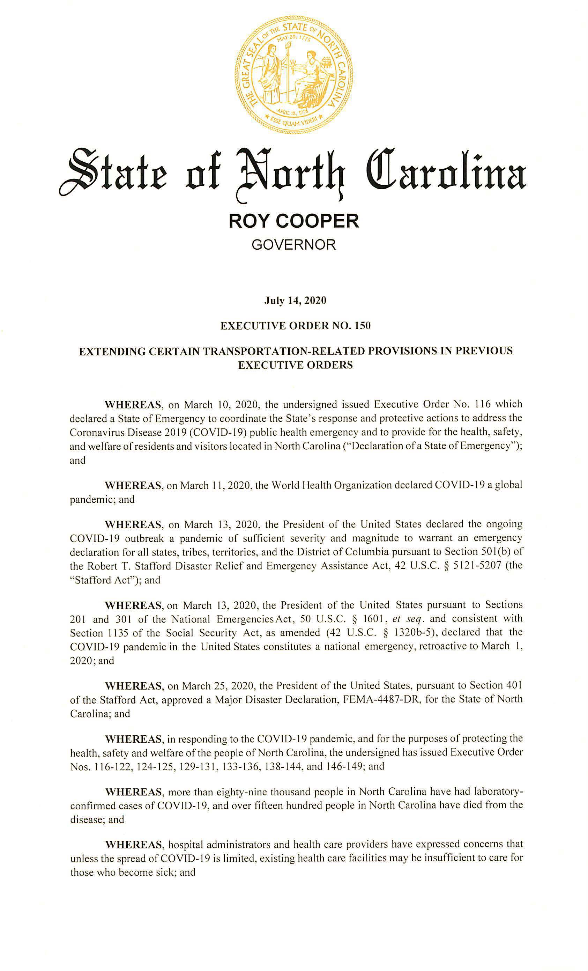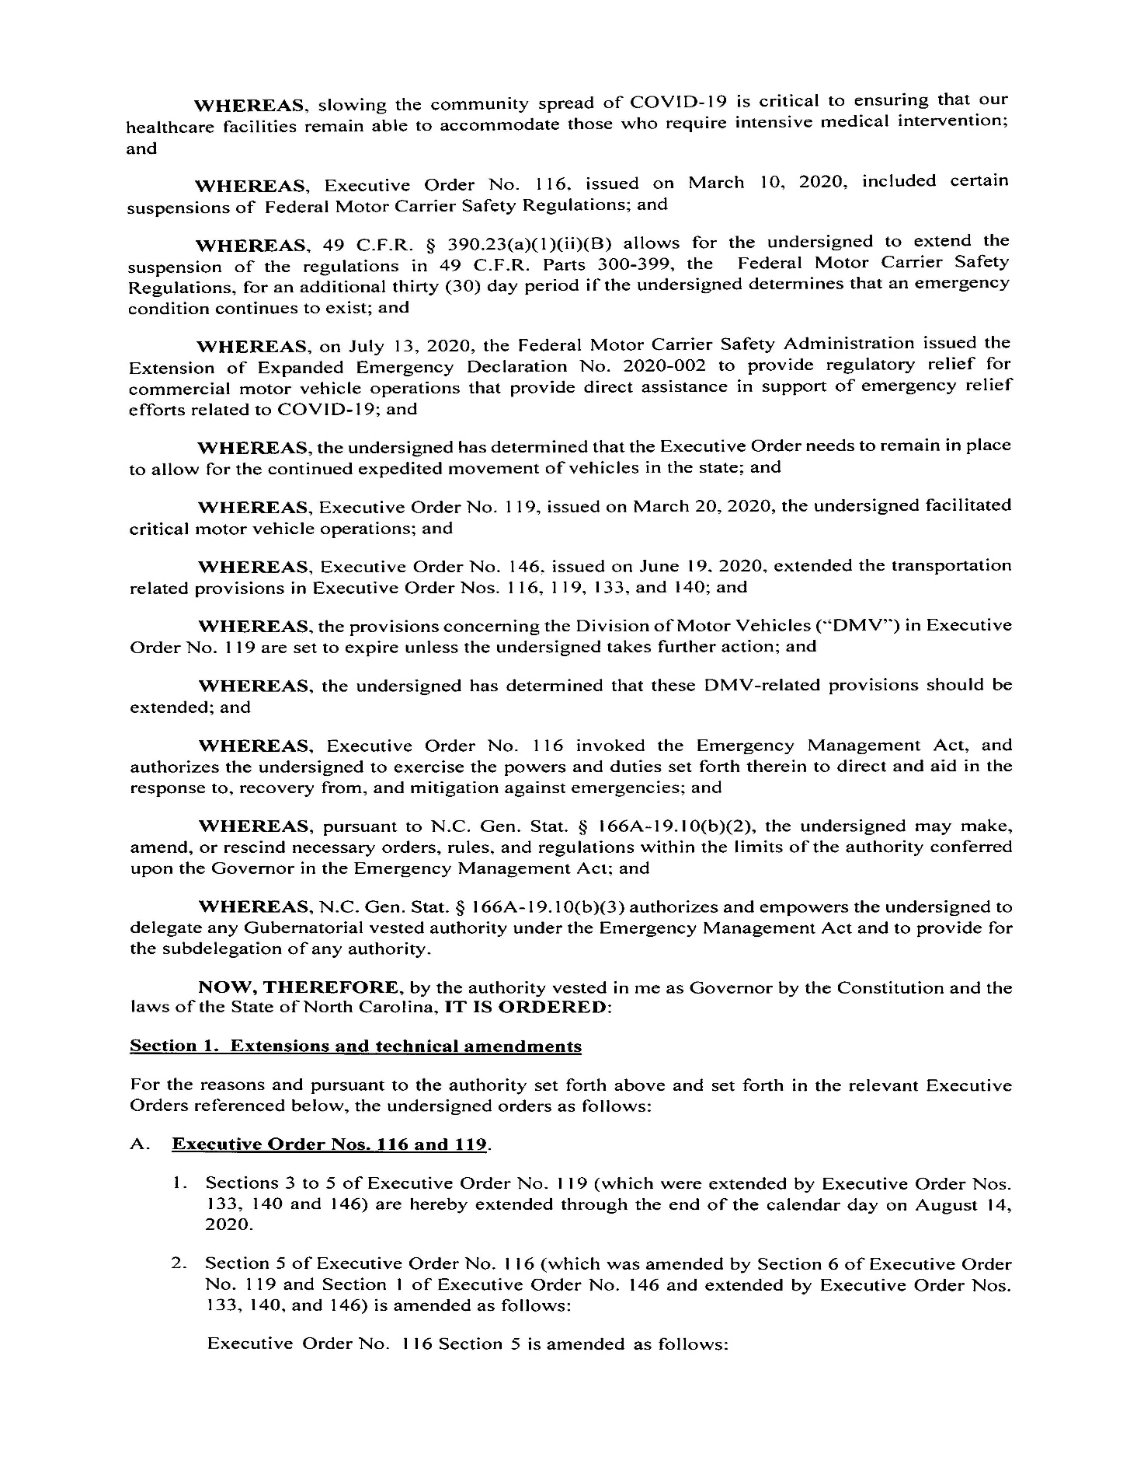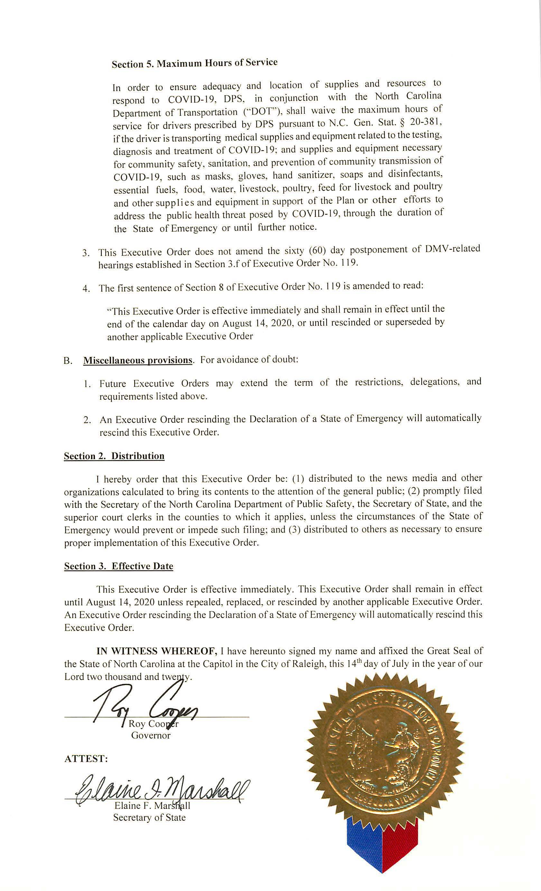
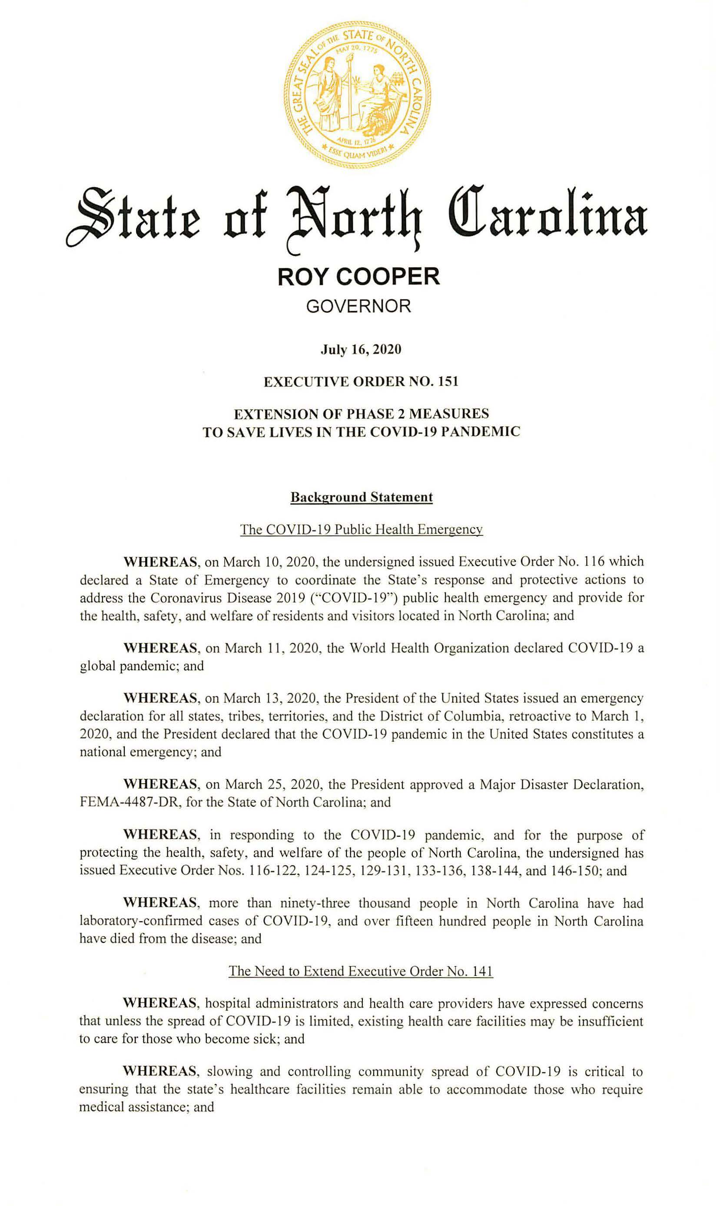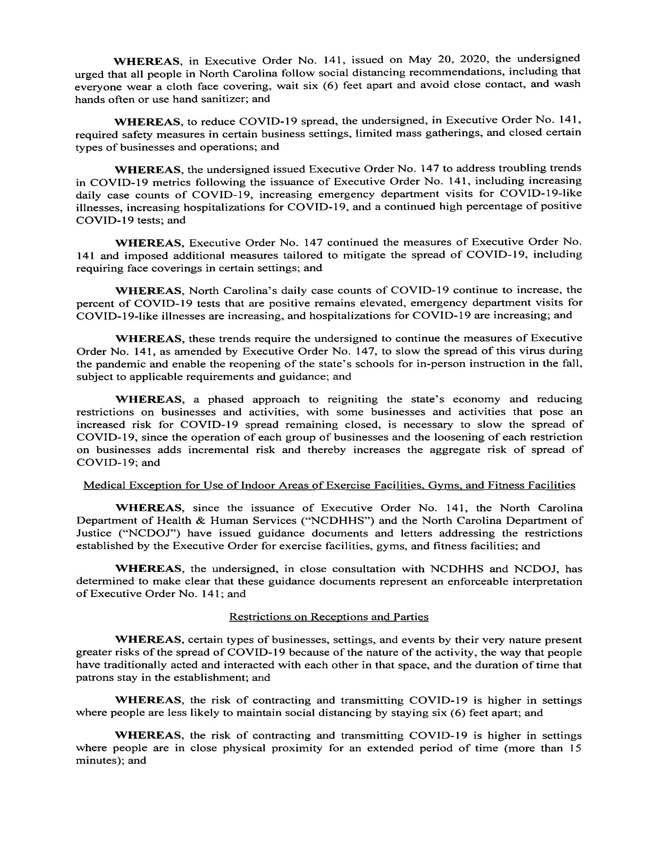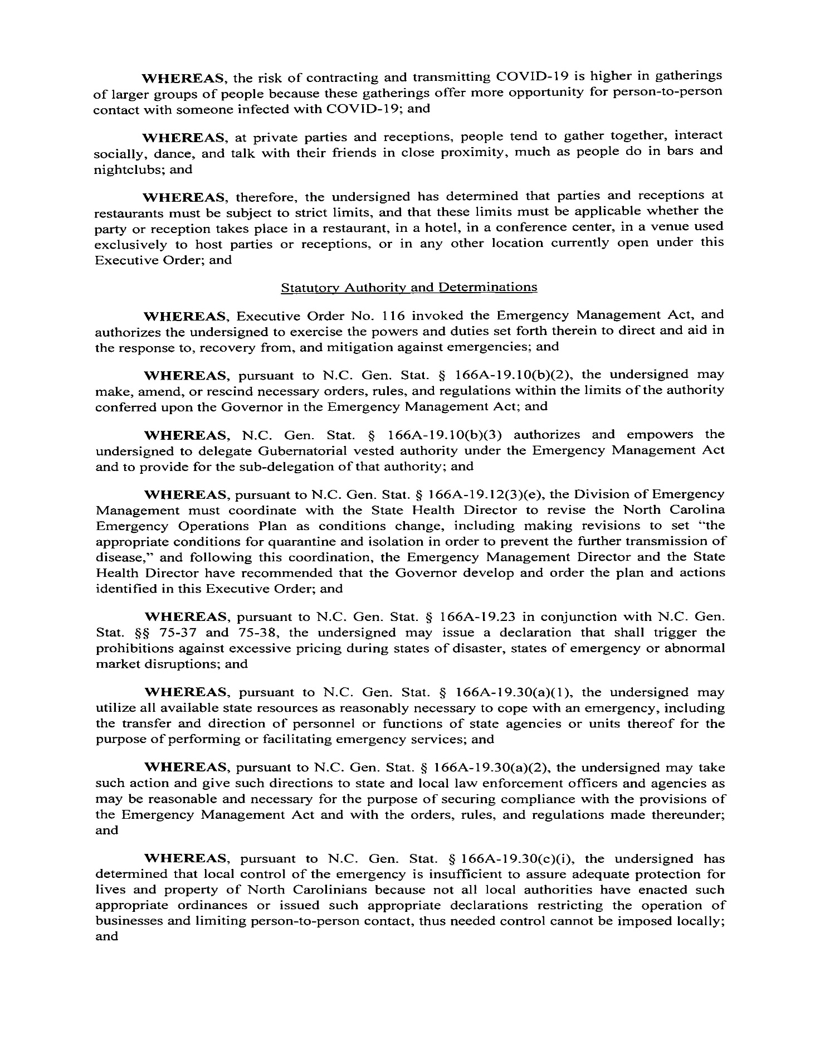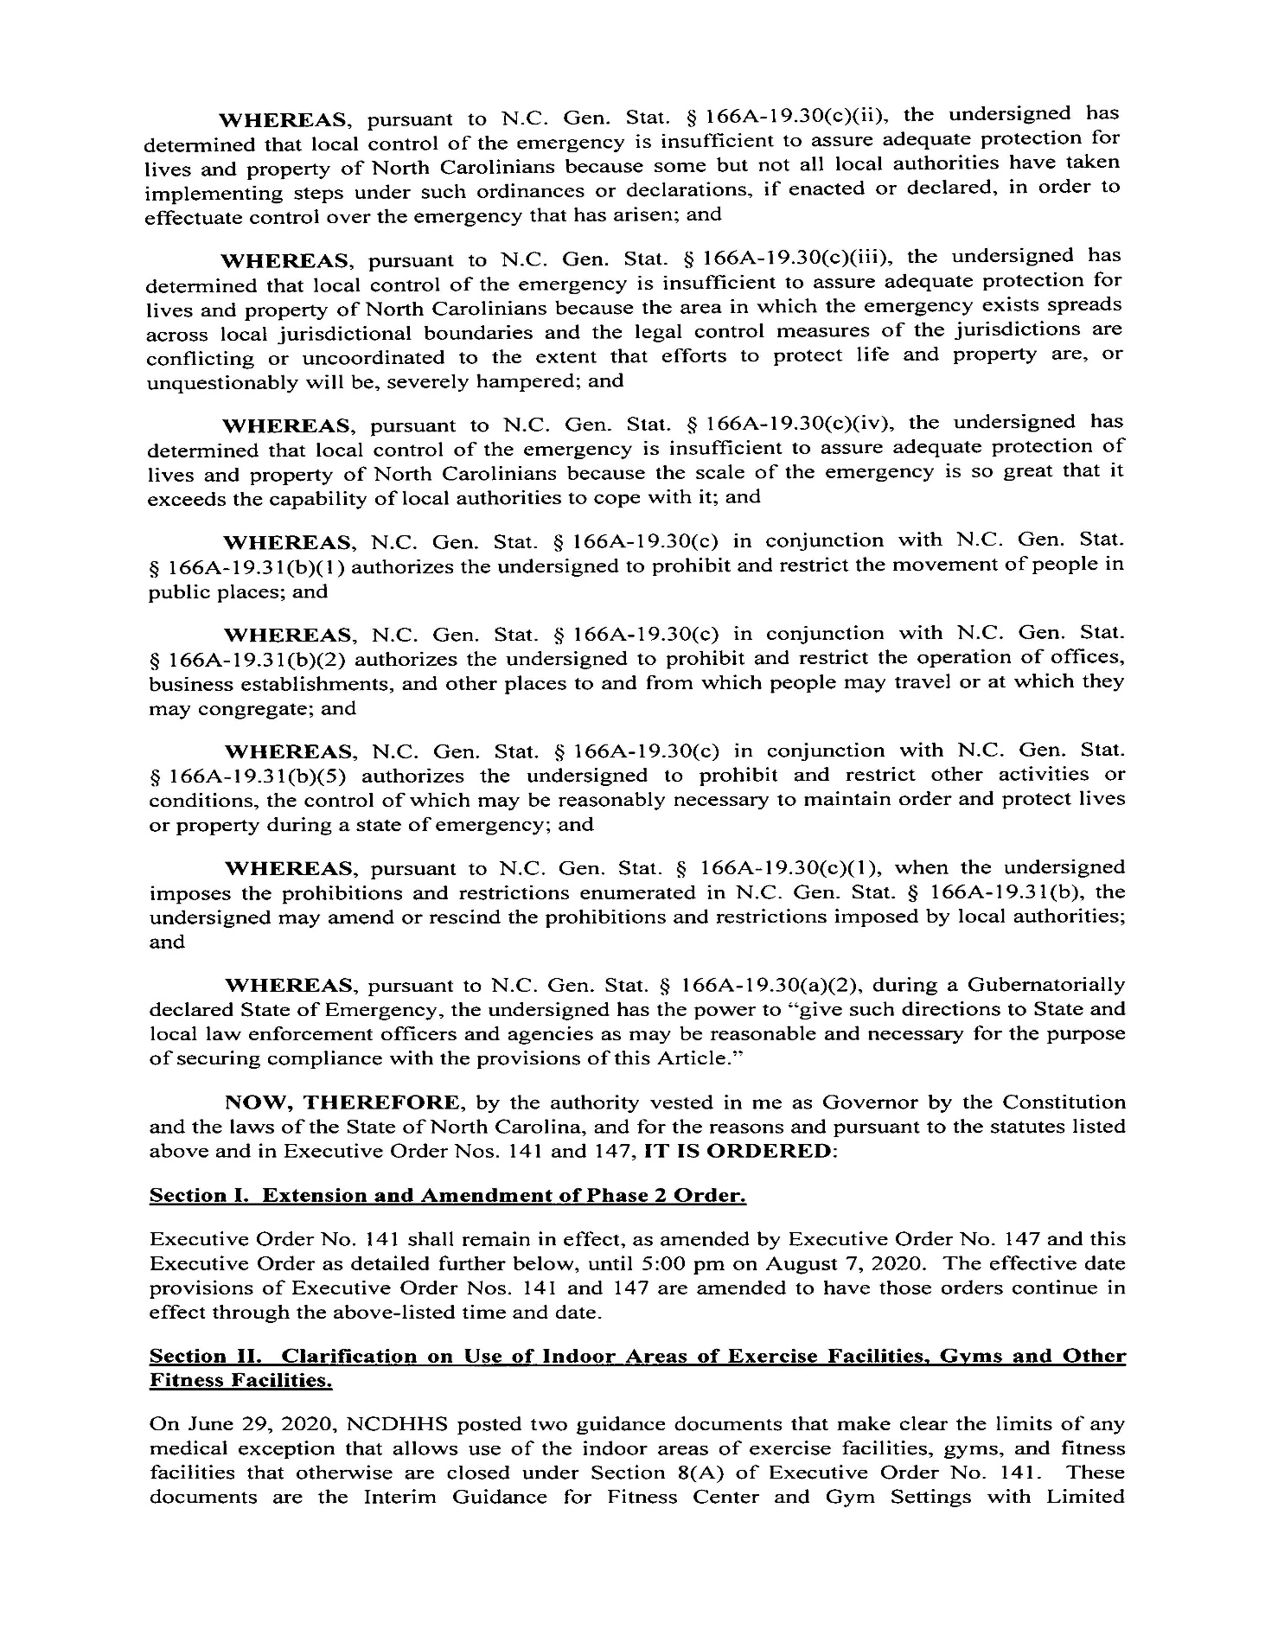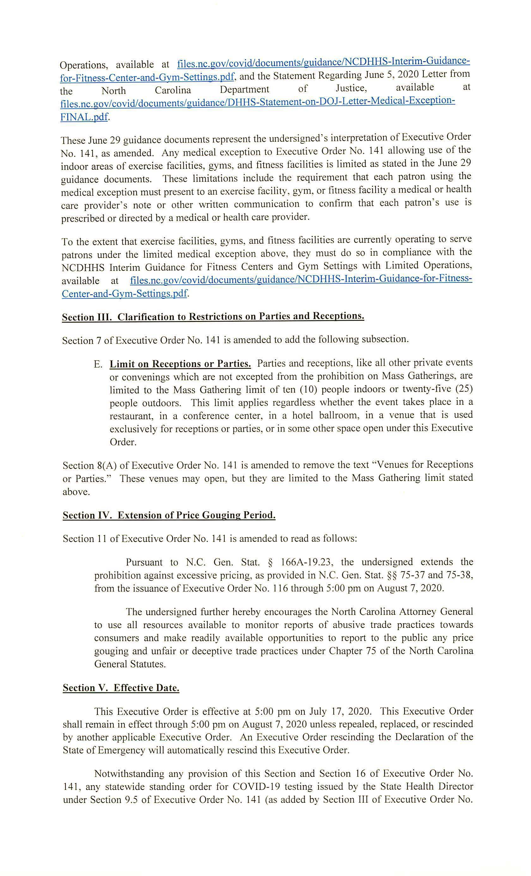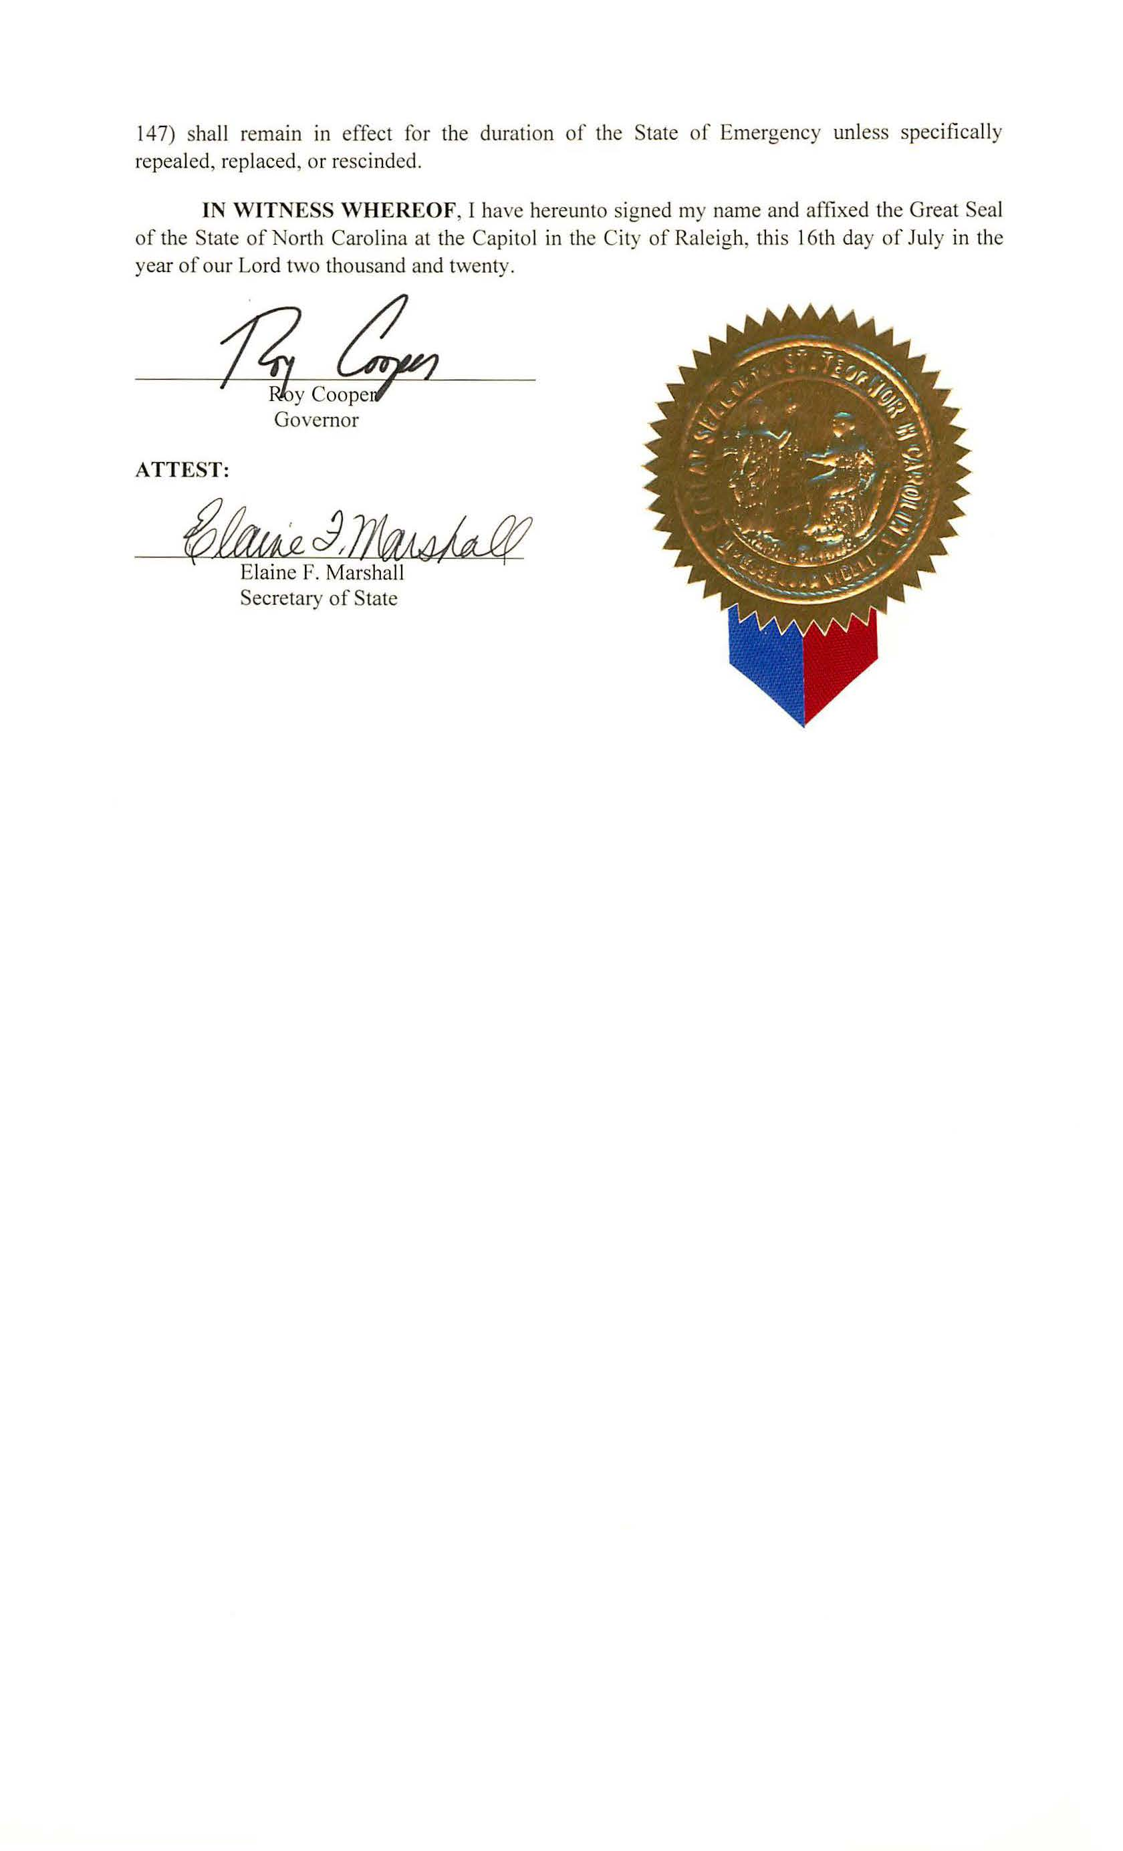
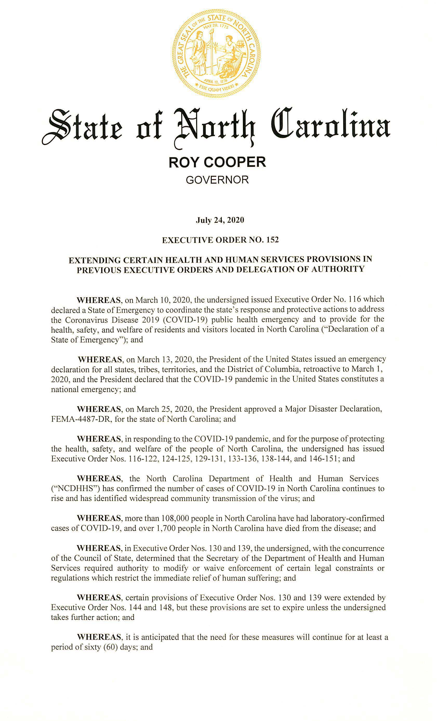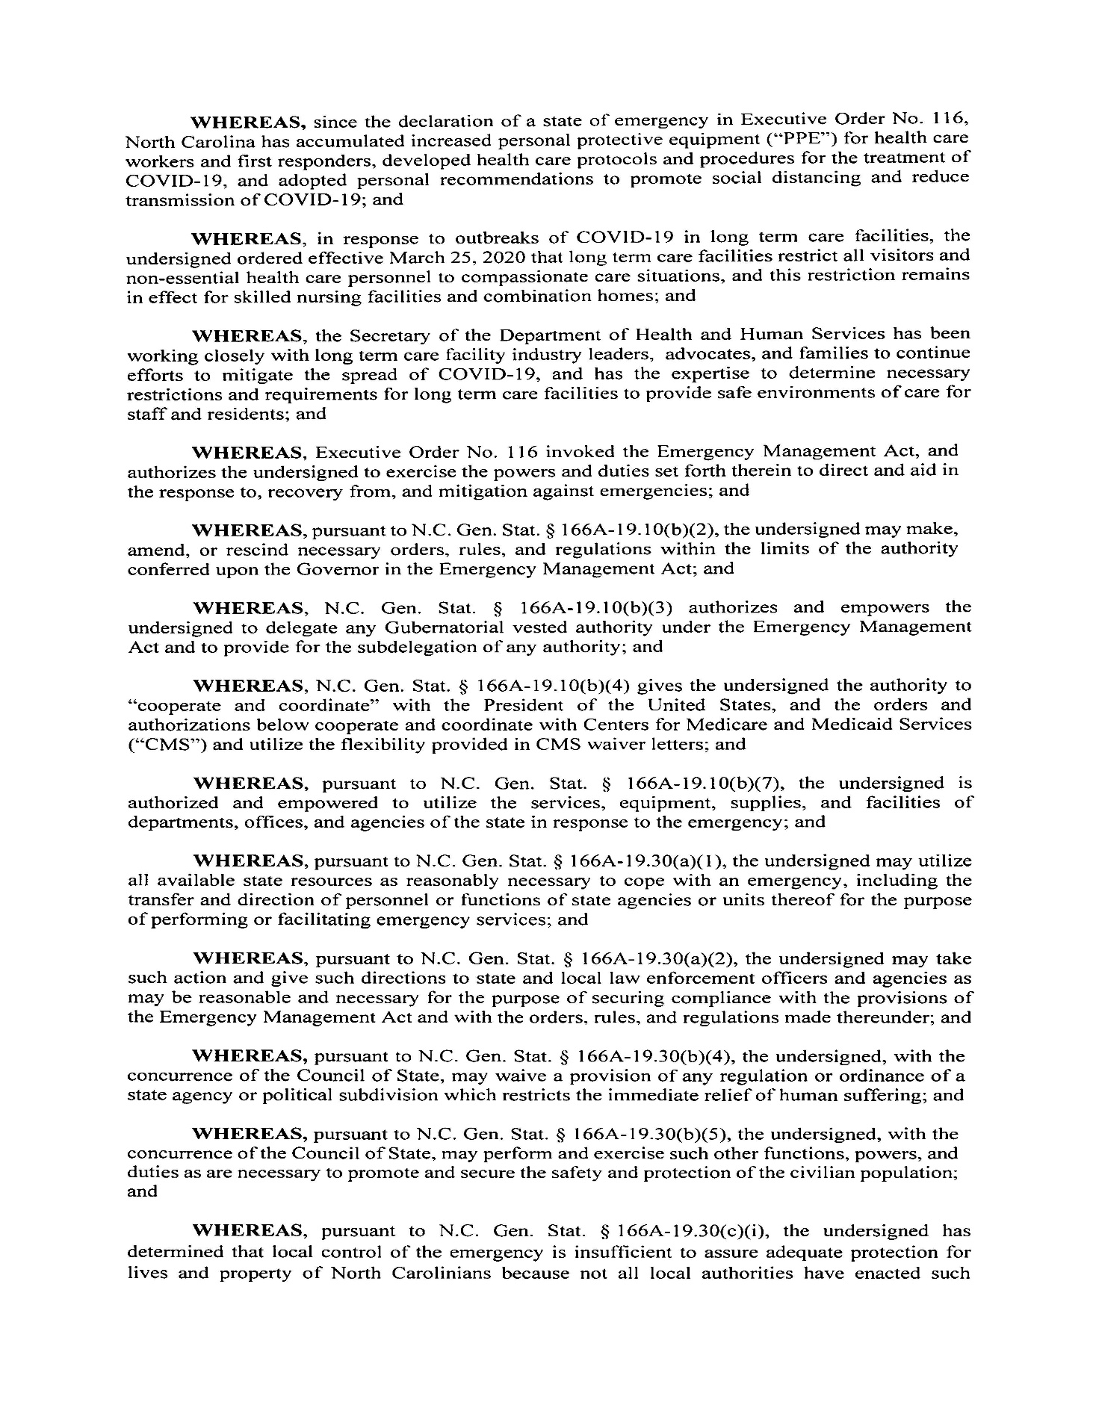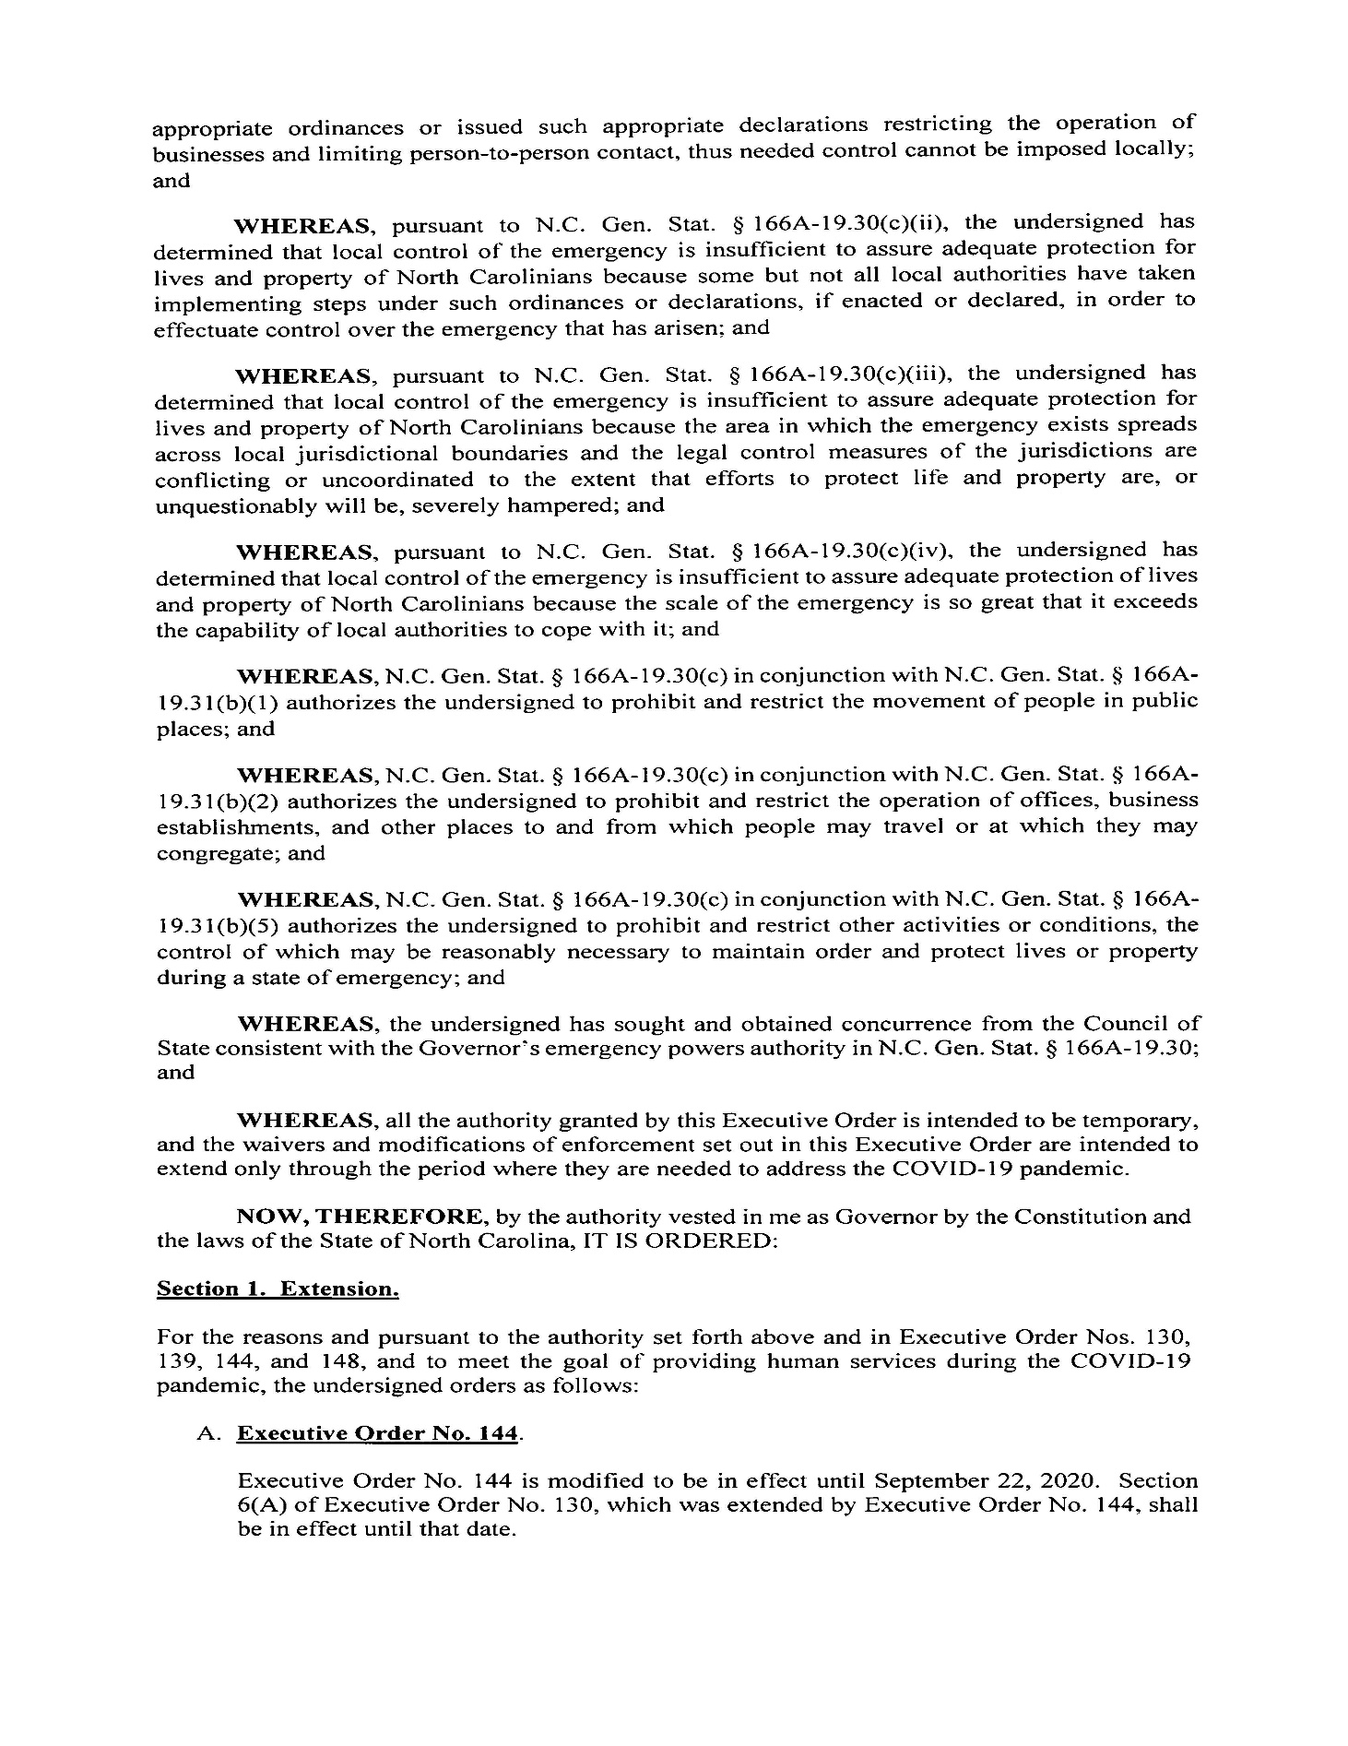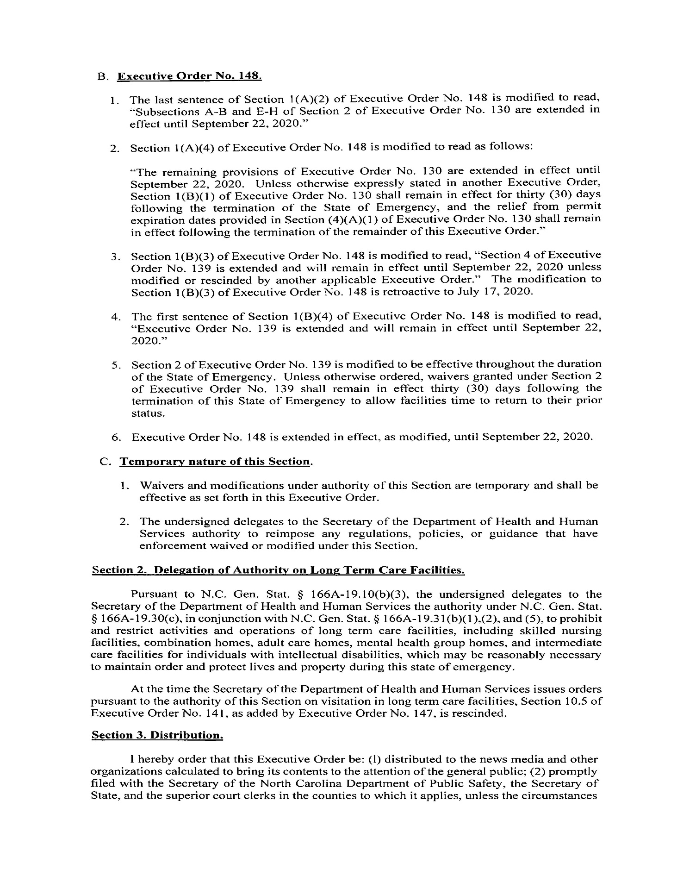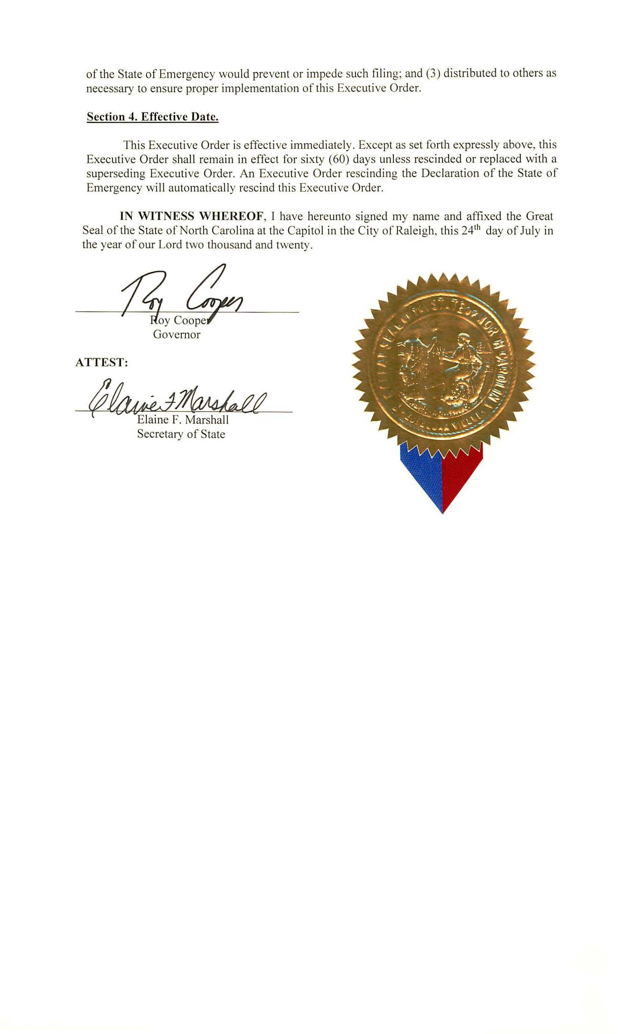

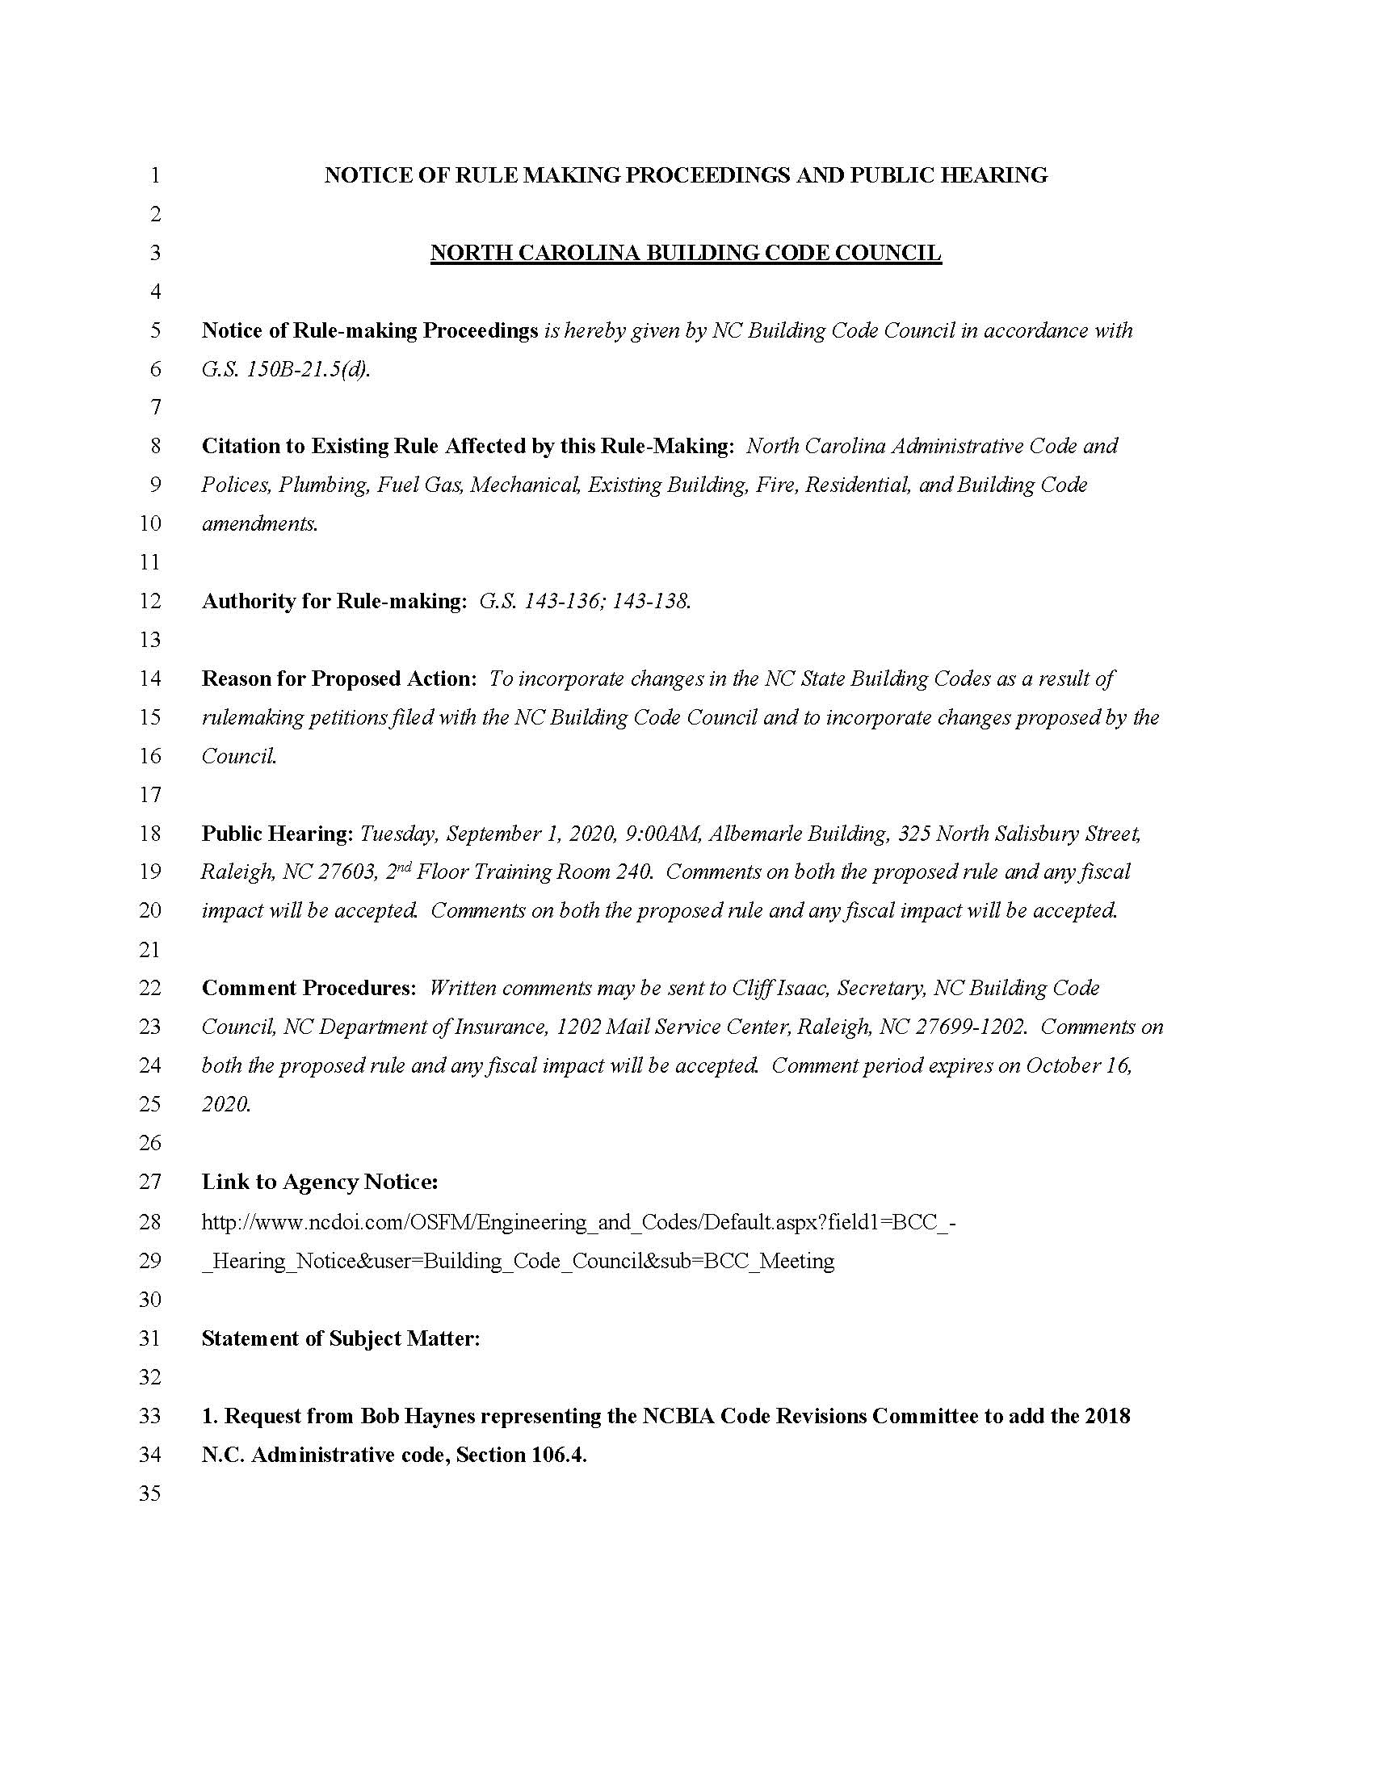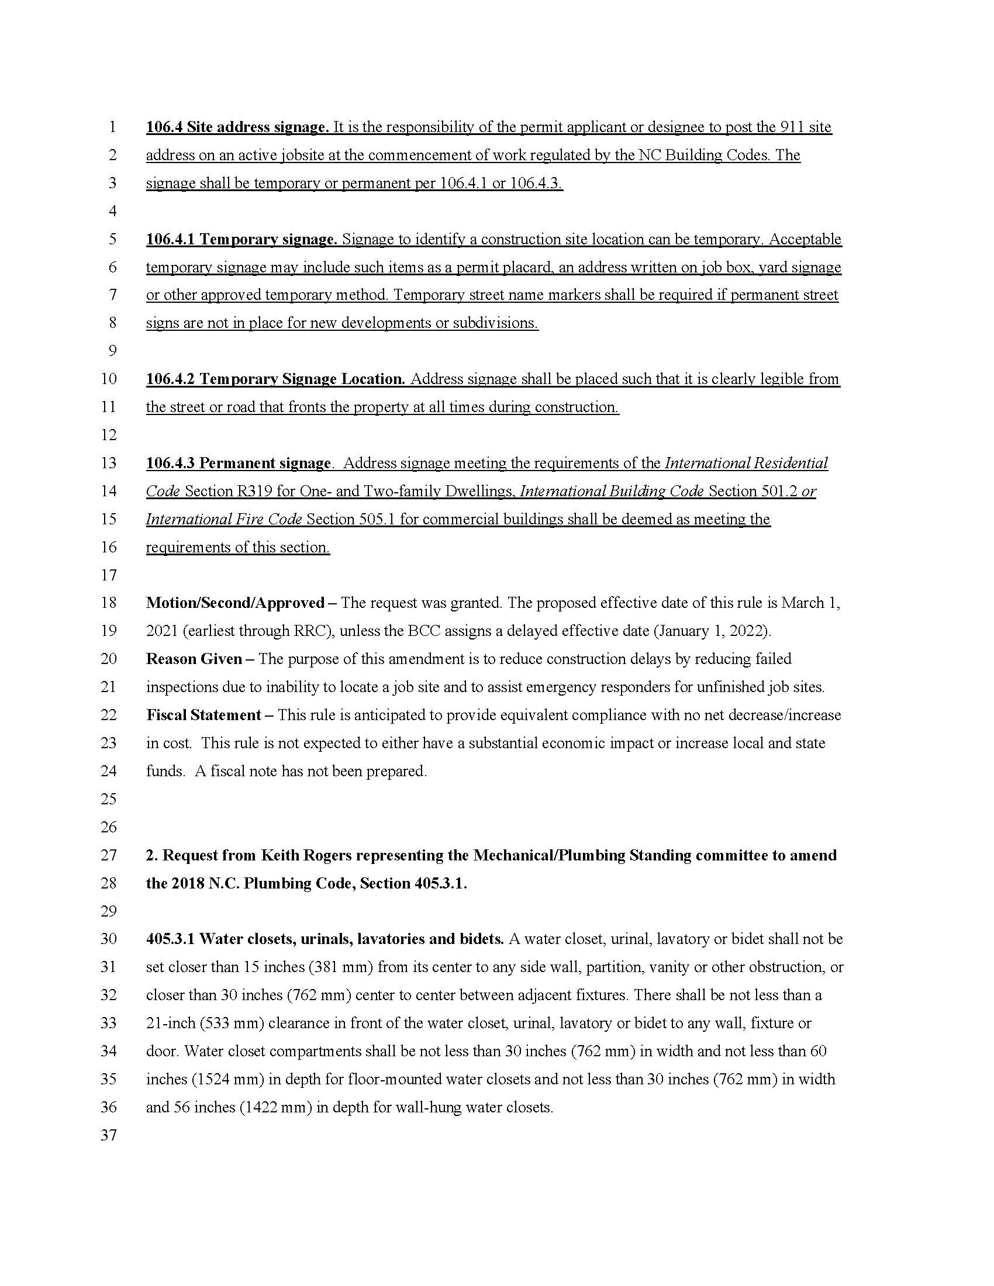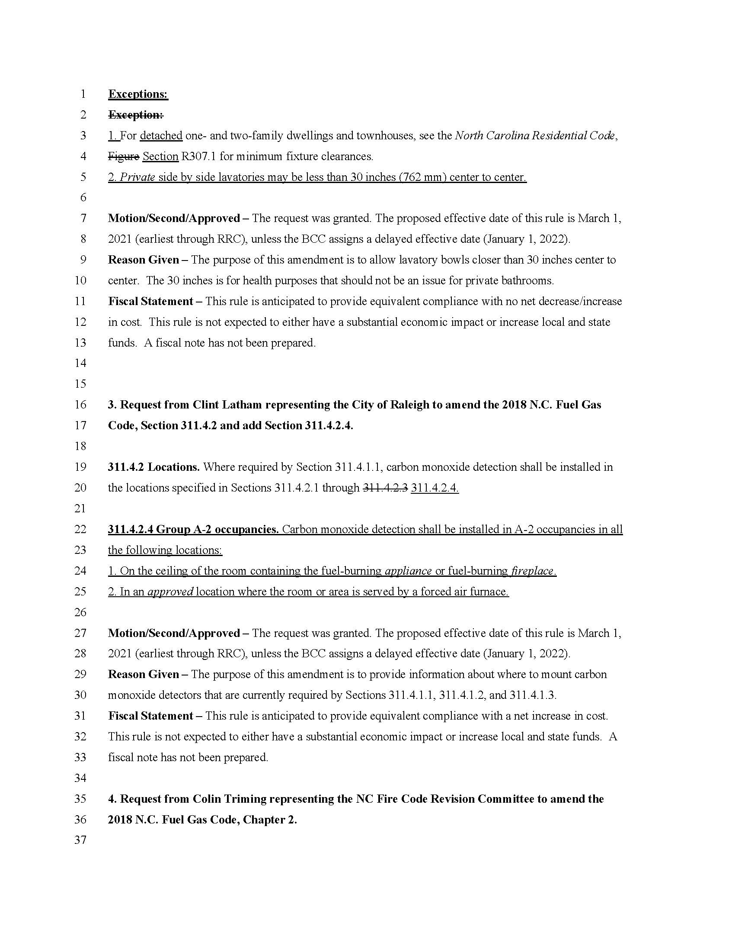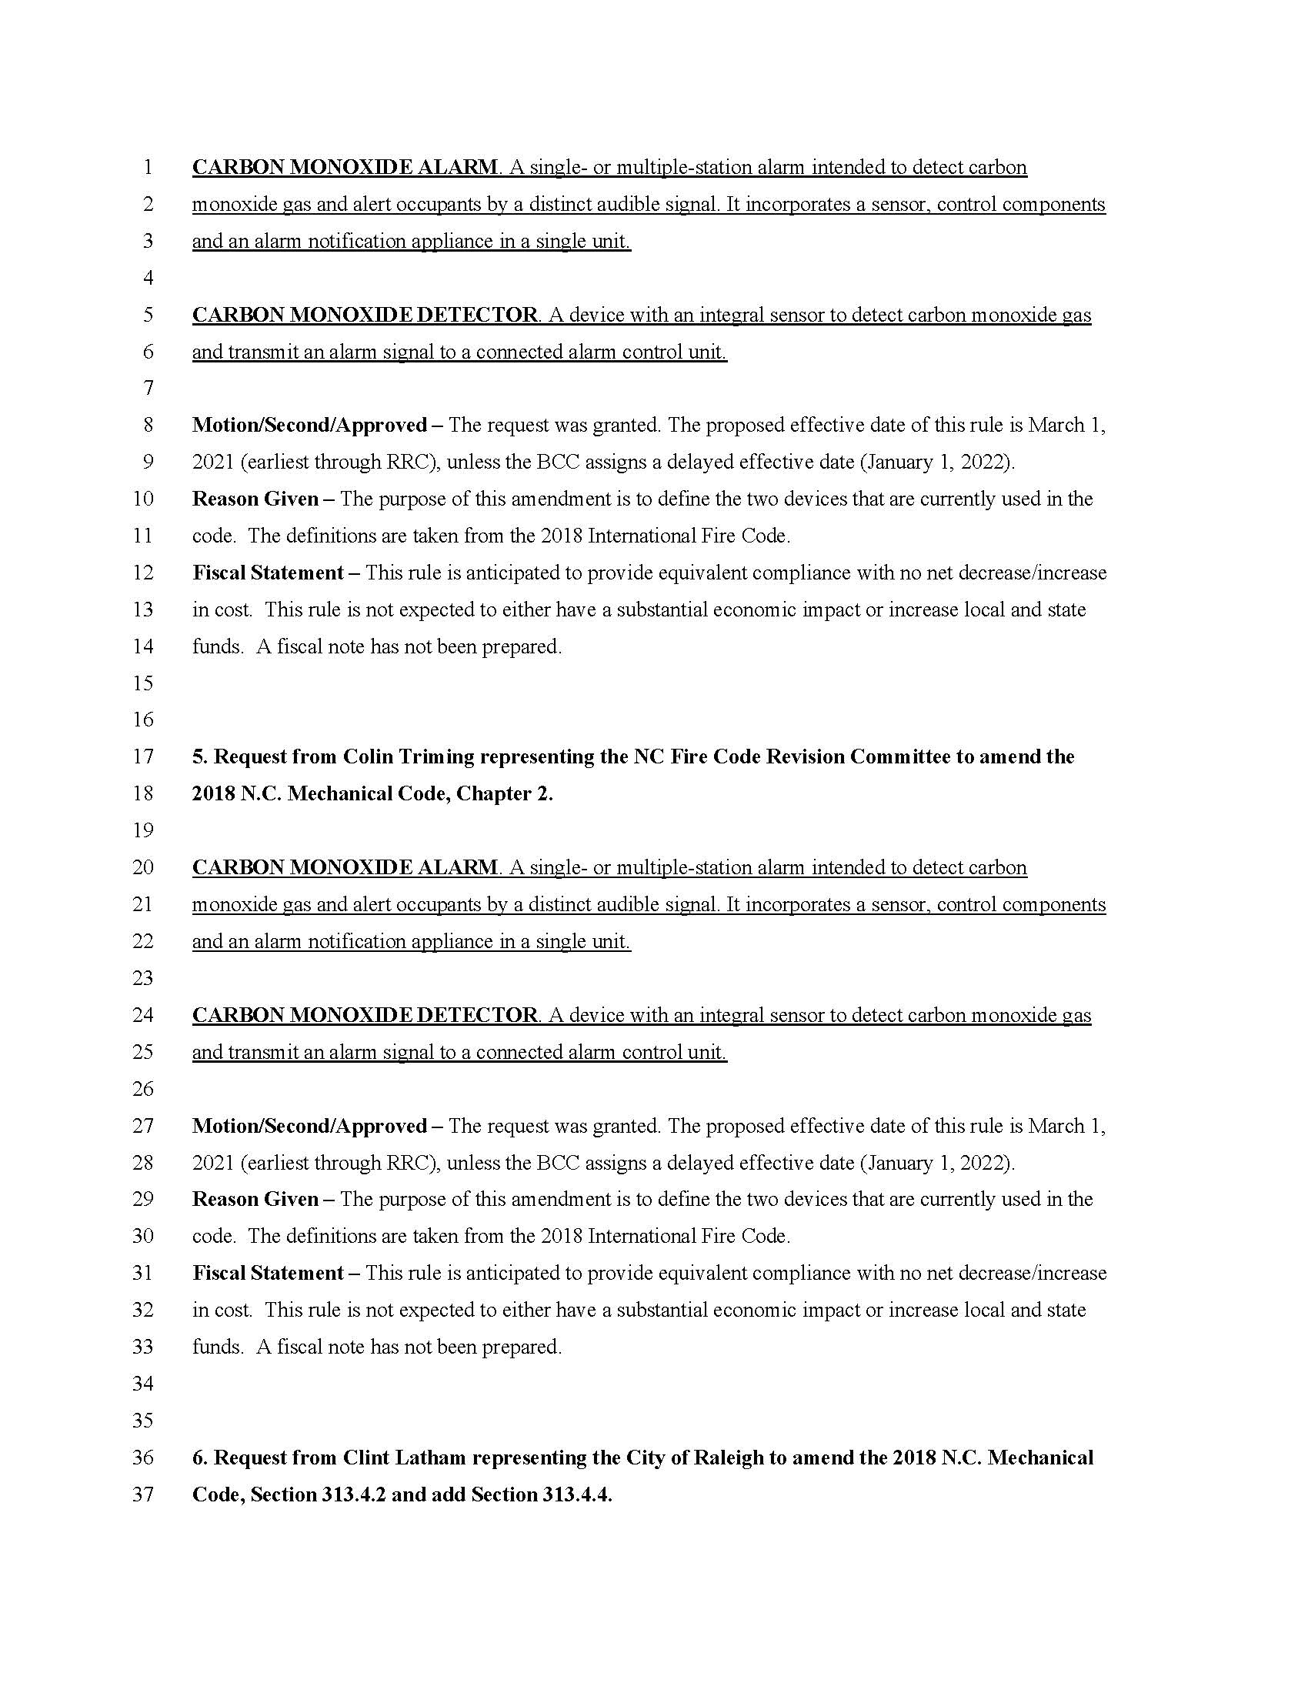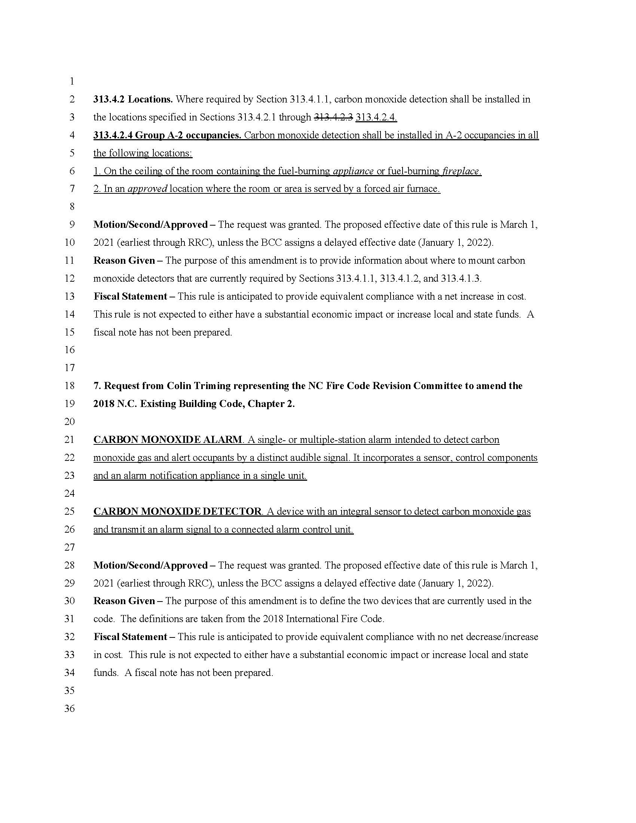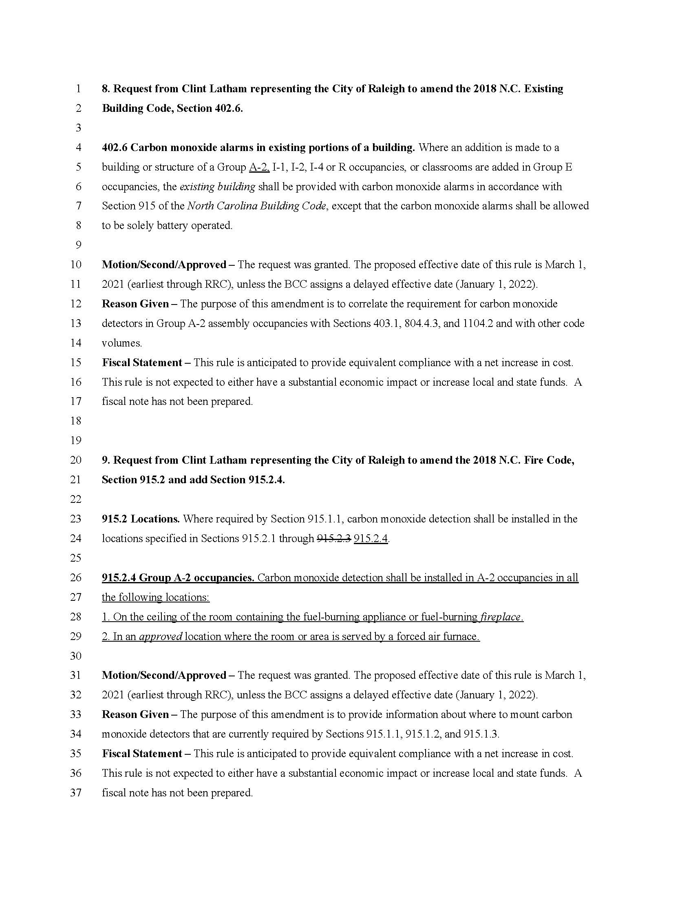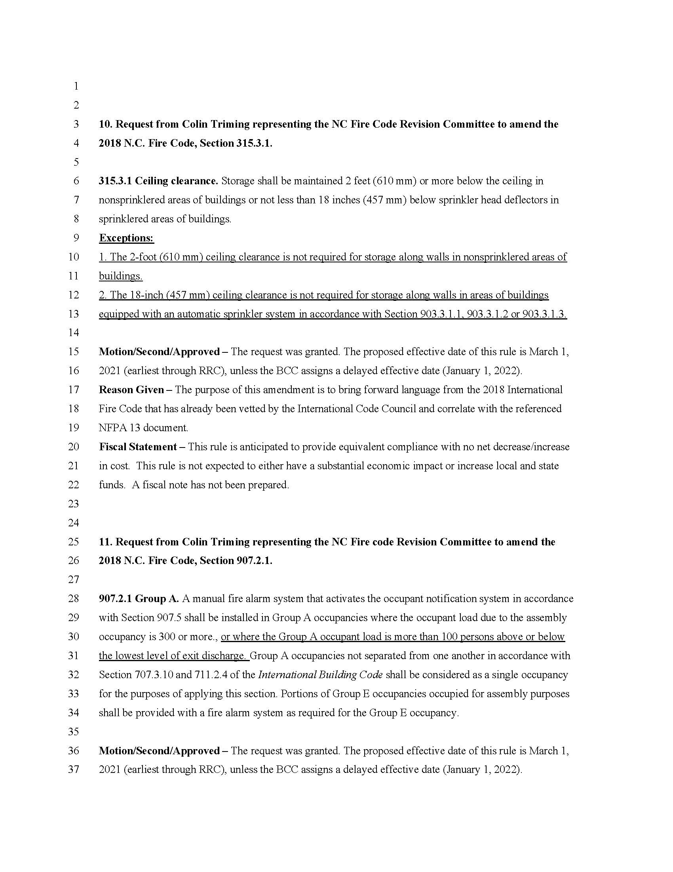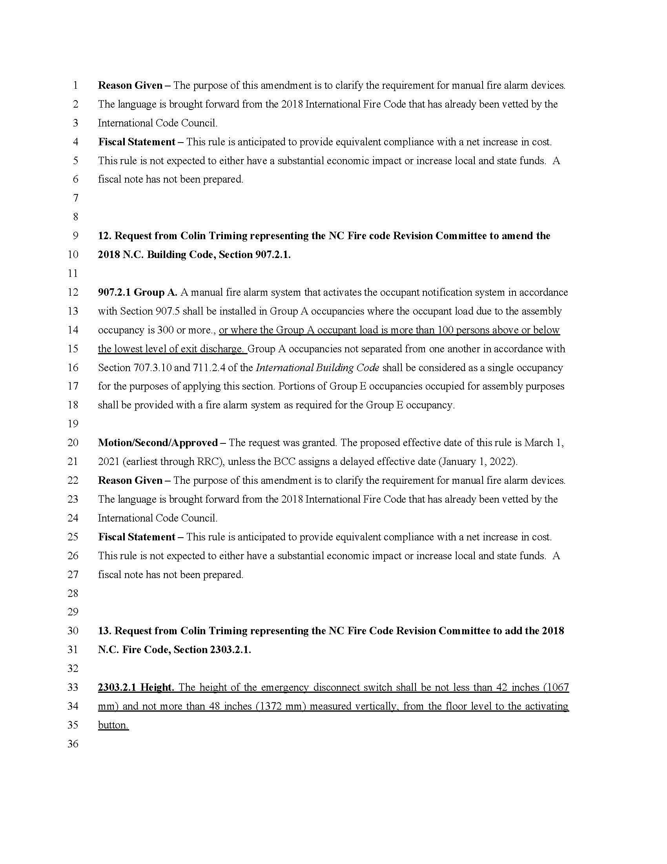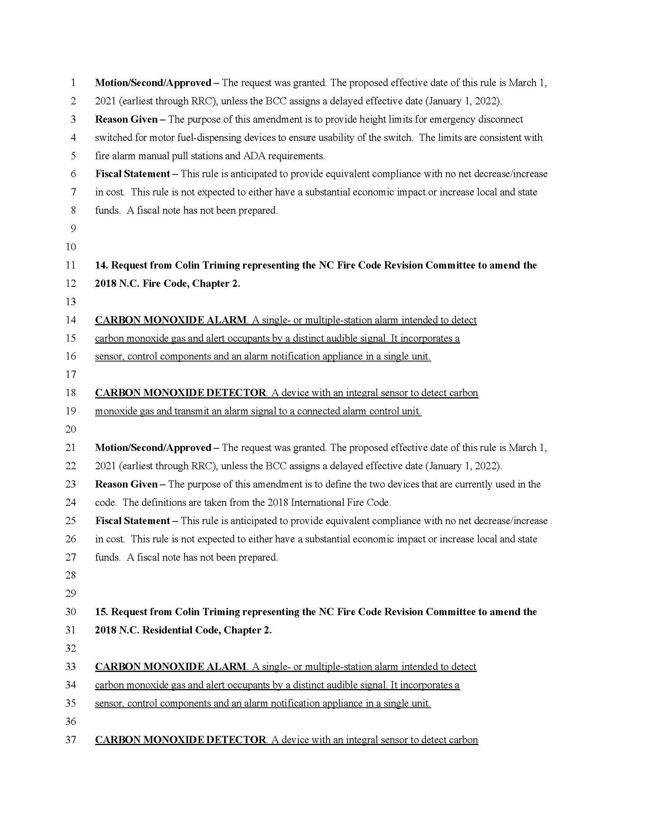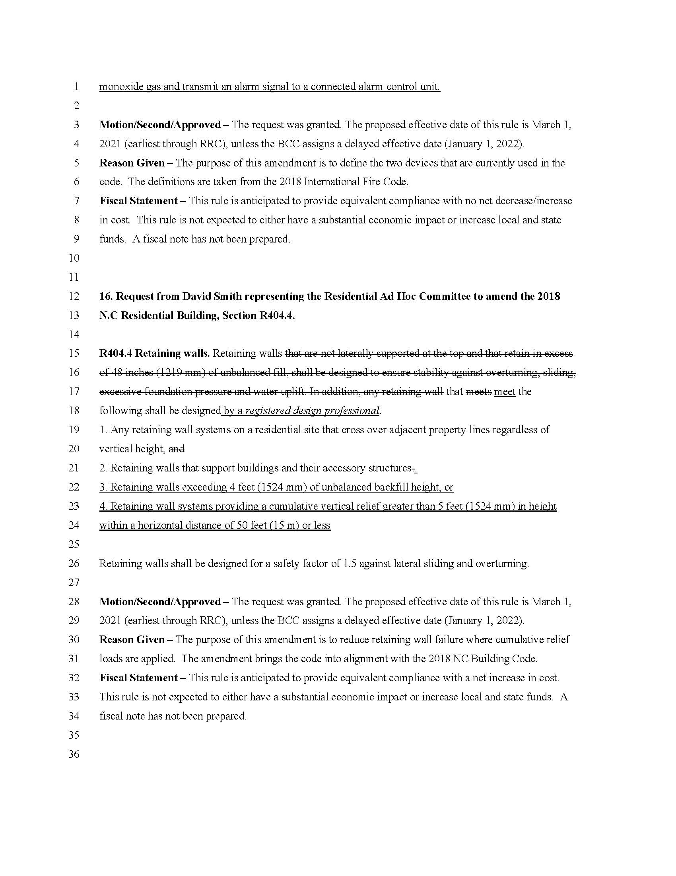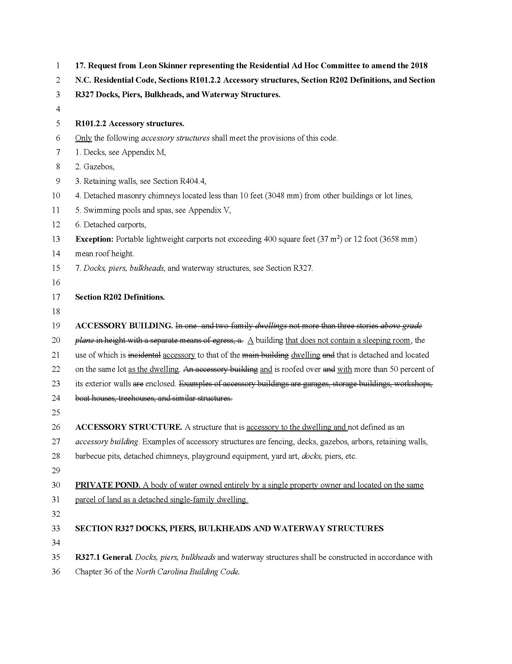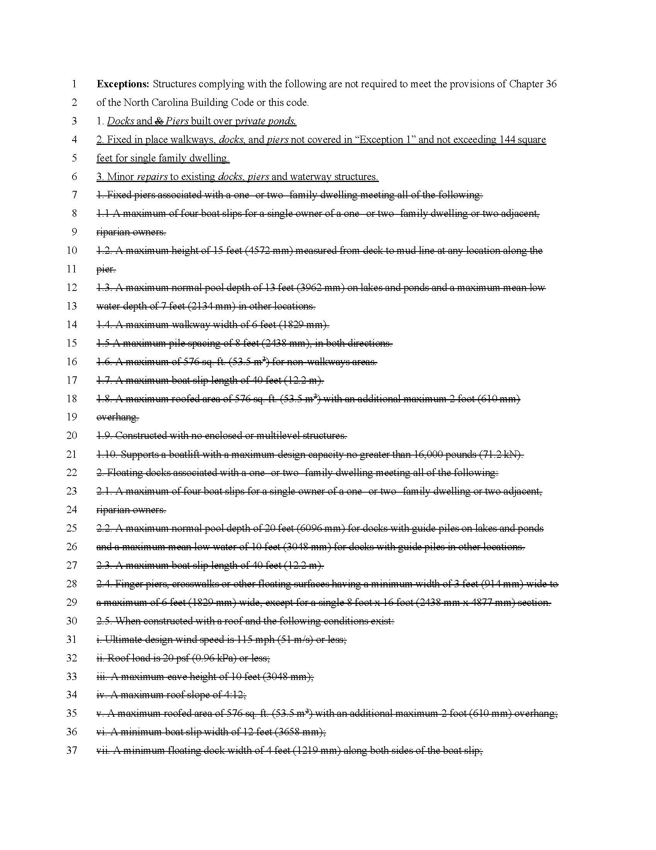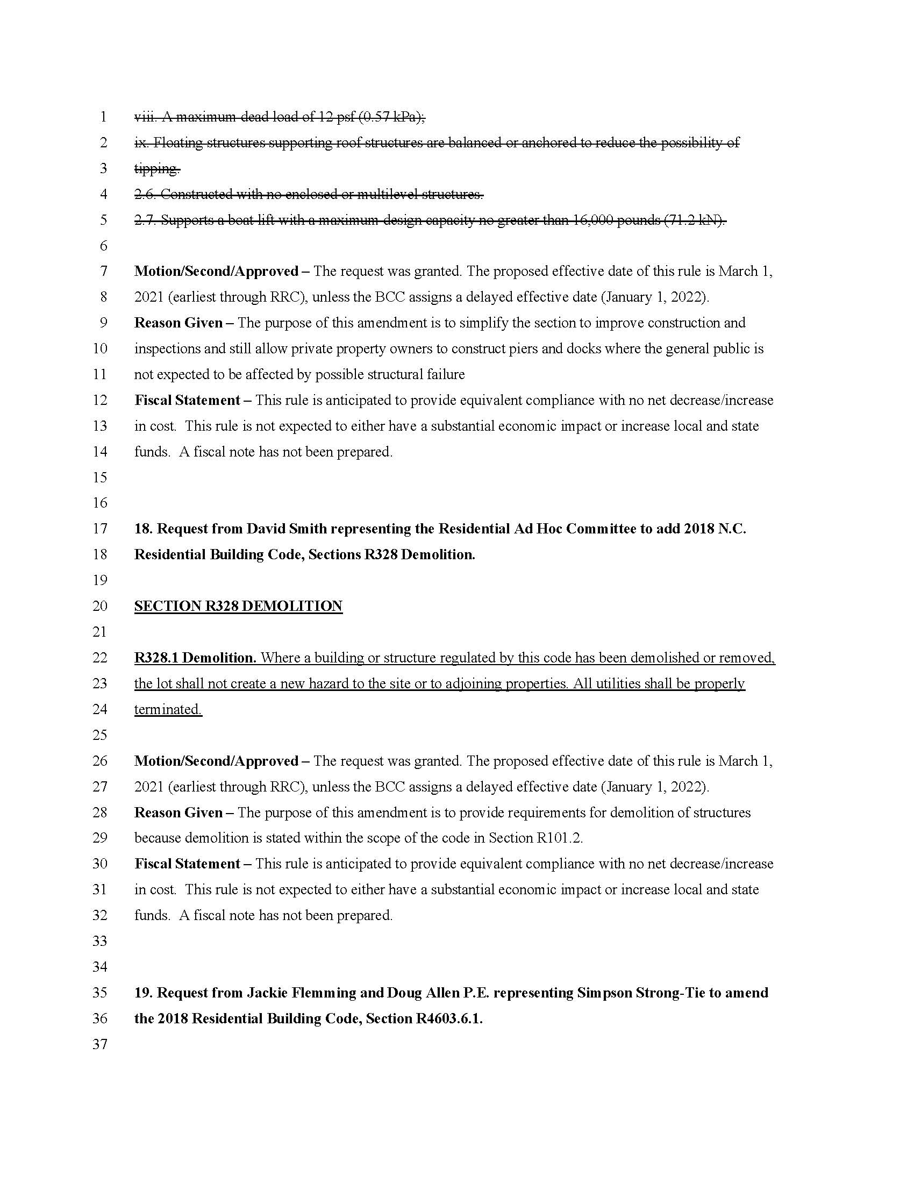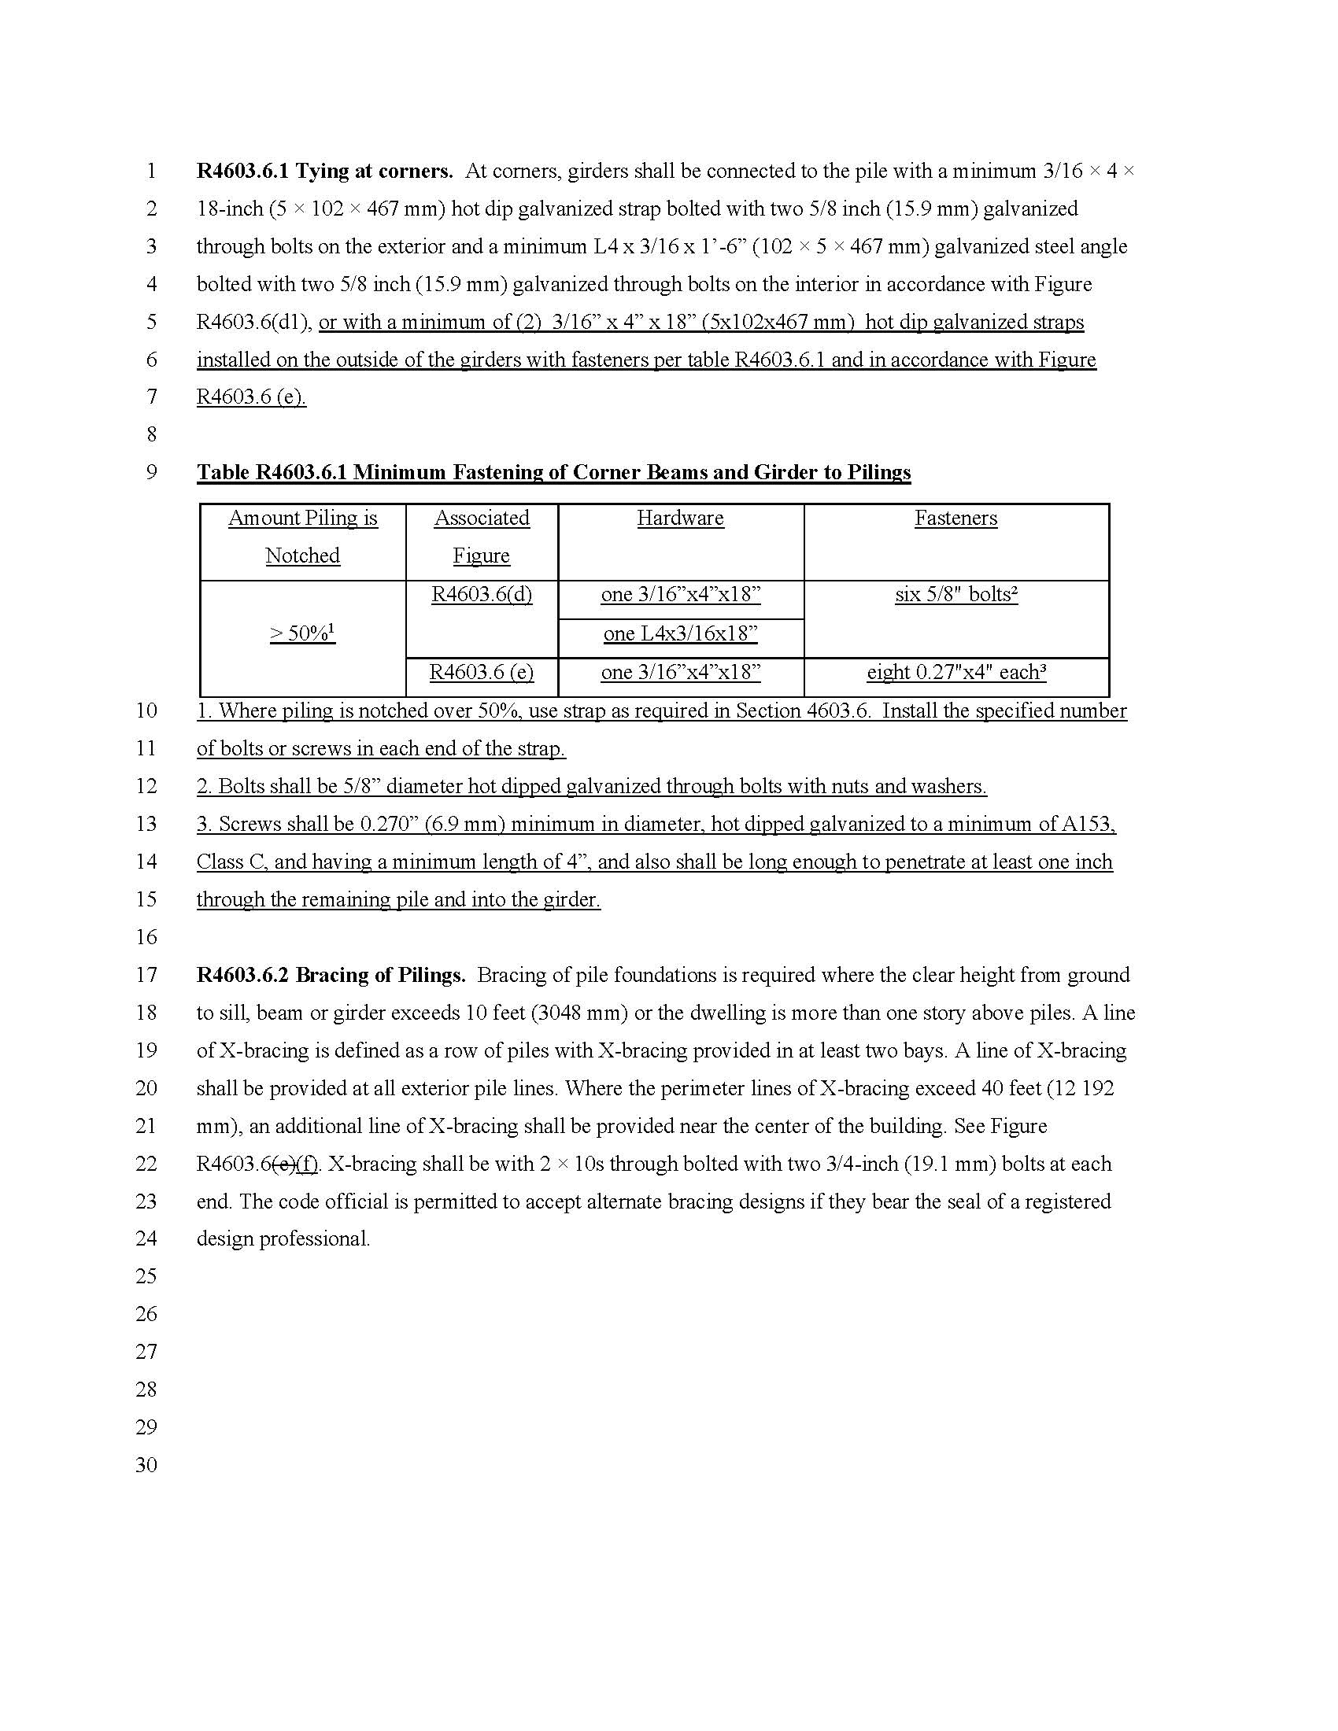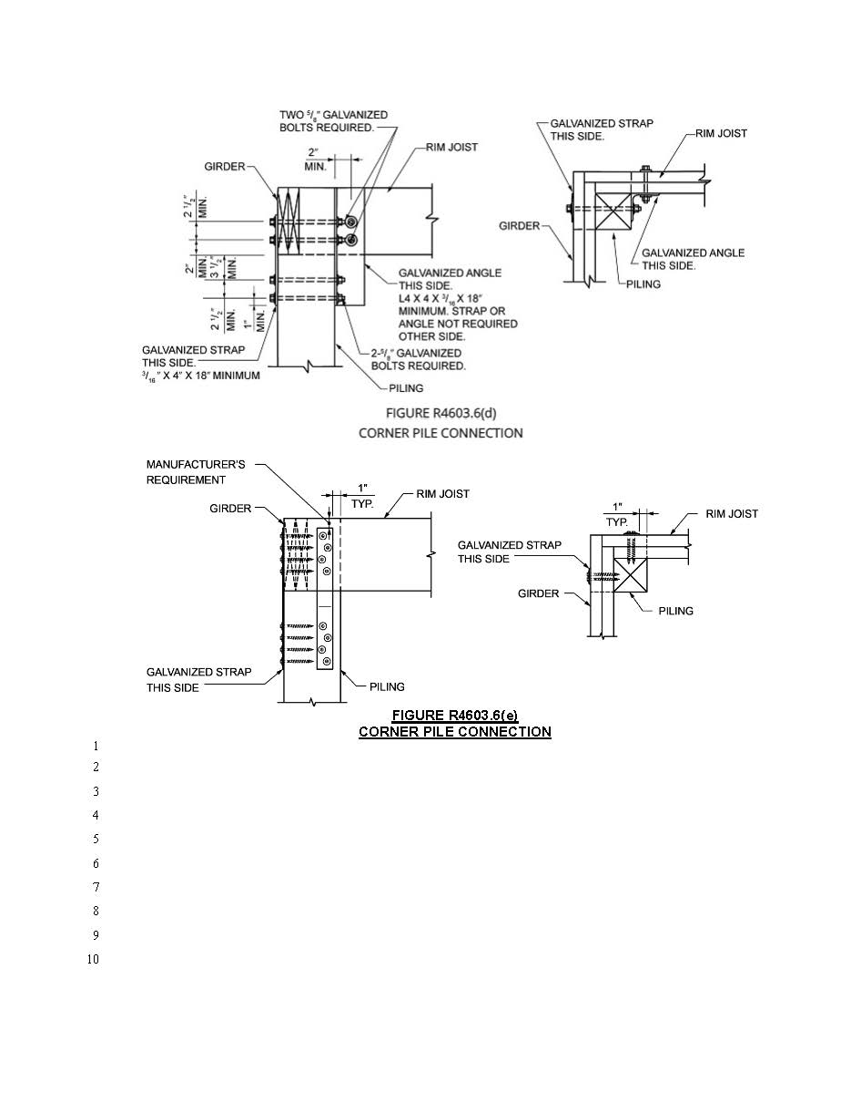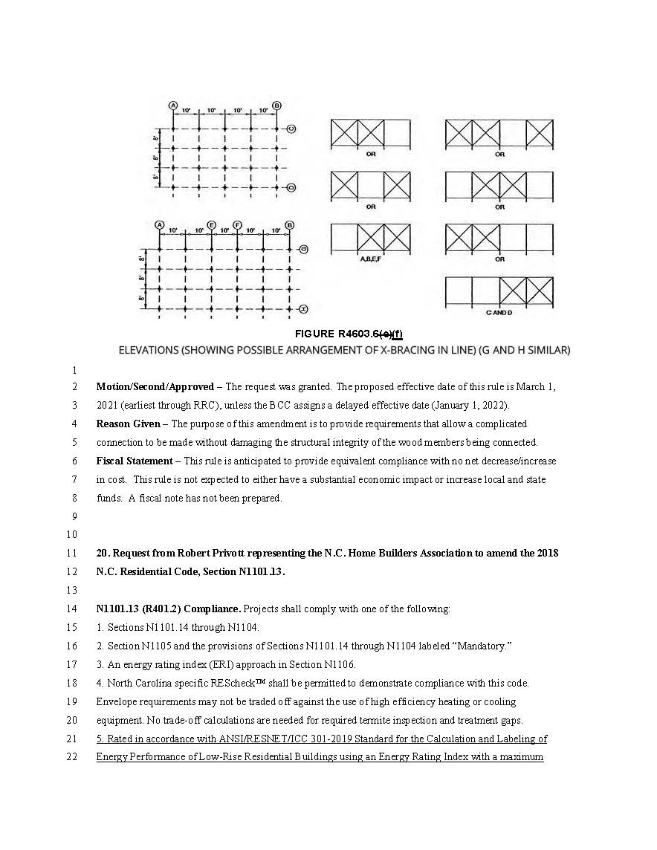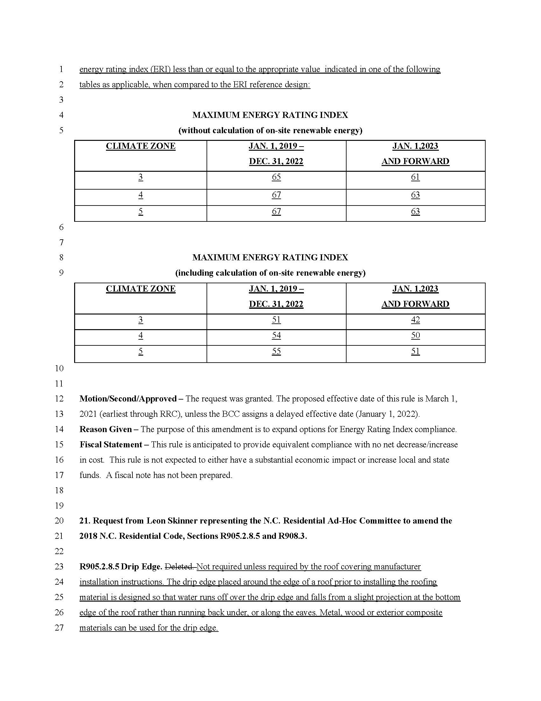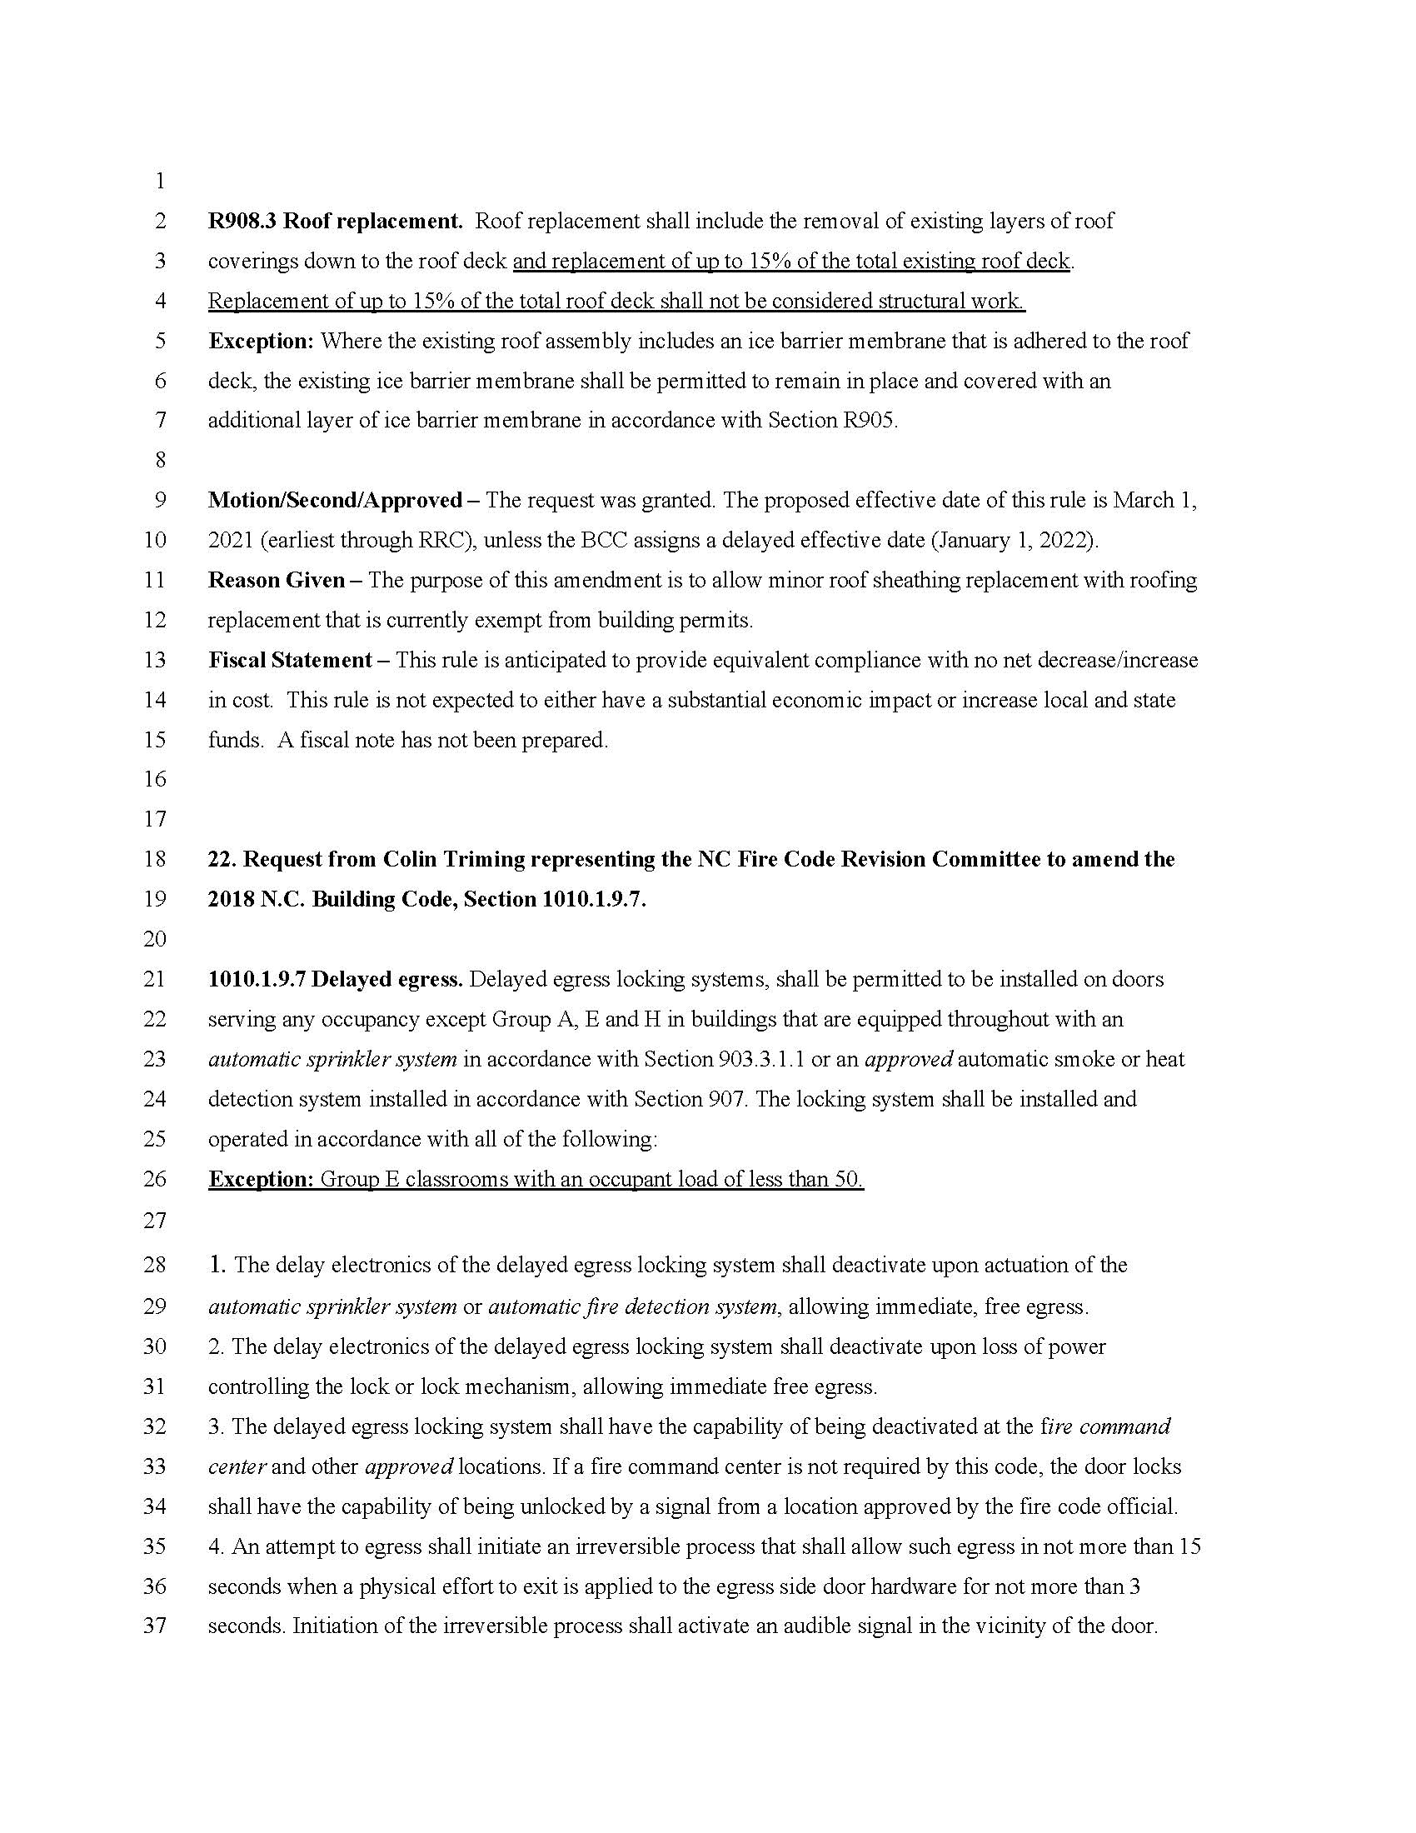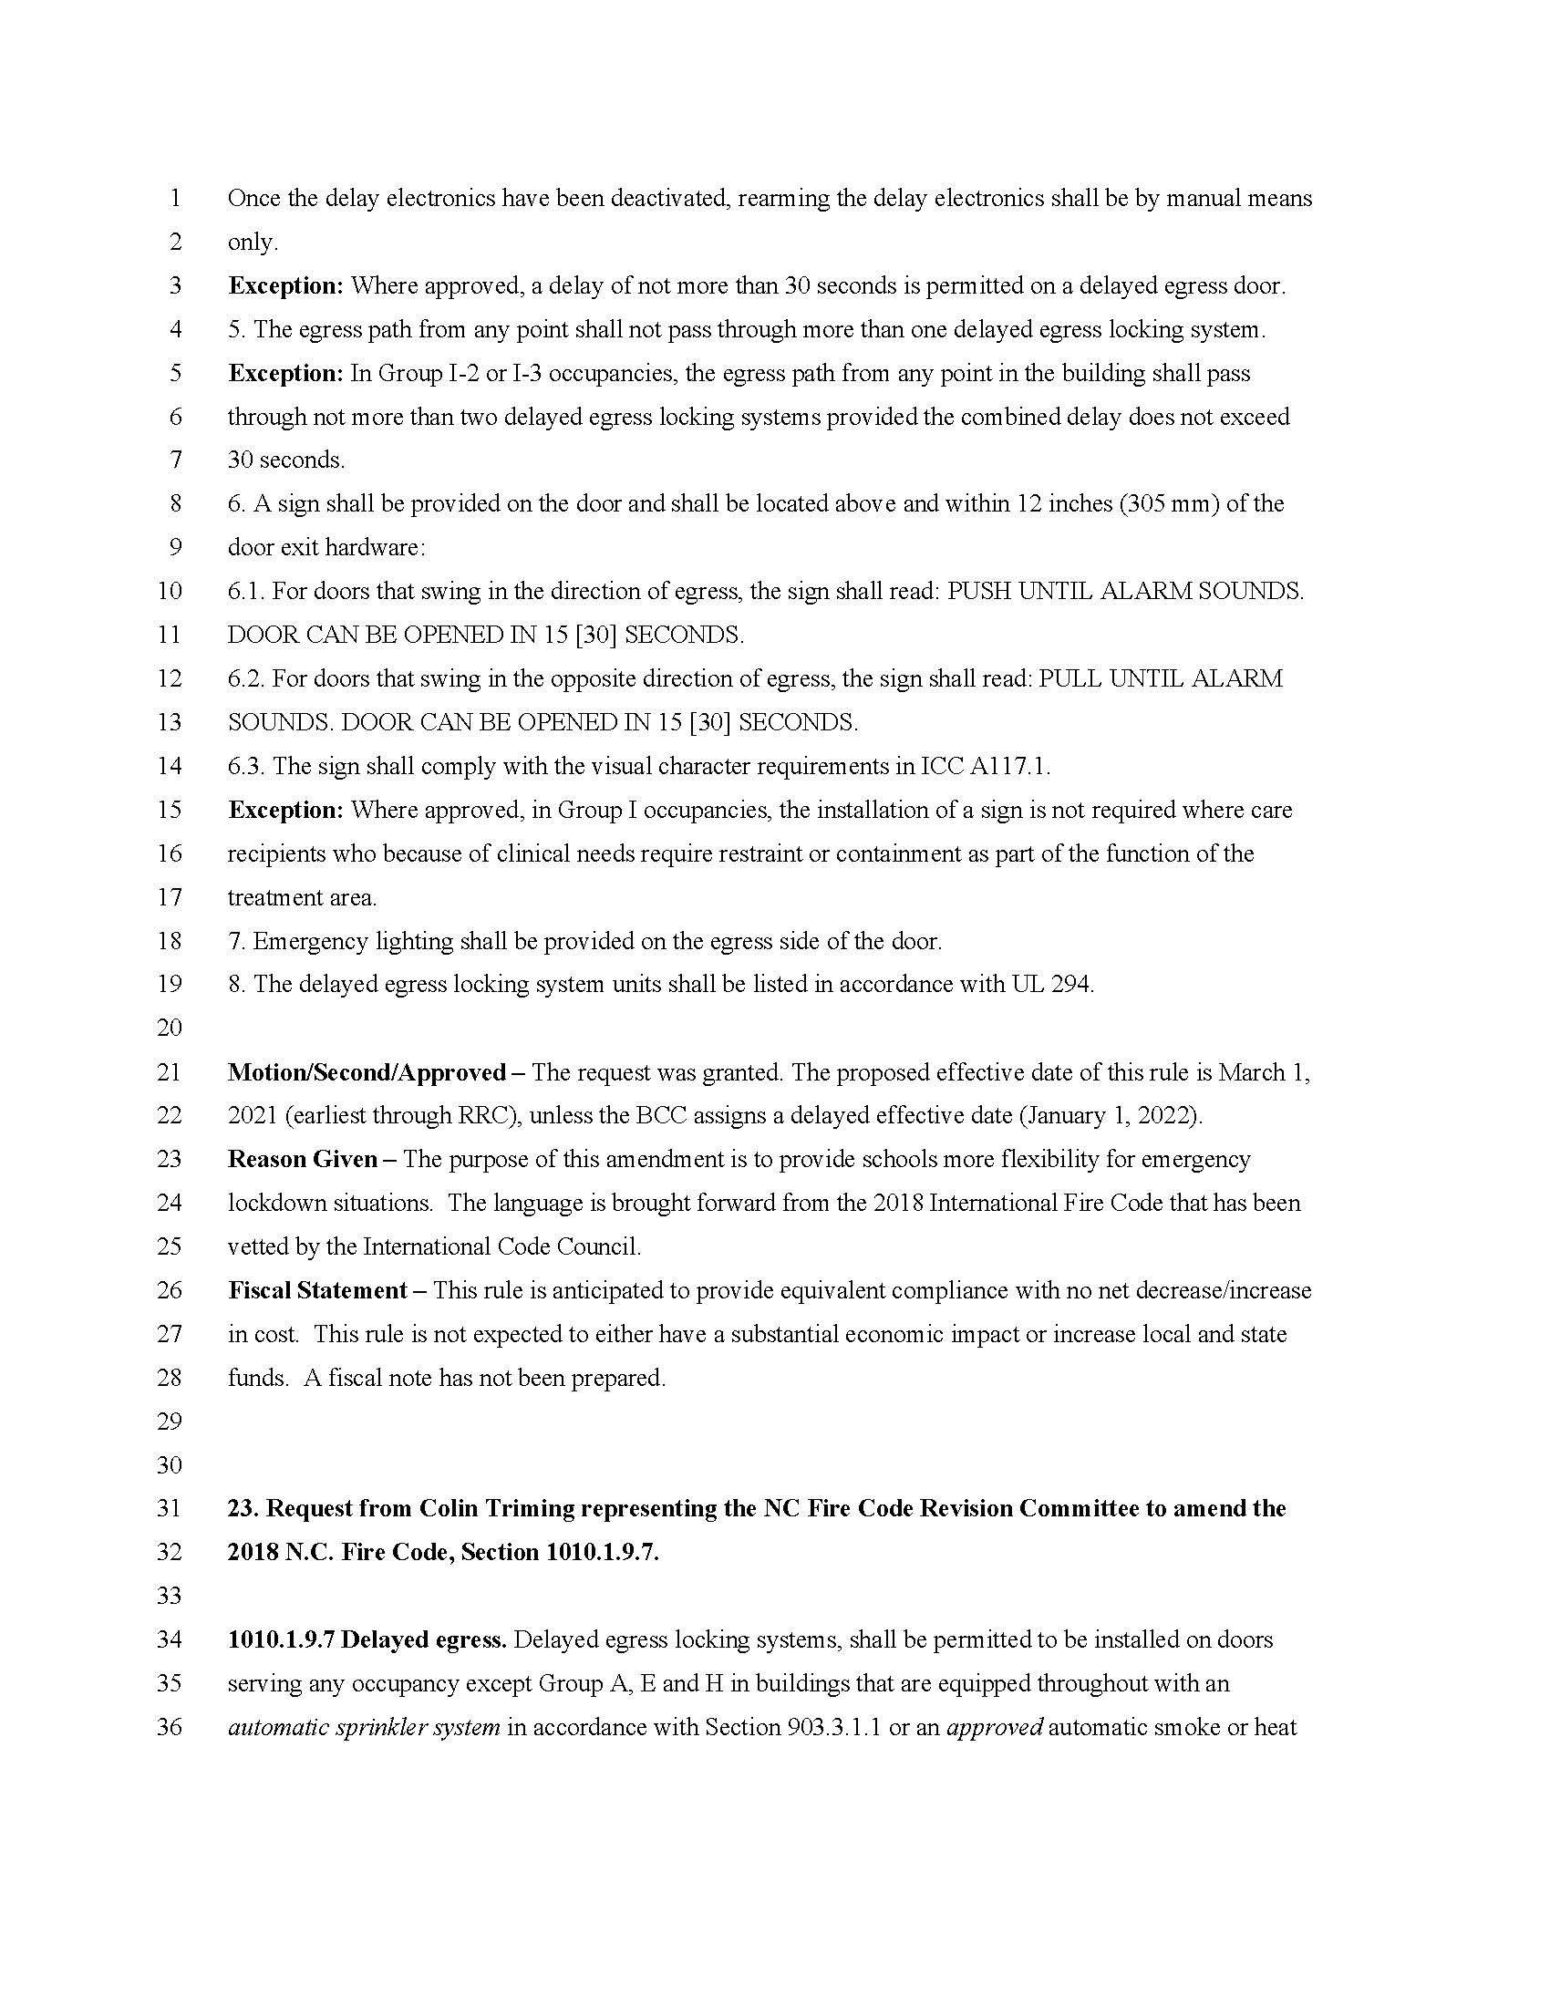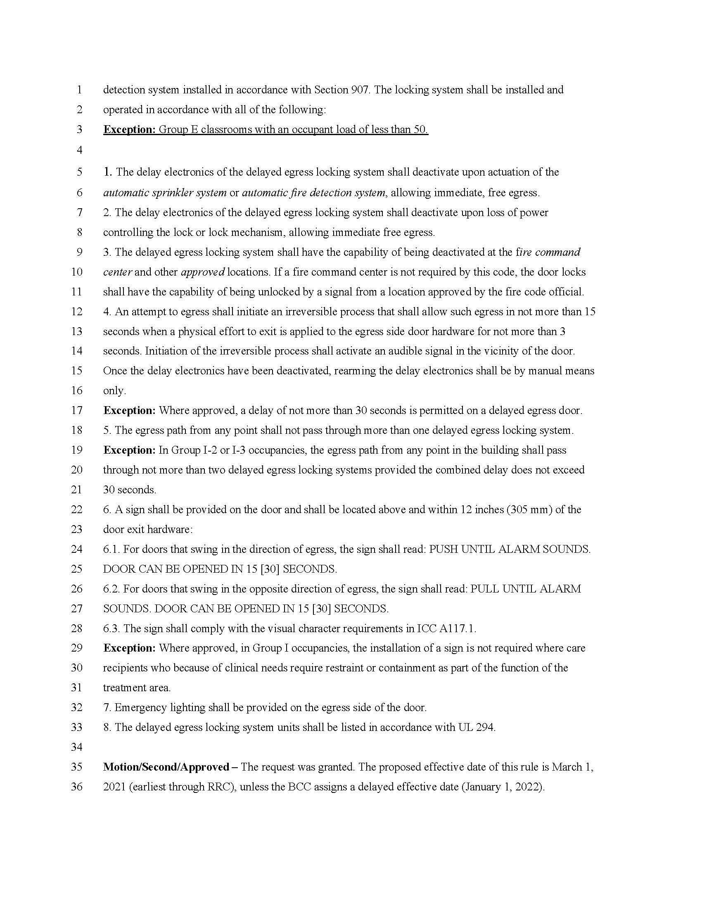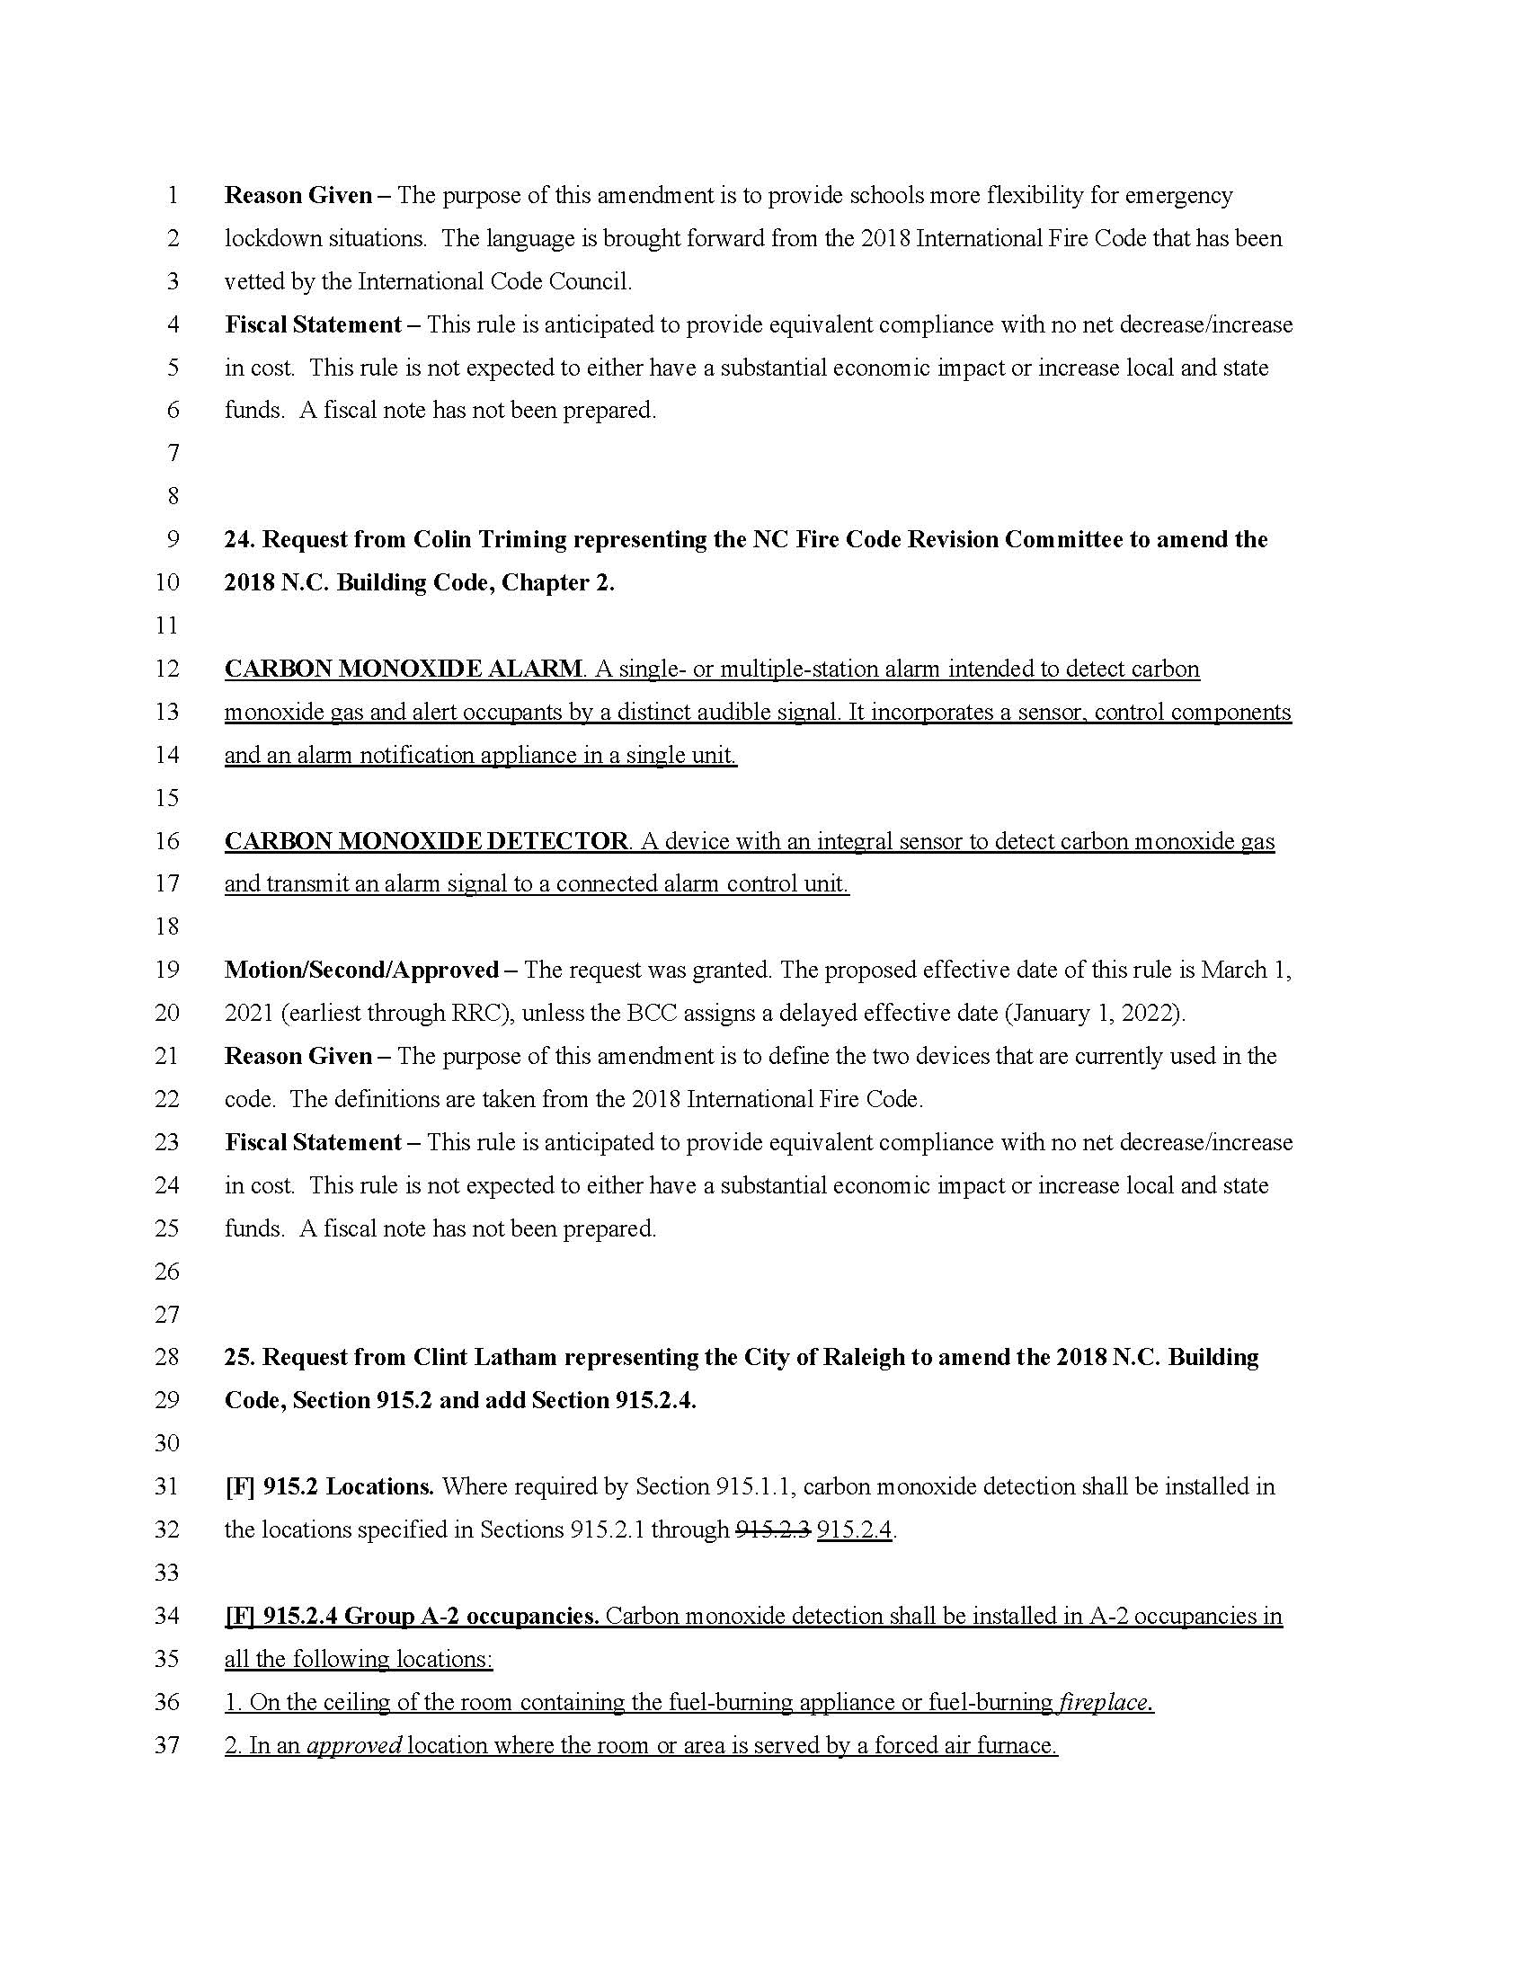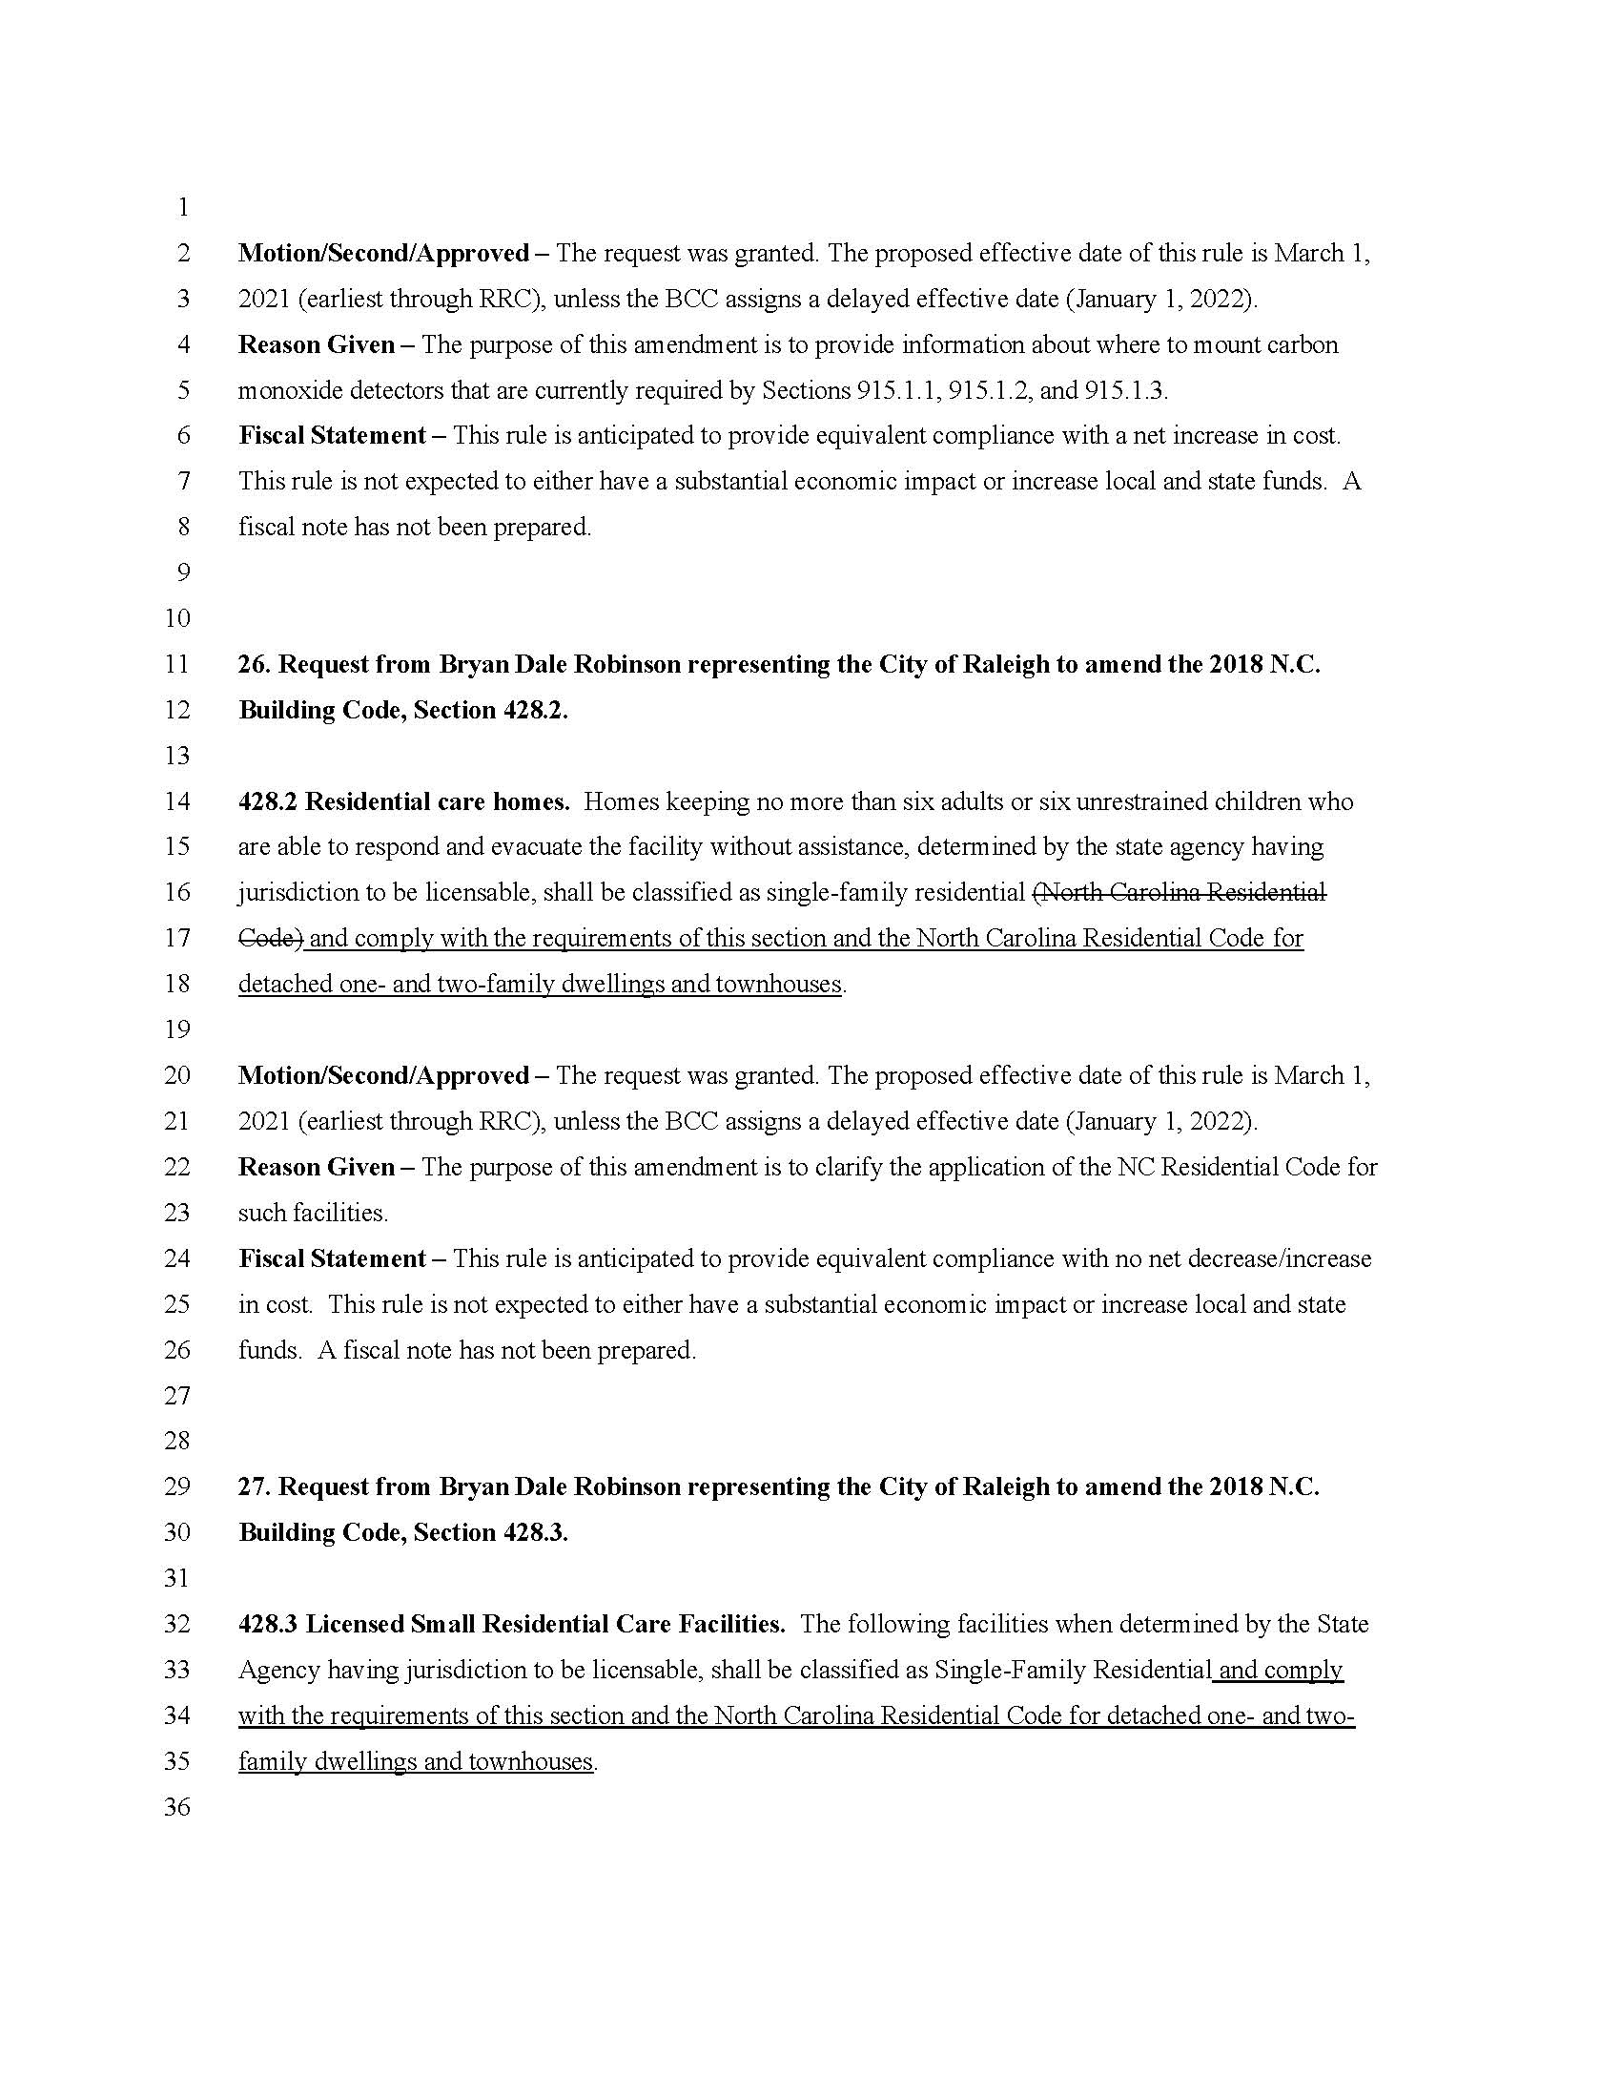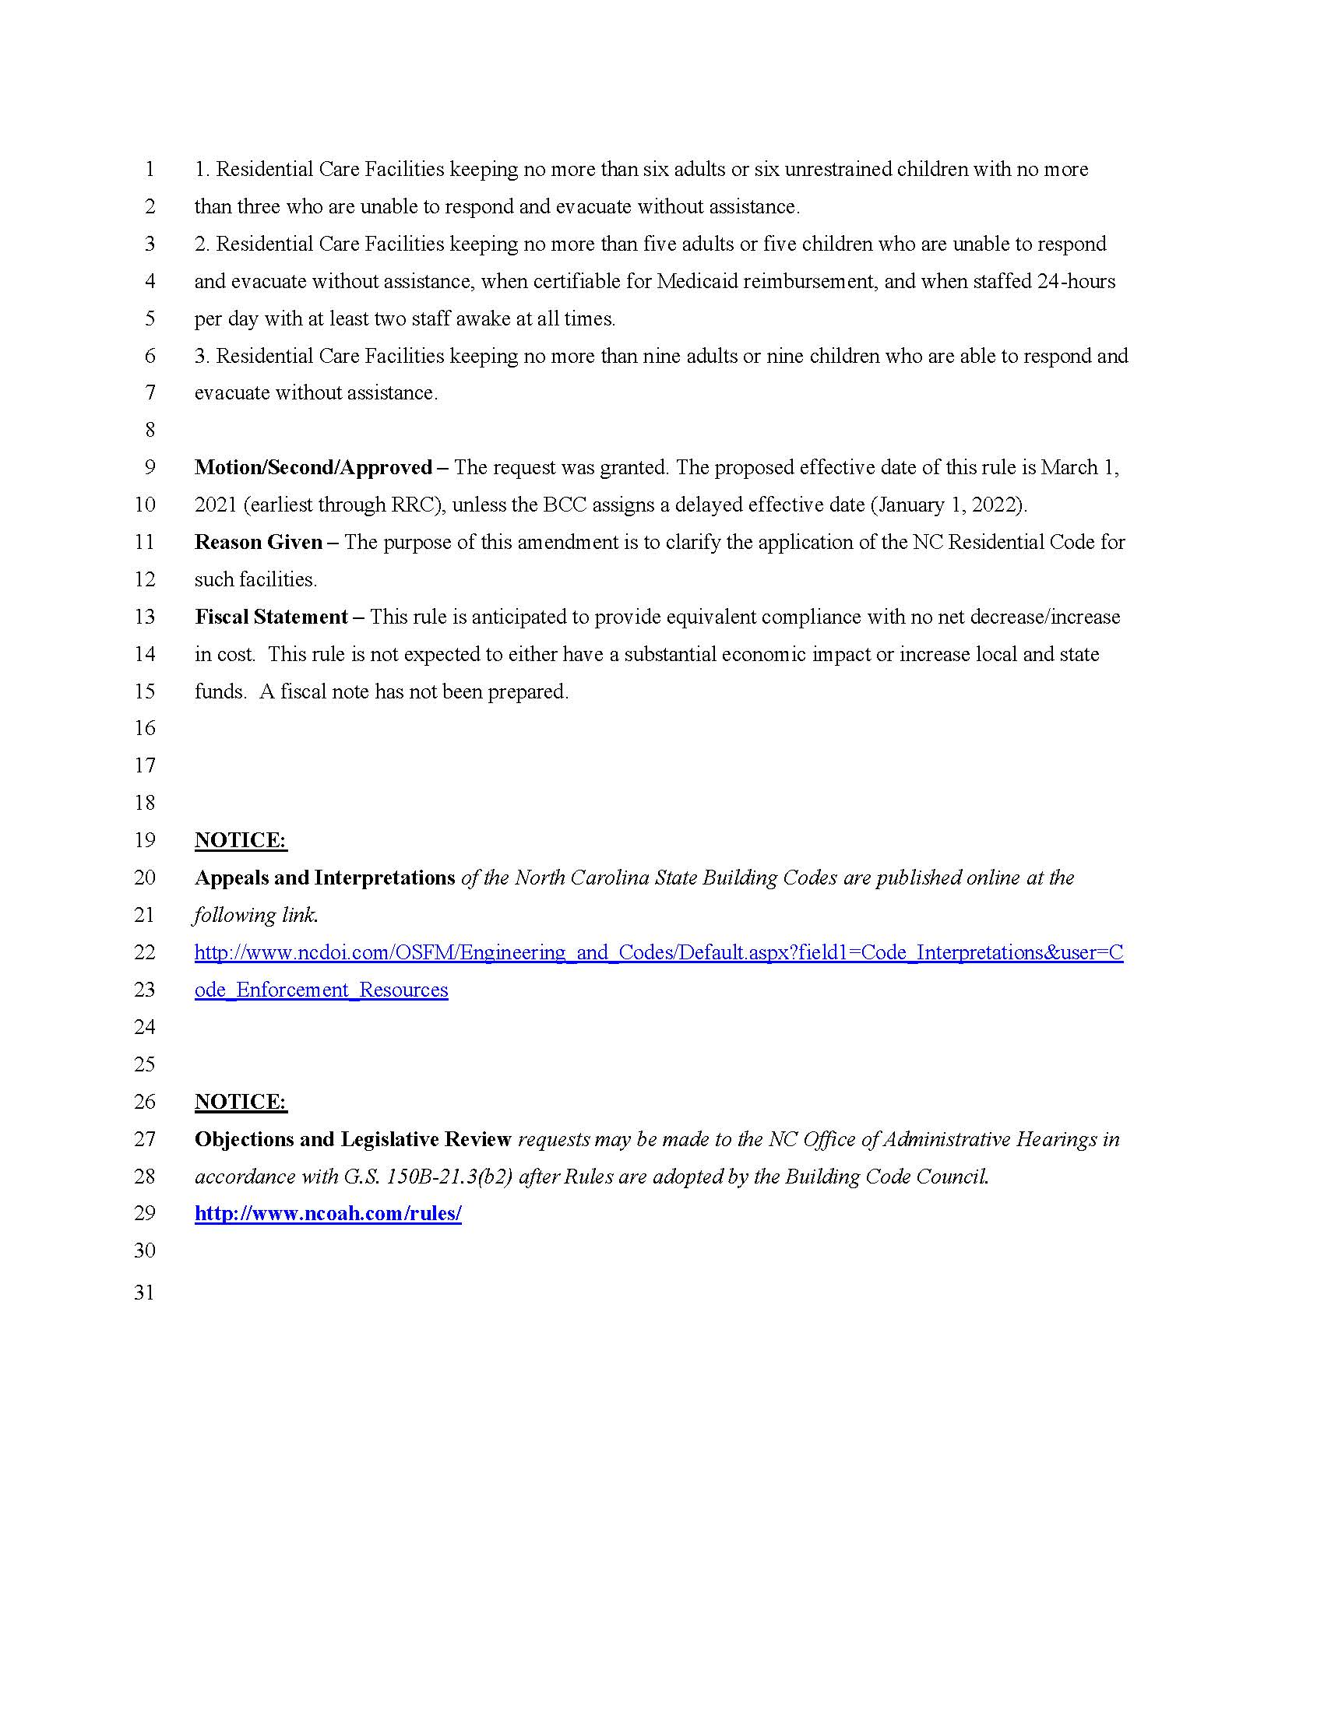
-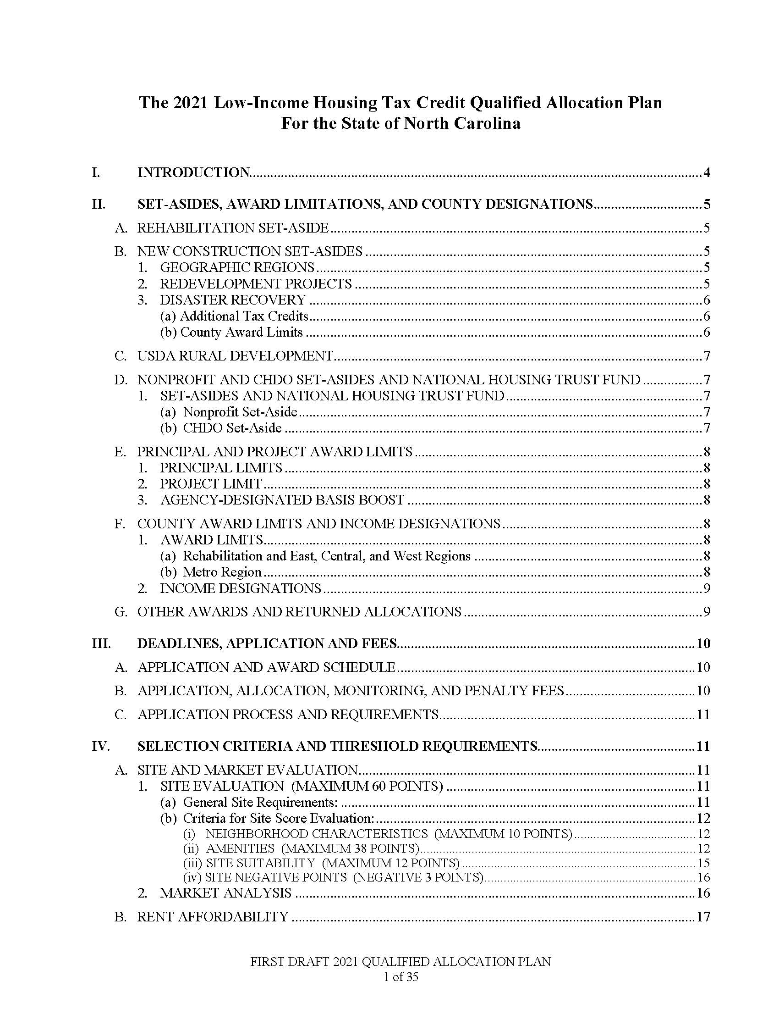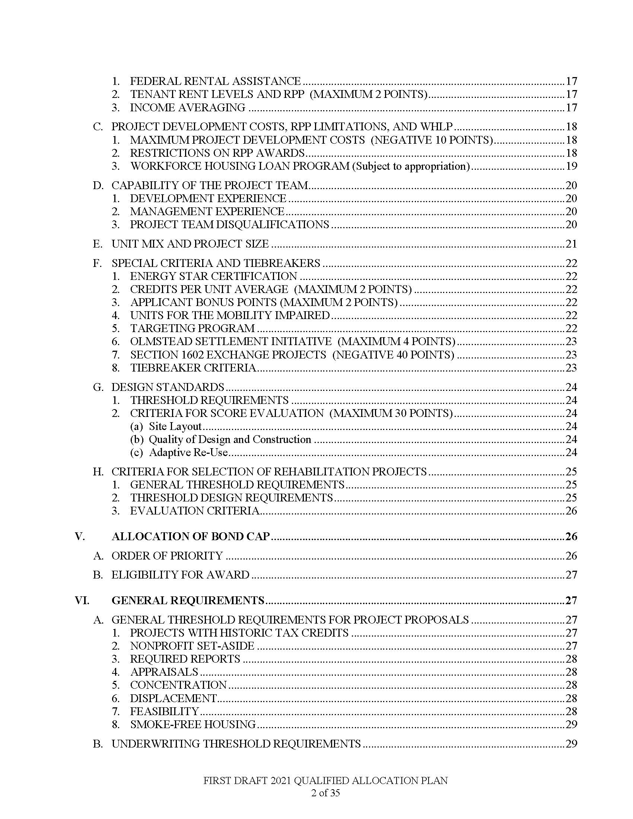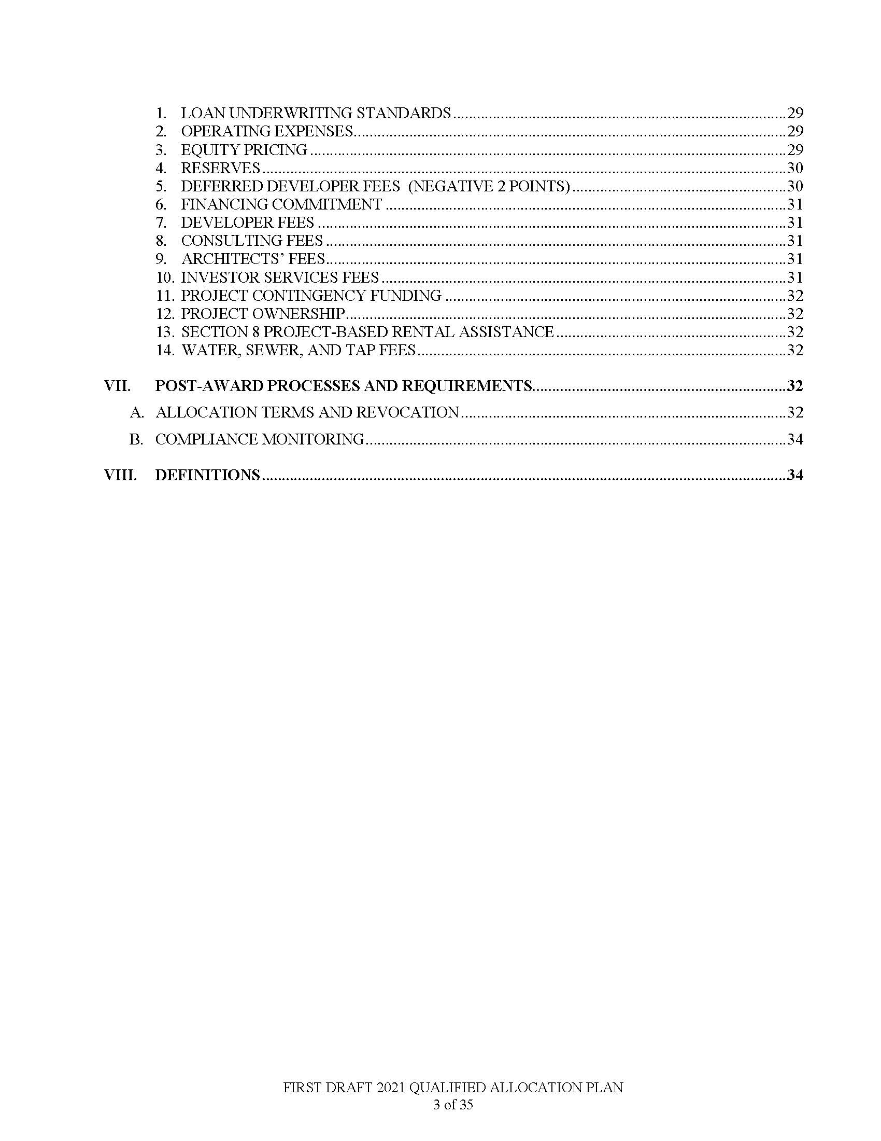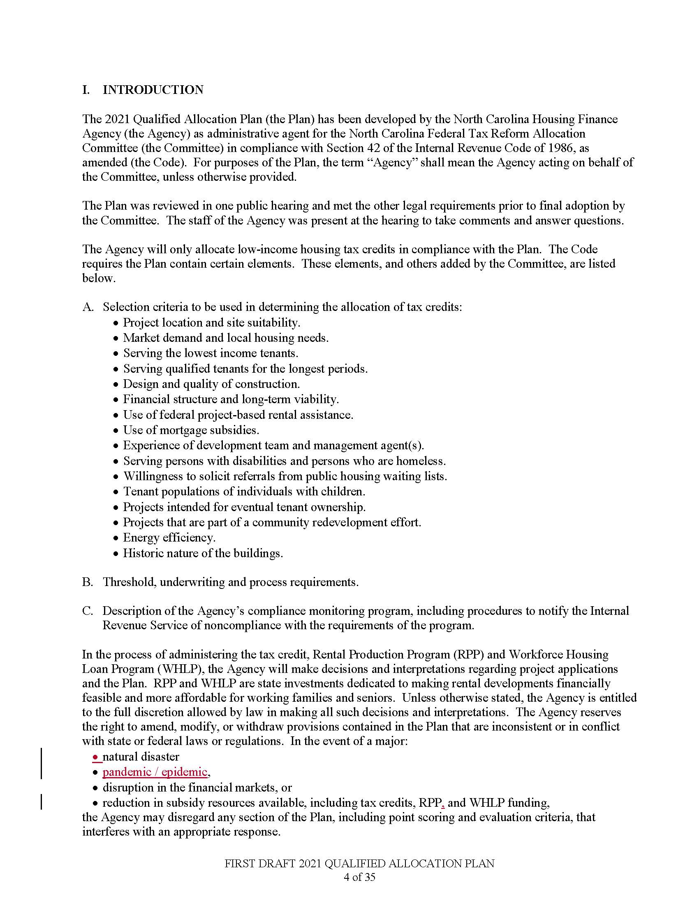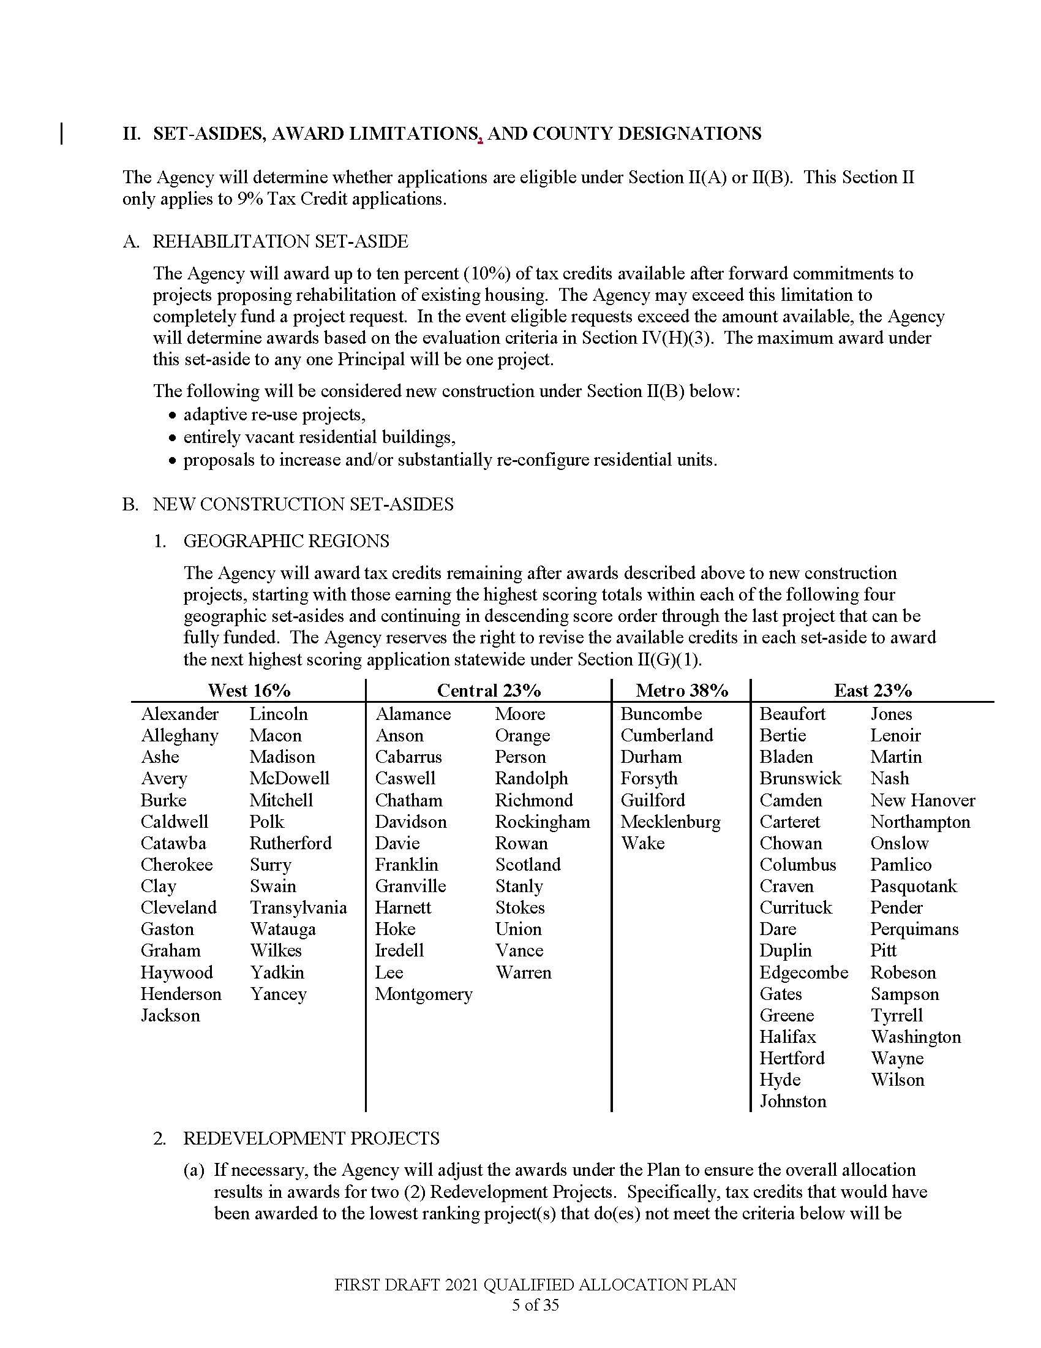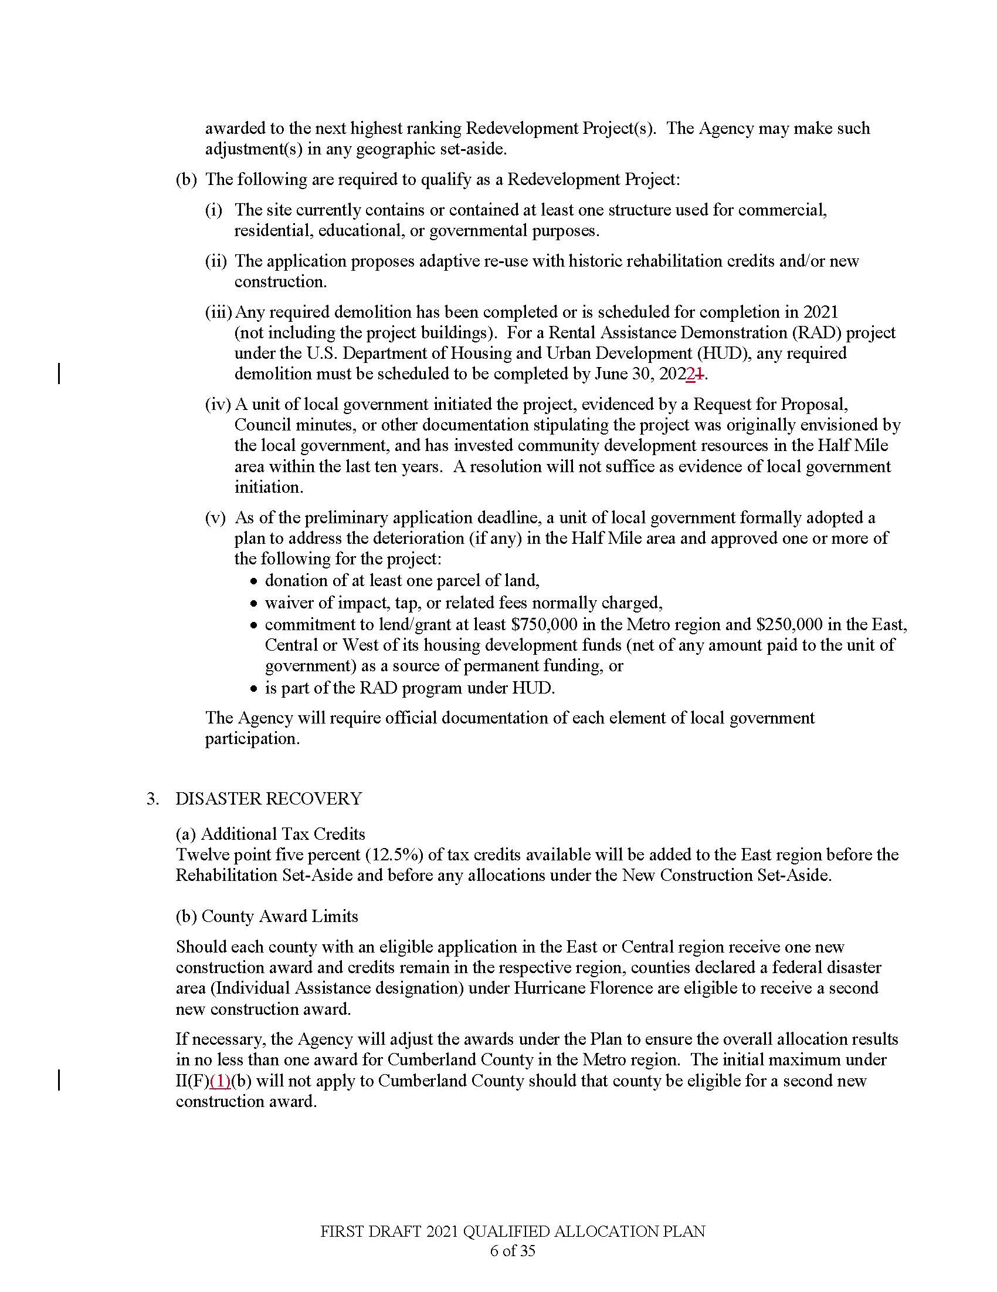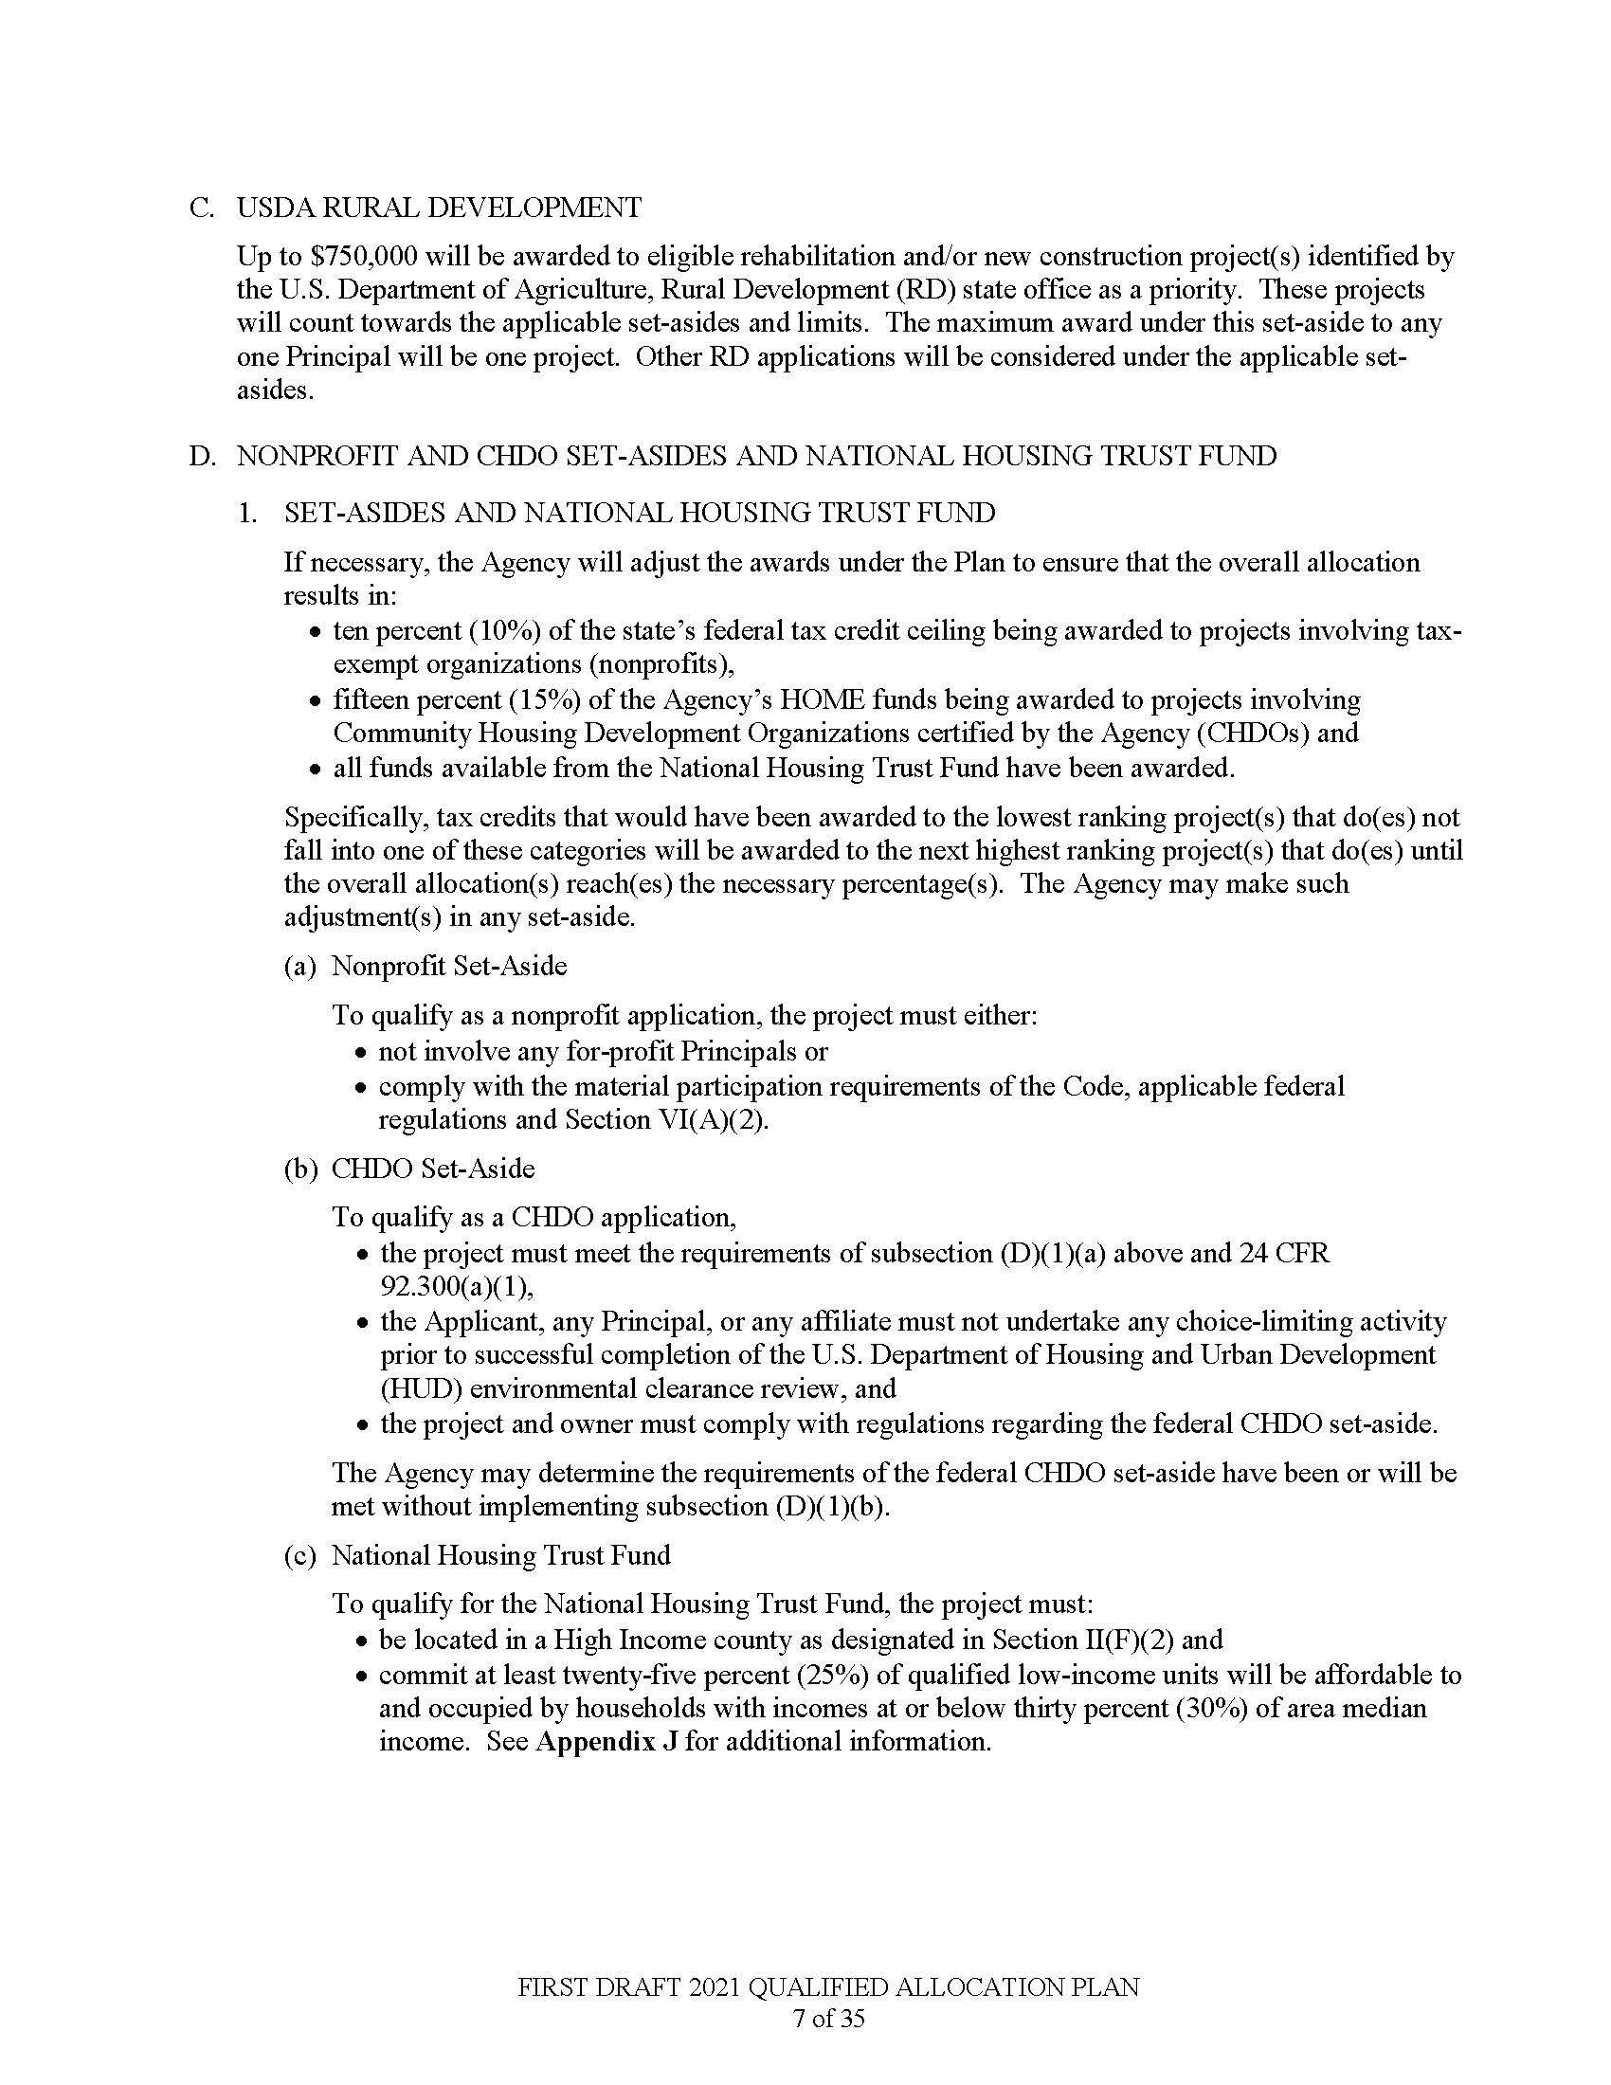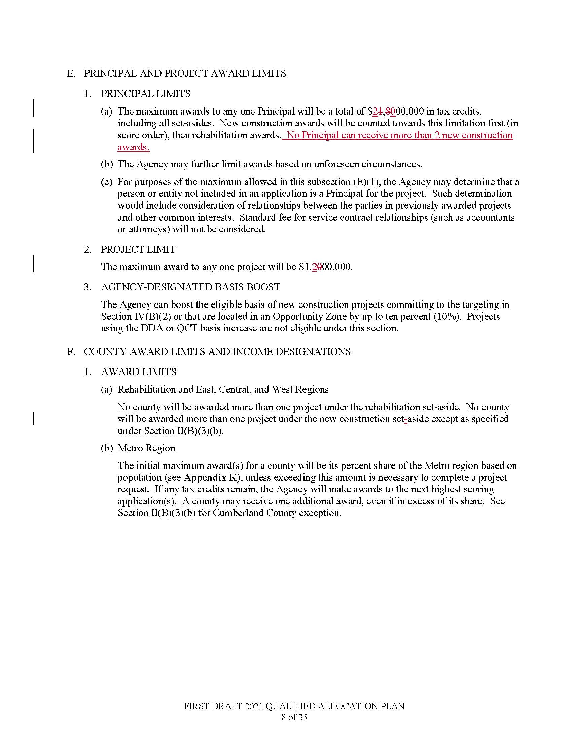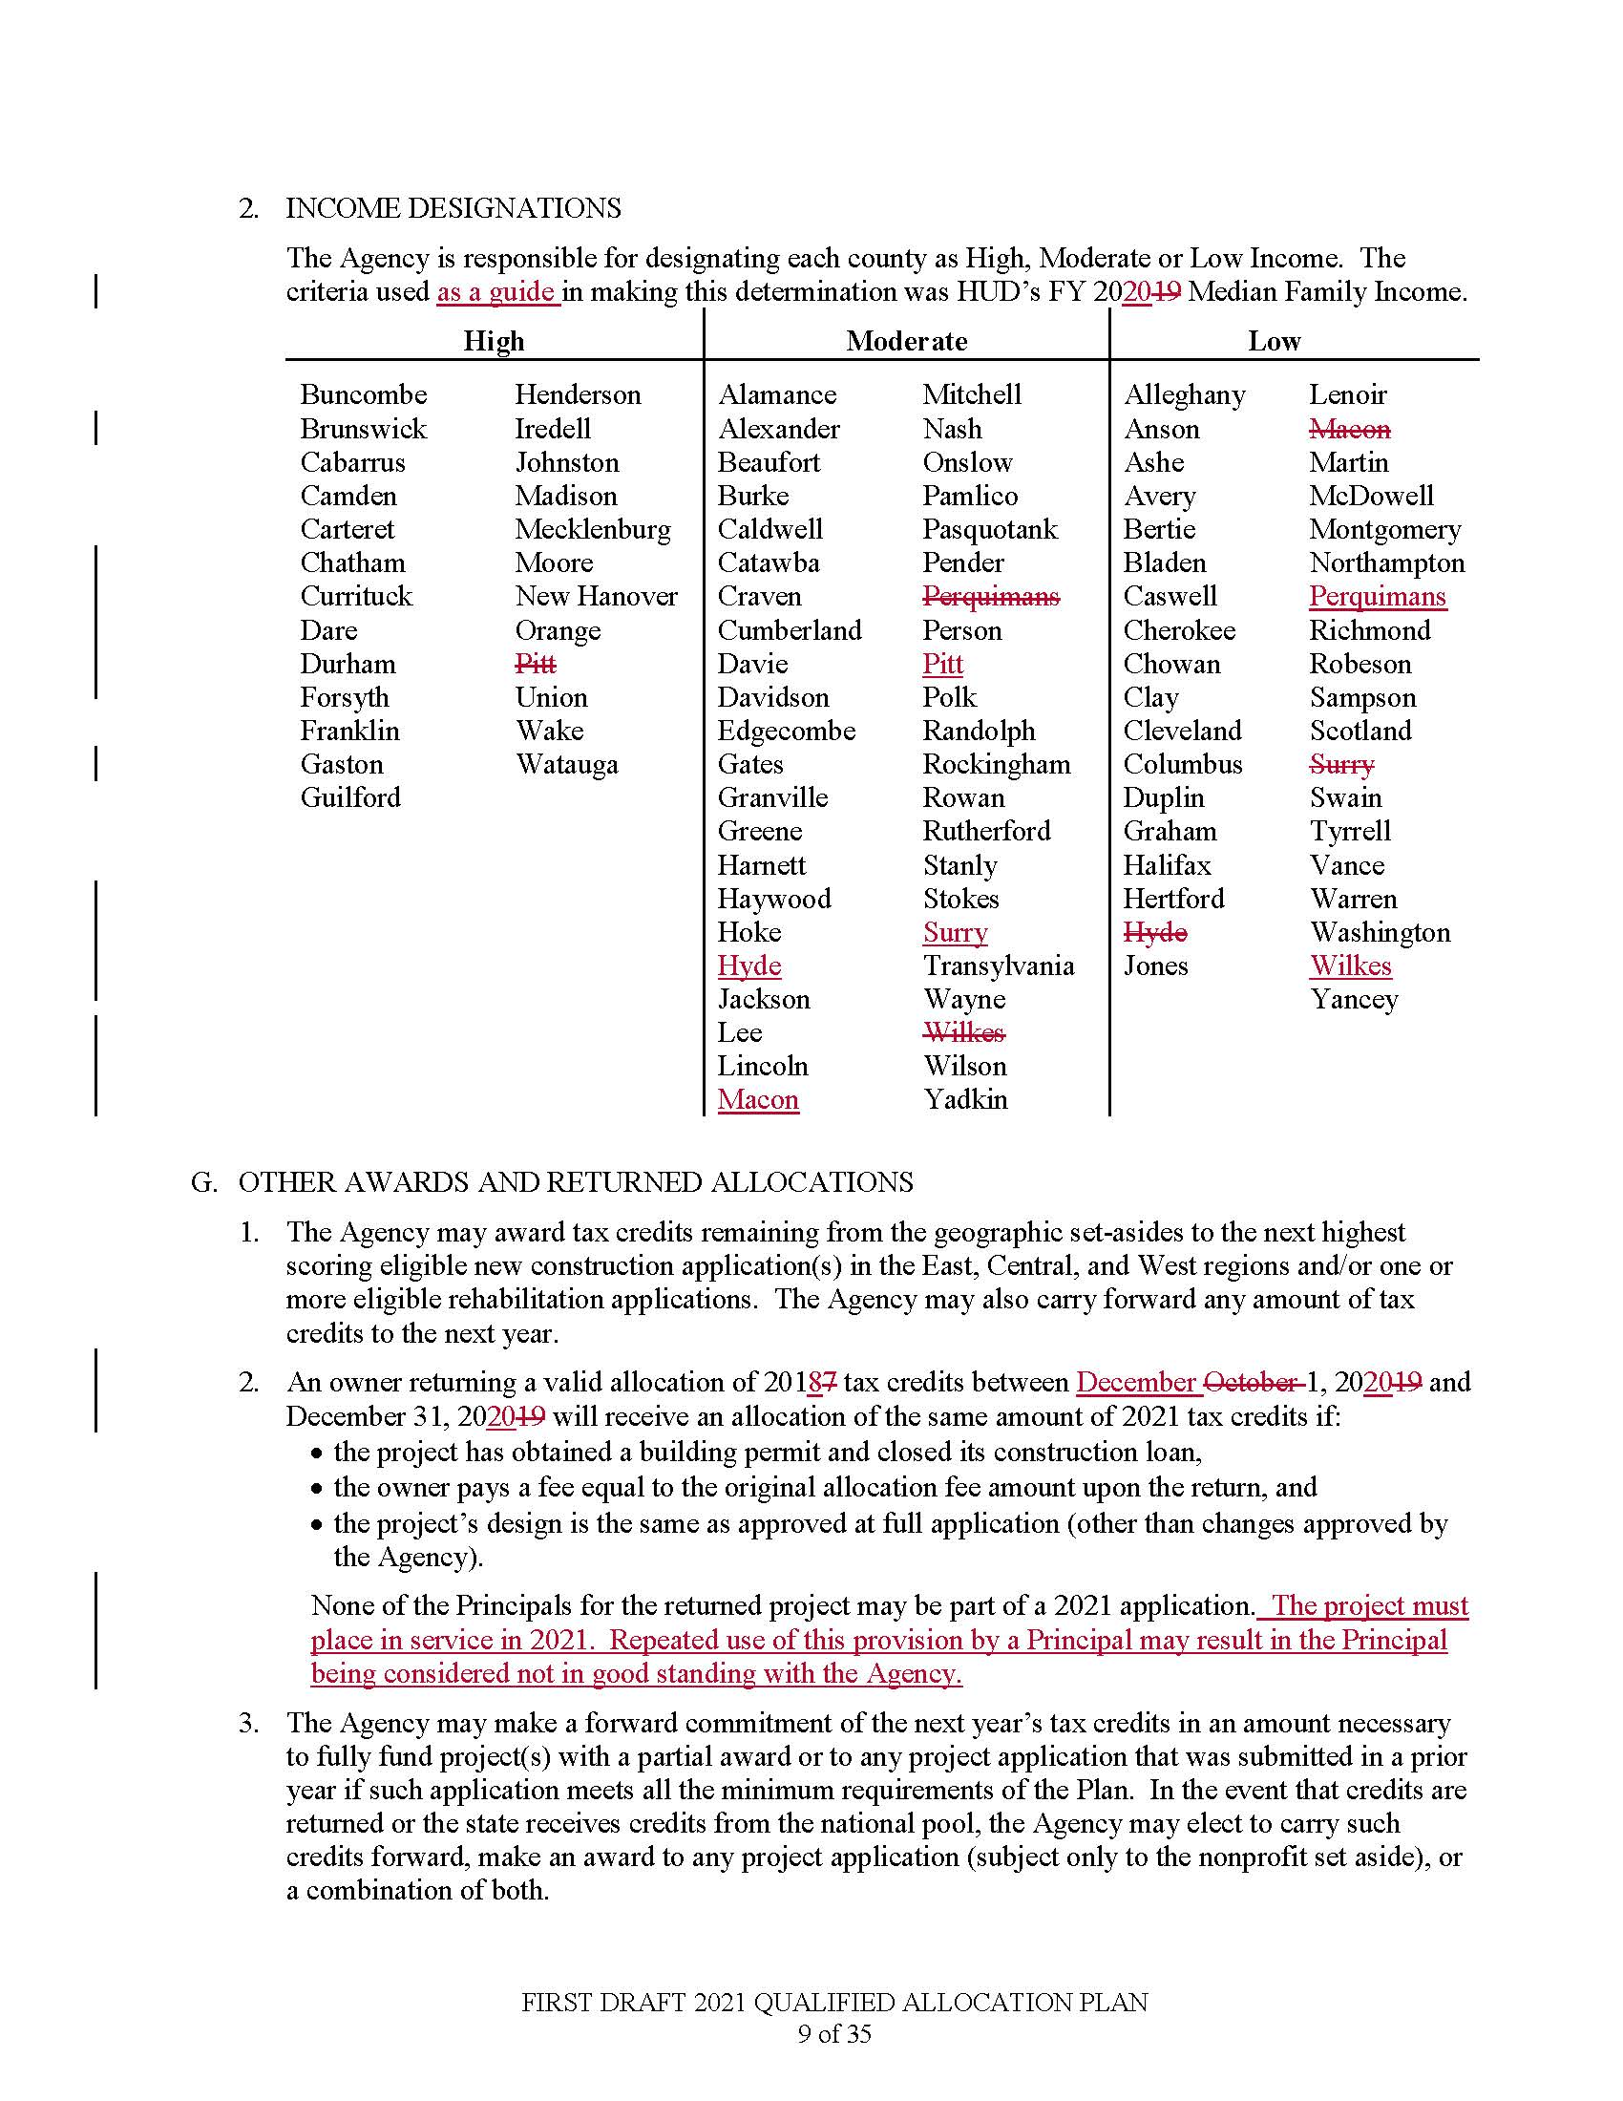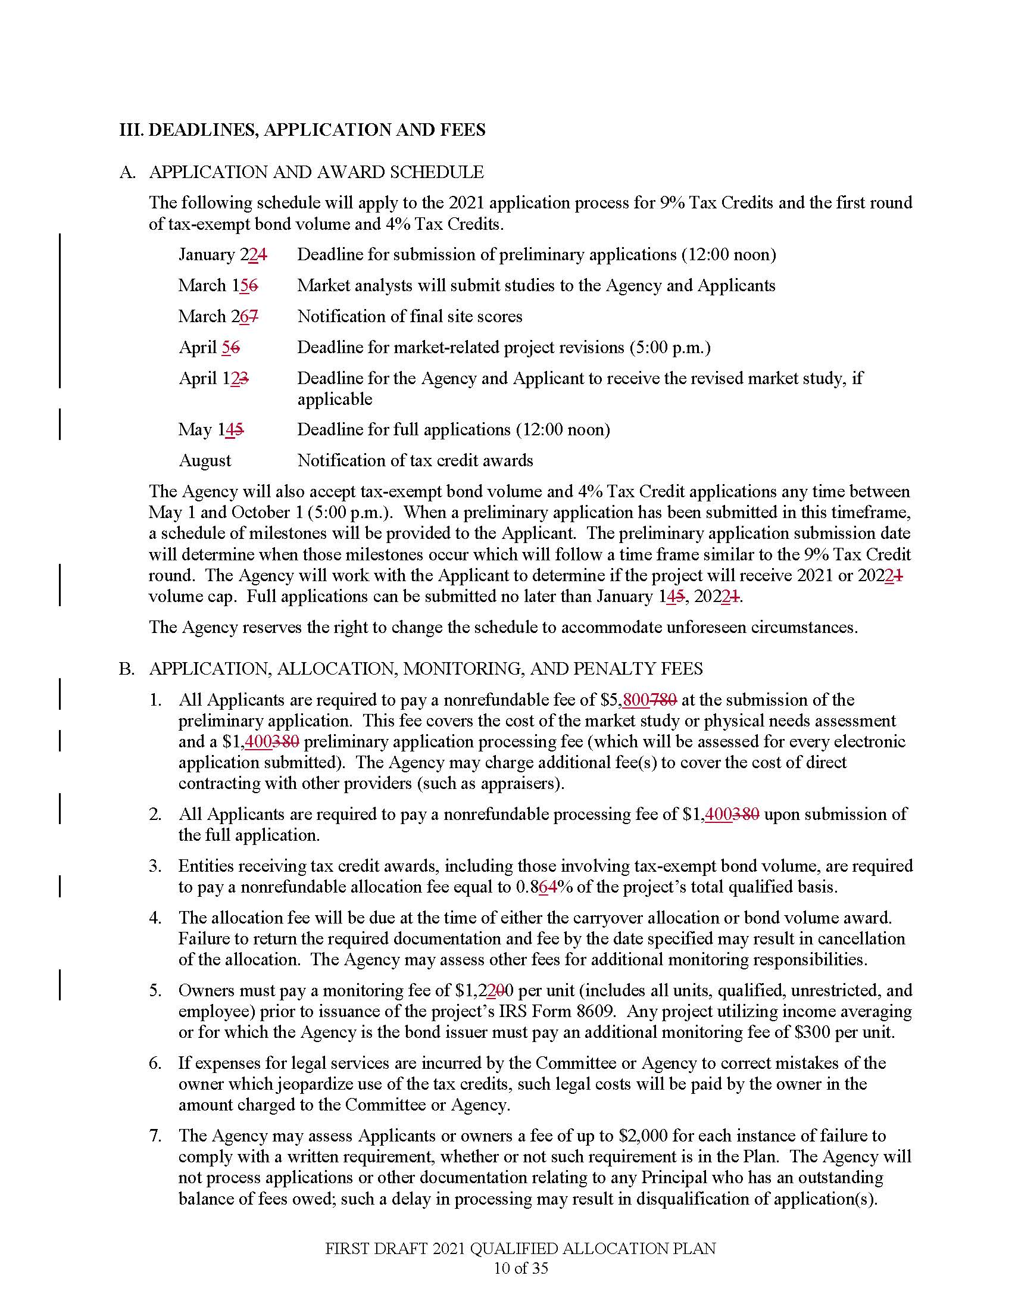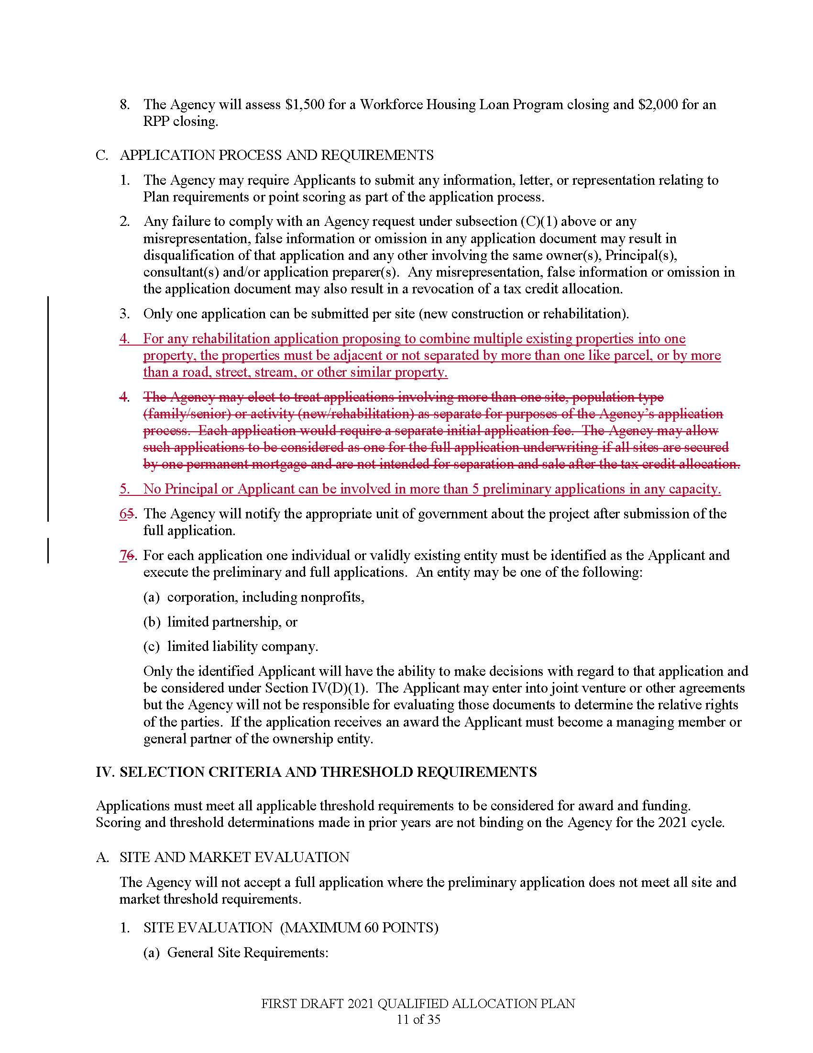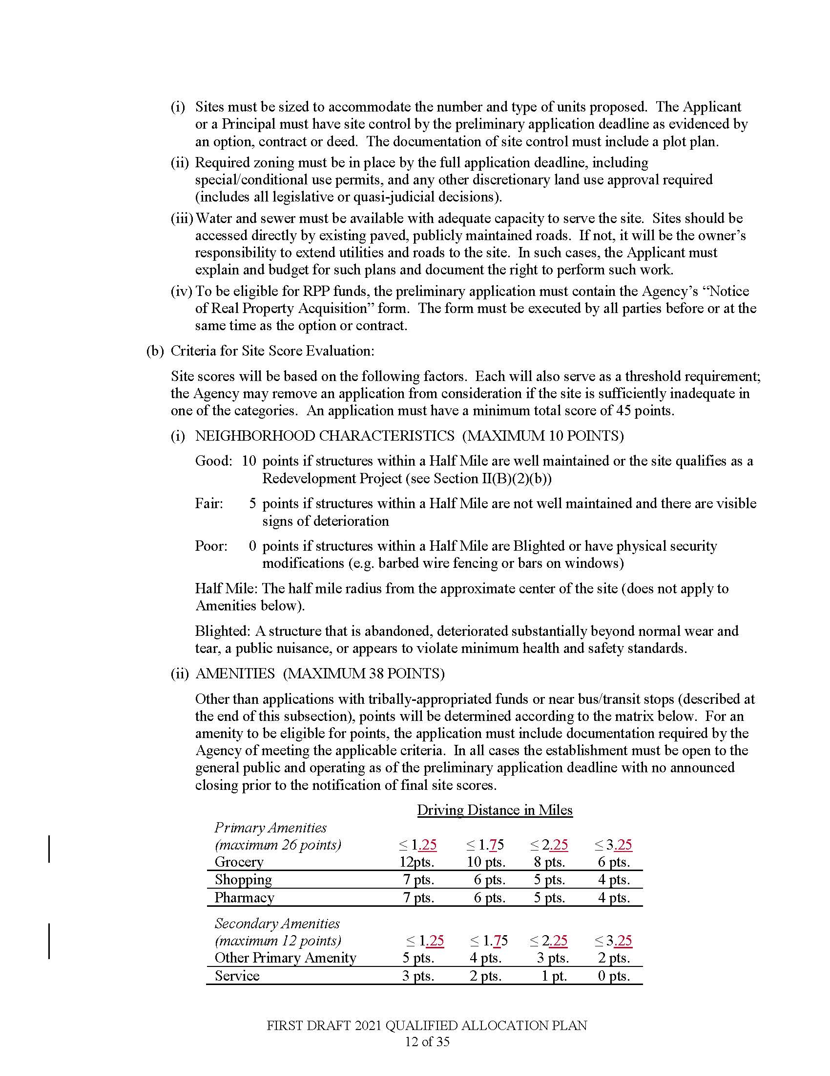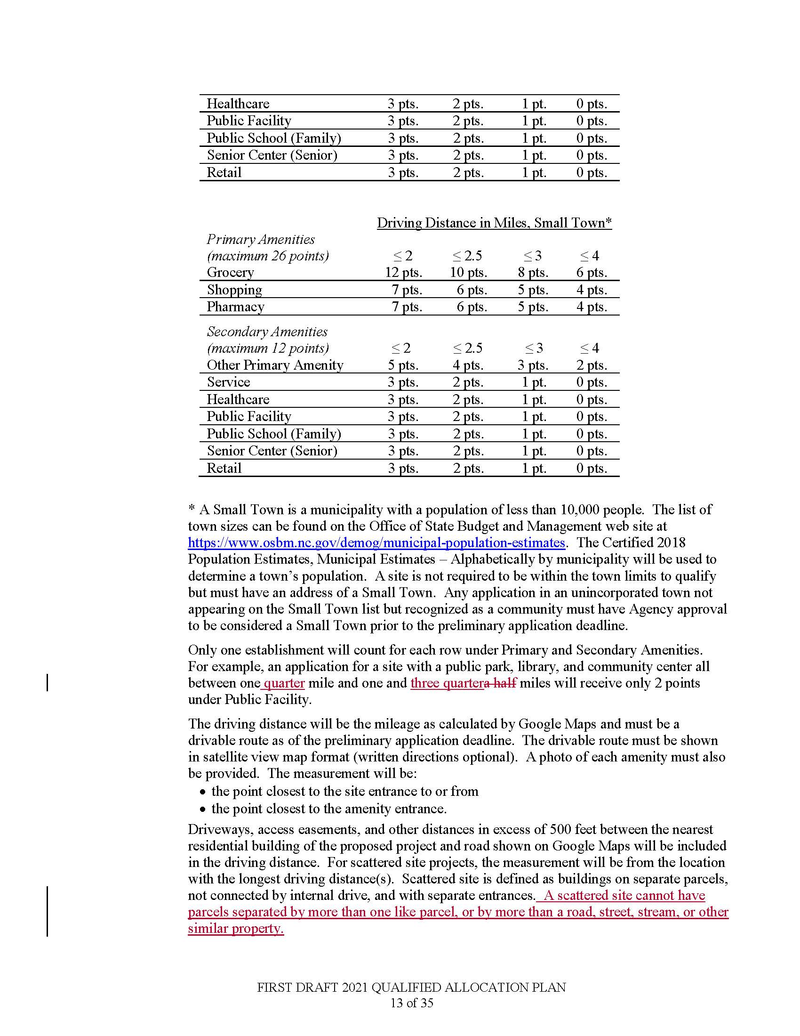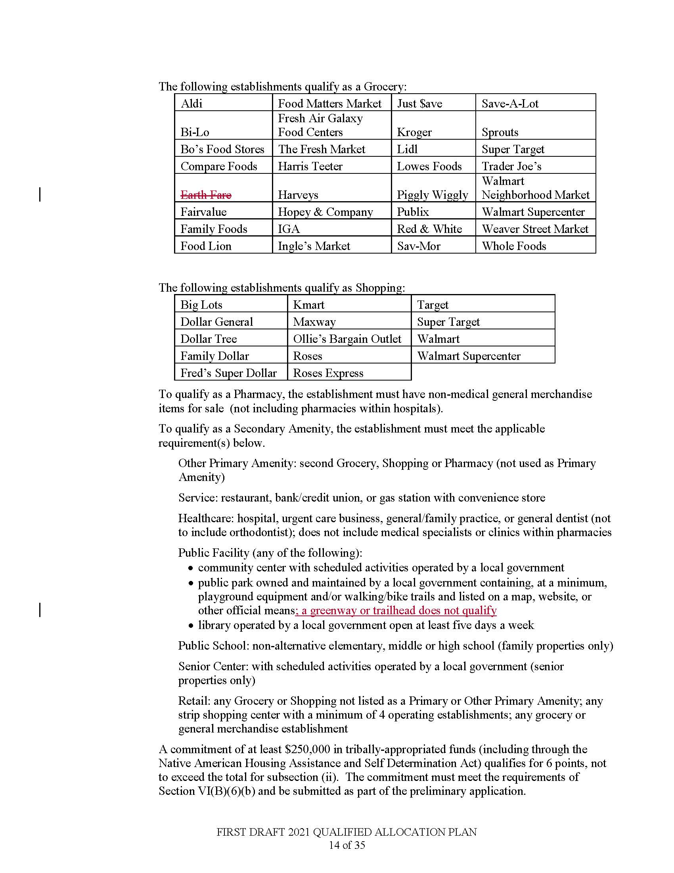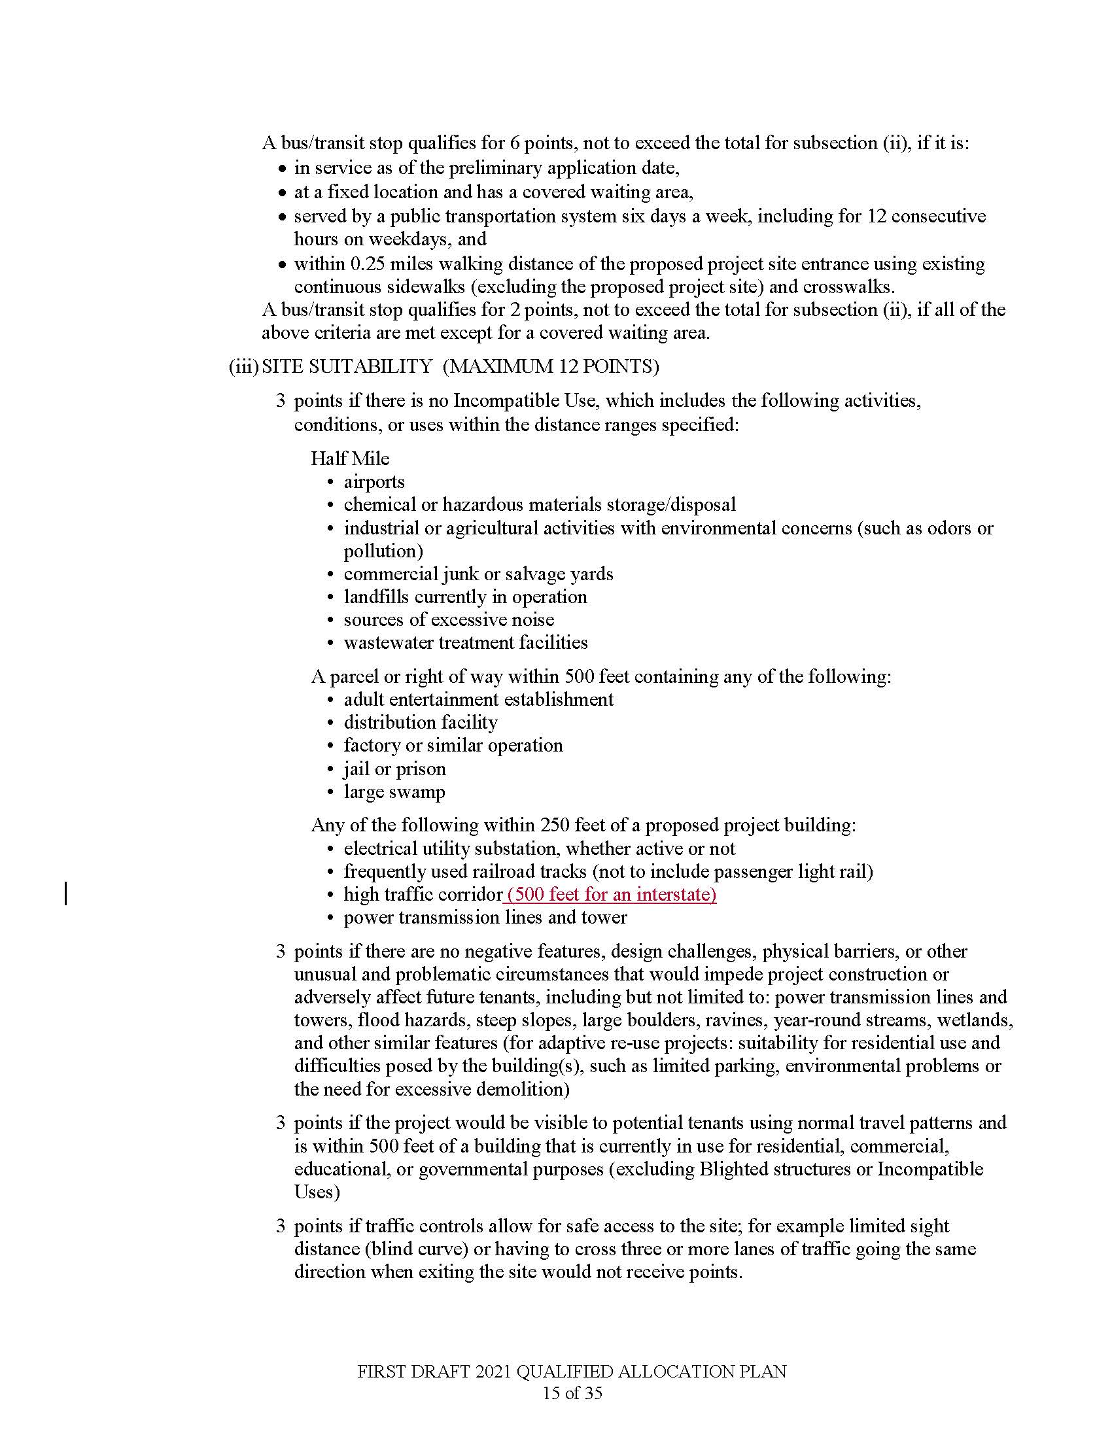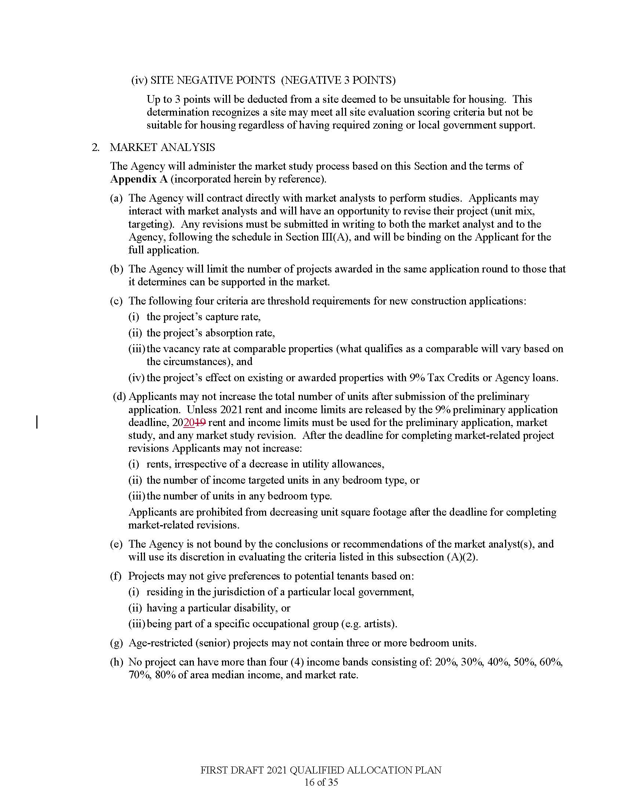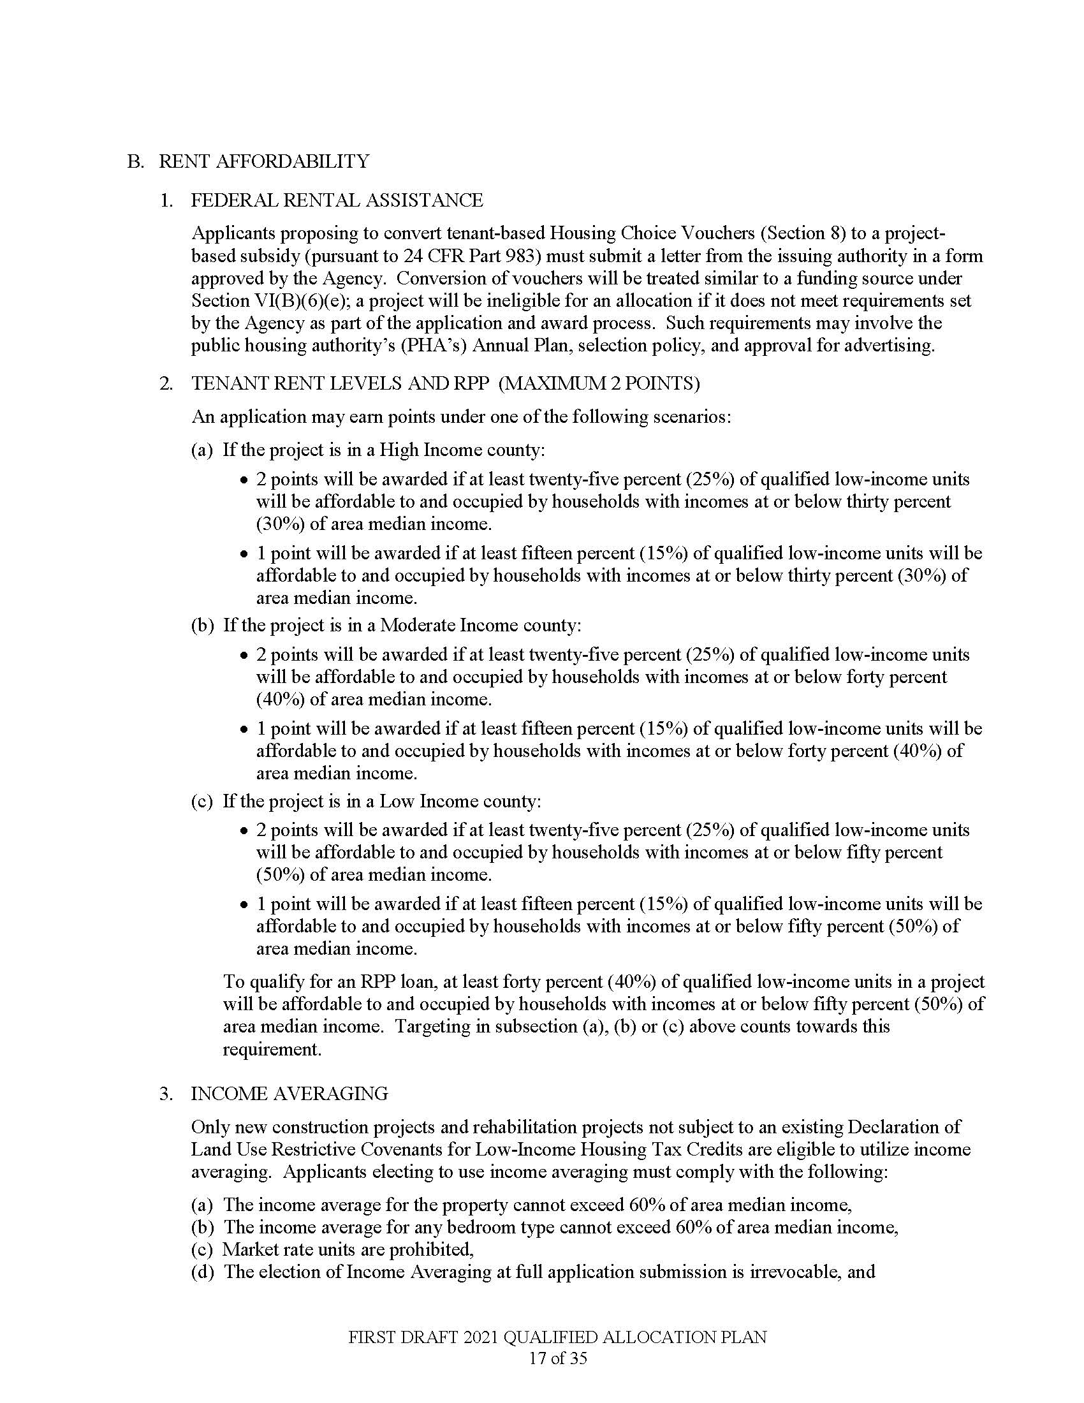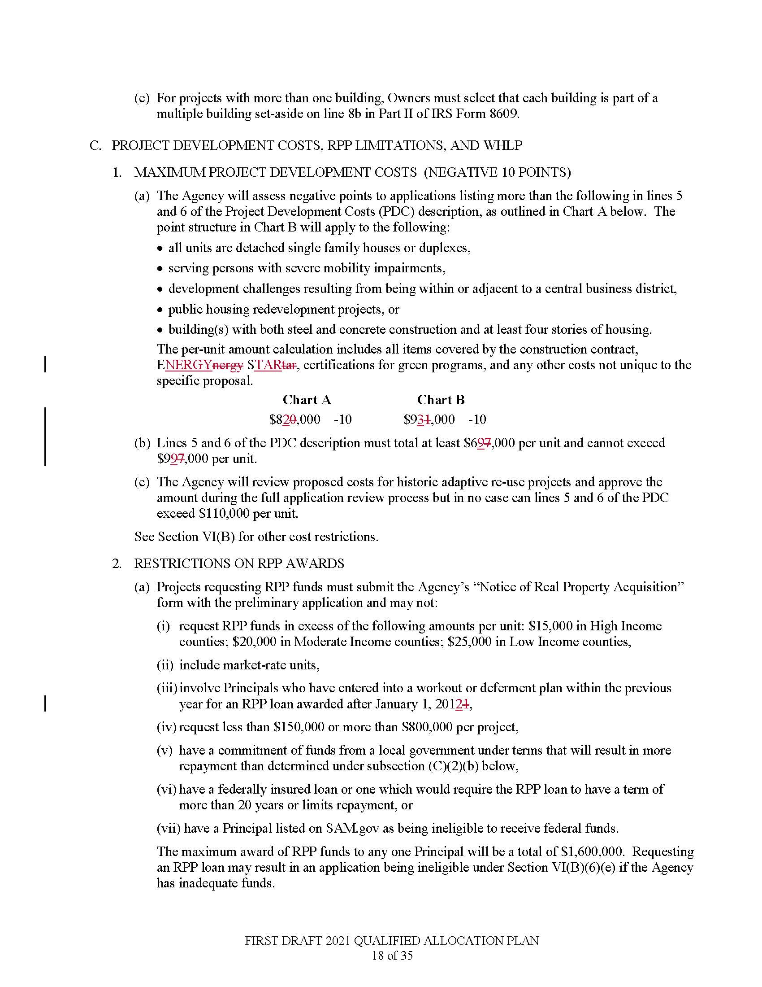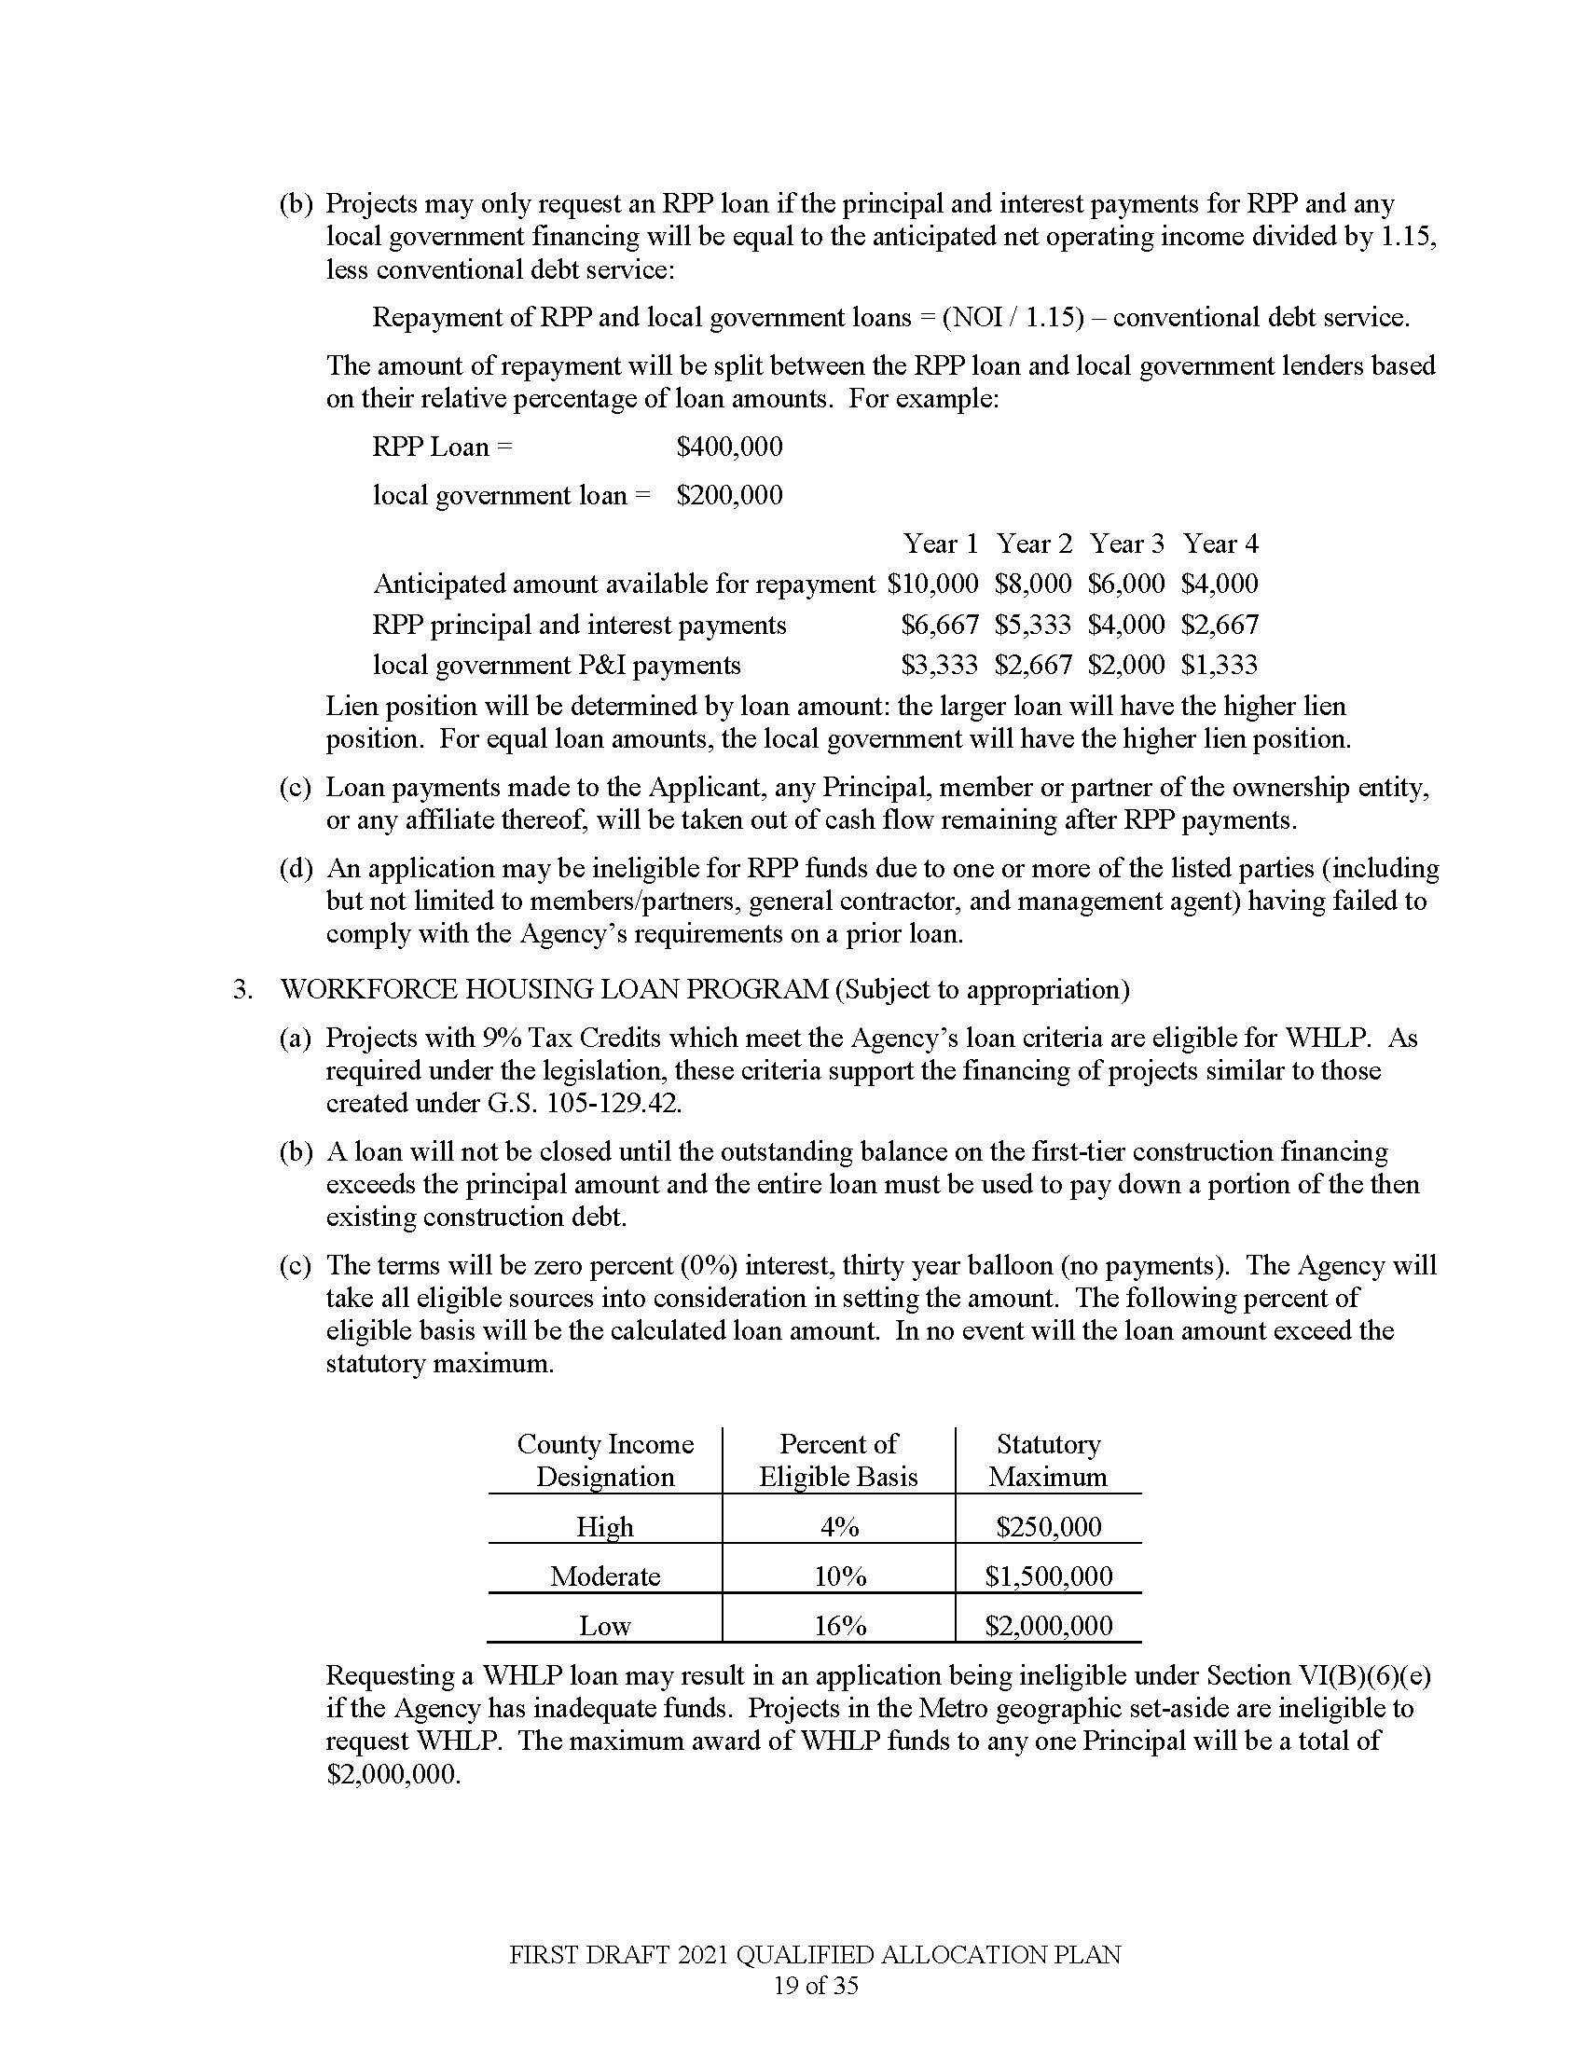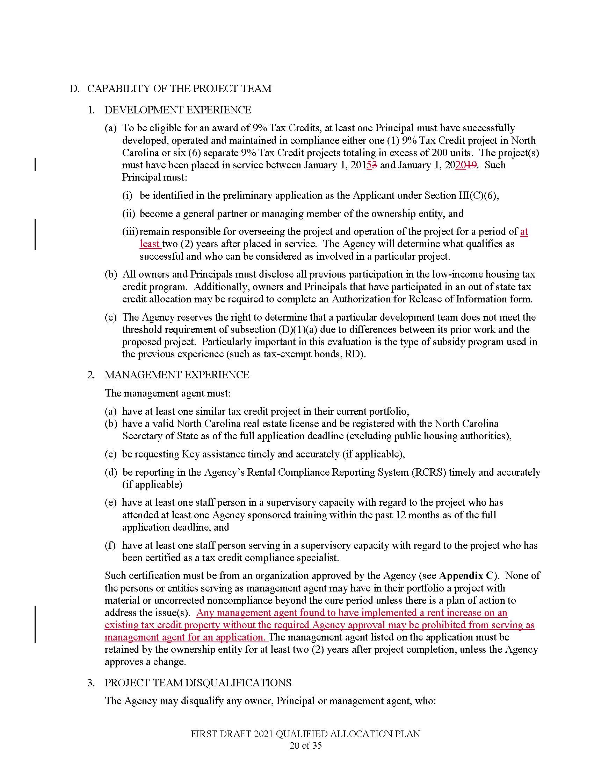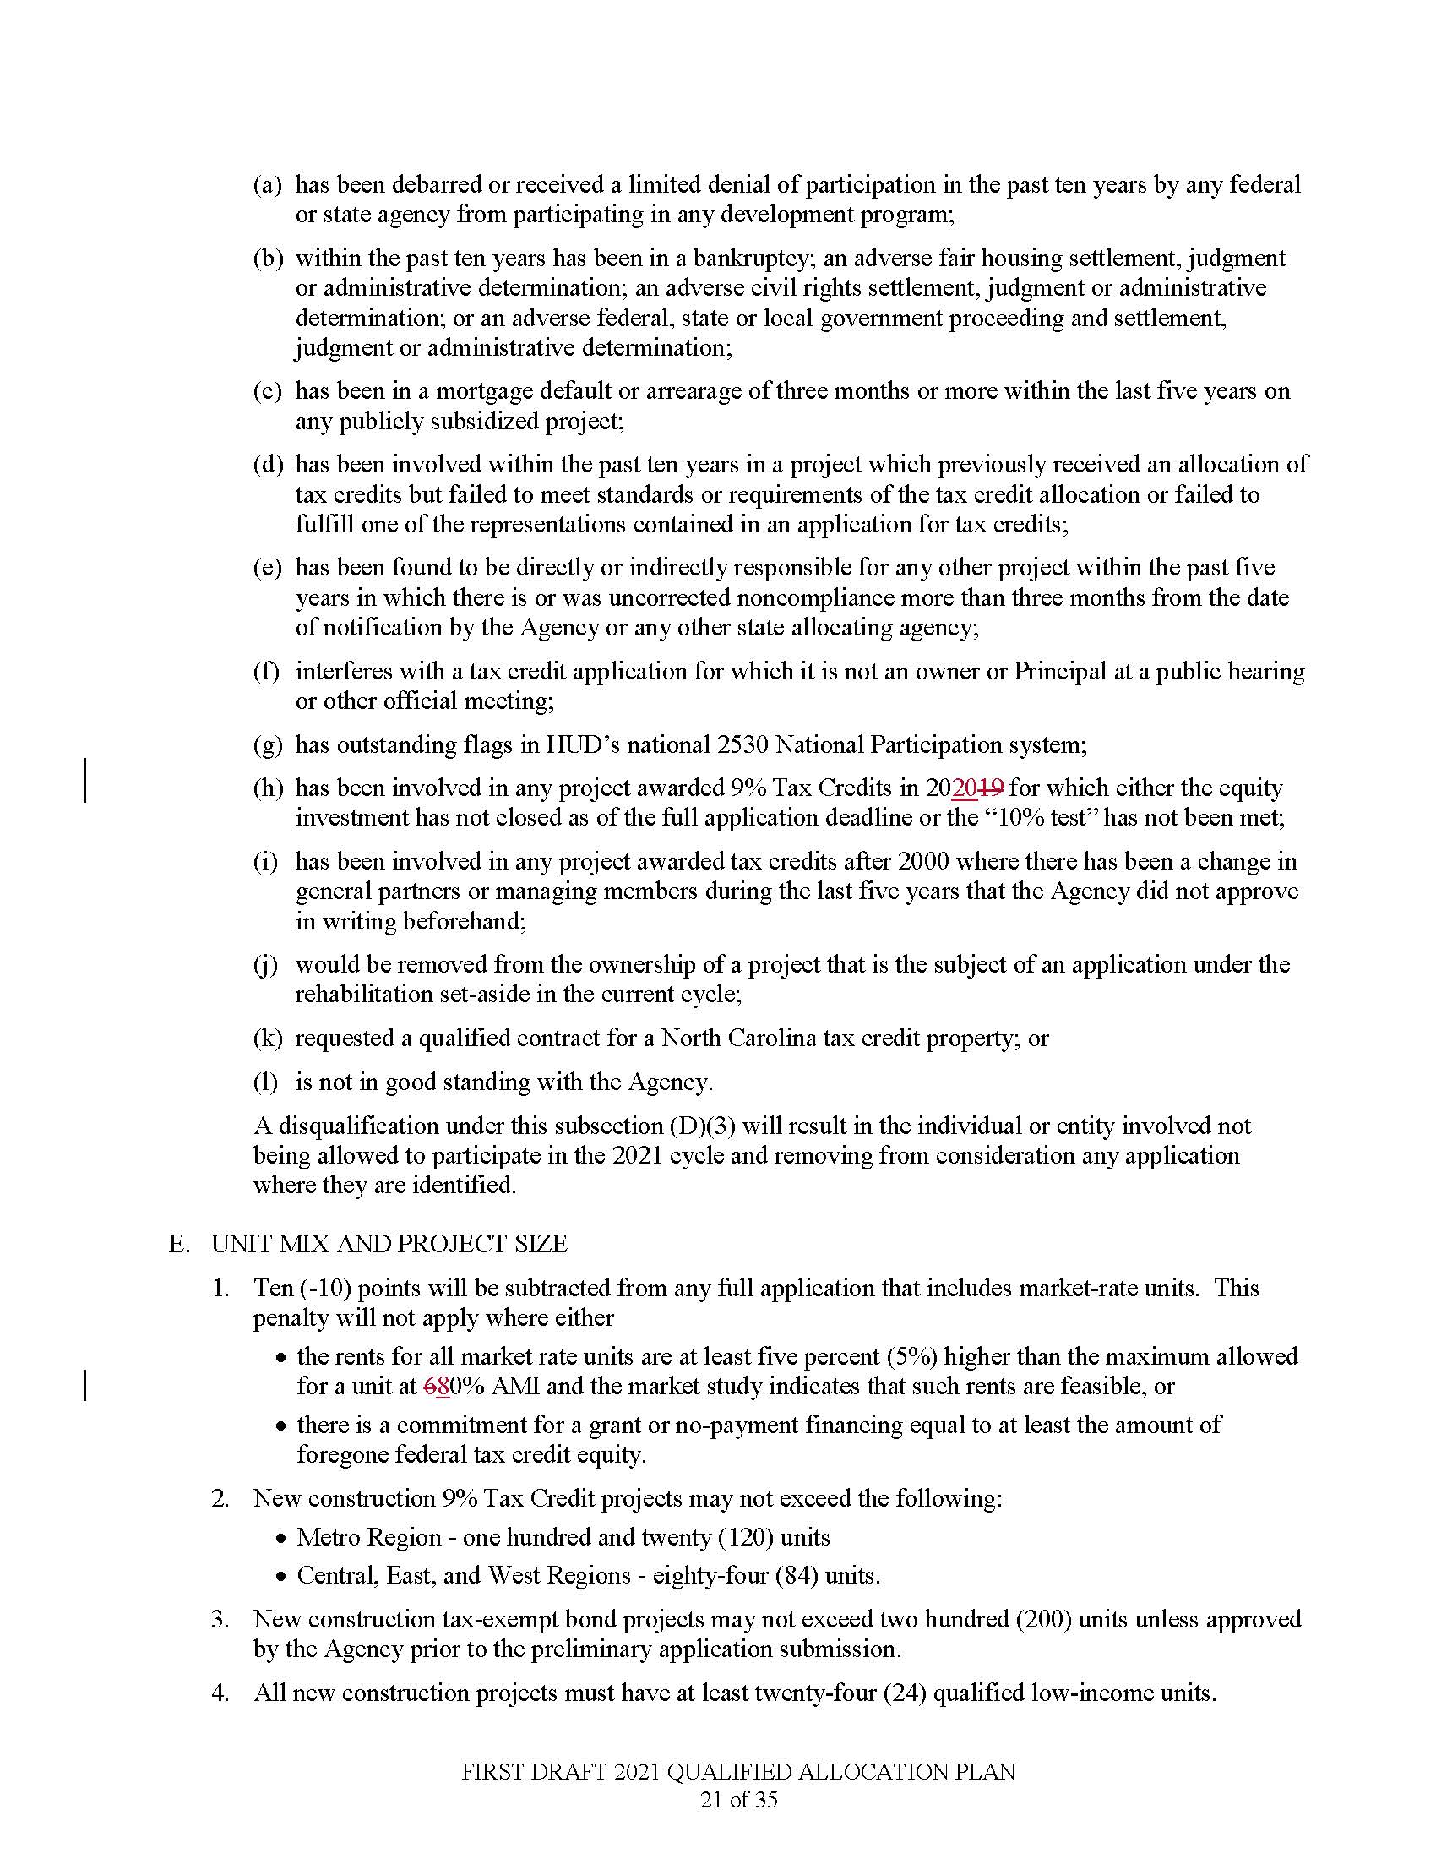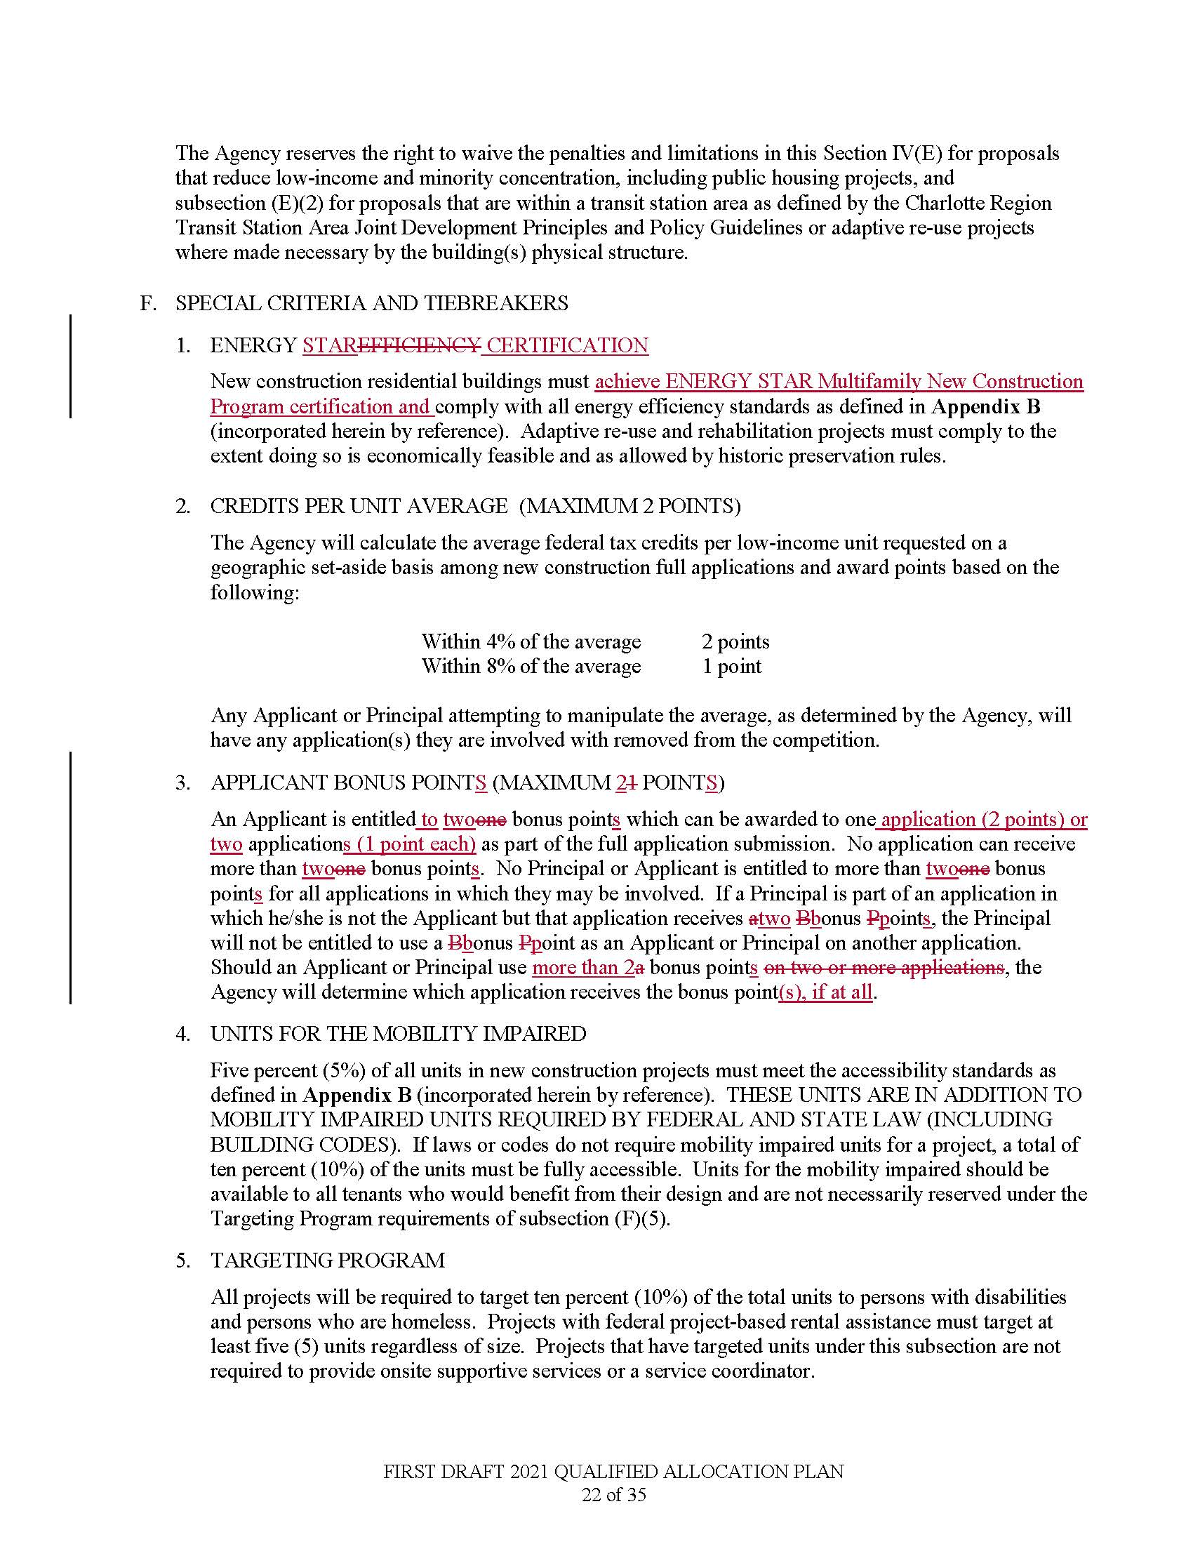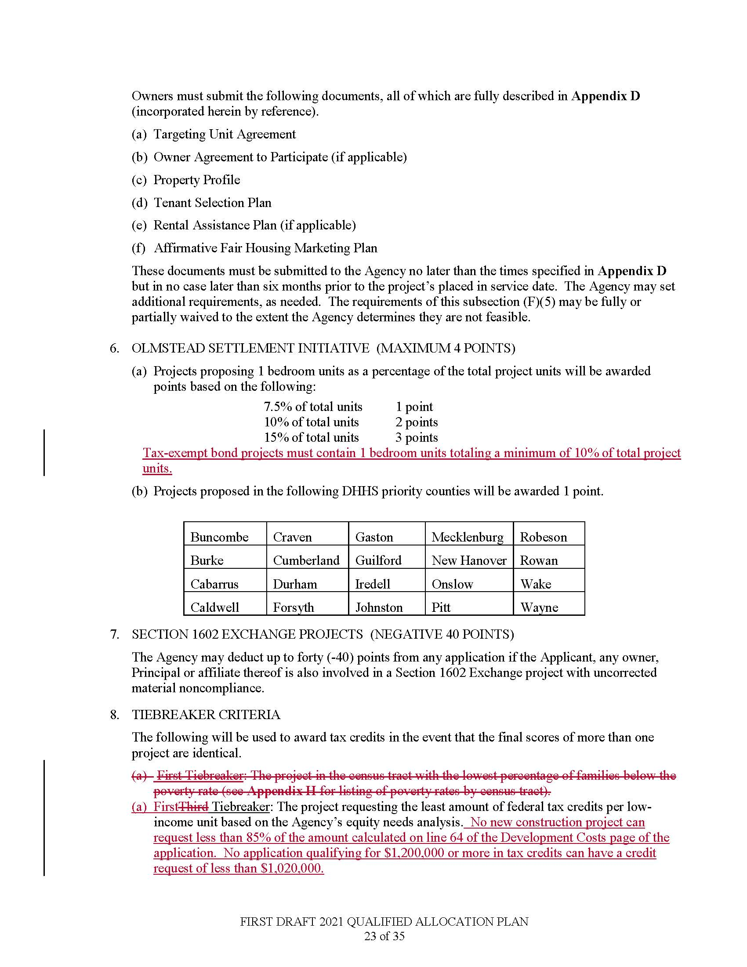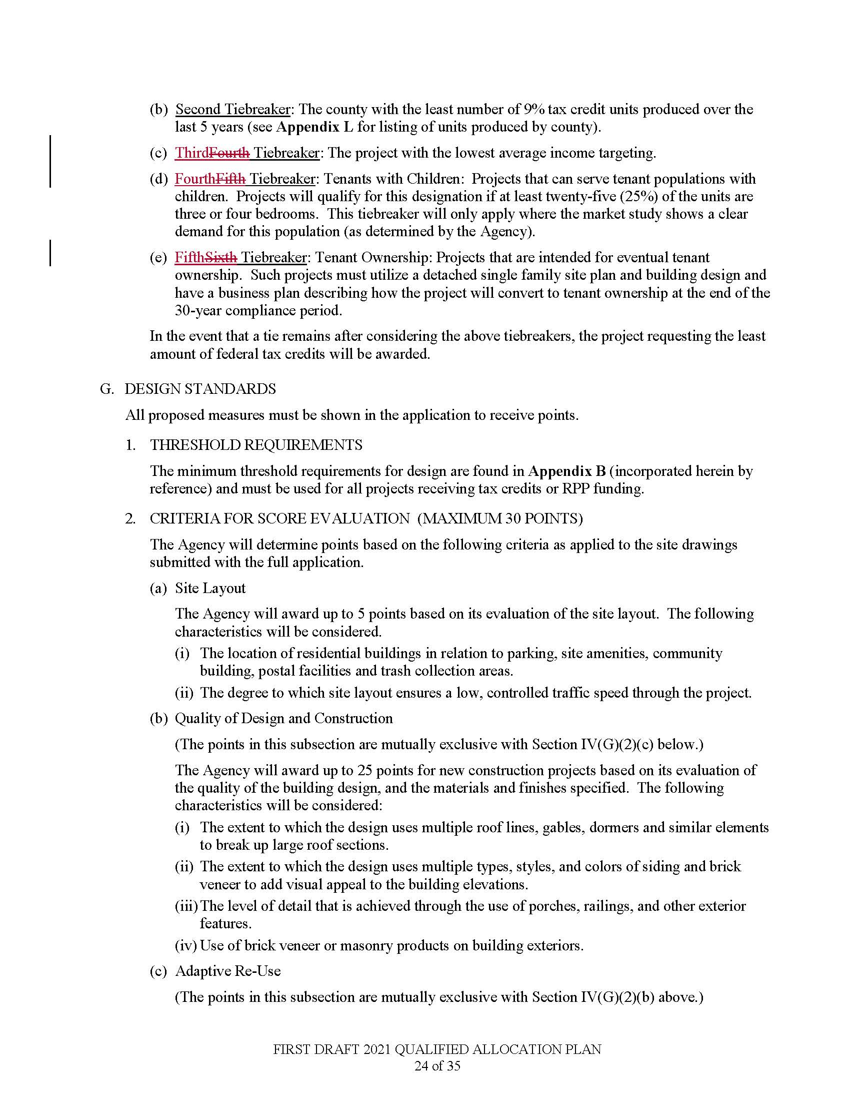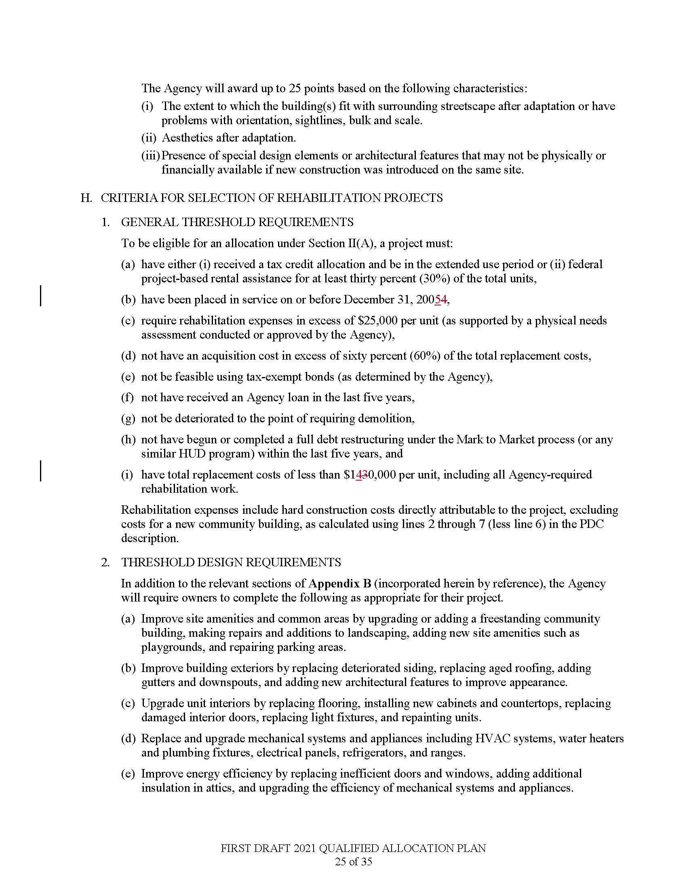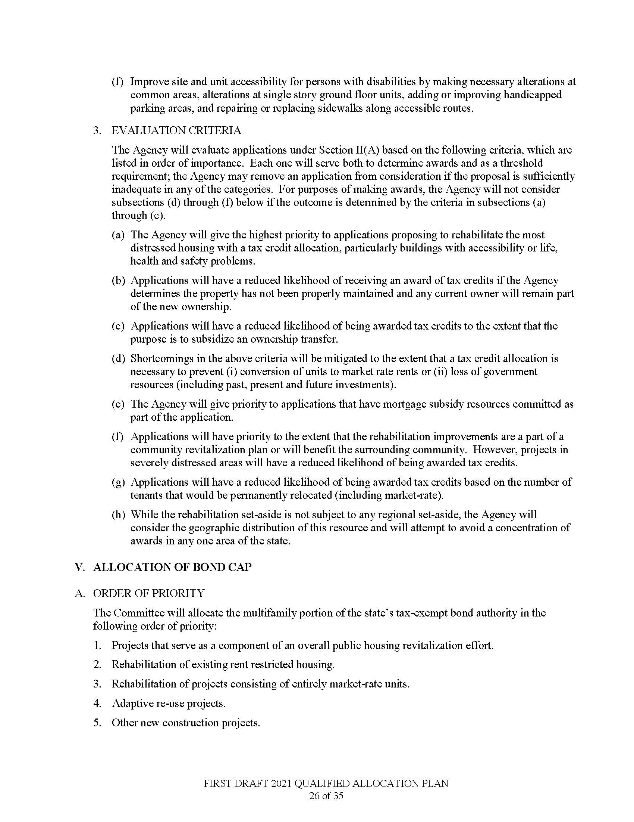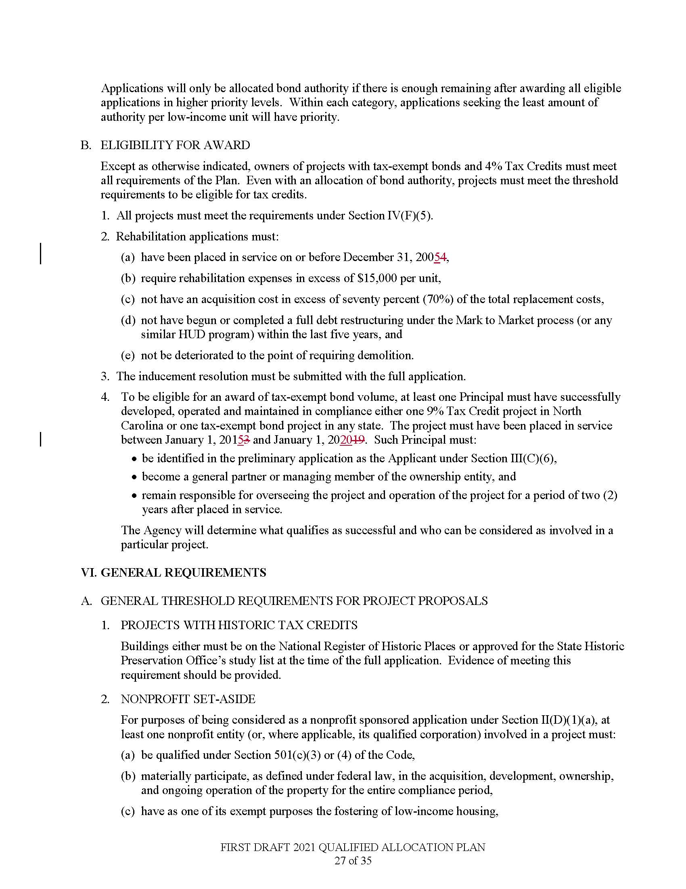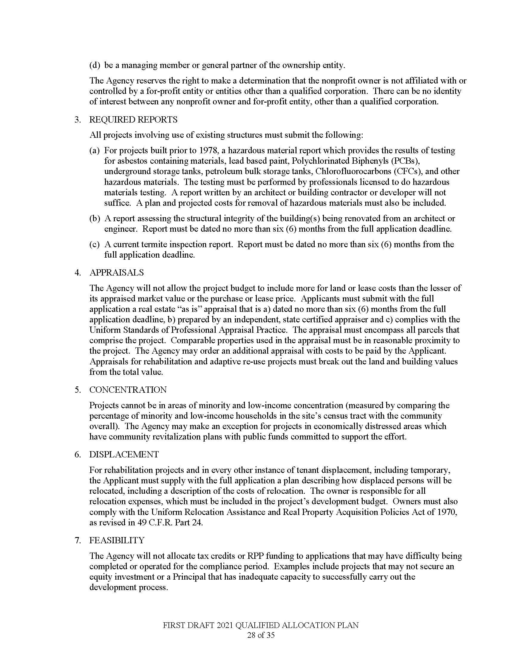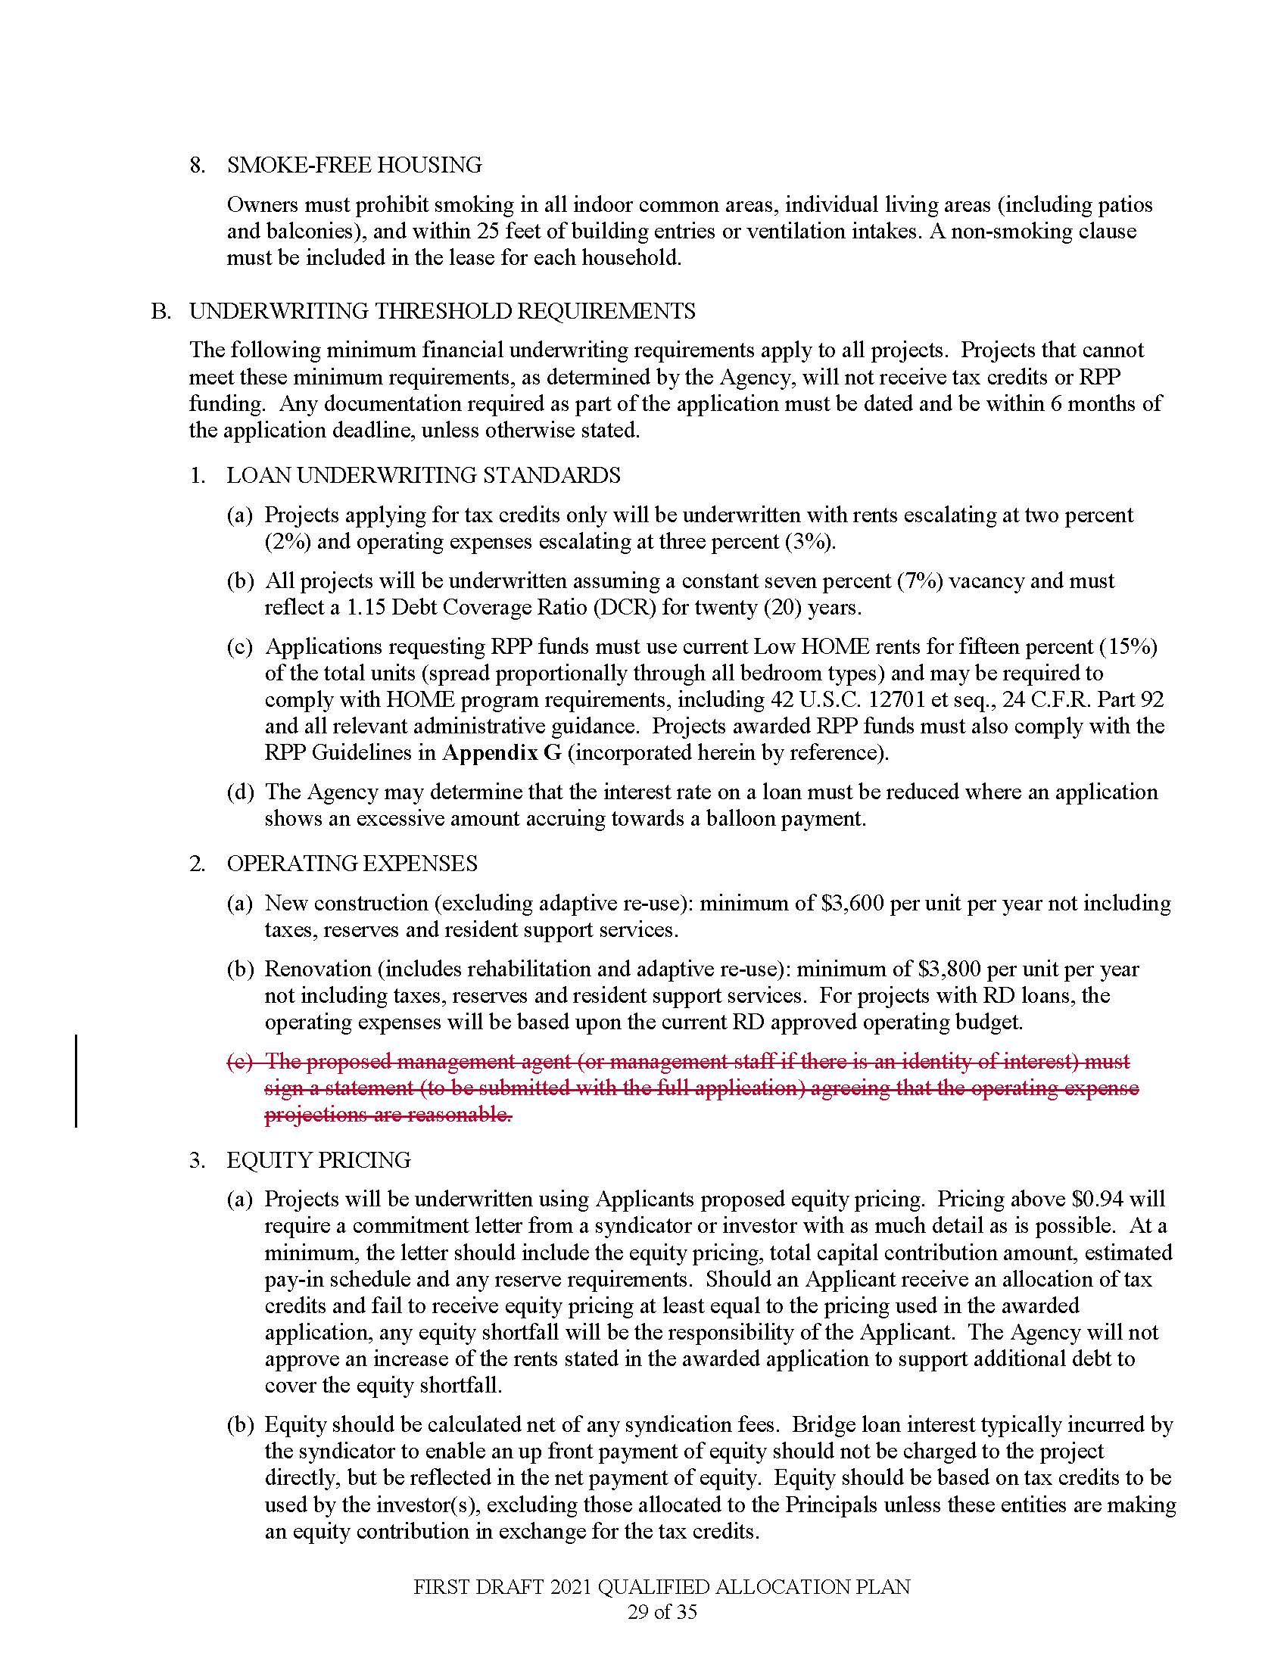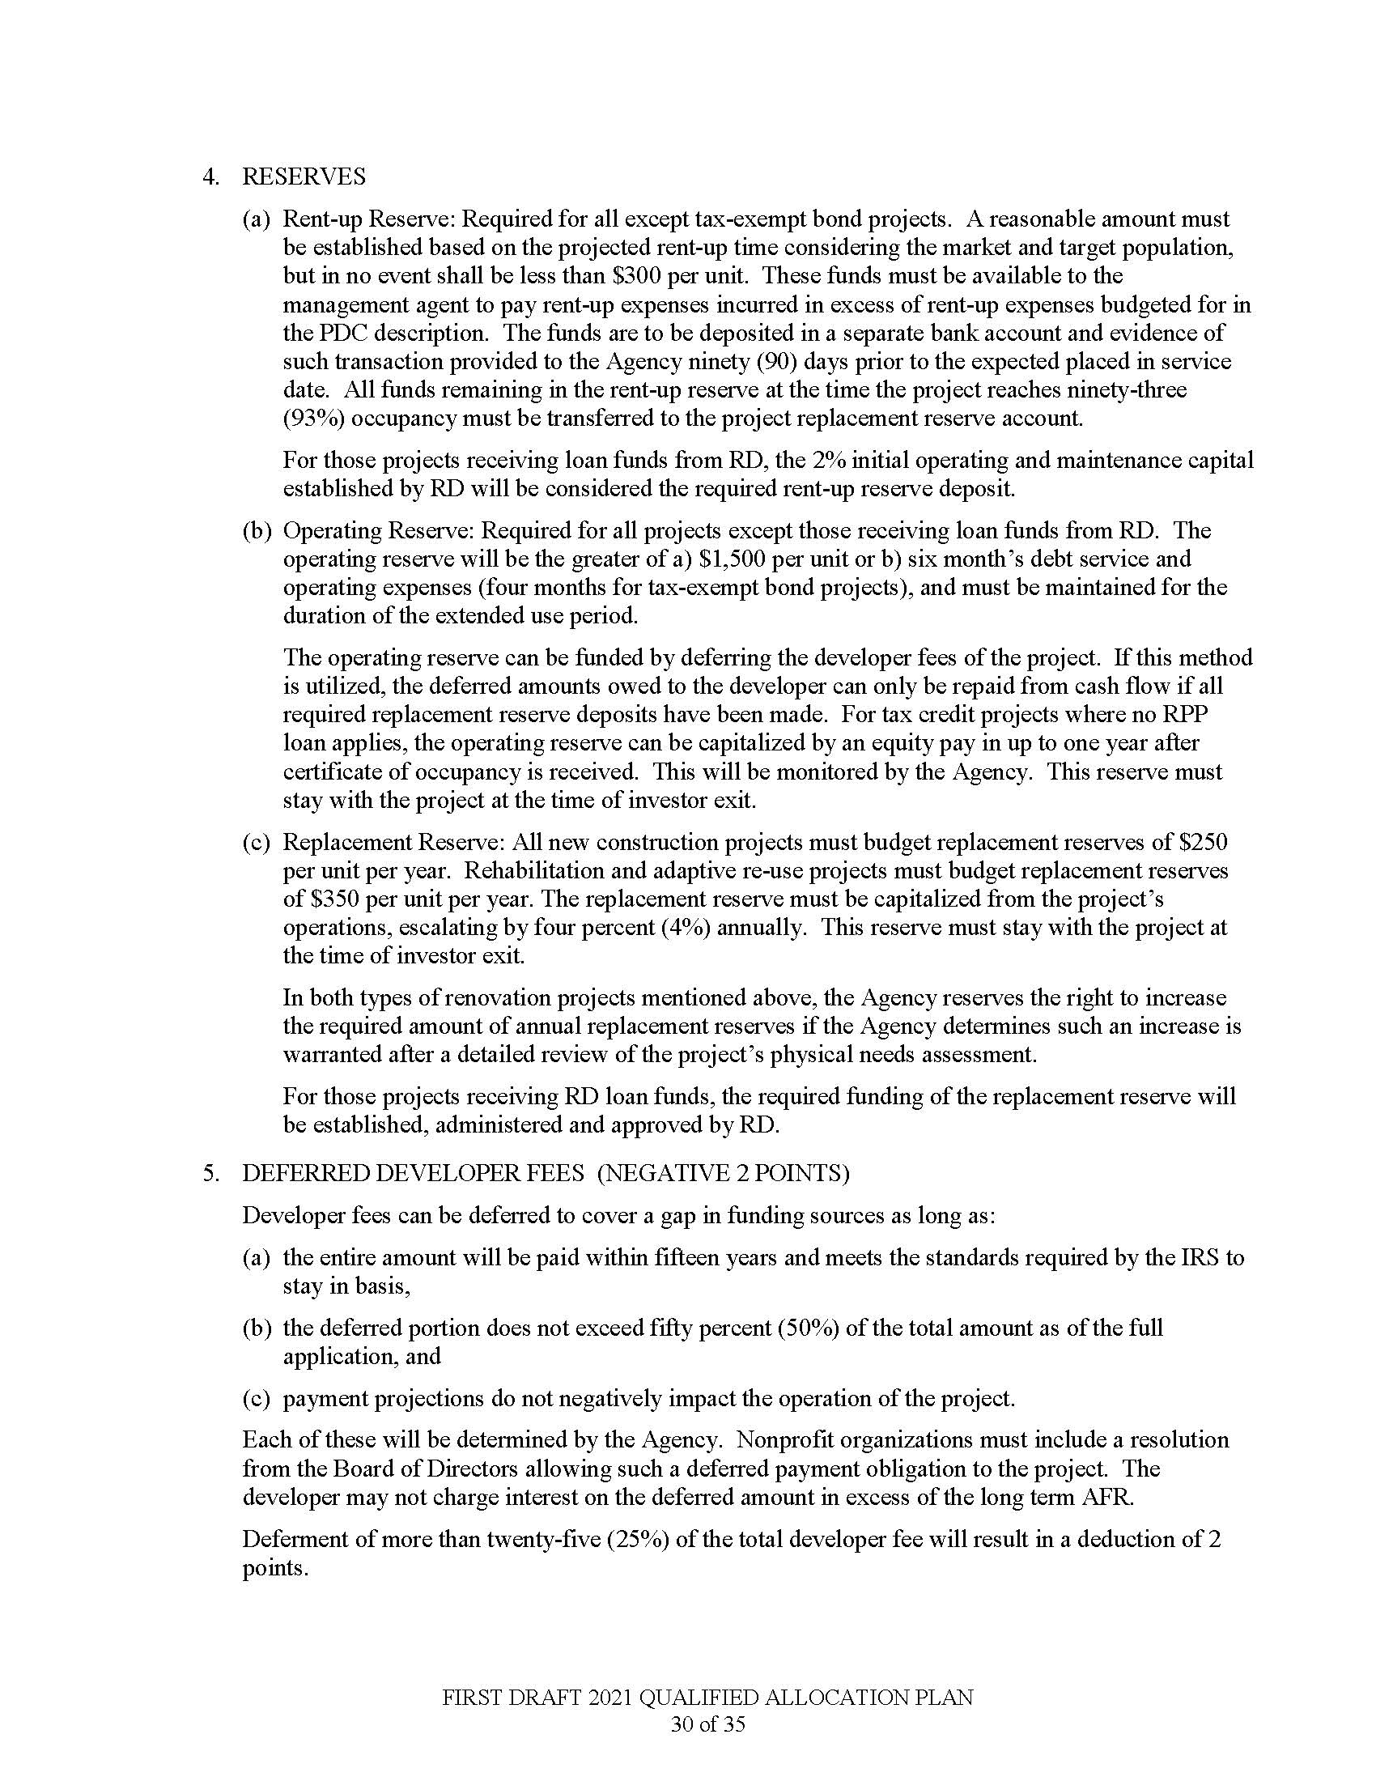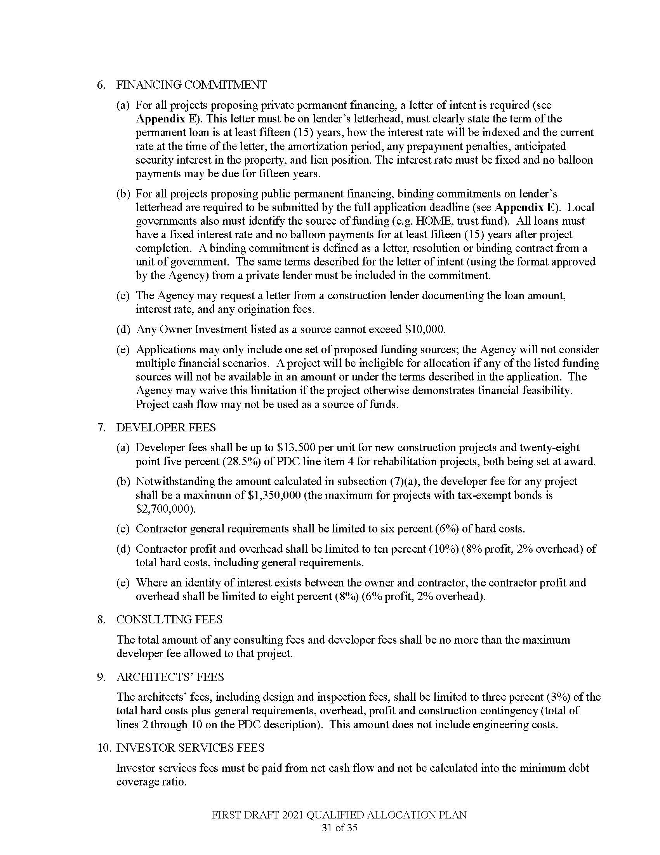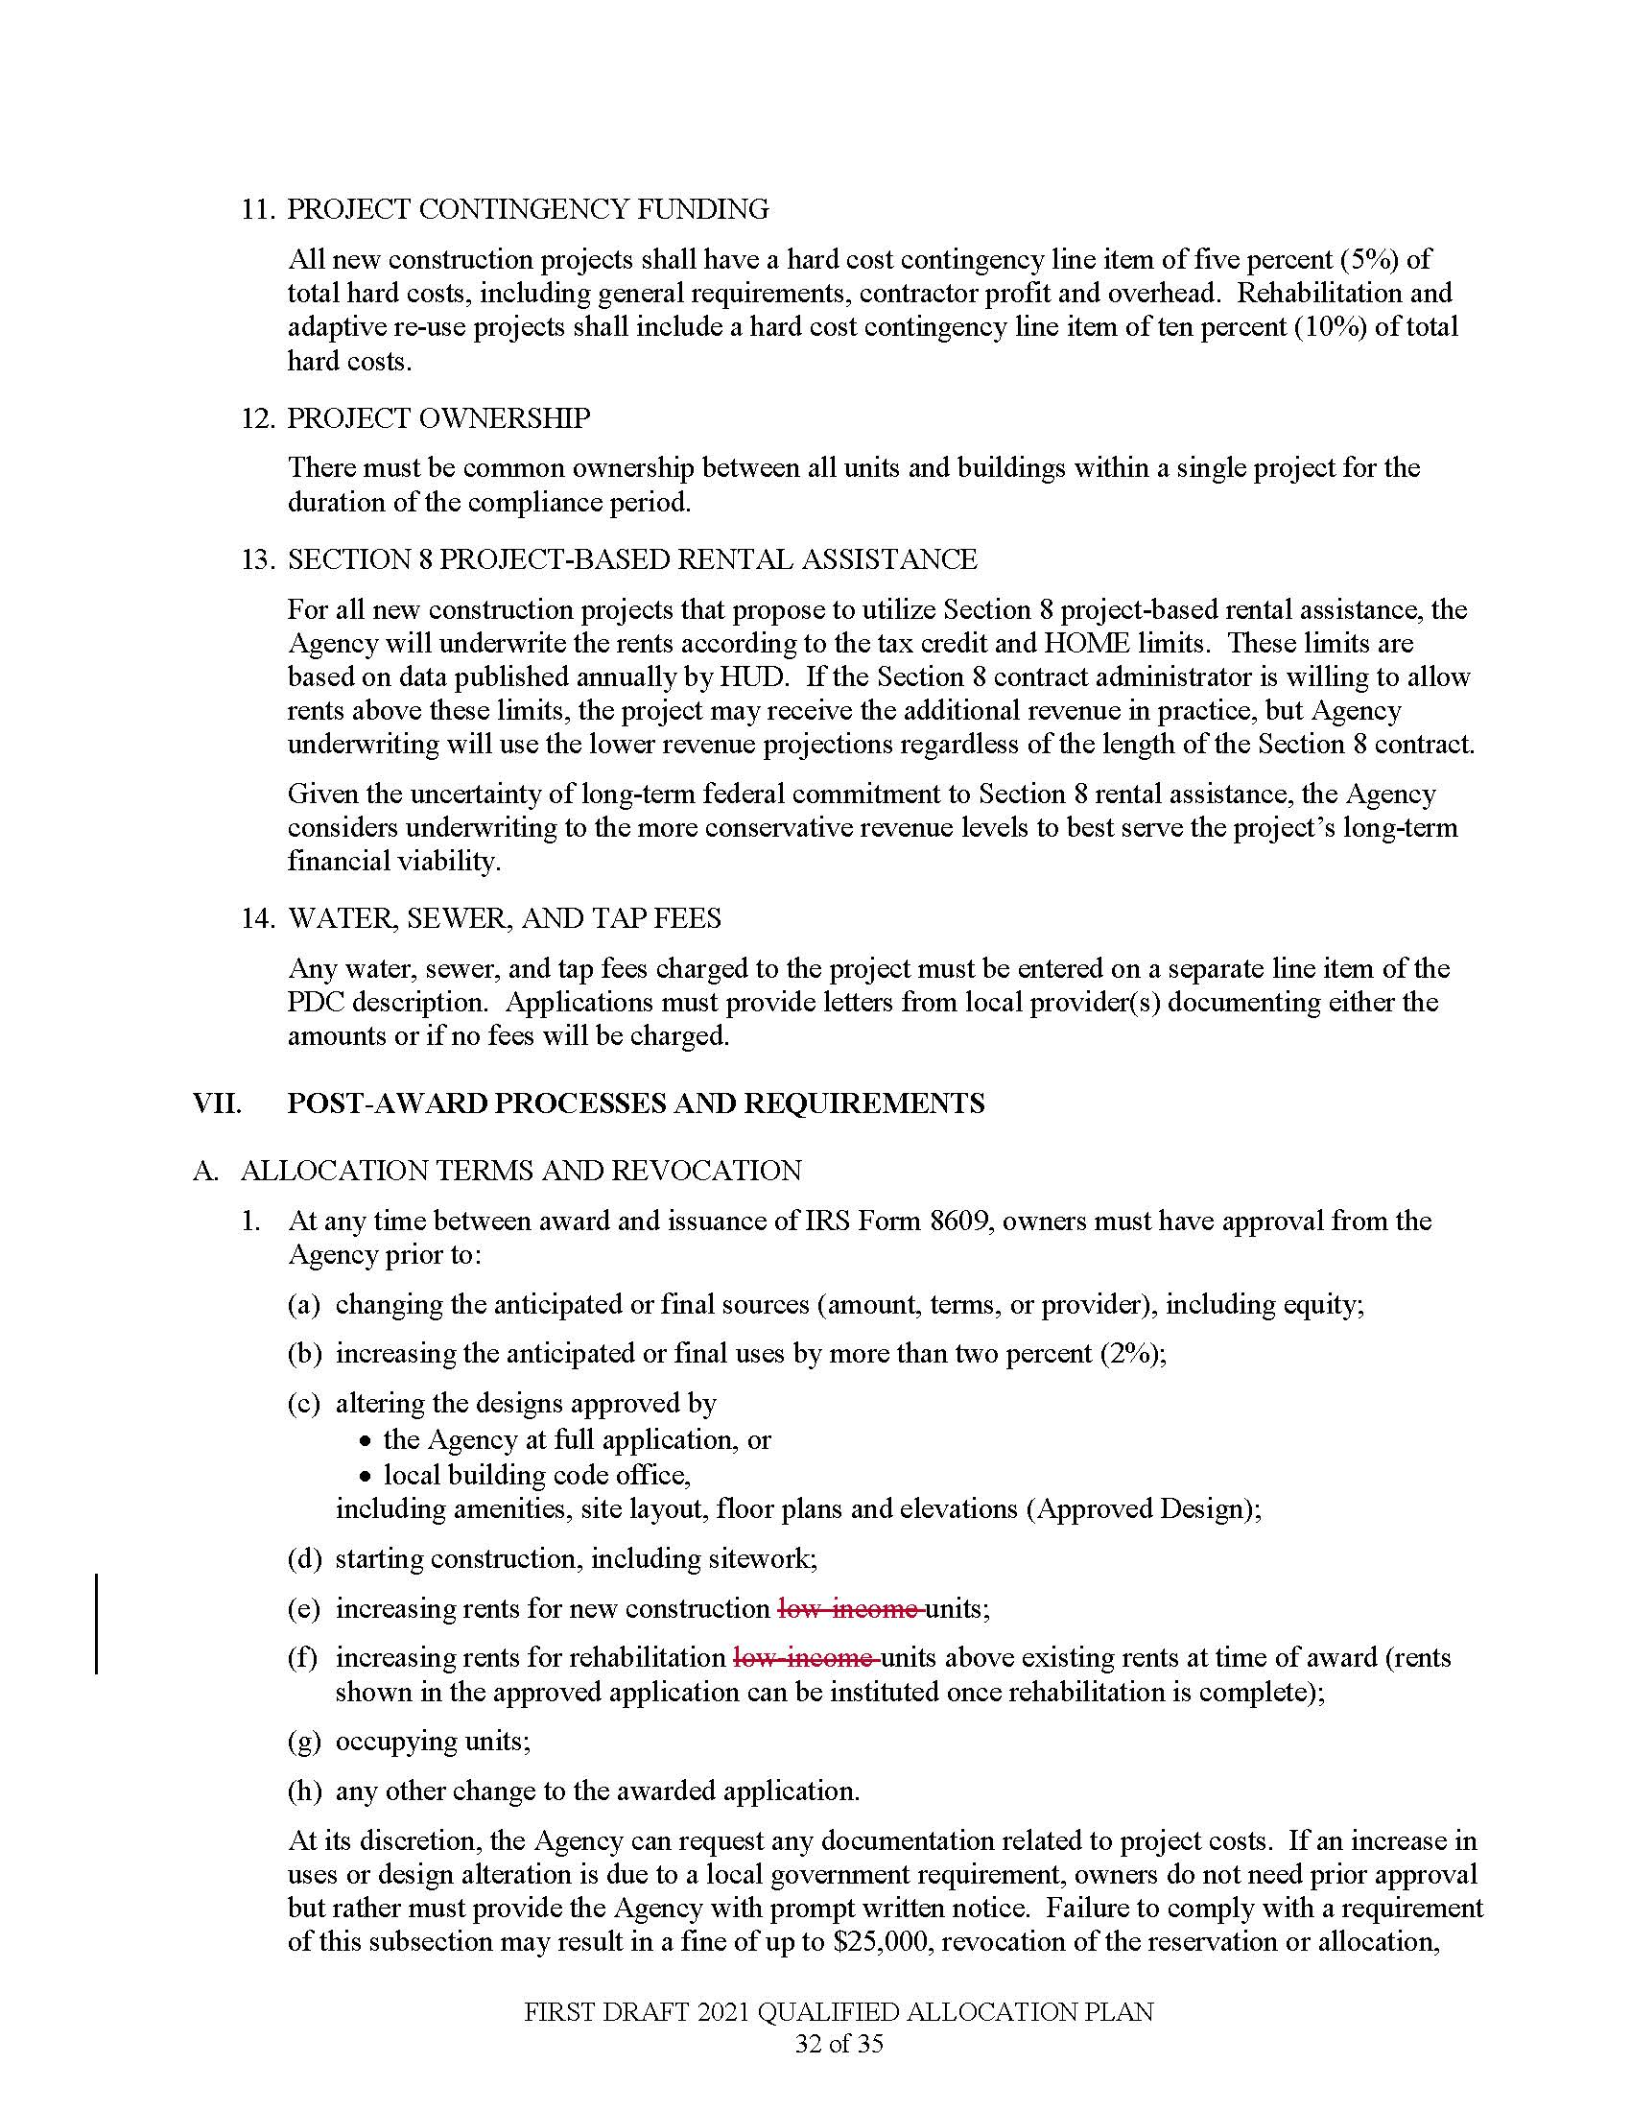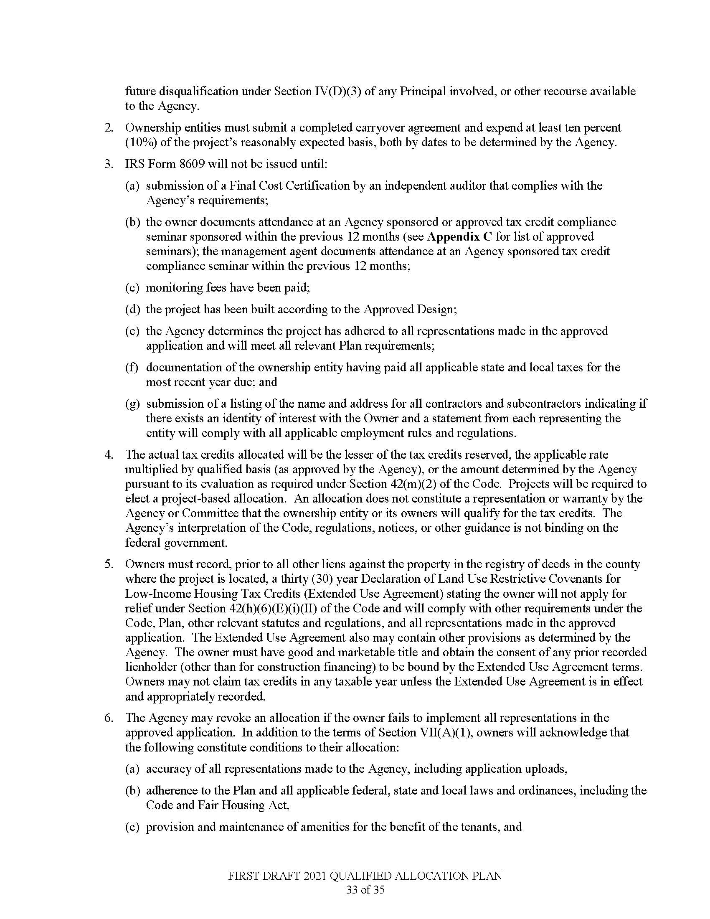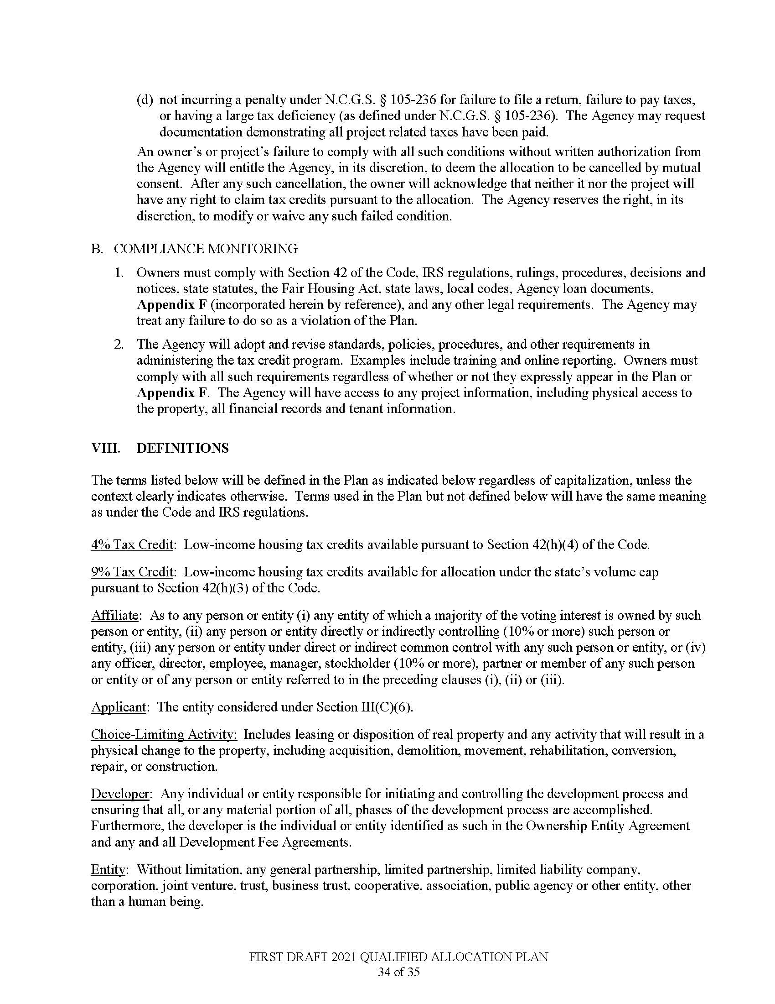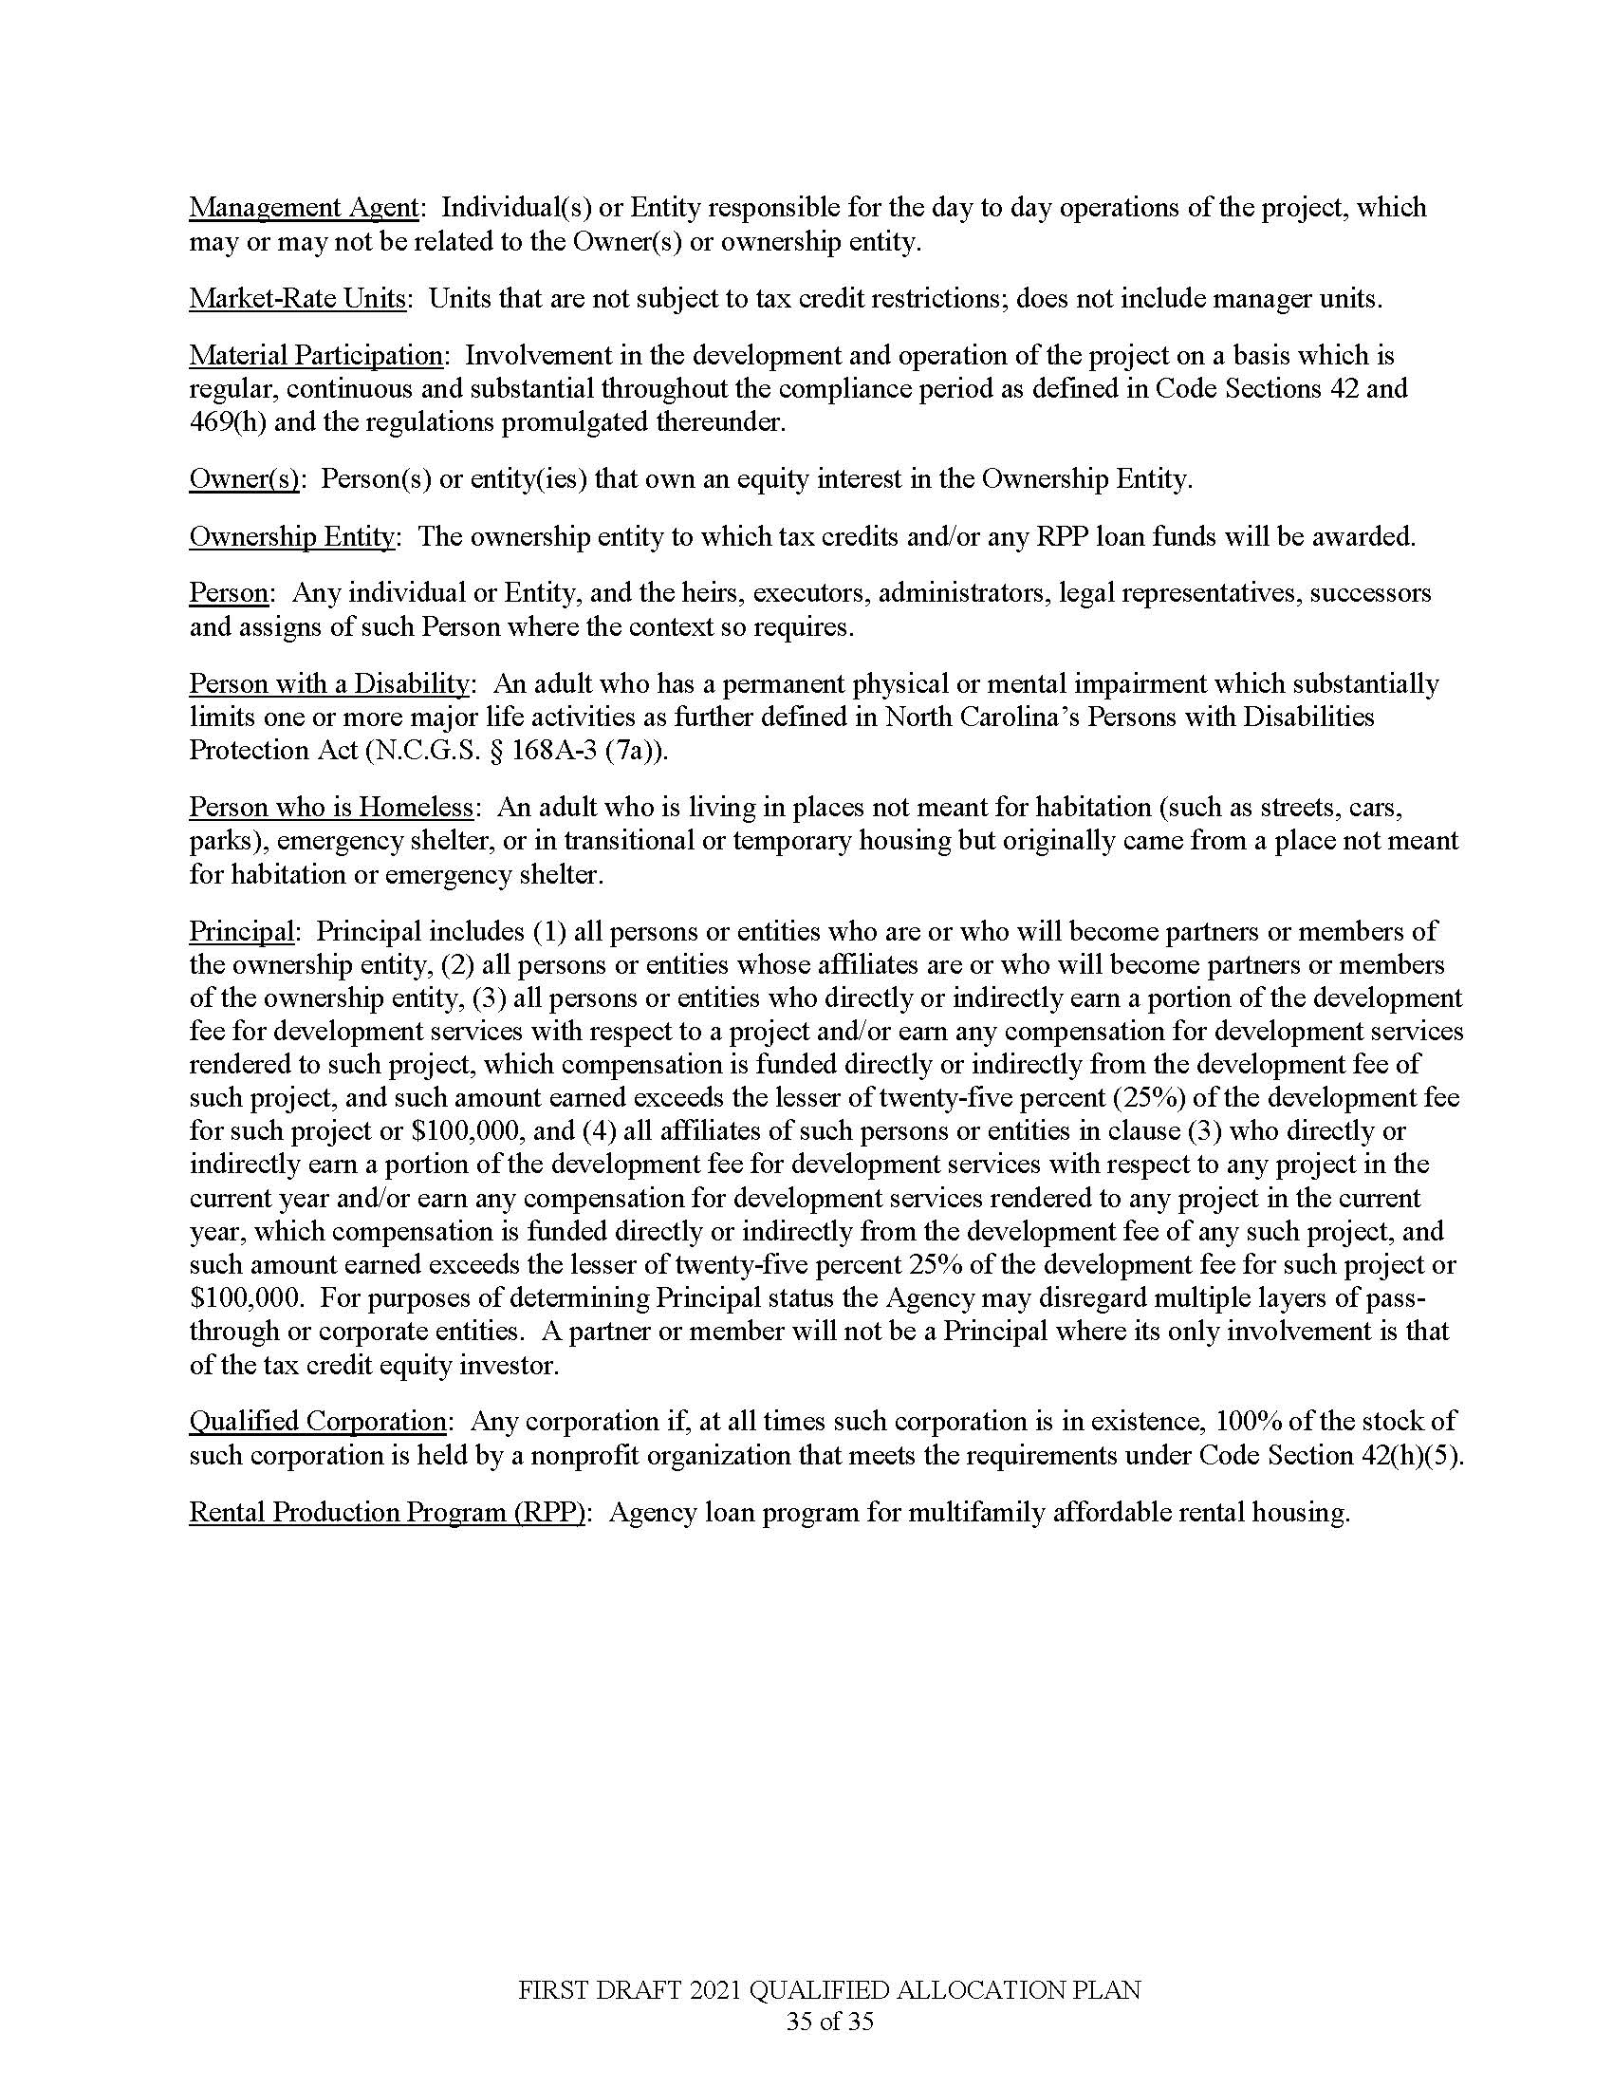

Note from the Codifier: The notices published in this Section of the NC Register include the text of proposed rules. The agency must accept comments on the proposed rule(s) for at least 60 days from the publication date, or until the public hearing, or a later date if specified in the notice by the agency. If the agency adopts a rule that differs substantially from a prior published notice, the agency must publish the text of the proposed different rule and accept comment on the proposed different rule for 60 days.
Statutory reference: G.S. 150B-21.2.

Title 09 – Offices of the Governor and Lt. Governor

Notice is hereby given in accordance with G.S. 150B-21.2 that the Department of Information Technology intends to adopt the rules cited as 09 NCAC 06A .0104; and 06D .0101-.0104.

Link to agency website pursuant to G.S. 150B-19.1(c): https://it.nc.gov/rules

Proposed Effective Date: December 1, 2020

Public Hearing:
Date: September 9, 2020
Time: 2:00 p.m.
Location: Webex, Link to join: https://ncgov.webex.com/ncgov/onstage/g.php?MTID=ec981cc268140a3b47da9ea4e714fb65c

Reason for Proposed Action: Agency is submitting the rules for adoption pursuant to G.S. 143B-1321(a)(16), G.S. 150B-20 and G.S. 116E-4(b). Chapter 150B requires that agencies with rulemaking authority adopt rules regarding the public's right to petition the agency to adopt rules. The first proposed rule aims to put the public on notice as to how they can communicate a proposed rule to the NC Department of Information Technology (NC DIT).

Chapter 116E provides that the Government Data Analytics Center (GDAC) within NC DIT is charged with specific oversight and operation of the ELDS, and requires that rules be adopted to implement the Article. GDAC's primary purpose for pursuing rulemaking is to meet the statutory requirement found in Chapter 116E and to ensure that the agencies and institutions that exchange data for the purposes listed in the Chapter are doing so under the same rules and legal framework.

Comments may be submitted to: Leigh Jackson, PO Box 17209, Raleigh, NC 27619-7209; phone (919) 917-6620; email DITrulesrequests@nc.gov

Comment period ends: October 16, 2020

Procedure for Subjecting a Proposed Rule to Legislative Review: If an objection is not resolved prior to the adoption of the rule, a person may also submit written objections to the Rules Review Commission after the adoption of the Rule. If the Rules Review Commission receives written and signed objections after the adoption of the Rule in accordance with G.S. 150B-21.3(b2) from 10 or more persons clearly requesting review by the legislature and the Rules Review Commission approves the rule, the rule will become effective as provided in G.S. 150B-21.3(b1). The Commission will receive written objections until 5:00 p.m. on the day following the day the Commission approves the rule. The Commission will receive those objections by mail, delivery service, hand delivery, or facsimile transmission. If you have any further questions concerning the submission of objections to the Commission, please call a Commission staff attorney at 919-431-3000.

Fiscal impact. Does any rule or combination of rules in this notice create an economic impact? Check all that apply.

State funds affected

Local funds affected

Substantial economic impact (>= $1,000,000)

Approved by OSBM

No fiscal note required

Chapter 06 - Office of Information and Technology Services

SUBCHAPTER 06A – INFORMATION TECHNOLOGY PROCUREMENT

SECTION .0100 – FORMS, TERMS AND CONDITIONS AND DEFINITIONS

09 NCAC 06A .0104 PETITIONS FOR RULE-MAKING

(a) Any person submitting a petition requesting the adoption, amendment, or repeal of a rule under this Chapter shall address the petition to the Rules Coordinator, Attn: DIT Legal Services, Mail Service Center 4101, Raleigh, North Carolina 27699-4101. Alternatively, a petition can also be emailed to DITrulesrequests@nc.gov.

(b) The petition shall contain the following:

(1) for petitions to adopt or amend a rule, a draft of the proposed rule or amendment;

(2) a statement of the effect of the requested rule change; and

(3) the name and address of the petitioner.

(c) The petition may contain the following:

(1) the reason for the proposal;

(2) the effect of the new rule on existing rules; or

(3) any data supporting the rule proposal.

Authority G.S. 143B-1321(a)(16); 116E-4(b).

SUBCHAPTER 06D – government data analytics center

SECTION .0100 – NORTH CAROLINA EDUCATION LONGITUDINAL DATA SYSTEM

09 NCAC 06D .0101 DEFINITIONS

In addition to the definitions set forth in 116E-1, the following definitions shall apply to the rules in this Section:
(1) "Aggregated" means the act of collecting or combining information and presenting it in a way that does not include personally identifying information of individuals. Aggregated data can be used for the purposes of making comparisons or identifying patterns within or among groups of subjects or individuals. An example of aggregated data would be the number of high school graduates from Wake County who graduated from the University of North Carolina System with a Bachelor of Science in Engineering within the past three years and their average salary.
(2) "Applicable law" means all statutes and rules of North Carolina and all relevant United States federal statutes, regulations, standards and policy requirements pertaining to the protection of privacy and security of confidential data. Applicable law includes the Family Educational Rights and Privacy Act, 20 U.S.C. 1232g; the Health Insurance Portability and Accountability Act, 42 U.S.C. 300gg, 29 U.S.C 1181 et seq., and 42 USC 1320d et seq.; the Workforce Innovation and Opportunity Act, 29 U.S.C. Ch. 32; and all regulations promulgated thereunder.
(3) "Contributor" means an entity that discloses Data to the System. The Contributors may be one or more of the entities specified in G.S. 116E-5(d)(1).
(4) "Data" means student data as defined in G.S. 116E-1(4), workforce data as defined in G.S. 116E-1(7), or other personally identifying data disclosed by the Contributors to the System and any data released from the System in response to data requests.
(5) "GDAC" means the Government Data Analytics Center, which has the authority to operate and oversee the System pursuant to G.S. 116E-4.
(6) "North Carolina Education Longitudinal Data System" or "System" means the technical system operated by GDAC along with the technical systems maintained and operated by the Contributors to collect, store, aggregate, and report or disclose Data solely when those systems are being utilized to respond to a Request.
(7) "Report" means the de-identified or aggregated information, data extract, or data file generated by the System using Data on a specified group of students, workforce members, or both, to fulfill a Request.
(8) "Request" means an inquiry for a Report containing information on a specified group of students, workforce members, or both from the System by a Requestor.
(9) "Requestor" means an entity or individual that makes a Request to the System for a Report. A Requestor may also be a Contributor.

Authority G.S. 143B-1321(a)(16); 116E-4(b).

09 NCAC 06D .0102 DATA REQUEST PROCESS

(a) In order to initiate a Request for a Report from the System, a Requestor must complete an Education Longitudinal Data System Report Request Form located at: https://it.nc.gov/services/nc-gdac. The Requestor shall submit the form through the website if submission is available online, by emailing it to gdacadmin@nc.gov, or by mailing a hard copy to the following address: Government Data Analytics Center, 4101 Mail Service Center, Raleigh, NC 27699-4101.

(b) The Requestor shall include, at a minimum, the following information in the Request form:

(1) the name of the Requestor individual and his or her contact information;

(2) the name of the organization for whom Requestor is making the Request on behalf of, if applicable;

(3) whether or not the Requestor, or the organization the Requestor is making the Request on behalf of, is considered a public official as defined under 20 C.F.R. 603.2(d);

(4) the categories or types of Data needed to generate the Reports being requested, e.g., data pertaining to students who graduated high school in 2013 who were students in the University of North Carolina School System in 2014;

(5) the purposes for which the Requestor will utilize the Reports; and

(6) to whom or in what medium the Requestor plans to publish research based on or interpretations of the Report.

(c) Requestors who receive data shall:

(1) store Reports on servers or media utilizing safeguards based on nationally accepted standards, including those published by the National Institute of Standards and Technology (NIST);

(2) comply with all Applicable Law and the Requestor data sharing agreement in storing and using the Reports, if applicable; and

(3) use a data destruction policy based on nationally accepted standards, including NIST standards, to destroy the Report after it has served the Requestor's stated purpose if the Report contains de-identified but not aggregated workforce data from the Division of Employment Security.

Authority G.S. 143B-1321(a)(16); 116E-4(b).

09 NCAC 06D .0103 CONTRIBUTOR DATA SHARING AGREEMENTS

(a) All Contributors that plan to contribute Data to the System shall enter into one or more Memoranda of Understanding with the Government Data Analytics Center and one or more Contributor that contain, at a minimum, the following:

(1) obligations to comply with all Applicable Law when disclosing, accessing, or using Data in the System;

(2) limitations on Data access to authorized persons employed or contracted by the parties of the Memorandum of Understanding;

(3) requirements for safeguarding any Data disclosed by a Contributor; and

(4) terms regarding the relevant limitations of liability for State and local government agencies and private or non-governmental Contributors.

(b) In accordance with G.S. 143B-1385(d)(2), each Contributor shall be the sole custodian of the Data it stores and maintains and that may be disclosed to the System. Each Contributor shall only disclose Data to the System and to GDAC that the Contributor is authorized to disclose in compliance with Applicable Law.

Authority G.S. 143B-1321(a)(16); 116E-4(b).

09 NCAC 06D .0104 REQUESTOR DATA SHARING AGREEMENTS AND REQUIREMENTS

(a) Except as provided in Paragraph (b) of this Rule, all Requestors shall enter into a data sharing agreement with the Contributors that are the custodians of the Data that may be needed to generate a requested report. The requestor data sharing agreement shall be separate and distinct from the Memorandum of Understanding between the Contributors and GDAC.

(b) Requestors who are also Contributors and parties to the Contributor Memorandum of Understanding shall not be required to enter into a Requestor data sharing agreement unless one or more of the Contributors responding to the party's Request requires a data sharing agreement to be entered into before Data is disclosed. An example of when a Requestor data sharing agreement may be required is an instance where a Contributor is making a Request of the NC Department of Commerce for Data that has not been Aggregated.

(c) The Requestor data sharing agreements shall contain, at a minimum, the following:

(1) limitations on Report access to authorized persons;

(2) prohibition on the re-identification of persons included in Reports as only de-identified information may be presented to Requestors in Reports from the System pursuant to G.S. 116E-(5)(e);

(3) information technology system and data security standards required by the Contributor who will be providing Data for the Report;

(4) privacy compliance standards;

(5) data breach procedures, including notification of DIT of any cybersecurity incidents as described by G.S. 143B-1320(a)(12) or G.S. 143b-1320(a)(15) using the incident report form available at: https://it.nc.gov/resources/cybersecurity-risk-management/statewide-cybersecurity-incident-report-form;

(6) terms regarding the disclaimer of liability and warranties as applied to Contributors; and

(7) data retention and data removal standards, if applicable.

Authority G.S. 143B-1321(a)(16); 116E-4(b).

Title 10A – Department of Health and Human Services

Notice is hereby given in accordance with G.S. 150B-21.2 that the Child Care Commission intends to amend the rules cited as 10A NCAC 09 .0102, .0302, .0403, .0601, .0606, .0607, .0701, .0713, .0801, .0802, .1103, .1106, .1402, .1403, .1702, .1703, .1706, .1707, .1714, .1718, .1721, .1724, .1729, .1730, .2204, .2206, .2209, .2318, .2408, .2410, .2509, .2703, .2809, .2817, .2903, and .3012.

Link to agency website pursuant to G.S. 150B-19.1(c): https://ncchildcare.ncdhhs.gov/Whats-New

Proposed Effective Date: December 1, 2020

Public Hearing:
Date: September 14, 2020
Time: 1:00 p.m.
Location: In an abundance of caution and to address protective measures to help prevent the spread of COVID-19, this public hearing will be held by WebEx.
To join as an attendee: https://ncgov.webex.com/ncgov/onstage/g.php?MTID=e8053308a46e9ea6d1b04550aed4faa37

Reason for Proposed Action:

10A NCAC 09 .0102 DEFINITIONS

A new definition was added for the “North Carolina Early Childhood Administration Credential.” Amendments were made to the definition of “Teacher’s aide or Aide” by removing the stipulation that they be monetarily compensated and allows them to be uncompensated. The purpose of this definition is to allow teacher aides or aides that are at least sixteen but less than 18 years old the opportunity to gain child care experience by working under someone who meets all qualifications who is at least 21 years of age. The definition of “Toddler” was revised to define the age of a toddler as 13 months to 35 months.

10A NCAC 09 .0302 APPLICATION FOR A LICENSE FOR A CHILD CARE CENTER

Proposed amendments were made to reflect new terminology by replacing the word “background” with “record.” New rule language was added to clarify the requirement for centers to maintain daily records of arrival and departure times for children as they arrive and depart the center.

10A NCAC 09 .0403 TEMPORARY LICENSES FOR CENTERS

Language is added to clarify that a temporary license remains in effect even after the six-month time period while waiting on the issuance of a rated license or administrative action. This change reflects current policy and practice.

10A NCAC 09 .0601 SAFE ENVIRONMENT

New language is added to clarify the expectation that all child care centers are to be free of lead poisoning hazards.

10A NCAC 09 .0606 SAFE SLEEP PRACTICES

“Play pen” was added to make the rule consistent with language in other sections related to rest. Additional language is proposed to promote safe sleep practices for infants during rest time, specifically noting children’s faces shall not have anything over their face during naptime.

10A NCAC 09 .0607 EMERGENCY PREPAREDNESS AND RESPONSE IN CHILD CARE CENTERS

This amendment lists the correct name of the agency that develops the Emergency Preparedness training as the Child Care Health and Safety Resource Center.

10A NCAC 09 .0701 HEALTH STANDARDS FOR CHILD CARE PROVIDERS, SUBSTITUTE PROVIDERS, VOLUNTEERS, AND UNCOMPENSATED PROVIDERS

This rule is amended to meet ADA federal requirements to say the medical report must be completed prior to employment rather than within 60 days of employment. Language is also included that the medical information must also be maintained separately from the personnel file which is a new requirement.

10A NCAC 09 .0713(f) STAFF/CHILD RATIOS FOR CENTERS

This is a recurring change with amended language to the staff/child ratio section, clarifying the combination of groups in a child care setting. New language is added to reflect the combination of children between the ages of 12 months and 24 months and to reflect the posting of staff/child ratio. New language and a chart were added clarifying staff/ratios for centers with multi-age group classrooms.

10A NCAC 09 .0801 APPLICATION FOR ENROLLMENT

Proposed language is added to the medication action plan to clarify when to update the plan, in addition to updating it annually. The rule now includes when changes are made by the parent or health care professional.

10A NCAC 09 .0802 EMERGENCY MEDICAL CARE

Proposed language adds the child’s name back into rule as what shall be included on an incident report. The words “if applicable” was added for clarification.

10A NCAC 09 .1103 ON-GOING TRAINING REQUIREMENTS

The rule is amended to allow technical assistance to count toward annual ongoing training requirements at a ratio of 3hrs:1hr under certain conditions.

10A NCAC 09 .1106 DOCUMENTATION OF TRAINING

“On-going” and “Professional Development” was added to the rule title. On-going training requirements were amended; and Paragraph (b) is a new addition requiring the documentation of countable TA.

10A NCAC 09 .1402 OUTDOOR SPACE

This proposed amendment clarifies outdoor space requirements, which are less than previously required. Prior to 2017, the rule required 75 square feet for half of the capacity. The suggested change is 75 square feet for the children using the space.

10A NCAC 09 .1403 ACTIVITIES INVOLVING WATER IN CHILD CARE CENTERS

Amendments made to reflect terminology used when children participate in aquatic activities away from the center. “Off-premises” replaces the word “field trip.”

10A NCAC 09 .1702 APPLICATION FOR A LICENSE FOR A FAMILY CHILD CARE HOME

Change made in existing rule to reflect new terminology by replacing “background” with “record.”

New rule language added to clarify the requirement for centers to maintain daily records of arrival and departure as the children arrive and depart the center.

10A NCAC 09 .1703 ON-GOING REQUIREMENTS FOR FAMILY CHILD CARE HOME OPERATORS

The rule is amended to allow technical assistance to count toward annual ongoing training requirements at a ratio of 3hrs:1hr under certain conditions.

10A NCAC 09 .1706 NUTRITION STANDARDS

Changes “center” to “family child care home” to clarify rule type.

10A NCAC 09 .1707 BUILDING REQUIREMENTS

Proposed language added to require family child care homes to be free of lead poisoning hazards.

10A NCAC 09 .1714 EMERGENCY PREPAREDNESS

Correction made to clarify facility type. The rule referenced Child Care Centers and should have referenced Family Child Care Homes.

10A NCAC 09 .1718 REQUIREMENTS FOR DAILY

Proposed language matches this Rule with the Child Care Center rules. Individual sleeping space noting possible types and the need for linens was added. This Rule was inadvertently left out of the review of existing rules process. Individual linens are already addressed, and facilities are already giving each child individual space.

10A NCAC 09 .1721 REQUIREMENT FOR RECORDS

This is a recurring change. Language added to clarify the medical action rules and when to update them. Corrections were made to this Rule to match the Child Care Center rules.

10A NCAC 09 .1724 SAFE SLEEP PRATICES

Language added to make rule consistent with Child Care Center rules (mat, play pen and cot was added).

10A NCAC 09 .1729 ADDITIONAL CAREGIVER AND SUBSTITUTE PROVIDER QUALIFICATIONS

Language added to clarify rule and to be consistent with Child Care Center rules. The word screening was added.

10A NCAC 09 .1730 ACTIVITIES INVOLVING WATER

This is a recurring change. Language added to rule and added new language about documentation. “The policies shall be reviewed with additional caregivers and substitute providers prior to caring for children participating in aquatic activities.”

10A NCAC 09 .2204 PROVISIONAL CHILD CARE FACILITY LICENSE OR PROVISIONAL NOTICE OF COMPLIANCE

Language added to clarify policy regarding time for a facility to correct lead poisoning hazards as determined by 15A NCAC 18A .2816.

10A NCAC 09 .2206 SUSPENSION

Proposed language adds additional circumstance to the time period for correcting a violation due to suspension.

10A NCAC 09 .2209 REVOCATION OF A CHILD CARE FACILITY LICENSE OR AN ORDER TO CEASE OPERATION

Amendment sets the standards for a revocation of a child care facility when in receipt of a disapproved sanitation classification.

10A NCAC 09 .2318 CHILD CARE CENTER RECORD RETENTION

Language added to clarify the types of records that shall be kept at the Center. Under child records policy was added for “off-premises” and “shaken baby syndrome and abusive head trauma.” The words “or screening” was added to proof of Tuberculosis Test to be kept in personnel records.

10A NCAC 09 .2408 STAFF QUALIFICATIONS

The revision in this Rule was to provide clarifying language to support an existing requirement in Rule .1102. There is no new requirement, only noting it in this Section as well as the other.

10A NCAC 09 .2410 CHILDREN’S ACTIVITIES

Language added that provided a reference of the daily outdoor time requirements for child care centers.

10A NCAC 09 .2509 ACTIVITIES: OFF PREMISES

Language added to reflect word change, from “field trip” to “off-premises.”

10A NCAC 09 .2703(f) CRIMINAL HISTORY RECORD CHECK REQUIREMENTS FOR CHILD CARE PROVIDERS

The option for provisional qualification allows child care providers who moved to North Carolina within the last five years to become provisionally qualified if they comply with the out of state requirement. Language was ad
Comments may be submitted to: Dedra Alston, 2201 Mail Service Center, Raleigh, NC 27699-2201; phone (919) 814-6307; fax (919) 715-0968; email Dedra.Alston@dhhs.nc.gov

Comment period ends: October 16, 2020

Procedure for Subjecting a Proposed Rule to Legislative Review: If an objection is not resolved prior to the adoption of the rule, a person may also submit written objections to the Rules Review Commission after the adoption of the Rule. If the Rules Review Commission receives written and signed objections after the adoption of the Rule in accordance with G.S. 150B-21.3(b2) from 10 or more persons clearly requesting review by the legislature and the Rules Review Commission approves the rule, the rule will become effective as provided in G.S. 150B-21.3(b1). The Commission will receive written objections until 5:00 p.m. on the day following the day the Commission approves the rule. The Commission will receive those objections by mail, delivery service, hand delivery, or facsimile transmission. If you have any further questions concerning the submission of objections to the Commission, please call a Commission staff attorney at 919-431-3000.

Fiscal impact. Does any rule or combination of rules in this notice create an economic impact? Check all that apply.

State funds affected

Local funds affected

Substantial economic impact (>= $1,000,000)

Approved by OSBM

No fiscal note required

Chapter 09 - Child Care Rules

SECTION .0100 - DEFINITIONS

10A NCAC 09 .0102 DEFINITIONS

The terms and phrases used in this Chapter are defined as follows except when the context of the rule requires a different meaning. The definitions prescribed in G.S. 110-86 also apply to these Rules.
(1) "Activity area" means a space that is accessible to children and where related equipment and materials are kept in accordance with G.S. 110-91(12).
(2) "Agency" as used in this Chapter means Division of Child Development and Early Education, Department of Health and Human Services located at 333 Six Forks Road, Raleigh, North Carolina 27609.
(3) "Appellant" means the person or persons who request a contested case hearing.
(4) "Basic School-Age Care" training (BSAC training) means the training on the elements of quality afterschool care for school-age children, developed by the North Carolina State University Department of 4-H Youth Development and subsequently revised by the North Carolina School-age Quality Improvement Project.
(5) "Biocontaminant" means blood, bodily fluids, or excretions that may spread infectious disease.
(6) "Child Care Center" means an arrangement where, at any one time, there are three or more preschool-age children or nine or more school-age children receiving child care. This does not include arrangements described in Item (18) of this Rule regarding Family Child Care Homes.
(7) "Child Care Facility" means child care centers, family child care homes, and any other child care arrangement not excluded by G.S. 110-86(2), that provides child care, regardless of the time of day, wherever operated, and whether or not operated for profit.
(8) "Child care provider" as defined by G.S. 110-90.2(a)(2) includes the following employees who have contact with the children in a child care program:
(a) facility directors;
(b) child care administrative staff;
(c) teachers;
(d) teachers' aides;
(e) substitute providers;
(f) uncompensated providers;
(g) cooks;
(h) maintenance personnel; and
(i) drivers.
(9) "Child Development Associate Credential" means the national early childhood credential administered by the Council for Early Childhood Professional Recognition.
(10) "Curriculum" means a curriculum that has been approved as set forth in these Rules by the NC Child Care Commission as comprehensive, evidenced-based, and with a reading component.
(11) "Developmentally appropriate" means suitable to the chronological age range and developmental characteristics of a specific group of children.
(12) "Division" means the Division of Child Development and Early Education within the Department of Health and Human Services.
(13) "Domains" means the developmental areas of learning described in the North Carolina Foundations for Early Learning and Development © 2013, available on the Division's website at http://ncchildcare.nc.gov/providers/pv_foundations.asp. This instrument is incorporated by reference and does not include subsequent editions. The domains address children's emotional and social development, health and physical development, approaches to play and learning, language development, and communication and cognitive development.
(14) "Drop-in care" means a child care arrangement where children attend on an intermittent, unscheduled basis.
(15) "Early Childhood Environment Rating Scale - Revised Edition" (Harms, Clifford, and Cryer, 2005, published by Teachers College Press, New York, NY) is the instrument used to evaluate the quality of care received by a group of children in a child care center, when the majority of children in the group are two and a half years old through five years old, to achieve three or more points for the program standards of a rated license. This instrument is incorporated by reference and does not include subsequent editions. A copy of the scale is available for purchase on the Teachers College Press website at http://www.teacherscollegepress.com/assessment_materials.html. The cost of this scale is twenty-four dollars and ninety-five cents ($24.95). A copy of this instrument is on file at the Division at the address given in Item (2) of this Rule and is available for public inspection during regular business hours. For the purposes of this Rule, "regular business hours" for the Division means 8 a.m. to 5 p.m. during weekdays, excluding state holidays.
(16) "Experience working with school-age children" means working with school-age children as a child care administrator, program coordinator, group leader, assistant group leader, lead teacher, teacher or aide.
(17) "Family Child Care Environment Rating Scale – Revised Edition" (Harms, Cryer and Clifford, 2007, published by Teachers College Press, New York, NY) is the instrument used to evaluate the quality of care received by children in family child care homes to achieve three or more points for the program standards of a rated license. This instrument is incorporated by reference and does not include subsequent editions. A copy of the scale is available for purchase on the Teachers College Press website at http://www.teacherscollegepress.com/assessment_materials.html. The cost of this scale is twenty-four dollars and ninety-five cents ($24.95). A copy of this instrument is on file at the Division at the address given in Item (2) of this Rule and is available for public inspection during regular business hours.
(18) "Family Child Care Home" means a child care arrangement located in a residence where, at any one time, more than two children, but less than nine children, receive child care. Family child care home operators must reside at the location of the family child care home.
(19) "First aid kit" is a collection of first aid supplies (such as bandages, tweezers, disposable nonporous gloves, micro shield or face mask, liquid soap, cold pack) for treatment of minor injuries or stabilization of major injuries.
(20) "Group" means the children assigned to a specific caregiver or caregivers, to meet the staff/child ratios set forth in G.S. 110-91(7) and in this Chapter, using space the Division has identified for each group.
(21) "Health care professional" means:
(a) a physician licensed in North Carolina;
(b) a nurse practitioner approved to practice in North Carolina; or
(c) a licensed physician assistant.
(22) "Household member" means a person who resides in a family home as evidenced by factors including maintaining clothing and personal effects at the household address, receiving mail at the household address, using identification with the household address, or eating and sleeping at the household address on a regular basis.
(23) "If weather conditions permit" means:
(a) temperatures that fall within the guidelines developed by the Iowa Department of Public Health and specified on the Child Care Weather Watch chart. These guidelines shall be used when determining appropriate weather conditions for taking children outside for outdoor learning activities and playtime. This chart may be downloaded free of charge from http://idph.iowa.gov/Portals/1/Files/HCCI/weatherwatch.pdf; and is incorporated by reference and includes subsequent editions and amendments;
(b) following the air quality standards as set out in 15A NCAC 18A .2832(d). The Air Quality Color Guide can be found on the Division's web site at https://xapps.ncdenr.org/aq/ForecastCenter or call 1-888-RU4NCAIR (1-888-784-6224); and
(c) no active precipitation. Caregivers may choose to go outdoors when there is active precipitation if children have appropriate clothing such as rain boots and rain coats, or if they are under a covered area.
(24) "Infant" means any child from birth through 12 months of age.
(25) "Infant/Toddler Environment Rating Scale - Revised Edition" (Harms, Cryer, and Clifford, 2003, published by Teachers College Press, New York, NY) is the instrument used to evaluate the quality of care received by a group of children in a child care center, when the majority of children in the group are younger than 30 months old, to achieve three or more points for the program standards of a rated license. This instrument is incorporated by reference and does not include subsequent editions. A copy of the scale is available for purchase on the Teachers College Press website at http://www.teacherscollegepress.com/assessment_materials.html. The cost of this scale is twenty-four dollars and ninety-five cents ($24.95). A copy of this instrument is on file at the Division at the address given in Item (2) of this Rule and is available for public inspection during regular business hours.
(26) "ITS-SIDS Training" means the Infant/Toddler Safe Sleep and SIDS Risk Reduction Training developed by the NC Healthy Start Foundation and administered by the North Carolina Child Care Health and Safety Resource Center for the Division of Child Development and Early Education for caregivers of children ages 12 months and younger. Information regarding trainer and training availability can be found on the Division's website at http://ncchildcare.ncdhhs.gov/providers/pv_itssidsproject.asp.
(27) "Lead Teacher" means an individual who is responsible for planning and implementing the daily program of activities for a group of children in a child care facility. A lead teacher is counted in staff/child ratio, has unsupervised contact with children, and is monetarily compensated by the facility.
(28) "Licensee" means the person or entity that is granted permission by the State of North Carolina to operate a child care facility. The owner of a facility is the licensee.
(29) "Lockdown drill" means an emergency safety procedure in which occupants of the facility remain in a locked indoor space and is used when emergency personnel or law enforcement determine a dangerous person is in the vicinity.
(30) "North Carolina Early Childhood Administration Credential" means the state early childhood administration credential that is based on completion of required early childhood coursework taken at any NC Community College. Other post secondary curriculum coursework shall be approved as equivalent if the Division determines that the content of the other post secondary curriculum coursework offered is substantially equivalent to the NC Early Childhood Administration Credential Coursework. A copy of the North Carolina Early Childhood Administration Credential requirements is on file at the Division at the address given in Item (2) of this Rule and is available for public inspection or copying at no charge during regular business hours. This information can be found on the Division's website at http://ncchildcare.ncdhhs.gov/providers/credent.asp.
(30)(31) "North Carolina Early Educator Certification (certification)" is an acknowledgement of an individual's verified level of educational achievement based on a standardized scale. The North Carolina Institute for Child Development Professionals certifies individuals and assigns a certification level on two scales:
(a) the Early Care and Education Professional Scale (ECE Scale) in effect as of July 1, 2010; or
(b) the School Age Professional Scale (SA Scale) in effect as of May 19, 2010.

Each scale reflects the amount of education earned in the content area pertinent to the ages of children served. The ECE Scale is designed for individuals working with or on behalf of children ages birth to five. The SA Scale is designed for individuals working with or on behalf of children ages 5 to 12 who are served in school age care settings. Information on the voluntary certification process can be found on the North Carolina Institute for Child Development Professionals website at

http://ncicdp.org/certification-licensure/eec-overview/.
(31)(32) "North Carolina Early Childhood Credential" means the state early childhood credential that is based on completion of required early childhood coursework taken at any NC Community College. Other post secondary curriculum coursework shall be approved as equivalent if the Division determines that the content of the other post secondary curriculum coursework offered is substantially equivalent to the NC Early Childhood Credential Coursework. A copy of the North Carolina Early Childhood Credential requirements is on file at the Division at the address given in Item (2) of this Rule and is available for public inspection or copying at no charge during regular business hours. This information can be found on the Division's website at

http://ncchildcare.ncdhhs.gov/providers/credent.asp.
(32)(33) "Operator" means the owner, director, or other person having responsibility for operation of a child care facility subject to licensing.
(33)(34) "Owner" means any person with a five percent or greater equity interest in a child care facility; however, stockholders of corporations who own child care facilities shall not be subject to mandatory criminal history checks pursuant to G.S. 110-90.2 unless they are a child care provider.
(34)(35) "Parent" means a child's parent, legal guardian, or full-time custodian.
(35)(36) "Passageway" means a hall or corridor.
(36)(37) "Person" means any individual, trust, estate, partnership, corporation, joint stock company, consortium, or any other group, entity, organization, or association.
(37)(38) "Premises" means the entire child care building and grounds including natural areas, outbuildings, dwellings, vehicles, parking lots, driveways and other structures located on the property.
(38)(39) "Preschooler" or "preschool-age child" means any child who is at least three years of age and does not fit the definition of school-age child in this Rule.
(39)(40) "Reside" refers to any person that lives at a child care facility location. Factors for determining residence include:
(a) use of the child care facility address as a permanent address for personal identification or mail delivery;
(b) use of the child care facility to store personal belongings such as furniture, clothing, and toiletry items; and
(c) names listed on official documents such as criminal records or property tax records.
(40)(41) "School-Age Care Environment Rating Scale, Updated Edition" (Harms, Jacobs, and White, 2014, published by Teachers College Press) is the instrument used to evaluate the quality of care received by a group of children in a child care center, when the majority of the children in the group are older than five years, to achieve three or more points for the program standards of a rated license. This instrument is incorporated by reference and does not include subsequent editions. A copy of the scale is available for purchase on the Teacher College Press website at http://www.teacherscollegepress.com/assessment_materials.html. The cost of this scale is twenty-four dollars and ninety-five cents ($24.95). A copy of this instrument is on file at the Division at the address given in Item (2) of this Rule and is available for public inspection during regular business hours.
(41)(42) "School-age child" means any child who is attending or who has attended a public or private grade school or kindergarten and meets age requirements as specified in G.S. 115C-364.
(42)(43) "Seasonal Program" means a recreational program as set forth in G.S. 110-86(2)(b).
(43)(44) "Shelter-in-Place drill" means staying in place to take shelter rather than evacuating. It involves selecting a small interior room, with no or few windows, and used when emergency personnel or law enforcement determine there is an environmental or weather related threat.
(44)(45) "Staff" or "staff member" as used in this Chapter includes child care providers, substitute providers, and uncompensated providers. Volunteers, as defined in this Rule, are not staff members.
(45)(46) "Substitute provider" means any person who temporarily assumes the duties of a staff person for a time period not to exceed two consecutive months and may or may not be monetarily compensated by the facility. Any substitute provider shall must be at least 18 years of age and literate.
(46)(47) "Teacher" means an individual who assists the Lead Teacher in planning and implementing the daily program of activities for a group of children in a child care facility. A teacher is counted in staff/child ratio, has unsupervised contact with children, and is monetarily compensated by the facility.
(47)(48) "Teacher's aide" or "Aide" means a person who assists the lead teacher or the teacher in planning and implementing the daily program, is monetarily compensated, shall be at least 16 years old and less than 18 years old, shall be literate, and may count in staff/child ratio as long as they work under the direct supervision of a credentialed staff person who is at least 21 years of age. shall not be counted in staff/child ratio or have unsupervised contact with children.
(48)(49) "Toddler" means any child ages 13 months to 3 years of age. 35 months of age.
(49)(50) "Track-Out Program" means any child care provided to school-age children when they are out of school on a year-round school calendar.
(50)(51) "Uncompensated provider" means a person who works in a child care facility and is counted in staff/child ratio or has unsupervised contact with children, but who is not monetarily compensated by the facility. Any uncompensated provider shall must be at least 18 years of age and literate.
(51)(52) "Volunteer" means a person who works in a child care facility and is not counted in staff/child ratio, does not have unsupervised contact with children, and is not monetarily compensated by the facility. A person who is at least 13 years of age, but less than 16 years of age, may work on a volunteer basis, as long as he or she is supervised by and works with a staff person who is at least 21 years of age and meets staff qualification requirements.

Authority G.S. 110-85; 110-88; 110-90.2; 143B-168.3.

SECTION .0300 - PROCEDURES FOR OBTAINING A LICENSE

10A NCAC 09 .0302 APPLICATION FOR A LICENSE FOR A CHILD CARE center

(a) An application for a license for a child care center shall be submitted on the form provided by the Division, which may be found online at http://ncchildcare.ncdhhs.gov/PDF_forms/FacilityProfileApp.pdf. The application for a child care center license shall include the following information:

(1) owner name;

(2) center name, address, phone number, and location address;

(3) center contact information;

(4) requested age range of children in the child care center;

(5) hours of operation;

(6) type of care to be provided;

(7) type of building;

(8) type of center;

(9) proposed opening date;

(10) proposed number of children to be served;

(11) type of business operation;

(12) history of operation or licensing of child care facilities; and

(13) signature of applicant of either:
(A) the individual who will be responsible for the operation of the center and for assuring compliance with G.S. 110, Article 7 and this Chapter; or
(B) an officer of an entity who will be responsible for the operation of the center and for ensuring compliance with G.S. 110, Article 7 and this Chapter.

Upon receipt of the application, the Division shall assess the information provided to determine if the prospective licensee may be denied a license for one or more of the reasons set forth in 10A NCAC 09 .2215.

(b) In addition to the application, an applicant shall submit the following documentation:

(1) the required criminal record background check qualification letter as set forth in 10A NCAC 09 .2703;

(2) inspection reports required by G.S. 110-91(1), (4), and (5). If a center does not conform with a building, fire, or sanitation standard, the Division shall accept an inspector's determination that equivalent, alternative protection is provided;

(3) measurements of all rooms to be used for child care and a sketch of the center's floor plan, including ceiling height, location of bathrooms, doors, and required exits; and

(4) written information to verify compliance with G.S. 110, Article 7 and the Rules in this Chapter as follows:
(A) emergency medical plan;
(B) activity plans;
(C) discipline policy;
(D) incident reports; and
(E) incident logs.

(c) During the pre-licensing visits, the applicant or the operator shall be able to describe the plans for the daily program, including room arrangement, staffing patterns, equipment, and supplies, in sufficient detail to show that the center shall comply with applicable requirements for activities, equipment, and staff-child ratios for the capacity of the center and type of license requested.

(d) During the pre-licensing visit the applicant shall have the following available for review pursuant to 10A NCAC 09 .0304(g):

(1) staff records that include:
(A) an application for employment and date of birth;
(B) documentation of education, training, and experience;
(C) medical and health records;
(D) documentation of staff orientation, participation in training, and staff development activities; and
(E) required criminal history records background check documentation;

(2) children's records that include an application for enrollment, medical and immunization records, and permission to seek emergency medical care;

(3) daily attendance records;

(4) daily records of arrival and departure times at the center for each child; child and shall be maintained as children arrive and depart;

(5) records of monthly fire drills documenting the date and time of each drill, the length of time taken to evacuate the building, and the signature of the person who conducted the drill as required by NC Fire Code 405.5; A copy of the form may be found on the Division's website at http://ncchildcare.ncdhhs.gov/pdf_forms/EPR_EmergencyDrillLog_Centers.pdf;

(6) records of monthly playground inspections documented on a checklist provided by the Division; A copy of the form may be found on the Division's website at http://ncchildcare.ncdhhs.gov/pdf_forms/playground.pdf;

(7) records of administered medications;

(8) records of lockdown or shelter-in-place drills as defined in 10A NCAC 09 .0102, giving the date each drill was held, the time of day, the length of time taken to get into designated locations and the signature of the person who conducted the drill. A copy of the form may be found on the Division's website at https://ncchildcare.ncdhhs.gov/pdf_forms/EPR_EmergencyDrillLog_Centers.pdf; and

(9) an electronic mail address for the center.

(e) The Division shall make one or more inspections of the center and premises to assess compliance with all applicable licensure statutes and rules and either:

(1) issue a single license for the address of the center if all applicable requirements of G.S. 110, Article 7 and this Section are met;

(2) issue a provisional license pursuant to 10A NCAC 09 .2204; or

(3) deny the application in accordance with 10A NCAC 09 .2215.

Authority G.S. 110-85; 110-86; 110-88(2); 110-88(5); 110-91; 110-91(1), (4) and (5); 110-92; 110-93; 110-99; 143B-168.3.

SECTION .0400 - ISSUANCE OF PROVISIONAL AND TEMPORARY LICENSES

10A NCAC 09 .0403 TEMPORARY LICENSES FOR CENTERS

(a) When an operator proposes to open a new center or to change the ownership or location of an existing center, the Division shall issue the operator a temporary license upon the receipt of a license application pursuant to 10A NCAC 09 .0204 or .0302 and the documents specified in 10A NCAC 09 .0301 and .0302.

(b) The temporary license shall be posted in a prominent place in the center that parents are able to view daily.

(c) The temporary license shall remain in effect for a minimum of six months or until expire after six months or upon the issuance of a star-rated license, provisional license, a special provisional, provisional, or probationary license, summary suspension, suspension, or a denial of a rated license to the operator. operator whichever occurs earlier.

Authority G.S. 110-88(10); 110-99; 143B-168.3.

SECTION .0600 - SAFETY REQUIREMENTS FOR CHILD CARE CENTERS

10A NCAC 09 .0601 SAFE ENVIRONMENT

(a) A safe indoor and outdoor environment shall be provided for the children in care in accordance with rules in this Section.

(b) All equipment and furnishings shall be in good repair. All commercially manufactured equipment and furnishings shall be assembled and installed according to procedures specified by the manufacturer. For equipment and furnishings purchased after September 1, 2017, the manufacturer's instructions shall be kept on file or electronically accessible, if available.

(c) Equipment and furnishings shall be sturdy, stable, and free of hazards that may injure children including sharp edges, lead based or peeling paint, rust, loose nails, splinters, protrusions (excluding nuts and bolts on sides of fences), and pinch and crush points.

(d) All broken equipment or furnishings referenced in Paragraph (c) of this Rule shall be removed from the premises immediately or made inaccessible to the children.

(e) Each child care center shall provide equipment and furnishings that are child-size or that can be adapted use by children. Chairs and tables shall be of appropriate height for the children who will be using them.

(f) Each child care center shall be free of lead poisoning hazards as defined in G.S. 130A-131.7(7).

Authority G.S. 110-91(3),(6); 143B-168.3.

10A NCAC 09 .0606 SAFE SLEEP Practices

(a) Each center licensed to care for infants aged 12 months or younger shall develop, adopt, and comply with a written safe sleep policy that:

(1) specifies that caregivers shall place infants aged 12 months or younger on their backs for sleeping, unless:
(A) for an infant aged six months or less, the center receives a written waiver of this requirement from a health care professional; or
(B) for an infant older than six months, the center receives a written waiver of this requirement from a health care professional, or a parent or a legal guardian;

(2) specifies no pillows, wedges or other positioners, pillow-like toys, blankets, toys, bumper pads, quilts, sheepskins, loose bedding, towels and washcloths, or other objects may be placed with a sleeping infant aged 12 months or younger;

(3) specifies that children shall not be swaddled;

(4) specifies that nothing shall be placed over the head or face of an infant aged 12 months or younger when the infant is laid down to sleep;

(5) specifies that the temperature in the room where infants aged 12 months or younger are sleeping does not exceed 75° F;

(6) specifies that caregivers shall visually check, in person, sleeping infants aged 12 months or younger at least every 15 minutes;

(7) specifies how caregivers shall document compliance with visually checking on sleeping infants aged 12 months or younger;

(8) specifies that pacifiers that attach to infant clothing shall not be used with sleeping infants;

(9) specifies that infants aged 12 months or younger sleep alone in a crib, bassinet, play pen, mat, or cot;

(10) specifies that infants aged 12 months or younger are prohibited from sleeping in sitting devices, including car safety seats, strollers, swings, and infant carriers. Infants that fall asleep in sitting devices shall be moved to a crib, bassinet, play pen, mat, or cot; and

(11) specifies any other steps the center shall take to provide a safe sleep environment for infants aged 12 months or younger.

(b) The center shall post a copy of its safe sleep policy about infant safe sleep practices in the infant room where it can be easily seen by parents and caregivers.

(c) A copy of the center's safe sleep policy shall be given and explained to the parents of an infant aged 12 months or younger on or before the first day the infant attends the center. The parent shall sign a statement acknowledging the receipt and explanation of the policy. The acknowledgement shall contain:

(1) the infant's name;

(2) the date the infant first attended the center;

(3) the date the center's safe sleep policy was given and explained to the parent; and

(4) the date the parent signed the acknowledgement.

The center shall retain the acknowledgement in the child's record as long as the child is enrolled at the center.

(d) If a center amends its safe sleep policy, it shall give written notice of the amendment to the parents of all enrolled infants aged 12 months or younger at least 14 days before the amended policy is implemented. Each parent shall sign a statement acknowledging the receipt and explanation of the amendment. The center shall retain the acknowledgement in the child's record as long as the child is enrolled at the center.

(e) A caregiver shall place a child age 12 months or younger on the child's back for sleeping, unless for a child age 6 months or younger, the operator obtains a written waiver from a health care professional; or for a child older than 6 months, the operator obtains a written waiver from a health care professional or parent. Waivers shall include the following:

(1) the infant's name and birth date;

(2) the signature and date of the infant's health care professional or parent;

(3) if a wedge is needed specify why it is needed and how it is to be used; and

(4) the infant's authorized sleep positions.

The center shall retain the waiver in the child's record as long as the child is enrolled at the center.

(f) For each infant with a waiver on file at the center as specified in Paragraph (e) of this Rule, a notice shall be posted for quick reference near the infant's crib, bassinet, play pen, cot or mat that shall include:

(1) the infant's name;

(2) the infant's authorized sleep position; and

(3) the location of the signed waiver.

No confidential medical information, including an infant's medical diagnosis, shall be shown on the notice.

(g) Documents that verify staff member's compliance with visual checks on infants shall be maintained for a minimum of one month.

(h) A bed, crib, or cot, equipped with a firm waterproof mattress at least four inches thick and a fitted sheet shall be provided for each child who remains in the center after midnight. The top of bunk beds shall be used by school-age children only.

(i) A caregiver shall not place anything over the face of a child during rest time.

Authority G.S. 110-85; 110-91(15); 143B-168.3.

10A NCAC 09 .0607 Emergency Preparedness and Response in child care centers

(a) For the purposes of this Rule, the Emergency Preparedness and Response in Child Care is a session training developed by the Division of Public Health North Carolina Child Care Health and Safety Resource Center for child care operators and providers on creating an Emergency Preparedness and Response Plan and practicing, responding to and recovering from emergencies in child care centers.

(b) Existing child care centers shall have one person on staff who has completed the Emergency Preparedness and Response in Child Care training. New centers shall have one person on staff who has completed the Emergency Preparedness and Response in Child Care training within one year of the effective date of the initial license. When the trained staff member leaves employment, the center shall ensure that another staff member completes the required training within four months of the vacancy. Documentation of completion of the training shall be maintained in the individual's personnel file or in a file designated for emergency preparedness and response plan documents.

(c) Upon completion of the Emergency Preparedness and Response in Child Care training, the trained staff shall develop the Emergency Preparedness and Response Plan. The Emergency Preparedness and Response Plan means a written plan that addresses how a child care center will respond to both natural and man-made disasters, such as fire, tornado, flood, power failures, chemical spills, bomb threats, earthquakes, blizzards, nuclear disasters, or a dangerous person or persons in the vicinity, to ensure the safety and protection of the children and staff. This Plan must be on a template provided by the Division available at https://rmp.nc.gov/portal/#, and completed within four months of completion of the Emergency Preparedness and Response in Child Care training.

(d) The Emergency Preparedness and Response Plan shall include:

(1) written procedures for accounting for all in attendance including:
(A) the location of the children, staff, volunteer and visitor attendance lists; and
(B) the name of the person(s) responsible for bringing the children, staff, volunteer and visitor attendance lists in the event of an emergency.

(2) a description for how and when children shall be transported;

(3) methods for communicating with parents and emergency personnel or law enforcement;

(4) a description of how children's nutritional and health needs will be met;

(5) the relocation and reunification process;

(6) emergency telephone numbers;

(7) evacuation diagrams showing how the staff, children, and any other individuals who may be present will evacuate during an emergency;

(8) the date of the last revision of the plan;

(9) specific considerations for non-mobile children and children with special needs; and

(10) the location of a Ready to Go File. A Ready to Go File means a collection of information on children, staff and the facility, to utilize, if an evacuation occurs. The file shall include, a copy of the Emergency Preparedness and Response Plan, contact information for individuals to pick-up children, each child's Application for Child Care, medication authorizations and instructions, any action plans for children with special health care needs, a list of any known food allergies of children and staff, staff contact information, Incident Report forms, an area map, and emergency telephone numbers.

(e) The trained staff shall review the Emergency Preparedness and Response Plan annually, or when information in the plan changes, to ensure all information is current.

(f) All staff shall review the center's Emergency Preparedness and Response Plan during orientation and on an annual basis with the trained staff. Documentation of the review shall be maintained at the center in the individual's personnel file or in a file designated for emergency preparedness and response plan documents.

(g) All substitutes and volunteers counted in ratio shall be informed of the child care center's Emergency Preparedness and Response Plan and its location. Documentation of this notice shall be maintained in the individual personnel files or in a file designated for emergency preparedness and response plan documents.

(h) Centers operated by a Local Education Agency that have completed critical incident training and a School Risk Management Plan as set forth by the Department of Public Instruction shall be exempt from Paragraphs (a) through (e) of this Rule. When a School Risk Management Plan has been completed, the requirements of Paragraphs (f) and (g) of this Rule shall be applicable. The School Risk Management Plan shall be available for review by the Division. More information regarding the School Risk Management Plan is located online at https://sera.nc.gov/srmp/.

Authority G.S. 110-85; 143B-168.3.

SECTION .0700 - STAFF qUALIFICATIONS

10a NCAC 09 .0701 HEALTH STANDARDS FOR CHILD CARE PROVIDERS, SUBSTITUTE PROVIDERS, VOLUNTEERS, AND UNCOMPENSATED PROVIDERS

(a) Health and emergency information shall be obtained for staff members as specified in the chart below:

Required for: | Item Requirements: | Due Date:
Child care providers and uncompensated providers who are not substitute providers or volunteers as defined in 10A NCAC 09 .0102, including the director. | Medical Report  A statement signed by a health care professional that indicates that the person is emotionally and physically fit to care for children. | Within 60 days of employment.  Prior to employment.  When submitted, the medical statement shall not be older than 12 months.
All staff, including the director and individuals who volunteer more than once per week. | Tuberculin (TB) Test or Screening  The results indicating the individual is free of active tuberculosis shall be obtained within the 12 months prior to the date of employment. | On or before first day of work.
Child care providers, including the director, uncompensated providers, substitute providers, and volunteers. | Emergency Information Form, including the name, address, and telephone number of the person to be contacted in case of an emergency, and the responsible party's choice of health care professional. professional, any chronic illness, any medication taken for that illness, and any other information that has a direct bearing on ensuring safe medical treatment for the individual. | On or before the first day of work.  The emergency information shall be updated as changes occur and at least annually.
All staff, including the director. | Health Questionnaire  A statement signed by the staff member that indicates that the person is emotionally and physically fit to care for children. | Annually following the initial medical statement.
Substitute providers and volunteers. | Health Questionnaire  A statement signed by the substitute provider or volunteer that indicates that the person is emotionally and physically fit to care for children. | On or before first day of work and annually thereafter.

(b) The Division, or the director of the child care center, may request an evaluation of a staff member's emotional and physical fitness to care for children when there is reason to believe that there has been deterioration in the staff member's emotional or physical fitness to care for children. This request may be based upon factors such as observations by the director or center staff, reports of concern from family, reports from law enforcement or reports from medical personnel.

(c) A copy of the forms in the chart in Paragraph (a) of this Rule may be found on the Division's website at http://ncchildcare.nc.gov/providers/pv_provideforms.asp. http://ncchildcare.ncdhhs.gov/providers/pv_provideforms.asp.

(d) Staff medical statements, proof of a tuberculosis test or screening, and completed health questionnaires shall be included in the staff member's medical file, which must be maintained separately from the staff member's individual personnel file in the center.

Authority G.S. 110-85; 110-91(1),(8),(9); 143B-168.3.

10a ncac 09 .0713 STAFF/CHILD RATIOS FOR CENTERS

(a) The staff/child ratios and group sizes for single-age groups of children in centers shall be as follows:

Age of Children | Ratio Staff/Children | Maximum Group Size
0 to 12 Months | 1/5 | 10
12 to 24 Months | 1/6 | 12
2 to 3 Years | 1/10 | 20
3 to 4 Years | 1/15 | 25
4 to 5 Years | 1/20 | 25
5 Years and Older | 1/25 | 25

(1) in any multi-age group situation, when combining age groups, the staff/child ratio for the youngest child in the group shall be maintained for the entire group;

(2) children of all ages may be cared for together in groups younger than two years old may be cared for in groups with older children for the first and last operating hour of the day, provided the staff/child ratio for the youngest child in the group is maintained;

(3) a child two years of age and older may be placed with children under one year of age when a physician certifies that the developmental age of the child makes this placement appropriate;

(4) when determined to be developmentally appropriate by the operator and parent, a child age two or older may be placed one age level above his or her chronological age without affecting the staff/child ratio for that group. This provision shall be limited to one child per group;

(5) except as provided in Subparagraphs (2) and (3) of this Paragraph, children under one year of age shall be kept separate from children two years of age and over;

(6) children between the ages of 12 months and 24 months shall not be grouped with older children unless all children in the group are less than three years of age;

(6)(7) when only one caregiver is required to meet the staff/child ratio and no children under two years of age are in care, that caregiver may concurrently perform food preparation or other duties that are not direct child care responsibilities as long as supervision of the children as specified in 10A NCAC 09 .1801 is maintained;

(7)(8) except as provided in Subparagraph (6)(7) of this Paragraph, staff members and child care administrators who are counted in meeting the staff/child ratios as stated in this Rule shall not concurrently perform food preparation or other duties that are not direct child care responsibilities; and

(8)(9) when only one caregiver is required to meet the staff/child ratio, the operator shall select one of the following options for emergency relief:
(A) the center shall post the name, address, and telephone number of an adult who has agreed in writing to be available to provide emergency relief; or
(B) there shall be a second adult on the premises who is available to provide emergency relief.

(10) the staff/child ratio applicable to a classroom as described in Paragraph (a) of this Rule shall be posted in that classroom in an area that parents are able to view at all times.

(b) The staff/child ratios for a center located in a residence with a licensed capacity of 3 to 12 children when any preschool-age child is enrolled, or with a licensed capacity of 3 to 15 children when only school-age children are enrolled, are as follows:

Age of Children | Ratio Staff/Children
0 to 12 Months | 1/5 preschool children plus three additional school-age children
12 to 24 Months | 1/6 preschool children plus two additional school-age children
2 to 13 Years | 1/10
3 to 13 Years | 1/12
All school-age | 1/15

(c) The staff/child ratio applicable to a classroom for a center located in a residence as described in Paragraph (b) of this Rule shall be posted in that classroom in an area that parents are able to view at all times.

(d) When only one caregiver is required to meet the staff/child ratio for a center located in a residence, as described in Paragraph (b) of this Rule and children under two years of age are in care, that person shall not concurrently perform food preparation or other duties that are not direct child care responsibilities.

(e) When only one caregiver is required to meet the staff/child ratio for a center located in a residence, as described in Paragraph (b) of this Rule the operator shall select one of the following options for emergency relief:

(1) the center shall post the name, address, and telephone number of an adult who has agreed in writing to be available to provide emergency relief and who can respond within a reasonable period of time; or

(2) there shall be a second adult on the premises who is available to provide emergency relief.

(f) This Paragraph is for centers designed to care for children in multi-age group settings. Before meeting the ratios outlined in the chart of this Paragraph, or before changing from multi-age group ratios to single age group ratios, the Division must be notified in writing. The ratios are as follows:

Age of Children | Ratio Staff/Children | Maximum Group Size
0 to 3 years of age | 1/4 | 8
12 months to 36 months | 1/5 | 10
24 months to 60 months | 1/6 | 10

(1) Paragraphs (a) through (e) of this Rule do not apply to centers that choose to meet the ratios outlined in this Paragraph; and

(2) The staff/child ratio applicable for a multi-age group as described in this Paragraph shall be posted in that classroom in an area that parents are able to view at all times.

Authority G.S. 110-85; 110-91(7); 143B-168.3.

SECTION .0800 - HEALTH STANDARDS FOR CHILDREN

10a NCAC 09 .0801 APPLICATION FOR ENROLLMENT

(a) Each child in care shall have an individual application for enrollment completed and signed by the child's parent, as defined in 10A NCAC 09 .0102. The completed, signed application shall be on file in the center on the first day the child attends and shall include the following information:

(1) emergency medical information as set forth in Rule .0802(c) of this Section;

(2) the child's full name and the name the child is to be called;

(3) the child's date of birth;

(4) any allergies and the symptoms and type of response required for allergic reactions;

(5) any health care needs or concerns, symptoms of and the type of response required for these health care needs or concerns;

(6) fears or behavior characteristics that the child has; and

(7) the names of individuals to whom the center may release the child, as authorized by the person who signs the application.

(b) For any child with health care needs such as allergies, asthma, or other chronic conditions that require specialized health services, a medical action plan shall be attached to the application. The medical action plan shall be completed by the child's parent or a health care professional and may include the following:

(1) a list of the child's diagnosis or diagnoses including dietary, environmental, and activity considerations that are applicable;

(2) contact information for the child's health care professional(s);

(3) medications to be administered on a scheduled basis; and

(4) medications to be administered on an emergency basis with symptoms, and instructions.

The medical action plan shall be updated on an annual basis. basis and when changes to the plan are made by the child's parent or health care professional. Sample medical action plans may be found on the Division's website at

http://ncchildcare.ncdhhs.gov/providers/pv_provideforms.asp;

(c) Center administrators and staff shall release a child only to an individual listed on the application.

(d) The information contained in Subparagraphs (a)(1) through (a)(7) and Paragraph (b) of this Rule, shall be accessible to caregiving staff during the time the child is in care.

(e) Center administrators and staff shall use the information provided on the application to ensure that each individual child's needs are met during the time the child is in care.

Authority G.S. 110-88; 143B-168.3.

10a NCAC 09 .0802 EMERGENCY MEDICAL CARE

(a) Each child care center shall have a written plan that sets forth the steps to follow in the event of a child medical emergency. The plan shall be reviewed with all staff annually and whenever the plan is revised. This plan shall give the procedures to be followed to ensure that any child who becomes ill or is injured and requires medical attention while in care at the center receives appropriate medical attention. The following information shall be included in the center's emergency medical care plan:

(1) The name of the person and at least one alternate, responsible for carrying out that plan of action, ensuring that appropriate medical care is given, and determining which of the following is needed:
(A) first aid given at the center for an injury or illness needing only minimal attention; and
(B) calling 911 in accordance with CPR or First Aid training recommendations.

(2) The name of the person and one alternate, at the center responsible for:
(A) ensuring that the signed authorization described in Paragraph (d) of this Rule is taken with the ill or injured child to the medical facility;
(B) accompanying the ill or injured child to the medical facility;
(C) notifying a child's parents or emergency contact person about the illness or injury and where the child has been taken for treatment;
(D) obtaining substitute staff, if needed, to maintain required staff/child ratio and adequate supervision of children who remain in the center; and

(3) A statement giving the location of the telephone located on the premises available for use in case of emergency. A telephone located in an office in the center that is sometimes locked during the time the children are present shall not be designated for use in an emergency.

(b) One person identified as the person or alternate responsible for carrying out the emergency medical care plan and ensuring that appropriate medical care is given shall:

(1) be on the premises at all times; and

(2) accompany children for off premise off-premises activities.

(c) Emergency medical care information shall be on file for each child. That information shall include:

(1) the name, address, and telephone number of the parent or other person to be contacted in case of an emergency;

(2) the responsible party's choice of health care professional;

(3) any chronic illness and any medication taken for that illness; and

(4) any other information that has a direct bearing on ensuring safe medical treatment for the child.

This emergency medical care information shall be on file in the center on the child's first day of attendance and shall be updated as changes occur and at least annually.

(d) Each child's parent, legal guardian, or full-time custodian shall sign a statement authorizing the center to obtain medical attention for the child in an emergency. That statement shall be on file on the first day the child attends the center. It shall be easily accessible to staff so that it can be taken with the child whenever emergency medical treatment is necessary.

(e) The child care provider shall complete an incident report each time a child is injured as a result of an incident occurring while the child is in care. This incident report shall include:

(1) facility identifying information; the child's name, date and time of incident, part of body injured, type of injury;

(2) the child's name;

(2)(3) date and time of the incident; the names of adult witnesses to incident;

(3)(4) witness to the incident; a description of how and where incident occurred;

(4)(5) time the parent is notified of the incident and by whom; the piece of equipment involved (if any);

(5)(6) piece of equipment involved, if applicable; any treatment received; and

(6)(7) cause of injury, if applicable; the steps taken to prevent reoccurrence.

(8) type of injury, if applicable;

(9) body part injured, if applicable;

(10) where the child received medical treatment, if applicable;

(11) description of how and where the incident occurred, and the First Aid received; and

(12) steps taken to prevent reoccurrence.

This report shall be signed by the person completing it and by the parent, a copy given to the parent, and the report maintained in the child's file. A copy of the form may be found on the Division's website at http://ncchildcare.ncdhhs.gov/pdf_forms/DCDEE-0058.pdf.

(f) When medical treatment is required by a health care professional, community clinic, or local health department as a result of an incident occurring while the child is in care, a copy of the incident report shall be mailed to a representative of the Division within seven calendar days after the incident.

(g) An incident log shall be completed any time an incident report is completed. This log shall:

(1) include the name of the child;

(2) include the date of the incident;

(3) include the date the incident report was submitted to the Division, if applicable;

(4) include the name of the staff member who complete the incident report;

(5) be cumulative and maintained in a separate file; and

(6) be available for review by a representative of the Division.

This log shall be completed on a form provided by the Division. A copy of the log may be found on the Division's website at https://ncchildcare.ncdhhs.gov/Portals/0/documents/pdf/I/incident_log_i.pdf?ver=2017-05-16-105723-723.

(h) A First Aid information sheet shall be posted in a place for referral. The information sheet shall include first aid guidance regarding burns, scalds, fractures, sprains, head injuries, poisons, skin wounds, stings and bites. An information sheet may be requested free of charge from the North Carolina Child Care Health and Safety Resource Center at 1-800-367-2229.

Authority G.S. 110-85; 110-91(1),(9); 143B-168.3.

SECTION .1100 – CONTINUING EDUCATION AND PROFESSIONAL DEVELOPMENT

10A NCAC 09 .1103 ON-GOING training and professional development REQUIREMENTS

(a) After the first year of employment, the child care administrator and any staff who have responsibility for planning and supervising a child care center, and staff who work with children, shall participate in on-going training activities annually, as follows:
Education and Experience | Required Training
Four-year degree or higher advanced degree in a child care related field of study from a regionally accredited college or university | 5 clock hours
Two-year degree in a child care related field of study from a regionally accredited college or university, or persons with a North Carolina Early Childhood Administration Credential | 8 clock hours
Certificate or diploma in a child care related field of study from a regionally accredited college or university, or persons with a North Carolina Early Childhood Credential | 10 clock hours
10 years documented experience as a teacher, director, or caregiver in a licensed child care arrangement | 15 clock hours
If none of the other criteria in this chart apply | 20 clock hours

(b) Health and safety training shall be completed as part of on-going training so that every five years, all of the topic areas set forth in 10A NCAC 09 .1102(b) will have been covered.

(c) Completion of cardiopulmonary resuscitation (CPR) and First Aid training shall not be counted toward meeting annual on-going training requirements.

(d) A combination of college coursework, Continuing Education Units (CEU's) or clock hours shall be used to complete the requirements in Paragraph (a) of this Rule.

(e)(d) Any staff working less than 40 hours per week may choose to complete on-going training requirements as outlined in Paragraph (a) of this Rule, or the training requirement may be prorated as follows:

WORKING HOURS PER WEEK | CLOCK HOURS REQUIRED
0-10 | 5
11-20 | 10
21-30 | 15
31-40 | 20

(f)(e) For purposes of this Rule, "regionally accredited" means a college or university accredited by one of the following accrediting bodies:
(1) Middle States Association of Colleges and Schools;
(2) New England Association of School and Colleges;
(3) North Central Association of Colleges and Schools;
(4) Northwest Accreditation Commission;
(5) Southern Association of Colleges and Schools; or
(6) Western Association of Schools and Colleges.

(f) For every three hours of countable technical assistance provided, one hour may be counted toward annual training requirements set forth in Paragraph (a) of this Rule, not to exceed 50 percent of the total required so long as:
(1) the child care center has a 3-5 star rated license; and
(2) the participating administrator or staff member has earned at least 18 semester hours in early childhood education.

(g) For purposes of this Section, "countable technical assistance" means technical assistance provided to administrative or caregiving staff members at a child care center by a person who has been endorsed by the NC Institute for Child Development Professionals as a technical assistance provider and shall include:
(1) a cycle of observation;
(2) identified goals based on the observation;
(3) a timeline for completion of identified goals;
(4) evaluation and feedback for each participant;
(5) technical assistance time in the classroom; and
(6) one-on-one consultation with each participant at a time when they are not responsible for a child or group of children.

(h) A combination of college coursework, Continuing Education Units (CEU's), clock hours, or countable technical assistance shall be used to complete the requirements in Paragraph (a) of this Rule.

Authority G.S. 110-85; 110-91(11); 143B-168.3.

10a NCAC 09 .1106 DOCUMENTATION OF on-going training and Professional development

(a) Each center shall have a record of training activities in which each staff member participates, including copies of training certificates or official documentation provided by the trainer. That record shall include the subject matter, topic area in G.S. 110-91(11), training provider, date provided, hours, and name of staff who completed the training. This documentation shall be on file and current.

(b) Each center shall have a record of countable technical assistance in which each staff member participates, including copies of documentation, observations and evaluations provided by the person who has been endorsed by the NC Institute for Child Development Professionals as a technical assistance provider. That record shall include the dates and times of technical assistance with staff, names of all participating staff members and the name of the technical assistance provider. This documentation shall be on file and current.

Authority G.S. 110-85; 110-91(9),(11); 143B-168.3.

SECTION .1400 - SPACE REQUIREMENTS

10A NCAC 09 .1402 OUTDOOR SPACE

(a) When a center is licensed for 6 to 29 children, the The outdoor play area shall be no smaller than 75 square feet times the total number of children for which the center is licensed. for each child using the outdoor learning environment at any one time.

(b) When a center is licensed for 30 or more children, the outdoor play area shall be no smaller than 75 square feet times one-half of the total number of children for which the center is licensed or shall be 2,250 square feet, whichever is larger.

(c)(b) Paragraphs (a) and (b) Paragraph (a) of this Rule apply only to child care centers initially licensed after April 1, 1984.

(d)(c) The outdoor play area shall provide an area that is shaded by a building, awnings, trees, or other methods.

(e)(d) The outdoor area shall be designed so that staff is able to adequately supervise the entire area in accordance with 10A NCAC 09 .1801(a).

Authority G.S. 110-85(1),(2); 110-91(6); 143B-168.3.

10A NCAC 09 .1403 ACTIVITIES INVOLVING WATER In child care centers

(a) The requirements in this Rule apply to child care center "aquatic activities," which are defined as activities that take place in or around a body of water such as swimming, swimming instruction, wading, and visits to water parks. Aquatic activities do not include water play activities such as water table play, slip and slide activities, or playing in sprinklers.

(b) Aquatic activities involving the following are prohibited:

(1) hot tubs;

(2) spas;

(3) saunas or steam rooms;

(4) portable wading pools; and

(5) natural bodies of water and other unfiltered, nondisinfected containments of water.

(c) For every 25 children in care participating in aquatic activities, there shall be at least one person who has a life guard training certificate issued by the Red Cross or other training determined by the Division to be equivalent to the Red Cross training, appropriate for both the type of body of water and type of aquatic activity. These lifeguards shall not be counted in the required staff/child ratios referenced in Paragraph (e) of this Rule.

(d) Children under the age of three shall not participate in aquatic activities except to the extent necessary to implement any child's Individualized Family Service Plan (IFSP) or Individualized Education Program (IEP).

(e) The following staff/child ratios shall be maintained whenever children participate in aquatic activities:

Age of Children Ratio Staff/Children

3 to 4 Years 1/8

4 to 5 Years 1/10

5 Years and Older 1/13

Notwithstanding the staff/child ratios, at no time shall there be fewer than two staff members supervising the aquatic activity.

(f) Children shall be adequately supervised by center staff at all times while participating in aquatic activities. For purposes of this Rule, "Adequate supervision" means that half of the center staff needed to meet the staff/child ratios in Paragraph (e) of this Rule is in the water and the other half is out of the water. If an uneven number of staff are needed to meet the required staff/child ratios, the majority shall be in the water. Staff shall be stationed in pre-assigned areas that will enable them at all times to hear, see, and respond to the children whether in or out of the water. Children shall not enter the water before center staff are stationed in their pre-assigned areas. Center staff shall devote their full attention to supervising the children in their pre-assigned areas of coverage and shall communicate with one another about children moving from one area to another area.

(g) Prior to children participating in aquatic activities, the center shall develop policies that address the following:

(1) aquatic safety hazards;

(2) pool and aquatic activity area supervision including restroom or changing room use;

(3) how discipline will be handled during aquatic activities;

(4) the facility's field trip off-premises and transportation policies and procedures; and

(5) that children shall be directed to exit the water during an emergency.

(h) Before staff first supervise children on an aquatic activity, and annually thereafter, staff shall sign and date statements that they have reviewed:

(1) the center policies as specified in Paragraph (g) of this Rule;

(2) any guidelines provided by the pool operator or other off-site aquatic facility; and

(3) the requirements of this Rule.

The statement shall be maintained in the staff person's personnel file for one year or until it is superseded by a new statement.

(i) Centers shall obtain written permission from parents for participation in aquatic activities. The written permission shall include a statement that parents are aware of the center's aquatic policies specified in Paragraph (g) of this Rule. The center shall maintain copies of written parental permission in each child's file.

(j) Any outdoor swimming pool located on the child care center premises shall be enclosed by a fence that is at least four feet high, separated from the remaining outdoor play area by that fence, and locked and inaccessible to children when not in use.

(k) Swimming pool safety rules shall be posted and visible to children and staff for any swimming pool located on the child care center premises. These rules shall state:

(1) the location of a First Aid kit;

(2) that only water toys are permitted;

(3) that children are not allowed to run or push one another;

(4) that swimming is allowed only when at least two adults are present; and

(5) that glass objects are not allowed.

(l) All swimming pools used by children shall meet the "Rules Governing Public Swimming Pools" in accordance with 15A NCAC 18A .2500 which are incorporated by reference, including subsequent amendments. A copy of these Rules can be found at http://ehs.ncpublichealth.com/docs/rules/294306-9-2500.pdf and is available at no charge.

(m) Educational activities, such as observing tadpoles, exploring mud, or learning about rocks and vegetation shall be permitted.

(n) Boating, rafting, and canoeing activities are permitted. Prior to participating in recreational activities conducted on the water, children shall wear an age or size appropriate personal floatation device approved by the United States Coast Guard. This personal floatation device shall be worn for the duration of the activity.

Authority G.S. 110-85; 110-88(5); 110-91(1),(6); 143B-168.3.

SECTION .1700 – FAMILY CHILD CARE HOME REQUIREMENTS

10A NCAC 09 .1702 APPLICATION FOR A LICENSE FOR A FAMILY CHILD CARE HOME

(a) Any person who plans to operate a family child care home (FCCH) shall apply for a license using a form provided by the Division. Only one licensed family child care home shall operate at the location address of any home. The form can be found on the Division's website at http://ncchildcare.nc.gov/pdf_forms/FaciltyProfileApp.pdf. https://ncchildcare.nc.gov//PDF_forms/Family_Child_Care_Home_Application_Packet.pdf. The application for a family child care home license shall include the following information:

(1) owner name;

(2) facility name, address, phone number, email address, and location address;

(3) facility contact information;

(4) requested age range of children in the child care center;

(5) hours of operation;

(6) type of care to be provided;

(7) type of building;

(8) type of family child care home;

(9) proposed opening date;

(10) proposed number of children to be served;

(11) type of business operation;

(12) history of operation or licensing of child care facilities; and

(13) signature of applicant of either:
(A) the individual who will be responsible for the operation of the family child care home and for assuring compliance with G.S. 110, Article 7 and this Chapter; or
(B) an officer of an entity who will be responsible for the operation of the family child care home and for ensuring compliance with G.S. 110, Article 7 and this Chapter.

Upon receipt of the application, the Division shall assess the information provided to determine if the prospective licensee may be denied a license for one or more of the reasons set forth in 10A NCAC 09 .2215.

(b) The applicant for a family child care home license shall also submit supporting documentation with the application for a license to the Division. The supporting documentation shall include:

(1) a copy of a non-expired qualification letter in accordance with 10A NCAC 09 .2702;

(2) a copy of documentation of completion of a First Aid and cardiopulmonary resuscitation (CPR) course within 12 months prior to applying for a license;

(3) a copy of documentation of completion of ITS-SIDS training within 12 months prior to applying for a license, if requesting a license to care for infants ages 12 months and younger;

(4) proof of negative results of the applicant's tuberculosis test or screening completed within the past 12 months;

(5) a completed health questionnaire; a copy of the health questions can be found on the Division's website, http://ncchildcare.nc.gov/pdf_forms/emergency_information_health_questionnaire_i.pdf and includes a statement signed by the staff member that indicates that the person is emotionally and physically fit to care for children;

(6) a copy of non-expired pet vaccinations for any pet in the home;

(7) if a home has a private well, a negative well water bacteriological analysis;

(8) copies of any inspections required by local ordinances; and

(9) any other documentation required by the Division according to the rules in this Section to support the issuance of a license.

(c) Upon receipt of a complete application for a family child care home and supporting documentation, a Division representative shall make an announced visit to each home. An announced visit shall not be required by a Division representative if the applicant is subject to the circumstances in 10A NCAC 09 .2214. The issuance of a license applies as follows:

(1) if all applicable requirements of G.S. 110, Article 7 and this Section are met, a six month temporary license shall be issued;

(2) a one- star rated license shall be issued to a family child care home operator who complies with the minimum standards for a license contained in this Section and G.S. 110-91 at the end of the six month temporary time period;

(3) a two- through five- star rated license shall be issued to a family child care home operator who complies with minimum and voluntary standards for a license contained in this Section, Section .2800 of this Chapter and G.S. 110-91, at the end of the six month temporary time period;

(4) if the applicable requirements of G.S. 110, Article 7 and this Section are not met, the Division representative shall establish with the applicant a time period for the home to achieve compliance. If the Division representative determines that all applicable requirements of G.S. 110, Article 7 and this Section are met within the established time period, a license shall be issued; or

(5) if all applicable requirements of G.S. 110, Article 7 and this Section are not met or cannot be met within the established time, the Division shall deny the application. The temporary license shall remain in effect for a minimum of six months or until the issuance of a star-rated license, a special provisional license, provisional license, summary suspension, suspension, probationary license, or a denial of a rated license to the operator.

(d) A family child care home operator shall notify the Division no later than 30 calendar days prior to relocation of a family child care home. The operator must apply for a license for the new physical location as described in Paragraph (a) of this Rule. An operator requesting relocation of the family child care home shall not operate until he or she has received a license from the Division for the new location.

(e) When a family child care home operator wants to change ownership of the program, the prospective new operator shall apply for a new license in accordance with Paragraph (a) of this Rule, at least 30 days before the change occurs. The family child care home license shall not be bought, sold, or transferred from one individual to another.

(f) The family child care home license shall be valid only for the location address listed on it.

(g) The family child care home license shall be returned to the Division in the event of termination, revocation, suspension, or summary suspension.

(h) A family child care home licensee shall notify the Division in writing if a change occurs that affects the information shown on the license. The Division shall issue a new license upon verification of the operator's compliance with all applicable requirements in this Section for the change. This includes the following:

(1) decreasing the capacity of the family child care home;

(2) increasing the capacity of the family child care home;

(3) changes to shifts of care;

(4) requests to change the age range of the family child care home;

(5) requests to remove a restriction from the license, including documentation of steps taken by the operator to comply with requirements which resulted in the licensure restriction; and

(6) changes to the operator's legal name.

(i) The family child care home license shall be posted in a place in the home that parents are able to view daily.
Authority G.S. 110-88(5); 110-86; 110-91; 110-93; 110-99; 143B-168.3.

10A NCAC 09 .1703 on-going REQUIREMENTS FOR FAMILY CHILD CARE HOME OPERATORS

(a) After receiving a license, family child care home operator shall:

(1) Update the health questionnaire annually. The Division may request an evaluation of the operator's emotional and physical fitness to care for children when there is reason to believe that there has been a deterioration in the operator's emotional or physical fitness to care for children. This request may be based upon factors such as observations by the director or center staff, reports of concern from family, reports from law enforcement or reports from medical personnel. The Division may require the operator to obtain written proof that he or she is free of active tuberculosis when the Division determines that the operator was exposed to a person with active tuberculosis;

(2) Renew First Aid training on or before expiration of the certification appropriate for the ages of children in care;

(3) Renew CPR course on or before the expiration of the certification appropriate for the ages of children in care;

(4) Renew ITS-SIDS training every three years from the completion of previous ITS-SIDS training; and

(5) Complete Recognizing and Responding to Suspicions of Child Maltreatment training within 90 days of licensure. This training shall count toward requirements set forth in Paragraph (d) of this Rule. Recognizing and Responding to Suspicions of Child Maltreatment training is available at https://www.preventchildabusenc.org/.

(b) Family child care home operators and staff members shall complete health and safety training within one year of employment, unless the operator or staff member has completed the training within the year prior to beginning employment or within the year prior to receiving a license. Health and safety training shall be in addition to the pre-licensing visit and new staff orientation requirements set forth in Rules .1702(d) and .1729(c) of this Section. The following persons shall be exempt from this requirement:

(1) service providers such as speech therapists, occupational therapists, and physical therapists; and

(2) substitutes who provide services for less than 10 days in a 12-month period.

(c) The health and safety training shall include the following topic areas:

(1) Prevention and control of infectious diseases, including immunization;

(2) Administration of medication, with standards for parental consent;

(3) Prevention of and response to emergencies due to food and allergic reactions;

(4) Building and physical premises safety, including identification of and protection from hazards that can cause bodily injury such as electrical hazards, bodies of water, and vehicular traffic;

(5) Emergency preparedness and response planning for emergencies resulting from a natural disaster, or a man-caused event;

(6) Handling and storage of hazardous materials and the appropriate disposal of biocontaminants;

(7) Precautions in transporting children, if applicable;

(8) Prevention of shaken baby syndrome, abusive head trauma, and child maltreatment;

(9) CPR and First Aid training as required in Rule .1102(c) and (d) of this Chapter;

(10) Recognizing and reporting child abuse, child neglect, and child maltreatment; and

(11) Prevention of sudden infant death syndrome and use of safe sleeping practices.

(d) After the first year of employment, the family child care home operator, and staff who work with children shall complete on-going training activities as follows:

(1)
Education and Experience | Required Training
Four-year degree or higher advanced degree in a child care related field of study from a regionally accredited college or university | 5 clock hours
Two-year degree in a child care related field of study from a regionally accredited college or university, or persons with a North Carolina Early Childhood Administration Credential | 8 clock hours
Certificate or diploma in a child care related field of study from a regionally accredited college or university, or persons with a North Carolina Early Childhood Credential | 10 clock hours
10 years documented experience as a teacher, director, or caregiver in a licensed child care arrangement | 15 clock hours
If none of the other criteria in this chart apply | 20 clock hours

(2) complete health and safety training as part of on-going training so that every five years, all the topic areas set forth in Paragraph (c) of this Rule will have been covered;

(3) cardiopulmonary resuscitation (CPR) and First Aid training shall not be counted toward meeting annual on-going training activities in Subparagraph (d)(1) of this Rule;

(4) a combination of college coursework, Continuing Education Units (CEU's) or clock hours shall be used to complete the requirements in Subparagraph (d)(1) of this Rule; and

(5)(4) any staff working less than 40 hours per week may choose to complete on-going training requirements as outlined in Paragraph (d)(1) of this Rule or the training requirement may be prorated as follows:

WORKING HOURS PER WEEK | CLOCK HOURS REQUIRED
0-10 | 5
11-20 | 10
21-30 | 15
31-40 | 20

(e) For purposes of this Rule, "regionally accredited" means a college or university accredited by one of the following accrediting bodies:

(1) Middle States Association of Colleges and Schools;

(2) New England Association of School and Colleges;

(3) North Central Association of Colleges and Schools;

(4) Northwest Accreditation Commission;

(5) Southern Association of Colleges and Schools; or

(6) Western Association of Schools and Colleges.

(f) For every three hours of countable technical assistance provided, one hour may be counted toward annual training requirements set forth in Subparagraph(d)(1) of this Rule, not to exceed 50 percent of the total required so long as:

(1) the family child care home has a 3-5 star rated license; and

(2) the participating operator or staff member has earned at least 18 hours semester hours in early childhood education.

(g) For purposes of this Rule, "countable technical assistance" means technical assistance provided to operator or caregiving staff members at a family child care home by a person who has been endorsed by the NC Institute for Child Development Professionals as a technical assistance provider and shall include:

(1) a cycle of observation;

(2) identified goals based on the observation;

(3) a timeline for completion of identified goals;

(4) evaluation and feedback for each participant;

(5) technical assistance time in the family child care home; and

(6) one-on-one consultation with each participant at a time when they are not responsible for a child or group of children.

(h) A combination of college coursework, Continuing Education Units (CEU's), clock hours, or countable technical assistance shall be used to complete the requirements in Subparagraph (d)(1) of this Rule.

(f)(i) The family child care home operator and staff members shall complete a professional development plan within one year of employment and at least thereafter. The plan shall:

(1) document the individual's professional development goals;

(2) be appropriate for the ages of children in their care;

(3) include the continuing education, coursework or training needed to meet the individual's planned goals;

(4) be completed by the operator and staff member in a collaborative manner; and

(5) be maintained in their personnel file.

Sample professional development plan templates may be found on the Division's website at http://ncchildcare.nc.gov/providers/pv_provideforms.asp. Another form may be used other than the sample templates provided by the Division as long as the form includes the information set forth in this Rule.

(g)(j) Each family child care home operator shall have a record of training activities in which each staff member participates, including copies of training certificates or official documentation provided by the trainer. That record shall include the subject matter, topic area in G.S. 110-91(11), training provider, date provided, hours, and name of staff who completed the training. This documentation shall be on file and current.

(k) Each family child care home operator shall have a record of countable technical assistance in which the operator and each staff member participates, including copies of documentation, observations and evaluations provided by the person who has been endorsed by the NC Institute for Child Development Professionals as a technical assistance provider. That record shall include the dates and times of technical assistance with the operator or staff, names of all participating staff members and the name of the technical assistance provider. This documentation shall be on file and current.

(h)(l) The family child care home operator and staff members may meet on-going training requirements by attending child-care workshops, conferences, seminars, or courses, provided each training activity satisfies the following criteria:

(1) Prior approval from the Division shall not be required for training offered by a college or university with nationally recognized regional accreditation, a government agency, or a state, or international professional organization or its affiliates, provided the content complies with G.S. 110-91(11). Government agencies or state or national professional organizations who provide training shall submit an annual training plan for review by the Division. The plan is not required for any state, national, or international conferences sponsored by a professional child care organization.

(2) Prior approval from the Division shall be required for any agencies, organizations, or individuals not specified in Subparagraph (1) of this Paragraph who wish to provide training for child care operators and staff. To obtain such approval, the agency, organization, or individual shall:
(A) complete and submit on-going training approval forms provided by the Division 15 business days prior to the training event that includes the name and qualifications of the trainer, name of training, target audience and content of the training;
(B) submit a training roster, to the Division, listing the attendees' name, the county of employment, and day time phone number no later than 15 days after the training event;
(C) provide training evaluations to be completed by attendees; and
(D) keep the training rosters and evaluations on file for two years.

(3) Distance learning shall be permitted from trainers approved by the Division or offered by an accredited post-secondary institution, as listed on the United States Department of Education's Database of Accredited Post-Secondary Institutions and Programs at http://ope.ed.gov/accreditation/. Distance learning shall not be permitted for Cardiopulmonary Resuscitation (CPR) and First Aid.

(i)(m) The Division shall approve training based upon the following factors:

(1) the trainer's education, training, and experience relevant to the training topic;

(2) content that is in compliance with G.S. 110-91(11); and

(3) contact hours for the proposed content and scope of the training session.

(j)(n) The Division shall deny approval of training to:

(1) Agencies, organizations, or individuals not meeting the standards listed in this Rule and in G.S. 110-91(11); and

(2) Agencies, organizations, or individuals who intentionally falsify any information submitted to the Division.

(k)(o) Agencies, organizations, or individuals who intentionally falsify any information submitted to the Division pursuant to this Rule shall be permanently ineligible to apply for approval of training.

(l)(p) Denial of approval of training or a determination of falsification is appealable pursuant to G.S. 110-94 and the North Carolina Administrative Procedure Act, G.S. 150B-23.

Authority G.S. 110-85; 110-88; 110-91; 143B-168.3.

10A NCAC 09 .1706 NUTRITION STANDARDS

(a) Meals and snacks served to children in a Family Child Care Home shall comply with the Meal Patterns for Children in Child Care Programs from the United States Department of Agriculture (USDA) which are based on the recommended nutrient intake judged by the National Research Council to be adequate for maintaining good nutrition. The types of food, number and size of servings shall be appropriate for the ages and developmental levels of the children in care. The Meal Patterns for Children in Child Care Programs are incorporated by reference and include subsequent amendments. A copy of the Meal Patterns for Children in Child Care Programs is available online at https://www.fns.usda.gov/cacfp/meals-and-snacks.

(b) When children bring their own food for meals and snacks to the program, if the food does not meet the nutritional requirements specified in Paragraph (a) of this Rule, the operator must provide additional food necessary to meet those requirements.

(c) A child's parent may opt out of the supplemental food provided by the operator as set forth in G.S. 110-91(2) h.1. When a child's parent opts out of the supplemental food provided by the center, family child care home, the operator shall obtain the parents signature acknowledging the parental decision and shall maintain the acknowledgment in the child's file at the home and provide a copy to the parent. A child's parent may opt out of the supplemental food provided by the center, family child care home, subject to the following:

(1) the operator shall not provide any food or drink so long as the child's parent or guardian provides all meals, snacks, and drinks scheduled to be served at the program's designated times;

(2) the opt out ability is not available for specific meals or days based on menu options;

(3) if a child requests specific foods being served to other children, but the parent has opted out, the operator shall not serve supplemental food; and

(4) If the child's parent has opted out, but does not provide all meals and snacks for the child, the operator shall replace the missing meal or snack as if the child's parent or guardian had not opted out of the supplemental food program.

(d) The food required by special diets for medical, religious or cultural reasons, or parental preferences, may be provided by the operator or may be brought to the program by the parents. If the diet is prescribed by a health care professional, a statement signed by the health care professional shall be on file at the program and written instructions must be provided by the child's parent, health care professional or a licensed dietitian/nutritionist. If the diet is not prescribed by a health care professional, written instructions shall be provided by the child's parent and shall be on file at the program.

(e) Children's special diets or food allergies shall be posted in the food preparation area and in the child's eating area.

(f) Food that does not meet the nutritional requirements specified in Paragraph (a) of this Rule, such as cupcakes, cakes, and donuts shall only be offered for special occasions such as holidays and birthdays.

(g) The operator, additional caregivers, and substitute providers shall role model appropriate eating behaviors by consuming only food or beverages that meet the nutritional requirements specified in Paragraph (a) of this Rule in the presence of children in care.

(h) Meals and snacks shall be planned according to the number of hours a child is in care. For children ages 15 months and older a meal or snack must be provided at least every four hours. These Rules shall apply in all situations except during sleeping hours and nighttime care:

Hours Child  Is in Care | Age of Child | Snack and Meal Requirement
At least 2 hours but less than 4 hours | Preschool-age children | 1 snack, unless child is present during the time a meal is being served
Any hours in care | School-age children | 1 snack, unless child is present during the time a meal is being served
At least 4 hours but less than 6 hours | All Children | 1 meal equal to 1/3 of the child's daily food needs
At least 6 hours but less than 12 hours | All Children | 2 meals and 1 snack OR 2 snacks and 1 meal equal to ½ of the child's daily food needs
More than 12 hours | All Children | 2 snacks and 2 meals equal to 2/3 of the child's daily food needs
Second Shift  (approximately 3:00 p.m. to 11:00 p.m.) | All Children | 1 meal

(i) The parent or health care professional of each child under 15 months of age shall provide the operator an individual written feeding plan for the child. This plan shall be followed at the home. This plan shall include the child's name, be signed by the parent or health care professional, and be dated when received by the operator. Each infant's plan shall be modified in consultation with the child's parent or health care professional to reflect changes in the child's needs as he or she develops. The feeding plans for each infant shall include the type and amount of milk, formula and food, the frequency of feedings and be available for reference by the operator.

(j) Parents shall be allowed to provide breast milk for their children. Accommodations for breastfeeding mothers shall be provided that include seating and an electrical outlet, in a place other than a bathroom, that is shielded from view by staff and the public, which may be used by mothers while they are breastfeeding or expressing milk.

(k) Each infant shall be held for bottle feeding until able to hold his or her own bottle. Bottles shall not be propped. Each child shall be held or placed in feeding chairs or other age-appropriate seating apparatus to be fed. The feeding chair or other seating apparatus shall be disassembled for cleaning purposes.

(l) Breast milk, formula and other bottled beverages sent from home shall be fully prepared, dated, and labeled with individual child names. All beverages shall be returned to the child's parent or discarded at the end of each day.

(m) Frozen breast milk that is sent from home may be stored frozen for up to seven days. Frozen breast milk shall be labeled with the date received, date thawed for use and individual child name. Once thawed, the breast milk shall be refrigerated for no more than 24 hours. Thawed breast milk shall not be refrozen. The thawed breast milk shall be returned to the child's parent or discarded at the end of each day.

(n) Any formula which is prepared by the operator shall be prepared according to the instructions on the formula package or label, or according to written instructions from the child's health care professional.

(o) Baby food, snack items and meal items sent from home shall be dated and labeled with individual child names.

(p) Microwaves shall not be used to thaw or warm breast milk, baby food, formula or other bottled beverages. Bottle warming equipment and power cords shall be inaccessible to children when in use. Bottle warming equipment shall be emptied and cleaned daily.

(q) Infants shall not be served juice in a bottle without a prescription or written statement on file from a health care professional or licensed dietitian/nutritionist.

(r) Each infant shall be served only formula, breast milk and bottles labeled with their individual name.

(s) Drinking water shall be freely available and offered to children on a frequent basis. Individual drinking utensils shall be provided by the parent or operator.

(t) When milk, milk products, or fruit juices are provided by the operator, only pasteurized products or products which have undergone an equivalent process to pasteurization shall be used.

(u) The operator shall serve only the following beverages:

(1) breast milk, as specified in Paragraph (k) of this Rule;

(2) formula;

(3) water;

(4) unflavored whole milk, for children ages 12-23 months;

(5) unflavored skim or lowfat milk for children 24 months through five years;

(6) unflavored skim milk, unflavored low-fat milk, or flavored skim milk for children six years and older; or

(7) 100 percent fruit juice, limited to 6 ounces per day, for all ages.

Authority G.S. 110-85; 110-91(2); 143B-168.3.

10A NCAC 09 .1707 BUILDING REQUIREMENTS

The applicant shall ensure that the family child care home complies with the following requirements:
(1) all children are kept on the ground level with an exit at grade;
(2) all family child care homes must be free of lead poisoning hazards as defined in G.S. 130A-131.7(7);
(3)(2) all homes are equipped with an electrically operated (with a battery backup) smoke detector, or one electrically operated and one battery operated smoke detector located next to each other;
(4)(3) all homes are provided with at least one five pound 2-A: 10-B: C type extinguisher for every 2,500 square feet of floor area;
(5)(4) heating appliances shall be installed and maintained according to the NC Building Code;
(6)(5) all indoor areas used by children are heated when the temperature is below 65 degrees and ventilated when the temperature is above 85 degrees;
(7)(6) pipes or radiators that are hot enough to be capable of burning children and are accessible to the children are covered or insulated; and
(8)(7) children are cared for in space designated as the caregiving area on a floor plan provided by the operator to the Division as specified in 10A NCAC 09 .1709. Changes to the designated caregiving space shall be submitted to the Division 30 days prior to the new space being used by children. For family child care homes licensed prior to October 1, 2017, the floor plan showing designated caregiving space shall be submitted to the Division by November 30, 2017 or the next annual inspection, whichever is sooner. For family child care homes licensed after October 1, 2017, the floor plan showing designated caregiving space shall be submitted to the Division prior to licensure.

Authority G.S. 110-85; 110-86(3); 110-91; 143B-168.3.

10A NCAC 09 .1714 EMERGENCY PREPAREDNESS AND RESPONSE

(a) For purposes of this Rule, the Emergency Preparedness and Response in Child Care is a training developed by the Division of Public Health North Carolina Child Care Health and Safety Resource Center for child care operators and providers on creating an Emergency Preparedness and Response Plan and practicing, responding to, and recovering from emergencies in child care facilities.

(b) Existing family child care home operators (operator or operators) shall complete the Emergency Preparedness and Response in Child Care training. Within one year of the effective date of a new license, the operator of a new family child care home shall have completed the Emergency Preparedness and Response in Child Care training. When the trained staff member leaves employment, the center family child care home shall ensure that another staff member completes the required training within four months of the vacancy. Documentation of completion of the training shall be maintained in the operator's personnel file.

(c) Upon completion of the Emergency Preparedness and Response in Child Care training, the operator shall develop the Emergency Preparedness and Response Plan. The Emergency Preparedness and Response Plan means a written plan that addresses how a child care facility will respond to both natural and man-made disasters, such as fire, tornado, flood, power failures, chemical spills, bomb threats, earthquakes, blizzards, nuclear disaster, or a dangerous person in the vicinity, to ensure the safety and protection of the children and additional caregivers. This Plan shall be on a template provided by the Division available at https://rmp.nc.gov/portal/#, completed within four months of completion of the Emergency Preparedness and Response in Child Care training, and available for review.

(d) The Emergency Preparedness and Response Plan shall include the following:

(1) written procedures for accounting for all in attendance, including:
(A) the location of the children, staff, volunteer and visitor attendance lists; and
(B) the name of the person(s) responsible for bringing the children, staff, volunteer and visitor attendance lists in the event of an emergency.

(2) a description for how and when children shall be transported;

(3) methods for communicating with parents and emergency personnel or law enforcement;

(4) a description of how children's nutritional and health needs will be met;

(5) the relocation and reunification process;

(6) emergency telephone numbers;

(7) evacuation diagrams showing how the operator, family members, children and any other individuals who may be present will evacuate during an emergency;

(8) the date of the last revision of the plan;

(9) specific considerations for non-mobile children and children with special needs; and

(10) the location of the Ready to Go File. A Ready to Go File means a collection of information on children, additional caregivers and the facility, to utilize, if an evacuation occurs. The file shall include a copy of the Emergency Preparedness and Response Plan, contact information for individuals to pick-up children, each child's Application for Child Care, medication authorizations and instructions, any action plans for children with special health care needs, a list of any known food allergies of children and additional caregiver, additional caregiver contact information, Incident Report forms, an area map, and emergency telephone numbers.

(e) The operator shall review the Emergency Preparedness and Response Plan annually, or when information in the plan changes, to ensure all information is current.

(f) The operator shall review the Family Child Care Home's Emergency Preparedness and Response Plan with additional caregivers prior to the individual caring for children and on an annual basis.

(g) All substitute providers and volunteers who provide care to children shall be informed of the Emergency Preparedness and Response Plan and its location. Documentation of this notice shall be maintained in the individual personnel files.

Authority 110-85; 110-88; 110-91; 143B-168.3.

10A NCAC 09 .1718 REQUIREMENTS FOR DAILY OPERATIONS

(a) The family child care home operator (operator or operators) shall provide the following on a daily basis for all children in care:

(1) Developmentally appropriate equipment and materials for a variety of outdoor activities that allow for vigorous play, large and small muscle development, and social, emotional, and intellectual development. For purposes of this Rule "vigorous" means done with force and energy. Each child shall have the opportunity for a minimum of one hour of outdoor play each day that weather conditions permit. The operator shall provide space and time for vigorous indoor activities when children cannot play outdoors;

(2) Individual sleep requirements for infants aged 12 months or younger shall be provided for as specified in 10A NCAC 09 .1724(a)(2). A supply of clean linens must be on hand so that linens can be changed whenever they become soiled or wet. Linens shall be changed weekly or whenever they become soiled or wet; wet. An individual sleeping space such as a bed, crib, play pen, cot, mat, or sleeping bag with individual linens for each pre-school age child in care for four hours or more, or for all children if overnight care is provided, to rest;

(3) A safe sleep environment by ensuring that when a child is sleeping or napping, bedding or other objects shall not be placed in a manner that covers the child's face;

(4) A separate area that can be supervised pursuant to 10A NCAC 09 .1720(a) for children who become ill to the extent that they can no longer participate in group activities. Parents shall be notified if their child becomes too sick to remain in care;

(5) The opportunity each day for each child under the age of 12 months for supervised play while awake and alert while positioned on his or her stomach;

(6) Developmentally appropriate activities as planned on a written schedule and activity plan. The schedule and activity plan may be combined as one document. Materials or equipment shall be available indoors and outdoors to support the activities listed on the written schedule and activity plan;

(7) A written schedule that shall:
(A) Show blocks of time assigned to types of activities and include periods of time for both active play and quiet play or rest;
(B) Show times and activities that are developmentally appropriate for the ages of children in care;
(C) Reflect daily opportunities for both free choice and guided activities;
(D) Include a minimum of one hour of outdoor play throughout the day, if weather conditions permit;
(E) Include a daily gross motor activity that may occur indoors or outdoors; and
(F) For children under two years old, interspersed among the daily events shall be individualized caregiving routines such as eating, napping, and toileting;

(8) A written activity plan that shall:
(A) Include activities intended to stimulate the following developmental domains, in accordance with North Carolina Foundations for Early Learning and Development, available on the Division's website at https://www.ncchildcare.ncdhhs.gov//pdf_forms/nc_foundations.pdf:
(i) emotional and social development;
(ii) health and physical development;
(iii) approaches to play and learning;
(iv) language development and communication; and
(iv) cognitive development.
(B) Identify activities that allow children to choose to participate with the whole group, part of the group, or independent of the group;
(C) Reflect that children have at least four different activities daily, at least one of which is outdoors, if weather conditions permit, as specified in G.S. 110-91(12) as follows:
(i) art and other creative play;
(ii) children's books;
(iii) blocks and block building;
(iv) manipulatives; and
(v) family living and dramatic play.
(D) Provide materials and opportunities at least weekly, indoors or outdoors, for the following:
(i) music and rhythm;
(ii) science and nature; and
(iii) sand and water play.

(9) A clean and open area that allows freedom of movement shall be available, both indoors and outdoors; and

(10) Operators who provide care to school-age children shall provide a balance of activities appropriate to the age, needs and interests of the school-age children.

(b) When screen time is provided on any electronic media device with a visual display, it shall be:

(1) offered to stimulate a developmental domain in accordance with the North Carolina Foundations for Early Learning and Development as referenced in this Section;

(2) limited to a maximum of 30 minutes per day and no more than a total of two and a half hours per week per child; and

(3) documented on a cumulative log or activity plan, and shall be available for review by the Division. Division; and

(4) usage time periods may be extended for school assigned homework for school-age children.

(c) Screen time is prohibited for children under the age of three years. The operator shall offer alternate activities for children under the age of three years.

Authority G.S. 110-85; 110-88; 110-91(12); 143B-168.3.

10A NCAC 09 .1721 REQUIREMENTS FOR RECORDS

(a) The family child care home operator shall maintain the following health records for each enrolled child, including his or her own preschool child(ren):

(1) a copy of the child's health assessment as required by G.S. 110-91(1);

(2) a copy of the child's immunization record;

(3) an application for enrollment that includes information set forth in this Subparagraph provided by the Division that is completed and signed by a child's parent, as defined in 10A NCAC 09 .0102. A copy of the form may be found on the Division's website at https://ncchildcare.ncdhhs.gov/pdf_forms/DCD-0377.pdf. The completed form shall be on file the first day the child attends. An operator may use another form other than the one provided by the Division, as long as the form includes the following information:
(A) the child's full name and the name the child is to be called;
(B) the child's date of birth;
(C) any allergies and the symptoms and type of response required for allergic reactions;
(D) any health care needs or concerns, symptoms of and the type of response required for these health care needs or concerns;
(E) fears or behavior characteristics that the child has;
(F) the names of individuals to whom the operator may release the child as authorized by the person who signs the application;
(G) the names and phone numbers of persons to be contacted in an emergency situation;
(H) the name and phone number of the child's physician; and
(I) authorization for the operator to seek emergency medical care in the parent's absence.

(4) For any child with health care needs such as allergies, asthma, or other chronic conditions that require specialized health services, a medical action plan shall be attached to the application. The medical action plan shall be completed by the child's parent or a health care professional and may include the following:
(A) a list of the child's diagnosis or diagnoses including dietary, environmental, and activity considerations that are applicable;
(B) contact information for the health care professional(s);
(C) medications to be administered on a scheduled basis; and
(D) medications to be administered on an emergency basis with symptoms, and instructions.

The medical action plan shall be updated on an annual basis. basis and when changes to the plan are made by the child's parent or health care professional. Sample medical action plans may be found on the Division's website at https://ncchildcare.ncdhhs.gov/providers/pv_provideforms.asp;

(5) when medication is administered, authorization for the operator to administer the specific medication according to the parent's or physician's instructions.

(b) The family child care home operator and staff shall release a child only to an individual listed on the application.

(c) The information contained in Parts (a)(3)(A) through (a)(3)(J) and Subparagraph (a)(4) of this Rule, shall be accessible to caregiving staff during the time the child is in care at the family child care home.

(d) The family child care home operator and staff shall use the information provided on the application to ensure that individual child's needs are met during the time the child is in care.

(e) The family child care home operator shall complete and maintain other records that include:

(1) documentation of the operator's Emergency Preparedness and Response Plan on a template provided by the Division of Emergency Management at http://rmp.nc.gov/portal/#;

(2) documentation that monthly fire drills are practiced. The documentation shall include the date each drill is held, the time of day, the length of time taken to evacuate the home, and the operator's signature;

(3) incident reports that are completed each time a child is injured or when a child receives medical treatment by a health care professional, community clinic, or local health department as a result of an incident occurring while the child is in care. The incident report shall include: form shall contain the following information:
(A) facility identifying information;
(B) the child's name;
(B)(C) date and time of the incident;
(C)(D) witness to the incident;
(D)(E) time the parent is notified of the incident and by who; whom;
(E)(F) piece of equipment involved; involved, if applicable;
(F)(G) cause of injury; injury, if applicable;
(G)(H) type of injury; description of injury or incident;
(H)(I) body part injured; injured, if applicable;
(I)(J) where the child received medical treatment; treatment, if applicable;
(J)(K) description of how and where the incident occurred and pediatric First Aid received; and
(K)(L) steps taken to prevent reoccurrence; reoccurrence.
(L) signature of staff member and date form completed; and
(M) signature of parent and date.

This report shall be signed by the person completing it and by the parent, a copy given to the parent, and the report maintained in the child's file. When medical treatment is required, a copy of the incident report shall be mailed to a representative of the Division within seven calendar days after the incident. A copy of the form can be found on the Division's website at https://ncchildcare.ncdhhs.gov/pdf_forms/DCDEE-0058.pdf;

(4) an incident log that is filled out any time an incident report is completed. This log shall be cumulative and maintained in a separate file and shall be available for review by the Division. This log shall be completed on a form supplied by the Division. A copy of the form can be found on the Division's website at https://ncchildcare.ncdhhs.gov/pdf_forms/incident_log_i.pdf;

(5) documentation that a monthly check for hazards on the outdoor play area is completed. This form shall be supplied by the Division and shall be maintained in the family child care home for review by the Division. The form shall include the following information:
(A) Name of facility, time and date the form was completed;
(B) Signature of individual completing form;
(C) General inspection items;
(D) Surfacing;
(E) General hazard items; and
(F) Deterioration of equipment.

For items on the checklist the operator has to check if pass or fail, if fail identify the problem and solution. A copy of the form can be found of the Division's website at https://ncchildcare.ncdhhs.gov/pdf_forms/fcch_outdoor_inspection_checklist.pdf;

(6) daily attendance records for all children in care, including the operator's own preschool children. The attendance record shall indicate the date and time of arrival and departure for each child; child and shall be maintained as children arrive and depart; and

(7) documentation of lockdown or shelter-in-place drills giving the date each drill is held, the time of day, the length of time taken to get into designated locations and the signature of the person who conducted the drill.

(f) Written records shall be maintained as follows in a family child care home:

(1) All children's records as required in this Section, except medication permission slips as required in Rule .1720(b)(13) of this Section, shall be kept on file as long as the child is enrolled and for one year from the date the child is no longer enrolled.

(2) Records regarding administration of medications required by Rule .1720(b)(13) of this Section shall be maintained during the time period the medication is being administered and for six months after the medication is administered.

(3) Additional caregiver and substitute provider records as required in this Section shall be maintained on file for as long as the individual is employed and for one year from the employee's last date of employment.

(4) All program records, including documentation of operator qualifications, as required in this Section shall be maintained on file for as long as the license remains valid except as follows:
(A) A minimum of 30 days from the revision or replacement date:

Record | Rule
Daily Schedule | .1718(a)(6)
Activity Plan | .1718(a)(6)
Infant Feeding Plan | .1706(i)
Menu | .1706(b)
Allergy Posting | .1706(e)
SIDS Sleep Chart/Visual Check | .1724(a)(8)

(B) A minimum of one year from the revision or replacement date:

Record | Rule
Attendance | .1721(e)(6)
Emergency Numbers | .1719(a)(12)
Safe Sleep Policy | .1724(c) and (d)
Written Plan of Care | .1712
Emergency Medical Care Plan | .1713
Emergency Preparedness and Response Plan | .1721(e)(1)
Field Trip/Transportation  Off-Premises and routine Transportation  Permission | .1723(5) .1723(5), .1723(15)(a) and .1723(b)
List and Identifying Information for Children being Transported | .1723(13) and .1723(15)(c)
Fire Drill Log | .1721(e)(2)
Lockdown or Shelter-in-Place Drill Log | .1721(e)(7)
Incident Log | .1721(e)(4)
Playground Outdoor Play Area Inspection | .1721(e)(5)
Pet Vaccinations | .1719(b)(1)
Medication Error Log | .1720(b)(14)

(5) Well-water analysis, pool inspection and inspections for local ordinances as referenced in Rules .1702(b)(7), .1730(i), and .1725(a)(1), of this Section and G.S. 110-91 shall remain on file at the family child care home for as long as the license remains valid.

(6) Records may be maintained in a paper format or an electronic format, provided that all required signatures are preserved in a paper format, PDF, or other graphic format.

(7) All records required in this Chapter shall be available at the family child care home for review by the Division during the hours of operation listed on the child care license.

Authority G.S. 110-88; 110-91(1),(9).

10A NCAC 09 .1724 SAFE SLEEP practices

(a) Each operator licensed to care for infants aged 12 months or younger shall develop, adopt, and comply with a written safe sleep policy that:

(1) specifies that the operator shall place infants aged 12 months or younger on their backs for sleeping, unless:
(A) for an infant aged six months or less, the operator receives a written waiver of this requirement from a health care professional; or
(B) for an infant older than six months, the operator receives a written waiver of this requirement from a health care professional, or a parent or a legal guardian;

(2) specifies that infants aged 12 months or younger shall be placed in a crib, bassinet or play pen pen, mat, or cot with a firm padded surface when sleeping;

(3) specifies no pillows, wedges or other positioners, pillow-like toys, blankets, toys, bumper pads, quilts, sheepskins, loose bedding, towels and washcloths, or other objects may be placed in a crib with a sleeping infant aged 12 months or younger;

(4) specifies that children shall not be swaddled;

(5) specifies that nothing shall be placed over the head or face of an infant aged 12 months or younger when the infant is laid down to sleep;

(6) specifies that the temperature in the room where infants aged 12 months or younger are sleeping does not exceed 75°F;

(7) specifies the operator shall visually check sleeping infants aged 12 months or younger at least every 15 minutes;

(8) specifies how the operator shall document compliance with visually checking on sleeping infants aged 12 months or younger;

(9) specifies that pacifiers that attach to infant clothing shall not be used with sleeping infants;

(10) specifies that infants aged 12 months or younger sleep alone in a crib, bassinet, play pen, mat, or cot;

(11) specifies that infants aged 12 months or younger shall be prohibited from sleeping in sitting devices, including car safety seats, strollers, swings, and infant carriers. Infants that fall asleep in sitting devices shall be moved to a crib, bassinet, play pen, mat, or cot; and

(12) specifies any other steps the operator shall take to provide a safe sleep environment for infants aged 12 months or younger.

(b) The operator shall post a copy of the safe sleep policy and poster about safe sleep practices in the infant room where it can be easily seen by parents and caregivers.

(c) A copy of the operator's safe sleep policy shall be given and explained to the parents of an infant aged 12 months or younger on or before the first day the infant attends the home. The parent shall sign a statement acknowledging the receipt and explanation of the policy. The acknowledgement shall contain:

(1) the infant's name;

(2) the date the infant first attended the home;

(3) the date the operator's safe sleep policy was given and explained to the parent; and

(4) the date the parent signed the acknowledgement.

The operator shall retain the acknowledgement in the child's record as long as the child is enrolled at the home.

(d) If an operator amends a home's safe sleep policy, the operator shall give written notice of the amendment to the parents of all enrolled infants aged 12 months or younger at least 14 days before the amended policy is implemented. Each parent shall sign a statement acknowledging the receipt and explanation of the amendment. The operator shall retain the acknowledgement in the child's record as long as the child is enrolled at the home.

(e) The operator shall place a child aged 12 months or younger on the child's back for sleeping, unless for a child aged 6 months or younger, the operator obtains a written waiver from a health care professional; or for a child older than 6 months, the operator obtains a written waiver from a health care professional or parent. Waivers shall include the following:

(1) the infant's name and birth date;

(2) be signed and dated by the infant's health care professional or parent;

(3) if a wedge is needed, specify why it is needed and how it should be used; and

(4) the infant's authorized sleep positions.

The operator shall retain the waiver in the child's record as long as the child is enrolled at the home.

(f) Documents that verify staff member's compliance with visual checks on infants shall be maintained for a minimum of one month.

(g) For each infant with a waiver on file at the home as specified in Paragraph (e) of this Rule, a notice shall be posted for quick reference near the infant's crib, bassinet, play pen, or mat that shall include:

(1) the infant's name;

(2) the infant's authorized sleep position; and

(3) the location of the signed waiver.

No confidential medical information, including an infant's medical diagnosis, shall be shown on the notice.

Authority G.S. 110-85; 110-91(15); 143B-168.3.

10A NCAC 09 .1729 ADDITIONAL CAREGIVER AND SUBSTITUTE PROVIDER QUALIFICATIONS

(a) An individual who provides care for five hours or more in a week during planned absences of the family child care home operator shall:

(1) be 21 years old;

(2) have a high school diploma or GED;

(3) have completed a First Aid and cardiopulmonary resuscitation (CPR) course within 12 months prior to caring for children;

(4) have completed a health questionnaire;

(5) have proof of negative results of a tuberculosis test or screening completed within 12 months prior to the first day of providing care;

(6) have submitted criminal background check forms as required in Rule .2703 of this Chapter;

(7) have documentation of annual on-going training as described in Rule .1703(d) of this Section after the first year of employment;

(8) have completed ITS-SIDS training, if licensed to care for infants;

(9) have completed Recognizing and Responding to Suspicions of Child Maltreatment training; and

(10) have documentation that the operator has reviewed the requirements found in this Chapter, including the Emergency Preparedness and Response Plan, and in G.S. Chapter 110, Article 7.

While the individual provides care at a family child care home, copies of information required by Subparagraphs (1) through (10) of this Paragraph shall be on file in the home and available for review by the Division.

(b) An individual who provides care for less than five hours in a week during planned absences of the operator shall be literate and meet all requirements listed in Paragraph (a) of this Rule except the requirements for annual training and a high school diploma or GED.

(c) The operator shall conduct 16 hours of orientation with all caregivers, prior to the individual caring for children, including substitute providers, volunteers, and uncompensated providers, who are providing care. The orientation shall include an overview of the following topics, specifically focusing on the operation of the facility:

(1) recognizing, responding to, and reporting child abuse, neglect, or maltreatment pursuant to G.S. 110-105.4 and G.S. 7B-301;

(2) review of the home's operational policies, including the written plan of care, safe sleep policy, the transportation policy, identification of building and premises safety issues, the emergency medical care plan, and the Emergency Preparedness and Response Plan;

(3) adequate supervision of children in accordance with Rule .1711(a) of this Section;

(4) information regarding prevention of shaken baby syndrome, abusive head trauma, and child maltreatment;

(5) prevention and control of infectious diseases, including immunization;

(6) firsthand observation of the home's daily operations;

(7) instruction regarding assigned duties;

(8) instruction in the maintenance of a safe and healthy environment;

(9) instruction in the administration of medication to children in accordance with Rule .1720(b) of this Section;

(10) review of the home's purposes and goals;

(11) review of G.S. 110, Article 7 and 10A NCAC 09;

(12) review of Section .2800 of this Chapter if the operator has a two- through five- star license at the time of employment;

(13) an explanation of the role of State and local government agencies in the regulation of child care, their impact on the operation of the center, and their availability as a resource;

(14) an explanation of the individual's obligation to cooperate with representatives of State and local government agencies during visits and investigations;

(15) prevention of and response to emergencies due to food and allergic reactions; and

(16) review of the home's handling and storage of hazardous materials and the appropriate disposal of biocontaminants.

The operator and individual providing care shall sign and date a statement that attests that this review was completed. This statement shall be kept on file in the home and available for review by the Division.

(d) An individual who provides care during unplanned absences of the operator, such as medical emergencies, shall be 18 years old and submit criminal records check forms as required in Rule .2703(j) of this Chapter. The children of an emergency caregiver shall not be counted in the licensed capacity for the first day of the emergency caregiver's service.

Authority G.S. 110-85; 110-88; 110-91; 143B-168.3.

10A NCAC 09 .1730 activities involving water

(a) The requirements in this Rule apply to "aquatic activities," which are defined as activities that take place in a body of water such as swimming, swimming instruction, wading, and visits to water parks. Aquatic activities do not include water play activities such as water table play, slip and slide activities, or playing in sprinklers.

(b) Aquatic activities involving the following are prohibited:

(1) hot tubs;

(2) spas;

(3) saunas or steam rooms;

(4) portable wading pools; and

(5) natural bodies of water and other unfiltered, nondisinfected containments of water.

(c) When children enrolled in a family child care home participate in aquatic activities, there shall be at least one person who has a life guard training certificate issued by the Red Cross or other training determined by the Division to be equivalent to the Red Cross training, appropriate for both the type of body of water and type of aquatic activity. Verification of the operator's completion of this course from an approved training organization shall be maintained in their personnel file in the family child care home. The Division shall post a list of approved training organizations on its website at http://ncchildcare.nc.gov/providers/pv_sn2_ov_pd.asp. http://ncchildcare.ncdhhs.gov/providers/pv_sn2_ov_pd.asp.

(d) The family child care home operator shall be responsible for adequately supervising the aquatic activity for the duration of the activity. For purposes of this Rule, "Adequate supervision" means that the operator shall be able to hear, see, and respond to the children whether in or out of the water.

(e) Prior to children participating in aquatic activities, the operator shall develop policies that address the following:

(1) aquatic safety hazards;

(2) pool and aquatic activity area supervision, including restroom or changing room use;

(3) how discipline will be handled during aquatic activities;

(4) the operator's field trip off premise and transportation policies; and

(5) that children shall be directed to exit the water during an emergency.

The policies shall be reviewed with additional caregivers and substitute providers prior to caring for children participating in aquatic activities.

(f) Family child care home operators shall obtain written permission from parents for participation in aquatic activities. The written permission shall include a statement that parents are aware of the operator's aquatic policies specified in Paragraph (f) of this Rule. The operator shall maintain copies of written parental permission in each child's file.

(g) Any outdoor swimming pool located on the family child care home premises shall be enclosed by a fence that is at least four feet high, separated from the remaining outdoor play area by that fence, and locked and inaccessible to children when not in use.

(h) Swimming pool safety rules shall be posted and visible to children and staff for any swimming pool located on the child care facility premises. These rules shall state:

(1) the location of a First Aid kit;

(2) that only water toys are permitted;

(3) that children are not allowed to run or push one another;

(4) that swimming is allowed only when the operator is present; and

(5) that glass objects are not allowed.

(i) All swimming pools used by children in care shall meet the "Rules Governing Public Swimming Pools" in accordance with 15A NCAC 18A .2500 which are incorporated by reference, including subsequent amendments. A copy of these Rules can be found at http://ehs.ncpublichealth.com/docs/rules/294306-9-2500.pdf and is available at no charge.

(j) Educational activities, such as observing tadpoles, exploring mud, or learning about rocks and vegetation shall be permitted.

(k) Boating, rafting, and canoeing activities are permitted. Prior to participating in recreational activities conducted on the water, children shall wear an age or size appropriate personal floatation device approved by the United States Coast Guard. This personal floatation device shall be worn for the duration of the activity.

Authority G.S. 110-88; 110-91(1),(3),(6); 143B-168.3.

SECTION .2200 - ADMINISTRATIVE ACTIONS AND CIVIL PENALTIES

10A NCAC 09 .2204 PROVISIONAL Child Care Facility license or provisional notice of compliance

A provisional child care facility license or provisional notice of compliance may be issued to an operator for any period of time not to exceed 12 months for, among other things, the following reasons:
(1) a substantiation of one or more violations as a result of a complaint that do not meet the criteria for a maltreatment finding pursuant to G.S. 110-105.3(b)(3) but for which more than three months is needed to monitor for corrective action implementation;
(2) to allow a time period for correcting a violation of the building, fire, or sanitation requirements; requirements, provided that the inspector documents that the violation is not hazardous to the health or safety of the children, including lead hazard remediation;
(3) to allow a time period for remediation of an identified lead poisoning hazard as defined in G.S. 130A-131.7(7), regardless of whether a provisional sanitation classification has been issued;
(3)(4) to allow a time period for correction of an administratively dissolved corporation status from the North Carolina Secretary of State;
(4)(5) when the compliance history of the facility drops below the minimum requirement set forth in G.S. 110-90;
(5)(6) change of location of a child care facility without proper notification to the Division as specified in Rules 10A NCAC 09 .0204(b), .0403(a), and .1702(d); or
(6)(7) pattern of noncompliance.

Authority G.S. 110-88(6); 110-90; 110-99; 143B-168.3.

10A NCAC 09 .2206 SUSPENSION

A suspension of a license or suspension of a notice of compliance may be issued to an operator for a time period not to exceed 12 consecutive months for the following reasons:
(1) the operator of the child care facility is a corporate entity that has been placed under revenue suspension by the North Carolina Secretary of State;
(2) when the Division has issued a provisional child care facility license or notice of compliance related to building, fire, or sanitation requirements and the operator has failed to comply; or
(3) to allow a specific time period for correcting a violation of building, fire, or sanitation requirements, provided that the appropriate inspector documents that closure of the child care facility is necessary to protect health or safety of children during correction. correction, or when a disapproved sanitation classification is issued to a child care facility.

The suspension of a child care facility license or suspension of a notice of compliance shall not be stayed during the pendency of an appeal.

Authority G.S. 110-88; 110-90; 110-102.2; 143B-168.3; 150B-3.

10A NCAC 09 .2209 REVOCATION of a Child Care Facility license or an order to cease operation

Revocation of a child care facility license or an order to cease operation may be issued to an operator for the following reasons:
(1) child maltreatment has occurred in a child care facility and harm occurred as set forth in Rule .2201(c)(2) of this Section;
(2) more than two determinations of child maltreatment have occurred at a child care facility within three years;
(3) violation of any section of G.S. 110, Article 7 or the Rules of this Chapter or 10A NCAC 10 has been willful or continual as evidenced by:
(a) a pattern of noncompliance, and the operator has not made efforts to correct repeated violations or is unable to comply; or
(b) the operator has failed to comply with the terms of a corrective action plan issued with a special provisional or probationary license or notice of compliance;
(4) violation of any section of G.S. 110, Article 7 or the Rules of this Chapter or 10A NCAC 10 is hazardous to health or safety of children;
(5) the operator fails to comply with an implemented protection plan as set forth in G.S. 110-105.3(e);
(6) the operator falsifies information in violation of G.S. 110-91(14);
(7) the compliance history of the facility drops below the minimum requirement set forth in G.S. 110-90 and the conditions at the facility are hazardous to the health and safety of the children or staff;
(8) receipt of a disapproved sanitation classification that is not corrected with a provisional superior or approved sanitation classification; classification within 12 months of issuance of a Suspension as set forth in Rule .2206 of this Section; or
(9) the operator of the child care facility is a corporate entity that has been placed under revenue suspension from the North Carolina Secretary of State that has not been corrected within one year of issuance of a Suspension as set forth in Rule .2206 of this Section.

Authority G.S. 110-88; 110-90; 110-102.2; 143B-168.3; 150B-3.

SECTION .2300 - FORMS

10A NCAC 09 .2318 Child CARE CENTER RECORD RETENTION

All records required in this Chapter shall be maintained for review by representatives of the Division as specified in G.S. 110-91(9), Rule .0304(g) of this Chapter, and as follows:
(1) The records shall be available at the center during the hours of operation listed on the child care license.
(2) Records may be maintained in a paper format or an electronic format, provided that all required signatures are preserved in a paper format, PDF or other used graphic format.
(3) Records regarding administration of medications required by Rules .0302(d)(7) and .0803(13) of this Chapter shall be maintained during the time period the medication is being administered and for six months after the medication is administered.
(4) All building inspections as referenced in G.S. 110-91, and in Rule .0302 of this Chapter shall remain on file at the center for as long as the license remains valid.
(5) All fire, sanitation, and pool, inspections as referenced in G.S. 110-91, and Rules .0302 and .1403 of this Chapter shall remain on file at the center for a minimum of three years.
(6) Each child care center shall retain records for children as follows:

Type of Child Record | In each child's file, for as long as the child is enrolled | For 1 year after the child is no longer enrolled
Child Medical Report  Rule .0302(d)(2) | X | X
Immunization Record  Rule .0302(d)(2) | X | X
Child Application  Rules .0302(d)(2) and .0801(a) | X | X
Child Emergency Medical Care Information  Rules .0302(d)(2), .0801(a)(1) and .0802(c) through (d) | X | X
Safe Sleep Policy  Rule .0606(c) | X | X
Notice of Amendment to Safe Sleep Policy  Rule .0606(d) | X | X
Safe Sleep Waiver  Rule .0606(e) | X | X
Child Medical Action Plan  Rule .0801(b) | X | X
Incident Report  Rule .0802(e) | X | X
Parental Permission for Administration of Medication  Rules .0803(3), (4), (6) through (9) and (11) | X | X
Supplemental Food "Opt Out" Statement  Rule .0901(d) | X | X
Parental Permission for Transportation and Off-Premises Activities  Rules .1003(i) and (j), .1005(b)(3) and (4) | X | X
Parental Permission for Aquatic Activities  Rule .1403(i) | X | X
Discipline Policies  Rule .1804(a) | X | X
Notice of Change to Discipline Policies Rule .1804(b) | X | X
Shaken Baby Syndrome and Abusive Head Trauma Policy  Rule .0608 | X | X

(7) Each child care center shall retain records for personnel as follows:

Type of Personnel Record | For at least 1 year after employee is no longer employed | For 1 Year After  Record Created | Until the record is superseded by a new statement | In each personnel file or designated emergency preparedness file
Application for Employment  Rule .0302(d)(1)(A) | X
Staff Medical Report  Rules .0302(d)(1)(C) and .0701(a) | X
Health Questionnaire  Rules .0302(d)(1)(C) and .0701(a) | X
Proof of Tuberculosis Test or Screening  Rules .0302(d)(1)(C) and .0701(a) | X
Staff Emergency Medical Care Information  Rules .0302(d)(1)(C) and .0701(a) | X
Evaluation of Emotional and Physical Fitness (as applicable)  Rule .0701(b) | X
Verification of Age Rules .0302(d)(1)(A), .0703, and .0704 | X
Criminal Record Check Information Rules .0302(d)(1)(E); | X
Education and Equivalency Forms Rules .0302(d)(1)(B), .0703, .0704 and .2510 | X
Record of On-going Training Rules  .0302(d)(1)(D), and .1103(a) | X
Documentation of Staff Orientation Rules .0302(d)(1)(D), and .1101(a) | X
Documentation of Emergency Preparedness and Response in Child Care Training  Rule .0607(b) |  |  |  | X
Documentation of Review of Emergency Preparedness and Response Plan  Rules .0607(e), (f) and (g) |  |  |  | X
Documentation of First Aid training Rule .1102(c) | X
Documentation of CPR training  Rule .1102(d) | X
Documentation of Playground Safety Training if applicable  Rule .1102(e) | X
Documentation of ITS-SIDS Safe Sleep Training if applicable  Rule .1102(f) | X
Documentation of Aquatic Activities Policy Receipt  Rule .1403(h) |  | X | X
Documentation of BSAC training if applicable  Rule .2510 | X

(8) Each child care center shall retain records for the program as follows:

Type of Program Record | As long as the license remains valid | A minimum of 30 days after  record revised  or replaced | A minimum of 1 year after  record created, revised or replaced
Attendance  Rule .0302(d)(3) |  |  | X
Daily record of arrival and departure times for children  Rule .0302(d)(4) |  |  | X
Fire Drill Log .0604(t)  Rule .0302(d)(5) |  |  | X
Playground Inspection  Rules .0302(d)(6) and .0605(q) |  |  | X
Lockdown or Shelter-In-Place Drill Record  Rules .0302(d)(8) and .0604(u) |  |  | X
Daily Schedule  Rule .0508(a) |  |  | X
Activity Plan  Rule .0508(a) |  | X
Manufacturer's Instructions for equipment and furnishings  Rules .0601(b) and .0605(b) | X
Fire Evacuation Procedures  Rule .0604(r) | X
Written plan for evacuation in centers that do not meet institutional building code  Rule .0604(r) |  |  | X
Safe Pick-Up and Delivery Procedures  Rule .1003 |  |  | X
Safe Sleep Policy  Rule .0606(a) | X
SIDS Sleep Chart/Visual Check  Rule .0606(a)(7) |  | X
Emergency Preparedness and Response Plan  Rules .0607(c) and (d) |  |  | X
Shaken Baby Syndrome and Abusive Head Trauma Policy  Rule .0608 | X
Emergency Medical Care Plan  Rule .0802(a) |  |  | X
Incident Log  Rule .0802(f) |  |  | X
Menu  Rule .0901(b) |  | X
Allergy Postings  Rule .0901(g) |  | X
Infant Feeding Plan  Rule .0902(a) |  | X
Identifying Information for Children being Transported  Rule .1003(d) |  |  | X
List of children being transported  Rules .1003(l) and .1005(b)(6) |  |  | X
Schedule of Off Premise Off-Premises Activities  Rule .1005(b)(5) |  |  | X
Aquatic Activity Policies  Rule .1403(g) | X
Documentation of emergency situation that necessitated a lack of direct supervision  Rule .1801(a) | X
Discipline Practices  Rules .1803 and .1804 | X

Authority G.S. 110-85; 110-91(9); 143B-168.3.

SECTION .2400 - CHILD CARE FOR MILDLY ILL CHILDREN

10A NCAC 09 .2408 STAFF QUALIFICATIONS

(a) All staff working with the mildly sick children shall complete all requirements in this Chapter pertaining to preservice training in 10A NCAC 09 .0704, .0710 and .0711, orientation in 10A NCAC 09 .1101, health and safety training requirements in 10A NCAC 09 .1102, on-going training in 10A NCAC 09 .1103, and staff records in 10A NCAC 09 .0701. In addition, the requirements for staff who care for children with Level One symptoms as described in Rule .2404, Paragraphs (a)(1)(A) and (B) of this Section shall be as follows:

(1) Each group of children shall have a lead teacher present who has the North Carolina Early Childhood Credential or its equivalent prior to assuming care giving responsibilities.

(2) Each group of children shall have a staff person present who meets the requirements in 10A NCAC 09 .0705(a), (b), and (d). This may be the same individual referenced in Subparagraph (a)(1) of this Rule.

(3)(2) In addition to staff orientation requirements in 10A NCAC 09 .1101 of this Chapter prior to assuming care giving duties all caregivers shall complete 10 hours of training on the following:
(A) storage and administration of medication;
(B) infection control procedures;
(C) aspiration of nasal secretions;
(D) positioning for sleeping and eating;
(E) temperature and respiratory rate taking;
(F) documentation of signs, symptoms, physical appearance, intake and output, and communication with family and physicians;
(G) recognizing when to stop, increase, or decrease oral intake of fluids;
(H) recognizing signs and symptoms associated with the increased severity of illness including behavioral changes, changes in bowel movements, increased sluggishness, etc.;
(I) developing individualized plans of care;
(J) special dietary requirements and maintaining hydration; and
(K) emergency procedures, including notification of a parent, should a child's condition worsen.

(4)(3) Any caregiver caring for a child whose illness requires special knowledge, skills, or equipment shall have training and equipment prior to caring for the child.

(5)(4) Completion of the training required by Subparagraph (a)(2) of this Rule shall count toward meeting one year's annual on-going training requirements in 10A NCAC 09 .1103.

(6)(5) When a center cares for mildly sick children as a component of a child care center, the administrator shall meet the education requirements for administrators as required by G.S. 110-91(8).

(b) In addition to the staffing requirements listed in Subparagraphs (a)(1) through (a)(4) of this Rule, if children with Level Two symptoms as described in Parts (a)(2)(A) through (a)(2)(E) of Rule .2404 of this Section are in care, the following number of medical staff shall be on site based upon the total number of children in care:

No. of Children Type of Medical Staff

1 to 10 an RN, or a LPN with a health care professional in the immediate vicinity

10 to 20 an RN

20 to 40 an RN and an additional LPN

Each medical staff shall have one year of full-time pediatric nursing experience, and may count in staff/child ratio. Medical staff may also act as lead teachers if they have the North Carolina Early Childhood Credential or equivalent.

Authority G.S. 110-88(11); 143B-168.3.

10A NCAC 09 .2410 CHILDREN'S ACTIVITIES

(a) Daily activities shall be provided in accordance with Section .0500 of these Rules and in accordance with each child's individualized plan of care. Activity areas shall not be required, but developmentally appropriate equipment and materials must be available daily for mildly sick children in care.

(b) Eating, toileting, sleeping, resting, and playing shall be individually determined and flexible to allow each child to decide when and whether to participate in available activities, and to nap or rest at any time.

(c) Daily outdoor time shall be available for children with Level One symptoms symptoms, as set forth in Rule .0508(c) of this Chapter, who are present more than three consecutive days unless deemed inappropriate by the child's attending health care professional.

Authority G.S. 110-88(11); 143B-168.3.

SECTION .2500 - CARE FOR SCHOOL-AGE CHILDREN

10A NCAC 09 .2509 ACTIVITIES: OFF PREMISES OFF-PREMISES

(a) The requirements of this Rule and Section .1000 of this Chapter shall apply when activities for school-age children are conducted outdoors or off the premises for 75 percent of each day.

(b) The facility shall develop a plan of activities which is posted in a place in the home base or given to the parents. The plan shall include the location, purpose, time and date, person in charge, and telephone number or method for contacting the person in charge.

(c) Activities shall be planned to accommodate a variety of individual interests and shall provide opportunities for choice.

(d) Written permission from parents shall be obtained before transporting children on field trips or leaving the premises. off-premises activities.

(e) Blanket permissions from parents for field trips or leaving the premises off-premises activities shall be acceptable only when a plan of activities to be conducted off the premises is posted in a place for review by parents and staff in advance on a weekly basis.

Authority G.S. 110-91(6),(12); 143B-168.3.

SECTION .2700 - CRIMINAL BACKGROUND CHECKS

10A NCAC 09 .2703 Criminal History Record check requirements for child care providers

(a) In addition to the requirements in Rules .0302 and .1702 of this Chapter, a child care provider shall submit the following to the Division prior to the issuance of a license or prior to beginning employment:

(1) a signed and completed Authority for Release of Information form; and

(2) fingerprint impressions submitted on the forms required by the Division and State Bureau of Investigation;

(3) if a child care provider is an out-of-state resident, he or she shall also submit a certified local history from the Clerk of Superior Court in his or her county of residence.

All required forms can be found on the Division's website at http://ncchildcare.dhhs.state.nc.us/general/dhhscrc_childcare.asp.

(b) If the child care provider has a criminal history of convictions, pending indictment of a crime, or pending criminal charges, he or she may submit to the Division additional information concerning the conviction or charges that the Division shall use in making the determination of the child care provider's qualification. The Division shall also consider the following in making its decision:

(1) the length of time since conviction;

(2) whether the child care provider is currently on probation;

(3) the nature of the offense;

(4) the circumstances surrounding the commission of the offense or offenses;

(5) the evidence of rehabilitation;

(6) the number and type of prior offenses; and

(7) the age of the child care provider at the time of occurrence.

(c) If the child care provider is a firm, partnership, association, or corporation, the chief executive officer or other person serving in like capacity or a person designated by the chief executive officer as responsible for the operation of the facility, shall complete the criminal history record check as specified in Paragraph (a) of this Rule.

(d) If a Letter of Intent to Operate pursuant to G.S. 110-106 is submitted to the Division, the person signing the Letter of Intent shall submit all forms as required in Paragraph (a) of this Rule.

(e) Child care providers shall have a valid qualification letter prior to employment or living in the family child care home, and the qualification letter shall be kept on file at the facility for review by representatives of the Division.

(f) Provisional child care providers may be employed at a child care facility or reside in a family child care home, nonlicensed home, or child care center in a residence and shall be counted in staff/child ratio. Provisional child care providers shall be supervised at all times by an individual who received a qualifying result on a criminal background check within the past three years and may not be left alone with children. Owners found to be in violation of this Paragraph may be issued an administrative action up to and including revocation of their child care license or notice of compliance in accordance with Section .2200 of this Chapter.

(g) Within five days of applying for provisional status through the Division's online portal, the applicant shall complete and submit any documents specific to their former state(s) of residence that are necessary to complete the out-of-state portion of their background check. The applicant shall also certify in writing within five days to the Division that they have made the required requests. When requested by the Division, the applicant shall submit a copy and proof of submission of the documents necessary to complete the out-of-state portion of their background check. The Division shall provide to the applicant the necessary information to make these requests, if applicable.

(h)(g) After six months, the Division shall issue a qualification letter to a provisional child care provider if the Division does not receive a response to its request for the state sex offender registry check, the state abuse and neglect registry, or the state criminal history check from the state or states in which the provisional provider currently resides or has resided at any time during the five years prior to submitting documents for a criminal history check. However, nothing in this Rule shall prevent the Division from disqualifying a provisional child care provider at a later date based upon failure to comply with the requirements of Paragraph (g) of this Rule or if information is received from any other state after six months have elapsed.

(i)(h) Child care providers found to be disqualified shall not be eligible for employment in child care until a qualification letter has been issued by the Division.

(j)(i) Child care providers determined by the Division to be disqualified shall be terminated by the center or family child care home immediately upon receipt of the disqualification notice.

(k)(j) Disqualification of a child care provider living in a family child care home or a center located in a residence shall be grounds for issuance of a summary suspension of the license in accordance with 10A NCAC 09 .2213.

(l)(k) Refusal on the part of the employer to dismiss a child care provider who has been found to be disqualified shall be grounds for suspension, denial, or revocation of the license or any other administrative action or civil penalty permitted by law or rule. If an applicant appeals the disqualification, the child care provider shall not be employed during the appeal process.

(m)(l) Operators, as defined by G.S. 110-86(7), shall include the criminal history mandatory reporting requirement in all new employee orientation information. All child care providers and household members who have incurred any pending charges, indictments, or convictions (other than minor traffic offenses) since the last qualification letter was issued by the Division shall notify the operator of such charges within five business days or before returning to work, whichever comes first. The operator shall notify the Division of any such pending charges, indictments, or convictions within one business day of being notified.

(n)(m) The qualification letter shall be valid for a maximum of three years from the date of issuance.

(o)(n) Prior to the expiration date of the qualification letter, the child care provider shall complete and submit the forms listed in Paragraph (a) of this Rule.

(p)(o) After a child care provider has been qualified, the Division shall complete a new criminal history record check if the Division of Child Development and Early Education conducts an investigation involving alleged criminal activity by the child care provider.

(q)(p) Individuals who live in the household who have had their 16th birthday after the initial licensing of a family child care home shall complete and submit the forms listed in Paragraph (a) of this Rule to the Division within five business days of their 16th birthday.

(r)(q) Child care operators shall notify the Division of all new child care providers who are hired or have moved into the home or center located with a residence within five business days by submitting the form provided by the Division.

Authority G.S. 110-85; 110-86(7); 110-90.2; 110-90.2(a); 110-106; 114-19.5; 143B-168.3; S.L. 2012-160, s.1.

SECTION .2800 - TWO THROUGH FIVE STAR RATED LICENSES

10A NCAC 09 .2809 ENHANCED SPACE REQUIREMENTS

(a) There shall be at least 30 square feet inside space per child per the total licensed capacity and 75 square feet outside space for one-third of the total number of the capacity for which the center is licensed. each child using the outdoor learning environment at any one time. In the alternative there shall be at least 35 square feet inside space per child per the total licensed capacity and 75 square feet outside space per child for at least 50 percent of the total licensed capacity.

(b) There shall be an area that can be arranged for administrative and private conference activities.

Authority G.S. 110-88(7); 110-90(4); 143B-168.3.

10A NCAC 09 .2817 ENHANCED PROGRAM STANDARDS FOR CHILD CARE CENTERS

(a) To achieve one point for program standards, the center shall be in compliance with all applicable requirements in Rules .0513-.0516 of this Chapter.

(b) To achieve two through seven points for program standards, the center shall meet all the applicable requirements in Rule .2806 of this Section and the criteria listed in the following chart:

Program Standards (.2817)  Point Level | Staff/Child Ratio Requirement | Space Requirement | Environment Rating Scale (ERS) Requirements  (as referenced in Rule .2802(f) of this Section)
2 Points | Meets enhance Staff/Child Ratio in Rule .2818(b), OR | Meets Enhanced Space in Rule .2809 | N/A
3 Points | Meets enhance Staff/Child Ratio in Rule .2818(b), OR | Meets Enhanced Space in Rule .2809;  AND | Each classroom has at least a score of 4.0 or higher
4 Points | Meets enhanced Staff/Child Ratio in Rule .2818(b), AND | Meets Enhanced Staff/Child Ratio in Rule .2809 AND  N/A | Have an average combined score of 4.5, with no one classroom score lower than 4.0 in each classroom evaluated
5 Points | Meets enhanced Staff/Child Ratio in Rule .2818(b), AND | Meets Enhanced Staff/Child Ratio in Rule .2809 AND  N/A | Have an average combined score of 4.75, with no one classroom score lower than 4.0 in each classroom evaluated
6 Points | Meets enhanced Staff/Child Ratio in Rule .2818(b), AND | Meets Enhanced Space in Rule .2809; AND | Have an average combined score of 5.0, with no one classroom score lower than 4.0 in each classroom evaluated
7 Points | Meets enhanced Staff/Child Ratio in Rule .2818(b), and (c) AND | Meets Enhanced Space in Rule .2809; AND | Have a score of 5.0 in each classroom evaluated

Authority G.S. 110-88(7); 110-90(4); 143B-168.3.

SECTION .2900 - DEVELOPMENTAL DAY SERVICES

10A NCAC 09 .2903 STAFF QUALIFICATIONS

(a) Each center serving children ages birth to three years shall have:

(1) one staff who holds a NC Birth-through-Kindergarten (B-K) Continuing or Initial License issued by the North Carolina Department of Public Instruction;

(2) a NC Provisional B-K or Pre-K/K Preschool Add-on License issued by the North Carolina Department of Public Instruction; or

(3) a NC Lateral Entry B-K License issued by the North Carolina Department of Public Instruction. Instruction;

(4) a NC Residency B-K License issued by the North Carolina Public Instruction; or

(5) a NC Emergency B-K License issued by the North Carolina Department of Public Instruction as determined by the Early Educator Support, Licensure and Professional Development (EESLPD) Unit.

This staff shall provide program oversight and supervision for any caregivers in classrooms with children ages birth to three years.

(b) In accordance with G.S. 115C-84.2(a)(1), during the [185 day] school year (as defined by the State Board of Education), each child aged three-years-old and older on or before the initial school entry date specified in G.S. 115C-364 (school entry date) shall be served in a classroom with at least one lead teacher who holds a B-K Standard Professional I licensure or provisional licensure in B-K, or Preschool an Initial B-K License or another NC Educator's License and a Provisional B-K or Pre-K/K Add-on licensure license issued from the Department of Public Instruction.

(c) Children who turn three-years-old after the school entry date who are identified as a child with a disability as evidenced by an Individualized Education Program (IEP), shall be served in a classroom by a teacher who holds a NC B-K Continuing B-K or Initial B-K License; or a another NC Educator's License and a Provisional B-K or Pre-K/K Preschool Add-on License or License; or a NC Lateral Entry B-K License. License or a Residency B-K License.

(d) Teachers who are required to hold a NC B-K Continuing B-K or Initial License issued by the North Carolina Department of Public Instruction as specified in Paragraph (a) of this Rule shall be enrolled with the Early Educator Support, Licensure & Professional Development Unit of the Division of Child Development and Early Education. Enrollment procedures may be found online at http://ncchildcare.dhhs.state.nc.us/general/mb_eeslpd.asp. https://ncchildcare.ncdhhs.gov/Portals/0/documents/pdf/N/NCPre-K_EESLPD_Enrollment_Application_REV_JUL2019.pdf?ver=2019-08-16-135555-313.

(e) For centers operating for 12 months as specified by Rule .2902(a) of this Section, during the two additional months of operation each group of preschool children shall have at least one lead teacher with a minimum of an A.A.S. degree in early childhood education or child development, or an A.A.S. degree in any major with 12 semester hours in early childhood education or child development.

(f) For centers operating for 10 months as specified by Rule .2902(a) of this Section, during the 10-month school year, (as defined by the State Board of Education), each group of school-age children shall have at least one teacher who holds State certification as a Special Education Teacher. For centers operating for 12 months as specified by Rule .2902(a) of this Section, during the two additional months of operation each group of school-age children shall have at least one teacher who has completed at least two semester hours of school-age care related coursework and has completed or is enrolled in at least two additional semester hours of school-age related coursework.

(g) Center administrators shall have a Level III North Carolina Early Childhood Administration Credential and two years of work experience with children with developmental delays or disabilities.

Authority G.S. 110-85; 110-88(5); 110-88(14).

SECTION .3000 - NC PRE-KINDERGARTEN SERVICES

10A NCAC 09 .3012 NC PRE-K TEACHER EDUCATION, LICENSURE AND CREDENTIALS

(a) All teachers shall hold, or be working toward a North Carolina (NC) Birth through Kindergarten (B-K) Continuing License or B-K or Preschool Pre-K/K Add-on License issued by the North Carolina Department of Public Instruction. Teachers working toward the required education and license shall meet one of the following requirements:

(1) a North Carolina NC B-K Initial License; or

(2) a NC Lateral Entry B-K License; North Carolina K-6 license and a Provisional Preschool Add-on license;

(3) another North Carolina or another state's license and a NC Provisional B-K license; or a NC Residency B-K License;

(4) a NC Emergency B-K License as determined by the Early Educator Support, Licensure and Professional Development (EESLPD) Unit;

(5) another NC Educator's License and a Provisional B-K or Pre-K/K license;

(6) another state's license; or

(7)(4) a BA/BS degree in B-K, child development, early childhood education, or an early childhood education related field, and be eligible for a NC Lateral Entry Residency B-K License.

(b) Pre-K teachers with a NC Lateral Entry B-K License as specified in Subparagraph (a)(4)(a)(2) of this Rule shall make progress toward the B-K Continuing License by:

(1) obtaining a and following an official Lateral Entry B-K Plan of Study issued by an accredited college or university with a North Carolina Department of Public Instruction approved teacher education program; B-K Teacher Education Program;

(2) submitting to the Division Division, college or university transcripts verifying the completion of a minimum of six semester credit hours per school year in accordance with Subparagraph (1) of this Paragraph;

(3) completing the three-year North Carolina State Board of Education Beginning Teacher Support Program in accordance with G.S. 115C-296(e) 115C-300.1 and North Carolina State Board of Education Policy LICN-004; LICN-004; TCED-0016; and

(4) achieving the NC B-K Initial or Continuing License issued by the North Carolina Department of Public Instruction within three years.

(c) Pre-K teachers with a NC Residency B-K License as specified in Subparagraph (a)(3) of this Rule shall make progress toward the B-K Continuing License by:

(1) obtaining and following an official Residency B-K Plan of Study issued by an approved North Carolina Department of Public Instruction (NCDPI) Educator Preparation Program (EPP) based on:
(A) submission of all college transcripts to the EPP;
(B) overall GPA of 2.7 or higher on the undergraduate degree or as determined by the EPP; and
(C) employment as a Lead Teacher in a non-public NC Pre-K or Developmental Day Preschool classroom;

(2) submitting to the Division, college or university transcripts verifying the completion of a minimum of six semester credit hours per school year in accordance with Subparagraph (1) of this Paragraph;

(3) meet the Division's and EPP's requirements to renew the Residency License no more than two times within a three-year period; and

(4) achieving the NC B-K Initial or Continuing License issued by the North Carolina Department of Public Instruction within three years.

(d) Pre-K teachers with a NC Emergency License shall make progress toward the B-K Continuing License by:

(1) obtaining and following an official Plan of Study prepared by an EPP. This official Plan of Study must specify how to qualify for a Residency B-K License during the upcoming school year.

(2) submitting to the Division, college or university transcripts verifying the completion of a minimum of six semester credit hours or less per school year in accordance with Subparagraph (1) of this Paragraph; and

(3) holding an Emergency License does not guarantee conversion to a Residency B-K License the following school year.

(c)(e) Pre-K teachers with a NC Provisional B-K or Preschool Pre-K/K Add-on License shall make progress toward the B-K Continuing License by:

(1) obtaining and following a Plan of Study issued by an accredited college or university with a North Carolina Department of Public Instruction approved teacher education program; B-K Teacher Education Program;

(2) submitting to the Division college or university transcripts verifying the completion of a minimum of six semester credit hours per year in accordance with Subparagraph (1) of this Paragraph;

(3) completing the three-year North Carolina State Board of Education Beginning Teacher Support Program in accordance with G.S. 115C-296(e) 115C-300.1 and North Carolina State Board of Education Policy LICN-004; TCED-0016; and

(4) achieving the NC B-K Initial or Continuing License issued by the North Carolina Department of Public Instruction within five years.

(d)(f) Teachers not meeting the annual minimum semester hours as set forth in Subparagraphs (b)(2) and (b)(3)(b)(1), (c)(1) and (d)(1) of this Rule shall submit a written request to the Division of Child Development and Early Education Early Educator Support, Licensure and Professional Development Unit requesting an extension to complete the requirement. Teachers shall submit a written request to the Division of Child Development and Early Education Early Educator Support, Licensure and Professional Development Unit. The written request shall include the reason for not meeting the provisions of this Rule, a list of the required coursework and semesters hours to be completed as prescribed by the Plan of Study, a timeline for completing the required semester hours, and documentation supporting course enrollment and expected completion dates.

(e)(g) In determining whether to approve less than the annual minimum required semester hours, the Division shall consider reasons, including:

(1) maternity parental or family leave;

(2) death, disability, or illness; and

(3) natural or man-made disasters.

(f)(h) Teachers shall maintain the B-K or Preschool Pre-K/K Add-on Continuing License in accordance with G.S. 115C-296(b)(1)b.4. 115C-296 (II). and NC State Board of Education Policy LICN-005. These policies can be found at http://www.ncga.state.nc.us/EnactedLegislation/Statutes/HTML/BySection/Chapter_115C/GS_115C-296.html

https://simbli.eboardsolutions.com/ePolicy/policy.aspx?PC=LICN-005&Sch=10399&S=10399&C=LICN&RevNo=1.03&T=A&Z=P&St=ADOPTED&PG=6&SN=true.

(g)(i) Teachers with expired B-K Continuing licenses shall meet the provisions set forth in G.S. 115C-296(b)(1)b.4. 115C-296(II). which can be found at http://www.ncga.state.nc.us/EnactedLegislation/Statutes/HTML/BySection/Chapter_115C/GS_115C-296.html

https://simbli.eboardsolutions.com/ePolicy/policy.aspx?PC=LICN-005&Sch=10399&S=10399&C=LICN&RevNo=1.03&T=A&Z=P&St=ADOPTED&PG=6&SN=true

and North Carolina State Board of Education Policy LICN-005. These policies can be found at https://stateboard.ncpublicschools.gov/policy-manual/licensure/copy2_of_licensure-renewal-requirements.

https://simbli.eboardsolutions.com/ePolicy/policy.aspx?PC=LICN-005&Sch=10399&S=10399&C=LICN&RevNo=1.03&T=A&Z=P&St=ADOPTED&PG=6&SN=true.

(h)(j) The site-level administrator shall maintain documentation available for review by the Division, of the progress toward the required standard requirements as specified in this Rule.

(i)(k) All NC Pre-K lead teachers employed by nonpublic schools must be enrolled with the Early Educator Support, Licensure & Professional Development Unit of the Division of Child Development and Early Education. Enrollment requirements may be found on the Division of Child Development and Early Education website at http://ncchildcare.dhhs.state.nc.us/general/mb_eeslpd.asp.

https://ncchildcare.ncdhhs.gov/Portals/0/documents/pdf/N/NCPre-K_EESLPD_Enrollment_Application_REV_JUL2019.pdf?ver=2019-08-16-135555-313.

Authority G.S. 110-85; 110-88; S.L. 2011-145, s. 10.7(a).

Title 12 – Department of Justice

Notice is hereby given in accordance with G.S. 150B-21.2 that the Sheriffs' Education and Training Standards Commission intends to amend the rule cited as 12 NCAC 10B .2005.

Link to agency website pursuant to G.S. 150B-19.1(c): https://ncdoj.gov/law-enforcement-training/sheriffs/

Proposed Effective Date: January 1, 2021

Public Hearing:
Date: September 2, 2020
Time: 8:30 a.m.
Location: 1700 Tryon Park Drive, Raleigh, NC 27610

Reason for Proposed Action: 12 NCAC 10B .2005 sets out the annual in-service training topics for 2021.

Comments may be submitted to: Diane Konopka, 1700 Tryon Park Drive, Raleigh, NC 27615; email dkonopka@ncdoj.gov

Comment period ends: October 16, 2020

Procedure for Subjecting a Proposed Rule to Legislative Review: If an objection is not resolved prior to the adoption of the rule, a person may also submit written objections to the Rules Review Commission after the adoption of the Rule. If the Rules Review Commission receives written and signed objections after the adoption of the Rule in accordance with G.S. 150B-21.3(b2) from 10 or more persons clearly requesting review by the legislature and the Rules Review Commission approves the rule, the rule will become effective as provided in G.S. 150B-21.3(b1). The Commission will receive written objections until 5:00 p.m. on the day following the day the Commission approves the rule. The Commission will receive those objections by mail, delivery service, hand delivery, or facsimile transmission. If you have any further questions concerning the submission of objections to the Commission, please call a Commission staff attorney at 919-431-3000.

Fiscal impact. Does any rule or combination of rules in this notice create an economic impact? Check all that apply.

State funds affected

Local funds affected

Substantial economic impact (>= $1,000,000)

Approved by OSBM

No fiscal note required

Chapter 10 - Sheriffs' Education and Training Standards Commission

SUBCHAPTER 10B - N.C. SHERIFFS' EDUCATION AND TRAINING STANDARDS COMMISSION

SECTION .2000 - IN-SERVICE TRAINING FOR JUSTICE OFFICERS

12 NCAC 10B .2005 MINIMUM TRAINING REQUIREMENTS

(a) A Sheriff or Department Head may use a lesson plan developed by the North Carolina Justice Academy or a lesson plan for any of the topic areas developed by another entity such as a different law enforcement agency or training provider. The Sheriff or Department Head may also use a lesson plan developed by a certified instructor, provided that the instructor develops the lesson plan in accordance with the Instructional Systems Development model as taught in Criminal Justice Instructor Training and as described in 12 NCAC 09B .0209. Lesson plans shall be designed to be delivered in hourly increments. A student who completes the training shall receive the number of credits that correspond to the number of hours assigned to the course, regardless of the amount of time the student spends completing the course, where each hour of instruction shall be worth one credit (e.g., "Legal Update" is designed to be delivered in four hours and will yield four credits). With the exception of Firearms Training and Requalification, successful completion of training shall be demonstrated by passing tests as developed by the delivering agency or as written by the North Carolina Justice Academy. A written test comprised of at least five questions per hour of training shall be developed by the delivering agency, or the agency may use the written test developed by the North Carolina Justice Academy, for each in-service training topic. A student shall pass each test by achieving 70 percent correct answers. Firearms Training and Requalification shall be demonstrated qualification with a firearm as set out in Section .2100 of this Subchapter.

(b) The in-service training for topic areas of the Sheriff's or Department Head's choosing required by this Rule shall either:

(1) meet the requirements of Paragraph (a) of this Rule; or

(2) be delivered pursuant to National Certification Programs administered by the International Association of Directors of Law Enforcement Standards and Training (IADLEST) completed during the mandated in-service year to satisfy these topics in part or in whole. It is not required that this IADLEST training be written in the Instructional Systems Design (ISD) format or delivered by a Commission certified instructor.

(c) The 2019 Law Enforcement In-Service Training Program requires 24 credits of training and successful completion in the following topic areas:

(1) Legal Update;

(2) Juvenile Law Update;

(3) Individual Wellness: Coping with Stress and PTSD;

(4) Best Practices for Officers During Community Dissent;

(5) Law Enforcement Intelligence Update: Gangs and Divisive Groups;

(6) Domestic Violence: Law and Procedure Update;

(7) Opioid Awareness and Response;

(8) Firearms Training and Requalification for deputy sheriffs as set out in Section .2100 of this Subchapter; and

(9) Any topic areas of the Sheriff's choosing.

(d) The 2019 Detention Officer In-Service Training Program requires 16 credits of training and successful completion in the following topic areas:

(1) Detention Officer Legal Update;

(2) Detention Intelligence Update: Gangs and Divisive Groups;

(3) Individual Wellness: Coping with Stress and PTSD;

(4) Inmate Suicide Prevention;

(5) Opioid Awareness and Response; and

(6) Any topic areas of the Sheriff's or Department Head's choosing.

(e) The 2019 Telecommunicator In-Service Training Program requires 16 credits of training and successful completion in the following topic areas:

(1) Individual Wellness: Coping with Stress and PTSD;

(2) Civil Liability for Telecommunicators;

(3) Human Fatigue in Shift Work; Strategies for Improving Performance;

(4) Handling Difficult Callers; and

(5) Any topic areas of the Sheriff's or Department Head's choosing.

(f)(c) The 2020 Law Enforcement In-Service Training Program requires 24 credits of training and successful completion in the following topic areas:

(1) 2020 Legal Update;

(2) 2020 Long-Term Effects of Childhood Adversity;

(3) 2020 The Signs Within: Suicide Prevention Education and Awareness;

(4) 2020 Career Survival: Training and Standards Issues;

(5) 2020 Communication Strategies When Encountering Persons Who are Deaf or Hard of Hearing;

(6) 2020 Armed/Unarmed Security/Company Police: Understanding Their Roles and Authority;

(7) 2020 Firearms Training and Requalification for deputy sheriffs as set out in Section .2100 of this Subchapter; and

(8) Any topic areas of the Sheriff's choosing.

(g)(d) The 2020 Detention Officer In-Service Training Program requires 16 credits of training and successful completion in the following topic areas:

(1) 2020 Overcoming Negativity in the Detention Center;

(2) 2020 Documenting the Incident Refresher;

(3) 2020 The Signs Within: Suicide Prevention Education and Awareness

(4) 2020 Career Survival: Training and Standards Issues;

(5) 2020 Recognizing Signs of Assaultive Behavior; and

(6) Any topic areas of the Sheriff's or Department Head's choosing.

(h)(e) The 2020 Telecommunicator In-Service Training Program requires 16 credits of training and successful completion in the following topic areas:

(1) 2020 Suicide Callers;

(2) 2020 Overcoming Negativity in the Communications Center;

(3) 2020 Processing Calls/Quality Assurance;

(4) 2020 Responding to Domestic Violence Callers;

(5) 2020 Career Survival: Training and Standards Issues; and

(6) Any topic areas of the Sheriff's or Department Head's choosing.

(f) The 2021 Law Enforcement In-Service Training Program requires 24 credits of training and successful completion in the following topic areas:

(1) 2021 Legal Update;

(2) 2021 Continue to Make a Difference: Positive Engagement Stories and Studies;

(3) 2021 School Safety and Responding to School Incidents;

(4) 2021 Firearms Training and Requalification for deputy sheriffs as set out in Section .2100 of this Subchapter; and

(5) Any topic areas of the Sheriff's choosing.

(g) The 2021 Detention Officer In-Service Training Program requires 16 credits of training and successful completion in the following topic areas:

(1) 2021 Detention Legal Updates;

(2) 2021 Followership: Being an Influential Employee;

(3) 2021 Inmate Mental Health; and

(4) Any topic areas of the Sheriff's or Department Head's choosing.

(h) The 2021 Telecommunicator In-Service Training Program requires 16 credits of training and successful completion in the following topic areas:

(1) 2021 Followership: Being an Influential Employee;

(2) 2021 Critical Thinking for Telecommunicators;

(3) 2021 Crisis Negotiations; and

(4) Any topic areas of the Sheriff's or Department Head's choosing.

Authority G.S. 17E-4; 17E-7.

Title 15A – Department of Environmental Quality

Notice is hereby given in accordance with G.S. 150B-21.2 and G.S. 150B-21.3A(c)(2)g. that the Environmental Management Commission intends to amend the rules cited as 15A NCAC 02N .0406; 02O .0101, .0102, repeal the rules cited as 15A NCAC 02O .0103, .0312-.0316, readopt with substantive changes the rules cited as 15A NCAC 02N .0203, .0301, .0303, .0304, .0504, .0901-.0907; 02O .0203, .0204, .0302, .0304, .0308, .0402, .0503, .0504, readopt without substantive changes the rules cited as 15A NCAC 02N .0201, .0202, .0302, .0401-.0405, .0501-.0503, .0505, .0506, .0601-.0604, .0701-.0708, .0801-.0805, and repeal through readoption the rules cited as 15A NCAC 02O .0201, .0202, .0301, .0303, .0305-.0307, .0311, .0401, .0501, and .0502.

Pursuant to G.S. 150B-21.2(c)(1), the text of the rule(s) proposed for readoption without substantive changes are not required to be published. The text of the rules are available on the OAH website: http://reports.oah.state.nc.us/ncac.asp.

Link to agency website pursuant to G.S. 150B-19.1(c): https://deq.nc.gov/permits-regulations/rules-regulations/proposed-main

Proposed Effective Date: January 1, 2021

Public Hearing:
Date: September 1, 2020
Time: 6:00 p.m.
Location: In an abundance of caution and to address protective measures to help prevent the spread of COVID-19, this public hearing will be held by webinar.
WebEx Events meeting link: https://ncdenrits.webex.com/ncdenrits/onstage/g.php?MTID=ea7c3cc345db4ec5f828a4d6da313da85
Event number: 161 526 8266 Event password: NCDWM

Reason for Proposed Action: The rule changes to 15A NCAC 02N are necessary to incorporate input from stakeholders, and make technical corrections such as: formatting of rule text; updating websites; adding clarifying language; deleting sampling methods, industry standards and code of practice, and other standard procedures that were no longer relevant and replacing them with those that are current; deleting unnecessary language and obsolete rules; and correcting grammar, cross-references, inconsistencies, authorities, etc., and as a part of the readoption of the 15A NCAC 02N rules as required by G.S. 150B-21.3A (Periodic Review of Existing Rules).

The rule changes to 15A NCAC 02O are necessary to make technical corrections such as: formatting of rule text; updating websites; adding clarifying language; deleting unnecessary language and obsolete rules; and correcting grammar, cross-references, inconsistencies, authorities, etc., and as part of the readoption of the 15A NCAC 02O rules as required by G.S. 150B-21.3A (Periodic Review of Existing Rules).

Comments may be submitted to: Andria Merritt, NCDEQ/DWM/UST Section, 1646 Mail Service Center, Raleigh, NC 27699-1646; phone (919) 707-8157; fax (919) 715-1117; email andria.merritt@ncdenr.gov

Comment period ends: October 16, 2020

Procedure for Subjecting a Proposed Rule to Legislative Review: If an objection is not resolved prior to the adoption of the rule, a person may also submit written objections to the Rules Review Commission after the adoption of the Rule. If the Rules Review Commission receives written and signed objections after the adoption of the Rule in accordance with G.S. 150B-21.3(b2) from 10 or more persons clearly requesting review by the legislature and the Rules Review Commission approves the rule, the rule will become effective as provided in G.S. 150B-21.3(b1). The Commission will receive written objections until 5:00 p.m. on the day following the day the Commission approves the rule. The Commission will receive those objections by mail, delivery service, hand delivery, or facsimile transmission. If you have any further questions concerning the submission of objections to the Commission, please call a Commission staff attorney at 919-431-3000.

Fiscal impact. Does any rule or combination of rules in this notice create an economic impact? Check all that apply.

State funds affected

Local funds affected

Substantial economic impact (>= $1,000,000)

Approved by OSBM

No fiscal note required

Chapter 02 - Environmental Management

SUBCHAPTER 02N – criteria and standards applicable to UNDERGROUND STORAGE TANKS

SECTION .0200 - PROGRAM SCOPE AND INTERIM PROHIBITION

15A NCAC 02N .0201 APPLICABILITY (READOPTION WITHOUT SUBSTANTIVE CHANGES)

15A NCAC 02N .0202 INSTALLATION REQUIREMENTS FOR PARTIALLY EXCLUDED UST SYSTEMS (READOPTION WITHOUT SUBSTANTIVE CHANGES)

15A NCAC 02N .0203 DEFINITIONS

(a) The regulations governing "Definitions" set forth in 40 CFR 280.12 (Subpart A) are hereby incorporated by reference, reference excluding any subsequent amendments and editions, except that:

(1) 40 CFR 280.12 "UST system" shall be changed to read "'UST system' or 'Tank system' means an underground storage tank, connected underground piping, underground ancillary equipment, dispenser, and containment system, if any";

(2) 40 CFR 280.12 "Class A operator" shall not be incorporated by reference;

(3) 40 CFR 280.12 "Class B operator" shall not be incorporated by reference;

(4) 40 CFR 280.12 "Class C operator" shall not be incorporated by reference;

(5) 40 CFR 280.12 "Replaced" shall not be incorporated by reference; and

(6) 40 CFR 280.12 "Secondary containment or secondarily contained" shall not be incorporated by reference.

(b) This Rule shall apply throughout this Subchapter except that:

(1) "Implementing agency" shall mean the "Division of Waste Management."

(2) "Division" shall mean the "Division of Waste Management."

(3) "Director" and "Director of the Implementing Agency" shall mean the "Director of the Division of Waste Management."

(c)(b) The following definitions shall apply throughout this Subchapter:

(1) "De minimis concentration" means the amount of a regulated substance that does not exceed one percent (1%) of the capacity of a tank, excluding piping and vent lines.

(2) "Director" and "Director of the Implementing Agency" means the "Director of the Division of Waste Management."

(3) "Division" means the "Division of Waste Management."

(2)(4) "Expeditiously emptied after use" means the removal of a regulated substance from an emergency spill or overflow containment UST system within 48 hours after use of the UST system has ceased.

(5) "Implementing agency" means the "Division of Waste Management."

(3)(6) "Previously closed" means:
(A) An UST system from which all regulated substances had been removed, the tank had been filled with a solid inert material, and tank openings had been sealed or capped prior to December 22, 1988; or
(B) An UST system removed from the ground prior to December 22, 1988.

(4)(7) "Temporarily closed" means:
(A) An UST system from which the product has been removed such that not more than one inch of product and residue are present in any portion of the tank; or
(B) Any UST system in use as of December 22, 1988 that complies with the provisions of 15A NCAC 02N .0801. Rule .0801 of this Subchapter.

(5)(8) "Secondary containment" means a method or combination of methods of release detection for UST systems that includes:
(A) For tank installations or replacements completed prior to November 1, 2007, double-walled construction and external liners (including vaults); liners, including vaults;
(B) For underground piping installations or replacements completed prior to November 1, 2007, trench liners and double-walled construction;
(C) For tank installations or replacements completed on or after November 1, 2007, double-walled construction and interstitial release detection monitoring that meet the requirements of Section .0900 of this Subchapter; and
(D) For all other UST system component installations or replacements completed on or after November 1, 2007, double-walled construction or containment within a liquid-tight sump and interstitial release detection monitoring that meet the requirements of Section .0900 of this Subchapter. Upon written request, the Division shall approve other methods of secondary containment for connected piping that it determines are capable of meeting the requirements of Section .0900 of this Subchapter.

(6)(9) "Interstitial space" means the opening formed between the inner and outer wall of an UST system with double-walled construction or the opening formed between the inner wall of a containment sump and the UST system component that it contains.

(7)(10) "Replace" means to remove an UST system or UST system component and to install another UST system or UST system component in its place.

(8)(11) "UST system component or tank system component" means any part of an UST system.

Authority G.S. 143-215.3(a)(15); 143B-282(a)(2)(h); 150B-21.6.

SECTION .0300 - UST SYSTEMS: DESIGN, CONSTRUCTION, INSTALLATION, AND NOTIFICATION

15A NCAC 02N .0301 PERFORMANCE STANDARDS FOR UST SYSTEM INSTALLATIONS OR REPLACEMENTS COMPLETED AFTER DECEMBER 22, 1988 AND BEFORE NOVEMBER 1, 2007

(a) The regulations governing "Performance standards for new UST systems" set forth in 40 CFR 280.20 (Subpart B) are hereby incorporated by reference, reference excluding any subsequent amendments and editions, except that:

(1) 40 CFR 280.20(a)(4) shall not be incorporated by reference;

(2) 40 CFR 280.20(b)(3) shall not be incorporated by reference; and

(3) UST system or UST system component installations or replacements completed on or after November 1, 2007, shall also meet the requirements of Section .0900 of this Subchapter. Subchapter; and

(4) Note to Paragraph (d) of 40 CFR 280.20 is amended to include Petroleum Equipment Institute Publication RP1000, "Recommended Practices for the Installation of Marina Fueling Systems."

(b) No UST system shall be installed within 100 feet of a well serving a public water system, as defined in G.S. 130A-313(10), or within 50 feet of any other well supplying water for human consumption.

(c) An UST system existing on January 1, 1991, and located within the area described in Paragraph (b) of this Rule may be replaced with a new tank meeting the performance standards of 40 CFR 280.20 and the secondary containment provisions of 40 CFR 280.42(a) through (d). The replacement UST system shall not be located nearer to the water supply source than the UST system being replaced.

(d) Except as prohibited in Paragraph (b) of this Rule, an UST system shall meet the requirements for secondary containment described at 40 CFR 280.42(a) through (d):

(1) Within 500 feet of a well serving a public water supply or within 100 feet of any other well supplying water for human consumption; or

(2) Within 500 feet of any surface water classified as High Quality Water (HQW), Waters (HQW); Outstanding Resource water (ORW), Waters (ORW); WS-I, WS-II or SA. Water Supply I – Natural (WS-I); Water Supply II – Undeveloped (WS-II); Market Shellfishing, Salt Water (SA).

(e) An UST system or UST system component installation completed on or after November 1, 2007, to replace an UST system or UST system component located within the areas described in Paragraphs (b), (c), or (d) of this Rule shall meet the requirements of Section .0900 of this Subchapter.

(f) 40 CFR 280.20 Note to paragraph (d) is amended to include Petroleum Equipment Institute Publication RP1000, "Recommended Practices for the Installation of Marina Fueling Systems."

Authority G.S. 143-215.3(a)(15); 143B-282(a)(2)(h); 150B-21.6.

15A NCAC 02N .0302 UPGRADING OF EXISTING UST SYSTEMS AFTER DECEMBER 22, 1998 AND BEFORE NOVEMBER 1, 2007 (READOPTION WITHOUT SUBSTANTIVE CHANGES)

15A NCAC 02N .0303 NOTIFICATION REQUIREMENTS

The regulations governing "Notification requirements" set forth in 40 CFR 280.22 (Subpart B) are hereby incorporated by reference, reference excluding any subsequent amendments and editions, except that:
(1) Owners and operators of an UST system shall submit to the Division, on forms provided by the Division, a notice of intent to conduct any of the following activities:
(a) notice of installation of a new UST system or UST system component shall be in accordance with Rule .0902 of this Subchapter;
(b) notice of installation of a leak detection device installed outside of the outermost wall of the tank and piping, such as vapor detection or groundwater monitoring devices, shall be given at least 30 days before the activity begins. The notice shall be provided on form "UST-8 Notification of Activities Involving Underground Storage Tank Systems," which may be accessed free of charge at http://deq.nc.gov/about/divisions/waste-management/underground-storage-tanks-section/forms. Form "UST-8 Notification of Activities Involving Underground Storage Tank Systems" shall include:
(i) the same information provided in Appendix I to 40 CFR 280, except that Sections X (2) and (3), and Section XI shall not be included on the form;
(ii) operator identification and contact information;
(iii) number of tank compartments and tank compartment identity, capacity, and product stored;
(iv) identity of tanks that are manifold together with piping;
(v) stage I Vapor Recovery equipment type and installation date;
(vi) corrosion protection methods for metal flexible connectors, submersible pumps, and riser pipes;
(vii) UST system and UST system component installation date, manufacturer, model, and leak detection monitoring method;
(viii) spill containment equipment installation date, manufacturer, model, and leak detection monitoring method;
(ix) overfill prevention equipment installation date, manufacturer, and model; and
(x) leak detection equipment manufacturer and model;
(c) notice of permanent closure or change-in-service of an UST system shall be given at least 30 days before the activity begins, unless a North Carolina Professional Engineer or North Carolina Licensed Geologist retained by the owner or operator to provide professional services for the tank closure or change-in-service submits the notice. A North Carolina Professional Engineer or North Carolina Licensed Geologist may submit the notice at least five business days before the activity begins. begins. The notice shall be provided on form "UST-3 Notice of Intent: UST Permanent Closure or Change-in-Service," which may be accessed free of charge at http://deq.nc.gov/about/divisions/waste-management/underground-storage-tanks-section/forms. Form "UST-3 Notice of Intent: UST Permanent Closure or Change-in-Service" shall include:
(i) owner identification and contact information;
(ii) site location information;
(iii) site contact information;
(iv) contractor and consultant identification and contact information;
(v) identity of UST systems to be permanently closed or that will undergo a change-in-service;
(vi) for permanent closure, the proposed method of UST System closure – removal or fill in-place;
(vii) for a change-in-service, the new contents to be stored;
(viii) proposed UST system closure or change-in-service date; and
(ix) signature of UST system owner;
(d) notice of a change of ownership of a UST system pursuant to 40 CFR 280.22(b) shall be provided on form "UST-15 Change of Ownership of UST System(s)," which may be accessed free of charge at http://deq.nc.gov/about/divisions/waste-management/underground-storage-tanks-section/forms. Form "UST-15 Change of Ownership of UST System(s)" shall include:
(i) the same information provided in Appendix II to 40 CFR 280;
(ii) site location information;
(iii) notarized signature of the new owner of an UST system;
(iv) name and notarized signature of the previous owner of an UST system; and
(v) appended information shall include documentation of an UST system ownership transfer such as a property deed or bill of sale and for a sale. A person signing the form on behalf of another, another shall provide documentation they can legally sign in such capacity, such as an officer of a corporation, administrator of an estate, representative of a public agency, or as having power of attorney, documentation showing that the person can legally sign in such capacity. attorney.
(2) Owners and operators of UST systems that were in the ground on or after May 8, 1986, were required to notify the Division in accordance with the Hazardous and Solid Waste Amendments of 1984, Public Law 98-616, on a form published by the Environmental Protection Agency on November 8, 1985 (50-FR 46602) 46602), unless notice was given pursuant to Section 103(c) of CERCLA. Owners or operators who have not complied with the notification requirements shall complete the appropriate form "UST-8 Notification of Activities Involving Underground Storage Tank Systems" and submit the form to the Division.
(3) Beginning October 24, 1988, any person who sells a tank intended to be used as an UST shall notify the purchaser of such tank of the owner's notification obligations under Item (1) of this Rule.
(4) Any reference in 40 CFR Part 280 to the notification form in Appendix I shall refer to the North Carolina notification form "UST-8 Notification of Activities Involving Underground Storage Tank Systems". Systems."

Authority G.S. 143-215.3(a)(15); 143B-282(a)(2)(h); 150B-21.6.

15A NCAC 02N .0304 implementation schedule for PERFORMANCE standards for new ust systems and upgrading requirements for existing ust systems located in areas defined in rule .0301(d)

(a) The following implementation schedule shall apply only to owners and operators of UST systems located within areas described in Rule .0301(d) of this Section. This implementation schedule shall govern tank owners and operators in complying with the secondary containment requirements set forth in Rule .0301(d) of this Section for new UST systems and the secondary containment requirements set forth in Rule .0302(a) of this Section for existing UST systems.

(1) All new UST systems and replacements to an UST system shall be provided with secondary containment as of April 1, 2001.

(2) All steel or metal connected piping and ancillary equipment of an UST, regardless of date of installation, shall be provided with secondary containment as of January 1, 2005.

(3) All fiberglass or non-metal connected piping and ancillary equipment of an UST, regardless of date of installation, shall be provided with secondary containment as of January 1, 2008.

(4) All UST systems installed on or before January 1, 1991 shall be provided with secondary containment as of January 1, 2008.

(5) All USTs installed after January 1, 1991, and prior to April 1, 2001, shall be provided with secondary containment as of January 1, 2020. Owners of USTs located within 100 to 500 feet of a public water supply well, if the well serves only a single facility and is not a community water system, may seek a variance in accordance with Paragraphs (d) through (i) of this Rule.

(b) All owners and operators of UST systems shall implement the following enhanced leak detection monitoring as of April 1, 2001. The enhanced leak detection monitoring shall consist of the following:

(1) An automatic tank gauging system for each UST;

(2) An electronic line leak detector for each pressurized piping system;

(3) One 0.1 gallon per hour (gph) test per month or one 0.2 gph test per week on each UST system;

(4) A line tightness test capable of detecting a leak rate of 0.1 gph, once per year for each suction piping system. No release detection shall be required for suction piping that is designed and constructed in accordance with 40 CFR 280.41(b)(1)(ii)(A) through (E);

(5) If the UST system is located within 500 feet of a public water supply well or within 100 feet of any other well supplying water for human consumption, owners or operators shall sample the water supply well at least once per year. The sample collected from the well shall be characterized in accordance with:
(A) Standard Method 6200B, Volatile Organic Compounds Purge and Trap Capillary-Column Gas Chromatographic/Mass Spectrometric Method, which is incorporated by reference including subsequent amendments and editions, and may be obtained at http://www.standardmethods.org/ at a cost of sixty-nine dollars ($69.00); seventy-five dollars ($75.00);
(B) EPA Method 625, 625.1, Base/Neutrals and Acids, which is incorporated by reference including subsequent amendments and editions, and may be accessed free of charge at http://water.epa.gov/scitech/methods/cwa/organics/upload/2007_07_10_methods_method_ organics_625.pdf ; and
(C) If a waste oil UST system is present that does not meet the requirements for secondary containment in accordance with 40 CFR 280.42(b)(1) through (4), the sample shall also be analyzed for lead and chromium using Method 6010C, 6010D, Inductively Coupled Plasma-Atomic Plasma-Optical Emission Spectrometry, which is incorporated by reference including subsequent amendments and editions, and may be accessed free of charge at http://www.epa.gov/epawaste/hazard/testmethods/sw846/pdfs/6010c.pdf https://www.epa.gov/sites/production/files/2015-12/documents/6010d.pdf or Method 6020A, 6020B, Inductively Coupled Plasma-Mass Spectrometry, which is incorporated by reference including subsequent amendments and editions, and may be accessed free of charge at http://www.epa.gov/epawaste/hazard/testmethods/sw846/pdfs/6020a.pdf; https://www.epa.gov/sites/production/files/2015-12/documents/6020b.pdf; and

(6) The first sample collected in accordance with Subparagraph (b)(5) of this Rule shall be collected and the results received by the Division by October 1, 2000, and yearly thereafter.

(c) An UST system or UST system component installation completed on or after November 1, 2007, to upgrade or replace an UST system or UST system component as required in Paragraph (a) of this Rule shall meet the performance standards of Section .0900 of this Subchapter.

(d) The Environmental Management Commission may grant a variance from the secondary containment requirements in Subparagraph (a)(5) of this Rule for USTs located within 100 to 500 feet of a public water supply well if the well serves only a single facility and is not a community water system. Any request for a variance shall be in writing by the owner of the UST for which the variance is sought. The request for variance shall be submitted to the Director, Division of Waste Management, 1646 Mail Service Center, Raleigh, NC 27699-1646. The Environmental Management Commission shall grant the variance if the Environmental Management Commission finds facts to support the following conclusions:

(1) The variance will not endanger human health and welfare or groundwater; and

(2) UST systems are operated and maintained in compliance with 40 CFR Part 280, Article 21A of G.S. 143B, and the rules in this Subchapter.

(e) The Environmental Management Commission may require the variance applicant to submit such information as the Environmental Management Commission deems necessary to make a decision to grant or deny the variance. Information that may be requested includes the following:

(1) Water supply well location, depth, construction specifications, and sampling results;

(2) Groundwater depth and flow direction; and

(3) Leak detection monitoring and testing results.

(f) The Environmental Management Commission may impose such conditions on a variance as the Environmental Management Commission deems necessary to protect human health and welfare and groundwater. Conditions for a variance may include the following:

(1) Increased frequency of leak detection and leak prevention monitoring and testing;

(2) Periodic water supply well sampling; and

(3) Increased reporting and recordkeeping.

(g) The findings of fact supporting any variance under this Rule shall be in writing and made part of the variance.

(h) The Environmental Management Commission may rescind a variance that was previously granted if the Environmental Management Commission discovers through inspection or reporting that the conditions of the variance are not met or that the facts no longer support the conclusions in Subparagraphs (d)(1) and (2) of this Rule.

(i) An owner of an UST system who is aggrieved by a decision of the Environmental Management Commission to deny or rescind a variance or to conditionally grant a variance may commence a contested case by filing a petition pursuant to G.S. 150B-23 within 60 days after receipt of the decision.

Authority G.S. 143-215.3(a)(15); 143B-282(a)(2)(h).

SECTION .0400 - GENERAL OPERATING REQUIREMENTS

15A NCAC 02N .0401 SPILL AND OVERFILL CONTROL (READOPTION WITHOUT SUBSTANTIVE CHANGES)

15A NCAC 02N .0402 OPERATION AND MAINTENANCE OF CORROSION PROTECTION (READOPTION WITHOUT SUBSTANTIVE CHANGES)

15A NCAC 02N .0403 COMPATIBILITY (READOPTION WITHOUT SUBSTANTIVE CHANGES)

15A NCAC 02N .0404 REPAIRS ALLOWED (READOPTION WITHOUT SUBSTANTIVE CHANGES)

15A NCAC 02N .0405 REPORTING AND RECORDKEEPING (READOPTION WITHOUT SUBSTANTIVE CHANGES)

15A NCAC 02N .0406 PERIODIC TESTING OF SPILL PREVENTION EQUIPMENT AND CONTAINMENT SUMPS USED FOR INTERSTITIAL MONITORING OF PIPING AND PERIODIC INSPECTION OF OVERFILL PREVENTION EQUIPMENT

The regulations governing "Periodic testing of spill prevention equipment and containment sumps used for interstitial monitoring of piping and periodic inspection of overfill prevention equipment" set forth in 40 CFR 280.35 (Subpart C) are hereby incorporated by reference, reference excluding any subsequent amendments and editions, except that that:
(1) UST system or UST system component installations or replacements completed on or after November 1, 2007, shall meet the requirements of Section .0900 of this Subchapter.
(2) 40 CFR 280.35(a)(1)(ii)(C) shall be rewritten as follows: (C) Requirements determined by the Division to be no less protective of human health and the environment than the requirements listed in Paragraphs (a)(1)(ii)(A) and (B) of this section.

Authority G.S. 143-215.3(a)(15); 143B-282(a)(2)(h); 150B-21.6.

SECTION .0500 - RELEASE DETECTION

15A NCAC 02N .0501 GENERAL REQUIREMENTS FOR ALL UST SYSTEMS (READOPTION WITHOUT SUBSTANTIVE CHANGES)

15A NCAC 02N .0502 REQUIREMENTS FOR PETROLEUM UST SYSTEMS (READOPTION WITHOUT SUBSTANTIVE CHANGES)

15A NCAC 02N .0503 REQUIREMENTS FOR HAZARDOUS SUBSTANCE UST SYSTEMS (READOPTION WITHOUT SUBSTANTIVE CHANGES)

15A NCAC 02N .0504 METHODS OF RELEASE DETECTION FOR TANKS

(a) The regulations governing "Methods of release detection for tanks" set forth in 40 CFR 280.43 (Subpart D) are hereby incorporated by reference, reference excluding any subsequent amendments and editions, except that 40 CFR 280.43(f)(3), (f)(4), and (f)(5) shall not be adopted by reference.

(b) Wells used for monitoring or testing for free product in the groundwater shall be:

(1) Located as follows: located
(A) for new installations, within and at the end of the excavation having the lowest elevation and along piping at intervals not exceeding 50 feet; or
(B) for existing installations, in the excavation zone or as near to it as technically feasible and installed in a borehole at least four inches larger than the diameter of the casing;

(2) A a minimum of two inches in diameter. diameter;

(3) The number of wells installed shall be sufficient to detect releases from the UST system; installed such that a release from any portion of the UST will be detected;

(3)(4) Equipped equipped with a screen that extends from two feet below land surface to a depth of 20 feet below land surface or two feet below the seasonal low water level, whichever is shallower. The screen shall be designed and installed to prevent the migration of natural soils or filter pack into the well while allowing the entry of regulated substances into the well under both high and low groundwater level conditions;

(4)(5) Surrounded surrounded with clean sand or gravel to the top of the screen, plugged and grouted the remaining distance to finished grade with cement grout;

(5)(6) Constructed constructed of a permanent casing and screen material that is inert to the stored substance and is corrosion resistant;

(6)(7) Developed developed upon completion of installation until the water is clear and sediment free;

(7)(8) Protected protected with a water-tight cover and lockable cap;

(8)(9) Labeled labeled as a liquid monitor well; and

(9)(10) Equipped equipped with a liquid leak detection device continuously operating on an uninterrupted basis; or
(A) For tanks storing petroleum products, tested at least once every 14 days with a device or hydrocarbon-sensitive paste capable of detecting the liquid stored; or
(B) For tanks storing hazardous substances, sampled and tested at least once every 14 days for the presence of the stored substance.

(c) Wells used for monitoring or testing for free product in the groundwater at new installations and constructed in accordance with Paragraph (b) of this Rule shall be deemed to be permitted in accordance with the requirements of 15A NCAC 02C .0105.

(d) Any person completing or abandoning any well used for testing of vapors or monitoring for free product in the groundwater shall submit the record report required by 15A NCAC 02C .0114(b).

(e) Wells used for monitoring for the presence of vapors in the soil gas of the excavation zone shall be equipped with a continuously operating vapor detection device operating on an uninterrupted basis or tested at least once every 14 days for vapors of the substance stored.

Authority G.S. 143-215.3(a)(15); 143B-282(a)(2)(h); 150B-21.6.
15A NCAC 02N .0505 METHODS OF RELEASE DETECTION FOR PIPING (READOPTION WITHOUT SUBSTANTIVE CHANGES)

15A NCAC 02N .0506 RELEASE DETECTION RECORDKEEPING (READOPTION WITHOUT SUBSTANTIVE CHANGES)

SECTION .0600 - RELEASE REPORTING, INVESTIGATION, AND CONFIRMATION

15A NCAC 02N .0601 REPORTING OF SUSPECTED RELEASES (READOPTION WITHOUT SUBSTANTIVE CHANGES)

15A NCAC 02N .0602 INVESTIGATION DUE TO OFF-SITE IMPACTS (READOPTION WITHOUT SUBSTANTIVE CHANGES)

15A NCAC 02N .0603 RELEASE INVESTIGATION AND CONFIRMATION STEPS (READOPTION WITHOUT SUBSTANTIVE CHANGES)

15A NCAC 02N .0604 REPORTING AND CLEANUP OF SPILLS AND OVERFILLS (READOPTION WITHOUT SUBSTANTIVE CHANGES)

SECTION .0700 - RELEASE RESPONSE AND CORRECTIVE ACTION FOR UST SYSTEMS CONTAINING PETROLEUM OR HAZARDOUS SUBSTANCES

15A NCAC 02N .0701 GENERAL (READOPTION WITHOUT SUBSTANTIVE CHANGES)

15A NCAC 02N .0702 INITIAL RESPONSE (READOPTION WITHOUT SUBSTANTIVE CHANGES)

15A NCAC 02N .0703 INITIAL ABATEMENT MEASURES AND SITE CHECK (READOPTION WITHOUT SUBSTANTIVE CHANGES)

15A NCAC 02N .0704 INITIAL SITE CHARACTERIZATION (READOPTION WITHOUT SUBSTANTIVE CHANGES)

15A NCAC 02N .0705 FREE PRODUCT REMOVAL (READOPTION WITHOUT SUBSTANTIVE CHANGES)

15A NCAC 02N .0706 INVESTIGATIONS FOR SOIL AND GROUNDWATER CLEANUP (READOPTION WITHOUT SUBSTANTIVE CHANGES)

15A NCAC 02N .0707 CORRECTIVE ACTION PLAN (READOPTION WITHOUT SUBSTANTIVE CHANGES)

15A NCAC 02N .0708 PUBLIC PARTICIPATION (READOPTION WITHOUT SUBSTANTIVE CHANGES)

SECTION .0800 - OUT-OF-SERVICE UST SYSTEMS AND CLOSURE

15A NCAC 02N .0801 TEMPORARY CLOSURE (READOPTION WITHOUT SUBSTANTIVE CHANGES)

15A NCAC 02N .0802 PERMANENT CLOSURE AND CHANGES-IN-SERVICE (READOPTION WITHOUT SUBSTANTIVE CHANGES)

15A NCAC 02N .0803 ASSESSING THE SITE AT CLOSURE OR CHANGE-IN-SERVICE (READOPTION WITHOUT SUBSTANTIVE CHANGES)

15A NCAC 02N .0804 APPLICABILITY TO PREVIOUSLY CLOSED UST SYSTEMS (READOPTION WITHOUT SUBSTANTIVE CHANGES)

15A NCAC 02N .0805 CLOSURE RECORDS (READOPTION WITHOUT SUBSTANTIVE CHANGES)

SECTION .0900 - PERFORMANCE STANDARDS FOR UST SYSTEM OR UST SYSTEM COMPONENT INSTALLATION OR REPLACEMENT COMPLETED ON OR AFTER NOVEMBER 1, 2007

15A NCAC 02N .0901 general requirements

(a) This Section applies to a UST system or UST system component installation or replacement completed on or after November 1, 2007.

(b) A UST system or UST system component shall not be installed or replaced within an area defined at 15A NCAC 02N .0301(b). in Rule .0301(b) of this Subchapter.

(c) A tank shall meet the requirements for secondary containment including interstitial release detection monitoring in accordance with this Rule.

(d) All UST system components other than tanks including connected piping, underground ancillary equipment, dispensers, line leak detectors, submersible pumps, spill buckets, siphon bars, and remote fill pipes shall meet the requirements for secondary containment including interstitial release detection monitoring in accordance with this Rule. Gravity-fed vertical fill pipes, vapor recovery, vent lines, and containment sumps are excluded from the secondary containment requirements in this Rule.

(e) A UST system design is required for installation or replacement of a UST system, UST, or connected piping. If required by G.S. 89C, UST system designs must be prepared by a Professional Engineer licensed by the North Carolina Board of Examiners for Engineers and Surveyors.

[Note: The North Carolina Board of Examiners for Engineers and Surveyors has determined via letter dated December 20, 1993, that preparation of a UST system design constitutes practicing engineering under G.S. 89C.]

(f) If required by the equipment manufacturer, persons installing, replacing or repairing UST systems or UST system components must be trained and certified by the equipment manufacturer or the equipment manufacturer's authorized representative to install, replace or repair such equipment.

(g) UST systems or UST system components shall be installed, tested, operated, and maintained in accordance with the manufacturer's specifications and the codes of practice, and industry standards described at 15A NCAC 02N .0907. in Rule .0907 of this Section.

(h) UST systems or UST system components shall not be installed or replaced in areas where they will be in contact with contaminated soil or free product.

(i) Secondary containment systems shall be designed, constructed, installed and maintained to:

(1) Detect detect the failure of the inner wall and outer wall for UST system components with double wall construction;

(2) Contain contain regulated substances released from a UST system until they are detected and removed;

(3) Prevent prevent a release of regulated substances to the environment outside of the containment system;

(4) Direct direct releases to a monitoring point or points;

(5) Provide provide a release detection monitoring device or monitoring method for the interstitial space;

(6) Continuously on an uninterrupted basis, monitor the inner and outer walls of double-walled tanks for breaches of integrity using pressure, vacuum or hydrostatic monitoring methods or monitor the interstitial space of double-walled tanks for releases using an electronic liquid detecting sensor method along with periodic testing as specified in Rule .0903(f); .0903(f) of this Section;

(7) Continuously on an uninterrupted basis, monitor the inner and outer walls of double-walled non-tank components for breaches of integrity using pressure, vacuum, or hydrostatic methods, or monitor a non-tank component for releases by using an electronic liquid detecting sensor placed in a containment sump and in the interstitial space of a double-walled spill bucket along with periodic integrity testing as specified in Rules .0904(h), .0905(f), .0904(f), .0905(g) and .0906(e); .0906(e) of this Section; and

(8) Provide provide a printed record of release detection monitoring results and an alarm history for each month.

(j) Electronic liquid detecting sensors used to monitor the interstitial space of double-walled tanks and non-tank components shall meet the following requirements:

(1) Electronic liquid detecting sensors used for tanks and spill buckets must shall be located at the lowest point in the interstitial space. Electronic liquid detecting sensors used for containment sumps must shall be located as specified in Rule .0905(d). .0905(d) of this Section.

(2) A tank must shall have a method to verify that an electronic liquid detecting sensor is located at the lowest point of the interstitial space. Verification of the sensor location must shall be available for inspection.

(3) Electronic liquid detecting sensors must shall detect the presence of any liquid in the interstitial space and must shall activate an alarm when any type of liquid is detected.

(4) Any liquid detected in the interstitial space must be removed within 48 hours of discovery.

(k) New or replacement dispensers shall be provided with under dispenser containment sumps and shall meet the secondary containment requirements and performance standards of this Rule.

(l) All release detection monitoring equipment shall be installed, calibrated, operated and maintained in accordance with manufacturer's instructions. All release detection monitoring equipment shall be checked annually for operability, proper operating condition and proper calibration in accordance with the manufacturers manufacturer's written guidelines. The results of the last annual check must be recorded, maintained at the UST site or the tank owner or operator's place of business, and made available for inspection.

(m) Releases detected in an interstitial space shall be reported in accordance with Rule .0601 of this Subchapter and investigated in accordance with the manufacturers manufacturer's written guidelines. Any changes in the original physical characteristics or integrity of a piping system or a containment sump must shall also be reported in accordance with Rule .0601 of this Subchapter and investigated in accordance with the manufacturer's written guidelines.

(n) UST systems and UST system components shall also meet all of the installation requirements specified in 40 CFR 280.20(c), (d) and (e). In addition, overfill prevention equipment shall be checked annually for operability, proper operating condition and proper calibration in accordance with the manufacturer's written guidelines. with:

(1) written requirements developed by the manufacturer;

(2) a code of practice developed by a nationally recognized association or independent testing laboratory; or

(3) requirements determined by the Division to be no less protective of human health and the environment than the requirements listed in Subparagraph (1) or (2) of this Paragraph. At a minimum, the inspection must ensure that overfill prevention equipment is set to activate at the correct level specified in 40 CFR 280.20(c)(1)(ii) and will activate when regulated substance reaches that level.

The results of the last annual check must shall be recorded, maintained at the UST site or the tank owner or operator's place of business, and made available for inspection.

Authority G.S. 143-215.3(a)(15); 143B-282(a)(2)(h).

15A NCAC 02N .0902 NOTIFICATION

(a) Owners and operators must shall provide notification of installation or replacement of an UST system, UST, or connected piping to the Division in accordance with 15A NCAC 02N .0303. Rule .0303 of this Subchapter. The notice shall also include:

(1) An UST system design.

(2) Equipment to be installed including model and manufacturer and the materials of construction.

(3) Device or method to be used to allow piping to be located after it is buried underground.

(4) A site plan drawn to scale showing the proposed location of UST systems relative to buildings and other permanent structures, roadways, utilities, other UST systems, monitoring wells, and water supply wells within 500 feet used for human consumption within 500 feet. consumption.

(5) A schedule for UST system installation or replacement.

(b) Owners and operators must shall notify the Division at least 48 hours prior to the following stages of construction so that the Division may perform an inspection of the installation:

(1) Pre-installation pre-installation tightness testing of tanks; and

(2) Final final tightness testing of piping before it is backfilled.

(c) Documents showing the following information shall be submitted to the Division within 30 days after UST system, UST, or connected piping installation or replacement is completed and shall be maintained at the UST system site or the owner's or operator's place of business for the life of the UST system. These records shall be transferred to a new tank owner at the time of a transfer of tank ownership:

(1) Certification from the UST system installer containing:
(A) The the UST system installer's name, address and telephone number; training and any certification received from the manufacturer of the equipment that was installed or replaced or the equipment manufacturer's authorized representative including any certification number;
(B) An an as-built diagram drawn to scale showing: the name and address of the UST system site; the date of UST system, UST, or connected piping installation or replacement; the equipment that was installed including model and manufacturer; the information described at 15A NCAC 02N .0903(b); in Rule .0903(c) of this Section; the method used to anchor a tank in the ground; if the equipment has single-walled or double-walled construction; the year the piping was manufactured and any production code; and the device or method used to allow piping to be located after it is buried underground. The as-built diagram shall also show the location of the installed or replaced UST systems relative to: buildings and other permanent structures, utilities, monitoring wells and other UST systems located at the site; adjacent roadways; and water supply wells used for human consumption within 500 feet;
(C) A a listing of the manufacturer's written guidelines, codes of practice, and industry standards used for installation; and
(D) A a statement that the UST system was installed in accordance with the design and the manufacturer's specifications.

(2) Manufacturer manufacturer warranties;

(3) Any any equipment performance claims; and

(4) Records records of all tightness testing performed.

Authority G.S. 143-215.3(a)(15); 143B-282(a)(2)(h).

15A NCAC 02N .0903 TANKS

(a) Tanks must shall be protected from external corrosion in accordance with 40 CFR 280.20(a)(1), (2), (3), or (5).

(b) Owners and operators of tanks installed in accordance with 40 CFR 280.20(a)(2) shall comply with all applicable requirements for corrosion protection systems contained in this Subchapter.

(c) The exterior surface of a tank shall bear a permanent marking, code stamp, or label showing the following information:

(1) The the engineering standard used;

(2) The the diameter in feet;

(3) The the capacity in gallons;

(4) The the materials of construction of the inner and outer walls of the tank, including any external or internal coatings;

(5) Serial serial number or other unique identification number designated by the tank manufacturer;

(6) Date date manufactured; and

(7) Identity identify of manufacturer.

(d) Tanks that will be reused shall be certified by the tank manufacturer prior to re-installation and meet all of the requirements of this Section. Tank owners and operators shall submit proof of certification to the Division along with a notice of intent (Rule .0902). in accordance with Rule .0902 of this Section.

(e) Tanks shall be tested before and after installation in accordance with the following requirements:

(1) Pre- Installation Test - Before installation, the primary containment and the interstitial space shall be tested in accordance with the manufacturers written guidelines and PEI/RP100, "Recommended Practice for Installation of Underground Liquid Storage Systems." PEI/RP100, "Recommended Practice for Installation of Underground Liquid Storage Systems" is hereby incorporated by reference including subsequent amendments and editions. A copy may be obtained from Petroleum Equipment Institute, P.O. Box 2380, Tulsa, Oklahoma 74101-2380 Institute at https://my.pei.org/productdetails?id=a1Bf4000001yPEBEA2 at a cost of one hundred and ninety-five dollars ($95.00). ($195.00). The presence of soap bubbles or water droplets during a pressure test, any change in vacuum beyond the limits specified by the tank manufacturer during a vacuum test, or any change in liquid level in an interstitial space liquid reservoir beyond the limits specified by the tank manufacturer, shall be considered a failure of the integrity of the tank.

(2) Post-installation Test – The interstitial space shall be checked for a loss of pressure or vacuum, or a change in liquid level in an interstitial space liquid reservoir. Any loss of pressure or vacuum beyond the limits specified by the tank manufacturer, or a change in liquid level beyond the limits specified by the tank manufacturer, shall be considered a failure of the integrity of the tank.

(3) If a tank fails a pre-installation or post-installation test, tank installation shall be suspended until the tank is replaced or repaired in accordance with the manufacturer's specifications. Following any repair, the tank shall be re-tested in accordance with Subparagraph (e)(1)(1) of this Rule Paragraph if it failed the pre-installation test and in accordance with Subparagraph (e)(2)(2) of this Rule Paragraph if it failed the post-installation test.

(f) The interstitial spaces of tanks that are not monitored using vacuum, pressure, or hydrostatic methods shall be tested for tightness before UST system start-up, between six months and the first anniversary of start-up, and every three years thereafter. The interstitial space shall be tested using an interstitial tank tightness test method that is capable of detecting a 0.10 gallon per hour leak rate with a probability of detection (Pd) of at least 95 percent and a probability of false alarm (Pfa) of no more than 5 five percent. The test method shall be evaluated by an independent testing laboratory, consulting firm, not-for-profit research organization, or educational institution using the most recent version of the United States Environmental Protection Agency's (EPA's) "Standard Test Procedures for Evaluating Leak Release Detection Methods." Methods: Volumetric and Non-volumetric Tank Tightness Testing (EPA 510-B-19-003)." EPA's "Standard Test Procedures for Evaluating Leak Release Detection Methods." Methods: Volumetric and Non-volumetric Tank Tightness Testing (EPA 510-B-19-003)" is hereby incorporated by reference including subsequent amendments and additions. A copy may be obtained by visiting EPA's Office of Underground Storage Tank website: http://www.epa.gov/OUST/pubs/protocol.htm https://www.epa.gov/ust/standard-test-procedures-evaluating-various-leak-detection-methods and may be accessed free of charge. The independent testing laboratory, consulting firm, not-for-profit research organization, or educational institution shall certify that the test method can detect a 0.10 gallon per hour leak rate with a Pd of at least 95 percent and a Pfa of no more than 5 five percent for the specific tank model being tested. If a tank fails an interstitial tank tightness test, it shall be replaced by the owner or operator or repaired by the manufacturer or the manufacturer's authorized representative in accordance with manufacturer's specifications. Tank owners and operators shall report all failed interstitial tank tightness tests to the Division within 24 hours. Failed interstitial tank tightness tests shall be reported by fax to the Division of Waste Management, Underground Storage Tank Section, at (919) 715-1117. Following any repair, the tank interstitial space shall be re-tested for tightness. The most recent interstitial tightness test record shall be maintained at the UST site or the tank owner's or operator's place of business and shall be available for inspection.

Authority G.S. 143-215.3(a)(15); 143B-282(a)(2)(h).

15A NCAC 02N .0904 PIPING

(a) Piping, with the exception of flexible connectors and piping connections, shall be pre-fabricated with double-walled construction. Any flexible connectors or piping connections that do not have double-walled construction shall be installed in containment sumps that meet the requirements of 15A NCAC 02N .0905. Rule .0905 of this Section.

(b) Piping Piping, with the exception of metal flex connectors and piping connections, shall be constructed of non-corroding materials. meet the requirements of Subparagraph (1) or (2) of this Paragraph. Metal flexible connectors and piping connections shall be installed in containment sumps that meet the requirements of 15A NCAC 02N .0905. Rule .0905 of this Section.

(c)(1) Piping shall Primary and secondary piping are constructed of non-corroding materials and comply with the UL Underwriters Laboratories Standard (UL) 971 standard "Nonmetallic Underground Piping for Flammable Liquids;" Liquids" that is in effect at the time the piping is installed. UL 971 standard "Nonmetallic "Standard for Nonmetallic Underground Piping for Flammable Liquids" is hereby incorporated by reference including subsequent amendments and editions. A copy may be obtained from Underwriters Laboratories, 333 Pfingsten Road, Northbrook, Illinois 60062-2096 Laboratories at https://www.shopulstandards.com/PurchaseProduct.aspx?UniqueKey=7936 at a cost of four hundred and two dollars ($402.00).

(2) Primary piping is constructed of stainless steel and secondary piping is constructed of non-corroding materials and complies with UL 971A "Outline of Investigation for Metallic Underground Fuel Pipe." UL 971A "Outline of Investigation for Metallic Underground Fuel Pipe" is hereby incorporated by reference including subsequent amendments and editions. A copy may be obtained from Underwriters Laboratories at https://www.shopulstandards.com/PurchaseProduct.aspx?UniqueKey=15373 at a cost of two hundred and twenty-five dollars ($225.00).

(d)(c) Piping that is buried underground shall be constructed with a device or method that allows it to be located once it is installed.

(e)(d) Piping that conveys regulated substances under pressure shall also be equipped with an automatic line leak detector that meets the requirements of 40 CFR 280.44(a).

(f)(e) At the time of installation, the primary containment and interstitial space of the piping shall be initially tested, monitored during construction, and finally tested in accordance with the manufacturers written guidelines and PEI/RP100, "Recommended Practice for Installation of Underground Liquid Storage Systems." The presence of soap bubbles or water droplets or any loss of pressure beyond the limits specified by the piping manufacturer during testing shall be considered a failure of the integrity of the piping. If the piping fails a tightness test, it shall be replaced by the owner or operator or repaired by the manufacturer or the manufacturer's authorized representative in accordance with the manufacturer's written specifications. Following any repair, the piping shall be re-tested for tightness in accordance with the manufacturers written guidelines and PEI/RP100, "Recommended Practice for Installation of Underground Liquid Storage Systems."

(g)(f) Piping that is not monitored continuously for releases using vacuum, pressure, or hydrostatic methods, shall be tested for tightness every three years following installation. The primary containment and shall be tested using a piping tightness test method that is capable of detecting a 0.10 gallon per hour leak rate with a probability of detection (Pd) of at least 95 percent and a probability of false alarm (Pfa) of no more than five percent. The test method shall be evaluated by an independent testing laboratory, consulting firm, not-for-profit research organization, or educational institution using the most recent version of the United States Environmental Protection Agency's (EPA's) "Standard Test Procedures for Evaluating Release Detection Methods: Pipeline Release Detection (EPA 510-B-19-005)." EPA's "Standard Test Procedures for Evaluating Release Detection Methods: Pipeline Release Detection (EPA 510-B-19-005)" is hereby incorporated by reference including subsequent amendments and additions. The independent testing laboratory, consulting firm, not-for-profit research organization, or educational institution shall certify that the test method can detect a 0.10 gallon per hour leak rate with a Pd of at least 95 percent and a Pfa of no more than five percent. The interstitial space of the piping shall be tested in accordance with the manufacturers manufacturer's written guidelines and PEI/RP100 "Recommended Practice for Installation of Underground Liquid Storage Systems." or a code of practice developed by a nationally recognized association or independent testing laboratory. If the piping fails a tightness test, it shall be replaced or repaired by the manufacturer or the manufacturer's authorized representative in accordance with the manufacturer's specifications. Following any repair, the piping shall be re-tested for tightness. tightness in accordance with Paragraph (f) of this Rule. The most recent periodic tightness test record shall be maintained at the UST site or the tank owner or operator's place of business and shall be available for inspection.

Authority G.S. 143-215.3(a)(15); 143B-282(a)(2)(h).

15A NcAC 02N .0905 CONTAINMENT SUMPS

(a) Containment sumps must shall be constructed of non-corroding materials.

(b) Containment sumps must shall be designed and manufactured expressly for the purpose of containing and detecting a release.

(c) Containment sumps must shall be designed, constructed, installed and maintained to prevent water infiltration.

(d) Electronic sensor probes used for release detection monitoring must shall be located no more than two inches above the lowest point of the containment sump.

(e) At installation, containment sumps shall be tested for tightness after construction, but before backfilling. Tightness testing shall be conducted in accordance with the manufacturers manufacturer's written guidelines and PEI/RP100, "Recommended Practice for Installation of Underground Liquid Storage Systems." Any change in water level shall be considered a failure of the integrity of the sump. Other tightness test methods may be used if they are approved by the Division. In approving a containment sump tightness testing method the Division shall consider the following factors:

(1) The the inner surface of the sump is tested to at least six four inches above the highest joint or penetration fitting, whichever is higher; and

(2) The the method is capable of detecting a fracture, perforation or gap in the sump within the specified test period.

(f) If a containment sump fails an installation tightness test, the sump must shall be replaced or repaired by the manufacturer or the manufacturer's authorized representative in accordance with the manufacturer's specifications. Following replacement or repair, the containment sump must shall be re-tested for tightness in accordance with Paragraph (e) of this Rule.

(g) Containment sumps that are not monitored continuously on an uninterrupted basis for releases using vacuum, pressure or hydrostatic interstitial monitoring methods shall be tested for tightness every three years following installation in accordance with the manufacturers written guidelines and PEI/RP100, "Recommended Practice for Installation of Underground Liquid Storage Systems." with:

(1) written requirements developed by the manufacturer;

(2) a code of practice developed by a nationally recognized association or independent testing laboratory; or

(3) requirements determined by the Division to be no less protective of human health and the environment than the requirements listed in Subparagraph (1) and (2) of this Paragraph.

If a containment sump fails a periodic tightness test, the sump must shall be replaced in accordance with Paragraphs (a), (b) and (c) of this Rule or repaired by the manufacturer or the manufacturer's authorized representative in accordance with the manufacturer's specifications. specifications or a code of practice developed by a nationally recognized association or independent testing laboratory. Following replacement or repair, the containment sump must shall be re-tested for tightness in accordance with Paragraph (e) of this Rule. The last periodic tightness test record must shall be maintained at the UST site or the tank owner or operator's place of business and must shall be readily available for inspection.

(g)(h) All containment sumps shall be visually inspected at least annually for the presence of water or regulated substance. in accordance with Rule .0407 of this Subchapter. Any water or regulated substance must present in a sump at the time of inspection shall be removed from the sump within 48 hours of discovery. The visual inspection results must shall be documented and must shall be maintained for at least one year at the UST site or the tank owner's or operator's place of business and must shall be readily available for inspection.

Authority G.S. 143-215.3(a)(15); 143B-282(2)(h).

15A NCAC 02N .0906 SPILL BUCKETS

(a) Spill buckets shall be pre-fabricated with double-walled construction.

(b) Spill buckets must shall be protected from corrosion by being constructed of non-corroding materials.

(c) Spill buckets must shall be designed, constructed, installed installed, and maintained to prevent water infiltration.

(d) After installation but before backfilling, the primary containment and interstitial space of the spill bucket shall be tested in accordance with the manufacturers manufacturer's written guidelines and PEI/RP100, "Recommended Practice for Installation of Underground Liquid Storage Systems." or a code of practice developed by a nationally recognized association or independent testing laboratory. Any change in vacuum during a vacuum test or any change in liquid level in an interstitial space liquid reservoir beyond the limits specified by the equipment manufacturer shall be considered a failure of the integrity of the spill bucket. If the spill bucket fails a tightness test, it must shall be replaced or repaired by the manufacturer or the manufacturer's authorized representative in accordance with the manufacturer's specifications. Following any repair, the spill bucket must shall be re-tested for tightness in accordance with the manufacturers' written guidelines and PEI/RP100, "Recommended Practice for Installation of Underground Liquid Storage Systems." or a code of practice developed by a nationally recognized association or independent testing laboratory.

(e) Spill buckets that are not monitored continuously on an uninterrupted basis for releases using vacuum, pressure or hydrostatic methods, must shall be tested for tightness at installation and every three years following installation. The primary containment and interstitial space of the spill bucket shall be tested in accordance with the manufacturers' written guidelines and PEI/RP100 "Recommended Practice for Installation of Underground Liquid Storage Systems." with:

(1) written requirements developed by the manufacturer;

(2) a code of practice developed by a nationally recognized association or independent testing laboratory; or

(3) requirements determined by the Division to be no less protective of human health and the environment than the requirements listed in Subparagraph (1) and (2) of this Paragraph.

If the spill bucket fails a tightness test, it must shall be replaced and tested in accordance with Paragraphs (a) through (d) of this Rule or repaired by the manufacturer or the manufacturer's authorized representative in accordance with the manufacturer's specifications. Following any repair, the spill bucket must shall be re-tested for tightness. tightness in accordance with the manufacturers' written guidelines or a code of practice developed by a nationally recognized association or independent testing laboratory. The last periodic tightness test record must shall be maintained at the UST site or the tank owner or operator's place of business and must shall be readily available for inspection.

Authority G.S. 143-215.3(a)(15); 143B-282(2)(h).

15A NCAC 02N .0907 NATIONAL CODES OF PRACTICE AND INDUSTRY STANDARDS

In order to comply with this Section, owners and operators must comply with either of the following standards:
(1) The most recent versions of the following national codes of practice and industry standards applicable at the time of UST system installation or replacement shall be used to comply with this Section. used.
(a) American Concrete Institute (ACI) International 224R-89, 224R-01, "Control of Cracking in Concrete Structures." ACI International 224R-89, 224R-01, "Control of Cracking in Concrete Structures" is hereby incorporated by reference including subsequent amendments and editions. A copy may be obtained from ACI International, P.O. Box 9094, Farmington Hills, Michigan 48333-9094 International at https://www.concrete.org/store/productdetail.aspx?ItemID=22401&Format=DOWNLOAD&Language=English&Units=US_AND_METRIC at a cost of sixty-seven seventy-four dollars and fifty cents ($67.50). ($74.50).
(b) ACI International 350-06, "Environmental Engineering Concrete Structures." ACI International 350-06, "Environmental Engineering Concrete Structures" is hereby incorporated by reference including subsequent amendments and editions. A copy may be obtained from ACI International, P.O. Box 9094, Farmington Hills, Michigan 48333-9094 International at https://www.concrete.org/store/productdetail.aspx?ItemID=35006&Language=English&Units=US_Units at a cost of one hundred sixty-six eighty-one dollars and fifty cents ($166.50). ($181.50).
(c) American Petroleum Institute (API) Standard 570, "Piping Inspection Code: Inspection Repair, Alteration and Re-rating of In-Service Piping Systems." API Standard 570, "Piping Inspection Code: Inspection Repair, Alteration and Re-rating of In-Service Piping Systems" is hereby incorporated by reference including subsequent amendments and editions. A copy may be obtained from API Publications, 15 Inverness Way East, M/S C303B, Englewood, Colorado 80112-5776 Publications at https://www.techstreet.com/api/standards/api-570?product_id=1910713 at a cost of one hundred eight eighty-five dollars ($108.00). ($185.00).
(d) API Recommended Practice 1110, "Recommended Practice for the Pressure Testing of Liquid Petroleum Pipelines." API Recommended Practice 1110, "Recommended Practice for the Pressure Testing of Liquid Petroleum Pipelines" is hereby incorporated by reference including subsequent amendments and editions. A copy may be obtained from API Publications, 15 Inverness Way East, M/S C303B, Englewood, Colorado 80112-5776 Publications at https://www.techstreet.com/api/standards/api-rp-1110-r2018?product_id=1852115 at a cost of fifty-five ninety-eight dollars ($55.00). ($98.00).
(e) API Recommended Practice 1615, "Installation of Underground Petroleum Storage Systems." API Recommended Practice 1615, "Installation of Underground Hazardous Substances or Petroleum Storage Systems" is hereby incorporated by reference including subsequent amendments and editions. A copy may be obtained from API Publications, 15 Inverness Way East, M/S C303B, Englewood, Colorado 80112-5776 Publications at https://www.techstreet.com/api/standards/api-rp-1615?product_id=1780646 at a cost of one two hundred eight eleven dollars ($108.00). ($211.00).
(f) API Recommended Practice 1621, "Bulk Liquid Stock Control at Retail Outlets." API Recommended Practice 1621, "Bulk Liquid Stock Control at Retail Outlets" is hereby incorporated by reference including subsequent amendments and editions. A copy may be obtained from API Publications, 15 Inverness Way East, M/S C303B, Englewood, Colorado 80112-5776 Publications at https://www.techstreet.com/api/standards/api-rp-1621-r2012?product_id=14616 at a cost of seventy-three eighty-five dollars ($73.00). ($85.00).
(g) API Recommended Practice 1631, "Interior Lining and Periodic Inspection of Underground Storage Tanks." API Recommended Practice 1631, "Interior Lining and Periodic Inspection of Underground Storage Tanks" is hereby incorporated by reference including subsequent amendments and editions. A copy may be obtained from API Publications, 15 Inverness Way East, M/S C303B, Englewood, Colorado 80112-5776 Publications at https://www.techstreet.com/api/standards/api-rp-1631?product_id=913787 at a cost of seventy-six eighty-nine dollars ($76.00). ($89.00).
(h) API Recommended Practice 1637, "Using the API Color Symbol System to Mark Equipment and Vehicles for Product Identification at Service Stations Gasoline Dispensing Facilities and Distribution Terminals." API Recommended Practice 1637, "Using the API Color Symbol System to Mark Equipment and Vehicles for Product Identification at Service Stations Gasoline Dispensing Facilities and Distribution Terminals" is hereby incorporated by reference including subsequent amendments and editions. A copy may be obtained from API Publications, 15 Inverness Way East, M/S C303B, Englewood, Colorado 80112-5776 Publications at https://www.techstreet.com/api/standards/api-rp-1637-r2012?product_id=1274225 at a cost of fifty-nine sixty-eight dollars ($59.00). ($68.00).
(i) American Society of Mechanical Engineers (ASME) International: B31.4-2006, "2006 Pipeline "Pipeline Transportation Systems for Liquid Hydrocarbons Liquids and other Liquids." Slurries." ASME International: B31.4-2006, "2006 Pipeline "Pipeline Transportation Systems for Liquid Hydrocarbons Liquids and other Liquids." Slurries" is hereby incorporated by reference including subsequent amendments and editions. A copy may be obtained from ASME, 22 Law Drive, Box 2900, Fairfield, NJ 07007-2900 ASME at https://www.asme.org/codes-standards/find-codes-standards/b31-4-pipeline-transportation-systems-liquids-slurries at a cost of one two hundred twenty-nine fifteen dollars ($129.00). ($215.00).
(j) National Fire Protection Association (NFPA) 30, "Flammable and Combustible Liquids Code." NFPA 30, "Flammable and Combustible Liquids Code" is hereby incorporated by reference including subsequent amendments and editions. A copy may be obtained from National Fire Protection Association, 1 Batterymarch Park, Quincy, Massachusetts 02169-7471 Association at https://catalog.nfpa.org/NFPA-30-Flammable-and-Combustible-Liquids-Code-P1164.aspx?icid=D729 at a cost of forty-two dollars and fifty cents ($42.50). seventy-five dollars ($75.00).
(k) NFPA 30A, "Automotive and Marine Service Station Code." "Code for Motor Fuel Dispensing Facilities and Repair Garages." NFPA 30A, "Automotive and Marine Service Station Code" "Code for Motor Fuel Dispensing Facilities and Repair Garages" is hereby incorporated by reference including subsequent amendments and editions. A copy may be obtained from National Fire Protection Association, 1 Batterymarch Park, Quincy, Massachusetts 02169-7471 Association at https://catalog.nfpa.org/NFPA-30A-Code-for-Motor-Fuel-Dispensing-Facilities-and-Repair-Garages-P1165.aspx?icid=D729 at a cost of thirty-three fifty dollars and fifty cents ($33.50). ($50.50).
(l) NFPA 329, "Handling Underground "Recommended Practice for Handling Releases of Flammable and Combustible Liquids." Liquids and Gases." NFPA 329, "Handling Underground "Recommended Practice for Handling Releases of Flammable and Combustible Liquids." Liquids and Gases" is hereby incorporated by reference including subsequent amendments and editions. A copy may be obtained from National Fire Protection Association, 1 Batterymarch Park, Quincy, Massachusetts 02169-7471 Association at https://catalog.nfpa.org/NFPA-329-Recommended-Practice-for-Handling-Releases-of-Flammable-and-Combustible-Liquids-and-Gases-P1287.aspx?icid=D729 at a cost of thirty-three fifty dollars and fifty cents ($33.50). ($50.50).
(m) PEI: PEI/RP100, "Recommended Practice for Installation of Underground Liquid Storage Systems." PEI: PEI/RP100, "Recommended Practice for Installation of Underground Liquid Storage Systems" is hereby incorporated by reference including subsequent amendments and editions. A copy may be obtained from Petroleum Equipment Institute at https://www.techstreet.com/pei/standards/pei-rp100-17?gateway_code=pei&product_id=1945712 at a cost of one hundred ninety-five dollars ($195.00).
(n) PEI: PEI/RP1200, "Recommended Practice for Testing and Verification of Spill, Overfill, Leak Detection and Secondary Containment Equipment at UST Facilities." PEI: PEI/RP1200, "Recommended Practice for Testing and Verification of Spill, Overfill, Leak Detection and Secondary Containment Equipment at UST Facilities" is hereby incorporated by reference including subsequent amendments and editions. A copy may be obtained from Petroleum Equipment Institute at https://www.techstreet.com/pei/standards/pei-rp1200-17?product_id=1952629 at a cost of one hundred ninety-five dollars ($195.00).
(n)(o) Steel Tank Institute (STI) ACT 100 F894, "Specifications for External Corrosion Protection of FRP Composite Steel Underground Storage Tanks." Steel Tank Institute (STI) ACT 100 F894, "Specifications for External Corrosion Protection of FRP Composite Steel Underground Storage Tanks" is hereby incorporated by reference including subsequent amendments and editions. A copy may be obtained from Steel Tank Institute, at 570 Oakwood Road, Lake Zurich, Illinois 60047 https://www.steeltank.com/Publications/STISPFAStore/ProductDetail/tabid/502/rvdsfpid/act-100-specification-for-external-corrosion-protection-of-frp-composite-steel-usts-f894-2/Default.aspx at a cost of fifty sixty dollars ($50.00). ($60.00).
(o)(p) STI ACT 100-U F961, "Specifications for External Corrosion Protection of Composite Steel Underground Storage Tanks." STI ACT 100-U F961, "Specifications for External Corrosion Protection of Composite Steel Underground Storage Tanks" is hereby incorporated by reference including subsequent amendments and editions. A copy may be obtained from Steel Tank Institute, 570 Oakwood Road, Lake Zurich, Illinois 60047 Institute at https://www.steeltank.com/Publications/STISPFAStore/ProductDetail/tabid/502/rvdsfpid/act-100u-specification-for-external-corrosion-protection-of-composite-steel-underground-storage-tanks-f961-250/Default.aspx at a cost of fifty sixty dollars ($50.00). ($60.00).
(p)(q) STI 922, F922, "Specifications for Permatank." STI 922, F922, "Specifications for Permatank" is hereby incorporated by reference including subsequent amendments and editions. A copy may be obtained from Steel Tank Institute, 570 Oakwood Road, Lake Zurich, Illinois 60047 Institute at https://www.steeltank.com/Publications/STISPFAStore/ProductDetail/tabid/502/rvdsfpid/permatank-f922-specification-for-permatank-231/Default.aspx at a cost of fifty sixty dollars ($50.00). ($60.00).
(q)(r) Underwriters UL 58, "Steel Underground tanks for Flammable and Combustible Liquids." UL 58, "Steel Underground tanks for Flammable and Combustible Liquids" is hereby incorporated by reference including subsequent amendments and editions. A copy may be obtained from Underwriters Laboratories, 333 Pfingsten Road, Northbrook, Illinois 60062-2096 Laboratories at https://www.shopulstandards.com/PurchaseProduct.aspx?UniqueKey=33920 at a cost of four five hundred forty-five and two dollars ($445.00). ($502.00).
(r)(s) UL 567, "Pipe "Standard for Emergency Breakaway Fittings, Swivel Connectors and Pipe-Connection Fittings for Petroleum Products and LP Gas." UL 567, "Pipe "Standard for Emergency Breakaway Fittings, Swivel Connectors and Pipe-Connection Fittings Petroleum Products and LP Gas" is hereby incorporated by reference including subsequent amendments and editions. A copy may be obtained from Underwriters Laboratories, 333 Pfingsten Road, Northbrook, Illinois 60062-2096 Laboratories at https://www.shopulstandards.com/PurchaseProduct.aspx?UniqueKey=27791 at a cost of eight hundred eighty-five ninety-seven dollars ($885.00). ($897.00).
(t) UL 567A, "Standard for Emergency Breakaway Fittings, Swivel Connectors and Pipe-Connection Fittings for Gasoline and Gasoline/Ethanol Blends with Nominal Ethanol Concentrations up to 85 Percent (E0 – E85)." UL 567A, "Standard for Emergency Breakaway Fittings, Swivel Connectors and Pipe-Connection Fittings for Gasoline and Gasoline/Ethanol Blends with Nominal Ethanol Concentrations up to 85 Percent (E0 – E85)" is hereby incorporated by reference including subsequent amendments and editions. A copy may be obtained from Underwriters Laboratories at https://www.shopulstandards.com/PurchaseProduct.aspx?UniqueKey=29197 at a cost of six hundred thirty-one dollars ($631.00).
(u) UL 567B, "Standard for Emergency Breakaway Fittings, Swivel Connectors and Pipe-Connection Fittings for Diesel Fuel, Biodiesel Fuel, Diesel/Biodiesel Blends with Nominal Biodiesel Concentrations up to 20 Percent (B20), Kerosene, and Fuel Oil." UL 567B, "Standard for Emergency Breakaway Fittings, Swivel Connectors and Pipe-Connection Fittings for Diesel Fuel, Biodiesel Fuel, Diesel/Biodiesel Blends with Nominal Biodiesel Concentrations up to 20 Percent (B20), Kerosene, and Fuel Oil" is hereby incorporated by reference including subsequent amendments and editions. A copy may be obtained from Underwriters Laboratories at https://www.shopulstandards.com/PurchaseProduct.aspx?UniqueKey=29195 at a cost of four hundred and two dollars ($402.00).
(s)(v) UL 971, "Nonmetallic "Standard for Nonmetallic Underground Piping for Flammable Liquids;" Liquids." UL 971, "Standard for Nonmetallic Underground Piping for Flammable Liquids" is hereby incorporated by reference including subsequent amendments and editions. A copy may be obtained from UL at https://www.shopulstandards.com/PurchaseProduct.aspx?UniqueKey=7936 at a cost of four hundred and two dollars ($402.00).
(w) UL 971A, "Outline of Investigation for Metallic Underground Fuel Pipe." UL 971A, "Outline of Investigation for Metallic Underground Fuel Pipe" is hereby incorporated by reference including subsequent amendments and editions. A copy may be obtained from UL at https://www.shopulstandards.com/PurchaseProduct.aspx?UniqueKey=15373 at a cost of two hundred and twenty-five dollars ($225.00).
(t)(x) UL 1316, "Glass-Fiber-Reinforced Plastic "Standard for Fibre Reinforced Underground Storage Tanks for Petroleum Products, Alcohols, Flammable and Alcohol-Gasoline Mixtures." Combustible Liquids." UL 1316, "Glass-Fiber-Reinforced Plastic "Standard for Fibre Reinforced Underground Storage Tanks for Petroleum Products, Alcohols, Flammable and Alcohol-Gasoline Mixtures." Combustible Liquids" is hereby incorporated by reference including subsequent amendments and editions. A copy may be obtained from Underwriters Laboratories, 333 Pfingsten Road, Northbrook, Illinois 60062-2096 Laboratories at https://www.shopulstandards.com/PurchaseProduct.aspx?UniqueKey=35172 at a cost of four hundred forty-five and two dollars ($445.00); or ($402.00).
(u)(y) UL 1746, "External Corrosion Protection Systems for Steel Underground Storage Tanks." UL 1746, "External Corrosion Protection Systems for Steel Underground Storage Tanks" is hereby incorporated by reference including subsequent amendments and editions. A copy may be obtained from Underwriters Laboratories, 333 Pfingsten Road, Northbrook, Illinois 60062-2096 Laboratories at https://www.shopulstandards.com/PurchaseProduct.aspx?UniqueKey=15742 at a cost of eight nine hundred eighty-five ninety-eight dollars ($885.00); or ($998.00); and
(2) Other appropriate codes or standards applicable at the time of UST system installation or replacement may be used provided they are developed by ACI, American National Standards Institute (ANSI), API, ASME, ASTM, NFPA, National Leak Prevention Association (NLPA), PEI, STI and UL.

Authority G.S. 143-215.3(a)(15); 143B-282(a)(2)(h).

SUBCHAPTER 02O - FINANCIAL RESPONSIBILITY REQUIREMENTS FOR OWNERS AND OPERATORS OF UNDERGROUND STORAGE TANKS

SECTION .0100 - GENERAL CONSIDERATIONS

15A NCAC 02O .0101 GENERAL

(a) The purpose of this Subchapter is to establish the requirements for financial responsibility for owners Owners and operators of underground storage tanks underground storage tank systems that are subject to regulation pursuant to 40 CFR 280.10 and located in North Carolina. North Carolina, shall comply with the financial responsibility requirements in this Subchapter.

(b) The Department of Environment, Health, and Natural Resources Environmental Quality (Department), Division of Waste Management (Division) shall administer the underground storage tank financial responsibility compliance program for the State of North Carolina.

(c) Department staff may conduct inspections as necessary to ensure compliance with this Subchapter.

Authority G.S. 143-215.3(a)(15); 143-215.94H; 143B-282(2)(h) 143B-282(a)(2)(h).

15A NCAC 02O .0102 COPIES OF REFERENCED FEDERAL REGULATIONS Financial Responsibility

(a) Copies of applicable Code of Federal Regulations sections incorporated in this Subchapter are available for inspection at Department of Environment, Health, and Natural Resources regional offices. They are:

(1) Asheville Regional Office, Interchange Building, 59 Woodfin Place, Asheville, North Carolina 28802;

(2) Winston-Salem Regional Office, Suite 100, 8025 North Point Boulevard, Winston-Salem, North Carolina 27106;

(3) Mooresville Regional Office, 919 North Main Street, Mooresville, North Carolina 28115;

(4) Raleigh Regional Office, 3800 Barrett Drive, Post Office Box 27687, Raleigh, North Carolina 27611;

(5) Fayetteville Regional Office, Wachovia Building, Suite 714, Fayetteville, North Carolina 28301;

(6) Washington Regional Office, 1424 Carolina Avenue, Farish Building, Washington, North Carolina 27889;

(7) Wilmington Regional Office, 127 Cardinal Drive Extension, Wilmington, North Carolina 28405.

(b) Copies of such regulations can be made at these regional offices for ten cents ($0.10) per page. Individual complete copies may be obtained from the U.S. Environmental Protection Agency, Office of Underground Storage Tanks, Post Office Box 6044, Rockville, Maryland 20850 for no charge.

The governing Federal Regulations set forth below are hereby incorporated by reference excluding any subsequent amendments and editions. Copies may be obtained at www.ecfr.gov/cgi-bin/ECFR?page=browse at no cost.

(1) 40 CFR 280.90, "Applicability";

(2) 40 CFR 280.91, "Compliance Dates";

(3) 40 CFR 280.94, "Allowable Mechanisms and Combinations of Mechanisms";

(4) 40 CFR 280.96, "Guarantee";

(5) 40 CFR 280.98, "Surety Bond";

(6) 40 CFR 280.99, "Letter of Credit";

(7) 40 CFR 280.102, "Trust Fund";

(8) 40 CFR 280.103, "Standby Trust Fund";

(9) 40 CFR 289.104, "Local Government Bond Rating Test";

(10) 40 CFR 280.105, "Local Government Financial Test";

(11) 40 CFR 280.106, "Local Government Guarantee";

(12) 40 CFR 280.107, "Local Government Fund";

(13) 40 CFR 280.108, "Substitution of Financial Assurance Mechanisms by Owner or Operator";

(14) 40 CFR 280.109, "Cancellation or Nonrenewal by a Provider of Financial Assurance";

(15) 40 CFR 280.110, "Reporting by Owner or Operator";

(16) 40 CFR 280.112, "Drawing on Financial Assurance Mechanisms";

(17) 40 CFR 290.113. "Release from the Requirements".

Authority G.S. 12-3.1(c); 143-215.3(a)(15); 143B-282(2)(h).

15A NCAC 02O .0103 SUBSTITUTED SECTIONS

(a) References to sections of the Federal Regulations incorporated by reference will refer to those sections and any subsequent amendments and editions.

(b) References to 40 CFR 280.93 are to be taken as references to Rule .0204 of this Subchapter, with Paragraph correspondence being: 40 CFR 280.93(a) corresponds to 15A NCAC 2O .0204(a) and (b); 40 CFR 280.93(b) corresponds to 15A NCAC 2O .0204(c) and (d); 40 CFR 280.93(c) and (d) have no correspondence; and 40 CFR 280.93(e), (f), (g), and (h) correspond to 15A NCAC 2O .0204(f), (g), (h), and (i), respectively.

(c) References to 40 CFR 280.95 are to be taken as references to Rule .0302 of this Subchapter, with Paragraph correspondence being: 40 CFR 280.95(a), (e), (f), and (g) correspond to 15A NCAC 2O .0302(a), (c), (d), and (e), respectively; 40 CFR 280.95(b) and (c) correspond to 15A NCAC 2O .0302(b); 40 CFR 280.95(d) corresponds to 15A NCAC 2O .0302(f) and (g).

Authority G.S. 143-215.94H; 143-215.94T; 150B-21.6.

SECTION .0200 - PROGRAM SCOPE

15A NCAC 02O .0201 APPLICABILITY

(a) The provisions for "Applicability" contained in 40 CFR 280.90 are hereby incorporated by reference including any subsequent amendments and editions. Locations where this material is available are specified in Rule .0102 of this Subchapter.

(b) The Rules contained in this Subchapter apply to all dual usage tanks as defined in Rule .0203 of this Section.

Authority G.S. 143-215.94A; 143-215.94H; 143-215.94T; 150B-21.6.

15A NCAC 02O .0202 COMPLIANCE DATES

The provisions for "Compliance Dates" contained in 40 CFR 280.91 are hereby incorporated by reference including any subsequent amendments and editions. Locations where this material is available are specified in Rule .0102 of this Subchapter.

Authority G.S. 143-215.94A; 143-215.94H; 150B-21.6.

15A NCAC 02O .0203 DEFINITIONS

(a) The definitions contained in 15A NCAC 2N .0203 and 40 CFR 280.92 are hereby incorporated by reference including any subsequent amendments and editions, reference, except for "Director of the Implementing Agency", "Occurrence", and "Financial Reporting Year". Locations where this material is available are specified in Rule .0102 of this Subchapter. as modified below. The federal regulation may be accessed at www.ecfr.gov/cgi-bin/ECFR?page=browse at no charge.

(1) "Director of the Implementing Agency" shall mean the Director of the Division of Waste Management.

(2) "Financial reporting year" shall be modified to allow a compilation report to be used to support a financial test. The compilation report shall be prepared by a Certified Public Accountant (CPA) or Certified Public Accounting Firm (CPA Firm) as defined in 21 NCAC 08A .0301.

(b) The following definitions are defined for the purposes of shall apply throughout this Subchapter:

(1) "Annual Operating Fee" is an annual fee required to be paid by the owner or operator of each commercial underground storage tank, as defined in G.S. 143-215.94A, in use on or after January 1 of the year, beginning with 1989.

(2) "Dual Usage Tank" means an underground storage tank which has had varied usage which would cause the tank to be considered an underground storage tank regulated in accordance with 15A NCAC 2N during certain times and an unregulated tank during other times and for which both the regulated and unregulated usages were integral to the operation or existence of the tank.

(3) "Director of the Implementing Agency" means the Director of the Division of Environmental Management of the Department of Environment, Health, and Natural Resources.

(4) "Financial reporting year" means the latest consecutive twelve-month period for which any of the following reports used to support a financial test is prepared:
(A) a 10K report submitted to the SEC;
(B) an annual report of tangible net worth submitted to Dun and Bradstreet;
(C) annual reports submitted to the Energy Information Administration or the Rural Electrification Administration; or
(D) a compilation report by a Certified Public Accountant or Certified Public Accounting Firm.

(5) "Occurrence" means one or more releases which result(s) in a single plume of soil, groundwater, and/or surface water contamination (consisting of free product and/or associated dissolved contaminants exceeding standards established under 15A NCAC 2L .0202 or any other applicable laws, rules, or regulations) emanating from a given site.

(1) "Independent" Certified Public Accountant or Certified Public Accounting Firm shall mean a CPA or CPA firm that examines the financial records and business transactions of an owner, operator or guarantor for whom the CPA or CPA firm is not affiliated.

(2) "Financial assurance" shall mean per occurrence and annual aggregate amounts of financial responsibility, collectively.

Authority G.S. 143-215.94A; 143-215.94H; 150B-21.6.

15A NCAC 02O .0204 AMOUNT AND SCOPE OF REQUIRED FINANCIAL RESPONSIBILITY

(a) Owners or operators of petroleum underground storage tanks located in North Carolina must demonstrate financial responsibility for at least one million dollars ($1,000,000) per occurrence for taking corrective action and for compensating third parties for bodily injury and property damage caused by accidental releases arising from the operation of petroleum underground storage tanks.

(b) Compliance with all laws, rules, and regulations relating to the Commercial Leaking Petroleum Underground Storage Tank Cleanup Fund shall constitute demonstration of financial responsibility for that amount specified in Paragraph (a) of this Rule which is in excess of the sum of the amounts required to be paid per occurrence by the owner or operator for cleanup and for third-party claims.

(c) Owners or operators of petroleum underground storage tanks located in North Carolina must demonstrate financial responsibility for taking corrective action and for compensating third parties for bodily injury and property damage caused by accidental releases arising from the operation of petroleum underground storage tanks in at least the following annual aggregate amounts:

(1) For owners or operators of one to 100 petroleum underground storage tanks, one million dollars ($1,000,000); and

(2) For owners or operators of 101 or more petroleum underground storage tanks, two million dollars ($2,000,000).

(d) If all laws, rules, and regulations relating to the Commercial Leaking Petroleum Underground Storage Tank Cleanup Fund are complied with, the owner or operator may meet the financial responsibility requirements of Paragraph (c) of this Rule by providing an annual aggregate financial assurance of at least the sum of the amounts specified in Subparagraphs (d)(1), (2), and (3) of this Rule as follows, in addition to the assurance provided by the Commercial Fund:

(1) The average maximum amount required to be paid by an owner or operator per occurrence for cleanup as determined in accordance with Paragraph (e) of this Rule;

(2) The average maximum amount required to be paid by an owner or operator per occurrence for third party claims as determined in accordance with Paragraph (e) of this Rule; and

(3) Three percent of the multiple of:
(A) the amount in Subparagraph (d)(1) of this Rule; and
(B) the number of tanks being covered.

(e) An owner or operator providing financial assurance for more than one underground storage tank where the various tanks do not all require the same maximum amounts to be paid per occurrence for cleanup and/or third party claims shall calculate an average maximum amount to be paid per occurrence as follows:

(1) Determine the maximum amount to be paid per occurrence for each underground storage tank being assured;

(2) Sum the values determined in Subparagraph (e)(1) of this Rule and divide by the number of underground storage tanks being assured.

(a) Pursuant to G.S. 143-215.94H(a)(2), owners or operators shall maintain evidence of financial responsibility for taking corrective action and for compensating third parties for bodily injury and property damage caused by accidental releases arising from the operation of petroleum underground storage tanks. The minimum financial responsibility that must be maintained per occurrence is determined by calculating the sum of the following:

(1) $20,000 for taking corrective action to cleanup environmental damage pursuant to G.S. 143-215.94(B)(b)(3);

(2) $100,000 for compensating third parties for bodily injury and property damage pursuant to G.S. 143-215.94(B)(b)(5); and

(3) the multiple of $600 and the number of petroleum underground storage tanks that an owner or operator owns or operates in the state of North Carolina.

(b) The minimum financial responsibility that shall be maintained as an annual aggregate is equal to the per occurrence amount.

(f)(c) Owners or operators shall annually review the amount of aggregate financial assurance provided. The amount of required financial responsibility and annual aggregate assurance shall be adjusted at the time of the review to that required in Paragraphs (a), (b), (c), and (d) of this Rule. All changes in status, including installations and closures, shall be reported to the Department, and all fees due shall be paid in accordance with applicable laws, rules, and regulations. review.

(g)(d) If an owner or operator uses separate mechanisms or separate combinations of mechanisms to demonstrate financial responsibility for different petroleum underground storage tanks, the annual aggregate amount of financial assurance required shall be based on the number of tanks covered by each such separate mechanism or combination of mechanisms.

(h)(e) The amounts amount of financial assurance required under this Rule exclude s legal defense costs.

(i)(f) The required per-occurrence and annual aggregate coverage amounts do amount of financial assurance does not in any way limit the liability of the owner or operator.

(j)(g) Assurance Evidence of financial responsibility for petroleum underground storage tanks located in North Carolina must shall be provided separately from that provided for petroleum underground storage tanks not located in North Carolina.

Authority G.S. 143-215.94H; 143-215.94T.

SECTION .0300 - ASSURANCE MECHANISMS

15A NCAC 02O .0301 ALLOWABLE MECHANISMS AND COMBINATIONS OF MECHANISMS

The provisions for "Allowable Mechanisms and Combinations of Mechanisms" contained in 40 CFR 280.94 are hereby incorporated by reference including any subsequent amendments and editions. Locations where this material is available are specified in Rule .0102 of this Subchapter. "Guarantee" and "Surety Bond" are acceptable mechanisms in the State of North Carolina.

Authority G.S. 143-215.94H; 150B-21.6.

15A NCAC 02O .0302 SELF INSURANCE

(a) Assurance of financial responsibility may be provided by an owner or operator or guarantor as a self-insurer if the owner or operator has complied with all of the laws, rules, and regulations relative to the Commercial Leaking Petroleum Underground Storage Tank Cleanup Fund and the owner or operator or guarantor either establishes a Trust Fund as set out in Paragraph (h) of this Rule or qualifies to be a self-insurer An owner, operator or guarantor may meet the financial responsibility requirements by passing the financial test specified in Paragraph (b) of this Rule or a financial test of 40 CFR 280.95. of this Rule.

(b) To qualify as an insurer, an An owner, operator, operator or guarantor, individually or collectively, must shall meet the following criteria based on year-end financial statements for the latest completed fiscal year.

(1) The owner or operator, operator or guarantor, individually or collectively must shall have a total tangible net worth of at least: at least $150,000 and not more than $3,000,000:
(A) The sum of the amounts specified in Subparagraphs (b)(1)(A)(i) and (ii) of this Rule as follows, not to exceed three million dollars ($3,000,000) and not to be less than one hundred fifty thousand dollars ($150,000):
(i) the multiple of:

(2) A cleanup cost factor determined by multiplying the following:
(I) the number of tanks being covered by this mechanism,
(A) the number of petroleum underground storage tanks that an owner or operator owns and/or operates in the state of North Carolina and that are covered by self-insurance. USTs that are manifolded together are considered separate USTs. A multi-compartment UST is considered one UST;
(II) the cleanup costs required to be paid by the owner or operator per occurrence in accordance with G.S. 143-215.94B(b),
(B) $20,000 for taking corrective action to cleanup environmental damage pursuant to G.S. 143-215.94(B)(b)(3);
(III) the proportion of the required financial assurance required pursuant to Rule .0204 of this Subchapter being covered by this mechanism, and
(C) the proportion of financial assurance required pursuant to Rule .0204 of this Subchapter being covered by self-insurance; and
(IV) a constant representing an average value per tank calculated from 0.05 for each underground storage tank covered by this mechanism which is in compliance with any performance standards required on December 22, 1998, and 0.18 for each underground storage tank covered by this mechanism which is not in compliance with any performance standards required on December 22, 1998.
(D) a constant equal to 0.05.
(ii) two percent of the multiple of:

(3) A third party liability cost factor determined by multiplying the following:
(I) the number of tanks being covered by this mechanism,
(A) the number of petroleum underground storage tanks that an owner or operator owns and/or operates in the state of North Carolina and that are covered by self-insurance;
(II) the amount for third party claims required to be paid by the owner or operator per occurrence in accordance with G.S. 143-215.94B(b),
(B) $100,000 for compensating third parties for bodily injury and property damage pursuant to G.S. 143-215.94(B)(b)(5); and
(III) the proportion of the required financial assurance required pursuant to Rule .0204 of the Subchapter being covered by this mechanism,
(C) the proportion of financial assurance required pursuant to Rule .0204 of this Subchapter being covered by self-insurance; and
(D) a constant equal to 0.02.
(B) Any amount of tangible net worth used to assure financial responsibility for petroleum underground storage tanks not located in North Carolina;

(4) The amount of tangible net worth used to assure financial responsibility for petroleum underground storage tanks not located in North Carolina;
(C) Ten times the sum of the corrective action cost estimates, the current closure and post-closure care cost estimates, and amount of liability coverage for Hazardous Waste Management Facilities and Hazardous Waste Storage Facilities for which a financial test is used to demonstrate financial responsibility to EPA under 40 CFR Parts 264.101, 264.143, 264.145, 265.143, 265.145, 264.147, and 265.147 or to a state implementing agency under a state program authorized by EPA under 40 CFR Part 271; and

(5) Ten times the sum of the corrective action cost estimates (40 CFR 264.101(b)), the closure (40 CFR 264.143 and 265.143) and post-closure care (40 CFR 264.145 and 265.145) cost estimates, and amount of liability coverage (40 CFR 264.147 and 265.147) for Hazardous Waste Management Facilities and Hazardous Waste Storage Facilities for which a financial test is used to demonstrate financial responsibility to EPA or to a State implementing agency under a State program authorized by EPA under 40 CFR 271; and
(D) Ten times the sum of current plugging and abandonment cost estimates for injection wells for which a financial test is used to demonstrate financial responsibility to EPA under 40 CFR Part 144.63 or to a state implementing agency under a state program authorized by EPA under 40 CFR Part 145.

(6) Ten times the sum of current plugging and abandonment cost estimates for injection wells (40 CFR 144.63) for which a financial test is used to demonstrate financial responsibility to the EPA under 40 CFR 144.63 or to a State implementing agency under a State program authorized by EPA under 40 CFR Part 145.

(2)(7) In addition to any other requirements of this Section, a Guarantor must guarantor shall have a net worth of at least two hundred thousand dollars ($200,000) $200,000 greater than any tangible net worth used by the guarantor in Subparagraph (b)(1) of this Rule. Subparagraph (1) of this Paragraph.

(3) The owner or operator, or guarantor, individually or collectively, must each have a letter signed by the chief financial officer, worded as specified in Paragraph (g) of this Rule, and must do one of the following:
(A) Obtain annually a compilation report issued by an independent certified public accountant or certified public accounting firm;
(B) File financial statements annually with the U.S. Securities and Exchange Commission, the Energy Information Administration, or the Rural Electrification Administration; or
(C) Report annually the firm's tangible net worth to Dun and Bradstreet, and Dun and Bradstreet must have assigned the firm a financial strength rating of 4A or 5A.

(c) The owner or operator, operator or guarantor, individually or collectively, must shall each have a letter signed by the chief financial officer, worded as specified in Paragraph (g) of this Rule, and must shall do one of the following:

(1) Obtain annually a compilation report issued by an independent certified public accountant or certified public accounting firm;

(2) File Pursuant to 40 CFR 280.95(b)(4)(i), file financial statements annually with the U.S. Securities and Exchange Commission, the Energy Information Administration, or the Rural Electrification Administration; or

(3) Report Pursuant to 40 CFR 280.95(b)(4)(ii), report annually the firm's tangible net worth to Dun and Bradstreet, and Dun and Bradstreet must have assigned the firm a financial strength rating of 4A or 5A.

(4) The firm's year-end financial statements must be independently compiled and cannot include an adverse accountant's report or a "going concern" qualification.

(d) The firm's year-end financial statements cannot include an adverse accountant's report or a "going concern" qualification.

(c)(e) If an owner or operator is acting as a self-insurer in accordance with Paragraph (b) of this Rule and finds that he or she no longer meets the requirements of the test in Paragraph (b) of this Rule based on the year-end financial statements, the owner or operator must obtain alternative coverage within 150 days of the end of the year for which financial statements have been prepared. 40 CFR 280.95(d), (e), (f) and (g) are incorporated by reference except that "financial test" means the financial test specified in Paragraph (b) of this Rule.

(d) The Department may require reports of financial condition at any time from a guarantor and from an owner or operator who is self insuring. If the Department finds, on the basis of such reports or other information, that the owner, operator, or guarantor no longer meets the financial test requirements of Paragraph (b) of this Rule, the owner or operator must obtain alternate coverage within 30 days after notification of such a finding.

(e) If the owner or operator fails to obtain alternate assurance within 150 days of finding that he or she no longer meets the requirements of the financial test based on the year-end financial statements, or within 30 days of notification by the Department that he or she no longer meets the requirements of the financial test, the owner or operator must notify the Department of such failure within 10 days.

(f) To demonstrate that it meets the financial test under Paragraph (b) of this Rule, the chief financial officer of each owner or owner, operator or guarantor must shall sign, within 120 days of the close of each financial reporting year, as defined by the 12-month period for which financial statements used to support the financial test are prepared, a letter worded exactly as in Paragraph (g) of this Rule, except that the instructions in brackets are to be replaced by the relevant information and the brackets deleted.

(g) LETTER FROM CHIEF FINANCIAL OFFICER

I, [insert: name of chief financial officer], the chief financial officer of [insert: name and address of the owner or operator, owner, operator or guarantor] have prepared this letter in support of the use of [insert: "the financial test of self-insurance," and/or "guarantee"] to demonstrate financial responsibility for [insert: "taking corrective action" or "compensating third parties for bodily injury and property damage"] caused by [insert: "sudden accidental releases" and/or "nonsudden accidental releases"] in the amount of at least [insert: dollar amount] per occurrence and [insert: dollar amount] annual aggregate arising from operating (an) underground storage tank(s).

Underground storage tanks at the following facilities are assured by this financial test by this [insert: "owner or operator," or "guarantor"]:

[List or attach the following information for each facility: the name and address of the facility where tanks assured by this financial test are located, located and facility number(s) assigned by the Department, and date(s) of last payment of annual tank operating fee(s). Department. If separate mechanisms or combinations of mechanisms, other than the Commercial Leaking Petroleum Underground Storage Tank Cleanup Fund mechanisms are being used to assure any of the tanks at this facility, list each tank assured by this financial test.]

[When appropriate, include the following for Hazardous Waste Management Facilities, Hazardous Waste Storage Facilities, and Injection Wells:

A {insert: "financial test," or "guarantee"} [insert: "financial test" or "guarantee"] is also used by this {insert: "owner or operator," or "guarantor"} [insert: "owner, operator" or "guarantor"] to demonstrate evidence of financial responsibility in the following amounts under EPA regulations or state programs authorized by EPA under 40 CFR Parts 271 and 145:

EPA Regulations Amount

Closure (including 264.143 and 265.143) 40 CFR 264.143 and 265-143) $____________

Post-Closure Care (including 264.145 and 265.145) 40 CFR 264.145 and 265.145) $____________

Liability Coverage (including 264.147 and 265.147) 40 CFR 264.147 and 265.147) $____________

Corrective Action (including 264.101(b)) 40 CFR 264.101(b)) $____________

Plugging and Abandonment (including 144.63) 40 CFR 144.63) $____________

Total $____________]

This [insert: "owner or operator," "owner, operator" or "guarantor"] has not received an adverse report or a "going concern" qualification from an independent accountant on his financial statements for the latest completed fiscal year.

1. a. Number of USTs being covered __________

b. Average maximum amount of cleanup costs __________
(Rule .0204(d)(1))

c. Average maximum amount of third-party costs __________
(Rule .0204(d)(2))

d. Proportion covered __________

e. Constant (Rule .0302(b)(1)(A)(i)) __________

f. Cleanup Total (a x b x d x e) $____________

g. Third-Party Total (0.02 x a x c x d) $____________

h. If Guarantor, list $200,000 $____________

2. Tangible assets applied to USTs not in North Carolina $____________

3. Ten times the costs for Hazardous Waste Facilities and Injections Wells $____________

4. Sum of lines 1f, 1g, 1h, and 2 $____________

5. Total tangible assets $____________

6. Total liabilities [if any of the amount reported on line 4 is included in total liabilities,

you may deduct that amount from this line and add that amount to line 7] $____________

7. Tangible net worth [subtract line 6 from line 5] $____________

1. a. Number of USTs in North Carolina being covered _____________

b. Proportion covered _____________

c. Cleanup cost factor (multiply 0.05 x $20,000 x #1a and #1b) $____________

d. Third party liability cost factor (multiply 0.02 x $100,000 x #1a and #1b) $____________

2. Cleanup and third-party liability cost factor total (sum of #1c and #1d) $____________

3. Guarantor factor (enter $200,000, if guarantor) $____________

4. Net worth used to assure environmental liabilities for Hazardous Waste Management Facilities,

Hazardous Waste Storage Facilities, and Injection Wells multiplied by 10 $____________

5. Net worth used to assure environmental liabilities for USTs outside of North Carolina $____________

6. Total net worth required to self-insure or to be a guarantor (sum of #2, #3, #4 and #5) $____________

7. Total tangible assets $____________

8. Total liabilities (if any of the amount reported for #6 is included in total liabilities, you may

deduct that amount from this line and add that amount to #9) $____________

9. Tangible net worth (subtract #8 from #7) $____________

Yes No

8. 10. Is line 7 9 at least [for an owner or operator: $150,000; for a guarantor: $350,000]? _____ _____

9. 11. Is line 7 9 equal to or greater than line 4? 6? _____ _____

10. 12. Has a compilation report been issued by an independent certified public accountant or certified

public accounting firm? _____ _____

11. 13. Have financial statements for the latest fiscal year been filed with the Securities

and Exchange Commission? _____ _____

12. 14. Have financial statements for the latest fiscal year been filed with the Energy Information

Administration? _____ _____

13. 15. Have financial statements for the latest fiscal year been filed with the Rural Electrification

Administration? _____ _____

14. 16. Has financial information been provided to Dun and Bradstreet, and has Dun and

Bradstreet provided a financial strength rating of 4A or 5A? [Answer "Yes" only

if both criteria have been met] _____ _____

I hereby certify that the wording of this letter is identical to the wording specified in 15A NCAC 2O .0302, as such regulations were constituted on the date shown immediately below, and that the information contained herein is complete and accurate.

[Signature of chief financial officer]

[Name]

[Title]

[Date]

(h) The provisions for "Trust Fund" contained in 40 CFR 280.102 are hereby incorporated by reference including any subsequent amendments and editions. Locations where this material is available are specified in Rule .0102 of this Subchapter.

Authority G.S. 58-2-205; 143-215.94H; 150B-21.6.

15A NCAC 02O .0303 GUARANTEE

The provisions for "Guarantee" contained in 40 CFR 280.96 are hereby incorporated by reference including any subsequent amendments and editions. Locations where this material is available are specified in Rule .0102 of this Subchapter.

Authority G.S. 143-215.94H; 150B-21.6.

15A NCAC 02O .0304 INSURANCE AND RISK RETENTION GROUP COVERAGE

The provisions for "Insurance and Risk Retention Group Coverage" contained in 40 CFR 280.97 entitled "Insurance and Risk Retention Group Coverage" are hereby is incorporated by reference including reference, excluding any subsequent amendments and editions, except that "licensed to transact the business of insurance or eligible to provide insurance as an excess or surplus lines insurer in one or more states" in 280.97(b)(1), 40 CFR 280.97(b)(1), (b)(2), and (c) is replaced by "licensed, registered, or otherwise authorized to provide insurance in North Carolina". Locations where this material is available are specified in Rule .0102 of this Subchapter. This document may be accessed at www.ecfr.gov/cgi-bin/ECFR?page=browse at no charge. The requirements in 40 CFR 280.97 shall be met to demonstrate financial responsibility by insurance pursuant to G.S. 143-215.94H.

Authority G.S. 58-2-125; 58-22; 143-215.94H; 150B-21.6.

15A NCAC 02O .0305 SURETY BOND

The provisions for "Surety Bond" contained in 40 CFR 280.98 are hereby incorporated by reference including any subsequent amendments and editions. Locations where this material is available are specified in Rule .0102 of this Subchapter.

Authority G.S. 143-215.94H; 150B-21.6.

15A NCAC 02O .0306 LETTER OF CREDIT

The provisions for "Letter of Credit" contained in 40 CFR 280.99 are hereby incorporated by reference including any subsequent amendments and editions. Locations where this material is available are specified in Rule .0102 of this Subchapter.

Authority G.S. 143-215.94H; 150B-21.6.

15A NCAC 02O .0307 STANDBY TRUST FUND

The provisions for "Standby Trust Fund" contained in 40 CFR 280.103 are hereby incorporated by reference including any subsequent amendments and editions. Locations where this material is available are specified in Rule .0102 of this Subchapter.

Authority G.S. 143-215.94H; 150B-21.6.

15A NCAC 02O .0308 INSURANCE POOLS

(a) Insurance Pools established by owners and operators may be used alone or in combination to demonstrate financial assurance in accordance with Rules .0204 and .0301 Rule .0204 of this Subchapter.

(b) To be an eligible mechanism, mechanism for demonstrating financial assurance, Insurance Pools must shall comply with the requirements of G.S. 143-215.94I and any other requirements imposed by the Commissioner of Insurance of the State of North Carolina and any relevant law, rule, or regulation. G.S. 143-215.94I.

(c) Each owner and operator provided providing financial assurance through an Insurance Pool must shall maintain a certificate of insurance issued by the Insurance Pool listing, at least: that lists at a minimum the following information:

(1) the name and address of the member;

(2) the location of the facilities owned by that member where underground storage tanks are being insured by the pool;

(3) the number of insured underground storage tanks at each facility;

(4) the capacity of each insured underground storage tank;

(5) the amount of insurance provided for each underground storage tank; and

(6) the name, address, and signature of the Administrator of the Insurance Pool.

Authority G.S. 143-215.94H; 143-215.94I.

15A NCAC 02O .0311 LOCAL GOVERNMENT BOND RATING TEST

The regulations governing "Local Government Bond Rating Test" set forth in 40 CFR 280.104 (Subpart H) are hereby incorporated by reference.

Authority G.S. 143-215.94H; 150B-21.6.

15A NCAC 02O .0312 LOCAL GOVERNMENT FINANCIAL TEST

The regulations governing "Local Government Financial Test" set forth in 40 CFR 280.105 (Subpart H) are hereby incorporated by reference.

Authority G.S. 143-215.94H; 150B-21.6.

15A NCAC 02O .0313 LOCAL GOVERNMENT GUARANTEE

The regulations governing "Local Government Guarantee" set forth in 40 CFR 280.106 (Subpart H) are hereby incorporated by reference.

Authority G.S. 143-215.94H; 150B-21.6.

15A NCAC 02O .0314 LOCAL GOVERNMENT FUND

The regulations governing "Local Government Fund" set forth in 40 CFR 280.107 (Subpart H) are hereby incorporated by reference.

Authority G.S. 143-215.94H; 150B-21.6.

15A NCAC 02O .0315 SUBSTITUTION OF FINANCIAL ASSURANCE MECHANISMS

The regulations governing "Substitution of Financial Assurance Mechanisms by Owners or Operators" set forth in 40 CFR 280.108 (Subpart H) are hereby incorporated by reference.

Authority G.S. 143-21 5.94H; 150B-21.6.

15A NCAC 02O .0316 CANCELLATION OR RENEWAL BY A PROVIDER OF ASSURANCE

The regulations governing "Cancellation or Non-renewal by a Provider of Financial Assurance '' set forth in 40 CFR 280.109 (Subpart H) are hereby incorporated by reference.

Authority G.S. 143-21 5.94H; 150B-21.6.

SECTION .0400 - RESPONSIBILITIES OF OWNERS AND OPERATORS

15A NCAC 02O .0401 REPORTING BY OWNER OR OPERATOR

The provisions for "Reporting by Owner or Operator" contained in 40 CFR 280.106 are hereby incorporated by reference including any subsequent amendments and editions. Locations where this material is available are specified in Rule .0102 of this Subchapter.

Authority G.S. 143-215.94H; 150B-21.6.

15A NCAC 02O .0402 RECORD KEEPING

(a) The provisions for "Record Keeping" contained in 40 CFR 280.107 280.111 entitled "Record Keeping" are hereby is incorporated by reference including any reference, excluding subsequent amendments and editions. Locations where this material is available are specified in Rule .0102 of this Subchapter. This document may be accessed at www.ecfr.gov/cgi-bin/ECFR?page=browse at no charge.

(b) In addition to the requirements incorporated in Paragraph (a) of this Rule, the following are required as evidence of financial responsibility: an owner or operator using an Insurance Pool as a financial assurance mechanism in accordance with Rule .0308 of this Subchapter, shall maintain a copy of the signed insurance certificate as specified in Rule .0308(c) of this Subchapter.

(1) An owner or operator using an "Insurance Pool" must maintain a copy of the signed insurance certificate as specified in Rule .0308(c) of this Subchapter.

(2) Each owner or operator must maintain copies of cancelled checks for payment of annual tank operating fees for the preceding three years or any alternate evidence of payment of the annual operating fees supplied by the Department.

Authority G.S. 143-215.94H; 150B-21.6.

SECTION .0500 - CHANGES IN STATUS

15A NCAC 02O .0501 DRAWING ON FINANCIAL ASSURANCE MECHANISMS

The provisions for "Drawing on Financial Assurance Mechanisms" contained in 40 CFR 280.108 are hereby incorporated by reference including any subsequent amendments and editions. Locations where this material is available are specified in Rule .0102 of this Subchapter.

Authority G.S. 143-215.94H; 150B-21.6.

15A NCAC 02O .0502 RELEASE FROM THE REQUIREMENTS

The provisions for "Release From the Requirements" contained in 40 CFR 280.109 are hereby incorporated by reference including any subsequent amendments and editions. Locations where this material is available are specified in Rule .0102 of this Subchapter.

Authority G.S. 143-215.94H; 150B-21.6.

15A NCAC 02O .0503 INCAPACITY OF OWNER OR OPERATOR OR PROVIDER OF ASSURANCE

(a) The provisions for "Bankruptcy or Other Incapacity of Owner or Operator or Provider of Financial Assurance" contained in 40 CFR 280.110, 280.114 entitled "Bankruptcy or Other Incapacity of Owner or Operator or Provider of Financial Assurance, except for Subsection 280.110(d), are hereby is incorporated by reference including any reference, excluding subsequent amendments and editions. Locations where this material is available are specified in Rule .0102 of this Subchapter. This document may be accessed at www.ecfr.gov/cgi-bin/ECFR?page=browse at no charge.

(b) Within 30 days after receipt of notification that the Commercial Leaking Petroleum Underground Storage Tank Cleanup Fund has become incapable of paying for assured corrective action or third-party compensation costs, the owner or operator must shall obtain financial assurance for the full amounts specified in Rule .0204, Paragraphs (a) and (c), of this Subchapter. 40 CFR 280.93.

(c) Within 30 days after receipt of notification that the Noncommercial Leaking Petroleum Underground Storage Tank Cleanup Fund has become incapable of paying for additional cleanup actions to be undertaken by the Department, any owner or operator or guarantor who self insures or guarantees based on Rule .0302, Paragraph (b), of this Subchapter must obtain financial assurance for at least twice the amount specified in Rule .0204, Paragraph (d), of this Subchapter assured in accordance with Rule .0302, Paragraph (b), of this Subchapter.

Authority G.S. 143-215.94H; 143-215.94T; 150B-21.6.

15A NCAC 02O .0504 REPLENISHMENT

(a) The provisions for "Replenishment of Guarantees, Letters of Credit, or Surety Bonds" contained in 40 CFR 280.111 are hereby 280.115 entitled "Replenishment of Guarantees, Letters of Credit, or Surety Bonds" is incorporated by reference including any reference, excluding subsequent amendments and editions. Locations where this material is available are specified in Rule .0102 of this Subchapter. This document may be accessed at www.ecfr.gov/cgi-bin/ECFR?page=browse at no charge.

(b) If at any time after a standby trust (40 CFR 280.103) is funded upon the instruction of the Department with funds drawn from a guarantee, guarantee (40 CFR 280.96), letter of credit, credit (40 CFR 280.99), or surety bond, bond (40 CFR 280.98), and the amount in the standby trust is reduced to less than the amount for which the owner or operator is responsible per occurrence for third party claims, the owner or operator shall within 60 days from which the funds were drawn:

(1) Replenish replenish the value of financial assurance to equal the full amount of coverage required, or required pursuant to Rule .0204 of this Subchapter; or

(2) Acquire acquire another financial assurance mechanism for the full amount of coverage provided by the Standby Trust. the amount by which funds in the standby trust fund have been reduced.

Authority G.S. 143-215.94H; 143-215.94T; 150B-21.6.

* * * * * * * * * * * * * * * * * * * *

Notice is hereby given in accordance with G.S. 150B-21.2 and G.S. 150B-21.3A(c)(2)g. that the Environmental Management Commission intends to adopt the rules cited as 15A NCAC 13B .0208, .0403-.0406, .0567, amend the rule cited as 15A NCAC 13B .0207, readopt with substantive changes the rules cited as 15A NCAC 13B .0101-.0106, .0201-.0203, .0301, .0302, .0401, .0402, .0503-.0505, .0508-.0510, .0562-.0566, .0601, .0602, and repeal through readoption the rules cited as 15A NCAC 13B .0204, .0501, .0502, .0701-.0706 and .1301.

Pursuant to G.S. 150B-21.17, the Codifier has determined it impractical to publish the text of rules proposed for repeal unless the agency requests otherwise. The text of the rule(s) are available on the OAH website at http://reports.oah.state.nc.us/ncac.asp.

Link to agency website pursuant to G.S. 150B-19.1(c): https://deq.nc.gov/permits-regulations/rules-regulations/proposed-main

Proposed Effective Date: January 1, 2021

Public Hearing to accept comments on 15A NCAC 13B Sections .0100-.0400, .0700, and .1300
Date: September 22, 2020
Time: 4:00 p.m.

Location: A virtual public hearing will be held by webinar as follows:

WebEx Events meeting link: https://ncdenrits.webex.com/ncdenrits/onstage/g.php?MTID=edfd436aa9ee60dbf985cf90eaa899672

Event number (access code): 161 941 0693

Event password: NCDWM1

Call +1-415-655-0003 US TOLL, enter access code

If you wish to attend the hearing, you must register before 5:00 pm on Monday, September 21, 2020. Registration information can be found on the DEQ Proposed Rule webpage at the following link: https://deq.nc.gov/documents/15a-ncac-13b-0100-0700-and-1300-solid-waste-management.

Public Hearing to accept comments on 15A NCAC 13B Rules .0501-.0505, .0508-.0510, .0562-.0567, .0601, and .0602

Date: September 24, 2020
Time: 6:00 p.m.

Location: A virtual public hearing will be held by webinar as follows:

WebEx Events meeting link: https://ncdenrits.webex.com/ncdenrits/onstage/g.php?MTID=e3e75cbcac19c33e3262a6999487e89cb

Event number (access code): 161 570 3065

Event password: NCDWM1

Call +1-415-655-0003 US TOLL, enter access code

If you wish to attend the hearing, you must register before 5:00 pm on Wednesday, September 23, 2020. Registration information can be found on the DEQ Proposed Rule webpage at the following link: https://deq.nc.gov/documents/15a-ncac-13b-0100-0700-and-1300-solid-waste-management

Reason for Proposed Action: Rules .0101-.0106, .0201-.0203, .0301, .0302, .0401, .0402, .0503-.0505, .0508-.0510, .0562-.0566, .0601, and .0602 for solid waste management are proposed for readoption in accordance with G.S. 150B-21.3A, with changes to update these rules to be consistent with current statutes and other rules, provide clarification, and to incorporate into rule current policies or permit conditions. Rules .0403 - .0406 and .0567 are proposed for adoption to provide clarification and to incorporate into rule what was required by permit condition and operational plans under existing rule for transfer stations and the closure of LCID landfills. Rule .0207 is proposed for amendment to make some minor technical corrections. Rule .0208 is proposed for adoption to incorporate into rule existing policies and procedures regarding collection centers and temporary disaster debris staging sites. Rules .0204, .0501, .0502, .0701-.0706, and .1301 are proposed for repeal because the requirements of these rules are now in general statute, so these rules are no longer necessary.

Comments may be submitted to: Jessica Montie, 1646 Mail Service Center, Raleigh, NC 27699-1646; phone (919) 707-8247; fax (919) 707-8247; email dwm.publiccomments@ncdenr.gov (Please include "Solid Waste Rule Readoption" in the subject line)

Comment period ends: October 16, 2020

Procedure for Subjecting a Proposed Rule to Legislative Review: If an objection is not resolved prior to the adoption of the rule, a person may also submit written objections to the Rules Review Commission after the adoption of the Rule. If the Rules Review Commission receives written and signed objections after the adoption of the Rule in accordance with G.S. 150B-21.3(b2) from 10 or more persons clearly requesting review by the legislature and the Rules Review Commission approves the rule, the rule will become effective as provided in G.S. 150B-21.3(b1). The Commission will receive written objections until 5:00 p.m. on the day following the day the Commission approves the rule. The Commission will receive those objections by mail, delivery service, hand delivery, or facsimile transmission. If you have any further questions concerning the submission of objections to the Commission, please call a Commission staff attorney at 919-431-3000.

Fiscal impact. Does any rule or combination of rules in this notice create an economic impact? Check all that apply.

State funds affected

Local funds affected

Substantial economic impact (>= $1,000,000)

Approved by OSBM

No fiscal note required

Chapter 13 - Solid Waste Management

SUBCHAPTER 13B - SOLID WASTE MANAGEMENT

SECTION .0100 - GENERAL PROVISIONS

15A NCAC 13B .0101 DEFINITIONS

The definitions in G.S. 130A-290 Article 9 of Chapter 130A of the General Statutes and the following definitions shall apply throughout this Subchapter:
(1) "Aerated static pile composting" means the process in which decomposing organic material is placed in piles over an active aeration system that is used to supply oxygen and to control temperature for the purpose of producing compost.
(2)(1) "Agricultural Waste" waste" means waste materials produced from the raising of plants and animals, including animal manures, bedding, plant stalks, hulls, and vegetable matter.
(3)(2) "Airport" means public-use airport open to the public without prior permission and without restrictions within the physical capacities of available facilities.
(4) "Anaerobic digestion" means the biological process in which microorganisms break down biodegradable organic material in the absence of oxygen.
(5)(3) "Backyard Composting" composting" means the on-site composting of yard waste and food residuals by the owner or tenant of a residential property. The waste material is generated only onsite, and the resulting compost is used only onsite or on the owner or tenant's property. from residential property by the owner or tenant for non-commercial use.
(6) "Backyard vermicomposting" means the on-site vermicomposting by the owner or tenant of a residential property using organic material from the residential property with the product produced used only onsite or on the owner or tenant's property.
(4) "Blood products" means all bulk blood and blood products.
(7)(5) "Cell" means compacted solid waste completely enveloped by a compacted cover material.
(8) "Collection center" means a collection point for the temporary storage of solid waste for individual residential households who choose to transport solid waste generated on their own property to a facility owned or operated by a local government, rather than directly to a solid waste management facility permitted in accordance with the rules of this Subchapter. Collection centers are also known as "convenience centers" and "drop-off-centers," and are not transfer facilities or transfer stations for the purpose of this Subchapter. A person, business, or local government facility that collects materials for the purpose of recycling, and does not collect any solid waste for the purpose of disposal, is not a collection center for the purpose of this Subchapter. A collection center shall be in accordance with Rule .0208(a) of this Subchapter.
(9)(6) "Compost" means a decomposed, humus-like organic matter, produced in an aerobic composting process that is designed and monitored to ensure that the product is free from pathogens, offensive odors, toxins toxins, or materials harmful at the point of end use. Compost is suitable for use as a soil conditioner, conditioner and may have with varying nutrient values.
(10)(7) "Compost facility" Facility" means a solid waste facility established in accordance with Section .1400 of this Subchapter which that utilizes a controlled biological process of degrading non-hazardous solid waste. A compost facility may include include:
(a) materials processing and hauling equipment;
(b) structures to control drainage; and
(c) structures to collect and treat leachate; and
(d) storage areas for the incoming waste, the final products, and residual materials.
(11)(8) "Composting" means the controlled biological decomposition of organic waste by naturally occurring bacteria under an aerobic process that is designed and monitored to yield a stable, humus-like, pathogen-free compost product. final product resulting in volume reduction of 30 - 75 percent.
(12)(9) "Composting pad" Pad" means a surface, whether soil or manufactured, where the process of composting takes place, and where raw and finished materials are stored.
(13) "Construction and demolition debris landfill" and "C&DLF" mean a sanitary landfill unit established in accordance with Rules .0531 through .0546 of this Subchapter for the land disposal of C&D solid waste.
(14)(10) "Curing" means a continuation of the composting process after the high heat stage during which compost stability and maturity continue to increase. Curing occurs after completing the process to further reduce pathogens and the requirements for vector attraction reduction. the final state of composting, after the majority of the readily metabolized material has been decomposed, in which the compost material stabilizes and dries.
(15) "C&D solid waste" means solid waste generated solely from the construction, remodeling, repair, or demolition operations on pavement and buildings or structures. C&D solid waste may include municipal and industrial wastes that are identical to materials generated from the construction, remodeling, repair, or demolition operations on pavement and buildings or structures.
(16)(11) "Demolition landfill" means a sanitary landfill that was limited to receiving stumps, limbs, leaves, concrete, brick, wood, uncontaminated earth or other solid wastes approved by the Division, which either ceased operation or was converted to a LCIDLF. Land Clearing and Inert Debris Landfill pursuant to Rule .0563.
(17) "Digestate" means the organic material produced during the anaerobic digestion process. The digestate is a wet mixture of solid and liquid that is rich in nutrients.
(18)(12) "Division" means the Director of the Division of Waste Management or the Director's authorized representative.
(19)(13) "Erosion control measure, structure, or device" means physical devices constructed, and management practices utilized, to control sedimentation and soil erosion such as silt fences, sediment basins, check dams, channels, swales, energy dissipation pads, seeding, mulching mulching, and other similar items.
(20)(14) "Explosive gas" means Methane (CH₄). a landfill gas that will propagate a flame in air at 25 degrees Celsius and atmospheric pressure, such as methane or hydrogen sulfide.
(15) "Federal act" means the Resource Conservation and Recovery Act of 1976, P.L. 94-580, as amended.
(21)(16) "Floodplain" "Floodplain," "base floodplain," "one-hundred-year floodplain," or "100-year floodplain" mean "base floodplain" as defined in G.S. 143-215.52. means the lowland and relatively flat areas adjoining inland and coastal waters, including flood-prone areas of offshore islands, which are inundated by the 100-year flood.
(22)(17) "Foreign matter" Matter" means metals, glass, plastics, rubber, bones, and leather, but does not include sand, grit, rocks rocks, or other similar materials.
(23) "Hazardous waste" means the term as defined in G.S. 130A-290(a)(8). The term does not include those solid wastes excluded from regulation pursuant to 40 CFR 261.4, incorporated by reference in 15A NCAC 13A .0106. The term does include hazardous waste generated by very small quantity generators as defined by 40 CFR 260.10, incorporated by reference in 15A NCAC 13A .0102(b).
(18) "Hazardous waste landfill facility" means any facility or any portion of a facility for disposal of hazardous waste on or in land in accordance with rules promulgated under this article.
(24)(19) "Incineration" means the process disposal of burning solid, semi-solid semi-solid, or gaseous combustible wastes through a burning process designed to create to an inoffensive a waste gas emission that complies with 15A NCAC 02D and a waste residue containing little or no combustible material. material; but is not open burning.
(25) "Incinerator" means a device designed to dispose of solid, semi-solid, or gaseous combustible wastes by incineration.
(26)(20) "Industrial process waste" Process Waste" means any solid, semi-solid, or liquid waste generated by a manufacturing or processing plant which that is a result of the manufacturing or processing process. This definition does not include packaging materials associated with such activities.
(27) "Industrial solid waste" means the term as defined in G.S. 130A-290(a)(13b). Such waste may include waste resulting from electric power generation, water treatment, and manufacturing processes for the following:
(a) fertilizer/agricultural chemicals;
(b) food and related products or byproducts;
(c) inorganic chemicals;
(d) iron and steel;
(e) leather and leather products;
(f) nonferrous metals or foundries;
(g) organic chemicals;
(h) plastics and resins;
(i) pulp and paper;
(j) rubber and miscellaneous plastic products;
(k) stone, glass, clay, and concrete products;
(l) textiles; and
(m) transportation equipment.
This term does not include mining waste or oil and gas waste.
(28)(21) "Industrial solid waste landfill" Solid Waste Landfill" and "ISWLF" means mean a sanitary landfill unit established in accordance with Rules .0503 through .0505 of this Subchapter for the disposal of industrial solid waste, or for the exclusive disposal of scrap tires also known as a tire monofill. facility for the land disposal of "industrial solid waste" as defined in Item (11) of Rule .1602 of this Subchapter, and is not a The term land application unit, surface impoundment, injection well, or waste pile, as defined under 40 CFR Part 257.
(29) "Inert debris waste" means inert debris that consists solely of asphalt, cured concrete, brick, concrete block, gravel, and rock. Inert debris waste shall not contain chemical adhesives or sealants, or lead-based paint.
(30) "In-vessel composting" or "within-vessel" means the process in which decomposing organic material is enclosed in a drum, silo, bin tunnel, or other container for the purpose of producing compost under aerobic conditions.
(31)(22) "Land clearing and inert debris landfill" or "LCIDLF" means mean a landfill unit established in accordance with Rules .0563 through .0567 of this Subchapter for the disposal of yard waste and inert debris waste. facility for the land disposal of land clearing waste, concrete, brick, concrete block, uncontaminated soil, gravel and rock, untreated and unpainted wood, and yard trash.
(32)(23) "Land clearing waste" means land-clearing debris that consists solely of solid waste which is generated solely from land clearing activities such as stumps, trees, limbs, brush, grass, and other naturally occurring vegetative material.
(33) "Landfill gas" means a gas or mixture of gases generated by the decomposition of solid waste in a landfill.
(24) "Leachate" means any liquid, including any suspended components in liquid, that has percolated through or drained from solid waste.
(34) "Licensed geologist" means the term as defined in G.S. 89E.
(35) "Licensed professional engineer" means "professional engineer" as defined in G.S. 89C.
(36) "Licensed professional land surveyor" means "professional land surveyor" as defined in G.S. 89C.
(37) "Licensed soil scientist" means the term as defined in G.S. 89F.
(38)(25) "Lower explosive limit" means the lowest percent by volume of a mixture of explosive gases that which will propagate a flame in air at 25 degrees Celsius and atmospheric pressure.
(39)(26) "Microbiological wastes" waste" means and includes cultures and stocks of etiologic agents. The term includes cultures of specimens from medical, pathological, pharmaceutical, research, commercial, and industrial laboratories.
(40)(27) "Mulch" means a material generated from the chipping or grinding of naturally occurring wood waste such as tree stumps, limbs, and branches. Mulch shall not contain engineered, treated, or manufactured wood waste such as creosote telephone poles or railroad ties; wooden pallets or skids; laminated wood including flooring; painted, stained, or oiled wood; plywood; or composite boards such as particle board, medium-density fiberboard (MDF), oriented strand board (OSB), or similar products manufactured by binding or fixing the strands, particles, fibers, veneers or boards of wood together to form a composite material. a protective covering of various substances, substances especially organic, to which no plant food has been added and for which no plant food is claimed. Mulch is generally placed around plants to prevent erosion, compaction, evaporation of moisture, freezing of roots, and weed growth.
(41) "Municipal solid waste landfill" and "MSWLF" mean a sanitary landfill unit established in accordance with Section .1600 of this Subchapter for the disposal of municipal solid waste.
(42)(28) "One-hundred year flood" "One-hundred-year flood," "100-year flood," or "base flood" means "base flood" as defined in G.S. 143-215.52. means a flood that has a one percent or less chance of recurring in any year or a flood of a magnitude equaled or exceeded once in 100 years on the average over a significantly long period.
(43)(29) "Open burning" means the term as defined in 15A NCAC 02D .1902. any fire wherein the products of combustion are emitted directly into the outdoor atmosphere and are not directed thereto through a stack or chimney, incinerator, or other similar devices.
(44)(30) "Pathogens" means organisms that are capable of producing infection or diseases, often found in waste materials.
(45)(31) "Pathological wastes" waste" means and includes the following wastes that are removed during surgery and autopsies: human tissues, organs, body parts, secretions and excretions, and blood and body fluids fluids. that are removed during surgery and autopsies; and It also includes the carcasses and body parts of all animals that were have been exposed to pathogens that are infectious to humans during in research, were used in the production of biologicals or in the in vivo testing of pharmaceuticals, or that died of a known or suspected infectious disease transmissible to humans. disease.
(32) "Putrescible" means solid waste capable of being decomposed by microorganisms with sufficient rapidity as to cause nuisances from odors and gases, such as kitchen wastes, offal and carcasses.
(46) "Putrescible waste" and "Putrescent" means solid waste that is capable of or is generating odors and gases from the process of decomposition by microorganisms. Putrescible waste or solid waste that may become putrescent may include medical waste, kitchen and food waste, offal, and carcasses.
(33) "Radioactive waste material" means any waste containing radioactive material as defined in G.S. 104E-5(14).
(47)(34) "Regulated Medical Waste" medical waste" means blood and body fluids in individual containers in volumes greater than 20 milliliters, ml, microbiological waste, and pathological waste that have not been treated pursuant to Rule .1207 .1204 of this Subchapter.
(48)(35) "Residues from Agricultural Products and Processing" agricultural products and processing" means solids, semi-solids semi-solids, or liquid residues from food and beverage processing and handling, silviculture, agriculture, handling; silviculture; agriculture; and aquaculture operations. operations The residues shall be that are non-toxic, non-hazardous, and shall contain no domestic wastewater.
(49)(36) "Respondent" means the person against whom an administrative penalty has been assessed.
(37) "Runoff" means the portion of precipitation that drains from an area as surface flow.
(50) "Sanitary landfill" means the term as defined in G.S. 130A-290(31). Landfills permitted in accordance with Rules .0503 through .0505 and .0510; Rules .0531 through .0546; and Section .1600 of this Subchapter are sanitary landfills. Land clearing and inert debris landfills are not sanitary landfills.
(51) "Seasonal high groundwater table" and "SHGT" means the highest level of the uppermost aquifer during a year with normal rainfall. SHGT may be determined in the field through identification of redoximorphic features in the soil profile, monitoring of the water table elevation, or modeling of predicted groundwater elevations.
(52)(38) "Sediment" means solid particulate matter both mineral and organic, that has been or is being transported by water, air, gravity, or ice from its site location of origin.
(53) "Septage management facility" means land, personnel, and equipment used in the management of septage, including septage management firms as defined in G.S. 130A-290(a)(33), septage detention and treatment facilities, and septage land application sites established in accordance with Rules .0831 through .0846 of this Subchapter.
(39) "Sharps" means and includes needles, syringes, and scalpel blades.
(54)(40) "Siltation" means sediment resulting from accelerated erosion which that is settleable or removable by properly designed, constructed, and maintained control measures and which has been transported from its point of origin within the site land-disturbing activity and which has been deposited, or is in suspension in water.
(55)(41) "Silviculture Waste" waste" means waste materials produced from the care and cultivation of forest trees, including bark and woodchips.
(56) "Soil" means the unconsolidated mineral and organic material of the land surface. It consists of a mixture of organic matter and of sand, silt, and clay minerals.
(42) "Soil Group I" means soil group I as defined in 15A NCAC 13B .0807(a)(1)(A) of the Septage Management Rules.
(57)(43) "Soil Scientist" scientist" means a person who is a licensed soil scientist as defined in G.S. 89F, or an individual who is a North Carolina Licensed Soil Scientist, a Certified Professional Soil Scientist or Soil Specialist by the American Registry of Certified Professionals Professional in Agronomy, Crops, and Soils, Soils (ARCPACS) or an individual that demonstrates or a person with equivalent experience or education.
(58)(44) "Solid waste collector" means any person who collects or transports solid waste by whatever means, methods such as including but not limited to, highway, rail, and navigable waterway.
(59)(45) "Solid waste generator" means any person who produces solid waste.
(60)(46) "Spoiled food" means any food which that has been removed from sale by the United States Department of Agriculture, the N.C. Department of Agriculture and Consumer Services, North Carolina Department of Agriculture, Food and Drug Administration, or any other regulatory agency having jurisdiction in determining that food is unfit for consumption.
(61) "Temporary debris storage and reduction site" mean parcels of land that are reviewed by the Division to be used to store and process waste generated from an incident that caused a declaration of a state of emergency or disaster in accordance with Chapter 166A, Article 1A, Part 4 of the General Statutes to assist with local and State recovery and compliance with the Robert T. Stafford Disaster Relief and Emergency Assistance Act, Public Law 93-288, as amended. These sites may also be established to store or process additional from a natural disaster such as a hurricane, tornado, severe storm, ice storm, or a 100-year flood event, even if no declaration of a state of emergency or disaster occurs. These sites shall be in accordance with Rule .0208(b) of this Subchapter.
(47) "Steam sterilization" means treatment by steam at high temperatures for sufficient time to render infectious waste non-infectious.
(62)(48) "Transfer facility" station" means a permanent structure with mechanical equipment established in accordance with Section .0400 of this Subchapter that is used for the collection collection, consolidation, or compaction of solid waste prior to the transportation of solid waste for final disposal.
(63)(49) "Treatment and processing facility" means a facility established in accordance with Section .0300 of this Subchapter for used in the treatment and processing of solid waste for prior to the transportation of solid waste for final disposal or for utilization by reclaiming or recycling.
(64)(50) "Vector" means a carrier such as rodents, insects, and birds carrier, usually an arthropod, that is capable of transmitting a pathogen from one organism to another.
(65) "Vermicompost" means the product of the vermicomposting process that is a dark, fertile mixture of decomposed organic waste, bedding material, and granular castings.
(66) "Vermicomposting" means the controlled and managed process by which live worms convert organic materials into vermicompost.
(67) "Vermiculture" means raising of earthworms for the purpose of vermicomposting.
(68)(51) "Water supply watershed" means an area from which water drains to a point or impoundment, and the water is then used as a source for a public water supply.
(69)(52) "Water table" and "groundwater table" mean means the upper limit of the portion of the ground wholly saturated with water.
(70)(53) "Windrow" "Windrow composting" means a process for compost production in which decomposing organic materials are placed in piles and are turned or agitated to assure all parts of the decomposing material meet the requirements of Section .1400 of this Subchapter for pathogen reduction and vector attraction reduction. an elongated compost pile (typically eight feet wide by ten feet high).
(71)(54) "Working face" means that portion of the land solid waste disposal site where solid wastes are discharged, spread, and compacted prior to the placement of cover material.
(55) "Yard trash" means Solid waste resulting from landscaping and yard maintenance such as brush, grass, tree limbs, and similar vegetative material.
(72)(56) "Yard Waste" waste" means land-clearing waste and yard trash. "Yard Trash" and "Land-clearing Debris" as defined in G.S. 130A-290, including stumps, limbs, leaves, grass, and untreated wood.

Authority G.S. 130A-294.

15A NCAC 13B .0102 APPLICABILITY

(a) The management of solid waste is subject to Chapter 130A Article 1 Part 2 and Article 9 of the General Statutes; and shall be subject to the rules of this Subchapter. The rules of this Subchapter shall not apply to the management of hazardous waste, with the exception of Rule .0103(h) of this Section.

(b) The rules of this Section are applicable to the general management of solid waste by all persons in the State unless exempted by Article 9 of Chapter 130A of the General Statutes or the rules of this Subchapter.

These solid waste management rules are for general application throughout the State of North Carolina unless otherwise specifically indicated by their context. Rules found in Section .0700 of this Subchapter apply to the Division's program for solid waste management and also to the Division's program for hazardous waste management. All other rules of this Subchapter apply to the Division's program for solid waste management but not to the Division's program for hazardous waste management. Other hazardous waste management program rules are found in 15A NCAC 13A. The official policy and purpose of the State of North Carolina in regard to solid waste control is set forth in Article 9 of Chapter 130A of the North Carolina General Statutes.
Authority G.S. 130A-294.

15A NCAC 13B .0103 GENERAL CONDITIONS requirements

(a) All solid waste shall be stored, collected, transported, separated, processed, recycled, recovered, and disposed of in a manner consistent with the requirements of these Rules. the rules of this Subchapter. The Division of Solid Waste Management is responsible for the enforcement of these Rules. the rules of this Subchapter.

(b) No solid waste containing radioactive waste material as defined in G.S. 104E-5 shall be collected and transported, stored, treated, processed, disposed of of, or reclaimed, except as specifically authorized by a radioactive material license issued by the Department of Health and Human Services, Division of Health Service Regulation, Radiation Protection Section. Radiation Protection, DEHNR.

(c) Solid waste shall be disposed of at a solid waste disposal site in accordance with Article 9 of Chapter 130A of the General Statutes and the rules of this Subchapter. The disposal of solid waste shall be in accordance with the hierarchy of methods of managing solid waste in G.S. 130A-309.04(a)(1) through (6). the Solid Waste Management Act and the Federal Act. Hazardous waste, lead acid batteries, liquid waste, including used oil, regulated medical waste, and any other wastes that may pose a threat to the environment or the public health, as determined by the Division, are prohibited from disposal at a solid waste disposal site.

(d) In addition to the requirements of G.S. 130A-309.10, hazardous waste, liquid waste, and regulated medical waste are prohibited from disposal at a solid waste disposal site. The Division may prohibit a waste stream of a particular type or from a particular source from being accepted at solid waste management facilities or disposed of at a solid waste disposal site if the Division determines that the waste stream contains an emerging contaminant or pathogen that may pose a risk to the environment or public health through the management or disposal of such waste at a particular solid waste management facility. If the Division prohibits such a waste stream, the Division shall notify all affected facilities in writing and shall post a notice on the Division's Solid Waste Section website at https://deq.nc.gov/about/divisions/waste-management/solid-waste-section no less than 48 hours prior to the effective date of the prohibition. The notice shall contain the type or source of the prohibited waste stream, the reason for the prohibition, the effective date of the prohibition, and the ending date of the prohibition or a statement that the prohibition shall be in effect until the Division removes the prohibition.

(d) The Division has developed a "Procedure and Criteria for Waste Determination" which is used to determine whether a waste is:

(1) hazardous as defined by 15A NCAC 13A, and

(2) suitable for disposal at a solid waste management facility. Information required for evaluation includes the identity of the generator, identity of the waste and how it was generated, and laboratory results indicating the chemical constituency of the waste. Copies of "Procedure and Criteria for Waste Determination" may be obtained from and inspected at the Division, P.O. Box 27687, Raleigh, N.C. 27611-7687. The waste determination procedure shall be used for:
(A) Waste which is generated outside the population and geographic area which the solid waste management facility is permitted to serve under .0504(1)(g).
(B) Waste from a transfer facility other than a facility permitted under these Rules.
(C) Waste generated by a new generator inside the population and geographic area which the Solid Waste Management Facility is permitted to serve if the components of the waste cannot be readily determined otherwise.
(D) Waste generated through a change in industrial process by an existing generator, provided the components of the waste cannot be readily determined otherwise.
(E) A load of waste which a sanitary landfill operator suspects may contain materials which the facility is not permitted to receive.
(F) Requests by a generator interested in transporting waste to an identified solid waste management facility for treatment and processing, transfer or disposal.
(G) All sludges except sludge from water treatment plants.
(H) Other wastes deemed appropriate by the Division for testing before transporting to a solid waste management facility.

(e) No person shall dispose or cause the disposal of solid waste in or on waters in a manner that results in solid waste's entering waters or being deposited upon lands of the state. State.

(f) Solid waste disposal sites including sanitary landfills, land clearing and inert debris landfills, and incinerators shall comply with the same requirements as "new solid waste disposal facilities" provided in G.S. 143-215.54 in accordance with the applicability and effective dates of S.L. 2000-150. White Goods shall not be disposed of at a solid waste disposal site after January 1, 1991.

(g) By July 1, 1991, all All solid waste management facilities owned and operated by or on behalf of a local government government, except facilities which will receive no waste after July 1, 1992, shall install have scales and shall weigh all solid waste when it is received at the facility.

(h) By July 1, 1991, each local government operating a permitted solid waste management facility shall initiate a solid waste recycling program which shall be designed to achieve the goal of recycling at least 25 percent of the municipal solid waste stream by January 1, 1993, prior to final disposal or incineration at a solid waste disposal facility.

(i) After January 1, 1998, all active sanitary landfills (except land clearing and inert debris landfills) shall be equipped with liners, leachate collection systems and final cover systems as required in Sections .0500 and .1600 of this Subchapter.

(h) When the Division assesses an administrative penalty for violations of Article 9 of Chapter 130A of the General Statutes and the rules adopted thereunder, the penalty shall be assessed in accordance with G.S. 130A-22 and the following assessment procedures:

(1) For all violations for which a penalty is assessed, a notice of the assessment shall be sent to the respondent by US Postal Service registered or certified mail, or hand-delivered. The notice shall describe the nature of the violation, state the amount of the penalty and the costs assessed in accordance with G.S. 130A-22(j)("investigative costs"), state when the penalty and investigative costs are due, state that each day of a continuing violation will constitute a separate violation, and advise the respondent of the right to appeal in accordance with G.S. 150B.

(2) After the notice has been issued, the respondent may request to settle the penalty assessment and violations through informal procedures as set forth in G.S. 150B-22(a). The Division may reduce the amount of the assessed penalty as a part of a settlement agreement resulting from the informal procedure process.

(3) The assessed penalty and the investigative costs shall be due and payable within 60 days of receipt of the notice issued in accordance with Subparagraph (1) of this Paragraph.

(4) The assessment of a penalty does not prevent the Division from also suspending or revoking a permit in accordance with G.S. 130A-23.

Authority G.S. 130A-294.

15A NCAC 13B .0104 SOLID WASTE STORAGE

(a) The owner or occupant of any property, unless except that exempted from the rules of this Subchapter in accordance with G.S. 130A-294(b), as specified in Rule .0103(c) of this Subchapter shall be responsible for the sanitary storage of all solid waste accumulated on the property.

(b) Unless another type of container is required by the unit of local government, garbage Garbage shall be stored in either durable durable, rust-resistant rust resistant, nonabsorbent, watertight, rodent proof, and easily cleanable containers with a close-fitting cover that is impervious to flies. close fitting flytight cover, when applicable, or other types of containers acceptable to the local governing agency and conforming to the intent of this Section.

(c) Refuse shall be stored in durable containers that are consistent with the requirements of the unit of local government. containers or as otherwise provided in this Section. Where garbage is stored in combination with refuse, containers shall meet the requirements for garbage containers.

(d) Hazardous waste shall be stored as prescribed in the applicable state or federal rules.

(e) All containers for the storage of solid waste shall be maintained in such a manner as to prevent the creation of a nuisance or insanitary conditions. Containers that are broken or otherwise fail to meet this Rule shall be replaced with acceptable containers. Refuse too large or otherwise not suitable for storage in containers shall be stored in a nuisance free manner consistent with requirements with the unit of local government.

(f)(d) All solid waste shall be stored in such a manner using safe and sanitary practices for the preservation of the public health and welfare and the environment that prevents the generation of leachate, the attraction of vectors, the release of odors, and the release of waste or leachate to the environment. as to prevent the creation of a nuisance, insanitary conditions, or a potential public health hazard.

Authority G.S. 130A-294.

15A NCAC 13B .0105 COLLECTION AND TRANSPORTATION OF SOLID WASTE

(a) The solid waste collector shall be responsible for the collection and transportation of all solid waste to a solid waste management facility as defined in G.S. 130A-290 that is permitted by the Division.

(b) The solid waste collector shall transport to a solid waste disposal site or solid waste management facility only those solid wastes that are allowed by the site or facility permit.

(c) Vehicles or containers used for the collection of solid waste, and transportation by whatever means, including highway, rail, and navigable waterway, shall be constructed, operated, and maintained to be leak resistant in order to prevent the creation of a nuisance to public health from the escape of solid, semi-solid, or liquid waste. In order to meet the requirement to be leak resistant, the owner or and/or operator of the vehicle or container shall adhere to the following standards:

(1) All surfaces that come in contact with waste shall be smooth and non-absorbent.

(2) All drain holes and valves shall be closed, plugged, or sealed.

(3) The vehicle or container shall be equipped with seals, gaskets, or other devices pursuant to manufacturer specifications in order to prevent the escape of liquids. Such seals, gaskets, and other devices shall be maintained and replaced pursuant to manufacturer specifications.

(4) The vehicle or container body, waste holding area, and hopper, if so equipped, shall be free of holes, cracks, rusting, corrosion, or other evidence of damage or weakness that may allow the escape of solid, semi-solid, or liquid waste.

(5) The waste holding area, including the hopper and around the packer blade, if so equipped, shall be clean clear of debris to prevent vectors or the accumulation of litter.

(6) The vehicle or container shall be loaded, transported, operated, and maintained to prevent the escape of solid, semi-solid, or liquid waste to the environment.

(7) The vehicle or container shall be serviced, repaired, and cleaned to maintain sanitary conditions, to preserve the integrity of the door seal, to prevent the accumulation of mechanical fluids, dirt, leachate, and filth waste particulates on the vehicle's exterior, and to prevent contamination of the environment by fluids.

Authority G.S. 130A-294(b); S.L. 2013-413.

15A NCAC 13B .0106 GENERATOR OF SOLID WASTE

(a) Unless exempted from the rules of this Subchapter in accordance with G.S. 130A-294(b), a A solid waste generator shall be responsible for storing, collecting, and disposing of solid waste in accordance with the rules of this Subchapter. the satisfactory storage, collection and disposal of solid waste.

(b) Unless exempted from the rules of this Subchapter in accordance with G.S. 130A-294(b), the The solid waste generator shall ensure that his or her waste is disposed of at a solid waste disposal site or solid waste management facility which that is permitted by the Division to receive the waste. such waste in accordance with the rules of this Subchapter.

Authority G.S. 130A-294.

SECTION .0200 - PERMITS FOR SOLID WASTE MANAGEMENT FACILITIES

15A NCAC 13B .0201 PERMIT REQUIRED

(a) No person shall treat, process, store, or dispose of solid waste or arrange for the treatment, processing, storage, or disposal of solid waste except at a solid waste management facility permitted by the Division for such activity, except as provided in G.S. 130A-294(b).

(b) No person shall cause, suffer, allow, or permit the treatment, storage, or processing processing, or disposal of solid waste upon any real or personal property owned, operated, leased, or in any way controlled by that person without first having been issued obtaining a permit for a solid waste management facility from the Division authorizing such activity, except as provided in G.S. 130A-294(b).

(c) No solid waste management facility shall be established, operated, maintained, constructed, expanded, or modified without a currently valid permit issued by the Division for the specified type of disposal activity. It is the responsibility of every owner or and operator of a proposed solid waste management facility to apply for a permit for the facility. The term "owner" shall include record owners of the land where the facility is located or proposed to be located and holders of any leasehold interest, however denominated, in any part of the land or structures where the facility is located or proposed to be located.

(d) The solid waste management facility permit, except for permits authorizing land clearing and inert debris permits, landfills, septage management facilities, or compost facilities, shall have two parts, as follows:

(1) A permit approval to construct a solid waste management facility or portion of a facility shall be issued by the Division after site and construction plans have been approved by the Division and it has been determined that the facility can be operated in accordance with Article 9 of Chapter 130A and the applicable rules set forth in this Subchapter, and other applicable state, State, federal, and local laws. An applicant shall not clear or grade land or commence construction for a solid waste management facility or a portion thereof until a permit approval to construct has been issued.

(2) A permit approval to operate a solid waste management facility shall not be issued unless it has been determined that the facility has been constructed in accordance with the construction plans, that any pre-operation conditions of the permit to construct have been met, and that the permit has been recorded, if applicable, in accordance with Rule .0204 of this Section. G.S. 130A-301.

(e) Land clearing and inert debris facilities landfills, septage management facilities, and compost facilities may be issued a combined permit that includes approval to construct and operate the facility.

(f) Land clearing and inert debris facilities subject to Rule .0563(1) of this Subchapter may construct and operate after notification as provided for under Rule .0563(2) of this Subchapter.

(f)(g) All solid waste management facilities shall be operated in conformity with these Rules the rules of this Subchapter and shall utilize safe and sanitary practices for the preservation of the public health and welfare and the environment by preventing the generation of leachate, the attraction of vectors, the release of odors, and the release of waste or leachate to the environment. not create a nuisance, or an unsanitary condition, or a potential public health hazard.

(g) Disposal area boundaries for landfills permitted in accordance with Sections .0500 or .1600 of this Subchapter shall be delineated with permanent markers on the ground. The markers shall be of adequate height and spacing so that they are distinguishable from the surrounding landscape, and so that the adjacent markers are visible when standing at a marker.

(h) The owner or operator shall notify the Department within 30 days of a significant change in accordance with G.S. 130A-295.2(g). The owner or operator shall submit an application to amend a permit for a change in ownership or corporate structure of a permitted solid waste management facility. If the facility is required to establish financial assurance pursuant to Section .1800 of this Subchapter, then the facility shall not be released from the requirement to establish financial assurance until the Division has issued a permit to the new owner.

(i) Permits issued by the Division are subject to review by the Division. The Division shall provide written notice to a facility no less than 180 days prior to an unscheduled review.

(j) Solid waste management facilities permitted by the Division in accordance with this Subchapter are subject to Article 1 Part 2 and Article 9 of Chapter 130A of the General Statutes, 15A NCAC 02C, 02L, 04, and the surface water quality standards in 15A NCAC 02B. [Note this list is not comprehensive, and is provided for information only.]

Authority G.S. 130A-294; S.L. 2015-286, s.4.9.

15A NCAC 13B .0202 PERMIT APPLICATION

(a) Application Applications for permits required by Rule .0201 of this Section shall be forwarded submitted to the Department of Environment, Health, and Natural Resources, Environmental Quality, Division of Solid Waste Management, Solid Waste Section, Post Office Box 27687, 1646 Mail Service Center, Raleigh, North Carolina 27699-1646. 27611. Permit applications shall contain the following information:

(1) Site site and construction plans;

(2) An an approval letter from the unit of local government having zoning authority over the area where the facility is to be located stating that the proposed facility meets all of the requirements of the local zoning ordinance, or that the site is not zoned;

(3) Detailed plans and specifications for solid waste management facilities shall be prepared and certified by a licensed professional engineer if required by G.S. 89C. except for land clearing and inert debris landfills subject to Rule .0563(1) of this Subchapter. The plans shall bear an imprint of the registration seal of the engineer and geological Geological studies shall be certified by bear the seal of a licensed professional geologist, in accordance with N.C.G.S. Chapter if required by G.S. 89E; and

(4) Any other information for pertinent to the proposed facility. facility, if it is necessary to determine compliance with the requirements of this Subchapter.

(b) Specific information for a permit application is found in Sections .0300 through .1600 .0300, .0400 and .0500 of this Subchapter.

(c) All applications for a permit approval to construct as set forth in Rule .0201(d)(1) of this Section shall also include documentation necessary to determine compliance with G.S. 130A-295.2 and G.S. 130A-295.3, such as the following:

(1) cost estimates for financial assurance if the facility is subject to Section .1800 of this Subchapter;

(2) documentation that the Division may request to determine compliance with the requirements for financial qualifications in accordance with G.S. 130A-295.2(d), if any;

(3) the environmental compliance history for the applicant as defined in G.S. 130A-295.3(a); and

(4) if the applicant is a business entity, an organizational chart showing the structure of the applicant as defined in G.S. 130A-295.3(a)(i) through (iii).

(d) All applications for a permit approval to operate as set forth in Rule .0201(d)(2) of this Section shall also include documentation necessary to determine compliance with G.S. 130A-295.2 and G.S. 130A-295.3, such as the following:

(1) updated cost estimates for financial assurance if the facility is subject to Section .1800 of this Subchapter;

(2) the executed financial assurance mechanism if the facility is subject to Section .1800 of this Subchapter;

(3) an updated environmental compliance history for the applicant as defined in G.S. 130A-295.3(a); and

(4) if the applicant is a business entity, an updated organizational chart showing the structure of the applicant as defined in G.S. 130A-295.3(a)(i) through (iii).

(e) When a permit applicant submits a complete application for a permit to the Division prior to the expiration date of the existing permit for the facility, including the payment of an annual fee and permit application fee if required by G.S. 130A-291.1 or 130A-295.8, the existing permit shall not expire until a decision on the permit application is made by the Division.

Authority G.S. 130A-294.

15A NCAC 13B .0203 PERMIT APPROVAL OR DENIAL

(a) Upon receipt of a permit application, the Division shall review the request to assure that all provisions of these Rules, the Solid Waste Management Act, and the Federal Resource Conservation and Recovery Act, as amended, will be met. The Division shall review permit applications in accordance with the timelines established in G.S. 130A-295.8(e). Based on its review, the Division shall either approve or deny the request in writing.

(b) When an application is approved, the applicant shall be provided a permit. If the approval is contingent upon certain conditions being met by the applicant, such as a final construction inspection or obtaining a local government franchise approval, such conditions shall be noted on the permit.

(c) Before receiving solid waste at a newly permitted facility, an inspection shall be made by a representative of the Division to assure that the site is prepared in accordance with the permit, and the permit shall be recorded in accordance with G.S. 130A-301. with the Register of Deeds in the county where the facility is located in accordance with the recordation requirements set out in 15A NCAC 13B .0204.

(d) By receiving solid waste at a permitted facility, the permittee(s) permittee shall be considered to have accepted the conditions of the permit and shall comply with the conditions of the permit.

(e) When the Division denies a permit for a solid waste management facility, it shall state in writing the reason for such denial and shall also state its estimate of the changes in the applicant's proposed activities or plans which that will be required for in order that the applicant may to obtain a permit. A denial shall be without prejudice to the submission of a future application for a permit after revisions are made to meet objections specified as reasons for denial. The Division shall deny a permit as set forth in G.S. 130A-294(a)(4)c, or for the following reasons: Reasons for denial include:

(1) Submission submission of incomplete information;

(2) Failure failure to meet applicable the requirements of this Subchapter; or

(3) Failure failure to meet any applicable a requirement or standard set forth in Article 9 of Chapter 130A of the N.C. General Statutes; or

(4) Any other reasons which siting, design, construction, or operation plans that would prevent the solid waste management facility or site from being operated in the future in accordance with Article 9, Chapter 130A of the General Statutes, these Rules, the requirements of this Subchapter, the Federal Resource Conservation and Recovery Act, as amended, or G.S. 89C or 89E. Act, or acceptable engineering or public health and environmental standards.

(f) Appeals of permit decisions shall be in accordance with Article 3, Chapter 150B of the General Statutes 3 of N.C.G.S., Chapter 150B, and the Rules rules adopted thereunder.

(g) The Division may suspend or revoke a permit in accordance with G.S. 130A-23. If the Division revokes or suspends a permit, the Division shall notify the owner or operator in writing of the reasons for the permit action.

Authority G.S. 130A-294.

15A NCAC 13B .0204 RECORDATION OF LAND DISPOSAL PERMITS

Authority G.S. 130A-294.

15A NCAC 13B .0207 LIFE-OF-SITE PERMIT ISSUED FOR A SANITARY LANDFILL OR TRANSFER STATION

(a) A transfer station permit issued in accordance with Section .0400 of this Subchapter, or a new or existing sanitary landfill permit issued in accordance with Section .0500 of this Subchapter for industrial solid waste landfill facilities or construction and demolition landfill facilities or Section .1600 of this Subchapter for municipal solid waste landfill facilities or transfer station permit shall be subject to Section .0400, .0500, or .1600 of this Subchapter and shall be for the life-of-site as defined in G.S. 130A-294(a2).

(b) A life-of-site permit application for a new sanitary landfill for the life-of-site shall contain design, construction, site development, and operation plans. Site development plans shall state the duration of the life-of-site in the site development or facility plan prepared in accordance with Section .0500 or .1600 of this Subchapter; and shall show the phases or progression of operation in periods of no less than five years and no greater than the life-of-site. life of the site as contained in the facility plan. The life-of-site of a sanitary landfill shall be specified in the facility plan prepared in accordance with Section .0500 or .1600 of this Subchapter.

(c) A sanitary landfill that has an existing permit issued by the Division as of prior to July 1, 2016 shall be approved for a life-of-site permit for the life-of-site within 90 days of submittal of the following updated permit information:

(1) a specification of the duration of the life-of-site stated quantified in the site development or facility plan;

(2) landfill capacity in years, projected for the life-of-site; life of the site;

(3) average monthly disposal rates and estimated variances; and

(4) a copy of the local government franchise agreement or approving resolution for the life-of-site. life of the site.

(d) Each phase within a life-of-site permit for sanitary landfills shall be designed and constructed in accordance with Sections .0500 or .1600 of this Subchapter. Site development plans shall show the phases or progression of construction and operation in periods of no less than five years and no greater than the life-of-site life of the site as contained stated in the site development or facility plan.

(e) A life-of-site permit application for a new transfer station for the life-of-site shall conform to the requirements of Section .0400 of this Subchapter. Subchapter and shall contain a site plan for the life of the site. A specification of the life-of-site of a transfer station shall be quantified The duration of the life-of-site shall be stated in the site plan prepared in accordance with Section .0400 of this Subchapter. Subchapter. The site plan shall be for the life-of-site.

(f) A transfer facility station that has an existing permit as of issued by the Division prior to July 1, 2016 shall be approved for a life-of-site permit upon submittal of a written request for approval of a permit for the life of the site for the transfer station. The duration of the life-of-site shall be stated in the request. that shall include a specification of the quantified life-of-site.

Authority G.S. 130A-294; S.L. 2015-286, s. 4.9.

15A NCAC 13B .0208 permit exemptions

(a) A collection center shall not be required to obtain a permit from the Division for the construction or operation of these facilities if the facility operations comply with Article 9 Chapter 130A of the General Statutes, the rules of this Subchapter, and the following conditions:

(1) This Rule does not exempt collection centers and their operations from any other applicable local, State, or federal permitting and operational requirements, if such requirements exist.

(2) Collection centers shall not receive solid waste generated from non-residential activities or by commercial waste collection services. Facilities that receive such waste shall comply with the requirements for transfer stations in accordance with Section .0400 of this Subchapter.

(3) Solid waste received at collection centers shall be stored in accordance with Rule .0104 of this Subchapter. Garbage shall not be stored at the collection center for more than seven days between the time of collection and the time of disposal at a solid waste management facility permitted in accordance with the rules of this Subchapter to accept such waste. Refuse shall not be stored at the collection center more than 90 days between the time of collection and the time of removal to a solid waste management facility permitted in accordance with the rules of this Subchapter to accept such waste.

(4) Source-separated recyclables such as paper, plastic, and electronics that would commonly be collected by a local curbside recycling collection program but are instead being collected at the collection center for the purpose of recycling are not subject to the requirements of Subparagraph (2) of this Paragraph, and shall be managed in accordance with G.S. 130A-309.05(c).

(5) The following items shall not be accepted at collection centers for the purposes of disposal:
(A) construction, demolition, or industrial wastes from commercial or industrial sources;
(B) burning or smoldering waste;
(C) asbestos-containing materials, unless it is generated by an individual property owner and is packaged and handled to prevent the material from being friable;
(D) radioactive waste;
(E) hazardous waste;
(F) regulated medical waste;
(G) animal carcasses;
(H) liquid waste unless it is in containers similar in size to containers found in household waste; and
(I) items banned from landfill disposal pursuant to G.S. 130A-309.10.

(6) Owners and operators of collection centers shall allow the Division to enter the collection center property to inspect any facilities, equipment, practices, or operations to determine compliance with Article 9 Chapter 130A of the General Statutes or the rules of this Subchapter.

(b) A temporary debris storage and reduction site (site) shall not be required to obtain a permit from the Division for the temporary operation of these sites for solid waste management after a disaster event if the operations comply with Article 9 Chapter 130A of the General Statutes, the rules of this Subchapter, and the following conditions:

(1) The landowner or operator of the site shall submit notification of the proposed site to the Division on a site evaluation form that shall include the following:
(A) site name, address, city, county, parcel identification number, and latitude and longitude in decimal degrees, driving directions to the site, and acreage of the site;
(B) a description of the responsible parties for the site and their affiliation to the site;
(C) primary operator contact name, telephone number, and e-mail address;
(D) local government contact name, telephone number, and e-mail address;
(E) landowner name, address, telephone number, and e-mail address;
(F) waste types proposed to be accepted;
(G) proposed site operations and procedures for waste acceptance, handling, reduction, and removal;
(H) proposed destination of waste or materials removed from the site; and
(I) an aerial photograph indicating the proposed waste handling areas at the site and the buffer areas required in accordance with this Rule.
[Note: the site evaluation form may be found on the Division's website at: https://deq.nc.gov/about/divisions/waste-management/waste-management-permit-guidance/solid-waste-section/disaster-debris]

(2) Unless a site is located at a solid waste management facility that has been permitted by the Division in accordance with the rules of this Subchapter, or that has submitted notification to the Division in accordance with Rule .1402(g)(1)(A) of this Subchapter, sites shall be owned or operated by one of the following:
(A) a county government as defined in G.S. 153A-10;
(B) a city government as defined in G.S. 160A-1;
(C) a State or federal agency or institution;
(D) a State or federally-recognized Indian tribe; or
(E) a third-party entity under contract with one of the entities in Parts (A) through (D) of this Subparagraph with authorization of the landowner.

(3) A site shall meet the following siting requirements for the acceptance, storage, and processing of yard waste and demolition debris:
(A) Waste storage, processing, and handling areas shall be located no less than 100 feet from property boundaries, on-site structures, residences, private or public wells, septic tank systems, and surface waters.
(B) Waste storage, processing, and handling areas for demolition debris shall be located no less than 250 feet from potable wells.
(C) Grinding operations shall be located no less than 300 feet from residence and business properties and publicly owned roads and properties, unless the Division states a reduced buffer in the conditional approval letter because the type of grinding equipment or procedures proposed to be utilized will reduce the impacted area.
(D) A site shall not be located in wetlands as delineated by the U.S. Fish and Wildlife Service (FWS) National Wetlands Inventory Wetlands Mapper, which can be accessed from the U.S. FWS website at https://www.fws.gov/wetlands/index.html.
(E) A site shall not be located in the floodway as defined in 44 CFR 9.4, which can be accessed free of charge at https://www.ecfr.gov.
(F) A site shall not be located in the 100-year floodplain as delineated by the NC Flood Risk Information System (FRIS) unless exempted from this requirement by the Division in the letter of conditional site approval. When making the determination to exempt a site, the Division shall consider the availability of other potential locations for a that are not in the 100-year floodplain, the need for additional sites following an emergency or major disaster, the amount and types of waste proposed to be stored at the site, and the proposed waste handling activities at the site. The NC FRIS mapping tool can be accessed from the NC Floodplain Mapping Program website at https://fris.nc.gov/fris/?ST=NC.
(G) A site shall not damage or destroy a property of archaeological or historical significance that has been listed on the National Register of Historic Places or included on the Study List for the Register pursuant to 07 NCAC 04R .0206 and .0300, which are incorporated by reference including subsequent amendments and editions. The Division or the site operator shall obtain a site-specific survey from the State's Historic Preservation Office (SHPO) in the Department of Natural and Cultural Resources, and the Division shall include the site-specific survey response on SHPO letterhead with the letter of site pre-approval obtained in accordance with Subparagraph (8) of this Paragraph.
(H) The location, access, size, and operation of the site shall not have an adverse impact on any component included in the State Nature and Historic Preserve pursuant to G.S. 143-260.10. The Division or the site operator shall obtain a site-specific survey from the Natural Heritage Program (NHP) in the Department of Natural and Cultural Resources, and the Division shall include the site-specific survey response on NHP letterhead with the letter of site pre-approval obtained in accordance with Subparagraph (8) of this Paragraph.
(I) A site shall not jeopardize the continued existence of endangered or threatened species or result in the destruction or adverse modification of a critical habitat protected under the Federal Endangered Species Act of 1973, Public Law 93-205, as amended. The Division or the site operator shall obtain a site-specific survey from the Natural Heritage Program (NHP) in the Department of Natural and Cultural Resources, and the Division shall include the site-specific survey response on NHP letterhead with the letter of site pre-approval obtained in accordance with Subparagraph (8) of this Paragraph.
(J) The site shall comply with 15A NCAC 04 for sedimentation and erosion control. 15A NCAC 04 is incorporated by reference including subsequent amendments and editions.
The Division may amend the buffer requirements of Parts (A) through (C) of this Subparagraph if it is necessary for the preservation of the public health and the environment, or if additional waste handling areas are necessary to expedite recovery from a disaster or emergency.

(4) A site shall accept only waste generated by a disaster event for storage, segregation, processing, and reduction. A site shall not be used for solid waste management at any time other than following a disaster event. For the purposes of this Rule, "disaster event" means one of the following:
(A) a natural or man-made event that causes a declaration of a state of emergency or disaster in accordance with Chapter 166A, Article 1A, Part 4 of the General Statutes;
(B) a hurricane, tornado, severe storm, ice storm, or a 100-year flood event.

(5) A site shall not accept any waste other than yard waste and demolition debris, except that it may accept household hazardous waste, white goods, or electronics under the following conditions:
(A) the solid waste management facility that accepted the household hazardous waste, white goods, or electronics prior to the disaster event is not able to accept these wastes after the disaster event;
(B) the site operator shall submit to the Division a plan for the handling and removal of household hazardous waste, white goods, and electronics in writing prior to accepting these wastes after a disaster event;
(C) the household hazardous waste, white goods, and electronics shall be stored in containers that comply with Rules .0104 and .0105 of this Subchapter; and
(D) the household hazardous waste, white goods, and electronics shall be removed from the site within 30 days of receipt and managed in accordance with Article 9 of Chapter 130A of the general statutes and the rules of this Subchapter.

(6) A site shall comply with any local, State, and federal siting, permitting, and operational laws, rules, and ordinances, and with the requirements of the Federal Emergency Management Act.

(7) The open burning of solid waste is prohibited at a site unless approved by the Division of Air Quality or an EPA-delegated local air program prior to burning after a disaster event. The site shall comply with 15A NCAC 02D, and any additional siting buffers that may apply to burning activities. Ash generated by the burning of solid waste at a site shall be handled in the same manner as ash generated by a solid waste management facility in accordance with G.S. 130A-309.05(b).

(8) The site operator shall obtain a letter of site pre-approval from the Division stating that the Division has determined that the site meets the conditions of Subparagraphs (1) through (6) of this Paragraph, and providing the site identification number designated by the Division. The Division may provide additional conditions for site use in the letter of site pre-approval if it is necessary to comply with the requirements of this Subchapter, or to assist with local and State recovery and compliance with the Robert T. Stafford Disaster Relief and Emergency Assistance Act, Public Law 93-288, as amended. The Division may revoke the letter of site pre-approval if the site no longer complies with the requirements of this Rule.

(9) The site operator shall notify the Division verbally or in writing that the site is accepting waste within 14 days of initial acceptance of waste after a disaster event.

(10) All solid waste shall be removed from the site for disposal, recycling, or reuse within 180 days of initial waste acceptance after a disaster event or emergency, unless the owner or operator requests an extension of time for waste removal in writing, and the Division grants the extension in writing. In making the determination to grant the extension, the Division shall consider factors such as the type of emergency or disaster and the effects on the part of the State in which it occurred, the amount and types of waste stored at the site, the efforts taken by the owner or operator to remove the waste; the compliance history of the owner or operator, and any extenuating circumstances that have caused the delay provided by the owner or operator in the request.

(11) Yard waste that has been reduced or processed, such as chipped wood or mulch, and removed from a site is not subject to regulation as a solid waste or the requirements of this Subchapter if it is managed as a recovered material in accordance with G.S. 130A-309.05(c) by the person receiving the material.

(12) Within 30 days of the removal of all solid waste, the site shall be graded to prevent ponding of surface water, and vegetative groundcover shall be established.

Authority G.S. 130A-294.

SECTION .0300 - TREATMENT AND PROCESSING FACILITIES

15A NCAC 13B .0301 siting and APPLICATION REQUIREMENTS

This Rule contains the information required for a permit application for each treatment and processing facility. A minimum of three sets of the following information shall be required in each application:

(a) A treatment and processing facility (site) shall meet the following siting requirements:

(1) Floodplain Restrictions: Any portions of the site property where storage or processing of solid waste occurs shall not be located in the 100-year floodplain.

(2) Cultural Resources Restrictions: A site shall not damage or destroy a property of archaeological or historical significance that has been listed on the National Register of Historic Places or included on the Study List for the Register pursuant to 07 NCAC 04R .0206 and .0300, which are incorporated by reference including subsequent amendments and editions.

(3) State Nature and Historic Preserve Restrictions: The location, access, size, and operation of the site shall not have an adverse impact on any component included in the State Nature and Historic Preserve pursuant to G.S. 143-260.10.

(4) Endangered and Threatened Species Restrictions: A site shall not jeopardize the continued existence of endangered or threatened species or result in the destruction or adverse modification of a critical habitat, protected under the Federal Endangered Species Act of 1973, Public Law 93-205, as amended.

(5) Clean Water Act requirements: a site or its operations shall:
(A) not cause a discharge of pollutants into waters of the United States, including wetlands, that violates any requirements of the Clean Water Act, including the National Pollutant Discharge Elimination System (NPDES) requirements pursuant to Section 402 of the Clean Water Act.
(B) comply with Section 404 of the Clean Water Act.
(C) not cause the discharge of a nonpoint source of pollution to waters of the United States, including wetlands, that violates any requirement of an area-wide or Statewide water quality management plan that has been approved under Section 208 or 319 of the Clean Water Act.

(6) Buffer Requirements: Unless otherwise stated in the site permit or local zoning requires larger buffers, the waste handling, treatment, processing, and storage areas shall be:
(A) no less than 100 feet from supply wells;
(B) no less than 100 feet from property lines;
(C) no less than 50 feet from waters of the State as defined in G.S. 143-212, or wetlands as defined in 40 CFR 232.2; and
(D) surrounded by an unused and cleared area of no less than 25 feet to allow access for fire or emergency response vehicles.

(b) A permit applicant shall submit to the Division one electronic copy of a permit application, and the application shall contain the plans described in Paragraphs (c) and (d) of this Rule.

(c) Site Plan. An application for a permit for a site shall contain a site plan that includes the following information:

(1) an aerial photograph, representative of existing conditions, at a scale of a least one inch equals 400 feet, showing the area within one quarter mile of the proposed site's boundaries with the following identified:
(A) property lines of the entire property where the site will be located;
(B) waste treatment, processing, and storage areas;
(C) buffer areas and distances to wells, residences, wetlands and water bodies, and descriptions of any buffer requirements by local government zoning regulations;
(D) existing land use and zoning;
(E) location of all private residences, commercial and industrial buildings, public or private utilities, roads, and schools;
(F) on-site easements;
(G) location of potable wells and public water supplies;
(H) historic sites described in Subparagraph (a)(2) of this Rule;
(I) state nature and historic preserves described in Subparagraph (a)(3) of this Rule;
(J) the existing topography and features of the site including general surface water drainage patterns and watersheds, 100-year floodplains, perennial and intermittent streams, rivers, and lakes; and
(K) the classification of the surface water drainage from the site in accordance with 15A NCAC 02B .0300;

(2) a letter from the unit of government having zoning jurisdiction over the site that states that the proposed use is allowed within the existing zoning, if any; that any necessary zoning approval or permit has been obtained, and that states the local zoning buffers that apply to the site; and

(3) letters from both the State Historic Preservation Office and the Natural Heritage Program within the Department of Cultural and Natural Resources stating whether the proposed use of the property will impact the historic sites described in Subparagraph (a)(2) of this Rule; State nature and historic preserves described in Subparagraph (a)(3) of this Rule; or the endangered or threatened species described in Subparagraph (a)(4) of this Rule located at the site.

(d) Operations Plan. An application for a permit for a site shall contain an operations plan that shall include a discussion of each of the following items:

(1) the type and quantity of wastes that will be accepted, the anticipated sources of the waste accepted, and the intended destination of recyclables and waste removed from the site;

(2) the procedures for receiving, screening, processing, handling, salvaging, storage, treating, and removal of waste and recovered materials, including the anticipated processing, treatment, and storage times,

(3) procedures for handling recyclables, wastes banned from landfill disposal in accordance with G.S. 130A-309.10(f), and special wastes as defined in G.S. 130A-290(a)(40);

(4) the solid waste treatment, processing, and storage areas, and the buffer areas required by Subparagraph (a)(6) of this Rule;

(5) the hours of operation, staffing, parking for visitors and employees, and traffic routing;

(6) methods for vector control, dust and odor control, drainage and erosion control, fire prevention, and daily cleanup;

(7) record keeping procedures;

(8) planned compliance with the operational and closure requirements of Rule .0302 of this Section;

(9) for sites that will accept, process, or recycle construction and demolition wastes, a description of how the site will comply with 40 CFR Part 61(M), G.S. 130A-444 through 452, and the rules adopted thereunder;

(10) a contingency plan that shall address planned operations in the event of loss of power, loss of communications, storm surges, scale malfunctions, and scale software malfunctions; in the event that the disposal site, haul route, or transfer equipment is not available; or during conditions exceeding design parameters. The owner or operator of the site shall provide back-up equipment, and contact information to obtain the equipment, and plans to by-pass the site) in case of equipment breakdown. The contingency plan shall be kept updated on-site and shall include site specific emergency procedures and contact information in case of emergencies;

(11) additional information for activities or features that the owner or operator may propose that are not otherwise described in this Paragraph, or that the Division may request if it is necessary to determine compliance with the rules of this Subchapter;

(12) in addition to the information required in this Paragraph, sites that are proposing to accept scrap tires shall also include the information required by Rule .1106(d) of this Subchapter in the operations plan, if it is not already required to be submitted by this Rule; and

(13) in addition to the information required in this Paragraph, sites that are proposing to accept medical waste shall also include the information required by Rule .1204(b)(4) of this Subchapter in the operations plan, if it is not already required to be submitted by this Rule.

(e) The Division shall review all permit applications in accordance with Rule .0203 of this Subchapter.

(f) Plans and documents submitted in the permit application in accordance with this Rule shall be incorporated into the permit when the permit is issued by the Division, and the site shall comply with the permit in accordance with Rule .0203(d) of this Subchapter.

(g) Permits issued by the Division for treatment and processing facilities are valid for five years; and are subject to the permit fees set forth in G.S. 130A-295.8.

(h) Modifications to the plans. The owner or operator may request to modify plans that were incorporated into the permit by the Division in accordance with Paragraph (f) of this Rule by submitting the request to the Division, including the modified plan and a demonstration showing how the proposed modifications comply with the rules of this Section. The Division shall respond to the request in writing within the timeline provided in G.S. 130A-295.8(e), and the response shall either approve or deny the request as submitted or request that additional information be submitted for the Division to consider the request. The Division's approval shall be based on whether the modification complies with the rules of this Subchapter. If the Division approves the request as submitted or upon receiving the additional information requested, the Division's written approval and the revised pages of the plan shall be added to the sites operating record. The owner or operator shall not implement the modification until the Division has issued an approval.

(i) Sites that received a permit from the Division prior to the readopted effective date of this Rule shall comply with the rules of this Section with the following exceptions:

(1) buildings, structures, and waste handling areas constructed prior to the readopted effective date of this Rule shall not be required to comply with Paragraph (a) of this Rule for the footprint existing on the readopted effective date of this Rule, or any replacements or modifications within that existing footprint; and

(2) if a building, structure, or waste handling area was constructed prior to the readopted effective date of this Rule, and is expanded beyond its existing footprint after the readopted effective date of this Rule, the footprint that was existing on the readopted effective date of this Rule shall not be required to comply with Paragraph (a) of this Rule, but the expansion areas shall comply with these requirements.

(j) Site buildings, structures, and waste handling areas that are exempt from the requirements of Paragraph (a) of this Rule shall continue to comply with the siting and buffer requirements stated in their permit issued prior to the readoption date of this Rule, if any.
(1) Site and operation plans;
(2) An approval letter from the unit of local government having zoning authority over the area where the facility is to be located, stating that the proposed facility meets all of the requirements of the local zoning ordinance, or that the site is not zoned; and
(3) Any other information pertinent to the proposed facility.

Authority G.S. 130A-294.

15A NCAC 13B .0302 OPERATIONAL and closure REQUIREMENTS

(a) Any person who maintains or operates The owner or operator of a solid waste treatment and processing facility (site) shall maintain and operate the facility site in accordance the permit conditions and the plans incorporated into the permit in accordance with Rule .0301(f) of this Section, and with the following requirements: practices unless otherwise specified in the permit:

(1) Operational plans shall be approved and followed as specified for the facility;

(1)(2) A a facility site shall only accept wastes that which it is permitted to receive;

(2)(3) Water that comes in contact with solid waste will leachate shall be contained on-site or properly treated prior to discharge from the site. A NPDES National Pollutant Discharge Elimination System (NPDES) permit may be required by the Department's Division of Water Resources prior to discharge to surface waters;

(3)(4) Equipment equipment for fire control shall be available;

(4)(5) Effective vector control measures shall be applied to control flies, rodents, and other insects or vermin;

(5)(6) Equipment shall be provided in the storage and charging areas and elsewhere as needed or as may be required in order to maintain the facility in a sanitary condition; and the owner or operator shall provide any equipment that is necessary to maintain the site using safe and sanitary practices for the preservation of the public health and welfare and the environment by preventing the generation of leachate, the attraction of vectors, the release of odors, and the release of waste or leachate to the environment;

(6)(7) Appropriate barrier methods such as fencing or diking shall be provided to confine material subject to be blown by the wind within the site. area. At the conclusion of each day of operation, all windblown material resulting from the operation shall be collected and disposed of or containerized returned to the area by the owner or operator. operator;

(7) sites that are permitted by the Division to accept scrap tires shall also comply with Section .1100 of this Subchapter;

(8) sites that are permitted by the Division to accept medical waste shall also comply with Section .1200 of this Subchapter;

(9) sites shall comply with 15A NCAC 02D, 02L, and the surface water quality standards in 15A NCAC 02B; and shall also comply with 15A NCAC 04 which is incorporated by reference including subsequent amendments and editions;

(10) the owner or operator shall submit to the Division upon request any information or records required to be kept under the conditions of the permit or the rules of this Section; and

(11) the owner or operator shall only conduct the solid waste management activities that the site is permitted to conduct.

(b) When a site ceases the acceptance of waste, closure of the site shall comply with the following requirements:

(1) The owner or operator shall remove all waste from the site property and dispose of it at a facility permitted by the Division to receive such waste no less than 120 days after the date the site ceased the acceptance of waste.

(2) The owner or operator shall comply with the closure requirements specified in the permit issued by the Division.

(3) For a site that accepts medical waste, the owner or operator shall also meet the requirements of Section .1200 of this Subchapter.

(4) The owner or operator shall notify the Division in writing that the site has been closed in accordance with this Rule.

(5) The Division shall conduct an inspection to determine compliance with Subparagraphs (1) through (3) of this Paragraph.

(6) When a site has been closed in accordance with this Paragraph, the permit is terminated, and any future solid waste management at the site shall require a new permit.

Authority G.S. 130A-294.

SECTION .0400 - TRANSFER STATIONS FACILITIES

15A NCAC 13B .0401 APPLICATION REQUIREMENTS purpose and applicability

This Rule contains the information required for a permit application for each transfer facility. A minimum of three sets of the following information shall be required in each application:
(1) Site and operation plans;
(2) An approval letter from the unit of local government having zoning authority over the area where the facility is to be located, stating that the proposed facility meets all the requirements of the local zoning ordinance, or that the site is not zoned; and
(3) Any other information pertinent to the proposed facility.

(a) Owners or operators of transfer stations shall comply with applicable federal, State, and local laws, rules, regulations, and ordinances, and shall comply with the rules of this Section as follows:

(1) Transfer stations that did not receive a permit to operate from the Division prior to the readopted effective date of this Rule shall comply with the rules of this Section.

(2) Transfer stations that received a permit to operate from the Division prior to the readopted effective date of this Rule shall comply with the rules of this Section with the following exceptions:
(A) buildings, structures, and waste handling areas constructed prior to the readopted effective date of this Rule shall not be required to comply with Rule .0403(a), (b)(1), or (b)(2) of this Section for the footprint existing on the readopted effective date of this Rule, or any replacements or modifications within that existing footprint; and
(B) if a building, structure, or waste handling area was constructed prior to the readopted effective date of this Rule, and is expanded beyond its existing footprint after the readopted effective date of this Rule, the footprint that was existing on the readopted effective date of this Rule shall not be required to comply with Rule .0403(a), (b)(1), or (b)(2) of this Section, but the expansion areas shall comply with these requirements.

Transfer station buildings, structures, and waste handling areas that are exempt from the requirements of Rule .0403(a), (b)(1), and (b)(2) of this Section by this Subparagraph shall continue to comply with the comparable siting, buffer, and construction requirements stated in their permit issued prior to the readoption date of this Rule.

(b) Transition period: Transfer stations permitted by the Division prior to the readopted effective date of this Rule shall submit to the Division an assessment report demonstrating compliance with the following conditions and the rules of this Section by no later than six months from the readopted effective date of this Rule:

(1) The assessment report shall include an assessment of the status of the building, access roads, parking, and leachate collection system of the current operations compared to the design of the site as stated in the site permit, the plans incorporated into the permit by Rule .0404(d) of this Section, and the rules of this Section. If required by G.S. 89C or G.S. 89E and not under the purview of another licensed profession, the assessment report shall be prepared by a licensed professional engineer or a licensed geologist.

(2) The assessment report shall contain recommendations for any actions necessary to comply with the rules of this Section. The Division shall notify the owner or operator of the site in writing within 12 months of receipt of the report of the changes required to comply with the rules of this Section, if any.

(3) The site shall complete the actions required to comply with the rules of this Section within three years of receipt of the Division's notification of the required changes. The site may submit a request to extend this deadline to the Division in writing. The request shall include the reasons for the request and the anticipated date that the work will be completed. The Division shall approve an extension of the deadline in writing if the Division determines that the scope of work needed to comply with the rules of this Section cannot be completed in three years.

(c) Unless otherwise prohibited from accepting waste by local ordinance, transfer stations are not subject to service area restrictions if the receiving disposal site permit includes the origin of waste as identified by franchise or local government approval.

(d) Wastes entering the State via a transfer station are deemed out-of-state waste to the point of disposal, regardless of any further processing, recycling, or other reduction activity.

(e) The transportation of regulated medical waste shall not be subject to the rules of this Section, but shall comply with Section .1200 of this Subchapter. Transfer stations that receive or transport solid waste by rail, roadway, or water shall be subject to the rules of this Section.

Authority G.S. 130A-294.

15A NCAC 13B .0402 OPERATIONAL REQUIREMENTS General requirements

Any person who maintains or operates a transfer facility shall maintain and operate the facility in conformance with the following practices unless otherwise specified in the permit.
(1) Operational plans shall be approved and followed as specified for the facility;
(2) A facility shall only accept those wastes which it is permitted to receive;
(3) Water that comes into contact with solid waste will be contained on-site or properly treated prior to discharge from the site. An NPDES permit may be required prior to discharge to surface waters;
(4) Equipment for fire control shall be available;
(5) Effective vector control measures shall be applied to control flies, rodents, and other insects or vermin;
(6) Equipment shall be provided in the storage and charging areas and elsewhere as needed or as may be required in order to maintain the facility in a sanitary condition; and
(7) Appropriate method shall be provided to confine material subject to be blown by the wind within the area. At the conclusion of each day of operation, all windblown material resulting from the operation shall be collected and returned to the area by the owner or operator.

(a) The owner or operator of a transfer station (site) shall comply with the conditions of the permit issued by the Division. In the event of noncompliance with the permit, the owner or operator shall take all reasonable steps to prevent releases to the environment and shall carry out such measures as are reasonable to prevent adverse impacts to human health or the environment.

(b) The owner or operator shall submit to the Division upon request any information or records required to be kept under the conditions of the permit or the rules of this Section.

(c) In an enforcement action, necessity to halt or reduce the permitted activity to maintain compliance with the conditions of the permit shall not be a defense. Notification of anticipated noncompliance does not stay any existing permit condition.

(d) The owner or operator may submit an application for a permit amendment or modification in accordance with G.S. 130A-294(a3). The filing of an application for a permit modification or amendment, or a notification of a significant change in accordance with G.S. 130A-295.2(g), does not stay any existing permit condition.

(e) The Division shall deny an application for a permit for the reasons provided in G.S. 130A-294(a)(4)c. The Division may suspend or revoke a permit in accordance with G.S. 130A-23. If the Division denies a permit application or revokes or suspends a permit, the Division shall notify the owner or operator in writing of the reasons for the permit action.

(f) If construction is not commenced within 18 months following the issuance date of the permit approval to construct, or an amendment to the permit approval to construct, then the permit shall expire.

(g) The owner or operator shall operate and maintain all sites and related appurtenances that are installed or used by the owner or operator to achieve compliance with the conditions of the permit, the plans incorporated in the permit in accordance with Rule .0404(d) of this Section, and any documents referenced in the permit and the rules of this Section.

(h) The site shall only conduct the solid waste management activities that the site is permitted to conduct. Construction and operation of additional solid waste management activities at the site shall not impede site operations.

(i) Site permits issued by the Division in accordance with this Section are valid for the life-of-site operations in accordance with Rule .0207 of this Subchapter, not to exceed 60 years from the date of the first permit issued for the site.

(j) Sites permitted under the rules of this Section shall be subject to the permit fees set forth in G.S. 130A-295.8.

(k) The owner or operator shall report to the Division verbally or in writing within 24 hours from the time the owner or operator becomes aware of the circumstances of any release or discharge of leachate or contaminants outside the leachate collection system or other containment component at the site.

Authority G.S. 130A-294.

15A NCAC 13B .0403 SITING AND DESIGN REQUIREMENTS

(a) A transfer station (site) shall meet the following siting requirements:

(1) Floodplain Restrictions: The portions of the site containing the buildings, leachate collection systems, and any areas where storage or processing of solid waste occurs shall not be located in the 100-year floodplain.

(2) Cultural Resources Restrictions: A site shall not damage or destroy a property of archaeological or historical significance that has been listed on the National Register of Historic Places or included on the Study List for the Register pursuant to 07 NCAC 04R .0206 and .0300 which are incorporated by reference including subsequent amendments and editions.

(3) State Nature and Historic Preserve Restrictions: The location, access, size, and operation of the site shall not have an adverse impact on any component included in the State Nature and Historic Preserve pursuant to G.S. 143-260.10.

(4) Endangered and Threatened Species Restrictions: A site shall not jeopardize the continued existence of endangered or threatened species or result in the destruction or adverse modification of a critical habitat, protected under the Federal Endangered Species Act of 1973, Public Law 93-205, as amended.

(5) Clean Water Act requirements: a site or site operations shall:
(A) not cause a discharge of pollutants into waters of the United States, including wetlands, that violates any requirements of the Clean Water Act, including the National Pollutant Discharge Elimination System (NPDES) requirements pursuant to Section 402 of the Clean Water Act.
(B) comply with Section 404 of the Clean Water Act.
(C) not cause the discharge of a nonpoint source of pollution to waters of the United States, including wetlands, that violates any requirement of an area-wide or Statewide water quality management plan that has been approved under Section 208 or 319 of the Clean Water Act.

(6) Buffer Requirements: Unless otherwise stated in the site permit or local zoning requires larger buffers, the waste loading, unloading, and storage areas at the site shall be:
(A) no less than 100 feet from supply wells;
(B) no less than 100 feet from property lines;
(C) no less than 50 feet from waters of the State as defined in G.S. 143-212, or wetlands as defined in 40 CFR 232.2; and
(D) surrounded by an unused and cleared area of no less than 25 feet to allow access for fire or emergency response vehicles.

(b) Sites shall meet the following design requirements:

(1) Sites shall be designed and constructed so that all solid waste receiving, handling, transfer, and storage occurs on an impervious surface, such as concrete or asphalt, unless otherwise stated in the site permit.

(2) Tipping areas shall be located within an enclosed building or covered area to prevent precipitation from coming into contact with waste, and all waste shall be contained in the tipping area unless otherwise stated in the site permit.

(3) All recovered materials and recyclables stored at the site shall comply with G.S. 130A-309.05(c).

(4) The site shall be designed to operate within the capacity specified in the permit to accommodate estimated waste volumes, and within schedules prescribed in the permit for removal of all waste streams and materials permitted to be handled at the site. Other activities occurring at a site shall not prohibit compliance with the operational requirements in Rule .0405 of this Section.

(5) A water supply shall be provided for cleaning site floors, walls, and equipment.

(6) Leachate, including wash water and process water, shall be collected and contained within the site's collection and containment system described in the site permit.

(7) All vehicles and containers that contain solid waste shall be staged within the perimeter of a leachate collection system or shall be covered and in compliance with Rule .0105 of this Subchapter.

(8) Leachate collection and treatment systems shall be designed to facilitate the removal of leachate and wastewater, and may include pipes, manholes, trenches, berms, collection sumps or basins, pumps, risers, liners, and liner splices.

(9) The site design shall include barriers such as fencing and gates to prevent unauthorized entry and to minimize the escape of windblown materials off site.

(10) In accordance with G.S. 130A-295.5, sites shall be designed and operated so that traffic congestion from loading and unloading of collection and transportation vehicles is minimized beyond the site entrance onto the public road, and beyond any egress ramp approved by the N.C. Department of Transportation.

(11) An all-weather road that is accessible by the Division and loaded collection vehicles shall be provided from the entrance gate to the unloading, receiving, and tipping areas.

(12) Storage areas for waste materials shall be designed to prevent potential fires from spreading outside the storage area, to prevent vectors, and to prevent the escape of waste, leachate, odors, dust, and litter from the site.

(13) If materials banned from landfill disposal in accordance with G.S. 130A-309.10(f) or recyclable materials will be stored on site, the site design shall include a storage area for these materials that is separate from the areas used for handling of waste meant for disposal.

(14) Sites shall be designed and operated to prevent the attraction of vectors.

(15) Sites shall be designed and operated to minimize the spread of odors and fugitive dust emissions generated by solid waste over the property line to comply with 15A NCAC 02D .0540 and .1806.

(16) Sites shall be designed, operated, and maintained to direct surface water run-on and run-off to prevent ponding or collection of surface water in waste handling and storage areas.

(17) Sites that intend to accept, process, or recycle construction and demolition wastes shall be designed to comply with 40 CFR Part 61(M), G.S. 130A-444 through 452, and the rules adopted thereunder.

Authority G.S. 130A-294.

15A NCAC 13B .0404 APPLICATION REQUIREMENTS

(a) Applications for transfer station permits submitted in accordance with Paragraph (c) of this Rule shall be submitted to the Division of Waste Management Solid Waste Section for review and approval prior to commencement of construction or operation of a transfer station (site).

(b) Permit applications for transfer stations are subject to the permit application fees required by G.S. 130A-295.8.

(c) In accordance with Rule .0201 of this Subchapter, a permit for a transfer station shall have two parts:

(1) Permit Approval to Construct. An application for a permit approval to construct a transfer station shall meet the requirements of Paragraphs (g) through (m) of this Rule and shall be submitted to the Division prior to commencing construction of the site. The application shall include the plans required in Paragraphs (g) through (j) of this Rule.

(2) Permit Approval to Operate. The owner or operator shall meet the pre-operative requirements listed in the permit approval to construct to qualify for a permit approval to operate. Construction documentation as outlined in Paragraph (n) of this Rule shall be submitted to the Division prior to receiving waste at the site. The site shall not begin receiving waste until a permit approval to operate has been issued by the Division.

(d) Permits issued by the Division in accordance with this Section shall incorporate all plans approved by the Division that are required to be submitted by Paragraphs (g) through (j) of this Rule, and a Corrective Action Plan if required in accordance with Rule .0405(a)(2) of this Section.

(e) Amendment to the permit. The owner or operator shall submit an application to amend the permit for a change in ownership or corporate structure of a permitted site. The owner or operator shall notify the Division within 30 days of a change in ownership or corporate structure in accordance with G.S. 130A-295.2(g).

(f) Modifications to the plans. The owner or operator may request to modify plans that were incorporated into the permit by the Division in accordance with the rules of this Section by submitting the request to the Division, including the modified plan and a demonstration showing how the proposed modifications comply with the rules of this Section. The Division shall respond to the request in writing within the timeline provided in G.S. 130A-295.8(e), and the response shall either approve or deny the request as submitted or request that additional information be submitted for the Division to consider the request. The Division's approval shall be based on whether the modification complies with the rules of this Subchapter. If the Division approves the request as submitted or upon receiving the additional information requested, the Division's written approval and the revised pages of the plan shall be added to the site's operating record. The owner or operator shall not implement the modification until the Division has issued an approval.

(g) Site Plan. An application for a permit for a site shall contain a site plan that includes the following information:

(1) an aerial photograph, representative of existing conditions, at a scale of a least one inch equals 400 feet, showing the area within one quarter mile of the proposed site's boundaries with the following identified:
(A) property lines of the entire property where the site will be located;
(B) existing land use and zoning;
(C) location of all private residences, commercial and industrial buildings, public or private utilities, roads, and schools;
(D) on-site easements;
(E) location of potable wells and public water supplies;
(F) historic sites described in Rule .0403(a)(2) of this Section;
(G) state nature and historic preserves described in Rule .0403(a)(3) of this Section;
(H) the existing topography and features of the site including general surface water drainage patterns and watersheds, 100-year floodplains, perennial and intermittent streams, rivers, and lakes; and
(I) the classification of the surface water drainage from the site in accordance with 15A NCAC 02B .0300.

(2) a siting report demonstrating compliance with the siting criteria of Rule .0403(a) of this Section, including a letter from the unit of government having zoning jurisdiction over the site that states that the proposed use is allowed within the existing zoning, if any; that any necessary zoning approval or permit has been obtained, and that states the local zoning buffers that apply to the site.

(3) letters from both the State Historic Preservation Office and the Natural Heritage Program within the Department of Cultural and Natural Resources stating whether the proposed use of the site as a solid waste transfer station will impact the historic sites described in Rule .0403(a)(2) of this Section; State nature and historic preserves described in Rule .0403(a)(3) of this Section; or the endangered or threatened species described in Rule .0403(a)(4) of this Section located on the transfer station property.

(h) Construction Plan. An application for a permit for a site shall contain a construction plan that includes the following items:

(1) Construction drawings showing:
(A) existing and proposed contours;
(B) property boundaries;
(C) the location of barriers, fences, or other structures that control access to the site,
(D) buffer areas and distances to wells, residences, wetlands and water bodies and descriptions of any buffer requirements by local government zoning regulations;
(E) the water diversion, collection, conveyance, erosion and sedimentation control, treatment, storage, and discharge facilities that will be used, such as drainage patterns and surface water drainage control structures both within the area and at the site perimeter, including berms, ditches, sedimentation basins, pumps, sumps, culverts, pipes, inlets, velocity breaks, sodding, erosion matting, or other methods of erosion control;
(F) the solid waste storage, loading, and unloading areas, including the tipping floor;
(G) buildings and facilities that will be used in the operation, including their horizontal and vertical dimensions;
(H) concrete foundations or pads and identification of all other ground cover for the site operation;
(I) location of scales and weigh stations that will be used in the operation;
(J) a survey grid with base lines and monuments that will be used for field control;
(K) access roads and traffic flow patterns to and within the site;
(L) leachate collection, control, and treatment systems including pipes, manholes, trenches, berms, collection sumps or basins, pumps, risers, liners, and liner splices; and
(M) materials management handling areas for sites that will manage pre-sorted recyclables and any materials diverted from the incoming waste stream; and

(2) a description of how the site will comply with the design requirements of Rule .0403(b) of this Section.

(i) Operations Plan. An application for a permit for a site shall contain an operations plan that shall include a discussion of each of the following items:

(1) the type and quantity of waste that will be accepted, the anticipated sources of the waste accepted, the intended destination of waste removed from the site, and the intended destination of recovered materials if any are proposed to be removed from the site;

(2) the procedures and anticipated processing and storage times for the activities that the site is proposing to conduct, such as receiving, screening, processing, handling, salvaging, storage, and removal of waste and recovered materials including recyclables, wastes banned from landfill disposal in accordance with G.S. 130A-309.10(f), and special wastes as defined in G.S. 130A-290(a)(40);

(3) the hours of operation, staffing, parking for visitors and employees, and traffic routing;

(4) methods for vector control, dust and odor control, drainage and erosion control, fire prevention, and daily cleanup;

(5) record-keeping procedures;

(6) groundwater and surface water monitoring and corrective action, if required by the Division in accordance with Rule .0405(a)(2) of this Section;

(7) planned compliance with the operational requirements of Rule .0405 of this Section;

(8) for sites that will accept, process, or recycle construction and demolition wastes, a description of how the site will comply with 40 CFR Part 61(M), G.S. 130A-444 through 452, and the rules adopted thereunder;

(9) for sites designed with a leachate collection system, a leachate management plan that includes the following:
(A) a description of the performance and design concepts for the leachate collection system and any storm water segregation included in the engineering design;
(B) monitoring procedures for leachate storage tanks, if present, to ensure proper functioning;
(C) operational control methods to ensure that surface water is diverted from the operational area, and the tipping floor is free of standing water; and
(D) a process to abandon or remove the leachate collection system upon closure of the site. The Division may allow leachate collection systems to remain in place for future use if the owner or operator provides documentation of measures taken to comply with the requirements of this Section and to protect human health and safety and the environment, such as capping or blocking of any discharge points or open-ended piping to prevent unintended collection, storage, or discharge of leachate. The Division may also require recordation and land use restrictions in accordance with Rule .0406(7) of this Section;

(10) a contingency plan that shall address planned operations in the event of loss of power, loss of communications, storm surges, scale malfunctions, and scale software malfunctions; in the event that the disposal site, haul route, or transfer equipment is not available; or during conditions exceeding design parameters. The owner or operator of a site shall provide back-up equipment, and contact information to obtain the equipment, and plans to by-pass the site in case of equipment breakdown. The contingency plan shall be kept updated on-site and shall include site-specific emergency procedures and contact information in case of emergencies; and

(11) additional information for activities or features that the owner or operator is proposing that are not otherwise described in this Paragraph, or that the Division may request if it is necessary to determine compliance with the rules of this Subchapter.

(j) Closure Plan. An application for a permit for a site shall contain a closure plan that describes the steps necessary to close the site at any point during the active life of the site in accordance with the requirements in Rule .0406 of this Section. The closure plan shall include the following information:

(1) a description of all activities, including the removal of any remaining solid wastes or materials from the site, activities required for the closure of the site, and abandonment of all on-site systems.

(2) a schedule for completing all activities necessary to satisfy the closure criteria set forth in Rule .0406 of this Section;

(3) the cost estimate for closure and post closure activities; and

(4) a plan for retention of operating record and receipts including those from closure activities.

(k) Sites shall comply with financial responsibility requirements in accordance with G.S. 130A-295.2 and Section .1800 of this Subchapter. If the Division requires the site to conduct post-closure care in accordance with Rule .0406(b) of this Section, the site shall maintain financial assurance during the post-closure care period until released from post-closure care by the Division.

(l) Owners or operators of sites are subject to the compliance history review requirements in G.S. 130A-295.3.

(m) Sites shall comply with the traffic study requirements in G.S. 130A.295.5.

(n) Following completion of construction but prior to commencing operations, the owner or operator shall submit to the Division the as-built drawings and a final construction report that the site has been constructed in accordance with the Division-approved drawings and specifications in the permit to construct. If required by G.S. 89C, these items shall be certified by a licensed professional engineer.

Authority G.S. 130A-294.

15A NCAC 13B .0405 OPERATIONAL REQUIREMENTS

(a) The owner or operator of a transfer station (site) shall maintain and operate the site in accordance with the approved operations plan submitted in accordance with Rule .0404(i) of this Section and the following conditions:

(1) Dust and Odor Control. Fugitive dust emissions generated by site operations shall comply with 15A NCAC 02D .0540. The site shall comply with 15A NCAC 02D .1806 for odors.

(2) Groundwater and Surface Water Monitoring and Corrective Action Requirements. The site shall prevent the release of leachate and contaminants to groundwater and surface water and shall comply with 15A NCAC 02L and the surface water quality standards in 15A NCAC 02B.

(3) Fire Protection and Control.
(A) Open burning of solid waste is prohibited at all sites, unless approval has been obtained from the Division, and from the Division of Air Quality in accordance with 15A NCAC 02D .1900, and from the local government prior to any burning activity.
(B) Hot ashes, hot loads, or cinders shall not be accepted at a site. The waste screening procedures required in accordance with Subparagraph (8) of this Paragraph and described in the operations plan shall address identification and rejection of loads containing hot ashes and cinders.
(C) The operator of a site shall provide equipment on-site to control fires and make documented arrangements with a local fire protection agency to provide fire-fighting services.
(D) The operator shall verbally notify the Division of fires that occur at a site within 24 hours of the fire and shall submit a written report to the Division within 15 days of the fire. The report shall include the site name and permit number; the date and time of the fire; actions taken by the operator in response to the fire; the cause of the fire; the area, type, and amount of waste that caught fire; and a plan of action to prevent fires in the future; the name and title of the person submitting the information, and the date the information is submitted.

(4) Vector Control. Owners or operators of a site shall operate and maintain the site to prevent on-site populations of vectors.

(5) Noise Control. Noise levels shall meet local ordinances if they exist. If local ordinances for noise do not exist, noise levels for site operations, except fire and safety alarms, shall not exceed 85 decibels at the property line.

(6) Erosion and Sedimentation Control Requirements. The site shall comply with 15A NCAC 04, which is incorporated by reference including subsequent amendments and editions; and the owner or operator shall utilize erosion and sedimentation control measures that prevent sediment from leaving the site and prevent on-site erosion.

(7) Training. During hours of operation, an operator trained in accordance with G.S. 130A-309.25 shall be on-site. Sites shall provide all staff with no less than eight hours of training updates annually that includes a review of the operations plan and permit documents. Documentation of the training shall be placed in the operating record and provided to the Division upon request.

(8) Waste Screening. Sites shall comply with the following waste screening requirements:
(A) Site personnel shall screen incoming loads weekly at a rate of no less than five percent of the average daily waste tonnage reported in the site's annual report for the previous year. Site personnel shall be trained annually to identify liquid waste, hazardous waste, PCB waste, special wastes as defined in G.S. 130A-290(a)(40), wastes banned from landfill disposal in accordance with G.S. 130A-309.10(f) if the site receiving the waste for disposal is a landfill, and wastes that the intended final disposal site is not permitted by the Division to accept. The screening shall be conducted as described in the approved operations plan prepared in accordance with Rule .0404(i) of this Section. Waste screening and rejected wastes shall be recorded in writing, and the records shall be kept on site for no less than five years and shall be made available to the Division during a site inspection or upon request.
(B) The owner or operator shall include in the operations plan a plan to manage any identified hazardous and liquid wastes. The plan shall address identification, removal, storage, and final disposal of the waste.

(9) Waste Acceptance: Sites shall not accept the following:
(A) hazardous waste unless the site is permitted by the Division in accordance with 15A NCAC 13A to receive such waste;
(B) polychlorinated biphenyls (PCB) wastes as defined in 40 CFR 761.3, which is incorporated by reference, including subsequent amendments and editions, and may be accessed at www.ecfr.gov at no cost;
(C) asbestos waste unless the waste is received and handled in compliance with the requirements of 40 CFR 61.150, which is incorporated by reference, including subsequent amendments and editions, and may be accessed at www.ecfr.gov at no cost. Bags shall be no less than six mil thick and shall be labeled with the warning required by 40 CFR 61.150(a)(1)(iv) that they contain asbestos-containing materials. Sites shall provide notice to the landfill facility receiving the asbestos waste prior to disposal.
(D) waste banned by G.S. 130A-309.10 at the disposal destination;
(E) waste banned by local law or ordinance at the disposal destination; and
(F) waste banned from disposal by a local law or an ordinance at the place of waste origin.

(10) Windblown waste: Site staff shall conduct daily inspections for windblown waste on the site property. Windblown litter from site operations discovered during the daily inspections or observed on adjacent properties shall be picked up and containerized for proper disposal by the end of each operating day, unless the landowner of the adjacent property denies access to site staff. The site shall prevent waste from being blown outside the waste handling areas by the wind, using methods such as:
(A) requiring that vehicles entering and leaving the site keep waste covered;
(B) providing skirts, such as rubber belting or brushes, around the top of chutes to minimize the space between the chute and the hauling trailer at sites with chutes and hoppers; or
(C) preventing waste from leaving the site using methods such as fencing, netting, or diking.

(11) Site Cleaning and Maintenance: Unless otherwise stated in the site permit, all waste shall be removed from the tipping floor, the truck loading bays, and from behind push walls by the end of each day of operation and disposed of in accordance with this Subchapter. The tipping floor, push walls, and truck loading bays shall be cleaned with a pressure washer no less than once per month. The remaining areas of the site building including side walls and any material storage areas outside of the building shall be cleaned with a pressure washer no less than twice per year. Wash water generated from cleaning waste handling areas shall be contained and treated as leachate. Cleaning and maintenance records shall be maintained and made available to the Division upon request.

(b) Water that comes into contact with solid waste is leachate and shall be collected from the site for disposal to an approved facility or discharged directly from the site into a sanitary sewer line. A National Pollutant Discharge Elimination System (NPDES) permit may be required prior to the discharge of leachate to surface waters, as provided by 40 CFR Parts 258.26 and 258.27, which are incorporated by reference, including subsequent amendments and editions, and may be accessed at www.ecfr.gov at no cost.

(c) All vehicles and containers being used for the temporary storage of solid waste shall be maintained in accordance with Rule .0105 of this Subchapter; and shall be stored so that any potential release of leachate from the vehicles or containers will be collected by the leachate collection system.

(d) Operating Record and Recordkeeping requirements. The owner or operator of a site shall retain an operating record in electronic or hard copy format at the site, or in an alternative location stated in the permit. The records required by Subparagraphs (1) and (2) of this Paragraph shall be maintained for no less than five years. The records required by Subparagraphs (3) through (9) of this Paragraph shall be maintained for the life of the site. The operating record shall contain the following information:

(1) records of waste inspections, monitoring results, certifications of training, and training procedures required by the rules of this Section;

(2) amounts by weight of solid waste received at the site including county and state of generation, in accordance with G.S. 130A-309.09D;

(3) demonstrations, certifications, findings, monitoring, testing, or analytical data required by the rules of this Section;

(4) closure or post-closure care monitoring, testing, or analytical data required by the rules of this Section;

(5) cost estimates and financial assurance documentation required by Section .1800 of this Subchapter;

(6) site audit records, compliance records, maintenance records, and inspection reports;

(7) a copy of the current Permit to Construct and Permit to Operate;

(8) a copy of the plans that have been incorporated into the permit in accordance with Rule .0404(d) of this Section; and

(9) a Corrective Action Plan, if required by Subparagraph (a)(2) of this Rule.

(e) Access requirements.

(1) Sites shall be secured to prevent unauthorized entry by means such as gates, chains, berms, or fences.

(2) An attendant shall always be on duty at the site while it is open for public use to ensure compliance with operational requirements.

(3) The access roads shall be of all-weather construction and maintained to be accessible by loaded collection vehicles and by the Division.

(4) Signs shall be posted at the site entrances unless otherwise stated in the site permit. The signs shall be constructed of a durable, weather-resistant material. The signs shall be clear and legible and show the name of the operator of the site, emergency contact information, the operating hours of the site, the permit number of the current permit authorizing operations at the site, the types of waste that can be accepted under the permit, and that hazardous waste and liquid waste cannot be accepted at the site.

Authority G.S. 130A-294.

15A NCAC 13B .0406 CLOSURE REQUIREMENTS

(a) The owner or operator of a transfer station (site) shall schedule and document closure of all sites in accordance with the following criteria:

(1) The owner or operator shall submit written notification to the Division no less than 90 days prior to the proposed date of cessation of waste acceptance at a site.

(2) The owner or operator shall begin closure activities no later than 30 days after the date of the final receipt of waste at the site.

(3) The owner or operator shall remove all waste from the site in accordance with the requirements of this Subchapter, and complete closure activities of the site in accordance with the site permit and the rules of this Section within 180 days following the beginning of closure as specified in Subparagraph (2) of this Paragraph.

(4) When the requirements of Subparagraph (3) of this Paragraph have been met, the owner or operator shall notify the Division in writing that the requirements have been met. The notification shall describe how the requirements were met and shall be placed in the operating record.

(5) A final inspection for closure shall be conducted by the Division to verify that the conditions of closure have been met.

(6) Leachate collection systems, if present, shall be closed in accordance with the approved leachate management plan submitted in accordance with Rule .0404(i)(9) of this Section.

(7) Recordation and Land Use Restrictions.
(A) If the site has been required by the Division to conduct a corrective action program following closure of the site in accordance with this Rule, or elects to leave a leachate collection system or tank in place for future use, the owner or operator shall record a notice for the site property at the local county Register of Deeds office that is discoverable during a title search for the site property, and notify the Division that the notice has been recorded and a copy has been placed in the operating record. The notice shall be in accordance with G.S. 130A-310.71(e) or G.S. 143B-279.10.
(B) The notice shall notify any potential purchaser of the property that the land has been used as a solid waste management facility and its use may be restricted by the Division.
(C) Upon written request by the owner or operator, the Division shall provide the land owner of record documentation to record with the county Register of Deeds, stating that site use is no longer restricted if all post-closure care activities required by the Rules of this Section are completed, the Division authorizes termination of any corrective action program in accordance with 15A NCAC 02L .0106, and the leachate collection system has been removed.

(b) If the Division requires groundwater or surface water monitoring or corrective action at a site in accordance with Rule .0405(a)(2) of this Section, the monitoring and corrective action at the site shall continue in a post-closure care period until the Division authorizes termination of corrective action at the site in accordance with 15A NCAC 02L .0106.

Authority G.S. 130A-294.

SECTION .0500 - DISPOSAL SITES

15A NCAC 13B .0501 APPROVED DISPOSAL METHODS
15A NCAC 13B .0502 OPEN DUMPS

Authority G.S. 130A-294.

15A NCAC 13B .0503 SITING AND DESIGN REQUIREMENTS FOR DISPOSAL SITES industrial solid waste landfills

(a) An industrial solid waste landfill unit ("site" or "ISWLF unit") Disposal sites shall comply with the following siting requirements in order for a permit to be issued:

(1) A site shall meet the following siting requirements:
(a) A site located in a floodplain shall not restrict the flow of the 100-year flood, reduce the temporary water storage capacity of the floodplain or result in washout of solid waste so as to pose a hazard to human life, wildlife or land or water resources.
(b) A site shall be located in consideration of the following:
(i) a site shall not cause or contribute to the taking of any endangered or threatened species of plants, fish, or wildlife;
(ii) a site shall not result in the destruction or adverse modification of the critical habitat of endangered or threatened species as identified in 50 C.F.R. Part 17 which is hereby incorporated by reference including any subsequent amendments and editions. This information is available for inspection at the Department of Environment, Health, and Natural Resources, Division of Solid Waste Management, 401 Oberlin Road, Raleigh, North Carolina 27605 where copies can be obtained at no cost;
(iii) a site shall not damage or destroy an archaeological or historical site; and
(iv) a site shall not cause an adverse impact on a state park, recreation or scenic area, or any other lands included in the state nature and historic preserve.

(1) Floodplain Restriction. A site shall not be located in the 100-year floodplain in accordance with G.S. 143-215.54(c) and S.L. 2000-150.

(2) Cultural Resources Restrictions: A site shall not damage or destroy a property of archaeological or historical significance that has been listed on the National Register of Historic Places or included on the Study List for the Register pursuant to 07 NCAC 04R .0206 and .0300, which are incorporated by reference including subsequent amendments or editions.

(3) State Nature and Historic Preserve Restrictions: A site shall not have an adverse impact on any component included in the State Nature and Historic Preserve pursuant to G.S. 143-260.10.

(4) Endangered and Threatened Species Restrictions: A site shall not jeopardize the continued existence of endangered or threatened species or result in the destruction or adverse modification of a critical habitat, protected under the Federal Endangered Species Act of 1973, Public Law 93-205, as amended.

(5)(c) A new site disposing of putrescible wastes shall not be located within 10,000 feet of an airport runway used by turbojet aircraft or within 5,000 feet of an airport runway used by piston-type aircraft; and

(6)(d) A site shall have available adequate suitable soils for cover either on-site or from off-site.

(b)(2) A site shall comply with the following design requirements for a permit to be issued: A site shall meet the following design requirements:

(1)(a) If the site accepts waste types that are expected to generate explosive gases, The the concentration of explosive gases generated by the site, shall not exceed:
(A)(i) twenty-five 25 percent of the lower explosive limit for the explosive gases in on-site site structures, excluding structures (excluding gas control or recovery system components; components); and
(B)(ii) the lower explosive limit for the explosive gases at the property boundary;

(2)(b) A site shall not allow uncontrolled public access so as to expose the public to potential health and safety hazards at the disposal site; A site shall be secured to prevent unauthorized entry by means such as gates, chains, berms, and fences.

(3)(c) A site shall meet the following surface water requirements:
(A)(i) A site shall not cause a discharge of pollutants into waters of the state State that is in violation of the requirements of the National Pollutant Discharge Elimination System (NPDES), under Section 402 of the Clean Water Act, as amended, or that is in violation of 15A NCAC 02B. standards promulgated under G.S. 143-214.1 and G.S. 143-215;
(B)(ii) A site shall not cause a discharge of dredged material or fill material into waters of the state State that is in violation of the requirements under Section 404 of the Clean Water Act, as amended, or that is in violation of any state State requirements regulating the discharge of dredged or fill material into waters of the state, State, including wetlands; and
(C)(iii) A site shall not cause non-point source pollution of waters of the state State that violates assigned water quality standards. 15A NCAC 02B.
(D) A site shall comply with Rule .0602 of this Subchapter.

(4)(d) A site shall meet the following ground water groundwater protection requirements:
(A)(i) A site, except for land clearing and inert debris landfills subject to Rule .0564(8)(e) of this Section, A site shall comply with G.S. 130A-295.6(f). be designed so that the bottom elevation of solid waste will be a minimum of four feet above the seasonal high water table;
(B)(ii) Operators of new industrial solid waste landfills, lateral expansions of existing industrial solid waste landfills, and industrial solid waste landfills receiving solid waste on or after January 1, 1998 shall submit to the Division a design which satisfies one of the following criteria: A site that has not previously been permitted by the Division for an ISWLF unit, or a lateral expansion of an existing permitted site shall be designed with a leachate collection system, a closure cap system, and a composite liner system consisting of an upper component and lower component. The upper component of the composite liner system shall consist of a flexible membrane liner (FML) no less than 30 mil thick. The lower component of the composite liner system shall consist of a layer of compacted soil no less than two feet thick with a hydraulic conductivity of no more than 1 X 10-7 cm/sec. FML components consisting of high-density polyethylene (HDPE) shall be no less than 60 mil thick. The FML component shall be installed in direct and uniform contact with the compacted soil component.
(C)(A) An owner or operator applying for a permit for a site that has not previously been permitted by the Division for an ISWLF unit, or a lateral expansion of an existing permitted site may submit a request to the Division to be exempt from the requirements of Part (B) of this Subparagraph. The request shall be submitted in writing with the proposed site information required to be submitted in accordance with Rule .0504(c) of this Section. The request shall include a description of the types of waste proposed to be disposed of at the site, and a proposed site design that will ensure demonstrates that the post-settlement bottom elevation of the waste will be a minimum of four feet above both the seasonal high groundwater table and the bedrock datum plane contours as required by G.S. 130A-295.6(f). The site design shall also demonstrate that the ground water groundwater quality standards or interim maximum allowable contaminant levels established under 15A NCAC 2L 02L will not be exceeded in the uppermost aquifer at the compliance boundary established by the Division in accordance with 15A NCAC 2L. 02L. The site design shall be based upon modeling methods that include the hydrogeologic characteristics of the site and surrounding lands; the climatic factors of the area; and the volume and physical and chemical characteristics of the leachate. The Division shall approve the request if the request and the proposed site design comply with Article 9 of Chapter 130A of the General Statutes and the rules of this Subchapter. acceptable to the Division, which shall include, at a minimum, the following factors:
(I) the hydrogeologic characteristics of the facility and surrounding lands;
(II) the climatic factors of the area; and
(III) the volume and physical and chemical characteristics of the leachate; or
(B) a design with a leachate collection system, a closure cap system, and a composite liner system consisting of two components: the upper component shall consist of a minimum 30-ml flexible membrane (FML), and the lower components shall consist of at least a two-foot layer of compacted soil with a hydraulic conductivity of no more than 1 X 10-7cm/sec. FML components consisting of high density polyethylene (HDPE) shall be at least 60-ml thick.

The FML component shall be installed in direct and uniform contact with the compacted soil component.
(iii) The Division reserves the right to require an applicant to submit a liner design if the groundwater protection demonstration is Sub-item (ii) in of this Paragraph is not satisfactory.
(D)(iv) Industrial solid waste landfills A site shall comply with ground water standards established under 15A NCAC 2L Rule .0601 of this Subchapter. at the compliance boundary.

(5)(e) A site shall not engage in open burning of solid waste. waste unless approval has been obtained from the Division, and from the Division of Air Quality in accordance with 15A NCAC 02D .1900, and from the local government prior to any burning activity.

(6)(f) A site, except a land clearing and inert debris landfill, A site shall meet the following buffer requirements:
(A)(i) A site that received site study approval from the Division in accordance with Rule .0504(a)(1) of this Section prior to the readopted effective date of this Rule shall maintain a buffer of 50 feet between all property lines and disposal areas. A site that receives site study approval after the readopted effective date of this Rule shall maintain a buffer of no less than 200 feet A 50-foot minimum buffer between all property lines and disposal areas;
(B)(ii) A site shall have a buffer of no less than 500 feet 500-foot minimum buffer between the disposal area and residential structures private dwellings and supply wells existing at the time that the Division site study approval in accordance with Rule .0504(a)(1) of this Section; and disposal areas; and
(C)(iii) A site shall have a buffer of no less than 50 feet 50-foot minimum buffer between the disposal area and any stream, river, lake, pond, or other waters of the State as defined in G.S. 143-212; streams and rivers and disposal areas; and

(7)(g) A site shall comply with the requirements in 15A NCAC 04 for sedimentation and erosion control. 15A NCAC 04 is incorporated by reference including subsequent amendments and editions. Requirements of the Sedimentation Pollution Control Law (15A NCAC 4) shall be met.

Authority G.S. 130A-294.

15A NCAC 13B .0504 APPLICATION REQUIREMENTS FOR SANITARY LANDFILLS Industrial Solid waste landfills

A permit for a sanitary landfill shall be based upon a particular stream of identified waste, as set forth in Rule .0504(1)(g)(i) and (ii) of this Section. Any substantial change in the population or area to be served, or in the type, quantity or source of waste shall require a new permit and operation plan, including waste determination procedures where appropriate.
(1) The following information shall be required for reviewing a site application for a proposed sanitary landfill:

(a) The permit applicant for an industrial solid waste landfill unit ("ISWLF unit" or "site") permit shall prepare a site study in accordance with Paragraph (c) of this Rule, and submit the site study to the Division. The Division shall review the site study for a proposed new site prior to consideration of an application for a permit. Following review of the site study, the Division shall notify the applicant that either:

(1) the site is deemed suitable for establishing an ISWLF unit and the applicant may prepare an application for a permit in accordance with Paragraph (b) of this Rule; and the site-specific conditions and design requirements stated in the notification, if any; or

(2) the site is deemed unsuitable for establishing an ISWLF unit and the Division shall specify the reasons that prevent the ISWLF unit from being operated in accordance with Chapter 130A Article 9 of the General Statutes, the rules of this Subchapter, and any applicable federal laws and regulations.

(b) When the site has been deemed suitable for an ISWLF unit by the Division in accordance with Subparagraph (a)(1) of this Rule, the permit applicant shall submit to the Division one electronic copy of a permit application, and the application shall contain the plans described in Paragraphs (d) through (f) of this Rule. A permit for a site shall be based upon a particular type and source of waste, as identified in the operation plan required by Paragraph (e) of this Rule.

(c) The site study shall contain the following information:

(1)(a) An aerial photograph on a scale of at least 1 inch equals 400 feet showing the area within one-fourth mile of the proposed site's boundaries with the following specifically identified:
(A)(i) Entire entire property owned or leased by the person proposing the disposal site;
(B)(ii) Land land use and zoning;
(C)(iii) Location location of all homes, industrial buildings, public or private utilities, and roads;
(D)(iv) Location location of wells, watercourses, dry runs, and other applicable details regarding the general topography; and
(E)(v) Flood plains. floodplains.

(2)(b) A map on a scale of at least 1 inch equals 1000 feet showing the area within two miles of the proposed site's boundaries with that identifies known groundwater users, potential or existing sources of groundwater and surface water pollution, water intakes, airports and runways, and subdivisions. the following specifically identified:
(i) Known ground water users;
(ii) Potential or existing sources of ground water and surface water pollution;
(iii) Water intakes;
(iv) Airport and runways; and
(v) Subdivisions.

(3)(c) A geological and hydrological study of the site which that provides:
(A)(i) Soil soil borings for which the numbers and depths have been confirmed by the Division and lab testing of selected soil samples that provide:
(i)(A) standard penetration resistance;
(ii)(B) particle size analysis;
(iii)(C) soil classification using the Unified Soil Classification System;
(iv)(D) geologic considerations such as slopes and solution features; (slopes, solution features, etc.);
(v)(E) undisturbed representative geologic samples of the unconfined or confined or semiconfined hydrological units within a depth of 50 feet that provide the following information for each major lithologic unit the units:
(I) saturated hydraulic conductivity or by in situ, (or by in situ);
(II) volume percent water; water, and
(III) porosity;
(vi)(F) remolded sample of cover soils that provide the provide:
(I) saturated hydraulic conductivity,
(II) total porosity, and
(III) atterberg limits;
(vii)(G) stratagraphic stratigraphic cross sections identifying hydrogeological units including lithology;
(viii)(H) tabulation of water table elevations at time of boring, 24 hours, hours after boring, and seven days after boring; days (The number of cased borings to provide this information shall be confirmed by the Division.); and
(ix)(I) boring logs; and
(B)(ii) A a boundary plat locating soil borings with accurate horizontal and vertical control which controls that are tied to a permanent onsite benchmark;
(C)(iii) A a potentiometric map of the uppermost surficial aquifer based on stabilized water table elevations; and
(D)(iv) A a report summarizing the geological and hydrological evaluation.

(4)(d) A conceptual design plan presenting special engineering features or considerations which must shall be included or maintained in site construction, operation, maintenance maintenance, and closure.

(e) Local government approvals:
(i) If the site is located within an incorporated city or town, or within the extra-territorial jurisdiction of an incorporated city or town, the approval of the governing board of the city or town shall be required. Otherwise, the approval of the Board of Commissioners of the county in which the site is located shall be required. Approval may be in the form of either a resolution or a vote on a motion. A copy of the resolution, or the minutes of the meeting where the vote was taken, shall be forwarded to the Division.

(5) A copy of the franchise or local government approval from each unit of local government in whose jurisdiction the site is located in accordance with G.S 130A-294(b1). No franchise or local government approval shall be required for site used to dispose of waste generated solely by the permit applicant.

(6)(ii) A letter from the unit of government having zoning jurisdiction over the site which states that the proposal meets all of the requirements of the local zoning ordinance, or that the site is not zoned.

(7)(f) A discussion of compliance with siting standards in Rule .0503(1) 0503(a) of this Section. Subchapter.

(8)(g) A report indicating that describes the following:
(A)(i) population and area to be served;
(B)(ii) type, quantity quantity, and source of waste; waste that will be disposed of at the site;
(C)(iii) the equipment that will be used for operating the site;
(D)(iv) a proposed water quality groundwater monitoring plan including surface water sampling locations, well location locations, and well schematics showing proposed screened interval, depth depth, and construction; and
(E)(v) additional information or a more detailed geologic report may be required depending on specifics of the site. if it is necessary to determine compliance with the rules of this Subchapter. This report may be based on physical evidence, initially, or due to information obtained from the site plan application.

(9) letters from both the State Historic Preservation Office and the Natural Heritage Program within the Department of Cultural and Natural Resources stating whether the proposed use of the property will impact the historic sites described in Rule .0503(a)(2) of this Subchapter; State nature and historic preserves described in Rule .0503(a)(3) of this Subchapter; or the endangered or threatened species described in Rule .0503(a)(4) of this Subchapter located at the site.

(10) additional information for activities or features that the owner or operator is proposing that are not otherwise described in this Rule, or that the Division may request if it is necessary to determine compliance with the rules of this Subchapter.
(h) Any other information pertinent to the suitability of the proposed site.
(2) The following information shall be required for reviewing a construction plan application for a proposed sanitary landfill:

(d) Construction Plan. An application for a permit for the site shall contain a construction plan that shall include the following information:

(1)(a) A a map showing existing features including to include: existing topography of the site on a scale of no less than one inch equals 200 feet with five-foot contours, benchmarks, springs, streams, potential groundwater monitoring sites, pertinent geological features, and soil boring locations;
(i) existing topography of the site on a scale of at least 1 inch equals 200 feet with five foot contours;
(ii) bench marks;
(iii) springs;
(iv) streams;
(v) potential ground water sites;
(vi) pertinent geological features; and
(vii) soil boring locations.

(2)(b) A a grading plan that provides: provides proposed excavated contours, soil boring locations, locations and elevations of dikes or trenches, designated buffer zones, diversion and controlled removal of surface water from the work areas, and proposed utilities and structures;
(i) proposed excavated contours;
(ii) soil boring locations;
(iii) locations and elevations of dikes or trenches;
(iv) designated buffer zones;
(v) diversion and controlled removal of surface water from the work areas; and
(vi) proposed utilities and structures.

(3)(c) A construction plan that provides: a site development plan showing the following:
(A) phases or progression of construction and operation in increments of five years up to the life-of-site of the ISWLF;
(B)(i) engineering design for liners, liners and leachate collections systems;
(C)(ii) proposed final contours showing removal of surface water runoff; and
(D)(iii) locations of slope drains or other drop structures; structures.

(4)(d) An an erosion control plan that identifies the following:
(A)(i) locations of temporary erosion control measures such as sediment (sediment basins, stone filters, terraces, or silt fences; fences, etc.);
(B)(ii) locations of permanent erosion control measures such as rip (rip rap, energy dissipators, ditch stabilization, or pipe drains; drain, etc.); earthwork calculations; calculations for temporary and permanent erosion control measures; a discussion of compliance with 15A NCAC 04 for sedimentation and erosion control, which is incorporated by reference including subsequent amendments and editions; and
(C)(iii) seeding specifications and schedules.

(5)(e) Engineering engineering diagrams showing typical sections of: of dikes, trenches, diversions, and sediment basins;
(i) dikes,
(ii) trenches,
(iii) diversions, and
(iv) sediment basins.

(6)(f) A minimum of two cross sections two cross sections per operational area showing original elevations, proposed excavated depths, proposed final elevations, the groundwater elevation, and soil borings; and showing:
(i) original elevations,
(ii) proposed excavated depths,
(iii) proposed final elevations,
(iv) ground water elevation, and
(v) soil borings.
(g) Site development showing phases or progression of operation in five-year or ten-year phases of construction and operation.

(7) a discussion of compliance with the design requirements in Rule .0503(b) of this Section.

(e)(h) Operations Plan. An application for a permit for the site shall contain an operations plan that shall include the following information: A written report that contains the following:

(1)(i) a A copy of the deed or other legal description of the landfill site that would be sufficient as a description in an instrument of conveyance and property owner's name;

(2)(ii) name and emergency contact information for the Name of individual responsible for operation, maintenance, and closure operation and maintenance of the site;

(3) type, quantity, and source of waste that will be disposed of at the site;

(4) a discussion of compliance with the operational requirements in Rule .0505 of this Section;

(5) a discussion of compliance with the monitoring requirements of Section .0600 of this Subchapter;

(f) Closure and Post-Closure Care Plan. An application for a permit for the site shall contain a closure and post-closure plan that shall include the following information:

(1) a description of the closure of the site, including quantification of the life-of-site, closure and final cover procedures, and projected use of land after closure; and

(2) a description of the post-closure care period of the site, including maintenance and monitoring procedures, and a discussion of compliance with Section .0600 of this Subchapter.

(3) the cost estimate for closure and post-closure activities as required under Section .1800 of this Subchapter.

(g) If required by G.S. 89C or 89E and not under the purview of another licensed profession, a licensed professional engineer or licensed geologist shall certify the information submitted in accordance with Paragraphs (c) through (f) of this Rule.

(h) The Division shall review all permit applications in accordance with Rule .0203 of this Subchapter.

(i) Plans and documents submitted in the permit application in accordance with this Rule shall be incorporated into the permit when the permit is issued by the Division, and the site shall comply with the permit in accordance with Rule .0203(d) of this Subchapter.

(j) Modifications to the plans. The owner or operator may request to modify plans that were incorporated into the permit by the Division in accordance with the Paragraph (i) of this Rule by submitting the request to the Division, including the modified plan and a demonstration showing how the proposed modifications comply with the rules of this Section. The Division shall respond to the request in writing within the timeline provided in G.S. 130A-295.8(e), and the response shall either approve or deny the request as submitted or request that additional information be submitted for the Division to consider the request. The Division's approval shall be based on whether the modification complies with the rules of this Subchapter. If the Division approves the request as submitted or upon receiving the additional information requested, the Division's written approval and the revised pages of the plan shall be added to the site's operating record. The owner or operator shall not implement the modification until the Division has issued an approval.
(iii) Projected use of land after completion of the sanitary landfill;
(iv) Anticipated lifetime of the project;
(v) Description of systematic usage of area, operation, orderly development and completion of the sanitary landfill;
(vi) Earthwork calculations;
(vii) Seeding specifications and schedules;
(viii) Calculations for temporary and permanent erosion control measures;
(ix) Any narrative necessary to describe compliance with the Sedimentation Pollution Control Act of 1973 (15A NCAC 4);
(x) A discussion of compliance with design requirements in Rule .0503(2) of this Section.

Authority G.S. 130A 294.

15A NCAC 13B .0505 OPERATIONAL and closure REQUIREMENTS FOR Industrial Solid Waste LandfillS SANITARY LANDFILLS

(a) Any person who maintains or operates The owner or operator of an industrial solid waste landfill unit (site) a sanitary landfill site shall maintain and operate the site in conformance with the permit and the plans incorporated into the permit in accordance with Rule .0504(i) of this Section, and with Sections .0600 and .1800 of this Subchapter, and the following: following practices, unless otherwise specified in the permit:

(1) Plan and Permit Requirements
(a) Construction plans shall be approved and followed.

(b) Specified monitoring and reporting requirements shall be met.

(2) Spreading and Compacting Requirements
(a) Solid waste shall be restricted into the smallest area feasible.
(b) Solid waste shall be compacted as densely as practical into cells.

(1)(3) Solid waste shall be managed within the disposal area throughout the life-of-site and post-closure care period to prevent the escape of waste and the attraction of vectors and scavenging, and to minimize fires and the generation of odors. The owner or operator shall comply with this requirement using either the following compaction and cover procedures, or other procedures that the owner or operator may include in the operations plan and the closure and post-closure plan required by Rule .0504 of this Section that shall be as effective as the compaction and cover procedures: Cover Requirements
(A)(a) Solid waste shall be compacted and covered at the end of after each day of operation, with a compacted layer of at least no less than six inches of soil. suitable cover or as specified by the Division.
(B)(b) Areas which that will not have additional wastes placed on them for the next 12 months, months or more, but where final termination of disposal operations has not occurred, shall be covered with a minimum of no less than one foot of intermediate cover. compacted soil.
(C)(c) After final termination of disposal operations at the site or a major part thereof, or upon revocation of a permit, the area shall be covered with at least no less than two feet of suitable compacted earth. soil.

(2)(4) Erosion Control Requirements Requirements:
(A)(a) Adequate erosion Erosion control measures shall be practiced to prevent silt from leaving the site.
(B)(b) Adequate erosion Erosion control measures shall be practiced to prevent excessive on-site erosion.
(C) The site shall comply with 15A NCAC 04, which is incorporated by reference including subsequent amendments and editions.

(3)(5) Drainage Control Requirements Requirements:
(A)(a) Surface water shall be diverted from the operational area.
(B)(b) Surface water shall not be impounded over or in waste.
(C)(c) Completed areas Areas that have been covered in accordance with Subparagraph (1) of this Paragraph shall be adequately sloped to allow surface water runoff in a controlled manner.

(4)(6) Vegetation Requirements Requirements:
(A)(a) Within six months after After final termination of disposal operations at the site or a major part thereof or upon revocation of a permit, the site area shall be stabilized with native grasses; grasses within the timeframe established in the construction plan incorporated into the permit in accordance with Rule .0504(i) of this Section.
(B)(b) Temporary seeding will shall be utilized as if it is necessary to stabilize the site. site or prevent erosion.

(5)(7) Water Protection Requirements Requirements:
(A)(a) The separation distance of four feet between waste and the seasonal high groundwater water table shall be maintained. maintained unless otherwise specified by the Division in the permit.
(B)(b) Solid waste shall not be disposed of in water.
(C)(c) Leachate shall be contained on site or properly treated prior to discharge. An A National Pollutant Discharge Elimination System (NPDES) NPDES permit issued by the Department of Environmental Quality, Division of Water Resources in accordance with 15A NCAC 02B may be required prior to the discharge of leachate to surface waters.

(6)(8) Access and Security Requirements Requirements:
(A)(a) The site shall be adequately secured to prevent unauthorized entry by means of such as gates, chains, berms, or fences. fences, and other security measures approved by the Division, to prevent unauthorized entry.
(B)(b) An attendant individual trained in landfill operations shall be on duty at the site at all times while it the site is open for public use and during active waste management operations to ensure compliance with operational requirements.
(C)(c) The access road to the site shall be of all-weather construction and maintained in good condition. to allow access by Division staff and fire-fighting vehicles.
(D)(d) Dust control measures shall be implemented. implemented where necessary.

(7)(9) Sign Requirements Requirements:
(A)(a) Signs providing information on disposal dumping procedures, the hours during which the site is open for public use, the permit number number, emergency contact information, and other pertinent other information specified in the permit conditions shall be posted at the site entrance.
(B)(b) Signs shall be posted stating the types of waste that shall not be accepted at the site, such as that no hazardous waste, or liquid waste, construction and demolition waste, or municipal solid waste. waste can be received without written permission from the Division.
(C)(c) Traffic signs or markers shall be provided as necessary to promote an orderly traffic pattern to direct traffic to and from the discharge area to minimize traffic congestion. area and to maintain efficient operating conditions.

(8)(10) Safety Requirements Requirements:
(A)(a) Open burning burning, as defined in 15A NCAC 02D .1900, of solid waste is prohibited prohibited unless approval has been obtained from the Division, and from the Division of Air Quality in accordance with 15A NCAC 02D .1900, and from the local government prior to any burning activity.
(B)(b) Equipment shall be provided The owner or operator of the site shall maintain equipment on-site to control accidental fires or and arrangements shall be made with the local fire protection agency to immediately provide fire-fighting services. services when needed.
(C)(c) Fires that occur at the site a sanitary landfill shall be reported to the Division by verbal notice within 24 hours and a written notification shall be submitted within 15 days.
(D)(d) The removal of solid waste from the site a sanitary landfill is prohibited unless the owner or operator owner/operator approves and the removal is not performed on the working face.
(E)(e) Containers such as tubes, barrels, drums, tanks, cans, and bottles Barrels and drums shall not be disposed of unless they are empty and perforated sufficiently to ensure that no liquid waste or hazardous waste is contained therein.

(9)(11) Waste Acceptance and Disposal Requirements Requirements:
(A)(a) A site shall only accept those solid wastes which that it is permitted to receive. The site landfill owner or operator shall notify the Division within 24 hours of attempted disposal of any waste the site landfill is not permitted to receive, including waste from outside the area the site landfill is permitted to serve.
(B)(b) No hazardous waste or liquid waste shall be accepted or disposed of at a site. in a sanitary landfill.
(C)(c) Spoiled foods, animal carcasses, abattoir waste, hatchery waste, and other animal waste delivered to the disposal site If the site has been permitted by the Division to receive putrescible waste, this waste shall be covered upon receipt. immediately.
(D)(d) Asbestos waste shall be managed in accordance with 40 CFR 61(M). Asbestos waste shall be covered upon receipt, with soil or compacted waste, to prevent airborne conditions. Asbestos waste shall be disposed of using methods that prevent unintended exposure of asbestos by future land-disturbing activities, such as disposal in a marked area separate and apart from other solid wastes or recording the latitude and longitude coordinates of the asbestos area within the existing landfill footprint. The disposal methods shall be described in the operations plan required by Rule .0504(e) of this Section.

Asbestos waste that is packaged in accordance with 40 CFR 61, which is adopted by reference in accordance with G.S. 150B-14(c), may be disposed of separate and apart from other solid wastes at the bottom of the working face or in an area not contiguous with other disposal areas, in either case, in virgin soil. Separate areas shall be clearly marked so that asbestos is not exposed by future land-disturbing activities. The waste shall be covered immediately with soil in a manner that will not cause airborne conditions. Copies of 40 CFR 61 may be obtained and inspected at the Division.
(E)(e) Wastewater treatment sludges shall not be accepted for disposal, unless otherwise specified in the site permit. may only be used as a soil conditioner and incorporated into the final two feet of cover. Sludges shall be examined for acceptance by Waste Determination procedures in Rule .0103(e) of this Subchapter.

(10)(12) Miscellaneous Requirements Other Requirements:
(A)(a) Effective vector Vector control measures shall be applied to control flies, rodents, and other insects or vermin. vermin when necessary.
(B)(b) Appropriate Barrier methods such as fencing and diking shall be provided at the site within the area to confine solid waste subject to be blown by the wind. At the conclusion of each day of operation, all windblown material resulting from the operation shall be collected and disposed of returned to the area by the owner or operator.
(C) The owner or operator of a site shall comply with the financial responsibility requirements set forth in G.S. 130A-295.2
(D) A site that accepts scrap tires shall also comply with Section .1100 of this Subchapter.
(E) The owner or operator shall submit to the Division upon request any information or records required to be kept under the conditions of the permit or the rules of this Section.

(b) When a site has ceased the acceptance of waste, closure of the site shall comply with the following requirements:

(1) The owner or operator shall notify the Division in writing that the site has been closed in accordance with the rules of this Section and the construction plan required in accordance with Rule .0504(d) of this Section.

(2) The owner or operator shall provide certification that final cover has been installed as described in the construction plan required in accordance with Rule .0504(d) of this Section.

(3) The Division shall conduct an inspection to determine compliance with closure requirements. If the site has been closed in accordance with the rules of this Section and the construction plan required in accordance with Rule .0504(d) of this Section, the Division shall issue a closure letter to the owner or operator that confirms closure of the site, and provides post-closure conditions for the site as set forth in Paragraph (c) of this Rule.

(c) When a site has been closed in accordance with the requirements of this Rule, post-closure maintenance and water quality monitoring shall be the responsibility of the owner or operator, and shall be specified in the closure letter issued by the Division in accordance with Paragraph (b) of this Rule, and shall comply with Section .0600 of this Subchapter.

(d) When a site has been closed in accordance with this Rule, the permit is terminated. Any future solid waste management or disposal at the site shall require a new permit.

Authority G.S. 130A-294.

15A NCAC 13B .0508 siting and APPLICATION REQUIREMENTS FOR INCINERATORS

Five sets of plans shall be required for each application.

(a) An incinerator for the disposal of solid waste (site) shall meet the following siting requirements:

(1) Floodplain Restrictions: Any portions of the site property containing the incinerator building and areas where storage or processing of solid waste occurs shall not be located in the 100-year floodplain.

(2) Cultural Resources Restrictions: A site shall not damage or destroy a property of archaeological or historical significance that has been listed on the National Register of Historic Places or included on the Study List for the Register pursuant to 07 NCAC 04R .0206 and .0300, which are incorporated by reference including subsequent amendments and editions.

(3) State Nature and Historic Preserve Restrictions: The location, access, size, and operation of the site shall not have an adverse impact on any component included in the State Nature and Historic Preserve pursuant to G.S. 143-260.10.

(4) Endangered and Threatened Species Restrictions: A site shall not jeopardize the continued existence of endangered or threatened species or result in the destruction or adverse modification of a critical habitat, protected under the Federal Endangered Species Act of 1973, Public Law 93-205, as amended.

(5) Clean Water Act requirements: a site or its operations shall:
(A) not cause a discharge of pollutants into waters of the United States, including wetlands, that violates any requirements of the Clean Water Act, including the National Pollutant Discharge Elimination System (NPDES) requirements pursuant to Section 402 of the Clean Water Act.
(B) comply with Section 404 of the Clean Water Act.
(C) not cause the discharge of a nonpoint source of pollution to waters of the United States, including wetlands, that violates any requirement of an area-wide or Statewide water quality management plan that has been approved under Section 208 or 319 of the Clean Water Act.

(6) The permit issued by the Division for the site shall state the site-specific buffer requirements for the site. When determining the site-specific buffers, the Division shall include any buffers required by the incinerator permit issued by the Division of Air Quality for the site. [Note: Incinerators are also subject to the requirements of 15A NCAC 02D.]

(b) A permit applicant shall submit to the Division one electronic copy of a permit application, and the application shall contain the plans described in Paragraphs (c) and (d) of this Rule.

(c) Site Plan. An application for a permit for incinerator for the disposal of solid waste shall contain a site plan that includes the following information:

(1) an aerial photograph, representative of existing conditions, at a scale of a least one inch equals 400 feet, showing the area within one quarter mile of the proposed site's boundaries with the following identified:
(A) property lines of the entire property where the site will be located;
(B) existing land use and zoning;
(C) location of all private residences, commercial and industrial buildings, public or private utilities, roads, and schools;
(D) on-site easements;
(E) location of potable wells and public water supplies;
(F) historic sites described in Subparagraph (a)(2) of this Rule;
(G) state nature and historic preserves described in Subparagraph (a)(3) of this Rule;
(H) the existing topography and features of the site including general surface water drainage patterns and watersheds, 100-year floodplains, perennial and intermittent streams, rivers, and lakes; and
(I) the classification of the surface water drainage from the site in accordance with 15A NCAC 02B .0300;

(2) a letter from the unit of government having zoning jurisdiction over the site that states that the proposed use is allowed within the existing zoning, if any; that any necessary zoning approval or permit has been obtained, and that states the local zoning buffers that apply to the site;

(3) letters from both the State Historic Preservation Office and the Natural Heritage Program within the Department of Cultural and Natural Resources stating whether the proposed use of the property will impact the historic sites described in Subparagraph (a)(2) of this Rule; State nature and historic preserves described in Subparagraph (a)(3) of this Rule; or the endangered or threatened species described in Subparagraph (a)(4) of this Rule located at the site; and

(4) a copy of the valid air quality permit for the operation of the incinerator issued by the Department of Environmental Quality, Division of Air Quality in accordance with 15A NCAC 02D.

(d) Operations Plan. An application for a permit for incinerator for the disposal of solid waste shall contain an operations plan that shall include a discussion of each of the following items:

(1) the type and quantity of wastes that will be accepted; including the anticipated sources of the wastes accepted, and the intended destination of materials and ash removed from the site;

(2) the procedures for receiving, storing, incineration, and removal of waste and ash, including the anticipated storage and incineration times;

(3) the hours of operation and staffing;

(4) methods for daily cleanup;

(5) record-keeping procedures;

(6) planned compliance with the operational and closure requirements of Rule .0509 of this Section;

(7) a contingency plan that shall address planned operations in the event of loss of power, loss of communications, storm surges, scale malfunctions, and scale software malfunctions; in the event that the disposal site, haul route, or transfer equipment is not available; or during conditions exceeding design parameters. The owner or operator of the site shall provide back-up equipment, and contact information to obtain the equipment, and plans to by-pass the site in case of equipment breakdown. The contingency plan shall be kept updated on-site and shall include site specific emergency procedures and contact information in case of emergencies;
(8) additional information that the Division may request pertaining to the site operations if it is necessary to determine compliance with the rules of this Subchapter; and
(9) in addition to the information required in this Paragraph, incinerators that are permitted by the Division to accept medical waste shall also include the information required by Rule .1204(b)(4) of this Subchapter in the operations plan.

(e) The Division shall review all permit applications in accordance with Rule .0203 of this Subchapter.

(f) Plans and documents submitted in the permit application in accordance with this Rule shall be incorporated into the permit when the permit is issued by the Division, and the site shall comply with the permit in accordance with Rule .0203(d) of this Subchapter.

(g) Permits issued by the Division for incinerators are valid for five years, and are subject to the permit fees set forth in G.S. 130A-295.8.

(h) Sites that received a permit from the Division prior to the readopted effective date of this Rule shall comply with the rules of this Section with the following exceptions:

(1) buildings, structures, and waste handling areas constructed prior to the readopted effective date of this Rule shall not be required to comply with Paragraph (a) of this Rule for the footprint existing on the readopted effective date of this Rule, or any replacements or modifications within that existing footprint; and

(2) if a building, structure, or waste handling area was constructed prior to the readopted effective date of this Rule, and is expanded beyond its existing footprint after the readopted effective date of this Rule, the footprint that was existing on the readopted effective date of this Rule shall not be required to comply with Paragraph (a) of this Rule, but the expansion areas shall comply with these requirements.

(i) Site buildings, structures, and waste handling areas that are exempt from the requirements of Paragraph (a) of this Rule shall continue to comply with the siting and buffer requirements stated in their permit issued prior to the readoption date of this Rule, if any.
(1) Site and operation plans of the proposed incinerator;
(2) A copy of the air quality permit application to the Division of Environmental Management, Department of Environment, Health and Natural Resources;
(3) An approval letter from the unit of local government having zoning authority over the area where the facility is to be located stating that the site meets all of the requirements of the local zoning ordinance, or that the site is not zoned; and
(4) The type, quantity and source of waste for disposal.

Authority G.S. 130A-294.

15A NCAC 13B .0509 OPERATIONAL and closure REQUIREMENTS FOR INCINERATORS

(a) Any person who maintains or operates an An owner or operator of an incinerator for the disposal of solid waste (site) shall maintain and operate the site in conformance comply with the permit conditions, the plans incorporated into the permit in accordance with Rule .0508(f) of this Section, and the following requirements: following practices, unless otherwise specified in the permit:

(1) All incinerators sites shall be sited, designed, operated, and maintained using safe and sanitary practices for the preservation of the public health and welfare and the environment by preventing the generation of leachate, the attraction of vectors, the release of odors, and the release of waste or leachate to the environment. designed and operated in a manner so as to prevent the creation of a nuisance or potential health hazard;

(2) The incinerator plant shall be so situated, equipped, operated, and maintained as to minimize interference with other activities in the area;

(3) All solid waste to be disposed of at the site shall be confined to the dumping area. Adequate storage facilities shall be provided;

(2) The storage of solid waste at the site shall comply with Rule .0104 of this Subchapter and the conditions of the permit issued by the Division.

(3) Sites that are permitted by the Division to accept medical waste shall also comply with Section .1200 of this Subchapter.

(4) Effective vector Vector control measures shall be applied to prevent or control on-site populations of flies, rodents, and other insects or vermin; vermin.

(5) The owner or operator shall provide equipment that is necessary to maintain the site in compliance with Subparagraph (1) of this Paragraph. Equipment shall be provided in the storage and charging areas and elsewhere as needed or as may be required in order to maintain the plant in a sanitary condition;

(6) All ash and waste residue from the site incinerator plant shall be promptly disposed of at an approved sanitary landfill a solid waste management facility permitted by the Division to receive such waste. site;

(7) An air quality permit issued by the Department of Environmental Quality, Division of Air Quality Division of Environmental Management, Department of Environment, Health, and Natural Resources, shall be obtained prior to site operation. operation;

(8) A site shall only accept those solid wastes which that it is permitted to receive. receive; and

(9) Water that comes into contact with solid waste Leachate shall will be contained on-site or properly treated prior to discharge. A NPDES permit A National Pollutant Discharge Elimination System (NPDES) permit issued by the Department of Environmental Quality, Division of Water Resources in accordance with 15A NCAC 02B may be required prior to discharge to surface waters.

(10) The owner or operator shall submit to the Division upon request any information or records required to be kept under the conditions of the permit or the rules of this Section.

(b) When a site ceases the acceptance of waste, closure of the site shall comply with the following requirements:

(1) The owner or operator shall remove all waste, including ash, from the site property and dispose of the waste at a facility permitted by the Division to receive such waste no less than 120 days after the date the incinerator ceased the acceptance of waste.

(2) The owner or operator shall comply with the closure requirements specified in the permits issued by the Division and the Division of Air Quality, if any.

(3) For a site that accepts medical waste, the owner or operator shall also meet the requirements of Section .1200 of this Subchapter.

(4) The owner or operator shall notify the Division in writing that the site has been closed in accordance with this Rule.

(5) The Department shall conduct an inspection to determine compliance with Subparagraphs (1) through (3) of this Paragraph.

(6) When a site has been closed in accordance with this Paragraph, the permit is terminated, and any future solid waste management at the site shall require a new permit.

History Note: Authority G.S. 130A-294;
Eff. April 1, 1982;
Amended Eff. September 1, 1990. 1990;
Readopted Eff. January 1, 2021.

15A NCAC 13B .0510 CLOSURE CONDITIONS POST-CLOSURE CARE Requirements for closed C&DLF and MSWLF UNITS EXEMPTED from other C&DLF and MSWLF rules

The owner or operator of a closed construction and demolition landfill unit or municipal solid waste landfill unit that is required to comply with this Rule in accordance with Rule .0531 of this Section or Rule .1601 of this Subchapter (site) shall comply with the post-closure care requirements specified in the permit conditions, the closure plan for the facility, and the closure letter or permit for closure issued by the Division to the site at or near the time of closure, such as maintenance, water quality monitoring, and explosive gas monitoring. The owner or operator shall also comply with Section .0600 of this Subchapter. The owner or operator shall submit to the Division upon request any information or records required to be kept under the permit conditions, the closure letter, or the rules of this Subchapter.

(a) When the disposal site has been closed in accordance with Rule .0505 of this Subchapter, the operator shall:
(1) Notify the Division in writing in order that a site inspection may be made by the Division to determine compliance with closure procedures; and
(2) Provide test holes as specified by the Division, to determine compliance for final cover.

(b) An inspection shall be made by a representative of the Division and a written statement will be supplied to the operator concerning the closure of the site.

(c) When a solid waste disposal site has been closed in accordance with the requirements of the Division, future necessary maintenance and water quality monitoring shall be the responsibility of the owner and the operator and shall be specified in the closure letter.

(d) When a solid waste disposal site has been closed in accordance with the requirements of the Division, the permit is terminated. Any future disposal at the site shall require a new permit.

Authority G.S. 130A-294.

15A NCAC 13B .0562 BENEFICIAL FILL

A permit is not required for beneficial fill activity that meets all of the following conditions:
(1) The fill material consists only of inert debris strictly limited to concrete, brick, concrete block, uncontaminated soil, rock, and gravel.
(2) The fill activity involves no excavation.
(3) The purpose of the fill activity is to improve land use potential or other approved beneficial reuses.
(4) The fill activity is not exempt from, and must comply with, all other applicable Federal, State, and Local laws, ordinances, rules, and regulations, including but not limited to zoning restrictions, flood plain restrictions, wetland restrictions, mining regulations, sedimentation and erosion control regulations. Fill activity shall not contravene groundwater standards.

(a) "Beneficial fill" means a fill activity to level or bring an area to grade for the beneficial purpose of stabilizing the land or improving the land use potential using only inert debris waste.

(b) A solid waste management permit is not required for beneficial fill that meets the following conditions:

(1) any soils mixed with the beneficial fill or used for cover shall meet unrestricted use standards for soils as defined in 130A-310.65;

(2) excavation shall not be conducted for the purpose of creating a beneficial fill area or expanding the footprint of the existing beneficial fill area;

(3) in the absence of local ordinances pertaining to beneficial fill, the activity shall be limited in duration to one year from the initial placement of material and no larger than one acre in size;

(4) the beneficial fill shall be setback from an adjacent property line a distance that allows for slope construction and maintenance in accordance with this Rule;

(5) the beneficial fill shall be covered with a minimum of one foot of compacted soil and graded at a slope no greater than a three horizontal to one vertical;

(6) the beneficial fill is not exempt from, and shall comply with, all other applicable federal, State, and local laws, ordinances, rules, and regulations, including local zoning restrictions, flood plain regulations, wetland regulations, mining regulations, and sedimentation and erosion control regulations;

(7) the beneficial fill shall comply with the groundwater quality standards established in 15A NCAC 02L; and

(8) beneficial fill shall not be placed in waters of the State, or at or below the seasonal high groundwater table.

(c) Soil generated from properties where there has been no known release of contaminants shall not be subject to regulation as a solid waste.

(d) This Rule does not apply to fill activities solely consisting of soil generated from properties where there has been a release of contaminants, if the soil meets unrestricted use standards for soils as defined in G.S. 130A-310.65.

(e) Fill activities using solid waste as the fill material that do not meet the requirements of this Rule are subject to permitting as a solid waste management facility in accordance with this Subchapter.

Authority G.S. 130A-294.

15A NCAC 13B .0563 APPLICABILITY REQ. FOR LAND CLEARING/INERT DEBRIS (LCID) LANDFILLS general requirements for LCIDLFs

Management of land clearing and inert debris shall be in accordance with the State hierarchy for managing solid waste as provided for under G.S. 130A-309.04(a). Disposal in a landfill is considered to be the least desirable method of managing land clearing and inert debris. Where landfilling is necessary, the requirements of this Rule apply. The owner or operator of a land clearing and inert debris landfill (site) shall obtain a permit from the Division, unless exempted from permitting pursuant to G.S. 130A-294(a)(4)a. A site shall comply with Rules .0564 through .0567 of this Section, and the following requirements:
(1) The site shall accept only yard waste and inert debris waste for disposal. An individual permit from the Division of Solid Waste Management is not required for Land Clearing and Inert Debris (LCID) landfills that meet all of the following conditions:
(a) The facility is to be operated for the disposal of land clearing waste, inert debris, untreated wood, and yard trash. Operations must be consistent and in compliance with the local government solid waste management plan as approved by the Division of Solid Waste Management.
(b) The total disposal area is under two acres in size.
(c) The facility and practices comply with the siting criteria under Rule .0564, and operational requirements under Rule .0566.
(2)(d) The fill activity site is not exempt from, and must shall comply with all other Federal, federal, State, and or Local local laws, ordinances, Rules, rules, regulations, and or orders, including but not limited to zoning regulations, restrictions, flood plain regulations, restrictions, wetland regulations, restrictions, sedimentation and erosion control regulations, requirements, and mining regulations.
(2) Where an individual permit is not required, the following applies:
(a) The owner of the land where the landfill is located must notify the Division on a prescribed form, duly signed, notarized, and recorded as per Sub-item (2)(b) of this Rule. The operator of the landfill, if different from the land owner, shall also sign the notification form.
(b) The owner must file the prescribed notification form for recordation in the Register of Deeds' Office. The Register of Deeds shall index the notification in the grantor index under the name of the owner of the land in the county or counties in which the land is located. A copy of the recorded notification, affixed with the Register's seal and the date, book and page number of recording shall be sent to the Division of Solid Waste Management.
(c) When the land on which the Land Clearing and Inert Debris Landfill is sold, leased, conveyed, or transferred in any manner, the deed or other instrument of transfer shall contain in the description section in no smaller type than that used in the body of the deed or instrument a statement that the property has been used as a Land Clearing and Inert Debris Landfill and a reference by book and page to the recordation of the notification.
(3) An individual permit is required, except for landfills subject to Item (5) of this Rule, for the construction and operation of a Land Clearing and Inert Debris (LCID) landfill when:
(a) The facility is to be operated for the disposal of land clearing waste, inert debris, untreated wood, and yard trash. Operations must be consistent and in compliance with the local government solid waste management plan as approved by the Division of Solid Waste Management, and
(b) The total disposal area is greater than two acres in size.
(3)(4) Individual permits Permits issued by the Division for land clearing and inert debris landfills shall be valid issued for not more than five years. years; and are subject to the permit fees set forth in G.S. 130A-295.8.
(4)(5) A permit shall not be required for a site that meets the following conditions: Landfilling of land clearing and inert debris generated solely from, and within the right of way of, North Carolina Department of Transportation projects shall be subject to the following:
(a) The site property shall be a project right-of-way owned by the State of North Carolina or the N.C. Department of Transportation, and the site shall be operated the N.C. Department of Transportation. Only waste types as described in Sub-item (1)(a) of this Rule may be disposed of within the Department of Transportation right of way.
(b) The site shall accept only land clearing waste and inert debris waste that was generated from within the same N.C. Department of Transportation project right-of-way that the site is located in. Waste is landfilled within the project right of way from which it was generated.
(c) The site disposal area shall not exceed two contiguous acres in size.
(d) Disposal sites shall comply The site shall comply with the siting requirements of Rule .0564 of this Section. Section except for Item (10).
(e) Disposal sites are not subject to the requirements of Item (2) of this Rule and Rule .0204 of this Subchapter.
(5) Owners or operators shall not construct or operate more than one site that is exempted from permitting in accordance with G.S. 130A-294(a)(4)a. on any single parcel of land.
(6) Within five years of the readopted effective date of this Rule, the owner or operator of a notified LCIDLF that was not closed prior to the readopted effective date of this Rule shall comply with the requirements of this Rule, or shall close the notified LCIDLF in accordance with Rule .0567(b) of this Section, except that closure does not need to be in accordance with any plans, and the required notification of closure is not required to be certified. For the purpose of this Rule, "notified LCIDLF" means a site that was not required to obtain a permit from the Division prior to the readopted effective date of this Rule because the site was designed and constructed to be two acres or less in size, and was required to record a notification for the site with the Register of Deeds' office and submit the notification to the Division.
(6) Landfills that are currently permitted as demolition landfills are required to comply with the following:
(a) Only waste types as described in Sub-item (3)(a) of this Rule may be accepted for disposal, as of the effective date of this Rule unless otherwise specified in the existing permit.
(b) Operations must be in compliance with Rule .0566 of this Section as of the effective date of this Rule.
(c) Existing demolition landfills must comply with the siting criteria requirements of these Rules as of January 1, 1998 or cease operations and close in accordance with these Rules.

Authority G.S. 130A-294; 130A-301; 130A-301.1.

15A NCAC 13B .0564 SITING CRITERIA FOR LCIDLFs LAND CLEARING AND INERT DEBRIS (LCID) LANDFILLS

The following siting criteria shall apply for Land Clearing and Inert Debris (LCID) landfills: A land clearing and inert debris landfill (site) shall meet the following siting criteria:
(1) Floodplain Restrictions. Facilities or practices, The site shall not be located in the 100-year floodplain.
(2) Facilities or practices shall not cause or contribute to the taking of any endangered or threatened species of plants, fish, or wildlife.
(3) Facilities or practices shall not result in the destruction or adverse modification of the critical habitat of endangered or threatened species as identified in 50 CFR Part 17 which is hereby incorporated by reference including any subsequent amendments and editions. This material is available for inspection at the Department of Environment, Health, and Natural Resources, Division of Solid Waste Management, 401 Oberlin Road, Raleigh, North Carolina 27605 where copies can be obtained at no cost.
(2)(4) Cultural Resources Restrictions. Facilities or practices The site and site operations shall not damage or destroy an archaeological or historical site. a property of archaeological or historical significance that has been listed on the National Register of Historic Places or included on the Study List for the Register pursuant to 07 NCAC 04R .0206 and .0300, which are incorporated by reference including subsequent amendments and editions.
(3)(5) State Nature and Historic Preserve Restrictions. Facilities or practices The site and site operations shall not cause have an adverse impact on a state park, recreation or scenic area, or any other lands included in the state nature and historic preserve. any component included in the State Nature and Historic Preserve pursuant to G.S. 143-260.10.
(4) Endangered and Threatened Species Restrictions. The site and site operations shall jeopardize the continued existence of endangered or threatened species or result in the destruction or adverse modification of a critical habitat, protected under the Federal Endangered Species Act of 1973, Public Law 93-205, as amended.
(5) Clean Water Act requirements. The site and site operations shall:
(a) not cause a discharge of pollutants into waters of the United States, including wetlands, that violates any requirements of the Clean Water Act, including the National Pollutant Discharge Elimination System (NPDES) requirements pursuant to Section 402 of the Clean Water Act.
(b) comply with Section 404 of the Clean Water Act.
(c) not cause the discharge of a nonpoint source of pollution to waters of the United States, including wetlands, that violates any requirement of an area-wide or Statewide water quality management plan that has been approved under Section 208 or 319 of the Clean Water Act.
(6) Facilities shall not be located in any wetland as defined in the Clean Water Act, Section 404(b).
(7) It must be shown that adequate suitable soils are available for cover, either on site or from on or off site.
(8) Land Clearing and Inert Debris landfills shall meet the following surface and ground water requirements:
(a) Facilities or practices shall not cause a discharge of pollutants into waters of the state that is in violation of the requirements of the National Pollutant Discharge Elimination System (NPDES), under Section 402 of the Clean Water Act, as amended.
(b) Facilities or practices shall not cause a discharge of dredged materials or fill material into waters of the state that is in violation of the requirements under Section 404 of the Clean Water Act, as amended.
(c) Facilities or practices shall not cause non-point source pollution of waters of the state that violates assigned water quality standards.
(d) Waste in landfills with a disposal area greater than two acres shall be placed a minimum of four feet above the seasonal high water table, except where an alternative separation is approved by the Division.
(e) Waste in landfills with a disposal area less than two acres shall be placed above the seasonal high water table.
(6)(9) Buffer Requirements. The facility The site shall maintain meet the following minimum buffer requirements:
(a) 50 feet from the waste boundary to all surface waters of the state State as defined in G.S. 143-212.
(b) 100 feet from the waste boundary disposal area to property lines, residential dwellings, commercial or public buildings, and potable wells.
(c) The Division may establish alternative buffers in the permit conditions if it is necessary for the preservation of public health and the environment. Buffer requirements may be adjusted as necessary to insure adequate protection of public health and the environment.
(7)(10) The site shall establish and maintain an access road around the waste boundary for access by emergency or fire-fighting vehicles and equipment. The facility shall meet all requirements of any applicable zoning ordinance.
(8) The site shall have soil available for cover either on site or from on or off site.
(9) The site and site operations shall comply with 15A NCAC 02L for protection of groundwater quality. The bottom elevation of the waste shall be no less than four feet above the seasonal high groundwater table.

Authority G.S. 130A-294.

15A NCAC 13B .0565 APPLICATION REQuirements FOR LCIDLFS LAND CLEARING/INERT DEBRIS (LCID) LANDFILLS

(a) Five sets of plans, maps, and reports shall be required with each application. A permit applicant for a proposed land clearing and inert debris landfill (site) permit shall submit one electronic copy of an application to the Division that shall contain the following information: The seal of a professional engineer is required when submitting plans for a Land Clearing and Inert Debris (LCID) landfill.

(1) The following information is required in order to review and approve the siting of a Land Clearing and Inert Debris (LCID) landfill: a copy of the deed for the site property including the property owner's name, the parcel identification number, and a legal description of the property;

(2)(a) An an approval letter from the unit of local government having zoning authority over the area where the facility site is to be located stating that the site meets all of the requirements of the local zoning ordinance, or that the site is not zoned. zoned;

(3)(b) Location on a county road map. map showing the location of the site;

(c) Information showing that the bottom elevation of the waste shall be four feet above the seasonal high water table. Seasonal high water table elevations shall be obtained from on site test borings, test pits, or from other geological or water table investigations, studies, or reports from the immediate area of the proposed facility.

(4) letters from both the State Historic Preservation Office and the Natural Heritage Program within the Department of Cultural and Natural Resources stating whether the proposed use of the property will impact the historic sites described in Rule .0564(a)(2) of this Section; State nature and historic preserves described in Rule .0564(a)(3) of this Section; or the endangered or threatened species described in Rule .0564(a)(4) of this Section located at the site;

(5)(d) A written report indicating that the facility shall comply with all the requirements set forth under a description of how the site will comply with Rule .0564 of this Section. Section;

(e) A copy of the deed or other legal description of the site that would be sufficient as a description in an instrument of conveyance, showing property owner's name.

(f) Any other information pertinent to the suitability of the proposed facility.

(6)(2) The following shall be provided on a map or aerial photograph with a scale of at least no less than one inch equals four hundred 400 feet showing the following in an area within one-fourth mile of the site:
(A)(a) Entire the entire property or portion thereof owned or leased by the person providing the disposal site. where the site is proposed to be located;
(B)(b) Location the location of all homes, buildings, public or private utilities, roads, wells, watercourses, water or other impoundments, and any other applicable features or details. that the Division may request if it is necessary to determine compliance with this Subchapter;
(C)(c) the 100-year floodplain flood plain boundaries, if any. any;
(D)(d) Wetland boundaries, if any. boundaries of wetlands as defined in Section 404(b) of the Clean Water Act, if any; and
(E)(e) Historical or archaeological sites, if any. the boundaries of sites described in Rule .0564(2) and (3) of this Section, if any;

(f) Park, scenic, or recreation area boundaries, if any.

(7)(3) Development development and design plans and details, drawings for the site, at a scale of at least no less than one inch equals one hundred 100 feet, feet with one inch equals forty feet preferred, and with specifications containing the following information: information shall be submitted with the application for a proposed Land Clearing and Inert Debris (LCID) landfill:
(A)(a) Property or site property boundaries, boundary, fully dimensioned with bearings and distances, tied to North Carolina grid coordinates where available; reasonably feasible.
(B)(b) Easements and rights-of-way. easements and rights-of-way;
(C)(c) Existing pertinent existing on site and adjacent structures such as houses, buildings, wells, roads and bridges, water and sewer utilities, septic fields, and storm drainage features. features;
(D)(d) Proposed proposed and existing roads, points of ingress and egress, and egress along with access control controls such as gates, fences, or berms. berms;
(E)(e) Buffer buffer and set back lines along with the and buffered boundaries or features; boundary or feature.
(F)(f) springs, Springs, streams, creeks, rivers, ponds, and other surface waters and impoundments. impoundments;
(G)(g) Wetlands, if any. wetlands, if any;
(H)(h) Boundary boundary of the proposed waste area. area;
(I) the proposed bottom elevation of the waste in relation to the seasonal high groundwater table;
(J)(i) Existing existing topography with contours at a minimum of five-foot five foot intervals. Where necessary, a A smaller interval shall be utilized if it is necessary to clarify existing topographic conditions. conditions;
(K)(j) Proposed proposed excavation, grading, and final contours at a minimum of five-foot five foot intervals. Where necessary, a A smaller interval shall be utilized if it is necessary to clarify proposed grading. Excavation, grading, and fill material side slopes shall not exceed a ratio of three horizontal to one vertical; one (3:1).
(L)(k) Where where an on site borrow pit for operational and final cover is proposed, indicate the borrow pit excavation and grading plan with contours at a minimum of five-foot five foot intervals. Where necessary, a A smaller interval shall be utilized if it is necessary to clarify proposed grading. grading;
(M)(l) Proposed proposed surface water control features and devices such as slope drains, storm water pipes, inlets, culverts, and channels. channels;
(N)(m) Information information showing that the project meets the requirements of 15A NCAC 04 for sedimentation and erosion control, which is incorporated by reference including subsequent amendments and editions; 15A NCAC 4, Sedimentation Control Rules.
(O)(n) Location location of test borings or test pits, if used to determine the seasonal high groundwater water table elevation; and elevation, shall be shown on the plans.
(P)(o) A minimum of no less than two cross-sections, one each along each major axis, per operational area showing original elevations, proposed excavation, and proposed final elevations; showing:
(i) Original elevations.
(ii) Proposed excavation.
(iii) Proposed final elevations.

(8)(4) An operational an operations plan addressing the requirements under in Rule .0566 of this Section that shall contain and containing the following information: information shall be submitted with the application for a proposed Land Clearing and Inert Debris (LCID) landfill:
(A)(a) Name, the name, address, and phone number number, and e-mail address of the site owner and operator; individual responsible for operation and maintenance of the facility.
(b) Projected use of the land after completion.
(B)(c) Description a description of systematic usage of disposal area, operation, and development of the site; orderly development and closure of the landfill.
(C)(d) Type, type, source, and quantity of waste to be accepted. accepted; and
(D)(e) An an emergency contingency plan, including fire-fighting procedures; fire fighting procedures.

(9) a closure and post-closure plan addressing the requirements in Rule .0567 of this Section that shall contain the following information:
(A) the procedures and schedule for closure of the site;
(B) the projected use of the property after closure of the site; and
(C) the procedures and schedule for post-closure care maintenance, and for post-closure groundwater, surface water, or explosive gas monitoring if it is required by the Division to determine compliance with Rule .0566(11) or (13) of this Section; and

(10) other information that the Division may request if it is necessary to determine compliance with the rules of this Subchapter.

(b) If required by G.S. 89C or 89E and not under the purview of another licensed profession, a licensed professional engineer or licensed geologist shall certify the information submitted in accordance with Subparagraphs (a)(6) through (a)(10) of this Rule.

(c) The Division shall review all permit applications in accordance with Rule .0203 of this Subchapter.

(d) Plans and documents submitted in the permit application in accordance with this Rule shall be incorporated into the permit when the permit is issued by the Division, and the site shall comply with the permit in accordance with Rule .0203(d) of this Subchapter.

(e) Modifications to the plans. The owner or operator may request to modify plans that were incorporated into the permit by the Division in accordance with the Paragraph (d) of this Rule by submitting the request to the Division, including the modified plan and a demonstration showing how the proposed modifications comply with the rules of this Section. The Division shall respond to the request in writing within the timeline provided in G.S. 130A-295.8(e), and the response shall either approve or deny the request as submitted or request that additional information be submitted for the Division to consider the request. The Division's approval shall be based on whether the modification complies with the rules of this Subchapter. If the Division approves the request as submitted or upon receiving the additional information requested, the Division's written approval and the revised pages of the plan shall be added to the site's operating record. The owner or operator shall not implement the modification until the Division has issued an approval.

(f) The permit issued by the Division shall be recorded with the Register of Deeds in the same manner as sanitary landfills in accordance with G.S. 130A-301.

Authority G.S. 130A-294.

15A NCAC 13B .0566 OPERATIONAL requirements for lcidLFS REQ. FOR LAND CLEARING/INERT DEBRIS (LCID) LANDFILLS

Land Clearing and Inert Debris (LCID) landfills The owner or operator of a land clearing and inert debris landfill (site) shall comply with the permit conditions, the plans incorporated into the permit in accordance with Rule .0565(d) of this Section, and meet the following operational requirements:
(1) Operational plans shall be approved and followed as specified for the facility.
(1)(2) The facility site shall only accept those solid wastes that which it is permitted to receive.
(2)(3) Solid waste in the landfill shall be compacted. restricted to the smallest area feasible and compacted as densely as practical into cells. Slopes shall not exceed a three horizontal to one vertical ratio at any time.
(3)(4) All waste shall be covered with no less than six inches of soil monthly, Adequate soil cover shall be applied monthly, or when the active area reaches one acre in size, whichever occurs first. Any soils used for cover at a site shall meet unrestricted use standards for soils as defined in 130A-310.65.
(4)(5) 120 calendar days after completion of any phase of disposal operations, or upon revocation of a permit, the disposal area Areas that will not have additional wastes placed on them for three months or more, but where final termination of disposal operations has not occurred, shall be covered with a minimum of no less than one foot of suitable soil cover sloped to allow direct the flow of surface water from the landfill, and stabilized with vegetative ground cover or other stabilizing material. runoff in a controlled manner. The Division may require further action in order to correct any condition which the Division determines is or may become be injurious to the public health, or a nuisance to the community.
(5)(6) Adequate erosion control measures, structures, or devices shall be utilized to prevent silt from leaving the site and to prevent excessive on site erosion. erosion, and shall comply with 15A NCAC 04, which is incorporated by reference including subsequent amendments and editions.
(7) Provisions for a ground cover sufficient to restrain erosion must shall be accomplished within 30 working days or 120 calendar days upon completion of any phase of landfill development.
(6)(8) The facility site shall be adequately secured by means of barriers such as gates, chains, berms, and fences fences, etc. to prevent unauthorized access. access except when an operator is on duty. An attendant operator shall be on duty at all times while the site landfill is open for public use to assure compliance with operational requirements and to prevent acceptance of unauthorized wastes.
(7)(9) Access roads shall be of all-weather construction and shall be maintained to allow access by vehicles transporting waste, Department staff, and fire-fighting vehicles. properly maintained.
(8)(10) Surface water shall be diverted from the working face and shall not be impounded over waste.
(9)(11) Solid waste shall not be disposed of in water.
(10)(12) Fire Protection and Control.
(a) Open burning of solid waste is prohibitied. prohibited, unless approval has been obtained from the Division, the local government, and the Division of Air Quality in accordance with 15A NCAC 02D .1900 prior to any burning activity.
(b) Hot ashes, hot loads, or cinders shall not be disposed of in the landfill. The waste screening procedures described in the operations plan in accordance with this Rule shall address identification and rejection of loads containing hot ashes and cinders.
(c) The owner or operator shall provide equipment on-site to control fires and make documented arrangements with a local fire protection agency to provide fire-fighting services.
(d) The owner or operator shall provide verbal notification to the Division of fires that occur at site within 24 hours of the fire and shall submit written notification to the Division within 15 days of the fire. The notification shall include the site name and permit number; the date and time of the fire; actions taken by the owner or operator in response to the fire; the cause of the fire; the area, type, and amount of waste that caught fire; and a plan of action to prevent fires in the future; the name and title of the person submitting this information, and the date the information is submitted.
(11)(13) The concentration of explosive gases generated by the site facility shall not exceed: exceed
(a) 25 Twenty-five percent of the lower explosive limit for the gases in facility structures. site structures; or
(b) The the lower explosive limit for the gases at the property boundary. The Division may require quarterly monitoring of explosive gases if it is necessary to determine compliance with this Item. If the Division requires monitoring, the Division shall provide written notice of the requirement to the owner or operator.
(12)(14) Leachate shall be contained and managed onsite. Leachate shall be properly managed on site through the use of current best management practices.
(13)(15) A site shall comply with 15A NCAC 02L for the protection of groundwater quality, and the surface water quality standards established in 15A NCAC 02B. Should the Division deem it necessary, ground water or surface water monitoring, or both, may be required as provided for under Rules .0601 and .0602 of this Subchapter.
(14)(16) A sign shall be posted at the facility site entrance showing the site contact name and number, number in case of an emergency and the permit number. the permit number, emergency contact information, and the waste types accepted for disposal at the site. The permit number requirement is not applicable for facilities not requiring an individual permit.
(15) Inert debris waste accepted at the site shall be placed within the permitted landfill footprint unless it is being processed for recycling or beneficial reuse. Inert debris waste shall not be placed as beneficial fill as defined in Rule .0562 within the site buffer areas or elsewhere on the property unless stated in the site permit.
(16) The owner or operator shall submit to the Division upon request any information or records required to be kept under the conditions of the permit or the rules of this Section.

Authority G.S. 130A-294.

15A NCAC 13B .0567 CLOSURE AND POST-CLOSURE CARE REQUIREMENTS FOR LCIDLFS

(a) The owner or operator of a land clearing and inert debris landfill (site) shall implement the closure of the site in accordance with this Rule and the plans incorporated into the permit in accordance with Rule .0565(d) of this Section. The owner or operator shall notify the Division no less than 90 days prior to the expected closure of the site.

(b) Closure Requirements.

(1) The owner or operator of a site shall begin closure activities no later than 30 days after the final receipt of wastes. The disposal area shall be covered with no less than one foot of soil cover sloped to direct the flow of surface water from the landfill and stabilized with vegetative ground cover or other stabilizing material.

(2) The owner or operator of a site shall complete closure activities in accordance with the closure and post-closure care plan incorporated into the permit in accordance with Rule .0565(d) of this Section within 120 days following the beginning of closure.

(3) Within 30 days of completion of closure of the site, the owner or operator shall submit to the Division a certification verifying that closure has been completed in accordance with the closure plan. If required by G.S. 89C, the certification shall be completed by a licensed professional engineer.

(4) When a site has been closed in accordance with this Rule, the permit is terminated. Any future solid waste management or disposal at the site shall require a new permit.

(c) Post-Closure Care Requirements.

(1) Following closure of the site, the owner or operator shall conduct post-closure care in accordance with the closure and post-closure care plan incorporated into the permit in accordance with Rule .0565(d) of this Section, and the following requirements:
(A) maintenance of the integrity and effectiveness of any cap system, including making repairs to the cover to correct the effects of settlement, subsidence, erosion, or other events, and preventing surface water run-on and run-off from eroding or otherwise damaging the cap system;
(B) maintenance of the vegetative cover of the cap, and ensuring that trees and other woody vegetation do not become established on the cap;
(C) maintenance of vehicle and fire-fighting lanes to allow access to the entire waste boundary of the site;
(D) groundwater, surface water, and explosive gas monitoring in accordance with the closure and post closure care plan, if it is required by the Division to determine compliance with Rule .0566(11) or (13) of this Section;
(E) maintenance of the operating record by the owner or operator. The operating record shall be made available to the Division for inspection upon request during the post-closure care period; and
(F) any additional actions that the Division may require to correct any condition that the Division determines may be injurious to the public health or a nuisance to the community.

(2) Property lines shall not be altered to result in reduction of the buffer areas set forth in Rule .0564(6) of this Section or stated in the site permit.

(3) The buffer areas set forth in Rule .0564(6) of this Section or stated in the site permit shall not be developed or utilized for residential, commercial, industrial, or institutional purposes, including above-ground or below-ground construction or improvements such as utilities, roads, parking lots, and sidewalks.

(4) Post-closure care shall be conducted for 10 years.

Authority G.S. 130A-294.

SECTION .0600 - MONITORING REQUIREMENTS

15A NCAC 13B .0601 ground-water groundwater MONITORING

(a) This Rule shall apply to a sanitary landfill that is not subject to Rules .0531 through .0546 or Section .1600 of this Subchapter (hereinafter "site"). This Rule shall apply for the life of the site and the post-closure care period of the site.

(b) A site shall be subject to the groundwater requirements and standards in 15A NCAC 02L .0101 through .0114 and 15A NCAC 02L .0201 through .0202.

(c)(a) The Division shall require a solid waste management facility to A site shall provide such ground-water groundwater monitoring capability as the Division determines to be necessary to detect the effects of the site facility on ground-water groundwater in the area. In making such a determination, the Division shall consider the following factors:

(1) the design of the site facility, the nature of the processes it will use, and the type of waste it will handle;

(2) soil and other geological conditions in the area;

(3) nearness of ground-water groundwater to the site; facility;

(4) uses that are being or may be made of any ground-water groundwater that may be affected by the site; facility; and

(5) any other factors that reasonably relate to the potential for ground-water groundwater effects from the site. facility.

(b) Responsibility for sample collection and analysis will be defined as a part of the permit condition.

(c) Any other information that the Division deems pertinent to the development of a ground-water monitoring system will be required.

(d) All monitoring wells required pursuant to this Rule shall comply with monitoring well construction standards of 15A NCAC 2C .0105. 02C .0108. Copies of 15A NCAC 2C may be obtained from and inspected at the Division.

(e) The owner or operator of a site shall submit a A record of the monitoring well installation shall be filed with to the Division upon completion of the installation. monitoring wells.

(f) Groundwater quality monitoring wells shall be constructed of materials, and by procedures, approved by the Division.

(f) The site shall not cause an exceedance of the groundwater quality standards and interim maximum allowable concentrations established under 15A NCAC 02L .0202 in the uppermost aquifer at the review boundary or compliance boundary as established in 15A NCAC 02L .0107 and .0108.

Authority G.S. 130A-294.

15A NCAC 13B .0602 SURFACE WATER MONITORING

(a) The Division shall require a solid waste management facility to This Rule shall apply to a sanitary landfill that is not subject to Rules .0531 through .0546 or Section .1600 of this Subchapter (hereinafter "site"). This Rule shall apply for the life of the site and the post-closure care period of the site.

(b) The owner or operator of a site shall provide such surface water monitoring capability as the Division determines to be necessary to detect the effects of the site facility on surface water in the area. waters contained on or bordering the site property. In making such a this determination, the Division shall consider the following factors:

(1) the design of the site, facility, the nature of the process it will use, and the type of waste it will handle;

(2) drainage patterns and other hydrological conditions in the area;

(3) nearness of surface water to the site; facility;

(4) uses that are being or may be made of any surface water that may be affected by the site; facility; and

(5) any other factors that reasonably relate to the potential for surface water effects from the site. facility.

(b) Responsibility for sample collection and analysis will be defined as a part of the permit conditions.

(c) Any other information that the Division deems pertinent to the development of a surface water monitoring system will be required.

(c) The site shall not cause an exceedance of the surface water standards established under 15A NCAC 02B .0200. If a surface water quality standard is not established in 15A NCAC 02B .0200 for any detected constituent or parameter, the owner or operator shall obtain a determination from the Division on establishing a surface water standard using EPA Nationally Recommended Water Quality Criteria which can be viewed on the Department's website at https://deq.nc.gov/about/divisions/water-resources/planning/classification-standards/surface-water-standards.

Authority G.S. 130A-294.

SECTION .0700 - ADMINISTRATIVE PENALTY PROCEDURES

15A NCAC 13B .0701 ADMINISTRATIVE PENALTIES
15A NCAC 13B .0702 STANDARDS
15A NCAC 13B .0703 PROCEDURE FOR ASSESSMENT: REVOCATION OF PERMIT
15A NCAC 13B .0704 PAYMENTS: HEARING
15A NCAC 13B .0705 STAY OF PENALTY ASSESSMENT
15A NCAC 13B .0706 WAIVER OF ADMINISTRATIVE HEARING

Authority G.S. 130A-22(f).

SECTION .1300 - DISPOSITION OF FETAL REMAINS

15A NCAC 13B .1301 MANNER OF DISPOSITION OF FETAL REMAINS

Authority G.S. 130A-309.26.

Title 21 - Occupational Licensing Boards and Commissions

Chapter 06 – BOARD OF Barber Examiners

Notice is hereby given in accordance with G.S. 150B-21.2 that the Board of Barber Examiners intends to adopt the rule cited as 21 NCAC 06F .0128 and amend the rules cited as 21 NCAC 06F .0124; 06N .0102 and .0111.

Link to agency website pursuant to G.S. 150B-19.1(c): https://www.ncbarbers.com/news.html

Proposed Effective Date: December 1, 2020

Public Hearing:
Date: September 3, 2020
Time: 10:00 a.m.
Location: By videoconference at shorturl.at/rDPR6 or by teleconference at (984) 204-1487, conference ID 558 944 222#

Reason for Proposed Action:

The adoption of 21 NCAC 06F .0128 would establish certain exceptions to requirements that normally apply to barber schools and students. The exceptions would apply during a state of emergency declared by the Governor. These exceptions are currently in place as a temporary rule.

The amendment to 21 NCAC 06F .0124 would exclude hours received through online classes from counting toward the limit for field trips. This exclusion is currently in place as a temporary rule.

The amendment to 21 NCAC 06N .0102 would eliminate the requirement for new or renovated barber shops to submit copies of the certificates of occupancy.

The amendment to 21 NCAC 06N .0111 would lengthen the amount of time for barber schools to submit the form BAR-10 when a state of emergency has been declared by the Governor. This extension of time is currently in place as a temporary rule.

Comments may be submitted to: Dennis Seavers, 7001 Mail Service Center, Raleigh, NC 27699-7000; phone (919) 814-0641; fax (919) 981-5068; email dennis.seavers@nc.gov

Comment period ends: October 16, 2020

Procedure for Subjecting a Proposed Rule to Legislative Review: If an objection is not resolved prior to the adoption of the rule, a person may also submit written objections to the Rules Review Commission after the adoption of the Rule. If the Rules Review Commission receives written and signed objections after the adoption of the Rule in accordance with G.S. 150B-21.3(b2) from 10 or more persons clearly requesting review by the legislature and the Rules Review Commission approves the rule, the rule will become effective as provided in G.S. 150B-21.3(b1). The Commission will receive written objections until 5:00 p.m. on the day following the day the Commission approves the rule. The Commission will receive those objections by mail, delivery service, hand delivery, or facsimile transmission. If you have any further questions concerning the submission of objections to the Commission, please call a Commission staff attorney at 919-431-3000.

Fiscal impact. Does any rule or combination of rules in this notice create an economic impact? Check all that apply.

State funds affected

Local funds affected

Substantial economic impact (>= $1,000,000)

Approved by OSBM

No fiscal note required

SUBCHAPTER 06F – BARBER SCHOOL

21 NCAC 06F .0124 STUDENT HOURS

(a) No student shall be given credit for more than eight total hours during any instruction day.

(b) Students shall record their start time by electronic means upon entering the school for practical or theory hours. Students shall not record any period of break from instruction, even if remaining on school premises.

(c) In meeting the minimum course work and designated barber school curricula required by Rule .0120 of this Section, no student shall be given credit for more than eight hours per month and 40 hours for the duration of enrollment in the school that were obtained by instruction or demonstration off school premises or from a field trip. trip, except for hours received through online classes.
Authority G.S. 86A-22.

21 NCAC 06F .0128 WAIVER OF REQUIREMENTS DURING DISASTER OR EMERGENCY

(a) If the Governor declares a state of emergency, the following exceptions shall apply to barber schools and students:

(1) Schools shall maintain a monthly record of the subject matter taught to the student in theory classes, the requirement in Rule .0110(4) of this Subchapter for a weekly record notwithstanding.

(2) Schools shall provide to the Board the list of students required by G.S. 86A-22(5) by the last day of each month, the requirement in Rule .0110(6) of this Subchapter for schools to submit the list by the 15th of each month notwithstanding.

(3) Within 60 days of the date on which any student completes his or her course of study, drops out of school, or transfers to another school, the barber school shall return the student permit to the Board, the requirement in Rule .0113(d) of this Subchapter to return the student permit within five business days notwithstanding.

(4) Students shall not be required to meet the requirements in Rule .0122 of this Subchapter if the students are attending online classes.

(5) No student shall be given credit for more than 10 total hours during any instruction day, the restriction to eight hours in Rule .0124(a) of this Subchapter notwithstanding.

(6) The restrictions on off-campus hours in Rule .0124(c) of this Subchapter shall not apply to hours that students receive during a state of emergency.

(7) Schools shall not be required to revise the handbooks required by Rule .0125 of this Subchapter to reflect the exceptions listed in this Rule.

(b) The exceptions in this Rule shall only apply through the duration of the state of emergency.

Authority G.S. 86A-22.

SUBCHAPTER 06N – FEES AND FORMS

21 NCAC 06N .0102 FORM BAR-1

(a) The Form BAR-1 shall be filed when one applies to open or manage a new barber shop. It requests the following:

(1) the name and address of the shop;

(2) the name, address, and certificate number of the manager;

(3) the name and address of the shop owner;

(4) the physical dimensions of the shop;

(5) for a new or renovated shop, a copy of the certificate of occupancy;

(6)(5) the shop business hours;

(7)(6) the type of fixtures installed; and

(8)(7) the date the shop will be ready for inspection.

(b) The fee required by Rule .0101(a)(19) of this Section shall accompany this form.

(c) The Form BAR-1 shall be notarized.

Authority G.S. 86A-1; 86A-13; 86A-15; 86A-25; 150B-11.

21 NCAC 06N .0111 FORM BAR-10

(a) The Form BAR-10 is a report that shall be filed monthly by the manager of the school for each student enrolled in barber school. It requires the following:

(1) the name of the school submitting the report;

(2) the name and date of enrollment of the student;

(3) the month and year for which the report is filed;

(4) the dates and hours of the student's absences;

(5) the dates and hours of the student's attendance;

(6) the number of patrons served for clinical services; and

(7) the subject matter covered in practical and theory courses.

(b) The Form BAR-10 shall be submitted to the Board over the signature of the manager of the school and co-signed by the student.

(c) The Form BAR-10 shall be returned to the Board within five business days of the date on which If a student completes his or her course of study, drops out of school, or transfers to another school. school, the barber school shall return the Form BAR-10 to the Board:

(1) within five business days; or

(2) within 30 days if the student's enrollment ends during the effective period of a state of emergency declared by the Governor.

Authority G.S. 86A-22.

* * * * * * * * * * * * * * * * * * * *

Chapter 32 - Medical Board

Notice is hereby given in accordance with G.S. 150B-21.2 that the Medical Board intends to amend the rule cited as 21 NCAC 32S .0212.

Link to agency website pursuant to G.S. 150B-19.1(c): www.ncmedboard.org/about_the_board/rule_changes

Proposed Effective Date: February 1, 2021

Public Hearing:
Date: October 16, 2020
Time: 10:00 a.m.
Location: Public Hearing will be held via teleconference: 1-919-518-9840; Conference ID: 208-299-494#

Reason for Proposed Action: The Medical Board's amendments remove the physician assistant's license number and the authorized primary or back-up physician's name and telephone number from the physician assistant's prescription in accordance with G.S. 90-18.1.

Comments may be submitted to: Lynne Taylor, 1203 Front Street, Raleigh, NC 27609; phone (919) 326-1109; email rules@ncmedboard.org

Comment period ends: October 16, 2020

Procedure for Subjecting a Proposed Rule to Legislative Review: If an objection is not resolved prior to the adoption of the rule, a person may also submit written objections to the Rules Review Commission after the adoption of the Rule. If the Rules Review Commission receives written and signed objections after the adoption of the Rule in accordance with G.S. 150B-21.3(b2) from 10 or more persons clearly requesting review by the legislature and the Rules Review Commission approves the rule, the rule will become effective as provided in G.S. 150B-21.3(b1). The Commission will receive written objections until 5:00 p.m. on the day following the day the Commission approves the rule. The Commission will receive those objections by mail, delivery service, hand delivery, or facsimile transmission. If you have any further questions concerning the submission of objections to the Commission, please call a Commission staff attorney at 919-431-3000.

Fiscal impact. Does any rule or combination of rules in this notice create an economic impact? Check all that apply.

State funds affected

Local funds affected

Substantial economic impact (>= $1,000,000)

Approved by OSBM

No fiscal note required

SUBCHAPTER 32S - PHYSICIAN ASSISTANTS

SECTION .0200 – PHYSICIAN ASSISTANT REGISTRATION

21 NCAC 32S .0212 PRESCRIPTIVE AUTHORITY

A physician assistant may prescribe, order, procure, dispense, and administer drugs and medical devices subject to the following conditions:
(1) The physician assistant complies with all State and federal laws regarding prescribing, including G.S. 90-18.1(b);
(2) Each supervising physician and physician assistant incorporates within his or her written supervisory arrangements, as defined in Rule .0201(9) of this Section, instructions for prescribing, ordering, and administering drugs and medical devices and a policy for periodic review by the physician of these instructions and policy;
(3) In order to compound and dispense drugs, the physician assistant complies with G.S. 90-18.1(c);
(4) In order to prescribe controlled substances,
(a) the physician assistant must have a valid Drug Enforcement Administration (DEA) registration and prescribe in accordance with DEA rules;
(b) refills shall be issued consistent with Controlled Substance Law and regulations; and
(c) the supervising physician shall possess at least the same schedule(s) of controlled substances as the physician assistant's DEA registration;
(5) Each prescription issued by the physician assistant contains, in addition to other information required by law, the following:
(a) the physician assistant's name, practice address, and telephone number; and
(b) the physician assistant's license number and, if applicable, the physician assistant's DEA number for controlled substances prescriptions; prescriptions. and
(c) the authorizing supervising physician's, either primary or back-up, name and telephone number;
(6) The physician assistant documents prescriptions in writing on the patient's record, including the medication name and dosage, amount prescribed, directions for use, and number of refills;
(7) A physician assistant who requests, receives, and dispenses medication samples to patients complies with all applicable State and federal regulations; and
(8) A physician assistant shall not prescribe controlled substances, as defined by the State and federal controlled substances acts, for:
(a) the physician assistant's own use;
(b) the use of the physician assistant's supervising physician;
(c) the use of the physician assistant's immediate family;
(d) the use of any person living in the same residence as the physician assistant; or
(e) the use of any anyone with whom the physician assistant is having a sexual relationship.

As used in this Item, "immediate family" means a spouse, parent, child, sibling, parent-in-law, son-in-law or daughter-in-law, brother-in-law or sister-in-law, step-parent, step-child, or step-sibling.

Authority G.S. 90-5.1(a)(3); 90-18.1.

Title 25 – Office of State Human Resources

Notice is hereby given in accordance with G.S. 150B-21.2 that the State Human Resources Commission intends to amend the rules cited as 25 NCAC 01C .0405; and 01E .0908.

Link to agency website pursuant to G.S. 150B-19.1(c): https://oshr.nc.gov/about-oshr/state-hr-commission/proposed-rulemaking

Proposed Effective Date: December 1, 2020

Public Hearing:
Date: September 1, 2020
Time: 2:00 p.m.
Location: Teleconference: Call into STATEOP_MEETME_150 919-662-4658

Reason for Proposed Action:

25 NCAC 01C .0405 - This Rule is being updated to include inmates, interns, and externs as exceptions to the mandatory break-in-service requirement for temporary employment. These three categories of temporary employees are already exempted in the Temporary Employment Policy and in practice. The updated Rule also more clearly defines each of the exception categories. It also clarifies that the Rule applies to all temporaries employed by the state.

25 NCAC 01E .0908 - Changes were made to the text of the Rule to clarify that the policy applies to part-time employees (half-time or more) and does not apply to part-time employees (less than half-time) and to remove reference to trainee appointment.

Comments may be submitted to: Christine Ryan, OSHR, 1331 Mail Service Center, Raleigh, NC 27699-1331; phone (984) 236-0824; email christine.ryan@nc.gov

Comment period ends: October 16, 2020

Procedure for Subjecting a Proposed Rule to Legislative Review: If an objection is not resolved prior to the adoption of the rule, a person may also submit written objections to the Rules Review Commission after the adoption of the Rule. If the Rules Review Commission receives written and signed objections after the adoption of the Rule in accordance with G.S. 150B-21.3(b2) from 10 or more persons clearly requesting review by the legislature and the Rules Review Commission approves the rule, the rule will become effective as provided in G.S. 150B-21.3(b1). The Commission will receive written objections until 5:00 p.m. on the day following the day the Commission approves the rule. The Commission will receive those objections by mail, delivery service, hand delivery, or facsimile transmission. If you have any further questions concerning the submission of objections to the Commission, please call a Commission staff attorney at 919-431-3000.

Fiscal impact. Does any rule or combination of rules in this notice create an economic impact? Check all that apply.

State funds affected

Local funds affected

Substantial economic impact (>= $1,000,000)

Approved by OSBM

No fiscal note required

Chapter 01 - Office of State Human Resources

SUBCHAPTER 01C – PERSONNEL ADMINISTRATION

SECTION .0400 - APPOINTMENT

25 NCAC 01C .0405 TEMPORARY APPOINTMENT
(a) A temporary appointment is an appointment for a limited term to a permanent or temporary position, to fill a workforce need for a limited period of time. Temporary employees may not be used to permanently expand the workforce beyond authorized levels. Temporary appointments shall not to exceed 12 11 consecutive months, subject to the following exemptions:

(1) Full-time Students, students shall be exempt from the 12-months maximum limit. "Students" include those defined as those undergraduate students taking at least 12 semester credit hours or graduate students taking at least nine semester 9 credit hours.

(2) Retired employees, employees defined as those individuals drawing a retirement income or Social Security benefits may have temporary appointments for more than 12 months if and he or she signs having signed a statement that he or she is they are not available for, nor seeking permanent employment. "Retired employees" include those drawing a retirement income or social security benefits.

(3) Inmates that are on a work-release program.

(4) Interns defined as those students who regardless of the number of credit hours enrolled work to gain occupational experience for a short period of time, not to exceed three months.

(5) Externs defined as those students who regardless of the number of credit hours enrolled are employed as part of a written agreement between the state and an academic institution by which the student is paid and earns course credit.

(b) Employees with a temporary appointment shall not earn or accrue leave, leave or receive total state service credit, retirement credit, severance pay, or priority reemployment consideration.

(c) This Rule applies to all temporaries employed by the state.

Authority G.S. 126-4.

SUBCHAPTER 01E - EMPLOYEE BENEFITS

SECTION .0900 – HOLIDAYS

25 NCAC 01E .0908 ELIGIBILITY

Full-time and part-time (half-time or more) employees with a permanent, probationary, trainee probationary or time-limited appointment, are eligible for the paid holidays. Part-time (half-time or more) employees receive holidays on a pro rata basis. Temporary and part-time (less than half-time) employees are not eligible for paid holidays.

Authority G.S. 126-4.

Note from the Codifier: The rules published in this Section of the NC Register are emergency rules reviewed by the Codifier of Rules and entered in the North Carolina Administrative Code. The agency must subsequently publish a proposed temporary rule on the OAH website (www.ncoah.com/rules) and submit that adopted temporary rule to the Rules Review Commission within 60 days from publication of the emergency rule or the emergency rule will expire on the 60th day from publication.
This section of the Register may also include, from time to time, a listing of emergency rules that have expired. See G.S. 150B-21.1A and 26 NCAC 02C .0600 for adoption and filing requirements.

Title 19A - Department of Transportation

Rule-making Agency: Division of Motor Vehicles

Rule Citation: 19A NCAC 03B .0201

Effective Date: July 22, 2020

Findings Reviewed and Approved by the Codifier: July 14, 2020

Reason for Action: 19A NCAC 03B .0201(A)(4) ROAD TEST as currently written, requires the Driver’s License Examiner and the applicant to ride in the applicant’s vehicle together to perform the road test and rate the required maneuvers. To conduct a road test requires driver license examiners to be in close proximity with the driver in a confined vehicle cabin where social distancing is not possible, exposing the examiner to potentially health compromising or life-threatening positions. In order to promote social distancing and hygiene during the COVID-19 pandemic and ensure driver’s license employees and customer safety, on June 19, 2020 House Bill 158 was ratified, temporarily waiving the road test requirement for level II limited provisional licenses for young drivers under the age of 18. The division has consulted with DHHS and has determined that road tests should not be reinitiated until the Governor institutes Phase III of his reopening plan. DMV is seeking to waive road tests for a select group of adult drivers where training and/or safe driving records have been established. These drivers are either new drivers who need a license for livelihood or household purposes and have some indicia of driving proficiency satisfactory to the Division of Motor Vehicles. Drivers will still be required to pass a knowledge test, sign test and visual examination.

Chapter 03 - Division of Motor Vehicles

SUBCHAPTER 03B - DRIVER LICENSE SECTION

SECTION .0200 - DRIVER'S LICENSE ISSUANCE

19a ncac 03B .0201 DRIVER'S LICENSE EXAMINATION AND ONLINE RENEWAL

(a) The Division shall issue a driver's license to any person who passes the tests and meets the requirements listed below and is otherwise eligible under G.S. 20 to hold a license. Applicants for a driver's license are subject to the following tests and requirements:

(1) Knowledge Examination. This is an automated computer test on knowledge of rules of the road. An audio component allows applicants with reading comprehension difficulties to listen to the test questions by use of earphones. Eighty percent of the questions shall be answered correctly in order to pass the knowledge examination. For the issuance of a remote renewal, the requirement of a knowledge examination shall be waived.

(2) Road Signs. This is a test on knowledge of highway signs and their meanings. Applicants for a regular Class "C" license shall correctly identify nine of twelve road signs. Applicants for "A" or "B" licenses shall correctly identify all road signs. For the issuance of a remote renewal, the requirement of the road signs test shall be waived.

(3) Visual Acuity Test. The applicant's visual acuity shall be 20/40 or better in either eye or both eyes together to receive an unrestricted license. A license is restricted to require corrective lenses if acuity is less than 20/40 in either eye or both eyes together.

(4) Road Test. The road test measures the applicant's ability to operate a motor vehicle safely in actual traffic situations. The required maneuvers are: quick stop, turnabout, backing, approach corner, right turns, left turns, traffic lights, use of vehicle operating equipment, starts, use of lanes, use of brakes, following, and paying attention. Approval or disapproval is determined by the driver license examiner based upon the applicant's ability to execute the required maneuvers. For the issuance of a remote renewal, renewal or during a pandemic where an executive order is in place, the requirement of a road test shall be waived. may be waived if previous driver training and/or safe driving records can be established.

(5) Remote Renewal. The renewal of a driver's license by mail, telephone, or electronic device. Applicants will find instructions for remote renewal on the Division of Motor Vehicles' Website at http://www.ncdot.gov/dmv. A driver's license issued by remote renewal expires in accordance with G.S. 20-7(f)(6)c.

(6) Attestation. An applicant eligible to make application for a remote renewal shall truthfully attest to the following as part of the application for a remote renewal:
(A) The applicant is a resident of North Carolina and currently resides at the address listed on the license to be renewed;
(B) The license holder's name as it appears on the license to be renewed has not changed;
(C) All information provided during the application for a remote renewal has been provided truthfully;
(D) That the applicant knows of no change in his or her vision since the last time the applicant passed the visual acuity test in Subparagraph (a)(3) of this Rule that would impair the applicant's ability to safely drive a motor vehicle; and
(E) That no change in physical or mental abilities has occurred since the last issuance.

(7) Photo Requirement. The requirement of a newly captured photo in G.S. 20-7(n)(4) shall be waived for an applicant eligible to make application for a remote renewal, providing the applicant has an existing DMV photo on file.

(8) Upon completion of the remote renewal process, the license shall be renewed if all criteria in G.S. 20-7 are met. The applicant may use the current license for all legitimate driver license purposes until the license becomes invalid for some other reason, or receipt of the new license card.

(b) The tests contained in Paragraph (a) shall be administered as follows:

(1) First time applicants. Applicants applying for a driver's license for the first time shall complete the full examination, to include the knowledge examination, road signs test, visual acuity test, and road test. Applicants in this Subparagraph are not eligible to apply for remote renewal.

(2) Renewals and licenses expired less than two years. Applicants seeking to renew a valid, unexpired North Carolina driver's license shall complete the road signs test and visual acuity test, unless the applicant is renewing remotely. Applicants possessing a previously issued North Carolina driver's license, expired less than two years, shall complete the road signs test and visual acuity test. An applicant shall attest during the application for a remote driver license renewal that the applicant knows of no change in his or her vision as set out in Part (a)(6)(D) of this Rule.

(3) Applicants possessing a previously issued North Carolina driver's license expired greater than two years. Applicants shall complete the full examination, to include the knowledge examination, road signs test, visual acuity test, and road test. Applicants in this Subparagraph are not eligible to apply for remote renewal.

(4) Applicants with a driver's license issued by another State, which is valid and current, or expired less than two years. Applicants seeking to transfer their current driver's license from another state or applicants possessing a driver's license issued by another state that is expired less than two years shall complete the road signs test and visual acuity test. Applicants in this Subparagraph are not eligible to apply for remote renewal.

(5) Applicants with a driver's license issued by another state, expired more than two years. Applicants shall complete the full examination, to include the knowledge examination, road signs test, visual acuity test, and road test. Applicants in this Subparagraph are not eligible to apply for remote renewal.

History Note: Authority G.S. 20-2; 20-7(a),(c),(f); 20-39; S.L. 2014-100, s. 34.8(a), 34.8(b);
Eff. July 1, 1978;
Amended Eff. May 4, 2015; May 1, 2014; December 1, 1993; July 1, 1982; June 5, 1981. 1981;
Emergency Amendment Eff. July 22, 2020.

Note from the Codifier: The rules published in this Section of the NC Register are temporary rules reviewed and approved by the Rules Review Commission (RRC) and have been delivered to the Codifier of Rules for entry into the North Carolina Administrative Code. A temporary rule expires on the 270th day from publication in the Register unless the agency submits the permanent rule to the Rules Review Commission by the 270th day.
This section of the Register may also include, from time to time, a listing of temporary rules that have expired. See G.S. 150B-21.1 and 26 NCAC 02C .0500 for adoption and filing requirements.

TITLE 04 – DEPARTMENT OF COMMERCE

Rule-making Agency: Department of Commerce/Division of Employment Security

Rule Citation: 04 NCAC 24G .0102 and .0103

Effective Date: July 24, 2020

Date Approved by the Rules Review Commission: July 16, 2020

Reason for Action: A serious and unforeseen threat to the public health, safety or welfare. The effective date of a recent act of the General Assembly or of the U.S. Congress Cite Families First Coronavirus Response Act Pub 1 No. 116-127, Division D 1402 (2020). A recent change in federal or state budgetary policy Eff. date of change March 17, 2020. Executive Order No. 118, Governor Roy Cooper, 2020. On March 10, 2020 the Governor of North Carolina issued Executive Order No. 116 and declared a state of emergency to coordinate a response and enact protective measures to help prevent the spread of Coronavirus Disease 2019 (COVID-19), a respiratory disease that results from the coronavirus. COVID-19 can result in serious illness or death. On March 11, 2020, the World Health Organization declared the coronavirus an international pandemic. The World Health Organization, the Centers for Disease Control and Prevention, and the United States Department of Health and Human Services have declared COVID-19 a public health threat and emergency. On March 17, 2020, the Governor of North Carolina issued Executive Order No. 118 and directed the Secretary of Commerce and Assistant Secretary for the Division of Employment Security to ensure that individuals who are separated from employment, had hours reduced or are prevented from working due to a medical condition caused by COVID-19 or due to the communicable disease control measures are eligible for unemployment benefits to the maximum amount permitted by law.

On March 18, 2020, the President of the United States signed the Families First Coronavirus Response Act (Pub. 1 116-127). The legislation makes emergency supplemental appropriations in response to the spread of COVID-19 and includes the Emergency Unemployment Insurance Stabilization and Access Act of 2020(EUISAA) at Division D. EUISAA sets forth the requirements for emergency administrative grants to states and authorize emergency flexibility allowing states to temporarily modify certain aspects of their unemployment compensation laws, a short-term waiver of interest on state trust fund advances, and full federal funding during extended benefit periods through December 31, 2020.

chapter 24 – employment security

subchapter 24G - UNEMPLOYMENT COMPENSATION DUE TO PUBLIC HEALTH EMERGENCY OR DISASTER DECLARATION

section .0100 - UNEMPLOYMENT COMPENSATION DUE TO CORONAVIRUS AND COVID-19

04 NCAC 24G .0102 NOTICE THAT EMPLOYERS MUST GIVE TO EMPLOYEES AS A RESULT OF CORONAVIRUS

Employers shall provide employees with notice of the availability of unemployment compensation at the time of separation from employment. The notice shall inform employees of the following:
(1) Unemployment insurance benefits are available to workers who are unemployed and who meet the State's eligibility requirements;
(2) Employees may file a claim in the first week that employment stops or work hours are reduced;
(3) Employees may file claims online at des.nc.gov or by telephone to (888) 737-0259.
(4) Employees must provide DES with the following personal information for DES to process the claim:
(a) their full legal name;
(b) their social security number; and
(c) proof of authorization to work (if the employee is not a U.S. citizen or resident).
(5) Employees may contact DES at (888) 737-0259 and select the appropriate menu option for assistance.

History Note: Authority G.S. 96-4; 166A-19.30; Families First Coronavirus Response Act, Pub. L. No. 116-127, Division D, 1402 (2020); E.O. 118, Governor Roy Cooper, 2020;
Emergency Adoption Eff. April 14, 2020;
Temporary Adoption Eff. July 24, 2020.

04 NCAC 24G .0103 TEMPORARY WAIVER OF BENEFIT CHARGES TO EMPLOYER ACCOUNTS

(a) DES shall temporarily waive the charging of benefit payments to employer accounts as required by State or Federal law.

(b) The temporary waiver of these benefit charges shall apply only to claims filed for the period of and pertaining to the declared coronavirus and COVID-19 public health emergency as set forth in Executive Order No. 118 issued on March 17, 2020.

(c) DES shall temporarily suspend the requirements of 04 NCAC 24D .0102(9) and (10).

(d) DES shall temporarily suspend the requirements of 04 NCAC 24D .0103.

(e) DES shall temporarily suspend the requirements of 04 NCAC 24D .0105.

History Note: Authority G.S. 96-4; 166A-19.30; Families First Coronavirus Response Act, Pub. L. No. 116-127, Division D, 1402 (2020); E.O. 118, Governor Roy Cooper, 2020;
Emergency Adoption Eff. April 14, 2020;
Temporary Adoption Eff. July 24, 2020.

TITLE 14b – department of public safety

Rule-making Agency: Private Protective Services Board

Rule Citation: 14B NCAC 16 .0201, .0806, .0904, .1202, and .1203

Effective Date: July 24, 2020

Date Approved by the Rules Review Commission: July 16, 2020

Reason for Action: On March 10, 2020, the Governor of North Carolina, by issuing Executive Order No. 116, declared a state of emergency to coordinate a response and enact protective measures to help prevent the spread of COVID-19. On March 12, 2020, the Governor of North Carolina and the NC Department of Health and Human Services recommended high risk persons stay at home, that schools implement plans for distance or e-learning, that employers and employees use teleworking technologies, and that mass gatherings should cancel, postpone, and modify these events or offer online streaming services. On March 14, 2020, the Governor of North Carolina issued Executive Order No. 117 that prohibited mass gatherings, closed schools, and urged social distancing. These various Orders closed the North Carolina Justice Academy - the only source for firearms instructor training - have limited in-class offerings for continuing education, which would not be in compliance with the Governor's Executive Order and have limited travel.

Chapter 16 - Private Protective Services Board

SECTION .0200 - LICENSES: TRAINEE PERMITS

14B NCAC 16 .0201 APPLICATION FOR LICENSES AND TRAINEE PERMITS

(a) Each applicant for a license or trainee permit shall submit an online application on the website provided by the Board. The online application shall be accompanied by:

(1) one set of classifiable fingerprints on an applicant fingerprint card that shall be mailed separately to the Board's office;

(2) one head and shoulders digital photograph of the applicant in JPG, JPEG, or PNG format of sufficient quality for identification, taken within six months prior to online application and submitted by uploading the photograph online with the application submission;

(3) upload online a statement of the results of a statewide criminal history records search by the reporting service designated by the Board pursuant to G.S. 74C-8.1(a) for each state where the applicant has resided within the preceding 60 months;

(4) the applicant's non-refundable application fee, along with a four dollar ($4.00) convenience fee and credit card transaction fee;

(5) the actual cost charged to the Private Protective Services Board by the State Bureau of Investigation to cover the cost of criminal record checks performed by the State Bureau of Investigation, collected online by the Private Protective Services Board; and

(6) an Equifax credit check run within 30 days of the license application submission date, which will be submitted to the Board's investigator during the application process.

(b) Applications for trainee permits shall be accompanied by a notarized statement on a form provided by the Board and signed by the applicant and his or her prospective supervisor, stating that the trainee applicant shall at all times work with and under the direct supervision of that supervisor and the form shall be uploaded as part of the online application process.

(c) Private investigator trainees applying for a license shall make available for inspection a log of experience on a form provided by the Board.

(d) Each applicant must upload evidence of high school graduation either by diploma, G.E.D. certificate, or other proof.

(e) Each applicant for a license shall meet personally with a Board investigator, the Screening Committee, the Director, or another Board representative designated by the Director prior to being issued a license. The applicant shall discuss the provisions of G.S. 74C and the administrative rules in this Chapter during the personal meeting. The applicant shall sign a form provided by the Board indicating that he or she has reviewed G.S. 74C and the administrative rules in this Chapter with the Board's representative. During a national or State declared state of emergency that restricts or prohibits travel, the personal meeting requirement may be waived if requested by the applicant in lieu of alternative means of communication.

History Note: Authority G.S. 74C-2; 74C-5; 74C-8; 74C-8.1; 74C-12;
Eff. June 1, 1984;
Amended Eff. May 1, 2012; July 1, 2011; August 1, 1998; December 1, 1995; July 1, 1987;
December 1, 1985;
Transferred and Recodified from 12 NCAC 07D .0201 Eff. July 1, 2015;
Amended Eff. November 1, 2017;
Readopted Eff. March 1, 2020;
Emergency Amendment Eff. May 6, 2020;
Temporary Amendment Eff. July 24, 2020.

SECTION .0800 - ARMED SECURITY GUARD FIREARM REGISTRATION PERMIT

14B NCAC 16 .0806 RENEWAL OF ARMED SECURITY GUARD FIREARM REGISTRATION PERMIT

(a) Each applicant for renewal of an armed security guard firearm registration permit identification card or his or her employer shall complete an online form on the website provided by the Board. This online form shall be submitted not more than 90 days prior to expiration of the applicant's current armed registration and shall be accompanied by:

(1) one head and shoulders color digital photograph of the applicant in JPG, JPEG, or PNG format of sufficient quality for identification, taken within six months prior to online application and submitted by uploading the photograph online with the application submission;

(2) upload online a statement of the results of a statewide criminal history search obtained by the reporting service designated by the Board pursuant to G.S. 74C-8.1(a) for each state where the applicant has resided within the preceding 12 months;

(3) the applicant's renewal fee, along with the four dollar ($4.00) convenience fee and credit card transaction fee;

(4) the actual cost charged to the Private Protective Services Board by the State Bureau of Investigation to cover the cost of criminal record checks performed by the State Bureau of Investigation, collected online by the Private Protective Services Board;

(5) a statement signed by a certified trainer that the applicant has successfully completed the training requirements of Rule .0807 of this Section; and

(6) a completed affidavit form and public notice statement form.

(b) The employer of each applicant for a registration renewal shall give the applicant a copy of the online application and a copy of the completed affidavit form to serve as a record of application for renewal and shall retain a copy of the application, including affidavit in the guard's personnel file in the employer's office.

(c) Members of the armed forces whose registration is in good standing and to whom G.S. 105-249.2 grants an extension of time to file a tax return shall receive that same extension of time to pay the registration renewal fee and to complete any continuing education requirements prescribed by the Board. A copy of the military order or the extension approval by the Internal Revenue Service or by the North Carolina Department of Revenue shall be furnished to the Board.

(d) A registered armed security guard may utilize a dedicated light system or gun-mounted light for requalification.

(e) During a national or State declared state of emergency that restricts or prohibits a registered armed security guard from requalifying, the Board may extend the deadline for requalification up to 60 days beyond the effective period of the state of emergency. Any registration renewed pursuant to this Paragraph shall be issued conditionally and shall automatically expire on the 60th day if requalification requirements have not been met.
History Note: Authority G.S. 74C-5; 74C-13;
Eff. June 1, 1984;
Amended Eff. May 1, 2012; October 1, 2010; December 1, 1995; February 1, 1990; December 1,
1985;
Transferred and Recodified from 12 NCAC 07D .0806 Eff. July 1, 2015;
Amended Eff. January 1, 2018; November 1, 2017;
Readopted Eff. November 1, 2019;
Amended Eff. March 1, 2020;
Emergency Amendment Eff. May 6, 2020;
Temporary Amendment Eff. July 24, 2020.

SECTION .0900 – TRAINER CERTIFICATE

14B NCAC 16 .0904 RENEWAL OF A FIREARMS TRAINER CERTIFICATE

(a) Each applicant for renewal of a firearms trainer certificate shall complete an online renewal form on the website provided by the Board. This form shall be submitted online not less than 30 days prior to the expiration of the applicant's current certificate and shall be accompanied by:

(1) uploaded online a certificate of successful completion of a firearms trainer refresher course approved by the Board and the Secretary of Public Safety consisting of a minimum of eight hours of classroom and practical range training in safety and maintenance of the applicable firearm (i.e. handgun, shotgun, or rifle), range operations, control and safety procedures, and methods of firing. This training shall be completed within 180 days of the submission of the renewal application;

(2) uploaded online a statement of the results of a criminal history records search by the reporting service designated by the Board pursuant to G.S. 74C-8.1(a) for each state where the applicant has resided within the preceding 48 months;

(3) the applicant's renewal fee, along with the four dollar ($4.00) convenience fee and credit card transaction fee; and

(4) the actual cost charged to the Private Protective Services Board by the State Bureau of Investigation to cover the cost of criminal record checks performed by the State Bureau of Investigation, collected online by the Private Protective Services Board.

(b) Members of the armed forces whose certification is in good standing and to whom G.S. 105-249.2 grants an extension of time to file a tax return shall receive that same extension of time to pay the certification renewal fee and to complete any continuing education requirements prescribed by the Board. A copy of the military order or the extension approval by the Internal Revenue Service or by the North Carolina Department of Revenue shall be furnished to the Board.

(c) Any firearms trainer who fails to qualify with the minimum score during the refresher course shall not continue to instruct during the period between the failure to qualify and the expiration of his or her permit.

(d) The holder of a firearms trainer certificate may utilize a dedicated light system or gun mounted light for personal requalification.

(e) During a national or State declared state of emergency that restricts or prohibits a certified firearms trainer from requalifying, the Board may extend the deadline for requalification up to 60 days beyond the effective period of the state of emergency. Any certificate renewed pursuant to this Paragraph shall be issued conditionally and shall automatically expire on the 60th day if requalification requirements have not been met.

History Note: Authority G.S. 74C-5; 74C-8.1(a); 74C-13;
Eff. June 1, 1984;
Amended Eff. January 1, 2013; October 1, 2010; June 1, 2009; December 1, 1995; December 1,
1985;
Transferred and Recodified from 12 NCAC 07D .0904 Eff. July 1, 2015;
Amended Eff. November 1, 2017; February 1, 2016; October 1, 2015;
Readopted Eff. November 1, 2019;
Amended Eff. March 1, 2020;
Emergency Amendment Eff. May 6, 2020;
Temporary Amendment Eff. July 24, 2020.

SECTION .1200 – CONTINUING EDUCATION

14B NCAC 16 .1202 REQUIRED CONTINUING EDUCATION HOURS

(a) Each licensee shall complete 12 credit hours of continuing education training during each two year renewal period.

(b) Credit shall be given only for classes that have been approved by the Board as set forth in Rule .1203 of this Section.

(c) A licensee who attends a complete meeting of a regularly scheduled meeting of the Board shall receive two credit hours for each meeting that the licensee attends, with credit being given for a maximum of two meetings per year with no more than four credit hours per year and eight credit hours per renewal period.

(d) No more than six hours of CEU credit shall be given during a renewal period for online courses. However, during a national or State declared state of emergency that restricts or prohibits a licensee from attending live continuing education courses or a meeting of the Board, all required hours may be obtained online and credit shall be given upon written request to the Director.

(e) No course offering CEU credits may be taken for credit more than one time during a renewal period.

History Note: Authority G.S. 74C-2; 74C-5; 74C-22;
Eff. February 1, 2010;
Amended Eff. May 1, 2014;
Transferred and Recodified from 12 NCAC 07D .1302 Eff. July 1, 2015;
Emergency Amendment May 6, 2020;
Readopted Eff. July 1, 2020;
Temporary Amendment Eff. July 24, 2020.

14B NCAC 16 .1203 ACCREDITATION STANDARDS

(a) CE courses may obtain the approval of the Board by submitting the following information to the Board for consideration:

(1) the nature and purpose of the course;

(2) the course objectives or goals;

(3) the outline of the course, including the number of training hours for each segment; and

(4) the name of the instructor.

(b) To determine if a course will receive approval from the Board, the Board shall complete the following review:

(1) The matter shall be referred to the Training and Education Committee for the appointment of a sub-committee that shall review the course under consideration. The sub-committee shall consist of at least two industry members of the Training and Education Committee. Other members of the sub-committee may be appointed at the discretion of the Training and Education Committee Chairman.

(2) The sub-committee shall review the course to determine if the course is pertinent to the industry, and if the course meets its stated objectives or goals.

(3) When the sub-committee completes its review, it shall report to the Training and Education Committee. The Training and Education Committee shall review the course to determine if the course is pertinent to the industry, and if the course meets its stated objectives and goals. The Training and Education Committee shall then report the findings with a recommendation of acceptance or denial to the Private Protective Services Board.

(c) Upon receipt of the Training and Education Committee report, the Private Protective Services Board shall determine by majority vote if the course will be approved for continuing education credits. In making its determination, the Board shall review the course to determine if the course is pertinent to the industry, and if the course meets its stated objectives or goals.

(d) Each approved course shall remain an approved course for four years from the date of approval by the Board, unless the course instructor changes.

(e) Trainers and instructors shall receive continuing education credit of five hours for every actual teaching hour with an eight hour cap of continuing education credit every two years.

(f) Colleges, universities, trade schools, and other degree granting institutions shall be granted standing approval when the institutions are accredited, certified, or approved by the Department of Public Instruction or by a similar agency in another state and the course is related to law, criminal justice, security profession, finance, ethics, forensics, crime prevention, and investigation. Approval is one credit hour per contact hour not to exceed eight credit hours.

(g) Online courses shall be approved by the Board based on compliance with the standards set forth in Paragraph (a) of this Rule. No more than six hours of CEU credit shall be given during a renewal period for online courses.

(h) No course offering CEU credits may be taken for credit more than one time during a renewal period.

History Note: Authority G.S. 74C-5; 74C-22;
Eff. February 1, 2010;
Amended Eff. October 1, 2011;
Transferred and Recodified from 12 NCAC 07D .1303 Eff. July 1, 2015;
Emergency Amendment Eff. May 6, 2020;
Readopted Eff. July 1, 2020;
Temporary Amendment Eff. July 24, 2020.

Title 21 - Occupational Licensing Boards and Commissions

Chapter 10 – board of Chiropractic Examiners

Rule-making Agency: Board of Chiropractic Examiners

Rule Citation: 21 NCAC 10 .0216

Effective Date: July 24, 2020

Date Approved by the Rules Review Commission: July 16, 2020

Reason for Action: On March 10, 2020, the Governor of North Carolina, by issuing Executive Order No. 116, declared a state of emergency to coordinate a response and enact protective measures to help prevent the spread of COVID-19. The COVID-19 is a respiratory disease that can result in serious illness or death. The COVID-19, previously unidentified in humans, spreads easily from person to person. Once an outbreak of the COVID-19 begins, it is difficult to contain. The World Health Organization, the Center for Disease Control and Prevention, and the United States Department of Health and Human Services have declared COVID-19 a public health threat and emergency. On March 12, 2020, the Governor of North Carolina and the NC Department of Health and Human Services recommended high risk persons stay at home, that schools implement plans for distance or e-learning, that employers and employees use teleworking technologies, and that mass gatherings should cancel, postpone, and modify these events or offer online streaming services. On March 14, 2020, the Governor of North Carolina issued Executive Order No. 117 that prohibited mass gatherings, closed schools, and urged social distancing.

SECTION .0200 - PRACTICE OF CHIROPRACTIC

21 NCAC 10 .0216 WAIVER

(a) The Board may waive any rule in this Chapter that is not statutorily required if a licensee, or applicant for license or certification, submits a written request. The Board may also waive any rule in 21 NCAC 10 that is not statutorily required upon its own initiative. Factors the Board shall use in determining whether to grant the waiver are:
(1) degree of disruption to the Board;
(2) cost to the Board;
(3) degree of benefit to the public;
(4) whether the requesting party had control over the circumstances that required the requested waiver;
(5) notice to and opposition by the public;
(6) need for the waiver; and
(7) previous requests for waivers submitted from the requesting party.

(b) The Board may waive any rule in this Chapter that is not statutorily required upon its own initiative during a disaster declaration by the President of the United States or the Governor, a national emergency declaration by the President of the United States, or a state of emergency declaration issued under G.S. 166A-19.3(19), based on the factors set forth in Paragraph (a)(1), (2), (3), (5) and (6) of this Rule. If the Board wishes to waive a rule, it shall provide notice by posting a link on their website and sending out information to their interested persons mailing list.

(c) Any waiver granted by the Board in accordance with this Rule based upon a declared state of emergency shall include a date certain upon which the waiver will expire, not to exceed 12 months from the date that the waiver is granted.

History Note: Authority G.S. 90-142; 150B-19(6);
Emergency Adoption Eff. April 28, 2020. 2020;
Temporary Adoption Eff. July 24, 2020.

* * * * * * * * * * * * * * * * * * * *

Chapter 12 – LICENSING BOARD FOR General Contractors

Rule-making Agency: Licensing Board for General Contractors

Rule Citation: 21 NCAC 12A .0607

Effective Date: July 24, 2020

Date Approved by the Rules Review Commission: July 16, 2020

Reason for Action: On March 10, 2020, the Governor of North Carolina, by issuing Executive Order No. 116, declared a state of emergency to coordinate a response and enact protective measures to help prevent the spread of COVID-19. The COVID-19 is a respiratory disease that can result in serious illness or death. The COVID-19, previously unidentified in humans, spreads easily from person to person. Once an outbreak of the COVID-19 begins, it is difficult to contain. The World Health Organization, the Center for Disease Control and Prevention, and the United States Department of Health and Human Services have declared COVID-19 a public health threat and emergency. On March 12, 2020, the Governor of North Carolina and the NC Department of Health and Human Services recommended high risk persons stay at home, that schools implement plans for distance or e-learning, that employers and employees use teleworking technologies, and that mass gatherings should cancel, postpone, and modify these events or offer online streaming services. On March 14, 2020, the Governor of North Carolina issued Executive Order No. 117 that prohibited mass gatherings, closed schools, and urged social distancing.

SUBCHAPTER 12A – GENERAL PROVISIONS

SECTION .0600 - RULE-MAKING PROCEDURES
21 NCAC 12A .0607 WAIVER

(a) The Board may waive any rule in this Chapter that is not statutorily required if a licensee, qualifier, continuing education course provider, or continuing education course instructor submits a written request. The Board may also waive any rule in 21 NCAC 12 that is not statutorily required upon its own initiative. Factors the Board shall use in determining whether to grant the waiver are:
(1) degree of disruption to the Board;
(2) cost to the Board;
(3) degree of benefit to the public;
(4) whether the requesting party had control over the circumstances that required the requested waiver;
(5) notice to and opposition by the public;
(6) need for the waiver; and
(7) previous requests for waivers submitted from the requesting party.

(b) The Board may waive any rule in this Chapter that is not statutorily required upon its own initiative during a disaster declaration by the President of the United States or the Governor, a national emergency declaration by the President of the United States, or a state of emergency declaration issued under G.S. 166A-19.3(19), based on the factors set forth in Paragraph (a)(1), (2), (3), (5) and (6) of this Rule. If the Board wishes to waive a rule, it shall provide notice by posting a link on their website and sending out information to their interested persons mailing list.

(c) Any waiver granted by the Board in accordance with this Rule based upon a declared state of emergency shall include a date certain upon which the waiver will expire, not to exceed 12 months from the date that the waiver is granted.

History Note: Authority G.S. 87-10.2(j); 150B-19;
Emergency Adoption Eff. April 24, 2020; 2020;
Temporary Adoption Eff. July 24, 2020.

* * * * * * * * * * * * * * * * * * * *

Chapter 30 – board of Massage and Bodywork Therapy

Rule-making Agency: Board of Massage and Bodywork Therapy

Rule Citation: 21 NCAC 30 .0636

Effective Date: July 24, 2020

Date Approved by the Rules Review Commission: July 16, 2020

Reason for Action: A serious and unforeseen threat to the public health, safety or welfare has arisen with the coronavirus outbreak in North Carolina. The Governor declared a state of emergency on March 10, 2020. All massage and bodywork therapy schools and programs were required to close their facilities due to the outbreak. To allow students to continue to receive education, the Board proposed to eliminate rules that would prevent schools from being able to offer online classes.

SECTION .0600 - MASSAGE AND BODYWORK THERAPY SCHOOLS

21 NCAC 30 .0636 WAIVER OF REQUIREMENTS DURING DISASTER OR EMERGENCY

(a) If the governor Governor declares a state of emergency, the following exceptions shall apply to massage and bodywork therapy schools, programs and students, the requirements in this Subchapter notwithstanding:

(1) Classroom hours of supervised instruction that are not hands-on may be provided online, despite the requirement in Rule .0602(8) .0602(10) of this Subchapter.

(2) Total number of supervised classroom hours of instruction that are not hands-on may include online hours, despite the requirement in Rule .0603(b)(4) of this Subchapter.

(3) For a student to receive credit in a course that is not hands-on, the student shall attend, in-class or online, 75 percent of the instructional hours of the course and shall also make up missed instructional hours to equal no less than 98 percent of the instructional hours in the course, pursuant to Rule .0620(11) of this Subchapter.

(4) Schools shall not be required to revise the Student Enrollment Agreement required by Rule .0629 or School Catalog required by Rule .0630 to reflect the exceptions listed in this Rule.

(b) The exceptions in this Rule shall only apply during the effective period of the state of emergency.

History Note: Authority G.S. 86A-22; 90-626;
Emergency Adoption Eff. April 17, 2020;
Temporary Adoption Eff. July 24, 2020.

* * * * * * * * * * * * * * * * * * * *

Chapter 34 – Board of Funeral Service

Rule-making Agency: Board of Funeral Service

Rule Citation: 21 NCAC 34A .0128

Effective Date: July 24, 2020

Date Approved by the Rules Review Commission: July 16, 2020

Reason for Action: On March 10, 2020, the Governor of North Carolina, by issuing Executive Order No. 116, declared a state of emergency to coordinate a response and enact protective measures to help prevent the spread of COVID-19. The COVID-19 is a respiratory disease that can result in serious illness or death. The COVID-19, previously unidentified in humans, spreads easily from person to person. Once an outbreak of the COVID-19 begins, it is difficult to contain. The World Health Organization, the Center for Disease Control and Prevention, and the United States Department of Health and Human Services have declared COVID-19 a public health threat and emergency. On March 12, 2020, the Governor of North Carolina and the NC Department of Health and Human Services recommended high risk persons stay at home, that schools implement plans for distance or e-learning, that employers and employees use teleworking technologies, and that mass gatherings should cancel, postpone, and modify these events or offer online streaming services. On March 14, 2020, the Governor of North Carolina issued Executive Order No. 117 that prohibited mass gatherings, closed schools, and urged social distancing.

SUBCHAPTER 34A - BOARD FUNCTIONS

SECTION .0100 - GENERAL PROVISIONS

21 NCAC 34A .0128 WAIVER

(a) The Board may waive any rule in this Chapter that is not statutorily required if a licensee, trainee, or continuing education course provider submits a written request. The Board may also waive any rule in Chapter 34 of the Administrative Code that is not statutorily required upon its own initiative. Factors the Board shall use in determining whether to grant the waiver are:

(1) degree of disruption to the Board;

(2) cost to the Board;

(3) degree of benefit to the public;

(4) whether the requesting party had control over the circumstances that required the requested waiver;

(5) notice to and opposition by the public;

(6) need for the waiver; and

(7) previous requests for waivers submitted from the requesting party.

(b) The Board may waive any rule in this Chapter that is not statutorily required upon its own initiative during a disaster declaration by the President of the United States or the Governor, a national emergency declaration by the President of the United States, or a state of emergency declaration issued under G.S. 166A-19.3(19), based on the factors set forth in Paragraph (a)(1), (2), (3), (5) and (6) of this Rule. If the Board wishes to waive a rule, it shall provide notice by posting a link on their website and sending out information to their interested persons mailing list.

(c) Any waiver granted by the Board in accordance with this Rule based upon a declared state of emergency shall include a date certain upon which the waiver will expire, not to exceed 12 months from the date that the waiver is granted.

History Note: Authority G.S. 90-210.23(a); 150B-19(6);
Emergency Adoption Eff. April 14, 2020. 2020;
Temporary Adoption Eff. July 24, 2020.
* * * * * * * * * * * * * * * * * * * *

Chapter 39 - On-Site Wastewater Contractors and Inspectors Certification BOARD

Rule-making Agency: Onsite Wastewater Contractors and Inspectors Certification Board

Rule Citation: 21 NCAC 39 .0904

Effective Date: July 24, 2020

Date Approved by the Rules Review Commission: July 16, 2020

Reason for Action: On March 10, 2020, the Governor of North Carolina, by issuing Executive Order No. 116, declared a state of emergency to coordinate a response and enact protective measures to help prevent the spread of COVID-19. The COVID-19 is a respiratory disease that can result in serious illness or death. The COVID-19, previously unidentified in humans, spreads easily from person to person. Once an outbreak of the COVID-19 begins, it is difficult to contain. The World Health Organization, the Center for Disease Control and Prevention, and the United States Department of Health and Human Services have declared COVID-19 a public health threat and emergency. On March 12, 2020, the Governor of North Carolina and the NC Department of Health and Human Services recommended high risk persons stay at home, that schools implement plans for distance or e-learning, that employers and employees use teleworking technologies, and that mass gatherings should cancel, postpone, and modify these events or offer online streaming services. On March 14, 2020, the Governor of North Carolina issued Executive Order No. 117 that prohibited mass gatherings, closed schools, and urged social distancing.

SECTION .0900 – RULEMAKING PROCEDURES

21 NCAC 39 .0904 WAIVER OR EXTENSION

(a) The Board may waive or extend any rule in this Chapter that is not statutorily required if a certificate holder submits a written request. The Board may also waive or extend any rule in 21 NCAC 39 that is not statutorily required upon its own initiative. Factors the Board shall use in determining whether to grant the waiver or extension are:
(1) degree of disruption to the Board;
(2) cost to the Board;
(3) degree of benefit to the public;
(4) whether the requesting party had control over the circumstances that required the requested waiver or extension;
(5) notice to and opposition by the public;
(6) need for the waiver or extension; and
(7) previous requests for waivers or extensions submitted from the requesting party.

(b) The Board may waive any rule in this Chapter that is not statutorily required upon its own initiative during a disaster declaration by the President of the United States or the Governor, a national emergency declaration by the President of the United States, or a state of emergency declaration issued under G.S. 166A-19.3(19), based on the factors set forth in Paragraph (a)(1), (2), (3), (5) and (6) of this Rule. If the Board wishes to waive a rule, it shall provide notice by posting a link on their website and sending out information to their interested persons mailing list.

(c) Any waiver granted by the Board in accordance with this Rule based upon a declared state of emergency shall include a date certain upon which the waiver will expire, not to exceed 12 months from the date that the waiver is granted.

History Note: Authority G.S. 90A-74; 150B-19(6);
Emergency Adoption Eff. May 20, 2020. 2020;
Temporary Adoption Eff. July 24, 2020.

This Section contains information for the meeting of the Rules Review Commission July 16, 2020 at 1711 New Hope Church Road, RRC Commission Room, Raleigh, NC. Anyone wishing to submit written comment on any rule before the Commission should submit those comments to the RRC staff, the agency, and the individual Commissioners. Specific instructions and addresses may be obtained from the Rules Review Commission at 984-236-1850. Anyone wishing to address the Commission should notify the RRC staff and the agency no later than 5:00 p.m. of the 2nd business day before the meeting. Please refer to RRC rules codified in 26 NCAC 05.

RULES REVIEW COMMISSION MEMBERS

Appointed by Senate | Appointed by House
Jeff Hyde (Chair) | Anna Baird Choi (2nd Vice Chair)
Jeanette Doran (1st Vice Chair) | Andrew P. Atkins
Robert A. Bryan, Jr. | Paul Powell
Margaret Currin | Garth Dunklin
W. Tommy Tucker, Sr.
COMMISSION COUNSEL
Amber Cronk May 984-236-1936
Amanda Reeder 984-236-1939
Ashley Snyder 984-236-1941
Karlene Turrentine 984-236-1948

RULES REVIEW COMMISSION MEETING DATES
August 20, 2020 September 17, 2020
October 15, 2020 November 19, 2020

RULES REVIEW COMMISSION MEETING

MINUTES

July 16, 2020

The Rules Review Commission met on Thursday, July 16, 2020 in the Commission Room at 1711 New Hope Church Road, Raleigh, North Carolina, and via WebEx. The Commissioners held a WebEx meeting to ensure compliance with Executive Order 121, other orders limiting mass gatherings, and to encourage social distancing. The meeting was conducted in accordance with the provisions of G.S. 166A-19.24.
DRAFT

Commissioner Tucker was present in the Commission room, and Commissioners present via teleconference were Andrew Atkins, Bobby Bryan, Anna Baird Choi, Margaret Currin, Jeanette Doran, Garth Dunklin, and Paul Powell.

Staff members present were Commission Counsel Ashley Snyder and Amanda Reeder; and Alex Burgos. Commission Counsel Amber Cronk May and Karlene Turrentine were present via WebEx.

The meeting was called to order at 9:08 a.m. with Second Vice Chair Choi presiding.

The Second Vice Chair read the notice required by G.S. 138A-15(e) and reminded the Commission members that they have a duty to avoid conflicts of interest and the appearance of conflicts of interest.

APPROVAL OF MINUTES

The Second Vice Chair asked for any discussion, comments, or corrections concerning the minutes of the June 18, 2020 meeting. There were none and the minutes were approved as distributed.

Upon the call of the Second Vice Chair, the minutes were approved by roll-call vote, ayes 8, noes 0 as follows: Voting in the affirmative: Atkins, Bryan, Choi, Currin, Doran, Dunklin, Tucker, and Powell – 8. Voting in the negative: None.

FOLLOW UP MATTERS
Pesticide Board
02 NCAC 09L .0102, .0103, .0308, .0310, .0317,.0318, .0402 , .0502, .0503, .0504, .0505, .0509, .0516, .0519, .0520, .0522, .0523, .0524, .0525, .0526, .0527, .0602, .0603, .0701, .0702, .0703, .0705, .0707, .0810, .1001, .1002, .1003, .1005, .1006, .1009, .1102, .1103, .1104, .1105, .1107, .1108, .1109, .1111, .1201, .1202, .1302, .1303, .1305, .1306, .1401, .1402, .1404, .1805, .1806, .1901, .1902, .1905, .1906, .1907, .1908, .1909,.1914, .2001, .2002, .2003, .2004, .2201, .2202, and .2203 - Upon the call of the Second Vice Chair, the rules were approved by roll-call vote, ayes 8, noes 0 as follows: Voting in the affirmative: Atkins, Bryan, Choi, Currin, Doran, Dunklin, Tucker, and Powell – 8. Voting in the negative: None.

Upon the call of the Second Vice Chair, the Commission objected to 02 NCAC 09L .0101, .0515, .0529 by roll-call vote, ayes 8, noes 0 as follows: Atkins, Bryan, Choi, Currin, Doran, Dunklin, Tucker, and Powell – 8. Voting in the negative: None.
DRAFT
The Commission objected to 02 NCAC 09L .0101, .0515, and .0529 in accordance with G.S. 150B-21.10.

The Commission objected to Rule 02 NCAC 09L .0101 for lack of necessity. The language does not meet the definition of a “rule” because it does not set a standard of general applicability. Instead, it concerns internal agency management.

The Commission objected to Rule 02 NCAC 09L .0515 for ambiguity because the Rule does not specify which “applicants” or types of licensure it was regulating. It is also unclear whether an applicant can take the exam a total of three times or whether an applicant can take up to three exams each year until passage.

The Commission also objected to Rule 02 NCAC 09L .0529 for lack of necessity. The Rule states it applies “prior to January 1, 2017.” Since the contents of the Rule are no longer in effect, the Commission objected due to lack of necessity.

Commission for the Blind
10A NCAC 63C .0203, .0204, .0403, and .0601 - Upon the call of the Second Vice Chair, the rules were approved by roll-call vote, ayes 7, noes 1 as follows: Voting in the affirmative: Atkins, Bryan, Choi, Currin, Doran, Dunklin, and Powell – 7. Voting in the negative: Tucker - 1.

Crime Victims Compensation Commission
14B NCAC 09 .0301, .0302, and .0305 – The agency is addressing the technical change requests from the June meeting. No action was required by the Commission.

14B NCAC 09 .0303 and .0304 - The agency is addressing the objections from the June meeting. No action was required by the Commission.

Private Protective Services Board
14B NCAC 16 .1001, .1002, .1003, .1207, .1304, and .1404 - The agency is addressing the objections from the June meeting. No action was required by the Commission.

Building Code Council
Residential Code, N1106.2 (R406.2); Energy Conservation Code, R202; and Energy Conservation Code R406.2. – The rules were withdrawn and returned to the agency at the request of the agency. No action was required by the Commission.

LOG OF FILINGS (PERMANENT RULES)

Department of Commerce/ Division of Employment Security
Upon the call of the Second Vice Chair, the rules were approved by roll-call vote, ayes - 8, noes 0 as follows: Voting in the affirmative: Atkins, Bryan, Choi, Currin, Doran, Dunklin, Tucker, and Powell – 8. Voting in the negative: None.

State Board of Elections
Upon the call of the Second Vice Chair, the rule was approved by roll-call vote, ayes 8, noes 0 as follows: Voting in the affirmative: Atkins, Bryan, Choi, Currin, Doran, Dunklin, Tucker, and Powell – 8. Voting in the negative: None.

Code Officials Qualification Board
Upon the call of the Second Vice Chair, the rules were approved by roll-call vote, ayes 8, noes 0 as follows: Voting in the affirmative: Atkins, Bryan, Choi, Currin, Doran, Dunklin, Tucker, and Powell – 8. Voting in the negative: None.

Alarm Systems Licensing Board
Upon the call of the Second Vice Chair, the rules were approved by roll-call vote, ayes 8, noes 0 as follows: Voting in the affirmative: Atkins, Bryan, Choi, Currin, Doran, Dunklin, Tucker, and Powell – 8. Voting in the negative: None.

State Board of Education 16 NCAC 06B

Upon the call of the Second Vice Chair, the period of review was extended for the rules by roll-call vote, ayes 6, noes 2 as follows:

Voting in the affirmative: Atkins, Bryan, Choi, Currin, Dunklin, and Powell – 6. Voting in the negative: Doran and Tucker - 2.
DRAFT

Tom Ziko, Interim General Counsel with the agency, addressed the Commission.

State Board of Education 16 NCAC 06C

Upon the call of the Second Vice Chair, the period of review was extended for the rules by roll-call vote, ayes 6, noes 2 as follows:

Voting in the affirmative: Atkins, Bryan, Choi, Currin, Dunklin, and Powell – 6. Voting in the negative: Doran and Tucker - 2.

State Board of Education 16 NCAC 06D,E,G

Upon the call of the Second Vice Chair, the period of review was extended for the rules by roll-call vote, ayes 6, noes 2 as follows:

g in the affirmative: Atkins, Bryan, Choi, Currin, Dunklin, and Powell – 6. Voting in the negative: Doran and Tucker - 2.

State Board of Education 16 NCAC 06H,K

Upon the call of the Second Vice Chair, the period of review was extended for the rules by roll-call vote, ayes 6, noes 2 as follows:

Voting in the affirmative: Atkins, Bryan, Choi, Currin, Dunklin, and Powell – 6. Voting in the negative: Doran and Tucker - 2.

Medical Board/Perfusion Advisory Committee
Upon the call of the Second Vice Chair, the rule was approved by roll-call vote, ayes 8, noes 0 as follows: Voting in the affirmative: Atkins, Bryan, Choi, Currin, Doran, Dunklin, Tucker, and Powell – 8. Voting in the negative: None.

Board of Funeral Service

First Vice Chair Doran presided over the discussion and vote on the Board of Funeral Service rules.

Upon the call of the First Vice Chair, the rules were approved by roll-call vote, ayes 7, noes 0 as follows: Voting in the affirmative: Atkins, Bryan, Currin, Doran, Dunklin, Tucker, and Powell – 7. Voting in the negative: None.

Prior to the review of the rules from the Board of Funeral Service, Commissioner Choi recused herself and did not participate in any discussion or vote concerning the rules because her law firm provides legal representation to the Board.

The Commission received over 10 letters of objection to Rules 21 NCAC 34B .0313 and .0502. Pursuant to G.S. 150B-21.3, these rules are now subject to legislative review and a delayed effective date.

Board of Pharmacy
Second Vice Chair Choi resumed presiding over the meeting.

Upon the call of the Second Vice Chair, the rules were approved by roll-call vote, ayes 8, noes 0 as follows: Voting in the affirmative: Atkins, Bryan, Choi, Currin, Doran, Dunklin, Tucker, and Powell – 8. Voting in the negative: None.

LOG OF FILINGS (TEMPORARY RULES)

Department of Commerce/ Division of Employment Security

04 NCAC 24G .0102 and .0103 - Upon the call of the Second Vice Chair, the rules were approved by roll-call vote, ayes 8, noes 0 as follows: Voting in the affirmative: Atkins, Bryan, Choi, Currin, Doran, Dunklin, Tucker, and Powell – 8. Voting in the negative: None.

Department of Public Safety

14B NCAC 05B .0401 - The Rule was withdrawn at the request of the agency. No action was required by the Commission.

Private Protective Services Board

14B NCAC 16 .0201, .0806, .0904, .1202, .1203 - Upon the call of the Second Vice Chair, the rules were approved by roll-call vote, ayes 8, noes 0 as follows: Voting in the affirmative: Atkins, Bryan, Choi, Currin, Doran, Dunklin, Tucker, and Powell – 8. Voting in the negative: None.

Board of Chiropractic Examiners

First Vice Chair Doran presided over the remainder of the meeting.

21 NCAC 10 .0216 - Upon the call of the First Vice Chair, the rule was approved by roll call vote, ayes 7, noes 0 as follows: Voting in the affirmative: Atkins, Bryan, Currin, Doran, Dunklin, Tucker, and Powell. Voting in the negative: None.
DRAFT

Prior to the review of the rule from the Board of Chiropractic Examiners, Commissioner Choi recused herself and did not participate in any discussion or vote concerning the rule because her law firm provides legal representation to the Board.

Licensing Board for General Contractors

21 NCAC 12A .0607 - Upon the call of the Vice Chair, the rule was approved by roll-call vote, ayes 7, noes 0 as follows: Voting in the affirmative: Atkins, Bryan, Currin, Doran, Dunklin, Tucker, and Powell – 7. Voting in the negative: None.

Prior to the review of the rule from the Licensing Board for General Contractors, Commissioner Choi recused herself and did not participate in any discussion or vote concerning the rule because her law firm provides legal representation to the Board. Additionally, she is the rulemaking coordinator for the Board.

Board of Massage and Bodywork Therapy

21 NCAC 30 .0636 - Upon the call of the Vice Chair, the rule was approved by roll-call vote, ayes 8, noes 0 as follows: Voting in the affirmative: Atkins, Bryan, Choi, Currin, Doran, Dunklin, Tucker, and Powell – 8. Voting in the negative: None.

Board of Funeral Service

21 NCAC 34A .0128 - Upon the call of the Vice Chair, the rule was approved by roll-call vote, ayes 7, noes 0 as follows: Voting in the affirmative: Atkins, Bryan, Currin, Doran, Dunklin, Tucker, and Powell – 7. Voting in the negative: None.

Prior to the review of the rule from the North Carolina Board of Funeral Service, Commissioner Choi recused herself and did not participate in any discussion or vote concerning the rule because her law firm provides legal representation to the Board.

Onsite Wastewater Contractors and Inspectors Certification Board

21 NCAC 39 .0904 - Upon the call of the Vice Chair, the rule was approved by roll-call vote, ayes 7, noes 0 as follows: Voting in the affirmative: Atkins, Bryan, Currin, Doran, Dunklin, Tucker, and Powell – 7. Voting in the negative: None.

Prior to the review of the rule from the Onsite Wastewater Contractors and Inspectors Certification Board, Commissioner Choi recused herself and did not participate in any discussion or vote concerning the rule because her law firm provides legal representation to the Board.

COMMISSION BUSINESS

The meeting adjourned at 9:59 a.m.

The next regularly scheduled meeting of the Commission is Thursday, August 20, 2020 at 9:00 a.m.

Alexander Burgos, Paralegal

Minutes approved by the Rules Review Commission:

Jeff Hyde, Chair

Rules Review Commission Meeting July 16, 2020

Held Via WebEx

Name Agency

Catherine Lee General Contractors

Charles Wilkins Massage and Bodywork Therapy

Christina Waggett Pesticide Board

Clint Pinyan Pharmacy Board

Loretta Peace Bunch Insurance

Lou Martin State Board of Education

Cynthia Speight DHHS

Denice Henderson DHHS

Deanna Townsend

Elizabeth Kirk Occupational Therapy

Frank Weisner

Jessica Macari

Laura R

Lindsey Wakely Elections

Patrick Jones Agriculture

Regina Adams Commerce

Shelia Stephens

Tom Ziko State Board of Education

Tom Felling NC DOJ

Jim Burnette Pesticide Board

Pat Jones Pesticide Board

Deanna Townsend-Smith State Board of Education

List of Approved Temporary Rules
July 16, 2020 Meeting
Commerce - Employment Security, Division of
Notice that Employers Must Give to Employees as a Result ... | 04 | NCAC | 24G | .0102
Notice that Employers Must Give to Employees as a Result ... | 04 | NCAC | 24G | .0102
Temporary Waiver of Benefit Charges to Employer Accounts | 04 | NCAC | 24G | .0103
Temporary Waiver of Benefit Charges to Employer Accounts | 04 | NCAC | 24G | .0103
Private Protective Services Board
Application for Licenses and Trainee Permits | 14B | NCAC | 16 | .0201
Renewal of Armed Security Guard Firearm Registration Permit | 14B | NCAC | 16 | .0806
Renewal of a Firearms Trainer Certificate | 14B | NCAC | 16 | .0904
Required Continuing Education Hours | 14B | NCAC | 16 | .1202
Accreditation Standards | 14B | NCAC | 16 | .1203
Chiropractic Examiners, Board of
Waiver | 21 | NCAC | 10 | .0216
General Contractors, Licensing Board for
Waiver | 21 | NCAC | 12A | .0607
Massage and Bodywork Therapy, Board of
Waiver of Requirements During Disaster or Emergency | 21 | NCAC | 30 | .0636
Funeral Service, Board of
Waiver | 21 | NCAC | 34A | .0128
Onsite Wastewater Contractors and Inspectors Certification Board
Waiver | 21 | NCAC | 39 | .0904

List of Approved Permanent Rules
July 16, 2020 Meeting
Pesticide Board
Duties (Continued) | 02 | NCAC | 09L | .0102
Assignment of Duties | 02 | NCAC | 09L | .0103
Registration for the Following Year | 02 | NCAC | 09L | .0308
ReRegistration | 02 | NCAC | 09L | .0310
Registration of Pesticides to Meet Special Local Needs | 02 | NCAC | 09L | .0317
Exemption of Agencies for Use of Pesticides in Emergencies | 02 | NCAC | 09L | .0318
Tolerances | 02 | NCAC | 09L | .0402
List of Restricted Use Pesticides | 02 | NCAC | 09L | .0502
Pesticide Applicators | 02 | NCAC | 09L | .0503
Definitions | 02 | NCAC | 09L | .0504
Classifications | 02 | NCAC | 09L | .0505
Consultant Education Requirements | 02 | NCAC | 09L | .0509
Continuances | 02 | NCAC | 09L | .0516
Certification | 02 | NCAC | 09L | .0519
Recertification Requiremetns | 02 | NCAC | 09L | .0520
Recertification Options | 02 | NCAC | 09L | .0522
Recertification in Additional Categories | 02 | NCAC | 09L | .0523
Expiration of Certification | 02 | NCAC | 09L | .0524
Recertification of Pesticide Dealers | 02 | NCAC | 09L | .0525
Pesticide Dealer Recertification Options | 02 | NCAC | 09L | .0526
Expiration of Pesticide Dealer Certification | 02 | NCAC | 09L | .0527
Disposal of Pesticides | 02 | NCAC | 09L | .0602
Disposal of Pesticide Containers | 02 | NCAC | 09L | .0603
Orchard Rats | 02 | NCAC | 09L | .0701
Restrictions Concerning Control of Orchard Rats | 02 | NCAC | 09L | .0702
Gulls | 02 | NCAC | 09L | .0703
Restrictions Concerning Control of Pigeons | 02 | NCAC | 09L | .0705
Eastern and Hairy-Tailed Moles | 02 | NCAC | 09L | .0707
Adoption by Reference | 02 | NCAC | 09L | .0810
Definitions | 02 | NCAC | 09L | .1001
General Requirements | 02 | NCAC | 09L | .1002
Drift Control | 02 | NCAC | 09L | .1003
Restricted Areas | 02 | NCAC | 09L | .1005
Exemptions | 02 | NCAC | 09L | .1006
Notification of Apiaries | 02 | NCAC | 09L | .1009
Definitions | 02 | NCAC | 09L | .1102
Certification Examination | 02 | NCAC | 09L | .1103
Single Purchase Emergency Certification Permit | 02 | NCAC | 09L | .1104
Applications Under Supervision Of Certified Applicator | 02 | NCAC | 09L | .1105
Age Limitations | 02 | NCAC | 09L | .1107
Term of Certification; Recertification | 02 | NCAC | 09L | .1108
Certification of Private Applicators | 02 | NCAC | 09L | .1109
Certification/Recertification Fee | 02 | NCAC | 09L | .1111
Restrictions on Use and Storage | 02 | NCAC | 09L | .1201
Pesticide Dealer and Purchaser Responsibility | 02 | NCAC | 09L | .1202
General Requirements | 02 | NCAC | 09L | .1302
Exemptions | 02 | NCAC | 09L | .1303
Record Keeping Requirements | 02 | NCAC | 09L | .1305
Recipient Identification | 02 | NCAC | 09L | .1306
Definitions | 02 | NCAC | 09L | .1401
Record Keeping Requirements | 02 | NCAC | 09L | .1402
Drift Control | 02 | NCAC | 09L | .1404
Adoption by Reference | 02 | NCAC | 09L | .1805
Crop Advisor Exemption | 02 | NCAC | 09L | .1806
Definitions | 02 | NCAC | 09L | .1901
Storage Requirements for All Pesticides | 02 | NCAC | 09L | .1902
Storage Facility Requirements: RUP | 02 | NCAC | 09L | .1905
Large Storage Facility Requirements: RUP | 02 | NCAC | 09L | .1906
Purpose and Implementation of Contingency Plan | 02 | NCAC | 09L | .1907
Content of Contingency Plan | 02 | NCAC | 09L | .1908
Copies of Contingency Plan | 02 | NCAC | 09L | .1909
Effective Date of Storage Regulation | 02 | NCAC | 09L | .1913
Bulk Storage Requirements | 02 | NCAC | 09L | .1914
Definitions | 02 | NCAC | 09L | .2001
Application of Pesticides Through Irrigation Systems | 02 | NCAC | 09L | .2002
Prohibition of Connection to a Public Water System | 02 | NCAC | 09L | .2003
Inspection: Maintenance and Modification | 02 | NCAC | 09L | .2004
Definitions | 02 | NCAC | 09L | .2201
Pesticide Use Limitation Areas | 02 | NCAC | 09L | .2202
Pesticides with Additional Use Limitations | 02 | NCAC | 09L | .2203
Commerce - Employment Security, Division of
Addresses for Filing Claims, Appeals, Exceptions, Request... | 04 | NCAC | 24A | .0104
Method of Payment | 04 | NCAC | 24A | .0206
Written Request Required | 04 | NCAC | 24A | .0501
Content of Request for Documents, Hearing Recordings and ... | 04 | NCAC | 24A | .0502
Indigency | 04 | NCAC | 24A | .0503
Invoice and Fees | 04 | NCAC | 24A | .0504
Official Forms | 04 | NCAC | 24A | .0601
Notice Requirement for Overpayment | 04 | NCAC | 24B | .0601
Administrative Proceedings | 04 | NCAC | 24C | .0301
General Format of Reports and Forms and Methods of Submis... | 04 | NCAC | 24D | .0601
Requirements for Transfer of Experience | 04 | NCAC | 24D | .0702
Late Notice of Transfer | 04 | NCAC | 24D | .0703
Special Tax Investigations | 04 | NCAC | 24D | .0901
Division's Obligations | 04 | NCAC | 24D | .1002
Elections, State Board of
Expenditures for Residential Real Property | 08 | NCAC | 21 | .0301
Blind, Commission for the
Suspension of Termination of License and Removal from Bus... | 10A | NCAC | 63C | .0203
Filling of Vacancies | 10A | NCAC | 63C | .0204
Procedure | 10A | NCAC | 63C | .0403
General Responsibilities | 10A | NCAC | 63C | .0601
Code Officials Qualification Board
Nature of Probationary Certificate | 11 | NCAC | 08 | .0602
Nature of Standard Certificate | 11 | NCAC | 08 | .0702
Residential Changeout Inspector | 11 | NCAC | 08 | .0734
Alarm Systems Licensing Board
Application for License | 14B | NCAC | 17 | .0201
Renewal or Reinstatement of License | 14B | NCAC | 17 | .0204
Application for Registration | 14B | NCAC | 17 | .0301
Medical Board/Perfusion Advisory Committee
Practice During a Disaster | 21 | NCAC | 32V | .0111
Funeral Service, Board of
Petition for Predetermination | 21 | NCAC | 34A | .0204
Procedures for Provisional Licensure | 21 | NCAC | 34B | .0313
Application Form and Equivalent Examinations for Reciproc... | 21 | NCAC | 34B | .0502
Pharmacy, Board of
Right To Hearing | 21 | NCAC | 46 | .2001
Request for Hearing | 21 | NCAC | 46 | .2004
Granting or Denying Hearing Request | 21 | NCAC | 46 | .2005
Notice of Hearing | 21 | NCAC | 46 | .2006
Who Shall Hear Contested Cases | 21 | NCAC | 46 | .2007
Informal Procedures | 21 | NCAC | 46 | .2008
Petition for Intervention | 21 | NCAC | 46 | .2009
Types of Intervention | 21 | NCAC | 46 | .2010
Disqualification of Board Members | 21 | NCAC | 46 | .2011
Subpoenas | 21 | NCAC | 46 | .2013
Witnesses | 21 | NCAC | 46 | .2014
Final Decision | 21 | NCAC | 46 | .2015
Proposals for Decisions | 21 | NCAC | 46 | .2016
Reapplications, Reinstatement, Rehearing and Reconsideration | 21 | NCAC | 46 | .2017

This Section contains a listing of recently issued Administrative Law Judge decisions for contested cases that are non-confidential. Published decisions are available for viewing on the OAH website at http://www.ncoah.com/hearings/decisions/

If you are having problems accessing the text of the decisions online or for other questions regarding contested cases or case decisions, please contact the Clerk's office by email: oah.clerks@oah.nc.gov or phone 984-236-1850.

OFFICE OF ADMINISTRATIVE HEARINGS

Chief Administrative Law Judge

JULIAN MANN, III

Senior Administrative Law Judge

FRED G. MORRISON JR.

ADMINISTRATIVE LAW JUDGES

Melissa Owens Lassiter Selina Malherbe

Don Overby J. Randolph Ward

J. Randall May Stacey Bawtinhimer

David Sutton Tenisha Jacobs

Year | Code | Number | Date Decision  Filed | Petitioner |  | Respondent | ALJ
 |  |  |  | Published
20 | DHR | 00549 | 6/12/2020 | Wake Radiology Diagnostic Imaging LLC | v. | NC Department of Health and Human Services, Division of Health Service Regulation, Health Care Planning and Certificate of Need | Bawtinhimer
19 | DOJ | 01619 | 6/3/2020 | Maurice A Devalle | v. | NC Sheriffs Education and Training Standards Commission | Lassiter
19 | DOJ | 02493 | 6/11/2020 | Craig Dana Malton | v. | North Carolina Criminal Justice Education and Training Standards Commission | Culpepper
19 | DOJ | 06336 | 6/2/2020 | Jason Thomas Potter | v. | NC Sheriffs Education and Training Standards Commission | Ward
19 | EHR | 06050 | 6/30/2020 | Glade/Winding Woods Homeowners Group | v. | NC Department of Environmental Quality | May
19 | OSP | 06277 | 6/12/2020 | Juanita Cantrell | v. | Avery County Dept of Social Services | Sutton
 |  |  |  | Unpublished
20 | ABC | 01067 | 6/18/2020 | NC Alcoholic Beverage Control Commission | v. | Young Seung Lee T/A Golden Kings Market | Malherbe
20 | ABC | 01458 | 6/22/2020 | NC Alcoholic Beverage Control Commission | v. | Fidel Torres T/A Texas Discotheque | May
20 | BOE | 01232 | 6/18/2020 | Penny Wynne McGhee | v. | North Carolina Board of Elections | Bawtinhimer
20 | BOE | 01394 | 6/19/2020 | Citizens to Elect Rena Turner Committee Rena W Turner | v. | NC State Board of Elections | Sutton
20 | CPS | 01106 | 6/22/2020 | Shirlene N Best | v. | NC Crime Victims Compensation Commission | Ward
19 | CRA | 06778 | 6/17/2020 | Devonte Morris | v. | NC Department of Health and Human Services, Division of Social Services, Child Support Enforcement | Bawtinhimer
19 | CSE | 05840 | 6/24/2020 | Paul Ronald Brown Jr | v. | NC Department of Health and Human Services, Division of Social Services, Child Support Enforcement | Sutton
19 | CSE | 05933 | 6/22/2020 | Prince Haynes | v. | NC Department of Health and Human Services, Division of Social Services, Child Support Enforcement Section | Culpepper
19 | CSE | 05965 | 6/19/2020 | Jeron R Howie | v. | NC Department of Health and Human Services, Division of Social Services, Child Support Enforcement Section | Culpepper
19 | CSE | 05975 | 6/30/2020 | Raishad F Dobie | v. | NC Department of Health and Human Services, Division of Social Services, Child Support Enforcement | Lassiter
19 | CSE | 05977 | 6/30/2020 | Raishad F Dobie | v. | NC Department of Health and Human Services, Division of Social Services, Child Support Enforcement | Lassiter
19 | CSE | 05979 | 6/30/2020 | Raishad F Dobie | v. | NC Department of Health and Human Services, Division of Social Services, Child Support Enforcement | Lassiter
19 | CSE | 06008 | 6/17/2020 | Mark Anthony M Buright | v. | NC Department of Health and Human Services, Division of Social Services, Child Support Enforcement | Culpepper
19 | CSE | 06060 | 6/17/2020 | Richard Bevan | v. | NC Department of Health and Human Services, Division of Social Services, Child Support Enforcement | Culpepper
19 | CSE | 06331 | 6/30/2020 | Christine L Barnes | v. | NC Department of Health and Human Services, Division of Social Services, Child Support Enforcement | Overby
19 | CSE | 06348 | 6/1/2020 | Todd J Rutledge | v. | NC Department of Health and Human Services, Division of Social Services, Child Support Enforcement | Ward
19 | CSE | 06360 | 6/12/2020 | Robert L Holmes Jr | v. | NC Department of Health and Human Services, Division of Social Services, Child Support Enforcement | Malherbe
19 | CSE | 06473 | 6/22/2020 | Benjamin C Pratt | v. | NC Department of Health and Human Services, Division of Social Services, Child Support Enforcement Section | May
19 | CSE | 06586 | 6/2/2020 | Jacob E Lofton Sr | v. | NC Department of Health and Human Services, Division of Social Services, Child Support Services | Bawtinhimer
19 | CSE | 06587 | 6/22/2020 | Vincent A Izediuno | v. | NC Department of Health and Human Services, Division of Social Services, Child Support Enforcement | May
19 | CSE | 06589 | 6/11/2020 | Christopher A Ketchum | v. | NC Department of Health and Human Services, Division of Social Services, Child Support Services | Overby
19 | CSE | 06610 | 6/2/2020 | Jacob E Lofton Sr | v. | NC Department of Health and Human Services, Division of Social Services, Child Support Services | Bawtinhimer
19 | CSE | 06636 | 6/2/2020 | Arthur Burke | v. | NC Department of Health and Human Services, Division of Social Services, Child Support Enforcement Section | Bawtinhimer
20 | CSE | 00530 | 6/23/2020 | Paul Adae-Mensah | v. | NC Department of Health and Human Services, Division of Social Services, Child Support Enforcement | Sutton
20 | CSE | 01606 | 6/10/2020 | William C Whitaker | v. | NC Department of Health and Human Services, Division of Social Services, Child Support Enforcement | Bawtinhimer
19 | DCS | 06117 | 6/3/2020 | Joseph H McIntosh | v. | NC Department of Health and Human Services, Division of Social Services, Child Support Enforcement | Ward
19 | DHR | 04918 | 6/29/2020 | Steven Wayne Lentz | v. | Central Regional Hospital | Mann
19 | DHR | 06791 | 6/10/2020 | Hugs R Precious Child Enrichment Center | v. | DHHS | Ward
20 | DHR | 00359 | 6/15/2020 | Kaleik Henderson | v. | NC DOHSR NC Healthcare Registry | Ward
20 | DHR | 00659 | 6/23/2020 | Self Determination LLC Anne Jeffries | v. | Mental Health Licensure and Certification Section NC Division of Health Service Regulation | Sutton
20 | DHR | 00811 | 6/26/2020 | International Healthcare Services | v. | State of North Carolina Department of Health and Human Services NC Tracks Operations Center | Jacobs
20 | DHR | 00935 | 6/9/2020 | Bert Elaine Crisco | v. | Division of Child Development and Early Education | Sutton
20 | DHR | 00953 | 6/26/2020 | Toryana Baldwin | v. | DHSR Adult Care Licensure | Ward
20 | DHR | 01095 | 6/10/2020 | Brueggers Bagels David Cohen | v. | NC Department of Health and Human Services Division of Public Health | Malherbe
20 | DHR | 01336 | 6/4/2020 | Coastal Community Action Inc (Godette CDC-2555067) Catissa Sullivan-Head | v. | NC Department of Health and Human Services, Division of Child Development and Early Education | Lassiter
20 | DHR | 01852 | 6/30/2020 | Jareh Healthcare Inc Deloris Young | v. | NC Department of Health and Human Services, Division of Medical Assistance | Mann
20 | DHR | 02024 | 6/22/2020 | Stella Peartree | v. | NC Department of Health and Human Services | Lassiter
20 | INS | 01551 | 6/18/2020 | Alcione Laskowski | v. | North Carolina State Health Plan for Teachers and State Employees | Malherbe
20 | OSP | 01408 | 6/11/2020 | Tiffany M Rochester | v. | NC Department of Public Safety Division of Adult Correction and Juvenile Justice | Sutton
20 | OSP | 01587 | 6/17/2020 | Richard McKenzie | v. | Jane Ammons Gilchrist, General Counsel NC Dept of Public Safety | Bawtinhimer
19 | SAP | 06718 | 6/11/2020 | North Carolina Substance Abuse Professional Practice Board | v. | Rafael Berry | Sutton
20 | SAP | 00634 | 6/10/2020 | North Carolina Addictions Specialist Professional Practice Board | v. | Shawn Gross CADC No. 20332 | Malherbe
20 | SAP | 00671 | 6/23/2020 | North Carolina Addictions Specialist Professional Practice Board | v. | Percy Rivers CADC No 2838 | Malherbe
20 | UNC | 02073 | 6/30/2020 | Cynthia Mayes Taylor | v. | University of North Carolina Hospitals | Mann

