NORTH CAROLINA

REGISTER

VOLUME 35 ● ISSUE 1 ● Pages 1 – 92

July 1, 2020

I. EXECUTIVE ORDERS

Executive Order No. 142-145 1 – 26

II. IN ADDITION

Alcoholic Beverage Control Commission – Public Notice 27

III. PROPOSED RULES

State Treasurer, Department of

Local Government Commission 28 – 30

IV. EMERGENCY RULES

Insurance, Department of

Industrial Commission 31 – 33

Public Safety, Department of

Alarm Systems Licensing Board 33 – 34

V. APPROVED RULES 35 – 80

Agriculture and Consumer Services, Department of

Structural Pest Control Committee

Natural and Cultural Resources, Department of

Parks and Recreation Authority

State Board of Elections

Elections, State Board of

Health and Human Services, Department of

Medical Care Commission

Public Safety, Department of

Private Protective Services Board

Environmental Quality, Department of

Sedimentation Control Commission

Transportation, Department of

Department

Occupational Licensing Boards and Commissions

Real Estate Commission

VI. RULES REVIEW COMMISSION 81 – 89

VII. CONTESTED CASE DECISIONS

Index to ALJ Decisions 90 – 92

PUBLISHED BY
The Office of Administrative Hearings
Rules Division Julian Mann III, Director
6714 Mail Service Center Molly Masich, Codifier of Rules
Raleigh, NC 27699-6714 Dana McGhee, Publications Coordinator
Telephone 984-236-1850 Lindsay Silvester, Editorial Assistant
Fax 984-236-1947 Cathy Matthews-Thayer, Editorial Assistant

Contact List for Rulemaking Questions or Concerns

For questions or concerns regarding the Administrative Procedure Act or any of its components, consult with the agencies below. The bolded headings are typical issues which the given agency can address but are not inclusive.

Rule Notices, Filings, Register, Deadlines, Copies of Proposed Rules, etc.

Office of Administrative Hearings

Rules Division
1711 New Hope Church Road 984-236-1850
Raleigh, North Carolina 27609 984-236-1947 FAX

contact: Molly Masich, Codifier of Rules molly.masich@oah.nc.gov 984-236-1934
Dana McGhee, Publications Coordinator dana.mcghee@oah.nc.gov 984-236-1937
Lindsay Silvester, Editorial Assistant lindsay.silvester@oah.nc.gov 984-236-1938
Cathy Matthews-Thayer, Editorial Assistant cathy.thayer@oah.nc.gov 984-236-1901

Rule Review and Legal Issues

Rules Review Commission
1711 New Hope Church Road 984-236-1850
Raleigh, North Carolina 27609 984-236-1947 FAX

contact: Amber Cronk May, Commission Counsel amber.may@oah.nc.gov 984-236-1936
Amanda Reeder, Commission Counsel amanda.reeder@oah.nc.gov 984-236-1939
Ashley Snyder, Commission Counsel ashley.snyder@oah.nc.gov 984-236-1941
Karlene Turrentine, Commission Counsel karlene.turrentine@oah.nc.gov 984-236-1948
Alexander Burgos, Paralegal alexander.burgos@oah.nc.gov 984-236-1940
Julie Brincefield, Administrative Assistant julie.brincefield@oah.nc.gov 984-236-1935

Fiscal Notes & Economic Analysis

Office of State Budget and Management
116 West Jones Street
Raleigh, North Carolina 27603-8005
Contact: Carrie Hollis, Economic Analyst osbmruleanalysis@osbm.nc.gov 984-236-0689

NC Association of County Commissioners
215 North Dawson Street 919-715-2893
Raleigh, North Carolina 27603
contact: Amy Bason amy.bason@ncacc.org

NC League of Municipalities 919-715-4000
150 Fayetteville Street, Suite 300
Raleigh, North Carolina 27601
contact: Sarah Collins scollins@nclm.org

Legislative Process Concerning Rulemaking
545 Legislative Office Building
300 North Salisbury Street 919-733-2578
Raleigh, North Carolina 27611 919-715-5460 FAX

Jason Moran-Bates, Staff Attorney
Jeremy Ray, Staff Attorney

NORTH CAROLINA REGISTER
Publication Schedule for January 2020 – December 2020

FILING DEADLINES |  |  | NOTICE OF TEXT |  | PERMANENT RULE |  |  | TEMPORARY RULES
Volume & issue number | Issue date | Last day for filing | Earliest date for public hearing | End of required comment  Period | Deadline to submit to RRC  for review at  next meeting | RRC Meeting Date | Earliest Eff.  Date of  Permanent Rule | 270th day from publication in the Register
34:13 | 01/02/20 | 12/06/19 | 01/17/20 | 03/02/20 | 03/20/20 | 04/16/20 | 05/01/20 | 09/28/20
34:14 | 01/15/20 | 12/19/19 | 01/30/20 | 03/16/20 | 03/20/20 | 04/16/20 | 05/01/20 | 10/11/20
34:15 | 02/03/20 | 01/10/20 | 02/18/20 | 04/03/20 | 04/20/20 | 05/21/20 | 06/01/20 | 10/30/20
34:16 | 02/17/20 | 01/27/20 | 03/03/20 | 04/17/20 | 04/20/20 | 05/21/20 | 06/01/20 | 11/13/20
34:17 | 03/02/20 | 02/10/20 | 03/17/20 | 05/01/20 | 05/20/20 | 06/18/20 | 07/01/20 | 11/27/20
34:18 | 03/16/20 | 02/24/20 | 03/31/20 | 05/15/20 | 05/20/20 | 06/18/20 | 07/01/20 | 12/11/20
34:19 | 04/01/20 | 03/11/20 | 04/16/20 | 06/01/20 | 06/22/20 | 07/16/20 | 08/01/20 | 12/27/20
34:20 | 04/15/20 | 03/24/20 | 04/30/20 | 06/15/20 | 06/22/20 | 07/16/20 | 08/01/20 | 01/10/21
34:21 | 05/01/20 | 04/09/20 | 05/16/20 | 06/30/20 | 07/20/20 | 08/20/20 | 09/01/20 | 01/26/21
34:22 | 05/15/20 | 04/24/20 | 05/30/20 | 07/14/20 | 07/20/20 | 08/20/20 | 09/01/20 | 02/09/21
34:23 | 06/01/20 | 05/08/20 | 06/16/20 | 07/31/20 | 08/20/20 | 09/17/20 | 10/01/20 | 02/26/21
34:24 | 06/15/20 | 05/22/20 | 06/30/20 | 08/14/20 | 08/20/20 | 09/17/20 | 10/01/20 | 03/12/21
35:01 | 07/01/20 | 06/10/20 | 07/16/20 | 08/31/20 | 09/21/20 | 10/15/20 | 11/01/20 | 03/28/21
35:02 | 07/15/20 | 06/23/20 | 07/30/20 | 09/14/20 | 09/21/20 | 10/15/20 | 11/01/20 | 04/11/21
35:03 | 08/03/20 | 07/13/20 | 08/18/20 | 10/02/20 | 10/20/20 | 11/19/20 | 12/01/20 | 04/30/21
35:04 | 08/17/20 | 07/27/20 | 09/01/20 | 10/16/20 | 10/20/20 | 11/19/20 | 12/01/20 | 05/14/21
35:05 | 09/01/20 | 08/11/20 | 09/16/20 | 11/02/20 | 11/20/20 | 12/17/20 | 01/01/21 | 05/29/21
35:06 | 09/15/20 | 08/24/20 | 09/30/20 | 11/16/20 | 11/20/20 | 12/17/20 | 01/01/21 | 06/12/21
35:07 | 10/01/20 | 09/10/20 | 10/16/20 | 11/30/20 | 12/21/20 | 01/21/21 | 02/01/21 | 06/28/21
35:08 | 10/15/20 | 09/24/20 | 10/30/20 | 12/14/20 | 12/21/20 | 01/21/21 | 02/01/21 | 07/12/21
35:09 | 11/02/20 | 10/12/20 | 11/17/20 | 01/04/21 | 01/20/21 | 02/18/21 | 03/01/21 | 07/30/21
35:10 | 11/16/20 | 10/23/20 | 12/01/20 | 01/15/21 | 01/20/21 | 02/18/21 | 03/01/21 | 08/13/21
35:11 | 12/01/20 | 11/05/20 | 12/16/20 | 02/01/21 | 02/22/21 | 03/18/21 | 04/01/21 | 08/28/21
35:12 | 12/15/20 | 11/20/20 | 12/30/20 | 02/15/21 | 02/22/21 | 03/18/21 | 04/01/21 | 09/11/21

This document is prepared by the Office of Administrative Hearings as a public service and is not to be deemed binding or controlling.

EXPLANATION OF THE PUBLICATION SCHEDULE

This Publication Schedule is prepared by the Office of Administrative Hearings as a public service and the computation of time periods are not to be deemed binding or controlling. Time is computed according to 26 NCAC 2C .0302 and the Rules of Civil Procedure, Rule 6.

GENERAL

The North Carolina Register shall be published twice a month and contains the following information submitted for publication by a state agency:
(1) temporary rules;
(2) text of proposed rules;
(3) text of permanent rules approved by the Rules Review Commission;
(4) emergency rules
(5) Executive Orders of the Governor;
(6) final decision letters from the U.S. Attorney General concerning changes in laws affecting voting in a jurisdiction subject of Section 5 of the Voting Rights Act of 1965, as required by G.S. 120-30.9H; and
(7) other information the Codifier of Rules determines to be helpful to the public.

COMPUTING TIME: In computing time in the schedule, the day of publication of the North Carolina Register is not included. The last day of the period so computed is included, unless it is a Saturday, Sunday, or State holiday, in which event the period runs until the preceding day which is not a Saturday, Sunday, or State holiday.

FILING DEADLINES

ISSUE DATE: The Register is published on the first and fifteen of each month if the first or fifteenth of the month is not a Saturday, Sunday, or State holiday for employees mandated by the State Personnel Commission. If the first or fifteenth of any month is a Saturday, Sunday, or a holiday for State employees, the North Carolina Register issue for that day will be published on the day of that month after the first or fifteenth that is not a Saturday, Sunday, or holiday for State employees.

LAST DAY FOR FILING: The last day for filing for any issue is 15 days before the issue date excluding Saturdays, Sundays, and holidays for State employees.

NOTICE OF TEXT

EARLIEST DATE FOR PUBLIC HEARING: The hearing date shall be at least 15 days after the date a notice of the hearing is published.

END OF REQUIRED COMMENT PERIOD
An agency shall accept comments on the text of a proposed rule for at least 60 days after the text is published or until the date of any public hearings held on the proposed rule, whichever is longer.

DEADLINE TO SUBMIT TO THE RULES REVIEW COMMISSION: The Commission shall review a rule submitted to it on or before the twentieth of a month by the last day of the next month.

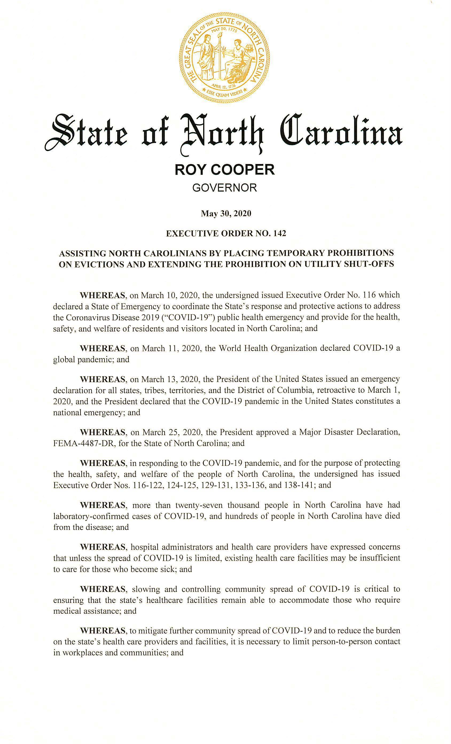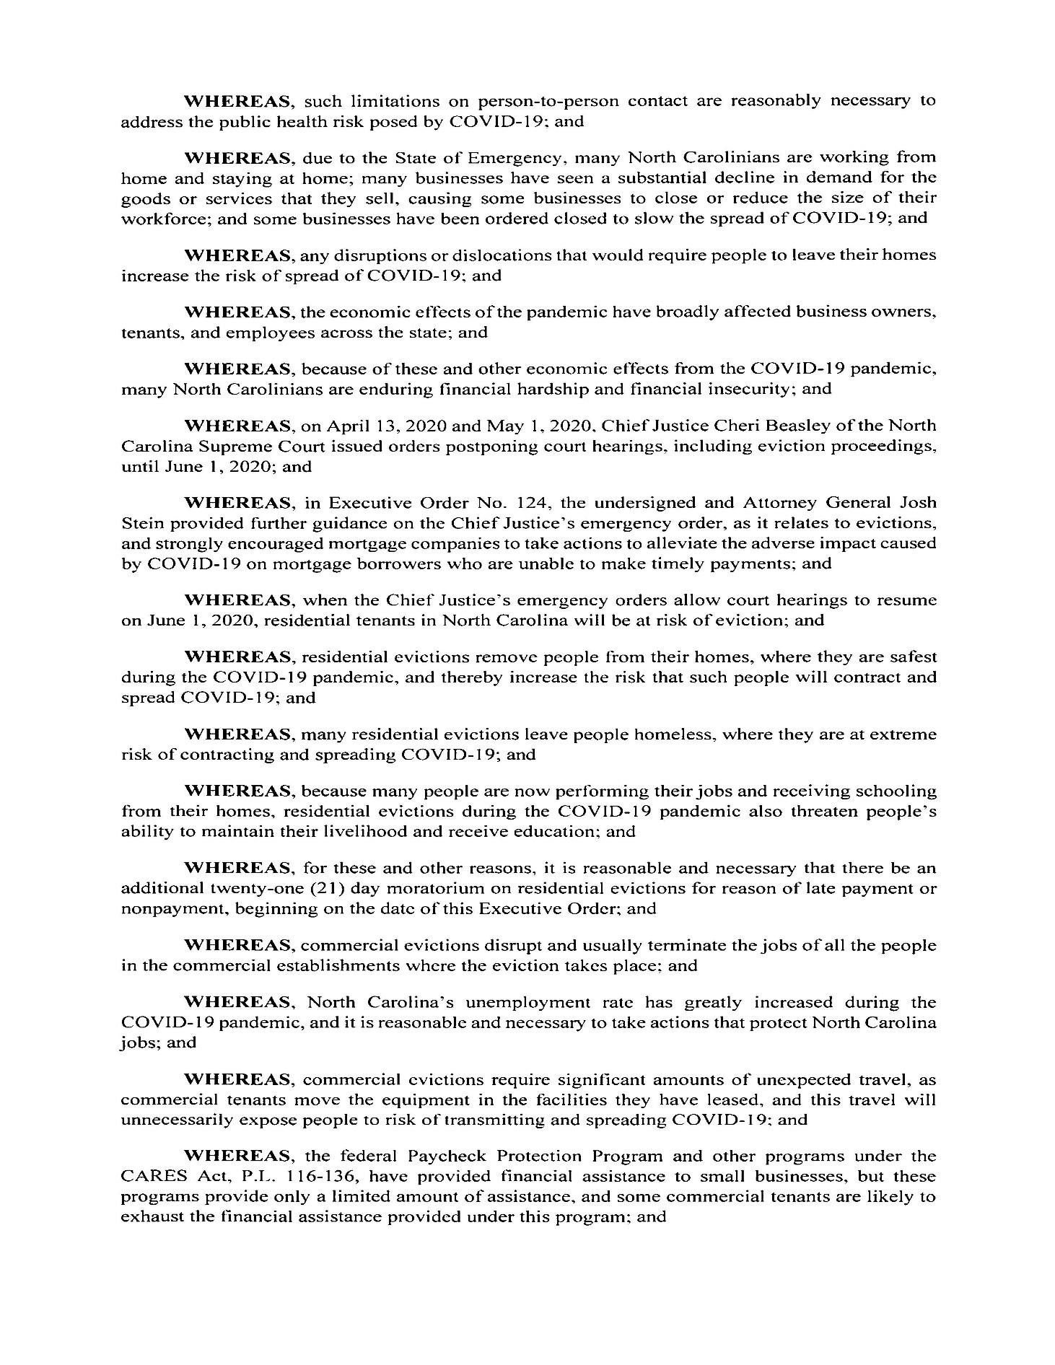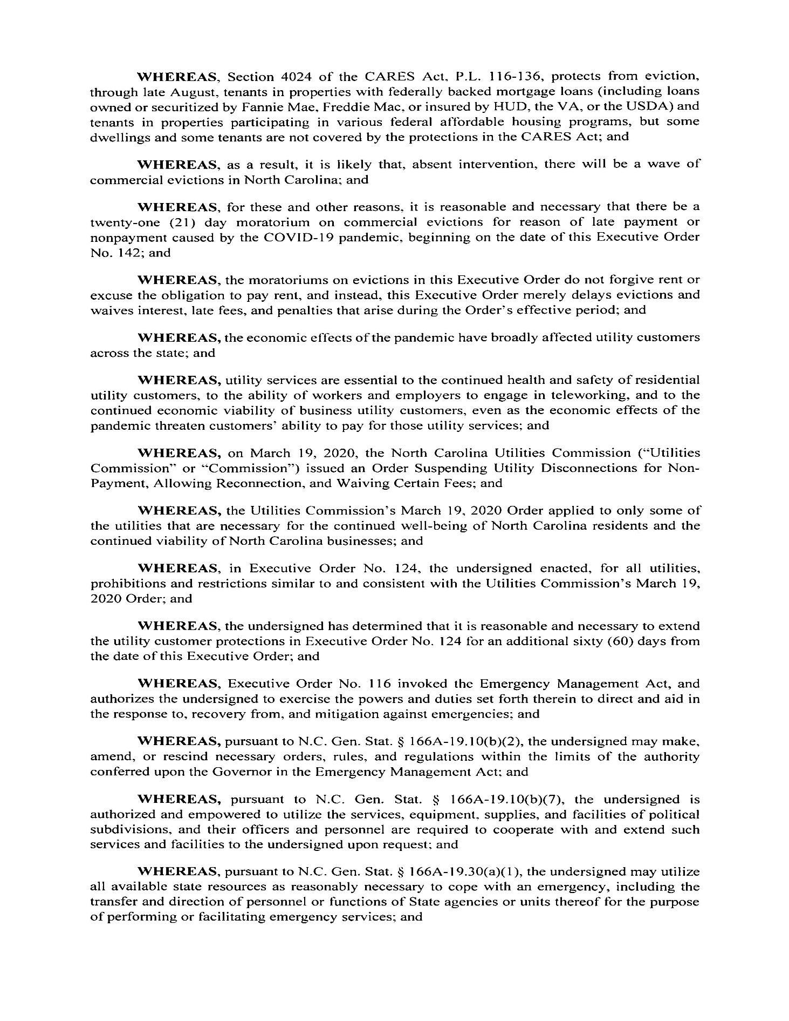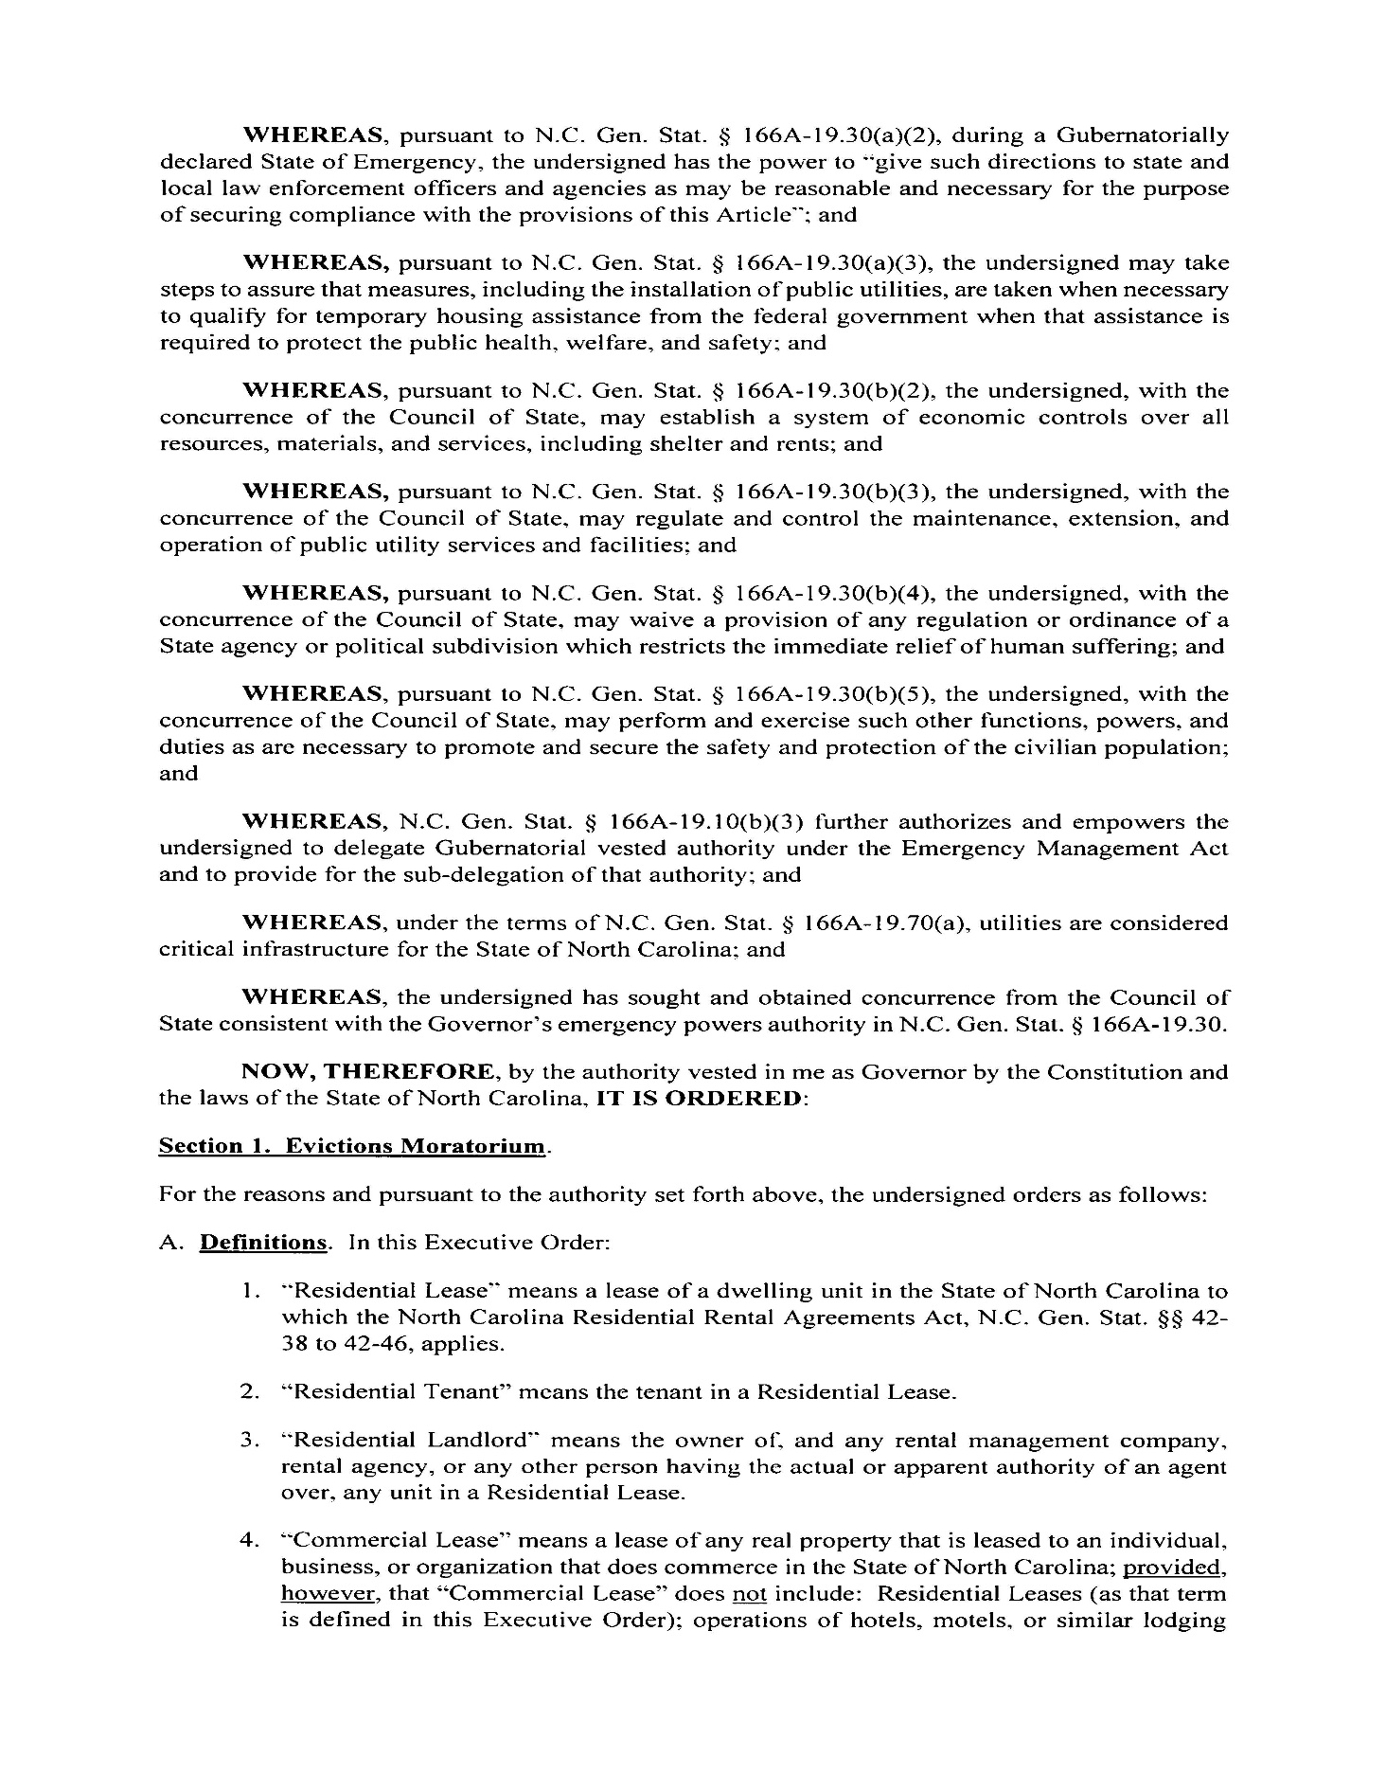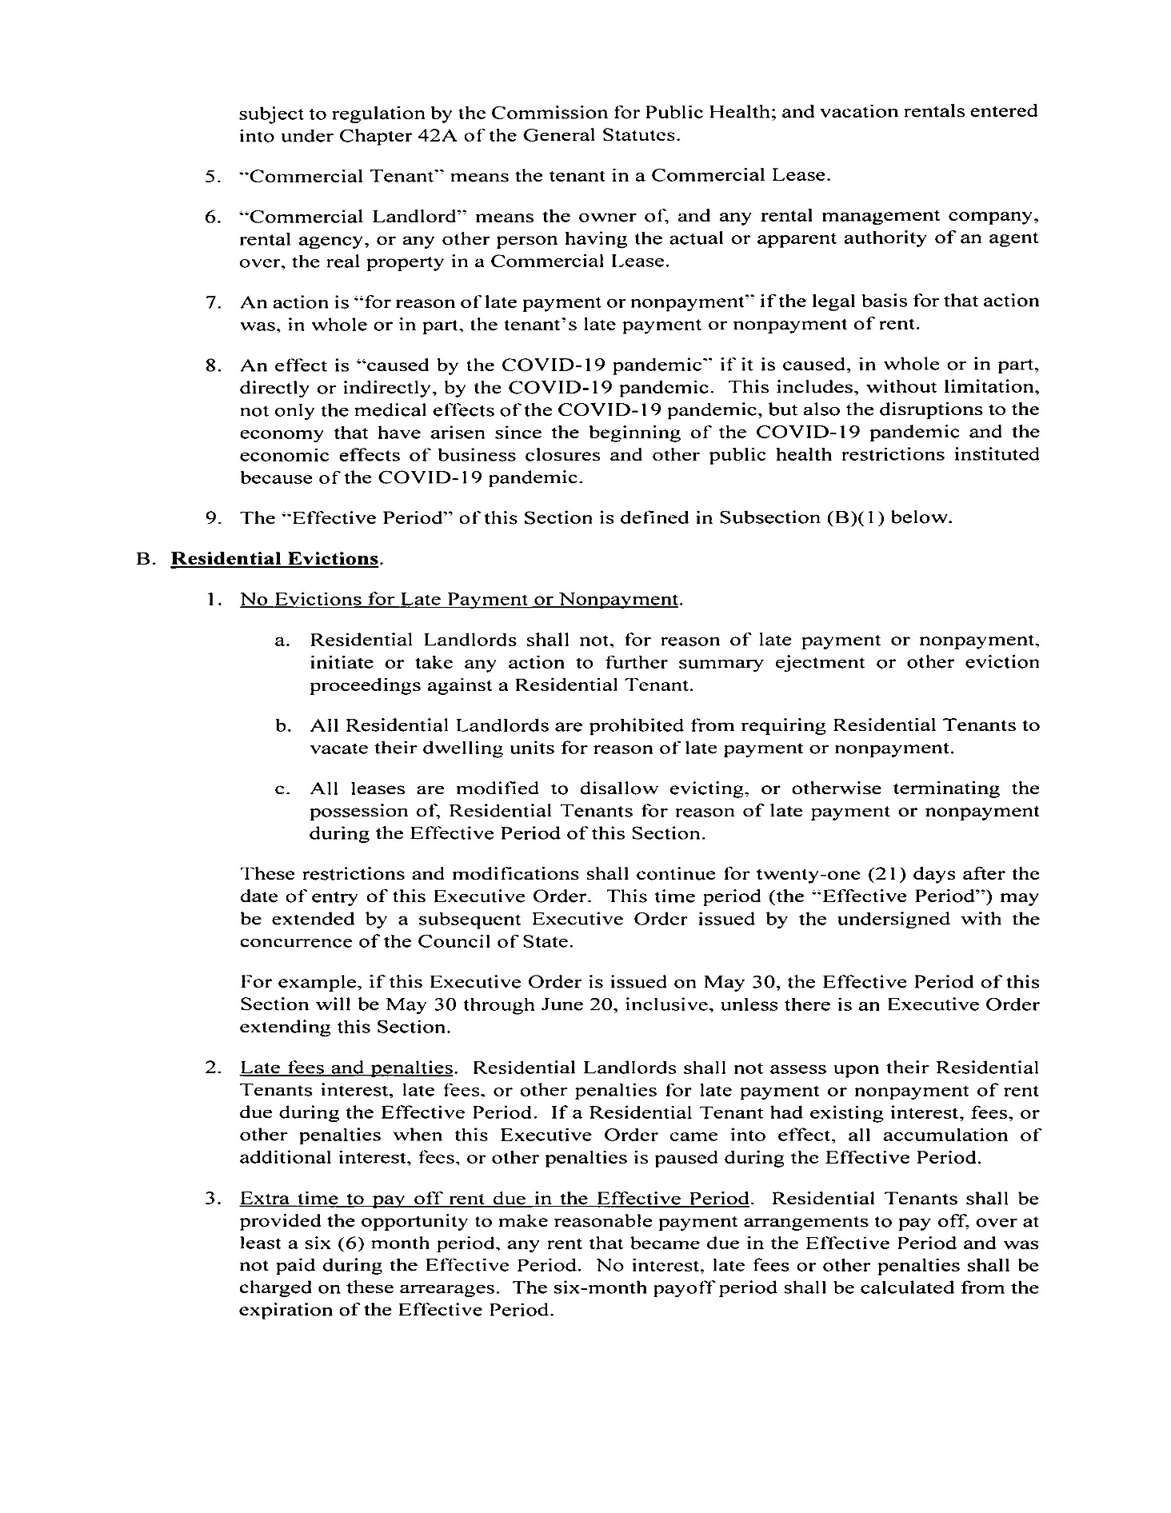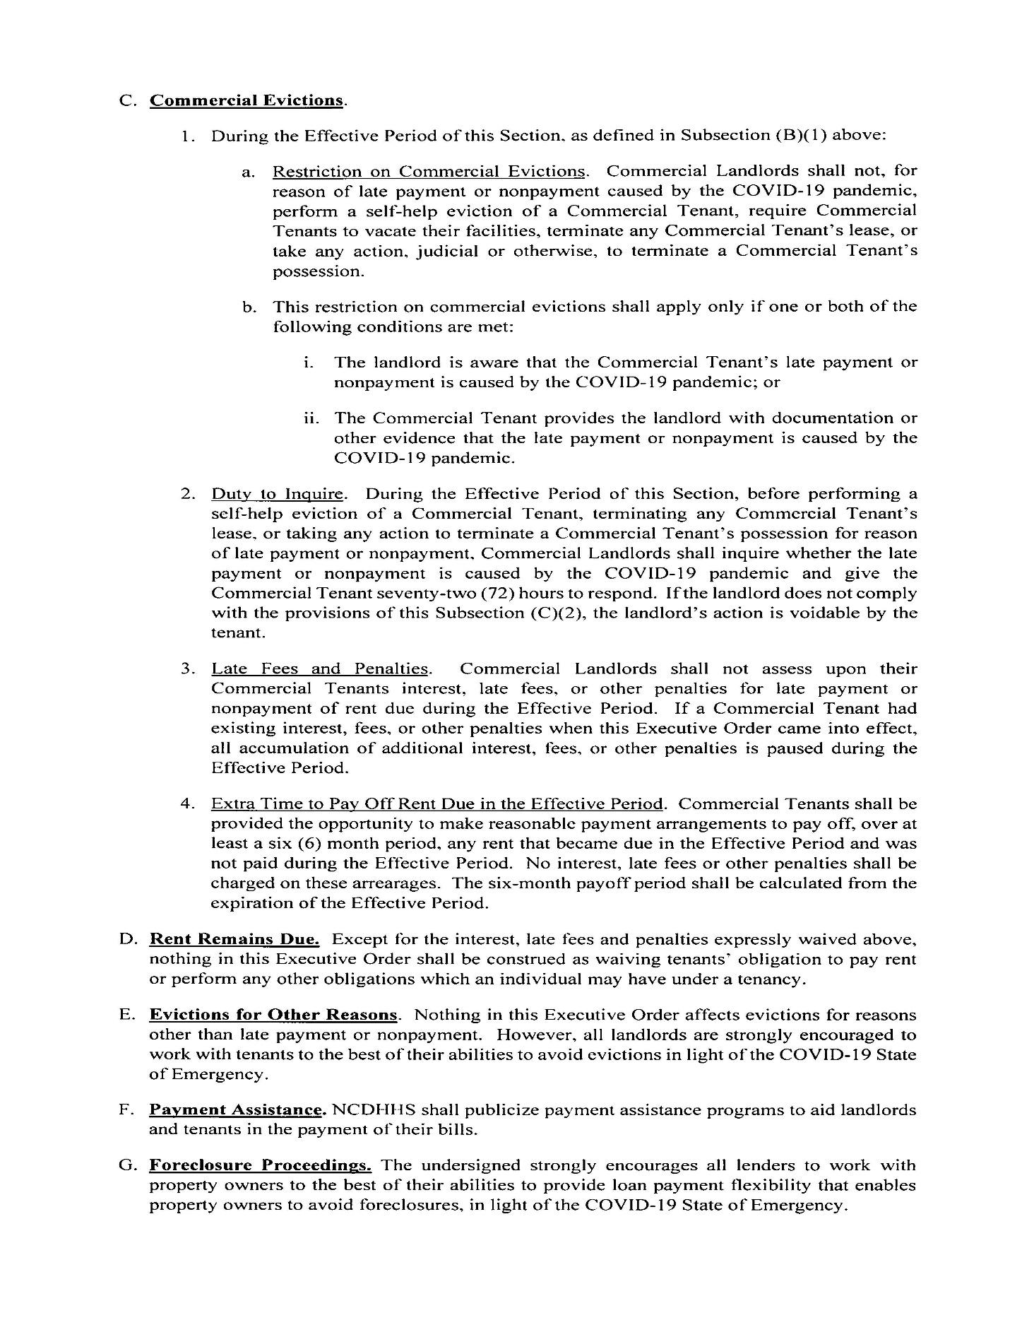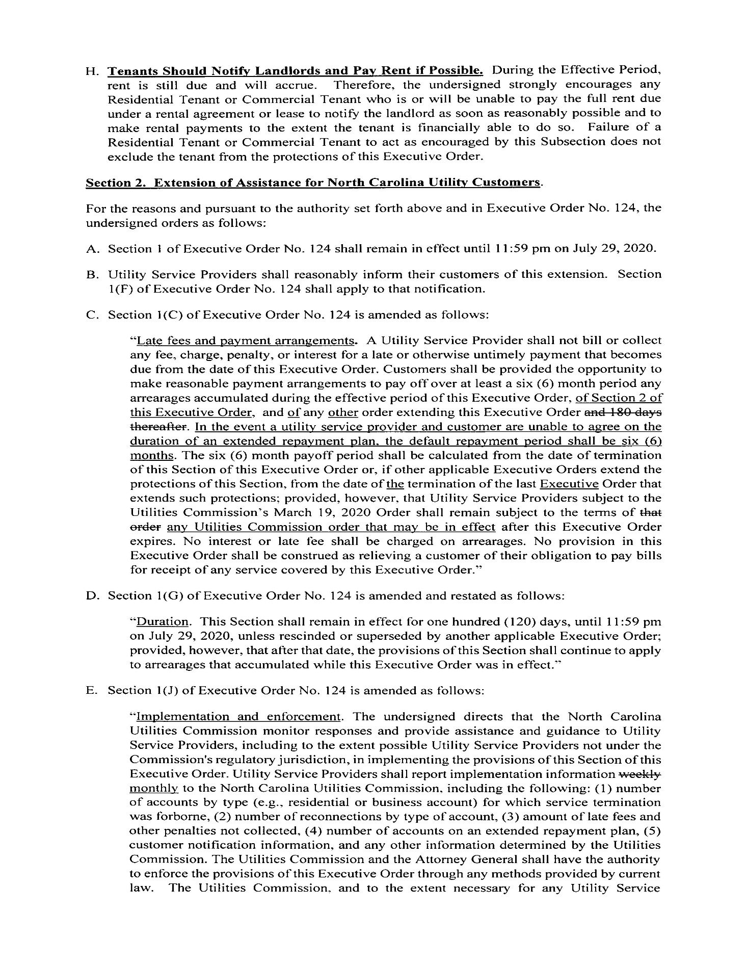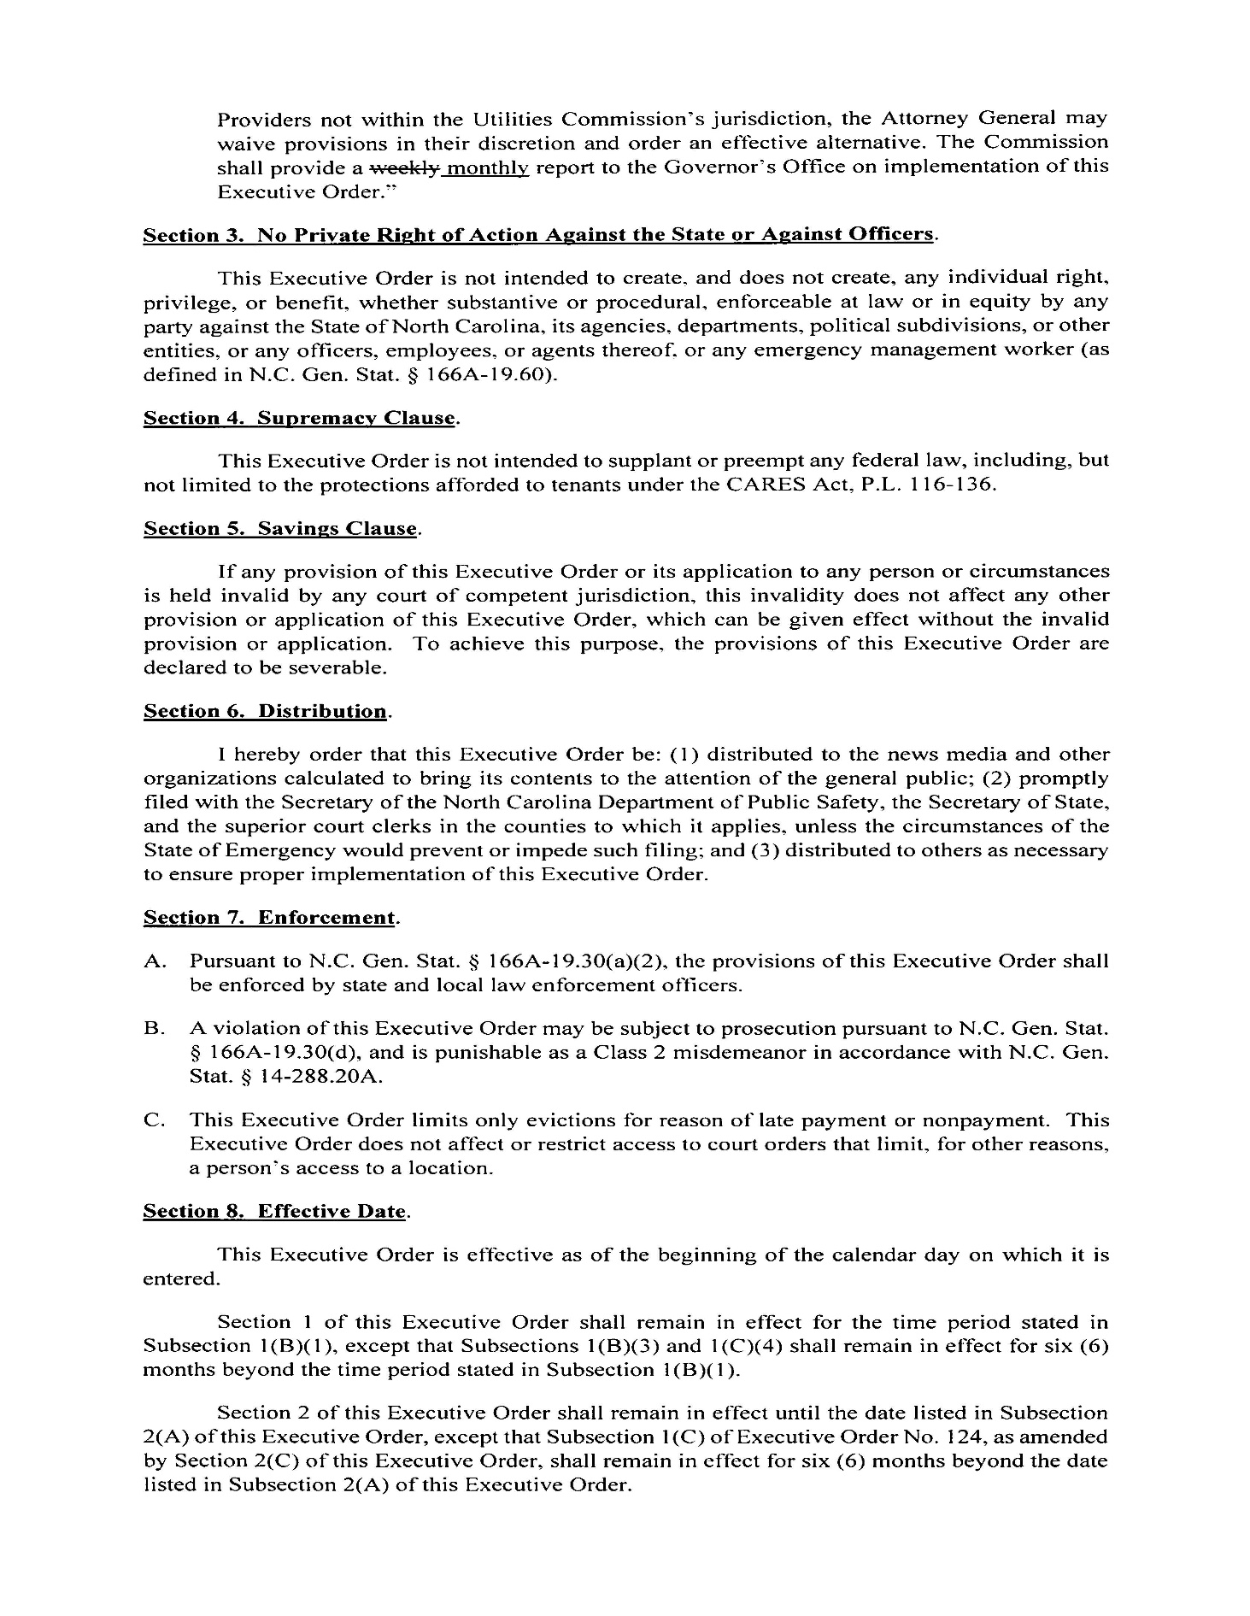
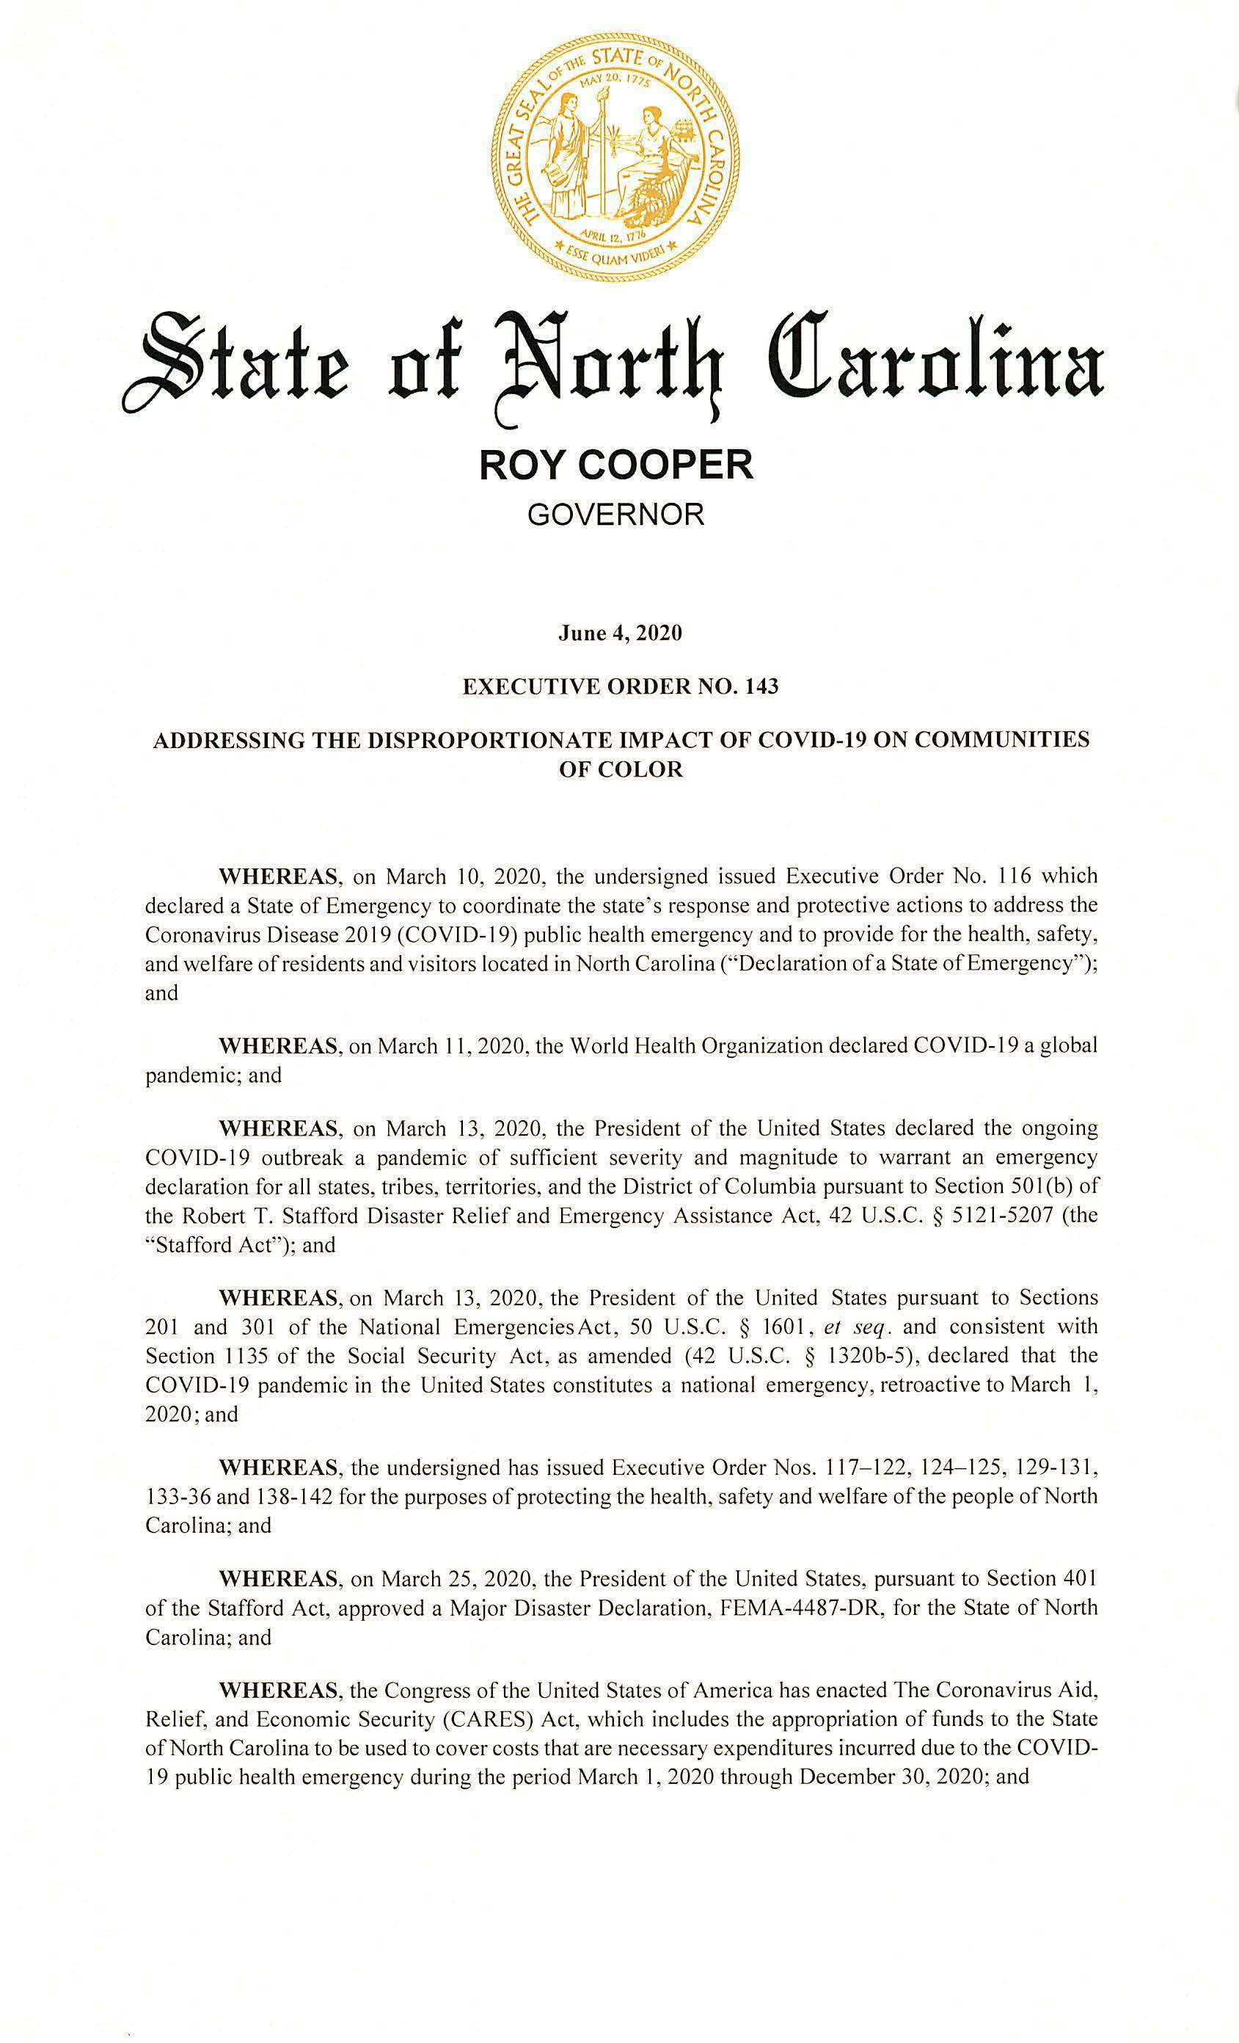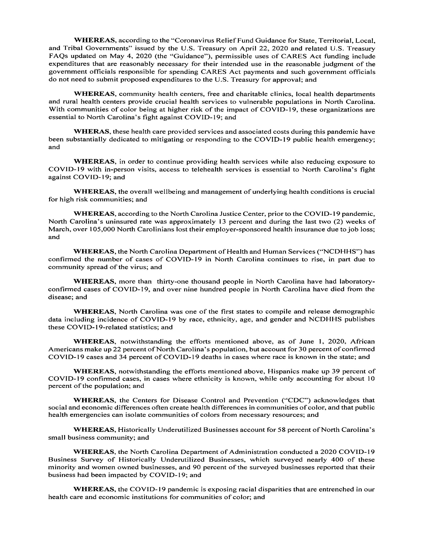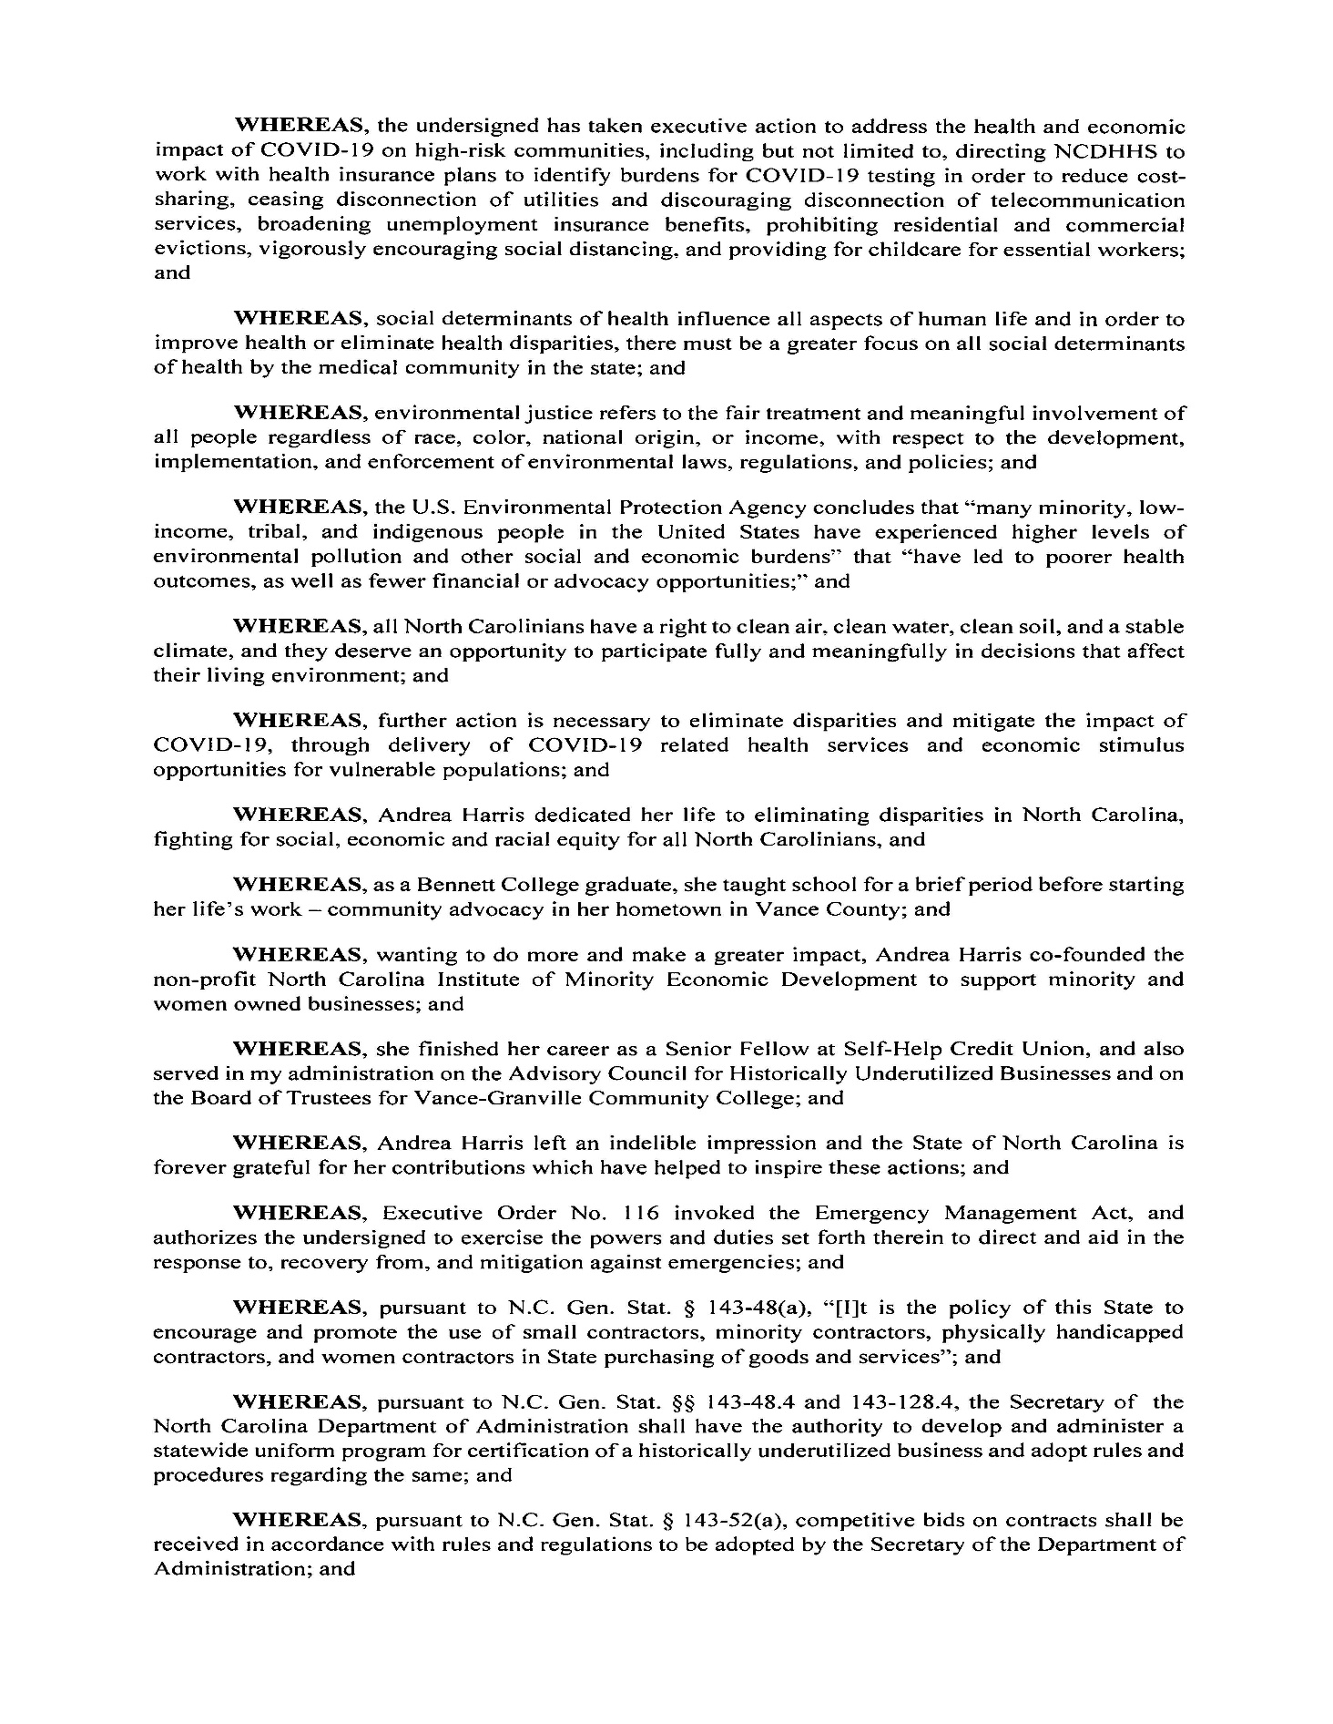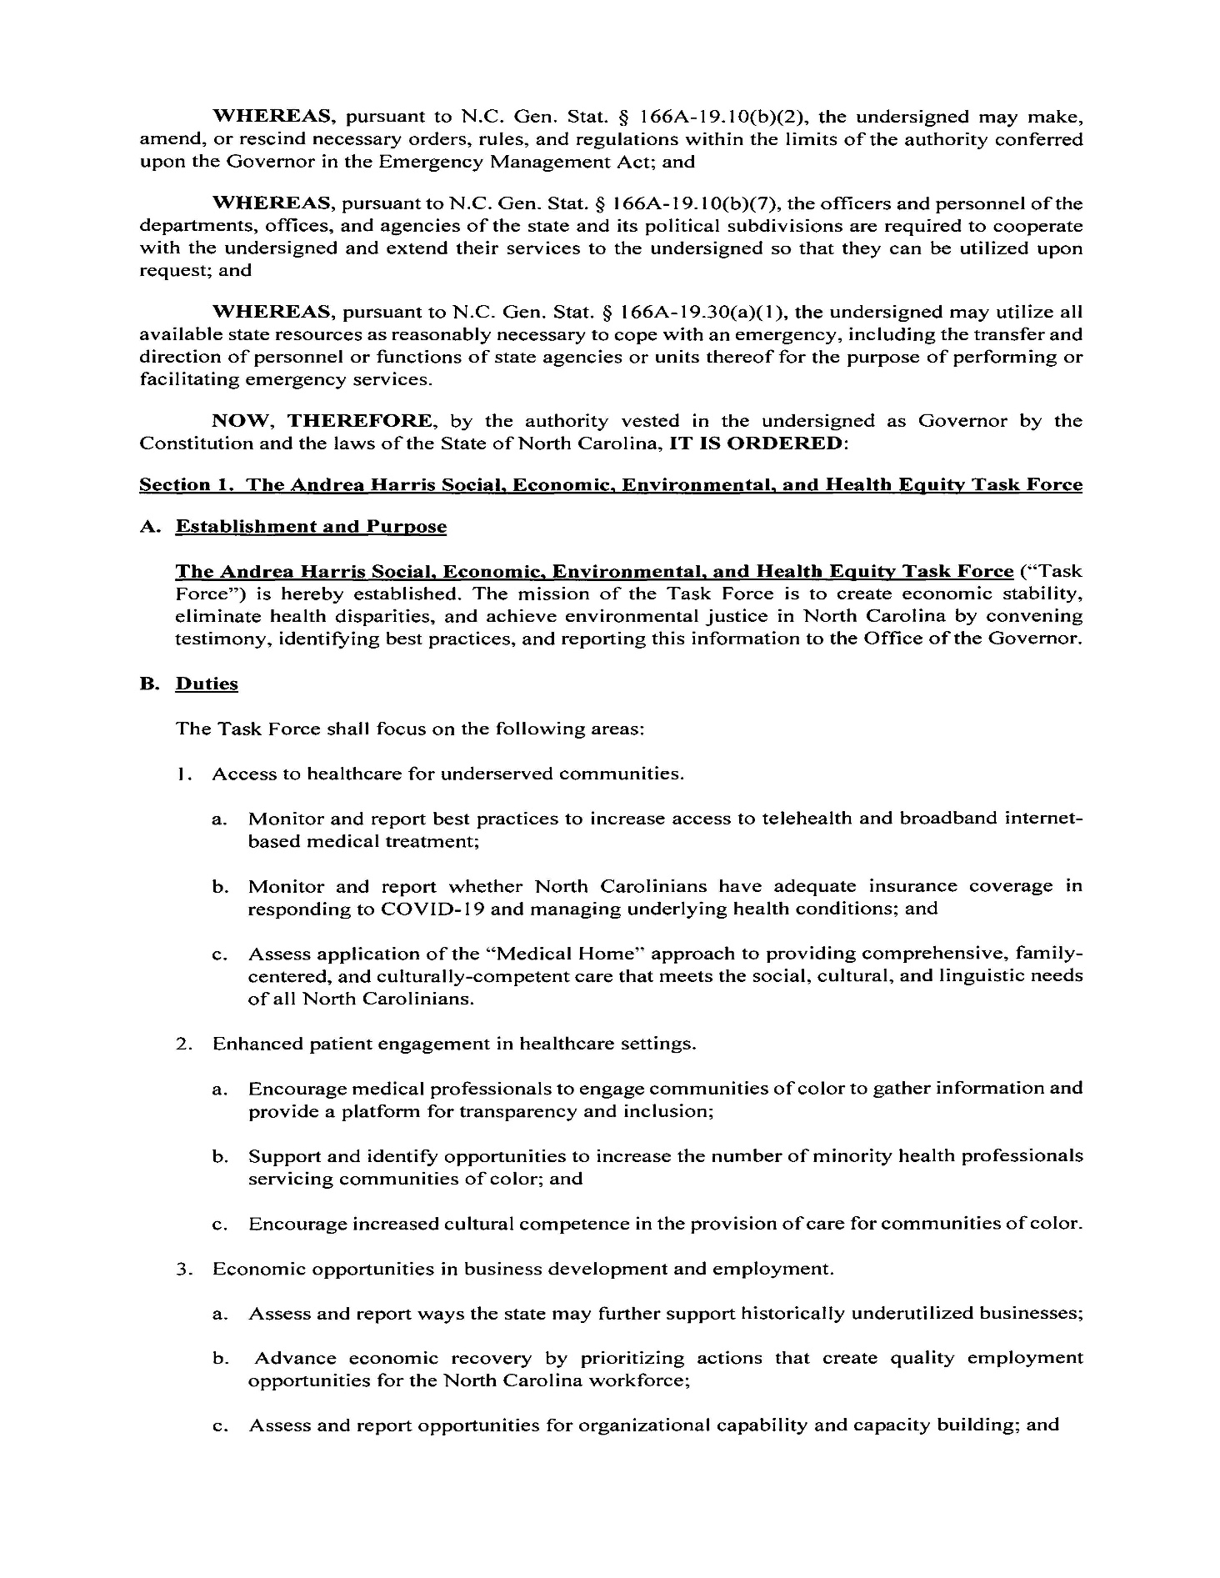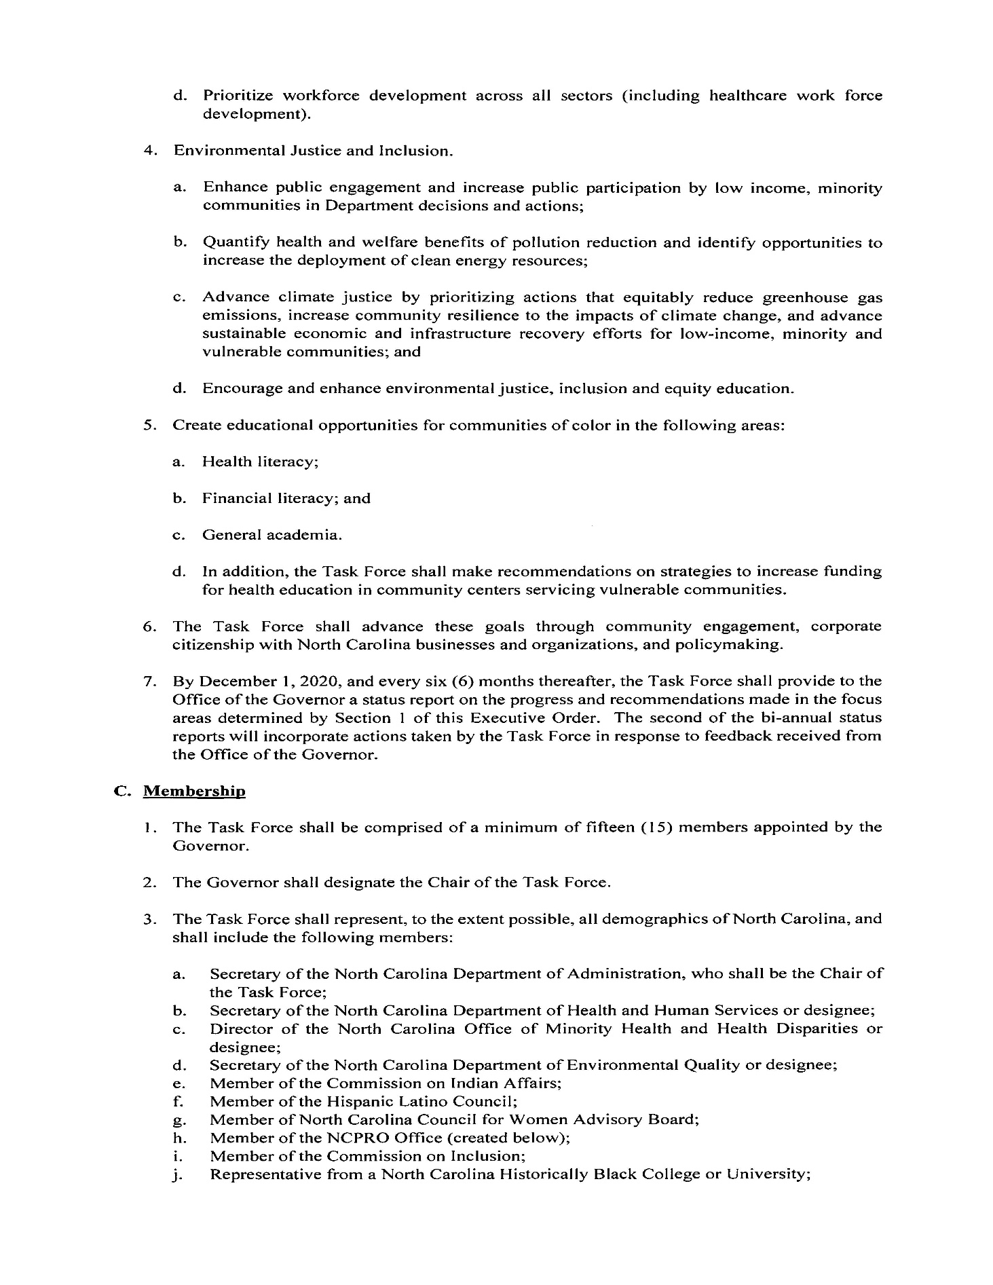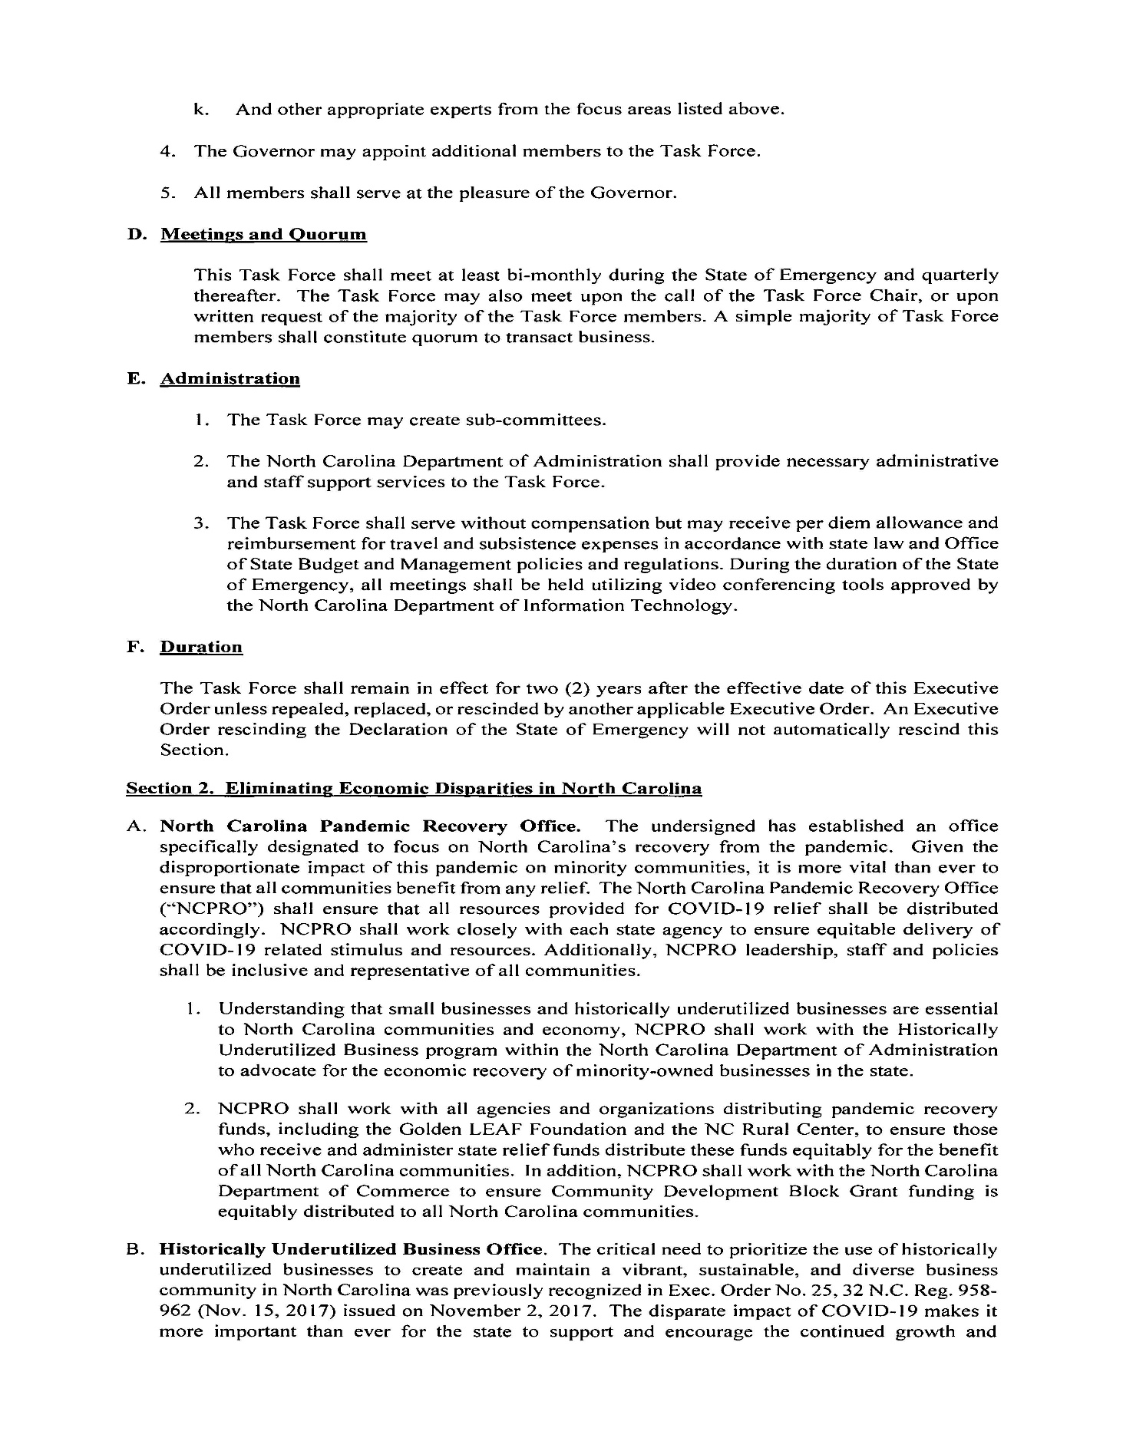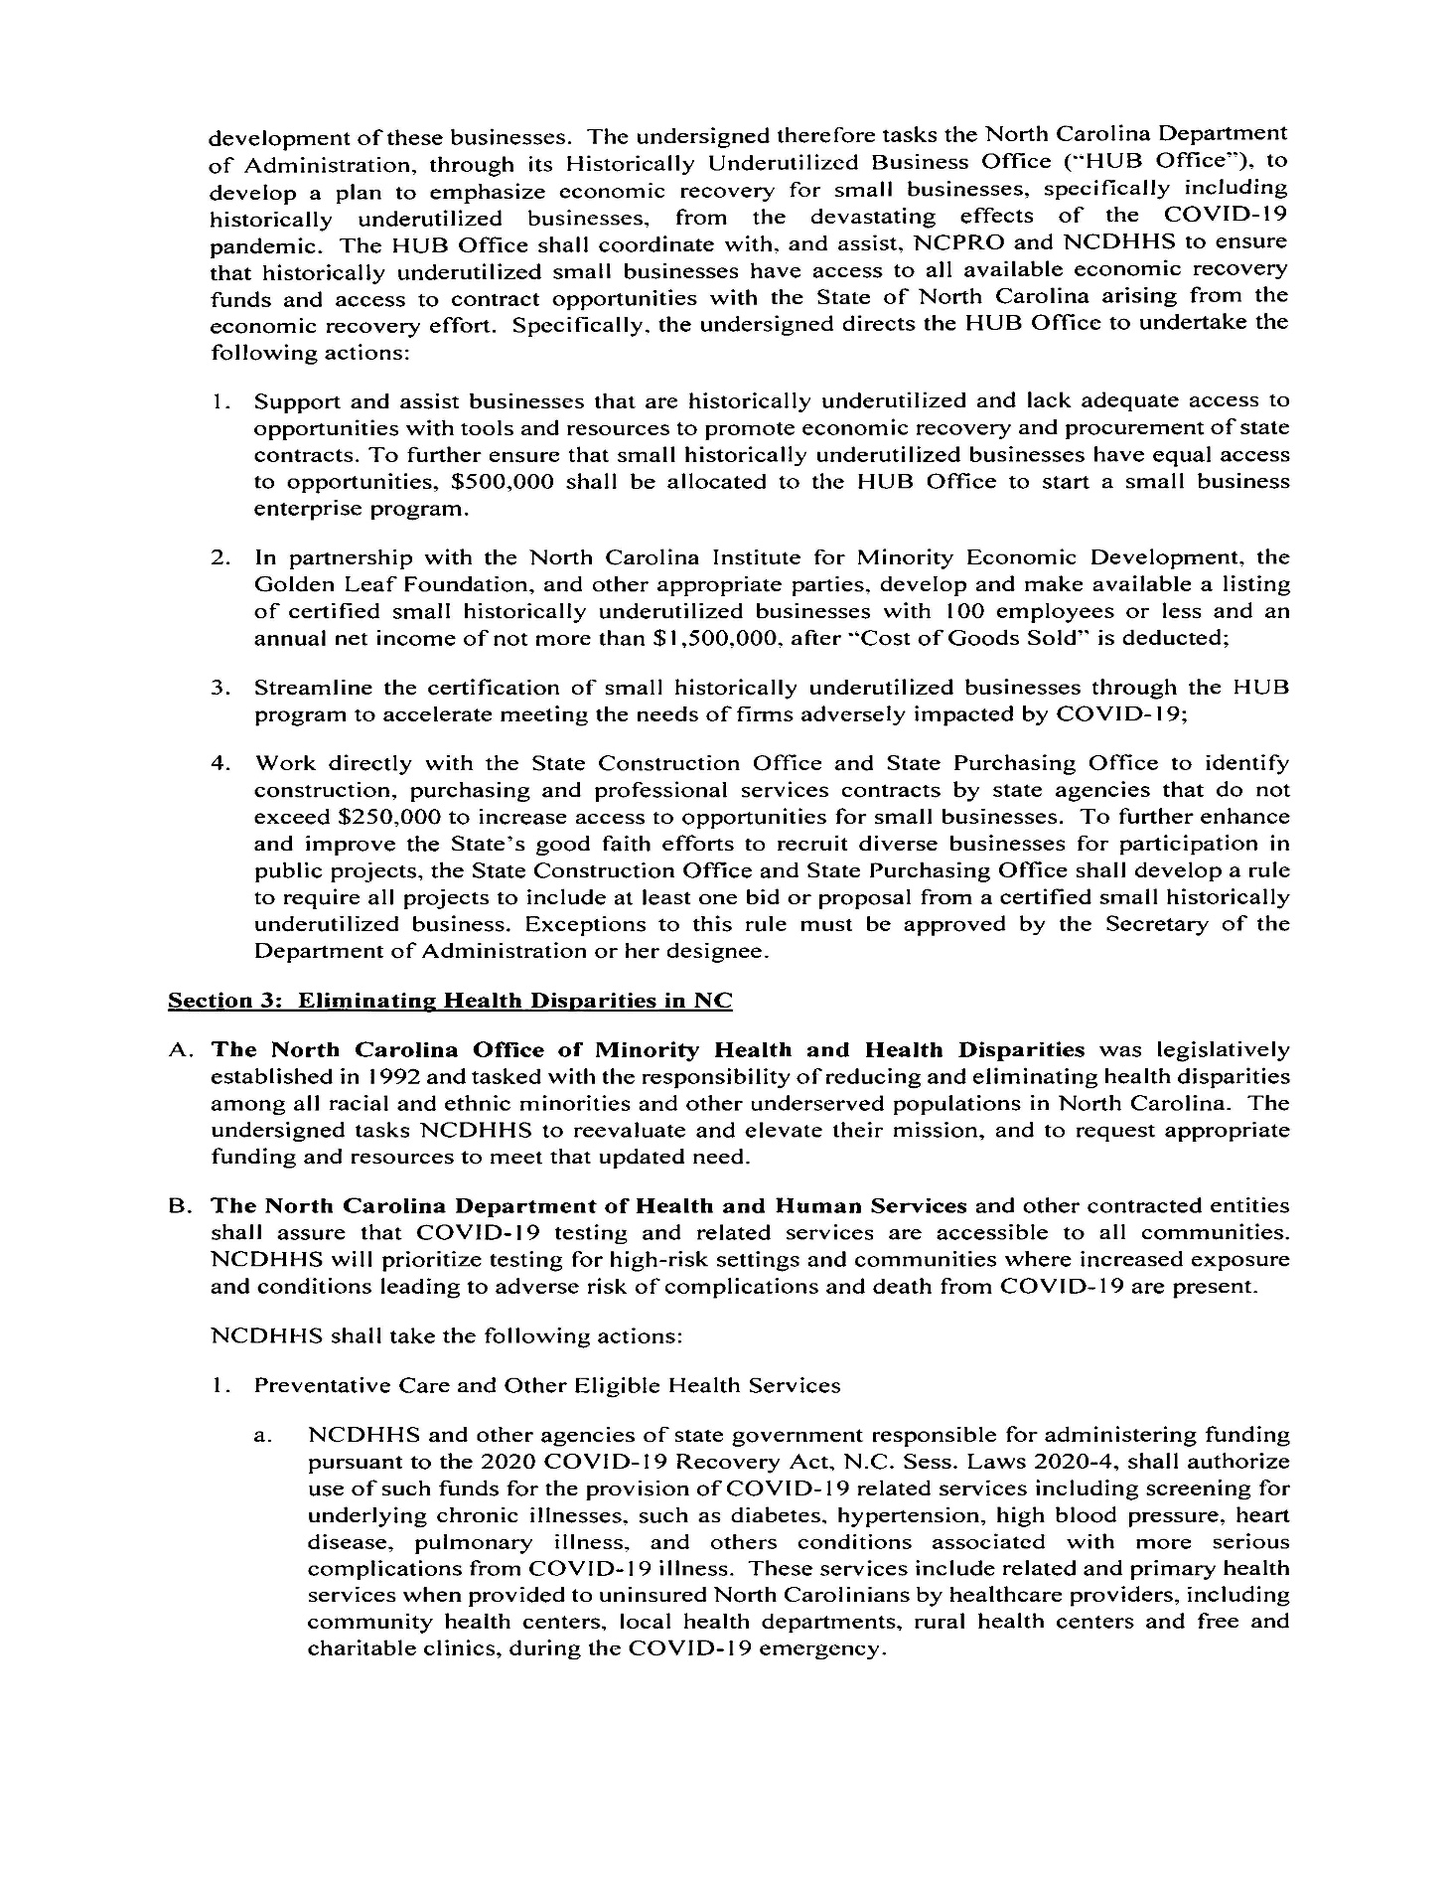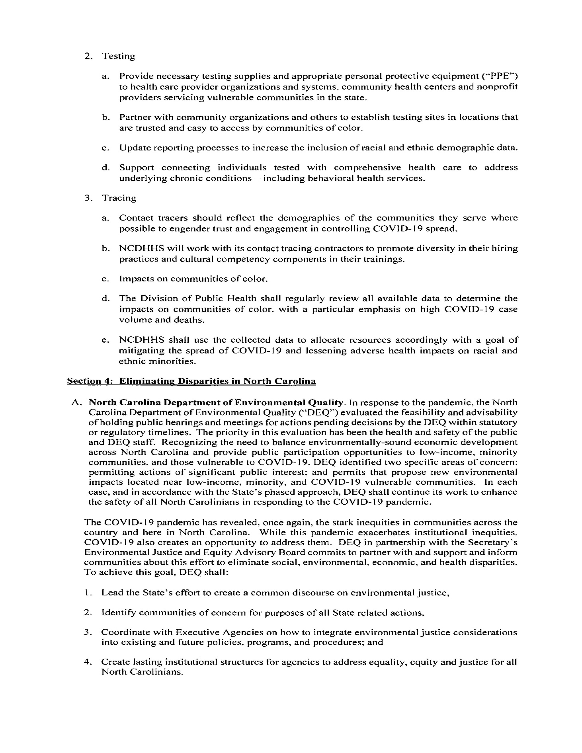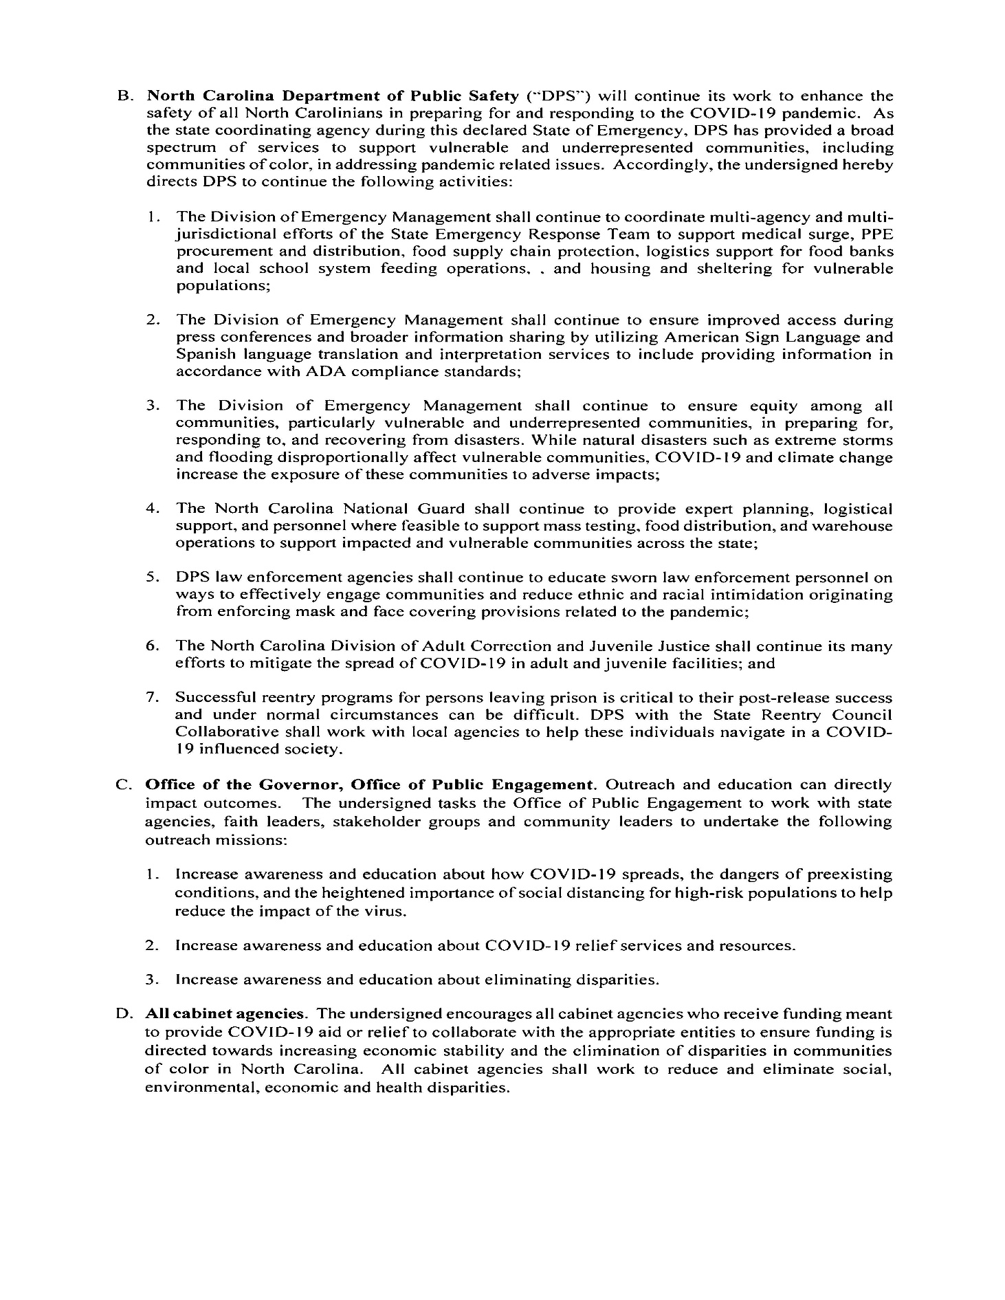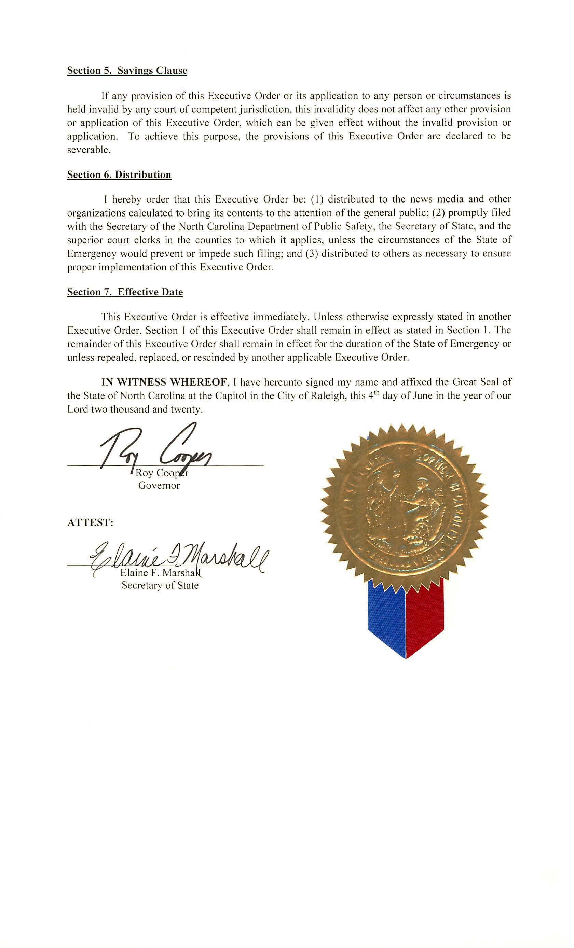
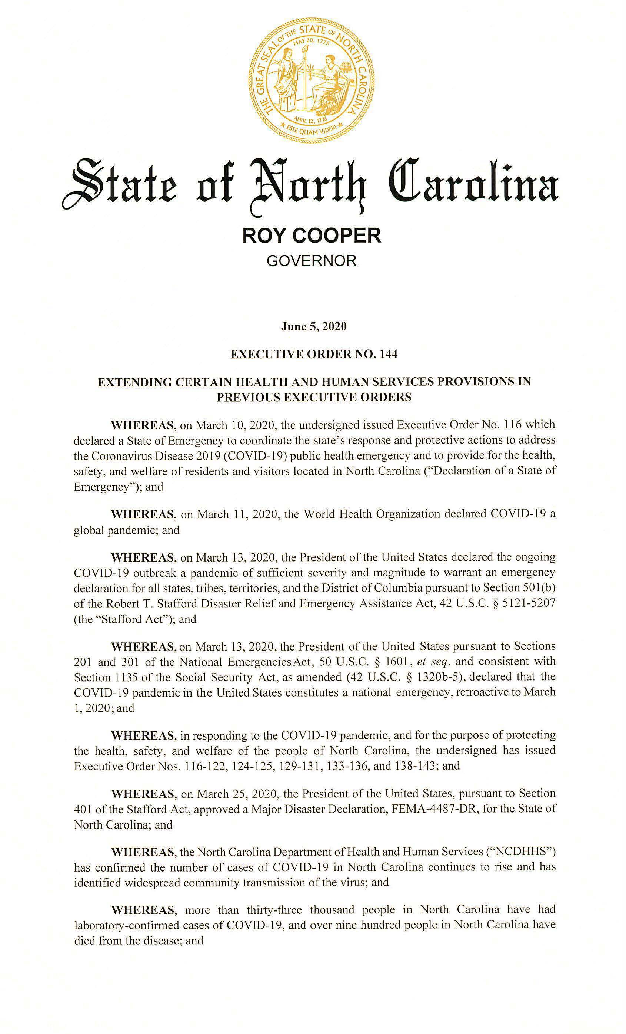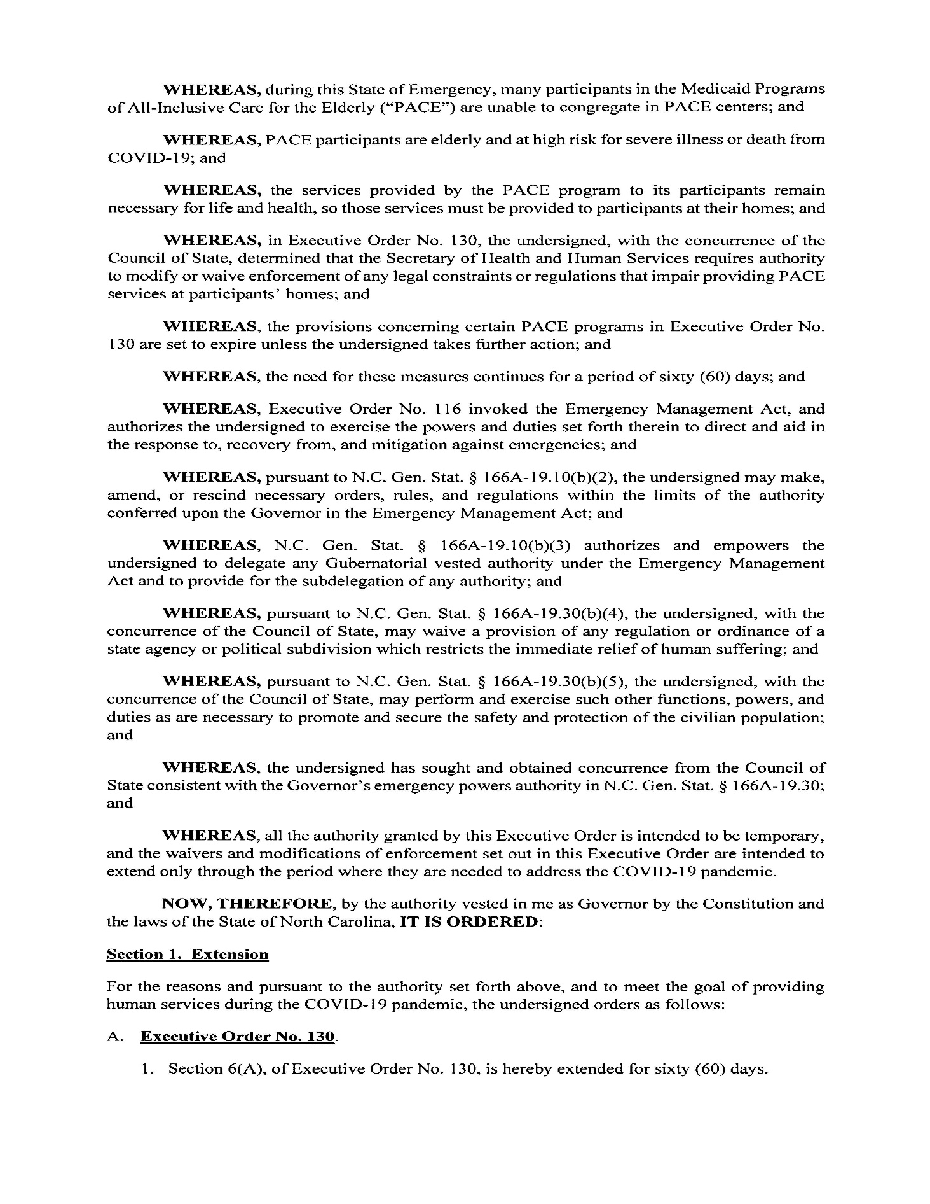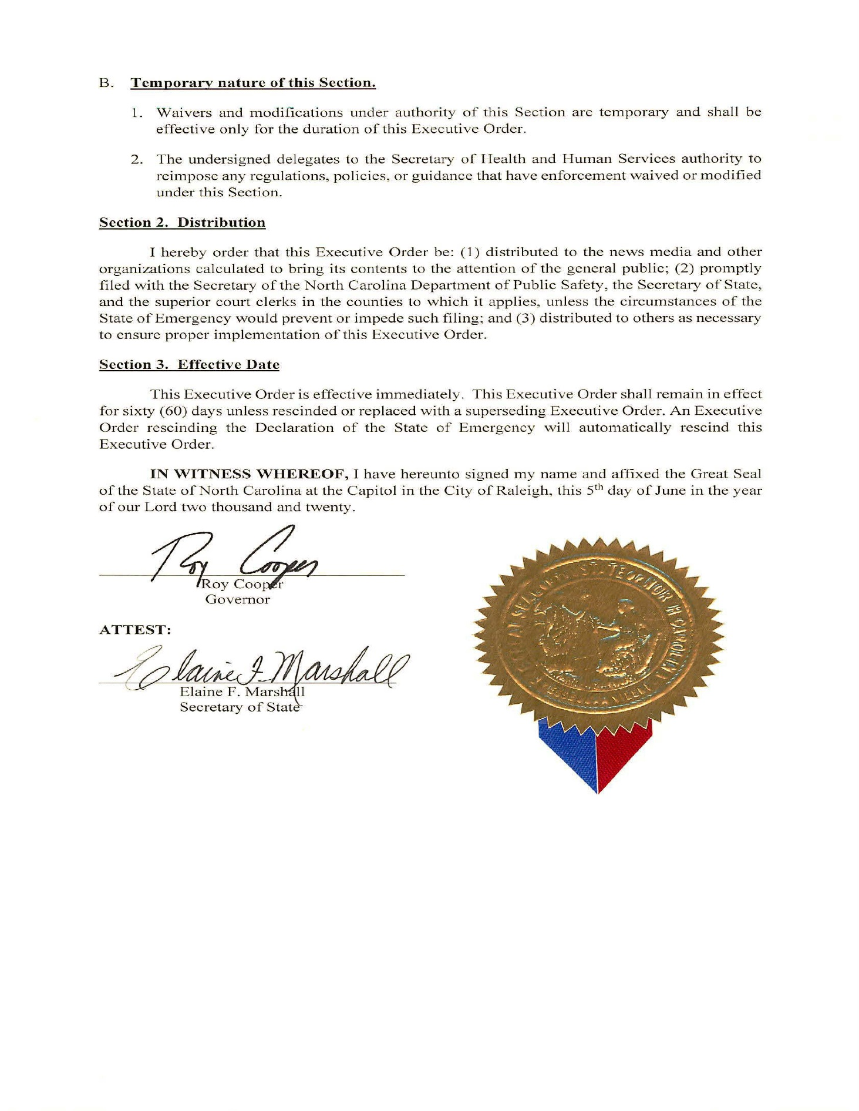
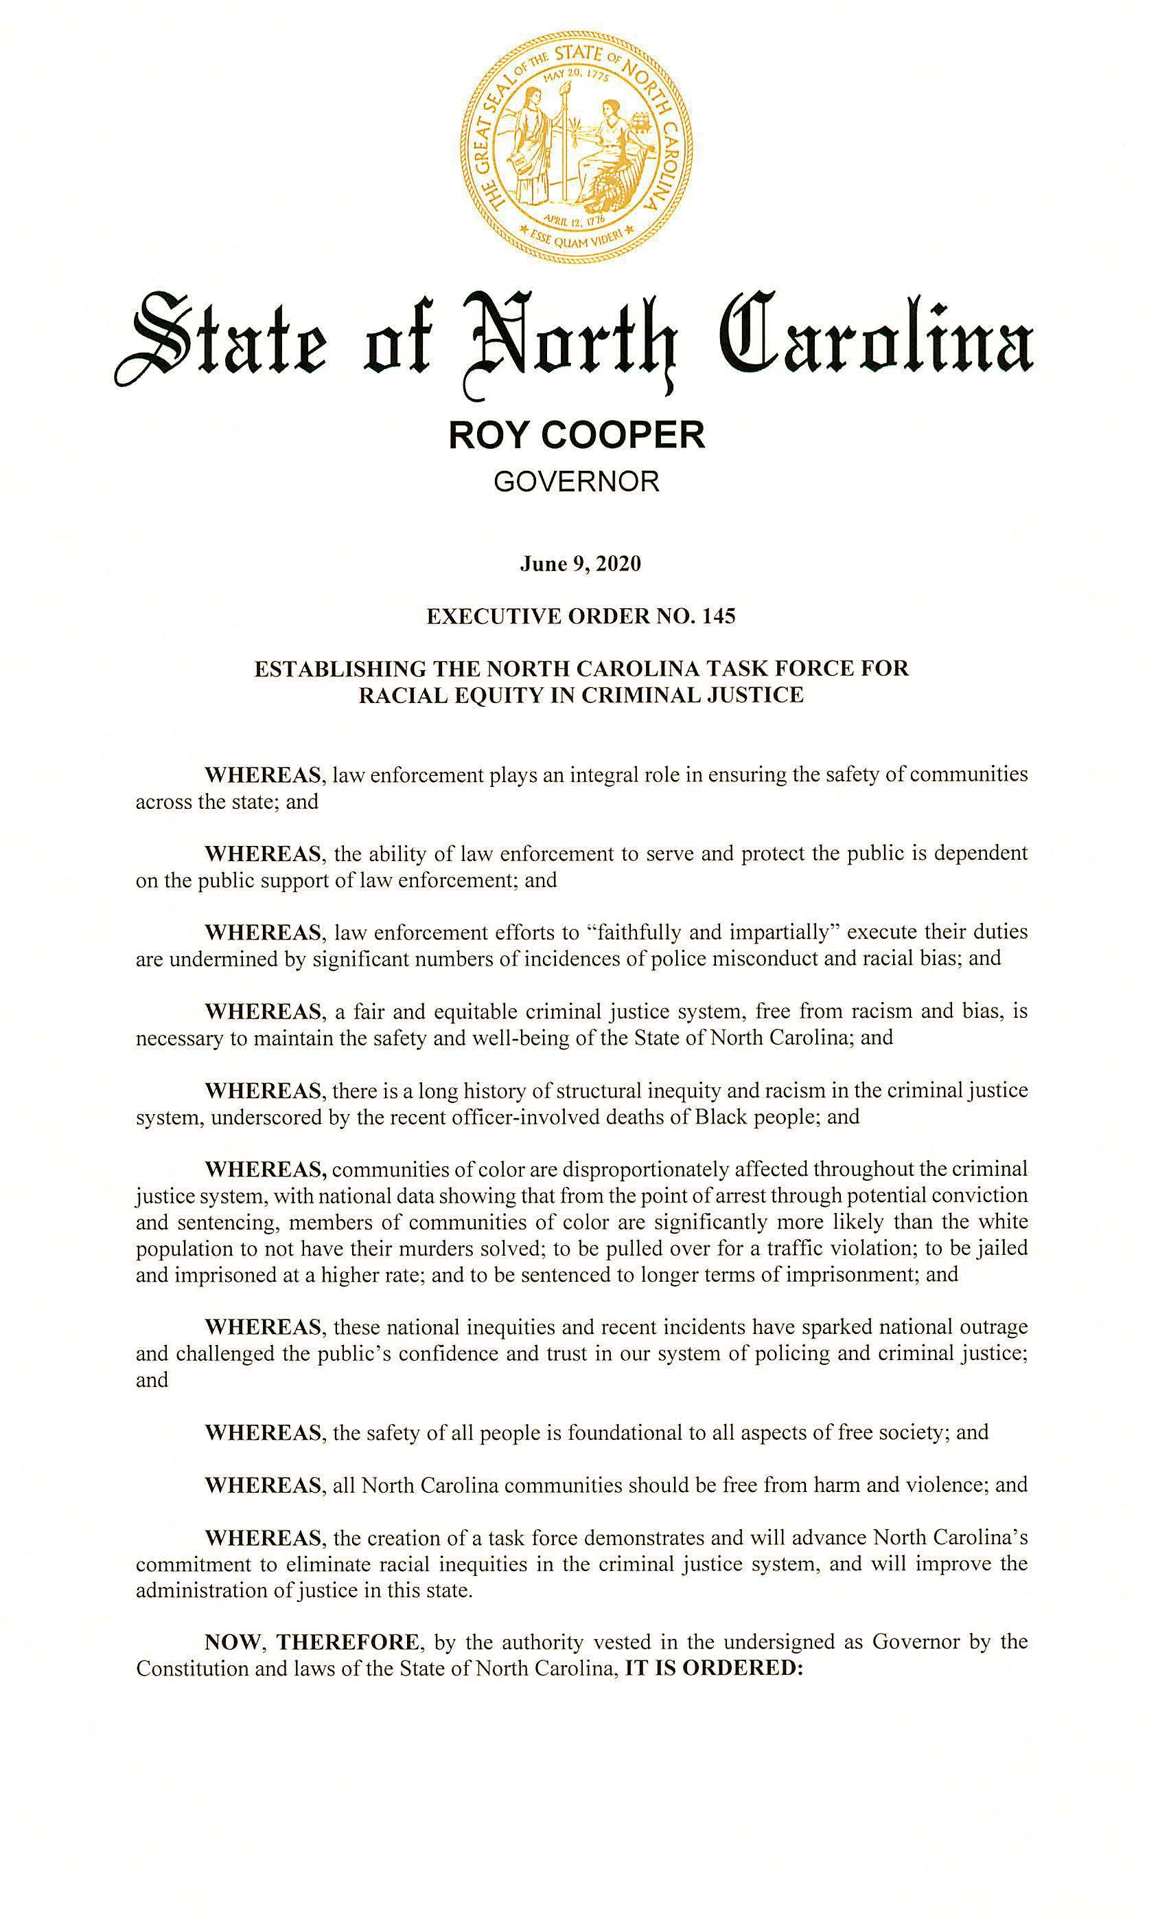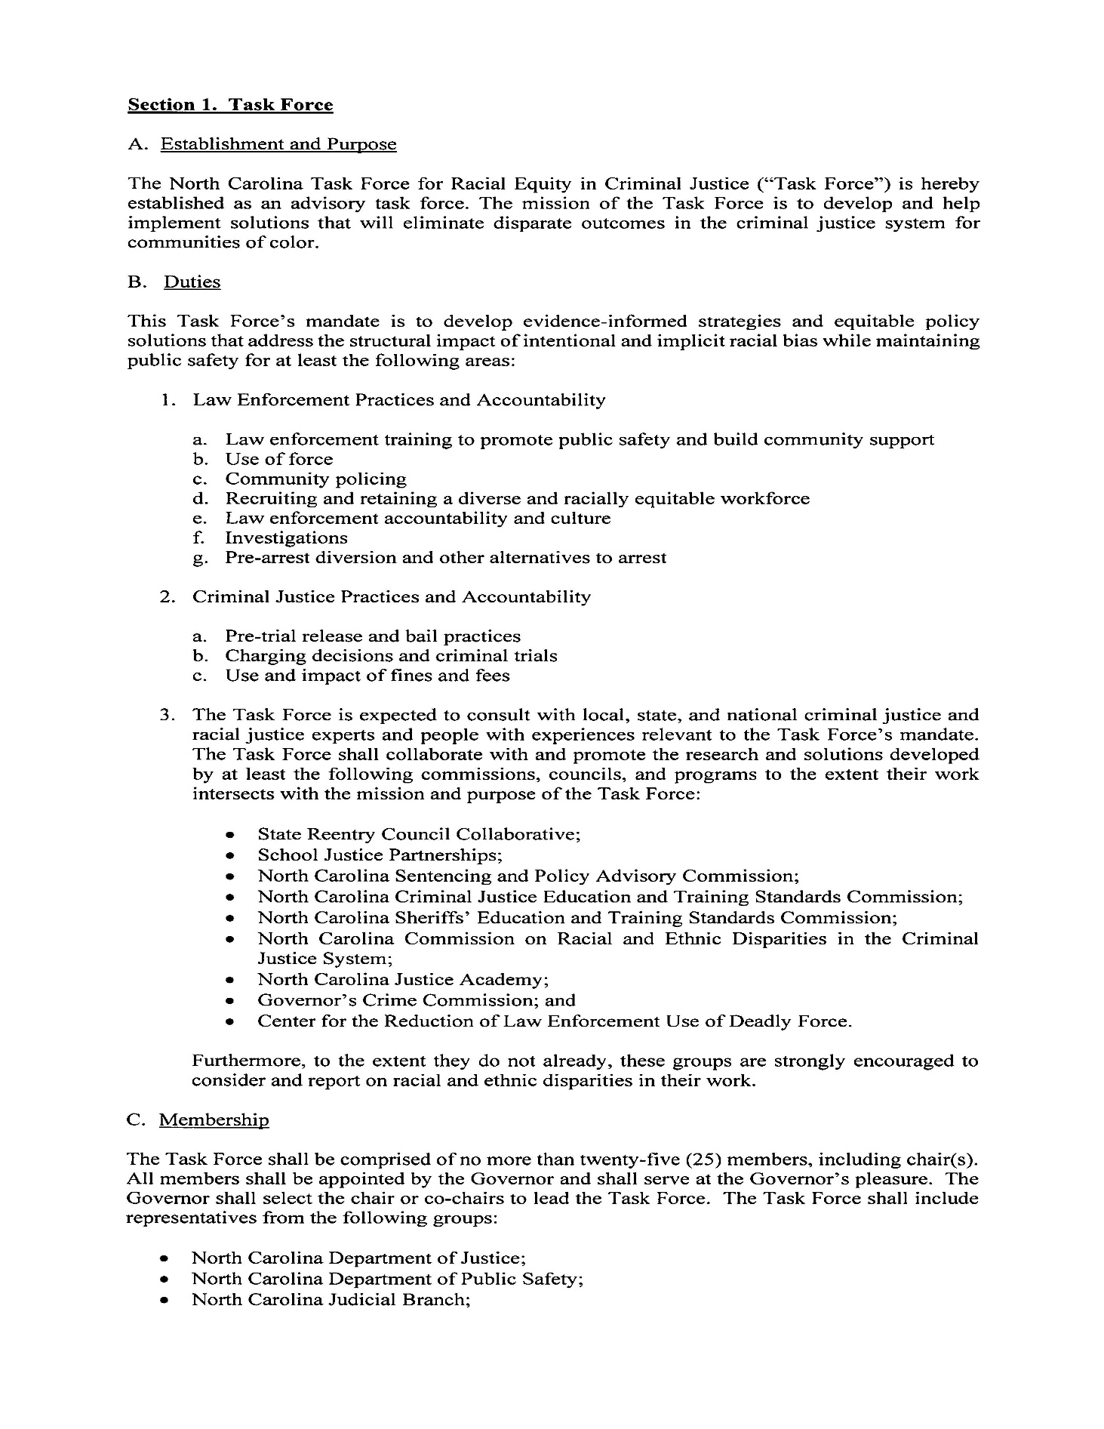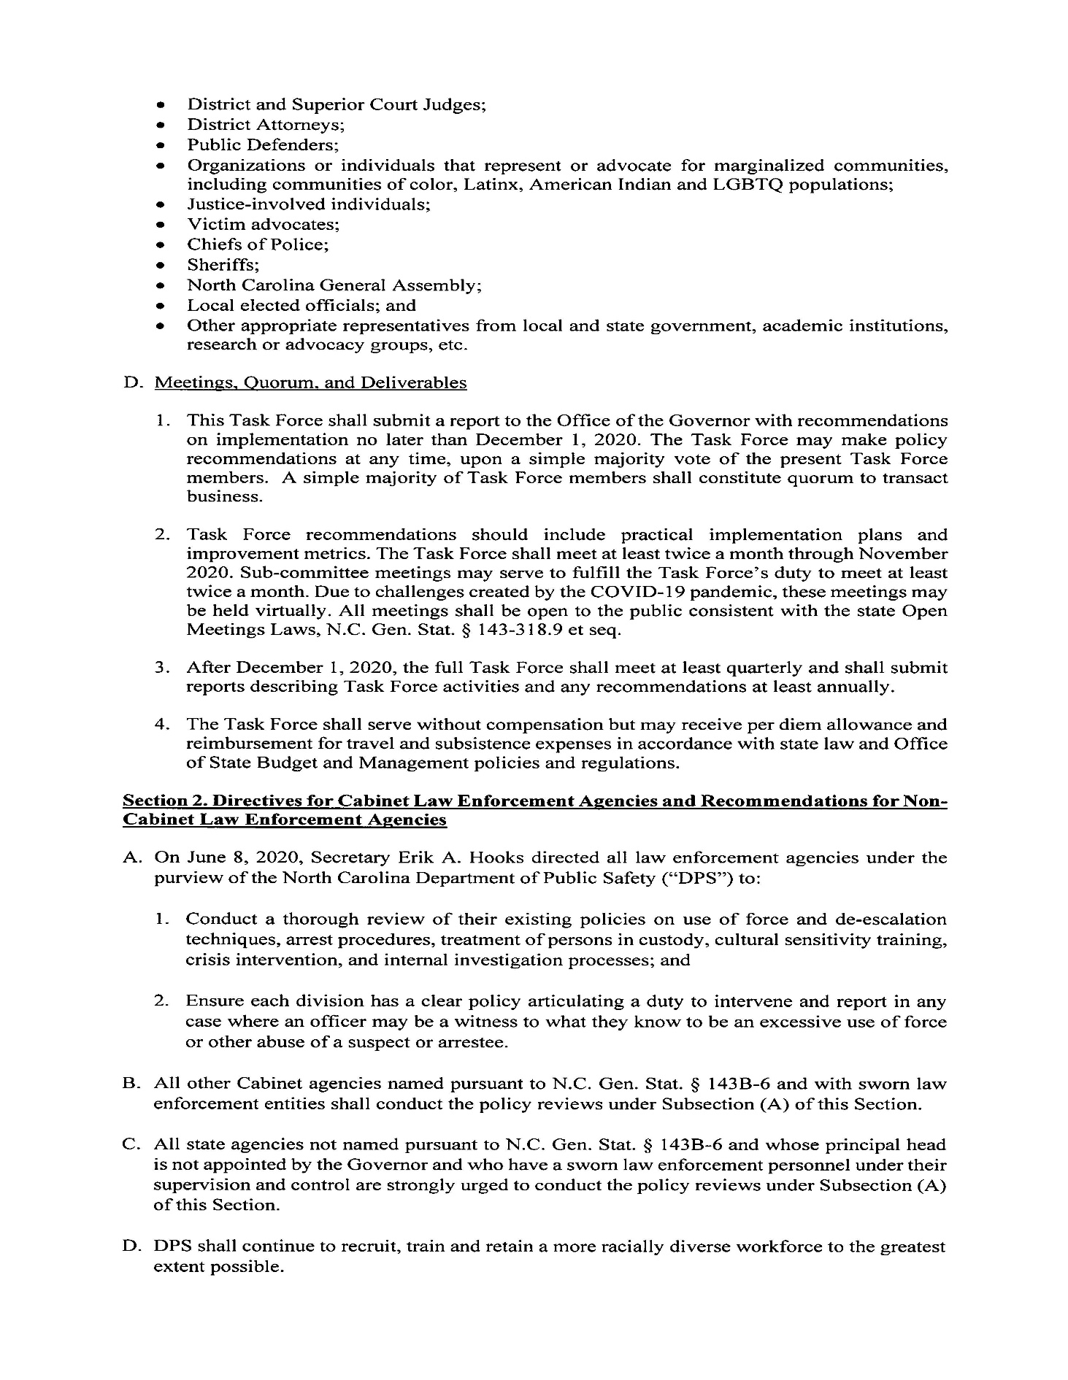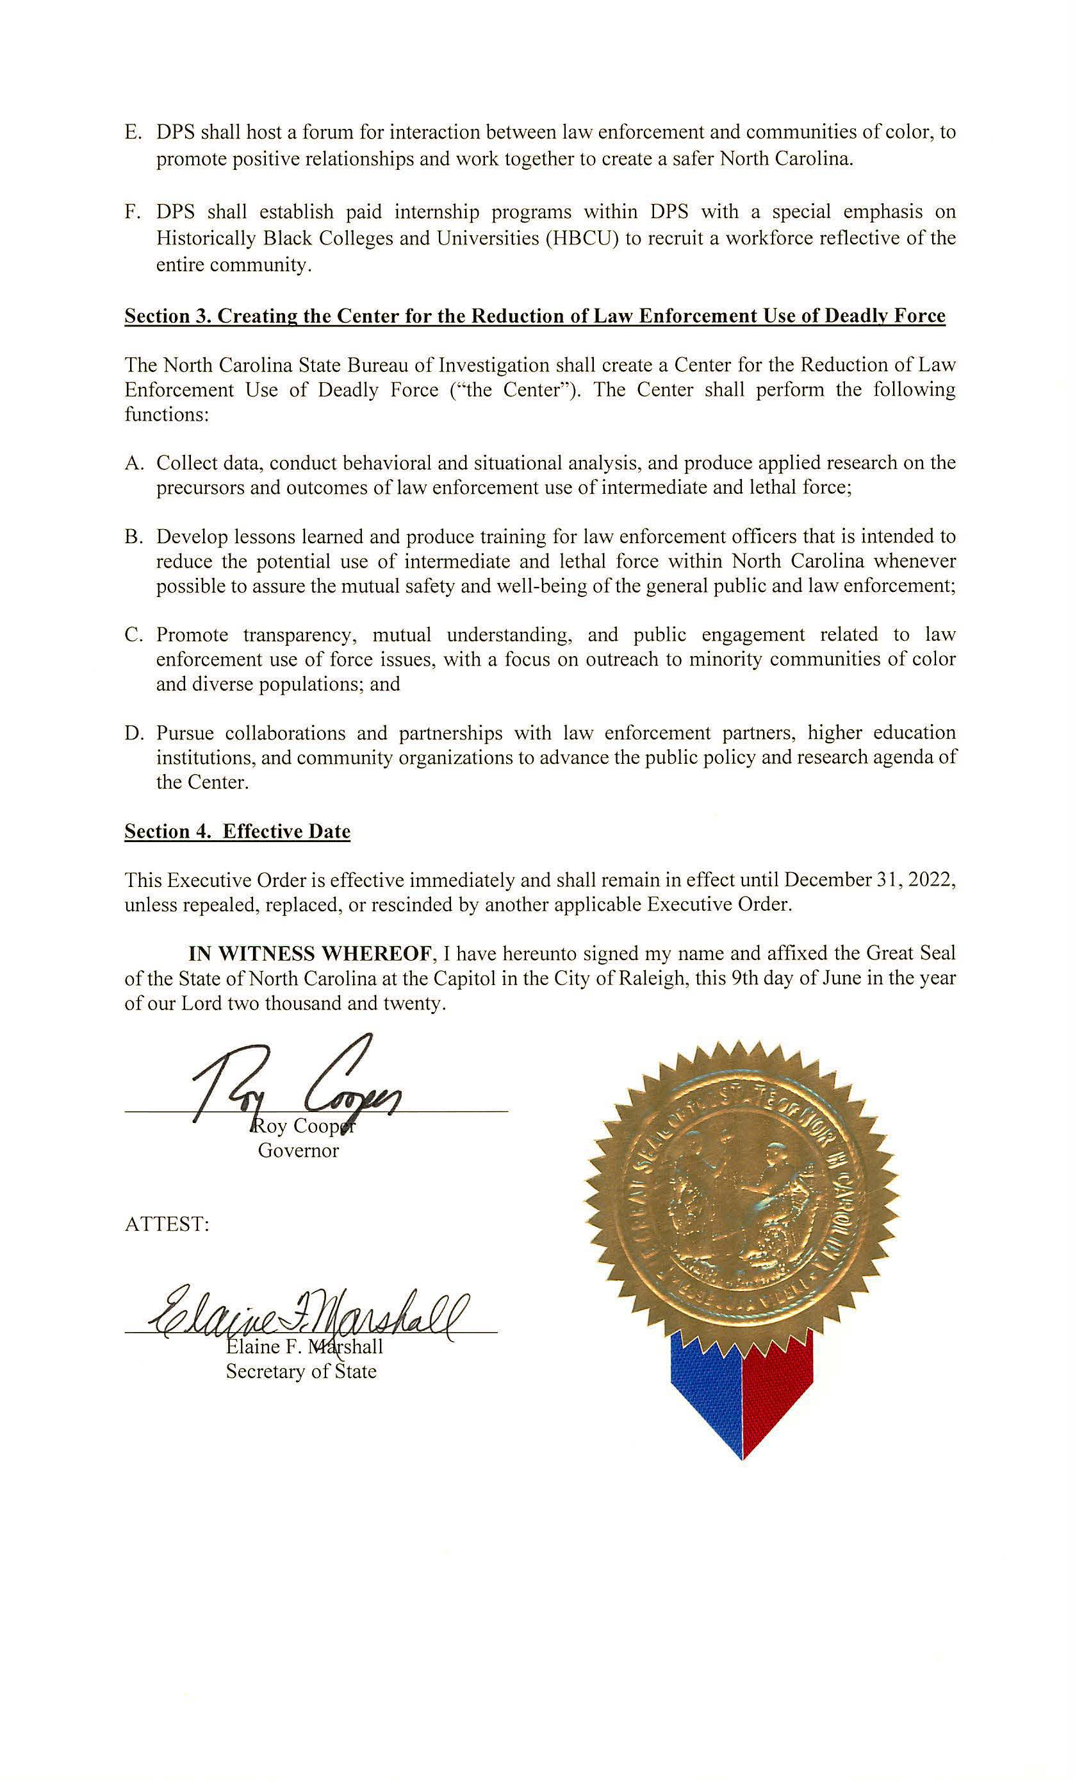

Alcoholic Beverage Control Commission
Notice

The ABC Commission has cancelled the public hearing on the ABC Store Spirituous Liquor Tasting Rules scheduled for July 8, 2020 at 10:00 a.m. at the ABC Commission Office at 400 E. Tryon Road, Raleigh, NC 27610. The public hearing on these rules is rescheduled for August 12, 2020 at 10:00 a.m. at the same location. The public comment period for the ABC Store Spirituous Liquor Tasting Rules, which currently run through July 8, 2020, will be extended until August 12, 2020 at 10:00 a.m.

The proposed rules for the ABC Store Spirituous Liquor Tasting Rules, 14B NCAC 15C .1301, .1303 - .1305 and .1307, were published in North Carolina Register, Volume 34, Issue 19, page 1773 on April 1, 2020.

Note from the Codifier: The notices published in this Section of the NC Register include the text of proposed rules. The agency must accept comments on the proposed rule(s) for at least 60 days from the publication date, or until the public hearing, or a later date if specified in the notice by the agency. If the agency adopts a rule that differs substantially from a prior published notice, the agency must publish the text of the proposed different rule and accept comment on the proposed different rule for 60 days.
Statutory reference: G.S. 150B-21.2.

Title 20 – DEPARTMENT of State Treasurer

Notice is hereby given in accordance with G.S. 150B-21.2 that the Local Government Commission intends to adopt the rule cited as 20 NCAC 03 .0508 and amend the rules cited as 20 NCAC 03 .0502 and .0505.

Link to agency website pursuant to G.S. 150B-19.1(c): https://www.nctreasurer.com/office-state-treasurer/nc-administrative-code-rules

Proposed Effective Date: November 1, 2020

Public Hearing:
Date: July 21, 2020
Time: 2:00-3:00pm
Location: Conference line: 1-877-402-9757; Access code: 4354283

Reason for Proposed Action: Implementation of the proposed rule changes will promote conformity to auditing best practices and improve financial transparency by ensuring that auditors will present findings and fiscal issues identified in an annual audit report to units and the public and by ensuring that all units receive relevant information in a consistent manner through the auditor’s presentation, regardless of the auditor employed. Additionally, the proposed rule changes will simplify the audit contract and audit fee business processes and streamline the responsibilities of the Local Government Commission staff in receiving and reviewing units’ responses to audit findings and corrective action plans.

The LGC is proposing to revise rules updating:
- the requirements related to the submission and presentation of audit reports to local governments and public authorities, and
- the submission and approval of audit invoices.

The LGC is proposing a new rule regarding:
- the process for units that are required to provide responses and corrective action plans to the LGC as a result of audit findings and financial indicators of concern.

Comments may be submitted to: Laura Rowe, 3200 Atlantic Ave, Raleigh, NC 27604; email dst.ncac@nctreasurer.com

Comment period ends: August 31, 2020

Procedure for Subjecting a Proposed Rule to Legislative Review: If an objection is not resolved prior to the adoption of the rule, a person may also submit written objections to the Rules Review Commission after the adoption of the Rule. If the Rules Review Commission receives written and signed objections after the adoption of the Rule in accordance with G.S. 150B-21.3(b2) from 10 or more persons clearly requesting review by the legislature and the Rules Review Commission approves the rule, the rule will become effective as provided in G.S. 150B-21.3(b1). The Commission will receive written objections until 5:00 p.m. on the day following the day the Commission approves the rule. The Commission will receive those objections by mail, delivery service, hand delivery, or facsimile transmission. If you have any further questions concerning the submission of objections to the Commission, please call a Commission staff attorney at 919-431-3000.

Fiscal impact. Does any rule or combination of rules in this notice create an economic impact? Check all that apply.

State funds affected

Local funds affected

Substantial economic impact (>= $1,000,000)

Approved by OSBM

No fiscal note required

Chapter 03 - Local Government Commission

SECTION .0500 - AUDIT CONTRACTS

20 NCAC 03 .0502 AUDIT CONTRACT
(a) The Secretary may promulgate a standard audit contract designed to include the specific requirements in Subdivision (c) of this Rule. The Secretary may revise the standard audit contract from time to time as circumstances require provided that the contract continues to include the requirements of this Section. The requirements may be included in the contract either specifically or by reference to this Section.

(b) Governmental units and their independent auditors may submit contracts on their own forms provided that the form includes all requirements, either specifically or by reference, in Subdivision (c) of this Rule.
(c) The following requirements and conditions shall be included in all contracts for governmental units:

(1) The scope of the audit shall include all funds and ledgers of the governmental unit, and the requirement that the audit shall be conducted in accordance with generally accepted auditing standards and shall include such tests of the accounting records and such other procedures (including direct confirmation of tax, utility and other receivables) as are considered by the auditor to be necessary in the circumstances. Exceptions to the scope of the audit may be made only by specific approval of the Secretary or a deputy secretary and only for reasons that are fully explained as to the circumstances of the particular situation.

(2) The audit shall include a review of the internal control system of the governmental unit as provided by generally accepted auditing standards. The auditor shall forward a management letter to the unit, detailing his the auditor's findings and his recommendations for improvement. The auditor shall forward a copy of the management letter to the Secretary. Commission.

(3) Information based on the audited financial statements shall be submitted to the Secretary for the purpose of identifying Financial Performance Indicators and Financial Performance Indicators of Concern.

(3)(4) The auditor shall, after the completion of his or her examination, submit to the governing body a report of the audit with as many copies as requested in the contract. The report shall include all funds and ledgers included in the scope of the audit, and an expression of opinion on the financial statements included therein. If the expression of opinion is in any way modified qualified or if an opinion is disclaimed or not included for any reason, sufficient reasons therefor shall be included in the report of audit. Copies of the audit report and any special reports issued as a result of the audit engagement shall be transmitted forthwith to the Secretary Commission.

(4)(5) The fee for the audit engagement shall be stated. All audit engagement fees and terms shall be clearly stated and shall allow for the computation of a final fee. The fee may be stated as a fixed dollar amount or as a rate per hour or day, either with or without a maximum.

(6) The auditor shall present the audited financial statements including any compliance reports to the unit's governing body or audit committee in an official meeting in open session as soon as the audited financial statements are available but not later than 45 days after the submission of the audit report to the Secretary. The auditor's presentation to the unit's governing body or audit committee must include:
(A) the description of each finding, including all material weaknesses and significant deficiencies, and any other issues related to the internal controls or fiscal health of the unit as disclosed in the management letter, the Single Audit or Yellow Book reports, or any other communications regarding internal controls as required by current auditing standards set by the Accounting Standards Board or its successor;
(B) the status of the prior year audit findings;
(C) the values of Financial Performance Indicators based on information presented in the audited financial statements; and
(D) notification to the governing body that the governing body must develop a "Response to the Auditor's Findings, Recommendations, and Fiscal Matters," if required under Rule 20 NCAC 03 .0508.
The Secretary shall verify auditors' compliance with the presentation requirement of Paragraph (c)(6) of this Rule.

(5)(7) The auditor shall promptly notify the governing body and the Secretary commission, if circumstances disclosed by during the audit call for a an expanded scope of work more detailed investigation by the auditor beyond that than necessary under ordinary conditions indicated by the auditor's audit planning and risk assessment.

(6)(8) No agreement(s) relating to the audit engagement but not attached to and referenced in the audit contract shall be enforceable by any party to said agreement(s).

(d) Form LGC-205 shall be provided for the convenience of those auditors and units who wish to use the form.

(e) The Commission is the state's agency charged with the duty of advising and assisting unit officials in all phases of fiscal management, and with promoting sound fiscal management, careful borrowing, and sound debt management practices as described in Rule 20 NCAC 03 .0101. To fulfill these duties, and pursuant to its authority under G.S. 159-34(b), the Commission may establish relevant criteria for gathering financial data to timely assist and identify units that are facing or may face fiscal management challenges or distress. For purposes of this Section, the following definitions apply:

(1) Financial Performance Indicators are values derived from information included in the audited financial statements that assist the Secretary in improving the comparability of reporting a given unit's financial condition and financial performance. These criteria include, but are not limited to, adequacy of a unit's fund balance; liquidity or the ability to meet short-term obligations; solvency or the ability to meet long-term obligations; debt service coverage; leverage; and such other indicators of financial condition and financial performance as the Secretary may from time to time establish.

(2) Financial Performance Indicators of Concern are Financial Performance Indicators with values which may indicate inadequate financial conditions or fiscal management concerns within the unit.

Authority G.S. 159-3(f); 159-34.
20 NCAC 03 .0505 AUDIT BILLINGS

(a) All invoices for services rendered in an audit engagement as defined in Rule 20 NCAC 03 .0503 shall be submitted to the Commission for approval before any payment is made. Payment before approval is a violation of law.

(b) Invoices to be approved shall be submitted in duplicate to the Secretary. Secretary at the mailing address of the Commission.

(c) Invoices shall be approved only under the following circumstances:

(1) There is a valid contract;

(2) The report of audit has been received;

(3) The audit billing and the report of audit conform conforms to the requirements of the contract and of this Section;

(4) Except in the case of a fixed fee, the The audit billing shows all calculations necessary to compute the fee from the rates and terms shown in the contract; and

(5) There are no circumstances known to the secretary Secretary indicating that the audit report may fail to conform to the requirements of the contract and of this Section. a failure on the part of the auditor to perform the audit as provided in this Section.

Notwithstanding the above, the Commission may approve interim billings up to a maximum of 75 percent of a fixed or maximum fee, or, in the case where there is no fixed or maximum fee, up to a maximum of 75 percent of the last year's billings for the last annual audit of the subject unit. unit submitted to the Secretary. Provided however, that the Secretary or a deputy secretary may approve a higher or lower amount, on an interim billing amount if he or she finds that such would be more equitable under a particular set of circumstances.

Authority G.S. 159-3(f); 159-34.

20 NCAC 03 .0508 RESPONSE TO THE INDEPENDENT AUDITOR'S FINDINGS, RECOMMENDATIONS, AND FISCAL MATTERS

(a) If the governing body of a unit of local government or public authority is notified by its independent auditor that the audited financial statements presented to the governing body included one or more significant deficiencies, material weaknesses, other findings or if the auditor determined that Financial Performance Indicators of Concern were identified based on information presented in the audited financial statements, then the governing body shall develop a "Response to the Auditor's Findings, Recommendations and Fiscal Matters" ("Response") signed by a majority of the members of the governing body and forward a copy of this response to the Secretary within 60 days of the auditor's presentation.

(b) The Response shall address each significant deficiency, material weaknesses and other finding(s) presented to the governing body and shall provide a financial plan to address each Financial Performance Indicator of Concern reported to the governing body and shall include the following:

(1) Audit Findings
(A) A written description of the procedure or process developed by the local government to address each finding, including all material weaknesses and significant deficiencies, and any other issues related to the internal controls or fiscal health of the unit as disclosed in the management letter, the Single Audit or Yellow Book reports, or any other communications regarding internal controls as required by current auditing standards set by the Accounting Standards Board or its successors.
(B) The description must provide sufficient detail that the governing body and the auditor can determine that the procedure or process will reasonably address the specific audit finding and is being properly implemented. The description may include such information as the date for implementation, the position titles responsible for implementation, the positions performing the procedures or processes, the frequency of performance, and other matters necessary to evaluate the success of the procedure or process.
(C) If the governing body disagrees with an audit finding, it shall fully describe its disagreement and explain the factors that support this determination.

(2) Financial Performance Indicators of Concern
(A) A written description of the plan developed by the governing body to address each Financial Performance Indicator of Concern.
(B) The plan must provide sufficient detail that the governing body and the auditor can determine that it will reasonably address the specific Financial Performance Indicator(s) of Concern. The description may include such information as the time period required for improvement, any governing body action required for implementation, the steps to increase revenue or reduce expenses, the frequency of performance evaluation, and other matters necessary to evaluate the success of the plan.

Authority G.S. 159-3(f); 159-34.

Note from the Codifier: The rules published in this Section of the NC Register are emergency rules reviewed by the Codifier of Rules and entered in the North Carolina Administrative Code. The agency must subsequently publish a proposed temporary rule on the OAH website (www.ncoah.com/rules) and submit that adopted temporary rule to the Rules Review Commission within 60 days from publication of the emergency rule or the emergency rule will expire on the 60th day from publication.
This section of the Register may also include, from time to time, a listing of emergency rules that have expired. See G.S. 150B-21.1A and 26 NCAC 02C .0600 for adoption and filing requirements.

TITLE 11 – department of insurance

Rule-making Agency: Industrial Commission

Rule Citation: 11 NCAC 23G .0104

Effective Date: June 16, 2020

Findings Reviewed and Approved by the Codifier: June 8, 2020

Reason for Action: 11 NCAC 23G .0104, as currently written, requires physical in-person attendance of all parties and other persons required to attend a mediation, unless all such parties and persons and the mediator agree to waive the physical in-person attendance requirement, or unless the physical in-person attendance requirement is waived by order of the Industrial Commission upon motion of a party and notice to all parties and persons required to attend the mediation.

Mediations in workers’ compensation cases are held indoors in offices where air may not circulate freely and where there may not be adequate space to allow mediation participants to stay 6 feet apart. These mediations often require the attendance of people who fall into a high-risk category for complications from COVID-19. Additionally, some mediations involve multiple defendants, thereby increasing the number of mediation participants to potentially more than 10 people. It is not uncommon for one party to refuse to agree to waive the physical in-person attendance requirement of the rule and it is not guaranteed that a motion to waive the physical in-person attendance requirement will be granted. Therefore, the current rule may result in gatherings contrary to the current social distancing and other recommendations of the Governor of North Carolina and the NC Dept. of Health and Human Services, including those recommendations contained in Executive Order 141, which currently is in effect.

As further evidence of why an emergency amended mediation attendance rule is needed, it should be noted that the North Carolina Supreme Court entered an order dated June 3, 2020 which approved an amended mediation rule for use in Superior Court cases that changes the presumptive physical in-person attendance requirement to a presumptive remote attendance requirement. G.S. 97-80(c) requires the Industrial Commission’s mediation rules to be “substantially similar” to the mediation rules approved by the Supreme Court for use in Superior Court cases. The Industrial Commission’s emergency amended mediation attendance rule will bring the Commission’s rule in conformity with the mediation attendance rule for use in Superior Court cases, which the Supreme Court deemed necessary to change in order to keep mediation participants safe during the COVID-19 pandemic. Based on the foregoing, an emergency rule is needed to protect the public health and safety.

Chapter 23 - Industrial Commission

SUBCHAPTER 23G – NORTH CAROLINA INDUSTRIAL COMMISSION RULES FOR MEDIATED SETTLEMENT AND NEUTRAL EVALUATION CONFERENCES

SECTION .0100 – MEDIATION AND SETTLEMENT

11 NCAC 23G .0104 DUTIES OF PARTIES, REPRESENTATIVES, AND ATTORNEYS

(a) Attendance. The following persons shall physically attend the mediated settlement conference:

(1) all individual parties;

(2) in a workers' compensation case, a representative of the employer at the time of injury if:
(A) the employer, instead of or in addition to the insurance company or administrator, has decision-making authority with respect to settlement;
(B) the employer is offering the claimant employment and the suitability of that employment is in issue;
(C) the employer and the claimant have agreed to simultaneously mediate non-compensation issues arising from the injury; or
(D) the Commission orders the employer representative to attend the conference if the representative's physical attendance is necessary to resolve matters in dispute in the subject action;

(3) an officer, employee or agent of any party that is not a natural person or a governmental entity who is not such party's outside counsel and who has the authority to decide on behalf of such party whether and on what terms to settle the action;

(4) in a workers' compensation case, an employee or agent of any party that is a governmental entity who is not such party's outside counsel or Attorney General's counsel responsible for the case and who has the authority to decide on behalf of such party and on what terms to settle the action.

(5) when the governing law prescribes that the terms of a proposed settlement may be approved only by a Board, an employee or agent who is not such party's outside counsel or Attorney General's counsel responsible for the case and who has the authority to negotiate on behalf of and to make a recommendation to the Board. Because G.S. 143-295 provides the Attorney General with settlement authority on behalf of governmental entities and agencies for state tort claims, an employee or agent of the named governmental entity or agency is not required to attend the mediated settlement conference; the Attorney General shall attempt to make an employee or agent of the named governmental entity or agency in a state tort claim available via telecommunication, and mediation shall not be delayed due to the absence or unavailability of the employee or agent of the named governmental entity or agency.

(6) The counsels of record; provided, that appearance by counsel does not dispense with or waive the required attendance of the parties listed in Subparagraphs (1) through (4);

(7) a representative of each defendant's primary workers' compensation or liability insurance carrier or self-insured that may be obligated to pay all or part of any claim presented in the action. Each carrier or self-insured shall be represented at the conference by an officer, employee or agent who is not such party's outside counsel and who has the authority to decide on behalf of the carrier or self-insured whether and on what terms to settle the action, or who has been authorized to negotiate on behalf of such carrier or self-insured and can communicate during the conference with persons who have such decision making authority; and

(8) by order of the Commission, other representatives of parties, employers or carriers, who may be obligated to pay all or part of any claim presented in the action and who are not required to attend the conference pursuant to Subparagraphs (1) through (6) of this Rule, if the Commission determines that the representative's attendance is necessary for purposes of resolving the matters in dispute in the subject action. Any employer or carrier who may be obligated to pay all or part of any claim presented in the action and who is not required to physically attend the mediated settlement conference pursuant to Subparagraphs (1) through (6) of this Rule or by Commission orders, may attend the conference if the employer or carrier elects to attend. If, during the conference, the mediator determines that the physical attendance of one or more additional persons is necessary to resolve the matters in dispute in the subject action, the mediator may recess the conference and reconvene the conference at a later date and time to allow the additional person or persons to physically attend.

(b) Any party or person required to attend a mediated settlement conference shall physically attend the conference until an agreement is reduced to writing and signed as provided in Paragraph (f) of this Rule, or until an impasse has been declared. Attendance shall mean physical in-person attendance whenever the mediation rules approved by the North Carolina Supreme Court that are in effect, either temporarily or permanently, for use in the Superior Court division require physical in-person attendance. During any time that attendance means physical in-person attendance, any Any such party or person person, including the mediator, may have the physical in-person attendance requirement excused or modified by agreement of all parties and persons persons, including the mediator, required to attend the conference, conference and the mediator, or by order of the Commission in the interests of justice upon motion of a party and notice to all parties and persons persons, including the mediator, required to attend the conference. Attendance shall mean attendance using remote technology whenever the mediation rules approved by the North Carolina Supreme Court that are in effect, either temporarily or permanently, for use in the Superior Court division require attendance through the use of remote technology. During any time that attendance means attendance through the use of remote technology, any party or person, including the mediator, may have the remote technology attendance requirement excused or modified by agreement of all parties and persons, including the mediator, required to attend the conference, or by order of the Commission in the interests of justice upon motion of a party and notice to all parties and persons, including the mediator, required to attend the conference. All parties and persons, including the mediator, shall comply with all public health and safety requirements set forth in the mediation rules approved by the North Carolina Supreme Court that are in effect, either temporarily or permanently, for use in the Superior Court division.

(c) In appropriate cases the Commission or the mediator, with the consent of the parties, may allow a party or insurance carrier representative who is required to physically attend a mediated settlement conference under this Rule to attend the conference by telephone, conference call, speaker telephone or videoconferencing; provided that, the party or representative so attending shall bear all costs of such telephone calls or videoconferencing, the mediator may communicate directly with the insurance representative with regard to matters discussed in mediation, and the mediator may set a subsequent mediated settlement conference at which all parties and representatives shall physically attend. The failure to properly appear by telephone or videoconferencing in accordance with this Paragraph shall subject the responsible party(ies) or representative(s) to sanctions pursuant to Rule .0105 of this Subchapter.

(d) Notice of Mediation Order. Within seven days after the receipt of an order for a mediated settlement conference, the carrier or self-insured named in the order shall provide a copy of the order to the employer and all other carriers who may be obligated to pay all or part of any claim presented in the workers' compensation case or any related third-party tortfeasor claims, and shall provide the mediator and the other parties in the action with the name, address and telephone number of all such carriers.

(e) Finalizing Agreement. If an agreement is reached in the mediated settlement conference, the parties shall reduce the agreement to writing, specifying all terms of the agreement that bear on the resolution of the dispute before the Commission, and shall sign the agreement along with their counsel. The parties may use IC Form MSC8, Mediated Settlement Agreement, or MSC9, Mediated Settlement Agreement – Alternative Form, for this purpose. Execution by counsel of a mediated settlement agreement for an employer or carrier who does not physically attend the mediated settlement conference shall be deemed to be in compliance with this Rule and 11 NCAC 23A .0502. By stipulation of the parties and at the parties' expense, the agreement may be electronically or stenographically recorded. All agreements for payment of compensation shall be submitted for Commission approval in accordance with 11 NCAC 23A .0501 and .0502.

(f) Payment of Mediator's Fee. The mediator's fee shall be paid at the conclusion of the mediated settlement conference, unless otherwise provided by Rule .0107 of this Subchapter, or by agreement with the mediator.

(g) Related Cases. Upon application by any party or person and upon notice to all parties, the Commission may, in the interests of justice, order an attorney of record, party or representative of an insurance carrier who may be liable for all or any part of a claim pending in a Commission case to attend a mediated settlement conference that may be convened in another pending case, regardless of the forum in which the other case may be pending, provided that all parties in the other pending case consent to the attendance ordered pursuant to this Paragraph. Any disputed issues concerning such an order shall be addressed to the Commission's Dispute Resolution Coordinator. Unless otherwise ordered, any attorney, party or carrier representative who attends a mediated settlement conference pursuant to this Paragraph shall not be required to pay any of the mediation fees or costs related to that conference. Requests that a party, attorney of record, or insurance carrier representative in a related case attend a mediated settlement conference in a Commission case shall be addressed to the court or agency in which the related case is pending, provided that all parties in the Commission case consent to the requested attendance.

History Note: Authority G.S. 97-80(a),(c); 143-295; 143-296; 143-300; Rule 4 of Rules Implementing Statewide Mediated Settlement Conference in Superior Court Civil Actions;
Eff. January 16, 1996;
Amended Eff. October 1, 1998;
Recodified from 04 NCAC 10A .0616;
Amended Eff. July 1, 2014; January 1, 2011; June 1, 2000;
Recodified from 04 NCAC 10G .0104 Eff. June 1, 2018;
Emergency Amendment Eff. June 16, 2020.

TITLE 14b – department of public safety

Rule-making Agency: Alarm Systems Licensing Board

Rule Citation: 14B NCAC 17 .0201

Effective Date: June 9, 2020

Findings Reviewed and Approved by the Codifier: June 1, 2020

Reason for Action: On March 10, 2020, the Governor of North Carolina, by issuing Executive Order No. 116, declared a state of emergency to coordinate a response and enact protective measures to help prevent the spread of COVID-19. The COVID-19 is a respiratory disease that can result in serious illness or death. The COVID-19, previously unidentified in humans, spreads easily from person to person. Once an outbreak of the COVID-19 begins, it is difficult to contain. The World Health Organization, the Center for Disease Control and Prevention, and the United States Department of Health and Human Services have declared COVID-19 a public health threat and emergency. On March 12, 2020, the Governor of North Carolina and the NC Department of Health and Human Services recommended high risk persons stay at home, that schools implement plans for distance or e-learning, that employers and employees use teleworking technologies, and that mass gatherings should cancel, postpone, and modify these events or offer online streaming services. On March 14, 2020, the Governor issued Executive Order No. 117 that prohibited mass gatherings, closed schools, and urged social distancing. On May 20, 2020 the Governor issued Executive Order 141 which relaxed some restrictions but citizens were still dissuaded from travel and "social distancing" still encouraged. These various Orders, as well as similar orders in other states, have limited travel.

Chapter 17 - Alarm Systems Licensing Board

SECTION .0200 – PROVISIONS FOR LICENSEES

14B NCAC 17 .0201 APPLICATION FOR LICENSE

(a) Each applicant for a license shall submit an online application on the website provided by the Board. When this online application is submitted, it shall be accompanied by:

(1) one set of classifiable fingerprints on an F.B.I. fingerprint card provided by the Board and mailed separately to the Board's office;

(2) one head and shoulders digital photograph of the applicant in JPG format of sufficient quality for identification, taken within six months prior to the online submission, and uploaded with the application submission;

(3) statements of the results of a statewide criminal history records search by the reporting service designated by the Board pursuant to G.S. 74D-2.1(a) for any state where the applicant has resided within the preceeding 60 months; and

(4) the applicant's application fee, along with a four dollar ($4.00) convenience fee charged by the third-party vendor and credit card transaction fee charged by the applicant's credit card provider and collected online.

(b) Each applicant shall upload evidence of high school graduation either by diploma, G.E.D. certificate, or other

equivalent documentation.

(c) Each applicant for a license shall meet personally with either a Board investigator, the Screening Committee, the Director, or a Board representative designated by the Director prior to being issued a license. The applicant shall discuss the provisions of G.S. 74D and the administrative rules in this Chapter during the personal meeting. The applicant shall sign a form provided by the Board stating that the applicant has reviewed the information with the Board's representative and that the applicant understands G.S. 74D and the administrative rules in this Chapter. During a National or State declared state of emergency which restricts or prohibits travel the personal meeting requirement may be waived in lieu of alternative means of communication.

(d) Each applicant for a branch office license shall submit an online application on the website provided by the Board. This online application shall be accompanied by the branch office application fee.

History Note: Authority G.S. 74D-2; 74D-2.1; 74D-3; 74D-5; 74D-7; 74D-8;
Temporary Rule Eff. January 9, 1984, for a period of 120 days to expire on May 7, 1984;
Eff. May 1, 1984;
Amended Eff. December 1, 2012; February 1, 2012; January 1, 2007; September 1, 2006; March 1, 1993; July 1, 1987; January 1, 1986;
Transferred and Recodified from 12 NCAC 11 .0201 Eff. July 1, 2015;
Amended Eff. December 1, 2017;
Readopted Eff. June 1, 2018;
Amended Eff. September 1, 2019;
Emergency Amendment Eff. June 9, 2020.

This Section includes a listing of rules approved by the Rules Review Commission followed by the full text of those rules. The rules that have been approved by the RRC in a form different from that originally noticed in the Register or when no notice was required to be published in the Register are identified by an * in the listing of approved rules. Statutory Reference: G.S. 150B-21.17.

Rules approved by the Rules Review Commission at its meeting on May 21, 2020 Meeting.

REGISTER CITATION TO THE
NOTICE OF TEXT
Structural Pest Control Committee
Application for Licenses and Cards: Examination | 02 | NCAC | 34 | .0302* | 34:11 NCR
Recertification | 02 | NCAC | 34 | .0309* | 34:11 NCR
Records: Pesticides and Application Equipment Used | 02 | NCAC | 34 | .0328* | 34:11 NCR
Ancillary Activities | 02 | NCAC | 34 | .0331* | 34:11 NCR
Wood-Destroying Insects: Excluding Subterranean Termites | 02 | NCAC | 34 | .0501* | 34:11 NCR
Pesticides for Subterranean Termite Prevention and/or Con... | 02 | NCAC | 34 | .0502* | 34:11 NCR
Subterranean Termite Control: Buildings After Constructed | 02 | NCAC | 34 | .0503* | 34:11 NCR
Reporting Damage: Infestation: Uninspected Areas | 02 | NCAC | 34 | .0504* | 34:11 NCR
Subterranean Termite Preventions/Res Bldgs Under Const | 02 | NCAC | 34 | .0505* | 34:11 NCR
Min Require/Subterranean Termite Prev/Commercial Bldgs Un... | 02 | NCAC | 34 | .0506* | 34:11 NCR
Wood-Destroying Insects and Other Organism Reports | 02 | NCAC | 34 | .0602* | 34:11 NCR
Written Records of Household Pest Control | 02 | NCAC | 34 | .0703* | 34:11 NCR
Decision of Committee | 02 | NCAC | 34 | .1206 | 34:11 NCR
Parks and Recreation Authority
Eligible Participants | 07 | NCAC | 13K | .0102* | 34:14 NCR
Funding Cycle | 07 | NCAC | 13K | .0103* | 34:14 NCR
Evaluation of Applications | 07 | NCAC | 13K | .0105* | 34:14 NCR
Grant Agreement | 07 | NCAC | 13K | .0106* | 34:14 NCR
Matching Requirements | 07 | NCAC | 13K | .0107* | 34:14 NCR
Eligible Projects and Costs | 07 | NCAC | 13K | .0108* | 34:14 NCR
Site Control and Dedication | 07 | NCAC | 13K | .0109* | 34:14 NCR
Inspections | 07 | NCAC | 13K | .0110* | 34:14 NCR
Elections, State Board of
Voting Procedures | 08 | NCAC | 10B | .0103* | 31:23 NCR
Medical Care Commission
The License | 10A | NCAC | 13F | .0202* | 34:06 NCR
Applying for a License to Operate a Facility not Currentl... | 10A | NCAC | 13F | .0204* | 34:06 NCR
Renewal of License | 10A | NCAC | 13F | .0208* | 34:06 NCR
Conditions for License Renewal | 10A | NCAC | 13F | .0209 | 34:06 NCR
Denial or Revocation of License | 10A | NCAC | 13F | .0212 | 34:06 NCR
The License | 10A | NCAC | 13G | .0202* | 34:06 NCR
Application for a License to Operate a Home not Currently... | 10A | NCAC | 13G | .0204* | 34:06 NCR
Renewal of License | 10A | NCAC | 13G | .0208* | 34:06 NCR
Conditions for License Renewal | 10A | NCAC | 13G | .0209 | 34:06 NCR
Denial and Revocation of License | 10A | NCAC | 13G | .0212 | 34:06 NCR
Appeal of Licensure Action | 10A | NCAC | 13G | .0213 | 34:06 NCR
Private Protective Services Board
Rulemaking and Administrative Hearing Procedures | 14B | NCAC | 16 | .0109* | 33:15 NCR
Investigation for Unarmed Security Guard Registration | 14B | NCAC | 16 | .0704* | 33:15 NCR
Sedimentation Control Commission
Who May Assess | 15A | NCAC | 04C | .0103* | 34:02 NCR
Criteria | 15A | NCAC | 04C | .0106* | 34:02 NCR
Transportation, Department of
Selective Vegetation Removal Permit Required to Remove Ve... | 19A | NCAC | 02E | .0601* | 34:13 NCR
Requests for Selective Vegetation Removal Permits for a F... | 19A | NCAC | 02E | .0602* | 34:13 NCR
Issuance or Denial of Selective Vegetation Removal Permit... | 19A | NCAC | 02E | .0603* | 34:13 NCR
Conditions of Selective Vegetation Removal Permit for Fac... | 19A | NCAC | 02E | .0604* | 34:13 NCR
Requests for Selective Vegetation Removal Permits for Out... | 19A | NCAC | 02E | .0608* | 34:13 NCR
Issuance or Denial of Selective Vegetation Removal Permit... | 19A | NCAC | 02E | .0609* | 34:13 NCR
Conditions of Selective Vegetation Removal Permit for Out... | 19A | NCAC | 02E | .0610* | 34:13 NCR
Beautification and Replanting Requirements for Selective ... | 19A | NCAC | 02E | .0611* | 34:13 NCR
Real Estate Commission
Broker-In-Charge | 21 | NCAC | 58A | .0110* | 34:15 NCR
License Application and Fee | 21 | NCAC | 58A | .0302 | 34:15 NCR
Petition for Predetermination | 21 | NCAC | 58A | .0305 | 34:15 NCR
Provisional Broker to be Supervised by Broker | 21 | NCAC | 58A | .0506 | 34:15 NCR
Procedures for Requesting Hearings When Applicant's Chara... | 21 | NCAC | 58A | .0616 | 34:15 NCR
Equivalent Credit | 21 | NCAC | 58A | .1708 | 34:15 NCR
Denial or Withdrawal of Continuing Education Credit | 21 | NCAC | 58A | .1710 | 34:15 NCR
Continuing Education Required of Nonresident Brokers | 21 | NCAC | 58A | .1711 | 34:15 NCR
Extensions of Time to Complete Postlicensing Education | 21 | NCAC | 58A | .1903 | 34:15 NCR
Denial or Withdrawal of Postlicensing Education Credit | 21 | NCAC | 58A | .1904 | 34:15 NCR
Definitions | 21 | NCAC | 58H | .0101* | 34:15 NCR
Applicability | 21 | NCAC | 58H | .0201 | 34:15 NCR
Application for Education Provider Certification | 21 | NCAC | 58H | .0202* | 34:15 NCR
Education Director | 21 | NCAC | 58H | .0203 | 34:15 NCR
Policies and Procedures Disclosure | 21 | NCAC | 58H | .0204 | 34:15 NCR
Course Materials | 21 | NCAC | 58H | .0205* | 34:15 NCR
Advertising and Recruitment Activities | 21 | NCAC | 58H | .0206 | 34:15 NCR
Course Completion Certificates and Reports | 21 | NCAC | 58H | .0207* | 34:15 NCR
Education Provider Records | 21 | NCAC | 58H | .0208 | 34:15 NCR
Expiration and Renewal of Provider Certification | 21 | NCAC | 58H | .0209* | 34:15 NCR
Denial, Withdrawal, or Termination of Education Provider ... | 21 | NCAC | 58H | .0210 | 34:15 NCR
Prelicensing and Postlicensing Roster Reporting | 21 | NCAC | 58H | .0211 | 34:15 NCR
School Records | 21 | NCAC | 58H | .0212 | 34:15 NCR
Evaluations of Instructor Performance | 21 | NCAC | 58H | .0213 | 34:15 NCR
Expiration and Renewal of a School Approval or License | 21 | NCAC | 58H | .0214 | 34:15 NCR
Denial, Withdrawal, or Termination of School Approval or ... | 21 | NCAC | 58H | .0215 | 34:15 NCR
Prelicensing, Postlicensing, and Update Course Instructor... | 21 | NCAC | 58H | .0301* | 34:15 NCR
Application and Criteria for Instructor Approval | 21 | NCAC | 58H | .0302 | 34:15 NCR
Denial or Withdrawal of Instructor Approval | 21 | NCAC | 58H | .0303* | 34:15 NCR
Instructor Conduct and Performance | 21 | NCAC | 58H | .0304 | 34:15 NCR
Digital Video Recordings | 21 | NCAC | 58H | .0305 | 34:15 NCR
Continuing Education Elective Course Requirements | 21 | NCAC | 58H | .0402* | 34:15 NCR
Commission Created Update Courses | 21 | NCAC | 58H | .0403* | 34:15 NCR
Course Scheduling | 21 | NCAC | 58H | .0404* | 34:15 NCR
Denial or Withdrawal of Sponsor Approval | 21 | NCAC | 58H | .0405 | 34:15 NCR
Approval and Renewal of Elective Course | 21 | NCAC | 58H | .0406 | 34:15 NCR
Continuing Education Elective Course Requirements | 21 | NCAC | 58H | .0407 | 34:15 NCR
Commission Created Update Courses | 21 | NCAC | 58H | .0408 | 34:15 NCR
Records and Commission Review | 21 | NCAC | 58H | .0409 | 34:15 NCR
Continuing Education Course Scheduling and Notification | 21 | NCAC | 58H | .0410 | 34:15 NCR
Continuing Education Course Attendance | 21 | NCAC | 58H | .0411 | 34:15 NCR
Continuing Education Roster Reports and Certificates | 21 | NCAC | 58H | .0412 | 34:15 NCR
Continuing Education Course Cost, Cancellation, and Refunds | 21 | NCAC | 58H | .0413 | 34:15 NCR
Advertising | 21 | NCAC | 58H | .0414 | 34:15 NCR

TITLE 02 - Department of Agriculture and Consumer Services

02 NCAC 34 .0302 APPLICATION FOR LICENSES AND CARDS: EXAMINATION

(a) Application for licenses under the provisions of G.S. 106-65.26(a) and (c):

(1) Application for examination shall be on a regular form prescribed by the Division. The Committee shall approve applications if a complete application was submitted to the Division and all criteria under G.S. 106-65.26 has been met.

(2) Upon approval of the application for examination, the Committee secretary shall notify the applicant of said approval and provide the necessary form(s) for the applicant to pre-register for the examination as required in Paragraph (c) of this Rule.

(3) Applications to take the examination shall be either typed or printed in ink and sworn to before a notary public or some other official authorized by law to administer oaths.

(4) A high-resolution, full-face, head, and shoulder photograph of the applicant, taken within the preceding 12 months of the date of application, and not less than two and one-half inches square, shall be attached to the application.

(5) All applications to take the examination shall be retained by the office of the Committee secretary. All documents filed in support of an application shall be kept by the office of the Committee secretary; provided, however, that the Committee shall permit such documents to be withdrawn upon substitution of a true copy. All examinations shall remain the property of the Committee.

(6) An applicant who fails to pass the license examination within 12 months of the approval of his or her application shall be required to provide current information concerning his or her qualifications to take the examination to ensure that the applicant is still qualified to take the examination.

(7) An applicant who gives or receives unauthorized assistance in answering test questions from anyone who is not employed by the Division during an examination shall be dismissed from the examination and his or her markings or results shall be voided and said applicant's examination fee shall be forfeited. Such applicant shall not be permitted to take a reexamination for a period of six months from the date of the examination.

(8) No person shall be admitted to the examination room except members of the Committee, the attorney for the Committee, the examining personnel, employees of the Structural Pest Control Division, and the applicants for licensure.

(9) Any applicant making a score of 70 percent or more on any license examination(s) shall be issued a license in that phase(s) of structural pest control after submitting a completed application with all required fees and insurance documents therefor.

(10) The applicant shall furnish the information required by G.S. 106-65.26 and this Rule to establish that said applicant possesses qualifications as specified in G.S. 106-65.26 of the Act for the particular license(s) which he or she seeks. The Committee or its authorized representatives may, based upon their review of the contents of an application, make such investigations as the Committee deems necessary to review an applicant's qualifications.

(11) All applicants passing the examination(s) for licenses shall apply for said licenses within six months from the date on which the examinations were taken. If such applicants fail to make application for said licenses, within the specified period, such applicants shall be required to take and pass reexaminations covering phases of structural pest control work for which licenses were applied before said licenses are issued.

(12) If an applicant for a license fails an examination, he or she may review the examination at the next scheduled review session.

(b) Application for certified applicator's identification card under the provisions of G.S. 106-65.26(a) and (b):

(1) Applications filed pursuant to G.S. 106-65.26(a) and (b) shall be on a form prescribed by the Division.

(2) An applicant for a certified applicator's identification card in any phase of structural pest control shall furnish information as specified in G.S. 106-65.26 of the Act to establish that said applicant possesses qualifications for the particular certified applicator's identification card which he or she seeks. The Committee or its authorized representatives may, based upon their review of the contents of an application, make such investigations as it deems necessary with respect to the applicant's qualifications.

(3) All applications for certified applicator's identification cards under the provisions of G.S. 106-65.26(a) and (b) shall be retained by the office of the Committee secretary. All documents filed in support of an application shall be kept by the office of the Committee secretary; provided, however, that the Committee shall at its discretion permit such documents to be withdrawn upon substitution of a true copy. All examinations shall remain the property of the Committee.

(4) Any applicant making a score of 70 percent or more on the core certification examination and on any certified applicator's examination(s) shall be issued a certified applicator's identification card in that phase of structural pest control after submitting a completed Division's Certified Applicator Card application with required fees therefor.

(5) All applicants passing the examination(s) for certified applicator's identification cards shall apply for said cards within six months from the date on which the examinations were taken. If such applicants fail to make application for said certified applicator's identification cards within the specified period, such applicants shall be required to take and satisfactorily pass reexaminations covering phases of structural pest control work for which certified applicator's identification cards were applied before said cards are issued.

(6) If an applicant fails to obtain a certified applicator's identification card within 12 months of passing the core examination the applicant shall take and pass a reexamination before being eligible for the card.

(7) Upon receipt of the application for examination, the Committee secretary shall provide the necessary exam pre-registration forms for the applicant to pre-register for the examination as required in Paragraph (c) of this Rule.

(8) If an applicant for a certified applicator's card fails an examination, he or she may review the examination at the next scheduled review session.

(9) Subparagraphs (a)(2), (5), (7), and (8) of this Rule shall also apply to all applicants for certified applicator's identification cards.

(10) Completion of the Registered Technician School shall be a prerequisite for the certification examination.

(c) Pre-registration for license and certified applicator examination applicants:

(1) All applicants for the license or certified applicator's examination(s) shall pre-register with the Committee secretary for said examination(s) no less than 10 days prior to the date of the examination.

(2) Applicants who fail to pre-register shall not be permitted to take the examination.

(3) Pre-registration shall include a completed application for examination.

(d) Frequency of examination by license applicant limited:

(1) An applicant who fails to pass the license examination on his or her first attempt may retake the examination at any subsequent scheduled examination.

(2) An applicant who fails to pass the second license examination shall wait a minimum of one examination between each subsequent examination: except that, in the event of a death of a licensee the applicant intending to succeed the deceased licensee may take the examination a third time prior to the first one examination waiting period.

(3) No applicant shall be permitted to take the examination more than six times per year nor more than two times in consecutive months, except as provided for in Subparagraph (d)(2) of this Rule.

History Note: Authority G.S. 106-65.29;
Eff. July 1, 1976;
Readopted Eff. November 22, 1977;
Amended Eff. July 1, 1998; August 3, 1992; January 1, 1991; January 1, 1989;
Readopted Eff. June 1, 2020.

02 NCAC 34 .0309 RECERTIFICATION

(a) Certified applicators and licensees shall be certified for a five-year period. At the end of said five-year period, a certified applicator or licensee, at his or her discretion, may be recertified for another five-year period by choosing one of the following options:

(1) reexamination taken between January 1, prior to the expiration of the five-year recertification period, and June 30;

(2) for recertification after July 1, 2002: earning Continuing Certification Units during the five years immediately preceding the expiration date of his certification. The number of CCUs required shall be as follows:
(A) recertification in any one phase: 10 CCUs total, five of which shall be solely applicable to the phase in which recertification is desired;
(B) recertification in any two phases: 15 CCUs total, five of which shall be solely applicable to the first phase and five solely applicable to the second phase in which recertification is desired;
(C) recertification in all three phases: 20 CCUs total, five of which shall be solely applicable to the first phase, five solely applicable to the second phase, and five solely applicable to the third phase in which recertification is desired;
(D) licensees and noncommercial certified applicators shall earn at least one of the required continuing certification units established in Subparagraph (a)(3) of this Rule in at least four years of the five- year recertification period;
(E) commercial certified applicators shall earn at least one of the required continuing certification units established in Subparagraph (a)(3) of this Rule in at least three years of the five-year recertification period;
(F) continuing certification units shall not be carried forward beyond the five-year recertification period.

(b) Licensees holding an inactive license shall be subject to the requirements of this Rule.

History Note: Authority G.S. 106-65.29;
Eff. July 1, 1976;
Readopted Eff. November 22, 1977;
Amended Eff. July 1, 1998; January 1, 1989; August 1, 1980;
Readopted Eff. June 1, 2020.
02 NCAC 34 .0328 RECORDS: PESTICIDES AND APPLICATION EQUIPMENT USED

(a) All structural pest control records required by this Chapter, pesticides, and application equipment used by the licensee or noncommercial certified applicator shall be maintained at the office location to which the license or certified applicator's card is issued. During inspections the licensee or his or her employee shall be present to provide access to all structural pest control records, pesticides, and application equipment, upon request by the Division.

(b) Notwithstanding the requirements of Paragraph (a) of this Rule, a licensee may request permission from the Division to maintain records, pesticides, and application equipment in a location other than the office location specified in Paragraph (a) of this Rule. The Division shall grant permission if its ability to regulate the licensee as required in Paragraph (c) of this Rule will not be impeded by granting the request. Any such request shall be submitted annually.

(c) All such records, pesticides, and equipment shall be made available for inspection during regular business hours, Monday – Friday, 8:00 am – 5:00 pm, upon request by the Division.

History Note: Authority G.S. 106-65.29;
Eff. August 1, 1980;
Amended Eff. January 1, 2017; July 1, 1998; January 1, 1989;
Readopted Eff. June 1, 2020.

02 NCAC 34 .0331 Ancillary Activities

(a) Persons engaged in ancillary activities in association with control of household pests or wood-destroying organisms as indicated in Paragraph (c) of this Rule may be an employee, independent contractor, or otherwise, for one or more structural pest control licensees and are exempt from structural pest control license requirements.

(b) Persons conducting ancillary activities shall not engage in any duties involving pesticides.

(c) Ancillary activities are limited to the following duties:

(1) Moving of furniture or bedding as defined in G.S. 106-65.95.

(2) Cleaning, maintenance, or repair of property.

(3) Removing of wood debris and cellulose material.

(4) Removing and replacing of insulation with exclusion of removing and replacing insulation that is registered as pesticide by the N.C. Pesticide Board pursuant to G.S. 143-442.

(5) Moving of heaters and fans while they are powered off, before and after treatment.

(6) Core drilling of soil, concrete, or other surfaces of locations marked for termite bait system installation.

(7) Trenching or excavation of soil, only for preparation of termiticide application.

History Note: Authority G.S. 106-65.29; S.L. 2014-100, s. 13.10.(b);
Eff. May 19, 2015;
Readopted Eff. June 1, 2020.

02 ncac 34 .0501 WOOD-DESTROYING INSECTS: EXCLUDING SUBTERRANEAN TERMITES

(a) Determining Active Infestations of Wood-Destroying Beetles. The licensee, certified applicator, or his or her representative(s) making the inspection for wood-destroying beetles shall each be responsible for determining the presence or absence of an active infestation(s). Before any work is performed for the treatment of wood-destroying insects under Paragraphs (a) and (b) of this Rule, the licensee or his or her employee shall provide the property owner or agent a written proposal including, in addition to that information in 02 NCAC 34 .0605, the name(s) of the wood-destroying insects(s) to be controlled, that part of the structure to be covered under the agreement such as the entire structure, understructure only, entire interior of the garage, etc., and the basis on which the licensee, certified applicator, or his or her representative(s) determined the infestation to be active or inactive as set forth herein below:

(1) Powder Post Beetle(s)(Anobiidae, Bostrichidae and Lyctidae)
(A) The presence of frass, the color of fresh cut wood, shall be acceptable as evidence of an active infestation of powder post beetles.
(B) The presence of holes alone or holes and dull colored frass shall not be acceptable evidence of an active infestation of powder post beetles except in cases where live larvae or pupae are found in wood members.
(C) If an active infestation of powder post beetles is found by the Division in any structure treated for said beetles, during or after the first complete adult beetle emergence period within 18 months of the treatment date, the licensee or certified applicator responsible for said treatment shall retreat the infested areas of the structure within 30 days of written notice from the Division. Retreatment for an active infestation of Powder Post Beetles as indicated in Parts (A) and (B) of this Subparagraph shall be performed, upon request of the Division, in the presence of a structural pest control inspector.
(D) If a licensee provides a guarantee, warranty, or service agreement in connection with a treatment for powder post beetles, the period of initial liability with regard to active infestation shall be 18 months from the original treatment date.

(2) Old House Borer (Hylotrupes bajulus). The presence of old house borer or oval exit holes with sawdust-like frass consisting of fine powder with tiny pellets in oval galleries in pine or other softwoods shall constitute evidence of an active infestation of the old house borer. The sound of feeding larvae of the old house borer without the presence of frass shall not constitute sufficient evidence of an active infestation.

(b) Identifying Other Wood-Destroying Insects. Before recommending treatment or selling a service for the prevention or control of wood-destroying insects, other than powder post beetles or old house borer, the licensee, certified applicator, or their representative(s) shall identify the wood-destroying insect(s) in question and inform the property owner or his authorized representative of the identity and habits of the wood-destroying insect(s) in question.

(c) Any reapplication of pesticides under this Rule shall be in accordance with the label of the pesticide used.

(d) Pesticide applications for the prevention of wood-boring beetles shall be performed only after informing the property owner or their authorized agent in writing of the biology and conditions supporting an infestation and survival of said insects. Such notice shall include an evaluation of the condition of the structure(s) to be treated and a statement as to whether or not such condition will support an infestation by wood-boring beetles.

History Note: Authority G.S. 106-65.29;
Eff. July 1, 1976;
Readopted Eff. November 22, 1977;
Amended Eff. August 1, 2002; July 1, 1998; January 1, 1989; August 1, 1980;
Readopted Eff. June 1, 2020.

02 NCAC 34 .0502 PESTICIDES FOR SUBTERRANEAN TERMITE PREVENTION AND/OR CONTROL

(a) Only those products which bear an EPA-approved label for such use and for which the Committee has received the following information from the Pesticide Registrant or Manufacturer shall be used for subterranean termite control:

(1) A written statement from the pesticide registrant that the termiticide is intended either for use:
(A) as a supplement to or in combination with other treatment(s); or
(B) by itself, as the sole source of termite control; and

(2) For termiticides under Part (a)(1)(B) of this Rule:
(A) data to support all efficacy claims made on the label, labeling, and any promotional materials distributed by the registrant or manufacturer; and
(B) if the Committee approves a termiticide under Part (a)(1)(B) and the Directions for Use differ from the requirements of Rules .0503, .0505, or .0506 of this Section, the Committee may determine that treatments with those termiticides are exempt from all or part of the requirements of Rules .0503(a)(4) and (6) through (11), .0505, or .0506 of this Section, provided that the product is labeled for protection of the entire structure and the licensee provides a warranty for the control of subterranean termites on the entire structure.

(b) Only those products approved by the Committee based on the data submitted pursuant to Subparagraph (a)(2) of this Rule shall be used for the prevention or control of subterranean termites as the sole source of termite control or prevention. The Committee shall approve the product if the data submitted supports the efficacy claims.

(c) Termiticides intended for use as a supplement to or in combination with other termiticides shall not be used alone without first disclosing the registrants' recommendations to the property owner or agent.

(d) A list of approved termiticides may be obtained by writing the North Carolina Department of Agriculture and Consumer Services, Structural Pest Control and Pestcides Division, 1090 Mail Service Center, Raleigh, NC 27699-1090, or by calling (919) 733-6100. The list can also be obtained online at https://www.ncagr.gov/SPCAP/structural/publications.htm.

History Note: Authority G.S. 106-65.29;
Eff. July 1, 1976;
Readopted Eff. November 22, 1977;
Amended Eff. January 1, 2017; July 18, 2002; July 1, 1998; August 1, 1980;
Readopted Eff. June 1, 2020.

02 NCAC 34 .0503 SUBTERRANEAN TERMITE CONTROL: BUILDINGS AFTER CONstruction

(a) The following standards and requirements apply to the treatment of a building for subterranean termite control after construction if the building has a basement or crawl space:

(1) Access openings shall be provided to permit inspection of all basement and crawl space areas of a building and all open porches.

(2) Clean up and remove all wood debris and cellulose material, such as wood, paper, and cloth, contacting soil in all crawl space areas. This excludes shavings or other cellulose material too small to be raked with the tines of an ordinary garden rake. Remove all visible stumps from all crawl space areas. Remove all visible form boards in contact with soil.

(3) Remove all earth which is within 12 inches of the bottom edges of floor joists or within eight inches of the bottom edges of subsills or supporting girders, but not below footings of foundation walls. If foundation footings are less than 12 inches below the bottom edges of joists, subsills, or supporting girders, a bank of soil 12 inches to 18 inches wide shall be left adjacent to footings for the purpose of support. Clearance shall be adequate to provide passage of a person to all crawl space areas of a building.

(4) All visible termite tubes or tunnels on pillars, pilasters, foundation walls, chimneys, step buttresses, sills, pipes, and other structures below the sill line shall be removed.

(5) Eliminate all wooden parts making contact with the building and soil, either outside or inside, as follows:
(A) No wood of any access opening shall be in contact with the soil.
(B) Where wood parts such as door frames, partition walls, posts, stair carriages, or other wood parts can be ascertained to be making direct soil contact through concrete or where there is evidence of termite activity or damage, such wood parts shall be cut off above the ground or floor level, the wood shall be removed from the concrete, and the resulting hole shall be filled with concrete or covered with a metal plate after the point of contact has been treated with a termiticide.
(C) Where wood parts such as vertical wood supports or other wood parts under a building or steps outside a building are not resting on solid masonry or concrete bases extending at least two inches above the soil surface or are in direct soil contact and such supports or steps are not removed, the supports and steps shall be cut off and set on a solid masonry or concrete footing extending at least two inches above the ground after the point of contact has been treated with a termiticide.
(D) When wood skirting and lattice work are suspended, there shall be at least a two-inch clearance between the top of the soil and the bottom edges of the wood skirting or lattice work. If the two-inch clearance is not acceptable to the property owner, it may be closed with solid masonry or concrete, but a minimum clearance of one-fourth of one inch shall be provided between the masonry or concrete and wood.
(E) Where houses or decks are built on pressure-treated wood pilings, pillars, or all-weather wood foundations, such pilings, pillars, and wood foundation members, including wood step supports, are not subject to Parts (a)(5)(A), (B), or (C) of this Rule.

(6) Where evidence of either past or present subterranean termite infestation exists, drill and treat all voids in multiple masonry foundation and bearing walls and all voids created by their placement at and a minimum distance of four feet in all directions from such evidence. Porch foundation walls shall be drilled and treated to a distance of three feet from the main foundation wall and the point of contact with any wooden members. Drill as follows:
(A) The distance between drill holes shall not exceed 16 lineal inches and holes shall be no more than 16 inches above the footing or, for footings deeper than 16 inches, above the lowest soil level.
(B) Test drill the main foundation wall behind any porch or slab area to determine if the porch or slab is supported by a wall whose placement creates a void between itself and the main foundation wall. If test reveals that a void exists, drill and treat all voids therein as specified in this Rule.

(7) Where evidence of either past or present subterranean termite infestation exists, drill and treat all voids in all multiple masonry pillars, pilasters, chimneys, and step buttresses associated or in contact with such evidence and any void created by their placement. Drill as follows:
(A) The distance between drill holes shall not exceed 16 lineal inches and shall be no more than 16 inches above the footing or, for footings deeper than 16 inches, immediately above the lowest soil level.
(B) Drilling is not required if solid concrete masonry footings of pillars, pilasters, chimneys, or step buttresses extend eight inches or more above the soil surface.

(8) Where concrete slabs over dirt-filled areas are at the level of, above the level of, or in contact with wood foundation members, treat dirt-filled areas with a termiticide as follows:
(A) Drill vertically three-eighths of one inch or larger holes in the slab, no more than six inches from the building foundation at no more than 12-inch intervals, and treat soil below slab from the bottom of the slab to the top of the footing; or
(B) Drill horizontally three-eighths of one inch or larger holes in the foundation wall of the concrete slab, no more than six inches from the building foundation every 16 vertical inches starting immediately below the bottom of the slab, and rod treat all soil adjacent to building foundation from the bottom of the slab to the lowest outside grade.

(9) Trench or trench and rod treat soil to establish a continuous termiticide barrier in the soil adjacent to, but not more than six inches from:
(A) all pillars, pilasters, chimneys, pressure-treated wood supports, and step buttresses;
(B) inside of foundation walls;
(C) outside of foundation walls; and
(D) the outside of foundation walls of concrete slabs over dirt-filled areas, and the entire perimeter of a slab foundation wall from the top of the grade to the top of the footing or to a minimum depth of 30 inches, whichever is less.

Where footings are exposed, treatment shall be performed adjacent to the footing but not below the bottom of the footing. The trench shall be no less than six inches in depth or to the bottom of the footing, whichever is less. Where outside concrete slabs adjacent to the foundation prevent trenching of soil, drill three-eighths of one inch or larger holes, not more than 12 inches apart and within six inches of the foundation wall, through slabs or through adjoining foundation wall, and rod treat soil below slabs as indicated above to establish a continuous termiticide barrier at all known points of entry. The soil around pipes and other utility conduits making contact with the structure shall be treated.

(10) Where stucco or similar materials, including extruded or expanded rigid foam insulation or similar materials, are installed on wood and extend to or below grade, trench soil to a depth below and under the edge of the stucco or similar materials and treat soil to establish a continuous termiticide barrier in the soil. After the soil has been treated, a masonry barrier wall may be erected to hold back the soil from making direct contact with the stucco or similar materials. Where outside slabs on grade adjacent to foundation prevent trenching of soil, drill three-eighths of one inch or larger holes through slabs within six inches of the foundation wall or through adjoining foundation wall, not more than 12 inches apart, and rod treat soil below slabs. Where drain tile, french drains, or other foundation drainage systems present a hazard of contamination outside the treatment zone, treatment shall be performed in a manner that will not introduce termiticide into the drainage system.

(11) The requirements set forth in Paragraph (b) of this Rule shall be followed if applicable to basement or crawl space construction.

(b) The following standards and requirements shall apply to the treatment of a building for subterranean termite control after construction if the building has a slab-on-ground construction:

(1) Treat soil to establish a continuous termiticide barrier in, under, and around all traps and openings in the slab.

(2) Drill vertically three-eighths inch or larger holes at all visible or known expansion and construction joints, cracks, and crevices in slab and around all utility conduits in the slab at no more than 12-inch intervals and rod treat soil below slab to establish a continuous termiticide barrier from the bottom of the slab to a depth of 30 inches or to the top of the footing, whichever is less, at all known points of entry. Where wooden structural members are in contact with concrete or masonry floors which have joints or cracks beneath the wooden structural members, including wall plates in utility or storage rooms adjoining the main building, the concrete or masonry shall be drilled and treated in order to achieve treatment of the soil beneath them; however, expansion and construction joints at the perimeter of the exterior wall may be rod treated by drilling through the foundation wall at no more than 12-inch intervals directly below the bottom of the slab.

(3) The requirements set forth in Paragraph (a) of this Rule shall also be followed, where applicable.

(c) Reapplication of Pesticide(s) to a Structure Previously Treated for Subterranean Termite Control:

(1) Termiticide shall be reapplied if soil test by the Division reveals that the soil is deficient in the termiticide which was applied to the soil.

(2) Any reapplication of pesticides under this Rule shall be in accordance with the label of the pesticide used.

(d) A licensee may enter into a written agreement for the control or prevention of subterranean termites in a building after it has been constructed without having to comply with Paragraphs (a) and (b) of this Rule provided that:

(1) The licensee has written proof that he or she or his or her authorized agent treated the entire building for subterranean termites at the time of its construction as required in 02 NCAC 34 .0505 or 02 NCAC 34 .0506 (or comparable rules in effect at the time of treatment); and

(2) A written agreement is issued in compliance with 02 NCAC 34 .0605.

(e) Paragraphs (a)(3), (a)(6) through (a)(11) and (b) of this Rule shall not apply to subterranean termite treatment performed using termite bait(s) labeled for protection of the entire structure if the licensee provides a warranty for the control of subterranean termites on the entire structure.

(f) If the licensee uses a termiticide that has been approved by the Committee pursuant to 02 NCAC 34 .0502(a)(2)(B) and the licensee complies with the requirements of that Part, the licensee shall not be required to comply with 02 NCAC 34 .0503(a)(4) and (a)(6) through (11). For a list of termiticides the Committee has approved under 02 NCAC 34 .0502(a)(2)(B), see

http://www.ncagr.gov/SPCAP/structural/documents/TTermiticidesApprovedForUseInNorthCarolinapdf.pdf.

History Note: Authority G.S. 106-65.24; 106-65.29;
Eff. July 1, 1976;
Readopted Eff. November 22, 1977;
Amended Eff. August 1, 1980;
Temporary Repeal Eff. August 24, 1987 for a period of 30 days to expire on September 22, 1987;
Temporary Repeal Expired Eff. September 22, 1987;
Amended Eff. January 1, 1989;
Temporary Amendment Eff. January 10, 1997;
Temporary Amendment Expired Eff. October 31, 1997;
Amended Eff. January 1, 2017; July 1, 2010; August 1, 2002; July 1, 1998;
Readopted Eff. June 1, 2020.

02 NCAC 34 .0504 REPORTING DAMAGE: INFESTATION: UNINSPECTED AREAS

(a) When inspecting for wood-destroying insects or wood-decay organisms or both, all wood members of a structure which can be ascertained by visual inspection to be damaged shall be brought to the attention of the property owner or his authorized agent and shall also be indicated in writing, in the contract or agreement, by the licensee or his authorized agent.

(b) The licensee or his authorized agent shall indicate in writing, in the contract or agreement, whether or not he or she is responsible for the replacement, repair, or reinforcement of any or all of the wood members which were ascertained by visual inspection to be damaged.

(c) Any visible evidence of infestation of wood-destroying organisms in, on, under, or in contact with, a structure shall be brought to the attention of the property owner or his authorized agent and shall be specified, in writing, in the contract or agreement, by the licensee or his authorized agent.

(d) The licensee or his or her authorized agent shall indicate and describe, in writing, on the contract or agreement, any area(s) of the building or crawl space of the building which have not been inspected and give the reasons for not making such inspection(s).

History Note: Authority G.S. 106-65.29;
Eff. July 1, 1976;
Readopted Eff. November 22, 1977;
Amended Eff. July 1, 1998; August 1, 1980;
Readopted Eff. June 1, 2020.

02 NCAC 34 .0505 SUBTERRANEAN TERMITE PREVENTION/RES BLDGS UNDER CONST

(a) All treatments performed pursuant to this Rule shall only be performed at the label recommended rate and concentration.

(b) The following standards and requirements shall apply to the treatment of a building for subterranean termite control during construction if the building has a basement, crawl space, or slab:

(1) Establish a vertical termiticide barrier in the soil by trenching or trenching and rodding along the inside of the main foundation wall; the entire perimeter of all multiple masonry chimney bases, pillars, pilasters, and piers; and both sides of partition or inner walls with a termiticide from the top of the grade to the top of the footing or to a minimum depth of 30 inches, whichever is less. Where footings are exposed, treatment shall be performed adjacent to the footing but not below the bottom of the footing. The trench shall be no less than six inches in depth or to the bottom of the footing, whichever is less. Where drain tile, french drains, or other foundation drainage systems present a hazard of contamination outside the treatment zone, treatment shall be performed in a manner that will not introduce termiticide into the drainage system.

(2) After a building or structure has been completed and the excavation filled and leveled so that the final grade has been reached along the outside of the main foundation wall, establish a vertical termiticide barrier in the soil by trenching or trenching and rodding adjacent to the outside of the main foundation wall with a termiticide from the top of the grade to the top of the footing or to a minimum depth of 30 inches, whichever is less. Where footings are exposed, treatment shall be performed adjacent to the footing and not below the bottom of the footing. The trench shall be no less than six inches in depth or to the bottom of the footing, whichever is less. Where drain tile, french drains, or other foundation drainage systems present a hazard of contamination outside the treatment zone, treatment shall be performed in a manner that will not introduce termiticide into the drainage system.

(3) Establish a horizontal termiticide barrier in the soil within three feet of the main foundation, under slabs, such as patios, walkways, driveways, terraces, gutters, etc., attached to the building. The treatment shall be performed before slab is poured but after fill material or fill dirt has been spread.

(4) Establish a horizontal termiticide barrier in the soil under the entire surface of floor slabs, such as basements, porches, entrance platforms, garages, carports, breezeways, and sun rooms. The treatment shall be performed before slab is poured but after fill material or fill dirt has been spread.

(5) Establish a vertical termiticide barrier in the soil around all critical areas, such as expansion and construction joints and plumbing and utility conduits, at their point of penetration of the slab or floor or, for crawl space construction, at the point of contact with the soil.

(6) If concrete slabs are poured prior to treatment, treatment of slabs shall be performed as required by 02 NCAC 34 .0503(a) or (b) except that the buyer of the property or his or her authorized agent may release the licensee from further treatment of slab areas under this Rule provided such release is obtained in writing on the Subterranean Termite Sub-Slab Release Form provided by the Division. This form shall contain;
(A) the name of the builder;
(B) the address of the property;
(C) an identification of the slab areas not treated;
(D) the name and address of the structural pest control company; and
(E) shall be signed by the company representative and the home buyer.

This form may be obtained by writing the North Carolina Department of Agriculture and Consumer Services, Structural Pest Control and Pesticides Division, 1090 Mail Service Center, Raleigh, NC 27699-1090 or by calling (919) 733-6100. The form may also be obtained online at https://www.ncagr.gov/SPCAP/structural/documents/TERMITICIDESAPPROVEDFORUSEINNORTHCAROLINA04222019.pdf.

(c) Slab-on-Ground Construction. The requirements set forth in Paragraph (a) of this Rule shall be followed, as applicable, in treating slab-on-ground construction.

(d) All treating requirements specified in this Rule shall be completed within 60 days following the completion of the structure, as described in Subparagraph (b)(2) of this Rule.

(e) Paragraphs (b) and (c) of this Rule shall not apply to subterranean termite treatment performed using termite bait(s) labeled for protection of the entire structure if the licensee provides a warranty for the control of subterranean termites on the entire structure.

(f) Paragraphs (b) and (c) of this Rule shall not apply to subterranean termite treatment performed using EPA registered topically applied wood treatment termiticides labeled for the protection of the entire structure if the licensee applies the material according to labeled directions and provides a warranty for the control of subterranean termites on the entire structure.

(g) No later than the date of the completion of any treatment performed under this Rule, the licensee or his or her employee shall place a durable sticker or label, no less than three inches square, on the meter base, circuit breaker box, inside surface of kitchen cabinet door, or other readily noticeable location providing the following information:

(1) The statement: "This structure was treated for the prevention of subterranean termites. A warranty has been issued to the builder. If you did not receive your copy of this warranty at closing, contact your builder or the company below for additional warranty information." in boldface type;

(2) The name, address, and telephone number of the company performing the treatment; and

(3) The date of final treatment.

(h) If the licensee uses a termiticide that has been approved by the Committee pursuant to 02 NCAC 34 .0502(a)(2)(B) and the licensee complies with the requirements of that Part, the licensee shall not be required to comply with this Rule. For a list of termiticides the Committee has approved under 02 NCAC 34.0502(a)(2)(B), see

http://www.ncagr.gov/SPCAP/structural/documents/TTermiticidesApprovedForUseInNorthCarolinapdf.pdf.
History Note: Authority G.S. 106-65.29;
Eff. July 1, 1976;
Readopted Eff. November 22, 1977;
Amended Eff. August 1, 1980;
Temporary Repeal Eff. August 24, 1987 for a period of 30 days to expire on September 22, 1987;
Temporary Repeal Expired Eff. September 22, 1987;
Amended Eff. January 1, 2017; July 1, 2004; August 1, 2002; April 1, 2001; July 1, 1998; January 1, 1991; January 1, 1998;
Readopted Eff. June 1, 2020.

02 NCAC 34 .0506 mIN REQUIRE/SUBTERRANEAN TERMITE PREV/COMMERCIAL BLDGS UNDER CONST

(a) All treatments performed for subterranean termite prevention in commercial buildings under construction shall be performed at the label recommended rate and concentration only.

(b) Licensees shall meet the following Minimum Treatment Requirements:

(1) Establish a vertical termiticide barrier in the soil by trenching or trenching and rodding along the inside of the main foundation wall; the entire perimeter of all multiple masonry chimney bases, pillars, pilasters, and piers; and both sides of partition or inner walls with a termiticide from the top of the grade to the bottom of the footing or a minimum depth of 30 inches, whichever is less. Where footings are exposed, treatment shall be performed adjacent to the footing but not below the bottom of the footing. The trench shall be no less than six inches in depth or to the bottom of the footing, whichever is less. Where drain tile, french drains, or other foundation drainage systems present a hazard of contamination outside the treatment zone, treatment shall be performed in a manner that will not introduce termiticide into the drainage system.

(2) After a building or structure has been completed and the excavation filled and leveled so that the final grade has been reached along the outside of the main foundation wall, establish a vertical termiticide barrier in the soil adjacent to the outside of the main foundation wall by trenching or trenching and rodding with a termiticide from the top of the grade to the top of the footing or to a minimum depth of 30 inches, whichever is less. Where footings are exposed, treatment shall be performed adjacent to the footing and not below the bottom of the footing. The trench shall be no less than six inches in depth or to the bottom of the footing, whichever is less. Where drain tile, french drains, or other foundation drainage systems present a hazard of contamination outside the treatment zone, treatment shall be performed in a manner that will not introduce termiticide into the drainage system.

(3) Establish a horizontal termiticide barrier in the soil within three feet of the main foundation, under slabs, such as patios, walkways, driveways, terraces, and gutters. The treatment shall be performed before slab is poured but after fill material or fill dirt has been spread.

(4) Establish a vertical termiticide barrier in the soil around all critical areas, such as expansion and construction joints and plumbing and utility conduits, at their point of penetration of the slab of floor, or for crawl space construction, at the point of contact with the soil.

(5) If concrete slabs are poured prior to treatment, treatment of slabs shall be performed as required by 02 NCAC 34 .0503(a) or (b).

(c) Paragraph (b) of this Rule shall not apply to subterranean termite treatment performed using termite bait(s) labeled for protection of the entire structure if the licensee provides a warranty for the control of subterranean termites on the entire structure.

(d) Paragraph (b) of this Rule shall not apply to subterranean termite treatments using EPA registered topically applied wood treatment termiticides labeled for the protection of the entire structure and the licensee applies the material according to labeled directions and provides a warranty for the control of subterranean termites on the entire structure. When foundation areas contain no wood or cellulose components and the wood treatment termiticide cannot be applied according to label directions, then applications specified in Paragraph (b) or (c) of this Rule shall be required.

(e) If the licensee uses a termiticide that has been approved by the Committee pursuant to 02 NCAC 34 .0502(a)(2)(B) and the licensee complies with the requirements of that subsection, the licensee shall not be required to comply with this Rule. For a list of termiticides the Committee has approved under 02 NCAC 34 .0502(a)(2)(B), see http://www.ncagr.gov/SPCAP/structural/documents/TTermiticidesApprovedForUseInNorthCarolinapdf.pdf.

History Note: Authority G.S. 106-65.29;
Eff. January 1, 1991;
Amended Eff. January 1, 2017; August 1, 2002; April 1, 2001; July 1, 1998;
Readopted Eff. June 1, 2020.

02 NCAC 34 .0602 WOOD-DESTROYING INSECT AND OTHER ORGANISM REPORTS

(a) Any written statement as to the presence or absence of wood-destroying insects or organisms or their damage in buildings or structures for sale shall be on the Wood-Destroying Insect Information Report (WDIR 100). An incomplete or inaccurate WDIR-100 shall not be acceptable and the issuance of such a report is grounds for disciplinary action by the Committee. No WDIR-100 shall be issued before an inspection of the building or structure is made. Each WDIR-100 issued by a licensee shall be kept in the files of said licensee and made available for inspection upon request of the Division.

(b) If during the inspection of a structure, a licensee or his or her authorized agent finds live subterranean termites or visible evidence of past or present infestation of subterranean termites such as tubes, damage, cast wings, infested wood scraps, or other cellulose materials, etc. in the structure and there is no visible evidence that said structure has been treated for subterranean termites, the licensee shall treat said structure for subterranean termites prior to the issuance of a WDIR-100 on the structure which states that the structure is free from subterranean termites or that a previous infestation is inactive.

(c) If a treatment is performed in conjunction with a WDIR-100, a copy of the written agreement and warranty, if any, shall be included with or attached to and become a part of the WDIR-100.

(d) A licensee, certified applicator, or registered technician shall not remove or destroy, or cause the removal or destruction of, any wood-destroying organism evidence discovered in, on, under, or in or on debris under a structure inspected pursuant to this Rule except as required by Paragraph (b) of this Rule.

History Note: Authority G.S. 106-65.29;
Eff. July 1, 1976;
Readopted Eff. November 22, 1977;
Amended Eff. August 3, 1992; September 1, 1987; August 1, 1980;
Temporary Amendment Eff. January 10, 1997;
Temporary Expired Eff. October 31, 1997;
Amended Eff. July 1, 1998;
Readopted Eff. June 1, 2020.

02 NCAC 34 .0703 WRITTEN RECORDS OF HOUSEHOLD PEST CONTROL

(a) Written records on the treatment for the control of all household pests shall be maintained by the licensee and made available for inspection at any time during regular business hours upon request from the Division. Such records shall include the following information:

(1) Name(s) and address(es) of the property owner(s) or his or her authorized representative(s);

(2) Name and address of company represented by the certified applicator or licensee or their authorized representatives and the license number of licensee responsible for the treatment;

(3) Address(es) of property(ies) treated, type(s) of treatment(s), and date(s) treatment(s) performed;

(4) Common name(s) of pest(s) to be controlled or covered by the initial agreement or any subsequent treatments;

(5) EPA approved brand name of pesticide used;

(6) Information required by EPA;

(7) Name of licensee, certified applicator, or registered technician making the application; and

(8) For "restricted use pesticides," as defined in G.S. 106-65.24(21), the information required by Subparagraphs (a)(5), (a)(6), and (a)(7) of this Rule shall also be included on the customer's copy of the written agreement or service record.

(b) Noncommercial certified applicators shall maintain and make available for inspection the following records of pesticides applied:

(1) EPA approved brand name of all pesticides applied;

(2) Target pest(s);

(3) Site of application;

(4) Date of application;

(5) Name of certified applicator or registered technician making the application; and

(6) Information required by EPA.

(c) Records shall be retained for two years beyond the last date of treatment.

History Note: Authority G.S. 106-65.29;
Eff. July 1, 1976;
Readopted Eff. November 22, 1977;
Amended Eff. August 1, 2002; July 1, 1998; January 1, 1989; August 20, 1980; August 1, 1980;
Readopted Eff. June 1, 2020.

02 NCAC 34 .1206 DECISION OF COMMITTEE

(a) The form and content of the Committee's decision in a contested case shall be as prescribed by G.S. 150B-42(a), and its decision shall be served upon the parties in a manner consistent with said statute.

(b) The official record of the hearing in a contested case shall contain those items specified in G.S. 150B-42(b).

History Note: Authority G.S. 106-65.29; 150B-38;
Eff. May 1, 1992;
Amended Eff. August 3, 1992;
Readopted Eff. June 1, 2020.

Title 07 – department of Natural and Cultural Resources

07 NCAC 13k .0102 ELIGIBLE APPLICATIONS

All county governments and incorporated municipalities of the State are eligible to submit applications. Public authorities, as defined by G.S. 159-7, are eligible applicants if they are authorized to acquire land or develop facilities for public recreation purposes. Eligible applicants may apply jointly for a project.

History Note: Authority G.S. 143B-135.56;
Temporary Adoption Eff. November 1, 1994, for a period of 180 days or until the permanent rule becomes effective, whichever is sooner;
Eff. April 1, 1995;
Amended Eff. August 1, 1998;
Temporary Amendment Eff. December 9, 2002;
Amended Eff. April 1, 2003;
Transferred from 15A NCAC 12K .0102 Eff. April 1, 2017;
Readopted Eff. June 1, 2020.

07 NCAC 13k .0103 FUNDING CYCLE

Annual funding schedule dates shall be the following:
(1) An announcement letter setting the application deadline and how to apply shall be mailed to all eligible applicants, as described in Rule .0102 of this Section, by November 1. This information shall be made available to other interested parties who contact the Department of Natural and Cultural Resources (Department) at: NC Division of Parks and Recreation, 1615 MSC, Raleigh, North Carolina 27699-1615, as well as on the following website: http://www.ncparks.gov/partf.
(2) Eligible applicants, as described in Rule .0102 of this Section, shall not request more than five hundred thousand dollars ($500,000) in Parks and Recreation Trust Fund (PARTF) assistance with each application.
(3) Applications shall be received by the Department or its designee or postmarked no later than the deadline date stated in the announcement letter for the current grant cycle pursuant to Item (1) of this Rule. The Parks and Recreation Authority will set the deadline date for between January 31 and May 30. If the deadline falls on a weekend or holiday, applications shall be received by the Department or postmarked no later than the following business day.
(4) The Authority shall meet within 180 days of the application deadline to select projects for funding.

History Note: Authority G.S. 143B-135.56; 143B-135.200;
Temporary Adoption Eff. November 1, 1994, for a period of 180 days or until the permanent rule becomes effective, whichever is sooner;
Eff. April 1, 1995;
Amended Eff. August 1, 2016; June 1, 2004; August 1, 1998;
Transferred from 15A NCAC 12K .0103 Eff. April 1, 2017;
Pursuant to G.S. 150B-21.3A, rule is necessary without substantive public interest Eff. May 1, 2018;
Amended Eff. June 1, 2020.

07 NCAC 13k .0105 EVALUATIONS OF APPLICATIONS

(a) In order for an application to be considered complete, an application shall include:

(1) Applicant's basic facts, such as applicant name and contact information;

(2) Description and justification for the project;

(3) Project costs;

(4) Source and amount of matching funds;

(5) Geographic location of the project;

(6) For projects that include the construction or renovation of facilities:
(A) Project site plan;
(B) Environmental review; and
(C) Certification of site control by the applicant's attorney, unless the construction or renovation is located on the property acquired as part of the project; and

(7) For projects that include the acquisition of land:
(A) Project conceptual plan;
(B) Identification and legal description of the property to be acquired;
(C) Valuation of the property to be acquired; and
(D) For donated property, a history of the property's conveyances.

(b) The Department shall review all applications for completeness. Each completed application shall be evaluated by the Department on the information provided in the application and in accordance with the PARTF criteria described in Paragraph (d) of this Rule. The Department shall make a recommendation to the Authority based on this evaluation. Incomplete applications shall be returned to the applicant.

(c) The Authority shall review the project evaluations and other data prepared by the applicant and by Department staff. Based on its review, the Authority shall determine which projects to approve for funding.

(d) The following criteria shall be used to evaluate projects:

(1) Public recreation facilities to be constructed or renovated as part of the project;

(2) Documentation of local recreational planning for the project;

(3) The acquisition or the conservation of unique natural, cultural, recreational, or scenic resources;

(4) The level of public involvement in developing and supporting the project;

(5) The applicant's commitment to operating and maintaining the project, determined by the level of staff or volunteer participation devoted to operation and maintenance of the project; and

(6) The suitability of the site for the proposed project development.

(e) The Authority shall also consider the following factors to evaluate projects: the geographic distribution of projects, the presence or absence of other funding sources, the population of the applicant, the level of compliance with prior grant agreements, the amount of funds available, and the amount of funds requested.

History Note: Authority G.S. 143B-135.56;
Temporary Adoption Eff. November 1, 1994, for a period of 180 days or until the permanent rule becomes effective, whichever is sooner;
Eff. April 1, 1995;
Amended Eff. June 1, 2006; August 1, 1998;
Transferred from 15A NCAC 12K .0105 Eff. April 1, 2017;
Readopted Eff. June 1, 2020.

07 NCAC 13k .0106 GRANT AGREEMENT

(a) Upon Authority approval, a written agreement shall be executed between the grant recipient(s) and the Department.

(b) The agreement shall define the Department's and grant recipient's responsibilities and obligations, the project period, project scope, and the amount of grant assistance.

(c) The approved application shall become a part of the grant agreement.

(d) Projects judged to have a significant environmental impact, determined in accordance with the State Environmental Policy Act (SEPA), found in G.S. 113A, shall submit an environmental assessment to the State Environmental Review Clearinghouse for review. Any comments received as a result of this submission shall be addressed by the applicant prior to execution of the project agreement.

(e) The grant agreement may be amended upon consent and approval by the Department and the grant recipient(s). In order to request an amendment, the grant recipient(s) shall submit a written request to the Department. The Department shall approve the amendment if local circumstances justify the amendment request.

(f) Projects shall not begin until the Department and grant recipient(s) sign the agreement. However, if an applicant submits a written request for a waiver for a land acquisition project that requires action prior to the anticipated signing of the agreement, the Department may grant a waiver, with advice from the Authority. A waiver shall be in effect for 24 months from the date of approval. A project receiving a waiver shall not receive preferential treatment in funding decisions.

(g) Following execution of the grant agreement, the Department shall reimburse the grant recipient for expenditures related to the project scope, as described in the grant agreement. All reimbursements shall be approved by the Department and shall total an amount that is less than or equal to the grant amount. The Department shall approve reimbursement requests for expenditures that are related to the project scope and occur during the project period.

(h) Accounting records that document all expenditures and requests for reimbursement shall be submitted by the grant recipient(s) to the Department for approval prior to or at the time of the close-out inspection, as described in Rule .0110 of this Section. The Department shall approve the accounting when the records are consistent with the project agreement and budget.

History Note: Authority G.S. 143B-135.56;
Temporary Adoption Eff. November 1, 1994, for a period of 180 days or until the permanent rule becomes effective, whichever is sooner;
Eff. April 1, 1995;
Amended Eff. August 1, 1998;
Temporary Amendment Eff. April 4, 2000;
Amended Eff. June 1, 2006; April 1, 2003; April 1, 2001;
Transferred from 15A NCAC 12K .0106 Eff. April 1, 2017;
Readopted Eff. June 1, 2020.

07 NCAC 13k .0107 matching requirements

(a) The donor of any land must be an individual or private organization.

(b) If a landowner sells land to the applicant for less than the appraised value, the amount of the donation shall be the difference between the appraised value and the amount paid by the applicant.

(c) The value of capital improvements that are located on the donated land and will be used for public recreation may be included in the value of the donation.

(d) Land that is transferred to the applicant due to a statute or rule shall not be considered a donation.

(e) The applicant must sign the grant agreement before taking title to donated land, unless a waiver, as described in Rule .0106(f) of this Section, has been approved.

History Note: Authority G.S. 143B-135.56;
Temporary Adoption Eff. November 1, 1994, for a period of 180 days or until the permanent rule becomes effective, whichever is sooner;
Eff. April 1, 1995;
Amended Eff. August 1, 1998;
Temporary Amendment Eff December 9, 2002;
Amended Eff. April 1, 2003;
Transferred from 15A NCAC 12K .0107 Eff. April 1, 2017;
Readopted Eff. June 1, 2020.

07 NCAC 13k .0108 ELIGIBLE PROJECTS AND COSTS

(a) PARTF grants shall be awarded to grantees for projects that are for the sole purpose of providing local park and recreation opportunities to the public. Grantees may receive funds for the following types of projects:

(1) Acquisition. Fee simple acquisition of real property for future recreational development and to protect areas with natural or scenic resources.
(A) Grantees acquiring property for recreation development shall have up to five years from when the Authority and the applicant sign the grant agreement to begin developing recreation facilities.
(B) Grantees acquiring property to protect areas with natural or scenic resources must open these areas to the general public to the extent that the resources will not be impaired.

(2) Development. Projects for the construction, expansion, and renovation/repair of the following:
(A) Primary facilities, including outdoor and indoor recreation facilities. Examples include camping facilities, picnic facilities, sports and playfields, trails, swimming facilities, boating/fishing facilities, spectator facilities, and gymnasiums.
(B) Support facilities and improvements such as roads, parking areas, accessibility features, utilities, landscaping, and other infrastructure projects that would have little or no recreational value without the primary recreation facilities.

(b) Other criteria for determining eligible projects and costs include:

(1) Only development on or acquisition of a single project site or a contiguous trail corridor is eligible for PARTF assistance.

(2) Utility lines developed with PARTF assistance shall be placed underground.

(3) The following costs are eligible within the limits that are identified below:
(A) Land acquisition costs such as appraisals, surveys, title work, and attorney fees.
(B) Construction costs such as site planning, design drawings, construction drawings, preparing cost estimates, architectural and engineering fees, permits, construction management, and project inspection.
(C) The cost of preparing an application.
(D) The costs in Parts (A) through (C) of this Subparagraph shall not exceed 20 percent of the total cost of the project or 20 percent of the maximum grant amount, whichever is less. These costs may be incurred within two years of the application deadline as well as during the project period.
(E) A contingency may be included in the development cost estimates, but shall not exceed five percent of total development costs or five percent of the maximum grant amount, whichever is less.

(4) PARTF-assisted facilities on school property shall not be recreational facilities provided by the school for the use of their students.

History Note: Authority G.S. 143B-135.56;
Temporary Adoption Eff. November 1, 1994, for a period of 180 days or until the permanent rule becomes effective, whichever is sooner;
Eff. April 1, 1995;
Amended Eff. June 1, 2006; April 1, 2003; August 1, 1998;
Transferred from 15A NCAC 12K .0108 Eff. April 1, 2017;
Readopted Eff. June 1, 2020.

07 NCAC 13k .0109 SITE CONTROL AND Restriction

(a) Land acquired with PARTF assistance shall be restricted in perpetuity for local park and recreation purposes for the use and benefit of the general public. The restriction shall be recorded in the public property records by the grantee.

(b) The site of a PARTF project for development shall be controlled, such as through fee simple ownership or long-term lease, by the grantee by the closing date of the application submission period. Any lease agreement shall extend for a minimum of 25 years unless the property is the subject of a federal, State, or local leasing arrangement that provides assurance that 25 years of public recreational use will be maintained.

(c) Grantees shall assure that PARTF-assisted development facilities are maintained and managed for public recreation use for a minimum period of 25 years after the completion date set forth in the grant agreement.

(d) PARTF-assisted land and facilities shall not be converted to uses that are other than public recreation without approval by the Department, in the following manner:

(1) A grant recipient shall request approval from the Department before any conversion occurs.

(2) The grant recipient shall receive public comments for a period of 30 days regarding the proposed conversion and address comments received prior to forwarding a conversion request to the Department.

(3) The Department shall deny the request if approval would impede access to or result in a net loss of recreational opportunities for the surrounding community.

(4) All conversions shall be mitigated with measures determined by the Department and the grant recipient and approved by the Department with advice from the Parks and Recreation Authority.

(5) The primary mitigation measure for a conversion is to have the grantee replace, at its own expense, land acquired with PARTF assistance with land of equal current fair market value and recreational usefulness. Recreational usefulness shall be determined by public recreational need in the surrounding community by the grantee, with approval by the Department. Facilities built with PARTF assistance shall be replaced with facilities of equal current replacement value, and recreational usefulness. Replacement areas shall also:
(A) be within the grantee's jurisdictional boundaries;
(B) provide or be part of a recreation area; and
(C) be consistent with all application requirements for a new PARTF application.

(6) Replacement property and facilities shall be encumbered by the same obligations as specified in the project agreement and rules of this Section for the converted property or facility.

(7) If the Department determines that the local government cannot replace the land or facilities, the Department may mitigate the conversion by the grantee repaying PARTF with funds equal to the current value of the land or facilities.

(8) The Department shall include provisions on conversions in all grant agreements.

(e) If PARTF-assisted facilities are built on public school property, the applicant(s) shall submit an agreement with the application describing that the facilities will be available to the general public during non-school hours. Projects on land owned by a school shall have sign(s) installed informing the public that the facilities are open to the general public. These signs shall also state the times when the facilities are reserved exclusively for school use.

(f) Failure by the grantee(s) to comply with the rules of this Section or the project agreement may result, in addition to any other legal remedies, in the Authority declaring the grantee(s) ineligible for further participation in the PARTF until such time as compliance has been obtained.

History Note: Authority G.S. 143B-135.56;
Temporary Adoption Eff. November 1, 1994, for a period of 180 days or until the permanent rule becomes effective, whichever is sooner;
Eff. April 1, 1995;
Amended Eff. October 1, 2007; August 1, 1998;
Transferred from 15A NCAC 12K .0109 Eff. April 1, 2017;
Readopted Eff. June 1, 2020.

07 NCAC 13k .0110 INSPECTIONS

(a) The Department shall perform progress inspections and a close-out inspection of the project site to ensure compliance with the grant agreement and eligibility of the grantee(s) for future program participation.

(b) Grantees shall be responsible for conducting periodic inspections, occurring at least once every five years, to ensure compliance with the grant agreement and Paragraphs (c) and (f) of 07 NCAC 13K .0109.

(c) The Department or its designee shall conduct random inspections to verify program compliance.

History Note: Authority G.S. 143B-135.56;
Temporary Adoption Eff. November 1, 1994, for a period of 180 days or until the permanent rule becomes effective, whichever is sooner;
Eff. April 1, 1995;
Amended Eff. August 1, 1998;
Transferred from 15A NCAC 12K .0110 Eff. April 1, 2017;
Readopted Eff. June 1, 2020.

TITLE 08 – state Board of Elections

08 NCAC 10B .0103 VOTING PROCEDURES

(a) From the time the polls are opened on Election Day until the precinct count has been completed, the returns signed, and the results declared, no person shall take or remove from the voting enclosure election supplies and materials, including official ballots, containers of official ballots, provisional official ballots, spoiled ballots, the pollbook or voter authorization slips, the registration records or any voting units or devices that are part of the voting system, except as authorized by G.S. 163-166.9 or 08 NCAC 10B .0108 to accommodate curbside voters. Provisions for removal of election supplies and materials at any time are permissible under the emergency management plan of a county board of elections in the cases of natural or man-made emergencies, pursuant to 08 NCAC 10B .0106.

(b) A person seeking to vote shall enter the voting enclosure at the voting place through the designated entrance and shall communicate the person's name and place of residence to one of the election officials. The election official may prompt the voter to provide this information. In a primary election, the voter shall also state the political party with which the voter affiliates and in whose primary the voter desires to vote, or if the voter is an unaffiliated voter permitted to vote in the primary of a particular party, the voter shall state the name of the authorizing political party in whose primary the voter wishes to vote. Unaffiliated voter participation in party primaries is subject to authorization by the respective State party executive committees pursuant to G.S. 163-119. Unaffiliated voters who are otherwise qualified may always participate in non-partisan primaries. This information, including the political party's primary in which the voter elected to participate, provided by the voter shall be recorded in the precinct pollbook or on the voter authorization slip. The election official to whom the voter gives this information shall announce the name and residence of the voter so that the information may be heard by other officials and observers. After examining the precinct registration records, the election official shall state whether the person seeking to vote is registered. The election official shall not presume the name, address, or party affiliation of any person seeking to vote.

(c) If the person is found to be registered and is not challenged pursuant to G.S. 163-87 or if the challenge is overruled pursuant to G.S. 163-88(a), the election official shall provide the voter with each official ballot the voter is entitled to vote. In a primary election the voter shall be allowed to vote the political party ballots the voter is entitled to vote and no others. Unaffiliated voters may choose to participate in only one party's primary and no others in the same election, or they may choose to vote a nonpartisan ballot. In the case of a second primary, unaffiliated voters who participated in a party's primary in the first primary may only vote that party's ballot in the second primary. However, if an unaffiliated voter did not participate in the first primary, the voter may choose which party's primary to participate in during the second primary.

(d) No person shall be denied the option to vote a provisional ballot. Reasons a person may vote a provisional ballot include that the person:

(1) is a registered voter in the county and has moved into the precinct 30 days or more prior to the election and has not reported the change to the board of elections;

(2) claims to have applied for voter registration in the county but there is no record of the person's name on the registration records;

(3) was removed from the list, but the person maintains eligibility to vote within the county;

(4) disputes the ballot style to which the person has been assigned; or

(5) on Election Day the person is found not to be registered to vote in the precinct and the responsible election official learns from the person that the person resides in a different precinct. In this case, the responsible election official shall inform the person that the person may vote a provisional ballot at the precinct or may go to the proper precinct under G.S. 163-55, G.S. 163-57, and G.S. 163-82.15(e).

(e) It is the duty of the election official to gather any voter information regarding changes of name and address in order to assist the county board of elections in updating voter records. If the county board of elections has identified a voter's record as lacking information or requiring updated information, the responsible election official shall require the voter to update the information.

(f) It is the duty of the election officials to give any voter any technical information the voter desires in regard to ballot items. In response to questions asked by the voter, the election official shall communicate to the voter only technical information necessary to enable the voter to vote the ballot. Technical information may include the number of pages the ballot contains or confirmation that the voter received the correct ballot style.

(g) On Election Day the Chief Judge shall assign two precinct officials, one from each political party if possible, to keep the pollbook or other voting record and to keep the registration list. The names of all persons voting shall be checked on the registration record and entered on the pollbook or other voting record. In an election where observers may be appointed pursuant to G.S. 163-45, each voter's party affiliation shall be entered in the proper column of the pollbook or other record approved by the State Board opposite the voter's name. The designated official shall make each entry at the time the ballots are handed to the voter. The information about the voter's political party registration shall be obtained from the registration record and not from the voter.

(h) Election officials must ensure that registration records are kept secure and do not leave the voting enclosure for any purpose. Observers appointed pursuant to G.S. 163-45 are entitled to obtain a list of the persons who have voted in the precinct so far in that election day at least at the following times: 10 a.m., 2 p.m. and 4 p.m. Counties using authorization to vote documents as opposed to traditional pollbooks may comply with the requirement by permitting each observer to inspect election records so that the observer may create a list of persons who have voted in the precinct.

History Note: Authority G.S. 163-22; 163-166.7;
Temporary Adoption Eff. April 15, 2002;
Eff. August 1, 2004;
Temporary Amendment Eff. August 23, 2019;
Readopted Eff. June 1, 2020.

TITLE 10A - Department of Health and Human Services

10A NCAC 13F .0202 THE LICENSE

(a) Except as otherwise provided in G.S. 131D-2.4, the Department shall issue an adult care home license to any person who submits the application material according to Rule .0204 of this Section and the Department determines that the applicant complies with the provisions of all State adult care home licensure statutes and rules of this Subchapter. All applications for a new license shall disclose the names of individuals who are co-owners, partners, or shareholders holding an ownership or controlling interest of five percent or more of the applicant entity.

(b) The license shall be posted in a publicly viewable place in the home.

(c) When a provisional license is issued according to G.S. 131D-2.7, the administrator shall post the provisional license and a copy of the notice from the Division of Health Service Regulation identifying the reasons for it, in a publicly viewable place in the home and in place of the full license.

(d) The license is not transferable or assignable.

(e) An adult care home shall be licensed only as an adult care home and not for any other level of care or licensable entity or service. The license shall be terminated when the home is licensed to provide a higher level of care or a combination of a higher level of care and adult care home level of care.

History Note: Authority G.S. 131D-2.4; 131D-2.7; 131D-2.16; 131D-4.5; 143B-165;
Eff. January 1, 1977;
Readopted Eff. October 31, 1977;
Temporary Amendment Eff. July 1, 2003;
Amended Eff. June 1, 2004;
Pursuant to G.S. 150B-21.3A, rule is necessary without substantive public interest Eff. March 6, 2018;
Amended Eff. June 1, 2020.

10A NCAC 13F .0204 APPLying for a LICENSE to operate a facility not currently licensed

(a) Prior to submission of a license application, all Certificate of Need requirements shall be met according to G.S. 131E, Article 9.

(b) In applying for a license to operate an adult care home to be constructed or renovated, or in an existing building that is not currently licensed, the applicant shall submit the following to the Division of Health Service Regulation:

(1) the Initial License Application that is available online at https://info.ncdhhs.gov/dhsr/acls/pdf/fcchgapp.pdf at no cost and includes the following:
(A) contact person, facility site and mailing addresses, and administrator;
(B) operation disclosure including names and contact information of the licensee, management company, and building owner;
(C) ownership disclosure including names and contact information of owners, principals, affiliates, shareholders, and members; and
(D) bed capacity including that of any special care unit for Alzheimer's and Related Disorders;

(2) plans and specifications as required in Section .0300 of this Subchapter and a construction review fee according to G.S. 131E-267 to be calculated and invoiced by the DHSR Construction Section;

(3) an approved fire and building safety inspection report from the local fire marshal to be submitted upon completion of construction or renovation;

(4) an approved sanitation report or a copy of the permit to begin operation from the sanitation division of the county health department to be submitted upon completion of construction or renovation;

(5) a nonrefundable license fee as required by G.S. 131E-272; and

(6) a certificate of occupancy or certification of compliance from the local building official to be submitted upon completion of construction or renovation.

(c) Issuance of an adult care home license shall be based on the following:

(1) completion of and approval in accordance with Subparagraphs (b)(1) through (b)(6) of this Rule;

(2) the Division of Health Service Regulation's Construction Section's recommendation of licensure based on compliance with rules in Section .0300 of this Subchapter;

(3) a compliance history review of the facility and its principals and affiliates according to G.S. 131D-2.4;

(4) approval by the Adult Care Licensure Section of the facility's operational policies and procedures based on compliance with the rules of this Subchapter; and

(5) the facility's demonstration of compliance with Adult Care Home statutes and rules of this Subchapter as determined by a pre-licensing survey of the facility by the Adult Care Licensure Section.

(d) The Adult Care Licensure Section shall notify in writing the applicant licensee and the county department of social services of the decision to license or not to license the adult care home based on compliance with adult care home statutes and the rules of this Subchapter within 14 days from the decision to license or not to license the facility.

History Note: Authority G.S. 131D-2.4; 131D-2.5; 131D-2.16; 143B-165;
Readopted Eff. October 31, 1977;
Amended Eff. April 1, 1984;
Temporary Amendment Eff. September 1, 2003;
Amended Eff. June 1, 2004;
Pursuant to G.S. 150B-21.3A, rule is necessary without substantive public interest Eff. March 6, 2018;
Amended Eff. June 1, 2020.

10A NCAC 13F .0208 RENEWAL OF LICENSE

(a) The licensee shall file a license renewal application annually on a calendar year basis on the forms provided by the Department at no cost with a nonrefundable annual license fee according to G.S. 131D-2.5. The renewal application form includes the following:

(1) contact person, facility site and mailing address, and administrator;

(2) operation disclosure including names and contact information of the licensee, management company, and building owner;

(3) ownership disclosure including names and contact information of owners, principals, affiliates, shareholders, and members holding an ownership or controlling interest of five percent or more of the applicant entity;

(4) bed capacity including that of any special care unit for Alzheimer's and Related Disorders; and

(5) population and census data.

(b) In determining whether to renew a license under G.S. 131D-2.4, the Department shall take into consideration at least the following:

(1) the compliance history of the applicant facility with the provisions of all State adult care home licensure statutes and rules of this Subchapter;

(2) the compliance history of the owners, principals, and affiliates of the applicant facility in operating other adult care homes in the State;

(3) the extent to which the conduct of the licensee, including owners, principals, affiliates, and persons and those with indirect control as defined in Rule .0201 of this Section, is likely to affect the quality of care at the applicant facility; and

(4) the hardship on residents of the applicant facility if the license is not renewed.

(c) When violations of licensure rules or statutes are documented by the Department and have not been corrected by the facility prior to license expiration, the Department shall either approve a continuation or extension of a plan of correction, issue a provisional license, or deny the license.

History Note: Authority G.S. 131D-2.4; 131D-2.5; 131D-2.16; 143B-165;
Eff. January 1, 1977;
Readopted Eff. October 31, 1977;
Temporary Amendment Eff. December 1, 1999;
Amended Eff. July 1, 2000;
Temporary Amendment Eff. July 1, 2003;
Amended Eff. June 1, 2004;
Pursuant to G.S. 150B-21.3A, rule is necessary without substantive public interest Eff. March 6, 2018;
Amended Eff. June 1, 2020.

10A NCAC 13F .0209 CONDITIONS FOR LICENSE RENEWAL

History Note: Authority G.S. 131D-2.4; 131D-2.16; 143B-165;
Temporary Adoption Eff. December 1, 1999;
Eff. July 1, 2000;
Temporary Amendment Eff. July 1, 2003;
Amended Eff. June 1, 2004;
Pursuant to G.S. 150B-21.3A, rule is necessary without substantive public interest Eff. March 6, 2018;
Repealed Eff. June 1, 2020.

10A NCAC 13F .0212 DENIAL OR REVOCATION OF LICENSE

(a) A license may be denied by the Division of Health Service Regulation for failure to comply with the rules of this Subchapter.

(b) Denial of a license by the Division of Health Service Regulation shall be effected by mailing to the applicant licensee, by registered mail, a notice setting forth the particular reasons for such action.

(c) A license may be revoked by the Division of Health Service Regulation in accordance with G.S. 131D-2.7(b) and G.S. 131D-29.

(d) When a facility receives a notice of revocation, the administrator shall inform each resident and the resident's responsible person in writing of the notice and the basis on which it was issued within five calendar days of the notice of revocation being received by the licensee of the facility.

History Note: Authority G.S. 131D-2.7; 131D-2.16; 131D-4.3; 131D-29; 143B-165;
Eff. January 1, 1977;
Readopted Eff. October 31, 1977;
Temporary Amendment Eff. July 1, 2003;
Amended Eff. June 1, 2004;
Pursuant to G.S. 150B-21.3A, rule is necessary without substantive public interest Eff. March 6, 2018;
Amended Eff. June 1, 2020.

10A NCAC 13G .0202 THE LICENSE

(a) Except as otherwise provided in G.S. 131D-2.4, the Department of Health and Human Services shall issue a family care home license to any person who submits the application material according to Rule .0204 of this Section and the Department determines that the applicant complies with the provisions of all State adult care home licensure statutes and rules of this Subchapter. All applications for a new license shall disclose the names of individuals who are co-owners, partners, or shareholders holding an ownership or controlling interest of five percent or more of the applicant entity.

(b) The license shall be posted in a publicly viewable place in the home.

(c) When a provisional license is issued according to G.S. 131D-2.7, the administrator shall post the provisional license and a copy of the notice from the Division of Health Service Regulation identifying the reasons for it, in a publicly viewable place in the home and in place of the full license.

(d) The license is not transferable or assignable.

(e) A family care home shall be licensed only as a family care home and not for any other level of care or licensable entity or service. The license shall be terminated when the home is licensed to provide a higher level of care or a combination of a higher level of care and family care home level of care.

History Note: Authority G.S. 131D-2.4; 131D-2.7; 131D-2.16; 131D-4.5; 143B-165;
Eff. January 1, 1977;
Readopted Eff. October 31, 1977;
Amended Eff. April 1, 1984;
Temporary Amendment Eff. January 1, 1998;
Amended Eff. April 1, 1999;
Temporary Amendment Eff. December 1, 1999;
Amended Eff. July 1, 2000;
Temporary Amendment Eff. July 1, 2004;
Amended Eff. July 1, 2005;
Readopted Eff. June 1, 2020.

10A NCAC 13G .0204 APPLYING FOR A LICENSE TO OPERATE A HOME NOT CURRENTLY LICENSED

(a) An application for a license to operate a family care home for adults in an existing building where no alterations are necessary as determined by the Construction Section of the Division of Health Service Regulation or a family care home that is to be constructed, added to, or renovated shall be made at the county department of social services in the county where the licensed family care home will be located.

(b) The applicant shall submit the following material to the county department of social services for submission to the Division of Health Service Regulation within 10 business days of receipt by the county department of social services:

(1) the Initial Licensure Application that is available online at https://info.ncdhhs.gov/dhsr/acls/pdf/acchgapp.pdf at no cost and includes the following:
(A) contact person, facility site and mailing addresses, and administrator;
(B) operation disclosure including names and contact information of licensee, management company, and building owner;
(C) ownership disclosure including names and contact information of owners, principals, affiliates, shareholders, and members; and
(D) bed capacity;

(2) an approval letter from the local zoning jurisdiction for the proposed location;

(3) a photograph of each side of the existing structure and at least one of each of the interior spaces if an existing structure;

(4) a set of blueprints or a floor plan of each level indicating the following:
(A) the layout of all rooms;
(B) the room dimensions (including closets);
(C) the door widths (exterior, bedroom, bathroom, and kitchen doors);
(D) the window sizes and window sill heights;
(E) the type of construction;
(F) the use of the basement and attic; and
(G) the proposed resident bedroom locations including the number of occupants and the bedroom and number (including the ages) of any non-resident who will be residing within the home;

(5) a cover letter prepared by the adult home specialist of the county department of social services stating the following:
(A) the prospective home site address;
(B) the name of the contact person (including address, telephone numbers, email address); and
(C) the name and address of the applicant (if different from the contact person); and

(6) a non-refundable license fee as required by G.S. 131E-272.

(c) Issuance of a family care home license shall be based on the following:

(1) completion of and approval in accordance with Subparagraphs (b)(1) through (b)(6) of this Rule;

(2) the Division of Health Service Regulation's Construction Section's recommendation of licensure based on compliance with rules in Section .0300 of this Subchapter;

(3) a compliance history review of the facility and its principals and affiliates according to G.S. 131D-2.4;

(4) approval by the Adult Care Licensure Section of the facility's operational policies and procedures based on compliance with the rules of this Subchapter; and

(5) the facility's demonstration of compliance with Adult Care Home statutes and rules of this Subchapter as determined by a pre-licensing survey of the facility by the Adult Care Licensure Section.

(d) The Adult Care Licensure Section shall notify in writing the applicant licensee and the county department of social services of the decision to license or not to license the adult care home based on compliance with adult care home statutes and the rules of this Subchapter within 14 days from the decision to license or not to license the facility.

History Note: Authority G.S. 131D-2.4; 131D-2.5; 131D-2.16; 143B-165;
Eff. January 1, 1977;
Readopted Eff. October 31, 1977;
Amended Eff. July 1, 1990; April 1, 1987; April 1, 1984;
ARRC Objection Lodged November 14, 1990;
Amended Eff. May 1, 1991;
Temporary Amendment Eff. September 1, 2003;
Amended Eff. July 1, 2005; July 1, 2004;
Readopted Eff. June 1, 2020.

10A NCAC 13G .0208 RENEWAL OF LICENSE

(a) The licensee shall file a license renewal application annually on a calendar year basis on the forms provided by the Department at no cost with a nonrefundable annual license fee according to G.S. 131D-2.5. The renewal application includes the following:

(1) contact person, facility site and mailing address, and administrator;

(2) operation disclosure including names and contact information of the licensee, management company, and building owner;

(3) ownership disclosure including names and contact information of owners, principals, affiliates, shareholders, and members holding an ownership or controlling interest of five percent or more of the applicant entity;

(4) bed capacity; and

(5) population and census data.

(b) In determining whether to renew a license under G.S. 131D-2.4, the Department shall take into consideration at least the following:

(1) the compliance history of the applicant facility with the provisions of all State adult care home licensure statutes and rules of this Subchapter;

(2) the compliance history of the owners. principals and affiliates of the applicant facility in operating other adult care homes in the State;

(3) the extent to which the conduct of the licensee, including owners, principals, affiliates, and persons and those with indirect control as defined in Rule .0201 of this Section, is likely to affect the quality of care at the applicant facility; and

(4) the hardship on residents of the applicant facility if the license is not renewed.

(c) When violations of licensure rules or statutes are documented by the Department and have not been corrected by the facility prior to license expiration, the Department shall either approve a continuation or extension of a plan of correction, issue a provisional license, or deny the license.

History Note: Authority G.S. 131D-2.4; 131D-2.16; 131D-4.5; 143B-165;
Eff. January 1, 1977;
Readopted Eff. October 31, 1977;
Amended Eff. December 1, 1992; July 1, 1990; April 1, 1987; April 1, 1984;
Temporary Amendment Eff. December 1, 1999;
Amended Eff. July 1, 2000;
Readopted Eff. June 1, 2020.

10A NCAC 13G .0209 CONDITIONS FOR LICENSE RENEWAL

History Note: Authority G.S. 131D-2.4; 131D-2.16; 131D-4.5; 143B-165;
Temporary Adoption Eff. December 1, 1999;
Eff. July 1, 2000;
Repealed Eff. June 1, 2020.

10A NCAC 13G .0212 DENIAL AND REVOCATION OF LICENSE

(a) A license may be denied by the Division of Health Service Regulation for failure to comply with the rules of this Subchapter.

(b) Denial of a license by the Division of Health Service Regulation shall be effected by mailing to the applicant licensee, by registered mail, a notice setting forth the particular reasons for such action.

(c) A license may be revoked by the Division of Health Service Regulation in accordance with G.S. 131D-2.7(b) and G.S. 131D-29.

(d) When a facility receives a notice of revocation, the administrator shall inform each resident and the resident's responsible person in writing of the notice and the basis on which it was issued within five calendar days of the notice of revocation being received by the licensee of the facility.

History Note: Authority G.S. 131D-2.7; 131D-2.16; 131D-4.3; 131D-29; 143B-165;
Eff. January 1, 1977;
Readopted Eff. October 31, 1977;
Amended Eff. April 1, 1984; May 1, 1981;
Temporary Amendment Eff. January 1, 1998;
Amended Eff. April 1, 1999;
Readopted Eff. June 1, 2020.

10A NCAC 13G .0213 APPEAL of licensure action

History Note: Authority 131D-2.4; 131D-2.16; 143B-165; 150B-23;
Eff. January 1, 1977;
Readopted Eff. October 31, 1977;
Amended Eff. July 1, 1990; April 1, 1984;
Repealed Eff. June 1, 2020.

TITLE 14B - Department of Public Safety

14B NCAC 16 .0109 RULEMAKING AND ADMINISTRATIVE HEARING PROCEDURES

History Note: Authority G.S. 74C-5; 74C-12;
Eff. May 1, 1988;
Transferred and Recodified from 12 NCAC 07D .0111 Eff. July 1, 2015;
Repealed Eff. August 1, 2020.

14B NCAC 16 .0704 INVESTIGATION FOR UNARMED SECURITY GUARD REGISTRATION

History Note: Authority G.S. 74C-5;
Eff. June 1, 1984;
Transferred and Recodified from 12 NCAC 07D .0704 Eff. July 1, 2015;
Repealed Eff. August 1, 2020.

TITLE 15A - Department of Environmental Quality

15A NCAC 04C .0103 WHO MAY ASSESS

History Note: Authority G.S. 113A-55; 113A-64; 143B-10;
Eff. February 1, 1976;
Amended Eff. November 1, 1984;
Repealed Eff. June 1, 2020.

15A NCAC 04C .0106 CRITERIA

History Note: Authority G.S. 113A-54(b); 113A-55; 113A-64(a);
Eff. February 1, 1976;
Amended Eff. November 1, 1984; April 1, 1978;
Repealed Eff. June 1, 2020.

TITLE 19A - Department of Transportation

19A NCAC 02E .0601 SELeCTIVE VEGETATION REMOVAL PERMIT REQUIRED TO REMOVE VEGETATION FROM STATE HIGHWAY RIGHT-OF-WAY

Selective cutting, thinning, pruning, or removal of vegetation within highway rights-of-way may be permitted only for opening views to business facilities and legally erected forms of outdoor advertising that are located adjacent to State highway rights-of-way, as described in G.S. 136-93(b). For purposes of selective vegetation removal permitting, "business facilities," hereinafter referred to as "facilities," are defined as office, institutional, commercial, and industrial buildings. In accordance with G.S. 136-93.3, agritourism activities, as defined in G.S. 99E-30, are considered facilities under this Section. The following requirements apply to facilities under this Section:
(1) all facilities, except for agritourism activities, shall include at least one permanent structural building;
(2) the building shall have all required local and State permits, be related to the facility's function, and be open and operational on a year-round basis; and
(3) any cutting, thinning, pruning, or removal of vegetation allowed pursuant to G.S. 136-93(b) shall be performed by the permittee or his or her agent at no cost to the Department of Transportation and shall comply with this Section.

History Note: Authority G.S. 136-18(5); 136-18(7); 136-18(9); 136-93(b); 136-93.3;
Temporary Rule Eff. April 13, 1982 for a Period of 48 Days to Expire on June 1, 1982;
Eff. June 1, 1982;
Amended Eff. January 1, 2015; November 1, 2012; June 2, 1982;
Readopted Eff. June 1, 2020.

19A NCAC 02E .0602 REQUESTS FOR SELeCTIVE VEGETATION REMOVAL PERMITS For A Facility

(a) Applications for selective vegetation cutting, thinning, pruning, or removal (exclusive of grasses) at a facility shall be made by the owner of the facility and sent to the Division Engineer of the North Carolina Department of Transportation (NCDOT), Division of Highways. Applications shall be submitted in both printed and electronic form. Application submittal information for each county is found on the NCDOT Selective Vegetation Removal website https://connect.ncdot.gov/resources/roadside/Pages/Selective-Vegetation-Removal-Permits.aspx. Applications for selective vegetation removal permits shall include the following information:

(1) the applicant contact information;

(2) the name and location of the facility;

(3) the indication of request for either a business facility or agritourism activity;

(4) a municipal review indication, if applicable;

(5) the requested use of and site access for power-driven equipment in accordance with Rule .0604(21) of this Section;

(6) a performance bond or certified check or cashier's check pursuant to G.S. 136-93;

(7) if using a contractor for vegetation removal work, identify the contractor and his or her qualifications if the contractor is not listed on the Department's website directory of qualified transportation firms;

(8) a payment of non-refundable two hundred dollar ($200.00) permit fee, pursuant to G.S. 136-18.7;

(9) a certificate of liability, and proof of worker's compensation and vehicle liability insurance coverage;

(10) a geographic information system document and property tax identification number to verify location of the facility in relation to municipal limits;

(11) a verification of on-site marking and tree-tagging requirements;

(12) a sketch, or amended sketch of the requested cut zone and information about trees to be cut, thinned, pruned, or removed in accordance with Rule .0604(10) of this Section;

(13) if applicable, certification that the applicant has permission from the adjoining landowner(s) to access their private property for the purpose of conducting selective vegetation removal permit activities;

(14) a certification that the facility qualifies as an agritourism activity as required by G.S. 136-93.3; and

(15) the applicant's notarized signature.

(b) Selective vegetation cutting, thinning, pruning, or removal for opening views to facilities shall be permitted only for the permittee's facilities adjacent to highway right-of-way at locations where the facilities have been constructed or where agritourism activities are carried out as set forth in G.S. 136-93.3 and Rule .0601 of this Section. Complete removal of all trees and other vegetation shall not be permitted. Dogwood trees and redbud trees shall be preserved. Other trees shall be preserved if they are not screening the facility from view, and when measured at six inches above the ground, equal four or more caliper inches in diameter. Trees, shrubs, and other vegetation less than four caliper inches in diameter may be removed. Trees, shrubs, and other vegetation that are four or more caliper inches in diameter, as measured at six inches above the ground, and not to be preserved, may be cut, thinned, pruned, or removed if approved by the Division Engineer having jurisdiction or that Division Engineer's designee. All vegetation cutting, thinning, pruning, or removal shall be in accordance with the current edition of the American National Standard for Arboricultural Operations-Safety Requirements ANSI Z133 that is hereby incorporated by reference, including subsequent amendments and editions. Copies of the Standard may be obtained from the International Society of Arboriculture (ISA) for a twenty dollars ($20.00) cost. The ISA may be contacted at 270 Peachtree Street NW, Suite 1900, Atlanta, GA 30303 or by accessing the website: http:/www.isa-arbor.com/store/product/122.

(c) Applications shall be accompanied by a sketch showing the requested limits of the selective cutting, thinning, pruning, or removal of vegetation. For facilities, the limits of selective cutting, thinning, pruning, or removal shall be restricted to one area of right-of-way adjacent to frontage property of the facility, but not to exceed 1,000 contiguous linear feet. Facilities with frontage property on opposite sides of the State highway right-of-way may split the maximum vegetation removal distance between the two sides of the highway, resulting in a total of two contiguous cutting or removal distances along frontage property, with the total of the two sides not exceeding 1,000 linear feet. The permitted limits of the selective vegetation removal permit shall not be altered for subsequent applications. The applicant shall also include on the sketch the location, species, and caliper inches of all trees desired for cutting, thinning, pruning, or removal, that have a diameter of four or more caliper inches, as measured six inches above ground level, at the time of the application. .

(d) The selective vegetation removal request may be reviewed on site by Department personnel and a representative of the applicant.

(e) In accordance with G.S. 136-93(d), if the application for vegetation cutting is for a site located within the corporate limits of a municipality and the municipality has previously advised the Division Engineer in writing of its desire to review such applications, the applicant shall deliver the application to the municipality at least 30 days prior to submitting the application to the Department, so the municipality may be given the opportunity to review the application. Information regarding whether a municipality desires to review vegetation removal applications may be found on the Department's Selective Vegetation Removal website or by contacting the Division Engineer's office.

History Note: Authority G.S. 136-18(5); 136-18(7); 136-18(9); 136-18.7; 136-93; 136-93.3;
Temporary Rule Eff. April 13, 1982 for a Period of 48 Days to Expire on June 1, 1982;
Eff. June 1, 1982;
Amended Eff. November 16, 1991; December 1, 1990; August 1, 1985; June 2, 1982;
Temporary Amendment Eff. November 16, 1999;
Amended Eff. August 1, 2000;
Temporary Amendment Eff. March 1, 2012;
Amended Eff. January 1, 2015; November 1, 2012;
Readopted Eff. June 1, 2020.

19A NCAC 02E .0603 ISSUANCE OR DENIAL OF SELECTIVE VEGETATION REMOVAL PERMIT For a facility

(a) Pursuant to G.S. 136-133.2, within 30 days following receipt of the application for a selective vegetation removal permit for a facility, including the fee set out in G.S. 136-18.7, the Division Engineer shall approve or deny the application. The applicant, as part of the application, shall state in writing the date that he or she has delivered a copy of the application, with required attachments, to a municipality that has previously advised the North Carolina Department of Transportation (NCDOT) in writing that it seeks to provide comments regarding such applications. The applicant shall deliver the application to the municipality at least 30 days prior to submitting the application to the Department. The list of municipalities requesting to review applications shall be maintained and updated by the Department on the NCDOT Selective Vegetation Removal website https://connect.ncdot.gov/resources/roadside/Pages/Selective-Vegetation-Removal-Permits.aspx. If written notice of approval or denial is not given to the applicant within the 30-day Department review period, then the application shall be deemed approved. If the application is denied, the Division Engineer shall advise the applicant, in writing, of the reasons for denial.

(b) The application shall be denied by the Division Engineer if:

(1) the application is for the opening of view to a facility that does not meet the requirements of Rule .0601 of this Section;

(2) it is determined by Department personnel that the facility is not screened from view;

(3) the application is for the opening of view to undeveloped property or to a facility that, due to obstructions off the right-of-way, is screened from view from the travel way regardless of the presence or absence of trees and other vegetation on the highway right-of-way;

(4) it is determined by Department personnel that removal of vegetation shall diminish a planting installed for headlight screening and affect the safety of the traveling public;

(5) the application is solely for providing visibility to on-premise signs;

(6) the application is for the removal of vegetation planted in accordance with a local, State, or federal beautification project. However, this Subparagraph shall not apply if a mitigation replanting plan related to the site for which the vegetation permit request is made as set forth in Rule .0611 of this Section, except for the provisions in Paragraph (d) and Subparagraph (g)(11); and is agreed upon in writing by the applicant, the Department, and, if applicable, the Federal Highway Administration;

(7) on two previous occasions, the applicant failed to meet the requirements of a selective vegetation removal permit, unless the applicant engages a landscape contractor to perform the current work;

(8) the application is for removal of vegetation that will open views to junkyards;

(9) the applicant fails to complete the requirements of the application as set forth in Rule .0602 of this Section;

(10) any cutting, thinning, pruning, or removal of vegetation encompassing the entirety of the maximum vegetation cutting or removal zone is prohibited due to conditions affecting the right-of-way to which the State is subjected or agrees in writing to subject itself, including conservation agreements, or due to the application at any time of State or federal rules, regulations, or statutes, including any conditions mandated as part of the issuance of a permit to the Department for a construction project by a State or federal agency with jurisdiction over the project; or

(11) an unlawful destruction or illegal cutting of vegetation has occurred within the highway right-of-way to create, increase, or improve a view to the facility from the travel way including acceleration and deceleration ramps. The Department shall not issue a selective vegetation removal permit at the requested site for a period of five years that shall begin on the date the Department resolves the "unlawful destruction" or "illegal cutting" incident by settlement agreement with the responsible party, or the Department administratively closes the case. For the purposes of this Subparagraph, "unlawful destruction or illegal cutting" is defined as the destruction or cutting of trees, shrubs, or other vegetation on the State-owned or State-maintained rights-of-way by anyone other than the Department or its authorized agents, or without written permission of the Department.

History Note: Authority G.S. 99E-30; 136-18(5); 136-18(7); 136-18(9); 136-93; 136-93.3; 136-130;
Temporary Rule Eff. April 13, 1982 for a Period of 48 Days to Expire on June 1, 1982;
Eff. June 1, 1982;
Amended Eff. August 1, 2000; November 1, 1991; December 1, 1990; August 1, 1985; June 2, 1982;
Temporary Amendment Eff. March 1, 2012;
Amended Eff. January 1, 2015; November 1, 2012;
Readopted Eff. June 1, 2020.

19A NCAC 02E .0604 CONDITIONS OF selective vegetation removal Permit for facilities

The following apply to the conditions of selective vegetation removal permit for facilities:
(1) Selected vegetation, within the approved limits as set forth in Rule .0602(c) of this Section may be cut, thinned, pruned, or removed by the permittee in accordance with the standards set out in G.S. 136-133.4;
(2) The permittee shall furnish a Performance Bond, certified check, or cashier's check made payable to North Carolina Department of Transportation (NCDOT) for the sum of two thousand dollars ($2,000). The Performance Bond, certified check, or cashier's check shall cover all restoration of the right-of-way to the condition prior to the occurrence of the damage caused by the permittee or the permittee's agent, if damage occurs during the permitted selective vegetation removal. The Performance Bond, certified check, or cashier's check shall be paid with the application before each permit to cut vegetation is issued. The Performance Bond, certified check, or cashier's check shall run concurrently with the permit. The Performance Bond, certified check, or cashier's check shall be released after a final inspection of the work by the Department reveals that all work provided for and specified by the permit is found to be completed and, if damage is caused by the permittee or the permittee's agent, all damages to the right-of-way, including damage to fencing and other structures within the right-of-way, have been repaired or restored;
(3) Companies that plan to apply for two or more permits may provide continuing bonds for the sum of one hundred thousand dollars ($100,000) and that type of bond shall be kept on file by the Utilities Unit of the Department;
(4) If the work is to be performed by any entity other than the permittee, either the permittee or the other entity shall furnish the Performance Bond, certified check, or cashier's check, as described in this Rule, for all work provided for and specified by the permit. Required forms for all bonds are available upon request from the Department and may be found on the NCDOT Selective Vegetation Removal website: https://connect.ncdot.gov/resources/roadside/Pages/Selective-Vegetation-Removal-Permits.aspx. Bonds shall be furnished with the selective vegetation removal application form, and to the official assigned to receive selective vegetation removal applications at the local North Carolina Department of Transportation, Division of Highways Office;
(5) The permittee shall provide proof of liability insurance coverage of five million dollars ($5,000,000). Whoever performs the work, the permittee, his or her contractor, or agent, shall maintain workers' compensation and vehicle liability insurance coverage. The permittee, his or her contractor, and agent shall be liable for any losses due to the negligence or willful misconduct of his or her agents, assigns, and employees. The permittee, in lieu of providing proof of liability insurance as described in this Item, may be shown as an additional insured on the general liability policy of the approved contractor or agent to perform the permitted work if the contractor or agent's policy provides five million dollars ($5,000,000) in coverage, and the permittee provides the Department with proof of the coverage. The permittee, contractor, or agent providing the coverage shall also name the Department as an additional insured on its general liability policy, and provide the Department with a copy of the certificate showing the Department named as an additional insured. The required limit of insurance may be obtained by a single general liability policy, the combination of a general liability and excess liability, or an umbrella policy;
(6) The permittee shall provide a document verifying the requested selective vegetation removal site location in relationship to corporate limits of a municipality. The document shall be a current geographic information system map of the nearest municipality, with color-coded boundary lines, a corresponding key or legend indicating corporate limits and territorial jurisdiction boundaries, and indicating the precise location of the business facility. The permittee shall also provide the property tax identification number for the parcel where the facility is located. The Department may require additional information if the boundary or facility location remains in question;
(7) Access from the highway main travel way shall be allowed only for surveying or delineation work in preparation for and processing of an application for a selective vegetation removal permit;
(8) The permittee shall perform site marking of the maximum vegetation cut or removal zone. The applicant shall mark the permitted cutting distances according to Rule .0602(c) of this Section. The two maximum points along the right-of-way boundary (or fence if there is a control of access fence) shall be marked with visible flagging tape. The two maximum points, corresponding to the beginning point and the ending point along the edge of the pavement of the travel way, perpendicular to the maximum points marked along the right-of-way boundary, shall be marked with spray paint. If the facility is located next to an acceleration or deceleration ramp, the two corresponding maximum points shall be marked along the edge of the pavement of the travel way of the ramp instead of the mainline of the roadway;
(9) The permittee shall perform tagging of trees. The permittee shall tag with visible material or flagging any trees that screen the facility from view, have been requested to be cut, thinned, pruned, or removed within the maximum vegetation cut or removal zone, and have a diameter of four or more caliper inches, as measured at six inches above the ground and at the time of the application. Trees tagged for cutting, thinning, pruning, or removal shall match the trees shown on the required sketch of the requested vegetation cut or removal zone;
(10) The Department may disapprove the requested cutting, thinning, pruning, or removal of selected trees that do not screen the facility from view from the roadway, and have a diameter of four or more caliper inches, as measured at six inches above the ground, at the time of the application. The Department shall make this determination by allowing selective thinning of tree density that opens the view to the facility or agritourism activities across the entire length of the maximum cut or removal zone, without complete removal of all trees and other vegetation. The Department shall disapprove cutting, thinning, pruning, or removal of trees that may have been tagged in error. If trees are disapproved for cutting, thinning, pruning, or removal, the Department shall specify those trees to the applicant during the site review. The applicant shall remove the tree flagging for the disapproved trees and submit to the Department, by electronic means (including electronic mail or facsimile), an amended version of the original sketch of the site, indicating the changes on the sketch, initialing, and dating the changes thereon;
(11) If any cutting, thinning, pruning, or removal of vegetation from any portion of the entirety of the maximum vegetation cutting or removal zone is prohibited due to conservation easements, conditions, other restrictions affecting the right-of-way to which the State is subjected, written agreements, State or federal rules, regulations, statutes, or permits, the permittee shall comply with applicable easements, rules, regulations, statutes, or permits for those portions of vegetation:
(a) If applicable easements, rules, regulations, statutes, or permits allow certain degrees and methods of cutting, thinning, pruning, or removal for portions of vegetation, the permittee shall comply with applicable easements, State or federal rules, regulations, statutes, or permits, including equipment type specifications for those portions of vegetation; and
(b) Portions of the maximum cutting or removal zone not within an easement, nor applicable to rules, regulations, statutes, or permits regulating vegetation removal, and other activities shall be governed by standards set out in G.S. 136-93;
(12) The permittee shall adhere to erosion control requirements, pursuant to G.S. 113, Article 4; entitled:
(13) A Division of Highways Inspector may be present while work is underway. The presence or absence of a Division of Highways inspector at the work site does not lessen the permittee's responsibility for conformity with the requirements of the permit. If a present inspector fails to acknowledge or identify work that does not conform with the requirements, this failure shall not prevent later notification to the permittee that the work is noncompliant with the permit;
(14) A selective vegetation removal permit shall be secured for each applicable facility prior to performing any vegetation removal work. The permittee, its contractor, or agent shall have a copy of the selective vegetation removal permit on the work site at all times during any phase of selective vegetation cutting, thinning, trimming, pruning, removal, or planting operations;
(15) If the Division Engineer or his or her representative observes unsafe operations, activities, or conditions, the Engineer shall suspend work. Work shall not resume until the unsafe operations, activities, or conditions have been eliminated or corrected. Failure to comply with any of the federal and State laws, ordinances, rules, or regulations governing safety and traffic control shall result in suspension of work. The permittee shall adhere to safety requirements, pursuant to G.S. 95, Article 16. Traffic control shall be in accordance with G.S. 136-30 and 19A NCAC 02B .0208;
(16) The permittee, its contractor, or agent shall take measures to locate and protect utilities located within the highway right-of-way and within the work area of the selective vegetation removal zone. The permittee may be responsible for restoration of any losses or damages to utilities caused by any actions of the permittee, its contractors, or agents, and to the satisfaction of the utility owner;
(17) Permits are valid for a period of one year and the permittee may cut, thin, prune, or remove vegetation more than one time during the permit year. If the applicant applies for and is approved for another permit at the same site during an existing permit year, the previous permit shall become null and void at the same time the new permit is issued;
(18) The permittee shall provide to the Department a 48-hour notification before entering the right-of-way for any work covered by the conditions of the permit. The permittee shall schedule all work with the Department. The permittee shall notify the Department in advance of work scheduled for nights, weekends, and State holidays. The Department may modify the permittee's work schedule for nights, weekends, and State holidays. When the Department restricts construction in work zones for the safety of the traveling public, the Department shall deny access to the right-of-way for selective vegetation removal;
(19) If work is planned in an active work zone, the permittee shall receive written permission from the contractor or the Department, if the Department's employees are performing the work. The permittee shall provide the Division Engineer with a copy of the written permission;
(20) Sites with vegetation not presenting a hazard from falling tree parts and follow-up work shall be restricted to individual and manual-operated power equipment and hand-held tools;
(21) The Department may allow use of power-driven vegetation removal equipment (such as excavator-based land clearing attachments, skid-steer cutters, and bucket trucks) if the Department determines that the use of such equipment will not cause safety hazards, any erosion, or damage to the right-of-way, and may allow access from the private property side to the right-of-way. Tree removal that presents a hazard from falling tree parts shall be performed in accordance with the current edition and subsequent amendments and editions of the American National Standard for Arboricultural Operations-Safety Requirements ANSI Z133;
(22) The height of stumps remaining after tree removal shall not exceed four inches above the surrounding ground level. At the end of each workday, all vegetation that has been cut, thinned, or pruned at the site shall be removed or chipped and spread in accordance with G.S. 136-133.4; and
(23) Upon completion of all work, the Department shall notify the permittee in writing of acceptance, terminate the permit, and return the Performance Bond, certified check, or cashier's check to the permittee. For replanting work, a different bond release schedule shall be applicable according to Rule .0611 of this Section. The permittee may terminate the permit at any time and request that the Department return the Performance Bond, certified check, or cashier's check. The termination and request for return of the Performance Bond, certified check, or cashier's check shall be made in writing and sent to the Division Engineer.

History Note: Authority 136-18(5); 136-18(7); 136-18(9); 136-30; 136-93; 136-93.3; 136-133.4;
Temporary Rule Eff. April 13, 1982 for a Period of 48 Days to Expire on June 1, 1982;
Eff. June 1, 1982;
Amended Eff. January 1, 2015; November 1, 2012; August 1, 2000; November 1, 1991; August 1, 1985; August 1, 1982; June 2, 1982;
Readopted Eff. June 1, 2020.

19A NCAC 02E .0608 REQUESTS FOR SELECTIVE VEGETATION REMOVAL PERMITS FOR OUTDOOR ADVERTISING

(a) Applications for selective vegetation cutting, thinning, pruning, or removal (exclusive of grasses) shall be made by the owner of an outdoor advertising sign permitted under G.S. 136-129(4) or (5), to the Division Engineer of the North Carolina Department of Transportation (NCDOT), Division of Highways. Applications shall be submitted in both printed and electronic form. Application submittal information for each county is found on the NCDOT Selective Vegetation Removal website: https://connect.ncdot.gov/resources/roadside/Pages/Selective-Vegetation-Removal-Permits.aspx. For sites within the corporate limits of a municipality that has previously advised the Department in writing that it seeks to review such applications, the applicant shall deliver the application to the municipality at least 30 days prior to submitting the application to the Department. Applications for selective vegetation removal permits shall include the following information consistent with G.S. 136-133.1:

(1) the applicant contact information;

(2) the outdoor advertising permit tag number and location of the sign;

(3) if the sign is located on a ramp, the application shall indicate whether cut zone is modified or normal;

(4) if an application is eligible for municipal review, and as a prerequisite to municipal review submittal, the application shall indicate the year the sign was erected. Upon request, the Department shall furnish the year of sign erection to the applicant. The Department may require additional proof if the year of the sign erection remains in question;

(5) an indication of appropriate maximum cutting distance;

(6) the applicant's desire to remove existing trees, if present. If existing trees are to be removed, such trees require compensation by either monetary reimbursement, removal of two nonconforming outdoor advertising signs, or a beautification and replanting plan as set out in Rule .0611 of this Section, and by submitting the Existing Tree Compensation Agreement form found on the NCDOT Selective Vegetation Removal website;

(7) the site plan, if existing trees are to be cut, thinned, pruned, or removed;

(8) if existing trees are to be cut, thinned, pruned, or removed, the additional required form includes applicant contact information, permit tag number, sign location, the number, caliper inches, and monetary value of existing trees to be cut, thinned, pruned, or removed, as determined by G.S. 136-93.2, and indication of compensatory choice;

(9) the additional form for existing tree removal, based on the compensatory choice made, also requires submittal of either a payment check in the amount of the tree loss monetary value, indication of the two nonconforming outdoor advertising signs to be surrendered, or agreement to submit a beautification replanting plan to the Department. Compliance with the compensatory choice shall be required before the selective vegetation removal permit can be approved;

(10) a municipal review indication, if applicable;

(11) the requested use of and site access for power-driven equipment in accordance with Rule .0610(23) of this Section;

(12) the performance bond or certified check or cashier's check pursuant to G.S. 136-93;

(13) if using a contractor for vegetation removal work, identify the contractor and his or her qualifications if the contractor is not listed on the Department's website directory of qualified transportation firms;

(14) a payment of the non-refundable two hundred dollar ($200.00) permit fee, pursuant to G.S. 136-18.7;

(15) the certificate of liability, proof of workers' compensation, and vehicle liability insurance coverage;

(16) the geographic information system document, property tax identification number to verify location of sign in relation to municipal limits, and territorial jurisdiction boundary;

(17) a verification of on-site marking and tree-tagging requirements;

(18) if the cutting request is for a modified cut zone along a highway ramp, a diagram of the cut zone is required unless the diagram is included on a site plan, and calculations are required comparing the modified cut zone to the normal cut zone;

(19) if the Department disputes the site plan, the Department may request additional information pursuant to G.S. 136-133.1(c);

(20) if applicable, certification that the applicant has permission from the adjoining landowner(s) to access their private property for the purpose of conducting selective vegetation removal permit activities; and

(21) the applicant's notarized signature.

(b) The selective vegetation removal request may be reviewed on site by Department personnel and a representative of the applicant.

History Note: Authority G.S. 136-18(5); 136-18(7); 136-18(9); 136-18.7; 136-93; 136-130; 136-133.1; 136-133.2;
Temporary Adoption Eff. March 1, 2012;
Eff. November 1, 2012;
Amended Eff. January 1, 2015;
Readopted Eff. June 1, 2020.

19A NCAC 02E .0609 ISSUANCE OR DENIAL OF SELECTIVE VEGETATION REMOVAL PERMIT FOR OUTDOOR ADVERTISING

(a) Pursuant to G.S. 136-133.2, within 30 days following receipt of the application for a selective vegetation removal permit for outdoor advertising, including the fee set out in G.S. 136-18.7, the Division Engineer shall approve or deny the application.

(b) The application shall be denied by the Division Engineer if:

(1) the application is for an outdoor advertising location where the outdoor advertising permit is less than two years old pursuant to G.S. 136-133.2;

(2) the application is for the opening of a view to a sign that has been declared illegal pursuant to G.S. 136-134, whose permit has been revoked, or is currently involved in litigation with the Department;

(3) it is determined by Department personnel that removal of vegetation shall diminish a planting installed for headlight screening and affect the safety of the traveling public;

(4) the application is for the removal of vegetation planted in accordance with a local, State, or federal beautification project prior to September 1, 2011 or prior to the issuance of an outdoor advertising permit for the erection of the applicable outdoor advertising structure, whichever date is later, unless a mitigating replanting plan related to the site for which the vegetation permit request is made, as set forth in Rule .0611 of this Section, except for the provisions in Paragraph (d) and Subparagraph (g)(11); and is agreed upon in writing by the applicant, the Department, and, if applicable, the Federal Highway Administration;

(5) on two previous occasions, the applicant failed to meet the requirements of a selective vegetation removal permit, unless the applicant engages a landscape contractor to perform the current work;

(6) the application is for removal of vegetation that will open views to junkyards;

(7) the requested site is subject to a five-year moratorium for willful failure to substantially comply with all requirements specified in a prior selective vegetation removal permit pursuant to G.S. 136-133.4(e);

(8) the applicant fails to complete the requirements of the application as set forth in Rule .0608 of this Section;

(9) any cutting, thinning, pruning, or removal of vegetation encompassing the entirety of the maximum vegetation cutting or removal zone is prohibited due to conditions affecting the right-of-way to which the State is subjected or agrees in writing to subject itself, including conservation agreements, prior to September 1, 2011 or prior to the issuance of an outdoor advertising permit for the erection of the applicable outdoor advertising structure, whichever date is later, or due to the application at any time of State statutes or rules or federal statutes or regulations, including any conditions mandated as part of the issuance of a permit to the Department for a construction project by a federal or State agency with jurisdiction over the construction project. The Department may mitigate within the right-of-way in the cut zone of a permitted outdoor advertising structure so long as trees and other plant materials for mitigation may not be of a projected mature height to decrease the visibility of a sign face, and such mitigation vegetation may not be cut or removed pursuant to a selective vegetation removal permit; or

(10) a modified vegetation removal zone application request along acceleration or deceleration ramps is not in accordance with G.S. 136-133.1(a1) or Rule .0612 of this Section.

History Note: Authority G.S. 136-18(5); 136-18(7); 136-18(9); 136-93; 136-130; 136-133.1(a1); 136-133.2; 136-133.3; 136-133.4; 136-134;
Temporary Adoption Eff. March 1, 2012;
Eff. February 1, 2013;
Amended Eff. January 1, 2015;
Readopted Eff. June 1, 2020.

19A NCAC 02E .0610 CONDITIONS OF SELECTIVE VEGETATION REMOVAL PERMITS FOR OUTDOOR ADVERTISING

The following apply to the conditions of selective vegetation removal permits for outdoor advertising:
(1) Selected vegetation, as defined in G.S. 136-133.1(b), may be cut, thinned, pruned, or removed in accordance with the standards set out in G.S. 136-133.4;
(2) The permittee shall furnish a Performance Bond, certified check, or cashier's check made payable to North Carolina Department of Transportation (NCDOT) for the sum of two thousand dollars ($2,000). The Performance Bond, certified check, or cashier's check shall cover all restoration of the right-of-way to the condition prior to the occurrence of the damage caused by the permittee or the permittee's agent, if damage occurs during the permitted selective vegetation removal. The Performance Bond, certified check, or cashier's check shall be paid with the application before each permit to cut vegetation is issued. The Performance bond, certified check, or cashier's check shall run concurrently with the permit. The Performance Bond, certified check, or cashier's check shall be released after a final inspection of the work by the Department reveals that all work provided for and specified by the permit is found to be completed and, if damage is caused by the permittee or the permittee's agent, all damages to the right-of-way, including damage to fencing and other structures within the right-of-way, have been repaired or restored;
(3) Companies that plan to apply for two or more permits may provide continuing bonds for the sum of one hundred thousand dollars ($100,000) and that type of bond shall be kept on file by the Utilities Unit of the Department;
(4) If the work is to be performed by any entity other than the sign owner or permittee, either the permittee or the other entity shall furnish the Performance Bond, certified check, or cashier's check, as described in this Rule, for all work provided for and specified by the permit. Required forms for all bonds are available upon request from the Department, or on the NCDOT Selective Vegetation Removal website: https://connect.ncdot.gov/resources/roadside/Pages/Selective-Vegetation-Removal-Permits.aspx. Bonds shall be furnished with the selective vegetation removal application form to the official assigned to receive selective vegetation removal applications at the local North Carolina Department of Transportation, Division of Highways Office;
(5) The permittee shall provide proof of liability insurance coverage of five million dollars ($5,000,000). Whoever performs the work, the permittee, his or her contractor, or agent shall maintain workers' compensation and vehicle liability insurance coverage. The permittee, his or her contractor, and agent shall be liable for any losses due to the negligence or willful misconduct of his or her agents, assigns, or employees. The permittee, in lieu of providing proof of liability insurance as described in this Item, may be shown as an additional insured on the general liability policy of the approved contractor or agent to perform the permitted work if the contractor or agent's policy provides five million dollars ($5,000,000) in coverage, and the permittee provides the Department with proof of the coverage. The permittee, contractor, or agent providing the coverage shall also name the Department as an additional insured on its general liability policy, and provide the Department with a copy of the certificate showing the Department named as an additional insured. The required limit of insurance may be obtained by a single general liability policy, the combination of a general liability and excess liability, or an umbrella policy;
(6) The permittee shall provide a document verifying the requested selective vegetation removal site location in relationship to corporate limits of a municipality, pursuant to G.S. 136-133.1(a)(5). The document shall be a current geographic information system map of the nearest municipality, with color-coded boundary lines, a corresponding key or legend indicating corporate limits, territorial jurisdiction boundaries, and indicating the precise location of the outdoor advertising structure. The permittee shall provide the property tax identification number for the parcel where the outdoor advertising structure is located. The Department may require additional information if the boundary or sign location remains in question;
(7) The permittee shall perform site marking of the maximum vegetation cut or removal zone. The applicant shall mark the proper permitted cutting distances according to G.S. 136-133.1(a)(1) – (6). Points A & B along the right-of-way boundary (or fence if there is a control of access fence) shall be marked with visible flagging tape. Points C, D, and E along the edge of the pavement of the travel way shall be marked with spray paint, including the actual distances. If the sign is located at an acceleration or deceleration ramp, points C, D, and E shall be marked along the edge of the pavement of the travel way of the ramp instead of the mainline of the roadway;
(8) The permittee shall perform tagging of trees. The permittee shall tag with a visible material or flagging all trees, including existing trees and other trees that are, at the time of the selective vegetation removal application, greater than four inches in diameter as measured six inches from the ground and requested to be cut, thinned, pruned, or removed. The applicant shall tag the existing trees (the exact same existing trees as on the site plan) that are desired to be cut, thinned, pruned, or removed with visible material or contrasting colored flagging. The permittee shall denote on the site plan or application the colors of flagging used to mark each category of trees;
(9) If there are existing trees requested for removal, the permittee shall satisfy the following before any work may be performed:
(a) submit the reimbursement to the Department pursuant to G.S. 136-133.1(d) in a cashier's check or certified check;
(b) fully disassemble two non-conforming outdoor advertising signs, their supporting structures, and return the outdoor advertising permits tags to the Department pursuant to G.S. 136-133.1(d); or
(c) obtain Departmental approval for the replanting plan in accordance with G.S. 136-133.1(e) and Rule .0611 of this Section;
(10) Should the vegetation removal permit be approved and tree removal is scheduled, the sign owner shall cut all disputed tree stumps in a level, horizontal manner, uniformly across the stump, and at a four inch height, so that tree rings may be counted, by the applicant or the Department, to determine the age of the tree;
(11) After a tree is removed and the applicant or the Department discovers, based on the number of rings in the tree stump, an error in the tree survey report or site plan, the Department shall request an amendment to the tree survey report or site plan, a redetermination shall be made by the Department, pursuant to G.S. 136-133.1(d) and (e), and the applicant shall be subject to that redetermination;
(12) For purposes of this Rule, the portion of the cut or removal zone means that the cut or removal zone shall be less than the entirety of the cut or removal zone. Where any portion of the cut or vegetation removal zone is restricted for the following reasons in this Item, the permittee shall comply with applicable conditions, mitigation requirements, rules, statutes, or permit requirements related to cutting, thinning, pruning, or removal of vegetation within the right-of-way:
(a) the State is subjected to or agrees in writing to subject itself to conditions affecting the right-of-way, including conservation agreements, prior to September 1, 2011, or prior to the issuance of an outdoor advertising permit for the erection of the applicable outdoor advertising structure, whichever date is later;
(b) applicable State or federal statutes, rules, or regulations, including any conditions mandated as part of the issuance of a permit to the Department for a construction project by a federal or State agency with jurisdiction over the construction project prohibit vegetation removal;
(c) mitigation within the right-of-way in the cut zone of a permitted outdoor advertising structure prohibits vegetation removal; however, trees and other plant materials for mitigation may not be of a projected mature height to decrease the visibility of a sign face; or
(d) If the reasons set forth in Sub-items (12)(a), (b), and (c) of this Rule allow certain degrees and methods of cutting, thinning, pruning, or removal for portions of vegetation, the permittee shall comply with the conditions of this Item, including equipment type for those portions of the cutting or removal zone. Vegetation removal for portions of the maximum cutting or removal zone not affected by the reasons set forth in Sub-items (12)(a), (b) and (c) of this Rule shall be governed by standards set out in G.S. 136-93;
(13) The permittee shall adhere to erosion control requirements, pursuant to G.S. 113A, Article 4;
(14) A Division of Highways Inspector may be present while work is underway. The presence or absence of a Division of Highways inspector at the work site does not lessen the permittee's responsibility for conformity with the requirements of the permit. If a present inspector fails to acknowledge or identify work that does not conform with the requirements, this failure shall not prevent later notification to the permittee that the work is noncompliant with the permit;
(15) A selective vegetation removal permit shall be secured for each applicable outdoor advertising site prior to performing any vegetation removal work;
(16) If the Division Engineer or his or her representative observes unsafe operations, activities, or conditions, the Engineer shall suspend work. Work shall not resume until the unsafe operations, activities, or conditions have been eliminated or corrected. Failure to comply with any of the federal and State laws, ordinances, rules, and regulations governing safety and traffic control shall result in suspension of work. The permittee shall adhere to safety requirements, pursuant to G.S. 95, Article 16. Traffic control shall be in accordance with G.S. 136-30 and 19A NCAC 02B .0208;
(17) The applicant shall certify that he or she has permission from the adjoining landowner(s) to access the private property for the purpose of conducting activities related to the selective vegetation removal permit application;
(18) The permittee, its contractor, or agent shall have a copy of the selective vegetation removal permit on the work site at all times during any phase of selective vegetation cutting, thinning, trimming, pruning, removal, or planting operations;
(19) The permittee, its contractor, or agent shall take measures to locate and protect utilities within the highway right-of-way and within the work area of the selective vegetation removal zone. The permittee may be responsible for restoration of any losses or damages to utilities caused by any actions of the permittee, its contractors, or agents, and to the satisfaction of the utility owner;
(20) Permits are valid for a period of one year and the permittee may cut, thin, prune, or remove vegetation more than one time during the permit year. If the applicant applies for and is approved for another permit at the same site during an existing permit year, the previous permit shall become null and void at the same time the new permit is issued;
(21) The permittee shall provide to the Department a 48-hour notification before entering the right-of-way for any work covered by the conditions of the permit. The permittee shall schedule all work with the Department. The permittee shall notify the Department in advance of work scheduled for nights, weekends and State holidays. The Department may modify the permittee's work schedule for nights, weekends, and State holidays. When the Department restricts construction in work zones for the safety of the traveling public, the Department shall deny access to the right-of-way for selective vegetation removal;
(22) If work is planned in an active work zone, the permittee shall receive written permission from the contractor or the Department if the Department's employees are performing the work. The permittee shall provide the Division Engineer with a copy of the written permission;
(23) An applicant shall be allowed to use individual and manual-operated power equipment and hand held tools at any site during initial cutting or removal of vegetation or while maintaining a site during the duration of a selected vegetation removal permit. The Department may allow use of power-driven vegetation removal equipment (such as excavator-based land clearing attachments, skid-steer cutters, and bucket trucks) if the Department determines that the use of such equipment will not cause safety hazards, any erosion, or damage to the right-of-way, and may allow access from the private property side to the right-of-way. Tree removal that presents a hazard from falling tree parts shall be performed in accordance with the current edition of the American National Standard for Arboricultural Operations-Safety Requirements ANSI Z133;
(24) The height of stumps remaining after tree removal shall not exceed four inches above the surrounding ground level. At the end of each workday, the work site shall be left with all vegetation cut, thinned, or pruned at the site either removed or chipped and spread in accordance with G.S. 136-133.4; and
(25) Upon completion of all work, the Department shall notify the permittee in writing of acceptance, terminate the permit, and return the Performance Bond, certified check, or cashier's check to the permittee. For replanting work, a different bond release schedule shall be applicable according to Rule .0611 of this Section. The permittee may terminate the permit at any time and request that the Department return of the Performance Bond, certified check, or cashier's check. The termination and request for return of the Performance Bond, certified check, or cashier's check shall be made in writing and sent to the Division Engineer.

History Note: Authority G.S. 136-18(5); 136-18(7); 136-18(9); 136-93; 136-93.2; 136-127; 136-130; 136-133.1; 136-133.2; 136-133.3; 136-133.4;
Temporary Adoption Eff. March 1, 2012;
Eff. February 1, 2013;
Amended Eff. January 1, 2015;
Readopted Eff. June 1, 2020.

19A NCAC 02E .0611 BEAUTIFICATION AND REPLANTING REQUIREMENTS FOR SELECTIVE VEGETATION REMOVAL PERMITs

(a) Any site with a valid selective vegetation removal permit issued pursuant to G.S. 136-93(b) qualifies for a beautification and replanting plan as set forth in G.S. 136-133.1(e).

(b) For future selective vegetation removal applications at replanted sites, replanted materials may be removed only if partially blocking the view to a sign face. In this case, the Department shall require plant substitutions on a one-for-one basis. All requests for plant substitutions shall be approved by the Department and installed according to the rules in this Section.

(c) Submittal of a site plan shall be in accordance with G.S. 136.133.1(c).

(d) This Paragraph applies to all replanting plans except mitigating replanting plans as specified in Rules .0603(b)(6) and .0609(b)(4) of this Section. The caliper inches of existing trees to be removed, according to the applicant's site plan, shall equal the caliper inches to be replanted, by the applicant at the outdoor advertising site, and from which existing trees are requested to be removed. If the caliper inches of existing trees from the site plan exceed the density of the Department's replanting site design, the excess caliper inches of trees shall be delivered by the applicant to the Department according to the schedule described in Subparagraph (g)(6) of this Rule. If plant material other than trees is proposed, the Department may consider such substitution for the required caliper inches.

(e) For sites that qualify according to the replanting criteria described in this Rule, the Department shall consult with the applicant and any local government that has requested to review and provide comments on selective vegetation removal applications pursuant to G.S. 136-93(d), or has notified the Department of its desire to review and provide comments on beautification and replanting plans. The local government shall be given 15 days to review and provide comments on beautification and replanting plans. If the local government provides comments on a beautification and replanting plan, the Department shall take the comments into consideration. If the local government does not make a request for a review, the criteria stated in the rules in this Section shall be followed for replanting determination.

(f) In consideration of differences in outdoor advertising sign structure heights, business facilities, or agritourism activities, the Department shall maintain on file regionalized landscape design plans and plant lists as a guide for applicants. The applicant may submit one of the Department's plans or a proposed beautification and replanting plan prepared and sealed by a North Carolina licensed landscape architect. The Department's written approval shall be based upon the current edition of the American Standard for Nursery Stock ANSI Z60.1 for a minimum of a 1.5 caliper inch replanted tree, of the beautification, replanting, and maintenance plan shall allow the applicant to proceed with requested vegetation cutting, thinning, pruning, or removal at the site. If plant material other than trees is proposed, the Department may consider such substitution for the required caliper inches. The American Standard for Nursery Stock ANSI Z60.1, approved by the American National Standards Institute and published by the American Horticulture Association is hereby incorporated by reference, including subsequent amendments and editions. The document may be accessed at no cost at americanhort.org/page/standards. The mailing address for AmericanHort is 2130 Stella Ct, Columbus, OH 43215.

(g) The approved beautification and replanting plan becomes a part of the selective vegetation removal permit pursuant to G.S. 136-93(b) and 136-133.1(e). All permit requirements shall continue to apply until all replanting and establishment requirements are satisfied and accepted in writing by the Department. The Department shall approve the replanting portion of the selective vegetation removal permit in writing and detail the requirements of the beautification and replanting plan. The following shall be required:

(1) The work for initial plantings and all future replacements by the permittee or any of their employees, agents, or assigns shall be in accordance with the current edition of the American National Standard for Tree Care Operations-Transplanting ANSI A300 (Part 6), Planting and Transplanting except as stipulated in this Rule. The American National Standard for Tree Care Operations-Transplanting ANSI A300 (Part 6), approved by the American National Standards Institute and published by the Tree Care Industry Association, Inc. is hereby incorporated by reference, including subsequent amendments and editions. Copies of the Standard may be obtained from the Tree Care Industry Association, Inc. for a twenty dollar ($20.00) cost. The Tree Care Industry Association, Inc. (TCIA) can be contacted at 670 North Commercial Street, Suite #201, Manchester, NH 03101 or at this website: www.tcia.org/TCIA/SHOP. Initial and replacement planting may be considered acceptable if the plants have been placed in the plant hole, backfilled, watered, mulched, staked, and guyed. All plants of one species that are shown on the plans to be planted within a bed, shall be planted concurrently and the entire group shall be completed before any plant therein is considered acceptable. Replacement planting consists of replacing those plants that are not in a living and healthy condition as defined in Subparagraph (7) of this Paragraph;

(2) The permittee shall adhere to erosion control requirements, according to G.S. 113A, Article 4;

(3) All plant materials shall be approved in writing by the Department prior to arrival at the site or prior to excess trees being furnished and delivered to the Department. The approval shall be based on the current edition and subsequent amendments and editions of the American Standard for Nursery Stock ANSI Z60.1;

(4) All work is subject to Division of Highways inspection, scheduled with the Department. A minimum 48-hour notification shall be provided to the Department by the permittee before entering the right-of-way for any beautification and replanting plan requirements;

(5) Grinding or other mechanical removal of all cut stumps (to a minimum depth of four inches below ground level) shall be completed in the area of replanting during the preparation of the site, prior to initial planting;

(6) All initial and replacement plantings shall be installed during the first planting season (November 1 to March 15) contemporaneous with or following the selective vegetation removal. If replanting cannot be completed by the March 15 deadline, the replanting shall occur during the next planting season. The same dates (November 1 to March 15) shall apply when the permittee provides the Department with excess plant material at a site where existing caliper inches exceeds the site design capacity;

(7) The permittee shall contact the Department to schedule a final replanting acceptance inspection upon completion of any plant material installation. For one year from the date of the initial planting acceptance for the entire replanting plan, the permittee shall establish all plant materials according to these provisions. Establishment for all initial or replacement plants shall begin after they are planted. The permittee shall be responsible for the area around plantings for a distance of six feet beyond the outside edges of the mulch. Establishment shall include: cutting of grass and weeds; watering; replacement of mulch; repair or replacement of guy stakes, guy wires, and water rings; and other work to encourage the survival and growth of plant material. The permittee shall remove and dispose of dead plants from the replanting plan site during the establishment period. Prior to the end of the one-year establishment period, the permittee is responsible for contacting the Department to schedule a site meeting with Departmental officials to identify plants to be replaced that are not in a living and healthy condition. Plants do not meet the living and healthy condition requirement and need replacement if 25 percent or more of the crown is dead, if the main leader is dead, or if an area of the plant has died leaving the character of its form compromised, lopsided, or disfigured. The permittee shall replace, during the planting period, plant material needed to restore the planting to the original quantity, size, and species of plant material. Any desired changes in plant material proposed by the permittee shall be requested in writing to the Department. The Department shall notify the permittee in writing of the approved changes to the replacement plantings;

(8) At the conclusion of the one-year establishment period, the Department shall issue a written acceptance of the permittee's work and release the bond. Then a one-year observation period shall begin during which the permittee shall maintain stability of the original and replacement plantings to promote their continued livability and healthy growth. The permittee is responsible for replacement of plants not meeting the living and healthy condition requirement during the observation period. Replacement shall occur in accordance with the dates of planting as stated in Subparagraph (6) of this Paragraph;

(9) After the one-year observation period concludes, the Department shall notify the permittee if the permit requirement conditions have been met successfully;

(10) Replanted materials may be pruned according to the current edition and subsequent amendments and editions of the American National Standard for Tree Care Operations-Pruning ANSI A300 (Part 1) – Planting and Transplanting; however, topping of trees or other vegetation is not allowed;

(11) This Paragraph applies to all replanting plans except mitigating replanting plans as specified in Rules .0603(b)(6) and .0609(b)(4) of this Section. Excess plants or trees furnished and delivered to the Department shall receive care and handling in accordance with digging, loading, transporting, unloading, planting, or otherwise handling plants. The permittee shall exercise care to prevent: windburn; injury to or drying out of the trunk, branches, or roots; or freezing of the plant roots. The solidity of the plant ball shall be preserved. Delivery of excess plant material shall be scheduled with the Department, allowing a minimum three days notification for each delivery. The permittee's responsibility for the furnished excess plants or trees ends at the time the plant material is delivered to, inspected by, and accepted by the Department;

(12) For mitigating replanting plans according to Rule .0609(b)(4) of this Section, trees and other plant material for a proposed beautification and replanting plan taken from the Department's landscape design plans and plant lists or prepared and sealed by a North Carolina licensed landscape architect, may be of a projected mature height to reduce visibility limitations to outdoor advertising sign faces. As an alternative to replanting, mitigation by pruning for vegetative crown reduction at an existing beautification project may be allowed, if mutually agreed upon in writing by the Department and permittee. All pruning shall be performed by removing the fewest number of branches necessary to accomplish the desired objective but in consideration of normal seasonal regrowth for the type of vegetation. All pruning for purposes of mitigation shall be in accordance with the current edition and subsequent amendments and editions of the American National Standards for Tree Care Operations-Pruning ANSI A300 (Part 1) – Planting and Transplanting. In the case of vegetation mortality caused by pruning, replacement plantings shall be required according to this Rule;

(13) Should the outdoor advertising structure related to the selective vegetation permit be sold or transferred, the new owner or permit holder is subject to the requirements in the General Statutes and rules in this Section, including those regarding planting, establishment, replacement or renovation plantings, minimum living and healthy condition, and observation; and

(14) Willful failure to substantially comply with the requirements of this Rule for the beautification and replanting plan shall subject the permittee to penalties prescribed in G.S. 136-133.4.

History Note: Authority G.S. 99E-30; 136-93; 136-93.3; 136-130; 136-133.1; 136-133.4;
Temporary Adoption Eff. March 1, 2012;
Eff. November 1, 2012;
Amended Eff. January 1, 2015;
Readopted Eff. June 1, 2020.

TITLE 21 - Occupational Licensing Boards and Commissions

Chapter 58 - Real Estate Commission

21 NCAC 58A .0110 BROKER-IN-CHARGE

(a) Every real estate firm shall designate one BIC for its principal office and one BIC for each of its branch offices. No office of a firm shall have more than one designated BIC. A BIC shall not serve as BIC for more than one office unless each of those offices share the same physical office space and delivery address.

(b) Every sole proprietorship shall designate a BIC if the sole proprietorship:

(1) engages in any transaction where a broker is required to deposit and maintain monies belonging to others in a trust account;

(2) engages in advertising or promoting services as a broker in any manner; or

(3) has one or more other brokers affiliated with the sole proprietorship in the real estate business.

(c) A licensed real estate firm shall not be required to have a BIC if it:

(1) is organized for the sole purpose of receiving compensation for brokerage services furnished by its qualifying broker through another firm or broker;

(2) is treated for tax purposes as a pass-through business by the United States Internal Revenue Service;

(3) has no principal or branch office; and

(4) has no licensed person associated with it other than its qualifying broker.

(d) A broker who maintains a trust or escrow account for the sole purpose of holding residential tenant security deposits received by the broker on properties owned by the broker in compliance with G.S. 42-50 shall not be required to be a BIC.

(e) In order for a broker to designate as a BIC for a sole proprietor, real estate firm, or branch office, a broker shall apply for BIC Eligible status by submitting an application on a form available on the Commission's website. The BIC Eligible status form shall include the broker's:

(1) name;

(2) license number;

(3) telephone number;

(4) email address;

(5) criminal history and history of occupational license disciplinary actions;

(6) certification of compliance with G.S. 93A-4.2, including that:
(A) his or her broker license is on active status;
(B) the broker has obtained at least two years of real estate brokerage experience equivalent to 40 hours per week within the previous five years or shall be a North Carolina licensed attorney with a practice that consisted primarily of handling real estate closings and related matters in North Carolina for three years immediately preceding application; and
(C) the broker completed the 12-hour Broker-in-Charge Course no earlier than one year prior to application and no later than 120 days after application; and

(7) signature.

(f) A broker who holds BIC Eligible status shall submit a form to become the designated BIC for a sole proprietor, real estate firm, or branch office. The BIC designation form shall include:

(1) the broker's:
(A) name;
(B) license number;
(C) telephone number;
(D) email address; and
(E) criminal history and history of occupational license disciplinary actions; and

(2) the firm's:
(A) name; and
(B) license number, if applicable;

(g) A designated BIC shall:

(1) assure that each broker employed at the office has complied with Rules .0503, .0504, and .0506 of this Subchapter;

(2) notify the Commission of any change of firm's business address or trade name and the registration of any assumed business name adopted by the firm for its use;

(3) be responsible for the conduct of advertising by or in the name of the firm at such office;

(4) maintain the trust or escrow account of the firm and the records pertaining thereto;

(5) retain and maintain records relating to transactions conducted by or on behalf of the firm, including those required to be retained pursuant to Rule .0108 of this Section;

(6) supervise provisional brokers associated with or engaged on behalf of the firm at such office in accordance with the requirements of Rule .0506 of this Subchapter;

(7) supervise all brokers employed at the office with respect to adherence to agency agreement and disclosure requirements;

(8) notify the Commission in writing that he or she is no longer serving as BIC of a particular office within 10 days following any such change; and

(9) complete the Commission's Basic Trust Account Procedures Course within 120 days of opening a trust account in accordance with G.S. 93A-6(g).

(h) A broker holding BIC Eligible status shall take the Broker-in-Charge Update Course during the license year of designation, unless the broker has satisfied the requirements of Rule .1702 of this Subchapter prior to designation.

(i) A broker's BIC Eligible status shall terminate if the broker:

(1) made any false statements or presented any false, incomplete, or incorrect information in connection with an application;

(2) fails to complete the 12-hour Broker-in-Charge Course pursuant to Paragraph (e) of this Rule;

(3) fails to renew his or her broker license pursuant to Rule .0503 of this Subchapter, or the broker's license has been suspended, revoked, or surrendered; or

(4) fails to complete the Broker-in-Charge Update Course and a four credit hour elective course pursuant to Rules .1702 and .1711 of this Subchapter, if applicable.

(j) In order to regain BIC Eligible status after a broker's BIC Eligible status terminates, the broker shall complete the 12-hour Broker-in-Charge Course prior to application and then submit a BIC Eligible status form pursuant to Paragraph (e) of this Rule.

(k) A nonresident commercial real estate broker licensed under the provisions of Section .1800 of this Subchapter shall not act as or serve in the capacity of a broker-in-charge of a firm or office in North Carolina.

History Note: Authority G.S. 93A-2; 93A-3(c); 93A-4; 93A-4.1; 93A-4.2; 93A-9;
Eff. September 1, 1983;
Amended Eff. July 1, 2014; May 1, 2013; July 1, 2010; July 1, 2009; January 1, 2008; April 1, 2006; July 1, 2005; July 1, 2004; April 1, 2004; September 1, 2002; July 1, 2001; October 1, 2000; August 1, 1998; April 1, 1997; July 1, 1995; July 1, 1994;
Pursuant to G.S. 150B-21.3A, rule is necessary without substantive public interest Eff. May 1, 2018;
Amended Eff. July 1, 2020; July 1, 2018.

21 NCAC 58A .0302 license application and fee

(a) The fee for an original application of a broker or firm license shall be one hundred dollars ($100.00).

(b) An applicant shall update information provided in connection with a license application in writing to the Commission or submit a new application form that includes the updated information without request by the Commission to ensure that the information provided in the application is current and accurate. Failure to submit updated information prior to the issuance of a license may result in disciplinary action against a broker or firm in accordance with G.S. 93A-6(b)(1). Upon the request of the Commission, an applicant shall submit updated information or provide additional information necessary to complete the application within 45 days of the request or the license application shall be canceled.

(c) The license application of an individual shall be canceled if the applicant fails to:

(1) pass a scheduled license examination within 180 days of filing a complete application pursuant to Rule .0301 of this Section; or

(2) appear for and take any scheduled examination without having the applicant's examination postponed or absence excused pursuant to Rule .0401 of this Subchapter.

History Note: Authority G.S. 93A-4; 93A-6(b)(1); 93A-9;
Eff. February 1, 1976;
Readopted Eff. September 30, 1977;
Amended Eff. July 1, 2017; April 1, 2006; July 1, 2004; April 1, 2004; July 1, 2003; October 1, 2000; August 1, 1998; July 1, 1998; July 1, 1996; February 1, 1989;
Pursuant to G.S. 150B-21.3A, rule is necessary without substantive public interest Eff. May 1, 2018;
Amended Eff. July 1, 2020.

21 NCAC 58A .0305 PETITION FOR PREDETERMINATION

(a) An individual who wishes to file a petition for a predetermination of whether the individual's criminal history will likely disqualify the individual from obtaining a real estate license shall submit a petition on the Commission's website.

(b) The petition shall include the petitioner's:

(1) legal name;

(2) mailing, physical, and email addresses;

(3) social security number;

(4) date of birth;

(5) telephone number;

(6) places of residence for the past seven years;

(7) employment history since the date the crime was committed;

(8) criminal record report prepared no more than 60 days prior to the date of petition;

(9) written statement describing the circumstances surrounding the commission of the crime(s);

(10) written statement of any rehabilitation efforts, if applicable;

(11) rehabilitative drug or alcohol treatments, if applicable;

(12) Certificate of Relief granted pursuant to G.S. 15A-173.2, if applicable;

(13) affidavits or other written documents, including character references, that the petitioner intends to submit for review;

(14) certification; and

(15) signature.

(c) The fee for a petition for predetermination shall be forty-five dollars ($45.00).

History Note: Authority G.S. 93A-4; 93B-8.1;
Temporary Adoption Eff. December 3, 2019;
Eff. July 1, 2020.

21 NCAC 58A .0506 PROVISIONAL BROKER TO BE SUPERVISED BY BROKER-IN-CHARGE

(a) A provisional broker may engage in or hold himself or herself out as engaging in activities requiring a real estate license only while his or her license is on active status pursuant to Rule .0504 of this Section and he or she is supervised by the broker-in-charge of the real estate firm or office with which the provisional broker is affiliated. A provisional broker shall be supervised by only one broker-in-charge at a time except that a provisional broker may be supervised by no more than two brokers-in-charge of two licensed affiliated firms located in the same physical location and acting as co-listing or co-selling agents in real estate transactions. When a provisional broker is supervised by more than one broker-in-charge, both brokers-in-charge shall bear all supervision responsibility at all times.

(b) Upon a provisional broker's affiliation with a real estate broker or brokerage firm, the broker-in-charge of the office where the provisional broker will be engaged in the real estate business shall file with the Commission a License Activation and Broker Affiliation form that sets forth the:

(1) provisional broker's:
(A) name;
(B) license number, type of license, and current license status;
(C) physical, mailing, and emailing addresses;
(D) public and private phone numbers;
(E) completed Postlicensing courses, if necessary;
(F) completed continuing education courses, if necessary; and
(G) signature.

(2) broker-in-charge's:
(A) name;
(B) license number;
(C) firm's name and license number;
(D) physical, mailing, and emailing addresses;
(E) public and private phone numbers; and
(F) signature.

(c) Upon the submission of the License Activation and Broker Affiliation form, the provisional broker may engage in real estate brokerage activities requiring a license under the supervision of the broker-in-charge; however, if the provisional broker and broker-in-charge do not receive from the Commission a written acknowledgment of the provisional broker supervision notification and, if appropriate, the request for license activation, within 30 days of the date shown on the form, the provisional broker shall cease all real estate brokerage activities pending receipt of the written acknowledgment from the Commission.

(d) A broker-in-charge shall supervise the provisional broker in a manner that assures that the provisional broker performs all acts for which a real estate license is required in accordance with the Real Estate License Law and Commission rules. A supervising broker who fails to supervise a provisional broker as prescribed in this Rule may be subject to disciplinary action pursuant to Rule .0110 of this Subchapter.

(e) Upon the termination of the supervisory relationship between a provisional broker and his or her broker-in-charge, the provisional broker and the broker-in-charge shall provide written notification of the date of termination to the Commission not later than 10 days following the termination.

History Note: Authority G.S. 93A-2(a1); 93A-2(a2); 93A-3; 93A-9;
Eff. February 1, 1976;
Readopted Eff. September 30, 1977;
Amended Eff. April 1, 2013; April 1, 2006; July 1, 2005; July 1, 2004; October 1, 2000; August 1, 1998; July 1, 1996; July 1, 1995; July 1, 1993;
Readopted Eff. July 1, 2019;
Amended Eff. July 1, 2020.

21 NCAC 58A .0616 PROCEDURES FOR REQUESTING HEARINGS WHEN APPLICANT's CHARACTER IS IN QUESTION

(a) When the moral character of an applicant for licensure or approval is in question, the applicant shall not be licensed or approved until the applicant has affirmatively demonstrated that the applicant possesses the requisite honesty, truthfulness, integrity, good moral character, and general fitness, including mental and emotional fitness, necessary to protect the public interest and promote public confidence in the real estate brokerage business. For the purposes of this Rule, applicant means any person or entity making application for licensure as a real estate broker or for licensure or approval as an instructor.

(b) When the applicant is an entity, it shall be directed and controlled by persons who possess the requisite honesty, truthfulness, integrity, good moral character, and general fitness, including mental and emotional fitness, necessary to protect the public interest and promote public confidence in the real estate brokerage business.

(c) When the character of an applicant is in question, the Commission shall defer action upon the application until the applicant is notified by letter. The letter informing the applicant that his or her moral character is in question shall be sent by certified mail, return receipt requested, to the address shown upon the application. The applicant shall have 60 days from the date of receipt of this letter to request a hearing before the Commission. If the applicant fails to request a hearing within this time or if a properly addressed letter is returned to the Commission undelivered, applicant's right to a hearing shall be considered waived and the application shall be deemed denied. If the applicant makes a timely request for a hearing in accordance with the provisions of this Rule, the Commission shall provide the applicant with a Notice of Hearing and hearing as required by G.S. 150B, Article 3A.

(d) Nothing in this Rule shall be interpreted to prevent an unsuccessful applicant from reapplying for licensure or approval if such application is otherwise permitted by law.

History Note: Authority G.S. 93A-4;
Eff. September 1, 2002;
Amended Eff. April 1, 2013; January 1, 2012; April 1, 2006;
Pursuant to G.S. 150B-21.3A, rule is necessary without substantive public interest Eff. May 1, 2018;
Amended Eff. July 1, 2020.

21 NCAC 58A .1708 EQUIVALENT CREDIT

(a) The Commission shall award a broker continuing education credit for teaching a Commission Update Course. A broker seeking continuing education credit for teaching a Commission Update Course shall submit a form, available on the Commission's website, that requires the broker to set forth the:

(1) broker's name, license number, instructor number, address, telephone number, and email address;

(2) Update Course number;

(3) education provider's name and number;

(4) education provider's address; and

(5) date the course was taught.

(b) The Commission shall award a broker continuing education elective credit for teaching a Commission approved continuing education elective for the first time any given continuing education elective is taught. A broker seeking continuing education credit under this Paragraph shall submit a form, available on the Commission's website, that requires the broker to set forth the:

(1) broker's name, license number, address, telephone number, and email address;

(2) course title;

(3) course number;

(4) education provider's name and number;

(5) education provider's address; and

(6) date the course was taught.

(c) The Commission may award continuing education elective credit for completion of an unapproved course that the Commission finds equivalent to the elective course component of the continuing education requirement set forth in 21 NCAC 58H .0402. The broker shall submit a course completion certificate issued by the education provider, a copy of the course description or course outline, and a fifty dollar ($50.00) fee for each course for which the broker seeks credit. A broker seeking continuing education credit for a course that is not approved by the Commission shall submit a form, available on the Commission's website, that requires the broker to set forth the:

(1) broker's name, license number, address, telephone number, and email address;

(2) course title;

(3) number of instructional hours;

(4) course instructor's name; and

(5) education provider's name, address, telephone number, and email address.

(d) The Commission may award continuing education elective credit for developing a continuing education elective course that is approved by the Commission pursuant to 21 NCAC 58H .0401. However, a broker shall only receive credit for the year in which the continuing education elective is approved. A broker seeking continuing education credit under this Paragraph shall submit a form, available on the Commission's website, that requires the broker to set forth the broker's name, license number, address, telephone number, and email address. Along with the form, the broker shall submit the course title, the course number, the date of the course approval, and a fifty dollar ($50.00) fee for each course for which the broker seeks credit.

(e) The Commission may award continuing education elective credit for authoring a real estate textbook. However, a broker shall receive credit for any single textbook only once. A broker seeking continuing education credit under this Paragraph shall submit a form, available on the Commission's website, that requires the broker to set forth the broker's name, license number, address, telephone number, and email address. Along with the form, the broker shall submit the title page of the textbook, showing the title, publisher, and publication date, the table of contents, and a fifty dollar ($50.00) fee for each textbook for which the licensee seeks credit.

(f) The Commission may award continuing education elective credit for authoring of a scholarly article on a real estate topic published in a professional journal or periodical. A broker shall receive credit for any single article only once. A broker seeking continuing education credit under this Paragraph shall submit a form, available on the Commission's website, that requires the broker to set forth the broker's name, license number, address, telephone number, and email address. Along with the form, the broker shall submit a copy of the article, proof of publication, and a fifty dollar ($50.00) fee for each article for which the broker seeks credit.

(g) In order for any application for equivalent credit to be considered and credits applied to the current licensing period, a complete application, the appropriate fee, and all supporting documents shall be received by the Commission no later than 5:00 p.m. on June 17.

(h) Any equivalent continuing education credit awarded under this Rule shall be applied first to make up any continuing education deficiency for the previous license period and then to satisfy the continuing education requirement for the current license period; however, credit for an unapproved course or educational activity, other than teaching an approved elective course, that was completed during a previous license period shall not be applied to a subsequent license period.

History Note: Authority G.S. 93A-3(c); 93A-38.5;
Eff. July 1, 1994;
Amended Eff. July 1, 2017; April 1, 2006; July 1, 2001; July 1, 2000; March 1, 1996; July 1, 1995;
Pursuant to G.S. 150B-21.3A, rule is necessary without substantive public interest Eff. May 1, 2018;
Amended Eff. July 1, 2020.

21 NCAC 58A .1710 DENIAL OR WITHDRAWAL OF CONTINUING EDUCATION CREDIT

(a) The Commission shall deny continuing education credit claimed by a broker or reported by an education provider for a broker, and shall withdraw continuing education credit previously awarded by the Commission to a broker upon finding that the broker:

(1) or education provider provided incorrect or incomplete information to the Commission concerning continuing education completed by the broker;

(2) failed to comply with the attendance requirement established by Rule .1705 of this Section; or

(3) was mistakenly awarded continuing education credit due to an administrative error.

(b) If an administrative error or an incorrect report by an education provider results in the denial or withdrawal of continuing education credit for a broker, the Commission shall, upon the written request of the broker, grant the broker an extension of time to satisfy the continuing education requirement.

(c) A broker who obtains or attempts to obtain continuing education credit through misrepresentation of fact, dishonesty, or other improper conduct shall be subject to disciplinary action pursuant to G.S. 93A-6.

History Note: Authority G.S. 93A-3(c); 93A-38.5;
Eff. July 1, 1994;
Amended Eff. July 1, 2017; July 1, 1995;
Pursuant to G.S. 150B-21.3A, rule is necessary without substantive public interest Eff. May 1, 2018;
Amended Eff. July 1, 2020.

21 NCAC 58A .1711 CONTINUING EDUCATION REQUIRED OF NONRESIDENT BROKERS

(a) To be considered a nonresident for continuing education purposes, a real estate broker licensed in North Carolina shall not have a North Carolina business address, mailing address, or residence address at the time he or she applies for license renewal if he or she seeks to renew his or her license on active status. A nonresident North Carolina broker who wishes to renew his or her license on active status may satisfy the continuing education requirement by any one of the following means:

(1) A nonresident broker may, at the time of license renewal, hold a real estate license on active status in another state and certify on a form prescribed by the Commission that the broker holds such license. If at any time after renewal there is a change in the status of the out-of-state license, the nonresident broker shall notify the Commission within 10 days and request that his or her North Carolina license be placed on inactive status, or provide evidence to the Commission that he or she has satisfied Subparagraph (a)(2) of this Rule or the requirements of Rule .1702 of this Section.

(2) A nonresident broker may, within one year preceding license expiration, complete the Commission-prescribed Update course plus one Commission-approved continuing education elective course, or complete two Commission-approved continuing education elective courses.

(b) When a nonresident broker's license has been on inactive status for more than two years and the broker is satisfying the requirements of Rule .1703(c) of this Subchapter, if a distance education Postlicensing course is unavailable, a nonresident broker may apply for equivalent education credit for a Postlicensing course by submitting a written request that includes a course completion certificate or transcript evidencing the completion of an education program in another state that:

(1) consisted of at least 30 hours of instruction;

(2) was completed within six months prior to application; and

(3) is parallel to the topics and timings described in the Commission's Postlicensing course syllabi.

(c) No carry-over credit to a subsequent license period shall be awarded for a course taken in another state that has not been approved by the North Carolina Real Estate Commission as an elective course pursuant to 21 NCAC 58H .0406.

History Note: Authority G.S. 93A-3(c); 93A-38.5;
Eff. July 1, 1994;
Amended Eff. July 1, 2017; July 1, 2015; January 1, 2008; April 1, 2006; October 1, 2000; March 1, 1996; July 1, 1995;
Pursuant to G.S. 150B-21.3A, rule is necessary without substantive public interest Eff. May 1, 2018;
Amended Eff. July 1, 2020; July 1, 2018.

21 NCAC 58A .1903 EXTENSIONS OF TIME TO COMPLETE POSTLICENSING EDUCATION

History Note: Authority G.S. 93A-4;
Eff. April 1, 2006;
Amended Eff. January 1, 2012;
Pursuant to G.S. 150B-21.3A, rule is necessary without substantive public interest Eff. May 1, 2018;
Repealed Eff. July 1, 2020.

21 NCAC 58A .1904 DENIAL OR WITHDRAWAL OF POSTLICENSING EDUCATION CREDIT

(a) The Commission may deny Postlicensing education credit claimed by a provisional broker or reported by an education provider for a provisional broker, and may withdraw Postlicensing education credit previously awarded by the Commission to a provisional broker and make appropriate license status changes for that broker upon finding that the provisional broker:

(1) or education provider provided incorrect or incomplete information to the Commission concerning Postlicensing education completed by the provisional broker;

(2) failed to comply with the attendance requirement pursuant to 21 NCAC 58H .0207; or

(3) was mistakenly awarded Postlicensing education credit due to an administrative error.

(b) When Postlicensing education credit is denied or withdrawn by the Commission under Paragraph (a) of this Rule, the provisional broker shall remain responsible for satisfying the Postlicensing education requirement in G.S. 93A-4(a1).

(c) A broker who obtains or attempts to obtain Postlicensing education credit through misrepresentation of fact, dishonesty or other improper conduct is subject to disciplinary action pursuant to G.S. 93A-6.

History Note: Authority G.S. 93A-4;
Eff. April 1, 2006;
Amended Eff. July 1, 2017; July 1, 2009;
Pursuant to G.S. 150B-21.3A, rule is necessary without substantive public interest Eff. May 1, 2018;
Amended Eff. July 1, 2020.

21 NCAC 58H .0101 definitions

The following definitions apply throughout this Subchapter and to all forms prescribed pursuant to this Chapter:
(1) "Blended learning" means a combination of Distance education and in-person methods of instruction.
(2) "Branch location" means any location in addition to the principal address of an education provider that offers Prelicensing or Postlicensing Courses.
(3) "Continuing Education" means a continuing education elective or Update Course.
(4) "Distance education" means a method of instruction accomplished through the use of media whereby teacher and student are separated by distance and time.
(5) "End-of-course examination" means an examination administered at the conclusion of a course that tests students' knowledge and mastery of all course subjects mandated by the Commission prescribed course syllabus.
(6) "Instructional hour" means 50 minutes of instruction and 10 minutes of break time.
(7) "Instructor development program" means courses of instruction designed to assist real estate instructors in the performance of Prelicensing, Postlicensing, or Continuing Education instructor duties or in the development of teaching skills.
(8) "License Examination Performance Record" means the percentage of an instructor's or school's students who, within 30 days of completing a Prelicensing course pursuant to 21 NCAC 58H .0210(a), take and pass the license examination, as defined in 21 NCAC 58A .0402, on their first attempt.
(9) "Postlicensing course" means any one of the courses comprising the 90 hour Postlicensing education program pursuant to G.S. 93A-4(a1) and 21 NCAC 58A .1902.
(10) "Prelicensing course" means a single course consisting of at least 75 hours of instruction on subjects prescribed by the Commission pursuant to G.S. 93A-4(a).
(11) "Public education provider" means any proprietary business or trade school licensed by the State Board of Community Colleges under G.S. 115D-90 or approved by the Board of Governors of the University of North Carolina that conducts approved real estate courses.
(12) "Synchronous distance-learning" means the instructor and students are separated only by distance and not time, allowing for real-time monitoring of student participation.
(13) "Update Courses" mean the General Update Course and the Broker-in-Charge Update Course.

History Note: Authority G.S. 93A-4; 93A-32; 93A-33; 93A-38.5;
Eff. July 1, 2017;
Amended Eff. July 1, 2020.

21 NCAC 58H .0201 APPLICABILITY

This Section applies to all real estate education providers offering approved real estate courses. Public education providers shall be exempt from the rules in this Section unless the rule specifically requires compliance.

History Note: Authority G.S. 93A-4; 93A-33;
Eff. July 1, 2017;
Amended Eff. July 1, 2020.

21 NCAC 58H .0202 ApPLICATION For education provider certification

(a) Any community college, junior college, or university located in this State and accredited by the Southern Association of Colleges and Schools seeking education provider certification shall apply to the Commission on a form available on the Commission's website and shall set forth the:

(1) education provider's name;

(2) education director's name and contact information;

(3) education director's email address;

(4) education provider's address;

(5) education provider's telephone number;

(6) education provider's website address;

(7) type of public institution;

(8) Prelicensing, Postlicensing, and Continuing Education courses to be offered by the applicant; and

(9) a signed certification by the education director that courses shall be conducted in compliance with the rules of this Subchapter.

(b) Any other person or entity seeking education provider certification shall apply to the Commission on a form available on the Commission's website and shall set forth the following criteria in addition to the requirements in G.S. 93A-34(b1):

(1) the website, physical and mailing address, and telephone number of the principal office of the education provider;

(2) the education director's license number, if applicable, email and mailing address, and telephone number;

(3) the North Carolina Secretary of State Identification Number, if applicable;

(4) the physical address of each proposed branch location, if applicable;

(5) the type of ownership entity;

(6) a signed Consent to Service of Process and Pleadings form available on the Commission's website, if a foreign entity;

(7) the Prelicensing, Postlicensing, and Continuing Education courses to be offered by the applicant; and

(8) a signed certification by the education director that courses shall be conducted in compliance with the rules of this Subchapter.

(c) The certification application fee for an education provider applying under Paragraph (b) of this Rule shall be two hundred dollars ($200.00) for each proposed education provider location. Provided however, education providers shall not be required to obtain a certification for every location a Continuing Education course is offered.

(d) If any education provider relocates any location or opens additional branch locations during any licensing period, the education director shall submit an original application for certification of that location pursuant to this Rule.

(e) In the event that any education provider advertises or operates in any manner using a name different from the name under which the education provider is certified, the education provider shall first file an assumed name certificate in compliance with G.S. 66-71.4 and shall notify the Commission in writing of the use of such an assumed name. An education provider shall not advertise or operate in any manner that would mislead a consumer as to the education provider's actual identity.

History Note: Authority G.S. 93A-4; 93A-34;
Eff. July 1, 2017;
Amended Eff. July 1, 2020.

21 NCAC 58H .0203 Education DIRECTOR

(a) All education providers shall designate an education director, who shall:

(1) supervise all education provider operations related to the conduct of offering Prelicensing, Postlicensing, and Continuing Education courses;

(2) ensure that each approved instructor meets the requirements of Rule .0302 of this Subchapter;

(3) ensure that each continuing education elective course instructor meets the requirements of Rule .0402(a)(5) of this Subchapter;

(4) ensure each course utilizes course materials pursuant to Rule .0205 of this Section;

(5) sign course completion certificates;

(6) submit to the Commission all required fees, rosters, reports, and other information;

(7) submit to the Commission the name and the instructor number of each course instructor within 10 days of employment;

(8) ensure compliance with all statutory and rule requirements governing the certification and operation of the education provider;

(9) take steps to protect the security and integrity of course examinations at all times; and

(10) act as the education provider's liaison to the Commission.

(b) Public education providers shall designate one permanent employee to serve as the education director.

(c) The education director shall approve a guest lecturer prior to the guest lecturer teaching a course session. Education directors shall ensure that all guest lecturers possess experience related to the particular subject area the guest lecturer is teaching. Guest lecturers may be utilized to teach collectively up to one-fourth of any Prelicensing or Postlicensing course.

(d) The education director shall ensure all instructors that teach Prelicensing or Postlicensing courses by methods other than distance education are observed at least once annually for a minimum of one hour of live uninterrupted instruction by either the education director or a Commission-approved Prelicensing or Postlicensing instructor present in the classroom. Education directors who are also instructors may, upon written request to the Commission, be evaluated by a Commission monitor. The evaluation shall be based on the instructor's teaching abilities pursuant to Rule .0304 of this Subchapter. The instructor shall receive the written evaluation of his or her instructional performance within 30 days of observation.

(e) The education director for any education provider shall view the Commission's Education Director video electronically within 30 days of initial designation and annually within 45 days immediately preceding expiration of education provider certification.

(f) Education providers shall notify the Commission within 10 days of any change in education director during the certification period.

(g) The education director shall admit any Commission authorized representative to monitor any class or provide access to a distance education course without prior notice. Such representatives shall not be required to register or pay any fee and shall not be reported as having completed the course.

(h) An education director shall dismiss a student from the course who is found to have cheated in any manner on a course examination and shall not award a passing grade or any partial completion of the course. The education director shall report the cheating incident in writing to the Commission within 10 days.

History Note: Authority G.S. 93A-4; 93A-33; 93A-34;
Eff. July 1, 2017;
Amended Eff. July 1, 2020; July 1, 2019.

21 NCAC 58H .0204 Policies and PRocedures Disclosure

(a) An education provider shall publish a Policies and Procedures Disclosure.

(b) In addition to the information required by G.S. 93A-34(c)(5), an education provider's Policies and Procedures Disclosure shall include:

(1) the name and address of the Commission, along with a statement that any complaints concerning the education provider or its instructors should be directed to the Commission;

(2) a statement that the education provider shall not discriminate in its admissions policy or practice against any person on the basis of age, sex, race, color, national origin, familial status, handicap status, or religion;

(3) the education provider's most recent annual License Examination Performance Record and the Annual Summary Report data as published by the Commission;

(4) the all-inclusive tuition and fees for a particular course;

(5) a written course cancellation and refund policy; and

(6) a signed certification acknowledging the student's receipt of the Policies and Procedures Disclosure prior to payment of any portion of tuition or registration fee without the right to a full refund.

History Note: Authority G.S. 93A-4; 93A-33; 93A-34;
Eff. July 1, 2017;
Amended Eff. July 1, 2020.

21 NCAC 58H .0205 course materials

(a) Course materials shall cover current North Carolina real estate related laws, rules, and practices. The nature and depth of subject matter coverage shall be consistent with the competency and instructional levels prescribed by the syllabus for the course for which approval is sought.

(b) Postlicensing courses shall utilize the current edition of the North Carolina Real Estate Manual. The North Carolina Real Estate Manual may be purchased on the Commission's website in electronic format for twenty five dollars ($25.00) per license year and as a print publication for fifty dollars ($50.00).

History Note: Authority G.S. 93A-4(d); 93A-33; 93A-34;
Eff. July 1, 2017;
Amended Eff. July 1, 2020.

21 NCAC 58H .0206 ADVERTISING and RECRUITMENT ACTIVITIES

(a) Any education provider utilizing its License Examination Performance Record or Annual Summary Report for advertising or promotional purposes shall only use the most recent annual License Examination Performance Record or Annual Summary Report as published on the Commission's website in a manner that is not misleading or false.

(b) Education providers shall not make or publish, by way of advertising or otherwise, any false or misleading statement regarding employment opportunities that may be available as a result of completion of a course offered by that education provider or acquisition of a real estate license.

(c) Education providers shall not use endorsements or recommendations of any person or organization for advertising or otherwise unless such person or organization has consented in writing to the use of the endorsement or recommendation. In no case shall any person or organization be compensated for an endorsement or recommendation.

(d) Education providers shall not offer Postlicensing courses only for brokers affiliated with a particular real estate broker, firm, franchise, or association.

(e) Education providers may offer and advertise courses in addition to those approved by the Commission pursuant to this Subchapter provided that references to such courses are not made or published in a manner that implies approval by the Commission.

(f) Instructional time and materials shall be utilized for instructional purposes only.

(g) All Continuing Education course advertisements and promotional materials shall specify the number of Continuing Education credit hours to be awarded by the Commission for the course.

(h) The education provider name shall be used in all publications and advertising.

History Note: Authority G.S. 93A-4; 93A-33;
Eff. July 1, 2017;
Amended Eff. July 1, 2020.
21 NCAC 58H .0207 course completion certificates and reports

(a) For each Prelicensing course taught, an education provider shall provide a course completion certificate within 180 days of enrollment that is signed by the education director to each student that:

(1) attends at least 80 percent of all scheduled instructional hours; and

(2) obtains a grade of at least a 75 percent on the end-of-course examination.

(b) For each Postlicensing course taught, an education provider shall provide a course completion certificate signed by the education director to each student that:

(1) attends at least ninety percent of all scheduled instructional hours; and

(2) obtains a grade of at least a 75 percent on the end-of-course examination.

(c) The end-of-course examination shall be proctored and students shall not use textbooks or other materials on the end-of-course examination. End-of-course examinations administered in a distance education, blended learning, or synchronous distance-learning course shall include proctoring or other security measures designed to verify the identity of the student taking the examination and ensure that students are not using textbooks or other materials on the end-of-course examination.

(d) For each Continuing Education course taught, an education provider shall provide a course completion certificate signed by the education director to each student that meets the requirements of 21 NCAC 58A .1705.

(e) The course completion certificate shall identify the course, date of completion, student, and instructor.

(f) An education director shall submit a Course Completion Report within seven calendar days of any student completing any real estate course pursuant to the education provider's Policies and Procedures Disclosure. The Course Completion Report shall include:

(1) each student's legal name;

(2) each student's email address and telephone number;

(3) each student's unique identification number, if reporting a Prelicensing course;

(4) each student's real estate broker license number, if applicable;

(5) the course completion date;

(6) the education provider's name and number;

(7) the course number; and

(8) the instructor's name and number;

(g) For each Prelicensing or Postlicensing course taught, an education director shall submit a Summary Report no later than the fifth day of the month. The Summary Report shall contain the previous month's data. The Summary Report shall include the:

(1) name of the instructor(s);

(2) title of course(s);

(3) number of students who paid tuition in each course and did not receive a refund;

(4) number of students who met all course requirements pursuant to Paragraph (a) and (b) of this Rule; and

(5) number of students who satisfied Subparagraph (a)(1) and (b)(1) of this Rule but did not satisfy Subparagraph (a)(2) and (b)(2) of this Rule.

(h) Education providers shall electronically submit the per student fee prescribed by G.S. 93A-4(a2) and G.S. 93A-38.5(d).

History Note: Authority G.S. 93A-4(d); 93A-33; 93A-34;
Eff. July 1, 2017;
Amended Eff. July 1, 2020.

21 NCAC 58H .0208 Education provider RECORDS

All education provider records shall be retained for three years by the education provider and be made available to the Commission during an investigation or application process. Education provider records shall include:
(1) enrollment and attendance records;
(2) each student's end-of-course examination with grade and graded answer sheet;
(3) a master copy of each end-of-course examination with its answer key, course title, course dates and name of instructor;
(4) all instructor evaluations pursuant to Rule .0203(d) of this Section;
(5) advertisements;
(6) ARELLO or IDECC certifications;
(7) bulletins, catalogues, Policies and Procedures Disclosure, and other official publications;
(8) course schedules;
(9) student course materials;
(10) signed certifications pursuant to Rule .0204(b)(6) of this Section; and
(11) statements of consent pursuant to Rule .0206(c) of this Section.

History Note: Authority G.S. 93A-4;
Eff. July 1, 2017;
Amended Eff. July 1, 2020.

21 NCAC 58H .0209 EXPIRATION AND RENEWAL of education provider certification

(a) All education provider and public education provider certifications shall expire annually on June 30 following certification.

(b) An education provider or public education provider seeking renewal of its certification shall submit an electronic application which shall include the following information:

(1) the education provider or public education provider's:
(A) name;
(B) number;
(C) mailing address;
(D) telephone number; and
(E) website address, if applicable; and

(2) the education director's name and signature;

(3) all approved real estate courses offered;

(4) a copy of the education provider's Policies and Procedures Disclosure, if applicable; and

(5) proof of bond as required in G.S. 93A-36, if applicable.

(c) Public education providers shall not be charged any fees to renew the education provider certification or course renewal.

(d) The education provider certification renewal fee shall be one hundred dollars ($100.00) for each education provider location.

(e) The renewal fee for an education provider to offer a Prelicensing or Postlicensing course at any of its locations during the licensed period shall be twenty-five dollars ($25.00) per Prelicensing or Postlicensing course.

(f) The renewal fee for an education provider to renew an approved continuing education elective course shall be fifty dollars ($50.00) per elective course.

(g) The materials fee for an education provider to renew an Update course approval shall be one hundred dollars ($100.00).

(h) If an education provider or public education provider certification has expired, the education provider shall submit an application for original certification pursuant to Rule .0202 of this Subchapter.

(i) Commission approval of all Continuing Education courses shall expire on June 30. In order to obtain approval for an expired Continuing Education course, an education provider shall submit an original application pursuant to Rule .0401 of this Subchapter.

(j) If an education provider transfers an aggregate of 50 percent or more of the ownership interest, the education provider shall notify the Commission in writing within 10 days of the transfer.

History Note: Authority G.S. 93A-3(f); 93A-4; 93A-33; 93A-34(b); 93A-35(b); 93A-36; 93A-38.5(d);
Eff. July 1, 2017;
Amended Eff. July 1, 2020; July 1, 2019.

21 ncac 58H .0210 DENIAL, WITHDRAWAL, or termination OF education provider certification

(a) The Commission may deny or withdraw certification of an education provider or suspend, revoke, or deny renewal of the certification of an education provider upon finding that an education provider:

(1) official was found by a court or government agency of competent jurisdiction to have violated any state or federal law;

(2) made any false statements or presented any false, incomplete, or incorrect information in connection with an application;

(3) failed to provide or provided false, incomplete, or incorrect information in connection with any report the education provider is required to submit to the Commission;

(4) presented to its students or prospective students false or misleading information relating to its instructional program, to the instructional programs of other institutions, or related to employment opportunities;

(5) collected money from students but refused or failed to provide the promised instruction;

(6) failed to submit the per student fee as required by G.S. 93A-4(a2) or 93A-38.5(d);

(7) refused at any time to permit authorized representatives of the Commission to inspect the education provider's facilities or audit its courses;

(8) or education director violated the rules of this Subchapter or was disciplined by the Commission under G.S. 93A-6;

(9) obtained or used, or attempted to obtain or use, in any manner or form, North Carolina real estate license examination questions;

(10) failed to provide to the Commission a written plan describing the changes the education provider made or intends to make in its instructional program including instructors, course materials, methods of student evaluation, and completion standards to improve the performance of the education provider's students on the license examination within 30 days of the Commission's request during an investigation or application process;

(11) provided the Commission a fee that was dishonored by a bank or returned for insufficient funds;

(12) Certificate of Authority was revoked, subject to a revenue suspension, or subject to administrative dissolution by the NC Secretary of State;

(13) failed to utilize course materials pursuant to Rule .0205 of this Section;

(14) failed to submit reports pursuant to Rule .0207 of this Section;

(15) provided false, incomplete, or misleading information relating to real estate licensing, education matters, or the broker's education needs or license status; or

(16) refused or failed to comply with the provisions of this Subchapter.

(b) A broker shall be subject to discipline pursuant to G.S. 93A-6 if the broker engages in dishonest, fraudulent, or improper conduct in connection with the operations of an education provider if that broker:

(1) has an ownership interest in the education provider;

(2) is the education director; or

(3) is an instructor for an education provider.

(c) The Commission shall withdraw an education provider's certification when its annual License Examination Performance Record fails to exceed 40 percent in each of the previous two license years. Following withdrawal, the education provider shall be ineligible to apply for certification for a period of one year.

(d) When ownership of a certified education provider is transferred and the education provider ceases to operate as the certified entity, the certification is not transferable and shall terminate on the effective date of the transfer. All courses shall be completed by the effective date of the transfer. The transferring owner shall report course completion(s) to the Commission. The new entity shall obtain an original certification for each location where the education provider will conduct courses as required by G.S. 93A-34 and Rule .0202 of this Section prior to advertising courses, registering students, accepting tuition, conducting courses, or otherwise engaging in any education provider operations.

History Note: Authority G.S. 93A-4(d); 93A-34(c); 93A-35(c); 93A-38;
Eff. July 1, 2017;
Amended Eff. July 1, 2020.

21 NCAC 58H .0211 Prelicensing and Postlicensing ROSTER REPORTING
21 NCAC 58H .0212 SCHOOL RECORDS
21 NCAC 58H .0213 EVALUATIONS OF INSTRUCTOR PERFORMANCE
21 NCAC 58H .0214 EXPIRATION AND RENEWAL of A School APPROVAL or LicensE
21 NCAC 58H .0215 DENIAL, WITHDRAWAL, or termination OF SCHOOL APPROVAL or License

History Note: Authority G.S. 93A-4; 93A-33; 93A-34; 93A-35; 93A-36; 93A-38;
Eff. July 1, 2017;
Amended Eff. July 1, 2019; July 1, 2018;
Repealed Eff. July 1, 2020.

21 NCAC 58H .0301 Prelicensing, Postlicensing, and update course INSTRUCTOR APPROVAL

(a) Approval of an instructor to teach Prelicensing and Postlicensing courses shall authorize the instructor to teach courses only in conjunction with and at certified education providers pursuant to Rule .0202 of this Subchapter.

(b) An instructor approved to teach Prelicensing and Postlicensing courses may elect to also teach Update courses upon initial approval, renewal, or any time while holding such approval.

(c) Approved instructors may teach Update courses for any certified education provider pursuant to Rule .0202 of this Subchapter. An approved instructor may not independently conduct an Update course unless the instructor has also obtained certification as an education provider.

History Note: Authority G.S. 93A-4(d); 93A-33; 93A-34;
Eff. July 1, 2017;
Amended Eff. July 1, 2020.

21 NCAC 58H .0302 APPLICATION AND CRITERIA FOR instrucTor APPROVAL

(a) An individual seeking original instructor approval shall submit an application on a form available on the Commission's website that shall require the instructor applicant to indicate the course(s) for which he or she is seeking approval and set forth the instructor applicant's:

(1) legal name, address, email address, and telephone number;

(2) real estate license number and instructor number, if any, assigned by Commission;

(3) criminal and occupational licensing history, including any disciplinary actions;

(4) education background, including specific real estate education;

(5) experience in the real estate business;

(6) real estate teaching experience, if any;

(7) a signed Consent to Service of Process and Pleadings for nonresident applicants; and

(8) signature.

(b) An instructor applicant shall demonstrate that he or she possesses good reputation and character pursuant to G.S. 93A-34(c)(9) and has:

(1) a North Carolina real estate broker license that is not on provisional status;

(2) completed continuing education sufficient to activate a license under 21 NCAC 58A .1703;

(3) completed 60 semester hours of college-level education at an institution accredited by any college accrediting body recognized by the U.S. Department of Education;

(4) completed the New Instructor Seminar within the previous six months; and

(5) within the previous seven years has either:
(A) two years full-time experience in real estate brokerage with at least one year in North Carolina;
(B) three years of instructor experience at a secondary or post-secondary level;
(C) real estate Prelicensing or Postlicensing instructor approval in another jurisdiction; or
(D) qualifications found to be equivalent by the Commission, including a current North Carolina law license and three years' full time experience in commercial or residential real estate transactions or representation of real estate brokers or firms.

(c) In order to complete the New Instructor Seminar, a broker shall:

(1) attend at least ninety percent of all scheduled hours; and

(2) demonstrate the ability to teach a 15-minute block of a single Prelicensing topic in a manner consistent with the course materials.

(d) Prior to teaching any Update course, an approved instructor shall take the Commission's annual Update Instructor Seminar for the current license period. The Update Instructor Seminar shall not be used to meet the requirement in Rule .0306(b)(4) of this Section.

History Note: Authority G.S. 93A-3(f); 93A-4; 93A-10; 93A-33; 93A-34;
Eff. July 1, 2017;
Amended Eff. July 1, 2020; July 1, 2019.

21 NCAC 58H .0303 DENIAL OR WITHDRAWAL OF instructor APPROVAL

(a) The Commission may deny or withdraw approval of any instructor applicant or approved instructor upon finding that the instructor or instructor applicant:

(1) has failed to meet the criteria for approval described in Rule .0302 of this Section or the criteria for renewal of approval described in Rule .0306 of this Section at the time of application or at any time during an approval period;

(2) made any false statements or presented any false, incomplete, or incorrect information in connection with an application for approval or renewal of approval or any report that is required to be submitted to the Commission;

(3) has failed to submit to the Commission any report, course examination, or video recording required by these Rules;

(4) has failed to demonstrate the ability to teach a Prelicensing, Postlicensing, or Update couse in a manner consistent with the course materials;

(5) taught a Prelicensing course and failed to provide to the Commission a written plan describing the changes the instructor has made or intends to make in his or her instructional program to improve the performance of the instructor's students on the license examination within 30 days of the Commission's request during an investigation or application process;

(6) has been convicted of, pleaded guilty to, or pleaded no contest to, a misdemeanor or felony violation of state or federal law by a court of competent jurisdiction;

(7) has been found by a court or government agency of competent jurisdiction to have violated any state or federal regulation prohibiting discrimination;

(8) has obtained, used, or attempted to obtain or use, in any manner or form, North Carolina real estate license examination questions;

(9) has failed to take steps to protect the security of end-of-course examinations;

(10) failed to take any corrective action set out in the plan described in Subparagraph (a)(5) of this Rule or as otherwise requested by the Commission;

(11) engaged in any other improper, fraudulent, or dishonest conduct;

(12) failed to utilize course materials pursuant to Rule .0205 of this Subchapter;

(13) failed to comply with any other provisions of this Subchapter.

(b) The Commission shall withdraw an instructor's approval when their annual License Examination Performance Record fails to exceed 40 percent in each of the previous two license years. Following withdrawal, the instructor shall be ineligible to apply for approval for a period of one year.

History Note: Authority G.S. 93A-4; 93A-33; 93A-34;
Eff. July 1, 2017;
Amended Eff. July 1, 2020.

21 NCAC 58H .0304 INSTRUCTOR CONDUCT AND PERFORMANCE

(a) All instructors shall ensure that class sessions are conducted at the scheduled time and for the full amount of time that is scheduled or required. Instructors shall conduct courses in accordance with the Commission's rules, and any applicable course syllabi, instructor guide, or course plan. Instructors shall conduct classes demonstrating the ability to:

(1) state student learning objectives at the beginning of the course and present accurate and relevant information;

(2) communicate correct grammar and vocabulary;

(3) utilize a variety of instructional techniques that require students to analyze and apply course content, including teacher-centered approaches, such as lecture and demonstration, and student-centered approaches, such as lecture discussion, reading, group problem solving, case studies, and scenarios;

(4) utilize instructional aids, such as:
(A) whiteboards;
(B) sample forms and contracts;
(C) pictures;
(D) charts; and
(E) videos.

(5) utilize assessment tools, such as:
(A) in-class or homework assignments, and
(B) quizzes and midterm examinations for Prelicensing and Postlicensing courses.

(6) avoid criticism of any other person, agency, or organization;

(7) identify key concepts and correct student misconceptions; and

(8) maintain control of the class.

(b) Instructors shall not obtain, use, or attempt to obtain or use, in any manner or form, North Carolina real estate license examination questions.

History Note: Authority G.S. 93A-4; 93A-33; 93A-34;
Eff. July 1, 2017;
Amended Eff. July 1, 2020.

21 NCAC 58H .0305 digital video recordings

(a) Upon request of the Commission during an investigation, an education provider or approved instructor shall submit a digital video recording depicting an instructor teaching a specified course topic.

(b) Any digital video recording submitted to the Commission shall:

(1) have been made within 12 months of the date of submission;

(2) be recorded either on a digital video disc (DVD), USB drive, or similar medium;

(3) be unedited;

(4) display a visible date and time stamp during the entire video recording;

(5) include a label identifying the instructor, the course title, subject being taught, and dates of the video instruction;

(6) include student materials used in the production of the video recording;

(7) have visual and sound quality to allow reviewers to see and hear the instructor; and

(8) show at least a portion of the students present in a live audience.

(c) The deadline for any digital video recording requested during an investigation shall be 30 days after the date of the next scheduled course, but no later than 120 days after the Commission's request.

History Note: Authority G.S. 93A-4; 93A-33; 93A-34;
Eff. July 1, 2017;
Amended Eff. July 1, 2020.

21 ncac 58h .0402 CONtinuing education elective course requirements

(a) Continuing education elective courses shall:

(1) cover subject matter related to real estate brokerage practice and offer knowledge or skills that will enable brokers to better serve real estate consumers and the public interest;

(2) consist of at least four hours of instruction;

(3) offer four continuing education credit hours;

(4) include handout materials for students that provide the information to be presented in the course; and

(5) be taught only by an instructor who possesses at least one of the following:
(A) a baccalaureate or higher degree in a field related to the subject matter of the course;
(B) three years' full-time work experience within the previous 10 years that is related to the subject matter of the course;
(C) three years' full-time experience within the previous 10 years teaching the subject matter of the course; or
(D) education or experience or both found by the education director to be equivalent to one of the above standards.

(b) Education providers shall notify the Commission in writing before making any changes in the content of an elective course. However, changes in course content that are technical in nature do not require written notification during the approval period, but shall be reported at the time the education provider requests renewal of course approval.

History Note: Authority G.S. 93A-3(c); 93A-38.5;
Eff. July 1, 2017;
Amended Eff. July 1, 2020.

21 ncac 58h .0403 Commission created Update courses

(a) The Commission shall annually develop Update courses and shall produce instructor and student materials for use by education providers.

(b) An education provider shall submit a one hundred dollar ($100.00) materials fee to offer the Update course.

(c) An education provider seeking approval to offer a modified Update course pursuant to Paragraph (f) of this Rule shall also submit the written permission of each of the course owners, if other than the applicant.

(d) Education providers shall use the Commission-developed course materials to conduct Update courses. Education providers shall provide a copy of the course materials to each broker taking an Update course.

(e) All Update course materials developed by the Commission are the sole property of the Commission and are subject to the protection of copyright laws. Violation of the Commission's copyright with regard to these materials shall be grounds for disciplinary action or other action as permissible by law.

(f) With advance approval from the Commission, education providers and approved instructors may make modifications to the Update course when the Update course is being promoted to and conducted for a group of brokers that specialize in a particular area of real estate brokerage. Such modifications shall relate to the same general subject matter addressed in the prescribed Update course and the Update course as modified shall achieve the same educational objectives as the unmodified Update course. Where certain subject matter addressed in the prescribed Update course is not directly applicable to the group of brokers who specialize in the particular area of real estate brokerage being targeted, different subject matter and education objectives may be substituted with the prior written consent of the Commission. All modified Update course materials shall be the joint property of the Commission and the education provider or approved instructor approved to make such modifications, or as otherwise determined by written agreement. Violation of the Commission's copyright with regard to these materials shall be grounds for disciplinary action or other action as permitted by law.

(g) The Update Course shall be offered by education providers only as an in-person and synchronous distance-learning course.

History Note: Authority G.S. 93A-3; 93A-38.5;
Eff. July 1, 2017;
Amended Eff. July 1, 2020.

21 ncac 58h .0404 COURSE SCHEDULING

(a) Continuing Education courses shall be scheduled and conducted in a manner that limits class sessions to a maximum of eight instructional hours in any given day. The maximum permissible class session without a break shall be 90 minutes. Courses scheduled for more than four instructional hours in any given day shall include a meal break of at least one hour.

(b) An education provider shall not offer, conduct, or allow a student to complete any continuing education course between June 11 and June 30, inclusive.

(c) An education provider offering a distance education Continuing Education course shall require students to complete the course within 30 days of the date of registration or the date the student is provided the course materials and permitted to begin work, whichever is the later date.

(d) Education providers shall not utilize a scheduling system that allows students to enroll late for a course and then complete their course work in a subsequently scheduled course. Late enrollment shall be permitted only if the enrolling student can satisfy the minimum attendance requirement set forth in Rule .0207 of this Subchapter.

(e) Education providers shall notify the Commission of all scheduled course offerings no later than 10 days prior to a scheduled course beginning date.

(f) The notice required by Paragraph (e) of this Rule shall include:

(1) the education provider name;

(2) the education provider number; and

(3) for each scheduled course:
(A) the name and course number;
(B) the scheduled beginning and ending dates, if applicable;
(C) the course meeting days and times, including any scheduled lunch breaks; and
(D) the name of the instructor and instructor number.

(g) If there is a change or cancellation within five days of the scheduled course date, then the education director shall provide notice to the Commission within 24 hours of the change or cancellation.

History Note: Authority G.S. 93A-3; 93A-38.5;
Eff. July 1, 2017;
Amended Eff. July 1, 2020; July 1, 2018.

21 ncac 58h .0405 DENIAL OR WITHDRAWAL OF sponsor APPROVAL

21 NCAC 58H .0406 APPROVAL AND RENEWAL OF ELECTIVE COURSE
21 ncac 58h .0407 CONTINUING EDUCATION ELECTIVE COURSE REQUIREMENTS

21 NCAC 58H .0408 COMMISSION CREATED UPDATE COURSES
21 ncac 58h .0409 RECORDS AND COMMISSION REVIEW

21 NCAC 58H .0410 CONTINUING EDUCATION COURSE SCHEDULING AND NOTIFICATION
21 ncac 58h .0411 CONTINUING EDUCATION COURSE ATTENDANCE

21 NCAC 58H .0412 CONTINUING EDUCATION ROSTER REPORTS AND CERTIFICATES
21 ncac 58h .0413 CONTINUING EDUCATION COURSE COST, CANCELLATION, AND REFUNDS

21 NCAC 58H .0414 ADVERTISING

History Note: Authority G.S. 93A-3(c); 93A-4.1; 93A-6(a)(15);
Eff. July 1, 2017;
Repealed Eff. July 1, 2020.

This Section contains information for the meeting of the Rules Review Commission July 16, 2020 at 1711 New Hope Church Road, RRC Commission Room, Raleigh, NC. Anyone wishing to submit written comment on any rule before the Commission should submit those comments to the RRC staff, the agency, and the individual Commissioners. Specific instructions and addresses may be obtained from the Rules Review Commission at 984-236-1850. Anyone wishing to address the Commission should notify the RRC staff and the agency no later than 5:00 p.m. of the 2nd business day before the meeting. Please refer to RRC rules codified in 26 NCAC 05.

RULES REVIEW COMMISSION MEMBERS

Appointed by Senate | Appointed by House
Jeff Hyde (Chair) | Jeanette Doran (1st Vice Chair)
Robert A. Bryan, Jr. | Andrew P. Atkins
Margaret Currin | Anna Baird Choi (2nd Vice Chair)
Brian P. LiVecchi | Paul Powell
W. Tommy Tucker, Sr. | Garth Dunklin
COMMISSION COUNSEL
Amber Cronk May 984-236-1936
Amanda Reeder 984-236-1939
Ashley Snyder 984-236-1941
Karlene Turrentine 984-236-1948

RULES REVIEW COMMISSION MEETING DATES
July 16, 2020 August 20, 2020
September 17, 2020 October 15, 2020

AGENDA

RULES REVIEW COMMISSION

Thursday, July 16, 2020 9:00 A.M.

1711 New Hope Church Rd., Raleigh, NC 27609
- Ethics reminder by the chair as set out in G.S. 138A-15(e)
- Approval of the minutes from the last meeting
- Follow-up matters
- Pesticide Board - 02 NCAC 09L .0101, .0102, .0103, .0308, .0310, , .0317,.0318, .0402 , .0502, .0503, .0504, .0505, .0509, .0515, .0516, .0519, .0520, .0522, .0523, .0524, .0525, .0526, .0527, .0529, .0602, .0603, .0701, .0702, .0703, .0705, .0707, .0810, .1001, .1002, .1003, .1005, .1006, .1009, .1102, .1103, .1104, .1105, .1107, .1108, .1109, .1111, .1201, .1202, .1302, .1303, .1305, .1306, .1401, .1402, .1404, .1805, .1806, .1901, .1902, .1905, .1906, .1907, .1908, .1909, .1913, .1914, .2001, .2002, .2003, .2004, .2201, .2202, .2203 (Snyder)
- Commission for the Blind - 10A NCAC 63C .0203, .0204, .0403, .0601 (Reeder)
- Crime Victims Compensation Commission – 14B NCAC 09 .0301, .0302, 0303, .0304, .0305 (Snyder)
- Private Protective Services Board - 14B NCAC 16 .1001, .1002, .1003, .1207, .1304, .1404 (Reeder)
- Building Code Council - Residential Code, N1106.2 (R406.2); Energy Conservation Code, R202;
Energy Conservation Code R406.2 (Reeder)

IV. Review of Log of Filings (Permanent Rules) for rules filed between May 21, 2020 through June 22, 2020
- Commerce/Division of Employment Security (Turrentine)
- State Board of Elections (Reeder)
- Code Officials Qualification Board (Reeder)
- Alarm Systems Licensing Board (Reeder)
- State Board of Education 16 NCAC 06B (Snyder)
- State Board of Education 16 NCAC 06C (May)
- State Board of Education 16 NCAC 06D,E,G (Snyder)
- State Board of Education 16 NCAC 06H,K (Reeder)
- Medical Board/Perfusion Advisory Committee (Reeder)
- Board of Funeral Service (Reeder)
- Board of Pharmacy (Reeder)

V. Review of Log of Filings (Temporary Rules) for any rule filed within 15 business days prior to the RRC Meeting
VI. Existing Rules Review
- Readoptions

VII. Commission Business
      - Next meeting: Thursday, August 20, 2020

Commission Review
Log of Permanent Rule Filings
May 21, 2020 through June 22, 2020
Commerce - Employment Security, Division of
The rules in Chapter 24 concern the Division of Employment Security.

The rules in Subchapter 24A concern general information (.0100); requests for documents and public records unrelated to contested claim (.0200); petitions for rulemaking (.0300); and requests for documents, hearing recordings, and transcripts related to pending appeal or contested case (.0500).
Addresses for Filing Claims, Appeals, Exceptions, Request...  Amend* |  | 04 | NCAC | 24A | .0104
Method of Payment  Amend* |  | 04 | NCAC | 24A | .0206
Written Request Required  Adopt* |  | 04 | NCAC | 24A | .0501
Indigency  Adopt* |  | 04 | NCAC | 24A | .0502
Invoice and Fees  Adopt* |  | 04 | NCAC | 24A | .0503
Disclosure of Records Related to Pending Appeal or Contested Case  Adopt* |  | 04 | NCAC | 24A | .0504
Official Forms  Amend* |  | 04 | NCAC | 24A | .0601
The rules in Subchapter 24B concern benefits including claims for unemployment insurance benefits (.0100); interstate claims (.0200); work search requirements (.0300); adjudication (.0400); labor disputes (.0500); unemployment insurance benefit overpayments (.0600); request for waiver of overpayment (.0700); interstate overpayment recovery (.0800); setoff debt collection act (.0900); treasury offset program (.1000); national directory of new hires (.1100).
Notice Requirement for Overpayment  Amend* |  | 04 | NCAC | 24B | .0601
The rules in Subchapter 24C concern initial appeals from determination including general initial appeals information (.0100); initial appeals hearing (.0200); legal representation for initial appeals (.0300); subpoenas for initial appeals (.0400); higher authority review of appeals decision (.0500); and post-decision relief (.0600).
Administrative Proceedings  Amend* |  | 04 | NCAC | 24C | .0301
The rules in Subchapter 24D concern tax administration including account charge protests (.0100); request for noncharging of benefits payments (.0200); adequacy (.0300); voluntary election and payments (.0400); records (.0500); reports (.0600); transfer of experience rating to related entity successor account (.0700); agreements to compromise (.0800); special tax investigations (.0900); requests and hearings to review and redetermine tax rate (.1000); treasury offset program and employer setoff debt collection (.1100); seasonal pursuits (.1200); collection methods of employer debt (.1300); and records (.1400).
General Format of Reports and Forms and Methods of Submis...  Amend* |  | 04 | NCAC | 24D | .0601
Requirements for Transfer of Experience  Amend* |  | 04 | NCAC | 24D | .0702
Late Notice of Transfer  Adopt* |  | 04 | NCAC | 24D | .0703
Special Tax Investigations  Amend* |  | 04 | NCAC | 24D | .0901
Division's Obligations  Amend* |  | 04 | NCAC | 24D | .1002
Elections, State Board of
The rules in Chapter 21 are department rules concerning reporting (.0100) and noncompliance (.0200); use of contributions (.0300).
Expenditures for Residential Real Property  Adopt* |  | 08 | NCAC | 21 | .0301
Code Officials Qualification Board
The rules in Chapter 8 are the engineering and building codes including the approval of school maintenance electricians (.0400); qualification board-limited certificate (.0500); qualification board-probationary certificate (.0600); qualification board-standard certificate (.0700); disciplinary actions and other contested matters (.0800); manufactured housing board (.0900); NC Home Inspector Licensure Board (.1000); home inspector standards of practice and code of ethics (.1100); disciplinary actions (.1200); home inspector continuing education (.1300); Manufactured Housing Board continuing education (.1400); and alternate designs and construction appeals (.1500).
Nature of Probationary Certificate  Amend* |  | 11 | NCAC | 08 | .0602
Nature of Standard Certificate  Amend* |  | 11 | NCAC | 08 | .0702
Residential Changeout Inspector  Adopt* |  | 11 | NCAC | 08 | .0734
Alarm Systems Licensing Board
The rules in Chapter 17 are from the N.C. Alarm Systems Licensing Board and cover the organization and general provisions (.0100); provisions for licensees (.0200); provisions for registrants (.0300); the recovery fund (.0400); and continuing education for licensees (.0500).
Application for License  Amend* |  | 14B | NCAC | 17 | .0201
Renewal or Reinstatement of License  Amend* |  | 14B | NCAC | 17 | .0204
Application for Registration  Amend* |  | 14B | NCAC | 17 | .0301
Education, State Board of
The rules in Chapter 6 cover elementary and secondary education including transportation, personnel, curriculum, textbooks, testing, students, public relations, and federal programs. The rules in Subchapter 6B concern the student transportation system.
School Bus Passengers  Adopt* |  | 16 | NCAC | 06B | .0111
Purchase of School Bus Equipment  Adopt** |  | 16 | NCAC | 06B | .0112
Activity Bus Drivers  Adopt** |  | 16 | NCAC | 06B | .0113
School Bus and Activity Bus Inspections  Adopt* |  | 16 | NCAC | 06B | .0114
The rules in Subchapter 6C concern personnel including general provisions (.0100); teacher education (.0200); licensure and educator Preparation Programs (EPPS) (.0300); annuities and pensions (.0400); performance appraisal system (.0500); code of professional practice and conduct for North Carolina educators (.0600); and educator employment (.0700).
Definitions  Adopt* |  | 16 | NCAC | 06C | .0334
NC Educator License for Area of Assignment  Adopt* |  | 16 | NCAC | 06C | .0335
License Levels for a NC Educator License  Adopt* |  | 16 | NCAC | 06C | .0336
Basic Entity Data to Apply for a NC Educator License  Adopt* |  | 16 | NCAC | 06C | .0337
Licensure Transaction Checklist to Apply for a NC Educato...  Adopt* |  | 16 | NCAC | 06C | .0338
Requirements to be Issued a Continuing Professional Licen...  Adopt* |  | 16 | NCAC | 06C | .0339
Requirements to be Issued an Initial Professional License...  Adopt* |  | 16 | NCAC | 06C | .0340
Requirements to be Issued a Residency License  Adopt* |  | 16 | NCAC | 06C | .0341
Requirements to Add a Provisional Teaching Area to a Nort...  Adopt* |  | 16 | NCAC | 06C | .0342
Degree Level Requirements to be Issued a Provisional Lice...  Adopt* |  | 16 | NCAC | 06C | .0343
Requirements to be Issued a Provisional Student Services ...  Adopt* |  | 16 | NCAC | 06C | .0344
Requirements to be Issued a Provisional License for Princ...  Adopt* |  | 16 | NCAC | 06C | .0345
Requirements to be Issued a Permit to Teach  Adopt* |  | 16 | NCAC | 06C | .0346
Recommendation to be Issued an Initial Professional License  Adopt* |  | 16 | NCAC | 06C | .0347
Enrollment and Employment Requirements for a Residency Li...  Adopt* |  | 16 | NCAC | 06C | .0348
Comparability for Out-of-State Licensure Exams  Adopt* |  | 16 | NCAC | 06C | .0349
Duration of an Initial Professional License  Adopt* |  | 16 | NCAC | 06C | .0350
Testing Requirements to Convert an Expired License  Adopt* |  | 16 | NCAC | 06C | .0351
Testing Requirements to Convert a Lateral Entry License  Adopt* |  | 16 | NCAC | 06C | .0352
Deadline for Licensure Testing Requirements  Adopt* |  | 16 | NCAC | 06C | .0353
Effectiveness Data Requirements to Qualify for a Continui...  Adopt* |  | 16 | NCAC | 06C | .0354
Teaching Experience Requirements to be Issued a NC Educat...  Adopt* |  | 16 | NCAC | 06C | .0355
Content Area Examination and Coursework Requirements to b...  Adopt* |  | 16 | NCAC | 06C | .0356
Requirements to be Issued an International Faculty License  Adopt* |  | 16 | NCAC | 06C | .0357
Restrictions to be Issued an Alternative License  Adopt* |  | 16 | NCAC | 06C | .0358
Restrictions for an Emergency License  Adopt* |  | 16 | NCAC | 06C | .0359
Application Eligibility to be Issued a Lifetime License  Adopt* |  | 16 | NCAC | 06C | .0360
Requirements for an Educator to be Placed on a Mandatory ...  Adopt* |  | 16 | NCAC | 06C | .0361
Renewal Credit Requirements to Renew a Continuing Profess...  Adopt* |  | 16 | NCAC | 06C | .0362
Renewal Credit Requirements to Renew a Continuing Profess...  Adopt* |  | 16 | NCAC | 06C | .0363
Experience/Degree Credit for Salary Purposes  Adopt* |  | 16 | NCAC | 06C | .0364
Non-Teaching Work Experience Credit Requirements for Nort...  Adopt* |  | 16 | NCAC | 06C | .0365
Experience Credit Requirements for Career and Technical E...  Adopt* |  | 16 | NCAC | 06C | .0366
Experience Credit Requirements for Junior Reserve Officer...  Adopt* |  | 16 | NCAC | 06C | .0367
Requirements to be Awarded the Corporal Pruitt Rainey Bra...  Adopt* |  | 16 | NCAC | 06C | .0368
Requirements for an Educator to be Granted Master's Degre...  Adopt* |  | 16 | NCAC | 06C | .0369
Experience Credit Restrictions Enforced by the Appeals Panel  Adopt* |  | 16 | NCAC | 06C | .0370
Licensure Fees for North Carolina Educators  Adopt* |  | 16 | NCAC | 06C | .0371
Denying a License Application or Suspension or Revocation...  Adopt* |  | 16 | NCAC | 06C | .0372
Reporting Requirements for Suspected Child Abuse by a Loc...  Adopt* |  | 16 | NCAC | 06C | .0373
Investigation Requirements to Determine Reasonable Cause ...  Adopt* |  | 16 | NCAC | 06C | .0374
Voluntary Surrender of an Educator License  Adopt* |  | 16 | NCAC | 06C | .0375
Reinstatement or Issuance for an Educator with a Suspende...  Adopt* |  | 16 | NCAC | 06C | .0376
Notification to Other States Involving Denial, Suspension...  Adopt* |  | 16 | NCAC | 06C | .0377
Procedure for Seeking Exception from Licensure Requirements  Adopt* |  | 16 | NCAC | 06C | .0378
One-Year Extension Process for Coursework Requirements to...  Adopt* |  | 16 | NCAC | 06C | .0379
Decision of the State Board of Education for a Requested ...  Adopt* |  | 16 | NCAC | 06C | .0380
Beginning Teacher Support Program Requirements  Adopt* |  | 16 | NCAC | 06C | .0381
Beginning Teacher Support Requirements  Adopt* |  | 16 | NCAC | 06C | .0382
Beginning Teacher Professional Development Plan  Adopt* |  | 16 | NCAC | 06C | .0383
Mentor Program Requirements  Adopt* |  | 16 | NCAC | 06C | .0384
Standards that Determine Teacher Ratings  Adopt* |  | 16 | NCAC | 06C | .0385
School Administrator Preparation Program Coursework Requi...  Adopt* |  | 16 | NCAC | 06C | .0386
School Administrator Preparation Program Curriculum Requi...  Adopt* |  | 16 | NCAC | 06C | .0387
School Administrator Preparation Program Internship Requi...  Adopt* |  | 16 | NCAC | 06C | .0388
School Administrator Preparation Program Internship Site ...  Adopt* |  | 16 | NCAC | 06C | .0389
School Administrators Preparation Program Requirements  Adopt* |  | 16 | NCAC | 06C | .0390
Testing Exemptions for Admission into an Educator Prepara...  Adopt* |  | 16 | NCAC | 06C | .0391
Testing Requirements for Admission into an Educator Prepa...  Adopt* |  | 16 | NCAC | 06C | .0392
Mathematics Instructional Requirements for Educator Prepa...  Adopt* |  | 16 | NCAC | 06C | .0393
Standards of Practice for Innovative or Experimental Prog...  Adopt* |  | 16 | NCAC | 06C | .0394
Process for Filing a Complaint Against and Educator Prepa...  Adopt* |  | 16 | NCAC | 06C | .0395
Restrictions on the Authority of the State Board of Educa...  Adopt* |  | 16 | NCAC | 06C | .0396
Educator Preparation Program Coursework Requirements for ...  Adopt* |  | 16 | NCAC | 06C | .0397
Model Teacher Contracts for Teachers  Adopt* |  | 16 | NCAC | 06C | .0701
The rules in Subchapter 6D cover instruction including curriculum (.0100), textbooks (.0200), testing programs (.0300), and accountability standards and graduation requirements (.0500).
Textbook Evaluation Criteria and Invitation to Submit  Adopt* |  | 16 | NCAC | 06D | .0211
Textbook Publishers Registry  Adopt* |  | 16 | NCAC | 06D | .0212
Test Administration in Public Schools  Adopt* |  | 16 | NCAC | 06D | .0307
Role of the Testing Coordinator  Adopt* |  | 16 | NCAC | 06D | .0308
Requirements of End-of-Course Assessments  Adopt* |  | 16 | NCAC | 06D | .0309
Appropriate Use of State Tests  Adopt* |  | 16 | NCAC | 06D | .0310
Testing Code of Ethics  Adopt* |  | 16 | NCAC | 06D | .0311
Use of State-Designated Assessments for the NC Teacher Ev...  Adopt* |  | 16 | NCAC | 06D | .0313
The rules in Subchapter 6E concern students including attendance (.0100); school athletics and sports medicine (.0200); and driver training (.0300);
Definition of Student Chronic Absenteeism Rate  Adopt* |  | 16 | NCAC | 06E | .0106
School Violence Acts Defined and the Annual Report of The...  Adopt* |  | 16 | NCAC | 06E | .0107
Interscholastic Athletes  Adopt* |  | 16 | NCAC | 06E | .0204
Concussion Safety Requirements for Interscholastic Compet...  Adopt* |  | 16 | NCAC | 06E | .0205
Athletic Trainers  Adopt* |  | 16 | NCAC | 06E | .0206
The rules in Subchapter 6G relate to education agency relations including rules about the school-based management and accountability program (.0300) and charter schools (.0500).
Alternative Schools' Accountability Models  Adopt* |  | 16 | NCAC | 06G | .0314
Accountability Annual Performance Standards  Adopt* |  | 16 | NCAC | 06G | .0315
Purpose of SBE's Compliance Commission for Accountability  Adopt* |  | 16 | NCAC | 06G | .0316
Charter School Accountability Requirements  Adopt* |  | 16 | NCAC | 06G | .0503
Charter Schools Student Admissions  Adopt* |  | 16 | NCAC | 06G | .0504
Charter Schools Financial Noncompliance - Impact of Finan...  Adopt* |  | 16 | NCAC | 06G | .0505
Charter Schools Governance Noncompliance  Adopt* |  | 16 | NCAC | 06G | .0506
Charter School Renewal Process  Adopt* |  | 16 | NCAC | 06G | .0507
Charter School Application and Review Process  Adopt* |  | 16 | NCAC | 06G | .0508
Planning Year for New Preliminary Charter Schools  Adopt* |  | 16 | NCAC | 06G | .0509
Charter Amendments for Existing Public Charter Schools - ...  Adopt* |  | 16 | NCAC | 06G | .0510
Charter Amendments for Existing Public Charter Schools - ...  Adopt* |  | 16 | NCAC | 06G | .0511
Fast Track Replication of High Quality Charter Schools - ...  Adopt* |  | 16 | NCAC | 06G | .0512
Fast Track Replication of High Quality Charter Schools - ...  Adopt* |  | 16 | NCAC | 06G | .0513
Fast Track Replication of High Quality Charter Schools - ...  Adopt* |  | 16 | NCAC | 06G | .0514
Fast Track Replication of High Quality Charter Schools - ...  Adopt* |  | 16 | NCAC | 06G | .0515
Virtual Charter Schools Attendance and Membership - Appli...  Adopt* |  | 16 | NCAC | 06G | .0516
Alternative Charter School Designation Policy - Purpose a...  Adopt* |  | 16 | NCAC | 06G | .0517
Alternative Charter School Designation Policy - Eligibility  Adopt* |  | 16 | NCAC | 06G | .0518
Alternative Charter School Designation Policy - Application  Adopt* |  | 16 | NCAC | 06G | .0519
Alternative Charter School Designation Policy - Applicati...  Adopt* |  | 16 | NCAC | 06G | .0520
Alternative Charter School Designation Policy - Review an...  Adopt* |  | 16 | NCAC | 06G | .0521
Alternative Charter School Designation Policy - Terminati...  Adopt* |  | 16 | NCAC | 06G | .0522
Management Organizations and Support Organizations  Adopt* |  | 16 | NCAC | 06G | .0523
Charter Schools Process for Assumption of Inadequately Pe...  Adopt* |  | 16 | NCAC | 06G | .0524
The rules in Subchapter 6H concern federal programs.
Nutrition Standards for Elementary Schools  Adopt* |  | 16 | NCAC | 06H | .0113
Dispute Resolution Process for Homeless Students - Defini...  Adopt* |  | 16 | NCAC | 06H | .0114
Dispute Resolution Process for Homeless Students - LEA Di...  Adopt* |  | 16 | NCAC | 06H | .0115
Dispute Resolution Process for Homeless Students - State ...  Adopt* |  | 16 | NCAC | 06H | .0116
Operations of Federal Programs  Adopt* |  | 16 | NCAC | 06H | .0117
The rules in Subchapter 6K concern the education services for the deaf and blind (EDSB).
School Security  Adopt* |  | 16 | NCAC | 06K | .0101
Standard Course of Study (SCOS)  Adopt* |  | 16 | NCAC | 06K | .0103
Placement Procedures  Adopt* |  | 16 | NCAC | 06K | .0104
Weapons Prohibited on School Property  Adopt* |  | 16 | NCAC | 06K | .0105
Medical Board/Perfusion Advisory Committee
The rules in Subchapter 32V are rules covering licensure of perfusionists and the practice of perfusion. Perfusion primarily concerns operating cardiopulmonary bypass systems during cardiac surgery cases.
Practice During a Disaster  Amend* |  | 21 | NCAC | 32V | .0111
Pharmacy, Board of
The rules in Chapter 46 cover organization of the board (.1200); general definitions (.1300); hospitals and other health facilities (.1400); admission requirements and examinations (.1500); licenses and permits (.1600); drugs dispensed by nurse and physician assistants (.1700); prescriptions (.1800); forms (.1900); administrative provisions (.2000); elections (.2100); continuing education (.2200); prescription information and records (.2300); dispensing in health departments (.2400); miscellaneous provisions (.2500); devices (.2600); nuclear pharmacy (.2700); compounding (.2800); product selection (.2900); disposal of unwanted drugs (.3000); clinical pharmacist practitioner (.3100); impaired pharmacist peer review program (.3200); and registry of pharmacist technicians (.3300).
Right to Hearing  Amend* |  | 21 | NCAC | 46 | .2001
Request for Hearing  Amend* |  | 21 | NCAC | 46 | .2004
Granting or Denying Hearing Request  Amend* |  | 21 | NCAC | 46 | .2005
Notice of Hearing  Amend* |  | 21 | NCAC | 46 | .2006
Who Shall Hear Contested Cases  Amend* |  | 21 | NCAC | 46 | .2007
Informal Procedures  Amend* |  | 21 | NCAC | 46 | .2008
Petition for Intervention  Amend* |  | 21 | NCAC | 46 | .2009
Types of Intervention  Repeal* |  | 21 | NCAC | 46 | .2010
Disqualification of Board Members  Amend* |  | 21 | NCAC | 46 | .2011
Subpoenas  Amend* |  | 21 | NCAC | 46 | .2013
Witnesses  Amend* |  | 21 | NCAC | 46 | .2014
Final Decision  Amend* |  | 21 | NCAC | 46 | .2015
Proposals for Decisions  Amend* |  | 21 | NCAC | 46 | .2016
Reapplications, Reinstatement, Rehearing and Reconsideration  Adopt* |  | 21 | NCAC | 46 | .2017

This Section contains a listing of recently issued Administrative Law Judge decisions for contested cases that are non-confidential. Published decisions are available for viewing on the OAH website at http://www.ncoah.com/hearings/decisions/

If you are having problems accessing the text of the decisions online or for other questions regarding contested cases or case decisions, please contact the Clerk's office by email: oah.clerks@oah.nc.gov or phone 984-236-1850.

OFFICE OF ADMINISTRATIVE HEARINGS

Chief Administrative Law Judge

JULIAN MANN, III

Senior Administrative Law Judge

FRED G. MORRISON JR.

ADMINISTRATIVE LAW JUDGES

Melissa Owens Lassiter Selina Malherbe

Don Overby J. Randolph Ward

J. Randall May Stacey Bawtinhimer

David Sutton Tenisha Jacobs

Year | Code | Number | Date Decision  Filed | Petitioner |  | Respondent | ALJ
 |  |  |  | Published
19 | DHR | 02961 | 4/28/2020 | Learning Early Childhood Center LLC | v. | Division of Child Development and Early Education- Department of Health and Human Services | Ward
19 | DHR | 06158 | 4/22/2020 | Bridges of Hope Inc | v. | NC Department of Health and Human Services, Division of Health Benefits | Bawtinhimer
19 | DHR | 06607 | 4/15/2020 | Marika Bright | v. | NC Department of Health and Human Services | Ward
19 | DOJ | 04778 | 4/9/2020 | Stephanie McGhee | v. | NC Sheriffs Education and Training Standards Commission | Sutton
19 | DOJ | 05064 | 4/27/2020 | Lamar Krider | v. | North Carolina Sheriffs Education and Training Standards Commission | Jacobs
19 | DOJ | 06722 | 4/17/2020 | Matthew Joseph Jankowski | v. | North Carolina Alarm Systems Licensing Board | Jacobs
19 | INS | 04536 | 4/13/2020 | Kelly Kavit | v. | North Carolina State Health Plan for Teachers and State Employees | Jacobs
19 | INS | 05717 | 4/22/2020 | Elizabeth Nickels | v. | North Carolina State Health Plan | Lassiter
19 | OSP | 05480 | 4/1/2020 | Wei Wen Gou | v. | North Carolina State University | Bawtinhimer
19 | OSP | 05604 | 4/8/2020 | Amie Roberts | v. | Transylvania County Department of Social Services Director Darrell Renfroe | Sutton
19 | SOS | 06198 | 4/17/2020 | Linda Verdi Rice | v. | NC Department of the Secretary of State | Lassiter
19 | SOS | 06568 | 4/21/2020 | Gardenia Johnson | v. | NC Department of the Secretary of State Attn: Ann Wall General Counsel | Malherbe
19 | UNC | 03351 | 4/16/2020 | Kim Smith | v. | University of North Carolina Hospitals | Ward
 |  |  |  | Unpublished
20 | ABC | 00178 | 4/3/2020 | NC Alcoholic Beverage Control Commission | v. | Casey Lynn Smith T/A Caseys Cove | May
20 | ABC | 00402 | 4/3/2020 | NC Alcoholic Beverage Control Commission | v. | Naeem Ahmed Bhatti T/A Washington Quick Mart | May
20 | CPS | 00358 | 4/14/2020 | Tina B Cline | v. | North Carolina Crime Victims Compensation Commission | Malherbe
19 | CSE | 05598 | 4/7/2020 | Nathan J Trautman | v. | NC Department of Health and Human Services, Division of Social Services, Child Support Enforcement Section | Culpepper
19 | CSE | 05719 | 4/27/2020 | Christopher Harrell | v. | NC Department of Health and Human Services, Division of Social Services, Child Support Enforcement | Jacobs
19 | CSE | 05796 | 4/27/2020 | Fritz S Chevalier | v. | NC Department of Health and Human Services, Division of Social Services, Child Support Services | Culpepper
19 | CSE | 05805 | 4/28/2020 | Aslam Tawhid | v. | NC Department of Health and Human Services, Division of Social Services, Child Support Services | Culpepper
19 | CSE | 05833 | 4/21/2020 | David L Wright | v. | NC Department of Health and Human Services, Division of Social Services, Child Support Services | Sutton
19 | CSE | 05906 | 4/22/2020 | Ian Williams | v. | NC Department of Health and Human Services, Division of Social Services, Child Support Enforcement | Sutton
19 | CSE | 05955 | 4/3/2020 | James Scott Whitaker | v. | NC Department of Health and Human Services, Division of Social Services, Child Support Enforcement Section | Culpepper
19 | CSE | 05964 | 4/15/2020 | Ariel J Moreiras | v. | NC Department of Health and Human Services, Division of Social Services, Child Support Services | Culpepper
19 | CSE | 06001 | 3/19/2020; 4/30/2020 | Geoffrey R Vincent | v. | NC Department of Health and Human Services, Division of Social Services, Child Support Services | Malherbe
19 | CSE | 06004 | 4/21/2020 | Jeffrey B Sluder | v. | NC Department of Health and Human Services, Division of Social Services, Child Support Services | Sutton
19 | CSE | 06005 | 4/6/2020 | William J Matson | v. | NC Department of Health and Human Services, Division of Social Services, Child Support Service | Culpepper
19 | CSE | 06023 | 4/2/2020 | Kenneth J Wolford | v. | NC Department of Health and Human Services, Division of Social Services, Child Support Services | Culpepper
19 | CSE | 06024 | 4/15/2020 | Joshua C Nelson | v. | NC Department of Health and Human Services, Division of Social Services, Child Support Services | Lassiter
19 | CSE | 06055 | 4/6/2020 | Fredrick L Williams | v. | NC Department of Health and Human Services, Division of Social Services, Child Support Services | Lassiter
19 | CSE | 06128 | 4/21/2020 | Thomas J Weaver | v. | NC Department of Health and Human Services, Division of Social Services, Child Support Services | Sutton
19 | CSE | 06131 | 4/30/2020 | Marcel A Pestano Jr | v. | NC Department of Health and Human Services, Division of Social Services, Child Support Enforcement | Ward
19 | CSE | 06134 | 4/22/2020 | Calop Thomason | v. | NC Department of Health and Human Services, Division of Social Services, Child Support Enforcement | Sutton
19 | CSE | 06177 | 4/23/2020; 4/27/2020 | Jermaine A McNair | v. | NC Department of Health and Human Services, Division of Social Services, Child Support Enforcement | Bawtinhimer
19 | CSE | 06253 | 4/27/2020 | Johan Rosario | v. | NC Department of Health and Human Services, Division of Social Services, Child Support Enforcement Section | Ward
19 | CSE | 06261 | 4/3/2020 | Fernando A rivera | v. | NC Department of Health and Human Services, Division of Social Services, Child Support Enforcement | Ward
19 | CSE | 06343 | 4/7/2020 | William E Smith | v. | NC Department of Health and Human Services, Division of Social Services, Child Support Enforcement | Ward
19 | CSE | 06382 | 4/13/2020 | Howard Michael Stein Jr | v. | NC Department of Health and Human Services, Division of Social Services, Child Support Enforcement Section | Bawtinhimer
19 | CSE | 06475 | 4/8/2020 | Joe Nelms | v. | NC Department of Health and Human Services, Division of Social Services, Child Support Enforcement | Ward
19 | DCS | 06057 | 4/16/2020 | Ronald L Waterman | v. | NC Department of Health and Human Services, Division of Social Services, Child Support Enforcement Section | Culpepper
19 | DHR | 06026 | 4/8/2020 | Lori Ann Buie | v. | NC Department of Health and Human Services, Division of Health Service Regulation | Jacobs
20 | DHR | 00728 | 4/22/2020 | Dr Edward A Patterson | v. | DOCD | Mann
20 | DHR | 00729 | 4/1/2020 | Aqcrevcia Japhuer Jones | v. | Golden Year Nursing Home Department of Health and Human Services Division of Health Service Regulation | Overby
20 | DHR | 01242 | 4/17/2020 | Jeffrey Levenbook | v. | NC Department of Health and Human Services, Division of Health Service Regulation | Bawtinhimer
20 | EHR | 00470 | 4/8/2020 | KG Plaza LLC | v. | NC Department of Environmental Quality | Jacobs
20 | EHR | 00761 | 4/24/2020 | Derrick Stroud | v. | North Carolina Department of Environmental Quality | Overby
20 | OAH | 00087 | 4/22/2020 | Cheryl A Jenkins | v. | Office of Administrative Hearings | Mann
20 | SOS | 00426 | 4/21/2020 | Rhondra Simpson | v. | Department of the Secretary of State | Malherbe
20 | SOS | 00548 | 4/21/2020 | Samantha E Foster | v. | North Carolina Department of the Secretary of State Notary Public Division | Malherbe

