NORTH CAROLINA

REGISTER

VOLUME 34 ● ISSUE 24 ● Pages 2347 – 2418

June 15, 2020

I. EXECUTIVE ORDERS

Executive Order No. 139-141 2347 – 2374

II. PROPOSED RULES

Health and Human Services, Department of

Medical Care Commission 2375 – 2383

Occupational Licensing Boards and Commissions

Funeral Service, Board of 2383 – 2384

Addictions Specialist Professional Practice Board 2384 – 2400

III. EMERGENCY RULES

Occupational Licensing Boards and Commissions

Onsite Wastewater Contractors and Inspectors Certification Board 2401

IV. TEMPORARY RULES

Environmental Quality, Department of

Wildlife Resources Commission 2402 – 2403

Occupational Licensing Boards and Commissions

Barber Examiners, Board of 2403 – 2404

Opticians, Board of 2404 – 2405

Respiratory Care Board 2405 – 2406

V. RULES REVIEW COMMISSION 2407 – 2415

VI. CONTESTED CASE DECISIONS

Index to ALJ Decisions 2416 – 2418

PUBLISHED BY
The Office of Administrative Hearings
Rules Division Julian Mann III, Director
6714 Mail Service Center Molly Masich, Codifier of Rules
Raleigh, NC 27699-6714 Dana McGhee, Publications Coordinator
Telephone 984-236-1850 Lindsay Silvester, Editorial Assistant
Fax 984-236-1947 Cathy Matthews-Thayer, Editorial Assistant

Contact List for Rulemaking Questions or Concerns

For questions or concerns regarding the Administrative Procedure Act or any of its components, consult with the agencies below. The bolded headings are typical issues which the given agency can address but are not inclusive.

Rule Notices, Filings, Register, Deadlines, Copies of Proposed Rules, etc.

Office of Administrative Hearings

Rules Division
1711 New Hope Church Road 984-236-1850
Raleigh, North Carolina 27609 984-236-1947 FAX

contact: Molly Masich, Codifier of Rules molly.masich@oah.nc.gov 984-236-1934
Dana McGhee, Publications Coordinator dana.mcghee@oah.nc.gov 984-236-1937
Lindsay Silvester, Editorial Assistant lindsay.silvester@oah.nc.gov 984-236-1938
Cathy Matthews-Thayer, Editorial Assistant cathy.thayer@oah.nc.gov 984-236-1901

Rule Review and Legal Issues

Rules Review Commission
1711 New Hope Church Road 984-236-1850
Raleigh, North Carolina 27609 984-236-1947 FAX

contact: Amber Cronk May, Commission Counsel amber.may@oah.nc.gov 984-236-1936
Amanda Reeder, Commission Counsel amanda.reeder@oah.nc.gov 984-236-1939
Ashley Snyder, Commission Counsel ashley.snyder@oah.nc.gov 984-236-1941
Alexander Burgos, Paralegal alexander.burgos@oah.nc.gov 984-236-1940
Julie Brincefield, Administrative Assistant julie.brincefield@oah.nc.gov 984-236-1935

Fiscal Notes & Economic Analysis

Office of State Budget and Management
116 West Jones Street
Raleigh, North Carolina 27603-8005
Contact: Carrie Hollis, Economic Analyst osbmruleanalysis@osbm.nc.gov 984-236-0689

NC Association of County Commissioners
215 North Dawson Street 919-715-2893
Raleigh, North Carolina 27603
contact: Amy Bason amy.bason@ncacc.org

NC League of Municipalities 919-715-4000
150 Fayetteville Street, Suite 300
Raleigh, North Carolina 27601
contact: Sarah Collins scollins@nclm.org

Legislative Process Concerning Rulemaking
545 Legislative Office Building
300 North Salisbury Street 919-733-2578
Raleigh, North Carolina 27611 919-715-5460 FAX

Jason Moran-Bates, Staff Attorney
Jeremy Ray, Staff Attorney

NORTH CAROLINA REGISTER
Publication Schedule for January 2020 – December 2020

FILING DEADLINES |  |  | NOTICE OF TEXT |  | PERMANENT RULE |  |  | TEMPORARY RULES
Volume & issue number | Issue date | Last day for filing | Earliest date for public hearing | End of required comment  Period | Deadline to submit to RRC  for review at  next meeting | RRC Meeting Date | Earliest Eff.  Date of  Permanent Rule | 270th day from publication in the Register
34:13 | 01/02/20 | 12/06/19 | 01/17/20 | 03/02/20 | 03/20/20 | 04/16/20 | 05/01/20 | 09/28/20
34:14 | 01/15/20 | 12/19/19 | 01/30/20 | 03/16/20 | 03/20/20 | 04/16/20 | 05/01/20 | 10/11/20
34:15 | 02/03/20 | 01/10/20 | 02/18/20 | 04/03/20 | 04/20/20 | 05/21/20 | 06/01/20 | 10/30/20
34:16 | 02/17/20 | 01/27/20 | 03/03/20 | 04/17/20 | 04/20/20 | 05/21/20 | 06/01/20 | 11/13/20
34:17 | 03/02/20 | 02/10/20 | 03/17/20 | 05/01/20 | 05/20/20 | 06/18/20 | 07/01/20 | 11/27/20
34:18 | 03/16/20 | 02/24/20 | 03/31/20 | 05/15/20 | 05/20/20 | 06/18/20 | 07/01/20 | 12/11/20
34:19 | 04/01/20 | 03/11/20 | 04/16/20 | 06/01/20 | 06/22/20 | 07/16/20 | 08/01/20 | 12/27/20
34:20 | 04/15/20 | 03/24/20 | 04/30/20 | 06/15/20 | 06/22/20 | 07/16/20 | 08/01/20 | 01/10/21
34:21 | 05/01/20 | 04/09/20 | 05/16/20 | 06/30/20 | 07/20/20 | 08/20/20 | 09/01/20 | 01/26/21
34:22 | 05/15/20 | 04/24/20 | 05/30/20 | 07/14/20 | 07/20/20 | 08/20/20 | 09/01/20 | 02/09/21
34:23 | 06/01/20 | 05/08/20 | 06/16/20 | 07/31/20 | 08/20/20 | 09/17/20 | 10/01/20 | 02/26/21
34:24 | 06/15/20 | 05/22/20 | 06/30/20 | 08/14/20 | 08/20/20 | 09/17/20 | 10/01/20 | 03/12/21
35:01 | 07/01/20 | 06/10/20 | 07/16/20 | 08/31/20 | 09/21/20 | 10/15/20 | 11/01/20 | 03/28/21
35:02 | 07/15/20 | 06/23/20 | 07/30/20 | 09/14/20 | 09/21/20 | 10/15/20 | 11/01/20 | 04/11/21
35:03 | 08/03/20 | 07/13/20 | 08/18/20 | 10/02/20 | 10/20/20 | 11/19/20 | 12/01/20 | 04/30/21
35:04 | 08/17/20 | 07/27/20 | 09/01/20 | 10/16/20 | 10/20/20 | 11/19/20 | 12/01/20 | 05/14/21
35:05 | 09/01/20 | 08/11/20 | 09/16/20 | 11/02/20 | 11/20/20 | 12/17/20 | 01/01/21 | 05/29/21
35:06 | 09/15/20 | 08/24/20 | 09/30/20 | 11/16/20 | 11/20/20 | 12/17/20 | 01/01/21 | 06/12/21
35:07 | 10/01/20 | 09/10/20 | 10/16/20 | 11/30/20 | 12/21/20 | 01/21/21 | 02/01/21 | 06/28/21
35:08 | 10/15/20 | 09/24/20 | 10/30/20 | 12/14/20 | 12/21/20 | 01/21/21 | 02/01/21 | 07/12/21
35:09 | 11/02/20 | 10/12/20 | 11/17/20 | 01/04/21 | 01/20/21 | 02/18/21 | 03/01/21 | 07/30/21
35:10 | 11/16/20 | 10/23/20 | 12/01/20 | 01/15/21 | 01/20/21 | 02/18/21 | 03/01/21 | 08/13/21
35:11 | 12/01/20 | 11/05/20 | 12/16/20 | 02/01/21 | 02/22/21 | 03/18/21 | 04/01/21 | 08/28/21
35:12 | 12/15/20 | 11/20/20 | 12/30/20 | 02/15/21 | 02/22/21 | 03/18/21 | 04/01/21 | 09/11/21

This document is prepared by the Office of Administrative Hearings as a public service and is not to be deemed binding or controlling.

EXPLANATION OF THE PUBLICATION SCHEDULE

This Publication Schedule is prepared by the Office of Administrative Hearings as a public service and the computation of time periods are not to be deemed binding or controlling. Time is computed according to 26 NCAC 2C .0302 and the Rules of Civil Procedure, Rule 6.

GENERAL

The North Carolina Register shall be published twice a month and contains the following information submitted for publication by a state agency:
(1) temporary rules;
(2) text of proposed rules;
(3) text of permanent rules approved by the Rules Review Commission;
(4) emergency rules
(5) Executive Orders of the Governor;
(6) final decision letters from the U.S. Attorney General concerning changes in laws affecting voting in a jurisdiction subject of Section 5 of the Voting Rights Act of 1965, as required by G.S. 120-30.9H; and
(7) other information the Codifier of Rules determines to be helpful to the public.

COMPUTING TIME: In computing time in the schedule, the day of publication of the North Carolina Register is not included. The last day of the period so computed is included, unless it is a Saturday, Sunday, or State holiday, in which event the period runs until the preceding day which is not a Saturday, Sunday, or State holiday.

FILING DEADLINES

ISSUE DATE: The Register is published on the first and fifteen of each month if the first or fifteenth of the month is not a Saturday, Sunday, or State holiday for employees mandated by the State Personnel Commission. If the first or fifteenth of any month is a Saturday, Sunday, or a holiday for State employees, the North Carolina Register issue for that day will be published on the day of that month after the first or fifteenth that is not a Saturday, Sunday, or holiday for State employees.

LAST DAY FOR FILING: The last day for filing for any issue is 15 days before the issue date excluding Saturdays, Sundays, and holidays for State employees.

NOTICE OF TEXT

EARLIEST DATE FOR PUBLIC HEARING: The hearing date shall be at least 15 days after the date a notice of the hearing is published.

END OF REQUIRED COMMENT PERIOD
An agency shall accept comments on the text of a proposed rule for at least 60 days after the text is published or until the date of any public hearings held on the proposed rule, whichever is longer.

DEADLINE TO SUBMIT TO THE RULES REVIEW COMMISSION: The Commission shall review a rule submitted to it on or before the twentieth of a month by the last day of the next month.

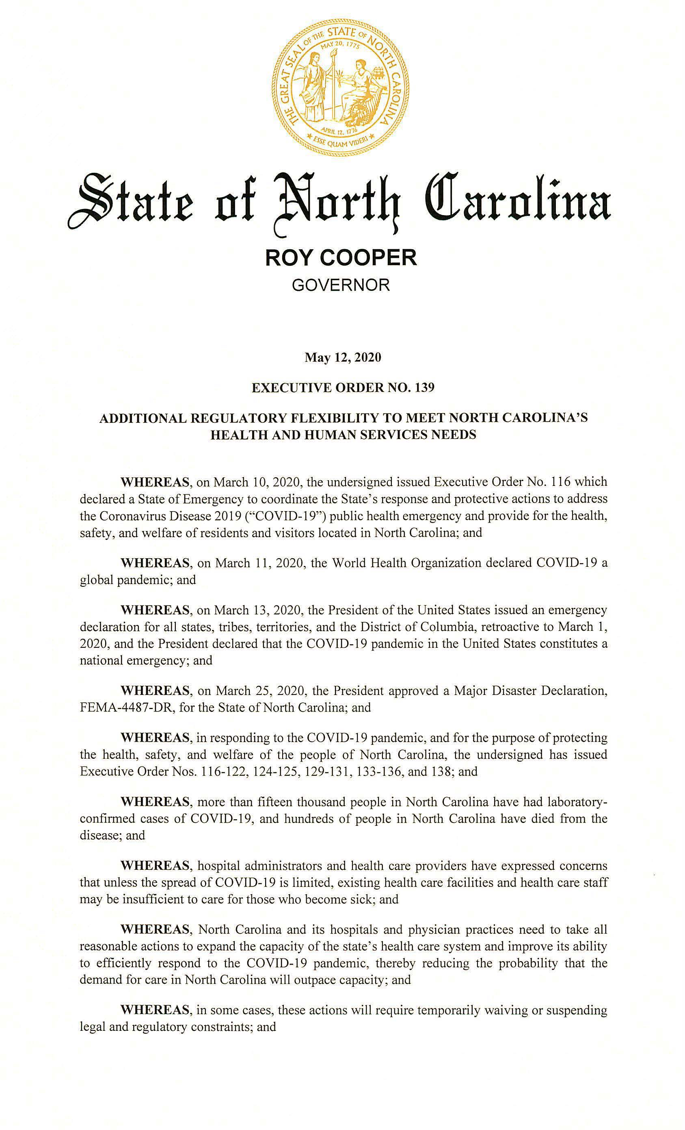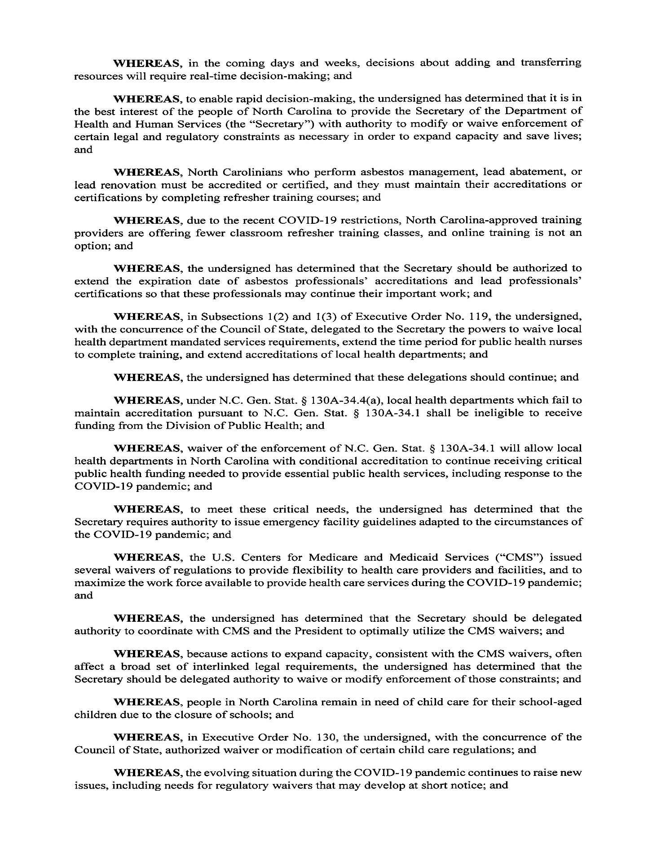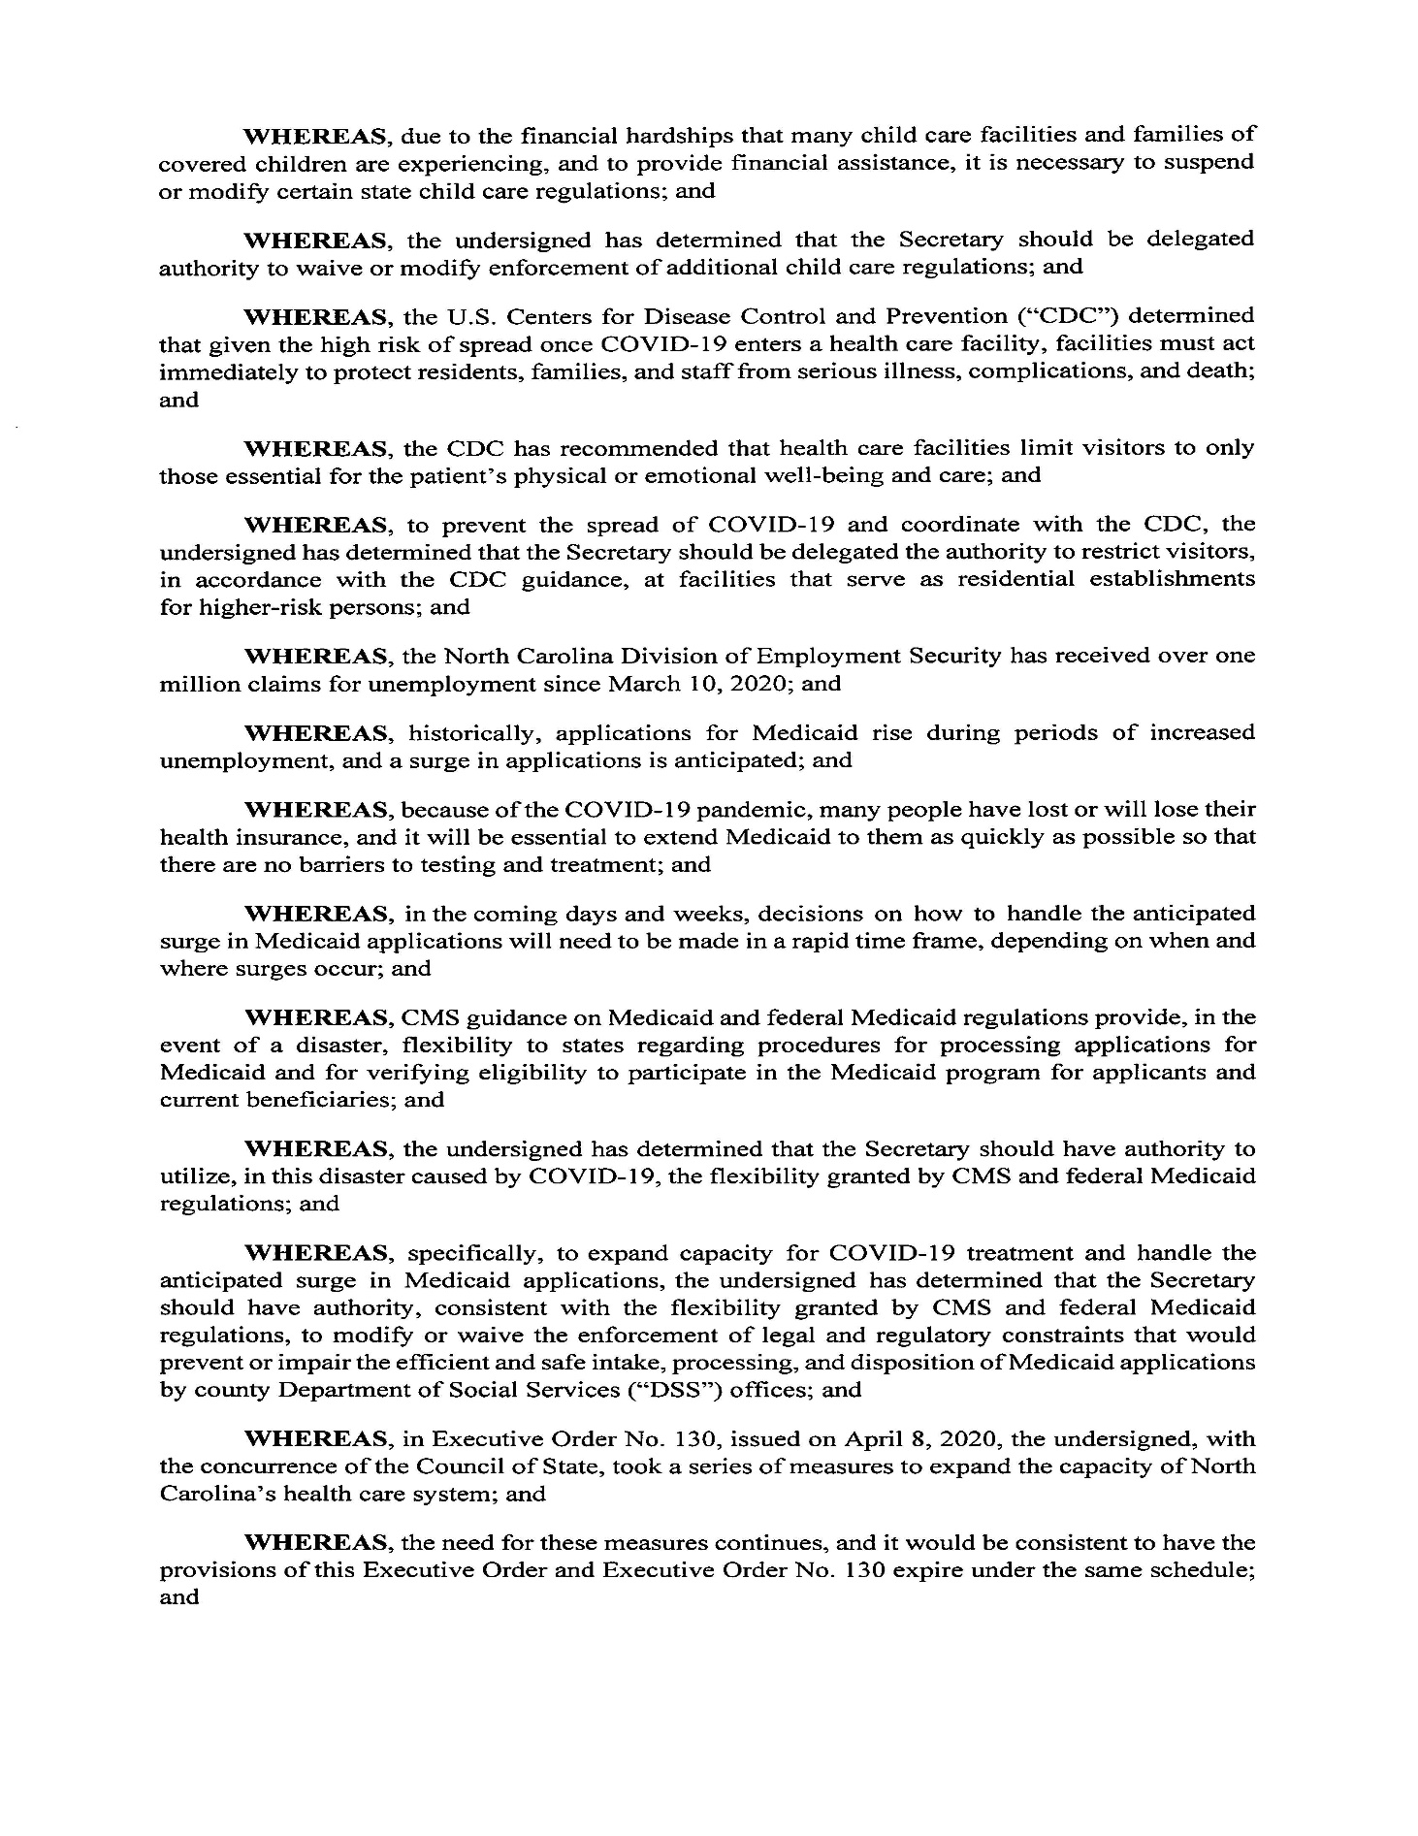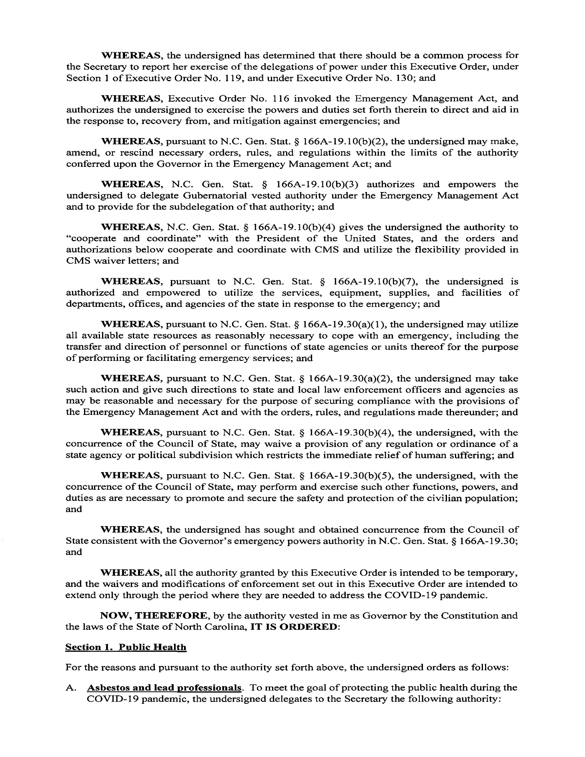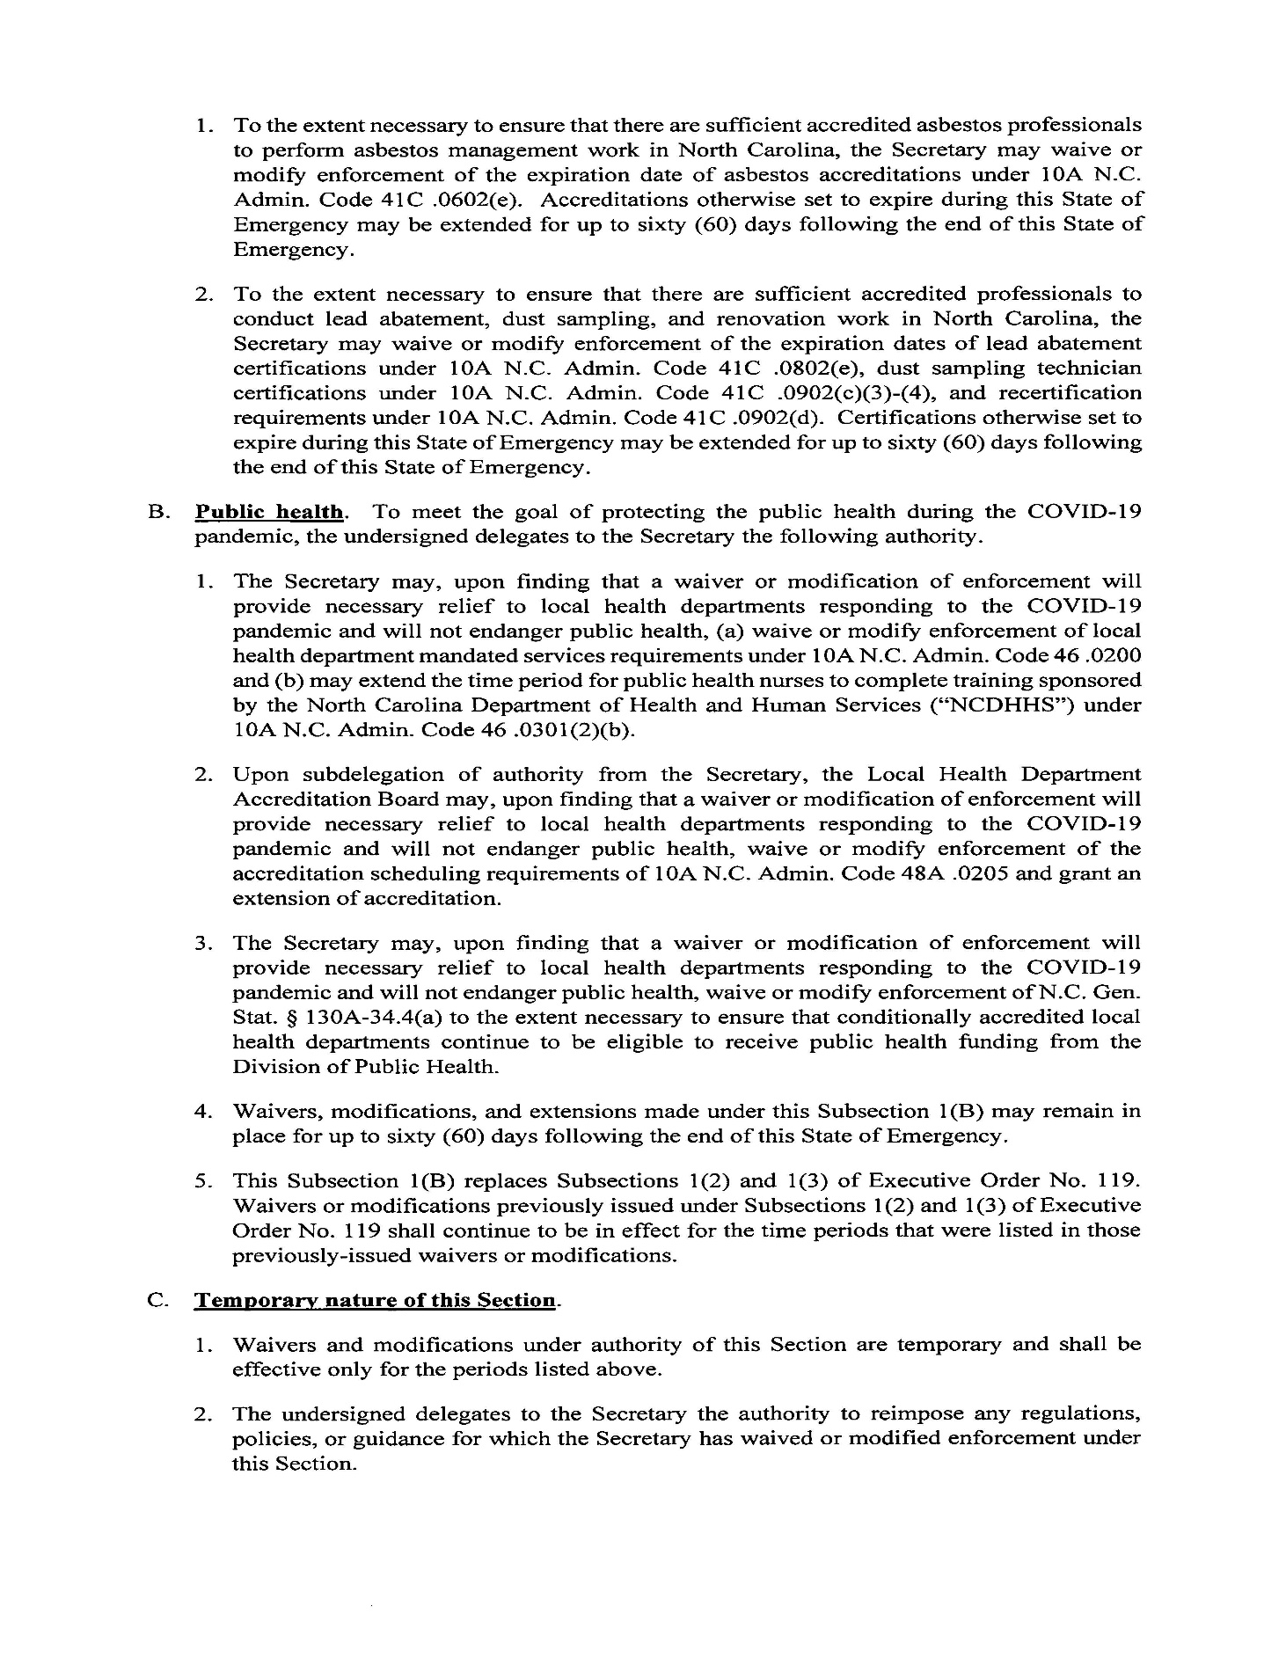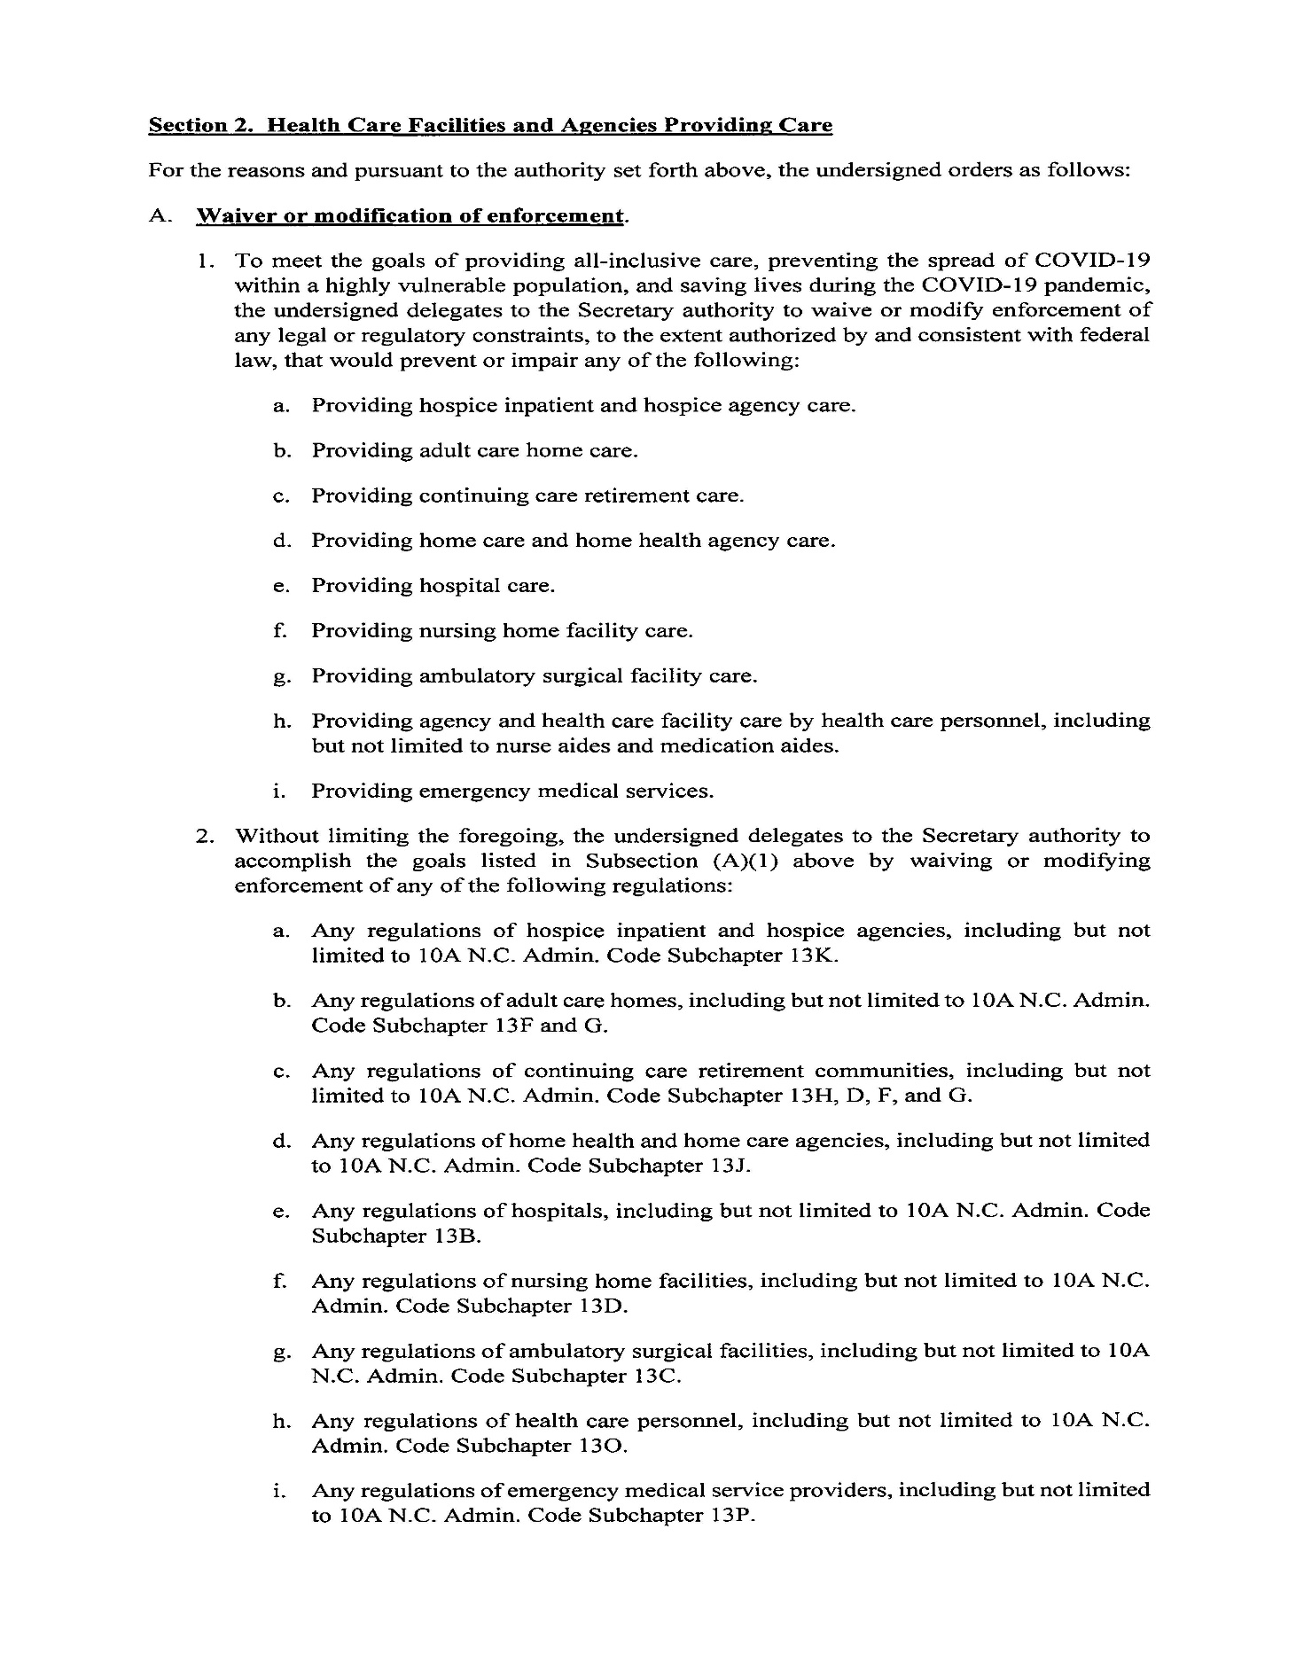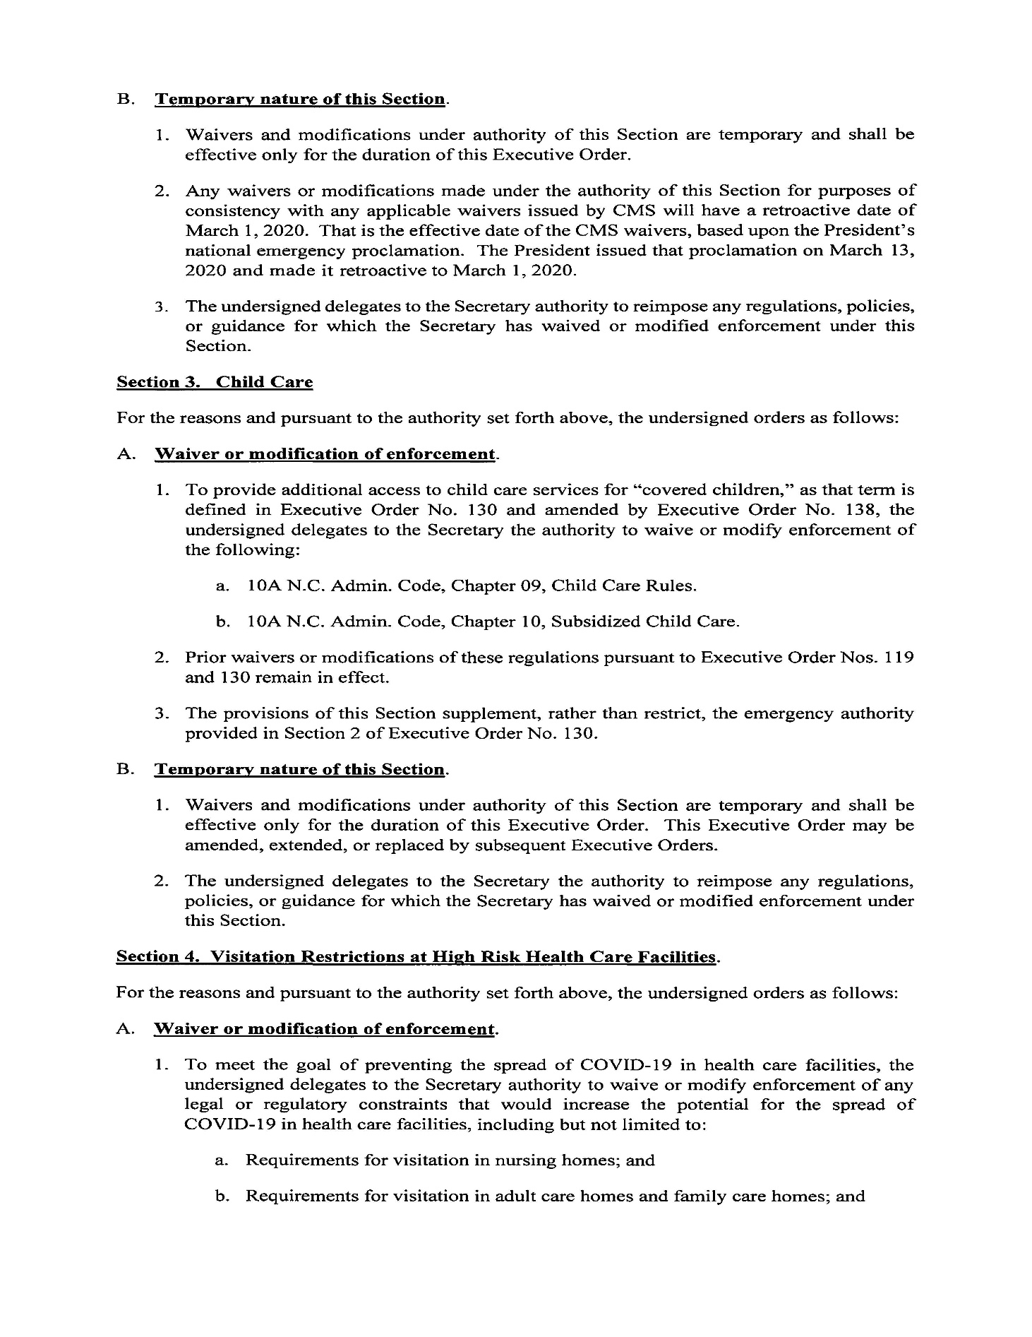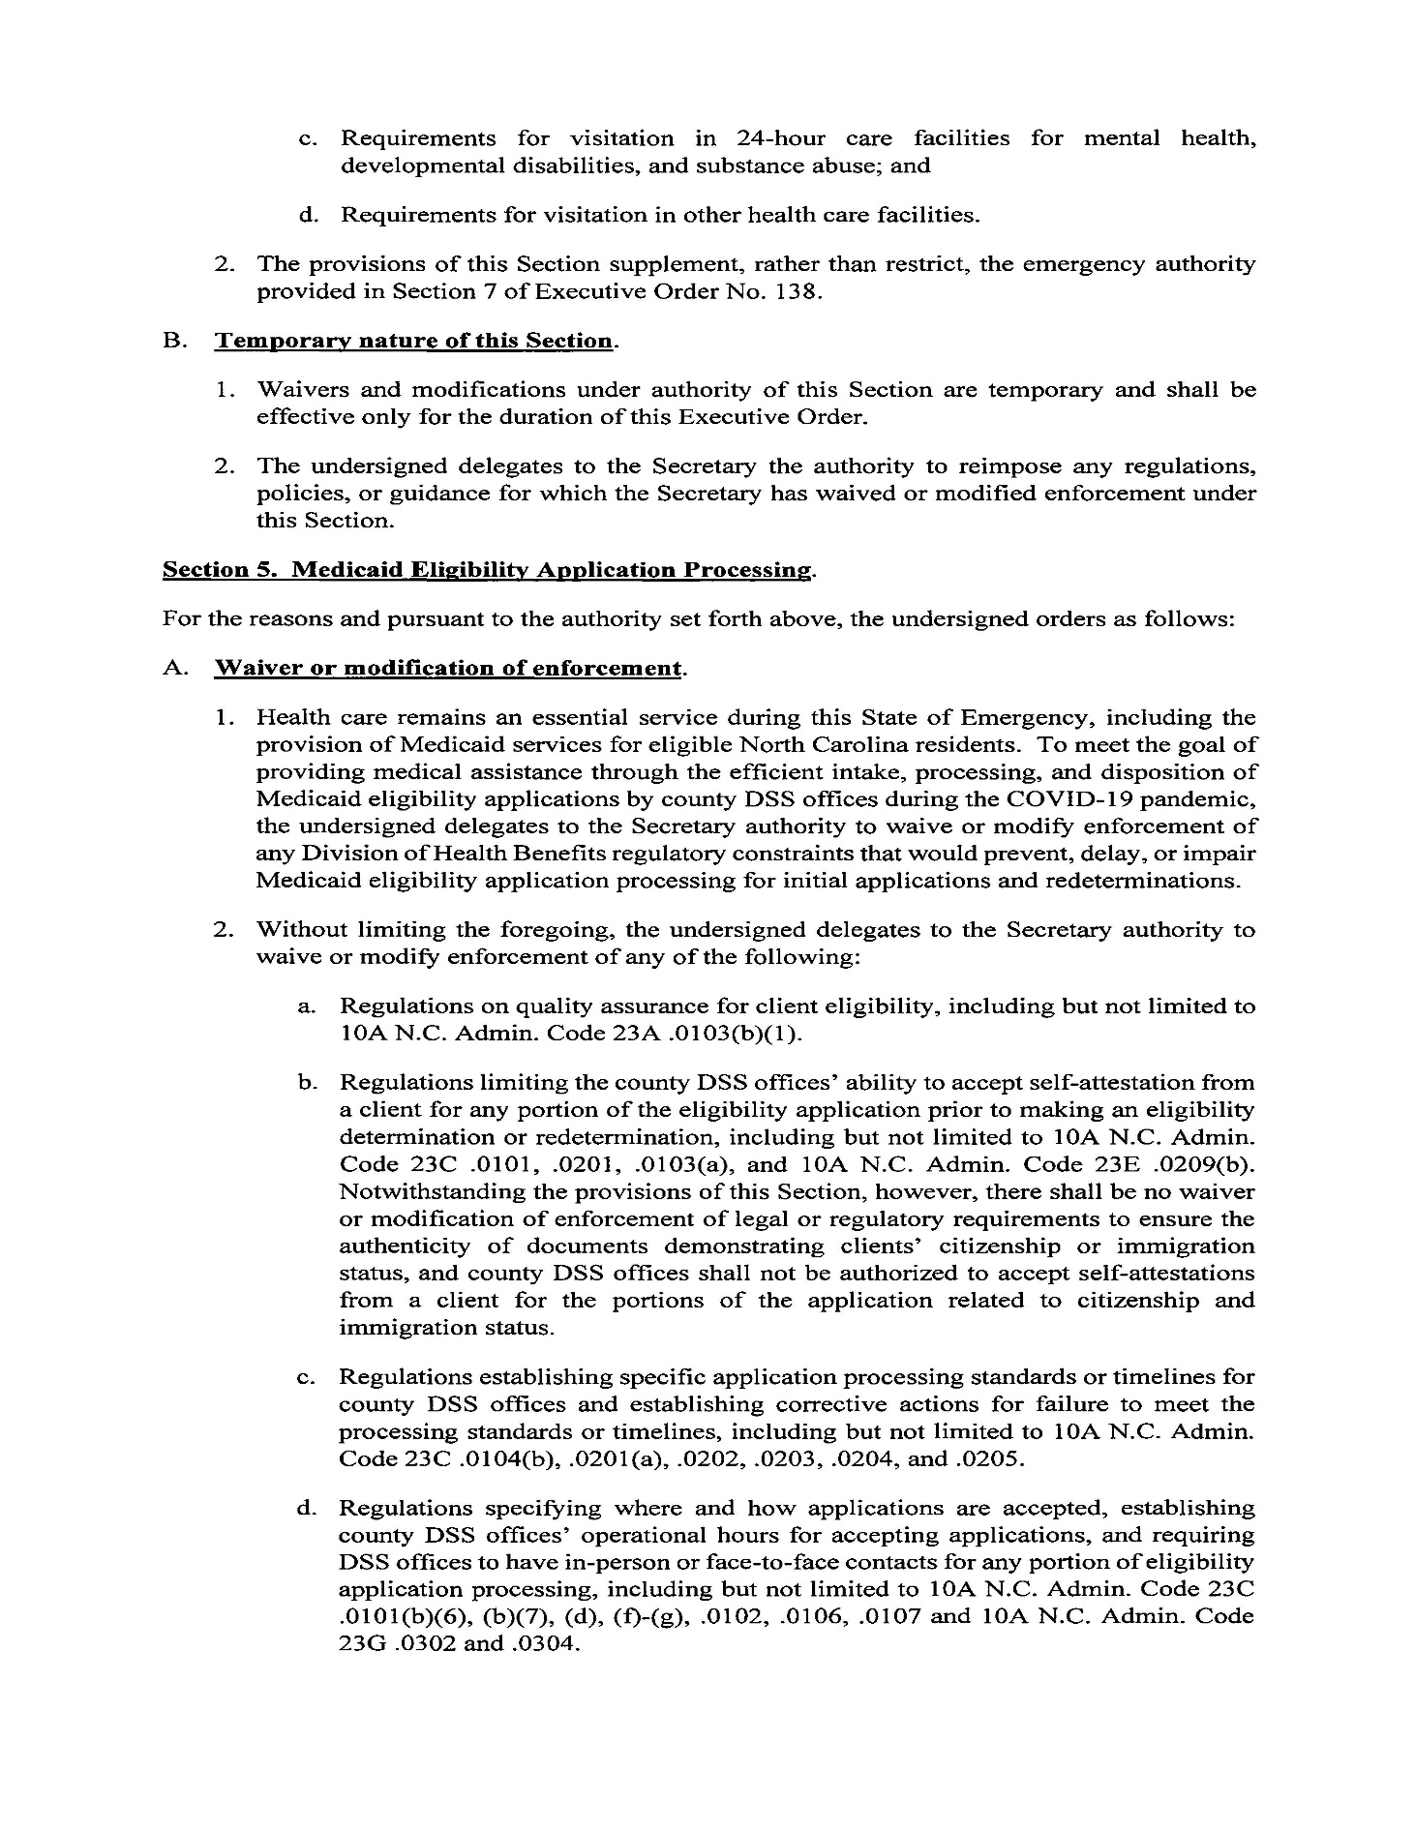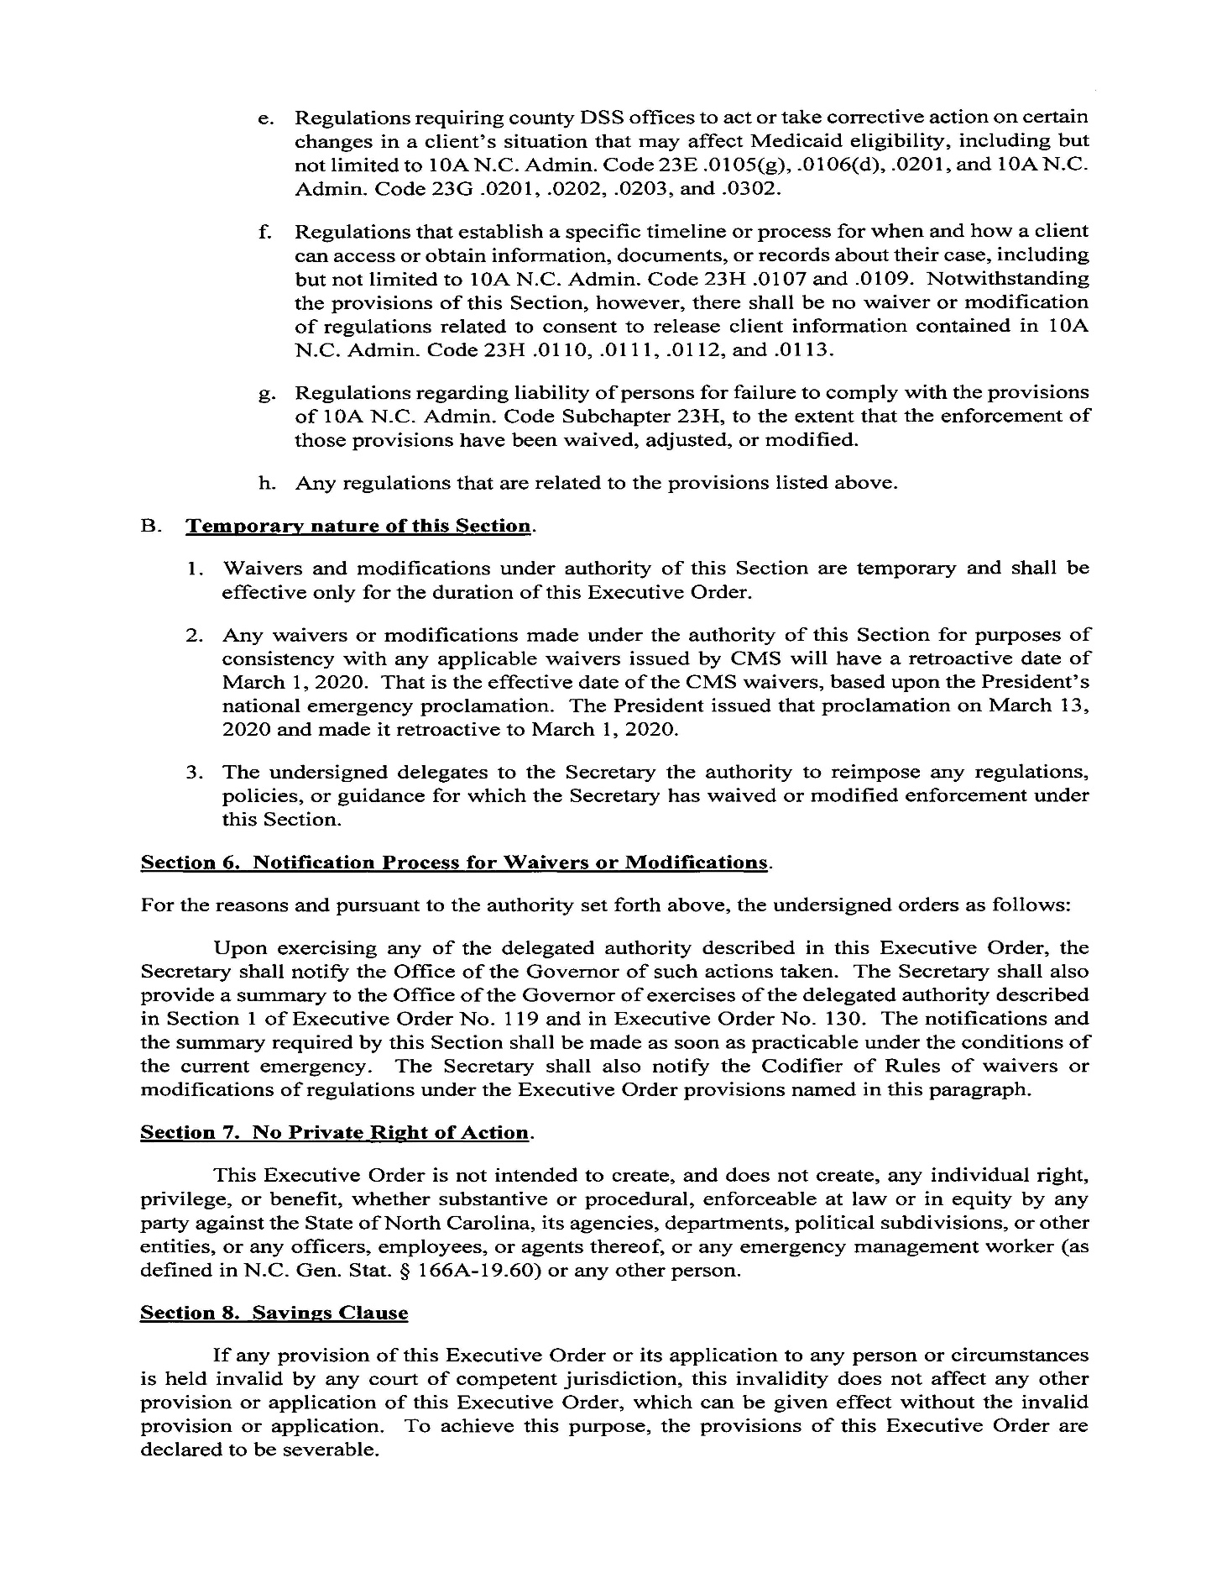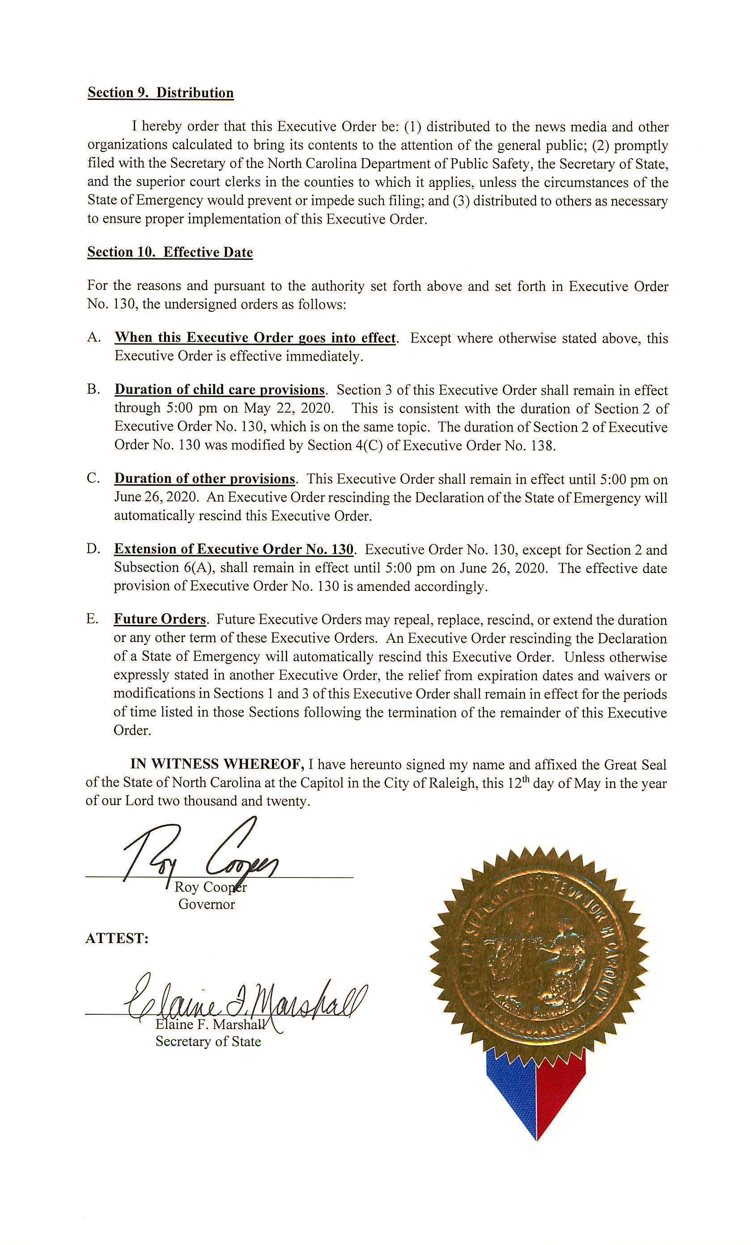
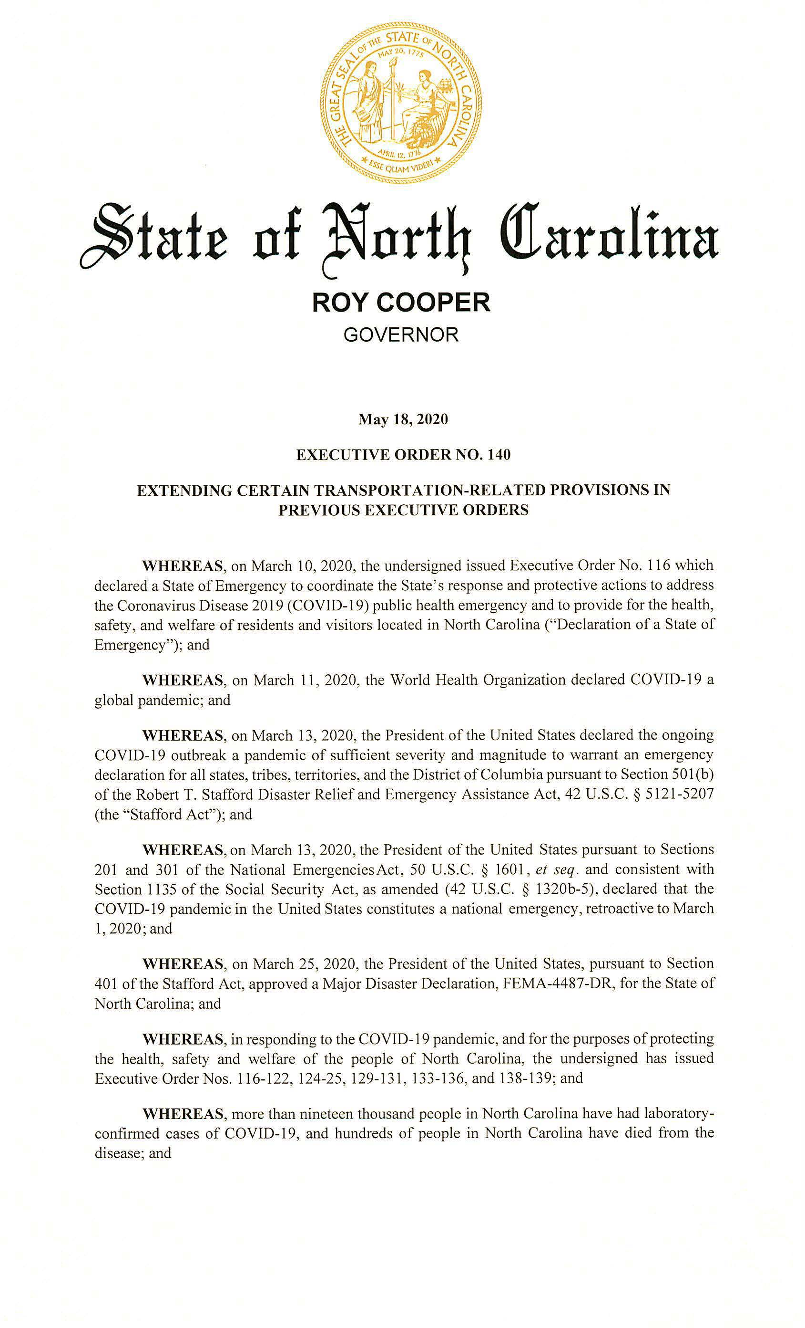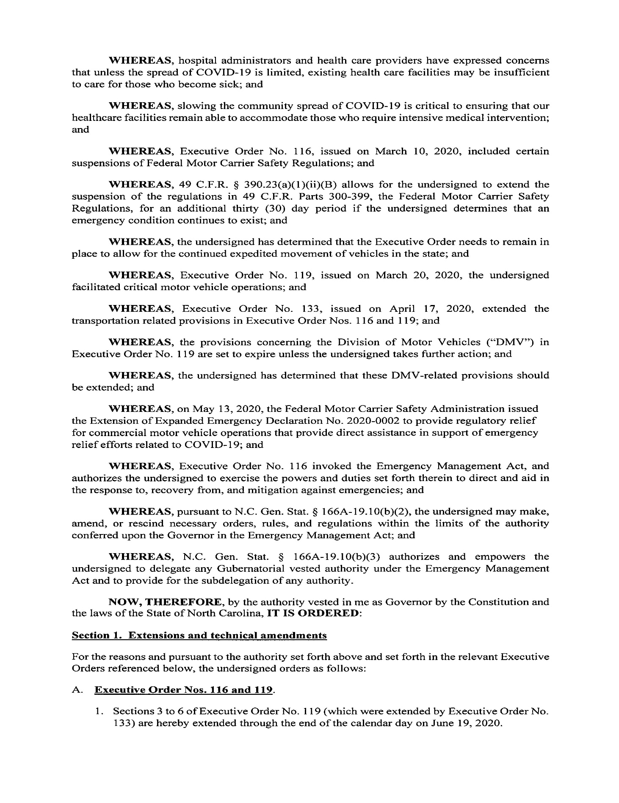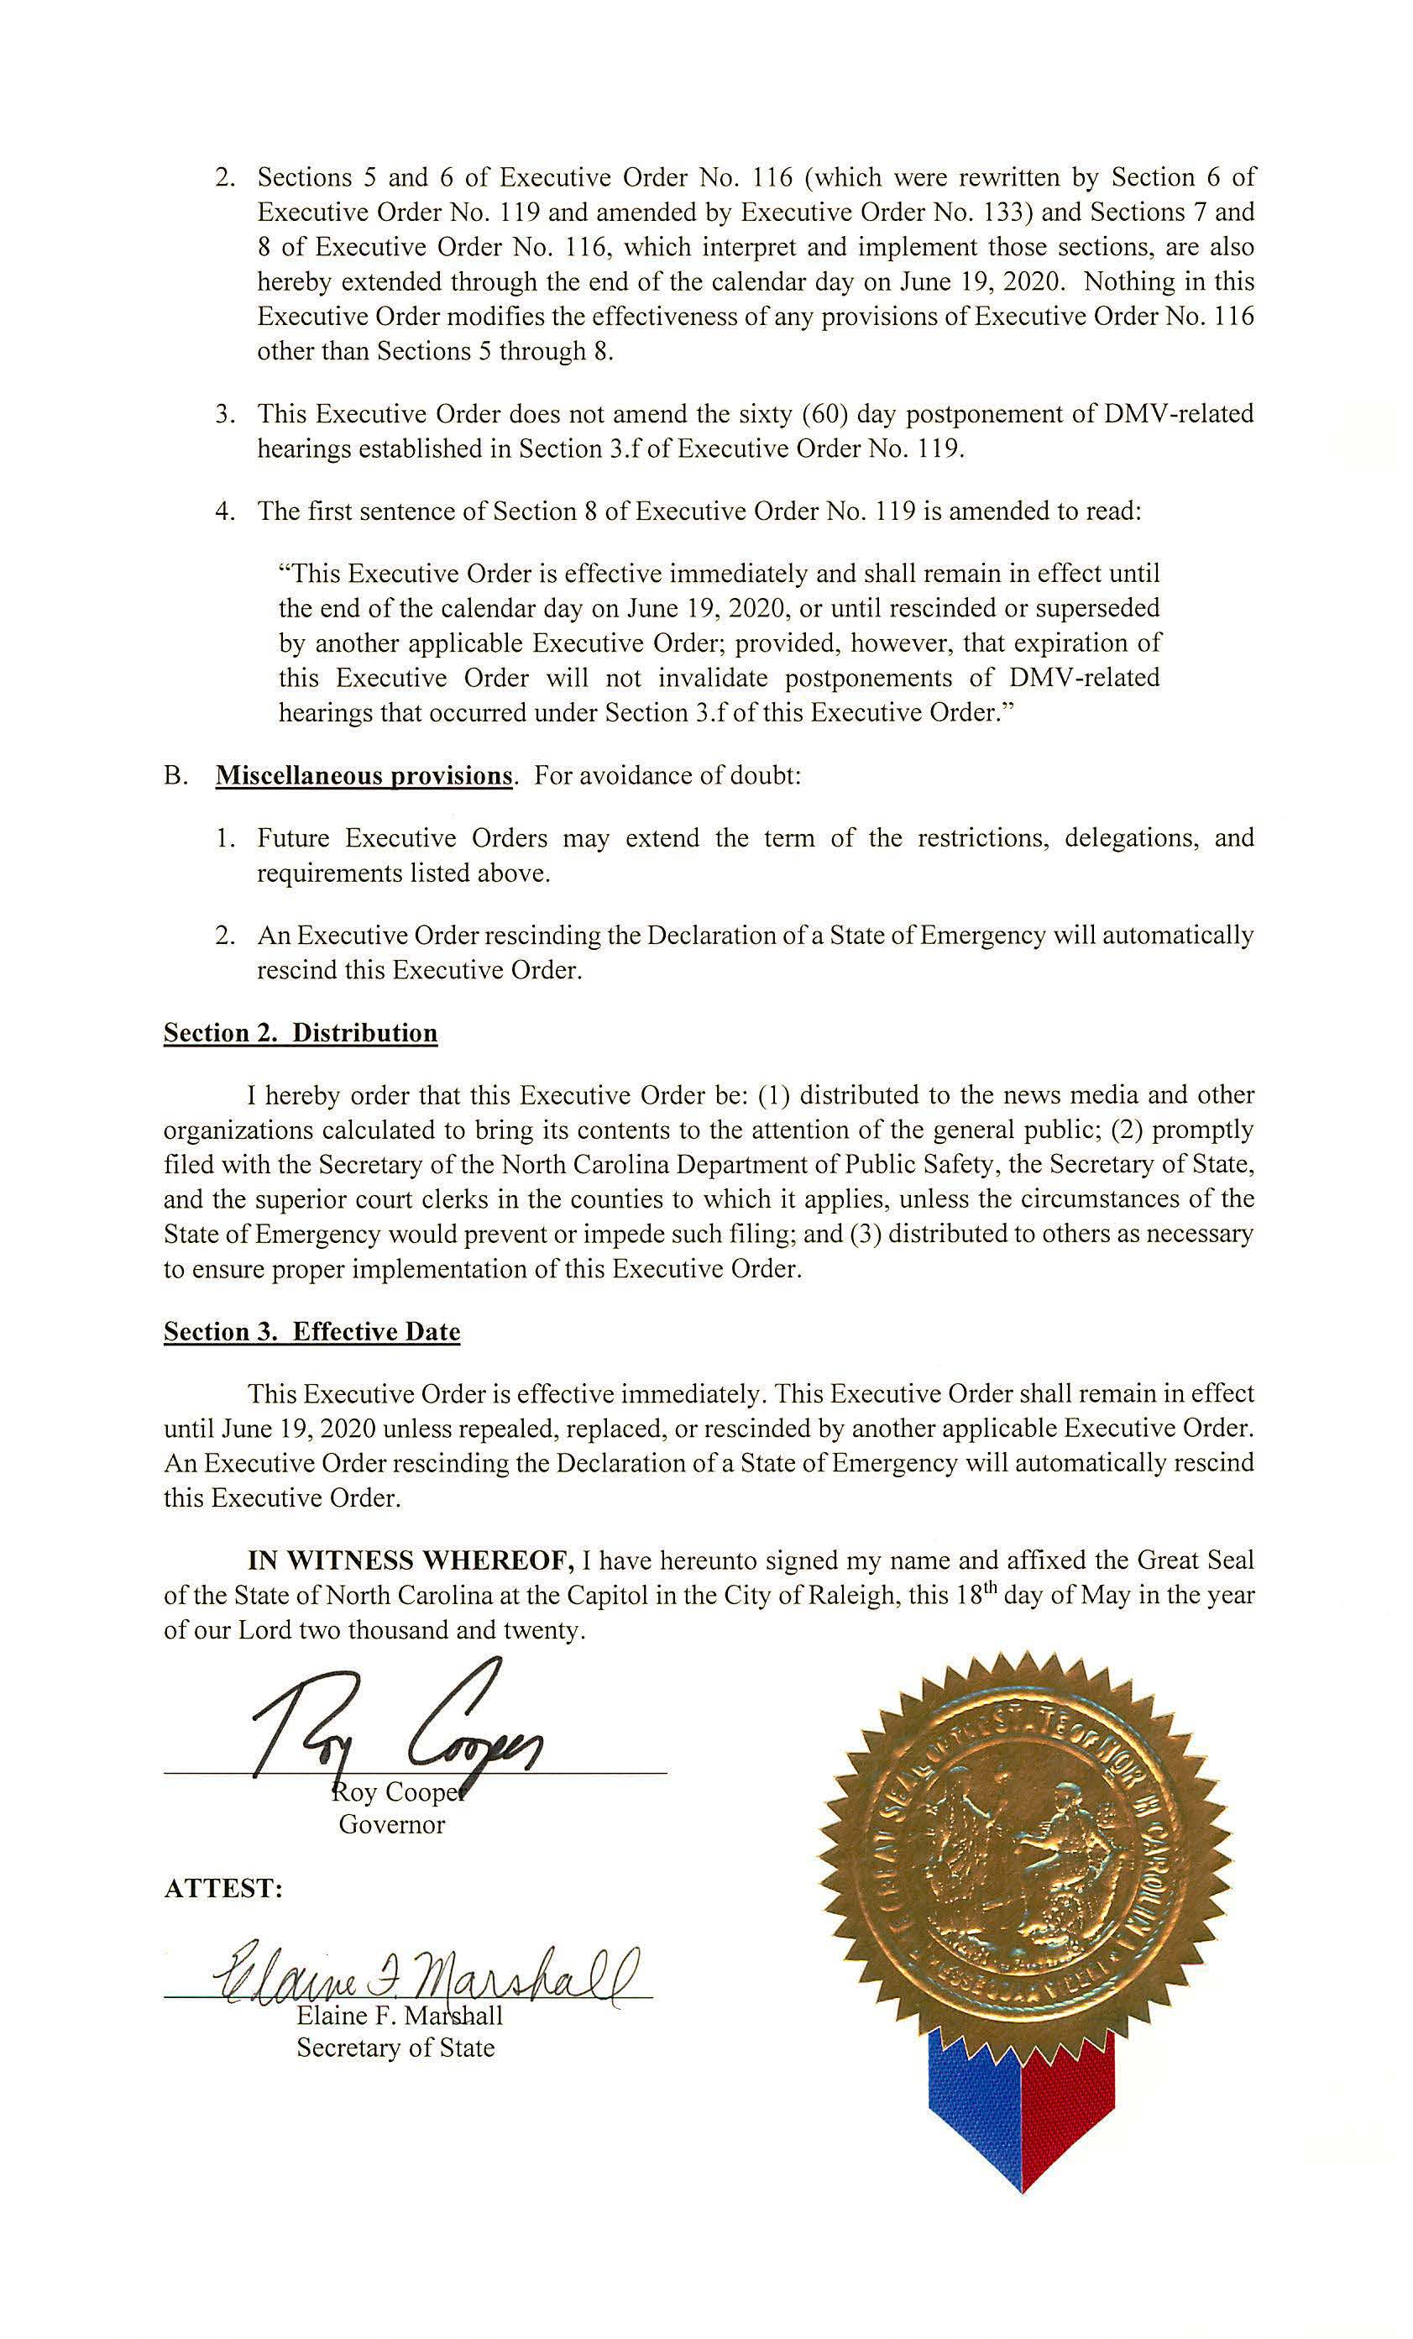
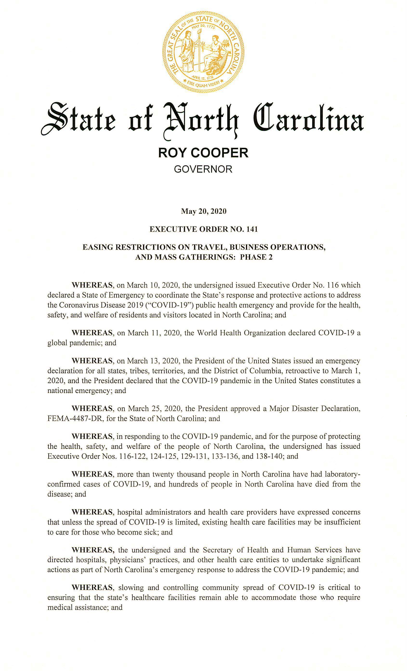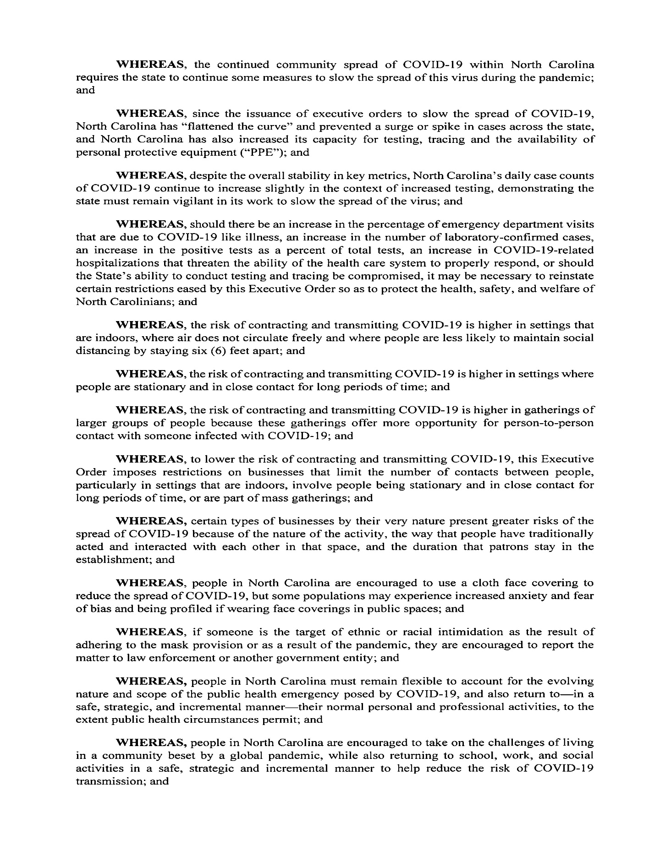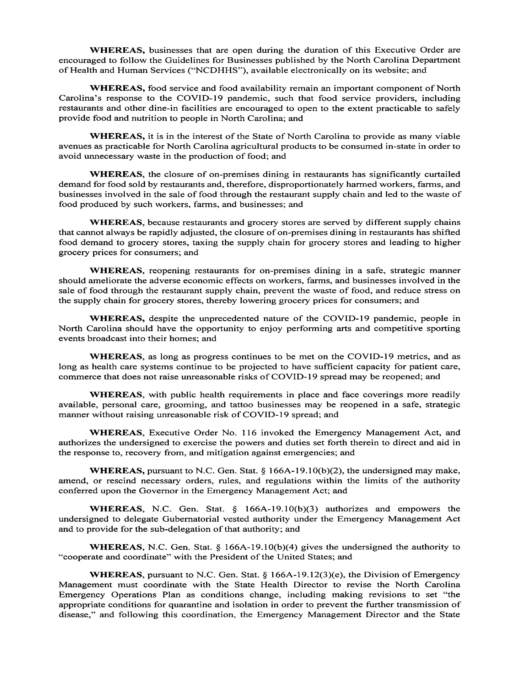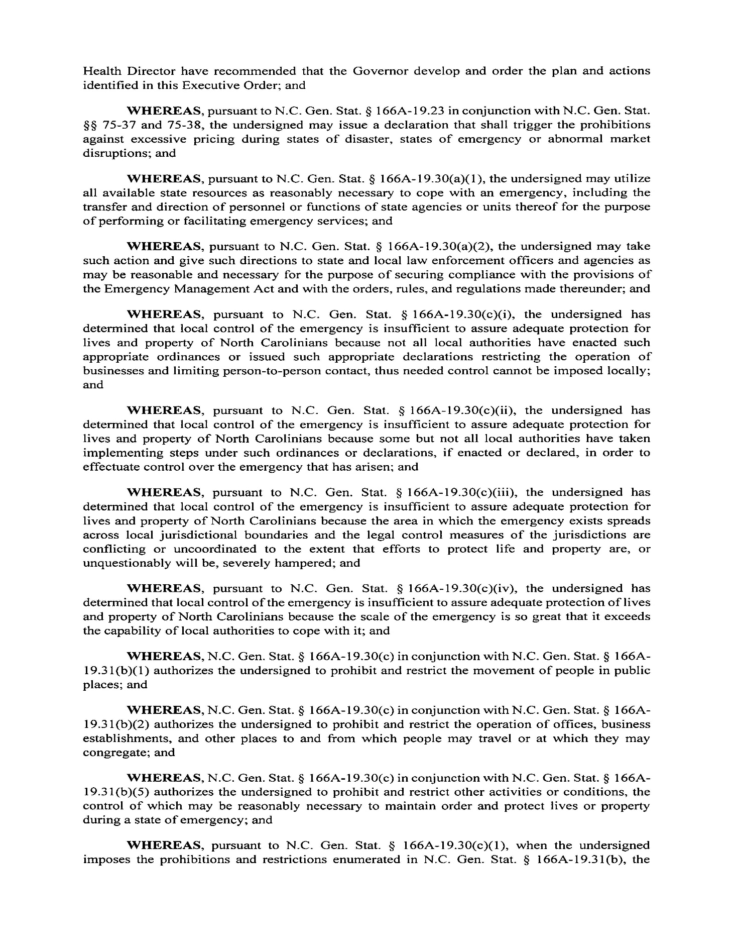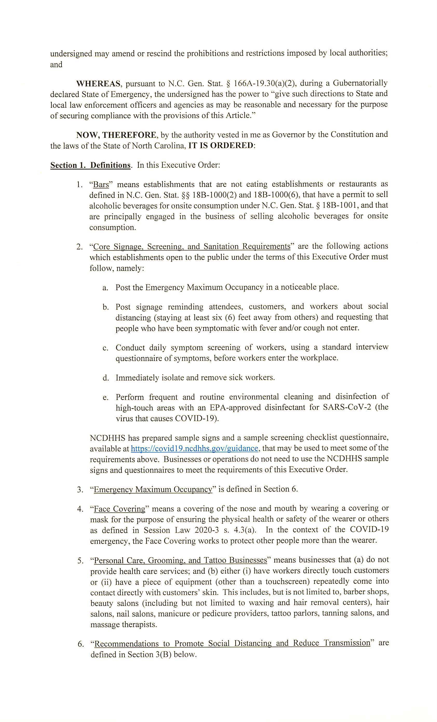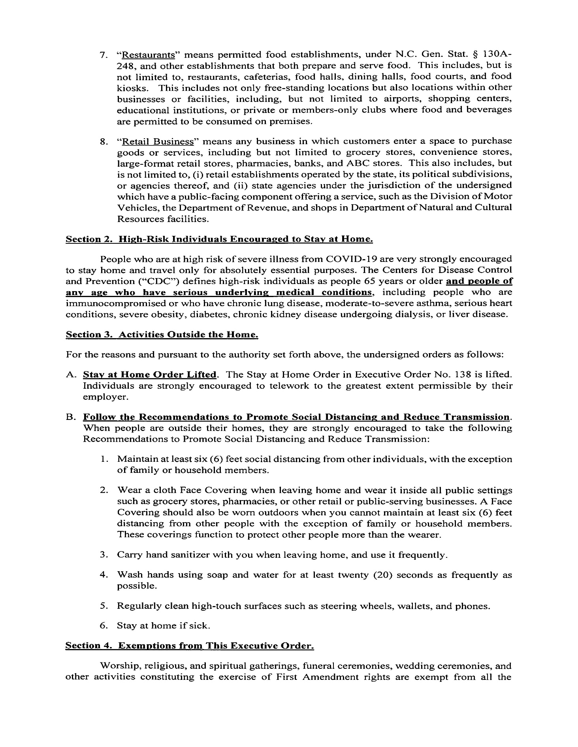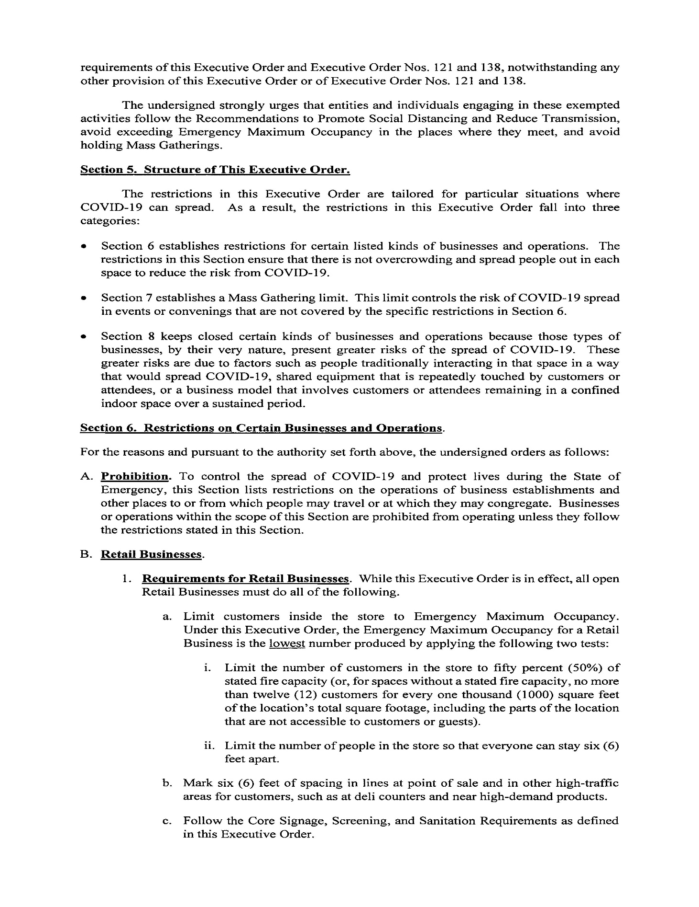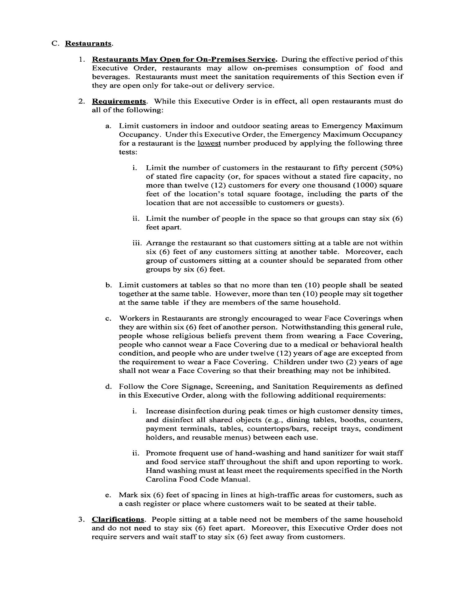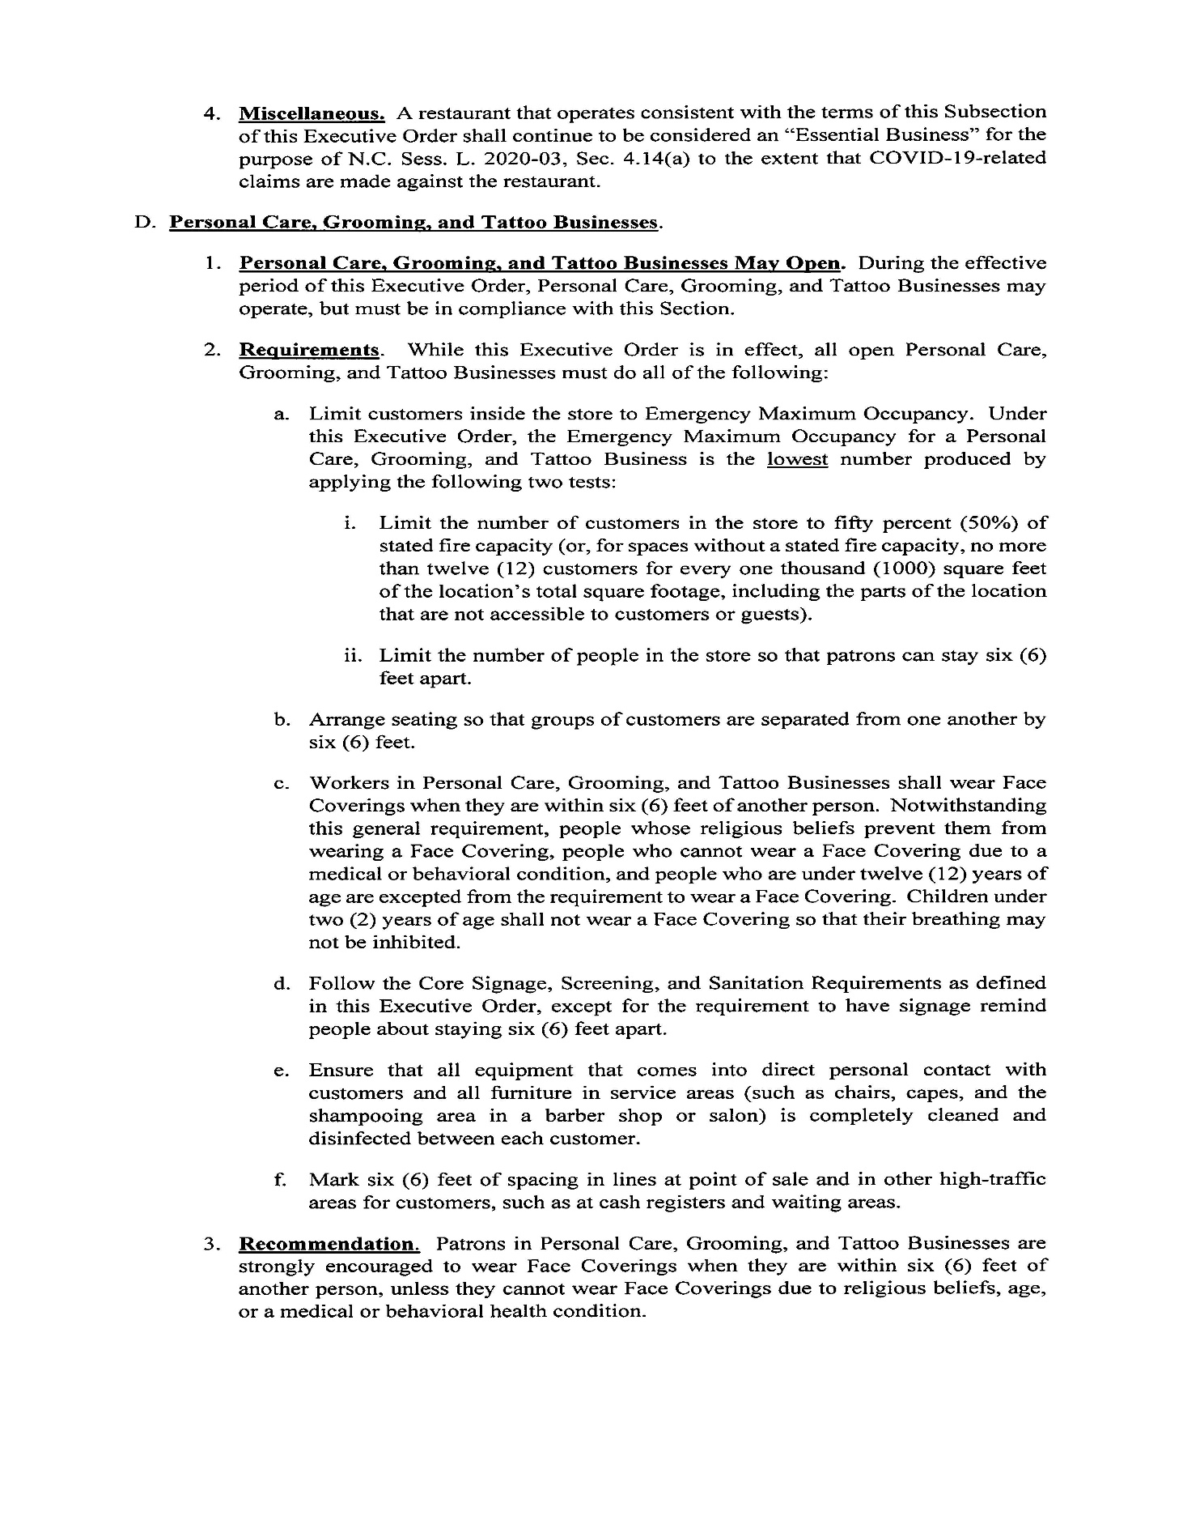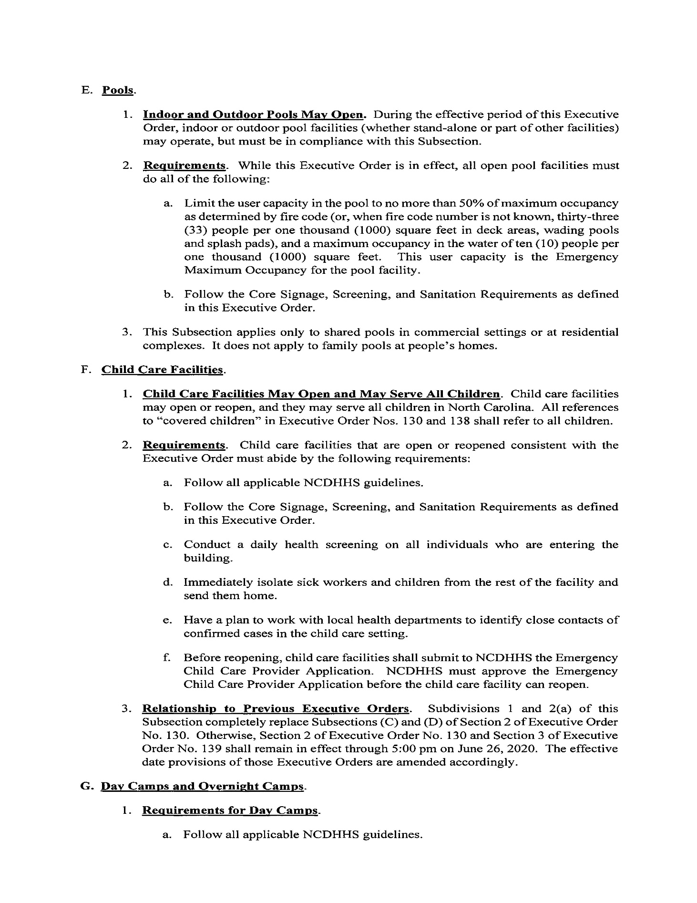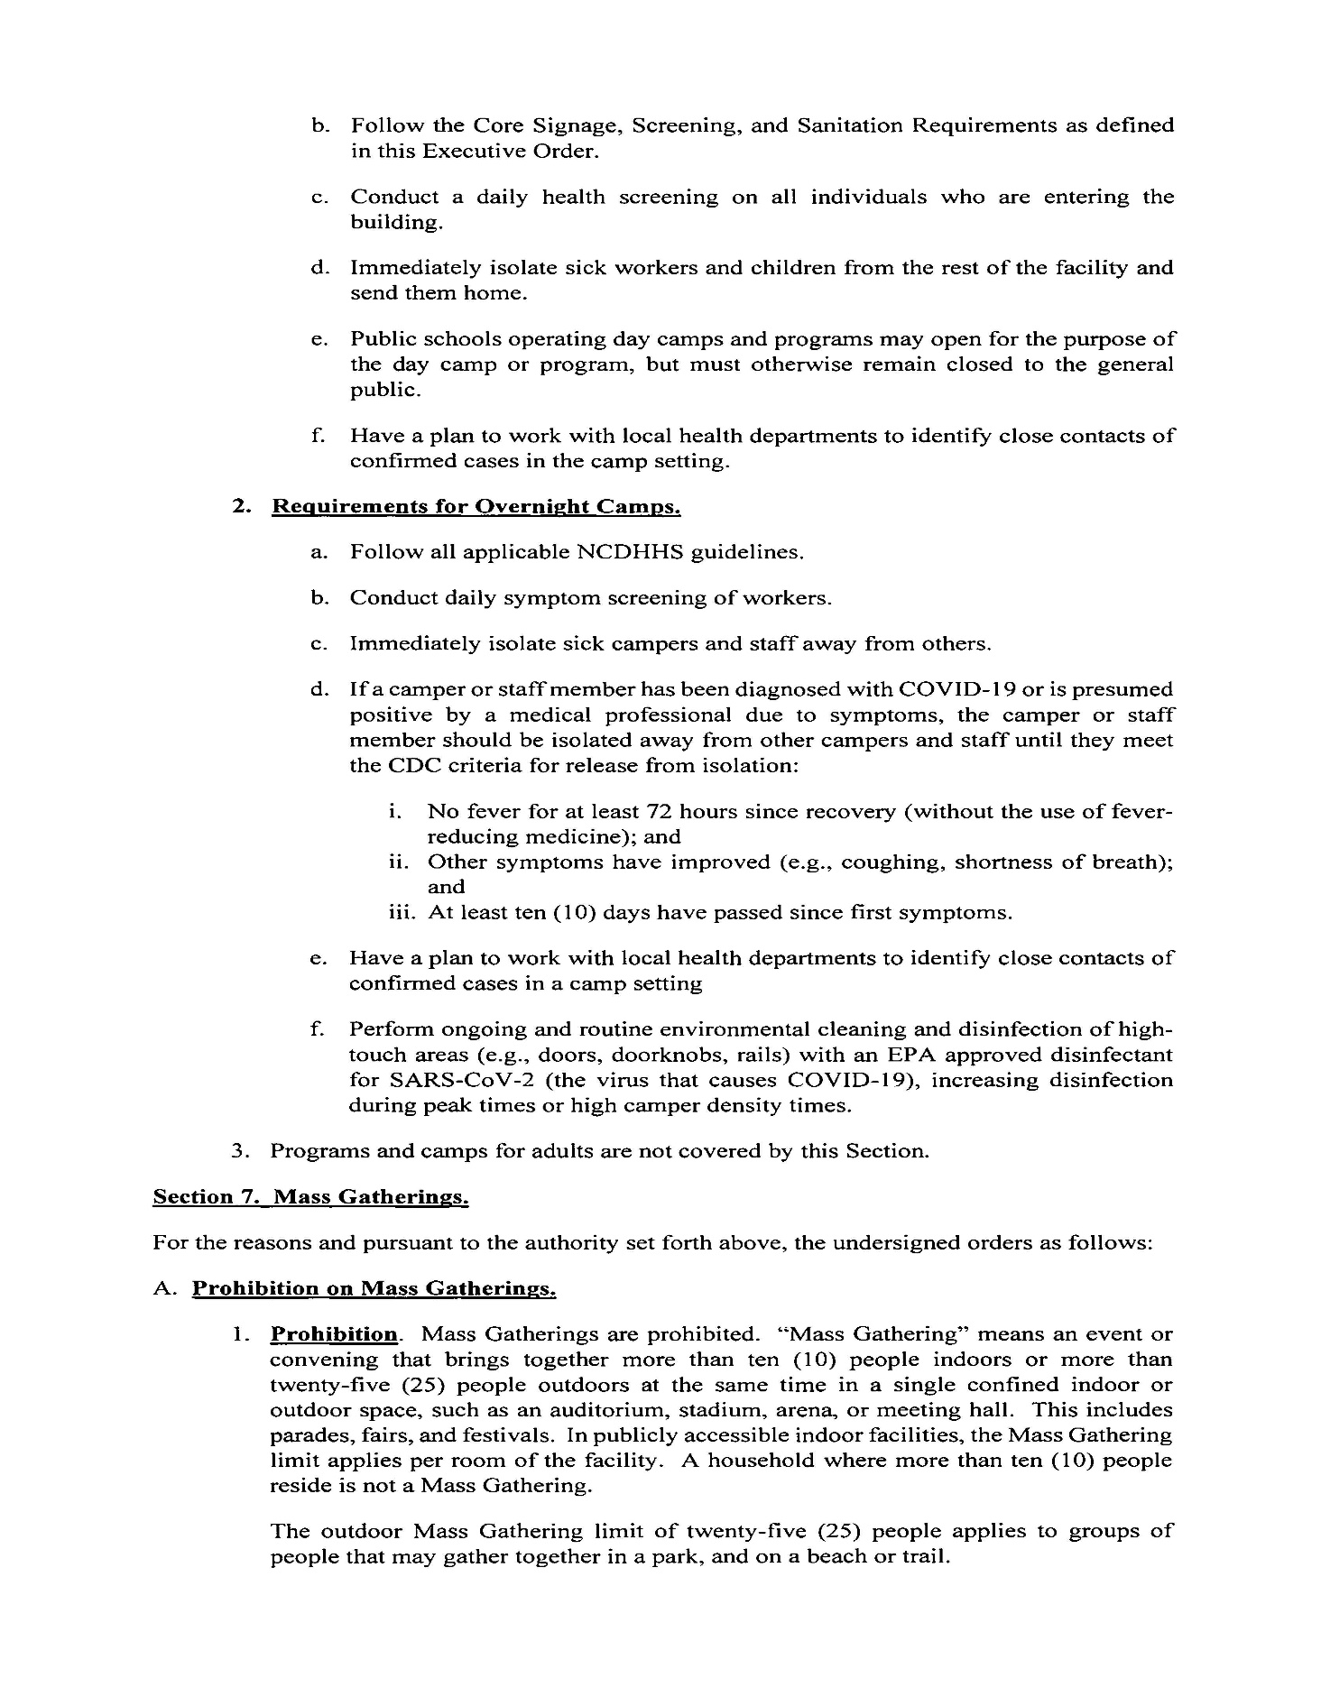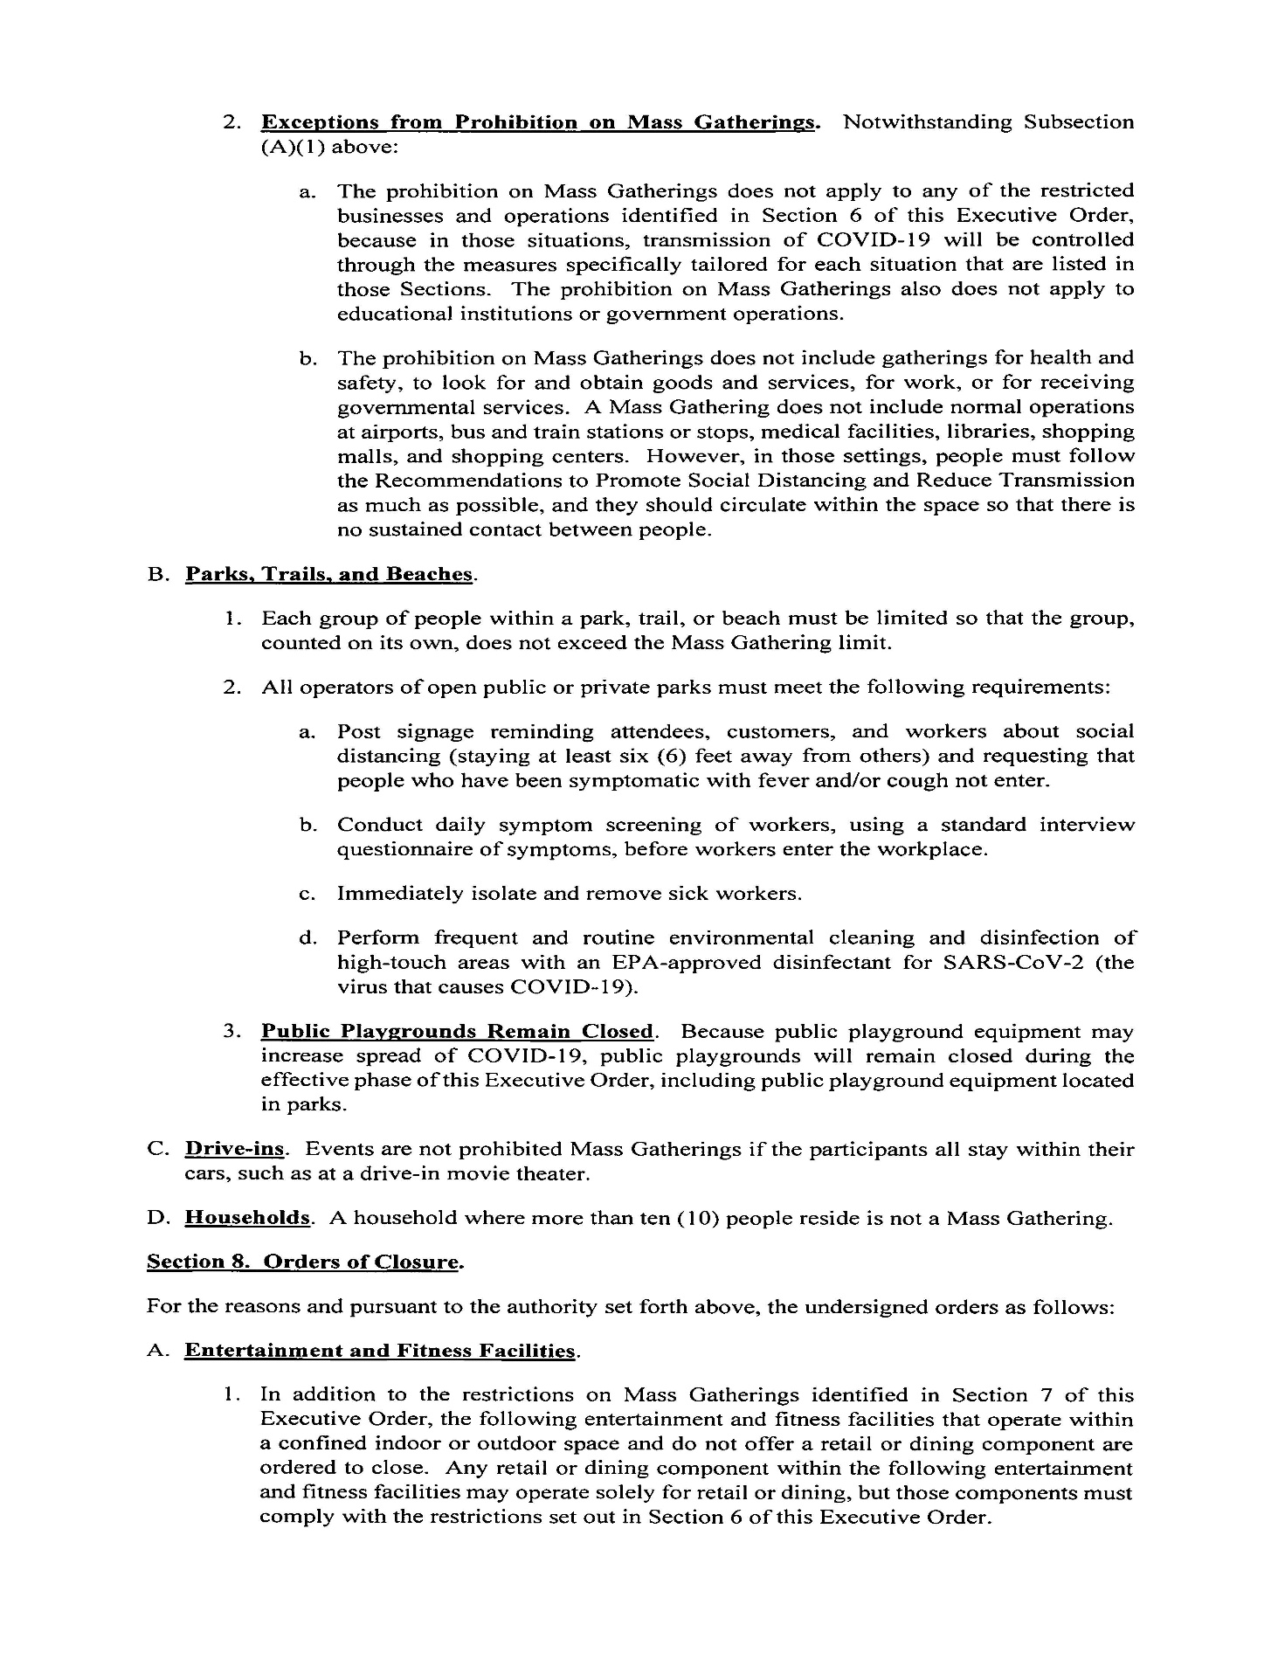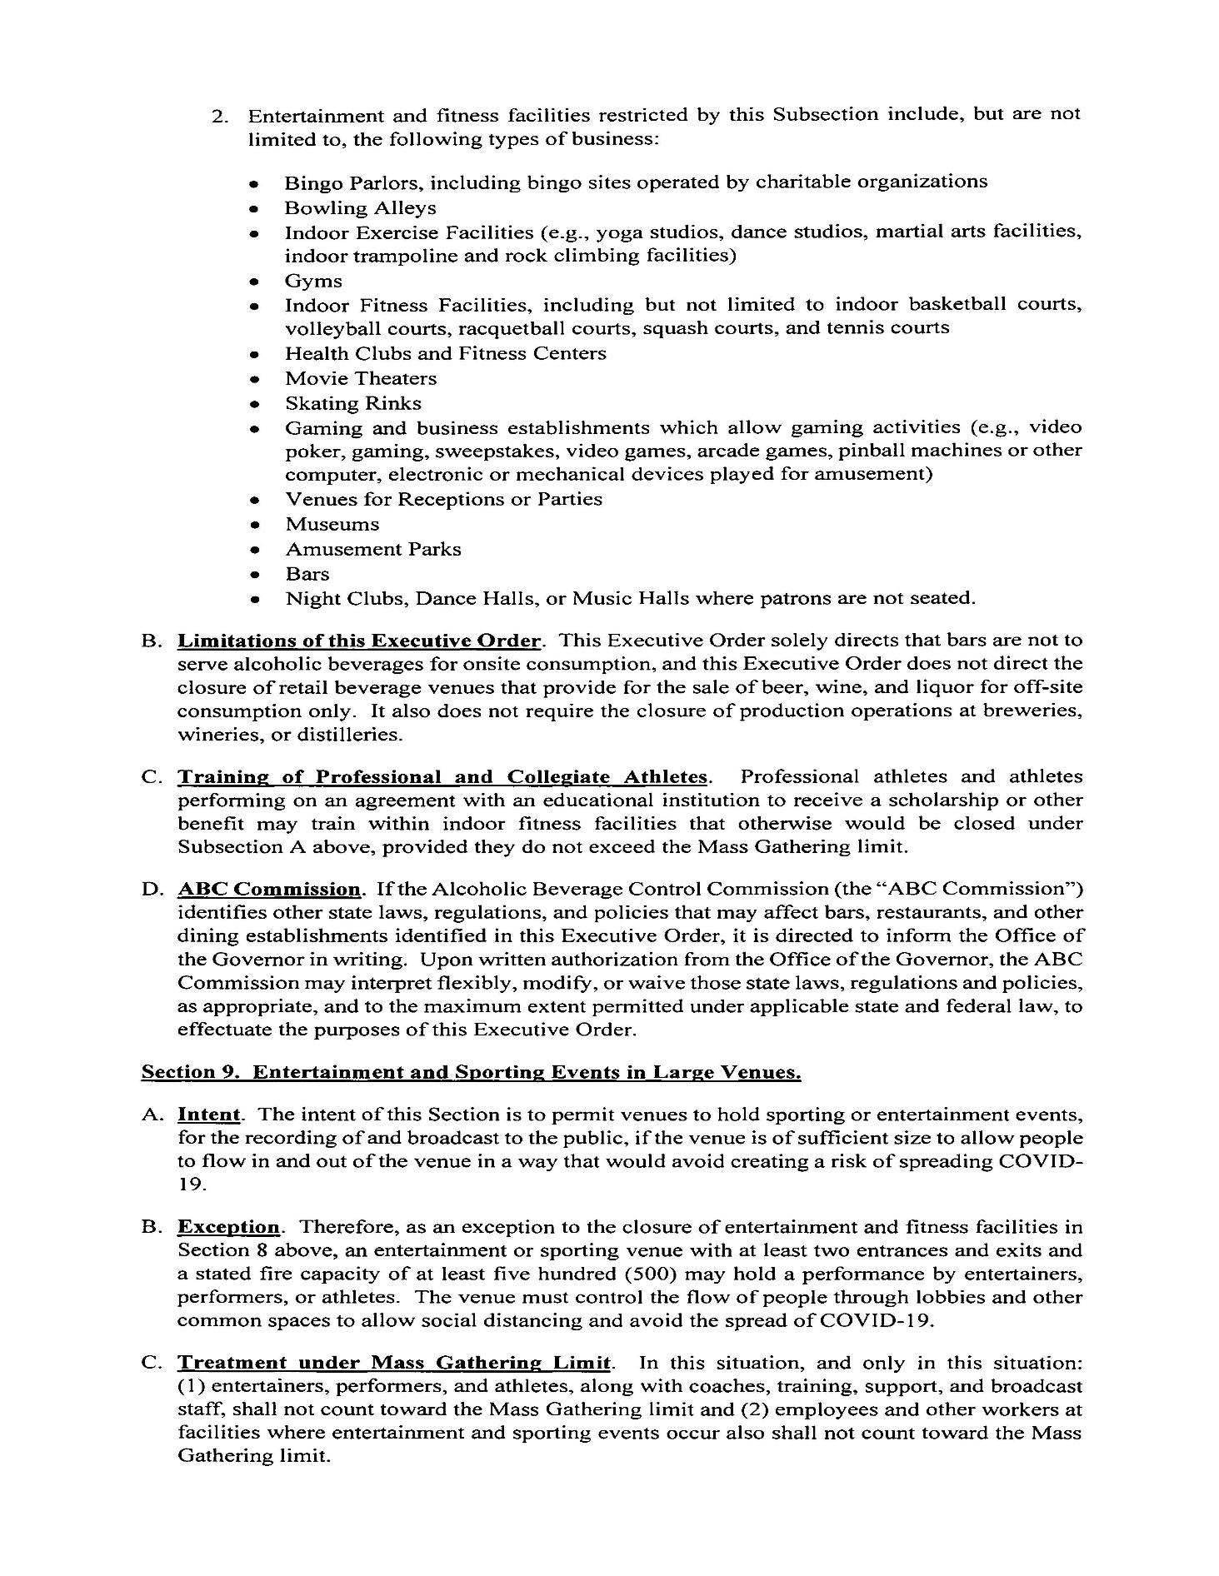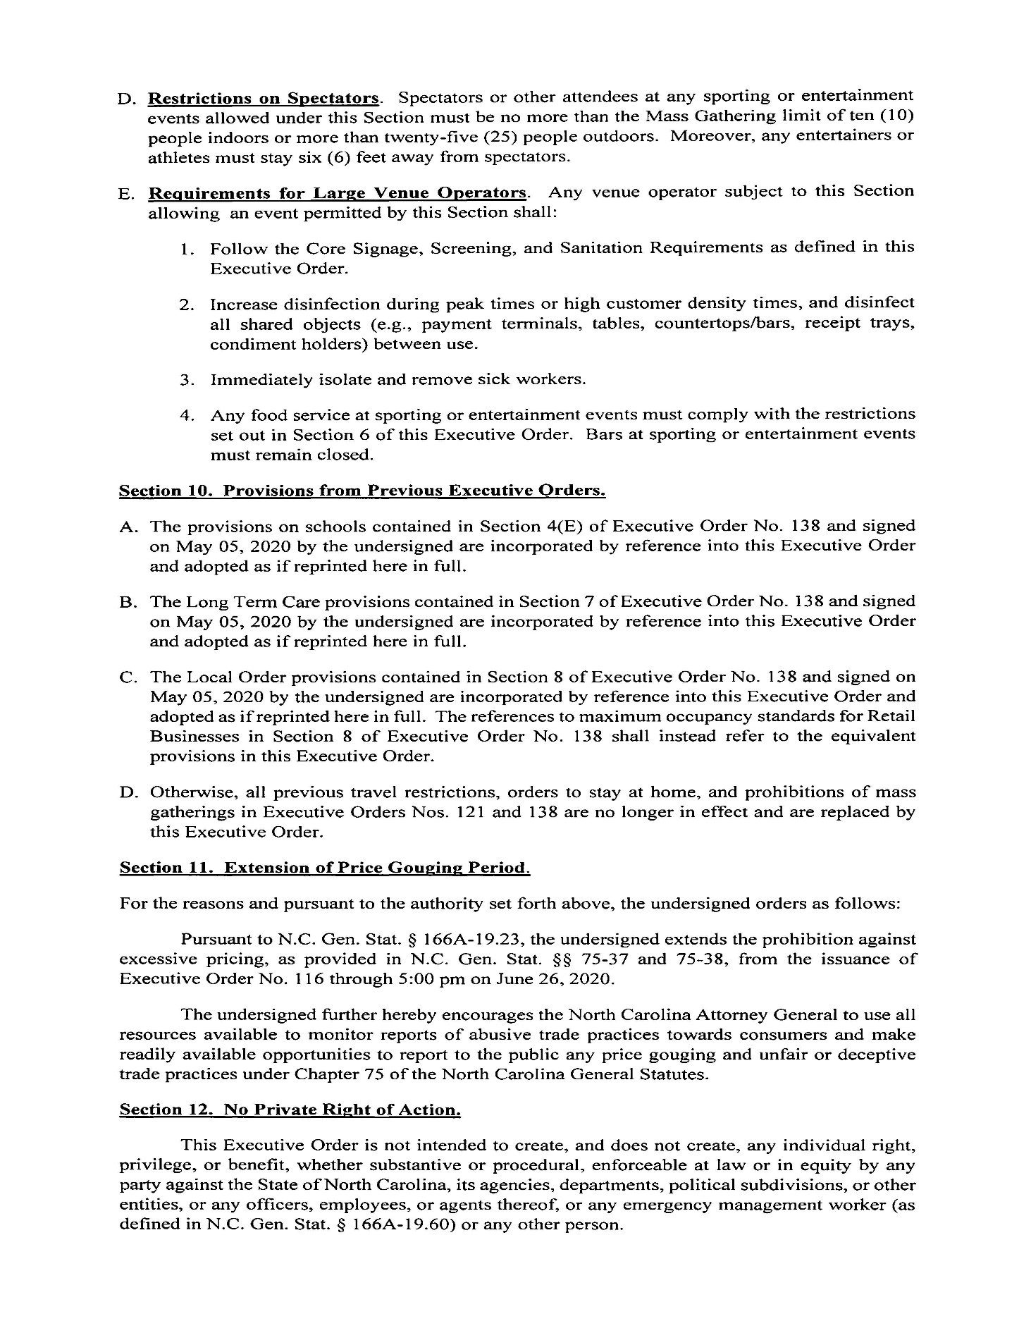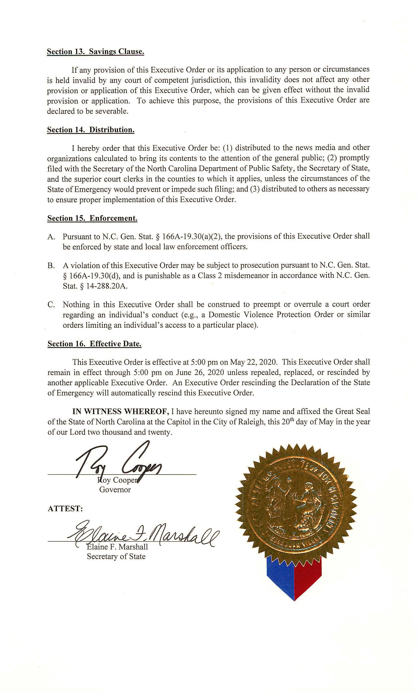

Note from the Codifier: The notices published in this Section of the NC Register include the text of proposed rules. The agency must accept comments on the proposed rule(s) for at least 60 days from the publication date, or until the public hearing, or a later date if specified in the notice by the agency. If the agency adopts a rule that differs substantially from a prior published notice, the agency must publish the text of the proposed different rule and accept comment on the proposed different rule for 60 days.
Statutory reference: G.S. 150B-21.2.

Title 10A – Department of Health and Human Services

Notice is hereby given in accordance with G.S. 150B-21.2 and G.S. 150B-21.3A(c)(2)g. that the Medical Care Commission intends to amend the rules cited as 10A NCAC 13C .0203, .0702, readopt with substantive changes the rules cited as 10A NCAC 13C .0202, .0501, .0902 and readopt without substantive changes the rule cited as 10A NCAC 13C .0301.

Pursuant to G.S. 150B-21.2(c)(1), the text of the rule(s) proposed for readoption without substantive changes are not required to be published. The text of the rules are available on the OAH website: http://reports.oah.state.nc.us/ncac.asp.

Link to agency website pursuant to G.S. 150B-19.1(c): https://info.ncdhhs.gov/dhsr/ruleactions.html

Proposed Effective Date: January 1, 2021

Public Hearing:
Date: July 28, 2020
Time: 10:00 a.m.
Location: Dorothea Dix Park, Brown Building, Room 104, 801 Biggs Drive, Raleigh, NC 27603

Reason for Proposed Action: Pursuant to GS 150B-21.3A, Periodic Review and Expiration of Existing Rules, all rules are reviewed at least every 10 years, or they shall expire. As a result of the periodic review of Subchapter 10A NCAC 13C, Licensing of Ambulatory Surgical Facilities, four proposed readoption rules were part of the nine rules that were determined as “Necessary With Substantive Public Interest,” requiring readoption. Substantive changes are proposed to three rules for readoption, non-substantive changes are proposed to one rule for readoption, and two rules are proposed for amendment to update the process for the regulation of licensed Ambulatory Surgical Facilities in N.C. The proposed rules clarify the provision of anesthesia services and of nursing personnel staffing levels in the facility, clarify and make consistent construction plan submission requirements including a time limit expiration on construction approvals in accordance with industry standard, and amend outdated statutory and rule citations referenced in rule. In addition, the proposed rules have been updated through technical changes and corrections.

Comments may be submitted to: Nadine Pfeiffer, 809 Ruggles Drive, 2701 Mail Service Center, Raleigh, NC 27699-2701; email DHSR.RulesCoordinator@dhhs.nc.gov

Comment period ends: August 14, 2020

Procedure for Subjecting a Proposed Rule to Legislative Review: If an objection is not resolved prior to the adoption of the rule, a person may also submit written objections to the Rules Review Commission after the adoption of the Rule. If the Rules Review Commission receives written and signed objections after the adoption of the Rule in accordance with G.S. 150B-21.3(b2) from 10 or more persons clearly requesting review by the legislature and the Rules Review Commission approves the rule, the rule will become effective as provided in G.S. 150B-21.3(b1). The Commission will receive written objections until 5:00 p.m. on the day following the day the Commission approves the rule. The Commission will receive those objections by mail, delivery service, hand delivery, or facsimile transmission. If you have any further questions concerning the submission of objections to the Commission, please call a Commission staff attorney at 984-236-1850.

Fiscal impact. Does any rule or combination of rules in this notice create an economic impact? Check all that apply.

State funds affected

Local funds affected

Substantial economic impact (>= $1,000,000)

Approved by OSBM

No fiscal note required

CHAPTER 13 – NC MEDICAL CARE COMMISSION

SUBCHAPTER 13C – LICENSING OF AMBULATORY SURGICAL FACILITIES

SECTION .0200 - LICENSING PROCEDURES

10A ncac 13C .0202 REQUIREMENTS FOR ISSUANCE OF LICENSE

(a) Upon application for a license from a facility never before licensed, a representative of the Department shall make an inspection of that facility. Every building, institution, or establishment for which a license that has been issued a license shall be inspected for compliance with the rules found in this Subchapter. An ambulatory surgery facility shall be deemed to meet licensure requirements if the ambulatory surgery facility is accredited by The Joint Commission (formerly known as "JCAHO"), Commission, AAAHC or AAAASF. Accreditation does shall not exempt a facility from statutory or rule requirements for licensure nor does shall it prohibit the Department from conducting inspections as provided in this Rule to determine compliance with all requirements.

(b) If the applicant has been issued a Certificate of Need and is found to be in compliance with the Rules found in this Subchapter, then the Department shall issue a license to expire on December 31 of each year.

(c) The Department shall be notified at the time of:

(1) any change of the owner or operator;

(2) any change of location;

(3) any change as to a lease; and

(4) any transfer, assignment, or other disposition or change of ownership or control of 20 percent or more of the capital stock or voting rights thereunder of a corporation that is the operator or owner of an ambulatory surgical facility, or any transfer, assignment, or other disposition of the stock or voting rights thereunder of such corporation that results in the ownership or control of more than 20 percent of the stock or voting rights thereunder of such corporation by any person.

A new application shall be submitted to the Department in the event of such a change or changes.

(d) The Department shall not grant a license until the plans and specifications that are stated in Section .1400 of this Subchapter, covering the construction of new buildings, additions, or material alterations to existing buildings are approved by the Department.

(e) The facility design and construction shall be in accordance with the licensure rules for ambulatory surgical facilities found in this Subchapter, the North Carolina State Building Code, and local municipal codes.

(f) Submission of Plans.

(1) Before construction is begun, schematic plans and specifications and final plans and specifications covering construction of the new buildings, alterations, renovations, or additions to existing buildings shall be submitted to the Division for approval. When construction or remodeling of a facility is planned, one copy of construction documents and specifications shall be submitted by the owner or owner's appointed representative to the Department for review and approval. As a preliminary step to avoid last minute difficulty with construction documents approval, schematic design drawings and design development drawings may be submitted for approval prior to the required submission of construction documents.

(2) The Division shall review the plans and notify the licensee that said buildings, alterations, additions, or changes are approved or disapproved. If plans are disapproved the Division shall give the applicant notice of deficiencies identified by the Division. Approval of construction documents and specifications shall be obtained from the Department prior to licensure. Approval of construction documents and specifications shall expire one year after the date of approval unless a building permit for the construction has been obtained prior to the expiration date of the approval of construction documents and specifications.

(3) The plans shall include a plot plan showing the size and shape of the entire site and the location of all existing and proposed facilities.

(4) Plans shall be submitted in duplicate. The Division shall distribute a copy to the Department of Insurance for review of the North Carolina State Building Code requirements if required by the North Carolina State Building Code which is hereby incorporated by reference, including all subsequent amendments. Copies of the Code may be accessed electronically free of charge at: http://www.ecodes.biz/ecodes_support/Free_Resources/2012NorthCarolina/12NorthCarolina_main.html.

(g) To qualify for licensure or license renewal, each facility shall provide to the Division, with its application, an attestation statement in a form provided by the Division verifying compliance with the requirements defined in Rule .0301(d) of this Subchapter.

Authority G.S. 131E-91; 131E-147; 131E-149. S.L. 2013-382, s. 13.1.

10A NCAC 13C .0203 SUSPENSION OR REVOCATION: AMBULATORY SURGICAL FACILITY

(a) The license may be suspended or revoked at any time for noncompliance with the regulations rules of the Department.

(b) Suspension or revocation of the license shall be covered by the rules regarding contested cases as found in 10 NCAC 3B .0200. G.S. 150B-23.

(c) Notwithstanding Subsection Paragraph (a) and (b) of this Rule, the Department may summarily suspend the license pursuant to General Statute G.S. 150B-3(c).

Authority G.S. 131E-148; 131E-149; 143B-165; 150B-3(c); 150B-23.

SECTION .0300 – GOVERNING AUTHORITY MANAGEMENT

10A NCAC 13C .0301 GOVERNING AUTHORITY (READOPTION WITHOUT SUBSTANTIVE CHANGES)

SECTION .0500 - ANESTHESIA SERVICES

10A NCAC 13C .0501 PROVIDING ANESTHESIA SERVICES

Only a physician, dentist dentist, or qualified anesthetist or qualified anesthesiologist as defined in Rule .0103 of this Subchapter, shall administer anesthetic agents (general and regional). agents. Podiatrists shall administer only local anesthesia. The governing authority shall establish written policies and procedures concerning the provision of anesthesia services, including the designation of those persons authorized to administer anesthetics. anesthetics in accordance with State law.

Authority G.S. 131E-149.

SECTION .0700 - RADIOLOGY SERVICES

10A NCAC 13c .0702 REGULATIONS FOR PERFORMED SERVICES

Radiation protection shall be provided in accordance with the rules and regulations adopted by the Radiation Protection Commission found in 10 NCAC 3G, and the recommendations of the National Council on Radiation Protection and Measurements. 10A NCAC 15. Records shall be kept of at least annual checks and calibration of all ionizing radiation therapy equipment used in the facility.

Authority G.S. 131E-149.

SECTION .0900 - NURSING SERVICES

10A NCAC 13C .0902 NURSING PERSONNEL

(a) An adequate number of licensed Licensed and ancillary nursing personnel shall be on duty to assure that staffing levels meet the total nursing needs of patients based on the number of patients in the facility and their individual nursing care needs.

(b) At least one registered nurse shall be in the facility during the hours it is in of operation. Nursing personnel shall be assigned to duties consistent with their training and experience.

Authority G.S. 131E-149.

* * * * * * * * * * * * * * * * * * * *

Notice is hereby given in accordance with G.S. 150B-21.2 that the Medical Care Commission intends to amend the rules cited as 10A NCAC 13D .2001, .3003 and repeal the rule cited as 10A NCAC 13D .2506.

Pursuant to G.S. 150B-21.17, the Codifier has determined it impractical to publish the text of rules proposed for repeal unless the agency requests otherwise. The text of the rule(s) are available on the OAH website at http://reports.oah.state.nc.us/ncac.asp.

Link to agency website pursuant to G.S. 150B-19.1(c): https://info.ncdhhs.gov/dhsr/ruleactions.html

Proposed Effective Date: January 1, 2021

Public Hearing:
Date: July 14, 2020
Time: 10:00 a.m.
Location: Dorothea Dix Park, Lineberger Building, Room 134, 1205 Umstead Drive, Raleigh, NC 27603

Reason for Proposed Action: The N.C. Medical Care Commission is proposing to amend two rules and repeal one rule for the Rules for the Licensing of Nursing Homes in 10A NCAC 13D for ventilator assisted care to be consistent with the federal regulations for Nursing Homes for individuals with this type of care need.

There is an identified need for more ventilator assisted care units in nursing homes as currently, access to care for these residents is challenging with there being only three Nursing Homes in the State providing residents ventilator assisted care. Incorporating the requirements in the Code of Federal Regulations (CFR) in the proposed rule amendments eliminates the differences in the standards between the State licensure rules and the CFR. The requirements in the proposed rule amendments will be broadened to allow more access for ventilator assisted care service in Nursing Homes and the requirements will be up to date, relevant, and backed by research.

The proposed rule amendments include definitions clarifying technical changes and the deletion of a definition due to its update and relocation to Rule 10A NCAC 13D .3003. The rules revise the requirements for the administration of respiratory care including respiratory therapists’ scope of practice in accordance to statute. Direct care nursing personnel staffing ratios have been relocated and incorporated into one rule. The requirements for the qualifications and responsibilities of the pulmonary physician have been updated, relocated and incorporated into amended Rule 10A NCAC 13D .3003; therefore, Rule 10A NCAC 13D .2506 is being repealed as the requirements in the rule are redundant and no longer needed.

Comments may be submitted to: Nadine Pfeiffer, 809 Ruggles Drive, 2701 Mail Service Center, Raleigh, NC 27699-2701; email DHSR.RulesCoordinator@dhhs.nc.gov

Comment period ends: August 14, 2020

Procedure for Subjecting a Proposed Rule to Legislative Review: If an objection is not resolved prior to the adoption of the rule, a person may also submit written objections to the Rules Review Commission after the adoption of the Rule. If the Rules Review Commission receives written and signed objections after the adoption of the Rule in accordance with G.S. 150B-21.3(b2) from 10 or more persons clearly requesting review by the legislature and the Rules Review Commission approves the rule, the rule will become effective as provided in G.S. 150B-21.3(b1). The Commission will receive written objections until 5:00 p.m. on the day following the day the Commission approves the rule. The Commission will receive those objections by mail, delivery service, hand delivery, or facsimile transmission. If you have any further questions concerning the submission of objections to the Commission, please call a Commission staff attorney at 984-236-1850.

Fiscal impact. Does any rule or combination of rules in this notice create an economic impact? Check all that apply.

State funds affected

Local funds affected

Substantial economic impact (>= $1,000,000)

Approved by OSBM

No fiscal note required

Chapter 13 - NC Medical Care Commission

SUBCHAPTER 13D – RULES FOR THE LICENSING OF NURSING HOMES

SECTION .2000 – GENERAL INFORMATION
10A NCAC 13D .2001 DEFINITIONS

In addition to the definitions set forth in G.S. 131E-101, the The following definitions will shall apply throughout this Subchapter:
(1) "Abuse" means the willful infliction of injury, unreasonable confinement, intimidation or punishment with resulting physical harm, pain, or mental anguish.
(2) "Accident" means an unplanned event resulting in the injury or wounding, no matter how slight, of a patient or other individual.
(3) "Addition" means an extension or increase in floor area or height of a building.
(4) "Administrator" as defined in G.S. 90-276(4).
(5) "Alteration" means any construction or renovation to an existing structure other than repair, maintenance, or addition.
(6) "Brain injury long term care" means an interdisciplinary, intensive maintenance program for patients who have incurred brain damage caused by external physical trauma and who have completed a primary course of rehabilitative treatment and have reached a point of no gain or progress for more than three consecutive months. Brain injury long term care is provided through a medically supervised interdisciplinary process and is directed toward maintaining the individual at the optimal level of physical, cognitive, and behavioral functions.
(7) "Capacity" means the maximum number of patient or resident beds for which the facility is licensed to maintain at any given time.
(8) "Combination facility" means a combination home as defined in G.S. 131E-101.
(9) "Comprehensive, inpatient rehabilitation program" means a program for the treatment of persons with functional limitations or chronic disabling conditions who have the potential to achieve a significant improvement in activities of daily living, including bathing, dressing, grooming, transferring, eating, and using speech, language, or other communication systems. A comprehensive, inpatient rehabilitation program utilizes a coordinated and integrated, interdisciplinary approach, directed by a physician, to assess patient needs and to provide treatment and evaluation of physical, psychosocial, and cognitive deficits.
(10) "Department" means the North Carolina Department of Health and Human Services.
(11) "Director of nursing" means a registered nurse who has authority and direct responsibility for all nursing services and nursing care.
(12) "Discharge" means a physical relocation of a patient to another health care setting, the discharge of a patient to his or her home, or the relocation of a patient from a nursing bed to an adult care home bed, or from an adult care home bed to a nursing bed.
(13) "Existing facility" means a facility currently licensed, a proposed facility, a proposed addition to a licensed facility, or a proposed remodeled licensed facility that will be built according to design development drawings and specifications approved by the Department for compliance with the standards established in Sections .3100, .3200, and .3400 of this Subchapter, to the effective date of this Rule.
(14) "Facility" means a nursing facility or combination facility as defined in this Rule.
(15) "Incident" means any accident, event, or occurrence that is unplanned, or unusual, and has actually caused harm to a patient, or has the potential for harm.
(16) "Inpatient rehabilitation facility or unit" means a free-standing facility or a unit (unit pertains to contiguous dedicated beds and spaces) within an existing licensed health service facility approved in accordance with G.S. 131E, Article 9 to establish inpatient, rehabilitation beds and to provide a comprehensive, inpatient rehabilitation program.
(17) "Interdisciplinary" means an integrated process involving representatives from disciplines of the health care team.
(18) "Licensee" means the person, firm, partnership, association, corporation, or organization to whom a license to operate the facility has been issued. The licensee is the legal entity that is responsible for the operation of the business.
(19) "Medication error rate" means the measure of discrepancies between medication that was ordered for a patient by the health care provider and medication that is actually administered to the patient. The medication error rate is calculated by dividing the number of errors observed by the surveyor by the opportunities for error, multiplied times 100.
(20) "Misappropriation of property" means the deliberate misplacement, exploitation, or wrongful, temporary or permanent use of a patient's belongings or money without the patient's consent.
(21) "Neglect" means a failure to provide goods and services necessary to avoid physical harm, mental anguish, or mental illness.
(22) "New facility" means a proposed facility, a proposed addition to an existing facility, or a proposed remodeled portion of an existing facility that will be built according to design development drawings and specifications approved by the Department for compliance with the standards established in Sections .3100, .3200, and .3400 of this Subchapter after the effective date of this Rule.
(23) "Nurse Aide" means a person who is listed on the N.C. Nurse Aide Registry and provides nursing or nursing-related services to patients in a nursing home. A nurse aide is not a licensed health professional. Nursing homes that participate in Medicare or Medicaid shall comply with 42 CFR Part 483.75(e), which is incorporated by reference, including subsequent amendments. The Code of Federal Regulations may be accessed at http://www.access.gpo.gov/nara/cfr/waisidx_08/42cfr483_08. https://www.ecfr.gov.
(24) "Nursing facility" means a nursing home as defined in G.S. 131E-101.
(25) "Patient" means any person admitted for nursing care.
(26) "Remodeling" means alterations, renovations, rehabilitation work, repairs to structural systems, and replacement of building systems at a nursing or combination facility.
(27) "Repair" means reconstruction or renewal of any part of an existing building for the purpose of its maintenance.
(28) "Resident" means any person admitted for care to an adult care home part of a combination facility as defined in G.S. 131E-101. facility.
(29) "Respite care" means services provided for a patient on a temporary basis, not to exceed 30 days.
(30) "Surveyor" means an authorized a representative of the Department who inspects nursing facilities and combination facilities to determine compliance with rules rules, laws, and regulations as set forth in G.S. 131E-117; Subchapters 13D and 13F of this Chapter; and 42 CFR Part 483, Requirements for States and Long Term Care Facilities.
(31) "Ventilator dependence" means a physiological dependency by a patient on the use of a ventilator for more than eight hours a day.
(32)(31) "Violation" means a failure to comply with the regulations, standards, and requirements rules, laws, and regulations as set forth in G.S. 131E-117 and 131D–21; Subchapters 13D and 13F of this Chapter; or 42 CFR Part 483, Requirements for States and Long Term Care Facilities, that directly relates to a patient's or resident's health, safety, or welfare, or which that creates a substantial risk that death, or serious physical harm will may occur.

Authority G.S. 131E-104.

SECTION .2500 - PHYSICIAN'S SERVICES

10A NCAC 13D .2506 PHYSICIAN SERVICES FOR VENTILATOR DEPENDENT PATIENTS

Authority G.S. 131E-104.

SECTION .3000 - SPECIALLY DESIGNATED UNITS

10A NCAC 13D .3003 VENTILATOR DEPENDENCE assisted care

(a) The general requirements in this Subchapter shall apply when applicable. In addition, facilities having patients requiring the use of ventilators for more than eight hours a day shall meet the following requirements: For the purpose of this Rule, ventilator assisted individuals, means as defined in 42 CFR Part 483.25(i), F695, herein incorporated by reference including subsequent amendments and editions. Copies of the Code of Federal Regulations, Title 42, Public Health, Part 482-End, 2019 may be accessed free of charge online at https://www.cms.gov/Regulations-and-Guidance/Guidance/Manuals/downloads/som107ap_pp_guidelines_ltcf.pdf.

(b) Facilities having patients who are ventilator assisted individuals shall:

(1) The facility shall be located within 30 minutes of an acute care facility. administer respiratory care in accordance with 42 CFR Part 483.25(i), F695;

(2) Respiratory therapy shall be provided and supervised by a respiratory therapist currently registered by the National Board for Respiratory Care. administer respiratory care in accordance with the scope of practice for respiratory therapists defined in G.S. 90-648; and The respiratory therapist shall:
(a) make, as a minimum, weekly on-site assessments of each patient receiving ventilator support with corresponding progress notes;
(b) be on-call 24 hours daily; and
(c) assist the pulmonologist and nursing staff in establishing ventilator policies and procedures, including emergency policies and procedures.

(3) Direct nursing care staffing shall be in accordance with Rule .3005 of this Section. provide pulmonary services from a physician who has training in pulmonary medicine according to The American Board of Internal Medicine. The physician shall be responsible for respiratory services and shall:
(A) establish with the respiratory therapist and nursing staff, ventilator policies and procedures, including emergency procedures;
(B) assess each ventilator assisted patient's status at least monthly with corresponding progress notes;
(C) respond to emergency communications 24-hours a day; and
(D) participate in individual care planning.

(c) Direct care nursing personnel staffing ratios established in Rule .2303 of this Subchapter shall not be applied to nursing services for patients who are ventilator assisted at life support settings. The minimum direct care nursing staff shall be 5.5 hours per patient day, allocated on a per shift basis as the facility chooses; however, in no event shall the direct care nursing staff fall below a registered nurse and a nurse aide I at any time during a 24-hour period.

Authority G.S. 131E-104.

* * * * * * * * * * * * * * * * * * * *

Notice is hereby given in accordance with G.S. 150B-21.3A(c)(2)g. that the Medical Care Commission intends to readopt with substantive changes the rules cited as 10A NCAC 13K .0102, .0401, .0604 and readopt without substantive changes the rules cited as 10A NCAC 13K .0701 and .1104.

Pursuant to G.S. 150B-21.2(c)(1), the text of the rule(s) proposed for readoption without substantive changes are not required to be published. The text of the rules are available on the OAH website: http://reports.oah.state.nc.us/ncac.asp.

Link to agency website pursuant to G.S. 150B-19.1(c): https://info.ncdhhs.gov/dhsr/ruleactions.html

Proposed Effective Date: January 1, 2021

Public Hearing:
Date: July 29, 2020
Time: 10:00 a.m.
Location: Dorothea Dix Park, Lineberger Building, Conference Room 134, 1205 Umstead Drive, Raleigh, NC 27603

Reason for Proposed Action: Pursuant to GS 150B-21.3A, Periodic Review and Expiration of Existing Rules, all rules are reviewed at least every 10 years, or they shall expire. As a result of the periodic review of Subchapter 10A NCAC 13K, Hospice Licensing Rules, these five rules were part of the 18 rules that were determined as “Necessary With Substantive Public Interest," requiring readoption. With input from stakeholders, substantive changes have been made to these proposed rules. The proposed rules incorporate current standards updates to delete definitions and to reference definitions to General Statute. The proposed rules update language and nomenclature, and update the reference for TB testing guidelines for at-risk employees. The proposed rules update and clarify outdated language and General Statute references to resident rights. In addition, the proposed rules incorporate technical changes to clarify wording, correct grammar, remove ambiguous words, and to add a reference and wording for incorporation of material in a rule by reference.

Comments may be submitted to: Nadine Pfeiffer, 809 Ruggles Drive, 2701 Mail Service Center, Raleigh, NC 27699-2701; email DHSR.RulesCoordinator@dhhs.nc.gov

Comment period ends: August 14, 2020

Procedure for Subjecting a Proposed Rule to Legislative Review: If an objection is not resolved prior to the adoption of the rule, a person may also submit written objections to the Rules Review Commission after the adoption of the Rule. If the Rules Review Commission receives written and signed objections after the adoption of the Rule in accordance with G.S. 150B-21.3(b2) from 10 or more persons clearly requesting review by the legislature and the Rules Review Commission approves the rule, the rule will become effective as provided in G.S. 150B-21.3(b1). The Commission will receive written objections until 5:00 p.m. on the day following the day the Commission approves the rule. The Commission will receive those objections by mail, delivery service, hand delivery, or facsimile transmission. If you have any further questions concerning the submission of objections to the Commission, please call a Commission staff attorney at 984-236-1850.

Fiscal impact. Does any rule or combination of rules in this notice create an economic impact? Check all that apply.

State funds affected

Local funds affected

Substantial economic impact (>= $1,000,000)

Approved by OSBM

No fiscal note required

Chapter 13 - NC Medical Care Commission

SUBCHAPTER 13K – HOSPICE LICENSING RULES

SECTION .0100 – GENERAL INFORMATION

10A NCAC 13K .0102 DEFINITIONS

In addition to the definitions set forth in G.S. 131E-201 131E-201, the following definitions shall apply throughout this Subchapter following: Subchapter:
(1) "Agency" means a licensed hospice as defined in Article 10 G.S. 131E-201(3).
(2) "Attending Physician" means the physician licensed to practice medicine in North Carolina who is identified by the patient at the time of hospice admission as having the most significant role in the determination and delivery of medical care for the patient.
(3)(2) "Care Plan" means the proposed method developed in writing by the interdisciplinary care team through which the hospice seeks to provide services which that meet the patient's and family's medical, psychosocial psychosocial, and spiritual needs.
(4)(3) "Clergy Member" means an individual who has received a degree from an from a theological school and has fulfilled appropriate denominational seminary requirements; or an individual who, by ordination or authorization from the individual's denomination, has been approved to function in a pastoral capacity. Each hospice shall designate a clergy member responsible for coordinating spiritual care to hospice patients and families.
(5)(4) "Coordinator of Patient Family Volunteers" means an individual on the hospice staff team who coordinates and supervises the activities of all patient family volunteers.
(6)(5) "Dietary Counseling" means counseling given by a licensed dietitian dietitian, licensed dietitian/nutritionist, or licensed nutritionist as defined in G.S. 90-357. G.S. 90-352.
(7)(6) "Director" means the person having administrative responsibility for the operation of the hospice.
(7) "Division" means the Division of Health Service Regulation of the North Carolina Department of Health and Human Services.
(8) "Governing Body" means the group of persons responsible for overseeing the operations of the hospice, specifically for including the development and monitoring of policies and procedures related to all aspects of the operations of the hospice program. The governing body ensures that all services provided are consistent with accepted standards of hospice practice.
(9) "Hospice" means a coordinated program of services as defined in G.S. 131E-176(13a). 131E-201.
(10) "Hospice Caregiver" means an individual on the hospice staff team who has completed hospice caregiver training as defined in 10A NCAC 13K Rule .0402 of this Subchapter and is assigned to a hospice residential facility or hospice inpatient unit.
(11) "Hospice Inpatient Facility or Hospice Inpatient Unit" means a licensed facility as defined in G.S. 131E-201(3). G.S. 131E-201(3a).
(12) "Hospice Residential Facility" means as defined in G.S. 131E-201(5) is a facility licensed to provide hospice care to hospice patients as defined in G.S. 131E-201(4) and their families in a group residential setting. G.S. 131E-201(5a).
(13) "Hospice Staff" Team" means members of the interdisciplinary team as defined in G.S. 131E-201(7), nurse aides, administrative and support personnel and patient family volunteers. G.S. 131E-201(6).
(14) "Informed Consent" means the agreement to receive hospice care made by the patient and family which that specifies in writing the type of care and services to be provided. The informed consent form shall be signed by the patient prior to service. If the patient's medical condition is such that a signature cannot be obtained, a signature shall be obtained from the individual having legal guardianship, applicable durable or health care power of attorney, or the family member or individual assuming the responsibility of primary caregiver.
(15) "Inpatient Beds" means beds licensed as such by the Department of Health and Human Services for use by hospice patients, for medical management of symptoms or for respite care.
(16)(15) "Interdisciplinary Team" means a group of hospice staff as defined in G.S. 131E-201(7). G.S. 131E-201(6).
(17)(16) "Licensed Practical Nurse" means a nurse holding a valid current license as required by G.S. 90, Article 9A. as defined in G.S. 90-171.30 or G.S. 171.32.
(18)(17) "Medical Director" means a physician licensed to practice medicine in North Carolina who directs the medical aspects of the hospice's patient care program.
(18) "Nurse Practitioner" means as defined in G.S. 90-18.2(a).
(19) "Nurse Aide" means an individual who is authorized to provide nursing care under the supervision of a licensed nurse, has completed a training and competency evaluation program or competency evaluation program and is listed on the Nurse Aide Registry, at the Division of Health Service Regulation. If the nurse aide performs Nurse Aide II tasks, he or she the nurse aide must shall also meet the requirements established by the N.C. Board of Nursing as defined in 21 NCAC 36 .0405. .0405, incorporated by reference including subsequent amendments and editions. This Rule may be accessed at http://reports.oah.state.nc.us/ncac.asp at no charge.
(20) "Occupational Therapist" means a person duly licensed as such, holding a current license as required by G.S. 90-270.29.
(21)(20) "Patient and Family Care Coordinator" means a registered nurse designated by the hospice to coordinate the provision of hospice services for each patient and family.
(22)(21) "Patient Family Volunteer" means an individual who has received orientation and training as defined in Rule .0402 of this Subchapter, and provides volunteer services to a patient and the patient's family in the patient's home or in a hospice inpatient facility or hospice inpatient unit, or a hospice residential facility.
(23)(22) "Pharmacist" means an individual licensed to practice pharmacy in North Carolina as required in G.S. 90-85(15). as defined in G.S. 90-85.3.
(24) "Physical Therapist" means an individual holding a valid current license as required by G.S. 90, Article 18B.
(25)(23) "Physician" means an individual licensed to practice medicine in North Carolina. as defined in G.S. 90-9.1 or G.S. 90-9.2.
(26)(24) "Premises" means the location or licensed site from which where the agency provides hospice services or maintains patient service records or advertises itself as a hospice agency.
(27)(25) "Primary Caregiver" means the family member or other person who assumes the overall responsibility for the care of the patient in the patient's home.
(28)(26) "Registered Nurse" means a nurse holding a valid current license as required by G.S. 90, Article 9A. as defined in G.S. 90-171.30 or G.S. 90-171.32.
(29)(27) "Respite Care" means care provided to a patient for temporary relief to family members or others caring for the patient at home.
(30) "Social Worker" means an individual who performs social work and holds a bachelor's or advanced degree in social work from a school accredited by the Council of Social Work Education or a bachelor's or an advanced degree in psychology, counseling or psychiatric nursing.
(31) "Speech and Language Pathologist" means an individual holding a valid current license as required by G.S. 90, Article 22.
(32)(28) "Spiritual Caregiver" means an individual authorized by the patient and family to provide for their spiritual direction. needs.

Authority G.S. 131E-202.

SECTION .0400 - PERSONNEL

10A NCAC 13k .0401 PERSONNEL

(a) Written policies shall be established and implemented by the agency regarding infection control and exposure to communicable diseases consistent with the rules set forth in 10A NCAC 41A. 41A, which is incorporated by reference, including subsequent amendments and editions. These policies and procedures shall include provisions for compliance with 29 CFR 1910 (Occupational Occupational Safety and Health Standards) Standards, which is incorporated by reference including subsequent amendments. amendments and editions. Emphasis shall be placed on compliance with These editions shall include 29 CFR 1910.1030 (Airborne and Bloodborne Pathogens). Bloodborne Pathogens. Copies of Title 29 Part 1910 can be purchased from the Superintendent of Documents, U.S. Government Printing Office, P.O. Box 371954, Pittsburgh, PA 15250-7954 or by calling Washington, D.C. (202) 512-1800. The cost is twenty one dollars ($21.00) and may be purchased with a credit card. obtained online at no charge at https://www.osha.gov/pls/oshaweb/owadisp.show_document?p_id=10051&p_table=STANDARDS.

(b) Hands-on care employees must shall have a baseline skin test for tuberculosis. Individuals who test positive must shall demonstrate non-infectious status prior to assignment in a patient's home. Individuals who have previously tested positive to the tuberculosis skin test shall obtain a baseline and subsequent annual verification that they are free of tuberculosis symptoms. The verification shall be obtained from the local health department, a private physician physician, or health nurse employed by the agency. The Tuberculosis Control Communicable Disease Branch of the North Carolina Department of Health and Human Services, Division of Public Health, 1902 1905 Mail Service Center, Raleigh, NC 27699-1902 27699-1905 will provide, provide free of charge guidelines for conducting and verification utilizing and Form DEHNR DHHS 3405 (Record of Tuberculosis Screening). Employees identified by agency risk assessment to be at risk for exposure are required to shall be subsequently tested at intervals prescribed by OSHA standards. in accordance with Centers for Disease Control (CDC) guidelines, which is incorporated by reference with subsequent amendments and editions. A copy of the CDC guidelines can be obtained online at no charge at https://search.cdc.gov/search/?query=TB+testing+intervals&sitelimit=&utf8=%E2%9C%93&affiliate=cdc-main.

(b)(c) Written policies shall be established and implemented which by the agency that include personnel record content, orientation, patient family volunteer training, and in-service education. Records on the subject of in-service education and attendance shall be maintained by the agency and retained for at least one year.

(c)(d) Job descriptions for every position, including volunteers involved in direct patient/family services, shall be established in writing which by the agency and shall include the position's qualifications and specific responsibilities. Individuals Hospice team member(s) shall be assigned only to duties for which that they are trained and competent to perform and when applicable for which they are properly licensed. perform, or licensed to perform.

(d)(e) Personnel records shall be established and maintained for all hospice staff, team, both paid and direct patient/family services volunteers. These records shall be maintained at least for one year after termination from agency employment. employment or volunteer service ends. When requested, requested by the State surveyors, the records shall be available on the agency premises for inspection by the Department. The records shall include:

(1) an application or resume which that lists education, training training, and previous employment that can be verified, including job title;

(2) a job description with record of acknowledgment by the staff; team member(s);

(3) reference checks or verification of previous employment;

(4) records of tuberculosis annual screening for those employees for whom the test is necessary as described in Paragraph (a) of this Rule; hands-on care team;

(5) documentation of Hepatitis B immunization or declination for hands on care staff; team;

(6) airborne and bloodborne pathogen training for hands on hands-on care staff, team, including annual updates, in compliance with 29 CFR 1910 and in accordance with the agency's exposure control plan;

(7) performance evaluations according to agency policy and policy, or at least annually;

(8) verification of staff credentials as applicable; team member(s) credentials;

(9) records of the verification of competencies by agency supervisory personnel of all skills required of hospice services personnel to carry out patient care tasks to which the staff is assigned. tasks. The method of verification shall be defined in agency policy.

Authority G.S. 131E-202.

SECTION .0600 - PATIENT/FAMILY CARE

10a NCAC 13K .0604 PATIENT'S RIGHTS AND RESPONSIBILITIES

(a) A hospice agency shall provide each patient with a written notice of the patient's rights and responsibilities in advance of furnishing care to the patient or during the initial evaluation visit before the initiation of services. The agency must shall maintain documentation showing that each patient has received a copy of his their rights and responsibilities. responsibilities as defined in G.S. 131E-144.3.

(b) The notice shall include at a minimum the patient's right to:

(1) be informed and participate in the patient's plan of care;

(2) voice grievances about the patient's care and not be subjected to discrimination or reprisal for doing so;

(3) confidentiality of the patient's records;

(4) be informed of the patient's liability for payment for services;

(5) be informed of the process for acceptance and continuance of service and eligibility determination;

(6) accept or refuse services;

(7) be informed of the agency's on-call service;

(8) be advised of the agency's procedures for discharge; and

(9) be informed of supervisory accessibility and availability

(c)(b) A hospice agency shall provide all patients with a business hours telephone number for information, questions questions, or complaints about services provided by the agency. The agency shall also provide the Division of Health Service Regulation's complaints number and the Department of Health and Human Services Careline number. intake telephone numbers: within N.C. (800) 624-3004; outside of N.C. (919) 855-4500. The Division of Health Service Regulation shall investigate all allegations of non-compliance with the rules. rules of this Subchapter.

(d)(c) A hospice agency shall initiate an investigation within 72-hours 72 hours of complaints made by a patient or his or her family. Documentation of both the existence of the complaint and the resolution of the complaint shall be maintained by the agency. agency, at a minimum of one-year, in accordance with hospice agency policy and procedures.

Authority G.S. 131E-202.

SECTION .0700 - PATIENT/FAMILY CARE PLAN

10a NCAC 13K .0701 CARE PLAN (READOPTION WITHOUT SUBSTANTIVE CHANGES)

SECTION .1100 - HOSPICE RESIDENTIAL CARE

10A NCAC 13K .1104 DIETARY SERVICES (READOPTION WITHOUT SUBSTANTIVE CHANGES)

Title 21 - Occupational Licensing Boards and Commissions

Chapter 34 – BOARD OF Funeral Service

Notice is hereby given in accordance with G.S. 150B-21.2 that the Board of Funeral Service intends to amend the rule cited as 21 NCAC 34B .0110.

Link to agency website pursuant to G.S. 150B-19.1(c): www.ncbfs.org

Proposed Effective Date: November 1, 2020

Public Hearing:
Date: July 7, 2020
Time: 10:00 a.m.
Location: 1033 Wade Ave., Suite 108, Raleigh, NC 27605

Reason for Proposed Action: To modernize the work report requirements for resident trainees performing traineeships for the purpose of obtaining licensure.

Comments may be submitted to: Stephen E. Davis, NC Board of Funeral Service, 1033 Wade Ave., Suite 108, Raleigh, NC 27605

Comment period ends: August 14, 2020

Procedure for Subjecting a Proposed Rule to Legislative Review: If an objection is not resolved prior to the adoption of the rule, a person may also submit written objections to the Rules Review Commission after the adoption of the Rule. If the Rules Review Commission receives written and signed objections after the adoption of the Rule in accordance with G.S. 150B-21.3(b2) from 10 or more persons clearly requesting review by the legislature and the Rules Review Commission approves the rule, the rule will become effective as provided in G.S. 150B-21.3(b1). The Commission will receive written objections until 5:00 p.m. on the day following the day the Commission approves the rule. The Commission will receive those objections by mail, delivery service, hand delivery, or facsimile transmission. If you have any further questions concerning the submission of objections to the Commission, please call a Commission staff attorney at 919-431-3000.

Fiscal impact. Does any rule or combination of rules in this notice create an economic impact? Check all that apply.

State funds affected

Local funds affected

Substantial economic impact (>= $1,000,000)

Approved by OSBM

No fiscal note required

SUBCHAPTER 34B - FUNERAL SERVICE

SECTION .0100 - RESIDENT TRAINEES

21 NCAC 34B .0110 REPORTS ON WORK REPORTS AND CHECKLISTS

(a) The Active resident trainee trainees shall submit a report to the Board every month on a form provided by the Board. Board no later than the 10th day of the calendar month that immediately follows the month during which the work was performed. On the report, the resident trainee shall provide: The resident trainee shall furnish the name of the trainee; the reporting period for the work report; the name and address of the funeral establishment where the resident trainee is serving; a description of the work performed during the preceding month; and any other information the Board deems necessary as required by law. The form shall be signed by the resident trainee and must be certified as correct by the licensee under whom the trainee served during the period and by the manager of the funeral establishment. The names of the deceased persons, and the names of the purchasers of preneed funeral contracts, on whose cases the trainee assisted and reported during traineeship must be retained by the trainee until his traineeship requirement has been fulfilled, and during such time such information shall be subject to inspection by the Board or its authorized agent. Such reports must be filed in the office of the Board not later than the 10th day of the calendar month which immediately follows the completion of each one month period of resident traineeship. Failure to submit such reports when due shall be sufficient cause for suspension or revocation of the certificate of resident traineeship.

(1) The trainee's name and signature;

(2) The month during which the work was performed;

(3) The number of hours worked during the preceding month;

(4) The name and address of the funeral establishment where the resident trainee is working;

(5) A description of the work performed during the preceding month;

(6) The name, license number, and notarized signature of the trainee's supervisor; and

(7) The name, license number, and notarized signature of the licensed manager of the funeral establishment where the resident trainee is working.

(b) By signing the report, the trainee's supervisor shall certify that the data contained in the report is correct. Neither the trainee nor the trainee's supervisor shall be permitted to amend or revise the work report after it is submitted to the Board. The Board shall not accept incomplete work reports and a trainee who fails to submit a complete work report by the date on which it is due shall be subject to the provisions of Paragraph (c) of this Rule.

(c) A late fee of twenty-five dollars ($25.00) shall be assessed against the trainee for each work report that is submitted to the Board after the date on which it is due. Additionally, following a trainee's first failure to timely submit a work report, the Board shall issue the trainee a letter that cautions against future non-compliance with this Rule. Following a trainee's second failure to timely submit a work report, the work set forth in the second untimely work report shall not be credited toward the certification of the trainee's resident traineeship. Following a trainee's third failure to timely submit a work report, the Board shall revoke the trainee's resident traineeship.

(d) Resident trainees must maintain a checklist for each decedent for whom he or she performs funeral services on a form provided by the Board. The checklist shall contain the following information:

(1) The name of the deceased person;

(2) The date on which the services were provided;

(3) The trainee's name and signature;

(4) A description of the funeral services provided; and

(5) The supervisor's signature.

(e) Resident trainees must maintain a list of the preneed funeral contracts with which the resident trainees participated.

(f) All documents and information set forth in this Rule must be retained by the trainee until his or her traineeship requirement has been certified by the Board, and during such time such information shall be subject to inspection by the Board or its authorized agent.

Authority G.S. 90-210.23(a),(d),(f); 90-210.25(a)(4)e.,(4)g; 90-210.67(a); 90-210.69(a).

* * * * * * * * * * * * * * * * * * * *

Chapter 68 – ADDICTIONS SPECIALIST PROFESSIONAL PRACTICE BOARD

Notice is hereby given in accordance with G.S. 150B-21.3A(c)(2)g. that the Addictions Specialist Professional Practice Board intends to readopt with substantive changes the rules cited as 21 NCAC 68 .0101, .0102, .0201, .0202, .0204, .0209, .0214, .0216, .0217, .0222, .0223, .0227, .0228, .0401-.0405, .0407, .0501, .0503, .0508, .0509, .0512, .0602, .0605, .0606, .0620, .0709 readopt without substantive changes the rules cited as 21 NCAC 68 .0220, .0221, .0224-.0226, .0301, .0303, .0304, .0307, .0502, .0504-.0507, .0510, .0511, .0601, .0603, .0604, .0607-.0611, .0615, .0701-.0708 repeal through readoption the rules cited as 21 NCAC 68 .0213, .0215 and .0406.

Pursuant to G.S. 150B-21.2(c)(1), the text of the rule(s) proposed for readoption without substantive changes are not required to be published. The text of the rules are available on the OAH website: http://reports.oah.state.nc.us/ncac.asp.

Link to agency website pursuant to G.S. 150B-19.1(c): https://www.ncsappb.org/rules/

Proposed Effective Date: October 1, 2020

Public Hearing:
Date: July 17, 2020
Time: 12:00 p.m.
Location: 1046 Washington St., Raleigh, NC 27605

Reason for Proposed Action: Periodic Existing Rules Review - Updated clinical terms, added electronic submission instructions, combined and clarified training approval process instructions, added language on approval of university specialty curricula, added language on ethics and social media, clarified committee responsibilities, removed outdated instructions and clarified supervisor responsibilities and duties.

Comments may be submitted to: Barden Culbreth, 1046 Washington St., Raleigh, NC 27605; email barden@ncaddictionsboard.org

Comment period ends: August 14, 2020

Procedure for Subjecting a Proposed Rule to Legislative Review: If an objection is not resolved prior to the adoption of the rule, a person may also submit written objections to the Rules Review Commission after the adoption of the Rule. If the Rules Review Commission receives written and signed objections after the adoption of the Rule in accordance with G.S. 150B-21.3(b2) from 10 or more persons clearly requesting review by the legislature and the Rules Review Commission approves the rule, the rule will become effective as provided in G.S. 150B-21.3(b1). The Commission will receive written objections until 5:00 p.m. on the day following the day the Commission approves the rule. The Commission will receive those objections by mail, delivery service, hand delivery, or facsimile transmission. If you have any further questions concerning the submission of objections to the Commission, please call a Commission staff attorney at 919-431-3000.

Fiscal impact. Does any rule or combination of rules in this notice create an economic impact? Check all that apply.

State funds affected

Local funds affected

Substantial economic impact (>= $1,000,000)

Approved by OSBM

No fiscal note required

SECTION .0100 - GENERAL

21 NCAC 68 .0101 DEFINITIONS

As used in the General Statutes or this Chapter, the following terms mean:
(1) "Applicant" means a person who submits documentation seeking Board status for registration, certification, or licensure.
(2) "Application packet" means a set of instructions and forms required by the Board for registration.
(3)(2) "Approved supervisor " means a person who monitors and directs the activities of a substance abuse use disorder professional in the role of an applicant a supervisor or a practice supervisor as set out in G.S. 90-113.31A. This is a person who fulfills or is in the process of fulfilling the requirements for this Board designation of approved supervisor pursuant to Rule .0211 of this Chapter by completing its academic, didactic, and experiential requirements.
(4)(3) "Assessment" means identifying and evaluating an individual's strengths, weaknesses, problems, and needs for the development of a treatment or service plan for a substance use disorder.
(5)(4) "Clinical application" means the assumption of professional and ethical responsibilities in the form of clinical supervision defined in Item (7) of this Rule in a clinical setting for 300 hours as well as the utilization of practice dimensions that include:
(a) clinical evaluation;
(b) treatment planning;
(c) referral;
(d) service coordination;
(e) counseling;
(f) education for the individual client, family or community; and
(g) documentation.
(6)(5) "Clinical setting" means a location where the primary purpose is the delivery of behavioral health care to clients, patients, and consumers.
(7)(6) "Clinical supervision" means clinical oversight required for all credentials with 50 percent clinical supervision that shall accrue in person and face-to-face while in the same room: the balance of this requirement may be fulfilled electronically via video, face-to-face, if performed in real time.
(8)(7) "Clinical supervision specific education" means training that covers the aspects of clinical supervision of a substance abuse use disorder professional or any of the Twelve Core Functions in their clinical application.
(9)(8) "Client" means an individual who is in receipt of substance abuse use disorder counseling.
(10)(9) "Complainant" means a person who has filed a an ethical complaint pursuant to these Rules.
(11)(10) "Consultation" means a meeting for discussion, decision-making, and planning with other service providers for the purpose of providing substance abuse use disorder counseling services.
(12)(11) "Crisis" means a radical change of status event in the course of treatment related to alcohol or drug use that threatens to compromise or destroy the rehabilitation effort.
(13)(12) "Deemed status group" means those persons who are credentialed as clinical addictions specialists because of their membership in a deemed status as defined in G.S. 90-113.31A(15).
(14)(13) "Education" means a service that is designed to inform and teach various groups including clients, families, schools, businesses, churches, industries, civic, and other community groups about the nature of substance abuse disorders and about available community resources. It also serves to improve the social functioning of recipients by increasing awareness of human behavior and providing alternative cognitive or behavioral responses to life's problems.
(15)(14) "Full-time" means 2,000 hours of substance abuse use disorder professional experience per year.
(16)(15) "General professional skill building" means education provided to enhance the general skills of a substance abuse substance use disorder professional.
(17)(16) "Hearing panel" means members of a committee designated by the chairperson of the committee to conduct an informal hearing to determine whether the applicant meets the standards required to be maintained for or awarded a credential.
(18)(17) "Impairment" means a mental illness, substance abuse, use disorder, chemical dependency, or physical illness. illness that inhibits the ability of the professional to meet the treatment needs of the client and his or her family.
(19)(18) "Letter of reference" means a letter that recommends a person for certification. credentialing.
(20)(19) "Membership in good standing" means a member's credential is not in a state of revocation, lapse, or suspension. However, an individual whose credential is suspended and the suspension is stayed is a member in good standing during the period of the stay.
(21)(20) "Passing score" means the score set and provided by the entity administering the exam.
(22)(21) "Person served" means an individual who is not a client but is in receipt of substance abuse use disorder prevention counseling.
(23)(22) "Personal service" means the delivery of a document into the hands of the person to whom it is addressed.
(24)(23) "President" means the President of the Board.
(25)(24) "Prevention consultation" means a service provided to other mental health, human service, community planning, development organization, or to individual practitioners in other organizations to assist in the development of insights and skills of the practitioner necessary for prevention of alcohol and drug abuse.
(26)(25) "Prevention performance domains" means areas of professional activities to include:
(a) planning and evaluations;
(b) education and skill development;
(c) community organization;
(d) public and organizational policy; and
(e) professional growth and responsibility.
(27)(26) "Referral" means identifying the needs of an individual that cannot be met by the counselor or agency and assisting the individual in utilizing the support systems and community resources available to transfer services.
(28)(27) "Rehabilitation" means re-establishing the functioning needed for professional competency.
(29)(28) "Reinstatement" means an action where the Board restores registration, certification, or licensure to an applicant after the applicant completes the requirements imposed by the Board.
(30)(29) "Relapse" means a return to the pattern of substance abuse misuse as well as the process during which indicators appear prior to the person's return to the pattern of substance abuse misuse or a re-appearance or exacerbation of physical, psychological, or emotional symptoms of impairment.
(31)(30) "Renewal" means an action by the Board granting a substance abuse professional a consecutive registration, certification, or licensure based upon the completion of requirements for renewal as prescribed by statute and the rules of the Board.
(32)(31) "Revival" means an action by the Board granting a substance abuse professional a registration, certification, or licensure following a lapse of registration, certification, or licensure wherein the professional must also meet the requirements for renewal.
(33)(32) "Reprimand" means a written warning from the Board to a person making application for certification or licensure by the Board or registered, certified, or licensed by the Board.
(34)(33) "Respondent" means a person who is making application for registration, certification, or licensure by the Board or is registered, certified, or licensed by the Board against whom a complaint has been filed.
(35)(34) "Sexual activity" or "sexual contact" means: means soliciting or engaging in any activities of a sexual nature, including kissing, fondling, or touching of the body, specifically to the genitals but may include other parts of the body meant to cause sexual arousal.
(a) Contact between the penis and the vulva or the penis and the anus;
(b) Contact between the mouth and the penis, the mouth and the vulva, or the mouth and the anus;
(c) The penetration, however slight, of the anal or genital opening of another by a hand, finger, or any object with an intent to abuse, humiliate, harass, degrade, arouse, or gratify the sexual desire of any person;
(d) Vaginal intercourse, cunnilingus, fellatio, or anal intercourse, if initiated, agreed to, or not resisted by the substance abuse professional; or
(e) Kissing or the intentional touching of the other's lips, genital area, groin, inner thigh, buttocks, breasts, or any other body parts, as well as the clothing covering any of these body parts for the purpose of sexual stimulation or gratification of either the substance abuse professional or the client if initiated or agreed to or not resisted by the substance abuse professional.
(36)(35) "Substance abuse use disorder counseling experience " means approved supervised experience that may be full-time, part-time, paid or voluntary, and shall include all of the Twelve Core Functions as set forth in Rule .0204 of this Chapter as documented by a job description and a supervisor's evaluation.
(37)(36) "Substance abuse use disorder prevention consultant experience" means approved supervised experience that may be full-time, part-time, paid or voluntary, and shall include all of the prevention domains referenced by Rule .0206 of this Chapter and as documented by a job description and supervisor's evaluation.
(38)(37) "Substance abuse use disorder specific" means education focused upon alcohol and other drugs and the substance abusing using population and is provided for a substance abuse use disorder professional by an individual whose education and experience is in the field of alcohol and other drugs.
(39)(38) "Supervised practice" means supervision of the applicant in the knowledge and skills related to substance abuse use disorder professionals.
(40)(39) "Supervisor of record" means the substance abuse use disorder professional primarily responsible for providing applicant or practice supervision to a supervisee.
(41)(40) "Suspension" means a loss of registration, certification, or licensure by a substance abuse professional or the privilege of making application for registration, certification, or licensure by an applicant for one of these credentials.

Authority G.S. 90-113.30; 90-113.31A; 90-113.31B; 90-113.33; 90-113.40; 90-113.41; 90-113.41A.

21 NCAC 68 .0102 BOARD MAILING ADDRESS

(a) Unless otherwise directed, all correspondence shall be mailed to the following address:

North Carolina Substance Abuse Addiction Specialist

Professional Certification Practice Board

P.O. Box 10126

Raleigh, NC 27605.

(b) The Board website shall be located at www.ncsappb.org.

Authority G.S. 90-113.30; 90-113.33.

SECTION .0200 - CERTIFICATION

21 NCAC 68 .0201 APPLICATION FOR REGISTRATION

(a) Applications, inquiries and forms shall be obtained from the Board's website, www.ncsappb.org and returned submitted to the Board. Board for review and approval.

(b) To obtain an application packet, the applicant shall submit a check or money order for pay a non-refundable fee in the amount of twenty-five dollars ($25.00) and a letter of intent stating the credential sought by the applicant. through the Board's application found on the website, www.ncsappb.org.

Authority G.S. 90-113.30; 90-113.33; 90-113.38; 90-113.39; 90-113.40.

21 ncac 68 .0202 REGISTRATION PROCESS FOR BOARD Credential

(a) Individuals shall register with the Board prior to providing professional services. This allows the Board to review the applicant's materials including education, training, experience and supervision contracts and provide the applicant with an understanding of his or her standing in the credentialing process.

(b) To register, the applicant shall send submit the following to the Board:

(1) Completed registration form application provided by the Board;

(2) Documentation of the degree required for a credential;

(3) A signed supervision contract on a form agreement provided by the Board documenting the proposed supervision process by an applicant supervisor;

(4) A signed form attesting to the applicant's promise to adhere An attestation or otherwise signed adherence by the applicant to the ethical standards of the Board;

(5) Documentation of three hours of educational training in ethics;

(6) Completed criminal history record check;

(7) Job description evidencing applicant is practicing under the scope of practice for the credential sought;

(8) Current resume;

(9) Completed special needs statement revealing special testing needs on a form provided by the Board if applicable; and

(10) A check or money order Payment in the amount as set in Rule .0205 that is non-refundable and made payable to the Board.

(c) Once the materials are determined by the Board to be in order the applicant shall be granted registration status.

(d) Registration with the Board shall be for a period as set out in G.S. 90-113.40A.

(e) An applicant shall become a Registrant upon receipt of written notification from the Board.

Authority G.S. 90-113.30; 90-113.33; 90-113.38; 90-113.39; 90-113.40; 90-113.40A; 90-113.46A.

21 NCAC 68 .0204 SUPERVISED PRACTICUM FOR cERTIFIED SUBSTANCE ABUSE COUNSELOR Alcohol and Drug Counselor AND LICENSED CLINICAL ADDICTIONS SPECIALIST

(a) All applicants for the certified substance abuse alcohol and drug counselor or the clinical addictions specialist credential shall complete a 300 hour practicum supervised by an applicant supervisor and the practicum shall cover all core functions of counseling. Verification of at least ten hours of this practicum shall be made in each of the core functions of this Rule. These 120 hours of the practicum shall be divided into one hour of supervision for every 10 hours of practice in each one of the 12 core functions. These core functions are:

(1) Screening to determine a client is appropriate and eligible for admission to a particular program;

(2) Intake to provide the administrative and initial assessment procedures for admission to a program;

(3) Orientation of the client to the general nature and goals of the program, rules governing client conduct, notice of the hours during which services are available, treatment costs to be borne by the client, if any, and client's rights;

(4) An assessment to identify and evaluate for the purpose of the development of a treatment plan an individual's strengths, weaknesses, problems and needs;

(5) The treatment planning process whereby the counselor and client identify and rank problems needing resolution, establish agreed upon immediate and long term goals, and decide on a treatment process and the resources to be utilized;

(6) Counseling to assist individuals, families, or groups in achieving goals through exploration of a problem and its ramifications, examination of attitudes and feelings, consideration of alternative solutions, and making decisions;

(7) Case management activities which bring services, agencies, resources or people together within a planned framework of action toward the achievement of established goals;

(8) Providing those crisis intervention services which respond to an alcohol or other drug abuser's needs during acute emotional and physical distress;

(9) Provision of client education information to individuals and groups describing alcohol and other drug abuse and the available services and resources;

(10) Referring the client whose needs cannot be met by the counselor or agency to other support systems and community resources available;

(11) Charting the results of the assessment and treatment plan while writing reports, progress notes, discharge summaries and other client-related data necessary for the compilation of necessary reports and recordkeeping; and

(12) Consultation with substance abuse and other professionals to assure comprehensive, quality care for the client.

(b) The remaining 180 hours of this practicum shall be in any of the core function areas.

(c) Upon completion of the 300 hours, the supervisor shall complete an evaluation form reviewing the certified substance abuse alcohol and drug counselor or clinical addictions specialist professional development and provide it to the Board, documenting the 300 hours of practice, including 30 hours of supervision on a form provided by the Board. supervision.

(d) Pursuant to G.S. 90-113.40(a)(7), the practicum may be completed as part of an academic course of study in a regionally accredited college or university or it may be developed in the work setting as long as it is supervised by an applicant supervisor.

(e) Pursuant to G.S. 90-113.40(c)(1), the 300 hours of practical training provided by an applicant supervisor shall be completed as part of the required two years postgraduate supervised substance abuse clinical addictions counseling experience.

Authority G.S. 90-113.30; 90-113.31; 90-113.33; 90-113.34; 90-113.39; 90-113.40.

21 NCAC 68 .0209 RECIPROCITY

(a) If a counselor, prevention consultant, clinical supervisor, or clinical addictions specialist holds a credential issued by an IC&RC/AODA, Inc. IC&RC member board or a successor organization as a certified substance abuse counselor (to include alcohol and other drugs), alcohol and drug counselor, certified prevention consultant, certified clinical supervisor or credentialed licensed clinical addictions specialist, the person may transfer this credential to North Carolina by applying a transfer fee as assessed by the IC&RC/AODA, Inc. paid to the IC&RC or its successor organization.

(b) The reciprocal credential effective date shall remain the same as in the previous state.

(c) At the time when re-credentialing is required, it will be the individual's responsibility to submit an application for re-credentialing. For the period of the first re-credentialing in North Carolina, the Board shall accept the member's former state re-credentialing requirements for the purpose of reciprocal re-credentialing. At the end of this re-credentialing period, it shall be the individual's responsibility to conform to the re-credentialing requirements of North Carolina in effect at the time of re-credentialing.

(d) In the event that the individual's IC&RC member board does not administer the same level exam required for reciprocal certification or licensing in North Carolina, the applicant shall be required to complete and pass the exam required by the rules of this Chapter and the North Carolina General Statute.

Authority G.S. 90-113.30; 90-113.33; 90-113.36; 90-113.37A.

21 NCAC 68 .0213 CONTINUING EDUCATION APPROVAL POLICY

(a) The Board shall approve educational events for professional credentialing. One certified hour is defined as one contact hour of participation in an organized continuing education experience. Continuing education used to meet the credentialing requirements shall be reviewed and approved according to these Rules. If the sponsor does not obtain approval from the Board, the individual participants shall be responsible for supplying all of the required information for each continuing education session at the time of request for credentialing or re-credentialing. Upon request, the Standards Committee shall review requests quarterly. Submission of approval requests shall be received 45 days prior to opening day of the event.

(b) Any applicant for training approval shall submit a training approval request form including:

(1) Title of course, date, location, individual or organization sponsor, whether it will be held only once or recurring.

(2) Presenter(s) who shall attach a resume outlining expertise in the subject area and content of the session.

(3) A description of the contents of a track, course, seminar, and the type of credit hours being requested to indicate if it is substance abuse specific, general skill building, or required training pursuant to other specialized credentials including Criminal Justice Addictions Professionals, Clinical Supervisors, Residential Facility Directors, or Prevention Consultants.

(4) Agenda, to include the breakdown of time including a 15 minute break for every two hours of education and amount of time allowed for meals.

(5) The sponsor or individual seeking approval shall pay an annual fee as follows:
(A) $25.00 for up to 10 hours;
(B) $50.00 for more than 10 hours and up to 20 hours;
(C) $75.00 for more than 20 hours and up to 30 hours;
(D) $100.00 for more than 30 hours and up to 40 hours;
(E) $125.00 for more than 40 hours.

(c) Training approved by IC&RC/AODA, Inc. or its successor organization member boards and organizations granted deemed status shall be accepted with documentation of completion.

(d) In-service training shall meet the same requirements as set out in Paragraphs (b) and (c) of this Rule. However, if persons who are non-employees of the sponsoring and presenting agency are invited to participate, then it is not considered in-service and Board pre-approval shall be required. Education received within the organization by outside trainers is not considered inservice.

(e) Presenters shall be given one hour of credit for every one hour presented. However, if the original presentation is repeated, hours can only be credited for the original presentation.

(f) The Board may revise or rescind credit hours if information is received documenting that a previously approved event was not presented as it was approved.

Authority G.S. 90-113.30; 90-113.33; 90-113.37A; 90-113.38; 90-113.39; 90-113.40.

21 NCAC 68 .0214 COLLEGE AND UNIVERSITY SUBSTAnCE ABUSE USE DISORDER SPECIALTY CURRICULA

(a) The standards committee shall be notified by a school of its intent to provide a substance abuse use disorder specialty curricula.

(b) Upon notification of the school's intent to provide a substance abuse use disorder specialty curriculum, the Board shall inform the school that the following information shall be needed from the applicant school:

(1) Curricula description including number of hours of substance abuse use disorder specific credits; credits. No more than 50 percent of educational hours may be obtained in an online asynchronous format;

(2) Information as to how the educational requirements for substance abuse use disorder specialty shall be met within the curricula pursuant to G.S. 90-113.41A(a)(2) a.-k.;

(3) The names and resume of any faculty who shall be teaching the substance abuse use disorder curricula;

(4) The name of the school in which the substance abuse use disorder curricula shall be housed and organizational contact information; and

(5) Specific guidelines and information on the field experience that shall be required of students including current substance abuse use disorder specific field placements and supervision. A clinical supervisor intern or certified clinical supervisor shall supervise the students enrolled in the substance use disorder specialty curricula described in this Section pursuant to 21 NCAC 68 .0204.

(c) The standards committee Standards Committee shall review curricula to determine if the proposal meets educational, hour, substance abuse use disorder specific and supervised experience qualifications.

(d) The curricula review subcommittee of the standards committee Standards Committee shall present recommendations to the Board.

(e) The Board shall notify the school of the status of its request and any recommendation.

(f) The curricula shall be submitted for review every three years. Application for extension of the curricula shall be made 90 days prior to the current expiration date. A previously approved substance use disorder specialty curricula school may forgo review by notifying the Board that there have been no substantive changes to the approved curricula.

(g) Individuals applying who have completed a curriculum from a school meeting the criteria set forth in Subparagraphs (b)(1) through (b)(5) of this Rule shall submit an official masters or more advanced degree transcript from the university or college.

Authority G.S. 90-113.30; 90-113.33; 90-113.39; 90-113.40.

21 NCAC 68 .0215 VERIFICATION

(a) Application for verification of credential shall be made to the Board.

(b) A request for verification shall be made in writing and submitted with a check or money order in the amount of twenty-five dollars ($25.00).

Authority G.S. 90-113.30; 90-113.33; 90-113.38; 90-113.40.

21 NCAC 68 .0216 BaCKGROUND INVESTIGATION

(a) Every applicant for an initial credential Registration issued pursuant to Article 5C of Chapter 90 of the General Statutes shall provide, at her or his expense, a completed complete a fingerprint card background check and accompanying release of information form, provided by the Board, meeting the standards set by the State Bureau of Investigation and obtained within 60 days of the date the applicant submits all the prerequisites for his or her credential.

(b) The applicant shall provide any additional information regarding any pending charge or conviction as requested by the Board.

(c) An applicant shall submit a verified statement listing all criminal convictions received by the applicant, subsequent to the date of the application. Failure to make full and accurate disclosure shall be grounds for immediate application denial or other disciplinary action applicable to registration, certification, or licensure pursuant to G.S. 90-113.44.

(d) Criminal histories from any jurisdiction shall be categorized as defined by North Carolina law.

(e) The categories of crimes (committed as separate incidents) are as follows:

(1) Category I. The following crimes:
(A) Murder, attempted murder, or manslaughter of a child 16 or under; or
(B) Sexual assault, including attempted sexual assault, rape, indecent liberties with a child, molestation, or sexual assault of a child, or the attempt to commit any of the aforementioned crimes.

(2) Category II. Crimes that primarily result in bodily or emotional harm to others, including:
(A) Manslaughter of a person over 16 years of age;
(B) Kidnapping or attempted kidnapping;
(C) Arson of an occupied dwelling;
(D) Robbery with a dangerous weapon or attempted robbery with a dangerous weapon;
(E) Felony assault other than a sexual assault;
(F) First degree burglary;
(G) Trafficking in controlled substances as it is defined in Article 5 of Chapter 90 of the General Statutes; or
(H) Any other felony that results in bodily or emotional harm to another.

(3) Category III. The following misdemeanors and felonies that do not primarily result in bodily or emotional harm to others:
(A) Three or more DWIs within the most recent seven years;
(B) Assault (misdemeanor);
(C) Felony larceny;
(D) Fraud, obtaining property by false pretenses, financial transaction card theft;
(E) Unauthorized use of an aircraft;
(F) Unlawfully carrying a weapon;
(G) Theft of a vehicle;
(H) Falsification of government documentation (felony);
(I) Arson of an unoccupied dwelling or other building within the curtilage;
(J) Burglary other than in the first degree;
(K) Sale and delivery violations of the North Carolina Controlled Substances Act resulting in a felony conviction;
(L) Embezzlement;
(M) Forgery;
(N) Any burning of property prosecuted as a felony;
(O) Robbery not with a dangerous weapon;
(P) Perjury;
(Q) Felony receiving and possessing stolen goods;
(R) Breaking and entering; or
(S) Any other felony not otherwise categorized.

(4) Category IV. The following misdemeanors:
(A) Any combination of three or more Category V offenses, except offenses occurring within the same incident shall be considered a single offense;
(B) Two DWIs within the most recent seven years;
(C) Possession of a controlled substance;
(D) Injury or damage to property;
(E) Resisting arrest;
(F) Larceny;
(G) Prostitution;
(H) Criminal mischief;
(I) Driving while license suspended or revoked;
(J) Falsification of government documents;
(K) Any misdemeanor burning; or
(L) Any other misdemeanor not otherwise categorized.

(5) Category V. Category V offenses are:
(A) One DWI within the most recent seven years;
(B) Disorderly conduct;
(C) Intoxicated and disruptive in public;
(D) Three or more incidents resulting in worthless check convictions; or
(E) Shoplifting or concealment.

(f) The following sanctions have been established by the Board according to the categories of crimes:

(1) An applicant with a Category I conviction shall have at least 15 years elapsed since the applicant has completed all aspects of his or her sentence received as a result of the last Category I conviction to be eligible for registration, certification, or licensure.

(2) An applicant with a Category II conviction shall have at least 10 years elapsed since the applicant has completed all aspects of his or her sentence received as a result of the last Category II conviction to be eligible for certification or licensure. Notwithstanding a Category II conviction, an applicant may be registered no sooner than five years following the date the applicant has completed all aspects of his or her sentence.

(3) An applicant with a Category III conviction shall have at least five years elapsed since the applicant has completed all aspects of his or her sentence received as a result of the last Category III conviction to be eligible for certification or licensure. Notwithstanding a Category III conviction, an applicant may be registered immediately following the date the applicant has completed all aspects of his or her sentence.

(4) An applicant with a Category IV conviction shall have at least three years elapsed since the applicant has completed all aspects of his or her sentence received as a result of the last Category IV conviction to be eligible for certification or licensure. Notwithstanding a Category IV conviction, an applicant may register immediately following the date the applicant has completed all aspects of his or her sentence.

(5) An applicant with a Category V conviction shall have at least one year elapsed since the applicant has completed all aspects of his or her sentence received as a result of the last Category V conviction to be eligible for certification or licensure. Notwithstanding a Category V conviction, an applicant may register immediately following the date the applicant has completed all aspects of his or her sentence.

(g) If a waiting period prior to licensure as a driver of a motor vehicle results from a conviction for a DWI offense, this waiting period shall not be considered an aspect of an applicant's sentence required to be completed prior to the awarding of a credential.

(h) An individual whose application is denied or whose registration is suspended or revoked may request a hearing under the procedure established in Article 5C of Chapter 90 and Chapter 150B of the North Carolina General Statutes and the North Carolina Administrative Code.

Authority G.S. 90-113.30; 90-113.31; 90-113.33; 90-113.40; 90-113.41A; 90-113.44.

21 NCAC 68 .0217 SUPERVISED PRACTICUM FOR CRIMINAL JUSTICE ADDICTIONS PROFESSIONAL CERTIFICATION

(a) All applicants for the criminal justice addictions professional certification shall complete 300 hours practicum. practicum as set forth in G.S. 90-113.40(d1)(2). The applicant supervisor shall;

(1) Train the criminal justice addictions professional and cover all criminal justice performance domains as set out in G.S. 90-113.31B(6);

(2) Submit verification that at least 10 hours of practice was provided in each of the performance domains; and

(3) Provide verification of at least one hour of supervision for every 10 hours of practice in each one of the performance domains on a supervisor evaluation form provided by the Board.

(b) The remaining hours of the practicum shall be in any of the performance domains.

(c) Upon completion of 300 hours, the applicant supervisor shall:

(1) Complete an evaluation form reviewing criminal justice addictions professional's development as a professional;

(2) Document the 300 hours of practice to include 30 hours of supervision by the applicant supervisor; and

(3) Submit this information to the Board on a form provided by the Board.

(d)(b) The practicum may be completed as part of an academic course of study in a regionally accredited college or university or it may be developed in the work setting as a substance use disorder professional as long as it is supervised by an applicant supervisor. The practicum shall take place within a criminal justice addiction professional setting to include a workplace for law enforcement, the judiciary, or corrections.
Authority G.S. 90-113.31A; 90-113.31B(6); 90-113.40; 90-113.40B.

21 NCAC 68 .0220 NOTICE TO APPLICANT OF FAILURE TO SATISFY BOARD (READOPTION WITHOUT SUBSTANTIVE CHANGES)

21 NCAC 68 .0221 Applicant Hearing (READOPTION WITHOUT SUBSTANTIVE CHANGES)

21 NCAC 68 .0222 Ethics AND QUality Assurance inquiry

(a) Information that is the basis for an inquiry into the issue of whether the applicant meets the ethical standards of the Board may be referred to the Chairperson of the Standards Quality Assurance Committee for review and further investigation. The Chairperson may pursue the investigation of this matter pursuant to the procedures used to investigate ethics complaints.

(b) Information that is the basis for an inquiry into the issue of whether the credentialed professional meets the ethical standards of the Board may be referred to the Chairperson of the Ethics Committee for review and further investigation. The Chairperson may pursue the investigation of this matter pursuant to the procedures used to investigate ethics complaints.

Authority G.S. 90-113.30; 90-113.33; 90-113.39; 90-113.40; 90-113.44.

21 NCAC 68 .0223 Standards AND Quality ASsurance Committee Action Actions

(a) The Standards The Quality Assurance Committee may take any of the following actions:

(1) Review applications for credentialing and re-credentialing; re-credentialing; and

(2) Recommend or deny candidates for credentialing and re-credentialing; re-credentialing.

(3) Review curricula requirements for Board approved training events;

(4) Review curricula requirements for Board approval of college or university courses; and

(5) Investigate complaints of illegal practice.

(b) The Standards Committee may take any of the following actions:

(1) Review curricula requirements for Board approved training events;

(2) Review curricula requirements for Board approval of college or university courses; and

(3) Recommend changes to curricula to reflect best practices and current trends in substance use disorder treatment and prevention.

Authority G.S. 90-113.30; 90-113.33; 90-113.39; 90-113.40.

21 NCAC 68 .0224 cREDENTIALING Status Denied If Serving Sentence (READOPTION WITHOUT SUBSTANTIVE CHANGES)

21 NCAC 68 .0225 SUSPENSION OF AUTHORITY AND ESCROW OF FUNDS (READOPTION WITHOUT SUBSTANTIVE CHANGES)

21 NCAC 68 .0226 ARMED SERVICES EXTENSION FOR CREDENTIAL (READOPTION WITHOUT SUBSTANTIVE CHANGES)

21 ncac 68 .0227 credential BY ENDORSEMENT or reciprocity BASED ON MILITARY SERVICE

(a) An applicant for a substance abuse substance use disorder professional credential by endorsement or reciprocity based on military service shall have his or her training honored automatically pursuant to the standards of the International Certification and Reciprocity Consortium/Alcohol and Other Drug Abuse, Incorporated. Consortium (IC&RC). The applicant shall apply for a credential by using the Board's credentialing software, Learning Builder, and submit to the Board:

(1) a reciprocity application form prescribed by the International Certification and Reciprocity Consortium/Alcohol and Other Drug Abuse, Incorporated IC&RC and provided by the Board as found at its website: www.ncsappb.org that shall be found accompanying the reciprocity information on the website;

(2) the application fee required by rule applicable to the specific credential as set forth in this Chapter;

(3) written evidence demonstrating that the applicant has been awarded a military occupational specialty as a substance abuse professional and that the applicant has engaged in practice as a substance abuse professional for at least 1,500 clinical hours per year during at least two of the five years preceding the date of application; and

(4) a statement disclosing and explaining the commission of any act set out in G.S. 90-113.46A, any disciplinary actions, investigations, malpractice claims, state or federal agency complaints, judgments, settlements, or criminal charges.

(b) All information required shall be received by the Board office.

(c) All applicants shall submit to the Board an electronic copy of the applicant's fingerprints as described on the Board's website.

Authority G.S. 90-113.31A(14); 90-113.33; 90-113.38; 90-113.39; 90-113.46; 90-113.46A; 93B-15.1.

21 ncac 68 .0228 substance abuse credential BY ENDORSEMENT or reciprocity BASED ON STATUS AS MILITARY SPOUSE

(a) An applicant for a substance abuse use disorder credential by endorsement or reciprocity based on the applicant's status as a military spouse shall have his or her training honored automatically pursuant to the standards of the International Certification and Reciprocity Consortium/Alcohol and Other Drug Abuse, Incorporated. Consortium (IC&RC). The applicant shall apply for a credential by using the Board's credentialing software, Learning Builder, and submit to the Board:

(1) a reciprocity application form prescribed by the International Certification and Reciprocity Consortium/Alcohol and Other Drug Abuse, Incorporated IC&RC and provided by the Board as found at its website: http://www.ncsappb.org that shall be found accompanying the reciprocity information on the website;

(2) the application fee required by rule applicable to the specific credential as set forth in this Chapter;

(3) written evidence demonstrating that the applicant is married to an active member of the U.S. military and that such applicant:
(A) holds a current substance abuse credential from another jurisdiction whose standards for the credential are substantially equivalent to or greater than those required for the credential described in G.S. 90, Article 5C, this Chapter, and is the subject of the application; and
(B) has engaged in practice as a substance abuse professional demonstrating the scope of practice as defined by G.S. 90-113.31B for at least 1,500 hours per year during at least two of the five years preceding the date of application; and

(4) a statement disclosing and explaining the commission of an act set out in G.S. 90-113.46A, any disciplinary actions, investigations, malpractice claims, state or federal agency complaints, judgments, settlements, or criminal charges.

(b) All information required shall be received by the Board office.

(c) All applicants shall submit to the Board an electronic copy of the applicant's fingerprints as described on the Board's website.

Authority G.S. 90-113.31A(14); 90-113.31B; 90-113.33; 90-113.38; 90-113.39; 90-113.46; 90-113.46A; 93B-15.1.

SECTION .0300 - CLINICAL ADDICTIONS SPECIALIST

21 NCAC 68 .0301 SCOPE (READOPTION WITHOUT SUBSTANTIVE CHANGES)

21 NCAC 68 .0303 APPLICATION FOR DEEMED STATUS BY PROFESSIONAL DISCIPLINE (READOPTION WITHOUT SUBSTANTIVE CHANGES)

21 NCAC 68 .0304 THREE-YEAR STANDARDS REVIEW OF DEEMED STATUS STANDING (READOPTION WITHOUT SUBSTANTIVE CHANGES)

21 NCAC 68 .0307 REVOCATION OF CREDENTIAL WHEN CHANGE IN STATUS (READOPTION WITHOUT SUBSTANTIVE CHANGES)

SECTION .0400 - EDUCATION

21 NCAC 68 .0401 EDUCATION APPROVAL POLICY

(a) The Certification Board shall approve educational events for professional certification or certification renewal. One certified hour is defined as one contact hour of participation in an organized education experience under sponsorship approved in accordance with these rules.

(b) The Certification Board shall review and approve all education used to meet the certification requirements.

(c) Approval may be requested by an individual applicant or by a sponsor or presenter. If the sponsor does not obtain credit from the Certification Board, the individual participants shall be responsible for supplying all of the required information for each session at the time of request for certification, recertification, or conversion. The Standards and Credentials Committee shall review requests once monthly.

(d) To insure a determination of a request prior to the date of presentation, sponsors, presenters, or individuals shall submit requests 45 days prior to opening day of the event.

(a) The Board shall approve educational events for professional credentialing. One certified hour is defined as one contact hour of participation in an organized continuing education experience. Continuing education used to meet the credentialing requirements shall be reviewed and approved according to these Rules. If the sponsor does not obtain approval from the Board, the individual participants shall be responsible for supplying all of the required information for each continuing education session at the time of request for credentialing or re-credentialing. Submission of approval requests shall be received 45 days prior to opening day of the event.

(b) Any applicant for training approval shall submit a training approval request form including:

(1) Title of course, date, location, individual or organization sponsor, whether it will be held only once or recurring.

(2) Presenter(s) who shall attach a resume outlining expertise in the subject area and content of the session.

(3) A description of the contents of a track, course, seminar, and the type of credit hours being requested to indicate if it is substance abuse specific, general skill building, or required training pursuant to other specialized credentials including Criminal Justice Addictions Professionals, Clinical Supervisors, Residential Facility Directors, or Prevention Consultants.

(4) Agenda, to include the breakdown of time including a 15 minute break for every two hours of education and amount of time allowed for meals.

(5) The sponsor or individual seeking approval shall pay an annual fee as follows:
(A) $25.00 for up to 10 hours;
(B) $50.00 for more than 10 hours and up to 20 hours;
(C) $75.00 for more than 20 hours and up to 30 hours;
(D) $100.00 for more than 30 hours and up to 40 hours;
(E) $125.00 for more than 40 hours.

(c) Training approved by IC&RC/AODA, Inc. or its successor organization member boards and organizations granted deemed status shall be accepted with documentation of completion.

(d) In-service training shall meet the same requirements as set out in Paragraphs (b) and (c) of this Rule. However, if persons who are non-employees of the sponsoring and presenting agency are invited to participate, then it is not considered in-service and Board pre-approval shall be required. The presenting agency or organization may contract with outside trainers to present to their employees and this shall be considered in-service training.

(e) Presenters shall be given one hour of credit for every one hour presented. However, if the original presentation is repeated, hours can only be credited for the original presentation.

(f) The Board may revise or rescind credit hours if information is received documenting that a previously approved event was not presented as it was approved.

(g) The Board may grant 15 clock hours of education for each college or university semester credit; the standard 3 credit semester course may be equal to 45 clock hours of education.

Authority G.S. 90-113.30; 90-113.37; 90-113.40.

21 NCAC 68 .0402 GENERAL GUIDELINES

(a) The guidelines set forth in this section shall apply to each approval request for obtaining credit for didactic and academic hours for course, curricula, and training events held January 1, 1987 or thereafter. events seeking pre-approval from the Board for professionals to use to meet their educational requirements for initial credentialing or renewal.

(b) The following information and standards shall be required:

(1) Title of course, date, location, sponsor (individual or organization), and whether it shall be held only once or periodically;

(2) The name of the presenter(s) and a resume outlining his or her expertise in the subject area and content of the session;

(3) A sufficient description of the contents of a track, course, seminar, or other unit of academic pursuit and the type of credit hours being requested to indicate if it is substance abuse specific or general skill building;

(4) An agenda reflecting the breakdown of time including a 15 minute break for every two hours of education and amount of time allowed for meals;

(5) Each application for training approval may include a copy of the objective evaluation tool to be used;

(6) The summary of evaluations may be submitted to the Board within 45 days following the program date(s).

(c)(b) The Certification Board shall have the right to review programs by sending a Certification Board member or designee to monitor the event or a portion of the event. When fulfilling this quality assurance role, the designated person shall present a letter of introduction to the presenter. notify the presenter or training sponsor in writing.

(d)(c) Certification hours shall be awarded only for actual hours attended.

(e) Certificates shall not be released until the event ends and they shall be modified to reflect actual hours completed.

(f)(d) Providers of Board approved events shall be required to document attendance at individual events for schools, courses, curricula and conferences.

(g)(e) Event sponsors shall maintain attendance and evaluation records for no less than three years.

(h) Training approved by International Certification and Reciprocity Consortium (ICRC) member boards shall be accepted with documentation of completion.

Authority G.S. 90-113.30; 90-113.37; 90-113.40.

21 NCAC 68 .0403 EMPLOYER INSERVICE TRAINING EVENT

(a) An employer inservice event shall be a training session that shall be provided by the applicant's employer for the purpose of professional certification credentialing and limited to the employees of that agency. and it shall be approved by the Board for this purpose as with other training events. The Board shall accept inservice training for professional credentialing and renewal but reserves the right to attend and evaluate the inservice training as described in 21 NCAC 68 .0402.

(b) An applicant's training in substance use disorder and prevention provided as part of military employment shall be considered inservice training.

Authority G.S. 90-113.30; 90-113.37; 90-113.40.

21 NCAC 68 .0404 CREDIT DENIAL OR LIMITATION

(a) Credit shall not be given for the following:

(1) Presentations given by banquet speakers unless the content meets the requirements described in this Section;

(2) One's own case presentation required for certification; or

(3) Registration time.

(b) The Board shall revise or rescind credit hours if information is received documenting that a previously approved event was not presented as it was approved. The Board may deny credit approval based on failure to provide accurate information to the Board as part of the credit approval application.

Authority G.S. 90-113.30; 90-113.37; 90-113.40.

21 NCAC 68 .0405 SPONSOR GUIDELINES

(a) Sponsors or presenters shall submit requests for approval prior to the event and shall allow the Board 45 days for review and approval. Requests by sponsors or presenters postmarked submitted after the event has taken place shall may not be reviewed or approved by the Board, but shall be returned. Board. Documentation of the event attendance shall then be submitted by each individual at the time request is made for certification or recertification or conversion. credentialing or renewal.

(b) All approvals from the Board shall be in writing and shall include the event approval number.

(c) Sponsors shall be responsible for providing a certificate of attendance which includes the approval number and number of approved education hours.

(d) Any event given on a recurring basis, as in the example of college courses, may be given approval on a yearly basis. Renewal of credit approval shall be based on submission of a letter notification by the sponsor or presenter documenting no change in course content. Any changes in content or method shall be submitted for review and approval in order to maintain prior approval. When changes have been made in content, method or agenda, the fee shall be the same as for a new event.

(e) Fees for review and approval of events:

(1) For 1-10 hours of instruction the Board shall impose a fee of twenty-five dollars ($25.00);

(2) For 11-20 hours of instruction the Board shall impose a fee of fifty dollars ($50.00);

(3) For 21-30 hours of instruction the Board shall impose a fee of seventy-five dollars ($75.00);

(4) For 31-40 hours of instruction the Board shall impose a fee of one hundred dollars ($100.00);

(5) For 41-50 hours of instruction the Board shall impose a fee of one hundred twenty-five dollars ($125.00);

(6) For 51-100 hours of instruction the Board shall impose a fee of one hundred fifty dollars ($150.00).

(7) For greater than 100 hours of instruction the Board shall impose a fee greater than one hundred fifty dollars ($150.00) and those additional charges shall be imposed in incremental amounts as set forth in Subparagraphs (e)(1) through (6) of this Rule, not to exceed three hundred dollars ($300.00).

Authority G.S. 90-113.30; 90-113.37; 90-113.38; 90-113.40.

21 ncac 68 .0406 PROCEDURES FOR APPROVAL OF SELF-STUDY COURSES

(a) Self-study courses may be submitted for approval for certification and recertification hours.

(b) A copy of all documents including test and documentation of completion shall be submitted with the application.

(c) No more than 50% of hours may be credited through self-study programs.

(d) Self-study courses may not be repeated for credit.

(e) A fee of one hundred fifty dollars ($150.00) shall be submitted for each course by the vendor for pre-approval by the Board. Pursuant to G.S. 90-113.39, approval is for one year from the date the Certification Board approves the application.

(f) Self study approved by IC&RC/AODA, Inc. member boards and organizations granted deemed status shall be accepted with documentation of completion.

Authority G.S. 90-113.30; 90-113.37; 90-113.38; 90-113.39; 90-113.40.

21 NCAC 68 .0407 APPLICANT GUIDELINES

(a) After January 1, 1985, to gain credit for an applicant's education for certification, recertification or conversion, the The applicant shall provide the event approval number and proper documentation of attendance which includes:

(1) Certificate of attendance; or

(2) Training cards or sheets signed by a sponsor or presenter.

(b) Documents not acceptable to establish that an applicant has received continuing education are as follows:

(1) Canceled checks;

(2) Receipts;

(3) Letters from supervisors who were non-participants in the course; or

(4) Program schedules.

(c) If the sponsor failed to obtain approval for an event, the applicant shall be responsible for supplying the required information for each session as stated in Rule .0402 of this Section.

(d) To gain credit for didactic or academic hours of continuing education events held prior to January 1, 1985, the following standards apply:

(1) The Board shall accept education previously approved by the former N.C. Alcoholism Certification Board and N.C. Drug Abuse Professional Certification Board.

(2) Events held between January 1, 1980 and December 31, 1984 shall include all of the information required pursuant to Rule .0402 of this Section, except the resume of the presenter.

(3) Events held prior to January 1, 1980 may be approved if a description of the material, method, number of hours and presenter's name is provided by the applicant.

(e) It is the responsibility of the individual applicant to put together a package of hours in accordance with criteria contained herein. Sixty hours of education shall be completed within the two years immediately prior to request for certification or recertification or conversion. There shall be no time frame on the remaining required hours for certification, to include conversion.

(f) Inservice events shall be identified as such.

(g) If a page of material is received from the applicant which does not comply with the above requirements, it shall be returned to the applicant.

(h) Request for approval shall be mailed to the Board.

Authority G.S. 90-113.30; 90-113.33; 90-113.37; 90-113.40.

SECTION .0500 - ETHICAL PRINCIPLES OF CONDUCT FOR THE SUBSTANCE ABUSE PROFESSIONAL

21 NCAC 68 .0501 PURPOSE AND SCOPE

(a) The ethical principles governing the credentialed substance abuse use disorder professional are established to protect the public health, safety and welfare.

(b) The primary goal of this code is to set forth principles to guide the conduct of the substance abuse use disorder professional. The Board may deem violation of these standards malpractice, negligence, incompetence, or engaging in conduct that could result in harm or injury to the public.

(c) Ethical principles shall provide a standard for the substance abuse use disorder professional in his or her professional roles, relationships and responsibilities.

(d) Upon submission of an application for a credential, each applicant shall review the ethical standards in these Rules, sign or otherwise adhere to the "Applicant's Code of Ethical Conduct" form, and return it to the Board agreeing thus agreeing to uphold the ethical principles of conduct.

Authority G.S. 90-113.30; 90-113.33; 90-113.39; 90-113.40.

21 NCAC 68 .0502 NON-DISCRIMINATION (READOPTION WITHOUT SUBSTANTIVE CHANGES)

21 NCAC 68 .0503 COMPETENCE

(a) The substance abuse use disorder professional shall employ the requisite knowledge, skill and proficiencies of a substance abuse practitioner competently providing services within his or her scope of practice.

(b) The substance abuse use disorder professional shall strive to learn about cultural and ethnic values in order to provide the highest level of care for a client who possesses a diverse or unfamiliar cultural or ethnic background.

(c) The substance abuse use disorder professional shall provide the necessary interpretive services to any client or refer the person for necessary services.

(d) The substance abuse use disorder professional shall assist in eliminating prevention, intervention, treatment, and supervision practices by persons unqualified or unauthorized to practice in the field.

(e) The substance abuse use disorder professional who knows of unethical conduct or of unprofessional practices by a substance abuse use disorder professional shall report such violations to the Board.

(f) The substance abuse use disorder professional shall recognize boundaries and limitations of his or her competencies and not offer services or use techniques outside of his or her professional competencies and scope of practice.

(g) The substance abuse use disorder professional who identifies a need for services outside his or her skill, training or experience shall refer the client to an appropriate professional or shall seek supervision and training to provide the required services for the individual.

(h) The substance abuse use disorder professional shall complete reports and record keeping functions in a manner that supports the client's treatment experience and welfare.

(i) The substance abuse use disorder professional shall recognize the negative impact impairment has on his or her functioning in public and professional performance and shall seek an assessment by a Board-approved provider and follow the recommendations. report such impairment to the Board for investigation and review, which may result in disciplinary or non-disciplinary action.

(j) No applicant shall be credentialed as a substance abuse use disorder professional who is serving any part of a court-ordered sentence as specifically prohibited by 21 NCAC 68 .0224.

Authority G.S. 90-113.30; 90-113.34; 90-113.36; 90-113.37; 90-113.39; 90-113.40; 90-113.41; 90-113.43; 90-113.44.

21 NCAC 68 .0504 LEGAL STANDARDS AND ethical STANDARDS (READOPTION WITHOUT SUBSTANTIVE CHANGES)

21 NCAC 68 .0505 EDUCATION AND training standards (READOPTION WITHOUT SUBSTANTIVE CHANGES)

21 NCAC 68 .0506 PUBLICATION CREDIT (READOPTION WITHOUT SUBSTANTIVE CHANGES)

21 NCAC 68 .0507 CLIENT WELFARE (READOPTION WITHOUT SUBSTANTIVE CHANGES)

21 NCAC 68 .0508 CONFIDENTIALITY

(a) The substance abuse use disorder professional shall protect the privacy of current and former clients and shall not disclose confidential information without prior consent.

(b) The substance abuse use disorder professional shall inform the client and obtain written permission for the use of interview material for training purposes and observation of an interview.

(c) The substance abuse use disorder professional shall make provisions for the maintenance of confidentiality and the ultimate disposition of confidential records. These provisions shall be consistent with the prohibition against disclosure of records or other information concerning any client in a federally-assisted alcohol or drug abuse program as it appears in 42 C.F.R., Part 2, 42 U.S.C. 290ee-3, the HIPAA Privacy Rule appearing in 45 CFR Sections 160 and 164 and State law.

(d) The substance abuse use disorder professional shall disclose confidential information only:

(1) when there is clear and imminent danger to the client or to other persons or a medical emergency and then only to the appropriate professional worker or public authorities;

(2) when compelled by law to provide such information;

(3) with a proper consent form in writing issued pursuant to 42 C.F.R., Part 2, 42 U.S.C. 290ee-3; or

(4) for internal program communications and communications that do not disclose patient-identifying information. only in accordance with state confidentiality rules found in 10A NCAC 26B and federal guidelines found in 42 CFR Part 2.

(e) With prior written consent the substance abuse use disorder professional shall discuss the information obtained in a clinical or consulting relationship only in a professional setting and only for a professional purpose concerned with the case. Written and oral reports shall present only data germane to the purpose of the evaluation.

(f) The substance abuse use disorder professional shall use material in classroom teaching and writing only when the identity of the person involved is disguised adequately to prevent disclosure or documented permission is given by the party or the information is in the public domain.

Authority G.S. 90-113.30; 90-113.43; 90-113.44.

21 NCAC 68 .0509 CLIENT RELATIONSHIPS

(a) The substance abuse use disorder professional shall not enter into a client/professional relationship with members of one's the professional's immediate family. For the purpose of this Rule "immediate family" means spouse, parent, sibling, child, grandparent, grandchild, stepchild, stepparent, parent-in-law, and child-in-law.

(b) The professional shall avoid dual relationships that could impair professional judgment or increase the risk of exploitation of a client. For the purpose of this Rule "dual relationships" includes relationships in a social media setting where the professional and client have access to privileged information including relationships, photographs, and personal thoughts and opinions of the professional and the client.

(c) Sexual activity or sexual contact of a substance abuse professional with a client shall be restricted as follows:

(1) The substance abuse use disorder professional shall not engage in or solicit sexual activity or sexual contact with a current client.

(2) The substance abuse use disorder professional shall not engage in or solicit sexual activity or sexual contact with a former client for five years after the termination of the counseling or consulting relationship.

(3) The substance abuse use disorder professional shall not engage in or solicit sexual activity or sexual contact with any client the professional knows to be currently in treatment at his or her own agency or place of professional employment.

(4) The substance abuse use disorder professional shall not knowingly engage in or solicit sexual activity or sexual contact with any identified former client of his or her own agency or place of professional employment for five years after the termination of the counseling or consulting relationship if both the professional was employed at the agency and the former client was a client of the agency during the same time period.

(5) Because sexual activity with a client is harmful to the client, a substance abuse use disorder professional shall not engage in sexual activities with a former client even after a five-year interval unless the substance abuse professional who engages in such activity after the five years following cessation or termination of treatment bears the burden of demonstrating that there has been no harm to the client in light of all relevant factors, including the following:
(A) The amount of time that has passed since treatment services were terminated;
(B) The nature and duration of the treatment services;
(C) The circumstances of termination;
(D) The client's personal history;
(E) The client's current mental status;
(F) The likelihood of adverse impact on the client and others; and
(G) Any statement made or action taken by the substance abuse professional during the course of treatment suggesting or inviting the possibility of a post-termination sexual or romantic relationship with the client.

(d) The substance abuse use disorder professional shall not misuse his or her professional relationship for sexual, financial, or any other personal advantage.

Authority G.S. 90-113.30; 90-113.33; 90-113.34; 90-113.44.

21 NCAC 68 .0510 INTERPROFESSIONAL RELATIONSHIPS (READOPTION WITHOUT SUBSTANTIVE CHANGES)

21 NCAC 68 .0511 REMUNERATION (READOPTION WITHOUT SUBSTANTIVE CHANGES)

21 ncac 68 .0512 responsibilities OF SUPERVISOR and SUPERVISEE

(a) A professional who has received a credential from the Board and who is serving as a clinical or practice supervisor shall:

(1) Be aware of his or her position with respect to supervisees and therefore not exploit the trust and reliance of such persons.

(2) Avoid dual relationships that could impair professional judgment, increase the risk of exploitation, or cause harm to the supervisee. To implement this standard the supervisor shall not:
(A) Instruct or supervise a person with whom the supervisor has participated in a sexual activity; a person living in the supervisor's household; or a family member who is related to the supervisor as a child, parent, grandchild, sister, brother, grandparent, spouse, mother-in-law, father-in-law, son-in-law, daughter-in-law, stepson, stepdaughter, stepmother, stepfather, brother-in-law, sister-in-law, spouse's grandparent, spouse's grandchild, grandchild's spouse, or spouse of a grandparent. A supervisor is related to an aunt, uncle, great aunt, or great uncle only if that relative is the sibling of the person's parent or grandparent. an immediate family member.
(B) Provide therapy or therapeutic counseling services to supervisees; or
(C) Solicit or engage in sexual activity or contact with supervisees during the period of supervision.

(3) Be trained in and knowledgeable about supervision methods and techniques.

(4) Supervise or consult only within his or her knowledge, training, and competency.

(5) Guide his or her supervisee to perform services responsibly, competently, and ethically. As authorized by the supervisee's employer, the supervisor shall assign to his or her supervisees only those tasks or duties that these individuals can be expected to perform competently, based on the supervisee's education, experience, or training, either independently or with the level of supervision being provided.

(6) Not disclose the Withhold confidential information provided by a supervisee except:
(A) As mandated by law;
(B) To prevent harm to a client or other person involved with the supervision;
(C) In educational or training settings where there are multiple supervisors, and then only to other supervisors who share responsibility for the performance or training of the supervisee; or
(D) If consent is obtained.

(7) Establish and facilitate a process for providing evaluation of performance and feedback to a supervisee. To implement this process the supervisee shall be informed of the timing of evaluations, methods, and levels of competency expected. Supervision documentation shall be signed by the supervisor and supervisee and include the date, time, duration, method, and topic of the supervision session.

(8) Not endorse Withhold endorsement of supervisees for credentialing, employment, or completion of an academic training program if they believe the supervisees are not qualified for the endorsement. A supervisor shall develop a plan to assist a supervisee who is not qualified for endorsement to become qualified.

(9) Make financial arrangements for any remuneration with supervisees and organizations only if these arrangements are in writing. All fees shall be disclosed to the supervisee prior to the beginning of supervision.

(10) Review documentation of previously supervised work experience, provided by the supervisee, for the purpose of credentialing by the Board. The supervisor may verify these hours to the Board if the supervisor deems that appropriate supervision and ethical practice was performed and may include these verified hours in their evaluation to the Board.

(b) The Supervisor of record shall provide notice to the office of the Board within 30 days from the date of the last session of clinical supervision that supervision has terminated. Upon receipt of this notice, as soon as is practicable, the Board shall mail a certified notice to notify the supervisee that he or she has 30 days to obtain supervision to retain the current credential. The supervisee shall provide the Board with a Board-approved add a new supervisor or otherwise update their supervision contract signed and dated by the supervisor and supervisee to maintain the supervisee's credential. on file with the Board. This contract shall be postmarked, indicating that it was mailed to the office within the 30-day time period after receipt of the certified notice from the Board.

Authority G.S. 90-113.30; 90-113.33; 90-113.38; 90-113.39; 90-113.40.

section .0600 – grounds FOR discipline and disciplinary procedures

21 NCAC 68 .0601 GROUNDS FOR PROFESSIONAL DISCIPLINE (READOPTION WITHOUT SUBSTANTIVE CHANGES)

21 NCAC 68 .0602 COMPLAINT PROCEDURES

(a) Initiation. Any individual with personal knowledge that any person has violated the code of ethics, any other rules of the Board, or G.S. 90, Article 5C may file a complaint against the substance abuse use disorder professional by submitting a written complaint. Complaint through the Ethics Complaint Form found on the Board's website, www.ncsappb.org.

(b) Form. The complaint shall be in writing, written or typed format stating the nature of the alleged offense and signed or otherwise attested to be true by the complainant. The complaint shall include:

(1) The name, address, and telephone number of the complainant;

(2) The name and address of the person against whom the complaint is made;

(3) A statement of the facts that describes the allegations against the person.

(c) The complaint shall be investigated as set out in Rule .0603.

(d) Following an investigation of the complaint, the ethics chairperson shall try to reach a settlement through informal procedures pursuant to G.S. 150B-22.

(e) Once the ethics committee concludes there is a basis to schedule a disciplinary hearing before the Board, the committee chairperson shall notify the person against whom the complaint is made. The notice to the respondent shall include the following:

(1) State the section(s) of the code of ethics, other rules of the Board, or G.S. 90, Article 5C which the complaint alleges has been violated;

(2) Direct that the respondent reply in writing and by certified mail within 15 days of receipt of this notice;

(3) Inform the respondent that failure to respond in writing within 15 days may result in revocation of credential.

(f) Whenever practicable, notice shall be given by personal service or by certified mail at the last known address of the respondent. If given by certified mail, it shall be deemed to have been given on the delivery date appearing on the return receipt.

(g) The Board may receive official correspondence in an ethics case through e-mail in order to further the investigation or when the subject of an investigation is unable to use or has been unresponsive to certified mail or other methods of delivery. The Board may use Law Enforcement or a private investigator licensed by Private Protective Services to personally serve a respondent.

(g) If notice cannot be given either by personal service or by certified mail, a notice that a complaint has been brought against the respondent shall then be given by publication. A party that cannot with due diligence be served by personal delivery or certified mail may be given notice to respond to a complaint by publication. Service of notice by publication shall consist of publishing a notice by publication once a week for three successive weeks in a newspaper that is qualified for legal advertising in accordance with G.S. 1-597 and G.S. 1-598 and circulated in the area where the party to be served is believed by the serving party to be located, or if there is no reliable information concerning the location of the party then in a newspaper circulated in the county of respondent's last address provided to the Board by the respondent. There shall be mailed to the party at or immediately prior to the first publication a copy of the notice to respond by publication to the respondent's last known address. Upon completion of such service there shall be filed with the Board by the ethics committee chairperson an affidavit showing the publication and mailing substantially in accordance with the requirement of G.S. 1-75.10(2), the circumstances warranting the use of service by publication, and information, if any, regarding the location of the party served. The notice shall include a statement by the Board that a complaint has been made against the respondent that is scheduled to be heard by the Board within 90 days. The notice shall inform respondent that respondent shall be given 30 days from the date of the last date of publication in which to respond to the service by publication for the purpose of notifying the Board of respondent's whereabouts. Response shall be made in writing to the Board at the address provided by the Board in its notice. If respondent provides the Board with information whereby respondent can be served by the deadline specific in the notice, the Board shall provide notice either personally or by certified mail as provided in Paragraph (d) of this Rule. Failure of respondent notified by publication of a complaint brought by the Board shall be treated as a failure of respondent to reply to the charges.

(h) Failure of the respondent to reply to the charges, including each specific allegation, may be considered an admission of the facts contained in the allegation(s).

Authority G.S. 90-113.30; 90-113.33; 90-113.44; 113.45.

21 NCAC 68 .0603 INVESTIGATION OF COMPLAINT (READOPTION WITHOUT SUBSTANTIVE CHANGES)

21 NCAC 68 .0604 HEARING BEFORE BOARD (READOPTION WITHOUT SUBSTANTIVE CHANGES)

21 NCAC 68 .0605 METHOD OF DISCIPLINE

(a) In the course of the disciplinary investigation or hearing the Board may:

(1) Deny a credential;

(2) Revoke a credential;

(3) Suspend a credential until further order of the Board or for a specified period of time;

(4) Admonish, reprimand, or censure the Respondent; or

(5) Take other actions not to be considered a disciplinary action, including a letter of caution or letter of warning with without the consent of the Respondent.

(b) Disciplinary or other actions by the Board with the Respondent's consent may be stayed for an additional period of time while the Respondent satisfies all of the conditions of the consent order based on the Respondent's failure to complete the order for reasons outside the Respondent's control.

Authority G.S. 90-113.30; 90-113.33; 90-113.34; 90-113.37; 90-113.43; 90-113.44; 90-113.45.

21 ncac 68 .0606 EFFECT OF ACTIONS OF COURT OR OF OTHER PROFESSIONAL GROUPS

(a) If a person credentialed or applying for a credential from the Board has been disciplined by another professional organization or convicted of a felony or a misdemeanor, the ethics committee or the Board may take this prior record into consideration when imposing disciplinary sanctions.

(b) When such prior discipline is discovered, it shall be referred to the ethics committee and shall be treated by the ethics committee in the same manner as a complaint.

(c) Such prior discipline or conviction as described in Paragraph (a) of this Rule shall be presumed to be correct and appropriate. In order to overcome this presumption, the respondent shall prove to the committee's or the Board's satisfaction at least one of the following:

(1) The process was so flawed that the finding of the court, organization or board is without basis; or

(2) Following an investigation by the Board, the disciplinary action by the court, organization or board does not bear a reasonable relation to the conduct complained of resulting in undue punishment.

(d) Registrants and certified The substance use disorder professionals professional shall notify the Board within 30 days from the date of any charges, conviction or finding of guilt, or pleading of nolo contendere for all criminal convictions. This reporting shall include DWI charges, arrests and convictions but exclude all other traffic convictions pursuant to G.S. 20.

(e) Failure to report these criminal convictions shall be considered a violation of the ethical principles of conduct.

Authority G.S. 90-113.30; 90-113.33; 90-113.39; 90-113.40; 90-113.43; 90-113.44; 90-113.45.

21 NCAC 68 .0607 DISCRETION OF BOARD (READOPTION WITHOUT SUBSTANTIVE CHANGES)

21 NCAC 68 .0608 CONFIDENTIALITY (READOPTION WITHOUT SUBSTANTIVE CHANGES)

21 NCAC 68 .0609 PETITION FOR REOPENING CASE (READOPTION WITHOUT SUBSTANTIVE CHANGES)

21 NCAC 68 .0610 Awarding the Credential following denial (READOPTION WITHOUT SUBSTANTIVE CHANGES)

21 NCAC 68 .0611 proof of rehabilitation (READOPTION WITHOUT SUBSTANTIVE CHANGES)

21 NCAC 68 .0615 INFORMAL PROCEEDINGS (READOPTION WITHOUT SUBSTANTIVE CHANGES)

21 NCAC 68 .0620 PUBLICATION OF ETHICS SANCTIONS

Sanctions of admonition, reprimand, censure, suspension or revocation of a credential shall be published by the Board as soon as it is practicable.

Authority G.S. 90-113.30; 90-113.33; 90-113.42; 90-113.43; 90-113.44.

SECTION .0700 – APPEALS PROCESS

21 NCAC 68 .0701 HEARING BEFORE BOARD: TIME REQUIREMENT (READOPTION WITHOUT SUBSTANTIVE CHANGES)

21 NCAC 68 .0702 RIGHT TO HEARING (READOPTION WITHOUT SUBSTANTIVE CHANGES)

21 NCAC 68 .0703 REQUEST FOR HEARING (READOPTION WITHOUT SUBSTANTIVE CHANGES)

21 NCAC 68 .0704 HEARING REQUESTS (READOPTION WITHOUT SUBSTANTIVE CHANGES)

21 NCAC 68 .0705 NOTICE OF HEARING (READOPTION WITHOUT SUBSTANTIVE CHANGES)

21 NCAC 68 .0706 WHO SHALL HEAR CONTESTED CASES (READOPTION WITHOUT SUBSTANTIVE CHANGES)

21 NCAC 68 .0707 PETITION FOR INTERVENTION (READOPTION WITHOUT SUBSTANTIVE CHANGES)

21 NCAC 68 .0708 TYPES OF INTERVENTION (READOPTION WITHOUT SUBSTANTIVE CHANGES)

21 NCAC 68 .0709 DISQUALIFICATION OF BOARD MEMBER

(a) Self-disqualification of Board Member. If for any reason the Board member determines that factors render him or her unable to conduct or participate in the hearing and perform all duties in an impartial manner, he or she shall submit, in writing, to the notify the Board Chair of his or her disqualification.

(b) Petition for Disqualification. If for any reason any party in a contested case believes that the Board member personally is biased or otherwise unable to conduct or participate in the hearing and perform all duties in an impartial manner, the party may file a sworn, notarized affidavit with the Board. The envelope of such affidavit shall bear the notation: "AFFIDAVIT OF DISQUALIFICATION OF BOARD MEMBER IN THE CASE OF (NAME OF CASE)."

(c) Contents of Affidavit. The affidavit must state all facts the party deems relevant to the disqualification of the Board member.

(d) Timeliness of Affidavit. An affidavit of disqualification shall be considered timely if filed at least 10 days before commencement of the hearing. Any other affidavit shall be considered timely provided it is filed at the first opportunity after the party becomes aware of the facts which give rise to a reasonable belief that the Board member may be disqualified pursuant to this Rule.

(e) Procedure for Determining Disqualification is as follows:

(1) The President Chair of the Board may appoint a member of the Board to investigate the allegations of the affidavit and report his or her findings and recommendations to the Board.

(2) The Board, with such assistance as it deems appropriate, shall decide whether to disqualify the challenged individual.

(3) The person whose disqualification is to be determined will not participate in the decision but will have the right to furnish information to the Board.

(4) A record of proceedings and the reasons for decisions reached shall be maintained as part of the contested case.

(f) Disqualification or withdrawal of a Board member because of personal bias or otherwise will not cause the hearing to be postponed unless a quorum is not available.

Authority G.S. 90-113.30; 90-113.39; 90-113.40.

Note from the Codifier: The rules published in this Section of the NC Register are emergency rules reviewed by the Codifier of Rules and entered in the North Carolina Administrative Code. The agency must subsequently publish a proposed temporary rule on the OAH website (www.ncoah.com/rules) and submit that adopted temporary rule to the Rules Review Commission within 60 days from publication of the emergency rule or the emergency rule will expire on the 60th day from publication.
This section of the Register may also include, from time to time, a listing of emergency rules that have expired. See G.S. 150B-21.1A and 26 NCAC 02C .0600 for adoption and filing requirements.

Title 21 - Occupational Licensing Boards and Commissions

Chapter 39 - On-Site Wastewater Contractors and Inspectors Certification board

Rule-making Agency: Onsite Wastewater Contractors and Inspectors Certification Board

Rule Citation: 21 NCAC 39 .0904

Effective Date: May 20, 2020

Findings Reviewed and Approved by the Codifier: May 12, 2020

Reason for Action: On March 10, 2020, the Governor of North Carolina, by issuing Executive Order No. 116, declared a state of emergency to coordinate a response and enact protective measures to help prevent the spread of COVID-19. The COVID-19 is a respiratory disease that can result in serious illness or death. The COVID-19, previously unidentified in humans, spreads easily from person to person. Once an outbreak of the COVID-19 begins, it is difficult to contain. The World Health Organization, the Center for Disease Control and Prevention, and the United States Department of Health and Human Services have declared COVID-19 a public health threat and emergency. On March 12, 2020, the Governor of North Carolina and the NC Department of Health and Human Services recommended high risk persons stay at home, that schools implement plans for distance or e-learning, that employers and employees use teleworking technologies, and that mass gatherings should cancel, postpone, and modify these events or offer online streaming services. On March 14, 2020, the Governor of North Carolina issued Executive Order no. 117 that prohibited mass gatherings, closed schools, and urged social distancing.

SECTION .0900 – RULEMAKING PROCEDURES

21 NCAC 39 .0904 WAIVER OR EXTENSION

The Board may waive or extend any rule in this Chapter that is not statutorily required if a certificate holder submits a written request. The Board may also waive or extend any rule in this Chapter that is not statutorily required upon its own initiative. Factors the Board shall use in determining whether to grant the waiver or extension are:
(1) degree of disruption to the Board;
(2) cost to the Board;
(3) degree of benefit to the public;
(4) whether the requesting party had control over the circumstances that required the requested waiver or extension;
(5) notice to and opposition by the public;
(6) need for the waiver or extension; and
(7) previous requests for waivers or extensions submitted from the requesting party.

History Note: Authority G.S. 90A-74; 150B-19(6);
Emergency Adoption Eff. May 20, 2020.

Note from the Codifier: The rules published in this Section of the NC Register are temporary rules reviewed and approved by the Rules Review Commission (RRC) and have been delivered to the Codifier of Rules for entry into the North Carolina Administrative Code. A temporary rule expires on the 270th day from publication in the Register unless the agency submits the permanent rule to the Rules Review Commission by the 270th day.
This section of the Register may also include, from time to time, a listing of temporary rules that have expired. See G.S. 150B-21.1 and 26 NCAC 02C .0500 for adoption and filing requirements.

TITLE 15A – DEPARTMENT OF ENVIRONMENTAL QUALITY

Rule-making Agency: Wildlife Resources Commission

Rule Citation: 15A NCAC 10F .0317 and .0327

Effective Date: June 1, 2020

Date Approved by the Rules Review Commission: May 21, 2020

Reason for Action: A serious and unforeseen threat to the public health, safety or welfare and G.S. 150B-21.1 (a)(7). A no wake zone, shore to shore, within 85 yards north and south of the NC Hwy 24/27/73 bridge eastbound and westbound spans, otherwise known as the James B. Garrison Bridge, is needed to mitigate water safety hazards during a NC DOT bridge construction project. Additionally, the temporary rule includes a no wake zone surrounding a boathouse and marina at 712 Berry Hill Drive in Norwood, NC. Increased boater activity surrounding newer commercial activities at this marina necessitates this amendment. The WRC has statutory authority (G.S. 150B-21.1(a)(7)) to establish no wake zones through temporary rulemaking procedures.

Chapter 10 - Wildlife Resources and Water Safety

SUBCHAPTER 10F - MOTORBOATS AND WATER SAFETY

SECTION .0300 - LOCAL WATER SAFETY REGULATIONS

15A NCAC 10F .0317 STANLY COUNTY

(a) Regulated Areas. This Rule shall apply to the following waters and portions of waters described as follows:

(1) Narrows Reservoir, otherwise known as Badin Lake; and Badin Lake.

(2) Lake Tillery: Turner Beach Cove shore to shore, south of a point at 35.22529 N, 80.09318 W.

(2) Lake Tillery.
(A) Turner Beach Cove shore to shore, south of a point at 35.22529 N, 80.09318 W.
(B) The waters within 50 yards of the fuel docks at the Boathouse and Marina at 712 Berry Hill Drive in Norwood.

(b) Speed Limit Near Ramps. No person shall operate a vessel at greater than no-wake speed within 50 yards of any public boat launching ramp while on the waters of a regulated area described in Paragraph (a) of this Rule.

(c) Swimming Areas. No person operating or responsible for the operation of a vessel shall permit it to enter any marked public swimming area on the waters of a regulated area described in Paragraph (a) of this Rule.

(d) Speed Limit. No person shall operate a vessel at greater than no-wake speed within any of the regulated area described in Paragraph (a) of this Rule:

(e) Placement of Markers. The Board of Commissioners of Stanly County shall be the designated agency for placement of markers implementing this Rule.

(f) Notwithstanding Paragraphs (a) through (e) of this Rule, no person shall operate a vessel at greater than no-wake speed in the waters of Lake Tillery shore to shore, within 85 yards north and 85 yards south of the NC Hwy 24/27/73 bridge eastbound and westbound spans, otherwise known as the James B. Garrison Bridge. The North Carolina Wildlife Resources Commission shall be the designated agency for placement and maintenance of markers for this regulated area.

History Note: Authority G.S. 75A-3; 75A-15;
Eff. February 1, 1976;
Amended Eff. July 1, 1995; March 25, 1978; November 1, 1977;
Temporary Amendment Eff. June 1, 1998;
Amended Eff. July 1, 2000; April 1, 1999; July 1, 1998;
Pursuant to G.S. 150B-21.3A, rule is necessary without substantive public interest Eff. December 6, 2016;
Amended Eff. October 1, 2018;
Emergency Amendment Eff. July 30, 2019;
Temporary Amendment Eff. June 1, 2020; October 1, 2019.

15A NCAC 10F .0327 MONTGOMERY COUNTY

(a) Regulated Areas. This Rule shall apply to the waters and portions of waters described as follows:

(1) Badin Lake.
(A) the cove west of Lakeshore Drive and east of Strand Drive, southeast of a line at the mouth of the cove from a point on the east shore at 35.49242 N, 80.09241 W to a point on the west shore at 35.49242 N, 80.09241 W;
(B) Lake Forest Drive Cove shore to shore, west of a point 50 yards east of the fueling site at the marina at 35.48739 N, 80.10918 W;
(C) Garr Creek shore to shore, north of a line beginning at a point on the east shore at 35.47952 N, 80.13633 W to a point on the west shore at 35.47946 N, 80.13932 W; and
(D) the channel between Beyer's Island and the mainland, shore to shore beginning at a line from a point on Beyer's Island at 35.49102 N, 80.10221 W to a point on the mainland at 35.49230 N, 80.10241 W, ending at a line westward, from a point on Beyer's Island at 35.48988 N, 80.10573 W to a point on the mainland at 35.49077 N, 80.10702 W.

(2) Lake Tillery.
(A) the waters within 50 yards of the boat ramp in the south end of Woodrun Cove at 35.33113 N, 80.06277 W;
(B) Carolina Forest Cove shore to shore and the waters within 50 yards of the boat ramps and boat slips at the end of Arroyo Drive in Carolina Forest Community, from a point on the south shore at 35.36276 N, 80.05386 W, northeast to a point on the north shore at 35.36405 N, 80.05304 W; and
(C) Lilly's Bridge Boating Access Area shore to shore, from line 25 feet north of the SR 1110 bridge otherwise known as Lillys Bridge Road at a point on the east shore at 35.23223 N, 80.06166 W, to a point on the west shore at 35.23289 N, 80.06318 W, to a line 200 feet southwest of the Lilly's Bridge Boating Access Area, from a point on the east shore at 35.23067 N; 80.06262 W, to a point on the west shore at 35.23156 N; 80.06437 W.

(3) Tuckertown Reservoir.

(b) Speed Limit Near Shore Facilities. No person shall operate a vessel at greater than no-wake speed within 50 yards of any marked boat launching area, dock, pier, bridge, marina, boat storage structure, or boat service area on the waters of the regulated areas described in Paragraph (a) of this Rule.

(c) Speed Limit. No person shall operate a vessel at greater than no-wake speed within any regulated area described in Paragraph (a) of this Rule.

(d) Badin Lake Swimming Area. No person operating or responsible for the operation of a vessel shall permit it to enter the marked swimming area on Badin Lake at the Pinehaven Village beach area at 370 Pinehaven Drive in New London, within 50 feet of the shoreline between points at 35.49927 N, 80.11428 W; and 35.49934 N, 80.11437 W.

(e) Placement of Markers. The Board of Commissioners of Montgomery County shall be the designated agency for placement of the markers implementing Parts (a)(1)(A), (B), (C), (2)(A) and (B), and Subparagraph (a)(3) of this Rule. The North Carolina Wildlife Resources Commission is the designated agency for placement and maintenance of the markers implementing Part (a)(2)(C) of this Rule. The Board of Commissioners of Montgomery County shall be the designated agency for placement and maintenance of the ropes and markers implementing Paragraph (d) of this Rule.

(f) Notwithstanding Paragraphs (a) through (e) of this Rule, no person shall operate a vessel at greater than no-wake speed in the waters of Lake Tillery shore to shore, within 85 yards north and 85 yards south of the NC Hwy 24/27/73 bridge eastbound and westbound spans, otherwise known as the James B. Garrison Bridge. The North Carolina Wildlife Resources Commission shall be the designated agency for placement and maintenance of markers for this regulated area.

History Note: Authority G.S. 75A-3; 75A-15;
Eff. November 1, 1977;
Amended Eff. December 1, 1990; May 1, 1989; March 25, 1978;
Temporary Amendment Eff. June 1, 1998;
Amended Eff. April 1, 1999; July 1, 1998;
Temporary Amendment Eff. July 1, 2002;
Amended Eff. August 1, 2006; June 1, 2005; April 1, 2003;
Pursuant to G.S. 150B-21.3A, rule is necessary without substantive public interest Eff. December 6, 2016;
Amended Eff. October 1, 2018; April 1, 2017;
Emergency Amendment Eff. July 30, 2019;
Temporary Amendment Eff. October 1, 2019;
Amended Eff. May 1, 2020;
Temporary Amendment Eff. June 1, 2020.

Title 21 - Occupational Licensing Boards and Commissions

Chapter 06 – board of Barber Examiners

Rule-making Agency: Board of Barber Examiners

Rule Citation: 21 NCAC 06F .0128; 06N .0111

Effective Date: June 1, 2020

Date Approved by the Rules Review Commission: May 21, 2020

Reason for Action: A serious and unforeseen threat to the public health, safety or welfare in the form of a coronavirus outbreak in North Carolina. The governor declared a state of emergency on March 10, 2020. Several barber schools gave the board notice that they have closed or will be closing their facilities due to the outbreak. To allow students to continue to receive education, the board proposed to eliminate rules that would prevent schools from being able to offer online classes. The board also proposed to alleviate the reporting requirements for schools because the pandemic would cause a decrease in staff levels. The temporary rule would also allow schools that offer online classes to have additional time to meet reporting requirements.

SUBCHAPTER 06F – BARBER SCHOOL

SECTION .0100 – BARBER SCHOOL

21 NCAC 06F .0128 WAIVER OF REQUIREMENTS DURING DISASTER OR EMERGENCY

(a) If the Governor declares a state of emergency, the following exceptions shall apply to barber schools and students:

(1) Schools shall maintain a monthly record of the subject matter taught to the student in theory classes, the requirement in Rule .0110(4) of this Subchapter for a weekly record notwithstanding.

(2) Schools shall provide to the Board the list of students required by G.S. 86A-22(5) by the last day of each month, the requirement in Rule .0110(6) of this Subchapter for schools to submit the list by the 15th of each month notwithstanding.

(3) Within 60 days of the date on which any student completes his or her course of study, drops out of school, or transfers to another school, the barber school shall return the student permit to the Board, the requirement in Rule .0113(d) of this Subchapter to return the student permit within five business days notwithstanding.

(4) Students shall not be required to meet the requirements in Rule .0122 of this Subchapter if the students are attending online classes.

(5) No student shall be given credit for more than 10 total hours during any instruction day, the restriction to eight hours in Rule .0124(a) of this Subchapter notwithstanding.

(6) The restrictions on off-campus hours in Rule .0124(c) of this Subchapter shall not apply to hours that students receive during a state of emergency.

(7) Schools shall not be required to revise the handbooks required by Rule .0125 of this Subchapter to reflect the exceptions listed in this Rule.

(b) The exceptions in this Rule shall only apply through the duration of the state of emergency.

History Note: Authority G.S. 86A-22;
Emergency Adoption Eff. March 27, 2020. 2020;
Temporary Adoption Eff. June 1, 2020.

SUBCHAPTER 06N – FEES AND FORMS

21 NCAC 06N .0111 FORM BAR-10

(a) The Form BAR-10 is a report that shall be filed monthly by the manager of the school for each student enrolled in barber school. It requires the following:

(1) the name of the school submitting the report;

(2) the name and date of enrollment of the student;

(3) the month and year for which the report is filed;

(4) the dates and hours of the student's absences;

(5) the dates and hours of the student's attendance;

(6) the number of patrons served for clinical services; and

(7) the subject matter covered in practical and theory courses.

(b) The Form BAR-10 shall be submitted to the Board over the signature of the manager of the school and co-signed by the student.

(c) The Form BAR-10 shall be returned to the Board within five business days of the date on which If a student completes his or her course of study, drops out of school, or transfers to another school. school, the barber school shall return the Form BAR-10 to the Board:

(1) within five business days; or

(2) within 30 days if the student's enrollment ends during the effective period of a state of emergency declared by the Governor.

History Note: Authority G.S. 86A-22;
Eff. May 1, 1989;
Readopted Eff. July 1, 2016;
Emergency Adoption Eff. March 27, 2020. 2020;
Temporary Adoption Eff. June 1, 2020.

* * * * * * * * * * * * * * * * * * * *

Chapter 40 – board of Opticians

Rule-making Agency: Board of Opticians

Rule Citation: 21 NCAC 40 .0113

Effective Date: June 1, 2020

Date Approved by the Rules Review Commission: May 21, 2020

Reason for Action: A serious and unforeseen threat to the public health, safety or welfare. On March 10, 2020, the Governor of North Carolina, by issuing Executive Order No. 116, declared a state of emergency to coordinate a response and enact protective measures to help prevent the spread of COVID-19. The COVID-19 is a respiratory disease that can result in serious illness or death. The COVID-19, previously unidentified in humans, spreads easily from person to person. Once an outbreak of the COVID-19 begins, it is difficult to contain. The World Health Organization, the Center for Disease Control and Prevention, and the United States Department of Health and Human Services have declared COVID-19 a public health threat and emergency. On March 12, 2020, the Governor of North Carolina and the NC Department of Health and Human Services recommended high risk persons stay at home, that schools implement plans for distance or e-learning that employers and employees use teleworking technologies, and that mass gatherings should cancel, postpone, and modify these events or offer online streaming services. On March 14, 2020, the Governor of North Carolina issues Executive Order No. 117 that prohibited mass gatherings, closed schools, and urged social distancing.

SECTION .0100 - LOCATION

21 NCAC 40 .0113 WAIVER

(a) The Board may waive any rule in this Chapter that is not statutorily required if a licensee, business or training establishment, trainee, or continuing education course provider submits a written request. The Board may also waive any rule in this Chapter that is not statutorily required upon its own initiative. Factors the Board shall use in determining whether to grant the waiver are:

(1) degree of disruption to the Board;

(2) cost to the Board;

(3) degree of benefit to the public;

(4) whether the requesting party had control over the circumstances that required the requested waiver;

(5) notice to and opposition by the public;

(6) need for the waiver; and

(7) previous requests for waivers submitted from the requesting party.

(b) The Board may waive any rule in this Chapter that is not statutorily required upon its own initiative during an exercise of emergency authority by a federal, state, or local governmental authority impacting North Carolina citizens based on the factors set forth in Paragraph (a)(1), (2), (3), (5) and (6) of this Rule. If the Board wishes to waive a rule, it shall provide notice by posting a link on their website and sending out information to their interested persons mailing list.

History Note: Authority G.S. 90-249; 150B-19(6);
Emergency Adoption Eff. April 9, 2020;
Temporary Adoption Eff. June 1, 2020.

* * * * * * * * * * * * * * * * * * * *

Chapter 61 - Respiratory Care Board

Rule-making Agency: Respiratory Care Board

Rule Citation: 21 NCAC 61 .0901

Effective Date: June 1, 2020

Date Approved by the Rules Review Commission: May 21, 2020

Reason for Action: A serious and unforeseen threat to the public health, safety or welfare. On March 10, 2020, the Governor of North Carolina, by issuing Executive Order No. 116, declared a state of emergency to coordinate a response and enact protective measures to help prevent the spread of COVID-19. The COVID-19 is a respiratory disease that can result in serious illness or death. The COVID-19, previously unidentified in humans, spreads easily from person to person. Once an outbreak of the COVID-19 begins, it is difficult to contain. The World Health Organization, the Center for Disease Control and Prevention, and the United States Department of Health and Human Services have declared COVID-19 a public health threat and emergency. This National Emergency Response is to ensure respiratory care practitioners can be licensed without any delay by waiving continuing education requirements and late fees pursuant to G.S. 90-652 (9)(13) and 90-660 (5).

SECTION .0900 – National Emergency Response Waivers for Certain Rules

21 NCAC 61 .0901 Rule Waivers

In light of the State of National Emergency declared by President Trump as a result of the COVID-19 Virus, and the urgent need to have respiratory care practitioners available to provide respiratory services to patients afflicted with COVID-19 Virus, the Board has determined to waive certain provisions in its rules, as set forth in this Rule. below, and during the effective period of this Temporary Rule.
(1) The Board shall waive the requirement for licensure set forth in 21 NCAC 61 .0201(a)(4) that requires each applicant for an initial license renewal to provide a copy of current certification in Basic Life Support (BLS);
(2) The Board shall waive the requirement for licensure set forth in 21 NCAC 61 .0201(b)(1) which that states that for applicants who have not practiced respiratory care for a period of time greater than one year, but less than five years, the applicant must provide evidence of 12 hours of continuing education, that meet the requirements of 21 NCAC 61 .0401, for each full year of inactivity;
(3) The Board shall waive the requirement for licensure set forth in 21 NCAC 61 .0204(a)(4) that requires following the late renewal of any license, an additional late fee of seventy-five dollars ($75.00);
(4) The Board shall waive the requirement for licensure set forth in 21 NCAC 61 .0302(c) that requires each applicant for renewal to provide proof of completion of continuing education requirements as established in this Chapter;
(5) The Board shall waive the requirement for licensure set forth in 21 NCAC 61 .0302(e) that requires each applicant for renewal to provide a copy of current certification in Basic Life Support (BLS);
(6) The Board shall waive the requirement for licensure set forth in 21 NCAC 61.0302(f) that requires licenses lapsed in excess of 24 months shall not be renewable;
(7) The Board shall waive the requirement for licensure set forth in 21 NCAC 61 .0305(b) that requires an individual licensed on inactive status to convert his or her license to active status by submission of a renewal application and payment of the renewal fee and late fee and provide evidence of the completion of a minimum of 12 hours of continuing education that meets the requirements of 21 NCAC 61 .0401 for each full year of inactivity;
(8) The Board shall waive the requirement for licensure set forth in 21 NCAC 61 .0401(a) for continuing education requirements, and shall renew licenses without compliance with this provision;
(9) The Board shall waive the requirement for licensure set forth in 21 NCAC 61 .0401(e) that requires a licensee to be subjected to a random audit for proof of compliance with the Board's requirements for continuing education; and
(10) The Board shall waive the requirement for licensure set forth in 21 NCAC 61 .0401(f) that requires continuing education audits be submitted to the Board no later than 30 days of receipt of the audit notice.

History Note: Authority G.S. 90-652(1); 90-652(2); 90-652(9); 90-652(11); 90-652(13);
Emergency Rule Eff. March 23, 2020;
Temporary Adoption Eff. June 1, 2020.

This Section contains information for the meeting of the Rules Review Commission May 21, 2020 at 1711 New Hope Church Road, RRC Commission Room, Raleigh, NC. Anyone wishing to submit written comment on any rule before the Commission should submit those comments to the RRC staff, the agency, and the individual Commissioners. Specific instructions and addresses may be obtained from the Rules Review Commission at 984-236-1850. Anyone wishing to address the Commission should notify the RRC staff and the agency no later than 5:00 p.m. of the 2nd business day before the meeting. Please refer to RRC rules codified in 26 NCAC 05.

RULES REVIEW COMMISSION MEMBERS

Appointed by Senate | Appointed by House
Jeff Hyde (Chair) | Jeanette Doran (1st Vice Chair)
Robert A. Bryan, Jr. | Andrew P. Atkins
Margaret Currin | Anna Baird Choi (2nd Vice Chair)
Brian P. LiVecchi | Paul Powell
W. Tommy Tucker, Sr. | Garth Dunklin
COMMISSION COUNSEL
Amber Cronk May 984-236-1936
Amanda Reeder 984-236-1939
Ashley Snyder 984-236-1941

RULES REVIEW COMMISSION MEETING DATES
June 18, 2020 July 16, 2020
August 20, 2020 September 17, 2020

RULES REVIEW COMMISSION MEETING

MINUTES

May 21, 2020

The Rules Review Commission met on Thursday, May 21, 2020 in the Commission Room at 1711 New Hope Church Road, Raleigh, North Carolina, and via telephone. The Commissioners held a telephonic meeting to ensure compliance with Executive Order 138, other orders limiting mass gatherings, and to encourage social distancing. The meeting was conducted in accordance with the provisions of G.S. 166A-19.24.
DRAFT

Commissioners Jeff Hyde and Tommy Tucker were present in the Commission Room, and Commissioners present via teleconference were Andrew Atkins, Anna Baird Choi, Bobby Bryan, Margaret Currin, Jeanette Doran, Garth Dunklin, Brian LiVecchi, and Paul Powell.

Staff members present were Commission Counsel, Ashley Snyder and Amanda Reeder; and Alex Burgos. Amber Cronk May, Commission Counsel, was present via teleconference.

The meeting was called to order at 9:00 a.m. with Chairman Hyde presiding.

The Chair read the notice required by G.S. 138A-15(e) and reminded the Commission members that they have a duty to avoid conflicts of interest and the appearances of conflicts of interest.

APPROVAL OF MINUTES

Chairman Hyde asked for any discussion, comments, or corrections concerning the minutes of the April 16, 2020 meeting. There were none and the minutes were approved as distributed.

Upon the call of the Chair, the minutes were approved by roll-call vote, ayes 9, noes 0 as follows: Voting in the affirmative: Atkins, Bryan, Choi, Currin, Doran, Dunklin, LiVecchi, Tucker, and Powell – 9. Voting in the negative: None.

The Chair notified the Commissioners that the following item on the agenda would be taken up out of order at the end of the agenda: Temporary rule for the Executive Director of the Board of Elections.

FOLLOW UP MATTERS
Structural Pest Control Committee
02 NCAC 34 .0302, .0309, .0328, .0331, .0501, .0502, .0503, .0504, .0505, .0506, .0602, .0703, and .1206 – Upon the call of the Chair, the rules were approved by roll-call vote, ayes 9, noes 0 as follows:
Voting in the affirmative: Atkins, Bryan, Choi, Currin, Doran, Dunklin, LiVecchi, Tucker, and Powell – 9. Voting in the negative: None.

Board of Elections
08 NCAC 10B .0103 - Upon the call of the Chair, the rule was approved by roll-call vote, ayes 9, noes 0 as follows:
DRAFT
Voting in the affirmative: Atkins, Bryan, Choi, Currin, Doran, Dunklin, LiVecchi, Tucker, and Powell – 9. Voting in the negative: None.

Medical Care Commission
10A NCAC 13F .0202, .0204, .0208, .0209, .0212; and 13G .0202, .0204, .0208, .0209, .0212, and .0213 - Upon the call of the Chair, the rules were approved by roll-call vote, ayes 9, noes 0 as follows:
Voting in the affirmative: Atkins, Bryan, Choi, Currin, Doran, Dunklin, LiVecchi, Tucker, and Powell – 9. Voting in the negative: None.

Commission for the Blind
The agency is addressing the objections for 10A NCAC 63C .0203, .0204, .0403, and .0601. No action was required by the Commission.

Department of Insurance
The agency is addressing the objections for 11 NCAC 12 .0321 and .0514. No action was required by the Commission.

Private Protective Services Board
14B NCAC 16 .0109 and .0704 - Upon the call of the Chair, the rules were approved by roll-call vote, ayes 9, noes 0 as follows:
Voting in the affirmative: Atkins, Bryan, Choi, Currin, Doran, Dunklin, LiVecchi, Tucker, and Powell – 9. Voting in the negative: None.

Sedimentation Control Commission
15A NCAC 04C .0103 and .0106 - Upon the call of the Chair, the rules were approved by roll-call vote, ayes 9, noes 0 as follows:
Voting in the affirmative: Atkins, Bryan, Choi, Currin, Doran, Dunklin, LiVecchi, Tucker, and Powell – 9. Voting in the negative: None.

Auctioneer Licensing Board
The agency is addressing the technical changes for 21 NCAC 04B .0101, .0102, .0103, .0104, .0201, .0202, .0203, .0301, .0302, .0303, .0401, .0402, .0403, .0404, .0405, .0501, .0502, .0503, .0504, .0505, .0506, .0601, .0602, .0603, .0604, .0605, .0606, .0607, .0701, .0801, .0802, .0803, .0804, .0805, .0806, .0807, .0808, .0809, .0810, .0811, .0812, .0813, .0814, .0815, .0816, .0817, .0818, and .0819. No action was required by the Commission.

Board of Examiners for Engineers and Surveyors
The agency is addressing the technical changes for 21 NCAC 56 .0303, .0304, .0501, .0503, .0601, .0603, .0804, .0902, .1301, .1302, .1403, .1603, .1604, and .1607. No action was required by the Commission.

Building Code Council
Residential Code, N1106.2 (R406.2); Energy Conservation Code, R202; and Energy Conservation Code R406.2. – Upon the call of the Chair, the rules were objected to by roll-call vote, ayes 9, noes 0 as follows:
Voting in the affirmative: Atkins, Bryan, Choi, Currin, Doran, Dunklin, LiVecchi, Tucker, and Powell – 9. Voting in the negative: None.

The Commission objected to these Rules for failure to comply with the APA. Specifically, the agency stated that no fiscal note was required for these Rules in its Notice of Text, published May 15, 2019. Pursuant to G.S. 150B-21.9(a), following a request from the public, the RRC sent the rules to the Office of State Budget Management (OSBM) to determine if these rules created a substantial economic impact. In a letter dated May 11, 2020, OSBM stated that fiscal note was required for these three rules.

Therefore, pursuant to G.S. 150B-21.4(b1) and 150B-21.9(a)(4), the Commission found that the agency did not comply with the APA.

LOG OF FILINGS (PERMANENT RULES)

Pesticide Board
DRAFT
Upon the call of the Chair, the period of review was extended for the following rules to by roll-call vote, ayes 9, noes 0 as follows:
Voting in the affirmative: Atkins, Bryan, Choi, Currin, Doran, Dunklin, LiVecchi, Tucker, and Powell – 9. Voting in the negative: None.

The Commission extended the period of review for 02 NCAC 09L .0101, .0102, .0103, .0308, .0310, .0317, .0318, .0402 , .0502, .0503, .0504, .0505, .0509, .0515, .0516, .0519, .0520, .0522, .0523, .0524, .0525, .0526, .0527, .0529, .0602, .0603, .0701, .0702, .0703, .0705, .0707, .0810, .1001, .1002, .1003, .1005, .1006, .1009, .1102, .1103, .1104, .1105, .1107, .1108, .1109, .1111, .1201, .1202, .1302, .1303, .1305, .1306, .1401, .1402, .1404, .1805, .1806, .1901, .1902, .1905, .1906, .1907, .1908, .1909, .1914, .2001, .2002, .2003, .2004, .2201, .2202, and .2203. in accordance with G.S. 150B-21.10. They did so in response to a request from the Pesticide Board to extend the period in order to allow the agency to address the requested technical changes and submit the revised rules at a later meeting.

Upon the call of the Chair, the Commission objected to 02 NCAC 09L .1913 by roll-call vote, ayes 9, noes 0 as follows:
Voting in the affirmative: Atkins, Bryan, Choi, Currin, Doran, Dunklin, LiVecchi, Tucker, and Powell – 9. Voting in the negative: None.

The Commission objected to 02 NCAC 09L .1913 for lack of clarity and lack of necessity. The Rule is repetitive of the effective date contained in the history note and is therefore unnecessary. The Rule also does not specify whether the term “these Rules” refers to the rules of this Section or the rules of this Subchapter, making it unclear.

Parks and Recreation Authority
Upon the call of the Chair, the rules were approved by roll-call vote, ayes 9, noes 0 as follows:
Voting in the affirmative: Atkins, Bryan, Choi, Currin, Doran, Dunklin, LiVecchi, Tucker, and Powell – 9. Voting in the negative: None.

Department of Transportation
Upon the call of the Chair, the rules were approved by roll-call vote, ayes 9, noes 0 as follows:
Voting in the affirmative: Atkins, Bryan, Choi, Currin, Doran, Dunklin, LiVecchi, Tucker, and Powell – 9. Voting in the negative: None.

Real Estate Commission
Upon the call of the Chair, the rules were approved with the exception of 21 NCAC 58H .0401 by roll-call vote, ayes 8, noes 0 as follows:
Voting in the affirmative: Atkins, Bryan, Choi, Currin, Doran, LiVecchi, Tucker, and Powell – 8. Voting in the negative: None.

Upon the call of the Chair, the Commission extended the period of review for 21 NCAC 58H .0401 in by roll-call vote, ayes 8, noes 0 as follows:
Voting in the affirmative: Atkins, Bryan, Choi, Currin, Doran, LiVecchi, Tucker, and Powell – 8. Voting in the negative: None.

The Commission extended the period of review for 21 NCAC 58H .0401 in accordance with G.S. 150B-21.10. They did so in response to a request from the agency to extend the period in order to allow the agency to address public comments received regarding this Rule.

Prior to the review of the rules from the Real Estate Commission, Commissioner Dunklin recused himself and did not participate in any discussion or vote concerning the rules because he practices before the NC Real Estate Commission and have been involved in discussions regarding these Rules.

Building Code Council
Upon the call of the Chair, the rules were approved by roll-call vote, ayes 9, noes 0 as follows:
Voting in the affirmative: Atkins, Bryan, Choi, Currin, Doran, Dunklin, LiVecchi, Tucker, and Powell – 9. Voting in the negative: None.

The Commission received over 10 letters of objection to the NC Plumbing Code, Sections 702.1, 702.4, 1102.2, and 1102.7. Pursuant to G.S. 150B-21.3, these Rules are subject to legislative review and a delayed effective date.
DRAFT

LOG OF FILINGS (TEMPORARY RULES)

Prior to the review of the temporary rule from the Executive Director of the Board of Elections, the Chair called the meeting into a brief recess at 9:56 a.m. The meeting resumed at 10:06 a.m.

During the review of the temporary rule from the Executive Director of the Board of Elections, the Chair called the meeting into a brief recess at 10:37 a.m. The meeting resumed at 10:42 a.m.

Executive Director of the Board of Elections

08 NCAC 01 .0106 - Upon the call of the Chair, the Commission declined to approve the Rule by roll-call vote, ayes 9, noes 0 as follows:

Voting in the affirmative: Atkins, Bryan, Choi, Currin, Doran, Dunklin, LiVecchi, Tucker, and Powell – 9. Voting in the negative: None. The vote was in accordance with G.S. 150B-21.1(b) and G.S. 150B-21.9.

The Commission determined that the Rule did not meet the criteria to qualify as a temporary rule under G.S. 150B-21.1(a). Specifically, the Commission found that the agency failed to show that adherence to notice and hearing requirements required for permanent rulemaking were contrary to the public interest for this amendment, such that immediate adoption would be required.

Further, the Commission objected to this Rule based on lack of statutory authority as set forth in G.S. 150B-21.9(a)(1). Specifically, the Commission found that the agency does not have the authority to expand the definition of “natural disaster” as proposed in Part (b)(1)(H) of the Rule.

The Commission also found Part (b)(1)(H) contained unclear language. As such, the Commission also objected based upon ambiguity, as set forth in G.S. 150B-21.9(a)(2).

In addition, the Commission found that the agency failed to provide notice to the public that the language in Paragraph (d) would be added to the Rule. As such, the Commission objected for lack of notice required by G.S. 150B-21.1(a3).

Jay DeLancy, with the Voter Integrity Project of North Carolina, Addressed the Commission.

Andy Jackson, with the Civitas Institute, addressed the Commission.

Katelyn Love, with the agency, addressed the Commission.

Wildlife Resources Commission

15A NCAC 10F .0317 and .0327 - Upon the call of the Chair, the Rules were approved by roll-call vote, ayes 9, noes 0 as follows:

Voting in the affirmative: Atkins, Bryan, Choi, Currin, Doran, Dunklin, LiVecchi, Tucker, and Powell – 9. Voting in the negative: None.

Board of Barber Examiners
21 NCAC 06F .0128 and 06N .0111 - Upon the call of the Chair, the Rules were approved by roll-call vote, ayes 9, noes 0 as follows: Voting in the affirmative: Atkins, Bryan, Currin, Doran, Dunklin, LiVecchi, Tucker, and Powell – 8. Voting in the negative: None.

Prior to the review of the rules from the Board of Barber Examiners, Commissioner Choi recused herself and did not participate in any discussion or vote concerning the rules because her law firm provides legal services to the Board.

State Board of Opticians
21 NCAC 40 .0113 - Upon the call of the Chair, the Rule was approved by roll-call vote, ayes 5, noes 3 as follows: Voting in the affirmative: Atkins, Bryan, Currin, Doran, Dunklin–5. Voting in the negative: LiVecchi, Tucker, and Powell - 3.
DRAFT

Catherine Lee, with the agency, addressed the Commission.

Prior to the review of the rules from the State Board of Opticians, Commissioner Choi recused herself and did not participate in any discussion or vote concerning the rules because her law firm provides legal services to the Board.

Respiratory Care Board
21 NCAC 61 .0901 - Upon the call of the Chair, the Rule was approved by roll-call vote, ayes 8, noes 1 as follows:

Voting in the affirmative: Atkins, Bryan, Choi, Currin, Doran, Dunklin, LiVecchi, and Powell – 8. Voting in the negative: Tucker-1.

COMMISSION BUSINESS

The meeting adjourned at 11:48 a.m.

The next regularly scheduled meeting of the Commission is Thursday, June 18, 2020 at 9:00 a.m.

Alexander Burgos, Paralegal

Minutes approved by the Rules Review Commission:

Jeff Hyde, Chair

Telephonic Attendees
Agency | Name
Structural Pest Control Committee | Jim Burnette
Structural Pest Control Committee | Victor Lennon
Structural Pest Control Committee | Richard Willis
Structural Pest Control Committee | Roger Bryan
Board of Elections | Katelyn Love
Medical Care Commission | Nadine Pfeiffer
Medical Care Commission | Ibtisam Zatari
Medical Care Commission | Tichina Hamer
Department of Insurance | Loretta Bunch
DEQ | Jennifer Everett
Auctioneer Licensing Board | Charlie Diehl
Building Code Council | Carl Martin
Pesticide Board | Pat Jones
DNCR | Mariah Street
Department of Transportation | Helen Landi
Department of Transportation | Hannah Jernigan
Department of Transportation | Ebony Pittman
Department of Transportation | David Harris
Real Estate Commission | Melissa Vuotto
Real Estate Commission | Rob Padgett
State Board of Elections | Katelyn Love
Civitas Institute | Andy Jackson
Voter Integrity Project | Jay DeLancy
Wildlife Resources Commission | Michael Smallwood
Wildlife Resources Commission | Betsy Haywood
Board of Barber Examiners | Dennis Seavers
Respiratory Care Board | Bill Croft
Opticians | Catherine Lee
Opticians | Sue Hodgins
DES | Regina Adams
Citizen | Trina Smith
Transparent Elections NC | Lynne Bernstein
Citizen of Wake County | Tripp Black
DHHS | Meghan Lamphere
Citizen of Wake County | Nicole Black
NC GOP | David Harris
Citizen of Onslow County | Steve Stephenson
Citizen of Wake County | Angela Starr

List of Approved Temporary Rules
May 21, 2020 Meeting
Wildlife Resources Commission
Stanly County | 15A | NCAC | 10F | .0317
Montgomery County | 15A | NCAC | 10F | .0327
Barber Examiners, Board of
Waiver of Requirements During Disaster or Emergency | 21 | NCAC | 06F | .0128
Form Bar-10 | 21 | NCAC | 06N | .0111
Opticians, State Board of
Waiver | 21 | NCAC | 40 | .0113
Respiratory Care Board
Rule Waivers | 21 | NCAC | 61 | .0901

List of Approved Permanent Rules
May 21, 2020 Meeting
Structural Pest Control Committee
Application for Licenses and Cards: Examination | 02 | NCAC | 34 | .0302
Recertification | 02 | NCAC | 34 | .0309
Records: Pesticides and Application Equipment Used | 02 | NCAC | 34 | .0328
Ancillary Activities | 02 | NCAC | 34 | .0331
Wood-Destroying Insects: Excluding Subterranean Termites | 02 | NCAC | 34 | .0501
Pesticides for Subterranean Termite Prevention and/or Con... | 02 | NCAC | 34 | .0502
Subterranean Termite Control: Buildings After Constructed | 02 | NCAC | 34 | .0503
Reporting Damage: Infestation: Uninspected Areas | 02 | NCAC | 34 | .0504
Subterranean Termite Preventions/Res Bldgs Under Const | 02 | NCAC | 34 | .0505
Min Require/Subterranean Termite Prev/Commercial Bldgs Un... | 02 | NCAC | 34 | .0506
Wood-Destroying Insects and Other Organism Reports | 02 | NCAC | 34 | .0602
Written Records of Household Pest Control | 02 | NCAC | 34 | .0703
Decision of Committee | 02 | NCAC | 34 | .1206
Parks and Recreation Authority
Eligible Participants | 07 | NCAC | 13K | .0102
Funding Cycle | 07 | NCAC | 13K | .0103
Evaluation of Applications | 07 | NCAC | 13K | .0105
Grant Agreement | 07 | NCAC | 13K | .0106
Matching Requirements | 07 | NCAC | 13K | .0107
Eligible Projects and Costs | 07 | NCAC | 13K | .0108
Site Control and Dedication | 07 | NCAC | 13K | .0109
Inspections | 07 | NCAC | 13K | .0110
Elections, State Board of
Voting Procedures | 08 | NCAC | 10B | .0103
Medical Care Commission
The License | 10A | NCAC | 13F | .0202
Applying for a License to Operate a Facility not Currentl... | 10A | NCAC | 13F | .0204
Renewal of License | 10A | NCAC | 13F | .0208
Conditions for License Renewal | 10A | NCAC | 13F | .0209
Denial or Revocation of License | 10A | NCAC | 13F | .0212
The License | 10A | NCAC | 13G | .0202
Application for a License to Operate a Home not Currently... | 10A | NCAC | 13G | .0204
Renewal of License | 10A | NCAC | 13G | .0208
Conditions for License Renewal | 10A | NCAC | 13G | .0209
Denial and Revocation of License | 10A | NCAC | 13G | .0212
Appeal of Licensure Action | 10A | NCAC | 13G | .0213
Private Protective Services Board
Rulemaking and Administrative Hearing Procedures | 14B | NCAC | 16 | .0109
Investigation for Unarmed Security Guard Registration | 14B | NCAC | 16 | .0704
Sedimentation Control Commission
Who May Assess | 15A | NCAC | 04C | .0103
Criteria | 15A | NCAC | 04C | .0106
Transportation, Department of
Selective Vegetation Removal Permit Required to Remove Ve... | 19A | NCAC | 02E | .0601
Requests for Selective Vegetation Removal Permits for a F... | 19A | NCAC | 02E | .0602
Issuance or Denial of Selective Vegetation Removal Permit... | 19A | NCAC | 02E | .0603
Conditions of Selective Vegetation Removal Permit for Fac... | 19A | NCAC | 02E | .0604
Requests for Selective Vegetation Removal Permits for Out... | 19A | NCAC | 02E | .0608
Issuance or Denial of Selective Vegetation Removal Permit... | 19A | NCAC | 02E | .0609
Conditions of Selective Vegetation Removal Permit for Out... | 19A | NCAC | 02E | .0610
Beautification and Replanting Requirements for Selective ... | 19A | NCAC | 02E | .0611
Real Estate Commission
Broker-In-Charge | 21 | NCAC | 58A | .0110
License Application and Fee | 21 | NCAC | 58A | .0302
Petition for Predetermination | 21 | NCAC | 58A | .0305
Provisional Broker to be Supervised by Broker | 21 | NCAC | 58A | .0506
Procedures for Requesting Hearings When Applicant's Chara... | 21 | NCAC | 58A | .0616
Equivalent Credit | 21 | NCAC | 58A | .1708
Denial or Withdrawal of Continuing Education Credit | 21 | NCAC | 58A | .1710
Continuing Education Required of Nonresident Brokers | 21 | NCAC | 58A | .1711
Extensions of Time to Complete Postlicensing Education | 21 | NCAC | 58A | .1903
Denial or Withdrawal of Postlicensing Education Credit | 21 | NCAC | 58A | .1904
Definitions | 21 | NCAC | 58H | .0101
Applicability | 21 | NCAC | 58H | .0201
Application for Education Provider Certification | 21 | NCAC | 58H | .0202
Education Director | 21 | NCAC | 58H | .0203
Policies and Procedures Disclosure | 21 | NCAC | 58H | .0204
Course Materials | 21 | NCAC | 58H | .0205
Advertising and Recruitment Activities | 21 | NCAC | 58H | .0206
Course Completion Certificates and Reports | 21 | NCAC | 58H | .0207
Education Provider Records | 21 | NCAC | 58H | .0208
Expiration and Renewal of Provider Certification | 21 | NCAC | 58H | .0209
Denial, Withdrawal, or Termination of Education Provider ... | 21 | NCAC | 58H | .0210
Prelicensing and Postlicensing Roster Reporting | 21 | NCAC | 58H | .0211
School Records | 21 | NCAC | 58H | .0212
Evaluations of Instructor Performance | 21 | NCAC | 58H | .0213
Expiration and Renewal of a School Approval or License | 21 | NCAC | 58H | .0214
Denial, Withdrawal, or Termination of School Approval or ... | 21 | NCAC | 58H | .0215
Prelicensing, Postlicensing, and Update Course Instructor... | 21 | NCAC | 58H | .0301
Application and Criteria for Instructor Approval | 21 | NCAC | 58H | .0302
Denial or Withdrawal of Instructor Approval | 21 | NCAC | 58H | .0303
Instructor Conduct and Performance | 21 | NCAC | 58H | .0304
Digital Video Recordings | 21 | NCAC | 58H | .0305
Continuing Education Elective Course Requirements | 21 | NCAC | 58H | .0402
Commission Created Update Courses | 21 | NCAC | 58H | .0403
Course Scheduling | 21 | NCAC | 58H | .0404
Denial or Withdrawal of Sponsor Approval | 21 | NCAC | 58H | .0405
Approval and Renewal of Elective Course | 21 | NCAC | 58H | .0406
Continuing Education Elective Course Requirements | 21 | NCAC | 58H | .0407
Commission Created Update Courses | 21 | NCAC | 58H | .0408
Records and Commission Review | 21 | NCAC | 58H | .0409
Continuing Education Course Scheduling and Notification | 21 | NCAC | 58H | .0410
Continuing Education Course Attendance | 21 | NCAC | 58H | .0411
Continuing Education Roster Reports and Certificates | 21 | NCAC | 58H | .0412
Continuing Education Course Cost, Cancellation, and Refunds | 21 | NCAC | 58H | .0413
Advertising | 21 | NCAC | 58H | .0414
Building Code Council
2018 NC Administrative Code/Inspections of Component or E... | 107.6
2018 NC Residential Code/Cross Bracing | AM109.1.4
2018 NC Residential Code/Height | R311.7.8.1
2018 NC Building Code/Allowable Number of Stories Above G... | 504.4
2018 NC Building Code/Height | 905.3.1
2018 NC Building Code/Type A Units | 1107.6.2.2.1
2018 NC Fire Code/Temporary Sleeping Units for Disaster R... | 321
2018 NC Fire Code/Height | 905.3.1
2018 NC Plumbing Code/Above-Ground Sanitary Drainage and ... | 702.1
2018 NC Plumbing Code/Fittings | 702.4
2018 NC Plumbing Code/Cured in Place Piping | 718
2018 NC Plumbing Code/Single Stack Vent System | 917
2018 NC Plumbing Code/Engineered Single Stack Systems | 917.1.1
2018 NC Plumbing Code/Inside Storm Drainage Conductors | 1102.2
2018 NC Plumbing Code/Fittings | 1102.7

This Section contains a listing of recently issued Administrative Law Judge decisions for contested cases that are non-confidential. Published decisions are available for viewing on the OAH website at http://www.ncoah.com/hearings/decisions/

If you are having problems accessing the text of the decisions online or for other questions regarding contested cases or case decisions, please contact the Clerk's office by email: oah.clerks@oah.nc.gov or phone 984-236-1850.

OFFICE OF ADMINISTRATIVE HEARINGS

Chief Administrative Law Judge

JULIAN MANN, III

Senior Administrative Law Judge

FRED G. MORRISON JR.

ADMINISTRATIVE LAW JUDGES

Melissa Owens Lassiter Selina Malherbe

Don Overby J. Randolph Ward

J. Randall May Stacey Bawtinhimer

David Sutton Tenisha Jacobs

Year | Code | Number | Date Decision  Filed | Petitioner |  | Respondent | ALJ
 |  |  |  | Published
19 | DHR | 02961 | 4/28/2020 | Learning Early Childhood Center LLC | v. | Division of Child Development and Early Education- Department of Health and Human Services | Ward
19 | DHR | 06158 | 4/22/2020 | Bridges of Hope Inc | v. | NC Department of Health and Human Services, Division of Health Benefits | Bawtinhimer
19 | DHR | 06607 | 4/15/2020 | Marika Bright | v. | NC Department of Health and Human Services | Ward
19 | DOJ | 04778 | 4/9/2020 | Stephanie McGhee | v. | NC Sheriffs Education and Training Standards Commission | Sutton
19 | DOJ | 05064 | 4/27/2020 | Lamar Krider | v. | North Carolina Sheriffs Education and Training Standards Commission | Jacobs
19 | DOJ | 06722 | 4/17/2020 | Matthew Joseph Jankowski | v. | North Carolina Alarm Systems Licensing Board | Jacobs
19 | INS | 04536 | 4/13/2020 | Kelly Kavit | v. | North Carolina State Health Plan for Teachers and State Employees | Jacobs
19 | INS | 05717 | 4/22/2020 | Elizabeth Nickels | v. | North Carolina State Health Plan | Lassiter
19 | OSP | 05480 | 4/1/2020 | Wei Wen Gou | v. | North Carolina State University | Bawtinhimer
19 | OSP | 05604 | 4/8/2020 | Amie Roberts | v. | Transylvania County Department of Social Services Director Darrell Renfroe | Sutton
19 | SOS | 06198 | 4/17/2020 | Linda Verdi Rice | v. | NC Department of the Secretary of State | Lassiter
19 | SOS | 06568 | 4/21/2020 | Gardenia Johnson | v. | NC Department of the Secretary of State Attn: Ann Wall General Counsel | Malherbe
19 | UNC | 03351 | 4/16/2020 | Kim Smith | v. | University of North Carolina Hospitals | Ward
 |  |  |  | Unpublished
20 | ABC | 00178 | 4/3/2020 | NC Alcoholic Beverage Control Commission | v. | Casey Lynn Smith T/A Caseys Cove | May
20 | ABC | 00402 | 4/3/2020 | NC Alcoholic Beverage Control Commission | v. | Naeem Ahmed Bhatti T/A Washington Quick Mart | May
20 | CPS | 00358 | 4/14/2020 | Tina B Cline | v. | North Carolina Crime Victims Compensation Commission | Malherbe
19 | CSE | 05598 | 4/7/2020 | Nathan J Trautman | v. | NC Department of Health and Human Services, Division of Social Services, Child Support Enforcement Section | Culpepper
19 | CSE | 05719 | 4/27/2020 | Christopher Harrell | v. | NC Department of Health and Human Services, Division of Social Services, Child Support Enforcement | Jacobs
19 | CSE | 05796 | 4/27/2020 | Fritz S Chevalier | v. | NC Department of Health and Human Services, Division of Social Services, Child Support Services | Culpepper
19 | CSE | 05805 | 4/28/2020 | Aslam Tawhid | v. | NC Department of Health and Human Services, Division of Social Services, Child Support Services | Culpepper
19 | CSE | 05833 | 4/21/2020 | David L Wright | v. | NC Department of Health and Human Services, Division of Social Services, Child Support Services | Sutton
19 | CSE | 05906 | 4/22/2020 | Ian Williams | v. | NC Department of Health and Human Services, Division of Social Services, Child Support Enforcement | Sutton
19 | CSE | 05955 | 4/3/2020 | James Scott Whitaker | v. | NC Department of Health and Human Services, Division of Social Services, Child Support Enforcement Section | Culpepper
19 | CSE | 05964 | 4/15/2020 | Ariel J Moreiras | v. | NC Department of Health and Human Services, Division of Social Services, Child Support Services | Culpepper
19 | CSE | 06001 | 3/19/2020; 4/30/2020 | Geoffrey R Vincent | v. | NC Department of Health and Human Services, Division of Social Services, Child Support Services | Malherbe
19 | CSE | 06004 | 4/21/2020 | Jeffrey B Sluder | v. | NC Department of Health and Human Services, Division of Social Services, Child Support Services | Sutton
19 | CSE | 06005 | 4/6/2020 | William J Matson | v. | NC Department of Health and Human Services, Division of Social Services, Child Support Service | Culpepper
19 | CSE | 06023 | 4/2/2020 | Kenneth J Wolford | v. | NC Department of Health and Human Services, Division of Social Services, Child Support Services | Culpepper
19 | CSE | 06024 | 4/15/2020 | Joshua C Nelson | v. | NC Department of Health and Human Services, Division of Social Services, Child Support Services | Lassiter
19 | CSE | 06055 | 4/6/2020 | Fredrick L Williams | v. | NC Department of Health and Human Services, Division of Social Services, Child Support Services | Lassiter
19 | CSE | 06128 | 4/21/2020 | Thomas J Weaver | v. | NC Department of Health and Human Services, Division of Social Services, Child Support Services | Sutton
19 | CSE | 06131 | 4/30/2020 | Marcel A Pestano Jr | v. | NC Department of Health and Human Services, Division of Social Services, Child Support Enforcement | Ward
19 | CSE | 06134 | 4/22/2020 | Calop Thomason | v. | NC Department of Health and Human Services, Division of Social Services, Child Support Enforcement | Sutton
19 | CSE | 06177 | 4/23/2020; 4/27/2020 | Jermaine A McNair | v. | NC Department of Health and Human Services, Division of Social Services, Child Support Enforcement | Bawtinhimer
19 | CSE | 06253 | 4/27/2020 | Johan Rosario | v. | NC Department of Health and Human Services, Division of Social Services, Child Support Enforcement Section | Ward
19 | CSE | 06261 | 4/3/2020 | Fernando A rivera | v. | NC Department of Health and Human Services, Division of Social Services, Child Support Enforcement | Ward
19 | CSE | 06343 | 4/7/2020 | William E Smith | v. | NC Department of Health and Human Services, Division of Social Services, Child Support Enforcement | Ward
19 | CSE | 06382 | 4/13/2020 | Howard Michael Stein Jr | v. | NC Department of Health and Human Services, Division of Social Services, Child Support Enforcement Section | Bawtinhimer
19 | CSE | 06475 | 4/8/2020 | Joe Nelms | v. | NC Department of Health and Human Services, Division of Social Services, Child Support Enforcement | Ward
19 | DCS | 06057 | 4/16/2020 | Ronald L Waterman | v. | NC Department of Health and Human Services, Division of Social Services, Child Support Enforcement Section | Culpepper
19 | DHR | 06026 | 4/8/2020 | Lori Ann Buie | v. | NC Department of Health and Human Services, Division of Health Service Regulation | Jacobs
20 | DHR | 00728 | 4/22/2020 | Dr Edward A Patterson | v. | DOCD | Mann
20 | DHR | 00729 | 4/1/2020 | Aqcrevcia Japhuer Jones | v. | Golden Year Nursing Home Department of Health and Human Services Division of Health Service Regulation | Overby
20 | DHR | 01242 | 4/17/2020 | Jeffrey Levenbook | v. | NC Department of Health and Human Services, Division of Health Service Regulation | Bawtinhimer
20 | EHR | 00470 | 4/8/2020 | KG Plaza LLC | v. | NC Department of Environmental Quality | Jacobs
20 | EHR | 00761 | 4/24/2020 | Derrick Stroud | v. | North Carolina Department of Environmental Quality | Overby
20 | OAH | 00087 | 4/22/2020 | Cheryl A Jenkins | v. | Office of Administrative Hearings | Mann
20 | SOS | 00426 | 4/21/2020 | Rhondra Simpson | v. | Department of the Secretary of State | Malherbe
20 | SOS | 00548 | 4/21/2020 | Samantha E Foster | v. | North Carolina Department of the Secretary of State Notary Public Division | Malherbe

