
NORTH CAROLINA

REGISTER

VOLUME 34 ● ISSUE 23 ● Pages 2140 – 2346

June 1, 2020

I. EXECUTIVE ORDERS

Executive Order No. 137-138 2140 – 2154

II. IN ADDITION

Alcoholic Beverage Control Commission – Public Notice 2155

Elections, Board of – Advisory Opinion 2156 – 2164

Building Code Council – Notice Rulemaking Proceedings and Public Hearing 2165– 2175

III. PROPOSED RULES

Health and Human Services, Department of

Public Health, Commission for 2176 – 2177

Environmental Quality, Department of

Public Health, Commission for 2177 – 2181

Occupational Licensing Boards and Commissions

Pastoral Counselors, Board of Examiners of Fee-based Practicing 2181 – 2184

State Human Resources, Office of

State Human Resources Commission 2184 – 2186

IV. EMERGENCY RULES

Justice, Department of

Criminal Justice Education and Training Standards Commission 2187 – 2189

Public Safety, Department of

Private Protective Services Board 2189 – 2192

Occupational Licensing Boards and Commissions

Barber Examiners, Board of 2192 – 2193

Dental Examiners, Board of 2193 – 2196

Landscape Architects, Board of 2196

Appraisal Board 2196 – 2197

V. APPROVED RULES 2198 – 2333

Natural and Cultural Resources, Department of

Department

State Board of Elections

Elections, State Board of

Insurance, Department of

Department

Public Safety, Department of

Private Protective Services Board

Environmental Quality, Department of

Environmental Management Commission

Marine Fisheries Commission

Wildlife Resources Commission

Occupational Licensing Boards and Commissions

Physical Therapy Examiners, Board of

Plumbing, Heating and Fire Sprinkler Contractors, Board of Examiners of

Psychology Board

Appraisal Board

VI. RULES REVIEW COMMISSION 2334 – 2343

VII. CONTESTED CASE DECISIONS

Index to ALJ Decisions 2344 – 2346

Contact List for Rulemaking Questions or Concerns

For questions or concerns regarding the Administrative Procedure Act or any of its components, consult with the agencies below. The bolded headings are typical issues which the given agency can address but are not inclusive.

Rule Notices, Filings, Register, Deadlines, Copies of Proposed Rules, etc.

Office of Administrative Hearings

Rules Division
1711 New Hope Church Road 984-236-1850
Raleigh, North Carolina 27609 984-236-1947 FAX

contact: Molly Masich, Codifier of Rules molly.masich@oah.nc.gov 984-236-1934
Dana McGhee, Publications Coordinator dana.mcghee@oah.nc.gov 984-236-1937
Lindsay Silvester, Editorial Assistant lindsay.silvester@oah.nc.gov 984-236-1938
Cathy Matthews-Thayer, Editorial Assistant cathy.thayer@oah.nc.gov 984-236-1901

Rule Review and Legal Issues

Rules Review Commission
1711 New Hope Church Road 984-236-1850
Raleigh, North Carolina 27609 984-236-1947 FAX

contact: Amber Cronk May, Commission Counsel amber.may@oah.nc.gov 984-236-1936
Amanda Reeder, Commission Counsel amanda.reeder@oah.nc.gov 984-236-1939
Ashley Snyder, Commission Counsel ashley.snyder@oah.nc.gov 984-236-1941
Alexander Burgos, Paralegal alexander.burgos@oah.nc.gov 984-236-1940
Julie Brincefield, Administrative Assistant julie.brincefield@oah.nc.gov 984-236-1935

Fiscal Notes & Economic Analysis

Office of State Budget and Management
116 West Jones Street
Raleigh, North Carolina 27603-8005
Contact: Carrie Hollis, Economic Analyst osbmruleanalysis@osbm.nc.gov 984-236-0689

NC Association of County Commissioners
215 North Dawson Street 919-715-2893
Raleigh, North Carolina 27603
contact: Amy Bason amy.bason@ncacc.org

NC League of Municipalities 919-715-4000
150 Fayetteville Street, Suite 300
Raleigh, North Carolina 27601
contact: Sarah Collins scollins@nclm.org

Legislative Process Concerning Rulemaking
545 Legislative Office Building
300 North Salisbury Street 919-733-2578
Raleigh, North Carolina 27611 919-715-5460 FAX

Jason Moran-Bates, Staff Attorney
Jeremy Ray, Staff Attorney

NORTH CAROLINA REGISTER
Publication Schedule for January 2020 – December 2020

FILING DEADLINES |  |  | NOTICE OF TEXT |  | PERMANENT RULE |  |  | TEMPORARY RULES
Volume & issue number | Issue date | Last day for filing | Earliest date for public hearing | End of required comment  Period | Deadline to submit to RRC  for review at  next meeting | RRC Meeting Date | Earliest Eff.  Date of  Permanent Rule | 270th day from publication in the Register
34:13 | 01/02/20 | 12/06/19 | 01/17/20 | 03/02/20 | 03/20/20 | 04/16/20 | 05/01/20 | 09/28/20
34:14 | 01/15/20 | 12/19/19 | 01/30/20 | 03/16/20 | 03/20/20 | 04/16/20 | 05/01/20 | 10/11/20
34:15 | 02/03/20 | 01/10/20 | 02/18/20 | 04/03/20 | 04/20/20 | 05/21/20 | 06/01/20 | 10/30/20
34:16 | 02/17/20 | 01/27/20 | 03/03/20 | 04/17/20 | 04/20/20 | 05/21/20 | 06/01/20 | 11/13/20
34:17 | 03/02/20 | 02/10/20 | 03/17/20 | 05/01/20 | 05/20/20 | 06/18/20 | 07/01/20 | 11/27/20
34:18 | 03/16/20 | 02/24/20 | 03/31/20 | 05/15/20 | 05/20/20 | 06/18/20 | 07/01/20 | 12/11/20
34:19 | 04/01/20 | 03/11/20 | 04/16/20 | 06/01/20 | 06/22/20 | 07/16/20 | 08/01/20 | 12/27/20
34:20 | 04/15/20 | 03/24/20 | 04/30/20 | 06/15/20 | 06/22/20 | 07/16/20 | 08/01/20 | 01/10/21
34:21 | 05/01/20 | 04/09/20 | 05/16/20 | 06/30/20 | 07/20/20 | 08/20/20 | 09/01/20 | 01/26/21
34:22 | 05/15/20 | 04/24/20 | 05/30/20 | 07/14/20 | 07/20/20 | 08/20/20 | 09/01/20 | 02/09/21
34:23 | 06/01/20 | 05/08/20 | 06/16/20 | 07/31/20 | 08/20/20 | 09/17/20 | 10/01/20 | 02/26/21
34:24 | 06/15/20 | 05/22/20 | 06/30/20 | 08/14/20 | 08/20/20 | 09/17/20 | 10/01/20 | 03/12/21
35:01 | 07/01/20 | 06/10/20 | 07/16/20 | 08/31/20 | 09/21/20 | 10/15/20 | 11/01/20 | 03/28/21
35:02 | 07/15/20 | 06/23/20 | 07/30/20 | 09/14/20 | 09/21/20 | 10/15/20 | 11/01/20 | 04/11/21
35:03 | 08/03/20 | 07/13/20 | 08/18/20 | 10/02/20 | 10/20/20 | 11/19/20 | 12/01/20 | 04/30/21
35:04 | 08/17/20 | 07/27/20 | 09/01/20 | 10/16/20 | 10/20/20 | 11/19/20 | 12/01/20 | 05/14/21
35:05 | 09/01/20 | 08/11/20 | 09/16/20 | 11/02/20 | 11/20/20 | 12/17/20 | 01/01/21 | 05/29/21
35:06 | 09/15/20 | 08/24/20 | 09/30/20 | 11/16/20 | 11/20/20 | 12/17/20 | 01/01/21 | 06/12/21
35:07 | 10/01/20 | 09/10/20 | 10/16/20 | 11/30/20 | 12/21/20 | 01/21/21 | 02/01/21 | 06/28/21
35:08 | 10/15/20 | 09/24/20 | 10/30/20 | 12/14/20 | 12/21/20 | 01/21/21 | 02/01/21 | 07/12/21
35:09 | 11/02/20 | 10/12/20 | 11/17/20 | 01/04/21 | 01/20/21 | 02/18/21 | 03/01/21 | 07/30/21
35:10 | 11/16/20 | 10/23/20 | 12/01/20 | 01/15/21 | 01/20/21 | 02/18/21 | 03/01/21 | 08/13/21
35:11 | 12/01/20 | 11/05/20 | 12/16/20 | 02/01/21 | 02/22/21 | 03/18/21 | 04/01/21 | 08/28/21
35:12 | 12/15/20 | 11/20/20 | 12/30/20 | 02/15/21 | 02/22/21 | 03/18/21 | 04/01/21 | 09/11/21

This document is prepared by the Office of Administrative Hearings as a public service and is not to be deemed binding or controlling.

EXPLANATION OF THE PUBLICATION SCHEDULE

This Publication Schedule is prepared by the Office of Administrative Hearings as a public service and the computation of time periods are not to be deemed binding or controlling. Time is computed according to 26 NCAC 2C .0302 and the Rules of Civil Procedure, Rule 6.

GENERAL

The North Carolina Register shall be published twice a month and contains the following information submitted for publication by a state agency:
(1) temporary rules;
(2) text of proposed rules;
(3) text of permanent rules approved by the Rules Review Commission;
(4) emergency rules
(5) Executive Orders of the Governor;
(6) final decision letters from the U.S. Attorney General concerning changes in laws affecting voting in a jurisdiction subject of Section 5 of the Voting Rights Act of 1965, as required by G.S. 120-30.9H; and
(7) other information the Codifier of Rules determines to be helpful to the public.

COMPUTING TIME: In computing time in the schedule, the day of publication of the North Carolina Register is not included. The last day of the period so computed is included, unless it is a Saturday, Sunday, or State holiday, in which event the period runs until the preceding day which is not a Saturday, Sunday, or State holiday.

FILING DEADLINES

ISSUE DATE: The Register is published on the first and fifteen of each month if the first or fifteenth of the month is not a Saturday, Sunday, or State holiday for employees mandated by the State Personnel Commission. If the first or fifteenth of any month is a Saturday, Sunday, or a holiday for State employees, the North Carolina Register issue for that day will be published on the day of that month after the first or fifteenth that is not a Saturday, Sunday, or holiday for State employees.

LAST DAY FOR FILING: The last day for filing for any issue is 15 days before the issue date excluding Saturdays, Sundays, and holidays for State employees.

NOTICE OF TEXT

EARLIEST DATE FOR PUBLIC HEARING: The hearing date shall be at least 15 days after the date a notice of the hearing is published.

END OF REQUIRED COMMENT PERIOD
An agency shall accept comments on the text of a proposed rule for at least 60 days after the text is published or until the date of any public hearings held on the proposed rule, whichever is longer.

DEADLINE TO SUBMIT TO THE RULES REVIEW COMMISSION: The Commission shall review a rule submitted to it on or before the twentieth of a month by the last day of the next month.

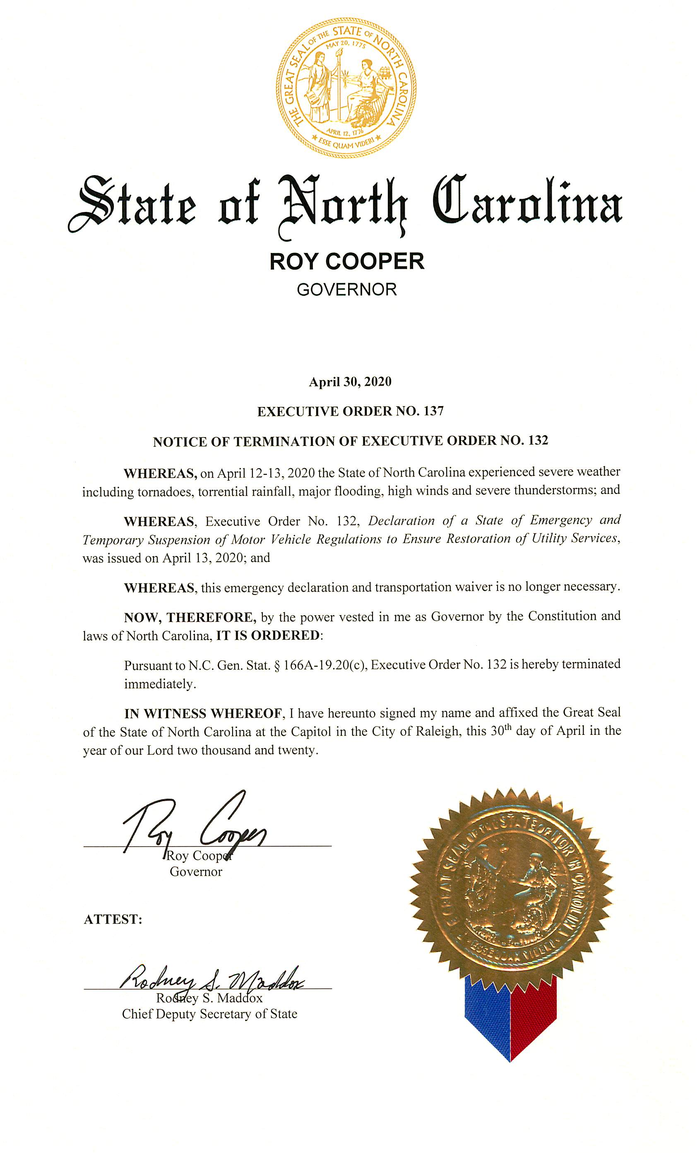
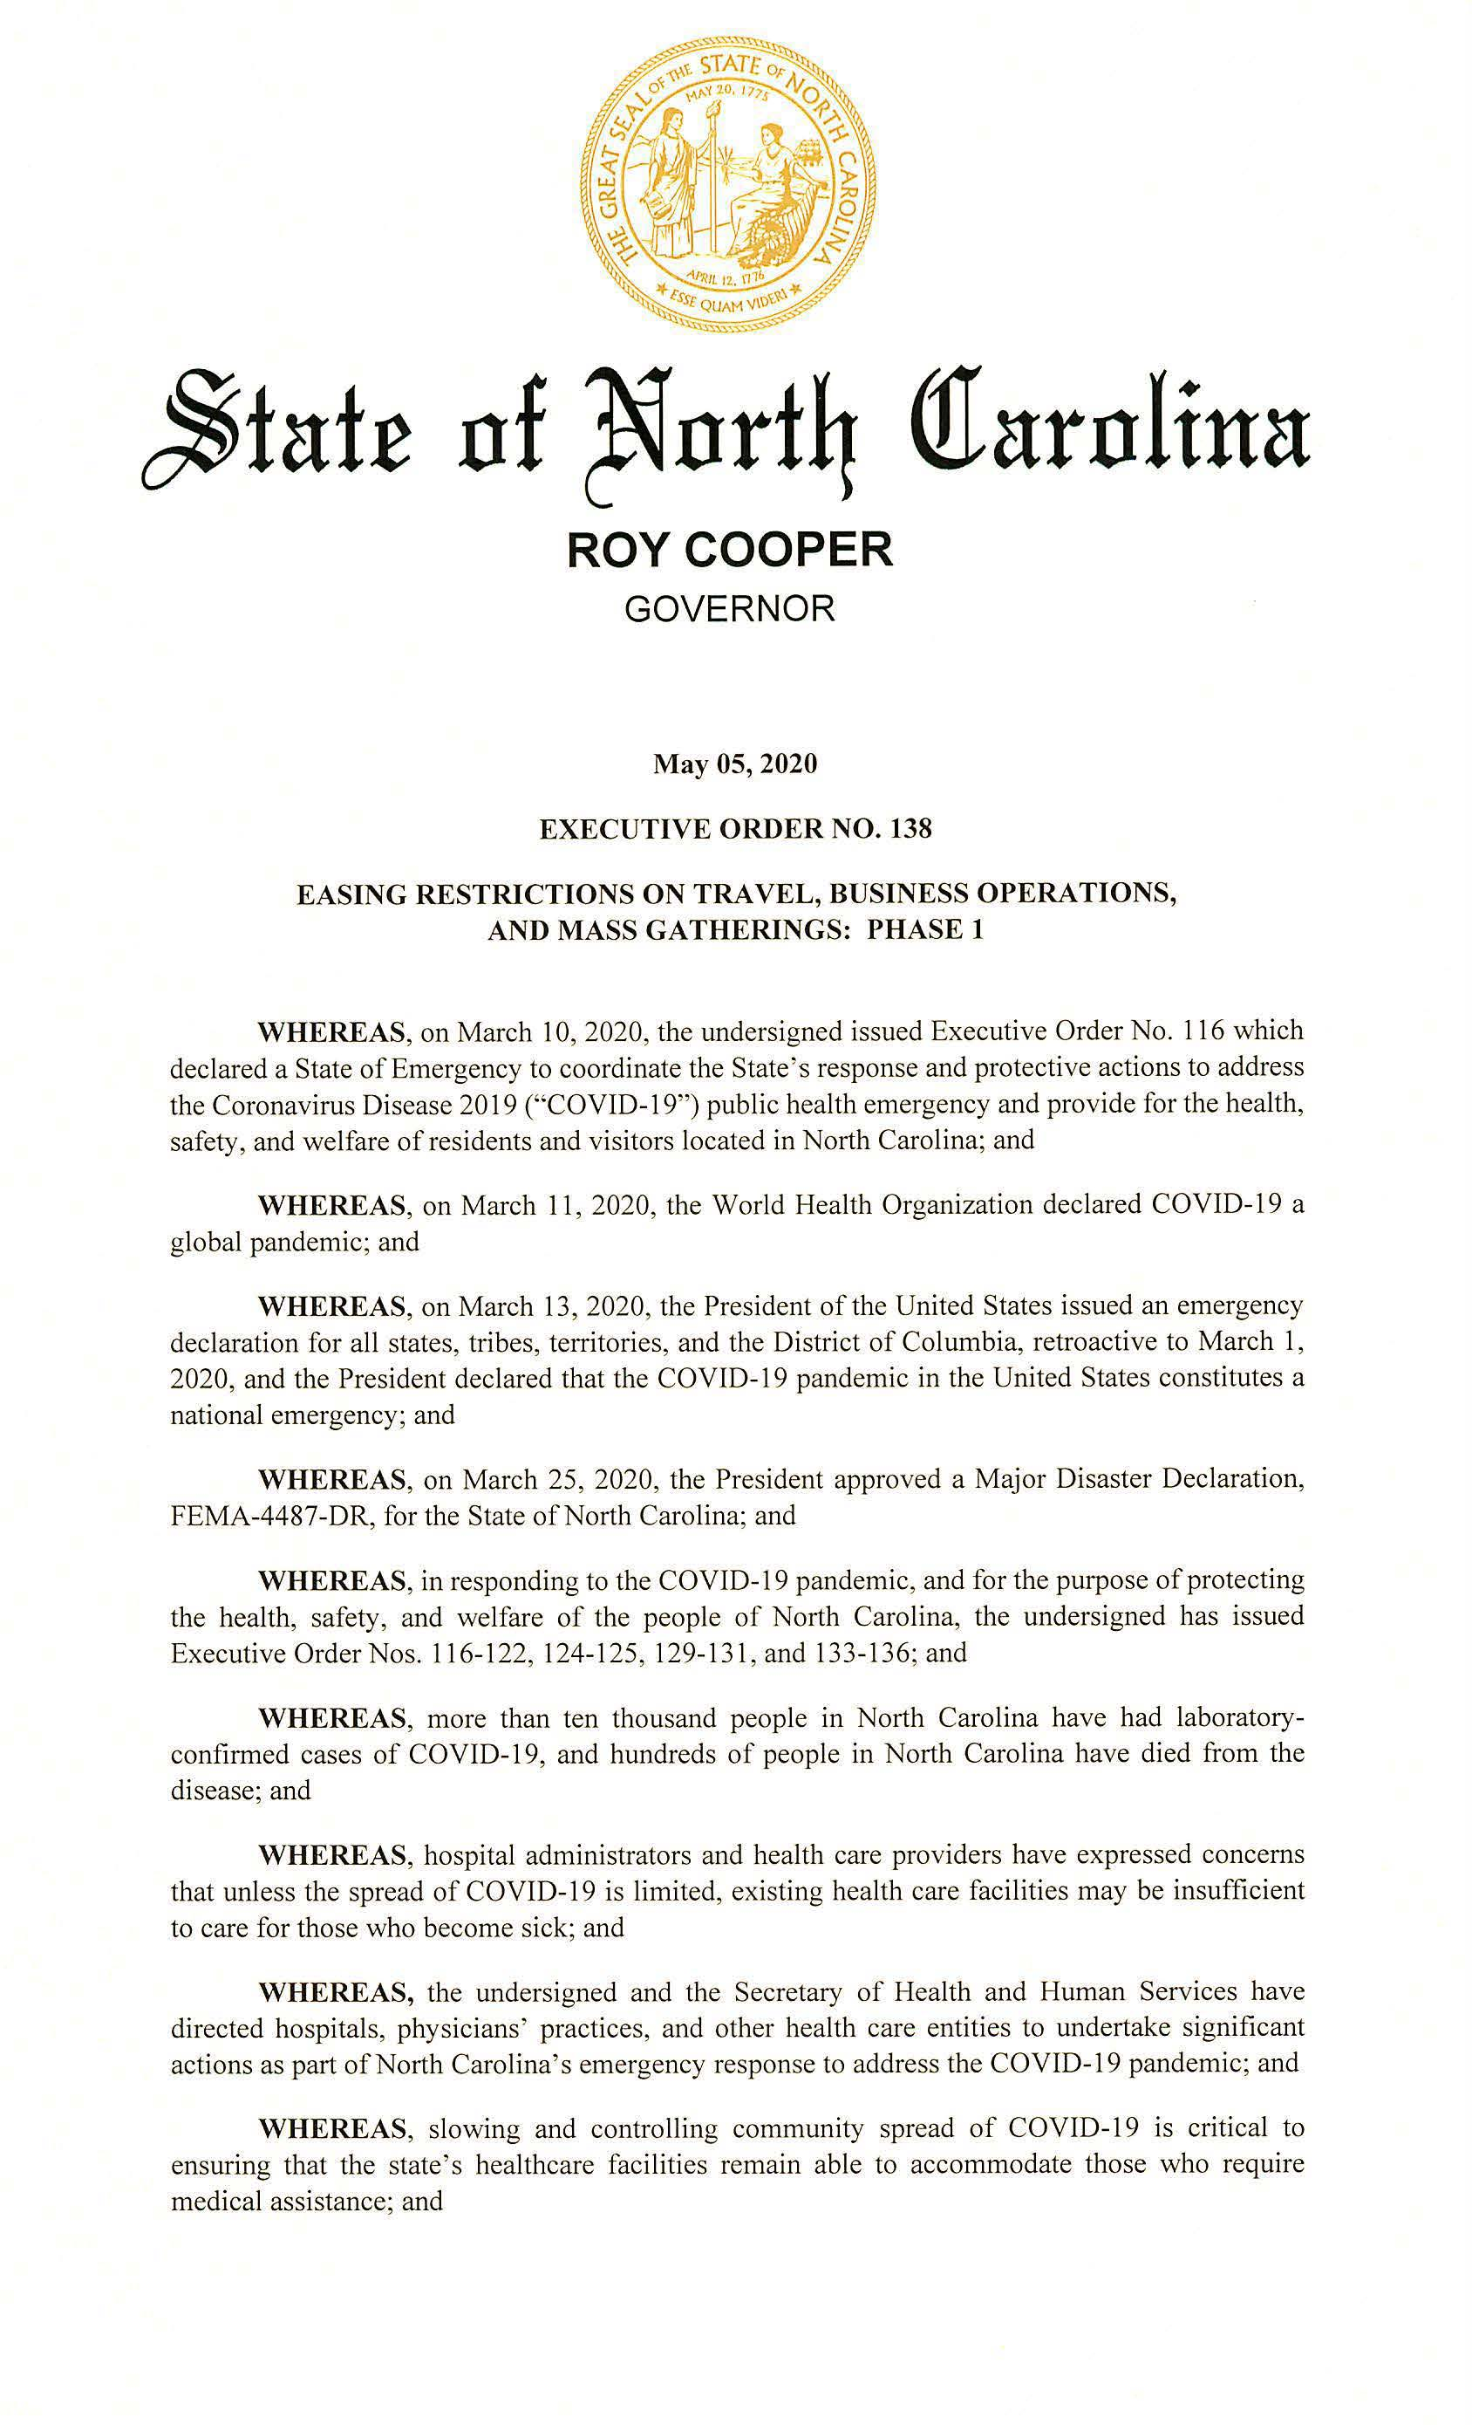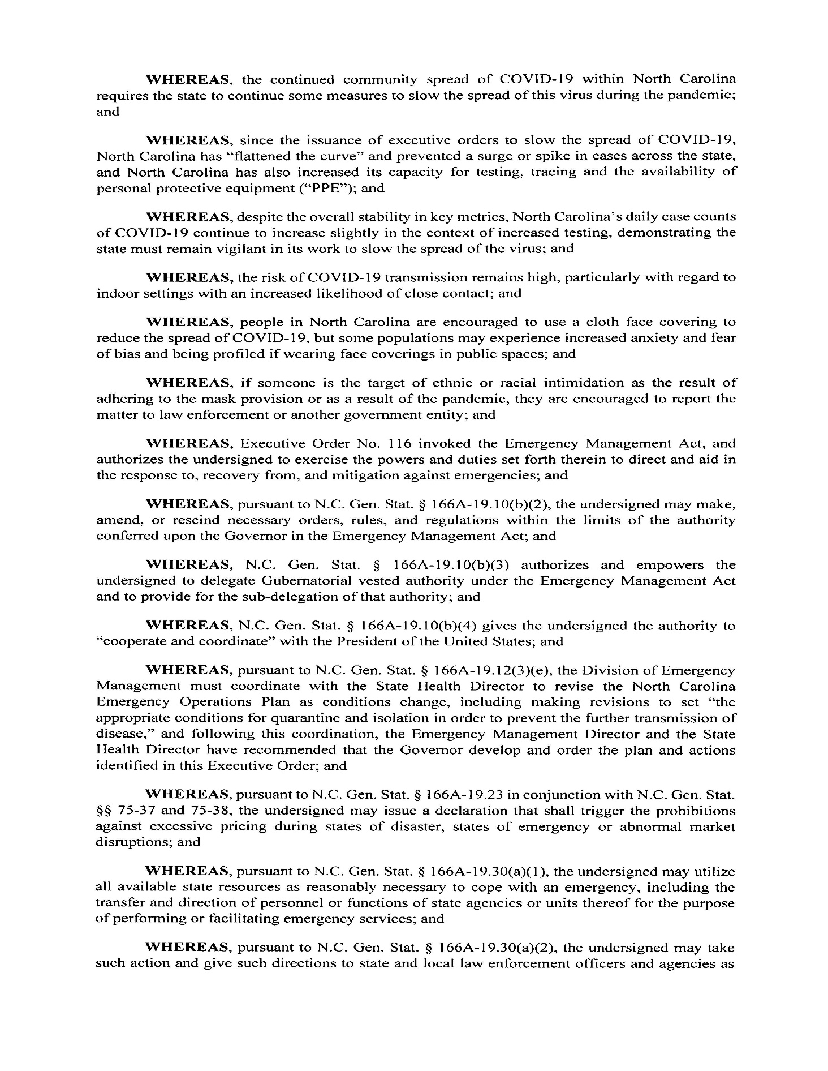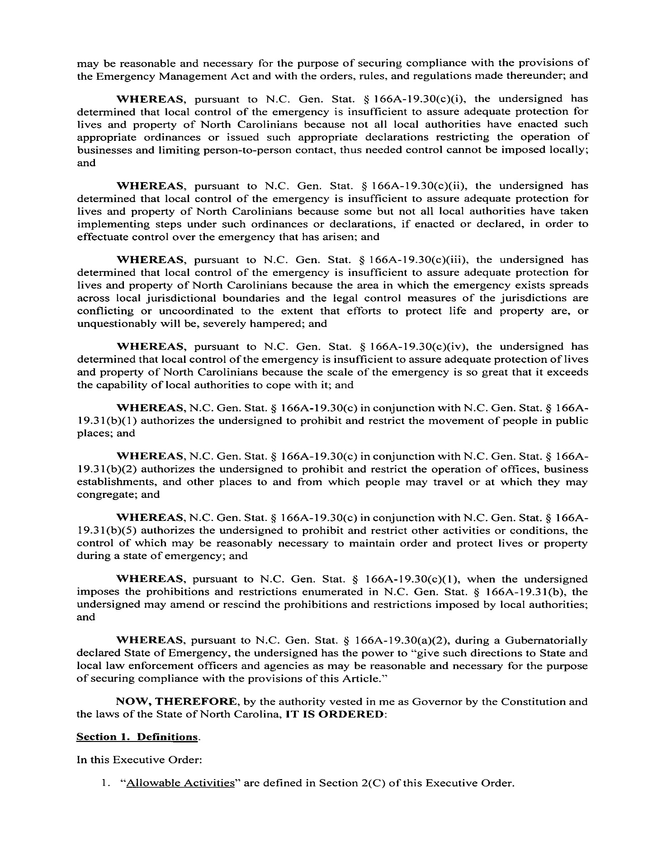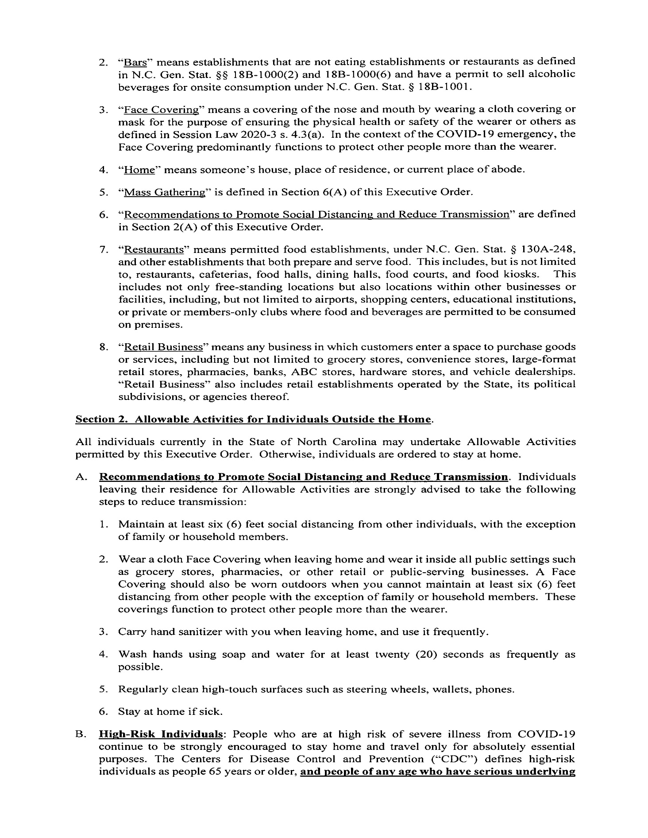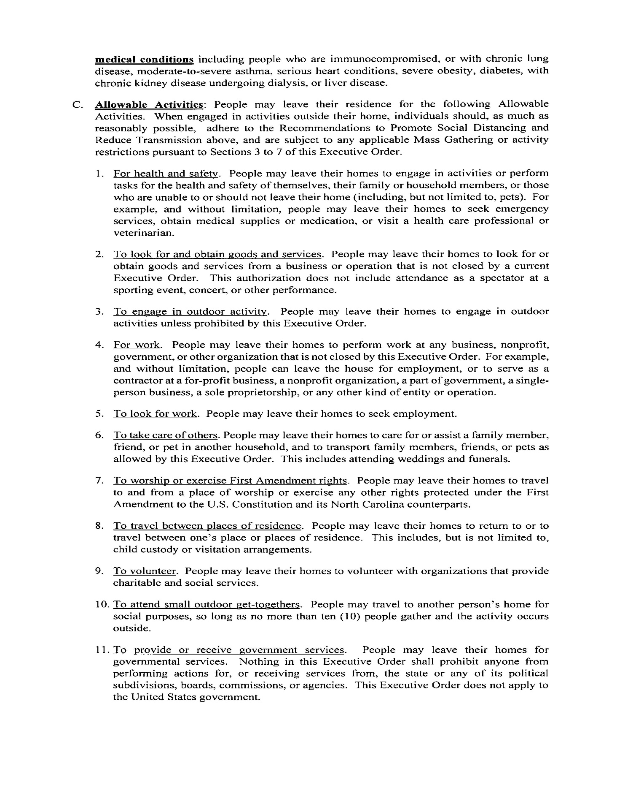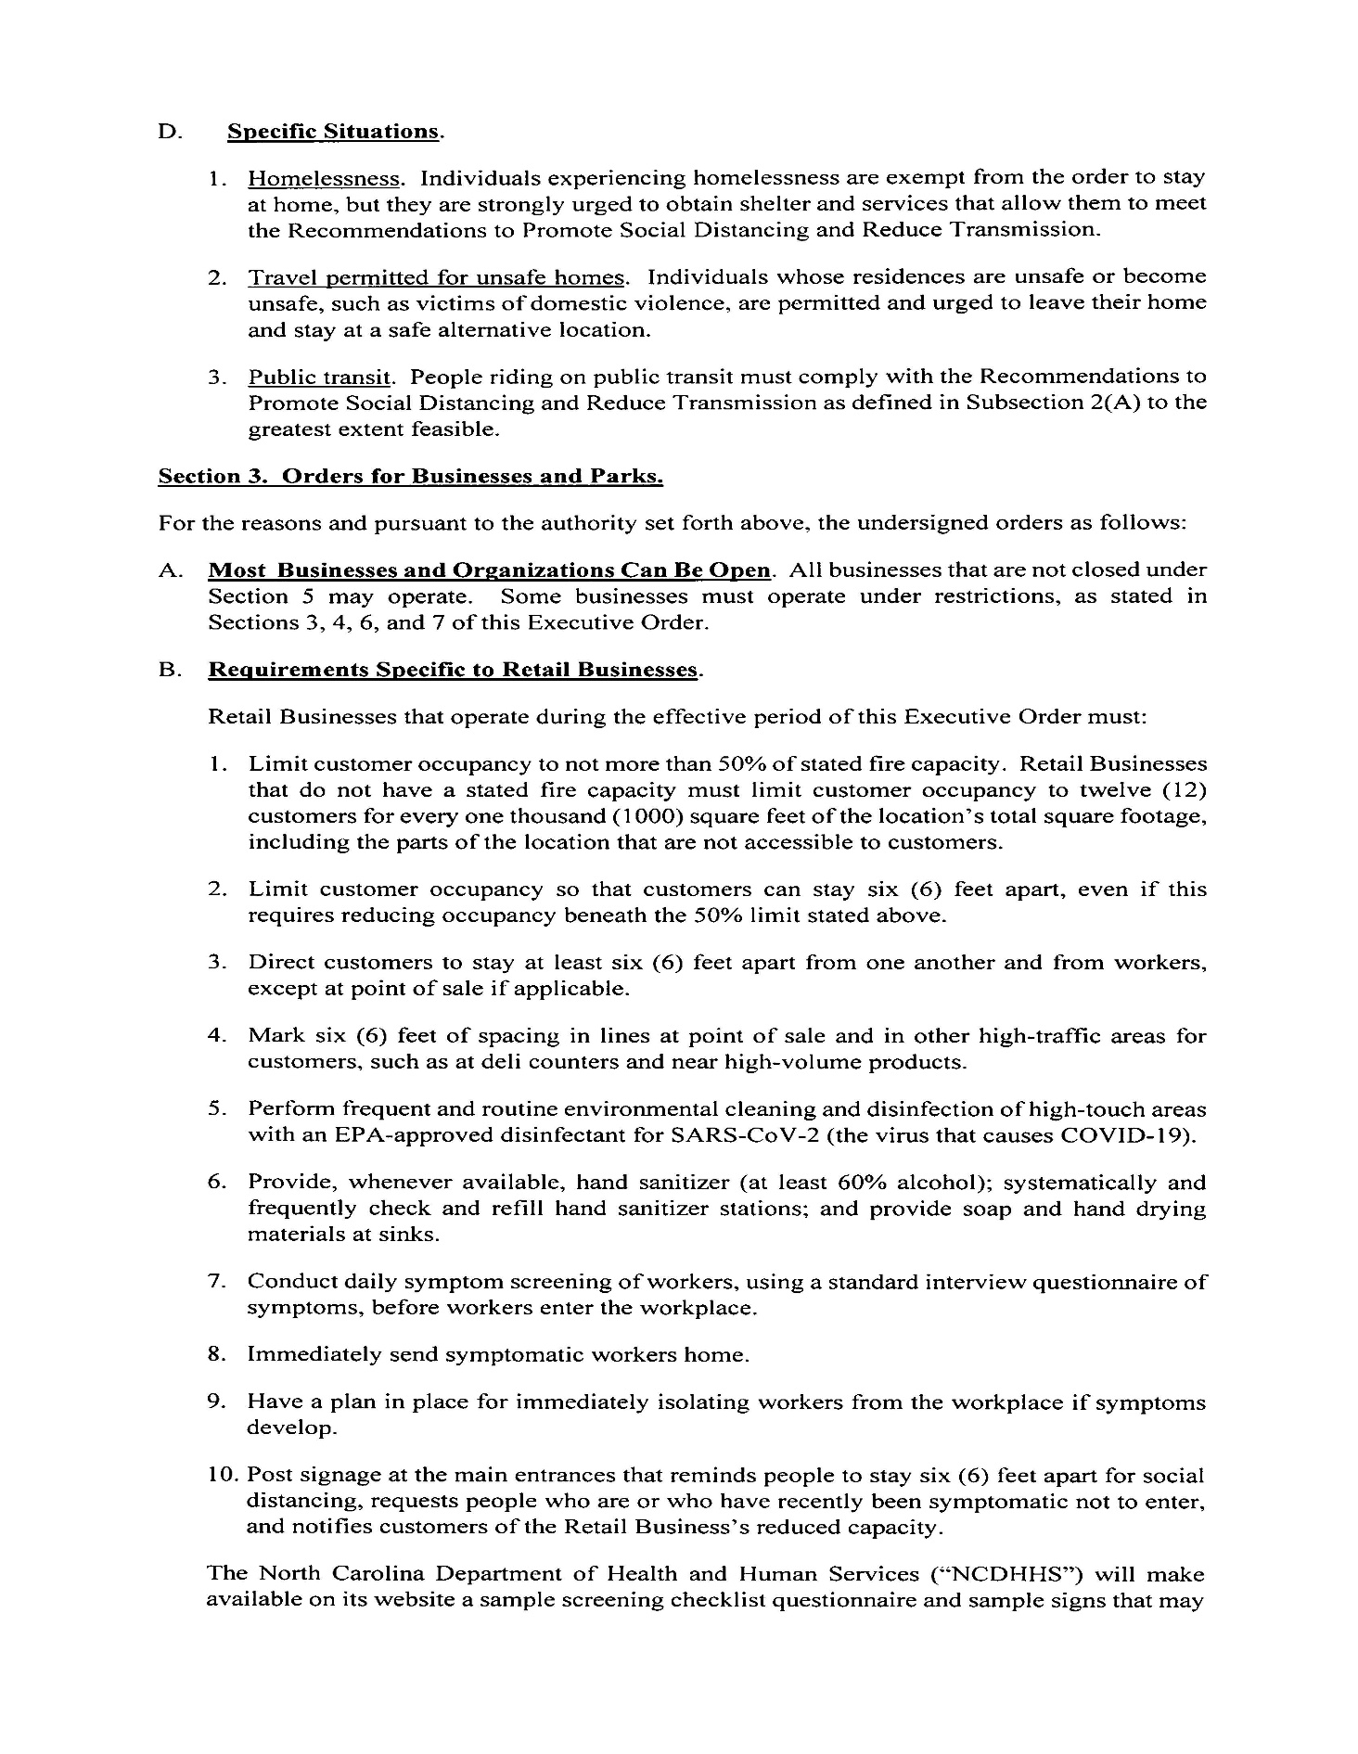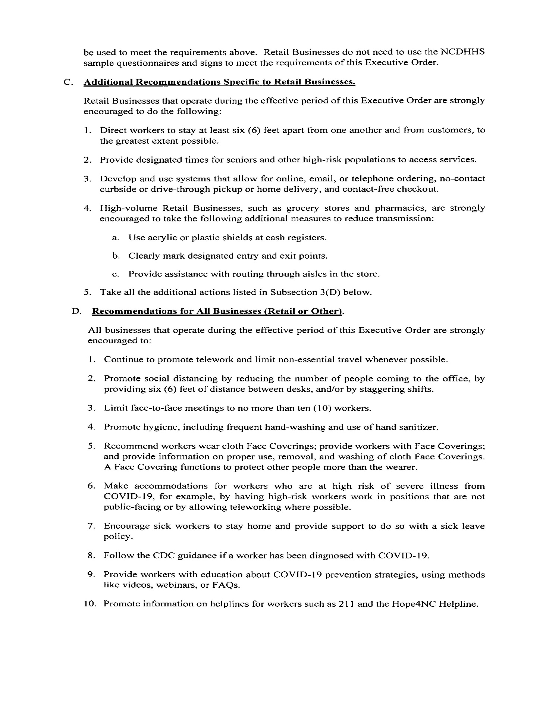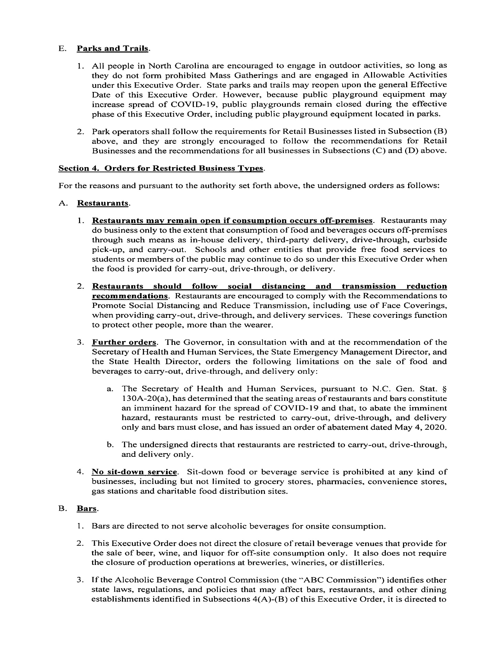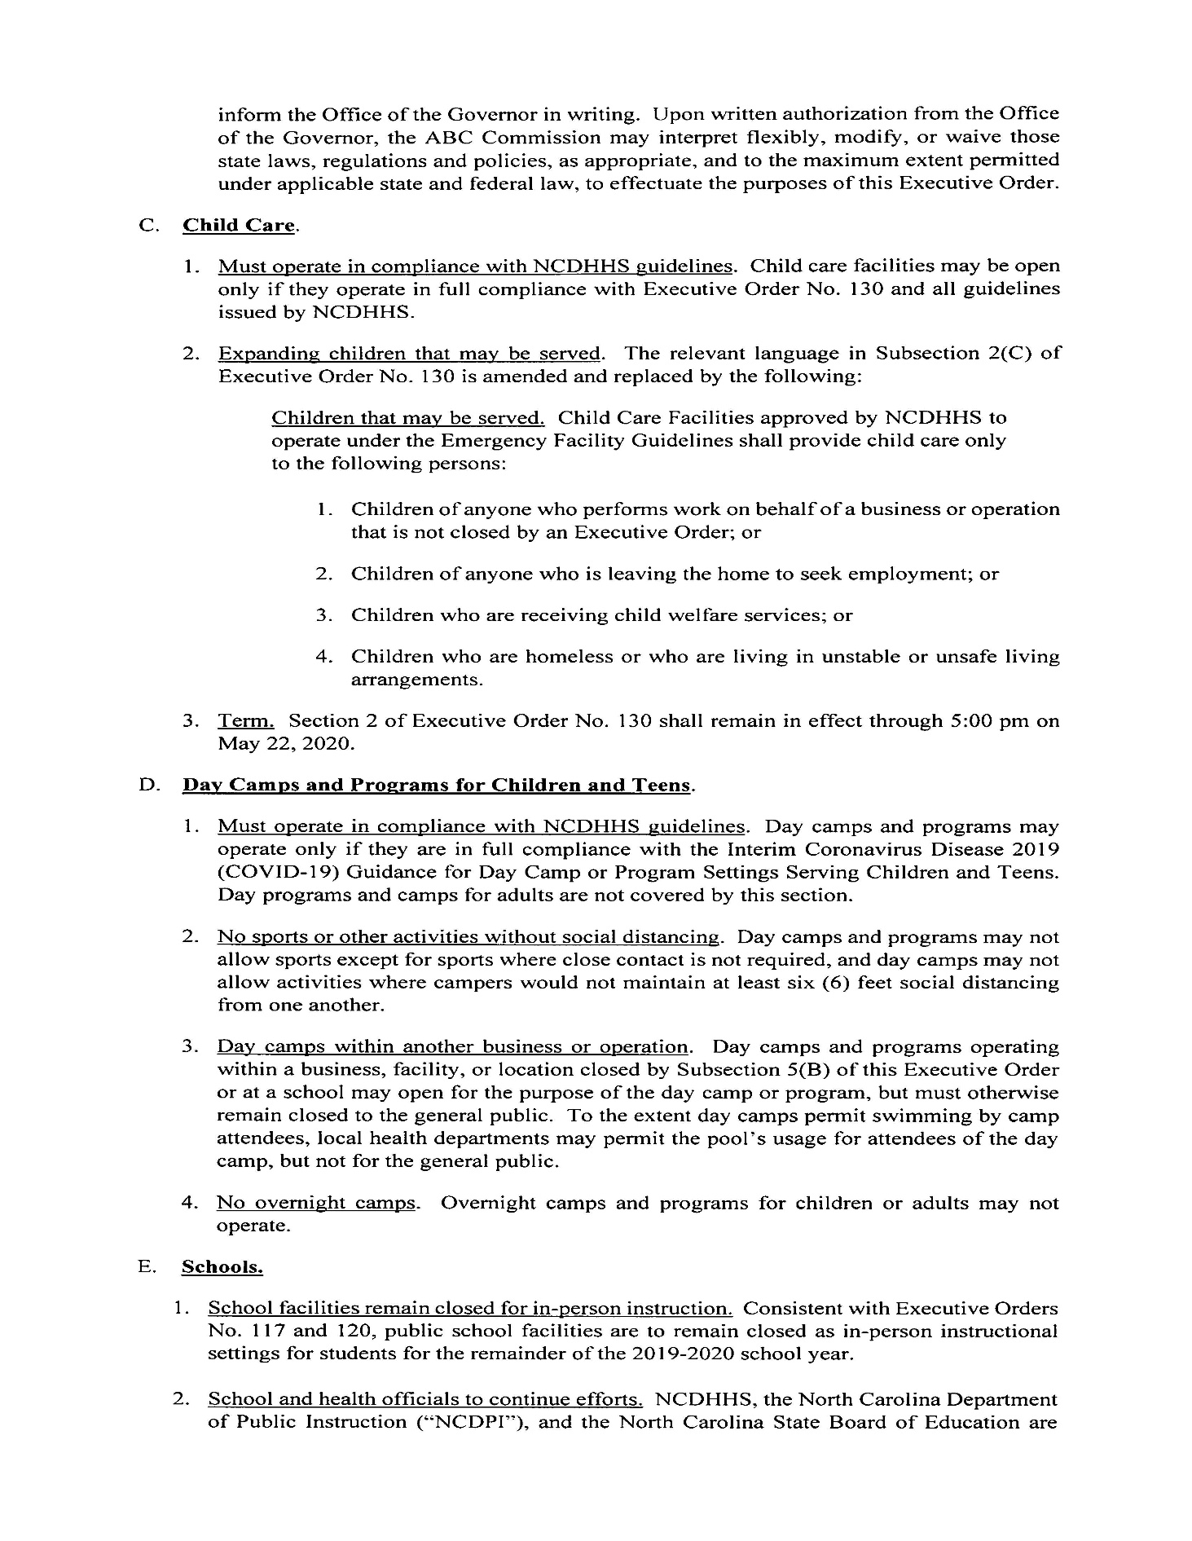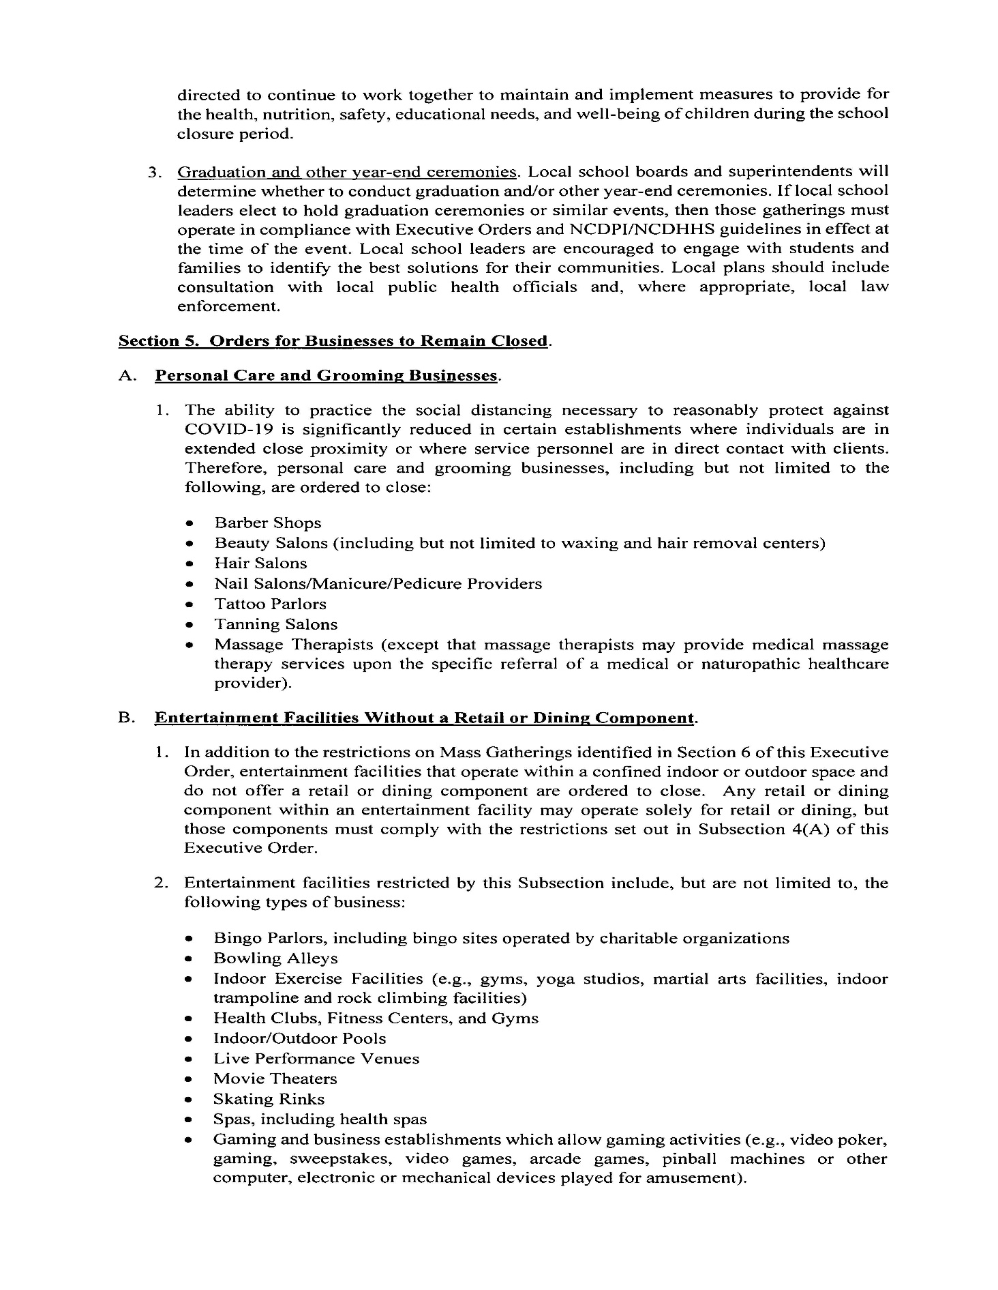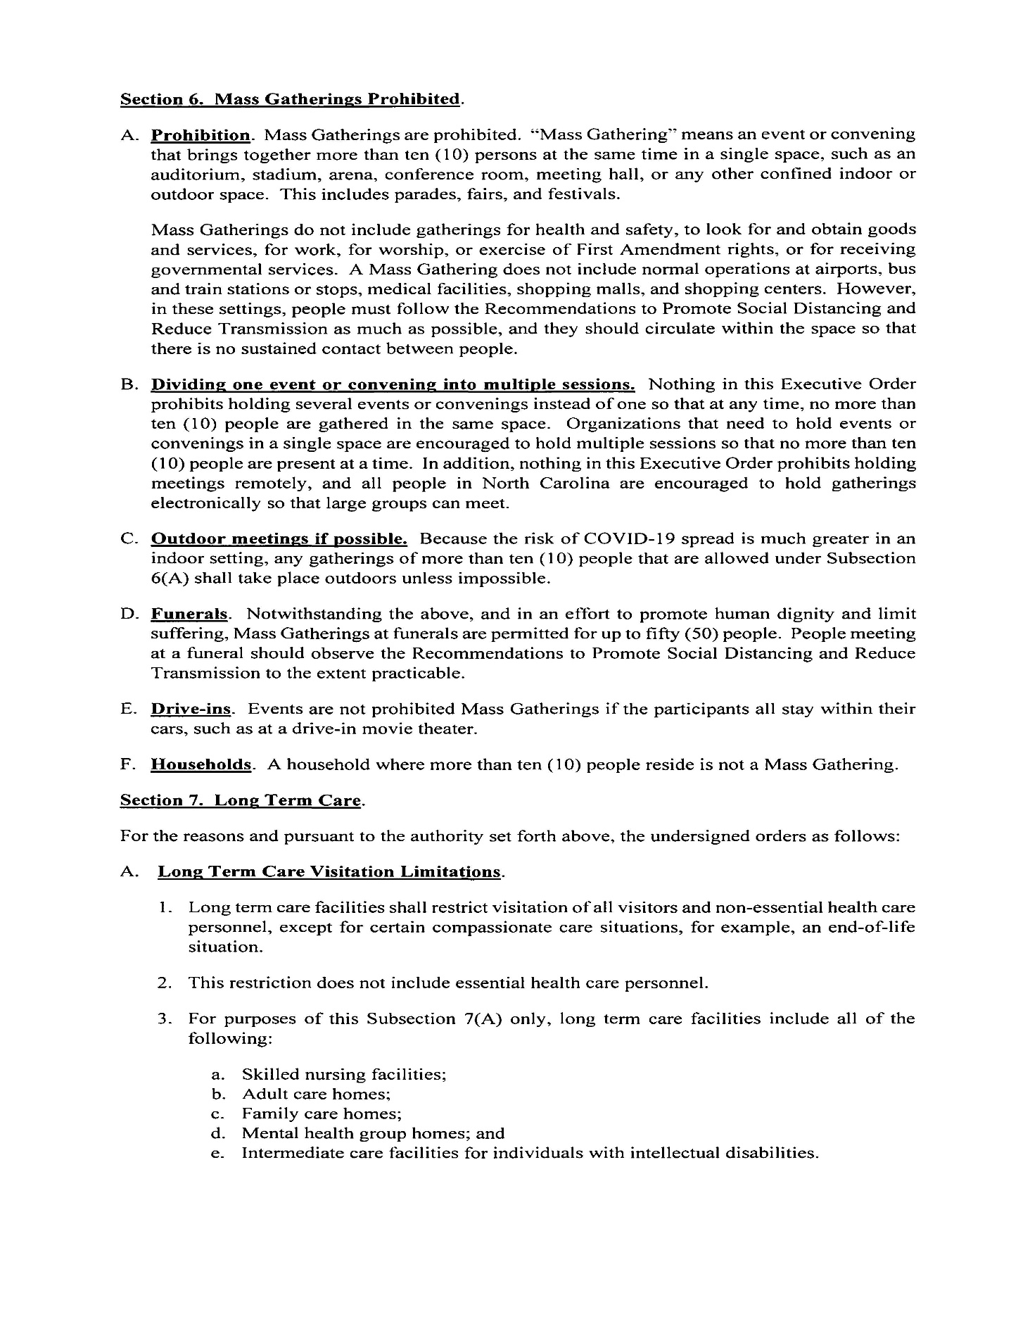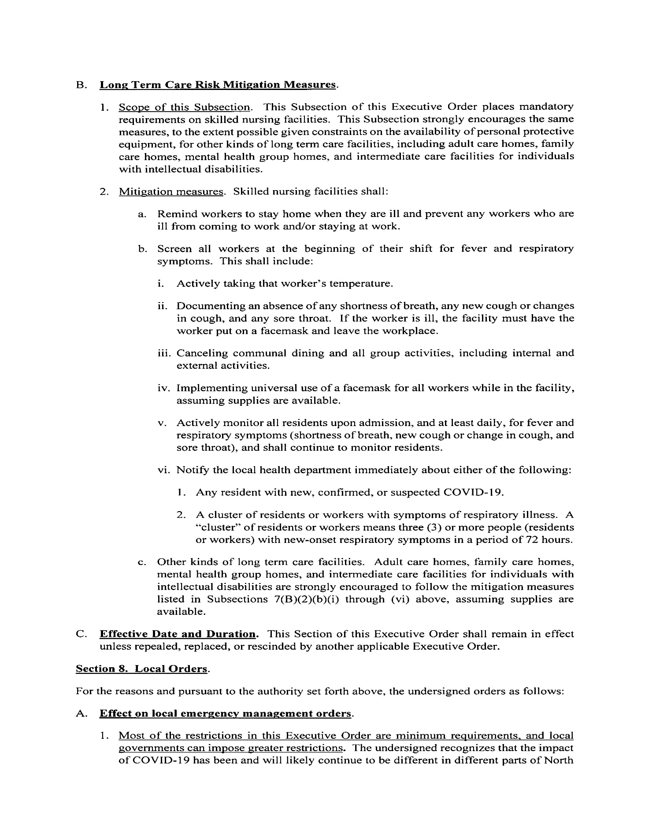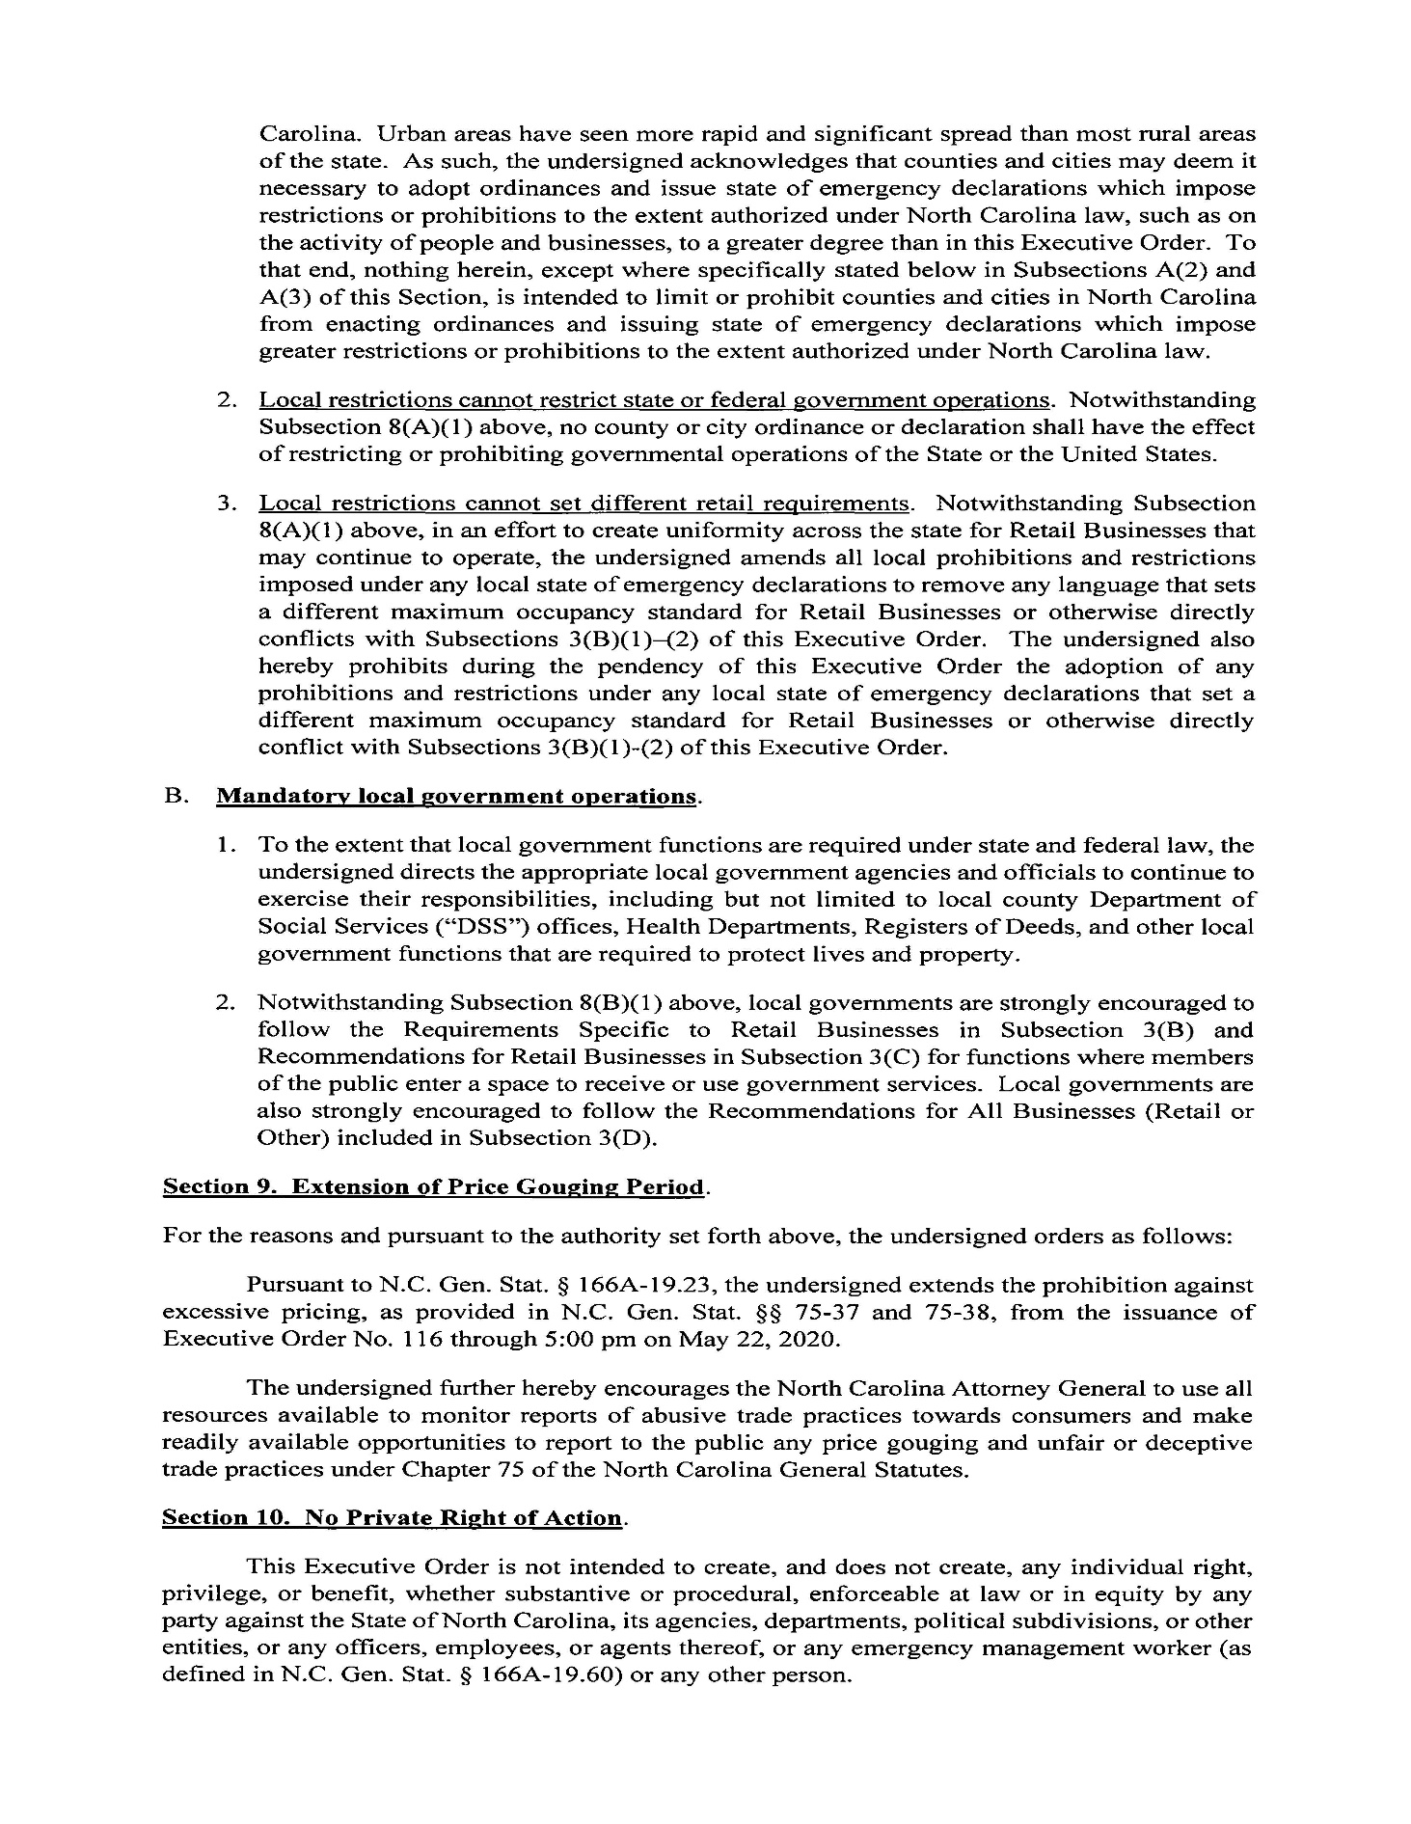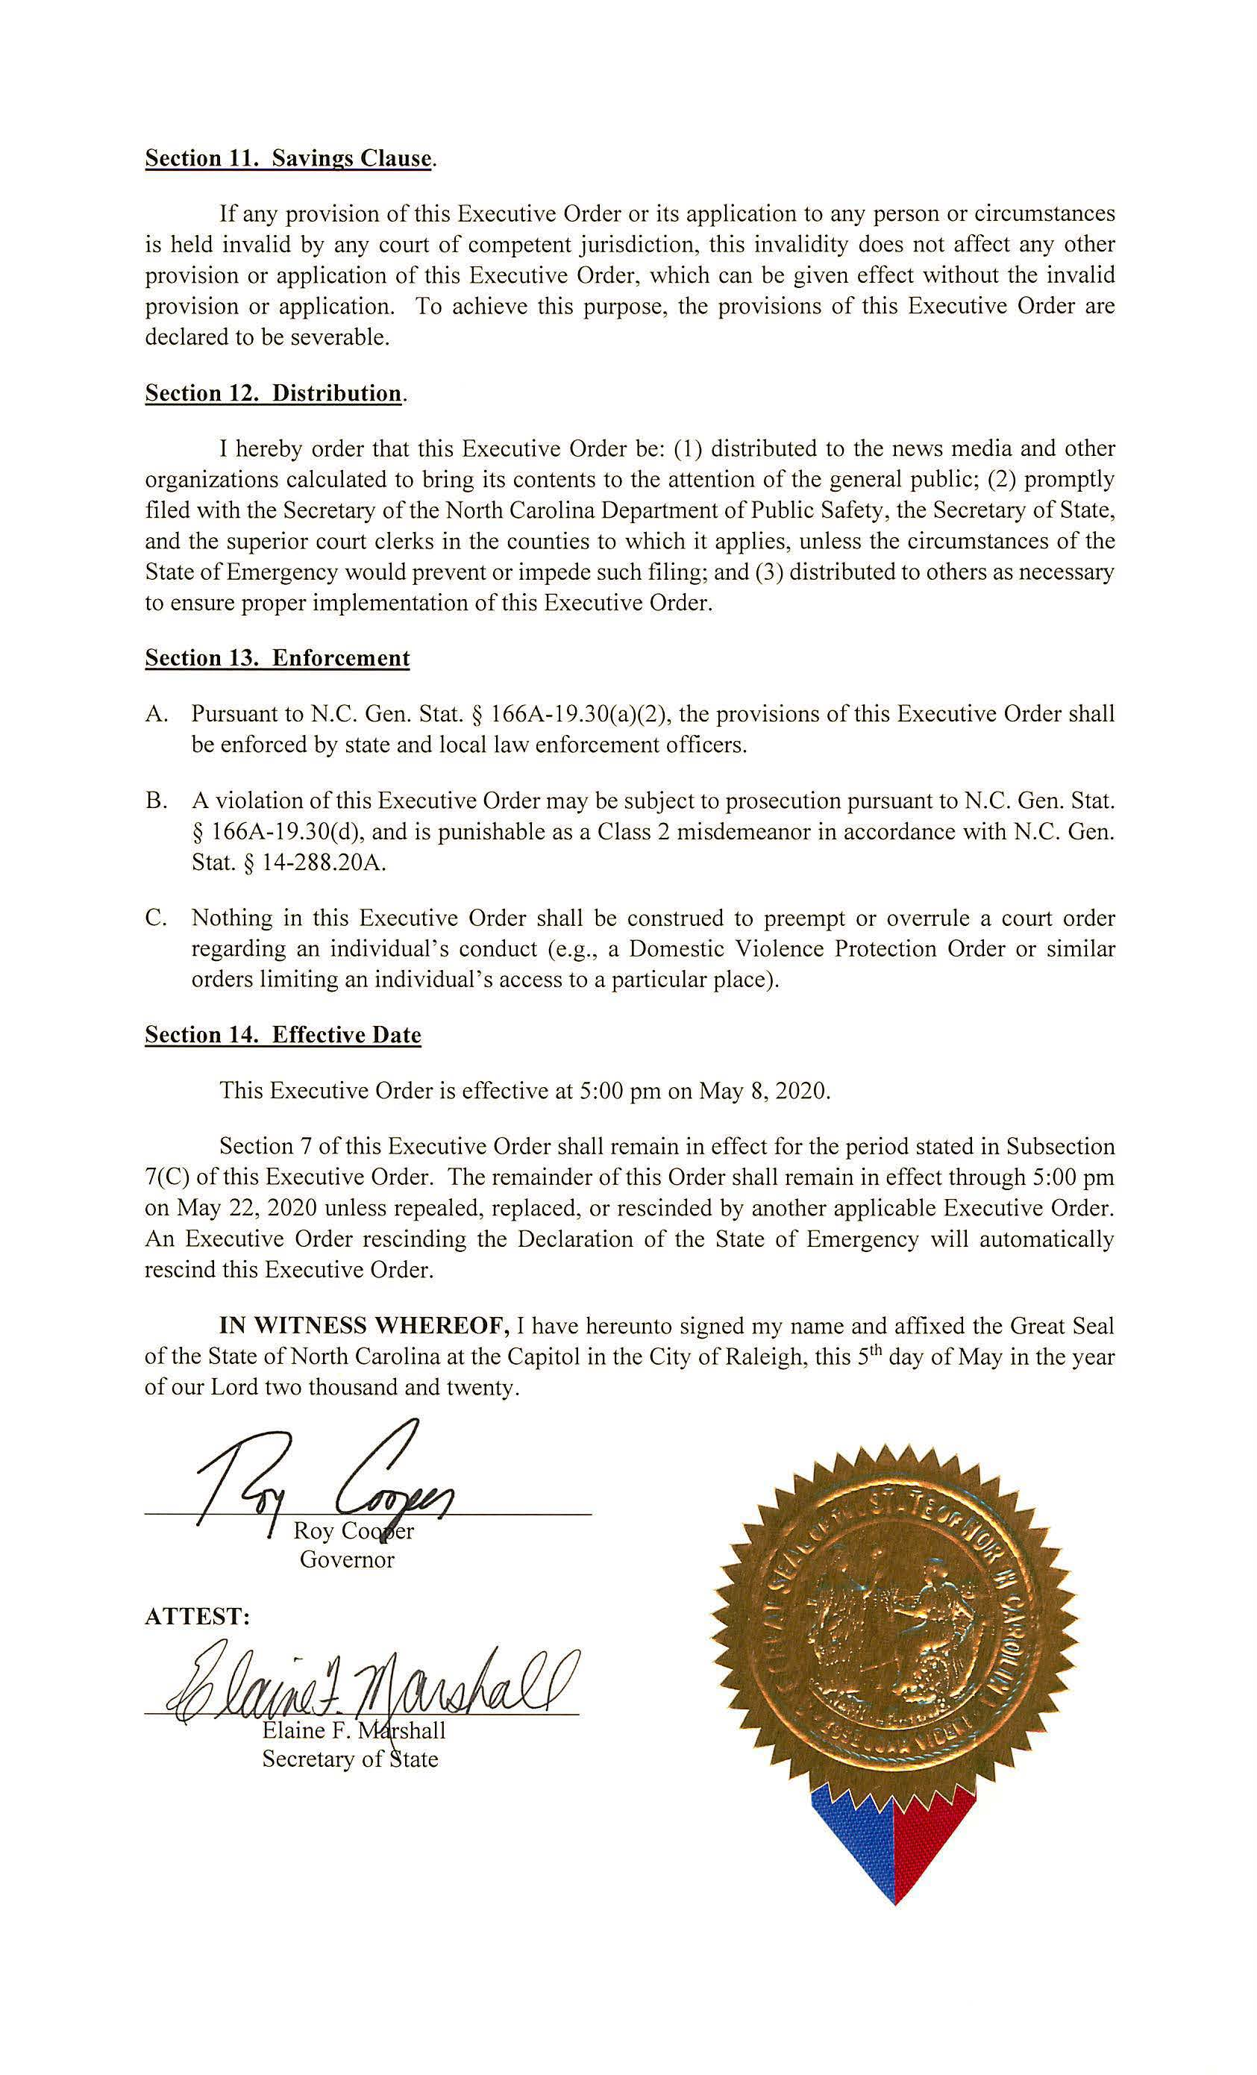

PUBLIC NOTICE

The ABC Commission has cancelled the public hearing on the ABC Store Spirituous Liquor Tasting Rules scheduled for June 10, 2020 at 10:00 a.m. at the ABC Commission Office at 400 E. Tryon Road, Raleigh, NC 27610. The public hearing on these rules is rescheduled for July 8, 2020 at 10:00 a.m. at the same location. The public comment period for the ABC Store Spirituous Liquor Tasting Rules, which currently run through June 10, 2020, will be extended until July 8, 2020 at 10:00 a.m.

The proposed rules for the ABC Store Spirituous Liquor Tasting Rules, 14B NCAC 15C .1301, .1303 - .1305 and .1307, were published in North Carolina Register, Volume 34, Issue 19, page 1773 on April 1, 2020.

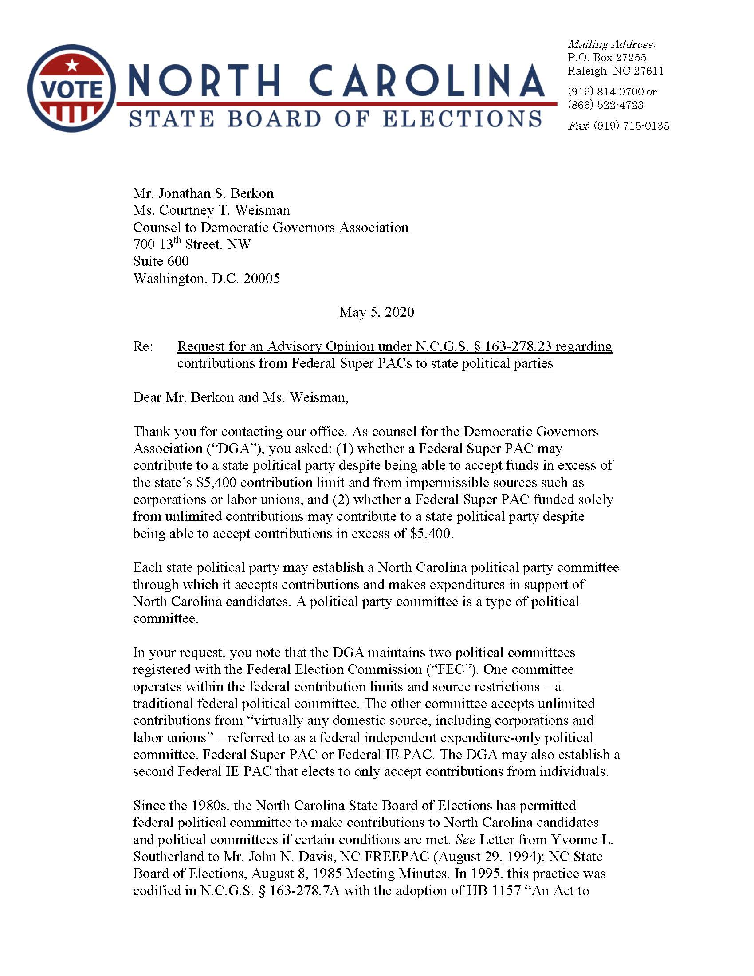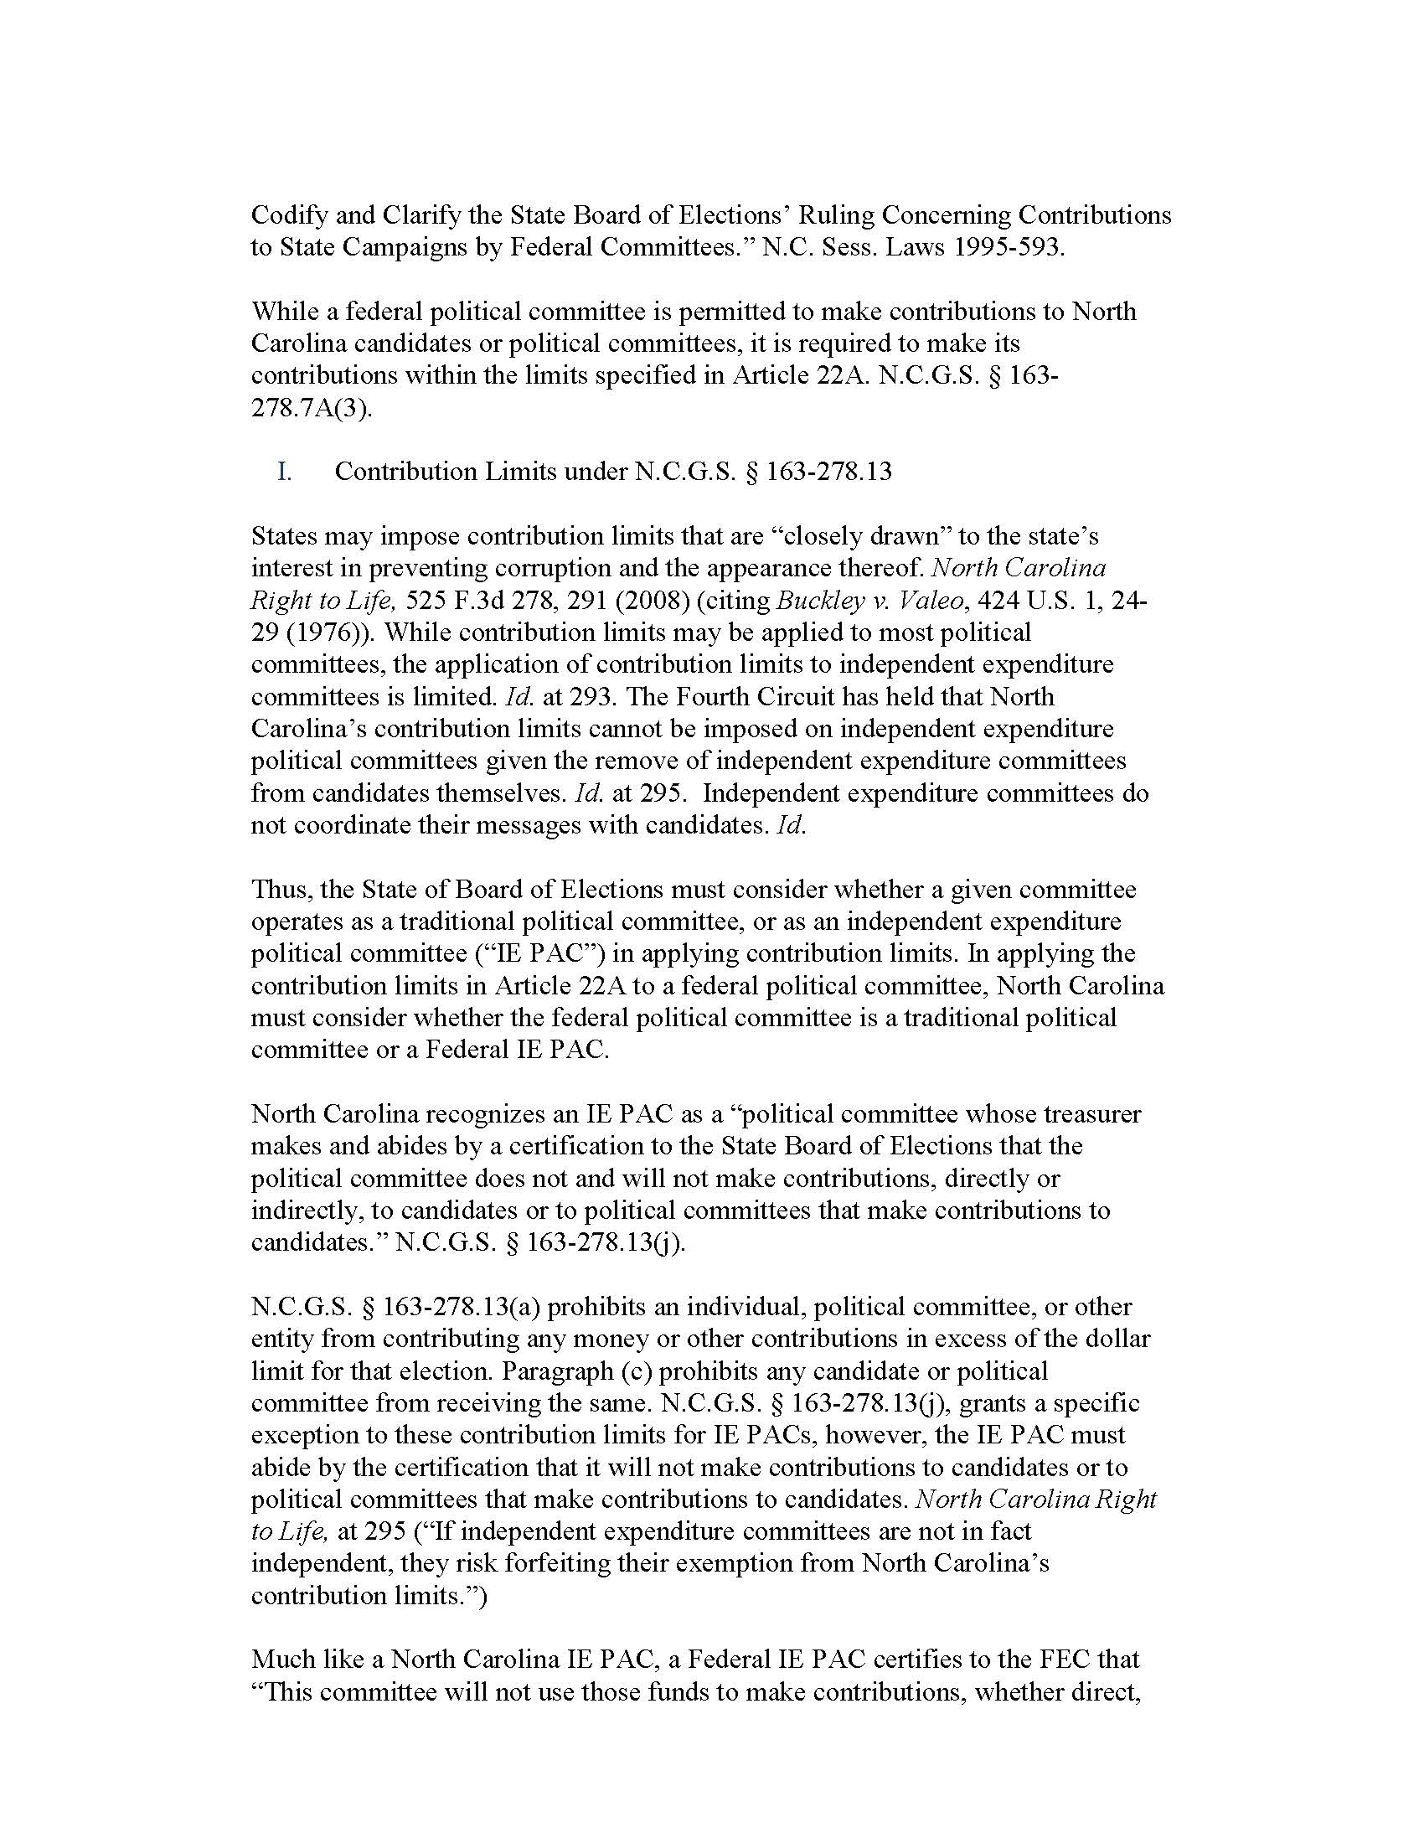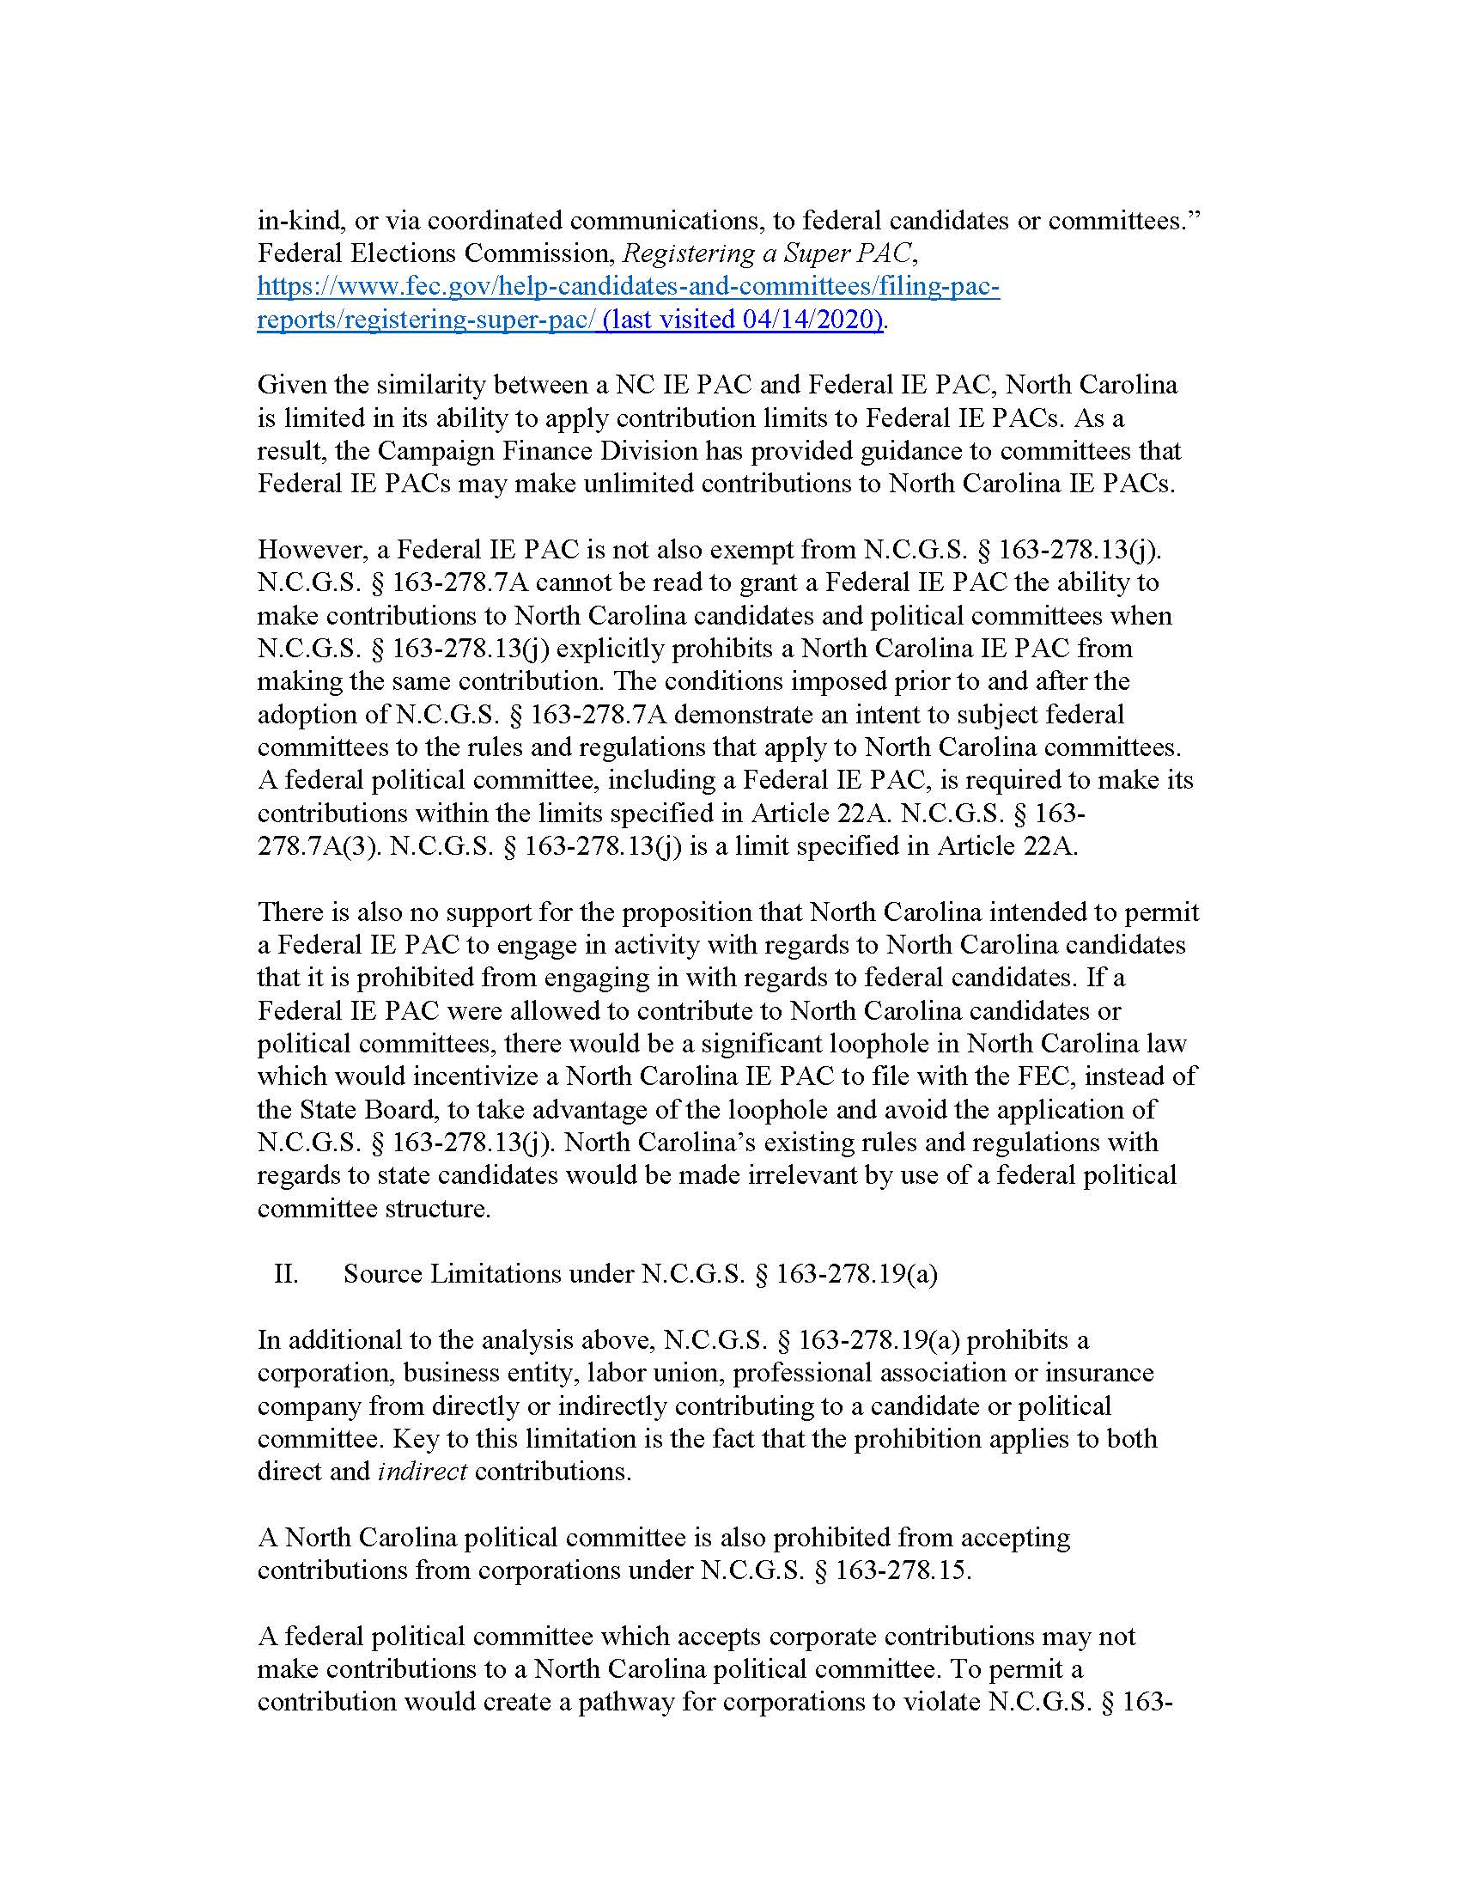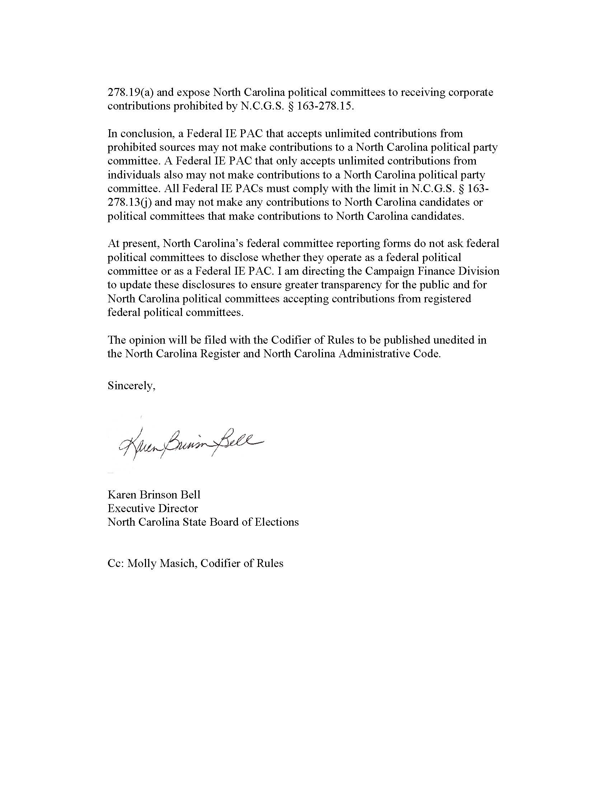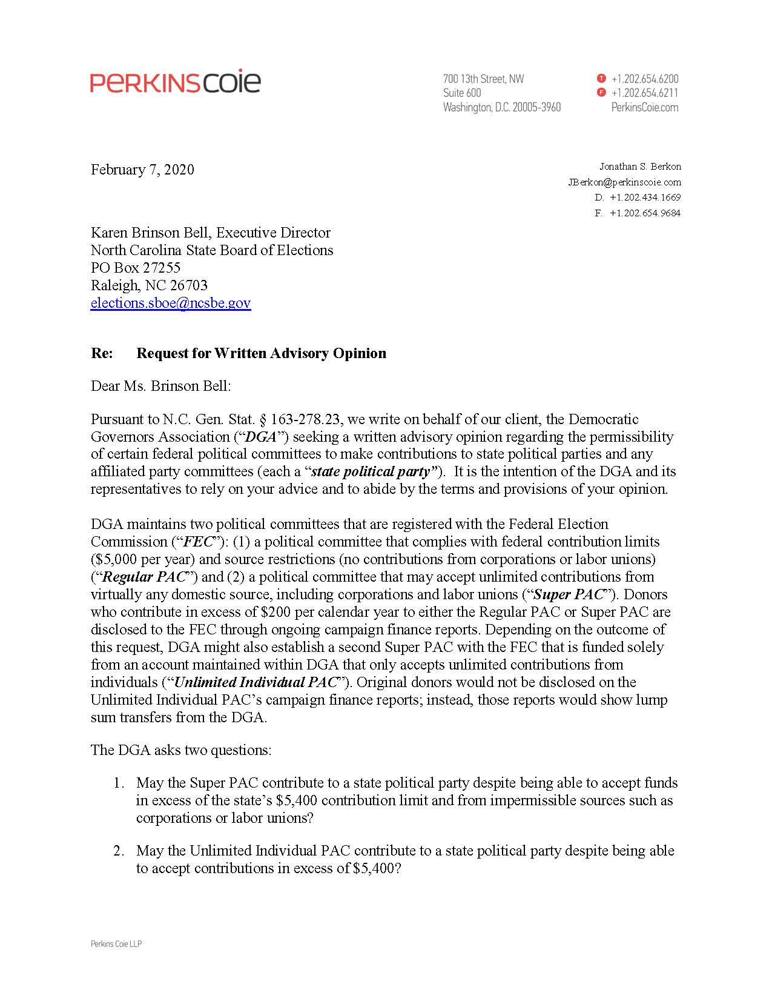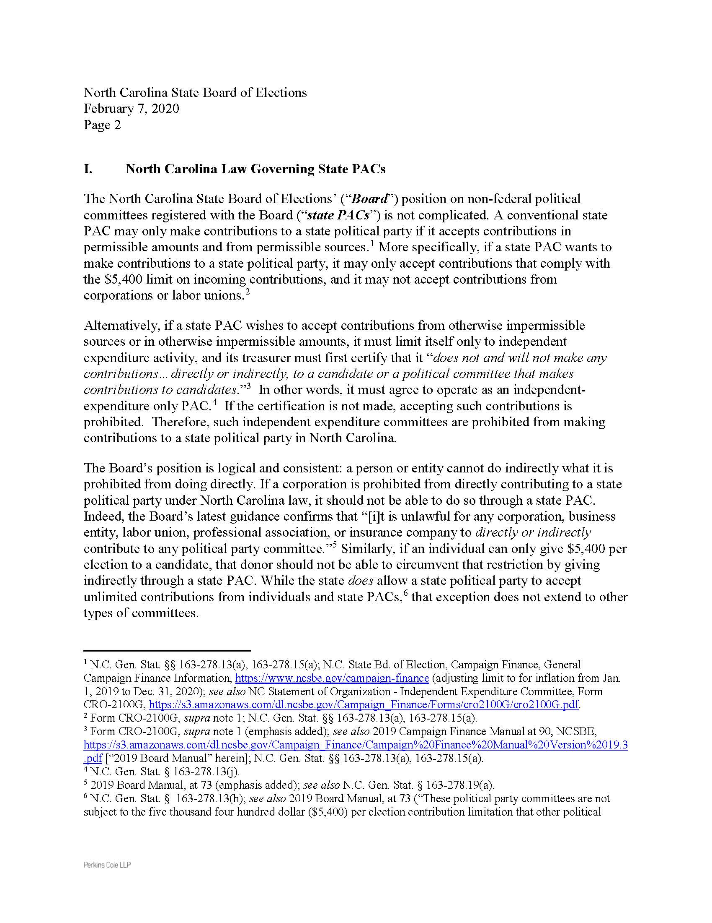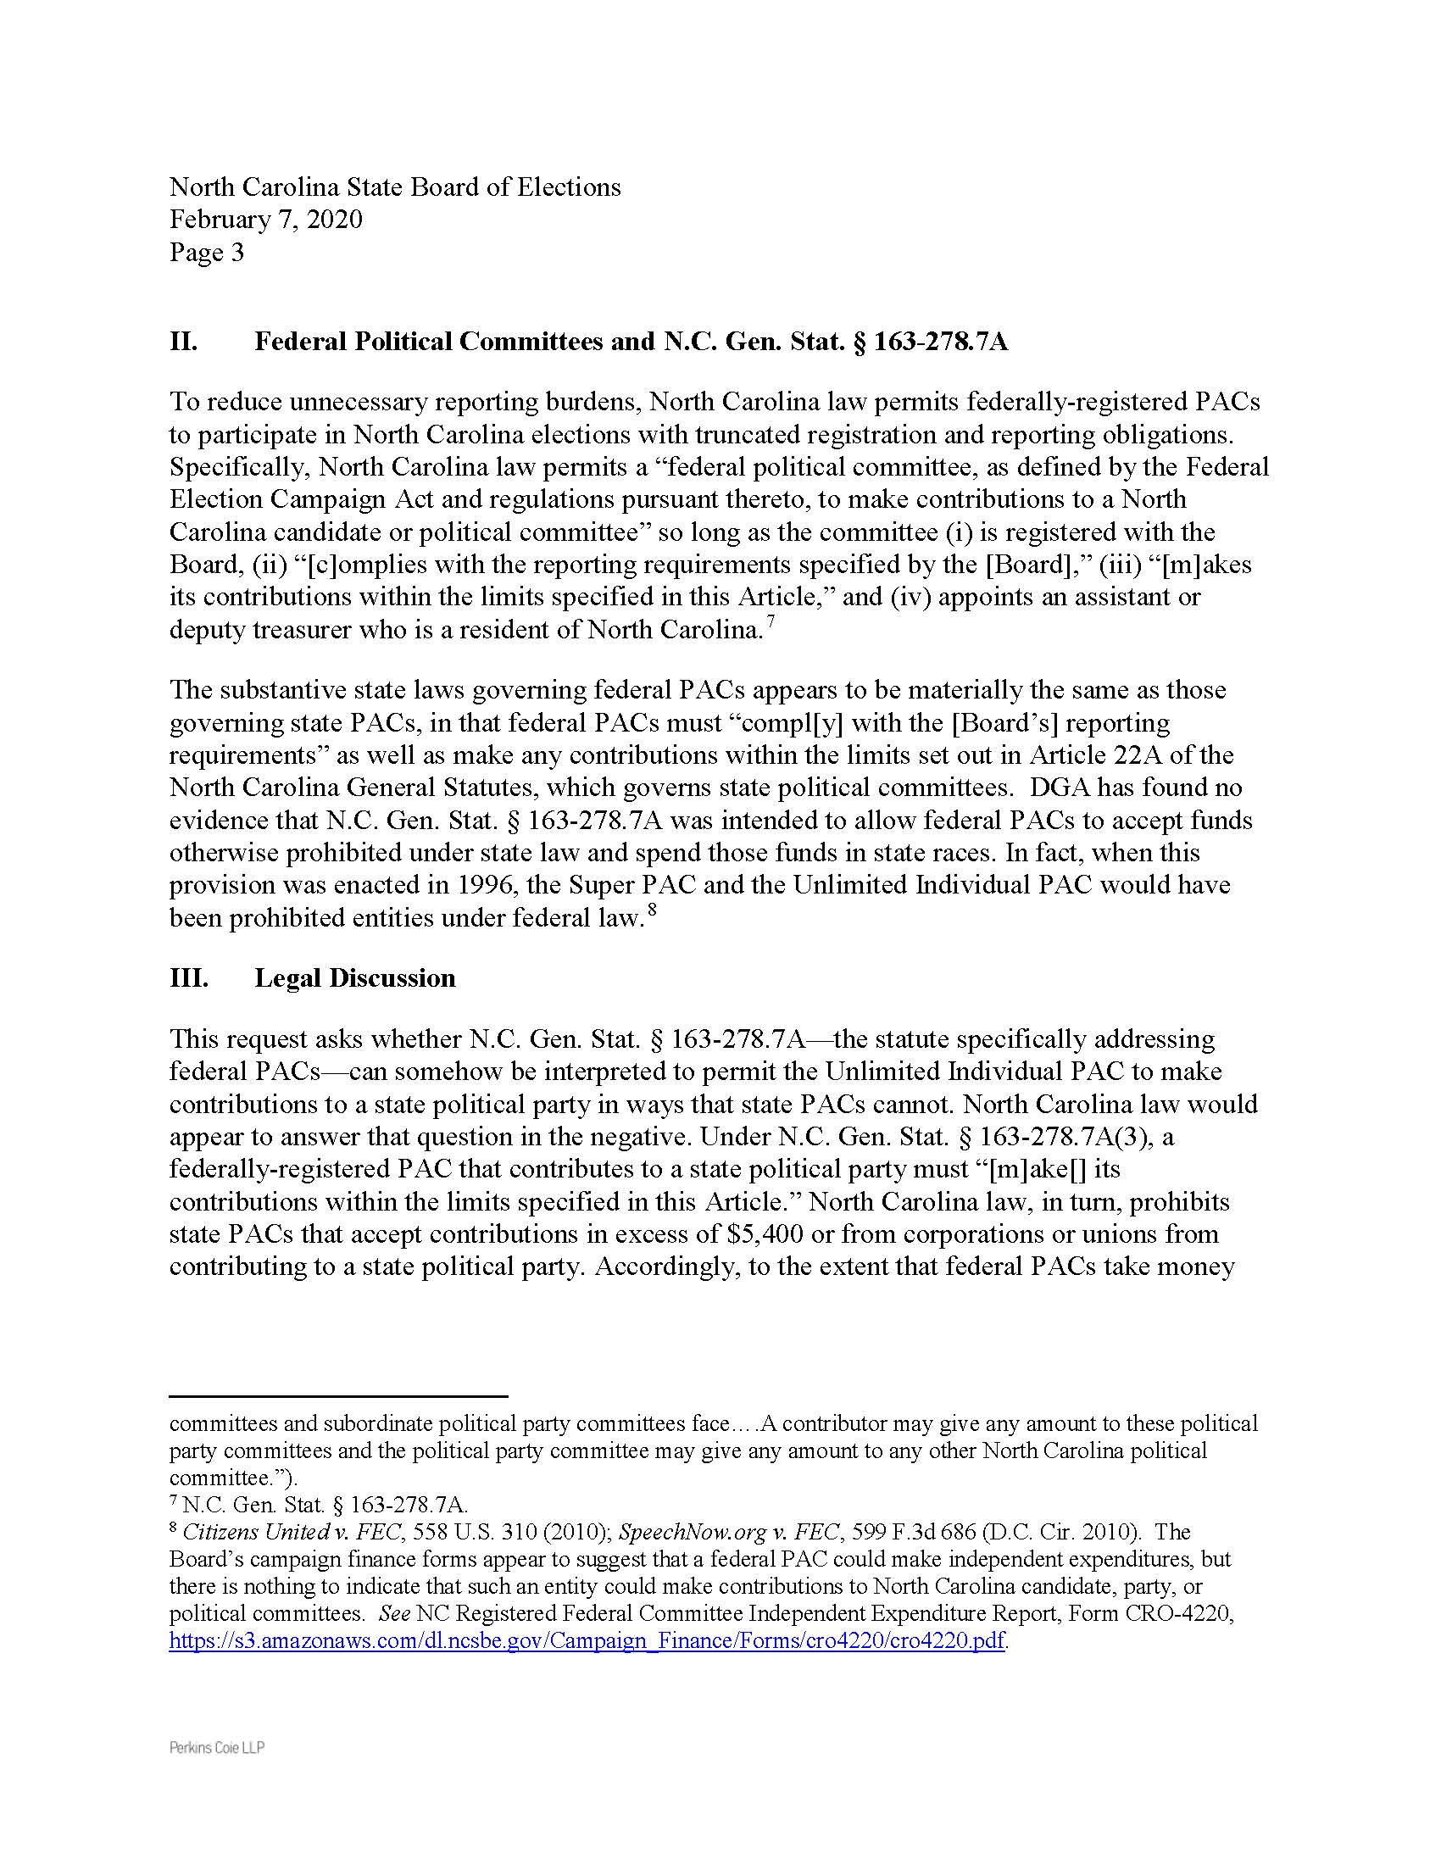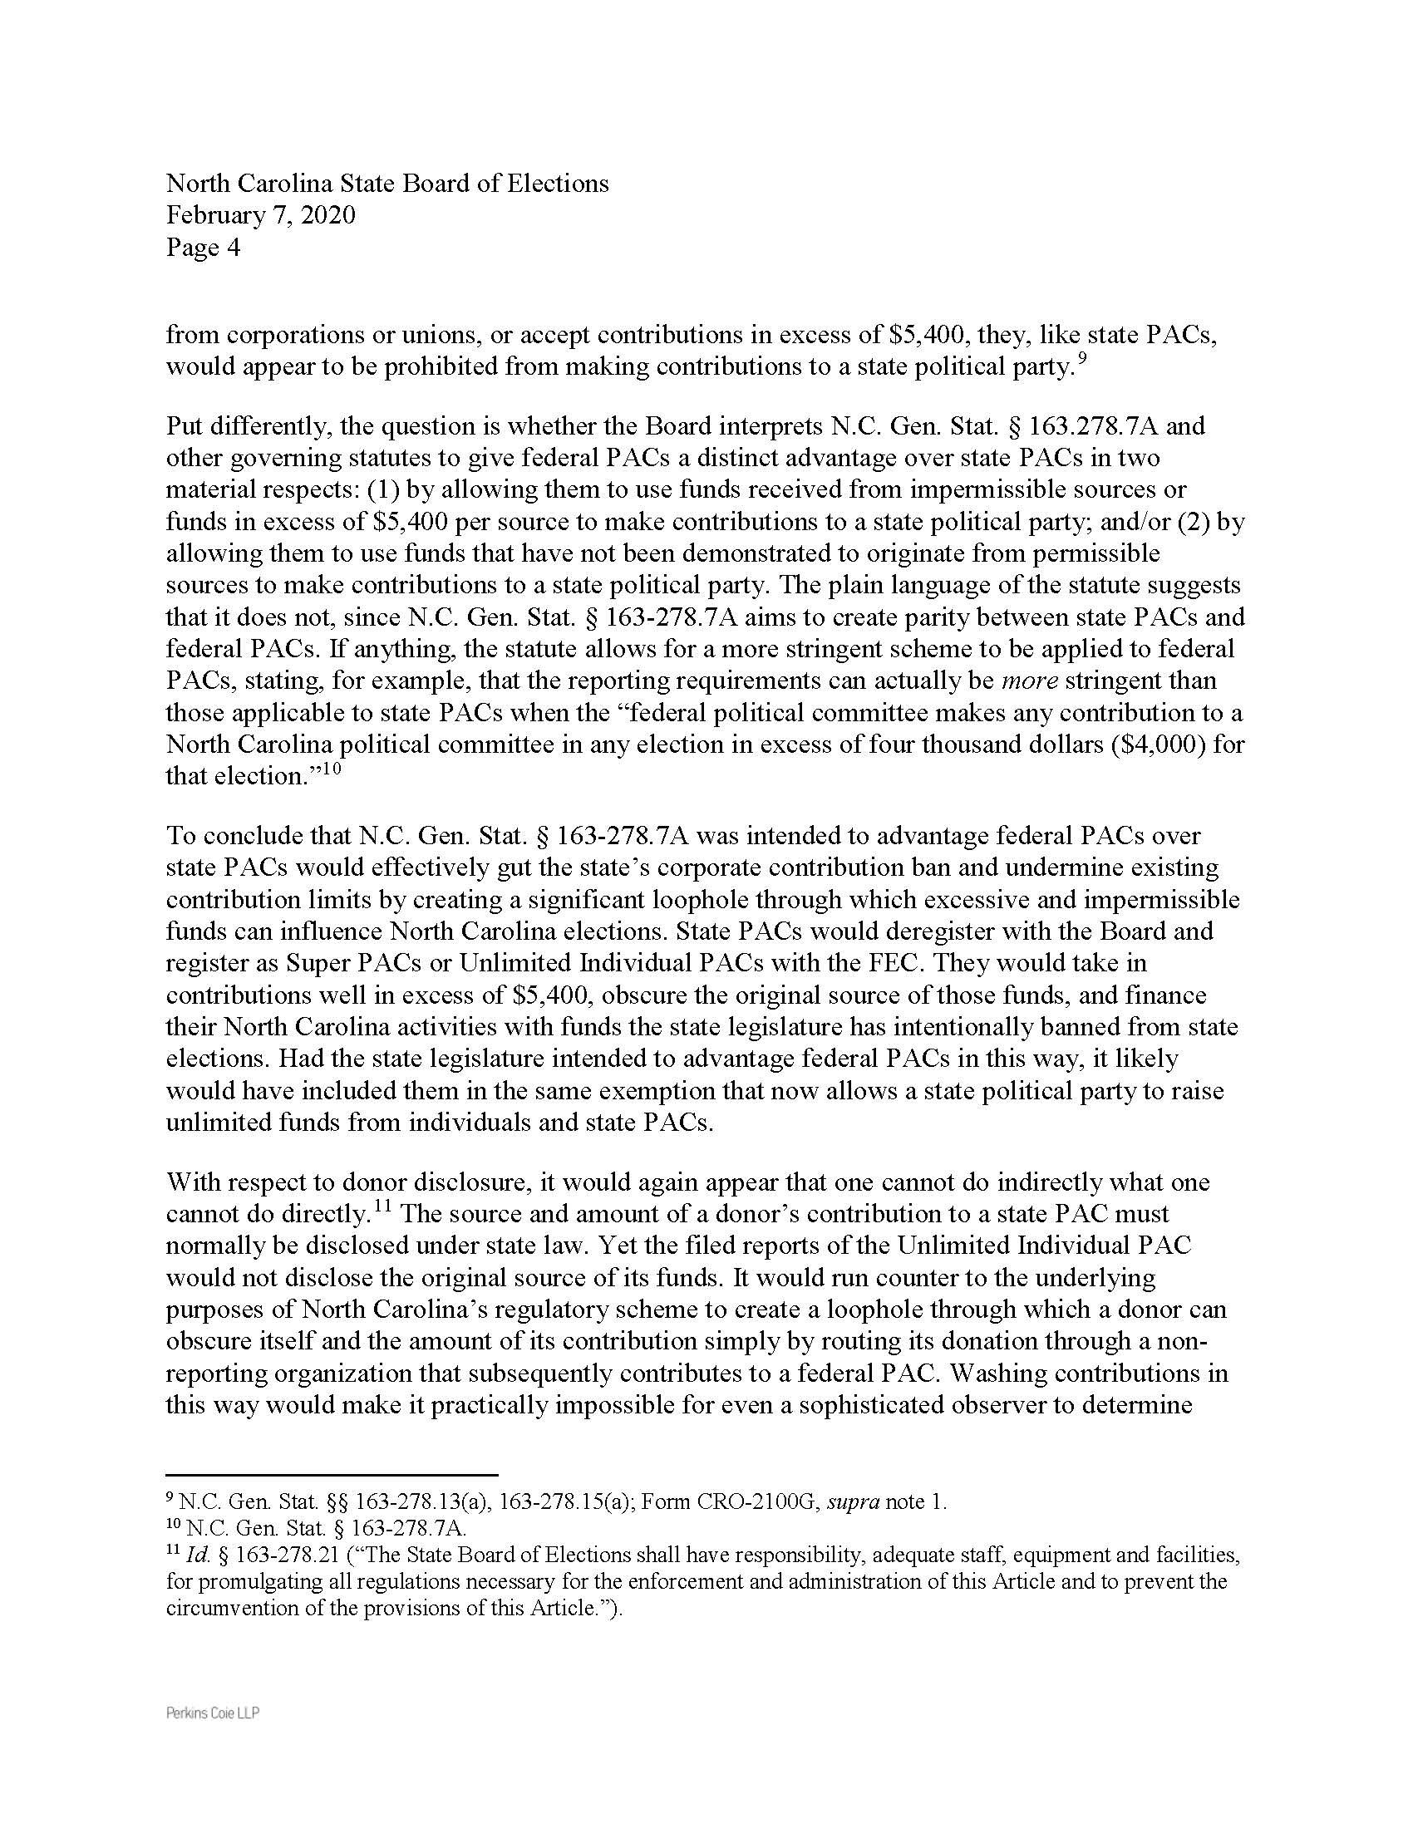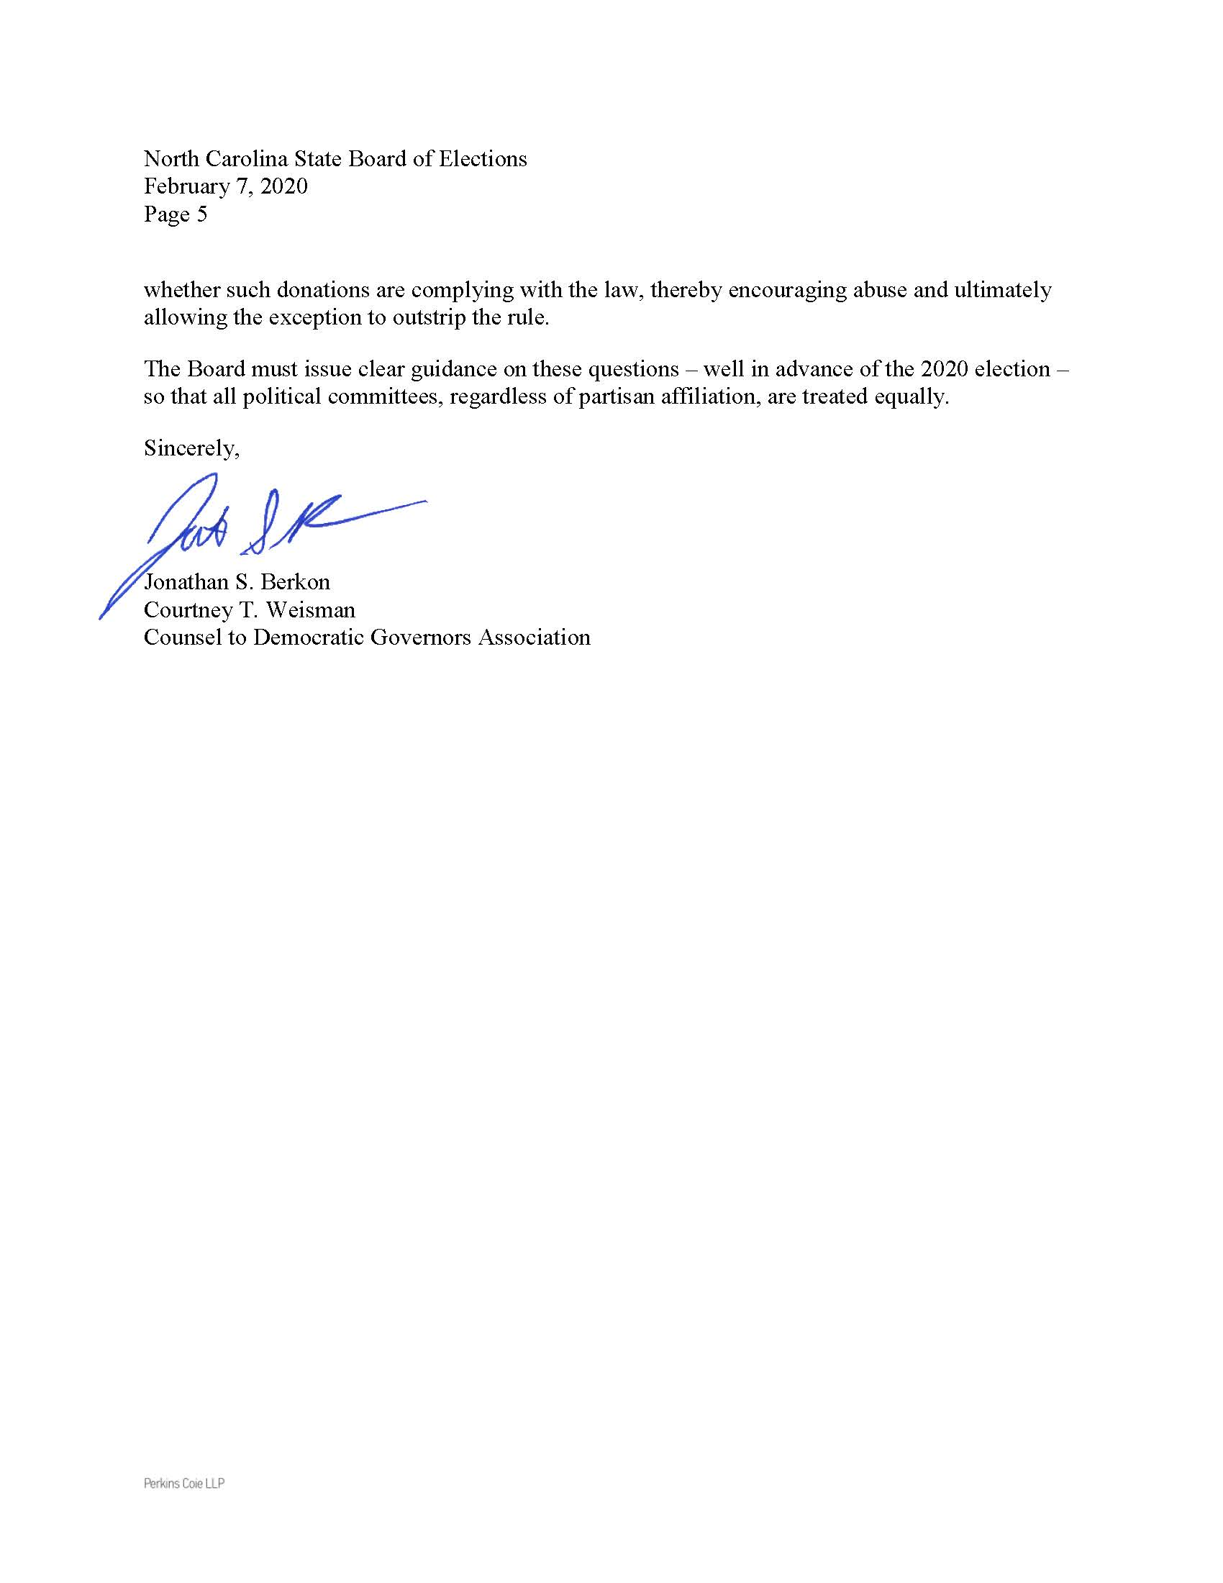

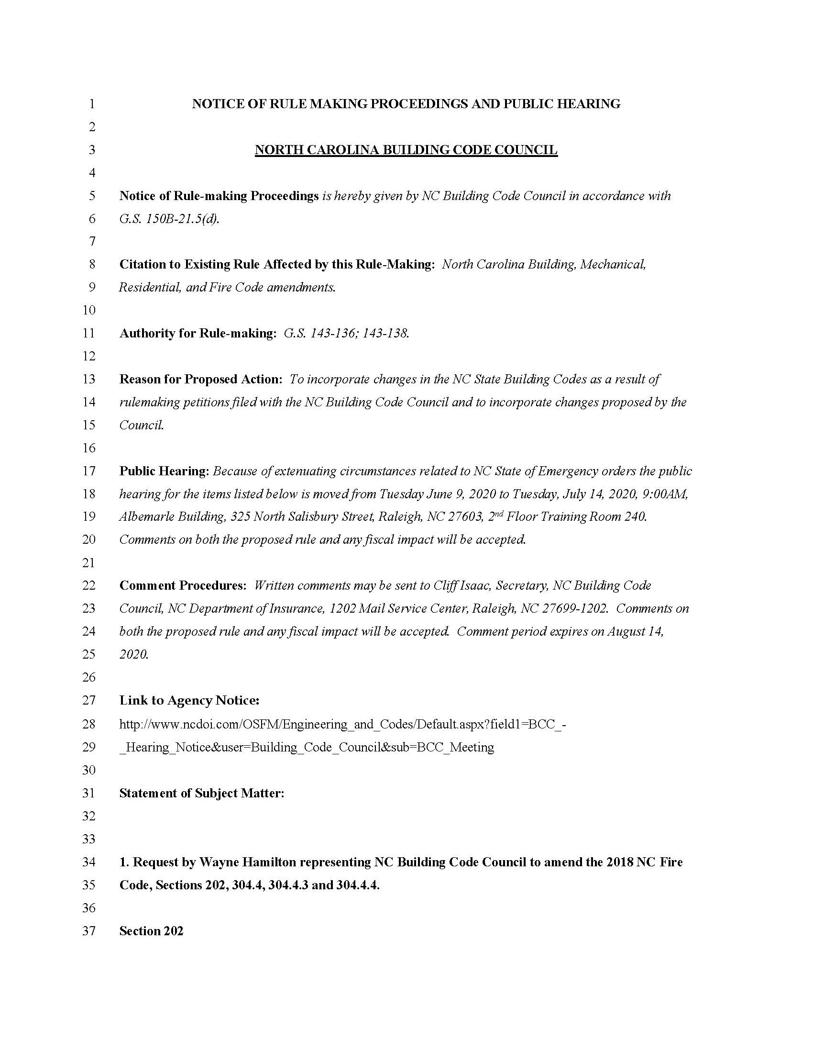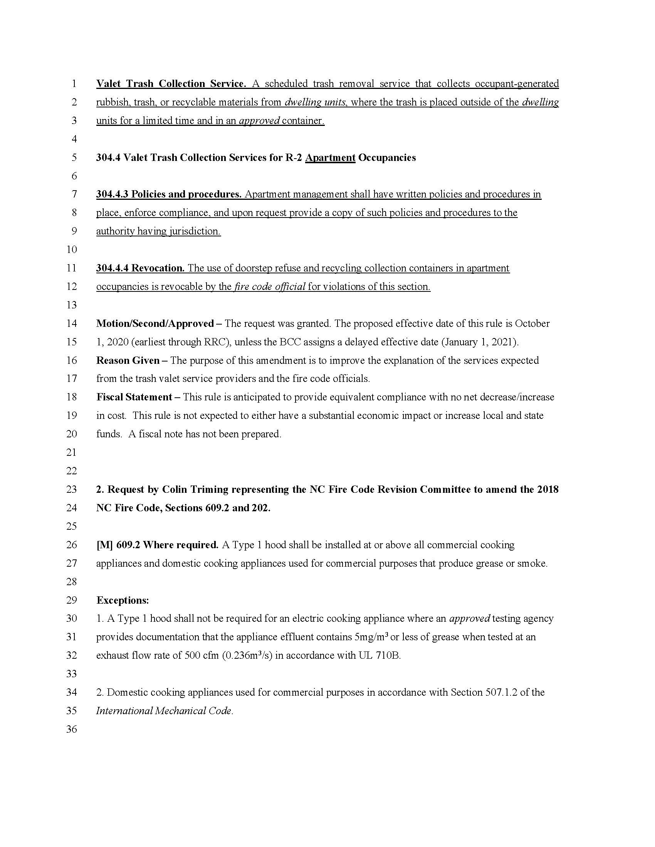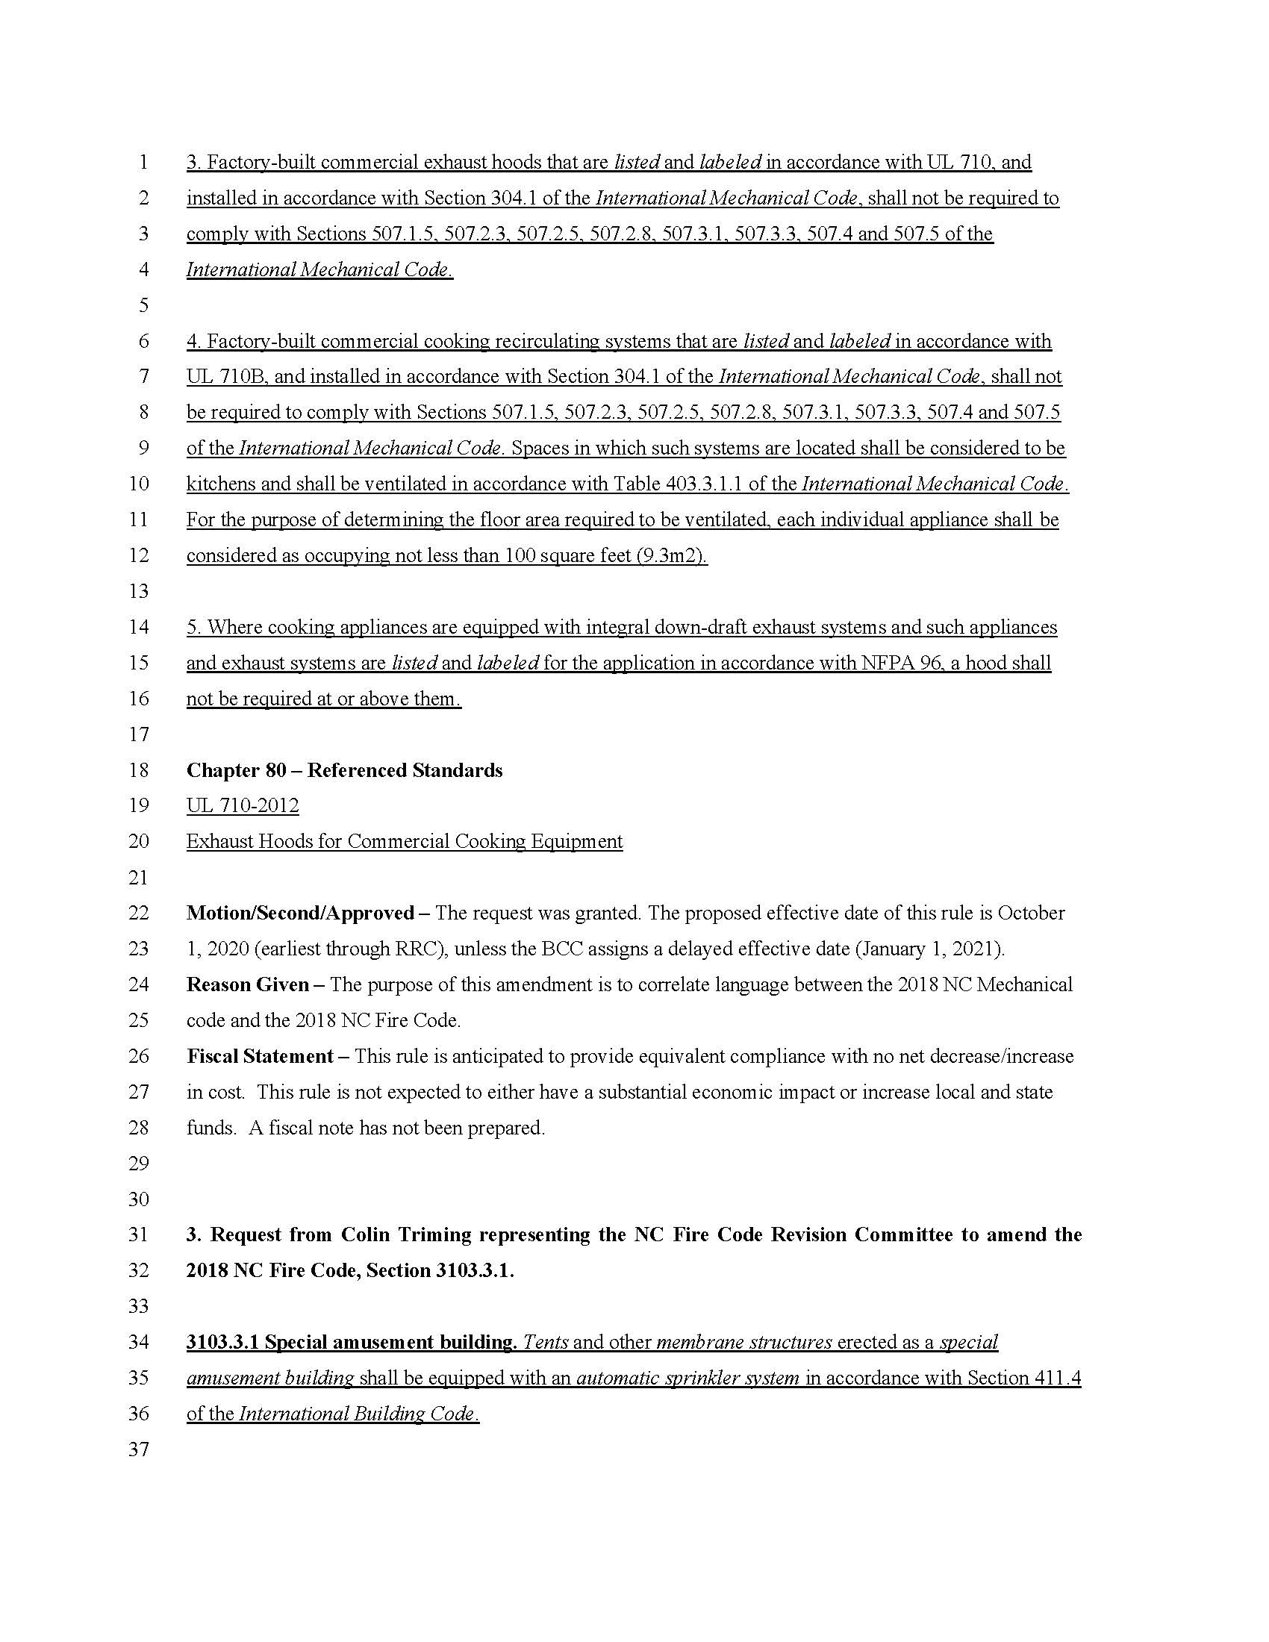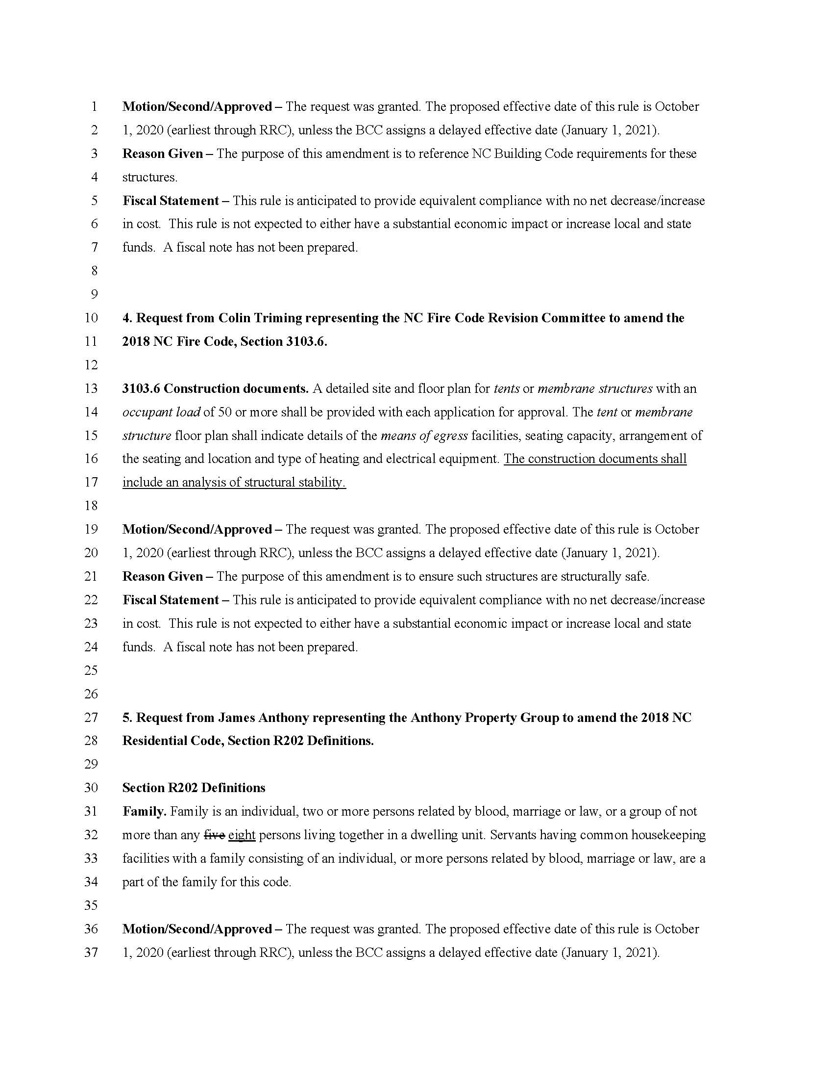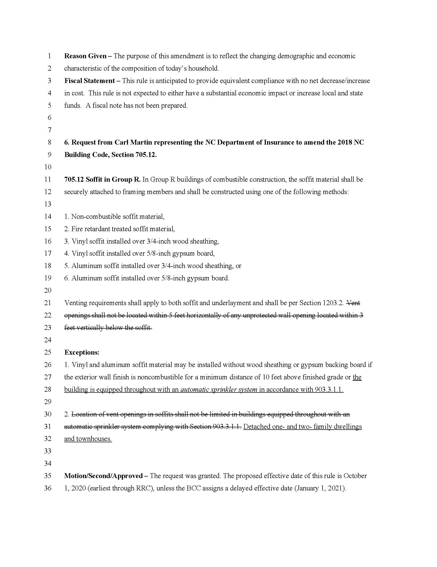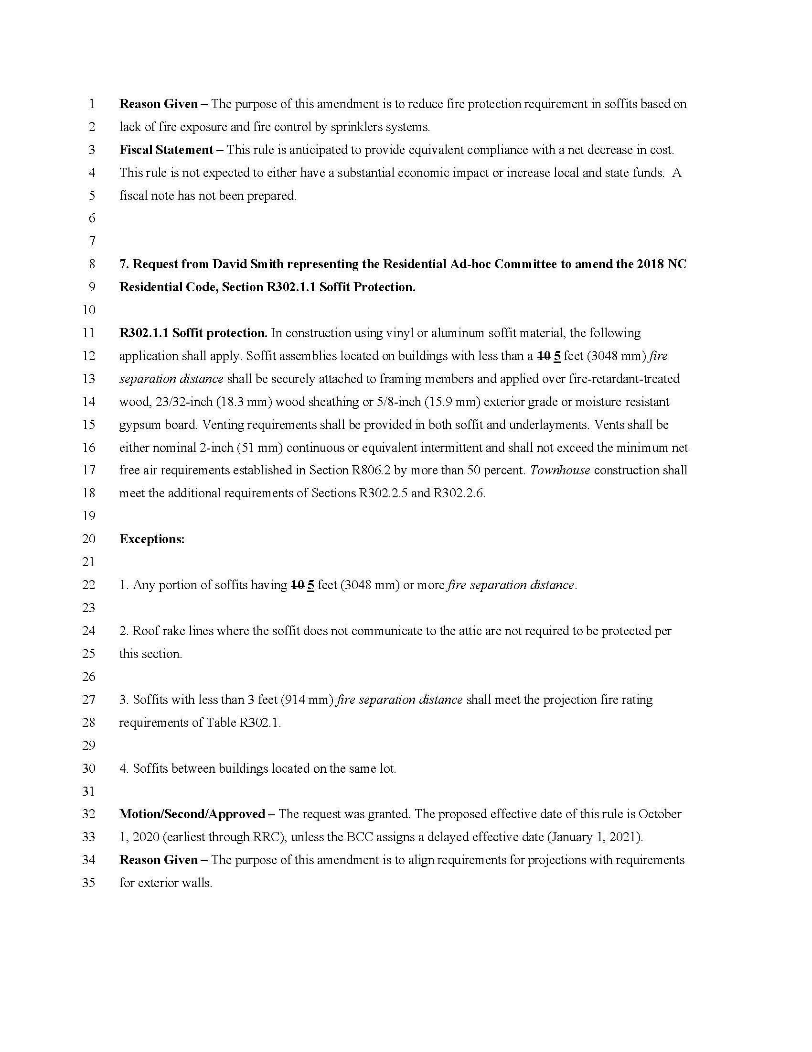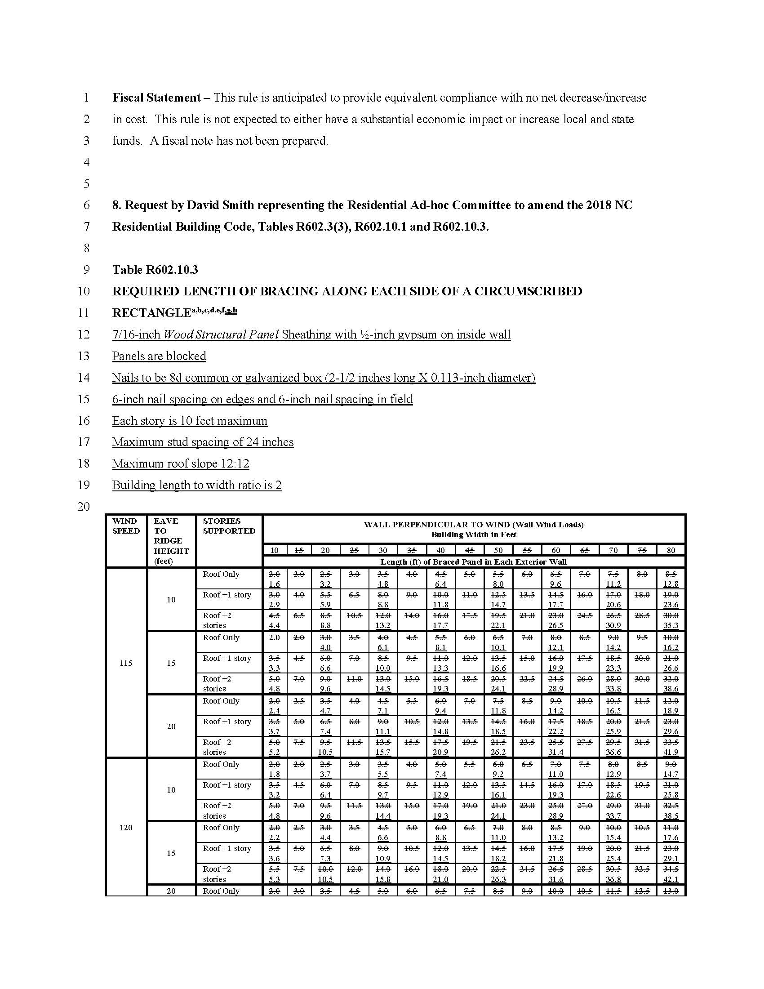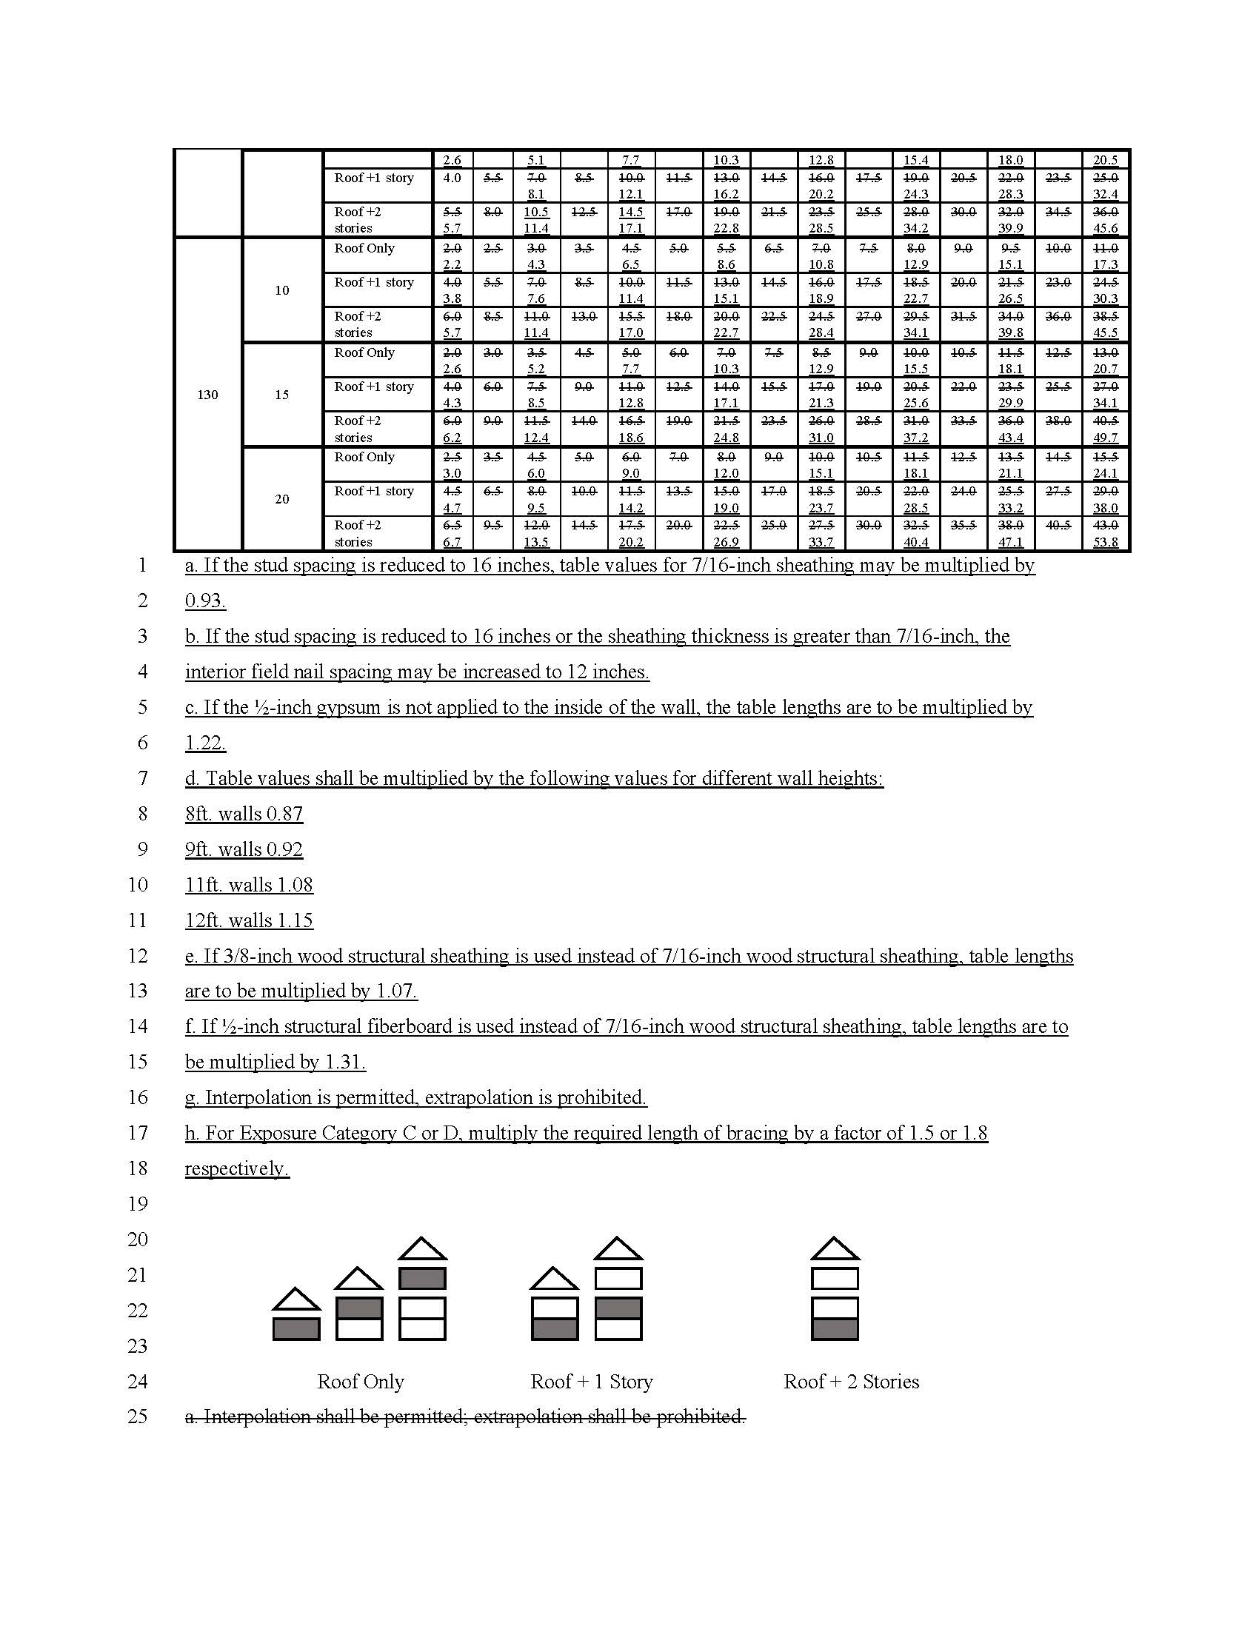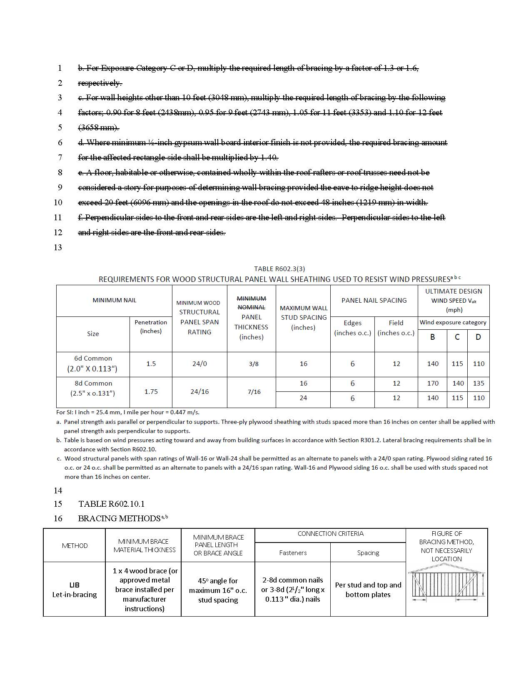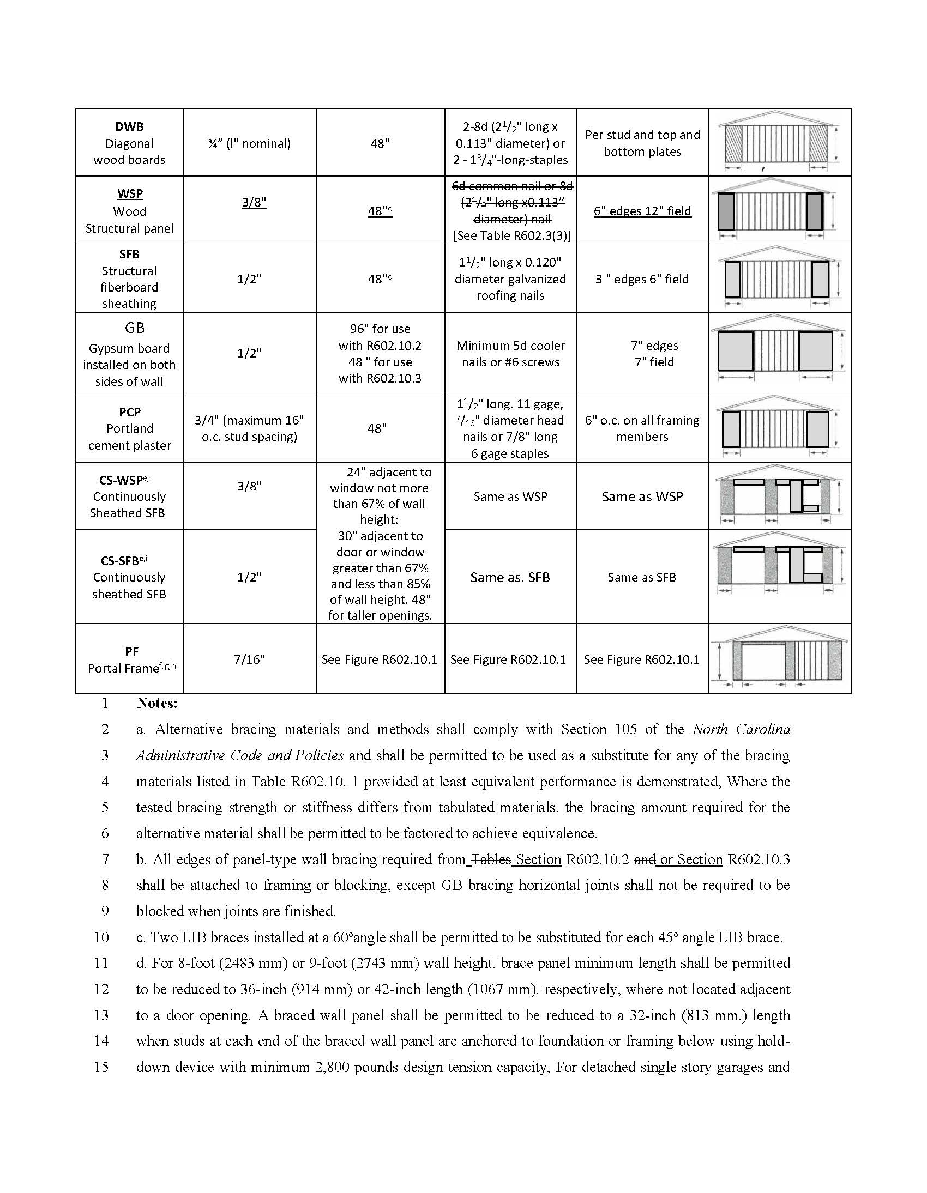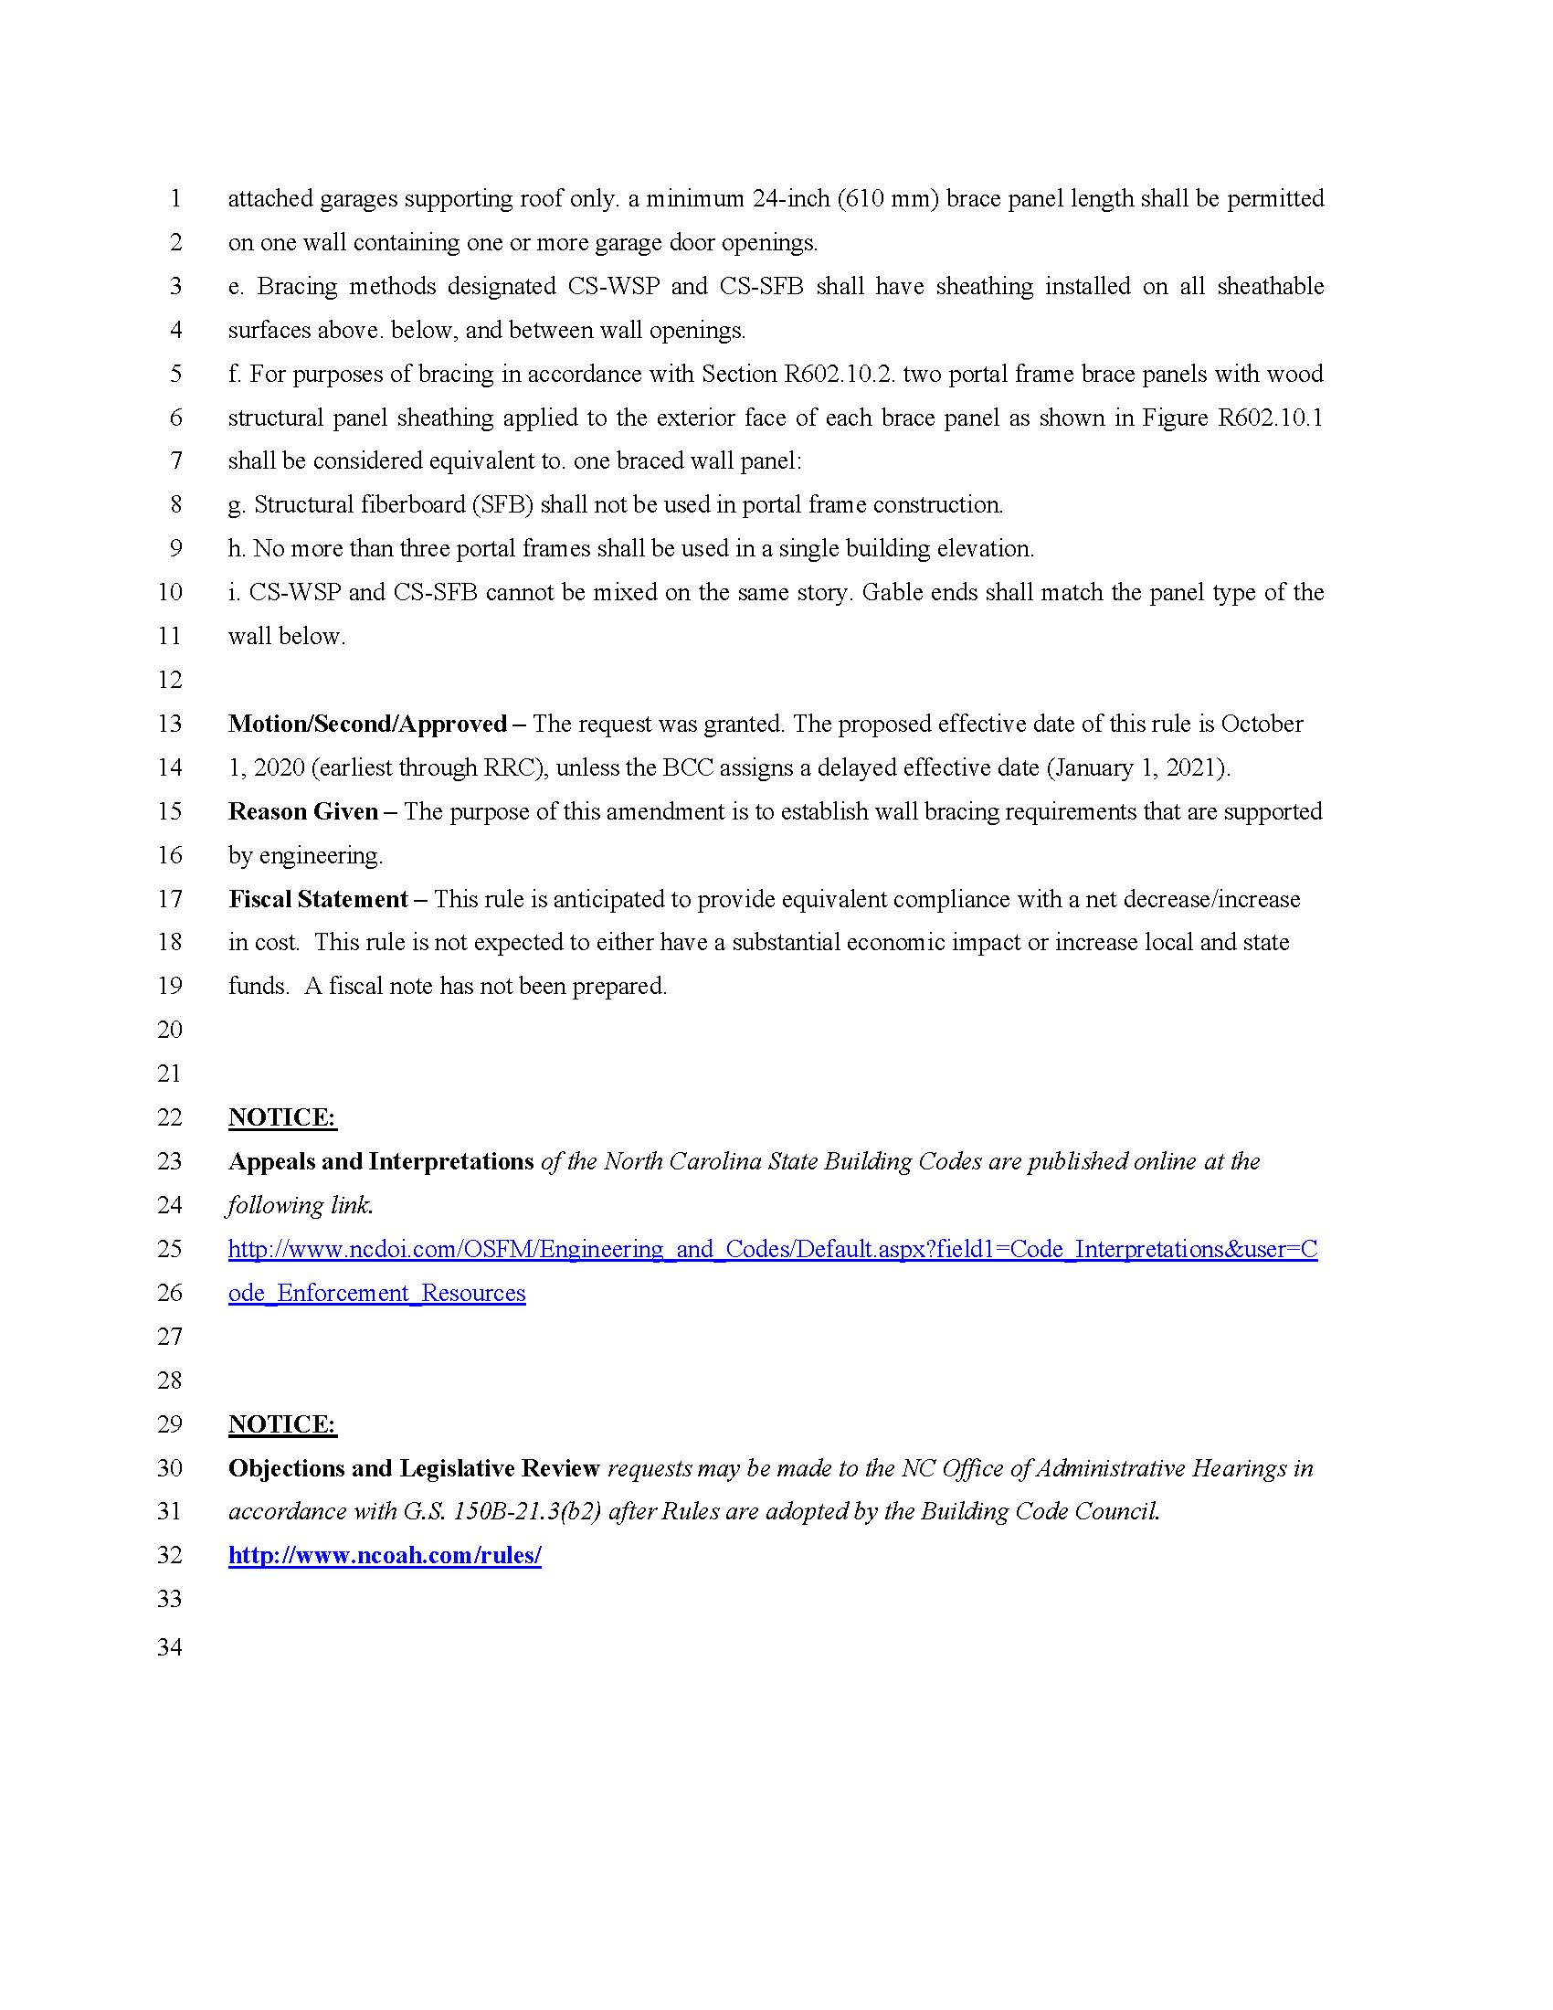

Note from the Codifier: The notices published in this Section of the NC Register include the text of proposed rules. The agency must accept comments on the proposed rule(s) for at least 60 days from the publication date, or until the public hearing, or a later date if specified in the notice by the agency. If the agency adopts a rule that differs substantially from a prior published notice, the agency must publish the text of the proposed different rule and accept comment on the proposed different rule for 60 days.
Statutory reference: G.S. 150B-21.2.

Title 10A – Department of Health and Human Services

Notice is hereby given in accordance with G.S. 150B-21.2 that the Commission for Public Health intends to adopt the rule cited as 10A NCAC 42B .0108 and amend the rules cited as 10A NCAC 42B .0102 and 43H .0314.

Link to agency website pursuant to G.S. 150B-19.1(c): https://cph.publichealth.nc.gov/

Proposed Effective Date: October 1, 2020

Public Hearing:
Date: June 26, 2020
Time: 10:00 a.m.
Location: In an abundance of caution and to address protective measures to help prevent the spread of COVID-19, this public hearing will be held by teleconference at 919-715-0769 (no access code).

Reason for Proposed Action: N.C.G.S. 130A-125 directs the Commission for Public Health (CPH) to amend its rules to ensure that each condition listed on the Recommended Uniform Screening Panel developed by the Secretary of the United States Department of Health and Human Services and the Advisory Committee on Heritable Disorders of Newborns and Children (the RUSP) is included in the Newborn Screening Program. It also permits CPH, in consultation with the Secretary of the NC Department of Health and Human Services, to increase the fee for newborn screening by no more than the amount necessary to offset the cost of incorporating a condition listed on the RUSP. The proposed rules align the Newborn Screening Program with the RUSP and increase the newborn screening fee by four dollars to offset the cost of incorporating Spinal Muscular Atrophy (SMA).

Comments may be submitted to: Virginia Niehaus, CPH Rulemaking Coordinator, 1931 Mail Service Center, Raleigh, NC 27699-1931; email cphcomment@lists.ncmail.net

Comment period ends: July 31, 2020

Procedure for Subjecting a Proposed Rule to Legislative Review: If an objection is not resolved prior to the adoption of the rule, a person may also submit written objections to the Rules Review Commission after the adoption of the Rule. If the Rules Review Commission receives written and signed objections after the adoption of the Rule in accordance with G.S. 150B-21.3(b2) from 10 or more persons clearly requesting review by the legislature and the Rules Review Commission approves the rule, the rule will become effective as provided in G.S. 150B-21.3(b1). The Commission will receive written objections until 5:00 p.m. on the day following the day the Commission approves the rule. The Commission will receive those objections by mail, delivery service, hand delivery, or facsimile transmission. If you have any further questions concerning the submission of objections to the Commission, please call a Commission staff attorney at 984-236-1850.

Fiscal impact. Does any rule or combination of rules in this notice create an economic impact? Check all that apply.

State funds affected

Local funds affected

Substantial economic impact (>= $1,000,000)

Approved by OSBM

No fiscal note required

Chapter 42 - Laboratory Services

SUBCHAPTER 42B - LABORATORY SECTIONS

10A NCAC 42B .0102 CLINICAL CHEMISTRY/NEWBORN NEWBORN SCREENING

(a) This laboratory will conduct screening for examine specimens for evidence of certain inborn errors of metabolism, for the detection of chronic diseases, diabetes, renal diseases, hypertension, certain clinical chemistry and hematology tests when requested by authorized senders of specimens within the guidelines of the Division of Maternal and Child Health and the Division of Public Health. the core conditions listed on the Recommended Uniform Screening Panel developed by the Secretary of the United States Department of Health and Human Services and the Advisory Committee on Heritable Disorders of Newborns and Children (the "RUSP"), which is hereby incorporated by reference, including any subsequent editions and amendments, and available free of charge at https://www.hrsa.gov/advisory-committees/heritable-disorders/rusp/index.html. Specimens shall be submitted to this laboratory for screening in accordance with the procedures set forth in 10A NCAC 43H .0314.

(b) This laboratory performs tests for hemoglobinopathies such as sickle cell trait and disease. The process to develop and implement new screening for the conditions described in Paragraph (a) of this Rule shall begin after the screening fee is established and adequate funds exist to acquire instrumentation, equipment, Program supplies, Program personnel, perform assay validations, implement preventative follow-up interventions, secure necessary infrastructure, and with the assurance that the laboratory has met all federal, State, and local requirements.

Authority G.S. 130A-88; 130A-125.

10A NCAC 42B .0108 FEES

(a) The State Laboratory of Public Health shall charge a fee of one hundred thirty-two dollars ($132.00) to cover the programmatic costs of the newborn screening performed by the State Laboratory of Public Health under 10A NCAC 42B .0102(a).

(b) In accordance with G.S. 130A-125, the Commission for Public Health, in consultation with the Secretary of the North Carolina Department of Health and Human Services, has determined that the fee listed in Paragraph (a) of this Rule is necessary to offset the cost of incorporating the conditions identified in 10A NCAC 42B .0102(a) in the Newborn Screening Program.

Authority G.S. 130A-125.

SUBCHAPTER 43H - SICKLE CELL SYNDROME: GENETIC COUNSELING:

SECTION .0300 - GENETIC HEALTH CARE

10A NCAC 43H .0314 SUBMISSION OF BLOOD SPECIMENS FOR SCREENING OF NEWBORNS

(a) The attending physician shall draw collect a blood specimen for each infant born in North Carolina and shall submit such specimens to the North Carolina State Laboratory of for Public Health for testing as set forth in 10A NCAC 42B .0102. for the following metabolic and other hereditary and congenital disorders:

(1) phenylketonuria (PKU);

(2) galactosemia;

(3) congenital primary hypothyroidism;

(4) congenital adrenal hyperplasia (21-hydroxylase deficiency); and

(5) sickle cell disease.

(b) Notwithstanding Paragraph (a) of this Rule, parents or guardians may object to screening in accordance with G.S. 130A-125(b).

(c) The hearing screening component of the Department's Newborn Screening Program is found in 10A NCAC 43F .1200.

Authority G.S. 130A-125.

Title 15A – Department of Environmental Quality

Notice is hereby given in accordance with G.S. 150B-21.2 that the Commission for Public Health intends to amend the rules cited as 15A NCAC 18A .2508 and .2543.

Link to agency website pursuant to G.S. 150B-19.1(c): https://cph.publichealth.nc.gov/

Proposed Effective Date: October 1, 2020

Public Hearing:
Date: July 10, 2020
Time: 10:00 a.m.
Location: In an abundance of caution and to address protective measures to help prevent the spread of COVID-19, this public hearing will be held by teleconference at 919-715-0769 (no access code).

Reason for Proposed Action: In compliance with SL 2019-88, the Commission for Public Health (CPH) adopted temporary rules in November 2019 governing the construction and operation of artificial swimming lagoons. Artificial swimming lagoon is defined as any body of water used for recreational purposes with more than 20,000 square feet of surface area, an artificial liner, and a method of disinfectant that results in a disinfectant residual in the swimming zone that is protective of the public health. CPH is now adopting permanent rules to ensure that the requirements for the construction and operation of artificial swimming lagoons do not expire from the Code.

Comments may be submitted to: Virginia Niehaus, CPH Rulemaking Coordinator, 1931 Mail Service Center, Raleigh, NC 27699-1931; email cphcomment@lists.ncmail.net

Comment period ends: July 31, 2020

Procedure for Subjecting a Proposed Rule to Legislative Review: If an objection is not resolved prior to the adoption of the rule, a person may also submit written objections to the Rules Review Commission after the adoption of the Rule. If the Rules Review Commission receives written and signed objections after the adoption of the Rule in accordance with G.S. 150B-21.3(b2) from 10 or more persons clearly requesting review by the legislature and the Rules Review Commission approves the rule, the rule will become effective as provided in G.S. 150B-21.3(b1). The Commission will receive written objections until 5:00 p.m. on the day following the day the Commission approves the rule. The Commission will receive those objections by mail, delivery service, hand delivery, or facsimile transmission. If you have any further questions concerning the submission of objections to the Commission, please call a Commission staff attorney at 984-236-1850.

Fiscal impact. Does any rule or combination of rules in this notice create an economic impact? Check all that apply.

State funds affected

Local funds affected

Substantial economic impact (>= $1,000,000)

Approved by OSBM

No fiscal note required

Chapter 18 - Environmental Health

SUBCHAPTER 18A – SANITATION

SECTION 2500 – PUBLIC SWIMMING POOLS

15a ncac 18a .2508 DEFINITIONS

The following definitions apply throughout this Section:
(1) "Department" means North Carolina Department of Health and Human Services.
(1)(2) "Equipment replacement" means replacement of individual components of the hydraulic and disinfection systems such as pumps, filters, and automatic chemical feeders.
(2)(3) "Public swimming pool" means public swimming pool as defined in G.S. 130A-280. Public swimming pools are divided into five types:
(a) "Swimming pools" are public swimming pools used primarily for swimming.
(b) "Spas" are public swimming pools designed for recreational and therapeutic use that are not drained, cleaned, or refilled after each individual use. Spas may include units designed for hydrojet circulation, hot water, cold water mineral bath, air induction bubbles, or any combination thereof. Common terminology for spas includes "therapeutic pool," "hydrotherapy pool," "whirlpool," "hot spa," and "hot tub."
(c) "Wading pools" are public swimming pools designed for use by children, including wading pools for toddlers and children's activity pools designed for casual water play ranging from splashing activity to the use of interactive water features placed in the pool.
(d) "Specialized water "Water recreation attractions" are pools designed for special purposes that differentiate them from swimming pools, wading pools and spas. They include:
(i) water slide plunge pools and run out lanes, which transfer the kinetic energy of the users' velocity through friction to the slide;
(ii) wave pools;
(iii) rapid rides;
(iv) lazy rivers;
(v) interactive play attractions that incorporate devices using sprayed, jetted, or other water sources contacting the users and that do not incorporate standing or captured water as part of the user activity area; and area;
(vi) training pools deeper than a 24 inch deep wading pool and shallower than a 36 inch deep swimming pool. pool; and
(vii) artificial swimming lagoons as defined in G.S. 130A-280.
(e) "Special purpose and therapy pools" are pools designed and used for therapeutic treatments or physical training and fitness outside of a licensed medical facility or practice of a licensed physical therapist. They include:
(i) float tanks used for float therapy in a salt brine solution;
(ii) swim spa training pools which use jetted water for stationary swimming against a water current;
(iii) exercise therapy and treadmill pools equipped for water resistance exercise therapy; and
(iv) scuba pools designed and used for training swimmers to use self-contained underwater breathing apparatus.
(3)(4) "Registered Design Professional" means an individual who is registered or licensed to practice engineering as defined by G.S. 89C or architecture as defined by G.S. 83A.
(4)(5) "Remodeled" means renovated in a manner requiring disruption of the majority of the pool shell or deck, changes in the pool profile, or redesign of the pool hydraulic system.
(5)(6) "Repair" means returning existing equipment to working order, replastering or repainting of the pool interior, replacement of tiles or coping and similar maintenance activities. This term includes replacement of pool decks where the Department has determined that no changes are needed to underlying pipes or other pool structures.
(6)(7) "Safety vacuum release system" means a system or device capable of providing vacuum release at a suction outlet caused by a high vacuum occurrence due to suction outlet flow blockage.
(7)(8) "Splash zone" means the area of an interactive play attraction that sheds water to a surge tank or container to be recirculated.
(8)(9) "Unblockable drain" means a drain of any size and shape that a human body cannot sufficiently block to create a suction entrapment hazard.
(10) "Water feature" means any component within a public swimming pool that pumps, jets, or sprays water above the waterline.

Authority G.S. 130A-280; 130A-282; S.L. 2019-88.

15A NCAC 18A .2543 WATER RECREATION ATTRACTIONS

(a) Water recreation attractions including water slides, wave pools, rapid rides, lazy rivers rivers, artificial swimming lagoons, and other similar features can deviate from the requirements of this Section with respect to pool profile, depth, freeboard, flow dynamics and surface skimming systems. The designing engineer or equipment manufacturer shall provide the Department with information design plans and technical specifications to justify such deviation deviation. as necessary for the proper function of the attraction. Water recreation attractions shall meet all other requirements of this Section.

(b) Water slide landing pools with a capacity of less than 60,000 gallons shall have a circulation and filtration system capable of turning over the entire pool capacity every two hours. Where automatic chemical controllers are used the turnover time shall be no more than three hours. Landing pool dimensions shall be consistent with the slide manufacturer's recommendation.

(c) When waterfalls are incorporated in water recreation attractions, they shall be constructed with no handholds or footholds to a height of four feet to discourage climbing.

(d) Interactive play attractions shall be constructed and operated in accordance with the rules of this section Rules of this Section and shall comply with the following:

(1) The recirculation system shall contain a water capacity equal to at least three minutes of maximum flow of all feature pumps and filter circulation pumps combined and shall not be less than 1,000 gallons. Where the water capacity exceeds 10,000 gallons, the minimum capacity shall be based on the lesser of three minutes of maximum feature flow or 7.5 gallons per square foot of splash zone watershed drained to the surge container.

(2) Access shall be provided to the surge water container.

(3) A filter circulation system shall be provided and shall be separate from the feature pump system except that both systems can draw water from a common drain pipe if the drain and pipe are sized to handle the flow of all pumps without exceeding the flow velocities specified in Rule .2518 of this Section.

(4) The filter circulation system shall draw water from the surge container through a variable height surface skimmer and a bottom drain located no more than 6 inches from the bottom of the container. Custom skimming systems that do not comply with ANSI/NSF Standard 50 shall be approved where the operational requirements make it necessary to deviate from that standard.

(5) The filter circulation system shall filter and return the entire water capacity in no more than 30 minutes and shall operate 24 hours a day.

(6) Automatic chemical controllers shall be provided to monitor and adjust the disinfectant residual and pH of the water contained in the system.

(7) The disinfectant residual in interactive play attractions shall be maintained at a level of at least two parts per million of free chlorine. Chlorine feeders shall be capable of producing 12 parts per million of free chlorine in the filter circulation piping.

(8) Valves shall be provided to control water flow to the features in accordance with the manufacturers' specifications.

(9) Splash zones shall be sloped to drains sized and located to remove all feature water to the surge tank without water accumulating on the surface.

(10) Deck or walkway space is not required outside the splash zone.

(11) Dressing and sanitary facilities shall not be provided. required.

(12) Interactive play features shall not be required to have a fence except the wading pool fence requirements shall apply to interactive play features located inside a swimming pool enclosure.

(13) The safety provisions of Rule .2530 of this Section shall not apply except a sign shall be posted prohibiting pets and glass containers.

(14) Interactive play attractions built prior to April 1, 2004, that do not comply with these design and construction requirements shall be permitted to operate as built if no water quality or safety violations occur.

(e) Training pools shall meet the requirements for swimming pools with the following exceptions:

(1) Training pools shall be equipped with a filter circulation system that filters and returns the entire pool capacity in no more than two hours.

(2) The free chlorine residual in training pools shall be maintained at no less than two parts per million.

(f) Artificial swimming lagoons shall meet the requirements for public swimming pools except as specified in this Rule:

(1) Pool shells shall not be required. Liners shall meet the requirements of Rule .2514 of this Section.

(2) Underwater components of the artificial swimming lagoon or float lines with openings greater than one-half inch shall not be allowed in swimming zones.

(3) All swimming zone float rope components shall be a color contrasting with the pool liner. The location of the float rope may vary from the requirements of Rule .2523(e) of this Section regarding breakpoint and slope. A contrasting color band shall not be required on the liner under the rope.

(4) Each swimming zone and water feature shall meet water quality standards as required in Rule .2535 of this Section. If the water quality of a swimming zone or water feature does not meet the requirements of Rule .2535 of this Section, the operator shall close the swimming zone or water feature and post a sign at the entrance of the swimming zone with legible letters of at least four inches (10 cm) in height stating "ATTENTION: THE SWIMMING ZONE IS CLOSED. SWIMMING IN THIS AREA IS NOT PERMITTED AT THIS TIME." The swimming zone or water feature shall remain closed until the water quality in the swimming zone or water feature complies with the requirements of Rule .2535 of this Section.

(5) All non-swimming zones shall be maintained so the bottom of the lagoon is visible in all areas.

(6) A sign shall be posted at all entrances with legible letters of at least four inches (10 cm) in height stating "NOTICE – NO SWIMMING ALLOWED OUTSIDE OF DESIGNATED SWIMMING ZONES."

(7) Signage shall be provided indicating swimming zones.

(8) Depth markings and no diving markers shall be provided on decks in swimming zones as required in Rule .2523 of this Section. Signs shall be posted at all entrances to swimming zones with legible letters of at least four inches (10cm) in height stating "NO DIVING" and stating the maximum depth of the swimming zone in Arabic numerals and shall include the word "feet" or the symbol "ft" to indicate the unit of measure.

(9) Decks may vary from the minimum deck area requirements in Rule .2522 of this Section at zero entry areas located within swimming zones. Access to swimming zones shall be provided for emergency vehicles and personnel. No decks shall be required in non-swimming zones. The requirements of Rule .2515(g)(1) of this Section shall not apply to swimming zones and Rule .2515(g) of this Section shall not apply to non-swimming zones.

(10) Swimming zones shall meet all safety provisions as set out in Rule .2530 of this Section. Where swimming zones are separated by more than 75 feet, each swimming zone shall separately meet all safety provisions. Non-swimming zones are exempt from the requirements in Rule .2530 of this Section.

(11) A water treatment system that does not meet the requirements of Rules .2518 and .2519 of this Section shall be approved by the Environmental Health Section of the Department's Division of Public Health when the treatment system performs in a manner equal or superior to the systems described in Rules .2518 and .2519 of this Section in terms of water clarification, disinfection, and removal of debris, and results in a disinfectant residual and pH level as required in Subparagraph (f)(4) of this Rule.

(12) The requirements of Rule .2529 of this Section and Rule .2526(e)–(h) of this Section shall not apply. Sanitary facility requirements shall comply with the 2018 North Carolina State Building Code: Plumbing Code, which is incorporated by reference, including any subsequent amendments or editions and available free of charge at: https://codes.iccsafe.org/content/NCPC2018.

(13) Bacteriological samples shall be collected by the operator in non-swimming zones and tested weekly. One sample shall be collected for every 250 feet of shoreline, with no more than 300 feet and no less than 25 feet between any two sampling locations. The samples shall be collected at least one foot below the surface, in at least three feet of water. The samples shall be analyzed by a laboratory accredited by the North Carolina Drinking Water Laboratory Certification Program, the North Carolina Wastewater/Groundwater Laboratory Certification Program, or the National Environmental Laboratory Accreditation Program. The test results shall be maintained as part of the records required in Rule .2535(11) of this Section.

(14) When the result of any test required by Subparagraph (f)(13) of this Rule exceeds the standards in Rule .3402(a) of this Subchapter, the operator shall:
(A) notify the permitting agency and resample the water within 24 hours of receipt of the result from the laboratory; and
(B) close all non-swimming zones and post a sign at all non-swimming zone entrances with legible letters of at least four inches (10 cm) in height stating "ATTENTION: ALL NON-SWIMMING ZONES ARE CLOSED. RECREATIONAL ACTIVITIES IN THIS AREA ARE NOT PERMITTED AT THIS TIME." This sign shall remain posted until resampling determines that bacterial levels do not exceed the standards in Rule .3402(a) of this Subchapter.

(15) Non-swimming zones shall not be required to comply with the lighting requirements of Rule .2524 of this Section. When night swimming is allowed, the operator shall provide lighting in swimming zones as required for public swimming pools.

(16) The requirements of Rule .2537(b)(16) of this Section shall not apply. Submersible pumps or mechanical pool cleaning equipment shall not be used in swimming zones or within 25 feet of swimming zones when a swimming zone is open to bathers. If submersible pumps or mechanical pool cleaning equipment are used in non-swimming zones when a non-swimming zone is open to users, the following conditions shall apply:
(A) A registered design professional shall provide design plans or technical specifications that demonstrate that any underwater suction outlets perform in a manner that is equally protective or more protective than the Pool and Hot Tub Alliance's ANSI/APSP/ICC-7 2013 Standard for Suction Entrapment Avoidance in Swimming Pools, which is incorporated by reference, including any subsequent amendments or editions, and available for a fee of one hundred sixty-five dollars ($165.00) at https://www.apsp.org/store1; and
(B) All floating components of submersible pumps or mechanical pool cleaning equipment shall be labeled with a sign above the water line with legible letters of at least four inches (10 cm) in a contrasting color stating: "DANGER: MECHANICAL EQUIPMENT IN USE. STAY BACK 25 FEET."

(17) The requirements of Rule .2521 of this Section shall not apply to non-swimming zones.

Authority G.S. 130A-280; 130A-282; S.L. 2011-39; S.L. 2019-88.

Title 21 - Occupational Licensing Boards and Commissions

Chapter 45 - Board of Examiners of Fee-Based Practicing Pastoral Counselors

Notice is hereby given in accordance with G.S. 150B-21.2 that the Board of Examiners of Fee-Based Practicing Pastoral Counselors intends to adopt the rule cited as 21 NCAC 45 .0403 and amend the rules cited as 21 NCAC 45 .0101, .0202, .0301, .0401, .0501, .0601, .0701, and .0801.

Link to agency website pursuant to G.S. 150B-19.1(c): ncpastoralcounseling.org

Proposed Effective Date: October 1, 2020

Instructions on How to Demand a Public Hearing: (must be requested in writing within 15 days of notice): Submit the written request to Carleton Irving, Executive Director, ncbfbppc@aol.com, PO Box 447, Kernersville, NC 27285.

Reason for Proposed Action: In 2019 the American Association of Pastoral Counselors dissolved. As a result, the supervision options for candidates for certification in pastoral counseling in North Carolina were significantly limited as the rules are currently written. The changes proposed increase the qualified supervision options for candidates pursuing certification. Additionally, it is in the public's best interest to expand the pool of certified pastoral counselors in the state to meet the growing demand for faith-sensitive mental health care. These rules alleviate barriers to certification and allow the board to update and expand its ability to serve the public in this area.

Comments may be submitted to: Carleton Irving, Executive Director, PO Box 447, Kernersville, NC 27285; email ncbfbppc@aol.com

Comment period ends: July 31, 2020

Procedure for Subjecting a Proposed Rule to Legislative Review: If an objection is not resolved prior to the adoption of the rule, a person may also submit written objections to the Rules Review Commission after the adoption of the Rule. If the Rules Review Commission receives written and signed objections after the adoption of the Rule in accordance with G.S. 150B-21.3(b2) from 10 or more persons clearly requesting review by the legislature and the Rules Review Commission approves the rule, the rule will become effective as provided in G.S. 150B-21.3(b1). The Commission will receive written objections until 5:00 p.m. on the day following the day the Commission approves the rule. The Commission will receive those objections by mail, delivery service, hand delivery, or facsimile transmission. If you have any further questions concerning the submission of objections to the Commission, please call a Commission staff attorney at 984-236-1850.

Fiscal impact. Does any rule or combination of rules in this notice create an economic impact? Check all that apply.

State funds affected

Local funds affected

Substantial economic impact (>= $1,000,000)

Approved by OSBM

No fiscal note required

SECTION .0100 – GENERAL PROVISIONS

21 NCAC 45 .0101 ADDRESS

(a) The mailing address for the North Carolina State Board of Fee-Based Practicing Pastoral Counselors is P.O. Box 447, Kernersville, NC 27285-0447.

(b) The website address for the Board is www.ncpastoralcounseling.org.

Authority G.S. 90-385.

SECTION .0200 - APPLICATION FOR CERTIFICATION

21 NCAC 45 .0202 REVIEW PROCEDURE

(a) A copy of the applicant's application, documentation for certification form, and all other required supporting documentation shall be mailed to all Board members prior to the next scheduled meeting. The Board shall review the applicant's application, documentation for certification form, and all other required supporting documentation at the next meeting. The applicant shall submit the information required in Rule .0201(a) of this Section to the Board. The Board shall review the information submitted at a Board meeting to determine compliance with G.S. 90-387.

(b) If approved, the applicant shall be informed and shall be given information regarding the exam. The Board shall publish information on its website about the exam that the applicant may use as assistance in preparing for it.

(c) If the credentials are unacceptable, the applicant is so informed and is given an explanation of the area(s) which are considered deficient. The Board shall notify an applicant if the credentials are denied and explain the area(s) that do not meet G.S. 90-387. Applicants may remedy deficiencies within one year from the date of notification of such without having to reapply.

(d) If a question arises during the review process regarding comments made by endorsers or supervisors, the Board shall seek to resolve the question by communicating with the endorser or supervisor, or the Board may refer the matter to their legal counsel or to a member of the Board or employee of the Board for investigation.

(e) If certification is denied, an explanation of the grounds for denial shall be given. The applicant may present additional written information in support of the application to be considered by the Board.

Authority G.S. 90-385(f); 90-387(a)(4); 90-387(b)(4).

SECTION .0300 - EXAMINATION

21 NCAC 45 .0301 TYPES

(a) The Board shall employ administer a written and oral examination to test an applicant's knowledge in the following areas:

(1) Code of Ethics; Ethics as set forth in G.S. 90-390(a)(7);

(2) Fee-Based Practicing Pastoral Counselors Certification Act; Act G.S. 90, Article 26;

(3) Individual Pastoral Counseling and Psychotherapy;

(4) Marriage, Family, or Group Counseling and Psychotherapy; and

(5) Religion, Theology, and Ethics of Pastoral Counseling.

(b) The written examination shall be given annually in the spring. A passing score shall consist of 70% correct responses on the written exam.

(c) The Board shall administer the oral examination shall be administered to applicants during the next regularly scheduled at a Board meeting. A passing score on the oral examination shall be determined by the applicant's demonstration to the satisfaction of the Board that skills necessary to engage in pastoral counseling and in-depth pastoral psychotherapy are integrated. These skills include but are not limited to: articulation of one's theory of pastoral counseling and psychotherapy; use of authority in the pastoral counseling and psychotherapy relationship; and emotional availability for the pastoral counseling and psychotherapy process, ability to satisfy G.S. 90-387, including the applicant's ability to articulate his or her theory of pastoral counseling and psychotherapy as defined in G.S. 90-382, and elaborate on written exam portions set forth in Subparagraphs (a)(3) through (5) of this Rule.

Authority G.S. 90-385(f); 90-387(a)(3); 90-387(b)(3). 90-387.

SECTION .0400 - CERTIFICATION RENEWAL

21 NCAC 45 .0401 CERTIFICATION RENEWAL FORM

The Board shall mail make renewal forms accessible through its website to each licensee the renewal form in the spring of each year. The licensee shall return the completed form on or before January 1 of the following year. The form shall ask for current home and business addresses and addresses, telephone numbers. numbers, and an email address. Pastoral Counseling Associates shall submit an additional form documenting required supervision as stated in Rule .0801 of this Chapter.

Authority G.S. 90-385(f); 90-389.

21 NCAC 45 .0403 Reinstatement after suspension

(a) A license that is suspended pursuant to G.S. 90-390 (b) may be reinstated if, within two years of suspension date, the renewal fees are paid and evidence of completing continuing education requirements is submitted. The continuing education requirements documented at the time of reinstatement must equal the hours required had the license not expired.

(b) A license that has been suspended for nonpayment of renewal fees or failure to comply with continuing education requirements for a period of more than two years shall not be reinstated. A new license may be granted pursuant to paying the applicable license application fees and meeting the licensing requirements under Sections .0200 and .0300 of this Chapter.

Authority G.S. 90-390(b); 90-390(d).

SECTION .0500 - CONTINUING EDUCATION

21 NCAC 45 .0501 CONTINUING EDUCATION REQUIREMENTS

(a) A form for continuing education requirements shall be mailed with the A certified person shall submit a form with continuing education requirements with his or her annual renewal form. form, which the Board will make accessible through its website. Each Fee-Based Practicing Pastoral Counselor and Pastoral Counseling Associate shall complete a total of 50 hours of continuing education each year in the following identified areas:

(1) Category I - Pastoral Theology;

(2) Category II - Clinical Theory and Practice;

(3) Category III - Pastoral, Psychological and Psychiatric Diagnosis;

(4) Category IV - Consultation and Supervision; and

(5) Category V - Reading Books and Professional Journals in the field of Pastoral Counseling and Psychotherapy.

(b) In a continuing education year, 20 hours of the 50 hours required shall be contact hours in either Category I - Pastoral Theology, Category II - Clinical Theory and Practice or Category III - Pastoral, Psychological and Psychiatric Diagnosis. Category I, II, and III.

(c) A continuing education year shall be June 1 to May 31 of the following year defined as January 1 through December 31.

(d) A member of the armed forces whose license is in good standing and to whom G.S. 105-249.2 grants an extension of time to file a tax return shall receive that same extension of time to pay the license renewal fee and complete any continuing education requirements prescribed by the Board. A copy of the military order or the extension approval by the Internal Revenue Service or by the North Carolina Department of Revenue shall be furnished to the Board.

Authority G.S. 90-385(f); 90-389.

SECTION .0600 - DEFINITIONS

21 NCAC 45 .0601 EQUIVALENCY

(a) For the purposes of G.S. 90-387(a)(4)(c), (d), (f), and (g), as well as 90-387(b)(4)(c), (e), (f), and (h), "equivalency" shall be determined by the Board on a case-by-case basis as set forth in this Rule. Equivalencies shall be considered on a case by case basis.

(b) Should a candidate choose to make a case for Candidates wishing to establish equivalent experience, education, education, or training training, the candidate shall document submit a written formal request to the Board. The Board shall assign a Board member to meet with the candidate and review the request. The request shall then be taken to the addressed by the Board based on equivalent standards to education, experience and training set forth in G.S. 90-387 for either approval or disapproval and a written response shall be sent to the candidate. The onus for documentation of equivalency shall rest entirely with the candidate For any experience, education, or training involved in their request, candidates shall submit documentation of completion with their application. Should equivalency not be granted, the candidate shall be given consultation regarding how to fulfill the particular standard.

Authority G.S. 90-385(f); 90-387.

SECTION .0700 - TEMPORARY CERTIFICATES

21 NCAC 45 .0701 ISSUANCE OF TEMPORARY CERTIFICATE

(a) The Board of Examiners shall issue temporary certificates at no additional cost than that of customary fees at the time of application to the Board of Examiners for a temporary certificate.

(b)(a) A person who requests a temporary certification as a Fee-Based Practicing Pastoral Counselor or a Fee-Based Practicing Pastoral Counseling Associate shall:

(1) Submit an application to take the next examination offered by the Board and pay the non-refundable application fee of one hundred dollars ($100.00); set forth in G.S. 90-387;

(2) Pay the non-refundable examination fee of four hundred dollars ($400.00) for Fee-Based Practicing Pastoral Counselor or the non-refundable examination fee of two hundred and fifty dollars ($250.00) for Fee-Based Practicing Pastoral Counseling Associate;

(3) Complete all of the documentation for certification form and all other supporting documentation required by the Board for assessing whether the candidate is qualified to take the written and oral examination; Submit the information required in Rule .0201 of this Chapter to the Board; and

(4) Be assigned a Board member to function as a liaison/presenter to the full Board and to the sub-committee assigned by the Board to review the request;

(5) Consult with the liaison/presenter in an individual consultation prior to the meeting with the sub-committee;

(6)(4) Pass the multiple choice components of the Board's written examination which covers knowledge of G.S. 90, Article 26 and The Code of Ethics; portions of the written exam set forth in Rule .0301(a)(1) and (a)(2) of this Chapter.

(7) Be interviewed by a sub-committee of the Board and be recommended by the sub-committee to the Board for a temporary certificate.

(c)(b) Temporary certificates shall be valid for no longer than one year and shall be automatically terminated at the time of the next examination given by the Board.

Authority G.S. 90-385(f); 90-384; 90-384; 90-385(f).

SECTION .0800 – supervision

21 NCAC 45 .0801 APPROVED SUPERVISION

(a) The 250 hours of supervision required for certification as a Fee-Based Practicing Pastoral Counselor and the 125 hours of supervision required for certification as a Fee-Based Practicing Pastoral Counseling Associate set forth in G.S. 90-387 shall be documented as provided by a a: Diplomate of the American Association for Pastoral Counselors (AAPC), a Fellow of the American Association of Pastoral Counselors under supervision by a Diplomate of the American Association of Pastoral Counselors or a

(1) North Carolina Certified Fee-Based Practicing Pastoral Counselor;

(2) A mental health professional licensed or certified to practice in North Carolina defined as a Licensed Clinical Mental Health Counselor (LCMHC); Licensed Clinical Mental Health Counselor Supervisor (LCMHCS); Licensed Marriage and Family Therapist (LMFT); Licensed Clinical Social Worker (LCSW); Licensed Psychologist; Licensed Medical Doctor with a Medical Board certification in psychiatry; Psychiatric Nurse Practitioner; or

(3) An individual with equal or greater clinical qualifications to one of these professionals that is approved by the Board through written equivalency request submitted to the Board.

(b) Any supervision beyond the required 250 hours may be documented as provided by a clinician in another mental health discipline who is current in certification or licensure with the particular certifying or licensing group or was current at the time of the supervisory experience.

Authority G.S. 90-385(f); 90-387(a)(4)d; 90-387(b)(4)h; 90-387.

Title 25 – Office of State Human Resources

Notice is hereby given in accordance with G.S. 150B-21.2 that the State Human Resources Commission intends to amend the rules cited as 25 NCAC 01E .1601-.1605, and .1607.

Link to agency website pursuant to G.S. 150B-19.1(c): https://oshr.nc.gov/about-oshr/state-hr-commission/proposedrulemaking

Proposed Effective Date: October 1, 2020

Public Hearing:
Date: June 17, 2020
Time: 10:00-11:00 a.m.
Location: Teleconference: Call into STATE_OP_MEETME_150 919-662-4657

Reason for Proposed Action: Change Rule references to clarify that state employees may use the leave for Volunteer Service and Child Involvement; expand the geographical area beyond the borders of North Carolina for those who wish to volunteer (especially after a disaster) or participate in a child's school activity outside the state; Also changes to the text of the Rule to align with the expanded use and for consistency and clarification.

Comments may be submitted to: Christine Ryan, 1331 Mail Service Center, Raleigh, NC 27699; phone (984) 236-0824; email christine.ryan@nc.gov

Comment period ends: July 31, 2020

Procedure for Subjecting a Proposed Rule to Legislative Review: If an objection is not resolved prior to the adoption of the rule, a person may also submit written objections to the Rules Review Commission after the adoption of the Rule. If the Rules Review Commission receives written and signed objections after the adoption of the Rule in accordance with G.S. 150B-21.3(b2) from 10 or more persons clearly requesting review by the legislature and the Rules Review Commission approves the rule, the rule will become effective as provided in G.S. 150B-21.3(b1). The Commission will receive written objections until 5:00 p.m. on the day following the day the Commission approves the rule. The Commission will receive those objections by mail, delivery service, hand delivery, or facsimile transmission. If you have any further questions concerning the submission of objections to the Commission, please call a Commission staff attorney at 984-236-1850.

Fiscal impact. Does any rule or combination of rules in this notice create an economic impact? Check all that apply.

State funds affected

Local funds affected

Substantial economic impact (>= $1,000,000)

Approved by OSBM

No fiscal note required

Chapter 01 - Office of State Human Resources

SUBCHAPTER 01E - EMPLOYEE BENEFITS

SECTION .1600 - COMMUNITY SERVICES LEAVE

25 NCAC 01E .1601 COMMUNITY SERVICE LEAVE PURPOSE

(a) A supervisor may approve Community Volunteer Service and Child Involvement Leave for employees as follows:

(1) for parents for involvement with their child in the schools a School as defined in in Rule .1602 in this Subchapter;

(2) for any employee to volunteer in the schools a School or in a Community Volunteer Service Organization as defined in in Rule .1602 in this Subchapter; or

(3) for any employee to volunteer in a Public University, Community College, School or State agency as defined in Rule .1602 of this Subchapter provided that the service is outside of the employee's normal scope of duties and responsibilities and that the employee is not receiving any form of compensation for the services rendered.

(b) A supervisor may approve special provisions for volunteer work as follows:

(1) tutoring and mentoring in public or non-public school as defined in Rule .1602 in this Subchapter; or

(2) volunteering in a literacy program in a public school as defined in Rule .1602 in this Subchapter.

for serving as a tutor, mentor or volunteer in a literacy program in a School as defined in Rule .1602 of this Subchapter.

Authority G.S. 126-4.

25 NCAC 01E .1602 DEFINITIONS

When used in this Section, these terms have the following meaning:
(1) "School" - An elementary school, a middle school, a high school, an accredited community college, university, vocational or trade school, or a child care program that is authorized to operate under the laws of the State of North Carolina. state in which it is located.
(2) "Public University" - A constituent institution of the University of North Carolina.
(3) "Community College" - An educational institution that is a member of the North Carolina Community College System.
(4)(2) "State Agency" - A State government agency that is authorized to operate under the laws of the State of North Carolina. state in which it is located.
(5)(3) "Child"- A dependent son or daughter who is a biological child, an adopted child, a foster child, a step-child, a legal ward, or a child of an employee standing in loco parentis.
(4) "Child Involvement" – The act of supporting one's Child through attendance or participation in activities related to the Child's education at his/her School.
(6)(5) "Community Service Organization" "Volunteer Service Organization" - A non-profit, non-partisan community organization that is designated as an IRS Code 501(c)(3) civic, charitable or humanitarian agency, or a human service organization licensed or accredited by the State of North Carolina state in which it is located to serve citizens with special needs including children, youth, and the elderly.
(7)(6) " Community Volunteer Service" - The act of supporting serving citizens of North Carolina and the broader community without expectation of compensation for services. through volunteer service.
(8)(7) "Volunteer" - A person who willingly chooses to perform hours of service for civic, charitable, or humanitarian reasons without promise or expectation of compensation for services provided.
(8) "Tutoring and Mentoring" - The act of volunteering in an elementary, middle or high school to support a student who is more likely than other students to struggle academically.
(9) "Literacy Program" - The act of volunteering in an elementary, middle or high school to assist students with reading or writing skills in accordance with established academic standards.

Authority G.S. 126-4.

25 NCAC 01E .1603 COVERED EMPLOYEES AND LEAVE CREDITS

(a) A full-time employee with a permanent, probationary, trainee or time-limited appointment may be granted 24 hours of community service leave Volunteer Service and Child Involvement Leave each calendar year. year, or in lieu of the 24 hours award, with the approval of the supervisor, an employee may be eligible to choose one of the following leave options:

(b) As an alternative leave option, with the approval of the supervisor, an employee may be eligible to choose one of the following:

(1) Tutoring and Mentoring - up to one hour per week, not to exceed 36 hours in a calendar year; or

(2) Literacy Program - up to five hours per month. month, not to exceed 45 hours in a calendar year.

(b)(c) The 24 hours of paid leave shall be credited to employees on January 1 of each year, unless they choose the tutoring/mentoring option. year. New employees shall be credited with leave immediately upon their employment, prorated at two hours per month for the remainder of the calendar year. Separated employees who are reemployed within the same calendar year shall be credited leave the same as a newly hired employee; however, the combination of reemployment credit and total hours used prior to separation in the same calendar year shall not exceed the annual 24 hour maximum leave benefit. benefit, or the additional benefit for tutoring/mentoring or literacy programs.

(c)(d) Part-time (half time or more) employees with a permanent, probationary, trainee or time-limited appointment may be granted leave prorated proportionately to the percentage awarded to full-time employees.

(d)(e) If an employee chooses to change leave options from regular Community Volunteer Service and Child Involvement Leave to the special alternative leave provisions for volunteering for the tutoring tutoring, or mentoring program or the literacy program or vice versa, during the calendar year, the maximum hours allowed under the new option shall be reduced adjusted by the amount already used in the prior leave option.

Authority G.S. 126-4.

25 NCAC 01E .1604 USES OF COMMUNITY VOLUNTEER SERVICE AND CHILD INVOLVEMENT LEAVE

Community Volunteer Service and Child Involvement Leave leave may be used for:
(1) meeting with a teacher or administrator concerning the employee's child;
(2) attending any function sponsored by the school in which the employee's child is participating. This provision shall only be utilized in conjunction with nonathletic programs that are a part or supplement to the school's academic or artistic program;
(3) donating time to perform performing school-approved volunteer work approved by a teacher, school administrator, or program administrator;
(4) donating time to perform performing a service for a community service organization. Volunteer Service Organization. It does not include attendance or participation in an event in which no service is performed;
(5) performing volunteer work for a public university that is approved by a university administrator or other university official;
(6) performing volunteer work for a community college that is approved by a community college administrator or other community college official; or
(7) performing volunteer work for a non-profit vocational or trade school that is approved by a school administrator or other school official; or
(7)(8) performing volunteer work for a State agency that is approved by the agency head or his/her designee.

Authority G.S. 126-4.

25 NCAC 01E .1605 COMMUNITY SERVICE LEAVE ADMINISTRATION

Each agency shall administer the Community Service leave Volunteer Service and Child Involvement Leave program as follows:
(1) Employees must receive approval from their supervisor to use community service leave. Volunteer Service and Child Involvement Leave. The agency may require that the leave be taken at a time other than the one requested, based on the needs of the agency. The agency may require proof that community service leave taken is being utilized within the purpose of this Subchapter.
(2) Leave shall only be requested and approved for community service Volunteer Service that occurs during the employee's regularly scheduled hours of work. Agencies with shift employees regularly scheduled to work evening or night shift with a shift schedule in excess of eight hours may allow the use of community service leave Volunteer Service and Child Involvement Leave in situations where the employee's participation in community service Volunteer Service and Child Involvement Leave outside of the normal work schedule significantly impacts the employee's normal sleep period. period, and if the agency can maintain sufficient coverage at the workplace.
(3) Reasonable travel time may be included in approved time for community service, Volunteer Service and Child Involvement Leave, but only for the time that intersects the employee's regular work schedule.
(4) If an employee transfers to another State agency, any balance of the community service leave Volunteer Service and Child Involvement Leave not used shall be transferred to the new agency. Under the tutoring and mentoring or literacy leave option, the employee shall secure approval from the new supervisor to continue with that option prior to the transfer.
(5) Leave not taken in a calendar year is forfeited; it shall not be carried over into the next calendar year.
(6) Employees shall not be paid for this leave upon separation from State government.
(7) The use of community service leave Volunteer Service and Child Involvement Leave shall be reported separately from all other paid leave. Employees and supervisors are responsible for accurate reporting of the use of community service leave Volunteer Service and Child Involvement Leave on the employee's time record.

Authority G.S. 126-4.

25 NCAC 01E .1607 SPECIAL LEAVE PROVISIONS

(a) Agency heads may establish a policy providing time off with pay to employees participating in volunteer emergency and rescue services. Each agency head shall determine that a bonafide bona fide need for such services exists within a given area. A bonafide bona fide need is defined as real or eminent danger to life or property. Volunteer emergency and rescue services leave shall not exceed 15 work days in any 12-month period, and should be entered as Other Management Approved Leave for timekeeping purposes.

(b) Each policy shall require proof of the employee's membership in an emergency volunteer organization and that the performance of such emergency services will not unreasonably hinder agency activity for which the employee is responsible.

(c) Blood, Bone Marrow and Organ Donorship - Employees may be given reasonable time off with pay for whole blood donation, pheresis procedure and bone marrow transplant. Employees may be given up to 30 days with pay for organ donation. Leave granted under this Paragraph should be entered as Other Management Approved Leave for timekeeping purposes.

Authority G.S. 126-4.

Note from the Codifier: The rules published in this Section of the NC Register are emergency rules reviewed by the Codifier of Rules and entered in the North Carolina Administrative Code. The agency must subsequently publish a proposed temporary rule on the OAH website (www.ncoah.com/rules) and submit that adopted temporary rule to the Rules Review Commission within 60 days from publication of the emergency rule or the emergency rule will expire on the 60th day from publication.
This section of the Register may also include, from time to time, a listing of emergency rules that have expired. See G.S. 150B-21.1A and 26 NCAC 02C .0600 for adoption and filing requirements.

TITLE 12 – Department of justice

Rule-making Agency: Criminal Justice Education and Training Standards Commission

Rule Citation: 12 NCAC 09B .0310, .0409; and 09C .0308

Effective Date: May 5, 2020

Findings Reviewed and Approved by the Codifier: April 27, 2020

Reason for Action: On March 10, 2020, the Governor of North Carolina, by issuing Executive Order No. 116, declared a state of emergency to coordinate a response and enact protective measures to help prevent the spread of COVID-19. C OVID-19 is a respiratory disease that can result in severe illness or death. The COVID-19, previously unidentified in humans, spreads quickly from person to person. Once an outbreak of the COVID-19 begins, it is difficult to contain. The World Health Organization, the Center for Disease Control and Prevention, and The United States Department of Health and Human Services have declared COVID-19 a public health threat and emergency encouraging social distancing to reduce infection rates. In the abundance of caution, several North Carolina Community College SMI course administrators canceled training. Per code, officers are in jeopardy of not obtaining their SMI operator certification or losing their SMI operator and or instructor certification.

Chapter 09 - Criminal Justice Education and Training Standards

SUBCHAPTER 09B - STANDARDS FOR CRIMINAL JUSTICE EMPLOYMENT: EDUCATION: AND TRAINING

SECTION .0300 - MINIMUM STANDARDS FOR CRIMINAL JUSTICE INSTRUCTORS

12 NCAC 09B .0310 TERMS AND CONDITIONS -- SMI INSTRUCTORS

(a) The term of a Speed Measurement Instrument (SMI) instructor, which includes radar, time-distance, and lidar instructors, is three years from the date the Commission issues the certificate, unless sooner terminated by the Commission. The certificate may be renewed for subsequent three year periods. The SMI instructor desiring renewal shall:

(1) Hold general instructor certification as required in 12 NCAC 09B .0303.

(2) Have been active in the SMI classroom instructional process during the previous certification period.

(3) Successfully complete a Commission-approved SMI instructor re-certification course as required in 12 NCAC 09B .0218, .0219, or .0239.

(b) All SMI instructors seeking re-certification shall successfully complete the re-certification course within 12 months from expiration of the initial certification period or re-certification period. If re-certification training is not obtained within the 12-month period, successful completion of the appropriate instructor training program as required in 12 NCAC 09B .0308 is required to obtain instructor certification. This prescribed 12-month period does not extend the instructor certification period.

(c) Individuals who hold SMI Instructor certification may, for just cause, be granted an extension of the three year certification period, pursuant to Paragraph (b) of this Rule by the Director, on a one-time basis only not to exceed 12 months. For purposes of this Rule, just cause means accident, illness, emergency, course cancellation, or other exceptional circumstances which precluded the instructor from attending an SMI Instructor Re-Certification Course.

History Note: Authority G.S. 17C-6;
Eff. November 1, 1981;
Readopted Eff. July 1, 1982;
Amended Eff. November 1, 2007; April 1, 1999; November 1, 1993; February 1, 1991; July 1, 1989; December 1, 1987;
Pursuant to G.S. 150B-21.3A, rule is necessary without substantive public interest Eff. May 25, 2019;
Emergency Amendment Eff. May 5, 2020.

SECTION .0400 - MINIMUM STANDARDS FOR COMPLETION OF TRAINING

12 NCAC 09B .0409 SATISFACTION OF TRAINING -- SMI OPERATORS

(a) To satisfy the training requirements for operator certification, a trainee shall complete all of the following:

(1) achieve a score of 70 percent correct answers on the comprehensive written examination, provided for in 12 NCAC 09B .0408(d).

(2) demonstrate successful completion of a certified offering of courses as prescribed under 12 NCAC 09B .0212, .0213, .0214, .0215, .0238, .0242, or .0244 as shown by the certification of the school director.

(3) demonstrate 100 percent proficiency in the motor-skill and performance subject areas as demonstrated to a certified Speed Measurement Instrument (SMI) instructor and further evidenced through documentation on the Commission's SMI forms and by the subscribing instructor's certification of trainee competence.

(4) present evidence showing prior North Carolina certification in a Commission-certified operator training course as prescribed in 12 NCAC 09B .0212 .0213, .0214, .0238, .0242, .0244 or present evidence showing prior certification which meets or exceeds North Carolina certification, or present evidence showing completion of 16 hours of supervised field practice within 90 days after completing a Commission-certified radar operator training course as prescribed in 12 NCAC 09B .0212 .0213, .0242, .0244.

(5) Individuals who are applying for SMI operator certification may, for just cause, be granted an extension of the 90 day requirement period to complete the 16 hours of supervised field practice, pursuant to Subparagraph (a)(4) of this Rule, by the Director, on a one-time basis only not to exceed 12 months. For purposes of this Rule, just cause means accident, illness, emergency, course cancellation, or other exceptional circumstances which precluded the applicant from completing the required supervised field practice time.

(b) Any trainee failing to achieve 100 percent proficiency in the motor-skill area may request written permission from the Director of the Standards Division for re-examination. The trainee's request for re-examination shall be made in writing and must be received by the Standards Division within 30 days of the original examination. The trainee's request for re-examination shall include the favorable recommendation of the school director who administered the course. A trainee shall have, within 90 days of the original examination, only one opportunity for motor-skill re-examination and must satisfactorily complete each identified area of deficiency on the original motor-skill examination. The trainee shall be notified by the Standards Division staff of a place, time and date for re-examination. If the trainee fails to achieve the prescribed score on the examination, the trainee shall not be recommended for certification and shall enroll and complete a subsequent course offering in its entirety before further examination may be permitted.

(c) To satisfy the training requirements for operator re-certification, an operator seeking re-certification shall:

(1) Achieve a score of 75 percent correct answers on the comprehensive written examination provided for in 12 NCAC 09B .0408(e).

(2) Demonstrate successful completion of a certified offering of courses as prescribed under 12 NCAC 09B .0218, .0219, .0220, .0221, .0222, .0239, .0240, .0243, or .0245 as shown by the certification of the school director.

(3) Satisfy all motor-skill requirements as required in Subparagraph (a)(3) of this Rule.

(d) At the time a trainee seeking operator re-certification fails to achieve the prescribed requirements on the comprehensive written examination as specified in 12 NCAC 09B .0409(c)(1), certification of the officer automatically and immediately terminates and that officer shall not be re-certified until successful completion of a subsequent course offering as prescribed under either 12 NCAC 09B .0212, .0213, .0214, .0238, .0242, or .0244 before further examination is permitted.

(e) At the time a trainee seeking operator re-certification fails to achieve the prescribed motor-skill requirements as specified in 12 NCAC 09B .0409(c)(3), certification of the officer automatically and immediately terminates and that officer shall not be re-certified until successful completion of the required motor-skill testing. Provided, however, such an officer may request re-examination as prescribed in Paragraph (b) of this Rule.

History Note: Authority G.S. 17C-6;
Eff. November 1, 1981;
Readopted w/change Eff. July 1, 1982;
Amended Eff. November 1, 2007; May 1, 2004; April 1, 1999; December 1, 1987; August 1, 1984; October 1, 1983; April 1, 1983;
Pursuant to G.S. 150B-21.3A, rule is necessary without substantive public interest Eff. May 25, 2019;
Emergency Amendment Eff. May 5, 2020.

SUBCHAPTER 09C - ADMINISTRATION OF CRIMINAL JUSTICE EDUCATION AND TRAINING STANDARDS

SECTION .0300 - CERTIFICATION OF CRIMINAL JUSTICE OFFICERS

12 NCAC 09C .0308 SPEED MEASUREMENT INSTRUMENT (SMI) OPERATORS CERTIFICATION PROGRAM

(a) Every person employed or appointed by the state or any political subdivision thereof as a law enforcement officer who uses a Speed Measuring Instrument for enforcement purposes shall hold certification from the Commission authorizing the officer to operate the speed measuring instrument.

(b) Standards Division staff shall issue certification in one of the following categories:

(1) radar operator speed measurement instrument (SMI) certification or re-certification requiring successful completion of the training program as required in 12 NCAC 09B .0210, .0212, .0213, .0218, .0220, .0221, .0242, .0243, .0244, or .0245;

(2) time-distance speed measurement instrument operator certification or re-certification requiring successful completion of the training program as required in 12 NCAC 09B .0211, .0213, .0214, .0219, .0221,. .0222, .0244, or .0245;

(3) lidar speed measurement instrument operator certification or re-certification requiring successful completion of the training program as required in 12 NCAC 09B .0237, .0238, .0239, .0240, .0242, .0243, .0244, or .0245.

(c) Certification in one or more categories reflects operational proficiency in the designated type(s) of approved equipment for which the trainee has been examined and tested. Such certification is for a three year period from the date of issue and re-certifications is for a three year period from the date of issue, unless sooner terminated by the Commission. The applicant shall meet the following requirements for operator certification or re-certification within 90 days of course completion and upon the presentation of documentary evidence showing that the applicant:

(1) has successfully completed the training program as required in 12 NCAC 09B .0210, .0211, .0212, .0213, .0214, .0218, .0219, .0220, .0221, .0222, .0237, .0238, .0239, .0240, .0242, .0243, .0244, or .0245;and

(2) has successfully completed a Commission-certified basic law enforcement training course as required in 12 NCAC 09B .0400 and is currently certified in a probationary status or holds general law enforcement certification; or

(3) if the applicant is a sheriff, deputy sheriff, or other sworn appointee with arrest authority governed by the provisions of G.S. 17E has met and is in compliance with the employment and training standards as established and made effective for such position by the North Carolina Sheriffs' Education and Training Standards Commission.

(d) Certified operators shall be notified by the Commission not less than 90 days prior to expiration of certification. All applicants for re-certification shall successfully complete a Commission-approved re-certification course within 12 months from the expiration of the previous certification. If re-certification is not obtained within the 12 month period, successful completion of the appropriate operator training programs as required by 12 NCAC 09B .0409(a) shall be required to obtain operator certification. This prescribed 12 month period shall not extend the operator certification period beyond its specified expiration date. When a re-certification course is successfully completed prior to the expiration of the previous certification, the new certification shall be issued by the Criminal Justice Standards Division effective upon the receipt of the Post-Delivery Report of Training Course Presentation. The Division Director may, for just cause, grant an extension of the SMI Operator's expiration date, on a one-time basis only, not to exceed 12 months, for just cause. For the purposes of this Rule, just cause means accident, illness, emergency, recertification course cancellation, or other exceptional circumstances which precluded the SMI operator from completing a recertification course prior to the SMI Operator certification being expired.

(e) Operator re-certification shall be issued only to officers with current law enforcement certification. When a re-certification course is successfully completed prior to the expiration of the previous certification, the new certification shall be issued by the Criminal Justice Standards Division effective upon the receipt of the Post-Delivery Report of Training Course Presentation.

(f) All certifications issued pursuant to this Rule and the standards in effect between November 1, 1981 and July 1, 1982 shall continue with full force and effect; however, said certifications are subject to the provisions of 12 NCAC 09C .0308(d) and (e).

History Note: Authority G.S. 17C-6;
Eff. November 1, 1981;
Readopted w/change Eff. July 1, 1982;
Temporary Amendment Eff. February 24, 1984, for a period of 120 days to expire on June 22, 1984;
Amended Eff. November 1, 2007; February 1, 2006; May 1, 2004; April 1, 1999; November 1, 1993; March 1, 1992; February 1, 1991; December 1, 1987;
Pursuant to G.S. 150B-21.3A, rule is necessary without substantive public interest Eff. May 25, 2019;
Emergency Amendment Eff. May 5, 2020.

Title 14B - Department of Public Safety

Rule-making Agency: Private Protective Services Board

Rule Citation: 14B NCAC 16 .0201, .0806, .0904, .1202, and .1203

Effective Date: May 6, 2020

Findings Reviewed and Approved by the Codifier: April 29, 2020

Reason for Action: On March 10, 2020, the Governor of North Carolina, by issuing Executive Order No. 116, declared a state of emergency to coordinate a response and enact protective measures to help prevent the spread of COVID-19. The COVID-19 is a respiratory disease that can result in serious illness or death. The COVID-19, previously unidentified in humans, spreads easily from person to person. Once an outbreak of the COVID-19 begins, it is difficult to contain. The World Health Organization, the Center for Disease Control and Prevention, and the United States Department of Health and Human Services have declared COVID-19 a public health threat and emergency. On March 12, 2020, the Governor of North Carolina and the NC Department of Health and Human Services recommended high risk persons stay at home, that schools implement plans for distance or e-learning, that employers and employees use teleworking technologies, and that mass gatherings should cancel, postpone, and modify these events or offer online streaming services. On March 14, 2020, the Governor of North Carolina issued Executive Order No. 117 that prohibited mass gatherings, closed schools, and urged social distancing. These various Orders closed the North Carolina Justice Academy — the only source for firearms instructor training — have limited in-class offerings for continuing education, which would not be in compliance with the Governor's Executive Order and have limited travel.

Chapter 16 - Private Protective Services Board

SECTION .0200 - LICENSES: TRAINEE PERMITS

14B NCAC 16 .0201 APPLICATION FOR LICENSES AND TRAINEE PERMITS

(a) Each applicant for a license or trainee permit shall submit an online application on the website provided by the Board. The online application shall be accompanied by:

(1) one set of classifiable fingerprints on an applicant fingerprint card that shall be mailed separately to the Board's office;

(2) one head and shoulders digital photograph of the applicant in JPG, JPEG, or PNG format of sufficient quality for identification, taken within six months prior to online application and submitted by uploading the photograph online with the application submission;

(3) upload online a statement of the results of a statewide criminal history records search by the reporting service designated by the Board pursuant to G.S. 74C-8.1(a) for each state where the applicant has resided within the preceding 60 months;

(4) the applicant's non-refundable application fee, along with a four dollar ($4.00) convenience fee and credit card transaction fee;

(5) the actual cost charged to the Private Protective Services Board by the State Bureau of Investigation to cover the cost of criminal record checks performed by the State Bureau of Investigation, collected online by the Private Protective Services Board; and

(6) an Equifax credit check run within 30 days of the license application submission date, which will be submitted to the Board's investigator during the application process.

(b) Applications for trainee permits shall be accompanied by a notarized statement on a form provided by the Board and signed by the applicant and his or her prospective supervisor, stating that the trainee applicant shall at all times work with and under the direct supervision of that supervisor and the form shall be uploaded as part of the online application process.

(c) Private investigator trainees applying for a license shall make available for inspection a log of experience on a form provided by the Board.

(d) Each applicant must upload evidence of high school graduation either by diploma, G.E.D. certificate, or other proof.

(e) Each applicant for a license shall meet personally with a Board investigator, the Screening Committee, the Director, or another Board representative designated by the Director prior to being issued a license. The applicant shall discuss the provisions of G.S. 74C and the administrative rules in this Chapter during the personal meeting. The applicant shall sign a form provided by the Board indicating that he or she has reviewed G.S. 74C and the administrative rules in this Chapter with the Board's representative. During a National or State declared state of emergency which restricts or prohibits travel the personal meeting requirement may be waived in lieu of alternative means of communication.

History Note: Authority G.S. 74C-2; 74C-5; 74C-8; 74C-8.1; 74C-12;
Eff. June 1, 1984;
Amended Eff. May 1, 2012; July 1, 2011; August 1, 1998; December 1, 1995; July 1, 1987;
December 1, 1985;
Transferred and Recodified from 12 NCAC 07D .0201 Eff. July 1, 2015;
Amended Eff. November 1, 2017;
Readopted Eff. March 1, 2020.
Emergency Amendment Eff. May 6, 2020.

SECTION .0800 - ARMED SECURITY GUARD FIREARM REGISTRATION PERMIT

14B NCAC 16 .0806 RENEWAL OF ARMED SECURITY GUARD FIREARM REGISTRATION

PERMIT

(a) Each applicant for renewal of an armed security guard firearm registration permit identification card or his or her employer shall complete an online form on the website provided by the Board. This online form shall be submitted not more than 90 days prior to expiration of the applicant's current armed registration and shall be accompanied by:

(1) one head and shoulders color digital photograph of the applicant in JPG, JPEG, or PNG format of sufficient quality for identification, taken within six months prior to online application and submitted by uploading the photograph online with the application submission;

(2) upload online a statement of the results of a statewide criminal history search obtained by the reporting service designated by the Board pursuant to G.S. 74C-8.1(a) for each state where the applicant has resided within the preceding 12 months;

(3) the applicant's renewal fee, along with the four dollar ($4.00) convenience fee and credit card transaction fee;

(4) the actual cost charged to the Private Protective Services Board by the State Bureau of Investigation to cover the cost of criminal record checks performed by the State Bureau of Investigation, collected online by the Private Protective Services Board;

(5) a statement signed by a certified trainer that the applicant has successfully completed the training requirements of Rule .0807 of this Section; and

(6) a completed affidavit form and public notice statement form.

(b) The employer of each applicant for a registration renewal shall give the applicant a copy of the online application and a copy of the completed affidavit form to serve as a record of application for renewal and shall retain a copy of the application, including affidavit in the guard's personnel file in the employer's office.

(c) Members of the armed forces whose registration is in good standing and to whom G.S. 105-249.2 grants an extension of time to file a tax return shall receive that same extension of time to pay the registration renewal fee and to complete any continuing education requirements prescribed by the Board. A copy of the military order or the extension approval by the Internal Revenue Service or by the North Carolina Department of Revenue shall be furnished to the Board.

(d) A registered armed security guard may utilize a dedicated light system or gun-mounted light for requalification.

(e) During a National or State declared state of emergency which restricts or prohibits a registered armed security guard from requalifying the Board may extend the deadline for requalification up to 60 days beyond the effective period of the state of emergency. Any registration renewed in reliance on this exemption shall be issued conditionally and shall automatically expire on the 60th day if requalification requirements have not been met.

History Note: Authority G.S. 74C-5; 74C-13;
Eff. June 1, 1984;
Amended Eff. May 1, 2012; October 1, 2010; December 1, 1995; February 1, 1990; December 1,
1985;
Transferred and Recodified from 12 NCAC 07D .0806 Eff. July 1, 2015;
Amended Eff. January 1, 2018; November 1, 2017;
Readopted Eff. November 1, 2019;
Amended Eff. March 1, 2020;
Emergency Amendment Eff. May 6, 2020.

SECTION .0900 – TRAINER CERTIFICATE

14B NCAC 16 .0904 RENEWAL OF A FIREARMS TRAINER CERTIFICATE

(a) Each applicant for renewal of a firearms trainer certificate shall complete an online renewal form on the website provided by the Board. This form shall be submitted online not less than 30 days prior to the expiration of the applicant's current certificate and shall be accompanied by:

(1) uploaded online a certificate of successful completion of a firearms trainer refresher course approved by the Board and the Secretary of Public Safety consisting of a minimum of eight hours of classroom and practical range training in safety and maintenance of the applicable firearm (i.e. handgun, shotgun, or rifle), range operations, control and safety procedures, and methods of firing. This training shall be completed within 180 days of the submission of the renewal application;

(2) uploaded online a statement of the results of a criminal history records search by the reporting service designated by the Board pursuant to G.S. 74C-8.1(a) for each state where the applicant has resided within the preceding 48 months;

(3) the applicant's renewal fee, along with the four dollar ($4.00) convenience fee and credit card transaction fee; and

(4) the actual cost charged to the Private Protective Services Board by the State Bureau of Investigation to cover the cost of criminal record checks performed by the State Bureau of Investigation, collected online by the Private Protective Services Board.

(b) Members of the armed forces whose certification is in good standing and to whom G.S. 105-249.2 grants an extension of time to file a tax return shall receive that same extension of time to pay the certification renewal fee and to complete any continuing education requirements prescribed by the Board. A copy of the military order or the extension approval by the Internal Revenue Service or by the North Carolina Department of Revenue shall be furnished to the Board.

(c) Any firearms trainer who fails to qualify with the minimum score during the refresher course shall not continue to instruct during the period between the failure to qualify and the expiration of his or her permit.

(d) The holder of a firearms trainer certificate may utilize a dedicated light system or gun mounted light for personal requalification.

(e) During a National or State declared state of emergency which restricts or prohibits a certified firearms trainer from requalifying the Board may extend the deadline for requalification up to 60 days beyond the effective period of the state of emergency. Any certificate renewed in reliance on this exemption shall be issued conditionally and shall automatically expire on the 60th day if requalification requirements have not been met.

History Note: Authority G.S. 74C-5; 74C-8.1(a); 74C-13;
Eff. June 1, 1984;
Amended Eff. January 1, 2013; October 1, 2010; June 1, 2009; December 1, 1995; December 1,
1985;
Transferred and Recodified from 12 NCAC 07D .0904 Eff. July 1, 2015;
Amended Eff. November 1, 2017; February 1, 2016; October 1, 2015;
Readopted Eff. November 1, 2019;
Amended Eff. March 1, 2020;
Emergency Amendment Eff. May 6, 2020.

SECTION .1200 – CONTINUING EDUCATION

14B NCAC 16 .1202 REQUIRED CONTINUING EDUCATION HOURS

(a) Each licensee shall complete 12 credit hours of continuing education training during each two year renewal

period.

(b) Credit shall be given only for classes that have been approved by the Board as set forth in Rule .1203 of this Section.

(c) A licensee who attends a complete meeting of a regularly scheduled meeting of the Private Protective Services Board shall receive two credit hours for each meeting that the licensee attends, with credit being given for a maximum of two meetings per year with no more than four credit hours per year and eight credit hours per renewal period.

(d) No more than six hours of CEU credit shall be given during a renewal period for on-line courses. However, during a National or State declared state of emergency which restricts or prohibits a licensee from attending live continuing education courses or a meeting of the Board all required hours may be obtained on-line and credit shall be given upon written request to the Director.

(e) No course offering CEU credits may be taken for credit more than one time during a renewal period.

History Note: Authority G.S. 74C-2; 74C-5; 74C-22;
Eff. February 1, 2010;
Amended Eff. May 1, 2014;
Transferred and Recodified from 12 NCAC 07D .1302 Eff. July 1, 2015;
Emergency Amendment Eff. May 6, 2020.

14B NCAC 16 .1203 ACCREDITATION STANDARDS

(a) CE courses may obtain the sanction of the Private Protective Services Board by submitting the following

information to the Board for consideration:

(1) the nature and purpose of the course;

(2) the course objectives or goals;

(3) the outline of the course, including the number of training hours for each segment; and

(4) the identity of the instructor.

(b) To determine if a course will receive sanctioning from the Private Protective Services Board, the Board shall complete the following review:

(1) The matter shall be referred to the Training and Education Committee for the appointment of a sub-committee that shall review the course under consideration. The sub-committee shall consist of at least two industry members of the Training and Education Committee. Other members of the sub-committee may be appointed at the discretion of the Training and Education Committee Chairman.

(2) The sub-committee shall review the course to determine if the course is pertinent to the industry, and if the course meets its stated objectives.

(3) When the sub-committee completes its review, it shall report to the Training and Education Committee. The Training and Education Committee shall review the course to determine if the course is pertinent to the industry, and if the course meets its stated objective. The Training and Education Committee shall then report the findings with a recommendation of acceptance or denial to the Private Protective Services Board.

(c) Upon receipt of the Training and Education Committee report, the Private Protective Services Board shall determine by majority vote if the course will be sanctioned for continuing education credits. In making its determination, the Board shall review the course to determine if the course is pertinent to the industry, and if the course meets its stated objective.

(d) Each approved course shall remain a validly approved course for four years from the date of approval by the Board, unless the identity of the course instructor changes.

(e) Trainers and instructors shall receive CEU credit of five hours for every actual teaching hour with an eight hour cap of CEU credit every two years.

(f) Colleges, universities, trade schools, and other degree granting institutions shall be granted standing approval when the institutions are accredited, certified, or approved by the Department of Public Instruction or by other state agencies and the course is related to law, criminal justice, security profession, finance, ethics, forensics, crime prevention, and investigation. Approval is one hour per contact hour not to exceed eight contact hours.

(g) Online courses shall be approved by the Board based on compliance with the standards set forth in Paragraph (a) of this Rule. No more than six hours of CEU credit shall be given during a renewal period for online courses.

(h) No course offering CEU credits may be taken for credit more than one time during a renewal period.
History Note: Authority G.S. 74C-2; 74C-4; 74C-5; 74C-22;
Eff. February 1, 2010;
Amended Eff. October 1, 2011;
Transferred and Recodified from 12 NCAC 07D .1303 Eff. July 1, 2015;
Emergency Amendment Eff. May 6, 2020.

Title 21 - Occupational Licensing Boards and Commissions

Chapter 06 – board of Barber Examiners

Rule-making Agency: Board of Barber Examiners

Rule Citation: 21 NCAC 06F .0129 and 06N .0115

Effective Date: May 19, 2020

Findings Reviewed and Approved by the Codifier: May 11, 2020

Reason for Action: On May 4, 2020, the governor signed legislation in response to the covid-19 pandemic, after having previously signed a declaration of a state of emergency. This legislation offered North Carolinians relief due the economic and health consequences of the pandemic. Among the provisions was authorization for state agencies to delay renewal dates for permits, licenses, and registrations. The statutory deadline for the renewal of licenses in the board's jurisdiction is May 31, 2020. However, since March 25, 2020, barbers across the state have been prohibited from providing services, and they are not expected to be able to work again until late mid- to late-May. Many barbers will have faced economic hardship as a result of the shutdown, and they will have difficulty being able to pay the renewal fee. The rule in Subchapter N would delay the renewal deadline until July 31, 2020, to offer barbers relief until they are able to begin working again. Separately, the adopted rules in Subchapter F would allow schools additional flexibility to offer online classes, which will help reduce the number of students present in the school building at once. The rules would also help for-profit schools that have been economically affected by the pandemic to reduce the number of instructors needed when practical and online theoretical training are being offered simultaneously.

SUBCHAPTER 06F – BARBER SCHOOL

SECTION .0100 – BARBER SCHOOL

21 NCAC 06F .0129 REQUIREMENTS FOR BARBER SCHOOL INSTRUCTORS DURING PANDEMIC

(a) For-profit barber schools shall employ at least one instructor for every 20 enrolled students, despite the requirement in G.S. 86A-22(2) to employ at least two instructors for the first 40 enrolled students.

(b) G.S. 86A-22(2) notwithstanding, barber schools may provide practical and theoretical training simultaneously with only one instructor if the barber school offers the theoretical training online.

History Note: Authority S.L. 2020-3, s. 4.38.(b);
Emergency Adoption Eff. May 19, 2020, to expire pursuant to S.L. 2020-3, s. 4.38.(e).

SUBCHAPTER 06N – FEES AND FORMS

21 NCAC 06N .0115 EXTENSION OF RENEWAL DEADLINES DURING COVID-19 STATE OF EMERGENCY

(a) The holders of the following licenses, permits, or certificates of registration shall renew their licenses, permits or certificates of registration by July 31, 2020:

(1) Certificates of registration for barbershops or barber schools, G.S. 86A-13(b) notwithstanding;

(2) Certificates of registration for registered barbers, G.S. 86A-17(a) notwithstanding;

(3) Certificates for barber instructors, G.S. 86A-23(b) notwithstanding; and

(4) Licenses for apprentice barbers, G.S. 86A-24(b) notwithstanding.

(b) Licenses, permits, and certificates of registration that would normally expire on May 31, 2020, shall remain valid through July 31, 2020.

History Note: Authority S.L. 2020-3, s. 4.38.(b);
Emergency Adoption Eff. May 19, 2020, to expire pursuant to S.L. 2020-3, s. 4.38.(e).

* * * * * * * * * * * * * * * * * * * *

TITLE 21 – occupational licensing boards and commissions

Chapter 16 – board of Dental Examiners

Rule-making Agency: Board of Dental Examiners

Rule Citation: 21 NCAC 16B .0318 and 16C .0312

Effective Date: May 22, 2020

Findings Reviewed and Approved by the Codifier: May 14, 2020
Reason for Action: On May 4, 2020, S.L. 2020-3, the COVID-19 Recovery Act, became law. Section 4.38.(b) of S.L. 2020-3 states that, "Notwithstanding any other provisions of State law, if a State agency determines that, due to the impacts of the coronavirus, it is in the public interest, including the public health, safety, and welfare and the economic well-being of the citizens and business of the State, the agency shall:…(3) Delay or modify any educational or examination requirements implemented by the agency pursuant to its statutes." Section 4.38.(e) permits State agencies to adopt emergency rules to implement this section, which shall expire August 1, 2020. Section 4.38.(a) defines a "State agency" as an agency in the executive branch of the government of this State, including a "board." In addition, the COVID-19 Recovery Act enacted G.S. 90-28.5, which authorizes the North Carolina State Board of Dental Examiners to waive requirements of Article 2 and Article 16 of Chapter 90 of the General Statutes to permit the provision of dental and dental hygiene services to the public during a state of emergency. Pursuant to the authority of S.L. 2020-3 s. 4.38 and G.S. 90-28.5 the Dental Board has determined that, due to the impacts of the coronavirus, it is in the public interest to delay or modify examination requirements implemented by the Dental Board pursuant to its statutes. Applicants for dental licenses and dental hygiene licenses are unable to complete the clinical examination requirements for licensure because of test cancellations due to social distancing and protective measures. The Dental Board seeks to assist applicants by granting a temporary limited license to applicants that satisfy all other application requirements and conditions, thereby enabling applicants to practice under the supervision of a North Carolina licensed dentist until such time as they are able to complete the necessary clinical examinations for licensure, and protecting the public health, safety, and welfare and the economic well-being of the citizens and business of the State.

SUBCHAPTER 16B - LICENSURE DENTISTS

SECTION .0300 - APPLICATION FOR LICENSURE

21 NCAC 16B .0318 TEMPORARY LIMIted LICENSE during state of emergency

(a) An individual shall be eligible for a temporary limited dental license during a state of emergency, subject to the requirements and limitations set out in this Rule, if he or she:

(1) is a graduate of and has a DMD or DDS degree from a dental school or program accredited by the Commission on Dental Accreditation of the American Dental Association;

(2) satisfies the requirements set out in Rules .0301(a), (b), and (c)(1)-(2) of this Subchapter;

(3) satisfies the examination requirements in Rule .0303(a) of this Subchapter; and

(4) achieves a passing score on the examination administered by the Joint Commission on National Dental Examinations as set out in Rule .0303(b) of this Subchapter.

(b) A temporary limited dental license shall not be granted to an individual who:

(1) is licensed to practice dentistry in any jurisdiction;

(2) lacks good moral character;

(3) has been disciplined by any dental board or other licensing body in another state or country; or

(4) has completed and failed the clinical examinations required by Rule .0303(b) of this Subchapter or any other clinical examinations accepted by another jurisdiction.

(c) An applicant for a temporary limited dental license under this Rule shall submit to the Board:

(1) a notarized application form provided by the Board at www.ncdentalboard.org that includes the information and materials required by Rule .0301(a) of this Subchapter;

(2) the nonrefundable application fee set forth in 21 NCAC 16M .0101;

(3) a letter from the dean of the dental school or program satisfying the requirements of Subparagraph (a)(1) of this Rule, confirming:
(A) the applicant is a graduate of the dental school or program; and
(B) the applicant is competent to practice dentistry under the supervision of a North Carolina licensed dentist; and

(4) a statement disclosing and explaining any investigations, malpractice claims, or state or federal agency complaints, judgments, or settlements that are related to licensure and are not disclosed elsewhere in the application.

(d) In addition to the requirements of Paragraph (c) of this Rule, an applicant for a temporary limited dental license shall request the applicable entity to provide the following required information or documents to the Board office, with each document in an unopened envelope sealed by the entity involved:

(1) the information or documents as set out in Rule .0301(c)(1) and (2) of this Subchapter;

(2) examination scores on the examination administered by the Joint Commission on National Dental Examinations as set out in Rule .0303(b) of this Subchapter; and

(3) examination scores on the clinical examinations required by Rule .0303(b) of this Subchapter or any other clinical examinations accepted by another jurisdiction if the applicant has taken all or any portion of a clinical examination prior to submitting the application.

(e) The Board shall receive all information and documentation set forth in Paragraphs (c) and (d) of this Rule and the applicant's passing scores on all examinations required by Rule .0303(a) of this Subchapter for the application to be complete. Applications that are not completed within one year of being submitted to the Board shall be disregarded as expired without a refund of the application fee.

(f) The licensee practicing pursuant to a temporary limited dental license granted under this Rule shall practice under the direct supervision of a North Carolina licensed dentist, who shall:

(1) supervise the functions performed by the licensee;

(2) employ and supervise no more than two temporary licensee dentists at the same time; and

(3) be responsible for all consequences or results arising from the temporary licensee's practice of dentistry.

The temporary limited dental license shall not take effect until the Board receives a letter from a North Carolina licensed dentist stating he or she will supervise and be responsible for the licensee in accordance with this Paragraph. The temporary licensee shall maintain documentation of any additional dentists under whose supervision the licensee practices, including a signed statement from each dentist agreeing to supervise the licensee and be responsible for all consequences or results arising from the temporary licensee's practice of dentistry. The licensee shall provide the documentation to the Board at its request.

(g) A temporary limited dental license granted under this Rule shall be in effect until the earlier of:

(1) the applicant completes the clinical examinations required by Rule .0303(b) of this Subchapter and receives passing scores, in which event the applicant's temporary dental license shall be converted to a dental license under Rule .0301 of this Subchapter as of the date the passing scores are provided to the Board by the testing agency;

(2) the applicant completes the clinical examinations required by Rule .0303(b) of this Subchapter or any other clinical examinations accepted by another jurisdiction and receives failing scores, in which event the applicant shall promptly notify the Board and the applicant's temporary dental license shall expire as of the date the failing scores are issued; or

(3) one year from the date the temporary limited dental license is issued.

(h) Any applicant who changes his or her address shall notify the Board office in writing within 10 business days.

(i) Any license obtained through fraud or by any false representation shall be revoked.

History Note: Authority G.S. 90-28; 90-28.5, 90-30; 90-39; S.L. 2020-3, s. 4.38;
Emergency Adoption Eff. May 22, 2020 to expire pursuant to S.L. 2020-3, s. 4.38.(e).

SUBCHAPTER 16C - LICENSURE DENTAL HYGIENISTS

SECTION .0300 - APPLICATION

21 NCAC 16C .0312 TEMPORARY LIMIted LICENSE during state of emergency

(a) An individual shall be eligible for a temporary limited dental hygiene license during a state of emergency, subject to the requirements and limitations set out in this Rule, if he or she:

(1) is a graduate of a dental hygiene program accredited by the Commission on Dental Accreditation of the American Dental Association;

(2) satisfies the requirements set out in Rules .0301(a), (b), and (c)(1)-(3) of this Subchapter; and

(3) satisfies the examination requirements in Rule .0303(a) of this Subchapter.

(b) A temporary limited dental hygiene license shall not be granted to an individual who:

(1) is licensed to practice dental hygiene in any jurisdiction;

(2) lacks good moral character;

(3) has been disciplined by any dental board or other licensing body in another state or country; or

(4) has failed the clinical examinations required by Rule .0303(b) of this Subchapter or any other clinical examinations accepted by another jurisdiction.

(c) An applicant for a temporary limited dental hygiene license under this Rule shall submit to the Board:

(1) a notarized application form provided by the Board at www.ncdentalboard.org that includes the information and materials required by Rule .0301(a) of this Subchapter;

(2) the nonrefundable application fee set forth in 21 NCAC 16M .0102;

(3) a letter from the dean of the dental hygiene program satisfying the requirements of Subparagraph (a)(1) of this Rule, confirming:
(A) the applicant is a graduate of the dental hygiene program; and
(B) the applicant is competent to practice dental hygiene under the supervision of a North Carolina licensed dentist; and

(4) a statement disclosing and explaining any investigations, malpractice claims, or state or federal agency complaints, judgments, or settlements that are related to licensure and are not disclosed elsewhere in the application.

(d) In addition to the requirements of Paragraph (c) of this Rule, an applicant for a temporary limited dental hygiene license shall request the applicable entity to provide the following required information or documents to the Board office, with each document in an unopened envelope sealed by the entity involved:

(1) the information or documents as set out in Rule .0301(c)(1)-(3) of this Subchapter;

(2) examination scores on the examination administered by the Joint Commission on National Dental Examinations required by Rule .0303(b) of this Subchapter if the applicant has taken the examination prior to submitting the application; and

(3) examination scores on the clinical examinations required by Rule .0303(b) of this Subchapter or any other clinical examinations accepted by another jurisdiction if the applicant has taken all or any portion of a clinical examination prior to submitting the application.

(e) The Board shall receive all information and documentation set forth in Paragraphs (c) and (d) of this Rule and the applicant's passing scores on all examinations required by Rule .0303(a) of this Subchapter for the application to be complete. Applications that are not completed within one year of being submitted to the Board shall be disregarded as expired without a refund of the application fee.

(f) The temporary limited dental hygiene license shall not take effect until the Board receives a letter from a North Carolina licensed dentist stating he or she will supervise the licensee and be responsible for all consequences or results arising from the temporary licensee's practice of dental hygiene. The temporary licensee shall maintain documentation of any additional dentists under whose supervision the licensee practices, including a signed statement from each dentist agreeing to supervise the licensee and be responsible for all consequences or results arising from the temporary licensee's practice of dental hygiene. The licensee shall provide the documentation to the Board at its request.

(g) A temporary limited dental hygiene license granted under this Rule shall be in effect until the earlier of:

(1) the applicant completes the written and clinical examinations required by Rule .0303(b) of this Subchapter and receives passing scores, in which event the applicant's temporary dental hygiene license shall be converted to a dental hygiene license under Rule .0301 of this Subchapter as of the date the passing scores are provided to the Board by the testing agencies;

(2) the applicant completes the written examination administered by the Joint Commission on National Dental Examinations required by Rule .0303(b) of this Subchapter and receives failing scores three times, thereby requiring additional study pursuant to Rule .0311(c) of this Subchapter, in which event the applicant shall promptly notify the Board of the third failing score and the applicant's temporary dental hygiene license shall expire as of the date the third failing score is issued;

(3) the applicant completes the clinical examinations required by Rule .0303(b) of this Subchapter or any other clinical examinations accepted by another jurisdiction and receives failing scores, in which event the applicant shall promptly notify the Board and the applicant's temporary dental hygiene license shall expire as of the date the failing scores are issued; or

(4) one year from the date the temporary limited dental hygiene license is issued.

(h) Any applicant who changes his or her address shall notify the Board office in writing within 10 business days.

(i) Any license obtained through fraud or by any false representation shall be revoked.

History Note: Authority G.S. 90-28.5, 90-223; 90-224; 90-229; S.L. 2020-3, s. 4.38;
Emergency Adoption Eff. May 22, 2020 to expire pursuant to S.L. 2020-3, s. 4.38.(e).

* * * * * * * * * * * * * * * * * * * *

Chapter 26 – board of Landscape Architects

Rule-making Agency: Board of Landscape Architects

Rule Citation: 21 NCAC 26 .0309

Effective Date: May 6, 2020

Findings Reviewed and Approved by the Codifier: April 29, 2020

Reason for Action: On March 10, 2020, the Governor of North Carolina, by issuing Executive Order No. 116, declared a state of emergency to coordinate a response and enact protective measures to help prevent the spread of COVID-19. The COVID-19 is a respiratory disease that can result in serious illness or death. The COVID-19, previously unidentified in humans, spreads easily from person to person. Once an outbreak of the COVID-19 begins, it is difficult to contain. The World Health Organization, the Center for Disease Control and Prevention, and the United States Department of Health and Human Services have declared COVID-19 a public health threat and emergency. On March 12, 2020, the Governor of North Carolina and the NC Department of Health and Human Services recommended high risk persons stay at home, that schools implement plans for distance or e-learning, that employers and employees use teleworking technologies, and that mass gatherings should cancel, postpone, and modify these events or offer online streaming services. On March 14, 2020, the Governor of North Carolina issued Executive Order No. 117 that prohibited mass gatherings, closed schools, and urged social distancing. On April 23, 2020 the Governor extended the effective date on these various Executive Orders through at least May 8, 2020. This rule would extend the continuing education deadline for license renewal since most course would not be in compliance with the Governor's Executive Orders.

SECTION .0300 - EXAMINATION AND LICENSING PROCEDURES

21 NCAC 26 .0309 EXemptions AND EXTENSION OF TIME

(a) A registrant shall be exempt from the continuing education requirements for any of the following reasons:

(1) New registrants by way of examination or comity for the current registration year.

(2) A licensee serving on temporary active duty in the armed forces of the United States for a period of time exceeding 90 consecutive days in a year or as provided by G.S. 93B-15(b), whichever is greater.

(3) A licensee experiencing physical disability or illness if supporting documentation is approved by the Board. Such documentation shall be in the form of a sworn statement by the registrant, a statement from a physician, or medical records which show that the disability or illness, prevented registrant's participation in a course that the registrant had enrolled, or prevented registrant's participation in the continuing education program for at least 90 consecutive days in a year.

(4) A licensee with emeritus status from the Board.

(b) In order to return to active practice, registrants who have received an exemption shall complete continuing education requirements for each exempted year, not to exceed two years.

(c) During a National or State declared state of emergency which restricts or prohibits a licensee from obtaining by active participation approved Board continuing education the Board may extend the compliance period up to 90 days beyond the effective period of the state of emergency. Any license renewed in reliance on this exemption shall be issued conditionally and shall automatically expire on September 30, 2020 or on the 90th day, whichever is later, if compliance is not documented in the licensee's secure on-line portal by that date.

History Note: Authority G.S. 89A-3.1(6); 89A-5; 93B-15;
Eff. March 1, 2015;
Emergency Amendment Eff. May 6, 2020.

* * * * * * * * * * * * * * * * * * * *

Chapter 57 - Appraisal Board

Rule-making Agency: Appraisal Board

Rule Citation: 21 NCAC 57B .0615

Effective Date: May 22, 2020

Findings Reviewed and Approved by the Codifier: May 14, 2020

Reason for Action: On May 4, 2020, the Governor of North Carolina signed into law Session Law 2020-3, entitled, "An Act to Provide Aid to North Carolinians in Response to the Coronavirus Disease 2019 (COVID-19) Crisis." Section 4.38 of SL 2020-3, entitled, "Authorize State Agencies to Exercise Regulatory Flexibility During the Coronavirus Emergency in Order to Protect the Economic Well-Being of the Citizens and Businesses of the State," requires that if a State agency determines that, due to the impacts of the coronavirus, it is in the public interest, including the public health, safety, and welfare and economic well-being of the citizens and businesses of the State, the agency shall take certain steps, as set forth in Section 4.38(b). The NC Appraisal Board has made the determination that due to the impacts of the coronavirus, it is in the public interest, including public health, safety, and welfare and the economic well-being of its licensees to take the steps set forth in this emergency rule to delay collection of renewal fees, modify continuing education requirements and allow for extensions of time to take the licensing examination. Section 4.38(e) authorizes the Board to adopt this emergency rule without commencing temporary rule making.

SUBCHAPTER 57B - REAL ESTATE APPRAISAL EDUCATION

SECTION .0600 - CONTINUING EDUCATION COURSES

21 NCAC 57B .0615 Emergency Provisions for EXTENSION OF RENEWAL PERIODS AND PAYMENT OF RENEWAL FEES AND Qualifying Education, Continuing Education and Licensing Examination

Due to the current State of Emergency in North Carolina and the United States, the North Carolina Appraisal Board is taking the following action:
(1) The deadline to pay the renewal fee for all current licensees, including registered trainees, licensed and certified appraisers, and registered appraisal management companies, shall be extended until September 30, 2020, and no late fee shall be charged if the renewal fee is paid no later than that date.
(2) An appraiser licensee applicant for renewal shall not submit an application for renewal until receipt by the Board of the roster that the applicant has completed the current version of the seven hour USPAP continuing education course, as required by 21 NCAC 57A .0204(d).
(3) No other deadlines shall be extended for payments of any other late fees or for late renewals or reinstatements of licenses, as set forth in G.S. 93E-1-7(c), G.S. 93E-2-6(b), and Rules 21 NCAC 57A .0206 and 57D .0203, except the extension for payment of the renewal fee for current licensees until September 30, 2020 set forth in this rule.
(4) Until June 30, 2020, schools and course sponsors for qualifying education courses and continuing education courses shall cancel or suspend all in-person courses. After that time, in-person courses may resume, so long as the course is conducted in compliance with all requirements set forth in the Governor's Executive Orders.
(5) Until September 30, 2020, schools and course sponsors may offer remote distance learning for continuing education courses. In order to offer remote distance learning, the school shall provide to the Board documentation that it has met the following requirements prior to the course taking place:
(a) The educational offering under consideration is currently approved for traditional classroom presentation;
(b) The platform utilized for distance education is live and interactive;
(c) The instructor verifies photo identification of the students; and
(d) The instructor maintains an attendance roster, which includes verifying 100 percent classroom attendance by, for example, taking attendance at various established times during the course.
(6) Until September 30, 2020, schools shall allow students to make-up qualifying education course hours by attending another course that is equivalent to the original course offered by the same school. The make-up hours attended by the student shall be for the same content that the student missed.
(7) Until September 30, 2020, schools and course sponsors may offer remote distance learning for qualifying education courses, as long as the qualifying education courses are approved in accordance with Sections III D.3 and III.F.6 of the AQB criteria.
(8) All other Board rules that apply to continuing education or qualifying education that do not conflict with this Rule are in effect and enforced by the Board.
(9) An appraiser licensee applicant who is unable to take the licensing examination within one year pursuant to 21 NCAC 57A .0301, due to illness or the testing service locations being closed shall make a written request to the Board. The Board shall grant appraiser licensee applicants an extension to take the licensing examination.

History Note: Authority G.S. 93E-1-6; 93E-1-7; 93E-1-8; 91E-2-6; S.L. 2020-03, s. 4.38;
Emergency Adoption Eff. April 1, 2020;
Emergency Adoption Eff. May 22, 2020 to expire pursuant to S.L. 2020-3, s. 4.38.(e).

This Section includes a listing of rules approved by the Rules Review Commission followed by the full text of those rules. The rules that have been approved by the RRC in a form different from that originally noticed in the Register or when no notice was required to be published in the Register are identified by an * in the listing of approved rules. Statutory Reference: G.S. 150B-21.17.

Rules approved by the Rules Review Commission at its meeting on April 16, 2020 Meeting.

REGISTER CITATION TO THE
NOTICE OF TEXT
Natural and Cultural Resources, Department of
Criteria for Designation | 07 | NCAC | 13F | .0202* | 34:07 NCR
Elections, State Board of
Best Efforts | 08 | NCAC | 21 | .0101* | 34:13 NCR
Reporting of Independent Expenditures | 08 | NCAC | 21 | .0102* | 34:13 NCR
Reporting of Special Contributions | 08 | NCAC | 21 | .0103* | 34:13 NCR
Reporting of Electioneering Communications | 08 | NCAC | 21 | .0104* | 34:13 NCR
Federal Political Committee Reporting | 08 | NCAC | 21 | .0105* | 34:13 NCR
Electronic Filing | 08 | NCAC | 21 | .0106* | 34:13 NCR
Procedures for Political and Referendum Committees | 08 | NCAC | 21 | .0201 | 34:13 NCR
Insurance, Department of
Total Losses on Motor Vehicles | 11 | NCAC | 04 | .0418* | 34:12 NCR
Building Code Publications: General Information | 11 | NCAC | 08 | .0203 | 34:02 NCR
Definitions | 11 | NCAC | 12 | .1501* | 34:10 NCR
Requirements for Use of HCFA Form 1450 (UB92) | 11 | NCAC | 12 | .1502* | 34:10 NCR
Requirements for Use of HCFA Form 1500 | 11 | NCAC | 12 | .1503* | 34:10 NCR
Requirements for Use of the Current ADA Dental Claim Form | 11 | NCAC | 12 | .1504* | 34:10 NCR
Managed Care Forms | 11 | NCAC | 12 | .1505* | 34:10 NCR
Electronic Format Standards | 11 | NCAC | 12 | .1506* | 34:10 NCR
Attachment Form or Format | 11 | NCAC | 12 | .1507* | 34:10 NCR
Medicare Supplement Payors | 11 | NCAC | 12 | .1508* | 34:10 NCR
Patient Submitted Claim Forms | 11 | NCAC | 12 | .1509* | 34:10 NCR
General Requirements | 11 | NCAC | 12 | .1803 | 34:10 NCR
Private Protective Services Board
Purpose | 14B | NCAC | 16 | .0101* | 33:15 NCR
Location | 14B | NCAC | 16 | .0102 | 33:15 NCR
Definitions | 14B | NCAC | 16 | .0103* | 33:15 NCR
Uniforms and Equipment | 14B | NCAC | 16 | .0104* | 33:15 NCR
Prohibited Acts | 14B | NCAC | 16 | .0105* | 33:15 NCR
Disciplinary Actions | 14B | NCAC | 16 | .0106* | 33:15 NCR
Law Enforcement Officers Special Provisions | 14B | NCAC | 16 | .0107* | 33:15 NCR
Records | 14B | NCAC | 16 | .0108* | 33:15 NCR
Change of Address or Telephone Number | 14B | NCAC | 16 | .0111* | 33:15 NCR
Suspension of Authority to Expend Funds | 14B | NCAC | 16 | .0112 | 33:15 NCR
Involvement in Administrative Hearing | 14B | NCAC | 16 | .0113* | 33:15 NCR
Determination of Experience | 14B | NCAC | 16 | .0204* | 33:15 NCR
Experience Requirements/Security Guard and Patrol License | 14B | NCAC | 16 | .0301* | 33:15 NCR
Experience Requirements for Guard Dog Service License | 14B | NCAC | 16 | .0302* | 33:15 NCR
Experience Requirements for a Private Investigator License | 14B | NCAC | 16 | .0401* | 33:15 NCR
Experience Requirements for a Counterintelligence License | 14B | NCAC | 16 | .0402* | 33:15 NCR
Trainee Permit Requirements | 14B | NCAC | 16 | .0403* | 33:15 NCR
Reports | 14B | NCAC | 16 | .0404* | 33:15 NCR
Private Investigator's Use of a Badge | 14B | NCAC | 16 | .0405* | 33:15 NCR
Experience Requirements for a Polygraph License | 14B | NCAC | 16 | .0501* | 33:15 NCR
Polygraph Examination Requirements | 14B | NCAC | 16 | .0503* | 33:15 NCR
Polygraph Instruments | 14B | NCAC | 16 | .0504 | 33:15 NCR
Experience Requirements for a Psychological Stress Evalua... | 14B | NCAC | 16 | .0601* | 33:15 NCR
P.S.E. Examination Requirements | 14B | NCAC | 16 | .0602* | 33:15 NCR
P.S.E. Instruments | 14B | NCAC | 16 | .0603 | 33:15 NCR
Minimum Standards for Unarmed Security Guard Registration | 14B | NCAC | 16 | .0703* | 33:15 NCR
Training Requirements for Unarmed Security Guards | 14B | NCAC | 16 | .0707* | 33:15 NCR
Minimum Stds/Armed Security Guard Firearm Registration Pe... | 14B | NCAC | 16 | .0803* | 33:15 NCR
Environmental Management Commission
Scope | 15A | NCAC | 02B | .0402* | 32:21 NCR
Definition of Terms | 15A | NCAC | 02B | .0403* | 32:21 NCR
Water Quality Based Effluent Limitations | 15A | NCAC | 02B | .0404* | 32:21 NCR
Technology Based Effluent Limitations | 15A | NCAC | 02B | .0406* | 32:21 NCR
Guidance for Determining a New Source | 15A | NCAC | 02B | .0407* | 32:21 NCR
Incorporation by Reference | 15A | NCAC | 02B | .0408* | 32:21 NCR
Purpose | 15A | NCAC | 02B | .0501* | 32:21 NCR
Scope | 15A | NCAC | 02B | .0502 | 32:21 NCR
Definitions | 15A | NCAC | 02B | .0503* | 32:21 NCR
Classification of Waste Resources | 15A | NCAC | 02B | .0504* | 32:21 NCR
Monitoring Requirements | 15A | NCAC | 02B | .0505* | 32:21 NCR
Reporting Requirements | 15A | NCAC | 02B | .0506* | 32:21 NCR
Tests and Measurements Applicable to Sics | 15A | NCAC | 02B | .0508* | 32:21 NCR
Incorporation by Reference | 15A | NCAC | 02B | .0511* | 32:21 NCR
Purpose | 15A | NCAC | 02H | .0101* | 32:21 NCR
Scope | 15A | NCAC | 02H | .0102* | 32:21 NCR
Deifintion of Terms | 15A | NCAC | 02H | .0103* | 32:21 NCR
Application: Permit Fees: Assessment for New Sources | 15A | NCAC | 02H | .0105* | 32:21 NCR
Filing Applications | 15A | NCAC | 02H | .0106* | 32:21 NCR
Staff Review and Evaluation | 15A | NCAC | 02H | .0107* | 32:21 NCR
Fact Sheets | 15A | NCAC | 02H | .0108* | 32:21 NCR
Public Notice | 15A | NCAC | 02H | .0109* | 32:21 NCR
Public Hearings | 15A | NCAC | 02H | .0111* | 32:21 NCR
Final Action on Permit Applications | 15A | NCAC | 02H | .0112* | 32:21 NCR
Notification of Applicants | 15A | NCAC | 02H | .0113* | 32:21 NCR
Modification and Revocation of Permits | 15A | NCAC | 02H | .0114* | 32:21 NCR
Public Access to Records | 15A | NCAC | 02H | .0115* | 32:21 NCR
Emergency Procedures | 15A | NCAC | 02H | .0116* | 32:21 NCR
Investigations: Monitoring: and Reporting | 15A | NCAC | 02H | .0117* | 32:21 NCR
Effluent Limitations and Standards | 15A | NCAC | 02H | .0118* | 32:21 NCR
Limitation on Delegation | 15A | NCAC | 02H | .0120* | 32:21 NCR
Suspension of Requirement for State NPDES Permits | 15A | NCAC | 02H | .0121* | 32:21 NCR
Reliability | 15A | NCAC | 02H | .0124* | 32:21 NCR
Permit Requirements for Peat Mining | 15A | NCAC | 02H | .0125* | 32:21 NCR
General Permits | 15A | NCAC | 02H | .0127* | 32:21 NCR
Authorization to Construct Permits | 15A | NCAC | 02H | .0138* | 32:21 NCR
Minimum Design Requirements | 15A | NCAC | 02H | .0139* | 32:21 NCR
Certification of Completion | 15A | NCAC | 02H | .0140* | 32:21 NCR
Operational Agreements | 15A | NCAC | 02H | .0141* | 32:21 NCR
Use/Wastewater Trtmnt Works Emgcy Main: Oper/Repair Fund | 15A | NCAC | 02H | .0142 | 32:21 NCR
Incorporation by Reference | 15A | NCAC | 02H | .0143* | 32:21 NCR
Statement of Policy | 15A | NCAC | 02H | .0401 | 32:21 NCR
Applicability | 15A | NCAC | 02H | .0402 | 32:21 NCR
Definition of Coastal Areas | 15A | NCAC | 02H | .0403 | 32:21 NCR
Facility Location and Design | 15A | NCAC | 02H | .0404 | 32:21 NCR
Privately Owned Installations | 15A | NCAC | 02H | .0405 | 32:21 NCR
Publicly Owned Sewerage Facilities | 15A | NCAC | 02H | .0406 | 32:21 NCR
Exceptions from Requirements | 15A | NCAC | 02H | .0407 | 32:21 NCR
Purpose | 15A | NCAC | 02H | .1201* | 32:21 NCR
Definitions | 15A | NCAC | 02H | .1202* | 32:21 NCR
Public Notice | 15A | NCAC | 02H | .1203* | 32:21 NCR
Final Action on Special Orders by Consent | 15A | NCAC | 02H | .1204* | 32:21 NCR
Action on Special Orders Issued without Consent | 15A | NCAC | 02H | .1205 | 32:21 NCR
Water Quality Special Orders by Consent | 15A | NCAC | 02H | .1206* | 32:21 NCR
Wildlife Resources Commission
Big Game Harvest Reports | 15A | NCAC | 10B | .0113* | 34:11 NCR
Deer (White Tailed) | 15A | NCAC | 10B | .0203* | 34:11 NCR
American Alligator | 15A | NCAC | 10B | .0224* | 34:11 NCR
Bullfrogs | 15A | NCAC | 10B | .0226* | 34:11 NCR
Public Mountain Trout Waters | 15A | NCAC | 10C | .0205 | 34:11 NCR
Transportation of Live Fish | 15A | NCAC | 10C | .0209 | 34:11 NCR
Possession of Certain Fishes | 15A | NCAC | 10C | .0211 | 34:11 NCR
Inland Game Fishes Designated | 15A | NCAC | 10C | .0301* | 34:11 NCR
Largemouth Bass | 15A | NCAC | 10C | .0305* | 34:11 NCR
Crappie | 15A | NCAC | 10C | .0306 | 34:11 NCR
Kokanee Salmon | 15A | NCAC | 10C | .0308 | 34:11 NCR
Striped Bass | 15A | NCAC | 10C | .0314 | 34:11 NCR
Trout | 15A | NCAC | 10C | .0316 | 34:11 NCR
Smallmouth Bass | 15A | NCAC | 10C | .0321* | 34:11 NCR
Alabama Bass and Spotted Bass | 15A | NCAC | 10C | .0322* | 34:11 NCR
Redeye Bass | 15A | NCAC | 10C | .0323 | 34:11 NCR
Catfish | 15A | NCAC | 10C | .0324 | 34:11 NCR
Manner of Taking Nongame Fishes | 15A | NCAC | 10C | .0401* | 34:11 NCR
General Regulations Regarding Use | 15A | NCAC | 10D | .0102* | 34:11 NCR
Hunting on Game Lands | 15A | NCAC | 10D | .0103* | 34:11 NCR
Possession and Removal of Animals, Plants and Materials | 15A | NCAC | 10D | .0105* | 34:11 NCR
Montgomery County | 15A | NCAC | 10F | .0327 | 34:11 NCR
Currituck County | 15A | NCAC | 10F | .0340* | 34:07 NCR
Physical Therapy Examiners, Board of
Licenses by Endorsement | 21 | NCAC | 48B | .0102* | 34:10 NCR
Licenses by Examination | 21 | NCAC | 48B | .0103* | 34:10 NCR
Schedule and Location of Examination | 21 | NCAC | 48D | .0102 | 34:10 NCR
Filing Application | 21 | NCAC | 48E | .0101* | 34:10 NCR
Foreign-Trained Physical Therapist Applicant by Examination | 21 | NCAC | 48E | .0110* | 34:10 NCR
Foreign-Trained Physical Therapist Applicant by Endorsement | 21 | NCAC | 48E | .0111* | 34:10 NCR
Foreign-Trained Physical Therapist Assistant Endorsement ... | 21 | NCAC | 48E | .0112* | 34:10 NCR
Foreign-Trained Physical Therapist Assistant Exam Applicant | 21 | NCAC | 48E | .0510* | 34:10 NCR
Continuing Competence Activities | 21 | NCAC | 48G | .0109* | 34:10 NCR
Notification | 21 | NCAC | 48G | .0202* | 34:10 NCR
Complaints and Investigations | 21 | NCAC | 48G | .0504 | 34:10 NCR
Plumbing, Heating and Fire Sprinkler Contractors, Board of Examiners of
Qualifications Determined by Examination | 21 | NCAC | 50 | .0301* | 34:11 NCR
Applications: Issuance of License | 21 | NCAC | 50 | .0306* | 34:11 NCR
Responsibilities of State and Local Government Technician... | 21 | NCAC | 50 | .0313* | 34:11 NCR
Private Educational Institution Plumbing or Heating Techn... | 21 | NCAC | 50 | .0314* | 34:11 NCR
Responsibilities of Private Educational Institution Techn... | 21 | NCAC | 50 | .0315* | 34:11 NCR
Residential Fire Sprinkler Design Contractor License | 21 | NCAC | 50 | .0316* | 34:11 NCR
Residential Fire Sprinkler Design Contractor Licensees | 21 | NCAC | 50 | .0317* | 34:11 NCR
Multiple Licenses | 21 | NCAC | 50 | .0405* | 34:11 NCR
Corporations, Partnerships and Trade Names | 21 | NCAC | 50 | .0407* | 34:11 NCR
Change of Trade Name | 21 | NCAC | 50 | .0408* | 34:11 NCR
Residential Fire Sprinkler Design License | 21 | NCAC | 50 | .0519* | 34:11 NCR
License Fees | 21 | NCAC | 50 | .1102* | 34:11 NCR
Petition for Predetermination | 21 | NCAC | 50 | .1106* | 34:11 NCR
Psychology Board
Psychological Associate Activities | 21 | NCAC | 54 | .2006* | 34:05 NCR
Psychological Associate | 21 | NCAC | 54 | .2008* | 34:05 NCR
Appraisal Board
Qualifications for Trainee Registration and Appraiser Lic... | 21 | NCAC | 57A | .0201* | 34:13 NCR
Temporary Practice | 21 | NCAC | 57A | .0210* | 34:13 NCR
Applicants Certified in Another State | 21 | NCAC | 57A | .0211* | 34:13 NCR
Time and Place | 21 | NCAC | 57A | .0301* | 34:13 NCR
Subject Matter and Passing Scores | 21 | NCAC | 57A | .0302 | 34:13 NCR
Examination Review | 21 | NCAC | 57A | .0306 | 34:13 NCR
Change of Name or Address | 21 | NCAC | 57A | .0404 | 34:13 NCR
Supervision of Trainees | 21 | NCAC | 57A | .0407* | 34:13 NCR
Appraisal Management Companies | 21 | NCAC | 57A | .0410 | 34:13 NCR
Experience Credit to Upgrade | 21 | NCAC | 57A | .0601* | 34:13 NCR
Registered Trainee Course Requirements | 21 | NCAC | 57B | .0101* | 34:13 NCR
Licensed Residential and Certified Residential Real Estat... | 21 | NCAC | 57B | .0102 | 34:13 NCR
Certified General Real Estate Appraiser Course Requirements | 21 | NCAC | 57B | .0103 | 34:13 NCR
Course Content | 21 | NCAC | 57B | .0302* | 34:13 NCR
Course Scheduling | 21 | NCAC | 57B | .0304* | 34:13 NCR
Instructor Requirements | 21 | NCAC | 57B | .0306* | 34:13 NCR
Criteria for Course Recognition | 21 | NCAC | 57B | .0307 | 34:13 NCR
Course Operational Requirements | 21 | NCAC | 57B | .0606* | 34:13 NCR
Payment of Fee Required by G.S. 93E-1-7(b1) | 21 | NCAC | 57B | .0613 | 34:13 NCR
Instructors for the Trainee/Supervisor Course Required by... | 21 | NCAC | 57B | .0614* | 34:13 NCR
Form of Complaints and Other Pleadings | 21 | NCAC | 57C | .0101* | 34:13 NCR
Form | 21 | NCAC | 57D | .0101* | 34:13 NCR

The following rules are subject to Legislative Review.

Marine Fisheries Commission
Tarpon | 15A | NCAC | 03M | .0509 | 34:07 NCR
License and Commercial Fishing Vessel Registration Transfers | 15A | NCAC | 03O | .0108* | 34:07 NCR
Wildlife Resources Commission
Prohibited Taking and Manner of Take | 15A | NCAC | 10B | .0201* | 34:11 NCR

TITLE 07 – dEPARTMENT OF Natural and Cultural Resources

07 NCAC 13F .0202 CRITERIA FOR DESIGNATION

History Note: Authority G.S. 143B-135.142; 143B-135.150; 143B-135.156;
Eff. April 4, 1979;
Amended Eff. August 1, 1988; January 1, 1985; October 1, 1984;
Transferred from 15A NCAC 12F .0202 Eff. April 1, 2017;
Repealed Eff. May 1, 2020.

TITLE 08 – STATE Board of Elections

08 NCAC 21 .0101 best efforts

The treasurer of a political committee or referendum committee shall be deemed to have exercised best efforts to obtain, maintain, and report the information required by G.S. 163-278.11(a)(1) if all of the following efforts set forth in this Rule are made:
(1) All written solicitations for contributions include a request for the contributor's full name, mailing address, and principal occupation as defined in G.S. 163-278.11(a)(1), and include a statement of North Carolina law regarding the collection and reporting of individual contributor information. The following are examples of acceptable statements for a candidate committee, political committee, or referendum committee:
(a) "State law requires us to use our best efforts to collect and report the full name, mailing address, job title or profession, and employer's name or employer's specified field of business activity of individuals whose contributions exceed fifty dollars ($50.00) in an election"; and
(b) "To comply with State law, we must use best efforts to obtain, maintain, and submit the full name, mailing address, job title or profession, and employer's name or employer's specified field of business activity of individuals whose contributions exceed fifty dollars ($50.00) in an election."
The request and statement shall appear in a clear and conspicuous manner on any response material included in a solicitation. The request and statement are not clear and conspicuous if they are in small type in comparison to the solicitation and response materials, or if the printing is difficult to read or if the placement is easily overlooked by the potential contributor.
(2) For each aggregate contribution received in excess of fifty dollars ($50.00) per election, as defined in G.S. 163-278.13(e), which lacks required contributor information, such as the contributor's full name, mailing address, job title or profession, or employer's name or employer's specified field of business activity, the treasurer makes at least one effort after the receipt of the contribution to obtain the missing information. That effort shall consist of either a written request sent to the contributor or an oral request to the contributor documented in writing. All documented requests shall be preserved and retained consistent with G.S. 163-278.35. The written or oral request must be made no later than 30 days after receipt of the contribution. The written or oral request shall not include material on any other subject or any additional solicitation, except that it may include language thanking the contributor for the contribution. The request must ask for the missing information and must include the statement set forth in Item (1) of this Rule. Written requests must include this statement in a clear and conspicuous manner. If the request is written, it shall be accompanied by a pre-addressed return post card or envelope for the response material.
(3) The treasurer reports all contributor information not provided by the contributor, but in the political committee's or referendum committee's possession, including information in contributor records, fundraising records and previously filed reports, in the same election cycle.
(4) If, after complying with all provisions of this section, the treasurer is unable to identify the contributor's principal occupation, the treasurer lists all available information and report "unable to obtain" as to the missing occupational information.
(5) If any of the contributor information is received after the contribution has been disclosed on a regularly scheduled report, the candidate committee, political committee, or referendum committee files on or before its next regularly scheduled reporting date, amendments to the report(s) originally disclosing the contribution(s), which include the contributor identifications together with the dates and amounts of the contribution(s). Amendments must be filed for all reports that cover the election in which the contribution was received that disclose itemizable contributions from the same contributor if the contributor information is incorrect or missing from the report.

History Note: Authority G.S. 163-278.11; 163-278.21; 163-278.22;
Eff. May 1, 2020.

08 NCAC 21 .0102 reporting of independent expenditures

(a) Once an individual as defined in G.S. 163-278.6(55), person as defined in G.S. 163-278.6(72), or other entity required to report independent expenditures under G.S. 163-278.12(a) has made independent expenditures with a present actual or market value in excess of one hundred dollars ($100.00) during an election as defined in G.S. 163-278.6(30), the individual, person, or entity shall report all independent expenditures, and any donations made to further independent expenditures, with the following board of elections:

(1) if the district of the candidate or ballot issue supported or opposed is within one county, and the candidate is not running for a legislative, judicial, or district attorney office, the report shall be filed with the county board of elections; or

(2) if the district of the candidate or ballot issue supported or opposed extends to more than one county, or the candidate is running for a legislative, judicial, or district attorney office, the report shall be filed with the State Board.

(b) An independent expenditure filer is the individual, person, or other entity making a reportable independent expenditure under G.S. 163-278.12(a).

(c) The independent expenditure filer shall file CRO-2210A Independent Expenditure Report Cover, CRO-2210B Donations to Further Independent Expenditures, and CRO-2210C Incurred Costs of Independent Expenditures available on the State Board's website unless the independent expenditure filer files reports electronically consistent with 08 NCAC 21 .0106. Independent expenditure reports filed with the county board of elections or the State Board shall include all of the following:

(1) the independent expenditure filer's name and mailing address;

(2) a phone number for the independent expenditure filer;

(3) if the independent expenditure filer is an individual, the filer's principal occupation as defined in G.S. 163-278.11(a)(1);

(4) if the independent expenditure filer is a person or entity, the principal place of business of the person or entity;

(5) for each independent expenditure made:
(A) The name and mailing address of the payee;
(B) The amount paid;
(C) The date the expenditure was incurred;
(D) A description of the expenditure; and
(E) The name of the candidate, candidates of an identified political party, or referendum supported or opposed by the independent expenditure;

(6) for each donation of more than one hundred dollars ($100.00) that must be reported under G.S. 163-278.12(f):
(A) the donor's name and mailing address;
(B) if the donor is an individual, the donor's principal occupation as defined in G.S. 163-278.11(a)(1);
(C) if the donor is a person or entity, the principal place of business of that person or entity;
(D) the amount of the donation; and
(E) the date of the donation; and

(7) a certification as to whether any expenditures reported were made in concert or cooperation with, or at the request or suggestion of, a candidate, a candidate campaign committee as defined in G.S. 163-278.38Z(3), a referendum committee, the agent of a candidate, the agent of a candidate campaign committee, or an agent of a referendum committee.

(d) An independent expenditure filer that makes expenditures with a present, actual, or market value in excess of five thousand dollars ($5,000.00) during an election as defined in G.S. 163-278.6(30) shall file independent expenditure reports electronically consistent with 08 NCAC 21 .0106.

(e) For each independent expenditure report filed electronically, the independent expenditure filer shall sign the Independent Expenditure Report Cover and file the signed original in accordance with Paragraph (g) of this Rule with the board of elections identified in Paragraph (a) of this Rule.

(f) The independent expenditure filer shall complete and file forms within the time period set forth in G.S. 163-278.12(d). An independent expenditure filer that makes a reportable independent expenditure within 10 days of an election, and has not previously reported independent expenditures during the election the independent expenditure affects, shall file reports no later than the 10th day after independent expenditures exceed one hundred dollars ($100.00). After the initial report, the independent expenditure filer shall continue to file independent expenditure reports according to the reporting schedule in G.S. 163-278.9 until the end of the election. The final report for a given election shall cover the period through the day of the election. If the independent expenditure filer makes independent expenditures in support of or in opposition to municipal candidates or municipal ballot issues, the independent expenditure filer shall report all independent expenditures according to the reporting schedule in Part 2 of Article 22A of Chapter 163 of the General Statutes.

(g) A report is considered filed either:

(1) on the date it is received by hand-delivery during regular business hours at the county board of elections or State Board of Elections;

(2) on the date it is postmarked by the United States Postal Services or marked with an equivalent marking by a delivery service authorized by G.S. 1A-1, Rule 4; or

(3) for an independent expenditure report filed electronically pursuant to Paragraph (d) of this Rule, on the date the completed report is emailed to the State Board of Elections at campaign.reporting@ncsbe.gov.

(h) A report that is missing any of the information in Paragraph (c) of this Rule shall not be considered filed in accordance with G.S. 163-278.12(d).

(i) An independent expenditure filer that makes an expenditure of five thousand dollars ($5,000) or more or receives a donation of one thousand dollars ($1,000) or more before an election but after the period covered by the last report due before that election, shall file a 48-hour report with the State Board or county board of elections using forms available on the State Board's website. An independent expenditure filer that makes a reportable independent expenditure within 10 days of an election, and has not previously reported independent expenditures during the election the independent expenditure affects, shall file 48-hour reports in accordance with this Paragraph. A 48-hour report shall be made using CRO-2210A Independent Expenditure Report Cover, CRO-2210B Donations to Further Independent Expenditures, and CRO-2210C Incurred Costs of Independent Expenditures. 48-hour reports may be filed by fax or email.

History Note: Authority G.S. 163-278.12; 163-278.21; 163-278.22;
Eff. May 1, 2020.

08 NCAC 21 .0103 reporting of special contributions

(a) Once a person as defined in G.S. 163-278.6(72) or other entity required to report contributions under G.S. 163-278.12(b) has made contributions with a present, actual, or market value in excess of one hundred dollars ($100.00) during an election as defined in G.S. 163-278.6(30), the person or entity shall report all contributions made, and any donations made to further contributions, with the following board of elections:

(1) if the district of the candidate, committee, or ballot issue supported or opposed is within one county, and the candidate is not running for a legislative, judicial, or district attorney office, the report shall be filed with the county board of elections; or

(2) if the district of the candidate, committee, or ballot issue supported or opposed extends to more than one county, or the candidate is running for a legislative, judicial, or district attorney office, the report shall be filed with the State Board.

(b) A special contributor is the person or other entity making a reportable contribution under G.S. 163-278.12(b).

(c) When reporting contributions, the special contributor shall file CRO-2215A Special Contributor Report Cover, CRO-2215B Donations to Further Contributions, and CRO-2215C Contributions to Registered Committees available on the State Board's website. Special contributor reports filed with the county board of elections or the State Board of Elections shall include all of the following:

(1) the special contributor's name and mailing address;

(2) the special contributor's principal place of business;

(3) for each contribution made;
(A) the name and mailing address of the recipient committee;
(B) the amount of the contribution;
(C) the date of the contribution; and
(D) for any in-kind contribution, a description of the expenditure;

(4) for each donation of more than one hundred dollars ($100.00) that must be reported under G.S. 163-278.12(f):
(A) the donor's name and mailing address;
(B) if the donor is an individual, the donor's principal occupation as defined in G.S. 163-2778.11(a)(1);
(D) if the donor is a person, the principal place of business of that person;
(E) the amount of the donation;
(F) the date of the donation;

(d) The special contributor shall complete and file forms within the time period set forth in G.S. 163-278.12(d). A special contributor that makes a reportable contribution within 10 days of an election, and has not previously reported contributions during that election, shall file reports no later than the 10th day after contributions exceed one hundred dollars ($100.00). After the initial report, the special contributor shall continue to file special contributor reports according to the reporting schedule in G.S. 163-278.9 until the end of the election. The final report for a given election shall cover the period through the day of the election. If the special contributor makes contributions in support of or in opposition to municipal candidates or municipal ballot issues, the special contributor shall report all contributions according to the reporting schedule in Part 2 of Article 22A of Chapter 163 of the General Statutes.

(e) A report is considered filed either:

(1) on the date it is received by hand-delivery during regular business hours at the county board of elections or State Board of Elections; or

(2) on the date it is postmarked by the United States Postal Services or marked with an equivalent marking by a delivery service authorized by G.S. 1A-1, Rule 4.

(f) A report that is missing any of the information in Paragraph (c) shall not be considered filed in accordance with G.S. 163-278.12(d).

(g) A special contributor that makes a contribution of five thousand dollars ($5,000) or more or receives a donation of one thousand dollars ($1,000) or more before an election but after the period covered by the last report due before that election, shall file a 48-hour report with the State Board or county board of elections using forms available on the State Board's website. A special contributor that makes a reportable contribution within 10 days of an election, and has not previously reported contributions during that election, shall file 48-hour reports in accordance with this Paragraph. A 48-hour report shall be made using CRO-2215A Special Contributor Report Cover, CRO-2215B Donations to Further Contributions, and CRO-2215C Contributions to Registered Committees. 48-hour reports may be filed by fax or email.

History Note: Authority G.S. 163-278.12; 163-278.21; 163-278.22;
Eff. May 1, 2020.

08 NCAC 21 .0104 reporting of electioneering communications

(a) Once an individual as defined in G.S. 163-278.6(55), person as defined in G.S. 163-278.6(72), or other entity required to report electioneering communications under G.S. 163-278.12C has incurred an expense for the direct cost of producing or airing electioneering communications with a present actual or market value aggregating in excess of five thousand dollars ($5,000) during an election as defined in G.S. 163-278.6(8j), the individual, person, or entity shall report all electioneering communications, and any donations made to further electioneering communications, with the following board of elections:

(1) if the district of the candidate referred to is within one county, and the candidate is not running for a legislative, judicial or district attorney office, the report shall be filed with the county board of elections; or

(2) if the district of the candidate referred to extends to more than one county, or the candidate is running for a legislative, judicial or district attorney office, the report shall be filed with the State Board.

(b) The direct cost of producing or airing electioneering communications includes, but is not limited to, the cost of studio rental time; video or audio recording media; staff salaries; consultant fees; talent; airtime on broadcast, cable or satellite radio and television stations; and the charges for a broker to purchase the airtime.

(c) When reporting electioneering communications, the individual, person, or entity shall file CRO-2310 Electioneering Communications Report Cover, CRO-2320 Controlling/Directing Entity List; CRO-2330 Receipts for Electioneering Communications, and CRO-2340 Incurred Costs for Electioneering Communications available on the State Board's website. Electioneering Communication reports filed with the county board of elections or the State Board of Elections shall include all of the following:

(1) the name and mailing address of the individual, person, or entity incurring the expense;

(2) a phone number for the individual, person, or entity incurring the expense;

(3) the name and mailing address of the custodian of the books and accounts of the individual, person, or entity incurring the expense;

(4) if the expense is incurred by an individual, the individual's principal occupation as defined in G.S. 163-278.11(a);

(5) if the expense is incurred by a person or entity, the principal place of business of the person or entity;

(6) if an individual, person, or entity is sharing or exercising direction or control over the activities of the individual, person, or entity incurring the expense with regards to the electioneering communication:
(A) the name and mailing address of the individual, person or entity sharing or exercising direction or control;
(B) if an individual, the individual's principal occupation as defined in G.S. 163-278.11(a)(1); and
(C) if a person or entity, the principal place of business of the person or entity;

(7) for each electioneering communication reported:
(A) the name and mailing address of each individual, person or entity paid to produce the electioneering communication;
(B) the amount paid to each individual, person or entity to produce the electioneering communication;
(C) the date of the electioneering communication;
(D) a description of the electioneering communication, including any title; and
(E) the name of the candidate or candidates referred to in the electioneering communication;

(8) for each donation of more than one thousand dollars ($1,000) during the reporting period made to further the electioneering communication:
(A) the donor's name and mailing address;
(B) if the donor is an individual, the individual's principal occupation as defined in G.S. 163-278.11(a)(1);
(C) if the donor is a person or entity, the principal place of business of the person or entity;
(D) the amount of the donation; and
(E) the date of the donation.

(d) The individual, person, or entity required to report electioneering communications shall complete and sign forms within the time period set forth in G.S. 163-278.12C(b). After the initial report, the individual, person, or entity incurring the expense shall continue to file electioneering communications reports according to the reporting schedule in G.S. 163-278.9 until the end of the election. The final report for a given election shall cover the period through the day of the election.

(e) A report is considered filed either:

(1) on the date it is received by hand-delivery during regular business hours at the county board of elections or State Board of Elections; or

(2) on the date it is postmarked by the United States Postal Services or marked with an equivalent marking by a delivery service authorized by G.S. 1A-1, Rule 4.

(g) A report that is missing any of the information in Paragraph (c) shall not be considered filed in accordance with G.S. 163-278.12C.

(h) A 48-hour report shall be filed with the State Board of Elections or county board of elections using forms provided by the State Board if an individual, person or entity that produces or airs an electioneering communication incurs an expense of five thousand dollars ($5,000) or more or receives a donation of one thousand dollars ($1,000) or more for making an electioneering communication before an election but after the period covered by the last report due before that election. A 48-hour report shall be made using CRO-2310 Electioneering Communications Report Cover, CRO-2320 Controlling/Directing Entity List, CRO-2330 Receipts for Electioneering Communications, and CRO-2340 Incurred Costs for Electioneering Communications. 48-hour reports may be filed by fax or email.

History Note: Authority G.S. 163-278.12C; 163-278.21; 163-278.22;
Eff. May 1, 2020.

08 NCAC 21 .0105 federal political committee reporting

(a) A federal political committee that makes a contribution as defined in G.S. 163-278.6(13) to a North Carolina political committee pursuant to G.S. 163-278.7A shall register with the State Board of Elections by filing the following forms available on the State Board's website no later than the 10th day following a federal political committee's contribution to a North Carolina political committee:

(1) CRO-4010 Federal Committee Statement of Organization, which shall report the information described in in G.S. 163-278.7(b), Federal ID Number, and type of committee;

(2) CRO-3500 Certification of Financial Account Information, which shall report the information described in G.S. 13-278.7(b)(8);

(3) An Organizational Disclosure Report to include the following, unless the federal political committee files reports electronically consistent with 08 NCAC 21 .0106:
(A) CRO-4100 Federal Committee North Carolina Disclosure Report Cover, which shall report:
(i) the full name, mailing address, phone number, and the NC ID Number assigned to the federal political committee;
(ii) the report year, period start date, and period end date for the report;
(iii) the full name of the treasurer and assistant treasurer during the period;
(iv) the total amount contributed to North Carolina political committees during the period;
(v) account information;
(vi) date filed; and
(vii) an original signature and certification in accordance with G.S. 163-278.32.
(B) CRO-4200 Federal Committee Report of Contributions to NC Political Committees, which shall list all contributions to North Carolina political committees made prior to the filing of the Organizational Disclosure Report. The federal political committee shall report the following for each contribution made by or refunded to the federal political committee:
(i) the full name, mailing address, and phone number for each recipient of a contribution;
(ii) the amount of each contribution;
(iii) the form of payment;
(iv) the date each contribution was made; and
(v) the total sum of all contributions to the recipient during the election;

(b) The treasurer of a federal political committee registered with the State of North Carolina pursuant to G.S. 163-278.7A shall file reports according to the reporting schedule in G.S. 163-278.9. If the federal political committee makes contributions to municipal candidates, the federal political committee must report contributions to municipal candidates according to the reporting schedule in Part 2 of Article 22A. The due date of each report shall be published on the State Board of Elections website.

(c) A federal political committee that shows a cumulative total of more than five thousand dollars ($5,000) in contributions to statewide candidates for an election cycle, or more than ten thousand dollars ($10,000) in contributions to non-statewide candidates for an election cycle, shall file reports electronically consistent with 08 NCAC 21 .0106. For each report filed electronically, the treasurer shall sign the CRO-4100 Federal Committee North Carolina Disclosure Report Cover and file the signed original in accordance with Paragraph (d) of this Rule with the State Board of Elections. All other federal political committees shall report on forms provided by the State Board, or may choose to file reports electronically consistent with 08 NCAC 21 .0106. A federal political committee that does not file electronically shall use the following State Board forms available on the State Board's website to file a report:

(1) CRO-4100 Federal Committee North Carolina Disclosure Report Cover; and

(2) CRO-4200 Federal Committee Report of Contributions to NC Political Committees.

(d) A report, certification, or other form is considered filed either:

(1) on the date it is received by hand-delivery during regular business hours at the State Board of Elections;

(2) on the date it is postmarked by the United States Postal Service or marked with an equivalent marking by a delivery service authorized by G.S. 1A-1, Rule 4; or

(3) for a disclosure report that is filed electronically , on the date the completed report is emailed to the State Board of Elections at campaign.reporting@ncsbe.gov.

(e) If no contribution is made during a period described in G.S. 163-278.9, the treasurer may certify the committee as inactive consistent with G.S. 163-278.10. An inactive committee shall not be required to file reports so long as the federal political committee makes no contributions. Once a contribution is made, the federal political committee shall resume reporting according to the reporting schedule in G.S. 163-278.9.

(f) Organizational, quarterly, semiannual, and final disclosure reports shall be filed even if no contributions are made by the federal political committee during the period of time covered by the report. A federal political committee may close at any time. Once closed, a committee may cease filing reports. In order to close, the federal political committee shall file the following forms available on the State Board's website:

(1) CRO-3410 Certification to Close Federal Committee which shall have an original signature and certify that the federal political committee no longer intends to make any contributions to North Carolina political committees; and

(2) A Final Disclosure Report to include the following:
(A) CRO-4100 Federal Committee North Carolina Disclosure Report Cover;
(B) CRO-4200 Federal Committee Report of Contributions to NC Political Committees, which shall list all contributions to North Carolina political committees made since the period end date of the last report.

History Note: Authority G.S. 163-278.7A; 163-278.21; 163-278.22;
Eff. May 1, 2020.

08 NCAC 21 .0106 electronic filing

(a) All political committees required to file electronically pursuant to G.S. 163-278.9(i) shall prepare disclosure reports using either of the following:

(1) the current version of the campaign finance software made available by the North Carolina State Board of Elections and available for download on the State Board website; or

(2) third party software only if that software can generate reports that are capable of import into the State Board's central database. The import file formats and validation tool to assist in verifying the format of import files shall be available on the State Board's website.

(b) Reports generated by the State Board software or third-party software shall be filed by e-mailing the generated .cfd file to campaign.reporting@ncsbe.gov. State Board staff shall process the .cfd file and send an e-mail to the political committee's treasurer confirming receipt.

(c) Reports shall be filed on or before 11:59 p.m. of the business day in which it is to be filed.

(d) For each disclosure report filed electronically, the treasurer shall sign the CRO-1000 Disclosure Report Cover and file it with the board of elections office where the political committee filed its Statement of Organization. The Disclosure Report Cover shall report:

(1) the full name, mailing address, phone number, and NC ID Number assigned to the political committee;

(2) the report year, period start date, and period end date for the report;

(3) the full name of the treasurer during the period;

(4) type of committee;

(5) type of report;

(6) account information;

(7) date filed; and

(8) an original signature and certification in accordance with G.S. 163-278.32.

(e) A Disclosure Report Cover is considered filed either:

(1) on the date it is received by hand-delivery during regular business hours at the county board of elections or State Board of Elections; or

(2) on the date it is postmarked by the United States Postal Service or marked with an equivalent marking by a delivery service authorized by G.S. 1A-1, Rule 4.

(f) A committee that exceeds the reporting threshold in G.S. 163-278.9(i) during an election cycle, and is required to start filing electronically shall ensure that each contributor's reported sum-to-date for the election cycle includes the sum of contribution received before the political committee began filing electronically.

(g) A committee that is required to file electronically pursuant to G.S. 163-278.9(i) and only files a paper report shall be deemed to have failed to file and shall receive a Notice of Noncompliance pursuant to 08 NCAC 21 .0201.

History Note: Authority G.S. 163-278.9; 163-278.21; 163-278.22;
Eff. May 1, 2020.

08 NCAC 21 .0201 PROCEDURES FOR POLITICAL and referendum COMMITTEES

(a) All bank accounts, safety deposit boxes, and other depositories utilized by political committees and referendum committees listed on the statement of organization as required by G.S. 163-278.7(b)(8) or G.S. 163-278.8(b) must be maintained in North Carolina.

(b) Whenever a political committee or referendum committee fails to file with the State Board any report required to be filed under the provisions of Article 22A of Chapter 163, the Board, by certified mail, shall issue a formal Notice of Noncompliance to the political treasurer of the committee and shall order that the report be filed within 30 days of issuance. In the event the committee does not file its report within 30 days of the issuance of the Notice of Noncompliance, the Board by certified mail shall issue a Notice of Termination of Active Status, which shall render the committee ineligible to receive or make contributions until such time as it has filed the delinquent report and has satisfied any statutory penalty incurred pursuant to G.S. 163-278.34.

History Note: Authority G.S. 163-278.7; 163-278.8; 163-278.21; 163-278.22; 163-278.23; 163-278.27; 163-278.34;
Eff. December 1, 1982;
Amended Eff. February 1, 1990;
Readopted Eff. October 1, 2018;
Transferred from 08 NCAC 01 .0104 Eff. May 1, 2020;
Amended Eff. May 1, 2020.

TITLE 11 - Department of Insurance

11 NCAC 04 .0418 TOTAL LOSSES ON MOTOR VEHICLES

(a) The Commissioner shall consider as prima facie violative of G.S. 58-63-15(11) the failure by an insurance company to adhere to the procedures in this Rule concerning the settlement of covered "total loss" motor vehicle claims when the failure is so frequent as to indicate a general business practice.

(b) For the purposes of this Rule, the following terms shall mean:

(1) "Licensed Motor Vehicle Dealer" means a person who is licensed by the North Carolina Department of Transportation Division of Motor Vehicles pursuant to Chapter 20, Article 12 of the N.C. General Statutes.

(2) "Local Market Area" means an area within a 100-mile radius of the place where the motor vehicle is principally garaged. If a substantially similar motor vehicle is unavailable within a 100-mile radius, the insurance company may increase the radius in increments of 50 miles until a substantially similar motor vehicle can be found.

(3) "Published Regional Average Values" means values derived from printed or electronically published motor vehicle pricing guides recognized in the motor vehicle industry, including National Automobile Dealers Association Pricing Guide Book or Kelley Blue Book that analyze current and historical motor vehicle sales data taking into consideration the year, make, model and condition of the motor vehicle, motor vehicle market conditions, and geographic area to reach an average retail value of the motor vehicle.

(4) "Substantially Similar Motor Vehicle" means a motor vehicle of the same make, model, and year of the damaged motor vehicle.

(c) When a motor vehicle is damaged in an amount which, inclusive of original and supplemental claims, equals or exceeds 75 percent of the pre-accident actual cash value as determined in accordance with Paragraph (d) of this Rule, an insurance company shall designate the motor vehicle as a "total loss" and pay the claimant the pre-accident value. In return, the insurance company shall receive possession of the legal title of the salvage of the total loss motor vehicle.

(d) If the insurance company and the claimant are unable to reach an agreement as to the actual cash value of the total loss motor vehicle, the settlement offer shall be based upon the following values:

(1) The published regional average values of substantially similar motor vehicles; and

(2) The retail cost of two or more substantially similar motor vehicles in the local market area when substantially similar motor vehicles are available or were available within 90 days of the accident to consumers in the local market area.

If no substantially similar motor vehicle is able to be located in the local market area, the settlement offer may be based upon quotations obtained from two or more licensed motor vehicle dealers located within the local market area.

(e) The settlement offer may be adjusted for condition, options, equipment, and mileage, less the cost of unrepaired damage that pre-existed the accident.

(f) Applicable sales tax and vehicle registration fees shall be included as part of the actual cash value settlement of the total loss motor vehicle, except where the claimant retains the salvage vehicle.

(g) The insurance company shall give consideration to evidence presented by the claimant such as receipts, photographs, or other documentation that the total loss motor vehicle owned by him or her was in a better condition prior to the accident than suggested by the insurer's settlement offer.

(h) When a motor vehicle's total loss is settled on a basis which deviates from this Rule, the deviation must be supported by documentation within the claim file detailing the total loss motor vehicle's condition and the reason for the deviation. Any deductions from the actual cash value of the total loss motor vehicle, including deduction for salvage or prior damage, shall be itemized and contain the amount of the deduction. The documentation that supports the basis for the settlement shall be shared with the claimant. The insurance company's record shall include documentation of the total loss settlement.

(i) If requested by the claimant, a total loss payment by an insurance company shall be accompanied by a written statement listing the estimates, evaluations, and any deductions used in calculating the payment, and the source of these values.

(j) No insurance company, adjuster, appraiser, agent, or any other person shall enter into any oral or written agreement(s), by and between themselves, to limit any original or supplemental claim(s) to keep the repair cost of a damaged motor vehicle below 75 percent of its pre-accident value.

(k) At the election of the claimant, or in those circumstances where the insurance company will be unable to obtain an unencumbered title to the total loss motor vehicle, the insurance company shall have the right to deduct the value of the salvage of the total loss motor vehicle from the actual cash value calculation and leave the salvage motor vehicle with the claimant.

(l) If the insurance company makes a deduction for the salvage value of a total loss motor vehicle retained by the claimant, the insurance company shall, upon request of the claimant, furnish the claimant with the name and address of a salvage dealer who will purchase the salvage for the amount deducted.

(m) Where the insurance company has the right to elect to replace the total loss motor vehicle and does so, the replacement motor vehicle shall be substantially similar to the total loss motor vehicle and paid for by the insurance company, subject only to the deductible and to the value of any additional options and equipment chosen by the claimant.

(n) The insurance company shall be responsible for all reasonable towing and storage charges until three days after the motor vehicle's owner and storage facility are notified in writing that the insurance company shall no longer reimburse the motor vehicle's owner or storage facility for storage charges. Notification to the motor vehicle's owner shall include the name, address, and telephone number of the facility where the motor vehicle is being stored. Notification to the storage facility shall include the name, address, and, if available, telephone number of the motor vehicle's owner. Proof of mailing, as defined in Rule .0430 of this Section, shall serve as the proof that the notification required by this Rule occurred.

(o) In instances where the towing and storage charges are paid to the owner, the check or draft for the amount of such service shall be payable jointly to the owner and the towing or storage service.

(p) No insurance company shall abandon the salvage of a total loss motor vehicle to a towing or storage service without the consent of the towing or storage service involved.

History Note: Authority G.S. 20-279.2; 58-2-40; 58-63-65;
Eff. December 15, 1979;
Amended Eff. April 1, 1993; April 1, 1989; July 1, 1986;
Readopted Eff. October 1, 2020.

* * * * * * * * * * * * * * * * * * * *

11 NCAC 08 .0203 BUILDING CODE PUBLICATIONS: GENERAL INFORMATION

(a) All volumes of the North Carolina State Building Code are published by the North Carolina Department of Insurance under the direction of the North Carolina Building Code Council. Amendments to all volumes of the code are published at: https://ncdoi.com/OSFM/Engineering_and_Codes/Default.aspx?field1=Codes_-_Code_Book_Sales&user=State_Building_Codes.

(b) Copies of the various volumes of the Building Code may be obtained from: North Carolina Department of Insurance, Engineering & Codes, 325 North Salisbury Street, Raleigh, North Carolina 27603. Information regarding cost of the publications may be obtained at the same address. Costs are based upon the cost to the Department of publication, distribution, and annual revisions.

History Note: Authority G.S. 143-138; 143-138.1;
Eff. February 1, 1976;
Readopted Eff. May 12, 1978;
Amended Eff. May 1, 2008; September 1, 1987;
Readopted Eff. May 1, 2020.

* * * * * * * * * * * * * * * * * * * *

11 NCAC 12 .1501 DEFINITIONS

In this Section, unless the context indicates otherwise:
(1) "CPT-4 Codes" means the Physician Current Procedural Terminology published by the American Medical Association.
(2) "Current ADA Dental Claim Form" means the most recent health insurance claim form published by the American Dental Association.
(3) "Ethnic origin code" is the established Ethnic (Race) Code as used by the Economics and Statistics Administration, Bureau of Labor Statistics, U.S. Department of Commerce.
(4) "CMS" means Centers for Medicare and Medicaid Services of the U.S. Department of Health and Human Services.
(5) "CMS Form 1450 (UB-04)" means the health insurance claim form published by the CMS for use by institutional health care providers.
(6) "CMS Form 1500" means the health insurance claim form published by the CMS for use by individual health care providers.
(7) "HCPCS" means Healthcare Common Procedure Coding System, a coding system that describes products, supplies, procedures, and health care provider services; and includes the CPT-4 Codes, alphanumeric codes, and related modifiers. HCPCS includes:
(a) "HCPCS Level I Codes", which are the CPT-4 codes and modifiers for professional services and procedures;
(b) "HCPCS Level II Codes", which are national alphanumeric codes and modifiers for health care products and suppliers, as well as some codes for professional services not included in the CPT-4 Codes;
(c) "HCPCS Level III Codes", which are local alphanumeric codes and modifiers for items and services not included in HCPCS Level I or HCPCS Level II.
(8) "ICD-9-CM Codes" means the diagnosis and procedure codes in the International Classification of Diseases, Clinical Modifications, published by the U.S. Department of Health and Human Services.
(9) "Individual health care provider" includes any individual, who under Chapter 90 of the General Statutes is licensed, registered, or certified to engage in the practice of or performs duties associated with any of the following: medicine, surgery, dentistry, pharmacy, optometry, midwifery, osteopathy, podiatry, chiropractic, radiology, nursing, physiotherapy, pathology, anesthesiology, anesthesia, laboratory analysis, rendering assistance to a physician, dental hygiene, psychiatry, or psychology.
(10) "Institutional health care provider" includes:
(a) a hospital defined under G.S. 131E-176(13);
(b) an ambulatory surgical facility defined under G.S. 131E-176(1b);
(c) a health service facility defined under G.S. 131E-176(9b);
(d) a home health agency defined under G.S. 131E-176(12);
(e) any of the entities listed in G.S. 58-55-35.
(11) "Payor" means an entity that provides a "health benefit plan", as defined in G.S. 58-3-171(c).
(12) "Standard claim form" means the CMS Form 1450 (UB-04), CMS Form 1500, or the current ADA Dental Claim Form.
History Note: Authority G.S. 58-2-40; 58-3-171;
Eff. October 1, 1994;
Readopted Eff. May 1, 2020.

11 NCAC 12 .1502 REQUIREMENTS FOR USE OF CMS Form 1450 (UB-04)

(a) The CMS Form 1450 (UB-04) shall be the standard claim form for all manual billing by institutional health care providers, and the CMS Form 1450 shall be accepted by all payors conducting business in this State.

(b) The cause of injury code shall be located in form locator 72. This code shall be required on all CMS Form 1450 (UB-04) claims generated by institutional health care providers for claims of inpatients and of patients treated in emergency rooms or trauma centers; and where the diagnosis includes an injury diagnosis, which means a diagnostic code in the range or 800-999 as defined in the ICD-10 coding manual.

(c) Payors may require institutional health care providers to use only the following coding systems for the filing of claims for health care services:

(1) Codes to report all diagnoses, reasons for encounters, and procedures based upon code level changes made effective October 1 of each year or other effective date designated by the CMS.

(2) HCPCS Level I and II Codes based upon code level changes made effective October 1 of each year or other effective date designated by the CMS.

(3) CPT-4 Codes based upon code level changes made effective January 1 of each year or other effective date designated by the CMS.

(d) When there is no applicable HCPCS Level I or Level II Code or modifier, the payor may establish its own code or modifier. A complete list of all codes and modifiers established by payors shall be published by and available upon request from payors.

History Note: Authority G.S. 58-2-40; 58-3-171;
Eff. October 1, 1994;
Amended Eff. March 1, 1995;
Readopted Eff. May 1, 2020.

11 NCAC 12 .1503 REQUIREMENTS FOR USE OF CMS FORM 1500

(a) The CMS Form 1500 shall be the standard claim form for all manual individual health care provider billing, and the CMS Form 1500 shall be accepted by all payors conducting business in this State.

(b) Payors may require individual health care providers to use only the following coding system for the filing of claims for health care services:

(1) ICD-9-CM Codes to report all diagnoses, reasons for encounters, and procedures based upon code level changes made effective October 1 of each year or other effective date designated by the CMS.

(2) HCPCS Level I and Level II Codes based upon code level changes made effective October 1 of each year or other effective date designated by the CMS.

(3) CPT-4 Codes based upon code level changes made effective January 1 of each year or other effective date designated by the CMS.

(c) When there is no applicable HCPCS Level I or Level II Code or modifier, the payor shall establish its own code or modifier. A complete list of all codes and modifiers established by payors shall be published by and available upon request from payors.

(d) Type of service codes may not be used.

(e) Place of service codes and descriptions shall be recognized by all payors processing claims for services rendered in North Carolina.

(f) CMS physician and specialty codes shall be recognized by payors processing claims for services rendered in North Carolina.

History Note: Authority G.S. 58-2-40; 58-3-171;
Eff. October 1, 1994;
Amended Eff. February 1, 1995;
Readopted Eff. May 1, 2020.

11 NCAC 12 .1504 REQUIREMENTS FOR USE OF THE CURRENT ADA DENTAL CLAIM FORM

Dentists shall use the current ADA Dental Claim Form and instructions for all manual claims filing with payors. The ADA Dental Claim Form is hereby incorporated by reference, including subsequent amendments and additions, and is available at no cost at https://www.ada.org/en/publications/cdt/ada-dental-claim-form.

History Note: Authority G.S. 58-2-40; 58-3-171;
Eff. October 1, 1994;
Amended Eff. February 1, 1995;
Readopted Eff. May 1, 2020.

11 NCAC 12 .1505 MANAGED CARE FORMS

(a) As used in this Rule, "managed care plan" includes a health maintenance organization or a preferred provider organization.

(b) The following managed care forms may be used by managed care plans, but shall not be a part of the standard claim form:

(1) An "out-of-network" justification form shall be used by patients filing claims with their managed care plans when they have to justify the reasons they sought out-of-network health care services. This form shall be standardized, and the managed care plan industry shall develop and file this form with the Commissioner.

(2) A "patient encounter form and electronic format" shall be used by managed care plans to record and report encounter information. This form shall provide information similar to the CMS Form 1450 (UB-04) and CMS Form 1500 and shall include information on patient identification, dates of services provided, types of services provided, and identities of health care providers. This form and electronic formats shall be standardized, and the managed care plan industry shall develop and file these with the Commissioner.

History Note: Authority G.S. 58-2-40; 58-3-171;
Eff. October 1, 1994;
Readopted Eff. May 1, 2020.

11 NCAC 12 .1506 ELECTRONIC FORMAT STANDARDS

(a) As used in this Rule, "ASC X12 Standard Format" means the standards for electronic data interchange within the health care provider industry developed by the Accredited Standards Committee X12 Insurance Subcommittee of the American National Standards Institute.

(b) Payors and health care providers that receive or generate claims or send payments by electronic means shall accept or generate the appropriate ASC X12 Standard Format for their health care claims submission and remittance transactions.

History Note: Authority G.S. 58-2-40; 58-3-171;
Eff. October 1, 1994;
Readopted Eff. May 1, 2020.

11 NCAC 12 .1507 ATTACHMENT FORM OR FORMAT

(a) As used in this Rule, "attachment form or format" means a form, document, or communication of any kind used by a payor to request additional information, other than that contained on the standard claim form, from a health care provider in connection with processing a claim for payment.

(b) Payors shall not require the submission of information already contained in the standard claim form.

History Note: Authority G.S. 58-2-40; 58-3-171;
Eff. October 1, 1994;
Readopted Eff. May 1, 2020.

11 NCAC 12 .1508 MEDICARE SUPPLEMENT PAYORS

Medicare supplement insurance payors shall electronically interface claims data with the Medicare Section of CMS.

History Note: Authority G.S. 58-2-40; 58-3-171;
Eff. October 1, 1994;
Readopted Eff. May 1, 2020.

11 NCAC 12 .1509 PATIENT SUBMITTED CLAIM FORMS

The health care provider shall provide a patient the CMS-1500 and UB-04 (CMS-1450) standard claim forms, if the patient must submit a claim to a payor. The standard claim form shall be provided as the initial bill for payment of services and shall be used by the patient to request reimbursement from a payor. Health care providers shall also continue to provide patients billing statements for subsequent billing of the same services. A payor shall not require any additional documentation from a patient to support a claim for reimbursement payment by a patient if the information required is already contained on the standard claim form. No payor shall require any patient to submit claims or other information in an electronic format.

History Note: Authority G.S. 58-2-40; 58-3-171;
Eff. October 1, 1994;
Readopted Eff. May 1, 2020.

11 NCAC 12 .1803 GENERAL REQUIREMENTS

No insurer shall provide any PPO benefit plan unless it complies with the following:
(1) Where the covered benefits of a PPO benefit plan include coinsurance, the difference in coinsurance rates between in-network covered services and out-of-network covered services shall not exceed 30 percentage points.
(2) If the schedule of benefits for a PPO benefit plan imposes a deductible for in-network covered services, the amount of any separate annual deductible per enrollee or per family for out-of-network covered services may not exceed two times the amount of the annual per enrollee or per family deductible applied to in-network covered services.
(3) If the schedule of benefits for a PPO benefit plan does not include an annual deductible for in-network covered services, the annual deductibles for out-of-network covered services shall not exceed two hundred and fifty dollars ($250.00) per enrollee and the family deductible may not exceed seven hundred and fifty dollars ($750.00).
(4) The portion of any charge for out-of-network covered services to be applied to an annual deductible may be based on actual charges or the insurer's usual and customary charges.
(5) If there are benefit maximums for in-network covered services, the amount of any annual and lifetime maximum limits for out-of-network covered services shall not be less than one-half of the amount of any annual and lifetime maximum limits for in-network covered services.
(6) If a PPO benefit plan includes copayments for both in-network covered services and out-of-network covered services, the amount of the copayment for an out-of-network covered service shall not exceed the copayment for an in-network covered service by more than twenty dollars ($20.00) or 100%, whichever is greater.
(7) If the schedule of benefits for a PPO benefit plan limits the annual out-of-pocket expenses of enrollees to a maximum amount for in-network covered services, the amount of any separate annual out-of-pocket maximum for out-of-network covered services may not exceed two times the maximum amount for in-network covered services.
(8) If the schedule of benefits for a PPO benefit plan does not include an annual maximum limit on out-of-pocket expenses for in-network covered services, the maximum limit on out-of-pocket expenses for out-of-network covered services shall not exceed one thousand two hundred and fifty dollars ($1,250) per enrollee or three thousand seven hundred and fifty dollars ($3,750) per family.
(9) An insurer offering a PPO benefit plan may limit coverage for annual physicals and health screenings performed for preventative purposes to those services provided on an in-network basis, except that services provided in connection with mandated benefits must be available on both an in-network and out-of-network basis. An insurer shall provide coverage on both an in-network and out-of-network basis for all other covered services.
(10) PPO benefit plans shall give enrollees the option to choose in-network covered services or out-of-network covered services each time those covered services are authorized, obtained, or rendered; and shall not require enrollees to obtain insurer approval to exercise that option.
(11) An insurer offering a PPO benefit plan shall not impose different medical management requirements, including utilization review criteria or prior approval requirements, for out-of-network covered services than are imposed on in-network covered services. Those medical management requirements shall not restrict enrollees' abilities to seek covered services on out-of-network bases.

History Note: Authority G.S. 58-2-40; 58-50-56;
Temporary Adoption Eff. January 1, 1998;
Eff. August 1, 1998;
Readopted Eff. May 1, 2020.

TITLE 14B - Department of Public Safety

14B NCAC 16 .0101 PURPOSE

The Private Protective Services Board is established within the North Carolina Department of Public Safety for the purpose of administering the licensing of and setting the education and training requirements for persons, firms, associations, and corporations engaged in the private protective services businesses within this State.

History Note: Authority G.S. 74C-4;
Eff. June 1, 1984;
Transferred and Recodified from 12 NCAC 07D .0101 Eff. July 1, 2015;
Amended Eff. October 1, 2015;
Readopted Eff. August 1, 2020.

14B NCAC 16 .0102 LOCATION

The administrative offices of the Private Protective Services Board are located at 3101 Industrial Drive, Suite 104, Raleigh, North Carolina 27609, telephone (919) 788-5320.

History Note: Authority G.S. 74C-4; 74C-5;
Eff. June 1, 1984;
Amended Eff. July 1, 2012; March 1, 2001; December 1, 1993; December 1, 1987;
Transferred and Recodified from 12 NCAC 07D .0102 Eff. July 1, 2015;
Amended Eff. November 1, 2017;
Readopted Eff. August 1, 2020.

14B NCAC 16 .0103 DEFINITIONS

In addition to the definitions set forth in G.S. 74C, the following definitions shall apply throughout this Subchapter:
(1) "Agency Head" means the Chairman of the Board.
(2) "Applicant" means any person, firm, or corporation applying to the Board for a license, trainee permit, registration, or firearms trainer certificate.
(3) "Armed Private Security Officer" means an individual employed, full time or part time, by a contract security company or a proprietary security organization:
(a) who at any time wears, carries, or possesses a firearm in the performance of his or her duties; and
(b) whose principal duty is that of:
(i) an armed security guard, officer, patrol, or watchman;
(ii) an armed armored car service guard;
(iii) a private detective; or
(iv) an armed courier service guard.
(4) "Board" means the Private Protective Services Board established by G.S. 74C.
(5) "Branch Manager or Operator" means the individual endowed with the responsibility and liability for a branch office.
(6) "Branch Office" means a separate but dependent part of a central organization engaged in the business of providing private protective services established for the purpose of extending the activities of the central organization. The establishment of a telephone number or mailing address in the company name constitutes prima facie evidence of a branch office. If an out-of-state person, firm, association, or corporation opens an office in North Carolina, the North Carolina office shall be deemed the principal place of business and shall have a resident licensed qualifying agent.
(7) "Chairman" means the Chairman of the Private Protective Services Board.
(8) "Contract Security Company" means any person, firm, association, or corporation engaging in a private protective services business as defined in G.S. 74C-3 that provides the services on a contractual basis for a fee or other valuable consideration to any other person, firm, association, or corporation.
(9) "Direct Supervision" means personal, face-to-face contact and direction of the trainee's activities on a frequent and reasonable basis.
(10) "Investigative Capacity" means any law enforcement agency position for which the duties include conducting investigations and interviews, completing reports, and testifying in courts, administrative hearings, or military tribunals.
(11) "Law Enforcement Officer" means a sworn peace officer who has the power of arrest, and who is an employee of the United States, any state, or any political subdivision of a state.
(12) "Licensee" means any person licensed to perform private protective services in North Carolina in accordance with G.S. 74C.
(13) "Proprietary Security Organization" means any person, firm, association, corporation, or department thereof:
(a) that employs any of the following:
(i) watchmen;
(ii) security guards or officers;
(iii) patrol personnel;
(iv) armored car personnel; or
(v) couriers; and
(b) that employs these persons regularly and exclusively as an employee in connection with the business affairs of such employer.
(14) "Qualifying Agent" means the individual licensee who is responsible for the private protective services business.
(15) "Restored" means that an individual is no longer in need of psychiatric care as determined by a physician.
(16) "Temporary unarmed security guard" means an individual who is hired for a period of 30 days or less within a calendar year and who is designated by his or her employer as a temporary security guard at the start of employment.

History Note: Authority G.S. 74C-3; 74C-5;
Eff. June 1, 1984;
Amended Eff. October 1, 2013; August 1, 1998; May 1, 1988; July 1, 1987;
Transferred and Recodified from 12 NCAC 07D .0104 Eff. July 1, 2015;
Readopted Eff. August 1, 2020.

14B NCAC 16 .0104 UNIFORMS AND EQUIPMENT

(a) This Rule applies to holders of a license, trainee permit, unarmed security guard registration, armed security guard registration, unarmed armored car service guard, armed armored car service guard, or firearms trainer certificates. No holder, while engaged in private protective services, shall wear or display any badge, insignia, device, shield, patch, or pattern that indicates or tends to indicate that the individual is a sworn law enforcement officer or that contains or includes the word "police" or the equivalent thereof, or is similar in wording to any law enforcement agency in the local area of the licensee's operations.

(b) No holder, while performing any private security service, shall have or utilize any vehicle or equipment displaying the words "law enforcement officer," "police," or the equivalent thereof, or have any sign, shield, marking, accessory, or insignia that indicates that the vehicle is a vehicle of a law enforcement agency.

(c) A holder who is required to wear a military style uniform while in the performance of private security services shall have:

(1) affixed over the left breast pocket of the uniform and on all caps or hats worn by the individual, badges or patches, distinct in design from those used by law enforcement agencies within the local area of the licensee's operations;

(2) affixed over the right breast pocket of the uniform a metal, plastic, or cloth tag not less than three inches nor more than five inches in length and not less than three-fourths inch nor more than one inch in height containing the words "Security Guard," "Security Officer," "Armored Car Guard," or "Armored Car Officer" in capital letters approximately one-half inch in height; and

(3) affixed over the "Security Guard," "Security Officer," "Armored Car Guard," or "Armored Car Officer" tag, a metal, plastic, or cloth tag bearing the name of the wearer. The name tag may be smaller than "Security Guard," "Security Officer," "Armored Car Guard," or "Armored Car Officer" tag if it is displayed in capital letters five-sixteenth inch to one-half inch in height.

(d) The wearing of the armed or unarmed private protective services card visible on the outermost garment (except foul weather clothing) satisfies the requirements of Subparagraphs (c)(1), (2) and (3) of this Rule.

(e) All holders who perform the duties of a security guard or security officer and who are not required to wear a military style uniform shall have affixed over the right or left breast pocket of the outermost garment (except for rainwear or other foul weather clothing) a tag as described in (c)(2) of this Rule.

History Note: Authority G.S. 74C-5; 74C-12; 74C-15;
Eff. June 1, 1984;
Amended Eff. January 1, 2015; January 1, 2013; July 1, 1995; July 1, 1987;
Transferred and Recodified from 12 NCAC 07D .0105 Eff. July 1, 2015;
Readopted Eff. August 1, 2020.

14B NCAC 16 .0105 PROHIBITED ACTS

(a) In addition to the prohibited acts set forth elsewhere in these Rules and in Chapter 74C of the General Statutes, any licensee, trainee, registrant, or firearms trainer who does any of the following may have his or her license, trainee permit, registration, or firearms trainer certificate revoked or suspended:

(1) Displays or causes or allows to be displayed, or has in his or her possession any cancelled, revoked, suspended, fictitious, or fraudulently altered license, trainee permit, registration identification card, or firearms trainer certificate, or any document simulating, purporting to be, or purporting to have been issued as a license, trainee permit, registration identification card, or firearms trainer certificate;

(2) Lends his or her license, trainee permit, registration identification card, or firearms trainer certificate to any person or allows the use thereof by another;

(3) Displays or represents any license, trainee permit, registration identification card, or firearms trainer certificate not issued to him or her as being his or her license, trainee permit, registration identification card, or firearms trainer certificate; or

(4) Includes in any advertisement a statement that implies official state authorized certification or approval other than this statement: "Licensed by the Private Protective Services Board of the State of North Carolina." Licensees must include their license number.

(b) In addition to the prohibited acts set forth elsewhere in these Rules and in Chapter 74C of the General Statutes, it shall be grounds for application denial or license registration suspension or revocation for an applicant, licensee, trainee, registrant, or trainer to make any false statement or give any false information to a third party in connection with any criminal history record check provided to the Board.

History Note: Authority G.S. 74C-5; 74C-8.1; 74C-12; 74C-16;
Eff. June 1, 1984;
Amended Eff. May 1, 2014; July 1, 1987;
Transferred and Recodified from 12 NCAC 07D .0106 Eff. July 1, 2015;
Readopted Eff. August 1, 2020.

14B NCAC 16 .0106 DISCIPLINARY ACTIONS

(a) The Board may deny a license, trainee permit, registration, or firearms trainer certificate for any violation of G.S. Chapter 74C or this Chapter. The Board may suspend or revoke a license, trainee permit, registration, or firearms trainer certificate for any violation of G.S. Chapter 74C or this Chapter, provided that the violation occurred within three years of the initiation of the Board investigation of the violation.

(b) The Board may issue a written reprimand to a holder of a license, trainee permit, registration identification card, or firearms trainee certificate when the Board determines:

(1) the holder has violated any of the provision of this Chapter or G.S. Chapter 74C that were applicable to the holder;

(2) the violation did not result in the physical injury of or property loss to any person; and

(3) the holder expresses an intention to correct or already has corrected the improper activity.

History Note: Authority G.S. 74C-5; 74C-8;
Eff. June 1, 1984;
Amended Eff. July 1, 2012;
Transferred and Recodified from 12 NCAC 07D .0107 Eff. July 1, 2015;
Readopted Eff. August 1, 2020.

14B NCAC 16 .0107 LAW ENFORCEMENT OFFICERS SPECIAL PROVISIONS

(a) Law enforcement officers may provide security guard and patrol services on an individual employer-employee basis to any person, firm, association, or corporation that is not engaged in a contract security guard and patrol business.

(b) Law enforcement officers, while off-duty, may be employed by a licensed security guard and patrol business provided the officer is registered with the Board.

(c) A law enforcement officer employed by a proprietary security organization at times when the officer is not scheduled for work with the employing law enforcement agency shall not be considered as being employed regularly and exclusively as an employee in connection with the business affairs of the employer.

History Note: Authority G.S. 74C-5; 74C-21;
Eff. June 1, 1984;
Amended Eff. December 1, 1985;
Transferred and Recodified from 12 NCAC 07D .0108 Eff. July 1, 2015;
Readopted Eff. August 1, 2020.

14B NCAC 16 .0108 RECORDS

(a) All records for an audit or an investigation required to be maintained by G.S. 74C or this Chapter shall be subject to inspection by the Director or the Director's designee between 8:00 a.m. - 5:00 p.m. Monday through Friday.

(b) Upon written request from the Director or the Director's designee, any licensee having registered employees shall submit a copy of its quarterly Division of Employment Security reports within 10 days of the request.

(c) All records required to be kept by this Chapter shall be retained for at least three years.

History Note: Authority G.S. 74C-5;
Eff. June 1, 1984;
Amended Eff. February 1, 2010; July 1, 1987;
Transferred and Recodified from 12 NCAC 07D .0109 Eff. July 1, 2015;
Readopted Eff. August 1, 2020.

14B NCAC 16 .0111 CHANGE OF ADDRESS OR TELEPHONE NUMBER

All licensees, registrants, permittees, and trainers must inform the Board of their home address, business street address, home telephone number, and business telephone number and must inform the Board within 15 days of any changes.

History Note: Authority G.S. 74C-5;
Eff. April 1, 1995;
Transferred and Recodified from 12 NCAC 07D .0113 Eff. July 1, 2015;
Readopted Eff. August 1, 2020.

14B NCAC 16 .0112 SUSPENSION OF AUTHORITY TO EXPEND FUNDS

In the event that the Board's authority to expend funds is suspended pursuant to G.S. 93B-2(d), the Board shall continue to issue and renew licenses, registrations, and certifications and all fees tendered shall be placed in an escrow account maintained by the Board for this purpose. Once the Board's authority is restored, the funds shall be moved from the escrow account into the general operating account.

History Note: Authority G.S. 93B-2(d);
Eff. January 1, 2013;
Transferred and Recodified from 12 NCAC 07D .0114 Eff. July 1, 2015;
Readopted Eff. August 1, 2020.

14B NCAC 16 .0113 INVOLVEMENT IN ADMINISTRATIVE HEARING

All licensees, registrants, and trainers shall report to the Board any administrative proceeding commenced against him or her that involves any potential revocation or suspension of, or other disciplinary action against, any private protective service license, permit, certification, or registration that he or she holds in another state. The Board must receive written notice of any such administrative proceeding within 30 days of the date the licensee, registrant, or trainer is notified of the administrative proceeding.

History Note: Authority G.S. 74C-5; 74C-12;
Eff. October 1, 2013;
Transferred and Recodified from 12 NCAC 07D .0115 Eff. July 1, 2015;
Readopted Eff. August 1, 2020.

14B NCAC 16 .0204 DETERMINATION OF EXPERIENCE

(a) Experience requirements shall be determined as follows:

(1) one year experience = 1,000 hours;

(2) two years experience = 2,000 hours;

(3) three years experience = 3,000 hours.

(b) Applicants shall make available upon Board request written documentation to verify experience.

(c) When applying for a license, registration, or trainee permit, the Board shall not consider any experience claimed by the applicant if:

(1) gained by contracting private protective services to another person, firm, association, or corporation while not in possession of a valid private protective services license; or

(2) gained when employed by a company contracting private protective services to another person, firm, association, or corporation while the company is not in possession of a valid private protective services license.

(d) The Board may consider formal classroom training that is directly related to the private protective services industry. The Board may grant one half hour of credit for each hour of formal classroom training, but shall grant no more than 200 hours. Paragraph (c) of this Rule is to be considered in addition to any other formal training credits. No credit shall be given for formal training required pursuant to these Rules.

History Note: Authority G.S. 74C-5; 74C-8;
Eff. June 1, 1984;
ARRC Objection October 19, 1988;
Amended Eff. April 1, 1999; February 1, 1996; March 1, 1989; December 1, 1985;
Transferred and Recodified from 12 NCAC 07D .0204 Eff. July 1, 2015;
Readopted Eff. August 1, 2020.

14B NCAC 16 .0301 EXPERIENCE REQUIREMENTS/SECURITY GUARD AND PATROL LICENSE

(a) In addition to the requirements of Section .0200 of this Chapter, applicants for a security guard and patrol license shall:

(1) establish to the Board's satisfaction three years of verifiable experience as a manager, supervisor, or administrator with a contract security company or a proprietary security organization performing guard and patrol functions;

(2) establish to the Board's satisfaction three years of experience as a manager, supervisor, or administrator in security with any federal, state, county, or municipal law enforcement agency performing guard and patrol functions; or

(3) establish to the Board's satisfaction a military occupational specialty and two years of experience within the past five years in the U.S. Armed Forces as a manager, supervisor, or administrator performing guard and patrol functions.

(b) In addition to the requirements of Section .0200 of this Chapter, an applicant for a security guard and patrol license that is the spouse of an active duty member of the U.S. Armed Forces shall establish to the Board's satisfaction:

(1) the spouse holds a current license, certification, or registration from another jurisdiction and the other jurisdiction's requirements are substantially equivalent to or exceed the Board's requirements; and

(2) the spouse has two years verifiable experience within the past five years as a manager, supervisor, or administrator performing guard and patrol functions.

(c) The Board shall give credit toward the experience requirements set forth in Subparagraphs (a)(1) and (2) and Subparagraph (b)(2) of this Rule as follows:

(1) An applicant shall receive a minimum of 400 hours of experience credit for an associate's degree. The Board shall grant up to 100 additional hours if the applicant can demonstrate that further training or course-work related to the private protective services industry was received while obtaining the associate's degree.

(2) An applicant shall receive 800 hours of experience credit for a bachelor's degree. The Board shall grant up to 200 additional hours if the applicant can demonstrate that further training or course-work related to the private protective services industry was received while obtaining the bachelor's degree.

(3) An applicant shall receive 1,200 hours of experience credit for a graduate degree. The Board shall grant an additional 300 additional hours if the applicant can demonstrate that further training or course-work related to the private protective services industry was received while obtaining the graduate degree.

(d) Persons licensed under Chapter 74D of the General Statutes of North Carolina may be issued a limited guard and patrol license exclusively for providing armed alarm responders.

History Note: Authority G.S. 74C-5; 74C-8; 93B-15.1;
Eff. June 1, 1984;
Amended Eff. October 1, 2013; February 1, 2009; December 1, 1995; January 4, 1994; January 1, 1990; August 1, 1988;
Transferred and Recodified from 12 NCAC 07D .0301 Eff. July 1, 2015;
Readopted Eff. August 1, 2020.

14b NCAC 16 .0302 EXPERIENCE REQUIREMENTS FOR GUARD DOG SERVICE LICENSE

(a) In addition to the requirements of Section .0200 of this Chapter, applicants for a guard dog service license shall:

(1) establish to the Board's satisfaction two years of verifiable experience as a manager, supervisor, administrator, or dog handler with a contract security company or proprietary security organization performing guard dog functions;

(2) establish to the Board's satisfaction two years of experience as a manager, supervisor, administrator, or dog handler with any federal, state, county, or municipal agency performing guard dog functions; or

(3) establish to the Board's satisfaction a military occupational specialty and two years of experience within the past five years in the U.S. Armed Forces as a manager, supervisor, or administrator or dog handler performing guard dog functions.

(b) In addition to the requirements of Section .0200 of this Chapter, an applicant for a guard dog service license that is the spouse of an active duty member of the U.S. Armed Forces shall establish to the Board's satisfaction:

(1) the spouse holds a current license, certification, or registration from another jurisdiction and the other jurisdiction's requirements are substantially equivalent to or exceed the Board's requirements; and

(2) the spouse has two years of verifiable experience within the past five years as a manager, supervisor, or administrator or dog handler performing guard dog functions.

History Note: Authority G.S. 74C-5; 74C-8; 93B-15.1;
Eff. June 1, 1984;
Amended Eff. October 1, 2013; February 1, 2009; January 4, 1994;
Transferred and Recodified from 12 NCAC 07D .0302 Eff. July 1, 2015;
Readopted Eff. August 1, 2020.

14B NCAC 16 .0401 EXPERIENCE REQUIREMENTS FOR A PRIVATE INVESTIGATOR LICENSE

(a) In addition to the requirements of G.S. 74C-8 and Section .0200 of this Chapter, applicants for a private investigator license shall:

(1) establish to the Board's satisfaction three years of verifiable experience while conducting investigations as set forth in G.S. 74C-3(a)(8) with a contract security company or with a private person, firm, association, or corporation;

(2) establish to the Board's satisfaction three years of verifiable experience while conducting investigations as set forth in G.S. 74C-3(a)(8) while serving in an investigative capacity as defined in Rule .0103(10) of this Chapter with any federal, state, county, municipal law enforcement agency, or other governmental agency; or

(3) establish to the Board's satisfaction a military occupational specialty and two years of verifiable experience within the past five years in the U.S. Armed Forces while conducting investigations as set forth in G.S. 74C-3(a)(8) while serving in an investigative capacity as defined in Rule .0103(10) of this Chapter.

(b) In addition to the requirements of Section .0200 of this Chapter, an applicant for a private investigator license that is the spouse of an active duty member of the U.S. Armed Forces shall establish to the Board's satisfaction:

(1) the spouse holds a current license, certification, or registration from another jurisdiction and the other jurisdiction's requirements are substantially equivalent to or exceed the Board's requirements; and

(2) the spouse has two years verifiable experience within the past five years while conducting investigations as set forth in in G.S. 74C-3(a)(8) while serving in an investigative capacity as defined in Rule .0103(10) of this Chapter.

(c) The Board shall give credit toward the experience requirements set forth in Paragraphs (a) and (b) of this Rule as follows:

(1) An applicant shall receive of 400 hours of experience credit for an associate's degree. The Board shall grant up to 100 additional hours if the applicant can demonstrate that further training or course-work related to the private protective services industry was received while obtaining the associate's degree.

(2) An applicant shall receive 800 hours of experience credit for a bachelor's degree. The Board shall grant up to 200 additional hours if the applicant can demonstrate that further training or course-work related to the private protective services industry was received while obtaining the bachelor's degree.

(3) An applicant shall receive 1,200 hours of experience credit for a graduate degree. The Board shall grant an additional 300 additional hours if the applicant can demonstrate that further training or course-work related to the private protective services industry was received while obtaining the graduate degree.

History Note: Authority G.S. 74C-5(2); 93B-15.1;
Eff. June 1, 1984;
Amended Eff. December 1, 1987;
Temporary Amendment Eff. October 1, 1989 For a Period of 180 Days to Expire on March 31, 1990;
Amended Eff. October 1, 2013; February 1, 2009; December 1, 1995; January 4, 1994; February 1, 1990;
Transferred and Recodified from 12 NCAC 07D .0401 Eff. July 1, 2015;
Readopted Eff. August 1, 2020.

14B NCAC 16 .0402 EXPERIENCE REQUIREMENTS FOR An Electronic COUNTERMEASURES LICENSE

In addition to the requirements of Section .0200 of this Chapter, applicants for an electronic countermeasures license shall:
(1) establish to the Board's satisfaction three years of experience in electronic countermeasures; or
(2) have successfully completed a course in electronic countermeasures given by a school specializing in electronic countermeasures that consists of a minimum of 40 hours of actual classroom instruction.

History Note: Authority G.S. 74C-5;
Eff. June 1, 1984;
Amended Eff. July 1, 2009; January 4, 1994; July 1, 1987;
Transferred and Recodified from 12 NCAC 07D .0402 Eff. July 1, 2015;
Readopted Eff. August 1, 2020.

14b NCAC 16 .0403 TRAINEE PERMIT REQUIREMENTS

(a) In addition to the requirements of Section .0200 of this Chapter, applicants for a trainee permit in private investigation or countermeasures shall be directly supervised by a licensee approved by the Board and that supervisor shall be responsible for the training and investigations of the trainee.

(b) Trainees who wish to apply for a license must submit an application to the Board in accordance with Rule .0201 of this Chapter.

(c) Private investigator trainees shall maintain a log on a form provided by the Board on its website as evidence of experience. This log must be available for inspection when applying for a private investigator license.

(d) Any request for renewal of a trainee permit or for issuance of a license shall be accompanied by an evaluation report of the trainee's performance on a form provided by the Board on its website and submitted by the trainee's supervisor.

History Note: Authority G.S. 74C-2; 74C-5;
Eff. June 1, 1984;
Amended Eff. December 1, 1985;
Transferred and Recodified from 12 NCAC 07D .0403 Eff. July 1, 2015;
Readopted Eff. August 1, 2020.

14B NCAC 16 .0404 REPORTS

(a) Private investigators shall make and offer to each client a written report containing the findings and details of the investigation within 30 days after the completion of the investigation for which the client has paid the investigator for the services. The licensee shall retain a copy of the written report.

(b) Descriptive reports, chronological reports, cover letters, and itemized invoices to the client shall be personally signed by a licensee. The file copy shall reflect the names of all participating employees and a description of the work performed by each one. These documents shall be retained by the licensee who signed the report.

History Note: Authority G.S. 74C-5;
Eff. June 1, 1984;
Amended Eff. October 1, 2010; July 1, 1987;
Transferred and Recodified from 12 NCAC 07D .0404 Eff. July 1, 2015;
Readopted Eff. August 1, 2020.

14B NCAC 16 .0405 private investigator's use of a badge

While engaged in his or her official duties, a private investigator shall be allowed to carry, possess, and display the badge set forth in this Rule. The badge shall be a duplicate of the badge shown below except for the licensee's name and license number. The badge shall be gold with dark blue lettering. Any deviation from this design shall be deemed an unauthorized badge and may constitute a violation of G.S. 74C-12(a) and this Rule. The badge shall be displayed in a folding pocket case with the badge displayed on one side of the case and the private investigator's pocket credential issued by the Board displayed on the opposite side of the case.



History Note: Authority G.S. 74C-5(12);
Eff. May 1, 2010;
Transferred and Recodified from 12 NCAC 07D .0405 Eff. July 1, 2015;
Readopted Eff. August 1, 2020.

14B NCAC 16 .0501 EXPERIENCE REQUIREMENTS FOR A POLYGRAPH LICENSE

(a) In addition to the requirements of Section .0200 of this Chapter, applicants for a polygraph license shall:

(1) pass an examination and a performance test administered by a panel of polygraph examiners designated by the Board;

(2) successfully complete a course of instruction at any polygraph school approved by the American Polygraph Association, the American Association of Police Polygraphists, or the Board; and

(3) have either:
(A) one year of verifiable polygraph experience; or
(B) complete at least six months of training as a holder of a polygraph trainee permit, and have administered no fewer than 50 polygraph examinations; or

(4) establish to the Board's satisfaction a military occupational specialty and two years of verifiable experience within the past five years in the U.S. Armed Forces performing polygraph examinations.

(b) In addition to the requirements of Section .0200 of this Chapter, an applicant for a polygraph license who is the spouse of an active duty member of the U.S. Armed Forces shall establish to the Board's satisfaction:

(1) the spouse holds a current license, certification, or registration from another jurisdiction and the other jurisdiction's requirements are substantially equivalent to or exceed the Board's requirements; and

(2) the spouse has two years of verifiable experience within the past five years performing polygraph examinations.

(c) Applicants for a polygraph license may take the examination required in Subparagraph (a)(1) of this Rule no more than twice in any calendar year. Any applicant who fails the polygraph examination four times shall retake the polygraph course of instruction required in Subparagraph (a)(2) of this Rule before taking the polygraph examination again.

(d) Polygraph operators who are duly licensed in another state may perform up to three examinations in this State without being licensed, provided that those examinations are for the purpose of an evaluation of that examiner and the Director has given authorization for this evaluation in advance.

History Note: Authority G.S. 74C-5; 93B-15.1;
Eff. June 1, 1984;
Amended Eff. May 1, 2014; October 1, 2013; July 1, 2009; December 1, 1985;
Transferred and Recodified from 12 NCAC 07D .0501 Eff. July 1, 2015;
Readopted Eff. August 1, 2020.

14B NCAC 16 .0503 POLYGRAPH EXAMINATION REQUIREMENTS

Polygraph licensees and trainees shall adhere to the following:
(1) Obtain written consent from the individual to be examined. The consent form shall be signed in the presence of the examiner and shall include a statement advising the examinee that he or she may terminate the examination at any time.
(2) A printed or reproducible electronic copy of each chart collected, as well as documents associated with the examination such as reports, question sets, and signed consent forms, shall be retained by the examiner for a minimum of three years. The examiner shall record the following information:
(a) the name of the examinee;
(b) the date of the examination;
(c) the type of examination;
(d) the time the examination started;
(e) the location of the examination; and
(f) the name and license number of the examiner.

This requirement may be completed by labeling the beginning of the first printed chart by hand, or by entering the information into the electronic polygraph file.
(3) The examiner shall give the examinee an opportunity prior to concluding the examination to explain reactions on the charts.
(4) The examiner shall not issue or permit an employee to issue an examination report that is misleading, biased, or falsified.
(5) Each examination report shall be a factual, impartial, and objective account of the pertinent information developed during the examination and the examiner's professional conclusion, based upon the analysis of the charts.
(6) All questions considered for chart analysis shall be documented in writing or an electronic question set and shall be reviewed with the examinee prior to any testing.
(7) An examiner shall not make a conclusive verbal or written examination report without having administered two or more charts consisting of the same questions.
(8) An examiner shall not inquire into the sexual conduct or preferences of a person to whom a polygraph examination is being given unless pertinent to an alleged sex-related crime, nor shall an examiner inquire into the activities, affiliations, or beliefs on religion, politics, or race, except where there is relevancy to an investigation.
(9) Each chart shall be signed at the end of the chart by the examinee and the examiner before the end of the recording if using an analog instrument. If an analog instrument is used, the examiner shall retain printed and not electronic copies of the charts for a minimum of three years. Retaining reproducible electronic copies of all charts noting the names of the examiner and examinee as well as the date and time of testing will also meet the requirements of this Item.
(10) An examiner shall conduct no more than five examinations in a 24 hour period.
(11) Each examiner shall keep a daily log of examinations. The daily log of examinations shall be maintained by the licensee for a minimum of three years and shall be subject to inspections by the Director or the Director's designee between 8:00 a.m. – 5:00 p.m. Monday through Friday.

History Note: Authority G.S. 74C-5;
Eff. June 1, 1984;
Amended Eff. May 1, 2014; December 1, 1987; July 1, 1987; December 1, 1985;
Transferred and Recodified from 12 NCAC 07D .0503 Eff. July 1, 2015;
Readopted Eff. August 1, 2020.

14B NCAC 16 .0504 POLYGRAPH INSTRUMENTS

(a) A polygraph examiner shall not conduct an examination unless the instrument used makes a simultaneous recording of at least three physiological tracings including the pneumo cardio and electrodermal changes. This recording must be in a form capable of review by another polygraph examiner and shall be available to the Board or its designated representative. This requirement shall not prohibit recording additional physiological phenomena on the same charts.

(b) A polygraph examiner shall not conduct an examination on an instrument unless the examiner has ensured the instrument is functioning as designed.

(c) A polygraph examiner shall:

(1) complete a functionality check or calibration of the instrument at time intervals that comply with the manufacturer's recommendations; and

(2) maintain a signed and dated record of the charts collected during the functionality check or calibration for a period of three years.

History Note: Authority G.S. 74C-5;
Eff. June 1, 1984;
Amended Eff. May 1, 2014; August 1, 1998; December 1, 1985;
Transferred and Recodified from 12 NCAC 07D .0504 Eff. July 1, 2015;
Readopted Eff. August 1, 2020.

14B NCAC 16 .0601 EXPERIENCE REQUIREMENTS FOR A PSYCHOLOGICAL STRESS EVALUATOR LICENSE

(a) In addition to the requirements of Section .0200 of this Chapter, applicants for a Psychological Stress Evaluator (P.S.E.) license shall:

(1) successfully complete a course of instruction at any P.S.E. school approved by the Board; or

(2) establish to the Board's satisfaction a military occupational specialty and two years of verifiable experience within the past five years in the U.S. Armed Forces conducting psychological stress evaluations.

(b) In addition to the requirements of Section .0200 of this Chapter, an applicant for a P.S.E. license that is the spouse of an active duty member of the U.S. Armed Forces shall establish to the Board's satisfaction:

(1) the spouse holds a current license, certification, or registration from another jurisdiction and the other jurisdiction's requirements are substantially equivalent to or exceed the Board's requirements; and

(2) the spouse has two years of verifiable experience within the past five years conducting psychological stress evaluations.

(c) A P.S.E. school shall consist of not less than 40 hours of live classroom instruction in psychological stress evaluation.

History Note: Authority G.S. 74C-5; 93B-15.1;
Eff. June 1, 1984;
Amended Eff. October 1, 2013; March 1, 2008;
Transferred and Recodified from 12 NCAC 07D .0601 Eff. July 1, 2015;
Readopted Eff. August 1, 2020.

14B NCAC 16 .0602 P.S.E. EXAMINATION REQUIREMENTS

P.S.E. licensees shall comply with the requirements of Rule .0503 of this Chapter. In addition, P.S.E. examinations shall be conducted by the examiner in the presence of the examinee and with the examinee's knowledge that he or she is being examined. Examination by telephone is prohibited.

History Note: Authority G.S. 74C-5;
Eff. June 1, 1984;
Transferred and Recodified from 12 NCAC 07D .0602 Eff. July 1, 2015;
Readopted Eff. August 1, 2020.

14b NCAC 16 .0603 P.S.E. INSTRUMENTS

An instrument used for P.S.E. examinations shall be capable of measuring and recording voice reactions on a graph. This recording must be in a form suitable for examination by another P.S.E. examiner. Such recordings shall be available to the Board or its designated representative. The instrument must be given maintenance, cleaning, adjustment, and demagnetizing periodically as recommended by the manufacturer and not less than once after each eight hours of continuous mechanical operation. The examiner shall conduct a test pattern of the instrument prior to each examination.

History Note: Authority G.S. 74C-5;
Eff. June 1, 1984;
Transferred and Recodified from 12 NCAC 07D .0603 Eff. July 1, 2015;
Readopted Eff. August 1, 2020.

14B NCAC 16 .0703 MINIMUM STANDARDS FOR UNARMED SECURITY GUARD REGISTRATION

An applicant for registration shall:
(1) be at least 18 years of age;
(2) be a citizen of the United States or a resident alien;
(3) be of good moral character and temperate habits. Any of the following within the last five years shall be prima facie evidence that the applicant does not have good moral character or temperate habits: conviction by any local, state, federal, or military court of any crime involving the illegal use, carrying, or possession of a firearm; conviction of any crime involving the illegal use, possession, sale, manufacture, distribution, or transportation of a controlled substance, drug, narcotic, or alcoholic beverage, conviction of a crime involving felonious assault or an act of violence; conviction of a crime involving unlawful breaking and/or entering, burglary, larceny, any offense involving moral turpitude; or a history of addiction to alcohol or a narcotic drug. For the purposes of this Rule, "conviction" means and includes the entry of a plea of guilty, plea of no contest, or a verdict rendered in open court by a judge or jury;
(4) not have been judicially declared incompetent or not have been involuntarily committed to an institution for treatment of mental illness. When an individual has been treated and found to have been restored, the Board will consider this evidence and determine whether the applicant meets the requirements of this Rule; and
(5) not have had a revocation of a registration.

History Note: Authority G.S. 74C-5; 74C-12(a)(19);
Eff. June 1, 1984;
Amended Eff. August 1, 1988; December 1, 1985;
Transferred and Recodified from 12 NCAC 07D .0703 Eff. July 1, 2015;
Readopted Eff. August 1, 2020.

14B ncac 16 .0707 TRAINING REQUIREMENTS FOR UNARMED SECURITY GUARDS

(a) Applicants for an unarmed security guard registration shall complete the basic unarmed security guard training course within 30 days from the date of permanent hire. The course shall consist of a minimum of 16 hours of classroom instruction including:

(1) The Security Officer in North Carolina -- (minimum of one hour);

(2) Legal Issues for Security Officers -- (minimum of three hours);

(3) Emergency Response -- (minimum of three hours);

(4) Communications -- (minimum of two hours);

(5) Patrol Procedures -- (minimum of three hours);

(6) Note Taking and Report Writing -- (minimum of three hours); and

(7) Deportment -- (minimum of one hour).

A minimum of four hours of classroom instruction shall be completed within 20 calendar days of any security guard, including probationary, being placed on a duty station. These four hours shall include the instruction on The Security Officer in North Carolina and Legal Issues for Security Officers.

(b) Licensees shall submit to the Director the name of the certified unarmed security guard trainer who will be conducting the unarmed security guard training.

(c) Training shall be conducted by a Board certified unarmed security guard trainer. A Board created lesson plan covering the training requirements in Paragraph (a) of this Rule shall be made available by the Board to each trainer. The Board may approve other media training materials that deliver the training requirements of Paragraph (a) of this Rule.

(d) The 16 hours of training may be delivered remotely under the following conditions:

(1) The training is presented by a Board certified unarmed security officer trainer.

(2) Each student is given a copy of the unarmed security guard training manual to use for the duration of the 16 hour training course.

(3) The technology used allows the trainer to see the students and the students to see the trainer in real time during the training.

(4) All students in each classroom are able to see and read the screen or monitor, and they must be able to hear and understand the audio presentation. All monitors used in each classroom must be at least 32 inches wide.

(5) The technology used is of sufficient quality so that the training audio and video is delivered smoothly and without interruption.

(6) Each student is taught to use the audio and video equipment in the classroom prior to the start of the 16 hour unarmed security officer training course.

(7) The total number of students receiving the remote training at one time does not exceed 35 students.

(8) Any additional training beyond the Board mandated training in the unarmed security guard training manual is taught either before or after the 16 hour unarmed security officer training.

(9) The Director is notified five days prior to training of the location of each classroom, name, and location of the certified trainer, and the number of students who will be present.

(10) The sponsoring agency allows the Director or the Director's designee access via computer of the training during the time that it is taking place.

History Note: Authority G.S. 74C-5; 74C-11; 74C-13(m);
Eff. January 1, 1990;
Amended Eff. June 1, 2009; November 1, 2006; June 1, 2004;
Transferred and Recodified from 12 NCAC 07D .0707 Eff. July 1, 2015;
Readopted Eff. August 1, 2020.

14B NCAC 16 .0803 MINIMUM standards for armed SECURITY GUARD FIREARM REGISTRATION PERMIT

Applicants for an armed security guard registration shall meet all of the requirements of Rule .0703 of this Chapter.

History Note: Authority G.S. 74C-5; 74C-13;
Eff. June 1, 1984;
Amended Eff. February 1, 1990; July 1, 1987;
Transferred and Recodified from 12 NCAC 07D .0803 Eff. July 1, 2015;
Readopted Eff. August 1, 2020.

TITLE 15A - Department of Environmental Quality

15A NCAC 02B .0402 SCOPE

Effluent limits established in this Section shall apply to all effluents discharged from pretreatment facilities and from outlets and point sources to the waters of the state.

History Note: Authority G.S. 143-215; 143-215.1; 143-215.3(a)(1);
Eff. February 1, 1976;
Readopted Eff. May 1, 2020.

15A NCAC 02B .0403 DEFINITION OF TERMS

The terms used in this Section shall be as defined in G.S. 143-212 and 143-213; the federal Clean Water Act (33 U.S.C. 1251 et seq.); 40 CFR Parts 122, 124, and 125; and as follows:
(1) "Commission" means the Environmental Management Commission or its successor.
(2) "Conventional pollutants" means biochemical oxygen demand (BOD(5)), Total Suspended Solids (TSS), pH, fecal coliform, oil and grease, and any other pollutants the USEPA designates as conventional in applicable regulations.
(3) "Director" means the Director of the Division of Water Resources or Division of Energy, Mineral and Land Resources, Department of Environmental Quality, whichever is the permitting authority; or his or her designee.
(4) "Division" means the Division of Water Resources or the Division of Energy, Mineral and Land Resources, Department of Environmental Quality, whichever is the permitting authority.
(5) "Effluent limited" segment of a surface water means a segment that stream monitoring, assessment, modeling, or other analysis indicates is meeting applicable water quality standards or will meet applicable water quality standards after the application of minimum treatment requirements.
(6) "Minimum treatment requirements" means the minimum technology-based effluent limitations that a specific discharge would be required to meet in order to satisfy applicable treatment standards, including the following:
(a) "Secondary treatment" is the minimum standard of treatment for POTWs, as set forth in Rule .0406(a) of this Section.
(b) "Best waste stabilization pond technology" is the standard of treatment for waste stabilization ponds treating municipal or similar wastewaters only, as set forth in Rule .0406(a) of this Section.
(c) "Best practicable waste treatment technology," or "BPWTT," is an advanced standard of treatment for POTWs, as set forth in Rule .0406(a) of this Section.
(d) "Best practicable pollutant control technology," or "BPT," is the minimum standard of treatment for existing industrial dischargers, as set forth in Rule .0406(c) of this Section and in 40 CFR Chapter I, Subpart N – Effluent Guidelines and Standards.
(e) "Best conventional pollutant control technology," or "BCT," is a standard of treatment for existing industrial dischargers and typically applies to conventional pollutants, as set forth in Rule .0406(c) of this Section and in 40 CFR Chapter I, Subpart N – Effluent Guidelines and Standards.
(f) "Best available technology economically achievable," or "BAT" is a standard of treatment for industrial dischargers and typically applies to nonconventional and priority pollutants, as set forth in Rule .0406(c) of this Section and 40 CFR Chapter I, Subpart N – Effluent Guidelines and Standards.
(g) "New source performance standards" is the standard of treatment for industrial dischargers determined to be a new source pursuant to 15A NCAC 02B .0407.
Minimum treatment requirements must be met even if the receiving waters affected can or are expected to be able to accept higher pollutant-load levels and still meet applicable water quality standards.
(7) "Nonconventional pollutant" means any pollutant not categorized as a conventional or priority pollutant parameter.
(8) "Oxygen consuming wastes" means those wastewater discharge components that are oxygen demanding in the aquatic environment. These are generally limited by BOD(5) and NH(3)-N.
(9) "Priority pollutant" means any chemical pollutant listed in 40 CFR Part 423, Appendix A.
(10) "Publicly owned treatment works," or "POTW," means a treatment works owned by a State or a municipality and is as defined in 40 CFR 403.3. This regulation can be accessed free of charge at http://www.gpo.gov/fdsys/.
(11) "Settleable solids" means the volumetric measurement of solids determined in the following manner: place one liter of the wastewater in a standard Imhoff cone and allow to settle for 45 minutes. After 45 minutes settling, stir the liquid layer, taking care not to disturb the solids already settled, and allow to settle for 15 additional minutes. Read the volume of solids immediately in milliliter per liter (ml/l).
(12) "Staff" means the Division.
(13) "Technology-based effluent limitations (or limits)," or "TBELs," means those effluent limits that are based on minimum treatment requirements.
(14) "Waste stabilization pond" (also called a "lagoon" or "oxidation pond") means an excavated or impounded basin designed for long term detention of treated or untreated wastewater and biological treatment to reduce biochemical oxygen demand and suspended solids. The pond may be single-cell or multi-cell. Stabilization ponds are further defined as:
(a) Photosynthetic Pond means a pond that is designed to rely on photosynthetic oxygenation (i.e., oxygen from algae) for any portion of the oxygen needed for waste treatment; this includes oxidation ponds and facultative lagoons. These ponds may have supplemental aeration by mechanical means. With regard to hydraulic flow, photosynthetic ponds are either of the:
(i) flow-through type, in which the pond is designed to discharge throughout the year; or
(ii) controlled-discharge type, in which the pond is designed to retain the wastewater without discharge from six months to one year, followed by controlled discharge over a short time interval, typically one to three weeks;
(b) Aerated Pond means a pond that is designed to rely on mechanical or diffused air aeration rather than photosynthetic oxygenation to provide oxygen needed for biological waste treatment. Aerated ponds are either of the:
(i) complete-mix type, in which sufficient energy is imparted to the wastewater to prevent deposition of solids in the pond; or
(ii) partial-mix type, in which only sufficient energy is used to dissolve and mix oxygen in the wastewater. Solid materials that settle in the partial-mix pond are decomposed anaerobically. Algae are commonly found in the partial-mix aerated pond, but the pond's design does not rely on photosynthetic oxygenation.
This definition does not include polishing or holding ponds which are preceded by other biochemical or physical/chemical secondary treatment processes and designed to increase their efficiency.
(15) "Water quality-based effluent limitations (or limits)," or "WQBELs," means those effluent limits that are established to ensure that a discharge does not cause or contribute to a contravention of state surface water quality standards.
(16) "Water quality limited" segment of a surface water means a segment in which water quality does not meet applicable water quality standards or is not expected to meet them even after the application of minimum treatment requirements.

History Note: Authority G.S. 143-215; 143-215.1; 143-215.3(a)(1);
Eff. February 1, 1976;
Amended Eff. August 12, 1979; November 1, 1978; December 1, 1976;
Readopted Eff. May 1, 2020.

15A NCAC 02B .0404 WATER QUALITY BASED EFFLUENT LIMITATIONS

(a) Effluent limitations shall be developed by the staff for all existing or proposed discharges to the surface waters of the state. Water quality based effluent limitations shall be established for discharges that are found, through mathematical modeling of water quality impacts, statistical analysis of stream characteristics and effluent data or other appropriate means, to have a reasonable potential to cause or contribute to exceedance of applicable water quality standards; except that, if the discharge is subject to both technology based and water quality based effluent limitations for a parameter, the more stringent limit shall apply.

(b) The staff may on a case-by-case basis develop seasonal limitations on the discharge of oxygen-consuming wastes when a treatment facility complies with applicable limitations on these wastes in the summer season but does not consistently comply in the winter season due to the effects of cooler temperatures or other seasonal factors beyond its control. A discharger may request seasonal effluent limitations by submitting a written request to the Director with justification for such limitations. In no case shall seasonal limitations cause or be expected to cause a receiving water body to violate applicable water quality standards.

(c) For the purpose of determining seasonal effluent limitations, the year shall consist of a summer and a winter discharge period. The summer period shall begin April 1 and extend through October 31. The winter period shall begin November 1 and extend through March 31. The summer oxygen-consuming wasteload allocation shall be developed using the flow criteria specified in 15A NCAC 02B .0206. The winter oxygen-consuming wasteload allocation shall not exceed two times the summer oxygen-consuming wasteload limitations nor shall it be less restrictive than minimum treatment requirements.

(d) No domestic sewage regardless of the treatment proposed and no other wastes that could adversely affect the taking of shellfish for market purposes shall be discharged into water classified "SA", into unnamed waters tributary to "SA" waters classified "C" or "SC" in accordance with 15A NCAC 02B .0301(i)(1)(B) and (C), or into other waters in such close proximity as to adversely affect such "SA" waters. Wastes discharged into other waters tributary to waters classified "SA" shall be treated in such manner as to assure that no impairment of water quality in the "SA" segments shall occur. No permits shall be issued for discharges into waters classified "SA" unless Shellfish Sanitation, Division of Marine Fisheries, Department of Environmental Quality, provides written concurrence that the discharge would not adversely affect shellfish water quality or the propagation of shellfish.

(e) The discharge of wastewaters to the Atlantic Ocean shall follow the guidelines and requirements set forth in 40 CFR Part 125, Subpart M, Ocean Discharge Criteria.

History Note: Authority G.S. 143-214.2(c); 143-215; 143-215.1; 143-215.3(a)(1);
Eff. February 1, 1976;
Amended Eff. August 12, 1979;
Readopted Eff. May 1, 2020.

15A NCAC 02B .0406 TECHNOLOGY BASED EFFLUENT LIMITATIONS

(a) Municipal (POTW) Wastewaters and Other Similar Discharges

(1) Applicability. This Paragraph is applicable to all municipal wastewater treatment discharges and all discharges consisting primarily of domestic sewage. In addition to the limits contained in this Paragraph, limits applicable to industrial categories contained in Paragraph (b) of this Rule shall be applicable to any municipality if influent waste discharges from industries in any single category account for 10 or more percent of its average daily wastewater flow or the industrial discharges significantly impact the municipal system or its effluent discharge.

(2) Effluent limitations, except for waste stabilization ponds subject to Subparagraph (3) of this Paragraph, shall include the following:

 | SECONDARY |  | "BPWTT"
Effluent Characteristic | Monthly Avg. | Weekly Avg. Max. | Avg. | Max.
BOD(5) | 30 mg/l | 45 mg/l | Reserved
TSS | 30 mg/l | 45 mg/l | Reserved
Fecal Coliform | (Effluent limitations for coliform bacteria and pH shall be imposed only if necessary to maintain compliance with applicable water quality standards.) |  | Reserved
pH |  |  | Reserved

(3) Effluent limitations for waste stabilization ponds shall include the following, provided that:
(A) Waste stabilization ponds are the sole process used for secondary treatment;
(B) The maximum facility design capacity is two million gallons per day or less; and
(C) Operation and maintenance data indicate that the requirements for TSS of Subparagraph (2) of this Paragraph cannot be achieved.

 | SECONDARY |  | "BPWTT"
Effluent Characteristic | Monthly Avg. | Weekly Avg. Max. | Avg. | Max.
BOD(5) | 30 mg/L | 45 mg/L | Reserved
TSS | 90 mg/L | 135 mg/L | Reserved
Fecal Coliform | (Effluent limitations for coliform bacteria and pH shall be imposed only if necessary to maintain compliance with applicable water quality standards.) |  | Reserved
pH |  |  | Reserved

(b) Industrial Waste Discharges.

(1) Applicability. This Paragraph is applicable to industrial wastewater treatment discharges.

(2) Effluent limits for industrial waste discharges are set forth in regulations promulgated by the Environmental Protection Agency, including those in 40 CFR Chapter I, Subpart N – Effluent Guidelines and Standards, which are hereby incorporated by reference, including any subsequent amendments and editions. These regulations can be accessed free of charge at http://www.gpo.gov/fdsys/.

40 CFR Part 129 -- EPA Toxic Pollutant Effluent Standards
40 CFR Part 401 -- EPA General Provisions for Effluent Guidelines and Standards
40 CFR Part 405 -- EPA Effluent Guidelines and Standards for Dairy Products
40 CFR Part 406 -- EPA Effluent Guidelines and Standards for Grain Mills
40 CFR Part 407 -- EPA Effluent Guidelines and Standards for Canned and Preserved Fruits and Vegetables
40 CFR Part 408 -- EPA Effluent Guidelines and Standards for Canned and Preserved Seafood
40 CFR Part 409 -- EPA Effluent Guidelines and Standards for Sugar Processing
40 CFR Part 410 -- EPA Effluent Guidelines and Standards for Textiles
40 CFR Part 411 -- EPA Cement Manufacturing Effluent Guidelines and Standards
40 CFR Part 412 -- EPA Effluent Guidelines and Standards for Concentrated Animal Feeding Operations (CAFO)
40 CFR Part 413 -- EPA Effluent Guidelines and Standards for Electroplating
40 CFR Part 414 -- EPA Effluent Guidelines and Standards for Organic Chemicals
40 CFR Part 415 -- EPA Effluent Guidelines and Standards for Inorganic Chemicals
40 CFR Part 417 -- EPA Effluent Guidelines and Standards for Soaps and Detergents
40 CFR Part 418 -- EPA Effluent Guidelines and Standards for Fertilizer Manufacturing
40 CFR Part 419 -- EPA Effluent Guidelines and Standards for Petroleum Refining
40 CFR Part 420 -- EPA Effluent Guidelines and Standards for Iron and Steel Manufacturing
40 CFR Part 421 -- EPA Effluent Guidelines and Standards for Nonferrous Metals
40 CFR Part 422 -- EPA Phosphate Manufacturing Effluent Guidelines and Standards
40 CFR Part 423 -- EPA Effluent Guidelines and Standards for Steam Electric Power Generating
40 CFR Part 424 -- EPA Effluent Guidelines for Ferroalloy Manufacturing
40 CFR Part 425 -- EPA Effluent Guidelines and Standards for Leather Tanning and Finishing
40 CFR Part 426 -- EPA Effluent Guidelines and Standards for Glass Manufacturing
40 CFR Part 427 -- EPA Effluent Guidelines and Standards for Asbestos Manufacturing
40 CFR Part 428 -- EPA Effluent Guidelines for Rubber Processing
40 CFR Part 429 -- EPA Effluent Guidelines and Standards for Timber Products
40 CFR Part 430 -- EPA Effluent Guidelines and Standards for Pulp, Paper, and Paper Board
40 CFR Part 432 -- EPA Effluent Guidelines and Standards for Meat Products
40 CFR Part 433 -- EPA Effluent Guidelines and Standards for Metal Finishing
40 CFR Part 434 -- EPA Effluent Guidelines and Standards for Coal Mining
40 CFR Part 435 -- EPA Effluent Guidelines and Standards for Offshore Oil and Gas Extraction
40 CFR Part 436 -- EPA Effluent Guidelines and Standards for Mineral Mining and Processing
40 CFR Part 437 -- EPA Effluent Guidelines and Standards for Centralized Waste Treatment
40 CFR Part 438 -- EPA Effluent Guidelines and Standards for Metals Products and Machinery
40 CFR Part 439 -- EPA Effluent Guidelines and Standards for Pharmaceutical Manufacturing
40 CFR Part 440 -- EPA Effluent Guidelines and Standards for Ore Mining and Dressing
40 CFR Part 441 – EPA Effluent Limitations Guidelines and Standards for the Dental Category
40 CFR Part 442 -- EPA Effluent Guidelines and Standards for Transportation Equipment Cleaning
40 CFR Part 443 -- EPA Effluent Guidelines and Standards for Paving and Roofing Materials
40 CFR Part 444 -- EPA Effluent Guidelines and Standards for Waste Combustors
40 CFR Part 445 -- EPA Effluent Guidelines and Standards for Landfills
40 CFR Part 446 -- EPA Effluent Guidelines and Standards for Paint Formulating
40 CFR Part 447 -- EPA Effluent Guidelines and Standards for Ink Formulating
40 CFR Part 449 -- EPA Effluent Guidelines and Standards for Airport Deicing
40 CFR Part 450 -- EPA Effluent Guidelines and Standards for Construction and Development
40 CFR Part 451 -- EPA Effluent Guidelines and Standards for Concentrated Aquatic Animal Production (Aquaculture)
40 CFR Part 454 -- EPA Effluent Guidelines and Standards for Gum and Wood Chemicals Manufacturing
40 CFR Part 455 -- EPA Effluent Guidelines for Pesticide Chemicals Manufacturing
40 CFR Part 457 -- EPA Effluent Guidelines and Standards for Explosives Manufacturing
40 CFR Part 458 -- EPA Effluent Guidelines and Standards for Carbon Black Manufacturing
40 CFR Part 459 -- EPA Effluent Guidelines and Standards for Photographic Processing
40 CFR Part 460 -- EPA Effluent Guidelines and Standards for Hospitals
40 CFR Part 461 -- EPA Effluent Guidelines and Standards for Battery Manufacturing
40 CFR Part 463 -- EPA Effluent Guidelines and Standards for Plastic Molding and Forming
40 CFR Part 464 -- EPA Effluent Guidelines and Standards for Metal Molding and Casting (Foundries)
40 CFR Part 465 -- EPA Effluent Guidelines and Standards for Coil Coating
40 CFR Part 466 -- EPA Effluent Guidelines and Standards for Porcelain Enameling
40 CFR Part 467 -- EPA Effluent Guidelines and Standards for Aluminum Forming
40 CFR Part 468 -- EPA Effluent Guidelines and Standards for Copper Forming
40 CFR Part 469 -- EPA Effluent Guidelines and Standards for Electrical and Electronic Components
40 CFR Part 471 -- EPA Effluent Guidelines and Standards for Nonferrous Metals Forming and Metal Powders

(3) For industrial categories or parts of categories for which effluent limits and guidelines have not been published and adopted, effluent limitations for existing industrial waste discharges, or new industrial waste discharges shall be calculated by the staff using the projected limits of the Environmental Protection Agency, the Environmental Protection Agency development document, and other available information in order to achieve the purposes of Article 21.

(4) On a case-by-case basis, if the staff determines, based on its professional judgment and applicable State and Federal guidelines, Rules, and laws, that effluent limits established by Subparagraph (b)(2) of this Paragraph are not adequate to control settleable solids, the staff shall establish effluent limits for settleable solids. Such effluent limitations for settleable solids shall be applicable only when the projected average solids concentration exceeds 5.0 ml/l and the limitations established shall lie within the range of 0.1 ml/l to 5.0 ml/l.

History Note: Authority G.S. 143-215; 143 215.1; 143-215.3(a)(1), (4);
Eff. February 1, 1976;
Amended Eff. July 1, 1988; December 1, 1984; November 1, 1978; December 1, 1976;
Readopted Eff. May 1, 2020.

15A NCAC 02B .0407 GUIDANCE FOR DETERMINING A NEW SOURCE

(a) A source shall be considered a new source by the Director if, on the date of publication of any applicable new source performance standard, construction has not commenced, as indicated by:

(1) significant site preparation work, such as major clearing or excavation;

(2) placement, assembly, or installation of facilities or equipment at the premises where such facilities or equipment will be used; except as provided in Paragraph (b) of this Rule;

(3) contractual obligation to purchase facilities or equipment whose value represents a substantial commitment to construct the facility, such as:
(A) structures;
(B) structural materials;
(C) machinery;
(D) process equipment; or
(E) construction equipment; or

(4) contractual obligation with a firm to design, engineer, and erect a completed facility (i.e., a turnkey plant).

(b) For the purposes of this Rule, the placement, assembly, or installation of facilities or equipment used in connection with feasibility, engineering, and design studies regarding the source or water pollution treatment for the source does not indicate that construction has commenced.

(c) A modification to an existing source shall be considered a new source if the alteration is of such magnitude to, in effect, create a new facility. Only those portions of a facility determined to be a new source shall be required to achieve new source performance standards.

History Note: Authority G.S. 143-215; 143-215.1; 143-215.3(a)(1), (4);
Eff. December 1, 1976;
Readopted Eff. May 1, 2020.

15A NCAC 02B .0408 INCORPORATION BY REFERENCE

(a) The following sections of Title 40 of the Code of Federal Regulations (CFR) are incorporated by reference, including subsequent amendments and editions, and shall apply throughout this Section except where procedural details of the federal regulations differ from procedures adopted elsewhere in this Section, in which case these Rules shall apply. These regulations can be accessed free of charge at http://www.gpo.gov/fdsys/.

(1) 40 CFR 122.2, 124.2, and 125.2: Definitions;

(2) 40 CFR 122.4: Prohibitions):

(3) 40 CFR 122.5 (a) and (b): Effect of permit;

(4) 40 CFR 122.7 (b) and (c): Confidential information;

(5) 40 CFR 122.21 (a)-(b), (c)(2), (e)-(k), (m)-(p), (q), and (r): Application for a permit;

(6) 40 CFR 122.22: Signatories;

(7) 40 CFR 122.23: Concentrated animal feeding operations;

(8) 40 CFR 122.24: Concentrated aquatic animal production facilities;

(9) 40 CFR 122.25: Aquaculture projects;

(10) 40 CFR 122.26: Storm water discharges;

(11) 40 CFR 122.27: Silviculture;

(12) 40 CFR 122.28: General permits;

(13) 40 CFR 122.29 (a), (b), and (d): New sources and new dischargers;

(14) 40 CFR 122.30: NPDES stormwater regulations for small MS4s: objectives;

(15) 40 CFR 122.31: NPDES stormwater regulations: role of Tribes;

(16) 40 CFR 122.32: NPDES stormwater regulations for small MS4s: applicability;

(17) 40 CFR 122.33: NPDES stormwater regulations for small MS4s: application for permit;

(18) 40 CFR 122.34: NPDES stormwater regulations for small MS4s: permit requirements;

(19) 40 CFR 122.35: NPDES stormwater regulations for small MS4s: shared responsibilities;

(20) 40 CFR 122.36: NPDES stormwater regulations for small MS4s: compliance;

(21) 40 CFR 122.37: NPDES stormwater regulations for small MS4s: evaluation;

(22) 40 CFR 122.41 (a)(1) and (b) through (n): Applicable permit conditions;

(23) 40 CFR 122.42: Conditions applicable to specified categories of permits;

(24) 40 CFR 122.43: Establishing permit conditions;

(25) 40 CFR 122.44: Establishing NPDES permit conditions;

(26) 40 CFR 122.45: Calculating permit conditions;

(27) 40 CFR 122.46: Duration;

(28) 40 CFR 122.47 (a): Schedules of compliance;

(29) 40 CFR 122.48: Monitoring requirements;

(30) 40 CFR 122.50: Disposal into wells;

(31) 40 CFR 122.61: Permit transfer;

(32) 40 CFR 122.62: Permit modification;

(33) 40 CFR 122.64: Permit termination;

(34) 40 CFR 124.3 (a): Application for a permit;

(35) 40 CFR 124.5 (a), (c), (d), and (f): Modification of permits;

(36) 40 CFR 124.6 (a), (c), (d), and (e): Draft permit;

(37) 40 CFR 124.8: Fact sheets;

(38) 40 CFR 124.10 (a)(1)(ii), (a)(1)(iii), (a)(1)(v), (b), (c), (d), and (e): Public notice;

(39) 40 CFR 124.11: Public comments and requests for hearings;

(40) 40 CFR 124.12 (a): Public hearings;

(41) 40 CFR 124.17 (a) and (c): Response to comments;

(42) 40 CFR 124.56: Fact sheets;

(43) 40 CFR 124.57 (a): Public notice;

(44) 40 CFR 124.59: Comments from government agencies;

(45) 40 CFR 124.62: Decision on variances;

(46) 40 CFR Part 125, Subparts A (Technology-Based Treatment Requirements), B (Aquaculture), D (Fundamentally Different Factors), H (Alternative Limitations, CWA Section 316(a)), I (Cooling Water Intake Structures, New Facilities, CWA Section 316(b)), J (Cooling Water Intake Structures, Existing Facilities, CWA Section 316(b)), M (Ocean Discharge Criteria), and N (Cooling Water Intake Structures, Offshore Oil and Gas Facilities, CWA Section 316(b));

(47) 40 CFR Parts 129 (Toxic Pollutant Effluent Standards) and 133 (Secondary Treatment Regulation), and Subchapter N (Effluent Guidelines and Standards);

(48) 40 CFR Parts 3 (Electronic Reporting) and 127 (NPDES Electronic Reporting);

(49) 40 CFR Part 136: Guidelines for establishing test procedures for the analysis of pollutants; and

(50) 40 CFR 401.15: List of toxic pollutants pursuant to CWA Section 307(a)(1).

(b) This Rule is not an exclusive list of federal regulations adopted by reference in this Section. Other rules of the Section incorporate some of these same federal regulations for clarity or emphasis and may incorporate additional regulations not listed in Paragraph (a) of this Rule.

History Note: Authority G.S. 143-211(c); 143-215.1(b)(4); 143B-282(5);
Eff. May 1, 2020.

15A NCAC 02B .0501 PURPOSE

The purpose of this Section is to set forth requirements for monitoring and reporting the quantity and quality of wastewater discharges to, and their effects upon, the water resources of the state.

History Note: Authority G.S. 143-215.3(a)(1); 143-215.64; 143-215.65; 143-215.66;
Eff. February 1, 1976;
Amended Eff. December 1, 1984;
Readopted Eff. May 1, 2020.

15A NCAC 02B .0502 SCOPE

This Section shall apply to all persons subject to the provisions of G.S. 143-215.1.

History Note: Authority G.S. 143-215.3(a)(1); 143-215.64; 143-215.65; 143-215.66;
Eff. February 1, 1976;
Readopted Eff. May 1, 2020.

15A NCAC 02B .0503 DEFINITIONS

Unless the context otherwise requires, the terms used in this Section shall be as defined in G.S. 143-212 and 143-213; the federal Clean Water Act (33 U.S.C. 1251 et seq.); 40 CFR Parts 122, 124, and 125; and as follows:
(1) "Biological monitoring" shall mean the sampling or testing of the biological integrity of surface waters and measurements of impacts, including accumulations of pollutants in tissue, toxicity monitoring, and characterization of instream biological populations.
(2) "Classified water pollution control facility" means a treatment works classified by the Water Pollution Control System Operator Certification Commission pursuant to Chapter 90A of the North Carolina General Statutes as class I, class II, class III, or class IV facility, or such other classifications as the Water Pollution Control System Operator Certification Commission may hereafter adopt.
(3) "Commercial laboratory" means any laboratory that analyzes water samples for a fee.
(4) "Composite sample" means a sample gathered over a 24 hour period in such a manner as to result in a total sample that is representative of the wastewater discharge during the sample period. This sample may be obtained by methods set forth in this Item; however, the Director may designate the method to be used, the number and size of aliquots necessary, and the time interval between grab samples on a case-by-case basis to ensure a representative sample. Samples may be collected manually or automatically.
(a) Continuous - a single, continuous sample collected over a 24 hour period proportional to the rate of flow;
(b) Constant time/variable volume - a series of grab samples collected at equal time intervals over a 24 hour period of discharge and combined proportional to the rate of flow measured at the time of individual sample collection;
(c) Variable time/constant volume - a series of grab samples of equal volume collected over a 24 hour period with the time intervals between samples determined by a preset number of gallons passing the sampling point. Flow measurement between sample intervals shall be determined by use of a flow recorder and totalizer, and the preset gallon interval between sample collection fixed at no greater than 1/24 of the expected total daily flow at the treatment system; or
(d) Constant time/constant volume - a series of grab samples of equal volume collected over a 24 hour period at a constant time interval. This method may be used in situations where effluent flow rates vary less than 15 percent. The grab samples shall be taken at intervals of no greater than 20 minutes apart during any 24 hour period and must be of equal size and of no less than 100 milliliters. Use of this method requires prior approval by the Director.
(5) "Daily" means every day on which a wastewater discharge occurs except Saturdays, Sundays and State and Federal holidays unless the Director determines that, due to variability in wastewater flows or characteristics or in treatment performance, it is necessary to also monitor on these days in order to characterize the discharge.
(6) "Design flow" means the average daily volume of wastewater that a water pollution control facility was designed, approved and constructed to treat.
(7) "Design treatment capability" means a water pollution control facility's capacity to achieve a specified degree of reduction in waste constituents or to control other characteristics at a specified design flow, such as required to meet specified discharge limits or removal efficiencies.
(8) "Director" means the Director of the Division of Water Resources or Division of Energy, Mineral and Land Resources, Department of Environmental Quality, whichever is the permitting authority; or his or her designee.
(9) "Division" means the Division of Water Resources or the Division of Energy, Mineral and Land Resources, Department of Environmental Quality, whichever is the permitting authority.
(10) "Domestic wastewater" means water-carried human wastes together with all other water-carried wastes normally present in wastewater from non-industrial processes.
(11) "Downstream" means locations in the receiving waters below a point of waste discharge after a reasonable opportunity for dilution and mixture as specified in 15A NCAC 02B .0204.
(12) "Effluent" means wastewater discharged following all treatment processes from a water pollution control facility or other point source whether treated or untreated.
(13) "Flow" means the total volume of wastewater discharged from an outlet during any given period.
(14) "Grab sample" means an individual discrete sample collected over a period of time not exceeding 15 minutes. Samples of this type must be representative of the discharge or the receiving waters.
(15) "Industrial establishment" means any manufacturing, business, commercial, or governmental enterprise that produces water carried wastes.
(16) "Influent" means the wastewater entering a water pollution control facility.
(17) "Monitoring" means a program of sample collection, analysis, and observation sufficient to quantify the characteristics of waste streams, treatment plant operations, and environmental impacts.
(18) "North American Industry Classification System" (NAICS) code means those six-digit numeric designations used to classify business establishments according to the processes employed to produce goods or services. For the purposes of this Section, each industry or unit of government shall be classified by NAICS codes applicable to each activity carried on by such establishment or unit that results in a discharge of wastewater. Any industrial establishment or unit of government that collects or discharges domestic sewage shall be classified as NAICS number 221320 in addition to any other classifications that apply. The North American Industry Classification System Manual, as used in this Section, is hereby incorporated by reference, including any subsequent amendments and editions. The manual may be accessed free of charge at https://www.census.gov/eos/www/naics/2017NAICS/2017_NAICS_Manual.pdf.
(19) "Point source" means any discernible, confined, and discrete conveyance, including, but not specifically limited to, any pipe, ditch, channel, tunnel, conduit, well, discrete fissure, container, rolling stock, concentrated animal feeding operation, or vessel or other floating craft from which waste is or may be discharged to the waters of the state.
(20) "Quarterly" means occurring four times during a 12-month period at a frequency of once per each interval of three consecutive months.
(21) "Quarterly Average" means the average of all samples taken over a quarterly period.
(22) "Sample" means a representative portion of the wastewater from water pollution control facilities or of receiving waters.
(23) "Standard Industrial Classification" (SIC) code means those four-digit numerical designations set forth in "The Standard Industrial Classification Manual," classifying industries according to the type of activity (relating to major products manufactured or principle services furnished) in which they are engaged. For the purposes of this Section, each industry or unit of government shall be classified by SIC numbers applicable to each activity carried on by such establishment or unit that results in a discharge of wastewater. Any industrial establishment or unit of government that collects or discharges domestic sewage shall be classified as SIC number 4952 in addition to any other classifications that apply. The Standard Industrial Classification Manual, as used in this Section, is hereby incorporated by reference, including any subsequent amendments and editions. A copy is available for inspection at the central office of the Division of Water Resources, 512 North Salisbury Street, Raleigh, North Carolina. The classifications found in the manual may also be accessed free of charge at https://www.osha.gov/pls/imis/sic_manual.html.
(24) "Storet number" means a number that designates a test or measurement according to the analytical procedure used or a method of measurement and units of measurement. Storet is an acronym for the water quality data storage and retrieval computer system of the Environmental Protection Agency.
(25) "Toxic substances" means any substance, or combinations of substances, including disease-causing agents, that, after discharge, and upon exposure, ingestion, inhalation, or assimilation into any organism, either directly from the environment or indirectly by ingestion through food chains, has the potential to cause death, disease, behavioral abnormalities, cancer, genetic mutations, physiological malfunctions (including malfunctions or suppression of reproduction or growth) or physical deformities in such organisms or their offspring, or other adverse health effects.
(26) "Toxicity monitoring" means controlled toxicity testing procedures employed to measure lethality or other harmful effects as measured by either aquatic populations or indicator species used as test organisms from exposure to a specific chemical or mixture of chemicals (as in an effluent) or ambient stream conditions.
(27) "Unit of government" means any incorporated city, town or village, county, sanitary district, metropolitan sewerage district, water or sewer authority, special purpose district, other municipality, or any agency, board, commission, department or political subdivision or public corporation of the State empowered pursuant to applicable laws to provide wastewater collection systems or wastewater treatment works.
(28) "Upstream" means locations in the receiving waters near but above a point of wastewater discharge and unaffected by the discharge.
(29) "Water pollution control facilities" or "facility" means "treatment works" as defined in G.S. 143-213.

History Note: Authority G.S. 143-213; 143-215.3(a)(1); 143-215.64; 143-215.65; 143-215.66;
Eff. February 1, 1976;
Amended Eff. April 1, 1993; December 1, 1984;
Readopted Eff. May 1, 2020.

15A NCAC 02B .0504 CLASSIFICATION OF WASTE SOURCES

(a) All persons subject to the requirements of these Rules shall determine the standard industrial classification (SIC) number or North American Industry Classification System number or both, as specified on its permit application forms at time of application or upon the request of the Director, for each type of manufacturing, service, or activity in which they are engaged, by reference to the applicable classification manuals.

(b) SIC number 4952 and NAICS number 221320 apply to every industrial establishment or unit of government that collects or discharges domestic wastewater, whether from on-premises bathrooms, restrooms, kitchens, dining rooms, water pollution control facilities, or from any other source.

(c) The owner or operator of every water pollution control facility that receives a wastewater influent from more than one source shall determine and report on its NPDES permit application, required per 15A NCAC 02B .0105, the name and industrial classification number(s) for each applicable activity(ies) of every industrial establishment contributing wastes containing toxic substances, in toxic quantities, and also every industrial establishment contributing an average daily wastewater influent of one percent or more of the design flow of the facility or in excess of 100,000 gallons per day, whichever is less, and shall report such other information as is required by Rule .0505 of this Section; provided; however, that it is not required that the name and SIC or NAICS number of any source contributing domestic sewage influent only be reported hereunder.

(d) The average daily influent volume contributed by any one source may be computed by dividing the total volume of wastewater discharged by the source during the reporting year by the total number of days that the source operated during the reporting year.

History Note: Authority G.S. 143-215.3(a)(1); 143-215.64; 143-215.65; 143-215.66;
Eff. February 1, 1976;
Amended Eff. April 1, 1993; December 1, 1984; November 1, 1978;
Readopted Eff. May 1, 2020.

15A NCAC 02B .0505 MONITORING REQUIREMENTS

(a) General. Every person subject to this Section ("permittee") shall establish, operate, and maintain a monitoring program consistent with its National Pollutant Discharge Elimination System (NPDES) Permit or as otherwise required by the Director to characterize its wastestreams and receiving waters, evaluate treatment performance, and determine compliance with permit conditions and applicable water quality standards.

(b) Wastewater and Stream Flow Measurement.

(1) Wastewater Flows.
(A) Every permittee shall install, operate, and maintain continuous flow measuring devices with recording or totalizing capabilities for each wastewater discharge, whether treated or untreated, for which monitoring and reporting requirements are specified in its permit; except as provided in Part (C) of this Subparagraph.
(B) The permittee shall install appropriate flow measurement devices consistent with approved engineering and scientific practices to ensure the accuracy and reliability of measurements of the volume of monitored discharges. Devices selected shall be capable of measuring flows with a maximum deviation of less than 10 percent from true discharge volumes. Flow measurement devices and their locations shall be subject to approval by the Director prior to their installation, in accordance with these requirements and 15A NCAC 02H .0138.
(C) On a case-by-case basis, the Director may approve the use of alternative flow measurement or flow control methods if such methods are reliable and sufficiently accurate to meet the aims of Paragraph (a) of this Rule.
(D) Flow measurement devices shall be accurately calibrated at a minimum of once per year and maintained to ensure that the accuracy of the measurements is consistent with the accepted capability of that type of device. Records of flow measurement device calibration shall be kept on file by the permittee for a period of at least three years. At a minimum, these records shall include the date of flow measurement device calibration and name of the person performing the calibration;

(2) Instream Flows. A reading of the U.S. Geological Survey stream flow staff gauge or reference point shall be made at the time of stream sampling in those instances so determined the Director.

(c) Sampling.

(1) Frequency and Location. Except as otherwise provided in this Rule, all industrial establishments and units of government shall take influent, effluent, and stream samples at such locations and with such frequency as shall be necessary to conduct the tests and analyses required by Rule .0508 of this Section.

(2) Establishment of Sampling Points:
(A) Sampling points as required in Rule .0508 of this Section shall be established for collecting influent and effluent samples for each facility.
(B) Sampling points shall be established in the receiving waters at one or more upstream locations and at one or more downstream locations. These locations shall be specified by the Director to ensure that upstream samples represent instream conditions prior to and subsequent to the wastewater discharge, respectively.

(3) Collection of Samples:
(A) Samples collected in receiving waters shall be grab samples.
(B) Samples of the influent and effluent of the water pollution control facility or other point source shall be composite samples, except as provided in Part (C) of this Subparagraph. Samples for facilities with design flows of 30,000 gallons per day or less shall be grab samples unless the Director determines that, due to such factors as the variability of the discharge or its potential for impacts on the receiving stream, composite samples are necessary to characterize the discharge. The Director may specify the type of sample and type of composite sampling required, in order to obtain representative samples.
(C) The following influent and effluent tests shall be made on grab samples and shall not be made on composite samples:
(i) dissolved oxygen;
(ii) temperature;
(iii) settleable matter;
(iv) turbidity;
(v) pH;
(vi) residual chlorine;
(vii) coliform bacteria (fecal or total);
(viii) cyanide;
(ix) oil and grease;
(x) sulfides;
(xi) phenols; and
(xii) volatile organics;

(4) Stream sampling may be discontinued at such times as flow conditions in the receiving waters or weather conditions present a substantial risk of injury or death to persons collecting samples. In such cases, on each day that sampling is discontinued, written justification for the discontinuance shall be specified in the monitoring report for the month in which the event occurred. This provision shall be strictly construed and shall not be utilized to avoid the requirements of this Section when performance of these requirements is attainable. When there is a discontinuance pursuant to this provision, stream sampling shall be resumed at the first opportunity after the risk period has ceased.

(d) Biological and Toxicity Monitoring. Biological and Toxicity monitoring may be required when such monitoring is necessary to establish whether the designated best use of the waters is being or may be impaired or when toxic substances are known or suspected to be present in the facility's discharge.

(e) Tests and Analyses.

(1) If a water pollution control facility receives waste influent from two or more sources, every test required by Rule .0508 of this Section for the standard industrial classification number applicable to the sources shall be performed one time, and it shall not be necessary to repeat such tests for each source; however, the tests shall be performed at the intervals specified by Rule .0508 of this Section for the applicable industrial classification requiring the most frequent test interval.

(2) If analyses of samples of any effluent or any receiving water (collected by the State or a public agency) indicate a violation of effluent limitations or water quality standards or that a violation of water quality standards may result under any projected conditions, including minimum stream flow and temperature extremes, the Director may require the person responsible for the violation or potential violation to monitor the pollutants or parameters at such points and with such frequency as he or she deems necessary and appropriate to characterize the effluent or receiving water, any real or projected violations, and the frequency and duration of such violations. If the source of the pollutant is unknown, the Director may require monitoring for specific pollutants from any suspected discharger.

(3) If the wastewaters discharged by any water pollution control facility violate any effluent limitations or water quality standards or contribute to the violation of water quality standards established by the Environmental Management Commission, the facility shall perform and report such additional tests and measurements at such frequencies and for such periods of time as the Director may require.

(4) Approved Methods of Analysis.
(A) Methods. The methods used in collection, preservation, and analysis of samples shall conform to the guidelines of the Environmental Protection Agency codified as 40 CFR Part 136, which is hereby incorporated by reference including any subsequent amendments and editions. These regulations can be accessed free of charge at http://www.gpo.gov/fdsys/. Other analytical procedures shall conform to those found in either the most recent edition of "Standard Methods for the Examination of Water and Wastewater" (Standard Methods) approved by the EPA, (published jointly by the American Public Health Association, the American Water Works Association, and the Water Environment Federation), or "Methods for Chemical Analysis of Waters and Wastes" (Methods for Chemical Analysis), or other methods as approved by the Director. Standard Methods for the Examination of Water and Wastewater is hereby incorporated by reference including any subsequent approved amendments and approved editions. The Standard Methods may be viewed free of charge at http://www.standardmethods.org. Methods for Chemical Analysis of Waters and Wastes is hereby incorporated by reference including any subsequent amendments and editions. These methods (document EPA-600-4-79-020) can be accessed free of charge at http://nepis.epa.gov.
(B) Method Sensitivity. Monitoring required for permit application or to determine compliance with effluent limitations or applicable water quality standards shall be performed using sufficiently sensitive methods in accordance with 40 CFR 122.21(e)(3) or 122.44(i), which are hereby incorporated by reference, including any subsequent amendments and editions. Biological testing shall be performed in accordance with 15A NCAC 02B .0103(b).

(5) Approval of Laboratories. Analytical determinations made pursuant to the requirements of this Section shall be made in adequately equipped laboratories staffed by person(s) competent to perform tests. Only monitoring programs that provide for the making of analytical determinations by qualified employees of the owner or by a laboratory certified by the Division under 15A NCAC 02H .0800 or 15A NCAC 02H .1100 shall be considered adequate.

(f) Process Control Monitoring Testing: The Director may require, on a case-by-case basis, process control monitoring testing suitable for the size and classification of the facility if necessary to evaluate the performance of the treatment facility or its unit processes.

History Note: Authority G.S. 143-215.3(a)(1); 143-215.64; 143-215.65; 143-215.66;
Eff. February 1, 1976;
Amended Eff. April 1, 1993; December 1, 1984; November 1, 1978;
Readopted Eff. May 1, 2020.

15A NCAC 02B .0506 REPORTING REQUIREMENTS

(a) General:

(1) Discharge Monitoring Reports. Every person subject to this Section shall file certified monitoring reports setting forth the results of tests and measurements conducted pursuant to NPDES permit monitoring requirements.
(A) Monthly monitoring reports shall be filed no later than 30 calendar days after the end of the reporting period for which the report is made.
(B) Reports filed pursuant to the requirements of Subparagraph (a)(1) of this Rule shall be submitted in a manner consistent with the requirements of 40 CFR Parts 3 and 127, which are hereby incorporated by reference including subsequent amendments and additions. Where submittal of monitoring reports on printed forms is allowed, such submittals shall be made on EPA Form 3320-1 (available at https://www3.epa.gov/npdes/pubs/dmr.pdf at no charge), DWR Form MR-1 (available at https://deq.nc.gov/about/divisions/water-resources/water-resources-permits/wastewater-branch/npdes-wastewater/forms-documents at no charge), or a substantially equivalent format approved by the Director and shall be submitted in duplicate to:
ATTN: CENTRAL FILES

DIVISION OF WATER RESOURCES

MAIL SERVICE CENTER 1617

RALEIGH, NORTH CAROLINA 27699-1617
(C) A copy of all printed reports submitted to the Director pursuant to this Section shall be retained by the owner of each permitted facility for a period of at least three years from the date of submission and shall be available on-site for inspection by the Division.
(D) In order to document information contained in reports submitted to the Director pursuant to this Section, the owner of each pollution control facility shall retain or have readily available for inspection by the Division the following items for a period of at least three years from report submission:
(i) the original laboratory reports from any certified laboratory utilized for sample analysis. Such reports must be signed by the laboratory supervisor, and must indicate the date and time of sample collection and analysis, and the analysts' name;
(ii) bench notes and data logs for sample analyses performed by the pollution control facility staff or operator in responsible charge, whether or not the facility has a certified lab; and
(iii) copies of all process control testing.
(E) In situations where no discharge has occurred from the facility during the report period, the permittee shall submit a monthly monitoring report giving all required information and indicating "NO FLOW" unless the Director agrees to waive the reporting requirement during extended conditions of no discharge.

(2) Incident Reports: 24-Hour Telephone Report.
(A) Every person subject to this Section shall report by telephone to either the central office or appropriate regional office of the Division as soon as possible but no later than 24 hours after occurrence or on the next working day following the occurrence or first knowledge of the occurrence of any of the following:
(i) any failure of a collection system, pumping station, or treatment facility resulting in a by-pass without treatment of all or any portion of the wastewater;
(ii) any occurrence at the water pollution control facility that results in the discharge of wastes that are abnormal in quantity or characteristic, such as the dumping of the contents of a sludge digester or the known passage of a hazardous substance through the facility; or
(iii) any process unit failure, due to known or unknown reasons, that renders the facility incapable of providing sufficient wastewater treatment to comply with permit requirements, such as might be caused by mechanical or electrical failures of pumps, aerators, compressors, etc.;
except that if the occurrence is one that may endanger the public health or fish or wildlife, and if contact with the central office or the appropriate regional office cannot be made, such person shall report as soon as possible to the NC Emergency Operations Center 24/7 at 1-800-858-0368 (toll-free) or 919-733-3300.
(B) The report shall provide, at a minimum, the following information in addition to the general information required in Subparagraph (a)(4) of this Rule:
(i) identity of the caller;
(ii) description of the incident;
(iii) location, date and time of the incident;
(iv) nature and estimated quantity of spill or release, if pertinent;
(v) duration and expected duration of the incident, if pertinent;
(vi) estimated nature and extent of environmental damage caused by the incident;
(vii) steps taken or anticipated in response to the incident.

(3) Incident Reports: 5-Day Written Report. Persons reporting such occurrences by telephone shall also provide a written report to the Division in letter or electronic form setting out the information required in Subparagraphs (a)(2) and (a)(4) of this Rule and pertinent information pertaining to the occurrence. This report must be received by the Division within five days following first knowledge of the occurrence.

(4) All reports required to be filed by this Section shall contain the following information in addition to such other information as is required for the particular report:
(A) name of facility;
(B) water pollution control facility location;
(C) the class assigned to the water pollution control facility;
(D) the water pollution control facility permit number assigned by the Department of Environmental Quality to the permit or other approval document issued by the Environmental Management Commission under which the discharge is made; and
(E) contact name, telephone number, email address, and mailing address; and

(5) Any person desiring confidentiality for any influent information submitted shall specify the influent information for which confidentiality is sought and shall justify such request to the Department of Environmental Quality, and, if such request is approved by the Director in accordance with G.S. 143-215.3C and 15A NCAC 02H .0115, shall by an appropriate stamp indicate the location of such information on each report filed thereafter.

(b) Monthly Monitoring Reports:

(1) Every person operating a monitoring system required by this Section shall file a monitoring report once each month that includes the data for the samples collected during the month. This report shall be filed no later than 30 calendar days after the end of the reporting period for which the report is made.

(2) Monthly monitoring reports shall be reviewed, compliance status determined, certified by signature, and submitted by the following:
(A) for a corporation: by a responsible corporate officer. For the purpose of the Section, a responsible corporate officer means:
(i) a president, secretary, treasurer or vice president of the corporation in charge of a principal business function, or any other person who performs similar policy or decision-making functions for the corporation; or
(ii) the manager of one or more manufacturing, production, or operating facilities, provided, the manager is authorized to make management decisions which govern the operation of the regulated facility including having the explicit or implicit duty of making major capital investment recommendations, and initiating and directing other comprehensive measures to ensure long term compliance with environmental laws and regulations; the manager can ensure that the necessary systems are established or actions taken to gather complete and accurate information for permit application requirements; and where authority to sign documents had been assigned or delegated to the manager in accordance with corporate procedures.
(B) for a partnership or sole proprietorship: by a general partner or the proprietor, respectively;
(C) for a municipality, State, Federal, County, or other public agency: by either a principal executive officer or ranking elected official; or
(D) a duly authorized representative of the person described in Paragraphs (b)(2)(A), (B) and (C). A person is a duly authorized representative only if:
(i) the authorization is made in writing by a person described in Paragraphs (b)(2)(A), (B) and (C);
(ii) the authorization specifies either an individual or a position having responsibility for the overall operation of the regulated facility or activity, such as the position of plant manager, operator of a well or well field, or superintendent; or an individual or position having overall responsibility for environmental matters for the company. A duly authorized representative may thus be either a named individual or any individual occupying a named position; and
(iii) the written authorization is submitted to the permitting authority. A permittee authorizing another individual to sign as representative in no way relinquishes any responsibility for the permit or his responsibility to remain familiar with the permit conditions and limits, including any modifications, and for the compliance data reports for the permit.
(E) Certification by Signature. The permittee signing the report shall certify to the following statement: "I certify, under penalty of law, that this document and all attachments were prepared under my direction or supervision in accordance with a system designed to assure that qualified personnel properly gather and evaluate the information submitted. Based on my inquiry of the person or persons who managed the system, or those persons directly responsible for gathering the information, the information submitted is, to the best of my knowledge and belief, true, accurate, and complete. I am aware that there are significant penalties for submitting false information, including the possibility of fines and imprisonment for knowing violations." The monthly report shall also be certified by the operator in responsible charge of a classified treatment facility or by the manager of an industrial establishment that has a point source of waste discharge and that does not have a classified water pollution control facility.

(3) In addition to the information required on all reports as set forth in Subparagraph (a)(4) of this Rule, the following information shall be submitted in monthly monitoring reports:
(A) name of person or group collecting sample or making observation;
(B) name of person or group that analyzed sample;
(C) name of operator in responsible charge of the facility and the grade certificate held;
(D) sampling point for each sample;
(E) date and time (on 2400 hour clock basis) at which each grab sample was collected;
(F) for composite samples:
(i) date on which collection of composite samples is commenced; and
(ii) time of starting and ending of composite sample period on 2400 hour clock basis;
(G) wastewater flow in million gallons per day (MGD), or in units specified in the permit;
(H) results of analyses (reported to the designated number of figures with a properly placed decimal point as indicated on each report sheet) together with the proper storet number (to be furnished by the Division) for the analytical procedure used and the reporting units shall be those specified by the NPDES permit or current enforcement document, unless modified by the Director;
(I) only numeric values shall be accepted in reporting results of fecal coliform testing. The reporting of "too numerous to count" (TNTC) as a value shall constitute a violation;
(J) the results of all tests on the characteristics of the effluent, including but not limited to NPDES Permit Monitoring Requirements, shall be reported on monthly report forms in accordance with Subparagraph (a)(1) of this Rule.
(K) the monthly average of analysis for each parameter and the maximum and minimum values for the month shall be reported; and
(L) certification by the Operator in Responsible Charge (ORC) that, in accordance with 15A NCAC 08G .0200, the report is accurate and complete and he or she has performed and documented the required visitation and process control.

(c) Additional Monitoring and Reporting Requirements:

(1) When a facility is operated on an independent contract basis, the operator in responsible charge shall, in accordance with 15A NCAC 08G .0900, notify the owner of the facility in writing of any existing or anticipated conditions at the facility that may interfere with its proper operation and that need corrective action by the owner. The notice shall include recommendations for corrective action.

(2) Two printed copies, or an electronic copy, of the signed notice to the owner shall be sent to the Division no later than the next monthly monitoring report.

(3) A log demonstrating visitation at the proper frequency for the assigned classification, in accordance with 15A NCAC 08G .0204, including dates and times of visits and documentation of proper process control monitoring, shall be maintained and shall be submitted to the Division upon request. Copies of all information must be available for inspection for a period of three years.

(d) All information submitted shall be classified as public information unless determined otherwise by the Director in accordance with 15A NCAC 02H .0115.

History Note: Authority G.S. 143-215.1(b); 143-215.3(a)(1); 143-215.64; 143-215.65; 143-215.66;
Eff. February 1, 1976;
Amended Eff. August 2, 1993; April 1, 1993; December 1, 1984; November 1, 1978;
Readopted Eff. May 1, 2020.

15A NCAC 02B .0508 TESTS AND MEASUREMENTS APPLICABLE TO SICS

(a) Determination of Type and Frequency of Tests and Measurements:

(1) Introduction. The tables set forth in this Rule are designed to indicate, for any particular water pollution control facility or point source, the minimum standard tests and measurements that are to be performed, the minimum frequency with which the tests and measurements are to be conducted, and the location and minimum number of sampling points that are required.

(2) Determination of Facility Class and SIC Numbers. Before the tables set forth in this Rule may be applied, the standard industrial classification(s) of the activities discharging to the water pollution control facility must be determined from The Standard Industrial Classification (SIC) Manual. The classification of the facility as determined by the Water Pollution Control System Operators Certification Commission, must also be known.

(b) Modification of Test(s) or Measurement(s) Requirements:

(1) If any of the tests and measurements, sampling points, or frequency of sampling requirements, as required in this Rule for a particular SIC group, are not applicable to the discharge of a particular water pollution control facility, or if it can be demonstrated that the objectives of this Section can be achieved by other acceptable means, then such requirements may be waived or modified to the extent that the Director determines to be appropriate.

(2) In addition to the tests and measurements as listed in this Rule applicable to each of the SIC groups, persons subject to this Section may be required to perform such additional tests and measurements at such sampling points and with such frequency as are determined by the Director to be necessary to characterize constituents of the waste discharge and their effect upon the receiving waters. This monitoring may include but not be limited to weekends and holidays to ensure representative sampling and proper operation and maintenance of any facility.

(c) Unclassified Activities:

(1) Any person owning or operating a water pollution control facility who determines that a major SIC group(s) is not listed in this Rule for an activity subject to this Section shall so notify the Division.

(2) The Director shall prescribe on a case-by-case basis the number and location of sampling points and the frequency with which tests and measurements must be made to characterize the quantity or quality of waste discharges resulting from any activity subject to this Section that is not included in the major SIC groups set forth in this Rule and to characterize the effects of the discharges upon the waters of this state.

(d) Index of Major Standard Industrial Groups:

SIC Number Major Products or Services

1400-1499 Mining

2000-2199 Food, Beverage and Tobacco Processing

2200-2299 Textile Processing

2400-2599 Lumber and Wood Products Except Wet Decking

2600-2699 Paper and Allied Products

2800-2899 Chemical and Allied Products

2900-2999 Petroleum Refining and Related Industries

3100-3199 Leather and Leather Products

3400-3699 Fabricated Metal Products Except Ordnance, Machinery and Transportation Equipment

Machinery Electrical Machinery, Equipment and Supplies

4900-4939 Electric, and Gas Services

4941 Water Supply

4952 Wastewater and all facilities discharging primarily domestic wastewater

7000-8999 Services

Abbreviations for sampling locations and frequencies to be used with SIC monitoring requirements:

"I" means influent "E" means effluent "U" means upstream "D" means downstream

"2/month" means samples are collected twice per month with a required 10 day interval between the collection of the samples

"3/week" means samples are collected three times per week on three separate days

MINING
MINIMUM REQUIREMENTS FOR SIC 1400-1499

 | REQUIRED TEST | LOCATION | FREQUENCY
 |  |  | CLASS | CLASS | CLASS | CLASS
 |  |  | I | II | III | IV
1. | Turbidity | E | Monthly | Monthly | Monthly | Monthly
2. | Settleable Matter | E | Monthly | Monthly | Monthly | Monthly
3. | TSS | E | Monthly | Monthly | Monthly | Monthly
4. | pH | E | Monthly | Monthly | Monthly | Monthly
5. | Toxics and Toxicity |  | ** | ** | ** | **

FOOD AND BEVERAGE PROCESSING AND TOBACCO PROCESSING
MINIMUM REQUIREMENTS FOR SIC 2000-2199
EFFLUENT LIMITED

 | REQUIRED TEST | LOCATION | FREQUENCY
 |  |  | CLASS | CLASS | CLASS | CLASS
 |  |  | I | II | III | IV
1. | pH | E | Weekly | Weekly | 3/week | Daily
2. | Temperature, °C | E | Weekly | Weekly | 3/week | Daily
3. | BOD, 5-day, 20°C | E | 2/month | Weekly | 3/week | Daily
4. | TSS | E | 2/month | Weekly | 3/week | Daily
5. | Ammonia Nitrogen | E | Monthly | 2/month | Weekly | Weekly
6. | Total Nitrogen | E | * | * | * | *
7. | Total Phosphorus | E | * | * | * | *
8. | Toxics and Toxicity |  | ** | ** | ** | **

WATER QUALITY LIMITED

1. | Dissolved Oxygen | E | Weekly | Weekly | 3/week | Daily
2. | Dissolved Oxygen | U,D | Weekly | Weekly | 3/week+ | 3/week+
3. | pH | E | Weekly | Weekly | 3/week | Daily
4. | Temperature, °C | E | Weekly | Weekly | 3/week | Daily
5. | Temperature, °C | U,D | Weekly | Weekly | 3/week+ | 3/week+
6. | BOD, 5-day, 20°C | E | 2/month | Weekly | 3/week | Daily
7. | TSS | E | 2/month | Weekly | 3/week | Daily
8. | Ammonia Nitrogen | E | 2/month | Weekly | 3/week | Daily
9. | Total Nitrogen | E | * | * | * | *
10. | Total Phosphorus | E | * | * | * | *
11. | Toxics and Toxicity |  | ** | ** | ** | **
12. | Conductivity | E | Weekly | Weekly | 3/week | Daily
13. | Conductivity | U,D | Weekly | Weekly | 3/week+ | 3/week+

TEXTILE PROCESSING
MINIMUM REQUIREMENTS FOR SIC 2200-2299
EFFLUENT LIMITED

 | REQUIRED TEST | LOCATION | FREQUENCY
 |  |  | CLASS | CLASS | CLASS | CLASS
 |  |  | I | II | III | IV
1. | pH | E | Weekly | Weekly | 3/week | Daily
2. | Temperature, °C | E | Weekly | Weekly | 3/week | Daily
3. | BOD, 5-day, 20°C | E | 2/month | Weekly | 3/week | Daily
4. | COD | E | 2/month | Weekly | 3/week | Daily
5. | TSS | E | 2/month | Weekly | 3/week | Daily
6. | Total Nitrogen | E | * | * | * | *
7. | Total Phosphorus | E | * | * | * | *
8. | Toxics and Toxicity |  | ** | ** | ** | **

WATER QUALITY LIMITED

 | REQUIRED TEST | LOCATION | FREQUENCY
 |  |  | CLASS | CLASS | CLASS | CLASS
 |  |  | I | II | III | IV
1. | Dissolved Oxygen | E | Weekly | Weekly | 3/week | Daily
2. | Dissolved Oxygen | U,D | Weekly | Weekly | 3/week+ | 3/week+
3. | pH | E | Weekly | Weekly | 3/week | Daily
4. | Temperature, °C | E | Weekly | Weekly | 3/week | Daily
5. | Temperature, °C | U,D | Weekly | Weekly | 3/week+ | 3/week+
6. | BOD, 5-day, 20°C | E | 2/month | Weekly | 3/week | Daily
7. | COD | E | 2/month | Weekly | Weekly | Weekly
8. | TSS | E | 2/month | Weekly | 3/week | Daily
9. | Total Nitrogen | E | * | * | * | *
10. | Total Phosphorus | E | * | * | * | *
11. | Toxics and Toxicity |  | ** | ** | ** | **
12. | Conductivity | E | Weekly | Weekly | 3/week | Daily
13. | Conductivity | U,D | Weekly | Weekly | 3/week+ | 3/week+

LUMBER AND WOOD PRODUCTS (EXCLUDING WET DECKING)
MINIMUM REQUIREMENTS FOR SIC 2400-2599
EFFLUENT LIMITED

 | REQUIRED TEST | LOCATION | FREQUENCY
 |  |  | CLASS | CLASS | CLASS | CLASS
 |  |  | I | II | III | IV
1. | pH | E | Weekly | Weekly | 3/week | Daily
2. | Temperature, °C | E | Weekly | Weekly | 3/week | Daily
3. | BOD, 5-day, 20°C | E | 2/month | Weekly | 3/week | Daily
4. | COD | E | Monthly | 2/month | Weekly | 3/week
5. | Total Phenols | E | 2/month | Weekly | 3/week | Daily
6. | TSS | E | 2/month | Weekly | 3/week | Daily
7. | Total Nitrogen | E | * | * | * | *
8. | Total Phosphorus | E | * | * | * | *
9. | Toxics and Toxicity |  | ** | ** | ** | **

WATER QUALITY LIMITED

1. | Dissolved Oxygen | E | Weekly | Weekly | 3/week | Daily
2. | Dissolved Oxygen | U,D | Weekly | Weekly | 3/week+ | 3/week+
3. | pH | E | Weekly | Weekly | 3/week | Daily
4. | Temperature, 0C | E | Weekly | Weekly | 3/week | Daily
5. | Temperature, 0C | U,D | Weekly | Weekly | 3/week+ | 3/week+
6. | BOD, 5-day, 200C | E | 2/month | Weekly | 3/week | Daily
7. | COD | E | 2/month | Weekly | 3/week | Daily
8. | Total Phenols | E | 2/month | Weekly | 3/week | Daily
9. | TSS | E | 2/month | Weekly | 3/week | Daily
10. | Total Nitrogen | E | * | * | * | *
11. | Total Phosphorus | E | * | * | * | *
12. | Toxics and Toxicity |  | ** | ** | ** | **
13. | Conductivity | E | Weekly | Weekly | 3/week | Daily
14. | Conductivity | U,D | Weekly | Weekly | 3/week+ | 3/week+

PAPER AND ALLIED PRODUCTS
MINIMUM REQUIREMENTS FOR SIC 2600-2699
EFFLUENT LIMITED

 | REQUIRED TEST | LOCATION | FREQUENCY
 |  |  | CLASS | CLASS | CLASS | CLASS
 |  |  | I | II | III | IV
1. | pH | E | Weekly | Weekly | 3/week | Daily
2. | Temperature, °C | E | Weekly | Weekly | 3/week | Daily
3. | BOD, 5-day, 20°C | E | 2/month | Weekly | 3/week | Daily
4. | TSS | E | 2/month | Weekly | 3/week | Daily
5. | Total Nitrogen | E | * | * | * | *
6. | Total Phosphorus | E | * | * | * | *
7. | Toxics and Toxicity |  | ** | ** | ** | **

WATER QUALITY LIMITED

1. | Dissolved Oxygen | E | Weekly | Weekly | 3/week | Daily
2. | Dissolved Oxygen | U,D | Weekly | Weekly | 3/week+ | 3/week+
3. | pH | E | Weekly | Weekly | 3/week | Daily
4. | Temperature, °C | E | Weekly | Weekly | 3/week | Daily
5. | Temperature, °C | U,D | Weekly | Weekly | 3/week+ | 3/week+
6. | BOD, 5-day, 20°C | E | 2/month | Weekly | 3/week | Daily
7. | TSS | E | 2/month | Weekly | 3/week | Daily
8. | Total Nitrogen | E | * | * | * | *
9. | Total Phosphorus | E | * | * | * | *
10. | Toxics and Toxicity |  | ** | ** | ** | **
11. | Conductivity | E | Weekly | Weekly | 3/week | Daily
12. | Conductivity | U,D | Weekly | Weekly | 3/week+ | 3/week+

CHEMICAL AND ALLIED PRODUCTS
MINIMUM REQUIREMENTS FOR SIC 2800-2899
EFFLUENT LIMITED

 | REQUIRED TEST | LOCATION | FREQUENCY
 |  |  | CLASS | CLASS | CLASS | CLASS
 |  |  | I | II | III | IV
1. | pH | E | Weekly | Weekly | 3/week | Daily
2. | Temperature, °C | E | Weekly | Weekly | 3/week | Daily
3. | BOD, 5-day, 20°C | E | 2/month | Weekly | 3/week | Daily
4. | TSS | E | 2/month | Weekly | 3/week | Daily
5. | Total Nitrogen | E | * | * | * | *
6. | Total Phosphorus | E | * | * | * | *
7. | Toxics and Toxicity |  | ** | ** | ** | **

WATER QUALITY LIMITED

1. | Dissolved Oxygen | E | Weekly | Weekly | 3/week | Daily
2. | Dissolved Oxygen | U,D | Weekly | Weekly | 3/week+ | 3/week+
3. | pH | E | Weekly | Weekly | 3/week | Daily
4. | Temperature, °C | E | Weekly | Weekly | 3/week | Daily
5. | Temperature, °C | U,D | Weekly | Weekly | 3/week+ | 3/week+
6. | BOD, 5-day, 20°C | E | 2/month | Weekly | 3/week | Daily
7. | TSS | E | 2/month | Weekly | 3/week | Daily
8. | Total Nitrogen | E | * | * | * | *
9. | Total Phosphorus | E | * | * | * | *
10. | Toxics and Toxicity |  | ** | ** | ** | **
11. | Conductivity | E | Weekly | Weekly | 3/week | Daily
12. | Conductivity | U,D | Weekly | Weekly | 3/week+ | 3/week+

PETROLEUM REFINING AND RELATED INDUSTRIES
MINIMUM REQUIREMENTS FOR SIC 2900-2999
EFFLUENT LIMITED

 | REQUIRED TEST | LOCATION | FREQUENCY
 |  |  | CLASS | CLASS | CLASS | CLASS
 |  |  | I | II | III | IV
1. | pH | E | Weekly | Weekly | 3/week | Daily
2. | Temperature, °C | E | Weekly | Weekly | 3/week | Daily
3. | BOD, 5-day, 20°C | E | 2/month | Weekly | 3/week | Daily
4. | TSS | E | 2/month | Weekly | 3/week | Daily
5. | Total Phenols | E | 2/month | Weekly | 3/week | Daily
6. | Oil and Grease | E | 2/month | Weekly | 3/week | Daily
7. | Total Nitrogen | E | * | * | * | *
8. | Total Phosphorus | E | * | * | * | *
9. | Toxics and Toxicity |  | ** | ** | ** | **

WATER QUALITY LIMITED

1. | Dissolved Oxygen | E | Weekly | Weekly | 3/week | Daily
2. | Dissolved Oxygen | U,D | Weekly | Weekly | 3/week+ | 3/week+
3. | pH | E | Weekly | Weekly | 3/week | Daily
4. | Temperature, °C | E | Weekly | Weekly | 3/week | Daily
5. | Temperature, °C | U,D | Weekly | Weekly | 3/week+ | 3/week+
6. | BOD, 5-day, 20°C | E | 2/month | Weekly | 3/week | Daily
7. | TSS | E | 2/month | Weekly | 3/week | Daily
8. | Total Phenols | E | 2/month | Weekly | 3/week | Daily
9. | Oil and Grease | E | 2/month | Weekly | 3/week | Daily
10. | Total Nitrogen | E | * | * | * | *
11. | Total Phosphorus | E | * | * | * | *
12. | Toxics and Toxicity |  | ** | ** | ** | **
13. | Conductivity | E | Weekly | Weekly | 3/week | Daily
14. | Conductivity | U,D | Weekly | Weekly | 3/week+ | 3/week+

LEATHER AND LEATHER PRODUCTS
MINIMUM REQUIREMENTS FOR SIC 3100-3199
EFFLUENT LIMITED

 | REQUIRED TEST | LOCATION | FREQUENCY
 |  |  | CLASS | CLASS | CLASS | CLASS
 |  |  | I | II | III | IV
1. | pH | E | Weekly | Weekly | 3/week | Daily
2. | Temperature, °C | E | Weekly | Weekly | 3/week | Daily
3. | BOD, 5-day, 20°C | E | 2/month | Weekly | 3/week | Daily
4. | TSS | E | 2/month | Weekly | 3/week | Daily
5. | COD | E | 2/month | Weekly | Weekly | Daily
6. | Ammonia Nitrogen | E | Monthly | Weekly | Weekly | Weekly
7. | Oil and Grease | E | 2/month | Weekly | 3/week | Daily
8. | Turbidity | E | Weekly | 3/week | Daily | Daily
9. | Total Nitrogen | E | * | * | * | *
10. | Total Phosphorus | E | * | * | * | *
11. | Toxics and Toxicity |  | ** | ** | ** | **

WATER QUALITY LIMITED

1. | Dissolved Oxygen | E | Weekly | Weekly | 3/week | Daily
2. | Dissolved Oxygen | U,D | Weekly | Weekly | 3/week+ | 3/week+
3. | pH | E | Weekly | Weekly | 3/week | Daily
4. | Temperature, °C | E | Weekly | Weekly | 3/week | Daily
5. | Temperature, °C | U,D | Weekly | Weekly | 3/week+ | 3/week+
6. | BOD, 5-day, 20°C | E | 2/month | Weekly | 3/week | Daily
7. | TSS | E | 2/month | Weekly | 3/week | Daily
8. | COD | E | 2/month | Weekly | 3/week | Daily
9. | Ammonia Nitrogen | E | 2/month | Weekly | 3/week | Daily
10. | Oil and Grease | E | 2/month | Weekly | 3/week | Daily
11. | Turbidity | E | Weekly | Weekly | 3/week | Daily
12. | Total Nitrogen | E | * | * | * | *
13. | Total Phosphorus | E | * | * | * | *
14. | Toxics and Toxicity |  | ** | ** | ** | **
15. | Conductivity | E | Weekly | Weekly | 3/week | Daily
16. | Conductivity | U,D | Weekly | Weekly | 3/week+ | 3/week+

FABRICATED METAL PRODUCTS EXCEPT ORDINANCE: MACHINERY AND TRANSPORTATION EQUIPMENT MACHINERYELECTRICAL MACHINERY, EQUIPMENT AND SUPPLIES
MINIMUM REQUIREMENTS FOR SIC 3400-3699
EFFLUENT LIMITED

 | REQUIRED TEST | LOCATION | FREQUENCY
 |  |  | CLASS | CLASS | CLASS | CLASS
 |  |  | I | II | III | IV
1. | pH | E | Weekly | Weekly | 3/week | Daily
2. | Temperature, °C | E | Weekly | Weekly | 3/week | Daily
3. | Oil and Grease | E | 2/month | Weekly | 3/week | Daily
4. | Total Nitrogen | E | * | * | * | *
5. | Total Phosphorus | E | * | * | * | *
6. | Toxics and Toxicity |  | ** | ** | ** | **
7. | Dissolved Oxygen | E | Weekly | Weekly | 3/week | Daily

WATER QUALITY LIMITED

1. | Dissolved Oxygen | E | Weekly | Weekly | 3/week | Daily
2. | pH | E | Weekly | Weekly | 3/week | Daily
3. | Temperature, °C | E | Weekly | Weekly | 3/week | Daily
4. | Oil and Grease | E | 2/month | Weekly | 3/week | Daily
5. | Total Nitrogen | E | * | * | * | *
6. | Total Phosphorus | E | * | * | * | *
7. | Toxics and Toxicity |  | ** | ** | ** | **

ELECTRICAL AND GAS SERVICES
MINIMUM REQUIREMENTS FOR SIC 4900-4939
EFFLUENT LIMITED

 | REQUIRED TEST | LOCATION | FREQUENCY
 |  |  | CLASS | CLASS | CLASS | CLASS
 |  |  | I | II | III | IV
1. | pH | E | Weekly | Weekly | Weekly | Weekly
2. | Temperature, °C | E | Weekly | Weekly | Weekly | Weekly
3. | Total Nitrogen | E | * | * | * | *
4. | Total Phosphorus | E | * | * | * | *
5. | Toxics and Toxicity |  | ** | ** | ** | **

WATER QUALITY LIMITED

1. | Dissolved Oxygen | E | Weekly | Weekly | Weekly | Weekly
2. | pH | E | Weekly | Weekly | Weekly | Weekly
3. | Temperature, °C | E | Weekly | Weekly | Weekly | Weekly
4. | Total Nitrogen | E | * | * | * | *
5. | Total Phosphorus | E | * | * | * | *
6. | Toxics and Toxicity |  | ** | ** | ** | **

Note: The following monitoring for steam electric generating establishments discharging once through cooling water or cooling tower blowdown shall be required whether or not the discharge is from a classified facility.

 | REQUIRED TEST | LOCATION | FREQUENCY
 |  |  | CLASS | CLASS | CLASS | CLASS
 |  |  | I | II | III | IV
1. | Temperature, °C | E | Cont. | Cont. | Cont. | Cont.
2. | Temperature, °C | U, D | 3/week+ | 3/week+ | 3/week+ | 3/week+
3. | Flow |  | Continuous | Continuous | Continuous | Continuous
 |  |  | during | during | during | during
 |  |  | discharge | discharge | discharge | discharge

WATER SUPPLY PLANTS
MINIMUM REQUIREMENTS FOR SIC 4941
EFFLUENT LIMITED

 | REQUIRED TEST | LOCATION | FREQUENCY
 |  |  | CLASS | CLASS | CLASS | CLASS
 |  |  | I | II | III | IV
1. | Settleable Solids | E | Weekly | Weekly | Weekly | Weekly
2. | TSS | E | 2/month | 2/month | 2/month | 2/month
3. | Turbidity | E | Weekly | Weekly | Weekly | Weekly
4. | pH | E | Weekly | Weekly | Weekly | Weekly
5. | Chloride | E | Weekly | Weekly | Weekly | Weekly

DOMESTIC WASTEWATER AND OTHER FACILITIES DISCHARGING PRIMARILY DOMESTIC
MINIMUM REQUIREMENTS FOR SIC 4952
EFFLUENT LIMITED

 | REQUIRED TEST | LOCATION | FREQUENCY
 |  |  | CLASS | CLASS | CLASS | CLASS
 |  |  | I | II | III | IV
1. | pH | E | 2/month | Weekly | 3/week | Daily
2. | Temperature, °C | E | Weekly | Weekly | 3/week | Daily
3. | BOD, 5-day, 20°C | I,E | 2/month | Weekly | 3/week | Daily
4. | TSS | I,E | 2/month | Weekly | 3/week | Daily
5. | Ammonia Nitrogen | E | Monthly | 2/month | Weekly | 3/week
6. | Fecal Coliform | E | 2/month | Weekly | 3/week | Daily
7. | Total Nitrogen | E | * | * | * | *
8. | Total Phosphorus | E | * | * | * | *
9. | Toxics and Toxicity |  | ** | ** | ** | **

WATER QUALITY LIMITED

1. | Dissolved Oxygen | E | Weekly | Weekly | 3/week | Daily
2. | Dissolved Oxygen | U,D | Weekly | Weekly | 3/week+ | 3/week+
3. | pH | E | 2/month | Weekly | 3/week | Daily
4. | Temperature, °C | E | Daily | Daily | Daily | Daily
5. | Temperature, °5 | U,D | Weekly | Weekly | 3/week+ | 3/week+
6. | BOD, 5-day, 20°C | I,E | 2/month | Weekly | 3/week | Daily
7. | TSS | I,E | 2/month | Weekly | 3/week | Daily
8. | Ammonia Nitrogen | E | 2/month | Weekly | 3/week | Daily
9. | Residual Chlorine | E | 2/week | 2/week | 3/week | Daily
10. | Fecal Coliform | E | 2/month | Weekly | 3/week | Daily
11. | Fecal Coliform | U,D | 2/month | Weekly | 3/week+ | 3/week+
12. | Conductivity | E | Weekly | Weekly | 3/week | Daily
13. | Conductivity | U,D | Weekly | Weekly | 3/week+ | 3/week+
14. | Total Nitrogen | E | * | * | * | *
15. | Total Phosphorus | E | * | * | * | *
16. | Toxics and Toxicity |  | ** | ** | ** | **

SERVICES
MINIMUM REQUIREMENTS FOR SIC 7000-8999
EFFLUENT LIMITED

 |  | REQUIRED TEST | LOCATION | FREQUENCY
 |  |  |  | CLASS | CLASS | CLASS | CLASS
 |  |  |  | I | II | III | IV
1. |  | pH | E | Weekly | Weekly | 3/week | Daily
2. |  | Temperature, °C | E | Weekly | Weekly | 3/week | Daily
3. |  | BOD, 5-day, 20°C | E | 2/month | Weekly | 3/week | Daily
4. |  | TSS | E | 2/month | Weekly | 3/week | Daily
5. |  | Ammonia Nitrogen | E | Monthly | 2/month | Weekly | 3/week
 | 6. | Detergents (MBAS) | E | 2/month | Weekly | 3/week | Daily
 | 7. | Fecal Coliform | E | 2/month | Weekly | 3/week | Daily
 | 8. | Total Nitrogen | E | * | * | * | *
 | 9. | Total Phosphorus | E | Monthly | 2/month | Weekly | 3/week
 | 10. | Toxics and Toxicity |  | ** | ** | ** | **

WATER QUALITY LIMITED

1. | Dissolved Oxygen | E | Weekly | Weekly | 3/week | Daily
2. | Dissolved Oxygen | U,D | Weekly | Weekly | 3/week+ | 3/week+
3. | pH | E | Weekly | Weekly | 3/week | Daily
4. | Temperature, °C | E | Weekly | Weekly | 3/week | Daily
5. | Temperature, °C | U,D | Weekly | Weekly | 3/week+ | 3/week+
6. | BOD, 5-day, 20°C | E | 2/month | Weekly | 3/week | Daily
7. | TSS | E | 2/month | Weekly | 3/week | Daily
8. | Ammonia Nitrogen | E | Monthly | 2/month | Weekly | 3/week
9. | Detergents (MBAS) | E | 2/month | Weekly | 3/week | Daily
10. | Fecal Coliform | E | 2/month | Weekly | 3/week | Daily
11. | Total Nitrogen | E | * | * | * | *
12. | Total Phosphorus | E | * | * | * | *
13. | Toxics and Toxicity |  | ** | ** | ** | **
14. | Conductivity | E | Weekly | Weekly | 3/week | Daily
15. | Conductivity | U,D | Weekly | Weekly | 3/week+ | 3/week+

+ Upstream and Downstream monitoring in water quality limited waters is to be conducted three times per week during June, July, August, and September, and once per week during the rest of the year.

* Total Nitrogen and Phosphorus Monitoring

(1) Monitoring Requirements
(A) All facilities equal to or greater than 50,000 gpd, shall monitor for total N and P.
(B) Facilities less than 50,000 gpd shall monitor for total N and P when discharging into nutrient sensitive waters as designated by the Division.

(2) Monitoring frequency for total N and P is based on river subbasins in two separate areas of the state as follows:
(A) Western area includes the French Broad, Broad, Savannah, New, Watauga, Little Tennessee, and Hiwassee:
Facility Design Capacity: Frequency
(i) 50,000 gpd or higher Semi-annually
(ii) 1,000,000 gpd or higher Quarterly.
(B) Piedmont and Eastern area includes the Catawba, Lumber, Yadkin, Cape Fear, Chowan, Neuse, Pasquotank, Roanoke, Tar-Pamlico, and White Oak:
Facility Design Capacity Frequency
(i) 50,000 gpd or higher Quarterly
(ii) 1,000,000 gpd or higher Monthly.

(3) Definition for Total Nitrogen and Total Phosphorus:
(A) Total Nitrogen shall be the sum of total Kjeldahl nitrogen, nitrate nitrogen, and nitrite nitrogen expressed as "N" in milligrams per liter (mg/L).
(B) Total Phosphorus shall include all orthophosphates and condensed phosphates, both dissolved and particulate, organic and inorganic, expressed as "P" in milligrams per liter (mg/L).

** Specific test type, conditions, and limitations shall be defined by permit. Toxicity limits shall be applied to all major discharges and all discharges of complex wastewater. Toxicity limitations and monitoring requirements may be applied to permits for other discharges when such discharge may impair the best use of the receiving water by the discharge of toxic substances in toxic amounts.

Specific frequency shall be defined by individual permit conditions. For most facilities with continuous and regularly occurring discharges, frequency will be defined as a minimum of quarterly.

History Note: Authority G.S. 143-215.3(a)(1); 143-215.64; 143-215.65; 143-215.66;
Eff. February 1, 1976;
Amended Eff. April 1, 1993; December 1, 1984; November 1, 1978;
Readopted Eff. May 1, 2020.

15A NCAC 02B .0511 INCORPORATION BY REFERENCE

(a) The following sections of Title 40 of the Code of Federal Regulations (CFR) are incorporated by reference, including subsequent amendments and editions, and shall apply throughout this Section except where procedural details of the federal regulations differ from procedures adopted elsewhere in this Section, in which case these Rules shall apply. These regulations can be accessed free of charge at http://www.gpo.gov/fdsys/.

(1) 40 CFR 122.2, 124.2, and 125.2: Definitions;

(2) 40 CFR 122.4: Prohibitions):

(3) 40 CFR 122.5 (a) and (b): Effect of permit;

(4) 40 CFR 122.7 (b) and (c): Confidential information;

(5) 40 CFR 122.21 (a)-(b), (c)(2), (e)-(k), (m)-(p), (q), and (r): Application for a permit;

(6) 40 CFR 122.22: Signatories;

(7) 40 CFR 122.23: Concentrated animal feeding operations;

(8) 40 CFR 122.24: Concentrated aquatic animal production facilities;

(9) 40 CFR 122.25: Aquaculture projects;

(10) 40 CFR 122.26: Storm water discharges;

(11) 40 CFR 122.27: Silviculture;

(12) 40 CFR 122.28: General permits;

(13) 40 CFR 122.29 (a), (b), and (d): New sources and new dischargers;

(14) 40 CFR 122.30: NPDES stormwater regulations for small MS4s: objectives;

(15) 40 CFR 122.31: NPDES stormwater regulations: role of Tribes;

(16) 40 CFR 122.32: NPDES stormwater regulations for small MS4s: applicability;

(17) 40 CFR 122.33: NPDES stormwater regulations for small MS4s: application for permit;

(18) 40 CFR 122.34: NPDES stormwater regulations for small MS4s: permit requirements;

(19) 40 CFR 122.35: NPDES stormwater regulations for small MS4s: shared responsibilities;

(20) 40 CFR 122.36: NPDES stormwater regulations for small MS4s: compliance;

(21) 40 CFR 122.37: NPDES stormwater regulations for small MS4s: evaluation;

(22) 40 CFR 122.41 (a)(1) and (b) through (n): Applicable permit conditions;

(23) 40 CFR 122.42: Conditions applicable to specified categories of permits;

(24) 40 CFR 122.43: Establishing permit conditions;

(25) 40 CFR 122.44: Establishing NPDES permit conditions;

(26) 40 CFR 122.45: Calculating permit conditions;

(27) 40 CFR 122.46: Duration;

(28) 40 CFR 122.47 (a): Schedules of compliance;

(29) 40 CFR 122.48: Monitoring requirements;

(30) 40 CFR 122.50: Disposal into wells;

(31) 40 CFR 122.61: Permit transfer;

(32) 40 CFR 122.62: Permit modification;

(33) 40 CFR 122.64: Permit termination;

(34) 40 CFR 124.3 (a): Application for a permit;

(35) 40 CFR 124.5 (a), (c), (d), and (f): Modification of permits;

(36) 40 CFR 124.6 (a), (c), (d), and (e): Draft permit;

(37) 40 CFR 124.8: Fact sheets;

(38) 40 CFR 124.10 (a)(1)(ii), (a)(1)(iii), (a)(1)(v), (b), (c), (d), and (e): Public notice;

(39) 40 CFR 124.11: Public comments and requests for hearings;

(40) 40 CFR 124.12 (a): Public hearings;

(41) 40 CFR 124.17 (a) and (c): Response to comments;

(42) 40 CFR 124.56: Fact sheets;

(43) 40 CFR 124.57 (a): Public notice;

(44) 40 CFR 124.59: Comments from government agencies;

(45) 40 CFR 124.62: Decision on variances;

(46) 40 CFR Part 125, Subparts A (Technology-Based Treatment Requirements), B (Aquaculture), D (Fundamentally Different Factors), H (Alternative Limitations, CWA Section 316(a)), I (Cooling Water Intake Structures, New Facilities, CWA Section 316(b)), J (Cooling Water Intake Structures, Existing Facilities, CWA Section 316(b)), M (Ocean Discharge Criteria), and N (Cooling Water Intake Structures, Offshore Oil and Gas Facilities, CWA Section 316(b));

(47) 40 CFR Parts 129 (Toxic Pollutant Effluent Standards) and 133 (Secondary Treatment Regulation), and Subchapter N (Effluent Guidelines and Standards);

(48) 40 CFR Parts 3 (Electronic Reporting) and 127 (NPDES Electronic Reporting);

(49) 40 CFR Part 136: Guidelines for establishing test procedures for the analysis of pollutants; and

(50) 40 CFR 401.15: List of toxic pollutants pursuant to CWA Section 307(a)(1).

(b) This Rule is not an exclusive list of federal regulations adopted by reference in this Section. Other rules of the Section incorporate some of these same federal regulations for clarity or emphasis and may incorporate additional regulations not listed in Paragraph (a) of this Rule.

History Note: Authority G.S. 143-211(c); 143-215.1(b)(4); 143B-282(5);
Eff. May 1, 2020.

15A NCAC 02H .0101 PURPOSE

The Rules of this Section set forth the requirements and procedures for application and issuance of state permits pursuant to G.S. 143-215.1, for the control of point sources of water pollution. These Rules apply to the following state permits and authorizations:

(1) NPDES permits for the discharge of waste or stormwater from an outlet, point source, or disposal system to surface waters of the state;

(2) NPDES permits for the discharge of stormwater;

(3) authorizations or permits for the construction, entering a contract for construction, and operation of treatment works with such a discharge; and

(4) permits for the discharge of waste from a pretreatment facility to a disposal system that discharges to surface waters of the state.

History Note: Authority G.S. 143-215.1; 143-215.3(a)(1);
Eff. February 1, 1976;
Amended Eff. August 3, 1992; August 1, 1988; October 1, 1987; December 1, 1984;
Readopted Eff. May 1, 2020.

15A NCAC 02H .0102 SCOPE

(a) The Rules in this Section apply to all persons:

(1) discharging or proposing to discharge waste, directly or indirectly, from a point source to the surface waters of the state;

(2) constructing or proposing to construct a treatment or pretreatment works with a discharge as described in Subparagraph (1) of this Paragraph;

(3) operating or proposing to operate a treatment works with a discharge as described in Subparagraph (1) of this Paragraph; or

(4) discharging or proposing to discharge stormwater that results in water pollution.

(b) These Rules do not apply to:

(1) those persons who have obtained a permit from a local pretreatment control authority that is authorized to issue such permits under a local pretreatment program approved in accordance with Section .0900 of this Subchapter;

(2) sanitary sewage systems or solid waste management facilities that are permitted under the authority of the Commission for Public Health; and

(3) other persons or activities specifically exempted in these Rules.

History Note: Authority G.S. 143-215.1; 143-215.1(b)(4)(e); 143-215.3(a)(1); 143-215.3(a)(14);
Eff. February 1, 1976;
Amended Eff. March 1, 1993; November 1, 1987; December 1, 1984;
Readopted Eff. May 1, 2020.

15A NCAC 02H .0103 DEFINITION OF TERMS

The terms used in this Section shall be as defined in G.S. 143-212 and G.S. 143-213; the federal Clean Water Act (33 U.S.C. 1251 et seq.); 40 CFR Parts 122, 124, and 125; and as follows:
(1) "Authorization to Construct" means a permit required pursuant to Rule .0138 of this Section for the construction of water pollution control facilities necessary to comply with the terms and conditions of an NPDES permit.
(2) "Certificate of Coverage" means the approval given dischargers that meet the requirements of coverage under a general permit.
(3) "Commission" means the Environmental Management Commission.
(4) "Committee" means the NPDES committee of the Environmental Management Commission.
(5) "Decontamination" means the physical or chemical process of reducing contamination and preventing the spread of contamination from persons and equipment at biological or chemical agent incidents.
(6) "Department" means the Department of Environmental Quality.
(7) "Director" means the Director of the Division of Water Resources or Division of Energy, Mineral and Land Resources, in the Department of Environmental Quality, whichever is the permitting authority, or his or her designee.
(8) "Discharges associated with biological or chemical decontamination" means the wastewater that is produced during activities intended to reduce potential biological or chemical contaminants and that are performed under the specific conditions listed in 15A NCAC 02H .0106(f)(11).
(9) "Division" means the Division of Water Resources or the Division of Energy, Mineral and Land Resources, Department of Environmental Quality, whichever is the permitting authority.
(10) "EPA" means the United States Environmental Protection Agency.
(11) "Existing", with respect to implementing the NPDES permitting program, means:
(a) facilities that physically exist and have been legally constructed prior to the adoption of state or federal regulatory requirements for new facilities. For the purposes of this definition, "legally constructed" means that the facility obtained all necessary approvals for construction in accordance with local, state, and federal regulations;
(b) facilities that have received an NPDES Permit and have received an Authorization to Construct and have constructed or begun significant construction of any wastewater treatment facilities within the term of the current permit; or
(c) facilities that have received a phased NPDES Permit and have received an Authorization to Construct for a phase of the permitted flow and have constructed or begun significant construction of the phased wastewater treatment facilities.

For the purpose of this definition, significant construction shall be considered as more than a nominal investment of money or other resources in the construction of the wastewater treatment facility, based on the facility size, complexity, cost and the required construction time for completion, in accordance with 15A NCAC 02B .0407, Guidance for Determining a New Source.
(12) "General Permit" means a "permit" issued under G.S. 143-215.1(b)(3) and (4) and 40 CFR 122.28 authorizing a category of similar discharges to surface waters.
(13) "Mine dewatering" means discharges of uncontaminated infiltrate and stormwater from mine excavation and the water that is removed to lower the water table to allow mining in an area.
(14) "Municipality" means a city, town, borough, county, parish, district, or other public body created by or under State law.
(15) "NPDES Permit" means a National Pollutant Discharge Elimination System permit required for the operation of point source discharges in accordance with the requirements of Section 402 of the Federal Water Pollution Control Act, 33 U.S.C. Section 1251 et seq.
(16) "New", with respect to implementing the NPDES permitting program, means:
(a) proposed facilities that do not have an NPDES Permit nor have any facilities constructed;
(b) facilities that physically exist, however are not legally constructed. For the purposes of this definition, "legally constructed" means that the facility obtained all necessary approvals for construction in accordance with local, state, and federal regulations;
(c) facilities that have received an NPDES Permit and, where necessary, an Authorization to Construct but have not begun significant construction of any wastewater treatment facilities within the term of the current Permit. For the purpose of this definition, construction shall be considered to be "significant" if more than a nominal investment of money or other resources has been invested in the construction of the wastewater treatment facility, based on the facility size, complexity, cost, and the required construction time for completion, in accordance with 15A NCAC 02B .0407, Guidance for Determining a New Source; or
(d) any facility that increases treatment plant hydraulic capacity without first obtaining an Authorization to Construct in accordance with Rule .0138 of this Section.
(17) "New Source" means any industrial installation from which there may be a discharge, the construction or modification of which is commenced on or after the date of publication of new source performance standards or pretreatment standards for new sources by the Environmental Protection Agency.
(18) "New Source Performance Standards" means those treatment performance standards applied to a "new source", such as standards set forth in Title 40, Subchapter N, of the Code of Federal Regulations (Effluent Guidelines and Standards).
(19) "Notice of Intent" means written notification to the Division that a discharge, facility or activity is intended to be covered by a general permit in accordance with Rules .0105 and .0127 of this Section.
(20) "Oil terminal storage facilities" means petroleum bulk storage, product transfer, loading, unloading, and related areas but does not include marinas or facilities engaged in the retail sale of petroleum products. For the purposes of determining eligibility for general permits per 15A NCAC 02H .0217, oil/water separators such as those at maintenance garages, gas stations, and National Guard and military reserve facilities shall be considered to be oil terminal storage facilities.
(21) "Once-through non-contact cooling water" means water taken from wells, surface waters, or water supply systems and used in a non-contact cooling system without the addition of biocides or other chemical additives. Boiler blowdown waters are included in this definition. Nuclear and fossil fuel electric generating plants are not included in this definition.
(22) "Point Source" means any discernible, confined, and discrete conveyance, including, but specifically not limited to, any pipe, ditch, channel, tunnel, conduit, well, discrete fissure, container, rolling stock, concentrated animal-feeding operation, or vessel or other floating craft from which wastes are or may be discharged to the surface waters of the State.
(23) "POTW" means Publicly Owned Treatment Works.
(24) "Pretreatment standard" means any regulation containing pollutant discharge limits for indirect dischargers for ensuring compliance with Section 307(b) and (c) of the Clean Water Act, 33 U.S.C. Section 1251 et seq. This term includes prohibited discharge limits and local sewer use ordinance limits.
(25) "Primary industry" means an industry listed in 40 CFR 122, Appendix A, which is hereby incorporated by reference including any subsequent amendments and editions. These regulations can be accessed free of charge at http://www.gpo.gov/fdsys/.
(26) "Professional Engineer" means a person who is registered and licensed as a professional engineer by the North Carolina Board of Examiners For Engineers and Surveyors.
(27) "Sand dredge" means a facility that removes sand from river bottoms. No other mining activities are included in this definition.
(28) "Seafood packing facility" means a business that is engaged in the sorting and packing of fresh seafood and that has a discharge consisting entirely of washdown and rinse water. Trout packing facilities are included in this definition. Wastewaters from seafood processing plants are not included in this definition.
(29) "Seafood processing facility" means a business that is engaged in the removal of heads, entrails, fins or scales, filleting, cooking, canning, or preparation of fresh seafood.
(30) "Staff" means the Division, or its successor.
(31) "Stormwater" is defined in G.S. 143, Article 21.
(32) "Swimming pool filter backwash" means normal filter backwash water from both public and private swimming pools or from spas with filter backwash facilities.
(33) "Tourist Gem Mine" means a business that is engaged in the recreational practice of removing gems and semi-precious stones from mined material.
(34) "Trout farm" means a facility for the commercial production of trout.
(35) "Water filtration facility" means backwash filters and sludge disposal systems associated with water treatment plants and backwash filters associated with wells.

History Note: Authority G.S. 106-399.4; 143-215.1(a); 143-215.3(a)(1);
Eff. February 1, 1976;
Amended Eff. September 1, 1995; March 1, 1993; August 3, 1992; August 1, 1991;
Temporary Amendment Eff. May 11, 2001;
Temporary Amendment Expired on February 26, 2002;
Amended Eff. April 1, 2003;
Readopted Eff. May 1, 2020.

15A NCAC 02H .0105 APPLICATION: PERMIT FEES: ASSESSMENT FOR NEW SOURCES

(a) Permit Applications.

(1) Except as provided in Paragraphs (d) and (e) of this Rule, any person who discharges or who proposes to discharge pollutants to the surface waters of the state or to a POTW when pretreatment of the wastewater is required shall complete, sign, and submit to the Director three copies of its permit application as described in this Rule or one copy of the application if submitted electronically in accordance with 40 CFR Parts 3 and 127.

(2) Application for state NPDES or pretreatment permits shall be made on EPA application forms. EPA forms can be accessed free of charge at https://www.epa.gov/npdes/npdes-applications-and-forms.

(3) Notice of Intent to seek coverage under a general NPDES permit shall be made in accordance with Rule .0127 of this Section.

(4) Where the Division is the control authority, application for pretreatment permits shall be made in accordance with 15A NCAC 02H .0916(b) and shall include the information required in Subparagraph (c)(1) of that Rule.

(5) Application for Authorization to Construct permits shall be made in accordance with Rule .0138 of this Section.

(b) Permit Fees.

(1) Application Fees. Every application for a new NPDES permit or major modification of an existing NPDES permit, every Notice of Intent to be covered by a general permit, and every application for a special order by consent shall be accompanied by a nonrefundable application fee in the amount stated in G.S. 143-215.3D and in accordance with Parts (A)-(D) of this Subparagraph.
(A) Each application or notice of intent shall be considered incomplete until the application fee is received.
(B) For a facility with multiple discharges under a single permit, the application fee shall be set by the single discharge to the waters of the state with the highest applicable fee in the fee schedule.
(C) No application fee shall be charged for modification of unexpired permits when the modifications are initiated by the Director.
(D) No application fee shall be charged for renewal of an existing NDPES permit except that, if the permittee also requests a major modification for new or increased flows or other change that requires a substantial evaluation of permit conditions, such as in Paragraph (c) of this Rule, an application fee for such major modification shall be charged.

(2) Annual Fees. Except as provided in this Subparagraph, an annual fee shall be charged in each year of the term of every NPDES permit, according to the fee schedule in G.S. 143-215.3D.
(A) Annual fees shall be billed each year in the calendar month in which the original permit was issued. The Director may change the billing month at the request of or with the consent of the permittee and shall prorate the ensuing annual fee to account for the added or reduced length of the affected billing period.
(B) When a new permit or major modification requested by the permittee is issued, the application fee shall be accepted as payment for the ensuing annual fee for that permit; if the permit or the modification is not issued, the application fee shall not be refunded.
(C) If an existing permit expires but qualifies for administrative extension under Rule .0112 of this Section, annual fees shall continue to be charged as long as the permit remains in effect.
(D) For a facility with multiple discharges under a single permit, the annual fee shall be set by the single discharge to the waters of the state with the highest applicable fee in the fee schedule.
(E) A person with multiple permits may have annual fees consolidated into one annual bill.
(F) Each application or notice of intent submitted pursuant to Paragraph (a) of this Rule shall be considered incomplete until annual fees due at the time of application, if any, are received by the Division.
(G) Permit Application Fees and Annual Fees for pretreatment facilities permitted by the Division shall be at the same rate as provided in G.S. 143-215.3D for NPDES facilities.

(3) No fees shall be required to be paid under this Rule by a farmer who submits an application or receives a permit that pertains to farming operations.

(4) Failure to pay an annual fee within 30 days after being billed is grounds for the Division to initiate action to revoke the permit in accordance with G.S. 143-215.1(b)(4)(c).

(5) Payment of fees shall be made in the form of a check or money order made payable to N.C. Department of Environmental Quality.

(6) Any applicant whose facility qualifies for a general permit under Rule .0127 of this Section shall be charged the amount provided in G.S. 143-215.3D for the appropriate general permit.

(c) Engineering Alternatives Analysis. In addition to applications required in Paragraph (a) of this Rule, applicants for NPDES permits for new or expanding discharges requiring construction of water pollution control facilities shall file with the Director two copies of an engineering proposal or, alternatively, one printed copy of the proposal and one complete copy if submitted electronically in accordance with 40 CFR Parts 3 and 127. The proposal shall set forth the following information:

(1) a description of the origin, type and flow of waste that is proposed to be discharged. The proposal shall include a rationale and a demonstration of need for the projected flow volumes. Flow shall be determined in accordance with 15A NCAC 02T .0114;

(2) a summary of the available waste treatment and disposal options that were considered and why the proposed system and point of discharge were selected; the summary shall have sufficient detail to establish that the most environmentally sound alternative was selected from the reasonably cost effective options;

(3) a narrative description of the proposed treatment works, including type and arrangement of major components, in sufficient detail to ensure that the proposed facility has the capability to comply with the permit limits; plans and specifications shall be required with the permit application for any system or component without established treatment capabilities for the type of waste to be treated or the degree of treatment needed to meet the permit limits;

(4) a location map, showing orientation of the facility with reference to at least two geographic references such as numbered roads, named streams and rivers, or landmarks;

(5) a scale location plan of the site showing location of the proposed treatment works and the proposed point of discharge;

(6) reports on special studies or modeling in cases where the impacts of the discharge have not yet been determined through computer modeling or other analysis of the proposed discharge; and

(7) a statement to demonstrate financial qualification and substantial previous compliance with federal and state laws, regulations, and rules for the protection of the environment as required by G.S. 143-215.1(b)(4)(b).

(d) In addition to providing applications required in Paragraph (a) of this Rule, applicants for new individual NPDES permits requiring construction of stormwater control facilities shall design and construct the facilities in accordance with criteria set forth in 15A NCAC 02H .1050-.1062 or file an engineering proposal in accordance with Paragraph (c) of this Rule.

(e) Applications for permit renewals.

(1) Applications for permit renewals shall be made by filing the required application form or forms, as listed in Paragraph (a) of this Rule, with the applicable fee, if any, as specified in Paragraph (b) of this Rule, at least 180 days prior to expiration of a permit.

(2) The notice and public participation procedures set forth in Rules .0109 and .0111 of this Section shall be followed for each request for permit renewal.

(3) A residuals management plan shall be submitted with the application for permit renewal in accordance with Rule .0138(b)(8) of this Section.

(4) Authorizations to Construct permits for wastewater control facilities shall not be subject to the notice and public participation procedures set forth in Rules .0109 and .0111 of this Section. Authorizations to Construct may be issued for any length of time, however, the NPDES permit must be in effect at time of construction.

(5) All applications are incomplete until required application fees are received, and incomplete applications may be returned to the applicant.

(f) Applications for permits for pretreatment facilities shall be made upon forms approved by the Director and submitted along with applicable supporting information to the Division of Water Resources. Applications may be submitted in printed form or submitted electronically in accordance with 40 CFR Parts 3 and 127. Applications shall include, at a minimum, the information specified in 15A NCAC 02H .0916.

(g) Applications for permits for new or modified discharges to the surface waters that meet the criteria established in or pursuant to G.S. 113A, Article 1, shall include, in addition to the application forms, fees, and supporting documents required in Paragraphs (a) and (e) of this Rule, an environmental assessment that shall meet the requirements of 01 NCAC 25 .0500. Any assessment that is required by any other state agency or any federal agency shall be deemed to comply with requirements of this Paragraph so long as it considers the potential aquatic impacts of the proposed discharge.

(h) Permits that result in construction of facilities that will be funded by public monies may require environmental documentation pursuant to North Carolina Environmental Policy Act, G.S. 113A. NPDES permit applications for which such documentation is required shall be considered incomplete until supported by the required documentation.

(i) Applicants for permits for new nonmunicipal domestic wastewater discharges shall file a notarized statement indicating whether or not each city or county government having jurisdiction over any part of the lands on which the proposed facility is to be located has a zoning or subdivision ordinance in effect, and, if such an ordinance is in effect, whether or not the proposed facility is consistent with the ordinance.

(j) For NPDES permits, a full disclosure of all known toxic components that can be reasonably expected to be in the discharge, including but not limited to those contained in a priority pollutant analysis, must be submitted for all primary industrial direct discharges in accordance with 40 CFR 122.21 Appendix D, which is hereby incorporated by reference including any subsequent amendments and editions, and for other direct discharges as required by the Director. These regulations can be accessed free of charge at http://www.gpo.gov/fdsys/.

History Note: Authority G.S. 143-215.1(c); 143-215.1(c)(6); 143-215.3(a); 143-215.3(a); 143-215.3D;
Eff. February 1, 1976;
Amended Eff. March 1, 1993; August 1, 1991; October 1, 1990; August 1, 1988;
Readopted Eff. May 1, 2020.

15A NCAC 02H .0106 FILING APPLICATIONS

(a) Permit applications shall be filed with the Director, Division of Water Resources. The Director's mailing address is 1617 Mail Service Center, Raleigh, North Carolina, 27699-1617.

(b) All NPDES permit applications, except those addressed in Paragraph (d) of this Rule, shall be filed at least 180 days before the date on which the discharge is to commence and, thereafter, at least 180 days before the expiration date of the existing permit. The director may grant permission for a later date on a case-by-case basis.

(c) All Authorization to Construct applications shall be filed at least 90 days in advance of the proposed commencement date of construction of water pollution control facilities but no earlier than the establishment of effluent limitations.

(d) All NPDES stormwater construction permit applications shall be filed in advance of the proposed commencement date of land disturbing activity that results in a stormwater discharge.

(e) Permit applications filed with the Director shall be signed as follows:

(1) in the case of corporations, by a principal executive officer of at least the level of vice-president, or his or her authorized representative, if such representative is responsible for the overall operation of the facility from which the discharge described in the permit application form originates;

(2) in the case of a partnership or a limited partnership, by a partner;

(3) in the case of a sole proprietorship, by the proprietor; and

(4) in the case of a municipal, state, or other public entity by either a principal executive officer, elected official, or other duly authorized employee.

(f) The following discharges are deemed to be permitted pursuant to G.S. 143-215.1(c) provided that no water quality standards are contravened, or expected to be contravened, and it shall not be necessary for the Division to issue separate permits for these activities:

(1) filter backwash and draining associated with swimming pools;

(2) filter backwash from raw water intake screening devices;

(3) condensate from residential or commercial air conditioning units;

(4) individual non-commercial vehicle washing operations;

(5) flushing and hydrostatic testing water associated with utility distribution systems;

(6) discharges associated with emergency removal and treatment activities for spilled oil authorized by the federal or state on-scene coordinator when such removals are undertaken to minimize overall environmental damage due to an oil spill;

(7) groundwaters generated by well construction or other construction activities;

(8) landscape irrigation, foundation or footing drains, or water from crawl space pumps;

(9) street wash water;

(10) flows from fire fighting; and

(11) excluding the provision in Subparagraph (f)(6) of this Rule, discharges associated with biological or chemical decontamination activities performed as a result of an emergency declared by the Governor or the Director of the Division of Emergency Management and that are conducted by or under the direct supervision of the federal or state on-scene coordinator and that meet the following specific conditions:
(A) the volume of discharge produced by the decontamination activity is too large to be contained on-site;
(B) the Division of Water Resources is informed prior to commencement of the discharge from the decontamination activity;
(C) overland flow or other non-discharge options are deemed to be impractical by the authorities conducting the decontamination activity; and
(D) the discharge is not radiologically contaminated.

(g) A wastewater treatment facility or treatment unit that is taken out of service but contains waste or residuals that could be discharged to surface waters or otherwise present an environmental or public health risk under foreseeable circumstances, including severe weather events, shall remain subject to NPDES permit requirements until the waste or residuals of concern are disposed in accordance with applicable standards and the permit is rescinded by the Director.

History Note: Authority G.S. 106-399.4; 143-215.1(b)(3); 143-215.1(c); 143-215.3(a)(1);
Eff. February 1, 1976;
Amended Eff. March 1, 1993; November 1, 1987; January 1, 1984; November 1, 1978;
Temporary Amendment Eff. May 11, 2001;
Temporary Amendment Expired on February 26, 2002;
Amended Eff. April 1, 2003;
Readopted Eff. May 1, 2020.

15A NCAC 02H .0107 STAFF REVIEW AND EVALUATION

(a) The Director is authorized to accept applications for the Commission and shall refer all applications to the staff for review and evaluation. Additionally, the Director shall refer NPDES Permit applications for the discharge of waste into waters classified as sources of public water supply (WS classification) and shellfish waters classified SA to the Public Water Supply Section, Division of Water Resources, and the Shellfish Sanitation Program, Division of Marine Fisheries, respectively, both of the Department of Environmental Quality, and shall not take final action on such applications until receiving written confirmation that the proposed discharge is acceptable.

(b) The Director shall acknowledge receipt of an NPDES or Authorization to Construct permit application upon verifying that the application is administratively complete, that is, includes the completed and signed application forms specified in Rule .0105(a) of this Section, any necessary supplemental information, and any associated fees, in accordance with Rules .0105 and .0106 of this Section.

(1) If an application is not administratively complete, the Director shall either return the application to the applicant as incomplete or request the additional information required. If additional information is requested, the applicant shall be given up to 60 days to provide the information to make the application complete.

(2) If technical review of the application reveals that additional information is necessary for staff to evaluate the proposed discharge, the Director shall notify the applicant of the additional information required. The applicant may be given up to 60 days to provide the information to make the application complete.

(c) The staff shall review the application, supplemental information, and other pertinent information, such as monitoring data, compliance records, special studies, and water quality management plans, and shall make a tentative determination to issue, reissue, deny, modify, revoke, rescind, or deny the permit.

(1) The staff shall conduct a site investigation of each facility prior to making its tentative determination regarding the NPDES permit. On-site investigations shall not be necessary for Authorization to Construct permits, activities covered under general permits, and renewal of individual permits when renewal does not require significant reevaluation of permit conditions such as to address expansion of treatment plant capacity, modification of the wastewater treatment process, or changes in the nature or source of wastewaters to be treated.

(2) If the staff's tentative determination in Subparagraph (1) of this Paragraph is to issue the permit, it shall if necessary make the following additional determinations in writing:
(A) proposed effluent limitations for those pollutants proposed to be limited;
(B) a proposed schedule of compliance, including interim dates and requirements, for meeting the proposed effluent limitations; and
(C) a description of any other special conditions proposed in the draft permit.

(3) The staff shall organize the determinations made pursuant to Subparagraphs (1) and (2) of this Paragraph into a draft permit.

(d) In the case of permits for which Notice of Intent is given in accordance with Rules .0105 and .0127 of this Section, a Certificate of Coverage under a general permit may be issued directly to the applicant in lieu of any other acknowledgment. If the discharge is not eligible for coverage under the general permit, or if the Notice of Intent is not complete and accompanied by the required application fee, the Notice of Intent shall be returned to the applicant with an explanation of the inadequacies.

History Note: Authority G.S. 130-161; 143-215.3(a)(1); 143-215.3(a)(4); 143-215.1(a);
143-215.1(c);
Eff. February 1, 1976;
Amended Eff. March 1, 1993; August 1, 1991; August 1, 1988; October 1, 1987;
Readopted Eff. May 1, 2020.

15A NCAC 02H .0108 FACT SHEETS

(a) For all discharges that do not qualify for a general NPDES permit and that have a total volume of 500,000 or more gallons on any day, a fact sheet providing a summary of the application shall be prepared by the staff and made available upon request following issuance of the public notice provided in accordance with Rule .0109 of this Section. The contents of such fact sheets shall include at least the following information:

(1) a sketch, map, or description of the location of the facility and any waste outlet identified in the application;

(2) a quantitative and qualitative description of the discharge described in the application that includes at least the following:
(A) the rate or frequency of the proposed discharge; if the discharge is continuous, the average daily flow in gallons per day or million gallons per day;
(B) for thermal discharges subject to limitation under the Clean Water Act, 33 U.S.C. Section 1251 et seq., the average summer and winter temperatures in degrees Fahrenheit;
(C) the average daily discharge in pounds per day of any pollutants that are subject to limitations or prohibition; and
(D) the type and characteristics of the wastes to be discharged.

(3) the tentative determinations required under Rule .0107 of this Section;

(4) a citation of the water quality standards and effluent standards and limitations applied to the proposed discharge, including the uses for which the receiving waters have been classified; and

(5) a more detailed description of the procedures for the formulation of final determinations than that given in a public notice including:
(A) the 30-day comment period required by Rules .0109 and .0111 of this Section;
(B) procedures for requesting a public hearing in accordance with Rule .0111 of this Section, and the nature thereof; and
(C) any other procedures by which the public may participate in the formulation of the final determinations.

(b) Any person, upon request, shall be furnished, without charge, one copy of any fact sheet.

History Note: Authority G.S. 143-215.3(a)(1); 143-215.1(c)(2)(a);
Eff. February 1, 1976;
Amended Eff. March 1, 1993; August 1, 1988; October 1, 1987;
Readopted Eff. May 1, 2020.

15A NCAC 02H .0109 PUBLIC NOTICE

(a) Notice of Application

(1) The Director shall provide public notice of each tentative determination to issue or deny an individual or general NPDES permit as follows:
(A) by publishing the notice one time in a newspaper having general circulation in said county, in accordance with G.S. 143-215.1(c)(2); and
(B) by mailing the notice or transmitting the notice electronically to all persons or agencies listed in Paragraphs (c) and (d) of this Rule.

(2) The notice shall allow at least 30 days for public comment on the draft permit and the proposed final action.

(3) The notice shall set forth at least the following:
(A) name, address, and phone number of the agency issuing the public notice;
(B) name and address of each applicant;
(C) a summary of each applicant's activities or operations that result in the discharge described in the NPDES application;
(D) name of waterway to which each discharge is made and a description of the location of each discharge on the waterway indicating whether such discharge is a new or an existing discharge;
(E) a statement of the tentative determination to issue or deny an NPDES permit for the discharge described in the NPDES application or general permit;
(F) a summary of the procedures for the formulation of final determinations, including a 30-day comment period and any other means by which interested persons may influence or comment upon the determinations; and
(G) address and phone number of state agency premises at which interested persons may obtain further information, request a copy of the draft permit, request a copy of the fact sheet, and inspect and copy NPDES application forms and related documents. Copies of the fact sheet shall be made available free upon request. Copies of the information on file, other than fact sheets, shall be made available upon request and payment of the cost of reproduction.

(4) Public notice for those activities covered by Certificates of Coverage issued pursuant to a general permit and for Authorizations to Construct shall not be required.

(b) Notice of Public Hearing

(1) The Director shall provide public notice of each public hearing on any NPDES permit application:
(A) by publishing the notice one time in a newspaper having general circulation in said county, in accordance with G.S. 143-215.1(c)(3), provided that, to the extent publication by electronic means is lawful, such publication may be substituted for newspaper publication;
(B) by mailing the notice or transmitting the notice electronically to all persons and government agencies that received a copy of the notice or the fact sheet for the NPDES application; and
(C) by mailing the notice or transmitting the notice electronically to any person or group upon request.

(2) The notice of any public hearing shall include at least the following:
(A) name, address, and phone number of agency holding the public hearing;
(B) name and address of each applicant whose application will be considered at the hearing;
(C) name of waterway to which each discharge is made and a description of the location of each discharge on the waterway;
(D) a reference to the public notice issued for each NPDES application including identification number and date of issuance;
(E) information regarding the time and location for the hearing;
(F) the purpose of the hearing;
(G) address and phone number of premises at which interested persons may obtain further information, request a copy of each draft NPDES permit, request a copy of each fact sheet, and inspect and copy NPDES forms and related documents; and
(H) a summary of the nature of the hearing including the procedures to be followed. The notice shall also state that additional information is on file with the Department of Environmental Quality, Division of Water Resources, at the Archdale Building at 512 North Salisbury Street, Raleigh, North Carolina, and may be inspected at any time during normal business hours, 8 a.m. to 5 p.m. Copies of the information on file shall be made available upon request and payment of cost of reproduction.

(c) The Director shall also give notice of draft NPDES permits and related public hearings to the following:

(1) state water pollution control agency for the States of Virginia, South Carolina, Tennessee, and Georgia;

(2) appropriate district engineer, U.S. Army Corps of Engineers;

(3) lead agency responsible for preparation of plan pursuant to Section 208(b) of the Clean Water Act, 33 U.S.C. Section 1251 et seq.; in approved 208 areas;

(4) state agency responsible for the preparation of plans pursuant to Section 303(e) of the Clean Water Act, 33 U.S.C. Section 1251 et seq.;

(5) any user identified in the permit application of a privately owned treatment works; and

(6) any other federal, state, or local agency upon request.

(d) Mailing Lists. Any person may request to receive copies of all notices required under this Rule, and the Director shall provide such copies to any such person. The Director shall establish and maintain an NPDES mailing list for this purpose. The Director may distribute notices, or otherwise make them available, by electronic means at no charge.

History Note: Authority G.S. 143-215.1(a)(1); 143-215.1(c); 143-215.4(a); 143-215.4(c);
Eff. February 1, 1976;
Amended Eff. March 1, 1993; August 1, 1988; October 1, 1987; December 1, 1984;
Readopted Eff. May 1, 2020.

15A NCAC 02H .0111 PUBLIC HEARINGS

(a) Public Hearings:

(1) Any person who desires a public hearing on any NPDES permit application shall submit a request to the Director in accordance with G.S. 143-215.1(c)(3). Any such request or petition for public hearing shall indicate the interest of the party filing such request and the reasons why a hearing is warranted.

(2) The Director shall determine whether a public hearing is warranted in accordance with G.S. 143-215.1(c)(3) and, if a hearing is warranted, shall issue public notice and conduct such hearing for the Commission. The Director may hold one or more hearings to consider an NPDES permit application or to consider a group of related NPDES permit applications, such as for facilities of similar type or location or subject to similar permit requirements.

(3) All comments received within 30 days following the publication date of the notice of NPDES permit application shall be made part of the application file and shall be considered by the Director prior to taking final action on the application.

(4) Any hearing brought pursuant to this Paragraph shall be held in the geographical area of the proposed discharge except that the Director may choose one or more alternative locations in the interest of facilitating public participation. If two or more hearings are held for a single permit application or for groups of similar applications, the hearings shall be located so as to provide for public participation across the geographical area of the permits.

(b) Adjudicatory Hearings and appeals shall be conducted in accordance with Article 3 of Chapter 150B of the General Statutes.
History Note: Authority G.S. 143-215.1(c)(1); 143-215.1(e); 143-215.3(a)(1); 143-215.3(a)(3); 143-215.3(a)(4); 143-215.5;
Eff. February 1, 1976;
Amended Eff. March 1, 1993; November 1, 1987;
Readopted Eff. May 1, 2020.

15A NCAC 02H .0112 FINAL ACTION ON PERMIT APPLICATIONS

(a) The Director shall take final action on all NPDES applications in accordance with G.S. 143-215.1(c)(4). In the case of an Authorization to Construct permit, the Director shall take final action within 90 days after the receipt of a complete application; or, if a public hearing is held concerning the Authorization to Construct, within 90 days following the closing of the record of the hearing.

(b) The Director shall:

(1) issue a permit containing such conditions as are necessary to effectuate the purposes of G.S. 143-215.1 and G.S. 143-215.67;

(2) issue a permit containing time schedules for achieving compliance with applicable effluent standards and limitations, water quality standards, and other legally applicable requirements;

(3) modify or revoke any permit upon giving 60 days notice to the person affected pursuant to Rule .0114(a) of this Section;

(4) rescind a permit upon request by the permittee; or

(5) deny a permit application:
(A) where necessary to effectuate the purposes of Article 21 Chapter 143;
(B) for a discharge prohibited by G.S. 143-214.2(a);
(C) where the Secretary of the Army finds the discharge would substantially impair anchorage and navigation;
(D) for a discharge to which the regional administrator of EPA has objected as provided in Section 402(d) of the Clean Water Act as amended, 33 U.S.C. Section 1251 et seq.; and
(E) for any point discharge that conflicts with a plan approved pursuant to Section 208(b) of the Clean Water Act as amended, 33 U.S.C. Section 1251 et seq.; effective February 4, 1987.

(c) No permit may be issued until the applicant provides sufficient evidence to ensure that the proposed system will comply with all applicable water quality standards and requirements. No permit may be issued when the imposition of conditions cannot reasonably ensure compliance with applicable water quality standards and regulations of all affected states.

(d) Duration of Permits. NPDES permits shall be issued or renewed for a period not to exceed five years.

(e) Continuation of expiring permits. Notwithstanding Paragraph (d) of this Rule, the conditions of an expired permit shall remain effective and enforceable until the effective date of a new permit, or until otherwise terminated, if:

(1) the permittee has submitted a timely and complete application under Rule .0106 of this Section; and

(2) the Director, through no fault of the permittee, does not issue a new permit with an effective date on or before the expiration date of the previous permit (for example, when issuance is impracticable due to time or resource constraints).

(f) Enforcement. When the permittee is not in compliance with the conditions of the expiring or expired permit, the Director may act in accordance with 40 CFR 122.6(c), which is hereby incorporated by reference, including all subsequent amendments or editions, or take any action authorized by Article 21 of Chapter 143 of the North Carolina General Statutes.

History Note: Authority G.S. 143-214.2(a); 143-215; 143-215.1(b); 143-215.1(c)(4); 143-215.1(c)(5); 143-215.2(a); 143-215.3(a)(1); 143-215.3(a)(3); 143-215.3(a)(4);
Eff. February 1, 1976;
Amended Eff. March 1, 1993; October 1, 1987; September 1, 1986; December 1, 1984;
Readopted Eff. May 1, 2020.

15A NCAC 02H .0113 NOTIFICATION OF APPLICANTS

The Director shall notify an applicant of the final decision of the applicant's permit application. Notifications of denial shall be made by certified mail and shall specify the reasons for the denial and the changes required to obtain the permit.

History Note: Authority G.S. 143-215.1(a); 143-215.3(a)(1); 143-215.3(a)(4);
Eff. February 1, 1976;
Amended Eff. October 1, 1987;
Readopted Eff. May 1, 2020.

15A NCAC 02H .0114 MODIFICATION AND REVOCATION OF PERMITS

(a) Any permit issued pursuant to this Section is subject to revocation or modification in whole or part pursuant to 40 CFR 122.62 or for any of the following:

(1) violation of any terms or conditions of the permit;

(2) obtaining a permit by misrepresentation or failure to disclose all facts;

(3) a change in any condition that requires either a temporary or permanent reduction or limitation of the permitted discharge;

(4) refusal of the permittee to permit the Director or his or her authorized representative upon presentation of credentials:
(A) to enter upon permittee's premises in which an effluent source is located or in which any records are required to be kept under terms and conditions of the permit;
(B) to have access to any copy and records required to be kept under terms and conditions of the permit;
(C) to inspect any monitoring equipment or method required in the permit; or
(D) to sample any discharge of pollutants;

(5) failure to pay the annual permit fee in accordance with Rule .0105 of this Section.

(b) Modifications and reissuance of permits shall be subject to the same public notice and other procedural requirements as set forth in this Section for the issuance of permits except as follows:

(1) modifications of the monitoring program contained in the permit;

(2) name changes or changes in the ownership of the discharge when no other change in the permit is indicated;

(3) a single modification of any compliance schedule not in excess of four months;

(4) modification of compliance schedules (construction schedules) in permits for new sources where the new source will not begin to discharge until control facilities are operational;

(5) modifications to include or amend pretreatment program requirements;

(6) issuance of permits revoked for failure to pay the annual permit fee; and

(7) minor modifications, such as typographical errors, incorrect maps, and similar minor changes.

History Note: Authority G.S. 143-215.1(b)(3); 143-215.3(a)(1);
Eff. February 1, 1976;
Amended Eff. March 1, 1993; September 1, 1988; November 1, 1987;
Readopted Eff. May 1, 2020.

15A NCAC 02H .0115 PUBLIC ACCESS TO RECORDS

(a) All materials, including records, reports, data, maps, diagrams, draft or final permits, fact sheets, or other documents or information and any public comments, in printed or electronic form, submitted to the Commission, the Secretary, or the Director are public records in accordance with Section 143-215.3C and Chapter 132 of the General Statutes and 40 CFR 122.7(b)-(c) and are subject to disclosure pursuant to G.S. 132-6 unless the materials qualify as confidential information as defined therein.

(b) The Director shall determine which information is entitled to confidential treatment. In the event the Director determines that such information is entitled to confidential treatment, he or she shall take steps to protect such information from disclosure. He or she shall submit the information considered to be confidential to the Regional Administrator, EPA, Region IV, for concurrence in his or her determination of confidentiality.

(c) Confidentiality of Information. Any request for a determination of confidentiality shall be subject to the following:

(1) Any claim of confidentiality shall be made by marking "confidential" or "trade secret" on each page containing such information.

(2) Until a claim of confidentiality is made, all materials submitted pursuant to the rules of this Section are public records and subject to disclosure in accordance with G.S. 132-1.

(3) Upon receiving a request for confidentiality, the Director shall maintain the affected materials separately from public record documents and shall not disclose the materials unless or until he or she determines in accordance with G.S. 143-215.3C and 132-1.2 and 40 CFR 122.7(b)-(c) that the materials do not qualify as confidential information.

(4) The Director may consult with the EPA Region 4 Administrator regarding whether materials marked as "confidential" or "trade secret" qualify as confidential information.

(5) Upon reviewing a request for confidentiality, the Director shall notify the applicant of his findings. If the Director determines that the materials or any portions thereof do not qualify as confidential information, those portions shall not be released for at least 60 days following the notification of findings. If the applicant files a contested case in response to the Director's decision, the materials shall not be released until conclusion of the contested case and then according to the court's decision. If the Director determines that the materials or any portions thereof qualify as confidential information, the Director shall continue to protect such information from disclosure.

(d) The following information may not be claimed and shall not qualify as "confidential" or "trade secret":

(1) The name and address of any permit applicant or permittee;

(2) Permit applications, including information or data required to be disclosed on the NPDES application forms pursuant to Rule .0105 of this Section or in printed or electronic attachments or appendices to such NPDES application forms; and

(3) Permits and effluent data.

History Note: Authority G.S. 132-6; 143-215.3(a)(1); 143-215.3(a)(2); 143-215.3(a)(4); 143-215.3C; 143-215.65;
Eff. February 1, 1976;
Amended Eff. March 1, 1993; October 1, 1987;
Readopted Eff. May 1, 2020.

15A NCAC 02H .0116 EMERGENCY PROCEDURES

History Note: Authority G.S. 143-215.3(a)(8); 143-215.3(a)(12); 143-215.6C; 143-215.13(d);
Eff. February 1, 1976;
Amended Eff. December 1, 1984; November 1, 1978;
Repealed Eff. May 1, 2020.

15A NCAC 02H .0117 INVESTIGATIONS: MONITORING: AND REPORTING

(a) Staff of the Department of Environmental Quality may conduct any investigations as provided in G.S. 143-215.3(a)(2), (7), and (9) for the purpose of determining compliance with water quality standards, effluent limitations, permit conditions and these Rules.

(b) Any person subject to the provisions of G.S. 143-215.1 shall comply with the monitoring and reporting requirements of Rules in Section 15A NCAC 02B .0500.

(c) Any person subject to the provisions of G.S. 143-215.1 shall allow the Director or his or her authorized representative:

(1) to enter upon permittee's premises in which an effluent source is located or in which any records are required to be kept under terms and conditions of the permit;

(2) to have access to any copy and records required to be kept under terms and conditions of the permit;

(3) to inspect any monitoring equipment or method required in the permit; or

(4) to sample any discharge of pollutants.

History Note: Authority G.S. 143-215.1(b)(1); 143-215.3(a)(1); 143-215.3(a)(2); 143-215.3(a)(4); 143-215.3(a)(7); 143-215.3(a)(9); 143-215.63;
Eff. February 1, 1976;
Amended Eff. March 1, 1993; October 1, 1987; December 1, 1984; November 1, 1978;
Readopted Eff. May 1, 2020.

15A NCAC 02H .0118 EFFLUENT LIMITATIONS AND STANDARDS

Any state NPDES permit shall contain effluent limitations and standards required by 15A NCAC 02B .0400 and the Clean Water Act, which is hereby incorporated by reference including any subsequent amendments and editions. 15A NCAC 02B .0400 contains the effluent standards and limitations for ensuring compliance with Sections 301, 302, 306, and 307 of the Clean Water Act (33 USC 1251, et seq.). For water quality limited stream segments, the rules provide that effluent limitations be calculated by the staff, and approved by the Director, to comply with Section 301(b)(1)(C) of the federal act. The state rules can be accessed free of charge at http://www.oah.state.nc.us/rules/. The Clean Water Act (33 U.S.C. 1251, et seq.) can be accessed free of charge at http://www.gpo.gov/fdsys/.

History Note: Authority G.S. 143-213(23); 143-215; 143-215.1(b)(1); 143-215.3(a)(1);
Eff. February 1, 1976;
Amended Eff. March 1, 1993; November 1, 1987;
Readopted Eff. May 1, 2020.

15A NCAC 02H .0120 LIMITATION ON DELEGATION

The Director may delegate any or all of the functions contained in this Section except the following:
(1) denial of a permit application;
(2) revocation of a permit not requested by the permittee;
(3) modification of a permit where initiated by the Division and that does not fall within the exceptions listed in Rule .0114(b) of this Section; or
(4) determination of confidentiality pursuant to G.S. 132 and 143-215.3C.

History Note: Authority G.S. 143-215.3(a)(1); 143-215.3(a)(4);
Eff. February 1, 1976;
Amended Eff. March 1, 1993;
Readopted Eff. May 1, 2020.

15A NCAC 02H .0121 SUSPENSION OF REQUIREMENT FOR STATE NPDES PERMITS

(a) An NPDES Permit issued by the U.S. Environmental Protection Agency shall serve in lieu of a State Permit under Rule .0104 of this Section and G.S. 143-215.1 so long as the Federal Permit remains in effect.

(b) Nothing in this Rule shall prevent the Commission from enforcing laws and regulations that by their terms are applicable without a G.S. 143-215.1 permit.

History Note: Authority G.S. 143-215.1; 143-215.3(a)(1); 143B-282;
Eff. December 1, 1976;
Amended Eff. December 1, 1984;
Readopted Eff. May 1, 2020.

15A NCAC 02H .0124 RELIABILITY

All facilities shall provide adequate reliability measures to ensure continued treatment and disinfection where the interruption of such treatment would result in a discharge of insufficient quality to protect the best intended uses of the affected surface waters. The reliability measures shall include the following:
(1) For new or hydraulically expanding facilities with mechanically operated components, and for any facility that mathematical modeling or other analysis determines would impact surface waters if treatment were interrupted, multiple (dual at a minimum) components such as pumps, chemical feed systems, aeration equipment and disinfection equipment;
(2) At least one of the following:
(a) dual or standby power supply on site; or
(b) approval by the Director that the facility:
(i) serves a private water distribution system that has automatic shut-off at power failure and no elevated water storage tanks and has sufficient storage capacity that no potential for overflow exists; or
(ii) can tolerate septic wastewater due to prolonged detention and would not threaten the best intended uses of the affected waters as a result of power failure; or
(c) provided that the waters that would be impacted by a power failure are classified as C Waters, a demonstration by the applicant of:
(i) a history of power reliability that would demonstrate that an alternative power source would not be needed; or
(ii) other measures would provide comparable assurances that surface waters will not be impacted during power failures;
(3) For new or hydraulically expanding mechanical facilities, the treatment plant must contain parallel units for components in the liquid line, such as screening, primary sedimentation, biological treatment units, chemical and physical treatment units, clarifiers, disinfection and effluent filters, unless the applicant can demonstrate that this requirement is not necessary to ensure the reliability of one or more unit processes;
(4) For mechanical facilities with a design capacity equal to or greater than 5.0 MGD and continuous operation, 24 hours per day, seven days per week staffing with each shift staffed by at least one certified wastewater operator unless the applicant can demonstrate that this requirement is not necessary to ensure reliability of its facility;
(5) For facilities permitted under this Section, the permittee must designate an Operator in Responsible Charge and a back-up operator as required by the Water Pollution Control System Operators Certification Commission as established in 15A NCAC 08G .0201; and
(6) The Operator in Responsible Charge, or back-up operator when appropriate, must operate and visit the facility as required by the Water Pollution Control System Operators Certification Commission as established in 15A NCAC 08G .0200 et seq.

History Note: Authority G.S. 143-214.1; 143-215.1(b); 143-215.3(a)(1);
Eff. December 1, 1984;
Amended Eff. March 1, 1993; October 1, 1987;
Readopted Eff. May 1, 2020.

15A NCAC 02H .0125 PERMIT REQUIREMENTS FOR PEAT MINING

(a) Any person who discharges or proposes to discharge pollutants from a peat mining operation to the surface waters of the state shall apply for, obtain, and comply with an NPDES permit for the discharge per the rules of this Section. Application shall be made to the Division in accordance with Rule .0105 of this Section. The application shall also include the following information:

(1) a list of and copies of all permits required by G.S. 143 215.1 for the project site, or copies of the applications submitted for those permits, including permits for waste disposal for sanitary facilities, on-site power plants, or energy conversion facilities;

(2) supporting information to evaluate compliance with the requirements of this Rule, including maps, diagrams, calculations, assumptions, engineering specifications, and documentation of any proposed deed restrictions, easements, contracts, performance bonds, or other legal mechanisms intended to ensure long term effectiveness of proposed control and mitigation measures; and

(3) other information required by this Rule.

(b) Applicability. The requirements of this Rule shall apply to mining, reclamation, post-reclamation, and related activities at all peat mining operations that have a reasonable potential to cause or contribute to the violation of water quality standards or loss of designated uses in estuarine nursery areas or any other downstream waters. The water quality standards and uses of the waters shall be protected during all phases of a peat mining project, and the cumulative impacts of other peat mining or land uses shall be considered in the evaluation of each permit. Estuarine nursery areas include:

(1) all Primary and Secondary Nursery Areas as designated by the Marine Fisheries Commission or the Wildlife Resources Commission;

(2) all anadromous fish spawning grounds and nursery areas identified in publications of the N.C. Division of Marine Fisheries; and

(3) all other nursery areas designated or otherwise identified by the Marine Fisheries Commission or the Wildlife Resources Commission.

(c) Drainage:

(1) Canals draining peat mines shall not outlet directly into estuarine nursery areas and shall be directed towards freshwater bodies unless:
(A) evaluations based on dye tracer studies, computer modeling, or other analyses indicate that the drainage will not cause or contribute to impairment of those estuarine nursery areas; or
(B) the discharge is approved in advance by the Marine Fisheries Commission or Wildlife Resources Commission, whichever established the designation.

(2) If the evaluation in Subparagraph (1) or other analyses indicate that the drainage could flow into estuarine nursery areas or other downstream waters identified per Paragraph (b) of this Rule, the project shall be designed such that the total annual water released from the site does not exceed that expected from the site covered with mature natural vegetation. Mature natural vegetation is the assemblage of indigenous plants expected to occur on a proposed project site if it developed undisturbed. This expectation may include periodic disturbance by fire at natural frequencies and intensities. Also, the peak flows from the site shall be controlled by the use of management techniques, such as basins, that moderate release rates so that flows do not exceed those expected from the site undrained and with mature natural vegetation. For purposes of this Subparagraph, undrained is the state of the proposed project site without structures or features imposed by human agency intended to facilitate removal of surface or subsurface water. In modelling or other analysis required by this Rule, major canals existing as of September 1, 1986, at a density no greater than one per mile by one per 1/2 mile (or 320 acre blocks), may be allowed at the discretion of the Commission when it is determined that modeling techniques for evaluating "undrained" conditions are not available. Water management systems shall be designed to meet the flow control requirements of this Paragraph utilizing models or other quantitative methods in accordance with Paragraph (g) of this Rule and considering the historic range of rainfall conditions. At no time shall flows exceed those expected under conditions existing at the time of permit issuance.

(3) Peat mining projects shall comply with the flow restrictions in Subparagraph (2) within four years of permit issuance and must show yearly improvements in runoff volumes as stipulated in the project plan.

(d) Nutrients. The project shall be designed so that nutrient loadings discharged from the site are no greater than would occur if the site were covered with mature natural vegetation. However, more stringent conditions may be established if monitoring, modeling or other quantitative methods indicate that the nutrient discharges would result in:

(1) growths of microscopic vegetation such that chlorophyll a values are greater than the applicable standard established in 15A NCAC 02B .0200; or

(2) growths of microscopic or macroscopic vegetation that impair the intended best usage of the waters.

Peat mining projects shall comply with the nutrient restrictions in this Paragraph within four years of permit issuance and must show yearly improvements in nutrient loadings as outlined in the project plan.

(e) Sediment. Best management practices, including settling basins on field ditches, shall be utilized to control sediment in drainage waters. The levels of sediment discharged must be predicted for the different stages of the operation and evidence provided that these levels will not adversely affect the uses of the receiving waters. The deposition of windblown dust into both drainage and adjacent waters and the effects during and after fires must be included in this analysis. Details on the rate of sediment buildup and the frequency and procedures for removal in the various components for the water control system, including canals and settling basins, must be provided. Adequate sediment controls must be provided during maintenance and expansion of canals and water control structures to ensure that receiving waters conform to surface water quality standards and controls in 15A NCAC 02B .0200.

(f) Other pollutants. The characteristics of the drainage water leaving the site must be described for all phases of the project. Any substances that may be discharged during some phase of the project, including those in runoff or leachate from on-site storage of peat or ash, must be identified and their potential impacts evaluated. The application shall include the results of the characterization and evaluation and shall describe the measures that will be taken to comply with the water quality standards and to protect the uses of the receiving waters.

(g) Quantitative methods of analysis. Modelling or other quantitative methods of analysis shall be used to determine the effectiveness of proposed pollution control measures and shall, at a minimum, meet the following requirements:

(1) All factors that may affect the quality or quantity of the discharge must be included in the design and evaluation of the water control system, including factors such as individual storm events, sequential storm events, fires, various land uses during different stages of the project, recharge or discharge to the groundwater, and construction, expansion, filling-in and maintenance of ditches, canals, settling basins, and impoundments;

(2) The assumptions made for each analysis or condition must be listed and possible errors and the effects of such errors, including interactions, must be evaluated for each assumption;

(3) Situations under which the predictions would be inaccurate must be identified and evaluated;

(4) Conditions under which the proposed water control system would fail to comply with flow, nutrient, or other control requirements must be evaluated, including mechanical failures, and descriptions of the storage and flow capacities of all system components along with the intensities and durations of storms that would be expected to exceed the capacity of the various components during each phase of the project. The impact of such failures on water quality and flows must be evaluated;

(5) In order to evaluate the performance of the proposed system under all anticipated conditions, various methods of analyses shall be utilized, including detailed models using historical rainfall data, as well as methods based on individual design storms and runoff coefficients.

(h) Wetland or swamp discharges. A discharge to a wetland or swamp shall not cause or contribute to the violation of water quality standards or loss of designated uses in these waters. For purposes of this Rule, wetlands are as defined in the federal NPDES regulations in 40 CFR 122.2, including any subsequent amendments and editions. These regulations can be accessed free of charge at http://www.gpo.gov/fdsys/. Where available, determinations of wetland status by the U.S. Environmental Protection Agency or the U.S. Army Corps of Engineers may be used in making wetland evaluations. The Commission may also make determinations of wetland status and define where water quality standards and uses must be protected. The application shall include information on the size, topography, soils, flows, water depths, channels, vegetation, wildlife resources, uses by wildlife and man, and other characteristics of a proposed filter area in order to demonstrate that the discharge will flow in the desired direction, that sheet flow and water quality benefits will be maintained over the long-term, and that water quality and existing uses of the area will not be threatened. The effects of storms or high water levels on these benefits and characteristics shall also be evaluated. A description of the means of diffusion to provide sheet flow shall be provided. The terms wildlife and wildlife resources are used as defined in G.S. 113-129.

(i) Effects on groundwater. The impacts of the proposed project and water control system on groundwater shall be evaluated in order to determine if the project will comply with Title 15A, Subchapter 2L, Classification and Water Quality Standards Applicable to the Groundwaters of North Carolina.

(j) Effects on adjacent landowners. Hydrologic and other alterations shall not cause or contribute to the loss of designated uses in waters of the state. The applicant shall prepare a description of the project and summary of the expected impacts on water quality and uses, send a copy to each adjacent landowner, and attach a copy of the document and any responses to the permit application.

(k) Assurance of continued operation. The permit application shall identify how the applicant will ensure the continued operation and maintenance of water control systems during peat mining operations and lasting until completion of reclamation activities in order to protect water quality. These mechanisms shall include paying for the costs of operating and maintaining the system. These assurances shall be provided by current owners and shall be required through all changes in ownership until reclamation is completed. Assurances of implementation of these mechanisms prior to the initiation of mining activity shall be a condition of the permit.

(l) Abandonment. The consequences of abandonment of the drainage and water control systems shall be described for each phase of the project, including the period after the reclamation plan is implemented. If the area of the project is abandoned at any time, the drainage discharges must comply with the design requirements of this Rule within four years or on a schedule approved by the Commission such that pollution never exceeds levels in existence at the start of the project. The analyses must verify that the mining bond and reclamation plan after the bond is released are both adequate to meet this condition. Further, it must be determined whether the mined area would flood, and if so, the depth of the water and points and rates of overflow must be described along with the impacts on adjacent lands and waters.

(m) Characteristics of treatment systems.

(1) For the purposes of this Rule, the characteristics of a treatment system are that the structure:
(A) is manmade and intended to be utilized for water management and water pollution control;
(B) is entirely on a single tract of privately owned land with the owner or owners controlling the inflows and outflows;
(C) has controls at the outlets so water may flow out but, under normal hydrological conditions, not into the structure or facility through the outlet(s); and
(D) is not an integral part of the ecosystem of the receiving waters so that if the operation causing the pollution is discontinued, the structure or facility can be removed from use without adversely impacting the hydrology or water quality of the receiving waters.

(2) Waters within a treatment system are not subject to water quality standards. However, if an impoundment lagoon, canal, ditch, or other treatment unit has all of the characteristics of a treatment system listed in Subparagraph (1), and if the public utilizes the waters within the treatment system, such as for fishing, the Commission may include conditions in the facility's permit that support the continued utilization of the waters, provided that such conditions are consistent with the provisions of this Section.

(n) Identification of outlet points. Waters downstream from an outlet point must be protected to meet the water quality standards and public uses. Canals are generally classified waters of the state, either as named stream segments in the Schedule of Classifications or as unnamed tributaries. The following factors shall be used as guidance in determining the outlet point:

(1) the outlet point must be entirely on the property of the permit applicant;

(2) the outlet point must be selected so that the owner can block, obstruct, or open the outlet point:
(A) without removing any established uses of the waters including navigation, fishing, and wildlife; and
(B) without adversely affecting drainage by other landowners;

(3) once a point has been designated as an outlet, the receiving waters shall not be obstructed by any landowner without approval and a permit modification by the Commission in accordance with the rules of this Section; and

(4) outlet designations may require reconsideration of the classification of the waters consistent with 15A NCAC 02B .0100-.0200.

History Note: Authority G.S. 143-214.1; 143-215(a); 143-215(b); 143-215.1; 143-215.3(a)(1);
Eff. September 1, 1986;
Readopted Eff. May 1, 2020.

15A NCAC 02H .0127 GENERAL PERMITS

(a) In accordance with the provisions of G.S. 143.215.1 (b)(3) and (4), general permits may be developed by the Division and issued by the Director for categories of activities as described in Paragraph (d) of this Rule.

(b) General permits shall be issued in accordance with G.S. 143-215.1, using the procedures specified in this Section for individual NPDES permits, including those for application and public notice.

(c) Each general permit shall establish conditions that apply to all discharges covered by the permit, such as effluent standards and limits, management practices, enforcement authorities, and rights and privileges as specified in the general permit.

(d) General permits may be issued for discharges from categories or subcategories of minor activities such as the following:

(1) once-through non-contact cooling waters with no biocidal additives;

(2) mine dewatering facilities;

(3) water filtration facilities;

(4) swimming pool filter backwash facilities;

(5) seafood packing facilities;

(6) oil terminal storage facilities;

(7) tourist gem mines;

(8) sand dredges;

(9) trout farms;

(10) aquifer restoration;

(11) stormwater discharges;

(12) single-family residences;

(13) other minor activities, provided that their discharges:
(A) involve the same or substantially similar operations;
(B) have similar discharge characteristics;
(C) require the same effluent limitations or operating conditions; and
(D) require the same or similar monitoring.

(e) General permits shall only be granted for discharge into waters classified either WS or SA following review and approval by the Shellfish Sanitation Program, Division of Marine Fisheries, and the Public Water Supply Section, Division of Water Resources, both of the Department of Environmental Quality. For the purposes of this Rule, "approval" means that the Program or Section either determines that the proposed discharge is acceptable pursuant to its regulations or specifies the conditions under which the discharge would be acceptable.

(f) Notwithstanding any provision of a general permit, permittees shall not violate state water quality standards or other applicable environmental standards.

(g) General permits shall be effective for a term not to exceed five years.

(h) Upon issuance of a general permit, any person may request coverage under the permit by completing and submitting to the Director a Notice of Intent that establishes its eligibility for coverage. The Notice of Intent shall be submitted using forms provided by the Division on the Division's website at https://deq.nc.gov/about/divisions/water-resources/water-quality-permitting/npdes-wastewater/npdes-permitting-process-1 in accordance with this Rule and applicable application procedures and fee specified in Rules .0105 and .0106 of this Section.

(i) The Notice of Intent shall include the following:

(1) name and address of owner and operator;

(2) location of the facility or site;

(3) nature of the business or regulated entity and of its operations and production processes;

(4) other permits held by the applicant:

(5) description of the type of discharge and its characteristics;

(6) description of treatment provided;

(7) outfall locations;

(8) for new or proposed discharges, a scale map, such as a 7.5 minute series USGS topographic map or copy of a portion thereof, showing the location of the facility and its outfalls;

(9) receiving stream name and classification;

(10) certification and signature of the applicant;

(11) supporting documentation; and

(12) other information, as specified in the general permit, necessary to determine the impacts of the discharge and its eligibility for the general permit;

(j) If a Notice of Intent is submitted in accordance with Paragraphs (h) and (i) of this Rule, the Director shall grant coverage under the general permit by issuing a Certificate of Coverage that specifies the general permit, the applicant's name and address, the name or type of facility, the issuance date of the Certificate, its effective date, and its expiration date, if any. If all requirements are not met, or if the Director determines the activity does not satisfy the eligibility criteria established in the general permit, the Director shall notify the applicant in writing, and the applicant shall submit an application for an individual permit.

(k) Dischargers that receive a Certificate of Coverage shall be authorized to discharge subject to the terms and conditions of that general permit and payment of an annual fee in accordance with Rules .0105 and .0106 of this Section.

(l) Dischargers covered by general permits are not required to submit new Notices of Intent or renewal requests unless so directed by the Division, such as may occur if eligibility criteria for permit coverage are modified.

(m) All previous state water quality permits issued to a facility that can be covered by a general permit, whether for construction or operation, shall be revoked upon request of the permittee, termination of the individual permit, and issuance of the Certification of Coverage.

(n) Any person covered or considering coverage under a general permit may choose to pursue an individual permit for any facility subject to the rules of this Section.

(o) The Director may require any person, otherwise eligible for coverage under a general permit, to apply for an individual NPDES permit by notifying that person that an application for an individual permit is required. Notification shall consist of a written description of the reason(s) for the decision, appropriate permit application forms and application instructions, a statement establishing the required date for submission of the application, and a statement informing the person that coverage by the general permit shall automatically terminate upon issuance of the individual permit. Reasons for requiring application for an individual permit include:

(1) a determination that the discharge is not consistent with that of a "minor activity" as set forth in G.S. 143-215.1(4)(d.);

(2) a change in conditions at the permitted site that alters the constituents or characteristics of the discharge such that the discharge no longer qualifies for coverage under a general permit;

(3) noncompliance with the general permit;

(4) noncompliance with Division Rules;

(5) a change in the availability of demonstrated technology or practices for the control or abatement of pollutants applicable to the point source;

(6) promulgation of effluent limitations for the point sources covered by the general permit;

(7) approval of a water quality management plan containing the requirements applicable to such point sources after the issuance of the general permit;

(8) a determination that the water of the stream receiving the discharge is not meeting applicable water quality standards;

(9) a determination that the discharge is no longer eligible for coverage under the general permit; or

(10) a decision by the Division to not renew the general permit.

(p) Any interested person may petition the Director in writing to take an action in accordance with this Rule to require an individual NPDES permit. The petition shall identify the affected facility, the applicable general permit, the action proposed, and the rationale for the action. The Director shall acknowledge receipt of the petition and shall provide his or her decision in the matter in writing to the petitioner and the affected permittee.

(q) General permits may be modified, terminated, or revoked and reissued in accordance with the authority and requirements of Rules .0112 and .0114 of this Section.

History Note: Authority G.S. 143-215(1); 143-215.3(a)(1);
Eff. October 1, 1987;
Amended Eff. March 1, 1993; August 1, 1991; August 1, 1988;
Readopted Eff. May 1, 2020.

15A NCAC 02H .0138 AUTHORIZATION TO CONSTRUCT PERMITS

(a) Authorization Required.

(1) After an NPDES permit has been issued by the Division of Water Resources in accordance with this Section, construction of wastewater treatment facilities or additions thereto shall not begin until final plans and specifications have been submitted to and an Authorization to Construct has been issued to the permittee by the Division of Water Resources, except as provided in Subparagraph (2) of this Paragraph.

(2) No Authorization to Construct shall be required for facilities intended to treat principally waste or sewage from an industrial facility whose discharge is authorized pursuant to an NPDES permit.

(3) If an Authorization to Construct has not been applied for in accordance with the requirements of the NPDES permit during the term of the permit, the permit shall be considered void upon expiration and future actions shall be considered as a new application.

(b) Application. The applicant for an Authorization to Construct shall submit two printed and signed copies and one electronic copy of each of the following:

(1) A completed and signed ATC Application Form. The form is available at no cost on the Division's website at https://deq.nc.gov/about/divisions/water-resources/water-resources-permits/wastewater-branch/npdes-wastewater/authorization-to-construct. The signature of the consulting engineer or other agent shall be accepted as representing the permittee on the application only if accompanied by a letter of authorization from the permittee. The application form shall include the following information:
(A) Applicant's name, title, and contact information;
(B) Professional Engineer's name and contact information;
(C) Facility name and NPDES permit number;
(D) Project description;
(E) Project design information;
(F) Flows used for project design;
(G) Effluent quality used for project design;
(H) Summary of unit treatment processes and equipment;
(I) Setback of wastewater treatment/storage units required per 15A NCAC 02T .0506(b);
(J) Application certification signed by the professional engineer; and
(K) Application certification by the Applicant.

(2) Plans and specifications. Signed, sealed, and dated engineering plans and specifications for the proposed facilities or facility modifications.

(3) When a permittee proposes to cease operation of its wastewater treatment facility, it shall verify that its wastewater flows will first be connected to a wastewater district or municipal system with sufficient capacity to treat the added flows.

(4) Documentation of the approval of a Sedimentation and Erosion Control Plan if it is required by the Division of Energy, Mineral and Land Resources or a delegated local government Sediment and Erosion Control Program.

(5) Documentation that a 110 volt power source and a potable water supply, equipped with backflow prevention, are available at the treatment system to allow for maintenance, clean-up and sampling. In cases where this is not reasonable or economically achievable, the applicant may request and the Director may grant an exception. if the applicant documents how it will provide the necessary power and potable water at the facility.

(6) For those wastewater disposal facilities that have the potential to cause a contravention of groundwater standards, hydrogeologic information as specified in Rule 15A NCAC 02T .0504.

(7) A residuals management plan, if the wastewater treatment system generates residuals. The plan must include the following:
(A) An explanation as to how the residuals will be stabilized. In addition if the residuals are generated from a system treating sewage, the explanation must show that the stabilization process meets the Environmental Protection Agency's criteria for a Class B residual as defined in 40 CFR 503 or for a Process to Significantly Reduce Pathogens (PSRP) as defined in 40 CFR Part 257 Appendix II, hereby incorporated by reference including any subsequent amendments and editions. These regulations can be accessed free of charge at http://www.gpo.gov/fdsys/.
(B) An evaluation of the residual storage requirements for the treatment facility. A minimum of 30 days storage shall be required on all facilities, except that the Director may waive this requirement on a case-by-case basis if the applicant demonstrates that this amount of storage is not necessary to prevent impacts to water quality and the public health. Storage shall be calculated based upon average sludge production rate and shall be process units that are separate from the treatment system, i.e., not the clarifiers or aeration basins. Additional storage may be required based upon the method of final disposal/utilization.
(C) No authorization to construct shall be issued unless the application package includes a commitment for the acceptance of the residual from a residuals management site approved in accordance with 15A NCAC 02T .0105 and .1109 and demonstrates that the approved site has adequate capacity to accept the residuals.

(8) A construction sequence plan for any project that will modify existing wastewater treatment facilities. The plan must outline the construction sequence to ensure continuous operation of the treatment system.

History Note: Authority G.S. 143-215.1(a6); 143-215.1(c)(1);
Eff. October 1, 1987;
Amended Eff. August 1, 2012; March 1, 1993; August 3, 1992;
Readopted Eff. May 1, 2020.

15A NCAC 02H .0139 MINIMUM DESIGN REQUIREMENTS

All facilities requiring a permit pursuant to this Section shall be designed following good engineering practice and comply with the minimum design requirements specified in 15A NCAC 02T .0114 and .0805. The plans and specifications must be stamped and sealed by a Professional Engineer licensed in North Carolina unless all three of the following conditions are met:
(1) the plans and specifications are for domestic waste from a single family dwelling with flows of 1,000 gallons per day or less;
(2) the plans and specifications are prepared by the homeowner, and contain all information needed to evaluate the proposed facility pursuant to Rule .0138 of this Section; and
(3) the effluent limitations are at least as stringent as for secondary treatment.

History Note: Authority G.S. 143-215.1(c)(1);
Eff. October 1, 1987;
Readopted Eff. May 1, 2020.

15A NCAC 02H .0140 CERTIFICATION OF COMPLETION

(a) Notwithstanding Paragraph (c) of this Rule, prior to operation of any treatment works or disposal system permitted in accordance with this Section, the permittee shall provide the signed and sealed certification of a professional engineer that the treatment works or disposal system has been installed in accordance with the Authorization to Construct and the approved plans and specifications.

(b) For facilities with phased construction or where there is a need to operate equipment under actual operating conditions prior to certification, additional certification may be needed as follow-ups to the initial, pre-operation, certification.

(c) In cases where the treatment works or disposal system was designed by a homeowner rather than a professional engineer, either the permittee or a professional engineer must submit this certification.

History Note: Authority G.S. 143-215.1(c)(1);
Eff. October 1, 1987;
Readopted Eff. May 1, 2020.
15A NCAC 02H .0141 OPERATIONAL AGREEMENTS

(a) Prior to issuance or reissuance of a permit pursuant to this Section for a wastewater facility as specified in G.S. 143-215.1(d1), the applicant must either:

(1) provide evidence to show that the applicant has been designated as a public utility by the State Utilities Commission; or

(2) enter into an operational agreement with the Division of Water Resources.

(b) The requirement for assurance of financial solvency shall be made on a case by case determination.

History Note: Authority G.S. 143-215.1(d1);
Eff. October 1, 1987;
Readopted Eff. May 1, 2020.

15A NCAC 02H .0142 USE/WASTEWATER TRTMT WORKS EMGCY MAIN: OPER/REPAIR FUND

History Note: Authority G.S. 143-215.3(a); 143-215.3B(c); 143-215.3B(e);
Eff. August 1, 1988;
Repealed Eff. May 1, 2020 (S.L. 2005-454, §8, effective January 1, 2006).

15A NCAC 02H .0143 INCORPORATION BY REFERENCE

(a) The following sections of Title 40 of the Code of Federal Regulations (CFR) are incorporated by reference, including subsequent amendments and editions, and shall apply throughout this Section except where procedural details of the federal regulations differ from procedures adopted elsewhere in this Section, in which case these Rules shall apply. These regulations can be accessed free of charge at http://www.gpo.gov/fdsys/.

(1) 40 CFR 122.2, 124.2, and 125.2: Definitions;

(2) 40 CFR 122.4: Prohibitions):

(3) 40 CFR 122.5 (a) and (b): Effect of permit;

(4) 40 CFR 122.7 (b) and (c): Confidential information;

(5) 40 CFR 122.21 (a)-(b), (c)(2), (e)-(k), (m)-(p), (q), and (r): Application for a permit;

(6) 40 CFR 122.22: Signatories;

(7) 40 CFR 122.23: Concentrated animal feeding operations;

(8) 40 CFR 122.24: Concentrated aquatic animal production facilities;

(9) 40 CFR 122.25: Aquaculture projects;

(10) 40 CFR 122.26: Storm water discharges;

(11) 40 CFR 122.27: Silviculture;

(12) 40 CFR 122.28: General permits;

(13) 40 CFR 122.29 (a), (b), and (d): New sources and new dischargers;

(14) 40 CFR 122.30: NPDES stormwater regulations for small MS4s: objectives;

(15) 40 CFR 122.31: NPDES stormwater regulations: role of Tribes;

(16) 40 CFR 122.32: NPDES stormwater regulations for small MS4s: applicability;

(17) 40 CFR 122.33: NPDES stormwater regulations for small MS4s: application for permit;

(18) 40 CFR 122.34: NPDES stormwater regulations for small MS4s: permit requirements;

(19) 40 CFR 122.35: NPDES stormwater regulations for small MS4s: shared responsibilities;

(20) 40 CFR 122.36: NPDES stormwater regulations for small MS4s: compliance;

(21) 40 CFR 122.37: NPDES stormwater regulations for small MS4s: evaluation;

(22) 40 CFR 122.41 (a)(1) and (b) through (n): Applicable permit conditions;

(23) 40 CFR 122.42: Conditions applicable to specified categories of permits;

(24) 40 CFR 122.43: Establishing permit conditions;

(25) 40 CFR 122.44: Establishing NPDES permit conditions;

(26) 40 CFR 122.45: Calculating permit conditions;

(27) 40 CFR 122.46: Duration;

(28) 40 CFR 122.47 (a): Schedules of compliance;

(29) 40 CFR 122.48: Monitoring requirements;

(30) 40 CFR 122.50: Disposal into wells;

(31) 40 CFR 122.61: Permit transfer;

(32) 40 CFR 122.62: Permit modification;

(33) 40 CFR 122.64: Permit termination;

(34) 40 CFR 124.3 (a): Application for a permit;

(35) 40 CFR 124.5 (a), (c), (d), and (f): Modification of permits;

(36) 40 CFR 124.6 (a), (c), (d), and (e): Draft permit;

(37) 40 CFR 124.8: Fact sheets;

(38) 40 CFR 124.10 (a)(1)(ii), (a)(1)(iii), (a)(1)(v), (b), (c), (d), and (e): Public notice;

(39) 40 CFR 124.11: Public comments and requests for hearings;

(40) 40 CFR 124.12 (a): Public hearings;

(41) 40 CFR 124.17 (a) and (c): Response to comments;

(42) 40 CFR 124.56: Fact sheets;

(43) 40 CFR 124.57 (a): Public notice;

(44) 40 CFR 124.59: Comments from government agencies;

(45) 40 CFR 124.62: Decision on variances;

(46) 40 CFR Part 125, Subparts A (Technology-Based Treatment Requirements), B (Aquaculture), D (Fundamentally Different Factors), H (Alternative Limitations, CWA Section 316(a)), I (Cooling Water Intake Structures, New Facilities, CWA Section 316(b)), J (Cooling Water Intake Structures, Existing Facilities, CWA Section 316(b)), M (Ocean Discharge Criteria), and N (Cooling Water Intake Structures, Offshore Oil and Gas Facilities, CWA Section 316(b));

(47) 40 CFR Parts 129 (Toxic Pollutant Effluent Standards) and 133 (Secondary Treatment Regulation), and Subchapter N (Effluent Guidelines and Standards);

(48) 40 CFR Parts 3 (Electronic Reporting) and 127 (NPDES Electronic Reporting);

(49) 40 CFR Part 136: Guidelines for establishing test procedures for the analysis of pollutants; and

(50) 40 CFR 401.15: List of toxic pollutants pursuant to CWA Section 307(a)(1).

(b) This Rule is not an exclusive list of federal regulations adopted by reference in this Section. Other rules of the Section incorporate some of these same federal regulations for clarity or emphasis and may incorporate additional regulations not listed in Paragraph (a) of this Rule.

History Note: Authority G.S. 143-211(c); 143-215.1(b)(4); 143B-282(5);
Eff. May 1, 2020.

15A NCAC 02H .0401 STATEMENT OF POLICY
15A NCAC 02H .0402 APPLICABILITY
15A NCAC 02H .0403 DEFINITION OF COASTAL AREAS
15A NCAC 02H .0404 FACILITY LOCATION AND DESIGN
15A NCAC 02H .0405 PRIVATELY OWNED INSTALLATIONS
15A NCAC 02H .0406 PUBLICLY OWNED SEWERAGE FACILITIES
15A NCAC 02H .0407 EXCEPTIONS FROM REQUIREMENTS

History Note: Authority G.S. 143-211; 143-214.2(c); 143-215; 143-215.1(a); 143-215.1(b)(1); 143-215.3(a)(1);
Eff. February 1, 1976;
Amended Eff. November 1, 1986; April 1, 1983; September 13, 1981; May 11, 1980;
Repealed Eff. May 1, 2020.

15A NCAC 02H .1201 PURPOSE

The purpose of this Section is to implement the provisions of G.S. 143-215.2 pertaining to the issuance of surface water and ground water Special Orders by the Environmental Management Commission.

History Note: Authority G.S. 143-215.2; 143-215.3(a)(1);
Eff. October 1, 1990;
Readopted Eff. May 1, 2020.

15A NCAC 02H .1202 DEFINITIONS

The terms used in this Section shall be as defined in G.S. 143-212 and G.S. 143-213. Other terms used in this Section are defined as follows:
(1) "Consent Order" or "Special Order by Consent" means a type of Special Order where the Commission enters into an agreement with the person responsible for water pollution to achieve some stipulated actions designed to reduce, eliminate, or prevent water quality degradation.
(2) "Director" means the Director of the Division of Water Resources.
(3) "Special Order" means a directive of the Commission to any person whom it finds responsible for causing or contributing to any pollution of the waters of the State. The term includes all orders or instruments issued by the Commission pursuant to G.S. 143-215.2.

History Note: Authority G.S. 143-212; 143-213; 143-215.2; 143-215.3(a)(1);
Eff. October 1, 1990;
Readopted Eff. May 1, 2020.

15A NCAC 02H .1203 PUBLIC NOTICE

(a) The Director shall provide notice of a proposed Consent Order in accordance with G.S. 143-215.2(a1)(1). The notice shall include the following information:

(1) name, address, and phone number of the agency issuing the public notice;

(2) name and address of the person to whom the order is directed;

(3) a summary of the proposed conditions of the agreement, including a disclosure of the final compliance date and the permit conditions that the permittee will be allowed to exceed;

(4) notice that a public meeting may be requested in accordance with G.S. 143-215.2(a1)(2); and

(5) a description of the information available for public review, where it can be found, and procedures for obtaining copies of documents.

(b) If a public meeting request is received, the Director shall consider all requests for a public meeting in accordance with G.S. 143-215.2(a1)(2). If he or she determines that there is public interest in holding a public meeting, he or she shall provide notice as set forth in G.S. 143-215.2(a1)(2). The notice shall include the following:

(1) the information specified in Subparagraphs (a)(1), (2), (3) and (5) of this Rule;

(2) the time and location for the meeting; and

(3) how public comment is to be provided.

(c) Any person may request to receive copies of all notices required by this Rule, and the Director shall provide copies of notices to those who have submitted a request.

(d) The Director may combine the requirements in Paragraphs (a) and (b) of this Rule with a combination comment period and public meeting notice.

(e) Any Special Order by Consent may be amended by the Director to incorporate minor modifications, such as reallocations of allowable flows, correction of typographical errors, and interim date extensions, in a consent order without public notice provided that the modifications do not extend the final compliance date by more than four months.

(f) The requirements of this Rule for public notice and public meeting were developed to apply to Special Orders by Consent. The Commission may specify other conditions for Special Orders issued without consent.
History Note: Authority G.S. 143-215.2; 143-215.3(a)(1); 143-215.3(a)(3); 143-215.3(a)(4);
Eff. November 1, 1990;
Amended Eff. August 3, 1992;
Readopted Eff. May 1, 2020.

15A NCAC 02H .1204 FINAL ACTION ON SPECIAL ORDERS BY CONSENT

The Director shall take final action in accordance with G.S. 143-215.2(a1)(4) on Special Orders by Consent in those cases where a public meeting is not held as provided in G.S. 143-215.2(a1)(2).

History Note: Authority G.S. 143-215.2; 143-215.3(a)(1); 143-215.3(a)(4);
Eff. October 1, 1990;
Readopted Eff. May 1, 2020.

15A NCAC 02H .1205 ACTION ON SPECIAL ORDERS ISSUED WITHOUT CONSENT

The Commission may issue a proposed Special Order without the consent of the person affected. The Commission shall notify the affected person of the procedure set out in G.S. 150B-23 to contest the proposed Special Order.

History Note: Authority G.S. 143-215.2(b); 143-215.3(a)(1);
Eff. October 1, 1990;
Amended Eff. August 3, 1992;
Readopted Eff. May 1, 2020.

15A NCAC 02H .1206 WATER QUALITY SPECIAL ORDERS BY CONSENT

(a) Applications for Water Quality Special Orders by Consent:

(1) A person that accepts responsibility for causing or contributing to pollution of the waters of the State may apply for a Special Order by Consent (Order, or SOC). Applications shall be submitted to the Division of Water Resources. An Order establishes a schedule of corrective actions necessary to achieve compliance and alternative limitations that will be effective until corrective actions are completed or until the completion date specified in the Order, whichever comes first.

(2) Applications by permittees shall be made in triplicate on forms supplied by the Division along with a nonrefundable four hundred dollars ($400.00) processing fee. The application form shall include the following information:
(A) applicant's name, title, and contact information;
(B) facility name and permit number (if applicable);
(C) date of pre-application meeting with the appropriate Regional Office of the Division and the name of the Division's representative at the meeting;
(D) a description of the existing treatment process, a summary of violations of permit conditions or limits, and an explanation of the circumstances contributing to the violations;
(E) if a flow increase is requested, actual and proposed plant flows and flow allocations and demonstration of the need for the flow increase per Paragraph (c) of this Rule; only facilities owned by a unit of government may request a flow increase, per G.S. 143-215.67(b);
(F) the results of an evaluation of the treatment units, operational procedures, and performance of the existing facility conducted by the permittee or other person. The person preparing these results shall sign the document. The evaluation shall include the following:
(i) a determination that noncompliance is not due to failure by the permittee to operate, manage, and maintain the wastewater disposal system and that the existing wastewater disposal system is being operated in such a way as to attain, under the existing conditions, the highest degree of treatment for which it was designed;
(ii) recommendations as to how the efficiencies of these facilities can be maximized;
(iii) a certification that the facilities cannot be operated in a manner that would achieve compliance with permit limits; and
(iv) a determination of the permit limits that the facility can be expected to meet if operated at its maximum efficiency during the term of the SOC. These may include interim limits for the various phases of construction.
(G) a predicted schedule for activities necessary to achieve permit compliance;
(H) a list of funding sources to be used to complete the proposed activities and bring the facility into compliance. The list shall indicate whether the funds have been secured or can be secured in time to conform to the schedule in Part (I) of this Subparagraph. If the permittee has applied for but not secured funding, it shall provide copies of those applications. If the permittee cannot verify that it has secured the necessary funding, it may propose alternative steps to achieving compliance with its permit;
(I) other information relevant to the Director's evaluation of the application, including:
(i) unavoidable future violations of permit conditions or limits;
(ii) a description of any process modifications that have been made to date to ensure optimum performance of existing facilities;
(iii) a description of collection system rehabilitation work completed or scheduled (including dates);
(iv) a description of any coordination with industrial users or actions taken to address their contribution to the permit violations;
(v) any other actions taken to correct problems and achieve compliance prior to applying for the SOC.
(vi) the date and results of the last Industrial Waste Survey; and
(vii) whether or not the facility is acting as a regional facility receiving wastewater from other municipalities having independent pretreatment programs;

(3) Applications shall be signed as follows:
(A) in the case of a City or Town, by a ranking elected official or other duly authorized employee;
(B) in the case of a corporation, company, industry, or other private entity, by a principal executive officer of at least the level of vice-president, or his duly authorized representative;
(C) in the case of a School District, by the Superintendent of Schools or other duly authorized employee;
(D) in the case of a partnership, by a general partner and in the case of a limited partnership, by a general partner; and
(E) in the case of a sole proprietorship, by the proprietor.

(4) If an application is incomplete or if the Division staff determines that additional information is necessary to its review of the application, the Director shall notify the applicant of the additional items or information required to complete the application. If the applicant does not complete its application within 60 days of the notification, the Director may return the application to the applicant and terminate the Division's review. The applicant must submit a new application, revised to address the deficiencies already noted and with a new processing fee, to renew its request for an Order.

(b) Development of the Special Order: Special Orders by Consent shall satisfy the following requirements:

(1) The compliance schedule in the SOC shall establish compliance dates for milestones, such as the start of construction, completion of construction, and achievement of final compliance, to ensure that the applicant makes continued progress toward achieving compliance with its permit requirements. No compliance date in the schedule shall follow the preceding compliance date by more than one year.

(2) For permitted facilities, interim effluent limitations may be established within the SOC. Interim effluent limitations must be based on the optimum expected efficiency of the existing treatment system, as demonstrated by the applicant in Subparagraph (a)(4) of this Rule. Tiered interim effluent limitations may be established in the SOC to reflect the operational capabilities of the facility during different phases of construction.

(3) To ensure compliance with all schedules dates and interim effluent limitations, all orders must contain stipulated penalties for violations of specified requirements. A monetary settlement may also be included in the order to settle previous violations.

(4) The permittee shall be responsible for funding necessary improvements to its wastewater disposal system and for paying any monetary settlement and stipulated penalties included in the SOC.

(c) No public utility or unit of government shall accept or agree to accept wastewater flows that exceed the capacity of its wastewater disposal system, except as provided in G.S. 143-215.67 and as follows:

(1) The Director shall not allow additional flows as part of a consent Order unless the following demonstrations are made. The Director shall then determine the allowable additional flows based on Parts (A) – (E) of this Subparagraph and in accordance with G.S. 143-215.67:
(A) New or improved wastewater treatment facilities will be constructed that will treat the existing and additional waste, or the permittee can adopt alternative steps to offset the impacts of the additional waste.
(B) The flows are needed to provide service to identified new residential, commercial, and industrial sources.
(C) The waste characteristics of the additional flows do not exceed those associated with domestic waste or are pretreated to domestic strengths. Volumes of non-pretreated industrial waste will be allocated as the calculated volume of their domestic strength equivalent. Additionally, waste of greater than domestic strength may be accepted if the parameters are not those for which interim limitations have been developed and the additional waste will not adversely affect the treatment efficiency of the treatment system for any modified parameter or result in the violation of any other permit limitation.
(D) Local legal authorities, including, but not limited to, adoption and implementation of industrial waste control and pretreatment ordinances, will be used to control new and proposed industrial waste tributary to the system.
(E) The cumulative impacts of wastewater allowed under the order will not result in any significant degradation in the quality of the waters ultimately receiving the wastewater during flow conditions between and including the 7-day, 10-year minimum flow (7Q10) and the average flow. The division must consider any special or protected waters, such as High Quality Waters, Water Supply Waters, Trout Waters and Shellfish Waters in conducting this evaluation. Significant degradation shall be defined to include but not be limited to the following:
(i) a predictive decrease in dissolved oxygen of 0.5 mg/l or greater at the point of maximum dissolved oxygen sag. In cases where existing (prior to adding the requested wastewater) dissolved oxygen conditions are above 3.0 mg/l at or above 7Q10 conditions, the amount of wastewater added shall not be allowed to depress oxygen levels below 3.0 mg/l at the corresponding stream flow levels. No additional wastewater shall be allowed if measured or predicted dissolved oxygen levels at any stream flow at or above 7Q10 are less than 3.0 mg/l, unless approval is granted by the Environmental Management Commission. In making this decision, the Commission shall consider criteria such as naturally occurring background dissolved oxygen levels and projected duration of impacts and stream miles impacted. In cases when adequate models do not exist to allow the prediction of instream dissolved oxygen impacts, no additional wastewater shall be allowed into the system;
(ii) a predictive increase in the length of the segment in which the predicted dissolved oxygen is less than dissolved oxygen standards of 0.5 miles or greater;
(iii) an increase in coliform bacteria density predicted to exceed applicable water quality standards;
(iv) increases in the coliform density, decreases in dissolved oxygen, or changes in any other water quality parameters that are predicted to result in mortality of fish or other aquatic life, closing of swimming areas or impact on other water uses, regardless of compliance with conditions Subparts (d)(1)(E)(i)-(iii) of this Rule; or
(v) the proposed addition of toxic pollutants in quantities not associated with domestic wastewater characteristics, unless the acceptance of the additional wastewater does not cause the combined wastewaters to exhibit reasonable potential to cause an exceedance of water quality standards.

(2) Approvals of additional wastewater flows may be rescinded by the Director for any schedule or condition violation, or limit violations in two consecutive months, or any other violation he or she considers sufficiently severe to warrant such action. In determining violations to be sufficiently severe, the Director shall consider factors such as the parameters being violated, the magnitude of the violations, the projected duration of the violations, the waters being impacted or projected to be impacted and the reasons for the violations. Upon a determination by the Director that the approval of a flow allocation is to be rescinded, he or she shall provide notice to the permittee that shall include the factors that made the decision necessary.

History Note: Authority G.S. 143-215.2; 143-215.3(a)(1); 143-215.3D;
Eff. August 3, 1992;
Readopted Eff. May 1, 2020.

* * * * * * * * * * * * * * * * * * * *

15A NCAC 03M .0509 TARPON

(a) It shall be unlawful to possess, sell, or offer for sale tarpon.

(b) It shall be unlawful to take tarpon by any method other than hook and line.

(c) It shall be unlawful to gaff, spear, or puncture a tarpon.

History Note: Authority G.S. 113-134; 113-182; 143B-289.52;
Eff. October 1, 1992;
Readopted Eff. (Pending legislative review pursuant to S.L. 2019-198).

15A NCAC 03O .0108 LICENSE and commercial fishing vessel registration TRANSFERS

(a) To transfer a license or Commercial Fishing Vessel Registration, the license or registration shall not be expired prior to transfer.

(b) Upon transfer of a license or Commercial Fishing Vessel Registration, the transferee becomes the licensee and assumes the privileges of holding the license or Commercial Fishing Vessel Registration.

(c) A transfer application including a certification statement form shall be provided by the Division of Marine Fisheries. A transfer application shall be completed for each transfer including, but not limited to:

(1) the information required as set forth in Rule .0101(a) of this Section;

(2) a notarized statement from the transferee listing any violations involving marine or estuarine resources in the State of North Carolina during the previous three years; and

(3) a notarized statement from the transferee that the information and supporting documentation submitted with the transfer application is true and correct, and that the transferee acknowledges that it is unlawful for a person to accept transfer of a license for which they are ineligible.

(d) A completed transfer application shall be returned to an office of the Division by mail or in person, except as set forth in Paragraph (e) of this Rule.

(e) A transfer application submitted to the Division without complete and required information shall be deemed incomplete and shall not be considered further until resubmitted with all required information. Incomplete applications shall be returned to the applicant with deficiency in the application so noted.

(f) A License to Land Flounder from the Atlantic Ocean shall only be transferred:

(1) with the transfer of the ownership of a vessel that the licensee owns that individually met the eligibility requirements of Rule .0101 (b)(1)(A) and (b)(1)(B) of this Section to the new owner of that vessel; or

(2) by the owner of a vessel to another vessel under the same ownership.

Transfer of a License to Land Flounder from the Atlantic Ocean transfers with it all flounder landings from the Atlantic Ocean associated with that vessel. Any transfer of license under this Paragraph shall only be processed through the Division of Marine Fisheries Morehead City Headquarters Office and no transfer is effective until approved and processed by the Division.

(g) Transfer of a Commercial Fishing Vessel Registration: If transferring ownership of a vessel bearing a current Commercial Fishing Vessel Registration, the new owner:

(1) shall follow the requirements in Rule .0101 of this Section and pay a replacement fee as set forth in Rule .0107 of this Section for a replacement Commercial Fishing Vessel Registration; and

(2) shall submit a transfer application with the signatures of the former owner and the new owner notarized.

(h) Transfer of a Standard or Retired Standard Commercial Fishing License:

(1) It is unlawful for a person to accept transfer of a Standard or Retired Standard Commercial Fishing License for which they are ineligible. Grandparents, grandchildren, and legal guardians of an individual are eligible to transfer a license and receive a transferred license.

(2) A Standard or Retired Standard Commercial Fishing License shall only be transferred if both the transferor and the transferee have no current suspensions or revocations of any Marine Fisheries license privileges. In the event of the death of the transferor, this requirement shall only apply to the transferee.

(3) For purposes of effecting transfers under this Paragraph:
(A) "business" shall mean corporations and limited liability companies that have been registered with the Secretary of State; and
(B) "owner" shall mean owner, shareholder, or manager of a business.

(4) At the time of the transfer of a Standard or Retired Standard Commercial Fishing License, the transferor shall indicate the retainment or transfer of the landings history associated with that Standard or Retired Standard Commercial Fishing License. The transferor may retain a landings history only if the transferor holds an additional Standard or Retired Standard Commercial Fishing License. Transfer of a landings history is all or none.

(5) To transfer a Standard or Retired Standard Commercial Fishing License, in addition to the requirements in Paragraph (c) of this Rule, the following information is required:
(A) information on the transferee as set forth in Rule .0101 of this Section;
(B) notarization of the transferor's and the transferee's signatures on the transfer application; and
(C) if the transferor is retiring from commercial fishing, evidence showing that such retirement has in fact occurred, which may include, but is not limited to, evidence of the transfer of all the transferor's Standard Commercial Fishing Licenses, sale of all the transferor's registered vessels, or discontinuation of any active involvement in commercial fishing.

(6) The Standard or Retired Standard Commercial Fishing License that is being transferred shall be surrendered to the Division at the time of the transfer application.

(7) Fees:
(A) The transferee shall pay a replacement fee as set forth in Rule .0107 of this Section.
(B) The transferee shall pay the differences in fees as specified in G.S. 113-168.2(e) or G.S. 113-168.3(b) if the transferee is a non-resident.
(C) The transferee shall pay the differences in fees as specified in G.S. 113-168.2(e) if the license to be transferred is a Retired Standard Commercial Fishing License and the transferee is less than 65 years old.

(8) Transfer of Standard or Retired Standard Commercial Fishing License for a Business:
(A) An individual holding a Standard or Retired Standard Commercial Fishing License may transfer their license to a business in which the license holder is also an owner of the business in accordance with application requirements as set forth in Rule .0101(a) of this Section.
(B) If a business is dissolved, the business may transfer the license or licenses of the business to an individual owner of the dissolved business. A dissolved business holding multiple licenses may transfer one license or multiple licenses to one owner or multiple owners or any combination thereof. A notarized statement showing agreement for the transfer of all owners of the business is required to complete this transaction.
(C) If a business is sold, the business may transfer the license or licenses of the business to the successor business at the time of sale.
(D) If an owner leaves the business, any license owned by that owner may be transferred back to themselves as an individual at the time the owner leaves the business, provided the owner was the last individual to own the license before the business owned the license. A notarized statement showing agreement for the transfer of all owners of the business is required to complete this transaction.

(9) Transfer of Standard or Retired Standard Commercial Fishing License for a Deceased Licensee:
(A) If an immediate surviving family member of the deceased licensee is eligible to hold the deceased licensee's Standard Commercial Fishing License or Retired Standard Commercial Fishing License, the Administrator or Executor shall give written notification within six months after the Administrator or Executor qualifies under G.S. 28A to the Division of the request to transfer the deceased's license to the estate Administrator or Executor.
(B) A transfer to the Administrator or Executor shall be made according to the provisions of Subparagraphs (2) through (4) of this Paragraph. The Administrator or Executor shall provide a copy of the deceased licensee's death certificate, a copy of the certificate of administration, and a list of eligible immediate family members to the Division.
(C) The Administrator or Executor shall only transfer a license in the Administrator or Executor name on behalf of the estate to an eligible surviving family member. The surviving family member transferee shall only transfer the license to a third party purchaser of the deceased licensee's fishing vessel. Transfers shall be made according to the provisions of Subparagraphs (2) through (4) of this Paragraph.

History Note: Authority G.S. 113-134; 113-168.1; 113-168.2; 113-168.3; 113-168.6; 113-182; 143B-289.52;
Eff. January 1, 1991;
Amended Eff. March 1, 1994;
Temporary Amendment Eff. August 1, 1999; July 1, 1999;
Amended Eff. August 1, 2000;
Readopted Eff. (Pending legislative review pursuant to S.L. 2019-198).

* * * * * * * * * * * * * * * * * * * *

15a ncac 10B .0113 BIG GAME Harvest REPORTS

(a) Definitions. The following definitions shall apply in this Rule:

(1) "Authorization number" means the number or code issued by the Electronic Big Game Reporting System upon completion of big game harvest registration, which shall serve as proof of registration and allow continued possession of the carcass.

(2) "Big Game" means bear, wild turkey, and white-tailed deer, as defined in G.S. 113- 129.

(3) "Big Game Harvest Report Card" means the reporting card supplied to the hunter by the Commission as part of the big game license, upon which the successful hunter validates and records the authorization number for a big game harvest.

(4) "Field Dress" means the bleeding or removal of the digestive, respiratory, and circulatory organs.

(5) "Validate" or "validation" means cutting or punching-out the day and month the harvest occurred on the appropriate line of the Big Game Harvest Report Card or Bonus Antlerless Deer Harvest Report Card or by affixing a Commission-issued Deer Management Assistance Program (DMAP) tag, as required by G.S. 113-291.2(e).

(6) "Register" or "Registration" means the process by which the harvest of big game is reported through the Electronic Big Game Reporting System and an authorization number is issued.

(7) "Remote Area" means an area where access to the Electronic Big Game Reporting System is unavailable.

(8) "Site of kill" or "site of harvest" means the location that a person takes possession of harvested big game.

(9) "Successful hunter" means a person that has lawfully taken and reduced to possession a big game animal.

(b) Validation. The successful hunter shall validate the Big Game Harvest Report Card or the Bonus Antlerless Deer Harvest Report Card before moving any big game from the site of kill. Deer harvested pursuant to the Deer Management Assistance Program (DMAP), that are not validated by the Big Game Harvest Report Card or the Bonus Antlerless Deer Harvest Report Card, shall be validated by affixing a Commission-issued DMAP tag.

(c) Field Dressing. Harvested big game may be field dressed at the site of kill or before registration. Further processing that obscures the identification of the harvested animal's species, age, or sex shall be prohibited without a valid authorization number.

(d) Registration. Harvested big game shall be registered via the Electronic Big Game Reporting System at www.ncwildlife.org or by calling 1-800-446-8663. Harvested big game shall be registered before the animal is:

(1) skinned; or

(2) dismembered; or

(3) left unattended by the successful hunter; or

(4) placed in the possession of another person.

Harvested big game animals that are not skinned, dismembered, left unattended by the successful hunter, or placed in the possession of another person, shall be registered by 12pm noon the day following the harvest.

(e) Registration in Remote Areas. Big game harvested in remote areas shall be registered by 12pm noon, the day after leaving the remote area. Notwithstanding the registration requirements in Paragraph (d) of this Rule, big game harvested in remote areas may:

(1) be placed in the possession of another, provided that the person in possession of the big game has the successful hunter's name and date of kill on their person; and

(2) be skinned and dismembered before registration, if the carcass cannot be transported intact.

(f) Authorization number. The authorization number shall be recorded in the space provided for the appropriate harvested big game animal on the Big Game Harvest Report Card or on the Bonus Antlerless Deer Harvest Report Card. Successful hunters validating a deer harvest by affixing a Commission-issued DMAP tag shall record and maintain the authorization number upon registration.

(g) Unattended Harvests. Except as otherwise provided by rule or law, successful hunters that leave a harvested big game animal unattended or in the possession of another person shall identify the carcass by attaching the authorization number issued at the time of registration. Except as provided in Paragraph (e) of this Rule, a person that takes possession of a big game animal from a successful hunter shall retain the authorization number of that animal.

(h) Exceptions. Requirements of this Rule shall not be applicable to special deer tags issued pursuant to G.S. 113-291.2(e).

(i) Any person hunting big game animals, including license exempt persons, shall have a valid Big Game Harvest Report Card, valid Bonus Antlerless Deer Harvest Report Card, or special tag pursuant to G.S. 113-291.2 in their possession. The Big Game Harvest Report Card or Bonus Antlerless Deer Harvest Report Card is part of the big game license and shall not be transferrable.

(j) Any persons who has requested a Big Game Harvest Report Card by phone or internet but has not yet received the Big Game Harvest Report Card by mail, shall validate the kill by affixing the harvest ID number provided by the Commission to the carcass and shall register in accordance with Paragraphs (d) or (e) of this Rule. The successful hunter shall retain all authorization numbers from reported harvests and shall transcribe those authorization numbers to the Big Game Harvest Report Card upon receipt of the card.

History Note: Authority G.S. 113-134; 113-270.3; 113-276.1; 113-291;
Eff. February 1, 1976;
Amended Eff. July 1, 1998; July 1, 1997; July 1, 1995; July 1, 1994; July 1, 1993; July 1, 1989;
Temporary Amendment Eff. July 1, 1999;
Amended Eff. August 1, 2017; August 1, 2012; August 1, 2010; June 1, 2009; May 1, 2007; May 1, 2004; July 1, 2000;
Readopted Eff. August 1, 2020.

15A NCAC 10B .0201 PROHIBITED TAKING AND MANNER OF TAKE

(a) It is unlawful for any person to take, or have in possession, any wild animal or wild bird listed in this Section except during the open seasons and in accordance with the limits herein prescribed, or as prescribed by 15A NCAC 10B .0300 pertaining to trapping or 15A NCAC 10D applicable to game lands managed by the Wildlife Resources Commission, unless otherwise permitted by law. Lawful seasons and bag limits for each species apply beginning with the first day of the listed season and continue through the last day of the listed season, with all dates being included. When any hunting season ends on a January 1 that falls on a Sunday, that season shall be extended to Monday, January 2.

(b) On Sundays, hunting on private lands shall be allowed under the following conditions:

(1) archery equipment as described in 15A NCAC 10B .0116, falconry, and dogs where and when allowed the other days of the week are lawful methods of take, except as prohibited in G.S. 103-2:

(2) firearms are lawful methods of take when used as described in G.S. 103-2; and

(3) migratory game birds shall not be taken.

(c) On Sundays, hunting on public lands is allowed with the following restrictions:

(1) only falconry and dogs used in conjunction with falconry are lawful methods of take; and

(2) migratory game birds shall not be taken.

These restrictions do not apply to military installations under the exclusive jurisdiction of the federal government.

(d) Those animals not classified as game animals in G.S. 113-129(7c), and for which a season is set under this Section, may be taken during the hours and methods authorized for taking game animals.

(e) Where local laws govern hunting, or are in conflict with this Subchapter, the local law shall prevail.

(f) No person shall possess or use any substance or material that contains or is labeled as containing any excretion collected from a cervid, including feces, urine, blood, gland oil, or other bodily fluid for the purposes of taking or attempting to take, attracting, or scouting wildlife. This prohibition shall not apply to natural substances collected by an individual from non-farmed cervids legally taken in North Carolina or synthetic products.

History Note: Authority G.S. 103-2; 113-291.1(a); 113-134; 113-291.2; 113-291.3;
Eff. February 1, 1976;
Amended Eff. May 1, 2016; August 1, 2012; July 10, 2010; July 1, 1996; July 1, 1987;
Amended Eff. Pending Legislative Review.

15A NCAC 10B .0203 DEER (WHITE-TAILED)

(a) Open Seasons (All Lawful Weapons) for hunting deer:

(1) Deer With Visible Antlers. Deer with antlers or spikes protruding through the skin, as distinguished from knobs or buttons covered by skin or velvet, may be taken on all game lands except Buffalo Cove, Nicholson Creek, Rockfish Creek, Sandhills, and South Mountains Game Lands (Refer to 15A NCAC 10D .0103 for Deer With Visible Antlers seasons on these Game Lands), during the following seasons:
(A) Saturday on or nearest October 15 through January 1 in all of Beaufort, Bladen, Brunswick, Carteret, Columbus*, Cumberland, Craven, Dare, Duplin, Harnett, Hoke, Hyde, Jones, Lenoir, Moore, New Hanover, Onslow, Pamlico, Pender, Richmond, Robeson, Sampson, Scotland, Tyrrell, and Washington counties.
*Unlawful to hunt or kill deer in Lake Waccamaw or within 50 yards of its shoreline.
(B) Saturday on or nearest October 15 through January 1 in all of Bertie, Camden, Chowan, Currituck, Edgecombe, Franklin, Gates, Greene, Halifax, Hertford, Johnston, Martin, Nash, Northampton, Pasquotank, Perquimans, Pitt, Vance, Wake, Warren, Wayne, and Wilson counties.
(C) Saturday before Thanksgiving Day through January 1 in all of Alexander, Alleghany, Ashe, Catawba, Cleveland, Davie, Forsyth, Gaston, Iredell, Lincoln, Polk, Rutherford, Stokes, Surry, Watauga, Wilkes, and Yadkin counties.
(D) Monday of Thanksgiving week through the third Saturday after Thanksgiving Day in all of Avery, Buncombe, Burke, Caldwell, Cherokee, Clay, Graham, Haywood, Henderson, Jackson, Macon, Madison, McDowell, Mitchell, Swain, Transylvania, and Yancey counties.
(E) Two Saturdays before Thanksgiving Day through January 1 in all of Alamance, Anson, Cabarrus, Caswell, Chatham, Davidson, Durham, Granville, Guilford, Lee, Mecklenburg, Montgomery, Orange, Person, Randolph, Rockingham, Rowan, Stanly, and Union counties.
(F) Saturday on or nearest September 10 through January 1 in those parts of Camden, Gates, and Pasquotank counties known as the Dismal Swamp National Wildlife Refuge; in those parts of Hyde, Tyrrell, and Washington counties known as the Pocosin Lakes National Wildlife Refuge; in that part of Hyde county known as Lake Mattamuskeet National Wildlife Refuge; in those parts of Dare and Hyde counties known as Alligator River National Wildlife Refuge; in those parts of Anson and Richmond counties known as the Pee Dee National Wildlife Refuge; and in that part of Currituck County known as the Mackay Island National Wildlife Refuge.

(2) Deer of Either Sex. Except on Game Lands, deer of either sex may be taken during the open seasons and in the counties and portions of counties listed in Parts (A), (B), (C), (D), (E), (F), and (G) of this Subparagraph (Refer to 15A NCAC 10D .0103 for either-sex deer seasons on Game Lands). Deer of either sex may be taken during the open season identified in Part (H) of this Subparagraph.
(A) The open either-sex deer hunting dates established by the U.S. Fish and Wildlife Service during the period from the Saturday on or nearest September 10 through January 1 in those parts of Camden, Gates, and Pasquotank counties known as the Dismal Swamp National Wildlife Refuge; in those parts of Hyde, Tyrrell, and Washington counties known as the Pocosin Lakes National Wildlife Refuge; in those parts of Anson and Richmond counties known as the Pee Dee National Wildlife Refuge; and in those parts of Currituck County known as the Currituck National Wildlife Refuge and the Mackay Island National Wildlife Refuge.
(B) The open either-sex deer hunting dates established by the appropriate military commands at each of the military installations listed in this Paragraph, during the period from Saturday on or nearest October 15 through January 1 in that part of Brunswick County known as the Sunny Point Military Ocean Terminal, in that part of Craven County known and marked as Cherry Point Marine Base, in that part of Onslow County known and marked as the Camp Lejeune Marine Base, on Fort Bragg Military Reservation, and on Camp Mackall Military Reservation.
(C) Youth either-sex deer hunts. First Saturday in October for youth either-sex deer hunting by permit only on a portion of Belews Creek Steam Station in Stokes County designated by agents of the Commission; the third Saturday in October for youth either-sex deer hunting by permit only on Mountain Island State Forest in Lincoln and Gaston counties; and the second Saturday in November for youth either-sex deer hunting by permit only on apportion of Warrior Creek located on W. Kerr Scott Reservoir, Wilkes County designated by agents of the Commission. A youth is defined as a person under 18 years of age.
(D) The first open Saturday of the Deer with Visible Antlers season described in Subparagraph (a)(1) of this Rule in all of Buncombe*, Haywood, Henderson, Madison, and Transylvania counties.
*Except for that part east of NC 191, south of the French Broad and Swannanoa Rivers, west of US 25, and north of NC 280
(E) The first open day of the Deer With Visible Antlers season described in Subparagraph (a)(1) of this Rule through the first Saturday thereafter in all of Avery, Burke, Caldwell, McDowell, Mitchell, and Yancey counties.
(F) The first open day of the Deer with Visible Antlers season described in Subparagraph (a)(1) of this Rule through the second Friday thereafter in all of Cleveland, Polk, and Rutherford counties.
(G) All the open days of the Deer With Visible Antlers season described in Subparagraph (a)(1) of this Rule in and east of Ashe, Watauga, Wilkes, Alexander, Catawba, Lincoln, and Gaston counties and in the following parts of counties: Buncombe: That part east of NC 191, south of the French Broad and Swannanoa Rivers, west of US 25, and north of NC 280; and Henderson; That part east of NC 191 and north and west of NC 280.
(H) The fourth Saturday in September in all counties, subject to the following restriction: only persons under the age of 18 years may hunt.

(b) Open Seasons (Archery) for hunting deer:

(1) Authorization. Subject to the restrictions set out in Subparagraph (2) of this Paragraph and the bag limits set out in Paragraph (e) of this Rule, deer may be taken with archery equipment during the following seasons:
(A) Saturday on or nearest September 10 through the day immediately preceding the first open day of the Blackpowder Firearms and Archery Seasons described in Subparagraph (c)(1) of this Rule; and the Sunday immediately following the closing of blackpowder firearms and archery season identified in Part (c)(1)(B) of this Rule to the Sunday before Thanksgiving in the counties and parts of counties having the open seasons for Deer With Visible Antlers specified by Part (a)(1)(D) of this Rule except on Buffalo Cove, Nicholson Creek, Rockfish Creek, Sandhills, and South Mountains Game Lands (Refer to 15A NCAC 10D .0103 for Archery seasons on these Game Lands).
(B) Sunday immediately following the closing of the open season for Deer With Visible Antlers through January 1 in the counties and parts of counties having the open season for Deer With Visible Antlers specified by Part (a)(1)(D) of this Rule.

(2) Restrictions
(A) In the areas of the State where the Commission is authorized to regulate the use of dogs as provided in G.S. 113-291.5, dogs may not be used for hunting deer during the archery season, except a single dog on a leash may be used to retrieve a dead or wounded deer in accordance with G.S. 113-291.1(k).
(B) Only archery equipment of the types authorized in 15A NCAC 10B .0116 for taking deer may be used during the archery deer hunting season.
(C) Deer of either sex may be taken during archery seasons specified by Part (b)(1)(A) of this Rule.
(D) Only deer with antlers or spikes protruding through the skin, as distinguished from knobs or buttons covered by skin or velvet, shall be taken during the archery season specified by Part (b)(1)(B) of this Rule.

(c) Open Seasons (Blackpowder Firearms and Archery) for hunting deer:

(1) Authorization. Subject to the restrictions set out in Subparagraph (2) of this Paragraph, deer may be taken only with blackpowder firearms and archery equipment during the following seasons:
(A) Two Saturdays preceding the first day of the Deer with Visible Antlers seasons described in Parts (a)(1)(A), (B), (C), (E), and (F) of this Rule through the second Friday thereafter except on Buffalo Cove, Nicholson Creek, Rockfish Creek, Sandhills, and South Mountains Game Lands (Refer to 15A NCAC 10D .0103 for Blackpowder Firearms and Archery seasons on these Game Lands):
(B) Monday on or nearest October 1 through the second Saturday thereafter in the counties and parts of counties having the open seasons for Deer With Visible Antlers specified by Part (a)(1)(D) of this Rule.

(2) Restrictions
(A) Deer of either sex may be taken during blackpowder firearms and archery season in any county or county part set forth in Part (a)(2)(G) of this Rule that has either-sex days for all lawful weapons and in the following counties: Polk, Rutherford, McDowell, Burke, Caldwell, and Cleveland. Deer of either sex may be taken on the first Saturday day of this season only in all other counties.
(B) In the areas of the State where the Commission is authorized to regulate the use of dogs as provided in G.S. 113-291.5, dogs shall not be used for hunting deer during the blackpowder firearms and archery seasons, except a single dog on a leash may be used to retrieve a dead or wounded deer in accordance with G.S. 113-291.1(k).

(3) As used in this Rule, blackpowder firearms means "Any firearm - including any firearm with a matchlock, flintlock, percussion cap, or similar type of ignition system - manufactured in or before 1898, that cannot use fixed ammunition; any replica of this type of firearm if such replica is not designed or redesigned for using rimfire or conventional centerfire fixed ammunition; and any muzzle-loading rifle, muzzle-loading shotgun, or muzzle-loading or cylinder-loading handgun that is designed to use blackpowder, blackpowder substitute, or any other propellant loaded through the muzzle or cylinder and that cannot use fixed ammunition."

(d) Open Season (Urban Season) for hunting deer:

(1) Authorization. Subject to the restrictions set out in Subparagraph (3) of this Paragraph and the bag limits set out in Paragraph (e) of this Rule, deer of either sex may be taken with bow and arrow in participating cities in the State, as defined in G.S. 160A-1(2), from the second Saturday following January 1 through the sixth Sunday thereafter. Deer shall not be taken on any game land or part thereof that occurs within a city boundary.

(2) Participation. Cities that intend to participate in the urban season shall send a letter to that effect no later than April 1 of the year prior to the start of the urban season to the Executive Director or his designee at 1722 Mail Service Center, Raleigh, N.C. 27699-1700. Cities shall also submit a map of the city's boundaries within which the urban season shall apply.

(3) Restrictions:
(A) In the areas of the State where the Commission is authorized to regulate the use of dogs as provided in G.S. 113-291.5, dogs shall not be used for hunting deer during the urban season, except a single dog on a leash may be used to retrieve a dead or wounded deer in accordance with G.S. 113-291.1(k).
(B) Only archery equipment of the types authorized in 15A NCAC 10B .0116 for taking deer shall be used during the urban season.

(e) Bag limits. The possession and season limit is six deer, two of which may be deer with visible antlers and four of which may be antlerless deer. Antlerless deer include males with knobs or buttons covered by skin or velvet as distinguished from spikes protruding through the skin. In addition to the bag limits described above, a hunter may obtain multiple bonus antlerless deer harvest report cards from the Wildlife Resources Commission or any Wildlife Service Agent to allow the harvest of two additional antlerless deer per card for deer harvested during the season described in Paragraph (d) of this Rule within the boundaries of participating municipalities, except on State-owned game lands. Antlerless deer harvested and reported on the bonus antlerless harvest report card shall not count as part of the possession and season limit. The bag limits described above do not apply to deer harvested in areas covered in the Deer Management Assistance Program (DMAP) as described in G.S. 113-291.2(e) for those individuals using Commission-issued DMAP tags and reporting harvest as described on the DMAP license. Season bag limits shall be set by the number of DMAP tags issued and in the hunters' possession. All deer harvested under this program, regardless of the date of harvest, shall be tagged with these DMAP tags and reported as instructed on the DMAP license. The hunter does not have to validate the Big Game Harvest Report Card provided with the hunting license for deer tagged with the DMAP tags. Any deer harvested on lands enrolled in the DMAP and not tagged with DMAP tags may only be harvested during the regularly established deer seasons subject to all the restrictions of those seasons, including bag limits, and reported using the big game harvest report card or the bonus antlerless harvest report card.

History Note: Authority G.S. 113-134; 113-270.3; 113-276.1; 113-291.1; 113-291.2; 113-291.5;
Eff. February 1, 1976;
Amended Eff. July 1, 1998; July 1, 1997; July 1, 1996, July 1, 1995; December 1, 1994; July 1, 1994; July 1, 1993;
Temporary Amendment Eff. July 1, 1999;
Amended Eff. July 1, 2000;
Temporary Amendment Eff. July 1, 2002; July 1, 2001;
Amended Eff. August 1, 2002 (Approved by RRC on 06/21/01 and 04/18/02);
Temporary Amendment Eff. June 1, 2003;
Amended Eff. June 1, 2004 (this amendment replaces the amendment approved by RRC on July 17, 2003);
Amended Eff. August 1, 2020; August 1, 2018; August 1, 2017; August 1, 2016; August 1, 2015; August 1, 2014; August 1, 2013; August 1, 2012; August 1, 2011; July 10, 2010; June 1, 2008; May 1, 2007; May 1, 2006; June 1, 2005.

15A NCAC 10B .0224 AMERICAN ALLIGATOR

(a) The season for taking American alligators shall be September 1 to October 1.

(b) Take shall be by permit only.

(c) The bag limit shall be one per permit and the season limit is one.

(d) American alligators shall only be restrained using one of the following methods in accordance with the provisions of the permit:

(1) a hand-held restraining line or catch pole;

(2) a snatch hook attached to a hand-held restraining line or rod and reel;

(3) a harpoon or gig attached to a hand-held restraining line;

(4) a baited wooden peg less than two inches in length attached to a hand-held restraining line; or

(5) archery equipment with an arrow-attached restraining line.

(e) If a minimum size limit is applicable to the county or municipality for which the permit is issued, the authorized size limit and method(s) of restraint shall be specified on the permit.

(f) American alligators restrained by any method specified in Paragraph (d) of this Rule shall be killed without delay upon capture except when a minimum size limit is specified on the permit. When a minimum size limit is specified on the permit, animals not meeting the minimum size limit shall be released immediately at the site of capture.

(g) American alligators may be taken day or night and with the use of artificial lights.

(h) The use of baited hooks is prohibited.

History Note: Authority G.S. 113-134; 113-291.1; 113-291.2;
Eff. August 1, 2018;
Amended Eff. August 1, 2020.

15A NCAC 10B .0226 BULLFROGS

(a) The open seasons for taking of bullfrog, Rana catesbeiana, shall be as follows:

(1) Except as provided in Subparagraph (a)(2) of this Rule, there shall be no closed season for taking bullfrogs.

(2) On Wildlife Resources Commission Property, as defined in G.S. 113-129, bullfrogs may be taken from April 1 to August 31 with a valid license that entitles the licensee to access and use Wildlife Resources Commission Property.

(b) Bag Limit: It shall be unlawful to take more than 24 bullfrogs in a 24-hour period that runs from 12 noon to 12 noon.

(c) Artificial lights may be used to take bullfrogs.

History Note: Authority G.S. 113-134; 113-291.1;
Eff. August 1, 2020.

15A NCAC 10C .0205 PUBLIC MOUNTAIN TROUT WATERS

(a) For purposes of this Rule, the following definitions apply:

(1) "Natural bait" means any living or dead organism (plant or animal), or parts thereof, or prepared substances designed to attract fish by the sense of taste or smell.

(2) "Single hook" means a fish hook with only one point.

(3) "Artificial lure" means a fishing lure that neither contains nor has been treated by any substance that attracts fish by the sense of taste or smell.

(4) "Artificial fly" means one single hook dressed with feathers, hair, thread, tinsel, rubber, or any similar material to which no additional hook, spinner, spoon or similar device is added.

(5) "Youth anglers" are individuals under 18 years of age.

(b) For purposes of this Rule, 15A NCAC 10C .0316, and 15A NCAC 10D .0104, the following classifications apply:

(1) "Public Mountain Trout Waters" are all waters included in this Rule and so designated in 15A NCAC 10D .0104.

(2) "Catch and Release/Artificial Flies Only Trout Waters" are Public Mountain Trout Waters where only artificial flies having one single hook may be used. No trout may be possessed or harvested while fishing these streams. Waters designated as such include tributaries unless otherwise noted.

(3) "Catch and Release/Artificial Lures Only Trout Waters" are Public Mountain Trout Waters where only artificial lures having one single hook may be used. No trout may be possessed or harvested while fishing these streams. Waters designated as such include tributaries unless otherwise noted.

(4) "Delayed Harvest Trout Waters" are Public Mountain Trout Waters where between October 1 and one-half hour after sunset on the Friday before the first Saturday of the following June, it is unlawful to possess natural bait, use more than one single hook on an artificial lure, or harvest or possess trout while fishing. From 6:00 a.m. on the first Saturday in June until noon that same day, only youth anglers may fish and these waters have no bait or lure restrictions. From noon on the first Saturday in June until October 1, anglers of all ages may fish and these waters have no bait or lure restrictions. Waters designated as such do not include tributaries unless otherwise noted.

(5) "Hatchery Supported Trout Waters" are Public Mountain Trout Waters that have no bait or lure restrictions. Waters designated as such do not include tributaries unless otherwise noted.

(6) "Special Regulation Trout Waters" are Public Mountain Trout Waters where watercourse-specific regulations apply. Waters designated as such do not include tributaries unless otherwise noted.

(7) "Wild Trout Waters" are Public Mountain Trout Waters which are identified as such in this Rule or 15A NCAC 10D .0104. Only artificial lures having only one single hook may be used. No person shall possess natural bait while fishing these waters. Waters designated as such do not include tributaries unless otherwise noted.

(8) "Wild Trout Waters/Natural Bait" are Public Mountain Trout Waters where all artificial lures and natural baits, except live fish, may be used provided they are fished using only one single hook. Waters designated as such include tributaries unless otherwise noted.

(9) "Undesignated Waters" are all other waters in the State. These waters have no bait or lure restrictions. Trout may not be possessed while fishing these waters from March 1 until 7:00 a.m. on the first Saturday in April.

(c) Seasons, creel, and size limits. Seasons, creel, and size limits for trout in all waters are listed in Rule .0316 of this Subchapter.

(d) Classifications. This Paragraph designates waters in each county that have a specific classification. Waters on game lands are so designated in 15A NCAC 10D .0104, unless otherwise indicated in this Paragraph. All other waters are classified as Undesignated Waters.

(1) Alleghany
(A) Delayed Harvest Trout Waters are as follows:
Little River (S.R. 1133 bridge to 275 yards downstream of the intersection of S.R. 1128 and S.R. 1129 [marked by a sign on each bank])
(B) Hatchery Supported Trout Waters are as follows:
Big Pine Creek
Bledsoe Creek
Brush Creek (N.C. 21 bridge to confluence with Little River, except where posted against trespassing)
Cranberry Creek
(Big) Glade Creek
Little River (275 yards downstream from the intersection of S.R. 1128 and S.R. 1129 [marked by a sign on each bank] to McCann Dam)
Meadow Fork
Pine Swamp Creek
Piney Fork
Prathers Creek
(C) Wild Trout Waters are as follows:
All waters located on Stone Mountain State Park

(2) Ashe County
(A) Catch and Release/Artificial Lures Only Trout Waters are as follows:
Big Horse Creek (Virginia state line to Mud Creek at S.R. 1363, excluding tributaries)
(B) Delayed Harvest Trout Waters are as follows:
Big Horse Creek (S.R. 1324 bridge to North Fork New River)
Helton Creek (SR 1372 bridge to North Fork New River)
South Fork New River (upstream end of Todd Island to the SR 1351 bridge)
Trout Lake
(C) Hatchery Supported Trout Waters are as follows:
Beaver Creek (N.C. 221 to confluence of Beaver Creek and South Beaver Creek)
Big Horse Creek (Mud Creek at S.R. 1363 to S.R. 1324 bridge)
Big Laurel Creek (S.R. 1315 bridge to confluence with North Fork New River)
Buffalo Creek (S.R. 1133 bridge to N.C. 194-88 bridge)
Cranberry Creek (Alleghany Co. line to South Fork New River)
Nathans Creek
North Fork New River (Watauga Co. line to Sharp Dam)
Old Fields Creek (N.C. 221 to South Fork New River)
Peak Creek (headwaters to Trout Lake, except Blue Ridge Parkway waters)
Roan Creek
Three Top Creek

(3) Avery County
(A) Catch and Release/Artificial Flies Only Trout Waters are as follows:
Elk River (portion on Lees-McRae College property, excluding the millpond)
Lost Cove Creek (game land portion, excluding Gragg Prong and Rockhouse Creek)
(B) Catch and Release/Artificial Lures Only Trout Waters are as follows:
Wilson Creek (game land portion)
(C) Hatchery Supported Trout Waters are as follows:
Boyde Coffey Lake
Elk River (S.R. 1305 crossing immediately upstream of Big Falls to the Tennessee state line)
Linville River (Land Harbor line [below dam] to the Blue Ridge Parkway boundary line, except where posted against trespassing)
Milltimber Creek
North Toe River — upper (Watauga St. to Roby Shoemaker Wetlands and Family Recreational Park, except where posted against trespassing)
North Toe River — lower (S.R. 1164 to Mitchell Co. line, except where posted against trespassing)
Squirrel Creek
Wildcat Lake
(D) Wild Trout Waters are as follows:
Birchfield Creek
Cow Camp Creek
Cranberry Creek (headwaters to U.S. 19E/N.C. 194 bridge)
Gragg Prong
Horse Creek
Kentucky Creek
North Harper Creek
Plumtree Creek
Roaring Creek
Rockhouse Creek
Shawneehaw Creek (portion adjacent to Banner Elk Greenway)
South Harper Creek
Webb Prong

(4) Buncombe County
(A) Catch and Release/Artificial Lures Only Trout Waters are as follows:
Carter Creek (game land portion)
(B) Hatchery Supported Trout Waters are as follows:
Bent Creek (headwaters to N.C. Arboretum boundary line)
Cane Creek (headwaters to S.R. 3138 bridge)
Corner Rock Creek (Little Andy Creek to confluence with Walker Branch)
Dillingham Creek (Corner Rock Creek to Ivy Creek)
Ivy Creek (Ivy River)(Dillingham Creek to U.S. 19-23 bridge)
Lake Powhatan
Reems Creek (Sugar Camp Fork to U.S. 19-23 bridge, except where posted against trespassing)
Rich Branch (downstream from the confluence with Rocky Branch)
Stony Creek
Swannanoa (S.R. 2702 bridge near Ridgecrest to Wood Avenue bridge [intersection of N.C. 81 and U.S. 74A in Asheville], except where posted against trespassing)

(5) Burke County
(A) Catch and Release/Artificial Lures Only Trout Waters are as follows:
Henry Fork (portion on South Mountains State Park)
(B) Delayed Harvest Trout Waters are as follows:
Jacob Fork (Shinny Creek to lower South Mountains State Park boundary)
(C) Hatchery Supported Trout Waters are as follows:
Carroll Creek (game land portion above S.R. 1405)
Henry Fork (lower South Mountain State Park line downstream to S.R. 1919 at Ivy Creek)
Linville River portion within Linville Gorge Wilderness area and portion below Lake James powerhouse from upstream bridge on S.R. 1223 to Muddy Creek)
(D) Special Regulation Trout Waters are as follows:
Catawba River (Muddy Creek to City of Morganton water intake dam)
(E) Wild Trout Waters are as follows:
All waters located on South Mountains State Park, except those waters identified in Parts A and B of this Subparagraph

(6) Caldwell County
(A) Delayed Harvest Trout Waters are as follows:
Wilson Creek (game land portion below Lost Cove Creek to Philips Branch)
(B) Hatchery Supported Trout Waters are as follows:
Boone Fork Pond
Buffalo Creek (mouth of Joes Creek to McCloud Branch)
Joes Creek (first falls upstream of S.R. 1574 to confluence with Buffalo Creek)
Wilson Creek (Phillips Branch to Brown Mountain Beach Dam, except where posted against trespassing)
Yadkin River (Happy Valley Ruritan Community Park to S.R. 1515)
(C) Wild Trout Waters are as follows:
Buffalo Creek (Watauga Co. line to Long Ridge Branch including game land tributaries)
Joes Creek (Watauga Co. line to first falls upstream of the end of S.R. 1574)
Rockhouse Creek

(7) Cherokee County
(A) Hatchery Supported Trout Waters are as follows:
Davis Creek (confluence of Bald and Dockery creeks to Hanging Dog Creek)
Hyatt Creek (Big Dam Branch to Valley River)
Junaluska Creek (Ashturn Creek to Valley River)
Shuler Creek (Joe Brown Hwy [S.R. 1325] bridge to Tennessee state line)
Valley River (S.R. 1359 to U.S. 19 Business bridge in Murphy)
(B) Special Regulation Trout Waters are as follows:
Apalachia Reservoir
(C) Wild Trout Waters/Natural Bait are as follows:
Bald Creek (game land portion)
Dockery Creek (game land portion)
North Shoal Creek (game land portion)

(8) Clay County
(A) Delayed Harvest Trout Waters are as follows:
Fires Creek (Rockhouse Creek to the foot bridge in the USFS Fires Creek Picnic Area)
(B) Hatchery Supported Trout Waters are as follows:
Buck Creek (game land portion downstream of U.S. 64 bridge)
Fires Creek (foot bridge in the USFS Fires Creek Picnic Area to S.R. 1300)
Tusquitee Creek (Compass Creek to lower S.R. 1300 bridge)

(9) Graham County
(A) Delayed Harvest Trout Waters are as follows:
(Big) Snowbird Creek (USFS footbridge at the old railroad junction to USFS Rd. 2579)
(B) Hatchery Supported Trout Waters are as follows:
Calderwood Reservoir (Cheoah Dam to Tennessee state line)
Cheoah Reservoir
Panther Creek (confluence of Stand Creek and Rock Creek to Lake Fontana)
Santeetlah Creek (Johns Branch to Lake Santeetlah)
(Big) Snowbird Creek (USFS Road 2579 to S.R. 1127 bridge)
Stecoah Creek (upper game land boundary to Lake Fontana)
Tulula Creek (S.R. 1201 to lower bridge on S.R. 1275)
West Buffalo Creek
Yellow Creek (Lake Santeetlah hydropower pipeline to Cheoah River)
(C) Wild Trout Waters are as follows:
Little Buffalo Creek
South Fork Squally Creek
Squally Creek
(D) Wild Trout Waters/Natural Bait are as follows:
Deep Creek
Franks Creek
Long Creek (game land portion)

(10) Haywood County
(A) Delayed Harvest Trout Waters are as follows:
West Fork Pigeon River (Queen Creek to the first game land boundary upstream of Lake Logan)
(B) Hatchery Supported Trout Waters are as follows:
Cold Springs Creek (Fall Branch to Pigeon River)
Jonathan Creek (upstream S.R. 1302 bridge to Pigeon River, except where posted against trespassing)
Pigeon River (Stamey Cove Branch to upstream U.S. 19-23 bridge)
Richland Creek (Russ Avenue [U.S. 276] bridge to U.S. 19 bridge)
West Fork Pigeon River (Tom Creek to Queen Creek, including portions on game lands, except Middle Prong)
(C) Wild Trout Waters/Natural Bait are as follows:
Hemphill Creek
Hurricane Creek

(11) Henderson County
(A) Delayed Harvest Trout Waters are as follows:
North Fork Mills River (game land portion below the Hendersonville watershed dam)
(B) Hatchery Supported Trout Waters are as follows:
(Rocky) Broad River (end of S.R. 1611 to Rutherford County line)
Cane Creek (railroad bridge upstream of S.R. 1551 bridge to U.S. 25 bridge)
Clear Creek (Laurel Fork to S.R. 1582)
Green River (Lake Summit powerhouse to game land boundary)
(Big) Hungry River (S.R. 1885 to Green River)

(12) Jackson County
(A) Catch and Release/Artificial Lures Only Trout Waters are as follows:
Flat Creek
Tuckasegee River (upstream from the Clark property)
(B) Delayed Harvest Trout Waters are as follows:
Tuckasegee River (downstream N.C. 107 bridge to the falls located 275 yards upstream of the U.S. 23-441 bridge [marked by a sign on each bank])
(C) Hatchery Supported Trout Waters are as follows:
Balsam Lake
Bear Creek Lake
Cedar Cliff Lake
Cullowhee Creek (Tilley Creek to Tuckasegee River)
Dark Ridge Creek (Jones Creek to Scott Creek)
Greens Creek (Greens Creek Baptist Church on S.R. 1370 to Savannah Creek)
Savannah Creek (Shell Branch to Cagle Branch)
Scott Creek (Dark Ridge Creek to Tuckasegee River, except where posted against trespassing)
Tanasee Creek Lake
Tuckasegee River — upper (John Brown Branch to the downstream N.C. 107 bridge)
Tuckasegee River — lower (falls located 275 yards upstream of U.S. 23-441 bridge [marked by a sign on each bank] to S.R. 1534 bridge at Wilmot)
Wolf Creek Lake
(D) Wild Trout Waters are as follows:
Gage Creek
North Fork Scott Creek
Tanasee Creek
Whitewater River (downstream from Silver Run Creek to South Carolina state line)
Wolf Creek (except Balsam Lake and Wolf Creek Lake)
(E) Wild Trout Waters/Natural Bait are as follows:
Buff Creek
Chattooga River (S.R. 1100 bridge to the South Carolina state line)
Lower Fowler Creek (game land portion)
Scotsman Creek (game land portion)

(13) Macon County
(A) Delayed Harvest Trout Waters are as follows:
Nantahala River (Whiteoak Creek to Nantahala hydropower discharge canal)
(B) Hatchery Supported Trout Waters are as follows:
Burningtown Creek (Left Prong to Little Tennessee River)
Cartoogechaye Creek (downstream U.S. 64 bridge to Little Tennessee River)
Cliffside Lake
Cullasaja River (Sequoyah Dam to U.S. 64 bridge near junction of S.R. 1672)
Nantahala River — upper (Dicks Creek to Whiteoak Creek)
Nantahala River — lower (Nantahala hydropower discharge canal to Swain Co. line)
Queens Creek Lake
(C) Wild Trout Waters/Natural Bait are as follows:
Chattooga River (S.R. 1100 bridge to South Carolina state line)
Jarrett Creek (game land portion)
Kimsey Creek
Overflow Creek (game land portion)
Park Creek
Tellico Creek (game land portion)
Turtle Pond Creek (game land portion)

(14) Madison County
(A) Delayed Harvest Trout Waters are as follows:
Big Laurel Creek (N.C. 208 bridge to the U.S. 25-70 bridge)
Shelton Laurel Creek (N.C. 208 bridge at Belva to the confluence with Big Laurel Creek)
Spring Creek (N.C. 209 bridge at Hot Springs city limits to iron bridge at end of Andrews Ave.)
(B) Hatchery Supported Trout Waters are as follows:
Big Laurel Creek (Puncheon Fork to the S.R. 1318 [Big Laurel Rd.] bridge downstream of Bearpen Branch)
Big Pine Creek (S.R. 1151 bridge to French Broad River)
Little Ivy Creek (confluence of Middle Fork and Paint Fork at Beech Glen to confluence with Ivy Creek at Forks of Ivy)
Max Patch Pond
Meadow Fork Creek (Meadow Fork Campground to Spring Creek)
Puncheon Fork (Wolf Laurel Branch to Big Laurel Creek)
Roaring Fork (Fall Branch to Meadow Fork)
Shelton Laurel Creek (confluence of Big Creek and Mill Creek to N.C. 208 bridge at Belva)
Shut-in Creek
Spillcorn Creek
Spring Creek (junction of N.C. 209 and N.C. 63 to USFS Rd. 223)
West Fork Shut-in Creek (lower game land boundary to confluence with East Fork Shut-in Creek)
(C) Wild Trout Waters/Natural Bait are as follows:
Big Creek (headwaters to the lower game land boundary)

(15) McDowell County
(A) Catch and Release/Artificial Lures Only Trout Waters are as follows:
Newberry Creek (game land portion)
(B) Delayed Harvest Trout Waters are as follows:
Catawba River (portion adjacent to Marion Greenway)
Curtis Creek (game land portion downstream of the USFS boundary at Deep Branch)
Mill Creek (U.S. 70 bridge to I-40 bridge)
(C) Hatchery Supported Trout Waters are as follows:
Armstrong Creek (Cato Holler line downstream to upper Greenlee line)
Catawba River (Catawba Falls Campground to Old Fort Recreation Park)
Little Buck Creek (game land portion)
Mill Creek (upper railroad bridge to U.S. 70 bridge, except where posted against trespassing)
North Fork Catawba River (headwaters to North Cove School at S.R. 1569 bridge)

(16) Mitchell County
(A) Delayed Harvest Trout Waters are as follows:
Cane Creek (N.C. 226 bridge to S.R. 1189 bridge)
North Toe River (U.S. 19E bridge to N.C. 226 bridge)
(B) Hatchery Supported Trout Waters are as follows:
Big Rock Creek (headwaters to N.C. 226 bridge at S.R. 1307 intersection)
Cane Creek (S.R. 1219 to N.C. 226 bridge)
East Fork Grassy Creek
Grassy Creek (East Fork Grassy Creek to mouth)
Little Rock Creek (Green Creek bridge to Big Rock Creek, except where posted against trespassing)
North Toe River (Avery Co. line to S.R. 1121 bridge)
(C) Wild Trout Waters are as follows:
Green Creek (headwaters to Green Creek bridge, except where posted against trespassing)
Little Rock Creek (above Green Creek bridge, including all tributaries, except where posted against trespassing)
Wiles Creek (game land boundary to mouth)

(17) Polk County
(A) Delayed Harvest Trout Waters are as follows:
Green River (Fishtop Falls Access Area to the confluence with Cove Creek)
(B) Hatchery Supported Trout Waters are as follows:
Green River (Mouth of Cove Creek to the natural gas pipeline crossing)
North Pacolet River (Joels Creek to N.C. 108 bridge)

(18) Rutherford County
(A) Hatchery Supported Trout Waters are as follows:
(Rocky) Broad River (Henderson Co. line to U.S. 64/74 bridge, except where posted against trespassing)

(19) Stokes County
(A) Hatchery Supported Trout Waters are as follows:
Dan River (Virginia state line downstream to a point 200 yards below the end of S.R. 1421)

(20) Surry County
(A) Delayed Harvest Trout Waters are as follows:
Ararat River (portion adjacent to the Ararat River Greenway)
Mitchell River (0.6 miles upstream of the end of S.R. 1333 to the lowermost bridge on S.R. 1330)
(B) Hatchery Supported Trout Waters are as follows:
Ararat River (S.R. 1727 bridge downstream to the N.C. 103 bridge)
Big Elkin Creek (dam 440 yards upstream of N.C. 268 bridge to a point 265 yards downstream of N.C. 268 [marked by a sign on each bank])
Fisher River (Cooper Creek)(Virginia state line to I-77 bridge)
Little Fisher River (Virginia state line to N.C. 89 bridge)
Lovills Creek (U.S. 52 Business bridge to Ararat River)
Pauls Creek (Virginia state line to .3 miles below S.R. 1625 bridge)

(21) Swain County
(A) Delayed Harvest Waters Trout Waters are as follows:
Tuckasegee River (U.S. 19 bridge to Slope Street bridge)
(B) Hatchery Supported Trout Waters are as follows:
Alarka Creek (game land boundary to Fontana Reservoir)
Calderwood Reservoir (Cheoah Dam to Tennessee state line)
Cheoah Reservoir
Connelly Creek (Camp Branch to Tuckasegee River)
Deep Creek (Great Smoky Mountains National Park Boundary line to Tuckasegee River)
Nantahala River (Macon Co. line to existing Fontana Lake water level)

(22) Transylvania County
(A) Catch and Release/Artificial Flies Only Trout Waters are as follows:
Davidson River (headwaters to Avery Creek, excluding Avery Creek, Looking Glass Creek and Grogan Creek)
(B) Delayed Harvest Trout Waters are as follows:
East Fork French Broad River (East Fork Baptist Church to the downstream S.R. 1107 bridge)
Little River (confluence of Lake Dense to 100 yards downstream of Hooker Falls)
(C) Hatchery Supported Trout Waters are as follows:
Davidson River (Avery Creek to lower USFS boundary)
French Broad River (confluence of North Fork French Broad River and West Fork)
French Broad River to the Island Ford Rd. [S.R. 1110] Access Area
Middle Fork French Broad River (upstream U.S. 178 bridge to French Broad River)
West Fork French Broad River (S.R. 1312 to confluence with North Fork French Broad River)
(D) Wild Trout Waters are as follows:
All waters located on Gorges State Park
Whitewater River (downstream from Silver Run Creek to South Carolina state line)
(E) Wild Trout Waters/Natural Bait are as follows:
North Fork French Broad River (game land portion downstream of S.R. 1326)
Thompson River (S.R. 1152 to South Carolina state line, except where posted against trespassing)

(23) Watauga County
(A) Catch and Release/Artificial Lures Only Trout Waters are as follows:
Laurel Creek (confluence of North and South Fork Laurel creeks to Elk Creek, excluding tributaries)
Pond Creek (headwaters to Locust Ridge Rd. bridge, excluding the pond adjacent to Coffee Lake)
(B) Delayed Harvest Trout Waters are as follows:
Lake Coffey
Watauga River (adjacent to intersection of S.R. 1557 and S.R. 1558 to N.C. 105 bridge and S.R. 1114 bridge to the Valle Crucis Community Park lower boundary)
(C) Hatchery Supported Trout Waters are as follows:
Beaverdam Creek (confluence of Beaverdam Creek and Little Beaverdam Creek to an unnamed tributary adjacent to the intersection of S.R. 1201 and S.R. 1203)
Beech Creek
Buckeye Creek (Buckeye Creek Reservoir dam to Grassy Gap Creek)
Buckeye Creek Reservoir
Cove Creek (S.R. 1233 bridge at Zionville to S.R. 1214 bridge at Sherwood)
Dutch Creek (second bridge on S.R. 1134 to mouth)
Elk Creek (S.R. 1510 bridge at Triplett to Wilkes Co. line, except where posted against trespassing)
Laurel Creek (S.R. 1123 bridge at S.R. 1157 intersection to Watauga River)
Meat Camp Creek (S.R. 1340 bridge at S.R. 1384 intersection to N.C. 194)
Middle Fork New River (adjacent to intersection of S.R. 1539 and U.S. 321 to South Fork New River)
Norris Fork Creek
South Fork New River (canoe launch 70 yards upstream of U.S. 421 bridge to lower boundary of Brookshire Park)
Stony Fork (S.R. 1500 bridge at S.R. 1505 intersection to Wilkes Co. line)
(D) Wild Trout Waters are as follows:
Dutch Creek (headwaters to second bridge on S.R. 1134)
Howard Creek
Maine Branch (headwaters to North Fork New River)
North Fork New River (from confluence with Maine and Mine branches to Ashe Co. line)
Watauga River (Avery Co. line to S.R. 1580 bridge)
Winkler Creek (lower bridge on S.R. 1549 to confluence with South Fork New River)

(24) Wilkes County
(A) Delayed Harvest Trout Waters are as follows:
East Prong Roaring River (Bullhead Creek downstream to Stone Mountain State Park lower boundary)
Elk Creek — upper (Watauga Co. line to lower boundary of the Blue Ridge Mountain Club)
Elk Creek — lower (portion on Leatherwood Mountains development)
Reddies River (Town of North Wilkesboro water intake dam to confluence with the Yadkin River)
Stone Mountain Creek (from falls at Alleghany Co. line to confluence with East Prong Roaring River and Bullhead Creek)
(B) Hatchery Supported Trout Waters are as follows:
Basin Creek (S.R. 1730 bridge to confluence with Lovelace Creek)
Bell Branch Pond
Cub Creek (.5 mile upstream of S.R. 2460 bridge to S.R. 1001 bridge)
Darnell Creek (North Prong Reddies River)(downstream ford on S.R. 1569 to confluence with North Fork Reddies River)
East Prong Roaring River (Stone Mountain State Park lower boundary to S.R. 1002 bridge)
Fall Creek (S.R. 1300 bridge to confluence with South Prong Lewis Fork, except where posted against trespassing)
Middle Fork Reddies River (Clear Prong)(headwaters to bridge on S.R. 1580)
Middle Prong Roaring River (headwaters to bridge on S.R. 1736)
North Fork Reddies River (Vannoy Creek)(headwaters to Union School bridge on S.R. 1559)
Pike Creek
Pike Creek Pond
South Fork Reddies River (S.R. 1355 bridge to confluence with Middle Fork Reddies River)
South Prong Lewis Fork (Fall Creek to U.S. 421 bridge adjacent to S.R. 1155 intersection)
(C) Wild Trout Waters are as follows:
All waters located on Stone Mountain State Park, except East Prong Roaring River from Bullhead Creek downstream to the Stone Mountain State Park lower boundary where Delayed Harvest Trout Waters regulations apply, and Stone Mountain Creek from falls at Alleghany County line to confluence with East Prong Roaring River and Bullhead Creek in Stone Mountain State Park where Delayed Harvest Trout Waters regulations apply

(25) Yancey County
(A) Catch and Release/Artificial Flies Only Trout Waters are as follows:
South Toe River (headwaters to Upper Creek)
Upper Creek
(B) Delayed Harvest Trout Waters are as follows:
Cane River (Blackberry Ridge Rd. to downstream boundary of Cane River County Park)
(C) Hatchery Supported Trout Waters are as follows:
Bald Mountain Creek (except where posted against trespassing)
Cane River (Bee Branch [S.R. 1110] to Bowlens Creek)
Price Creek (junction of S.R. 1120 and S.R. 1121 to Indian Creek)
South Toe River (Clear Creek to lower boundary line of Yancey Co. Recreation Park, except where posted against trespassing)
(D) Wild Trout Waters are as follows:
Cattail Creek (bridge at Mountain Farm Community Rd. to N.C. 197 bridge)
Lickskillet Creek
Middle Creek (game land boundary to mouth)

History Note: Authority G.S. 113-272; 113-292;
Eff. February 1, 1976;
Amended Eff. July 1, 1998; July 1, 1997; July 1, 1996; July 1, 1995; July 1, 1994; July 1, 1993; October 1, 1992;
Temporary Amendment Eff. July 1, 1999;
Amended Eff. July 1, 2000;
Temporary Amendment Eff. July 1, 2001;
Temporary Amendment Eff. July 1, 2002;
Amended Eff. August 1, 2002 (approved by RRC on 6/21/01 and 04/18/02);
Temporary Amendment Eff. June 1, 2003;
Amended Eff. June 1, 2004 (this amendment replaces the amendment approved by RRC on July 17, 2003);
Amended Eff. August 1, 2018; August 1, 2017; August 1, 2016; August 1, 2015; August 1, 2014; August 1, 2013; August 1, 2012; August 1, 2011; August 1, 2010; May 1, 2009; May 1, 2008; May 1, 2007; May 1, 2006; June 1, 2005;
Readopted Eff. August 1, 2019;
Amended Eff. August 1, 2020.

15A NCAC 10C .0209 TRANSPORTATION OF LIVE FISH

(a) Fish Transport: It shall be unlawful for any person, firm, or corporation to transport live freshwater nongame fishes, or live game fishes in excess of the possession limit, or fish eggs without having in possession a permit obtained from the North Carolina Wildlife Resources Commission.

(b) Fish Stocking: It shall be unlawful for any person, firm, or corporation to stock any life stage of any species of fish in the inland fishing waters of this State without having first procured a stocking permit from the North Carolina Wildlife Resources Commission.

(c) Permits for stocking fish shall be issued as follows:

(1) Application for a stocking permit shall be made on a form provided by the Commission. The applicant shall specify the purpose for the stocking, species to be stocked, the source of the stock, the number of individual specimens to be released, and the location where release is desired.

(2) Before issuing a stocking permit, the Executive Director shall review the application and determine, based on principles of wildlife management and biological science, that the proposed stocking will not:
(A) threaten the introduction of epizootic disease or
(B) create a danger to or an imbalance in the environment inimical to the conservation of wildlife resources.

(3) Based on the determination made in Subparagraph (2):
(A) If the Executive Director determines that either or both conditions cannot be met under any circumstances, the application shall be denied.
(B) If the Executive Director determines that both conditions may be met only by the introduction of fewer than the number requested, a permit only for the number that may be safely released shall be issued.
(C) If the Executive Director determines that the number requested may be safely released, he shall issue the permit.

(4) Any stocking permit issued by the Commission may impose the following conditions or restrictions:
(A) Location where the permitted number of fish may be stocked.
(B) Certification that fish are free of certifiable diseases by the vendor or a laboratory qualified to make such determination.
(C) Documentation of the date, time and location of the release.
(D) Access by the Commission to the property where fish introductions occur to assess impacts of the introduction.
(E) All conditions required shall be included in writing on the permit.

(5) Based on the criteria in Subparagraph (2), no permit shall be issued to stock any of the following species in the areas indicated:

SPECIES LOCATION

Salmonids except brown, brook,

and rainbow trout Statewide

Flathead catfish Statewide

Blue Catfish Statewide

(d) For purposes of this Rule, stocking is the introduction or attempted introduction of one or more individuals of a particular species of live fish into public waters for any purpose other than:

(1) As bait affixed to a hook and line, or

(2) A release incidental to "catch and release" fishing in an area within the same body of water where the fish was caught, or within an adjacent body of water not separated from that body by any natural or manmade obstruction to the passage of that species.

(e) The release of more than the daily creel limit, or if there is no established creel limit for the species, more than five individuals of the species, shall constitute prima facie evidence of an intentional release.

History Note: Authority G.S. 113-134; 113-135; 113-274; 113-292;
Eff. February 1, 1976;
Amended Eff. June 1, 2005;
Readopted Eff. August 1, 2020.

15A NCAC 10C .0211 POSSESSION OF CERTAIN FISHES

(a) It shall be unlawful to transport, purchase, possess, sell, or stock in the public or private waters of North Carolina any live individuals of:

(1) piranha;

(2) "walking catfish" (Clarias batrachus);

(3) snakehead fish (from the Family Channidae, formerly Ophiocephalidae);

(4) black carp (Mylopharyngodon piceus);

(5) bighead carp (Hypophthalmichthys nobilis);

(6) silver carp (Hypophthalmichthys molitrix);

(7) rudd (Scardinius erythropthalomus);

(8) round goby (Neogobius melanostomus);

(9) tubenose goby (Proterorhinus marmoratus);

(10) ruffe (Gymnocephalus cernuus);

(11) Japanese mysterysnail (Cipangopaludina japonica);

(12) Chinese mysterysnail (Cipangopaludina chinensis malleata);

(13) red-rim melania (Melanoides tuberculatus);

(14) virile crayfish (Orconectes (Gremicambarus) virilis);

(15) rusty crayfish (Orconectes (Procericambarus) rusticus);

(16) Australian red claw crayfish or "red claw" (Cherax quadricarinatus, or other species of "giant" crayfish species in the genus Cherax);

(17) white amur or "grass carp" (Ctenopharyngodon idella);

(18) swamp or "rice" eel (Monopterus albus);

(19) red shiner (Cyprinella lutrensis);

(20) zebra mussel (Dreissena polymorpha);

(21) quagga mussel (Dreissena rostriformis bugensis) or any mussel in the family Dreissenidae; or

(22) redtail catfish (Phractocephalus hemioliopterus).

(b) A person may buy, possess, or stock grass carp that have been certified to be triploid or sterile, only for the purpose of controlling aquatic vegetation under a permit issued by the Executive Director or his or her designee based on an evaluation of the potential for escapement and threat to sensitive aquatic habitats.

(c) It shall be unlawful to transport, possess, or release live river herring, also known as alewife or blueback herring, in the waters of the Little Tennessee River in and upstream of Lake Santeetlah and Cedar Cliff Lake, including all the tributaries and impoundments thereof, and on adjacent shorelines, docks, access ramps, and bridge crossings.

History Note: Authority G.S. 113-134; 113-274(c)(1c); 113-292;
Eff. February 1, 1976;
Amended Eff. September 1, 1984;
Temporary Amendment Eff. July 1, 2001;
Amended Eff. July 18, 2002;
Temporary Amendment Eff. September 1, 2002;
Amended Eff. August 1, 2013; August 1, 2011; June 1, 2009, June 1, 2005; August 1, 2004;
Readopted Eff. August 1, 2019;
Amended Eff. August 1, 2020.

15A NCAC 10C .0301 INLAND GAME FISHES DESIGNATED

The following fishes are classified and designated as inland game fishes:
(1) mountain trout, all species including but not limited to rainbow, brown and brook trout;
(2) muskellunge, chain (jack) and redfin pickerel;
(3) yellow perch, when found in inland waters, walleye and sauger;
(4) black bass, including Alabama, largemouth, smallmouth, spotted and redeye bass;
(5) black and white crappie;
(6) sunfish, including bluegill (bream), redbreast (robin), redear (shellcracker), pumpkinseed, warmouth, rock bass, (redeye), flier, Roanoke bass, and all other species of the sunfish family (Centrarchidae) not specifically listed in this Rule;
(7) spotted sea trout (speckled trout), when found in inland fishing waters;
(8) flounder, when found in inland fishing waters;
(9) red drum (channel bass, red fish, puppy drum), when found in inland fishing waters;
(10) striped bass, white bass, white perch and Morone hybrids (striped bass-white bass), when found in inland fishing waters;
(11) American and hickory shad, when found in inland fishing waters;
(12) kokanee salmon; and
(13) black bullhead, brown bullhead, flat bullhead, snail bullhead, white catfish, and yellow bullhead, when found in inland fishing waters.

History Note: Authority G.S. 113-134;
Eff. February 1, 1976;
Amended Eff. June 1, 2005; June 1, 2004; July 1, 1996; July 1, 1990; July 1, 1983; January 1, 1981; January 1, 1980;
Readopted Eff. August 1, 2020.

15A NCAC 10C .0305 LarGEMOUTH bass

(a) The daily creel limit for Largemouth Bass is five fish, except in waters identified in Paragraphs (b), (c), (d), and (l) of this Rule. There is no minimum size limit for Largemouth Bass, but only two of them may be less than 14 inches except in waters identified in Paragraphs (b), (c), (d), (e), (f), (g), (h), (i), (j), (k), and (l) of this Rule. There is no closed season, except for waters identified in Paragraph (l) of this Rule.

(b) In Lake Cammack in Alamance County, and Lake Holt in Granville County the daily creel limit for Largemouth Bass is 10 fish and no more than two fish greater than 14 inches may be possessed.

(c) In Lake Santeetlah in Graham County, there is no daily creel limit for Largemouth Bass and Smallmouth Bass less than 14 inches. The daily creel limit for Largemouth Bass and Smallmouth Bass greater than 14 inches is five fish in aggregate.

(d) In Lake Chatuge in Clay County, the daily creel limit for Largemouth Bass, Smallmouth Bass, Alabama Bass, and Spotted Bass is 10 fish in aggregate. The minimum size limit for Largemouth Bass is 12 inches.

(e) The minimum size limit for Largemouth Bass is 14 inches in the following:

(1) Lake Raleigh in Wake County;

(2) Lake Sutton in New Hanover County;

(3) Pungo Lake in Washington and Hyde counties;

(4) New Lake in Hyde County; and

(5) Currituck, Roanoke, Croatan, Albemarle sounds, and all their tributaries including Roanoke River downstream of Roanoke Rapids Dam, Chowan River, Meherrin River, Yeopim River, Pasquotank River, Perquimans River, Little River, Big Flatty Creek, North River, Northwest River, Scuppernong River, Alligator River (including the Alligator/Pungo Canal east of the NC Hwy 264/45 bridge, and all other associated tributaries and canals in these river systems.

(f) In Cane Creek Lake in Union County, and Buckhorn Reservoir in Wilson and Nash counties, the minimum size limit for Largemouth Bass is 16 inches.

(g) In Lake Phelps in Tyrrell and Washington counties, the minimum size limit for Largemouth Bass is 14 inches, and no fish between 16 and 20 inches may be possessed.

(h) In Shearon Harris Reservoir in Chatham and Wake counties and Lake Hampton in Yadkin County, there is no minimum size limit for Largemouth Bass, but only two Largemouth Bass less than 14 inches and no Largemouth Bass between 16 and 20 inches may be possessed.

(i) In Lake Thom-A-Lex in Davidson County, the minimum size limit for Largemouth Bass is 18 inches.

(j) In the Alleghany County portion of New River downstream of Fields Dam (Grayson County, Virginia) there is no minimum size limit for Largemouth Bass, but no fish between 14 and 22 inches in length may be possessed and only one Largemouth Bass, Smallmouth Bass, or Spotted Bass greater than 22 inches may be possessed.

(k) In Lake Mattamuskeet and associated canals in Hyde County, the minimum size limit for Largemouth Bass is 16 inches and only one Largemouth Bass greater than 20 inches may be possessed.

(l) In Jean Guite Creek and associated canals within the Town of Southern Shores, Dare County, no Largemouth Bass may be possessed.

History Note: Authority G.S. 113-134; 113-292;
Eff. February 1, 1976;
Temporary Amendment Eff. May 10, 1990, for a period of 180 days to expire on November 1, 1990;
Temporary Amendment Eff. May 22, 1990, for a period of 168 days to expire on November 1, 1990;
Temporary Amendment Eff. May 1, 1991, for a period of 180 days to expire on November 1, 1991;
Amended Eff. July 1, 1994; July 1, 1993; October 1, 1992;
Temporary Amendment Eff. December 1, 1994 for a period of 180 days or until the permanent rule becomes effective, whichever is sooner;
Amended Eff. July 1, 1998; July 1, 1997; July 1, 1996; July 1, 1995;
Temporary Amendment Eff. November 1, 1998;
Amended Eff. April 1, 1999;
Temporary Amendment Eff. July 1, 1999;
Amended Eff. July 1, 2000;
Temporary Amendment Eff. July 1, 2001;
Temporary Amendment Eff. March 8, 2002 [This rule replaces the rule proposed for permanent amendment effective July 1, 2002 and approved by RRC in May 2001];
Amended Eff. August 1, 2002 (approved by RRC in April 2002);
Temporary Amendment Eff. June 1, 2003;
Amended Eff. June 1, 2004 (this amendment replaces the amendment approved by RRC on July 17, 2003);
Amended Eff. August 1, 2018; August 1, 2017; August 1, 2016; November 1, 2013; August 1, 2012; March 1, 2012; August 1, 2011; August 1, 2010; May 1, 2009; July 1, 2008; May 1, 2008; May 1, 2007; May 1, 2006; June 1, 2005;
Readopted Eff. August 1, 2019;
Amended Eff. August 1, 2020.

15A NCAC 10C .0306 crappie

(a) There is no daily creel limit for Crappie, except for waters identified in Paragraphs (b), (c), (d), (e), and (f) of this Rule. There is no minimum size limit for these fish, except for waters identified in Paragraphs (d), (e), and (f). There is no closed season.

(b) In Buckhorn Reservoir in Wilson and Nash counties, the daily creel limit is 20 fish.

(c) In Lake Chatuge in Clay County, the daily creel limit is 30 fish.

(d) In the following waters, the daily creel limit is 20 fish and the minimum size limit is 10 inches:

(1) B. Everett Jordan Reservoir;

(2) Roanoke River and its tributaries downstream of Roanoke Rapids dam;

(3) Cashie River and its tributaries;

(4) Middle River and its tributaries;

(5) Eastmost River and its tributaries; and

(6) Lake Mattamuskeet and associated canals in Hyde County.

(e) In the following waters, the daily creel limit is 20 fish and the minimum size limit is eight inches:

(1) Lake Norman;

(2) Lake Hyco;

(3) Lake Ramseur;

(4) Cane Creek Lake (Union County);

(5) Lake Hampton (Yadkin County);

(6) Tar River downstream of Tar River Reservoir Dam and all tributaries;

(7) Neuse River downstream of Falls Lake Dam and all tributaries;

(8) Haw River downstream of Jordan Lake Dam and all tributaries;

(9) Deep River downstream of Lockville Dam and all tributaries;

(10) Cape Fear River and all tributaries;

(11) Waccamaw River downstream of Lake Waccamaw Dam and all tributaries;

(12) Lumber River including Drowning Creek and all tributaries;

(13) all other public fishing waters east of Interstate 95, except Tar River Reservoir in Nash County, Sutton Lake in New Hanover County, and waters listed in Paragraph (d) of this Rule; and

(14) all public waters west of Interstate 77, except Lake Chatuge.

(f) In John H. Kerr Reservoir, the daily creel limit is 25 fish and the minimum size limit is nine inches.

History Note: Authority G.S. 113-134; 113-292;
Eff. November 1, 2013;
Amended Eff. August 1, 2017; August 1, 2016; August 1, 2015;
Readopted Eff. August 1, 2019;
Amended Eff. August 1, 2020.

15A NCAC 10C .0308 KOKANEE SALMON

The daily creel limit for Kokanee Salmon is four fish. There is no minimum size limit for Kokanee Salmon. There is no closed season for Kokanee Salmon.

History Note: Authority G.S. 113-134; 113-292;
Eff. November 1, 2013;
Readopted Eff. August 1, 2020.
15A NCAC 10C .0314 STRIPED BASS

(a) The daily creel limit for Striped Bass and its hybrids is four fish in the aggregate, except in waters identified in Paragraphs (b), (e), (f), (g), (h), (i), and (j) of this Rule. The minimum size limit for these fish is 20 inches, except in waters identified in Paragraphs (b), (c), (d), (e), (f), (g), (h), (i), and (j) of this Rule. There is no closed season, except for waters identified in Paragraphs (g), (h), (i), (j), and (k) of this Rule.

(b) In the Dan River upstream from its confluence with Bannister River to the dam at Union Street in Danville, VA and in John H. Kerr Reservoir, the daily creel limit on Striped Bass and its hybrids is two in the aggregate and the minimum size limit is 20 inches from October 1 through May 31. From June 1 through September 30, the daily creel limit on Striped Bass and its hybrids is four in the aggregate with no minimum size limit.

(c) In Lake Gaston and Roanoke Rapids Reservoir, the minimum size limit for Striped Bass and its hybrids is 20 inches from October 1 through May 31. There is no minimum size limit for these fish from June 1 through September 30.

(d) In Lake Norman, Hyco Lake, Moss Lake, Mountain Island Reservoir, Oak Hollow Lake, Lake Thom-A-Lex, Lake Townsend, and Salem Lake the minimum size limit for Striped Bass and its hybrids is 16 inches.

(e) In Lake Chatuge in Clay County, the daily creel limit is 15 in the aggregate. There is no minimum size limit, but only two may be greater than 22 inches.

(f) In Lake Mattamuskeet, and in the Pee Dee River and its tributaries downstream from the Blewett Falls Dam to the South Carolina state line, the daily creel limit for Striped Bass and its hybrids is three fish in the aggregate, and the minimum size limit is 18 inches.

(g) In the inland fishing waters of Neuse, Pungo, and Tar Pamlico rivers and their tributaries extending upstream to the first impoundment of the main course on the river or its tributaries, and in all other inland fishing waters east of Interstate 95 not specified in Paragraphs (f), (h), (i), and (j) of this Rule, the daily creel limit for Striped Bass and its hybrids is two fish in the aggregate. The minimum size limit is 26 inches. In these waters, the season for taking and possessing Striped Bass is closed from May 1 through September 30.

(h) In the inland fishing waters of the Cape Fear River and its tributaries downstream of Buckhorn Dam, the season for taking and possessing Striped Bass is closed year-round.

(i) In the inland and joint fishing waters of the Roanoke River Striped Bass Management Area, as established in 15A NCAC 03R .0201 and identified in 15A NCAC 10C .0110, which includes the Roanoke, Cashie, Middle, and Eastmost rivers and their tributaries, the open season for taking and possessing Striped Bass and its hybrids is March 1 through April 30 from the joint-coastal fishing waters boundary at Albemarle Sound upstream to Roanoke Rapids Lake dam. During the open season, the daily creel limit for Striped Bass and its hybrids is two fish in the aggregate, and the minimum size limit is 18 inches. No fish between 22 inches and 27 inches in length shall be possessed in the daily creel limit. Only one fish larger than 27 inches may be possessed in the daily creel limit.

(j) In designated inland fishing waters of Roanoke Sound, Croatan Sound, Albemarle Sound, Chowan River, Currituck Sound, Alligator River, Scuppernong River, and their tributaries (excluding the Roanoke River and Cashie River and their tributaries), the Striped Bass fishing season, size limits, and creel limits are the same as those established by rules or proclamations of the Marine Fisheries Commission in adjacent joint or coastal fishing waters.

(k) In accordance with G.S. 113-292, the Executive Director may, by proclamation, suspend, or extend the hook-and-line season for Striped Bass in the inland and joint waters of coastal rivers and their tributaries. It is unlawful to violate the provisions of any proclamation issued under this authority.

History Note: Authority G.S. 113-134; 113-292; 113-304; 113-305;
Eff. November 1, 2013;
Amended Eff. June 1, 2018; August 1, 2016; August 1, 2015; August 1, 2014;
Readopted Eff. August 1, 2019;
Amended Eff. August 1, 2020.

15A NCAC 10C .0316 trout

(a) The daily creel limit for trout in Hatchery-Supported Trout Waters is seven fish. There is no minimum size limit for these fish. The open season is from 7 a.m. on the first Saturday in April until March 1, except for waters designated in Paragraph (g) of this Rule.

(b) The daily creel limit for trout in Wild Trout Waters and Wild Trout/Natural Bait Trout Waters is four fish. The minimum size limit for these fish is seven inches. There is no closed season.

(c) No trout may be harvested from Catch and Release/Artificial Lures Only Trout Waters or Catch and Release/Artificial Flies Only Trout Waters. Trout may not be possessed while fishing these waters.

(d) The daily creel limit for trout in Delayed Harvest Trout Waters is seven fish. There is no minimum size limit for these fish. The Youth-only Delayed Harvest Trout Water Season is from 6 a.m. on the first Saturday in June until 12 p.m. that same day. During this season only individuals under the age of 18 may fish. From 12 p.m. on the first Saturday in June until September 30, the Delayed Harvest Trout Waters Season is open for all anglers. From October 1 to one-half hour after sunset on the Friday before the first Saturday in June, trout may not be harvested or possessed while fishing these waters. Delayed Harvest Trout Waters are closed to all fishing from one-half hour after sunset on the Friday before the first Saturday in June to 6 a.m. on the first Saturday in June.

(e) The daily creel limits, size limits, and seasons for trout in Special Regulation Trout Waters are as follows:

(1) Apalachia Reservoir (Cherokee County) the daily creel limit is three trout. There is no minimum size limit, but only one may be greater than 14 inches. There is no closed season.

(2) Catawba River (Burke County) from Muddy Creek to the City of Morganton water intake dam the daily creel limit is two fish. The minimum size limit is 14 inches. There is no closed season.

(f) The daily creel limit for trout in undesignated trout waters is seven fish. There is no minimum size limit for these fish.

(g) There is no closed season on taking trout from Linville River within Linville Gorge Wilderness Area and the impounded waters of the following power reservoirs and municipally-owned water supply reservoirs open to the public for fishing.

(1) Bear Creek Lake;

(2) Buckeye Creek Reservoir;

(3) Calderwood Reservoir;

(4) Cedar Cliff Lake;

(5) Cheoah Reservoir;

(6) Cliffside Lake;

(7) Tanassee Creek Lake;

(8) Queens Creek Lake; and

(9) Wolf Lake.

(h) In designated Public Mountain Trout Waters the season for taking all species of fish is the same as the trout fishing season.

(i) All trout water designations and manners of take are set forth in 15A NCAC 10C .0205.

History Note: Authority G.S. 113-134; 113-292;
Eff. November 1, 2013;
Amended Eff. August 1, 2018; August 1, 2017; August 1, 2015;
Readopted Eff. August 1, 2019;
Amended Eff. August 1, 2020.

15A NCAC 10C .0321 SMALLMOUTH Bass

(a) The daily creel limit for Smallmouth Bass is five fish, except in waters identified in Paragraphs (b) and (c) of this Rule. There is no minimum size limit for Smallmouth Bass, but only two of them may be less than 14 inches except in waters identified in Paragraphs (b), (c), and (d) of this Rule. There is no closed season.

(b) In Lake Santeetlah in Graham County, there is no daily creel limit for Largemouth Bass and Smallmouth Bass less than 14 inches. The daily creel limit for Largemouth Bass and Smallmouth Bass greater than 14 inches is five fish in aggregate.

(c) In Lake Chatuge in Clay County, the daily creel limit for Largemouth Bass, Smallmouth Bass, Alabama Bass, and Spotted Bass is 10 fish in aggregate. There is no minimum size limit for Smallmouth Bass.

(d) In the Alleghany County portion of New River downstream of Fields Dam (Grayson County, Virginia) there is no minimum size limit for Smallmouth Bass, but no fish between 14 and 22 inches in length may be possessed and only one Largemouth Bass, Smallmouth Bass, or Spotted Bass greater than 22 inches may be possessed.

History Note: Authority G.S. 113-134; 113-292;
Eff. August 1, 2020.

15A NCAC 10C .0322 ALABAMA BASS AND SPOTTED Bass

(a) There is no daily creel limit for Alabama Bass or Spotted Bass, except for waters identified in paragraph (b) of this Rule. There is no minimum size limit or closed season.

(b) In Lake Chatuge in Clay County, the daily creel limit for Largemouth Bass, Smallmouth Bass, Alabama Bass, and Spotted Bass is 10 fish in aggregate.

(c) In the Alleghany County portion of New River downstream of Fields Dam (Grayson County, Virginia) there is no minimum size limit for Spotted Bass, but no fish between 14 and 22 inches in length may be possessed and only one Largemouth Bass, Smallmouth Bass, or Spotted Bass greater than 22 inches may be possessed.

History Note: Authority G.S. 113-134; 113-292;
Eff. August 1, 2020.

15A NCAC 10C .0323 REDEYE Bass

The daily creel limit for Redeye Bass is five fish. There is no minimum size limit for Redeye Bass, but only two of them may be less than 14 inches. There is no closed season.

History Note: Authority G.S. 113-134; 113-292;
Eff. August 1, 2020.

15A NCAC 10C .0324 CATFISH

The daily creel limit for Black Bullhead, Brown Bullhead, Flat Bullhead, Snail Bullhead, White Catfish, and Yellow Bullhead is 10 fish in aggregate. There is no minimum size limit or closed season for Black Bullhead, Brown Bullhead, Flat Bullhead, Snail Bullhead, White Catfish, and Yellow Bullhead.

History Note: Authority G.S. 113-134; 113-292;
Eff. August 1, 2020.

15A NCAC 10C .0401 MANNER OF TAKING NONGAME FISHES

(a) Except as permitted by the rules in this Section, it is unlawful to take nongame fishes from the inland fishing waters of North Carolina in any manner other than with hook and line, grabbling, or special device with a special device fishing license.

(b) Nongame fishes may be taken by hook and line, grabbling, or special device with a special device fishing license at any time without restriction as to size limits or creel limits, except as designated in this Rule.

(c) Special devices may only be used to take nongame fishes with a special device fishing license in those counties and waters with open season designated in Rule .0407 of this Section.

(d) Archery equipment may only be used for the take of catfish on Pee Dee River downstream of Blewett Falls Dam to the South Carolina state line and all tributaries.

(e) Set hooks, jug hooks, and trotlines may be used to take nongame fishes as designated in 15A NCAC 10C .0206.

(f) The season for taking nongame fishes by hook and line in designated public mountain trout waters is the same as the trout fishing season. Trout seasons are designated in 15A NCAC 10C .0316.

(g) Freshwater mussels, including the Asiatic clam (Corbicula fluminea), may be taken only from impounded waters, except mussels shall not be taken in:

(1) Lake Waccamaw in Columbus County; and

(2) University Lake in Orange County.

The daily possession limit for freshwater mussels is 200 in the aggregate, except there is no daily possession limit for the Asiatic clam (Corbicula fluminea).

(h) Blue crabs shall have a minimum carapace width of five inches (point to point) and it is unlawful to possess more than 50 crabs per person per day or to exceed 100 crabs per vessel per day.

(i) While boating on or fishing in the following inland fishing waters, no person shall take river herring (alewife and blueback herring) that are greater than six inches in length, or possess such herring regardless of origin in:

(1) Roanoke River downstream of Roanoke Rapids Dam;

(2) Tar River downstream of Rocky Mount Mill Dam;

(3) Neuse River downstream of Falls Lake Dam;

(4) Cape Fear River downstream of Buckhorn Dam;

(5) Pee Dee River downstream of Blewett Falls Dam;

(6) Lumber River, including Drowning Creek;

(7) all the tributaries to the rivers listed above; and

(8) all other inland fishing waters east of I-95.

(j) In waters that are stocked and managed for catfish and located on game lands, on Commission-owned property, or on the property of a cooperator, including waters within the Community Fishing Program, it is unlawful to take channel, white, or blue catfish by means other than hook and line; the daily creel limit for channel catfish is seven. Waters where this creel limit applies shall be posted on-site with signs indicating the creel limit.

(k) The daily creel limit for blue catfish greater than 32 inches is one fish in the following reservoirs:

(1) Lake Norman;

(2) Mountain Island Lake;

(3) Lake Wylie;

(4) Badin Lake;

(5) Lake Tillery;

(6) John H. Kerr Reservoir (North Carolina portion);

(7) Lake Gaston (North Carolina portion); and

(8) Roanoke Rapids Reservoir.

(l) The daily creel limit is five catfish in aggregate on the Pee Dee River downstream of Blewett Falls Dam to the South Carolina state line and all tributaries.

(m) The daily creel limit for American eels taken from or possessed, regardless or origin, while boating on or fishing in inland fishing waters is 25, and the minimum size limit is 9 inches.

(n) Grass carp shall not be taken or possessed on Lake James, Lookout Shoals Lake, Mountain Island Reservoir, and Lake Wylie, except that one fish per day may be taken with archery equipment.

(o) Grass carp shall not be taken or possessed on Lake Norman and the North Carolina portion of John H. Kerr Reservoir, except for scientific study by permit issued by the Wildlife Resources Commission.

(p) In inland fishing waters, gray trout (weakfish) recreational seasons, size limits, and creel limits are the same as those established by Marine Fisheries Commission rule or proclamations issued by the Fisheries Director in adjacent joint or coastal fishing waters.

(q) No person while fishing shall remove the head or tail or otherwise change the appearance of any nongame fish specified in Paragraphs (h), (i), (k), (m), and (p) of this Rule having a size limit so as to render it impractical to measure its total original length. No person while fishing shall change the appearance of any nongame fish specified in Paragraphs (g), (h), (j), (k), (l), (m), (n), (o), and (p) of this Rule having a daily creel limit so as to obscure its identification or render it impractical to count the number of fish in possession.

(r) Nongame fishes taken by hook and line, grabbling, or by special device with a special device fishing license may be sold, with the following exceptions:

(1) alewife and blueback herring, excluding those less than six inches in length collected from Kerr Reservoir (Granville, Vance, and Warren counties);

(2) blue crab; and

(3) bowfin.

(s) Margined madtom and tadpole madtom shall not be taken or possessed from inland fishing waters.

History Note: Authority G.S. 113-134; 113-272; 113-292;
Eff. February 1, 1976;
Amended Eff. July 1, 1994; July 1, 1993; May 1, 1992;
Temporary Amendment Eff. December 1, 1994;
Amended Eff. July 1, 1998; July 1, 1996; July 1, 1995;
Temporary Amendment Eff. July 1, 1999;
Amended Eff. July 1, 2000;
Temporary Amendment Eff. July 1, 2002; July 1, 2001;
Amended Eff. August 1, 2002 (approved by RRC on 06/21/01 and 04/18/02);
Temporary Amendment Eff. June 1, 2003;
Amended Eff. May 1, 2004 (this amendment replaces the amendment approved by RRC on July 17, 2003);
Amended Eff. August 1, 2019; August 1, 2018; August 1, 2016; August 1, 2015; August 1, 2014; August 1, 2013; August 1, 2012; August 1, 2011; August 1, 2010; May 1, 2009; May 1, 2008; May 1, 2007; May 1, 2006; June 1, 2005;
Readopted Eff. August 1, 2020.

15A NCAC 10D .0102 GENERAL REGULATIONS REGARDING USE

(a) For purposes of this Subchapter, the following definitions apply:

(1) "Permanent Hunting Blind" means any structure that is used for hunter concealment, constructed from manmade or natural materials, and that is not disassembled and removed at the end of each day's hunt.

(2) "Target shooting" means the discharge of a firearm for purposes other than hunting, trapping, or self-defense.

(3) "Youth" means individuals under 18 years of age.

(b) Trespass. Entry on game lands for purposes other than hunting, trapping, or fishing shall be as authorized by the landowner. The Wildlife Resources Commission has identified the following areas on game lands that have additional restrictions on entry or usage:

(1) Archery Zone. On portions of game lands posted as "Archery Zones" hunting is limited to bow and arrow hunting and falconry only. On these areas, deer of either sex may be taken on all open days of any applicable deer season.

(2) Safety Zone. On portions of game lands posted as "Safety Zones" hunting is prohibited. No person shall hunt or discharge a firearm or bow and arrow within, into, or across a posted safety zone on any game land. Falconry is exempt from this provision.

(3) Restricted Firearms Zone. On portions of game lands posted as "Restricted Firearms Zones" the use of centerfire rifles is prohibited.

(4) Restricted Zone. Portions of game lands posted as "Restricted Zones" are closed to all use by the general public, and entry upon such an area for any purpose is prohibited without first having obtained written approval of such entry or use from an authorized agent of the Wildlife Resources Commission. Entry shall be authorized only when such entry will not compromise the primary purpose for establishing the Restricted Zone and the person or persons requesting entry are able to demonstrate a valid need or such person is a contractor or agent of the Commission conducting official business. "Valid need" includes issues of access to private property, scientific investigations, surveys, or other access to conduct activities in the public interest.

(5) Temporary Restricted Zone. Portions of game lands posted as "Temporary Restricted Zones" are closed to all use by the general public, and entry upon such an area for any purpose is prohibited without first having obtained written approval of such entry or use from an authorized agent of the Wildlife Resources Commission. An area of a game land shall be declared a Temporary Restricted Zone when there is a danger to the health or welfare of the public due to topographical features or activities occurring on the area.

(6) Scouting-only Zone. On portions of the game lands posted as "Scouting-only Zones" the discharge of firearms or bow and arrow is prohibited.

(7) Restricted Deer Hunting Zone. On portions of game lands posted as "Restricted Deer Hunting Zones" the use of dogs for taking deer is prohibited, except as allowed by permit as provided in G.S. 113-264(d).

(8) Day Use Only Zone. On portions of game lands posted as "Day Use Only Zones" the use by the general public shall be prohibited from sunset to sunrise.

(9) Sensitive Habitat Zone. Portions of game lands posted as "Sensitive Habitat Zones" are closed to all use by the general public during the dates specified on the sign, and entry upon such an area for any purpose is prohibited without first obtaining written approval of such entry or use from an authorized agent of the Wildlife Resources Commission by calling 919-707-0150 and requesting a permit.

The Commission shall conduct a public input meeting in the area where the game land is located before establishing the following zones: archery, restricted firearms, restricted restricted deer hunting, day use only, or sensitive habitat. After the input meeting, the public comments shall be presented at an official Commission meeting for final determination.

(c) Littering. No person shall deposit any litter, trash, garbage, or other refuse at any place on any game land except in receptacles provided for disposal of such refuse at designated camping and target-shooting areas. No garbage dumps or sanitary landfills shall be established on any game land by any person, firm, corporation, county, or municipality, except as permitted by the landowner.

(d) Use of weapons. No person shall discharge:

(1) any weapon within 150 yards of any game land building or designated game land camping area, except where posted otherwise;

(2) any weapon within 150 yards of any residence located on or adjacent to game lands, except on Butner-Falls of Neuse and Jordan game lands; and

(3) any firearm within 150 yards of any residence located on or adjacent to Butner-Falls of Neuse and Jordan Game Lands.

No person shall hunt with or have in possession any shotgun shell containing lead or toxic shot while hunting on any posted waterfowl impoundment on any game land, except shotgun shells containing lead buckshot may be used while deer hunting. Every individual carrying a concealed handgun shall adhere to the requirements set forth in G.S. 14-415.11, even if the state issuing the concealed handgun permit is not North Carolina. On Butner-Falls of Neuse, Jordan, Kerr Scott, and Vance game lands, no person shall possess loaded firearms, ammunition, bows and arrows, crossbows, or other weapons except as provided in the Code of Federal Regulations, Title 36, Chapter III, Part 327.13, which is incorporated by reference, including subsequent amendments and editions, free of charge, at:

http://www.ecfr.gov/cgi-bin/text-idx?SID=75b0c14fb2c26906cf64a267eb69b052&mc=true&node=se36.3.327_

113&rgn=div8. On Buckhorn, Chatham, Harris, Hyco, Lee, Mayo, and Sutton Lake game lands; Pee Dee River Game Land north of U.S. 74; and that portion of R. Wayne Bailey- Caswell Game Land that is located north of U.S. 158 and east of N.C. 119, no person shall possess a firearm during closed hunting seasons or closed hunting days for game birds or game animals, except under the following conditions:

(1) the firearm is a .22 caliber pistol with a barrel not greater than seven and one-half inches in length and shooting only short, long, or long rifle ammunition carried as a side arm;

(2) the firearm is cased or not immediately available for use;

(3) the firearm is used by persons participating in field trials on field trial areas; or

(4) the firearm is possessed in designated camping areas for defense of persons and property.

(e) Game Lands License: Hunting and Trapping

(1) Requirement. Except as provided in Subparagraph (4) of this Paragraph, any person entering upon any game land for the purpose of hunting, trapping, running dogs, or training dogs using wildlife shall have in his or her possession a game lands license in addition to the appropriate hunting or trapping license, or a license that conveys the game land use privilege.

(2) For Commission-sanctioned field trials, active participants (as defined in 15A NCAC 10B .0114) in a field trial using wildlife shall possess a game lands license in addition to the appropriate North Carolina hunting license, or a license that conveys the game land use privilege, except non-residents may substitute hunting licenses from their state(s) of residence.

(3) For any other field trial using wildlife occurring on game lands, judges and active participants shall possess a game lands license in addition to the appropriate North Carolina hunting license, or a license that conveys the game land use privilege.

(4) Exceptions:
(A) a person under 16 years of age may hunt on game lands on the license of his parent or legal guardian;
(B) on the game lands described in Rule .0103(e)(1) of this Section, the game lands license is required only for hunting doves; all other activities are subject to the control of the landowners.

(f) Field Trials and Training Dogs. Any individual or organization sponsoring a field trial on the Sandhills Field Trial area or the Laurinburg Fox Trial facility, shall file with the Commission an application to use the area and facility accompanied by the facility use fee computed at the rate of two hundred dollars ($200.00) for each scheduled day of the trial. The total facility use fee shall cover the period from 12:00 noon of the day preceding the first scheduled day of the trial to 10:00 a.m. of the day following the last scheduled day of the trial. The facility use fee shall be paid for all intermediate days on which for any reason trials are not run but the building or facilities are used or occupied. A fee of seventy-five dollars ($75.00) per day shall be charged to sporting, educational, or scouting groups for scheduled events utilizing the club house only. No person or group of persons or any other entity shall enter or use in any manner any of the physical facilities located on the Sandhills Field Trial area or the Laurinburg Fox Trial facility without first having obtained written approval of such entry or use from an authorized agent of the Wildlife Resources Commission, and no such entry or use of any such facility shall exceed the scope of or continue beyond the approved use. The Sandhills Field Trial facilities shall be used only for field trials scheduled with the approval of the Wildlife Resources Commission. No more than 16 days of field trials may be scheduled for occurrence on the Sandhills facilities during any calendar month, and no more than four days may be scheduled during any calendar week; provided, that a field trial requiring more than four days may be scheduled during one week upon reduction of the maximum number of days allowable during some other week so that the monthly maximum of 16 days is not exceeded. Before October 1 of each year, the North Carolina Field Trial Association or other organization desiring use of the Sandhills facilities between October 22 and November 18 and between December 3 and March 31 shall submit its proposed schedule of such use to the Wildlife Resources Commission for its consideration and approval. The use of the Sandhills Field Trial facilities at any time by individuals for training dogs is prohibited; elsewhere on the Sandhills Game Lands dogs may be trained only on Mondays, Wednesdays, and Saturdays from October 1 through April 1. Dogs may not be trained or permitted to run unleashed from April 1 through August 15 on any game land located west of I-95, except when participating in field trials sanctioned by the Wildlife Resources Commission. Dogs may not be trained or permitted to run unleashed from March 15 through June 15 on any game land located east of I-95, except when participating in field trials sanctioned by the Wildlife Resources Commission. Additionally, on game lands located west of I-95 where special hunts are scheduled for sportsmen participating in the Disabled Sportsman Program, dogs may not be trained or allowed to run unleashed during legal big game hunting hours on the dates of the special hunts. A field trial shall be authorized when such field trial does not conflict with other planned activities on the Game Land or field trial facilities, and the applying organization can demonstrate their experience and expertise in conducting genuine field trial activities. Entry to physical facilities, other than by field trial organizations under permit, shall be granted when they do not conflict with other planned activities previously approved by the Commission and they do not conflict with the mission of the agency.

(g) Trapping. Subject to the restrictions contained in 15A NCAC 10B .0110, .0302, and .0303, trapping of furbearing animals is permitted on game lands during the applicable open seasons, except that trapping is prohibited:

(1) on the field trial course of the Sandhills Game Land;

(2) in posted "safety zones" located on any game land;

(3) by the use of bait on the National Forest Lands bounded by the Blue Ridge Parkway on the south, US 276 on the north and east, and NC 215 on the west;

(4) on the John's River Waterfowl Refuge in Burke County; and

(5) on the DuPont State Forest Game Lands.

On those areas of State-owned land known collectively as the Roanoke River Wetlands, controlled trapping is allowed under a permit system.

(h) Vehicular Traffic. No person shall drive a motorized vehicle on any game land except on those roads constructed, maintained, and opened for vehicular travel and those trails posted for vehicular travel, unless such person:

(1) is driving in the vehicle gallery of a scheduled bird dog field trial held on the Sandhills Game Land; or

(2) is a disabled sportsman as defined in Paragraph (k) of this Rule or holds a Disabled Access Program Permit as described in Paragraph (m) of this Rule and is abiding by the rules described in Paragraph (m).

(i) Camping.

(1) No person shall camp on any game land except on an area designated by the landowner for camping.

(2) On game lands owned by the State of North Carolina, where the North Carolina Wildlife Resources Commission is the primary custodian, the maximum period of consecutive overnight camping at any designated camping area is 14 days within any 30-day period from May 1 through August 31. After 14 consecutive days of camping, all personal belongings shall be removed from the game land.

(j) Swimming. Swimming is prohibited in the lakes located on the Sandhills Game Land.

(k) Disabled Sportsman Program. In order to qualify for permit hunts for disabled sportsmen offered by the Commission and use of designated blinds during those hunts, an individual shall possess a Disabled Veteran Sportsman license, a Totally Disabled Sportsman license, or a disabled sportsman hunt certification issued by the Commission. In order to qualify for the certification, the applicant shall provide medical certification of one or more of the following disabilities:

(1) missing 50 percent or more of one or more limbs, whether by amputation or natural causes;

(2) paralysis of one or more limbs;

(3) dysfunction of one or more limbs rendering the person unable to perform the task of grasping and lifting with the hands and arms or unable to walk without mechanical assistance, other than a cane;

(4) disease, injury, or defect confining the person to a wheelchair, walker, or crutches; or

(5) deafness.

On game lands where the privileges described in Paragraph (m) of this Rule apply, participants in the program may operate electric wheel chairs, all terrain vehicles, or other passenger vehicles:

(1) on ungated or open-gated roads normally closed to vehicular traffic; and

(2) on any Commission-maintained road open for vehicular travel and those trails posted for vehicular travel.

Each program participant may be accompanied by one companion provided such companion has in his possession the companion card issued by the Commission. Hunters who qualify under the Disabled Sportsman Program and their companions may access special hunting blinds for people with disabilities during regularly scheduled, non-permit hunting days on a first come basis, except for those blinds located on the Restricted Area of Caswell Game Land.

(l) Release of Animals and Fish. It is unlawful to release pen-raised animals or birds, wild animals or birds, domesticated animals, except hunting dogs and raptors where otherwise permitted for hunting or training purposes, or feral animals, or hatchery-raised fish on game lands without prior written authorization. It is unlawful to move wild fish from one stream to another on game lands without prior written authorization. Written authorization shall be given when release of such animals is determined by a Wildlife Resources Commission biologist not to be harmful to native wildlife in the area and such releases are in the public interest or advance the programs and goals of the Wildlife Resources Commission.

(m) Non-Highway Licensed Vehicles. It is unlawful to operate motorized land vehicles not licensed for highway use on Game Lands except for designated areas on National Forests. Disabled persons as defined in Paragraph (k) of this Rule and people who have obtained a Disabled Access Program permit are exempt from the previous sentence but shall comply with the terms of their permit. Furthermore, disabled persons, as defined under the federal Americans with Disabilities Act (42 U.S.C. 126) may use wheelchairs or other mobility devices designed for indoor pedestrian use on any area where foot travel is allowed.

(n) Disabled Access Program. Permits issued under this program shall be based upon medical evidence submitted by the person verifying that a handicap exists that limits physical mobility to the extent that normal utilization of the game lands is not possible without vehicular assistance. Persons meeting this requirement may operate electric wheel chairs, all terrain vehicles, and other passenger vehicles on any Commission-maintained road open for vehicular travel and those trails posted for vehicular travel and ungated or open-gated roads otherwise closed to vehicular traffic on game lands owned by the Wildlife Resources Commission and on game lands whose owners have agreed to such use. Those game lands, or parts thereof, where this Paragraph applies are designated in the game land rules and map book. This Paragraph does not permit vehicular access on fields, openings, roads, paths, or trails planted for wildlife food or cover. One companion, who is identified by a companion card issued to each qualified disabled person, may accompany a disabled person to provide assistance, provided the companion is at all times in visual or verbal contact with the disabled person. The companion may participate in all lawful activities while assisting a disabled person, provided license requirements are met. Any vehicle used by a qualified disabled person for access to game lands under this provision shall display the vehicular access permit issued by the Wildlife Resources Commission in the passenger area of the vehicle where it can easily be seen by Commission staff outside the vehicle. It is unlawful for anyone other than disabled persons as defined in Paragraph (k) of this Rule and those holding a Disabled Access Permit to hunt, during waterfowl season, within 100 yards of a waterfowl blind designated by the Wildlife Resources Commission as a Disabled Sportsman's hunting blind.

(o) Public nudity. Public nudity, including nude sunbathing, is prohibited on any Game Land, including land or water. For the purposes of this Section, "public nudity" means a person's intentional failure to cover with a fully opaque covering the person's genitals, pubic area, anal area, or female breasts below a point from the top of the areola while in a public place.

(p) Shooting Ranges. On public shooting ranges managed by the Commission, no person shall use designated shooting ranges for any purpose other than for firearm or bow and arrow marksmanship, development of shooting skills, or for other safe uses of firearms and archery equipment. All other uses, including camping, building fires, operating concessions or other activities not directly involved with recreational or competitive shooting are prohibited, except for activities that have been approved by the Commission and for which a permit has been issued may be conducted, provided that the permit authorizing such activity is available for inspection by wildlife enforcement officers at the time the activity is taking place. No person, when using any shooting range, shall deposit any debris or refuse on the grounds of the range. This includes any items used as targets, except that clay targets broken on the range, by the shooter, may be left on the grounds where they fall. No person shall shoot any items made of glass on the grounds of the range. No person may leave any vehicle or other obstruction in such a location or position that it will prevent, impede, or inconvenience the use by other persons of any shooting range. No person shall leave parked any vehicle or other object at any place on the shooting range other than such a place or zone as is designated as an authorized parking zone and posted or marked as such. No person shall handle any firearms or bow and arrow on a shooting range in a careless or reckless manner. No person shall intentionally shoot into any target holder, post, or other permanent fixture or structure while using a shooting range. No person shall shoot a firearm in a manner that would cause any rifled or smoothbore projectiles to travel off of the range, except that shotgun shot, size No. 4 or smaller may be allowed to travel from the range if it presents no risk of harm or injury to any person(s). Persons using a shooting range shall obey posted range safety rules and those persons who violate range safety rules or create a public safety hazard shall leave the shooting range if directed to by law enforcement officers or to leave by Commission employees. No person shall handle any firearms on a shooting range while under the influence of an impairing substance. The consumption of alcohol or alcoholic beverages on a shooting range is prohibited. Open days and hours of operation shall be designated on signs and at least one such sign shall be posted at the entrance to each shooting range. No person, when using any shooting range, shall do any act that is prohibited or neglect to do any act that is required by signs or markings placed on such area under authority of this Rule for the purpose of regulating the use of the area.

(q) Limited-access Roads. During the months of June, July, and August, roads posted as "Limited-access Roads" are open to motorized vehicles from 5:00 a.m. to 10:00 p.m. only. These roads shall be posted with the opening and closing times.

History Note: Authority G.S. 113-129; 113-134; 113-264; 113-270.3; 113-291.2; 113-291.5; 113-305; 113-306; 143-318.10;
Eff. February 1, 1976;
Amended Eff. July 1, 1993; April 1, 1992;
Temporary Amendment Eff. October 11, 1993;
Amended Eff. July 1, 1998; July 1, 1996; July 1, 1995; July 1, 1994;
Temporary Amendment Eff. July 1, 1999;
Amended Eff. July 1, 2000;
Temporary Amendment Eff. August 31, 2001;
Amended Eff. August 1, 2002;
Amended Eff. June 1, 2004; (this amendment replaces the amendment approved by RRC on July 17, 2003);
Amended Eff. January 1, 2013; January 1, 2012; June 1, 2011; August 1, 2010; May 1, 2009; May 1, 2008; May 1, 2007; May 1, 2006; November 1, 2005;
Temporary Amendment Eff. July 1, 2014;
Amended Eff. August 1, 2020; August 1, 2017; August 1, 2016; May 1, 2015; August 1, 2014.

15A NCAC 10D .0103 HUNTING ON GAME LANDS

(a) Safety Requirements. No person while hunting on any designated game land shall be under the influence of alcohol or any narcotic drug, or fail to comply with restrictions enacted by the National Park Service regarding the use of the Blue Ridge Parkway where it adjoins game lands listed in this Rule.

(b) Traffic Requirements. No person shall park a vehicle on game lands in such a manner as to block traffic or gates, or otherwise prevent vehicles from using any roadway.

(c) Tree Stands. It is unlawful to erect or to occupy, for the purpose of hunting, any tree stand or platform attached by nails, screws, bolts, or wire to a tree on any game land designated herein. This prohibition does not apply to lag-screw steps or portable stands that are removed after use with no metal remaining in or attached to the tree.

(d) Time and Manner of Taking. Hunting is allowed on game lands only during the open season for game animals and game birds, unless hunting is allowed by permit. Individual game lands or parts thereof may be closed to hunting or limited to specific dates by this Chapter. Persons shall hunt only with weapons lawful for the open game animal or game bird seasons. On managed waterfowl impoundments, persons shall:

(1) not enter the posted impoundment areas earlier than 4:00 a.m. on the permitted hunting dates;

(2) not hunt after 1:00 p.m. on such hunting dates;

(3) not set decoys out prior to 4:00 a.m.;

(4) remove decoys by 3:00 p.m. each day; and

(5) not operate any vessel or vehicle powered by an internal combustion engine.

On designated youth waterfowl days, youths may hunt on managed waterfowl impoundments from ½ hour before sunrise to sunset. On designated veterans and military waterfowl days, veterans, as defined in 38 USC 101, and members of the Armed Forces on active duty, including members of the National Guard and Reserves on active duty other than for training, with valid credentials may hunt on game lands and impoundments not designated as permit-only areas from ½ hour before sunrise to sunset. Restrictions (1), (3), and (5) in this Paragraph shall apply. On waterfowl impoundments that have a posted "Scouting-only Zone," trapping during the trapping season and waterfowl hunting on designated waterfowl hunting days are the only activities allowed on the portion of the impoundment outside of the posted "Scouting-only Zone." No person shall attempt to obscure the sex or age of any bird or animal taken by severing the head or any other part thereof, or possess any bird or animal that has been so mutilated. No person shall place, or cause to be placed on any game land, salt, grain, fruit, or other foods without prior written authorization of the Commission or its agent. A decision to grant or deny authorization shall be made based on the best management practices for the wildlife species in question. No person shall take or attempt to take any game birds or game animals attracted to such foods.

(e) Definitions:

(1) For purposes of this Section, "Dove Only Area" refers to a Game Land on which doves may be taken and dove hunting is limited to Mondays, Wednesdays, Saturdays, Thanksgiving Day, Christmas Day, and New Year's Days within the federally-announced season.

(2) For purposes of this Section, "Three Days per Week Area" refers to a Game Land on which any game may be taken during the open seasons and hunting is limited to Mondays, Wednesdays, Saturdays, Thanksgiving Day, Christmas Day, and New Year's Days, except for game lands in this Rule that specifically allow hunting on Tuesdays, Thursday, and Fridays. Falconry may also be practiced on Sundays. These "open days" also apply to either-sex deer hunting seasons listed under each game land. Raccoon and opossum hunting may continue until 7:00 a.m. on Tuesdays, until 7:00 a.m. on Thursdays, and until midnight on Saturdays.

(3) For purposes of this Section, "Six Days per Week Area" refers to a Game Land on which any game may be taken on the open days of Monday, Tuesday, Wednesday, Thursday, Friday, and Saturday during the open seasons.

(f) Hunting with Dogs on Game Lands. Deer shall not be taken with the use of dogs on game lands in counties or parts of counties where taking deer with dogs is prohibited as described in 15A NCAC 10B .0109.

(g) The listed seasons and restrictions apply in the following game lands:

(1) Alcoa Game Land in Davidson, Davie, Montgomery, Rowan, and Stanly counties
(A) Six Days per Week Area
(B) Deer of either sex may be taken the first open day of the applicable Deer With Visible Antlers Season through the second Friday thereafter in that portion in Montgomery county, and deer of either sex may be taken all the open days of the applicable Deer With Visible Antlers Season in those portions in Davidson, Davie, Rowan, and Stanly counties.
(C) On the Lick Creek Tract, deer and bear hunting is archery only.

(2) Alligator River Game Land in Tyrrell County
(A) Six Day per Week Area
(B) Deer of either sex may be taken all the open days of the applicable Deer With Visible Antlers Season.
(C) Bear may only be taken the first three hunting days during the November Bear Season and the first three hunting days during the second week of the December Bear Season.

(3) Angola Bay Game Land in Duplin and Pender counties
(A) Six Days per Week Area
(B) Deer of either sex may be taken all the open days of the applicable Deer With Visible Antlers Season.
(C) Target shooting is prohibited.

(4) Bachelor Bay Game Land in Bertie, Martin, and Washington counties
(A) Six Days per Week Area
(B) Deer of either sex may be taken all the open days of the applicable Deer With Visible Antlers Season.

(5) Bertie County Game Land in Bertie County
(A) Six Days per Week Area
(B) Deer of either sex may be taken all the open days of the applicable Deer With Visible Antlers Season.
(C) Target Shooting is prohibited.

(6) Bladen Lakes State Forest Game Land in Bladen County
(A) Three Days per Week Area
(B) Deer of either sex may be taken all the open days of the applicable Deer With Visible Antlers Season.
(C) Except for blackpowder firearms, rifles larger than .22 caliber rimfire shall not be used.
(D) On the Singletary Lake Tract, the use of dogs for hunting deer and bear is prohibited.
(E) Wild turkey hunting on the Singletary Lake Tract is by permit only.
(F) Camping is restricted to September 1 through the last day of February and March 31through May 14 in areas both designated and posted as camping areas.
(G) The use of dogs for pursuing or taking foxes shall be prohibited from February 15 through August 1.

(7) Brinkleyville Game Land in Halifax County
(A) Six Days per Week Area
(B) Deer of either sex may be taken the first open day of the applicable Deer With Visible Antlers Season through the second Friday thereafter.
(C) Horseback riding is prohibited.
(D) Target Shooting is prohibited.

(8) Brunswick County Game Land in Brunswick County
(A) Hunting is by permit only.
(B) The use of dogs for hunting deer is prohibited.

(9) Buckhorn Game Land in Orange County
(A) Hunting is by permit only.
(B) Horseback riding is prohibited.

(10) Buckridge Game Land in Tyrrell County.
(A) Three Days per Week Area
(B) Deer of either sex may be taken all the open days of the applicable Deer With Visible Antlers Season.
(C) Bear may only be taken the first three hunting days during the November Bear Season and the first three hunting days of the second week of the December Bear Season. If any of these days falls on a Tuesday, Friday or Saturday, bear hunting is allowed on those days.
(D) Target shooting is prohibited.

(11) Buffalo Cove Game Land in Caldwell and Wilkes Counties
(A) Six Days per Week Area
(B) The Deer With Visible Antlers season for deer consists of the open hunting days from the Monday before Thanksgiving Day through the third Saturday after Thanksgiving. Deer of either sex may be taken with archery equipment on open days beginning the Saturday on or nearest September 10 to the third Saturday thereafter, and Monday on or nearest October 15 to the Saturday before Thanksgiving Day. Deer with visible antlers may be taken with archery equipment the Monday immediately following the closing of the Deer With Visible Antlers Season, as described in this Part, through January 1. Deer of either sex may be taken with blackpowder firearms on open days beginning the Monday on or nearest October 1 through the Saturday of the second week thereafter.
(C) Deer of either sex may be taken the first open Saturday of the applicable Deer With Visible Antlers Season.
(D) Horseback riding is prohibited except on designated trails May 16 through August 31 and all horseback riding is prohibited from September 1 through May 15.

(12) Bullard and Branch Hunting Preserve Game Lands in Robeson County
(A) Three Days per Week Area
(B) Deer of either sex may be taken all the open days of the applicable Deer With Visible Antlers Season.

(13) Butner - Falls of Neuse Game Land in Durham, Granville, and Wake counties
(A) Six Days per Week Area
(B) Deer of either sex may be taken the first open day of the applicable Deer With Visible Antlers Season through the second Friday thereafter.
(C) Waterfowl shall be taken only on:
(i) the opening and closing days of the applicable waterfowl seasons;
(ii) Thanksgiving, Christmas, New Year's, and Martin Luther King, Jr. Days; and
(iii) Tuesdays, Thursdays, and Saturdays of the applicable waterfowl seasons.
On the posted waterfowl impoundments a special permit is required for all waterfowl hunting after November 1.
(D) Horseback riding is prohibited.
(E) Target shooting is prohibited.
(F) Wild turkey hunting is by permit only, except on those areas posted as an archery zone.
(G) The use of dogs for hunting deer is prohibited on that portion west of NC 50 and south of Falls Lake.
(H) The use of bicycles is restricted to designated areas, except that this restriction does not apply to hunters engaged in the act of hunting during the open days of the applicable seasons for game birds and game animals. On designated bicycle riding areas, the use of bicycles is allowed from May 15 through August 31, and on Sundays only from September 1 through May 14.
(I) Camping and the presence of campers and tents in designated Hunter Camping Areas are limited to September 1 through the last day of February and March 31 through May 14.
(J) Camping is allowed at any time in the designated Mountains-to-Sea Trail Camping Area and shall not exceed a maximum stay of two consecutive nights. Campfires are prohibited in this camping area.

(14) Buxton Woods Game Land in Dare County:
(A) Six Days per Week Area
(B) Deer of either sex may be taken the first open day of the applicable Deer With Visible Antlers Season through the first Friday thereafter.
(C) Target shooting is prohibited.

(15) Cape Fear River Wetlands Game Land in Pender County
(A) Six Days per Week Area
(B) Deer of either sex may be taken all the open days of the applicable Deer With Visible Antlers Season.
(C) Turkey Hunting is by permit only on that portion known as the Roan Island Tract.
(D) The use of dogs for hunting deer is prohibited on the portion of the game land that is west of the Black River, north of Roan Island, east of Lyon Swamp Canal to Canetuck Road, and south of NC 210 to the Black River.
(E) Target shooting is prohibited.

(16) Carteret County Game Land in Carteret County
(A) Six Days per Week Area
(B) Deer of either sex may be taken the first open day of the applicable Deer With Visible Antlers Season through the second Friday thereafter.
(C) The use of dogs for hunting deer is prohibited.
(D) Bear hunting on the Salters Creek Tract is by permit only.

(17) R. Wayne Bailey-Caswell Game Land in Caswell County
(A) Three Days per Week Area
(B) Deer of either sex may be taken the first open day of the applicable Deer With Visible Antlers Season through the second Wednesday thereafter.
(C) Horseback riding is allowed only during June, July, and August, and on Sundays during the remainder of the year except during open turkey and deer seasons. Horseback riding is allowed only on roads opened to vehicular traffic and on those gated roads and trails that are posted for equestrian use. People age 16 or older horseback riding on this game land shall possess a Game Lands license.
(D) The area encompassed by the following roads is permit-only for all quail and woodcock hunting, and all bird dog training: From Yanceyville south on NC 62 to the intersection of SR 1746, west on SR 1746 to the intersection of SR 1156, south on SR 1156 to the intersection of SR 1783, east on SR 1783 to the intersection of NC 62, north on NC 62 to the intersection of SR 1736, east on SR 1736 to the intersection of SR 1730, east on SR 1730 to NC 86, north on NC 86 to NC 62.
(E) On the posted waterfowl impoundment, waterfowl hunting is by permit only after November 1.
(F) Camping and the presence of campers and tents in designated Hunter Camping Areas are limited to September 1 through the last day of February and March 31 through May 14.
(G) Target shooting is prohibited, except at the R. Wayne Bailey-Caswell Shooting Range.

(18) Chatham Game Land in Chatham County
(A) Six Days per Week Area
(B) Deer of either sex may be taken the first open day of the applicable Deer With Visible Antlers Season through the second Friday thereafter.
(C) Wild turkey hunting is by permit only.
(D) Horseback riding is allowed only during June, July, and August; and on Sundays during the remainder of the year except during open turkey and deer seasons.
(E) Target shooting is prohibited.

(19) Chowan Game Land in Chowan County
(A) Six Days per Week Area
(B) Deer of either sex may be taken all the days of the applicable Deer With Visible Antlers Season.

(20) Chowan Swamp Game Land in Bertie, Gates, and Hertford counties.
(A) Six Days per Week Area
(B) Deer of either sex may be taken all the open days of the applicable Deer With Visible Antlers Season.
(C) Bear hunting is restricted to the first three hunting days during the November bear season and the first three hunting days during the second week of the December bear season except that portion of Chowan Swamp Game Land in Gates County that is east of Highway 158/13, south of Highway 158, west of Highway 32, and north of Catherine Creek and the Chowan River where the bear season is the same as the season dates for the Gates County bear season.
(D) Camping is restricted to September 1 through the last day of February and March 31 through May 14 in areas both designated and posted as camping areas.
(E) Horseback riding is prohibited except during May 16 through August 31 and on Sundays only September 1 through May 15 on those roads that are open to vehicular traffic and on those gated roads and trails posted for equestrian use.
(F) Target shooting is prohibited.

(21) Cold Mountain Game Land in Haywood County
(A) Six Days per Week Area
(B) Horseback riding is prohibited except on designated trails May 16 through August 31 and all horseback riding is prohibited from September 1 through May 15.
(C) Deer of either sex may be taken the first open Saturday of the applicable Deer With Visible Antlers Season.

(22) Columbus County Game Land in Columbus County.
(A) Three Days per Week Area
(B) Deer of either sex may be taken all the open days of the applicable Deer With Visible Antlers Season.
(C) Deer hunting on the Campbell Tract shall be by permit only.

(23) Croatan Game Land in Carteret, Craven, and Jones counties
(A) Six Days per Week Area
(B) Deer of either sex may be taken all the open days of the applicable Deer With Visible Antlers Season.
(C) Waterfowl shall be taken only on the following days:
(i) the opening and closing days of the applicable waterfowl seasons;
(ii) Thanksgiving, Christmas, New Year's, and Martin Luther King, Jr. Days; and
(iii) Tuesdays and Saturdays of the applicable waterfowl seasons.
(D) Beginning on the first open waterfowl day in October through the end of all waterfowl seasons, waterfowl hunting from designated Disabled Sportsmen blinds on the Catfish Lake Waterfowl Impoundment is by permit only.
(E) Dove hunting is by permit only for the first two open days of dove season on posted areas. During the rest of dove season, no permit is required to hunt doves.

(24) Currituck Banks Game Land in Currituck County
(A) Six Days per Week Area
(B) Permanent waterfowl blinds in Currituck Sound on these game lands shall be hunted by permit only from November 1 through the end of all waterfowl seasons.
(C) Licensed hunting guides may accompany the permitted individual or party provided the guides do not use a firearm.
(D) The boundary of the game land shall extend 5 yards from the edge of the marsh or shoreline.
(E) Dogs are allowed only for waterfowl hunting by permitted waterfowl hunters on the day of their hunt.
(F) No screws, nails, or other objects penetrating the bark shall be used to attach a tree stand or blind to a tree.
(G) Deer of either sex may be taken all the days of the applicable Deer With Visible Antlers season.

(25) Dan River Game Land in Rockingham County
(A) Three Days per Week Area
(B) Deer hunting is by permit only.
(C) Wild turkey hunting is by permit only.
(D) Horseback riding is prohibited except on those areas posted for equestrian use. People age 16 or older horseback riding on this game land must possess a Game Lands license.
(E) Target shooting is prohibited.

(26) Dare Game Land in Dare and Hyde counties
(A) Six Days per Week Area
(B) Deer of either sex may be taken the first open day of the applicable Deer With Visible Antlers Season through the first Friday thereafter.
(C) No hunting is allowed on posted parts of bombing range.
(D) The use and training of dogs is prohibited from March 1 through June 30.

(27) Dover Bay Game Land in Craven County
(A) Six Days per Week Area
(B) Deer of either sex may be taken all the days of the applicable Deer With Visible Antlers season.

(28) DuPont State Forest Game Lands in Henderson and Transylvania counties
(A) Hunting is by permit only.
(B) The training and use of dogs for hunting is prohibited except by special hunt permit holders during scheduled permit hunts.

(29) Elk Knob Game Land in Watauga County
(A) Six Days per Week Area
(B) Deer of either sex may be taken the first open day of the applicable Deer With Visible Antlers Season through the first Friday thereafter.

(30) Embro Game Land in Halifax and Warren counties
(A) Six Days per Week Area
(B) Deer of either sex may be taken the first open day of the applicable Deer With Visible Antlers Season through the second Friday thereafter.
(C) Horseback riding is prohibited.
(D) Target Shooting is prohibited.

(31) Goose Creek Game Land in Beaufort and Pamlico counties
(A) Six Days per Week Area
(B) Deer of either sex may be taken all the open days of the applicable Deer With Visible Antlers Season.
(C) Except as provided in Part (D) of this Subparagraph, waterfowl in posted waterfowl impoundments shall be taken only on the following days:
(i) the opening and closing days of the applicable waterfowl seasons;
(ii) Thanksgiving, Christmas, New Year's, and Martin Luther King, Jr. Days; and
(iii) Tuesdays and Saturdays of the applicable waterfowl seasons.
(D) Beginning on the first open waterfowl season day in October through the end of all waterfowl seasons, waterfowl hunting is by permit only on the following waterfowl impoundments: Pamlico Point, Campbell Creek, Hunting Creek, Spring Creek, Smith Creek, and Hobucken.
(E) On Pamlico Point and Campbell Creek Waterfowl Impoundments all activities, except waterfowl hunting on designated waterfowl hunting days and trapping during the trapping season, are restricted to the posted Scouting-only Zone during the period November 1 through March 15.
(F) Camping is restricted to September 1 through the last day of February and March 31 through May 14 in areas both designated and posted as camping areas.
(G) Hunting and vehicular access on the Parker Farm Tract is restricted from September 1 through January 1 and April 1 through May 15 to individuals that possess a valid hunting opportunity permit.

(32) Green River Game Land in Henderson, and Polk counties
(A) Six Days per Week Area
(B) Deer of either sex may be taken the first open Saturday of the applicable Deer With Visible Antlers Season.
(C) Horseback riding is prohibited.

(33) Green Swamp Game Land in Brunswick County
(A) Six Days per Week Area
(B) Deer of either sex may be taken all the open days of the applicable Deer With Visible Antlers Season.
(C) On that portion north of Big Macedonia Road, east of Makatoka Road, south of Little Macedonia Road, and west of Green Swamp Road, hunting and trapping is by permit only.
(D) Pursuing or chasing deer or bear with dogs for the purposes of training or hunting is prohibited on that portion of the game land that is north of Big Macedonia Road, east of Makatoka Road, south of Little Macedonia Road, and west of Green Swamp Road.

(34) Gull Rock Game Land in Hyde County
(A) Six Days per Week Area
(B) Deer of either sex may be taken all the open days of the applicable Deer With Visible Antlers Season.
(C) Waterfowl on posted waterfowl impoundments shall be taken only on the following days:
(i) the opening and closing days of the applicable waterfowl seasons; and
(ii) Thanksgiving, Christmas, New Year's, and Martin Luther King, Jr. Days; and
(iii) Tuesdays and Saturdays of the applicable waterfowl season.
(D) Camping is restricted to September 1 through the last day of February and March 31 through May 14 in areas designated and posted as camping areas.
(E) Bear may only be taken the first three hunting days during the November Bear Season and the first three hunting days during the second week of the December Bear Season, except for that portion designated as bear sanctuary.

(35) Harris Game Land in Chatham, Harnett, and Wake counties
(A) Six Days per Week Area
(B) Deer of either sex may be taken the first open day of the applicable Deer With Visible Antlers Season through the second Friday thereafter.
(C) Waterfowl shall be taken only on the following days:
(i) Tuesdays, Fridays, and Saturdays of the applicable waterfowl seasons;
(ii) Thanksgiving, Christmas, and New Year's Days; and
(iii) the opening and closing days of the applicable waterfowl seasons.
(D) The use or construction of permanent hunting blinds shall be prohibited.
(E) Wild turkey hunting is by permit only, except on those areas posted as an archery zone.
(F) Target shooting is prohibited.
(G) Horseback riding is prohibited.

(36) Headwaters State Forest Game Land in Transylvania County
(A) Six Days per Week Area
(B) Deer of either sex may be taken the first open day of the applicable Deer With Visible Antlers Season

(37) Hill Farm Game Land in Stokes County- hunting and trapping is by permit only.

(38) Holly Shelter Game Land in Pender County
(A) Six Days per Week Area
(B) Deer of either sex may be taken all the open days of the applicable Deer With Visible Antlers Season.
(C) Waterfowl may be taken only on the following days:
(i) the opening and closing days of the applicable waterfowl seasons;
(ii) Thanksgiving, Christmas, New Year's, and Martin Luther King, Jr. Days; and
(iii) Tuesdays and Saturdays of the applicable waterfowl seasons.
(D) Camping is restricted to September 1 through the last day of February and March 31 through May 14 in areas designated and posted as camping areas.
(E) On that portion north of the Bear Garden Road, west of Shaw Road to Baby Branch, east of the Northeast Cape Fear River, south of NC 53 and west of NC 50, deer hunting and bear hunting are permit only.
(F) The use of dogs for hunting deer and bear is prohibited:
(i) all open days on that portion of the game land that is south of Baby Branch extending west to Stag Park Road, west of Shaw Road, north of Meeks Road extending west to Stag Park Road and east of Stag Park Road; and
(ii) on Tuesdays, Thursdays, and Fridays, with the exception of Thanksgiving, Christmas, and New Year's days, and except for the area north of Bear Garden Road, west of Shaw Road to Baby Branch, east of the Northeast Cape Fear River, south of NC 53 and west of NC 50, where the use of dogs for deer and bear hunting is by permit only.
(G) Hunting and vehicular access on the Pender 4 Tract is restricted from September 1 to the last day of February and April 1 to May 15 to individuals that possess valid hunting opportunity permits, unless otherwise authorized by the Wildlife Resources Commission.
(H) Hunters who possess a Disabled Access Permit may operate an All Terrain Vehicle on and within 100 yards of trails designated for Disabled Sportsman Access.
(I) Target shooting is prohibited, except on the Holly Shelter Shooting Range.
(J) Geocaching is restricted to closed days for taking bear, deer, turkey, and waterfowl.

(39) Hyco Game land in Person County
(A) Six Days per Week Area
(B) Deer of either sex may be taken the first open day of the applicable Deer With Visible Antlers Season through the second Friday thereafter.
(C) Target shooting is prohibited.

(40) J. Morgan Futch Game Land in Tyrrell County - hunting and trapping is by permit only.

(41) Johns River Game Land in Burke County
(A) Hunting is by permit only.
(B) During permitted deer hunts, deer of either sex may be taken by permit holders.
(C) Entry on posted waterfowl impoundments is prohibited October 1 through March 31, except by lawful waterfowl hunting permit holders and only on those days written on the permits.
(D) The use or construction of permanent hunting blinds is prohibited.
(E) Camping and the presence of campers and tents in designated Hunter Camping Areas is limited to August 31 through the last day of February and March 31 through May 14.

(42) Jordan Game Land in Chatham, Durham, Orange, and Wake counties
(A) Six Days per Week Area
(B) Deer of either sex may be taken all the open days of the applicable Deer With Visible Antlers Season.
(C) Waterfowl may be taken only on:
(i) Mondays, Wednesdays, and Saturdays of the applicable waterfowl seasons;
(ii) Thanksgiving, Christmas, and New Year's Days; and
(iii) the opening and closing days of the applicable waterfowl seasons.
(D) Horseback riding is prohibited except on those areas posted as American Tobacco Trail and other areas posted for equestrian use. Unless otherwise posted, horseback riding is permitted on posted portions of the American Tobacco Trail anytime the trail is open for use. On all other trails posted for equestrian use, horseback riding is allowed only during June, July, and August, and on Sundays the remainder of the year except during open turkey and deer seasons. People age 16 or older who ride horseback on trails occurring entirely within the game land boundaries shall possess a Game Lands license.
(E) Target shooting is prohibited.
(F) Wild turkey hunting is by permit only, except on those areas posted as an Archery Zone.
(G) The use of bicycles is restricted to designated areas, except that this restriction does not apply to hunters engaged in the act of hunting during the open days of the applicable seasons for game birds and game animals.

(43) Juniper Creek Game Land in Brunswick and Columbus counties
(A) Six Days per Week Area
(B) Deer of either sex may be taken all the open days of the Deer With Visible Antlers Season.
(C) Camping is restricted to September 1 through the last day of February and March 31 through May 14 in areas both designated and posted as camping areas.

(44) Kerr Scott Game Land in Wilkes County
(A) Six Days per Week Area
(B) Use of centerfire rifles is prohibited.
(C) Use of blackpowder firearms, shotguns, or rifles for hunting deer during the applicable Deer With Visible Antlers Season is prohibited.
(D) Tree stands shall not be left overnight; and no screws, nails, or other objects penetrating the bark shall be used to attach a tree stand or blind to a tree.
(E) Deer of either sex may be taken on all open days of the applicable Deer With Visible Antlers season.
(F) Hunting on posted waterfowl impoundments is by permit only.
(G) The use of firearms for hunting wild turkey is prohibited.

(45) Lantern Acres Game Land in Tyrrell and Washington counties
(A) Six Days per Week Area
(B) Deer of either sex may be taken all the open days of the applicable Deer With Visible Antlers Season.
(C) Wild turkey hunting is by permit only.
(D) The use of dogs for hunting deer on the Godley Tract is prohibited.
(E) Waterfowl hunting on posted waterfowl impoundments is by permit only.

(46) Lee Game Land in Lee County
(A) Six Days per Week Area
(B) Deer of either sex may be taken the first open day of the applicable Deer With Visible Antlers Season through the second Friday thereafter.
(C) Target shooting is prohibited.

(47) Light Ground Pocosin Game Land in Pamlico County
(A) Six Days per Week Area
(B) Deer of either sex may be taken all the open days of the applicable Deer with Visible Antlers Season.

(48) Linwood Game Land in Davidson County
(A) Six Days per Week Area
(B) Deer of either sex may be taken on all of the open days of the applicable Deer With Visible Antlers Season.

(49) Lower Fishing Creek Game Land in Edgecombe and Halifax counties
(A) Six Days per Week Area
(B) Deer of either sex may be taken the first open day of the applicable Deer With Visible Antlers Season through the second Friday thereafter.
(C) Horseback riding is prohibited.
(D) The use of dogs for hunting deer is prohibited.
(F) Target Shooting is prohibited.

(50) Mayo Game Land in Person County
(A) Six Days per Week Area
(B) Deer of either sex may be taken the first open day of the applicable Deer With Visible Antlers Season through the second Friday thereafter.
(C) Waterfowl shall be taken only on:
(i) Tuesdays, Thursdays, and Saturdays applicable waterfowl seasons;
(ii) Christmas and New Year's Days; and
(iii) the opening and closing days of the applicable waterfowl seasons.
(D) Target shooting is prohibited.

(51) Mitchell River Game Land in Surry County
(A) Three Days per Week Area
(B) Deer of either sex may be taken the first open day of the applicable Deer With Visible Antlers Season through the second Wednesday thereafter.
(C) Horseback riding is prohibited except on designated trails May 16 through August 31, and all horseback riding is prohibited from September 1 through May 15.

(52) Nantahala Game Land in Cherokee, Clay, Graham, Jackson, Macon, Swain, and Transylvania counties
(A) Six Days per Week Area
(B) Deer of either sex may be taken the first open Saturday of the applicable Deer With Visible Antlers Season in that portion located in Transylvania County.

(53) Needmore Game Land in Macon and Swain counties.
(A) Six Days per Week Area
(B) Horseback riding is prohibited except on designated trails May 16 through August 31, and all horseback riding is prohibited from September 1 through May 15.
(C) On posted dove fields, dove hunting on the opening day of dove season is by permit only.

(54) Neuse River Game Land in Craven County
(A) Six Days per Week Area
(B) Deer of either sex may be taken all the open days of the applicable Deer With Visible Antlers Season.
(C) Camping is allowed any time within 100 yards of the Neuse River on that portion of the game land that lies west of NC-43.

(55) New Lake Game Land in Hyde and Tyrrell counties
(A) Six Days per Week Area
(B) Deer of either sex may be taken all the open days of the applicable Deer With Visible Antlers Season.

(56) Nicholson Creek Game Land in Hoke County
(A) Three Days per Week Area
(B) Deer of either sex may be taken with archery equipment on open hunting days from the Saturday on or nearest September 10 through the Friday before Thanksgiving Day.
(C) Deer of either sex may be taken with blackpowder firearms on open hunting days beginning the Saturday before Thanksgiving Day through the Wednesday thereafter.
(D) The Deer With Visible Antlers season consists of the open hunting days from the second Saturday before Thanksgiving through the third Saturday after Thanksgiving Day.
(E) Deer of either sex may be taken the first open day of the applicable Deer With Visible Antlers Season.
(F) The use of dogs for hunting deer is prohibited.
(G) Wild turkey hunting is by permit only.
(H) On Lake Upchurch, the following activities are prohibited:
(i) Operating any vessel or vehicle powered by an internal combustion engine; and
(ii) Swimming.
(I) Target shooting is prohibited.

(57) North River Game Land in Camden and Currituck counties
(A) Six Days per Week Area
(B) Deer of either sex may be taken all the open days of the applicable Deer With Visible Antlers Season.
(C) The boundary of the Game Land shall extend five yards from the edge of the marsh or shoreline.
(D) Hunting on the posted waterfowl impoundment is by permit only.

(58) Northwest River Marsh Game Land in Currituck County
(A) Six Days per Week Area
(B) Deer of either sex may be taken all the open days of the applicable Deer With Visible Antlers Season.
(C) The boundary of the Game Land shall extend five yards from the edge of the marsh or shoreline.

(59) Pee Dee River Game Land in Anson, Montgomery, Richmond, and Stanly counties
(A) Six Days per Week Area
(B) Deer of either sex may be taken the first open day of the applicable Deer With Visible Antlers Season through the second Friday thereafter.
(C) Use of centerfire rifles is prohibited in that portion in Anson and Richmond counties North of US-74.
(D) Target shooting is prohibited.
(E) Horseback riding is allowed only on roads opened to vehicular traffic and only during the following times:
(i) during June, July, and August; and
(ii) on Sundays during the other months or parts of months when deer and turkey seasons are closed.
(F) Pursuing or chasing deer or bear with dogs for the purposes of training or hunting shall be prohibited on that portion south of US-74.

(60) Perkins Game Land in Davie County
(A) Three Days per Week Area
(B) Deer of either sex may be taken the first open Saturday of the applicable Deer With Visible Antlers Season.
(C) Horseback riding is prohibited from November 1 through January 1.
(D) Target Shooting is prohibited.

(61) Pisgah Game Land in Avery, Buncombe, Burke, Caldwell, Haywood, Henderson, Madison, McDowell, Mitchell, Transylvania, Watauga, and Yancey counties
(A) Six Days per Week Area
(B) Deer of either sex may be taken the first open Saturday of the applicable Deer With Visible Antlers Season.
(C) Horseback riding is prohibited on the Black Bear (McDowell County), Linville River (Burke County), and Little Tablerock Tracts (Avery, McDowell, and Mitchell counties).
(D) The use of bicycles shall be restricted to designated trails on the Linville River Tract (Burke County). Persons engaged in the act of hunting on the Linville River Tract during any open day of an applicable season for game birds or game animals shall be exempt from this restriction.

(62) Pond Mountain Game Land in Ashe County
(A) Six Days per Week Area
(B) Deer of either sex may be taken the first open day of the applicable Deer With Visible Antlers Season through the first Friday thereafter.
(C) Horseback riding is prohibited except on designated trails from May 16 through August 31 and Sundays from September 1 through October 31. All horseback riding is prohibited from November 1 through May 15.

(63) Pungo River Game Land in Hyde County
(A) Six Days per Week Area
(B) Deer of either sex may be taken all the open days of the applicable Deer With Visible Antlers Season.

(64) Rendezvous Mountain State Forest Game Land in Wilkes County
(A) Three Days per Week Area
(B) Deer of either sex may be taken the first open day of the applicable Deer With Visible Antlers Season through the second Wednesday thereafter.
(C) Bear hunting is prohibited.

(65) Rhodes Pond Game Land in Cumberland and Harnett counties
(A) Hunting is by permit only.
(B) Swimming is prohibited on the area.

(66) Roanoke River Wetlands in Bertie, Halifax, Martin, and Northampton counties
(A) Hunting and trapping is by Permit only.
(B) Vehicles are prohibited on roads or trails except those operated on Commission business or by permit holders.
(C) Camping is restricted to September 1 through the last day of February and March 31 through May 14 in areas both designated and posted as camping areas, provided, however, that camping is allowed at any time within 100 yards of the Roanoke River on the state-owned portion of the game land.
(D) Target Shooting is prohibited.

(67) Roanoke Island Marshes Game Land in Dare County-Hunting is by permit only.

(68) Robeson Game Land in Robeson County
(A) Three Days per Week Area
(B) Deer of either sex may be taken all the open days of the applicable Deer With Visible Antlers Season.

(69) Rockfish Creek Game Land in Hoke County
(A) Three Days per Week Area
(B) Deer of either sex may be taken with archery equipment on open hunting days from the Saturday on or nearest September 10 to the fourth Friday before Thanksgiving Day.
(C) Deer of either sex may be taken with blackpowder firearms on open hunting days beginning the fourth Saturday before Thanksgiving Day through the Wednesday of the second week thereafter.
(D) The Deer With Visible Antlers season consists of the open hunting days from the second Saturday before Thanksgiving Day through the third Saturday after Thanksgiving Day.
(E) Deer of either sex may be taken the first open day of the applicable Deer With Visible Antlers Season.
(F) The use of dogs for hunting deer is prohibited.
(G) Wild turkey hunting is by permit only.
(H) Taking fox squirrels is prohibited.
(I) Target shooting is prohibited.

(70) Rocky Run Game Land in Onslow County - Hunting is by permit only.

(71) Sampson Game Land in Sampson County
(A) Three Days per Week Area
(B) Deer of either sex may be taken all the open days of the applicable Deer With Visible Antlers Season.
(C) Target shooting is prohibited.

(72) Sandhills Game Land in Hoke, Moore, Richmond, and Scotland counties
(A) Three Days per Week Area
(B) Hunting is prohibited on the J. Robert Gordon Field Trial Grounds from October 22 through March 31 except as follows:
(i) deer of either-sex may be taken with archery equipment on all the open days of the archery season through the fourth Friday before Thanksgiving Day; with blackpowder firearms and archery equipment all the open days of the blackpowder firearms season through the third Wednesday before Thanksgiving Day; and only deer with visible antlers may be taken with all legal weapons from the second Saturday before Thanksgiving Day through the Saturday following Thanksgiving Day;
(ii) dove may be taken all open days from the opening day of the dove season through the third Saturday thereafter;
(iii) squirrel (gray and fox) may be taken all the open days from the second Saturday before Thanksgiving Day through the Saturday following Thanksgiving Day;
(iv) rabbit may be taken all open days from the second Saturday preceding Thanksgiving Day through the Saturday following Thanksgiving Day;
(v) waterfowl may be taken on open days during any waterfowl season;
(vi) wild animals and wild birds may be taken as part of a Disabled Sportsmen Program Permit Hunt; and
(vii) raccoon and opossum may be taken on open days from sunrise Monday on or nearest October 15 through the last day of February.
(C) The Deer With Visible Antlers season is the open hunting days from the second Saturday before Thanksgiving Day through the third Saturday after Thanksgiving Day except on the J. Robert Gordon Field Trial Grounds.
(D) The archery season is all open days from the Saturday on or nearest to Sept. 10 to the fourth Friday before Thanksgiving Day and, except on the J. Robert Gordon Field Trial Grounds, the third Monday after Thanksgiving Day through January 1. Deer of either sex may be taken with archery equipment on all open hunting days during the archery season, by permit during the Deer with Visible antlers season, and the blackpowder firearms season as stated in this Subparagraph. Only deer with visible antlers may be taken from the third Monday after Thanksgiving Day through January 1.
(E) Blackpowder firearms season is all the open days from the fourth Saturday preceding Thanksgiving Day through the Wednesday of the second week thereafter and, except on the J. Robert Gordon Field Trial Grounds, the third Monday after Thanksgiving Day through January 1. Deer of either sex may be taken with blackpowder firearms on all open hunting days during the blackpowder firearms season and by permit during the Deer With Visible Antlers season. Only deer with visible antlers may be taken from the third Monday after Thanksgiving Day through January 1.
(F) Either-sex deer hunting during the Deer With Visible Antlers Season is by permit only.
(G) In addition to the regular hunting days, waterfowl may be taken on the opening and closing days of the applicable waterfowl seasons.
(H) Wild turkey hunting is by permit only.
(I) Horseback riding on field trial grounds from October 22 through March 31 is prohibited unless participating in authorized field trials.
(J) Camping and the presence of campers and tents in designated Hunter Camping Areas are limited to September 1 through the last day of February and March 31 through May 14.
(K) Target shooting is prohibited, except at the John F. Lentz Hunter Education Complex.

(73) Sandy Creek Game Land in Nash and Franklin Counties
(A) Six Days per Week Area
(B) Deer of either sex may be taken the first open day of the applicable Deer With Visible Antlers Season through the second Friday thereafter.
(C) Horseback riding is prohibited.
(D) The use of dogs for hunting deer is prohibited.
(E) Target Shooting is prohibited.

(74) Sandy Mush Game Land in Buncombe and Madison counties.
(A) Three Days per Week Area
(B) Deer of either sex may be taken the first open Saturday of the applicable Deer with Visible Antlers season.
(C) Horseback riding is prohibited except on designated trails May 16 through August 31 and all horseback riding is prohibited from September 1 through May 15.
(D) Dogs shall only be trained on Mondays, Wednesdays, and Saturdays and only as allowed in 15A NCAC 10D .0102(f).
(E) Dove hunting is by permit only from the opening day through the second Saturday of dove season.
(F) Target shooting is prohibited.

(75) Second Creek Game Land in Rowan County- hunting is by permit only.

(76) Shocco Creek Game Land in Franklin, Halifax, Nash, and Warren counties
(A) Six Days per Week Area
(B) Deer of either sex may be taken the first open day of the applicable Deer With Visible Antlers Season through the second Friday thereafter.
(C) Horseback riding is prohibited.
(D) Camping is restricted to September 1 through the last day of February and March 31 through May 14 in areas both designated and posted as camping areas.
(E) Target Shooting is prohibited.

(77) South Mountains Game Land in Burke, Cleveland, McDowell, and Rutherford counties
(A) Six Days per Week Area
(B) The Deer With Visible Antlers season for deer consists of the open hunting days from the Monday before Thanksgiving Day through the third Saturday after Thanksgiving. Deer of either sex may be taken with archery equipment on open days beginning the Saturday on or nearest September 10 to the third Saturday thereafter, and Monday on or nearest October 15 to the Saturday before Thanksgiving Day. Deer with visible antlers may be taken with archery equipment the Monday immediately following the closing of the Deer With Visible Antlers Season, as described in this Part, through January 1. Deer of either sex may be taken with blackpowder firearms on open days beginning the Monday on or nearest October 1 through the Saturday of the second week thereafter.
(C) Deer of either sex may be taken the first open Saturday of the applicable Deer With Visible Antlers Season.
(D) Horseback riding is prohibited except on designated trails during the following dates:
(i) January 2 through March 31;
(ii) May 16 through August 31;
(iii) Sundays only - April 1 through May 15; and
(iv) Sundays only - September 1 through January 1.

(78) Stones Creek Game Land in Onslow County
(A) Six Days per Week Area
(B) Deer of either sex may be taken all the open days of the applicable Deer With Visible Antlers Season.
(C) The use of dogs for hunting deer is prohibited on Mondays, Wednesdays, and Fridays.
(D) Swimming in all lakes is prohibited.
(E) Waterfowl on posted waterfowl impoundments may be taken only on the following days:
(i) the opening and closing days of the applicable waterfowl seasons;
(ii) Thanksgiving, Christmas, New Year's, and Martin Luther King, Jr. Days; and
(iii) Tuesdays and Saturdays of the applicable waterfowl seasons.
(F) Target shooting is prohibited.
(G) Geocaching is restricted to closed days for taking bear, deer, turkey, and waterfowl.

(79) Suggs Mill Pond Game Land in Bladen and Cumberland counties
(A) Hunting and trapping is by permit only.
(B) Camping is restricted to September 1 through the last day of February and March 31 through May 14 in areas both designated and posted as camping areas.
(C) Entry is prohibited on scheduled hunt or trapping days except for:
(i) hunters or trappers holding special hunt or trapping permits; and
(ii) persons using Campground Road to access Suggs Mill Pond Lake at the dam.
(D) During the period of November 1 through January 31, except on Sundays, the use of vessels on Suggs Mill Pond Lake and Little Singletary Lake is limited to waterfowl hunting only by waterfowl hunters possessing a valid and current Hunting Opportunity Permit issued by the Wildlife Resources Commission pursuant to G.S. 113-264(d).
(E) During the period of November 1 through March 15, the use of vessels on managed waterfowl impoundments is limited to waterfowl hunting only by waterfowl hunters possessing a valid and current Hunting Opportunity Permit issued by the Wildlife Resources Commission pursuant to G.S. 113-264(d).

(80) Sutton Lake Game Land in New Hanover and Brunswick counties
(A) Six Days per Week Area
(B) Deer of either sex may be taken the first open day of the applicable Deer With Visible Antlers Season through the first Friday thereafter.
(C) Target shooting is prohibited.

(81) Tar River Game Land in Edgecombe County
(A) Hunting is by permit only
(B) Target Shooting is prohibited

(82) Texas Plantation Game Land in Tyrrell County - hunting and trapping is by permit only.

(83) Three Top Mountain Game Land in Ashe County
(A) Six Days per Week Area
(B) Deer of either sex may be taken the first open day of the applicable Deer With Visible Antlers Season through the first Friday thereafter.
(C) Horseback riding is prohibited.

(84) Thurmond Chatham Game Land in Alleghany and Wilkes counties
(A) Six Days per Week Area
(B) Deer of either sex may be taken the first open day of the applicable Deer With Visible Antlers Season through the second Friday thereafter.
(C) Horseback riding is prohibited except on designated trails May 16 through August 31, and all horseback riding is prohibited from September 1 through May 15. People age 16 or older horseback riding on this game land shall possess a Game Lands license.
(D) The maximum period of consecutive overnight camping at any designated campground is 14 days within any 30 day period from May 1 through August 31. After 14 consecutive days of camping all personal belongings must be removed from the game land.

(85) Tillery game Land in Halifax County
(A) Six Days per Week Area
(B) Deer of either sex may be taken the first open day of the applicable Deer With Visible Antlers Season through the second Friday thereafter.
(C) Horseback riding is prohibited.
(D) The use of dogs for hunting deer is prohibited.
(E) Wild turkey hunting is by permit only.
(F) Target Shooting is prohibited.

(86) Toxaway Game Land in Jackson and Transylvania counties
(A) Six Days per Week Area
(B) Deer of either sex may be taken the first open Saturday of the applicable Deer With Visible Antlers Season.
(C) Horseback riding is prohibited except on designated trails May 16 through August 31 and all horseback riding is prohibited from September 1 through May 15.

(87) Uwharrie Game Land in Davidson, Montgomery, and Randolph counties
(A) Six Days per Week Area
(B) Deer of either sex may be taken the first open day of the applicable Deer With Visible Antlers Season through the second Friday thereafter.
(C) On the posted waterfowl impoundment, waterfowl may be taken only on the following days:
(i) the opening and closing days of the applicable waterfowl seasons;
(ii) Thanksgiving, Christmas, New Year's, and Martin Luther King, Jr. Days; and
(iii) Mondays, Wednesdays and Saturdays of the applicable waterfowl seasons.
(D) Target shooting is prohibited, except at the Flintlock Valley Shooting Range.

(88) Vance Game Land in Vance County
(A) Six Days per Week Area
(B) Deer of either sex may be taken all the open days of the applicable Deer With Visible Antlers Season.
(C) The use of dogs, centerfire rifles, and handguns for hunting deer is prohibited on the Nutbush Peninsula tract.

(89) Van Swamp Game Land in Beaufort and Washington counties
(A) Six Days per Week Area
(B) Deer of either sex may be taken all the open days of the applicable Deer With Visible Antlers Season.
(C) Bear may only be taken the first three hunting days during the November Bear Season and the first three hunting days during the second week of the December Bear Season.

(90) Voice of America Game Land in Beaufort County
(A) Hunting and trapping is by permit only.
(B) Target Shooting is prohibited.

(91) White Oak River Game Land in Onslow County
(A) Three Days per Week Area
(B) Deer of either sex may be taken all the open days of the applicable Deer With Visible Antlers Season.
(C) Except as provided in Part (D) of this Subparagraph, waterfowl in posted waterfowl impoundments shall be taken only on the following days:
(i) the opening and closing days of the applicable waterfowl seasons;
(ii) Thanksgiving, Christmas, New Year's, and Martin Luther King, Jr. Days; and
(iii) Tuesdays and Saturdays of the applicable waterfowl seasons.
(D) Beginning on the first open waterfowl season day in October through the end of all waterfowl seasons, a permit is required for hunting posted waterfowl impoundments.
(E) The Huggins Tract and Morton Tracts have the following restrictions:
(i) access on Hargett Avenue and Sloan Farm Road requires a valid Hunting Opportunity Permit issued by the Wildlife Resources Commission pursuant to G.S. 113-264(d);
(ii) hunting is by permit only; and
(iii) the use of dogs for hunting deer is prohibited.
(F) Wild turkey hunting is by permit only.
(G) Target Shooting is prohibited.

(92) Whitehall Plantation Game Land in Bladen and Pender counties
(A) Hunting and trapping is by permit only.
(B) Camping is restricted to September 1 through the last day of February and March 31 through May 14 in areas both designated and posted as camping areas.
(C) Pursuing or chasing deer or bear with dogs for the purposes of training or hunting is prohibited on the Long Ridge Tract.

(93) William H. Silver Game Land in Haywood County
(A) Six Days per Week Area
(B) Deer of either sex may be taken the first open Saturday of the applicable Deer With Visible Antlers Season.

(h) On permitted type hunts, deer of either sex may be taken on the hunt dates indicated on the permit. Completed applications shall be received by the Commission not later than the first day of September next preceding the dates of hunt. Permits shall be issued by random computer selection, shall be mailed to the permittees prior to the hunt, and are nontransferable. A hunter making a kill shall validate the kill and report the kill to a wildlife cooperator agent or by phone.

(i) The following game lands and refuges are closed to all hunting except to those individuals who have obtained a valid and current permit from the Wildlife Resources Commission:

(1) Bertie, Halifax and Martin counties—Roanoke River Wetlands;

(2) Bertie County—Roanoke River National Wildlife Refuge;

(3) Bladen County—Suggs Mill Pond Game Lands;

(4) Burke County—John's River Waterfowl Refuge;

(5) Dare County—Dare Game Lands (Those parts of bombing range posted against hunting);

(6) Dare County—Roanoke Sound Marshes Game Lands; and

(7) Henderson and Transylvania counties—DuPont State Forest Game Lands.

(j) Access to Hunting Creek Swamp Waterfowl Refuge in Davie County requires written permission from the Commission. Written permission may be granted only when entry onto the Waterfowl Refuge will not compromise the primary purpose for establishing the Waterfowl Refuge and the person requesting entry can demonstrate a valid need or the person is a contractor or agent of the Commission conducting official business. "Valid need" includes issues of access to private property, scientific investigations, surveys, or other access to conduct activities in the public interest.

(k) Feral swine may be taken by licensed hunters during the open season for any game animal or game bird using any legal manner of take allowed during those seasons. Dogs may not be used to hunt feral swine except on game lands that allow the use of dogs for hunting deer or bear, and during the applicable deer or bear season.

(l) Youth Waterfowl Day. On the day declared by the Commission to be Youth Waterfowl Day, youths may hunt on any game land and on any impoundment without a special hunt permit, including permit-only areas, except where prohibited in Paragraph (h) of this Rule.

(m) Veterans and Military Waterfowl Days. On the day declared by the Commission to be Veterans and Military Waterfowl Days, veterans, as defined in 38 USC 101, and members of the Armed Forces on active duty, including members of the National Guard and Reserves on active duty other than for training, with valid credentials may hunt on game lands and impoundments not designated as permit-only areas.

(n) Permit Hunt Opportunities for Disabled Sportsmen. The Commission may designate special hunts for participants of the disabled sportsman program by permit. The Commission may schedule these permit hunts during the closed season. Hunt dates and species to be taken shall be identified on each permit. If the hunt has a limited weapon choice, the allowed weapons shall be stated on each permit.

(o) As used in this Rule, horseback riding includes all equine species.

(p) When waterfowl hunting is authorized in this Rule on Christmas and New Years' Day and those days fall on Sundays, the open waterfowl hunting day shall be the following day.

History Note: Authority G.S. 113-134; 113-264; 113-291.2; 113-291.5; 113-296; 113-305;
Eff. February 1, 1976;
Temporary Amendment Eff. October 3, 1991;
Amended Eff. July 1, 1998; July 1, 1997; July 1, 1996; September 1, 1995; July 1, 1995; September 1, 1994; July 1, 1994;
Temporary Amendment Eff. October 1, 1999; July 1, 1999;
Amended Eff. July 1, 2000;
Temporary Amendment Eff. July 1, 2002; July 1, 2001;
Amended Eff. August 1, 2002 (approved by RRC on 06/21/01 and 04/18/02);
Temporary Amendment Eff. June 1, 2003;
Amended Eff. June 1, 2004 (this replaces the amendment approved by RRC on July 17, 2003);
Amended Eff. August 1, 2018; August 1, 2017; August 1, 2016; May 1, 2015; August 1, 2014; January 1, 2013; August 1, 2012; August 1, 2011; August 1, 2010; May 1, 2009; May 1, 2008; May 1, 2007; October 1, 2006; August 1, 2006; May 1, 2006; February 1, 2006; June 1, 2005; October 1, 2004;
Temporary Amendment Eff. August 1, 2018;
Amended Eff. August 1, 2020; August 1, 2019.

15A NCAC 10D .0105 Possession and Removal of animals, plants and materials

(a) For purposes of this Rule, the following definitions apply:

(1) "Other materials" includes: all metals, minerals, rocks, soil, organic debris, buildings, fences, historic artifacts, and water.

(2) "Commission lands" includes all State-owned game lands, hatcheries, depots, refuges, boating access areas and public fishing access areas, or parts thereof, allocated to the Wildlife Resources Commission.

(3) "Written permission" includes permits, sales agreements, agricultural agreements, and letters written by authorized Commission personnel. Written permissions shall specify the type of activity allowed, the Commission land(s) where the activity may occur and the persons authorized.

(b) On Commission lands:

(1) No wildlife resources, fungi, invertebrates, eggs, nests, animal parts, plants, plant materials, or other materials shall be possessed on or removed from Commission lands except:
(A) as allowed in this Rule;
(B) bullfrogs, as specified in 15A NCAC 10B .0226; or
(C) if written permission has been granted by the Wildlife Resources Commission.

This restriction applies to both dead and living wildlife resources, fungi, invertebrates, eggs, animal parts, plants and plant materials.

(2) All game, fur-bearing animals, wildlife resources, fisheries resources, and nongame animals or birds, for which the Commission has established an open season, legally taken under a valid hunting, trapping, fishing, falconry, or other license that entitles the licensee to access and use Wildlife Resources Commission Property may be possessed on and removed from Commission lands.

(3) Berries, fruit, nuts, mushrooms, ramps and other plants or plant products suitable for human consumption may be possessed on and removed from Commission lands without written permission for personal consumption only, except any fungi, plant or part thereof on a State or federal protected list shall not be possessed on or removed from Commission lands without written permission. All other fungi, plants and plant products which are not suitable for human consumption may not be possessed on or removed from Commission lands except with written permission. Crops or products thereof planted for the benefit of wildlife may not be removed without written permission.

(4) Insects, worms, or other invertebrates collected as fish bait may be possessed on and removed from Commission lands without written permission for personal use only, except any species on a State or federal protected list may not be collected and may not be removed from Commission lands. Sale of these resources is prohibited.

(5) Minimal amounts of animal parts, plant parts not removed from live plants, and other materials may be collected by hand and removed from Commission lands without written permission, except in violation of rules, general statutes or federal law. Collection of animal parts, plant parts not removed from live plants, and other materials for commercial use or sale is prohibited. For purposes of this Subparagraph, "minimal amounts," are quantities that fit within a cubic foot of space, except for firewood to be used at designated game land campgrounds. Minimal amounts of firewood are quantities sufficient to build and maintain a fire for the duration of the game land user's stay at the campground.

(6) Litter and road kill animals may be removed without written permission, except in violation of 15A NCAC 10B .0106.

(7) A collection license as described in 15A NCAC 10B .0119 does not qualify as written permission to collect or remove any wildlife resources from Commission lands. Written permission must be specific to the Commission land.

(c) On all other lands enrolled in the game land program;

(1) All game, fur-bearing animals, fisheries resources, and nongame animals or birds for which the Commission has established an open season, legally taken under a valid hunting, trapping, fishing, or falconry license may be possessed on and removed from game lands.

(2) Possession and removal of all other wildlife resources, fungi, invertebrates, eggs, nests, animals parts, plants, plant materials, or other materials is subject to the rules of the Commission and is at the discretion of the landowner, except where the landowner has ceded authority to the Commission. When the landowner has ceded authority to the Commission, the permissions and restrictions in Paragraph (b) of this Rule apply.

(d) Any individual who has written permission, or a hunting, trapping, fishing or falconry license required in order to possess or remove wildlife resources, fungi, invertebrates, eggs, nests, animals parts, plants, plant materials, or other materials from Commission lands and all other lands enrolled in the game land program shall have that written permission or license on his person. This requirement extends to any individual operating in conjunction with another's written permission.

History Note: Authority G.S. 113-134; 113-264; 113-291; 113-291.2; 113-305; 113-333;
Eff. August 1, 2012;
Amended Eff. August 1, 2020.

15A NCAC 10F .0327 MONTGOMERY COUNTY

(a) Regulated Areas. This Rule shall apply to the waters and portions of waters described as follows:

(1) Badin Lake.
(A) the cove west of Lakeshore Drive and east of Strand Drive, southeast of a line at the mouth of the cove from a point on the east shore at 35.49242 N, 80.09241 W to a point on the west shore at 35.49242 N, 80.09241 W;
(B) Lake Forest Drive Cove shore to shore, west of a point 50 yards east of the fueling site at the marina at 35.48739 N, 80.10918 W;
(C) Garr Creek shore to shore, north of a line beginning at a point on the east shore at 35.47952 N, 80.13633 W to a point on the west shore at 35.47946 N, 80.13932 W; and
(D) the channel between Beyer's Island and the mainland, shore to shore beginning at a line from a point on Beyer's Island at 35.49102 N, 80.10221 W to a point on the mainland at 35.49230 N, 80.10241 W, ending at a line westward, from a point on Beyer's Island at 35.48988 N, 80.10573 W to a point on the mainland at 35.49077 N, 80.10702 W.

(2) Lake Tillery.
(A) the waters within 50 yards of the boat ramp in the south end of Woodrun Cove at 35.33113 N, 80.06277 W;
(B) Carolina Forest Cove shore to shore and the waters within 50 yards of the boat ramps and boat slips at the end of Arroyo Drive in Carolina Forest Community, from a point on the south shore at 35.36276 N, 80.05386 W, northeast to a point on the north shore at 35.36405 N, 80.05304 W; and
(C) Lilly's Bridge Boating Access Area shore to shore, from line 25 feet north of the SR 1110 bridge otherwise known as Lillys Bridge Road at a point on the east shore at 35.23223 N, 80.06166 W, to a point on the west shore at 35.23289 N, 80.06318 W, to a line 200 feet southwest of the Lilly's Bridge Boating Access Area, from a point on the east shore at 35.23067 N; 80.06262 W, to a point on the west shore at 35.23156 N; 80.06437 W.

(3) Tuckertown Reservoir.

(b) Speed Limit Near Shore Facilities. No person shall operate a vessel at greater than no-wake speed within 50 yards of any marked boat launching area, dock, pier, bridge, marina, boat storage structure, or boat service area on the waters of the regulated areas described in Paragraph (a) of this Rule.

(c) Speed Limit. No person shall operate a vessel at greater than no-wake speed within any regulated area described in Paragraph (a) of this Rule.

(d) Badin Lake Swimming Area. No person operating or responsible for the operation of a vessel shall permit it to enter the marked swimming area on Badin Lake at the Pinehaven Village beach area at 370 Pinehaven Drive in New London, within 50 feet of the shoreline between points at 35.49927 N, 80.11428 W; and 35.49934 N, 80.11437 W.

(e) Placement of Markers. The Board of Commissioners of Montgomery County shall be the designated agency for placement of the markers implementing Parts (a)(1)(A), (B), (C), (2)(A) and (B), and Subparagraph (a)(3) of this Rule. The North Carolina Wildlife Resources Commission is the designated agency for placement and maintenance of the markers implementing Part (a)(2)(C) of this Rule. The Board of Commissioners of Montgomery County shall be the designated agency for placement and maintenance of the ropes and markers implementing Paragraph (d) of this Rule.

(f) Notwithstanding Paragraphs (a) through (e) of this Rule, no person shall operate a vessel at greater than no-wake speed in the waters of Lake Tillery shore to shore, within 85 yards north and 85 yards south of the NC Hwy 24/27/73 bridge eastbound and westbound spans, otherwise known as the James B. Garrison Bridge. The North Carolina Wildlife Resources Commission shall be the designated agency for placement and maintenance of markers for this regulated area.

History Note: Authority G.S. 75A-3; 75A-15;
Eff. November 1, 1977;
Amended Eff. December 1, 1990; May 1, 1989; March 25, 1978;
Temporary Amendment Eff. June 1, 1998;
Amended Eff. April 1, 1999; July 1, 1998;
Temporary Amendment Eff. July 1, 2002;
Amended Eff. August 1, 2006; June 1, 2005; April 1, 2003;
Pursuant to G.S. 150B-21.3A, rule is necessary without substantive public interest Eff. December 6, 2016;
Amended Eff. October 1, 2018; April 1, 2017;
Emergency Amendment Eff. July 30, 2019;
Temporary Amendment Eff. October 1, 2019;
Amended Eff. May 1, 2020.

15A NCAC 10F .0340 CURRITUCK COUNTY

(a) Regulated Areas. This Rule shall apply to the waters described as follows:

(1) Bell Island. All canals on Bell Island.

(2) Walnut Island. All canals in the Walnut Island subdivision in the Village of Grandy.

(3) Waterview Shores subdivision. All canals in the Waterview Shores subdivision in the Village of Grandy.

(4) Neal's Creek Landing. The waters of Neal's Creek within 50 yards of Neal's Creek Landing at the end of SR 1133, otherwise known as Neals Creek Road.

(5) Tull Bay.
(A) The waters of the canal off of Tull Bay from its mouth to its end at Tulls Bay Marina, downstream and within the canal leading to Tull's Bay Marina.
(B) The canals of the Tulls Bay Colony subdivision in Moyock including the waters 50 yards north along the Mississippi Canal from its intersection with Elizabeth Canal.

(6) Carova Beach. The canals at Carova Beach, east of a line in the northern canal from a point on the north shore at 36.51418 N, 75.87622 W to a point on the south shore at 36.51357 N, 75.87644 W; and east of a line in the southern canal from a point on the east shore at 36.51299 N, 75.87687 W to a point on the west shore at 36.51260 N, 75.87765 W.

(b) Speed Limit. No person shall operate a vessel at greater than no-wake speed within any of the regulated areas described in Paragraph (a) of this Rule.

(c) Placement of Markers. The Board of Commissioners of Currituck County shall be the designated agency for placement of the markers implementing this Rule, subject to the approval of the United States Coast Guard and the United States Army Corps of Engineers.

History Note: Authority G.S. 75A-3; 75A-15;
Eff. May 1, 1982;
Amended Eff. May 1, 2015; July 1, 1993; January 1, 1991; December 1, 1990; January 1, 1989;
Pursuant to G.S. 150B-21.3A, rule is necessary without substantive public interest Eff. December 6, 2016;
Amended Eff. May 1, 2020; October 1, 2018.

TITLE 21 - Occupational Licensing Boards and Commissions

Chapter 48 – BOARD OF Physical Therapy Examiners

21 NCAC 48B .0102 LICENSES BY ENDORSEMENT

(a) Endorsement. Each application for endorsement shall be considered on an individual basis.

(b) Examination Required. Only those persons initially licensed in another state by virtue of examination shall be considered for endorsement. Only the following examinations shall be considered:

(1) For Physical Therapists:
(A) Therapists licensed on the basis of a PT exam shall present total scores that meet the North Carolina passing level as set forth in 21 NCAC 48D .0105. If scores and information are not available from the other state, the applicant shall have the scores issued through the testing agency. If scores are no longer available or destroyed, the Board shall accept a notarized copy of exam scores from another state. If the total score on the examination is unsatisfactory, the exam shall be repeated. The cost of the examination shall be paid by the applicant.
(B) If licensed in another state by an examination compiled by that Board, the applicant shall supply information for the Board to attempt to obtain the examination in order to determine if it meets the requirements set forth in 21 NCAC 48D .0105. If it cannot be determined that the examination was equal to the North Carolina examination or if the scores received on an acceptable examination did not meet the North Carolina passing requirement, the applicant shall take the PT exam. The cost of the examination shall be paid by the applicant.
(C) A physical therapist currently licensed in another state whose license in that state was granted on the basis of the American Registry of Physical Therapists Examination shall be considered for endorsement.

(2) For Physical Therapist Assistants: Only those physical therapist assistants licensed in another state by a PTA exam shall be considered for endorsement. The examination score shall meet the North Carolina passing level as set forth in 21 NCAC 48D .0105. If not, the applicant shall be required to take the PTA exam and pay the cost of the examination.

(c) Active License. An applicant for licensure by endorsement shall submit verification of licensure in effect on the date the application for North Carolina licensure was filed with the Board in accordance with 21 NCAC 48E .0105.

(d) Jurisprudence Exercise. All applicants for licensure by endorsement shall furnish proof of completion of the Jurisprudence Exercise 1 as set forth in 21 NCAC 48G .0105(7).

History Note: Authority G.S. 90-270.92; 90-270.98(b); 90-270.100;
Eff. February 1, 1976;
Readopted Eff. September 30, 1977;
Amended Eff. August 1, 1998; February 1, 1996; November 1, 1991; December 1, 1990;
October 1, 1989; April 1, 1989;
Pursuant to G.S. 150B-21.3A, rule is necessary without substantive public interest Eff. May 1, 2018;
Amended Eff. May 1, 2020.

21 NCAC 48b .0103 LICENSES BY EXAMINATION

(a) Applicants. An applicant seeking an initial license or who fails to meet the requirements in Rule .0102 of this Section for endorsement must pass a computer-based examination set forth in Subchapter 48D of this Chapter to practice in North Carolina following the approval of the applicant's credentials.

(b) Timing of Examination. The applicant shall take the examination within one year following the Board's approval of his or her application. If the applicant does not do so, the applicant must submit his or her credentials to the Board for review before he or she can take the exam.

(c) Examination Taken in Another State. Applicants not previously licensed who take a PT exam or a PTA exam in another state may be licensed in North Carolina if they provide scores that meet the North Carolina passing level set forth in Rule 48D .0105 of this Chapter and meet all other requirements set forth in this Chapter and the Physical Therapy Practice Act for North Carolina licensure in effect at the time of application.

(d) Jurisprudence Exercise. All applicants for licensure for endorsement shall furnish proof of completion of the Jurisprudence Exercise 1 as set forth in 21 NCAC 48G .0105(7).

History Note: Authority G.S. 90-270.92; 90-270.95; 90-270.97;
Eff. February 1, 1976;
Readopted Eff. September 30, 1977;
Amended Eff. July 1, 2013; August 1, 2002; October 1, 1989; April 1, 1989; December 30, 1985; October 28, 1979;
Pursuant to G.S. 150B-21.3A, rule is necessary without substantive public interest Eff. May 1, 2018;
Amended Eff. May 1, 2020.

21 NCAC 48D .0102 SCHEDULE AND LOCATION OF EXAMINATION

Examinations may be scheduled by the applicant at sites designated by the testing agency recognized by the Federation.

History Note: Authority G.S. 90-270.92;
Eff. February 1, 1976;
Readopted Eff. September 30, 1977;
Amended Eff. August 1, 1998; December 30, 1985; October 28, 1979;
Pursuant to G.S. 150B-21.3A, rule is necessary without substantive public interest Eff. May 1,
2018;
Amended Eff. May 1, 2020.

21 NCAC 48E .0101 FILING APPLICATION

(a) An applicant for licensure shall ensure that his or her credentials are filed with the executive director in accordance with the rules of this Subchapter.

(b) To be considered for a desired examination date, the applicant shall submit all application requirements to the executive director at least 30 days prior to the examination.

(c) The Board shall not approve an application until the applicant has graduated as defined by 21 NCAC 48A .0105(6).

History Note: Authority G.S. 90-270.92; 90-270.95; 90-270.98(b);
Eff. February 1, 1976;
Readopted Eff. September 30, 1977;
Amended Eff. May 1, 1988; December 30, 1985; October 28, 1979;
Recodified Paragraph (c) to 21 NCAC 48C .0501 Eff. January 25, 1989;
Amended Eff. July 1, 2013; August 1, 1998; February 1, 1996;
Pursuant to G.S. 150B-21.3A, rule is necessary without substantive public interest Eff. May 1,
2018;
Amended Eff. May 1, 2020.

21 NCAC 48E .0110 FOREIGN-TRAINED PHYSICAL THERAPIST APPLICANT BY EXAMINATION

(a) This Rule shall apply to a physical therapist who has graduated from a program located outside the United States that has not been accredited by the Commission of Accreditation of Physical Therapy Education (CAPTE) or its successor, in accordance with G.S. 90-270.95(2), and does not hold an active license in another state or territory of the United States.

(b) All application forms and supporting documents shall be completed in English or accompanied by an English translation.

(c) For the applicant's educational credential to be determined substantially equivalent to that obtained by an applicant for licensure pursuant to G.S. 90-270.95(2), the applicant shall meet the standards of the Federation's most recent Coursework Tool (CWT) for Physical Therapists at https://www.fsbpt.org/FreeResources/RegulatoryResources/CourseworkTools(CWT).aspx. These coursework tools are incorporated by reference, including subsequent amendments and editions. Individuals wishing to obtain a copy may call the Federation at 703-299-3100 or download a copy from the Federation's website at no cost. Copies of the coursework tools are on file at the Division located at 8300 Health Park Suite 233, Raleigh, NC 27615 and are available for public inspection during regular business hours.

(d) The applicant shall make arrangements to have the credentials evaluated by the Foreign Credentialing Commission on Physical Therapy or a service that has a physical therapist consultant on staff and that is authorized to use the Federation's CWTs for physical therapists referred to in Paragraph (c) of this Rule. The Board shall review an applicant's educational program and shall consider the findings of the credentialing service.

(e) The applicant shall provide the following information to the Board:

(1) proof that the applicant has demonstrated English language proficiency by meeting the most recent Test of English as a Foreign Language (TOEFL) score requirement as defined by the Federation. This test is incorporated by reference, including subsequent amendments and editions. Individuals wishing to register for the TOEFL shall contact Examination Testing Service (http://www.ets.org/toefl/). The cost of this examination is posted on the ETS website. The TOEFL is an examination that is owned by ETS and is not available for public review; or

(2) documentation for exemption pursuant to 8 CFR 212.15 (http://www.uscis.gov/). 8 CFR 212.15 is incorporated by reference, including subsequent amendments and editions. Individuals wishing to obtain a copy at no cost may call the United States Citizenship and Immigration Service National Customer Service Center at 1-800-375-5283 or 1-800-767-1833 (TDD) toll free. A copy of 8 CFR 212.15 is on file at the Division located at 8300 Health Park Suite 233, Raleigh, NC 27615 and is available for public inspection during regular business hours.

(f) An applicant for licensure shall provide a complete set of fingerprints at the applicant's expense in order to obtain a criminal history record check in accordance with G.S. 90-270.96 and G.S. 143B-964.

History Note: Authority G.S. 90-270.92; 90-270.95; 90-270.97; 90-270.98; 143B-964; 150B-21.6(2);
Eff. December 30, 1985;
Amended Eff. November 1, 1991; August 1, 1991;
Temporary Amendment Eff. July 21, 1995, for a period of 180 days or until the permanent Rule becomes effective, whichever is sooner;
Amended Eff. February 1, 2015; December 1, 2006; November 1, 2004; August 1, 2002; August 1, 1998; February 1, 1996; October 1, 1995;
Pursuant to G.S. 150B-21.3A, rule is necessary without substantive public interest Eff. May 1, 2018;
Amended Eff. May 1, 2020; September 1, 2019; November 1, 2018.

21 ncac 48e .0111 FOREIGN-TRAINED PHYSICAL THERAPIST applicant by ENdorsement

(a) This Rule shall apply to a physical therapist who has graduated from a program located outside the United States that has not been accredited by the Commission of Accreditation of Physical Therapy Education (CAPTE) or its successor, in accordance with G.S. 90-270.95(2), and holds an active physical therapist license in another state or territory of the United States.

(b) All application forms and supporting documents shall be completed in English or accompanied by an English translation.

(c) For the applicant's educational credentials to be determined substantially equivalent to an educational program accredited pursuant to G.S. 90-270.95(2), the applicant shall meet the standards of the Federation's Coursework Tool (CWT) https://www.fsbpt.org/FreeResources/Regulatory Resources/CourseworkTools(CWT).aspx for the applicant's year of graduation. This coursework tool is incorporated by reference, including subsequent amendments and editions. Individuals wishing to obtain a copy may call the Federation at 703-299-3100 or download a copy from the Federation's website at no cost. A copy of the coursework tool is on file at the Division located at 8300 Health Park Suite 233, Raleigh, NC 27615 and is available for public inspection during regular business hours.

(d) The applicant shall make arrangements to have the credentials evaluated by the Foreign Credentialing Commission on Physical Therapy or a service that has a physical therapist consultant on staff and that is authorized to use the Federation's CWTs for physical therapists referred to in Paragraph (c) of this Rule. The Board shall review an applicant's educational program and shall consider the findings of the credentialing service.

(e) The applicant shall provide the following information to the Board:

(1) proof that the applicant has demonstrated English language proficiency by meeting the most recent Test of English as a Foreign Language (TOEFL) score requirement as defined by the Federation. This test is incorporated by reference, including subsequent amendments and editions. Individuals wishing to register for the TOEFL shall contact Examination Testing Service (http://www.ets.org/toefl/). The cost of this examination is posted on the ETS website. The TOEFL is an examination that is owned by ETS and is not available for public review; or

(2) documentation for exemption pursuant to 8 CFR 212.15 (http://www.uscis.gov/). 8 CFR 212.15 is incorporated by reference, including subsequent amendments and editions. Individuals wishing to obtain a copy at no cost may call the United States Citizenship and Immigration Service National Customer Service Center at 1-800-375-5283 or 1-800-767-1833 (TDD) toll free. A copy of 8 CFR 212.15 is on file at the Division located at 8300 Health Park Suite 233, Raleigh, NC 27615 and is available for public inspection during regular business hours.

(f) An applicant for licensure shall provide a complete set of fingerprints at the applicant's expense in order to obtain a criminal history record check in accordance with G.S. 90-270.96 and G.S. 143B-964.

History Note: Authority G.S. 90-270.92; 90-270.95; 90-270.95(2); 90-270-97; 90-270.98; 143B-964; 150B-21.6(2);
Eff. February 1, 2015;
Pursuant to G.S. 150B-21.3A, rule is necessary without substantive public interest Eff. May 1, 2018;
Amended Eff. May 1, 2020; September 1, 2019; November 1, 2018.

21 ncac 48e .0112 FOREIGN-TRAINED PHYSICAL therapist assistant applicant

(a) This Rule shall apply to a physical therapist assistant who has graduated from a program located outside the United States that has not been accredited by the Commission of Accreditation of Physical Therapy Education (CAPTE) or its successor, in accordance with G.S. 90-270.95(3), and holds an active physical therapist assistant license in another state or territory of the United States.

(b) All application forms and supporting documents shall be completed in English or accompanied by an English translation.

(c) For the applicant's educational credentials to be determined substantially equivalent to that obtained by an applicant for licensure pursuant to G.S. 90-270.95(3), the applicant shall meet the standards of the Federation's most recent Coursework Tool (CWT) for Physical Therapist Assistants https://www.fsbpt.org/FreeResources/Regulatory Resources/CourseworkTools(CWT).aspx for the applicant's year of graduation. This coursework tool is incorporated by reference, including subsequent amendments and editions. Individuals wishing to obtain a copy may call the Federation at 703-299-3100 or download a copy from the Federation's website at no cost. A copy of the coursework tool is on file at the Division located at 8300 Health Park Suite 233, Raleigh, NC 27615 and is available for public inspection during regular business hours.

(d) The applicant shall make arrangements to have the credentials evaluated by the Foreign Credentialing Commission on Physical Therapy or a service that has a physical therapist consultant on staff and that is authorized to use the Federation's CWTs for physical therapist assistants referred to in Paragraph (c) of this Rule. The Board shall review an applicant's educational program and shall consider the findings of the credentialing service.

(e) The applicant shall provide the following information to the Board:

(1) proof that the applicant has demonstrated English language proficiency by meeting the most recent Test of English as a Foreign Language TOEFL score requirement as defined by the Federation. This test is incorporated by reference, including subsequent amendments and editions. Individuals wishing to register for the TOEFL shall contact Examination Testing Service (http://www.ets.org/toefl/). The cost of this examination is posted on the ETS website. The TOEFL is an examination that is owned by ETS and is not available for public review; or

(2) documentation for exemption pursuant to 8 CFR 212.15 (http://www.uscis.gov/). 8 CFR 212.15 is incorporated by reference, including subsequent amendments and editions. Individuals wishing to obtain a copy at no cost may call the United States Citizenship and Immigration Service National Customer Service Center at 1-800-375-5283 or 1-800-767-1833 (TDD) toll free. A copy of 8 CFR 212.15 is on file at the 8300 Health Park Suite 233, Raleigh, NC 27615 and is available for public inspection during regular business hours.

(f) An applicant for licensure shall provide a complete set of fingerprints at the applicant's expense in order to obtain a criminal history record check in accordance with G.S. 90-270.96 and G.S. 143B-964.

History Note: Authority G.S. 90-270.92; 90-270.95; 90-270.97; 90-270.98; 143B-964; 150B-21.6(2);
Eff. February 1, 2015;
Pursuant to G.S. 150B-21.3A, rule is necessary without substantive public interest Eff. May 1, 2018;
Amended Eff. May 1, 2020; September 1, 2019; November 1, 2018.

21 ncac 48e .0510 FOREIGN-TRAINED PHYSICAL therapist assistant Exam applicant

(a) This Rule shall apply to a physical therapist assistant who has graduated from a program located outside the United States that has not been accredited by the Commission of Accreditation of Physical Therapy Education (CAPTE) or its successor, in accordance with G.S. 90-270.95(3).

(b) All application forms and supporting documents shall be completed in English or accompanied by an English translation.

(c) For the applicant's educational credentials to be determined substantially equivalent to that obtained by an applicant for licensure pursuant to G.S. 90-270.95(3), the applicant shall meet the standards of the most recent Federation's Coursework Tool (CWT) for Physical Therapist Assistants https://www.fsbpt.org/FreeResources/Regulatory Resources/CourseworkTools(CWT).aspx. This coursework tool is incorporated by reference, including subsequent amendments and editions. Individuals wishing to obtain a copy may call the Federation at 703-299-3100 or download a copy from the Federation's website at no cost. A copy of the coursework tool is on file at the Division located at 8300 Health Park Suite 233, Raleigh, NC 27615 and is available for public inspection during regular business hours.

(d) The applicant shall make arrangements to have the credentials evaluated by the Foreign Credentialing Commission on Physical Therapy or a service that has a physical therapist consultant on staff and that is authorized to use the Federation's CWTs for physical therapist assistants referred to in Paragraph (c) of this Rule. The Board shall review an applicant's educational program and shall consider the findings of the credentialing service.

(e) The applicant shall provide the following information to the Board:

(1) proof that the applicant has demonstrated English language proficiency by meeting the most recent Test of English as a Foreign Language TOEFL score requirement as defined by the Federation. This test is incorporated by reference, including subsequent amendments and editions. Individuals wishing to register for the TOEFL shall contact Examination Testing Service (http://www.ets.org/toefl/). The cost of this examination is posted on the ETS website. The TOEFL is an examination that is owned by ETS and is not available for public review; or

(2) documentation for exemption pursuant to 8 CFR 212.15 (http://www.uscis.gov/). 8 CFR 212.15 is incorporated by reference, including subsequent amendments and editions. Individuals wishing to obtain a copy at no cost may call the United States Citizenship and Immigration Service National Customer Service Center at 1-800-375-5283 or 1-800-767-1833 (TDD) toll free. A copy of 8 CFR 212.15 is on file at the 8300 Health Park Suite 233, Raleigh, NC 27615 and is available for public inspection during regular business hours.

(f) An applicant for licensure shall provide a complete set of fingerprints at the applicant's expense in order to obtain a criminal history record check in accordance with G.S. 90-270.96 and G.S. 143B-964.

History Note: Authority G.S. 90-270.92; 90-270.95; 90-270.97; 90-270.98; 143B-964; 150B-21.6(2);
Eff. May 1, 2020.

21 NCAC 48G .0109 CONTINUING COMPETENCE ACTIVITIES

(a) Continuing Education activities are eligible for points as follows:

(1) A registered attendee at courses or conferences offered live in real time by approved providers earns one point for each contact hour. The maximum number of points allowed during any reporting period shall be 29. The maximum number of points allowed during any reporting period for an interactive course offered through electronic media shall be 15. Credit shall not be given for the same course or conference more than once during any reporting period. The licensee shall retain the Certificate of Attendance issued by the approved provider.

(2) For registered participation in an academic course related to physical therapy offered for credit in a post-baccalaureate program unless the course is required for licensure, one semester hour earns 15 points, and the maximum number of points allowed during any reporting period shall be 29. The licensee shall obtain a letter grade of "C" or better, or "P" if offered on a pass/fail basis. Credit shall not be given for the same course more than one time. The licensee shall retain a transcript published by the approved provider or furnished by the academic institution.

(3) For attendance or participation in an activity related to physical therapy for which no assessment is received, two contact hours earns one point. The maximum number of points allowed during any reporting period shall be five. Credit shall not be given for the same activity more than one time. The licensee shall retain a certificate of completion, or if that is not available, a summary of the objectives of the activity and the time spent in the activity.

(4) For registered participation in a non-interactive course offered by an approved provider by videotape, satellite transmission, webcast, DVD, or other electronic media, one hour of participation earns one point. The maximum number of points allowed during any reporting period shall be 10. Credit shall not be given for the same course more than once during a reporting period. The licensee shall retain a certificate of completion provided by the course provider.

(5) For participation in a study group consisting of at least three licensees conducted either live or in real time through electronic media, whose purpose is to advance the knowledge and skills of the participants related to the practice of physical therapy, two hours of participation in the study group earns one point. The maximum number of points allowed during any reporting period shall be 10. The licensee shall retain a biography of each participant, a statement of the goals of the study group, attendance records for each participant, assignments for each participant and an analysis by each participant specifying the knowledge and skills enhanced by participating in the study group.

(6) For participation in a self-designed home study program for the purpose of advancing the knowledge and skill of the participant related to the practice of physical therapy, three hours of home study earns one point. The maximum number of points allowed for home study during any reporting period shall be five. The licensee shall retain a description of the plans and objectives of the me study, an analysis of the manner in which the plans and objectives were met, and a certification of the time spent on the project.

(7) For participation in continuing education required by credentialed residencies and fellowships, one point shall be granted for each contact hour. The maximum number of points for each reporting period shall be 29. The licensee shall retain the certificate of attendance issued by the American Physical Therapy Association ("APTA") credentialed residency or fellowship.

(8) For completion of a home study physical therapy program furnished by an approved provider, one hour of home study earns one point. The maximum number of points during any one reporting period allowed shall be 10. The licensee shall retain a certificate of completion issued by the approved provider.

(b) Points are awarded for advanced training as follows:

(1) For fellowships conferred by organizations credentialed by the APTA in a specialty area of the practice of physical therapy, 10 points shall be awarded for each full year of clinical participation, up to a maximum of 20 points per reporting period for this activity. The licensee shall retain the certificate conferred on the licensee or evidence that all requirements of the fellowship program have been met.

(2) For completion of a residency program in physical therapy offered by an APTA credentialed organization, 10 points shall be awarded for each full year of clinical participation, up to a maximum of 20 points per reporting period for this activity. The licensee shall retain the certificate conferred on the licensee or evidence that all requirements of the residency program have been met.

(3) For specialty certification or specialty recertification by the American Board of Physical Therapy Specialization ("ABPTS"), 20 points shall be awarded upon receipt of such certification or recertification during any reporting period. The licensee shall retain evidence from ABPTS that the certification or recertification has been granted.

(4) For a physical therapist assistant, Advanced Proficiency designation by the APTA for the PTA earns 19 points per reporting period. The licensee shall retain evidence from APTA that the designation has been awarded.

(c) Achieving a passing score on the Federation's Practice Review Tool ("PRT") earns 10 points. Taking the PRT without achieving a passing score earns five points. The licensee shall retain the certificate of completion and performance report. Points shall be awarded only one time for any specific practice area.

(d) Clinical Education activities are eligible for points as follows:

(1) For completion of a course offered by an approved provider for a licensee to become a Credentialed Clinical Instructor recognized by APTA, one course hour earns one point, and the maximum number of points awarded during any reporting period shall be 29. The licensee shall retain a credential certificate issued by the approved provider. Credit for completing the same course shall be given only once.

(2) For enrollment in a course offered by APTA for a licensee to become a Credentialed Clinical Instructor Trainer, one course hour earns one point, and the maximum number of points awarded during any reporting period shall be 29. The licensee shall retain a Trainer certificate issued by APTA. Credit for completing the same course shall be given only once.

(3) For serving as a Clinical Instructor for a physical therapist or physical therapist assistant student, resident, or fellow for a period of at least 80 hours, 40 hours of direct on-site supervision earns one point, and the maximum number of points awarded during any reporting period shall be eight. The licensee shall retain verification of the clinical affiliation agreement with the accredited educational program for the student supervised and a log showing the number of hours spent supervising the student.

(e) Presenting or teaching for an accredited physical therapy educational program; a transitional Doctor of Physical Therapy ("DPT") program; an accredited program for health care practitioners licensed under the provisions of Chapter 90 of the North Carolina General Statutes; or a state, national, or international workshop, seminar or professional health care conference earns two points for each hour of presentation or teaching. The licensee shall retain written materials advertising the presentation or teaching, or other evidence of the date, subject, goals and objectives of the presentation, and any written materials prepared by the licensee. A maximum of six points shall be allowed during any reporting period, and credit shall not be given for teaching or presenting the same subject matter more than one time during any reporting period.

(f) Research and published books or articles shall be eligible to accumulate up to a maximum of 15 points as follows:

(1) Submission of a request to a funding agency for a research grant as a Principal or Co-Principal Investigator earns 10 points. The licensee shall retain a copy of the research grant that shall include the title, an abstract, the funding agency, and the grant period. Points shall be awarded only one time during any reporting period.

(2) Having a research grant funded as a Principal Investigator or Co-Principal Investigator earns 10 points. The licensee shall retain a copy of the research grant that shall include the title, an abstract, the funding agency, the grant period and documentation of the funding received in a given period. Points shall be awarded only one time during a reporting period.

(3) Service as a Grants Reviewer earns one point for each two hours of grant review and a maximum of five points shall be allowed. The licensee shall retain a description of all grants reviewed and any reports generated in connection with the reviews, including the dates of service, the agency for whom the review was performed, and the hours spent on the grant review. Points shall be awarded only once for each grant reviewed during the reporting period.

(4) The author or editor of a book published by a third party entity dealing with a subject related to the practice of physical therapy earns 10 points. The licensee shall retain a copy of the published book and a list of consulted resources. Points shall be awarded only one time during any reporting period.

(5) The author or editor of a chapter in a book published by a third party entity dealing with a subject related to the practice of physical therapy earns five points. The licensee shall retain a copy of the published book and a list of consulted resources. Points shall be awarded only one time during any reporting period.

(6) The author of a published peer-reviewed article relating to the practice of physical therapy earns 10 points. The licensee shall retain the article, names and employers of the reviewers, and a list of consulted resources. Points shall be awarded only one time during any reporting period.

(7) The author of a published non peer-reviewed article or book-review or abstract relating to the practice of physical therapy earns four points. The licensee shall retain the article and a list of consulted resources. Each article, book-review, or abstract shall count one time only. A maximum of four points shall be awarded during any reporting period.

(8) The author of a published peer-reviewed abstract, book review, or peer-reviewed abstract for a poster or presentation related to the practice of physical therapy to a professional health care group earns five points for a presentation, up to a maximum of 15 points during any reporting period, and credit for the same poster or presentation shall not be awarded more than one time. The licensee shall retain a copy of the poster or presentation and a list of consulted resources.

(g) Clinical practice shall be eligible for points as follows:

(1) For each year during the reporting period that a licensee is engaged in clinical practice for 1,750 hours or more, three points shall be awarded. The licensee shall retain certification from the employer(s) for whom the services were performed including year and hours worked or document practice hours as the owner of a practice.

(2) For each year during the reporting period that a licensee is engaged in clinical practice for at least 1,000 hours but less than 1,750 hours, two points shall be awarded. The licensee shall retain a certification from the employer(s) for whom the services were performed including year and hours worked or document practice hours as the owner of a practice.

(3) For each year during the reporting period that a licensee is engaged in clinical practice for at least 200 hours but less than 1,000 hours, one point shall be awarded. The licensee shall retain a certification from the employer(s) for whom the services were performed including year and hours worked or document practice hours as the owner of a practice.

(h) Professional Self-Assessment earns five points for completion of an approved Reflective Practice Exercise. This exercise shall be approved if it is a process for a licensee to evaluate current professional practice abilities, to establish goals to improve those abilities, to develop a plan to meet those goals, and to document that the objectives are being accomplished. The licensee shall retain evidence of completion of all elements of the Reflective Practice Exercise. Points shall be awarded only one time during any reporting period.

(i) Workplace Education shall be eligible for points as follows:

(1) Presentation or attendance at an in-service session related to the practice of physical therapy, including health care issues related to the practice of physical therapy, shall be allowed. The licensee shall retain a roster or certificate of attendance signed by a representative of the employer. Two hours of attendance earns one point. One hour of presentation earns one point. A maximum of five points may be earned during any one reporting period. Credit for the same in-service shall not be granted more than one time.

(2) Presentation or attendance at an in-service session devoted to general patient safety, emergency procedures, or governmental regulatory requirements shall be allowed. The licensee shall retain a roster or certificate of attendance signed by a representative of the employer. Two contact hours of in-service are equivalent to one point, which shall be the maximum credit granted during any reporting period. Credit for the same in-service shall not be granted more than one time during any reporting period.

(j) Professional Service shall be eligible for points as follows:

(1) Participation in a national physical therapy or interdisciplinary (including physical therapy) organization as an officer or chair of a physical therapy services committee, physical therapy services task force member, or delegate to a national assembly earns five points for each full year of participation, up to a maximum of 10 points during any reporting period. The licensee shall retain organizational materials listing the licensee's participation, a statement of the responsibilities of the position, and a summary of the activities of the licensee.

(2) Participation in a state physical therapy or interdisciplinary (including physical therapy) organization as an officer or chair of a physical therapy services committee earns four points for each full year of participation, up to a maximum of eight points during any reporting period. The licensee shall retain organizational materials listing the licensee's participation, a statement of the responsibilities of the position, and a summary of the activities of the licensee.

(3) Participation in a local or regional physical therapy or interdisciplinary (including physical therapy) organization as an officer or chair of a physical therapy service committee earns two points for each full year of participation, up to a maximum of four points during any reporting period. The licensee shall retain organizational materials listing the licensee's participation, a statement of the responsibilities of the position, and a summary of the activities of the licensee.

(4) Participation as a member of a physical therapy professional organization committee involved with physical therapy services earns one point for each full year of participation, up to a maximum of two points during any reporting period. The licensee shall retain organizational materials listing the licensee's participation, a statement of the responsibilities of the committee, and a summary of the work of the committee.

(5) Participation in unpaid volunteer service to the general public and healthcare professionals related to physical therapy earns one point for at least 20 hours spent on service activities during each year, up to a maximum of two points during any reporting period. The licensee shall retain published materials describing the service activity.

(6) Membership in the APTA for one year earns one point. A point may be earned for each year of membership during the reporting period. The licensee shall retain proof of membership in the APTA.

(7) Membership in an APTA Section for one year earns one-half point. The licensee shall retain proof of membership in the APTA Section. Points shall not be awarded for membership in more than one Section.

(8) Selection by the Federation for participation as an item writer of exam questions for the National Physical Therapy Examination (NPTE) or by the American Board of Physical Therapy Specialties (ABPTS) earns five points for each year of participation. The licensee shall retain documentation of participation by the Federation or ABPTS.

(9) Participation in clinical research, clinical trials, or research projects related to the practice of physical therapy earns 1 point for each hour of participation, up to a maximum of 10 hours per reporting period. The licensee shall retain a log of hours of participation including date, activity performed, location of the research, and primary investigator.

(k) During each reporting period, every licensee shall complete a jurisprudence exercise provided by the Board. The jurisprudence exercise shall be available online at the Board's website, at http://www.ncptboard.org and a certificate of completion shall be issued to a licensee at the conclusion of the exercise, at which time one point shall be awarded to the licensee. The maximum number of points allowed during a reporting period is three.

History Note: Authority G.S. 90-270.92;
Eff. January 1, 2009;
Amended Eff. April 1, 2015; February 1, 2015; January 1, 2014;
Pursuant to G.S. 150B-21.3A, rule is necessary without substantive public interest Eff. May 1, 2018;
Amended Eff. May 1, 2020.

21 NCAC 48G .0202 NOTIFICATION

A licensee shall renew his or her license by January 31 close of business of each year. Any license not renewed by January 31 close of business shall lapse and the Board shall notify the licensee by written communication at the last known mailing or email address on record with the Board. Any person with a lapsed license shall notify his or her employer.

History Note: Authority G.S. 90-270.92; 90-270.99;
Eff. February 1, 1976;
Readopted Eff. September 30, 1977;
Amended Eff. August 1, 2002; August 1, 1998; April 1, 1989; December 30, 1985; October 28, 1979;
Pursuant to G.S. 150B-21.3A, rule is necessary without substantive public interest Eff. May 1, 2018;
Amended Eff. May 1, 2020.

21 NCAC 48G .0504 COMPLAINTS AND INVESTIGATIONS

(a) In order to file a complaint with the Board, the following information shall be submitted to the Board in writing, or by filing a complaint online at the Board's website www.ncptboard.org.

(1) the name and address of person alleged to have violated the Physical Therapy Practice Act;

(2) a statement of conduct that is the basis of the complaint; and

(3) the name, address, and telephone number of complainant.

(b) Upon receipt of a written complaint alleging misconduct that may subject a licensee to disciplinary action, or upon the receipt of the information that a violation of the Physical Therapy Practice Act may have occurred, the Board shall investigate the matter to determine whether probable cause exists to institute disciplinary proceedings.

(c) The Executive Director of the Board and a member appointed by the Chair shall serve as an investigative committee. This investigative committee may be assisted by:

(1) the Board's attorney;

(2) an investigator; or

(3) a consultant, who is not a NC PT/PTA licensee, retained by the investigative committee who possesses expertise that will assist the investigative committee in its investigation.

(d) The investigative committee shall investigate the complaint or information set forth in Paragraphs (a) and (b) of this Rule. In conducting its investigation, the Board Chair (or Executive Director, if designated by the Chair) may issue subpoenas in the investigative committee's name for the production of documents pursuant to the provisions of Rule .0512 of this Section. The investigative committee shall determine whether there is probable cause to believe that the licensee has violated any statute or Board rule that justifies a disciplinary hearing. If the investigative committee determines probable cause does not exist, the complaint shall be dismissed, and the complainant shall be notified of the investigative committee's action and its reasons. If the investigative committee determines that probable cause exists, the investigative committee shall offer to confer with the licensee in an attempt to settle the matter through informal means. If the investigative committee and the licensee reach an agreement on the disposition of the matter under investigation, the investigative committee shall cause to be drafted a proposed settlement agreement that shall include findings of fact, conclusions of law, and a consent order for presentation to and consideration by the Board. The settlement agreement shall be presented to and approved by the licensee before it is presented to the Board for consideration and approval.

(e) Prior to a decision rendered by the Board, any materials generated or obtained by the Board in conducting an investigation shall be considered confidential investigation records not subject to the Public Records Act, G.S. 132. However, copies of the materials may be provided to a licensee subject to disciplinary action, or to the licensee's attorney, so long as identifying information concerning the treatment or delivery of professional services to a patient who has not consented to its public disclosure shall be redacted.

(f) If the investigative committee and the licensee are not able to settle the matter under investigation by informal means, the licensee may request a contested case hearing pursuant to Rule .0502 of this Section or the Board shall give notice of a disciplinary or contested case hearing.

(g) If probable cause is found, but it is determined that license suspension or revocation is not warranted, the investigative committee shall recommend that the Board place the licensee on probation, or issue a warning to the licensee. In making this determination, the investigative committee shall consider such factors as harm to the public; nature of the conduct; and prior record of discipline. The investigative committee shall mail or email a copy of its recommendation to the licensee or the licensee's attorney.

(h) Within 20 days after receipt of the recommendation, the licensee may refuse the probation or warning and request a contested case hearing pursuant to this Rule. The refusal and request shall be filed with the Board. The legal counsel for the Board shall thereafter prepare, file, and serve a Notice of Hearing.

(i) In the alternative, within 20 days after receipt of the recommendation, the licensee may request an informal meeting with the Board to discuss the basis of the investigative committee's recommendation and present reasons why the Board should not follow the investigative committee's recommendation. There shall be no sworn testimony presented, nor shall there be a formal record of the proceedings.

(j) If the licensee does not request a contested case hearing or an informal meeting with the Board, the Board shall still determine whether to accept the investigative committee's recommendation.

(k) Participation by a current Board member in the investigation of a complaint shall disqualify that Board member from participating in the decision making process of a contested case hearing.

(l) Subsequent to the issuance of a notice of hearing, the attorney prosecuting the contested case for the Board may not communicate, directly or indirectly, in connection with any issue of fact or question of law, with any party, including the members of the Board assigned to make a decision or to make findings of fact and conclusions of law in the contested case, except on notice and opportunity for all parties to participate. However, the attorney prosecuting the matter for the Board may continue to communicate concerning the contested case with the members of the investigative committee who investigated the matter, with persons not parties to the contested case who may be called as witnesses including the person who filed the complaint, and with the Board members about other matters.

History Note: Authority G.S. 90-270.92; 150B-38; 150B-39; 150B-40;
Eff. October 1, 1995;
Amended Eff. February 1, 2015; July 1, 2013; August 1, 2002; August 1, 1998; February 1, 1996;
Readopted Eff. May 1, 2018;
Amended Eff. May 1, 2020.

* * * * * * * * * * * * * * * * * * * *

Chapter 50 – board of EXAMINERS OF Plumbing, Heating and Fire Sprinkler Contractors

21 NCAC 50 .0301 QUALIFICATIONS DETERMINED BY EXAMINATION

(a) In order to determine the qualifications of an applicant, the Board shall provide a written or computer-based examination in the following categories:

(1) Plumbing Contracting, Class I

(2) Plumbing Contracting, Class II

(3) Heating, Group No. l - Contracting, Class I

(4) Heating, Group No. 1 - Contracting, Class II

(5) Heating, Group No. 2 - Contracting, Class I

(6) Heating, Group No. 3 - Contracting, Class I

(7) Heating, Group No. 3 - Contracting, Class II

(8) Fuel Piping Contractor

(9) Fire Sprinkler Installation Contractor

(10) Fire Sprinkler Inspection Contractor

(11) Residential Fire Sprinkler Installation Contractor

(12) Restricted Limited Plumbing Contractor

(13) Fire Sprinkler Inspection Technician

(14) Limited Fire Sprinkler Maintenance Technician

(15) Plumbing Technician

(16) Heating Group No. 1 Technician

(17) Heating Group No. 2 Technician

(18) Heating Group No. 3 Technician

(19) Fuel Piping Technician

(20) Private Educational Institution Plumbing Technician

(21) Private Educational Institution Heating Group 1 Technician

(22) Private Educational Institution Heating Group 2 Technician

(23) Private Educational Institution Heating Group 3 Technician

(24) Residential Fire Sprinkler Design Contractor

(b) Each person being examined by the Board for a contractor license other than a Fire Sprinkler Installation or Fire Sprinkler Inspection Contractor license shall be required to pass both the business and law part and the technical part of the examination required by G.S. 87-21(b).

(c) Applicants for licensure as a Fire Sprinkler Installation Contractor shall submit evidence of current certification by the National Institute for Certification of Engineering Technologies (NICET) for Automated Sprinkler System Layout as the prerequisite for licensure. Applicants for licensure as a Fire Sprinkler Installation Contractor shall pass the business and law part of the exam administered by the Board. Persons licensed based upon NICET certification shall maintain such certification as a condition of license renewal.

(d) Applicants for licensure in the Fire Sprinkler Inspection Technician classification shall pass the technical examination offered by the Board. The Board shall accept the results of NICET examination resulting in Level II Certification in "Inspection and Testing of Water-based Systems" by NICET. Persons who obtain license as a Fire Sprinkler Inspection Technician based on NICET certification shall maintain such certification as a condition of license renewal.

(e) Applicants for licensure as a Fire Sprinkler Inspection Contractor shall submit evidence of Level III certification in "Inspection and Testing of Water-based Fire Systems" by NICET in lieu of the technical part of the Board-administered examination. Applicants for licensure as a Fire Sprinkler Inspection Contractor shall also pass the business and law part of the examination administered by the Board. Contractors who obtain license by NICET certification shall maintain such certification thereafter as a condition of license renewal.

(f) Applicants for a license in the Limited Fire Sprinkler Maintenance Technician classification shall obtain a license based on maintenance experience, education, and job classification set forth in Rule .0306 and pass a test administered by the Board.

(g) Applicants for a license as a Residential Fire Sprinkler Installation Contractor shall obtain a license based on experience set forth in Rule .0306 and shall pass the technical part of the Residential Fire Sprinkler Installation Contractor examination.

(h) Applicants for a license as a Plumbing, Heating, or Fuel Piping Technician shall obtain a license based on experience set forth in Rule .0306 of this Section and shall pass the Class I technical and Board laws and rules parts of the Board-administered examination related to the category for which a technician license is sought.

(i) Applicants who hold an active Plumbing, Heating, or Fuel Piping Technician license obtained by examination may obtain the Plumbing, Heating or Fuel Piping Contractor license in the same category by meeting the experience requirement listed in Rule .0306 of this Section for the specific contractor license sought and passage of only the business portion of the examination.

(j) Applicants for a license as a Restricted Limited Plumbing Contractor shall obtain a license based on experience set forth in Rule .0306 of this Section and shall be required to pass both the business and law part and the technical parts of the Restricted Limited Plumbing Contractor examination.

History Note: Authority G.S. 87-18; 87-21(a); 87-21(b);
Eff. February 1, 1976;
Readopted Eff. September 29, 1977;
Amended Eff. July 1, 1991; May 1, 1989; August 1, 1982;
Temporary Amendment Eff. September 15, 1997;
Amended Eff. March 1, 2005; January 1, 2004; July 1, 2003; August 1, 2002; July 1, 1998;
Emergency Amendment Eff. December 5, 2005;
Emergency Amendment Expired February 13, 2006;
Amended Eff. April 1, 2014; July 3, 2012; January 1, 2010; May 1, 2006;
Pursuant to G.S. 150B-21.3A, rule is necessary without substantive public interest Eff. August 22, 2015;
Amended Eff. July 1, 2020.

21 NCAC 50 .0306 APPLICATIONS: ISSUANCE OF LICENSE

(a) All applicants for licensure or examination shall file an application setting forth the information required in G.S. 87-21 and the rules of this Chapter on a form available on the Board website or at the Board office.

(b) Applicants for a plumbing or heating examination shall present evidence at the time of application to establish two years of full-time experience in the installation, maintenance, service, or repair of plumbing or heating systems related to the category for which a license is sought, whether or not a license was required for the work performed. Applicants for a fuel piping examination shall present evidence at the time of application to establish one year of experience in the installation, maintenance, service, or repair of fuel piping, whether or not a license was required for the work performed. Up to one-half of the experience may be in academic or technical training related to the field of endeavor for which examination is requested. The Board shall prorate part-time work of less than 40 hours per week or part-time academic work of less than 15 semester or quarter hours.

(c) The Board shall issue a license certificate bearing the license number assigned to the qualifying individual.

(d) Fire Sprinkler Installation Contractors shall meet experience requirements in accordance with NICET examination criteria.

(e) Applicants for examination or licensure in the Fire Sprinkler Inspection Technician classification shall submit evidence adequate to establish that the applicant has either:

(1) 4000 hours of experience involved in inspection and testing of previously installed fire sprinkler systems, consistent with NFPA-25, Standard for the Inspection Testing as Maintenance of Water-Based Fire Protection Systems of the National Fire Protection Association, adopted by the North Carolina Building Code, which is hereby incorporated by reference including all subsequent editions and amendments to the document as a full-time employee of a Fire Sprinkler Inspection Contractor or fire insurance underwriting organization;

(2) 4000 hours of experience as a full-time employee of a hospital, manufacturing, government, or university facility under direct supervision of Fire Sprinkler Inspection Contractor or a Fire Sprinkler Inspection Technician involved in inspection and testing of previously installed fire sprinkler systems, consistent with NFPA 25: Standard for the Inspection, Testing, and Maintenance of Water-Based Fire Protection Systems, which is hereby incorporated by reference including all subsequent editions and amendments. The document may be accessed free of charge at http://www.nfpa.org/codes-and-standards/;

(3) 4000 hours of experience involved in installation of fire sprinkler systems as a full-time employee of a Fire Sprinkler Installation Contractor; or

(4) a combination of 4000 hours of experience in any of the categories listed in this Paragraph.

(f) Applicants for licensure in the Fire Sprinkler Inspection Contractor classification shall meet experience requirements in accordance with NICET certification criteria.

(g) Applicants for initial licensure in the Limited Fire Sprinkler Maintenance Technician classification shall submit evidence of 2000 hours experience at the place for which license is sought as a full-time maintenance employee in facility maintenance with exposure to periodic maintenance of fire protection systems as described in Rule .0515 of this Chapter. Applicants who have held Limited Fire Sprinkler Maintenance Technician license previously are not required to demonstrate experience in addition to the experience at the time of initial licensure, but shall submit a new application if relocating to a new location.

(h) Applicants for licensure in the Residential Fire Sprinkler Installation Contractor classification shall hold an active Plumbing Class I or Class II Contractor license issued by this Board for a minimum of two years and shall document attendance at a 16 hour course approved by the Board pursuant to the Rules in this Chapter covering NFPA 13D: Standard for the Installation of Sprinkler Systems in One-and Two-Family Dwellings and Manufactured Homes, which is hereby incorporated by reference including all subsequent editions and amendments. The document may be accessed free of charge at http://www.nfpa.org/codes-and-standards/. Residential Fire Sprinkler Installation Contractors shall maintain a Plumbing Contractor license as a condition of renewal of the Residential Fire sprinkler Installation Contractor license.

(i) Applicants for a license as a plumbing or heating technician shall present evidence adequate to establish 3000 hours of full-time experience in the installation, maintenance, service, or repair of plumbing or heating systems related to the category for which a technician license is sought, whether or not a license was required for the work performed. Applicants for a license as a fuel piping technician shall present evidence adequate to establish 1500 hours of experience in the installation, maintenance, service, or repair of fuel piping, whether or not a license was required for the work performed. Up to one-half of the experience may be in academic or technical training related to the field of endeavor for which the examination is requested.

(j) Applicants for a Restricted Limited Plumbing Contractor license shall present evidence at the time of application to establish 1500 hours of full-time experience in the installation, maintenance, service, or repair of plumbing systems, whether or not a license was required for the work performed. Up to one-half of the experience may be in academic or technical training related to the field of endeavor for which examination is requested. The Board shall prorate part-time work of fewer than 40 hours per week or part-time academic work of less than 15 semester or quarter hours.

(k) In lieu of the requirements of Paragraph (j) of this Rule, applicants for a Restricted Limited Plumbing Contractor License who present a current active License from the North Carolina Irrigation Contractor Licensing Board may take the examination, provided the applicant demonstrates that he or she holds certification as a Backflow Inspector from one of the municipalities in North Carolina, or demonstrates 500 hours of experience in the maintenance, service, or repair of components of plumbing systems.

(l) Applicants for license based on completion of an apprenticeship program as described in G.S. 93B-8.6(b) shall meet the same experience and training requirements for the category of license sought as is set forth in this Rule.

History Note: Authority G.S. 87-18; 87-21(b);
Eff. February 1, 1976;
Readopted Eff. September 29, 1977;
Amended Eff. January 1, 2004; July 1, 2003; August 1, 2002; July 1, 1998; September 1, 1994;
November 1, 1993; April 1, 1991; May 1, 1990;
Temporary Amendment Eff. August 31, 2004;
Amended Eff. April 1, 2014; July 3, 2012; January 1, 2010; June 1, 2006; March 1, 2005;
Pursuant to G.S. 150B-21.3A, rule is necessary without substantive public interest Eff. August 22, 2015;
Amended Eff. July 1, 2020; April 1, 2018.

21 NCAC 50 .0313 responsibilities of State and Local Government Technician licensees

(a) A State and local government technician licensee shall be required to list their license with the Board in the name of the State and local government agency by whom the licensee is employed,

(b) The holder of license as a State and local government Heating Group 1 Technician, Heating Group 2 Technician, Heating Group 3 Technician, or Plumbing Technician shall be a full-time employee of a State or local government agency.

(c) A State and local government technician licensee shall ensure that a permit is obtained from the State or local code enforcement official for the jurisdiction where the worksite is located before commencing any work for which a license is required by the Board. The licensee shall also ensure that a request for final inspection of the work for which a license is required is made within 10 days of the earlier of the system being made operational or placed in service, absent agreement with the appropriate State or local code enforcement official. Absent agreement with the local code enforcement official the licensee shall not be relieved of responsibility to the Board to arrange inspection until a certificate of compliance or the equivalent is obtained from the appropriate State or local code enforcement official or the licensee has documentary evidence of his effort to obtain the same.

(d) The failure of a licensee to comply with the permit and inspection obligations outlined in this Rule shall be considered by the Board as evidence of incompetence or misconduct in the use of license from the Board.

(e) A State and local government technician licensee shall be responsible for general supervision to the extent of his qualifications, compliance with the codes and standards contained in Rule .0505 of this Chapter, and assurance that permits and inspections are obtained.

(f) The "general supervision" required by G.S. 87-26 is the degree of supervision necessary and sufficient to ensure that the work is performed in a workmanlike manner and with the requisite skill and that the installation is made in accordance with the codes and standards contained in Rule .0505 of this Chapter, manufacturer installation instructions and industry practice. General supervision requires that review of the work done pursuant to the State and local government technician license be performed by the State and local government technician licensee while the work is in progress.

(g) In each State or local government agency location, branch, or facility of any kind from which work requiring a license pursuant to G.S. 87, Article 2 is carried out there shall be on duty all hours during which the activities described herein are carried out, at least one licensee who holds State and local government technician license in the classification required for the work being proposed or performed, whose license is listed in the name of the particular State or local government agency at that location, and who is engaged in the work of the State or local government at the agency location or at an agency job site and who has the responsibility to exercise general supervision over the work and who has been empowered to act for the State or local government agency, as defined in Rule .0505 of this Chapter, of all work falling within his or her license qualification. Evidence of compliance shall be required as a condition of renewal or retention of license and falsification shall constitute fraud in obtaining license. The standards set forth in Rule .0512 of this Chapter shall be applied.

(h) An unlicensed person employed by a State and local government agency licensed and supervised pursuant to G.S. 87, Article 2 shall not be required to have a license and shall not be subject to an action for injunctive relief brought by the Board if the unlicensed person is a bona-fide employee of the State and local government.

(i) The annual license fee for a State and local government Technician license is one hundred fifty dollars ($150.00), except as provided in Paragraph (j) of this Rule.

(j) The annual license fee for a State and local government Plumbing or Heating Technician license that is listed as the second or subsequent licensee at the same agency location is seventy-five dollars ($75.00).

History Note: Authority G.S. 87-18; 87-21(b)(2)c; 87-22; 87-26;
Eff. April 1, 2017;
Amended Eff. July 1, 2020.

21 NCAC 50 .0314 PRIVATE EDUCATIONAL INSTITUTION PLUMBING OR HEATING TECHNICIAN

(a) Applicants for a license as a Private Educational Institution Plumbing or Heating Technician shall obtain a license based on experience set forth in Paragraph (c) of this Rule and shall pass the Class I technical and Board laws and rules part of the Board –administered examination described in 21 NCAC 50. 0301 related to the category for which a technician license is sought. The applicant need not pass the business part of the examination.

(b) Applicants for a license as a Private Educational Institution Plumbing or Heating Technician shall present evidence to establish 3000 hours of experience in the installation, maintenance service or repair of plumbing or heating system related to the category for which a technician license is sought, whether or not a license was required for the work performed.

(c) Applicants for a license as a Private Educational Institution Technician who currently hold an active plumbing or heating contractor license issued by this Board qualify for the corresponding State and local government technician license without examination.

(d) Applicants for a license as Private Educational Institution Technician who currently hold an active plumbing or heating technician license obtained by examination and issued by the Board qualify for the Corresponding Private Educational Institution technician license without examination.

History Note: Authority G.S. 87-18; 87-21(b);
Eff. July 1, 2020.

21 NCAC 50 .0315 responsibilities of private educational institution technician licensees

(a) A licensed Private Educational Institution Technician shall list their license with the Board in the name of the private educational institution by whom the licensee is employed.

(b) The holder of license as a Private Educational Institution Technician shall be a full-time employee of a private education institution.

(c) A Private Educational Institution Technician licensee shall ensure that a permit is obtained from the State or local code enforcement official of the jurisdiction where the worksite is located before commencing any work for which a license is required by the Board. The licensee shall also ensure that a request for final inspection of the work for which a license is required is made within 10 days of the earlier of the system being made operational or placed in service, absent agreement with the permitting authority. Absent agreement with the authority having jurisdiction the licensee shall not be relieved of responsibility to the Board to arrange inspection until a certificate of compliance or the equivalent is obtained from the authority having jurisdiction or the licensee has documentary evidence of his effort to obtain the same.

(d) The failure of a licensee to comply with the permit and inspection obligations outlined in this Rule shall be considered by the Board as evidence of incompetence or misconduct in the use of license from the Board.

(e) A Private Educational Institution Technician licensee shall be responsible for general supervision to the extent of his or her qualifications, compliance with the codes and standards contained in Rule .0505 of this Chapter, and assurance that permits and inspections are obtained.

(f) The "general supervision" required by G.S. 87-26 is the degree of supervision necessary and sufficient to ensure that the work is performed in a workmanlike manner and with the requisite skill and that the installation is made in accordance the codes and standards contained in Rule .0505 of this Chapter, manufacturer installation instructions and industry practice. General supervision requires that review of the work done pursuant to the Private Educational Institution Technician license be performed by the Private Educational Institution Technician licensee while the work is in progress.

(g) In each Private Educational Institution location, branch, or facility of any kind from which work requiring a license pursuant to G.S. 87, Article 2 is carried out there shall be on duty all hours during which the work requiring license is carried out, at least one licensee who holds the appropriate Private Educational Institution Technician license in the classification required for the work being proposed or performed, whose license is listed in the name of the particular Private Educational Institution at that location, and who is engaged in the work of the Private Educational Institution at the institution location or at an institution job site and who has the responsibility to exercise general supervision over the work and who has been empowered to act for the Private Educational Institution, as defined in Rule .0505 of this Chapter, of all work falling within his or her license qualification. Evidence of compliance shall be required as a condition of renewal or retention of license and falsification shall constitute fraud in obtaining license. The standards set forth in Rule .0512 of this Chapter shall be applied.

(h) An unlicensed person employed by a Private Educational Institution licensed and supervised pursuant to G.S. 87, Article 2 shall not be required to have a license and shall not be subject to an action for injunctive relief brought by the Board if the unlicensed person is a bona-fide employee of the State and local government.

(i) The annual license fee for a Private Educational Institution Technician license is one hundred fifty dollars ($150.00), except as provided in Paragraph (j) of this Rule.

(j) The annual license fee for a Private Educational Institution Technician license that is listed as the second or subsequent licensee at the same agency location is seventy-five dollars ($75.00).

History Note: Authority G.S. 87-18; 87-21(b);
Eff. July 1, 2020.

21 NCAC 50 .0316 RESIDENTIAL FIRE SPRINKLER DESIGN CONTRACTOR license

(a) Applicants for a Residential Fire Sprinkler Design Contractor license shall obtain a license based on experience set forth in Paragraph (b) of this Rule and shall be required to pass the Residential Fire Sprinkler Design technical examination.

(b) Applicants for a Residential Fire Sprinkler Design Contractor license shall present evidence at the time of application to establish that the applicant currently holds an active Residential Fire Sprinkler Installation Contractor license issued by the Board, and shall document completion of a 32 hour fire sprinkler systems design course created by the Board on NFPA-13D fire sprinkler system design.

History Note: Authority G.S. 87-18; 87-21(b);
Eff. July 1, 2020.

21 NCAC 50 .0317 RESPONSIBILITIES OF RESIDENTIAL FIRE SPRINKLER DESIGN CONTRACTORS

(a) Residential Fire Sprinkler Design Contractor licensees shall design NFPA 13D residential multipurpose fire sprinkler systems consistent with NFPA 13D design requirements and the water design conditions present at the system installation location.

(b) Residential Fire Sprinkler Design Contractor licensees shall sign and date each specific NFPA 13D residential design performed and shall not delegate this responsibility.

(c) Residential Fire Sprinkler Design Contractors shall maintain a Plumbing Contractor and a Residential Fire Sprinkler Installation Contractor license as a condition of renewal of the Residential Fire Sprinkler Design Contractor license.

(d) The annual license fee for a Residential Fire Sprinkler Design Contractor license is one hundred fifty dollars ($150.00).

History Note: Authority G.S. 87-18; 87-21(b)(2);
Eff. July 1, 2020.

21 NCAC 50 .0405 MULTIPLE LICENSES

(a) In order to maintain the identity of firms and allow effective supervision, each licensed contractor or technician shall qualify only the business location from which the majority of his or her work is carried out.

(b) A licensee shall only be listed on one contractor license at any given time, whether the license is issued in the name of the individual or in the name of a firm; provided, however, that the Fire Sprinkler Maintenance Technician qualification, the Private Educational Institution Technician, and the State and local government technician qualification may be listed separately in the name of the employer to which restricted.

(c) The holder of qualification as a contractor may, upon deletion of his or her name and qualifications from the license for a corporate, partnership, private education institution or State or local government agency, reinstate his or her personal license, either as an individual or in the name of some other corporation, partnership, or business that has a trade name, upon compliance with G.S. 87-26.

(d) A technician licensee, other than the holder of a Fire Sprinkler Maintenance Technician license, may, upon deletion of his or her name and qualification from a firm license, move his qualification to another licensed corporation, partnership, State or local governmental agency, private educational institution, or business that has a trade name, upon compliance with G.S. 87-26.

History Note: Authority G.S. 87-18; 87-21(b)(2)c; 87-26;
Eff. February 1, 1976;
Readopted Eff. September 29, 1977;
Amended Eff. December 31, 2011; January 1, 2010; January 1, 2004; July 1, 1998; May 1, 1989;
Pursuant to G.S. 150B-21.3A, rule is necessary without substantive public interest Eff. August 22, 2015;
Amended Eff. July 1, 2020; February 1, 2017.

21 NCAC 50 .0407 CORPORATIONS, PARTNERSHIPS AND TRADE NAMES

(a) Licensees shall list their license with the Board in the name in which they conduct business.

(b) A contractor license may be issued or renewed in the name of a corporation, partnership, State or local governmental agency, private educational institution, or business with a trade name upon compliance with the provisions of G.S. 87-26, verified by the execution of a form for that purpose furnished by the Board which is available at nclicensing.org.

(c) Additional licensees may be added to licenses issued in the above manner upon verifications of compliance with the provisions of G.S. 87-26. If a licensee terminates his association with a corporation, partnership, State or local governmental agency, private educational institution, or business with a trade name, both the firm and the licensee shall notify the Board within 30 days by completing the form for that purpose which is available at nclicensing.org.

(d) A person who has a license which has been expired less than three years may be added to an active license issued in the name of a corporation, partnership, State or local governmental agency, private educational institution, or business with a trade name, upon written request, completion of forms provided by the Board, and payment of the fee set forth in Rule .1102 of this Chapter.

(e) The license number assigned to a corporation, partnership, State or local governmental agency, private educational institution, or business with a trade name shall be that of the first licensee listed on the license.

(f) A corporation, partnership, State or local governmental agency, private educational institution, or business with a trade name which is issued a license is subject to the provisions of G.S. 87, Article 2 and to the rules in this Chapter.

History Note: Authority G.S. 87-18; 87-22; 87-26;
Eff. February 1, 1976;
Readopted Eff. September 29, 1977;
Amended Eff. December 31, 2011; November 1, 1994; November 1, 1993; July 1, 1991; May 1, 1989;
Pursuant to G.S. 150B-21.3A, rule is necessary without substantive public interest Eff. August 22, 2015;
Amended Eff. July 1, 2020.

21 NCAC 50 .0408 CHANGE OF TRADE NAME

(a) The trade name under which a license is issued may be changed upon written request to and compliance with Paragraph (b) of this Rule. If the Board approves the name change, the last license issued to the licensee must be returned to the Board before the new license will be sent to the licensee.

(b) A contractor license shall be issued or renewed using any corporate name, partnership name, State or local governmental agency, private educational institution, or trade name which is not the same as a name already in use according to the records of the Board.

(c) The licensee shall notify the Board of any change in location, telephone number, physical address, or mailing address from that shown on the last license renewal invoice within 30 days after the change takes place.

History Note: Authority G.S. 55B-5; 87-18; 87-26;
Eff. February 1, 1976;
Readopted Eff. September 29, 1977;
Amended Eff. January 1, 2010; December 1, 2003; November 1, 1994; February 1, 1991; May 1, 1989;
Pursuant to G.S. 150B-21.3A, rule is necessary without substantive public interest Eff. August 22, 2015;
Amended Eff. July 1, 2020.

21 NCAC 50 .0519 RESIDENTIAL FIRE SPRINKLER DESIGN CONTRACTOR license

(a) A licensed Residential Fire Sprinkler Design Contractor is authorized to design residential fire sprinkler Systems consistent with NFPA 13D Residential Multipurpose Fire Sprinkler Systems.

(b) An individual who holds an active license as a Plumbing Contractor and as a Residential Fire Sprinkler Installation Contractor may obtain license as a Residential Fire Sprinkler Design Contractor upon meeting the requirements of Rule .0316 of this Chapter.

(c) A licensed Fire Sprinkler Installation Contractor may design residential fire sprinkler systems consistent with NFPA 13D Residential Multipurpose Fire Sprinkler Systems without meeting the requirements of Paragraph (a) and (b) of this Rule.

History Note: Authority G.S. 87-18; 87-21(b);
Eff. July 1, 2020.

21 NCAC 50 .1102 LICENSE FEES

(a) Except as set out in Paragraphs (b) and (d) of this Rule, the annual license fee for plumbing, heating, and fuel piping contractor licenses issued or renewed by the Board is one hundred fifty dollars ($150.00).

(b) The annual license fee for a licensed individual who holds qualifications from the Code Officials Qualification Board and is employed full-time as a local government plumbing, heating or mechanical inspector is twenty-five dollars ($25.00).

(c) The initial application fee for a license without examination conducted by the Board is thirty dollars ($30.00).

(d) The annual license fee for a contractor or fire sprinkler inspection technician whose qualifications are listed as the second or subsequent individual on the license of a corporation, partnership, or business with a trade name under Paragraphs (a) or (c) of this Rule is seventy-five dollars ($75.00).

(e) The annual license fee for a Fire Sprinkler Installation Contractor and a Fire Sprinkler Inspection Contractor license by this Board is one hundred fifty dollars ($150.00).

(f) The annual license fee for a Limited Fire Sprinkler Maintenance Technician is one hundred fifty dollars ($150.00).

(g) The annual license fee for a Residential Fire Sprinkler Installation Contractor is one hundred fifty dollars ($150.00).

(h) The annual license fee for a Fire Sprinkler Inspection Technician is one hundred fifty dollars ($150.00).

(i) The annual license fee for all Fuel Piping Technician licenses listed with a Class A Gas Dealer is one hundred fifty dollars ($150.00).

(j) The annual license fee for Plumbing, Heating or Fuel Piping Technician licensees listed under a licensed Plumbing, Heating or Fuel Piping Contractor is seventy-five dollars ($75.00).

(k) The annual license fee for a Restricted Limited Plumbing Contractor is one hundred fifty dollars ($150.00).

History Note: Authority G.S. 87-18; 87-21; 87-22;
Eff. May 1, 1989;
Temporary Amendment Eff. November 17, 1989 for a period of 77 days to expire on February 1, 1990;
Amended Eff. November 1, 1994; July 1, 1991; March 1, 1990;
Temporary Amendment Eff. August 31, 2001; September 15, 1997;
Amended Eff. April 1, 2014; July 3, 2012; July 1, 2010; March 1, 2005; December 1, 2003; December 4, 2002;
Pursuant to G.S. 150B-21.3A, rule is necessary without substantive public interest Eff. August 22, 2015;
Amended Eff. July 1, 2020.

21 NCAC 50 .1106 PETITION FOR PREDETERMINATION

(a) An individual who wishes to file a petition for a predetermination of whether the individual's criminal history will likely disqualify the individual from obtaining a license from the Board shall submit a petition in writing at the office of the Board.

(b) The petition shall include the petitioner's:

(1) legal name;

(2) mailing, physical, and email addresses;

(3) social security number;

(4) date of birth;

(5) telephone number;

(6) criminal record report prepared no more than 60 days prior to the date of petition by the agency designated by the Board;

(7) written statement describing the circumstances surrounding the commission of the crime(s);

(8) written statement of any rehabilitation efforts;

(9) rehabilitative drug or alcohol treatments;

(10) Certificate of Relief granted pursuant to G.S. 15A-173.2;

(11) affidavits or other written documents, including character references, that the petitioner intends to submit for review;

(12) certification that the this information provided is true and complete;

(13) signature.

(c) The fee for a petition for predetermination shall be forty-five dollars ($45.00).

History Note: Authority G.S. 87-18; 93B-8.1(b6);
Eff. July 1, 2020.

* * * * * * * * * * * * * * * * * * * *

Chapter 54 –Psychology BOARD

21 NCAC 54 .2006 PSYCHOLOGICAL ASSOCIATE ACTIVITIES

(a) The assessment of overall personality functioning by a psychological associate requires supervision. The assessment of personality functioning involves any assessment or evaluative technique that leads to conclusions, inferences, and hypotheses regarding personality functioning. This includes:

(1) all statements regarding personality attributes, features, traits, structure, dynamics, and pathology or assets;

(2) the use of personality assessment techniques which include, but are not limited to, observation, interviewing and mental status examinations; and

(3) the use of current assessment techniques that, based upon evidence and research available to the psychologist, have evidence of reliability and validity.

Not requiring supervision are screening techniques that lead to basic descriptors of persons that may be completed by a variety of professional and non-professional observers and are interpreted by other parties.

(b) Psychotherapy, counseling, and any other interventions with a clinical population for the purpose of preventing or eliminating symptomatic, maladaptive, or undesired behavior provided by a psychological associate require supervision. Clinical populations include persons with discernible mental, behavioral, emotional, psychological, or psychiatric disorders as evidenced by an established diagnostic classification system in the current Diagnostic and Statistical Manual of Mental Disorders or International Classification of Diseases and all persons meeting the criteria for such diagnoses. Interventions other than psychotherapy and counseling that are encompassed by this definition include psychological assessment, psychoanalysis, behavior analysis/therapy, biofeedback, and hypnosis. Supervision is required when the psychological associate is providing an intervention to persons within a clinical population, directly with the person(s) or in consultation with a third party, for the purpose of preventing or eliminating symptomatic, maladaptive, or undesired behavior. Supervision is required for the design or clinical oversight of interventions for persons within a clinical population, such as biofeedback techniques and behavior intervention programs; however, supervision is not required for the actual implementation of such interventions that were designed for others to implement, which may or may not constitute ancillary services.

(c) The use, including authorization, of intrusive, punitive, or experimental procedures, techniques, or measures by a psychological associate requires supervision. These procedures, techniques, or measures include, but are not limited to, seclusion, physical restraint, the use of protective devices for behavioral control, isolation time-out, and any utilization of punishment techniques involving aversive stimulation. Also included in this definition are any other techniques that are physically intrusive, are restrictive of human rights or freedom of movement, place the client at risk for injury, or are experimental in nature (i.e., in which the efficacy and degree of risk have not previously been clinically established).

(d) Supervision is required for a psychological associate who provides clinical supervision to other service providers who are engaged in activities which would require supervision if directly provided by the psychological associate.

History Note: Authority G.S. 90-270.5(e); 90-270.9;
Eff. October 1, 1991;
Amended Eff. October 1, 2006;
Readopted Eff. January 1, 2021.

21 NCAC 54 .2008 PSYCHOLOGICAL ASSOCIATE

(a) A Psychological Associate practicing psychology in North Carolina shall receive supervision for activities specified in G.S. 90-270.5(e) and Rule .2006 of this Section.

(b) A Psychological Associate whose professional practice is limited to those activities other than those specified in G.S. 90-270.5(e) and Rule .2006 of this Section as requiring supervision shall not be required to receive supervision.

(c) A Psychological Associate who is a regular salaried employee of the State Department of Public Instruction or a local board of education, and whose professional activities are limited only to those for which he or she is employed by that agency, shall not be required to receive supervision. This exemption shall not apply to individuals who contract with the Department of Public Instruction or local boards of education for the delivery of psychological services which otherwise require supervision in the schools.

(d) A Psychological Associate who engages in the practice of psychology in a jurisdiction other than North Carolina shall not be required to receive supervision as set forth in this Rule for those services rendered in another jurisdiction so long as said services in another jurisdiction are rendered in a manner consistent with that jurisdiction's legal requirements.

(e) A written, notarized supervision contract form shall be filed within 30 days of a change in the conditions specified in the supervision contract form on file with the Board and within 30 days after receiving written notification from the Board that the filing of a new form is necessary to provide for the protection of the public or the regulation of the practice of psychology. A supervision contract form shall document either that supervision is required and shall be received, or that supervision is not required. A separate supervision contract form shall be filed for each separate work setting. A work setting is considered as self-employment, employment under an umbrella agency, or employment at a stand-alone business entity. If receiving supervision from more than one supervisor to meet the supervision requirements set forth in this Rule, a separate supervision contract form shall be filed with each individual supervisor.

(f) A supervisor shall report to the Board that agreed upon supervision has occurred and shall file a final report upon termination of supervision. A report shall be submitted to the Board by the following time periods:

(1) within 30 days after receiving written notification from the Board that such is due;

(2) within 2 weeks of termination of supervision; and,

(3) within 2 weeks of a change in the conditions specified in the supervision contract form on file with the Board.

If not receiving supervision, it shall be the responsibility of the Psychological Associate to report such to the Board.

(g) Additional supervision and reporting to the Board shall be required in cases where the Board determines by reviewing previous supervision reports or other information (e.g. reference letters, ethical complaints, etc.) problems in the supervisee's failure to practice in accordance with G.S. 90-270.15(a). Additional documentation or an interview with the Board or its designated representative(s) may be required when questions arise regarding the supervisee's practice due to information supplied or omitted on supervision contract forms and reports or when required forms are not filed with the Board.

(h) Supervision shall be provided in individual, face-to-face supervision, as defined by Rule .2003 of this Section, sessions which shall last no longer than 2 hours or less than 30 minutes by an individual who is an appropriate supervisor as defined in Rule .2001 of this Section. The rates of supervision specified in this Paragraph shall be provided for each separate work setting in which the Psychological Associate engages in the activities requiring supervision. Minimum hours of supervision required for each work setting shall not be split between more than two supervisors. The term "post-licensure" in this Paragraph shall refer to the period following issuance of a Psychological Associate license by the North Carolina Psychology Board. The term "supervised practice" in this Paragraph shall refer to activities requiring supervision as specified in G.S. 90-270.5(e) and Rule .2006 of this Section. Except as provided in Paragraph (g) of this Rule, minimum supervision requirements shall be as follows:

(1) Level 1. For a Psychological Associate with less than 3 calendar years consisting of at least 4500 hours of post-licensure supervised practice, minimum supervision shall be provided as follows:

No. of hours per month No. of hours of required

engaging in activities individual supervision

that require supervision per month

1 - 10 1

11 - 20 2

21 - 30 3

31 plus 4

(2) Level 2. If a Psychological Associate does not meet the pass point of a scaled score of 500 as set forth in Rule .1901(a)(1) of this Chapter, then, after receiving a minimum of 3 calendar years consisting of at least 4500 hours of post-licensure supervised practice a minimum of one hour per month individual supervision, the Psychological Associate who engages in activities requiring supervision, shall receive one hour of supervision per month, regardless of the number of hours per month engaging in activities that require supervision. To be approved by the Board for Level 2 supervision, a Psychological Associate shall:
(A) make application on an application form provided by the Board, which shall include the following information:
(i) legal name;
(ii) license number;
(iii) license date;
(iv) email address;
(v) mailing address;
(vi) telephone number;
(vii) dates of practicing psychology;
(viii) total hours of practicing psychology;
(ix) job title;
(x) work duties; and
(xi) name and address of supervisor.
(B) document that all performance ratings for the preceding 3 years and 4500 hours of post-licensure supervised practice have been average or above average as reported on previous supervision reports;
(C) have received at least one calendar year of supervision from the most recent supervisor; and
(D) have the recommendation of the most recent supervisor for this level of supervision.

(3) Level 3. After a minimum of 3 calendar years consisting of at least 4500 hours of post-licensure supervised practice, as set forth above in Paragraph (h)(1) of this Rule, or 5 calendar years of post licensure supervised experience, as set forth in Paragraph (h)(2) of this Rule if a psychological associate does not meet the scale score of 500, a minimum of one hour every three months of individual supervision shall be provided to a Psychological Associate who engages in activities requiring supervision, provided that a Psychological Associate shall:
(A) make application on an application form provided by the Board, which shall include the information set forth in Part (h)(2)(A) of this Rule;
(B) document that all performance ratings for the preceding 3 years and 4500 hours of post-licensure supervised practice have been average or above average for those applying under Subparagraph (h)(1) of this Rule; or 5 years of post-licensure supervised practice for those required to apply under Subparagraph (h)(2) of this Rule;
(C) have received at least one calendar year of supervision from the most recent supervisor; and
(D) have the recommendation of the most recent supervisor for this level of supervision.

(i) The frequency and scope of supervision may, at the discretion of the supervising psychologist, be modified provided that the minimum rate of supervision as defined in Subparagraph (h)(1), (h)(2) or (h)(3) of this Rule is provided. The supervising psychologist of record may review, approve, and monitor additional individual or group supervision to be provided to the supervisee by a licensed psychological associate, licensed psychologist holding a permanent or provisional license, or a professional from a related discipline. Such supervision shall not substitute for the minimum requirements specified in Subparagraph (h)(1), (h)(2) or (h)(3) of this Rule.

(j) Contract, report and application forms can be obtained from the Board's website.

History Note: Authority G.S. 90-270.4(c); 90-270.5(e); 90-270.9;
Eff. July 1, 1997;
Readopted Eff. January 1, 2021.

* * * * * * * * * * * * * * * * * * * *

Chapter 57 - Appraisal Board

21 NCAC 57A .0201 Qualifications for Trainee Registration and Appraiser Licensure and Certification

(a) Applicants for trainee registration, licensure as a licensed residential real estate appraiser, and for certification as a certified real estate appraiser shall satisfy the qualification requirements set forth in the Real Property Appraiser Qualification Criteria as implemented by The Appraisal Foundation's Appraiser Qualifications Board, which is hereby incorporated by reference, including subsequent amendments and editions and can be found at www.appraisalfoundation.org at no cost.

(b) Applicants for licensure or certification who are currently registered trainees shall submit a copy of their complete appraisal log in accordance with Rule .0407(c) of this Subchapter. Applicants for certification who are currently licensed or certified appraisers shall submit an appraisal log showing that they possess the amount and length of experience as set forth in the Real Property Appraiser Qualification Criteria as implemented by The Appraisal Foundation's Appraiser Qualifications Board. All applicants for licensure or certification shall provide to the Board copies of appraisal reports and work files in order for an appraisal to be given experience credit.

(c) When a trainee or a licensed real estate appraiser becomes a certified real estate appraiser, his or her previous registration or licensure shall be canceled by the Board. When a certified residential real estate appraiser becomes certified as a general real estate appraiser, his or her previous certification shall be canceled by the Board.

(d) In the event that the Board requests that an applicant submit updated information or provide further information that the Board determines is necessary in order for the applicant to complete the application and the applicant fails to submit the requested information within 90 days following the Board's request, the Board shall defer the applicant's application until the applicant requests a hearing. An applicant whose application has been deferred and does not request a hearing and who wishes to obtain a registration, license, or certificate shall start the licensing process over by filing a complete application with the Board and paying all required fees, as set forth in G.S. 93E-1-6.

(e) If an applicant has an open complaint before the North Carolina Appraisal Board or an appraiser licensing board from any other state, the application shall be accepted but no further action shall be taken on the application until the complaint is resolved. If the applicant has any pending criminal charges in this or any state, they shall be reviewed as set forth in G.S. 93B-8.1.

History Note: Authority G.S. 93E-1-6; 93E-1-10; 93B-8.1;
Eff. July 1, 1994;
Amended Eff. July 1, 2014; January 1, 2013; July 1, 2010; September 1, 2008; January 1, 2008; March 1, 2007; April 1, 2006, July 1, 2005; August 1, 2002; April 1, 1999;
Pursuant to G.S. 150B-21.3A, rule is necessary without substantive public interest Eff. October 3, 2017;
Amended Eff. June 1, 2020; May 1, 2020.

21 NCAC 57A .0210 TEMPORARY PRACTICE

(a) A real estate appraiser who does not reside in North Carolina and who is licensed or certified by the appraiser licensing or certifying agency in another state may apply to receive temporary appraiser licensing or certification privileges in this State by filing an application with the Board. The application is available on the Board's website at www.ncappraisalboard.org. The application shall include:

(1) the applicant's name, address, phone number, email, date of birth, social security number, driver's license number;

(2) license or certification number currently held in another state;

(3) whether the applicant has had any disciplinary actions taken against them in connection with any appraiser, real estate, or other professional license held;

(4) whether the applicant has ever been convicted of any criminal offense or has any criminal charges pending;

(5) the projected beginning and ending date;

(6) a legal description of the subject properties and state the purpose of the appraisal assignment; and

(7) the signature of the applicant.

(b) Upon filing a completed application accompanied by the fee prescribed in G.S. 93E-1-9(c), the Board shall consider whether an applicant's appraiser license or certification is or has been subject to discipline in their resident state or any other state, and shall consider all other information outlined in Rule .0202 of this Section, in determining whether to approve an application. If the application is approved, an applicant shall be granted a temporary practice permit by the Board authorizing the applicant to perform in this State the appraisal assignment described in the application, provided that the Board determines the length of time projected by the applicant for completion of the assignment is reasonable given the scope and complexity of the assignment.

(c) Privileges granted under the provisions of this Rule shall expire upon the expiration date set forth in the temporary practice permit. If additional time is needed to complete the appraisal assignment, the permittee may request an extension of the temporary practice permit. The request shall be submitted and received by the Board prior to the expiration of the original practice permit, shall be in writing, and shall include the following:

(1) temporary practice permit number;

(2) the amount of additional time needed to complete the assignment; and

(3) the reason the extension is necessary.

Upon receipt of the request, the Board shall extend the temporary practice privileges if it determines that additional time is needed to complete the assignment.

An applicant for a temporary practice permit shall not begin performing any appraisal work in this State until the temporary practice permit has been issued by the Board. The Board shall deny an applicant who begins work before the permit is issued.

(d) Persons granted temporary practice privileges under this Rule shall only advertise or otherwise hold themselves out as being a North Carolina licensed or certified appraiser for the assignment for which they received the temporary practice permit. Any appraisal report for an appraisal of property located in North Carolina shall contain a copy of the temporary practice number for that assignment.

(e) A trainee shall not apply for a temporary practice permit. The term "trainee" shall include apprentices and others who are licensed and regulated by a state agency to perform real estate appraisals under the supervision of a certified appraiser. If a trainee does enter the State to inspect a property located in this State, the trainee shall be accompanied by the trainee's supervising appraiser. The trainee's supervisor shall be a North Carolina certified real estate appraiser. If not, the supervising appraiser shall be certified as a real estate appraiser in another state and shall receive a temporary practice permit for the assignment.

History Note: Authority G.S. 93E-1-9; 93E-1-10; 12 U.S.C. 3351(a);
Eff. July 1, 1994;
Amended Eff. July 1, 2014; September 1, 2008; January 1, 2008; March 1, 2007; July 1, 2005; July 1, 2003; August 1, 2002; April 1, 1999;
Pursuant to G.S. 150B-21.3A, rule is necessary without substantive public interest Eff. October 3, 2017;
Amended Eff. May 1, 2020.

21 NCAC 57A .0211 APPLICANTS lICENSED OR CERTIFIED IN ANOTHER STATE

(a) Applicants for licensure or certification who are not licensed or certified in North Carolina but are licensed or certified in another State shall file an application as stated in Rule .0101 of this Subchapter. The application may be found on the Board's website at www.ncappraisalboard.org. The application requires:

(1) the applicant's name and contact information;

(2) the applicant's education background;

(3) the applicant's prior disciplinary and criminal history; and

(4) a sworn statement that the information in the application is correct.

Applicants who do not reside in North Carolina, shall consent to service of process in this State and file an affidavit of residency with the application. If the applicant is not active on the Appraisal Subcommittee's National Registry, the applicant shall file with the application a letter of good standing from the appraiser licensing board of any state where the applicant is licensed or certified no later than 30 days prior to the date application is made in this State.

(b) Applicants for licensure or certification shall obtain a criminal records check that complies with the requirements of G.S. 93E-1-6(c1).

(c) An appraiser whose license or certification is suspended in North Carolina shall not apply for licensure or certification in this State under this Rule while the license or certification is suspended. An appraiser whose license or certification was revoked in North Carolina shall not apply for licensure or certification in this State under this Rule for five years after the date of revocation.

History Note: Authority G.S. 93E-1-6(c1); 93E-1-9 ; 93E-1-10; 93E-1-12(c);
Eff. March 1, 2007;
Amended Eff. July 1, 2016; January 1, 2013; September 1, 2008; January 1, 2008;
Pursuant to G.S. 150B-21.3A, rule is necessary without substantive public interest Eff. October 3, 2017;
Amended Eff. May 1, 2020.

21 NCAC 57A .0301 TIME AND PLACE

(a) Applicants who have completed the education and experience requirements for licensure or certification as set forth in G.S. 93E-1-6 shall be issued an examination approval form by the Board. The examination approval form is valid for five attempts at the examination or for one year from date of issuance, whichever comes first.

(b) As set forth in the Real Property Appraiser Qualification Criteria as implemented by The Appraisal Foundation's Appraiser Qualifications Board, examination results are valid for 24 months from the date the examination is completed.

History Note: Authority G.S. 93E-1-6(c); 93E-1-10;
Eff. July 1, 1994;
Amended Eff. July 1, 2014; January 1, 2013; September 1, 2008; January 1, 2008; April 1, 2006; July 1, 2005; August 1, 2002; April 1, 1999;
Pursuant to G.S. 150B-21.3A, rule is necessary without substantive public interest Eff. October 3, 2017;
Amended Eff. May 1, 2020.

21 NCAC 57A .0302 SUBJECT MATTER AND PASSING SCORES

History Note: Authority G.S. 93E-1-6(c); 93E-1-10;
Eff. July 1, 1994;
Amended Eff. July 1, 2014; January 1, 2013; September 1, 2008; March 1, 2007; April 1, 1999;
Pursuant to G.S. 150B-21.3A, rule is necessary without substantive public interest Eff. October 3, 2017;
Repealed Eff. May 1, 2020.

21 NCAC 57A .0306 EXAMINATION REVIEW

History Note: Authority G.S. 93E-1-6(c); 93E-1-10;
Eff. July 1, 1994;
Amended Eff. April 1, 1999;
Pursuant to G.S. 150B-21.3A, rule is necessary without substantive public interest Eff. October 3, 2017;
Repealed Eff. May 1, 2020.

21 ncac 57a .0404 Change of Name or Address

All trainees, licensees, and certificate holders shall notify the Board in writing of each change of business address, residence address, or name change within 10 days of the change. The trainee, licensee, or certificate holder shall submit the Request for Reissuance of Appraiser Wall Certificate and Pocket Card Due to Name Change form. The form shall be accompanied by the fee prescribed in G.S. 93E-1-7(d). The form may be found on the Board's website at www.ncappraisalboard.org, and shall include the following information:
(1) licensee's previous name;
(2) licensee's new name;
(3) the date the name was legally changed;
(4) signature, date, and license number; and
(5) the legal documentation showing the name change.

History Note: Authority G.S. 93E-1-10;
Eff. July 1, 1994;
Amended Eff. August 1, 2002; April 1, 1999;
Pursuant to G.S. 150B-21.3A, rule is necessary without substantive public interest Eff. October 3, 2017;
Amended Eff. May 1, 2020.

21 NCAC 57A .0407 Supervision of Trainees

(a) A certified real estate appraiser may engage a registered trainee to assist in the performance of real estate appraisals, provided that the appraiser:

(1) has been certified for at least three years;

(2) has the number of trainees working under him or her at any one time as follows:
(A) a certified residential appraiser may have two trainees working under his or her supervision at any one time. Once at least one of those trainees has completed 50 percent of the required appraisal experience as set forth in G.S. 93E-1-6, a certified residential appraiser may add another trainee; and
(B) a certified general appraiser may have three trainees working under his or her supervision.

(3) prior to the date any trainee begins performing appraisals under his or her supervision, the supervisor shall inform the Board of the name of the trainee by filing a Supervisor Declaration Form with the Board. The form may be found on the Board's website at www.ncappraisalboard.org. The supervisor shall also inform the Board when a trainee is no longer working under his or her supervision by using the Supervisor Declaration Form. The form shall include the following information:
(A) the name and registration number of trainee;
(B) the name and certification number of supervisor;
(C) the date the trainee completed the supervisor/trainee course;
(D) the date the supervisor completed the supervisor/trainee course;
(E) whether the supervisor has had any disciplinary action within the past three years or pending complaints against his or her certification; and
(F) the signature of both the supervisor and trainee (only required for association).

(4) actively and personally supervises the trainee on all appraisal reports and appraisal related activities until the trainee is no longer under his or her supervision;

(5) reviews all appraisal reports and supporting data used in connection with appraisals in which the services of a trainee is utilized, and assures that research of general and specific data has been conducted and reported, application of appraisal principles and methodologies has been applied, and that any analysis, opinions, or conclusions are developed and reported so that the appraisal report is not misleading;

(6) complies with all provisions of Rule .0405 of this Section regarding appraisal reports;

(7) reviews and signs the trainee's log of appraisals prepared in accordance with Paragraph (c) of this Rule. The supervisor shall make available to the trainee a copy of every appraisal report where the trainee performs more than 75 percent of the work on the appraisal; and

(8) has not received any disciplinary action against his or her appraisal certificate from the State of North Carolina or any other state within the previous three years. For the purposes of this Subparagraph, "disciplinary action" means an active suspension, a downgrade of a credential, a revocation, or any other action that restricts a supervisor's ability to engage in appraisal practice.

(b) "Active and personal supervision" includes direction, guidance, and support from the supervisor. The supervising appraiser shall have input into and knowledge of the appraisal report prior to its completion, and shall make any changes to the report before it is transmitted to the client. In addition, the supervisor shall accompany the trainee on the inspections of the subject property on the first 50 appraisal assignments or the first 1500 hours of experience, whichever comes first, for which the trainee will perform more than 75 percent of the work. After that point, the trainee may perform the inspections without the presence of the supervisor provided that the supervisor is satisfied that the trainee is competent to perform those inspections, and that the subject property is less than 50 miles from the supervisor's primary business location. The supervisor shall accompany the trainee on all inspections of subject properties that are located more than 50 miles from the supervisor's primary business location.

(c) An appraisal experience log shall be maintained jointly by the supervisor and the trainee. Both the supervisor and the trainee are responsible for maintaining the experience log and ensuring that it is accurate, current, and includes the following:

(1) the type of property appraised;

(2) the type of appraisal performed;

(3) the date the report was signed;

(4) the complete street address of appraised property;

(5) a description of the work performed by the trainee;

(6) the scope of review and supervision of the supervisor, including whether the supervisor accompanied the trainee on the inspection of the subject property;

(7) the number of actual work hours by the trainee on the assignment; and

(8) the signature and state certification number of the supervisor.

The log shall be updated at least every 30 days. A separate log shall be maintained for each supervising appraiser. A log form is available on the Board's website at www.ncappraisalboard.org.

(d) An appraiser shall attend an education program regarding the role of a supervisor before any supervision of a trainee. This course shall be taught only by instructors approved by the Board in accordance with 21 NCAC 57B .0614.

(e) Trainees shall ensure that the Appraisal Board has received the Supervisor Declaration Form on or before the day the trainee begins assisting the supervising appraiser by contacting the Board by telephone or email at ncab@ncab.org. The form may be found on the Board's website at www.ncappraisalboard.org. Trainees shall not receive appraisal experience credit for appraisals performed in violation of this Paragraph.

(f) Supervising appraisers shall not be employed by a trainee or by a company, firm, or partnership in which the trainee has a controlling interest.

(g) If a trainee signs an appraisal report or provides assistance in the appraisal process and is noted in the report as having provided assistance, the appraiser signing the report shall have notified the Appraisal Board before the appraisal is signed that he or she is the supervisor for the trainee. If more than one appraiser signs the report, the appraiser with the highest level of credential shall be the declared supervisor for the trainee. If all appraisers signing the report have the same level of credential, at least one of them shall be declared as the trainee's supervisor before the report is signed.

(h) Only one trainee may receive credit for providing real property appraisal assistance on an appraisal report.

History Note: Authority G.S. 93E-1-6.1; 93E-1-10; 93E-1-12;
Eff. July 1, 1994;
Amended Eff. January 1, 2015; July 1, 2014; January 1, 2013; July 1, 2010; September 1, 2008; January 1, 2008; March 1, 2007; March 1, 2006; July 1, 2005; August 1, 2002; April 1, 1999;
Pursuant to G.S. 150B-21.3A, rule is necessary without substantive public interest Eff. October 3, 2017;
Amended Eff. May 1, 2020; July 1, 2019.

21 NCAC 57A .0410 APPRAISAL MANAGEMENT COMPANIES

An appraiser who performs an appraisal for an appraisal management company (AMC) shall verify that the company is registered with the North Carolina Appraisal Board pursuant to G.S. 93E-2-4, unless the AMC is exempt from registration pursuant to G.S. 93E -2-2, before accepting the assignment.

History Note: Authority G.S. 93E-2-1; 93E-2-3; 93E-2-4(a);
Eff. January 1, 2011;
Pursuant to G.S. 150B-21.3A, rule is necessary without substantive public interest Eff. October 3, 2017;
Amended Eff. May 1, 2020.

21 NCAC 57A .0601 EXPERIENCE CREDIT TO UPGRADE

Applicants for licensure or certification shall meet the Real Property Appraiser Qualification Criteria as implemented by The Appraisal Foundation's Appraiser Qualifications Board. An applicant shall obtain the required experience by performing or reviewing appraisals using appraisal methods and processes that are employed by real estate appraisers and shall comply with the edition of the USPAP in effect at the time of the appraisal, in addition to meeting the applicable requirements set forth in this Section.

History Note: Authority G.S. 93E-1-10;
Eff. July 1, 2016;
Amended Eff. May 1, 2020.

21 NCAC 57B .0101 REGISTERED TRAINEE COURSE REQUIREMENTS

(a) Each applicant for registration as a trainee shall meet the Real Property Appraiser Qualification Criteria as implemented by The Appraisal Foundation's Appraiser Qualifications Board.

(b) The Board shall approve all course sponsors, schools, and course content that qualify for credit. These courses shall be completed within the five-year period immediately preceding the date when application for registration is made to the Board by the applicant.

(c) Basic Appraisal Principles shall be a prerequisite to taking Basic Appraisal Procedures, and Basic Appraisal Procedures shall be a prerequisite to taking the 15 hour USPAP course.

(d) These courses shall be obtained in a classroom setting. No credit shall be given for these courses taken by any other method, such as correspondence school courses or online courses.

(e) Before the application may be granted by the Board, the applicant shall complete the supervisor course developed by the North Carolina Appraisal Board as set forth in 21 NCAC 57A .0407(d).

History Note: Authority G.S. 93E-1-6(a); 93E-1-8(a); 93E-1-10;
Eff. July 1, 1994;
Amended Eff. January 1, 2015; January 1, 2013; July 1, 2010; September 1, 2008; January 1, 2008; July 1, 2005; July 1, 2003; August 1, 2002;
Pursuant to G.S. 150B-21.3A, rule is necessary without substantive public interest Eff. October 3, 2017;
Amended Eff. May 1, 2020.

21 NCAC 57B .0102 LICENSED RESIDENTIAL AND CERTIFIED RESIDENTIAL REAL ESTATE APPRAISER COURSE REQUIREMENTS
21 NCAC 57B .0103 CERTIFIED GENERAL REAL ESTATE APPRAISER COURSE REQUIREMENTS

History Note: Authority G.S. 93E-1-6(a); 93E-1-6(b); 93E-1-6(c); 93E-1-8(a); 93E-1-10;
Eff. July 1, 1994;
Amended Eff. January 1, 2015; July 1, 2014; January 1, 2013; July 1, 2010; September 1, 2008; January 1, 2008; March 1, 2007; July 1, 2005; July 1, 2003; August 1, 2002;
Pursuant to G.S. 150B-21.3A, rule is necessary without substantive public interest Eff. October 3, 2017;
Amended Eff. March 21, 2019;
Repealed Eff. May 1, 2020.

21 NCAC 57B .0302 COURSE CONTENT

(a) All courses shall consist of instruction in the subject areas outlined in the Appraiser Qualification Board's Guide Note 1. Guide Note 1 may be accessed at the Appraisal Foundation website at www.appraisalfoundation.org.

(b) Partial credit shall be awarded when only part of the course covers the subject areas outlined in Appraiser Qualification Board's Guide Note 1.

(c) On or before the first class meeting day of the Basic Appraisal Principles course, the instructor shall give to each student a handout prepared by the Board regarding the trainee registration process and the process to upgrade to a licensed or certified appraiser. The student handout may be accessed on the Board's website at www.ncappraisalboard.org.

History Note: Authority G.S. 93E-1-6; 93E-1-8(a); 93E-1-10;
Eff. July 1, 1994;
Amended Eff. July 1, 2014; September 1, 2008; January 1, 2008; July 1, 2005; August 1, 2002;
Pursuant to G.S. 150B-21.3A, rule is necessary without substantive public interest Eff. October 3, 2017;
Amended Eff. May 1, 2020; September 1, 2019.

21 NCAC 57B .0304 Course scheduling

(a) All courses shall have fixed beginning and ending dates, and schools and course sponsors shall not utilize a scheduling system that allows students to enroll late for a course and then complete their course work in a subsequently scheduled course. Late enrollment shall be permitted only if the enrolling student satisfies the attendance requirements set forth in Paragraphs (d) and (e) of Rule .0303 of this Section.

(b) Courses shall be scheduled in a manner that provides for class meetings of up to eight classroom hours in any given day.

(c) A classroom hour consists of 50 minutes of classroom instruction. Classroom breaks at the rate of 10 minutes per classroom hour shall be scheduled; however, instructors shall not use accumulated, unused break time to end the class early.

(d) Instruction shall be given for the minimum hours as set forth in G.S. 93E-1-6.

(e) All courses, except those taught online via the Internet, shall have a minimum of five students enrolled in order for the course to be held.

History Note: Authority G.S. 93E-1-8(a); 93E-1-10;
Eff. July 1, 1994;
Amended Eff. July 1, 2016; July 1, 2010; January 1, 2008; July 1, 2005; August 1, 2002;
Pursuant to G.S. 150B-21.3A, rule is necessary without substantive public interest Eff. October 3, 2017;
Amended Eff. May 1, 2020.

21 NCAC 57B .0306 INSTRUCTOR REQUIREMENTS

(a) Except for guest lecturers as set forth in Paragraph (b) of this Rule, all courses that qualify for credit pursuant to this Section shall be taught by instructors who meet the following minimum qualifications:

(1) for residential appraiser courses, the instructor shall:
(A) have two years' full-time experience, consisting of 1500 hours per year, as a certified residential or general real estate appraiser within the previous five years, with at least one-half of the experience in residential property appraising; and
(B) be a current certified residential or general real estate appraiser.

(2) for general appraiser courses, the instructor shall:
(A) have three years' full-time experience as a general real estate appraiser within the previous five years, with at least one-half of the experience in income property appraising; and
(B) currently be and has been a certified general real estate appraiser for at least five years.

(3) for USPAP courses, the instructor shall:
(A) currently be a certified residential or a certified general appraiser; and
(B) be certified by the Appraiser Qualifications Board of the Appraisal Foundation as an instructor for the National USPAP Course. If a USPAP instructor fails to renew or loses his or her certification by the Appraiser Qualifications Board, the instructor shall stop teaching and notify the Appraisal Board of the loss of certification.

(4) for statistics, modeling and finance courses, the instructor shall:
(A) have previously completed this class; or
(B) have completed 3 semester hours of statistics from a regionally accredited college or university.

(b) Guest lecturers who do not possess the qualifications set forth in Paragraph (a) of this Rule may teach collectively up to one-fourth of any course, if each guest lecturer possesses education and experience in the subject area about which the lecturer is teaching.

(c) Instructors shall conduct their classes in a manner that demonstrates knowledge of the subject matter being taught and mastery of the following teaching skills:

(1) The ability to utilize illustrative examples, and to respond to questions from students;

(2) The ability to utilize varied instructive techniques other than straight lecture, such as class discussion;

(3) The ability to utilize instructional aids to enhance learning;

(4) The ability to maintain a learning environment and control of a class; and

(6) The ability to interact with students in a professional and non-discriminatory manner.

(d) Upon request of the Board, an instructor or proposed instructor shall submit to the Board a recording that depicts the instructor teaching portions of a qualifying course, in order to ensure that all requirements of this Rule are being met.

(e) The inquiry into determining whether to approve an instructor shall include consideration of whether the instructor has ever had any disciplinary action taken or has a disciplinary action pending against his or her appraisal license or certificate or any other professional license or certificate in North Carolina or any other state. If the instructor has any pending criminal charges in this or any state, they shall be reviewed as set forth in G.S. 93B-8.1 in determining whether to approve the instructor. An instructor shall not have received any disciplinary action against his or her appraisal license or certificate from the State of North Carolina or any other state within the previous two years. For the purposes of this Section, disciplinary action means a reprimand, suspension (whether active or inactive), or a revocation.

(f) Proposed qualifying course instructors who do not meet the minimum appraisal education and experience qualifications listed in Paragraph (a) of this Rule, and who seek to have their qualifications determined by the Board to be equivalent to the qualifications listed in Paragraph (a) of this Rule, shall supply the Board with copies of sample appraisal reports or other evidence of experience.

(g) Persons desiring to become instructors for qualifying courses shall file an instructor application for qualifying education and be approved by the Board. There is no fee for application for instructor approval. Once an instructor has been approved to teach a specific qualifying course, that person may teach the course at any school or for any course sponsor approved by the Appraisal Board to offer qualifying courses. The instructor application form shall include the following information:

(1) the instructor's name, address, phone number, and email address;

(2) a list of course provider(s) the instructor will be teaching for;

(3) the programs the instructor is seeking approval for;

(4) the instructor's licensing/certification history;

(5) whether the instructor has ever been denied a trainee registration, or appraiser license, or certificate in NC or any other state;

(6) whether the instructor has any disciplinary action taken against a trainee registration, appraiser license or certificate in NC or any other state;

(7) whether the instructor has had any disciplinary action within the past three years or pending complaints or charges pending against any professional license in this State;

(8) the instructor's college education, appraisal education, appraisal experience, and description of work experience; and

(9) the signature of applicant.

(h) Current Appraisal Board members shall not be eligible to teach qualifying courses during their term of office on the Board.

History Note: Authority G.S. 93E-1-8(a); 93E-1-10;
Eff. July 1, 1994;
Amended Eff. July 1, 2014; July 1, 2010; September 1, 2008; March 1, 2007; March 1, 2006; July 1, 2005; July 1, 2003; August 1, 2002;
Pursuant to G.S. 150B-21.3A, rule is necessary without substantive public interest Eff. October 3, 2017;
Amended Eff. June 1, 2020; May 1, 2020; July 1, 2019.

21 NCAC 57B .0307 CRITERIA FOR COURSE RECOGNITION

(a) Schools and course sponsors seeking to offer appraiser qualifying courses shall make written application to the Board and pay applicable fees as required by G.S. 93E-1-8(b). The application may be accessed at the Board's website at www.ncappraisalboard.org. This application shall include:

(1) the name of school, mailing address, and phone number;

(2) the name and email address of the school owner and contact person;

(3) the name of the school's Director pursuant to Rule .0207 of this Subchapter;

(4) whether the school owner(s), Director, or any proposed instructor have had any criminal convictions or had any disciplinary action taken against a professional license;

(5) whether the classroom facilities meet the minimum requirements in Rule .0204 of this Subchapter;

(6) the courses they are seeking approval for;

(7) the proposed instructors for the courses; and

(8) the applicant's signature.

(b) Appraisal subject matter electives offered for credit pursuant to the Real Property Appraiser Qualification Criteria as implemented by The Appraisal Foundation's Appraiser Qualifications Board shall meet all other requirements of this Chapter. The content of these electives shall be related to the appraisal of real property to be approved for credit. Appraisal subject matter elective courses shall contain a minimum of 15 hours.

(c) The 15 hour USPAP course shall be the 15-hour National USPAP Course as approved by the Appraiser Qualifications Board of the Appraisal Foundation.

(d) The application shall state the name of the instructor for each course. All instructors shall be approved by the Board pursuant to Rule .0306 of this Section. After the course is approved, if a school or course sponsor wishes to change instructors, the school shall notify the Board of the name of the new instructor at least seven calendar days before the proposed change would take effect. If the proposed instructor is not currently approved in accordance with Rule .0306 of this Section, the instructor shall be approved by the Board before the school or course sponsor may allow the instructor to start instructing.

(e) Course sponsors may offer all qualifying classes other than Basic Appraisal Principles, Basic Appraisal Procedures, and the 15 hour USPAP course online. The Board shall be provided access to the course online and shall not be charged any fee for such access. To be approved for credit, an online qualifying education course shall meet all of the conditions imposed by the Rules in this Subchapter. The course shall be interactive, permitting the participant to communicate, via telephone, electronic mail, or a website bulletin board, with the presenter and other participants. The sponsor of an online course shall have a method for recording and verifying attendance. A participant may periodically log on and off of an online course provided the total time spent participating in the course is equal to or exceeds the credit hours assigned to the program. The course design and delivery mechanism for an online course shall have received approval from the International Distance Education Certification Center (IDECC). Information about the IDECC may be found on their website at www.idecc.org. A course completion certificate shall be forwarded to the student as stated in Rule .0607 of this Subchapter.

History Note: Authority G.S. 93E-1-8(a); 93E-1-10;
Eff. July 1, 1994;
Amended Eff. July 1, 2014; July 1, 2010; September 1, 2008; January 1, 2008; August 1, 2002;
Pursuant to G.S. 150B-21.3A, rule is necessary without substantive public interest Eff. October 3, 2017;
Amended Eff. May 1, 2020.

21 NCAC 57B .0606 COURSE OPERATIONAL REQUIREMENTS

Course sponsors shall maintain compliance with Rule .0603 of this Section and shall also comply with the following requirements:
(1) Courses shall last a maximum of eight classroom hours in any day. A classroom hour shall consist of 50 minutes of classroom instruction and ten minutes of break time.
(2) Course sponsors shall not utilize advertising of any type that is false or misleading about the course content, number of hours of credit that have been awarded by the Board, or credentials of instructor. Sponsors shall specify the number of continuing education credit hours awarded by the Board for the course.
(3) Course sponsors shall, upon request, provide any prospective student a description of the course content regarding the instruction to be provided in the course.
(4) Courses shall be conducted in a facility that meets the following requirements:
(a) contains a student chair, desk or worktable space for each student;
(b) is free of noise or visual distractions that disrupt class sessions; and
(c) complies with all applicable local, state and federal laws and regulations regarding safety, health, and sanitation.
(d) Classes shall not be held in a personal residence
(5) The course sponsor shall require students to attend at least 90 percent of the scheduled classroom hours in order to complete the course, even if the number of continuing education credit hours awarded by the Board for the course is less than the number of scheduled classroom hours. Attendance shall be monitored during all class sessions to ensure compliance with the attendance requirement. Instruction shall be given for the number of hours for which credit is given. Instructors shall not accumulate unused break time to end the class early.
(6) Instructors shall require student attentiveness during class sessions. Students shall not be permitted to engage in activities that are not related to the instruction being provided.
(7) Course sponsors for which an application fee is required by Rules .0602(b) and .0611(b) of this Section shall administer course cancellation and fee refund policies. In the event a scheduled course is canceled, efforts shall be made to notify preregistered students of the cancellation and all prepaid fees received from such preregistered students shall be refunded within 30 days of the date of cancellation or, with the student's permission, applied toward the fees for another course.
(8) Upon request of the Board, in order to ensure compliance with the requirements of this Rule, the course sponsor shall submit to the Board a recording that depicts the instructor teaching portions of any continuing education course.
(9) Course sponsors shall provide the Board in writing or via an electronic link to the sponsors' website with the dates and locations of all classes the sponsor is offering in North Carolina at least 10 calendar days before the class is offered, unless circumstances beyond the control of the course sponsor require that the course be rescheduled, such as a weather emergency. If the dates or location of the classes change after such information is provided to the Board, the course sponsor shall notify the Board of such changes within five days of the rescheduled date in writing or via an electronic link.
(10) Course sponsors shall provide each student with contact information for the Appraisal Board.
(11) If an instructor has any disciplinary action taken on his or her appraisal license or any other professional license in North Carolina or any other state, or if the instructor has been convicted of or pled guilty to any misdemeanor or felony, the school or course sponsor shall report that fact to the Board within 15 business days.
(12) All courses, except those taught online, shall have a minimum number of five students enrolled in the course in order for the course to take place.

History Note: Authority G.S. 93E-1-8(c); 93E-1-10;
Eff. July 1, 1994;
Amended Eff. January 1, 2013; July 1, 2010; January 1, 2008; March 1, 2007; July 1, 2005; August 1, 2002;
Pursuant to G.S. 150B-21.3A, rule is necessary without substantive public interest Eff. October 3, 2017;
Amended Eff. May 1, 2020; July 1, 2019.

21 Ncac 57B .0613 payment of fee required by g.s. 93E-1-7(b1)

Schools and course sponsors who are required by G.S. 93E-1-7(b1) to pay a fee to the Board for each licensee completing an approved continuing education course conducted by the school or course sponsor shall remit the fee to the Board upon uploading the course roster online.

History Note: Authority G.S. 93E-1-7; 93E-1-10;
Eff. September 1, 2008;
Pursuant to G.S. 150B-21.3A, rule is necessary without substantive pubic interest Eff. October 3, 2017;
Amended Eff. May 1, 2020; July 1, 2018.

21 NCAC 57B .0614 INSTRUCTORS FOR THE TRAINEE/SUPERVISOR COURSE REQUIRED BY G.S. 93E-1-6.1

(a) Instructors for the trainee supervision course set forth in G.S. 93E-1-6.1 shall be real estate appraisers who have been certified residential or certified general appraisers for at least three years.

(b) Instructors shall not have received any disciplinary action regarding their appraisal certificate from the State of North Carolina or any other state within the previous three years. In addition, instructors shall not have been convicted of or pleaded guilty to any criminal act. "Criminal act" shall not include traffic infractions.

(c) All applicants for instructor of the trainee supervision course shall obtain a criminal records check. This records check shall have been performed within 60 days of the date the completed application for approval as an instructor is received by the Board. Applicants shall pay the vendor directly for the cost of these reports. The records check shall comply with the provisions of 21 NCAC 57A .0202(e).

(d) Persons who wish to teach the trainee supervision course shall be approved by the Board before they may teach this course. Approval of a trainee supervision course instructor authorizes the instructor to teach the course for any approved course sponsor.

(e) Applicants who wish to become instructors for the trainee supervision course shall attend an educational workshop sponsored by the Board or complete the trainee supervision course with another approved sponsor, before they may be approved. Applicants may check the Board's website for information regarding the date and location of the workshop. The website may be accessed at www.ncappraisalboard.org.

(f) Approval of trainee supervision course instructors expires on the next December 31 following the date of approval. Applications for renewal of Board approval, shall be filed with the Board annually on or before December 1.

History Note: Authority G.S. 93E-1-6.1; 93E-1-8(c); 93E-1-10;
Eff. July 1, 2014;
Amended Eff. July 1, 2016;
Pursuant to G.S. 150B-21.3A, rule is necessary without substantive public interest Eff. October 3, 2017;
Amended Eff. May 1, 2020.

21 NCAC 57C .0101 FORM OF COMPLAINTS AND OTHER PLEADINGS

(a) Complaints shall be in writing and contain the following information:

(1) name of the trainee, appraiser, or appraisal management company;

(2) name of the complainant;

(3) physical address and contact information of the complainant; and

(4) the facts that form the basis of the complaint.

(b) When a complaint is received by the Board it shall be considered an allegation. The Board staff shall review the allegation to determine whether it shall be investigated, including examination of the appraisal report, if applicable, which shall be requested from the appraiser, and if based on this information there appears to be no violations of USPAP or any of the Board rules or statutes, then the allegations shall not be further investigated and will be dismissed. A three-panel committee of the Board shall review this decision.

(c) If the three-panel committee determine that further investigation is required, then a formal complaint shall be opened, and the Board staff shall request a response and the entire workfile from the appraiser and shall proceed to investigate the matter.

(d) After the review as set forth above, when the Board staff investigates a complaint, the scope of the investigation shall not be limited to the persons or transactions described or alleged in the complaint.

(e) Complainants are not parties to contested cases heard by the Board, but may be witnesses in the cases.

(f) There is no specific form required for answers, motions, or other pleadings submitted prior to the hearing relating to contested cases before the Board, except they shall be in writing. The document shall identify the file number and state the matters it alleges, answers, or requests. Motions may be made on the record during the course of the hearing before the Board.

(g) After the review as set forth above, during the course of an investigation of a complaint, the Board, through its legal counsel or staff, may send a trainee, appraiser, or appraisal management company one or more letters of inquiry requesting a response from the trainee, appraiser, or appraisal management company. The initial letter of inquiry, or attachments thereto, shall set forth the subject matter being investigated. Upon receipt of a letter of inquiry, the trainee, appraiser, or appraisal management company shall respond within 30 calendar days. The response shall include copies of all documents requested in a letter of inquiry.

(h) Hearings in contested cases before the Board shall be governed by the provisions of Article 3A of Chapter 150B of the General Statutes.

(i) A complaint shall not be accepted if the applicable time period for retention of the work file for that appraisal assignment pursuant to the Recordkeeping Rule of the Uniform Standards of Professional Appraisal Practice has expired. This Section does not apply to complaints involving the actions outlined in G.S. 93E-1-12(b)(1),(2),(4), and (5).

History Note: Authority G.S. 93E-1-10; 93E-1-12; 93E-2-3; 93E-2-8;
Eff. July 1, 1994;
Amended Eff. July 1, 2014; January 1, 2011; July 1, 2003; August 1, 2002;
Readopted Eff. July 1, 2018;
Amended Eff. May 1, 2020.

21 NCAC 57D .0101 FORM

An appraisal management company that wishes to file an application for an appraisal management company certificate of registration may obtain the required form upon request to the Board or on the Board's website at www.ncappraisalboard.org. The appraisal management company shall submit the following information:
(1) the legal name of the applicant;
(2) the name under which the applicant will do business in North Carolina;
(3) the type of business entity;
(4) the address of its principal office;
(5) the applicant's NC Secretary of State Identification Number if required to be registered with the Office of the NC Secretary of State;
(6) a completed application for approval of the compliance manager;
(7) any past criminal conviction of and any pending criminal charge against any person or entity that owns 10 percent or more of the appraisal management company;
(8) any past revocation, suspension, cancellation, or denial of an appraisal license of any person or entity that owns any part, directly or indirectly, of the appraisal management company;
(9) any disciplinary action taken against the applicant, including the effective date of the disciplinary action and whether the applicant has complied;
(10) other States where the applicant is registered to operate, if applicable;
(11) applicant's employer identification number (EIN);
(12) if a general partnership, a description of the applicant entity, including a copy of its written partnership agreement or, if no written agreement exists, a written description of the rights and duties of the several partners;
(13) if a business entity other than a corporation, limited liability company, or partnership, a description of the organization of the applicant entity, including a copy of its organizational documents;
(14) if a foreign business entity, a certificate of authority to transact business in North Carolina and an executed consent to service of process and pleadings; and
(15) a certification that the applicant has obtained a surety bond as required by G.S. 93E-2-4(g).

History Note: Authority G.S. 93E-2-4;
Eff. January 1, 2011;
Amended Eff. July 1, 2014;
Pursuant to G.S. 150B-21.3A, rule is necessary without substantive public interest Eff. October 3, 2017;
Amended Eff. May 1, 2020.

This Section contains information for the meeting of the Rules Review Commission June 18, 2020 at 1711 New Hope Church Road, RRC Commission Room, Raleigh, NC. Anyone wishing to submit written comment on any rule before the Commission should submit those comments to the RRC staff, the agency, and the individual Commissioners. Specific instructions and addresses may be obtained from the Rules Review Commission at 984-236-1850. Anyone wishing to address the Commission should notify the RRC staff and the agency no later than 5:00 p.m. of the 2nd business day before the meeting. Please refer to RRC rules codified in 26 NCAC 05.

RULES REVIEW COMMISSION MEMBERS

Appointed by Senate | Appointed by House
Jeff Hyde (Chair) | Jeanette Doran (1st Vice Chair)
Robert A. Bryan, Jr. | Andrew P. Atkins
Margaret Currin | Anna Baird Choi (2nd Vice Chair)
Brian P. LiVecchi | Paul Powell
W. Tommy Tucker, Sr. | Garth Dunklin
COMMISSION COUNSEL
Amber Cronk May 984-236-1936
Amanda Reeder 984-236-1939
Ashley Snyder 984-236-1941

RULES REVIEW COMMISSION MEETING DATES
June 18, 2020 July 16, 2020
August 20, 2020 September 17, 2020

AGENDA

RULES REVIEW COMMISSION

Thursday, June 18, 2020 9:00 A.M.

1711 New Hope Church Rd., Raleigh, NC 27609
- Ethics reminder by the chair as set out in G.S. 138A-15(e)
- Approval of the minutes from the last meeting
- Follow-up matters
- Pesticide Board - 02 NCAC 09L .0101, .0102, .0103, .0308, .0310, .0317, .0318, .0402, .0502, .0503, .0504, .0505, .0509, .0515, .0516, .0519, .0520, .0522, .0523, .0524, .0525, .0526, .0527, .0529, .0602, .0603, .0701, .0702, .0703, .0705, .0707, .0810, .1001, .1002, .1003, .1005, .1006, .1009, .1102, .1103, .1104, .1105, .1107, .1108, .1109, .1111, .1201, .1202, .1302, .1303, .1305, .1306, .1401, .1402, .1404, .1805, .1806, .1901, .1902, .1905, .1906, .1907, .1908, .1909, .1913, .1914, .2001, .2002, .2003, .2004, .2201, .2202, .2203 (Snyder)
- Executive Director of the Board of Elections/Temporary Rule – 08 NCAC 01 .0106 (Reeder)
- Commission for the Blind - 10A NCAC 63C .0203, .0204, .0403, .0601 (Reeder)
- Department of Insurance - 11 NCAC 12 .0321, .0514 (Snyder)
- Auctioneer Licensing Board - 21 NCAC 04B .0101, .0102, .0103, .0104, .0201, .0202, .0203, .0301, .0302, .0303, .0401, .0402, .0403, .0404, .0405, .0501, .0502, .0503, .0504, .0505, .0604, .0605, .0606, .0607, .0701, .0801, .0802, .0803, .0804, .0805, .0806, .0807, .0808, .0809, .0810, .0811, .0812, .0813, .0814, .0815, .0816, .0817, .0818, .0819 (Reeder)
- Board of Examiners for Engineers and Surveyors - 21 NCAC 56 .0303, .0304, .0501, .0503, .0601, .0603, .0804, .0902, .1301, .1302, .1403, .1603, .1604, .1607 (Reeder)
- Real Estate Commission - 21 NCAC 58H .0401 (May)
H. Building Code Council - Residential Code, N1106.2 (R406.2); Energy Conservation Code, R202;
Energy Conservation Code R406.2 (Reeder)
- Review of Log of Filings (Permanent Rules) for rules filed between April 21, 2020 through May 20, 2020
- Department of Administration (May)
- Pesticide Board (Snyder)
- Medical Care Commission (May)
- Department of Health and Human Services (Reeder)
- Commission for Public Health (May)
- State Registrar (May)
- Criminal Justice Education and Training Standards Commission (May)
- Sheriffs' Education and Training Standards Commission (May)
- Crime Victims Compensation Commission (Snyder)
- Private Protective Services Board (Reeder)
- Coastal Resources Commission (May)
- Wildlife Resources Commission (Snyder)
- Environmental Management Commission (Snyder)
- Board of Barber Examiners (Reeder)
- Board of Massage and Bodywork Therapy (May)
- State Human Resources Commission (Snyder)
- Review of Log of Filings (Temporary Rules) for any rule filed within 15 business days prior to the RRC Meeting
V. Existing Rules Review
- Readoptions

VI. Commission Business
      - Next meeting: Thursday, July 16, 2020

Commission Review
Log of Permanent Rule Filings
April 21, 2020 through May 20, 2020

Administration, Department of
The rules in Subchapter 5B concern purchase procedures including requisitioning (.0100); specifications (.0200); procurement authorization and procedures (.0300); rejection of offers (.0500); purchase of used items (.0600); removal of certain items from general construction (.0700); inspection and testing (.0900); guarantees and warranties (.1000); term contracts (.1100); partial and multiple awards (.1200); waiver of competition (.1400); miscellaneous provisions (.1500) exemptions, emergencies and special delegations (.1600); inventories and stores (.1800); and records of the division of purchase and contract (.1900).
Negotiation  Amend* |  | 01 | NCAC | 05B | .0503
Pesticide Board
The rules in Chapter 9 are from the Food and Drug Protection Division of the Department of Agriculture and Consumer Services.

The rules in Subchapter 9L are from the N.C. Pesticide Board and include organizational rules (.0100); registration (.0300); samples and submissions (.0400); pesticide licenses (.0500); pesticide and pesticide container disposal (.0600); declaration of pests and restrictions on their control (.0700); bulk distribution of pesticides (.0800); aerial application of pesticides (.1000); private pesticide applicator certification (.1100); arsenic trioxide (.1200); availability of restricted use pesticides (.1300); ground application of pesticides (.1400); worker protection standards for agricultural pesticides (.1800); pesticide storage (.1900); chemigation (any process whereby pesticides are applied to land, crops, or plants using an irrigation system) (.2000); hearing rules of the North Carolina pesticide board (.2100); and interim protection measures for the Carolina heelsplitter mussel (.2200).
Red-winged Blackbird  Readopt without Changes* |  | 02 | NCAC | 09L | .0706
Medical Care Commission
The rules in Subchapter 13B set standards for the licensing of hospitals including supplemental rules for the licensure of skilled intermediate, adult care home beds in a hospital (.1900); specialized rehabilitative and rehabilitative services (.2000); general information (.3000); procedure (.3100); general requirements (.3200); patients’ bill of rights (.3300); supplemental rules for the licensure of critical care hospitals (.3400); grievance and management (.3500); management and administration of operations (.3600); medical staff (.3700); nursing services (.3800); medical record services (.3900); outpatient services (.4000); emergency services (.4100); special care units (.4200); maternal-neonatal services (.4300); respiratory care services (.4400); pharmacy services and medication administration (.4500); surgical and anesthesia services (.4600); nutrition and dietetic services (.4700); diagnostic imaging (.4800); laboratory services and pathology (.4900); physical rehabilitation services (.5000); infection control (.5100); psychiatric services (.5200); nursing and adult care beds (.5300); comprehensive inpatient rehabilitation (.5400); supplemental rules for hospitals providing living organ donation transplant services (.5500); physical plant (.6000); general requirements (.6100); and construction requirements (.6200).
Governing Body  Amend* |  | 10A | NCAC | 13B | .3501
Required Facility Bylaws, Policies, Rules, and Regulations  Readopt with Changes* |  | 10A | NCAC | 13B | .3502
Functions  Readopt with Changes* |  | 10A | NCAC | 13B | .3503
General Provisions  Readopt with Changes* |  | 10A | NCAC | 13B | .3701
Establishment  Readopt/Repeal* |  | 10A | NCAC | 13B | .3702
Appointment  Amend* |  | 10A | NCAC | 13B | .3703
Establishment and Categories of Medical Staff Membership  Readopt with Changes* |  | 10A | NCAC | 13B | .3704
Medical Staff Bylaws, Rules, and Regulations  Readopt with Changes* |  | 10A | NCAC | 13B | .3705
Organization and Responsibilities of the Medical Staff  Readopt with Changes* |  | 10A | NCAC | 13B | .3706
Medical Orders  Readopt with Changes* |  | 10A | NCAC | 13B | .3707
Medical Staff Responsibilities for Quality Improvement Re...  Amend* |  | 10A | NCAC | 13B | .3708
Health and Human Services, Department of
The rules in Chapter 15 are from the Radiation Protection Commission and include general provisions (.0100); registration of radiation machines, facilities and services (.0200); licensing of radioactive material (.0300); safety requirements for industrial radiography operations (.0500); x-rays in the healing arts (.0600); use of radioactive sources in the healing arts (.0700); requirements for analytical x-ray equipment (.0800); requirements for particle accelerators (.0900); notices, instructions, reports and inspections (.1000); fees (.1100); land disposal of radioactive waste (.1200); requirements for wire-line service operators and subsurface-tracer studies (.1300); tanning facilities (.1400); licenses for disposal site access (.1500); and standards for protections against radiation (.1600).
Payment Due  Readopt with Changes* |  | 10A | NCAC | 15 | .1102
Radioactive Materials and Accelerator Fee Amounts  Readopt with Changes* |  | 10A | NCAC | 15 | .1106
Public Health, Commission for
The rules in Chapter 41 concern epidemiology health.

The rules in Subchapter 41A deal with communicable disease control and include reporting of communicable diseases (.0100); control measures for communicable diseases including special control measures (.0200-.0300); immunization (.0400); purchase and distribution of vaccine (.0500); special program/project funding (.0600); licensed nursing home services (.0700); communicable disease grants and contracts (.0800); and biological agent registry (.0900).
Reportable Diseases and Conditions  Amend* |  | 10A | NCAC | 41A | .0101
State Registrar
The rules in Subchapter 41H concern vital records including general provisions (.0100); local registrars, deputy registrars, subregistrars (.0200); birth registration (.0300); delayed registration of births (.0400); death registration (.0500); certified copies (.0600); fees and refunds (.0700); change of names (.0800); corrections and amendments (.0900); new certificates (.1000); legitimations (.1100); removal of graves (.1200); access to records (.1300); and divorce and annulment (.1400).
Registration of Graves Removed  Readopt without Changes* |  | 10A | NCAC | 41H | .1201
Criminal Justice Education and Training Standards Commission
The rules in Chapter 9 are from the Criminal Justice Education and Training Standards Commission. This Commission has primary responsibility for setting statewide education, training, employment, and retention standards for criminal justice personnel (not including sheriffs).
The rules in Subchapter 9A cover the Commission organization and procedure (.0100) and enforcement of the rules (.0200).
Period of Suspension: Revocation: or Denial  Amend* |  | 12 | NCAC | 09A | .0205
This Commission has primary responsibility for setting statewide education, training, employment, and retention standards for criminal justice personnel (not including sheriffs). The rules in Subchapter 9B cover minimum standards for: employment (.0100); schools and training programs (.0200); criminal justice instructors (.0300); completion of training (.0400); school directors (.0500); and certification of post-secondary criminal justice education programs (.0600).
Responsibilities of the School Director  Amend* |  | 12 | NCAC | 09B | .0202
Admission of Trainees  Amend* |  | 12 | NCAC | 09B | .0203
Terms and Conditions of General Instructor Certification  Amend* |  | 12 | NCAC | 09B | .0303
The rules in Subchapter 9E relate to the law enforcement officers' in-service training program.
Instructors: Annual In-Service Training  Amend* |  | 12 | NCAC | 09E | .0104
Minimum Training Specifications: Annual In-Service Training  Amend* |  | 12 | NCAC | 09E | .0105
The rules in Subchapter 9G are the standards for correction including scope, applicability and definitions (.0100); minimum standards for certification of correctional officers, probation/parole officers, and probation/parole officers-intermediate (.0200); certification of correctional officers, probation/parole officers, probation/parole officers intermediate and instructors (.0300); minimum standards for training of correctional officers, probation/parole officers, and probation/parole officers-intermediate (.0400); enforcement of rules (.0500); professional certification program (.0600); and forms (.0700).
Terms and Conditions of General Instructor Certification  Amend* |  | 12 | NCAC | 09G | .0309
The rules in Subchapter 9H concern the firearms qualification certification program for qualified retired law enforcement officers.
Minimum Training Specifications  Amend* |  | 12 | NCAC | 09H | .0102
Sheriffs' Education and Training Standards Commission
The rules in Subchapter 10B govern the commission organization and procedure (.0100); enforcement rules (.0200); minimum standards for employment as a justice officer (deputy or jailer) (.0300); certification of justice officers (.0400); standards and accreditation for justice officers schools, training programs, and the instructors (.0500-.0900); certificate and awards programs for sheriffs, deputies, justice officers, jailers, reserve officers, and telecommunicators (.1000-.1700); in-service training (.2000); and firearms in-service training and re-qualification (.2100).
Certification of a Former Sheriff  Amend* |  | 12 | NCAC | 10B | .0407
Crime Victims Compensation Commission
The rules in Chapter 9 concern the crime victims compensation commission (.0300).
Administration  Readopt without Changes* |  | 14B | NCAC | 09 | .0301
Processing and Payment of Claims  Readopt without Changes* |  | 14B | NCAC | 09 | .0302
Meetings of the Commission  Readopt without Changes* |  | 14B | NCAC | 09 | .0303
Contested Cases  Readopt without Changes* |  | 14B | NCAC | 09 | .0304
Awards  Readopt without Changes* |  | 14B | NCAC | 09 | .0305
Private Protective Services Board
The rules in Chapter 16 are from the Private Protective Services Board and cover organization and general provisions (.0100); licenses and trainee permits (.0200); security guard patrol and guard dog service (.0300); private investigator: electronic countermeasures (.0400); polygraph (.0500); psychological stress evaluator (PSE) (.0600); unarmed security guard registration (.0700); armed security guard firearm registration permit (.0800); trainer certificate (.0900); recovery fund (.1000); training and supervision for private investigator associates (.1100); continuing education (.1300); and armed armored car service guards firearm registration permit (.1400).
Determination of Experience  Readopt without Changes* |  | 14B | NCAC | 16 | .0905
Pre-Delivery Report for Firearms Training Courses  Readopt without Changes* |  | 14B | NCAC | 16 | .0907
Post-Delivery Report for Firearms Training Courses  Readopt without Changes* |  | 14B | NCAC | 16 | .0908
Definitions  Readopt without Changes* |  | 14B | NCAC | 16 | .1001
Petition for Hearing/Application for Relief  Readopt without Changes* |  | 14B | NCAC | 16 | .1002
Processing Applications  Readopt without Changes* |  | 14B | NCAC | 16 | .1003
Definitions  Readopt without Changes* |  | 14B | NCAC | 16 | .1101
Training and Supervision Required in Level One  Readopt without Changes* |  | 14B | NCAC | 16 | .1102
Training and Supervision Required in Level Two  Readopt without Changes* |  | 14B | NCAC | 16 | .1103
Training and Supervision Required in Level Three  Readopt without Changes* |  | 14B | NCAC | 16 | .1104
Educational Degrees and Non-Degreed Training  Readopt without Changes* |  | 14B | NCAC | 16 | .1105
Consideration of Experience  Readopt without Changes* |  | 14B | NCAC | 16 | .1106
Enforcement  Readopt without Changes* |  | 14B | NCAC | 16 | .1107
Transferability of Training Hours  Readopt without Changes* |  | 14B | NCAC | 16 | .1108
Definitions  Readopt without Changes* |  | 14B | NCAC | 16 | .1201
Required Continuing Education Hours  Readopt without Changes* |  | 14B | NCAC | 16 | .1202
Accreditation Standards  Readopt without Changes* |  | 14B | NCAC | 16 | .1203
Non-Resident Licensee Continuing Education Credits  Readopt without Changes* |  | 14B | NCAC | 16 | .1204
Recording and Reporting Continuing Education Credits  Readopt without Changes* |  | 14B | NCAC | 16 | .1205
Non-Compliance  Readopt without Changes* |  | 14B | NCAC | 16 | .1206
Credit for CE Courses  Readopt without Changes* |  | 14B | NCAC | 16 | .1207
Minimum Standards for Unarmed Armored Car Service Guard R...  Readopt without Changes* |  | 14B | NCAC | 16 | .1303
Investigation for Unarmed Armored Car Service Guard Regis...  Readopt without Changes* |  | 14B | NCAC | 16 | .1304
Unarmed Armored Car Service Guard Registration Identifica...  Readopt without Changes* |  | 14B | NCAC | 16 | .1305
Training Requirements for Unarmed Car Service Guards  Readopt without Changes* |  | 14B | NCAC | 16 | .1307
Uniforms and Equipment  Readopt without Changes* |  | 14B | NCAC | 16 | .1308
Minimum Stds/Armed Armored Car Service Guard Firearm Regi...  Readopt without Changes* |  | 14B | NCAC | 16 | .1403
Investigation/Armed Armored Car Service Guard Firearm Reg...  Readopt without Changes* |  | 14B | NCAC | 16 | .1404
Armed Armored Car Service Guard Firearm Registration Perm...  Readopt without Changes* |  | 14B | NCAC | 16 | .1405
Training Requirements for Armed Armored Car Service Guards  Readopt without Changes* |  | 14B | NCAC | 16 | .1407
Uniforms and Equipment  Readopt without Changes* |  | 14B | NCAC | 16 | .1408
Coastal Resources Commission
The rules in Subchapter 7H are the state guidelines for areas of environmental concern (AECs) including introduction and general comments (.0100); the estuarine system (.0200); ocean hazard areas (.0300); public water supplies (.0400); natural and cultural resource areas (.0500); development standards (.0600); general permits for construction or maintenance of bulkheads and the placement of riprap for shoreline protection in estuarine and public trust waters (.1100); piers, docks and boat houses in estuarine and public trust waters (.1200); general permit to construct boat ramps along estuarine and public trust shorelines and into estuarine and public trust waters (.1300); groins in estuarine and public trust waters (.1400); excavation within or connecting to existing canals, channels, basins, or ditches in estuarine waters, public trust waters, and estuarine shoreline AECs (.1500); aerial and subaqueous utility lines with attendant structures in coastal wetlands, estuarine waters, public trust waters and estuarine shorelines (.1600); emergency work requiring a CAMA or a dredge and fill permit (.1700); beach bulldozing landward of the mean high-water mark in the ocean hazard AEC (.1800); temporary structures within the estuarine and ocean hazard AECs (.1900); authorizing minor modifications and repair to existing pier/mooring facilities in estuarine and public trust waters and ocean hazard areas (.2000); construction of sheetpile sill for shoreline protection in estuarine and public trust waters (.2100); construction of freestanding moorings in established waters and public trust areas (.2200); replacement of existing bridges and culverts in estuarine waters, estuarine shorelines, public trust areas and coastal wetlands (.2300); placement of riprap for wetland protection in estuarine and public trust waters (.2400); replacement of structures; the reconstruction of primary or frontal dune systems; and the maintenance excavation of existing canals, basins, channels, or ditches, damaged, destroyed, or filled in by hurricanes or tropical storms (.2500); construction of wetland, stream and buffer mitigation sites by the North Carolina Ecosystem Enhancement Program or the North Carolina Wetlands Restoration Program (.2600); and the construction of riprap sills for wetland enhancement in estuarine and public trust waters (.2700).
Application of Erosion Rate Setback Factors  Readopt without Changes* |  | 15A | NCAC | 07H | .0104
Effective Date of Rule Amendments  Readopt without Changes* |  | 15A | NCAC | 07H | .0105
General Definitions  Readopt without Changes* |  | 15A | NCAC | 07H | .0106
Estuarine and Ocean System Categories  Readopt without Changes* |  | 15A | NCAC | 07H | .0201
Management Objective of the Estuarine and Ocean Systems  Readopt without Changes* |  | 15A | NCAC | 07H | .0203
Coastal Wetlands  Readopt without Changes* |  | 15A | NCAC | 07H | .0205
Estuarine Waters  Readopt without Changes* |  | 15A | NCAC | 07H | .0206
Public Trust Areas  Readopt without Changes* |  | 15A | NCAC | 07H | .0207
Use Standards  Readopt without Changes* |  | 15A | NCAC | 07H | .0208
Coastal Shorelines  Readopt without Changes* |  | 15A | NCAC | 07H | .0209
Wildlife Resources Commission
The rules in Chapter 10 are promulgated by the Wildlife Resources Commission and concern wildlife resources and water safety. The rules in Subchapter 10A cover general WRC practices and procedures including petitions for rulemaking (.0400); declaratory rulemaking (.0500); warning tickets (.1000); waivers (.1100); emergency powers (.1200); wildlife poacher reward fund (.1300); interstate wildlife violator compact (wcv) (.1400); and evidence (.1500).
License Fees  Adopt* |  | 15A | NCAC | 10A | .1601
Environmental Management Commission
The rules in Chapter 13 cover hazardous and solid waste management, inactive hazardous substances, and waste disposal sites.

The rules in Subchapter 13A cover hazardous waste management and specifically HWTSD (hazardous waste treatment, storage, or disposal) facilities.
General  Amend* |  | 15A | NCAC | 13A | .0101
Standards for the Management of Specific Hazardous Wastes...  Amend* |  | 15A | NCAC | 13A | .0111
The rules in Subchapter 13B concern Solid Waste Management including general provisions (.0100); permits for solid waste management facilities (.0200); treatment and processing facilities (.0300); transfer facilities (.0400); disposal sites (.0500); monitoring requirements (.0600); administrative penalty procedures (.0700); septage management (.0800); yard waste facilities (.0900); solid waste management loan program (.1000); scrap tire management (.1100); medical waste management (.1200); disposition of remains of terminated pregnancies (.1300); municipal solid waste compost facilities (.1400); standards for special tax treatment of recycling and resource recovery equipment and facilities (.1500); requirements for municipal solid waste landfill facilities (.1600); requirements for beneficial use of coal combustion by-products (.1700); and financial assurance requirements for solid waste management facilities (.1800).
Financial Assurance Requirements for C&DLF Facilities and...  Readopt with Changes* |  | 15A | NCAC | 13B | .0546
Permit Required  Amend* |  | 15A | NCAC | 13B | .1105
Financial Responsibility Requirements  Readopt/Repeal* |  | 15A | NCAC | 13B | .1111
Financial Assurance Requirements for MSWLF Facilities and...  Readopt with Changes* |  | 15A | NCAC | 13B | .1628
General Requirements  Adopt* |  | 15A | NCAC | 13B | .1801
Financial Assurance Cost Estimate Requirements for Closure  Adopt* |  | 15A | NCAC | 13B | .1802
Financial Assurance Cost Estimate Requirements for Post-C...  Adopt* |  | 15A | NCAC | 13B | .1803
Financial Assurance Cost Estimate Requirements for Correc...  Adopt* |  | 15A | NCAC | 13B | .1804
Allowable Mechanisms for Financial Assurance  Adopt* |  | 15A | NCAC | 13B | .1805
Language of Mechanisms for Financial Assurance  Adopt* |  | 15A | NCAC | 13B | .1806
The rules in Subchapter 13C concern inactive hazardous substance or waste disposal sites including notices (.0100); prioritization system (.0200); and voluntary remedial action oversight by registered environmental consultants (.0300).
Definitions  Readopt with Changes* |  | 15A | NCAC | 13C | .0301
General Provisions  Readopt with Changes* |  | 15A | NCAC | 13C | .0302
Approval of Registered Environmental Consultants  Readopt with Changes* |  | 15A | NCAC | 13C | .0303
Minimum Qualifications for Registered Environmental Consu...  Readopt with Changes* |  | 15A | NCAC | 13C | .0304
Standards of Conduct for Registered Environmental Consult...  Readopt with Changes* |  | 15A | NCAC | 13C | .0305
Technical Standards for Registered Environmental Consultants  Readopt with Changes* |  | 15A | NCAC | 13C | .0306
Departmental Audits and Inspections  Readopt with Changes* |  | 15A | NCAC | 13C | .0307
Cleanup Levels  Readopt with Changes* |  | 15A | NCAC | 13C | .0308
Barber Examiners, Board of
The rules in Subchapter 06C concern contested cases including general rules (.0100); request for a hearing (.0200); notice (.0500); who shall hear contested cases (.0600); place of hearing (.0700); intervention (.0800); and hearing officers (.0900).
Predetermination for Individuals with Criminal Records  Adopt* |  | 21 | NCAC | 06C | .0913
The rules in Subchapter 6O govern the assessing of civil penalties.
Failure to Notify Board of Change of Barber Shop or School...  Amend* |  | 21 | NCAC | 06O | .0122
The rules in Subchapter 6S concern examinations.
General Examination Instructions  Amend* |  | 21 | NCAC | 06S | .0101
Massage and Bodywork Therapy, Board of
The rules in Chapter 30 concern organization and general provisions (.0100); application for licensure (.0200); licensing (.0300); business practices (.0400); standards of professional conduct (.0500); massage and bodywork therapy schools (.0600); continuing education (.0700); rules (.0800); complaints, disciplinary action and hearings (.0900); and massage and bodywork therapy establishments (.1000).
Fees  Adopt* |  | 21 | NCAC | 30 | .1014
State Human Resources Commission
The rules in Subchapter 1E cover employee benefits including general leave provisions (.0100); vacation leave (.0200); sick leave (.0300); workers compensation leave (.0700); military leave (.0800); holidays (.0900); miscellaneous leave (.1000); other types of leave without pay (.1100); community involvement (.1200); the voluntary shared leave program (.1300); family and medical leave (.1400); child involvement leave (.1500); community services leave (.1600); administrative leave (.1700) and incentive leave (.1800).
Separation  Amend* |  | 25 | NCAC | 01E | .0311
The rules in Subchapter 1J cover employee grievances (.0500); disciplinary actions including suspensions and dismissals (.0600); Governor's Award for Excellence (.0800); internal performance pay dispute resolution procedures (.0900); state employees assistance program (.1000); unlawful workplace harassment (.1100); employee grievances (.1200); employee appeals and grievance process (.1300); and employee mediation and grievance process (.1400).
Back Pay  Amend* |  | 25 | NCAC | 01J | .1306

This Section contains a listing of recently issued Administrative Law Judge decisions for contested cases that are non-confidential. Published decisions are available for viewing on the OAH website at http://www.ncoah.com/hearings/decisions/

If you are having problems accessing the text of the decisions online or for other questions regarding contested cases or case decisions, please contact the Clerk's office by email: oah.clerks@oah.nc.gov or phone 984-236-1850.

OFFICE OF ADMINISTRATIVE HEARINGS

Chief Administrative Law Judge

JULIAN MANN, III

Senior Administrative Law Judge

FRED G. MORRISON JR.

ADMINISTRATIVE LAW JUDGES

Melissa Owens Lassiter Selina Malherbe

Don Overby J. Randolph Ward

J. Randall May Stacey Bawtinhimer

David Sutton Tenisha Jacobs

Year | Code | Number | Date Decision  Filed | Petitioner |  | Respondent | ALJ
 |  |  |  | Published
19 | CPS | 04103 | 3/31/2020 | Margarita E Raman | v. | Victims Compensation | May
19 | CPS | 05203 | 3/5/2020 | David W Tate | v. | North Carolina Department of Public Safety Victims Compensation Commission | May
19 | CPS | 05607 | 3/13/2020 | Kyle Gene Foster | v. | Liddie Shropshire North Carolina Department of Public Safety | Lassiter
19 | DOJ | 02986 | 3/25/2020 | Aaron E Kennemore | v. | NC Sheriffs Education and Training Standards Commission | Sutton
19 | DOJ | 04083 | 3/12/2020 | Matthew Kevin Jean | v. | NC Criminal Justice Education and Training Standards Commission | Lassiter
19 | DOJ | 04314 | 3/4/2020 | Brianna Clay | v. | NC Sheriffs Education and Training Standards Commission | Lassiter
19 | DOJ | 05239 | 3/4/2020 | Miki Knutson Williams | v. | NC Private Protective Services Board | Lassiter
19 | INS | 04759 | 3/12/2020 | Judy Fulk Hopkins | v. | The State Health Plan | May
19 | INS | 04915 | 3/6/2020 | Cynthia McCrary | v. | State Health Plan | Lassiter
 |  |  |  | Unpublished
20 | ABC | 00435 | 3/25/2020 | NC Alcoholic Beverage Control Commission | v. | Anthony Curtis Groce T/A B S Jones Pub and Grill | Ward
19 | CPS | 05445 | 3/4/2020 | Charles Udoh | v. | NC DOT Equipement Department Gaston Correctional Center Erics Paint & Body Shop | Sutton
19 | CPS | 05915 | 3/4/2020 | Charles Udoh | v. | Gaston Correctional Center HR Department of Public Safety | Sutton
19 | CSE | 05456 | 3/9/2020 | Corey Paulk | v. | NC Department of Health and Human Services Division of Social Services Child Support Enforcement | Jacobs
19 | CSE | 05601 | 3/19/2020 | James R Allen | v. | NC Department of Health and Human Services, Division of Social Services, Child Support Enforcement Section | Overby
19 | CSE | 05616 | 3/27/2020 | Grace Hurlock | v. | NC Department of Health and Human Services, Division of Social Services, Child Support Enforcement | May
19 | CSE | 05617 | 3/26/2020 | Wardell J McClam Jr | v. | NC Department of Health and Human Services, Division of Social Services, Child Support Enforcement | May
19 | CSE | 05670 | 3/18/2020 | Guy C Anderson | v. | NC Department of Health and Human Services, Division of Social Services, Child Support Enforcement | Ward
19 | CSE | 05674 | 3/10/2020 | Jamal Mccray | v. | NC Department of Health and Human Services, Division of Social Services, Child Support Services | Culpepper
19 | CSE | 05712 | 3/20/2020 | Billy D Dudley | v. | NC Department of Health and Human Services, Division of Social Services, Child Support Services | Ward
19 | CSE | 05742 | 3/10/2020 | Scott M McMillan | v. | NC Department of Health and Human Services, Division of Social Services, Child Support Enforcement | Culpepper
19 | CSE | 05773 | 3/10/2020 | Mitchel T LeBrasseur | v. | NC Department of Health and Human Services, Division of Social Services, Child Support Enforcement Section | Culpepper
19 | CSE | 05929 | 3/16/2020 | Shawnta T White | v. | NC Department of Health and Human Services, Division of Social Services, Child Support Support | May
19 | CSE | 06000 | 3/5/2020 | Ashley N Fowler | v. | NC Department of Health and Human Services, Division of Social Services, Child Support Services | Culpepper
19 | CSE | 06001 | 3/19/2020 | Geoffrey R Vincent | v. | NC Department of Health and Human Services, Division of Social Services, Child Support Services | Malherbe
19 | CSE | 06344 | 3/12/2020 | Jason P Penkava | v. | NC Department of Health and Human Services, Division of Social Services, Child Support Enforcement | May
19 | CSE | 06429 | 3/12/2020 | Gerardo S Alfaro-Jimenez | v. | NC Department of Health and Human Services, Division of Social Services, Child Support Enforcement | May
19 | CSE | 06537 | 3/12/2020 | Rasheed A Stephens-Maddox | v. | NC Department of Health and Human Services, Division of Social Services, Child Support Enforcement | May
19 | CSE | 06582 | 3/12/2020 | Antonio Noland | v. | NC Department of Health and Human Services, Division of Social Services, Child Support Enforcement Section | May
20 | CSE | 00052 | 3/20/2020 | Exzavia D Cochran | v. | NC Department of Health and Human Services, Division of Social Services, Child Support Services | Malherbe
20 | CSE | 00727 | 3/9/2020 | Eric M Tenute | v. | NC Department of Health and Human Services, Division of Social Services, Child Support Enforcement Section | Bawtinhimer
20 | DAG | 00223 | 3/19/2020 | Ampco Inc dba Stricks LP Gas | v. | NC Department of Agriculture & Consumer Services | Mann
19 | DHR | 05774 | 3/9/2020 | Elite Home Health Care Inc and Elite Too Home Health Care | v. | The North Carolina Department of Health and Human Services, Division of Health Benefits and its Agent the Carolinas Center for Medical Excellence | Lassiter
19 | DHR | 06104 | 3/12/2020 | Edwards Community Support Services Inc | v. | Cardinal Innovations Healthcare | Bawtinhimer
19 | DHR | 06315 | 3/9/2020 | Faye Purdie | v. | Department of Health and Human Services | Jacobs
19 | DHR | 06738 | 3/10/2020 | Southern Living for Seniors of Burnsville NC LLC | v. | Department of Health and Human Services, Division of Health Service Regulation | Sutton
19 | DHR | 06839 | 3/12/2020 | Kimberly Jenkins BHM Salem Terrace LLC Licensee Salem Terrace | v. | NC Department of Health and Human Services, Division of Health Service Regulation Adult Care Licensure Section | May
19 | DHR | 06862 | 3/10/2020 | Yvonne E Lyons | v. | Department of Health and Human Services, Division of Health Service Regulation | Culpepper
19 | DHR | 06949 | 3/6/2020 | L A S Learning Playhouse Lamont Savage | v. | NC Department of Health and Human Services, Division of Child Development and Early Education | May
20 | DHR | 00184 | 3/6/2020 | Darleen Scales DeCarlos Davis | v. | Department of Health and Human Services | May
20 | DHR | 00334 | 3/31/2020 | Christian Home Healthcare | v. | NC Department of Health and Human Services | Overby
20 | DHR | 00690 | 3/23/2020 | Linda Davis | v. | DHHS Health Care Registry | Malherbe
19 | DOJ | 06178 | 3/6/2020 | Pamela Lee | v. | NC Sheriffs Education and Training Standards Commission | Ward
20 | MIS | 00438 | 3/31/2020 | Wendell J Mccarty | v. | Maggie Valley Police Department R Gilliland Chief of Police Maggie Valley NC J Mackey Maggie Valley Police Officer | Sutton
19 | OSP | 06896 | 3/31/2020 | Erica N Harris | v. | NC Department of Health and Human Services (DHHS) | Overby
20 | OSP | 00643 | 3/5/2020 | Oswald Woode | v. | Wake County Public School System Board of Education | Culpepper
19 | SAP | 06481 | 3/19/2020 | North Carolina Substance Abuse Professional Practice Board | v. | Chiquita Joseph | Overby

