
NORTH CAROLINA

REGISTER

VOLUME 34 ● ISSUE 22 ● Pages 2073 – 2139

May 15, 2020

I. EXECUTIVE ORDERS

Executive Orders No. 132-136 2073 – 2092

II. IN ADDITION

Elections, Board of- Advisory Opinion 2093 – 2096

III. PROPOSED RULES

Agriculture and Consumer Services, Department of

Gasoline and Oil Inspection Board 2097 – 2101

Natural and Cultural Resources, Department of

Department 2101 – 2102

Health and Human Services, Department of

Radiation Protection Commission 2102 – 2104

Environmental Quality, Department of

Coastal Resources Commission 2104

Occupational Licensing Boards and Commissions

Barber Examiners, Board of 2104 – 2106

General Contractors, Licensing Board for 2106 – 2112

IV. EMERGENCY RULES

Health and Human Services, Department of

HHS/Health Benefits, Division of 2113

Occupational Licensing Boards and Commissions

Chiropractic Examiners, Board of 2113 – 2114

General Contractors, Licensing Board for 2114

Medical Board 2114 – 2115

Midwifery Joint Committee 2115

Nursing, Board of 2115 – 2116

Real Estate Commission 2116 – 2117

Environmental Health Specialist Examiners, Board of 2117 – 2118

Speech and Language Pathologists and Audiologists,

Board of Examiners for 2118 – 2120

V. TEMPORARY RULES

Health and Human Services, Department of

Public Health, Commission for 2121 – 2124

VI. RULES REVIEW COMMISSION 2125 – 2136

VII. CONTESTED CASE DECISIONS

Index to ALJ Decisions 2137 – 2139

Contact List for Rulemaking Questions or Concerns

For questions or concerns regarding the Administrative Procedure Act or any of its components, consult with the agencies below. The bolded headings are typical issues which the given agency can address but are not inclusive.

Rule Notices, Filings, Register, Deadlines, Copies of Proposed Rules, etc.

Office of Administrative Hearings

Rules Division
1711 New Hope Church Road 984-236-1850
Raleigh, North Carolina 27609 984-236-1947 FAX

contact: Molly Masich, Codifier of Rules molly.masich@oah.nc.gov 984-236-1934
Dana McGhee, Publications Coordinator dana.mcghee@oah.nc.gov 984-236-1937
Lindsay Silvester, Editorial Assistant lindsay.silvester@oah.nc.gov 984-236-1938
Cathy Matthews-Thayer, Editorial Assistant cathy.thayer@oah.nc.gov 984-236-1901

Rule Review and Legal Issues

Rules Review Commission
1711 New Hope Church Road 984-236-1850
Raleigh, North Carolina 27609 984-236-1947 FAX

contact: Amber Cronk May, Commission Counsel amber.may@oah.nc.gov 984-236-1936
Amanda Reeder, Commission Counsel amanda.reeder@oah.nc.gov 984-236-1939
Ashley Snyder, Commission Counsel ashley.snyder@oah.nc.gov 984-236-1941
Alexander Burgos, Paralegal alexander.burgos@oah.nc.gov 984-236-1940
Julie Brincefield, Administrative Assistant julie.brincefield@oah.nc.gov 984-236-1935

Fiscal Notes & Economic Analysis

Office of State Budget and Management
116 West Jones Street
Raleigh, North Carolina 27603-8005
Contact: Carrie Hollis, Economic Analyst osbmruleanalysis@osbm.nc.gov 984-236-0689

NC Association of County Commissioners
215 North Dawson Street 919-715-2893
Raleigh, North Carolina 27603
contact: Amy Bason amy.bason@ncacc.org

NC League of Municipalities 919-715-4000
150 Fayetteville Street, Suite 300
Raleigh, North Carolina 27601
contact: Sarah Collins scollins@nclm.org

Legislative Process Concerning Rulemaking
545 Legislative Office Building
300 North Salisbury Street 919-733-2578
Raleigh, North Carolina 27611 919-715-5460 FAX

Jason Moran-Bates, Staff Attorney
Jeremy Ray, Staff Attorney

NORTH CAROLINA REGISTER
Publication Schedule for January 2020 – December 2020

FILING DEADLINES |  |  | NOTICE OF TEXT |  | PERMANENT RULE |  |  | TEMPORARY RULES
Volume & issue number | Issue date | Last day for filing | Earliest date for public hearing | End of required comment  Period | Deadline to submit to RRC  for review at  next meeting | RRC Meeting Date | Earliest Eff.  Date of  Permanent Rule | 270th day from publication in the Register
34:13 | 01/02/20 | 12/06/19 | 01/17/20 | 03/02/20 | 03/20/20 | 04/16/20 | 05/01/20 | 09/28/20
34:14 | 01/15/20 | 12/19/19 | 01/30/20 | 03/16/20 | 03/20/20 | 04/16/20 | 05/01/20 | 10/11/20
34:15 | 02/03/20 | 01/10/20 | 02/18/20 | 04/03/20 | 04/20/20 | 05/21/20 | 06/01/20 | 10/30/20
34:16 | 02/17/20 | 01/27/20 | 03/03/20 | 04/17/20 | 04/20/20 | 05/21/20 | 06/01/20 | 11/13/20
34:17 | 03/02/20 | 02/10/20 | 03/17/20 | 05/01/20 | 05/20/20 | 06/18/20 | 07/01/20 | 11/27/20
34:18 | 03/16/20 | 02/24/20 | 03/31/20 | 05/15/20 | 05/20/20 | 06/18/20 | 07/01/20 | 12/11/20
34:19 | 04/01/20 | 03/11/20 | 04/16/20 | 06/01/20 | 06/22/20 | 07/16/20 | 08/01/20 | 12/27/20
34:20 | 04/15/20 | 03/24/20 | 04/30/20 | 06/15/20 | 06/22/20 | 07/16/20 | 08/01/20 | 01/10/21
34:21 | 05/01/20 | 04/09/20 | 05/16/20 | 06/30/20 | 07/20/20 | 08/20/20 | 09/01/20 | 01/26/21
34:22 | 05/15/20 | 04/24/20 | 05/30/20 | 07/14/20 | 07/20/20 | 08/20/20 | 09/01/20 | 02/09/21
34:23 | 06/01/20 | 05/08/20 | 06/16/20 | 07/31/20 | 08/20/20 | 09/17/20 | 10/01/20 | 02/26/21
34:24 | 06/15/20 | 05/22/20 | 06/30/20 | 08/14/20 | 08/20/20 | 09/17/20 | 10/01/20 | 03/12/21
35:01 | 07/01/20 | 06/10/20 | 07/16/20 | 08/31/20 | 09/21/20 | 10/15/20 | 11/01/20 | 03/28/21
35:02 | 07/15/20 | 06/23/20 | 07/30/20 | 09/14/20 | 09/21/20 | 10/15/20 | 11/01/20 | 04/11/21
35:03 | 08/03/20 | 07/13/20 | 08/18/20 | 10/02/20 | 10/20/20 | 11/19/20 | 12/01/20 | 04/30/21
35:04 | 08/17/20 | 07/27/20 | 09/01/20 | 10/16/20 | 10/20/20 | 11/19/20 | 12/01/20 | 05/14/21
35:05 | 09/01/20 | 08/11/20 | 09/16/20 | 11/02/20 | 11/20/20 | 12/17/20 | 01/01/21 | 05/29/21
35:06 | 09/15/20 | 08/24/20 | 09/30/20 | 11/16/20 | 11/20/20 | 12/17/20 | 01/01/21 | 06/12/21
35:07 | 10/01/20 | 09/10/20 | 10/16/20 | 11/30/20 | 12/21/20 | 01/21/21 | 02/01/21 | 06/28/21
35:08 | 10/15/20 | 09/24/20 | 10/30/20 | 12/14/20 | 12/21/20 | 01/21/21 | 02/01/21 | 07/12/21
35:09 | 11/02/20 | 10/12/20 | 11/17/20 | 01/04/21 | 01/20/21 | 02/18/21 | 03/01/21 | 07/30/21
35:10 | 11/16/20 | 10/23/20 | 12/01/20 | 01/15/21 | 01/20/21 | 02/18/21 | 03/01/21 | 08/13/21
35:11 | 12/01/20 | 11/05/20 | 12/16/20 | 02/01/21 | 02/22/21 | 03/18/21 | 04/01/21 | 08/28/21
35:12 | 12/15/20 | 11/20/20 | 12/30/20 | 02/15/21 | 02/22/21 | 03/18/21 | 04/01/21 | 09/11/21

This document is prepared by the Office of Administrative Hearings as a public service and is not to be deemed binding or controlling.

EXPLANATION OF THE PUBLICATION SCHEDULE

This Publication Schedule is prepared by the Office of Administrative Hearings as a public service and the computation of time periods are not to be deemed binding or controlling. Time is computed according to 26 NCAC 2C .0302 and the Rules of Civil Procedure, Rule 6.

GENERAL

The North Carolina Register shall be published twice a month and contains the following information submitted for publication by a state agency:
(1) temporary rules;
(2) text of proposed rules;
(3) text of permanent rules approved by the Rules Review Commission;
(4) emergency rules
(5) Executive Orders of the Governor;
(6) final decision letters from the U.S. Attorney General concerning changes in laws affecting voting in a jurisdiction subject of Section 5 of the Voting Rights Act of 1965, as required by G.S. 120-30.9H; and
(7) other information the Codifier of Rules determines to be helpful to the public.

COMPUTING TIME: In computing time in the schedule, the day of publication of the North Carolina Register is not included. The last day of the period so computed is included, unless it is a Saturday, Sunday, or State holiday, in which event the period runs until the preceding day which is not a Saturday, Sunday, or State holiday.

FILING DEADLINES

ISSUE DATE: The Register is published on the first and fifteen of each month if the first or fifteenth of the month is not a Saturday, Sunday, or State holiday for employees mandated by the State Personnel Commission. If the first or fifteenth of any month is a Saturday, Sunday, or a holiday for State employees, the North Carolina Register issue for that day will be published on the day of that month after the first or fifteenth that is not a Saturday, Sunday, or holiday for State employees.

LAST DAY FOR FILING: The last day for filing for any issue is 15 days before the issue date excluding Saturdays, Sundays, and holidays for State employees.

NOTICE OF TEXT

EARLIEST DATE FOR PUBLIC HEARING: The hearing date shall be at least 15 days after the date a notice of the hearing is published.

END OF REQUIRED COMMENT PERIOD
An agency shall accept comments on the text of a proposed rule for at least 60 days after the text is published or until the date of any public hearings held on the proposed rule, whichever is longer.

DEADLINE TO SUBMIT TO THE RULES REVIEW COMMISSION: The Commission shall review a rule submitted to it on or before the twentieth of a month by the last day of the next month.

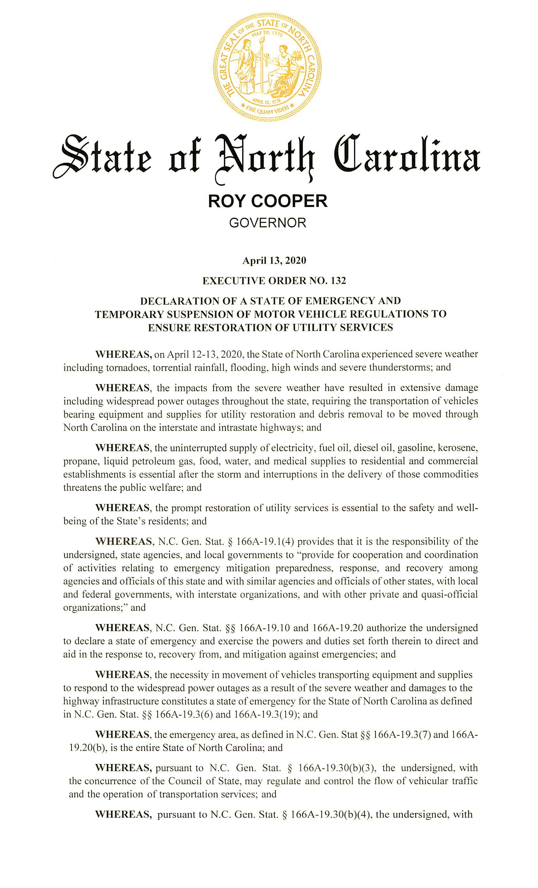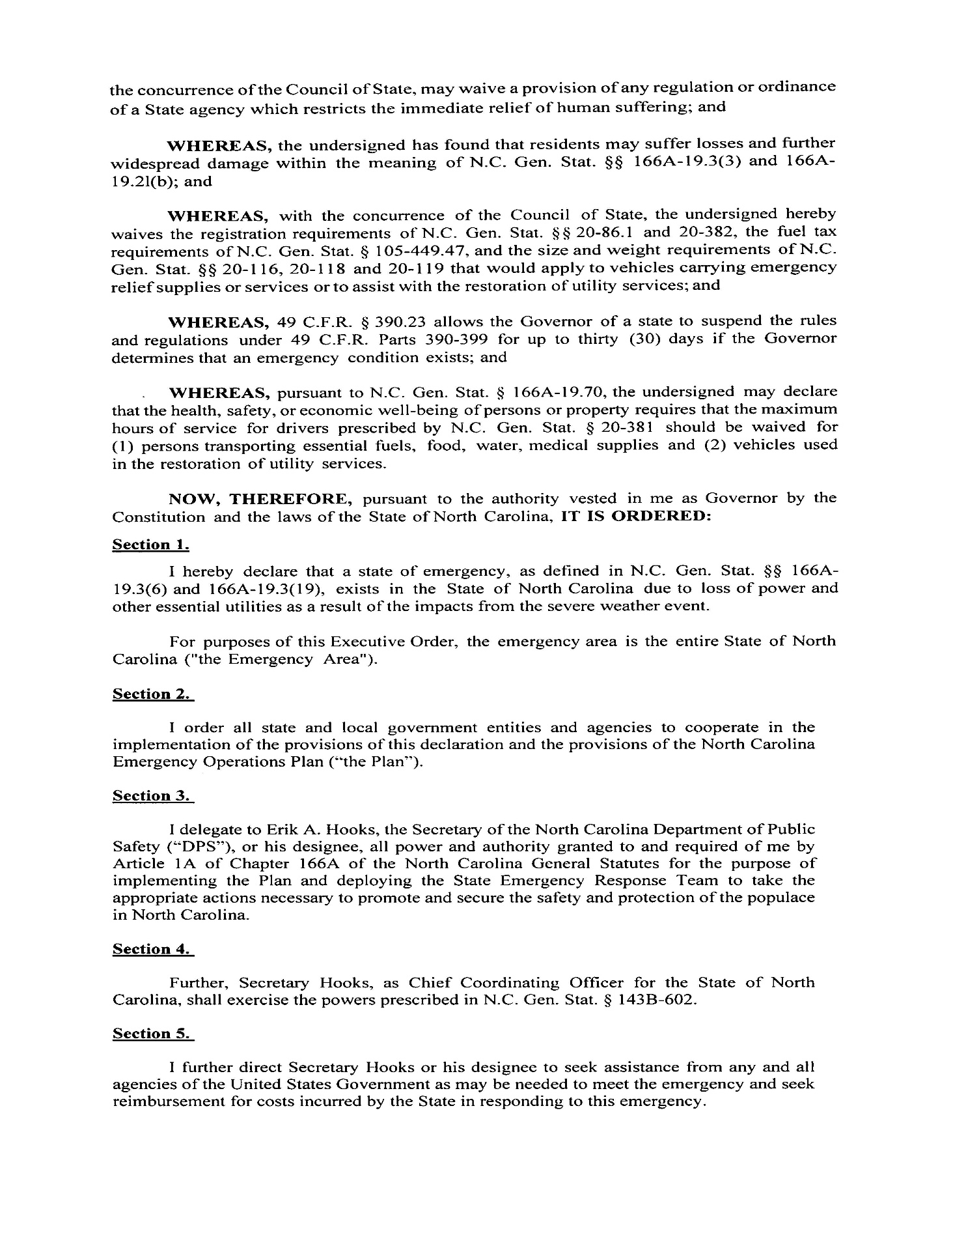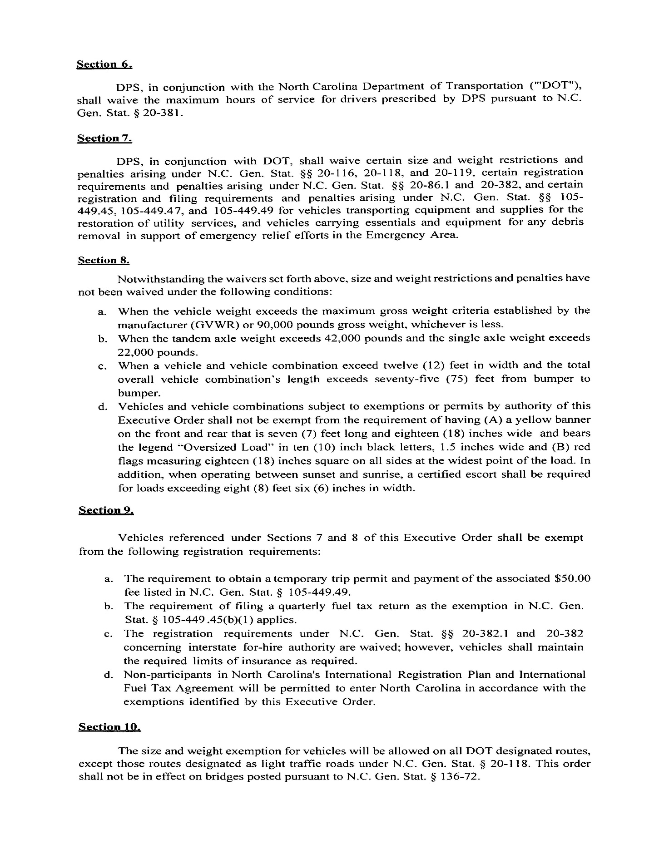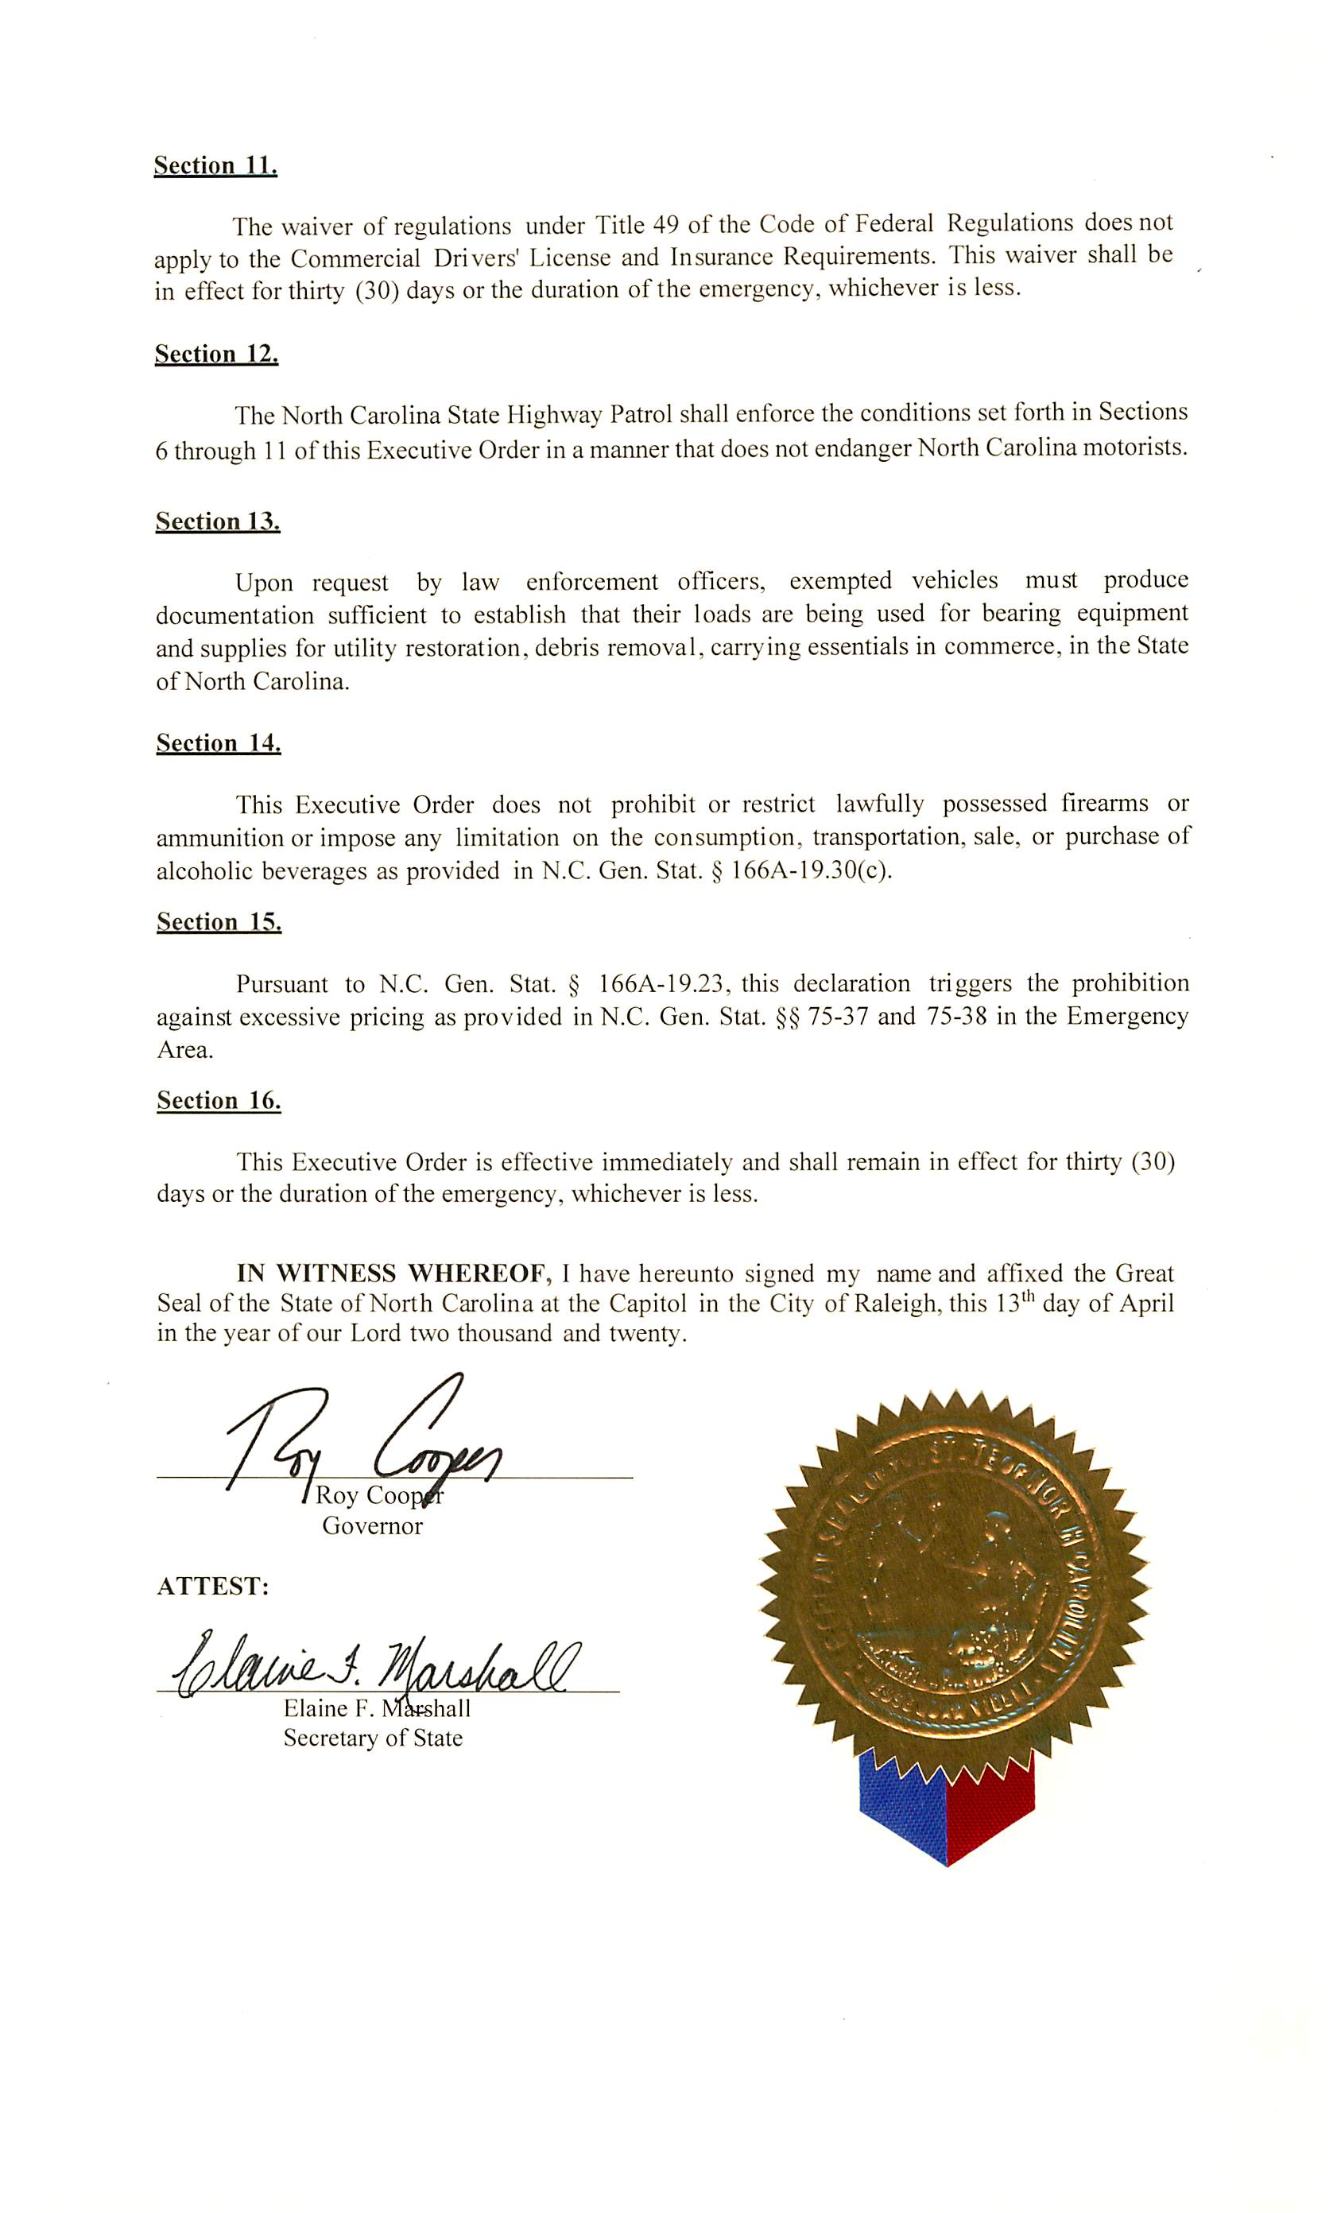
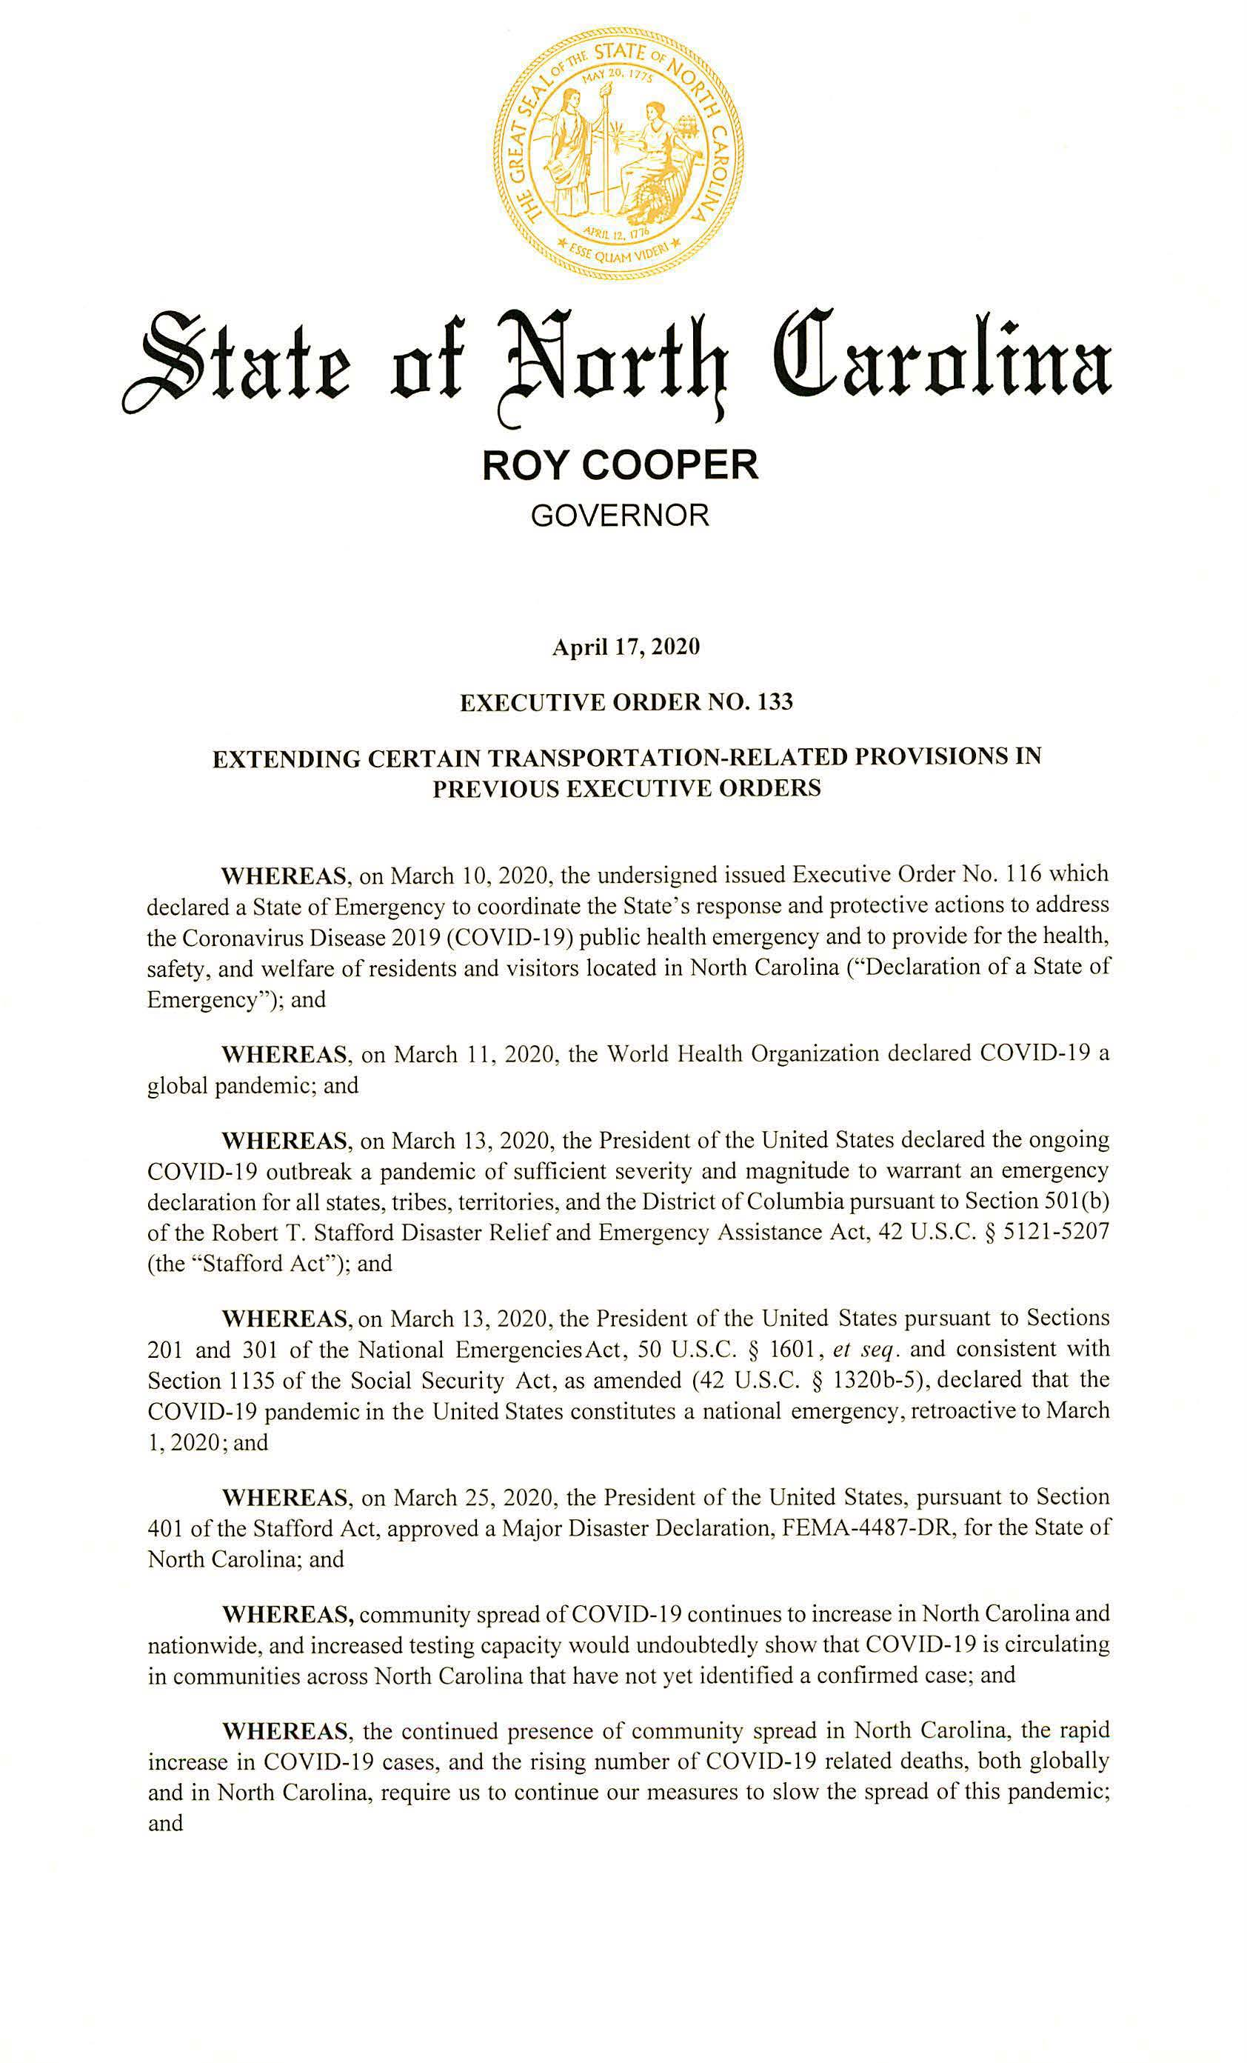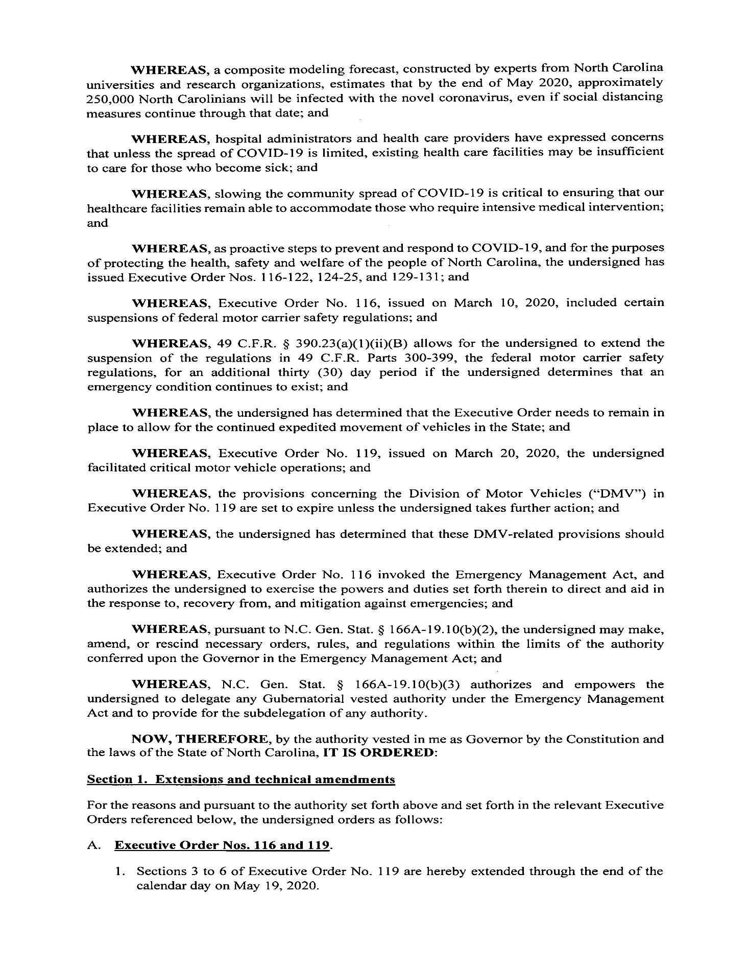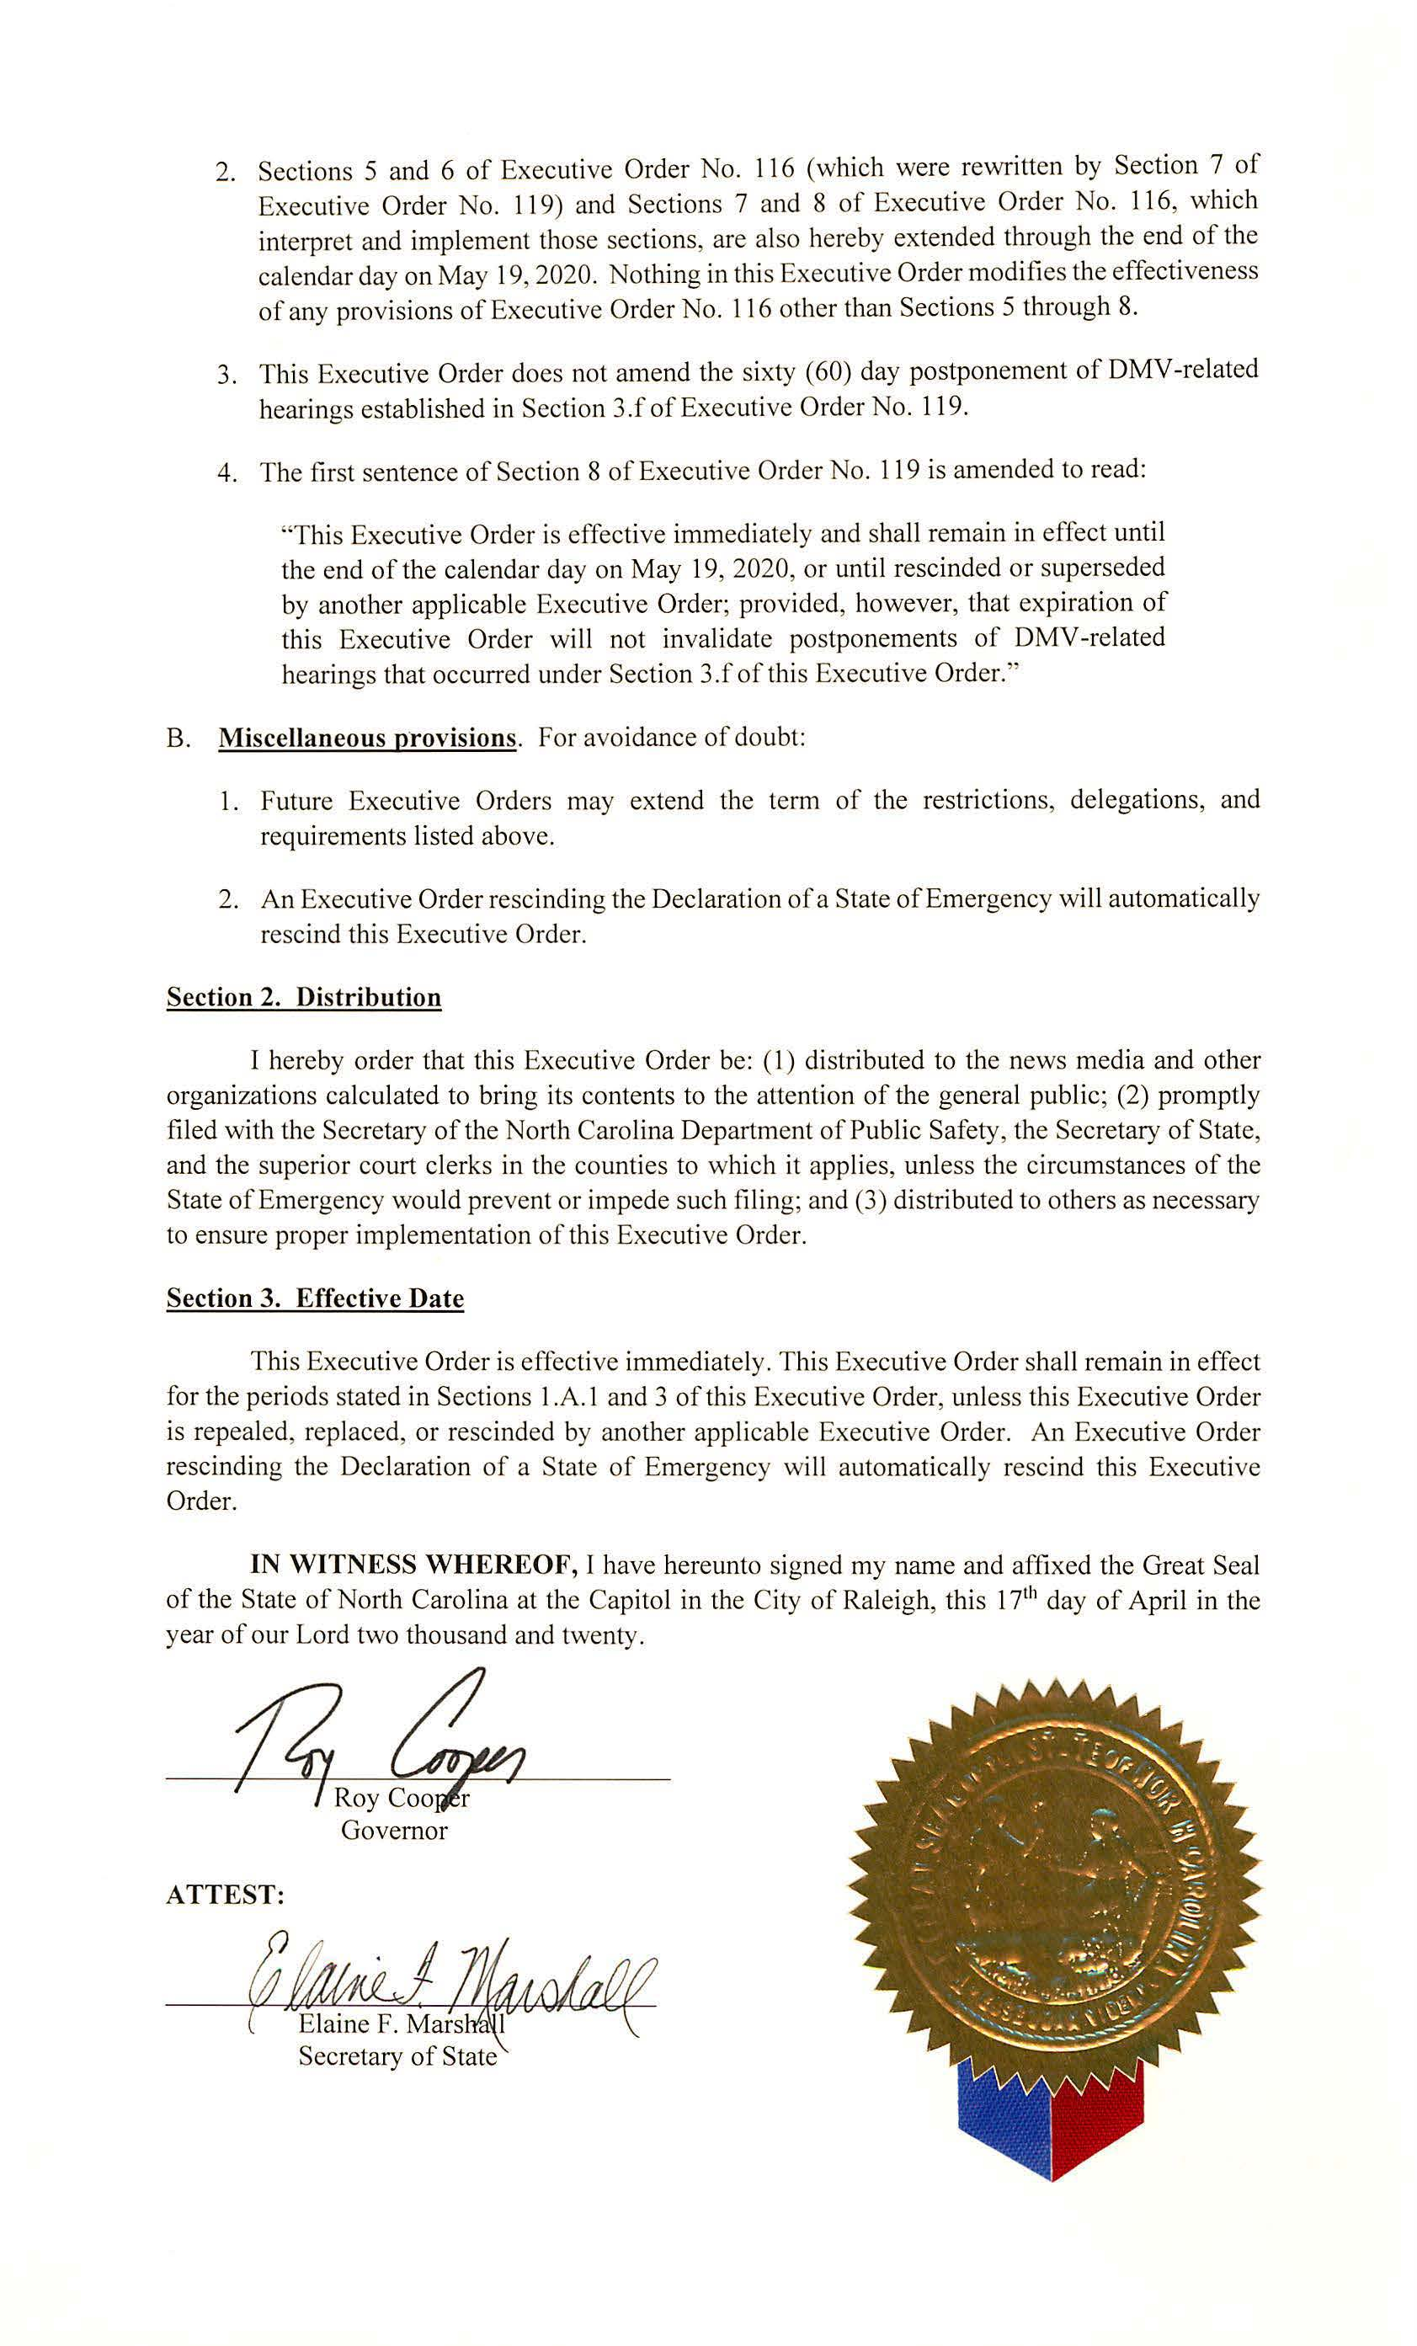
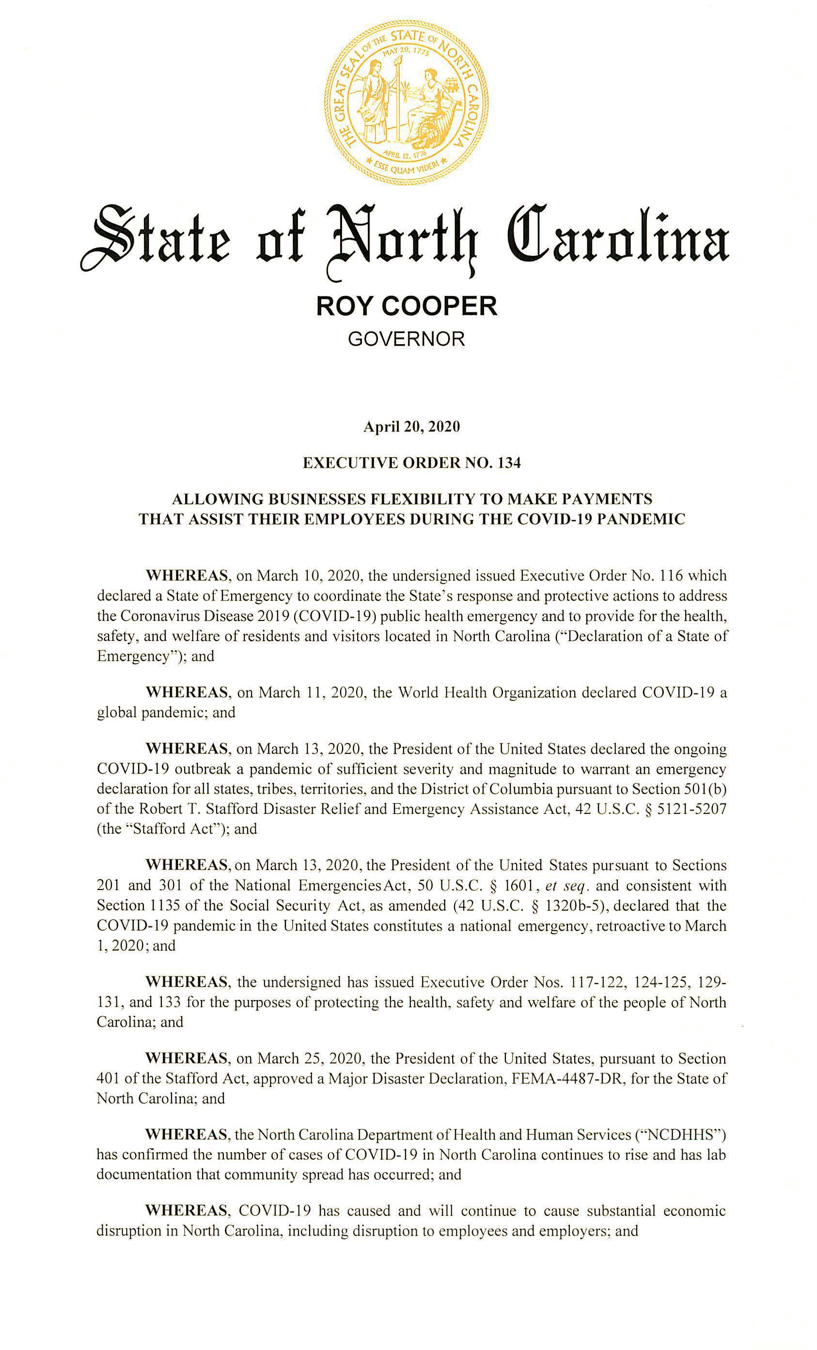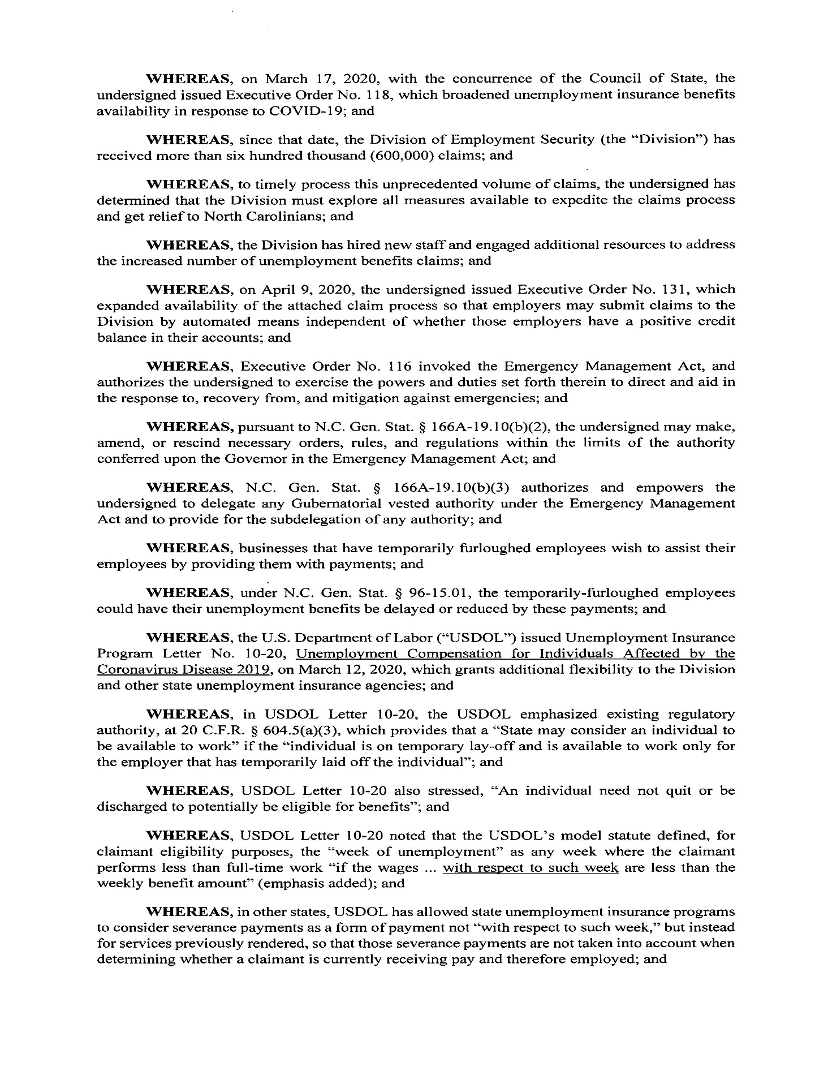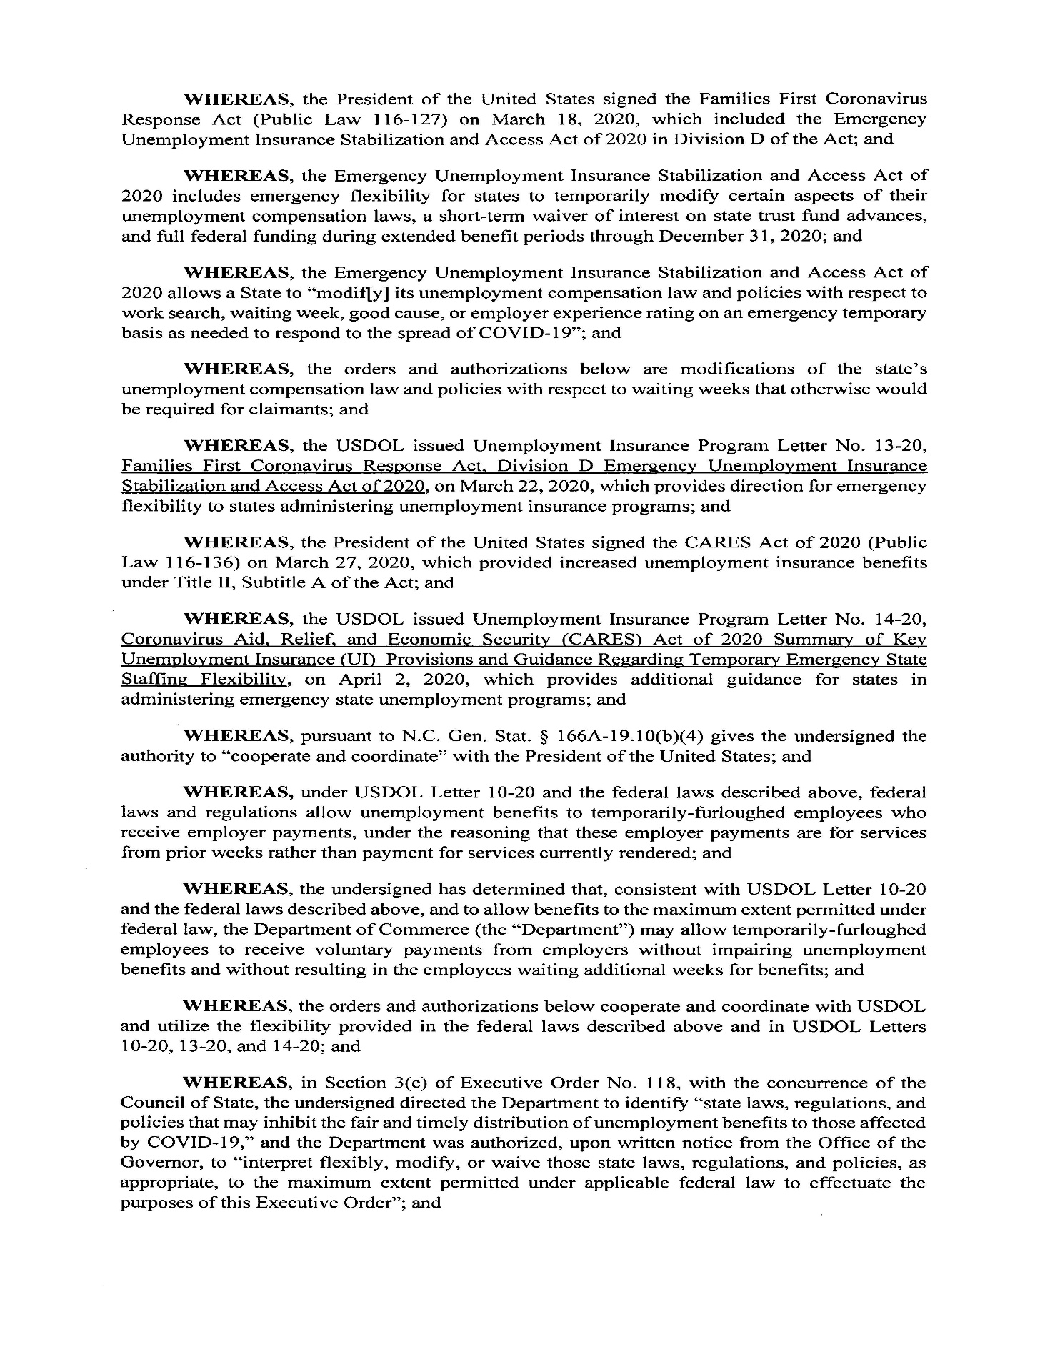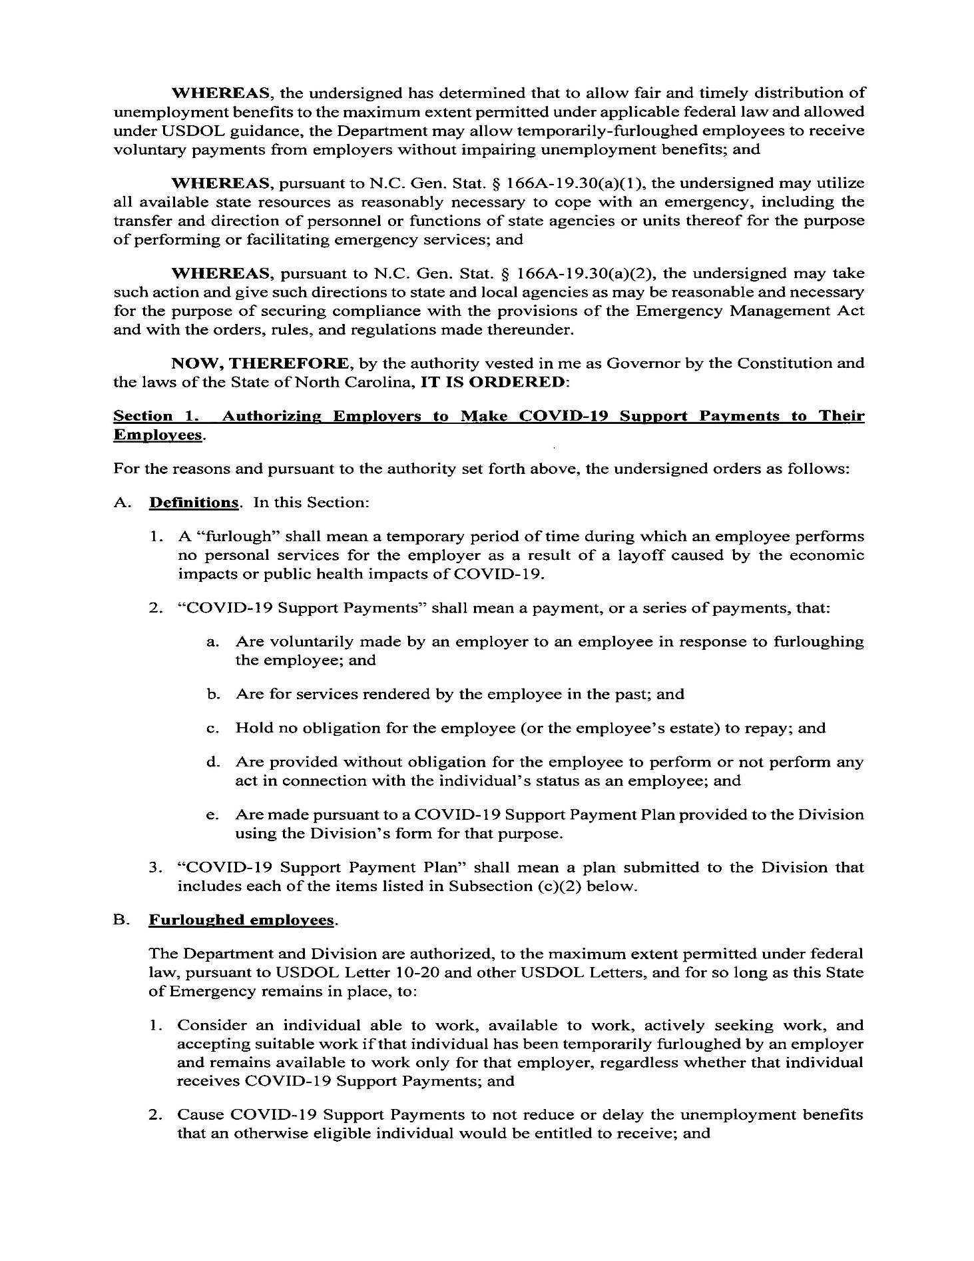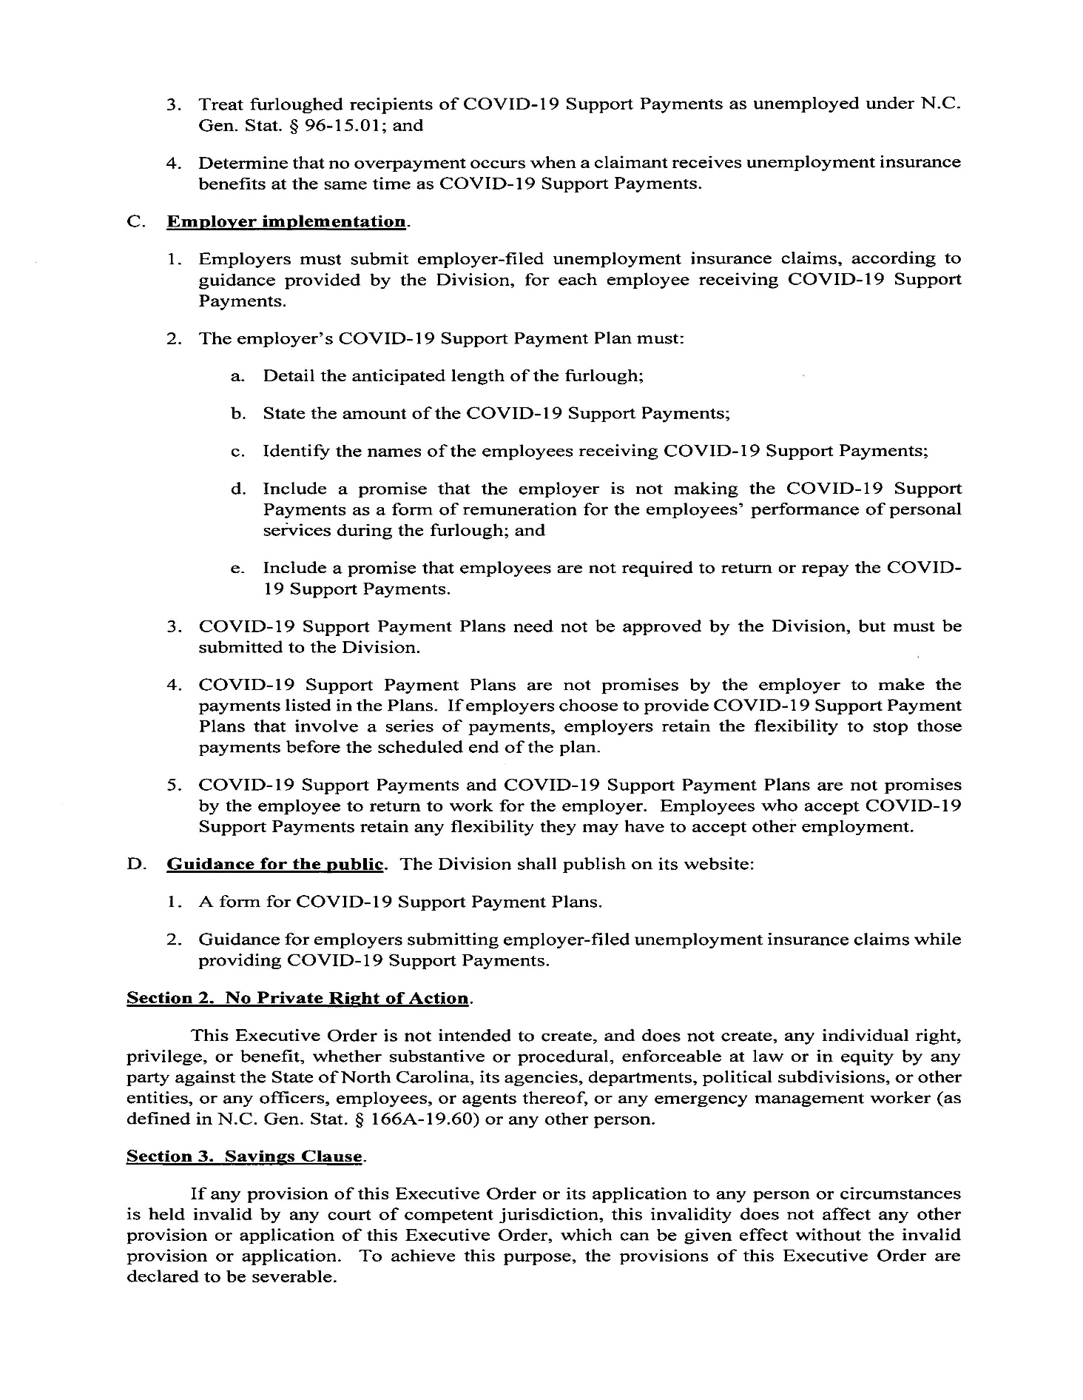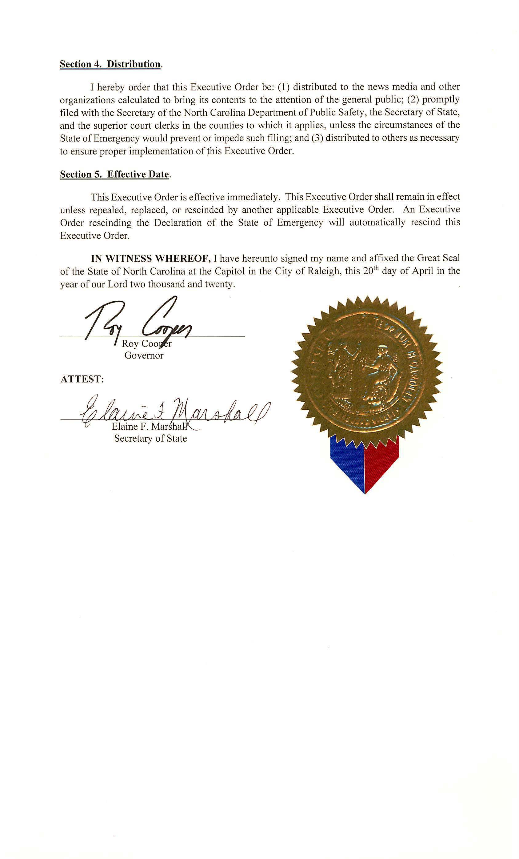
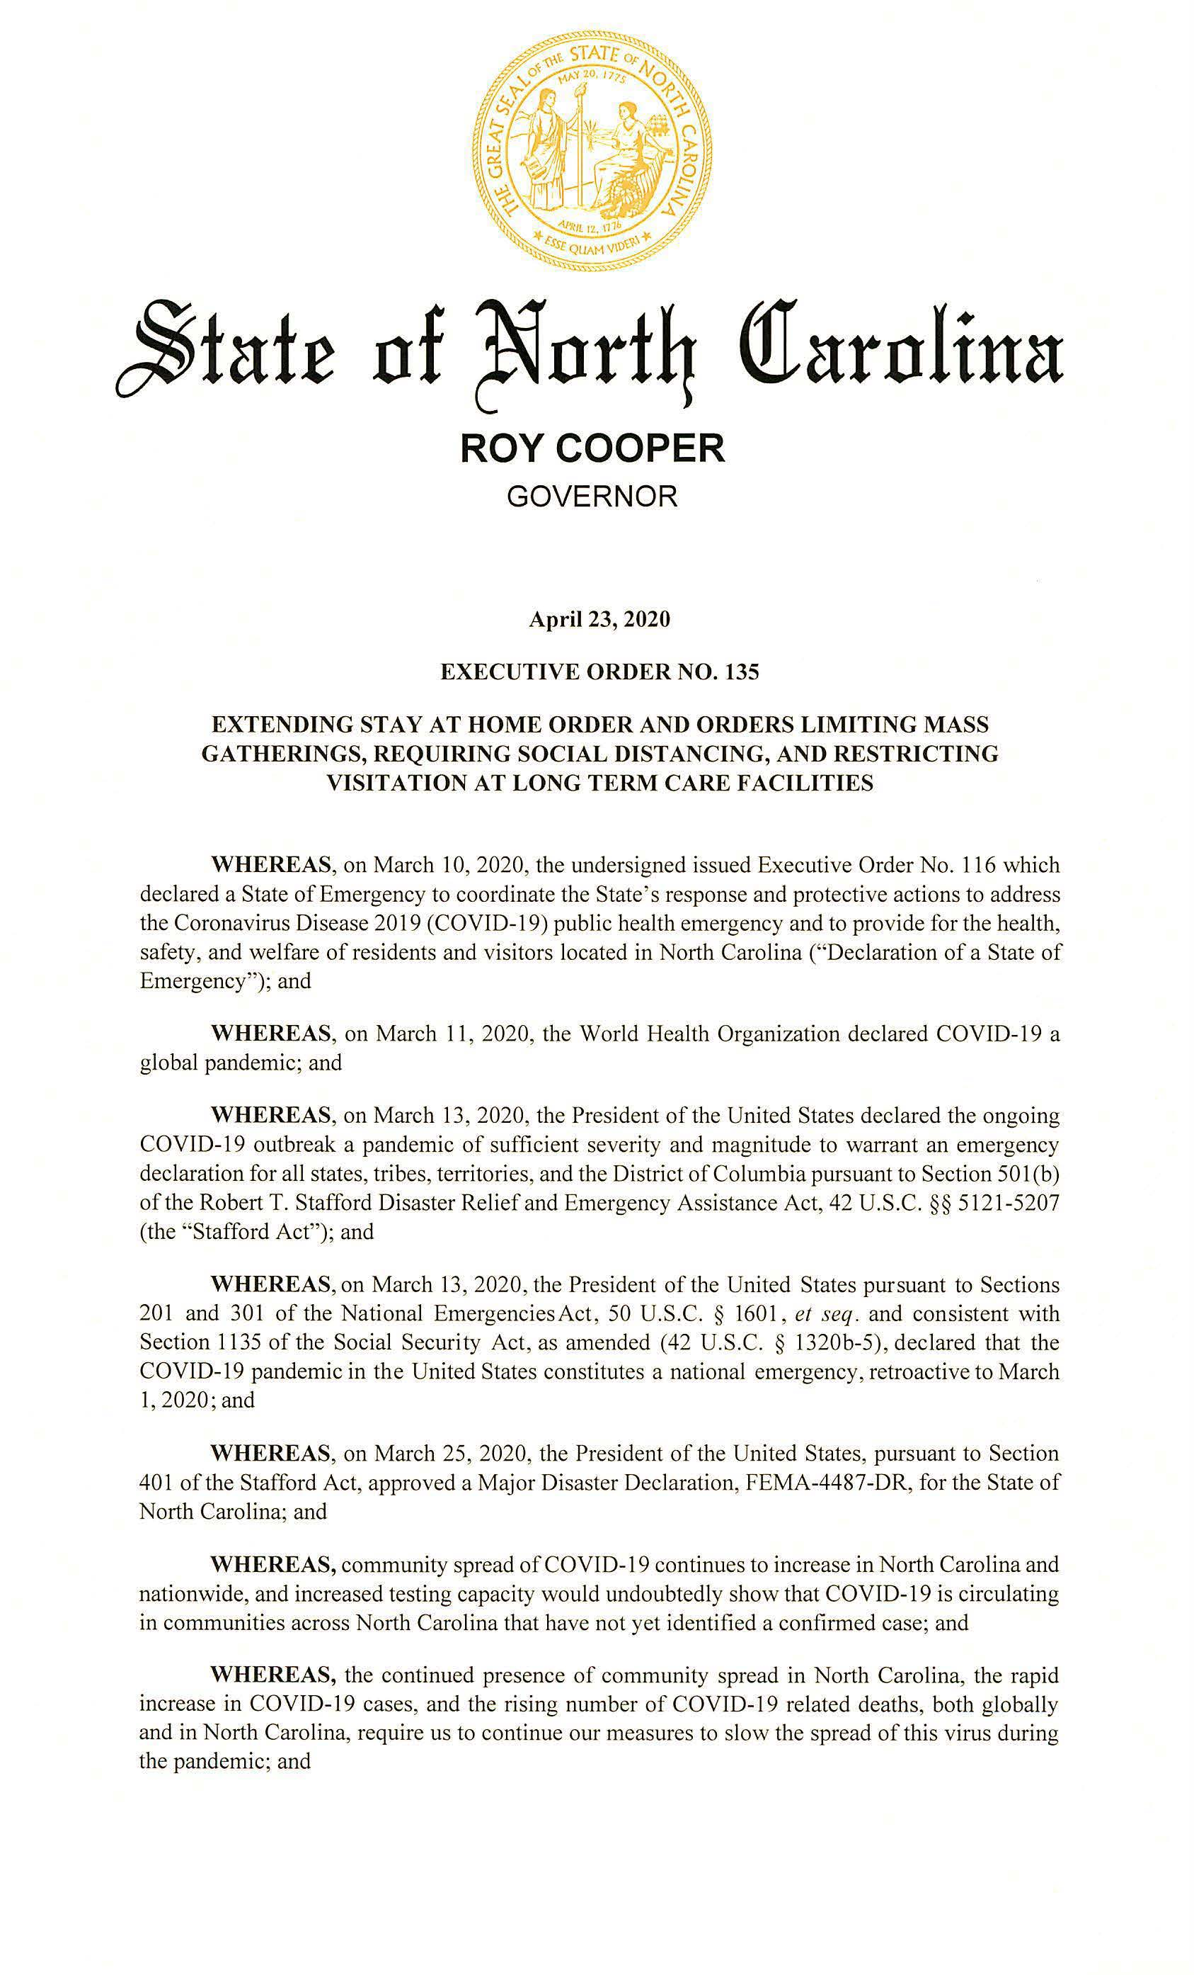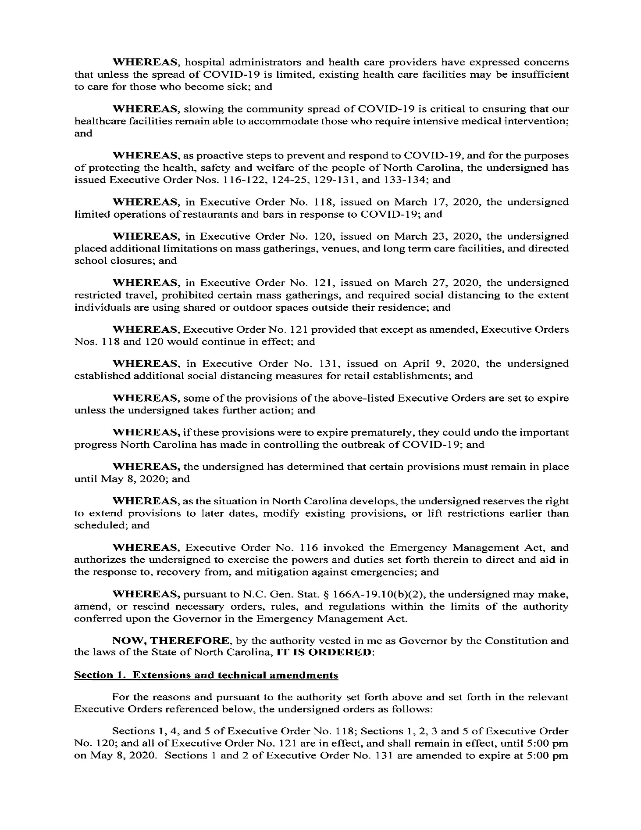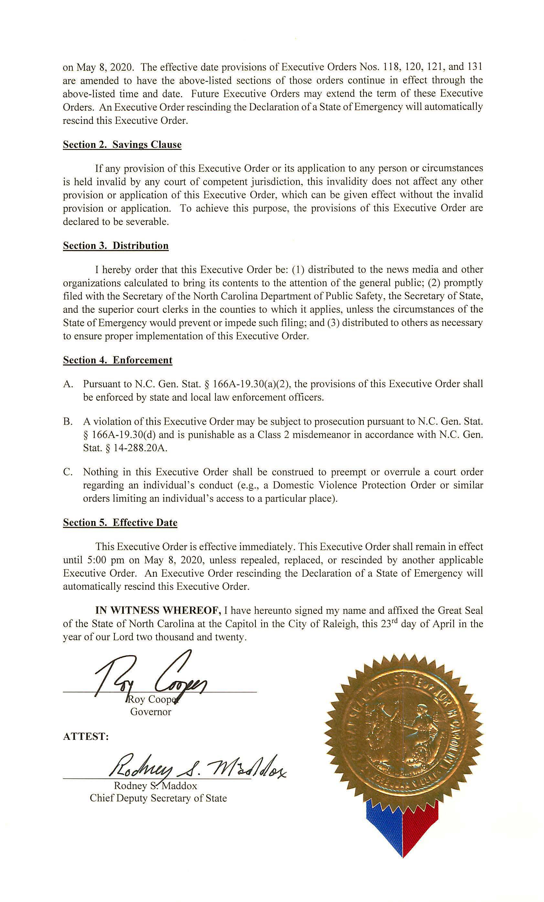
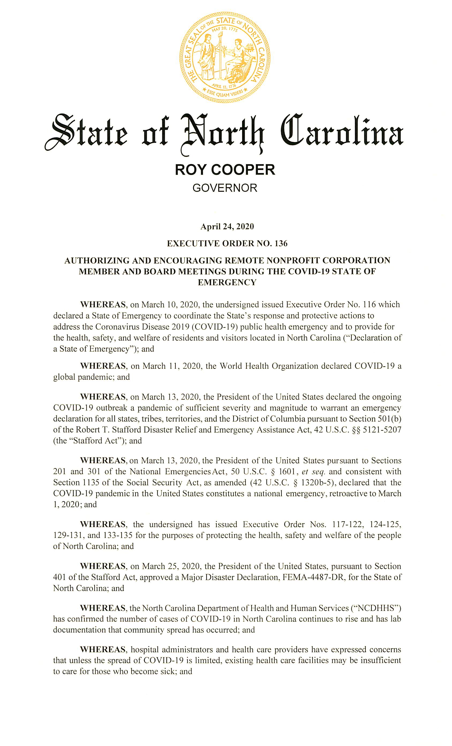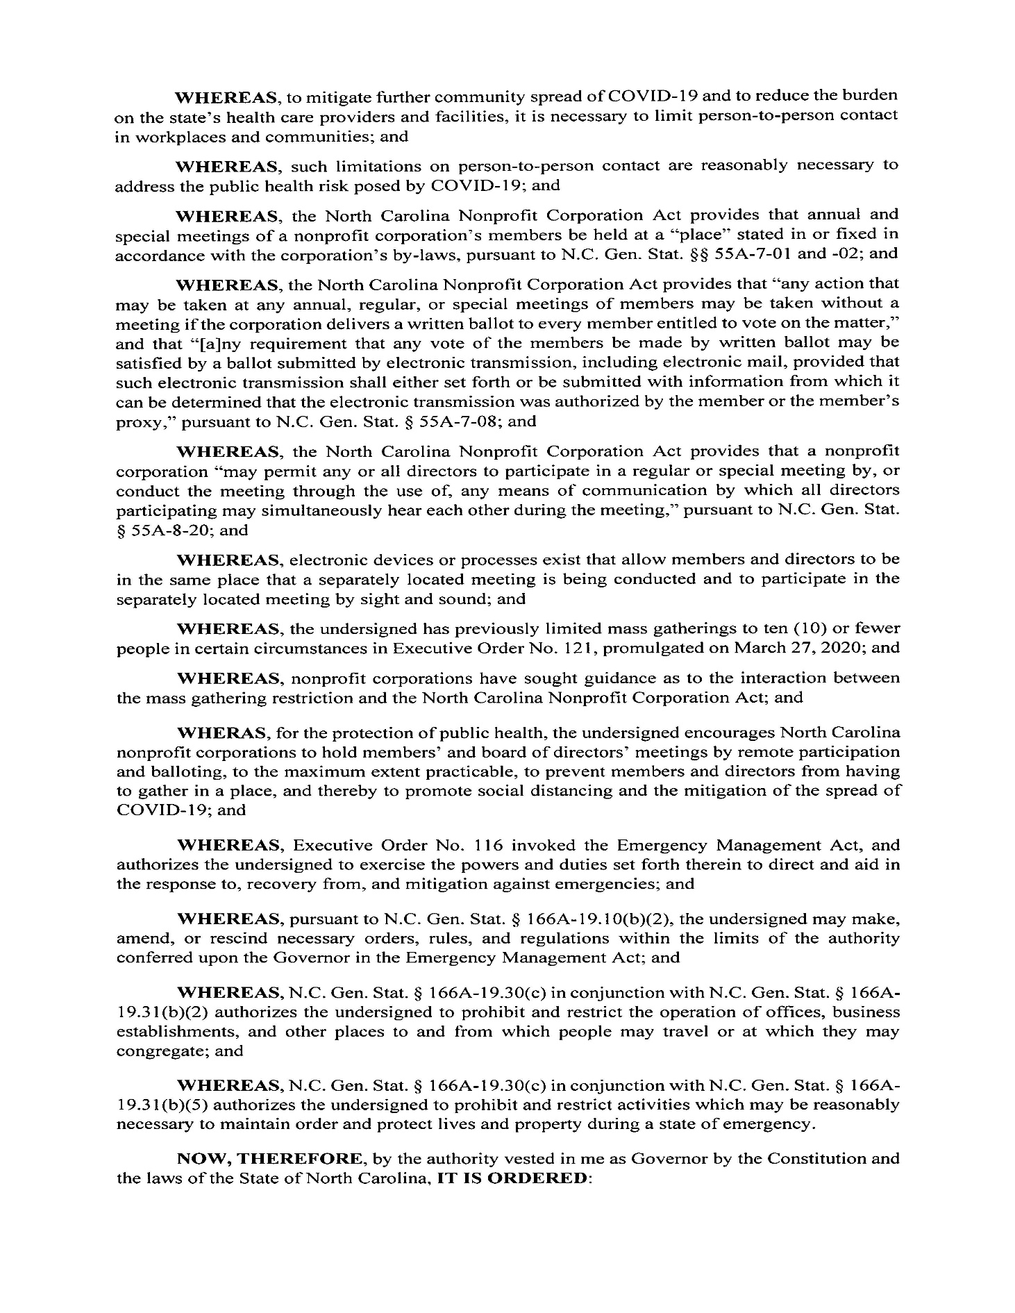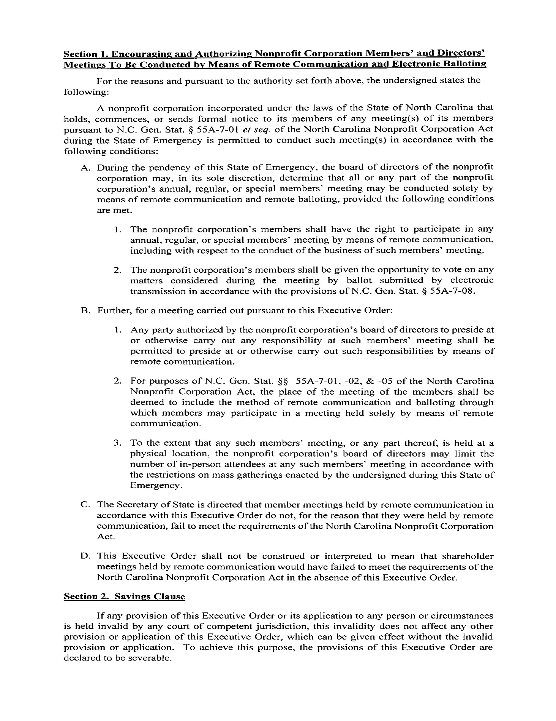

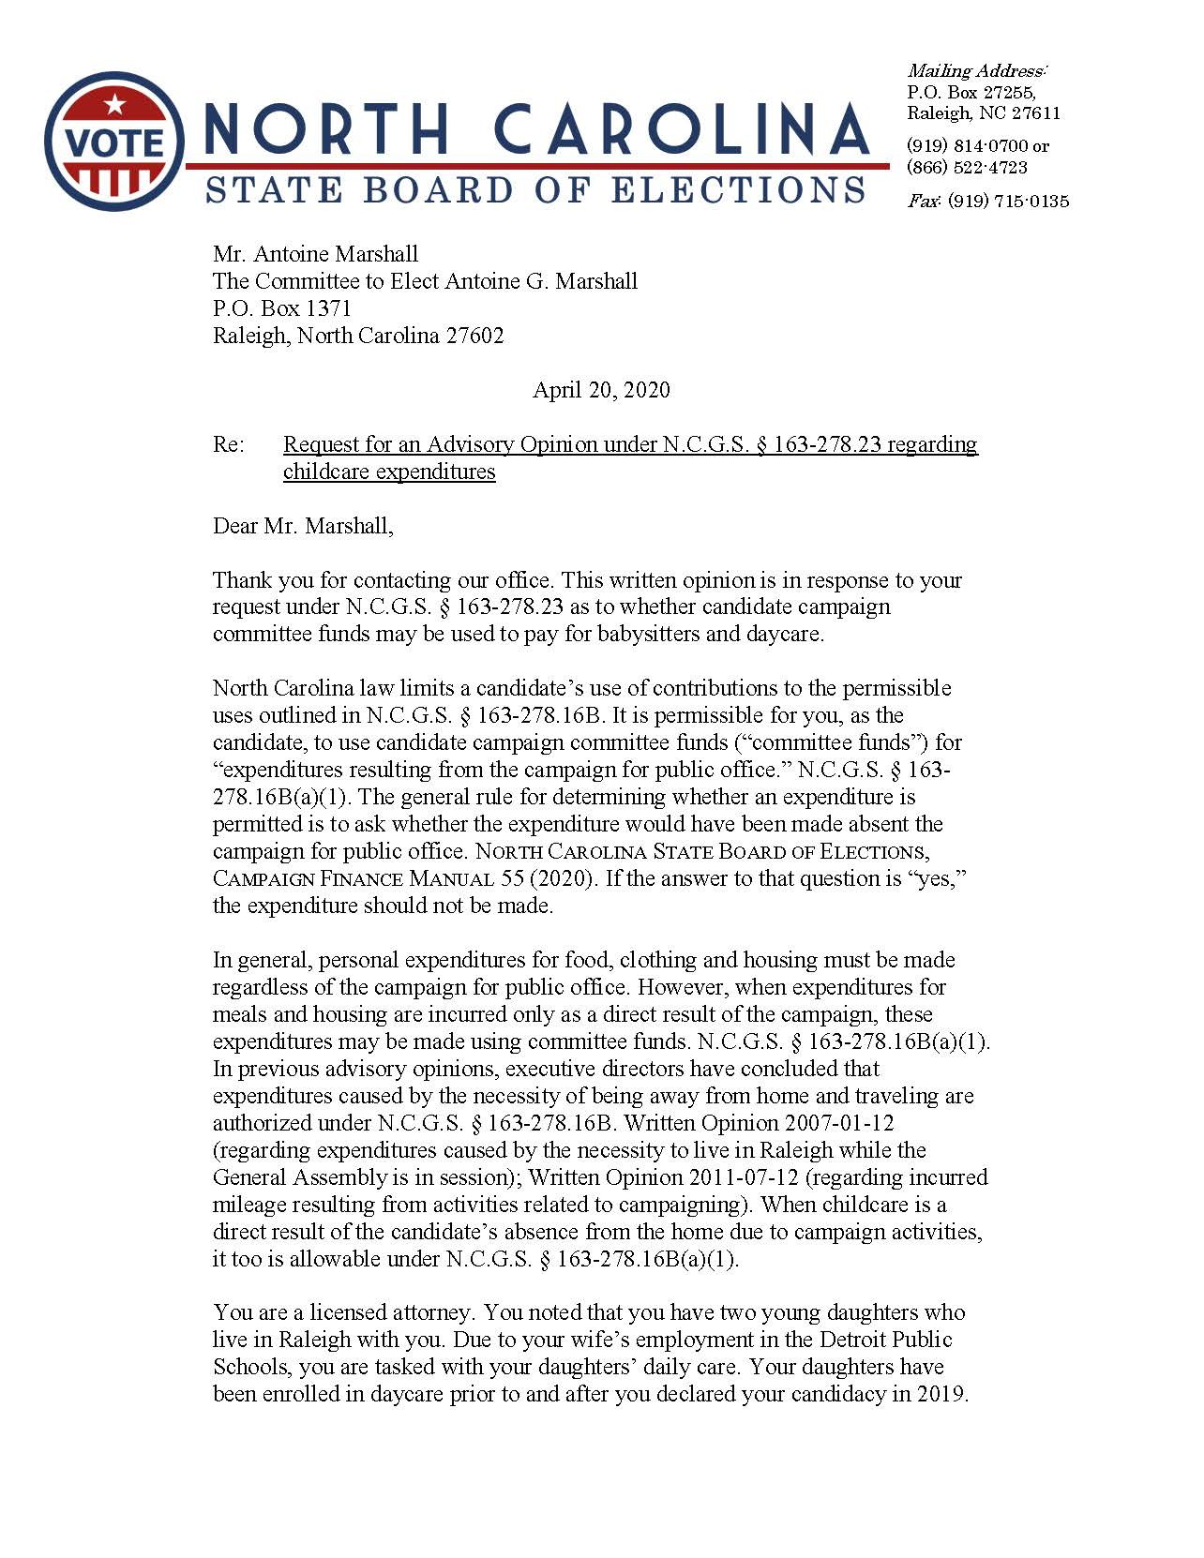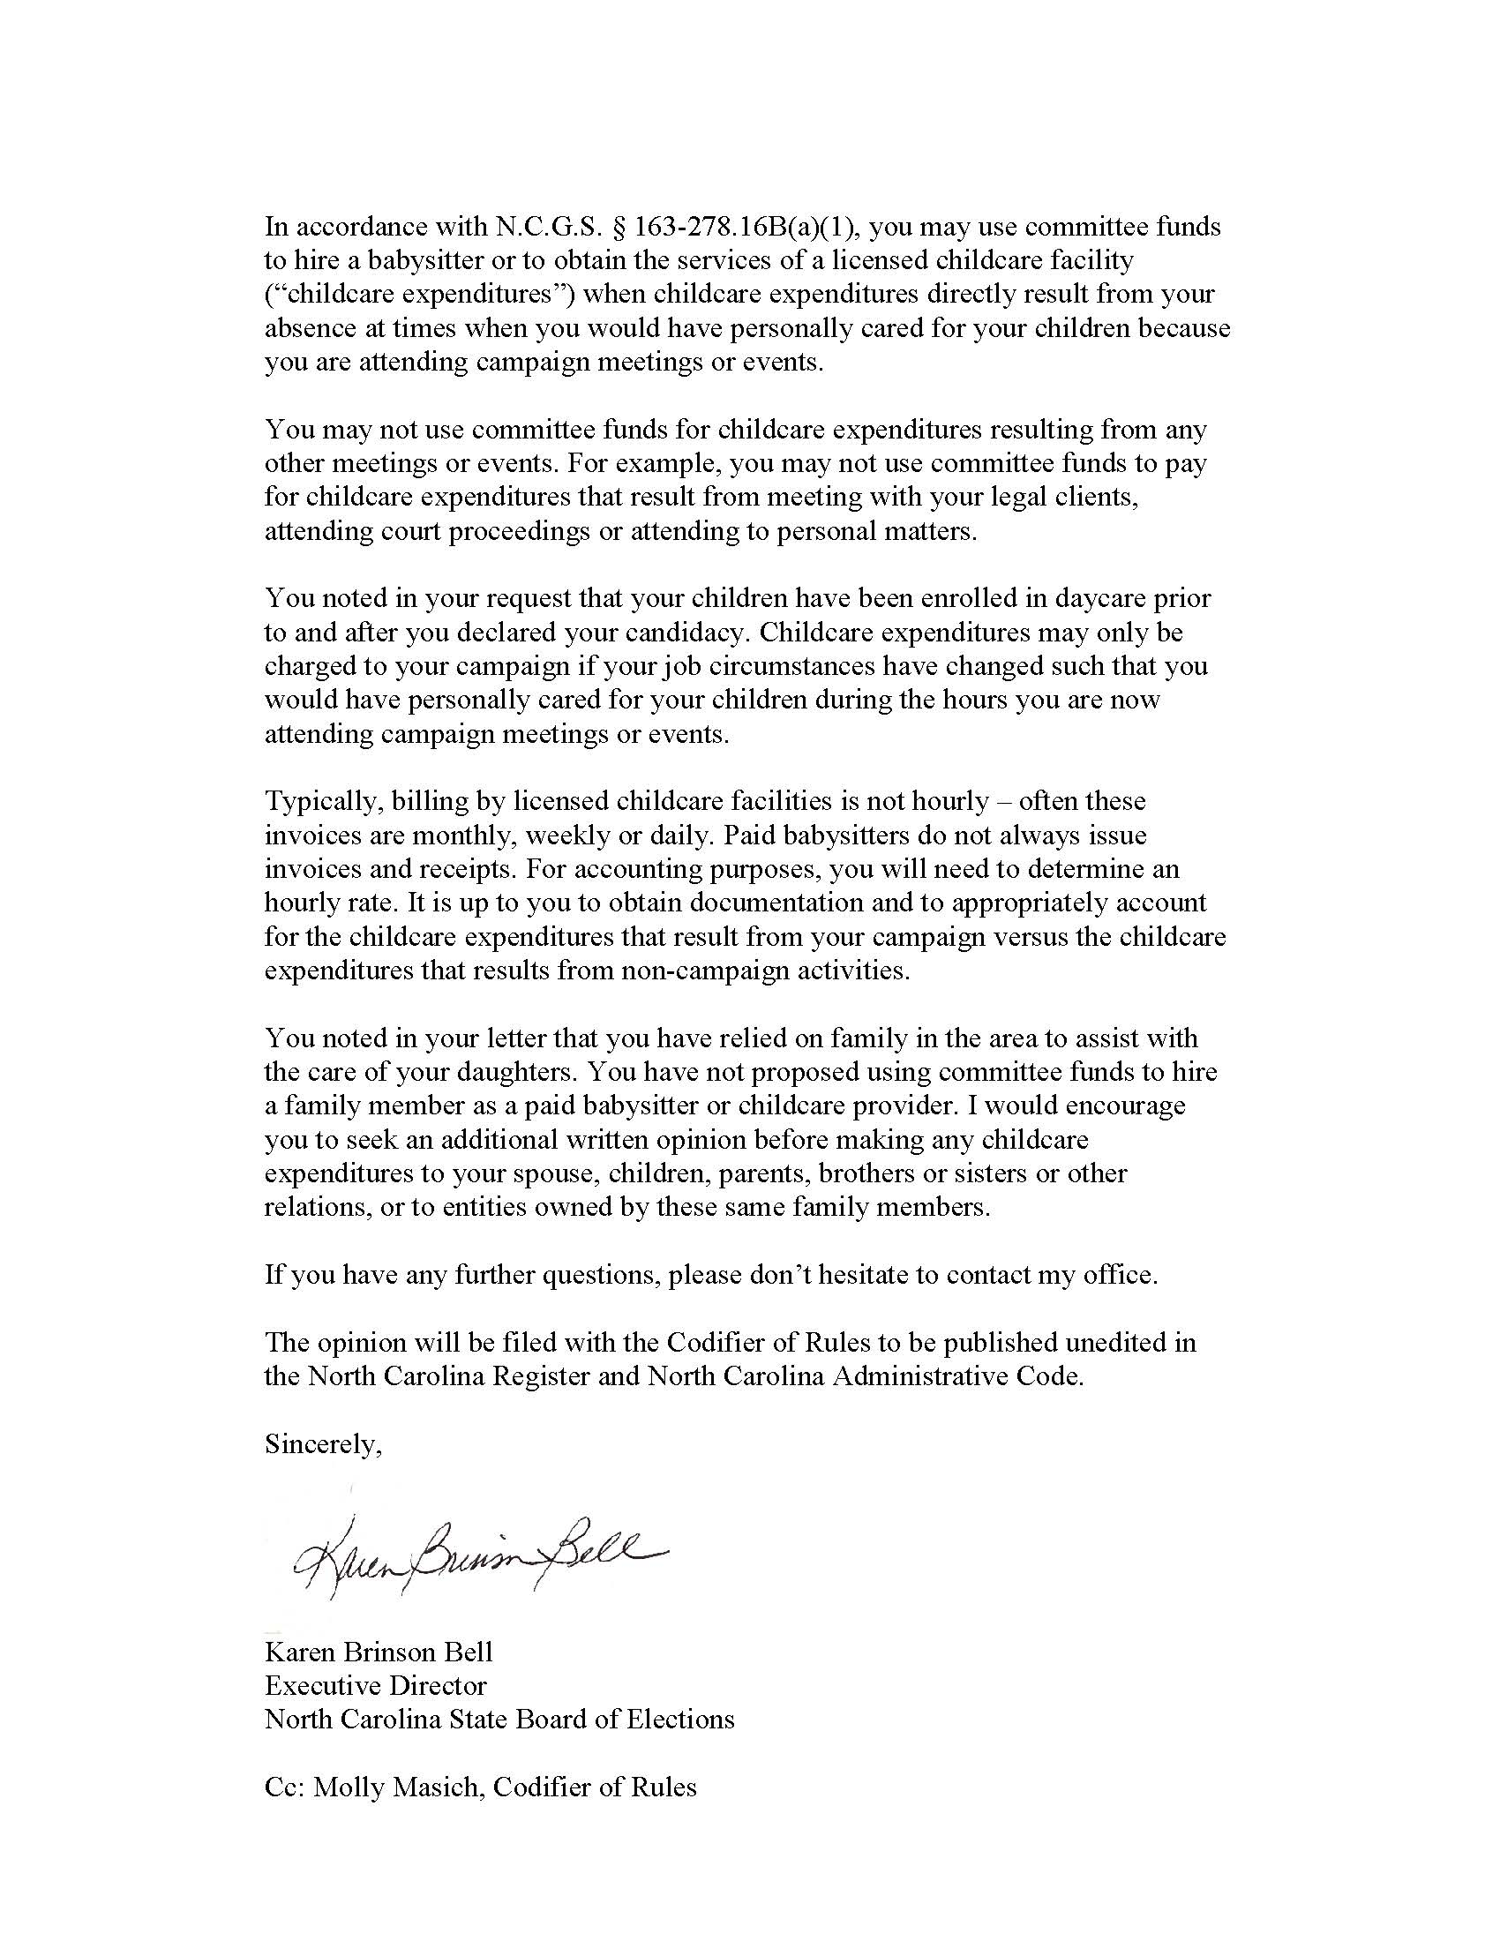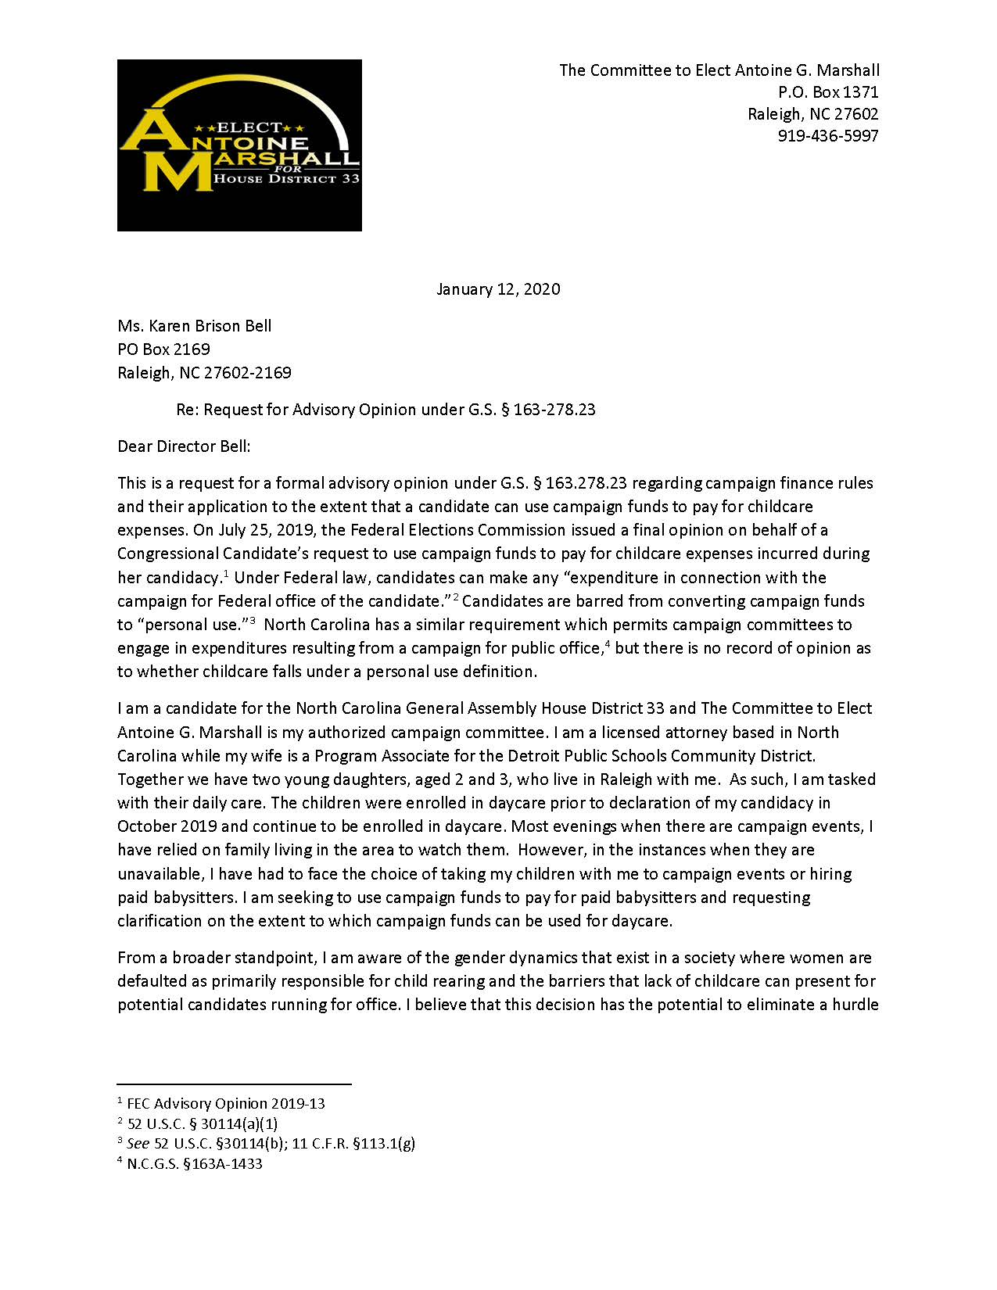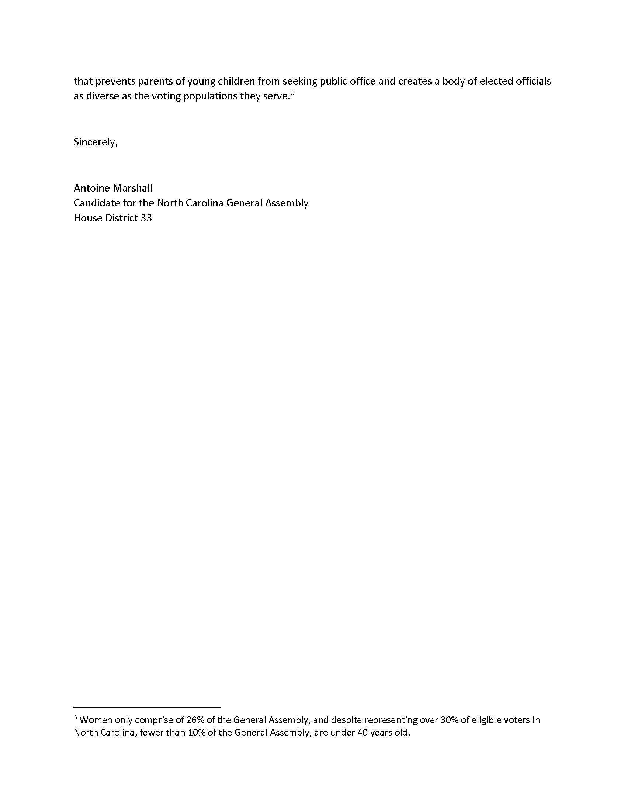

Note from the Codifier: The notices published in this Section of the NC Register include the text of proposed rules. The agency must accept comments on the proposed rule(s) for at least 60 days from the publication date, or until the public hearing, or a later date if specified in the notice by the agency. If the agency adopts a rule that differs substantially from a prior published notice, the agency must publish the text of the proposed different rule and accept comment on the proposed different rule for 60 days.
Statutory reference: G.S. 150B-21.2.

Title 02 – Department of Agriculture and Consumer Services

Notice is hereby given in accordance with G.S. 150B-21.2 that the Gasoline and Oil Inspection Board intends to adopt the rule cited as 02 NCAC 42 .0405 and amend the rules cited as 02 NCAC 42 .0102, .0201, and .0401.

Link to agency website pursuant to G.S. 150B-19.1(c): http://www.ncagr.gov/AdministrativeRules/ProposedRules/index.htm

Proposed Effective Date: September 1, 2020

Instructions on How to Demand a Public Hearing: (must be requested in writing within 15 days of notice): Any person may request a public hearing on the proposed rules by submitting a request in writing no later than May 30, 2020, to Stephen Benjamin, Secretary, NC Gasoline and Oil Inspection Board, 1050 Mail Service Center, Raleigh, NC 27699-1050.

Reason for Proposed Action: These amendments are updating terms, websites, and other technical-type changes. The rules also recognize the 1 psi allowance for E15 approved by the EPA and aligns our language with the federal language on dispenser labeling. The Board is also adopting language for water in storage tanks.

Comments may be submitted to: Stephen Benjamin, 1050 Mail Service Center, Raleigh, NC 27699-1050; email steve.benjamin@ncagr.gov

Comment period ends: July 14, 2020

Procedure for Subjecting a Proposed Rule to Legislative Review: If an objection is not resolved prior to the adoption of the rule, a person may also submit written objections to the Rules Review Commission after the adoption of the Rule. If the Rules Review Commission receives written and signed objections after the adoption of the Rule in accordance with G.S. 150B-21.3(b2) from 10 or more persons clearly requesting review by the legislature and the Rules Review Commission approves the rule, the rule will become effective as provided in G.S. 150B-21.3(b1). The Commission will receive written objections until 5:00 p.m. on the day following the day the Commission approves the rule. The Commission will receive those objections by mail, delivery service, hand delivery, or facsimile transmission. If you have any further questions concerning the submission of objections to the Commission, please call a Commission staff attorney at 919-431-3000.

Fiscal impact. Does any rule or combination of rules in this notice create an economic impact? Check all that apply.

State funds affected

Local funds affected

Substantial economic impact (>= $1,000,000)

Approved by OSBM

No fiscal note required

Chapter 42 - Gas and Oil Inspection

SECTION .0100 - PURPOSE AND DEFINITIONS

02 NCAC 42 .0102 DEFINITIONS

Except as otherwise defined in Chapter 119, North Carolina General Statutes, the definitions applicable in this Chapter are as follows:
(1) "ASTM" means ASTM International.
(2) "Approved lead substitute" means an EPA registered gasoline additive formulated to reduce valve seat recession in engines designed to operate on leaded gasoline.
(3) "Biodiesel" means a fuel comprised of mono-alkyl esters of long chain fatty acids derived from vegetable oils or animal fats, designated B100, and meeting the requirements of ASTM D 6751.
(4) "Biodiesel Blend" means a blend of biodiesel meeting ASTM D 6751 with petroleum-based diesel fuel meeting ASTM D 975 or fuel oil meeting ASTM D 396 and designated BXX, where XX represents the volume percentage of biodiesel in the blend.
(5) "Biomass-based diesel" means a diesel fuel substitute produced from nonpetroleum renewable resources that meets the registration requirements for fuels and fuel additives established by the Environmental Protection Agency under 42 U.S.C. 7545, an includes fuel derived from animal wastes, including poultry fats and poultry wastes, and other waste materials, or from municipal solid waste and sludges and oils derived from wastewater and the treatment of wastewater, except that the term does not include biodiesel as defined in this Part.
(5)(6) "Board" means the Gasoline and Oil Inspection Board.
(6)(7) "Cetane number" means the relative ignition quality of diesel fuels by the ASTM Cetane Method D 613.
(8) "CFR" means the Code of Federal Regulations.
(7)(9) "Denatured fuel ethanol" means ethanol meeting the provisions of ASTM D 4806, "Standard Specification for Denatured Fuel Ethanol to be Blended with Gasolines for Use as an Automotive Spark-Ignition Engine Fuel."
(8)(10) "Director" means the Director of the Standards Division of the North Carolina Department of Agriculture and Consumer Services.
(9)(11) "Distributor" means any person who transports or stores or causes the transportation or storage of gasoline at any point between any gasoline refinery or importer's facility and any retail outlet or wholesale purchaser-consumer's facility.
(10) "E85" means a petroleum product that is a blend of denatured ethanol and gasoline or natural gasoline of which the ethanol portion is nominally 70 to 85 percent ethanol by volume and meeting the requirements of ASTM D 5798.
(11)(12) "EPA" means the United States Environmental Protection Agency.
(13) "Ethanol Flex Fuel" means a mixture of gasoline and ethanol that contains 51 percent to 83 percent ethanol by volume.
(12)(14) "Leaded" means any gasoline or gasoline-oxygenate blend which contains more than 0.05 gram lead per U.S. gallon (0.013 gram lead per liter) or contains an approved lead substitute which provides a lead equivalency of at least 0.10 gram lead per U.S. gallon (0.026 gram per liter).
(13)(15) "Liquefied petroleum gas" means any material which is composed predominantly of any of the following hydrocarbons or mixtures of same: propane, propylene, butanes (normal or iso-butane), and butylenes.
(14)(16) "Motor Octane Number" means the number describing the relative anti-knock characteristic of a motor fuel determined by ASTM Motor Method (D 2700).
(15)(17) "NCWM" means the National Conference on Weights and Measures.
(16)(18) "NIST" means the National Institute of Standards and Technology.
(17)(19) "Octane Index" means the number obtained by adding the research octane number and the motor octane number and dividing the sum by two.
(18)(20) "Oxygenate" means any substance which, when added to gasoline, increases the amount of oxygen in that gasoline, and which has been approved by EPA for use in gasoline.
(19)(21) "Premium Diesel" means a refined middle distillate petroleum product that meets the specifications of ASTM D 975 and NIST Handbook 130, Uniform Engine Fuels, Petroleum Products and Automotive Lubricants Regulation, section 2.2.1.
(20)(22) "Qualitative word or term" means any word or term used in a brand name which by definition or customary usage indicates a level of quality, classification, grade, or designation.
(21)(23) "Regular" when used as part of a brand name or as a grade designation for gasoline or gasoline-oxygenate blend shall be construed to mean an unleaded regular grade commercial automotive gasoline or gasoline-oxygenate blend.
(22)(24) "Renewable Diesel Fuel" means a fuel which is not a mono-alkyl ester; meets the registration requirements for fuels and fuel additives established by the Environmental Protection Agency under section 7545 of the Clean Air Act; is intended for use in engines that are designed to run on conventional, petroleum derived diesel fuel; is derived from nonpetroleum renewable resources including, but not limited to, vegetable oil, animal wastes, including poultry fats and poultry wastes, and other waste materials, or municipal solid waste and sludges and oils derived from wastewater and the treatment of wastewater; and meets the latest version of ASTM specification D 975.
(23)(25) "Research Octane Number" means the number describing the relative anti-knock characteristic of a motor fuel determined by ASTM Research Method (D 2699).
(24)(26) "Retail" means the sale or offering for sale of gasoline to the ultimate consumer for use in a motor vehicle.
(25)(27) "Substantially Similar" rule means the United States Environmental Protection Agency's "Substantially Similar" rule, Section 211 (f)(1) of the Clean Air Act [42 U.S.C. 7545 (f)(1)].
(26)(28) "Terminal" means a facility at which gasoline is dispensed into trucks for transportation to retail outlets or wholesale purchaser-consumer facilities.
(27)(29) "Unleaded" means any gasoline or gasoline-oxygenate blend to which no lead or phosphorus compounds have been intentionally added and which contains not more than 0.05 gram lead per U.S. gallon (0.013 gram lead per liter) and not more than 0.005 gram phosphorus per U.S. gallon (0.0013 gram phosphorus per liter).

Authority G.S. 119-26; 119-26.1.

SECTION .0200 - QUALITY OF LIQUID FUEL PRODUCTS

02 NCAC 42 .0201 STANDARD SPECIFICATIONS

(a) The Board hereby adopts by reference, including subsequent amendments and editions, ASTM D 4814, "Standard Specification for Automotive Spark-Ignition Engine Fuel" as standard specification for gasoline with the following modifications:

(1) Applications for temporary exceptions to vapor pressure and vapor/liquid ratio specifications as provided in this Subparagraph may be made to the Director. Said applications shall contain evidence that outlets marketing gasoline in North Carolina cannot be supplied from bulk terminals furnishing specified volatility level gasoline or that customary sources of supply have been temporarily interrupted by product shortage and alternate sources furnishing specified volatility level gasoline are not available. Such temporary exceptions granted shall apply only until the next meeting of the Board at which time the Board shall establish the duration of the exception;

(2) The minimum lead content for gasoline registered or labeled as "leaded" shall be as defined in 02 NCAC 42 .0102;

(3) Vapor pressure and vapor/liquid ratio seasonal specifications as listed in this Subparagraph may be extended for a maximum period of 15 days to allow for the disbursement of old stocks. However, new stocks of a higher volatility classification shall not be offered for retail sale prior to the effective date of the higher volatility classification.

(b) The Board hereby adopts by reference, including subsequent amendments and editions, ASTM D 4814, "Standard Specification for Automotive Spark-Ignition Engine Fuel" as standard specification for alcohol blends with the following modifications:

(1) A vapor pressure tolerance not exceeding one pound per square inch (1 psi) for ethanol blends of up to 10 percent; 9 percent to 15 percent by volume;

(2) Vapor pressure seasonal specifications as listed in this Subparagraph may be extended for a maximum period of 15 days to allow for the disbursement of old stocks. However, new stocks of a higher volatility classification shall not be offered for retail sale prior to the effective date of the higher volatility classification;

(3) Applications for temporary exceptions to vapor pressure specifications as provided in this Subparagraph may be made to the Director. Said applications shall contain evidence that outlets marketing gasoline in North Carolina cannot feasibly be supplied from bulk terminals furnishing specified volatility level gasoline or that customary sources of supply have been temporarily interrupted by product shortage and alternate sources furnishing specified volatility level gasoline are not available. Such temporary exceptions granted shall apply only until the next meeting of the Board at which time the Board shall establish the duration of the exception;

(4) The minimum temperature at 50 percent evaporated shall be 150 degrees F (66 degrees C) as determined by ASTM Test Method D 86 for ethanol blends of up to 10 percent; 1 percent to 15 percent by volume;

(5) The minimum lead content for gasoline and alcohol blends registered or labeled as "leaded" shall be as defined in 02 NCAC 42 .0102;

(6) Octane rating shall not be less than the octane index certified on the brand name registration as required by 02 NCAC 42 .0500;

(7) All blends, both leaded and unleaded, shall be blended according to the EPA "Substantially Similar" rule or an EPA waiver for unleaded fuel;

(8) Water tolerance shall be such that no phase separation occurs when subjected to a temperature equal to the temperatures specified in the table for "Maximum Temperature for Phase Separation, ºC," ASTM D 4814;

(9) The vapor/liquid ratio specification shall be waived for ethanol blends of up to 10 percent.

(c) The Board hereby adopts by reference, including subsequent amendments and editions, ASTM D 975, "Standard Specification for Diesel Fuel Oils" as standard specification for diesel motor fuels and renewable diesel fuels with the following modification: For diesel motor fuel grade 2-D, the minimum flash point as determined by ASTM Test Method D 56shall be 115 degrees F (46 degrees C).

(d) The Board hereby adopts by reference, including subsequent amendments and editions, ASTM D 396, "Standard Specification for Fuel Oils" as standard specification for fuel oils and blends of biodiesel and fuel oil.

(e) The Board hereby adopts by reference, including subsequent amendments and editions, ASTM D 3699, "Standard Specification for Kerosene" as standard specification for kerosenes with the following modification: For grade 2-K, the presence or absence of coloring matter shall in no way be determinative of whether a substance meets the requirements of this grade of kerosene.

(f) The Board hereby adopts by reference, including subsequent amendments and editions, ASTM D 6751, "Standard Specification for Biodiesel (B100) Blend Stock for Distillate Fuels" as standard specification for biodiesel (B100) and for B99 (a blend of 99 percent biodiesel and one percent petroleum diesel).

(g) The Board hereby adopts by reference, including subsequent amendments and editions, ASTM D 5798, "Standard Specification for Fuel Ethanol (Ed75-Ed85) Ethanol Fuel Blends for Flexible Fuel for Automotive Spark-Ignition Engines" as standard specification for E85 fuel ethanol. Ethanol Flex Fuel.

(h) The Board hereby adopts by reference, including subsequent amendments and editions, NIST Handbook 130, "Uniform Engine Fuels, Petroleum Products and Automotive Lubricants Regulation," section 2.2.1 "Premium Diesel Fuel" as the standard specification of premium diesel fuels in addition to ASTM D 975. Copies of this document may be obtained at no cost from the NIST Web site - http://ts.nist.gov/WeightsandMeasures/. http://nist.gov/pml/weights-and-measures/publications/nist-handbooks/handbook-130 .

(i) In addition to meeting all specification requirements as set forth in this Rule, each fuel must be suitable for the intended use. Motor fuels shall not contain concentrations of methyl tertiary butyl ether (MTBE) in violation of G.S. 119-26.3.

(j) ASTM documents adopted by reference herein are available for inspection in the office of the Director of the Standards Division and may be obtained from ASTM International, 100 Barr Harbor Drive, PO Box C700, West Conshohocken, PA 19428-2959 or their Web site - www.astm.org, at the following cost for each document: D 396, thirty-five dollars ($35.00); fifty-four dollars ($54.00); D 975, forty-one dollars ($41.00); sixty-nine dollars ($69.00); D 3699, thirty dollars ($30.00); forty-eight dollars ($48.00); D 4814, forty-seven dollars ($47.00); sixty-nine dollars ($69.00); D 5798, thirty-five dollars ($35.00); forty-eight dollars ($48.00); and D 6571, thirty-five dollars ($35.00). forty-eight dollars ($48.00).

Authority G.S. 119-26; 119-26.1; 150B-14.

section .0400 - DISPENSING DEVICES AND PUMPS

02 NCAC 42 .0401 LABELING OF DISPENSING DEVICES

(a) For the purpose of product identity, each dispensing device used in the retailing of any motor fuel shall, on the front panel of the dispenser and in plain view of the customer, be labeled with the following:

(1) For gasoline, the registered brand name; name, which shall include both a brand name and a grade designation;

(2) For diesel fuel, the registered brand name plus a descriptive or generic label if the registered brand name does not identify the type or grade of product;

(3) For biodiesel and biodiesel, biodiesel blends, and biomass-based diesel, the registered brand name plus a descriptive or generic label if the registered brand name does not identify the type or grade of product; product and the labels as appropriate to the specific product as described in the most current version of 16 CFR 306.10 Automotive Fuel Rating Posting and 16 CFR 306.12 Labels;

(4) For gasoline-oxygenate blends other than E85 fuel ethanol containing: blends, the registered brand name, the labels appropriate to the specific product as described in the most current version of 15 CFR 306.10 Automotive Fuel Rating Posting and 16 CFR 306.12 Labels, and the following:
(A) At least one percent by volume of methanol, the registered brand name plus an additional label which states that the blend "contains methanol."
(B)(A) Ten Gasoline-ethanol blends of 10 percent or less by volume of ethanol, ethanol shall include a grade designation and the registered brand name plus an additional label which states that the blend "contains 10% ethanol," "may contain up to 10% ethanol," "contains 10% or less ethanol" or similar wording.
(B) Gasoline-ethanol blends of greater than 10 percent up to 15 percent by volume shall comply with EPA labeling requirements under 40 CFR 80.1501.
(C) Greater than 10 percent but no more than 15 percent by volume of ethanol, the registered brand name plus an additional label that states the blend "contains up to 15% ethanol," "contains between 10-15% ethanol," or similar wording.
(D) Greater than 15 percent but no more than 85 percent by volume of ethanol, the registered brand name plus an additional label which states the specific volume percentage of ethanol present in the blend such as "contains 30% ethanol."

(5) For E85 fuel ethanol, the registered brand name.

(b) The additional labels required by Subparagraph (a)(4) of this Rule shall be composed of letters at least one inch in height, minimum one-eighth inch stroke, which contrast with the label background and shall be affixed to the dispenser front panel in a position conspicuous from the driver's position. Exceptions to the requirements in Subparagraph (a)(4) of this Rule are:

(1) For fuels not covered by an EPA waiver, the additional label shall identify the percent by volume of ethanol or methanol in the blend; and

(2) For fuels meeting the EPA's "Substantially Similar" rule and which do not contain methanol, no additional label is required.

(c) Each dispensing device used in the retailing of products other than motor fuel shall, on the front panel of the dispenser and in plain view of the customer, be labeled as follows:

(1) Kerosene shall be labeled as either 1-K Kerosene or 2-K Kerosene. In addition, each dispenser shall contain one of the following legends as appropriate:
(A) On 1-K kerosene dispensers, the legend "Suitable For Use In Unvented Heaters"; or
(B) On 2-K kerosene dispensers, the legend "May Not Be Suitable For Use In Unvented Heaters"; and

(2) Other products shall be labeled with either the applicable generic name or a brand name which identifies the type of product.

(d) When a motor fuel or other product provided for in this Section is offered for sale, sold, or delivered at retail in barrels, casks, cans, or other containers, each container shall be labeled in accordance with this Section and in accordance with 15 U.S.C. 1451 et. seq., the Fair Packaging and Labeling Act.

(e) If a dispenser is designed so that one or more hoses connected to a common housing dispense more than one type or grade of product, means shall be provided to indicate the identity of the product being dispensed from the hose.

(f) Copies of 16 CFR 306 and 40 CFR 80.1501 may be accessed free of charge at www.ecfr.gov.

Authority G.S. 119-27; 119-27.2.

02 NCAC 42 .0405 Retail storage tanks and dispenser filters

The presence of water in retail storage tanks, filters on retail dispensers, product storage identification and volume product information shall be per the most current version of NIST Handbook 130, "Uniform Engine Fuels, Petroleum Products and Automotive Lubricants Regulation," Section 4, "Retail Storage Tanks and Dispenser Filters." Copies of this document may be obtained at no cost from the NIST website – https://www.nist.gov/pml/weights-and-measures/publications/nist-handbooks/handbook-130.

Authority G.S. 119-26.

Title 07 – Department of Natural and Cultural Resources

Notice is hereby given in accordance with G.S. 150B-21.3A(c)(2)g. that the Department of Natural and Cultural Resources intends to readopt with substantive changes the rule cited as 07 NCAC 13B .1003.

Link to agency website pursuant to G.S. 150B-19.1(c): https://www.ncparks.gov/park-rules

Proposed Effective Date: September 1, 2020

Public Hearing:
Date: July 8, 2020
Time: 1:00 p.m.
Location: Department of Natural and Cultural Resources Auditorium, 109 E. Jones Street, Raleigh, NC 27601

Reason for Proposed Action: The existing rule pertaining to alcohol in state parks currently bans all persons from possessing and/or consuming alcohol on park premises at most parks. This limitation is inconsistent with all other State Parks across the southeastern United States. To serve more of the growing population of North Carolina, the permission to change to a system with measured limitations pertaining to alcohol rather than almost a total abolition is requested.

Comments may be submitted to: Carol Tingley, 1615 Mail Service Center, Raleigh, NC 27699-1615

Comment period ends: July 14, 2020

Procedure for Subjecting a Proposed Rule to Legislative Review: If an objection is not resolved prior to the adoption of the rule, a person may also submit written objections to the Rules Review Commission after the adoption of the Rule. If the Rules Review Commission receives written and signed objections after the adoption of the Rule in accordance with G.S. 150B-21.3(b2) from 10 or more persons clearly requesting review by the legislature and the Rules Review Commission approves the rule, the rule will become effective as provided in G.S. 150B-21.3(b1). The Commission will receive written objections until 5:00 p.m. on the day following the day the Commission approves the rule. The Commission will receive those objections by mail, delivery service, hand delivery, or facsimile transmission. If you have any further questions concerning the submission of objections to the Commission, please call a Commission staff attorney at 919-431-3000.

Fiscal impact. Does any rule or combination of rules in this notice create an economic impact? Check all that apply.

State funds affected

Local funds affected

Substantial economic impact (>= $1,000,000)

Approved by OSBM

No fiscal note required

Chapter 13 - Parks and Recreation Area Rules

SUBCHAPTER 13B - PARKS AND RECREATION AREAS

SECTION .1000 - DISORDERLY CONDUCT: PUBLIC NUISANCE: ETC.

07 NCAC 13B .1003 INTOXICATING LIQUORS: ALCOHOLIC BEVERAGES AND cONTROLLED SUBSTANCE OR BEVERAGES Substances

(a) A person shall not possess or consume any malt beverage, fortified wine, unfortified wine or spirituous liquor as defined in G.S. 18B-101, within any state park park, natural area or recreation area, except at the Chimney Rock Attraction and Chimney Rock Restaurant at the Chimney Rock State Park except:

(1) as permitted under a long term long-term operating agreement agreement; and at the Summit Conference Center, Haw River State Park

(2) in designated areas designated in accordance with Paragraph (h) of this Rule; and only or

(3) after obtaining a Special Activity Permit from approved by the Director of the Division or his or her designee under Paragraphs (d) through (i) of in accordance with this Rule.

(b) A person shall not possess or consume any other alcoholic beverage, as defined by G.S. 18B-101, or controlled substance substance, as defined by G.S. 90-87(5) or intoxicating substance within any state park park, natural area or recreation area.

(b)(c) A person shall not be or become intoxicated intoxicated, as defined by G.S. 14-443(2), while within any state park park, natural area or recreation area, including during events approved under a Special Activity Permit.

(c)(d) A person shall not sell sell or serve, or attempt to sell sell or serve any malt beverage, fortified wine, unfortified wine or spirituous liquor as defined in G.S. 18B-101, within any state park park, natural area or recreation area. area, except:

(1) pursuant to the terms and conditions of a long-term operating lease from agreement with the Division. Division;

(2) in areas designated in accordance with Paragraph (h) of this Rule; or

(3) after obtaining a Special Activity Permit approved by the Director of the Division or his or her designee in accordance with this Rule.

(e) A person shall not sell sell or serve or attempt to sell sell or serve any other alcoholic beverage, as defined by G.S. 18B-101, or controlled substance substance, as defined by G.S. 90-87(5) or intoxicating substance within any state park park, natural area or recreation area.

(d)(f) Applications Requests for a Special Activity Permit authorizing the possession or consumption possession, consumption, sale or service of any malt beverage, fortified wine, unfortified wine or spirituous liquor as defined in G.S. 18B-101, shall be made by a Special Activity Permit request in writing to the Director of the Division or his or her designee, not less than 14 days prior to the date(s) of the intended use.

(e)(g) The written request shall state the period of time and the area from for which the use is requested; the number of persons expected to be in attendance; the type of activity and the type and amounts of malt beverage, fortified wine, unfortified wine or spirituous liquor involved; documentation of any and all permitting required by the North Carolina Alcoholic Beverage Control Commission; and the name and address of the individual, organization or group seeking permission to use any portion of any state park park, natural area or recreational area for the possession or consumption possession, consumption, sale or service of any malt beverage, fortified wine, unfortified wine or spirituous liquor, listing liquor; and, for organizations and groups requesting permission, the name and address of the requestor or its president, vice president(s), secretary and treasurer or its principal chief executive officer or officers, its directors, if any, and such other pertinent information as may be required by the Director of the Division, or his or her designee, sufficient to identify the organization submitting the request and the individuals principally engaged in the conduct of its affairs. authorized representative, such as the president or chief executive officer of the organization or group.

(f)(h) The Special Activity Permit shall specify the hours of permitted use, type of malt beverage, fortified wine, unfortified wine or spirituous liquor, the total amounts to be brought into the Park state park, natural area or recreation area, and the maximum number of attendees. attendees, and any additional conditions specified by the Director or his or her designee which are consistent with the purposes and management of the State Park System, as defined in G.S. 143B-135.42.

(g)(i) If the Director of the Division or his or her designee concludes that the requested use will not hinder or impede any regularly established use of the Haw River State Park and Chimney Rock State Park state park park, natural area or recreation area where the use is requested and will not adversely affect or threaten their care, protection or maintenance or create a nuisance by such use, is consistent with the protection of the natural resources, facilities, and public enjoyment of the State Park System, he or she shall grant permission to use the state park park, natural area or recreation area specified in the request or long term long-term operating lease agreement submitted in accordance with this Rule. If the Director or his or her designee shall determine otherwise, he or she shall deny the request.

(h)(j) The Director of the Division or his or her designee shall designate appropriate areas and occasions in the designated parks under this Rule, suitable for possession or consumption where possession, consumption sale or service of malt beverages, fortified wine, unfortified wine or spirituous liquor liquor, as defined in G.S. 18B-101. G.S. 18B-101, is allowed. Such areas and occasions shall may be limited so as not to interfere, or cause user conflicts, conflicts with other organizations, groups or individuals also visiting the state park but not requesting the Special Activity Permit. Examples of appropriate areas include meeting rooms, restaurants, cafeterias, lodging rooms and other similar areas in which user conflicts are minimized. Examples of permitted occasions include receptions, weddings and retreats. park, natural area or recreation area.

(i)(k) The applicant for a Special Activity Permit shall comply with all state or local laws, rules or ordinances related to the possession or consumption of any malt beverage, fortified wine or unfortified wine, as defined in G.S. 18B-101. Violation of the terms and conditions of a Special Activity Permit issued in accordance with this Rule is prohibited and shall result in revocation of the permit by the Director of the Division or his or her designee.

Authority G.S. 143B-135.16.

Title 10A – Department of Health and Human Services

Notice is hereby given in accordance with G.S. 150B-21.3A(c)(2)g. that the Radiation Protection Commission intends to readopt with substantive changes the rule cited as 10A NCAC 15 .1418.

Link to agency website pursuant to G.S. 150B-19.1(c): https://info.ncdhhs.gov/dhsr/ruleactions.html

Proposed Effective Date: October 1, 2020

Public Hearing:
Date: July 13, 2020
Time: 10:00 a.m.
Location: Dorothea Dix Park, Edgerton Building, Room 026, 809 Ruggles Drive, Raleigh, NC 27603

Reason for Proposed Action: Pursuant to GS 150B-21.3A, Periodic Review and Expiration of Existing Rules, all rules are reviewed at least every 10 years, or they shall expire. As a result of the periodic review of Chapter 10A NCAC 15, Radiation Protection, this proposed readoption rule was part of the 257 rules determined as “Necessary With Substantive Public Interest,” requiring readoption. With input from the Non-Ionizing Committee of the Radiation Protection Commission, substantive changes have been made to this rule. Safety measures have been added requiring the registrant to determine each consumer’s skin type in accordance with a skin typing system and record the skin type in the client tan record, and to document the tanning equipment’s ultraviolet bulb usage hours.

Comments may be submitted to: Nadine Pfeiffer, 809 Ruggles Drive, 2701 Mail Service Center, Raleigh, NC 27699-2701; email DHSR.RulesCoordinator@dhhs.nc.gov

Comment period ends: July 14, 2020

Procedure for Subjecting a Proposed Rule to Legislative Review: If an objection is not resolved prior to the adoption of the rule, a person may also submit written objections to the Rules Review Commission after the adoption of the Rule. If the Rules Review Commission receives written and signed objections after the adoption of the Rule in accordance with G.S. 150B-21.3(b2) from 10 or more persons clearly requesting review by the legislature and the Rules Review Commission approves the rule, the rule will become effective as provided in G.S. 150B-21.3(b1). The Commission will receive written objections until 5:00 p.m. on the day following the day the Commission approves the rule. The Commission will receive those objections by mail, delivery service, hand delivery, or facsimile transmission. If you have any further questions concerning the submission of objections to the Commission, please call a Commission staff attorney at 919-431-3000.

Fiscal impact. Does any rule or combination of rules in this notice create an economic impact? Check all that apply.

State funds affected

Local funds affected

Substantial economic impact (>= $1,000,000)

Approved by OSBM

No fiscal note required

Chapter 15 - Radiation Protection

SECTION .1400 - TANNING FACILITIES

10A NCAC 15 .1418 RECORDS: REPORTS AND OPERATING REQUIREMENTS

(a) Prior to initial exposure, the registrant shall provide each consumer the opportunity to read a copy of the warning specified in Rule .1414(b) of this Section and have the consumer sign a statement that the information has been read and understood. For illiterate or visually impaired persons unable to read, the warning statement shall be read aloud by the operator to that individual, in the presence of a witness, and the witness and the operator shall sign the statement.

(b) The registrant shall maintain a record of each consumer's total number of tanning visits, including dates and durations of tanning exposures.

(c) The registrant shall determine each consumer's skin type using a method that distinguishes between six skin types and record the skin type on the client tan record.

(c)(d) The registrant shall submit a written report of injury for which medical attention was sought or obtained from the use of registered tanning equipment to the Radiation Protection Section within five business days after occurrence. The report shall include:

(1) the name of the affected individual;

(2) the name and location of the tanning facility involved;

(3) the nature of the actual or alleged injury; and

(4) any other information relevant to the actual or alleged injury, including the date and duration of exposure and any documentation of medical attention sought or obtained.

(d)(e) The registrant shall not allow individuals under the age of 18 to use tanning equipment.

(e)(f) The registrant shall verify by checking legal identification that includes a driver's license, a passport, or military identification, each consumer is 18 years of age or older.

(f)(g) The registrant shall not allow minors to remain in the tanning room while the tanning equipment is in operation.

(g)(h) The registrant shall replace defective or burned out lamps, bulbs, or filters with a type intended for use in the affected tanning equipment as specified by the manufacturer's product label and having the same spectral distribution (certified equivalent lamp).

(h)(i) The registrant shall replace ultraviolet lamps and bulbs that are not otherwise defective or damaged at such frequency or after such duration of use as is recommended by the manufacturer of such lamps and bulbs.

(j) The registrant shall document the number of hours that ultraviolet lamps and bulbs are used.

(i)(k) The registrant shall certify that all tanning equipment operators are trained in at least the following:

(1) the requirements of this Section;

(2) procedures for correct operation of the tanning facility and tanning equipment;

(3) recognition of injury or overexposure to ultraviolet radiation;

(4) the tanning equipment manufacturer's procedures for operation and maintenance of the tanning equipment;

(5) the determination of skin type of customers and determination of duration of exposure to registered tanning equipment; and

(6) emergency procedures to be followed in case of injury.

(j)(l) The registrant shall allow operation of tanning equipment only by and in the physical presence of persons who have completed formal training courses that meet the requirements of Subparagraphs (i)(1) to (6) Paragraph (k) of this Rule.

(k)(m) The registrant shall maintain a record of operator training required in Paragraphs (i) and (j) Paragraph (k) of this Rule for inspection by authorized representatives of the agency.

(l)(n) No registrant shall possess, use, operate, or transfer tanning equipment or their ultraviolet radiation sources in such a manner as to cause any individual under 18 years of age to be exposed to radiation emissions from such equipment.

(m)(o) Each registrant shall make available to all employees current copies of the following documents:

(1) the facility's certificate of registration with the Radiation Protection Section; and

(2) conditions or documents incorporated into the registration by reference and amendments thereto.

Authority G.S. 104E-7(a)(7); 104E-9; 104E-9.1; 104E-12.

Title 15A – Department of Environmental Quality

Notice is hereby given in accordance with G.S. 150B-21.3A(c)(2)g. that the Coastal Resources Commission intends to readopt without substantive changes the rules cited as 15A NCAC 07H .0312; 07J .0403 and .0404.

Pursuant to G.S. 150B-21.2(c)(1), the text of the rule(s) proposed for readoption without substantive changes are not required to be published. The text of the rules are available on the OAH website: http://reports.oah.state.nc.us/ncac.asp.

Link to agency website pursuant to G.S. 150B-19.1(c): https://deq.nc.gov/permits-regulations/rules-regulations/proposed-rules

Proposed Effective Date: October 1, 2020

Instructions on How to Demand a Public Hearing: (must be requested in writing within 15 days of notice): Contact Braxton Davis, director, NC Division of Coastal Management, 400 Commerce Ave., Morehead City, NC 28557, phone 252-808-2808, email Braxton.Davis@ncdenr.gov

Reason for Proposed Action: Readoptions - N.C. Gen. Stat. §150B-21.3A requires state agencies to review existing rules every 10 years, determine which rules are still necessary, and either re-adopt or repeal each rule as appropriate. These rules are proposed for readoption without substantive changes.

Comments may be submitted to: Braxton Davis, 400 Commerce Avenue, Morehead City, NC 28557; email Braxton.Davis@ncdenr.gov

Comment period ends: July 14, 2020

Procedure for Subjecting a Proposed Rule to Legislative Review: If an objection is not resolved prior to the adoption of the rule, a person may also submit written objections to the Rules Review Commission after the adoption of the Rule. If the Rules Review Commission receives written and signed objections after the adoption of the Rule in accordance with G.S. 150B-21.3(b2) from 10 or more persons clearly requesting review by the legislature and the Rules Review Commission approves the rule, the rule will become effective as provided in G.S. 150B-21.3(b1). The Commission will receive written objections until 5:00 p.m. on the day following the day the Commission approves the rule. The Commission will receive those objections by mail, delivery service, hand delivery, or facsimile transmission. If you have any further questions concerning the submission of objections to the Commission, please call a Commission staff attorney at 919-431-3000.

Fiscal impact. Does any rule or combination of rules in this notice create an economic impact? Check all that apply.

State funds affected

Local funds affected

Substantial economic impact (>= $1,000,000)

Approved by OSBM

No fiscal note required

Chapter 07 - Coastal Management

SUBCHAPTER 07H - STATE GUIDELINES FOR AREAS OF ENVIRONMENTAL CONCERN

SECTION .0300 - OCEAN HAZARD AREAS

15A NCAC 07H .0312 TECHNICAL STANDARDS FOR BEACH FILL PROJECTS (READOPTION WITHOUT SUBSTANTIVE CHANGES)

SUBCHAPTER 07J - PROCEDURES FOR PROCESSING AND ENFORCEMENT OF MAJOR AND MINOR DEVELOPMENT PERMITS, VARIANCE REQUESTS, APPEALS FROM PERMIT DECISIONS, DECLARATORY RULINGS, AND STATIC LINE EXCEPTIONS

15A NCAC 07J .0403 DEVELOPMENT PERIOD/COMMENCEMENT/CONTINUATION (READOPTION WITHOUT SUBSTANTIVE CHANGES)

15A ncac 07j .0404 DEVELOPMENT PERIOD EXTENSION (READOPTION WITHOUT SUBSTANTIVE CHANGES)

Title 21 - Occupational Licensing Boards and Commissions

Chapter 06 – BOARD OF Barber Examiners

Notice is hereby given in accordance with G.S. 150B-21.2 that the Board of Barber Examiners intends to amend the rules cited as 21 NCAC 06N .0102, .0104-.0107, .0109, .0110, .0112 and .0113.

Link to agency website pursuant to G.S. 150B-19.1(c): https://www.ncbarbers.com/news.html

Proposed Effective Date: September 1, 2020

Public Hearing:
Date: June 3, 2020
Time: 10:00 a.m.
Location: Teleconference: phone number 888-204-5984, access code 6977625

Reason for Proposed Action: The proposed rules eliminate the requirement for notarization on certain forms, instead requiring attestations. This change would make it easier for applicants to file documents with the board.

Comments may be submitted to: Dennis Seavers, 7001 Mail Service Center, Raleigh, NC 27699-7000; phone (919) 814-0641; fax (919) 981-5068; email dennis.seavers@nc.gov

Comment period ends: July 14, 2020

Procedure for Subjecting a Proposed Rule to Legislative Review: If an objection is not resolved prior to the adoption of the rule, a person may also submit written objections to the Rules Review Commission after the adoption of the Rule. If the Rules Review Commission receives written and signed objections after the adoption of the Rule in accordance with G.S. 150B-21.3(b2) from 10 or more persons clearly requesting review by the legislature and the Rules Review Commission approves the rule, the rule will become effective as provided in G.S. 150B-21.3(b1). The Commission will receive written objections until 5:00 p.m. on the day following the day the Commission approves the rule. The Commission will receive those objections by mail, delivery service, hand delivery, or facsimile transmission. If you have any further questions concerning the submission of objections to the Commission, please call a Commission staff attorney at 919-431-3000.

Fiscal impact. Does any rule or combination of rules in this notice create an economic impact? Check all that apply.

State funds affected

Local funds affected

Substantial economic impact (>= $1,000,000)

Approved by OSBM

No fiscal note required

SUBCHAPTER 06N – FEES AND FORMS

21 NCAC 06N .0102 FORM BAR-1

(a) The Form BAR-1 shall be filed when one applies to open or manage a new barber shop. It requests the following:

(1) the name and address of the shop;

(2) the name, address, and certificate number of the manager;

(3) the name and address of the shop owner;

(4) the physical dimensions of the shop;

(5) for a new or renovated shop, a copy of the certificate of occupancy;

(6) the shop business hours;

(7) the type of fixtures installed; and

(8) the date the shop will be ready for inspection.

(b) The fee required by Rule .0101(a)(19) of this Section shall accompany this form.

(c) The Form BAR-1 shall be notarized. include the applicant's attestation that the information in the form is correct.

Authority G.S. 86A-1; 86A-13; 86A-15; 86A-25.

21 NCAC 06N .0104 FORM BAR-3

(a) The Form BAR-3 shall be filed for permission to enroll in barber school. It requires the following:

(1) the name, address, social security number, and birth date of the applicant;

(2) the applicant's prior barber school attendance, if any;

(3) the name of the school enrolled;

(4) the date of enrollment; and

(5) the signature of the school manager. manager's attestation that the information in the form is correct.

(b) The fee in 21 NCAC 06N .0101(a)(12) shall accompany this form.

Authority G.S. 86A-18; 86A-22; 86A-25; 93B-14.

21 NCAC 06N .0105 FORM BAR-4

(a) The Form BAR-4 shall be filed by one applying to take the examination to receive a registered apprentice certificate. It requires the following:

(1) the name, address, social security number, and birthdate of the applicant;

(2) the name of any barber school attended and the date of enrollment and graduation; and

(3) the place of proposed employment as an apprentice barber.

(b) The course training certification shall be filled in by the manager of the barber school the applicant last attended.

(c)(b) The fee in Rule .0101(a)(5) of this Section shall be submitted with the application.

(d)(c) The Form BAR-4 shall be notarized. include the applicant's attestation that the information in the form is correct.

Authority G.S. 86A-1; 86A-10; 86A-24; 86A-25; 93B-14.

21 NCAC 06N .0106 FORM BAR-5

(a) The Form BAR-5 shall be filed by one applying to take the examination to receive a registered barber certificate. It requires the following:

(1) the name, address, social security number, and birthdate of the applicant;

(2) barber school training; and

(3) the length of barbering experience.

(b) The Form BAR-5 shall be notarized. include the applicant's attestation that the information in the form is correct.

(c) The fee in 21 NCAC 06N .0101(a)(4) shall accompany this form.

Authority G.S. 86A-1; 86A-3; 86A-10; 86A-25; 93B-14.

21 NCAC 06N .0107 FORM BAR-6

(a) The Form BAR-6 shall be filed by one applying to take an examination as a barber school instructor. It requires the following:

(1) the name, address, social security number, and birthdate of the applicant;

(2) the current registered certificate number;

(3) the name of barber school attended; and

(4) the proposed place of employment, if any.

(b) The fee in Rule .0101(a)(11) of this Section shall accompany this form.

(c) The Form BAR-6 shall include the applicant's attestation that the information in the form is correct.

Authority G.S. 86A-23; 86A-25; 93B-14.

21 NCAC 06N .0109 FORM BAR-8

(a) The Form BAR-8 shall be filed by one who has practiced as a barber in a state other than North Carolina for three years or more and is applying to obtain a certificate as a registered barber in North Carolina. It requires the following:

(1) the name, address, social security number, and birthdate of the applicant;

(2) the name and address of any barber school attended in another state; and

(3) barbering experience and the status of each barber license in another state.

(b) The fee in Rule .0101(a)(21) of this Section shall accompany this form.

(c) The Form BAR-8 shall be notarized. include the applicant's attestation that the information in the form is correct.

(d) The Form BAR-8 shall be accompanied by verification from the applicant's out-of-state agency of the applicant's licensure in that state.

Authority G.S. 86A-1; 86A-12; 86A-25.

21 NCAC 06N .0110 FORM BAR-9

(a) The Form BAR-9 shall be filed when one applies to open a new barber school. It requires the following:

(1) the date the barber school will be ready for the Board inspection;

(2) the name and address of the barber school;

(3) the name and address of the owner;

(4) the name and address of the manager;

(5) the names, instructor certificate numbers, and address of the instructors;

(6) the physical dimensions of the barber school;

(7) the number of barber chairs, tool cabinets, towel cabinets, and lavatories; and

(8) a copy of the bond or alternative to a bond required by G.S. 86A-22(7)(a) or a request for waiver under G.S. 86A-22(7)(c).

(b) The Form BAR-9 shall be notarized. include the applicant's attestation that the information in the form is correct.

(c) The Form BAR-9 shall be accompanied by the fee in 21 NCAC 06N .0101(a)(20).

Authority G.S. 86A-1; 86A-22.

21 NCAC 06N .0112 FORM BAR-11

(a) The Form BAR-11 shall be filed by an individual who has military training and expertise and who wants to apply to become a registered barber pursuant to 21 NCAC 06K .0112. It requires the following:

(1) the name, address, social security number, and birthdate of the applicant; and

(2) copies of the military service records showing the applicant's military certification and experience in barbering.

(b) The applicant shall submit with the Form BAR-11 a certification letter from the applicant's out-of-state agency of the applicant's licensure if the conditions set forth in 21 NCAC 06K .0112(b) apply.

(c) The Form BAR-11 shall be notarized. include the applicant's attestation that the information in the form is correct.

Authority G.S. 86A-1; 86A-12; 93B-14; 93B-15.1.

21 NCAC 06N .0113 FORM BAR-12

(a) The Form BAR-12 shall be filed by an individual who has practiced as a barber pursuant to Rule 21 NCAC 06K .0113. It requires the following:

(1) the name, address, social security number, and birthdate of the applicant; and

(2) copies of the military service records showing that the applicant's spouse is serving in the military, along with evidence of the marriage, such as a copy of the marriage license.

(b) The applicant shall submit with the Form BAR-12 a certification letter from the applicant's out-of-state agency of the applicant's licensure.

(c) The Form BAR-12 shall be notarized. include the applicant's attestation that the information in the form is correct.

Authority G.S. 86A-1; 86A-25; 93B-14; 93B-15.1.

* * * * * * * * * * * * * * * * * * * *

Chapter 12 – LICENSING BOARD FOR General Contractors

Notice is hereby given in accordance with G.S. 150B-21.2 that the Licensing Board for General Contractors intends to adopt the rules cited as 21 NCAC 12B .0101-.0105, .0201-.0206, .0301-.0303, .0401-.0403 and amend the rules cited as 21 NCAC 12A .0304 and .0503.

Link to agency website pursuant to G.S. 150B-19.1(c): www.nclbgc.org

Proposed Effective Date: September 1, 2020

Public Hearing:
Date: June 17, 2020
Time: 9:00 a.m.
Location: 5400 Creedmoor Road, Raleigh, NC 27612

Reason for Proposed Action:

21 NCAC 12A .0304 Establish a fee for continuing education course sponsor applications and qualifier completion per G.S. 87-10.2.

21 NCAC 12A .0503 Amend licensure renewal requirements to include proof of continuing education.

21 NCAC 12B .0101 Establish the underlying reason for CE, applicability and clarity of terminology.

21 NCAC 12B .0l02 Clarify who is required to complete CE, subject matter of elective courses and the definition of "credit hour."

21 NCAC 12B .0103 Establish minimum requirements re: maintaining CE records and audits of records.

21 NCAC 12B .0104 Establish basis on which the Board may grant extensions of time and waivers of the CE requirements.

21 NCAC 12B .0105 Establish process to obtain and lift inactive status as described in G.S. 87-10.2(h).

21 NCAC 12B .0201 Establish minimum requirements for initial approval of CE provider application.

21 NCAC 12B .0202 Establish minimum requirements for renewal of CE provider application.

21 NCAC 128 .0203 Establish basis on which Board may withdraw or deny CE provider approval.

21 NCAC 128 .0204 Establish process by which CE providers shall notify Board of course attendance, transmittal of student fee, and notification of course completion.

21 NCAC 12B .0205 Clarifies that courses cannot be offered in December.

21 NCAC 12B .0206 Establish length of time that providers maintain CE records.

21 NCAC 12B .0301 Establish minimum CE course requirements.

21 NCAC 12B .0302 Establish process and requirements for obtaining CE elective course approval.

21 NCAC 12B .0303 Establish process and requirements for obtaining approval to offer the Mandatory CE course.

21 NCAC 12B .0401 Establish minimum requirements for obtaining initial CE instructor approval.

21 NCAC 128 .0402 Establish minimum requirements for renewal of CE instructor approval.

21 NCAC 12B .0403 Establish basis on which Board may withdraw or deny CE instructor approval.

Comments may be submitted to: C. Frank Wiesner, North Carolina Licensing Board for General Contractors, 5400 Creedmoor Road, Raleigh, NC 27612; phone (919) 571-4183; fax (919) 571-4703; email Frank.Wiesner@nclbgc.org

Comment period ends: July 14, 2020

Procedure for Subjecting a Proposed Rule to Legislative Review: If an objection is not resolved prior to the adoption of the rule, a person may also submit written objections to the Rules Review Commission after the adoption of the Rule. If the Rules Review Commission receives written and signed objections after the adoption of the Rule in accordance with G.S. 150B-21.3(b2) from 10 or more persons clearly requesting review by the legislature and the Rules Review Commission approves the rule, the rule will become effective as provided in G.S. 150B-21.3(b1). The Commission will receive written objections until 5:00 p.m. on the day following the day the Commission approves the rule. The Commission will receive those objections by mail, delivery service, hand delivery, or facsimile transmission. If you have any further questions concerning the submission of objections to the Commission, please call a Commission staff attorney at 919-431-3000.

Fiscal impact. Does any rule or combination of rules in this notice create an economic impact? Check all that apply.

State funds affected

Local funds affected

Substantial economic impact (>= $1,000,000)

Approved by OSBM

No fiscal note required

SUBCHAPTER 12A – GENERAL PROVISIONS

SECTION .0300 - APPLICATION PROCEDURE

21 NCAC 12A .0304 FEES

(a) The Board shall charge the following fees: fees related to license applications:

(1) Application for limited license: $75.00;

(2) Application for intermediate license: $100.00;

(3) Application for unlimited license: $125.00;

(4) Application for increase in limitation: $100.00 for increase to intermediate license and $125.00 for increase to unlimited license; and

(5) Late renewal: $10.00 per month for every month or part after the first day of January.

(b) The Board shall charge the following fees related to continuing education:

(1) Course Sponsor:
(A) Initial review: $25.00 per credit hour requested; and
(B) Subsequent annual review: $10.00 per credit hour requested.

(2) Qualifier Completion: $4.00 per credit hour per qualifier who completes an approved continuing education course. This fee shall be paid by the course sponsor.

(b)(c) All fees charged by the Board shall be non-refundable.

Authority G.S. 87-1; 87-10; 87-10.2(i).

SECTION .0500 - LICENSE

21 NCAC 12A .0503 RENEWAL OF LICENSE

(a) Applications for renewal of license shall contain the following:

(1) the Social Security Number of the applicant and qualifier(s) and tax identification number for corporations, LLCs, or partnerships;

(2) the applicant's contact information;

(3) the name of business under which licensee will be operating, if any;

(4) information regarding any changes made in the status of the licensee's business, since the initial application or last renewal was submitted to the Board, whichever is later;

(5) confirmation of license limitation and classifications;

(6) information about all crimes of which the applicant has been convicted since the initial application or last renewal was submitted to the Board, whichever is later;

(7) documentation regarding all crimes referenced above;

(8) information indicating whether the applicant has any disciplinary history with any other occupational licensing, registration, or certification agency since the initial application or last renewal was submitted to the Board, whichever is later;

(9) an attestation that the applicant maintains continued financial responsibility pursuant to Rule .0204 of this Chapter;

(10) if applicable, proof that the surety bond is maintained in compliance with Rule .0204 of this Chapter; and

(11) if necessary, proof of completion of continuing education requirements; and

(11)(12) the application fee and any accrued late fees as set forth in Rule .0304 of this Chapter.

(b) A licensee shall submit an audited financial statement as evidence of continued financial responsibility in accordance with Rule .0204 of this Chapter if the Board finds that the licensee is insolvent, financially unstable, or unable to meet its financial responsibilities based upon the information provided in the renewal application.

(c) A licensee shall provide the Board with a copy of any bankruptcy petition filed by the licensee within 30 days of its filing. A licensee in bankruptcy shall provide to the Board an agreed-upon procedures report on a form provided by the Board or an audited financial statement with a classified balance sheet as part of any application for renewal.

(d) A corporate license shall not be renewed unless it is in good standing with the N.C. Department of the Secretary of State.

(e) Upon receipt of a written request by or on behalf of a licensee who is currently in good standing with the Board, is serving in the armed forces of the United States, and to whom G.S. 105-249.2 grants an extension of time to file a tax return, the Board shall grant that same extension of time for complying with renewal application deadlines, for paying renewal fees, and for meeting any other requirement or conditions related to the maintenance or renewal of the license issued by the Board. The applicant shall furnish to the Board a copy of the military orders or the extension approval by the Internal Revenue Service or by the North Carolina Department of Revenue.

Authority G.S. 87-1; 87-4; 87-10; 87-10.2; 87-12; 87-13; 93B-15.

SUBCHAPTER 12B – CONTINUING EDUCATION

SECTION .0100 – GENERAL

21 NCAC 12B .0101 GENERAL

(a) To ensure continuing efforts on the part of licensed general contractors to remain current with new developments in all aspects of general contracting and to encourage better business practices and safety in the profession, continuing education is required as a condition of license renewal. If required pursuant to G.S. 87-10.2(a), a licensee shall submit, as a part of his or her renewal application, evidence that he or she has met the Board's continuing education requirements as set forth in this Section. Except as provided in Rule .0104 of this Subchapter, renewal applications that do not contain this information shall be deemed incomplete.

(b) This Subchapter shall apply to all aspects of continuing education as set forth in G.S. 87-10.2.

(c) For the purposes of this Subchapter, the terms "sponsor" and "provider" shall be synonymous.

Authority G.S. 87-10.2.

21 NCAC 12B .0102 CONTINUING EDUCATION CREDIT

(a) Beginning with renewals filed for the 2021 license year, a licensee shall designate at least one qualifier who shall complete eight continuing education (CE) hours during the year preceding renewal.

(b) For the purposes of this Subchapter, "elective courses" are defined as courses relating to the subject matter of general contracting as described in G.S. 87-1 and 87-10 that address general business practices, including business planning, contracts, liability exposure, human resources, basic accounting, financial statements, and safety.

(c) One credit hour is equal to 50 minutes of instructional time.

Authority G.S. 87-1; 87-10; 87-10.2.

21 NCAC 12B .0103 CONTINUING EDUCATION RECORDS; AUDIT

(a) A licensee shall maintain records of a qualifier's attendance at continuing education programs for which CE credit has been approved for four years following the processing date of the renewal application to which the CE credits were applied.

(b) Compliance with annual CE requirements shall be determined through a random audit process conducted by the Board. Licensees selected for auditing shall provide the Board with the following documentation of the CE activities claimed for the renewal period:

(1) attendance verification records; and

(2) information regarding course content, instructors, and sponsoring organization.

(c) Licensees selected for audit shall submit all requested information to the Board within 21 calendar days after the date the licensee was notified by the Board of the audit.

(d) Failure to maintain compliance with the Board's continuing education requirements shall result in the licensee's status being changed to invalid except as set forth in G.S. 87-10.2(h).

Authority G.S. 87-10.2(h).

21 NCAC 12B .0104 EXTENSION OF TIME

(a) The Board shall grant a licensee an extension of time to complete CE requirements during a period of service in the Armed Forces of the United States upon submission of the following to the Board:

(1) written request for an extension; and

(2) documentation that the licensee or his or her qualifier is serving in the Armed Forces of the United States and is eligible for an extension of time to file a tax return pursuant to G.S. 105-249.2.

(b) The Board shall grant a licensee an extension of time to obtain CE requirements if he or she or his or her qualifier has a disability or illness that prevents him or her from complying with CE requirements. In order to receive the waiver, a licensee shall provide the Board with the following:

(1) written request for waiver; and

(2) documentation that describes the disability or illness and explains how the disability or illness prevents the licensee's qualifier from complying with the Board's CE requirements. Documentation includes a letter from a licensed physician, nurse practitioner (NP), or physician assistant (PA).

(c) Where on a case-by-case basis the Board determines that due to an undue hardship (such as natural disaster or illness of family member) the licensee could not reasonably be expected to comply with the Board's CE requirements, the licensee shall be granted an extension of time in which to obtain the required CE credits. To be considered for an extension of time, a licensee shall submit the following:

(1) written request for extension; and

(2) documentation that supports the reason for the extension.

(d) The Board shall grant a waiver of CE requirements upon submission of documentation that a licensee or his or her qualifier is in active duty while serving in the Armed Forces and is or has been deployed for at least eight months during the twelve-month period during which CE credits were required.

(e) An extension granted under Paragraphs (b) or (c) of this Rule shall not exceed one year. Prior to the expiration of the one year extension of time, a licensee may request an additional extension in accordance with this Rule. Except as set out in Paragraph (a) of this Rule, the Board shall grant no more than two consecutive extensions.

Authority G.S. 87-10.2(j); 93B-15; 105-249.2.

21 NCAC 12B .0105 INACTIVE STATUS

(a) Requests for inactive status as described in G.S. 87-10.2(h) shall be in writing and shall contain the following:

(1) license name and number issued by the Board;

(2) name(s) of qualifier(s);

(3) if required, proof of active license status with the Board; and

(4) certification that the individual submitting the request is authorized by the licensee to do so.

(b) If a licensee on inactive status fails to renew his or her license as of January 1 of the following year, the license shall become invalid in accordance with Article 1, Chapter 87 and the rules set forth in 21 NCAC 12A.

(c) A licensee on inactive status who wishes to return to active status shall submit a written request to the Board that contains the following information:

(1) license name and number issued by the Board;

(2) name(s) of qualifier(s) and the classifications in which they qualify;

(3) application renewal fee and, if applicable, late fees as set out in G.S. 87-10(e) and Rule .0304 in 21 NCAC 12A .0304; and

(4) proof of completion of continuing education requirements as set forth in G.S. 87-10.2(h).

Authority G.S. 87-1; 87-10; 87-10.2(h).

SECTION .0200 – PROVIDERS
21 NCAC 12B .0201 APPLICATION FOR INITIAL APPROVAL OF CONTINUING EDUCATION PROVIDER

(a) Only continuing education providers approved by the Board shall be eligible to offer continuing education courses.

(b) Prospective providers of all courses must obtain written approval from the Board to conduct such course prior to conducting the course and prior to advertising or otherwise representing that the course is or may be approved for general contractor continuing education credit in North Carolina. No retroactive approval to conduct a continuing education course will be granted.

(c) Any entity seeking initial approval to be a continuing education provider shall make application on a form available on the Board's website that requires the applicant to set forth:

(1) the legal name of applicant and any assumed business name;

(2) the applicant's mailing address, telephone number, and email address;

(3) the SOS ID number issued by the NC Secretary of State, if applicable;

(4) the legal name(s) of the provider's owner(s), member(s), manager(s), or partner(s);

(5) the name of a continuing education coordinator who shall serve as the contact person for the provider; and

(6) the signature of the applicant or its legal designee.

(d) The name of any course provider shall not be identical or similar so as to cause confusion to the name of any other approved continuing education course provider.

(e) Continuing education providers shall notify the Board in writing within 10 days of any change in business name, ownership interest, continuing education coordinator, address, business telephone number, or email address.

Authority G.S. 87-10.2(c).

21 NCAC 12B .0202 EXPIRATION AND RENEWAL OF PROVIDER APPROVAL

(a) All Board approvals issued to providers shall expire annually on December 1 following issuance of approval.

(b) A provider shall submit an application for renewal of its approval within 45 days immediately preceding expiration of approval on a form available on the Board's website. The provider renewal application form shall include:

(1) the provider's name;

(2) the provider ID number issued by the Board;

(3) the name of the provider's designated continuing education coordinator;

(4) the provider's mailing address, telephone number, and web address, if applicable;

(5) any change in the provider's business entity; and

(6) the signature of the provider or its legal designee.

(c) If a provider's approval has expired, the provider shall submit an application as a new applicant.

Authority G.S. 87-10.2.

21 NCAC 12B .0203 DENIAL OR WITHDRAWAL OF PROVIDER APPROVAL

(a) The Board may deny or withdraw approval of any continuing education provider upon finding that the provider or the continuing education coordinator in the employ of the provider:

(1) made any false statements or presented any false, incomplete, or incorrect information in connection with an application for course or provider approval or renewal;

(2) made any false statements in course advertisement or promotional materials;

(3) provided false, incomplete, or incorrect information in connection with any reports the continuing education provider is required to submit to the Board;

(4) provided the Board a check or credit card for required fees that was not honored by a financial institution or bank or returned for insufficient funds;

(5) collected money from licensees and qualifiers for a continuing education course but refused or failed to provide the promised instruction;

(6) intentionally provided false, incomplete, or misleading information relating to general contractors licensing, education matters, or the qualifier's education requirements or license status;

(7) failed to submit the CE Roster Reports as required by Rule .0206 of this Subchapter;

(8) failed to submit the per student fee as required by 21 NCAC 12A .0304; or

(9) failed to comply with any other provision of this Chapter.

(b) A licensed general contractor and its qualifier(s) shall be subject to discipline pursuant to G.S. 87-11 if the licensee or its qualifier(s) engages in dishonest, fraudulent, or improper conduct in connection with the operations of a continuing education course provider if that licensee or qualifier(s):

(1) has an ownership interest in the course provider;

(2) is the designated continuing education coordinator for the course provider; or

(3) is an instructor for the course provider.

(c) When ownership of an approved continuing education provider is transferred to a separate legal entity, the provider's approval is not transferable and shall terminate on the effective date of the transfer. All courses shall be completed by the effective date of the transfer. The transferring owner shall report course completion(s) to the Board. The new entity shall obtain an original continuing education provider approval as required by Rule .0202 of this Subchapter prior to advertising courses, registering students, accepting tuition, conducting courses, or otherwise engaging in any provider operations.

Authority G.S. 87-10.2(b) and (c).

21 NCAC 12B .0204 ATTENDANCE; ROSTER REPORTS AND CERTIFICATES

(a) Qualifiers shall provide proof of identity upon arrival at a class session.

(b) At the conclusion of any continuing education course, the provider shall submit to the Board a CE Roster Report verifying each qualifier's completion of the course. The CE Roster Report shall be submitted to the Board and shall contain the following:

(1) provider's name;

(2) provider's ID number assigned by the Board;

(3) course instructor's name and ID number;

(4) course's name and ID number;

(5) course completion date; and

(6) name and qualifier ID number of each student who completed the course.

(c) Providers shall submit the CE Roster Report electronically to the Board within seven calendar days following the end of any course, but in no case later than December 7.

(d) Providers shall submit the per student fee required by 21 NCAC 12A .0304 with the CE Roster Report.

(e) Providers shall provide a course completion certificate to each student who completes an approved continuing education course. Providers shall provide a printed or electronic certificate to a student within 10 days following the course, but in no case later than December 7, for any course completed prior to that date.

(f) A student shall not be issued a completion certificate and shall not be reported to the Board as having completed a course unless the student satisfies the attendance requirements set forth in this Subchapter.

Authority G.S. 87-10.2(d) and (e).

21 NCAC 12B .0205 COURSE SCHEDULING

Continuing education providers shall not offer, conduct, or allow a student to complete any continuing education course between December 1 and December 31, inclusive.

Authority G.S. 87-10.2(b).

21 NCAC 12B .0206 RECORDS AND BOARD REVIEW

(a) All providers shall retain on file for four years records of student registration and attendance for each session of an approved continuing education course that is conducted and shall make such records available to the Board upon request during an investigation.

(b) Providers shall admit any Board authorized representative to monitor any continuing education class without prior notice. Such representatives shall not be required to register or pay any fee and shall not be reported as having completed the course.

Authority G.S. 87-10.2(b).

SECTION .0300 – COURSES

21 NCAC 12B .0301 COURSE REQUIREMENTS

(a) All continuing education courses shall:

(1) cover subject matter related to the practice of general contracting and offer knowledge or skills that will enable general contractors to better serve consumers and the public interest;

(2) offer two or four continuing education credit hours;

(3) include materials for students that provide the information to be presented in the course; and

(4) be taught only by an instructor who possesses education or experience in a field directly related to the course.

(b) Mandatory courses shall cover subject matter as established by the Board.

(c) Providers shall submit all elective courses to the Board for approval pursuant to Rule .0302 of this Subchapter.

(d) Providers shall obtain approval from the Board before making any changes in the content of a prior approved elective course. Requests for approval of changes shall be made in writing.

Authority G.S. 87-10.2(b).

21 NCAC 12B .0302 APPROVAL AND RENEWAL OF ELECTIVE COURSE

(a) Prior to obtaining the Board's written approval of a continuing education elective course, providers shall not offer, advertise, or otherwise represent that any continuing education elective course is, or may be, approved for continuing education credit in North Carolina.

(b) A provider seeking initial approval of a proposed elective course shall complete an application on a form available on the Board's website that requires the applicant to set forth the following:

(1) title of the proposed elective course;

(2) provider's legal name, address, and telephone number;

(3) continuing education coordinator's name;

(4) provider's ID number, if previously approved;

(5) credit hours awarded for completing the course;

(6) subject matter of the course as evidenced by course outlines, PowerPoint slides, videos, or other similar materials;

(7) identity of the course content owner;

(8) written permission of the course content owner, if other than the applicant;

(9) identity of prospective instructors; and

(10) signature of the provider or its legal designee.

(c) The application for initial approval shall be accompanied by a copy of the elective course guide, which shall include course objectives, learning objectives for each topic, a timed outline, instructional methods and aids to be employed, and all materials that will be provided to students.

(d) A provider seeking approval to offer an already approved elective course shall complete an application on a form available on the Board's website that requires the applicant to submit the following:

(1) title of the elective course;

(2) applicant's legal name, address, and telephone number;

(3) applicant's continuing education coordinator's name;

(4) applicant's continuing education provider code, if previously approved;

(5) identity of the course content owner;

(6) written permission of the course content owner, if other than the applicant;

(7) identity of prospective instructors;

(8) signature of the provider or its legal designee; and

(9) certification that there have been no changes to the course materials since the course was last approved.

(e) If the course will be taught by any method other than live, in-person, in-class instruction, the provider shall, if requested, make the presentation available and accessible to the Board at no cost to the Board during operating hours. In case of an internet-based course, the Board shall be provided access to the course at a date and time set by the Board and shall not be charged any fee for such access.

(f) All applications for approval and renewal of elective courses shall be accompanied by fees as required by 21 NCAC 12A .0304.

(g) Board approval of all continuing education elective courses shall expire on December 1 of each year.

(h) In order to obtain approval for an expired continuing education elective, a course provider shall submit an application for initial approval.

(i) Courses offered prior to Board approval shall not be eligible for continuing education credit.

Authority G.S. 87-10.2(b).

21 NCAC 12B .0303 MANDATORY COURSE

(a) The Board shall annually develop a Mandatory course as described in G.S. 87-10.2(b) and shall provide instructional materials for use by providers.

(b) Only approved continuing education providers shall offer the Mandatory course to students. Only approved instructors pursuant to Rule .0401 of this Subchapter shall instruct the Mandatory course.

(c) Providers shall obtain written approval from the Board prior to offering, advertising, or otherwise representing that any Mandatory course is being offered for continuing education credit in North Carolina.

(d) A provider seeking approval to offer the Mandatory course shall submit an application form available on the Board's website that shall require the following:

(1) provider's legal name, address, telephone number, and website:

(2) continuing education coordinator's name;

(3) if applicable, provider's ID number assigned by the Board;

(4) if applicable, name and instructor ID number of prospective instructors; and

(5) signature of the applicant or its legal designee.

(e) A provider may obtain approval from the Board to offer the Mandatory course by requesting it on the application or renewal of the provider's approval.

(f) All supplemental materials distributed to Mandatory course attendees shall be developed solely by the Board or its designee. Such materials shall be distributed to each student taking the Mandatory course.

(g) Board approval to offer Mandatory courses shall expire annually on November 30 following issuance of approval. Providers shall apply for renewal of approval to offer Mandatory courses along with the renewal of provider approval required in Rule .0202 of this Subchapter.

(h) All Mandatory course materials developed by the Board are the sole property of the Board and are subject to the protection of federal copyright laws. Violation of the Board's copyright with regard to these materials shall be grounds for disciplinary action or other action as permissible by law.

Authority G.S. 87-10.2(c).

SECTION .0400 – INSTRUCTORS

21 NCAC 12B .0401 APPLICATION AND CRITERIA FOR INITIAL INSTRUCTOR APPROVAL

(a) A provider seeking initial instructor approval shall submit an application on a form available on the Board's website that requires the instructor applicant to indicate the course(s) for which he or she is seeking approval and set forth the instructor applicant's:

(1) legal name, address, email address, and telephone number;

(2) general contractor's license number, qualifier ID number, and instructor ID number, if any, assigned by the Board;

(3) education background, including specific general contracting education;

(4) experience in the general contracting industry;

(5) professional licenses or certifications held by the prospective instructor;

(6) teaching experience, if any; and

(7) signature of the prospective instructor.

(b) Prior to teaching the Mandatory course, an instructor shall attend the Board's Mandatory Instructor Seminar for the designated license year.

(c) Approved instructors who are also qualifiers shall receive one hour of CE credit for each one hour of class instruction. Course providers shall be responsible for payment of all CE fees for instructors seeking CE credit.

Authority G.S. 87-10.2(b) and (d).

21 NCAC 12B .0402 RENEWAL AND EXPIRATION OF INSTRUCTOR APPROVAL

(a) Board approval of instructors shall expire annually on December 1 following issuance of Board approval.

(b) A provider shall file an application for a previously approved instructor renewal no less than 30 days immediately preceding expiration of approval. The instructor renewal application shall include the instructor's:

(1) legal name, address, email address, and telephone number;

(2) general contractor's license number and qualifier ID number, if applicable, and instructor ID number assigned by the Board;

(3) course name(s) and course number(s) for which the provider is seeking approval as an instructor; and

(4) signature.

(c) In order to reinstate an instructor approval that has been expired for less than six months, the former instructor shall meet the requirements set forth in Paragraph (b) of this Rule.

(d) If an instructor approval has been expired for more than six months, the provider shall file an application for initial instructor approval pursuant to Rule .0401 of this Subchapter.

Authority G.S. 87-10.2(d).

21 NCAC 12B .0403 DENIAL OR WITHDRAWAL OF INSTRUCTOR APPROVAL

The Board may deny or withdraw approval of any instructor applicant or approved instructor upon finding that the instructor or instructor applicant:
(1) has failed to meet the criteria for approval described in Rule .0401 of this Subchapter or the criteria for renewal of approval described in Rule .0402 of this Subchapter at the time of application or at any time during an approval period;
(2) made any false statements or presented any false, incomplete, or incorrect information in connection with an application for approval or renewal of approval or any report that is required to be submitted in accordance with this Subchapter;
(3) has failed to submit to the Board any report, course examination, or video recording required by this Subchapter;
(4) has failed to demonstrate the ability to teach any elective or Mandatory course in a manner consistent with the course materials;
(5) engaged in any other improper, fraudulent, or dishonest conduct as determined by the Board; or
(6) failed to comply with any other provisions of this Chapter.

Authority G.S. 87-10.2(d).

Note from the Codifier: The rules published in this Section of the NC Register are emergency rules reviewed by the Codifier of Rules and entered in the North Carolina Administrative Code. The agency must subsequently publish a proposed temporary rule on the OAH website (www.ncoah.com/rules) and submit that adopted temporary rule to the Rules Review Commission within 60 days from publication of the emergency rule or the emergency rule will expire on the 60th day from publication.
This section of the Register may also include, from time to time, a listing of emergency rules that have expired. See G.S. 150B-21.1A and 26 NCAC 02C .0600 for adoption and filing requirements.

Title 10A - Department of Health and Human Services

Rule-making Agency: HHS/Division of Health Benefits

Rule Citation: 10A NCAC 21A .0304

Effective Date: May 4, 2020

Findings Reviewed and Approved by the Codifier: April 24, 2020

Reason for Action: On March 10, 2020, the Governor of North Carolina, by issuing Executive Order No. 116, declared a state of emergency to coordinate a response and enact protective measures to help prevent the spread of COVID-19. The COVID-19, previously unidentified in humans, spreads easily from person to person that can result in serious illness or death. Once an outbreak of the COVID-19 begins, it is difficult to contain. The World Health Organization declared COVID-19 a global pandemic on March 11, 2020. On March 27, 2020, the Governor issued Executive Order No. 121 directing Essential Business and Operations to have employees utilize telework to the greatest extent possible. The emergency rule is needed to permit conducting county appeals hearings by phone or other electronic means to ensure the health and safety of our beneficiaries, county staff and state staff while continuing to adjudicate appeals. This measure is in the public interest and promotes the ends of justice as delaying appeal hearings would be detrimental in a time of greater health needs and economic fragility of North Carolinians.

Chapter 21 - Medical Assistance Administration

SUBCHAPTER 21A - GENERAL PROGRAM ADMINISTRATION

SECTION .0300 - APPEALS

10A ncac 21a .0304 conducting in county appeal hearings by telephone or electronic means

For public assistance and social services appeals filed pursuant to G.S. 108A-79:
(1) The Department may require conducting in county appeal hearings by telephone or feasible electronic means.
(2) The Department shall notify the appellant when in county hearings are required to be conducted in this manner by First Class U.S. Mail and make hearing arrangements considering the technology medium available to the appellant.
History note: Authority G.S. 108A-54; 108A-79; 42 C.F.R. 431.205; 42 C.F.R. 431.240;
Emergency Adoption Eff. May 4, 2020.

TITLE 21 – occupational licensing boards and commissions

chapter 10 – board of chiropractic examiners

Rule-making Agency: Board of Chiropractic Examiners

Rule Citation: 21 NCAC 10 .0216

Effective Date: April 28, 2020

Findings Reviewed and Approved by the Codifier: April 20, 2020

Reason for Action: On March 10, 2020, the Governor of North Carolina, by issuing Executive Order No. 116, declared a state of emergency to coordinate a response and enact protective measures to help prevent the spread of COVID-19. The COVID-19 is a respiratory disease that can result in serious illness or death. The COVID-19, previously unidentified in humans, spreads easily from person to person. Once an outbreak of the COVID-19 begins, it is difficult to contain. The World Health Organization, the Center for Disease Control and Prevention, and the United States Department of Health and Human Services have declared COVID-19 a public health threat and emergency. On March 12, 2020, the Governor of North Carolina and the NC Department of Health and Human Services recommended high risk persons stay at home, that schools implement plans for distance or e-learning, that employers and employees use teleworking technologies, and that mass gatherings should cancel, postpone, and modify these events or offer online streaming services. On March 14, 2020, the Governor of North Carolina issued Executive Order No. 117 that prohibited mass gatherings, closed schools, and urged social distancing.

SECTION .0200 - PRACTICE OF CHIROPRACTIC

21 NCAC 10 .0216 WAIVER

The Board may waive any rule in this Chapter that is not statutorily required if a licensee, or applicant for license or certification, submits a written request. The Board may also waive any rule in 21 NCAC 10 that is not statutorily required upon its own initiative. Factors the Board shall use in determining whether to grant the waiver are:
(1) degree of disruption to the Board;
(2) cost to the Board;
(3) degree of benefit to the public;
(4) whether the requesting party had control over the circumstances that required the requested waiver;
(5) notice to and opposition by the public;
(6) need for the waiver; and
(7) previous requests for waivers submitted from the requesting party.

History Note: Authority G.S. 90-142; 150B-19(6);
Emergency Adoption Eff. April 28, 2020.

* * * * * * * * * * * * * * * * * * * *

CHAPTER 12 – LICenSING BOARD FOR GENERAL CONTRACTORS

Rule-making Agency: Licensing Board for General Contractors

Rule Citation: 21 NCAC 12A .0607

Effective Date: April 24, 2020

Findings Reviewed and Approved by the Codifier: April 16, 2020

Reason for Action: On March 10, 2020, the Governor of North Carolina, by issuing Executive Order No. 116, declared a state of emergency to coordinate a response and enact protective measures to help prevent the spread of COVID-19. The COVID-19 is a respiratory disease that can result in serious illness or death. The COVID-19, previously unidentified in humans, spreads easily from person to person. Once an outbreak of the COVID-19 begins, it is difficult to contain. The World Health Organization, the Center for Disease Control and Prevention, and the United States Department of Health and Human Services have declared COVID-19 a public health threat and emergency. On March 12, 2020, the Governor of North Carolina and the NC Department of Health and Human Services recommended high risk persons stay at home, that schools implement plans for distance or e-learning, that employers and employees use teleworking technologies, and that mass gatherings should cancel, postpose, and modify these events or offer online streaming services. On March 14, 2020, the Governor of North Carolina issued Executive Order No. 117 that prohibited mass gatherings, closed schools, and urged social distancing.

SUBCHAPTER 12A – GENERAL PROVISIONS

section .0600 – rule-making procedures

21 NCAC 12A .0607 WAIVER

The Board may waive any rule in this Chapter that is not statutorily required if a licensee, qualifier, continuing education course provider, or continuing education course instructor submits a written request. The Board may also waive any rule in 21 NCAC 12 that is not statutorily required upon its own initiative. Factors the Board shall use in determining whether to grant the waiver are:
(1) degree of disruption to the Board;
(2) cost to the Board;
(3) degree of benefit to the public;
(4) whether the requesting party had control over the circumstances that required the requested waiver;
(5) notice to and opposition by the public;
(6) need for the waiver; and
(7) previous requests for waivers submitted from the requesting party.

History Note: Authority G.S. 87-10.2(j); 150B-19;
Emergency Adoption Eff. April 24, 2020.

* * * * * * * * * * * * * * * * * * * *

chapter 32 – medical board

Rule-making Agency: Medical Board

Rule Citation: 21 NCAC 32M .0119

Effective Date: April 21, 2020

Findings Reviewed and Approved by the Codifier: April 13, 2020

Reason for Action: On March 10, 2020, the Governor of North Carolina, by issuing Executive Order No. 116, declared a state of emergency to coordinate a response and enact protective measures to help prevent the spread of COVID-19. COVID-19 is a respiratory disease that can result in serious illness or death. COVID-19, previously unidentified in humans, spreads easily from person to person. Once an outbreak of COVID-19 begins, it is difficult to contain. The World Health Organization, the Center for Disease Control and Prevention, and the United States Department of Health and Human Services have declared COVID-19 a public health threat and emergency. The search for potential treatments for COVID-19 has caused shortages and threatens to cause further shortages in certain drugs. On March 24, 2020, the North Carolina State Health Director requested that the Medical Board and the Board of Pharmacy adopt the COVID-19 Drug Preservation Rule in order to alleviate shortages and ensure that these drugs are available to patients who need them.

SUBCHAPTER 32M - APPROVAL OF NURSE PRACTITIONERS

21 NCAC 32M .0119 COVID-19 DRUG PRESERVATION RULE

(a) The following drugs are "Restricted Drugs" as that term is used in this Rule:

(1) Hydroxychloroquine;

(2) Chloroquine;

(3) Lopinavir-ritonavir;

(4) Ribavirin;

(5) Oseltamivir;

(6) Darunavir; and

(7) Azithromycin.

(b) A nurse practitioner shall prescribe a Restricted Drug only if that prescription bears a written diagnosis from the prescriber consistent with the evidence for its use.

(c) When a patient has been diagnosed with COVID-19, any prescription of a Restricted Drug for the treatment of COVID-19 shall:

(1) Indicate on the prescription that the patient has been diagnosed with COVID-19;

(2) Be limited to no more than a fourteen-day supply; and

(3) Not be refilled, unless a new prescription is issued in conformance with this Rule, including not being refilled through an emergency prescription refill.

(d) A nurse practitioner shall not prescribe a Restricted Drug for the prevention of, or in anticipation of, the contraction of COVID-19 by someone who has not yet been diagnosed.

(e) A prescription for a Restricted Drug may be transmitted orally only if all information required by this Rule is provided to the pharmacy by the nurse practitioner or the nurse practitioner's agent, and that information is recorded in writing by the pharmacy along with the identity of the nurse practitioner or the nurse practitioner's agent transmitting the prescription.

(f) This Rule does not affect orders for administration to inpatients of health care facilities.

(g) This Rule does not apply to prescriptions for a Restricted Drug for a patient previously established on that particular Restricted Drug on or before March 10, 2020.

History Note: Authority G.S. 90-5.1(a)(3), 90-18.2, 90-12.5;
Emergency Adoption Eff. April 21, 2020.

* * * * * * * * * * * * * * * * * * * *

chapter 33 – midwifery joint committee

Rule-making Agency: Midwifery Joint Committee

Rule Citation: 21 NCAC 33 .0113

Effective Date: April 21, 2020

Findings Reviewed and Approved by the Codifier: April 13, 2020

Reason for Action: On March 10, 2020, the Governor of North Carolina, by issuing Executive Order No. 116, declared a state of emergency to coordinate a response and enact protective measures to help prevent the spread of COVID-19. The search for potential treatments for COVID-19 has caused shortages and threatens to cause further shortages in certain drugs. The Department of Health and Human Services submitted a formal request that the Board of Nursing adopt emergency rules with respect to nurses with prescribing authority to assist in alleviating shortages and ensure that these drugs are available to patients who need them.

SECTION .0100 – MIDWIFERY JOINT COMMITTEE

21 NCAC 33 .0113 COVID-19 DRUG PRESERVATION RULE

(a) The following drugs are "Restricted Drugs" as that term is used in this Rule:

(1) Hydroxychloroquine;

(2) Chloroquine;

(3) Lopinavir-ritonavir;

(4) Ribavirin;

(5) Oseltamivir;

(6) Darunavir; and

(7) Azithromycin.

(b) A nurse midwife shall prescribe a Restricted Drug only if that prescription bears a written diagnosis from the prescriber consistent with the evidence of its use.

(c) When a patient has been diagnosed with COVID-19, any prescription of a Restricted Drug for the treatment of COVID-19 shall:

(1) indicate on the prescription that the patient has been diagnosed with COVID-19;

(2) be limited to no more than a 14-day supply; and

(3) not be refilled, unless a new prescription is issued in conformance with this Rule, including not being refilled through an emergency prescription refill.

(d) A nurse midwife shall not prescribe a Restricted Drug for the prevention of, or in anticipation of, the contraction of COVID-19 by someone who has not yet been diagnosed.

(e) A prescription for a Restricted Drug may be transmitted orally only if all information required by this Rule is provided to the pharmacy by the nurse midwife, and that information is recorded in writing by the pharmacy, along with the identity of the nurse midwife transmitting the prescription.

(f) This Rule does not affect orders for administration to inpatients of health care facilities.

(g) This Rule does not apply to prescriptions for a Restricted Drug for a patient previously established on that particular Restricted Drug on or before March 10, 2020.

History Note: Authority G.S. 90-5.1; 90-8.2; 90-12.5; 90-171.23; 90-171.49;
Emergency Adoption Eff. April 21, 2020.

* * * * * * * * * * * * * * * * * * * *

chapter 36 – board of nursing

Rule-making Agency: Board of Nursing

Rule Citation: 21 NCAC 36 .0817

Effective Date: April 21, 2020

Findings Reviewed and Approved by the Codifier: April 13, 2020

Reason for Action: On March 10, 2020, the Governor of North Carolina, by issuing Executive Order No. 116, declared a state of emergency to coordinate a response and enact protective measures to help prevent the spread of COVID-19. The search for potential treatments for COVID-19 has caused shortages and threatens to cause further shortages in certain drugs. The Department of Health and Human Services submitted a formal request that the Board of Nursing adopt emergency rules with respect to nurses with prescribing authority to assist in alleviating shortages and ensure that these drugs are available to patients who need them.

SECTION .0800 - APPROVAL AND PRACTICE PARAMETERS FOR NURSE PRACTITIONERS

21 NCAC 36 .0817 COVID-19 DRUG PRESERVATION RULE

(a) The following drugs are "Restricted Drugs" as that term is used in this Rule:

(1) Hydroxychloroquine;

(2) Chloroquine;

(3) Lopinavir-ritonavir;

(4) Ribavirin;

(5) Oseltamivir;

(6) Darunavir; and

(7) Azithromycin.

(b) A nurse practitioner shall prescribe a Restricted Drug only if that prescription bears a written diagnosis from the prescriber consistent with the evidence of its use.

(c) When a patient has been diagnosed with COVID-19, any prescription of a Restricted Drug for the treatment of COVID-19 shall:

(1) Indicate on the prescription that the patient has been diagnosed with COVID-19;

(2) Be limited to no more than a 14-day supply; and

(3) Not be refilled, unless a new prescription is issued in conformance with this Rule, including not being refilled through an emergency prescription refill.

(d) A nurse practitioner shall not prescribe a Restricted Drug for the prevention of, or in anticipation of, the contraction of COVID-19 by someone who has not yet been diagnosed.

(e) A prescription for a Restricted Drug may be transmitted orally only if all information required by this Rule is provided to the pharmacy by the nurse practitioner, and that information is recorded in writing by the pharmacy, along with the identity of the nurse practitioner transmitting the prescription.

(f) This Rule does not affect orders for administration to inpatients of health care facilities.

(g) This Rule does not apply to prescriptions for a Restricted Drug for a patient previously established on that particular Restricted Drug on or before March 10, 2020.

History Note: Authority G.S. 90-5.1; 90-8.2; 90-12.5; 90-171.23; 90-171.49;
Emergency Adoption Eff. April 21, 2020.

* * * * * * * * * * * * * * * * * * * *

Chapter 58 - Real Estate Commission

Rule-making Agency: Real Estate Commission

Rule Citation: 21 NCAC 58G .0106

Effective Date: May 1, 2020

Findings Reviewed and Approved by the Codifier: April 21, 2020

Reason for Action: On March 10, 2020, the Governor of North Carolina, by issuing Executive Order No. 116, declared a state of emergency to coordinate a response and enact protective measures to help prevent the spread of COVID-19. The COVID-19 is a respiratory disease that can result in serious illness or death. The COVID-19, previously unidentified in humans, spreads easily from person to person. Once an outbreak of the COVID-19 begins, it is difficult to contain. The World Health Organization, the Center for Disease Control and Prevention, and the United States Department of Health and Human Services have declared COVID-19 a public health threat and emergency. On March 12, 2020, the Governor of North Carolina and the NC Department of Health and Human Services recommended high risk persons stay at home, that schools implement plans for distance or e-learning, that employers and employees use teleworking technologies, and that mass gatherings should cancel, postpone, and modify these events or offer online streaming services. On March 14, 2020, the Governor of North Carolina issued Executive Order No. 117 that prohibited mass gatherings, closed schools, and urged social distancing. On March 27, 2020, the Governor of North Carolina, by issuing Executive Order No. 121, ordered residents to stay-at-home to limit the spread of COVID-19 for thirty days. Local governments and counties have also enacted similar orders that impose stricter restrictions or prohibitions.

SUBCHAPTER 58G – NORTH CAROLINA REAL ESTATE COMMISSION

SECTION .0100 – GENERAL

21 NCAC 58G .0106 SYNCHRONOUS DISTANCE-LEARNING FOR PUBLIC HEALTH EMERGENCY

(a) Schools and course sponsors shall cancel or suspend all in-person courses until June 30, 2020.

(b) Schools, course sponsors, and education providers may offer synchronous distance-learning for continuing education courses except for the period between June 11, 2020 and June 30, 2020, inclusive. Schools and education providers may offer synchronous distance-learning for prelicensing and postlicensing courses. "Synchronous distance-learning" means the instructor and students are separated only by distance and not time, allowing for real-time monitoring of student participation.

(c) The Update Course shall be offered by schools, course sponsors, or education providers only as an in-person and synchronous distance-learning course.

History Note: Authority G.S. 93A-3(c); 93A-4.1(c);
Emergency Adoption Eff. May 1, 2020.

* * * * * * * * * * * * * * * * * * * *

Chapter 62 - Environmental Health Specialist Examiners

Rule-making Agency: Board of Environmental Health Specialist Examiners

Rule Citation: 21 NCAC 62 .0407 and .0411

Effective Date: April 28, 2020

Findings Reviewed and Approved by the Codifier: April 20, 2020

Reason for Action: The serious and unforeseen public health and safety threat caused by COVID-19 has resulted in Executive Orders calling for stay at home orders and prohibiting mass gatherings. The Board must balance its commitment to continuing education with its dedication to social isolation efforts directed by Federal, State and Local Governments. The Board adopted emergency rules without prior notice or hearing or upon any abbreviated notice or hearing the agency finds practical, because adherence to the notice and hearing requirements of this part would be contrary to the public interest and the immediate adoption of the rule is required by a serious and unforeseen threat to the public health or safety. The Board is making one-time extensions to create a situation where everyone has the same opportunities in light of an evolving public health landscape. The Board also recognizes that, due to circumstances beyond our control, it may not be possible for some to meet the prescribed standards.

SECTION .0400 - RULES OF OPERATION

21 NCAC 62 .0407 RENEWAL

(a) Applications for renewal shall be filed with the Board on a form provided by the Board and available from the Board website at: www.rsboard.com or from the Division of Environmental Health, 1630 Mail Service Center, Raleigh, NC 27699-1630. The renewal form may also be generated by the Registered Sanitarian Training and Authorization (RSTAS) computer system at: http://apps.bluelizard.com/RSTAS/.

(b) The renewal application shall be completed and signed by the applicant.

(c) Renewal fees shall be paid in accordance with Rule .0405(a)(5) of this Section. The renewal application shall be posted on the Board's website at www.rsboard.com by October 1 of each year. The individual shall download and submit the application for renewal to the Board. Individuals may also contact the Board at the Division of Environmental Health, 1630 Mail Service Center, Raleigh, NC 27699-1630 for a copy.

(d) Registered environmental health specialists or registered environmental health specialists interns who fail to renew by December 31 shall be notified by the Board that their registration has expired and that they may not practice as a registered environmental health specialist or a registered environmental health specialists intern until they have met the requirements for renewal.

(e) An environmental health law course based on North Carolina laws and rules with at least 15 contact hours approved by the Board shall be completed within the first four years of the date of most recent registration by the Board. This timeframe shall be extended by one additional year for anyone whose fourth year occurs in 2020.

(f) Registered environmental health specialists or registered environmental health specialists interns shall complete a minimum of 15 instructional clock hours of continuing education acceptable to the Board each year. year, except the 15 hours shall not be required for the year ending December 31, 2020. Continuing education acceptable to the Board includes:

(1) the specialized training course required in Rule .0411 of this Section;

(2) District Environmental Health Section Educational meetings;

(3) professional association courses and educational meetings;

(4) seminars or courses offered by the North Carolina State of Practice Committee;

(5) completion of a job related course offered by a college or university accredited by the Council of Higher Education Accreditation with the hours credited for the year that the course is completed;

(6) successful completion of a job related course offered by the Centers for Disease Control and Prevention, the Food and Drug Administration, or the Environmental Protection Agency;

(7) other practice-related training which:
(A) is technical in nature, related to the environment, environmental health or improving the practice of environmental health;
(B) is relevant to the actual job being performed by the participants or applicant;
(C) includes a method for determining the number of hours spent;
(D) includes a method of documentation for verification of completion;
(E) is available to all registered environmental health specialists and environmental health specialist interns; and
(F) has been granted approval by the Board based on the above standards; and

(g) Registrations that have expired may be renewed within 12 months after expiration upon submittal of application and payment of the renewal fee. The applicant shall provide verification to the Board that continuing education clock hours were obtained during the year since the expiration to comply with the requirements of this Section. Registrations that have expired for more than 12 months may not be renewed.

(h) Interns that are no longer employed in the field of environmental health in North Carolina may not renew.

(i) A registered environmental health specialist or a registered environmental health specialist intern in good standing whose active military service has impaired their ability to obtain the continuing education requirements in Paragraph (f) of this Rule are exempt from the continuing education requirement if written orders from their military unit are provided to the Board. In addition, the renewal fee is waived for each calendar year the environmental health specialist is on active duty.

(j) A registered environmental health specialist or registered environmental health specialist intern who is disabled may request a variance in continuing education hours during the period of the disability. The Board may grant or deny requests for variance in continuing education hours based on a disabling condition on a case by case basis, taking into consideration the particular disabling condition involved and its effect on the registered environmental health specialist or registered environmental health specialist's ability to complete the required hours. In considering the request, the Board may require additional documentation substantiating any specified disability.

(k) A maximum of five clock hours of approved continuing education, that is in excess of the required 15 clock hours, may be applied toward the continuing education requirements for the following year. A maximum of five clock hours of approved continuing education for the year ending December 31, 2020 may be applied toward the continuing education requirements for the following year.

History Note: Authority G.S. 90A-57; 90A-63; 90A-67; 93B-15;
Eff. February 1, 1976;
Readopted Eff. December 22, 1978;
Amended Eff. July 1, 2010; November 1, 1994; May 1, 1990; April 1, 1989; February 1, 1983;
Pursuant to G.S. 150B-21.3A, rule is necessary without substantive public interest Eff. January 13, 2015;
Emergency Amendment Eff. April 28, 2020.

21 NCAC 62 .0411 SPECIALIZED TRAINING

Every applicant for registration as a registered environmental health specialist intern shall complete the course entitled "Orientation and Initial Internship Training for Environmental Health Interns" offered by the Division of Environmental Health at the centralized training site within 12 18 months of registration as a registered environmental health specialist intern.

History Note: Authority G.S. 90A-50; 90A-51; 90A-53; 90A-57;
Eff. February 1, 1983;
Amended Eff. July 1, 2010; November 1, 1994; May 1, 1990;
Pursuant to G.S. 150B-21.3A, rule is necessary without substantive public interest Eff. January 13, 2015;
Emergency Amendment Eff. April 28, 2020.

* * * * * * * * * * * * * * * * * * * *

Chapter 64 – board of examiners for Speech and Language Pathologists and Audiologists

Rule-making Agency: Board of Examiners for Speech and Language Pathologists and Audiologists
Rule Citation: 21 NCAC 64 .0108 and .1101-.1105

Effective Date: April 24, 2020

Findings Reviewed and Approved by the Codifier: April 16, 2020

Reason for Action: On March 10, 2020, the Governor of North Carolina, by issuing Executive Order No. 116, declared a state of emergency to coordinate a response and enact protective measures to help prevent the spread of COVID-19. The COVID-19 is a respiratory disease that can result in serious illness or death. The COVID-19, previously unidentified in humans, spreads easily from person to person. Once an outbreak of the COVID-19 begins, it is difficult to contain. The World Health Organization, the Center for Disease Control and Prevention, and the United States Department of Health and Human Services have declared COVID-19 a public health threat and emergency. On March 12, 2020, the Governor of North Carolina and the NC Department of Health and Human Services recommended high risk persons stay at home, that schools implement plans for distance or e-learning, that employers and employees use teleworking technologies, and that mass gatherings should cancel, postpone, and modify these events or offer online streaming services. Additionally, it is in the public's best interest to expand the pool of healthcare providers, especially in settings where there are high risk individuals (nursing homes, assisted living facilities, etc.) and allow audiology assistants to perform limited tasks that are generally performed by audiologists. This rule alleviates access to health care concerns during the COVID-19 outbreak and promotes the public safety of patients.

SECTION .0100 - GENERAL PROVISIONS

21 NCAC 64 .0108 WAIVER

The Board may waive any rule in this Chapter that is not statutorily required if a licensee submits a written request. The Board may also waive any rule in 21 NCAC 64 that is not statutorily required upon its own initiative. Factors the Board shall use in determining whether to grant the waiver are:
(1) degree of disruption to the Board;
(2) cost to the Board;
(3) degree of benefit to the public;
(4) whether the requesting party had control over the circumstances that required the requested waiver;
(5) notice to and opposition by the public;
(6) need for the waiver; and
(7) previous requests for waivers submitted from the requesting party.

History Note: Authority G.S. 90-304; 150B-19(6);
Emergency Adoption Eff. April 24, 2020.

SECTION .1100 - REQUIREMENTS FOR THE USE OF audiology ASSISTANTS IN DIRECT SERVICE DELIVERY

21 NCAC 64 .1101 DEFINITIONS

(a) "Board" means the North Carolina Board of Examiners for Speech and Language Pathologists and Audiologists.

(b) "Licensee" means an individual who holds a current permanent license in audiology from the North Carolina Board of Examiners for Speech and Language Pathologists and Audiologists.

(1) "Primary Supervising Licensee" means the Licensee who supervises the majority of the Assistant's work, who is responsible for the Assistant's registration with the Board, and who bears the responsibility for all supervision requirements and notification responsibility to the Board of any changes in registration information.

(2) "Secondary Supervising Licensee" means a Licensee who may supervise the Assistant in the absence of the Primary Supervising Licensee to cover variations in work hours.

(c) "Assistant" means an Audiology Assistant who is registered by a Primary Supervising Licensee with the Board.

(d) "Registration" means the process through which an Assistant is approved by the Board to work with a Licensee to provide services to the public.

History Note: Authority G.S. 90-298.1; 90-304(a)(3);
Emergency Adoption Eff. April 24, 2020.

21 NCAC 64 .1102 GENERAL REQUIREMENTS

(a) For registration, Assistants must present:

(1) Evidence of high school diploma or equivalent; and

(2) Evidence of training provided by a supervising audiologist or education including specific instruction and demonstration of each task the assistant is to perform.

(b) Authority to approve the curriculum or the equivalent courses for audiology assistants is vested in the Board of Examiners.

(c) Assistants who conduct pure tone audiometry under general supervision by the licensee must have completed a board approved certificate program such as Certified Occupational Hearing Conservationists (COHC).

(d) A Licensee who is employed full-time (30 hours/week or more) may register to be primary supervisor of no more than two Assistants at any one time. A Licensee who is employed part-time (less than 30 hours/week) may register to supervise no more than one Assistant at any one time. The Primary Supervising Licensee shall be responsible for assuring compliance with the registration process, these rules, and with ethical standards. Secondary Supervising Licensees in the same practice may also supervise the Assistant, allowing for flexibility in scheduling.

(e) The Primary Supervising Licensee must keep the Board apprised of any changes in registration information.

(1) Changes of supervising licensee(s) will require prior written approval of the Board and should be requested in writing at least 10 days prior to the effective date.

(2) Changes that do not directly relate to patient care, such as change of address, must be reported to the Board in writing within 10 business days of the effective change.

(f) The Primary Supervising Licensee shall remit to the Board an annual registration fee for the Assistant in an amount of forty dollars ($40.00).

History Note: Authority G.S. 90-298.1; 90-304(a)(3);
Emergency Adoption Eff. April 24, 2020.

21 NCAC 64 .1103 LICENSEE REQUIREMENTS

(a) Licensees who register an Assistant must have held a current, permanent license in North Carolina for two years or equivalent qualifications from another state. Temporary license holders shall not register Assistants.

(b) Licensees who register an Assistant must demonstrate understanding of the basic elements of the registration and supervision process (scope of practice, ethics, written protocols, record keeping), and should satisfactorily complete a demonstration of knowledge and skills of tasks on the registration/supervision process.

(c) Licensees must submit the application and annual fee for registration of the Assistant to the Board.

(d) Licensees must assure that patients are informed when services are being provided by an Assistant and the Assistant must wear a badge that includes the job title: "Audiology Assistant."

(e) Tasks and duties that are within the scope of responsibilities for an Assistant are listed in Rules .1104 and .1105 of this Section. The standards for all patient services provided by the Assistant are the full responsibility of the Supervising Licensee and cannot be delegated. Therefore, the assignment of tasks and the amount and type of supervision must be determined by the Supervising Licensee to ensure quality of care considering: the skills of the Assistant, needs of the patient, the service-setting, the tasks assigned, and any other relevant factors. Before assigning treatment tasks to an Assistant, the Licensee must have first evaluated the patient files and developed a plan for the care and/or follow an established protocol.

(f) For every patient encounter (screening or treatment) in which an Assistant provides service, there must be documentation of the Assistant's services provided in the patient's medical record and co-signed by a Supervising Licensee 100 percent of the time. The Supervising Licensee has full responsibility for the accuracy and compliance of the documentation. These signed and dated patient encounter records must be retained as part of the patient's file for the time period specified in Rule .0209 of this Chapter and may be requested by the Board.

(g) The Board may do random audits of records to determine compliance with its rules.

(h) When patient services are being rendered by an Assistant, the Supervising Licensee must be accessible to the Assistant in order to assure that direct observation and supervision can occur when necessary.

(i) The Primary Supervising Licensee shall assess the Assistant's competencies during the initial 60 days of employment using a performance-based competency assessment. The completed assessment shall be submitted to the Board within 90 days of registration. A new competency assessment must be completed and filed within 90 days each time the Primary Supervising Licensee changes.

(j) Any attempt to engage in those activities and responsibilities reserved solely for the Supervising Licensee shall be regarded as the unlicensed practice of Audiology.

History Note: Authority G.S. 90-298.1; 90-304(a)(3);
Emergency Adoption Eff. April 24, 2020.

21 NCAC 64 .1104 AUTHORIZED TASKS OF AUDIOLOGY ASSISTANTS

(a) Direct Patient Services:

(1) Obtaining partial or selected case history information from patients and/or families.

(2) Administering audiologic screening protocols, as directed by the supervising audiologist. These screening procedures, including tests and checklists or parts of tests and checklists, will have the purpose of determining the need for further (diagnostic) testing by the supervising audiologist and must meet the following criteria:
(A) Have unambiguous administration protocols and methods.
(B) Consist of test items which require no more than a binary judgment (i.e., yes-no, present-absent).
(C) Require no more than a specifically-elicited single response.
(D) Require no clinical interpretation by the assistant.

(3) Preparing or positioning patients for evaluation or treatment following specific guidelines of the supervising audiologist and of the facility.

(4) Direct patient services for evaluation are not within the approved scope of responsibilities for assistants who are not Certified Occupational Hearing Conservationists (COHC). Audiology assistants who are not COHC may assist in the evaluation of both pediatric and adult patients, but only under the direct supervision of the supervising audiologist who is present in the room and attending to the assistant's activities 100 percent of the time. Audiology Assistants who are COHC may conduct unmasked pure-tone audiometry under general supervision by the licensee for adult patients. Direct patient services to children under the age of 21 years old are not within the approved scope of activities for assistants unless under the direct supervision of the supervising audiologist who is physically present in the room and attending to 100 percent of the assistant's activities.

(5) Basic hearing device repair and trouble shooting.

(6) Assistance with procedures related to the fitting and dispensing of hearing devices.

(7) Instructing patients in care and use of devices dispensed by the supervising audiologist.

(8) Providing services previously mentioned through telehealth to extend access to clinical care.

(b) Indirect Patient Services:

(1) Respecting the rights and dignity of all individuals.

(2) Reporting any workplace conduct which appears to be unethical or illegal to the supervising audiologist or to the Board of Examiners.

(3) Requesting assistance from the supervising audiologist, as needed, in order to ensure continuous service quality.

(4) Observing universal precautions and safety procedures.

(5) Releasing patients only to the care of appropriate care-givers.

(6) Participating in research activities as approved by the institution's Institutional Review Board and oversight committees.

History Note: Authority G.S. 90-298.1; 90-304(a)(3);
Emergency Adoption Eff. April 24, 2020.

21 NCAC 64 .1105 SUPERVISION AND CONTINUING COMPETENCE REQUIREMENTS

Discussing job expectations with the supervising audiologist(s) and having mutual understanding of job scope and specific responsibilities.
(1) Participating in a specified amount of supervised training according to a written plan for all tests and clinical equipment which will be used for assessment and treatment.
(2) Receiving regular, formal employment evaluations on a scheduled basis from the supervising audiologist(s) to assess one's performance, strengths, and weaknesses and to establish development goals for continuous performance improvement.
(3) Requesting assistance, additional instruction, and/or additional supervision from the supervising audiologist, when needed.
(4) Participating in various types of educational activities in order to enhance skill and knowledge, as assigned by the supervising audiologist.
(5) Reading information assigned by the audiologist.

History Note: Authority G.S. 90-298.1; 90-304(a)(3);
Emergency Adoption Eff. April 24, 2020.

Note from the Codifier: The rules published in this Section of the NC Register are temporary rules reviewed and approved by the Rules Review Commission (RRC) and have been delivered to the Codifier of Rules for entry into the North Carolina Administrative Code. A temporary rule expires on the 270th day from publication in the Register unless the agency submits the permanent rule to the Rules Review Commission by the 270th day.
This section of the Register may also include, from time to time, a listing of temporary rules that have expired. See G.S. 150B-21.1 and 26 NCAC 02C .0500 for adoption and filing requirements.

TITLE 10A – DEPARTMENT OF HEALTH AND HUMAN SERVICES

Rule-making Agency: Commission for Public Health

Rule Citation: 10A NCAC 41A .0101

Effective Date: April 24, 2020

Date Approved by the Rules Review Commission: April 16, 2020

Reason for Action: A novel Coronavirus was identified as the cause of an emerging infectious disease outbreak in December 2019 in Wuhan, Hubei Province, China. This novel Coronavirus causes respiratory illness ranging in severity from mild illness to death. As of March 23, 2020, over 340,000 confirmed cases and 15,000 deaths had been reported from 173 countries, including the United States. The first U.S. case was reported in a traveler returning from Wuhan on January 21, 2020 in Washington State. As of March 23, over 30,000 cases had been reported in the U.S., and over 260 cases had been reported in North Carolina. The North Carolina Division of Public Health is working closely with the Centers for Disease Control and Prevention (CDC) to monitor and respond to this pandemic in North Carolina. No vaccine or specific treatment for this infection is available. It is imperative that public health authorities be rapidly notified when infections of novel coronavirus or deaths caused by novel coronavirus are suspected so that appropriate control and mitigation measures can be quickly implemented to prevent further spread. Rapid notification of suspected infections and deaths will increase the timeliness of testing, case identification, and implementation of control and mitigation measures to protect the public’s health. For this reason, pursuant to G.S. 130A-141.1, the State Health Director issued a Temporary Order requiring immediate reporting of novel coronavirus infections effective February 3, 2020 and another Temporary Order requiring reporting of deaths due to novel coronavirus infection within 24 hours effective March 23, 2020. This temporary rule is needed to continue these reporting requirements while a permanent amendment is pursued. Immediate adoption of this temporary rule is required due to the serious and unforeseen threat posed by this infectious disease.

Chapter 41 - Epidemiology Health

SUBCHAPTER 41A - COMMUNICABLE DISEASE CONTROL

SECTION .0100 - COMMUNICABLE DISEASE CONTROL

10A NCAC 41A .0101 REPORTABLE DISEASES AND CONDITIONS

(a) The following named diseases and conditions are declared to be dangerous to the public health and are hereby made reportable within the time period specified after the disease or condition is reasonably suspected to exist:

(1) acquired immune deficiency syndrome (AIDS) ‑ 24 hours;

(2) anthrax ‑ immediately;

(3) botulism ‑ immediately;

(4) brucellosis ‑ 7 days;

(5) campylobacter infection ‑ 24 hours;

(6) Candida auris - 24 hours;

(7) Carbapenem-Resistant Enterobacteriaceae (CRE) – 24 hours;

(8) chancroid ‑ 24 hours;

(9) chikungunya virus infection ‑ 24 hours;

(10) chlamydial infection (laboratory confirmed) ‑ 7 days;

(11) cholera ‑ 24 hours;

(12) Creutzfeldt-Jakob disease – 7 days;

(13) cryptosporidiosis – 24 hours;

(14) cyclosporiasis – 24 hours;

(15) dengue ‑ 7 days;

(16) diphtheria ‑ 24 hours;

(17) Escherichia coli, shiga toxin-producing ‑ 24 hours;

(18) ehrlichiosis – 7 days;

(19) encephalitis, arboviral ‑ 7 days;

(20) foodborne disease, including Clostridium perfringens, staphylococcal, Bacillus cereus, and other and unknown causes ‑ 24 hours;

(21) gonorrhea ‑ 24 hours;

(22) granuloma inguinale ‑ 24 hours;

(23) Haemophilus influenzae, invasive disease ‑ 24 hours;

(24) Hantavirus infection – 7 days;

(25) Hemolytic-uremic syndrome – 24 hours;

(26) Hemorrhagic fever virus infection – immediately;

(27) hepatitis A ‑ 24 hours;

(28) hepatitis B ‑ 24 hours;

(29) hepatitis B carriage ‑ 7 days;

(30) hepatitis C, acute – 7 days;

(31) human immunodeficiency virus (HIV) infection confirmed ‑ 24 hours;

(32) influenza virus infection causing death – 24 hours;

(33) legionellosis ‑ 7 days;

(34) leprosy – 7 days;

(35) leptospirosis ‑ 7 days;

(36) listeriosis – 24 hours;

(37) Lyme disease ‑ 7 days;

(38) Lymphogranuloma venereum ‑ 7 days;

(39) malaria ‑ 7 days;

(40) measles (rubeola) ‑ 24 hours;

(41) meningitis, pneumococcal ‑ 7 days;

(42) meningococcal disease ‑ 24 hours;

(43) Middle East respiratory syndrome (MERS) ‑ 24 hours;

(44) monkeypox – 24 hours;

(45) mumps ‑ 7 days;

(46) nongonococcal urethritis ‑ 7 days;

(47) novel coronavirus infection causing death – 24 hours;

(48) novel coronavirus infection – immediately;

(47)(49) novel influenza virus infection – immediately;

(48)(50) plague ‑ immediately;

(49)(51) paralytic poliomyelitis ‑ 24 hours;

(50)(52) pelvic inflammatory disease – 7 days;

(51)(53) psittacosis ‑ 7 days;

(52)(54) Q fever ‑ 7 days;

(53)(55) rabies, human ‑ 24 hours;

(54)(56) Rocky Mountain spotted fever ‑ 7 days;

(55)(57) rubella ‑ 24 hours;

(56)(58) rubella congenital syndrome ‑ 7 days;

(57)(59) salmonellosis ‑ 24 hours;

(58)(60) severe acute respiratory syndrome (SARS) – 24 hours;

(59)(61) shigellosis ‑ 24 hours;

(60)(62) smallpox ‑ immediately;

(61)(63) Staphylococcus aureus with reduced susceptibility to vancomycin – 24 hours;

(62)(64) streptococcal infection, Group A, invasive disease ‑ 7 days;

(63)(65) syphilis ‑ 24 hours;

(64)(66) tetanus ‑ 7 days;

(65)(67) toxic shock syndrome ‑ 7 days;

(66)(68) trichinosis ‑ 7 days;

(67)(69) tuberculosis ‑ 24 hours;

(68)(70) tularemia – immediately;

(69)(71) typhoid ‑ 24 hours;

(70)(72) typhoid carriage (Salmonella typhi) ‑ 7 days;

(71)(73) typhus, epidemic (louse-borne) ‑ 7 days;

(72)(74) vaccinia – 24 hours;

(73)(75) vibrio infection (other than cholera) – 24 hours;

(74)(76) whooping cough – 24 hours; and

(75)(77) yellow fever ‑ 7 days.

(b) For purposes of reporting, "confirmed human immunodeficiency virus (HIV) infection" is defined as a positive virus culture, repeatedly reactive EIA antibody test confirmed by western blot or indirect immunofluorescent antibody test, positive nucleic acid detection (NAT) test, or other confirmed testing method approved by the Director of the State Public Health Laboratory conducted on or after February 1, 1990. In selecting additional tests for approval, the Director of the State Public Health Laboratory shall consider whether such tests have been approved by the federal Food and Drug Administration, recommended by the federal Centers for Disease Control and Prevention, and endorsed by the Association of Public Health Laboratories.

(c) In addition to the laboratory reports for Mycobacterium tuberculosis, Neisseria gonorrhoeae, and syphilis specified in G.S. 130A-139, laboratories shall report using electronic laboratory reporting (ELR), secure telecommunication, or paper reports.

(1) Isolation or other specific identification of the following organisms or their products from human clinical specimens:
(A) Any hantavirus or hemorrhagic fever virus.
(B) Arthropod-borne virus (any type).
(C) Bacillus anthracis, the cause of anthrax.
(D) Bordetella pertussis, the cause of whooping cough (pertussis).
(E) Borrelia burgdorferi, the cause of Lyme disease (confirmed tests).
(F) Brucella spp., the causes of brucellosis.
(G) Campylobacter spp., the causes of campylobacteriosis.
(H) Candida auris.
(I) Carbapenem-Resistant Enterobacteriaceae (CRE).
(J) Chlamydia trachomatis, the cause of genital chlamydial infection, conjunctivitis (adult and newborn) and pneumonia of newborns.
(K) Clostridium botulinum, a cause of botulism.
(L) Clostridium tetani, the cause of tetanus.
(M) Coronavirus, novel human strain.
(N)(M) Corynebacterium diphtheriae, the cause of diphtheria.
(O)(N) Coxiella burnetii, the cause of Q fever.
(P)(O) Cryptosporidium parvum, the cause of human cryptosporidiosis.
(Q)(P) Cyclospora cayetanesis, the cause of cyclosporiasis.
(R)(Q) Ehrlichia spp., the causes of ehrlichiosis.
(S)(R) Shiga toxin-producing Escherichia coli, a cause of hemorrhagic colitis, hemolytic uremic syndrome, and thrombotic thrombocytopenic purpura.
(T)(S) Francisella tularensis, the cause of tularemia.
(U)(T) Hepatitis B virus or any component thereof, such as hepatitis B surface antigen.
(V)(U) Human Immunodeficiency Virus, the cause of AIDS.
(W)(V) Legionella spp., the causes of legionellosis.
(X)(W) Leptospira spp., the causes of leptospirosis.
(Y)(X) Listeria monocytogenes, the cause of listeriosis.
(Z)(Y) Middle East respiratory syndrome virus.
(AA)(Z) Monkeypox.
(BB)(AA) Mycobacterium leprae, the cause of leprosy.
(CC)(BB) Plasmodium falciparum, P. malariae, P. ovale, and P. vivax, the causes of malaria in humans.
(DD)(CC) Poliovirus (any), the cause of poliomyelitis.
(EE)(DD) Rabies virus.
(FF)(EE) Rickettsia rickettsii, the cause of Rocky Mountain spotted fever.
(GG)(FF) Rubella virus.
(HH)(GG) Salmonella spp., the causes of salmonellosis.
(II)(HH) Shigella spp., the causes of shigellosis.
(JJ)(II) Smallpox virus, the cause of smallpox.
(KK)(JJ) Staphylococcus aureus with reduced susceptibility to vanomycin.
(LL)(KK) Trichinella spiralis, the cause of trichinosis.
(MM)(LL) Vaccinia virus.
(NN)(MM) Vibrio spp., the causes of cholera and other vibrioses.
(OO)(NN) Yellow fever virus.
(PP)(OO)Yersinia pestis, the cause of plague.

(2) Isolation or other specific identification of the following organisms from normally sterile human body sites:
(A) Group A Streptococcus pyogenes (group A streptococci).
(B) Haemophilus influenzae, serotype b.
(C) Neisseria meningitidis, the cause of meningococcal disease.

(3) Positive serologic test results, as specified, for the following infections:
(A) Fourfold or greater changes or equivalent changes in serum antibody titers to:
(i) Any arthropod-borne viruses associated with meningitis or encephalitis in a human.
(ii) Any hantavirus or hemorrhagic fever virus.
(iii) Chlamydia psittaci, the cause of psittacosis.
(iv) Coxiella burnetii, the cause of Q fever.
(v) Dengue virus.
(vi) Ehrlichia spp., the causes of ehrlichiosis.
(vii) Measles (rubeola) virus.
(viii) Mumps virus.
(ix) Rickettsia rickettsii, the cause of Rocky Mountain spotted fever.
(x) Rubella virus.
(xi) Yellow fever virus.
(B) The presence of IgM serum antibodies to:
(i) Chlamydia psittaci.
(ii) Hepatitis A virus.
(iii) Hepatitis B virus core antigen.
(iv) Rubella virus.
(v) Rubeola (measles) virus.
(vi) Yellow fever virus.

(4) Laboratory results from tests to determine the absolute and relative counts for the T-helper (CD4) subset of lymphocytes and all results from tests to determine HIV viral load.

(5) Identification of CRE from a clinical specimen associated with either infection or colonization, including all susceptibility results and all phenotypic or molecular test results.

(d) Laboratories utilizing electronic laboratory reporting (ELR) shall report in addition to those listed under Paragraph (c) of this Rule:

(1) All positive laboratory results from tests used to diagnosis chronic Hepatitis C Infection, including the following:
(A) Hepatitis C virus antibody tests (including the test specific signal to cut-off (s/c) ratio);
(B) Hepatitis C nucleic acid tests;
(C) Hepatitis C antigen(s) tests; and
(D) Hepatitis C genotypic tests.

(2) All HIV genotypic test results, including when available:
(A) The entire nucleotide sequence; or
(B) The pol region sequence (including all regions: protease (PR)/reverse transcriptase (RT) and integrase (INI) genes, if available).

(e) For the purposes of reporting, Carbapenem-Resistant Enterobacteriaceae (CRE) are defined as:

(1) Enterobacter spp, E.coli or Klebsiella spp positive for a known carbapenemase resistance mechanism or positive on a phenotypic test for carbapenemase production; or

(2) Enterobacter spp, E.coli or Klebsiella spp resistant to any carbapenem in the absence of carbapenemase resistance mechanism testing or phenotypic testing for carbapenemase production.

History Note: Authority G.S. 130A-134; 130A-135; 130A-139; 130A-141;
Amended Eff. October 1, 1994; February 1, 1990;
Temporary Amendment Eff. July 1, 1997;
Amended Eff. August 1, 1998;
Temporary Amendment Eff. February 13, 2003; October 1, 2002; February 18, 2002; June 1, 2001;
Amended Eff. April 1, 2003;
Temporary Amendment Eff. November 1, 2003; May 16, 2003;
Amended Eff. January 1, 2005; April 1, 2004;
Temporary Amendment Eff. June 1, 2006;
Amended Eff. April 1, 2008; November 1, 2007; October 1, 2006;
Temporary Amendment Eff. January 1, 2010;
Temporary Amendment Expired September 11, 2011;
Amended Eff. July 1, 2013;
Temporary Amendment Eff. December 2, 2014;
Amended Eff. October 1, 2015;
Emergency Amendment Eff. March 1, 2016;
Temporary Amendment Eff. July 1, 2016;
Amended Eff. January 1, 2018; October 1, 2016;
Pursuant to G.S. 150B-21.3A, rule is necessary without substantive public interest Eff. January 9, 2018;
Amended Eff. October 1, 2018;
Emergency Amendment Eff. February 17, 2020;
Temporary Amendment Eff. April 24, 2020.

This Section contains information for the meeting of the Rules Review Commission April 16, 2020 at 1711 New Hope Church Road, RRC Commission Room, Raleigh, NC. Anyone wishing to submit written comment on any rule before the Commission should submit those comments to the RRC staff, the agency, and the individual Commissioners. Specific instructions and addresses may be obtained from the Rules Review Commission at 984-236-1850. Anyone wishing to address the Commission should notify the RRC staff and the agency no later than 5:00 p.m. of the 2nd business day before the meeting. Please refer to RRC rules codified in 26 NCAC 05.

RULES REVIEW COMMISSION MEMBERS

Appointed by Senate | Appointed by House
Jeff Hyde (Chair) | Jeanette Doran (1st Vice Chair)
Robert A. Bryan, Jr. | Andrew P. Atkins
Margaret Currin | Anna Baird Choi (2nd Vice Chair)
Brian P. LiVecchi | Paul Powell
W. Tommy Tucker, Sr. | Garth Dunklin
COMMISSION COUNSEL
Amber Cronk May 984-236-1936
Amanda Reeder 984-236-1939
Ashley Snyder 984-236-1941

RULES REVIEW COMMISSION MEETING DATES
May 21, 2020 June 18, 2020
July 16, 2020 August 20, 2020

RULES REVIEW COMMISSION MEETING

MINUTES

April 16, 2020

The Rules Review Commission met on Thursday, April 16, 2020 in the Commission Room at 1711 New Hope Church Road, Raleigh, North Carolina, and via telephone. The Commissioners held a telephonic meeting to ensure compliance with Executive Order 121, other orders limiting mass gatherings, and to encourage social distancing.

Commissioner Jeff Hyde was present in the Commission Room, and Commissioners present via teleconference were Andrew Atkins, Anna Baird Choi, Bobby Bryan, Margaret Currin, Jeanette Doran, Garth Dunklin, Brian LiVecchi, Paul Powell, and Tommy Tucker.
DRAFT

Staff members present were Commission Counsel, Ashley Snyder, and Amanda Reeder; and Alex Burgos. Amber Cronk May, Commission Counsel, was present via teleconference.

The meeting was called to order at 9:01 a.m. with Chairman Hyde presiding.

The Chair read the notice required by G.S. 138A-15(e) and reminded the Commission members that they have a duty to avoid conflicts of interest and the appearances of conflicts of interest.

APPROVAL OF MINUTES

Chairman Hyde asked for any discussion, comments, or corrections concerning the minutes of the March 19, 2020 meeting. There were none and the minutes were approved as distributed.

FOLLOW UP MATTERS
Structural Pest Control Committee
02 NCAC 34 .0302, .0309, .0328, .0331, .0501, .0502, .0503, .0504, .0505, .0506, .0602, .0703, and .1206 - The agency is addressing the request for technical changes from the March meeting. No action was required by the Commission.

Department of Natural and Cultural Resources
07 NCAC 13F .0202 was unanimously approved.

Board of Elections
The agency is addressing the objection for 08 NCAC 10B .0103. No action was required by the Commission.

Medical Care Commission

10A NCAC 13F .0202, .0204, .0208, .0209, .0212; and 13G .0202, .0204, .0208, .0209, .0212, and .0213 - The agency is addressing the request for technical changes from the March meeting. No action was required by the Commission.
DRAFT
Commission for the Blind
The agency is addressing the objections for 10A NCAC 63C .0203, .0204, .0403, and .0601. No action was required by the Commission.

Department of Insurance
11 NCAC 04 .0418 was unanimously approved.

Department of Insurance
11 NCAC 12 .1501, .1502, .1503, .1504, .1505, .1506, .1507, .1508, .1509, .1803 were unanimously approved.

The Commission objected to 11 NCAC 12 .0321 for lack of clarity. Line 5 cross-references a repealed rule. The Rule also uses the undefined terms “excessive,” “inadequate” and “unfairly discriminatory” as well as the phrase “data deemed necessary by the commissioner.”

The Commission also objected to 11 NCAC 12 .0514 for lack of clarity. The Rule is unclear for reasons detailed in the staff opinion, including multiple versions and meanings of the word “plan.” It is also unclear whether “the order of benefit determination rules” refer to Item (3) of the Rule or Sub-item (3)(b) of the Rule. The Rule also uses the following undefined terms: “school accident-type coverage” at line 21; “parts” at line 29; “necessary, reasonable, and customary” at page 2, line 1; “services” at page 2, line 3; and “necessary medical expenses” at page 2, line 5.

Environmental Management Commission
15A NCAC 02B .0402, .0403, .0404, .0406, .0407, .0408, .0501, .0502, .0503, .0504, .0505, .0506, .0508, .0511; 02H .0101, .0102, .0103, .0105, .0106, .0107, .0108, .0109, .0111, .0112, .0113, .0114, .0115, .0116, .0117, .0118, .0120, .0121, .0124, .0125, .0127, .0138, .0139, .0140, .0141, .0142, .0143, .0401, .0402, .0403, .0404, .0405, .0406, .0407, .1201, .1202, .1203, .1204, .1205, and .1206 were unanimously approved.

Sedimentation Control Commission
15A NCAC 04C .0103 and .0106 - The agency is addressing the objections from the March meeting. No action was required by the Commission.

Psychology Board
21 NCAC 54 .2006 and .2008 were unanimously approved.

Building Code Council

Residential Code, N1106.2 (R406.2); Energy Conservation Code, R202; and Energy Conservation Code R406.2. – At the November meeting, the Commission voted pursuant to G.S. 150B-21.9 to ask the Office of State Budget and Management to determine if the above-referenced rules have a substantial economic impact and therefore require a fiscal note. A response to this request pursuant to G.S. 150B-21.9 will assist the Commission in determining whether the agency adopted the rules in accordance with the Administrative Procedure Act. OSBM has not formally responded to this request. No action was required by the Commission.

These Rules will remain under the Commission’s review until after review by OSBM and subsequent action by the agency pursuant to G.S. 150B-21.12.

LOG OF FILINGS (PERMANENT RULES)

State Board of Elections

All rules were unanimously approved.

Prior to the review of the rules from the State Board of Elections, Commissioner LiVecchi recused himself and did not participate in any discussion or vote concerning the rules because as an attorney in private practice, he routinely represents clients before the State Board of Elections in conjunction with matters directly related to the matter before the RRC.

Department of Insurance

11 NCAC 08 .0203 was unanimously approved.
DRAFT

Private Protective Services Board

All rules were unanimously approved with the following exceptions:

The Commission objected to 14B NCAC 16 .0109 and .0704 in accordance with G.S. 150B-21.10.

The Commission objected to 14B NCAC 16 .0109 for lack of clarity and necessity. Specifically, the rule was unclear as written as to which of the OAH rules, which were incorporated by the rule, will be used by the agency. In addition, the rule incorporated by reference OAH rule publication rules, which were already binding upon the agency. Therefore, that part of the rule was unnecessary.

The Commission objected to 14B NCAC 16 .0704 for lack of statutory authority and ambiguity. Specifically, the Commission found that the use of the term “administrator” throughout the rule was ambiguous, as changes to G.S. 74C through Session Law 2001-487 established a new position of “Director” and it does not appear that the administrator position exists anymore.

In addition, Paragraph (a) of the rule states that there shall be “such further investigation of the applicant as deemed necessary.” The rule does not say who will deem the investigation necessary, nor how the necessity will be determined. The Commission found that this language was ambiguous.

In Paragraph (b), the rule states that any denial of the registration by the administrator will be subject to review of the Board. However, G.S. 74C-12 states that any denial of an application will be made by the Board. The agency did not cite to any authority for the administrator to issue a denial such that it is reviewable by the Board, nor any authority of the Board to delegate this decision. Therefore, the Commission found that the agency lacks statutory authority for this Paragraph.

Marine Fisheries Commission

All rules were unanimously approved.

15A NCAC 03M .0509 and 03O .0108 are automatically subject to legislative review by S.L. 2019-198. The Commission also received over 10 letters of objection to 15A NCAC 03M .0509. Pursuant to G.S. 150B-21.3, these Rules are subject to legislative review and a delayed effective date.

Wildlife Resources Commission

All rules were unanimously approved.

The Commission received over 10 letters of objection to 15A NCAC 10B .0201. Pursuant to G.S. 150B-21.3, this Rule is now subject to legislative review and a delayed effective date.

Auctioneer Licensing Board

The Commission extended the period of review for 21 NCAC 04B .0101, .0102, .0103,.0104, .0201, .0202, .0203, .0301, .0302, .0303, .0401, .0402, .0403, .0404, .0405, .0501, .0502, .0503, .0504, .0505, .0604, .0605, .0606, .0607, .0701, .0801, .0802, .0803, .0804, .0805, .0806, .0807, .0808, .0809, .0810, .0811, .0812, .0813, .0814, .0815, .0816, .0817, .0818, and .0819 in accordance with G.S. 150B-21.10. They did so in response to a request from the Auctioneer Licensing Board to extend the period in order to allow the agency to address the requested technical changes and submit the revised rules at a later meeting.

Board of Physical Therapy Examiners

All rules were unanimously approved.

Board of Examiners of Plumbing, Heating and Fire Sprinkler Contractors

All rules were unanimously approved with the following exceptions:

21 NCAC 50 .0505 and .1101 were withdrawn at the request of the agency.
DRAFT

Board of Examiners for Engineers and Surveyors

The Commission extended the period of review for 21 NCAC 56 .0303, .0304, .0501, .0503, .0601, .0603, .0804, .0902, .1301, .1302, .1403, .1603, .1604, and .1607 in accordance with G.S. 150B-21.10. They did so in response to a request from the Board of Examiners for Engineers and Surveyors to extend the period in order to allow the agency to address the requested technical changes and submit the revised rules at a later meeting.

Appraisal Board

All rules were unanimously approved.

LOG OF FILINGS (TEMPORARY RULES)

Commission for Public Health

10A NCAC 41A .0101 was unanimously approved.

Department of State Treasurer

20 NCAC 01I .0101, .0102, .0103, .0104, and .0105 were withdrawn at the request of the agency. No action was required by the Commission.

EXISTING RULES REVIEW
DHHS/Division of Adult and Aging Services
04 NCAC 19O - As reflected in the attached letter, the Commission voted to schedule readoption of the rules no later than December 31, 2022 pursuant to G.S. 150B-21.3A(d)(2).

COMMISSION BUSINESS

The meeting adjourned at 9:34 a.m.

The next regularly scheduled meeting of the Commission is Thursday, May 21, 2020 at 9:00 a.m.

Alexander Burgos, Paralegal

Minutes approved by the Rules Review Commission:

Jeff Hyde, Chair

Telephonic Attendees

Mariah Street, DNCR

Kelly Tornow, Board of Elections

Lindsey Wakely, Board of Elections

Nadine Pfeiffer, DHHS/ DHSR

Ibtisam Zatari, DHSR

Tichina Hamer, DHSR

Cynthia Speight, Services for the Blind

John Hoomani, Department of Insurance

Ted Hamby, Department of Insurance

Robert Croom, Assistant Attorney General

Kathy Shortt, Department of Insurance

Loretta Peace‐Bunch, Department of Insurance

Jennifer Everett, Department of Environmental Quality

Mike Templeton, Division of Water Resources

Sondra Panico, Assistant Attorney General

Dan Collins, Psychology Board

Carl Martin, Office of State Fire Marshal

Jeff Gray, Private Protective Services Board

Catherine Blum, Division of Marine Fisheries

John Batherson, Department of Enviromental and Natural Resources

Shawn Maier, Department of Justice

Carrie Ruhlman, Wildlife Resources

Michael Smallwood, Wildlife Resources

Charlie Diehl, Auctioneers Iicensing Board

Deborah Ragan, Board of Physical Therapy Examiners

Kathy Arney, Board of Physical Therapy Examiners

David Gadd, Board of Physical Therapy Examiners

Don Rodgers, Appraisal Board

Virginia Niehaus, Division of Public Health

Kirsten Leloudis, Division of Public Health

Carl Williams, DHHS

John Barkley, Department of Justice

Misty Piekarr‐McWilliams, Division of Aging & Adult Services

Laura Rowe, Office of the State Treasurer

Regina Adams, DES

Barry Gupton, DOI/ Building Code Council

List of Approved Permanent Rules
April 16, 2020 Meeting
Natural and Cultural Resources, Department of
Criteria for Designation | 07 | NCAC | 13F | .0202
Elections, State Board of
Best Efforts | 08 | NCAC | 21 | .0101
Reporting of Independent Expenditures | 08 | NCAC | 21 | .0102
Reporting of Special Contributions | 08 | NCAC | 21 | .0103
Reporting of Electioneering Communications | 08 | NCAC | 21 | .0104
Federal Political Committee Reporting | 08 | NCAC | 21 | .0105
Electronic Filing | 08 | NCAC | 21 | .0106
Procedures for Political and Referendum Committees | 08 | NCAC | 21 | .0201
Insurance, Department of
Total Losses on Motor Vehicles | 11 | NCAC | 04 | .0418
Building Code Publications: General Information | 11 | NCAC | 08 | .0203
Definitions | 11 | NCAC | 12 | .1501
Requirements for Use of HCFA Form 1450 (UB92) | 11 | NCAC | 12 | .1502
Requirements for Use of HCFA Form 1500 | 11 | NCAC | 12 | .1503
Requirements for Use of the Current ADA Dental Claim Form | 11 | NCAC | 12 | .1504
Managed Care Forms | 11 | NCAC | 12 | .1505
Electronic Format Standards | 11 | NCAC | 12 | .1506
Attachment Form or Format | 11 | NCAC | 12 | .1507
Medicare Supplement Payors | 11 | NCAC | 12 | .1508
Patient Submitted Claim Forms | 11 | NCAC | 12 | .1509
General Requirements | 11 | NCAC | 12 | .1803
Private Protective Services Board
Purpose | 14B | NCAC | 16 | .0101
Location | 14B | NCAC | 16 | .0102
Definitions | 14B | NCAC | 16 | .0103
Uniforms and Equipment | 14B | NCAC | 16 | .0104
Prohibited Acts | 14B | NCAC | 16 | .0105
Disciplinary Actions | 14B | NCAC | 16 | .0106
Law Enforcement Officers Special Provisions | 14B | NCAC | 16 | .0107
Records | 14B | NCAC | 16 | .0108
Change of Address or Telephone Number | 14B | NCAC | 16 | .0111
Suspension of Authority to Expend Funds | 14B | NCAC | 16 | .0112
Involvement in Administrative Hearing | 14B | NCAC | 16 | .0113
Determination of Experience | 14B | NCAC | 16 | .0204
Experience Requirements/Security Guard and Patrol License | 14B | NCAC | 16 | .0301
Experience Requirements for Guard Dog Service License | 14B | NCAC | 16 | .0302
Experience Requirements for a Private Investigator License | 14B | NCAC | 16 | .0401
Experience Requirements for a Counterintelligence License | 14B | NCAC | 16 | .0402
Trainee Permit Requirements | 14B | NCAC | 16 | .0403
Reports | 14B | NCAC | 16 | .0404
Private Investigator's Use of a Badge | 14B | NCAC | 16 | .0405
Experience Requirements for a Polygraph License | 14B | NCAC | 16 | .0501
Polygraph Examination Requirements | 14B | NCAC | 16 | .0503
Polygraph Instruments | 14B | NCAC | 16 | .0504
Experience Requirements for a Psychological Stress Evalua... | 14B | NCAC | 16 | .0601
P.S.E. Examination Requirements | 14B | NCAC | 16 | .0602
P.S.E. Instruments | 14B | NCAC | 16 | .0603
Minimum Standards for Unarmed Security Guard Registration | 14B | NCAC | 16 | .0703
Training Requirements for Unarmed Security Guards | 14B | NCAC | 16 | .0707
Minimum Stds/Armed Security Guard Firearm Registration Pe... | 14B | NCAC | 16 | .0803
Environmental Management Commission
Scope | 15A | NCAC | 02B | .0402
Definition of Terms | 15A | NCAC | 02B | .0403
Water Quality Based Effluent Limitations | 15A | NCAC | 02B | .0404
Technology Based Effluent Limitations | 15A | NCAC | 02B | .0406
Guidance for Determining a New Source | 15A | NCAC | 02B | .0407
Incorporation by Reference | 15A | NCAC | 02B | .0408
Purpose | 15A | NCAC | 02B | .0501
Scope | 15A | NCAC | 02B | .0502
Definitions | 15A | NCAC | 02B | .0503
Classification of Waste Resources | 15A | NCAC | 02B | .0504
Monitoring Requirements | 15A | NCAC | 02B | .0505
Reporting Requirements | 15A | NCAC | 02B | .0506
Tests and Measurements Applicable to Sics | 15A | NCAC | 02B | .0508
Incorporation by Reference | 15A | NCAC | 02B | .0511
Purpose | 15A | NCAC | 02H | .0101
Scope | 15A | NCAC | 02H | .0102
Deifintion of Terms | 15A | NCAC | 02H | .0103
Application: Permit Fees: Assessment for New Sources | 15A | NCAC | 02H | .0105
Filing Applications | 15A | NCAC | 02H | .0106
Staff Review and Evaluation | 15A | NCAC | 02H | .0107
Fact Sheets | 15A | NCAC | 02H | .0108
Public Notice | 15A | NCAC | 02H | .0109
Public Hearings | 15A | NCAC | 02H | .0111
Final Action on Permit Applications | 15A | NCAC | 02H | .0112
Notification of Applicants | 15A | NCAC | 02H | .0113
Modification and Revocation of Permits | 15A | NCAC | 02H | .0114
Public Access to Records | 15A | NCAC | 02H | .0115
Emergency Procedures | 15A | NCAC | 02H | .0116
Investigations: Monitoring: and Reporting | 15A | NCAC | 02H | .0117
Effluent Limitations and Standards | 15A | NCAC | 02H | .0118
Limitation on Delegation | 15A | NCAC | 02H | .0120
Suspension of Requirement for State NPDES Permits | 15A | NCAC | 02H | .0121
Reliability | 15A | NCAC | 02H | .0124
Permit Requirements for Peat Mining | 15A | NCAC | 02H | .0125
General Permits | 15A | NCAC | 02H | .0127
Authorization to Construct Permits | 15A | NCAC | 02H | .0138
Minimum Design Requirements | 15A | NCAC | 02H | .0139
Certification of Completion | 15A | NCAC | 02H | .0140
Operational Agreements | 15A | NCAC | 02H | .0141
Use/Wastewater Trtmnt Works Emgcy Main: Oper/Repair Fund | 15A | NCAC | 02H | .0142
Incorporation by Reference | 15A | NCAC | 02H | .0143
Statement of Policy | 15A | NCAC | 02H | .0401
Applicability | 15A | NCAC | 02H | .0402
Definition of Coastal Areas | 15A | NCAC | 02H | .0403
Facility Location and Design | 15A | NCAC | 02H | .0404
Privately Owned Installations | 15A | NCAC | 02H | .0405
Publicly Owned Sewerage Facilities | 15A | NCAC | 02H | .0406
Exceptions from Requirements | 15A | NCAC | 02H | .0407
Purpose | 15A | NCAC | 02H | .1201
Definitions | 15A | NCAC | 02H | .1202
Public Notice | 15A | NCAC | 02H | .1203
Final Action on Special Orders by Consent | 15A | NCAC | 02H | .1204
Action on Special Orders Issued without Consent | 15A | NCAC | 02H | .1205
Water Quality Special Orders by Consent | 15A | NCAC | 02H | .1206
Marine Fisheries Commission
Tarpon | 15A | NCAC | 03M | .0509
License and Commercial Fishing Vessel Registration Transfers | 15A | NCAC | 03O | .0108
Wildlife Resources Commission
Big Game Harvest Reports | 15A | NCAC | 10B | .0113
Prohibited Taking and Manner of Take | 15A | NCAC | 10B | .0201
Deer (White Tailed) | 15A | NCAC | 10B | .0203
American Alligator | 15A | NCAC | 10B | .0224
Bullfrogs | 15A | NCAC | 10B | .0226
Public Mountain Trout Waters | 15A | NCAC | 10C | .0205
Transportation of Live Fish | 15A | NCAC | 10C | .0209
Possession of Certain Fishes | 15A | NCAC | 10C | .0211
Inland Game Fishes Designated | 15A | NCAC | 10C | .0301
Largemouth Bass | 15A | NCAC | 10C | .0305
Crappie | 15A | NCAC | 10C | .0306
Kokanee Salmon | 15A | NCAC | 10C | .0308
Striped Bass | 15A | NCAC | 10C | .0314
Trout | 15A | NCAC | 10C | .0316
Smallmouth Bass | 15A | NCAC | 10C | .0321
Alabama Bass and Spotted Bass | 15A | NCAC | 10C | .0322
Redeye Bass | 15A | NCAC | 10C | .0323
Catfish | 15A | NCAC | 10C | .0324
Manner of Taking Nongame Fishes | 15A | NCAC | 10C | .0401
General Regulations Regarding Use | 15A | NCAC | 10D | .0102
Hunting on Game Lands | 15A | NCAC | 10D | .0103
Possession and Removal of Animals, Plants and Materials | 15A | NCAC | 10D | .0105
Montgomery County | 15A | NCAC | 10F | .0327
Currituck County | 15A | NCAC | 10F | .0340
Physical Therapy Examiners, Board of
Licenses by Endorsement | 21 | NCAC | 48B | .0102
Licenses by Examination | 21 | NCAC | 48B | .0103
Schedule and Location of Examination | 21 | NCAC | 48D | .0102
Filing Application | 21 | NCAC | 48E | .0101
Foreign-Trained Physical Therapist Applicant by Examination | 21 | NCAC | 48E | .0110
Foreign-Trained Physical Therapist Applicant by Endorsement | 21 | NCAC | 48E | .0111
Foreign-Trained Physical Therapist Assistant Endorsement ... | 21 | NCAC | 48E | .0112
Foreign-Trained Physical Therapist Assistant Exam Applicant | 21 | NCAC | 48E | .0510
Continuing Competence Activities | 21 | NCAC | 48G | .0109
Notification | 21 | NCAC | 48G | .0202
Complaints and Investigations | 21 | NCAC | 48G | .0504
Plumbing, Heating and Fire Sprinkler Contractors, Board of Examiners of
Qualifications Determined by Examination | 21 | NCAC | 50 | .0301
Applications: Issuance of License | 21 | NCAC | 50 | .0306
Responsibilities of State and Local Government Technician... | 21 | NCAC | 50 | .0313
Private Educational Institution Plumbing or Heating Techn... | 21 | NCAC | 50 | .0314
Responsibilities of Private Educational Institution Techn... | 21 | NCAC | 50 | .0315
Residential Fire Sprinkler Design Contractor License | 21 | NCAC | 50 | .0316
Residential Fire Sprinkler Design Contractor Licensees | 21 | NCAC | 50 | .0317
Multiple Licenses | 21 | NCAC | 50 | .0405
Corporations, Partnerships and Trade Names | 21 | NCAC | 50 | .0407
Change of Trade Name | 21 | NCAC | 50 | .0408
Residential Fire Sprinkler Design License | 21 | NCAC | 50 | .0519
License Fees | 21 | NCAC | 50 | .1102
Petition for Predetermination | 21 | NCAC | 50 | .1106
Psychology Board
Psychological Associate Activities | 21 | NCAC | 54 | .2006
Psychological Associate | 21 | NCAC | 54 | .2008
Appraisal Board
Qualifications for Trainee Registration and Appraiser Lic... | 21 | NCAC | 57A | .0201
Temporary Practice | 21 | NCAC | 57A | .0210
Applicants Certified in Another State | 21 | NCAC | 57A | .0211
Time and Place | 21 | NCAC | 57A | .0301
Subject Matter and Passing Scores | 21 | NCAC | 57A | .0302
Examination Reveiw | 21 | NCAC | 57A | .0306
Change of Name or Address | 21 | NCAC | 57A | .0404
Supervision of Trainees | 21 | NCAC | 57A | .0407
Appraisal Management Companies | 21 | NCAC | 57A | .0410
Experience Credit to Upgrade | 21 | NCAC | 57A | .0601
Registered Trainee Course Requirements | 21 | NCAC | 57B | .0101
Licensed Residential and Certified Residential Real Estat... | 21 | NCAC | 57B | .0102
Certified General Real Estate Appraiser Course Requirements | 21 | NCAC | 57B | .0103
Course Content | 21 | NCAC | 57B | .0302
Course Scheduling | 21 | NCAC | 57B | .0304
Instructor Requirements | 21 | NCAC | 57B | .0306
Criteria for Course Recognition | 21 | NCAC | 57B | .0307
Course Operational Requirements | 21 | NCAC | 57B | .0606
Payment of Fee Required by G.S. 93E-1-7(b1) | 21 | NCAC | 57B | .0613
Instructors for the Trainee/Supervisor Course Required by... | 21 | NCAC | 57B | .0614
Form of Complaints and Other Pleadings | 21 | NCAC | 57C | .0101
Form | 21 | NCAC | 57D | .0101

List of Approved Temporary Rules
April 16, 2020 Meeting
Public Health, Commission for
Reportable Diseases and Conditions | 10A | NCAC | 41A | .0101

This Section contains a listing of recently issued Administrative Law Judge decisions for contested cases that are non-confidential. Published decisions are available for viewing on the OAH website at http://www.ncoah.com/hearings/decisions/

If you are having problems accessing the text of the decisions online or for other questions regarding contested cases or case decisions, please contact the Clerk's office by email: oah.clerks@oah.nc.gov or phone 984-236-1850.

OFFICE OF ADMINISTRATIVE HEARINGS

Chief Administrative Law Judge

JULIAN MANN, III

Senior Administrative Law Judge

FRED G. MORRISON JR.

ADMINISTRATIVE LAW JUDGES

Melissa Owens Lassiter Selina Malherbe

Don Overby J. Randolph Ward

J. Randall May Stacey Bawtinhimer

David Sutton Tenisha Jacobs

Year | Code | Number | Date Decision  Filed | Petitioner |  | Respondent | ALJ
 |  |  |  | Published
19 | BOE | 01535 | 1/7/2020; 1/14/2020 | The People for Rev. Joseph L Irving | v. | State Board of Elections and Ethics Enforcement | May
19 | BOE | 02435 | 1/24/2020 | Robert Jameson | v. | NC State Board of Elections | Ward
19 | DHR | 00943 | 5/21/2019; 1/9/2020 | Central Family Care Home Dr Thelma B Brown | v. | NC Department of Health and Human Services, Division of Health Service Regulation | Overby
19 | DHR | 02817 | 1/16/2020 | Perkins Professional Daycare Inc | v. | Department of Health and Human Services | May
19 | DHR | 05406 | 1/28/2020 | New Horizon Group Home LLC | v. | NC Department of Health and Human Services, Division of Social Services | Lassiter
19 | DOJ | 00322 | 1/27/2020 | Kenneth M Tanguay | v. | North Carolina Criminal Justice Education and Training Standards Commission | Lassiter
19 | DOJ | 01621 | 1/23/2020 | Matthew Bounds | v. | NC Sheriffs Education and Training Standards Commission | Sutton
19 | DOJ | 01622 | 1/30/2020 | Joshua Orion David | v. | NC Sheriffs Education and Training Standards Commission | Ward
19 | DOJ | 02498 | 1/23/2020 | Justin T Combs | v. | NC Sheriffs Education and Training Standards Commission | Sutton
19 | DOJ | 02985 | 1/6/2020 | Thomas Council | v. | NC Sheriffs Education and Training Standards Commission | Overby
19 | DOJ | 03862 | 1/21/2020 | Andre D Green Sr | v. | NC Sheriffs Education and Training Standards Commission | Bawtinhimer
19 | INS | 02486 | 1/3/2020 | Candace Heer | v. | State Health Plan | May
19 | INS | 03891 | 1/13/2020 | Donna Thomas Tedder | v. | North Carolina State Health Care Plan | Bawtinhimer
18 | OSP | 02258 | 1/6/2020 | Jodette Dorene Hall | v. | North Carolina Department of Public Safety | Bawtinhimer
19 | OSP | 03469 | 1/27/2020 | Alejandro Asbun | v. | North Carolina Department of Health and Human Services | Jacobs
19 | OSP | 03472 | 11/18/2019; 1/2/2020 | Rex A Draughon | v. | NCDPS Adult Corrections and Juvenile Justice | Overby
19 | OSP | 04414 | 1/29/2020 | Tiffany Efird | v. | NC DOT/ DMV | Bawtinhimer
 |  |  |  | Unpublished
19 | BAR | 06047 | 1/13/2020 | Kelvin D Exum | v. | The North Carolina State Bar | Overby
19 | BOE | 04976 | 1/10/2020 | Barbara Dantonio | v. | NC State Board of Elections | Ward
19 | CPS | 03805 | 1/7/2020 | Christene Callihan | v. | Crime Victims Compensation Commission | Lassiter
19 | CPS | 05739 | 1/7/2020 | Larry Richard Moore | v. | Public Safety operating as North Carolina State Highway Patrol | Sutton
19 | CPS | 06274 | 1/16/2020 | Courtney King | v. | NC Crime Victims Comp Commission | Malherbe
19 | CSE | 03117 | 1/2/2020 | Andrelle Wiley | v. | NC Department of Health and Human Services, Division of Social Services, Child Support Enforcement | Ward
19 | CSE | 05599 | 1/16/2020 | Eron Thomas | v. | NC Department of Health and Human Services, Division of Social Services, Child Support Enforcement | Culpepper
19 | CSE | 05671 | 1/7/2020 | Tesha M Mangum | v. | NC Department of Health and Human Services, Division of Social Services, Child Support Enforcement Section | Malherbe
19 | CSE | 05693 | 1/23/2020 | Ascencion Escamilla Rodriguez | v. | NC Department of Health and Human Services, Division of Social Services, Child Support Enforcement | May
19 | CSE | 05799 | 1/16/2020 | Charles Pettus | v. | NC Department of Health and Human Services, Division of Social Services, Child Support Enforcement | Culpepper
19 | CSE | 05856 | 1/30/2020 | Antonio Mock | v. | NC Department of Health and Human Services, Division of Social Services, Child Support Enforcement | Sutton
19 | CSE | 05921 | 1/13/2020 | Damian D Liles | v. | NC Department of Health and Human Services, Division of Social Services, Child Support Services | Sutton
19 | CSE | 05928 | 1/23/2020 | Allyson Lucia Chavis | v. | NC Department of Health and Human Services, Division of Social Services, Child Support Enforcement Section | May
19 | CSE | 05963 | 1/30/2020 | Dwain Evans | v. | NC Department of Health and Human Services, Division of Social Services, Child Support Enforcement Section | Sutton
19 | CSE | 05971 | 1/14/2020 | Thomas A Miller | v. | NC Department of Health and Human Services, Division of Social Services, Child Support Service | Sutton
19 | CSE | 06058 | 1/16/2020 | Lincoln Hardrick | v. | NC Department of Health and Human Services, Division of Social Services, Child Support Enforcement Section | Culpepper
19 | CSE | 06122 | 1/15/2020 | Gregory E Dwyer | v. | NC Department of Health and Human Services, Division of Social Services, Child Support Enforcement | Ward
19 | CSE | 06127 | 1/13/2020 | Claude Sanders | v. | NC Department of Health and Human Services, Division of Social Services, Child Support Enforcement Section | Malherbe
19 | CSE | 06330 | 1/14/2020 | Christine L Barnes | v. | NC Department of Health and Human Services, Division of Social Services, Child Support Enforcement | Bawtinhimer
19 | CSE | 06606 | 1/22/2020 | Michael T Holloway | v. | NC Department of Health and Human Services, Division of Social Services, Child Support Services | Bawtinhimer
19 | DCS | 04290 | 1/10/2020 | Lynetta J Givens | v. | NC Department of Health and Human Services, Division of Social Services, Child Support Enforcement Section | Malherbe
19 | DHR | 04623 | 1/28/2020 | Loretta Buckley Malakie | v. | NC Department of Health and Human Services, Division of Health Service Regulation | Sutton
19 | DHR | 05200 | 1/3/2020 | Antonio Ray Davis | v. | Department of Health and Human Services, Division of Health Service Regulation | Ward
19 | DHR | 05205 | 1/10/2020 | Onslow Pines Rest Home | v. | NC Dept of Health and Human Services (DHSR) | Mann
19 | DHR | 05871 | 1/17/2020 | LifeQuest Disabilities Services Inc Jane Williams | v. | Trillium Health Resources | Lassiter
19 | DHR | 05911 | 1/22/2020 | Teketa Pemberton | v. | DHHS | May
19 | DHR | 05962 | 1/22/2020 | Nicole Richardson | v. | NC Department of Health and Human Services, Division of Health Service Regulation | Mann
19 | DHR | 06006 | 1/7/2020 | Lalee Lee | v. | NC Department of Health and Human Services, Division of Health Service Regulation | Sutton
19 | DHR | 06383 | 1/7/2020 | Lewis E Williams | v. | DHHS Ms Lisa G Corbett General Counsel | Bawtinhimer
19 | DHR | 06419 | 1/29/2020 | Gaston Residential Services Inc | v. | NC Department of Health and Human Services, Division of Health Service Regulation | Malherbe
19 | DHR | 06446 | 1/21/2020 | Kiayanis Harris | v. | North Carolina Department of Health and Human Services, Division of Child Development and Early Education | Malherbe
19 | DHR | 06567 | 1/23/2020 | Sylvia Corry | v. | NC Department of Health and Human Services, Division of Child Development and Early Education | Malherbe
19 | DHR | 06942 | 1/30/2020 | Valerie R Davis | v. | NC Department of Health and Human Services, Division of Health Service Regulation | Malherbe
19 | DOJ | 02330 | 1/2/2020 | Demonte Dominique Shaw | v. | NC Private Protective Services Board | Bawtinhimer
19 | DST | 05116 | 1/17/2020 | Michael Bagala A/K/A Bernard C Wijesingha | v. | State Treasurer of North Carolina, Retirement Systems Division | Jacobs
19 | OSP | 05895 | 1/28/2020 | Charles A Wooten | v. | Cherry Hospital 1403 W Ash St Goldsboro NC (DHHS) | Overby

