NORTH CAROLINA

REGISTER

VOLUME 34 ● ISSUE 21 ● Pages 1903 – 2072

May 1, 2020

I. EXECUTIVE ORDERS

Executive Orders No. 121-131 1903 – 1968

II. IN ADDITION

Building Code Council – Notice of Rulemaking Proceedings 1969 – 1979

Labor, Department of – Notice of Adoption of Federal Standards 1980

Alcoholic Beverage Control Commission – Rescheduled Hearing 1981

III. PROPOSED RULES

Occupational Licensing Boards and Commissions

Medical Board 1982 – 1983

IV. EMERGENCY RULES

Commerce, Department of

Employment Security, Division of 1984 – 1985

Health and Human Services, Department of

Medical Care Commission 1985 – 1986

Insurance, Department of

Code Officials Qualification Board 1986 – 1987

Manufactured Housing Board 1987

Public Safety, Department of

Department and Commission for Public Health 1987 – 1988

Occupational Licensing Boards and Commissions

Landscape Contractors' Licensing Board 1988 – 1989

Massage and Bodywork Therapy, Board of 1989

Medical Board 1989 – 1990

Funeral Service, Board of 1990 – 1991

Opticians, Board of 1991

Social Work Certification and Licensure Board 1991 – 1992

V. APPROVED RULES 1993 – 2061

Natural and Cultural Resources, Department of

Department

Health and Human Services, Department of

Medical Care Commission

Department

Insurance, Department of

Department

Environmental Quality, Department of

Environmental Management Commission

Sedimentation Control Commission

Coastal Resources Commission

Public Health, Commission for

Occupational Licensing Boards and Commissions

Cemetery Commission

Dental Examiners, Board of

Medical Board

Midwifery Joint Committee

Pharmacy, Board of

Psychology Board

VI. RULES REVIEW COMMISSION 2062 – 2069

V. CONTESTED CASE DECISIONS 2070 – 2072

Contact List for Rulemaking Questions or Concerns

For questions or concerns regarding the Administrative Procedure Act or any of its components, consult with the agencies below. The bolded headings are typical issues which the given agency can address but are not inclusive.

Rule Notices, Filings, Register, Deadlines, Copies of Proposed Rules, etc.

Office of Administrative Hearings

Rules Division
1711 New Hope Church Road 984-236-1850
Raleigh, North Carolina 27609 984-236-1947 FAX

contact: Molly Masich, Codifier of Rules molly.masich@oah.nc.gov 984-236-1934
Dana McGhee, Publications Coordinator dana.mcghee@oah.nc.gov 984-236-1937
Lindsay Silvester, Editorial Assistant lindsay.silvester@oah.nc.gov 984-236-1938
Cathy Matthews-Thayer, Editorial Assistant cathy.thayer@oah.nc.gov 984-236-1901

Rule Review and Legal Issues

Rules Review Commission
1711 New Hope Church Road 984-236-1850
Raleigh, North Carolina 27609 984-236-1947 FAX

contact: Amber Cronk May, Commission Counsel amber.may@oah.nc.gov 984-236-1936
Amanda Reeder, Commission Counsel amanda.reeder@oah.nc.gov 984-236-1939
Ashley Snyder, Commission Counsel ashley.snyder@oah.nc.gov 984-236-1941
Alexander Burgos, Paralegal alexander.burgos@oah.nc.gov 984-236-1940
Julie Brincefield, Administrative Assistant julie.brincefield@oah.nc.gov 984-236-1935

Fiscal Notes & Economic Analysis

Office of State Budget and Management
116 West Jones Street
Raleigh, North Carolina 27603-8005
Contact: Carrie Hollis, Economic Analyst osbmruleanalysis@osbm.nc.gov 984-236-0689

NC Association of County Commissioners
215 North Dawson Street 919-715-2893
Raleigh, North Carolina 27603
contact: Amy Bason amy.bason@ncacc.org

NC League of Municipalities 919-715-4000
150 Fayetteville Street, Suite 300
Raleigh, North Carolina 27601
contact: Sarah Collins scollins@nclm.org

Legislative Process Concerning Rulemaking
545 Legislative Office Building
300 North Salisbury Street 919-733-2578
Raleigh, North Carolina 27611 919-715-5460 FAX

Jason Moran-Bates, Staff Attorney
Jeremy Ray, Staff Attorney

NORTH CAROLINA REGISTER
Publication Schedule for January 2020 – December 2020

FILING DEADLINES |  |  | NOTICE OF TEXT |  | PERMANENT RULE |  |  | TEMPORARY RULES
Volume & issue number | Issue date | Last day for filing | Earliest date for public hearing | End of required comment  Period | Deadline to submit to RRC  for review at  next meeting | RRC Meeting Date | Earliest Eff.  Date of  Permanent Rule | 270th day from publication in the Register
34:13 | 01/02/20 | 12/06/19 | 01/17/20 | 03/02/20 | 03/20/20 | 04/16/20 | 05/01/20 | 09/28/20
34:14 | 01/15/20 | 12/19/19 | 01/30/20 | 03/16/20 | 03/20/20 | 04/16/20 | 05/01/20 | 10/11/20
34:15 | 02/03/20 | 01/10/20 | 02/18/20 | 04/03/20 | 04/20/20 | 05/21/20 | 06/01/20 | 10/30/20
34:16 | 02/17/20 | 01/27/20 | 03/03/20 | 04/17/20 | 04/20/20 | 05/21/20 | 06/01/20 | 11/13/20
34:17 | 03/02/20 | 02/10/20 | 03/17/20 | 05/01/20 | 05/20/20 | 06/18/20 | 07/01/20 | 11/27/20
34:18 | 03/16/20 | 02/24/20 | 03/31/20 | 05/15/20 | 05/20/20 | 06/18/20 | 07/01/20 | 12/11/20
34:19 | 04/01/20 | 03/11/20 | 04/16/20 | 06/01/20 | 06/22/20 | 07/16/20 | 08/01/20 | 12/27/20
34:20 | 04/15/20 | 03/24/20 | 04/30/20 | 06/15/20 | 06/22/20 | 07/16/20 | 08/01/20 | 01/10/21
34:21 | 05/01/20 | 04/09/20 | 05/16/20 | 06/30/20 | 07/20/20 | 08/20/20 | 09/01/20 | 01/26/21
34:22 | 05/15/20 | 04/24/20 | 05/30/20 | 07/14/20 | 07/20/20 | 08/20/20 | 09/01/20 | 02/09/21
34:23 | 06/01/20 | 05/08/20 | 06/16/20 | 07/31/20 | 08/20/20 | 09/17/20 | 10/01/20 | 02/26/21
34:24 | 06/15/20 | 05/22/20 | 06/30/20 | 08/14/20 | 08/20/20 | 09/17/20 | 10/01/20 | 03/12/21
35:01 | 07/01/20 | 06/10/20 | 07/16/20 | 08/31/20 | 09/21/20 | 10/15/20 | 11/01/20 | 03/28/21
35:02 | 07/15/20 | 06/23/20 | 07/30/20 | 09/14/20 | 09/21/20 | 10/15/20 | 11/01/20 | 04/11/21
35:03 | 08/03/20 | 07/13/20 | 08/18/20 | 10/02/20 | 10/20/20 | 11/19/20 | 12/01/20 | 04/30/21
35:04 | 08/17/20 | 07/27/20 | 09/01/20 | 10/16/20 | 10/20/20 | 11/19/20 | 12/01/20 | 05/14/21
35:05 | 09/01/20 | 08/11/20 | 09/16/20 | 11/02/20 | 11/20/20 | 12/17/20 | 01/01/21 | 05/29/21
35:06 | 09/15/20 | 08/24/20 | 09/30/20 | 11/16/20 | 11/20/20 | 12/17/20 | 01/01/21 | 06/12/21
35:07 | 10/01/20 | 09/10/20 | 10/16/20 | 11/30/20 | 12/21/20 | 01/21/21 | 02/01/21 | 06/28/21
35:08 | 10/15/20 | 09/24/20 | 10/30/20 | 12/14/20 | 12/21/20 | 01/21/21 | 02/01/21 | 07/12/21
35:09 | 11/02/20 | 10/12/20 | 11/17/20 | 01/04/21 | 01/20/21 | 02/18/21 | 03/01/21 | 07/30/21
35:10 | 11/16/20 | 10/23/20 | 12/01/20 | 01/15/21 | 01/20/21 | 02/18/21 | 03/01/21 | 08/13/21
35:11 | 12/01/20 | 11/05/20 | 12/16/20 | 02/01/21 | 02/22/21 | 03/18/21 | 04/01/21 | 08/28/21
35:12 | 12/15/20 | 11/20/20 | 12/30/20 | 02/15/21 | 02/22/21 | 03/18/21 | 04/01/21 | 09/11/21

This document is prepared by the Office of Administrative Hearings as a public service and is not to be deemed binding or controlling.

EXPLANATION OF THE PUBLICATION SCHEDULE

This Publication Schedule is prepared by the Office of Administrative Hearings as a public service and the computation of time periods are not to be deemed binding or controlling. Time is computed according to 26 NCAC 2C .0302 and the Rules of Civil Procedure, Rule 6.

GENERAL

The North Carolina Register shall be published twice a month and contains the following information submitted for publication by a state agency:
(1) temporary rules;
(2) text of proposed rules;
(3) text of permanent rules approved by the Rules Review Commission;
(4) emergency rules
(5) Executive Orders of the Governor;
(6) final decision letters from the U.S. Attorney General concerning changes in laws affecting voting in a jurisdiction subject of Section 5 of the Voting Rights Act of 1965, as required by G.S. 120-30.9H; and
(7) other information the Codifier of Rules determines to be helpful to the public.

COMPUTING TIME: In computing time in the schedule, the day of publication of the North Carolina Register is not included. The last day of the period so computed is included, unless it is a Saturday, Sunday, or State holiday, in which event the period runs until the preceding day which is not a Saturday, Sunday, or State holiday.

FILING DEADLINES

ISSUE DATE: The Register is published on the first and fifteen of each month if the first or fifteenth of the month is not a Saturday, Sunday, or State holiday for employees mandated by the State Personnel Commission. If the first or fifteenth of any month is a Saturday, Sunday, or a holiday for State employees, the North Carolina Register issue for that day will be published on the day of that month after the first or fifteenth that is not a Saturday, Sunday, or holiday for State employees.

LAST DAY FOR FILING: The last day for filing for any issue is 15 days before the issue date excluding Saturdays, Sundays, and holidays for State employees.

NOTICE OF TEXT

EARLIEST DATE FOR PUBLIC HEARING: The hearing date shall be at least 15 days after the date a notice of the hearing is published.

END OF REQUIRED COMMENT PERIOD
An agency shall accept comments on the text of a proposed rule for at least 60 days after the text is published or until the date of any public hearings held on the proposed rule, whichever is longer.

DEADLINE TO SUBMIT TO THE RULES REVIEW COMMISSION: The Commission shall review a rule submitted to it on or before the twentieth of a month by the last day of the next month.

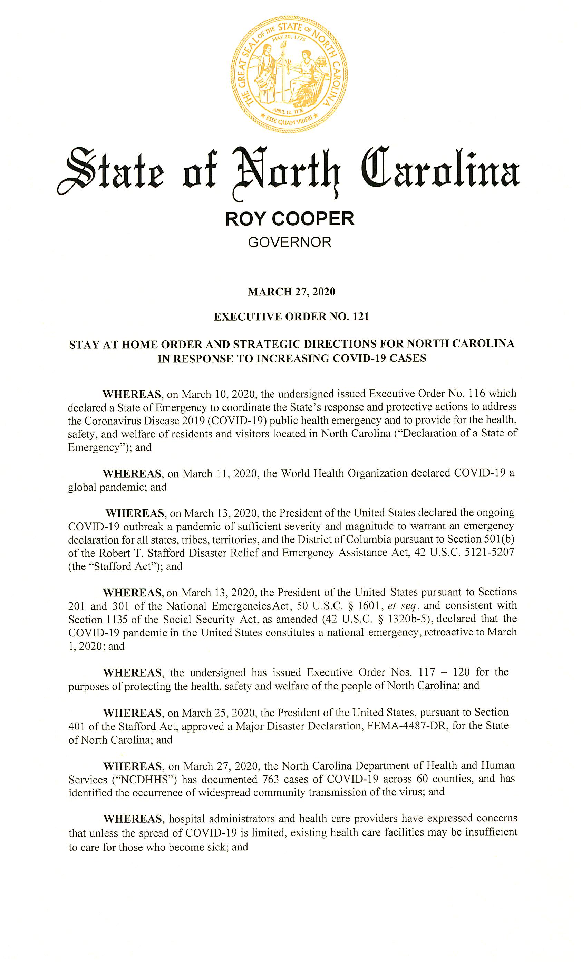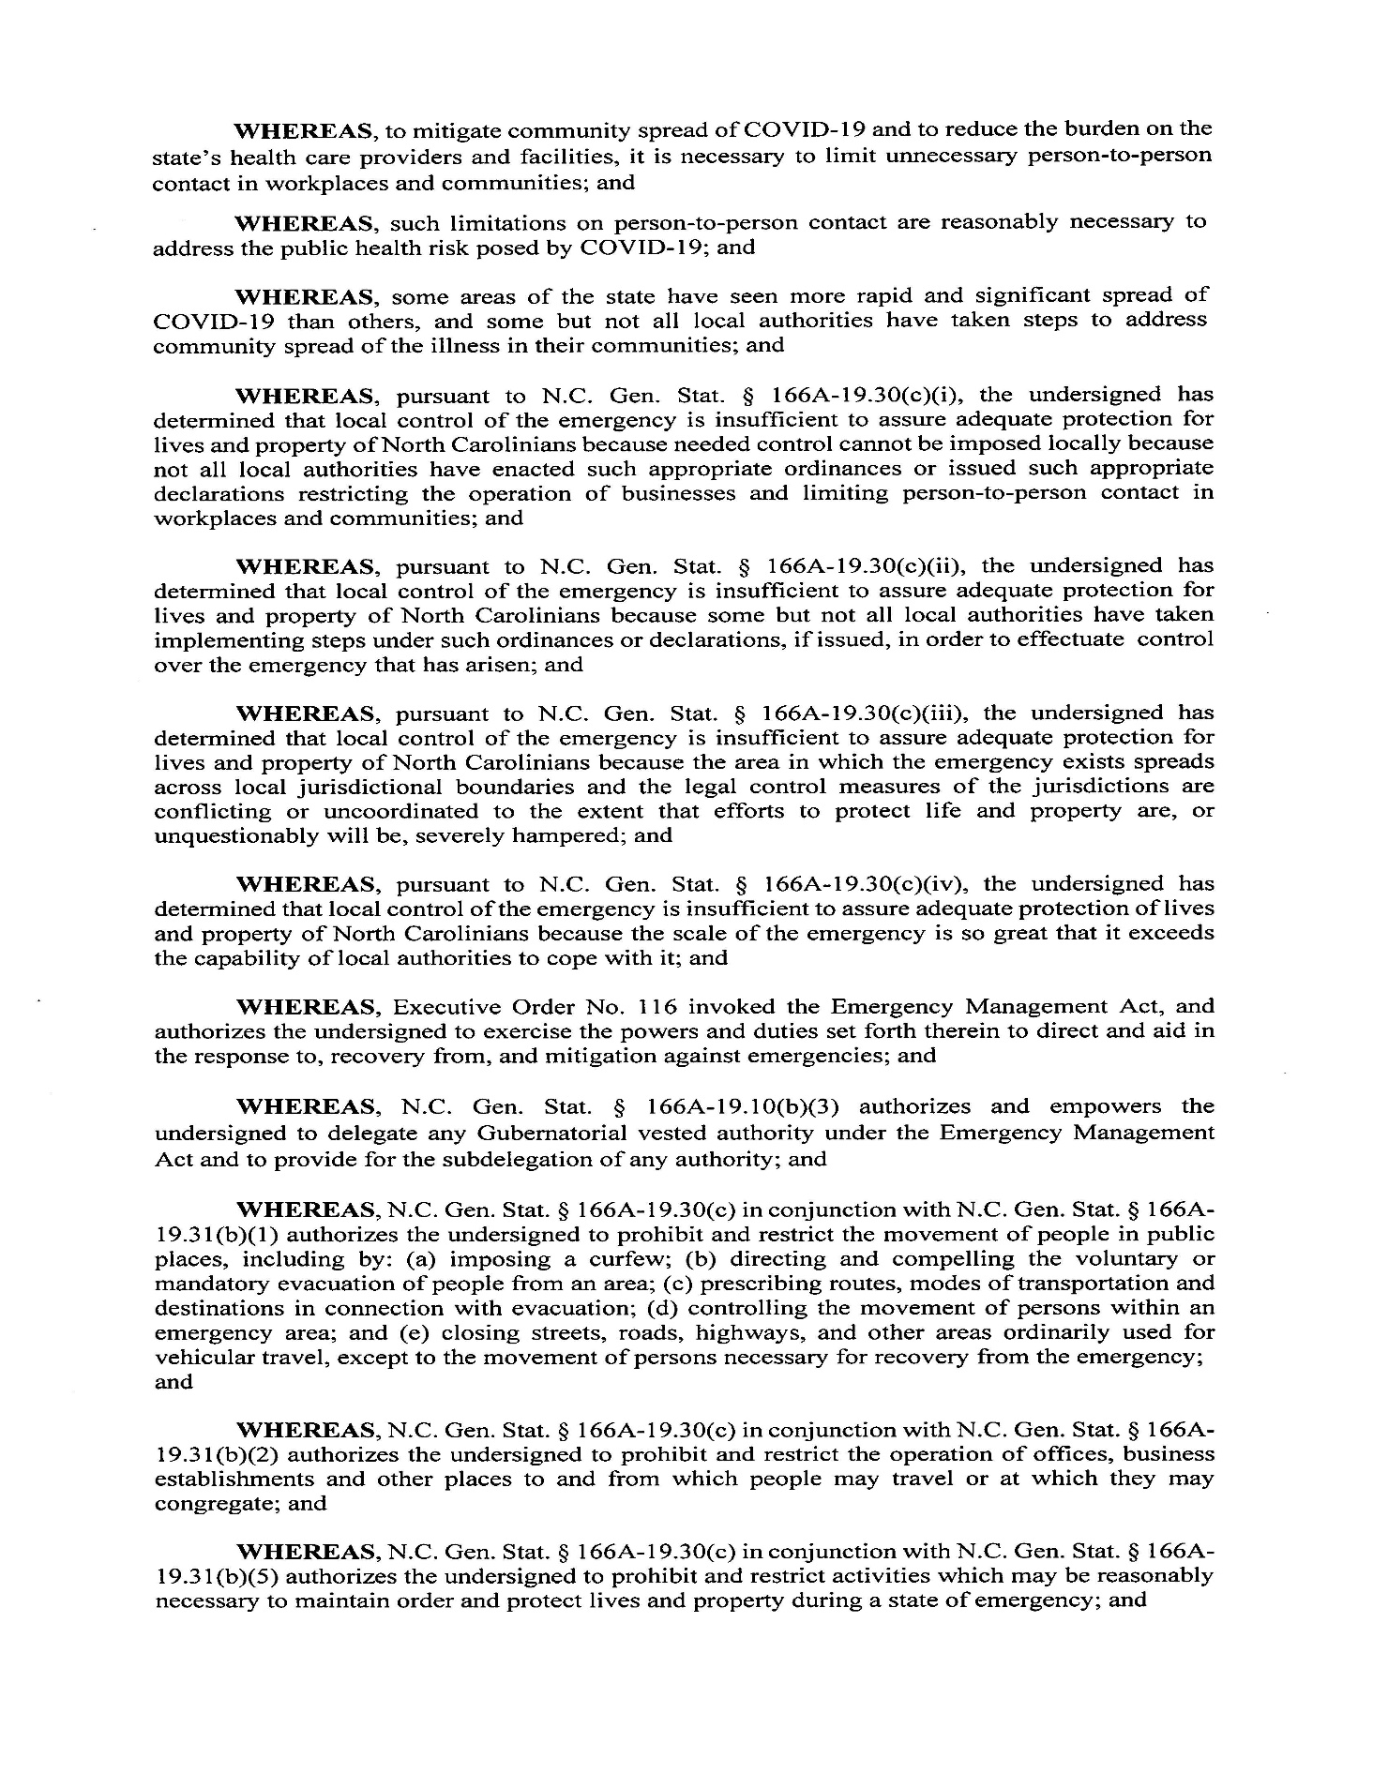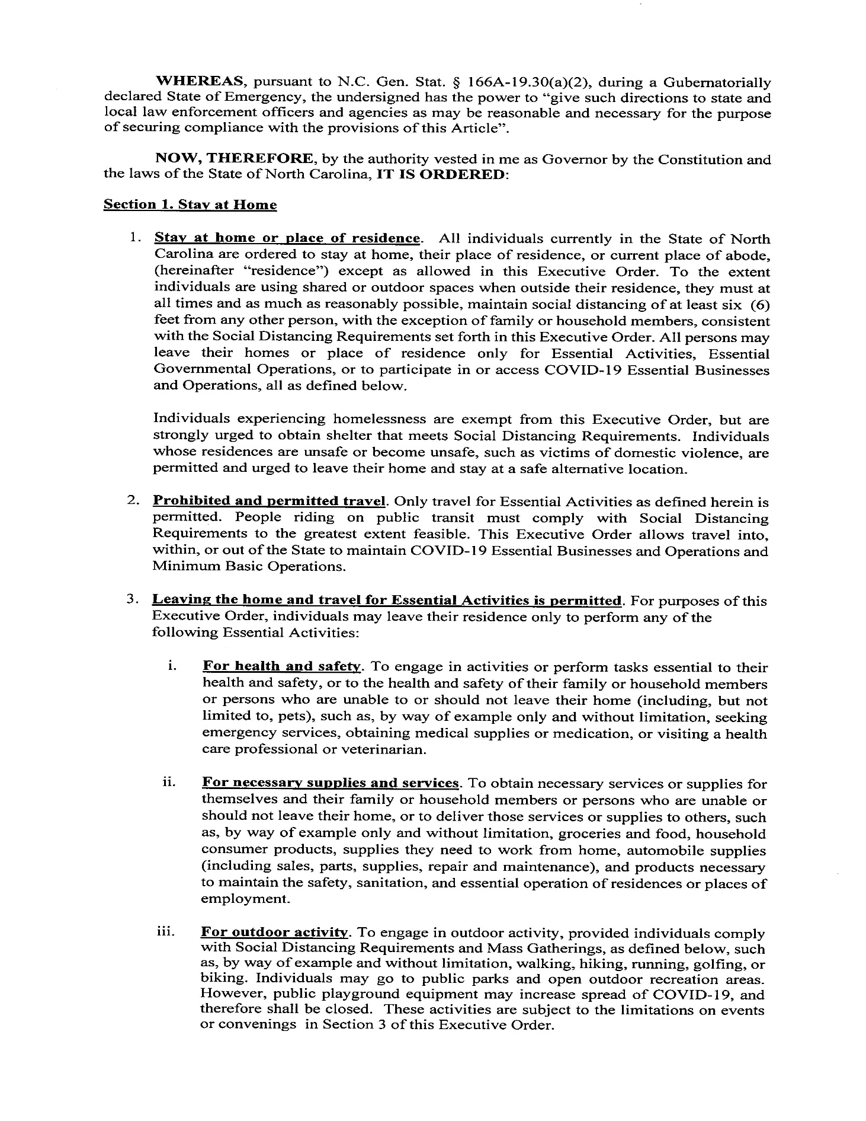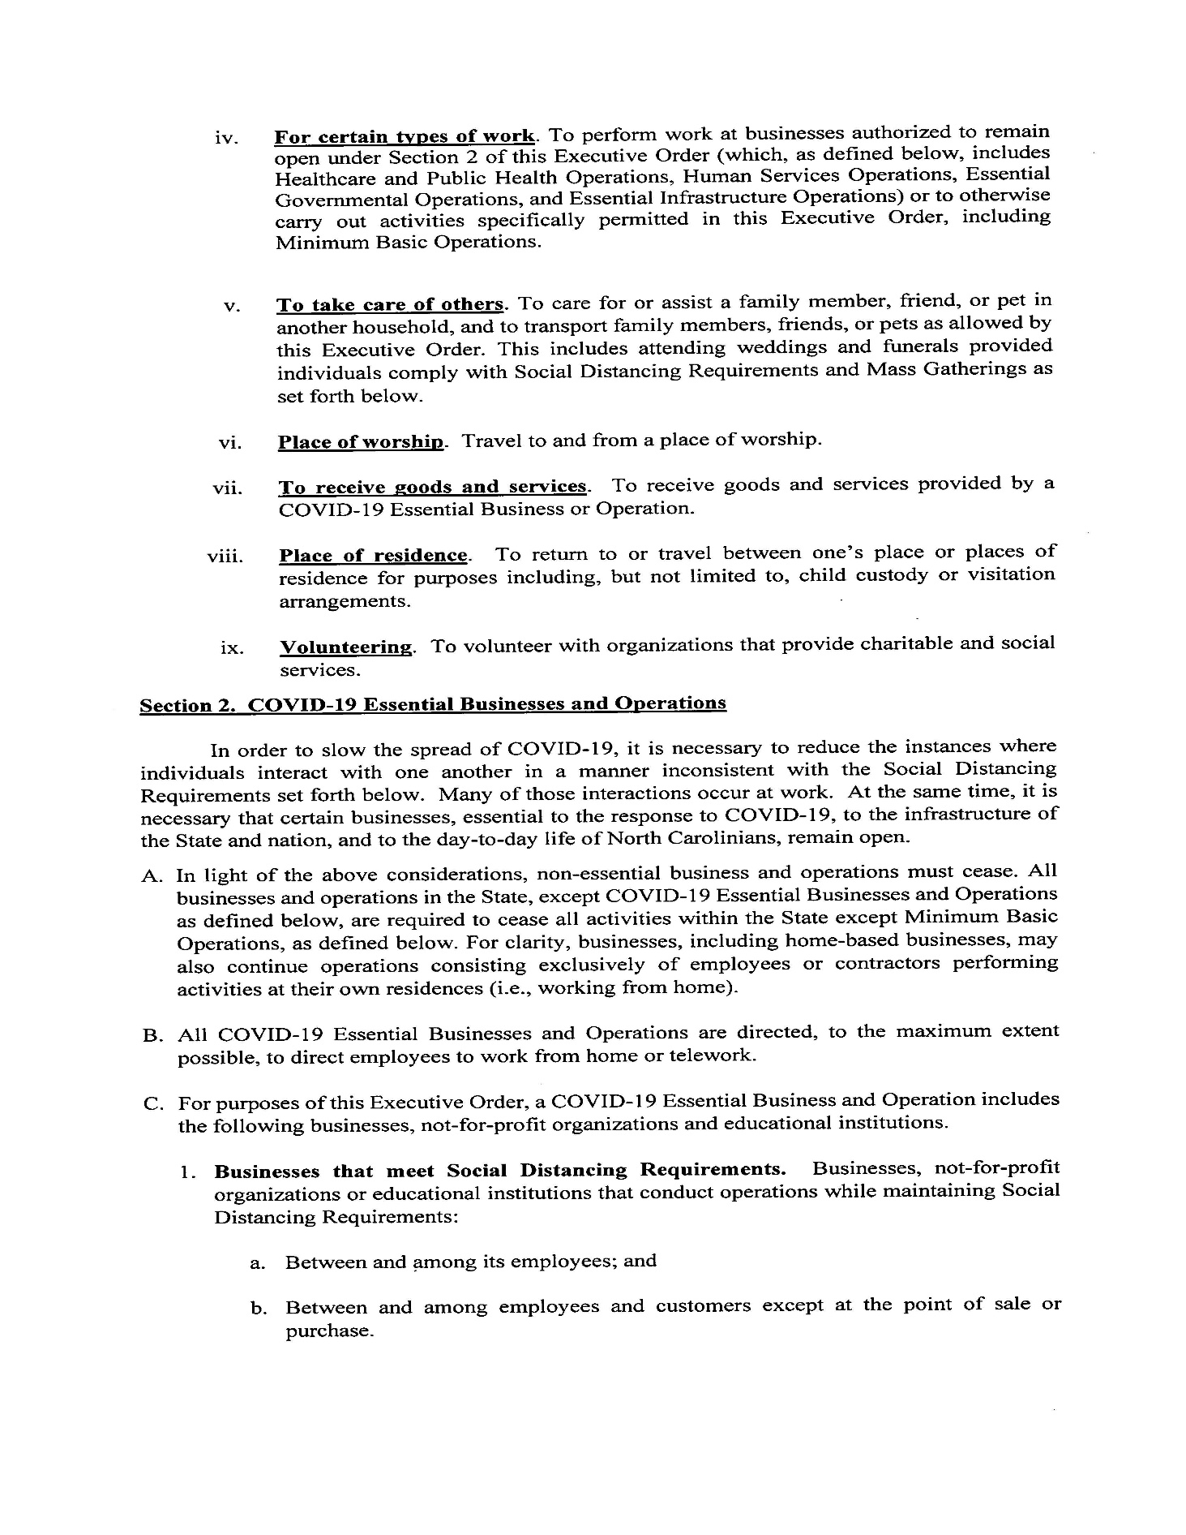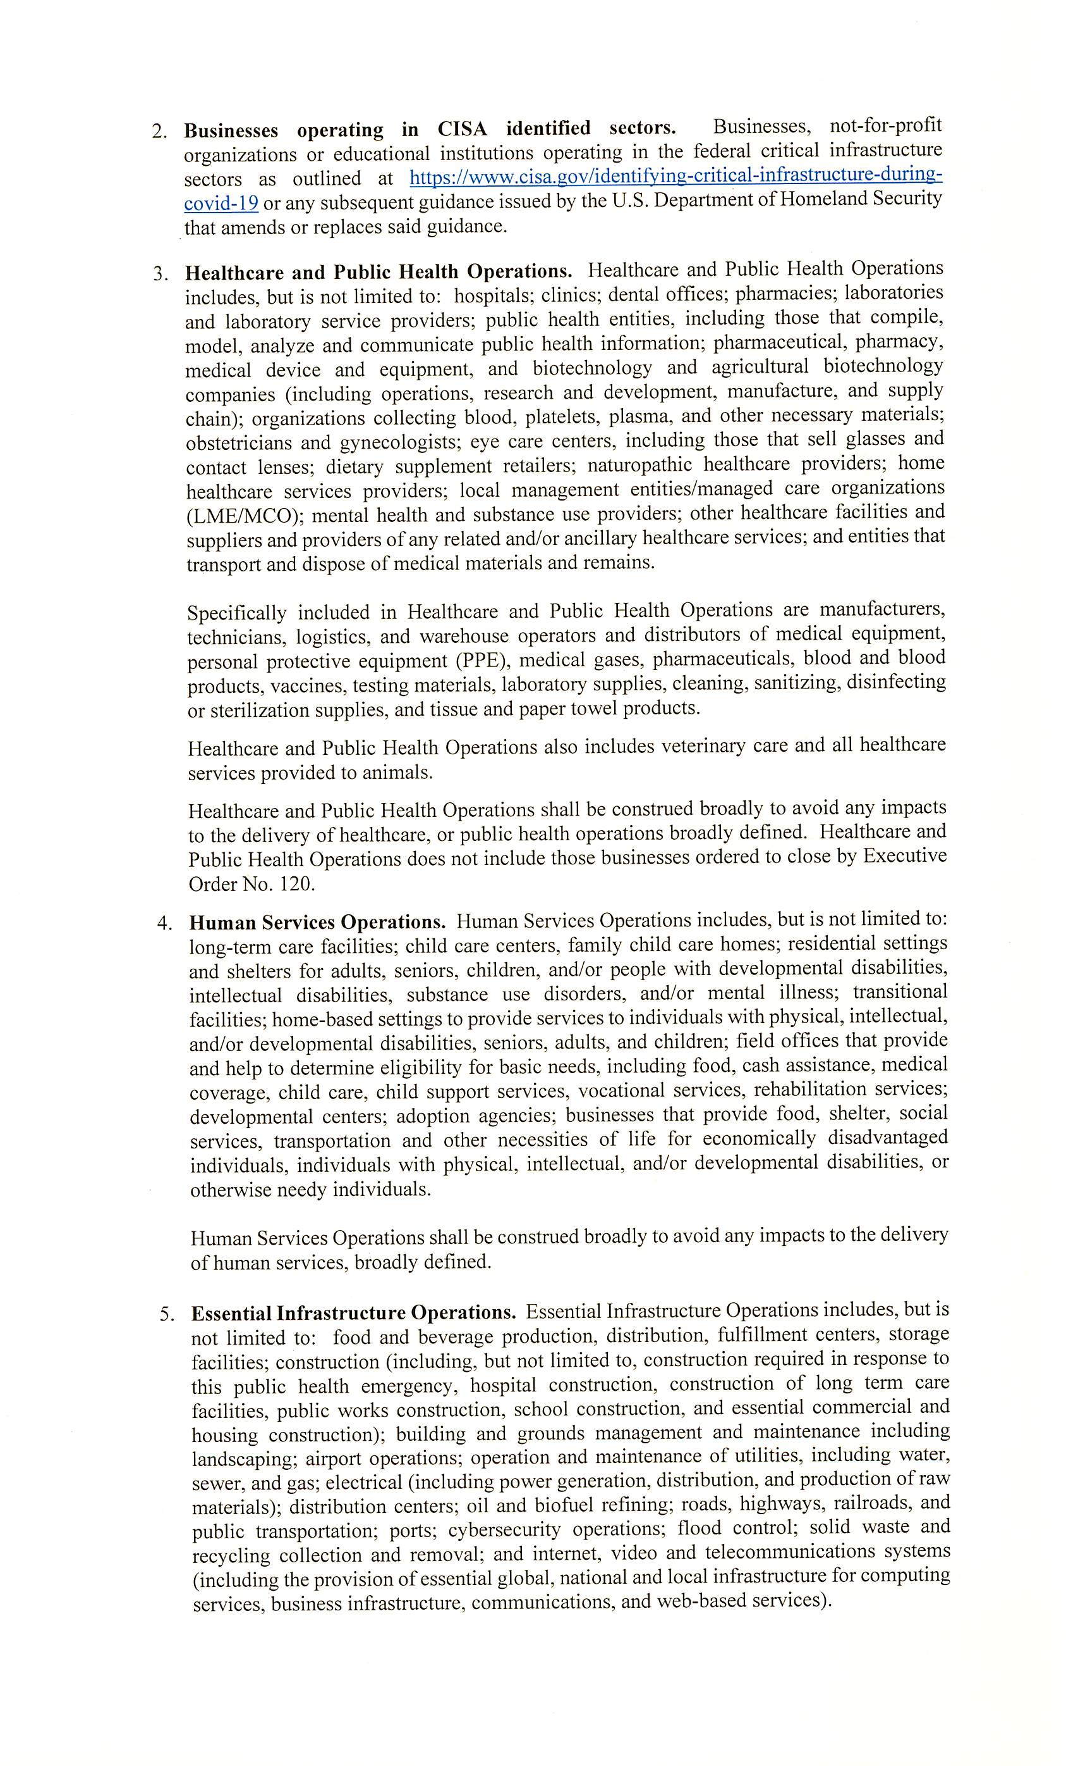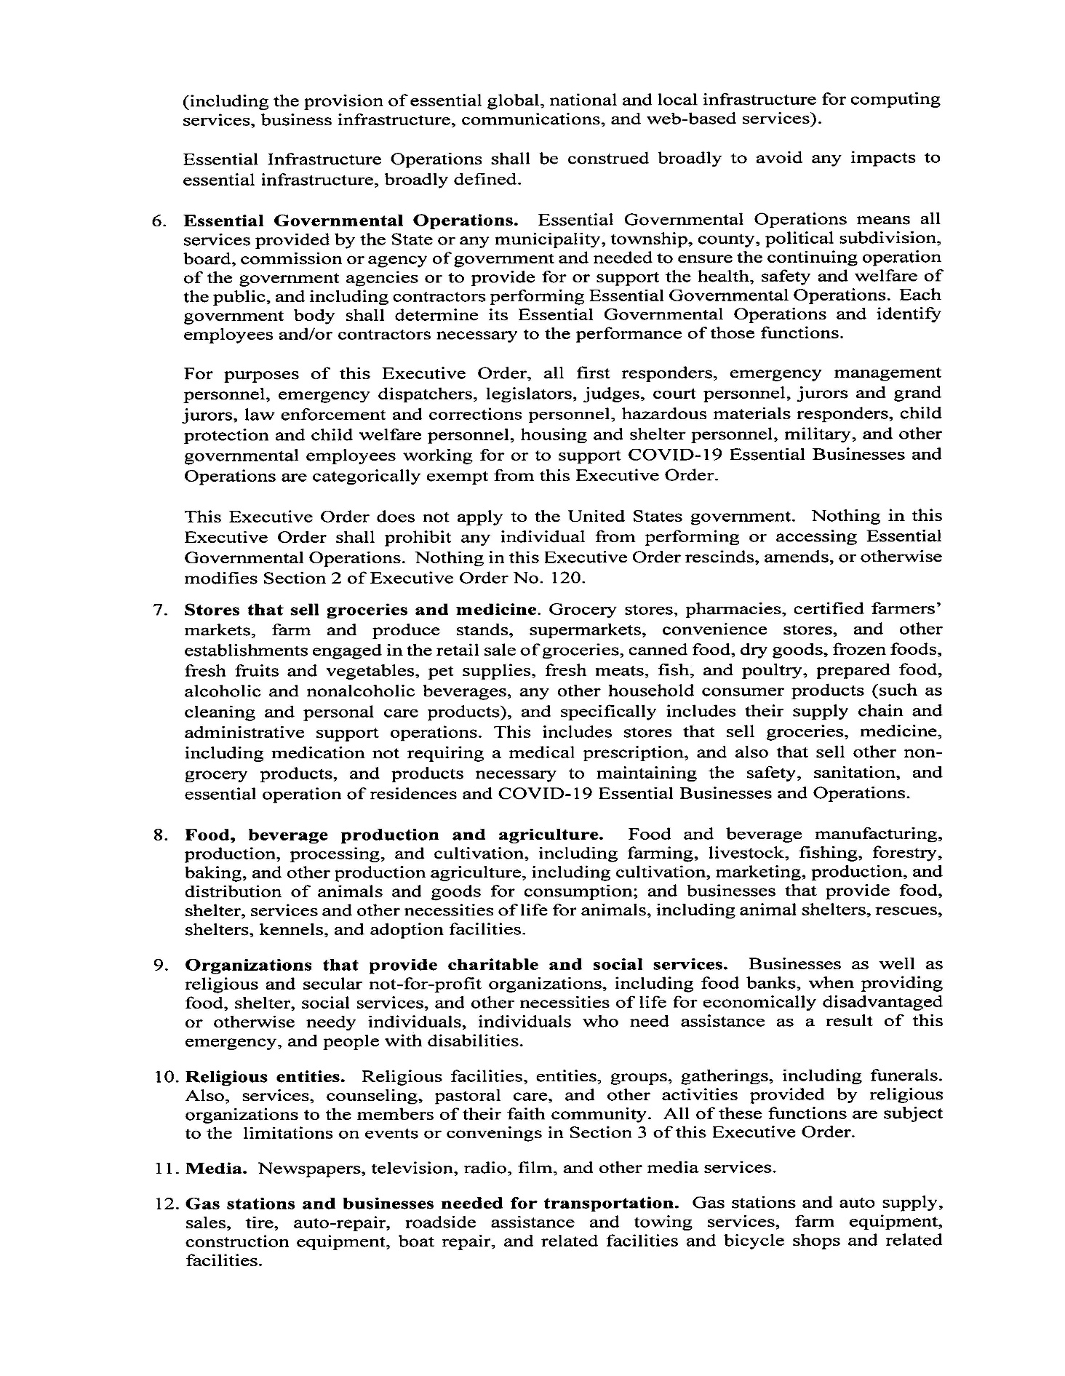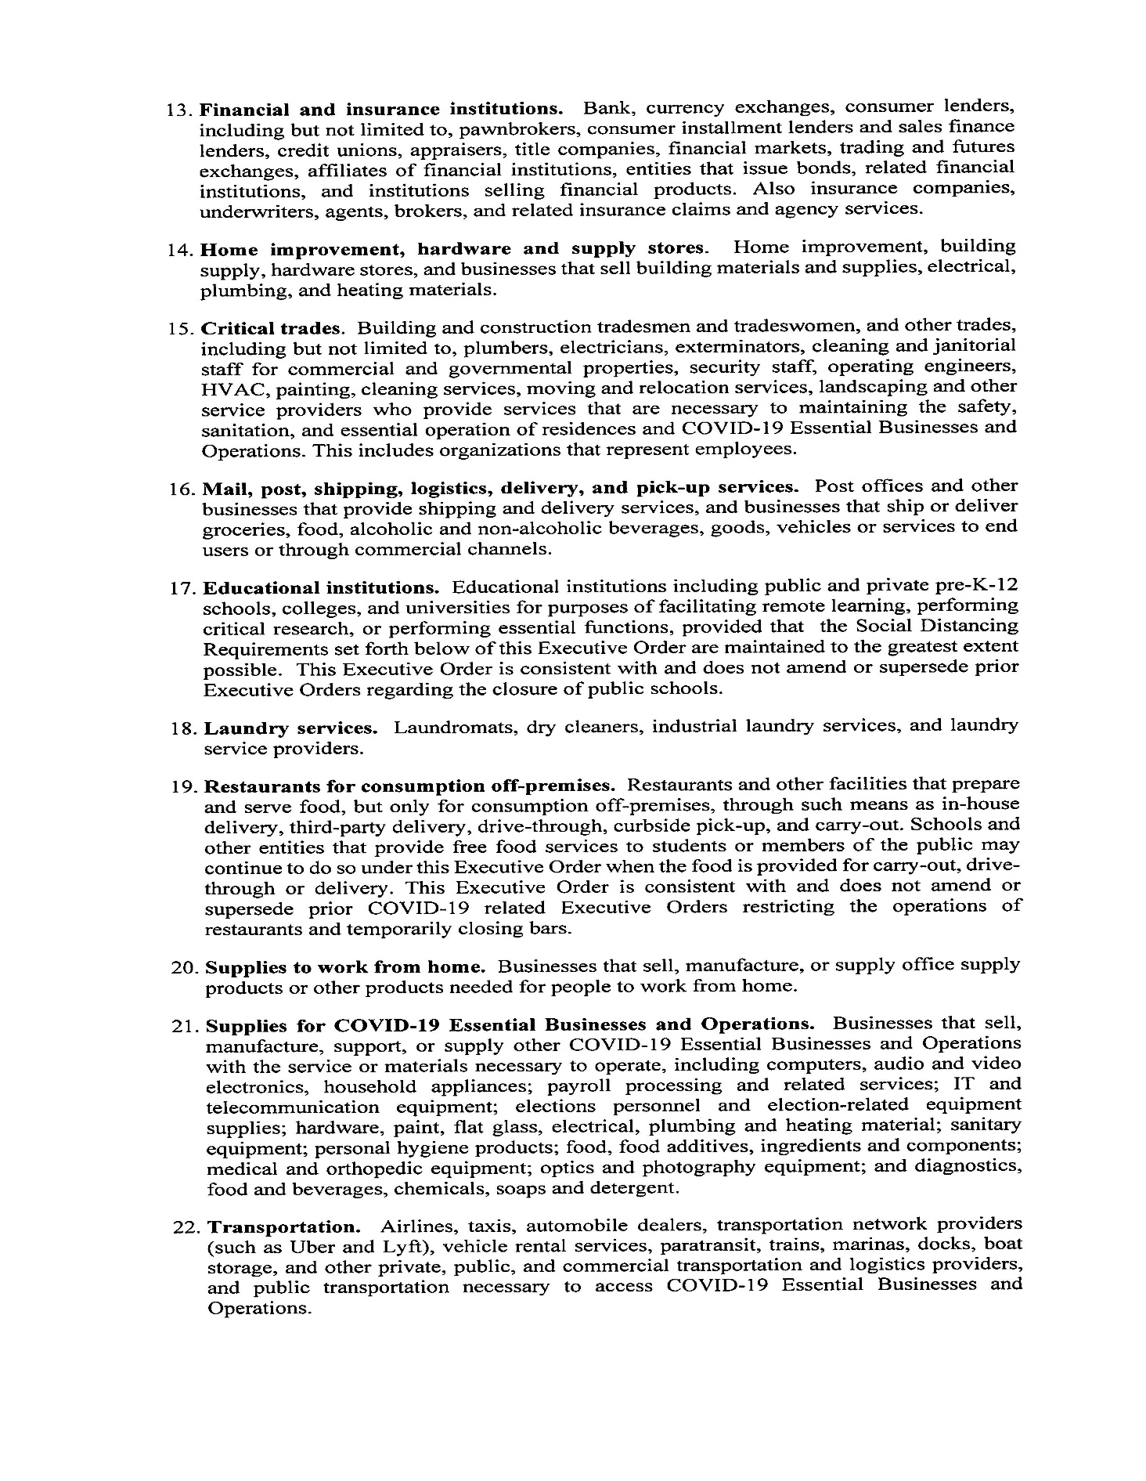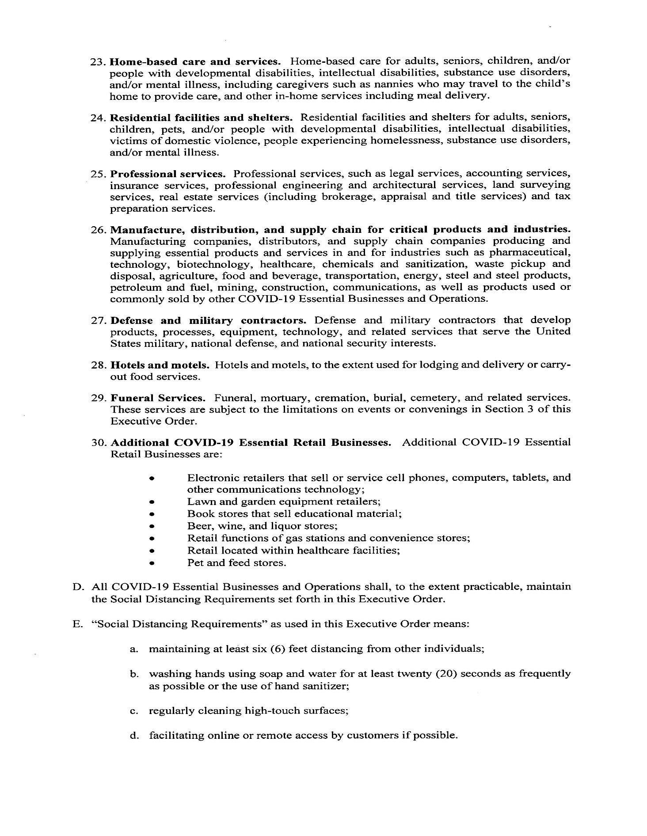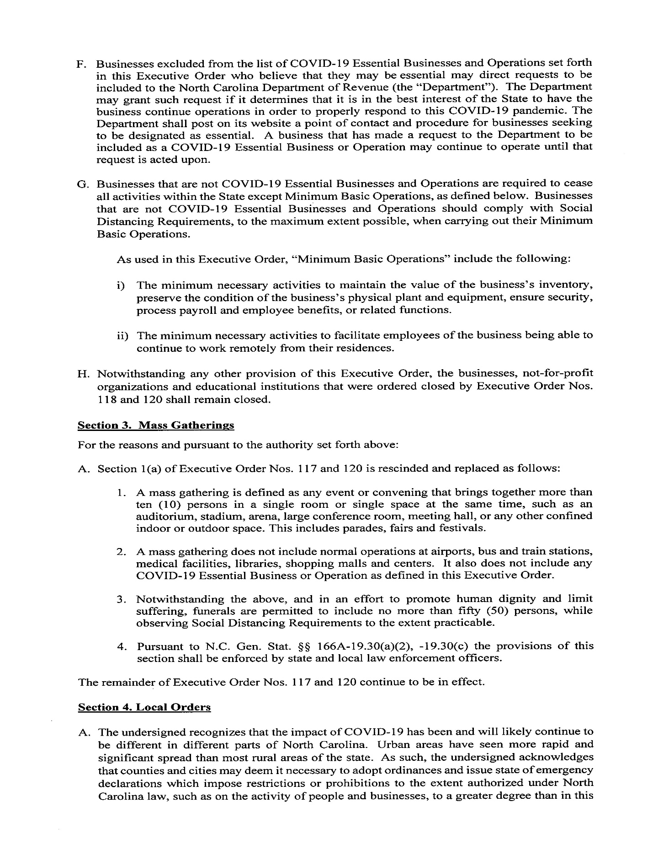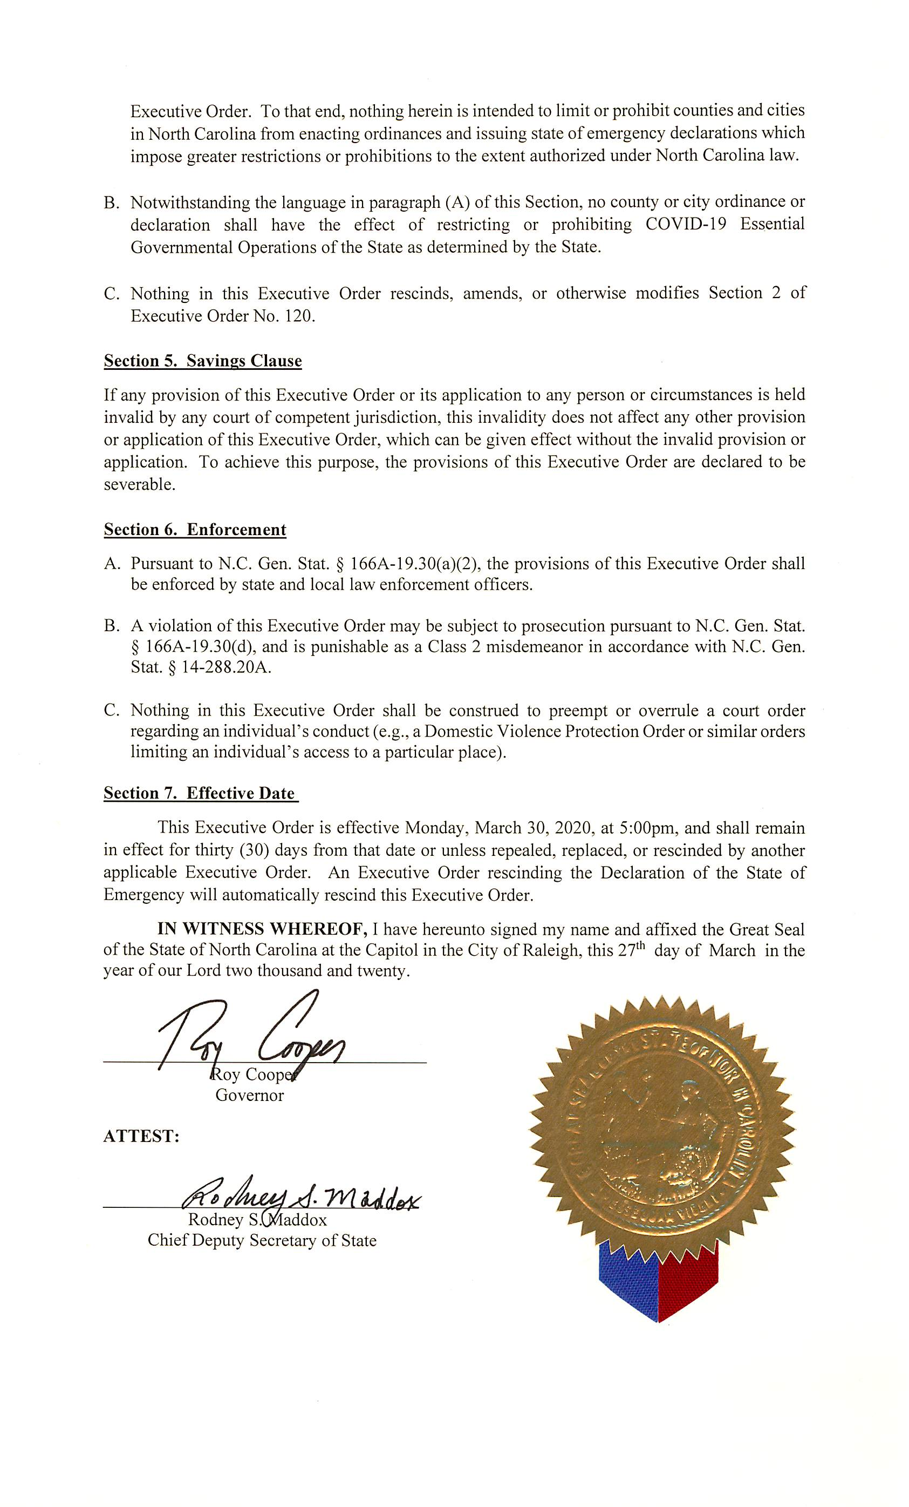
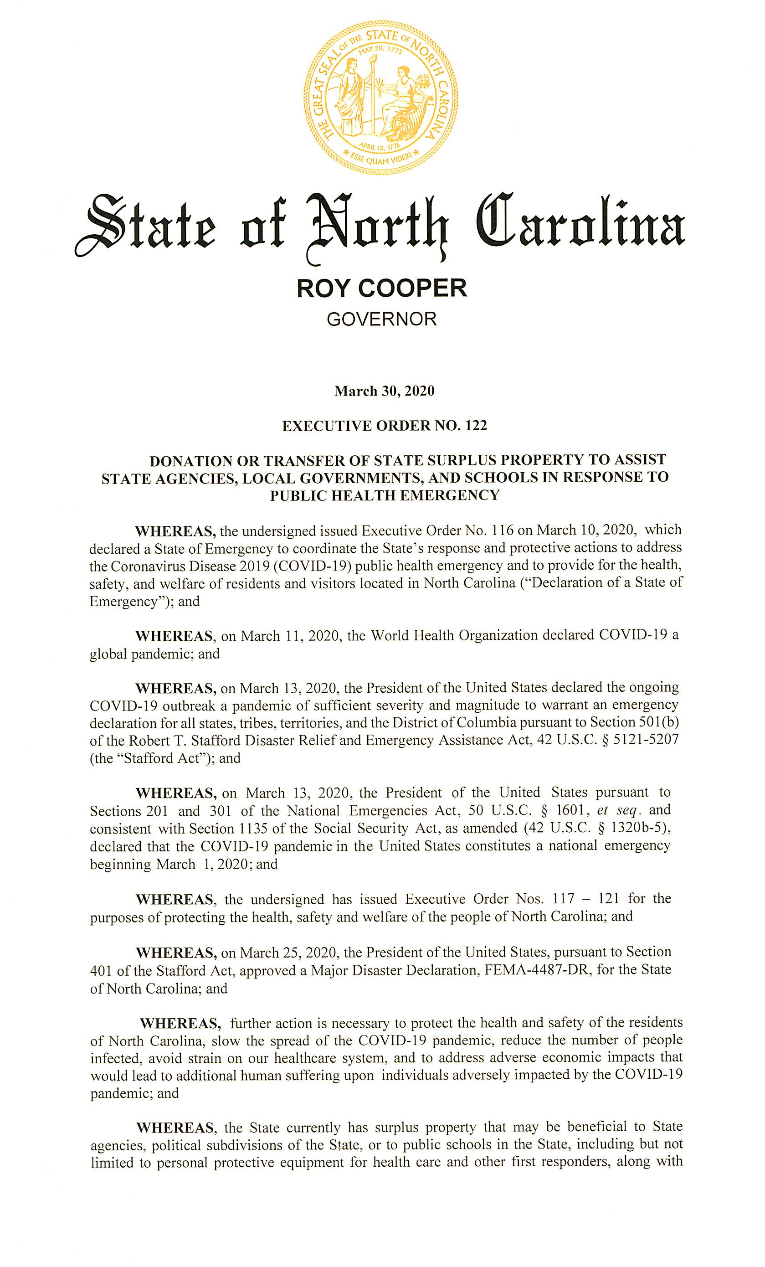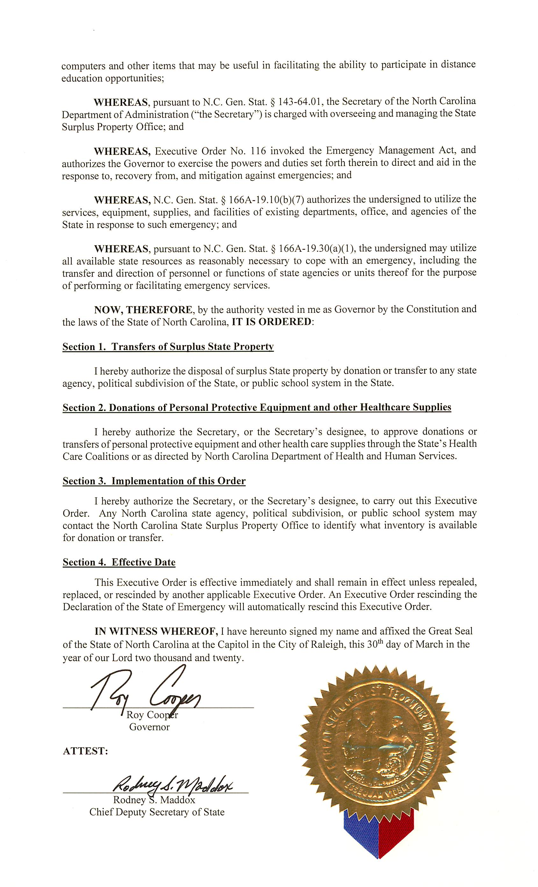
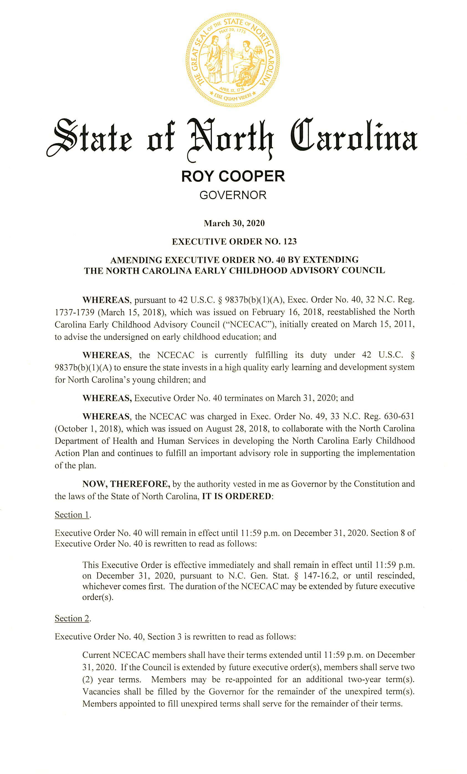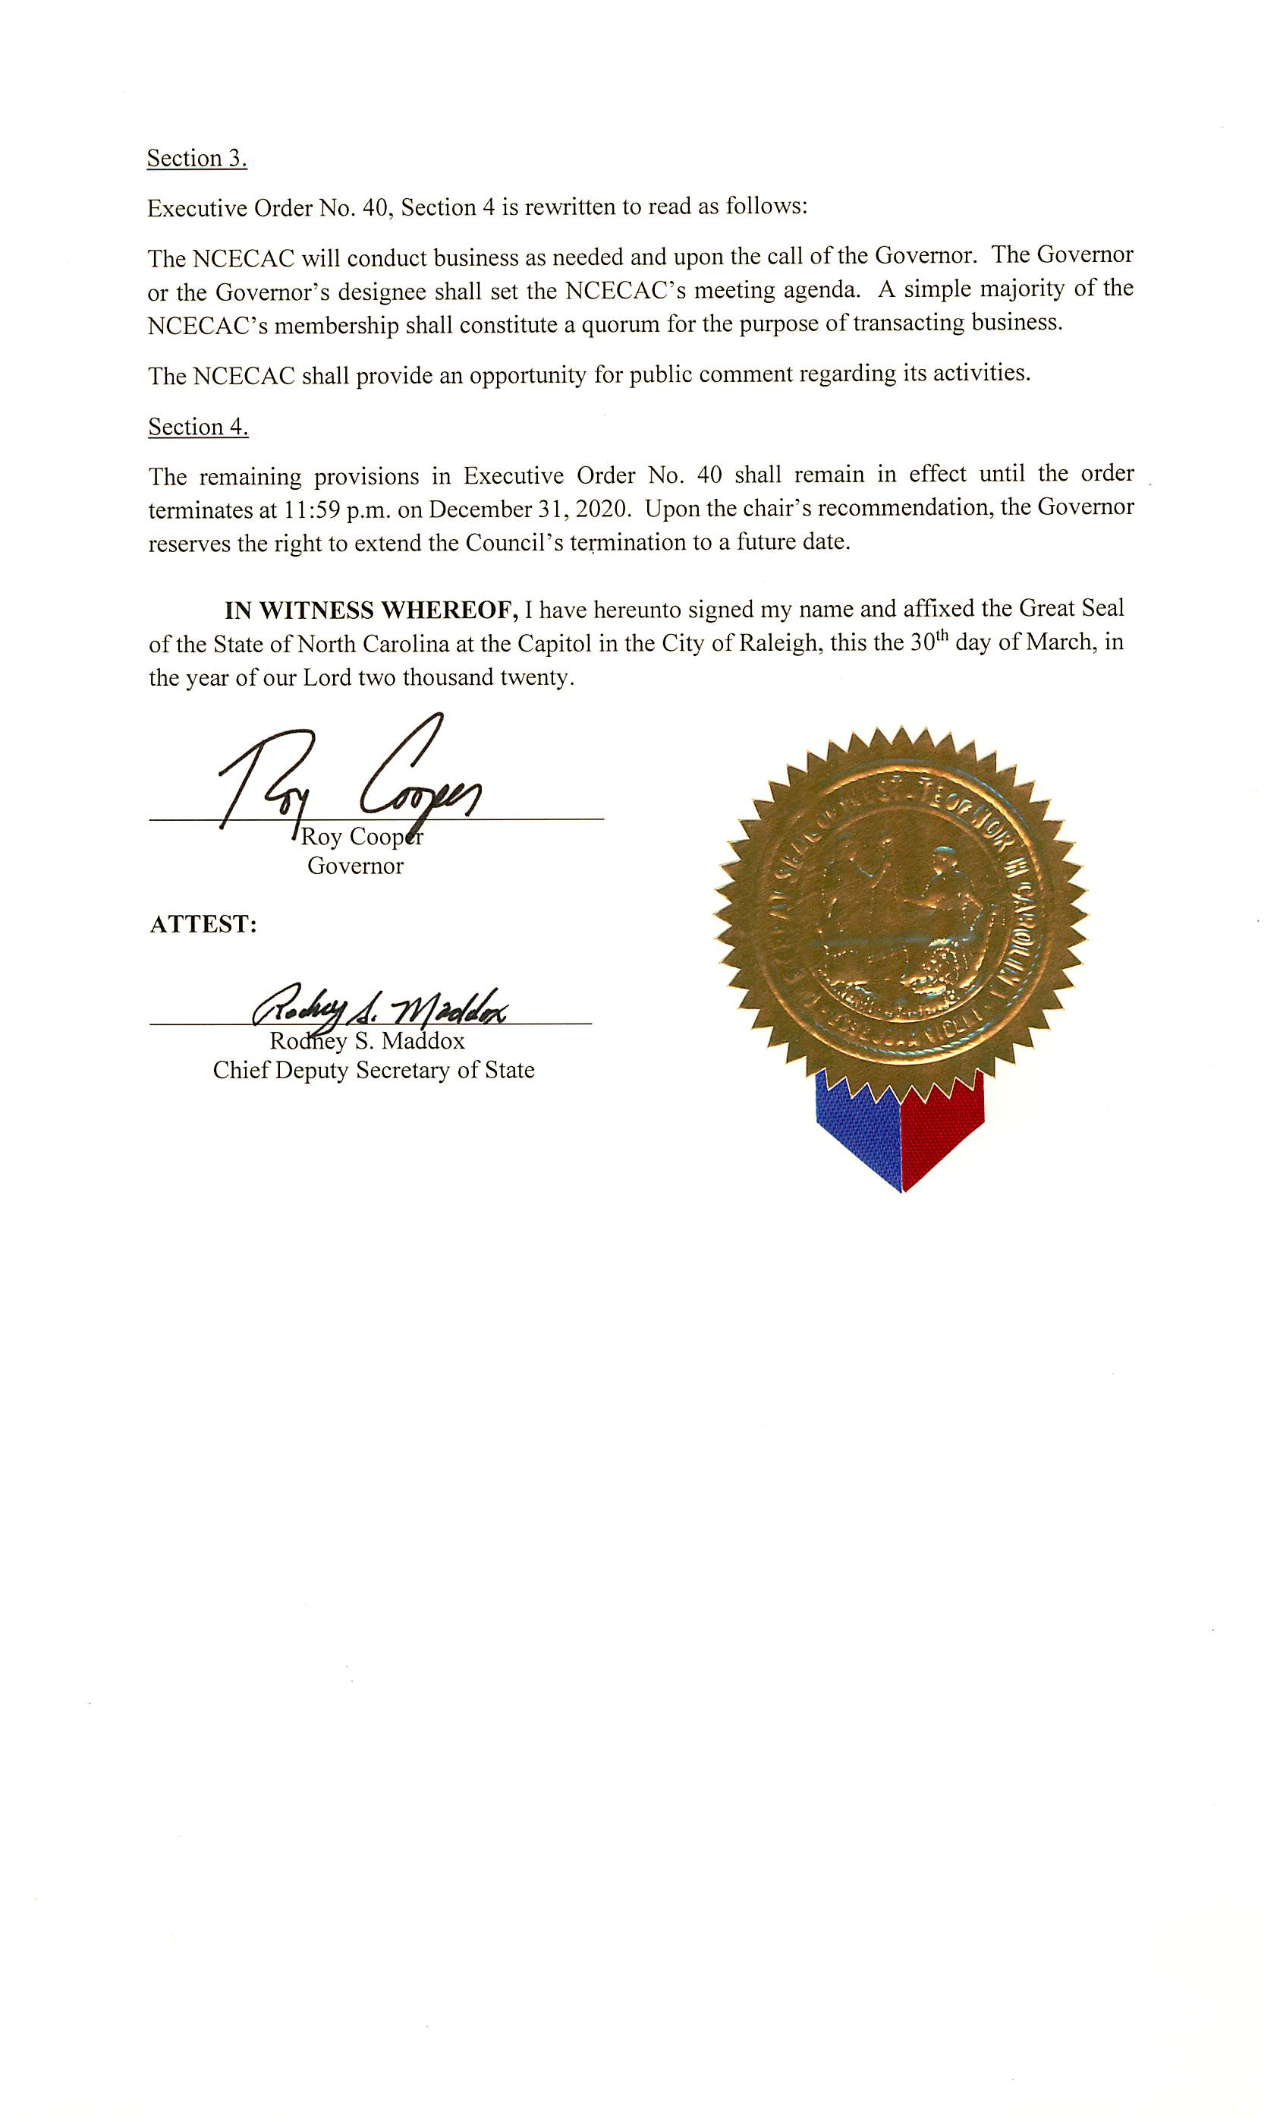
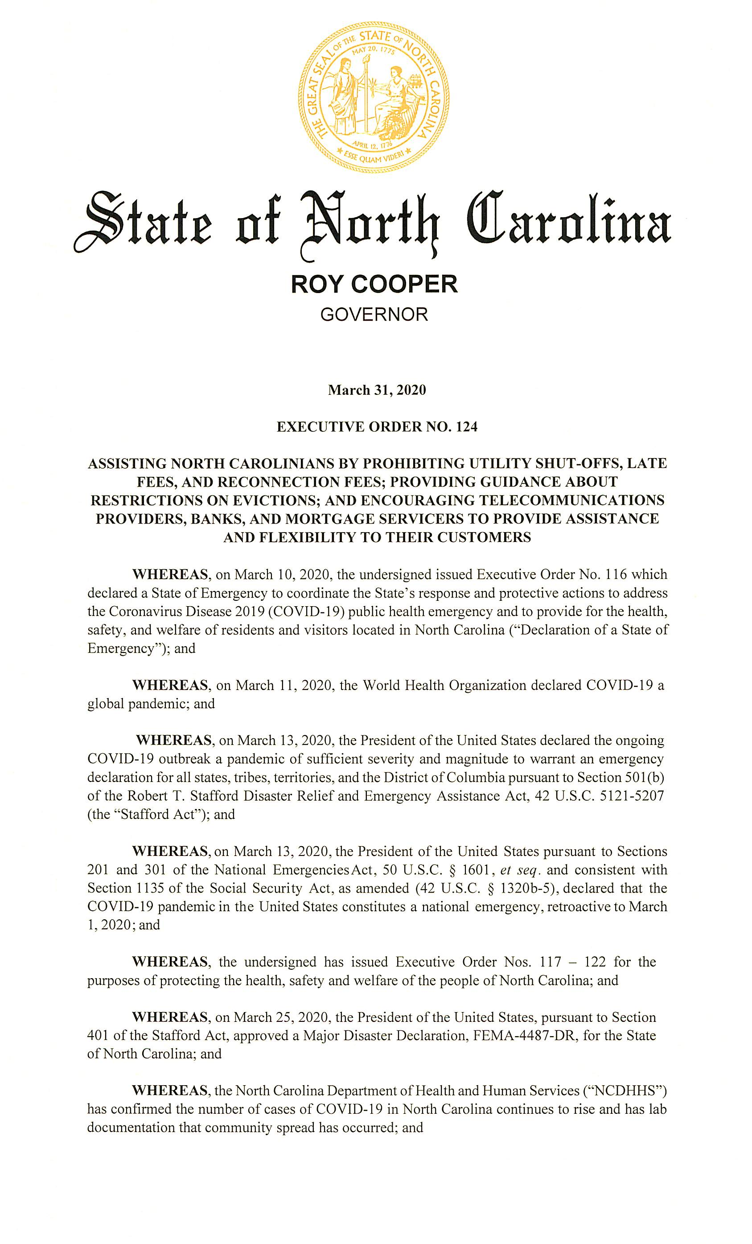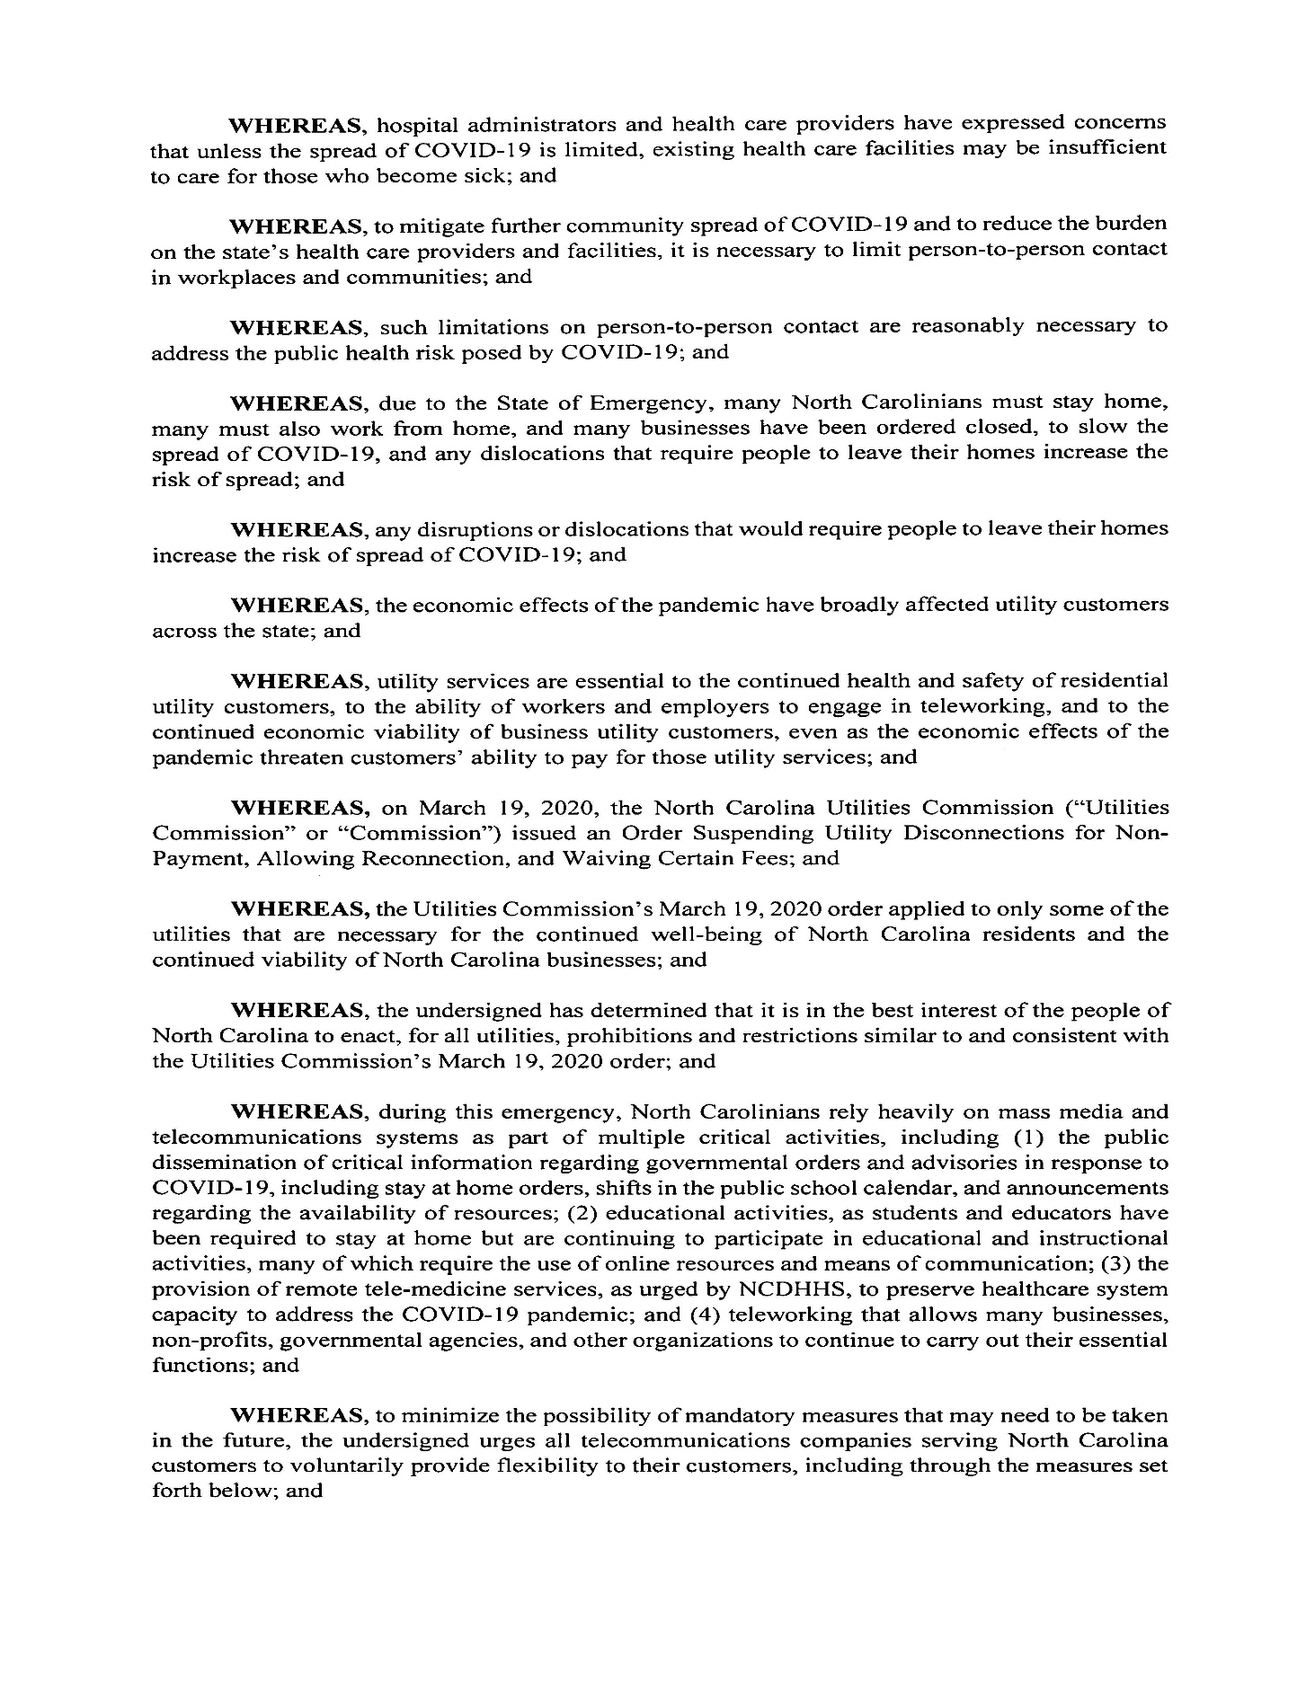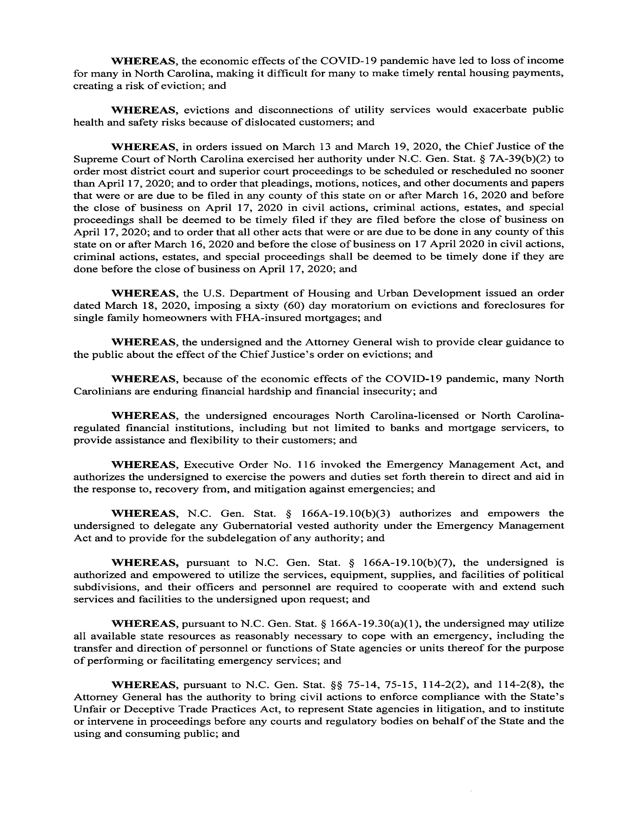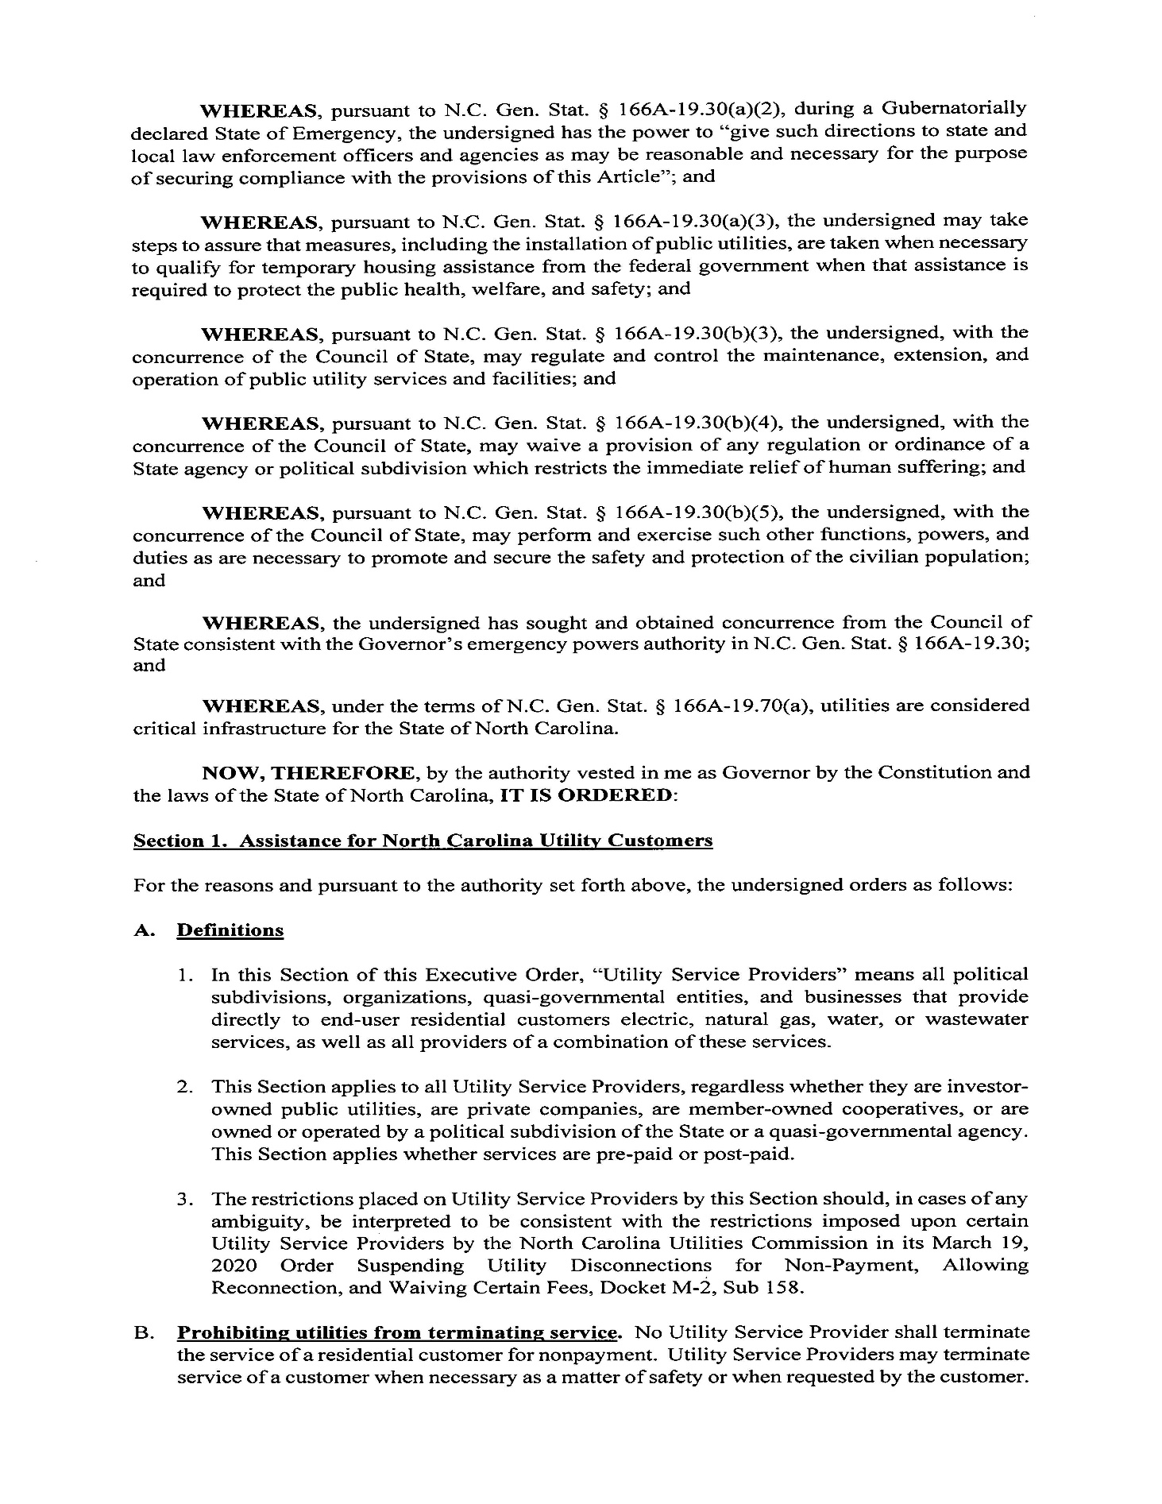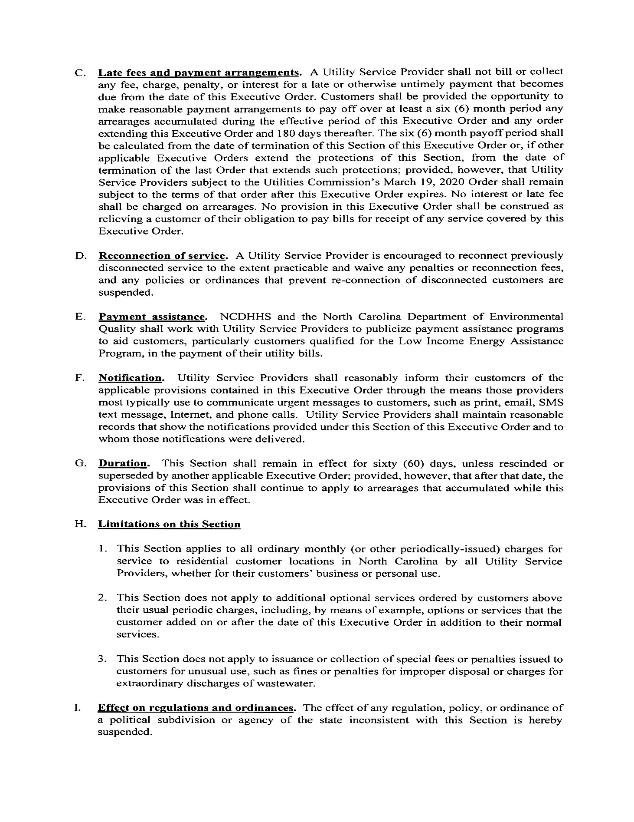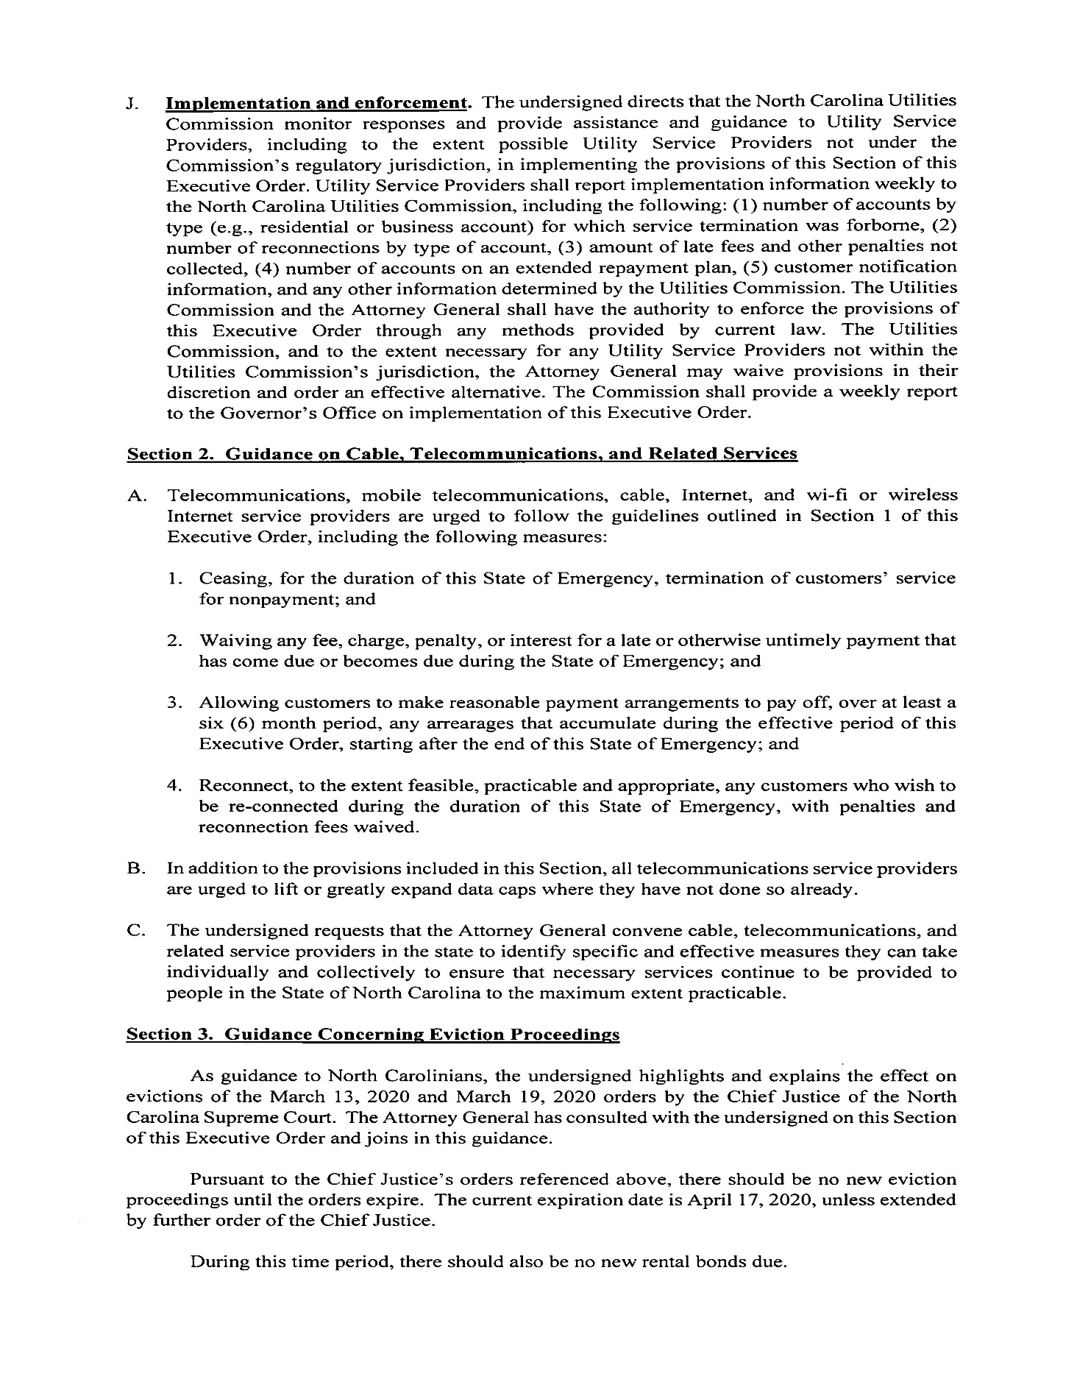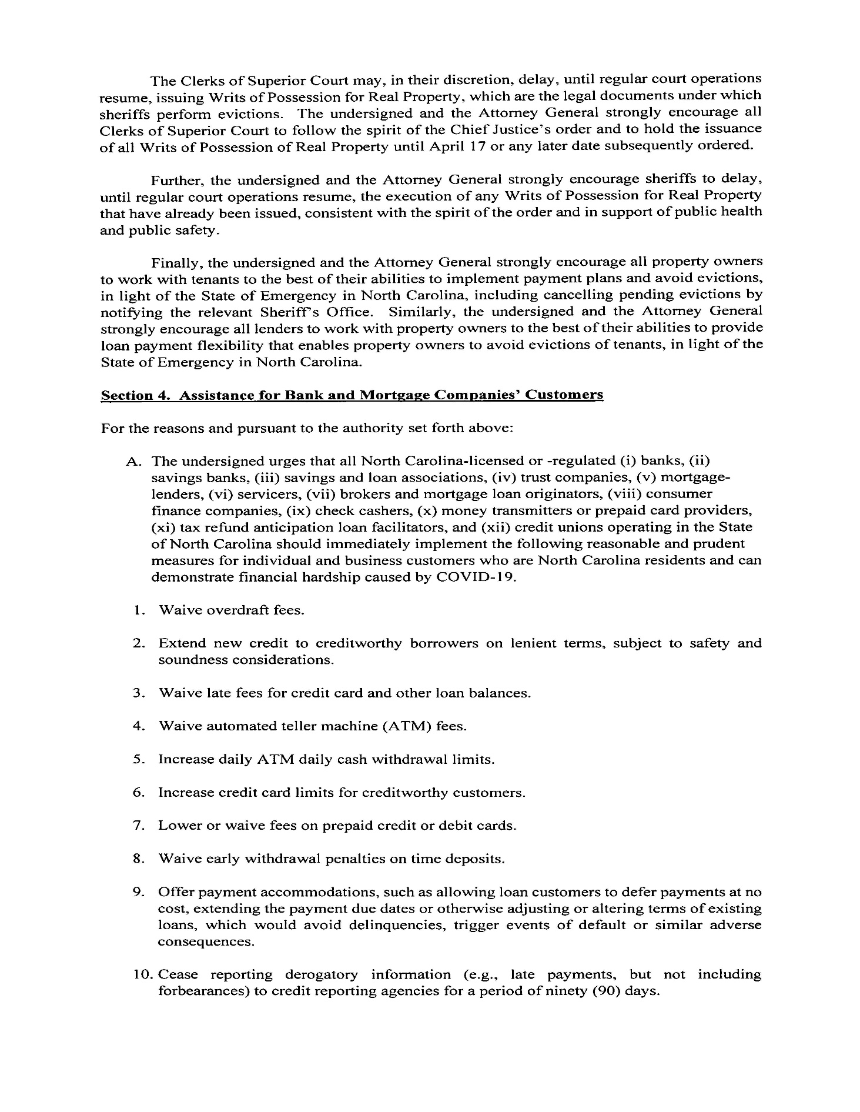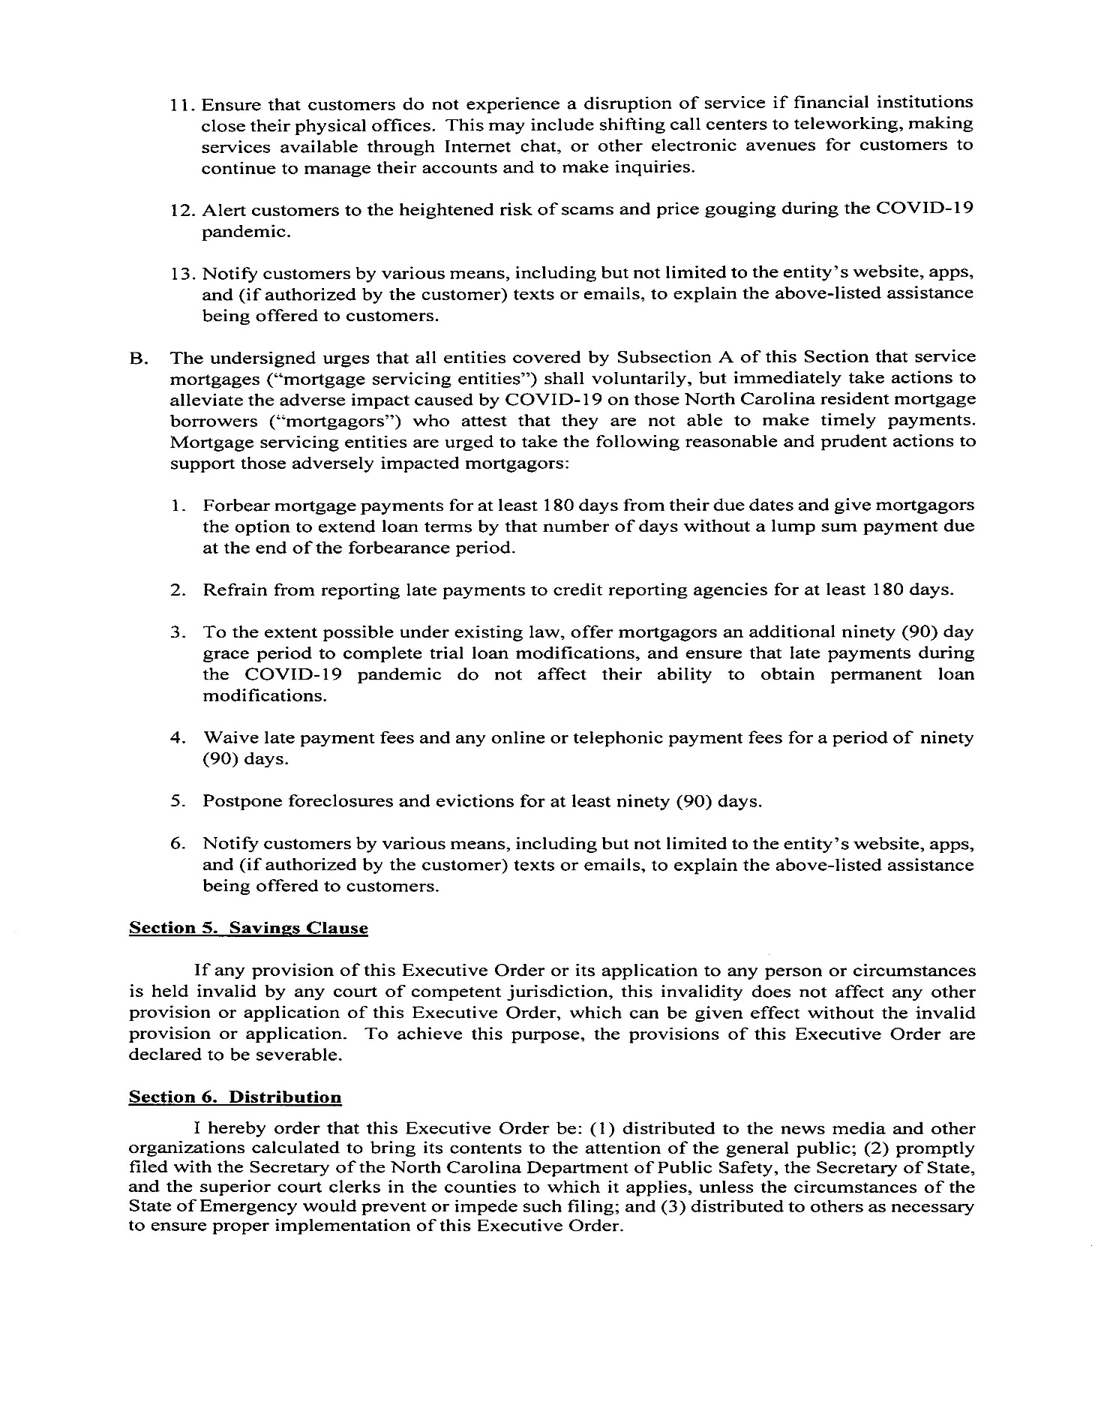
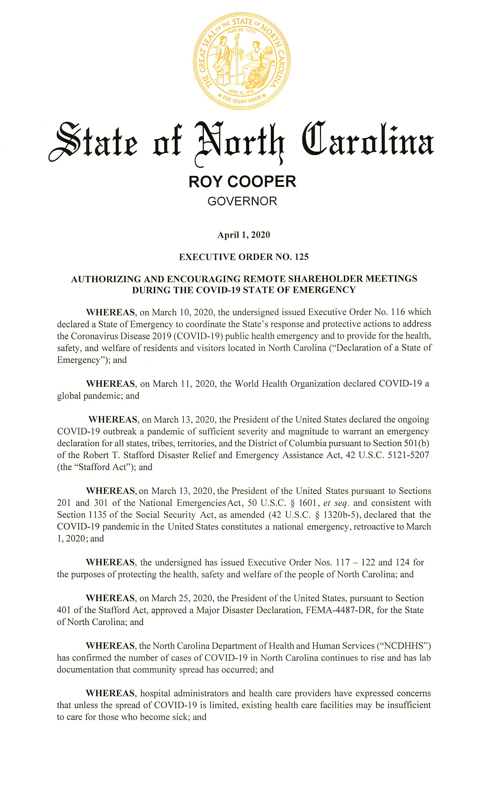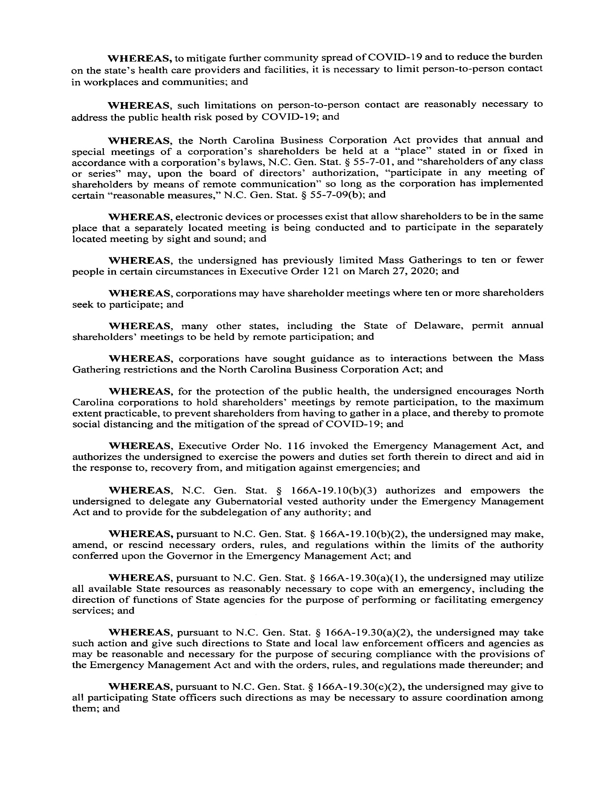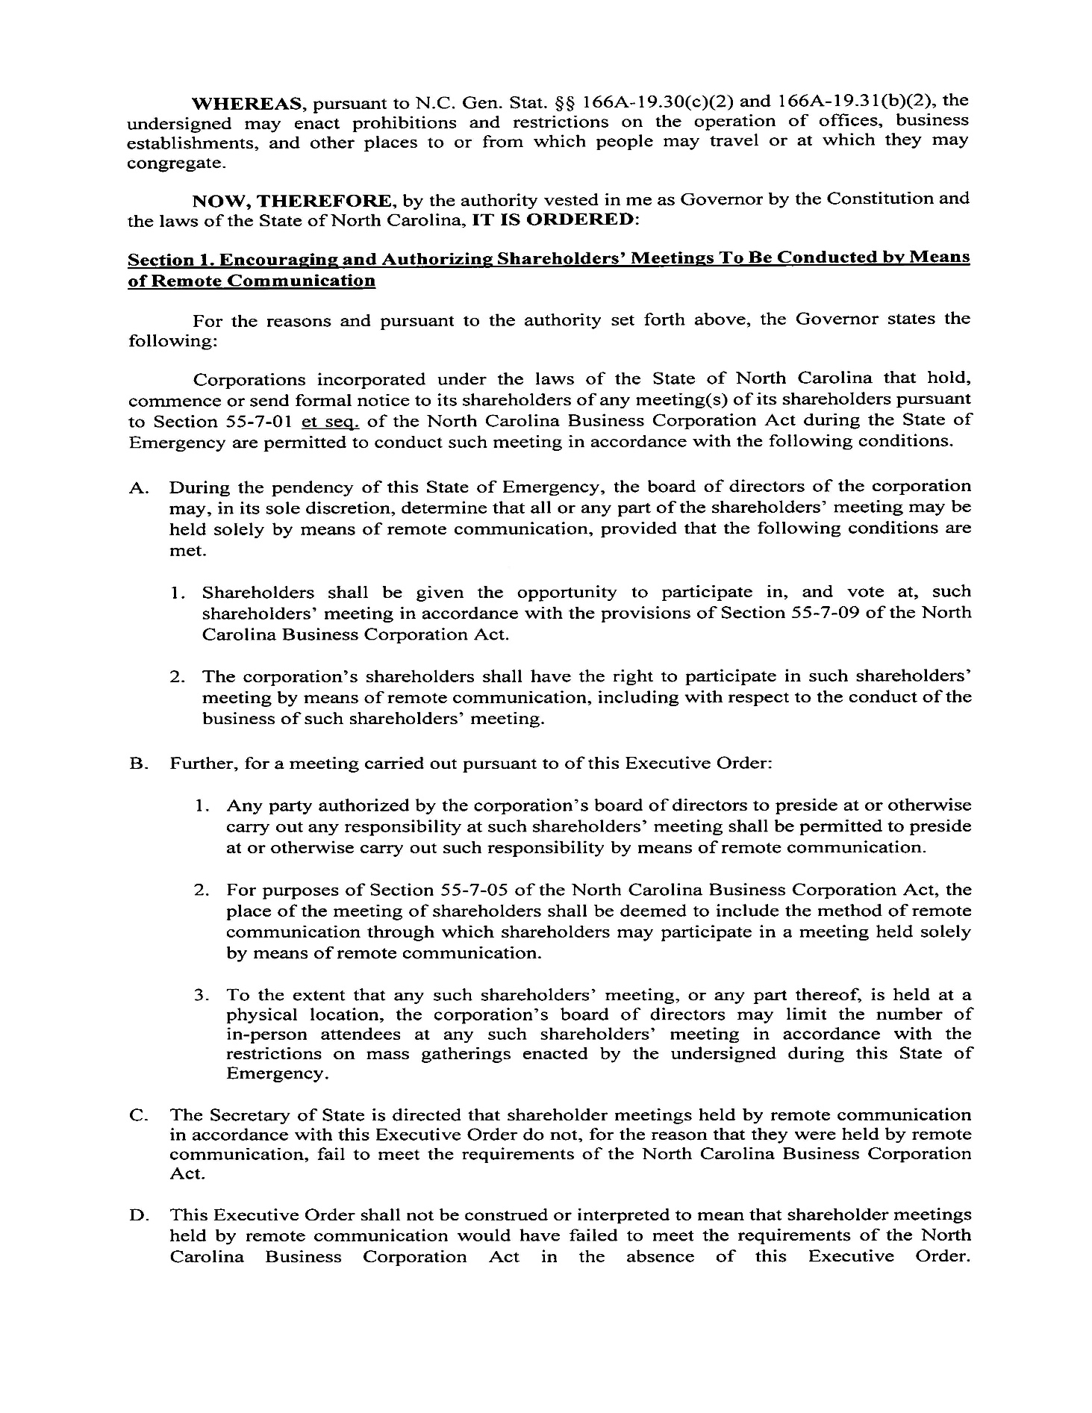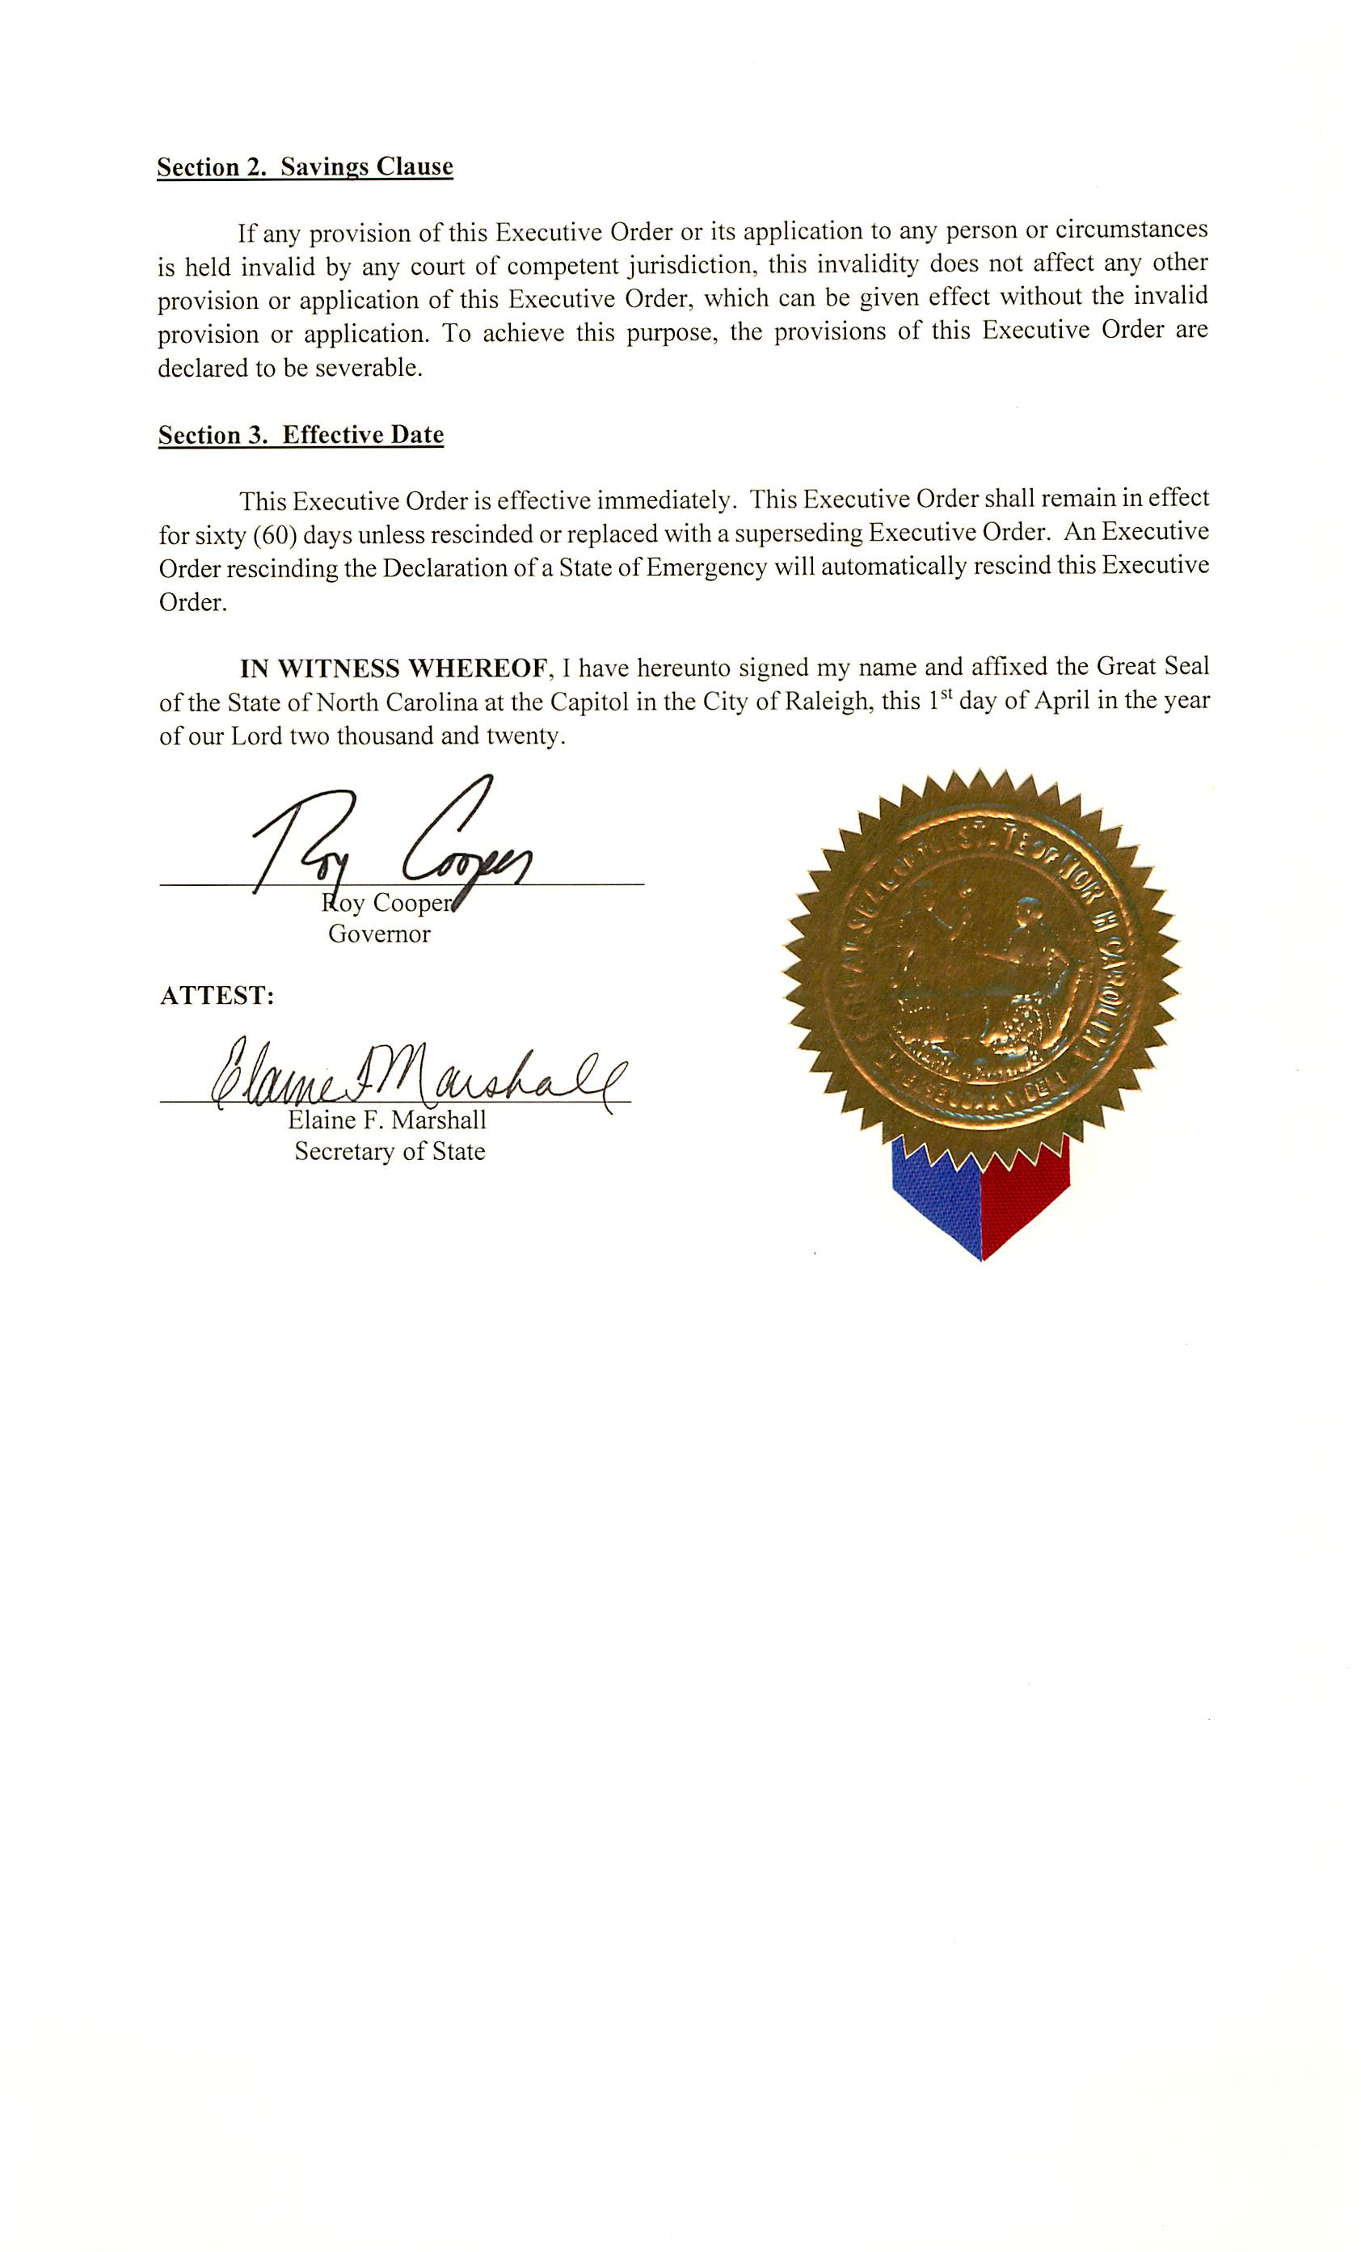
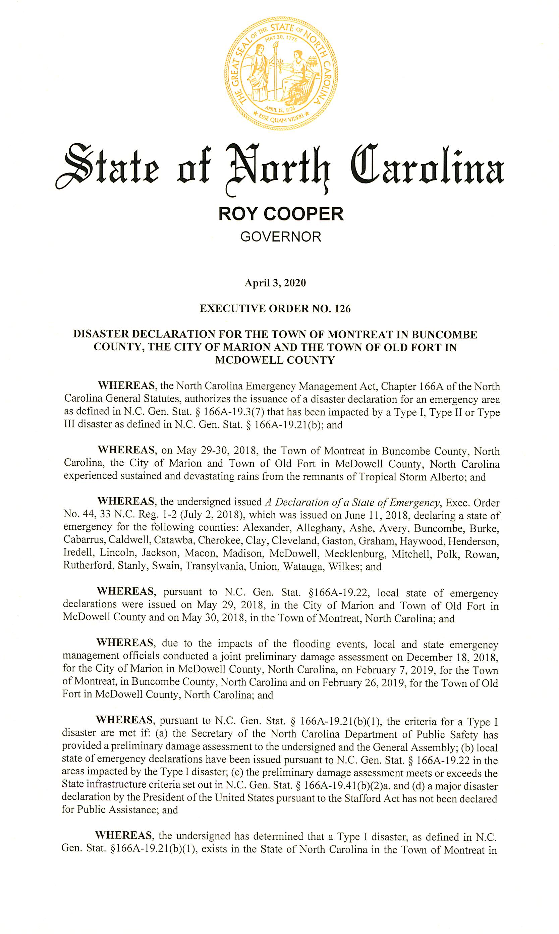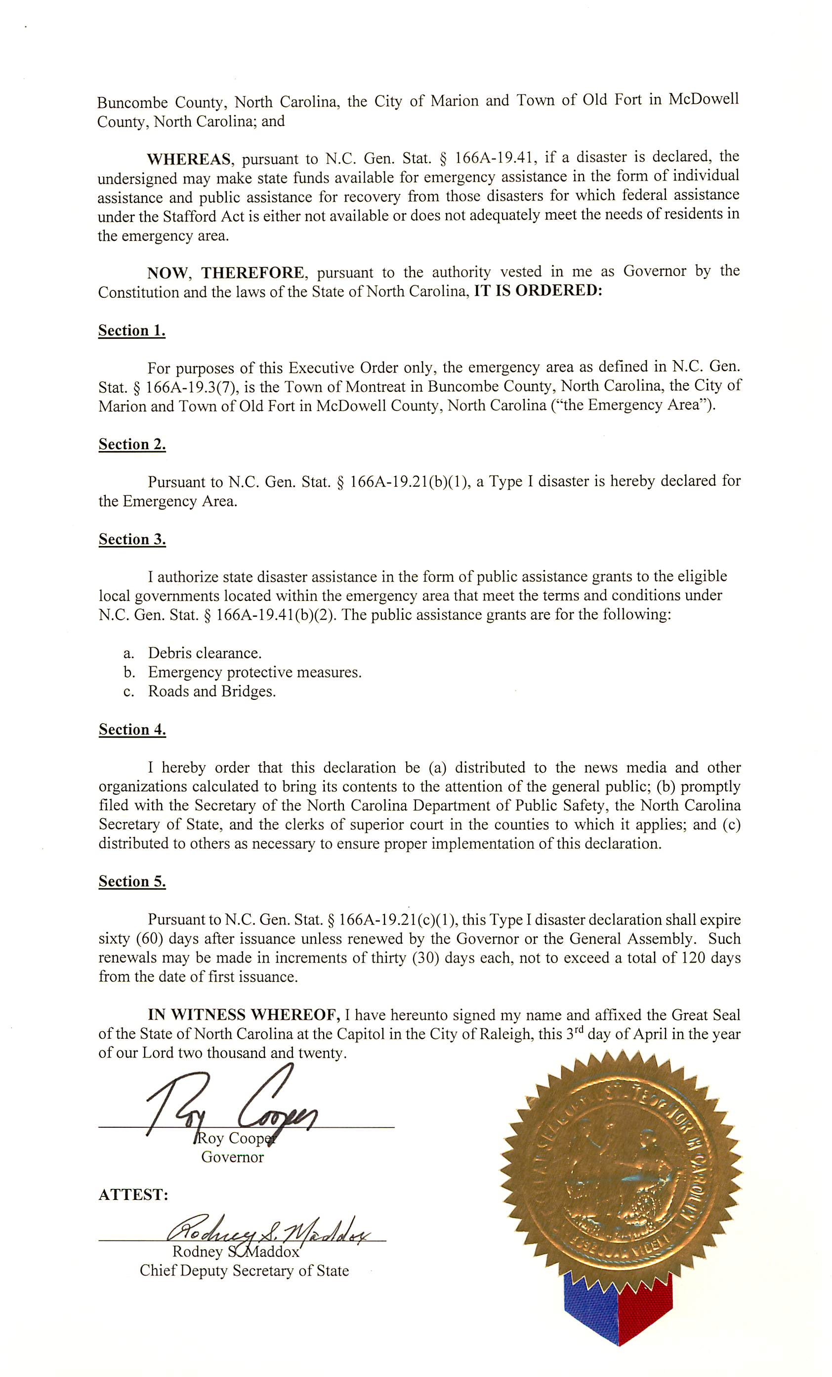
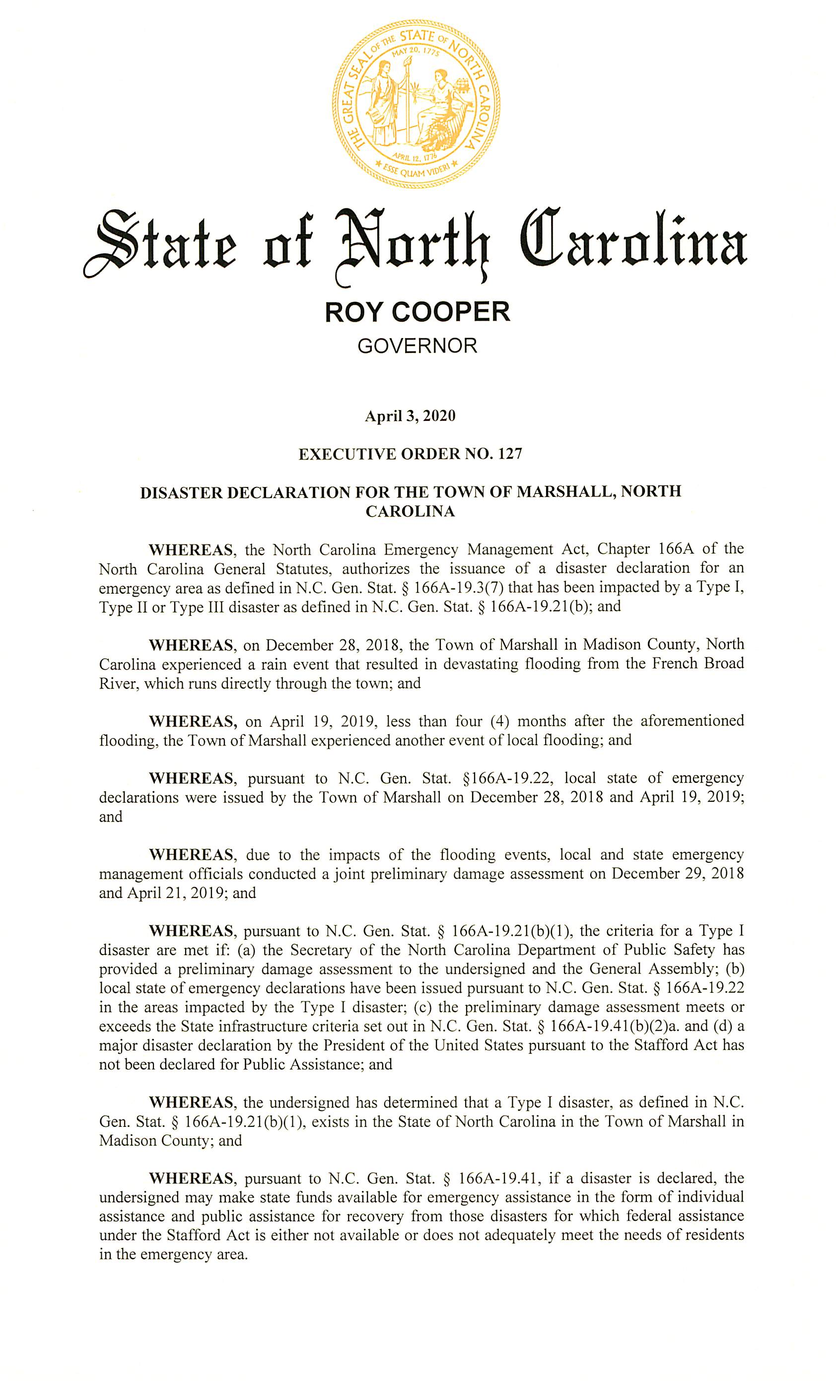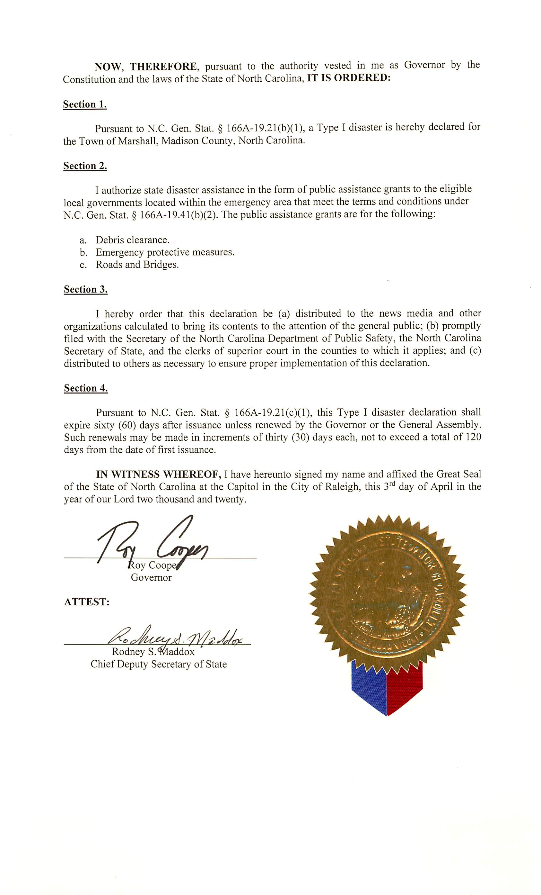
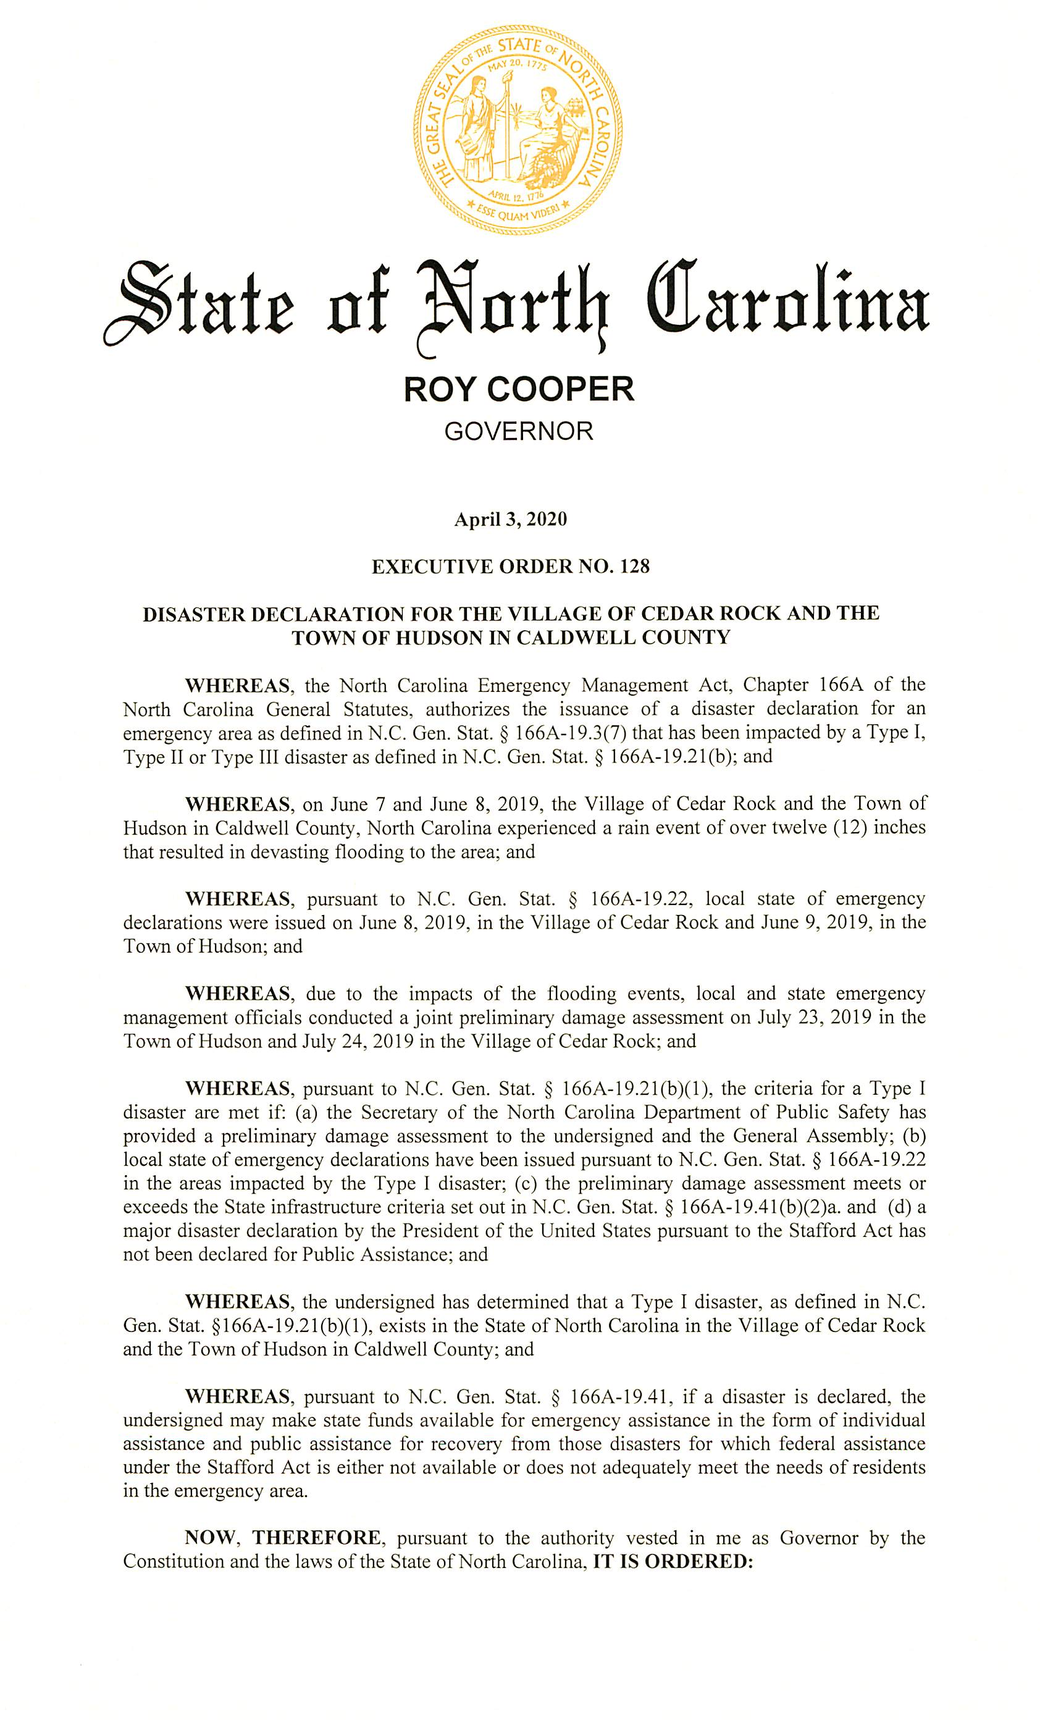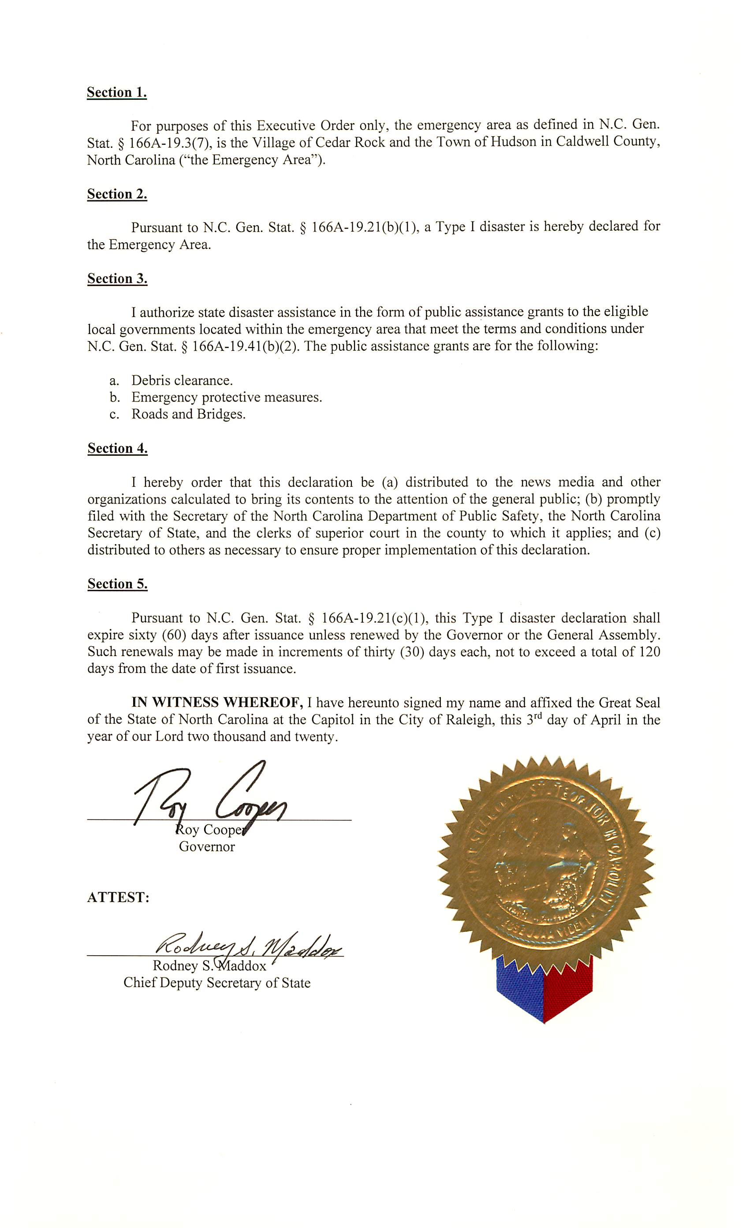
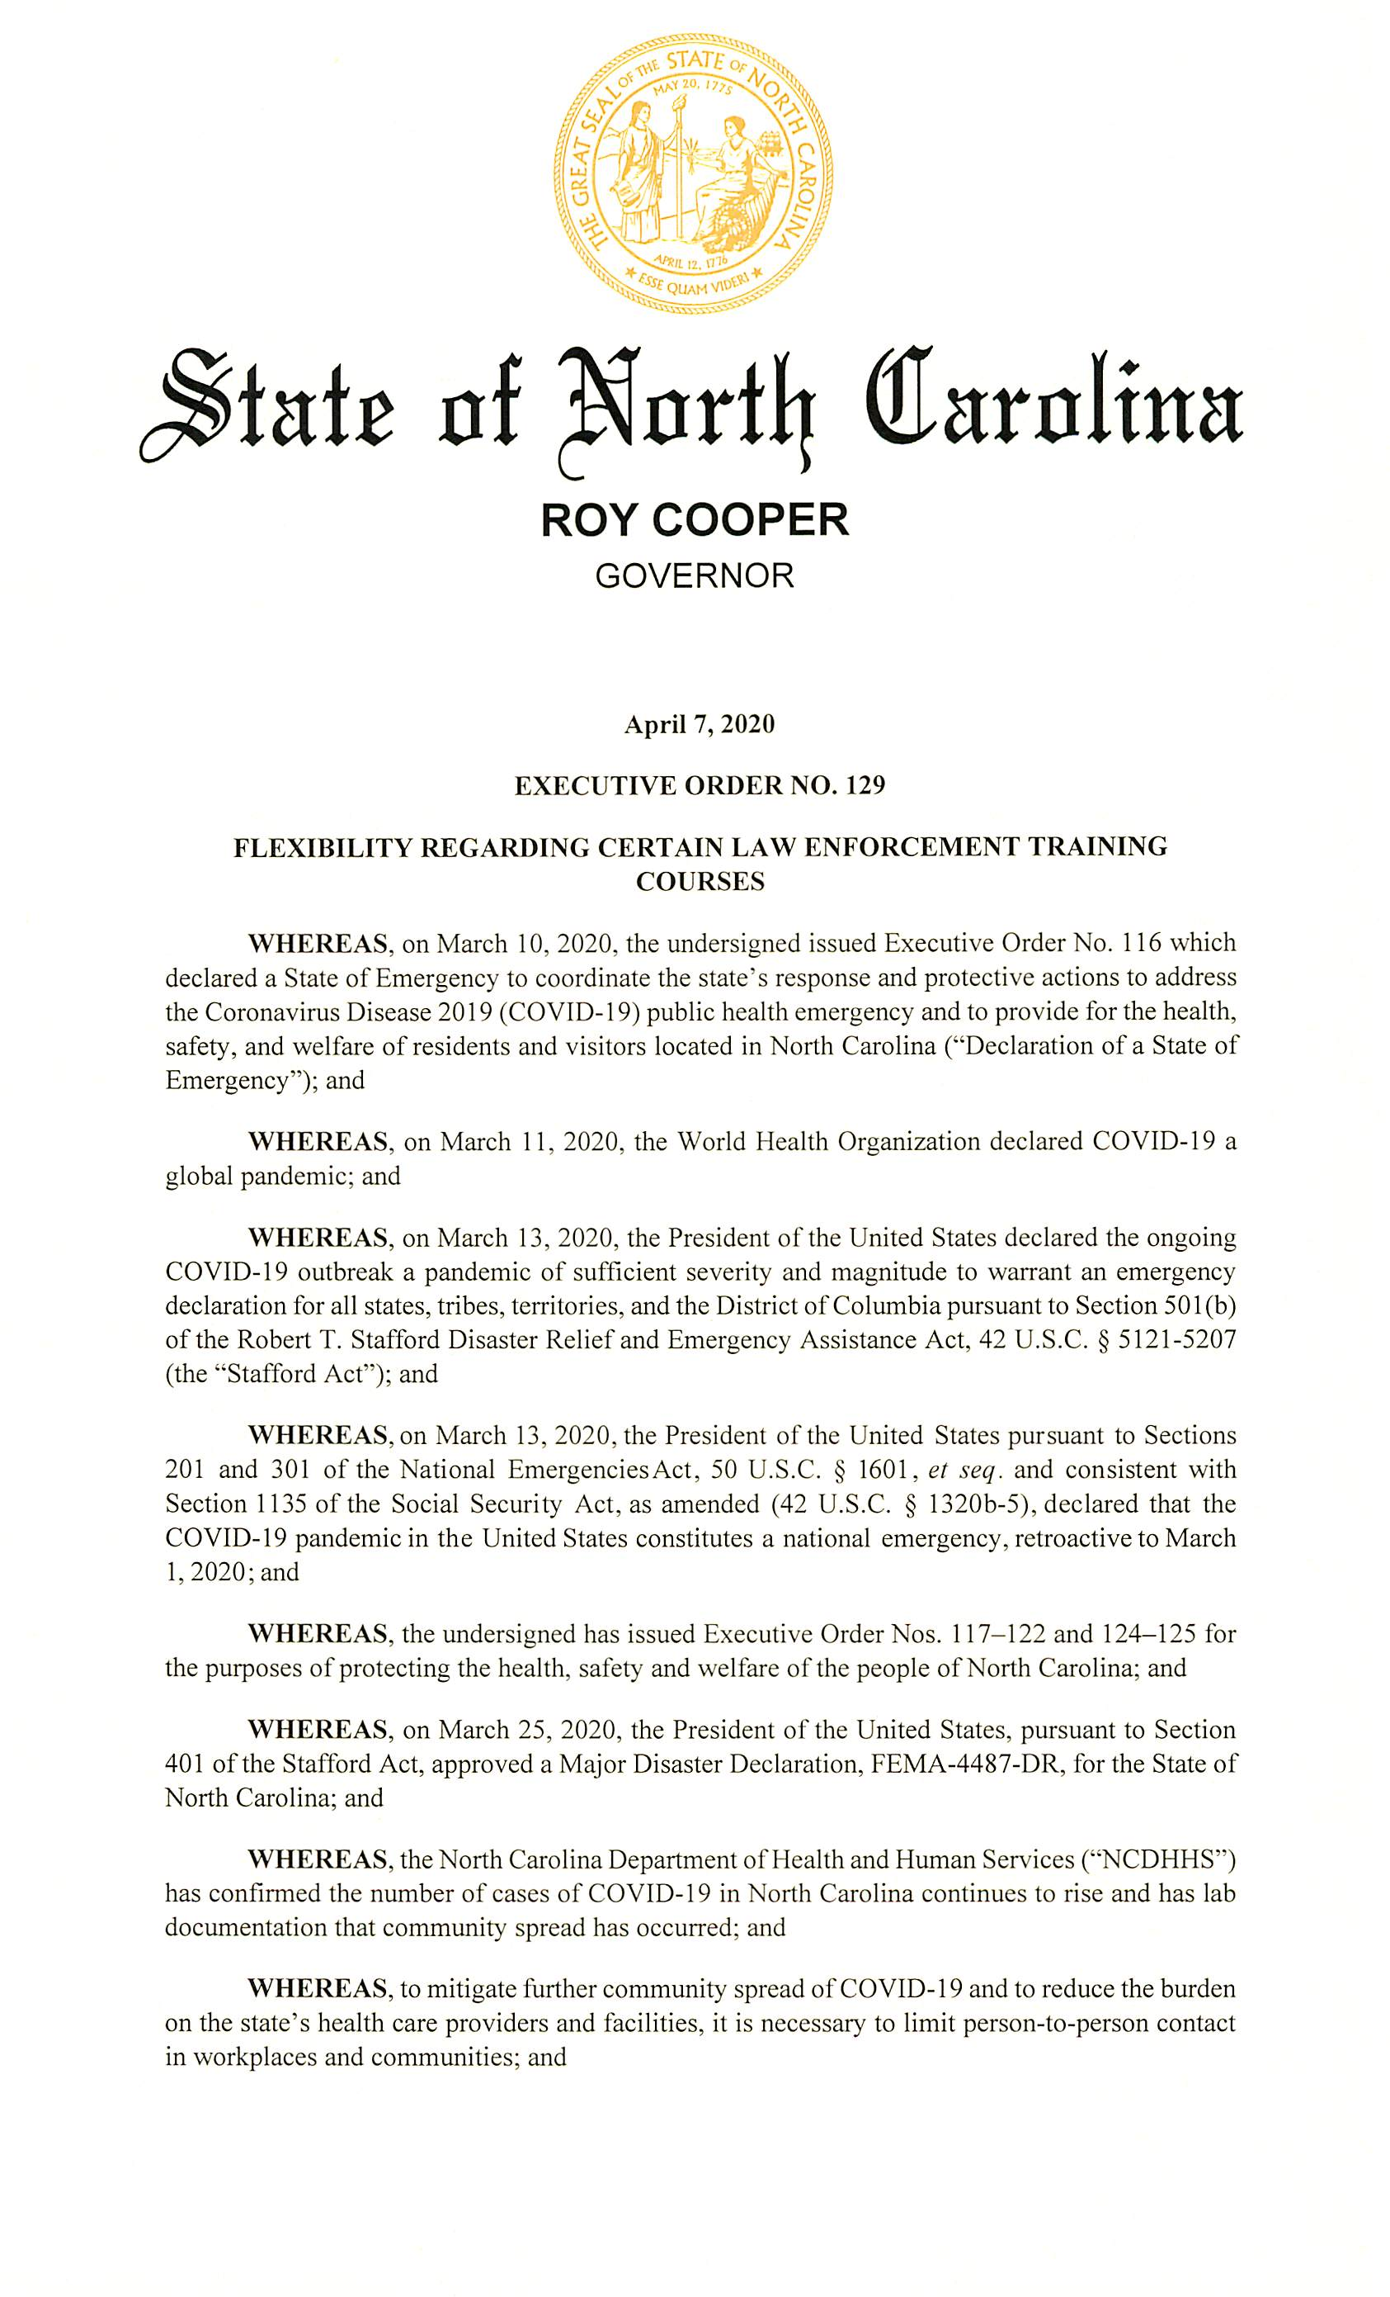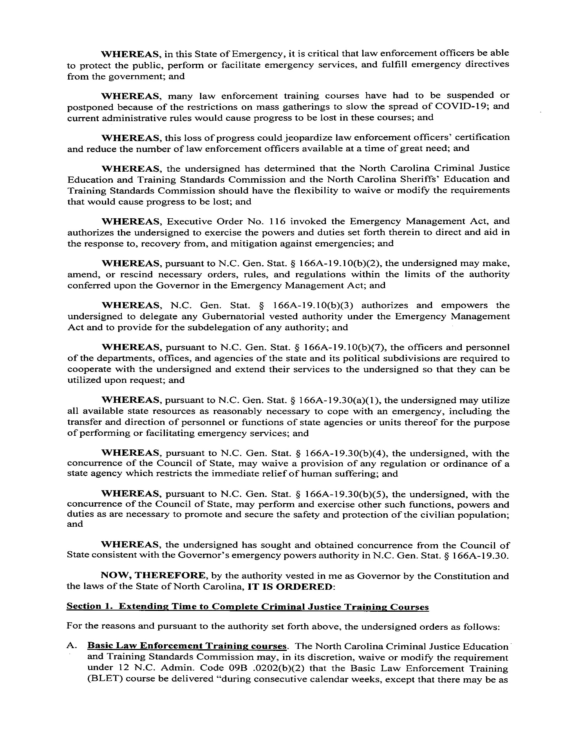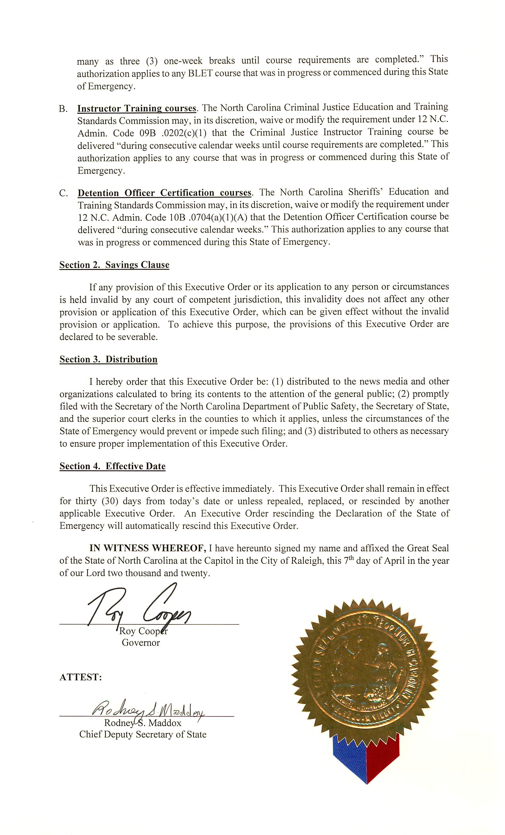
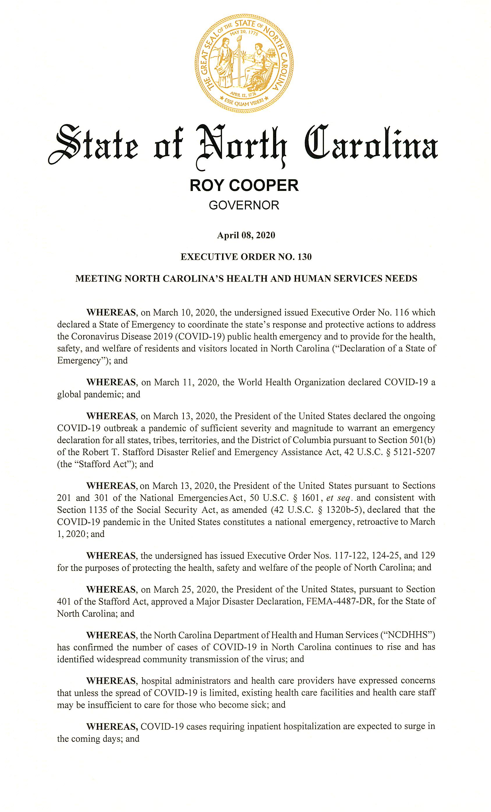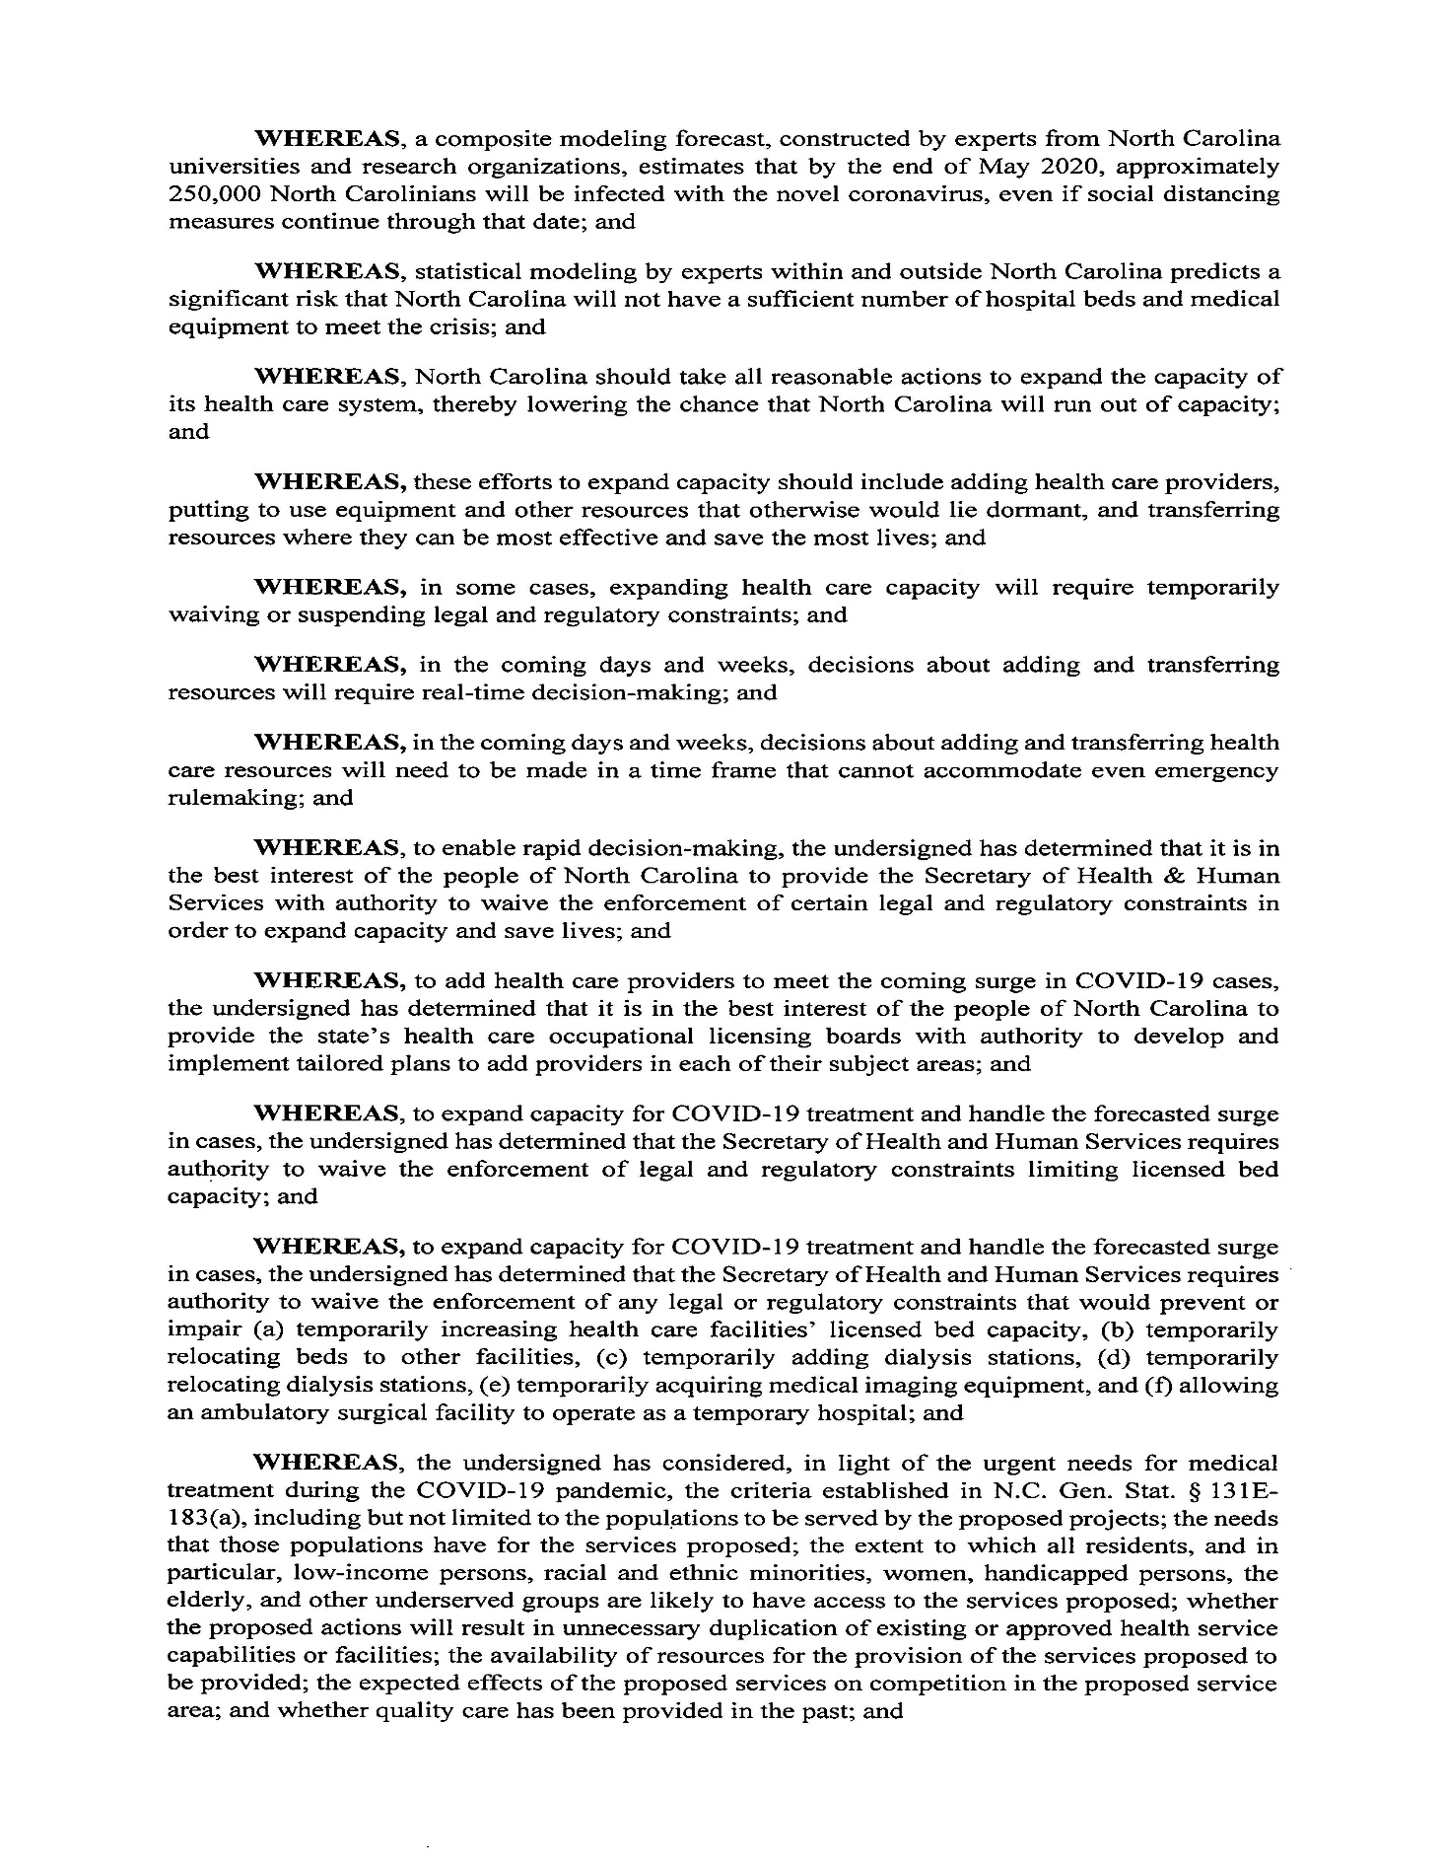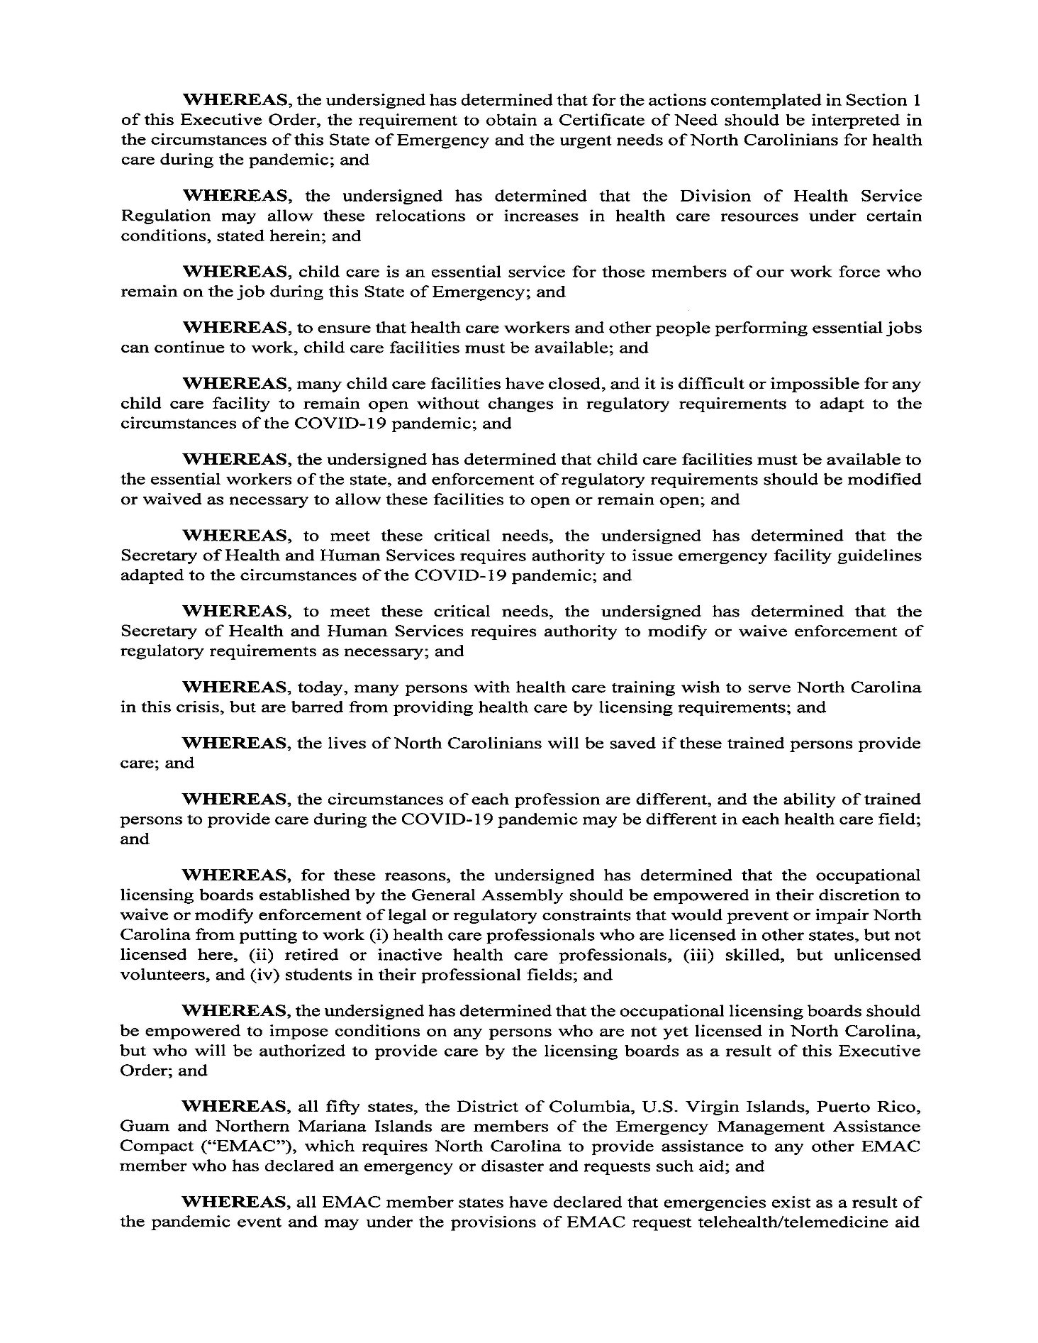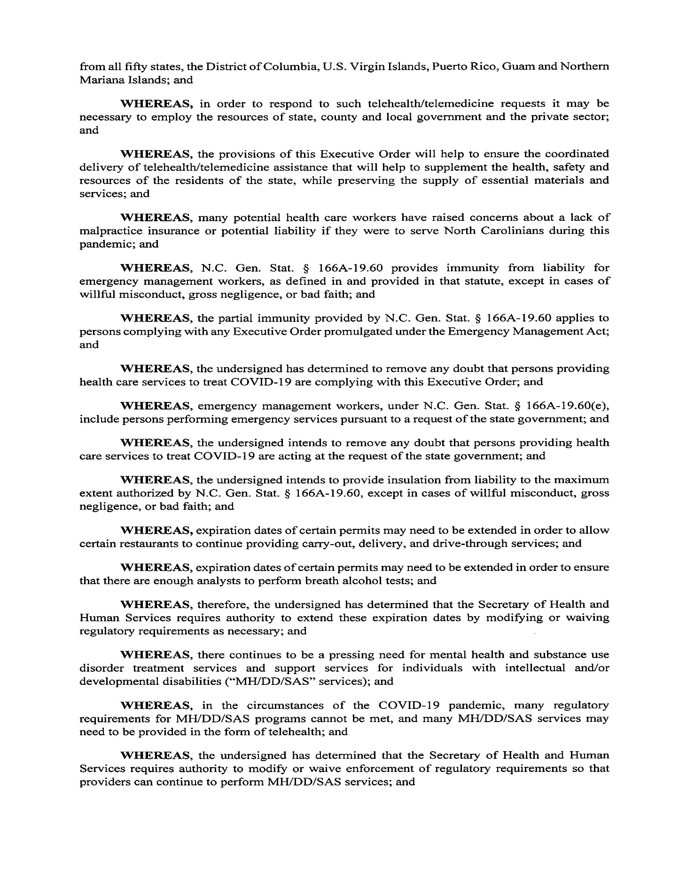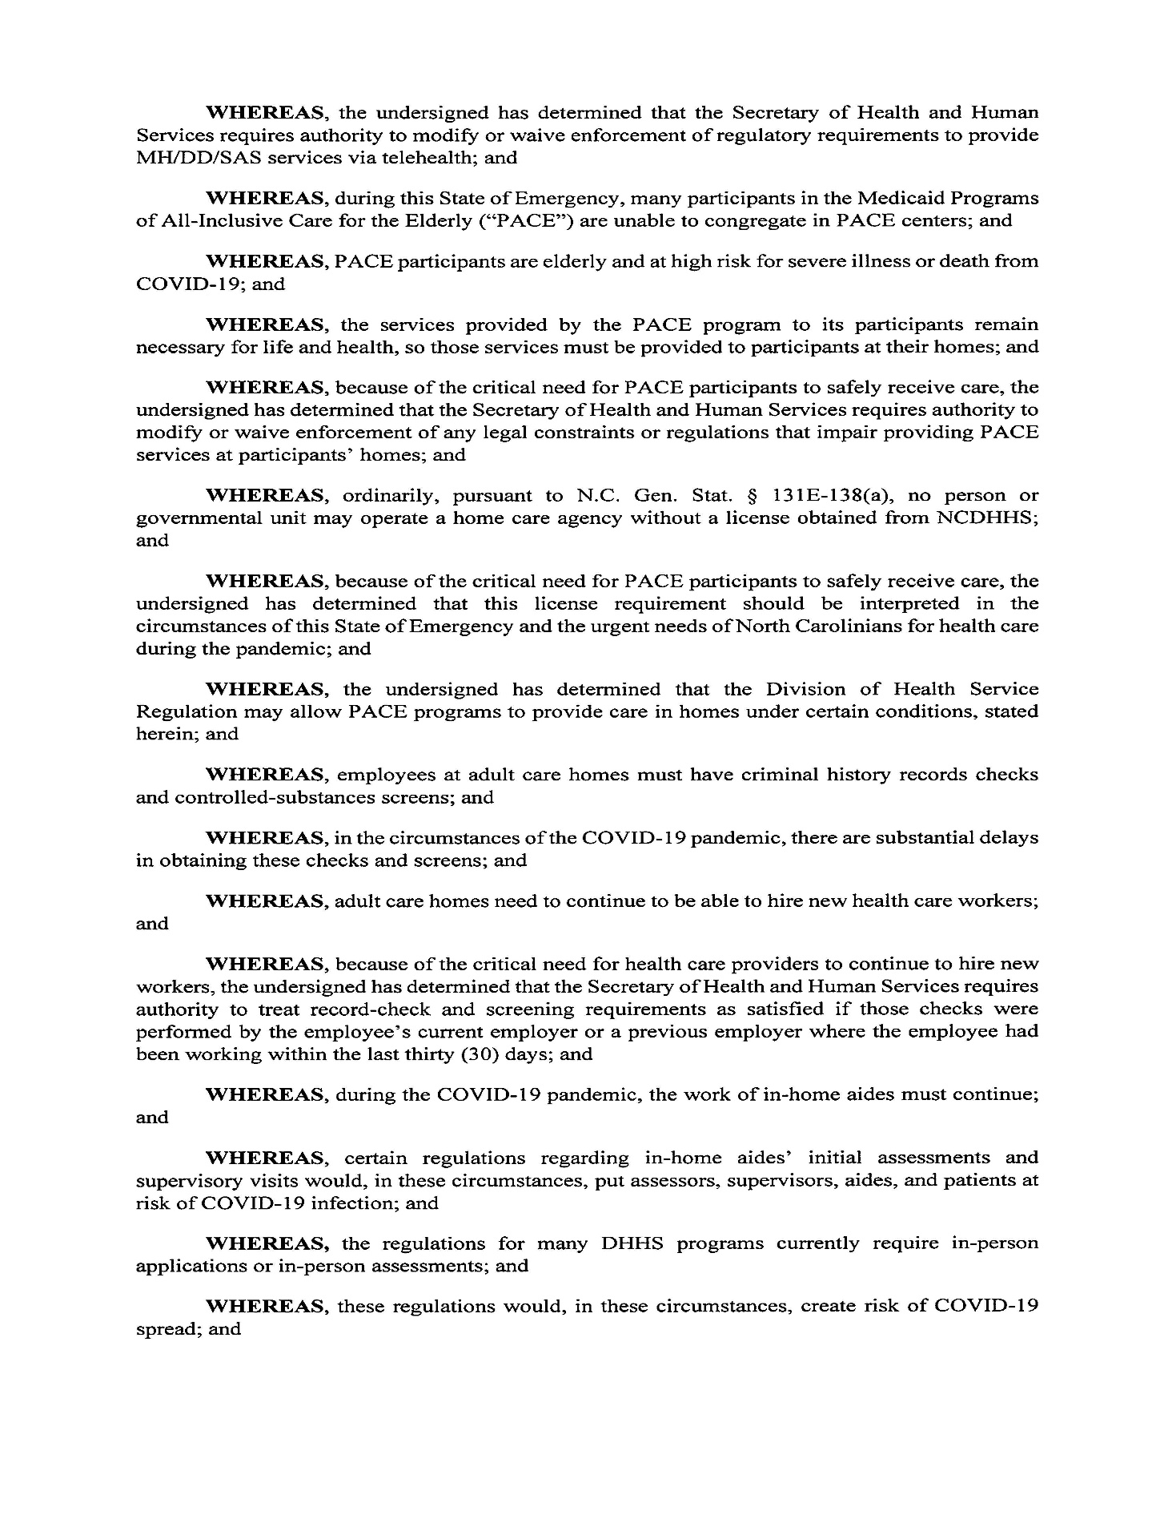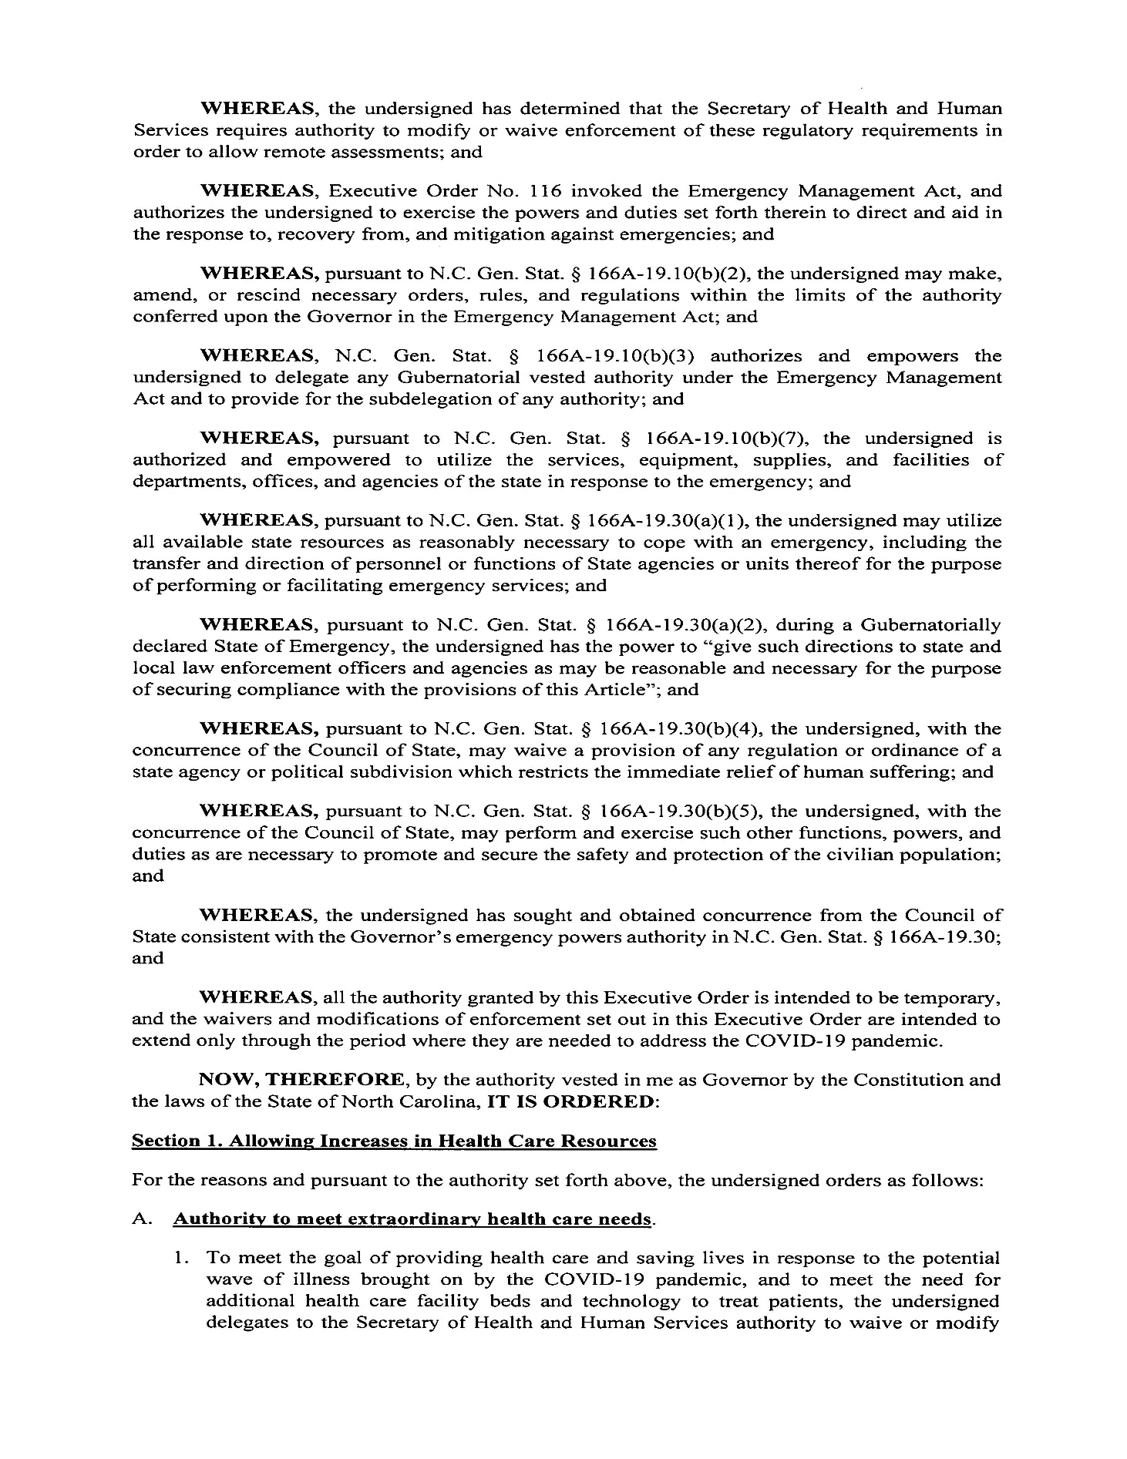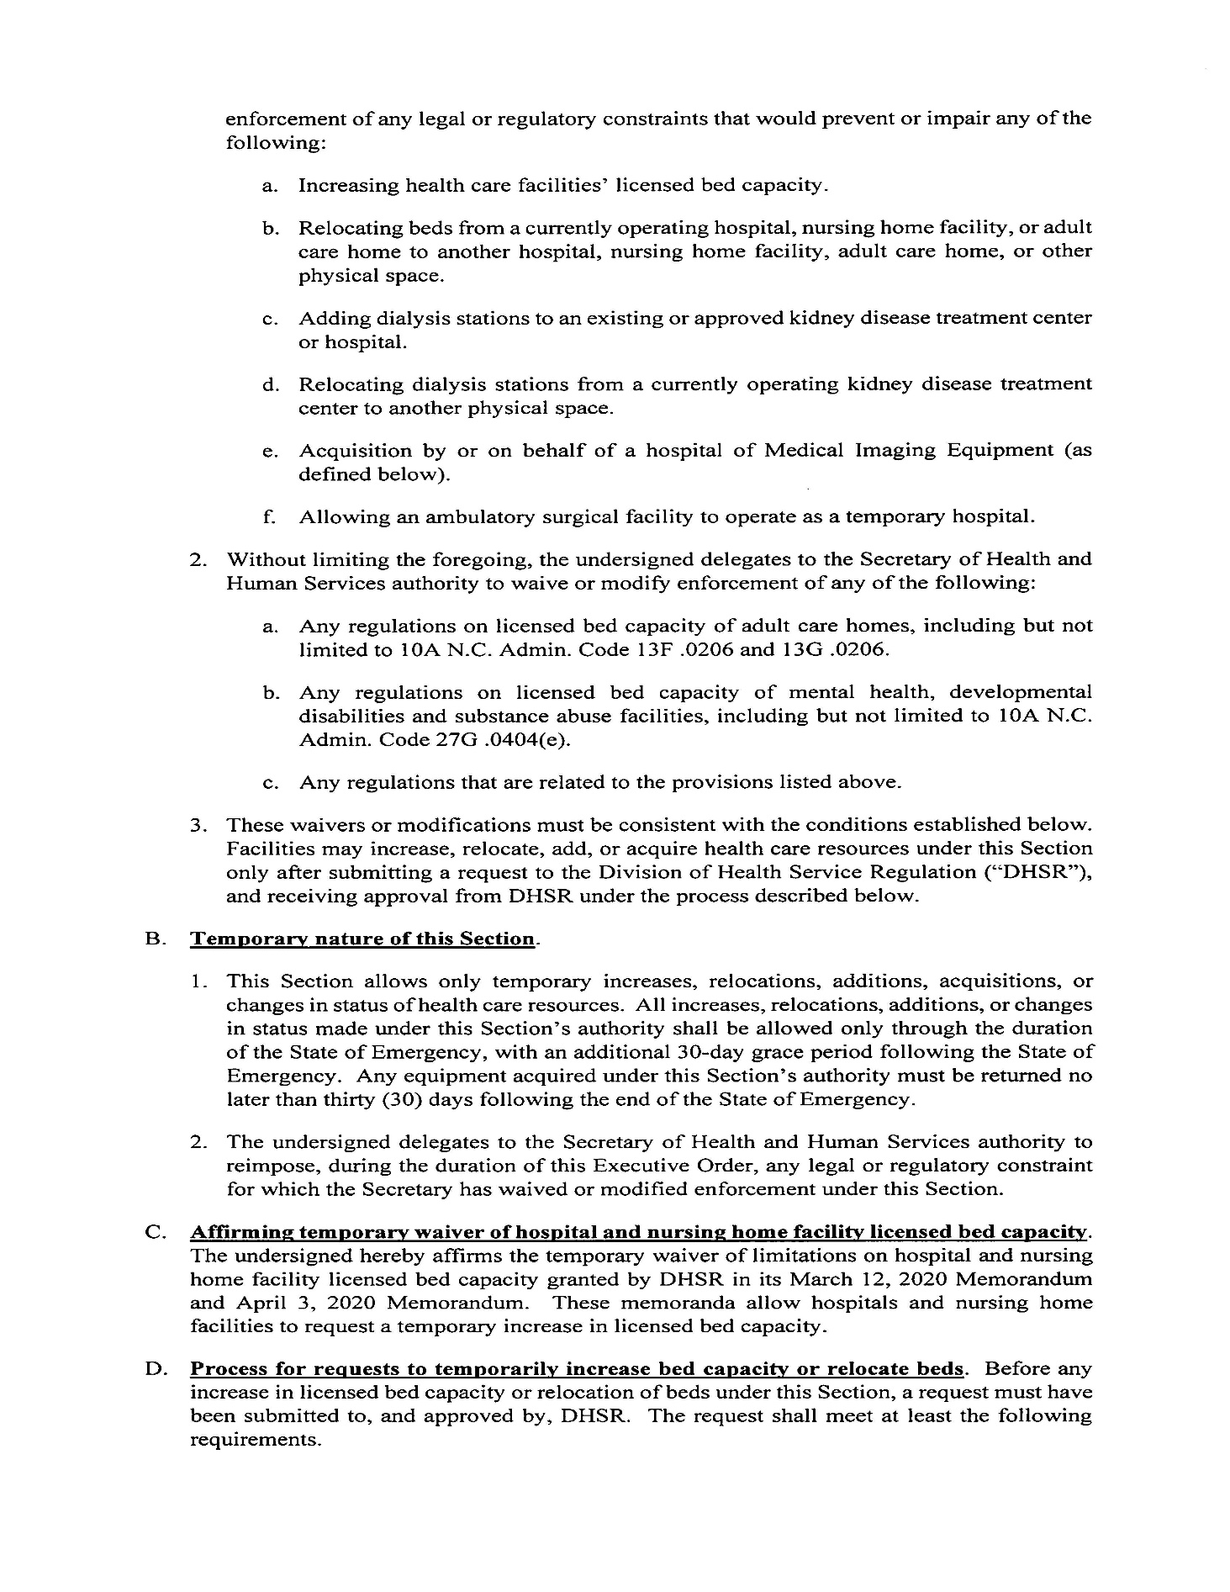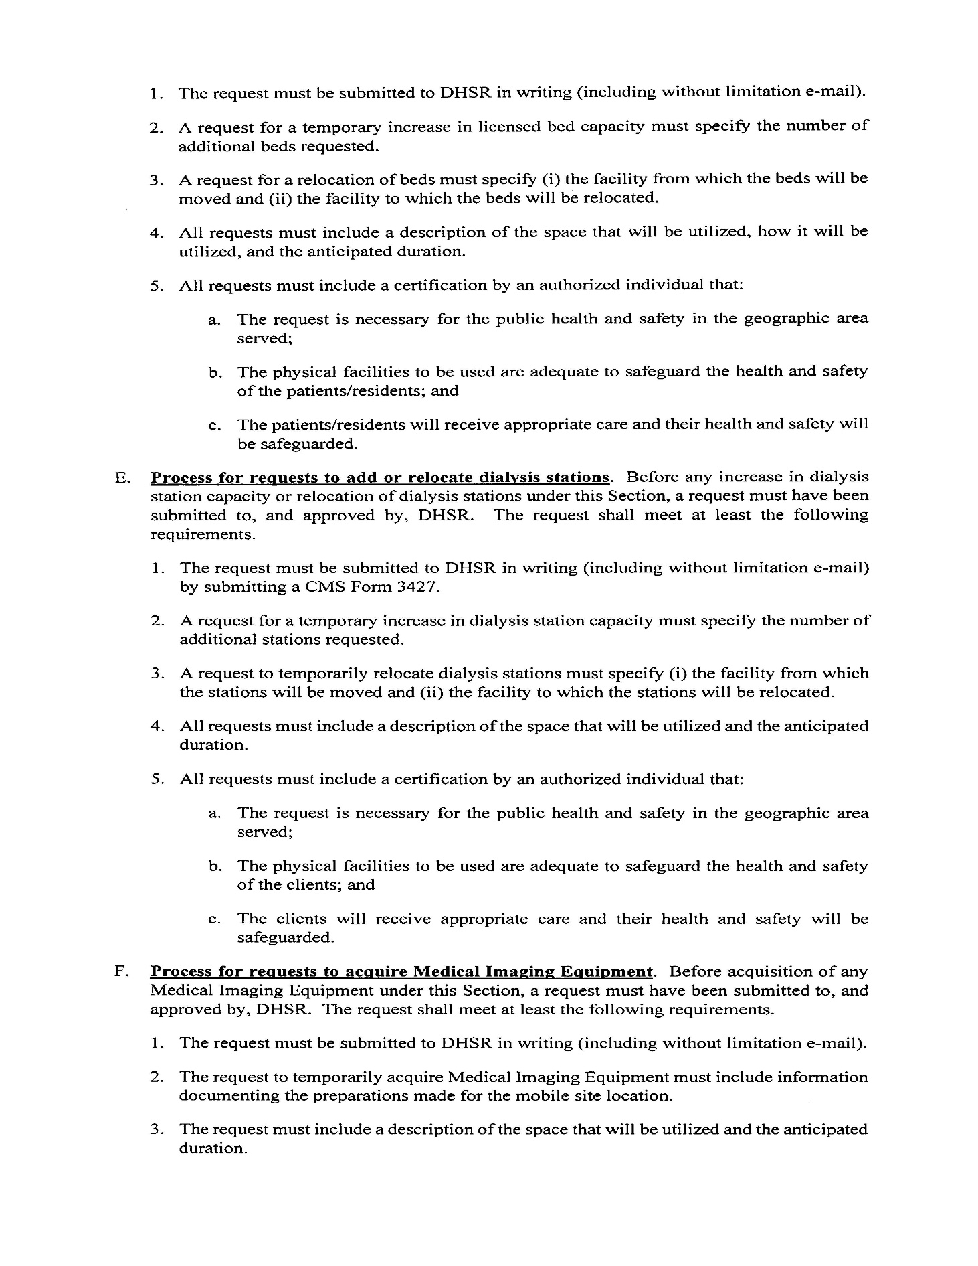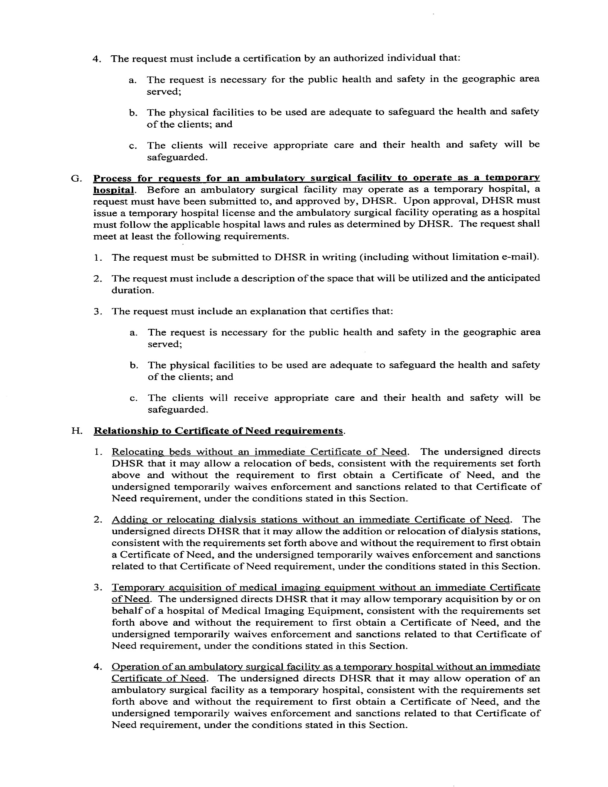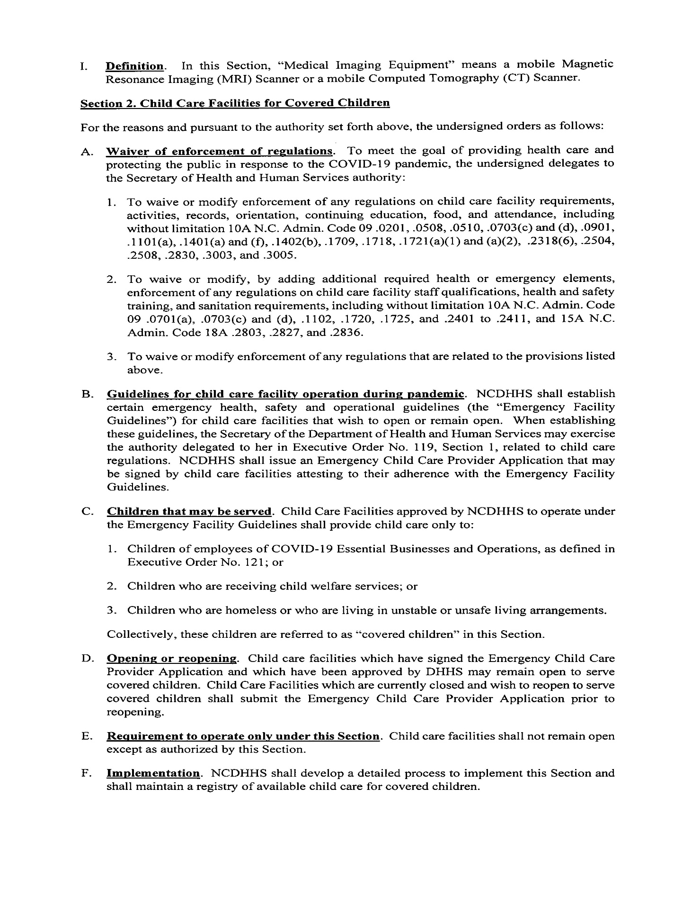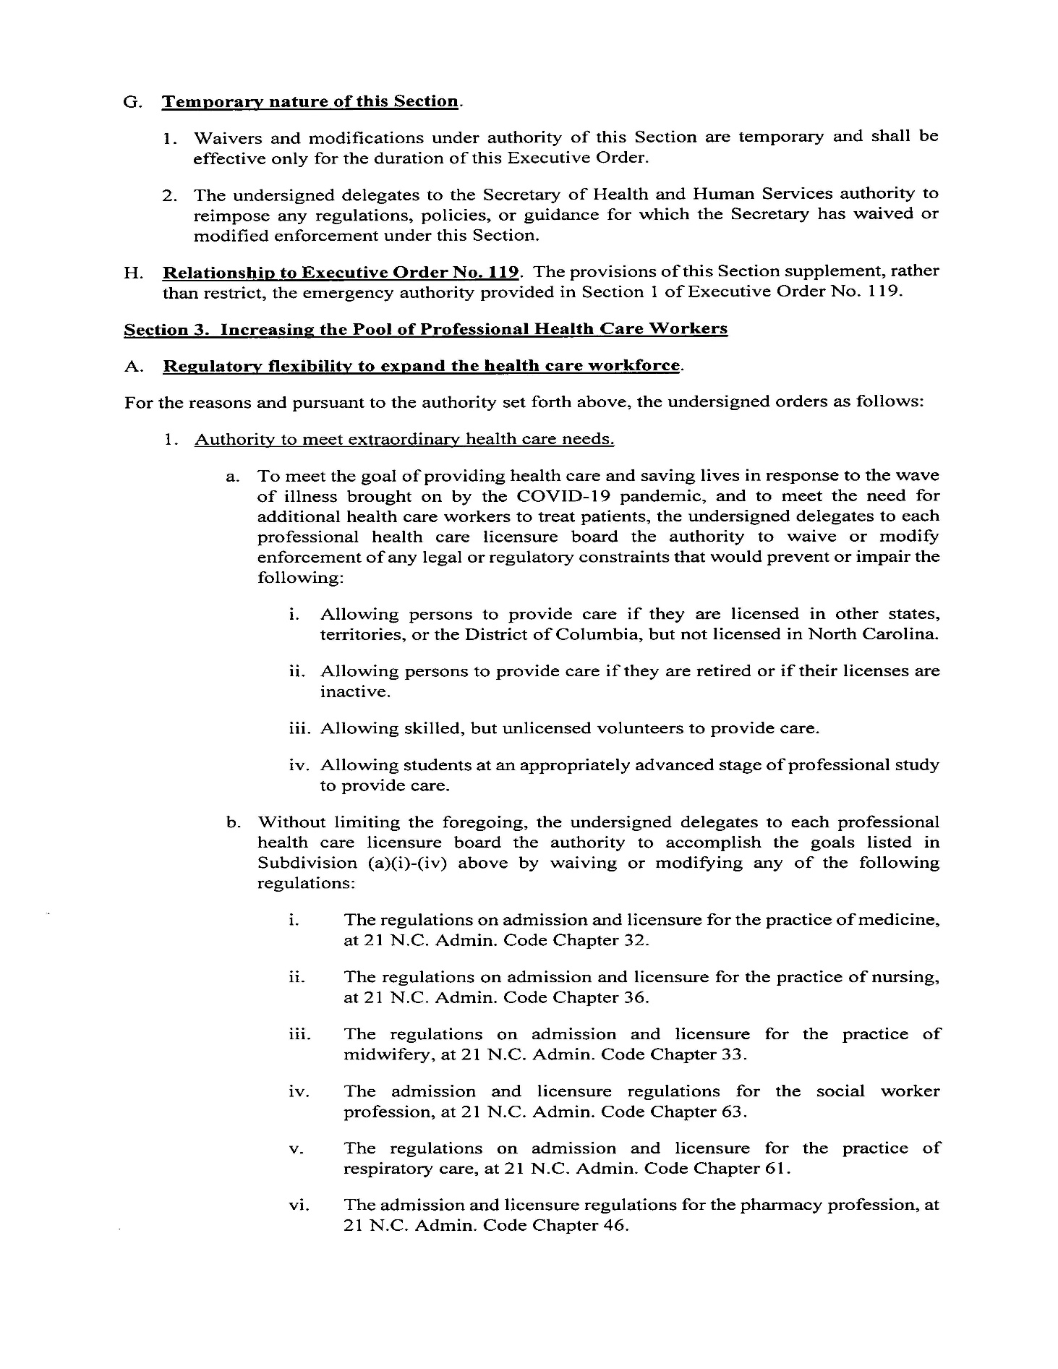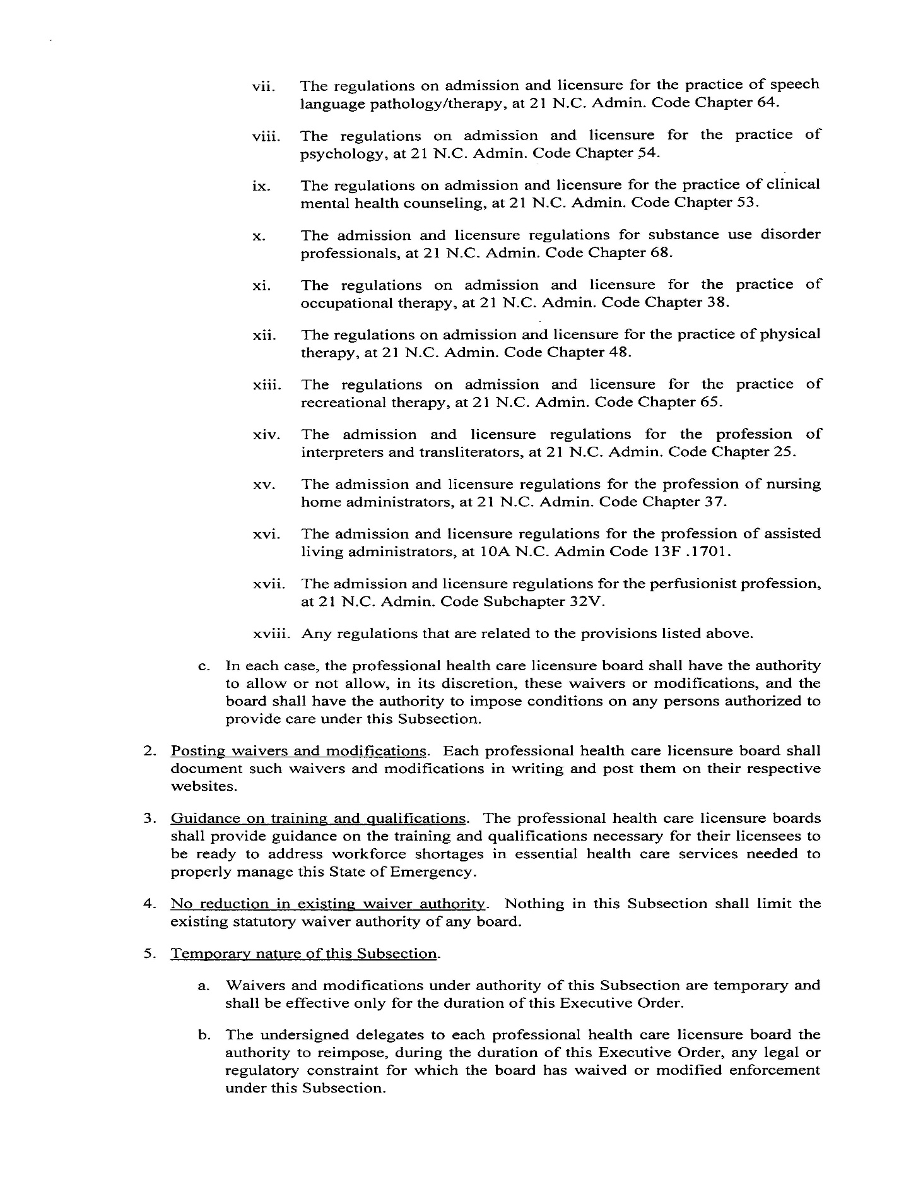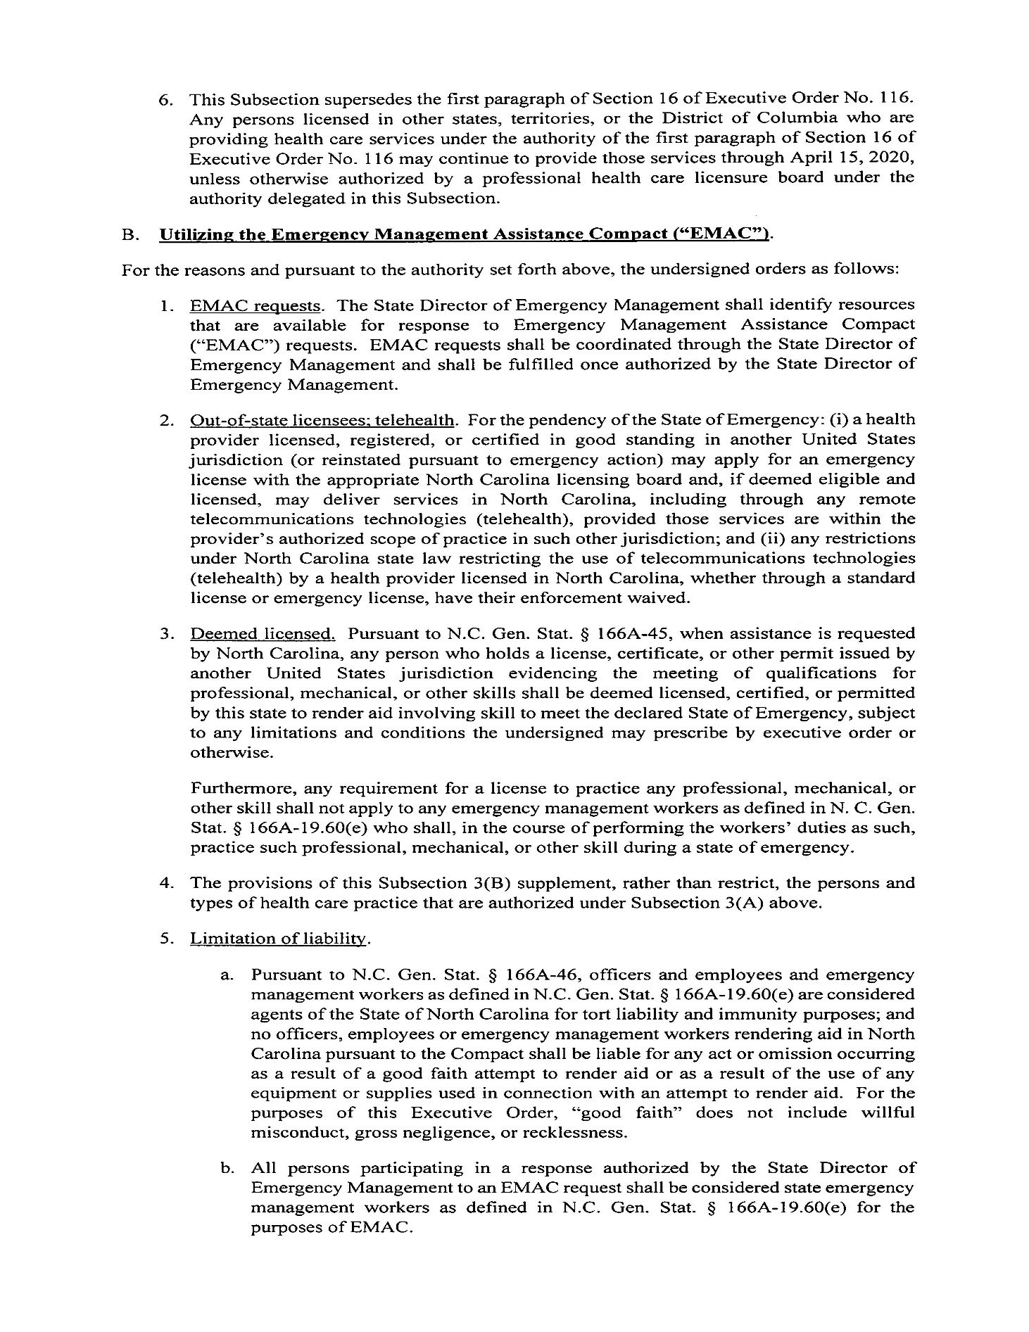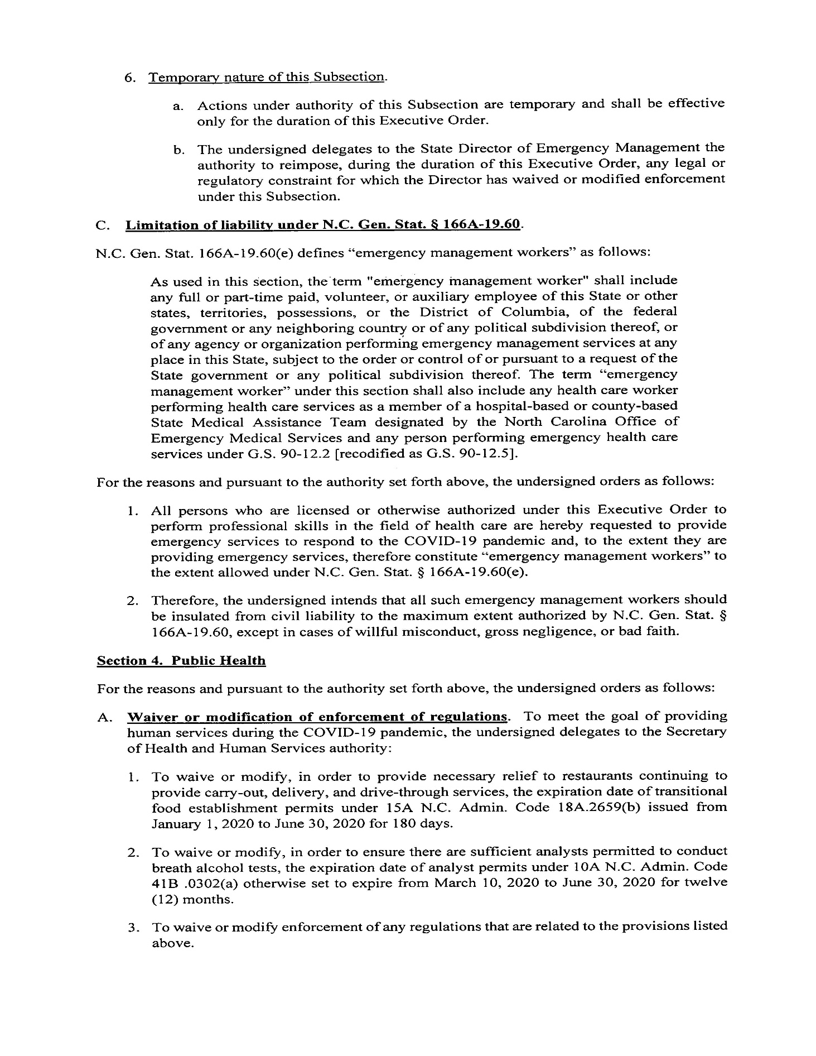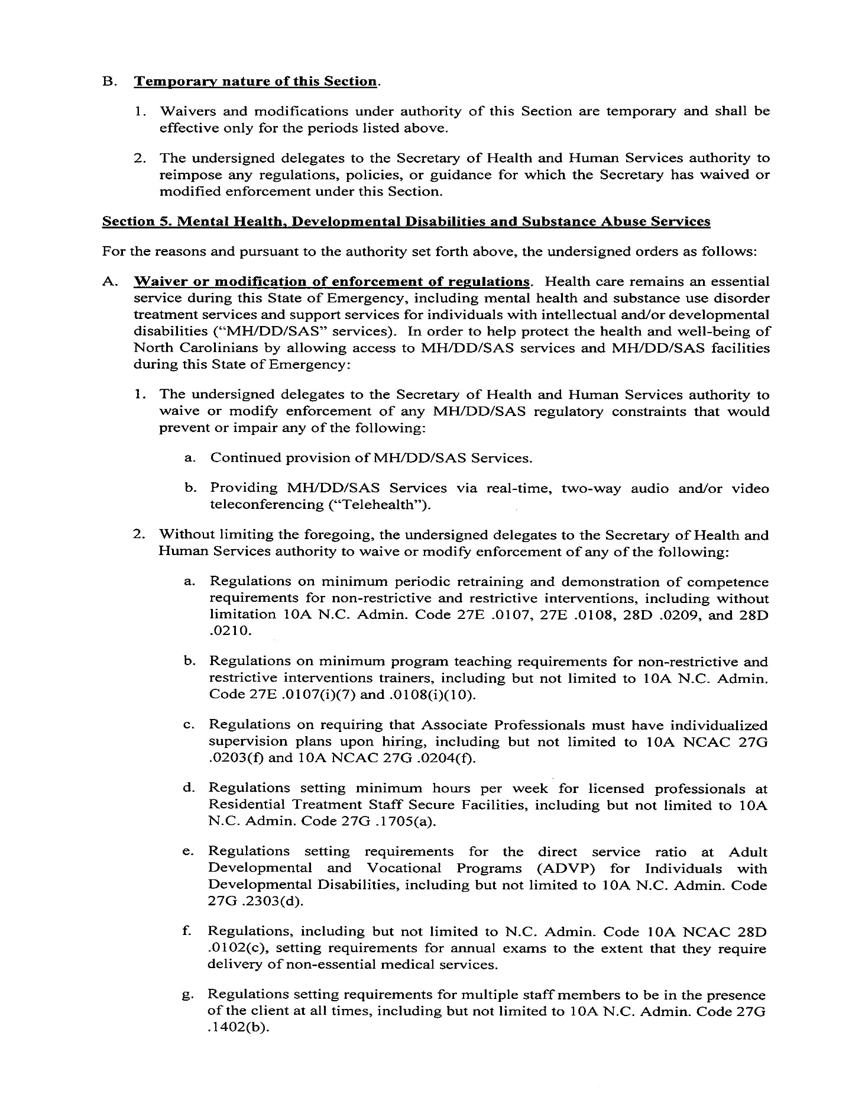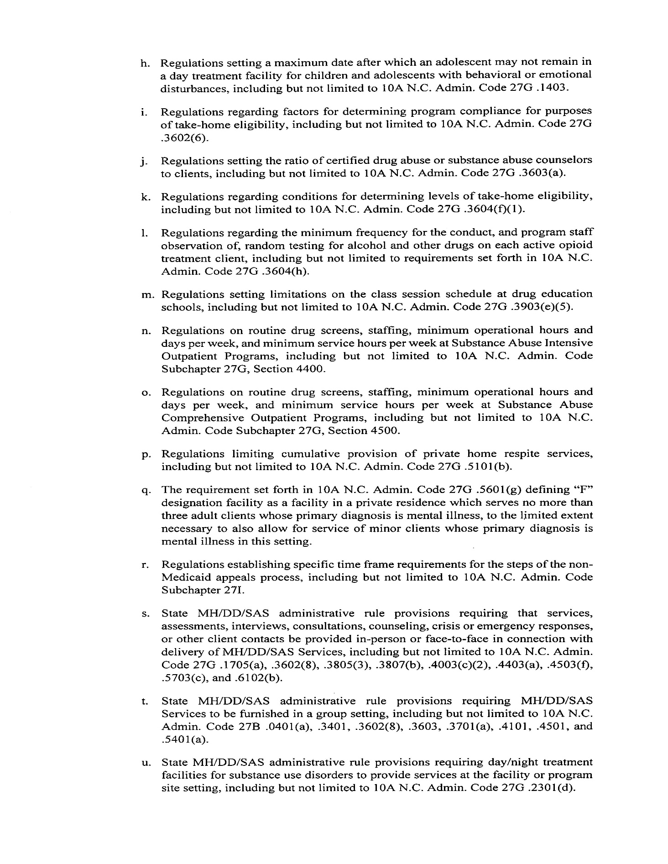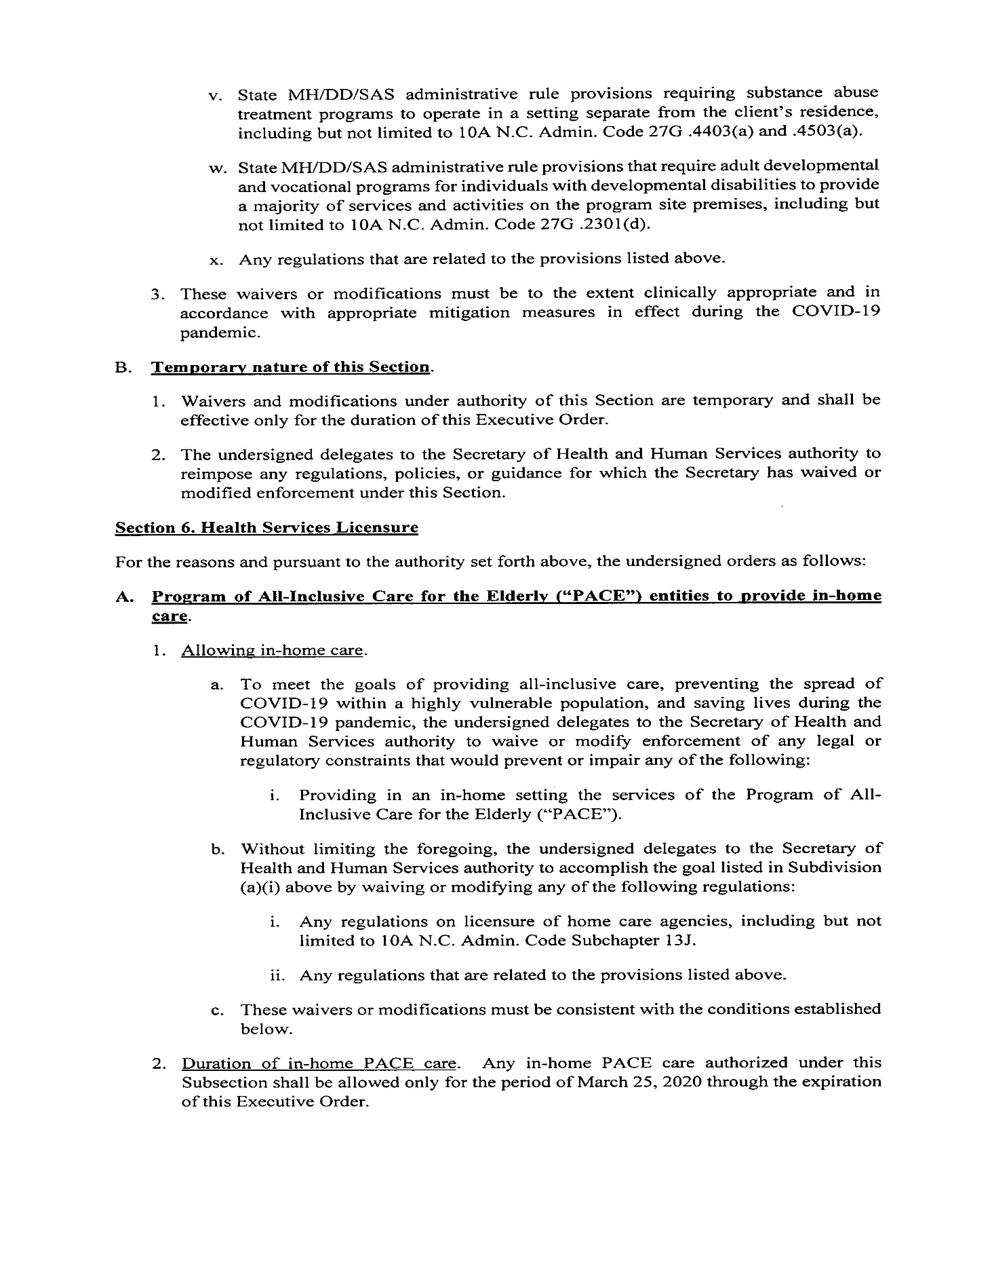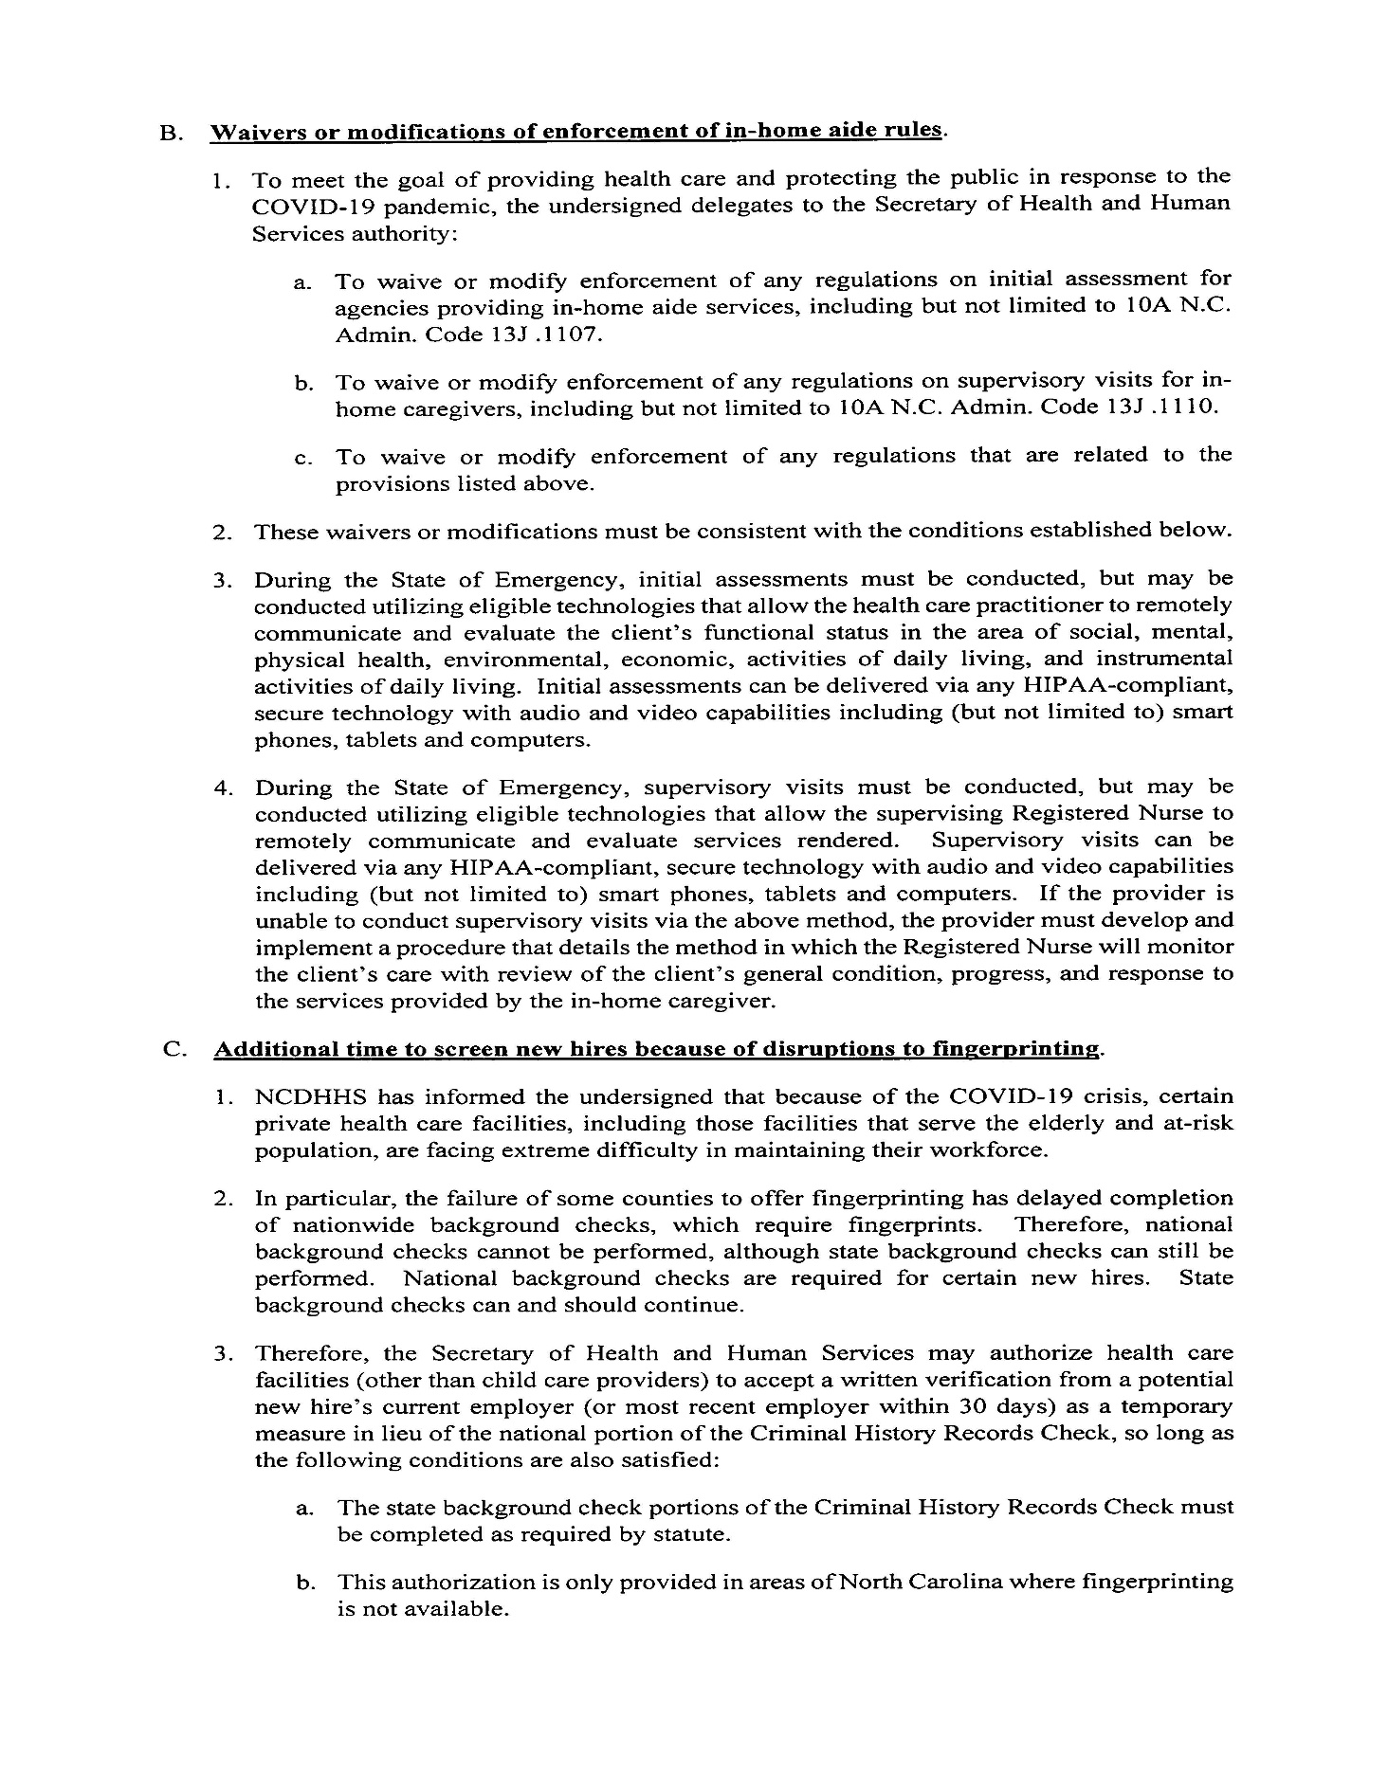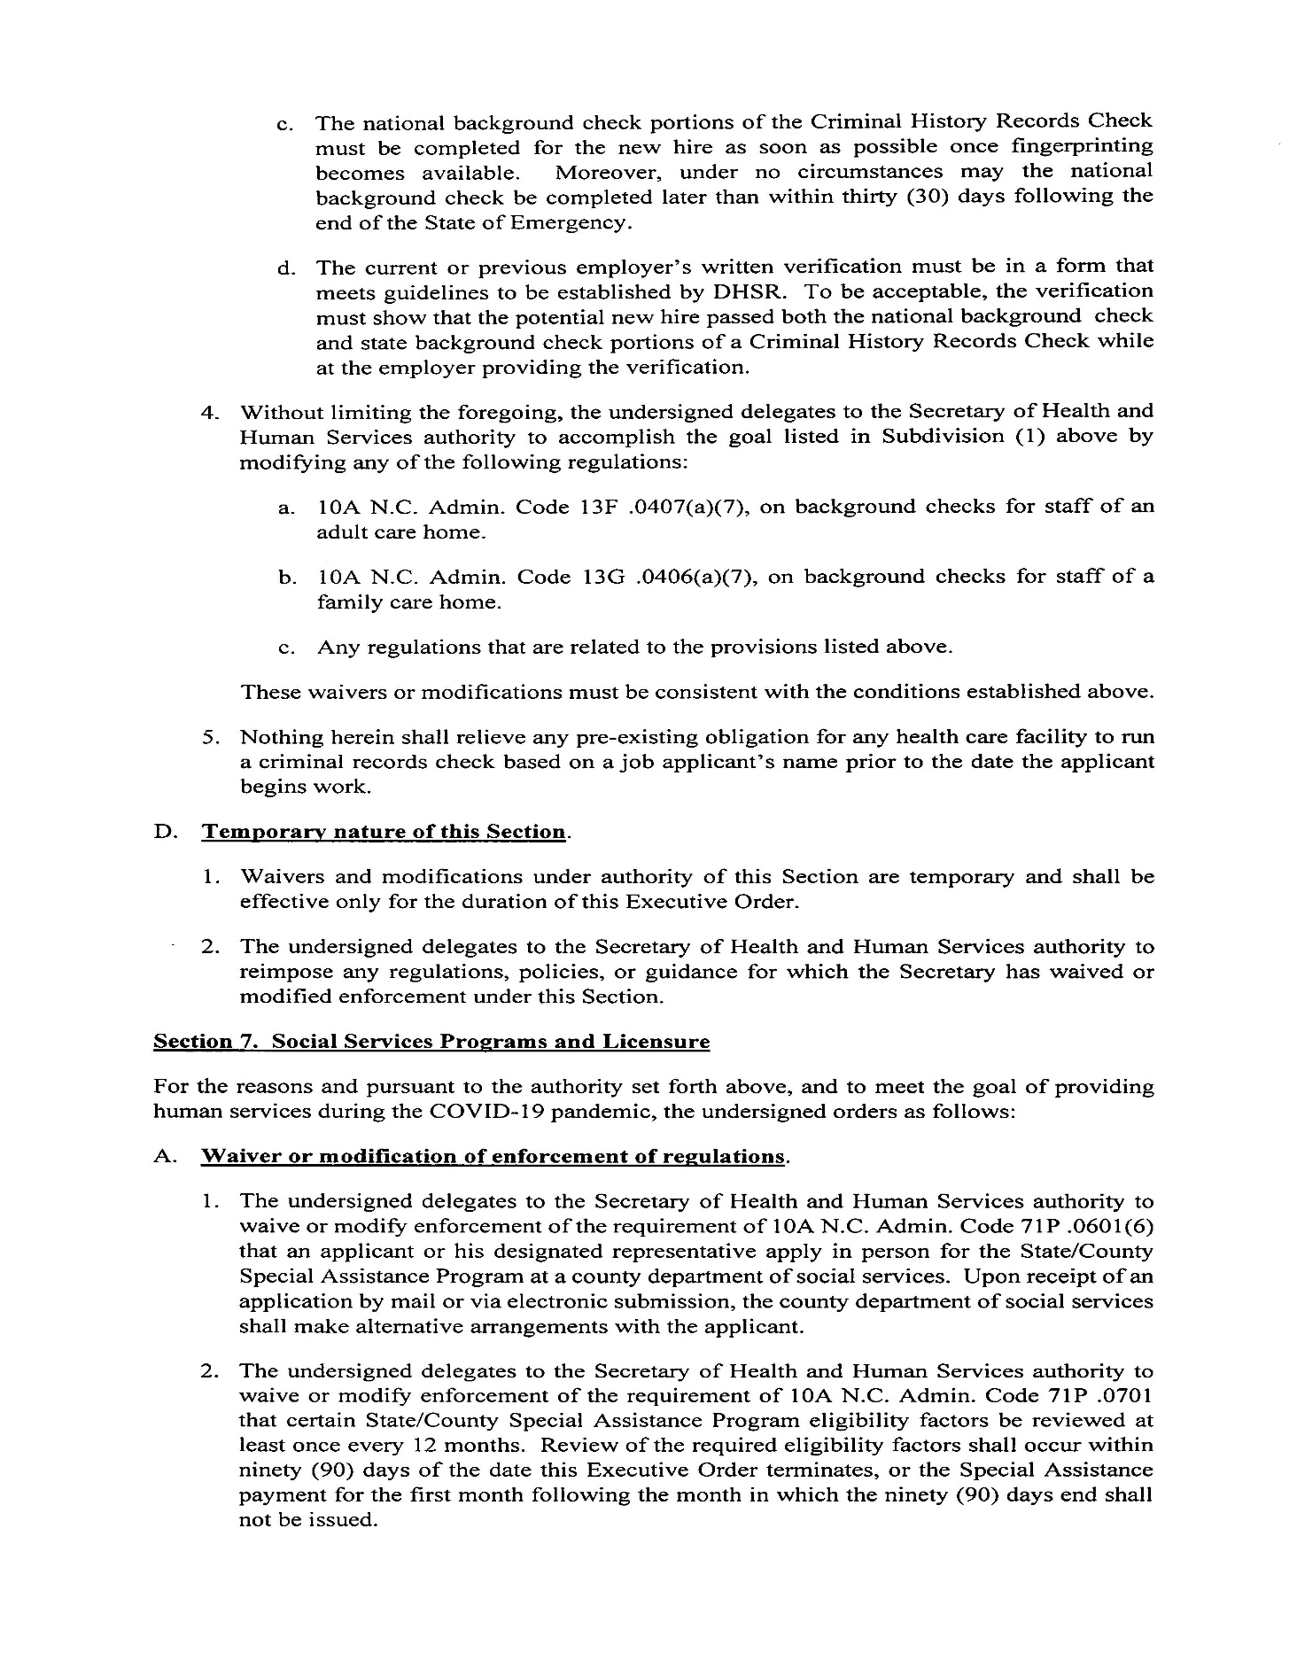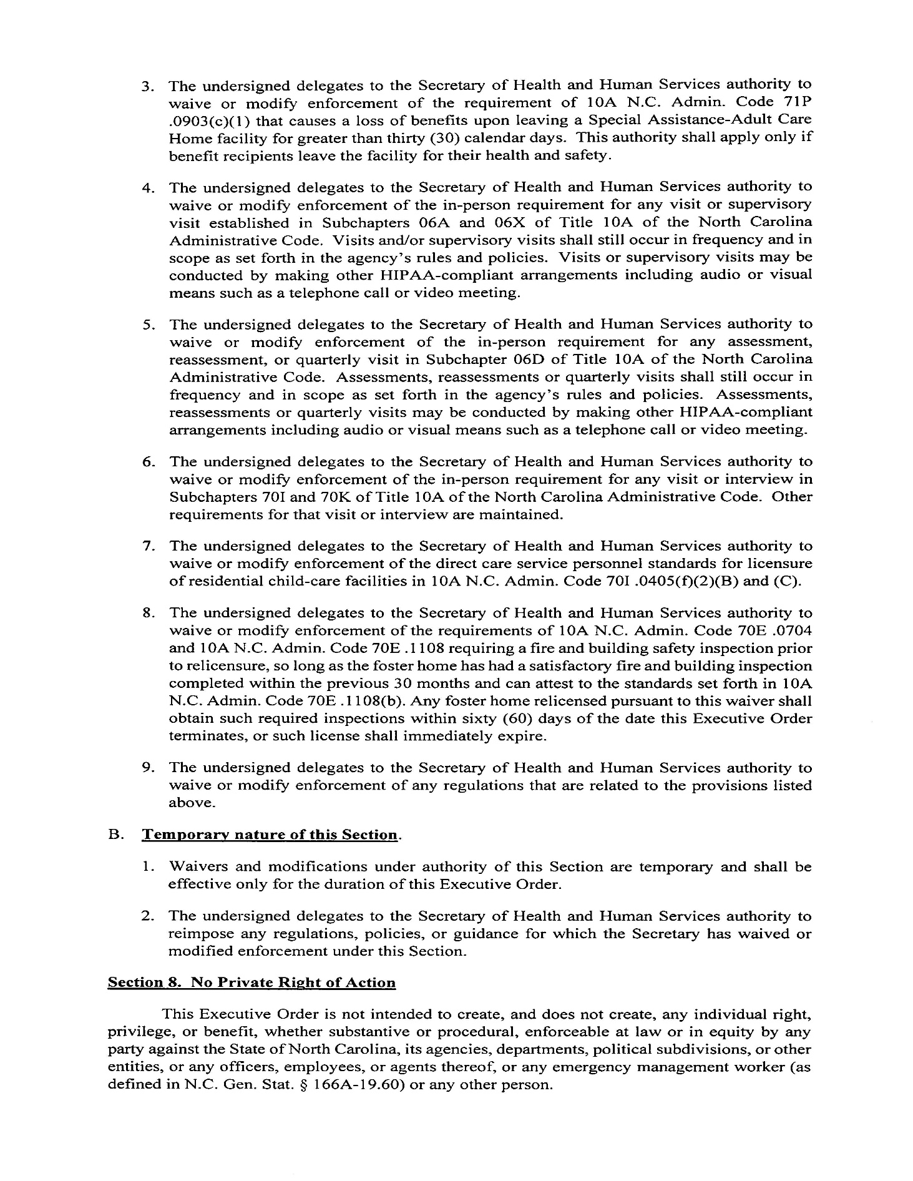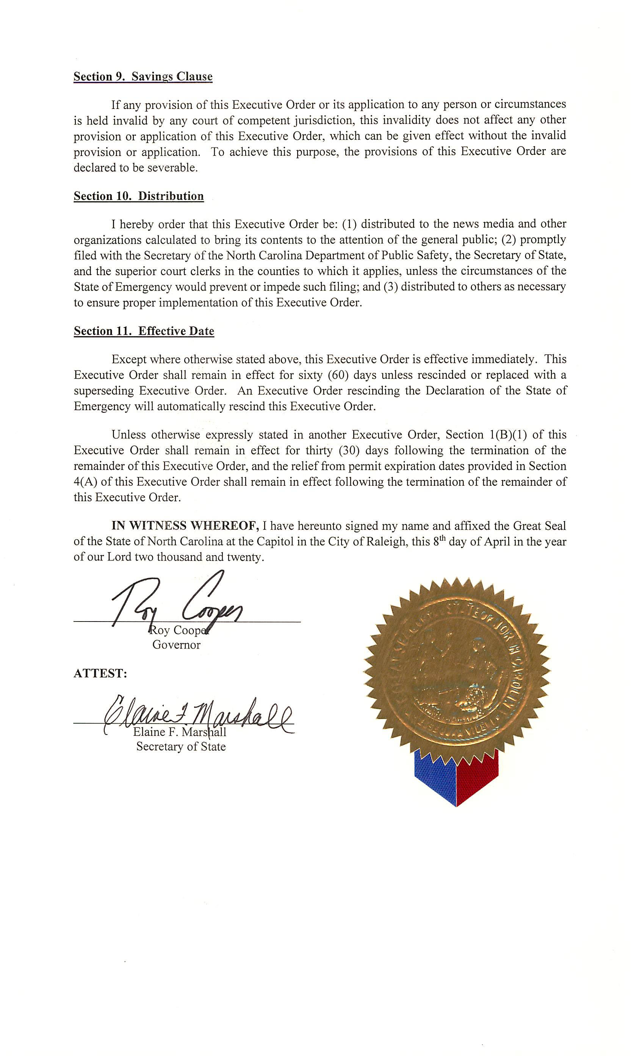
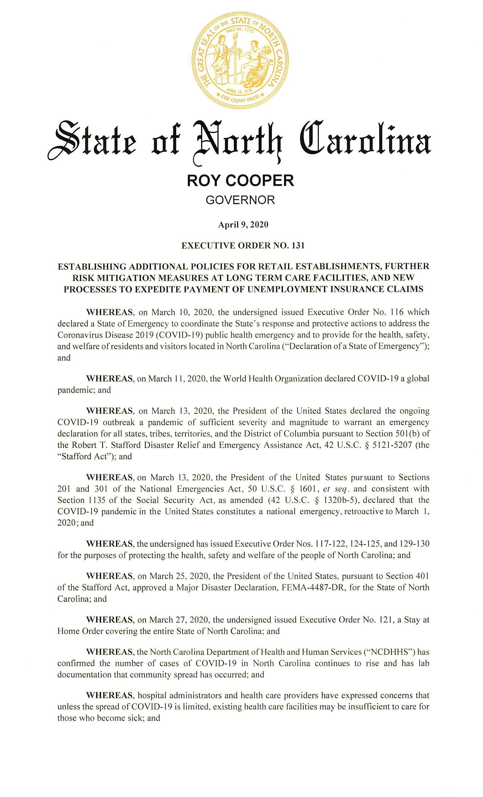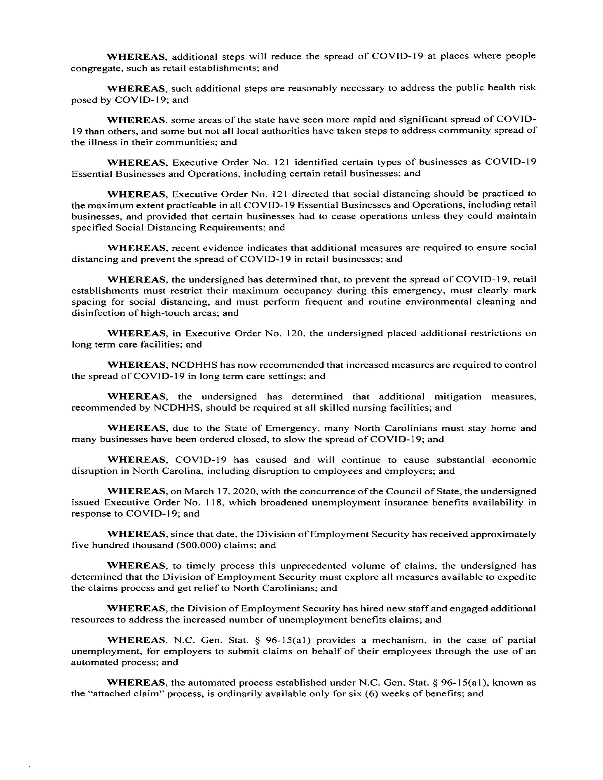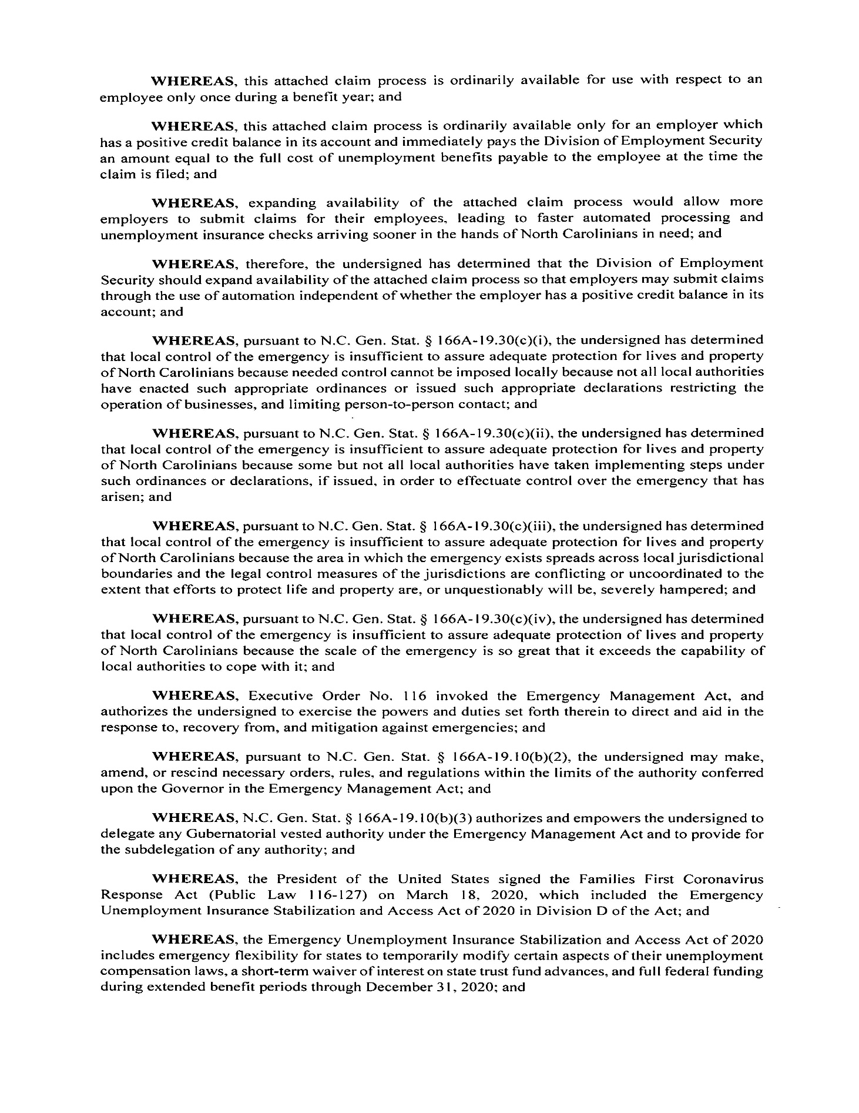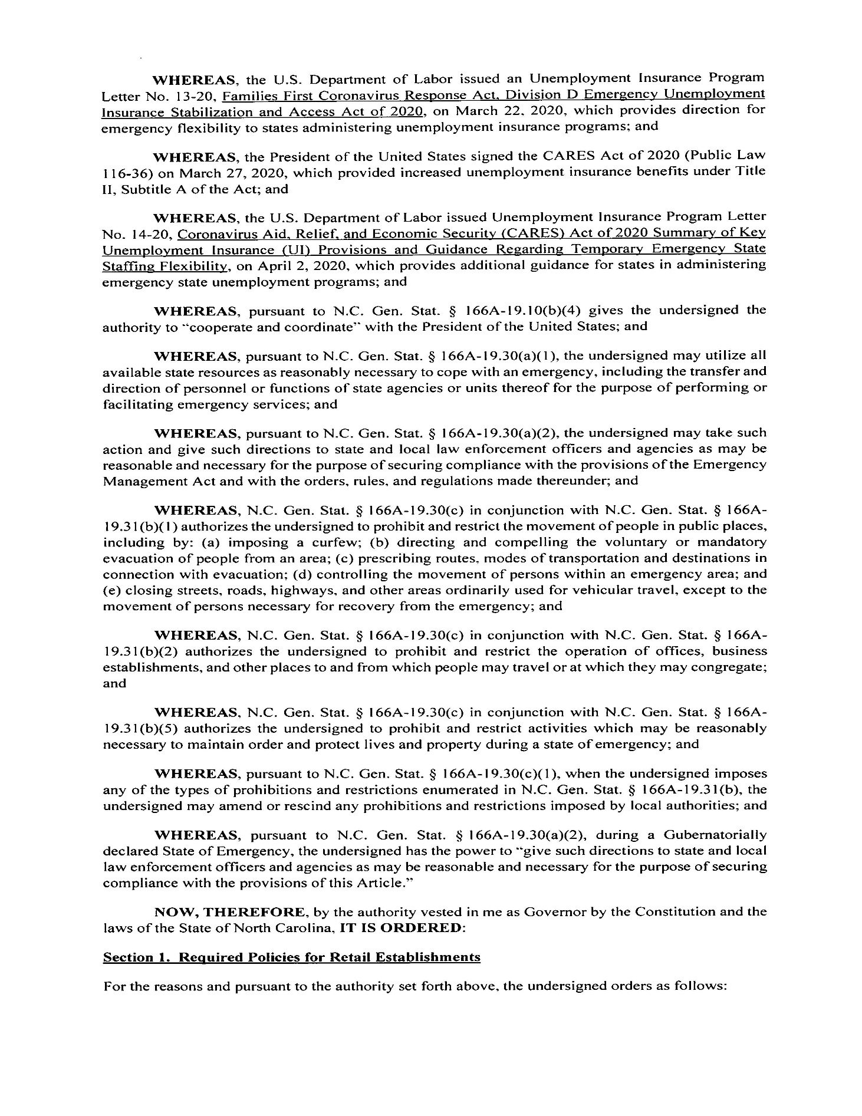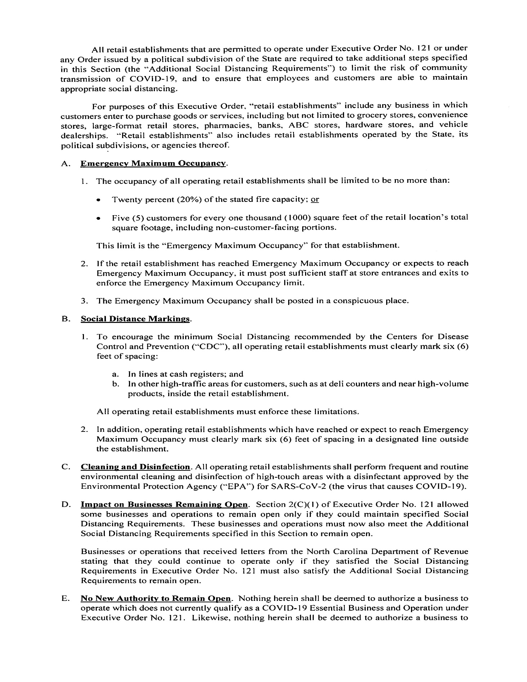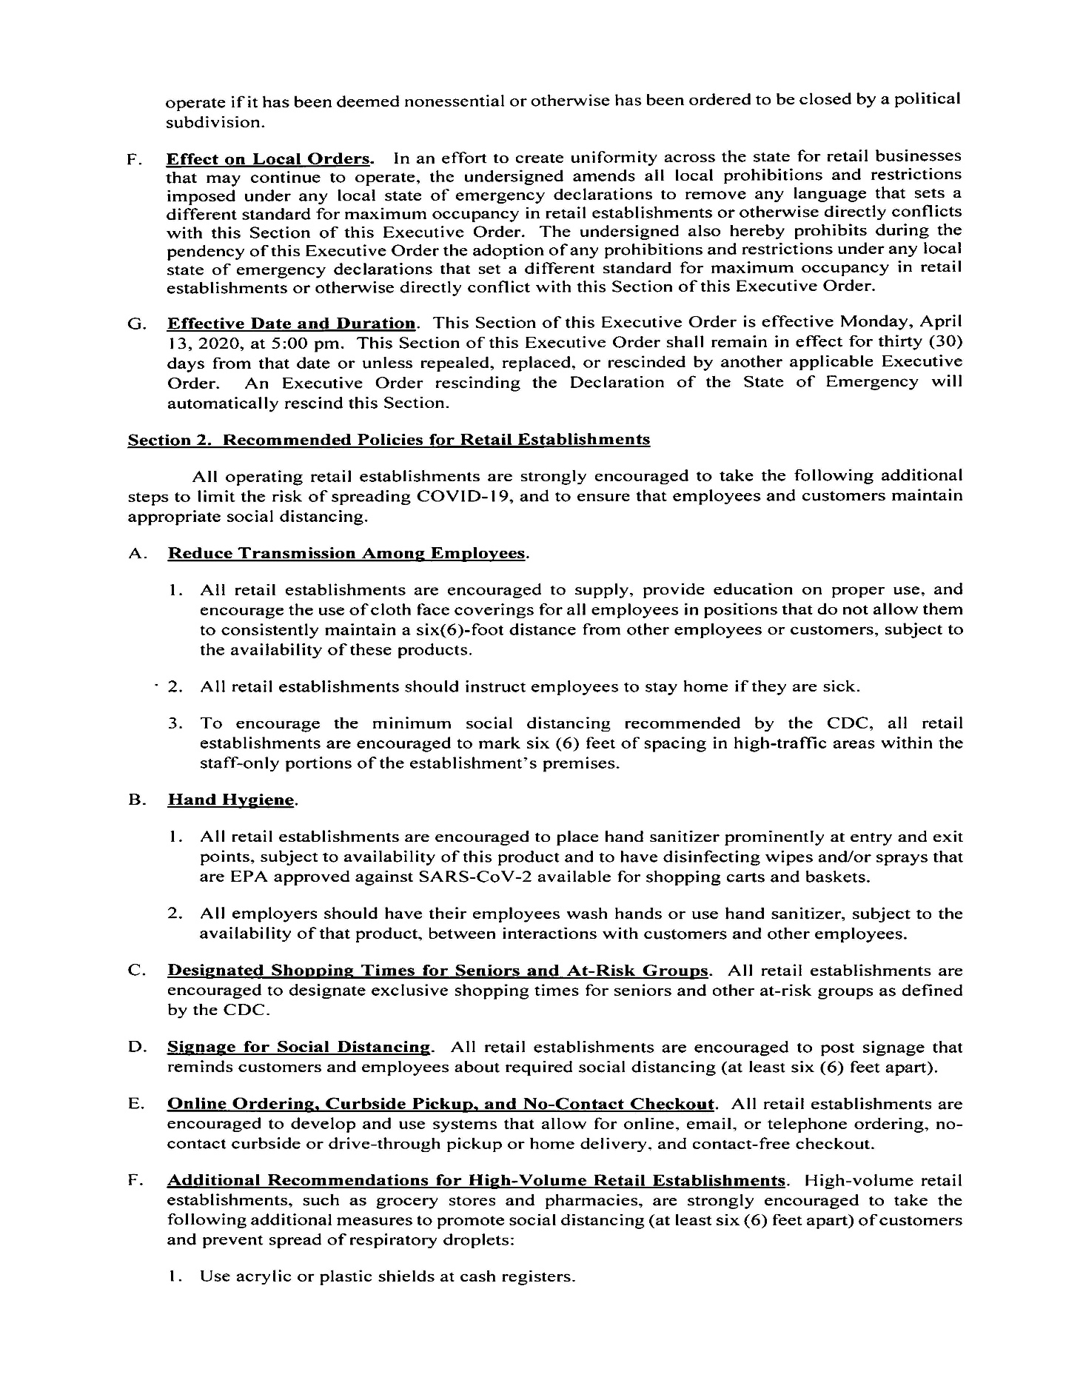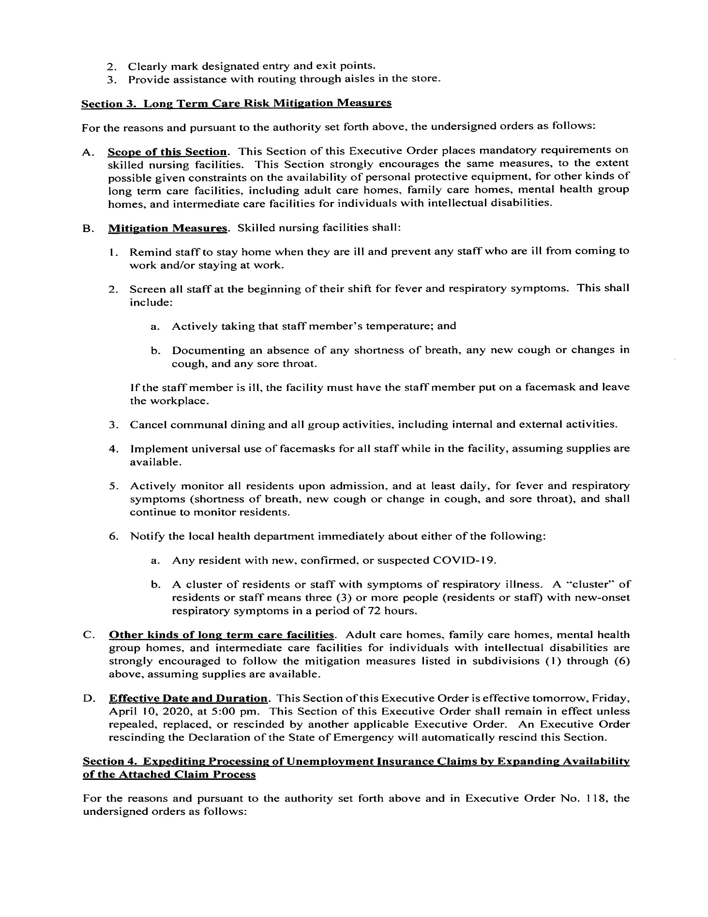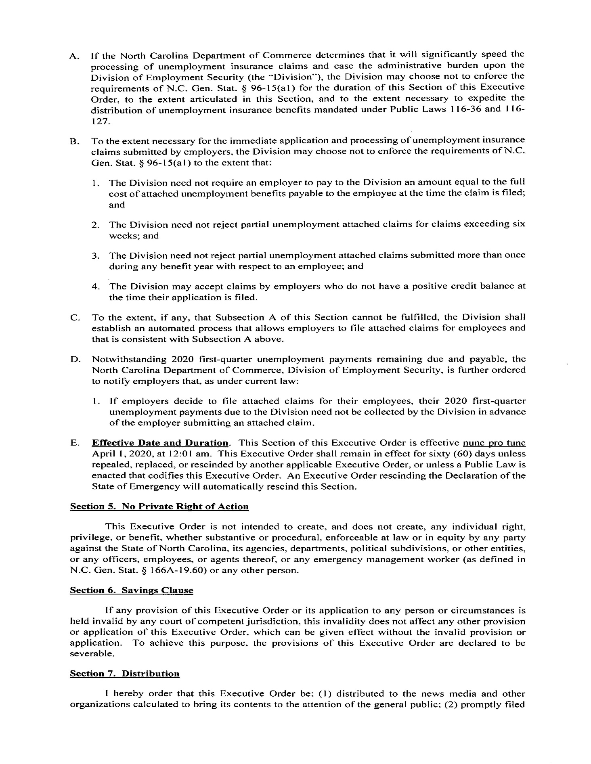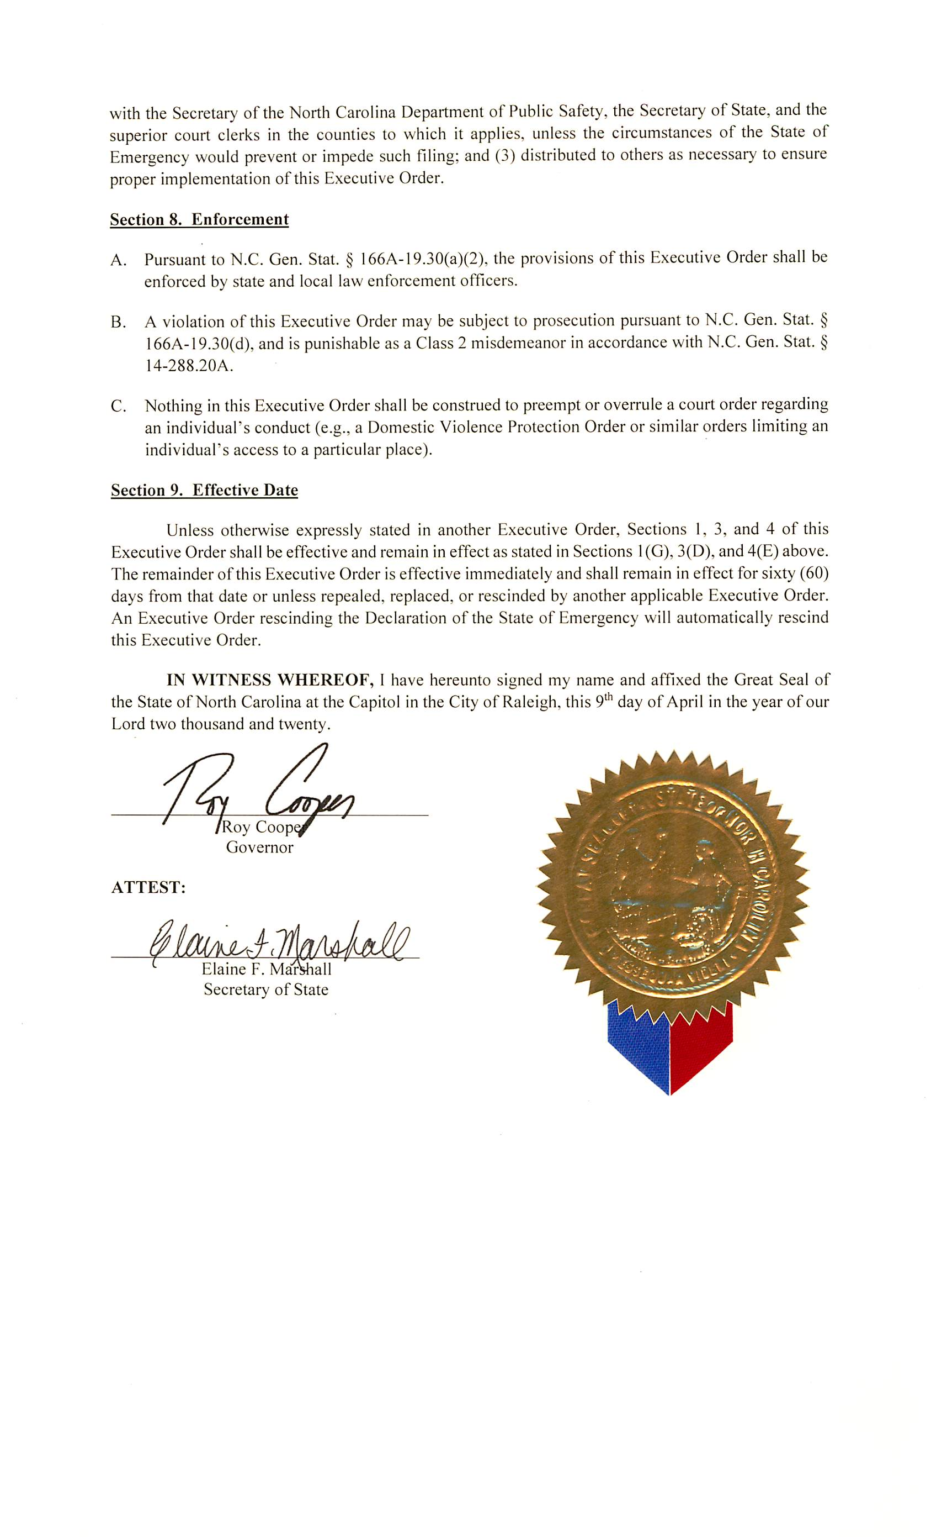

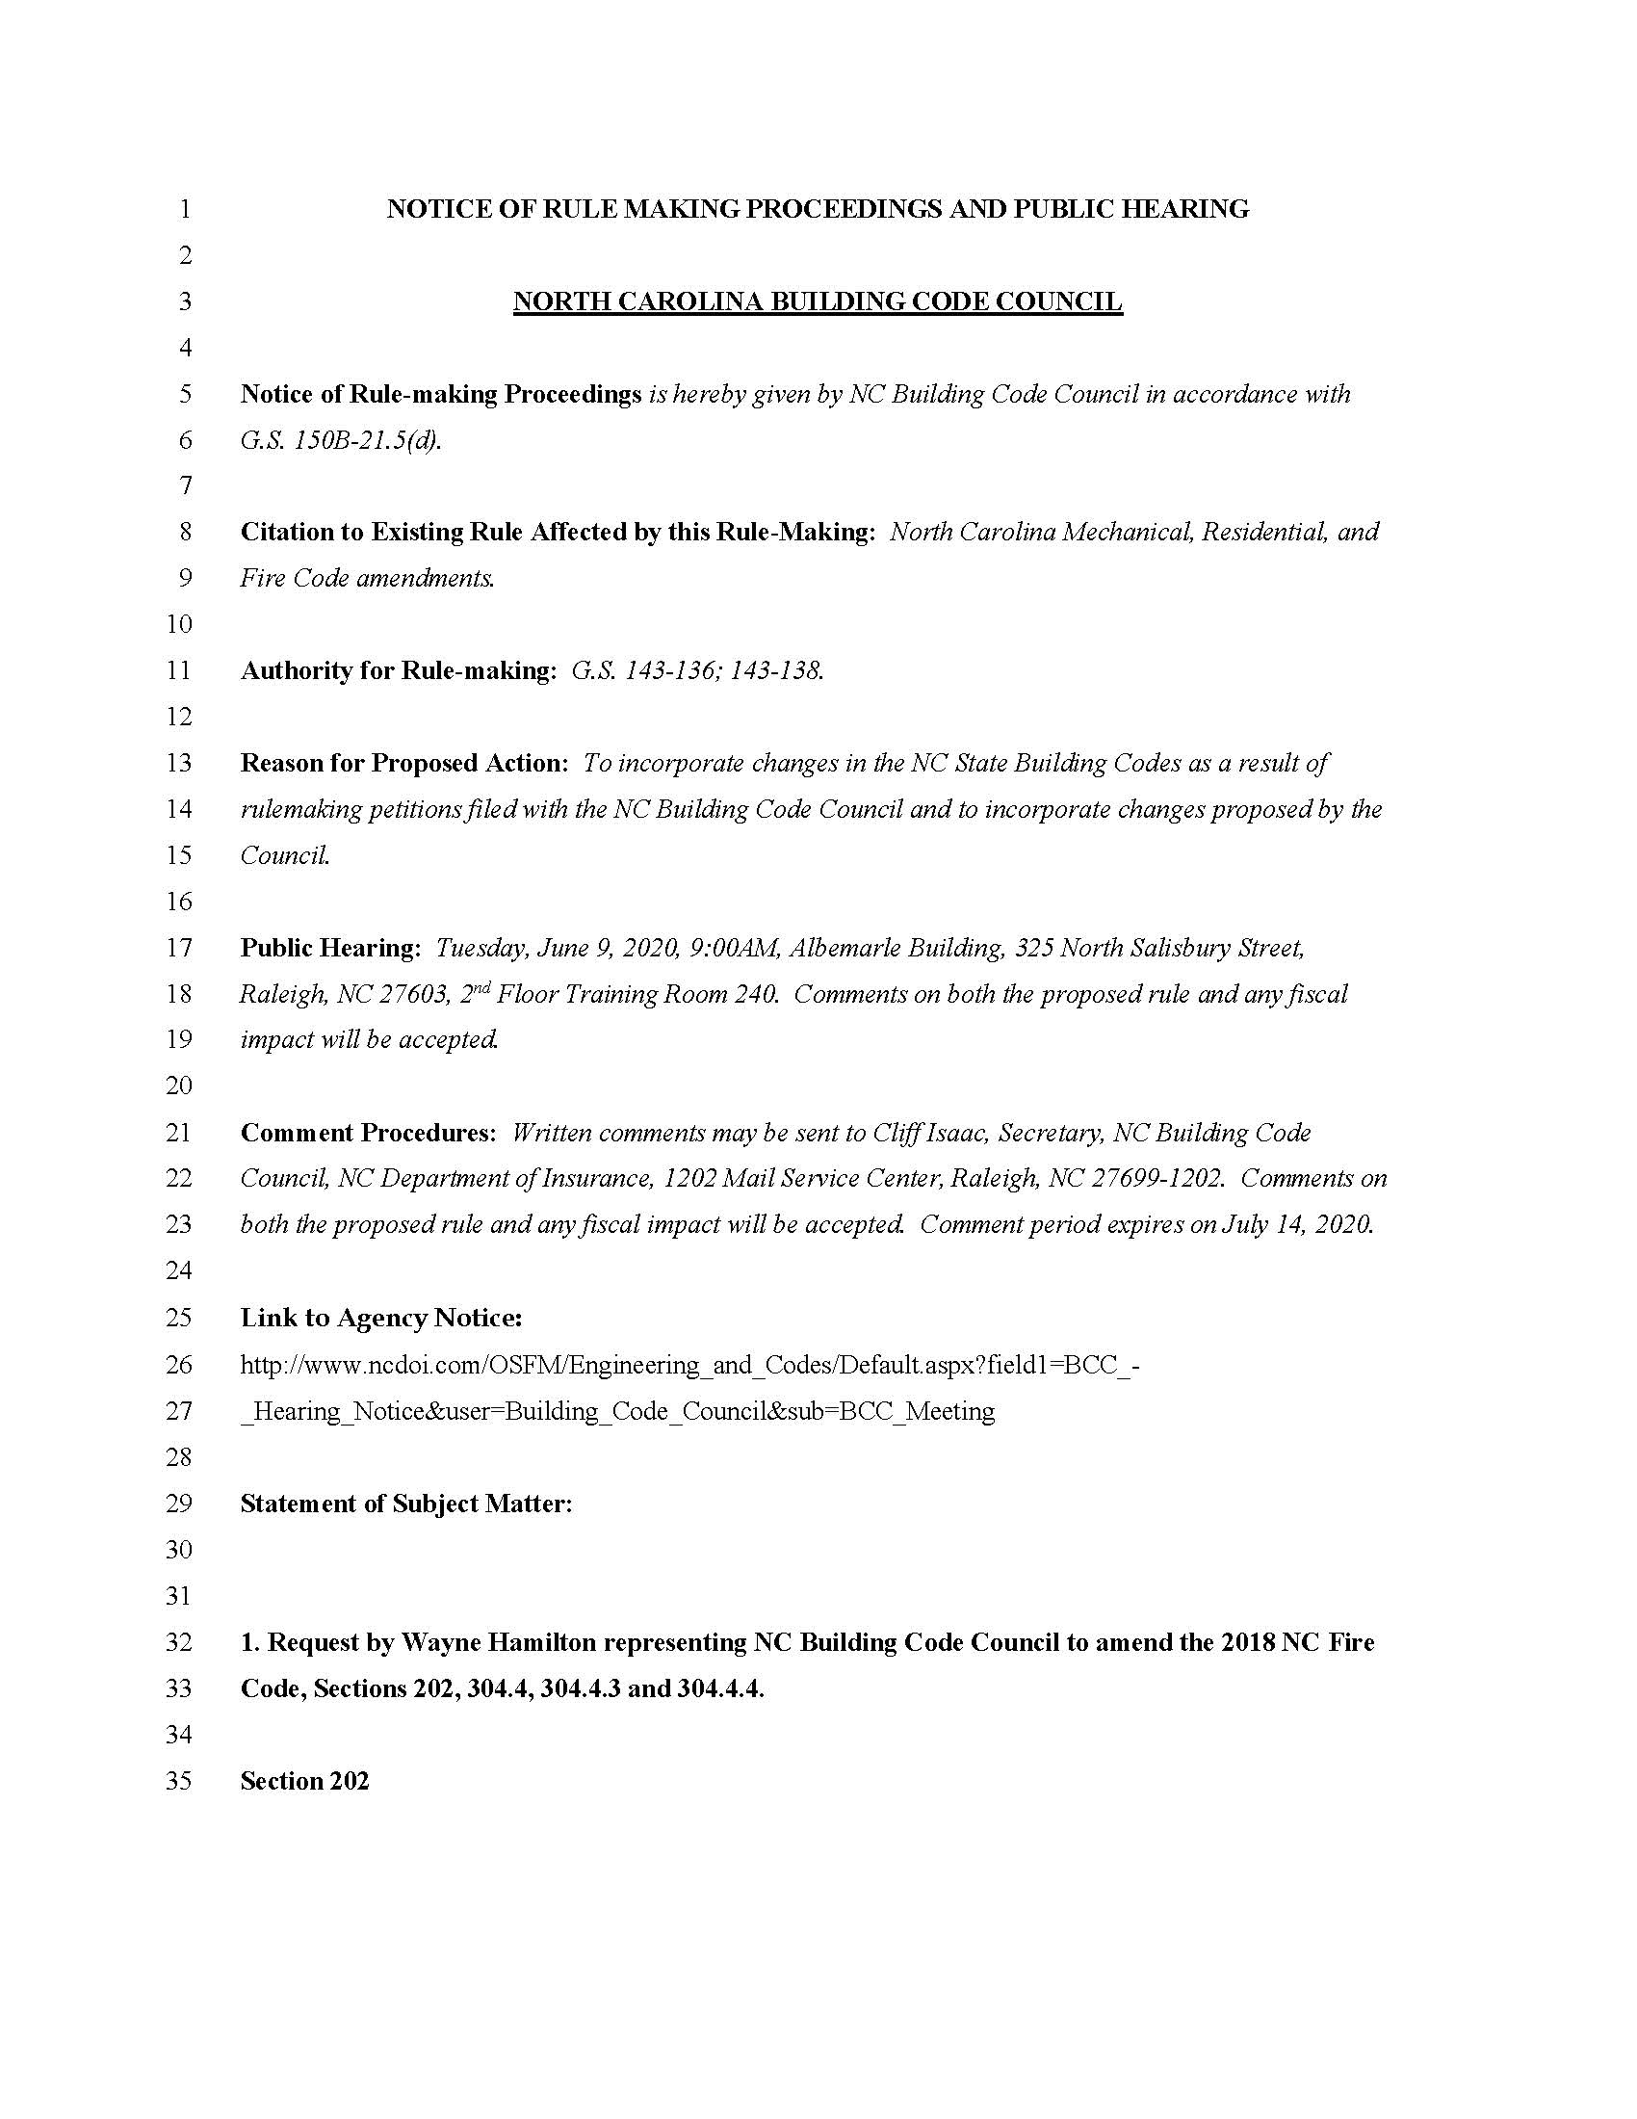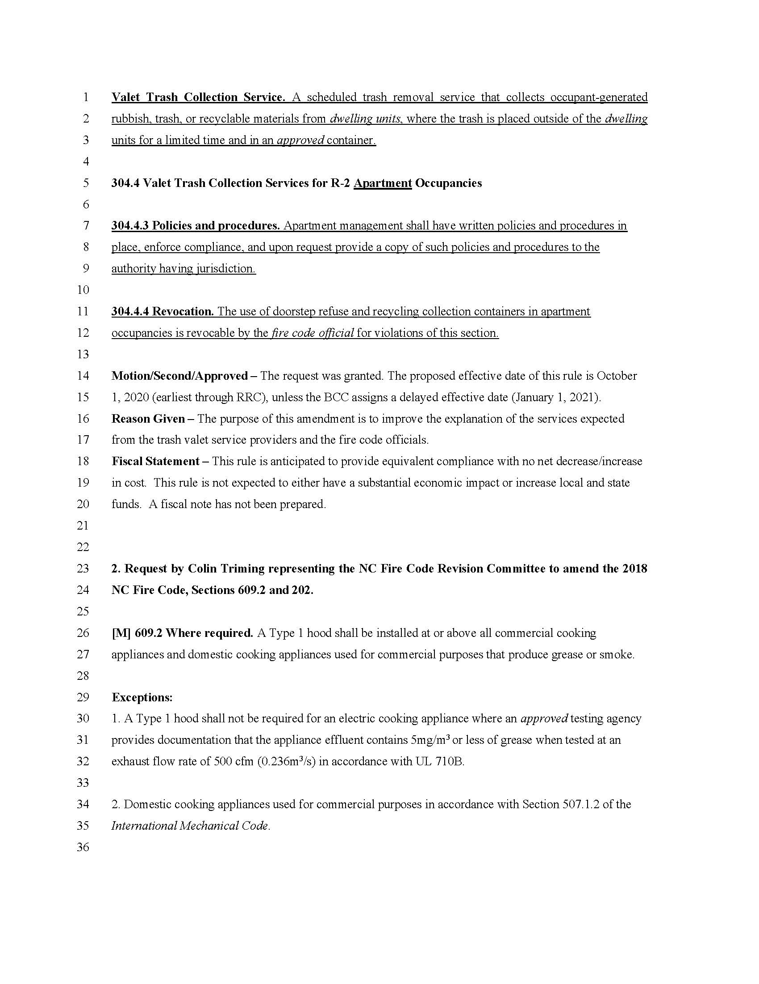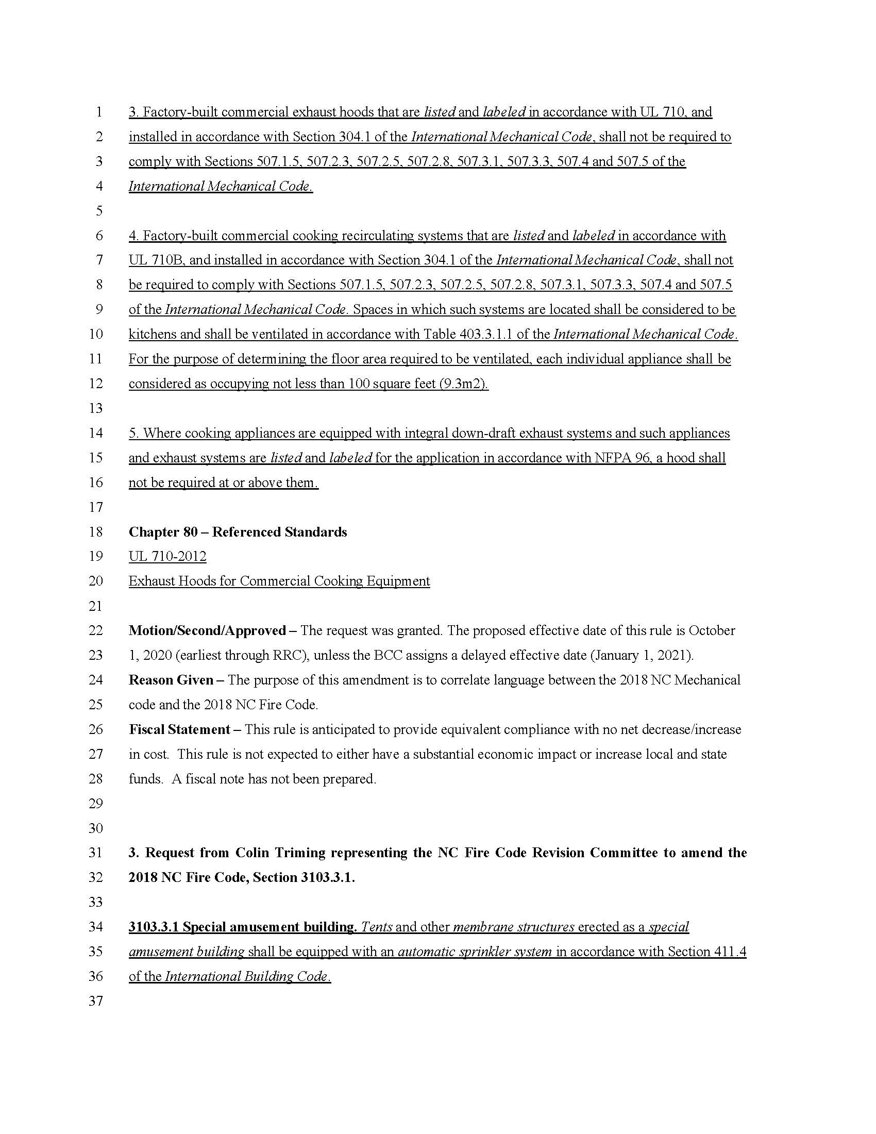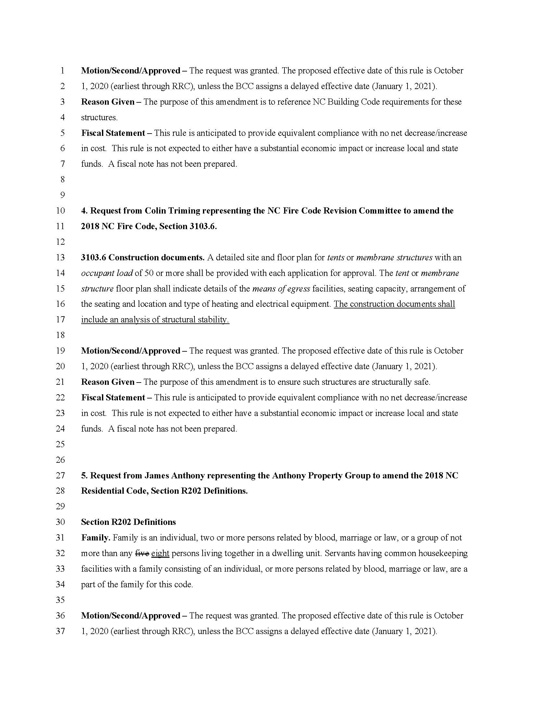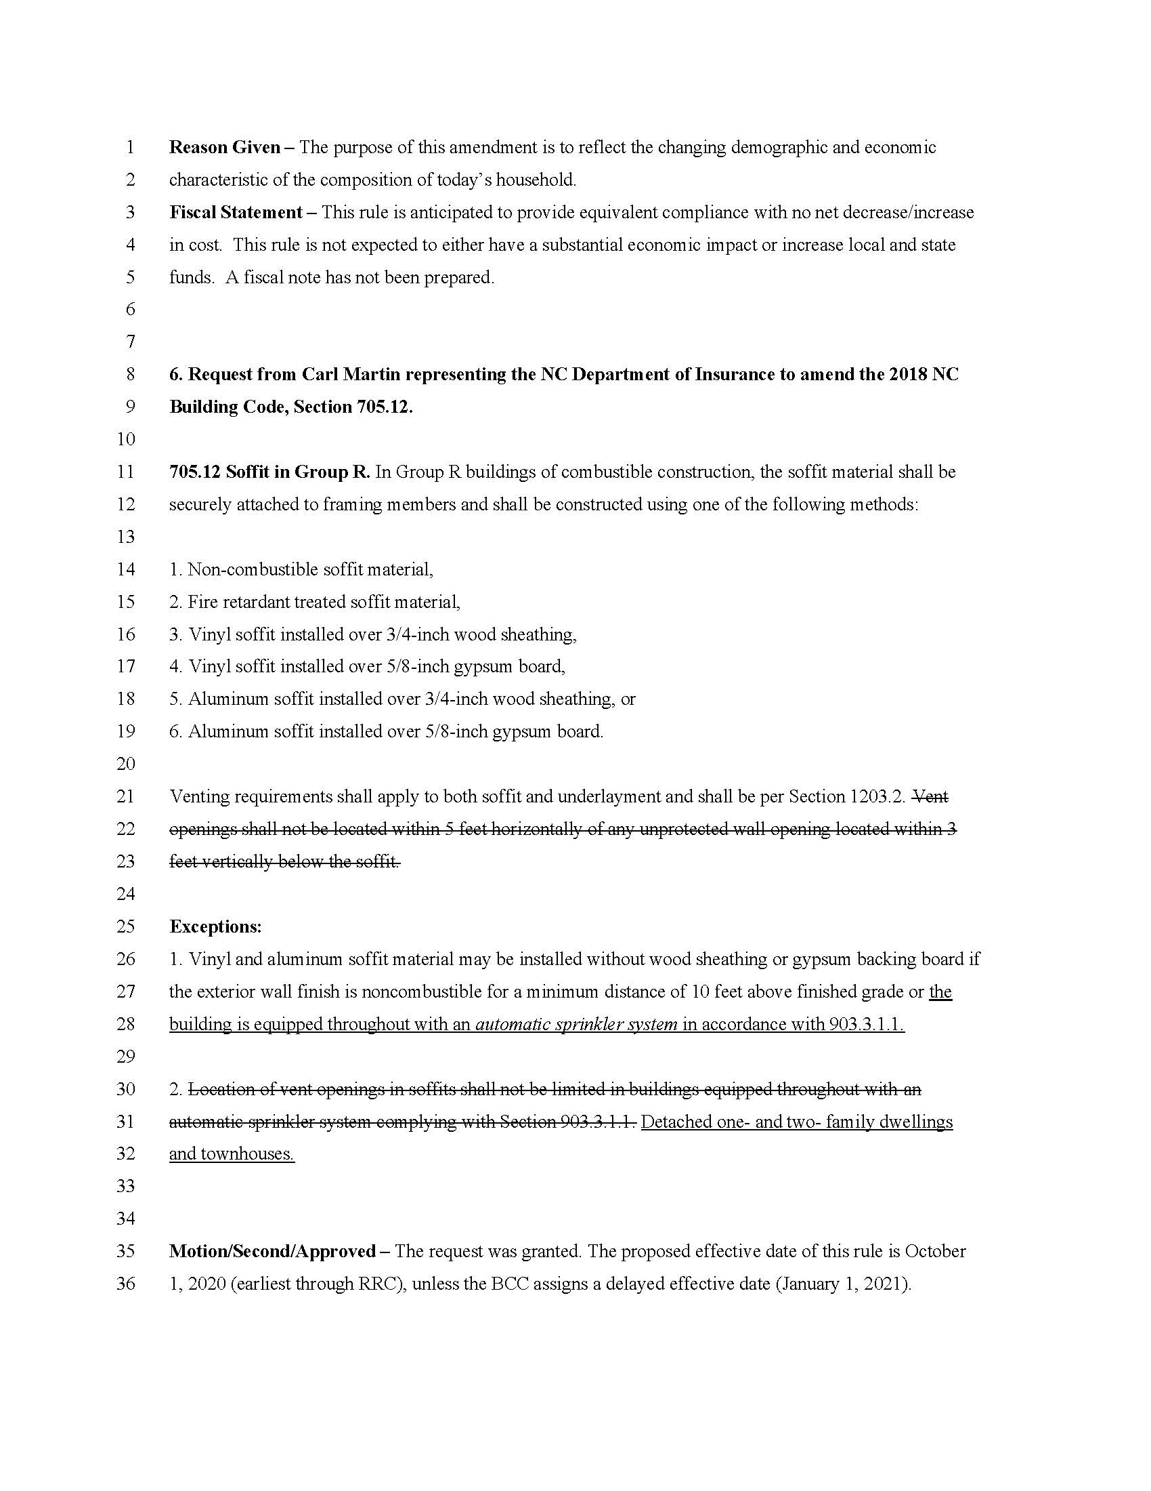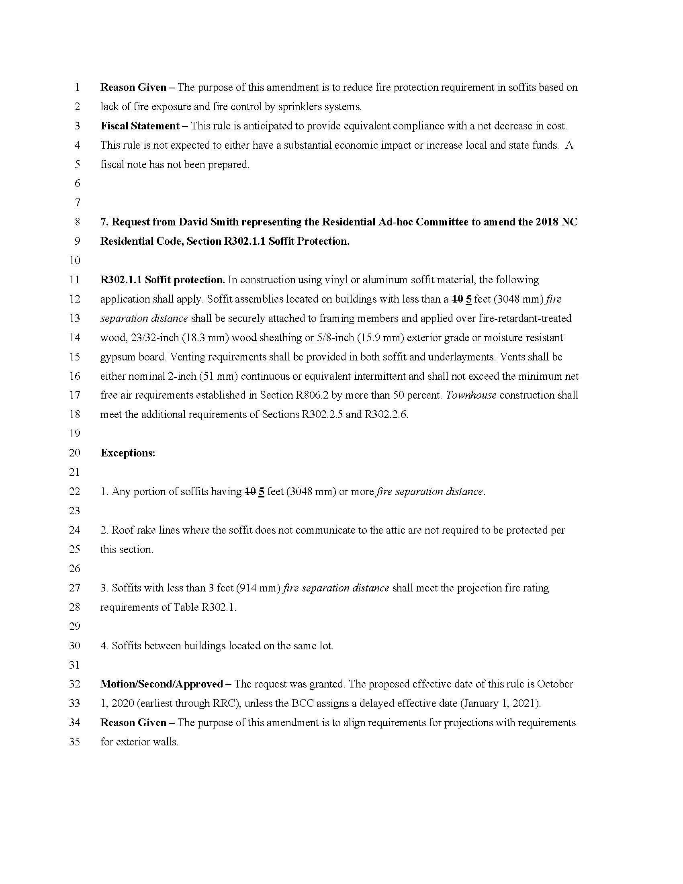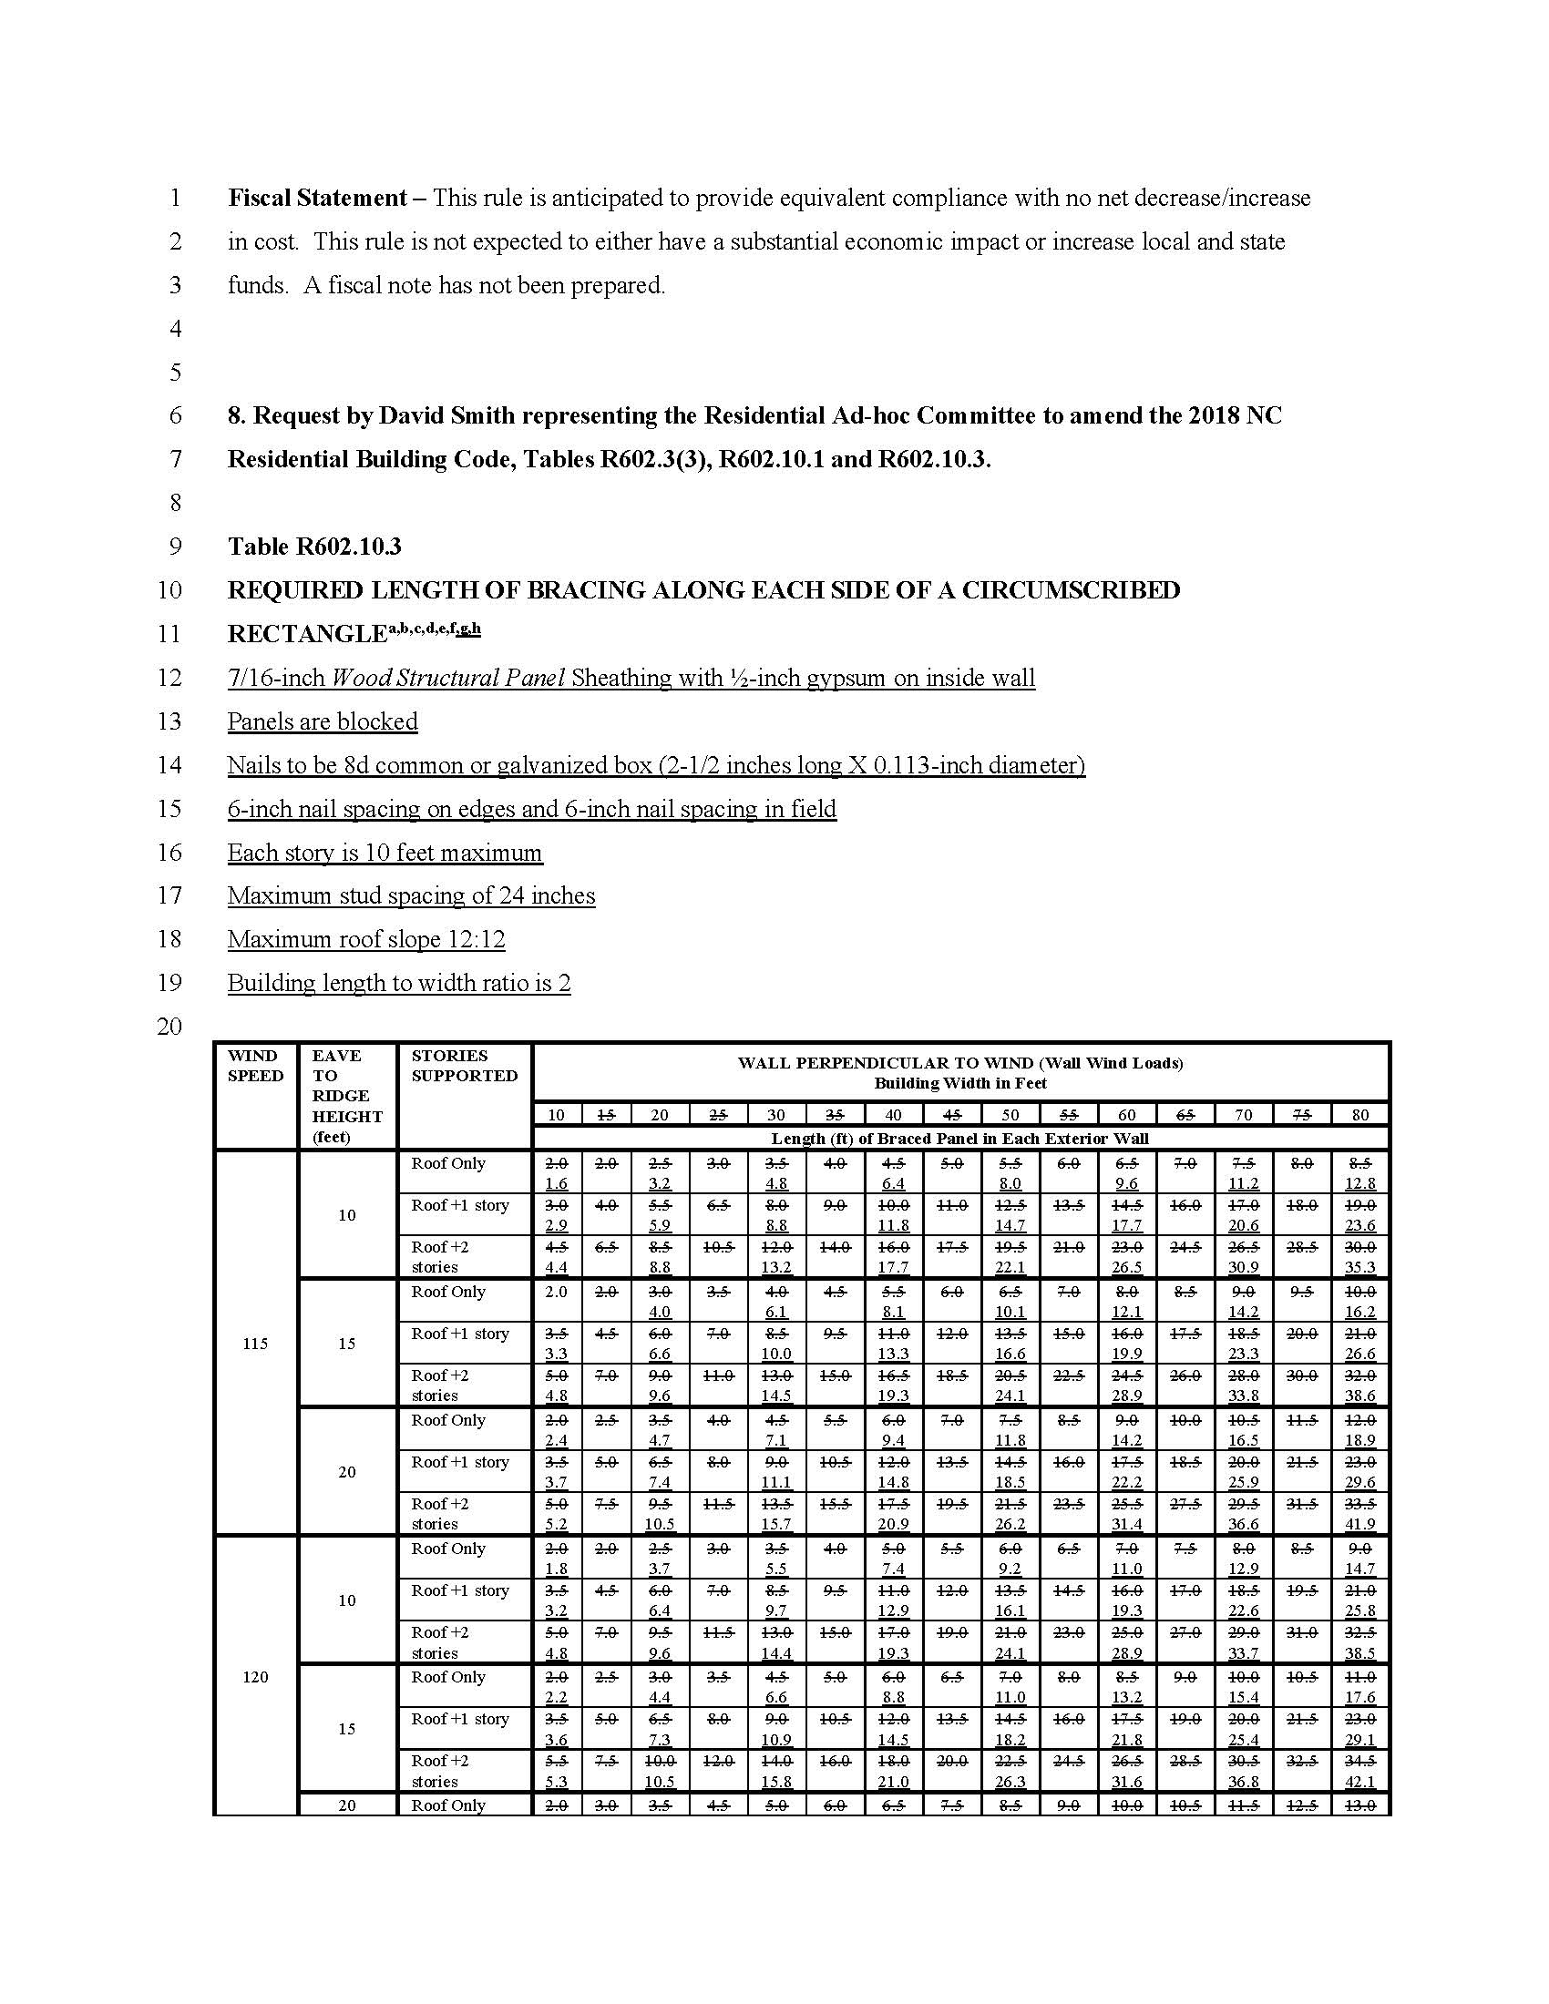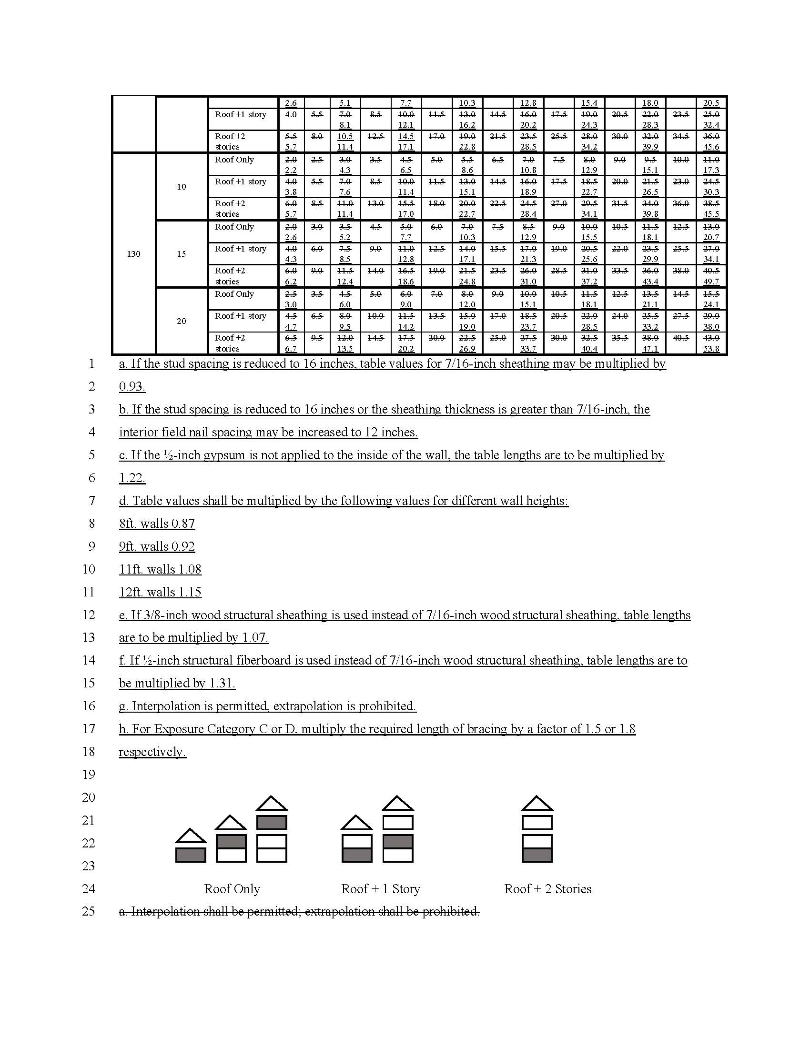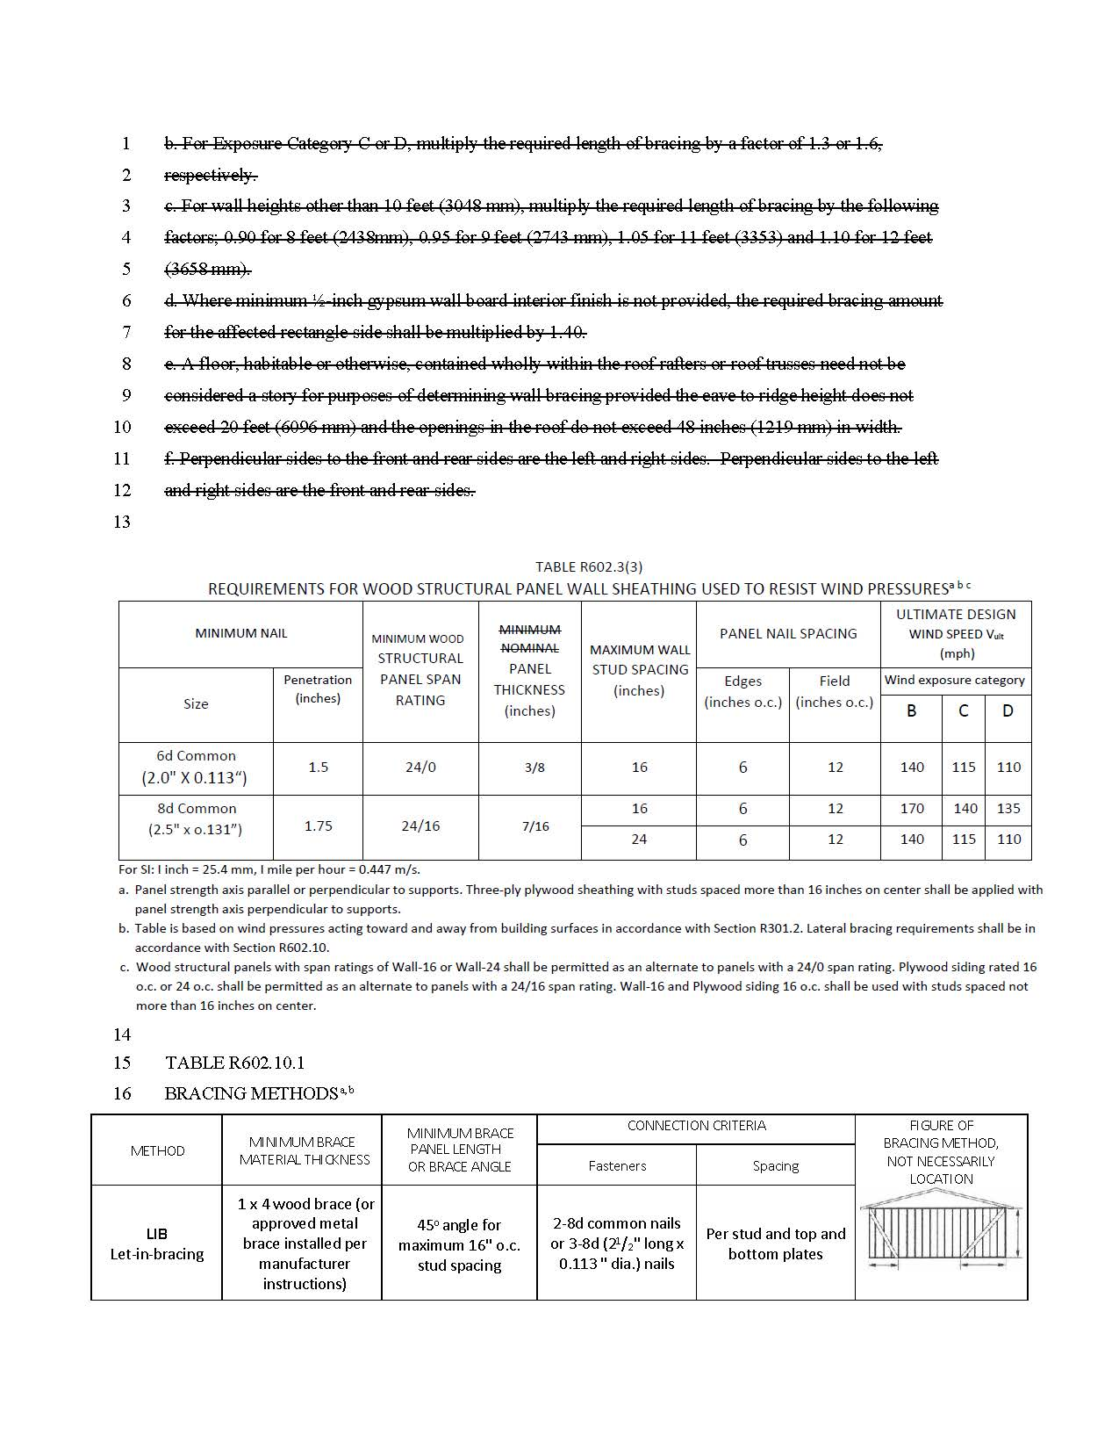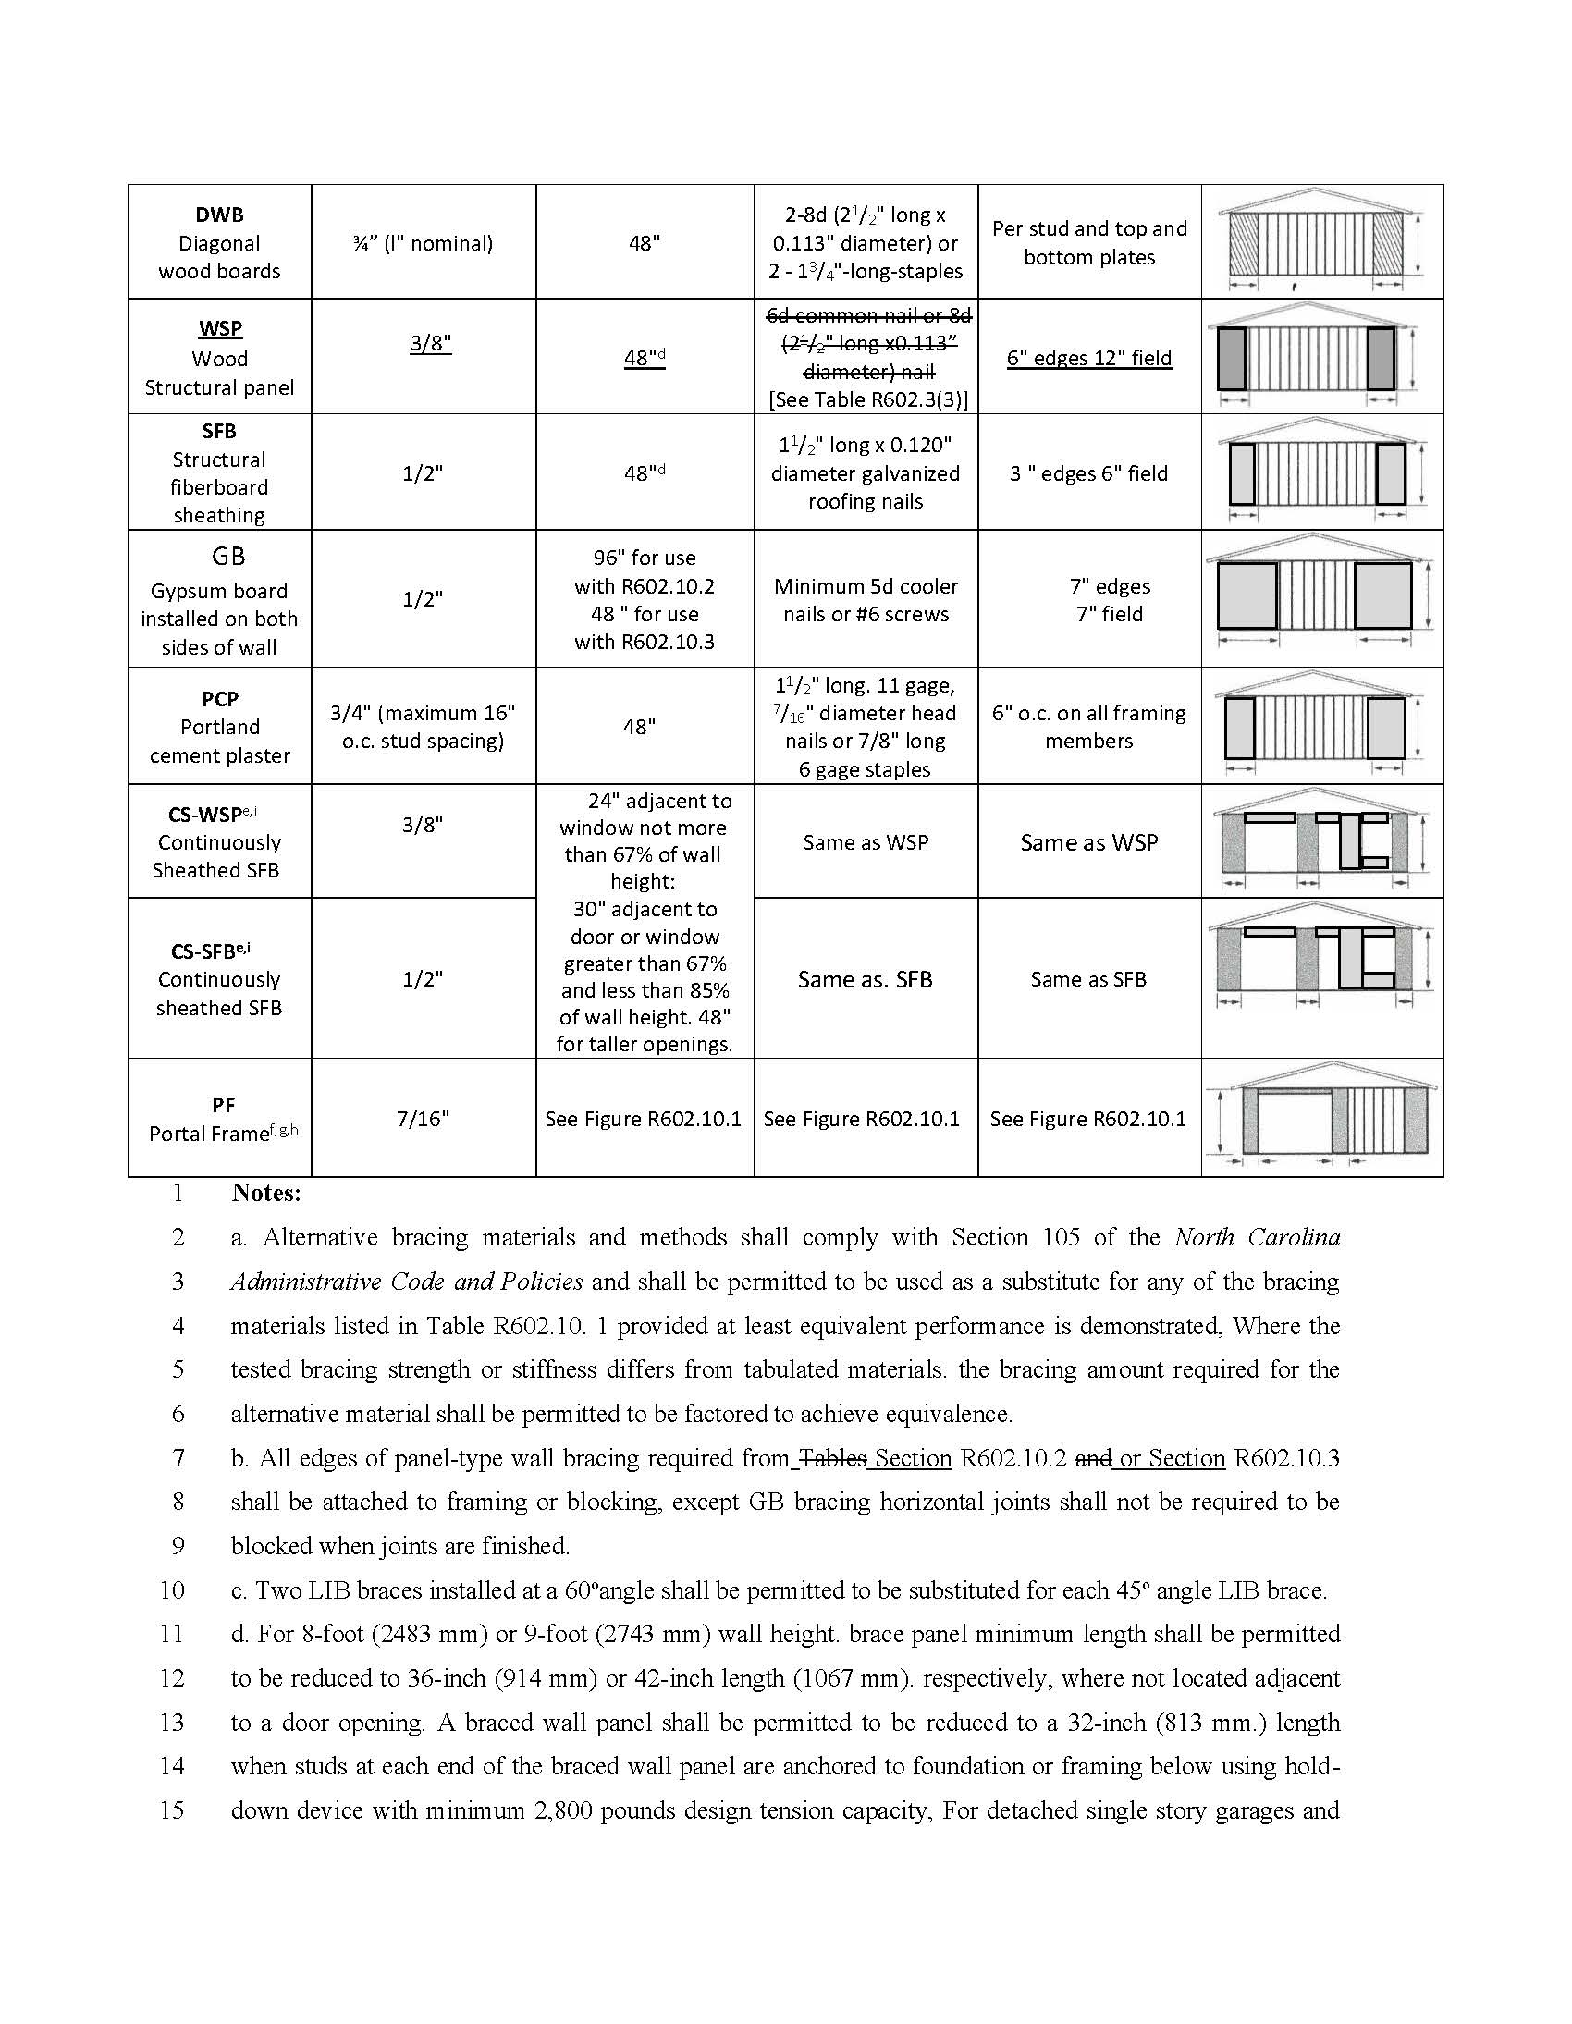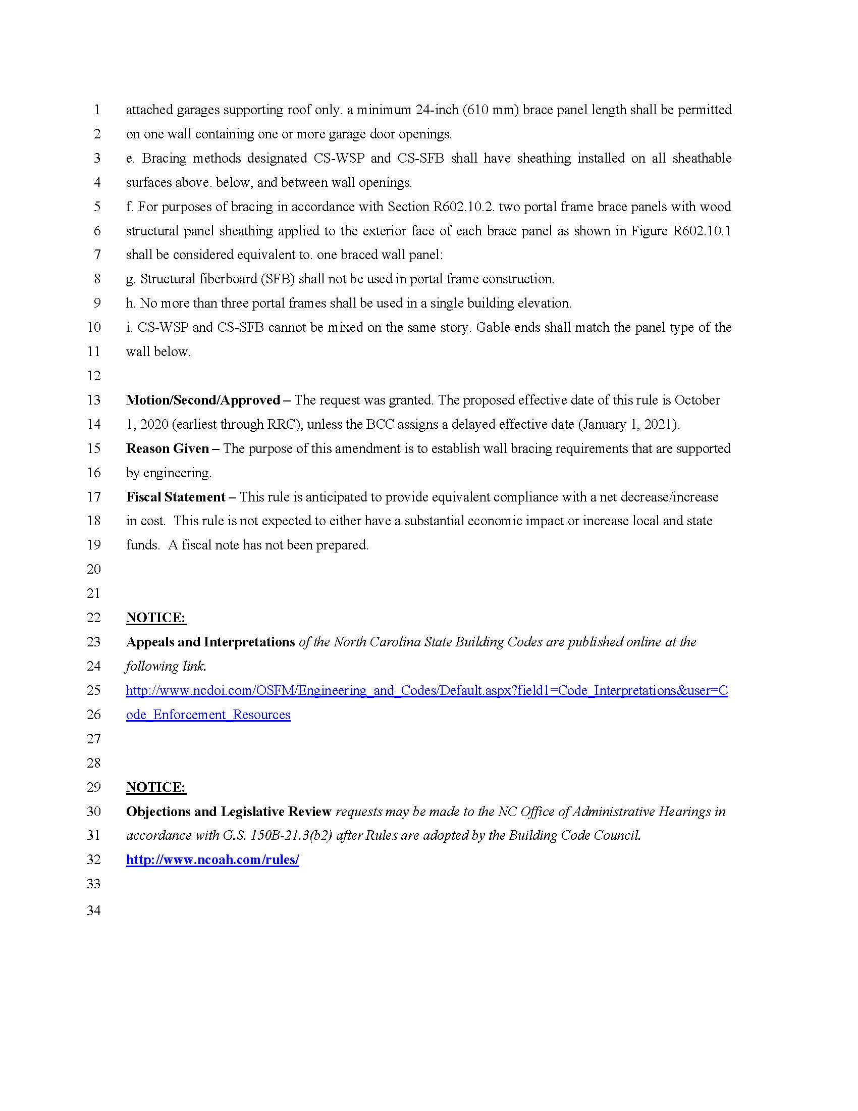
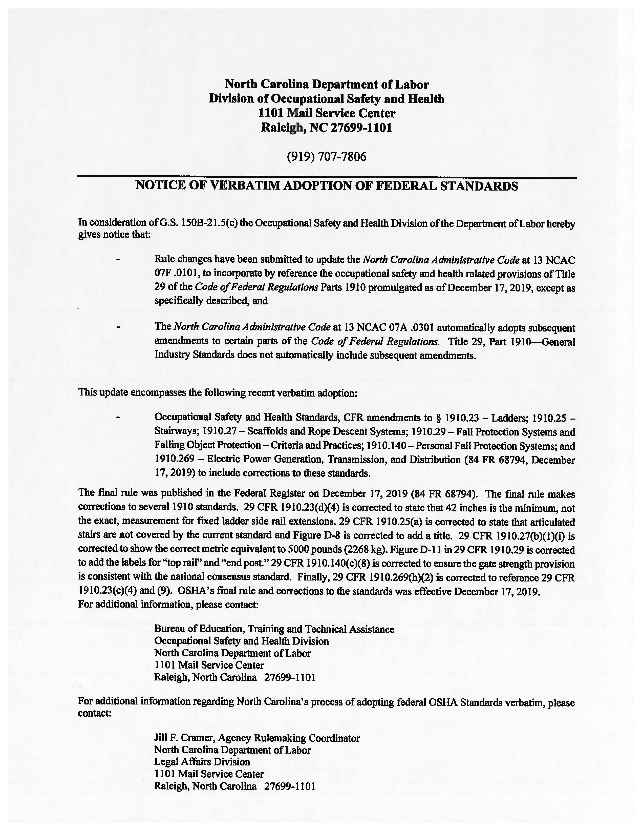

PUBLIC NOTICE

The ABC Commission has cancelled the public hearing on the ABC Store Spirituous Liquor Tasting Rules scheduled for May 13, 2020 at 10:00 a.m. at the ABC Commission Office at 400 E. Tryon Road, Raleigh, NC 27610. The public hearing on these rules is rescheduled for June 10, 2020 at 10:00 a.m. at the same location. The public comment period for the ABC Store Spirituous Liquor Tasting Rules, which currently runs through June 1, 2020, will be extended until June 10, 2020 at 10:00 a.m.

The proposed rules for the ABC Store Spirituous Liquor Tasting Rules, 14B NCAC 15C .1301, .1303 - .1305 and .1307, were published in North Carolina Register, Volume 34, Issue 19, page 1773 on April 1, 2020.

Note from the Codifier: The notices published in this Section of the NC Register include the text of proposed rules. The agency must accept comments on the proposed rule(s) for at least 60 days from the publication date, or until the public hearing, or a later date if specified in the notice by the agency. If the agency adopts a rule that differs substantially from a prior published notice, the agency must publish the text of the proposed different rule and accept comment on the proposed different rule for 60 days.
Statutory reference: G.S. 150B-21.2.

Title 21 - Occupational Licensing Boards and Commissions

Chapter 32 - North Carolina Medical Board

Notice is hereby given in accordance with G.S. 150B-21.2 that the Medical Board intends to amend the rule cited as 21 NCAC 32M .0117.

Link to agency website pursuant to G.S. 150B-19.1(c): www.ncmedboard.org/about_the_board/rule_changes

Proposed Effective Date: September 1, 2020

Public Hearing:
Date: June 30, 2020
Time: 10:00 a.m.
Location: North Carolina Medical Board, 1203 Front Street, Raleigh, NC 27609

Reason for Proposed Action: To add SOPI Report C to assist with identifying problematic prescribing practices.

Comments may be submitted to: Lynne Taylor, 1203 Front Street, Raleigh, NC 27609; phone (919) 326-1109 ext. 237; email lynne.taylor@ncmedboard.org

Comment period ends: June 30, 2020

Procedure for Subjecting a Proposed Rule to Legislative Review: If an objection is not resolved prior to the adoption of the rule, a person may also submit written objections to the Rules Review Commission after the adoption of the Rule. If the Rules Review Commission receives written and signed objections after the adoption of the Rule in accordance with G.S. 150B-21.3(b2) from 10 or more persons clearly requesting review by the legislature and the Rules Review Commission approves the rule, the rule will become effective as provided in G.S. 150B-21.3(b1). The Commission will receive written objections until 5:00 p.m. on the day following the day the Commission approves the rule. The Commission will receive those objections by mail, delivery service, hand delivery, or facsimile transmission. If you have any further questions concerning the submission of objections to the Commission, please call a Commission staff attorney at 919-431-3000.

Fiscal impact. Does any rule or combination of rules in this notice create an economic impact? Check all that apply.

State funds affected

Local funds affected

Substantial economic impact (>= $1,000,000)

Approved by OSBM

No fiscal note required

SUBCHAPTER 32M - APPROVAL OF NURSE PRACTITIONERS

21 NCAC 32M .0117 REPORTING CRITERIA

(a) The Department of Health and Human Services ("Department") may report to the North Carolina Board of Nursing ("Board of Nursing")("Board") information regarding the prescribing practices of those nurse practitioners ("prescribers") whose prescribing:

(1) falls within the top two percent of those prescribing 100 morphine milligram equivalents ("MME") per patient per day; or

(2) falls within the top two percent of those prescribing 100 MMEs per patient per day in combination with any benzodiazepine and who are within the top one percent of all controlled substance prescribers by volume.

(b) In addition, the Department may report to the Board of Nursing information regarding prescribers who have had two or more patient deaths in the preceding 12 months due to opioid poisoning where the prescribers authorized more than 30 tablets of an opioid to the decedent and the prescriptions were written within 60 days of the patient deaths.

(c) In addition, the Department may report to the Board information regarding prescribers who meet three or more of the following criteria, if there are a minimum of five patients for each criterion:

(1) at least 25 percent of the prescriber's patients receiving opioids reside 100 miles or greater from the prescriber's practice location;

(2) the prescriber had more than 25 percent of patients receiving the same opioids and benzodiazepine combination;

(3) the prescriber had 75 percent of patients receiving opioids self-pay for the prescriptions;

(4) the prescriber had 90 percent or more of patients in a three-month period that received an opioid prescription that overlapped with another opioid prescription for at least one week;

(5) more than 50 percent of the prescriber's patients received opioid doses of 100 MME or greater per day excluding office-based treatment medications; and

(6) the prescriber had at least 25 percent of patients who used three or more pharmacies within a three-month period to obtain opioids regardless of the prescriber.

(d) The Department may submit these reports to the Board of Nursing upon request and may include the information described in G.S. 90-113.73(b).

(e) The reports and communications between the Department and the Board of Nursing shall remain confidential pursuant to G.S. 90-16 and G.S. 90-113.74.

Authority G.S. 90-5.1(a)(3); 90-113.74.

* * * * * * * * * * * * * * * * * * * *

Notice is hereby given in accordance with G.S. 150B-21.2 that the Medical Board intends to amend the rule cited as 21 NCAC 32R .0102.

Link to agency website pursuant to G.S. 150B-19.1(c): www.ncmedboard.org/about_the_board/rule_changes

Proposed Effective Date: September 1, 2020

Public Hearing:
Date: June 30, 2020
Time: 10:00 a.m.
Location: North Carolina Medical Board, 1203 Front Street, Raleigh, NC 27609

Reason for Proposed Action: To clarify interprofessional continuing education approved by the Joint Accreditation for Interprofessional Continuing Education qualifies for CME credit.

Comments may be submitted to: Lynne Taylor, 1203 Front Street, Raleigh, NC 27609; phone (919) 326-1109 ext. 237; email lynne.taylor@ncmedboard.org

Comment period ends: June 30, 2020

Procedure for Subjecting a Proposed Rule to Legislative Review: If an objection is not resolved prior to the adoption of the rule, a person may also submit written objections to the Rules Review Commission after the adoption of the Rule. If the Rules Review Commission receives written and signed objections after the adoption of the Rule in accordance with G.S. 150B-21.3(b2) from 10 or more persons clearly requesting review by the legislature and the Rules Review Commission approves the rule, the rule will become effective as provided in G.S. 150B-21.3(b1). The Commission will receive written objections until 5:00 p.m. on the day following the day the Commission approves the rule. The Commission will receive those objections by mail, delivery service, hand delivery, or facsimile transmission. If you have any further questions concerning the submission of objections to the Commission, please call a Commission staff attorney at 919-431-3000.

Fiscal impact. Does any rule or combination of rules in this notice create an economic impact? Check all that apply.

State funds affected

Local funds affected

Substantial economic impact (>= $1,000,000)

Approved by OSBM

No fiscal note required

SUBCHAPTER 32R – CONTINUING MEDICAL EDUCATION (CME) REQUIREMENTS

SECTION .0100 – CONTINUING MEDICAL EDUCATION (CME) REQUIREMENTS

21 NCAC 32R .0102 APPROVED CATEGORIES OF CME

(a) Category 1 CME providers are:

(1) Institutions or organizations accredited by the Accreditation Council on Continuing Medical Education (ACCME) and reciprocating organizations;

(2) The American Osteopathic Association (AOA);

(3) A state medical society or association;

(4) The American Medical Association (AMA); and

(5) Specialty boards accredited by the American Board of Medical Specialties (ABMS), the AOA or Royal College of Physicians and Surgeons of Canada (RCPSC). (RCPSC); and

(6) The Joint Accreditation for Interprofessional Continuing Education.

(b) Category 1 CME education shall be presented, offered, or accredited by a Category 1 provider as defined above and shall include:

(1) Educational courses;

(2) Scientific or clinical presentations or publications;

(3) Printed, recorded, audio, video, online or electronic educational materials for which CME credits are awarded by the publisher;

(4) Journal-based CME activities within a peer-reviewed, professional journal;

(4)(5) Skill development;

(5)(6) Performance improvement activities; or

(6) Journal-based CME activities within a peer-reviewed, professional journal.

(7) Interprofessional continuing education.

Authority G.S. 90-5.1(a)(3)(9) and (10); G.S. 90-14(a)(15).

Note from the Codifier: The rules published in this Section of the NC Register are emergency rules reviewed by the Codifier of Rules and entered in the North Carolina Administrative Code. The agency must subsequently publish a proposed temporary rule on the OAH website (www.ncoah.com/rules) and submit that adopted temporary rule to the Rules Review Commission within 60 days from publication of the emergency rule or the emergency rule will expire on the 60th day from publication.
This section of the Register may also include, from time to time, a listing of emergency rules that have expired. See G.S. 150B-21.1A and 26 NCAC 02C .0600 for adoption and filing requirements.

TITLE 04 – department of commerce

Rule-making Agency: Department of Commerce/Division of Employment Security

Rule Citation: 04 NCAC 24G .0101-.0103

Effective Date: April 14, 2020

Findings Reviewed and Approved by the Codifier: April 3, 2020

Reason for Action: Emergency rules are needed because of a serious and unforeseen threat to the public health, safety, and welfare recent act of the U.S. Congress with the passage of the Families First Coronavirus Response Act, Pub. L. No. 116-127, Division D, 1402 (2020), Executive Order No. 118 issued by Governor Roy Cooper on March 17, 2020; and guidance from the U.S. Department of Labor in Unemployment Insurance Program Letter (UIPL) Nos. 13-20 (issued March 22, 2020) and 10-20 (issued March 12, 2020).

On March 10, 2020 the Governor of North Carolina Issued Executive Order No. 116 and declared a state of emergency to coordinate a response and enact protective measures to help prevent the spread of Coronavirus Disease 2019 (COVID-19), a respiratory disease that results from the coronavirus. COVID-19 can result in serious illness or death.

On March 11, 2020, the World Health Organization declared the coronavirus an international pandemic. The World Health Organization, the Centers for Disease Control and Prevention, and the United States Department of Health and Human Services have declared COVID-19 a public health threat and emergency.

On March 17, 2020, the Governor of North Carolina issued Executive Order No. 118 and directed the Secretary of Commerce and Assistant Secretary for the Division of Employment Security to ensure that individuals who are separated from employment, had hours reduced, or are prevented from working due to a medical condition caused by COVID-19 or due to communicable disease control measures are eligible for unemployment benefits to the maximum amount permitted by federal law.

On March 18, 2020 the President of the United States signed the Families First Coronavirus Response Act (Pub. 1 116-127). The legislation makes emergency supplemental appropriations in response to the spread of COVID19 and includes the Emergency Unemployment Insurance Stabilization and Access Act of 2020 (EUISAA) at Division D EUISAA sets for the requirements for emergency administrative grants to states and authorizes emergency flexibility allowing states to temporarily modify certain aspects of their unemployment compensation laws, a short-term waiver of interest on state trust fund advances, and full federal funding during extended benefit periods through December 31, 2020.

chapter 24 – employment security

SUBCHAPTER 24G – UNEMPLOYMENT COMPENSATION DUE TO PUBLIC HEALTH EMERGENCY OR DISASTER DECLARATION

SECTION .0100 – UNEMPLOYMENT COMPENSATION DUE TO CORONAVIRUS AND COVID-19

04 ncac 24g .0101 TEMPORARY WAIVER OF CERTAIN ELIGIBILITY REQUIREMENTS

(a) DES shall temporarily waive certain eligibility requirements for unemployment insurance benefits.

(b) The temporary waiver of these requirements shall apply only to claims filed for the period of and pertaining to the declared coronavirus and COVID-19 public health emergency as set forth in Executive Order No. 118 issued on March 17, 2020.

(c) DES shall temporarily waive:

(1) the requirement of a one week waiting period in G.S. 96-14.1(b);

(2) the work search requirements set forth in G.S. 96-14.9(b);

(3) the requirement for an individual to actively seek work pursuant to G.S. 96-14.9(e); and

(4) the lack of work requirements of the unemployed provisions of G.S. 96-15.01(b)(2)(a).

(d) DES shall postpone all mandatory in-person contact with individuals seeking unemployment benefits.

History Note: Authority G.S. 96-4; 96-14.1; 96-14.9; 96-15.01; 166A-19.30; 20 C.F.R. 604.4; Families First Coronavirus Response Act, Pub. L. No. 116-127, Division D, 1402 (2020); E.O. 118, Governor Roy Cooper, 2020;
Emergency Adoption Eff. April 14, 2020.

04 ncac 24g .0102 NOTICE THAT EMPLOYERS MUST GIVE TO EMPLOYEES AS A RESULT OF CORONAVIRUS

Employers shall provide employees with notice of the availability of unemployment compensation at the time of separation from employment. The notice shall inform employees of the following:
(1) Unemployment insurance benefits are available to workers who are unemployed and who meet the State's eligibility requirements;
(2) Employees may file a claim in the first week that employment stops, or work hours are reduced;
(3) Employees may file claims online at des.nc.gov or by telephone to (888) 737-0259.
(4) Employees must provide DES with the following information for DES to process the claim:
(a) full legal name;
(b) social security number; and
(c) authorization to work (if the employee is not a U.S. citizen or resident).
(5) Employees may contact DES at (888) 737-0259 and select the appropriate menu option for assistance.

History Note: Authority G.S. 96-4; 166A-19.30; Families First Coronavirus Response Act, Pub. L. No. 116-127, Division D, 1402 (2020); E.O. 118, Governor Roy Cooper, 2020;
Emergency Adoption Eff. April 14, 2020.

04 ncac 24g .0103 TEMPORARY WAIVER OF BENEFIT CHARGES TO EMPLOYER ACCOUNTS

(a) DES shall temporarily waive the charging of benefit payments to employer accounts as required by State or federal law.

(b) The temporary waiver of these benefit charges shall apply only to claims filed for the period of and pertaining to the declared coronavirus and COVID-19 public health emergency as set forth in Executive Order No. 118 issued on March 17, 2020.

(c) DES shall temporarily suspend the requirements of 04 NCAC 24D .0102(a)(9) and (10).

(d) DES shall temporarily suspend the requirements of 04 NCAC 24D .0103.

(e) DES shall temporarily suspend the requirements of 04 NCAC 24D .0105.

History Note: Authority G.S. 96-4; 166A-19.30; Families First Coronavirus Response Act, Pub. L. No. 116-127, Division D, 1402 (2020); E.O. 118, Governor Roy Cooper, 2020;
Emergency Adoption Eff. April 14, 2020.

TITLE 10a – department of health and human services

Rule-making Agency: Medical Care Commission

Rule Citation: 10A NCAC 13O .0301

Effective Date: April 20, 2020

Findings Reviewed and Approved by the Codifier: April 9, 2020

Reason for Action: On March 10, 2020, the Governor of North Carolina by issuing Executive Order No. 116, declared a state of emergency to coordinate a response and enact protective measures to help prevent the spread of COVID-19. The COVID-19 is a respiratory disease that can result in serious illness or death. The World Health Organization, the Center for Disease Control and Prevention, and the United States Department of Health and Human Services have declared COVID-19 a public health threat and emergency. In conjunction with government guidance, on March 16, 2020, the state-approved vendor Pearson VUE, suspended all nurse aid testing in North Carolina until conditions are deemed safe to re-open. In order to assist in the healthcare workforce and the citizens of North Carolina who need medical care, the Division of Health Service Regulation seeks to amend 10A NCAC 13O .0301 under emergency procedures by requesting reciprocity for out-of-state nurse aides who are active and in good standing on another state's Nurse Aide I Registry.

Chapter 13 - NC Medical Care Commission

SUBCHAPTER 13O – HEALTHCARE PERSONNEL REGISTRY

SECTION .0300 - NURSE AIDE I REGISTRY

10A NCAC 13O .0301 NURSE AIDE I TRAINING AND COMPETENCY EVALUATION

(a) To be eligible to be listed on the NC Nurse Aide I Registry by the Health Care Personnel Education and Credentialing Section, a person shall shall:

(1) pass a Nurse Aide I training program approved by the Department in accordance with 42 CFR Part 483.151 through Part 483.152 and the State of North Carolina's Nurse Aide I competency exam. exam; or

(2) apply to the Department for approval to be listed on the NC Nurse Aide I Registry by reciprocity transfer of a nurse aide certification or registration from another State to North Carolina.

(b) In applying for reciprocity transfer of a nurse aide certification or registration to be listed on the NC Nurse Aide I Registry pursuant to Subparagraph (a)(2) of this Rule, the applicant shall meet the following criteria:

(1) submit a completed application to the Department that includes the following:
(A) first, middle, and last name;
(B) the applicant's prior name(s), if any;
(C) mother's maiden name;
(D) gender;
(E) social security number;
(F) date of birth;
(G) mailing address;
(H) email address;
(I) home telephone number;
(J) any other State registries of nurse aides upon which the applicant is listed;
(K) certification or registration numbers for any State nurse aide registries identified in Part (b)(1)(J) of this Rule;
(L) original issue dates for any certifications or registrations identified in Part (b)(1)(K) of this Rule;
(M) expiration dates for any certifications or registrations identified in Part (b)(1)(K) of this Rule;
(N) training program name(s);
(O) training program locations(s);
(P) training program completion date(s) with a passing score; and
(Q) employment history;

(2) provide documentation verifying that his or her registry listing is active and in good standing in the State(s) of transfer, dated no older than 30 calendar days prior to the date the application is received by the Department; and

(3) provide a copy of his or her Social Security card and a valid government-issued identification containing a photograph and signature.

(c) For the applicant to be approved for reciprocity transfer of a nurse aide certification or registration to be listed on the NC Nurse Aide I Registry, the Department shall verify the following:

(1) the applicant has completed an application in accordance with Subparagraph (b)(1) of this Rule;

(2) the applicant is listed on another State's registry of nurse aides with an active status;

(3) the applicant has no pending or substantiated findings of abuse, neglect, exploitation, or misappropriation of resident or patient property recorded on another State's registry of nurse aides;

(4) the applicant has been employed as a nurse aide for monetary compensation consisting of at least eight hours of time worked performing nursing or nursing-related tasks delegated and supervised by a Registered Nurse for the previous 24 consecutive months;

(5) the name listed on the Social Security card and government-issued identification containing a photograph and signature submitted with the application matches the name listed on another State's registry of nurse aides or that the applicant has submitted additional documentation verifying any name changes; and

(6) that the applicant completed a State-approved nurse aide training and competency evaluation program that meets the requirements of 42 CFR 483 Part 152 or a State-approved competency evaluation program that meets the requirements of 42 CFR 483 Part 154.

(d) The Department shall within 10 business days of receipt of an application for reciprocity transfer of a nurse aide certification or registration or receipt of additional information from the applicant:

(1) inform the applicant by letter whether he or she has been approved; or

(2) request additional information from the applicant.

The applicant shall be added to the NC Nurse Aide I Registry within three business days of Department approval.

(b)(e) This Rule incorporates 42 CFR Part 483 Subpart D by reference, including all subsequent amendments and editions. Copies of the Code of Federal Regulations may be accessed electronically free of charge from www.gpo.gov/fdsys/browse/collectionCfr.action?collectionCode=CFR.

(c)(f) The State of North Carolina's Nurse Aide I competency exam shall include each course requirement specified in the Department-approved Nurse Aide I training program as provided for in 42 CFR Part 483.152.

(d)(g) The State of North Carolina's Nurse Aide I competency exam shall be administered and evaluated only by the Department or its contracted testing agent as provided for in 42 CFR Part 483.154.

(e)(h) The Department shall include a record of completion of the State of North Carolina's Nurse Aide I competency exam in the NC Nurse Aide I Registry within 30 business days of passing the written or oral exam and the skills demonstration as provided for in 42 CFR Part 483.154.

(f)(i) If the State of North Carolina's Nurse Aide I competency exam candidate does not pass the written or oral exam and the skills demonstration as provided for in 42 CFR Part 483.154, the candidate shall be advised by the Department of the areas that the individual did not pass.

(g)(j) Every North Carolina's Nurse Aide I competency exam candidate shall have, as provided for in 42 CFR Part 483.154, the opportunity to take the exam three times before being required to retake and pass a Nurse Aide I training program.

(h)(k) A person who is currently listed on any state's Nurse Aide I Registry shall not be required to take the Department-approved Nurse Aide I training program to be listed or, if his or her 24-month listing period has expired, relisted on the NC Nurse Aide I Registry, unless the person fails to pass the State of North Carolina's Nurse Aide I competency exam after three attempts.

(i)(l) U.S. military personnel who have completed medical corpsman training and retired or non-practicing nurses shall not be required to take the Department-approved Nurse Aide I training program to be listed or relisted on the Nurse Aide I Registry, unless the person fails to pass the State of North Carolina's Nurse Aide I competency exam after three attempts.

History Note: Authority G.S. 131E-255; 42 CFR Part 483;
Eff. January 1, 2016. 2016;
Emergency Amendment Eff. April 20, 2020.

TITLE 11 – Department of insurance

Rule-making Agency: Code Officials Qualification Board

Rule Citation: 11 NCAC 08 .0735

Effective Date: April 20, 2020

Findings Reviewed and Approved by the Codifier: April 9, 2020

Reason for Action: An emergency rule is needed to automatically issue Temporary Certificates to holders of a Probationary Certificate that are to expire between March 12th and December 31st 2020. Temporary Certificates are allowed under NC Gen. Stat. 143-151.13(d).

Chapter 08 - Engineering and Building Codes Division

SECTION .0700 - QUALIFICATION BOARD-STANDARD CERTIFICATE

11 NCAC 08 .0735 TEMPORARY CERTIFICATE

(a) A temporary certificate shall be issued without examination or additional application to any code enforcement official (CEO) who currently possesses a probationary certificate that expires between March 12, 2020 and December 31, 2020. The application the CEO initially submitted to obtain the probationary certificate shall provide the basis for issuing the temporary certificate.

(b) A temporary certificate shall authorize the CEO, during the effective period of the certificate, to hold the position of the type, level, and location that corresponds to the probationary certificate the applicant previously received. The certificate shall specify the type and level of code enforcement in which the CEO may engage and may be conditioned upon his having supervision from an official with the specified certification or qualifications included on the CEO's probationary certificate application.

(c) The temporary certificate shall be effective for one year only for the period of March 12, 2020 through March 12, 2021 and shall not be renewed. During the one-year period, the official shall complete the requirements set forth in 11 NCAC 08 .0706 to qualify for the appropriate standard certificate.

(d) A CEO who is issued a temporary certificate that the CEO no longer needs or wants shall return the temporary certificate, within 30 days of receipt, to the Engineering and Codes Division of Department of Insurance for cancellation.

(e) A temporary certificate shall remain valid only so long as the person certified is employed by the state or a local government as a code enforcement official of the type and level indicated on the certificate. When the person certified leaves such employment for any reason, he shall return the certificate to the Board.

(f) A CEO with only a temporary certificate and no standard or limited certificate is not required to complete any continuing education courses.

History Note: Authority G.S. 143-151.12; 143-151.13;
Emergency Adoption Eff. April 20, 2020.

* * * * * * * * * * * * * * * * * * * *

Rule-making Agency: Manufactured Housing Board

Rule Citation: 11 NCAC 08 .0913

Effective Date: April 20, 2020

Findings Reviewed and Approved by the Codifier: April 9, 2020

Reason for Action: The North Carolina Manufactured and Modular Homebuilders Association Registered Housing Specialist class and the Manufactured Housing Salesperson's test have been postponed until the COVID-19 "Stay at Home" order is rescinded by the Governor of North Carolina. Without passing the Manufactured Housing Salesperson's test the salesperson may no longer engage in business as a manufactured housing salesperson.

Chapter 08 - Engineering and Building Codes Division

SECTION .0900 - MANUFACTURED HOUSING BOARD

11 NCAC 08 .0913 EMERGENCY EXTENSION OF TEMPORARY LICENSE FOR MANUFACTURED HOUSING SALESPERSON

(a) A temporary manufactured housing salesperson's license issued by the Manufactured Housing Board which would otherwise expire pursuant to 11 NCAC 08 .0911(b) after March 1, 2020 shall not expire until 60 days after the Covid-19 "Stay at Home" order is rescinded by the Governor of North Carolina. The applicant shall take the Manufactured Salesperson's License exam in accordance with 11 NCAC 08 .0911(a) at one of the next two test dates scheduled by the North Carolina Manufactured Housing Board after the Covid-19 "Stay at Home" order is rescinded by the Governor of North Carolina.

(b) In the event an applicant who has been affected by the Covid-19 extension fails to take the exam or fails to attain a passing grade of 70 percent of a possible 100 percent at one of the next two scheduled dates after the order has been rescinded, the temporary salesperson's license shall expire.

History Note: Authority G.S. 143-143.10(b)(1)(4); 143-143.11;
Emergency Adoption Eff. April 20, 2020.

TITLE 14b – Department of Public safety

Rule-making Agency: Department of Public Safety

Rule Citation: 14B NCAC 05B .0401

Effective Date: April 14, 2020

Findings Reviewed and Approved by the Codifier: April 3, 2020

Reason for Action: On March 10, 2020, the Governor of North Carolina, by issuing Executive Order No. 116, declared a State of Emergency to coordinate a response and enact protective measures to help prevent the spread of COVID-19. The World Health Organization, the Center for Disease Control and Prevention, and the Unites States Department of Health and Human Services have declared COVID-19 a public health threat and emergency. Pursuant to the authority of the Secretary of the Department of Public Safety (Department), the Governor's Crime Commission, as a section of the Division of Administration within the Department and as a State administering agency of North Carolina, is applying to receive a new federal funding source, the Coronavirus Emergency Supplemental Fund (CESF). This fund was established by Congress to help states cover costs associated with responding to COVID-19. The current administrative rules are not conducive to the administration of an emergency funding source that could not have been anticipated. To efficiently distribute CESF, and any other funding that becomes available, in light of this emergency, the Department must temporarily waive the current application process set forth in 14B NCAC 05B .0200 and establish an emergency process for the efficient distribution of this critical grant funding to assist in the State's response to the COVID-19 pandemic.

Chapter 05 - Governor's Crime Commission

SUBCHAPTER 05B – GRANT ADMINISTRATION

SECTION .0400 – EMERGENCY GRANT APPLICATION PROCESS

14B NCAC 05B .0401 GRANT APPLICATION PROCESS FOR STATE OR FEDERAL FUNDS AWARDED IN RESPONSE TO COVID-19

(a) The Secretary of the Department of Public Safety (Secretary) shall waive the requirements for Program Grants as set forth in Sections .0200 of this Subchapter for the limited purpose of grant distribution for the Coronavirus Emergency Supplemental Fund, or any other State or federal fund established in response to the COVID-19 pandemic.

(b) The emergency grant application process shall consist of the following:

(1) The Executive Director of the Commission shall designate requirements for submission of grant applications for funding.

(2) To be considered for funding, applicants shall complete the grant application, which shall include the following information:
(A) Names, mailing addresses, telephone numbers, and signatures of the applicant;
(B) project information, including the following:
(i) a description of the project, its goals and objectives, and outcomes;
(ii) the issues or problems addressed by the project; and
(iii) project operation and activities.
(C) A proposed budget;
(D) a project time line;
(E) any other information required by these rules or otherwise requested in order to make a decision on the grant proposal; and
(F) a description of how the objectives of the proposed project are consistent with the outcomes and guidelines set forth in a State or federal grant program.

(3) Grant applications shall be electronically submitted to the Commission through the Grant Enterprise Management System (GEMS).

(4) Applications shall be received on an ongoing basis so long as funding is available.

(c) Applications that contain all of the information required in the Rule shall be forwarded to the Secretary. The Secretary shall select the applicants who will be awarded funding.

(d) Funding shall be administered as follows:

(1) The Commission staff shall administer the grant as funds are available. All applicants shall be notified in writing or electronic communication through the GEMS system upon completion of the selection process that the applicant has been approved or denied.

(2) Within 30 days of receipt of award notification, the applicant shall submit grant compliance and modification information. An applicant who does not provide the required information shall be ineligible for grant funding. For purposes of this rule, grant compliance and modification information includes the following:
(A) A list of grant conditions that were agreed to by an authorizing official of the applicant;
(B) a certification of non-supplanting;
(C) a certification of filing of an equal employment opportunity program;
(D) a memorandum of agreement or contract with any cooperating government agencies;
(E) a signature of all authorizing officials, implementing project director, and the applicant's chief financial officer; and
(F) a signed agreement to submit to an annual audit of the program.

(3) Funds shall be conveyed to grantees through Grant Award Contracts. The Grant Award Contract shall bear the signature of the grantee's authorizing official and the Executive Director of the Commission. The Grant Award Contract shall be signed and returned to the Department within 30 days.

History Note: Authority G.S. 143B-602(5); 143B-602(8)(a)-(c); 143B-1101(a)(8); 143B-1103; 143B-1104;
Emergency Adoption Eff. April 14, 2020.

TITLE 21 – Occupational licensing boards and commissons

chapter 28 – landscape contractors' licensing board

Rule-making Agency: Landscape Contractors' Licensing Board

Rule Citation: 21 NCAC 28B .0406

Effective Date: April 16, 2020

Findings Reviewed and Approved by the Codifier: April 7, 2020

Reason for Action: In accordance with Executive Order No. 116 declaring that a state of emergency exists and to coordinate a response and enact protective measures to help prevent the spread of COVID-19. The COVID-19, previously unidentified in humans, spreads easily from person to person is a respiratory disease that can result in serious illness or death. The World Health Organization, the Center for Disease Control and Prevention, and the United States Department of Health and Human Services have declared COVID-19 a public health threat and emergency and have encouraged social distancing to reduce infection rates. The North Carolina Landscape Contractors' Licensing Board seeks to assist licensed landscape contractors who are unable to locate a sufficient number of hours of in person continuing education classes that are required by 21 NCAC 28B .0400 by granting a one-time extension of the annual requirement set forth in that rule under the authority of G.S. 87D-20(b). In addition, the North Carolina Landscape Contractors' Licensing Board seeks to actively support the social isolation efforts that have been directed by the Federal and State Government for its licensed landscape contractors by this action.

SUBCHAPTER 28B – LICENSING BOARD RULES

SECTION .0400 - CONTINUING EDUCATION

21 NCAC 28B .0406 EMERGENCY EXTENSIONS OF CONTINUING EDUCATION REQUIREMENTS: LICENSED LANDSCAPE CONTRACTORS

(a) All active licensees shall be granted a one year extension of all continuing education requirements for the license year ending July 31, 2020.

(b) The Board shall accept Board-approved continuing education credits previously obtained in compliance for the license year ending July 31, 2020 and shall apply those credits to the license year ending July 31, 2021.

(c) This Rule does not affect any other licensure renewal requirements set forth in G.S. 89D and the rules set forth in this Subchapter.

History Note: Authority G.S. 89D-15(2); 89D-15(4); 89D-15(12); 89D-20(b); 150B-19(6);
Emergency Adoption Eff. April 16, 2020.

* * * * * * * * * * * * * * * * * * * *

chapter 30 - board of massage and bodywork therapy

Rule-making Agency: Board of Massage and Bodywork Therapy

Rule Citation: 21 NCAC 30 .0636

Effective Date: April 17, 2020

Findings Reviewed and Approved by the Codifier: April 8, 2020

Reason for Action: A serious and unforeseen threat to the public health, safety or welfare has arisen with the coronavirus outbreak in North Carolina. The Governor declared a state of emergency on March 10, 2020. All massage and bodywork therapy schools and programs have closed their facilities due to the outbreak. To allow students to continue to receive education, the Board proposes to eliminate rules that would prevent schools from being able to offer online classes.

SECTION .0600 - MASSAGE AND BODYWORK THERAPY SCHOOLS

21 NCAC 30 .0636 WAIVER OF REQUIREMENTS DURING DISASTER OR EMERGENCY

(a) If the governor declares a state of emergency, the following exceptions shall apply to massage and bodywork therapy schools, programs and students, the requirements in this Subchapter notwithstanding:

(1) Classroom hours of supervised instruction that are not hands-on may be provided online, despite the requirement in Rule .0602(8) of this Subchapter.

(2) Total number of supervised classroom hours of instruction that are not hands-on may include online hours, despite the requirement in Rule .0603(b)(4) of this Subchapter.

(3) For a student to receive credit in a course that is not hands-on, the student shall attend, in-class or online, 75 percent of the instructional hours of the course and shall also make up missed instructional hours to equal no less than 98 percent of the instructional hours in the course, pursuant to Rule .0620(11) of this Subchapter.

(4) Schools shall not be required to revise the Student Enrollment Agreement required by Rule .0629 or School Catalog required by Rule .0630 to reflect the exceptions listed in this Rule.

(b) The exceptions in this Rule shall only apply during the effective period of the state of emergency.

History Note: Authority G.S. 86A-22;
Emergency Adoption Eff. April 17, 2020.

* * * * * * * * * * * * * * * * * * * *

chapter 32 – medical board

Rule-making Agency: Medical Board

Rule Citation: 21 NCAC 32B .1708

Effective Date: April 6, 2020

Findings Reviewed and Approved by the Codifier: March 27, 2020

Reason for Action: On March 10, 2020, the Governor of North Carolina, by issuing Executive Order No. 116, declared a state of emergency to coordinate a response and enact protective measures to help prevent the spread of COVID-19. COVID-19 is a respiratory disease that can result in serious illness or death. COVID-19, previously unidentified in humans, spreads easily from person to person. Once an outbreak of the COVID-19 begins, it is difficult to contain. The World Health Organization, the Center for Disease Control and Prevention, and the United States Department of Health and Human Services have declared COVID-19 a public health threat and emergency. The search for potential treatments for COVID-19 has caused shortages and threatens to cause further shortages in certain drugs. On March 24, 2020, the North Carolina State Health Director requested that the Medical Board and the Board of Pharmacy adopt the COVID-19 Drug Preservation Rule in order to alleviate shortages and ensure that these drugs are available to patients who need them.

SUBCHAPTER 32B – LICENSE TO PRACTICE MEDICINE

SECTION .1700 – OTHER LICENSES

21 NCAC 32B .1708 COVID-19 DRUG PRESERVATION RULE

(a) The following drugs are "Restricted Drugs" as that term is used in this Rule:

(1) Hydroxychloroquine;

(2) Chloroquine;

(3) Lopinavir-ritonavir;

(4) Ribavirin;

(5) Oseltamivir;

(6) Darunavir; and

(7) Azithromycin.

(b) A physician or physician assistant shall prescribe a Restricted Drug only if that prescription bears a written diagnosis from the prescriber consistent with the evidence for its use.

(c) When a patient has been diagnosed with COVID-19, any prescription of a Restricted Drug for the treatment of COVID-19 shall:

(1) Indicate on the prescription that the patient has been diagnosed with COVID-19;

(2) Be limited to no more than a fourteen-day supply; and

(3) Not be refilled, unless a new prescription is issued in conformance with this Rule, including not being refilled through an emergency prescription refill.

(d) A physician or physician assistant shall not prescribe a Restricted Drug for the prevention of, or in anticipation of, the contraction of COVID-19 by someone who has not yet been diagnosed.

(e) A prescription for a Restricted Drug may be transmitted orally only if all information required by this Rule is provided to the pharmacy by the physician or the physician's agent, and that information is recorded in writing by the pharmacy along with the identity of the physician or physician's agent transmitting the prescription.

(f) This Rule does not affect orders for administration to inpatients of health care facilities.

(g) This Rule does not apply to prescriptions for a Restricted Drug for a patient previously established on that particular Restricted Drug on or before March 10, 2020.

History Note: Authority G.S. 90-5.1(a)(3), 90-12.5;
Emergency Adoption Eff. April 6, 2020.

* * * * * * * * * * * * * * * * * * * *

chapter 34 – board of funeral service

Rule-making Agency: Board of Funeral Service

Rule Citation: 21 NCAC 34A .0128

Effective Date: April 14, 2020

Findings Reviewed and Approved by the Codifier: April 3, 2020

Reason for Action: On March 10, 2020, the Governor of North Carolina, by issuing Executive Order No. 116, declared a state of emergency to coordinate a response and enact protective measures to help prevent the spread of COVID-19. The COVID-19 is a respiratory disease that can result in serious illness or death. The COVID-19, previously unidentified in humans, spreads easily from person to person. Once an outbreak of the COVID-19 begins, it is difficult to contain. The World Health Organization, the Center for Disease Control and Prevention, and the United States Department of Health and Human Services have declared COVID-19 a public health threat and emergency. On March 12, 2020, the Governor of North Carolina and the NC Department of Health and Humans Services recommended high risk persons stay at home, that schools implement plans for distance or e-learning, that employers and employees use teleworking technologies, and that mass gatherings should cancel, postpone, and modify these events or offer online streamlining services. On March 14, 2020, the Governor of North Carolina issued Executive Order No. 117 that prohibited mass gatherings, closed schools, and urged social distancing.

SUBCHAPTER 34A - BOARD FUNCTIONS

SECTION .0100 - GENERAL PROVISIONS

21 NCAC 34A .0128 WAIVER

The Board may waive any rule in this Chapter that is not statutorily required if a licensee, trainee, or continuing education course provider submits a written request. The Board may also waive any rule in 21 NCAC 34 that is not statutorily required upon its own initiative. Factors the Board shall use in determining whether to grant the waiver are:
(1) degree of disruption to the Board;
(2) cost to the Board;
(3) degree of benefit to the public;
(4) whether the requesting party had control over the circumstances that required the requested waiver;
(5) notice to and opposition by the public;
(6) need for the waiver; and
(7) previous requests for waivers submitted from the requesting party.

History Note: Authority G.S. 90-210.23(a); 150B-19(6);
Emergency Adoption Eff. April 14, 2020.

* * * * * * * * * * * * * * * * * * * *

chapter 40 – board of opticians

Rule-making Agency: Board of Opticians

Rule Citation: 21 NCAC 40 .0113

Effective Date: April 9, 2020

Findings Reviewed and Approved by the Codifier: April 1, 2020

Reason for Action: On March 10, 2020, the Governor of North Carolina, by issuing Executive Order No. 116, declared a state of emergency to coordinate a response and enact protective measures to help prevent the spread of COVID-19. COVID-19 is a respiratory disease that can result in serious illness or death. COVID-19, previously unidentified in humans, spreads easily from person to person. Once an outbreak of the COVID-19 begins, it is difficult to contain. The World Health Organization, the Center for Disease Control and Prevention, and the United States Department of Health and Human Services have declared COVID-19 a public health threat and emergency. On March 12, 2020, the Governor of North Carolina and the NC Department of Health and Human Services recommended high risk persons stay at home, that schools implement plans for distance or e-learning, that employers and employees use teleworking technologies, and that mass gatherings should cancel, postpone, and modify these events or offer online streaming services. On March 14, 2020, the Governor of North Carolina issues Executive Order No. 117 that prohibited mass gatherings, closed schools, and urged social distancing.

SECTION .0100 - LOCATION

21 NCAC 40 .0113 WAIVER

The Board may waive any rule in this Chapter that is not statutorily required if a licensee, business or training establishment, trainee, or continuing education course provider submits a written request. The Board may also waive any rule in this Chapter that is not statutorily required upon its own initiative. Factors the Board shall use in determining whether to grant the waiver are:
(1) degree of disruption to the Board;
(2) cost to the Board;
(3) degree of benefit to the public;
(4) whether the requesting party had control over the circumstances that required the requested waiver;
(5) notice to and opposition by the public;
(6) need for the waiver; and
(7) previous requests for waivers submitted from the requesting party.

History Note: Authority G.S. 90-249; 150B-19(6);
Emergency Adoption Eff. April 9, 2020.

* * * * * * * * * * * * * * * * * * * *

chapter 63 – social work certification and licensure board

Rule-making Agency: Social Work Certification and Licensure Board

Rule Citation: 21 NCAC 63 .0810

Effective Date: April 8, 2020

Findings Reviewed and Approved by the Codifier: March 31, 2020

Reason for Action: In light of the State of National Emergency declared by President Trump as a result of the COVID-19 Virus and the urgent need to have licensed clinical social workers available to provide clinical social work services to clients and associate licensees impacted by the COVID-19 Virus, the Board has determined to waive certain provisions in its rules as set forth below and during the effective period of this Emergency Rule.

section .0800 – disciplinary procedures

21 NCAC 63 .0810 WAIVER

In light of the State of National Emergency declared by President Trump as a result of the COVID-19 Virus, and the urgent need to have licensed clinical social workers available to provide clinical social work services to clients and associate licensees impacted by the COVID-19 Virus, the Board has determined to waive certain provisions in its rules, as set forth below, and during the effective period of this Emergency Rule:
(1) The Board shall waive the requirement for licensure set forth in 21 NCAC 63 .0211(a)(4) that requires preapproval by the Board to engage in more than 20 hours of supervision provided through the use of technology. This waiver will allow for up to half of the required supervision hours to be provided through the use of technology. This expanded definition will only apply until the state of emergency is lifted. All supervision provided through the use of technology shall be synchronous, involve visual and audio interactions throughout the entire session, and shall take place in such a manner as to maintain the confidentiality of the communication;
(2) The Board shall waive the requirement for licensure set forth in 21 NCAC 63 .0301 that requires applicants for licensure to pass the qualifying examination within two years of the initial application. An applicant who is unable to take the licensing examination prior to the expiration of the associate license due to the testing service locations being closed shall make a written request to the Board. The Board shall provide a limited extension of the licensee's associate license and grant each associate licensee an extension to take the licensing examination not to surpass December 31, 2020.
(3) The Board shall waive the requirement for licensure set forth in 21 NCAC 63 .0401(c)(4) that allows for half of the required continuing education accepted as distance learning to permit all hours for renewal to be accepted through distance learning that meet the requirements of 21 NCAC 63 .0401 and to include a minimum of four contact hours of continuing education focused on ethics related to social work practice and ethical decision making.

History Note: Authority G.S. 90B-6; 150B-19(6);
Emergency Adoption Eff. April 8, 2020.

This Section includes a listing of rules approved by the Rules Review Commission followed by the full text of those rules. The rules that have been approved by the RRC in a form different from that originally noticed in the Register or when no notice was required to be published in the Register are identified by an * in the listing of approved rules. Statutory Reference: G.S. 150B-21.17.

Rules approved by the Rules Review Commission at its meeting on March 19, 2020 Meeting.

REGISTER CITATION TO THE
NOTICE OF TEXT
Natural and Cultural Resources, Department of
Management of Natural River Areas | 07 | NCAC | 13F | .0303* | 34:07 NCR
Management of Scenic River Areas | 07 | NCAC | 13F | .0304* | 34:07 NCR
Medical Care Commission
Definitions | 10A | NCAC | 13B | .1902* | 34:06 NCR
Adult Care Home Personnel Requirements | 10A | NCAC | 13B | .1915 | 34:06 NCR
Training | 10A | NCAC | 13B | .1918* | 34:06 NCR
Required Spaces | 10A | NCAC | 13B | .1925 | 34:06 NCR
Definitions | 10A | NCAC | 13B | .3001* | 34:06 NCR
General Requirements | 10A | NCAC | 13B | .3101 | 34:06 NCR
Itemized Charges | 10A | NCAC | 13B | .3110* | 34:06 NCR
Transfer Agreement | 10A | NCAC | 13B | .3204 | 34:06 NCR
Discharge of Minor or Incompetent | 10A | NCAC | 13B | .3205* | 34:06 NCR
Minimum Provisions of Patient's Bill of Rights | 10A | NCAC | 13B | .3302* | 34:06 NCR
Procedure | 10A | NCAC | 13B | .3303* | 34:06 NCR
Additional Requirements for Traumatic Brain Injury Patients | 10A | NCAC | 13B | .5412* | 34:06 NCR
Additional Requirements for Spinal Cord Injury Patients | 10A | NCAC | 13B | .5413* | 34:06 NCR
Public Health, Commission for/Health and Human Services, Department of
Intoximeter: Model: EC/IR II | 10A | NCAC | 41B | .0322* | 34:11 NCR
Preventative Maintenance: Intoximeter: Model EC/IR II | 10A | NCAC | 41B | .0323* | 34:11 NCR
Approved Alcohol Screening Test Devices; Calibration | 10A | NCAC | 41B | .0503 | 34:11 NCR
Insurance, Department of
Motor Vehicle Repair Estimates | 11 | NCAC | 04 | .0419* | 34:12 NCR
Handling of Loss and Claim | 11 | NCAC | 04 | .0421* | 34:12 NCR
Definitions | 11 | NCAC | 04 | .0425 | 34:12 NCR
Definitions | 11 | NCAC | 06A | .1001 | 34:12 NCR
Ethical Standards | 11 | NCAC | 06A | .1002* | 34:12 NCR
Consent To Rate Procedures: Rate Bureau Coverages | 11 | NCAC | 10 | .0602* | 34:12 NCR
Environmental Management Commission
Nutrient Offset Credit Training | 15A | NCAC | 02B | .0703* | 33:16 NCR
Sedimentation Control Commission
Offices of the Sedimentation Control Commission | 15A | NCAC | 04A | .0101 | 34:02 NCR
Definitions | 15A | NCAC | 04A | .0105* | 34:02 NCR
Protection of Property | 15A | NCAC | 04B | .0105 | 34:02 NCR
Basic Erosion and Sedimentation Control Plan Objectives | 15A | NCAC | 04B | .0106* | 34:02 NCR
Mandatory Standards for Land-Disturbing Activity | 15A | NCAC | 04B | .0107* | 34:02 NCR
Design and Performance Standard | 15A | NCAC | 04B | .0108* | 34:02 NCR
Storm Water Outlet Protection | 15A | NCAC | 04B | .0109* | 34:02 NCR
Borrow and Waste Areas | 15A | NCAC | 04B | .0110* | 34:02 NCR
Access and Haul Roads | 15A | NCAC | 04B | .0111* | 34:02 NCR
Operations in Lakes or Natural Watercourses | 15A | NCAC | 04B | .0112* | 34:02 NCR
Responsibility for Maintenance | 15A | NCAC | 04B | .0113* | 34:02 NCR
Additional Measures | 15A | NCAC | 04B | .0115* | 34:02 NCR
Approval of Plans | 15A | NCAC | 04B | .0118* | 34:02 NCR
Inspections and Investigations | 15A | NCAC | 04B | .0120* | 34:02 NCR
Design Standards in Sensitive Watersheds | 15A | NCAC | 04B | .0124* | 34:02 NCR
Buffer Zone Requirements | 15A | NCAC | 04B | .0125* | 34:02 NCR
Application Fee | 15A | NCAC | 04B | .0126* | 34:02 NCR
Plan Approval Certificate | 15A | NCAC | 04B | .0127* | 34:02 NCR
Erosion Control Plan Expiration Date | 15A | NCAC | 04B | .0129 | 34:02 NCR
Emergencies | 15A | NCAC | 04B | .0130* | 34:02 NCR
Self-Inspections | 15A | NCAC | 04B | .0131* | 34:02 NCR
Design Standards for the Upper Neuse River Basin | 15A | NCAC | 04B | .0132 | 34:02 NCR
Procedures: Notices | 15A | NCAC | 04C | .0107* | 34:02 NCR
Requests for Administrative Hearing | 15A | NCAC | 04C | .0108 | 34:02 NCR
Administrative Hearing | 15A | NCAC | 04C | .0110 | 34:02 NCR
Further Remedies | 15A | NCAC | 04C | .0111 | 34:02 NCR
Model Ordinance | 15A | NCAC | 04D | .0102 | 34:02 NCR
General Purpose | 15A | NCAC | 04E | .0101 | 34:02 NCR
Definitions | 15A | NCAC | 04E | .0102 | 34:02 NCR
Copies of Rules | 15A | NCAC | 04E | .0104* | 34:02 NCR
Form and Content of Petition | 15A | NCAC | 04E | .0201* | 34:02 NCR
Disposition of Petitions | 15A | NCAC | 04E | .0203 | 34:02 NCR
Written Submissions | 15A | NCAC | 04E | .0403 | 34:02 NCR
Statement for Reasons of Decisions | 15A | NCAC | 04E | .0405 | 34:02 NCR
Record of Proceedings | 15A | NCAC | 04E | .0406 | 34:02 NCR
Declaratory Rules: Generally | 15A | NCAC | 04E | .0501* | 34:02 NCR
Procedure for Requesting Declaratory Rulings | 15A | NCAC | 04E | .0502* | 34:02 NCR
Disposition of Request | 15A | NCAC | 04E | .0503* | 34:02 NCR
Record of Decision | 15A | NCAC | 04E | .0504 | 34:02 NCR
Coastal Resources Commission
AECs Within Ocean Hazard Areas | 15A | NCAC | 07H | .0304* | 34:01 NCR
General Identification and Description of Landforms | 15A | NCAC | 07H | .0305* | 34:06 NCR
Use Standards for Ocean Hazard Areas: Exceptions | 15A | NCAC | 07H | .0309* | 34:01 NCR
Use Standards for State Ports Inlet Management Areas | 15A | NCAC | 07H | .0313* | 34:01 NCR
Purpose | 15A | NCAC | 07H | .1901* | 34:05 NCR
Approval Procedures | 15A | NCAC | 07H | .1902 | 34:05 NCR
General Conditions | 15A | NCAC | 07H | .1904* | 34:05 NCR
Specific Conditions | 15A | NCAC | 07H | .1905 | 34:05 NCR
Public Health, Commission for
Source Water Protection Planning | 15A | NCAC | 18C | .1305* | 33:11 NCR
Cemetery Commission
Withdrawals from Perpetual Care Trust Funds | 21 | NCAC | 07D | .0108* | 34:07 NCR
Dental Examiners, Board of
Petition for Predetermination | 21 | NCAC | 16A | .0106* | 34:11 NCR
Medical Board
Continuing Medical Education (CME) Required | 21 | NCAC | 32R | .0101* | 34:09 NCR
Continuing Medical Education | 21 | NCAC | 32S | .0216* | 34:09 NCR
Midwifery Joint Committee
Administrative Body and Definitions | 21 | NCAC | 33 | .0101* | 34:12 NCR
Fees | 21 | NCAC | 33 | .0102 | 34:12 NCR
Application | 21 | NCAC | 33 | .0103* | 34:12 NCR
Due Process | 21 | NCAC | 33 | .0105* | 34:12 NCR
Reporting Criteria | 21 | NCAC | 33 | .0110* | 34:12 NCR
Pharmacy, Board of
Device and Medical Equipment Committee | 21 | NCAC | 46 | .1207* | 34:12 NCR
Eligibility To Vote | 21 | NCAC | 46 | .2102 | 34:12 NCR
Committee on Nominations | 21 | NCAC | 46 | .2104* | 34:12 NCR
Device and Medical Equipment Committee Representatives | 21 | NCAC | 46 | .2109 | 34:12 NCR
Psychology Board
Board Address and Forms | 21 | NCAC | 54 | .1602* | 34:05 NCR
Fees | 21 | NCAC | 54 | .1605* | 34:05 NCR
Waiver of Compliance with Rules | 21 | NCAC | 54 | .1606* | 34:05 NCR
Delegation of Authority | 21 | NCAC | 54 | .1607 | 34:05 NCR
Ethical Violations | 21 | NCAC | 54 | .1608 | 34:05 NCR
Termination of Practice | 21 | NCAC | 54 | .1609* | 34:05 NCR
Practice By Psychologists who are not Residents of North ... | 21 | NCAC | 54 | .1610* | 34:05 NCR
Practice by Postdoctoral Trainees | 21 | NCAC | 54 | .1611 | 34:05 NCR
Criminal History Record Check | 21 | NCAC | 54 | .1612* | 34:05 NCR
Information Required | 21 | NCAC | 54 | .1701* | 34:05 NCR
Foreign Degree Application Policy | 21 | NCAC | 54 | .1702* | 34:05 NCR
Temporary Licenses | 21 | NCAC | 54 | .1703* | 34:05 NCR
Issuance of License | 21 | NCAC | 54 | .1705* | 34:05 NCR
Reapplication | 21 | NCAC | 54 | .1706* | 34:05 NCR
Senior Psychologist | 21 | NCAC | 54 | .1707* | 34:05 NCR
Psychological Associate | 21 | NCAC | 54 | .1802* | 34:05 NCR
Licensed Psychologist | 21 | NCAC | 54 | .1803* | 34:05 NCR
Examinations | 21 | NCAC | 54 | .1901* | 34:05 NCR
Retaking the National Examination | 21 | NCAC | 54 | .1903* | 34:05 NCR
Failure to Appear for the National Examination | 21 | NCAC | 54 | .1904* | 34:05 NCR
Supervisor | 21 | NCAC | 54 | .2001* | 34:05 NCR
Nature of Supervision | 21 | NCAC | 54 | .2002* | 34:05 NCR
Definition of Face to Face Supervision | 21 | NCAC | 54 | .2005* | 34:05 NCR
Applicants and Other Nonlicensed Individuals | 21 | NCAC | 54 | .2007* | 34:05 NCR
Licensed Psychologist | 21 | NCAC | 54 | .2009* | 34:05 NCR
License Renewal Form | 21 | NCAC | 54 | .2101* | 34:05 NCR
Second Notice | 21 | NCAC | 54 | .2102* | 34:05 NCR
Reinstatement | 21 | NCAC | 54 | .2103* | 34:05 NCR
Continuing Education | 21 | NCAC | 54 | .2104* | 34:05 NCR
Certificate of Registration | 21 | NCAC | 54 | .2202* | 34:05 NCR
Renewal of Certificate of Registration | 21 | NCAC | 54 | .2203* | 34:05 NCR
Right to Hearing | 21 | NCAC | 54 | .2301 | 34:05 NCR
Request for Hearing | 21 | NCAC | 54 | .2302 | 34:05 NCR
Granting or Denying Hearing Requests | 21 | NCAC | 54 | .2303 | 34:05 NCR
Notice of Hearing | 21 | NCAC | 54 | .2304 | 34:05 NCR
Who Shall Hear Contested Cases | 21 | NCAC | 54 | .2305 | 34:05 NCR
Disqualification of Board Member | 21 | NCAC | 54 | .2308* | 34:05 NCR
Failure to Appear | 21 | NCAC | 54 | .2309* | 34:05 NCR
Subpoenas | 21 | NCAC | 54 | .2311 | 34:05 NCR
Presiding Officer | 21 | NCAC | 54 | .2314 | 34:05 NCR
Petition for Rulemaking Hearings | 21 | NCAC | 54 | .2401* | 34:05 NCR
Disposition of Petition | 21 | NCAC | 54 | .2402* | 34:05 NCR
Request for Declaratory Ruling | 21 | NCAC | 54 | .2601* | 34:05 NCR
Health Services Activities | 21 | NCAC | 54 | .2701* | 34:05 NCR
Display of Certificate | 21 | NCAC | 54 | .2703* | 34:05 NCR
HSP-P Requirements | 21 | NCAC | 54 | .2704* | 34:05 NCR
HSP-PP Requirements | 21 | NCAC | 54 | .2705* | 34:05 NCR
HSP-PA Requirements | 21 | NCAC | 54 | .2706* | 34:05 NCR
Scope | 21 | NCAC | 54 | .2801* | 34:05 NCR
Titles | 21 | NCAC | 54 | .2802 | 34:05 NCR
Employment and Supervision of Unlicensed Individuals | 21 | NCAC | 54 | .2803* | 34:05 NCR
Qualifications and Training | 21 | NCAC | 54 | .2804* | 34:05 NCR
Services Appropriate for Ancillary Services Personnel | 21 | NCAC | 54 | .2805* | 34:05 NCR
Services Not Appropriate for Unlicensed Individuals | 21 | NCAC | 54 | .2806* | 34:05 NCR

Title 07 – department of Natural and Cultural Resources

07 NCAC 13F .0303 MANAGEMENT OF NATURAL RIVER AREAS

(a) The management of a natural river area shall give highest priority to protecting the values that make it outstanding while providing river-related outdoor recreation opportunities in a natural setting:

(1) No dredging or sand and gravel operations shall be permitted.

(2) No felled trees shall be removed unless they block passage down the river or obstruct stream flow.

(3) No streamside trees shall be cut unless they present a hazard to public health and safety.

(b) Recreation activities consistent with the management of a natural river area in the system are:

(1) hiking;

(2) backpacking;

(3) horseback riding on trails;

(4) boating, which may include tubing, kayaking, canoeing, rafting, and power boating;

(5) swimming; and

(6) hunting and fishing.

History Note: Authority G.S. 143B-135.156;
Eff. April 4, 1979;
Transferred from 15A NCAC 12F .0303 Eff. April 1, 2017;
Readopted Eff. April 1, 2020.

07 NCAC 13F .0304 MANAGEMENT OF SCENIC RIVER AREAS

Activities consistent with the management of a scenic river in the system are the same as those for a natural river area listed in Rule .0303(b) of this Section, plus scenic driving and bicycling.
History Note: Authority G.S. 143B-135.156;
Eff. April 4, 1979;
Transferred from 15A NCAC 12F .0304 Eff. April 1, 2017;
Readopted Eff. April 1, 2020.

TITLE 10A - Department of Health and Human Services

10A NCAC 13b .1902 DEFINITIONS

The following definitions shall apply throughout this Section, unless text otherwise indicates to the contrary:
(1) "Accident" means something occurring by chance or without intention that has caused physical or mental harm to a patient, resident, or employee.
(2) "Administer" means as defined in G.S. 90-87.
(3) "Administrator" means the person who has authority for and is responsible to the governing board for the overall operation of a facility.
(4) "Brain injury long-term care" is defined as an interdisciplinary, intensive maintenance program for patients who have incurred brain damage caused by external physical trauma and who have completed a primary course of rehabilitative treatment and have reached a point of no gain or progress for more than three consecutive months. Services are provided through a medically supervised interdisciplinary process and are directed toward maintaining the individual at the optimal level of physical, cognitive, and behavioral functioning.
(5) "Combination Facility" means any hospital with nursing home beds that is licensed to provide more than one level of care such as a combination of intermediate care and skilled nursing care and adult care home care.
(6) "Department" means the North Carolina Department of Health and Human Services.
(7) "Director of Nursing" means the nurse who has authority and responsibility for all nursing services and nursing care.
(8) "Dispense" means as defined in G.S. 90-87.
(9) "Drug" means as defined in G.S. 90-87.
(10) "Duly Licensed" means holding a current and valid license as required under the General Statues of North Carolina.
(11) "Incident" means an intentional or unintentional action, occurrence or happening that is likely to cause or lead to physical or mental harm to a patient, resident, or employee.
(12) "Licensed Practical Nurse" means as defined in G.S. 90-171.30 or G.S. 90-171.32.
(13) "Medication" means "drug" as defined in Item (9) of this Rule.
(14) "Nurse Aide" means any individual providing nursing or nursing-related services to patients in a facility, and is not a licensed health professional, a qualified dietitian or someone who volunteers to provide such services without pay, and who is listed in a Nurse Aide Registry pursuant to G.S. 131E-255.
(15) "Nurse Aide Trainee" means an individual who has not completed an approved nurse aide training course by the Department in accordance with 10A NCAC 13O .0301, herein incorporated by reference including subsequent amendments and editions, and competency evaluation and is demonstrating knowledge, while performing tasks that they have been found proficient in by an instructor. These tasks shall be performed under the supervision of a registered nurse. The term does not apply to volunteers.
(16) "Nursing Facility" means that portion of a nursing home certified under Title XIX of the Social Security Act (Medicaid) as in compliance with federal program standards for nursing facilities. It is often used synonymous with the term "nursing home," the usual prerequisite level for state licensure for nursing facility (NF) certification and Medicare skilled nursing facility (SNF) certification.
(17) "Nurse in Charge" means the nurse to whom duties for a specified number of patients and staff for a specified period of time have been delegated, such as for Unit A on the 7-3 or 3-11 shift.
(18) "On Duty" means personnel who are awake, dressed, and responsive to patient needs and present in the facility performing assigned duties.
(19) "Patient" means any person admitted for care to a skilled nursing or intermediate care facility.
(20) "Physician" means as defined in G.S. 90-9.1 or G.S. 90-9.2.
(21) "Qualified Dietitian" means as defined in 42 CFR 483.60(a)(1), herein incorporated by reference including subsequent amendments and editions. Electronic copies of 42 CFR 483.60 can be obtained free of charge at https://www.ecfr.gov/cgi-bin/text-idx?SID=1260800a39929487f0ca55b0ab5e710b&mc=true&tpl=/ecfrbrowse/Title42/42cfrv5_02.tpl#0.
(22) "Registered Nurse" means as defined in G.S. 90, Article 9A.
(23) "Resident" means as defined in G.S.131D-2.1.
(24) "Supervisor-in-Charge" means a duly licensed nurse to whom supervisory duties have been delegated by the Director of Nursing.
(25) "Ventilator dependence" means physiological dependency by a patient on the use of a ventilator for more than eight hours a day.

History Note: Authority G.S. 131E-79;
Eff. February 1, 1986;
Amended Eff. March 1, 1990;
Temporary Amendment Eff. October 1, 1990 For a Period of 142 Days to Expire on February 28, 1991;
Amended Eff. February 1, 1993; December 1, 1991; March 1, 1991;
Readopted Eff. April 1, 2020.

10A NCAC 13B .1915 adult care HOME PERSONNEL REQUIREMENTS

(a) The administrator shall designate a person to be in charge of the adult care home residents at all times. The nurse in charge of nursing services may also serve as supervisor-in-charge of the adult care home beds.

(b) If adult care home beds are located in a separate building or a separate level of the same building, there shall be a person on duty in the adult care home areas at all times.

(c) A licensed facility shall provide staff to assure that activities of daily living, personal grooming, and assistance with eating are provided to each resident. Medication administration as indicated by each resident's condition or physician's orders shall be carried out as identified in each resident's plan of care.

(d) Adult care home facilities licensed as a part of a combination facility shall comply with the staffing requirements in 10A NCAC 13F .0605 herein incorporated by reference including subsequent amendments and editions.

History Note: Authority G.S. 131E-79; 42 U.S.C. 1396 r (a);
Eff. February 1, 1986;
Temporary Amendment Eff. October 1, 1990 For a Period of 142 Days to Expire on February 28, 1991;
Amended Eff. March 1, 1991;
Readopted Eff. April 1, 2020.

10A NCAC 13B .1918 TRAINING

(a) A licensed facility shall provide patient or resident care employees a planned orientation and continuing education program emphasizing patient or resident assessment and planning, activities of daily living, personal grooming, rehabilitative nursing or restorative care, other patient or resident care policies and procedures, patients' rights, and staff performance expectations. Attendance and subject matter covered shall be documented for each session, retained in accordance with policy established by the facility, and available for licensure inspections.

(b) The administrator shall assure that employees are oriented within the first week of employment to the facility's philosophy and goals.

(c) Employees shall have specific on-the-job training as necessary to perform their individual job assignment.

(d) A nurse aide trainee may be employed to perform the duties of a nurse aide for a period of time not to exceed four months. During this period of time the nurse aide trainee shall be permitted to perform only those tasks that competence has been demonstrated and documented on the record. Nurse aide I shall meet the training and competency evaluation standards in 10A NCAC 13O .0301, incorporated herein by reference including subsequent amendments and editions. A record of nurse aide qualifications shall be maintained for each nurse aide used by a facility and shall be retained in the general personnel files of the facility in accordance with policy established by the facility.

(e) The initial orientation to the facility shall be exclusive of the Nurse Aide I training program. Competency evaluation shall be conducted in each of the following areas:

(1) Observation and documentation,

(2) Basic nursing skills,

(3) Personal care skills,

(4) Mental health and social service needs,

(5) Basic restorative services, and

(6) Residents' Rights.

History Note: Authority G.S. 131E-79; 42 U.S.C. 1396 r (b)(5);
Eff. February 1, 1986;
Temporary Rule Eff. October 1, 1990 For a Period of 142 Days to Expire on February 28, 1991;
Amended Eff. March 1, 1991; March 1, 1990;
Readopted Eff. April 1, 2020.

10A NCAC 13B .1925 REQUIRED SPACES

(a) A combination or nursing facility shall meet the following requirements for bedrooms, dining, recreation, and common use areas:

(1) single bedrooms shall be provided with not less than 100 square feet of floor area;

(2) bedrooms with more than one bed shall be provided with not less than 80 square feet of floor area per bed;

(3) dining, recreation, and common use areas shall:
(A) total not less than 25 square feet of floor area per bed for skilled nursing and intermediate care beds;
(B) total not less than 30 square feet of floor area per bed for adult care home beds; and
(C) be contiguous to patient and resident bedrooms.

(b) Floor space for the following rooms, areas, and furniture shall not be included in the floor areas required by Paragraph (a) of this Rule:

(1) toilet rooms;

(2) vestibules;

(3) bath areas;

(4) closets;

(5) lockers;

(6) built-in furniture;

(7) movable wardrobes;

(6) corridors; and

(7) areas for physical and occupational therapy.

History Note: Authority G.S. 131E-79;
Eff. February 1, 1986;
Readopted Eff. April 1, 2020.

10A NCAC 13B .3001 DEFINITIONS

Notwithstanding Section .1900 of this Subchapter, the following definitions shall apply throughout this Subchapter unless the context indicates to the contrary:
(1) "Appropriate" means suitable or fitting, or conforming to standards of care as established by professional organizations, including Association of Professionals in Infection Control and Epidemiology (APIC), American Medical Association (AMA) and American Nurses Association (ANA).
(2) "Authority having jurisdiction" means the Division of Health Service Regulation.
(3) "Certified Dietary Manager" or "CDM" means an individual who is certified by the Certifying Board of the Dietary Managers and meets the standards and qualification as referenced in the "Dietary Manager Training Program Requirements." These standards include any subsequent amendments and editions of the referenced manual. Copies of the "Dietary Manager Training Program Requirements" may be obtained free of charge at https://www.cbdmonline.org/.
(4) "Competence" means the state or quality of being able to perform specific functions well; skill; and ability.
(5) "Construction documents" means final building plans and specifications for the construction of a facility that a governing body submits to the Construction Section for approval as specified in Rule .3102 of this Subchapter.
(6) "Construction Section" means the Construction Section of the Division of Health Service Regulation.
(7) "Continuous" means ongoing or uninterrupted, 24 hours per day.
(8) "CRNA" means a Certified Registered Nurse Anesthetist who meets the criteria set forth in G.S. 90-171.21(d)(4).
(9) "Credentialed" means that the individual having a given title or position has been credited with the right to exercise official responsibilities to provide specific patient care and treatment services, within defined limits, based upon the individual's license, education, training, experience, competence, and judgment.
(10) "Department" means the Department of Health and Human Services.
(11) "Dietetics" means as defined in G.S. 90-352.
(12) "Dietitian" means a person who meets the criteria set forth in G.S. 90, Article 25.
(13) "Direct Supervision" means the state of being under the control of a supervisor, manager, or other person of authority.
(14) "Division" means the Division of Health Service Regulation.
(15) "Facility" means a hospital as defined in G.S. 131E-76.
(16) "Full-time equivalent" means a unit of measure of employee work time that is equal to the number of hours that one full-time employee would work during one calendar year if the employee worked eight hours a day, five days a week, and 52 weeks a year; i.e. 2,080 hours per year.
(17) "Governing body" means the authority as defined in G.S. 131E-76.
(18) "Imaging" means a reproduction or representation of a body or body part for diagnostic purposes by radiologic intervention that may include conventional fluoroscopic exam, magnetic resonance, nuclear or radio-isotope scan.
(19) "Invasive procedure" means a procedure involving puncture or incision of the skin, insertion of an instrument or foreign material into the body (excluding venipuncture and intravenous therapy).
(20) "License" means formal permission to provide services as granted by the State.
(21) "Medical staff" means the formal organization that is comprised of individuals who have sought and obtained clinical privileges in a facility. As defined by the facility's medical staff bylaws, rules and regulations, those members of the medical staff who regularly and routinely admit patients to a facility constitute the active medical staff.
(22) "Mission statement" means a written statement of the philosophy and beliefs of the organization or hospital as approved by the governing body.
(23) "Neonate" means the newborn from birth to one month.
(24) "Nurse executive" means a registered nurse who is the director of nursing services or a representative of decentralized nursing management staff.
(25) "Nurse midwife" means a person who meets the criteria as set forth in G.S. 90-171.21(d)(4).
(26) "Nursing facility" means as defined in G.S. 131E-116(2).
(27) "Nursing staff" means the registered nurses, licensed practical nurses, nurse aides, and others under nurse supervision, who provide patient care. The term also includes clerical personnel who work in clinical areas under nurse supervision.
(28) "Nutrition and Dietetic Technician Registered" means as defined by the Academy of Nutrition and Dietetics. A copy of the requirements can be obtained at https://www.eatrightpro.org/about-us/what-is-an-rdn-and-dtr/what-is-a-nutrition-and-dietetics-technician-registered at no cost.
(29) "Nutrition therapy" ranges from intervention and counseling on diet modification to administration of specialized nutrition therapies as determined necessary to manage a condition or treat illness or injury. Specialized nutrition therapies include supplementation with medical foods, enteral and parenteral nutrition. Nutrition therapy integrates information from the nutrition assessment with information on food and other sources of nutrients and meal preparation consistent with cultural background and socioeconomic status.
(30) "Observation bed" means a bed used for no more than 24-hours, to evaluate and determine the condition and disposition of a patient and is not considered a part of the hospital's licensed bed capacity.
(31) "Patient" means any person receiving diagnostic or medical services at a hospital.
(32) "Pharmacist" means as defined in G.S. 90-85.3.
(33) "Physical Rehabilitation Services" means any combination of physical therapy, occupational therapy, speech therapy, or vocational rehabilitation.
(34) "Physician" means a person who meets the criteria set forth in G.S.90-9.1 or G.S. 90-9.2.
(35) "Provisional license" means a hospital license recognizing less than full compliance with the licensure rules.
(36) "Qualified" means having complied with the specific conditions for employment or the performance of a function.
(37) "Reference" means to use in consultation to obtain information.
(38) "Special Care Unit" means a unit or area of a hospital that includes a critical care unit, an intermediate care unit, or a pediatric care unit.
(39) "Unit" means a designated area of the hospital for the delivery of patient care services.

History Note: Authority G.S. 131E-79;
RRC Objection due to lack of Statutory Authority Eff. July 13, 1995;
Eff. January 1, 1996;
Readopted Eff. April 1, 2020.

10A NCAC 13B .3101 GENERAL REQUIREMENTS

(a) An application for licensure shall be submitted to the Division prior to a license being issued or patients admitted.

(b) An existing facility shall not sell, lease, or subdivide a portion of its bed capacity without the approval of the Division.

(c) Application forms may be obtained by contacting the Division.

(d) The Division shall be notified in writing 30 days prior to the occurrence of any of the following:

(1) addition or deletion of a licensable service;

(2) increase or decrease in bed capacity;

(3) change of chief executive officer;

(4) change of mailing address;

(5) ownership change; or

(6) name change.

(e) Each application shall contain the following information:

(1) legal identity of applicant;

(2) name or names used to present the hospital or services to the public;

(3) name of the chief executive officer;

(4) ownership disclosure;

(5) bed complement;

(6) bed utilization data;

(7) accreditation data;

(8) physical plant inspection data; and

(9) service data.

(f) A license shall include only facilities or premises within a single county.

History Note: Authority G.S. 131E-79;
Eff. January 1, 1996;
Amended Eff. April 1, 2003;
Readopted Eff. April 1, 2020.

10A NCAC 13B .3110 ITEMIZED CHARGES

(a) The facility shall provide an itemized list of charges to discharged patients or the facility shall include on patients' bills that are not itemized, notification of the right to request an itemized bill within three years of receipt of the non-itemized bill or so long as the hospital, a collections agency, or other assignee asserts the patient has an obligation to pay the bill.

(b) If requested, the facility shall provide an itemized list of charges to the patient or the patient's representative. This list shall detail in language comprehensible to an ordinary layperson the specific nature of the charges or expenses incurred by the patient.

(c) The itemized listing shall include each specific chargeable item or service in the following service areas:

(1) room rate;

(2) laboratory;

(3) radiology and nuclear medicine;

(4) surgery;

(5) anesthesiology;

(6) pharmacy;

(7) emergency services;

(8) outpatient services;

(9) specialized care;

(10) extended care;

(11) prosthetic and orthopedic appliances; and

(12) professional services provided by the facility.

History Note: Authority G.S. 131E-79; 131E-91;
Eff. January 1, 1996;
Temporary Amendment Eff. May 1, 2014;
Amended Eff. November 1, 2014;
Readopted Eff. April 1, 2020.

10A NCAC 13B .3204 TRANSFER AGREEMENT

(a) Any facility that does not provide hospital based nursing facility service shall maintain written agreements with institutions offering this kind of care. Such agreements shall provide for the transfer and admission of patients who no longer require the services of the hospital but do require nursing facility services.

(b) A patient shall not be transferred to another medical care facility unless prior arrangements for admission have been made. Clinical records to provide continuity of care shall accompany the patient.
History Note: Authority G.S. 131E-79;
Eff. January 1, 1996;
Readopted Eff. April 1, 2020.

10A NCAC 13B .3205 DISCHARGE OF MINOR OR INCOMPETENT

Individuals who cannot legally consent to his or her own care shall be discharged to the custody of parents, legal guardian, person standing in loco parentis, or patient representative pursuant to 42 CFR 483.12(a)(1) herein incorporated by reference with subsequent amendments and editions, unless otherwise directed by the parent or guardian, or court of competent jurisdiction. This regulation may be accessed at https://www.cms.gov/Medicare/Provider-Enrollment-and-Certification/CertificationandComplianc/Hospitals at no cost. If the parent or guardian directs that discharge be made otherwise, he or she shall so state in writing, and the statement shall become a part of the permanent medical record of the patient.

History Note: Authority G.S. 131E-79;
Eff. January 1, 1996;
Readopted Eff. April 1, 2020.

10A NCAC 13B .3302 MINIMUM PROVISIONS OF PATIENT'S BILL OF RIGHTS

This Rule does not apply to patients in licensed nursing facility beds since these individuals are granted rights pursuant to G.S. 131E-117. A patient in a hospital facility subject to this Rule has the following rights pursuant to 42 CFR 482.13, which is hereby incorporated by reference including subsequent amendments and editions. This regulation can be accessed at https://www.ecfr.gov/cgi-bin/text-idx?SID=e867c7c6cbfeb689406afea7d88e8a80&mc=true&node=pt42.5.482&rgn=div5#se42.5.482_113 at no cost:
(1) A patient has the right to respect, dignity, and comfort.
(2) A patient has the right, upon request, to be given the name of his or her attending physician, the names of all other physicians participating in his or her care, and the names and functions of other health care persons having contact with the patient.
(3) A patient has the right to privacy concerning his or her own medical care program. Case discussion, consultation, examination, and treatment are considered confidential and shall be conducted privately pursuant to 42 CFR 482.13(c)(1):
(4) A patient has the right to know what facility rules and regulations apply to his or her conduct as a patient.
(5) A patient has the right to expect emergency procedures to be implemented without delay.
(6) A patient has the right to quality care and professional standards that are maintained and reviewed.
(7) A patient has the right to information in laymen's terms, concerning his or her diagnosis, treatment and prognosis, including information about alternative treatments and possible complications. When it is not possible or medically advisable to give such information to the patient, the information shall be given on his or her behalf to the patient's designee.
(8) Except for emergencies, a physician must obtain informed consent prior to the start of any procedure or treatment.
(9) A patient has the right to be advised when a physician is considering the patient as a part of a medical care research program or donor program. Informed consent shall be obtained prior to participation in such a program. The patient or legally responsible party may refuse to continue in any program that he or she has previously given informed consent. An Institutional Review Board (IRB) may waive or alter the informed consent requirement if it reviews and approves a research study in accordance with federal regulations for the protection of human research subjects including U.S. Department of Health and Human Services (HHS) regulations under 45 CFR Part 46 and U.S. Food and Drug Administration (FDA) regulations under 21 CFR Parts 50 and 56. 45 CFR Part 46 and 21 CFR Parts 50 and 56 are incorporated by reference, including subsequent amendments and editions. These regulations may be accessed at https://www.hhs.gov/ohrp/regulations-and-policy/regulations/common-rule/index.html at no cost. For any research study proposed for conduct under an FDA "Exception from Informed Consent Requirements for Emergency Research" or an HHS "Emergency Research Consent Waiver" that waives informed consent but community consultation and public disclosure about the research are required, any facility proposing to be engaged in the research study shall also verify that the proposed research study has been registered with the North Carolina Medical Care Commission. When the IRB has authorized the start of the community consultation process required for emergency research, but before the beginning of that process, notice of the proposed research study shall be provided to the North Carolina Medical Care Commission. The notice shall include:
(a) the title of the research study;
(b) a description of the research study, including a description of the population to be enrolled;
(c) a description of the planned community consultation process, including proposed meeting dates and times;
(d) instructions for opting out of the research study; and
(e) contact information including mailing address and phone number for the IRB and the principal investigator.

The Medical Care Commission may publish all or part of the above information in the North Carolina Register, in accordance with 26 NCAC 02C .0307, and may require the institution proposing to conduct the research study to attend a public meeting convened by a Medical Care Commission member in the community where the proposed research study is to take place to present and discuss the study or the community consultation process proposed.
(10) A patient has the right to refuse any drugs, treatment or procedure offered by the facility, and a physician shall inform the patient of his or her right to refuse any drugs, treatment or procedures and of the medical consequences of the patient's refusal of any drugs, treatment or procedure.
(11) A patient has the right to assistance in obtaining consultation with another physician at the patient's request and expense.
(12) A patient has the right to medical and nursing services without discrimination based upon race, color, religion, sex, sexual orientation, gender identity, national origin or source of payment.
(13) A patient who does not speak English shall have access to an interpreter.
(14) A patient or his or her designee has the right to have all records pertaining to his or her medical care treated as confidential except as otherwise provided by law or third party contractual arrangements. A patient's access to medical records may be restricted by the patient's attending physician. If the physician restricts the patient's access to information in the patient's medical record, the physician shall record the reasons on the patient's medical record. Access shall be restricted only for medical reason. A patient's designee shall have access to the information in the patient's medical records even if the attending physician restricts the patient's access to those records.
(15) A patient has the right not to be awakened by hospital staff unless it is medically necessary.
(16) The patient has the right to be free from duplication of medical and nursing procedures as determined by the attending physician.
(17) The patient has the right to medical and nursing treatment that avoids unnecessary physical and mental discomfort.
(18) When medically permissible, a patient may be transferred to another facility only after he or his next of kin or other legally responsible representative has received complete information and an explanation concerning the needs for and alternatives to such a transfer. The facility that the patient is to be transferred must first have accepted the patient for transfer.
(19) The patient has the right to examine and receive a detailed explanation of his bill.
(20) The patient has a right to information and counseling on the availability of known financial resources for his health care.
(21) A patient has the right to be informed upon discharge of his or her continuing health care requirements following discharge and the means for meeting them.
(22) A patient shall not be denied the right of access to an individual or agency who is authorized to act on his or her behalf to assert or protect the rights set out in this Section.
(23) A patient has the right to be informed of his rights at the earliest possible time in the course of his or her hospitalization.
(24) A patient has the right to designate visitors who shall receive the same visitation privileges as the patient's immediate family members, regardless of whether the visitors are legally related to the patient.

History Note: Authority G.S. 131E-75; 131E-79; 143B-165;
RRC Objection due to ambiguity Eff. July 13, 1995;
Eff. January 1, 1996;
Temporary Amendment Eff. April 1, 2005;
Amended Eff. January 1, 2011; May 1, 2008; November 1, 2005;
Readopted Eff. April 1, 2020.

10A NCAC 13B .3303 PROCEDURE

(a) The facility shall develop and implement procedures to inform patients of his or her rights. Copies of the facilities' Patient's Bill of Rights shall be made available through one of the following ways:

(1) locations posted in a public place in the facility in addition to copies available upon request; or

(2) provided a copy to each patient or responsible party upon admission or as soon after admission as is feasible.

(b) The address and telephone number of the Acute and Home Care Licensure and Certification Section in the Department responsible for the enforcement of the provisions of this Rule shall be posted.

(c) The facility shall adopt procedures to ensure a comprehensive investigation of violations of patients' rights and to ensure their enforcement pursuant to 42 CFR 483.12(a)(2) herein incorporated by reference including subsequent amendments and editions. This regulation may be accessed at https://www.cms.gov/Medicare/Provider-Enrollment-and-Certification/CertificationandComplianc/Hospitals at no cost. These procedures shall ensure that:

(1) a system is established to identify formal written complaints;

(2) written complaints are recorded and investigated;

(3) investigation and resolution of complaints shall be conducted; and

(4) disciplinary and education procedures shall be developed for members of the hospital and medical staff who are noncompliant with facility policies.

(d) The Division shall investigate or refer to other State agencies all complaints within the jurisdiction of the rules in this Subchapter.

History Note: Authority G.S. 131E-79;
Eff. January 1, 1996;
Readopted Eff. April 1, 2020.

10A NCAC 13B .5412 ADDITIONAL REQUIREMENTS FOR TRAUMATIC BRAIN INJURY PATIENTS

(a) Inpatient rehabilitation facilities providing services to patients with traumatic brain injuries shall provide staff to meet the needs of patients in accordance with the patient assessment, treatment plan, and physician orders.

(b) The facility shall provide special equipment to meet the needs of patients with traumatic brain injury, including specially designed wheelchairs, tilt tables and standing tables.

(c) The facility shall provide the consulting services of a neuropsychologist.

(d) The facility shall provide continuing education in the care and treatment of brain injury patients for all staff.

History Note: Authority G.S. 131E-79;
RRC Objection due to lack of statutory authority Eff. January 18, 1996;
Eff. May 1, 1996;
Readopted Eff. April 1, 2020.

10A NCAC 13B .5413 ADDITIONAL REQUIREMENTS FOR SPINAL CORD INJURY PATIENTS

(a) Inpatient rehabilitation facilities providing services to patients with spinal cord injuries shall provide staff to meet the needs of patients in accordance with the patient assessment, treatment plan, and physician orders.

(b) The facility shall provide special equipment to meet the needs of patients with spinal cord injury, including specially designed wheelchairs, tilt tables and standing tables.

(c) The facility shall provide continuing education in the care and treatment of spinal cord injury patients for all staff.

(d) The facility shall provide specific staff training and education in the care and treatment of spinal cord injury.

History Note: Authority G.S. 131E-79;
RRC Objection due to lack of statutory authority Eff. January 18, 1996;
Eff. May 1, 1996;
Readopted Eff. April 1, 2020.

* * * * * * * * * * * * * * * * * * * *

10a ncac 41b .0322 INTOXIMETERS: MODEL INTOX EC/IR II and model intoX ec/ir ii (ENHANCED WITH SERIAL NUMBER 10,000 OR HIGHER)

The following operational procedures shall be followed when administering a test using the Intoximeters, Model Intox EC/IR II and Model Intox EC/IR II (Enhanced with serial number 10,000 or higher):
(1) Ensure instrument displays time and date;
(2) Ensure observation period requirements have been met;
(3) Initiate breath test sequence;
(4) Enter information as prompted by the instrument;
(5) Verify instrument accuracy;
(6) When "PLEASE BLOW" appears, collect breath sample;
(7) When "PLEASE BLOW" appears, collect breath sample; and
(8) Print test record.

If the alcohol concentrations differ by more than 0.02, a third or fourth breath sample shall be collected when "PLEASE BLOW" appears. Sequential tests shall be administered as soon as feasible by repeating steps (1) through (8), as applicable.

History Note: Authority G.S. 15A-534.2(d); 20-139.1(b);
Eff. November 1, 2007;
Pursuant to G.S. 150B-21.3A, rule is necessary without substantive public interest Eff. January 9, 2018;
Amended Eff. April 1, 2020.

10A NCAC 41B .0323 PREVENTIVE MAINTENANCE: INTOXIMETERS: MODEL INTOX EC/IR II and model intox ec/ir ii (enhanced with serial number 10,000 or higher)

The preventive maintenance procedures for the Intoximeters, Model Intox EC/IR II and Model Intox EC/IR II (Enhanced with serial number 10,000 or higher) to be followed at least once every four months are:
(1) Verify the ethanol gas canister displays at least 51 pounds per square inch (psi) of pressure, or the alcoholic breath simulator thermometer shows 34 degrees, plus or minus .2 degree centigrade;
(2) Verify instrument displays time and date;
(3) Initiate breath test sequence;
(4) Enter information as prompted;
(5) Verify instrument accuracy;
(6) When "PLEASE BLOW" appears, collect breath sample;
(7) When "PLEASE BLOW" appears, collect breath sample;
(8) Print test record;
(9) Run diagnostic program and confirm preventive maintenance status of "Pass"; and
(10) Verify that the ethanol gas canister is being changed before expiration date, or the alcoholic breath simulator solution is being changed every four months or after 125 Alcoholic Breath Simulator tests, whichever occurs first.

A signed original of the preventive maintenance record, or an electronic copy of the signed original of the preventive maintenance record, shall be kept on file at the North Carolina Department of Health and Human Services for three years.

History Note: Authority G.S. 15A-534.2(d); 20-139.1(b2);
Eff. November 1, 2007;
Pursuant to G.S. 150B-21.3A, rule is necessary without substantive public interest Eff. January 9, 2018;
Amended Eff. April 1, 2020.

10A NCAC 41B .0503 APPROVED ALCOHOL SCREENING TEST DEVICES: CALIBRATION

(a) The following breath alcohol screening test devices are approved as to type and make:

(1) ALCO-SENSOR (with two-digit display), manufactured by Intoximeters, Inc.

(2) ALCO-SENSOR III (with three-digit display), manufactured by Intoximeters, Inc.

(3) ALCO-SENSOR IV, manufactured by Intoximeters, Inc.

(4) ALCO-SENSOR FST, manufactured by Intoximeters, Inc.

(5) S-D2, manufactured by CMI, Inc.

(6) S-D5, manufactured by CMI, Inc.

(7) ALCO-SENSOR III (Enhanced with Serial Numbers above 1,200,000), manufactured by Intoximeters, Inc.

(8) ALCO-SENSOR FST (Enhanced with Serial Numbers 200,000 and higher), manufactured by Intoximeters, Inc.

(9) LIFELOC FC10, manufactured by Lifeloc Technologies, Inc.

(10) INTOXILYZER 500, manufactured by CMI, Inc.

(11) ALCOVISOR MERCURY, manufactured by PAS International.

(b) The agency or operator shall verify instrument calibration of each alcohol screening test device at least once during each 30 day period of use. The verification shall be performed using an alcoholic breath simulator with a simulator solution in accordance with Paragraph (c) of this Rule or an ethanol gas canister in accordance with Paragraph (d) of this Rule.

(c) Alcoholic breath simulators used exclusively to verify instrument calibration of alcohol screening test devices shall have the solution changed every 30 days or after 25 calibration tests, whichever occurs first.

(d) Ethanol gas canisters used exclusively to verify instrument calibration of alcohol screening test devices shall not be utilized beyond the expiration date on the canister.

(e) Requirements of Paragraphs (b), (c), and (d) of this Rule shall be recorded on an alcoholic breath simulator log or an ethanol gas canister log designed by the Forensic Tests for Alcohol Branch within the North Carolina Department of Health and Human Services and maintained by the user agency in accordance with the user agency's retention policy.

History Note: Authority G.S. 20-16.3; 20-138.7(d);
Eff. February 1, 1976;
Readopted Eff. December 5, 1977;
Amended Eff. July 1, 2007; November 1, 2005; April 1, 2001; January 1, 1995; January 4, 1994; April 1, 1993; January 4, 1993;
Pursuant to G.S. 150B-21.3A, rule is necessary without substantive public interest Eff. January 9, 2018;
Amended Eff. April 1, 2020.

TITLE 11 - Department of Insurance

11 NCAC 04 .0419 MOTOR VEHICLE REPAIR ESTIMATES

(a) The Commissioner shall consider as prima facie violative of G.S. 58-63-15(11) the failure by an insurance company to adhere to the procedures in this Rule concerning repair estimates on covered motor vehicle damage claims when the failure is so frequent as to indicate a general business practice.

(b) For the purposes of this Rule, the following terms shall mean:

(1) "Digital Inspection" means an inspection of a damaged motor vehicle conducted by using digital photographs, videos, or other digital evidence through an electronic processing system authorized by an insurer.

(2) "Licensed Motor Vehicle Damage Appraiser" means an individual who is licensed as a motor vehicle damage appraiser pursuant to Article 33 of Chapter 58 of the N.C. General Statutes or is licensed in another state whose licensing requirements are substantially similar to or exceed those established under that Article.

(3) "Physical Inspection" means an inspection of a damaged motor vehicle conducted in person by an insurer's representative.

(c) When a motor vehicle is damaged, and the claim is either covered by an insurer for a first-party claim or liability is established for a third-party claim, the insurer shall adhere to the following procedures concerning repair estimates:

(1) If the insurer requires the claimant to obtain more than two estimates of property damage, any cost of the additional estimate(s) shall be paid by the insurer.

(2) An insurer shall perform a physical or digital inspection of the damaged vehicle within 10 business days of receipt of the claim. If the insurer cannot perform the inspection in the timeframe, the insurer shall provide the claimant with a verbal or written explanation of the reason the inspection has not occurred. The reason for the delay shall be documented in writing within the claim file.

(3) No insurer shall refuse to perform a physical inspection of the damaged vehicle if requested by the claimant.

(4) The insurer may satisfy the inspection requirements of this Rule by having a licensed motor vehicle damage appraiser conduct the inspection of the damaged vehicle.

(5) An insurer shall provide a verbal or written explanation to the claimant if there is any delay in responding to a request for a supplemental inspection. The reason for the delay shall be documented in writing in the claim file.

(6) An insurer shall, upon request, provide copies of the original estimate and all supplemental estimates to the claimant.

(7) When the insurer elects to have the damaged vehicle repaired, the insurer shall, upon request of the claimant, furnish the claimant with a copy of its estimate. This estimate shall contain the name and address of the insurer and, if the estimate was prepared by someone other than the insurer, the name and address of the person preparing the estimate. If there is a dispute concerning pre-existing damage to the vehicle that the insurer does not intend to have repaired, the extent of such damage shall be stated in the estimate.

History Note: Authority G.S. 58-2-40; 58-63-65;
Eff. December 15, 1979;
Amended Eff. April 1, 1993; April 1, 1989;
Readopted Eff. October 1, 2020.

11 NCAC 04 .0421 HANDLING OF LOSS AND CLAIM PAYMENTS

(a) The Commissioner shall consider the failure by an insurer to adhere to the procedures in this Rule concerning loss and claim payments as prima facie evidence violation of G.S. 58-63-15(11) when such failure is so frequent as to indicate a general business practice.

(b) When a motor vehicle is damaged and the claim is covered by an insurer, the insurer shall adhere to the following procedures concerning loss and claim payments.

(1) Loss and claim payments shall be mailed or delivered within 10 business days after the claim is settled.

(2) Unless the insured consents, no insurer shall deduct premiums owed by the insured on a policy from a loss or claim payment made under another policy.

(3) No insurer shall withhold the entire amount of a loss or claim payment because the insured owes premium or other monies in an amount less than the loss or claim payment.

(4) If a release or full payment of claim is executed by a claimant involving a repair to a motor vehicle, it shall not bar the right of the claimant to assert a claim for property damages unknown to either the claimant or to the insurance carrier prior to the repair of the motor vehicle if the damages were caused by the accident and could not be determined or known until after the repair or attempted repair of the motor vehicle. This claim shall be asserted within the statute of limitations set forth in G.S. 1-52(16).

(5) If a release or full payment of claim is executed by a third-party claimant involving a repair to a motor vehicle, it shall not bar the right of the third-party claimant to assert a claim for diminution in fair market value pursuant to G.S. 20-279.21(d1) caused by the accident and could not be determined or known until after the repair or attempted repair of the motor vehicle. This claim shall be asserted within the statute of limitations set forth in G.S. 1-52(16).

(c) For purposes of this Rule, "diminution in fair market value" shall be as defined in 11 NCAC 04 .0425.

(d) If a claim for diminution in fair market value is asserted pursuant to this Rule and G.S. 20-279.21(d1), the written appraisal reports prepared by each appraiser shall be exchanged with the other party.

History Note: Authority G.S. 20-279.2; 58-2-40; 58-63-65;
Eff. December 15, 1979;
Amended Eff. February 1, 1996; April 1, 1993; April 1, 1989; July 1, 1986;
Readopted Eff. October 1, 2020.

11 NCAC 04 .0425 DEFINITIONS

As used in this Section the following terms shall be construed as follows:
(1) "After market part" means a part made by a nonoriginal manufacturer.
(2) "Claimant" means a first-party or third-party claimant.
(3) "Diminution in Fair Market Value," as that term is used in G.S. 20-279.21, means the difference in the fair market value of the vehicle immediately before the accident and after any repairs made to the vehicle as a result of the accident have been completed.
(4) "Disinterested appraiser," as that term is used in G.S. 20-279.21, means a motor vehicle damage appraiser who:
(a) Is not employed by either the claimant or the insurer;
(b) Has no financial interest in the outcome of the appraisal; and
(c) Did not participate in the original appraisal.
(5) "First-Party Claimant" means a person that is making a claim on an insurance policy in which they are the insured party.
(6) "Insurer" means as defined in G.S. 58-1-5(3), and includes any person authorized by the insurer to represent the insurer with respect to a claim and who is acting within the scope of the person's authority.
(7) "Nonoriginal manufacturer" means any manufacturer other than the original manufacturer of a part.
(8) "Part" means a component of a motor vehicle.
(9) "Third-Party Claimant" means a person that is making a claim on an insurance policy in which they are not the insured party.

History Note: Authority G.S. 20-279.2; 20-279.21; 58-2-40;
Eff. April 1, 1989;
Readopted Eff. October 1, 2020.

* * * * * * * * * * * * * * * * * * * *

11 NCAC 06a .1001 DEFINITIONS

As used in this Section, the following terms shall mean:
(1) "Claimant" means as defined in 11 NCAC 04 .0425.
(2) "Motor vehicle damage appraiser" means as defined in G.S. 58-33-10(14).

History Note: Authority G.S. 58-2-40;
Eff. April 1, 2020.

11 NCAC 06A .1002 ETHICAL STANDARDS

(a) Every licensed motor vehicle damage appraiser, when conducting business, shall:

(1) identify himself or herself and his or her job title;

(2) when requested, provide his or her National Producer Number, and the Department's website address and phone number for verification of license status;

(3) prepare an independent appraisal of damages; and

(4) comply with all local, State, and federal laws, in the motor vehicle damage appraiser's business affairs.

(b) Every licensed motor vehicle damage appraiser shall refrain from:

(1) disparaging the professional reputation of a motor vehicle damage appraiser or other persons associated with the claim;

(2) recommending the utilization of a particular motor vehicle repair service in violation of G.S. 58-33-76(a).

(3) recommending a claimant needing repairs or other services in connection with a loss to any person with whom the motor vehicle damage appraiser has a financial interest or who provides the motor vehicle damage appraiser any compensation for the referral or any resulting business;

(4) impeding the appraisal process or the settlement of a property damage claim;

(5) receiving any gratuity or other consideration in violation of G.S. 58-33-76(b).

(6) advising or recommending a claimant to obtain or not obtain legal advice or counsel from a particular legal counsel;

(7) giving legal advice on property damage claims in violation of G.S. 84-4;

(8) solicit a power of attorney from a consumer that authorizes the motor vehicle damage appraiser to sign insurance-related forms;

(9) attempting to influence a magistrate in the selection of an umpire pursuant to G.S. 20-279.21(d1), including using influence through a client or claimant;

(10) engaging in the salvage of automobiles if the salvage is obtained as a result of appraisal services rendered by the motor vehicle damage appraiser; and

(11) act in any manner outside the scope of a motor vehicle damage appraiser, as set forth in Chapter 58, Article 33 of the General Statutes.

(c) Pursuant to G.S. 58-2-70 and G.S. 58-33-46, the Commissioner may consider the failure of a licensed motor vehicle damage appraiser to comply with this Rule as a basis for administrative action.

History Note: Authority G.S. 58-2-40;
Eff, April 1, 2020.

* * * * * * * * * * * * * * * * * * * *

11 NCAC 10 .0602 CONSENT TO RATE PROCEDURES: RATE BUREAU COVERAGES

(a) This Rule applies to automobile physical damage, excess motor vehicle liability coverage and residential property with not more than four housing units. Insurers may charge a premium in excess of that promulgated by the North Carolina Rate Bureau by instituting a consent to rate procedure that meets the requirements of G.S. 58-36-30(b), (b1) and this Rule.

(b) Residential Property With Not More than Four Housing Units:

(1) The premium to be charged against loss to residential property with not more than four housing units shall be presumed reasonable if it does not exceed 250 percent of the premium based upon the approved rates in North Carolina.

(2) Any proposed premium in excess of 250 percent of the premium based upon the approved rates in North Carolina shall be filed with the Commissioner for his or her review and approval in accordance with the procedures set forth in G.S. 58-36-30(a).

(c) Workers' Compensation and Employers' Liability Insurance. An initial (first time) application to effect consent to rate, pursuant to G.S. 58-36-30(c), for workers' compensation or employers' liability insurance in excess of the rate promulgated by the North Carolina Rate Bureau, shall contain the following:

(1) a description of the insurance proposed, including primary and excess limits, the amount of coverage, the deductible, and any other factor used for rating, where applicable;

(2) the rate and premium that would be charged without application of consent to rate;

(3) the proposed rate and premium;

(4) the percent increase. The rate to be charged shall be presumed reasonable if it does not exceed 250 percent of the rate that would be charged without application of consent to rate. Any proposed rate in excess of 250 percent shall be explained and shall be subject to review and approval of the Commissioner;

(5) the names and addresses of the insurer, the writing agent, and the insured;

(6) the effective date of the proposed rate;

(7) the policy period;

(8) the policy number; and

(9) a letter signed by the insured acknowledging and consenting to the proposed rate. If coverage for the specific risk written on consent to rate is available through a residual market, North Carolina Workers Compensation Insurance Plan, a statement signed by the insured acknowledging that fact shall also be executed. This letter shall be retained in the insurer's office and be made available to the Commissioner upon request.

The insurer is not required to obtain the written consent of the insured on any renewal of or endorsement to the policy if the policy renewal or endorsement states that the rates are greater than those rates that are applicable in the State of North Carolina.

(d) All records generated under G.S. 58-36-30(b), (b1), (c), and this Rule shall be maintained in accordance with the requirements of 11 NCAC 19 .0100.

History Note: Authority G.S. 58-2-40(1); 58-36-30(b);
Eff. February 1, 1976;
Readopted Eff. July 11, 1978;
Amended Eff. August 3, 1992; February 1, 1990; January 1, 1989;
Temporary Amendment Eff. November 8, 1996;
Amended Eff. July 1, 1998;
Pursuant to G.S. 150B-21.3A, rule is necessary without substantive public interest January 3, 2017;
Amended Eff. April 1, 2020; December 1, 2018.

TITLE 15A - Department of Environmental Quality

15A NCAC 02B .0703 Nutrient Offset CREDIT TRADING

(a) PURPOSE. The purpose of this Rule is to establish standards and procedures applicable to providers for approval of nutrient reduction projects and associated nutrient offset credits that will be transferred to persons or entities subject to nutrient rules of this Subchapter. Nutrient offset credit is distinct from nutrient accounting for direct compliance with individual nutrient strategy rules, which is not governed by this Rule. Nutrient accounting includes joint compliance by multiple local governments as authorized in individual nutrient strategy rules. Nutrient offset credits represent a compliance option to the extent allowed by nutrient rules of this Subchapter, including:

(1) the Neuse Nutrient Strategy as set forth in Rule .0710 of this Section;

(2) the Tar-Pamlico Nutrient Strategy as set forth in Rule .0730 of this Section;

(3) the Jordan Lake Nutrient Strategy as set forth in Rule .0262 of this Subchapter, including to the extent that the requirements of this Rule related to the nutrient offset credits are incorporated by the Jordan Lake rules; and

(4) the Falls Lake Nutrient Strategy as set forth in Rule .0275 of this Subchapter, including to the extent that the requirements of this Rule related to the nutrient offset credits are incorporated by the Falls Lake rules.

(b) GEOGRAPHIC RESTRICTIONS. Nutrient offset credits may be used to satisfy regulatory obligations only when generated by a nutrient reduction project within an allowable geographic area identified in G.S. 143-214.26, as designated by the U.S. Geological Survey, with the following additional restrictions:

(1) Nutrient offset credits may be used to satisfy regulatory obligations incurred in the upper Falls watershed only if they were generated by a nutrient reduction project located within the upper Falls watershed, as this geographic area is described in 15A NCAC 02B .0276.

(2) Nutrient offset credits may be used to satisfy regulatory obligations incurred in the lower Falls watershed only if they were generated by a nutrient reduction project located within the Falls Lake watershed, as these geographic areas are described in 15A NCAC 02B .0276.

(3) Nutrient offset credits may be used to satisfy regulatory obligations incurred in the Jordan Lake watershed only if they were generated by a nutrient reduction project in the same subwatershed of the Jordan Lake watershed, as these geographic areas are described in 15A NCAC 02B .0262.

(4) Nutrient offset credits may be used to satisfy regulatory obligations incurred in the Neuse 01 8-digit cataloguing unit, as designated by the U.S. Geological Survey, outside of the Falls Lake watershed only if they were generated by a nutrient reduction project located outside of the Falls Lake watershed.

(5) Nutrient offset credits generated by nutrient reduction projects for compliance with an estuarine nutrient strategy shall be generated in an area that is within or drains to:
(A) surface waters identified for restoration under the applicable nutrient-related TMDL or nutrient strategy; or
(B) surface waters classified as SA, SB, or SC that fails to meet the chlorophyll-a water quality standard in a subsequent integrated report.

(c) NUTRIENT OFFSET CREDIT APPROVAL STANDARD. Providers shall demonstrate that a nutrient reduction project is designed, constructed, implemented, and sustained in a manner that, according to the best available scientific evidence, studies, and principles, will generate the estimated nutrient load reduction for the duration of time for which credits are approved. Nutrient offset credits shall be generated and transferred in accordance with G.S. 143-214.26.

(d) QUANTIFYING NUTRIENT OFFSET CREDITS. The quantity of nutrient offset credits eligible to be generated by a nutrient reduction project shall be determined according to the following provisions:

(1) Nutrient reduction credit sought on developed lands shall be calculated in relation to load reductions achieved relative to the project site's current loading condition, as determined by the provider and verified by the Division;

(2) Nutrient load reductions shall be site-specific estimates of decreases in annual mass load of nitrogen or phosphorus to the nearest receiving surface water feature. Such estimates shall be supported by the weight of evidence from available, current and applicable research, may involve water quality modeling or engineering formulas and calculations, and shall reflect as closely as possible project design specifications.

(3) Unless specifically excepted in Rule, reductions shall not include those already implemented to satisfy other requirements under the same nutrient strategy; other local, State or federal requirements; or those resulting from State or federal compensatory mitigation requirements. Specifically, a nutrient reduction project shall not generate nutrient offset credits and buffer or wetland mitigation credits in spatially overlapping areas. However, restored forest buffer areas associated with stream mitigation projects may generate both stream and nutrient offset credits in spatially overlapping areas within 50 feet from the top of the stream bank.

(4) Stream, buffer, or wetland mitigation credit that has not been used to satisfy a mitigation requirement may be converted into nutrient offset credit if the credit-generating project or portion thereof complies with this Rule.

(5) A nutrient reduction project may generate both nitrogen and phosphorus offset credits in the same area.

(6) A nutrient reduction project may be designed to generate permanent nutrient offset credit or term nutrient offset credit and shall specify which, or both, in the project plan. Permanent nutrient reduction credits and term nutrient reduction credits shall be maintained separately, even if associated with the same nutrient offset project.

(7) Permanent nutrient offset credits may be utilized for temporary compliance purposes. If so, for each pound of annual term compliance credit received, 1/30th of one pound of permanent nutrient offset credit shall be utilized and retired by removal from the applicable ledger.

(8) Nutrient offset credits that were approved prior to the adoption of this Rule may make application to be reclassified. The Division shall approve the application associated with any nutrient offset project to reclassify credits as permanent that meet the requirements for permanent credits at the time of the application to be reclassified. Other nutrient offset credits that were approved prior to the adoption of this Rule or that were conditionally approved pursuant to a mitigation banking instrument or other agreement with DEQ prior to the adoption of this Rule, shall be considered term credits and may be transferred between term and permanent ledgers at a ratio of 30 years of term nutrient offset credit to one permanent nutrient offset credit.

(9) Term nutrient offset credits shall be associated with the calendar year or years in which the associated nutrient load reductions are generated.

(e) PROJECT APPROVAL STANDARDS. Providers shall comply with the following requirements to request approval from the Division to implement a nutrient reduction project for the purpose of generating nutrient offset credits.

(1) NUTRIENT OFFSET BANKING INSTRUMENT. Providers seeking approval of a nutrient offset bank shall submit their draft nutrient offset banking instrument to the Division prior to seeking approval of project plans. A nutrient offset banking instrument shall provide legal and financial assurances that a provider will implement, maintain, and sustain nutrient reduction projects as proposed in subsequent project plans and associated nutrient reduction practice design specifications.

(2) PROJECT PLAN REQUIREMENTS. Prior to initiating a nutrient reduction project, providers shall submit a project plan proposal to the Division for review and approval that includes the following elements:
(A) A site location and site boundaries of the proposed project.
(B) The geographic area eligible to be served by nutrient offset credits in accordance with Paragraph (b) of this Rule or in compliance with in-lieu fee nutrient offset requirements applicable at the time an in-lieu fee payment was accepted.
(C) Documentation of the conditions of the site at the time of the submittal of the project plan.
(D) Documentation of the condition of the site during the baseline period of the applicable nutrient strategy, unless excepted by Subparagraph (d)(1) of this Paragraph. The Division may accept more recent documentation if it determines such documentation establishes the probable loading condition of the site during the baseline period.
(E) A description of the proposed project that supports compliance with the standard in Paragraph (c) of this Rule. Projects conforming to minimum design criteria for stormwater control measures in 15A NCAC 02H .1050 through .1062 shall be deemed as meeting this requirement. Design criteria for stormwater control measure variants and additional nutrient reduction practices established in the Division's Catalog of Nutrient Reduction Practices also meet this requirement.
(F) Nutrient credit calculations determined in conformance with Paragraph (d) of this Rule.
(G) Identification of the property owner and parties responsible for obtaining all permits and other authorizations needed to:
(i) establish the proposed project;
(ii) construct and ensure initial performance of the project;
(iii) report on and successfully complete the project by completing all crediting milestones;
(iv) hold and enforce all easement or other protection mechanisms; and
(v) ensure maintenance of the project for its credited duration.
(H) A description of how the project will be implemented, which shall include a timeline and a commitment to provide an as-built report upon the full project construction or installation.
(I) A description of how the project will be maintained and monitored after it has been installed and for its duration.
(J) A description of how the project will be sustained for its credited life, including a commitment to repair and renovate it as needed to maintain its performance, to keep records of all such operation, maintenance, monitoring, repair and renovation, and to notify the Division of any significant performance remediation needs and plans.
(K) Identification of federal or State grant funding contributing to project implementation.

(3) FINANCIAL ASSURANCES. Providers seeking approval of a nutrient offset bank shall provide the financial assurance that a project plan will be constructed as proposed. The financial assurance shall be in the form of a completion bond, credit insurance, letter of credit, escrow, or other vehicle acceptable to the Division in accordance with this Subparagraph, payable to, or for the benefit of, the Division, to ensure the involved property is secured in fee title or by easement and that planting or construction, monitoring or maintenance are completed as necessary to meet the requirements of the project plan.

(4) PROJECT PLAN APPROVAL. The Division shall approve the provider's project plan proposal after verifying the provider's compliance with Subparagraphs (1), (2) and (3) of this Paragraph and completing an onsite review to verify that preconstruction site conditions are suitable to generate the credits proposed by the project plan. However, the Division may partially or fully waive these requirements for term practices or projects if it determines that the burden of compliance is disproportionate to the value of the credits being generated and alternative means are used to satisfy the basic credit approval standard set forth in Paragraph (c) of this Rule.

(f) RELEASE AND ACCOUNTING FOR NUTRIENT OFFSET CREDITS. The Division shall release nutrient offset credits from an approved project in the following manner:

(1) The Division shall release credits to providers upon confirmation that project-specific milestones reflected in the project plan's credit release schedule have been met. Project-specific milestones for permanent nutrient offset credits shall conform to the following requirements:
(A) Credits shall not be released until the property is secured in fee title or by easement and financial assurance is posted for planting or construction of the project.
(B) No more than 50 percent of the credits shall be released for a project until financial assurance is provided for monitoring and maintenance activities lasting until project completion.
(C) No more than 80 percent of the credits shall be released for a project until the provider complies with the requirements of Paragraph (g).

(2) Once credits are released for a nutrient offset bank and until bank closure, nutrient offset bank providers shall provide a credit/debit ledger to the Division at intervals no less frequently than quarterly.

(3) The Division shall not release any credits for a project if that project is financed in whole or in part by State grant funding or federal grant funding.

(g) MAINTAINING PERMANENT NUTRIENT OFFSET CREDITS. All permanent nutrient offset projects shall comply with the following requirements:

(1) A provider shall transfer responsibility for oversight of a completed permanent project to a perpetual steward in accordance with this Paragraph and the approved project plan. A perpetual steward may also transfer responsibility to another perpetual steward in accordance with the terms of this Paragraph, subject to DWR approval. Perpetual stewards may not assume project maintenance or restoration responsibilities.

(2) The provider shall create and transfer to the perpetual steward a non-wasting endowment or other dedicated financial surety to provide for the oversight of the completed permanent project. The endowment amount shall be proportionate to the duties accepted by the perpetual steward.

(3) For projects utilizing conservation easements, the provider shall acquire and then transfer a conservation easement to a perpetual steward in accordance with 26 U.S.C. 170(h) and the Conservation and Historic Preservation Agreements Act, G.S. 121, Article 4. The terms of the conservation easement shall be consistent with a Division-approved template or be approved by the Division as conforming to Paragraph (c) of this Rule. Non-governmental perpetual stewards shall be accredited by the Land Trust Accreditation Commission or approved by the Division.

(4) For projects utilizing SCMs, they shall be placed in and protected by recorded drainage easements with recorded access easements to the nearest public right-of-way for purposes of operation and maintenance. These easements shall be granted in favor of the person or entity responsible for operating and maintaining the structures, with a note as to the responsible person or entity. Easements shall be of sufficient width for inspection and maintenance of the project.

The Division may temporarily or permanently invalidate permanent credits generated by an SCM if it determines that the SCM has been impacted due to failure to comply with the terms of an associated project plan, nutrient offset banking instrument, easement, maintenance agreement, other protective agreement, or this Rule.

(5) Projects designed to restore a natural ecological community at the project site, which are completed and then damaged by natural causes, may be passively restored exclusively through natural ecological processes.

(h) RENEWING TERM NUTRIENT OFFSET CREDITS. Expiring term nutrient offset credits may be renewed by the provider upon providing documentation to the Division that the project meets the credit approval standard

set forth in Paragraph (c) of this Rule for the duration of the renewal period.

(i) ADDITIONAL PROVISIONS REGARDING THE DIVISION OF MITIGATION SERVICES.

(1) DMS shall establish and revise nutrient offset rates as set out in 15A NCAC 02R .0602. Offset payments accepted by DMS shall be placed into the Riparian Buffer Restoration Fund administered by the Department pursuant to G.S. 143-214.21.

(2) On or before November 30 of each year, DMS shall provide an annual report to the Division concerning the nutrient in-lieu fee program that includes a requirement ledger. The requirement ledger shall include all nutrient offset credit requirements paid by 8-digit cataloguing unit or for each geographic area identified in Paragraph (b) of this Rule, the date by which the requirement shall be satisfied by a project, and the projects and credits that have been applied to all requirements.

(3) Subject to the geographic restrictions in Paragraph (b) of this Rule, DMS may accept payments for nutrient offset credits prior to initiating projects. After accepting payment, DMS shall construct projects that, upon completion as described in the approved project plan, will generate nutrient offset credits sufficient to fulfill all new requirements generated by these payments. Projects shall be instituted before the end of the first full State fiscal year after DMS receives payment and constructed before the end of the third full State fiscal year after DMS receives payment. DMS may also acquire credits from another provider to apply toward its requirements.

(4) If DMS fails to meet deadlines associated with project institution or construction as specified in Subparagraph (3) of this Paragraph, then DMS shall develop an action strategy to include in the annual report specified in Subparagraph (2) of this Paragraph. Action strategies shall include all of the following:
(A) a list of factors resulting in delays or deficiencies in procurement, project implementation, or construction;
(B) specific actions and a timeline planned by DMS to satisfy outstanding credit requirements such that a project will be instituted before the end of the first full state fiscal year after the action strategy is submitted to the Division in the annual report and constructed before the end of the third full state fiscal year after the action strategy is submitted to the Division in the annual report, unless otherwise specified in the action strategy;
(C) the anticipated date by which all outstanding nutrient offset credit requirements will be satisfied; and
(D) an evaluation of current progress in relation to any prior action strategies.

(j) NUTRIENT OFFSET CREDIT TRANSACTIONS. Parties who seek to acquire nutrient offset credits under rules of this Subchapter shall do so in compliance with those rules, the requirements of Paragraph (b) of this Rule, G.S. 143-214.26, and the following:

(1) Offset payments made to DMS shall be contingent upon acceptance of the payment by DMS. DMS shall consider its financial, temporal, and technical ability to satisfy the request to make its determination.

(2) Where persons seek to satisfy regulatory obligations for more than one nutrient type, they shall acquire nutrient reduction credits to address each type.

(3) Projects shall be approved and the associated offset credits released by the Division before they may be utilized for NPDES wastewater permit compliance purposes.

(4) For offset credits used to meet NPDES wastewater discharge requirements, the applicant shall provide 50 percent additional credits to address the uncertainty factor for using unmonitored nonpoint source reductions to meet point source discharge limits. Application of this ratio is in addition to other ratios that may be applied, including delivery or transport factors where applicable. Exceptions to the application of this uncertainty factor are as follows:
(A) The uncertainty factor for wastewater dischargers in the Jordan Lake watershed shall instead be determined in accordance with 15A NCAC 02B .0273(2)(d)(ii) until final action is taken with respect to that rule's next readoption pursuant to G.S. 150B-21.3A, S.L. 2016-94, and S.L. 2018-5.
(B) The uncertainty factor for wastewater dischargers in the Falls Lake watershed shall instead be determined in accordance with 15A NCAC 02B .0282(2)(b)(i) until final action is taken with respect to that rule's next readoption pursuant to G.S. 150B-21.3A, S.L. 2016-94, and S.L. 2018-5.

(5) Delivery factors shall be applied to estimate nutrient reductions to an impaired water body subject to a nutrient strategy if required under rules of this Subchapter for that strategy.

(6) Term credits may be utilized for compliance only during the year in which they are generated and as described in Subparagraph (d)(2) of this Rule. They may not be cumulatively banked for future years.

(k) DEVELOPER-RESPONSIBLE NUTRIENT OFFSET PROJECTS. A developer subject to new development stormwater requirements of this Subchapter may satisfy its nutrient reduction obligations by generating its own offsite credits. It may do so by establishing a nutrient offset bank and generating credits in accordance with this Rule. Alternatively, the developer shall comply with all provisions of this Rule governing the generation of nutrient offset credits by a provider with the following modifications:

(1) Instead of a credit release schedule, credit for the project may be assigned upon construction of the project and submission to the Division of the as-built report as described in the project plan;

(2) Credit shall be assigned at a 50 percent rate based on the design specifications of the fully completed project(s); and

(3) Liability for the generation of credits as described in the project plan remains with the developer until the completion of all milestones associated with the project.

(l) NPDES WASTEWATER PERMITTEE-RESPONSIBLE NUTRIENT OFFSET PROJECTS. A locality, authority, utility, or sanitation district operating a permitted wastewater facility subject to wastewater rules of this Subchapter may generate nutrient offset credits by installing projects in accordance with this Rule. Any credits generated may then be utilized for compliance purposes as if acquired from another provider.

History Note: Authority G.S. 143-214.1; 143-214.20; 143-214.21; 143-214.26;
Eff. August 1, 1998;
Amended Eff. August 1, 2006;
Amended Eff. September 1, 2010;
Recodified from 15A NCAC 02B .0240 Eff. April 1, 2020;
Readopted Eff. April 1, 2020.

* * * * * * * * * * * * * * * * * * * *

15A NCAC 04A .0101 OFFICES OF THE SEDIMENTATION CONTROL COMMISSION

Persons may contact the North Carolina Sedimentation Control Commission offices at the Archdale Building, 512 N. Salisbury Street, P.O. Box 27687, Raleigh, North Carolina 27611. Persons may contact regional offices of the Commission's staff in the Division of Energy, Mineral, and Land Resources at the following locations:
(1) Asheville Regional Office
2090 U.S. 70 Hwy.
Swannanoa, NC 28778-8211
(2) Winston-Salem Regional Office
450 W. Hanes Mill Rd., Suite 300
Winston-Salem, N.C. 27105
(3) Mooresville Regional Office
610 E. Center Avenue, Suite 301
Mooresville, N.C. 28115-2578
(4) Raleigh Regional Office
3800 Barrett Drive
Raleigh, N.C. 27609-7222
(5) Fayetteville Regional Office
225 Green Street, Suite 714
Fayetteville, N.C. 28301-5095
(6) Washington Regional Office
1424 Carolina Ave.
Washington, N.C. 27889-3314
(7) Wilmington Regional Office
127 Cardinal Dr., Ext.
Wilmington, N.C. 28405-3845

History Note: Authority G.S. 113A-54; 143B-298;
Eff. February 1, 1976;
Amended Eff. August 1, 2012 (see S.L. 2012-143, s.1.(f)); October 1, 1995; February 1, 1992; May 1, 1990; December 1, 1988;
Pursuant to G.S. 150B-21.3A, rule is necessary without substantive public interest Eff. February 2, 2016;
Amended Eff. April 1, 2020.

15A NCAC 04A .0105 DEFINITIONS

In addition to the terms defined in G.S. 113A-52, the following definitions shall apply in this Chapter and have these meanings:
(1) "Accelerated Erosion" means any increase over the rate of natural erosion, as a result of land-disturbing activities.
(2) "Act" means the Sedimentation Pollution Control Act of 1973 in G.S. 113A-50, et seq.
(3) "Adequate Erosion Control Devices or Structures" means one that controls the soil material within the land area under responsible control of the person conducting the land-disturbing activity.
(4) "Approving Authority" means the Division or other State or a local government agency that has been delegated erosion and sedimentation plan review responsibilities in accordance with the provisions of the Act.
(5) "Being Conducted" means a land-disturbing activity has been initiated and not deemed complete by the approving authority.
(6) "Borrow" means fill material that is required for on-site construction that is obtained from other locations.
(7) "Buffer Zone" means the strip of land adjacent to a lake or natural watercourse.
(8) "Coastal Counties" means the following counties: Beaufort, Bertie, Brunswick, Camden, Carteret, Chowan, Craven, Currituck, Dare, Gates, Hertford, Hyde, New Hanover, Onslow, Pamlico, Pasquotank, Pender, Perquimans, Tyrrell, and Washington.
(9) "Completion of Construction or Development" means that no further land-disturbing activity is required on a phase of a project except that which, as determined by the approving authority, is necessary for establishing a permanent ground cover.
(10) "Director" means the Director of the Division of Energy, Mineral, and Land Resources of the Department of Environmental Quality.
(11) "Discharge Point" or "Point of Discharge" means that point where runoff leaves a tract of land where a land-disturbing activity has occurred or enters a lake or natural watercourse.
(12) "Division" or "DEMLR" means the Division of Energy, Mineral, and Land Resources of the Department of Environmental Quality.
(13) "Energy Dissipator" means a structure or a shaped channel section with mechanical armoring placed at the outlet of pipes or conduits to receive and break down the energy from high velocity flow.
(14) "Ground Cover" means any natural vegetative growth or other material that renders the soil surface stable against accelerated erosion.
(15) "High Quality Waters" means those described in 15A NCAC 02B .0224, which is herein incorporated by reference including subsequent amendments and editions.
(16) "High Quality Water (HQW) Zones" means areas in the Coastal Counties that are within 575 feet of High Quality Waters and for the remainder of the State, areas that are within one mile of and drain to HQW's.
(17) "Lake or Natural Watercourse" means any stream, river, brook, swamp, sound, bay, creek, run, branch, canal, waterway, estuary, and any reservoir, lake, or pond.
(18) "Natural Erosion" means "erosion" as defined in G.S. 113A-52(5) under natural environmental conditions undisturbed by man.
(19) "Person Conducting the Land-disturbing Activity" means any person who may be held responsible for a violation unless provided otherwise by the Act, the rules of this Chapter, or any order or local ordinance adopted pursuant to these Rules or the Act.
(20) "Person Who Violates," or "Violator," as used in G.S. 113A-64, means: any landowner or other person who has financial or operational control over the land-disturbing activity; or who has directly or indirectly allowed the activity, and who has failed to comply with any provision of the Act, the rules of this Chapter, or any order or local ordinance adopted pursuant to the Act, as it imposes a duty upon that person.
(21) "Plan" means an erosion and sedimentation control plan.
(22) "Sedimentation" means the process by which sediment resulting from accelerated erosion has been or is being transported off the site of the land-disturbing activity or into a lake or natural watercourse.
(23) "Storm Drainage Facilities" means the system of inlets, conduits, channels, ditches, and appurtenances that serve to collect and convey stormwater through and from a given drainage area.
(24) "Stormwater Runoff" means the runoff of water resulting from precipitation in any form.
(25) "Ten-Year Storm" means a rainfall of an intensity that, based on historical data, is predicted, by a method acceptable to the approving authority, to be equaled or exceeded, on the average, once in 10 years, and of a duration that will produce the maximum peak rate of runoff from the watershed of interest under average antecedent wetness conditions.
(26) "Twenty-five Year Storm" or "Q25" means a rainfall of an intensity that, based on historical data, is predicted, by a method acceptable to the approving authority, to be equaled or exceeded, on the average, once in 25 years, and of a duration that will produce the maximum peak rate of runoff from the watershed of interest under average antecedent wetness conditions.
(27) "Uncovered" means having had ground cover removed from, on, or above the soil surface.
(28) "Undertaken" means the initiating of any activity or phase of activity that results or will result in a change in the ground cover or topography of a tract of land.
(29) "Velocity" means the speed of flow through a cross-section perpendicular to the direction of the main channel at the peak flow of the storm of interest but not exceeding bank full flows.
(30 "Waste" means surplus materials resulting from on-site construction and to be disposed offsite.

History Note: Authority G.S. 113A-52; 113A-54;
Eff. November 1, 1984;
Amended Eff. May 1, 1990;
Temporary Amendment Eff. November 1, 1990 for a period of 180 days to expire on April 29, 1991;
ARRC Objection Lodged November 14, 1990;
ARRC Objection Removed December 20, 1990;
Amended Eff. January 1, 1991;
Temporary Amendment Eff. January 14, 1992 for a period of 180 days to expire on July 11, 1992;
Amended Eff. August 1, 2012 (see S.L. 2012-143, s.1.(f)); October 1, 1995; April 1, 1992;
Readopted Eff. April 1, 2020.

15A NCAC 04B .0105 PROTECTION OF PROPERTY

Persons conducting land-disturbing activity shall follow the measures specified in this Chapter and the Act to protect all public and private property from sedimentation and erosion damage caused by the land-disturbing activities.

History Note: Authority G.S. 113A-54(d)(2);
Eff. February 1, 1976;
Amended Eff. August 1, 1988; November 1, 1984;
Readopted Eff. April 1, 2020.

15A NCAC 04B .0106 BASIC EROSION AND SEDIMENTATION CONTROL PLAN OBJECTIVES

An erosion and sedimentation control plan developed pursuant to this Chapter shall be designed to address the following:
(1) Identify Critical Areas. Identify site areas subject to accelerated erosion, and off-site areas vulnerable to damage from erosion and sedimentation.
(2) Limit Exposed Areas. Limit the size of the area exposed at any one time.
(3) Limit Time of Exposure. Limit exposure to the shortest time specified in G.S. 113A-57, the rules of this Chapter, or as directed by the approving authority.
(4) Control Surface Water. Control surface water originating upgrade of exposed areas in order to reduce erosion and sediment loss during exposure.
(5) Control Sedimentation. All land-disturbing activity shall be planned to prevent off-site sedimentation damage.
(6) Manage Stormwater Runoff. Plans shall be designed so that any increase in velocity of stormwater runoff resulting from a land-disturbing activity will not result in accelerated erosion of the receiving stormwater conveyance or at the point of discharge. Plans shall include measures to prevent accelerated erosion within the project boundary and at the point of discharge.

History Note: Authority G.S. 113A-54(d)(4); 113A-54.1;
Eff. February 1, 1976;
Amended Eff. July 1, 2000; February 1, 1992; May 1, 1990; November 1, 1984; March 14, 1980;
Readopted Eff. April 1, 2020.

15A NCAC 04B .0107 MANDATORY STANDARDS FOR LAND-DISTURBING ACTIVITY

(a) No land-disturbing activity subject to these Rules shall be undertaken except in accordance with G.S. 113A-57 and the standards established in these Rules.

(b) Unless where otherwise specified in the Act or the rules of this Chapter, provisions for permanent ground cover sufficient to restrain erosion shall be accomplished within 90 calendar days following completion of construction or development.

(c) Pursuant to G.S. 113A-57(4) and 113A-54(d)(4), an erosion and sedimentation control plan shall be filed and approved by the approving authority.

(d) All individuals that obtain a State or locally-approved erosion and sedimentation control plan that disturb one acre or more of land are required by the U.S. Environmental Protection Agency to obtain coverage under the N.C. Department of Environmental Quality Construction General Permit No. NCG010000 (NCG01). The requirements in NCG01 for temporary or permanent ground cover may differ from the ground cover, or stabilization, requirements in this Chapter. It is the responsibility of the person conducting the land-disturbing activity to ensure compliance with the NCG01.

History Note: Authority G.S. 113A-54(d)(4); 113A-57;
Eff. February 1, 1976;
Amended Eff. July 1, 2000; May 1, 1990; August 1, 1988; November 1, 1984; March 14, 1980;
Readopted Eff. April 1, 2020.

15A NCAC 04B .0108 DESIGN AND PERFORMANCE STANDARD

Except where otherwise specified in this Chapter, erosion and sedimentation control measures, structures, and devices shall be planned, designed, and constructed to provide protection from the runoff of a 10-year storm that produces the maximum peak rate of runoff as calculated according to procedures in the United States Department of Agriculture, Natural Resources Conservation Service's "National Engineering Field Handbook 630 (Handbook 630)." This document is herein incorporated by reference including subsequent amendments and editions, and may be accessed at no cost at

https://www.nrcs.usda.gov/wps/portal/nrcs/detailfull/national/water/manage/hydrology/?cid=stelprdb1043063. Other methodologies may be used if based on generally accepted engineering standards that are shown to be equivalent to or improved over the procedures in Handbook 630. The approving authority shall determine acceptability of an alternative methodology based upon a showing that the runoff model used was based on observed data in agreement with the predictive model.

History Note: Authority G.S. 113A-54;
Eff. February 1, 1976;
Amended Eff. November 1, 1984; July 1, 1978;
Readopted Eff. April 1, 2020.

15A NCAC 04B .0109 StormWater OUTLET PROTECTION

(a) Persons shall provide a design for the land-disturbing activity so that the post-construction velocity of the ten-year storm runoff in the receiving stormwater conveyance to, and including, the discharge point, does not exceed the greater of:

(1) the velocity established by the table in Paragraph (d) of this Rule; or

(2) the projected velocity of the ten-year storm runoff in the receiving stormwater conveyance prior to development.

If the projected conditions in Subparagraphs (1) or (2) of this Paragraph cannot be met, then the receiving stormwater conveyance to, and including, the discharge point shall be designed and constructed to withstand the expected velocity anywhere the velocity exceeds the velocity prior to development by ten percent.

(b) When conditions of this Rule can be met, the Commission shall allow alternative measures to control downstream erosion, including:

(1) compensation for increased runoff from areas rendered impervious by designing measures to promote infiltration;

(2) avoiding increases in stormwater discharge velocities by using vegetated or roughened swales and waterways in place of closed drains and paved sections;

(3) providing energy dissipators at storm drainage outlets to reduce flow velocities to the discharge points; or

(4) protecting stormwater conveyances subject to accelerated erosion by improving cross sections or providing erosion-resistant lining.

(c) This Rule shall not apply when stormwater discharge velocities will not result in accelerated erosion in the receiving stormwater conveyance or discharge point.

(d) The following table sets maximum permissible velocity for storm water discharges:

Maximum Permissible

Material Velocities in feet and Meters Per Second*

F.P.S. M.P.S.

Fine Sand (noncolloidal) 2.5 .8

Sandy Loam (noncolloidal) 2.5 .8

Silt Loam (noncolloidal) 3.0 .9

Ordinary Firm Loam 3.5 1.1

Fine Gravel 5.0 1.5

Stiff Clay (very colloidal) 5.0 1.5

Graded, Loam to Cobbles (noncolloidal) 5.0 1.5

Graded, Silt to Cobbles (colloidal) 5.5 1.7

Alluvial Silts (noncolloidal) 3.5 1.1

Alluvial Silts (colloidal) 5.0 1.5

Coarse Gravel (noncolloidal) 6.0 1.8

Cobbles and Shingles 5.5 1.7

Shales and Hard Pans 6.0 1.8

*For sinuous channels, multiply allowable velocity by 0.95 for slightly sinuous, by 0.9 for moderately sinuous channels, and by 0.8 for highly sinuous channels. Source: Adapted from recommendations by Special Committee on Irrigation Research, American Society of Civil Engineers, 1926, for channels with straight alignment.

History Note: Authority G.S. 113A-54(b); 113A-54(c);
Eff. February 1, 1976;
Amended Eff. February 1, 1992; May 1, 1990; November 1, 1984; July 1, 1978;
Readopted Eff. April 1, 2020.

15A NCAC 04B .0110 BORROW AND WASTE AREAS

If the same person conducts the land-disturbing activity and any related borrow or waste activity, the related borrow or waste activity shall constitute part of the land-disturbing activity, unless the borrow or waste activity is regulated under the Mining Act of 1971, G.S. 74, Article 7, or is a landfill regulated by the Division of Waste Management. If the land-disturbing activity and any related borrow or waste activity are not conducted by the same person, they shall be considered by the approving authority as separate land-disturbing activities.

History Note: Authority G.S. 113A-54(b);
Eff. February 1, 1976;
Amended Eff. May 1, 1990; November 1, 1984;
Readopted Eff. April 1, 2020.

15A NCAC 04B .0111 ACCESS AND HAUL ROADS

Except for public roads, temporary access and haul roads constructed or used in connection with any land-disturbing activity shall be considered a part of the activity.

History Note: Authority G.S. 113A-54;
Eff. February 1, 1976;
Readopted Eff. April 1, 2020.

15A NCAC 04B .0112 OPERATIONS IN LAKES OR NATURAL WATERCOURSES

Land-disturbing activity in connection with construction in, on, over, or under a lake or natural watercourse shall minimize the extent and duration of disruption of the stream channel. Where relocation of a stream forms an essential part of the proposed activity, the relocation shall minimize changes in the stream flow characteristics.

History Note: Authority G.S. 113A-54;
Eff. February 1, 1976;
Amended Eff. November 1, 1984;
Readopted Eff. April 1, 2020.

15A NCAC 04B .0113 RESPONSIBILITY FOR MAINTENANCE

During the development of a site, the person conducting the land-disturbing activity shall install and maintain all temporary and permanent erosion and sedimentation control measures as required by the approved plan or any provision of the Act, the rules of this Chapter, or any order or local ordinance adopted pursuant to the Act. After site development, the land owner or person in possession or control of the land shall install and maintain all permanent erosion and sediment control measures, except those measures installed within a road or street right of way or easement accepted for maintenance by a governmental agency.

History Note: Authority G.S. 113A-54;
Eff. February 1, 1976;
Amended Eff. November 1, 1984; July 1, 1978;
Readopted Eff. April 1, 2020.

15A NCAC 04B .0115 ADDITIONAL MEASURES

Whenever the Commission or a local government determines that accelerated erosion and sedimentation continues despite the installation of protective practices, they shall direct the person conducting the land-disturbing activity to take additional protective action necessary to achieve compliance with the conditions specified in the Act or the rules of this Chapter.

History Note: Authority G.S. 113A-54(b); 113A-54.1(b);
Eff. February 1, 1976;
Amended Eff. November 1, 1984;
Readopted Eff. April 1, 2020.

15A NCAC 04B .0118 APPROVAL OF PLANS

(a) Persons conducting land-disturbing activity on a tract that covers one or more acres shall file the erosion and sedimentation control plan with the local government having jurisdiction or with the Commission if no local government has jurisdiction. The approving authority shall act on the plan within 30 days of receipt of the plan or the plan shall be deemed approved. A paper copy of the approved plan shall be kept on file at the job site. After approving a plan, if the Commission or local government determines, either upon review of such plan or upon inspection of the job site, that the plan is inadequate to meet the requirements of the Act and of this Chapter, the Commission or local government shall require a revised plan. Pending the preparation of the revised plan, work shall cease or shall continue under conditions outlined by the approving authority.

(b) Commission Approval:

(1) The Commission shall review plans for all land-disturbing activity over which the Commission has exclusive jurisdiction pursuant to G.S. 113A-56, and all other land-disturbing activity where no local government has jurisdiction.

(2) The Commission shall complete its review of any completed plan within 30 days of receipt and shall notify the person submitting the plan in writing that it has been:
(A) approved;
(B) approved with modification; or
(C) disapproved.

(3) The Commission's approval with modification or disapproval of any proposed plan shall entitle the person submitting the plan to an administrative hearing in accordance with the provisions of G.S. 150B-23.

(4) Any plan submitted for a land-disturbing activity for which an environmental document is required by the North Carolina Environmental Policy Act, G.S. 113, Article 1, and the Department rules set forth in 15A NCAC 01C shall be deemed incomplete until an environmental document is available for review. The Commission shall notify the person submitting the plan that the 30-day time limit for review of the plan pursuant to Subparagraph (2) of this Paragraph shall not begin until the environmental document is available for review.

(c) An erosion and sedimentation control plan shall be disapproved unless the application includes an authorized statement of financial responsibility and documentation of property ownership. This statement shall be signed by the person financially responsible for the land-disturbing activity or his or her attorney-in-fact. The statement shall include the mailing and street addresses of the principal place of business of the person financially responsible and of the owner of the land or their registered agents.

(d) Local Government Approval:

(1) Local Governments administering erosion and sedimentation control programs shall develop and publish procedures for approval of plans. The procedures shall follow applicable laws, ordinances, and rules, and shall contain procedures for appeal consistent with the local government's organization and operations.

(2) Appeals of local government decisions shall be conducted pursuant to G.S. 113A-61(c).

(3) The Secretary shall appoint employees of the Department as he or she deems necessary to consider appeals from the local government's final disapproval or modification of a plan. Within 30 days following receipt of notification of the appeal, the departmental employee shall complete the review and shall notify the local government and the person appealing the local government's decision that the plan be approved, approved with modifications, or disapproved.

(4) If the person submitting the plan disagrees with the decision reached by a Departmental employee, he or she may appeal the decision to the Commission by filing notice within 15 days with the Director of the Division of Energy, Mineral, and Land Resources. The Director shall make the proposed erosion control plan and the records relating to the local government's and Departmental employee's review, available to an erosion and sedimentation control plan review committee consisting of three members of the Commission appointed by the Chairman. Within 10 days following receipt of the notification of appeal, the erosion and sedimentation control plan review committee shall notify the local government and the person submitting the plan of a place and time for a hearing for consideration of the appeal. Both parties shall be given at least 15 days' notice of the hearing and an opportunity to present written or oral arguments. The erosion and sedimentation plan review committee shall notify both parties of its decision concerning the approval, disapproval, or modification of the proposed plan within 30 days following the hearing.

(e) The applicant's right under G.S. 113A-54.1(d) to appeal the Director's disapproval of an erosion control plan under G.S. 113A-54.1(c) gives rise to a right to an appeal to the Commission. An applicant desiring to appeal the Commission's disapproval of an erosion control plan shall file with the Office of Administrative Hearings a contested case petition under G.S. 150B, Article 3.

History Note: Authority G.S. 113A-2; 113A-54; 113A-54.1; 113A-57; 113A-60(a); 113A-61(b); 113A-61(c);
Eff. February 1, 1976;
Amended Eff. May 1, 1990; August 1, 1988;
Temporary Amendment Eff. January 14, 1992 for a period of 180 days to expire on July 11, 1992;
Amended Eff. August 1, 2012 (see S.L. 2012-143, s.1.(f)); June 1, 1995; February 1, 1992;
Readopted Eff. April 1, 2020.

15A NCAC 04B .0120 INSPECTIONS AND INVESTIGATIONS

(a) The Commission, Department of Environmental Quality, or local government may require written statements related to items including Notices of Violation (NOVs) or Stop-Work orders, or the filing of reports under oath, such as self-inspection or engineering/design reports, concerning land-disturbing activity, as necessary to carry out duties specified in the Act.

(b) Inspection of sites shall be carried out by the staff of Department of Environmental Quality, representatives of a delegated local government, or other qualified persons authorized by the Commission or Department of Environmental Quality as necessary to carry out duties specified in the Act.

(c) No person shall refuse entry or access to any person authorized by the Commission or any representative of a delegated local government who requests entry for purposes of inspection.

(d) When a preconstruction conference is proposed pursuant to G.S. 113A-51, the request shall be set forth in the plan.

History Note: Authority G.S. 113A-51; 113A-54(b); 113A-58; 113A-61.1;
Eff. February 1, 1976;
Amended Eff. October 1, 1995; May 1, 1990; November 1, 1984;
Readopted Eff. April 1, 2020.

15A NCAC 04B .0124 DESIGN STANDARDS IN SENSITIVE WATERSHEDS

(a) Uncovered areas in HQW zones shall be limited to a maximum total area of 20 acres within the boundaries of the tract. Only the land-disturbing activity within a HQW zone shall be governed by this Rule. Larger areas may be uncovered within the boundaries of the tract with the written approval of the Director upon providing engineering justification with a construction sequence that considers phasing, limiting exposure, weekly submitted self-inspection reports, and more conservative design than the 25-year storm. The Director may also stipulate the inclusion of other conditions in the plan as necessary based on specific site conditions.

(b) Erosion and sedimentation control measures, structures, and devices within HQW zones shall be planned, designed, and constructed to provide protection from the runoff of the 25-year storm that produces the maximum peak rate of runoff as calculated according to procedures in the United States Department of Agriculture, Natural Resources Conservation Service's "National Engineering Field Handbook 630 for Conservation Practices." Other methodologies may be used if based on generally accepted engineering standards that are shown to the Division to be equivalent to or improved over the procedures in Handbook 630. The Division shall determine acceptability of an alternative methodology based upon a showing that the runoff model used was based on observed data in agreement with the predictive model.

(c) In order to provide for water quality protection in HQW zones, sediment basins that discharge to those areas shall be designed and constructed to meet the following criteria:

(1) use a surface withdrawal mechanism, except when the basin drainage area is less than 1.0 acre;

(2) have a minimum of 1800 cubic feet of storage area per acre of disturbed area;

(3) have a minimum surface area of 325 square feet per cfs of Q25 peak inflow;

(4) have a minimum dewatering time of 48 hours; and

(5) incorporate 3 baffles, unless the basin is less than 20 feet in length, in which case 2 baffles shall be sufficient.

(d) Upon a written request of the applicant, the Director may allow alternative design or control measures in lieu of meeting the conditions required in Subparagraphs (c)(2) through (c)(5) of this Rule if the applicant demonstrates that meeting all of those conditions will result in design or operational hardships and that the alternative measures will provide an equal or more effective level of erosion and sedimentation control on the site. Alternative measures may include quicker application of ground cover, use of sediment flocculants, and use of enhanced ground cover practices.

(e) Newly constructed open channels in HQW zones shall be designed and constructed with side slopes no steeper than two horizontal to one vertical if a vegetative cover is used for stabilization, unless soil conditions permit a steeper slope or where the slopes are stabilized by using mechanical devices, structural devices, or other forms of ditch liners proven to the Division as being effective in restraining accelerated erosion. The angle for side slopes shall be sufficient to restrain accelerated erosion.

History Note: Authority G.S. 113A-54(b); 113A-54(c)(1);
Eff. May 1, 1990;
Readopted Eff. April 1, 2020.

15A NCAC 04B .0125 BUFFER ZONE REQUIREMENTS

(a) The width of a buffer zone shall be measured from the edge of the water to the nearest edge of the disturbed area, with the 25 percent of the strip nearer the land-disturbing activity containing natural or artificial means of confining visible siltation.

(b) A 25-foot minimum width undisturbed buffer zone shall be protected adjacent to trout waters designated by the Environmental Management Commission. The 25-foot width buffer zone shall be measured horizontally from the top of the bank to the nearest area of disturbance.

(c) Where a temporary and minimal disturbance is permitted as an exception by G.S. 113A-57(1), land-disturbing activities in the buffer zone adjacent to designated trout waters shall be limited to a maximum of 10 percent of the total length of the buffer zone within the tract and distributed such that there is not more than 100 linear feet of disturbance in each 1000 linear feet of buffer zone.

(d) Upon a written request of the applicant, the Director may allow a larger area of disturbance than provided in Paragraph (c) of this Rule if the applicant demonstrates that additional measures will be utilized that will achieve an equal or more effective level of erosion and sedimentation control than would be achieved had the specifications prescribed in Paragraph (c) of this Rule been followed.

(e) No land-disturbing activity shall be undertaken within a buffer zone adjacent to trout waters that is predicted by the approving authority to cause stream temperature violations in these waters as set forth in 15A NCAC 02B .0211 which is hereby incorporated by reference including subsequent amendments and editions.

History Note: Authority G.S. 113A-54(b); 113A-54(c)(1); 113A-57(1);
Eff. May 1, 1990;
Amended Eff. February 1, 1992;
Readopted Eff. April 1, 2020.

15a ncac 04b .0126 APPLICATION FEE

(a) The nonrefundable application fee, in the amount provided in G.S. 113A-54.2, shall be paid when an erosion and sedimentation control plan is filed in accordance with Rule .0118 of this Section.

(b) Each plan shall be deemed incomplete until the application fee is paid.

(c) No application fee shall be charged for review of a revised plan unless the revised plan contains an increase in the number of acres to be disturbed. If the revised plan contains an increase in the number of acres to be disturbed, the plan review processing fee to be charged shall be the amount specified in G.S. 113A-54.2 for each additional acre (or any part thereof) disturbed.

History Note: Authority G.S. 113A-54; 113A-54.2;
Temporary Rule Eff. November 1, 1990, for a period of 180 days to expire on April 29, 1991;
AARC Objection Lodged November 14, 1990;
AARC Objection Removed December 20, 1990;
Eff. January 1, 1991;
Amended Eff. August 1, 2002; July 1, 2000;
Readopted Eff. April 1, 2020.

15A NCAC 04B .0127 CERTIFICATE of Plan approval

(a) The Commission shall issue a certificate of plan approval to the applicant by hard copy or electronic submittal. Before construction begins, that documentation shall be posted at the primary entrance of the job site or other location that is observable to the public and inspectors.

(b) No person may initiate a land-disturbing activity until notifying the approving authority of the date that the land-disturbing activity will begin.

History Note: Authority G.S. 113A-54(b);
Temporary Rule Eff. November 1, 1990, for a period of 180 days to expire on April 29, 1991;
ARRC Objection Lodged November 14, 1990;
ARRC Objection Removed December 20, 1990;
Eff. January 1, 1991;
Amended Eff. July 1, 2000;
Readopted Eff. April 1, 2020.

15A NCAC 04B .0129 EROSION CONTROL PLAN EXPIRATION DATE

If no land-disturbing activity has been undertaken on a site, an erosion control plan shall expire three years following the date of approval.

History Note: Authority G.S. 113A-54.1(a);
Eff. October 1, 1995;
Readopted Eff. April 1, 2020.

15A NCAC 04B .0130 EMERGENCIES

Any person who conducts an emergency repair essential to protect human life that results in a land-disturbing activity within the meaning of G.S. 113A-52(6) and these Rules shall take the following actions:
(1) notify the Director, or his or her designee, of the repair as soon as possible, but no later than five working days after the emergency ends; and
(2) take all measures necessary to protect all public and private property from damage caused by the repair as soon as possible, but no later than 15 working days after the emergency ends.

History Note: Authority G.S. 113A-52.01(4); 113A-54(b);
Eff. October 1, 1995;
Readopted Eff. April 1, 2020.

15A NCAC 04B .0131 SELF-INSPECTIONS

All land-disturbing activities required to have an approved erosion and sedimentation control plan under G.S. 113A-54.1(e) shall conduct self-inspections for initial installation or modification of any erosion and sedimentation control devices and practices described in an approved plan. In addition, weekly and rain-event self-inspections are required by federal regulations, that are implemented through the NPDES Construction General Permit No. NCG 010000.
(1) For self-inspections required pursuant to G.S. 113A-54.1(e), the inspection shall be performed during or after each of the following phases of the plan;
(a) initial installation of erosion and sediment control measures;
(b) clearing and grubbing of existing ground cover;
(c) completion of any grading that requires ground cover;
(d) completion of all land-disturbing activity, construction, or development, including permanent ground cover establishment and removal of all temporary measures; and
(e) transfer of ownership or control of the tract of land where the erosion and sedimentation control plan has been approved and work has begun. The new owner or person in control shall conduct and document inspections until the project is permanently stabilized as set forth in Sub-Item (c) of this Item.
(2) Documentation of self-inspections performed under Item (1) of this Rule shall include:
(a) Visual verification of ground stabilization and other erosion control measures and practices as called for in the approved plan;
(b) Verification by measurement of settling basins, temporary construction entrances, energy dissipators, and traps.
(c) The name, address, organization affiliation, telephone number, and signature of the person conducting the inspection and the date of the inspection shall be included, whether on a copy of the approved erosion and sedimentation control plan or an inspection report. A template for an example of an inspection and monitoring report is provided on the DEMLR website at: https://deq.nc.gov/about/divisions/energy-mineral-land-resources/erosion-sediment-control/forms. Any relevant licenses and certifications may also be included. Any documentation of inspections that occur on a copy of the approved erosion and sedimentation control plan shall occur on a single copy of the plan and that plan shall be made available on the site.
(d) A record of any significant deviation from any erosion or sedimentation control measure from that on the approved plan. For the purpose of this Rule, a "significant deviation" means an omission, alternation, or relocation of an erosion or sedimentation control measure that prevents it from performing as intended. The record shall include measures required to correct the significant deviation, along with documentation of when those measures were taken. Deviations from the approved plan may also be recommended to enhance the intended performance of the sedimentation and erosion control measures.

History Note: Authority G.S. 113A-54; 113A-54.1(e);
Eff. October 1, 2010;
Readopted Eff. April 1, 2020.

15A NCAC 04B .0132 Design Standards for the Upper Neuse River Basin (Falls Lake Watershed)

In addition to any other requirements of State, federal, and local law, land-disturbing activity in the watershed of the drinking water supply reservoir that meets the applicability requirements of Session Law 2009-486, Section 3.(a), shall meet all of the following design standards for sedimentation and erosion control:
(1) Erosion and sedimentation control measures, structures, and devices shall be planned, designed, and constructed to provide protection from the runoff of the 25-year storm that produces the maximum peak rate of runoff as calculated according to procedures set out in the United States Department of Agriculture, Natural Resources Soil Conservation Service's "National Engineering Field Handbook 630 for Conservation Practices" or according to procedures adopted by any other agency of the State or the United States.
(2) Sediment basins shall be planned, designed, and constructed so that the basin will have a settling efficiency of at least 70 percent for the 40-micron size soil particle transported into the basin by the runoff of the two-year storm that produces the maximum peak rate of runoff as calculated according to procedures in the United States Department of Agriculture, Natural Resources Soil Conservation Service's "National Engineering Field Handbook 630 for Conservation Practices" or according to procedures adopted by any other agency of the State or the United States.
(3) Newly constructed open channels shall be planned, designed, and constructed with side slopes no steeper than two horizontal to one vertical if a vegetative cover is used for stabilization unless soil conditions permit steeper side slopes or where the side slopes are stabilized by using mechanical devices, structural devices, or other ditch liners sufficient to restrain accelerated erosion. The angle for side slopes shall be sufficient to restrain accelerated erosion, as determined by the Division, based on soil conditions.
(4) For an area of land-disturbing activity where grading activities have been completed, temporary or permanent ground cover sufficient to restrain erosion shall be provided as soon as practicable, but not later than seven days after completion of grading. For an area of land-disturbing activity where grading activities have not been completed, temporary ground cover shall be provided as follows:
(a) For an area with no slope, temporary ground cover shall be provided for the area if it has not been disturbed for a period of 14 days.
(b) For an area of moderate slope, temporary ground cover shall be provided for the area if it has not been disturbed for a period of 10 days. For purposes of this Item, "moderate slope" means an inclined area, the inclination of which is less than or equal to three units of horizontal distance to one unit of vertical distance.
(c) For an area of steep slope, temporary ground cover shall be provided for the area if it has not been disturbed for a period of seven days. For purposes of this Item, "steep slope" means an inclined area, the inclination of which is greater than three units of horizontal distance to one unit of vertical distance.

History Note: Authority G.S. 113A-54(b); S.L. 2009-486;
Eff. February 1, 2012;
Readopted Eff. April 1, 2020.

15A NCAC 04C .0107 PROCEDURES: NOTICES

(a) The notice of violation shall describe the violation, request that all illegal activity cease, and inform the violator that a civil penalty may be assessed pursuant to G.S. 113A-64. If particular actions need to be taken to comply with the Sedimentation Pollution Control Act, the notice shall specify the actions to be taken, specify a time period for compliance, and state that upon failure to comply within the allotted time, the person shall become subject to the assessment of a civil penalty for each day of the continuing violation beginning with the date of the violation.

(b) The stop-work order provided in G.S. 113A-65.1 shall serve as the notice of violation for purposes of the assessment of a civil penalty pursuant to G.S. 113A-64(a)(1). Copies of the stop-work order shall be served upon persons the Department has reason to believe may be responsible for the violation pursuant to G.S. 1A-1, Rule 4.

History Note: Authority G.S. 113A-54; 113A-61.1; 113A-64; 113A-65.1;
Eff. February 1, 1976;
Amended Eff. May 1, 1990; November 1, 1984;
Temporary Amendment Eff. January 14, 1992 for a period of 180 days to expire on July 11, 1992;
Amended Eff. August 1, 2000; October 1, 1995; April 1, 1992;
Temporary Amendment Eff. August 1, 2000;
Amended Eff. April 1, 2001;
Readopted Eff. April 1, 2020.

15A NCAC 04C .0108 REQUESTS FOR ADMINISTRATIVE HEARING

History Note: Authority G.S. 113A-64; 143B-10; 150B-23;
Eff. February 1, 1976;
Amended Eff. October 1, 1995; October 1, 1988; October 5, 1980; April 1, 1978;
Repealed Eff. April 1, 2020.

15A NCAC 04C .0110 ADMINISTRATIVE HEARING
15A NCAC 04C .0111 FURTHER REMEDIES

History Note: Authority G.S. 113A-54; 113A-55; 113A-60; 113A-64 through 113A-66; 150B-22 et seq.;
Eff. February 1, 1976;
Amended Eff. October 1, 1995; August 1, 1988; November 1, 1984; October 5, 1980;
Pursuant to G.S. 150B-21.3A, rule is necessary without substantive public interest Eff. February 2, 2016;
Repealed Eff. April 1, 2020.

15A NCAC 04D .0102 MODEL ORDINANCE

History Note: Authority G.S. 113A-54(d); 113A-60;
Eff. February 1, 1976;
Amended Eff. March 14, 1980; February 23, 1979;
Summary Rule Filed January 26, 1982;
Amended Eff. October 1, 1995; May 1, 1990; August 1, 1988; November 1, 1984;
Repealed Eff. April 1, 2020.

15A NCAC 04E .0101 GENERAL PURPOSE
15A NCAC 04E .0102 DEFINITIONS

History Note: Authority G.S. 113A-54; 113A-55; 150B;
Eff. March 14, 1980;
Amended Eff. August 1, 2012 (see S.L. 2012-143, s.1.(f)); May 1, 1990; November 1, 1984;
Pursuant to G.S. 150B-21.3A, rule is necessary without substantive public interest Eff. February 2, 2016;
Repealed Eff. April 1, 2020.

15A NCAC 04E .0104 COPIES OF RULES

(a) Copies of Commission rules may be requested by contacting the Commission's staff at the Archdale building address set forth in 15A NCAC 04A .0101. The request shall specify the rules requested, for example, 15A NCAC 04, Sedimentation Control, or 15A NCAC 04B .0113, Responsibility for Maintenance. A fee may be charged to recover mailing and duplication costs for requests of more than one copy of the same rule(s).

(b) The rules of the Commission (15A NCAC 04) can also be found on the website of the NC Office of Administrative Hearings at: https://www.oah.nc.gov.

History Note: Authority G.S. 113A-54; 113A-55;
Eff. March 14, 1980;
Amended Eff. August 1, 1988; November 1, 1984;
Pursuant to G.S. 150B-21.3A, rule is necessary without substantive public interest Eff. February 2, 2016;
Amended Eff. April 1, 2020.

15A NCAC 04E .0201 FORM AND CONTENT OF PETITION

(a) Any person wishing to request the adoption, amendment, or repeal of a rule of the Commission shall make the request in a petition to the Commission addressed to the:
Director
Division of Energy, Mineral, and Land Resources
1612 Mail Service Center
Raleigh, North Carolina 27699-1612

(b) The petition shall contain the following information:

(1) the text of the proposed rule(s) for adoption or amendment;

(2) a statement of the reasons for adoption or amendment of the proposed rule(s), or the repeal of an existing rule(s);

(3) a statement of the effect on existing rules or orders; and

(4) the name(s) and address(es) of the petitioner(s).

(c) The petitioner may include the following information within the request:

(1) the statutory authority for the agency to promulgate the rules(s);

(2) a statement of the effect of the proposed rule(s) on existing practices in the area involved, including cost factors for persons affected by the proposed rule(s);

(3) a statement explaining the computation of the cost factors;

(4) a description, including the names and addresses, if known, of those most likely to be affected by the proposed rule(s); and

(5) documents and data supporting the proposed rule(s).

(d) Petitions that do not contain the information required by Paragraph (b) of this Rule shall be returned to the petitioner by the Director on behalf of the Commission.

(e) In its review of the proposed rule, the Commission shall consider whether it has authority to adopt the rule; the effect of the proposed rule on existing rules, programs, and practices; probable costs and cost factors of the proposed rule; and the impact of the rule on the public and regulated entities.

History Note: Authority G.S. 113A-54; 150B-20;
Eff. March 14, 1980;
Amended Eff. November 1, 1984;
Pursuant to G.S. 150B-21.3A, rule is necessary without substantive public interest Eff. February 2, 2016;
Amended Eff. April 1, 2020.

15A NCAC 04E .0203 DISPOSITION OF PETITIONS

History Note: Authority G.S. 113A-54; 113A-55; 150B-16;
Eff. March 14, 1980;
Amended Eff. August 1, 1988; November 1, 1984; June 5, 1981;
Pursuant to G.S. 150B-21.3A, rule is necessary without substantive public interest Eff. February 2, 2016;
Repealed Eff. April 1, 2020.

15A NCAC 04E .0403 WRITTEN SUBMISSIONS

History Note: Authority G.S. 113A-54; 150B-12(e);
Eff. March 14, 1980;
Amended Eff. June 5, 1981;
Pursuant to G.S. 150B-21.3A, rule is necessary without substantive public interest Eff. February 2, 2016;
Repealed Eff. April 1, 2020.

15A NCAC 04E .0405 STATEMENT OF REASONS FOR DECISION
15A NCAC 04E .0406 RECORD OF PROCEEDINGS

History Note: Authority G.S. 113A-54; 150B-11(2); 150B-12(e);
Eff. March 14, 1980;
Amended Eff. August 1, 1988; November 1, 1984;
Pursuant to G.S. 150B-21.3A, rule is necessary without substantive public interest Eff. February 2, 2016;
Repealed Eff. April 1, 2020.

15A NCAC 04E .0501 DECLARATORY RULINGS: GENERALLY

At the request of any person aggrieved, as defined in G.S. 150B-2(6), the Sedimentation Control Commission may issue a declaratory ruling as provided in G.S. 150B-4 and the rules of this Section.

History Note: Authority G.S. 113A-54; 150B-4;
Eff. March 14, 1980;
Pursuant to G.S. 150B-21.3A, rule is necessary without substantive public interest Eff. February 2, 2016;
Amended Eff. April 1, 2020.

15A NCAC 04E .0502 PROCEDURE FOR REQUESTING DECLARATORY RULINGS

(a) All requests for a declaratory ruling shall be filed with the Director, Division of Energy, Mineral, and Land Resources, Department of Environmental Quality, 1612 Mail Service Center, Raleigh, NC 27699-1612.

(b) All requests shall include the following:

(1) name and address of petitioner(s);

(2) the rule, statute, or order upon which a ruling is desired;

(3) a statement as to whether the request is for a ruling on the validity of a rule or on the applicability of a rule, statute, or order to a given factual situation;

(4) arguments or data that demonstrate that the petitioner is aggrieved by the rule, statute, or order, or its potential application to petitioner;

(5) a statement of the consequences of a failure to issue a declaratory ruling in favor of the petitioner;

(6) a statement of the facts proposed for adoption by the Commission;

(7) a draft of the proposed ruling; and

(8) a statement of whether an oral argument is desired, and, if so, the reason(s) for requesting such an oral argument.

(c) A request for a ruling on the applicability of a rule, order or statute shall include a description of the specific factual situation on which the ruling is to be based and documentation supporting those facts. A request for a ruling on the validity of a Commission rule shall state the aggrieved person's reason(s) for questioning the validity of the rule and a brief or legal memorandum supporting the aggrieved person's position. A person may ask for both types of declaratory rulings in a single request.

(d) In the manner provided in G.S. 150B-23(d), any other person may request to intervene in the request for declaratory ruling. The request to intervene shall be determined by the Chairman.

History Note: Authority G.S. 113A-54; 150B-4;
Eff. March 14, 1980;
Pursuant to G.S. 150B-21.3A, rule is necessary without substantive public interest Eff. February 2, 2016;
Amended Eff. April 1, 2020.

15A NCAC 04E .0503 DISPOSITION OF REQUEST

(a) The Commission Chairman shall make a determination on the completeness of the request for declaratory ruling based on the requirements of Rule .0502 of this Section, and the Chairman shall make a recommendation to the Commission on whether to grant or deny a request for a declaratory ruling.

(b) Before deciding the merits of the request, the Commission may:

(1) request additional written submissions from the petitioner(s);

(2) request a written response from the Department, or any other person; and

(3) hear oral arguments from the petitioner(s) and the Department or their legal counsel.

(c) Whenever the Commission believes for good cause that the issuance of a declaratory ruling is undesirable, the Commission may refuse to issue such ruling. The Commission shall notify in writing the person requesting the ruling, stating the reason(s) for the refusal to issue a ruling on the request.

(d) "Good cause" as the term is used in Paragraph (c) of this Rule shall include:

(1) finding that there has been a similar determination in a previous contested case or declaratory ruling;

(2) finding that the matter is the subject of a pending contested case hearing or litigation in any North Carolina or federal court;

(3) finding that no genuine controversy exists as to the application of a rule, statute, or order to the specific factual situation presented; or

(4) finding that the factual context put forward as the subject of the declaratory ruling was considered upon the adoption of the rule being questioned, as evidenced by the rulemaking record.

(e) The Commission, through the Department, shall keep a record of each declaratory ruling, which shall include at a minimum the following items:

(1) the request for a ruling;

(2) any written submission by a party;

(3) the given state of facts on which the ruling was based;

(4) any transcripts or recordings of oral proceedings, or, in the absence of a transcript or recording, a summary of all arguments;

(5) any other matter considered by the Commission in making the decision; and

(6) the declaratory ruling, or the decision to refuse to issue a declaratory ruling.

(f) For purposes of this Section, a declaratory ruling shall be deemed to be in effect until:

(1) the statute or rule interpreted by the declaratory ruling is repealed or the relevant provisions of the statute or rule are amended or altered;

(2) any court of the Appellate Division of the General Court of Justice shall construe the statute or rule that is the subject of the declaratory ruling in a manner irreconcilable with the declaratory ruling;

(3) the Commission changes the declaratory ruling prospectively; or

(4) any court sets aside the declaratory ruling in litigation between the Commission or Department of Environmental Quality and the party requesting the ruling.

(g) The party requesting a declaratory ruling may agree to allow the Commission to extend any of the deadlines beyond the timeframes provided in G.S. 150B-4.

(h) A declaratory ruling is subject to judicial review in the same manner as an agency final decision or order in a contested case. Unless the requesting party consents to the delay, failure of the Commission to issue a decision or a ruling on the merits within the time provided in G.S. 150B-4 shall constitute a denial of the request as well as a denial on the merits of the request and shall be subject to judicial review.

History Note: Authority G.S. 113A-54; 113A-55; 150B-4
Eff. March 14, 1980;
Amended Eff. August 1, 1988; June 5, 1981;
Pursuant to G.S. 150B-21.3A, rule is necessary without substantive public interest Eff. February 2, 2016;
Amended Eff. April 1, 2020.

15A NCAC 04E .0504 RECORD OF DECISION

History Note: Authority G.S. 113A-54; 150B-11;
Eff. March 14, 1980;
Pursuant to G.S. 150B-21.3A, rule is necessary without substantive public interest Eff. February 2, 2016;
Repealed Eff. April 1, 2020.

* * * * * * * * * * * * * * * * * * * *

15A NCAC 07H .0304 AECS WITHIN OCEAN HAZARD AREAS

The ocean hazard AECs contain all of the following areas:
(1) Ocean Erodible Area. This is the area where there exists a substantial possibility of excessive erosion and significant shoreline fluctuation. The oceanward boundary of this area is the mean low water line. The landward extent of this area is the distance landward from the first line of stable and natural vegetation as defined in 15A NCAC 07H .0305(a)(5) to the recession line established by multiplying the long-term annual erosion rate times 90; provided that, where there has been no long-term erosion or the rate is less than two feet per year, this distance shall be set at 180 feet landward from the first line of stable and natural vegetation. For the purposes of this Rule, the erosion rates are the long-term average based on available historical data. The current long-term average erosion rate data for each segment of the North Carolina coast is depicted on maps entitled "North Carolina 2019 Oceanfront Setback Factors & Long-Term Average Annual Erosion Rate Update Study" and approved by the Coastal Resources Commission on February 28, 2019 (except as such rates may be varied in individual contested cases or in declaratory or interpretive rulings). In all cases, the rate of shoreline change shall be no less than two feet of erosion per year. The maps are available without cost from any Local Permit Officer or the Division of Coastal Management on the internet at http://www.nccoastalmanagement.net.
(2) Inlet Hazard Area. The inlet hazard areas are natural-hazard areas that are especially vulnerable to erosion, flooding, and other adverse effects of sand, wind, and water because of their proximity to dynamic ocean inlets. This area extends landward from the mean low water line a distance encompassing that area within which the inlet migrates, based on statistical analysis, and shall consider such factors as previous inlet territory, structurally weak areas near the inlet, and external influences such as jetties, terminal groins, and channelization. The areas on the maps identified as Inlet Hazard Areas included in the report entitled INLET HAZARD AREAS, The Final Report and Recommendations to the Coastal Resources Commission, 1978, as amended in 1981, by Loie J. Priddy and Rick Carraway are incorporated by reference and are hereby designated as Inlet Hazard Areas, except for:
(a) the location of a former inlet which has been closed for at least 15 years;
(b) inlets that due to shoreline migration, no longer include the current location of the inlet; and
(c) inlets providing access to a State Port via a channel maintained by the United States Army Corps of Engineers.
In all cases, the Inlet Hazard Area shall be an extension of the adjacent ocean erodible areas and in no case shall the width of the inlet hazard area be less than the width of the adjacent ocean erodible area. This report is available for inspection at the Department of Environmental Quality, Division of Coastal Management, 400 Commerce Avenue, Morehead City, North Carolina or at the website referenced in Item (1) of this Rule.
(3) Unvegetated Beach Area. Beach areas within the Ocean Hazard Area where no stable and natural vegetation is present may be designated as Unvegetated Beach Areas on either a permanent or temporary basis as follows:
(a) An area appropriate for permanent designation as an Unvegetated Beach Area is a dynamic area that is subject to rapid unpredictable landform change due to wind and wave action. The areas in this category shall be designated following studies by the Division of Coastal Management. These areas shall be designated on maps approved by the Coastal Resources Commission and available without cost from any Local Permit Officer or the Division of Coastal Management on the internet at the website referenced in Item (1) of this Rule.
(b) An area that is unvegetated as a result of a hurricane or other major storm event may be designated by the Coastal Resources Commission as an Unvegetated Beach Area for a specific period of time, or until the vegetation has re-established in accordance with 15A NCAC 07H .0305(a)(5). At the expiration of the time specified or the re-establishment of the vegetation, the area shall return to its pre-storm designation.
The Commission designates as temporary unvegetated beach areas those oceanfront areas of Surf City and North Topsail Beach in which the vegetation line as shown on the United States National Oceanic and Atmospheric Administration imagery dated September 17, 2018 was destroyed as a result of Hurricane Florence in September 2018. The designation AEC boundaries can be found on the Division's website at
https://files.nc.gov/ncdeq/Coastal%20Management/GIS/unvegetated_beach_aec.pdf. This designation shall continue until such time as the stable and natural vegetation has reestablished, or until the area is permanently designated as an unvegetated beach area pursuant to Sub-Item (3)(a) of this Rule.
(4) State Ports Inlet Management Area. These are areas adjacent to and within Beaufort Inlet and the mouth of the Cape Fear River, providing access to a State Port via a channel maintained by the Unites States Army Corps of Engineers. These areas are unique due to the influence of federally-maintained channels, and the critical nature of maintaining shipping access to North Carolina's State Ports. These areas may require specific management strategies not warranted at other inlets to address erosion and shoreline stabilization. State Ports Inlet Management Areas shall extend from the mean low water line landward as designated on maps approved by the Coastal Resources Commission and available without cost from the Division of Coastal Management, and on the internet at the website at
https://files.nc.gov/ncdeq/Coastal%20Management/GIS/state_port_aec.pdf.

History Note: Authority G.S. 113A-107; 113A-107.1; 113A-113; 113A-124;
Eff. September 9, 1977;
Amended Eff. December 1, 1993; November 1, 1988; September 1, 1986; December 1, 1985;
Temporary Amendment Eff. October 10, 1996;
Amended Eff. April 1, 1997;
Temporary Amendment Eff. October 10, 1996 Expired on July 29, 1997;
Temporary Amendment Eff. October 22, 1997;
Amended Eff. April 1, 2020; July 1, 2016; September 1, 2015; May 1, 2014; February 1, 2013; January 1, 2010; February 1, 2006; October 1, 2004; April 1, 2004; August 1, 1998.

15A NCAC 07H .0305 GENERAL IDENTIFICATION AND DESCRIPTION OF LANDFORMS

(a) This Paragraph describes natural and man-made features that are found within the ocean hazard area of environmental concern.

(1) Ocean Beaches. Ocean beaches are lands consisting of unconsolidated soil materials that extend from the mean low water line landward to a point where either:
(A) the growth of vegetation occurs; or
(B) a distinct change in slope or elevation alters the configuration of the landform, whichever is farther landward.

(2) Nearshore. The nearshore is the portion of the beach seaward of mean low water that is characterized by dynamic changes both in space and time as a result of storms.

(3) Primary Dunes. Primary dunes are the first mounds of sand located landward of the ocean beaches having an elevation equal to the mean flood level (in a storm having a one percent chance of being equaled or exceeded in any given year) for the area plus six feet. Primary dunes extend landward to the lowest elevation in the depression behind that same mound of sand commonly referred to as the "dune trough".

(4) Frontal Dunes. The frontal dune is the first mound of sand located landward of ocean beaches that has stable and natural vegetation present.

(5) Vegetation Line. The vegetation line refers to the first line of stable and natural vegetation, which shall be used as the reference point for measuring oceanfront setbacks. This line represents the boundary between the normal dry-sand beach, which is subject to constant flux due to waves, tides, storms and wind, and the more stable upland areas. The vegetation line is generally located at or immediately oceanward of the seaward toe of the frontal dune or erosion escarpment. The Division of Coastal Management or Local Permit Officer shall determine the location of the stable and natural vegetation line based on visual observations of plant composition and density. If the vegetation has been planted, it may be considered stable when the majority of the plant stems are from continuous rhizomes rather than planted individual rooted sets. Planted vegetation may be considered natural when the majority of the plants are mature and additional species native to the region have been recruited, providing stem and rhizome densities that are similar to adjacent areas that are naturally occurring. In areas where there is no stable and natural vegetation present, this line may be established by interpolation between the nearest adjacent stable natural vegetation by on-ground observations or by aerial photographic interpretation.

(6) Static Vegetation Line. In areas within the boundaries of a large-scale beach fill project, the vegetation line that existed within one year prior to the onset of project construction shall be defined as the "static vegetation line". The "onset of project construction" shall be defined as the date sediment placement begins, with the exception of projects completed prior to the original effective date of this Rule, in which case the award of the contract date will be considered the onset of construction. A static vegetation line shall be established in coordination with the Division of Coastal Management using on-ground observation and survey or aerial imagery for all areas of oceanfront that undergo a large-scale beach fill project. Once a static vegetation line is established, and after the onset of project construction, this line shall be used as the reference point for measuring oceanfront setbacks in all locations where it is landward of the vegetation line. In all locations where the vegetation line as defined in this Rule is landward of the static vegetation line, the vegetation line shall be used as the reference point for measuring oceanfront setbacks. A static vegetation line shall not be established where a static vegetation line is already in place, including those established by the Division of Coastal Management prior to the effective date of this Rule. A record of all static vegetation lines, including those established by the Division of Coastal Management prior to the effective date of this Rule, shall be maintained by the Division of Coastal Management for determining development standards as set forth in Rule .0306 of this Section. Because the impact of Hurricane Floyd in September 1999 caused significant portions of the vegetation line in the Town of Oak Island and the Town of Ocean Isle Beach to be relocated landward of its pre-storm position, the static line for areas landward of the beach fill construction in the Town of Oak Island and the Town of Ocean Isle Beach, the onset of which occurred in 2000, shall be defined by the general trend of the vegetation line established by the Division of Coastal Management from June 1998 aerial orthophotography.

(7) Beach Fill. Beach fill refers to the placement of sediment along the oceanfront shoreline. Sediment used solely to establish or strengthen dunes shall not be considered a beach fill project under this Rule. A "large-scale beach fill project" shall be defined as any volume of sediment greater than 300,000 cubic yards or any storm protection project constructed by the U.S. Army Corps of Engineers.

(8) Erosion Escarpment. The normal vertical drop in the beach profile caused from high tide or storm tide erosion.

(9) Measurement Line. The line from which the ocean hazard setback as described in Rule .0306(a) of this Section is measured in the unvegetated beach area of environmental concern as described in Rule .0304(3) of this Section. In areas designated pursuant to Rule .0304(3)(b) of this Section, the Division of Coastal Management shall establish a measurement line by:
(A) determining the average distance the pre-storm vegetation line receded at the closest vegetated site adjacent to the area designated by the Commission as the unvegetated beach AEC; and
(B) mapping a line equal to the average recession determination in Part (A) of this Subparagraph, measured in a landward direction from the first line of stable and natural vegetation line on the most recent pre-storm aerial photography in the area designated as an unvegetated beach AEC.

(10) Development Line. The line established in accordance with 15A NCAC 07J .1300 by local governments representing the seaward-most allowable location of oceanfront development. In areas that have development lines approved by the CRC, the vegetation line or measurement line shall be used as the reference point for measuring oceanfront setbacks instead of the static vegetation line, subject to the provisions of Rule .0306(a)(2) of this Section.

(b) For the purpose of public and administrative notice and convenience, each designated minor development permit-letting agency with ocean hazard areas may designate, subject to CRC approval in accordance with the local implementation and enforcement plan as defined in 15A NCAC 07I .0500, an identifiable land area within which the ocean hazard areas occur. This designated notice area shall include all of the land areas defined in Rule .0304 of this Section. Natural or man-made landmarks may be considered in delineating this area.

History Note: Authority G.S. 113A-107; 113A-113(b)(6); 113A-124;
Eff. September 9, 1977;
Amended Eff. December 1, 1992; September 1, 1986; December 1, 1985; February 2, 1981;
Temporary Amendment Eff. October 10, 1996;
Amended Eff. January 1, 1997;
Temporary Amendment Eff. October 10, 1996 Expired on July 29, 1997;
Temporary Amendment Eff. October 22, 1997;
Amended Eff. April 1, 2020; April 1, 2016; April 1, 2008; August 1, 2002; August 1, 1998.

15A NCAC 07H .0309 USE STANDARDS FOR OCEAN HAZARD AREAS: EXCEPTIONS

(a) The following types of development shall be permitted seaward of the oceanfront setback requirements of Rule .0306(a) of this Section if all other provisions of this Subchapter and other state and local regulations are met:

(1) campsites;

(2) driveways and parking areas with clay, packed sand, or gravel;

(3) elevated decks not exceeding a footprint of 500 square feet;

(4) beach accessways consistent with Rule .0308(c) of this Section;

(5) unenclosed, uninhabitable gazebos with a footprint of 200 square feet or less;

(6) uninhabitable, single-story storage sheds with a foundation or floor consisting of wood, clay, packed sand or gravel, and a footprint of 200 square feet or less;

(7) temporary amusement stands consistent with Section .1900 of this Subchapter;

(8) sand fences; and

(9) swimming pools.

In all cases, this development shall be permitted only if it is landward of the vegetation line or static vegetation line, whichever is applicable; involves no alteration or removal of primary or frontal dunes which would compromise the integrity of the dune as a protective landform or the dune vegetation; has overwalks to protect any existing dunes; is not essential to the continued existence or use of an associated principal development; is not required to satisfy minimum requirements of local zoning, subdivision or health regulations; and meets all other non-setback requirements of this Subchapter.

(b) Where application of the oceanfront setback requirements of Rule .0306(a) of this Section would preclude placement of permanent substantial structures on lots existing as of June 1, 1979, buildings shall be permitted seaward of the applicable setback line in ocean erodible areas and State Ports Inlet Management Areas, but not inlet hazard areas or unvegetated beach areas, if each of the following conditions are met:

(1) The development is set back from the ocean the maximum feasible distance possible on the existing lot and the development is designed to minimize encroachment into the setback area;

(2) The development is at least 60 feet landward of the vegetation line or static vegetation line, whichever is applicable;

(3) The development is not located on or in front of a frontal dune, but is entirely behind the landward toe of the frontal dune;

(4) The development incorporates each of the following design standards, which are in addition to those required by Rule .0308(d) of this Section.
(A) All pilings shall have a tip penetration that extends to at least four feet below mean sea level;
(B) The footprint of the structure shall be no more than 1,000 square feet, and the total floor area of the structure shall be no more than 2,000 square feet. For the purpose of this Section, roof-covered decks and porches that are structurally attached shall be included in the calculation of footprint;
(C) Driveways and parking areas shall be constructed of clay, packed sand or gravel except in those cases where the development does not abut the ocean and is located landward of a paved public street or highway currently in use. In those cases concrete, asphalt, or turfstone may also be used;
(D) No portion of a building's total floor area, including elevated portions that are cantilevered, knee braced or otherwise extended beyond the support of pilings or footings, may extend oceanward of the total floor area of the landward-most adjacent building. When the geometry or orientation of a lot precludes the placement of a building in line with the landward most adjacent structure of similar use, an average line of construction shall be determined by the Division of Coastal Management on a case-by-case basis in order to determine an ocean hazard setback that is landward of the vegetation line, static vegetation line or measurement line, whichever is applicable, a distance no less than 60 feet.

(5) All other provisions of this Subchapter and other state and local regulations are met. If the development is to be serviced by an on-site waste disposal system, a copy of a valid permit for such a system shall be submitted as part of the CAMA permit application.

(c) The following types of water dependent development shall be permitted seaward of the oceanfront setback requirements of Rule .0306(a) of this Section if all other provisions of this Subchapter and other state and local regulations are met:

(1) piers providing public access; and

(2) maintenance and replacement of existing state-owned bridges, and causeways and accessways to such bridges.

(d) Replacement or construction of a pier house associated with an ocean pier shall be permitted if each of the following conditions is met:

(1) The ocean pier provides public access for fishing and other recreational purposes whether on a commercial, public, or nonprofit basis;

(2) Commercial, non-water dependent uses of the ocean pier and associated pier house shall be limited to restaurants and retail services. Residential uses, lodging, and parking areas shall be prohibited;

(3) The pier house shall be limited to a maximum of two stories;

(4) A new pier house shall not exceed a footprint of 5,000 square feet and shall be located landward of mean high water;

(5) A replacement pier house may be rebuilt not to exceed its most recent footprint or a footprint of 5,000 square feet, whichever is larger;

(6) The pier house shall be rebuilt to comply with all other provisions of this Subchapter; and

(7) If the pier has been destroyed or rendered unusable, replacement or expansion of the associated pier house shall be permitted only if the pier is being replaced and returned to its original function.

(e) In addition to the development authorized under Paragraph (d) of this Rule, small scale, non-essential development that does not induce further growth in the Ocean Hazard Area, such as the construction of single family piers and small scale erosion control measures that do not interfere with natural oceanfront processes, shall be permitted on those non-oceanfront portions of shoreline that exhibit features characteristic of an Estuarine Shoreline. Such features include the presence of wetland vegetation, and lower wave energy and erosion rates than in the adjoining Ocean Erodible Area. Such development shall be permitted under the standards set out in Rule .0208 of this Subchapter. For the purpose of this Rule, small scale is defined as those projects which are eligible for authorization under 15A NCAC 07H .1100, .1200 and 15A NCAC 07K .0203.

(f) Transmission lines necessary to transmit electricity from an offshore energy-producing facility may be permitted provided that each of the following conditions is met:

(1) The transmission lines are buried under the ocean beach, nearshore area, and primary and frontal dunes, all as defined in Rule .0305 of this Section, in such a manner so as to ensure that the placement of the transmission lines involves no alteration or removal of the primary or frontal dunes; and

(2) The design and placement of the transmission lines shall be performed in a manner so as not to endanger the public or the public's use of the beach.

(g) Existing stormwater outfalls as of the last amended date of this rule within the Ocean Hazard AEC that are owned or maintained by a State agency or local government, may be extended oceanward subject to the provisions contained within 15A NCAC 07J .0200. Outfalls may be extended below mean low water and may be maintained in accordance with 15A NCAC 07K .0103. Shortening or lengthening of outfall structures within the authorized dimensions, in response to changes in beach width, is considered maintenance under 15A NCAC 07K .0103. Outfall extensions may be marked with signage and shall not prevent pedestrian or vehicular access along the beach. This Paragraph does not apply to existing stormwater outfalls that are not owned or maintained by a State agency or local government.

History Note: Authority G.S. 113A-107(a); 113A-107(b); 113A-113(b)(6)a; 113A-113(b)(6)b; 113A-113(b)(6)d; 113A-124;
Eff. February 2, 1981;
Amended Eff. April 1, 2010; June 1, 2010; February 1, 2006; September 17, 2002 pursuant to S.L. 2002-116; August 1, 2000; August 1, 1998; April 1, 1996; April 1, 1995; February 1, 1993; January 1, 1991; April 1, 1987.

15A NCAC 07H .0313 USE STANDARDS FOR STATE PORTS INLET MANAGEMENT AREAS

(a) Development within State Ports Inlet Management Areas are defined by Rule .0304 of this Section in accordance with the standards in this Rule.

(b) All development in the State Ports Inlet Management Areas shall be set back from the first line of stable and natural vegetation, static vegetation line, or measurement line at a distance in accordance with Rule .0305(a)(5) of this Section, except for development exempted under Rule .0309 of this Section.

(c) Notwithstanding the use standards for temporary erosion control structures described in Rule .0308(a)(2) of this Section, a local government or State government agencies may apply for a permit to seek protection of an imminently threatened frontal or primary dune, public and private structures and infrastructure within a State Ports Inlet Management Area. For the purpose of this Rule, a frontal or primary dune, structure, or infrastructure shall be considered imminently threatened in a State Ports Inlet Management Area if:

(1) its foundation, septic system, right-of-way in the case of roads, or waterward toe of the dune is less than 20 feet away from the erosion scarp;

(2) site conditions, such as flat beach profile or accelerated erosion, increase the risk of imminent damage to the structure as determined by the Director of the Division of Coastal Management;

(3) the frontal or primary dune or infrastructure will be imminently threatened within six months as certified by persons meeting all applicable State occupational licensing requirements; or

(4) the rate of erosion from the erosion scarp or shoreline within 100 feet of the infrastructure, structure, frontal or primary dune was greater than 20 feet over the preceding 30 days.

Permit applications to protect property where no structures are imminently threatened require consultation with the US Army Corps of Engineers.

(d) Temporary erosion control structures constructed by a local or state government shall have a base width not exceeding 20 feet, and a height not to exceed six feet. Individual sandbags shall be tan in color and be a minimum of three feet wide and seven feet in length when measured flat.

(e) Established common-law and statutory public rights of access to the public trust lands and waters in State Ports Inlet Management Areas shall not be eliminated or restricted. Development shall not encroach upon public accessways nor shall it limit the intended use of the accessways.

(f) Except where inconsistent with the above standards, all other rules in this Subchapter pertaining to development in the ocean hazard areas shall be applied to development within the State Ports Inlet Management Areas.

(g) In addition to the types of development excepted under Rule .0309 of this Section, small-scale, non-essential development that does not induce further growth in the State Ports Inlet Management Areas, such as the construction of single-family piers and small-scale erosion control measures that do not interfere with natural inlet movement, may be permitted on those portions of shoreline within a designated State Ports Inlet Management Area that exhibit features characteristic of Estuarine Shoreline. Such features include the presence of wetland vegetation, lower wave energy, and lower erosion rates than in the adjoining Ocean Erodible Area. Such development shall be permitted under the standards set out in Rule .0208 of this Subchapter. For the purpose of this Rule, small-scale is defined as those projects which are eligible for authorization under 15A NCAC 07H .1100 and .1200.

History Note: Authority G.S. 113A-107; 113A-107.1; 113A-113; 113A-124;
Eff. April 1, 2020.

15A NCAC 07H .1901 PURPOSE

A permit under this Section shall allow for the placement of temporary structures within the estuarine and ocean systems AECs according to the provisions provided in 15A NCAC 07J .1100 and according to the rules in this Section.

History Note: Authority G.S. 113-229(c1); 113A-107(a)(b); 113A-113(b); 113A-118.1;
Eff. March 1, 1989;
Amended Eff. April 1, 2020; August 1, 2000.

15A NCAC 07H .1902 APPROVAL PROCEDURES

(a) The applicant shall contact the Division of Coastal Management at the address provided in 15A NCAC 07A .0101 and complete an application requesting approval for development. For temporary structures associated with scientific research, permit applicants shall be lead investigators on behalf of accredited educational institutions, or state or federal agencies.

(b) If a temporary structure is to be located less than 400 feet waterward of normal high water or normal water level, or within the established pier head line as determined by the Division of Coastal Management, the applicant shall provide:

(1) a written statement signed by the adjacent riparian property owners indicating that they have no objections to the proposed work; or

(2) confirmation that the adjacent riparian property owners have been notified by certified mail of the proposed work. Such notice should instruct adjacent property owners to provide any comments on the proposed development in writing for consideration by permitting officials to the Division of Coastal Management within ten days of receipt of the notice, and indicate that no response will be interpreted as no objection. DCM staff will review all comments and determine, based on their relevance to the potential impacts of the proposed project, if the proposed project can be approved by a General Permit. If DCM determines that the project exceeds the conditions established by this General Permit, DCM shall notify the applicant that a Major Permit application shall be required.

(c) No work shall begin until an onsite meeting is held with the applicant and a Division of Coastal Management representative to inspect and mark the site of construction of the proposed development. Temporary structures authorized by this General Permit may remain in place for a maximum of one year from the date of issuance. The project site shall be restored to pre-development conditions and all structures shall be removed within one year of permit issuance, or by the date specified with the General Permit.

History Note: Authority G.S. 113-229(cl); 113A-107(a)(b); 113A-113(b); 113A-118.1;
Eff. March 1, 1989;
Amended Eff. April 1, 2020; January 1, 1990.

15A NCAC 07H .1904 GENERAL CONDITIONS

(a) Temporary structures for the purpose of this general permit are those which are constructed or installed within the estuarine and ocean system AECs and because of their dimensions or functions cannot be authorized by another General Permit within this Subchapter.

(b) There shall be no encroachment oceanward of the first line of stable vegetation within the ocean hazard AEC except for the placement of auxiliary structures such as signs, fences, posts, or pilings.

(c) There shall be no fill or excavation activity below normal high water or normal water level.

(d) This permit shall not be applicable to proposed development where the Division of Coastal Management has determined, based on a review of the application, that notice and review pursuant to G.S. 113A-119 is necessary because there are unresolved questions concerning the proposed activity's impact on adjoining properties or on water quality; air quality; coastal wetlands; cultural or historic sites; wildlife; fisheries resources; or public trust rights.

(e) Individuals shall allow authorized representatives of the Department of Environmental Quality to make periodic inspections at any time necessary to ensure that the activity being performed under authority of this general permit is in accordance with the terms and conditions prescribed herein.

(f) This permit does not eliminate the need to obtain any other state, local or federal authorization, nor, to abide by rules or regulations adopted by any federal, state, or local agency.

(g) Development carried out under this permit shall be consistent with all local requirements, and local land use plans current at the time of authorization.

History Note: Authority G.S. 113-229(c1); 113A-107(a)(b); 113A-113(b); 113A-118.1;
Eff. March 1, 1989;
Amended Eff. May 1, 1990; March 1, 1990;
RRC Objection due to ambiguity Eff. May 19, 1994;
Amended Eff. April 1, 2020; August 1, 1998; July 1, 1994.

15A NCAC 07H .1905 SPECIFIC CONDITIONS

Proposed temporary structures shall meet each of the following specific conditions to be eligible for authorization by the general permit:
(1) All aspects of the structure shall be removed and the site returned to pre-project conditions at the expiration of this general permit.
(2) There shall be no work within any productive shellfish beds without authorization from the Division of Marine Fisheries.
(3) The proposed structure shall not involve the disturbance of any marsh, submerged aquatic vegetation, or other wetlands including excavation or filling of these areas.
(4) The proposed activity shall not disrupt navigation and transportation channels and shall be marked to prevent being a hazard to navigation.
(5) The proposed structure shall not impede public access or other public trust uses.
(6) The proposed structure shall not be habitable.
(7) There shall be no disturbance of existing dunes.
(8) Temporary structures authorized by this permit shall not individually or cumulatively exceed 100 square meters in size.
(9) Structures shall not be constructed in a designated Primary Nursery Area without approval from the Division of Marine Fisheries or the Wildlife Resources Commission.

History Note: Authority G.S. 113-229(c1); 113A-107(a)(b); 113A-113(b); 113A-118.1;
Eff. March 1, 1989;
Amended Eff. April 1, 2020; May 1, 1990.

* * * * * * * * * * * * * * * * * * * *

15A NCAC 18C .1305 SOURCE WATER PROTECTION PLANNING

(a) In compliance with G.S. 130A-320, every supplier of water operating a public water system treating and furnishing water from a surface water source shall create and implement a Source Water Protection Plan. For purposes of this Rule, the Source Water Protection Plan required by G.S. 130A-320 shall be referred to as a Source Water Resiliency and Response Plan (SWRRP).

(b) The SWRRP shall include a list of potential contaminant sources (PCSs) that have potential to reach surface waters, both provided by the Department and supplemented by the water system if additional PCSs are known to exist by the supplier of water. The listed PCSs will be located in the following areas as defined in Classifications and Water Quality Standards Applicable to Surface Waters and Wetlands of North Carolina, 15A NCAC 02B .0200, which is hereby incorporated by reference, including subsequent amendments and editions:

(1) within the entire watershed for waters classified as WS-I;

(2) within the critical area and 1,000 feet from perennial streambanks within the protected area for waters classified as WS-II and WS-III;

(3) within the critical area and 1,000 feet from perennial streambanks within the protected area for waters classified as WS-IV;

(4) within ½ mile from the normal pool elevation in which the intake is located, or to the ridge line of the watershed, whichever comes first, for a reservoir within waters classified as WS-V; and

(5) within ½ mile, measured as a straight line, upstream from and draining to the intake located directly in the stream or river, or to the ridge line of the watershed, whichever comes first, for a direct-stream intake within waters classified as WS-V.

(c) Any community water system subject to this Rule shall certify completion and implementation of a SWRRP by December 31, 2022. The SWRRP shall contain the following elements:

(1) identification and contact information of personnel responsible for emergency management, including water system, local, State, and federal emergency response personnel;

(2) an evaluation of a water system's ability to take the following actions:
(A) close its water intake(s) in the event of contamination, including a determination of the duration of time the water intake(s) can remain closed while maintaining positive water pressure within the distribution system;
(B) isolate or divert contaminated water from its surface water intake(s);
(C) reduce demand by implementing conservation measures during a contamination event. Water Shortage Response Plans may be referenced to fulfill this requirement for water systems required to prepare a Water Shortage Response Plan under 15A NCAC 02E .0607, which is hereby incorporated by reference, including subsequent amendments and editions; and
(D) meet demand via alternate sources of supply in the event of contamination or loss of its primary water source.

(3) identification of foreseeable natural and human-caused emergency events, including water shortages and outages;

(4) a description of the emergency response strategies for each identified shortage or outage event and each potential contamination event associated with PCSs identified and listed in Paragraph (b) of this Rule;

(5) standard operating procedures to close intakes and switch to an alternate intake during a contamination event, including procedures that outline exercises designed to practice closure and switching of the intake(s);

(6) a description of public notification procedures; and

(7) identification and evaluation of all facilities and equipment that upon failure would result in a water outage or violations of this Subchapter.

(d) For community water systems that are subject to this Rule and also required to complete a Risk and Resilience Assessment and an Emergency Response Plan under Section 2013 of America's Water Infrastructure Act of 2018 (AWIA), the system's Risk and Resilience Assessment and Emergency Response Plan created to comply with AWIA may be referred to as a SWRRP and used to satisfy the requirements of this Rule, if the PCS list was compiled in accordance with Paragraph (b) of this Rule. The schedule for certifying completion and implementation of the SWRRP pursuant to this Paragraph shall be as follows:

(1) by September 30, 2020 for community water systems serving more than 100,000 people;

(2) by June 30, 2021 for community water systems serving 50,000 to 99,999 people; and

(3) by December 30, 2021 for community water systems serving 3,301 to 49,999 people.

(e) Non-transient, non-community water systems subject to this Rule shall certify completion and implementation of a SWRRP by December 31, 2022. The SWRRP shall contain the following elements:

(1) identification and contact information of personnel responsible for emergency management, including water system, local, State, and federal emergency response personnel; and

(2) an evaluation of a water system's ability to take the following actions:
(A) close its water intake(s) in the event of contamination, including a determination of the duration of time the water intake(s) can remain closed while maintaining positive water pressure within the distribution system;
(B) isolate or divert contaminated water from its surface water intake(s);
(C) reduce demand by implementing conservation measures during a contamination event; and
(D) meet demand via alternate sources of supply in the event of contamination or loss of its primary water source.

(f) Any public water system that begins treating and furnishing water from a surface water source on or after December 31, 2022 shall create and implement a SWRRP that satisfies the requirements of this Rule prior to the commencement of its operations.

(g) Any public water system required to create and implement a SWRRP in accordance with this Rule shall review and update its SWRRP at five-year intervals from its creation deadline, as specified in Paragraph (c), (d), (e), or (f) of this Rule.

(h) The SWRRP and any associated documentation used in its creation and implementation shall be available for review by Department staff upon request.

(i) The supplier of water shall certify that a SWRRP has been created and implemented, and that the water system's governing body has been advised of the SWRRP creation and implementation. The certification shall be submitted to the Department by the deadline specified in Paragraphs (c), (d), (e), or (f) of this Rule.

(j) The supplier of water shall certify that a SWRRP has been revised and that the water system's governing body has been advised of the revision. The certification shall be submitted to the Department by the revision deadline specified in Paragraph (g) of this Rule.

History Note: Authority G.S. 130A-315; 130A-320(c);
Eff. January 1, 2019;
Amended Eff. April 1, 2020.

TITLE 21 - Occupational Licensing Boards and Commissions

Chapter 07 - Cemetery Commission

21 NCAC 07D .0108 WITHDRAWALS FROM PERPETUAL CARE TRUST FUNDS

(a) For purposes of this Rule, the following definitions shall apply:

(1) "corpus amount" means the sum of:
(A) the amount of all deposits made to a trust fund at the inception of the trust fund; and
(B) the aggregate amount of all deposits made to the trust fund after the inception of the trust fund.

(2) "deposits" means the deposits to trust funds required by G.S. 65-64.

(3) "income" means interest income, dividend income, or any amount of capital gain income to the extent allowed to be withdrawn by the Commission pursuant to this Rule.

(4) "total market value" means the total market value of the assets in the trust fund, as reflected in the records of the trustee.

(5) "trust fund" means a care and maintenance trust fund required by G.S. 65-61 or perpetual care trust fund required by G.S. 65-63.

(b) Without the prior written approval of the Commission pursuant to G.S. 65-61, no amounts from a trust fund may be withdrawn from the trust fund if either:

(1) at the time of the withdrawal, the total market value of the trust fund is less than the corpus amount; or

(2) immediately after the withdrawal is made, the total market value of the trust fund would be less than the corpus amount.

History Note: Authority G.S. 65-49; 65-61;
Eff. April 1, 2020.

* * * * * * * * * * * * * * * * * * * *

Chapter 16 – board of Dental Examiners

21 NCAC 16A .0106 PETITION FOR PREDETERMINATION

An individual who wishes to file a petition for a predetermination of whether the individual's criminal history will likely disqualify the individual from obtaining a dental license or dental hygiene license shall submit a petition on the forms furnished by the Board at www.ncdentalboard.org that shall include the petitioner's:
(1) legal name;
(2) mailing, physical, and email addresses;
(3) social security number;
(4) date of birth;
(5) telephone number;
(6) place(s) of residence for the past seven years;
(7) employment history since the commission of the crime(s);
(8) criminal record report prepared no more than 60 days prior to the date of petition by Castle Branch, Inc., or another reporting service designated by the Board in accordance with G.S. 93B-8.1(b6), the cost of which shall be borne by the petitioner;
(9) copies of all documents in the court file related to any conviction reported on the petition or noted on the criminal record report, certified by the clerk of court or other judicial official;
(10) written statement describing the circumstances surrounding the commission of the crimes;
(11) written statement of any rehabilitation efforts, if applicable;
(12) rehabilitative drug or alcohol treatments, if applicable;
(13) Certificate of Relief granted pursuant to G.S. 15A-173.2, if applicable;
(14) affidavits or other written documents, including character references, that the petitioner wishes the Board to consider in responding to the petition;
(15) written statement certifying that the information and documentation submitted with the petition is complete and accurate to the best of the petitioner's knowledge;
(16) fee of forty-five dollars ($45.00) for a petition for predetermination; and
(17) notarized signature.

History Note: Authority G.S. 90-29; 90-30; 90-41; 90-48; 90-223; 90-224; 90-229; 93B-8.1;
Eff. April 1, 2020.

* * * * * * * * * * * * * * * * * * * *

Chapter 32 - Medical Board

21 NCAC 32R .0101 CONTINUING MEDICAL EDUCATION (CME) REQUIRED

(a) Continuing Medical Education (CME) is defined as education, training, and activities to increase knowledge and skills generally recognized and accepted by the profession as within the basic medical sciences, the discipline of clinical medicine, and the provision of healthcare to the public. The purpose of CME is to maintain, develop, or improve the physician's knowledge, skills, professional performance, and relationships a physician uses to provide services for his or her patients and practice, the public, or profession.

(b) A physician licensed to practice medicine in the State of North Carolina, except those physicians holding a residency training license, shall complete at least 60 hours of Category 1 CME relevant to the physician's current or intended specialty or area of practice every 3 years. Every physician who prescribes controlled substances, except those physicians holding a residency training license, shall complete at least 3 hours of CME from the required 60 hours of Category 1 CME designed specifically to address controlled substance prescribing practices. The controlled substance prescribing CME shall include instruction on controlled substance prescribing practices and controlled substance prescribing for chronic pain management. CME that includes recognizing signs of the abuse or misuse of controlled substances, or non-opioid treatment options shall qualify for the purposes of this Rule.

(c) The three-year period described in Paragraph (b) of this Rule begins on the physician's birthday following the issuance of his or her license.

History Note: Authority G.S. 90-5.1(a)(3); 90-5.1(a)(10); 90-14(a)(15); S.L. 2015-241, s. 12F.16(b) and 12F.16(c);
Eff. January 1, 2000;
Amended Eff. August 1, 2012; January 1, 2001;
Pursuant to G.S. 150B-21.3A rule is necessary without substantive public interest Eff. March 1, 2016;
Amended Eff. April 1, 2020; September 1, 2016.

21 NCAC 32S .0216 CONTINUING MEDICAL EDUCATION

(a) A physician assistant shall complete at least 50 hours of Continuing Medical Education (CME) every two years. The CME shall be recognized by the National Commission on Certification of Physician Assistants (NCCPA) as Category I CME. The physician assistant shall provide CME documentation for inspection by the Board or its agent upon request. The two-year period shall begin on the physician assistant's birthday following the issuance of his or her license.

(b) A physician assistant who prescribes controlled substances shall complete at least two hours of CME, from the required 50 hours, designed specifically to address controlled substance prescribing practices. The controlled substance prescribing CME shall include instruction on controlled substance prescribing practices and controlled substance prescribing for chronic pain management. CME that includes recognizing signs of the abuse or misuse of controlled substances, or non-opioid treatment options shall qualify for purposes of this Rule.

(c) A physician assistant who possesses a current certification with the NCCPA shall be deemed in compliance with the requirement of Paragraph (a) of this Rule. The physician assistant shall attest on his or her annual renewal he or she is currently certified by the NCCPA. Physician assistants who attest he or she possesses a current certificate with the NCCPA shall not be exempt from the controlled substance prescribing CME requirement of Paragraph (b) of this Rule. A physician assistant shall complete the required two hours of controlled substance CME unless the CME is a component part of their certification activity.

History Note: Authority G.S. 90-5.1(a)(3); 90-5.1(a)(10); 90-18.1; S.L. 2015-241, 12F.16(b) and 12F.16(c);
Eff. September 1, 2009;
Amended Eff. May 1, 2015; November 1, 2010;
Pursuant to G.S. 150B-21.3A rule is necessary without substantive public interest Eff. March 1, 2016;
Amended Eff. April 1, 2020; September 1, 2016.

* * * * * * * * * * * * * * * * * * * *

Chapter 33 - Midwifery Joint Committee

21 NCAC 33 .0101 ADMINISTRATIVE BODY AND DEFINITIONS

(a) The responsibility for administering the provisions of G.S. 90, Article 10A, shall be assumed by an administrative body, the Midwifery Joint Committee, hereinafter referred to as the "Committee." The certified nurse midwife shall hereinafter be referred to as "midwife."

(b) In addition to the definitions set forth in G.S. 90-178.2, the following shall apply to the rules in this Chapter:

(1) "Primary Supervising Physician" means a physician with an active unencumbered license with the North Carolina Medical Board who, by signing the midwife application, shall be held accountable for the on-going supervision, consultation, collaboration, and evaluation of the medical acts performed by the midwife, as defined in the site specific written clinical practice guidelines. A physician in a graduate medical education program, whether fully licensed or holding only a resident's training license, shall not be named as a primary supervising physician. A physician in a graduate medical education program who is also practicing in a non-training situation may supervise a midwife in the non-training situation if he or she is fully licensed.

(2) "Back-up Primary Supervising Physician" means a physician licensed by the North Carolina Medical Board who, by signing an agreement with the midwife and the primary supervising physician or physicians shall be held accountable for the supervision, consultation, collaboration, and evaluation of medical acts by the midwife in accordance with the site specific written clinical practice guidelines when the primary supervising physician is not available. The signed and dated agreements for each back-up primary supervising physician or physicians shall be maintained at each practice site. A physician in a graduate medical education program, whether fully licensed or holding only a resident's training license, shall not be named as a back-up primary supervising physician. A physician in a graduate medical education program who is also practicing in a non-training situation may be a back-up primary supervising physician to a midwife in the non-training situation if he or she is fully licensed and has signed an agreement with the midwife and the primary supervising physician.

(3) "Obstetrics" means a branch of medical science that deals with birth and with its antecedents and sequels, including prenatal, intrapartum, postpartum, newborn or gynecology, and otherwise unspecified primary health services for women.

History Note: Authority G.S. 90-178.4;
Eff. February 1, 1984;
Amended Eff. July 1, 2000; October 1, 1988;
Readopted Eff. November 1, 2018;
Amended Eff. April 1, 2020.

21 NCAC 33 .0102 FEES

(a) The fee for a new application and initial approval shall be one hundred dollars ($100.00).

(b) The fee for annual renewal shall be fifty dollars ($50.00).

(c) The fee for reinstatement for an expired approval shall be five dollars ($5.00).

History Note: Authority G.S. 90-178.4(b);
Eff. February 1, 1984;
Amended Eff. July 1, 2000;
Readopted Eff. November 1, 2018;
Amended Eff. April 1, 2020.

21 NCAC 33 .0103 APPLICATION AND ANNUAL RENEWAL

(a) To be eligible for an approval to practice as a midwife, an applicant shall:

(1) submit a completed application for approval to practice, attesting under oath or affirmation that the information on the application is true and complete, and authorizing the release to the Committee of all information pertaining to the application. Application is posted on the Board of Nursing's website at www.ncbon.com;

(2) submit information on the applicant's education, evidence of the applicant's certification by the American College of Nurse Midwives, identification of the physician or physicians who will supervise the applicant, and the sites where the applicant intends to practice midwifery;

(3) submit the approval to practice application fee as established in 90-178.4(b)(1);

(4) have an unencumbered registered nurse license and midwifery license or approval to practice in all jurisdictions in which a license/approval to practice is or has ever been held;

(5) have no pending court conditions as a result of any misdemeanor or felony conviction(s). Applicant shall provide a written explanation and any investigative report or court documents evidencing the circumstances of the crime(s) if requested by the Committee. The Committee may use these documents when determining if an approval to practice should be denied pursuant to G.S. 90-178.6 and 90-171.37;

(6) submit a written explanation and all related documents if the midwife has ever been listed as a nurse aide and if there have ever been any substantiated findings pursuant to G.S. 131E-255. The Committee may take these findings into consideration when determining if an approval to practice should be denied pursuant to G.S. 90-178.6. In the event findings are pending, the Committee may withhold taking any action until the investigation is completed; and

(7) complete a criminal background check in accordance with G.S. 90-171.48.

In the event that any of the information required in accordance with this Paragraph should indicate a concern about the applicant's qualifications, an applicant may be required to appear in person for an interview with the Committee if the Committee determines in its discretion that more information is needed to evaluate the application.

(b) Each midwife shall annually renew their approval to practice with the Committee no later than the last day of the midwife's birth month by:

(1) submitting a completed application for renewal, attesting under oath or affirmation that the information on the application is true and complete, and authorizing the release to the Committee of all information pertaining to the application. Applications are located on the Board of Nursing's website at www.ncbon.com;

(2) attest to having completed the requirements of the Certificate Maintenance Program of the American College of Nurse Midwives, including continuing education requirements, and submit evidence of completion if requested by the Committee as specified in Rule .0111 of this Section;

(3) submitting the approval to practice renewal fee as established in G.S. 90-178.4(b)(2).

History Note: Authority G.S. 90-178.4(b); 90-178.5;
Eff. February 1, 1984;
Amended Eff. March 1, 2017; January 1, 1989;
Readopted Eff. November 1, 2018;
Amended Eff. April 1, 2020.

21 ncac 33 .0105 DISCIPLINARY ACTION

(a) The midwife is subject to G.S. 90-171.37; 90-171.48 and 21 NCAC 36 .0217 by virtue of the license to practice as a registered nurse.

(b) After an investigation is completed, the Committee may recommend one of the following:

(1) dismiss the case;

(2) issue a private letter of concern;

(3) enter into negotiation for a Consent Order;

(4) a disciplinary hearing in accordance with G.S. 150B, Article 3A.

History Note: Authority G.S. 90-178.6;
Eff. February 1, 1985;
Amended Eff. August 1, 2002; October 1, 1988;
Readopted Eff. November 1, 2018;
Amended Eff. April 1, 2020.

21 NCAC 33 .0110 REPORTING CRITERIA

(a) The Department of Health and Human Services ("Department") may report to the Committee information regarding the prescribing practices of those midwives ("prescribers") whose prescribing:

(1) falls within the top two percent of those prescribing 100 morphine milligram equivalents ("MME") per patient per day; or

(2) falls within the top two of those prescribing 100 MMEs per patient per day in combination with any benzodiazepine and who are within the top one percent of all controlled substance prescribers by volume.

(b) The Department may report to the Committee information regarding midwives who have had two or more patient deaths in the preceding 12 months due to opioid poisoning where the prescribers authorized more than 30 tablets of an opioid to the decedent and the prescriptions were written within 60 days of the patient deaths.

(c) The Department may report to the Committee information regarding prescribers who meet three or more of the following criteria, if there are a minimum of five patients for each criterion:

(1) at least 25 percent of the prescriber's patients receiving opioids reside 100 miles or greater from the prescriber's practice location;

(2) the prescriber had more than 25 percent of patients receiving the same opioids and benzodiazepine combination;

(3) the prescriber had 75 percent of patients receiving opioids self-pay for the prescriptions;

(4) the prescriber had 90 percent or more of patients in a three-month period that received an opioid prescription that overlapped with another opioid prescription for at least one week;

(5) more than 50 percent of the prescriber's patients received opioid doses of 100 MME or greater per day excluding office based treatment medications;

(6) the prescriber had at least 25 percent of patients who used three or more pharmacies within a three-month period to obtain opioids regardless of the prescriber.

(d) The Department may submit these reports to the Committee upon request and may include the information described in G.S. 90-113.73(b).

(e) The reports and communications between the Department and the Committee shall remain confidential pursuant to G.S. 90-113.74.

History Note: Authority G.S. 90-113.74; 90-178.4;
Eff. May 1, 2016;
Amended Eff. December 1, 2017;
Readopted Eff. November 1, 2018;
Amended Eff. April 1, 2020.

* * * * * * * * * * * * * * * * * * * *

Chapter 46 – board of Pharmacy

21 NCAC 46 .1207 DEVICE AND MEDICAL EQUIPMENT COMMITTEE

(a) The device and medical equipment committee shall consist of the following:

(1) a representative of the medical equipment suppliers;

(2) a representative of the medical oxygen suppliers;

(3) a representative of the rehabilitation technology suppliers; and

(4) two Board members.

(b) Each of the members of the device and medical equipment committee shall be appointed by the Board. Device and medical equipment permit holders may provide input in these appointments. The representative must practice in the area for which he or she is nominated, but need not practice exclusively in that area. In case of death, resignation, or removal from the committee, the Board shall fill the vacancy with a representative who meets the criteria for the position.

History Note: Authority G.S. 90-85.6; 90-85.22;
Eff. April 1, 2020.

21 NCAC 46 .2102 ELIGIBILITY TO VOTE

Eligible voters for Board members shall be the pharmacists licensed in North Carolina and residing in North Carolina on October 31 of the year the election begins.

History Note: Authority G.S. 90-85.7; 90-85.22;
Eff. April 1, 1983;
Amended Eff. May 1, 2017; September 1, 1995; May 1, 1989;
Pursuant to G.S. 150B-21.3A, rule is necessary without substantive public interest Eff. October 3, 2017;
Amended Eff. April 1, 2020.

21 NCAC 46 .2104 COMMITTEE ON NOMINATIONS

In the event that no eligible candidates have petitioned for nomination, the Board may appoint an advisory committee on nominations in September of each year that an election for Board position(s) begins. Members of this committee shall submit at least two names of eligible candidates for each position to be filled on the Board by October 1 for the next election.

History Note: Authority G.S. 90-85.7;
Eff. April 1, 1983;
Amended Eff. May 1, 2017; July 1, 1996; May 1, 1989;
Pursuant to G.S. 150B-21.3A, rule is necessary without substantive public interest Eff. October 3, 2017;
Amended Eff. April 1, 2020.

21 ncac 46 .2109 DEVICE AND MEDICAL EQUIPMENT COMMITTEE REPRESENTATIVES

History Note: Authority G.S. 90-85.6; 90-85.22;
Eff. September 1, 1995;
Amended Eff. April 1, 2003;
Pursuant to G.S. 150B-21.3A, rule is necessary without substantive public interest Eff. October 3, 2017;
Repealed Eff. April 1, 2020.

* * * * * * * * * * * * * * * * * * * *

Chapter 54 – Psychology board

21 NCAC 54 .1602 BOARD ADDRESS and forms

(a) The mailing address for the North Carolina Psychology Board is 895 State Farm Road, Suite 101, Boone, North Carolina 28607.

(b) The Board's website address is www.ncpsychologyboard.org.

(c) All forms required by the Rules may be found on the Board's website.

History Note: Authority G.S. 90-270.9;
Eff. September 1, 1982;
Amended Eff. October 1, 1995; March 1, 1989; August 1, 1984;
Pursuant to G.S. 150B-21.3A, rule is necessary without substantive public interest Eff. October 3, 2017;
Amended Eff. April 1, 2020.

21 NCAC 54 .1605 FEES

The following charges shall be assessed:
(1) Duplication listing of all licensees and contact information - $8.00;
(2) Renewal of license - $250.00;
(3) National written examination - $50.00 plus the cost of the examination set by the vendor;
(4) State examination - $200.00;
(5) Ethics renewal examination - $50.00;
(6) costs for copies of public records as follows:
(a) "actual costs" as defined in G.S. 132-6.2(b) and provided on the Board's website;
(b) mailing costs if applicable; and
(c) 10 pages or less - no charge;
(7) Application fee - $100.00;
(8) Reinstatement fee - $100.00;
(9) Returned check - $20.00;
(10) Duplication of individual licensee licensure status information - $10.00;
(11) Disciplinary costs:
(a) consent order - $300.00; and
(b) hearing - $300.00 per hour for a hearing that results in disciplinary action, with a minimum charge of three hundred dollars ($300.00) for the first hour or portion thereof, and then prorated thereafter for each half-hour;
(12) Certificate of registration for professional corporation or professional limited liability company - $50.00; and
(13) Renewal fee for certificate of registration for professional corporation or professional limited liability company - $25.00.

History Note: Authority G.S. 12-3.1(c); 55B-10; 55B-11; 57D-02-01; 90-270.9; 90-270.15(c); 90-270.18(b); 90-270.18(c); 132-6.2(b);
Legislative Objection Lodged Eff. August 26, 1982;
Eff. September 1, 1982;
Curative Amended Eff. September 28, 1982;
Temporary Amendment Eff. October 1, 1989 For a Period of 180 Days to Expire on April 1, 1990;
Temporary Amendment Eff. October 1, 1990 For a Period of 180 Days to Expire on April 1, 1991;
Amended Eff. January 1, 1991;
Temporary Amendment Eff. September 1, 1993, for a period of 180 days or until the permanent rule becomes effective, whichever is sooner;
Amended Eff. December 1, 2011; July 1, 1996; April 1, 1994; December 1, 1993;
Readopted Eff. Pending consultation pursuant to G.S. 12-3.1.

21 NCAC 54 .1606 WAIVER OF COMPLIANCE WITH RULES

(a) Upon written request, the Board may waive compliance with any of its rules when a medical emergency, severe weather, unexpected closure of testing facility or other unforeseen circumstance renders compliance with the rule impossible, except where to do so would be contrary to statute or applicable regulations of other agencies.

(b) The factors to be used in deciding whether to waive a rule are:

(1) the necessity for a waiver;

(2) whether or not compliance with the rule is impossible under the circumstances set forth in the request;

(3) the amount of notice given to the Board and its staff;

(4) the responsibility of the person making the request for the conditions creating the need for a waiver;

(5) previous requests for a waiver made by the same person;

(6) the precedential value of such a waiver;

(7) the harm to the person making the waiver request if a waiver is not granted; and

(8) the harm to the Board if a waiver is granted.

History Note: Authority G.S. 90-270.9;
Eff. August 1, 1984;
Pursuant to G.S. 150B-21.3A, rule is necessary without substantive public interest Eff. October 3, 2017;
Amended Eff. April 1, 2020.

21 NCAC 54 .1607 DELEGATION OF AUTHORITY

History Note: Authority G.S. 90-270.8; 90-270.9;
Eff. August 1, 1984;
Repealed Eff. April 1, 2020.

21 NCAC 54 .1608 ETHICAL VIOLATIONS

The Board shall use those policies, publications, guidelines, and casebooks developed by the American Psychological Association in determining whether violations of the Ethical Principles of Psychologists have occurred. In addition, publications, guidelines, policies, and statements provided by the Association of State and Provincial Psychology Boards, the National Association of School Psychologists, and other relevant professional associations and bodies may be used in interpreting the Ethical Principles of Psychologists.

History Note: Authority G.S. 90-270.9; 90-270.15(a)(10);
Eff. January 1, 1986;
Amended Eff. May 1, 1996; September 1, 1988;
Readopted Eff. April 1, 2020.

21 NCAC 54 .1609 TERMINATION OF PRACTICE

A licensee whose license is suspended or revoked, an applicant who is notified that he or she has failed an examination for the second time, an applicant who is notified that licensure is denied, or an applicant whose application is withdrawn, or who fails to complete the application process within the applicable stipulated time period set forth in Rules .1701(c), .1707(g) and .2130(c) of this Chapter, must terminate the practice of psychology within a two week period following receipt of written termination notification from the Board and shall confirm such termination in writing to the Board.

History Note: Authority G.S. 90-270.4(h); 90-270.9;
Temporary Adoption Eff. December 1, 1993, for a Period of 180 Days or until the permanent rule becomes effective whichever is sooner;
Eff. April 1, 1994;
Readopted Eff. April 1, 2020.

21 NCAC 54 .1610 PRACTICE BY PSYCHOLOGISTS WHO ARE NOT RESIDENTS OF NORTH CAROLINA

(a) To practice psychology in North Carolina for up to five days in a calendar year, a psychologist who is not a resident of North Carolina shall submit the following information to the Board five business days prior to the psychologist engaging in the practice of psychology in North Carolina:

(1) a written statement from a jurisdiction verifying that the psychologist's license is in good standing, that there is no pending disciplinary action against the license, and describing any supervision requirements under which the individual practices in that jurisdiction;

(2) a signed or digitally signed supervision statement from non-resident psychologist showing compliance with Paragraph (b) of this Rule; and

(3) a written report from the psychologist who is not a resident of North Carolina describing his or her intended practice in North Carolina and, if applicable, the name of the North Carolina psychologist(s) with whom he or she will be associating.

(b) Supervision shall be provided at the same level as that which is required for the psychologist who is not a resident of North Carolina in the jurisdiction verifying licensure in Subparagraph (a)(1) of this Rule by a North Carolina permanently licensed psychologist or licensed psychological associate who meets the requirements of 21 NCAC 54 .2001.

(c) The Board shall waive the five day notice period specified in Paragraph (a) of this Rule for licensed psychologists or licensed psychological associates who are not residents of North Carolina and are placed in North Carolina by the American Red Cross due to a disaster.

(d) This Rule applies only to the practice of psychology when the psychologist or client/patient are physically located in North Carolina.

History Note: Authority G.S. 90-270.4(f); 90-270.9;
Eff. September 1, 1996;
Readopted Eff. April 1, 2020.

21 NCAC 54 .1611 PRACTICE BY POSTDOCTORAL TRAINEES

An individual pursuing postdoctoral training or experience in psychology shall be exempt from licensure pursuant to G.S. 90-270.4(d) if the following criteria are met:
(1) the postdoctoral training or experience in psychology meets all the criteria set forth in 21 NCAC 54 .2009(i); and
(2) the individual has completed all doctoral degree requirements of a program that was accredited by the American Psychological Association or Canadian Psychological Association at the time the individual graduated from the program. Evidence of completion of all degree requirements shall be in the form of either an official transcript showing the date on which the degree was conferred or a letter from the registrar, dean of graduate school, or director of graduate studies verifying that all substantive and administrative requirements for the doctoral degree have been met without exception and stating the date on which the doctoral degree will be awarded.

History Note: Authority G.S. 90-270.4(d); 90-270.9;
Eff. September 1, 2005;
Readopted Eff. April 1, 2020.

21 NCAC 54 .1612 CRIMINAL HISTORY RECORD CHECK

Within 30 days of receipt of written communication from the Board or Board designee that a criminal history record check is required, a licensee who is under investigation by the Board shall submit to the Board the following:
(1) signed fingerprint search consent form, which shall include the following information:
(a) legal name;
(b) Social Security number;
(c) date of birth;
(d) sex; and
(e) race.
(2) completed Fingerprint Record Card, (a blank card to be completed can be requested from the Board or a local sheriff's department);
(3) payment of fee required by the North Carolina Department of Public Safety to conduct a criminal history record check; and
(4) other such form(s) or information as required by the North Carolina Department of Public Safety to perform a criminal history record check.

History Note Authority G.S. 90-270.9; 90-270.22(a);
Eff. March 1, 2008;
Readopted Eff. April 1, 2020.

21 NCAC 54 .1701 INFORMATION REQUIRED

(a) Except as provided in Paragraph (b) of this Rule and Rule .1707 of this Section, the information required for each applicant for licensure shall consist of:

(1) a typed or printed, signed or digitally signed application form. The form shall include the following information:
(A) legal name;
(B) home mailing address and telephone number;
(C) business name, mailing address and telephone number;
(D) preferred mailing address;
(E) Social Security number;
(F) e-mail address;
(G) date and place of birth;
(H) licensure or applicant for licensure by another psychology board;
(I) if taken, the score on the Examination for Professional Practice in Psychology;
(J) if previously an applicant for a license to practice psychology in North Carolina;
(K) if denied a professional license or permit, or privilege of taking an examination;
(L) had a professional license or permit ever disciplined by any licensing authority in North Carolina or elsewhere;
(M) whether aware of any pending charges against a professional license or permit which are held;
(N) if ever withdrawn an application for licensure or an application to take a professional licensing examination in North Carolina or elsewhere;
(O) if ever been convicted of, or entered a plea of guilty or nolo contendere to any felony or misdemeanor other than a minor traffic violation;
(P) other fields of work for which the applicant is licensed or certified, or has applied for licensure or certification;
(Q) whether the applicant holds a diploma from the American Board of Professional Psychology;
(R) whether doctoral program was APA accredited at the time of your graduation;
(S) names of graduate programs attended and dates degrees awarded;
(T) names and mailing addresses of three professional references, other than supervisors;
(U) all work experience, including, any graduate internship, practicum, or other supervised training experience that serves as the basis for the current application for licensure;
(V) any disability that may require an accommodation in taking licensing examinations;
(W) if applying for Health Services Provider Certification;
(X) if applying for senior psychologist as specified in Rule .1707 of this Section; and
(Y) certify that the applicant has read and understands the public notice statement on employee misclassification maintained on the Board's website and whether the applicant has been investigated for employee misclassification within the past 12 months.

(2) the application fee under Rule .1605(7) of this Chapter;

(3) a typed or printed, signed or digitally signed supervision contract form. The form shall include the following information:
(A) supervisee's name, North Carolina psychology license number and level, mailing address, e-mail address and telephone number;
(B) supervisee's current work setting;
(C) if supervision contract form is for an applicant or replaces previous supervision contract form(s);
(D) supervisor's name and psychology license number, business telephone number, business name and address;
(E) if the supervisor has;
(i) been denied a professional license or permit;
(ii) had any disciplinary, remedial, rehabilitative, or other action taken against a professional license, certificate, or permit by any licensing or certification authority in North Carolina or elsewhere; or
(iii) if aware of any pending charges against a professional license, certificate, or permit;
(F) if the supervisee has:
(i) been denied a professional license or permit;
(ii) had any disciplinary, remedial, rehabilitative, or other action taken against a professional license, certificate, or permit by any licensing or certification authority in North Carolina or elsewhere; or
(iii) if aware of any pending charges against a professional license, certificate, or permit;
(G) number of hours per week engaged in the practice of psychology;
(H) number of hours allotted for individual supervision per week;
(I) number of individual supervision sessions per week; and
(J) if supervision is not required under Rule .2008 of this Section.

(4) a signed fingerprint search consent form, which may be downloaded from the Board's website; a completed Fingerprint Record Card, which can be obtained from the Board office or a local Sheriff's office; and other such form(s) or information as required by the North Carolina Department of Justice to perform a criminal history record check;

(5) payment of fee required by the North Carolina Department of Justice to conduct a criminal history record check;

(6) an official transcript(s) sent to the Board by any institution of higher education from which the applicant received a graduate degree or otherwise completed graduate course work in psychology;

(7) the completed supervisor forms completed by present and past supervisor. The form shall include the following information:
(A) names of applicant and supervisor;
(B) institution or setting where applicant was supervised;
(C) supervisor's position at the time supervision occurred;
(D) applicant's position or title;
(E) dates of applicant's employment or training;
(F) dates of supervision of applicant;
(G) number of hours per week applicant practiced psychology under supervisor's direction;
(H) number of weeks during which applicant practiced psychology under supervisor's direction;
(I) number of practice of psychology hours accumulated;
(J) number of health services hours accumulated;
(K) number of hours per week of individual face-to-face supervision;
(L) duties performed by applicant;
(M) if supervisor is licensed as a psychologist in North Carolina or in any other state or jurisdiction in the U.S. or Canada; and
(N) if the applicant is competent to practice psychology.

(8) three completed reference forms from professionals who are familiar with the applicant's current work, one of which is from a doctoral level psychologist. The reference form shall include:
(A) names of reference and applicant;
(B) time period reference has known applicant;
(C) nature of professional relationship;
(D) judgment regarding the applicant's training, experience, professional skills, adherence to
(E) legal and ethical standards; and
(F) areas of concern, further comments, and recommendations to the Board.

(9) a written verification and report on the status of any occupational licensure, including dates of licensure and any disciplinary action that is pending or has been taken, sent directly to the Board from any other regulatory agency in North Carolina and any other jurisdiction in which the applicant has applied for a license, is currently licensed, or previously was licensed, if applicable;

(10) an official report of any previous score obtained on the Examination for Professional Practice in Psychology sent directly to the Board from the Association of State and Provincial Psychology Boards, if applicable; and

(11) any additional documentation regarding educational credentials described in Rules .1802 and .1803 of this Chapter, if requested by the Board.

(b) The information required for each applicant applying for licensure on the basis of holding a current credential for psychology licensure mobility shall consist of:

(1) typed or printed, signed or digitally signed application form. The form shall include the following information:
(A) legal name;
(B) home mailing address and telephone number;
(C) business name, mailing address and telephone number;
(D) Social Security number;
(E) e-mail address;
(F) date and place of birth;
(G) licensure or applicant for licensure by another psychology board;
(H) if:
(i) been denied a professional license or permit, or privilege of taking an examination;
(ii) had a professional license or permit disciplined in any way; or
(iii) if aware of any pending charges against a professional license or permit;
(I) if ever have withdrawn an application for licensure or an application to take a professional licensing examination;
(J) if ever have been convicted of, or entered a plea of guilty or nolo contendere to any felony or misdemeanor other than a minor traffic violation;
(K) other fields of work for which the applicant is licensed or certified, or has applied for licensure or certification;
(L) if holds a CPQ issued by the Association of State and Provincial Psychology Boards;
(M) if registrant in the National Register of Health Service Providers in Psychology;
(N) if holds a diploma from the American Board of Professional Psychology;
(O) names of graduate programs attended and dates degrees awarded;
(P) names and mailing addresses of three professional references, other than supervisors;
(Q) all work experience including, any graduate internship, practicum, or other supervised training experience that serves as the basis for current application for licensure;
(R) any disability that may require some special accommodation in taking licensing examinations;
(S) if applying for Health Services Provider Certification; and
(T) certify that the applicant has read and understands the public notice statement on employee misclassification maintained on the Board's website and whether the applicant has been investigated for employee misclassification within the past 12 months.

(2) affidavit that attests to having no unresolved complaint in any jurisdiction at the time of application in North Carolina;

(3) application fee under Rule .1605(7) of this Chapter;

(4) typed or printed, signed or digitally signed supervision contract form as described in Subparagraph (a)(3) of this Rule;

(5) signed consent form, which can be downloaded from the Board's website, completed Fingerprint Record Card, which can be obtained from the Board office or a local Sheriff's office, and other such form(s) or information as required by the North Carolina Department of Justice to perform a criminal history record check;

(6) payment of fee required by the North Carolina Department of Justice to conduct a criminal history record check;

(7) official transcript sent to the Board by the institution of higher education from which the applicant received his or her doctoral degree in psychology; or if applicable, a copy of the transcript sent directly to the Board by either the Association of State and Provincial Psychology Boards, National Register of Health Service Providers in Psychology, or American Board of Professional Psychology;

(8) three completed reference forms, as described in Subparagraph (a)(8) of this Rule, from professionals who are familiar with the applicant's current work, one of which is from a doctoral level psychologist;

(9) written verification and report on the status of any occupational licensure, including dates of licensure and any disciplinary action which is pending or has been taken, sent directly to the Board from any other regulatory agency in North Carolina and any other jurisdiction in which the applicant has applied for a license, is currently licensed, or previously was licensed;

(10) written verification sent directly to the Board from the applicable organization(s) that the applicant holds a current credential in good standing for psychology licensure mobility from one of the following:
(A) Certificate of Professional Qualification (CPQ) from the Association of State and Provincial Psychology Boards;
(B) registrant in the National Register of Health Service Providers in Psychology; or
(C) diplomate of the American Board of Professional Psychology; and

(11) documentation of meeting requirements for health services provider certification as specified in Section .2700 of this Chapter, if applicable.

(c) An application shall contain all materials required under Paragraph (a) or (b) of this Rule to be complete. The application forms may be found on the Board website. An incomplete application shall be active for three months from the date on which the application is received in the Board office. At the end of such time, if still incomplete, the application shall be void, and the applicant shall be deemed to have discontinued the application process. If the individual chooses to pursue licensure at a later date, the individual shall reapply.

(d) To be considered to have made application pursuant to G.S. 90-270.5(a), the information specified in Subparagraphs (a)(1) through (a)(5) of this Rule, or Subparagraphs (b)(1) through (b)(6) of this Rule if applying on the basis of a mobility credential, shall be filed in the Board office within 30 days of offering to practice or undertaking the practice of psychology in North Carolina.

History Note: Authority G.S. 90-270.4(h); 90-270.5(a); 90-270.9; 90-270.11(a); 90-270.11(b); 90-270.13(a); 90-270(a1)(6); 90-270.13(b); 90-270.15; 90-270.22(a);
Eff. September 1, 1982;
Amended Eff. March 1, 2008; September 1, 2005; January 1, 1996; November 1, 1991; March 1, 1989; June 1, 1988;
Readopted Eff. April 1, 2020.

21 NCAC 54 .1702 FOREIGN DEGREE APPLICATION

(a) Applicants applying for licensure on the basis of a foreign degree shall provide documentation, in addition to the information required in 21 NCAC 54 .1701 that establishes the following:

(1) the existence of the degree-granting institution;

(2) the validity of the degree, transcripts, and any supporting documents;

(3) the equivalence of the degree in terms of level of training, content of curriculum, and course credits; and

(4) the equivalence of any supervised experience obtained outside the United States.

Such documentation shall be in the form of a course-by-course evaluation of credentials submitted directly to the Board from an evaluation service that is a member of the National Association of Credentials Evaluation Services, Inc. A listing of members can be found on the National Association of Credentials Evaluation Services, Inc. website, www.naces.org.

(b) Except as described in Paragraph (c) of this Rule, only original documents shall be submitted to the Board in support of the application and the documents shall be received directly from the institution(s) or individual(s) involved.

(c) When an original document cannot be provided directly by the institution or individual involved, an original document possessed by the applicant shall be reviewed and copied by a Board member or designee.

(d) Any document that is in a language other than English shall be accompanied by a translation with a written verification from the translator that the translation into English is accurate and complete. This translation shall be completed by an individual, other than the applicant, who upon written request of the applicant is approved by the Board or a Board designee, and who does not have a relationship with the applicant. Such individuals that shall be approved by the Board as translators include college or university language faculty, a translation service, or an American consul.

History Note: Authority G.S. 90-270.9; 90-270.11(c);
Legislative Objection Lodged Eff. August 26, 1982;
Eff. September 1, 1982;
Curative Amended Eff. September 28, 1982;
Amended Eff. July 1, 2008; October 1, 1995; March 1, 1989; June 1, 1988;
Readopted Eff. April 1, 2020.

21 NCAC 54 .1703 TEMPORARY LICENSES

(a) To be issued a temporary license to practice psychology in North Carolina, a psychologist who is not a resident of North Carolina shall submit the following information to the Board at least 10 business days prior to the psychologist engaging in the practice of psychology in North Carolina:

(1) a typed, or printed, signed or digitally signed temporary license application form, including an affidavit that the standards under which the psychologist who is not a resident of North Carolina is licensed in another jurisdiction are substantially equivalent to or higher than the requirements of G.S. 90-270.1 et seq.;

(2) whether the applicant has been disciplined by any licensing authority in North Carolina or elsewhere, or is aware of any pending charges against a professional license or permit which is held;

(3) reason for applying for temporary licensure in North Carolina;

(4) if the applicant wants to be considered for temporary health services provider certification;

(5) a written statement from any jurisdiction where the psychologist is licensed that the psychologist's license is in good standing, that there is no pending disciplinary action against the license, and describing any supervision requirements under which the individual practices in that jurisdiction;

(6) a signed or digitally signed statement showing compliance with supervision requirements specified in Subparagraph (a)(2) of this Rule; and

(7) the temporary license fee set forth in G.S. 90-270.18(b)(8).

(b) Only one 30-day temporary license shall be issued to an individual in any calendar year. Supervision shall be provided at the same level as that which is required for the psychologist who is not a resident of North Carolina in the jurisdiction verifying licensure in Subparagraph (a)(3) of this Rule by a North Carolina permanently licensed psychologist or licensed psychological associate who meets the requirements of Rule .2001 of this Chapter.

(c) A psychologist requesting reinstatement of licensure may apply for a temporary license to practice psychology in North Carolina by submitting the information listed in 21 NCAC 54 .2103. A temporary license issued under this Paragraph shall be valid until the applicant takes the first examination to which he or she is admitted by the Board, pursuant to Rule .2103(e) of this Chapter, and is notified of the results, and until the reinstatement fee set forth in Rule .1605(8) of this Chapter is paid. This license shall not be issued, reissued, or extended if the applicant fails the examination, fails to appear for the examination, or fails to remit the required fees within the time period stipulated in Rule .2103(a)(4) or (b)(9) of this Chapter. A temporary licensee shall comply with supervision requirements specified in Section .2000 of this Chapter for the same level of licensure for which application for reinstatement is approved.

(d) For the 5 day temporary practice notification requirement to practice psychology in North Carolina in accordance with G.S. 90-270.4(f), a psychologist who is not a resident of North Carolina shall submit to the Board the temporary practice notification form at least 10 business days prior to the psychologist engaging in the practice of psychology in North Carolina The temporary practice notification form shall include:

(1) name of application;

(2) degree awarded;

(3) mailing address;

(4) telephone number;

(5) Social Security number;

(6) name of jurisdiction in which licensed, including date of licensure, and license number;

(7) dates of intended practice in North Carolina;

(8) name of North Carolina psychologist(s) with whom applicant will be associating, if applicable;

(9) description of intended practice in North Carolina; and

(10) whether required to be supervised for practice in the jurisdiction in which applicant is licensed.

History Note: Authority G.S. 90-270.5(f); 90-270.5(g); 90-270.9;
Eff. September 1, 1982;
Amended Eff. September 1, 1996; October 1, 1991; March 1, 1989; June 1, 1988;
Readopted Eff. April 1, 2020.

21 NCAC 54 .1705 ISSUANCE OF LICENSE

At any time when a licensee is practicing psychology, a licensee shall display the Board-issued licensure certificate in view of the licensee's patients or clients or have the Board-issued wallet licensure card available for view upon request by the licensee's patients or clients.

History Note: Authority G.S. 90-270.9;
Eff. September 1, 1982;
Amended Eff. July 1, 1996;
Readopted Eff. April 1, 2020.

21 NCAC 54 .1706 REAPPLICATION

To reapply for licensure, an applicant must submit all information listed in Rule .1701 of this Section and, if applicable, Rule .1702 of this Section. A reapplication shall be reviewed under the statutes and rules in effect on the date of reapplication.

History Note: Authority G.S. 90-270.9; 150B-11(1);
Eff. October 1, 1991;
Readopted Eff. April 1, 2020.

21 NCAC 54 .1707 SENIOR PSYCHOLOGIST

(a) Except as provided in Paragraph (b) of this Rule, to be approved for licensure at the Licensed Psychologist level on the basis of senior psychologist status, an applicant shall hold a doctoral degree in psychology from an institution of higher education and shall meet all of the following requirements:
(1) is licensed and has been licensed for 12 continuous years at the doctoral level by one or more other state or provincial psychology boards that are members of the Association of State and Provincial Psychology Boards, during which time, and in which jurisdiction(s), he or she has practiced psychology for a minimum of 10 years for at least 20 hours per week;
(2) has had no disciplinary sanction during his or her period of licensure in any jurisdiction;
(3) has no unresolved disciplinary complaint with a licensing board in any jurisdiction at the time of application or during the pendency of application in North Carolina; and
(4) passes the State examination.

(b) An applicant who received the doctoral degree prior to January 1, 1978, upon which his or her psychology licensure in another jurisdiction is based, shall hold a doctoral degree from an institution of higher education and meet all of the requirements specified in Subparagraphs (a)(1) through (a)(4) of this Rule.

(c) Except as provided in Paragraph (d) of this Rule, to be approved for licensure at the Licensed Psychological Associate level on the basis of senior psychologist status, an applicant shall hold a master's, specialist, or doctoral degree in psychology from an institution of higher education and shall meet all of the following requirements:
(1) is licensed and has been licensed for 12 continuous years at the master's level by one or more other state or provincial psychology boards that are members of the Association of State and Provincial Psychology Boards, during which time, and in which jurisdiction(s), he or she has practiced psychology for a minimum of 10 years for at least 20 hours per week;
(2) has had no disciplinary sanction during his or her entire period of licensure in any jurisdiction;
(3) has no unresolved disciplinary complaint with a licensing board in any jurisdiction at the time of application or during the pendency of application in North Carolina; and
(4) passes the State examination.

(d) An applicant who received the degree prior to January 1, 1978, upon which his or her psychology licensure in another jurisdiction is based, shall hold a master's, specialist, or doctoral degree from an institution of higher education and meet all of the requirements specified in Subparagraphs (c)(1) through (c)(4) of this Rule.

(e) The information required for each applicant shall consist of:
(1) a typed or printed signed or digitally signed application form, as described in Rule .1701(a)(1) of this Chapter, and an affidavit that attests to meeting the requirements specified in Subparagraphs (a)(1) through (a)(3) or Subparagraphs (c)(1) through (c)(3) of this Rule, as applicable;
(2) a typed or , signed or digitally signed supervision contract form as described in Rule .1701(a)(3) of this Section;
(3) the application fee set forth in Rule .1605(6) of this Chapter;
(4) a signed consent form, completed Fingerprint Record Card, and other such form(s) or information as required by the North Carolina Department of Justice to perform a criminal history record check;
(5) payment of fee required by the North Carolina Department of Justice to conduct a criminal history record check;
(6) an official college transcript(s) sent to the Board by any training institution(s) from which the applicant received a graduate degree;
(7) three completed reference forms, as described in Rule .1701(a)(8) of this Section, from professionals who are familiar with the applicant's current work, one of which is from a doctoral level psychologist; and
(8) a written verification and report on the status of any occupational licensure, including dates of licensure and any disciplinary action that is pending or has been taken, sent directly to the Board from any other regulatory agency in North Carolina and any other jurisdiction where the applicant has applied for a license, is currently licensed, or previously was licensed.

(f) To be complete, an application shall contain all materials required under Subparagraph (e) of this Rule. An incomplete application shall be active for three months from the date on which the application is received in the Board office. At the end of such time, if still incomplete, the application shall be void, and the applicant shall be deemed to have discontinued the application process. If the individual chooses to pursue licensure at a later date, the individual shall reapply.

(g) To be considered to have made application pursuant to G.S. 90-270.5(a), the information specified in Subparagraphs (e)(1) through (e)(5) of this Rule shall be filed in the Board office within 30 days of offering to practice or undertaking the practice of psychology in North Carolina.

History Note: Authority G.S. 90-270.5(a); 90-270.9; 90-270.13(a); 90-270.13(e); 90-270.22(a);
Eff. January 1, 1996;
Amended Eff. March 1, 2008; August 1, 2006;
Readopted Eff. April 1, 2020.

21 NCAC 54 .1802 PSYCHOLOGICAL ASSOCIATE

(a) Licensure for the level of psychological associate shall require a master's degree or specialist degree in psychology from an institution of higher education. The degree program shall meet all of the following requirements:

(1) The program shall be identified and labeled as a psychology program. The program shall specify in institutional catalogues its purpose to educate and train students to engage in the activities that constitute the practice of psychology as defined in G.S. 90-270.2(8).

(2) The program shall maintain authority and primary responsibility for the core and specialty areas.

(3) The program shall have a body of students in residence at the physical campus of the institution who are matriculated in that program for a degree.

(4) There shall be a full-time psychology faculty employed in residence at the physical campus of the institution, sufficient in size and breadth to carry out its responsibilities, employed by and providing instruction at the physical campus of the institution.

(5) There shall be a psychologist responsible for the student's program, either as the administrative head of the program, or as the advisor, professor, or committee chair for the individual student's program.

(6) The program shall be an integrated, organized sequence of study in psychology as demonstrated by a curriculum track or tracks wherein course sequences and course content are described in institutional catalogues, departmental handbooks, or other institutional publications.

(7) The program shall encompass the equivalent of a minimum of one academic year of graduate study in student residence at the institution from which the degree is granted. Residence requires in person interaction with psychology faculty and other matriculated psychology students at the physical campus of the institution. One year's residency is defined as 30 semester (45 quarter or 40 trimester) hours taken in person at the physical campus of the institution over the course of one year.

(8) The program shall include supervised training experience listed on the applicant's transcript and shall include an internship, externship, practicum, or other supervised field experience related to the area of specialty and the practice of psychology and shall meet all of the following criteria:
(A) It shall be a planned and directed program of training for the practice of psychology, in contrast to on-the-job training, and shall provide the trainee with a planned and directed sequence of training that is integrated with the educational program in which the student is enrolled. This supervised training experience shall be planned by the educational program faculty and supervised training experience site staff, rather than by the student.
(B) The supervised training experience shall have a written description of the program of training, or a written agreement, developed prior to the time of the training, between the student's educational program and the supervised training experience site, detailing the responsibilities of the student and the supervised training experience site. The agreement shall be approved by the student's educational program prior to the beginning of the supervised training experience.
(C) The supervised training experience site shall have a designated licensed or certified psychologist or psychological associate responsible for the supervised training experience.
(D) A student enrolled in a supervised training experience shall be designated as any of the following: an "intern," "extern," or "practicum student," or shall hold a title that provides training status for the practice of psychology.
(E) The supervised training experience shall be a minimum of 12 weeks consisting of at least 500 hours of supervised training. At least 400 hours of the training shall be in the practice of psychology. Supervision for this supervised training experience shall be provided as required by Parts (G) or (H) of this Subparagraph.
(F) The supervised training experience shall be completed within a period of 12 consecutive months at not more than two supervised training experience sites.
(G) Except as provided in Part (H) of this Subparagraph, individual in person supervision that oversees the student's practice of psychology shall be provided by a North Carolina licensed psychologist or psychological associate or by a psychologist who is exempt from licensure, pursuant to G.S. 90-270.4(b), at a rate of not less than one hour per week during at least 12 separate weeks of the supervised training experience. The supervisor shall establish and maintain a level of supervisory contact consistent with professional standards and shall be accessible to the student.
(H) If completing a supervised training experience outside of North Carolina, the student shall be provided scheduled individual in person supervision by a licensed or certified psychologist or psychological associate or by an individual holding a master's, specialist, or doctoral degree in psychology, at a rate of not less than one hour per week during at least 12 separate weeks of the supervised training experience. The supervisor shall supervise the student practice of psychology and maintain a level of supervisory contact consistent with professional standards and shall be accessible to the student. Proof of the supervisor's license or degree program shall be required by the Board to establish the supervisor's training in psychology.

(9) Except as provided in Paragraph (b) of this Rule, the program of study shall include a minimum of 45 semester (68 quarter or 60 trimester) hours of graduate study in standard psychology courses, including courses drawn from academic psychology (e.g., social, experimental, physiological, and developmental psychology, and history of psychology), statistics and research design, scientific and professional ethics and standards, and a specialty area. Of the required 45 semester (68 quarter or 60 trimester) program hours, not more than 6 semester (9 quarter or 8 trimester) hours shall be credited for supervised training experience and not more than 6 semester (9 quarter or 8 trimester) hours shall be credited for thesis or dissertation. No credit shall be allowed for audited courses or courses taken at an institution which does not meet the definition of an "institution of higher education" as defined by G.S. 90-270.2(5).

(b) If an individual's degree program did not include a minimum of 45 semester (68 quarter or 60 trimester) hours of course content, as defined in Subparagraph (a)(9) of this Rule, but included a minimum of 39 semester (59 quarter or 52 trimester) hours of graduate study in standard psychology courses, as specified in Subparagraph (a)(9) of this Rule, allowing not more than 6 semester (9 quarter or 8 trimester) hours for supervised training experience and 6 semester (9 quarter or 8 trimester) hours for thesis or dissertation, the individual shall be allowed to take, and must pass with a grade of "B" or above, additional graduate level course work to meet the hourly requirement in Subparagraph (a)(9) of this Rule. The individual shall complete standard psychology courses, as defined by Subparagraph (a)(9) of this Rule, to meet the minimum educational requirements to apply for licensure. The course work shall be completed at an institution of higher education in a graduate psychology program in the same specialty area as the degree program completed by the individual and shall be reported on an official transcript. No credit shall be accepted by the Board for audited courses. This additional graduate level course work shall not duplicate course work taken by the individual in his or her degree program or prior to admittance to his or her degree program and shall be completed in one or more of the following areas:

(1) academic psychology (e.g., social, experimental, physiological, and/or developmental psychology, and history of psychology);

(2) statistics and research design;

(3) scientific and professional ethics and standards; or

(4) electives offered in the course of study for the individual's specialty area (e.g., clinical psychology, counseling psychology, school psychology, or other specialty area in psychology).

(c) If an individual's degree program did not include a minimum of 39 semester (59 quarter or 52 trimester) hours in standard psychology courses, allowing not more than 6 semester (9 quarter or 8 trimester) hours for supervised training experience and not more than 6 semester (9 quarter or 8 trimester) hours for thesis or dissertation, the individual shall not be allowed to obtain additional hours at a post-graduate level to meet the hourly requirements in Subparagraph (a)(9) of this Rule.

(d) An individual shall not, under any circumstance following the completion of the individual's master's or specialist degree in psychology, be allowed to complete a practicum, internship, or other supervised training experience requiring the individual to practice psychology in order to meet the minimum educational requirement.

(e) An applicant whose credentials have been approved by the Board for examination at the licensed psychologist level may be issued a license as a psychological associate if the applicant fails an examination at the licensed psychologist level but passes such at the psychological associate level. To receive this license, the applicant shall make a written request to the Board for licensure at the psychological associate level within 30 days from the date when the applicant is notified of his or her examination score.

History Note: Authority G.S. 90-270.9; 90-270.11(b);
Eff. September 1, 1982;
Amended Eff. August 1, 2006; July 1, 1997; October 1, 1991; August 1, 1984;
Readopted Eff. April 1, 2020.

21 NCAC 54 .1803 LICENSED PSYCHOLOGIST

(a) Licensure for the level of licensed psychologist shall require a doctoral degree in psychology from an institution of higher education. The doctoral program shall be accredited by the American Psychological Association or the Canadian Psychological Association at the time of the individual's graduation from the program, or one which meets all of the following requirements:

(1) The program shall be identified and labeled a psychology program. The program shall specify in institutional catalogues its purpose to educate and train students to engage in the activities that constitute the practice of psychology as defined in G.S. 90-270.2(8).

(2) The program shall maintain authority and primary responsibility for the core and specialty areas.

(3) The program shall have a body of students in residence at the physical campus of the institution who are matriculated in that program for a degree.

(4) There shall be a full-time psychology faculty in residence at the physical campus of the institution, sufficient in size and breadth to carry out its responsibilities, employed by and providing instruction at the physical campus of the institution.

(5) There shall be a psychologist responsible for the applicant's program either as the administrative head of the program, or as the advisor, professor, or committee chair for the individual applicant's program.

(6) The program shall be an integrated, organized sequence of study in psychology as demonstrated by a curriculum track or tracks wherein course sequences and course content are described in institutional catalogues, departmental handbooks, or other institutional publications.

(7) The program shall encompass the equivalent of a minimum of three academic years of full-time graduate study, two years of which are at the institution from which the degree is granted, and one year of which is in residence at the institution from which the degree is granted. Residence requires in person interaction with psychology faculty and other matriculated psychology students. One year's residence is defined as 30 semester (45 quarter or 40 trimester) hours taken on a full-time or part-time basis in person at the physical campus of the institution over the course of one year.

(8) The program shall include practicum, internship, field experiences, or laboratory training related to the area of specialty and the practice of psychology. This experience shall be supervised by a licensed psychologist.

(9) Except as provided in Paragraph (b) of this Rule, the program of study shall include a minimum of 60 semester (90 quarter or 80 trimester) hours of graduate study in standard psychology courses, exclusive of credits for internship or practicum and thesis or dissertation, including instruction in scientific and professional ethics and standards, research design and methodology, statistics and psychometrics, and the specialty area. No credit shall be allowed for audited courses or courses taken at an institution that does not meet the definition of an "institution of higher education" as defined by G.S. 90-270.2(5).

(10) The program shall include a minimum of three semester (five quarter or four trimester) hours of coursework in each of these content areas:
(A) biological bases of behavior, such as, physiological psychology, comparative psychology, neuropsychology, sensation and perception, psychopharmacology;
(B) cognitive-affective bases of behavior, such as, cognition, memory, learning, thinking, motivation, emotion;
(C) social bases of behavior, such as, social psychology, group processes, organizational and systems theory, cultural and ethnic bases, sex roles; and
(D) individual differences, such as, personality theory, human development, abnormal psychology, individual differences.

(b) If an individual's degree program did not include a minimum of 60 semester (90 quarter or 80 trimester) hours in standard psychology courses, as specified in Subparagraphs (a)(9) and (a)(10) of this Rule, but included a minimum of 54 semester (81 quarter or 72 trimester) hours of graduate study in standard psychology courses, as specified in Subparagraphs (a)(9) and (a)(10) of this Rule, exclusive of credits for internship or practicum and thesis or dissertation, the individual shall be allowed to take, and must pass with a grade of "B" or above, additional graduate level course work to meet the hourly requirement specified in Subparagraphs (a)(9) and (a)(10) of this Rule. The individual shall complete , standard psychology courses, as defined by Subparagraphs (a)(9) and (a)(10) of this Rule, to meet the minimum educational requirements to apply for licensure. The course work shall be completed at an institution of higher education in a graduate psychology program in the same specialty area as the degree program completed by the individual and shall be reported on an official transcript. Alternately, the course work may be completed in a formal re-specialization program in psychology at an institution of higher education as defined in G.S. 90-270.2(5), which shall be reported on an official transcript. A formal re-specialization program in psychology means a program in which individuals already holding a doctoral degree in psychology complete additional education and training in order to change their specialist area of study. Re-specialization programs involve coursework in a health service psychology field, including clinical, counseling, school or combinations of these areas. Respecialization programs also include education in profession-wide competencies, such as, ethics, assessment, intervention; experiential education such as practicum; and a one-year internship. The individual shall provide a certificate of completion of a respecialization program, issued by the program. No credit shall be accepted by the Board for audited courses. This additional graduate level course work shall not duplicate course work taken by the individual in his or her degree program or prior to admittance to his or her degree program.

(c) If an individual's degree program did not include a minimum of 54 semester (81 quarter or 72 trimester) hours of graduate study in standard psychology courses, exclusive of credits for internship or practicum and thesis or dissertation, the individual shall not be allowed to obtain additional hours at a post-graduate level to meet the hourly requirements in Subparagraphs (a)(9) and (a)(10).

History Note: Authority G.S. 90-270.9; 90-270.11(a);
Eff. June 1, 1988;
Amended Eff. July 1, 2009; July 1, 1997; October 1, 1991; March 1, 1989;
Readopted Eff. April 1, 2020.

21 NCAC 54 .1901 T EXAMINATIONS

(a) Qualifying Examinations. The following examinations shall be taken as set forth in this Rule. The applicant shall comply with this Rule and the deadlines and procedures established by the examination contractor, and the testing vendor.

(1) National Examination. An applicant for licensure shall take the national examination after being approved for the national examination by the Board. The national examination is the Examination for Professional Practice in Psychology (EPPP) that is developed by the Association of State and Provincial Psychology Boards (ASPPB). The passing point for licensed psychologist shall be a scaled score of 500, and the passing point for licensed psychological associate shall be a scaled score of 440, unless a licensed psychological associate applies to practice under Rule .2008(h)(3) of this Chapter. Then in order to be approved under Rule .2008(h)(3) of this Chapter, he or she must meet the passing point of a scaled score of 500. If a licensed psychological associate does not meet the passing point of a scaled score of 500, he or she must have been practicing for 5 years, as set forth in Rule .2008(h)(3) of this Chapter in order to apply to practice under Rule .2008(h)(3) of this Chapter. This examination shall not be required for an applicant who has previously taken the EPPP and whose score met the North Carolina passing point which was established for that particular administration date of the examination, unless the Board determines pursuant to G.S. 90-270.15 that an individual shall be required to take and pass a current form of the EPPP. The EPPP shall not be required for an applicant who documents meeting requirements for licensure specified in Rule .1707 of this Chapter.

(2) State Examination. An applicant for licensure shall take the Board-developed State Examination after being approved for the state examination by the Board. The State Examination shall asses the applicant's knowledge of the North Carolina Psychology Practice Act, the rules of this Chapter and the code of ethics of the American Psychological Association. The passing point for all licensees shall be set at 78 percent of the total scored items on the examination.

(3) Ethics Renewal Examination. An applicant for license renewal shall take the Board-developed ethics renewal examination every two years. Completion of this examination shall count for one Category A continuing education credit in ethics, as required by Rule .2104(d) of this Chapter.

(b) Special Administrations. Applicants with disabilities as defined by the Americans with Disabilities Act of 1990 (ADA), which is hereby incorporated by reference, including subsequent amendments and editions, available at no cost at www.ada.gov, and documented by a licensed medical professional shall be administered the EPPP and State examination under conditions that shall minimize the effect of the disabilities on their performance. Special test administrations shall be as comparable as possible to a standard administration.

History Note: Authority G.S. 90-270.9; 90-270.11; 90-270.15(b); 90-270.14(a)(2);
Eff. September 1, 1982;
Amended Eff. September 1, 2005; April 1, 2001; October 1, 1996; March 1, 1989; January 1, 1986; July 1, 1985; August 1, 1984;
Readopted Eff. April 1, 2020.

21 ncac 54 .1903 RETAKING the national examination

An applicant may take the national examination no more than 4 times in a 12-month period and no more frequently than every 60 days upon payment of the required fee set forth in Rule .1605(3) of this Section. The 12-month period begins on the date of the letter notifying the applicant that his or her credentials have been approved for national examination by the Board. After failing the national examination for the fourth time or after the passage of 12 months, whichever occurs first, an applicant must reapply for licensure.

History Note: Authority G.S. 90.270.5(b); 90-270.9;
Eff. September 1, 1982;
Amended Eff. April 1, 2001; October 1, 1991; March 1, 1989; July 1, 1985;
Readopted Eff. April 1, 2020.

21 ncac 54 .1904 FAILURE TO APPEAR for the national examination

(a) If an applicant does not appear for the national examination within four months from the date of the letter sent by the Board notifying the applicant that his or her credentials have been approved for the national examination by the Board, the applicant she shall be deemed to have failed the examination.

(b) If the applicant does not appear for the national examination within the time period set forth in Paragraph (a) of this Rule, the applicant shall be permitted to take the examination within the next consecutive four months without reapplying for licensure.

(c) If the applicant does not appear for an examination within the second four-month period, he or she shall be deemed to have failed the examination a second time and must reapply for licensure. Except as exempt under G.S. 90-270.4, after failing to appear for the examination for the second time, an applicant shall not practice or offer to practice psychology without first becoming licensed by the Board.

History Note: Authority G.S. 90-270.5(b); 90-270.9;
Eff. September 1, 1982;
Amended Eff. April 1, 2001; May 1, 1996; October 1, 1991; March 1, 1989; July 1, 1985;
Readopted Eff. April 1, 2020.

21 NCAC 54 .2001 SUPERVISOR

(a) Except as provided in Paragraph (b) of this Rule, the following individuals shall be recognized as qualified supervisors for individuals requiring supervision to practice psychology:

(1) a licensed psychologist who has been issued a permanent license by the Board;

(2) any person who was in a psychology position with the State of North Carolina on December 31, 1979, and who is still so employed, provided that such supervision is, and was on December 31, 1979, within the psychologist's job description and is only for activities that are part of the duties and responsibilities of the supervisee within his or her position at a State agency or department;

(3) a doctoral level licensed psychologist who is licensed in the jurisdiction where the supervisee is practicing psychology; or

(4) a licensed psychological associate who is under supervision as required under Rule .2008 of this Section and is approved to practice under Rule .2008(h)(3) of this Section and is certified as a health services provider psychological associate (HSP-PA) under Rule .2706 of this Chapter.

(b) The Board shall disapprove an otherwise qualified supervisor for the following reasons:

(1) documentation that the supervisor is not competent or qualified to supervise the supervisee;

(2) documentation the supervisor has failed to adhere to legal or ethical standards as set forth in G.S. 90-270.15(a);

(3) documentation that there is a lack of similarity between the supervisor's training, experience and area of practice and the supervisee's proposed area(s) of practice;

(4) documentation that the supervisor has a license against which disciplinary or remedial action has been taken by the Board or any other occupational licensing Board; or

(5) documentation that the supervisor has not completed the training described, and within the time frame set forth, in Paragraph (c) of this Rule.

(c) A licensee who engages in the supervision of an applicant for licensure, a licensed psychological associate, or a provisionally licensed psychologist in North Carolina must complete a three-hour training session which meets the following requirements:

(1) addresses how to supervise in accordance with Board rules regarding supervision requirements;

(2) is sponsored or co-sponsored by an entity approved by the Board as a Category A program sponsor in Rule .2104(b)(3) of this Chapter; and

(3) is presented by an individual or individuals assigned by the Board.

If a licensee takes the training session on-line, the licensee shall take and complete an examination at the completion of the session. The sponsor or co-sponsor of a training session shall submit a list of attendees who complete the three-hour training session, including completing any examination, to the Board no later than 30 days following the training session. The training shall be completed, and documentation of completion received in the Board's office, no later than September 1, 2022. If the training is not completed by September 1, 2022, a licensee shall not enter into a supervision contract with an applicant, a licensed psychological associate, or a licensed psychologist-provisional until he or she completes the training and the Board receives documentation of such. A licensee who completes the training and passes the examination shall be permitted to count the three hours toward the minimum continuing education hours required in Rule .2104 of this Chapter for the renewal period it was when completed.

(d) The licensee shall be required to take the training set forth in Paragraph (c) of this Rule one time unless the Board finds that he or she is failing to adhere to the supervision requirements set forth in this Section.

(e) Each supervisor shall:

(1) assess his or her ability to meet the supervisory needs of supervisees and potential supervisees;

(2) offer and provide supervision only within the supervisor's area(s) of competence;

(3) enter into a written agreement with the supervisee on a Board adopted supervision contract form, which sets forth the supervisee's obligations as well as the supervisor's responsibilities to the supervisee;

(4) direct the supervisee to practice psychology only within areas for which the supervisee is qualified by education, training, or supervised experience;

(5) establish and maintain a level of supervisory contact consistent with that described in the supervision contract form on file with the Board and be accessible to the supervisee;

(6) direct the supervisee to keep the supervisor informed of services performed by the supervisee;

(7) advise the Board if the supervisor has reason to believe that the supervisee is practicing in a manner that indicates that violations of G.S. 90-270.15(a) have been committed;

(8) maintain a record of supervision with a supervisee that documents the following:
(A) dates and appointment times of each supervision session, including the length of time of each session;
(B) a summary of each session including treatment or assessment issues addressed, concerns identified by the supervisor and supervisee, recommendations of the supervisor, and intended outcome for recommendations of the supervisor; and
(C) fees charged, if any, to the supervisee for supervision;

(9) except when prevented from doing so by circumstances beyond the supervisor's control, retain securely and confidentially the records reflecting supervision with a supervisee for at least seven years from the date of the last session of supervision with a supervisee. If there are pending legal or ethical investigations or proceedings or if there is any other compelling circumstance, the supervisor shall retain the complete record of supervision securely and confidentially for a period of seven years from the final resolution of such legal or ethical matter;

(10) report on the supervision report form that agreed upon supervision has occurred; and

(11) file a final supervision report within two weeks of termination of supervision.

(f) To maintain the professional nature of the supervision, a familial or personal relationship, such as a spouse, parent, sibling or close friend, shall not exist between the supervisor and supervisee, except in extraordinary circumstances, such as the lack of availability of any other qualified supervisor. In such cases, the Board shall require documentation from the supervisor or supervisee that no other supervision is available and three reference letters from other mental health professionals regarding the supervisor's ability to perform the supervision requirements under Paragraph (e) of this Rule.

History Note: Authority G.S. 90-270.5; 90-270.9;
Eff. September 1, 1982;
Amended Eff. July 1, 1997; October 1, 1991; March 1, 1989;
Readopted Eff. January 1, 2021.

21 NCAC 54 .2002 NATURE OF SUPERVISION

(a) The nature of supervision shall depend on the areas of practice, experience, and training related to the area of specialty of the supervisee. A supervisor shall train the supervisee in skills, methods, and interventions, including enhancement and refinement of previously learned skills.

(b) During supervision, the supervisor and supervisee shall include consideration of the following areas:

(1) ethical, legal, and professional standards in accordance with G.S. 90-270.15(a);

(2) technical skills and competency;

(3) supervisee's utilization of supervision; and

(4) supervisee's ability to function with reduced supervision, as set forth in Rule .2008 of this Section.

(b) Each supervisee shall:

(1) attend scheduled supervision sessions;

(2) provide the supervisor with a disclosure of psychological services being offered or rendered by the supervisee;

(3) cooperate with the supervisor to assure that all conditions in Rule .2001(c) of this Section are met;

(4) provide the supervisor with information necessary for the supervisor to advise the supervisee on cases of possible violations of G.S. 90-270.15(a);

(5) notify the Board if he or she has reason to believe that the supervisor has behaved in a manner which indicates that the supervisor has committed a violation of G.S. 90-270.15(a); and

(6) file a revised supervision contract form within 30 days of a change in the conditions specified in the supervision contract form on file with the Board, as set forth in Rule .2008 of this Section.

(c) The supervisee and supervisor shall determine jointly how to notify clients or patients of the supervisory process such as clinical information may be discussed with the supervisor or the means by which the supervisor may be contacted, and which cases, issues, and techniques are necessary for supervision. Supervisors shall not be required to sign or co-sign supervisees' reports, treatment plans, letters, or other clinical documents. Clinical documents are not required to reflect that the supervisee is receiving supervision.

History Note: Authority G.S. 90-270.5; 90-270.9;
Eff. September 1, 1982;
Amended Eff. July 1, 1997; October 1, 1991; March 1, 1989;
Readopted Eff. April 1, 2020.

21 NCAC 54 .2005 DEFINiTION OF FACE TO FACE SUPERVISION

(a) As used in these Rules in this Chapter the term "face-to-face supervision" shall mean both in-person supervision, where the supervisor and supervisee meet in person at the same physical location, and electronic means of face‐to‐face interaction without meeting in person.

(b) The face‐to‐face supervision shall be live, interactive, and visual. Video or other technology may be used so long as it is real time and involves verbal and visual interaction for the entire session. The face‐to‐face supervision shall maintain the confidentiality of the communication as it relates to the identifying information regarding patients/clients.

(c) When a supervisor and supervisee are deciding whether to meet in person or through electronic medium, they shall consider factors such as:
(1) whether reports or evaluations will be reviewed and whether that can be done through use of electronic medium;
(2) whether the supervisory relationship is recently established; or
(3) whether there are concerns that are better addressed in person.

History Note: Authority G.S. 90-270.2(f); 90-270.9; 90-270.5; 90-270.9;
Eff. September 1, 1982;
Amended Eff. July 1, 1997; January 1, 1986; August 1, 1984;
Readopted Eff. January 1, 2021.

21 NCAC 54 .2007 APPLICANTS AND OTHER NONLICENSED INDIVIDUALS

(a) Except as provided for in this Rule, Rule .1610 of this Chapter, and Rule .1703 of this Chapter, applicants and individuals who have yet to apply for licensure shall not practice or offer to practice psychology without supervision. With the exception of those activities which are exempt from licensure as stipulated in G.S. 90-270.4, all activities comprising the practice of psychology shall be subject to supervision by a supervisor. A minimum of one hour per week of face-to-face individual supervision shall be required in any week in which an applicant practices psychology. Supervision shall be provided by an individual who shall be recognized as an appropriate supervisor of licensees as defined in Rule .2001 of this Section.

(b) An applicant who is not practicing or offering to practice psychology in North Carolina shall not be required to receive supervision.

(c) An applicant shall keep a written, notarized supervision contract form on file in the Board's office at all times. A supervision contract form shall document either that supervision is required and shall be received, or that supervision is not required.

(d) An initial written, notarized supervision contract form shall be filed along with the application form. The contents of the contract form can be found in Rule .1701(a)(3) of this Chapter. A new supervision contract form shall be filed within 30 days of a change in the conditions specified in the supervision contract form on file with the Board and within 30 days after receiving written notification from the Board that the filing of a new form is necessary to provide for the protection of the public or the regulation of the practice of psychology.

(e) Supervision reports shall be submitted upon termination of supervision, when there is a change in the conditions specified in the supervision contract form on file with the Board, or at any time that the supervisor has concerns regarding the supervisee's performance. The report form shall include the following:

(1) legal name;

(2) license number;

(3) mailing address, email address and telephone number;

(4) work setting covered by report;

(5) if work at the setting has been terminated;

(6) dates covered by the report;

(7) supervisor's name and license number;

(8) number of hours of supervision;

(9) number of supervision sessions;

(10) number of hours supervisee engaged in activities requiring supervision;

(11) number of hours supervisee engaged in health service activities;

(12) ratings of supervisee; and

(13) if supervisee was unemployed or not practicing psychology in North Carolina.

(f) Additional monitoring and reporting to the Board shall be required in cases where the Board determines by reviewing previous supervision reports or other information (e.g., reference letters, ethical complaints, etc.) problems in the supervisee's failure to practice in accordance with G.S. 90-270.15(a). Additional documentation or an interview with the Board or its designated representative(s) may be required when questions arise regarding the supervisee's practice due to information supplied or omitted on supervision contract forms and reports or when required forms are not filed with the Board.

(g) Contract and report forms can be obtained from the Board's website.

History Note: Authority G.S. 90-270.5(c); 90-270.9;
Eff. April 1, 1994;
Temporary Adoption Eff. December 1, 1993, for a period of 180 Days or until the permanent rule becomes effective, whichever is sooner;
Amended Eff. July 1, 1997;
Readopted Eff. April 1, 2020.

21 NCAC 54 .2009 LICENSED PSYCHOLOGIST

(a) Except as provided in Rule .1707 of this Chapter, to be issued a permanent license at the Psychologist level, an applicant shall document a minimum of 2 years consisting of at least 3000 hours of supervised practice which shall meet the requirements specified in Paragraphs (i) and (j) of this Rule. A minimum of 1 calendar year consisting of at least 1500 hours of this supervised practice shall be accrued at the postdoctoral level.

(b) A psychologist who meets all other requirements for a permanent license set forth in G.S. 90-270.11(a) except the two years of supervised experience shall be issued a provisional license at the Psychologist level and shall comply with supervision requirements specified in this Rule.

(c) If practicing psychology in North Carolina, a provisional licensee shall receive at least one hour per week of face-to-face individual supervision by an appropriate supervisor as defined in Rule .2001 of this Section until permanent status is approved by the Board.

(d) A provisional licensee who engages in the practice of psychology in a jurisdiction other than North Carolina shall not be required to receive supervision specified in this Rule for those services rendered in another jurisdiction so long as said services in another jurisdiction shall be rendered in a manner consistent with that jurisdiction's legal requirements.

(e) A written, notarized supervision contract form shall be filed within 30 days of a change in the conditions specified in the supervision contract form on file with the Board and within 30 days after receiving written notification from the Board that the filing of a new form is necessary to provide for the protection of the public or the regulation of the practice of psychology. A supervision contract form shall document either that supervision is required and shall be received, or that supervision is not required. A separate supervision contract form shall be filed for each separate work setting. A work setting is considered as self-employment, employment under an umbrella agency, or employment at a stand-alone business entity. If receiving supervision from more than one supervisor, a separate supervision contract form shall be filed with each individual supervisor.

(f) A supervisor shall report to the Board that agreed upon supervision has occurred and shall file a final report upon termination of supervision. If not receiving supervision, it shall be the responsibility of the provisional licensee to report such to the Board. A report shall be submitted to the Board within 30 days after receiving written notification from the Board that such is due, within 2 weeks of termination of supervision, and within 2 weeks of a change in the conditions specified in the supervision contract form on file with the Board.

(g) Additional supervision and reporting to the Board shall be required in cases where the Board determines by reviewing previous supervision reports or other information (e.g. reference letters, ethical complaints, etc.) problems in the supervisee's failure to practice in accordance with G.S. 90-270.15(a). Additional documentation or an interview with the Board or its designated representative(s) may be required when questions arise regarding the supervisee's practice due to information supplied or omitted on supervision contract forms and reports or when required forms are not filed with the Board.

(h) One year of supervised experience shall meet all of the following criteria for a training program in psychology:

(1) The training shall be a planned sequence of training experience in the practice of psychology, in contrast to "on the job" training, and shall provide the trainee with a planned, programmed sequence of training experience.

(2) The training site shall have a written statement or brochure which describes its training program and is made available to prospective trainees.

(3) Trainees shall be designated as "interns," fellows," or "residents," or shall hold other designation which indicates training status.

(4) The training shall be completed within a consecutive period of 24 months.

(5) The training shall consist of at least 1500 hours of practice in psychology as defined by G.S. 90-270.2(8).

(6) A minimum of two doctorally trained licensed, certified, or license eligible psychologists shall be supervisors at the training site.

(7) The training shall be under the direction of a licensed, certified, or license eligible doctorally trained psychologist who shall be on the staff of the training site, who shall approve and monitor the training, who shall be familiar with the training site's purposes and functions, , and who shall agree to assume responsibility for the quality, suitability, and implementation of the training experience.

(8) The training shall provide a minimum of two hours per week of individual face-to-face discussion of the trainee's practice, with the intent of overseeing the psychological services rendered by the trainee. Supervision may be provided in part by psychiatrists, social workers, or other related professionals qualified by the training site, but at least 50% of supervision shall be provided by licensed, certified, or license-eligible doctorally trained psychologists.

(9) In addition to individual supervision, the training site shall provide a minimum of two hours per week of instruction which may be met by group supervision, assigned reading, seminars, and similarly constituted organized training experiences.

(10) Internships accredited by the American Psychological Association shall be deemed to meet the requirements in this Paragraph.

(i) One year of supervised experience shall meet all of the following criteria:

(1) A minimum of one hour per week of face-to-face, individual supervision shall be provided.

(2) The experience shall consist of a minimum of 1 calendar year, shall include 1500 hours of practice, and shall be completed within a consecutive 4-year period.

(3) Supervision shall be provided for the practice of psychology as defined by G.S. 90-270.2(8).

(4) Supervision shall be provided by an individual who is an appropriate supervisor of licensees as defined in Rule .2001 of this Section.

(j) Contract and report forms can be obtained from the Board's website.

History Note: Authority G.S. 90-270.5(d); 90-270.9;
Eff. July 1, 1997;
Readopted Eff. April 1, 2020.

21 NCAC 54 .2101 LICENSE RENEWAL FORM

(a) A licensee shall renew his or her license by October 1 of each even numbered year by submitted to the Board a completed renewal application form.

(b) The form shall include the following information:

(1) legal name;

(2) license number;

(3) current addresses and email address;

(4) telephone number;

(5) area of specialty;

(6) principal setting of practice;

(7) any malpractice actions;

(8) whether denied a professional license, had a professional license disciplined, or have pending charges against a professional license;

(9) whether convicted of, or entered a plea of guilty or nolo contendere to any felony or any misdemeanor involving moral turpitude, misrepresentation or fraud in dealing with the public, or conduct otherwise relevant to fitness to practice psychology, or a misdemeanor charge reflecting the inability to practice psychology with due regard to the health and safety of clients or patients;

(10) whether completed required continuing education during the preceding two years, as required by Rule .2104 of this Section; and

(11) a complete supervision report shall be submitted.

(c) Failure of a postal service or an internet provider to deliver the renewal application or failure of a licensee to submit all required information on the form by the deadline set forth in G.S. 90-270.14(a), shall not excuse the late fee or prevent license suspension.

History Note: Authority G.S. 90-270.9; 90-270.14;
Eff. September 1, 1982;
Amended Eff. May 1, 1996; October 1, 1991; August 1, 1984;
Readopted Eff. April 1, 2020.

21 NCAC 54 .2102 SECOND NOTICE

(a) If a licensee has not sent in a renewal application and fee required in accordance with G.S. 90-270.14(1), the Board shall send a second notice of renewal to the licensee. Upon receipt of the second notification, the licensee shall provide the required information.

(b) Failure to provide the required renewal application and fees within 60 days of the renewal date shall result in the automatic suspension of the license.

History Note: Authority G.S. 90-270.9; 90-270.14(1); 90-270.15(f);
Eff. September 1, 1982;
Readopted Eff. April 1, 2020.

21 NCAC 54 .2103 REINSTATEMENT

(a) The information required for each applicant requesting reinstatement of licensure after a license has been suspended due to non-renewal shall consist of:

(1) completed reinstatement application form. The form shall include the following information:
(A) applicant's legal name;
(B) mailing address and telephone number;
(C) business name, mailing address and telephone number;
(D) Social Security number;
(E) e-mail address;
(F) date and place of birth;
(G) licensure or applicant for licensure by another psychology board;
(H) if taken, the score on the Examination for Professional Practice in Psychology;
(I) whether applicant has previously applied for a license to practice psychology in North Carolina;
(J) whether the applicant was denied a professional license or permit, privilege of taking an examination, had a professional license or permit disciplined by any licensing authority in North Carolina or elsewhere, or charges are pending against a professional license or permit held by the applicant;
(K) whether the applicant has withdrawn an application for licensure or an application to take a professional licensing examination in North Carolina or elsewhere;
(L) whether the applicant has ever been convicted of, or entered a plea of guilty or nolo contendere to any felony or misdemeanor other than a minor traffic violation;
(M) other fields of work for which the applicant is licensed or certified; or has applied for licensure or certification;
(N) whether the applicant holds a diploma from the American Board of Professional Psychology;
(O) whether doctoral program was APA accredited at the time of graduation;
(P) names of graduate programs attended and dates degrees awarded;
(Q) names and mailing addresses of three professional references, other than supervisors;
(R) all work experience including, any graduate internship, practicum, or other supervised training experience that serves as the basis for current application for licensure;
(S) reason for reapplying for licensure in North Carolina;
(T) any disability that may require some special accommodation, as set forth in the ADA in taking licensing examinations;
(U) if applying for Health Services Provider Certification; and
(V) certify that the applicant has read and understands the public notice statement on employee misclassification maintained on the Board's website and whether the applicant has been investigated for employee misclassification within the past 12 months.

(2) documentation of having completed a minimum of 24 continuing education hours as specified in Rule .2104 of this Section during the two years preceding the date of application for reinstatement of licensure;

(3) completed supervision report form, if applicable; and

(4) payment of the renewal and reinstatement fees.

The information listed in this Paragraph shall be filed in the Board office within 30 days after a license has been suspended due to non-renewal.

(b) The information required for each applicant requesting reinstatement of licensure after a license has been suspended for more than 30 days due to non-renewal or after a license has been voluntarily relinquished with the Board's , consent, pursuant to G.S. 90-270.15(h), shall consist of:

(1) typed or legibly printed, signed or digitally signed application form and supervision contract form;

(2) signed consent form, completed Fingerprint Record Card, and other such form(s) or information as required by the North Carolina Department of Justice to perform a criminal history record check;

(3) payment of fee required by the North Carolina Department of Justice to perform a criminal history record check;

(4) documentation of having completed a minimum of 24 continuing education hours as specified in Rule .2104 of this Section during the two years preceding the date of application for reinstatement of licensure;

(5) completed supervisory forms from present and past supervisors, if applicable, as set forth in G.S. 90-270.15(h);

(6) three completed reference forms from professionals who are familiar with the applicant's current work, one of which shall be from a doctoral level psychologist, as set forth in Rule .1701(a)(8) of this Chapter;

(7) written verification and report on the status of any occupational licensure, including dates of licensure and any disciplinary action which is pending or has been taken, sent directly to the Board from any other regulatory agency in North Carolina and any other jurisdiction in which the applicant has applied for a license, is currently licensed, or previously was licensed, if applicable;

(8) official graduate college transcripts sent directly to the Board by the training institution(s); and

(9) payment of the renewal and reinstatement fees within 30 days after receiving notification from the Board that reinstatement of licensure has been approved.

(c) An application shall contain all required materials as set forth in Paragraphs (a) and (b) of this Rule to be complete. An incomplete application shall be active for three months from the date of application. At the end of such time, if still incomplete, the application shall be void, and the applicant shall be deemed to have discontinued the application process. If the individual chooses to pursue licensure at a later date, the individual shall reapply.

(d) To be considered to have made application for reinstatement of licensure pursuant to Paragraph (b) of this Rule the information specified in Subparagraphs (b)(1) through (b)(4) of this Rule shall be filed in the Board office within 30 days of offering to practice or undertaking the practice of psychology in North Carolina.

(e) The Board shall require applicants for reinstatement to take the state examination.

History Note: Authority G.S. 90-270.9; 90-270.14(a)(2); 90-270.15(f),(h); 90-270.22(a);
Eff. August 1, 1984;
Amended Eff. March 1, 2008; May 1, 1996; November 1, 1991; March 1, 1989;
Readopted Eff. April 1, 2020.

21 NCAC 54 .2104 CONTINUING EDUCATION

(a) All licensees shall complete continuing education in accordance with this Rule prior to the renewal of a license. The license of any license who fails to complete the required continuing education shall not be renewed and shall be suspended automatically in accordance with G.S. 90-270.15(f).

(b) Definitions.

(1) Continuing education hour – one hour of instructional or contact time.

(2) Biennial renewal period – the period of time from the first day of October in each even numbered year, continuing until the last day in November in the next even numbered year.

(3) Category A program sponsor –
(A) North Carolina Psychology Board;
(B) American Psychological Association (APA);
(C) American Psychological Association approved sponsors;
(D) National Association of School Psychologists (NASP);
(E) National Association of School Psychologists approved sponsors;
(F) North Carolina Area Health Education Centers (NCAHEC); or
(G) North Carolina Psychological Association (NCPA).

(4) Category B program sponsor – any program sponsor not listed in Subparagraph (3) of this Paragraph.

(c) During each biennial renewal period, a licensee must complete a minimum of 24 continuing education hours, a minimum of 15 of which must be completed under a Category A program sponsor as defined in Subparagraph )(b)(3) of this Rule. The remaining required hours of continuing education may be completed in either Category A or Category B. Included in the 15 hours under a Category A program sponsor, a minimum of 3 continuing education hours in the area of ethics in the professional practice of psychology must be completed. To be credited as fulfillment of this requirement, the word "ethics" or a derivative of the word "ethics" must be in the title of the program, and the program must include such content.

(d) Except as specified in Paragraphs (f) and (g) of this Rule, the 24 continuing education hours, whether Category A or B, must meet all of the following requirements:

(1) The continuing education hours must be obtained through:
(A) in-person attendance at programs;
(B) presentations at programs; or
(C) completion of on-line or correspondence courses.

(2) The program sponsor shall award a certificate of completion which documents the following information:
(A) name of sponsor and any cosponsor of program;
(B) number of contact hours credited for psychologists;
(C) title of program;
(D) date of program; and
(E) in the case of an APA or NASP approved sponsor, a statement that the entity is APA or NASP approved to provide the program as continuing education to psychologists.

(3) All continuing education hours, whether Category A or B, must be in the maintenance and enrichment of professional skills and competencies within the licensee's scope of practice in psychology, including, but not limited to:
(A) training in empirically supported assessment or treatment;
(B) the application of research to the practice of psychology;
(C) legal issues in psychology;
(D) ethics in the professional practice of psychology;
(E) training in how to properly supervise in accordance with Board rules regarding supervision requirements, as described in Rule .2001(c) of this Chapter; and
(F) training in best practice standards and guidelines.

(e) To renew a licensee, a licensee shall submit the following to document that he or she has met the continuing education requirements specified in this Rule:

(1) a signed attestation form; which includes the following:
(A) Category A documentation including:
(i) date of program;
(ii) number of contact hours;
(iii) name of sponsor of program;
(iv) title of program;
(v) location of program.
(B) Category B. documentation including:
(i) date of program or activity;
(ii) number of instructional or contact hours;
(iii) description of activity;
(iv) name of presenter, facilitator, or leader;
(v) name of sponsor;
(vi) location;
(vii) full citation of article;
(viii) summary of content; and
(C) an attestation by the licensee that the statements on the form are true and correct.

(2) except as specified in Paragraphs (f) and (g) of this Rule, copies of certificates of completion that include the information specified in Subparagraph (d)(2) of this Rule.

(f) A maximum of three continuing education hours may be credited in each biennial renewal period for any licensee who has received Board-required supervision, except when specified otherwise under a Consent Order or Final Decision executed by the Board. These three hours must be documented by the supervisor and will be credited toward the maximum nine hours allowed under Category B program sponsors.

(g) A maximum of nine continuing education hours may be credited in each biennial renewal period for graduate course work completed on a pass/fail or graded basis in a doctoral psychology program that is approved by the American Psychological Association. These hours must be documented on an official transcript sent to the Board by the institution of higher education at which the applicant completed the courses and will be credited toward the maximum nine hours allowed under Category B program sponsors.

(h) A maximum of one continuing education hour may be credited in each biennial renewal period for completion in each renewal cycle of the Board developed ethics renewal examination described in Rule .1901(a)(3) of this Chapter.

(i) Continuing education hours credited for license renewal in one biennium renewal period shall not be credited for license renewal in another biennium renewal period.

(j) An individual licensed on or before October 1, 2020, shall attest on the license renewal application for the 2020-2022 biennial renewal period, and on each subsequent biennial renewal application, to having met the mandatory continuing education requirements specified in this Rule. An individual licensed after October 1, 2020, shall attest on the second license renewal application following licensure, and on each subsequent biennial renewal application, to having met the mandatory continuing education requirements specified in this Rule.

(k) An applicant for reinstatement of licensure must document that he or she has completed a minimum of 24 continuing education hours as specified in this Rule within the two years preceding the date of application for reinstatement of licensure and must attest on each subsequent biennial renewal application to having met the mandatory continuing education requirements specified in this Rule.

History Note: Authority G.S. 90-270.9; 90-270.14(a)(2);
Eff. August 1, 2002;
Amended Eff. July 1, 2003;
Readopted Eff. April 1, 2020.

21 NCAC 54 .2202 CERTIFICATE OF REGISTRATION

The information required for an applicant to obtain a certificate of registration for a professional corporation or professional limited liability company organized to render professional psychological services shall consist of:
(1) typed, or printed, signed or digitally signed application form. The form shall include the following information:
(A) name of corporation;
(B) purpose for which corporation is organized;
(C) mailing address;
(D) email address;
(E) telephone number;
(F) name, address, and license number (if applicable) of incorporator(s);
(G) name and license number of stockholder(s);
(H) name and occupation of members of board of directors;
(I) name and occupation of officers;
(J) name and license number of psychologists to be employed by the corporation; and
(K) name and duties of persons other than psychologists employed, or to be employed, by the corporation.
(2) a completed Articles of Incorporation for a professional corporation or the Articles of Organization for a professional limited liability company; and
(3) following submission of the Articles of Incorporation or Articles of Organization to the Secretary of State by the applicant , the applicant must submit to the Board a final certified copy of the Articles of Incorporation or Articles of Organization issued by the Secretary of State. The certificate of registration shall remain effective until January 1 following the date of such registration.

History Note: Authority G.S. 55B-10; 57D-2-01; 90-270.9;
Eff. September 1, 1982;
Amended Eff. July 1, 1996; March 1, 1989; January 1, 1986;
Readopted Eff. April 1, 2020.

21 NCAC 54 .2203 RENEWAL OF CERTIFICATE OF REGISTRATION

(1) An application for renewal shall be sent to each registered professional corporation and professional limited liability company prior to January 1. The Board shall renew the certificate of registration upon receipt of the completed written application of the holder and the renewal fee, as set forth in Rule .1605 of this Chapter.

(2) The application shall include the following information:

(A) names of current members of professional entity;

(B) corporation or company mailing address;

(C) corporation or company email address and telephone number;

(D) assumed name, if different from professional entity name.

History Note: Authority G.S. 55B-11; 57D-2-02; 90-270.9;
Eff. September 1, 1982;
Amended Eff. July 1, 1996;
Readopted Eff. April 1, 2020.

21 NCAC 54 .2301 RIGHT TO HEARING

21 NCAC 54 .2302 REQUEST FOR HEARING

21 NCAC 54. 2303 GRANTING OR DENYING HEARING REQUESTS

21 NCAC 54 .2304 NOTICE OF HEARING

21 NCAC 54 .2305 WHO SHALL HEAR CONTESTED CASES

History Note: Authority G.S. 90-270.9; 150B-3(b); 150B-38; 150B-40(b); 150B-40(e);
Eff. August 1, 1984;
Amended Eff. March 1, 1989; September 1, 1988; August 1, 1987; January 1, 1986;
Repealed Eff. April 1, 2020.

21 NCAC 54 .2308 DISQUALIFICATION OF BOARD MEMBER

(a) If for any reason a Board member determines that personal bias or other factors render him unable to conduct or participate in the hearing and perform all duties in an impartial manner, he shall submit, in writing, to the Board, his disqualification and the reasons.

(b) If for any reason any party in a contested case believes that a Board member is personally biased or otherwise unable to conduct or participate in the hearing and perform all duties in an impartial manner, the party may file a sworn, notarized affidavit with the Board.

(c) The affidavit must state all facts the party deems relevant to the disqualification of a Board member.

(d) An affidavit seeking disqualification shall be considered timely if filed at least 10 days before commencement of the hearing or, if filed within 10 days of the hearing, as soon as the party becomes aware of the facts that give rise to the belief that Board member may be disqualified.

(e) Procedure for Determining Disqualification.

(1) The chairperson of the Board may appoint a member of the Board to investigate the allegations of the affidavit and report his findings and recommendations to the Board.

(2) The Board, with the advice of such assistants as it deems appropriate, shall decide whether to disqualify the challenged individual.

(3) The person whose disqualification is to be determined will not participate in the decision but will have the right to furnish information to the Board.

(4) A record of proceedings and the reasons for decisions reached will be maintained as part of the contested case.

(f) Disqualification or withdrawal of a Board member because of personal bias or otherwise will not require the hearing to be postponed unless a quorum is not available or the Board member disqualified is the presiding officer and assignment of a new presiding officer would cause substantial prejudice to any party.

History Note: Authority G.S. 90-270.9; 150B-40(b);
Eff. August 1, 1984;
Amended Eff. March 1, 1989; January 1, 1986;
Readopted Eff. April 1, 2020.

21 NCAC 54 .2309 FAILURE TO APPEAR

(a) Continuances shall be granted only in compelling circumstances, such as sickness, previous immovable conflict, or unavailability of key witnesses.

(b) If a hearing is conducted or a decision is reached in an administrative hearing in the absence of a party, or if a proceeding is dismissed as to a party, that party may file a motion for reconsideration with the Board.

(c) Motions to reconsider shall not be granted except when the petitioner can show that the reasons for his failure to appear were due to an emergency, such as an urgent medical issue or severe weather.

History Note: Authority G.S. 90-270.9; 150B-40(a);
Eff. August 1, 1984;
Amended Eff. March 1, 1989; January 1, 1986;
Readopted Eff. April 1, 2020.

21 NCAC 54 .2311 SUBPOENAS

History Note: Authority G.S. 90-270.9; 150B-39(c);
Eff. August 1, 1984;
Amended Eff. March 1, 1989; January 1, 1986;
Repealed Eff. April 1, 2020.

21 NCAC 54 .2314 PRESIDING OFFICER

Prior to designation of a presiding officer by the Board, or if the presiding officer is unavailable or disqualifies himself, the chairperson of the Board shall act as presiding officer for purposes of issuing subpoenas, ordering the production of records, responding to motions for continuances or extensions of time, controlling and ruling on issues surrounding discovery, and otherwise acting on matters arising in connection with a pending hearing.

History Note: Authority G.S. 90-270.9; 150B-40(b),(c);
Eff. January 1, 1986;
Readopted Eff. April 1, 2020.

21 NCAC 54 .2401 PETITION FOR RULEMAKING HEARINGS

(a) Any person wishing to submit a petition requesting the adoption, amendment or repeal of a rule by the Board shall mail a petition to the Board at the address shown in Rule .1602 of this Chapter.

(b) The petition shall include the following information:

(1) a draft of the proposed text change, if requesting the Board to create or amend a rule;

(2) a statement of the effect the proposed rule change would have; and

(3) name(s) and address(es) of petitioner(s).

(c) The petition may also include the following information:

(1) reasons for the proposal;

(2) statutory authority for the Board to promulgate the rule;

(3) effect of the proposed rule on existing practices in the area involved, including cost factors if available;

(4) any data supporting the proposal; and

(5) names of those most likely to be affected by the proposed rule, with addresses if reasonably known;

History Note: Authority G.S. 90-270.9; 150B-20;
Eff. June 1, 1988;
Amended Eff. March 1, 1989;
Readopted Eff. April 1, 2020.

21 NCAC 54 .2402 DISPOSITION OF PETITION

(a) The Board shall determine whether to grant the petitioner's request. Prior to making this determination, the Board's chairperson or his or her designee may request additional information from the petitioner(s), may contact interested persons likely to be affected by the proposed rule and request comments, or may use any other method for obtaining information. The chairperson or designee shall consider all of the contents of the petition submitted plus any other information obtained by the means described herein.

(b) Based upon the information submitted as set forth in G.S. 150B-20 and Rule .2401 of this Section, the chairperson or designee shall recommend to the Board to either grant or deny the petition.

History Note: Authority G.S. 90-270.9; 150B-20;
Eff. June 1, 1988;
Readopted Eff. April 1, 2020.

21 NCAC 54 .2601 REQUEST FOR DECLARATORY RULING

(a) All requests for declaratory rulings shall be written and mailed to the North Carolina Psychology Board at the address shown in Rule .1602 of this Chapter.

(b) Each Request for Declaratory Ruling must include the following information:

(1) name and address of the persons requesting the ruling;

(2) the statute or rule to which the request relates;

(3) a statement of the manner in which the requesting person is aggrieved by the rule or statute or its potential application to him or her; and

(4) the consequences of a failure to issue a declaratory ruling.

(c) Whenever the Board finds good cause exists to deny the request for declaratory ruling, the Board shall deny the request to issue a declaratory ruling. The Board's refusal shall be followed within 30 days of the receipt of the petition, by the issuance of written notification to the petitioner. The notice shall state the decision and the reasons therefore.

(d) Good cause for the denial of a declaratory ruling request shall include one of the following:

(1) the person submitting the request is not a person aggrieved;

(2) there is no conflict or inconsistency within the Board regarding an interpretation of the law or a rule adopted by the Board;

(3) a situation where there has been a similar controlling factual determination in a contested case;

(4) if the request for declaratory ruling involves a factual context that was considered upon adoption of the rule being questioned as evidenced by the rulemaking record;

(5) the factual representations are not related to the statute or rule being questioned;

(6) issuing the declaratory ruling will not serve the public interest; or

(7) if circumstances stated in the request or otherwise known to the Board show that a contested case hearing would be appropriate.

(e) Where the Board issues a declaratory ruling, the declaratory ruling shall be issued within 45 days after Board's decision to grant the petition.

(f) A declaratory ruling procedure may consist of written submissions, oral hearings, or other procedure as deemed appropriate by the Board based upon whether the additional submitted information would assist the Board in determining whether to grant or deny the petition.

History Note: Authority G.S. 90-270.9; 150B-4;
Eff. June 1, 1988;
Readopted Eff. April 1, 2020.

21 NCAC 54 .2701 Health Services ACTIVITIES

(a) Health services in psychology include services provided directly to clients or patients or groups of clients or patients. Such services include the following:

(1) the diagnosis, evaluation, treatment, remediation, and prevention of:
(A) mental, emotional, and behavioral disorder;
(B) substance abuse and dependency; and
(C) psychological aspects of physical illness, accident, injury, and disability.

(2) psychotherapy, counseling, psychoeducational, and neuropsychological services related to services described in Subparagraph (a)(1) of this Rule;

(3) psychological assessment and report writing, including scoring of test protocols;

(4) documentation of services provided to clients or patients, such as progress or process notes, clinical entries in records;

(5) collateral contacts by a psychologist with family members, caretakers, and other individuals for the purpose of benefiting a client or patient of that psychologist; and

(6) consultation with other professionals in service to the psychologist's clients or patients.

(b) Health services in psychology do not include the following:

(1) clinical supervision of other professionals who provide health services to clients or patients;

(2) psychoeducational instruction to individuals who are not identified clients or patients of the psychologist providing such instruction;

(3) career counseling, to include assessment of interests and aptitudes;

(4) vocational and educational guidance;

(5) the teaching of psychology;

(6) the conduct of psychological research and the provision of psychological services or consultations to organizations or institutions, except when such activities involve the delivery of direct health services to individuals or groups of individuals who are themselves the intended beneficiaries of such services; or

(7) administrative tasks associated with the delivery of health services, such as billing and insurance communications.

History Note: Authority G.S. 90-270.2(4); 90-270.2(8); 90-270.9;
Temporary Adoption Eff. April 20, 1994 for a period of 180 days or until the permanent rule becomes effective, whichever is sooner;
Eff. July 1, 1994;
Amended Eff. July 1, 2009;
Readopted Eff. April 1, 2020.

21 NCAC 54 .2703 DISPLAY OF CERTIFICATE

A health services provider certificate shall be displayed within the same physical office as the licensee's licensure certificate, or be available for view upon request by the licensee's patients or clients, at any time that licensee is practicing psychology.

History Note: Authority G.S. 90-270.9; 90-270.20;
Eff. July 1, 1994;
Readopted Eff. April 1, 2020.

21 NCAC 54 .2704 HSP-P REQUIREMENTS

(a) To be certified as a health services provider psychologist (HSP-P), a licensed psychologist holding permanent North Carolina licensure shall be qualified by education as defined in Paragraph (b) of this Rule and shall have completed two years of supervised experience, of which at least one year shall be post-doctoral. These two years of experience shall meet the criteria specified in Paragraphs (d) and (e) of this Rule, or in Paragraph (f) of this Rule. The applicant shall meet the criteria and submit the documentation required by this Rule.

(b) The application form shall include the following information:

(1) applicant's name;

(2) mailing address;

(3) email address;

(4) telephone number;

(5) license number; and

(6) health services provider certification level.

(c) For purposes of G.S. 90-270.20(b), a licensed psychologist shall be qualified by education upon documentation of the following:

(1) is approved for or is listed in the National Register of Health Service Providers in Psychology at the time of the application;

(2) is a diplomat in good standing of the American Board of Professional Psychology in a health services specialty area;

(3) is a graduate from a doctoral program that was accredited at the time of the applicant's graduation by the American Psychological Association or the Canadian Psychological Association in Clinical Psychology, Counseling Psychology, School Psychology, or Combined Professional-Scientific Psychology; or

(4) has an academic foundation in the provision of health services as defined in Rule .2701(a) of this Section which meets the following requirements:
(A) The applicant's doctoral program or formal postdoctoral program of re-specialization in psychology shall train individuals to provide health services in psychology.
(B) Within the applicant's doctoral training program, or formal postdoctoral program of respecialization, in health services in psychology, course work shall have been completed in the areas of assessment, diagnosis, intervention, and psychopathology. The applicant shall further establish that he or she has completed relevant course work that has provided training in diagnosis, evaluation, treatment, remediation, or prevention of mental, emotional, and behavioral disorder, disability, and illness; substance abuse; habit and conduct disorder; or psychological aspects of physical illness, accident, injury, and disability.
(C) An applicant shall be considered to have been trained in the provision of health services in psychology if the applicant establishes that requirements set forth in Parts (b)(4)(A) and (b)(4)(B) of this Rule have been met through a doctoral program, or formal postdoctoral program of re-specialization, in any one of the following areas of specialization in psychology: applied behavior analysis in psychology, applied developmental psychology, clinical psychology, counseling psychology, rehabilitation psychology, or school psychology.
(D) An applicant who has completed a doctoral program that trains individuals for careers in administration, research, teaching, academia, and other areas not involving training in the provision of health services in psychology shall not be considered to have been provided an academic foundation in the provision of health services and shall not be approved for HSP-P certification.
(E) Only that course work taken at an institution of higher education as defined in G.S. 90-270.2(5) shall be considered by the Board to establish that an applicant has an academic foundation in the provision of health services.

(d) Except as provided in Paragraph (f) of this Rule, and in addition to the one year of supervised experience required by Paragraph (e) of this Rule, an applicant shall have one year of supervised experience as follows:

(1) The training shall be a planned sequence of training experience in the provision of health services, in contrast to "on the job" training, and shall provide the trainee with a planned, programmed sequence of training experience.

(2) The training site shall have a written statement or brochure that describes its training program and is made available to prospective trainees.

(3) Trainees shall be designated as "interns," fellows," or "residents," or hold other designation which indicates training status.

(4) The training shall be completed within 24 months.

(5) The training shall consist of at least 1500 hours of practice.

(6) At least 25% of the training shall be spent in the provision of direct health services to patients or clients seeking assessment or treatment.

(7) Up to 25% of the training may be comprised of research activities.

(8) A minimum of two doctorally trained licensed, certified, or license eligible psychologists shall be supervisors at the training site.

(9) The training shall be under the direction of a licensed, certified, or license eligible doctorally trained psychologist who is on the staff of the training site, who approves and monitors the training, who is familiar with the training site's purposes and functions, and who agrees to assume responsibility for the quality, suitability, and implementation of the training experience.

(10) The training shall provide a minimum of two hours per week of individual face-to-face discussion of the trainee's practice, with the intent of overseeing the health services rendered by the trainee. Supervision may be provided in part by psychiatrists, social workers, or other mental health professionals qualified by the training site, but at least 50 percent of supervision shall be provided by licensed, certified, or license-eligible doctorally trained psychologists.

(11) In addition to individual supervision, the training site shall provide a minimum of two hours per week of instruction which may be met by group supervision, assigned reading, seminars, and similarly constituted organized training experiences.

(12) This specified year of supervised experience may be obtained at a predoctoral level, provided that an additional year of supervised experience as defined in Paragraph (d) of this Rule is obtained at a post-doctoral level.

(13) Internships accepted for listing in the National Register of Health Service Providers in Psychology and internships accredited by the American Psychological Association in Clinical Psychology, Counseling Psychology, or School Psychology shall be deemed to meet the requirements in this Paragraph.

(e) An applicant shall demonstrate one year of supervised experience which meets the following requirements:

(1) The experience shall consist of a minimum of one calendar year and include 1500 hours of supervised experience.

(2) The experience shall be completed within a consecutive four-year period.

(3) The supervision shall be for the direct provision of health services in psychology by the applicant to individuals or groups of clients/patients.

(4) At least one hour per week of formal, face-to-face, individual supervision shall be provided.

(5) The supervisor shall be a licensed or certified psychologist, whose license or certificate was in good standing, in the state where the practice occurred.

(6) The supervisor, at the time of supervision, shall not be in a dual relationship with the supervisee, such as spouse, relative, friend, or therapist.

(7) This specified year of supervised experience may be obtained at a predoctoral level, provided that an additional year of supervised experience as defined in Paragraph (c) of this Rule is obtained at a post-doctoral level.

(f) An applicant who documents that he or she meets any one of the following criteria shall be deemed to meet all requirements of this Rule for certification as a health services provider psychologist (HSP-P):

(1) is currently approved for listing, or is currently listed, in the National Register of Health Service Providers in Psychology;

(2) is a diplomate in good standing of the American Board of Professional Psychology in Clinical Psychology, Counseling Psychology, or School Psychology;

(3) is a graduate from a doctoral program which was accredited at the time of the applicant's graduation by the American Psychological Association in Clinical Psychology, Counseling Psychology, School Psychology, or Combined Professional-Scientific Psychology and which included an internship accredited by the American Psychological Association, and who completes a postdoctoral year of supervised experience as defined in either Paragraph )(d) or (e) of this Rule;

(4) is a graduate from a doctoral program which was fully accredited at the time of the applicant's graduation by the American Psychological Association in School Psychology and which included an internship meeting the guidelines of the Council of Directors of School Psychology Programs as documented by the program chair, and who completes a postdoctoral year of supervised experience as defined in either Paragraph (d) or (e) of this Rule;

(5) is a graduate who received a doctoral degree prior to 1979 from a program which included course work which demonstrates an academic foundation in the provision of health services as defined in Rule .2701(a) of this Section, and which included the equivalent of a one year supervised internship in an American Psychological Association accredited program providing health services, in a Veterans Administration setting providing health services, or at a site providing health services which was specifically acceptable to the applicant's doctoral training program, and who completes a postdoctoral year of supervised experience as defined in either Paragraph (c) or (d) of this Rule; or

(6) is approved for licensure under senior psychologist requirements specified in 21 NCAC 54 .1707 and demonstrates that at least 25 percent of his or her qualifying practice has been in the provision of direct health services, as defined in Rule .2701(a) of this Section.

(g) An applicant applying under Subparagraph (f)(1) of this Rule, and who has not yet been approved for listing in the National Register of Health Service Providers in Psychology, shall be permitted to file an affidavit verifying that he or she qualifies for listing in the Register. Upon receipt of this affidavit, the Board may issue a health services provider certificate, conditioned upon receipt of a letter from the Register within 60 days of receipt of the affidavit which confirms approval for, or listing in, the Register. An extension of the 60 days may be granted upon showing that additional time is needed for application review by the National Register of Health Service Providers.

(h) An applicant for health services provider certification who knowingly provides false or fraudulent information to the Board with respect to his or her application, shall be subject to disciplinary action by the Board, pursuant to G.S. 90-270.15, including revocation of licensure and the health services provider certificate.

History Note: Authority G.S. 90-270.9; 90-270.13(a)(6),(c); 90-270.15(a)(3); 90-270.15(a)(22); 90-270.20(b);
Temporary Adoption Eff. December 19, 1994 for a period of 180 days or until the permanent rule becomes effective, whichever is sooner;
RRC Objection due to lack of statutory authority Eff. May 18, 1995;
Eff. June 21, 1995;
Amended Eff. August 1, 2000; August 1, 1996; January 1, 1996;
Readopted Eff. April 1, 2020.

21 NCAC 54 .2705 HSP-PP REQUIREMENTS
(a) To be certified as a health services provider psychologist provisional (HSP-PP), a licensed psychologist holding provisional North Carolina licensure shall be qualified by education. An applicant shall submit a completed, notarized application form and provide documentation of meeting health services provider requirements.
(b) The application form shall include the following information:
(1) applicant's name;
(2) mailing address;
(3) email address;
(4) telephone number;
(5) license number; and
(6) health services provider certification level.
(c) An applicant shall demonstrate that he or she is qualified by education to provide health services by meeting one of the criteria defined in Rule .2704(b) of this Section.

History Note: Authority G.S. 90-270.9; 90-270.20(d);
Temporary Adoption Eff. December 19, 1994 for a period of 180 days or until the permanent rule becomes effective, whichever is sooner;
RRC Objection due to lack of statutory authority Eff. May 18, 1995;
Eff. June 21, 1995;
Amended Eff. January 1, 1996;
Readopted Eff. April 1, 2020.

21 NCAC 54 .2706 HSP-PA REQUIREMENTS

(a) To be certified as a health services provider psychological associate (HSP-PA), a North Carolina licensed psychological associate shall be qualified by education as set forth in Paragraph (b) of this Rule, and submit a completed, notarized application form. The application form shall include the following information:

(1) applicant's name;

(2) mailing address;

(3) email address;

(4) telephone number;

(5) license number; and

(6) health services provider certification level.

(b) An applicant shall demonstrate that he or she holds a master's, specialist, or doctoral degree which provides an academic foundation in the provision of health services by meeting the following requirements:

(1) The master's, specialist, or doctoral program in psychology shall train individuals to provide health services in psychology.

(2) Course work shall be completed in the areas of assessment, diagnosis, intervention, psychopathology, evaluation, treatment, remediation, or prevention of one or more of the following areas:
(A) mental, emotional, and behavioral disorder, disability, and illness;
(B) substance abuse;
(C) habit and conduct disorder; or
(D) psychological aspects of physical illness, accident, injury, and disability.

(3) An applicant shall be considered to have been trained in the provision of health services in psychology if the applicant establishes that requirements set forth in Subparagraphs (b)(1) and (b)(2) of this Rule have been met through a master's, specialist, or doctoral degree program in psychology in any one of the following areas of specialization in psychology: applied behavior analysis in psychology, applied developmental psychology, clinical psychology, counseling psychology, rehabilitation psychology, school psychology, health psychology, or substance abuse treatment psychology.

(4) If the applicant is unable to establish that he or she has a master's, specialist, or doctoral degree from a program in psychology that provides training in the provision of health services, the applicant shall not be eligible for HSP-PA certification. This shall apply even if the applicant establishes that course work in the areas listed in Subparagraph (b)(2) of this Rule was completed or if the applicant has completed an applied training experience (i.e., practicum, internship, residency, postdoctoral fellowship, etc.) in the provision of health services without having completed a planned and directed training program in health services in psychology.

(5) An applicant who has completed a program in psychology that establishes in institutional publications an intent to train individuals for careers in administration, research, teaching, academia, and other areas not involving training in the provision of health services in psychology shall not be considered to have been provided an academic foundation in the provision of health services and shall not be approved for HSP-PA certification.

(6) Only course work taken at an institution of higher education as defined in G.S. 90-270.2(5) shall be considered by the Board to establish that an applicant has an academic foundation in the provision of health services.

(7) Applicants for HSP-PA shall document that their degree program included an internship, externship, practicum, or supervised field experience at a site providing health services. This supervised training experience shall meet all of the following criteria:
(A) It shall be a planned sequence of training experience, in contrast to on-the-job training, and shall be integrated with the educational program in which the student is enrolled. This supervised training experience shall be planned by the educational program faculty and training site staff rather than by the student.
(B) The supervised training experience shall have a written description detailing the program of training, or a written agreement, developed prior to the time of the training, between the student's educational program and the training site. Such an agreement shall be approved by the student's educational program prior to the beginning of the supervised training experience.
(C) The supervised training experience site shall have a designated and appropriately licensed or certified psychologist or psychological associate responsible for the integrity and quality of the supervised training experience.
(D) A student enrolled in a supervised training experience shall be designated as any of the following: an "intern," "extern," or "practicum student," or shall hold a title which indicates training status for the practice of psychology and provision of health services.
(E) The supervised training experience shall be a minimum of 12 weeks consisting of at least 500 hours of supervised training. At least 400 hours of the training shall be in the provision of health services as defined by G.S. 90-270.2(4) and Rule .2701(a) of this Section.
(F) The supervised training experience shall be completed within a period of 12 consecutive months at not more than two training sites.
(G) Except as provided in Part (b)(7)(H) of this Rule, regularly scheduled individual face-to-face supervision with the specific intent of overseeing the provision of health services shall be provided by a North Carolina licensed or certified psychologist or psychological associate or by a psychologist who is exempt from licensure, pursuant to G.S. 90-270.4(b), at a rate of not less than one hour per week during at least 12 separate weeks of the supervised training experience. The supervisor shall establish and maintain a level of supervisory contact consistent with professional standards and shall be accessible to the student.
(H) If completing a supervised training experience outside of North Carolina, the student shall be provided regularly scheduled individual face-to-face supervision with the specific intent of overseeing the provision of health services by a licensed or certified psychologist or psychological associate or by an individual holding a master's, specialist, or doctoral degree in psychology, at a rate of not less than one hour per week during at least 12 separate weeks of the supervised training experience. The supervisor shall establish and maintain a level of supervisory contact consistent with professional standards and shall be accessible to the student. Proof of the supervisor's license or degree program, as applicable, may be required by the Board to establish the supervisor's training in psychology.

(c) An applicant who is approved for licensure as a Psychological Associate under senior psychologist requirements specified in 21 NCAC 54 .1707 and demonstrates that at least 25 percent of his or her qualifying practice has been in the provision of direct health services, as defined in Rule .2701(a) of this Section, shall be deemed to meet all requirements of this Rule for certification as a health services provider psychological associate (HSP-PA).

History Note: Authority G.S. 90-270.9; 90-270.13(c); 90-270.20(c);
Temporary Adoption Eff. December 19, 1994 for a period of 180 days or until the permanent rule becomes effective, whichever is sooner;
RRC Objection due to lack of statutory authority Eff. May 18, 1995;
Eff. June 21, 1995;
Amended Eff. March 1, 2008; August 1, 2000; August 1, 1996;
Readopted Eff. April 1, 2020.

21 NCAC 54 .2801 SCOPE

(a) Any psychologist employing or supervising unlicensed individuals performing ancillary services shall maintain professional responsibility for the quality of the services rendered and for the effects of the services upon the client, patient, or other individuals. The psychologist shall have face-to-face contact during the course of services with all patients, clients, or other recipients of services who are provided ancillary services by unlicensed persons as part of the psychologist's services.

(b) Ancillary services shall be considered to be only those activities that an individual shall engage in for the purpose of providing assistance to a psychologist in providing psychological services to patients, clients, and their families, as set forth in Rule .2805 of this Section. Not included as ancillary services are those clerical and administrative services which are not directly related to assisting a psychologist in the provision of psychological services.

(c) Failure of any psychologist to train ancillary services personnel, to ensure that training has occurred, or to supervise ancillary services personnel shall subject that psychologist to disciplinary action pursuant to G.S. 90-270.15(a).

History Note: Authority G.S. 90-270.9; 90-270.21;
Eff. April 1, 2003;
Readopted Eff. April 1, 2020.

21 NCAC 54 .2802 TITLES

Titles of individuals providing ancillary services shall not indicate either that these individuals are licensed or trained in psychology or that the individuals are providing services defined as the practice of psychology in G.S. 90-270.2(8). Unlicensed individuals providing ancillary services shall not use any title incorporating the words "assessment," "associate," "clinical," "counseling," "diagnostic," "evaluation," "examiner," "psychologic," "psychological," "psychologist," "psychology," or derivatives of such. Examples of titles that unlicensed individuals may use include "aide," "assistant," "behavioral," "testing," "technician," "psychometrist," or derivatives of these titles.

History Note: Authority G.S. 90-270.9; 90-270.21;
Eff. April 1, 2003;
Readopted Eff. April 1, 2020.

21 NCAC 54 .2803 EMPLOYMENT AND SUPERVISION OF UNLICENSED INDIVIDUALS

(a) Any psychologist who employs or supervises unlicensed individuals who provide ancillary services as specified in Rule .2801 of this Section shall maintain documentation of the relationship between the psychologist and the unlicensed individual beginning with the date employment began. The psychologist shall maintain documentation of the relationship with the unlicensed individual for a minimum of seven years after the termination of the relationship and shall present the documentation to the Board upon written request.

(b) If the unlicensed individual is supervised by more than one psychologist, there shall be a psychologist appointed to have primary responsibility for the coordination of and provision of ancillary services by the unlicensed individual. The appointed psychologist shall have responsibility for clinical record keeping with regard to the ancillary services provided by the unlicensed individual. Any psychologist supervising or employing persons who provide ancillary services shall not submit records regarding ancillary services personnel to the Board unless ordered to do so pursuant to G.S. 90-270.9.

(c) The psychologist shall be competent to render all ancillary services specified in Rule .2801 of this Section that the employee or supervisee shall render. Supervision may be delegated to other psychologists affiliated with the employment setting whose competence in the delegated areas has been demonstrated by previous education, training, and experience.

(d) Any psychologist who employs or supervises individuals to provide ancillary services shall be accessible at all times, either on-site or through electronic communication, and shall be available to render assistance when needed to the unlicensed individual and patient or client, or shall have arranged for another psychologist to be accessible and available in the absence of the supervising psychologist. Psychologists shall meet with all unlicensed individuals whom they supervise to the extent necessary to provide supervision for the activities in which the unlicensed individual is engaged. The psychologist shall maintain documentation of supervisory sessions, including dates, appointment times, and length of time of each supervision session, for a period of at least seven years following the termination of ancillary services by ancillary services personnel.

History Note: Authority G.S. 90-270.9; 90-270.21;
Eff. April 1, 2003;
Readopted Eff. April 1, 2020.

21 NCAC 54 .2804 QUALIFICATIONS AND TRAINING

(a) Prior to the provision of ancillary services by an unlicensed individual, the psychologist supervising or employing the individual shall provide training in and establish that the individual has knowledge and understanding of legal and ethical requirements for maintaining confidentiality, exceptions to confidentiality, including mandated reporting of suspected abuse or neglect, and professional ethics. The licensed psychologist shall maintain documentation that the individual is trained in the aforementioned areas. Documentation of training shall include the date(s) on which training occurred, the purpose of the training, the identity of the individual(s) providing the training, and the total number of hours of training for each date on which the training occurred. Training in professional ethics shall include the Code of Conduct set forth in G.S. 90-270.15(a).

(b) The psychologist shall maintain documentation of the employee's or supervisee's training for at least seven years following the termination of ancillary services by ancillary services personnel.

(c) A psychologist shall not employ or supervise individuals to provide ancillary services who have previously been licensed or certified to practice psychology who have relinquished their licenses or certification or who have had their licenses or certification restricted, suspended, or revoked by the Board in North Carolina or any other jurisdiction.

History Note: Authority G.S. 90-270.9; 90-270.21;
Eff. April 1, 2003;
Readopted Eff. April 1, 2020.

21 NCAC 54 .2805 SERVICES APPROPRIATE FOR ANCILLARY SERVICES PERSONNEL

(a) When a psychologist employs or supervises an unlicensed individual that provides only clerical functions, such as responding to telephone inquiries, scheduling appointments, filing insurance claims, typing psychological reports, and completing data entry of test results after a patient or client has responded to such items as questionnaires and forms, the licensed psychologist shall be exempt from the requirements of Rule .2803 of this Section as to these unlicensed individuals.

(b) Tasks requiring technical skills, training and judgment during execution are appropriate activities in which unlicensed individuals may engage. Examples of these activities include obtaining demographic histories; implementing biofeedback techniques; administering and scoring specific parts of psychological tests, including neuropsychological tests, which are scored on a pass/fail, multiple choice, or true/false basis, or for which scores are based on speed or quantity of performance; administering intelligence tests and other psychological tests to an individual in which the patient or client's performance may alter the length of the protocol, require adjustment of the number of items administered, or require that a decision be made to probe a response of the patient or client provided that ancillary services personnel have been deemed by the licensee to have met the training requirements of the test publisher; and implementing specific behavioral interventions that are part of a treatment plan.

(c) A dated entry shall be made in the patient or client's records at any time that an ancillary service is provided at the request or direction of the licensee. This entry shall include all ancillary services provided and billed to a third party or paid by the patient or client to the licensee and all ancillary services for which there is no charge. Unlicensed individuals providing ancillary services who make clinical record entries regarding services they provide shall sign such entries and indicate their titles under Rule .2802 of this Section as providers of ancillary services. The psychologist shall ensure that case notes, financial statements, and other records of services identify whether the psychologist or the unlicensed individual was the direct provider of the service.

History Note: Authority G.S. 90-270.9; 90-270.21;
Eff. April 1, 2003;
Readopted Eff. April 1, 2020.

21 NCAC 54 .2806 SERVICES NOT APPROPRIATE FOR UNLICENSED INDIVIDUALS

Individuals providing ancillary services shall not engage in the administration of projective techniques; psychological evaluation report writing; and all forms of diagnostic interviewing, counseling, and psychotherapy. Psychological test results shall not be interpreted by ancillary services personnel to recipients of services or their designated representative(s).

History Note: Authority G.S. 90-270.9; 90-270.21;
Eff. April 1, 2003;
Readopted Eff. April 1, 2020.

This Section contains information for the meeting of the Rules Review Commission May 21, 2020 at 1711 New Hope Church Road, RRC Commission Room, Raleigh, NC. Anyone wishing to submit written comment on any rule before the Commission should submit those comments to the RRC staff, the agency, and the individual Commissioners. Specific instructions and addresses may be obtained from the Rules Review Commission at 984-236-1850. Anyone wishing to address the Commission should notify the RRC staff and the agency no later than 5:00 p.m. of the 2nd business day before the meeting. Please refer to RRC rules codified in 26 NCAC 05.

RULES REVIEW COMMISSION MEMBERS

Appointed by Senate | Appointed by House
Jeff Hyde (Chair) | Jeanette Doran (1st Vice Chair)
Robert A. Bryan, Jr. | Andrew P. Atkins
Margaret Currin | Anna Baird Choi (2nd Vice Chair)
Brian P. LiVecchi | Paul Powell
W. Tommy Tucker, Sr. | Garth Dunklin
COMMISSION COUNSEL
Amber Cronk May 984-236-1936
Amanda Reeder 984-236-1939
Ashley Snyder 984-236-1941

RULES REVIEW COMMISSION MEETING DATES
May 21, 2020 June 18, 2020
July 16, 2020 August 20, 2020

AGENDA

RULES REVIEW COMMISSION

Thursday, May 21, 2020 9:00 A.M.

1711 New Hope Church Rd., Raleigh, NC 27609
- Ethics reminder by the chair as set out in G.S. 138A-15(e)
- Approval of the minutes from the last meeting
- Follow-up matters
- Structural Pest Control Committee - 02 NCAC 34 .0302, .0309, .0328, .0331, .0501, .0502, .0503, .0504, .0505, .0506, .0602, .0703, .1206 (Snyder)
- Board of Elections - 08 NCAC 10B .0103 (May)
- Medical Care Commission - 10A NCAC 13F .0202, .0204, .0208, .0209, .0212; 13G. .0202, .0204, .0208, .0209, .0212, .0213 (May)
- Commission for the Blind - 10A NCAC 63C .0203, .0204, .0403, .0601 (Reeder)
- Department of Insurance - 11 NCAC 12 .0321, .0514 (Snyder)
- Private Protective Services Board – 14B NCAC 16 .0109, .0704 (Reeder)
- Sedimentation Control Commission - 15A NCAC 04C .0103, .0106 (Reeder)
- Auctioneer Licensing Board - 21 NCAC 04B .0101, .0102, .0103, .0104, .0201, .0202, .0203, .0301, .0302, .0303, .0401, .0402, .0403, .0404, .0405, .0501, .0502, .0503, .0504, .0505, .0604, .0605, .0606, .0607, .0701, .0801, .0802, .0803, .0804, .0805, .0806, .0807, .0808, .0809, .0810, .0811, .0812, .0813, .0814, .0815, .0816, .0817, .0818, .0819 (Reeder)
- Board of Examiners for Engineers and Surveyors - 21 NCAC 56 .0303, .0304, .0501, .0503, .0601, .0603, .0804, .0902, .1301, .1302, .1403, .1603, .1604, .1607 (Reeder)
- Building Code Council - Residential Code, N1106.2 (R406.2); Energy Conservation Code, R202;
Energy Conservation Code R406.2 (Reeder)
- Review of Log of Filings (Permanent Rules) for rules filed between March 21, 2020 through April 20, 2020
- Pesticide Board (Snyder)
- Parks and Recreation Authority (Reeder)
- Department of Transportation (Reeder)
- Real Estate Commission (May)
- Building Code Council (Reeder)
- Review of Log of Filings (Temporary Rules) for any rule filed within 15 business days prior to the RRC Meeting
V. Existing Rules Review
- Readoptions

VI. Commission Business
      - Next meeting: Thursday, June 18, 2020

Commission Review
Log of Permanent Rule Filings
March 21, 2020 through April 20, 2020

Pesticide Board
The rules in Chapter 9 are from the Food and Drug Protection Division of the Department of Agriculture and Consumer Services.

The rules in Subchapter 9L are from the N.C. Pesticide Board and include organizational rules (.0100); registration (.0300); samples and submissions (.0400); pesticide licenses (.0500); pesticide and pesticide container disposal (.0600); declaration of pests and restrictions on their control (.0700); bulk distribution of pesticides (.0800); aerial application of pesticides (.1000); private pesticide applicator certification (.1100); arsenic trioxide (.1200); availability of restricted use pesticides (.1300); ground application of pesticides (.1400); worker protection standards for agricultural pesticides (.1800); pesticide storage (.1900); chemigation (any process whereby pesticides are applied to land, crops, or plants using an irrigation system) (.2000); hearing rules of the North Carolina pesticide board (.2100); and interim protection measures for the Carolina heelsplitter mussel (.2200).
Duties of Pesticide Section  Readopt without Changes* |  | 02 | NCAC | 09L | .0101
Duties (Continued)  Readopt without Changes* |  | 02 | NCAC | 09L | .0102
Assignment of Duties  Readopt without Changes* |  | 02 | NCAC | 09L | .0103
Registration for the Following Year  Readopt without Changes* |  | 02 | NCAC | 09L | .0308
Reregistration  Readopt without Changes* |  | 02 | NCAC | 09L | .0310
Registration of Pesticides to Meet Special Local Needs  Readopt without Changes* |  | 02 | NCAC | 09L | .0317
Exemption of Agencies for Use of Pesticides in Emergencies  Readopt without Changes* |  | 02 | NCAC | 09L | .0318
Tolerances  Readopt with Changes* |  | 02 | NCAC | 09L | .0402
List of Restricted Use Pesticides  Readopt without Changes* |  | 02 | NCAC | 09L | .0502
Pesticide Applicators  Readopt without Changes* |  | 02 | NCAC | 09L | .0503
Definitions  Readopt without Changes* |  | 02 | NCAC | 09L | .0504
Classifications  Readopt without Changes* |  | 02 | NCAC | 09L | .0505
Consultant Education Requirements  Readopt without Changes* |  | 02 | NCAC | 09L | .0509
Re-Examinations  Readopt without Changes* |  | 02 | NCAC | 09L | .0515
Continuances  Readopt with Changes* |  | 02 | NCAC | 09L | .0516
Certification  Readopt without Changes* |  | 02 | NCAC | 09L | .0519
Recertification Requirements  Readopt without Changes* |  | 02 | NCAC | 09L | .0520
Recertification Options  Readopt without Changes* |  | 02 | NCAC | 09L | .0522
Recertification in Additional Categories  Readopt without Changes* |  | 02 | NCAC | 09L | .0523
Expiration of Certification  Readopt without Changes* |  | 02 | NCAC | 09L | .0524
Recertification of Pesticide Dealers  Readopt without Changes* |  | 02 | NCAC | 09L | .0525
Pesticide Dealer Recertification Options  Readopt without Changes* |  | 02 | NCAC | 09L | .0526
Expiration of Pesticide Dealer Certification  Readopt without Changes* |  | 02 | NCAC | 09L | .0527
Soil and Growing Media Fumigation Examination Waver  Readopt without Changes* |  | 02 | NCAC | 09L | .0529
Disposal of Pesticides  Readopt without Changes* |  | 02 | NCAC | 09L | .0602
Disposal of Pesticide Containers  Readopt without Changes* |  | 02 | NCAC | 09L | .0603
Orchard Rats  Readopt without Changes* |  | 02 | NCAC | 09L | .0701
Restrictions Concerning Control of Orchard Rats  Readopt without Changes* |  | 02 | NCAC | 09L | .0702
Gulls  Readopt without Changes* |  | 02 | NCAC | 09L | .0703
Restrictions Concerning Control of Pigeons  Readopt without Changes* |  | 02 | NCAC | 09L | .0705
Eastern and Hairy-Tailed Moles  Readopt without Changes* |  | 02 | NCAC | 09L | .0707
Adoption by Reference  Readopt without Changes* |  | 02 | NCAC | 09L | .0810
Definitions  Readopt without Changes* |  | 02 | NCAC | 09L | .1001
General Requirements  Readopt without Changes* |  | 02 | NCAC | 09L | .1002
Drift Control  Readopt without Changes* |  | 02 | NCAC | 09L | .1003
Restricted Areas  Readopt without Changes* |  | 02 | NCAC | 09L | .1005
Exemptions  Readopt without Changes* |  | 02 | NCAC | 09L | .1006
Notification of Apiaries  Readopt without Changes* |  | 02 | NCAC | 09L | .1009
Definitions  Readopt without Changes* |  | 02 | NCAC | 09L | .1102
Certification Examination  Readopt without Changes* |  | 02 | NCAC | 09L | .1103
Single Purchase Emergency Certification Permit  Readopt without Changes* |  | 02 | NCAC | 09L | .1104
Applications Under Supervision Of Certified Applicator  Readopt without Changes* |  | 02 | NCAC | 09L | .1105
Age Limitations  Readopt without Changes* |  | 02 | NCAC | 09L | .1107
Term of Certification; Recertification  Readopt without Changes* |  | 02 | NCAC | 09L | .1108
Certification of Private Applicators  Readopt without Changes* |  | 02 | NCAC | 09L | .1109
Certification/Recertification Fee  Readopt without Changes* |  | 02 | NCAC | 09L | .1111
Restrictions on Use and Storage  Readopt without Changes* |  | 02 | NCAC | 09L | .1201
Pesticide Dealer and Purchaser Responsibility  Readopt without Changes* |  | 02 | NCAC | 09L | .1202
General Requirements  Readopt without Changes* |  | 02 | NCAC | 09L | .1302
Exemptions  Readopt without Changes* |  | 02 | NCAC | 09L | .1303
Record Keeping Requirements  Readopt without Changes* |  | 02 | NCAC | 09L | .1305
Recipient Identification  Readopt without Changes* |  | 02 | NCAC | 09L | .1306
Definitions  Readopt without Changes* |  | 02 | NCAC | 09L | .1401
Record Keeping Requirements  Readopt without Changes* |  | 02 | NCAC | 09L | .1402
Drift Control  Readopt without Changes* |  | 02 | NCAC | 09L | .1404
Adoption by Reference  Readopt without Changes* |  | 02 | NCAC | 09L | .1805
Crop Advisor Exemption  Readopt without Changes* |  | 02 | NCAC | 09L | .1806
Definitions  Readopt without Changes* |  | 02 | NCAC | 09L | .1901
Storage Requirements for All Pesticides  Readopt without Changes* |  | 02 | NCAC | 09L | .1902
Storage Facility Requirements: RUP  Readopt without Changes* |  | 02 | NCAC | 09L | .1905
Large Storage Facility Requirements: RUP  Readopt without Changes* |  | 02 | NCAC | 09L | .1906
Purpose and Implementation of Contingency Plan  Readopt without Changes* |  | 02 | NCAC | 09L | .1907
Content of Contingency Plan  Readopt without Changes* |  | 02 | NCAC | 09L | .1908
Copies of Contingency Plan  Readopt without Changes* |  | 02 | NCAC | 09L | .1909
Effective Date of Storage Regulation  Readopt without Changes* |  | 02 | NCAC | 09L | .1913
Bulk Storage Requirements  Readopt without Changes* |  | 02 | NCAC | 09L | .1914
Definitions  Readopt without Changes* |  | 02 | NCAC | 09L | .2001
Application of Pesticides Through Irrigation Systems  Readopt without Changes* |  | 02 | NCAC | 09L | .2002
Prohibition of Connection to a Public Water System  Readopt without Changes* |  | 02 | NCAC | 09L | .2003
Inspection: Maintenance and Modification  Readopt without Changes* |  | 02 | NCAC | 09L | .2004
Definitions  Readopt without Changes* |  | 02 | NCAC | 09L | .2201
Pesticide Use Limitation Areas  Readopt without Changes* |  | 02 | NCAC | 09L | .2202
Pesticides with Additional Use Limitations  Readopt without Changes* |  | 02 | NCAC | 09L | .2203
Parks and Recreation Authority
The rules in Subchapter 13k concern the general provisions of the parks and recreation trust fund grants for local government.
Eligible Participants  Readopt without Changes* |  | 07 | NCAC | 13K | .0102
Funding Cycle  Amend* |  | 07 | NCAC | 13K | .0103
Evaluation of Applications  Readopt without Changes* |  | 07 | NCAC | 13K | .0105
Grant Agreement  Readopt with Changes* |  | 07 | NCAC | 13K | .0106
Matching Requirements  Readopt without Changes* |  | 07 | NCAC | 13K | .0107
Eligible Projects and Costs  Readopt with Changes* |  | 07 | NCAC | 13K | .0108
Site Control and Dedication  Readopt with Changes* |  | 07 | NCAC | 13K | .0109
Inspections  Readopt without Changes* |  | 07 | NCAC | 13K | .0110
Transportation, Department of
The rules in Chapter 2 are from the Division of Highways.

The rules in Subchapter 2E concern miscellaneous operations including tort claims (.0100); outdoor advertising (.0200); junkyard control (.0300); general ordinances (.0400); selective vegetation removal policy (.0600); professional or specialized services (.0700); solicitation of contributions for religious purposes at rest areas (.0800); distribution of newspapers from dispensers at rest areas and welcome centers (.0900); scenic byways (.1000); tourist-oriented directional sign program (.1100); private property owners (.1200).
Selective Vegetation Removal Permit Required to Remove Ve...  Readopt without Changes* |  | 19A | NCAC | 02E | .0601
Requests for Selective Vegetation Removal Permits for a F...  Readopt without Changes* |  | 19A | NCAC | 02E | .0602
Issuance or Denial of Selective Vegetation Removal Permit...  Readopt without Changes* |  | 19A | NCAC | 02E | .0603
Conditions of Selective Vegetation Removal Permit for Fac...  Readopt without Changes* |  | 19A | NCAC | 02E | .0604
Requests for Selective Vegetation Removal Permits for Out...  Readopt without Changes* |  | 19A | NCAC | 02E | .0608
Issuance or Denial of Selective Vegetation Removal Permit...  Readopt without Changes* |  | 19A | NCAC | 02E | .0609
Conditions of Selective Vegetation Removal Permit for Out...  Readopt without Changes* |  | 19A | NCAC | 02E | .0610
Beautification and Replanting Requirements for Selective ...  Readopt without Changes* |  | 19A | NCAC | 02E | .0611
Real Estate Commission
The rules in Subchapter 58A are rules relating to real estate brokers and salesmen including rules dealing with general brokerage (.0100); application for license (.0300); examinations (.0400); licensing (.0500); real estate commission hearings (.0600); petitions for rules (.0700); rulemaking (.0800); declaratory rulings (.0900); real estate education and recovery fund (.1400); discriminatory practices prohibited (.1600); mandatory continuing education (.1700); limited nonresident commercial licensing (.1800); post-licensure education (.1900); annual reports (.2000); brokers in military service (.2100); and broker price opinions and comparative market analyses (.2200).
Broker-In-Charge  Amend* |  | 21 | NCAC | 58A | .0110
License Application and Fee  Amend* |  | 21 | NCAC | 58A | .0302
Petition for Predetermination  Adopt* |  | 21 | NCAC | 58A | .0305
Provisional Broker to be Supervised by Broker  Amend* |  | 21 | NCAC | 58A | .0506
Procedures for Requesting Hearings When Applicant's Chara...  Amend* |  | 21 | NCAC | 58A | .0616
Equivalent Credit  Amend* |  | 21 | NCAC | 58A | .1708
Denial or Withdrawal of Continuing Education Credit  Amend* |  | 21 | NCAC | 58A | .1710
Continuing Education Required of Nonresident Brokers  Amend* |  | 21 | NCAC | 58A | .1711
Extensions of Time to Complete Postlicensing Education  Repeal* |  | 21 | NCAC | 58A | .1903
Denial or Withdrawal of Postlicensing Education Credit  Amend* |  | 21 | NCAC | 58A | .1904
The rules in Subchapter 58H concern real estate education including general rules (.0100); real estate schools (.0200); approved instructors (.0300); and real estate courses (.0400).
Definitions  Amend* |  | 21 | NCAC | 58H | .0101
Applicability  Amend* |  | 21 | NCAC | 58H | .0201
Application for Education Provider Certification  Amend* |  | 21 | NCAC | 58H | .0202
Education Director  Amend* |  | 21 | NCAC | 58H | .0203
Policies and Procedures Disclosure  Amend* |  | 21 | NCAC | 58H | .0204
Course Materials  Amend* |  | 21 | NCAC | 58H | .0205
Advertising and Recruitment Activities  Amend* |  | 21 | NCAC | 58H | .0206
Course Completion Certificates and Reports  Amend* |  | 21 | NCAC | 58H | .0207
Education Provider Records  Amend* |  | 21 | NCAC | 58H | .0208
Expiration and Renewal of Provider Certification  Amend* |  | 21 | NCAC | 58H | .0209
Denial, Withdrawal, or Termination of Education Provider ...  Amend* |  | 21 | NCAC | 58H | .0210
Prelicensing and Postlicensing Roster Reporting  Repeal* |  | 21 | NCAC | 58H | .0211
School Records  Repeal* |  | 21 | NCAC | 58H | .0212
Evaluations of Instructor Performance  Repeal* |  | 21 | NCAC | 58H | .0213
Expiration and Renewal of a School Approval or License  Repeal* |  | 21 | NCAC | 58H | .0214
Denial, Withdrawal, or Termination of School Approval or ...  Repeal* |  | 21 | NCAC | 58H | .0215
Prelicensing, Postlicensing, and Update Course Instructor...  Amend* |  | 21 | NCAC | 58H | .0301
Application and Criteria for Instructor Approval  Amend* |  | 21 | NCAC | 58H | .0302
Denial or Withdrawal of Instructor Approval  Amend* |  | 21 | NCAC | 58H | .0303
Instructor Conduct and Performance  Amend* |  | 21 | NCAC | 58H | .0304
Digital Video Recordings  Amend* |  | 21 | NCAC | 58H | .0305
Approval of a Real Estate Education Course  Amend* |  | 21 | NCAC | 58H | .0401
Continuing Education Elective Course Requirements  Amend* |  | 21 | NCAC | 58H | .0402
Commission Created Update Courses  Amend* |  | 21 | NCAC | 58H | .0403
Course Scheduling  Amend* |  | 21 | NCAC | 58H | .0404
Denial or Withdrawal of Sponsor Approval  Repeal* |  | 21 | NCAC | 58H | .0405
Approval and Renewal of Elective Course  Repeal* |  | 21 | NCAC | 58H | .0406
Continuing Education Elective Course Requirements  Repeal* |  | 21 | NCAC | 58H | .0407
Commission Created Update Courses  Repeal* |  | 21 | NCAC | 58H | .0408
Records and Commission Review  Repeal* |  | 21 | NCAC | 58H | .0409
Continuing Education Course Scheduling and Notification  Repeal* |  | 21 | NCAC | 58H | .0410
Continuing Education Course Attendance  Repeal* |  | 21 | NCAC | 58H | .0411
Continuing Education Roster Reports and Certificates  Repeal* |  | 21 | NCAC | 58H | .0412
Continuing Education Course Cost, Cancellation, and Refunds  Repeal* |  | 21 | NCAC | 58H | .0413
Advertising  Repeal* |  | 21 | NCAC | 58H | .0414
Building Code Council
2018 NC Administrative Code/Inspections of Component or E...  Amend* |  | 107.6
2018 NC Residential Code/Cross Bracing  Amend* |  | AM109.1.4
2018 NC Residential Code/Height  Amend* |  | R311.7.8.1
2018 NC Building Code/Allowable Number of Stories Above G...  Amend* |  | 504.4
2018 NC Building Code/Height  Amend* |  | 905.3.1
2018 NC Building Code/Type A Units  Amend* |  | 1107.6.2.2.1
2018 NC Fire Code/Temporary Sleeping Units for Disaster R...  Amend* |  | 321
2018 NC Fire Code/Height  Amend* |  | 905.3.1
2018 NC Plumbing Code/Above-Ground Sanitary Drainage and ...  Amend* |  | 702.1
2018 NC Plumbing Code/Fittings  Amend* |  | 702.4
2018 NC Plumbing Code/Cured in Place Piping  Amend* |  | 718
2018 NC Plumbing Code/Single Stack Vent System  Amend* |  | 917
2018 NC Plumbing Code/Engineered Single Stack Systems  Amend* |  | 917.1.1
2018 NC Plumbing Code/Inside Storm Drainage Conductors  Amend* |  | 1102.2
2018 NC Plumbing Code/Fittings  Amend* |  | 1102.7

This Section contains a listing of recently issued Administrative Law Judge decisions for contested cases that are non-confidential. Published decisions are available for viewing on the OAH website at http://www.ncoah.com/hearings/decisions/

If you are having problems accessing the text of the decisions online or for other questions regarding contested cases or case decisions, please contact the Clerk's office by email: oah.clerks@oah.nc.gov or phone 984-236-1850.

OFFICE OF ADMINISTRATIVE HEARINGS

Chief Administrative Law Judge

JULIAN MANN, III

Senior Administrative Law Judge

FRED G. MORRISON JR.

ADMINISTRATIVE LAW JUDGES

Melissa Owens Lassiter Selina Malherbe

Don Overby J. Randolph Ward

J. Randall May Stacey Bawtinhimer

David Sutton Tenisha Jacobs

Year | Code | Number | Date Decision  Filed | Petitioner |  | Respondent | ALJ
 |  |  |  | Published
19 | BOE | 01535 | 1/7/2020; 1/14/2020 | The People for Rev. Joseph L Irving | v. | State Board of Elections and Ethics Enforcement | May
19 | BOE | 02435 | 1/24/2020 | Robert Jameson | v. | NC State Board of Elections | Ward
19 | DHR | 00943 | 5/21/2019; 1/9/2020 | Central Family Care Home Dr Thelma B Brown | v. | NC Department of Health and Human Services, Division of Health Service Regulation | Overby
19 | DHR | 02817 | 1/16/2020 | Perkins Professional Daycare Inc | v. | Department of Health and Human Services | May
19 | DHR | 05406 | 1/28/2020 | New Horizon Group Home LLC | v. | NC Department of Health and Human Services, Division of Social Services | Lassiter
19 | DOJ | 00322 | 1/27/2020 | Kenneth M Tanguay | v. | North Carolina Criminal Justice Education and Training Standards Commission | Lassiter
19 | DOJ | 01621 | 1/23/2020 | Matthew Bounds | v. | NC Sheriffs Education and Training Standards Commission | Sutton
19 | DOJ | 01622 | 1/30/2020 | Joshua Orion David | v. | NC Sheriffs Education and Training Standards Commission | Ward
19 | DOJ | 02498 | 1/23/2020 | Justin T Combs | v. | NC Sheriffs Education and Training Standards Commission | Sutton
19 | DOJ | 02985 | 1/6/2020 | Thomas Council | v. | NC Sheriffs Education and Training Standards Commission | Overby
19 | DOJ | 03862 | 1/21/2020 | Andre D Green Sr | v. | NC Sheriffs Education and Training Standards Commission | Bawtinhimer
19 | INS | 02486 | 1/3/2020 | Candace Heer | v. | State Health Plan | May
19 | INS | 03891 | 1/13/2020 | Donna Thomas Tedder | v. | North Carolina State Health Care Plan | Bawtinhimer
18 | OSP | 02258 | 1/6/2020 | Jodette Dorene Hall | v. | North Carolina Department of Public Safety | Bawtinhimer
19 | OSP | 03469 | 1/27/2020 | Alejandro Asbun | v. | North Carolina Department of Health and Human Services | Jacobs
19 | OSP | 03472 | 11/18/2019; 1/2/2020 | Rex A Draughon | v. | NCDPS Adult Corrections and Juvenile Justice | Overby
19 | OSP | 04414 | 1/29/2020 | Tiffany Efird | v. | NC DOT/ DMV | Bawtinhimer
 |  |  |  | Unpublished
19 | BAR | 06047 | 1/13/2020 | Kelvin D Exum | v. | The North Carolina State Bar | Overby
19 | BOE | 04976 | 1/10/2020 | Barbara Dantonio | v. | NC State Board of Elections | Ward
19 | CPS | 03805 | 1/7/2020 | Christene Callihan | v. | Crime Victims Compensation Commission | Lassiter
19 | CPS | 05739 | 1/7/2020 | Larry Richard Moore | v. | Public Safety operating as North Carolina State Highway Patrol | Sutton
19 | CPS | 06274 | 1/16/2020 | Courtney King | v. | NC Crime Victims Comp Commission | Malherbe
19 | CSE | 03117 | 1/2/2020 | Andrelle Wiley | v. | NC Department of Health and Human Services, Division of Social Services, Child Support Enforcement | Ward
19 | CSE | 05599 | 1/16/2020 | Eron Thomas | v. | NC Department of Health and Human Services, Division of Social Services, Child Support Enforcement | Culpepper
19 | CSE | 05671 | 1/7/2020 | Tesha M Mangum | v. | NC Department of Health and Human Services, Division of Social Services, Child Support Enforcement Section | Malherbe
19 | CSE | 05693 | 1/23/2020 | Ascencion Escamilla Rodriguez | v. | NC Department of Health and Human Services, Division of Social Services, Child Support Enforcement | May
19 | CSE | 05799 | 1/16/2020 | Charles Pettus | v. | NC Department of Health and Human Services, Division of Social Services, Child Support Enforcement | Culpepper
19 | CSE | 05856 | 1/30/2020 | Antonio Mock | v. | NC Department of Health and Human Services, Division of Social Services, Child Support Enforcement | Sutton
19 | CSE | 05921 | 1/13/2020 | Damian D Liles | v. | NC Department of Health and Human Services, Division of Social Services, Child Support Services | Sutton
19 | CSE | 05928 | 1/23/2020 | Allyson Lucia Chavis | v. | NC Department of Health and Human Services, Division of Social Services, Child Support Enforcement Section | May
19 | CSE | 05963 | 1/30/2020 | Dwain Evans | v. | NC Department of Health and Human Services, Division of Social Services, Child Support Enforcement Section | Sutton
19 | CSE | 05971 | 1/14/2020 | Thomas A Miller | v. | NC Department of Health and Human Services, Division of Social Services, Child Support Service | Sutton
19 | CSE | 06058 | 1/16/2020 | Lincoln Hardrick | v. | NC Department of Health and Human Services, Division of Social Services, Child Support Enforcement Section | Culpepper
19 | CSE | 06122 | 1/15/2020 | Gregory E Dwyer | v. | NC Department of Health and Human Services, Division of Social Services, Child Support Enforcement | Ward
19 | CSE | 06127 | 1/13/2020 | Claude Sanders | v. | NC Department of Health and Human Services, Division of Social Services, Child Support Enforcement Section | Malherbe
19 | CSE | 06330 | 1/14/2020 | Christine L Barnes | v. | NC Department of Health and Human Services, Division of Social Services, Child Support Enforcement | Bawtinhimer
19 | CSE | 06606 | 1/22/2020 | Michael T Holloway | v. | NC Department of Health and Human Services, Division of Social Services, Child Support Services | Bawtinhimer
19 | DCS | 04290 | 1/10/2020 | Lynetta J Givens | v. | NC Department of Health and Human Services, Division of Social Services, Child Support Enforcement Section | Malherbe
19 | DHR | 04623 | 1/28/2020 | Loretta Buckley Malakie | v. | NC Department of Health and Human Services, Division of Health Service Regulation | Sutton
19 | DHR | 05200 | 1/3/2020 | Antonio Ray Davis | v. | Department of Health and Human Services, Division of Health Service Regulation | Ward
19 | DHR | 05205 | 1/10/2020 | Onslow Pines Rest Home | v. | NC Dept of Health and Human Services (DHSR) | Mann
19 | DHR | 05871 | 1/17/2020 | LifeQuest Disabilities Services Inc Jane Williams | v. | Trillium Health Resources | Lassiter
19 | DHR | 05911 | 1/22/2020 | Teketa Pemberton | v. | DHHS | May
19 | DHR | 05962 | 1/22/2020 | Nicole Richardson | v. | NC Department of Health and Human Services, Division of Health Service Regulation | Mann
19 | DHR | 06006 | 1/7/2020 | Lalee Lee | v. | NC Department of Health and Human Services, Division of Health Service Regulation | Sutton
19 | DHR | 06383 | 1/7/2020 | Lewis E Williams | v. | DHHS Ms Lisa G Corbett General Counsel | Bawtinhimer
19 | DHR | 06419 | 1/29/2020 | Gaston Residential Services Inc | v. | NC Department of Health and Human Services, Division of Health Service Regulation | Malherbe
19 | DHR | 06446 | 1/21/2020 | Kiayanis Harris | v. | North Carolina Department of Health and Human Services, Division of Child Development and Early Education | Malherbe
19 | DHR | 06567 | 1/23/2020 | Sylvia Corry | v. | NC Department of Health and Human Services, Division of Child Development and Early Education | Malherbe
19 | DHR | 06942 | 1/30/2020 | Valerie R Davis | v. | NC Department of Health and Human Services, Division of Health Service Regulation | Malherbe
19 | DOJ | 02330 | 1/2/2020 | Demonte Dominique Shaw | v. | NC Private Protective Services Board | Bawtinhimer
19 | DST | 05116 | 1/17/2020 | Michael Bagala A/K/A Bernard C Wijesingha | v. | State Treasurer of North Carolina, Retirement Systems Division | Jacobs
19 | OSP | 05895 | 1/28/2020 | Charles A Wooten | v. | Cherry Hospital 1403 W Ash St Goldsboro NC (DHHS) | Overby

