
NORTH CAROLINA

REGISTER

VOLUME 34 ● ISSUE 20 ● Pages 1831 – 1902

April 15, 2020

I. EXECUTIVE ORDERS

Executive Order No. 117 1831 – 1833

Executive Order No. 118 1834 – 1838

Executive Order No. 119 1839 – 1843

Executive Order No. 120 1844 – 1847

II. IN ADDITION

Environmental Quality, Department of/Division of Air Quality –

Rescheduled Public Hearing 1848

III. PROPOSED RULES

Elections, State Board of

Elections, State Board of 1849

Insurance, Department of

Industrial Commission 1849 – 1868

Occupational Licensing Boards and Commissions

Dental Examiners, Board of 1869 – 1878

IV. EMERGENCY RULES

Elections, State Board of

Executive Director 1879

Occupational Licensing Boards and Commissions

Barber Examiners, Board of 1880

Electrical Contractors, Board of Examiners for 1880 – 1881

Pharmacy, Board of 1881 – 1882

Appraisal Board 1882

Real Estate Commission 1882 – 1883

Respiratory Care Board 1883 – 1884

Speech and Language Pathologists and Audiologists,

Board of Examiners for 1884 – 1885

V. RULES REVIEW COMMISSION 1886 – 1899

VI. CONTESTED CASE DECISIONS

Index to ALJ Decisions 1900 – 1902

PUBLISHED BY
The Office of Administrative Hearings
Rules Division Julian Mann III, Director
6714 Mail Service Center Molly Masich, Codifier of Rules
Raleigh, NC 27699-6714 Dana McGhee, Publications Coordinator
Telephone (919) 431-3000 Lindsay Silvester, Editorial Assistant
Fax (919) 431-3104 Cathy Matthews-Thayer, Editorial Assistant

Contact List for Rulemaking Questions or Concerns

For questions or concerns regarding the Administrative Procedure Act or any of its components, consult with the agencies below. The bolded headings are typical issues which the given agency can address but are not inclusive.

Rule Notices, Filings, Register, Deadlines, Copies of Proposed Rules, etc.

Office of Administrative Hearings

Rules Division
1711 New Hope Church Road (919) 431-3000
Raleigh, North Carolina 27609 (919) 431-3104 FAX

contact: Molly Masich, Codifier of Rules molly.masich@oah.nc.gov (919) 431-3071
Dana McGhee, Publications Coordinator dana.mcghee@oah.nc.gov (919) 431-3075
Lindsay Silvester, Editorial Assistant lindsay.silvester@oah.nc.gov (919) 431-3078
Cathy Matthews-Thayer, Editorial Assistant cathy.thayer@oah.nc.gov (919) 431-3006

Rule Review and Legal Issues

Rules Review Commission
1711 New Hope Church Road (919) 431-3000
Raleigh, North Carolina 27609 (919) 431-3104 FAX

contact: Amber Cronk May, Commission Counsel amber.may@oah.nc.gov (919) 431-3074
Amanda Reeder, Commission Counsel amanda.reeder@oah.nc.gov (919) 431-3079
Ashley Snyder, Commission Counsel ashley.snyder@oah.nc.gov (919) 431-3081
Alexander Burgos, Paralegal alexander.burgos@oah.nc.gov (919) 431-3080
Julie Brincefield, Administrative Assistant julie.brincefield@oah.nc.gov (919) 431-3073

Fiscal Notes & Economic Analysis

Office of State Budget and Management
116 West Jones Street
Raleigh, North Carolina 27603-8005
Contact: Carrie Hollis, Economic Analyst osbmruleanalysis@osbm.nc.gov (984) 236-0689

NC Association of County Commissioners
215 North Dawson Street (919) 715-2893
Raleigh, North Carolina 27603
contact: Amy Bason amy.bason@ncacc.org

NC League of Municipalities (919) 715-4000
150 Fayetteville Street, Suite 300
Raleigh, North Carolina 27601
contact: Sarah Collins scollins@nclm.org

Legislative Process Concerning Rulemaking
545 Legislative Office Building
300 North Salisbury Street (919) 733-2578
Raleigh, North Carolina 27611 (919) 715-5460 FAX

Jason Moran-Bates, Staff Attorney
Jeremy Ray, Staff Attorney

NORTH CAROLINA REGISTER
Publication Schedule for January 2020 – December 2020

FILING DEADLINES |  |  | NOTICE OF TEXT |  | PERMANENT RULE |  |  | TEMPORARY RULES
Volume & issue number | Issue date | Last day for filing | Earliest date for public hearing | End of required comment  Period | Deadline to submit to RRC  for review at  next meeting | RRC Meeting Date | Earliest Eff.  Date of  Permanent Rule | 270th day from publication in the Register
34:13 | 01/02/20 | 12/06/19 | 01/17/20 | 03/02/20 | 03/20/20 | 04/16/20 | 05/01/20 | 09/28/20
34:14 | 01/15/20 | 12/19/19 | 01/30/20 | 03/16/20 | 03/20/20 | 04/16/20 | 05/01/20 | 10/11/20
34:15 | 02/03/20 | 01/10/20 | 02/18/20 | 04/03/20 | 04/20/20 | 05/21/20 | 06/01/20 | 10/30/20
34:16 | 02/17/20 | 01/27/20 | 03/03/20 | 04/17/20 | 04/20/20 | 05/21/20 | 06/01/20 | 11/13/20
34:17 | 03/02/20 | 02/10/20 | 03/17/20 | 05/01/20 | 05/20/20 | 06/18/20 | 07/01/20 | 11/27/20
34:18 | 03/16/20 | 02/24/20 | 03/31/20 | 05/15/20 | 05/20/20 | 06/18/20 | 07/01/20 | 12/11/20
34:19 | 04/01/20 | 03/11/20 | 04/16/20 | 06/01/20 | 06/22/20 | 07/16/20 | 08/01/20 | 12/27/20
34:20 | 04/15/20 | 03/24/20 | 04/30/20 | 06/15/20 | 06/22/20 | 07/16/20 | 08/01/20 | 01/10/21
34:21 | 05/01/20 | 04/09/20 | 05/16/20 | 06/30/20 | 07/20/20 | 08/20/20 | 09/01/20 | 01/26/21
34:22 | 05/15/20 | 04/24/20 | 05/30/20 | 07/14/20 | 07/20/20 | 08/20/20 | 09/01/20 | 02/09/21
34:23 | 06/01/20 | 05/08/20 | 06/16/20 | 07/31/20 | 08/20/20 | 09/17/20 | 10/01/20 | 02/26/21
34:24 | 06/15/20 | 05/22/20 | 06/30/20 | 08/14/20 | 08/20/20 | 09/17/20 | 10/01/20 | 03/12/21
35:01 | 07/01/20 | 06/10/20 | 07/16/20 | 08/31/20 | 09/21/20 | 10/15/20 | 11/01/20 | 03/28/21
35:02 | 07/15/20 | 06/23/20 | 07/30/20 | 09/14/20 | 09/21/20 | 10/15/20 | 11/01/20 | 04/11/21
35:03 | 08/03/20 | 07/13/20 | 08/18/20 | 10/02/20 | 10/20/20 | 11/19/20 | 12/01/20 | 04/30/21
35:04 | 08/17/20 | 07/27/20 | 09/01/20 | 10/16/20 | 10/20/20 | 11/19/20 | 12/01/20 | 05/14/21
35:05 | 09/01/20 | 08/11/20 | 09/16/20 | 11/02/20 | 11/20/20 | 12/17/20 | 01/01/21 | 05/29/21
35:06 | 09/15/20 | 08/24/20 | 09/30/20 | 11/16/20 | 11/20/20 | 12/17/20 | 01/01/21 | 06/12/21
35:07 | 10/01/20 | 09/10/20 | 10/16/20 | 11/30/20 | 12/21/20 | 01/21/21 | 02/01/21 | 06/28/21
35:08 | 10/15/20 | 09/24/20 | 10/30/20 | 12/14/20 | 12/21/20 | 01/21/21 | 02/01/21 | 07/12/21
35:09 | 11/02/20 | 10/12/20 | 11/17/20 | 01/04/21 | 01/20/21 | 02/18/21 | 03/01/21 | 07/30/21
35:10 | 11/16/20 | 10/23/20 | 12/01/20 | 01/15/21 | 01/20/21 | 02/18/21 | 03/01/21 | 08/13/21
35:11 | 12/01/20 | 11/05/20 | 12/16/20 | 02/01/21 | 02/22/21 | 03/18/21 | 04/01/21 | 08/28/21
35:12 | 12/15/20 | 11/20/20 | 12/30/20 | 02/15/21 | 02/22/21 | 03/18/21 | 04/01/21 | 09/11/21

This document is prepared by the Office of Administrative Hearings as a public service and is not to be deemed binding or controlling.

EXPLANATION OF THE PUBLICATION SCHEDULE

This Publication Schedule is prepared by the Office of Administrative Hearings as a public service and the computation of time periods are not to be deemed binding or controlling. Time is computed according to 26 NCAC 2C .0302 and the Rules of Civil Procedure, Rule 6.

GENERAL

The North Carolina Register shall be published twice a month and contains the following information submitted for publication by a state agency:
(1) temporary rules;
(2) text of proposed rules;
(3) text of permanent rules approved by the Rules Review Commission;
(4) emergency rules
(5) Executive Orders of the Governor;
(6) final decision letters from the U.S. Attorney General concerning changes in laws affecting voting in a jurisdiction subject of Section 5 of the Voting Rights Act of 1965, as required by G.S. 120-30.9H; and
(7) other information the Codifier of Rules determines to be helpful to the public.

COMPUTING TIME: In computing time in the schedule, the day of publication of the North Carolina Register is not included. The last day of the period so computed is included, unless it is a Saturday, Sunday, or State holiday, in which event the period runs until the preceding day which is not a Saturday, Sunday, or State holiday.

FILING DEADLINES

ISSUE DATE: The Register is published on the first and fifteen of each month if the first or fifteenth of the month is not a Saturday, Sunday, or State holiday for employees mandated by the State Personnel Commission. If the first or fifteenth of any month is a Saturday, Sunday, or a holiday for State employees, the North Carolina Register issue for that day will be published on the day of that month after the first or fifteenth that is not a Saturday, Sunday, or holiday for State employees.

LAST DAY FOR FILING: The last day for filing for any issue is 15 days before the issue date excluding Saturdays, Sundays, and holidays for State employees.

NOTICE OF TEXT

EARLIEST DATE FOR PUBLIC HEARING: The hearing date shall be at least 15 days after the date a notice of the hearing is published.

END OF REQUIRED COMMENT PERIOD
An agency shall accept comments on the text of a proposed rule for at least 60 days after the text is published or until the date of any public hearings held on the proposed rule, whichever is longer.

DEADLINE TO SUBMIT TO THE RULES REVIEW COMMISSION: The Commission shall review a rule submitted to it on or before the twentieth of a month by the last day of the next month.

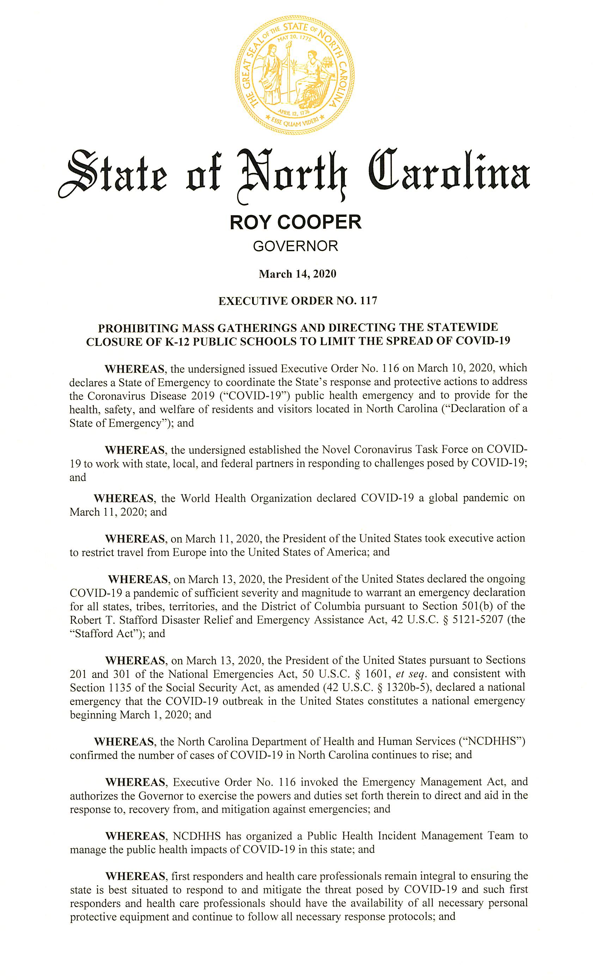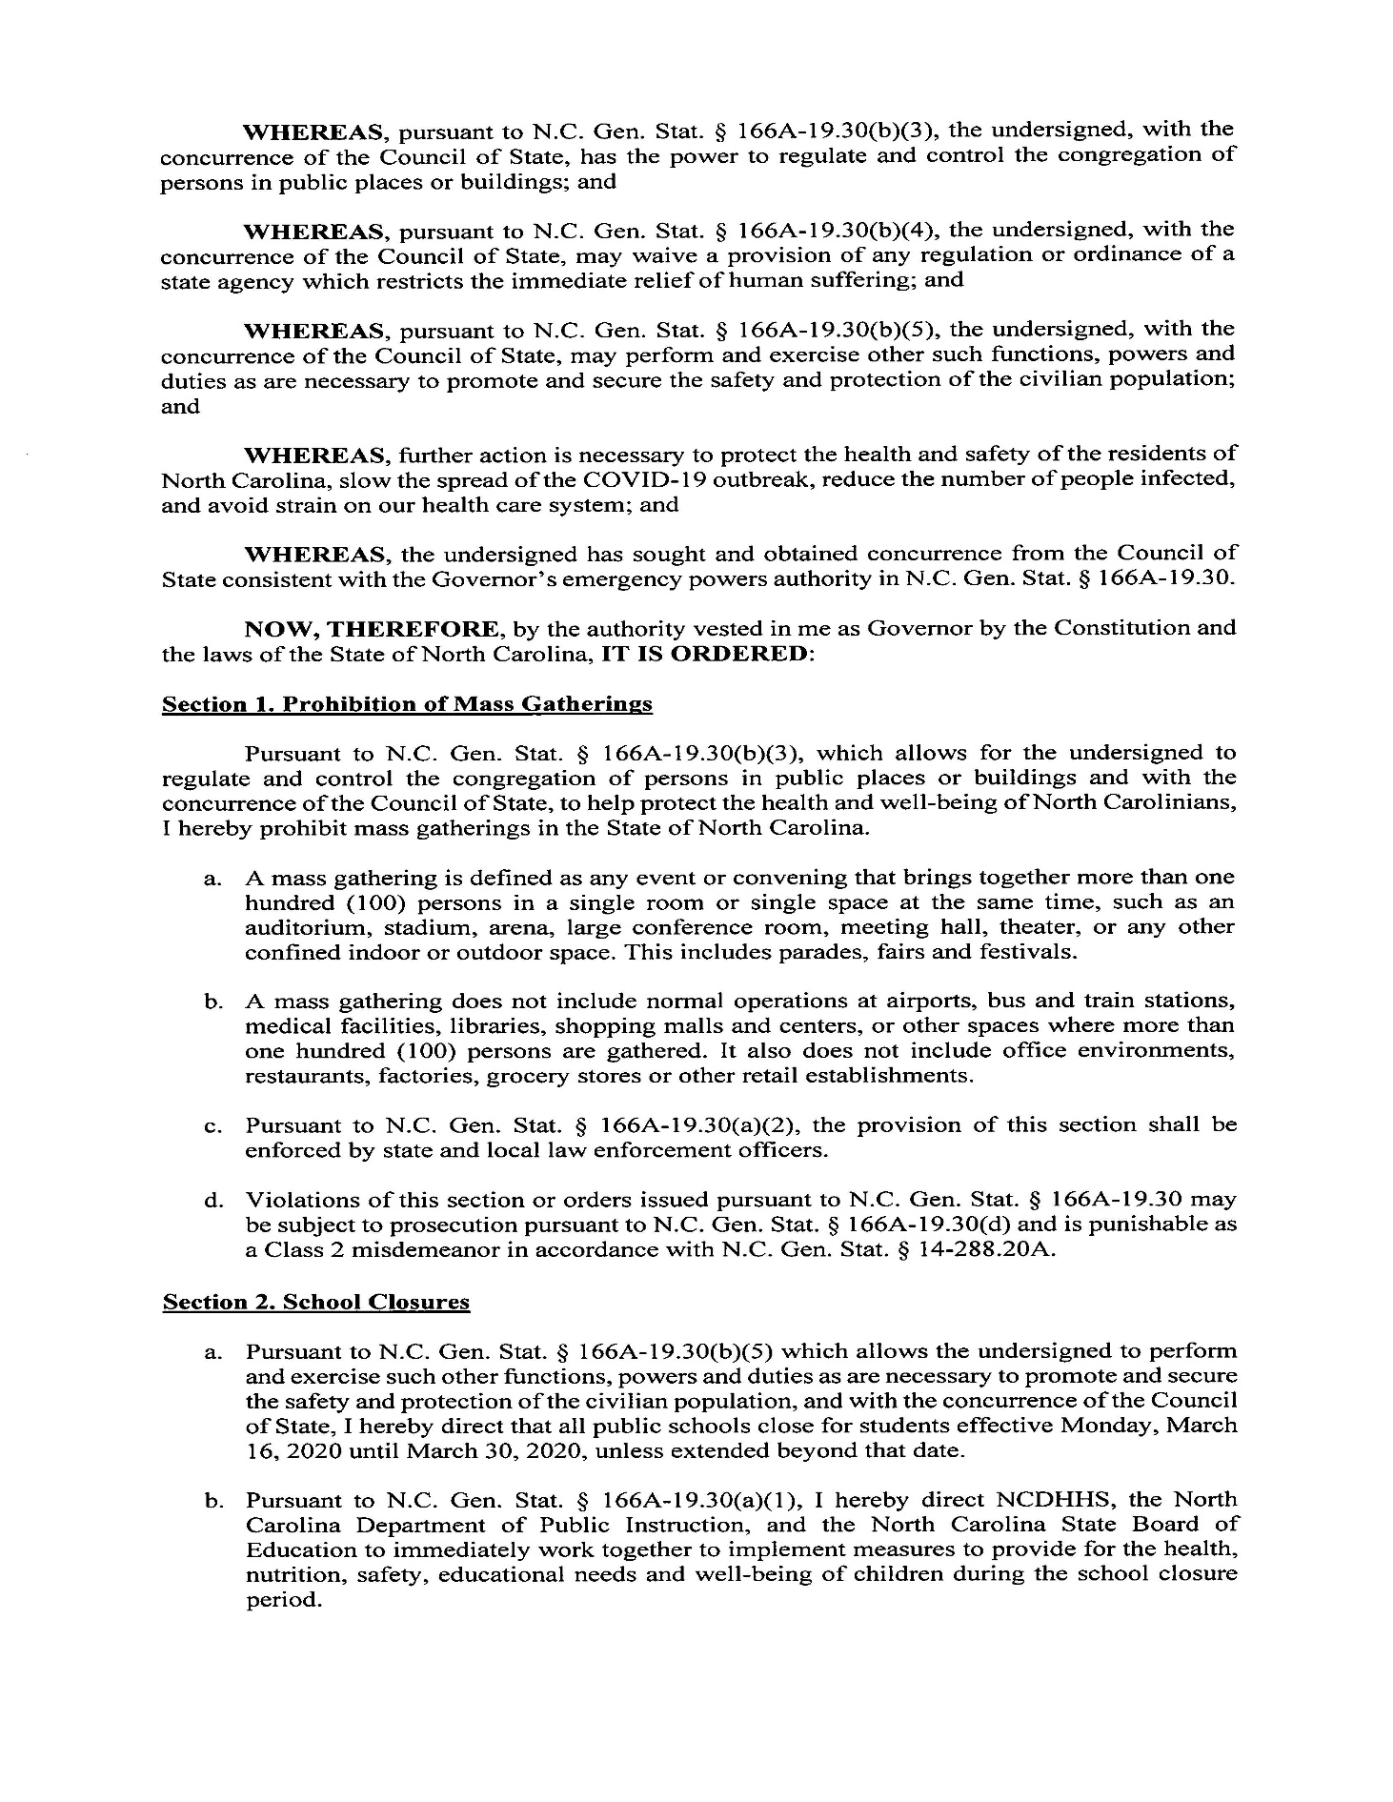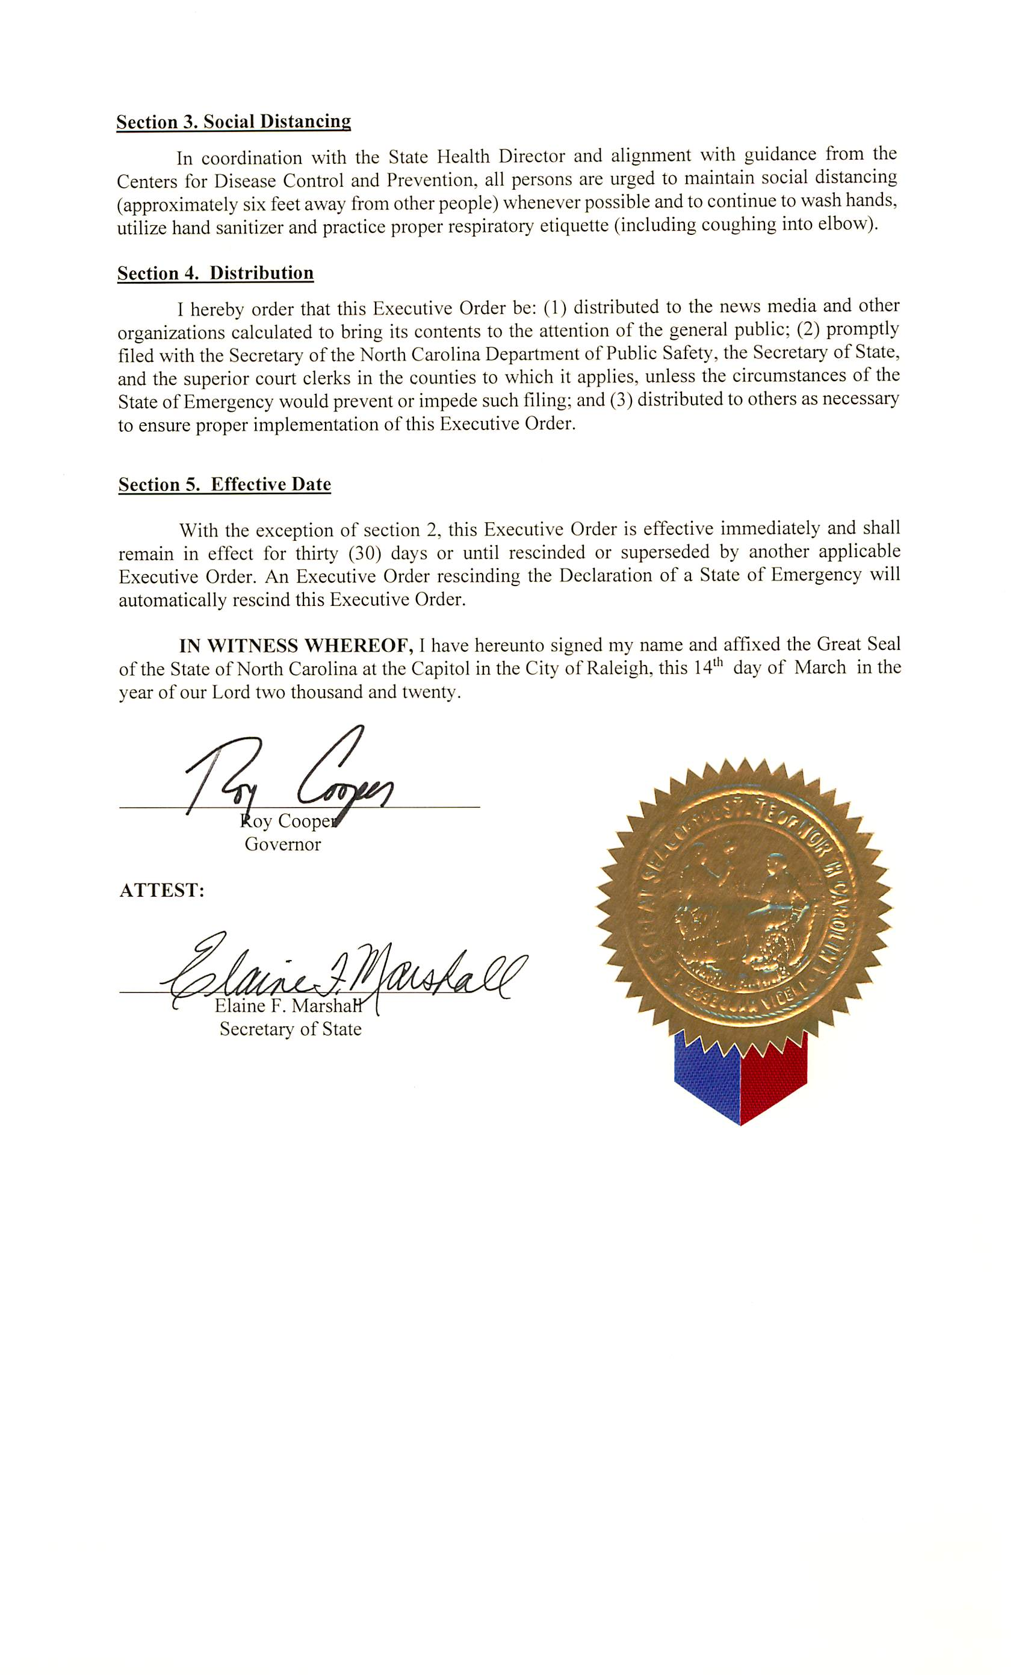
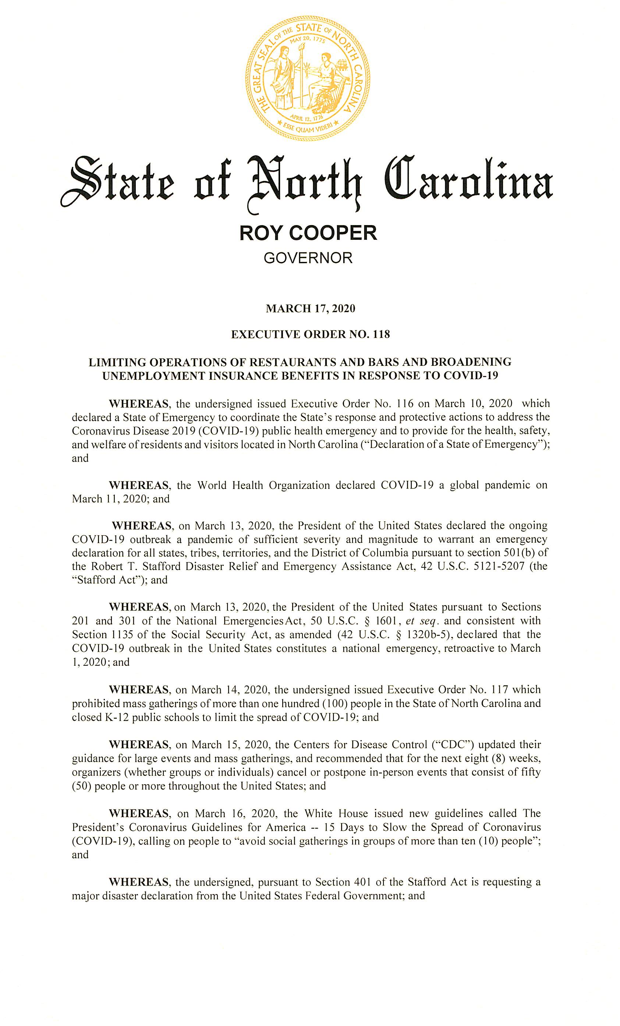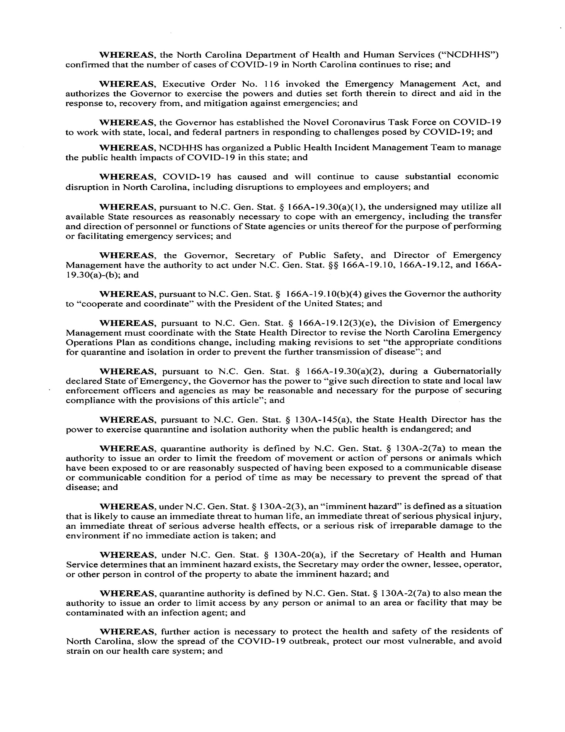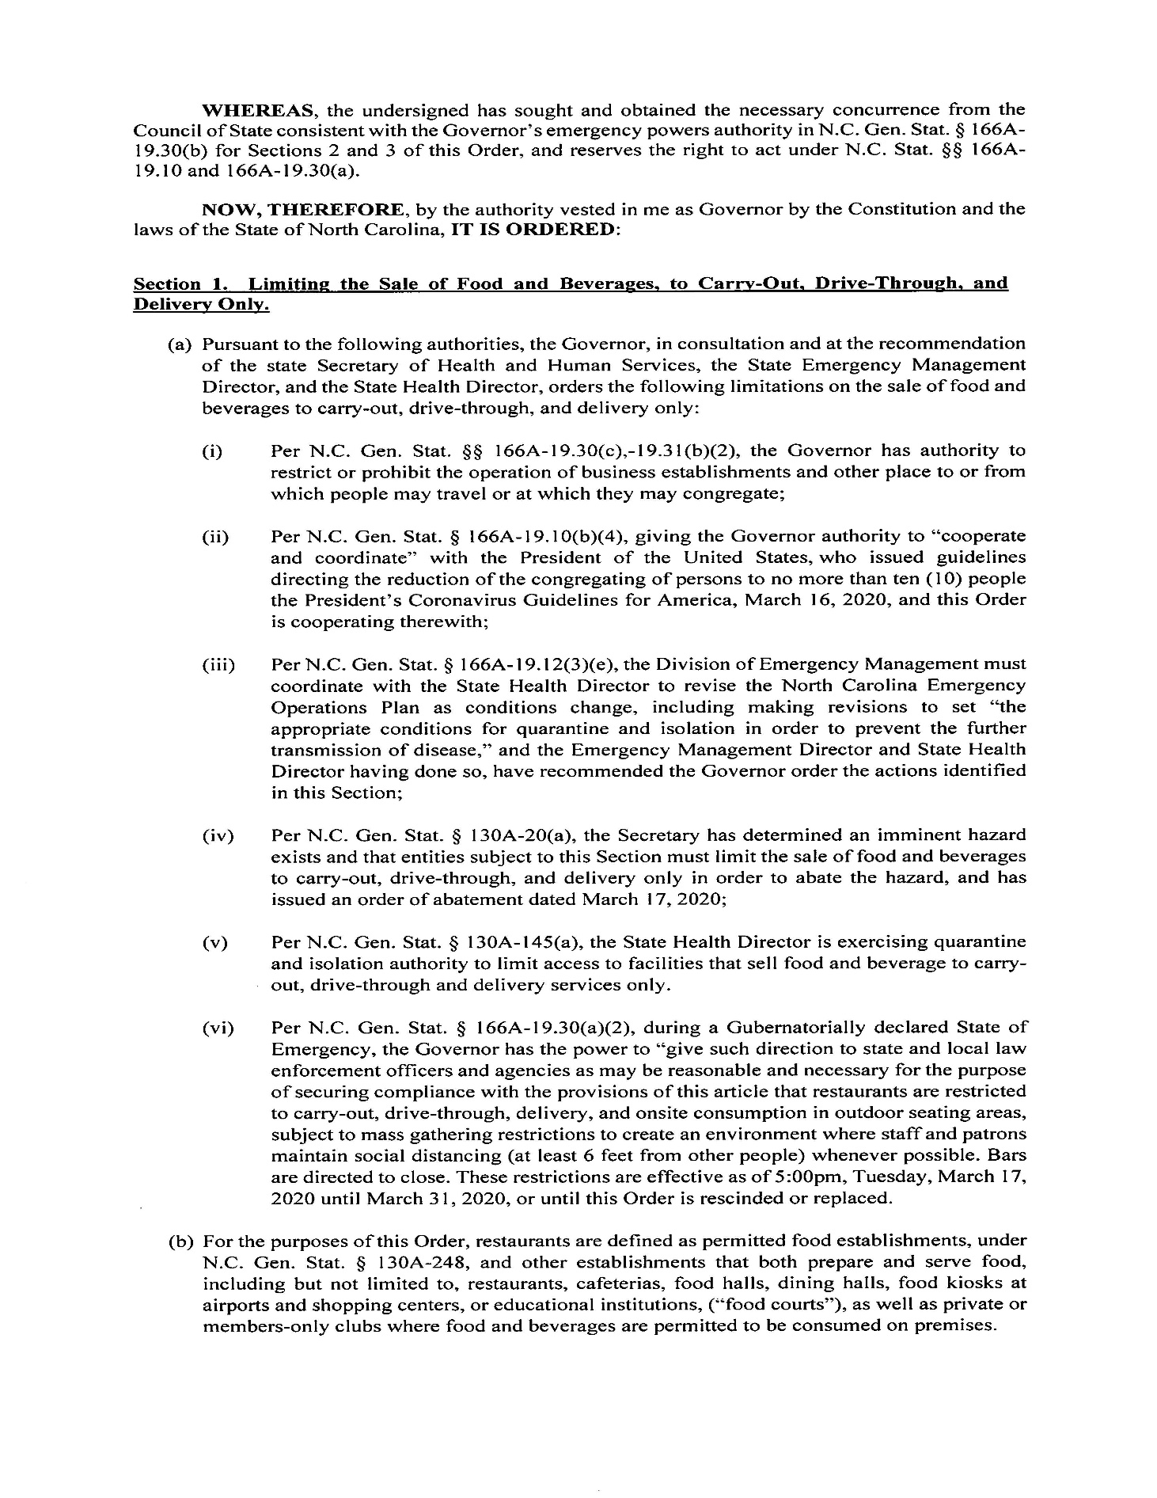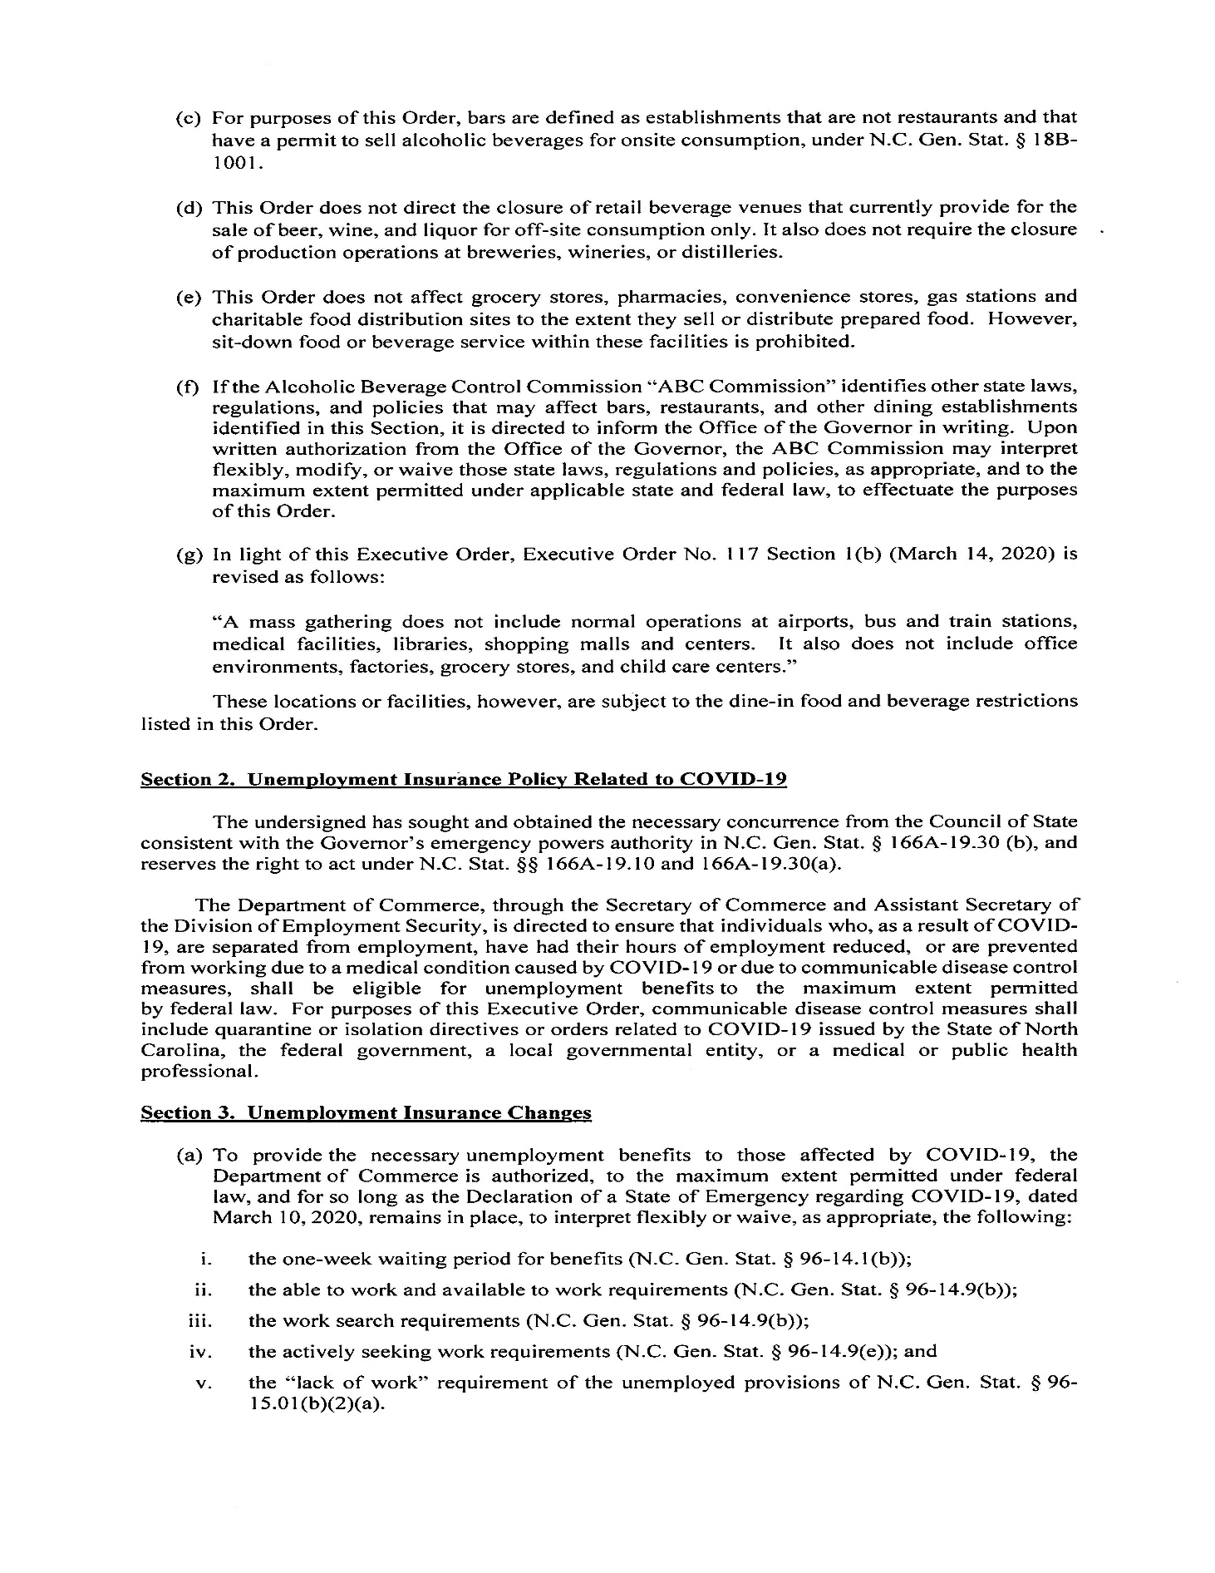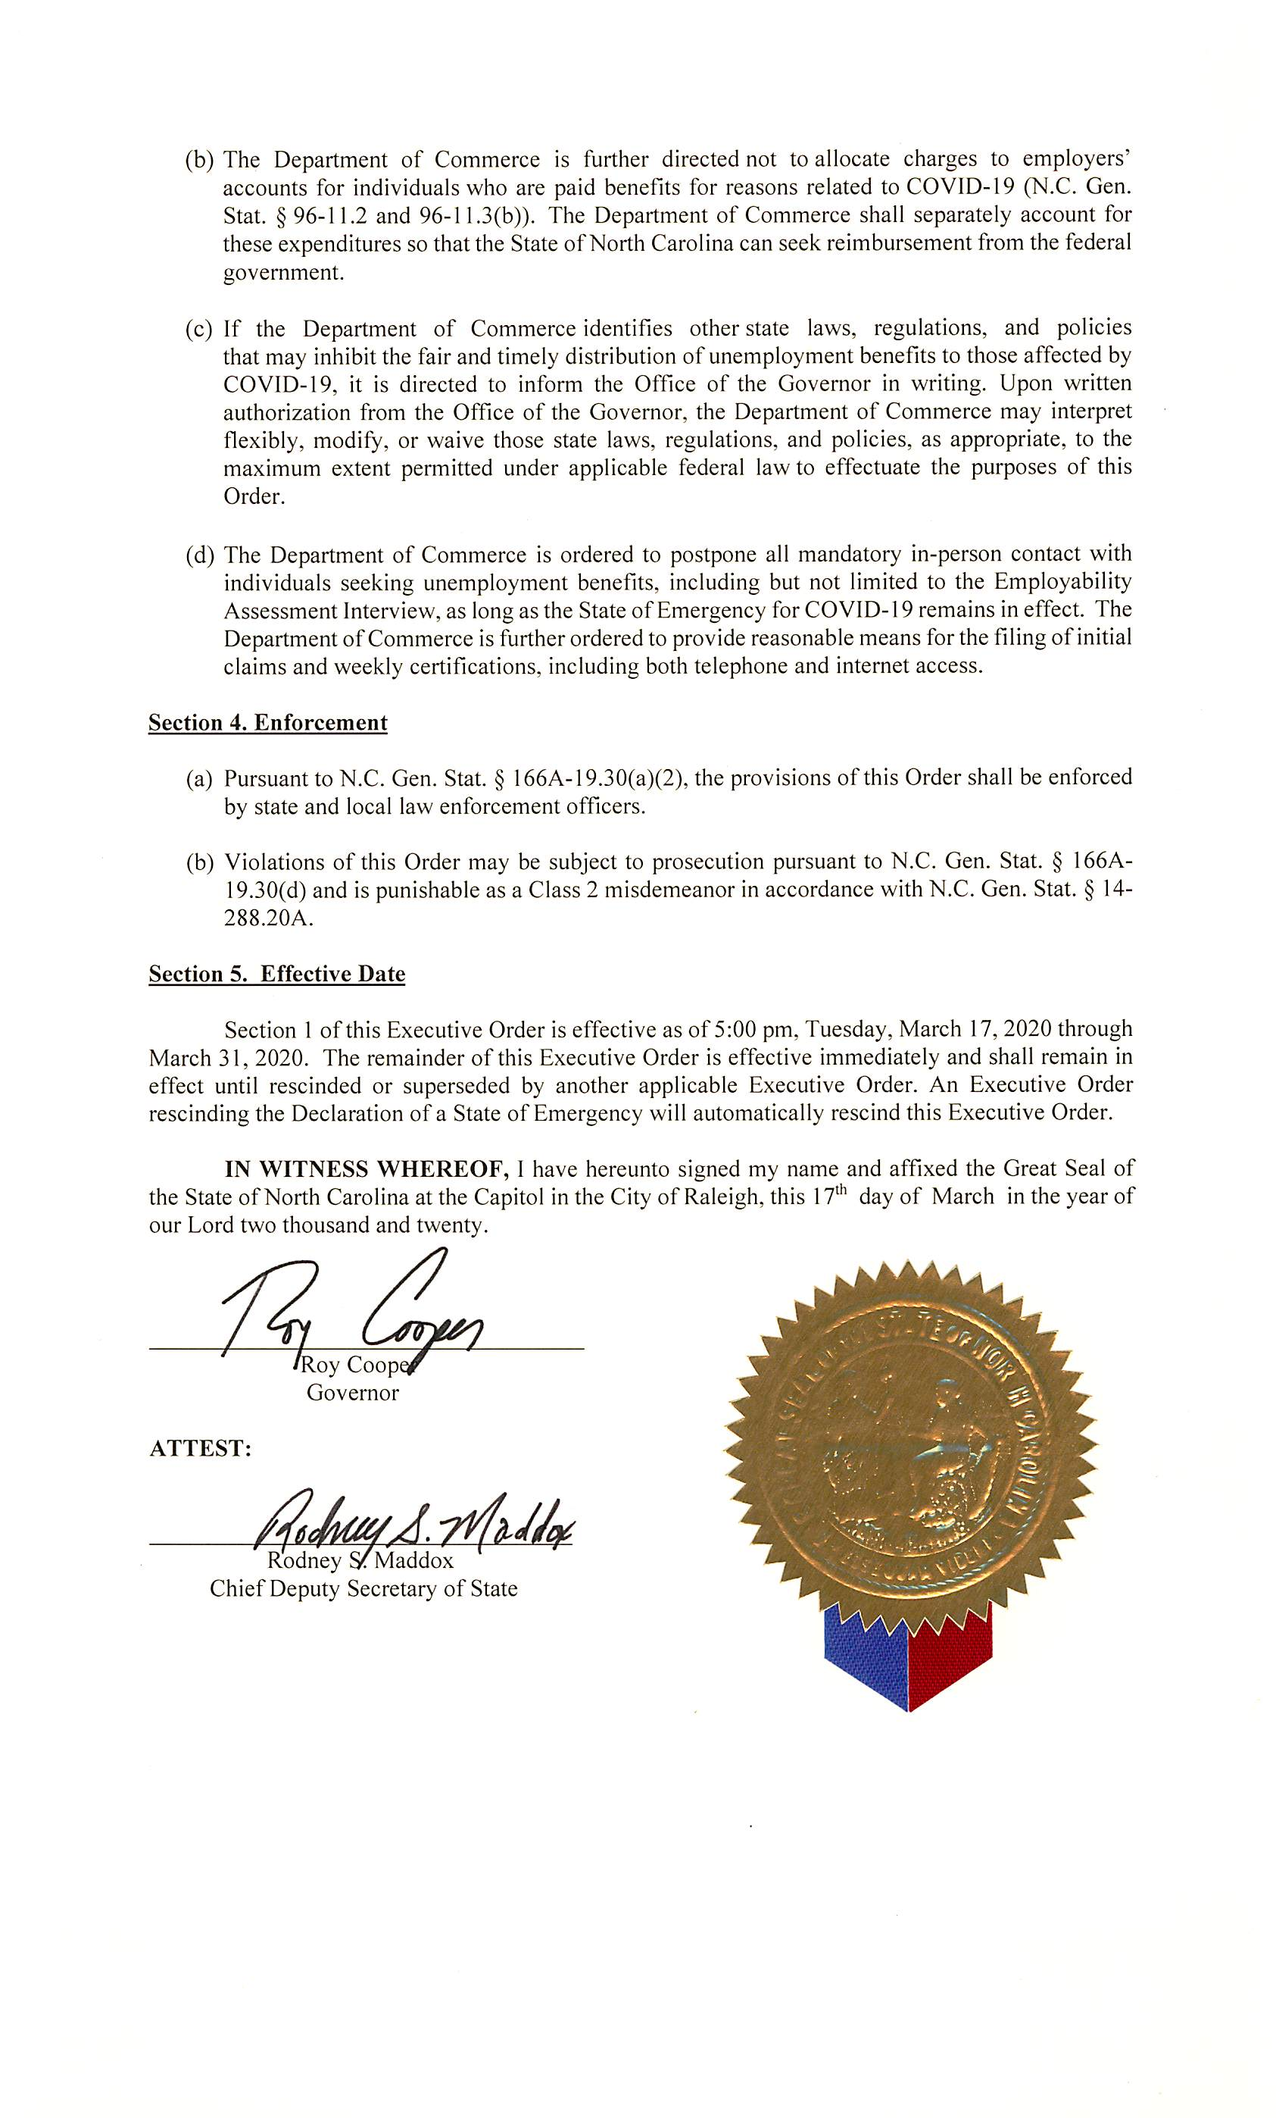
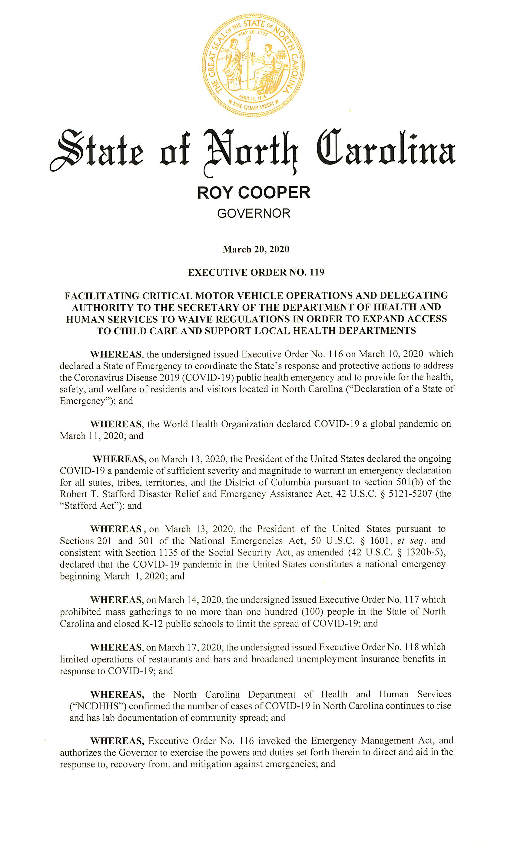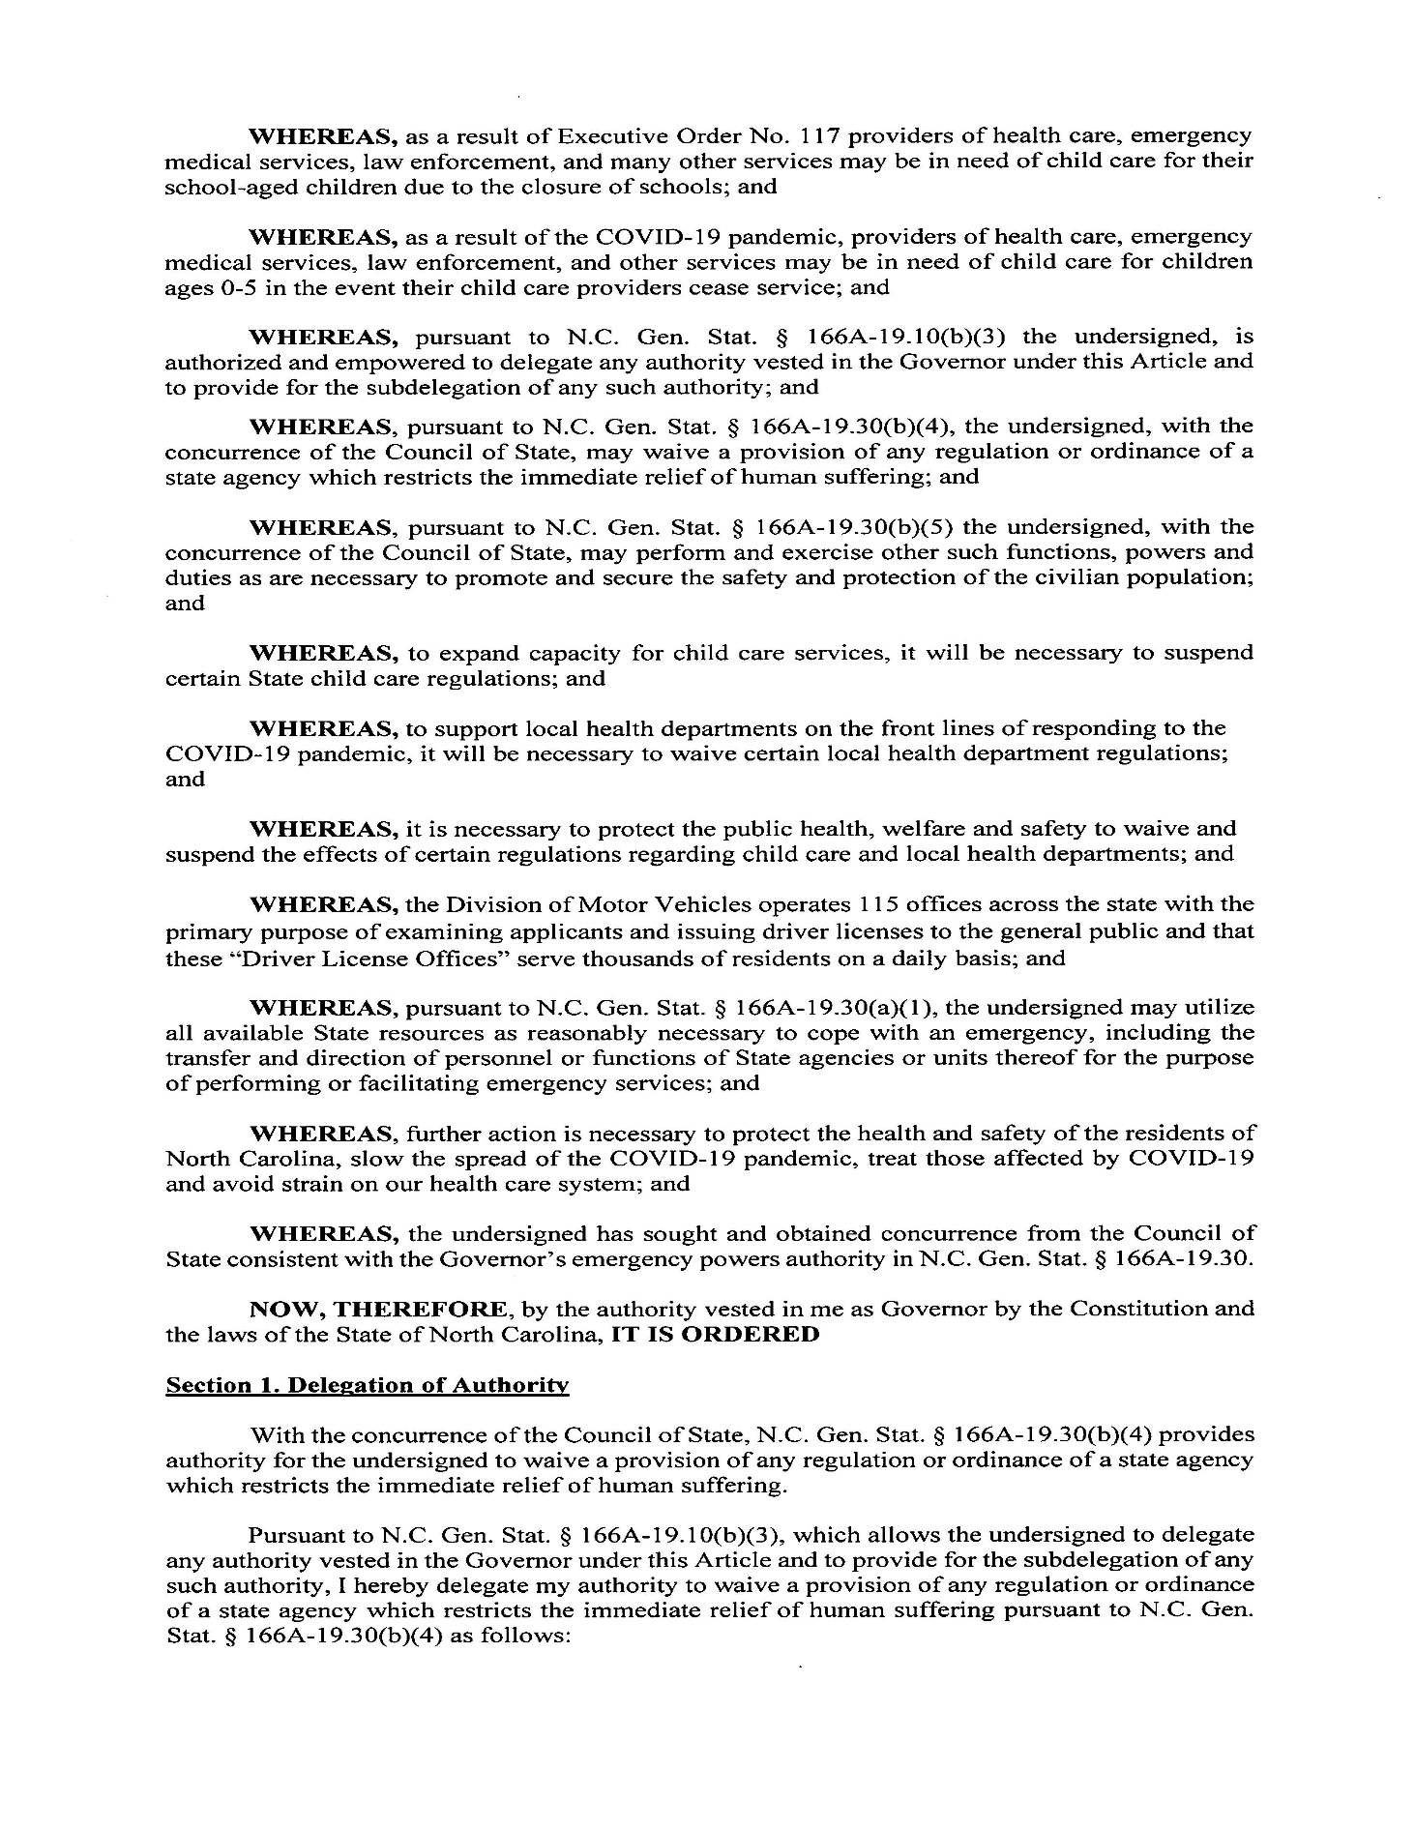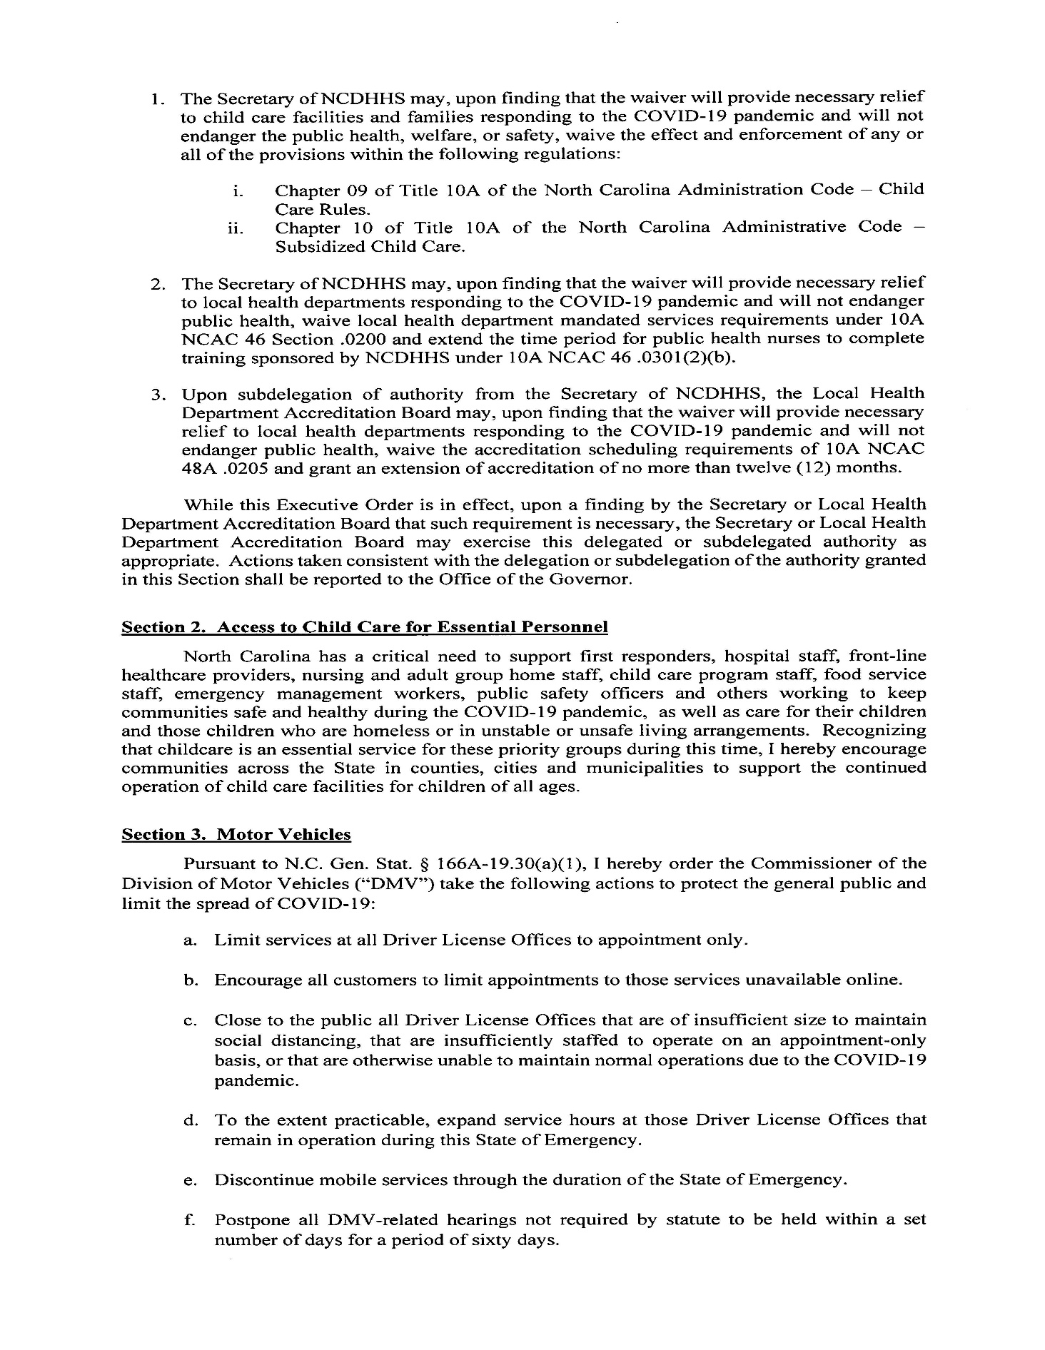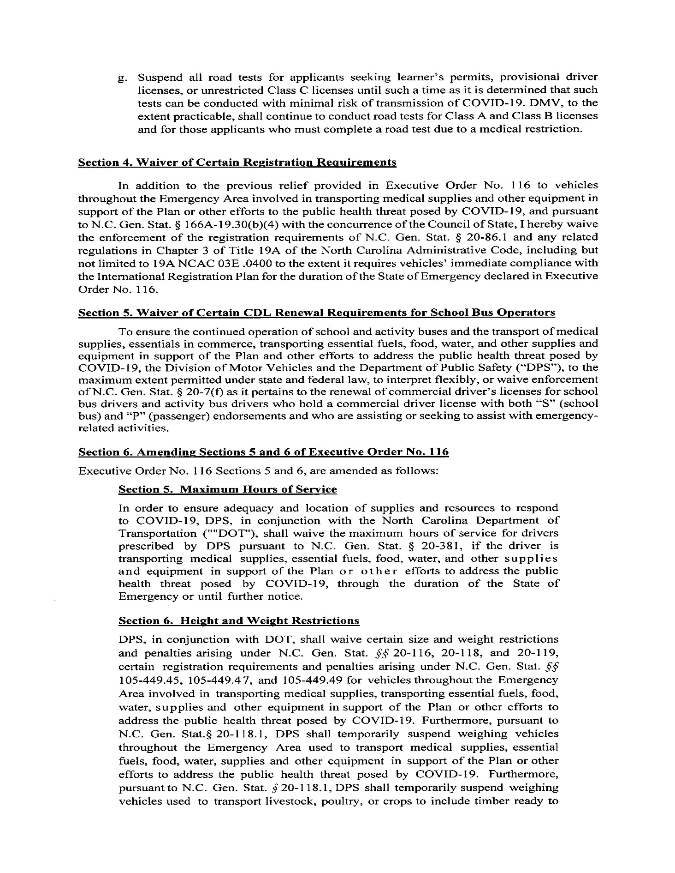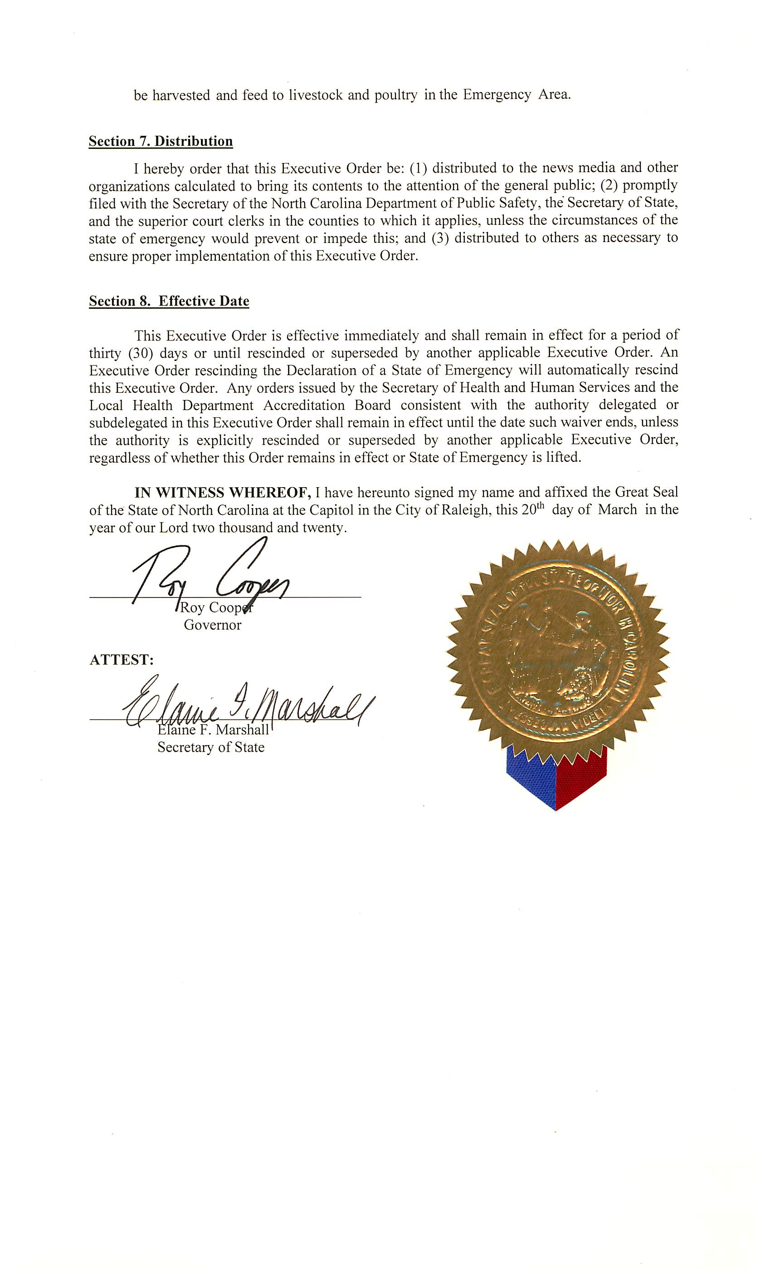
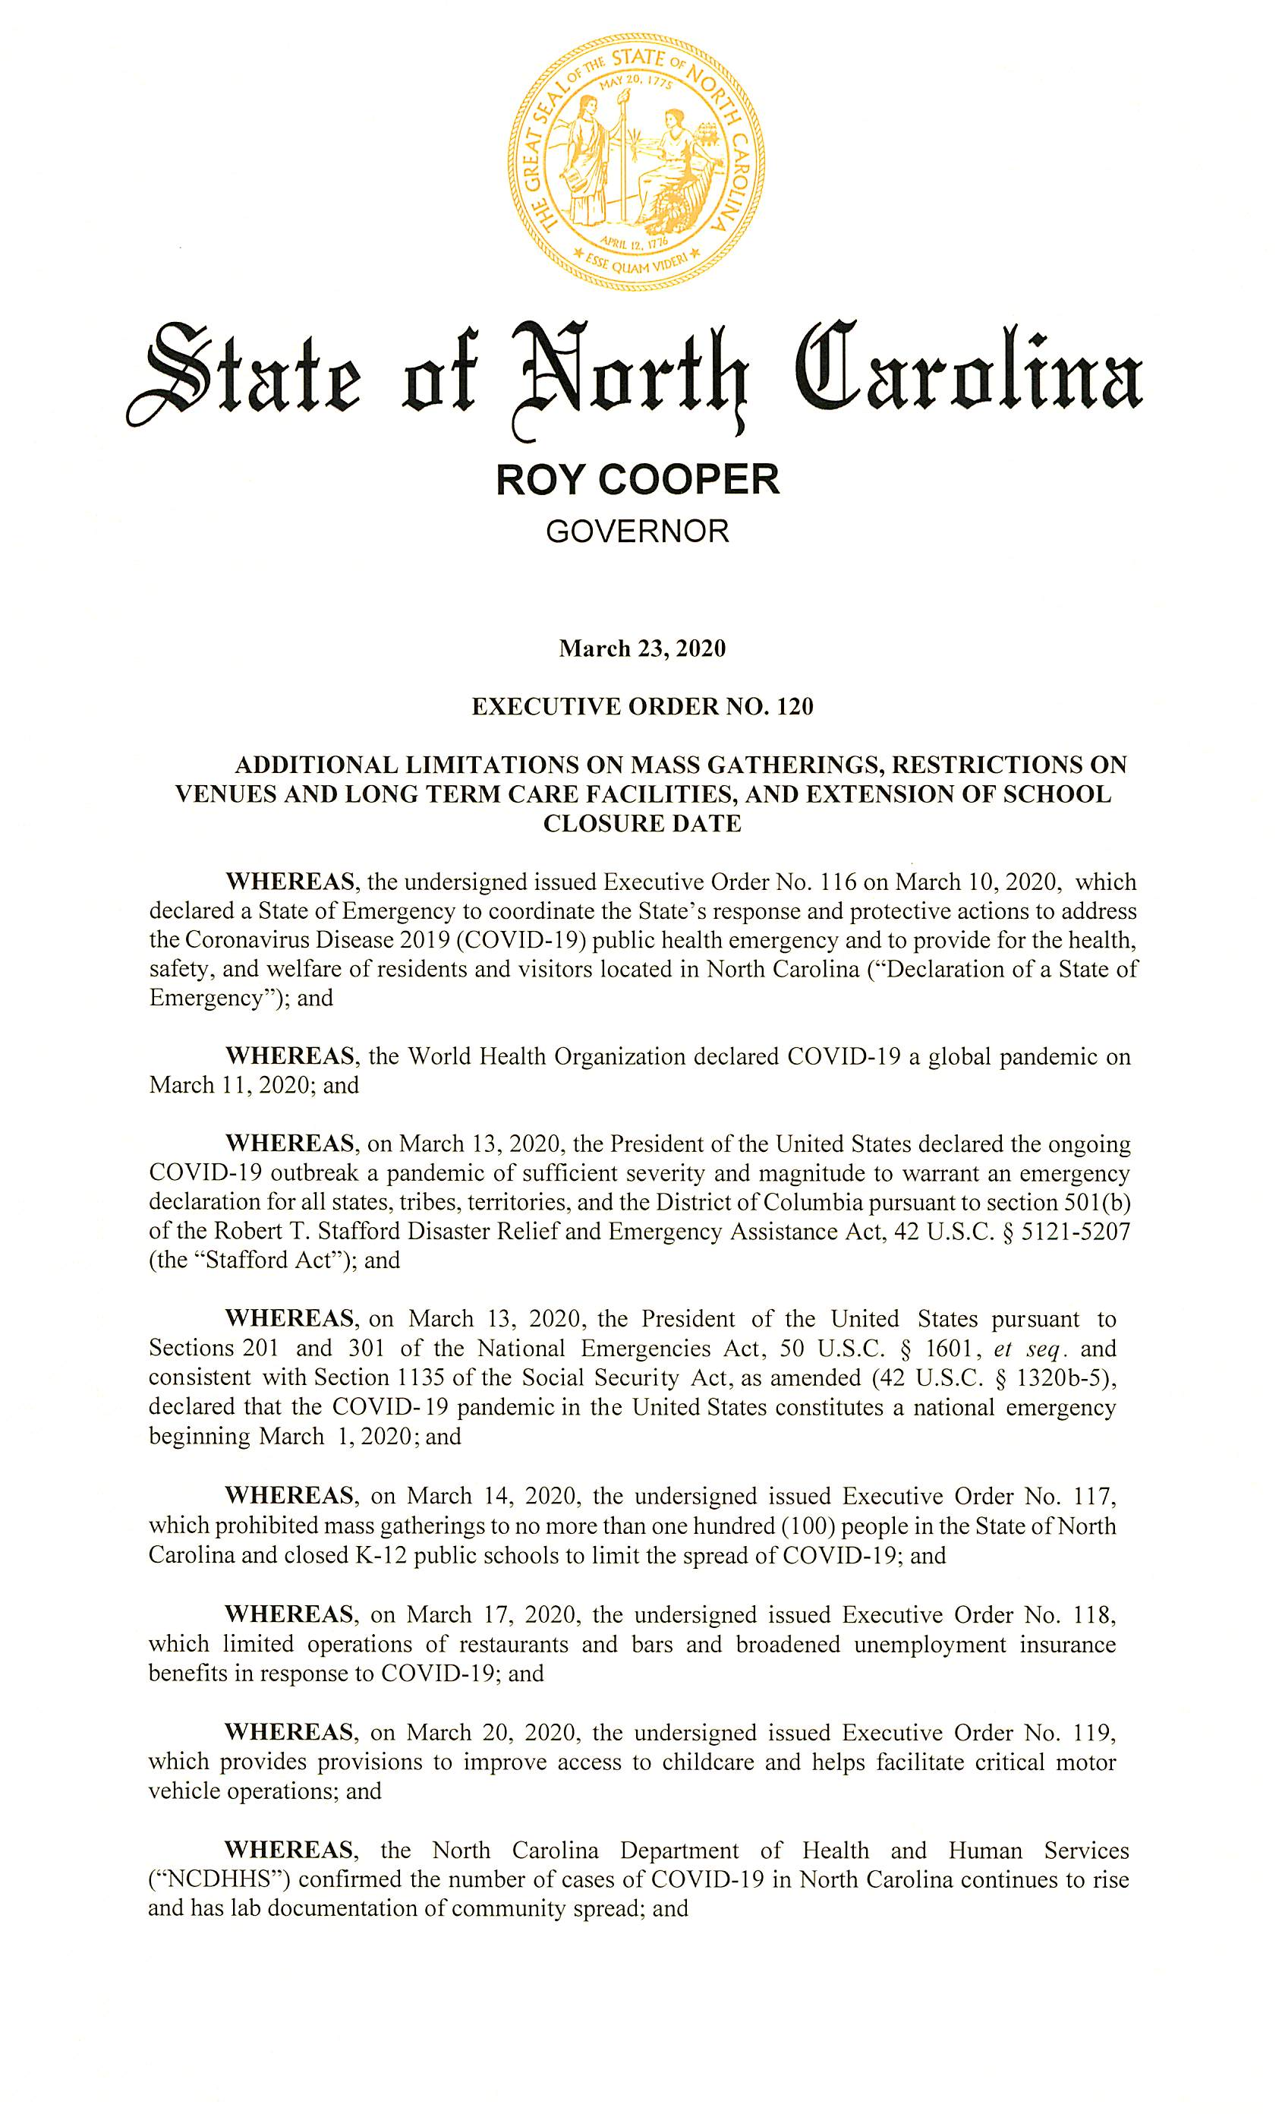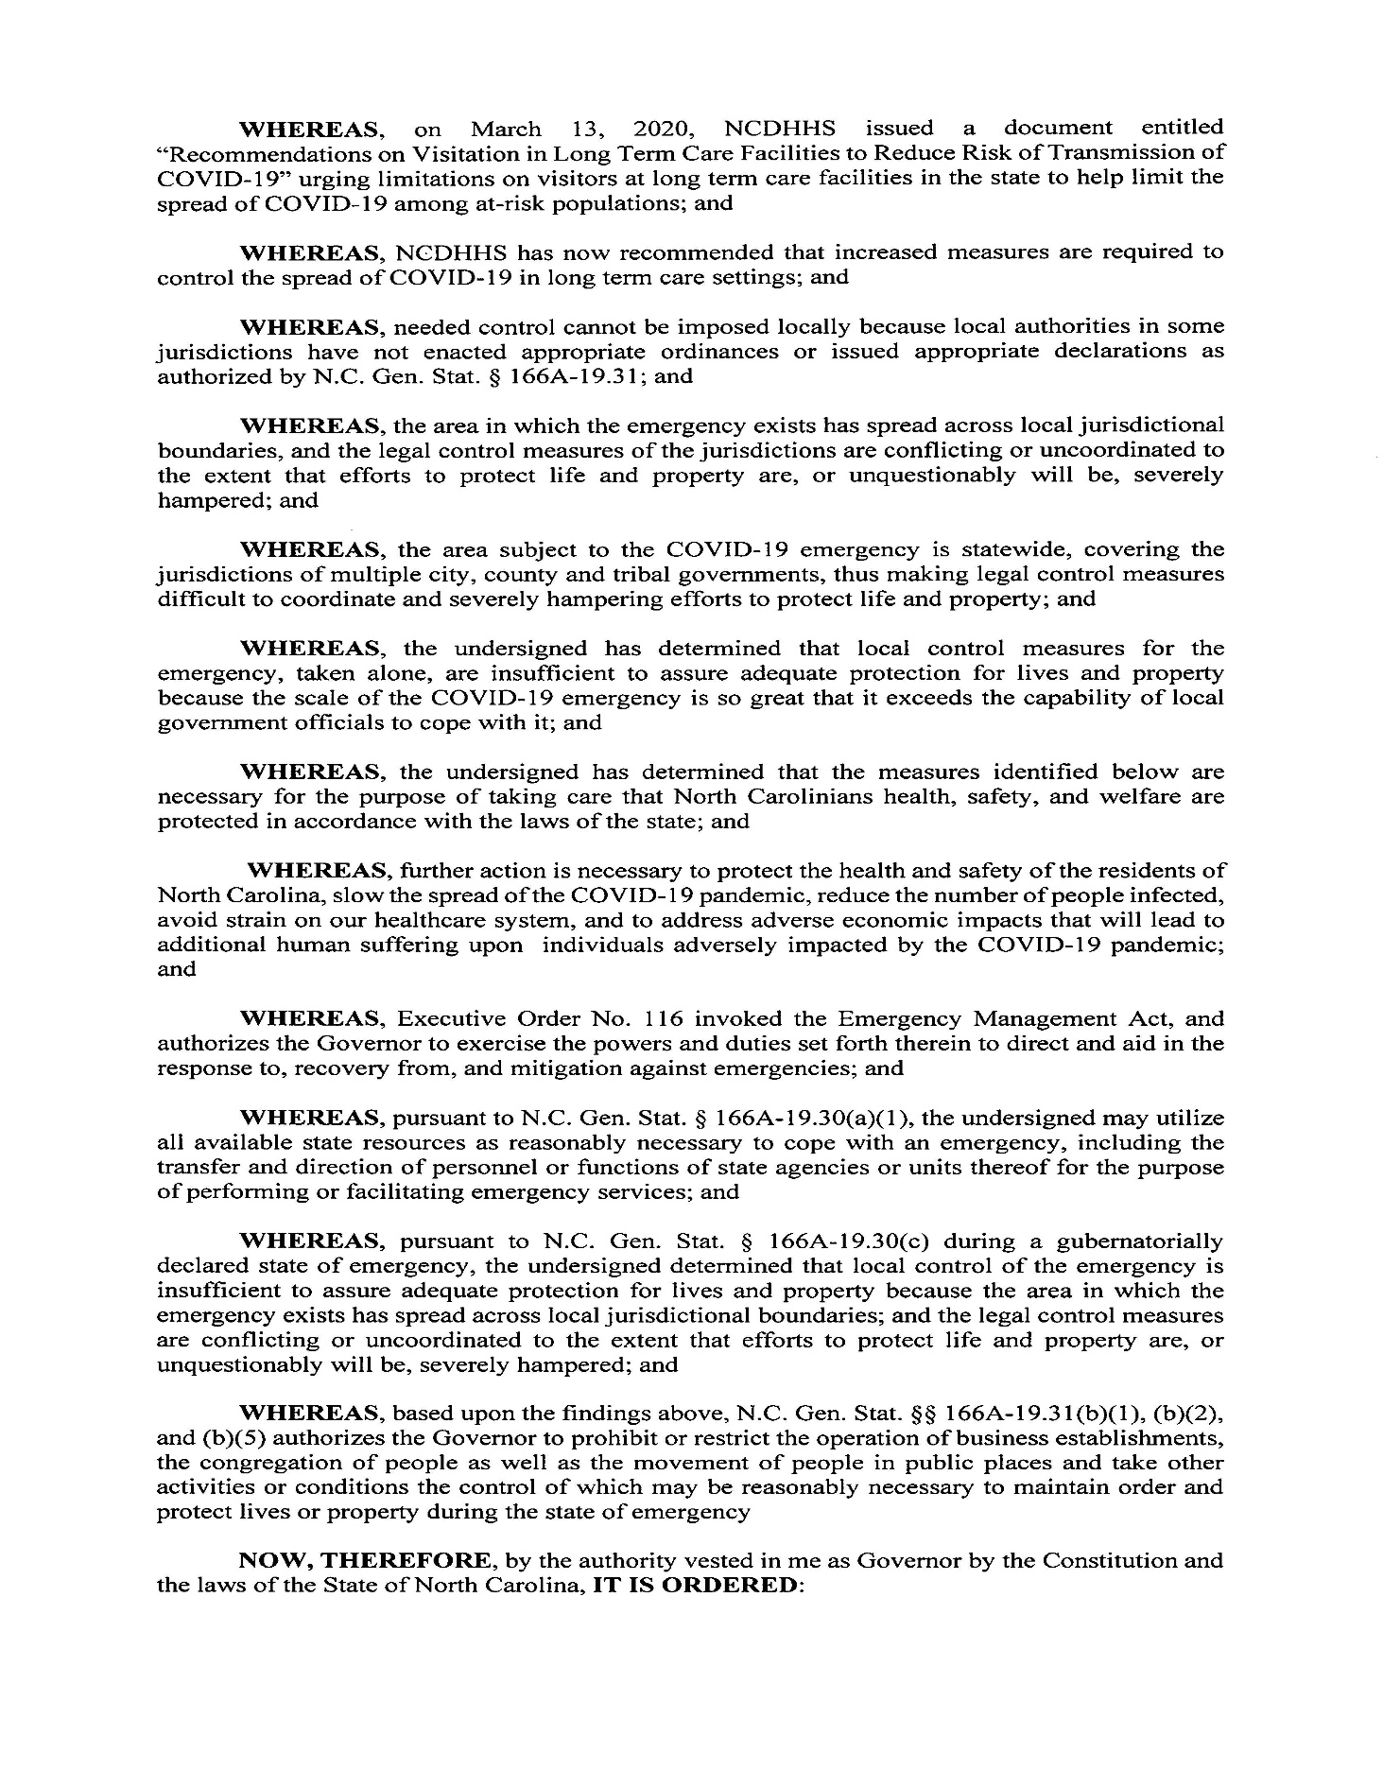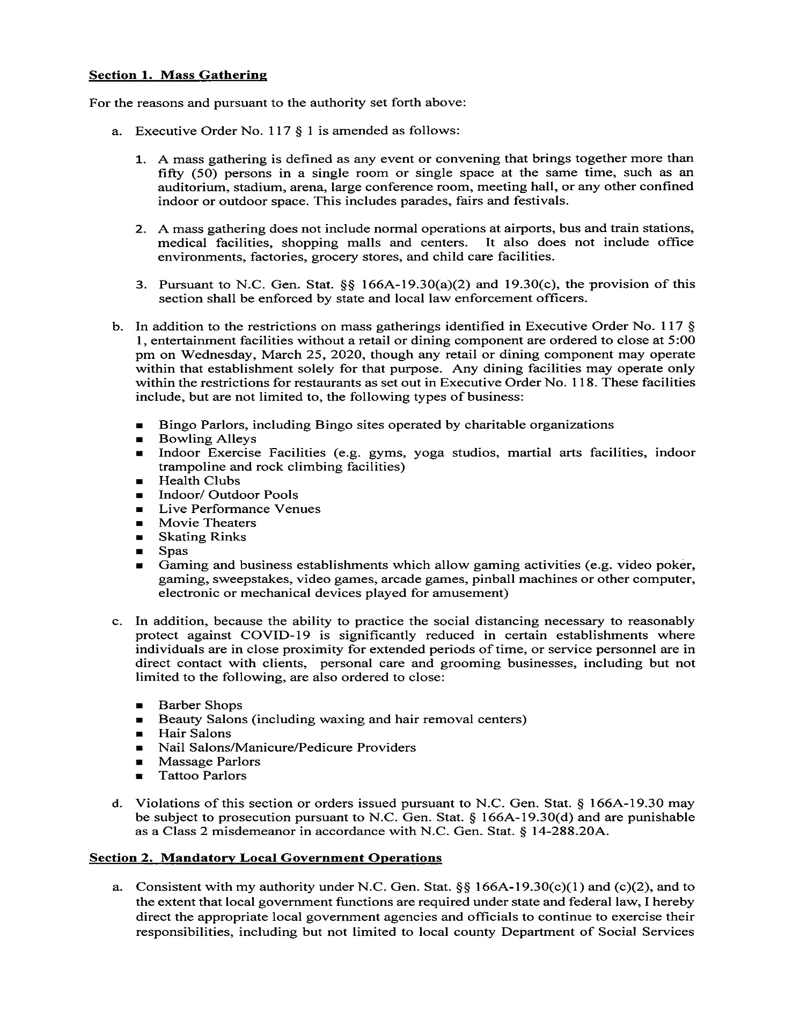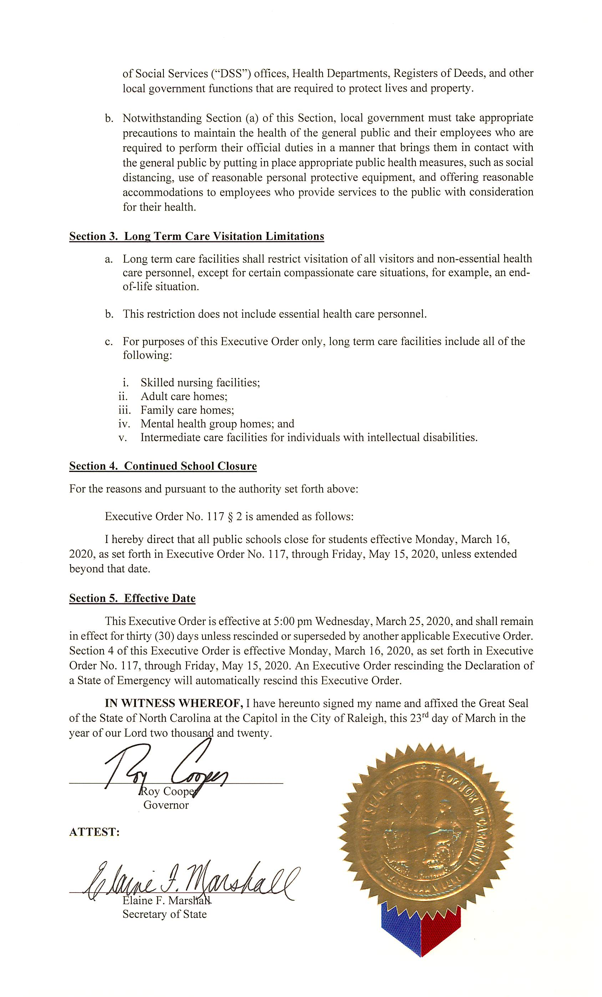

*UPDATE*: In the abundance of caution, to address protective measures to help prevent the spread of COVID-19, the Department of Environmental Quality, Division of Air Quality (DAQ), is providing notice to extend the comment period to May 8, 2020 and schedule a digital public hearing on the adoption of the Control of Emissions from Log Fumigation Operations rule and the amendment of the Toxic Air Pollutant Guidelines rule. The public hearing will be held via Cisco’s WebEx teleconferencing service instead of an in-person meeting. DAQ will also be receiving public comments until May 8, 2020 on the accompanying revised fiscal note for the proposed rule adoption and amendment.
Rescheduled Public Hearing for the Control of Emissions from Log Fumigation Operations Rule
*UPDATE*: In the abundance of caution, to address protective measures to help prevent the spread of COVID-19, the Department of Environmental Quality, Division of Air Quality (DAQ), is providing notice to extend the comment period to May 8, 2020 and rescheduling the public hearing initially scheduled for March 17, 2020 and March 18, 2020, which were cancelled due to Covid-19 social distancing concerns, and is now rescheduled as a digital public hearing to receive comment on the adoption of the Control of Emissions from Log Fumigation Operations rule, the amendment of the Toxic Air Pollutant Guidelines rule, and the accompanying fiscal note. The public hearing will be held via Cisco’s WebEx teleconferencing service instead of an in-person meeting.
Rescheduled Public Hearing for the Control of Emissions from Log Fumigation Operations Rule
Purpose: To receive comments on the adoption of 15A NCAC 02D .0546, Control of Emissions from Log Fumigation Operations, the amendment of 15A NCAC 02D .1104, Toxic Air Pollutant Guidelines, and on the accompanying fiscal note.
Background: On January 9, 2020, the Environmental Management Commission (EMC) approved proceeding to public comment on the adoption of the Control of Emissions from Log Fumigation Operations rule and the amendment of the Toxic Air Pollutant Guidelines rule and revised fiscal note.
The original public notice and description of the rules were previously published in North Carolina Register Volume 33, Issue 24.
Comment Period Duration: Monday, February 3, 2020 – Friday, May 8, 2020
The date and time of the digital public hearing is:
Monday May 4, 2020, 6:00 P.M.
Participants can join the meeting starting at 5:45 P.M.
WebEx link: https://ncdenrits.webex.com/ncdenrits/onstage/g.php?MTID=e296a5f2baee634a3b0baca4710cad625
Meeting number (access code): 614 804 792
Meeting password: NCDAQ
*If you wish to speak at the digital public hearing, you must register, provide the required information, and follow instructions on ways to join the public hearing. Registration must be completed by 12:00 pm on May 4, 2020. To register, please click the following link:
https://forms.office.com/Pages/ResponsePage.aspx?id=3IF2etC5mkSFw-zCbNftGcdRQfzEdNdMhe982T18CERUNEhBWDFOOVBKUUdVVFBCMDFGTFhBMkMwUi4u
*For instructions on ways to join the public hearing, please refer to the following link: https://files.nc.gov/ncdeq/Air%20Quality/rules/hearing/instructions-on-ways-to-join-webex.pdf
*If you have technical difficulties, the following automated voicemail has been setup to receive your verbal comments: 919-707-8430.
You can also submit comments via any of the methods below:
Email: daq.publiccomments@ncdenr.gov (Please type “Revised Log Fumigation Rule” in the subject line)
Postal Mail: Rule Development Branch Supervisor
NC Division of Air Quality
1641 Mail Service Center
Raleigh, NC 27699-1641
Fax: (919) 715-0717 (Please address it to “Rule Development Branch Supervisor”.)
Voicemail: 919-707-8430 (Please state your name and any affiliation before commenting.)
More information on the public hearing, including the proposed rule, amendment, and fiscal note are available online at https://deq.nc.gov/about/divisions/air-quality/air-quality-rules/rules-hearing-process.

Note from the Codifier: The notices published in this Section of the NC Register include the text of proposed rules. The agency must accept comments on the proposed rule(s) for at least 60 days from the publication date, or until the public hearing, or a later date if specified in the notice by the agency. If the agency adopts a rule that differs substantially from a prior published notice, the agency must publish the text of the proposed different rule and accept comment on the proposed different rule for 60 days.
Statutory reference: G.S. 150B-21.2.

Title 08 – State Board of Elections

Notice is hereby given in accordance with G.S. 150B-21.2 that the State Board of Elections intends to adopt the rule cited as 08 NCAC 21 .0301.

Link to agency website pursuant to G.S. 150B-19.1(c): www.ncsbe.gov

Proposed Effective Date: August 1, 2020

Public Hearing:
Date: April 30, 2020
Time: 1:00 p.m.
Location: This hearing will take place via web conference. Please register to attend and/or speak using the following link: https://attendee.gotowebinar.com/register/5569341261116421134. After registering, you will receive a confirmation email containing information about joining the webinar.

Reason for Proposed Action: In accordance with G.S. 150B-20 and 08 NCAC 15 .0101, Bob Hall, a registered voter and resident of Orange County, submitted a rulemaking petition to the State Board of Elections on January 23, 2020. The petition requested that the State Board engage in rulemaking to adopt a new rule limiting candidate expenditures under G.S. 163-278.16B. The petition proposed a prohibition on the use of candidate committee funds to purchase, lease, rent or reimburse the candidate for residential real property that is owned directly or indirectly by the candidate or a member of the candidate's family.

The State Board choose to grant the petition on March 20, 2020. At that same meeting, the State Board voted to submit the proposed text of 08 NCAC 21 .0301 to the Office of Administrative Hearings for publication in the North Carolina Register and to transmit the same to all interested parties for public comment from April 15, 2020 to June 15, 2020.

Comments may be submitted to: Rulemaking Coordinator, P.O. Box 27255, Raleigh, NC 27611-7255; email rules@ncsbe.gov

Comment period ends: June 15, 2020

Procedure for Subjecting a Proposed Rule to Legislative Review: If an objection is not resolved prior to the adoption of the rule, a person may also submit written objections to the Rules Review Commission after the adoption of the Rule. If the Rules Review Commission receives written and signed objections after the adoption of the Rule in accordance with G.S. 150B-21.3(b2) from 10 or more persons clearly requesting review by the legislature and the Rules Review Commission approves the rule, the rule will become effective as provided in G.S. 150B-21.3(b1). The Commission will receive written objections until 5:00 p.m. on the day following the day the Commission approves the rule. The Commission will receive those objections by mail, delivery service, hand delivery, or facsimile transmission. If you have any further questions concerning the submission of objections to the Commission, please call a Commission staff attorney at 919-431-3000.

Fiscal impact. Does any rule or combination of rules in this notice create an economic impact? Check all that apply.

State funds affected

Local funds affected

Substantial economic impact (>= $1,000,000)

Approved by OSBM

No fiscal note required

SECTION .0300 – RULE SECTION NOT FOUND

08 ncac 21 .0301 Expenditures for residential real property

(a) An expenditure does not result from the campaign for public office or result from holding public office under G.S. 163-278.16B if the purpose of the expenditure is to purchase, lease, rent, or make mortgage payments on residential real property that is owned, either directly or indirectly, by the candidate or officeholder, or a member of the candidate's or officeholder's family, even if a portion of the residence is used for the campaign or holding office.

(b) For the purpose of this rule, "family" includes a candidate's or officeholder's spouse, children, parents, brothers, or sisters.

Authority G.S. 163-278.16B; 163-278.21.

Title 11 – Department of Insurance

Notice is hereby given in accordance with G.S. 150B-21.2 that the Industrial Commission intends to amend the rules cited as 11 NCAC 23A .0108, .0109, .0302; 23B .0104, .0105; 23L .0101-.0103, and .0105.

Link to agency website pursuant to G.S. 150B-19.1(c): https://www.ic.nc.gov/efilingandotheramendments.html

Proposed Effective Date: August 1, 2020

Public Hearing:
Date: May 6, 2020
Time: 2:00 p.m.
Location: Teleconference Line#: 1-888-363-4735; Access Code#: 4465746

Reason for Proposed Action: The Industrial Commission (hereinafter "Commission") has deemed it necessary to amend the rules cited as 11 NCAC 23A .0108, .0109, and .0302, 11 NCAC 23B .0104 and .0105, and 11 NCAC 23L .0101, .0102, .0103, and .0105 in order to enable the most efficient processing and handling of the filings made in workers' compensation and State tort claims within the Commission's case management system. The proposed amendments to 11 NCAC 23A .0108 and 11 NCAC 23B .0104 also make these rules more consistent with the statutes, the NC Rules of Appellate Procedure, and the terms and conditions that govern appeals in ordinary civil cases with regard to Notices of Appeal to the NC Court of Appeals. The proposed amendments to 11 NCAC 23L .0101, .0102, and .0103 also make the notices on the forms that are the subject of these rules consistent with the proposed changes to 11 NCAC 23A .0408 and .0501, which were published in the January 15, 2020 North Carolina Register. (Please note that the proposed amendments to 11 NCAC 23L .0103 that were published in the January 15, 2020 North Carolina Register have been italicized in the version of 11 NCAC 23L .0103 that is attached to this Notice of Text).

Comments may be submitted to: Gina Cammarano, 1240 Mail Service Center, Raleigh, NC 27699-1240; phone (919) 807-2524; email gina.cammarano@ic.nc.gov

Comment period ends: June 15, 2020

Procedure for Subjecting a Proposed Rule to Legislative Review: If an objection is not resolved prior to the adoption of the rule, a person may also submit written objections to the Rules Review Commission after the adoption of the Rule. If the Rules Review Commission receives written and signed objections after the adoption of the Rule in accordance with G.S. 150B-21.3(b2) from 10 or more persons clearly requesting review by the legislature and the Rules Review Commission approves the rule, the rule will become effective as provided in G.S. 150B-21.3(b1). The Commission will receive written objections until 5:00 p.m. on the day following the day the Commission approves the rule. The Commission will receive those objections by mail, delivery service, hand delivery, or facsimile transmission. If you have any further questions concerning the submission of objections to the Commission, please call a Commission staff attorney at 919-431-3000.

Fiscal impact. Does any rule or combination of rules in this notice create an economic impact? Check all that apply.

State funds affected

Local funds affected

Substantial economic impact (>= $1,000,000)

Approved by OSBM

No fiscal note required

Chapter 23 - Industrial Commission

SUBCHAPTER 23A - WORKERS' COMPENSATION RULES

SECTION .0100 - ADMINISTRATION

11 NCAC 23A .0108 ELECTRONIC FILINGS WITH THE COMMISSION; HOW TO FILE

(a) All documents filed with the Commission in workers' compensation cases shall be submitted electronically in accordance with this Rule. Any document transmitted to the Commission in a manner not in accordance with this Rule shall not be accepted for filing. Any document filed with the Commission that requires contemporaneous payment of a processing fee pursuant to Rule 11 NCAC 23E .0203 shall not be deemed filed until the fee has been paid in full. The electronic filing requirements of this Rule shall not apply to employees, medical providers, employees or non-insured employers without legal representation. Employees, medical providers, Employees and non-insured employers without legal representation may file all documents with the Commission via the Commission's Electronic Document Filing Portal ("EDFP"), ("EDFP") or by sending the documents to the Clerk of the Industrial Commission via electronic mail, mail (dockets@ic.nc.gov), facsimile, U.S. Mail, private courier service, or hand delivery.

(b) Except as set forth in Paragraphs (d) and (e) of this Rule, all documents required to be submitted electronically to the Commission shall be filed transmitted to the Commission via EDFP. Information regarding how to register for and use EDFP is available at http://www.ic.nc.gov/training.html. In the event EDFP is inoperable, all documents required to be filed via EDFP shall be transmitted to the Commission via electronic mail to edfp@ic.nc.gov. Documents required to be filed via EDFP that are sent to the Commission via electronic mail when EDFP is operable shall not be accepted for filing.

(c) Transcripts of depositions shall be filed with the Commission pursuant to this Rule by the court reporting service. Transcripts filed with the Commission shall have only one page of text per page and shall include all exhibits. The parties shall provide the Commission's court reporting service with the information necessary to effectuate filing of the deposition transcripts and attached exhibits via EDFP. If an exhibit to a deposition is in a form that makes submission of an electronic copy impracticable, counsel for the party offering the exhibit shall make arrangements with the Commission to facilitate the submission of the exhibit. Condensed transcripts and paper copies of deposition transcripts shall not be accepted for filing.

(d) A Form 19 shall be filed as the first report of injury (FROI) via electronic data interchange (EDI), except in claims involving non-insured employers employers, or in claims for lung disease, in claims with multiple employers or multiple carriers, or in claims with six-character IC file numbers, in which case the Form 19 shall be filed electronically via EDFP to forms@ic.nc.gov, by mail to 1235 Mail Service Center, Raleigh, North Carolina 27699-1235, or as otherwise permitted pursuant to Paragraph (a) of this Rule. Information regarding how to register for and use EDI is available at www.ncicedi.info.

(e) The workers' compensation forms and documents listed in Table 1 shall not be required to be transmitted via EDFP provided all applicable qualifying conditions are met.

Table 1: Forms and documents exempt from EDFP filing requirements and how to file them:

DOCUMENT | QUALIFYING CONDITION(S) | HOW TO FILE
Form 18 | No IC file number has been assigned | Electronically to forms@ic.nc.gov, by mail to 1235 Mail Service Center, Raleigh, North Carolina 27699-1235, or as otherwise permitted pursuant to Paragraph (a) of this Rule
Form 18B | Always exempt from EDFP filing requirement | Electronically to forms@ic.nc.gov, by mail to 1235 Mail Service Center, Raleigh, North Carolina 27699-1235, or as otherwise permitted pursuant to Paragraph (a) of this Rule
Form 51 | Always exempt from EDFP filing requirement | Electronically to forms@ic.nc.gov
Plaintiff's Attorney Representation Letter | No IC file number has been assigned | Electronically to forms@ic.nc.gov
Documents to be filed with the Commission's Compliance & Fraud Investigative Division | Always exempt from EDFP filing requirement | Electronically to fraudcomplaints@ic.nc.gov or as otherwise permitted pursuant to Paragraph (a) of this Rule
Documents to be filed with the Commission's Medical Fees Section | Always exempt from EDFP filing requirement | Electronically to medicalfees@ic.nc.gov or as otherwise permitted pursuant to Paragraph (a) of this Rule
Documents to be filed with the Commission's Safety Education & Training Section | Always exempt from EDFP filing requirement | Electronically to safety@ic.nc.gov or as otherwise permitted pursuant to Paragraph (a) of this Rule
A Form 25N to be filed with the Commission's Medical Rehabilitation Nurses Section | No IC file number has been assigned | Electronically to 25N@ic.nc.gov
Rehabilitation referrals to be filed with the Commission's Medical Rehabilitation Nurses Section | No IC file number has been assigned | Electronically to rehab.referrals@ic.nc.gov

(e) Documents to be filed with the Criminal Investigations & Employee Classification Division regarding fraud complaints shall be submitted electronically to fraudcomplaints@ic.nc.gov. Documents to be filed with the Criminal Investigations & Employee Classification Division regarding employee misclassification shall be submitted electronically to emp.classification@ic.nc.gov. Safety rules to be filed with the Commission under 11 NCAC 23A .0411 shall be submitted electronically to safety@ic.nc.gov.

(f) A self-insured employer, carrier or guaranty association, third-party administrator, court reporting service, medical provider, or law firm may apply to the Commission for an emergency temporary waiver of the electronic filing requirement set forth in Paragraph (a) of this Rule when it is unable to comply because of temporary technical problems or lack of electronic mail or internet access. The request for an emergency temporary waiver shall be included with any filing submitted via facsimile, U.S. Mail, or hand delivery due to such temporary technical or access issues.

(g) A Notice of Appeal to the North Carolina Court of Appeals shall be accepted for filing by the Commission via EDFP or U.S. Mail. EDFP, U.S. Mail, hand delivery, or any other means allowed by the Rules of Appellate Procedure or applicable statutes governing appeals from the General Courts of Justice. Notwithstanding the foregoing, employees and non-insured employers without legal representation may file all documents with the Commission as provided in Paragraph (a) of this Rule.

Authority G.S. 97-80; 97-81; 97-86.

11 NCAC 23A .0109 Contact information

(a) "Contact information" for purposes of this Rule shall include telephone number, facsimile number, email address, and mailing address.

(b) All attorneys of record with matters before the Commission shall inform the Commission in writing of any change in the attorney's contact information via email to dockets@ic.nc.gov. the Commission's Electronic Document Filing Portal ("EDFP").

(c) All unrepresented persons or entities with matters before the Commission shall inform the Commission upon any change to their contact information in the following manner:

(1) All employees who are not represented by counsel shall inform the Commission of any change in contact information by filing a written notice via EDFP, the Commission's Electronic Document Filing Portal ("EDFP"), email to forms@ic.nc.gov, facsimile, U.S. Mail, private courier service, or hand delivery.

(2) All non-insured employers that are not represented by counsel shall inform the Commission of any change in contact information by filing a written notice via EDFP, email to dockets@ic.nc.gov, facsimile, U.S. Mail, private courier service, or hand delivery.

Authority G.S. 97-80.

SECTION .0300 - INSURANCE

11 NCAC 23A .0302 Required Contact Information from Carriers

All insurance carriers, third party administrators, and self-insured employers shall designate a primary contact person for workers' compensation issues in North Carolina and shall maintain and provide annually on July 1 to the Director of Claims Administration of the Commission via the Commission's Electronic Document Filing Portal ("EDFP") email at rule302@ic.nc.gov, the primary contact person's current contact information, including direct telephone and facsimile numbers, mailing addresses, and email addresses. Contact information shall be updated within 30 days of any change.

Authority G.S. 97-80(a); 97-94.

SUBCHAPTER 23B – TORT CLAIMS RULES

SECTION .0100 – ADMINISTRATION

11 NCAC 23B .0104 ELECTRONIC FILINGS WITH THE COMMISSION; HOW TO FILE

(a) All filings to the Commission in tort claims shall be submitted electronically in accordance with this Rule. Any document transmitted to the Commission in a manner not in accordance with this Rule shall not be accepted for filing. Plaintiffs without legal representation may file all documents with the Office of the Clerk of the Commission via the Commission's Electronic Document Filing Portal (EDFP), ("EDFP") or by sending the documents to the Clerk of the Industrial Commission via electronic mail, mail (dockets@ic.nc.gov), facsimile, U.S. Mail, private courier service, or hand delivery.

(b) Except as set forth in Paragraph (c) of this Rule, all documents shall be transmitted to the Commission via EDFP. Information regarding how to register for and use EDFP is available at http://www.ic.nc.gov/training.html. In the event EDFP is inoperable, all documents required to be filed via EDFP shall be transmitted to the Commission via electronic mail to edfp@ic.nc.gov. Documents required to be filed via EDFP that are sent to the Commission via electronic mail when EDFP is operable shall not be accepted for filing.

(c) The tort claims forms and documents listed in Table 1 shall not be required to be transmitted via EDFP provided all applicable qualifying conditions are met.

Table 1: Forms and documents exempt from EDFP filing requirements and how to file them:
DOCUMENT | QUALIFYING CONDITION(S) | HOW TO FILE
Form T-1 | No IC file number has been assigned | Hand delivery to the Industrial Commission's main office or by mail to 1236 Mail Service Center, Raleigh, North Carolina 27699-1236.
Form T-3 | No IC file number has been assigned | Email to dockets@ic.nc.gov, hand delivery to the Industrial Commission's main office, or by mail to 1236 Mail Service Center, Raleigh, North Carolina; 27699-1236
Pre-affidavit motion under Rule 9(j)(3) of the Rules of Civil Procedure to extend the Statute of Limitations. | No IC file number has been assigned. | Hand delivery to the Industrial Commission's main office or by mail to 1236 Mail Service Center, Raleigh, North Carolina 27699-1236.

(d) A one-year waiver shall be granted to an attorney who notifies the Commission of the attorney's inability to comply with the electronic filing requirements in Paragraph (a) of this Rule due to a lack of the necessary internet technology resources. The notification shall indicate why the attorney is unable to comply with the rule and outline the attorney's plan for coming into compliance within the one-year period. The notification shall be filed with the Office of the Clerk of the Commission via facsimile or U.S. Mail. This Paragraph shall expire one year from the effective date of this Rule.

(c)(e) Any party may apply to the Commission for an emergency temporary waiver of the electronic filing requirement set forth in Paragraph (a) of this Rule if it is unable to comply because of temporary technical problems or lack of electronic mail or internet access. The request for an emergency temporary waiver shall be included with any filing submitted via facsimile, U.S. Mail, or hand delivery due to such temporary technical or access issues.

(d)(f) A Notice of Appeal to the North Carolina Court of Appeals shall be accepted for filing by the Commission via EDFP or U.S. Mail. EDFP, U.S. Mail, hand delivery, or any other means allowed by the Rules of Appellate Procedure or applicable statutes governing appeals from the General Courts of Justice. Notwithstanding the foregoing, plaintiffs without legal representation may file all documents with the Commission as provided in Paragraph (a) of this Rule.

Authority G.S. 143-291; 143-291.2; 143-293; 143-297; 143-300.
11 NCAC 23B .0105 Contact information

(a) "Contact information" for purposes of this Rule shall include telephone number, facsimile number, email address, and mailing address.

(b) All persons or entities without legal representation who have matters pending before the Commission shall advise the Commission upon any change in contact information by filing a written notice via the Commission's Electronic Document Filing Portal ("EDFP"), electronic mail, mail (dockets@ic.nc.gov), facsimile, U.S. Mail, private courier service, or hand delivery.

(c) A plaintiff without legal representation who was an inmate in the North Carolina Division of Adult Corrections at the time of filing his or her tort claim, shall, within thirty (30) days of release, provide the Commission with written notice of his or her post-release contact information in any manner authorized in Paragraph (b) of this Rule. Following the initial written notice of post-release contact information, the previously incarcerated plaintiff shall continue to advise the Commission upon all changes in contact information in accordance with Paragraph (b) of this Rule.

(d) All attorneys of record with matters before the Commission shall inform the Commission in writing of any change in the attorney's or the represented party's contact information via email to dockets@ic.nc.gov. EDFP.

Authority G.S. 143-291; 143-300.

SUBCHAPTER 23L – INDUSTRIAL COMMISSION FORMS

SECTION .0100 – WORKERS' COMPENSATION FORMS

11 NCAC 23L .0101 FORM 21 – AGREEMENT FOR COMPENSATION FOR DISABILITY

(a)(Effective until July 1, 2015) The parties to a workers' compensation claim shall use the following Form 21, Agreement for Compensation for Disability, for agreements regarding disability and payment of compensation therefor pursuant to G.S. 97-29 and 97-30. Additional issues agreed upon by the parties such as payment of compensation for permanent partial disability may also be included on the form. This form is necessary to comply with Rule 11 NCAC 23A .0501, where applicable. The Form 21, Agreement for Compensation for Disability, shall read as follows:

North Carolina Industrial Commission

Agreement for Compensation for Disability

(G.S. 97-82)

IC File # __________

Emp. Code # __________

Carrier Code # __________

Carrier File # __________

Employer FEIN __________

The Use Of This Form Is Required Under The Provisions of The Workers' Compensation Act

____________________________________________________________

Employee's Name

____________________________________________________________

Address

____________________________________________________________

City State Zip

____________________________________________________________

Home Telephone Work Telephone

Social Security Number: _______ Sex: M F Date of Birth: _______

____________________________________________________________

Employer's Name Telephone Number

____________________________________________________________

Employer's Address City State Zip

____________________________________________________________

Insurance Carrier

____________________________________________________________

Carrier's Address City State Zip

____________________________________________________________

Carrier's Telephone Number Carrier's Fax Number

We, The Undersigned, Do Hereby Agree And Stipulate As Follows:

1. All parties hereto are subject to and bound by the provisions of the Workers' Compensation Act and __________ is the carrier/administrator for the employer.

2. The employee sustained an injury by accident or the employee contracted an occupational disease arising out of and in the course of employment on or by __________ .

3. The injury by accident or occupational disease resulted in the following injuries: __________

________________________________________________________________________________.

4. The employee was/ was not paid for the entire day when the injury occurred.

5. The average weekly wage of the employee at the time of the injury, including overtime and all allowances, was $________, subject to verification unless otherwise agreed upon in Item 9 below.

6. Disability resulting from the injury or occupational disease began on ________.

7. The employer and carrier/administrator hereby undertake to pay compensation to the employee at the rate of $________ per week beginning ________, and continuing for ________ weeks.

8. The employee has / has not returned to work for ________________________________

on ________________, at an average weekly wage of $________.

9. State any further matters agreed upon, including disfigurement, permanent partial, or temporary partial disability: ________________________________________________________________.

10. If applicable, the Second Injury Fund Assessment is $________. Check  is  is not attached.

11. The date of this agreement is ________. Date of first payment: ________ Amount: ________.

12. IMPORTANT NOTICE TO EMPLOYEE: The Industrial Commission’s fee for processing this agreement is $300.00 to be paid in equal shares by the employee and the employer. You are not required to pay your portion of the fee in advance, and if your award is $3,000.00 or less, you are not responsible for any portion of the fee. If your award is more than $3,000.00, the employer shall deduct $150.00 from your award, unless you and your employer agree otherwise.

Check one of the boxes below if the award is more than $3,000.00:

The employer will deduct $150.00 from the amount to be paid pursuant to this agreement.

The employee and employer have agreed that the employer will pay the entire fee.

__________________________________________________________________________________

Name Of Employer Signature Title

__________________________________________________________________________________

Name Of Carrier / Administrator Signature Title

By signing I enter into this agreement and certify that I have read the “Important Notices to Employee” printed on Pages 1 and 2 of this form.

__________________________________________________________________________________

Signature of Employee Address

__________________________________________________________________________________

Signature of Employee's Attorney Address

North Carolina Industrial Commission

The Foregoing Agreement Is Hereby Approved:

___________________________________________

Claims Examiner Date

___________________________________________

Attorney's Fee Approved

Check Box If No Attorney Retained.

Check Box If Employee Is In Managed Care.

IMPORTANT NOTICE TO EMPLOYEE CLAIMING ADDITIONAL WEEKLY CHECKS OR LUMP SUM PAYMENTS

Once your compensation checks have been stopped, if you claim further compensation, you must notify the Industrial Commission in writing within two years from the date of receipt of your last compensation check or your rights to these benefits may be lost.

IMPORTANT NOTICE TO EMPLOYEE INJURED BEFORE JULY 5, 1994 CLAIMING ADDITIONAL MEDICAL BENEFITS

If your injury occurred before July 5, 1994, you are entitled to medical compensation as long as it is reasonably necessary, related to your workers' compensation case, and authorized by the carrier or the Industrial Commission.

IMPORTANT NOTICE TO EMPLOYEE INJURED ON OR AFTER JULY 5, 1994 CLAIMING ADDITIONAL MEDICAL BENEFITS

If your injury occurred on or after July 5, 1994, your right to future medical compensation will depend on several factors. Your right to payment of future medical compensation will terminate two years after your employer or carrier/administrator last pays any medical compensation or other compensation, whichever occurs last. If you think you will need future medical compensation, you must apply to the Industrial Commission in writing within two years, or your right to these benefits may be lost. To apply you may also use Industrial Commission Form 18M, Employee’s Application for Additional Medical Compensation (G.S. 97-25.1), available at http://www.ic.nc.gov/forms.html.

IMPORTANT NOTICE TO EMPLOYER

The employee must be provided a copy when the agreement is signed by the employee. Pursuant to Rule 11 NCAC 23A .0501, within 20 days after receipt of the agreement executed by the employee, the employer or carrier/administrator must submit the agreement to the Industrial Commission, or show cause for not submitting the agreement. The employer or carrier/administrator shall file a Form 28B, Report of Compensation and Medical Compensation Paid, within 16 days after the last payment made pursuant to this agreement or be subject to a penalty.

NEED ASSISTANCE?

If you have questions or need help and you do not have an attorney, you may contact the Industrial Commission at (800) 688-8349.

Form 21

11/2014

Self-Insured Employer or Carrier, Mail to:

NCIC - Claims Section

4335 Mail Service Center

Raleigh, NC 27699-4335

Telephone: (919) 807-2502

Helpline: (800) 688-8349

Website: http://www.ic.nc.gov/

(a)(Effective July 1, 2015) The parties to a workers' compensation claim shall use the following Form 21, Agreement for Compensation for Disability, for agreements regarding disability and payment of compensation therefor pursuant to G.S. 97-29 and 97-30. Additional issues agreed upon by the parties such as payment of compensation for permanent partial disability may also be included on the form. This form is necessary to comply with Rule 11 NCAC 23A .0501, where applicable. The Form 21, Agreement for Compensation for Disability, shall read as follows:

North Carolina Industrial Commission

Agreement for Compensation for Disability

(G.S. 97-82)

IC File # __________

Emp. Code # __________

Carrier Code # __________

Carrier File # __________

Employer FEIN __________

The Use Of This Form Is Required Under The Provisions of The Workers' Compensation Act

____________________________________________________________

Employee's Name

____________________________________________________________

Address

____________________________________________________________

City State Zip

____________________________________________________________

Home Telephone Work Telephone

Last 4 digits of Social Security Number: _______ Sex: M F Date of Birth: _______

____________________________________________________________

Employer's Name Telephone Number

____________________________________________________________

Employer's Address City State Zip

____________________________________________________________

Insurance Carrier

____________________________________________________________

Carrier's Address City State Zip

____________________________________________________________

Carrier's Telephone Number Carrier's Fax Number

We, The Undersigned, Do Hereby Agree And Stipulate As Follows:

1. All parties hereto are subject to and bound by the provisions of the Workers' Compensation Act and __________ is the carrier/administrator for the employer.

2. The employee sustained an injury by accident or the employee contracted an occupational disease arising out of and in the course of employment on or by __________.

3. The injury by accident or occupational disease resulted in the following injuries: __________

________________________________________________________________________________.

4. The employee was/ was not paid for the entire day when the injury occurred.

5. The average weekly wage of the employee at the time of the injury, including overtime and all allowances, was $________, subject to verification unless otherwise agreed upon in Item 9 below.

6. Disability resulting from the injury or occupational disease began on ________.

7. The employer and carrier/administrator hereby undertake to pay compensation to the employee at the rate of $________ per week beginning ________, and continuing for ________ weeks.

8. The employee has / has not returned to work for ________________________________

on ________________ , at an average weekly wage of $________.

9. State any further matters agreed upon, including disfigurement, permanent partial, or temporary partial disability: ________________________________________________________________.

10. If applicable, the Second Injury Fund Assessment is $________. Check is is not attached.

11. The date of this agreement is ________. Date of first payment: ________ Amount: ________.

__________________________________________________________________________________

Name Of Employer Signature Title

__________________________________________________________________________________

Name Of Carrier / Administrator Signature Title

By signing I enter into this agreement and certify that I have read the “Important Notices to Employee” printed on Page 2 of this form.

__________________________________________________________________________________

Signature of Employee Address

__________________________________________________________________________________

Signature of Employee's Attorney Address

North Carolina Industrial Commission

The Foregoing Agreement Is Hereby Approved:

___________________________________________

Claims Examiner Date

___________________________________________

Attorney's Fee Approved

Check Box If No Attorney Retained.

Check Box If Employee Is In Managed Care.

IMPORTANT NOTICE TO EMPLOYEE CLAIMING ADDITIONAL WEEKLY CHECKS OR LUMP SUM PAYMENTS

Once your compensation checks have been stopped, if you claim further compensation, you must notify the Industrial Commission in writing within two years from the date of receipt of your last compensation check or your rights to these benefits may be lost.

IMPORTANT NOTICE TO EMPLOYEE INJURED BEFORE JULY 5, 1994 CLAIMING ADDITIONAL MEDICAL BENEFITS

If your injury occurred before July 5, 1994, you are entitled to medical compensation as long as it is reasonably necessary, related to your workers' compensation case, and authorized by the carrier or the Industrial Commission.

IMPORTANT NOTICE TO EMPLOYEE INJURED ON OR AFTER JULY 5, 1994 CLAIMING ADDITIONAL MEDICAL BENEFITS

If your injury occurred on or after July 5, 1994, your right to future medical compensation will depend on several factors. Your right to payment of future medical compensation will terminate two years after your employer or carrier/administrator last pays any medical compensation or other compensation, whichever occurs last. If you think you will need future medical compensation, you must apply to the Industrial Commission in writing file an application for additional medical compensation pursuant to G.S. 97-25.1 within two years, or your right to these benefits may be lost. To apply you may also use Industrial Commission Form 18M, Employee’s Application for Additional Medical Compensation (G.S. 97-25.1),available at http://www.ic.nc.gov/forms.html. An application for additional medical compensation may be made on a Form 18M Employee’s Application for Additional Medical Compensation or by written request. In the alternative, an employee may file an application for additional medical compensation by filing a Form 33 Request that Claim be Assigned for Hearing pursuant to 11 NCAC 23A .0602. All Industrial Commission forms are available at https://www.ic.nc.gov/forms.html.

IMPORTANT NOTICE TO EMPLOYER

The employee must be provided a copy when the agreement is signed by the employee. Pursuant to Rule 11 NCAC 23A .0501, within 20 days after receipt of the agreement executed by the employee, the employer or carrier/administrator must submit the agreement to the Industrial Commission. Commission, or show cause for not submitting the agreement. The employer or carrier/administrator shall file a Form 28B, Report of Compensation and Medical Compensation Paid, within 16 days after the last payment made pursuant to this agreement or be subject to a penalty.

NEED ASSISTANCE?

If you have questions or need help and you do not have an attorney, you may contact the Industrial Commission at (800) 688-8349.

Form 21

7/2015 8/2020

Self-Insured Employer or Carrier, File via Electronic Document Filing Portal (“EDFP”):Carrier, Mail to:

NCIC - Claims Section

4335 Mail Service Center

Raleigh, NC 27699-4335

Telephone: (919) 807-2502

Helpline: (800) 688-8349

Website: http://www.ic.nc.gov/
https://www.ic.nc.gov/docfiling.html
Contact Information:
NCIC- Claims Administration
Telephone: (919) 807-2502
Helpline: (800) 688-8349
Website: https://www.ic.nc.gov

(b) The copy of the form described in Paragraph (a) of this Rule can be accessed at http://www.ic.nc.gov/forms/form21.pdf. https://www.ic.nc.gov/forms/form21.pdf. The form may be reproduced only in the format available at http://www.ic.nc.gov/forms/form21.pdf https://www.ic.nc.gov/forms/form21.pdf and may not be altered or amended in any way.

Authority G.S. 97-73; 97-80(a); 97-81(a); 97-82; S.L. 2014-77.

11 NCAC 23L .0102 FORM 26 – SUPPLEMENTAL AGREEMENT AS TO PAYMENT OF COMPENSATION

(a)(Effective until July 1, 2015) If the parties to a workers' compensation claim have previously entered into an approved agreement on a Form 21, Agreement for Compensation for Disability, or a Form 26A, Employer's Admission of Employee's Right to Permanent Partial Disability, they shall use the following Form 26, Supplemental Agreement as to Payment of Compensation, for agreements regarding subsequent additional disability and payment of compensation pursuant to G.S. 97-29 and 97-30. Additional issues agreed upon by the parties such as payment of compensation for permanent partial disability may also be included on the form. This form is necessary to comply with Rule 11 NCAC 23A .0501, where applicable. The Form 26, Supplemental Agreement as to Payment of Compensation, shall read as follows:

North Carolina Industrial Commission

Supplemental Agreement as to Payment

of Compensation (G.S. §97-82)

IC File # __________

Emp. Code # __________

Carrier Code # __________

Carrier File # __________

Employer FEIN __________

The Use Of This Form Is Required Under The Provisions of The Workers' Compensation Act

____________________________________________________________

Employee's Name

____________________________________________________________

Address

____________________________________________________________

City State Zip

____________________________________________________________

Home Telephone Work Telephone

Social Security Number: _______ Sex: M F Date of Birth: _______

____________________________________________________________

Employer's Name Telephone Number

____________________________________________________________

Employer's Address City State Zip

____________________________________________________________

Insurance Carrier

____________________________________________________________

Carrier's Address City State Zip

____________________________________________________________

Carrier's Telephone Number Carrier's Fax Number

We, The Undersigned, Do Hereby Agree and Stipulate As Follows:

1. Date of injury: __________

2. The employee returned to work / was rated on __________ (date), at a weekly wage of $__________.

3. The employee became totally disabled on __________.

4. Employee's average weekly wage was reduced / was increased on __________, from $__________ per week to $__________ per week.

5. The employer and carrier/administrator hereby undertake to pay compensation to the employee at the rate of $__________ per week.

Beginning __________, and continuing for__________ weeks. The type of disability compensation is

________________________________________________________________________________.

6. State any further matters agreed upon, including disfigurement or temporary partial disability:

________________________________________________________________________________.

7. IMPORTANT NOTICE TO EMPLOYEE: The Industrial Commission’s fee for processing this agreement is $300.00 to be paid in equal shares by the employee and the employer. You are not required to pay your portion of the fee in advance, and if your award is $3,000.00 or less, you are not responsible for any portion of the fee. If your award is more than $3,000.00, the employer shall deduct $150.00 from your award, unless you and your employer agree otherwise.

Check one of the boxes below if the award is more than $3,000.00:

The employer will deduct $150.00 from the amount to be paid pursuant to this agreement.

The employee and employer have agreed that the employer will pay the entire fee.

8. The date of this agreement is __________.

__________________________________________________________________________________

Name Of Employer Signature Title

__________________________________________________________________________________

Name Of Carrier/Administrator Signature Title

By signing I enter into this agreement and certify that I have read the “Important Notices to Employee” printed on Pages 1 and 2 of this form.

__________________________________________________________________________________

Signature of Employee Address

__________________________________________________________________________________

Signature of Employee's Attorney Address

Check box if no attorney retained.

North Carolina Industrial Commission

The Foregoing Agreement Is Hereby Approved:

__________________________________________________________________________________

Claims Examiner Date

__________________________________________________________________________________

Attorney's fee approved

IMPORTANT NOTICE TO EMPLOYEE CLAIMING ADDITIONAL WEEKLY CHECKS OR LUMP SUM PAYMENTS

Once your compensation checks have been stopped, if you claim further compensation, you must notify the Industrial Commission in writing within two years from the date of receipt of your last compensation check or your rights to these benefits may be lost.

IMPORTANT NOTICE TO EMPLOYEE INJURED BEFORE JULY 5, 1994 CLAIMING ADDITIONAL MEDICAL BENEFITS

If your injury occurred before July 5, 1994, you are entitled to medical compensation as long as it is reasonably necessary, related to your workers’ compensation case, and authorized by the carrier or the Industrial Commission.

IMPORTANT NOTICE TO EMPLOYEE INJURED ON OR AFTER JULY 5, 1994 CLAIMING ADDITIONAL MEDICAL BENEFITS

If your injury occurred on or after July 5, 1994, your right to future medical compensation will depend on several factors. Your right to payment of future medical compensation will terminate two years after your employer or carrier/administrator last pays any medical compensation or other compensation, whichever occurs last. If you think you will need future medical compensation, you must apply to the Industrial Commission in writing within two years, or your right to these benefits may be lost. To apply you may also use Industrial Commission Form 18M, Employee's Application for Additional Medical Compensation (G.S. 97-25.1), available at http://www.ic.nc.gov/forms.html.

IMPORTANT NOTICE TO EMPLOYER

This form shall be used only to supplement Form 21, Agreement for Compensation for Disability (G.S. 97-82), or an award in cases in which subsequent conditions require a modification of a former agreement or award. The employee must be provided a copy of the form when the agreement is signed by the employee. Pursuant to Rule 11 NCAC 23A .0501, within 20 days after receipt of the agreement executed by the employee, the employer or carrier/administrator must submit the agreement to the Industrial Commission, or show cause for not submitting the agreement. The employer or carrier/administrator shall file a Form 28B, Report of Compensation and Medical Compensation Paid, within 16 days after the last payment made pursuant to this agreement or be subject to a penalty.

NEED ASSISTANCE?

If you have questions or need help and you do not have an attorney, you may contact the Industrial Commission at (800) 688-8349.

Form 26

11/2014

Self-Insured Employer or Carrier Mail to:

NCIC - Claims Administration

4335 Mail Service Center

Raleigh, North Carolina 27699-4335

Main Telephone: (919) 807-2500

Helpline: (800) 688-8349

Website: http://www.ic.nc.gov/

(a) (Effective July 1, 2015) If the parties to a workers' compensation claim have previously entered into an approved agreement on a Form 21, Agreement for Compensation for Disability, or a Form 26A, Employer's Admission of Employee’s Right to Permanent Partial Disability, they shall use the following Form 26, Supplemental Agreement as to Payment of Compensation, for agreements regarding subsequent additional disability and payment of compensation pursuant to G.S. 97-29 and 97-30. Additional issues agreed upon by the parties such as payment of compensation for permanent partial disability may also be included on the form. This form is necessary to comply with Rule 11 NCAC 23A .0501, where applicable. The Form 26, Supplemental Agreement as to Payment of Compensation, shall read as follows:

North Carolina Industrial Commission

Supplemental Agreement as to Payment

of Compensation (G.S. §97-82)

IC File # __________

Emp. Code # __________

Carrier Code # __________

Carrier File # __________

Employer FEIN __________

The Use Of This Form Is Required Under The Provisions of The Workers' Compensation Act

____________________________________________________________

Employee's Name

____________________________________________________________

Address

____________________________________________________________

City State Zip

____________________________________________________________

Home Telephone Work Telephone

Last 4 digits of Social Security Number: _______ Sex: M F Date of Birth: _______

____________________________________________________________

Employer's Name Telephone Number

____________________________________________________________

Employer's Address City State Zip

____________________________________________________________

Insurance Carrier

____________________________________________________________

Carrier's Address City State Zip

____________________________________________________________

Carrier's Telephone Number Carrier's Fax Number

We, The Undersigned, Do Hereby Agree and Stipulate As Follows:

1. Date of injury: __________.

2. The employee returned to work / was rated on __________ (date), at a weekly wage of $__________.

3. The employee became totally disabled on __________.

4. Employee's average weekly wage was reduced / was increased on __________, from $__________ per week to $__________ per week.

5. The employer and carrier/administrator hereby undertake to pay compensation to the employee at the rate of $__________ per week.

Beginning __________, and continuing for__________ weeks. The type of disability compensation is

________________________________________________________________________________.

6. State any further matters agreed upon, including disfigurement or temporary partial disability:

________________________________________________________________________________.

7. The date of this agreement is __________.

__________________________________________________________________________________

Name Of Employer Signature Title

__________________________________________________________________________________

Name Of Carrier/Administrator Signature Title

By signing I enter into this agreement and certify that I have read the "Important Notices to Employee" printed on Page 2 of this form.

__________________________________________________________________________________

Signature of Employee Address

__________________________________________________________________________________

Signature of Employee's Attorney Address

Check box if no attorney retained.

North Carolina Industrial Commission

The Foregoing Agreement Is Hereby Approved:

__________________________________________________________________________________

Claims Examiner Date

__________________________________________________________________________________

Attorney's fee approved

IMPORTANT NOTICE TO EMPLOYEE CLAIMING ADDITIONAL WEEKLY CHECKS OR LUMP SUM PAYMENTS

Once your compensation checks have been stopped, if you claim further compensation, you must notify the Industrial Commission in writing within two years from the date of receipt of your last compensation check or your rights to these benefits may be lost.

IMPORTANT NOTICE TO EMPLOYEE INJURED BEFORE JULY 5, 1994 CLAIMING ADDITIONAL MEDICAL BENEFITS

If your injury occurred before July 5, 1994, you are entitled to medical compensation as long as it is reasonably necessary, related to your workers’ compensation case, and authorized by the carrier or the Industrial Commission.

IMPORTANT NOTICE TO EMPLOYEE INJURED ON OR AFTER JULY 5, 1994 CLAIMING ADDITIONAL MEDICAL BENEFITS

If your injury occurred on or after July 5, 1994, your right to future medical compensation will depend on several factors. Your right to payment of future medical compensation will terminate two years after your employer or carrier/administrator last pays any medical compensation or other compensation, whichever occurs last. If you think you will need future medical compensation, you must apply to the Industrial Commission in writing file an application for additional medical compensation pursuant to G.S. 97-25.1 within two years, or your right to these benefits may be lost. To apply you may also use Industrial Commission Form 18M, Employee's Application for Additional Medical Compensation (G.S. 97-25.1), available at http://www.ic.nc.gov/forms.html. An application for additional medical compensation may be made on a Form 18M Employee’s Application for Additional Medical Compensation or by written request. In the alternative, an employee may file an application for additional medical compensation by filing a Form 33 Request that Claim be Assigned for Hearing pursuant to 11 NCAC 23A .0602. All Industrial Commission forms are available at https://www.ic.nc.gov/forms.html.

IMPORTANT NOTICE TO EMPLOYER

This form shall be used only to supplement Form 21, Agreement for Compensation for Disability (G.S. 97-82), or an award in cases in which subsequent conditions require a modification of a former agreement or award. The employee must be provided a copy of the form when the agreement is signed by the employee. Pursuant to Rule 11 NCAC 23A .0501, within 20 days after receipt of the agreement executed by the employee, the employer or carrier/administrator must submit the agreement to the Industrial Commission. Commission, or show cause for not submitting the agreement. The employer or carrier/administrator shall file a Form 28B, Report of Compensation and Medical Compensation Paid, within 16 days after the last payment made pursuant to this agreement or be subject to a penalty.

NEED ASSISTANCE?

If you have questions or need help and you do not have an attorney, you may contact the Industrial Commission at (800) 688-8349.

Form 26

7/20158/2020

Self-Insured Employer or Carrier, File via Electronic Document Filing Portal (“EDFP”):Carrier Mail to:

NCIC - Claims Administration

4335 Mail Service Center

Raleigh, North Carolina 27699-4335

Main Telephone: (919) 807-2500

Helpline: (800) 688-8349

Website: http://www.ic.nc.gov/
https://www.ic.nc.gov/docfiling.html
Contact Information:
NCIC- Claims Administration
Telephone: (919) 807-2502
Helpline: (800) 688-8349
Website: https://www.ic.nc.gov

(b) The copy of the form described in Paragraph (a) of this Rule can be accessed at http://www.ic.nc.gov/forms/form26.pdf. https://www.ic.nc.gov/forms/form26.pdf. The form may be reproduced only in the format available at http://www.ic.nc.gov/forms/form26.pdf https://www.ic.nc.gov/forms/form26.pdf and may not be altered or amended in any way.

Authority G.S. 97-73; 97-80(a); 97-81(a); 97-82; S.L. 2014-77.

11 NCAC 23L .0103 FORM 26A – EMPLOYER'S ADMISSION OF EMPLOYEE'S RIGHT TO PERMANENT PARTIAL DISABILITY

(a) (Effective until July 1, 2015)The parties to a workers' compensation claim shall use the following Form 26A, Employer's Admission of Employee’s Right to Permanent Partial Disability, for agreements regarding the employee's entitlement to and the employer's payment of compensation for permanent partial disability pursuant to G.S. 97-31. Additional issues agreed upon by the parties, such as election of payment of temporary partial disability pursuant to G.S. 97-30, may also be included on the form. This form is necessary to comply with Rule 11 NCAC 23A .0501, where applicable. The Form 26A, Employer's Admission of Employee's Right to Permanent Partial Disability, shall read as follows:

North Carolina Industrial Commission

Employer's Admission of Employee's Right to Permanent Partial Disability

(G.S. §97-31)

IC File # __________

Emp. Code # __________

Carrier Code # __________

Carrier File # __________

Employer FEIN __________

The Use Of This Form Is Required Under The Provisions of The Workers' Compensation Act

____________________________________________________________

Employee's Name

____________________________________________________________

Address

____________________________________________________________

City State Zip

____________________________________________________________

Home Telephone Work Telephone

Social Security Number: _______ Sex: M F Date of Birth: _______

____________________________________________________________

Employer's Name Telephone Number

____________________________________________________________

Employer's Address City State Zip

____________________________________________________________

Insurance Carrier

____________________________________________________________

Carrier's Address City State Zip

____________________________________________________________

Carrier's Telephone Number Carrier's Fax Number

WE, THE UNDERSIGNED, DO HEREBY AGREE AND STIPULATE AS FOLLOWS:

1. All the parties hereto are subject to and bound by the provisions of the Workers' Compensation Act and ______________________ is the Carrier/Administrator for the Employer.

2. The employee sustained an injury by accident or the employee contracted an occupational disease arising out of and in the course of employment on _____________________.

3. The injury by accident or occupational disease resulted in the following injuries: ______________________________________________________________________________.

4. The employee was was not paid for the 7 day waiting period.

If not, was salary continued? □ yes □ no. Was employee paid for the date of injury? yes no

5. The average weekly wage of the employee at the time of the injury, including overtime and all allowances, was $_____________. This results in a weekly compensation rate of $____________.

6. The employee has has not returned full time to work for _________________________

on ________________________, at an average weekly wage of $__________________.

7. Claimant was released with permanent restrictions without permanent restrictions.

8. Permanent partial disability compensation will be paid to the injured worker as follows:

____ weeks of compensation at rate of $________ per week for ____% rating to ___________ (body part)

____ weeks of compensation at rate of $________ per week for ____% rating to ___________ (body part)

____ weeks of compensation at rate of $________ per week for ____% rating to ___________ (body part)

Total amount of permanent partial disability compensation is $___________. Date of first payment:______________.

9. State any further matters agreed upon, including disfigurement, loss of teeth, election of temporary partial disability, waiting period or other: ___________________________________________________________________________________.

10. An overpayment is claimed in the amount of $_______________. Overpayment was calculated as follows:_______________________________________________________________________.

If overpayment claimed, a Form 28B, Report of Compensation and Medical Compensation Paid, is attached. yes no

11. If applicable, the Second Injury Fund Assessment is $ ___________________. A check is is not included.

12. IMPORTANT NOTICE TO EMPLOYEE: The Industrial Commission's fee for processing this agreement is $300.00 to be paid in equal shares by the employee and the employer. You are not required to pay your portion of the fee in advance, and if your award is $3,000.00 or less, you are not responsible for any portion of the fee. If your award is more than $3,000.00, the employer shall deduct $150.00 from your award, unless you and your employer agree otherwise.

Check one of the boxes below if the award is more than $3,000.00:

The employer will deduct $150.00 from the amount to be paid pursuant to this agreement.

The employee and employer have agreed that the employer will pay the entire fee.

The undersigned hereby certify that the material medical and vocational reports related to the injury have been provided to the employee or the employee's attorney and have been filed with the Industrial Commission for consideration pursuant to G.S. 97-82(a) and Rule 11 NCAC 23A .0501.

__________________________________________________________________________________

Name Of Employer Signature Title Date

__________________________________________________________________________________

Name Of Carrier/Administrator Signature Direct Phone Number Title Date

By signing I enter into this agreement and certify that I have read the "Important Notices to Employee"

printed on pages 2 and 3 of this form.

__________________________________________________________________________________

Signature of Employee Address Date

__________________________________________________________________________________

Signature of Employee's Attorney Address______________________Date

Check box if no attorney retained.

North Carolina Industrial Commission

The Foregoing Agreement Is Hereby Approved:

__________________________________________________________________________________

Claims Examiner Date

__________________________________________________________________________________

Attorney's fee approved

IMPORTANT NOTICE TO EMPLOYEE CLAIMING ADDITIONAL WEEKLY CHECKS OR LUMP SUM PAYMENTS

Once your compensation checks have been stopped, if you claim further compensation, you must notify the Industrial Commission in writing within two years from the date of receipt of your last compensation check or your rights to these benefits may be lost.

IMPORTANT NOTICE TO EMPLOYEE INJURED BEFORE JULY 5, 1994 CLAIMING ADDITIONAL MEDICAL BENEFITS

If your injury occurred before July 5, 1994, you are entitled to medical compensation as long as it is reasonably necessary, related to your workers' compensation case, and authorized by the carrier or the Industrial Commission.

IMPORTANT NOTICE TO EMPLOYEE INJURED ON OR AFTER JULY 5, 1994 CLAIMING ADDITIONAL MEDICAL BENEFITS

If your injury occurred on or after July 5, 1994, your right to future medical compensation will depend on several factors. Your right to payment of future medical compensation will terminate two years after your employer or carrier/administrator last pays any medical compensation or other compensation, whichever occurs last. If you think you will need future medical compensation, you must apply to the Industrial Commission in writing within two years, or your right to these benefits may be lost. To apply you may also use Industrial Commission 18M, Employee's Application for Additional Medical Compensation (G.S. 97-25.1), available at http://www.ic.nc.gov/forms.html.

IMPORTANT NOTICE TO EMPLOYER

The employee must be provided a copy when the agreement is signed by the employee. Pursuant to Rule 11 NCAC 23A .0501, within 20 days after receipt of the agreement executed by the employee, the employer or carrier/administrator must submit the agreement to the Industrial Commission, or show cause for not submitting the agreement. The employer or carrier/administrator shall file a Form 28B, Report of Compensation and Medical Compensation Paid, within 16 days after the last payment made pursuant to this agreement or be subject to a penalty.

NEED ASSISTANCE?

If you have questions or need help and you do not have an attorney, you may contact the Industrial Commission at (800) 688-8349.

Form 26A

11/2014

Self-Insured Employer or Carrier Mail to:

NCIC - Claims Administration

4335 Mail Service Center

Raleigh, North Carolina 27699-4335

Main Telephone: (919) 807-2500

Helpline: (800) 688-8349

Website: http://www.ic.nc.gov/

(a) (Effective July 1, 2015) The parties to a workers' compensation claim shall use the following Form 26A, Employer's Admission of Employee's Right to Permanent Partial Disability, for agreements regarding the employee's entitlement to and the employer's payment of compensation for permanent partial disability pursuant to G.S. 97-31. Additional issues agreed upon by the parties, such as election of payment of temporary partial disability pursuant to G.S. 97-30, may also be included on the form. This form is necessary to comply with Rule 11 NCAC 23A .0501, where applicable. The Form 26A, Employer's Admission of Employee's Right to Permanent Partial Disability, shall read as follows:

North Carolina Industrial Commission

Employer's Admission of Employee's Right to Permanent Partial Disability

(G.S. §97-31)

IC File # __________

Emp. Code # __________

Carrier Code # __________

Carrier File # __________

Employer FEIN __________

The Use Of This Form Is Required Under The Provisions of The Workers' Compensation Act

____________________________________________________________

Employee's Name

____________________________________________________________

Address

____________________________________________________________

City State Zip

____________________________________________________________

Home Telephone Work Telephone

Last 4 digits of Social Security Number: _______ Sex: M F Date of Birth: _______

____________________________________________________________

Employer's Name Telephone Number

____________________________________________________________

Employer's Address City State Zip

____________________________________________________________

Insurance Carrier

____________________________________________________________

Carrier's Address City State Zip

____________________________________________________________

Carrier's Telephone Number Carrier's Fax Number

WE, THE UNDERSIGNED, DO HEREBY AGREE AND STIPULATE AS FOLLOWS:

1. All the parties hereto are subject to and bound by the provisions of the Workers' Compensation Act and ______________________ is the Carrier/Administrator for the Employer.

2. The employee sustained an injury by accident or the employee contracted an occupational disease arising out of and in the course of employment on _____________________.

3. The injury by accident or occupational disease resulted in the following injuries: ______________________________________________________________________________.

4. The employee was was not paid for the 7 day waiting period.

If not, was salary continued? yes no. Was employee paid for the date of injury? yes no

5. The average weekly wage of the employee at the time of the injury, including overtime and all allowances, was $_____________. This results in a weekly compensation rate of $____________.

6. The employee has has not returned full time to work for _________________________

on ________________________, at an average weekly wage of $__________________.

7. Claimant was released with permanent restrictions without permanent restrictions. If claimant was released with permanent restrictions and has returned to work for the employer of injury, attach a job description if known to exist.

8. Permanent partial disability compensation will be paid to the injured worker as follows:

____ weeks of compensation at rate of $________ per week for ____% rating to ___________ (body part)

____ weeks of compensation at rate of $________ per week for ____% rating to ___________ (body part)

____ weeks of compensation at rate of $________ per week for ____% rating to ___________ (body part)

Total amount of permanent partial disability compensation is $___________. Date of first payment:______________.

9. State any further matters agreed upon, including disfigurement, loss of teeth, election of temporary partial disability, waiting period or other: ___________________________________________________________________________________.

10. An overpayment is claimed in the amount of $_______________. Overpayment was calculated as follows:_______________________________________________________________________.

If overpayment claimed, a Form 28B, Report of Compensation and Medical Compensation Paid, is attached. yes no

11. If applicable, the Second Injury Fund Assessment is $ ___________________. A check is is not included.

The undersigned hereby certify that the material medical and vocational reports records related to the injury injury, including any job description known to exist if the employee has permanent restrictions and has returned to work for the employer of injury, have been provided to the employee or the employee's attorney and have been filed with the Industrial Commission for consideration pursuant to G.S. 97-82(a) and Rule 11 NCAC 23A .0501.

_____________________________________________________________________________________________

Name Of Employer Signature Title Date

_____________________________________________________________________________________________

Name Of Carrier/Administrator Signature Direct Phone Number Email Address Title Date

By signing I enter into this agreement and certify that I have read the "Important Notices to Employee"

printed on Page 3 of this form.

_____________________________________________________________________________________________

Signature of Employee Address Email Address Date

_____________________________________________________________________________________________

Signature of Employee's Attorney Address Email Address Date

Check box if no attorney retained.

North Carolina Industrial Commission

The Foregoing Agreement Is Hereby Approved:

_____________________________________________________________________________________________

Claims Examiner Date

_____________________________________________________________________________________________

Attorney's fee approved

IMPORTANT NOTICE TO EMPLOYEE CLAIMING ADDITIONAL WEEKLY CHECKS OR LUMP SUM PAYMENTS

Once your compensation checks have been stopped, if you claim further compensation, you must notify the Industrial Commission in writing within two years from the date of receipt of your last compensation check or your rights to these benefits may be lost.

IMPORTANT NOTICE TO EMPLOYEE INJURED BEFORE JULY 5, 1994 CLAIMING ADDITIONAL MEDICAL BENEFITS

If your injury occurred before July 5, 1994, you are entitled to medical compensation as long as it is reasonably necessary, related to your workers' compensation case, and authorized by the carrier or the Industrial Commission.

IMPORTANT NOTICE TO EMPLOYEE INJURED ON OR AFTER JULY 5, 1994 CLAIMING ADDITIONAL MEDICAL BENEFITS

If your injury occurred on or after July 5, 1994, your right to future medical compensation will depend on several factors. Your right to payment of future medical compensation will terminate two years after your employer or carrier/administrator last pays any medical compensation or other compensation, whichever occurs last. If you think you will need future medical compensation, you must apply to the Industrial Commission in writing file an application for additional medical compensation pursuant to G.S. 97-25.1 within two years, or your right to these benefits may be lost. To apply you may also use Industrial Commission 18M, Employee's Application for Additional Medical Compensation (G.S. 97-25.1), available at http://www.ic.nc.gov/forms.html. An application for additional medical compensation may be made on a Form 18M Employee’s Application for Additional Medical Compensation or by written request. In the alternative, an employee may file an application for additional medical compensation by filing a Form 33 Request that Claim be Assigned for Hearing pursuant to 11 NCAC 23A .0602. All Industrial Commission forms are available at https://www.ic.nc.gov/forms.html.

IMPORTANT NOTICE TO EMPLOYER

The employee must be provided a copy when the agreement is signed by the employee. Pursuant to Rule 11 NCAC 23A .0501, within 20 days after receipt of the agreement executed by the employee, the employer or carrier/administrator must submit the agreement to the Industrial Commission. Commission, or show cause for not submitting the agreement. The employer or carrier/administrator shall file a Form 28B, Report of Compensation and Medical Compensation Paid, within 16 days after the last payment made pursuant to this agreement or be subject to a penalty.

NEED ASSISTANCE?

If you have questions or need help and you do not have an attorney, you may contact the Industrial Commission at (800) 688-8349.

Form 26A

7/2015 6/20208/2020

Self-Insured Employer or Carrier, File via Electronic Document Filing Portal (“EDFP”): Carrier Mail to:

NCIC - Claims Administration

4335 Mail Service Center

Raleigh, North Carolina 27699-4335

Main Telephone: (919) 807-2500

Helpline: (800) 688-8349

Website: http://www.ic.nc.gov/
https://www.ic.nc.gov/docfiling.html
Contact Information:
NCIC- Claims Administration
Telephone: (919) 807-2502
Helpline: (800) 688-8349
Website: https://www.ic.nc.gov

(b) A copy of the form described in Paragraph (a) of this Rule can be accessed at http://www.ic.nc.gov/forms/form26a.pdf. https://www.ic.nc.gov/forms/form26a.pdf. The form may be reproduced only in the format available at http://www.ic.nc.gov/forms/form26a.pdf https://www.ic.nc.gov/forms/form26a.pdf and may not be altered or amended in any way.

Authority G.S. 97-30; 97-31; 97-73; 97-80(a); 97-81(a); 97-82; S.L. 2014-77.

11 NCAC 23L .0105 Form T-42 – Application for Appointment of Guardian Ad Litem

(a) Persons seeking to appear on behalf of an infant or incompetent shall apply on a Form T-42, Application for Appointment of Guardian Ad Litem, in accordance with Rule 11 NCAC 23B .0203. The Form T-42, Application for Appointment of Guardian Ad Litem, shall read as follows:

North Carolina Industrial Commission

IC File # TA- __________

Application for Appointment of Guardian Ad Litem

The use of this Form is required under Rule 11 NCAC 23B .0203

___________ Plaintiff(s) v. _________Defendant(s)

To the North Carolina Industrial Commission:

The undersigned __________ respectfully shows unto the North Carolina Industrial Commission that __________ is an __ infant or __ incompetent without general or testamentary guardian in this State, and that by reason thereof can bring an action only by a guardian ad litem; that the infant or incompetent has a cause of action against the defendants on account of the following matter and things:

_____________________________________________________________________________________________

The undersigned is a reputable person closely connected with the infant or incompetent having the relationship with the infant or incompetent as follows: _______________________________________________________________

Wherefore, the undersigned prays the Commission that a fit and proper person be appointed Guardian Ad Litem for the infant or incompetent for the purpose of bringing on his or her behalf an action as above set out.

Signature of Applicant __________________________________________________ Date____________________

(Please complete page 2 of form)

Order Appointing Guardian Ad Litem

It appearing to the North Carolina Industrial Commission from the above application that ____________________ is an __ infant or __ incompetent having no general or testamentary guardian within this State and that said infant or incompetent appears to have a good cause of action against the defendant(s); and it further appearing to the Commission after due inquiry that ____________________ is a fit and proper person to be appointed guardian ad litem for the infant or incompetent for the purpose of bringing this action on his or her behalf;

It is therefore ordered that ____________________ be and is hereby appointed guardian ad litem of ____________________ to bring action on his or her behalf.

This __________ day of ____________________.

Commissioner or Deputy Commissioner Commissioner, Deputy Commissioner, or Executive Secretary ______________________________________________________________________

Please type or print:

Full name and address of minor or incompetent:

_____________________________________________________________________________________________

Birth date of minor: ____________________

Full name and address of proposed guardian ad litem:

_____________________________________________________________________________________________

Important Information for Parties

Parties should take notice of the provisions set forth in Rule 11 NCAC 23B .0203.

11 NCAC 23B .0203 Infants and Incompetents

(a) Persons seeking to appear on behalf of an infant or incompetent, in accordance with G.S. 1A-1, Rule 17, shall apply on a Form T-42 Application for Appointment of Guardian ad Litem. The Commission shall appoint a fit and proper person as guardian ad litem, if the Commission determines it to be in the best interest of the minor or incompetent. The Commission shall appoint the guardian ad litem only after due inquiry as to the fitness of the person to be appointed.

(b) The Commission may assess a fee to be paid to an attorney who serves as a guardian ad litem for actual services rendered upon receipt of an affidavit of actual time spent in representation of the minor or incompetent as part of the costs.

ATTORNEYS: File via Electronic Document Filing Portal (“EDFP”)
https://www.ic.nc.gov/docfiling.html
UNREPRESENTED PLAINTIFFS: File via EDFP, https://www.ic.nc.gov/docfiling.html OR
Mail to: Industrial Commission Clerk’s Office, 1236 Mail Service Center, Raleigh NC 27699-1236 OR
File via hand delivery: Business days from 8 a.m. – 5 p.m., Dobbs Building, 6th floor, 430 N. Salisbury Street,
Raleigh NC 27603.

SEND TO:

dockets@ic.nc.gov

Office of the Clerk

1236 Mail Service Center

Raleigh, NC 27699-1236

Main telephone: (919) 807-2500

Helpline (800) 688-8349

Website: http://www.ic.nc.gov

FORM T-42

(b) A copy of the form described in Paragraph (a) of this Rule can be accessed at http://www.ic.nc.gov/formt42.pdf. https://www.ic.nc.gov/forms/formt-42.pdf. The form shall be reproduced only in the format available at http://www.ic.nc.ogv/forms/formt42.pdf https://www.ic.nc.gov/forms/formt-42.pdf and shall not be altered or amended in any way.

Authority G.S. 143-291; 143-295; 143-300.

Title 21 - Occupational Licensing Boards and Commissions

Chapter 16 – BOARD OF Dental Examiners

Notice is hereby given in accordance with G.S. 150B-21.2 that the Board of Dental Examiners intends to amend the rules cited as 21 NCAC 16B .1101; 16C .0303, .0601; 16G .0103; and 16H .0104.

Link to agency website pursuant to G.S. 150B-19.1(c): www.ncdentalboard.org

Proposed Effective Date: September 1, 2020

Public Hearing:
Date: June 11, 2020
Time: 6:30 p.m.
Location: 2000 Perimeter Park Drive, Suite 160, Morrisville, NC 27560

Reason for Proposed Action:

21 NCAC 16B .1101; 16C .0601 are proposed for amendment to make them consistent with the content and structure of all other amended application rules.

21 NCAC 16C .0303 is proposed for amendment to make the Board's examination rules for dentists and dental hygienists consistent.

21 NCAC 16G .0103 is proposed for amendment to prohibit dental hygienists and dental assistants from administering anesthesia and sedation consistent with the Board's other rules and guidance to dentists.

21 NCAC 16H .0104 is proposed for amendment to exclude coronal polishing from functions that may be delegated to a Dental Assistant I in training.

Comments may be submitted to: Bobby White, 2000 Perimeter Park Drive, Suite 160, Morrisville, NC 27560

Comment period ends: June 15, 2020

Procedure for Subjecting a Proposed Rule to Legislative Review: If an objection is not resolved prior to the adoption of the rule, a person may also submit written objections to the Rules Review Commission after the adoption of the Rule. If the Rules Review Commission receives written and signed objections after the adoption of the Rule in accordance with G.S. 150B-21.3(b2) from 10 or more persons clearly requesting review by the legislature and the Rules Review Commission approves the rule, the rule will become effective as provided in G.S. 150B-21.3(b1). The Commission will receive written objections until 5:00 p.m. on the day following the day the Commission approves the rule. The Commission will receive those objections by mail, delivery service, hand delivery, or facsimile transmission. If you have any further questions concerning the submission of objections to the Commission, please call a Commission staff attorney at 919-431-3000.

Fiscal impact. Does any rule or combination of rules in this notice create an economic impact? Check all that apply.

State funds affected

Local funds affected

Substantial economic impact (>= $1,000,000)

Approved by OSBM

No fiscal note required

SUBCHAPTER 16B - LICENSURE DENTISTS

SECTION .1100 - REINSTATEMENT

21 NCAC 16B .1101 APPLICATION FOR REINSTATEMENT AND PROOF OF COMPETENCY

(a) Any person desiring to practice dentistry in North Carolina whose North Carolina dental license has been revoked, suspended, retired, or expired shall submit to the Board an application for reinstatement. All applications for reinstatement of a dental license shall be submitted on forms furnished by the Board at www.ncdentalboard.org and no application shall be deemed complete that does not set forth all the information required relative to the applicant. Incomplete applications shall be returned to the applicant. shall include:

(1) original dental license number and date of issuance;

(2) full name;

(3) street address as of the date of the application;

(4) telephone number;

(5) email address;

(6) citizenship or immigration status, with verifying documentation;

(7) a statement disclosing and explaining the nature, facts, and disposition of any matter where the applicant has ever:
(A) been summoned to court or before a magistrate for the violation of any law or ordinance or for the commission of any felony or misdemeanor;
(B) been arrested for the violation of any law or ordinance or for the commission of any felony or misdemeanor;
(C) been taken into custody for the violation of any law or ordinance or for the commission of any felony or misdemeanor;
(D) been indicted for the violation of any law or ordinance or for the commission of any felony or misdemeanor;
(E) been convicted or tried for the violation of any law or ordinance or for the commission of any felony or misdemeanor;
(F) been charged with the violation of any law or ordinance or for the commission of any felony or misdemeanor; or
(G) pleaded guilty to the violation of any law or ordinance or for the commission of any felony or misdemeanor;

(8) whether the applicant is under investigation as of the date of the application or has ever been investigated by the Board or any other licensing board;

(9) whether the applicant has ever had a civil lawsuit related to the practice of dentistry settled;

(10) all dental licenses from other jurisdictions ever held by the applicant, including dates of licensure;

(11) a statement disclosing all the applicant's dental practices from dental school graduation to the date of the application, including:
(A) the dates during which the applicant was engaged in practice as a dentist;
(B) the addresses of the offices or places at which the applicant was employed or practicing, and the names and addresses of all employers, partners, associates, or persons sharing office space;
(C) whether the applicant was practicing general dentistry or a specialty; and
(D) the reason for the termination of each employment or period of private practice;

(12) a statement disclosing and explaining any current condition or impairment, including substance abuse, alcohol abuse, or a mental, emotional, or nervous disorder or condition, that in any way affects the ability to practice dentistry. For purposes of this Rule, "current" means recently enough that the condition or impairment may affect the applicant's ability to function as a dentist as set out in G.S. 90-41(a)(2) and (7). If the applicant contends that the condition or impairment is reduced or ameliorated because the applicant is receiving ongoing treatment or participating in a monitoring or support program, the applicant may provide information regarding the treatment or program, and may include any verification demonstrating that the applicant has complied with all provisions and terms of any drug treatment program, or impaired dentists or other impaired professionals program;

(13) two letters of character reference from non-family members;

(14) a copy of a National Practitioner Data Bank report concerning the applicant that was obtained within six months prior to the date the report is submitted to the Board;

(15) documentation of the applicant's completion of continuing education courses, as set out in 21 NCAC 16R .0200, in amounts equal to the number of hours required for renewal of a dental license; and

(16) a copy of an unexpired CPR certificate.

(b) The applicant shall submit to the Board the notarized application form for reinstatement with all the information and materials listed in Paragraph (a) of this Rule, shall be accompanied by: by the nonrefundable reinstatement application fee set forth in 21 NCAC 16M .0101(a)(8) and the renewal fees set forth in 21 NCAC 16M .0101(a)(2) and (b).

(1) the non-refundable reinstatement fee;

(2) two letters of character reference from non-family members;

(3) a current report from the National Practitioner Databank;

(4) proof of completion of continuing education courses in clinical patient care from Board-approved sponsors, as defined in Rule 16R .0104 of this Chapter in amounts equal to the hours required for renewal of a dental license; and

(5) a copy of current CPR card.

(c) In addition to the requirements of Paragraphs (a) and (b) of this Rule, if the applicant is or has ever been Applicants who are licensed in other states states, the applicant shall request the dental regulatory authority or other occupational or professional regulatory authority of each licensing jurisdiction where the applicant holds or has ever held a dental license to send to the Board office, in an unopened envelope sealed by the authority, a certificate of the applicant's licensure status accompanied by a disclosure of any disciplinary action taken or investigation pending. shall ensure that the Board receives verification of licensure from the board of each state in which they are licensed.

(d) Applicants An applicant whose North Carolina license has been revoked, suspended, inactive or lapsed retired, or expired for more than one year shall submit to the Board a completed fingerprint record card and signed release of information form authorizing the Board to request a fingerprint-based form, completed Fingerprint Record Card, and such other form(s) required to perform a criminal history record check from the North Carolina State Bureau of Investigation. check. The form and card are available from the Board office.

(e) Applicants An applicant for reinstatement whose North Carolina dental license has been revoked, suspended, inactive or lapsed retired, or expired for two to five years may be required, at the Board's discretion, to shall take refresher courses on topics as specified by the Board. Refresher courses may be required Board if the Board determines, based upon the facts of the case, determines that the applicant may lack lacks skills or knowledge to practice dentistry. dentistry competently. Refresher courses for individuals an applicant whose licenses have been license was revoked or suspended shall relate to the deficiencies that led to the imposition of discipline. Refresher courses for individuals an applicant whose licenses have license has been inactive or lapsed retired or expired shall be specified by the Board taking take into account the amount of time the license has been inactive or lapsed retired or expired and the individual's applicant's level of experience.

(f) Applicants An applicant for seeking reinstatement of a whose North Carolina dental license that has been revoked, suspended, inactive or lapsed retired, or expired for more than five years must successfully shall pass the clinical examination given to first-time applicants American Board of Dental Examiners dental licensure clinical examinations before applying for reinstatement.

(g) The Board shall receive all information and documentation set forth in Paragraphs (a) through (e) of this Rule and the applicant's passing scores on any examinations required under Paragraph (f) of this Rule for the application to be complete. Applications that are not completed within one year of being submitted to the Board shall be disregarded as expired without a refund of the application fees.

(g)(h) Any applicant who changes his or her address shall notify the Board office in writing within 10 business days.

(i) Any license obtained through fraud or by any false representation shall be revoked.

Authority G.S. 90-30; 90-41; 90-42.

SUBCHAPTER 16C - LICENSURE DENTAL HYGIENISTS

SECTION .0300 - APPLICATION

21 NCAC 16C .0303 BOARD APPROVED EXAMINATIONS

(a) All applicants for dental hygiene licensure shall achieve passing scores on the Board's sterilization and jurisprudence examinations. Reexamination on the written examinations shall be governed by Rule .0311 of this Section.

(b) All applicants for dental hygiene licensure shall achieve passing scores on written the examination administered by the Joint Commission on National Dental Examinations and clinical examinations administered by Board approved testing agencies. The Board shall determine which testing agencies are approved based on the requirements set forth in Paragraphs (c) and (d) of this Rule.

(c) Clinical testing To qualify as an approved testing agency, the test-development agencies shall permit allow Board representation on the Board of Directors examination review committee and the Examination Review Committee board of directors of the agency or equivalent committee and allow Board input in the examination development and administration.

(d) The To qualify as an approved testing agency, the clinical examination administered by a testing agency shall:

(1) be substantially equivalent to or an improvement to the clinical licensure examination most recently administered by the Board;

(2)(1) include procedures performed on human subjects as part of the assessment of clinical competency;

(3)(2) include probing, supra supra- and subgingival scaling scaling, and soft tissue management; and

(4)(3) provide the following:
(A) anonymity between applicants and examination graders;
(B) standardization and calibration of graders;
(C) a mechanism for post exam analysis;
(D) conjunctive scoring, which is scoring that requires applicants to earn a passing grade on all sections or areas tested and that does not allow weighted, averaged averaged, or overall scoring to compensate for failures in individual subject areas;
(E) a minimum passing score set by the testing agency for each subject area tested;
(F) an annual review of the examination;
(G) a task analysis performed at least once every seven years that surveys dentists nationwide to determine the content domain to be scored and how the sections of the examination are scored; of the examination;
(H) a defined system of quality assurance to ensure uniform, consistent administration of the examination at each testing site; and
(I) does not permit a dental hygiene instructor to grade candidates at any institution at which the instructor is employed on a full time basis. employed.

(e) The Board shall accept examination scores for five years following the date of the examination. Each applicant shall arrange for and ensure the submission to the Board office the applicant's scores. Individuals who apply for licensure more than five years after the examination date must shall re-take the examination. examination. Each Each applicant shall arrange for and ensure that the applicant's scores are to be submitted to the Board office. The applicant shall comply with all requirements of such testing agency in applying for and taking the examination.

(f) The Board shall specify the agencies that will conduct Board approved licensure examinations. The applicant shall comply with all requirements of the testing agency in applying for and taking the examination.

Authority G.S. 90-224.

section .0600 – reinstatement of dental hygiene license

21 NCAC 16C .0601 application for reinstatement and PROOF OF COMPETENCY

(a) Any person desiring to practice dental hygiene in North Carolina whose North Carolina dental hygiene license has been revoked, suspended, retired, or expired shall submit to the Board an application for reinstatement. All applications for reinstatement of a dental hygiene license shall be made on the forms furnished by the Board at www.ncdentalboard.org and no application shall be deemed complete that does not set forth all the information required relative to the applicant. Incomplete applications shall be returned to the applicant. Any applicant who changes his or her address shall notify the Board office within 10 business days. shall include:

(1) original dental hygiene license number and date of issuance;

(2) full name;

(3) street address as of the date of the application;

(4) telephone number;

(5) email address;

(6) citizenship or immigration status, with verifying documentation;

(7) a statement disclosing and explaining the nature, facts, and disposition of any matter where the applicant has ever:
(A) been summoned to court or before a magistrate for the violation of any law or ordinance or for the commission of any felony or misdemeanor;
(B) been arrested for the violation of any law or ordinance or for the commission of any felony or misdemeanor;
(C) been taken into custody for the violation of any law or ordinance or for the commission of any felony or misdemeanor;
(D) been indicted for the violation of any law or ordinance or for the commission of any felony or misdemeanor;
(E) been convicted or tried for the violation of any law or ordinance or for the commission of any felony or misdemeanor;
(F) been charged with the violation of any law or ordinance or for the commission of any felony or misdemeanor; or
(G) pleaded guilty to the violation of any law or ordinance or for the commission of any felony or misdemeanor;

(8) whether the applicant is under investigation as of the date of the application or has ever been investigated by the Board or any other licensing board;

(9) whether the applicant has ever had a civil lawsuit related to the practice of dentistry settled;

(10) all dental hygiene licenses from other jurisdictions ever held by the applicant, including dates of licensure;

(11) a statement disclosing all the applicant's dental hygiene practices, including:
(A) the dates during which the applicant was employed as a dental hygienist;
(B) the name and address of each employer; and
(C) the reason for the termination of each employment;

(12) a statement disclosing and explaining any current condition or impairment, including substance abuse, alcohol abuse, or a mental, emotional, or nervous disorder or condition, that in any way affects the ability to practice dental hygiene. For purposes of this Rule, "current" means recently enough that the condition or impairment may affect the applicant's ability to function as a dental hygienist as set out in G.S. 90-229(a)(4) and (13). If the applicant contends that the condition or impairment is reduced or ameliorated because the applicant is receiving ongoing treatment or participating in a monitoring or support program, the applicant may provide information regarding the treatment or program, and may include any verification demonstrating that the applicant has complied with all provisions and terms of any drug treatment program, or impaired dental hygienists or other impaired professionals program;

(13) two letters of character reference from non-family members;

(14) a copy of a National Practitioner Data Bank report concerning the applicant that was obtained within six months prior to the date the report is submitted to the Board;

(15) documentation of the applicant's completion of continuing education courses, as set out in 21 NCAC 16I, in amounts equal to the number of hours required for renewal of a dental hygiene license; and

(16) a copy of an unexpired CPR certificate.

(b) The applicant shall submit to the Board the notarized application form for reinstatement with all the information and materials listed in Paragraph (a) of this Rule, accompanied by the nonrefundable reinstatement application fee set forth in 21 NCAC 16M .0102(a)(3) and the renewal fees set forth in 21 NCAC 16M .0102(a)(2) and (b). shall accompany the application.

(c) All applicants for reinstatement whose North Carolina license has been revoked, suspended, inactive or lapsed for more than five years must successfully pass the clinical examination given to first-time applicants before seeking reinstatement. In addition to the requirements of Paragraphs (a) and (b) of this Rule, if the applicant is or has ever been licensed in other states, the applicant shall request the dental regulatory authority or other occupational or professional regulatory authority of each licensing jurisdiction where the applicant holds or has ever held a dental hygiene license to send to the Board office, in an unopened envelope sealed by the authority, a certificate of the applicant's licensure status accompanied by a disclosure of any disciplinary action taken or investigation pending.

(d) An applicant whose North Carolina license has been revoked, suspended, retired, or expired for more than one year shall submit to the Board a completed fingerprint record card and signed release of information form authorizing the Board to request a fingerprint-based criminal history check from the North Carolina State Bureau of Investigation.

(d)(e) Applicants An applicant for reinstatement whose North Carolina dental hygiene license has been revoked, suspended, inactive or lapsed retired, or expired for two to five years may, at the Board's discretion, be required to shall take refresher courses as specified by the Board. Refresher courses may be required Board if the Board determines, based upon the facts of the case, determines that the applicant may lack lacks skills or knowledge to practice dental hygiene. hygiene competently. Refresher courses for individuals an applicant whose licenses have been license was revoked or suspended shall relate to the deficiencies that led to the imposition of discipline. Refresher courses for individuals an applicant whose licenses have license has been inactive or lapsed retired or expired shall be specified by the Board taking take into account the amount of time the license has been inactive or lapsed retired or expired and the individual's applicant's level of experience.

(e) Applicants who are licensed in other states shall ensure that the Board receives verification of licensure from the board of each state in which they are licensed.

(f) Applicants whose North Carolina license has been revoked, suspended, inactive or lapsed for more than one year shall submit to the Board a signed release form, completed Fingerprint Record Card, and such other form(s) required to perform a criminal history check at the time of the application for reinstatement. The form and card are available from the Board office. An applicant for reinstatement whose North Carolina dental hygiene license has been revoked, suspended, retired, or expired for more than five years shall pass the American Board of Dental Examiners dental hygiene licensure clinical examinations before seeking reinstatement.

(g) Applicants shall provide proof of continuing education in clinical patient care, by Board-approved sponsors, equal to the number of hours currently required for the renewal of a dental hygiene license and current CPR certification. The Board shall receive all information and documentation set forth in Paragraphs (a) through (e) of this Rule and the applicant's passing scores on any examinations required under Paragraph (f) of this Rule for the application to be complete. Applications that are not completed within one year of being submitted to the Board shall be disregarded as expired without a refund of the application fees.

(h) Two letters of character reference from non-family members. Any applicant who changes his or her address shall notify the Board office in writing within 10 business days.

(i) A report from the National Practitioner Databank. Any license obtained through fraud or by any false representation shall be revoked.

Authority G.S. 90-223; 90-224; 90-229.

SUBCHAPTER 16G - DENTAL HYGIENISTS

SECTION .0100 - FUNCTIONS THAT MAY BE DELEGATED

21 NCAC 16g .0103 PROCEDURES PROHIBITED

Those procedures that require the professional education and skill of a dentist and may shall not be delegated to a dental hygienist shall include:
(1) performing comprehensive examination, diagnosis, and treatment planning;
(2) performing surgical or cutting procedures on hard or soft tissues, including laser, air abrasion, or micro-abrasion procedures;
(3) placing or removing therapeutic sulcular nonresorbable agents;
(4) issuing prescription drugs, medications, or work authorizations;
(5) performing the final placement or intraoral adjustment of a fixed or removable appliance;
(6) performing intraoral occlusal adjustments that affect function, fit, or occlusion of any temporary or permanent restoration or appliance;
(7) performing direct pulp capping or pulpotomy;
(8) placing sutures;
(9) performing final placement or cementation of orthodontic bands or brackets;
(10) performing the placement or cementation of final restorations;
(11) administering any anesthetic by any route except administering topically-applied agents intended to anesthetize only cutaneous tissue;
(12) using a high-speed handpiece intraorally;
(13) performing cementation of endodontic posts;
(14) condensing Amalgam;
(15) using a transcutaneous electrical nerve stimulation (TENS) unit;
(16) applying formocresol;
(17) placing stainless steel crown on permanent or primary teeth;
(18) performing pulp vitality testing;
(19) performing curettage;
(20) placing periodontal or surgical dressing;
(21) performing oral brush biopsy;
(22) taking bite registration or Elastometrics;
(23) placing eugenol wick in dry socket;
(24) fabricating or delivering sleep apnea appliance; and
(25) removing, replacing, or torqueing either impression or prosthetic implant abutments. abutments; and
(26) administering any sedation or general anesthesia pharmacological agents, including drawing a dosage into a syringe.

Authority G.S. 90-221(a); 90-223(b).

SUBCHAPTER 16H - DENTAL ASSISTANTS

SECTION .0100 - CLASSIFICATION AND TRAINING

21 NCAC 16H .0104 APPROVED EDUCATION AND TRAINING PROGRAMS

(a) To be classified as a Dental Assistant II, an assistant shall have and maintain an unexpired CPR certification and also shall meet one of the following criteria:

(1) completion of:
(A) an ADA-accredited dental assisting program; or
(B) one academic year or longer in an ADA-accredited dental hygiene program; or

(2) completion of the Dental Assistant certification examination(s) administered by the Dental Assisting National Board; or

(3) completion of:
(A) full-time employment as a Dental Assistant I for two years of the preceding five, consisting of at least 3,000 hours total;
(B) a 3-hour course in sterilization and infection control; and
(C) a 3-hour course in dental office emergencies.

(b) A Dental Assistant I who has completed the requirements of sections Parts (a)(3)(B)-(C) of this Rule but not completed the training pursuant to section (a)(3)(A)may Part (a)(3)(A) of this Rule may be trained in any dental delivery setting by a licensed dentist and allowed to perform the functions of a Dental Assistant II, as specified in 21 NCAC 16H .0203,under Rule .0203 of this Subchapter, under the direct control and supervision of a licensed dentist. dentist, except that a Dental Assistant I performing the functions of a Dental Assistant II pursuant to this Paragraph shall not perform the coronal polishing function set out in Rule .0203(a)(21) of this Subchapter.

(c) An For purposes of this Rule, an unexpired CPR certification as used herein is one that is in effect and valid at the time of classification as a Dental Assistant II and remains so at all times while employed as a Dental Assistant II or while performing any of the permitted functions under 21 NCAC 16H .0203. Rule .0203 of this Subchapter.

(d) No A Dental Assistant may shall not take radiographs before completing radiology training consistent with G.S. 90-29(c)(12).

Authority G.S. 90-29(c)(9).

* * * * * * * * * * * * * * * * * * * *

Notice is hereby given in accordance with G.S. 150B-21.2 that the Board of Dental Examiners intends to amend the rules cited as 21 NCAC 16F .0104, .0105; 16I .0101; 16N .0403; 16R .0101, .0102, and .0108.

Link to agency website pursuant to G.S. 150B-19.1(c): www.ncdentalboard.org

Proposed Effective Date: September 1, 2020

Public Hearing:
Date: June 11, 2020
Time: 6:30 p.m.
Location: 2000 Perimeter Park Drive, Suite 160, Morrisville, NC 27560

Reason for Proposed Action:

21 NCAC 16F .0104, .0105; 16I .0101; 16R .0101, .0102, and .0108 are proposed for amendment to make them consistent with the content and structure of all other amended application rules.

21 NCAC 16N .0403 is proposed for amendment to update the statutory citation and to match the statute's timeframe for a declaratory ruling.

Comments may be submitted to: Bobby White, 2000 Perimeter Park Drive, Suite 160, Morrisville, NC 27560

Comment period ends: June 15, 2020

Procedure for Subjecting a Proposed Rule to Legislative Review: If an objection is not resolved prior to the adoption of the rule, a person may also submit written objections to the Rules Review Commission after the adoption of the Rule. If the Rules Review Commission receives written and signed objections after the adoption of the Rule in accordance with G.S. 150B-21.3(b2) from 10 or more persons clearly requesting review by the legislature and the Rules Review Commission approves the rule, the rule will become effective as provided in G.S. 150B-21.3(b1). The Commission will receive written objections until 5:00 p.m. on the day following the day the Commission approves the rule. The Commission will receive those objections by mail, delivery service, hand delivery, or facsimile transmission. If you have any further questions concerning the submission of objections to the Commission, please call a Commission staff attorney at 919-431-3000.

Fiscal impact. Does any rule or combination of rules in this notice create an economic impact? Check all that apply.

State funds affected

Local funds affected

Substantial economic impact (>= $1,000,000)

Approved by OSBM

No fiscal note required

SUBCHAPTER 16F - PROFESSIONAL CORPORATIONS

SECTION .0100 – SCOPE

21 NCAC 16F .0104 CERTIFICATE OF REGISTRATION

(a) Each professional corporation, association, or limited liability company shall submit an application Application for a certificate of registration shall be made in writing to the Board, and shall be submitted upon on the form provided by the Board for that purpose. The application shall be accompanied by a certified copy of the certificate of incorporation and articles of incorporation of a P.A. or P.C. or a certified copy of the articles of organization of a P.L.L.C., together with a check in the amount of fifty dollars ($50.00) in payment of the registration fee. purpose, and shall include the following information:

(1) name of the company;

(2) street address of the company;

(3) mailing address of the company, if different from the street address;

(4) email address of the company;

(5) name, address, and dental license number of each shareholder or member, and each dentist to be employed by the company once it is registered;

(6) name, address, and occupation of each corporation director and officer, or each limited liability company manager; and

(7) name, address, and duties of each person, other than dentists, to be employed by the company once it is registered.

(b) The application shall be:

(1) signed by the president or vice president of the professional corporation or association or by a manager of the professional limited liability company, and notarized;

(2) submitted to the Board with all the information listed in Paragraph (a) of this Rule;

(3) accompanied by the registration fee of fifty dollars ($50.00); and

(4) accompanied by a certified copy of the certificate of incorporation and articles of incorporation of the professional corporation or association or a certified copy of the articles of organization of the professional limited liability company. For purposes of this Subparagraph, "certified" means the copy is accompanied by certification of filing from the Secretary of State as set forth in G.S. 55D-17.

(b)(c) The initial certificate of registration shall remain effective for one year from the date of issuance thereof, issuance, unless suspended or terminated as by law provided, provided in G.S. 55B-13, and each subsequent renewal of the certificate shall be effective for a period of one year from the date of issue.

Authority G.S. 55B-10; 57D-2-01; 90-48.

21 NCAC 16F .0105 APPLICATION FOR RENEWAL

(a) At least 20 days prior to the date of expiration of the certificate, certificate of registration, the corporation or limited liability company shall submit its written application for renewal upon a form to be provided by the Board. The application must be accompanied by a check in the amount of twenty-five dollars ($25.00) in payment of the renewal fee. Board, and shall include the following information:

(1) name of the company as shown on the certificate of registration;

(2) name of the company as of the date of the application for renewal, if the company name has been amended;

(3) street address of the company;

(4) mailing address of the company, if different from the street address;

(5) email address of the company; and

(6) name and dental license number of each dentist practicing under the company.

(b) The application shall be submitted by the president or vice president of the professional corporation or association or by a manager of the professional limited liability company to the Board with all the information listed in Paragraph (a) of this Rule, accompanied by the renewal fee of twenty-five dollars ($25.00).

Authority G.S. 55B-11; 57D-2-01; 90-48.

subchapter 16i - ANNUAL RENEWAL OF LICENSE AND CONTINUING EDUCATION REQUIREMENTS: DENTAL HYGIENIST

section .0100 - ANNUAL RENEWAL

21 NCAC 16I .0101 APPLICATIONS

(a) A renewal application for a dental hygiene license shall be completed and received in the Board's office submitted electronically before midnight on January 31 of each year. Any renewal applications received after that date will require a late fee. year through the Board's website: www.ncdentalboard.org. The renewal application shall include:

(1) dental hygiene license number;

(2) full name;

(3) mailing address and any secondary address the licensee wishes to provide;

(4) telephone number;

(5) fax number;

(6) email address;

(7) citizenship or immigration status, with verifying documentation;

(8) whether, during the calendar year preceding the application, the licensee has:
(A) been summoned to court or before a magistrate for the violation of any law or ordinance or for the commission of any felony or misdemeanor;
(B) been arrested for the violation of any law or ordinance or for the commission of any felony or misdemeanor;
(C) been taken into custody for the violation of any law or ordinance or for the commission of any felony or misdemeanor;
(D) been indicted for the violation of any law or ordinance or for the commission of any felony or misdemeanor;
(E) been convicted or tried for the violation of any law or ordinance or for the commission of any felony or misdemeanor;
(F) been charged with the violation of any law or ordinance or for the commission of any felony or misdemeanor;
(G) pleaded guilty to the violation of any law or ordinance or for the commission of any felony or misdemeanor;
(H) been disciplined by any professional licensing board; or
(I) had a malpractice suit settled or pending against the licensee;

(9) whether the licensee has been investigated for employee misclassification as an independent contractor within the five years preceding the application;

(10) employment status as a dental hygienist as of the date of the application, including;
(A) whether the licensee is currently working as a dental hygienist;
(B) name of the practice in which the licensee provides services;
(C) primary setting in which the licensee provides services;
(D) type of employer for which the licensee works; and
(E) number of hours the licensee works in an average week;

(11) a report of the licensee's completion of continuing education hours related to clinical patient care during the calendar year preceding the application, or the licensee's exemption from reporting;

(12) whether the licensee holds an unexpired CPR certification;

(13) whether the licensee has been employed as a limited supervision hygienist as set forth in 21 NCAC 16Z during the calendar year preceding the application; and

(14) a written statement certifying that the information submitted is accurate to the best of the licensee's knowledge.

(b) In addition to the requirements of Paragraph (a) of this Rule, the licensee shall mail to the Board the following materials for review by the Board before the license will be renewed:

(1) for each matter existing under Subparagraph (a)(8) of this Rule, a statement describing the nature, facts, and disposition of the matter, and include a copy, certified by the clerk of court or the applicable licensing board, of the disposition or judgment in the matter; and

(2) for each matter under Subparagraph (a)(9) of this Rule, documentation of the results of the investigation.

(c) The Board shall receive all information and documentation set forth in Paragraphs (a) and (b) of this Rule, accompanied by the renewal fees set forth in 21 NCAC 16M .0102, for the renewal application to be complete. If a renewal application is not complete, the license shall not be renewed.

(d) Eligible licensees shall be granted an extension period as set out in Rule .0111 of this Subchapter in which to pay renewal fees, obtain CPR certification, and comply with the Board's continuing education rules.

(e) Any license obtained through fraud or by any false representation shall be revoked.

Authority G.S. 90-227; 93B-15.

SUBCHAPTER 16N - RULEMAKING AND ADMINISTRATIVE HEARING PROCEDURES

SECTION .0400 - DECLARATORY RULINGS

21 NCAC 16N .0403 DISPOSITION OF REQUESTS

(a) When the Board deems it appropriate to issue a declaratory ruling it ruling, it shall issue such the declaratory ruling as soon as practicable but no longer than the period set out in G.S. 150B-4(a1). 60 days after receipt of the petition.

(b) A declaratory ruling proceeding may consist of written submissions or other procedures as may be appropriate in the Board determines to be in the interests of justice and judicial economy based on the content and circumstances of the particular request.

(c) Whenever the Board believes finds for good cause exists to deny the request for that the issuance of a declaratory ruling, ruling is undesirable, the Board may refuse deny the request to issue such a declaratory ruling. When good cause is deemed to exist, In that event, the Board will shall notify the petitioner of its decision in writing, stating the reasons for the denial of the declaratory ruling.

(d) For purposes of Paragraph (c) of this Rule, good cause for the denial of the Board will ordinarily refuse to issue a declaratory ruling: ruling request may include one of the following:

(1) Unless the petitioner shows does not show that the circumstances are so changed since the adoption of the rule that such and a declaratory ruling would be warranted;

(2) Unless the petitioner shows that the agency did not give to the factors specified in the request for a declaratory ruling a full consideration at the time the rule was adopted; adopted, the Board gave full consideration to the factors specified in the request for a declaratory ruling;

(3) Where there has been a previous determination of a contested case involving similar factual questions; and or

(4) Where the subject matter of the request is involved in pending litigation in any state State or federal court in North Carolina.

Authority G.S. 150B-4.

subchapter 16r – ANNUAL RENEWAL OF LICENSE AND CONTINUING EDUCATION REQUIREMENTS: DENTIST

SECTION .0100 - RENEWAL OF LICENSE

21 NCAC 16R .0101 APPLICATIONS

(a) A renewal application for a dental license shall be completed and received in the Board's office submitted electronically before midnight on January 31 of each year. The renewal form may be obtained on the board's year through the Board's website: www.ncdentalboard.org. The renewal application shall include:

(1) dental license number;

(2) full name;

(3) mailing address;

(4) telephone number;

(5) fax number;

(6) email address;

(7) citizenship or immigration status, with verifying documentation;

(8) whether, during the calendar year preceding the application, the licensee has:
(A) been summoned to court or before a magistrate for the violation of any law or ordinance or for the commission of any felony or misdemeanor;
(B) been arrested for the violation of any law or ordinance or for the commission of any felony or misdemeanor;
(C) been taken into custody for the violation of any law or ordinance or for the commission of any felony or misdemeanor;
(D) been indicted for the violation of any law or ordinance or for the commission of any felony or misdemeanor;
(E) been convicted or tried for the violation of any law or ordinance or for the commission of any felony or misdemeanor;
(F) been charged with the violation of any law or ordinance or for the commission of any felony or misdemeanor;
(G) pleaded guilty to the violation of any law or ordinance or for the commission of any felony or misdemeanor;
(H) been disciplined by any professional licensing board; or
(I) had a malpractice suit settled or pending against the licensee;

(9) whether the licensee has been investigated for employee misclassification as an independent contractor within the five years preceding the application;

(10) employment status as a dentist as of the date of the application, including:
(A) whether the licensee is currently working as a dentist;
(B) primary practice area;
(C) name of the practice in which the licensee provides services;
(D) primary setting in which the licensee provides services;
(E) number of hours the licensee works in an average week;
(F) whether the licensee is self-employed;
(G) if not self-employed, the type of employer for which the licensee works; and
(H) if self-employed, the number of dentists, hygienists, and dental assistants working in the licensee's practice;

(11) a report of the licensee's completion of continuing education hours related to clinical patient care during the calendar year preceding the application, or the licensee's exemption from reporting;

(12) whether the licensee is enrolled in or completed a residency program during the calendar year preceding the application;

(13) whether the licensee holds an unexpired CPR certification;

(14) whether the licensee employed dental hygienists as limited supervision hygienists as set forth in 21 NCAC 16Z during the calendar year preceding the application;

(15) whether the licensee is registered with and using the N.C. Controlled Substances Reporting System as of the date of the application;

(16) whether the licensee has an active U.S. Drug Enforcement Administration license as of the date of the application to prescribe schedule II-IV controlled medications;

(17) whether the licensee has completed at least one hour of continuing education in controlled substance prescribing practices and controlled substance prescribing for chronic pain management during the calendar year preceding the application; and

(18) a written statement certifying that the information submitted is accurate to the best of the licensee's knowledge.

(b) In addition to the requirements of Paragraph (a) of this Rule, the licensee shall mail to the Board the following materials for review by the Board before the license will be renewed:

(1) for each matter existing under Subparagraph (a)(8) of this Rule, a statement describing the nature, facts, and disposition of the matter, and include a copy, certified by the clerk of court or the applicable licensing board, of the disposition or judgment in the matter; and

(2) for each matter under Subparagraph (a)(9) of this Rule, documentation of the results of the investigation.

(c) The Board shall receive all information and documentation set forth in Paragraphs (a) and (b) of this Rule, accompanied by the renewal fees set forth in 21 NCAC 16M .0101, for the renewal application to be complete. If a renewal application is not complete, the license will not be renewed.

(b)(d) Eligible licensees as defined by Rule .0206 of this Subchapter shall be granted an extension period in accordance with 26 U.S.C. 7508 as set out in 21 NCAC 16B .0900 in which to pay license, general anesthesia, and sedation permit renewal fees, obtain CPR certification, renew professional association and corporation registrations and comply with the Dental Board's continuing education rules.

(e) Any license obtained through fraud or by any false representation shall be revoked.

Authority G.S. 90-28; 90-31; 90-39; 93B-15.

21 NCAC 16R .0102 FEE FOR LATE FILING AND DUPLICATE LICENSE

(a) If the application for a renewal certificate, including all information and documentation set out in Rule .0101 of this Subchapter and accompanied by the renewal fees fee required by 21 NCAC 16M .0101, is not received in to the Board's office before midnight on January 31 of each year, an additional fee of fifty dollars ($50.00) for late renewal shall be charged for the renewal certificate. as set out in 21 NCAC 16M .0101.

(b) A fee of twenty-five dollars ($25.00) shall be charged for each duplicate of any license or certificate issued by the Board. Board as set out in 21 NCAC 16M .0101.
Authority G.S. 90-31; 90-39.

21 NCAC 16R .0108 LICENSE VOID UPON FAILURE TO TIMELY RENEW

If an application for a renewal certificate, including all information and documentation set out in Rule .0101 of this Subchapter and accompanied by the renewal fee and any applicable late filing fees required by 21 NCAC 16M .0101 .0101, is not received in the Board's office before midnight on March 31 of each year, the license shall become void and the applicant must shall apply for reinstatement. A copy of the reinstatement application form and the location of the Board's office can be found at www.ncdentalboard.org. reinstatement in accordance with 21 NCAC 16B .1101.

Authority G.S. 90-31; 90-34.

Note from the Codifier: The rules published in this Section of the NC Register are emergency rules reviewed by the Codifier of Rules and entered in the North Carolina Administrative Code. The agency must subsequently publish a proposed temporary rule on the OAH website (www.ncoah.com/rules) and submit that adopted temporary rule to the Rules Review Commission within 60 days from publication of the emergency rule or the emergency rule will expire on the 60th day from publication.
This section of the Register may also include, from time to time, a listing of emergency rules that have expired. See G.S. 150B-21.1A and 26 NCAC 02C .0600 for adoption and filing requirements.

TITLE 08 – state board of elections

Rule-making Agency: Executive Director of the State Board of Elections

Rule Citation: 08 NCAC 01 .0106

Effective Date: March 20, 2020

Findings Reviewed and Approved by the Codifier: March 12, 2020

Reason for Action: G.S. 163-27.1 authorizes the Executive Director of the State Board of Elections to exercise emergency powers to conduct an election in a district where the normal schedule for the election is disrupted by a natural disaster, extremely inclement weather, or armed conflict. The coronavirus outbreak in North Carolina compels the Executive Director of the State Board of Elections to amend her emergency powers to include catastrophic conditions, including a disease epidemic, so that any necessary modifications to the normal schedule or operations of the election can be addressed as soon as possible.

Chapter 01 - Departmental Rules

08 NCAC 01 .0106 emergency powers of executive director

(a) In exercising his or her emergency powers and determining whether the "normal schedule" for the election has been disrupted in accordance with G.S. 163A-750, 163-27.1, the Executive Director shall consider whether one or more components of election administration has been impaired. The Executive Director shall consult with State Board members when exercising his or her emergency powers if feasible given the circumstances set forth in this Rule.

(b) For the purposes of G.S. 163A-750, 163-27.1, the following shall apply:

(1) A natural disaster or extremely inclement weather include a: any of the following:
(A) Hurricane;
(B) Tornado;
(C) Storm or snowstorm;
(D) Flood;
(E) Tidal wave or tsunami;
(F) Earthquake or volcanic eruption;
(G) Landslide or mudslide; or
(H) Catastrophe arising from natural causes resulted resulting in a disaster declaration by the President of the United States or the Governor. Governor, a national emergency declaration by the President of the United States, or a state of emergency declaration issued under G.S. 166A-19.3(19). "Catastrophe arising from natural causes" includes a disease epidemic or other public health incident that makes it impossible or extremely hazardous for elections officials or voters to reach or otherwise access the voting place or that creates a significant risk of physical harm to persons in the voting place, or that would otherwise convince a reasonable person to avoid traveling to or being in a voting place.

(2) An armed conflict includes mobilization, pre-deployment, or deployment of active or reserve members of the United States armed forces or National Guard during a national emergency or time of war.

(c) The Executive Director acting under G.S. 163A-750 163-27.1 to conduct an election in a district where the normal schedule for the election is disrupted must ensure that remedial measures are calculated to offset the nature and scope of the disruption(s). In doing so, the Executive Director shall consider the following factors:

(1) Geographic scope of disruption;

(2) Effects on contests spanning affected and non-affected areas;

(3) Length of forewarning and foreseeability of disruption;

(4) Availability of alternative registration or voting opportunities;

(5) Duration of disruption;

(6) Displacement of voters or election workers;

(7) Access to secure voting locations;

(8) Sufficiency of time remaining for the General Assembly and the Governor to adopt emergency legislation addressing the disruption;

(9) Detrimental effects on election integrity and ballot security; and

(10) Aggregate effects on important Federal and State certification deadlines.

History Note: Authority G.S. 163A-750; 163-27.1;
Eff. October 1, 2018;
Emergency Amendment Eff. March 20, 2020.

TITLE 21 – occupational licensing boards and commissions

chapter 06 – board of barber examiners

Rule-making Agency: North Carolina Board of Barber Examiners

Rule Citation: 21 NCAC 06F .0128 and 06N .0111

Effective Date: March 27, 2020

Findings Reviewed and Approved by the Codifier: March 19, 2020

Reason for Action: A serious and unforeseen threat to the public health, safety or welfare has arisen with the coronavirus outbreak in North Carolina. The governor declared a state of emergency on March 10, 2020. Several barber schools have given the board notice that they have closed or will be closing their facilities due to the outbreak. To allow students to continue to receive education, the board proposes to eliminate rules that would prevent schools from being able to offer online classes. In addition, the board proposed to extend the timeframes for reporting requirements so that schools with absent staff members can still fulfill their obligations.

SUBCHAPTER 06F – BARBER SCHOOL

SECTION .0100 – BARBER SCHOOL

21 NCAC 06F .0128 WAIVER OF REQUIREMENTS DURING DISASTER OR EMERGENCY

(a) If the governor declares a state of emergency, the following exceptions shall apply to barber schools and students, the requirements in this Subchapter notwithstanding:

(1) Schools shall maintain a monthly record of the subject matter taught to the student in theory classes, despite the requirement in Rule .0110(4) of this Subchapter for a weekly record.

(2) Schools shall provide to the Board the list of students required by G.S. 86A-22(5) by the last day of each month, despite the requirement in Rule .0110(6) of this Subchapter for schools to submit the list by the 15th of each month.

(3) Within 60 days of the date on which any student completes his or her course of study, drops out of school, or transfers to another school, the barber school shall return the student permit to the Board, despite the requirement in Rule .0113(d) of this Subchapter to return the student permit within five business days.

(4) Students shall not be required to meet the requirements in Rule .0122 of this Subchapter if the students are attending online classes.

(5) No student shall be given credit for more than 10 total hours during any instruction day, despite the restriction to eight hours in Rule .0124(a) of this Subchapter.

(6) The restrictions on off-campus hours in Rule .0124(c) of this Subchapter shall not apply to hours that students receive during a state of emergency.

(7) Schools shall not be required to revise the handbooks required by Rule .0125 of this Subchapter to reflect the exceptions listed in this Rule.

(b) The exceptions in this Rule shall only apply during the effective period of the state of emergency.

History Note: Authority G.S. 86A-22;
Emergency Adoption Eff. March 27, 2020.

SUBCHAPTER 06N – FEES AND FORMS

21 NCAC 06N .0111 FORM BAR-10

(a) The Form BAR-10 is a report that shall be filed monthly by the manager of the school for each student enrolled in barber school. It requires the following:

(1) the name of the school submitting the report;

(2) the name and date of enrollment of the student;

(3) the month and year for which the report is filed;

(4) the dates and hours of the student's absences;

(5) the dates and hours of the student's attendance;

(6) the number of patrons served for clinical services; and

(7) the subject matter covered in practical and theory courses.

(b) The Form BAR-10 shall be submitted to the Board over the signature of the manager of the school and co-signed by the student.

(c) The Form BAR-10 shall be returned to the Board within five business days of the date on which If a student completes his or her course of study, drops out of school, or transfers to another school. school, the barber school shall return the Form BAR-10 to the Board:

(1) within five business days; or

(2) within 30 days if the student's enrollment ends during the effective period of a state of emergency declared by the governor.

History Note: Authority G.S. 86A-22;
Eff. May 1, 1989;
Readopted Eff. July 1, 2016. 2016;
Emergency Adoption Eff. March 27, 2020.

* * * * * * * * * * * * * * * * * * * *

Chapter 18 – board of examiners of Electrical Contractors

Rule-making Agency: Board of Examiners of Electrical Contractors

Rule Citation: 21 NCAC 18B .1109

Effective Date: March 30, 2020

Findings Reviewed and Approved by the Codifier: March 20, 2020

Reason for Action: Due to a serious and unforeseen threat to the public health and safety the Board has adopted this emergency rule. On March 10, 2020, the Governor of North Carolina, by issuing Executive Order No. 116, declared a state of emergency to coordinate a response and enact protective measures to help prevent the spread of COVID-19. The COVID-19 is a respiratory disease that can result in serious illness or death. The COVID-19, previously unidentified in humans, spreads easily from person to person. Once an outbreak of the COVID-19 begins, it is difficult to contain. The World Health Organization, the Center for Disease Control and Prevention, and the United States Department of Health and Human Services have declared COVID-19 a public health threat and emergency and have encouraged social distancing to reduce infection rates. The State Board of Examiners of Electrical Contractors seeks to assist contractors who are unable to locate a sufficient number of hours of in person continuing education classes that are required by 21 NCAC 18B .1101 by granting a one-time waiver of the annual requirement set forth in that rule under the authority of G.S. 87-44.1. In addition, the State Board of Examiners of Electrical Contractors seeks to contribute towards the social isolation efforts that have been directed by the Federal and State Government by this action.

SUBCHAPTER 18B - BOARD'S RULES FOR THE IMPLEMENTATION OF THE ELECTRICAL contracting licensing act

SECTION .1100 - CONTINUING EDUCATION

21 NCAC 18B .1109 EMERGENCY WAIVER OF CONTINUING EDUCATION REQUIREMENTS:

LISTED QUALIFIED INDIVIDUALS

Effective March 20, 2020, and in response to an ongoing National Health emergency, all existing listed qualified individuals shall receive a one-time waiver of their continuing education requirements to be effectuated by each listed qualified individual receiving credit for their required number of annual hours for their classification as that number is set forth in Rule .1101 of this Section.

History Note: Authority G.S. 87-42; 87-44.1;
Emergency Adoption Eff. March 30, 2020.

* * * * * * * * * * * * * * * * * * * *

chapter 46 – board of pharmacy

Rule-making Agency: Board of Pharmacy

Rule Citation: 21 NCAC 46 .1819

Effective Date: April 1, 2020

Findings Reviewed and Approved by the Codifier: March 24, 2020
Reason for Action: On March 10, 2020, the Governor of North Carolina, by issuing Executive Order No. 116, declared a state of emergency to coordinate a response and enact protective measures to help prevent the spread of COVID-19. COVID-19 is as respiratory disease that can result in serious illness or death. COVID-19, previously unidentified in humans, spreads easily from person to person. Once an outbreak of COVID-19 begins, it is difficult to contain. The World Health Organization, the Center for Disease Control and Prevention, and the United States Department of Health and Human Services have declared COVID-19 a public health threat and emergency. The search for potential treatments for COVID-19 has caused shortages and threatens to cause further shortages in certain drugs. On March 24, 2020, the North Carolina Secretary of Health and Human Services and the State Health Director requested that the Medical Board and the Board of Pharmacy adopt the COVID-19 Drug Preservation Rule in order to alleviate shortages and ensure that these drugs are available to patients who need them.

SECTION .1800 – prescriptions

21 NCAC 46 .1819 COVID-19 DRUG PRESERVATION RULE

(a) The following drugs are "Restricted Drugs" as that term is used in this Rule:

(1) Hydroxychloroquine;

(2) Chloroquine;

(3) Lopinavir-ritonavir;

(4) Ribavirin;

(5) Oseltamivir;

(6) Darunavir; and

(7) Azithromycin.

(b) A pharmacist shall fill or refill a prescription for a Restricted Drug only if that prescription bears a written diagnosis from the prescriber consistent with the evidence for its use.

(c) When a patient has been diagnosed with COVID-19, any prescription of a Restricted Drug for the treatment of COVID-19 shall:

(1) Indicate on the prescription order that the patient has been diagnosed with COVID-19;

(2) Be limited to no more than a 14 day supply; and

(3) Not be refilled, unless a new prescription order is issued in conformance with this Rule, including not being refilled through an emergency prescription refill.

(d) A pharmacist shall not fill or refill a prescription for a Restricted Drug for the prevention of, or in anticipation of, the contraction of COVID-19 by someone who has not yet been diagnosed.

(e) A prescription for a Restricted Drug may be transmitted orally only if all information required by this Rule is provided to the pharmacy by the physician or the physician's agent, and that information is recorded in writing by the pharmacy, along with the identity of the physician or physician's agent transmitting the prescription.

(f) This Rule does not affect orders for administration to inpatients of health care facilities.

(g) This Rule does not apply to prescriptions for a Restricted Drug for a patient previously established on that particular Restricted Drug on or before March 10, 2020.

History Note: Authority G.S. 90-85.6; 90-85.26; 90-85.32;
Emergency Adoption Eff. April 1, 2020.

* * * * * * * * * * * * * * * * * * * *

CHAPTER 57 – APPRAISAL BOARD

Rule-making Agency: Appraisal Board

Rule Citation: 21 NCAC 57B .0615

Effective Date: April 1, 2020

Findings Reviewed and Approved by the Codifier: March 24, 2020

Reason for Action: On March 10, 2020, the Governor of North Carolina, by issuing Executive Order No. 116, declared a state of emergency to coordinate a response and enact protective measures to help prevent the spread of COVID-19. The COVID-19 is a respiratory disease that can result in serious illness or death. The COVID-19, previously unidentified in humans, spreads easily from person to person. Once an outbreak of the COVID-19 begins, it is difficult to contain. The World Health Organization, the Center for Disease Control and Prevention, and the United States Department of Health and Human Services have declared COVID-19 a public health threat and emergency. On March 12, 2020, the Governor of North Carolina and the NC Department of Health and Human Services recommended high risk persons stay at home, that schools implement plans for distance or e-learning, that employers and employees use teleworking technologies, and that mass gatherings should cancel, postpone, and modify these events or offer online streaming services. On March 14, 2020, the Governor of North Carolina issues Executive Order No. 117 that prohibited mass gatherings, closed schools, and urged social distancing. These rules would prohibit in class offerings, in compliance with the Governor's Executive Order and allow the Board to lift regulations and allow course providers to offer virtual and online options.

SUBCHAPTER 57B - REAL ESTATE APPRAISAL EDUCATION

SECTION .0600 - CONTINUING EDUCATION COURSES

21 NCAC 57B .0615 Emergency Provisions for Qualifying Education, Continuing Education and Licensing Examination

Due to the current State of Emergency in North Carolina and the United States the North Carolina Appraisal Board is taking the following action:
(1) Schools and course sponsors for qualifying education courses and continuing education courses shall cancel or suspend all in-person courses immediately until May 30, 2020.
(2) Until June 30, 2020, schools and course sponsors may offer remote distance-learning for continuing education courses. In order to offer remote distance learning the school shall provide to the Board documentation that it has met the following requirements prior to the course taking place:
(a) The educational offering under consideration is currently approved for traditional classroom presentation;
(b) The platform utilized for distance education is live and interactive;
(c) The instructor verifies photo identification of the students; and
(d) The instructor maintains an attendance roster, which includes verifying 100% classroom attendance by, for example, taking attendance at various established times during the course.
(3) Schools shall allow students to make-up qualifying education course hours by attending another course that is equivalent to the original course offered by the same school. The make-up hours attended by the student shall be for the same content that the student missed.
(4) Until June 30, 2020, schools and course sponsors may offer remote distance-learning for qualifying education courses, as long as the qualifying education courses are approved in accordance with Sections III D.3 and III.F.6 of the AQB criteria.
(5) All other Board rules that apply to continuing education or qualifying education that do not conflict with this Rule are in effect and enforced by the Board.
(6) An applicant who is unable to take the licensing examination within one year pursuant to 21 NCAC 57A .0301 due to illness or the testing service locations being closed shall make a written request to the Board. The Board shall grant applicants an extension to take the licensing examination.

History Note: Authority G.S. 93E-1-6; 93E-1-7; 93E-1-8;
Emergency Adoption Eff. April 1, 2020.

* * * * * * * * * * * * * * * * * * * *

chapter 58 – real estate commission

Rule-making Agency: North Carolina Real Estate Commission

Rule Citation: 21 NCAC 58G .0104 and .0105

Effective Date: March 26, 2020

Findings Reviewed and Approved by the Codifier: March 18, 2020

Reason for Action: On March 10, 2020 the Governor of North Carolina, by issuing Executive Order No. 116, declared a state of emergency to coordinate a response and enact protective measures to help prevent the spread of COVID-19. The COVID-19 is a respiratory disease that can result in serious illness or death. The COVID-19 previously unidentified in humans, spreads easily from person to person. Once an outbreak of the COVID-19 begins, it is difficult to contain. The World Health Organization, the Center for Disease Control and Prevention, and the United States Department of Health and Human Services have declared COVID-19 a public health threat and emergency. On March 12, 2020, the Governor of North Carolina and the NC Department of Health and Human Services recommended high risk persons stay at home, that schools implement plans for distance or e-learning, that employers and employees use teleworking technologies, and that mass gatherings should cancel, postpone, and modify these events or offer online streaming services. On March 14, 2020, the Governor of North Carolina issued Executive Order 117 that prohibited mass gatherings, closed schools, and urged social distancing.

SUBCHAPTER 58G – NORTH CAROLINA REAL ESTATE COMMISSION

SECTION .0100 – GENERAL

21 NCAC 58G .0104 LIMITED EDUCATION REQUIREMENTS FOR PUBLIC HEALTH EMERGENCY

(a) Schools and course sponsors shall cancel or suspend all in-person courses until April 30, 2020.

(b) Until June 10, 2020, schools and course sponsors may offer synchronous distance-learning for continuing education courses. Until June 30, 2020, schools and course sponsors may offer synchronous distance-learning for prelicensing and postlicensing courses. "Synchronous distance-learning" means the instructor and students are separated only by distance and not time, allowing for real-time monitoring of student participation.

(c) Schools shall allow students to make-up prelicensing and postlicensing course hours by attending another course of the same type offered by the same school. The make-up hours attended by the student shall be for the same content that the student missed.

(d) An applicant who is unable to take the licensing examination within 180 days pursuant to 21 NCAC 58A .0401 due to illness or the testing service locations being closed shall make a written request using the Commission's website. The Commission shall grant each applicant an extension to take the licensing examination.

(e) A broker requiring an extension of time to complete the 12-hour Broker-in-Charge Course pursuant to 21 NCAC 58A .0110(e) and .1712(b)(5) shall make a written request using the Commission's website prior to the licensee's original 120 day deadline. The Commission shall grant each broker an extension to complete the 12-hour Broker-in-Charge Course.

(f) The Commission shall grant all brokers an extension of time to complete postlicensing or continuing education courses.

(g) The Commission shall waive the prelicensing and postlicensing course examination requirements of 21 NCAC 58H .0210(a)(2), .0210(b)(2) and .0210(c).

History Note: Authority G.S. 93A-3(c); 93A-4.1(c);
Emergency Adoption Eff. March 26, 2020.

21 NCAC 58G .0105 LIMITED INSTRUCTOR EDUCATION REQUIREMENTS FOR PUBLIC HEALTH EMERGENCY

Instructors shall not be required to comply with 21 NCAC 58H .0306(b)(4) prior to June 30, 2020, to renew instructor approval.

History Note: Authority G.S. 93A-3(c); 93-4.1(c);
Emergency Adoption Eff. March 26, 2020.

* * * * * * * * * * * * * * * * * * * *

chapter 61 – respiratory care board

Rule-making Agency: Respiratory Care Board

Rule Citation: 21 NCAC 61 .0901

Effective Date: March 30, 2020

Findings Reviewed and Approved by the Codifier: March 20, 2020

Reason for Action: On March 10, 2020, the Governor of North Carolina, by issuing Executive Order No. 116, declared a state of emergency to coordinate a response and enact protective measures to help prevent the spread of COVID-19. The COVID-19 is respiratory disease that can result in serious illness or death. The COVID-19, previously unidentified in humans, spreads easily from person to person. Once an outbreak of the COVID-19 begins, it is difficult to contain. The World Health Organization, the Center for Disease Control and Prevention, and the United States Department of Health and Human Services have declared COVID-19 a public health threat and emergency. This National Emergency Response is to ensure respiratory care practitioners can by licensed without any delay.

SECTION .0900 – National Emergency Response Waivers for Certain Rules

21 NCAC 61 .0901 Rule Waivers

In light of the State of National Emergency declared by President Trump as a result of the COVID-19 Virus, and the urgent need to have respiratory care practitioners available to provide respiratory services to patients afflicted with COVID-19 Virus, the Board has determined to waive certain provisions in its rules, as set forth below, and during the effective period of this Emergency Rule.

(a) The Board shall waive the requirement for licensure set forth in 21 NCAC 61 .0201 (a)(4) that requires each applicant for renewal to provide a copy of current certification in Basic Life Support (BLS);

(b) The Board shall waive the requirement for licensure set forth in 21 NCAC 61 .0201(b)(1) which states that for applicants who have not practiced respiratory care for a period of time greater than one year, but less than five years, the applicant must provide evidence of twelve hours of continuing education, that meet the requirements of 21 NCAC 61 .0401, for each full year of inactivity;

(c) The Board shall waive the requirement for licensure set forth in 21 NCAC 61 .0204 (a)(4) that requires the late renewal of any license, an additional late fee of seventy-five dollars ($75.00);

(d) The Board shall waive the requirement for licensure set forth in 21 NCAC 61 .0302 (c) that requires each applicant for renewal to provide proof of completion of continuing education requirements as established in this Chapter;

(e) The Board shall waive the requirement for licensure set forth in 21 NCAC 61 .0302 (e) that requires each applicant for renewal to provide a copy of current certification in Basic Life Support (BLS);

(f) The Board shall waive the requirement for licensure set forth in 21 NCAC 61.0302 (f) that requires licenses lapsed in excess of 24 months shall not be renewable;

(g) The Board shall waive the requirement for licensure set forth in 21 NCAC 61.0305 (b) that requires an individual licensed on inactive status to convert his or her license to active status by submission of a renewal application and payment of the renewal fee and late fee and evidence of the completion of a minimum of 12 hours of continuing education that meets the requirements of 21 NCAC 61 .0401 for each full year of inactivity;

(h) The Board shall waive the requirement for licensure set forth in 21 NCAC 61.0401 (a) for continuing education requirements, and shall renew licenses without compliance with this provision;

(i) The Board shall waive the requirement for licensure set forth in 21 NCAC 61.0401 (e) that requires a licensee to be subjected to a random audit for proof of compliance with the Board's requirements for continuing education; and

(j) The Board shall waive the requirement for licensure set forth in 21 NCAC 61.0401 (f) that requires continuing education audits be submitted to the Board no later than 30 days of receipt of the audit notice.

History Note: Authority G.S. 90-652(1); 90-652(2); 90-652(9); 90-652(11); 90-652(13);
Emergency Adoption Eff. March 30, 2020.

* * * * * * * * * * * * * * * * * * * *

chapter 64 – board of examiners for speech and language pathologists and audiologists

Rule-making Agency: Board of Examiners for Speech and Language Pathologists and Audiologists

Rule Citation: 21 NCAC 64 .0219

Effective Date: March 27, 2020

Findings Reviewed and Approved by the Codifier: March 19, 2020

Reason for Action: In accordance with Executive Order No. 116 and in order to alleviate access to health care concerns during the COVID-19 outbreak and for the purpose of public safety of both patients and licensed practitioners, relaxation of telepractice rules are required in order to allow Speech and Language Pathology-Assistants to safely provide help with Speech and Language Pathologists' caseloads from a distance, while still under the supervision of the Speech and Language Pathologist.

SECTION .0200 - INTERPRETATIVE RULES

21 NCAC 64 .0219 TELEPRACTICE

(a) The Board shall temporarily waive the requirement for licensure for telepractice in order to allow speech and language pathologists to delegate telepractice to speech and language pathology-assistants under the same level of direct supervision as required by 21 NCAC 64 .1003(e)(1)(2) and (6). This temporary waiver of licensure shall apply only to speech and language pathology-assistants and shall continue for the duration of the declared emergency as set forth in Executive Order No. 116 issued March 10, 2020.

(a)(b) For purposes of this Rule the following words shall have the following meanings:

(1) "Patient site" means the patient's physical location at the time of the receipt of the telepractice services.

(2) "Provider" means a licensed speech and language pathologist or audiologist who provides telepractice services.

(3) "Provider site" means the licensee's physical location at the time of the provision of the telepractice services.

(4) "Telepractice" means the use of telecommunications and information technologies for the exchange of encrypted patient data, obtained through real-time interaction, from patient site to provider site for the provision of speech and language pathology and audiology services to patients through hardwire or internet connection. Telepractice also includes the interpretation of patient information provided to the licensee via store and forward techniques.

(b)(c) Telepractice shall be obtained in real time and in a manner sufficient to ensure patient confidentiality.

(c)(d) Telepractice is subject to the same standard of practice stated in Rules .0205 and .0216 of this Chapter as if the person being treated were physically present with the licensee. Telepractice is the responsibility of the licensee and shall not be delegated.

(d)(e) Providers must hold a license in the state of the provider site and shall be in compliance with the statutory and regulatory requirements of the patient site.

(e)(f) Licensees and staff involved in telepractice must be trained in the use of telepractice equipment.

(f)(g) Notification of telepractice services shall be provided to the patient and guardian if the patient is a minor. The notification shall include the right to refuse telepractice services and options for alternate service delivery.

(g)(h) Telepractice constitutes the practice of Speech and Language Pathology and Audiology in both the patient site and provider site.

History note: Authority G.S. 90-304(a)(3);
Eff. July 1, 2010;
Amended Eff. March 1, 2014;
Pursuant to G.S. 150B-21.3A, rule is necessary without substantive public interest Eff. October 4, 2016;
Emergency Amendment Eff March 27, 2020.

This Section contains information for the meeting of the Rules Review Commission March 19, 2020 at 1711 New Hope Church Road, RRC Commission Room, Raleigh, NC. Anyone wishing to submit written comment on any rule before the Commission should submit those comments to the RRC staff, the agency, and the individual Commissioners. Specific instructions and addresses may be obtained from the Rules Review Commission at 919-431-3000. Anyone wishing to address the Commission should notify the RRC staff and the agency no later than 5:00 p.m. of the 2nd business day before the meeting. Please refer to RRC rules codified in 26 NCAC 05.

RULES REVIEW COMMISSION MEMBERS

Appointed by Senate | Appointed by House
Jeff Hyde (Chair) | Jeanette Doran (1st Vice Chair)
Robert A. Bryan, Jr. | Andrew P. Atkins
Margaret Currin | Anna Baird Choi (2nd Vice Chair)
Brian P. LiVecchi | Paul Powell
W. Tommy Tucker, Sr. | Garth Dunklin
COMMISSION COUNSEL
Amber Cronk May (919) 431-3074
Amanda Reeder (919) 431-3079
Ashley Snyder (919) 431-3081

RULES REVIEW COMMISSION MEETING DATES
April 16, 2020 May 21, 2020
June 18, 2020 July 16, 2020

RULES REVIEW COMMISSION MEETING

MINUTES

March 19, 2020

The Rules Review Commission met on Thursday, March 19, 2020 in the Commission Room at 1711 New Hope Church Road, Raleigh, North Carolina, and via telephone. The Commissioners held a telephonic meeting due to multiple Executive Orders limiting mass gatherings, such as Executive Order 117, which were issued to address the COVID-19 virus.

Commissioner Jeff Hyde was present in the Commission Room, and Commissioners present via teleconference were Andrew Atkins, Anna Baird Choi, Bobby Bryan, Margaret Currin, Jeanette Doran, Garth Dunklin, Brian LiVecchi, Paul Powell, and Tommy Tucker.
DRAFT

Staff members present were Commission Counsel Amber Cronk May, Ashley Snyder, and Amanda Reeder; and Alex Burgos and Dana McGhee.

The meeting was called to order at 9:05 a.m. with Chairman Hyde presiding.

The Chair read the notice required by G.S. 138A-15(e) and reminded the Commission members that they have a duty to avoid conflicts of interest and the appearances of conflicts of interest.

APPROVAL OF MINUTES

Chairman Hyde asked for any discussion, comments, or corrections concerning the minutes of the February 20, 2020 meeting. There were none and the minutes were approved as distributed.

The Chair notified the Commissioners that the following item on the agenda would be taken up out of order at the end of the agenda: Permanent Rules for the Department of Insurance.

FOLLOW UP MATTERS
Department of Natural and Cultural Resources
07 NCAC 13F .0202, .0303, and .0304 – All rewritten rules were approved with the following exception:

The Commission objected to 07 NCAC 13F .0202 based upon ambiguity.
Specifically, the Commission found that as reflected in the Request for Technical Changes, the rule contains multiple terms, such as “high quality” [in Subparagraph (a)(2)] and “substantial evidence” [in Part (b)(3)(A)], that are ambiguous and therefore make the rule unclear as written.

Board of Elections
The agency is addressing the objection for 08 NCAC 10B .0103. No action was required by the Commission.

Commission for the Blind
The agency is addressing the objections for 10A NCAC 63C .0203, .0204, .0403, and .0601. No action was required by the Commission.
DRAFT
Department of Insurance
11 NCAC 12 .0321, .0514, .1501, .1502, .1503, .1504, .1505, .1506, .1507, .1508, .1509, .1803 - The agency is addressing the request for technical changes from the February meeting. No action was required by the Commission.

Criminal Justice Education and Training Standards Commission
12 NCAC 09E .0105 – The rule was returned to the agency. No action was required by the Commission.

Environmental Management Commission
15A NCAC 02B .0240 (to be recodified as 15A NCAC 02B .0703) was unanimously approved.

Environmental Management Commission
15A NCAC 02B .0402, .0403, .0404, .0406, .0407, .0408, .0501, .0502, .0503, .0504, .0505, .0506, .0508, .0511; 02H .0101, .0102, .0103, .0105, .0106, .0107, .0108, .0109, .0111, .0112, .0113, .0114, .0115, .0116, .0117, .0118, .0120, .0121, .0124, .0125, .0127, .0138, .0139, .0140, .0141, .0142, .0143, .0401, .0402, .0403, .0404, .0405, .0406, .0407, .1201, .1202, .1203, .1204, .1205, and .1206 - The agency is addressing the objections. No action was required by the Commission.

Sedimentation Control Commission
15A NCAC 04A .0101 and .0105; 04B .0105, .0106, .0107, .0108, .0109, .0110, .0111, .0112, .0113, .0115, .0118, .0120, .0124, .0125, .0126, .0127, .0129, .0130, .0131, and .0132; 04C .0103, .0106, .0107, .0108, .0110, and .0111; 04D .0102; 04E .0101, .0102, .0104, .0201, .0203, .0403, .0405, .0406, .0501, .0502, .0503, and .0504 - All rules were unanimously approved with the following exceptions:

The Commission objected to 15A NCAC 04C .0103 based upon lack of necessity. Specifically, the Commission found that the rule states that the Secretary may assess civil penalties. However, both of the statutes cited in the History Note for this Rule, G.S. 113A-55 and 113A-64, state that the Secretary assesses civil penalties. As this Rule simply repeats statute, the Commission determined that it is unnecessary.

The Commission objected to Rule 15A NCAC 04C .0106 for lack of statutory authority. Specifically, the Commission found that the rule purported to set criteria the Secretary will use in assessing civil penalties, which were in addition to the criteria set forth in G.S. 113-64(a)(3). The Commission determined the agency does not have authority to create new criteria through rulemaking.

Coastal Resources Commission
15A NCAC 07H .0304, .0305, .0309, .0313, .1901, .1902, .1904, and .1905 - All rules were unanimously approved.

Psychology Board
21 NCAC 54 .2006 and .2008 - The agency is addressing the objections from the February meeting. No action was required by the Commission.

21 NCAC 54 .1602, .1605, .1606, .1607, .1608, .1609, .1610, .1611, .1612, .1701, .1702, .1703, .1705, .1706, .1707, .1802, .1803, .1901, .1903, .1904, .2001, .2002, .2005, .2007, .2009, .2101, .2102, .2103, .2104, .2202, .2203, .2301, .2302, .2303, .2304, .2305, .2308, .2309, .2311, .2314, .2401, .2402, .2601, .2701, .2703, .2704, .2705, .2706, .2801, .2802, .2803, .2804, .2805, and .2806 - All rules were unanimously approved.

Building Code Council

Residential Code, N1106.2 (R406.2); Energy Conservation Code, R202; and Energy Conservation Code R406.2. – At the November meeting, the Commission voted pursuant to G.S. 150B-21.9 to ask the Office of State Budget and Management to determine if the above-referenced rules have a substantial economic impact and therefore require a fiscal note. A response to this request pursuant to G.S. 150B-21.9 will assist the Commission in determining whether the agency adopted the rules in accordance with the Administrative Procedure Act. OSBM has not formally responded to this request. No action was required by the Commission.

These Rules will remain under the Commission’s review until after review by OSBM and subsequent action by the agency pursuant to G.S. 150B-21.12.

LOG OF FILINGS (PERMANENT RULES)

Structural Pest Control Committee

The Commission extended the period of review for 02 NCAC 34 .0302, .0309, .0328, .0331, .0501, .0502, .0503, .0504, .0505, .0506, .0602, .0703, and .1206 in accordance with G.S. 150B-21.10. They did so in response to a request from the Structural Pest Control Committee to extend the period in order to allow the agency to address the requested technical changes and submit the revised rules at a later meeting.
DRAFT

Medical Care Commission
10A NCAC 13B – All rules were unanimously approved.

10A NCAC 13F and G - The Commission extended the period of review for 10A NCAC 13F .0202, .0204, .0208, .0209, .0212; and 13G .0202, .0204, .0208, .0209, .0212, and .0213 in accordance with G.S. 150B-21.10. They did so in response to a request from the Medical Care Commission to extend the period in order to allow the agency to address the requested technical changes and submit the revised rules at a later meeting.

Commission for Public Health/DHHS 10A NCAC 41B
All rules were unanimously approved.

Department of Insurance

All rules were unanimously approved with the following exception:

The Commission objected to 11 NCAC 04 .0418 in accordance with G.S. 150B-21.10.

The Commission objected to this Rule for ambiguity in Subparagraph (b)(3) and Paragraph (d). Specifically, Subparagraph (b)(3) does not define or explain what qualifies as a “pricing guide.” In Paragraph (d), the process for calculating a car’s “actual cash value” is unclear as written.

Daniel Wyatt with Collision Service Investigators of North Carolina addressed the Commission.

John Hoomani, with the agency, addressed the Commission.

Commission for Public Health
15A NCAC 18C .1305 was unanimously approved.

Cemetery Commission

21 NCAC 07D .0108 was unanimously approved.

Board of Dental Examiners

21 NCAC 16A .0106 was unanimously approved.

Medical Board
All rules were unanimously approved.

Prior to the review of the rule from the Medical Board, Commissioner Atkins recused himself and did not participate in any discussion or vote concerning the rules because of a conflict.

Midwifery Joint Committee
All rules were approved with Commissioner Tucker voting against.

Prior to the review of the rule from the Midwifery Joint Committee, Commissioner Choi recused herself and did not participate in any discussion or vote concerning the rules because her law firm provides legal counsel to the Board.

Board of Pharmacy
All rules were unanimously approved.

EXISTING RULES REVIEW
Department of Environmental Quality
01 NCAC 41C, D and 04 NCAC 12 - As reflected in the attached letter, the Commission voted to schedule readoption of the rules no later than January 31, 2021 pursuant to G.S. 150B-21.3A(d)(2).

Environmental Management Commission
DRAFT
15A NCAC 02I, J - As reflected in the attached letter, the Commission voted to schedule readoption of the rules no later than January 31, 2021 pursuant to G.S. 150B-21.3A(d)(2).

COMMISSION BUSINESS

The meeting adjourned at 10:34 a.m.

The next regularly scheduled meeting of the Commission is Thursday, April 16, 2020 at 9:00 a.m.

Alexander Burgos, Paralegal

Minutes approved by the Rules Review Commission:

Jeff Hyde, Chair

Via Teleconference

Individual and Agency
Jennifer Everett, DEQ
Phillip Reynolds, DOJ
Sondra Panico, DOJ
Daniel Collins, Psychology Board
Jay Frick, DEQ
John Huisman, DEQ
Charminique Williams, CJETS
Virginia Niehaus, CPH
Kirsten Leloudis, DHHS
John Barkley, DHHS
Kenny Benfield, DPH
John Hoomani, DOI
Loretta Peace-Bunch, DOI
Kathy Shortt, DOI

List of Approved Permanent Rules
March 19, 2020 Meeting
Natural and Cultural Resources, Department of
Management of Natural River Areas | 07 | NCAC | 13F | .0303
Management of Scenic River Areas | 07 | NCAC | 13F | .0304
Medical Care Commission
Definitions | 10A | NCAC | 13B | .1902
Adult Care Home Personnel Requirements | 10A | NCAC | 13B | .1915
Training | 10A | NCAC | 13B | .1918
Required Spaces | 10A | NCAC | 13B | .1925
Definitions | 10A | NCAC | 13B | .3001
General Requirements | 10A | NCAC | 13B | .3101
Itemized Charges | 10A | NCAC | 13B | .3110
Transfer Agreement | 10A | NCAC | 13B | .3204
Discharge of Minor or Incompetent | 10A | NCAC | 13B | .3205
Minimum Provisions of Patient's Bill of Rights | 10A | NCAC | 13B | .3302
Procedure | 10A | NCAC | 13B | .3303
Additional Requirements for Traumatic Brain Injury Patients | 10A | NCAC | 13B | .5412
Additional Requirements for Spinal Cord Injury Patients | 10A | NCAC | 13B | .5413
Public Health, Commission for/Health and Human Services, Department of
Intoximeter: Model: EC/IR II | 10A | NCAC | 41B | .0322
Preventative Maintenance: Intoximeter: Model EC/IR II | 10A | NCAC | 41B | .0323
Approved Alcohol Screening Test Devices; Calibration | 10A | NCAC | 41B | .0503
Insurance, Department of
Motor Vehicle Repair Estimates | 11 | NCAC | 04 | .0419
Handling of Loss and Claim | 11 | NCAC | 04 | .0421
Definitions | 11 | NCAC | 04 | .0425
Definitions | 11 | NCAC | 06A | .1001
Ethical Standards | 11 | NCAC | 06A | .1002
Consent To Rate Procedures: Rate Bureau Coverages | 11 | NCAC | 10 | .0602
Environmental Management Commission
Nutrient Offset Credit Training | 15A | NCAC | 02B | .0240
Sedimentation Control Commission
Offices of the Sedimentation Control Commission | 15A | NCAC | 04A | .0101
Definitions | 15A | NCAC | 04A | .0105
Protection of Property | 15A | NCAC | 04B | .0105
Basic Erosion and Sedimentation Control Plan Objectives | 15A | NCAC | 04B | .0106
Mandatory Standards for Land-Disturbing Activity | 15A | NCAC | 04B | .0107
Design and Performance Standard | 15A | NCAC | 04B | .0108
Storm Water Outlet Protection | 15A | NCAC | 04B | .0109
Borrow and Waste Areas | 15A | NCAC | 04B | .0110
Access and Haul Roads | 15A | NCAC | 04B | .0111
Operations in Lakes or Natural Watercourses | 15A | NCAC | 04B | .0112
Responsibility for Maintenance | 15A | NCAC | 04B | .0113
Additional Measures | 15A | NCAC | 04B | .0115
Approval of Plans | 15A | NCAC | 04B | .0118
Inspections and Investigations | 15A | NCAC | 04B | .0120
Design Standards in Sensitive Watersheds | 15A | NCAC | 04B | .0124
Buffer Zone Requirements | 15A | NCAC | 04B | .0125
Application Fee | 15A | NCAC | 04B | .0126
Plan Approval Certificate | 15A | NCAC | 04B | .0127
Erosion Control Plan Expiration Date | 15A | NCAC | 04B | .0129
Emergencies | 15A | NCAC | 04B | .0130
Self-Inspections | 15A | NCAC | 04B | .0131
Design Standards for the Upper Neuse River Basin | 15A | NCAC | 04B | .0132
Procedures: Notices | 15A | NCAC | 04C | .0107
Requests for Administrative Hearing | 15A | NCAC | 04C | .0108
Administrative Hearing | 15A | NCAC | 04C | .0110
Further Remedies | 15A | NCAC | 04C | .0111
Model Ordinance | 15A | NCAC | 04D | .0102
General Purpose | 15A | NCAC | 04E | .0101
Definitions | 15A | NCAC | 04E | .0102
Copies of Rules | 15A | NCAC | 04E | .0104
Form and Content of Petition | 15A | NCAC | 04E | .0201
Disposition of Petitions | 15A | NCAC | 04E | .0203
Written Submissions | 15A | NCAC | 04E | .0403
Statement for Reasons of Decisions | 15A | NCAC | 04E | .0405
Record of Proceedings | 15A | NCAC | 04E | .0406
Declaratory Rules: Generally | 15A | NCAC | 04E | .0501
Procedure for Requesting Declaratory Rulings | 15A | NCAC | 04E | .0502
Disposition of Request | 15A | NCAC | 04E | .0503
Record of Decision | 15A | NCAC | 04E | .0504
Coastal Resources Commission
AECs Within Ocean Hazard Areas | 15A | NCAC | 07H | .0304
AECs Within Ocean Hazard Areas | 15A | NCAC | 07H | .0304
General Identification and Description of Landforms | 15A | NCAC | 07H | .0305
Use Standards for Ocean Hazard Areas: Exceptions | 15A | NCAC | 07H | .0309
Use Standards for State Ports Inlet Management Areas | 15A | NCAC | 07H | .0313
Purpose | 15A | NCAC | 07H | .1901
Approval Procedures | 15A | NCAC | 07H | .1902
General Conditions | 15A | NCAC | 07H | .1904
Specific Conditions | 15A | NCAC | 07H | .1905
Public Health, Commission for
Source Water Protection Planning | 15A | NCAC | 18C | .1305
Cemetery Commission
Withdrawals from Perpetual Care Trust Funds | 21 | NCAC | 07D | .0108
Dental Examiners, Board of
Petition for Predetermination | 21 | NCAC | 16A | .0106
Medical Board
Continuing Medical Education (CME) Required | 21 | NCAC | 32R | .0101
Continuing Medical Education | 21 | NCAC | 32S | .0216
Midwifery Joint Committee
Administrative Body and Definitions | 21 | NCAC | 33 | .0101
Fees | 21 | NCAC | 33 | .0102
Application | 21 | NCAC | 33 | .0103
Due Process | 21 | NCAC | 33 | .0105
Reporting Criteria | 21 | NCAC | 33 | .0110
Pharmacy, Board of
Device and Medical Equipment Committee | 21 | NCAC | 46 | .1207
Eligibility To Vote | 21 | NCAC | 46 | .2102
Committee on Nominations | 21 | NCAC | 46 | .2104
Device and Medical Equipment Committee Representatives | 21 | NCAC | 46 | .2109
Psychology Board
Board Address and Forms | 21 | NCAC | 54 | .1602
Fees | 21 | NCAC | 54 | .1605
Waiver of Compliance with Rules | 21 | NCAC | 54 | .1606
Delegation of Authority | 21 | NCAC | 54 | .1607
Ethical Violations | 21 | NCAC | 54 | .1608
Termination of Practice | 21 | NCAC | 54 | .1609
Practice By Psychologists who are not Residents of North ... | 21 | NCAC | 54 | .1610
Practice by Postdoctoral Trainees | 21 | NCAC | 54 | .1611
Criminal History Record Check | 21 | NCAC | 54 | .1612
Information Required | 21 | NCAC | 54 | .1701
Foreign Degree Application Policy | 21 | NCAC | 54 | .1702
Temporary Licenses | 21 | NCAC | 54 | .1703
Issuance of License | 21 | NCAC | 54 | .1705
Reapplication | 21 | NCAC | 54 | .1706
Senior Psychologist | 21 | NCAC | 54 | .1707
Psychological Associate | 21 | NCAC | 54 | .1802
Licensed Psychologist | 21 | NCAC | 54 | .1803
Examinations | 21 | NCAC | 54 | .1901
Retaking the National Examination | 21 | NCAC | 54 | .1903
Failure to Appear for the National Examination | 21 | NCAC | 54 | .1904
Supervisor | 21 | NCAC | 54 | .2001
Nature of Supervision | 21 | NCAC | 54 | .2002
Definition of Face to Face Supervision | 21 | NCAC | 54 | .2005
Applicants and Other Nonlicensed Individuals | 21 | NCAC | 54 | .2007
Licensed Psychologist | 21 | NCAC | 54 | .2009
License Renewal Form | 21 | NCAC | 54 | .2101
Second Notice | 21 | NCAC | 54 | .2102
Reinstatement | 21 | NCAC | 54 | .2103
Continuing Education | 21 | NCAC | 54 | .2104
Certificate of Registration | 21 | NCAC | 54 | .2202
Renewal of Certificate of Registration | 21 | NCAC | 54 | .2203
Right to Hearing | 21 | NCAC | 54 | .2301
Request for Hearing | 21 | NCAC | 54 | .2302
Granting or Denying Hearing Requests | 21 | NCAC | 54 | .2303
Notice of Hearing | 21 | NCAC | 54 | .2304
Who Shall Hear Contested Cases | 21 | NCAC | 54 | .2305
Disqualification of Board Member | 21 | NCAC | 54 | .2308
Failure to Appear | 21 | NCAC | 54 | .2309
Subpoenas | 21 | NCAC | 54 | .2311
Presiding Officer | 21 | NCAC | 54 | .2314
Petition for Rulemaking Hearings | 21 | NCAC | 54 | .2401
Disposition of Petition | 21 | NCAC | 54 | .2402
Request for Declaratory Ruling | 21 | NCAC | 54 | .2601
Health Services Activities | 21 | NCAC | 54 | .2701
Display of Certificate | 21 | NCAC | 54 | .2703
HSP-P Requirements | 21 | NCAC | 54 | .2704
HSP-PP Requirements | 21 | NCAC | 54 | .2705
HSP-PA Requirements | 21 | NCAC | 54 | .2706
Scope | 21 | NCAC | 54 | .2801
Titles | 21 | NCAC | 54 | .2802
Employment and Supervision of Unlicensed Individuals | 21 | NCAC | 54 | .2803
Qualifications and Training | 21 | NCAC | 54 | .2804
Services Appropriate for Ancillary Services Personnel | 21 | NCAC | 54 | .2805
Services Not Appropriate for Unlicensed Individuals | 21 | NCAC | 54 | .2806

This Section contains a listing of recently issued Administrative Law Judge decisions for contested cases that are non-confidential. Published decisions are available for viewing on the OAH website at http://www.ncoah.com/hearings/decisions/

If you are having problems accessing the text of the decisions online or for other questions regarding contested cases or case decisions, please contact the Clerk's office by email: oah.clerks@oah.nc.gov or phone 919-431-3000.

OFFICE OF ADMINISTRATIVE HEARINGS

Chief Administrative Law Judge

JULIAN MANN, III

Senior Administrative Law Judge

FRED G. MORRISON JR.

ADMINISTRATIVE LAW JUDGES

Melissa Owens Lassiter Selina Malherbe

Don Overby J. Randolph Ward

J. Randall May Stacey Bawtinhimer

David Sutton Tenisha Jacobs

Year | Code | Number | Date Decision  Filed | Petitioner |  | Respondent | ALJ
 |  |  |  | Published
19 | BOE | 01535 | 1/7/2020; 1/14/2020 | The People for Rev. Joseph L Irving | v. | State Board of Elections and Ethics Enforcement | May
19 | BOE | 02435 | 1/24/2020 | Robert Jameson | v. | NC State Board of Elections | Ward
19 | DHR | 00943 | 5/21/2019; 1/9/2020 | Central Family Care Home Dr Thelma B Brown | v. | NC Department of Health and Human Services, Division of Health Service Regulation | Overby
19 | DHR | 02817 | 1/16/2020 | Perkins Professional Daycare Inc | v. | Department of Health and Human Services | May
19 | DHR | 05406 | 1/28/2020 | New Horizon Group Home LLC | v. | NC Department of Health and Human Services, Division of Social Services | Lassiter
19 | DOJ | 00322 | 1/27/2020 | Kenneth M Tanguay | v. | North Carolina Criminal Justice Education and Training Standards Commission | Lassiter
19 | DOJ | 01621 | 1/23/2020 | Matthew Bounds | v. | NC Sheriffs Education and Training Standards Commission | Sutton
19 | DOJ | 01622 | 1/30/2020 | Joshua Orion David | v. | NC Sheriffs Education and Training Standards Commission | Ward
19 | DOJ | 02498 | 1/23/2020 | Justin T Combs | v. | NC Sheriffs Education and Training Standards Commission | Sutton
19 | DOJ | 02985 | 1/6/2020 | Thomas Council | v. | NC Sheriffs Education and Training Standards Commission | Overby
19 | DOJ | 03862 | 1/21/2020 | Andre D Green Sr | v. | NC Sheriffs Education and Training Standards Commission | Bawtinhimer
19 | INS | 02486 | 1/3/2020 | Candace Heer | v. | State Health Plan | May
19 | INS | 03891 | 1/13/2020 | Donna Thomas Tedder | v. | North Carolina State Health Care Plan | Bawtinhimer
18 | OSP | 02258 | 1/6/2020 | Jodette Dorene Hall | v. | North Carolina Department of Public Safety | Bawtinhimer
19 | OSP | 03469 | 1/27/2020 | Alejandro Asbun | v. | North Carolina Department of Health and Human Services | Jacobs
19 | OSP | 03472 | 11/18/2019; 1/2/2020 | Rex A Draughon | v. | NCDPS Adult Corrections and Juvenile Justice | Overby
19 | OSP | 04414 | 1/29/2020 | Tiffany Efird | v. | NC DOT/ DMV | Bawtinhimer
 |  |  |  | Unpublished
19 | BAR | 06047 | 1/13/2020 | Kelvin D Exum | v. | The North Carolina State Bar | Overby
19 | BOE | 04976 | 1/10/2020 | Barbara Dantonio | v. | NC State Board of Elections | Ward
19 | CPS | 03805 | 1/7/2020 | Christene Callihan | v. | Crime Victims Compensation Commission | Lassiter
19 | CPS | 05739 | 1/7/2020 | Larry Richard Moore | v. | Public Safety operating as North Carolina State Highway Patrol | Sutton
19 | CPS | 06274 | 1/16/2020 | Courtney King | v. | NC Crime Victims Comp Commission | Malherbe
19 | CSE | 03117 | 1/2/2020 | Andrelle Wiley | v. | NC Department of Health and Human Services, Division of Social Services, Child Support Enforcement | Ward
19 | CSE | 05599 | 1/16/2020 | Eron Thomas | v. | NC Department of Health and Human Services, Division of Social Services, Child Support Enforcement | Culpepper
19 | CSE | 05671 | 1/7/2020 | Tesha M Mangum | v. | NC Department of Health and Human Services, Division of Social Services, Child Support Enforcement Section | Malherbe
19 | CSE | 05693 | 1/23/2020 | Ascencion Escamilla Rodriguez | v. | NC Department of Health and Human Services, Division of Social Services, Child Support Enforcement | May
19 | CSE | 05799 | 1/16/2020 | Charles Pettus | v. | NC Department of Health and Human Services, Division of Social Services, Child Support Enforcement | Culpepper
19 | CSE | 05856 | 1/30/2020 | Antonio Mock | v. | NC Department of Health and Human Services, Division of Social Services, Child Support Enforcement | Sutton
19 | CSE | 05921 | 1/13/2020 | Damian D Liles | v. | NC Department of Health and Human Services, Division of Social Services, Child Support Services | Sutton
19 | CSE | 05928 | 1/23/2020 | Allyson Lucia Chavis | v. | NC Department of Health and Human Services, Division of Social Services, Child Support Enforcement Section | May
19 | CSE | 05963 | 1/30/2020 | Dwain Evans | v. | NC Department of Health and Human Services, Division of Social Services, Child Support Enforcement Section | Sutton
19 | CSE | 05971 | 1/14/2020 | Thomas A Miller | v. | NC Department of Health and Human Services, Division of Social Services, Child Support Service | Sutton
19 | CSE | 06058 | 1/16/2020 | Lincoln Hardrick | v. | NC Department of Health and Human Services, Division of Social Services, Child Support Enforcement Section | Culpepper
19 | CSE | 06122 | 1/15/2020 | Gregory E Dwyer | v. | NC Department of Health and Human Services, Division of Social Services, Child Support Enforcement | Ward
19 | CSE | 06127 | 1/13/2020 | Claude Sanders | v. | NC Department of Health and Human Services, Division of Social Services, Child Support Enforcement Section | Malherbe
19 | CSE | 06330 | 1/14/2020 | Christine L Barnes | v. | NC Department of Health and Human Services, Division of Social Services, Child Support Enforcement | Bawtinhimer
19 | CSE | 06606 | 1/22/2020 | Michael T Holloway | v. | NC Department of Health and Human Services, Division of Social Services, Child Support Services | Bawtinhimer
19 | DCS | 04290 | 1/10/2020 | Lynetta J Givens | v. | NC Department of Health and Human Services, Division of Social Services, Child Support Enforcement Section | Malherbe
19 | DHR | 04623 | 1/28/2020 | Loretta Buckley Malakie | v. | NC Department of Health and Human Services, Division of Health Service Regulation | Sutton
19 | DHR | 05200 | 1/3/2020 | Antonio Ray Davis | v. | Department of Health and Human Services, Division of Health Service Regulation | Ward
19 | DHR | 05205 | 1/10/2020 | Onslow Pines Rest Home | v. | NC Dept of Health and Human Services (DHSR) | Mann
19 | DHR | 05871 | 1/17/2020 | LifeQuest Disabilities Services Inc Jane Williams | v. | Trillium Health Resources | Lassiter
19 | DHR | 05911 | 1/22/2020 | Teketa Pemberton | v. | DHHS | May
19 | DHR | 05962 | 1/22/2020 | Nicole Richardson | v. | NC Department of Health and Human Services, Division of Health Service Regulation | Mann
19 | DHR | 06006 | 1/7/2020 | Lalee Lee | v. | NC Department of Health and Human Services, Division of Health Service Regulation | Sutton
19 | DHR | 06383 | 1/7/2020 | Lewis E Williams | v. | DHHS Ms Lisa G Corbett General Counsel | Bawtinhimer
19 | DHR | 06419 | 1/29/2020 | Gaston Residential Services Inc | v. | NC Department of Health and Human Services, Division of Health Service Regulation | Malherbe
19 | DHR | 06446 | 1/21/2020 | Kiayanis Harris | v. | North Carolina Department of Health and Human Services, Division of Child Development and Early Education | Malherbe
19 | DHR | 06567 | 1/23/2020 | Sylvia Corry | v. | NC Department of Health and Human Services, Division of Child Development and Early Education | Malherbe
19 | DHR | 06942 | 1/30/2020 | Valerie R Davis | v. | NC Department of Health and Human Services, Division of Health Service Regulation | Malherbe
19 | DOJ | 02330 | 1/2/2020 | Demonte Dominique Shaw | v. | NC Private Protective Services Board | Bawtinhimer
19 | DST | 05116 | 1/17/2020 | Michael Bagala A/K/A Bernard C Wijesingha | v. | State Treasurer of North Carolina, Retirement Systems Division | Jacobs
19 | OSP | 05895 | 1/28/2020 | Charles A Wooten | v. | Cherry Hospital 1403 W Ash St Goldsboro NC (DHHS) | Overby

