NORTH CAROLINA

REGISTER

VOLUME 34 ● ISSUE 09 ● Pages 731 – 826

November 1, 2019

I. EXECUTIVE ORDERS

Executive Order No. 106 731

Executive Order No. 107 732

Executive Order No. 108 733 – 734

II. IN ADDITION

Building Code Council – Notice of Rule Making Proceedings 735 – 753

Labor, Department of – Notice of Verbatim Adoption of Federal Standards 754

Rate Bureau – Public Notice 755

III. PROPOSED RULES

Environmental Quality, Department of

Coastal Resources Commission 756 – 765

Occupational Licensing Boards and Commissions

Medical Board 765 – 766

Nursing, Board of 766 – 768

IV. APPROVED RULES 769 – 818

Administration, Department of

Department

Agriculture and Consumer Services, Department of

Agriculture, Board of

Health and Human Services, Department of

Health Benefits, Division of

Justice, Department of

Criminal Justice Education and Training Standards Commission

Public Safety, Department of

Alcoholic Beverage Control Commission

Environmental Quality, Department of

Wildlife Resources Commission

Public Health, Commission for

Occupational Licensing Boards and Commissions

Certified Public Accountant Examiners, Board of

Cosmetic Art Examiners, Board of

Dental Examiners, Board of

Opticians, State Board of

V. RULES REVIEW COMMISSION 819 – 823

VI. CONTESTED CASE DECISIONS

Index to ALJ Decisions 824 – 826

Contact List for Rulemaking Questions or Concerns

For questions or concerns regarding the Administrative Procedure Act or any of its components, consult with the agencies below. The bolded headings are typical issues which the given agency can address, but are not inclusive.

Rule Notices, Filings, Register, Deadlines, Copies of Proposed Rules, etc.

Office of Administrative Hearings

Rules Division
1711 New Hope Church Road (919) 431-3000
Raleigh, North Carolina 27609 (919) 431-3104 FAX

contact: Molly Masich, Codifier of Rules molly.masich@oah.nc.gov (919) 431-3071
Dana McGhee, Publications Coordinator dana.mcghee@oah.nc.gov (919) 431-3075
Lindsay Silvester, Editorial Assistant lindsay.silvester@oah.nc.gov (919) 431-3078
Cathy Matthews-Thayer, Editorial Assistant cathy.thayer@oah.nc.gov (919) 431-3006

Rule Review and Legal Issues

Rules Review Commission
1711 New Hope Church Road (919) 431-3000
Raleigh, North Carolina 27609 (919) 431-3104 FAX

contact: Amber Cronk May, Commission Counsel amber.may@oah.nc.gov (919) 431-3074
Amanda Reeder, Commission Counsel amanda.reeder@oah.nc.gov (919) 431-3079
Ashley Snyder, Commission Counsel ashley.snyder@oah.nc.gov (919) 431-3081
Alexander Burgos, Paralegal alexander.burgos@oah.nc.gov (919) 431-3080
Julie Brincefield, Administrative Assistant julie.brincefield@oah.nc.gov (919) 431-3073

Fiscal Notes & Economic Analysis

Office of State Budget and Management
116 West Jones Street (919) 807-4700
Raleigh, North Carolina 27603-8005 (919) 733-0640 FAX
Contact: Carrie Hollis, Economic Analyst osbmruleanalysis@osbm.nc.gov (919) 807-4757

NC Association of County Commissioners
215 North Dawson Street (919) 715-2893
Raleigh, North Carolina 27603
contact: Amy Bason amy.bason@ncacc.org

NC League of Municipalities (919) 715-4000
150 Fayetteville Street, Suite 300
Raleigh, North Carolina 27601
contact: Sarah Collins scollins@nclm.org

Legislative Process Concerning Rule-making
545 Legislative Office Building
300 North Salisbury Street (919) 733-2578
Raleigh, North Carolina 27611 (919) 715-5460 FAX

Jason Moran-Bates, Staff Attorney
Jeremy Ray, Staff Attorney

NORTH CAROLINA REGISTER
Publication Schedule for January 2019 – December 2019

FILING DEADLINES |  |  | NOTICE OF TEXT |  | PERMANENT RULE |  |  | TEMPORARY RULES
Volume & issue number | Issue date | Last day for filing | Earliest date for public hearing | End of required comment  Period | Deadline to submit to RRC  for review at  next meeting | RRC Meeting Date | Earliest Eff.  Date of  Permanent Rule | 270th day from publication in the Register
33:13 | 01/02/19 | 12/06/18 | 01/17/19 | 03/04/19 | 03/20/19 | 04/18/19 | 05/01/19 | 09/29/19
33:14 | 01/15/19 | 12/19/18 | 01/30/19 | 03/18/19 | 03/20/19 | 04/18/19 | 05/01/19 | 10/12/19
33:15 | 02/01/19 | 01/10/19 | 02/16/19 | 04/02/19 | 04/22/19 | 05/16/19 | 06/01/19 | 10/29/19
33:16 | 02/15/19 | 01/25/19 | 03/02/19 | 04/16/19 | 04/22/19 | 05/16/19 | 06/01/19 | 11/12/19
33:17 | 03/01/19 | 02/08/19 | 03/16/19 | 04/30/19 | 05/20/19 | 06/20/19 | 07/01/19 | 11/26/19
33:18 | 03/15/19 | 02/22/19 | 03/30/19 | 05/14/19 | 05/20/19 | 06/20/19 | 07/01/19 | 12/10/19
33:19 | 04/01/19 | 03/11/19 | 04/16/19 | 05/31/19 | 06/20/19 | 07/18/19 | 08/01/19 | 12/27/19
33:20 | 04/15/19 | 03/25/19 | 04/30/19 | 06/14/19 | 06/20/19 | 07/18/19 | 08/01/19 | 01/10/20
33:21 | 05/01/19 | 04/09/19 | 05/16/19 | 07/01/19 | 07/22/19 | 08/15/19 | 09/01/19 | 01/26/20
33:22 | 05/15/19 | 04/24/19 | 05/30/19 | 07/15/19 | 07/22/19 | 08/15/19 | 09/01/19 | 02/09/20
33:23 | 06/03/19 | 05/10/19 | 06/18/19 | 08/02/19 | 08/20/19 | 09/19/19 | 10/01/19 | 02/28/20
33:24 | 06/17/19 | 05/24/19 | 07/02/19 | 08/16/19 | 08/20/19 | 09/19/19 | 10/01/19 | 03/13/20
34:01 | 07/01/19 | 06/10/19 | 07/16/19 | 08/30/19 | 09/20/19 | 10/17/19 | 11/01/19 | 03/27/20
34:02 | 07/15/19 | 06/21/19 | 07/30/19 | 09/13/19 | 09/20/19 | 10/17/19 | 11/01/19 | 04/10/20
34:03 | 08/01/19 | 07/11/19 | 08/16/19 | 09/30/19 | 10/21/19 | 11/21/19 | 12/01/19 | 04/27/20
34:04 | 08/15/19 | 07/25/19 | 08/30/19 | 10/14/19 | 10/21/19 | 11/21/19 | 12/01/19 | 05/11/20
34:05 | 09/03/19 | 08/12/19 | 09/18/19 | 11/04/19 | 11/20/19 | 12/19/19 | 01/01/20 | 05/30/20
34:06 | 09/16/19 | 08/23/19 | 10/01/19 | 11/15/19 | 11/20/19 | 12/19/19 | 01/01/20 | 06/12/20
34:07 | 10/01/19 | 09/10/19 | 10/16/19 | 12/02/19 | 12/20/19 | 01/16/20 | 02/01/20 | 06/27/20
34:08 | 10/15/19 | 09/24/19 | 10/30/19 | 12/16/19 | 12/20/19 | 01/16/20 | 02/01/20 | 07/11/20
34:09 | 11/01/19 | 10/11/19 | 11/16/19 | 12/31/19 | 01/21/20 | 02/20/20 | 03/01/20 | 07/28/20
34:10 | 11/15/19 | 10/24/19 | 11/30/19 | 01/14/20 | 01/21/20 | 02/20/20 | 03/01/20 | 08/11/20
34:11 | 12/02/19 | 11/06/19 | 12/17/19 | 01/31/20 | 02/20/20 | 03/19/20 | 04/01/20 | 08/28/20
34:12 | 12/16/19 | 11/21/19 | 12/31/19 | 02/14/20 | 02/20/20 | 03/19/20 | 04/01/20 | 09/11/20

This document is prepared by the Office of Administrative Hearings as a public service and is not to be deemed binding or controlling.

EXPLANATION OF THE PUBLICATION SCHEDULE

This Publication Schedule is prepared by the Office of Administrative Hearings as a public service and the computation of time periods are not to be deemed binding or controlling. Time is computed according to 26 NCAC 2C .0302 and the Rules of Civil Procedure, Rule 6.

GENERAL

The North Carolina Register shall be published twice a month and contains the following information submitted for publication by a state agency:
(1) temporary rules;
(2) text of proposed rules;
(3) text of permanent rules approved by the Rules Review Commission;
(4) emergency rules
(5) Executive Orders of the Governor;
(6) final decision letters from the U.S. Attorney General concerning changes in laws affecting voting in a jurisdiction subject of Section 5 of the Voting Rights Act of 1965, as required by G.S. 120-30.9H; and
(7) other information the Codifier of Rules determines to be helpful to the public.

COMPUTING TIME: In computing time in the schedule, the day of publication of the North Carolina Register is not included. The last day of the period so computed is included, unless it is a Saturday, Sunday, or State holiday, in which event the period runs until the preceding day which is not a Saturday, Sunday, or State holiday.

FILING DEADLINES

ISSUE DATE: The Register is published on the first and fifteen of each month if the first or fifteenth of the month is not a Saturday, Sunday, or State holiday for employees mandated by the State Personnel Commission. If the first or fifteenth of any month is a Saturday, Sunday, or a holiday for State employees, the North Carolina Register issue for that day will be published on the day of that month after the first or fifteenth that is not a Saturday, Sunday, or holiday for State employees.

LAST DAY FOR FILING: The last day for filing for any issue is 15 days before the issue date excluding Saturdays, Sundays, and holidays for State employees.

NOTICE OF TEXT

EARLIEST DATE FOR PUBLIC HEARING: The hearing date shall be at least 15 days after the date a notice of the hearing is published.

END OF REQUIRED COMMENT PERIOD
An agency shall accept comments on the text of a proposed rule for at least 60 days after the text is published or until the date of any public hearings held on the proposed rule, whichever is longer.

DEADLINE TO SUBMIT TO THE RULES REVIEW COMMISSION: The Commission shall review a rule submitted to it on or before the twentieth of a month by the last day of the next month.

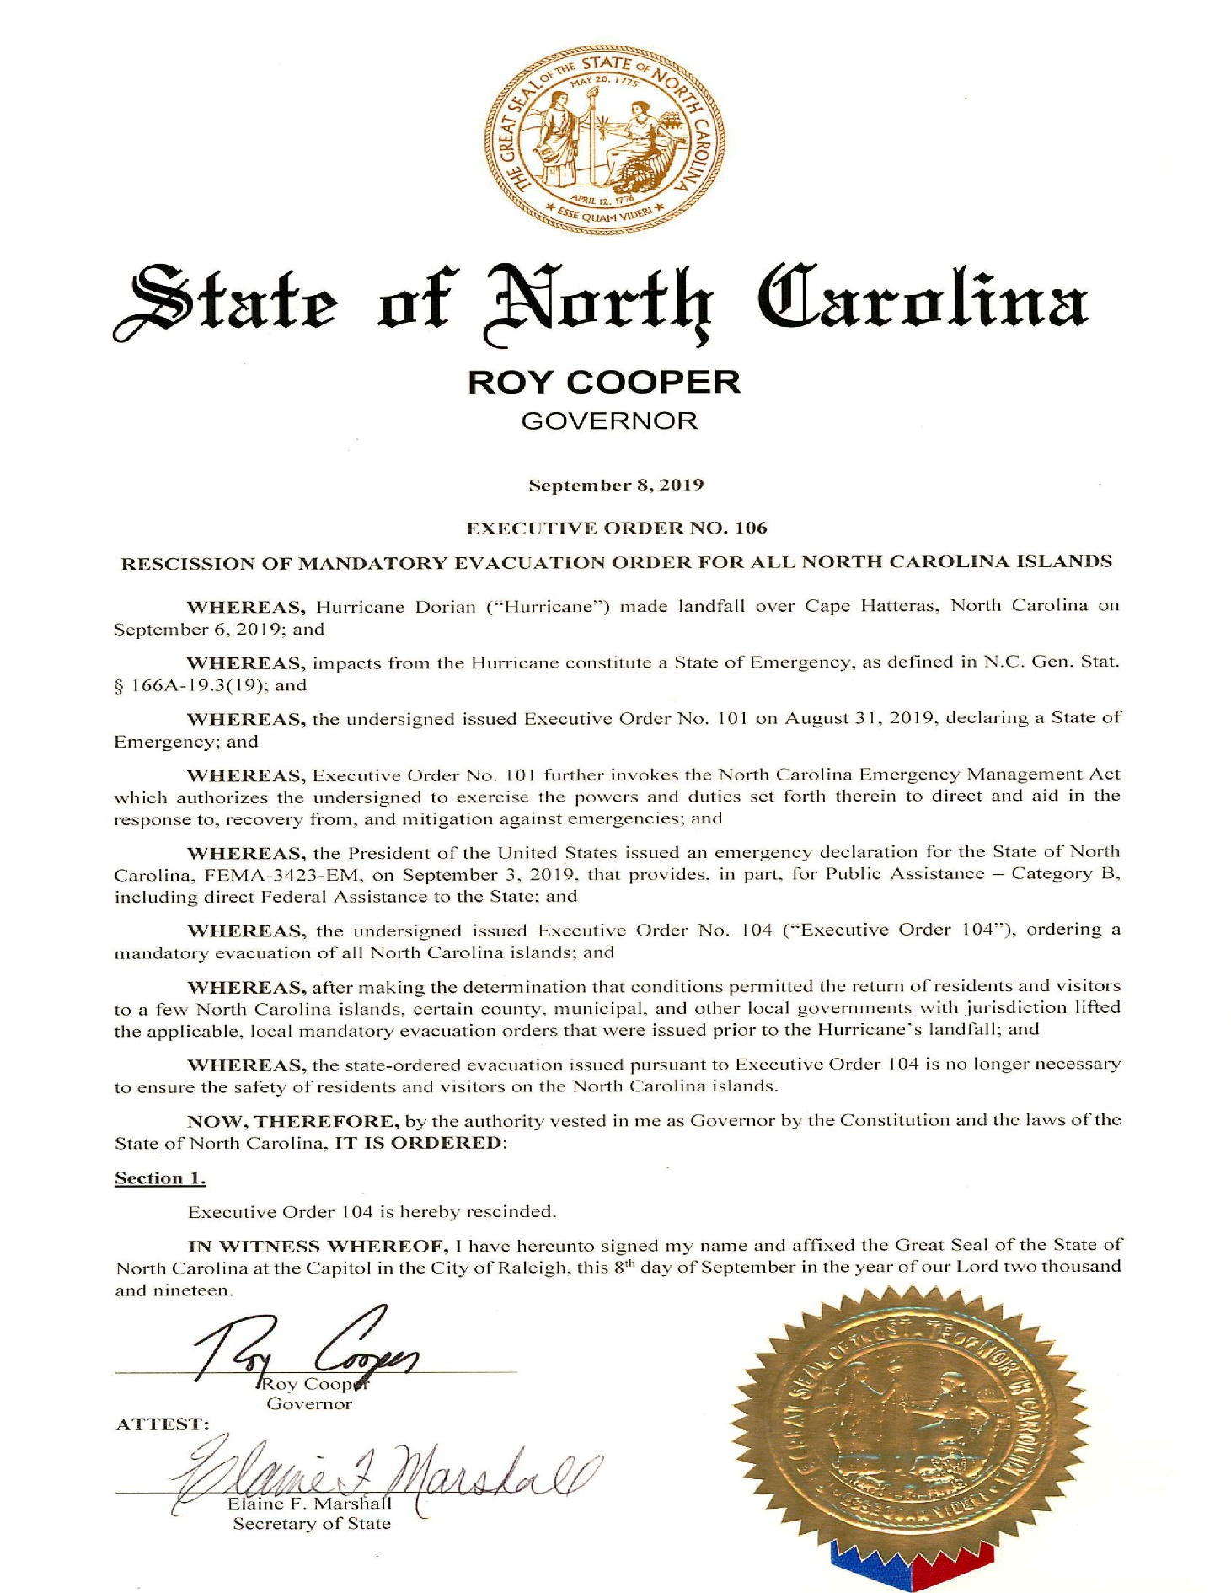
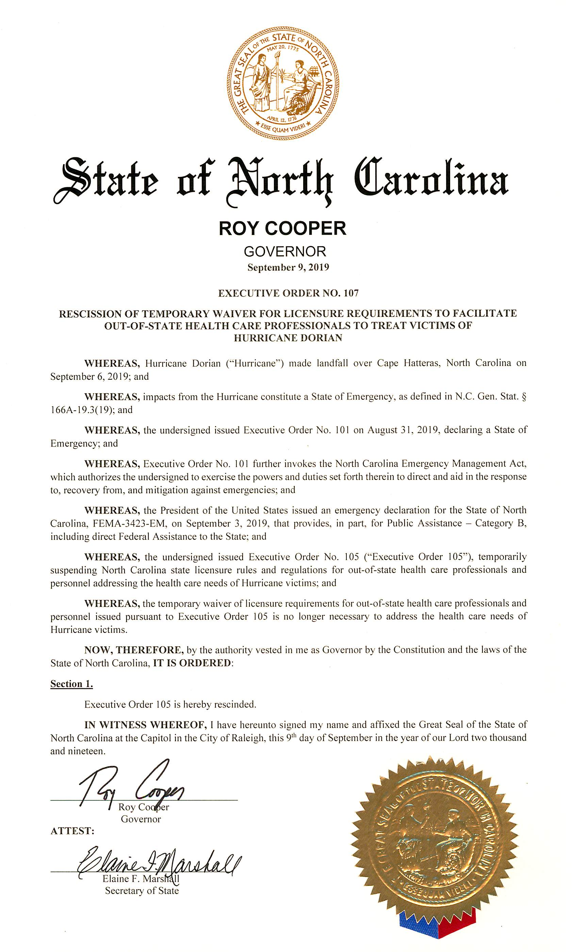
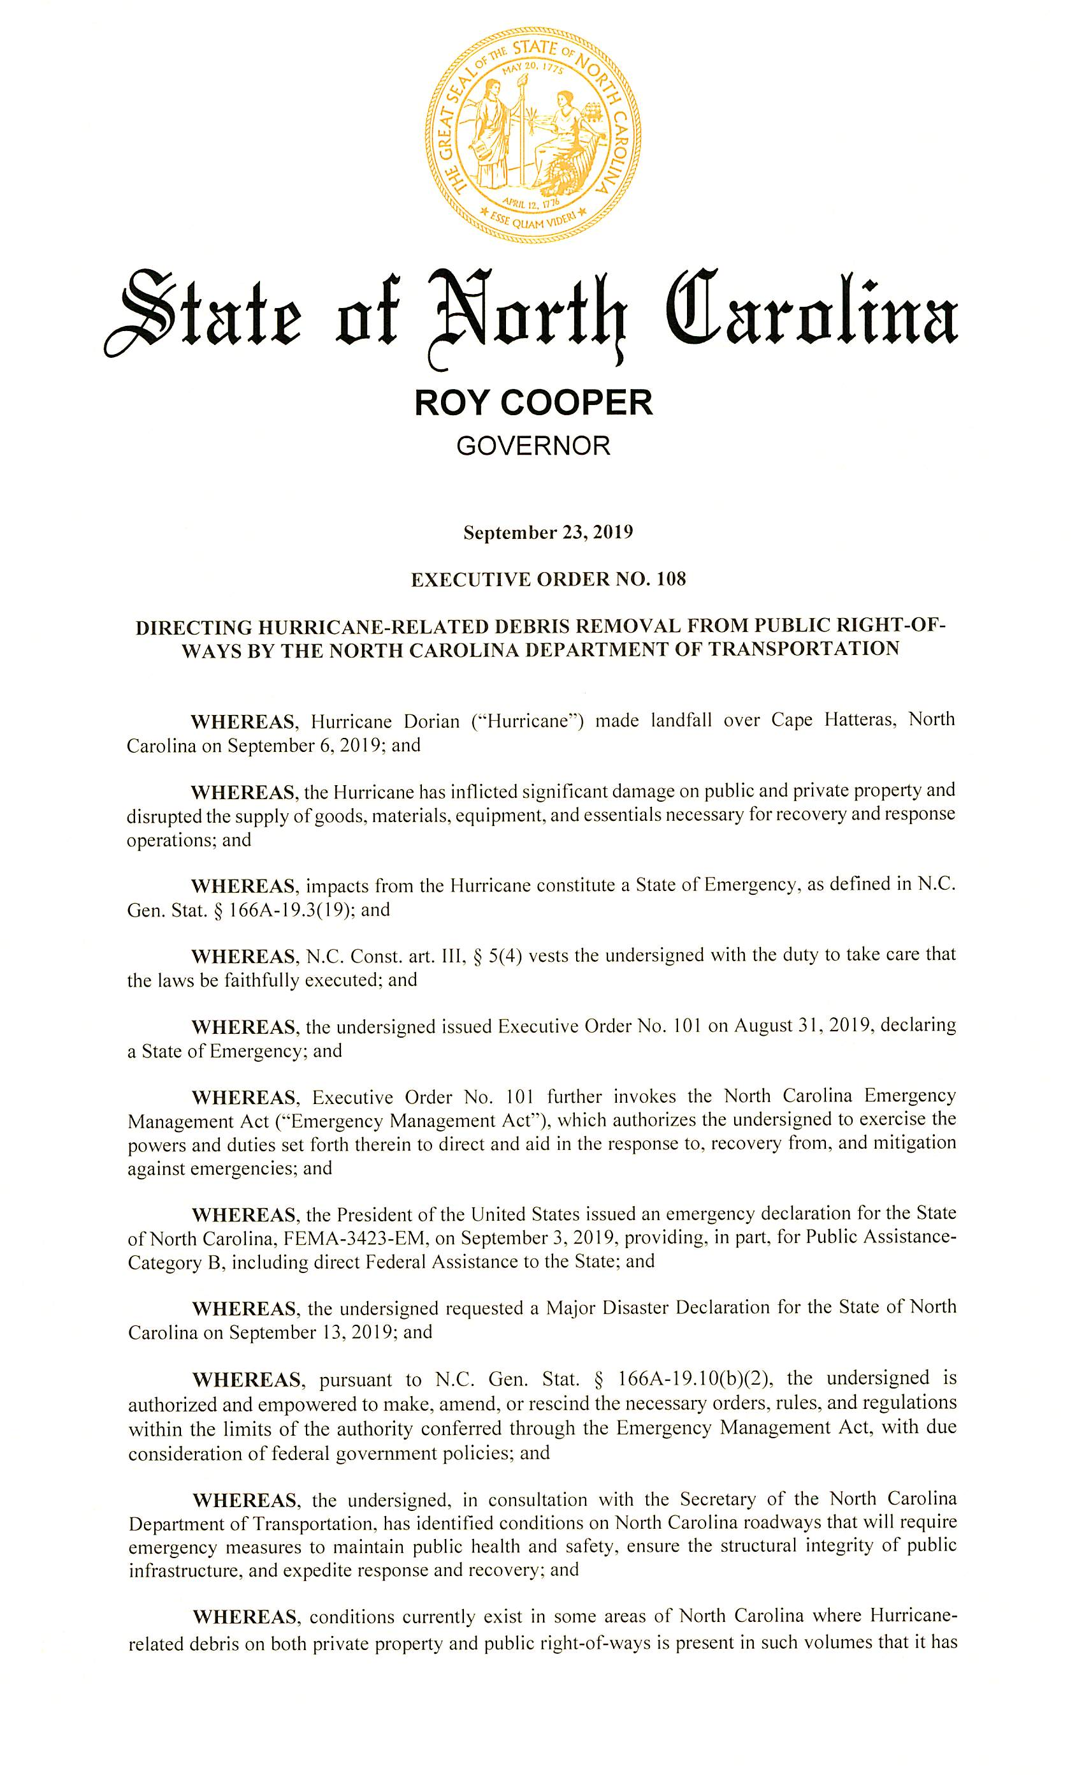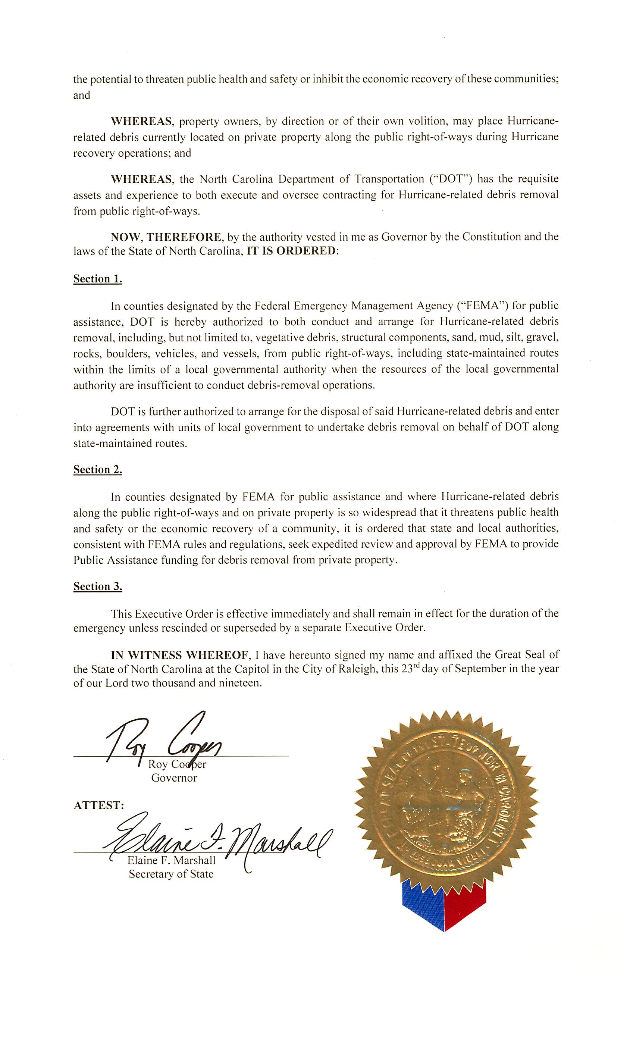

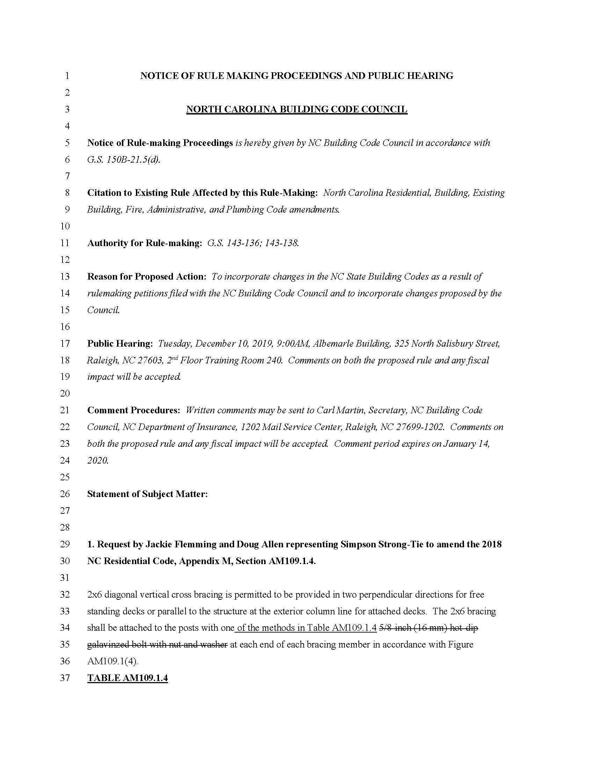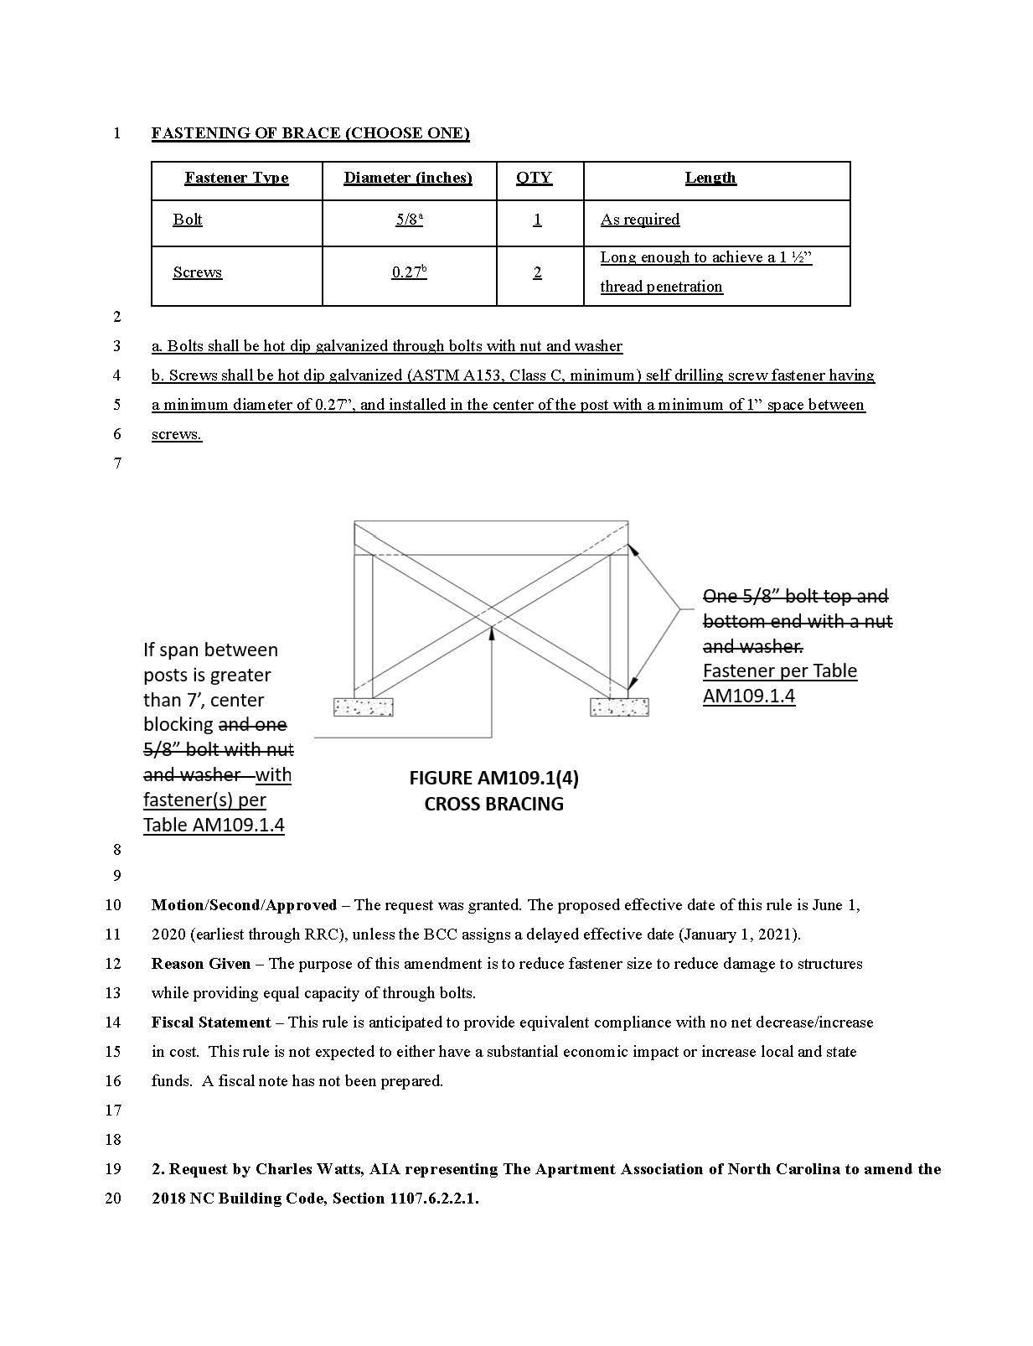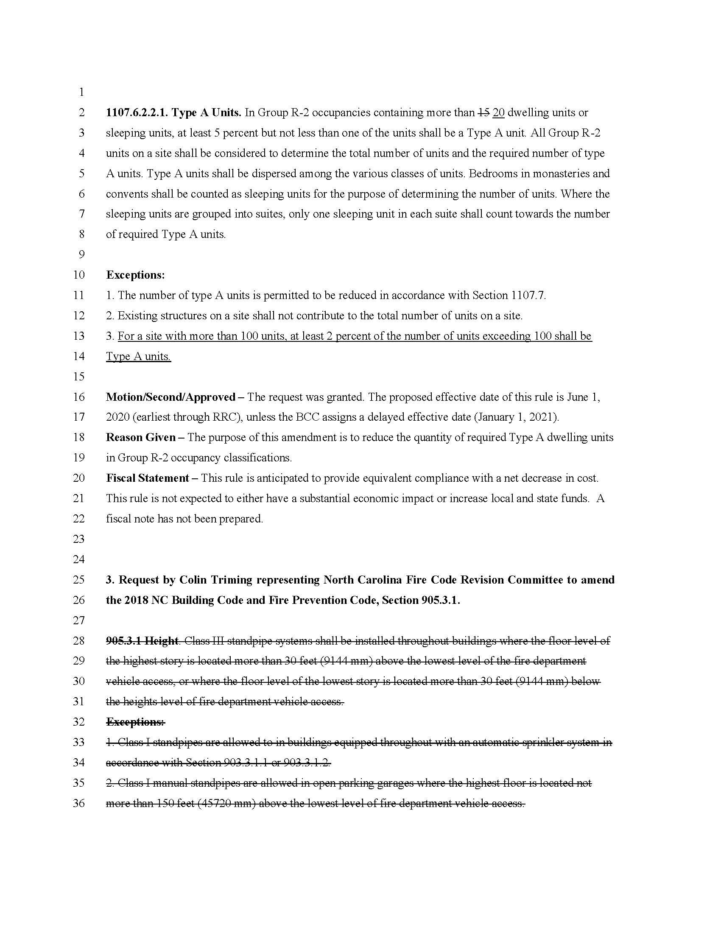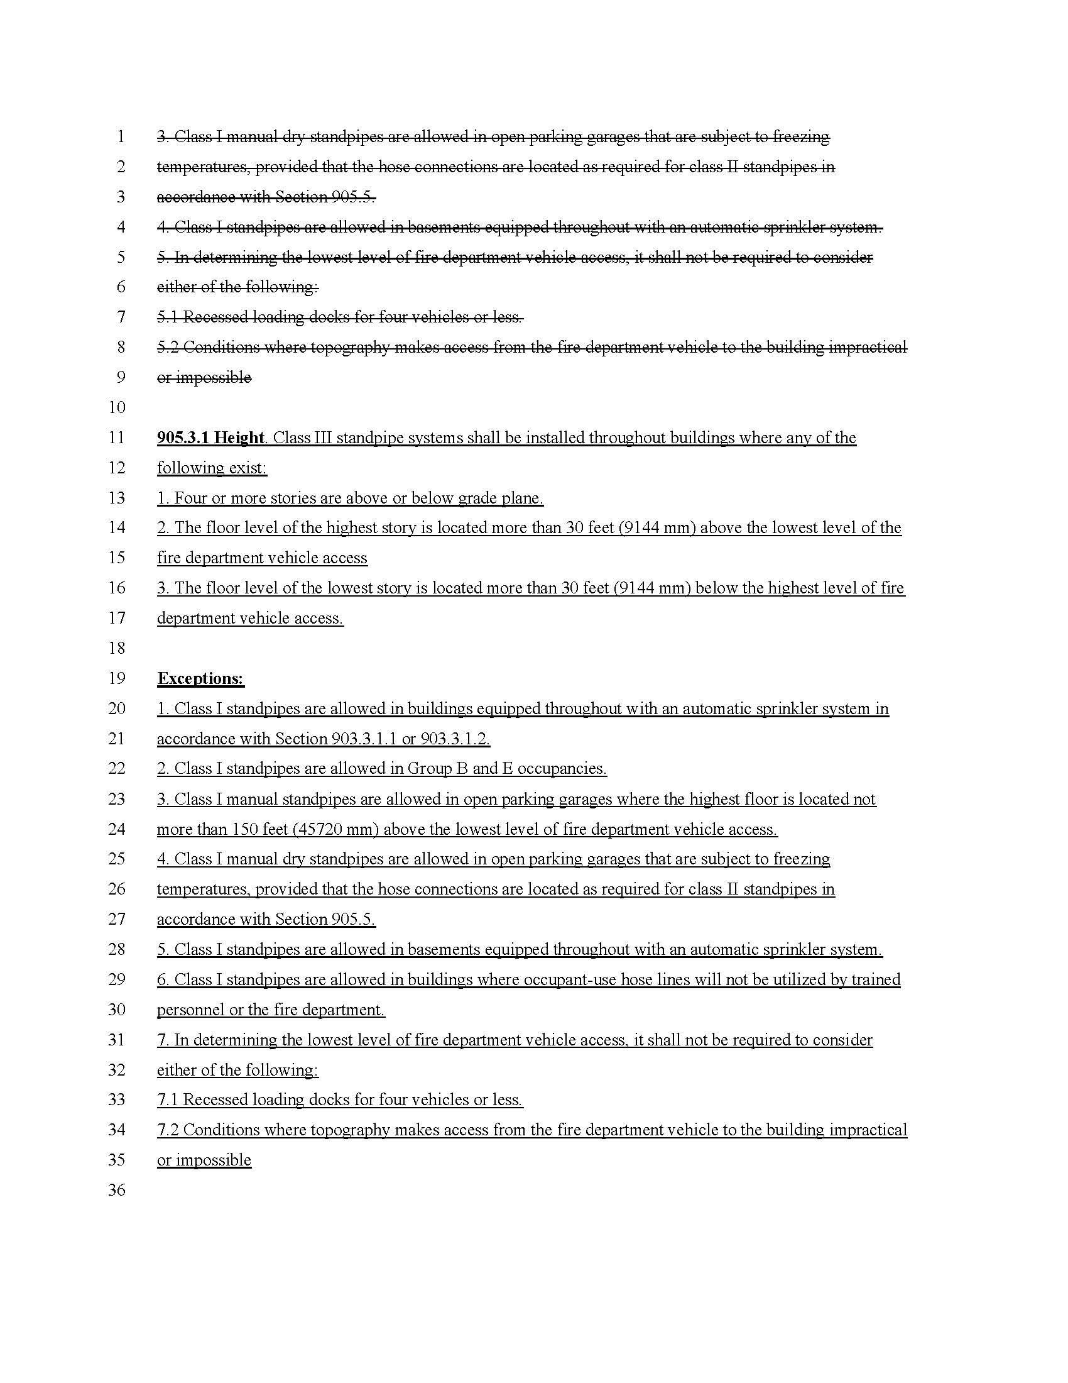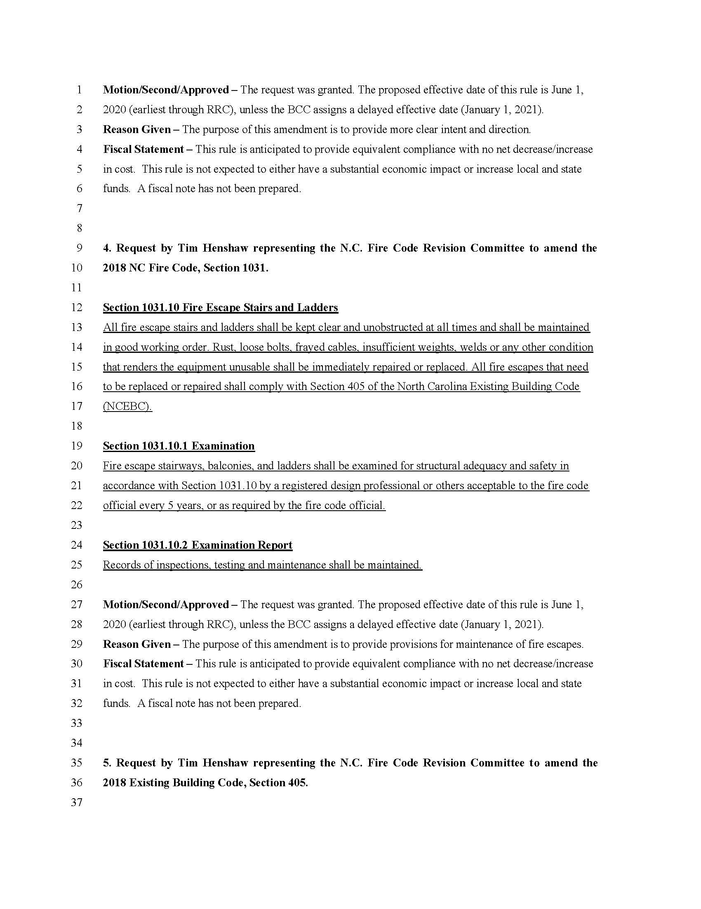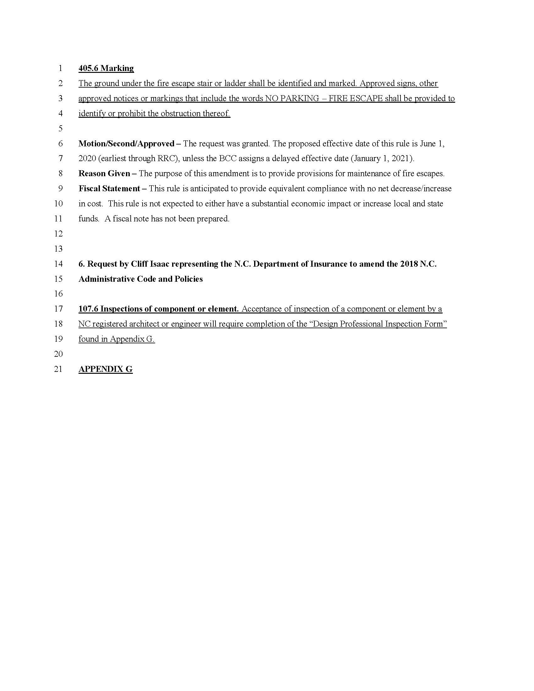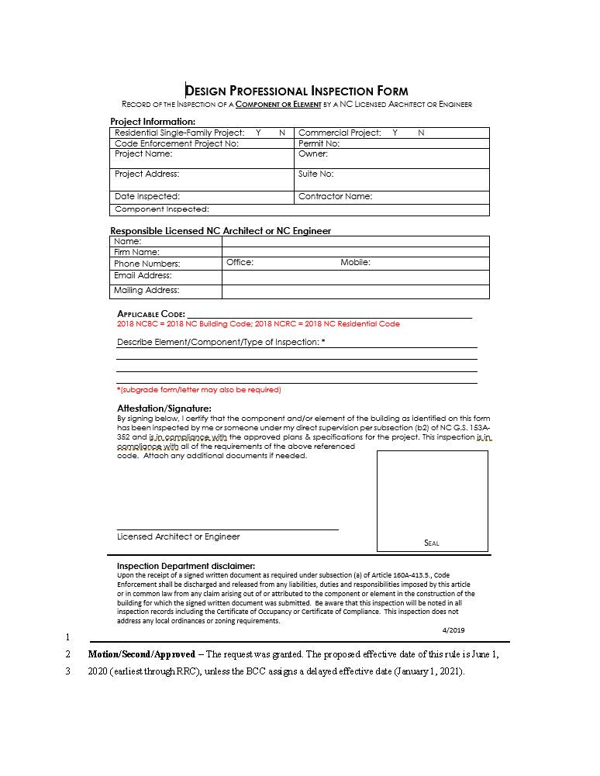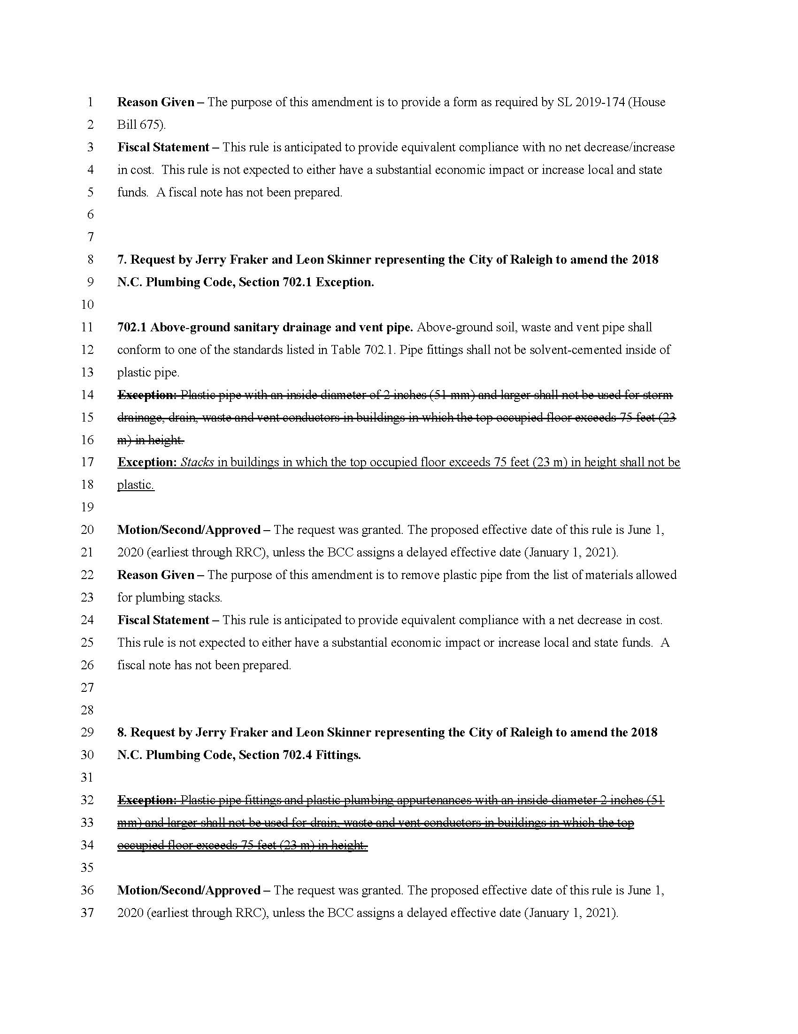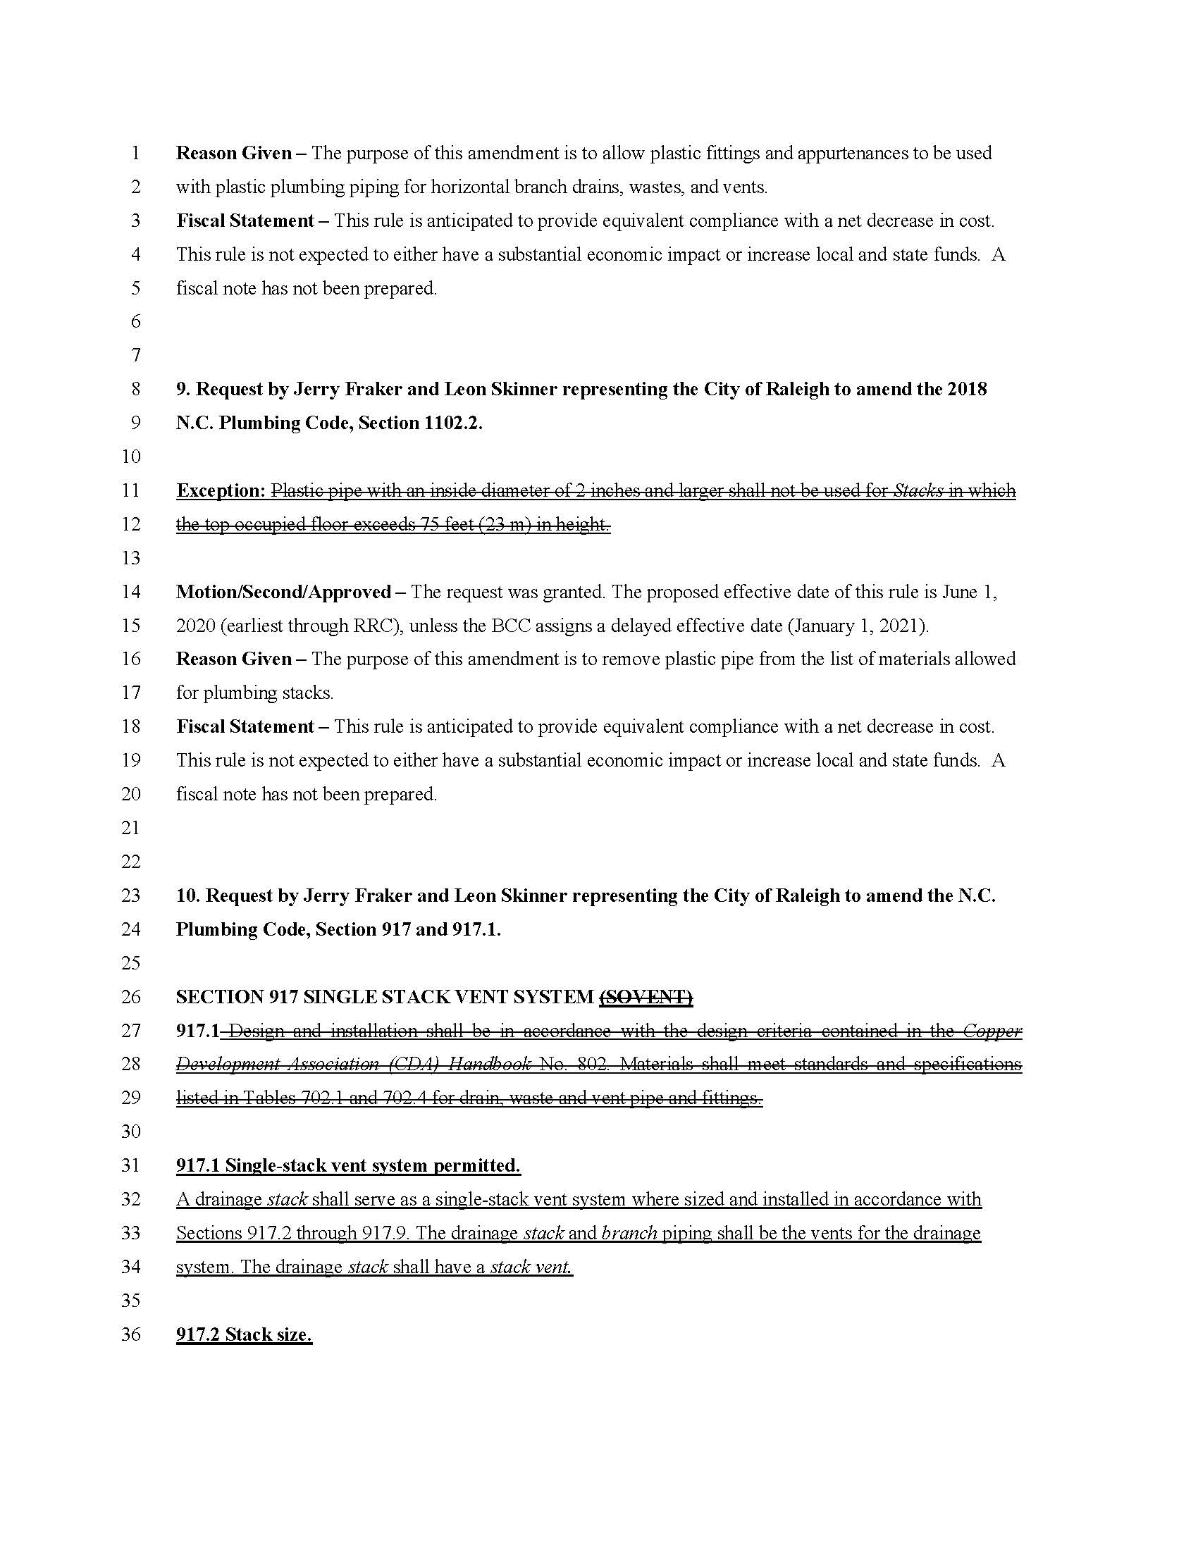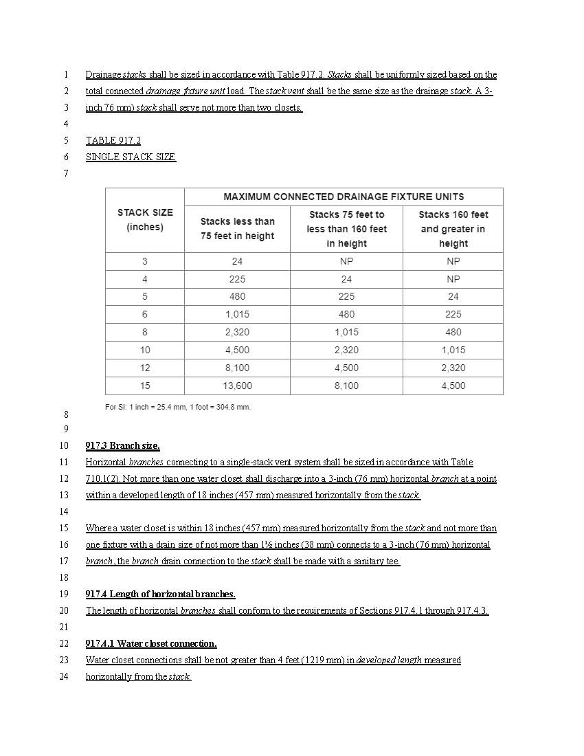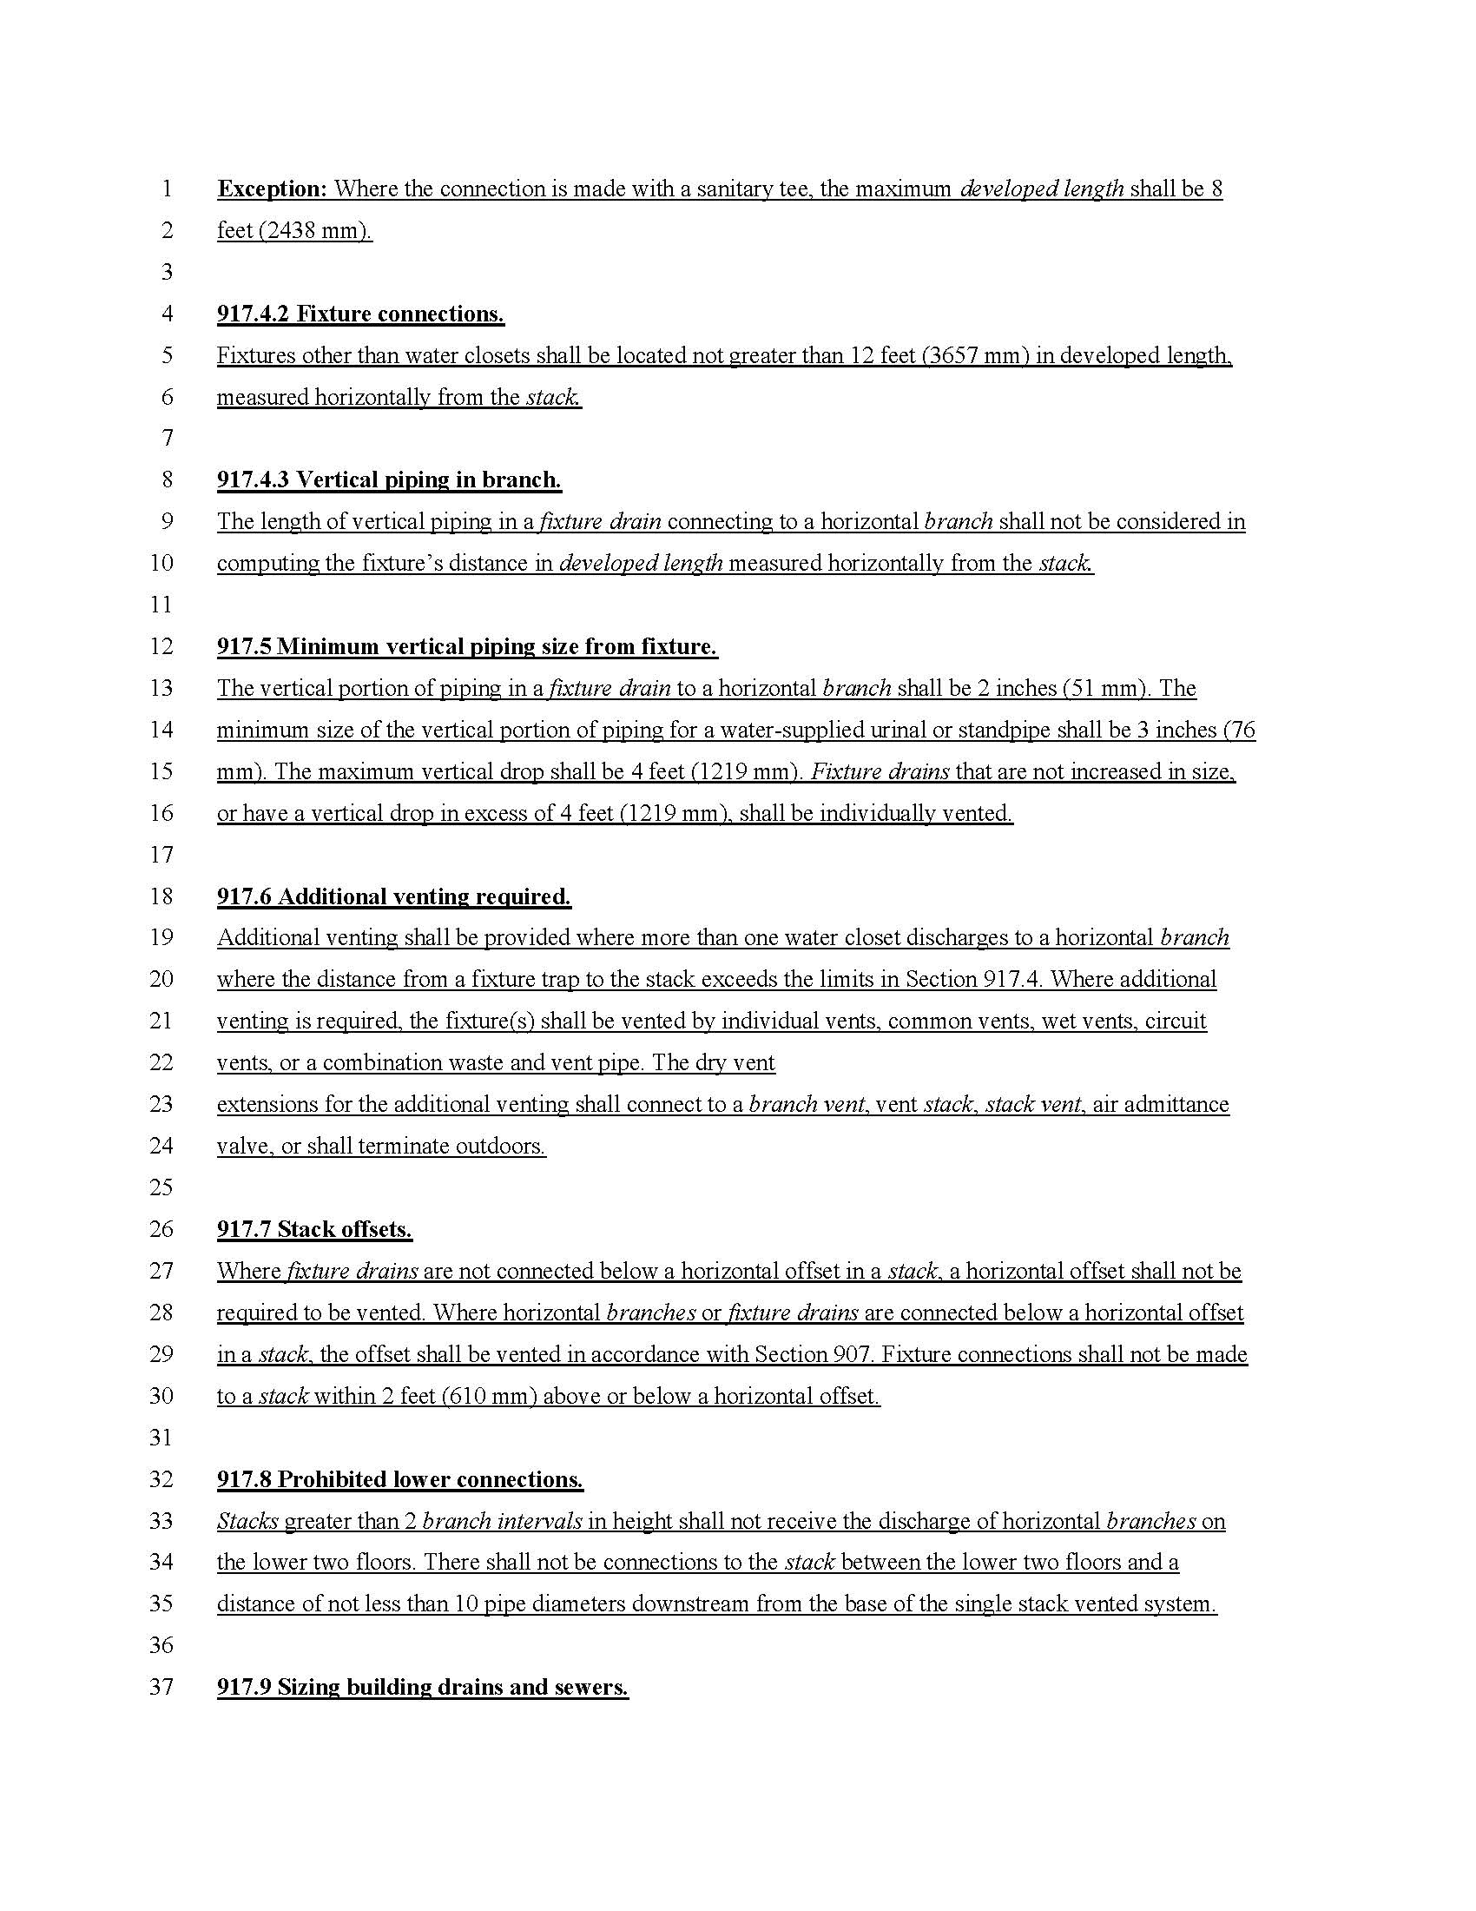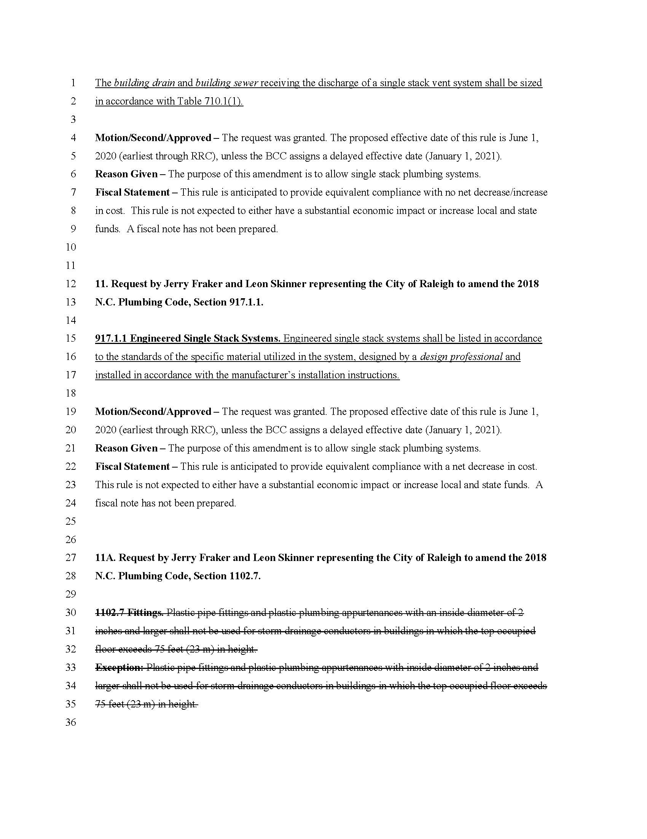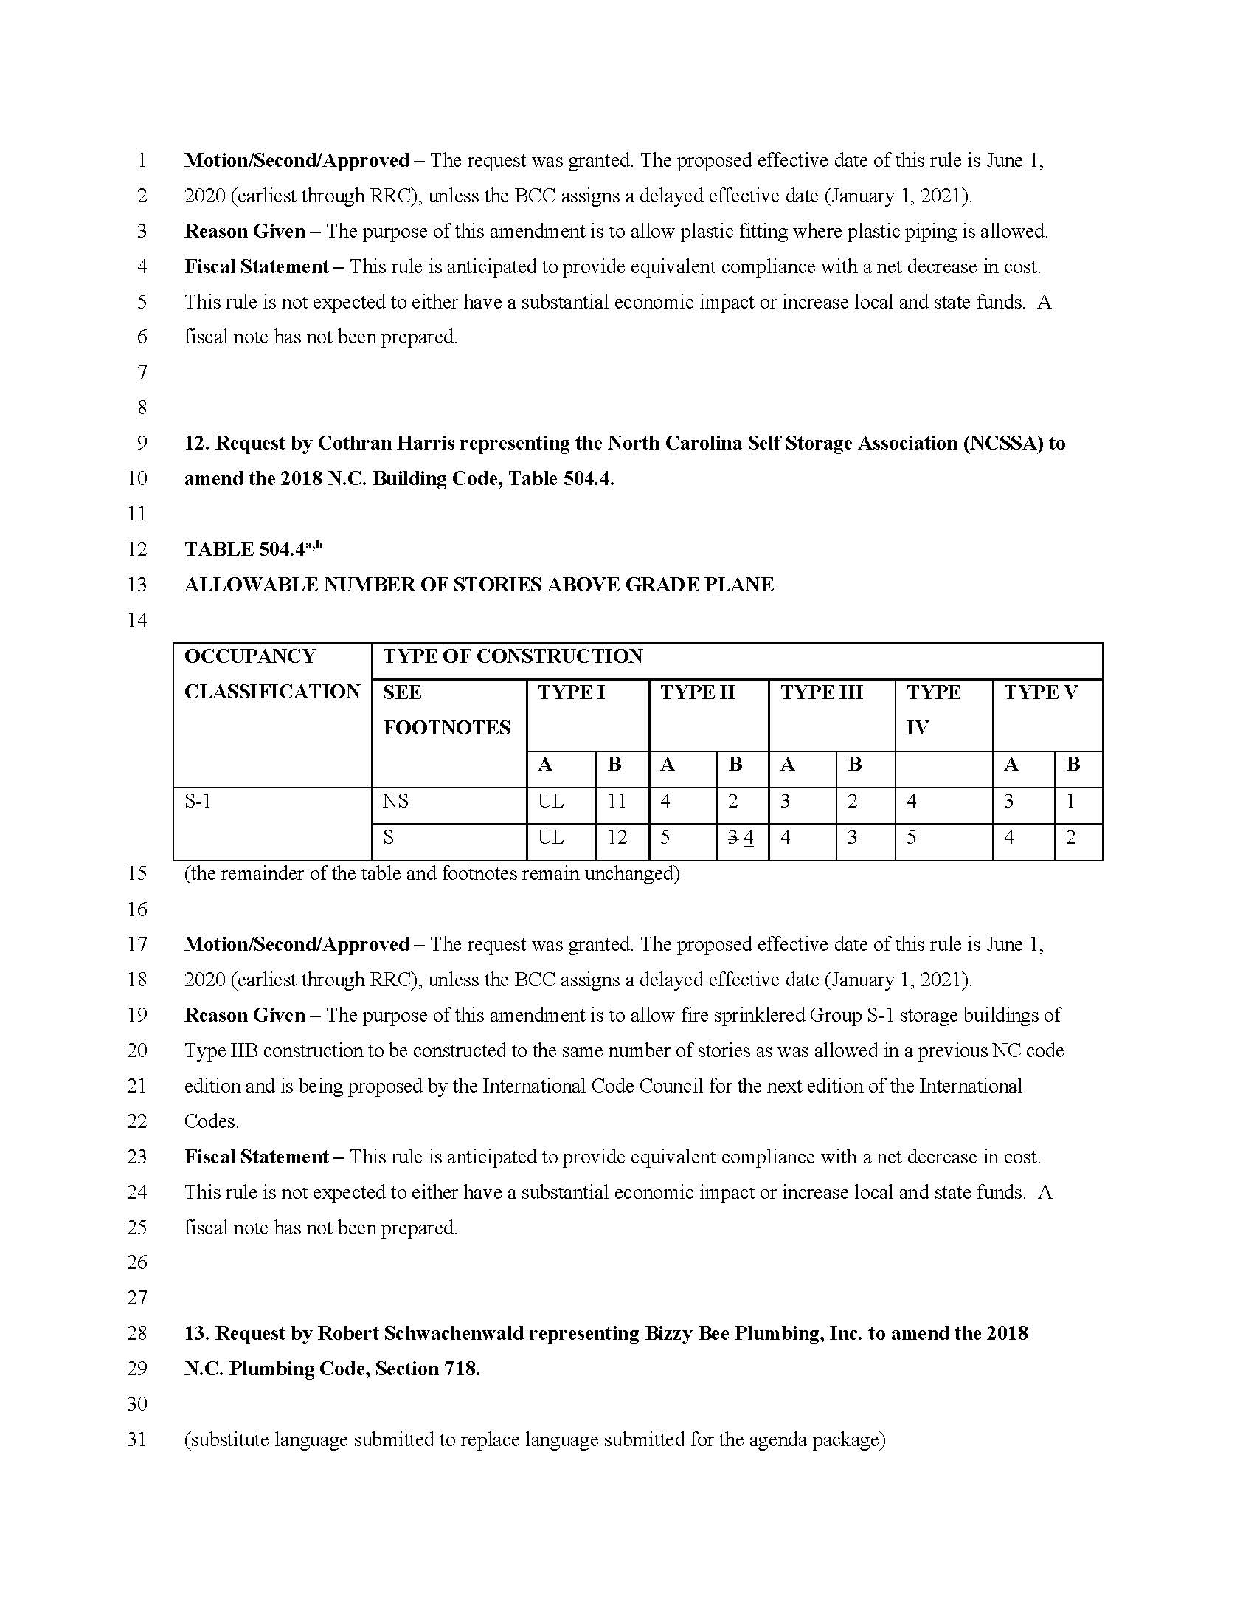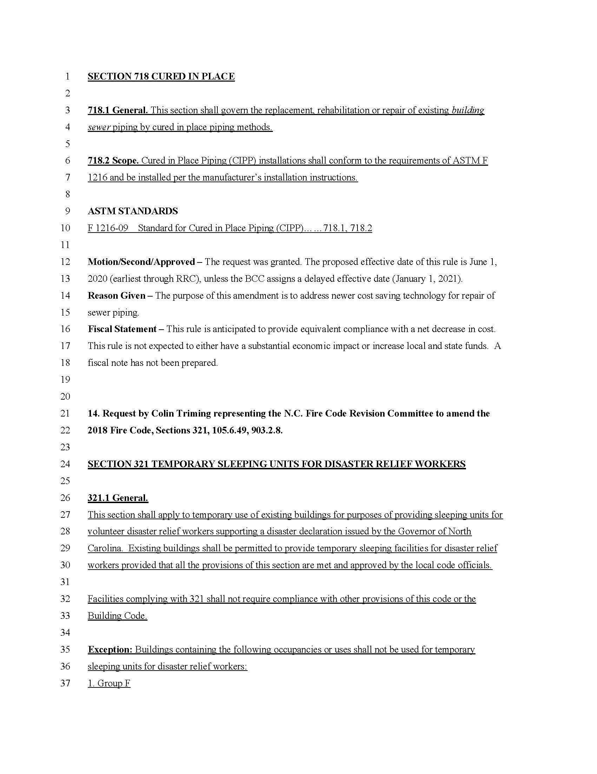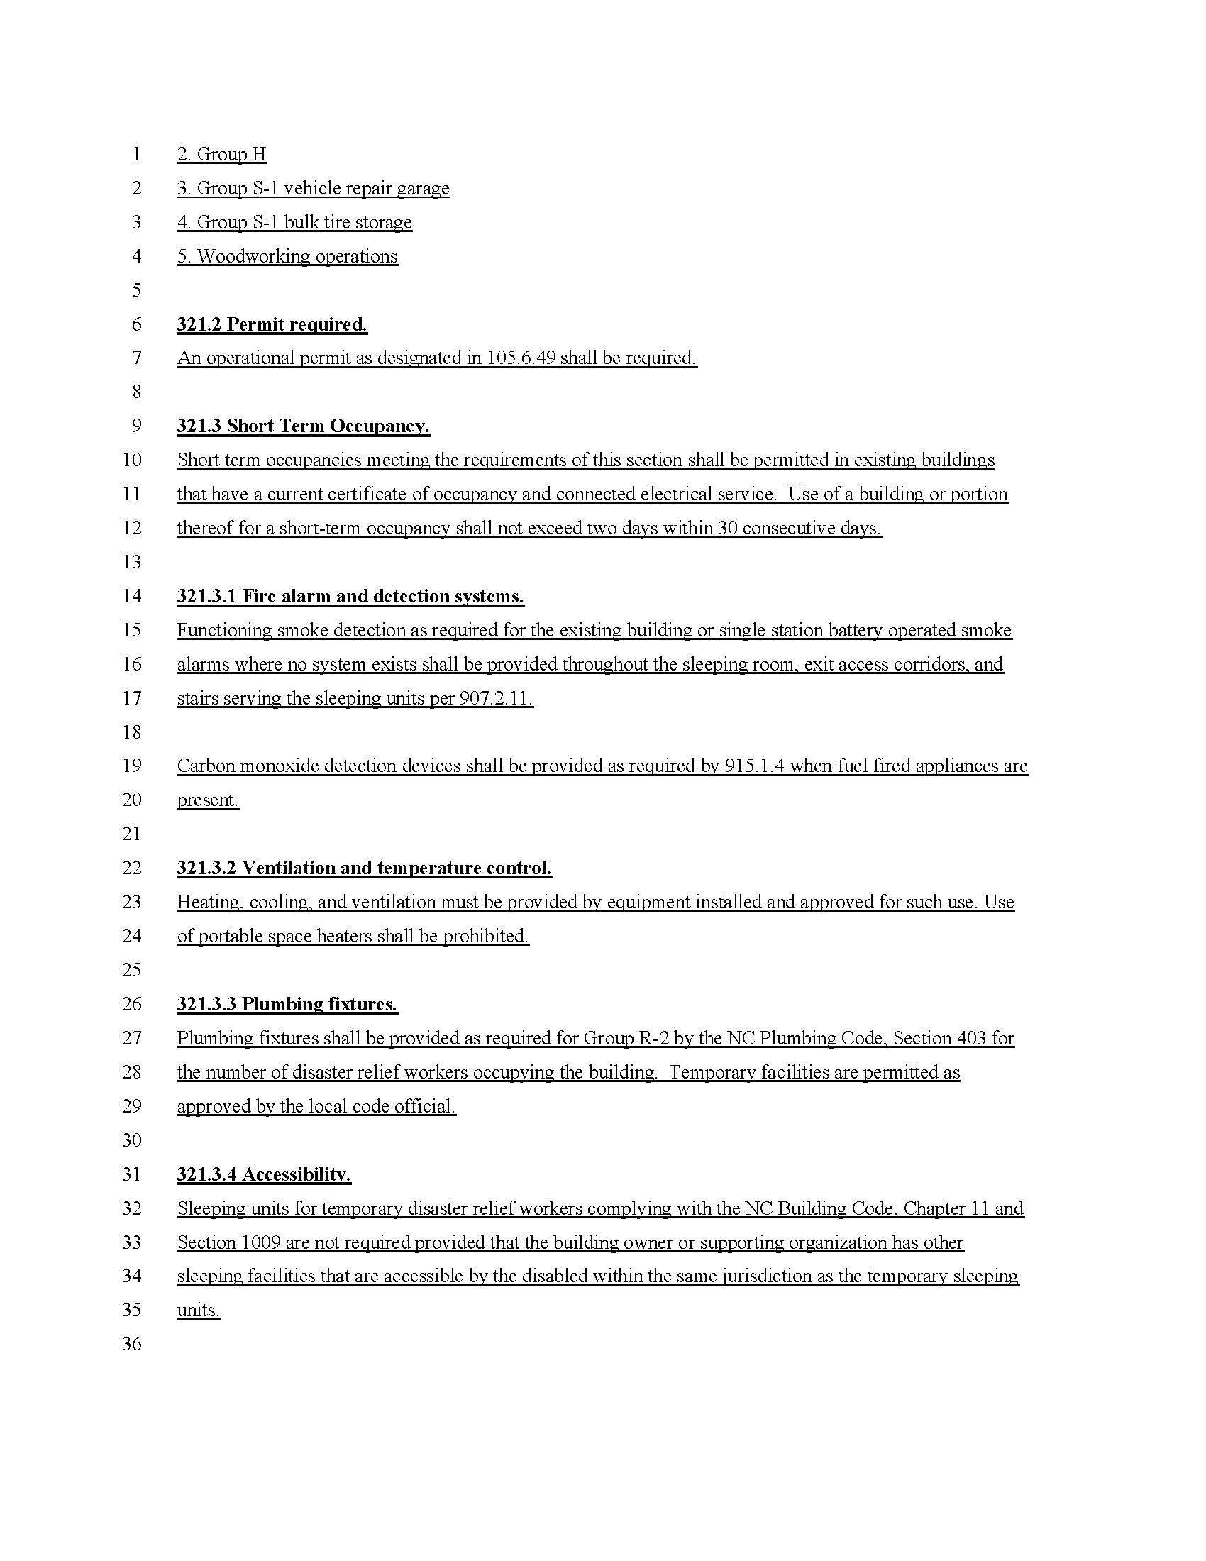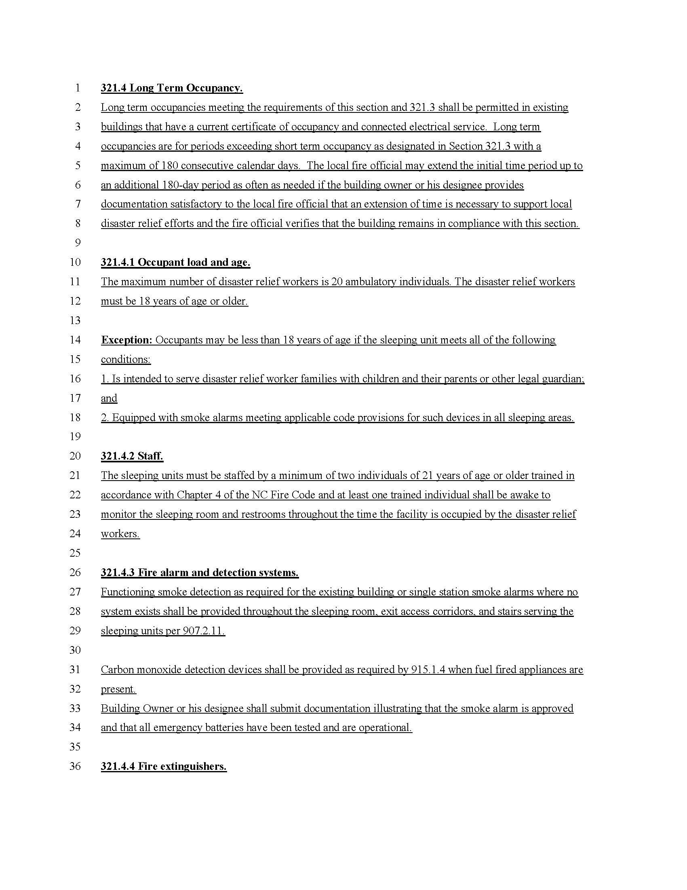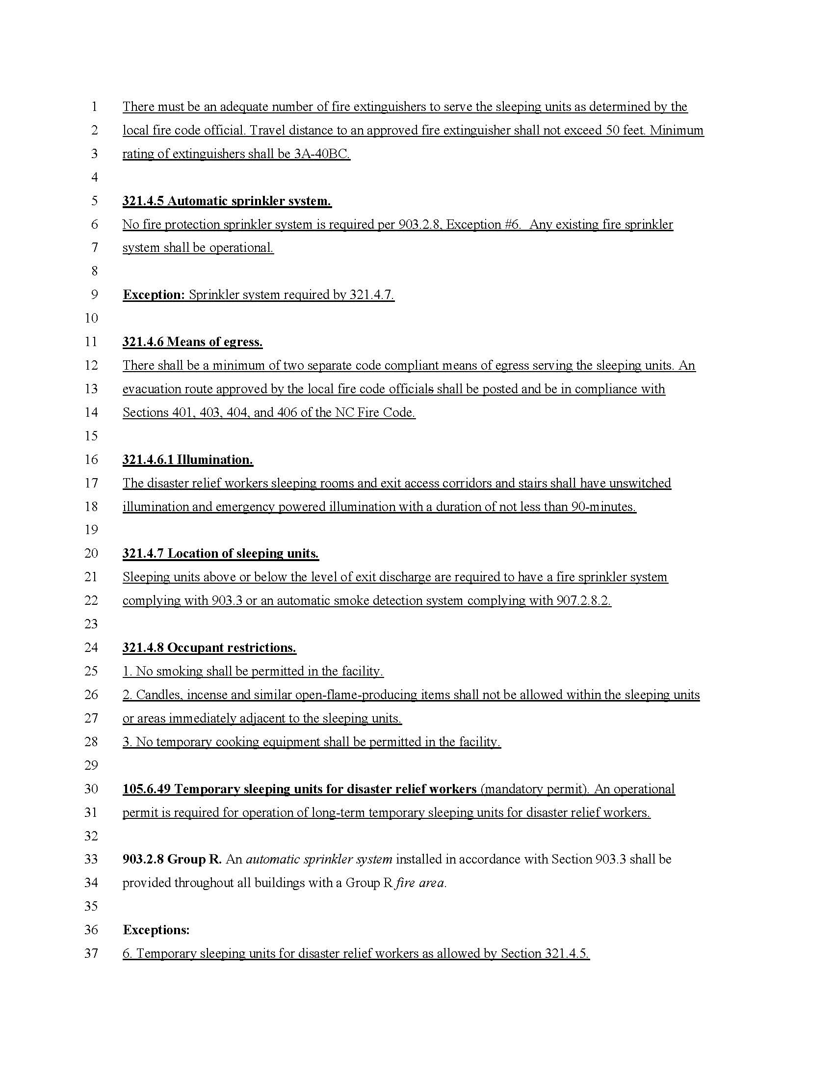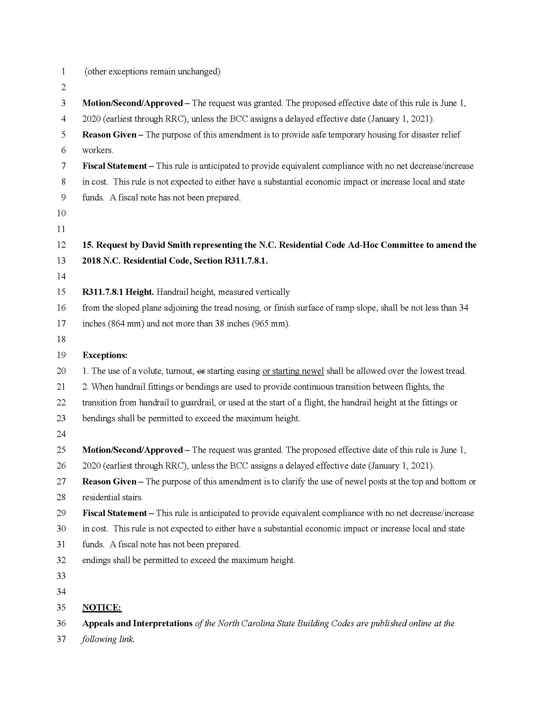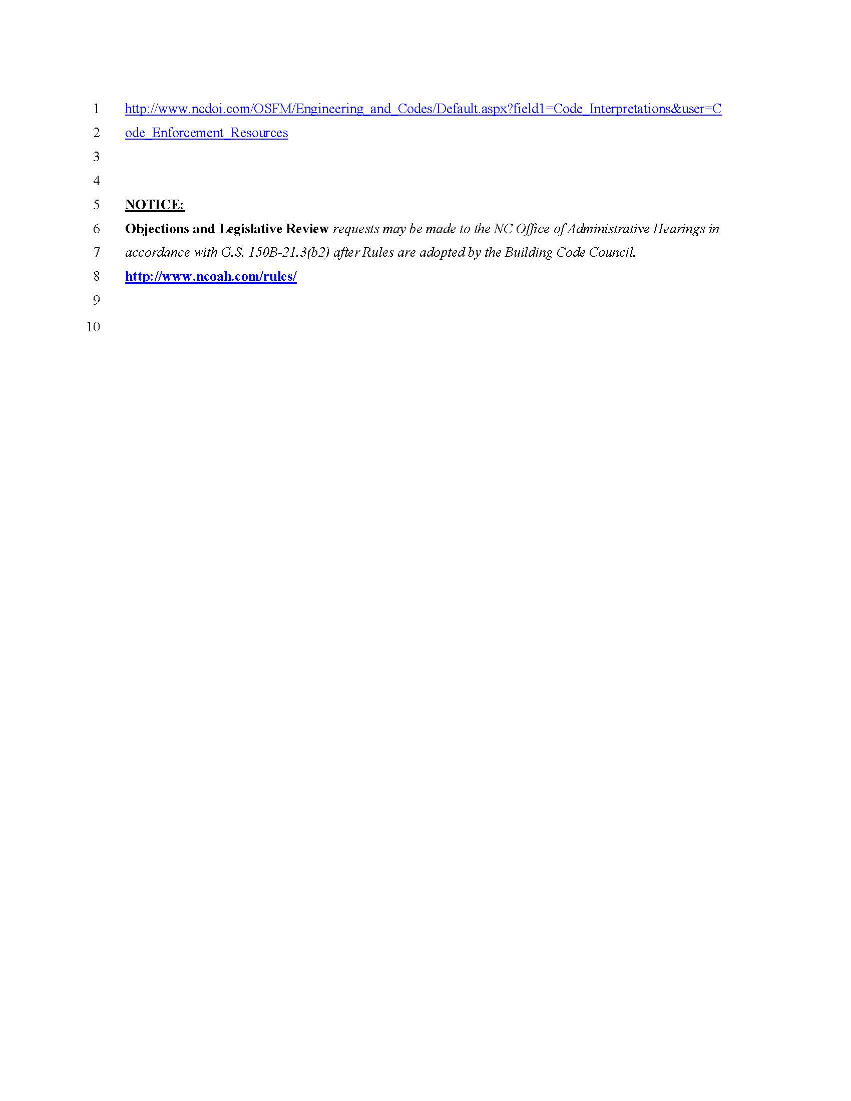
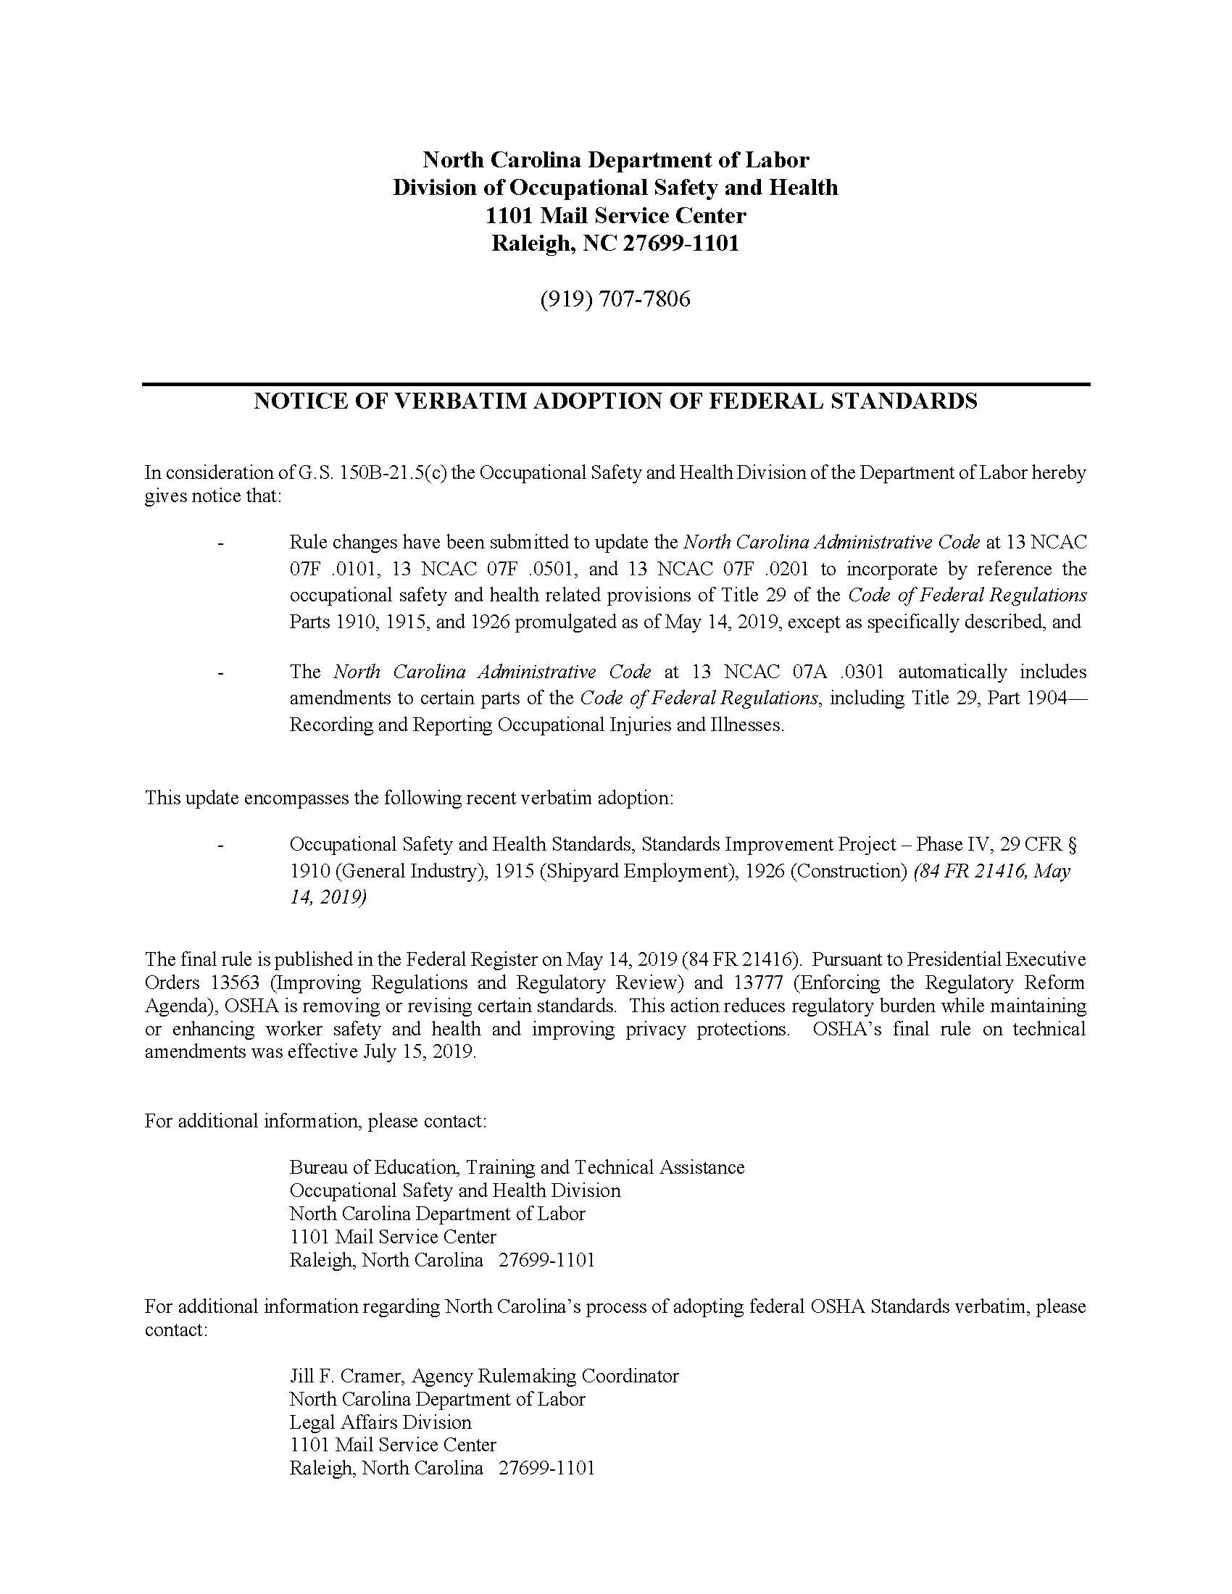
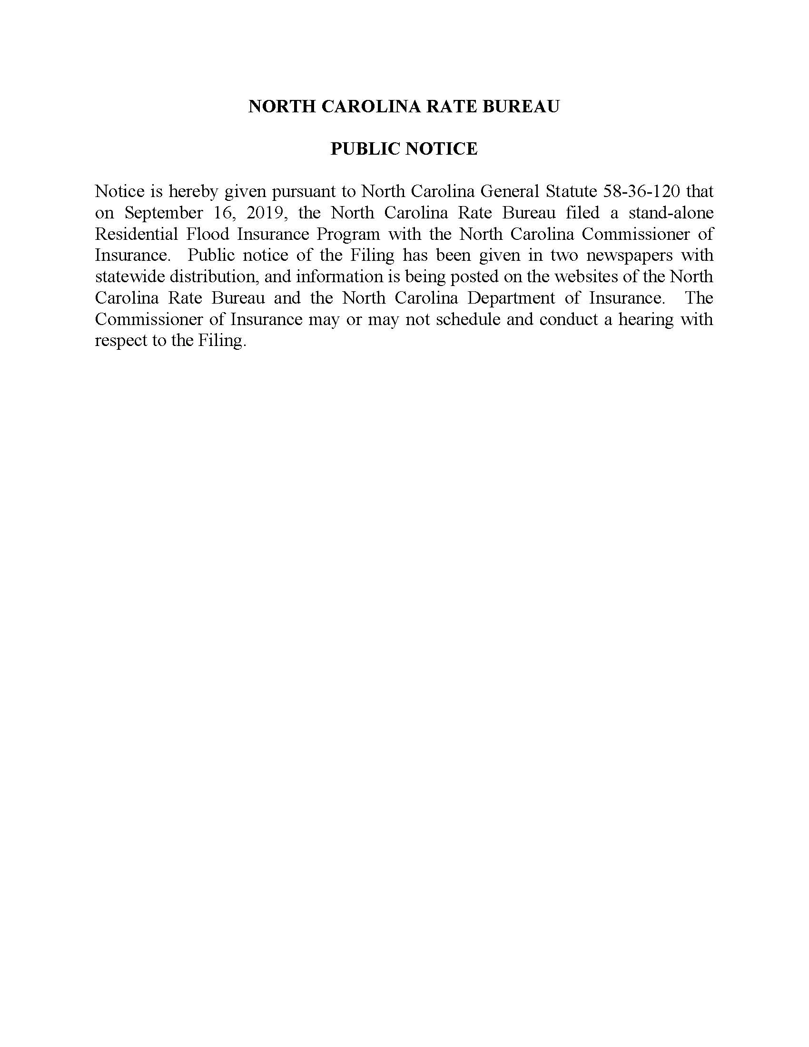

Note from the Codifier: The notices published in this Section of the NC Register include the text of proposed rules. The agency must accept comments on the proposed rule(s) for at least 60 days from the publication date, or until the public hearing, or a later date if specified in the notice by the agency. If the agency adopts a rule that differs substantially from a prior published notice, the agency must publish the text of the proposed different rule and accept comment on the proposed different rule for 60 days.
Statutory reference: G.S. 150B-21.2.

title 15a – department of environmental quality

Notice is hereby given in accordance with G.S. 150B-21.3A(c)(2)g. that the Coastal Resources Commission intends to readopt without substantive changes the rules cited as 15A NCAC 07H .0104-.0106, .0201, .0203, .0205-.0209, .0301-.0306, .0308-.0311, .0401, .0404-.0406, .0501-.0510, .0601-.0604, .1101-.1105, .1201-.1205, .1301-.1305, .1401-.1405, .1501-.1505, .1601-.1605, .1701-.1705, .1801-.1805, .1901-.1905, .2001-.2005, .2101-.2105, .2201-.2205, .2301-.2305, .2401-.2405, .2501-.2505, .2601-.2605, .2701-.2705; 07I .0204, .0302, .0305, .0306, .0401, .0402, .0406, .0504-.0511, .0601, .0602, .0701, .0702; 07J .0102, .0201, .0203, .0204, .0206-.0211, .0301, .0302, .0312, .0405-.0407, .0409, .0410, .0602-.0605, .0701-.0703, .1105-.1107, .1201-.1206, .1301-.1303; 07K .0101, .0103, .0202, .0204-.0212, .0401, .0402; 07L .0503; 07M .0201, .0202, .0301-.0303, .0306-.0308, .0401-.0403, .0503, .0601-.0603, .0701-.0705, .0801, .0802, .0902, .1001, .1002, .1101, .1102, .1201, and .1202.

Pursuant to G.S. 150B-21.2(c)(1), the text of the rule(s) proposed for readoption without substantive changes are not required to be published. The text of the rules are available on the OAH website: http://reports.oah.state.nc.us/ncac.asp.

Link to agency website pursuant to G.S. 150B-19.1(c): https://deq.nc.gov/permits-regulations/rules-regulations/proposed-rules

Proposed Effective Date: April 1, 2020

Public Hearing:

Date: November 20, 2019

Time: 1:15 p.m.

Location: Islander Hotel, 102 Islander Drive, Emerald Isle, NC 28594

Reason for Proposed Action:

Readoptions - G.S. 150B-21.3A requires state agencies to review existing rules every 10 years, determine which rules are still necessary, and either re-adopt or repeal each rule as appropriate.

Comments may be submitted to: Braxton Davis, 400 Commerce Avenue, Morehead City, NC 28557; email Braxton.Davis@ncdenr.gov

Comment period ends: December 31, 2019

Procedure for Subjecting a Proposed Rule to Legislative Review: If an objection is not resolved prior to the adoption of the rule, a person may also submit written objections to the Rules Review Commission after the adoption of the Rule. If the Rules Review Commission receives written and signed objections after the adoption of the Rule in accordance with G.S. 150B-21.3(b2) from 10 or more persons clearly requesting review by the legislature and the Rules Review Commission approves the rule, the rule will become effective as provided in G.S. 150B-21.3(b1). The Commission will receive written objections until 5:00 p.m. on the day following the day the Commission approves the rule. The Commission will receive those objections by mail, delivery service, hand delivery, or facsimile transmission. If you have any further questions concerning the submission of objections to the Commission, please call a Commission staff attorney at 919-431-3000.

Fiscal impact. Does any rule or combination of rules in this notice create an economic impact? Check all that apply.

State funds affected

Local funds affected

Substantial economic impact (>= $1,000,000)

Approved by OSBM

No fiscal note required

Chapter 07 - Coastal Management

SUBCHAPTER 07H - STATE GUIDELINES FOR AREAS OF ENVIRONMENTAL CONCERN

SECTION .0100 - INTRODUCTION AND GENERAL COMMENTS

15a ncac 07h .0104 APPLICATION OF EROSION RATE SETBACK FACTORS (READOPTION WITHOUT SUBSTANTIVE CHANGES)

15A NCAC 07H .0105 EFFECTIVE DATE OF RULE AMENDMENTS (READOPTION WITHOUT SUBSTANTIVE CHANGES)

15A NCAC 07H .0106 GENERAL DEFINITIONS (READOPTION WITHOUT SUBSTANTIVE CHANGES)

section .0200 – the estuarine and ocean systems
15A nCAC 07H .0201 ESTUARINE AND OCEAN SYSTEM CATEGORIES (READOPTION WITHOUT SUBSTANTIVE CHANGES)

15A NCAC 07H .0203 MANAGEMENT OBJECTIVE OF THE ESTUARINE AND OCEAN SYSTEM (READOPTION WITHOUT SUBSTANTIVE CHANGES)

15A NCAC 07H .0205 COASTAL WETLANDS (READOPTION WITHOUT SUBSTANTIVE CHANGES)

15A NCAC 07H .0206 ESTUARINE WATERS (READOPTION WITHOUT SUBSTANTIVE CHANGES)

15A NCAC 07H .0207 PUBLIC TRUST AREAS (READOPTION WITHOUT SUBSTANTIVE CHANGES)

15A NCAC 07H .0208 USE STANDARDS (READOPTION WITHOUT SUBSTANTIVE CHANGES)

15A NCAC 07H .0209 COASTAL SHORELINES (READOPTION WITHOUT SUBSTANTIVE CHANGES)

SECTION .0300 - OCEAN HAZARD AREAS

15A NCAC 07H .0301 OCEAN HAZARD CATEGORIES (READOPTION WITHOUT SUBSTANTIVE CHANGES)

15A NCAC 07H .0302 SIGNIFICANCE OF THE OCEAN HAZARD CATEGORY (READOPTION WITHOUT SUBSTANTIVE CHANGES)

15A NCAC 07H .0303 MANAGEMENT OBJECTIVE OF OCEAN HAZARD AREAS (READOPTION WITHOUT SUBSTANTIVE CHANGES)

15A NCAC 07H .0304 AECS WITHIN OCEAN HAZARD AREAS (READOPTION WITHOUT SUBSTANTIVE CHANGES)

15A NCAC 07H .0305 GENERAL IDENTIFICATION AND DESCRIPTION OF LANDFORMS (READOPTION WITHOUT SUBSTANTIVE CHANGES)

15A NCAC 07h .0306 GENERAL USE STANDARDS FOR OCEAN HAZARD AREAS (READOPTION WITHOUT SUBSTANTIVE CHANGES)

15A NCAC 07H .0308 SPECIFIC USE STANDARDS FOR OCEAN HAZARD AREAS (READOPTION WITHOUT SUBSTANTIVE CHANGES)

15A NCAC 07H .0309 USE STANDARDS FOR OCEAN HAZARD AREAS: EXCEPTIONS (READOPTION WITHOUT SUBSTANTIVE CHANGES)

15A NCAC 07H .0310 USE STANDARDS FOR INLET HAZARD AREAS (READOPTION WITHOUT SUBSTANTIVE CHANGES)

15A NCAC 07H .0311 INSTALLATION AND MAINTENANCE OF SAND FENCING (READOPTION WITHOUT SUBSTANTIVE CHANGES)

SECTION .0400 - PUBLIC WATER SUPPLIES

15A NCAC 07H .0401 PUBLIC WATER SUPPLY CATEGORIES (READOPTION WITHOUT SUBSTANTIVE CHANGES)

15A NCAC 07H .0404 AECS WITHIN PUBLIC WATER SUPPLIES (READOPTION WITHOUT SUBSTANTIVE CHANGES)

15A NCAC 07H .0405 SMALL SURFACE WATER SUPPLY WATERSHEDS (READOPTION WITHOUT SUBSTANTIVE CHANGES)

15A NCAC 07H .0406 PUBLIC WATER SUPPLY WELL FIELDS (READOPTION WITHOUT SUBSTANTIVE CHANGES)

SECTION .0500 - NATURAL AND CULTURAL RESOURCE AREAS

15A NCAC 07H .0501 GENERAL (READOPTION WITHOUT SUBSTANTIVE CHANGES)

15A NCAC 07H .0502 SIGNIFICANCE (READOPTION WITHOUT SUBSTANTIVE CHANGES)

15A NCAC 07H .0503 NOMINATION AND DESIGNATION PROCEDURES (READOPTION WITHOUT SUBSTANTIVE CHANGES)

15A NCAC 07H .0504 AECS WITHIN CATEGORY (READOPTION WITHOUT SUBSTANTIVE CHANGES)

15A NCAC 07H .0505 COASTAL AREAS THAT SUSTAIN REMNANT SPECIES (READOPTION WITHOUT SUBSTANTIVE CHANGES)

15A NCAC 07H .0506 COASTAL COMPLEX NATURAL AREAS (READOPTION WITHOUT SUBSTANTIVE CHANGES)

15A NCAC 07H .0507 UNIQUE COASTAL GEOLOGIC FORMATIONS (READOPTION WITHOUT SUBSTANTIVE CHANGES)

15A NCAC 07H .0508 USE STANDARDS (READOPTION WITHOUT SUBSTANTIVE CHANGES)

15A NCAC 07H .0509 SIGNIFICANT COASTAL ARCHAEOLOGICAL RESOURCES (READOPTION WITHOUT SUBSTANTIVE CHANGES)

15A NCAC 07H .0510 SIGNIFICANT COASTAL HISTORIC ARCHITECTURAL RESOURCES (READOPTION WITHOUT SUBSTANTIVE CHANGES)

SECTION .0600 - DEVELOPMENT STANDARDS APPLICABLE TO ALL AECs

15A NCAC 07H .0601 NO VIOLATION OF ANY RULE (READOPTION WITHOUT SUBSTANTIVE CHANGES)

15A NCAC 07H .0602 POLLUTION OF WATERS (READOPTION WITHOUT SUBSTANTIVE CHANGES)

15A NCAC 07H .0603 MINIMUM ALTITUDES (READOPTION WITHOUT SUBSTANTIVE CHANGES)

15A NCAC 07H .0604 NOISE POLLUTION (READOPTION WITHOUT SUBSTANTIVE CHANGES)

SECTION .1100 - GENERAL PERMIT FOR CONSTRUCTION OF BULKHEADS AND RIPRAP REVETMENTS FOR SHORELINE PROTECTION IN ESTUARINE AND PUBLIC TRUST WATERS AND OCEAN HAZARD AREAS

15A NCAC 07H .1101 PURPOSE (READOPTION WITHOUT SUBSTANTIVE CHANGES)

15A NCAC 07H .1102 APPROVAL PROCEDURES (READOPTION WITHOUT SUBSTANTIVE CHANGES)

15A NCAC 07H .1103 PERMIT FEE (READOPTION WITHOUT SUBSTANTIVE CHANGES)

15A NCAC 07H .1104 GENERAL CONDITIONS (READOPTION WITHOUT SUBSTANTIVE CHANGES)

15A NCAC 07H .1105 SPECIFIC CONDITIONS (READOPTION WITHOUT SUBSTANTIVE CHANGES)

SECTION .1200 - GENERAL PERMIT FOR CONSTRUCTION OF PIERS AND DOCKING FACILITIES: IN ESTUARINE AND PUBLIC TRUST WATERS AND OCEAN HAZARD AREAS

15A NCAC 07H .1201 PURPOSE (READOPTION WITHOUT SUBSTANTIVE CHANGES)

15A NCAC 07H .1202 APPROVAL PROCEDURES (READOPTION WITHOUT SUBSTANTIVE CHANGES)

15A NCAC 07H .1203 PERMIT FEE (READOPTION WITHOUT SUBSTANTIVE CHANGES)

15A NCAC 07H .1204 GENERAL CONDITIONS (READOPTION WITHOUT SUBSTANTIVE CHANGES)

15A NCAC 07H .1205 SPECIFIC CONDITIONS (READOPTION WITHOUT SUBSTANTIVE CHANGES)

SECTION .1300 – GENERAL PERMIT TO CONSTRUCT BOAT RAMPS ALONG ESTUARINE AND PUBLIC TRUST SHORELINES AND INTO ESTUARINE AND PUBLIC TRUST WATERS

15A NCAC 07H .1301 PURPOSE (READOPTION WITHOUT SUBSTANTIVE CHANGES)

15A NCAC 07H .1302 APPROVAL PROCEDURES (READOPTION WITHOUT SUBSTANTIVE CHANGES)

15A NCAC 07H .1303 PERMIT FEE (READOPTION WITHOUT SUBSTANTIVE CHANGES)

15A NCAC 07H .1304 GENERAL CONDITIONS (READOPTION WITHOUT SUBSTANTIVE CHANGES)

15A NCAC 07H .1305 SPECIFIC CONDITIONS (READOPTION WITHOUT SUBSTANTIVE CHANGES)

SECTION .1400 - GENERAL PERMIT FOR CONSTRUCTION OF GROINS IN ESTUARINE AND PUBLIC TRUST WATERS AND OCEAN HAZARD AREAS

15A NCAC 07H .1401 PURPOSE (READOPTION WITHOUT SUBSTANTIVE CHANGES)

15A NCAC 07H .1402 APPROVAL PROCEDURES (READOPTION WITHOUT SUBSTANTIVE CHANGES)

15A NCAC 07H .1403 PERMIT FEE (READOPTION WITHOUT SUBSTANTIVE CHANGES)

15A NCAC 07H .1404 GENERAL CONDITIONS (READOPTION WITHOUT SUBSTANTIVE CHANGES)

15A NCAC 07H .1405 SPECIFIC CONDITIONS (READOPTION WITHOUT SUBSTANTIVE CHANGES)

SECTION .1500 - GENERAL PERMIT FOR EXCAVATION WITHIN OR CONNECTING TO EXISTING CANALS, CHANNELS, BASINS, OR DITCHES IN ESTUARINE WATERS, PUBLIC TRUST WATERS, AND COASTAL SHORELINE AECS

15A NCAC 07H .1501 PURPOSE (READOPTION WITHOUT SUBSTANTIVE CHANGES)

15A NCAC 07H .1502 APPROVAL PROCEDURES (READOPTION WITHOUT SUBSTANTIVE CHANGES)

15A NCAC 07H .1503 APPLICATION FEE (READOPTION WITHOUT SUBSTANTIVE CHANGES)

15A NCAC 07H .1504 GENERAL CONDITIONS (READOPTION WITHOUT SUBSTANTIVE CHANGES)

15A NCAC 07H .1505 SPECIFIC CONDITIONS (READOPTION WITHOUT SUBSTANTIVE CHANGES)

SECTION .1600 - GENERAL PERMIT FOR THE INSTALLATION OF AERIAL AND SUBAQUEOUS UTILITY LINES WITH ATTENDANT STRUCTURES IN COASTAL WETLANDS: ESTUARINE WATERS: PUBLIC TRUST WATERS AND ESTUARINE SHORELINES

15A NCAC 07H .1601 PURPOSE (READOPTION WITHOUT SUBSTANTIVE CHANGES)

15A NCAC 07H .1602 APPROVAL PROCEDURES (READOPTION WITHOUT SUBSTANTIVE CHANGES)

15A NCAC 07H .1603 PERMIT FEE (READOPTION WITHOUT SUBSTANTIVE CHANGES)

15A NCAC 07H .1604 GENERAL CONDITIONS (READOPTION WITHOUT SUBSTANTIVE CHANGES)

15A NCAC 07H .1605 SPECIFIC CONDITIONS (READOPTION WITHOUT SUBSTANTIVE CHANGES)

SECTION .1700 - GENERAL PERMIT FOR EMERGENCY WORK REQUIRING A CAMA AND/OR A DREDGE AND FILL PERMIT

15A NCAC 07H .1701 PURPOSE (READOPTION WITHOUT SUBSTANTIVE CHANGES)

15A NCAC 07H .1702 APPROVAL PROCEDURES (READOPTION WITHOUT SUBSTANTIVE CHANGES)

15A NCAC 07H .1703 PERMIT FEE (READOPTION WITHOUT SUBSTANTIVE CHANGES)

15A NCAC 07H .1704 GENERAL CONDITIONS (READOPTION WITHOUT SUBSTANTIVE CHANGES)

15A NCAC 07H .1705 SPECIFIC CONDITIONS (READOPTION WITHOUT SUBSTANTIVE CHANGES)

SECTION .1800 - GENERAL PERMIT TO ALLOW BEACH BULLDOZING IN THE OCEAN HAZARD AEC

15A NCAC 07H .1801 PURPOSE (READOPTION WITHOUT SUBSTANTIVE CHANGES)

15A NCAC 07H .1802 APPROVAL PROCEDURES (READOPTION WITHOUT SUBSTANTIVE CHANGES)

15A NCAC 07H .1803 PERMIT FEE (READOPTION WITHOUT SUBSTANTIVE CHANGES)

15A NCAC 07H .1804 GENERAL CONDITIONS (READOPTION WITHOUT SUBSTANTIVE CHANGES)

15A nCAC 07H .1805 SPECIFIC CONDITIONS (READOPTION WITHOUT SUBSTANTIVE CHANGES)

section .1900 – general permit to allow for temporary stRuctures within coastal shorelines and ocean hazard aecs

15A NCAC 07H .1901 PURPOSE (READOPTION WITHOUT SUBSTANTIVE CHANGES)

15A NCAC 07H .1902 APPROVAL PROCEDURES (READOPTION WITHOUT SUBSTANTIVE CHANGES)

15A NCAC 07H .1903 PERMIT FEE (READOPTION WITHOUT SUBSTANTIVE CHANGES)

15A NCAC 07H .1904 GENERAL CONDITIONS (READOPTION WITHOUT SUBSTANTIVE CHANGES)

15A NCAC 07H .1905 SPECIFIC CONDITIONS (READOPTION WITHOUT SUBSTANTIVE CHANGES)

SECTION .2000 - GENERAL PERMIT FOR AUTHORIZING MINOR MODIFICATIONS AND REPAIR TO EXISTING PIER/MOORING FACILITIES IN ESTUARINE AND PUBLIC TRUST WATERS and ocean hazard areas

15A NCAC 07H .2001 PURPOSE (READOPTION WITHOUT SUBSTANTIVE CHANGES)

15A NCAC 07H .2002 APPROVAL PROCEDURES (READOPTION WITHOUT SUBSTANTIVE CHANGES)

15A NCAC 07H .2003 PERMIT FEE (READOPTION WITHOUT SUBSTANTIVE CHANGES)

15A NCAC 07H .2004 GENERAL CONDITIONS (READOPTION WITHOUT SUBSTANTIVE CHANGES)

15A NCAC 07H .2005 SPECIFIC CONDITIONS (READOPTION WITHOUT SUBSTANTIVE CHANGES)

Section .2100 - GENERAL PERMIT FOR CONSTRUCTION OF SHEETPILE SILL FOR SHORELINE PROTECTION IN ESTUARINE AND PUBLIC TRUST WATERS AND OCEAN HAZARD AREAS

15A NCAC 07H .2101 PURPOSE (READOPTION WITHOUT SUBSTANTIVE CHANGES)

15A NCAC 07H .2102 APPROVAL PROCEDURES (READOPTION WITHOUT SUBSTANTIVE CHANGES)

15A NCAC 07H .2103 PERMIT FEE (READOPTION WITHOUT SUBSTANTIVE CHANGES)

15A NCAC 07H .2104 GENERAL CONDITIONS (READOPTION WITHOUT SUBSTANTIVE CHANGES)

15A NCAC 07H .2105 SPECIFIC CONDITIONS (READOPTION WITHOUT SUBSTANTIVE CHANGES)

SECTION .2200 – GENERAL PERMIT FOR CONSTRUCTION OF FREESTANDING MOORINGS AND BIRD NESTING POLES IN ESTUARINE WATERS AND PUBLIC TRUST AREAS AND OCEAN HAZARD AREAS

15A NCAC 07H .2201 PURPOSE (READOPTION WITHOUT SUBSTANTIVE CHANGES)

15A NCAC 07H .2202 APPROVAL PROCEDURES (READOPTION WITHOUT SUBSTANTIVE CHANGES)

15A NCAC 07H .2203 PERMIT FEE (READOPTION WITHOUT SUBSTANTIVE CHANGES)

15A NCAC 07H .2204 GENERAL CONDITIONS (READOPTION WITHOUT SUBSTANTIVE CHANGES)

15A NCAC 07H .2205 SPECIFIC CONDITIONS (READOPTION WITHOUT SUBSTANTIVE CHANGES)

SECTION .2300 - GENERAL PERMIT FOR REPLACEMENT OF EXISTING BRIDGES AND CULVERTS IN ESTUARINE WATERS, ESTUARINE AND PUBLIC TRUST SHORELINES, PUBLIC TRUST AREAS, AND COASTAL WETLANDS

15A NCAC 07H .2301 PURPOSE (READOPTION WITHOUT SUBSTANTIVE CHANGES)

15A NCAC 07H .2302 APPROVAL PROCEDURES (READOPTION WITHOUT SUBSTANTIVE CHANGES)

15A NCAC 07H .2303 PERMIT FEE (READOPTION WITHOUT SUBSTANTIVE CHANGES)

15A NCAC 07H .2304 GENERAL CONDITIONS (READOPTION WITHOUT SUBSTANTIVE CHANGES)

15A NCAC 07H .2305 SPECIFIC CONDITIONS (READOPTION WITHOUT SUBSTANTIVE CHANGES)

Section .2400 - GENERAL PERMIT FOR PLACEMENT OF RIPRAP REVETMENTS FOR WETLAND PROTECTION IN ESTUARINE AND PUBLIC TRUST WATERS

15A NCAC 07H .2401 PURPOSE (READOPTION WITHOUT SUBSTANTIVE CHANGES)

15A NCAC 07H .2402 APPROVAL PROCEDURES (READOPTION WITHOUT SUBSTANTIVE CHANGES)

15A NCAC 07H .2403 PERMIT FEE (READOPTION WITHOUT SUBSTANTIVE CHANGES)

15A NCAC 07H .2404 GENERAL CONDITIONS (READOPTION WITHOUT SUBSTANTIVE CHANGES)

15A NCAC 07H .2405 SPECIFIC CONDITIONS (READOPTION WITHOUT SUBSTANTIVE CHANGES)

SECTION .2500 - EMERGENCY GENERAL PERMIT, TO BE INITIATED AT THE DISCRETION OF THE SECRETARY OF THE DEPARTMENT OF ENVIRONMENT AND NATURAL RESOURCES FOR REPLACEMENT OF STRUCTURES, THE RECONSTRUCTION OF PRIMARY OR FRONTAL DUNE SYSTEMS, AND THE MAINTENANCE EXCAVATION OF EXISTING CANALS, BASINS, CHANNELS, OR DITCHES, DAMAGED, DESTROYED, OR FILLED IN BY HURRICANES OR TROPICAL STORMS, PROVIDED ALL REPLACEMENT, RECONSTRUCTION AND MAINTENANCE EXCAVATION ACTIVITIES CONFORM TO ALL CURRENT STANDARDS

15A ncac 07h .2501 PURPOSE (READOPTION WITHOUT SUBSTANTIVE CHANGES)

15A NCAC 07h .2502 APPROVAL PROCEDURES (READOPTION WITHOUT SUBSTANTIVE CHANGES)

15A NCAC 07H .2503 PERMIT FEE (READOPTION WITHOUT SUBSTANTIVE CHANGES)

15a ncac 07h .2504 GENERAL CONDITIONS (READOPTION WITHOUT SUBSTANTIVE CHANGES)

15A ncac 07h .2505 SPECIFIC CONDITIONS (READOPTION WITHOUT SUBSTANTIVE CHANGES)

SECTION .2600 – GENERAL PERMIT FOR CONSTRUCTION OF MITIGATION BANKS AND IN-LIEU FEE MITIGATION PROJECTS

15A NCAC 07H .2601 PURPOSE (READOPTION WITHOUT SUBSTANTIVE CHANGES)

15A NCAC 07H .2602 APPROVAL PROCEDURES (READOPTION WITHOUT SUBSTANTIVE CHANGES)

15A NCAC 07H .2603 PERMIT FEE (READOPTION WITHOUT SUBSTANTIVE CHANGES)

15A NCAC 07H .2604 GENERAL CONDITIONS (READOPTION WITHOUT SUBSTANTIVE CHANGES)

15A NCAC 07H .2605 SPECIFIC CONDITIONS (READOPTION WITHOUT SUBSTANTIVE CHANGES)

SECTION .2700 – GENERAL PERMIT FOR THE CONSTRUCTION OF MARSH SILLS

15A NCAC 07H .2701 PURPOSE (READOPTION WITHOUT SUBSTANTIVE CHANGES)

15A NCAC 07H .2702 APPROVAL PROCEDURES (READOPTION WITHOUT SUBSTANTIVE CHANGES)

15A NCAC 07H .2703 PERMIT FEE (READOPTION WITHOUT SUBSTANTIVE CHANGES)

15A NCAC 07H .2704 GENERAL CONDITIONS (READOPTION WITHOUT SUBSTANTIVE CHANGES)

15A NCAC 07H .2705 SPECIFIC CONDITIONS (READOPTION WITHOUT SUBSTANTIVE CHANGES)

SUBCHAPTER 07I -SECRETARY'S GRANT CRITERIA AND PROCEDURES FOR LOCAL IMPLEMENTATION AND ENFORCEMENT PROGRAMS UNDER THE COASTAL AREA MANAGEMENT ACT

SECTION .0200 - POLICY AND STANDARDS

15A NCAC 07I .0204 LOCAL ORDINANCE REQUIRED (READOPTION WITHOUT SUBSTANTIVE CHANGES)

SECTION .0300 - APPLICATION PROCEDURES

15A NCAC 07I .0302 APPLICATION PROCESS (READOPTION WITHOUT SUBSTANTIVE CHANGES)

15A NCAC 07I .0305 GRANT ADMINISTRATION (READOPTION WITHOUT SUBSTANTIVE CHANGES)

15A NCAC 07I .0306 GRANT CONDITIONS (READOPTION WITHOUT SUBSTANTIVE CHANGES)

SECTION .0400 - GENERALLY APPLICABLE STANDARDS

15A NCAC 07I .0401 PROGRAM COSTS (READOPTION WITHOUT SUBSTANTIVE CHANGES)

15A NCAC 07I .0402 INELIGIBLE ACTIVITIES (READOPTION WITHOUT SUBSTANTIVE CHANGES)

15A NCAC 07I .0406 APPLICATION FEES (READOPTION WITHOUT SUBSTANTIVE CHANGES)

SECTION .0500 - LOCAL IMPLEMENTATION AND ENFORCEMENT PLANS

15A NCAC 07I .0504 RECORD OF HEARINGS AND COMMENTS (READOPTION WITHOUT SUBSTANTIVE CHANGES)

15A NCAC 07I .0505 CONTENT OF PLAN (READOPTION WITHOUT SUBSTANTIVE CHANGES)

15A NCAC 07I .0506 ALLOCATION OF AUTHORITY (READOPTION WITHOUT SUBSTANTIVE CHANGES)

15A NCAC 07I .0507 LOCAL PERMIT OFFICER (READOPTION WITHOUT SUBSTANTIVE CHANGES)

15A NCAC 07I .0508 CONSIDERATION OF APPLICATION BY PERMIT OFFICER (READOPTION WITHOUT SUBSTANTIVE CHANGES)

15A NCAC 07I .0509 NOTICE OF CIVIL ACTION (READOPTION WITHOUT SUBSTANTIVE CHANGES)

15A NCAC 07I .0510 COMMISSION REVIEW AND ACCEPTANCE OF THE LOCAL PLAN (READOPTION WITHOUT SUBSTANTIVE CHANGES)

15A NCAC 07I .0511 COMMITMENT TO ADOPT LOCAL MANAGEMENT PLAN AS ORDINANCE (READOPTION WITHOUT SUBSTANTIVE CHANGES)

SECTION .0600 -AMENDMENT OF LOCAL MANAGEMENT PLAN

15A NCAC 07I .0601 NOTICE AND PUBLIC HEARING REQUIREMENT (READOPTION WITHOUT SUBSTANTIVE CHANGES)

15A NCAC 07I .0602 COASTAL RESOURCES COMMISSION APPROVAL (READOPTION WITHOUT SUBSTANTIVE CHANGES)

SECTION .0700 - FAILURE TO ENFORCE AND ADMINISTER PLAN
15A NCAC 07I .0701 SANCTION FOR VIOLATIONS BY THE LOCAL PERMIT-LETTING AGENCY (READOPTION WITHOUT SUBSTANTIVE CHANGES)

15A NCAC 07I .0702 WHEN AN ACTION EXCEEDS THE LOCAL AUTHORITY (READOPTION WITHOUT SUBSTANTIVE CHANGES)

SUBCHAPTER 07J - PROCEDURES FOR PROCESSING AND ENFORCEMENT OF MAJOR AND MINOR DEVELOPMENT PERMITS, VARIANCE REQUESTS, APPEALS FROM PERMIT DECISIONS, DECLARATORY RULINGS, AND STATIC LINE EXCEPTIONS

SECTION .0100 - DEFINITIONS

15A NCAC 07J .0102 GENERAL DEFINITIONS (READOPTION WITHOUT SUBSTANTIVE CHANGES)

SECTION .0200 - APPLICATION PROCESS

15A NCAC 07J .0201 PERMIT REQUIRED (READOPTION WITHOUT SUBSTANTIVE CHANGES)

15A NCAC 07J .0203 PREPARATION OF WORK PLATS (READOPTION WITHOUT SUBSTANTIVE CHANGES)

15A NCAC 07J .0204 PROCESSING THE APPLICATION (READOPTION WITHOUT SUBSTANTIVE CHANGES)

15A NCAC 07J .0206 PUBLIC NOTICE OF THE PROPOSED DEVELOPMENT (READOPTION WITHOUT SUBSTANTIVE CHANGES)

15A NCAC 07J .0207 AGENCY REVIEW/COMMENTS: MAJOR DEVELOPMENT/DREDGE AND FILL (READOPTION WITHOUT SUBSTANTIVE CHANGES)

15A NCAC 07J .0208 PERMIT CONDITIONS (READOPTION WITHOUT SUBSTANTIVE CHANGES)

15A NCAC 07J .0209 ISSUANCE OF PERMITS (READOPTION WITHOUT SUBSTANTIVE CHANGES)

15A NCAC 07J .0210 REPLACEMENT OF EXISTING STRUCTURES (READOPTION WITHOUT SUBSTANTIVE CHANGES)

15A NCAC 07J .0211 NON-CONFORMING DEVELOPMENT (READOPTION WITHOUT SUBSTANTIVE CHANGES)

SECTION .0300 - HEARING PROCEDURE

15A NCAC 07J .0301 WHO IS ENTITLED TO A CONTESTED CASE HEARING (READOPTION WITHOUT SUBSTANTIVE CHANGES)

15A NCAC 07J .0302 PETITION FOR CONTESTED CASE HEARING (READOPTION WITHOUT SUBSTANTIVE CHANGES)

15A NCAC 07J .0312 SETTLEMENT (READOPTION WITHOUT SUBSTANTIVE CHANGES)

SECTION .0400 - FINAL APPROVAL AND ENFORCEMENT

15A NCAC 07J .0405 PERMIT MODIFICATION (READOPTION WITHOUT SUBSTANTIVE CHANGES)

15A NCAC 07J .0406 PERMIT ISSUANCE AND TRANSFER (READOPTION WITHOUT SUBSTANTIVE CHANGES)

15A NCAC 07J .0407 PROJECT MAINTENANCE: MAJOR DEVELOPMENT/DREDGE AND FILL (READOPTION WITHOUT SUBSTANTIVE CHANGES)

15A NCAC 07J .0409 CIVIL PENALTIES (READOPTION WITHOUT SUBSTANTIVE CHANGES)

15A NCAC 07J .0410 RESTORATION/MITIGATION (READOPTION WITHOUT SUBSTANTIVE CHANGES)

SECTION .0600 - DECLARATORY RULINGS AND PETITIONS FOR RULEMAKING

15A NCAC 07J .0602 PROCEDURE FOR REQUESTING DECLARATORY RULINGS (READOPTION WITHOUT SUBSTANTIVE CHANGES)

15A NCAC 07J .0603 PROCEDURES: CONSIDERING REQUESTS FOR DECLARATORY RULINGS (READOPTION WITHOUT SUBSTANTIVE CHANGES)

15A NCAC 07J .0604 FEDERAL ACTIVITIES (READOPTION WITHOUT SUBSTANTIVE CHANGES)

15A NCAC 07J .0605 PETITIONS FOR RULEMAKING (READOPTION WITHOUT SUBSTANTIVE CHANGES)

SECTION .0700 – PROCEDURES FOR CONSIDERING VARIANCE PETITIONS

15A NCAC 07J .0701 VARIANCE PETITIONS (READOPTION WITHOUT SUBSTANTIVE CHANGES)

15A NCAC 07J .0702 STAFF REVIEW OF VARIANCE PETITIONS (READOPTION WITHOUT SUBSTANTIVE CHANGES)

15A NCAC 07J .0703 PROCEDURES FOR DECIDING VARIANCE PETITIONS (READOPTION WITHOUT SUBSTANTIVE CHANGES)

SECTION .1100 - GENERAL PERMIT PROCEDURE

15A NCAC 07J .1105 APPLICATION PROCEDURES (READOPTION WITHOUT SUBSTANTIVE CHANGES)

15A NCAC 07J .1106 PERMIT CONDITIONS (READOPTION WITHOUT SUBSTANTIVE CHANGES)

15A NCAC 07J .1107 PERMIT COMPLIANCE (READOPTION WITHOUT SUBSTANTIVE CHANGES)

SECTION .1200 – STATIC AND VEGETATION LINE EXCEPTION PROCEDURES

15A NCAC 07J .1201 REQUESTING THE STATIC LINE EXCEPTION (READOPTION WITHOUT SUBSTANTIVE CHANGES)

15A NCAC 07J .1202 REVIEW OF THE STATIC LINE EXCEPTION REQUEST (READOPTION WITHOUT SUBSTANTIVE CHANGES)

15A NCAC 07J .1203 PROCEDURES FOR APPROVING THE STATIC LINE EXCEPTION (READOPTION WITHOUT SUBSTANTIVE CHANGES)

15A NCAC 07J .1204 REVIEW OF THE LARGE-SCALE BEACH-FILL PROJECT AND APPROVED STATIC LINE EXCEPTIONS (READOPTION WITHOUT SUBSTANTIVE CHANGES)

15A NCAC 07J .1205 REVOCATION AND EXPIRATION OF THE STATIC LINE EXCEPTION (READOPTION WITHOUT SUBSTANTIVE CHANGES)

15A NCAC 07J .1206 LOCAL GOVERNMENTS AND COMMUNITIES WITH STATIC VEGETATION LINES AND STATIC LINE EXCEPTIONS (READOPTION WITHOUT SUBSTANTIVE CHANGES)

SECTION .1300 – DEVELOPMENT LINE PROCEDURES

15A NCAC 07J .1301 REQUESTING THE DEVELOPMENT LINE (READOPTION WITHOUT SUBSTANTIVE CHANGES)

15A NCAC 07J .1302 PROCEDURES FOR APPROVING THE DEVELOPMENT LINE (READOPTION WITHOUT SUBSTANTIVE CHANGES)

15A NCAC 07J .1303 LOCAL GOVERNMENTS AND COMMUNITIES WITH DEVELOPMENT LINES (READOPTION WITHOUT SUBSTANTIVE CHANGES)

SUBCHAPTER 07K - ACTIVITIES IN AREAS OF ENVIRONMENTAL CONCERN WHICH DO NOT REQUIRE A COASTAL AREA MANAGEMENT ACT PERMIT

SECTION .0100 - ACTIVITIES NOT CONSIDERED DEVELOPMENT

15A NCAC 07K .0101 STATUTORY EXCEPTIONS FROM THE DEFINITION OF DEVELOPMENT (READOPTION WITHOUT SUBSTANTIVE CHANGES)

15A NCAC 07K .0103 MAINTENANCE AND REPAIR (READOPTION WITHOUT SUBSTANTIVE CHANGES)

SECTION .0200 - CLASSES OF MINOR MAINTENANCE AND IMPROVEMENTS WHICH SHALL BE EXEMPTED FROM THE CAMA MAJOR DEVELOPMENT PERMIT REQUIREMENT

15A NCAC 07K .0202 EXEMPTION: PROJECTS REQUIRING DREDGE: FILL: STATE EASEMENT (READOPTION WITHOUT SUBSTANTIVE CHANGES)

15A NCAC 07K .0204 EXEMPTIONS FOR PROJECTS REQUIRING AIR QUALITY PERMIT (READOPTION WITHOUT SUBSTANTIVE CHANGES)

15A NCAC 07K .0205 EXEMPTIONS FOR PROJECTS REQUIRING THE NPDES (READOPTION WITHOUT SUBSTANTIVE CHANGES)

15A NCAC 07K .0206 SMALL DITCHES EXEMPTED (READOPTION WITHOUT SUBSTANTIVE CHANGES)

15A NCAC 07K .0207 STRUCTURAL ACCESSWAYS OVER FRONTAL DUNES EXEMPTED (READOPTION WITHOUT SUBSTANTIVE CHANGES)

15A NCAC 07K .0208 SINGLE FAMILY RESIDENCES EXEMPTED (READOPTION WITHOUT SUBSTANTIVE CHANGES)

15A NCAC 07K .0209 EXEMPTION / ACCESSORY USES / MAINTENANCE REPAIR / REPLACEMENT (READOPTION WITHOUT SUBSTANTIVE CHANGES)

15A NCAC 07K .0210 NOMINATION CATEGORIES EXCLUDED: MINOR PERMIT EXEMPTION (READOPTION WITHOUT SUBSTANTIVE CHANGES)

15A NCAC 07K .0211 JOCKEY'S RIDGE AEC (READOPTION WITHOUT SUBSTANTIVE CHANGES)

15a ncac 07k .0212 INSTALLATION AND MAINTENANCE OF SAND FENCING (READOPTION WITHOUT SUBSTANTIVE CHANGES)

SECTION .0400 - CLASSES OF FEDERAL AGENCY ACTIVITIES EXEMPTED FROM THE PERMIT REQUIREMENT

15A NCAC 07K .0401 MAINTENANCE OF FEDERAL NAVIGATION CHANNELS (READOPTION WITHOUT SUBSTANTIVE CHANGES)

15A NCAC 07K .0402 FEDERAL AGENCY ACTIVITIES EXEMPTED (READOPTION WITHOUT SUBSTANTIVE CHANGES)

SUBCHAPTER 07L - LOCAL PLANNING AND MANAGEMENT GRANTS

SECTION .0500 - GENERAL STANDARDS

15A NCAC 07L .0503 PRIORITIES FOR FUNDING planning and management PROJECTS (READOPTION WITHOUT SUBSTANTIVE CHANGES)

SUBCHAPTER 07M - GENERAL POLICY GUIDELINES FOR THE COASTAL AREA

SECTION .0200 - SHORELINE EROSION POLICIES

15A NCAC 07M .0201 DECLARATION OF GENERAL POLICY (READOPTION WITHOUT SUBSTANTIVE CHANGES)

15A NCAC 07M .0202 POLICY STATEMENTS (READOPTION WITHOUT SUBSTANTIVE CHANGES)

SECTION .0300 - SHOREFRONT ACCESS POLICIES

15A NCAC 07M .0301 DECLARATION OF GENERAL POLICY (READOPTION WITHOUT SUBSTANTIVE CHANGES)

15A NCAC 07M .0302 DEFINITIONS (READOPTION WITHOUT SUBSTANTIVE CHANGES)

15A NCAC 07M .0303 STANDARDS FOR PUBLIC ACCESS (READOPTION WITHOUT SUBSTANTIVE CHANGES)

15A NCAC 07M .0306 LOCAL GOVERNMENT AND STATE INVOLVEMENT IN ACCESS (READOPTION WITHOUT SUBSTANTIVE CHANGES)

15A NCAC 07M .0307 ELIGIBILITY, SELECTION CRITERIA AND MATCHING REQUIREMENTS (READOPTION WITHOUT SUBSTANTIVE CHANGES)

15A NCAC 07M .0308 PUBLIC INVOLVEMENT/NOTICE (READOPTION WITHOUT SUBSTANTIVE CHANGES)

SECTION .0400 - coastal energy policies

15A NCAC 07M .0401 DECLARATION OF GENERAL POLICY (READOPTION WITHOUT SUBSTANTIVE CHANGES)

15A NCAC 07M .0402 DEFINITIONS (READOPTION WITHOUT SUBSTANTIVE CHANGES)

15A NCAC 07M .0403 POLICY STATEMENTS (READOPTION WITHOUT SUBSTANTIVE CHANGES)

SECTION .0500 - POST-DISASTER POLICIES

15A NCAC 07M .0503 POLICY STATEMENTS (READOPTION WITHOUT SUBSTANTIVE CHANGES)

SECTION .0600 - FLOATING STRUCTURE POLICIES

15A NCAC 07M .0601 DECLARATION OF GENERAL POLICY (READOPTION WITHOUT SUBSTANTIVE CHANGES)

15A NCAC 07M .0602 DEFINITIONS (READOPTION WITHOUT SUBSTANTIVE CHANGES)

15A NCAC 07M .0603 POLICY STATEMENTS (READOPTION WITHOUT SUBSTANTIVE CHANGES)

SECTION .0700 - MITIGATION POLICY

15A NCAC 07M .0701 DECLARATION OF GENERAL POLICY (READOPTION WITHOUT SUBSTANTIVE CHANGES)

15A NCAC 07M .0702 DEFINITIONS (READOPTION WITHOUT SUBSTANTIVE CHANGES)

15A NCAC 07M .0703 MITIGATION CANDIDACY (READOPTION WITHOUT SUBSTANTIVE CHANGES)

15A NCAC 07M .0704 POLICY STATEMENTS (READOPTION WITHOUT SUBSTANTIVE CHANGES)

15A NCAC 07M .0705 REVIEW PROCEDURES (READOPTION WITHOUT SUBSTANTIVE CHANGES)

SECTION .0800 - COASTAL WATER QUALITY POLICIES

15A NCAC 07M .0801 DECLARATION OF GENERAL POLICIES (READOPTION WITHOUT SUBSTANTIVE CHANGES)

15A NCAC 07M .0802 POLICY STATEMENTS (READOPTION WITHOUT SUBSTANTIVE CHANGES)

SECTION .0900 - POLICIES ON USE OF COASTAL AIRSPACE

15A NCAC 07M .0902 POLICY STATEMENTS (READOPTION WITHOUT SUBSTANTIVE CHANGES)

SECTION .1000 - POLICIES ON WATER AND WETLAND BASED TARGET AREAS FOR MILITARY TRAINING ACTIVITIES

15A NCAC 07M .1001 DECLARATION OF GENERAL POLICY (READOPTION WITHOUT SUBSTANTIVE CHANGES)

15A NCAC 07M .1002 POLICY STATEMENTS (READOPTION WITHOUT SUBSTANTIVE CHANGES)

SECTION .1100 - POLICIES ON BENEFICIAL USE AND AVAILABILITY OF MATERIALS RESULTING FROM THE EXCAVATION OR MAINTENANCE OF NAVIGATIONAL CHANNELS

15A NCAC 07M .1101 DECLARATION OF GENERAL POLICY (READOPTION WITHOUT SUBSTANTIVE CHANGES)

15A NCAC 07M .1102 POLICY STATEMENTS (READOPTION WITHOUT SUBSTANTIVE CHANGES)

SECTION .1200 - POLICIES ON OCEAN MINING

15A NCAC 07M .1201 DECLARATION OF GENERAL POLICY (READOPTION WITHOUT SUBSTANTIVE CHANGES)

15A NCAC 07M .1202 POLICY STATEMENTS (READOPTION WITHOUT SUBSTANTIVE CHANGES)

Title 21 - Occupational Licensing Boards and Commissions

Chapter 32 - Medical Board

Notice is hereby given in accordance with G.S. 150B-21.2 that the Medical Board intends to amend the rules cited as 21 NCAC 32R .0101; and 32S .0216.

Link to agency website pursuant to G.S. 150B-19.1(c): www.ncmedboard.org/about_the_board/rule_changes

Proposed Effective Date: April 1, 2020
Public Hearing:
Date: December 3, 2019
Time: 10:00 a.m.
Location: North Carolina Medical Board, 1203 Front St., Raleigh, NC 27609

Reason for Proposed Action:

21 NCAC 32R .0101 CONTINUING MEDICAL EDUCATION (CME) REQUIREMENTS is being amended to give physicians more options regarding the mandatory controlled substances CME

requirement.

21 NCAC 32S .0216 CONTINUING MEDICAL EDUCATION is being amended to give physician assistants more options regarding the mandatory controlled substances CME requirement.

Comments may be submitted to: Lynne Taylor, North Carolina Medical Board, PO Box 20007, Raleigh, NC 27615; email rules@ncmedboard.org

Comment period ends: December 31, 2019

Procedure for Subjecting a Proposed Rule to Legislative Review: If an objection is not resolved prior to the adoption of the rule, a person may also submit written objections to the Rules Review Commission after the adoption of the Rule. If the Rules Review Commission receives written and signed objections after the adoption of the Rule in accordance with G.S. 150B-21.3(b2) from 10 or more persons clearly requesting review by the legislature and the Rules Review Commission approves the rule, the rule will become effective as provided in G.S. 150B-21.3(b1). The Commission will receive written objections until 5:00 p.m. on the day following the day the Commission approves the rule. The Commission will receive those objections by mail, delivery service, hand delivery, or facsimile transmission. If you have any further questions concerning the submission of objections to the Commission, please call a Commission staff attorney at 919-431-3000.

Fiscal impact. Does any rule or combination of rules in this notice create an economic impact? Check all that apply.

State funds affected

Local funds affected

Substantial economic impact (>= $1,000,000)

Approved by OSBM

No fiscal note required

SUBCHAPTER 32R – CONTINUING MEDICAL EDUCATION (CME) REQUIREMENTS

SECTION .0100 – CONTINUING MEDICAL EDUCATION (CME) REQUIREMENTS
21 NCAC 32R .0101 CONTINUING MEDICAL EDUCATION (CME) REQUIRED

(a) Continuing Medical Education (CME) is defined as education, training, and activities to increase knowledge and skills generally recognized and accepted by the profession as within the basic medical sciences, the discipline of clinical medicine, and the provision of healthcare to the public. The purpose of CME is to maintain, develop, or improve the physician's knowledge, skills, professional performance, and relationships that a physicians use physician uses to provide services for their patients, patients their and practice, the public, or the profession.

(b) Each person A physician licensed to practice medicine in the State of North Carolina, except those physicians holding a residency training license, shall complete at least 60 hours of Category 1 CME relevant to the physician's current or intended specialty or area of practice every three 3 years. Beginning on July 1, 2017, every Every physician who prescribes controlled substances, except those physicians holding a residency training license, shall complete at least three 3 hours of CME, CME from the required 60 hours of Category 1 CME, that is CME designed specifically to address controlled substance prescribing practices. The controlled substance prescribing CME shall include instruction on controlled substance prescribing practices, recognizing signs of the abuse or misuse of controlled substances, practices and controlled substance prescribing for chronic pain management. CME that includes recognizing signs of the abuse or misuse of controlled substances, or non-opioid treatment options shall qualify for the purposes of this Rule.

(c) The three year three-year period described in Paragraph (b) of this Rule begins on the physician's first birthday following the initial licensure. issuance of his or her license.

Authority G.S. 90-5.1(a)(3); 90-5.1(a)(10); 90-14(a)(15); S.L. 2015-241, s. 12F.16(b) and 12F.16(c).

SUBCHAPTER 32S - PHYSICIAN ASSISTANTS

SECTION .0200 – PHYSICIAN ASSISTANT REGISTRATION

21 NCAC 32S .0216 CONTINUING MEDICAL EDUCATION

(a) A physician assistant shall complete at least 50 hours of continuing medical education Continuing Medical Education (CME) every two years. The CME shall be recognized by the National Commission on Certification of Physician Assistants (NCCPA) as Category I CME. A The physician assistant shall provide CME documentation for inspection by the board Board or its agent upon request. The two year two-year period shall begin on the physician assistant's first birthday following initial licensure. the issuance of his or her license.

(b) Beginning on July 1, 2017, a A physician assistant who prescribes controlled substances shall complete at least two hours of CME, from the required 50 hours, designed specifically to address controlled substance prescribing practices. The controlled substance prescribing CME shall include instruction on controlled substance prescribing practices, recognizing signs of the abuse or misuse of controlled substances, practices and controlled substance prescribing for chronic pain management. CME that includes recognizing signs of the abuse or misuse of controlled substances, or non-opioid treatment options shall qualify for purposes of this Rule.

(c) A physician assistant who possesses a current certification with the NCCPA shall be deemed in compliance with the requirement of Paragraph (a) of this Rule. The physician assistant shall attest on his or her annual renewal that he or she is they are currently certified by the NCCPA. Physician assistants who attest that they possess a current certificate with the NCCPA shall not be exempt from the controlled substance prescribing CME requirement of Paragraph (b) of this Rule. A Physician Assistants physician assistant shall complete the required two hours of controlled substance CME unless such the CME is a component part of their certification activity.

Authority G.S. 90-5.1(a)(3); 90-5.1(a)(10); 90-18.1; S.L. 2015-241, 12F.16(b) and 12F.16(c).

* * * * * * * * * * * * * * * * * * * *

Chapter 36 – BOARD OF Nursing

Notice is hereby given in accordance with G.S. 150B-21.2 that the Board of Nursing intends to amend the rule cited as 21 NCAC 36 .0405.

Link to agency website pursuant to G.S. 150B-19.1(c): www.ncbon.com

Proposed Effective Date: March 1, 2020

Public Hearing:
Date: December 5, 2019
Time: 9:00 am
Location: NC Board of Nursing, 4516 Lake Boone Trail, Raleigh, NC 27607

Reason for Proposed Action: The Community College System and the North Carolina Board of Nursing have collaboratively allowed the nurse aide II course to be offered in the Career and College Promise track in high schools. In order to do this, exceptions to the admission requirements for the NAII course were necessary, but there is no provision in the administrative code for these exceptions to be made. In order to continue the nurse aide II course in the career and college promise track, and thus allow high school students to avail themselves of this opportunity, the Board of Nursing is amending 21 NCAC 36 .0405 to provide authority to make the necessary exceptions.

Comments may be submitted to: Angela Ellis, PO Box 2129, Raleigh, No 27602-2129; fax (919) 882-8582; email public.comment@ncbon.com

Comment period ends: December 31, 2019

Procedure for Subjecting a Proposed Rule to Legislative Review: If an objection is not resolved prior to the adoption of the rule, a person may also submit written objections to the Rules Review Commission after the adoption of the Rule. If the Rules Review Commission receives written and signed objections after the adoption of the Rule in accordance with G.S. 150B-21.3(b2) from 10 or more persons clearly requesting review by the legislature and the Rules Review Commission approves the rule, the rule will become effective as provided in G.S. 150B-21.3(b1). The Commission will receive written objections until 5:00 p.m. on the day following the day the Commission approves the rule. The Commission will receive those objections by mail, delivery service, hand delivery, or facsimile transmission. If you have any further questions concerning the submission of objections to the Commission, please call a Commission staff attorney at 919-431-3000.

Fiscal impact. Does any rule or combination of rules in this notice create an economic impact? Check all that apply.

State funds affected

Local funds affected

Substantial economic impact (>= $1,000,000)

Approved by OSBM

No fiscal note required

SECTION .0400 - UNLICENSED PERSONNEL: NURSE AIDES

21 NCAC 36 .0405 APPROVAL OF NURSE AIDE EDUCATION courses

(a) The Board shall accept nurse aide I courses that are approved by DHSR.

(b) The Board shall approve nurse aide II courses. Nurse aide II courses may be offered by a State-licensed individual, agency, or educational institution after the course is approved by the Board.

(1) Each entity desiring to offer a nurse aide II course shall submit a course approval application 60 days prior to offering the course. It shall include documentation of the following standards:
(A) the students shall be taught and supervised by qualified faculty as defined in Subparagraph (b)(3) of this Rule;
(B) the clinical-experience faculty to student ratio shall not exceed 1:10;
(C) the selection and utilization of clinical facilities shall support the course curriculum as outlined in Subparagraph (b)(2) of this Rule;
(D) a written contract shall exist between the course provider and clinical facility prior to student clinical experience in the facility;
(E) admission requirements for all programs except those offered as career and college promise tract programs shall include:
(i) successful completion of nurse aide I training course or DHSR-established equivalent and current active nurse aide I listing on DHSR Registry;
(ii) High School or High School Equivalency diploma; and
(iii) other admission requirements as identified by the course provider; and
(F) Admission requirements for all career and college promise tract programs shall include:
(i) successful completion of a nurse aide I course or DHSR-established equivalent;
(ii) active nurse aide I listing on DHSR Registry after the first attempt to pass nurse aide I test and within no more than five calendar days from enrollment in the nurse aide II course;
(iii) expected High School diploma or High School Equivalency diploma not more than three months from completion of the nurse aide II course;
(iv) other admission requirements as identified by the course provider; and
(F)(G) a procedure for timely processing and disposition of course and student complaints shall be established.

(2) Nurse aide II courses shall include a minimum of 80 hours of theory and 80 hours of clinical instruction, supervised by a Board-approved registered nurse faculty, consistent with the nurse aide II curriculum as defined by the Board in Rule .0403(b) of this Section. Changes made by the Board in the nurse aide II course shall be published in the Bulletin and posted on the Board's website at www.ncbon.com. A nurse aide II education course shall not use simulation as a substitute for the required 80 hours of clinical experience. Competency validation of up to three required nurse aide II skills shall be permitted in the simulated laboratory environment if validation of such skills is not available in the clinical experience site.

(3) Minimum competency and qualifications for faculty for the nurse aide II courses shall include:
(A) an active unencumbered license to practice as a registered nurse in North Carolina;
(B) at least two years of direct patient care experiences as a registered nurse; and
(C) experience teaching adult learners.

(4) Each nurse aide II course shall furnish the Board with records, data, and reports requested by the Board that provide information concerning the operation of the course and all individuals who attended the course within the past five years.

(5) When an approved nurse aide II course closes, the Board shall be notified in writing by the course. The Board shall be informed as to the permanent storage of student records.

(6) A Board-approved nurse aide II course that will provide nurse aide II competency evaluation shall obtain Board approval prior to offering competency evaluation.
(A) Board-approved nurse aide II course shall be in full approval status for at least one year prior to submitting an application to provide nurse aide II competency evaluation; and
(B) full approval course status shall be maintained to provide nurse aide II competency evaluation.

(c) An annual course report shall be submitted by the course director to the Board in a Board-approved format by March 31 of each year. Failure to submit an annual report shall result in administrative action affecting approval status as described in Paragraphs (e) and (f) of this Rule.

(d) Complaints regarding nurse aide II courses shall result in an on-site survey by the Board if necessary to resolve the complaint.

(e) Approval status shall be determined by the Board using the annual course report, survey report, and other data submitted by the program, agencies, or students. The determination shall result in full approval or approval with stipulations.

(f) If stipulations have not been met as specified by the Board, a hearing shall be held by the Board regarding course approval status. A course may continue to operate while awaiting the hearing before the Board; however, in the case of summary suspension of approval as authorized by G.S. 150B-3(c), the course shall immediately cease operation.

(1) When a hearing is scheduled, the Board shall cause notice to be served on the course and shall specify a date for the hearing, to be held not less than 20 days from the date on which notice is given.

(2) If evidence presented at hearing shows that the course is complying with all federal and State law, including the rules in this Section, the Board shall assign the course full approval status.

(3) If evidence presented at hearing shows that the course is not complying with all federal and State law, including the rules in this Section, the Board shall withdraw approval.
(A) This action shall constitute discontinuance of the course.
(B) The parent institution shall present a plan to the Board for transfer of students to approved courses or shall fully refund tuition paid by the student. Closure shall take place after the transfer of students to approved courses within a time frame established by the Board.
(C) The parent institution shall notify the Board of the arrangements for storage of permanent records.

Authority G.S. 90-171.20(2)(4)(7)d,e,g; 90-171.39; 90-171.40; 90-171.43(4); 90-171.55; 90-171.83; 42 U.S.C.S. 1395i-3 (1987).

This Section includes a listing of rules approved by the Rules Review Commission followed by the full text of those rules. The rules that have been approved by the RRC in a form different from that originally noticed in the Register or when no notice was required to be published in the Register are identified by an * in the listing of approved rules. Statutory Reference: G.S. 150B-21.17.

Rules approved by the Rules Review Commission at its meeting on September 19, 2019 Meeting.

REGISTER CITATION TO THE
NOTICE OF TEXT
Administration, Department of
Definitions | 01 | NCAC | 05A | .0112* | 33:23 NCR
Confidentiality | 01 | NCAC | 05B | .0103* | 33:23 NCR
Copies of Specifications | 01 | NCAC | 05B | .0207 | 33:23 NCR
Qualified Products List | 01 | NCAC | 05B | .0208 | 33:23 NCR
Confidentiality | 01 | NCAC | 05B | .0210 | 33:23 NCR
Electronic, Facsimile, and Telephone Offers | 01 | NCAC | 05B | .0303* | 33:22 NCR
Recall of Offers | 01 | NCAC | 05B | .0304 | 33:23 NCR
Public Opening | 01 | NCAC | 05B | .0305* | 33:23 NCR
Late Offers, Modifications, or Withdrawals | 01 | NCAC | 05B | .0306* | 33:22 NCR
Extension of Acceptance Time | 01 | NCAC | 05B | .0308* | 33:23 NCR
Evaluation | 01 | NCAC | 05B | .0309* | 33:23 NCR
Notification of Award | 01 | NCAC | 05B | .0310* | 33:23 NCR
Tabulations and Abstracts | 01 | NCAC | 05B | .0313 | 33:23 NCR
Advertisement Requirements | 01 | NCAC | 05B | .0316* | 33:23 NCR
Mandatory Conferences/Site Vists | 01 | NCAC | 05B | .0317* | 33:23 NCR
Rejection or Cancellation of Offers | 01 | NCAC | 05B | .0501 | 33:23 NCR
Public Record | 01 | NCAC | 05B | .0502 | 33:23 NCR
Negotiation | 01 | NCAC | 05B | .0503* | 33:23 NCR
Extenstion of Contract Termination Dates | 01 | NCAC | 05B | .1108 | 33:23 NCR
Use | 01 | NCAC | 05B | .1201 | 33:23 NCR
Confidentiality | 01 | NCAC | 05B | .1501 | 33:23 NCR
Change in Corporate Structure | 01 | NCAC | 05B | .1507 | 33:23 NCR
Use of Purchasing Power for Private Gain | 01 | NCAC | 05B | .1510 | 33:23 NCR
Anticompetitive, Deceptive, and Fraudulent Practices | 01 | NCAC | 05B | .1511 | 33:23 NCR
Advertising | 01 | NCAC | 05B | .1516 | 33:23 NCR
Protest Procedures | 01 | NCAC | 05B | .1519* | 33:23 NCR
Faithful Performance | 01 | NCAC | 05B | .1521* | 33:23 NCR
Reciprocal Preference | 01 | NCAC | 05B | .1522* | 33:23 NCR
Relationship of Consultant to State | 01 | NCAC | 05D | .0209 | 33:23 NCR
Agriculture, Board of
Admission Rules | 02 | NCAC | 20B | .0104* | 33:24 NCR
HHS - Health Benefits, Division of
Change In Situation | 10A | NCAC | 23G | .0304* | 33:13 NCR
Criminal Justice Education and Training Standards Commission
Certification Training for School Resource Officers | 12 | NCAC | 09B | .0313* | 33:24 NCR
Topical Areas | 12 | NCAC | 09F | .0102* | 33:24 NCR
Instructor Responsibilities | 12 | NCAC | 09F | .0105* | 33:24 NCR
Alcoholic Beverage Control Commission
Refund Offers | 14B | NCAC | 15B | .1013* | 33:23 NCR
Wildlife Resources Commission
Wildlife Taken for Depredations | 15A | NCAC | 10B | .0106* | 33:18 NCR
Catawba, Iredell, Lincoln, and Mecklenburg Counties | 15A | NCAC | 10F | .0307* | 33:15 NCR
Onslow County | 15A | NCAC | 10F | .0320 | 33:15 NCR
McDowell County | 15A | NCAC | 10F | .0339 | 33:19 NCR
City of Rocky Mount - Rocky Mount Millpond Dam Safety Zone | 15A | NCAC | 10F | .0370 | 33:19 NCR
Definitions and General Requirements for Captivity License | 15A | NCAC | 10H | .1401* | 33:18 NCR
Captivity License for Rehabilitation | 15A | NCAC | 10H | .1402* | 33:18 NCR
Captivity License for Holding | 15A | NCAC | 10H | .1403* | 33:18 NCR
Minimum Standards Captivity License for Holding | 15A | NCAC | 10H | .1404* | 33:18 NCR
Captivity License Revocation and Enforcement | 15A | NCAC | 10H | .1405* | 33:18 NCR
Form an Captivity Licenses | 15A | NCAC | 10H | .1406* | 33:18 NCR
Public Health, Commission for
Lead Poisoning Hazards in Child Care Centers | 15A | NCAC | 18A | .2816* | 33:23 NCR
Certified Public Accountant Examiners, Board of
Conditioning Requirements | 21 | NCAC | 08F | .0105 | 33:21 NCR
Cosmetic Art Examiners, Board of
Ventilation and Light | 21 | NCAC | 14H | .0302 | 33:21 NCR
Licensees and Students | 21 | NCAC | 14H | .0401* | 33:21 NCR
Disinfection Procedures | 21 | NCAC | 14H | .0403* | 33:21 NCR
Operations of Schools of Cosmetic Art | 21 | NCAC | 14P | .0113* | 33:21 NCR
Continuing Education | 21 | NCAC | 14R | .0105* | 33:21 NCR
New School Applications | 21 | NCAC | 14T | .0102* | 33:21 NCR
All Cosmetic Art Schools | 21 | NCAC | 14T | .0201* | 33:21 NCR
Permanent Records, Forms and Documentation | 21 | NCAC | 14T | .0502* | 33:21 NCR
Cosmetic Art Curricula | 21 | NCAC | 14T | .0601* | 33:21 NCR
Cosmetology Curriculum | 21 | NCAC | 14T | .0602* | 33:21 NCR
Apprentice Cosmetology Curriculum | 21 | NCAC | 14T | .0603* | 33:21 NCR
Esthetics Curriculum | 21 | NCAC | 14T | .0604* | 33:21 NCR
Manicuring Curriculum | 21 | NCAC | 14T | .0605* | 33:21 NCR
Natural Hair Care Curriculum | 21 | NCAC | 14T | .0606* | 33:21 NCR
Cosmetology Teacher Trainee Curriculum | 21 | NCAC | 14T | .0607* | 33:21 NCR
Esthetic Teacher Trainee Curriculum | 21 | NCAC | 14T | .0608* | 33:21 NCR
Manicurist Teacher Trainee Curriculum | 21 | NCAC | 14T | .0609* | 33:21 NCR
Natural Hair Care Teacher Curriculum | 21 | NCAC | 14T | .0610* | 33:21 NCR
Online Instruction | 21 | NCAC | 14T | .0611* | 33:21 NCR
Instruction Guidelines | 21 | NCAC | 14T | .0612* | 33:21 NCR
School Operations/Licensure Maintenance | 21 | NCAC | 14T | .0701 | 33:21 NCR
Expiration of Student Credit | 21 | NCAC | 14T | .0703 | 33:21 NCR
Dental Examiners, Board of
Definitions | 21 | NCAC | 16A | .0101* | 33:24 NCR
Suspension of Authority to Expend Funds | 21 | NCAC | 16A | .0105 | 33:24 NCR
Examination Required; Exemptions | 21 | NCAC | 16B | .0101* | 33:24 NCR
Board Approved Examinations | 21 | NCAC | 16B | .0303* | 33:24 NCR
Licensure | 21 | NCAC | 16C | .0101* | 33:24 NCR
General Permitted Functions of Dental Assistant I | 21 | NCAC | 16H | .0201* | 33:24 NCR
Limited Exception for Assisting Hygienists | 21 | NCAC | 16H | .0208* | 33:24 NCR
Fee for Late Filing and Duplicate License | 21 | NCAC | 16I | .0106 | 33:24 NCR
Right to Hearing | 21 | NCAC | 16N | .0501 | 33:24 NCR
Subpoenas | 21 | NCAC | 16N | .0603* | 33:24 NCR
Disciplinary Factors | 21 | NCAC | 16N | .0607* | 33:24 NCR
Training for Public Health Hygienists | 21 | NCAC | 16W | .0102* | 33:24 NCR
Opticians, State Board of
Location and Function | 21 | NCAC | 40 | .0101* | 33:23 NCR
Fees | 21 | NCAC | 40 | .0108 | 33:23 NCR
Duty to Provide Direct Supervision | 21 | NCAC | 40 | .0212* | 33:23 NCR
Licensure Examination Fees | 21 | NCAC | 40 | .0302* | 33:23 NCR
Licensure Examination and Re-Examination | 21 | NCAC | 40 | .0303* | 33:23 NCR
License Renewal Information | 21 | NCAC | 40 | .0320* | 33:23 NCR

TITLE 01 - Department of Administration

01 NCAC 05A .0112 DEFINITIONS

For the purpose of this Chapter:
(1) "Agency" means all departments, institutions, boards, commissions, universities, community colleges or other units of the State, unless specifically exempted by statute.
(2) "Best and Final Offer" ("BAFO") is a document that memorializes the details of Negotiations between the State and a Vendor and mutually modifies the Vendor's Offer.
(3) "Best Value Procurement" shall have the same meaning as in G.S. 143-135.9.
(4) "Bid Value Benchmark" or "General Delegation" means the maximum authorized expenditure set pursuant to G.S. 143-52(a) and 143-53.1 for which an agency may contract to purchase Goods or Services without obtaining prior approval for the purchase from the Division.
(5) "Consultant Services" means contracted work or tasks performed by a Vendor or independent contractor possessing specialized knowledge, experience, expertise and professional qualifications to investigate assigned problems or projects and to provide counsel, review, analysis or advice in formulating or implementing improvements in programs or Services. This includes improvements related to the organization, planning, directing, control, evaluation and operation of a program, Agency or department.
(6) "Clarification" means communications between the State and a Vendor that may occur after receipt of Vendor's Offer made for the purpose of eliminating irregularities, informalities, or apparent clerical mistakes in an Offer. A Clarification may also be used in order for the State to interpret an Offer or Offers or to facilitate the State's evaluation of all Offers. A Clarification shall not be used to cure material deficiencies in an Offer, alter the scope of an Offer, or to negotiate.
(7) "Competition" in purchasing exists when the available market for the Goods or Services to be acquired consists of more than one Responsible Vendor that is qualified and willing to submit an Offer.
(8) "Competitive Range" means a rational grouping of the most competitive Offers as determined by the Purchasing Agency.
(9) "Contract" means any type of agreement entered into by State Agencies, regardless of what it may be titled or called, setting out the obligations of the parties concerning a Procurement of Goods or Services.
(10) "Deficiency" means either a failure to meet a stated requirement or a combination of weaknesses in an Offer that increases the risk that a Vendor will be unable to meet its contractual obligations.
(11) "Division" means the Division of Purchase and Contract.
(12) "Electronic" means electrical, digital, magnetic, optical, electromagnetic or any other similar technology.
(13) "Electronic Bid System" means the Division's Electronic system used variously to advertise Solicitations, notify Vendors, conduct Reverse Auctions, and post contract awards.
(14) "Emergency Situations" means unforeseen circumstances that endanger lives, property, or the continuation of a vital program, as determined by the purchasing Agency Director, and that can be rectified only by immediate purchases or rental of Goods or Services.
(15) "Goods" means any tangible property, including all equipment, materials, supplies and commodities. Unless the context requires otherwise, acquisition of printing shall be considered the purchase of Goods under these Rules.
(16) "Goods Contract" means any agreement involving the Procurement of Goods from a Vendor, but which may also have ancillary Services aspects.
(17) "Negotiation" means oral or written communications in a waived or open competitive Procurement between the State and Vendor undertaken with the intent of allowing Vendor to revise their Offers. Revisions may apply to price, schedule, technical requirements, or other terms of the proposed contract. Negotiations are specific to each Offer and shall be conducted to maximize the State's ability to obtain best value based on the evaluation factors set forth in the Solicitation. Negotiations shall be memorialized in any resulting Contract.
(18) "Offer" means a bid, proposal, BAFO or other proposition submitted in response to any Solicitation, Negotiation, or other approved acquisition process, as well as responses to solution-based Solicitations and government-Vendor partnerships.
(19) "Personal Service Contract" has the same definition as in G.S. 143-48.6(b). Personal Service Contracts may include Contracts with a doctor, dentist, attorney, architect, professional engineer, scientist or performer of the fine arts or similar professions. Personal Services Contracts are a type of Service Contract.
(20) "Pressing Need" means a need arising from unforeseen causes outside the State's control, including delay by contractors, delay in transportation, breakdown in machinery, or unanticipated volume of work, which can be satisfied only by immediate purchase or rental of Goods or Services.
(21) "Price" means the amount paid by the State to a Vendor for Goods or Services.
(22) "Procurement" means the process of acquiring Goods or Services.
(23) "Progressive Award" means an award of portions of a definite quantity requirement to more than one Vendor. Each portion is for a definite quantity and the sum of the portions is the total quantity procured. A Progressive Award may be in the Purchasing Agency's best interest when awards to more than one Vendor for different amounts of the same item are needed to obtain the total quantity or the time or times of delivery required.
(24) "Public Funds" means any amount received, held, disbursed or otherwise subject to or accounted for in accordance with the State Budget Act and amounts used to acquire Goods and Services that are required to be purchased in accordance with Article 3 of Chapter 143 of the General Statutes.
(25) "Purchasing Agency" or "Purchaser" means the Agency that issues a purchase order or otherwise acquires Goods or Services through a purchasing process.
(26) "Recalled Bid" means a Bid that is rescinded by the Vendor after the bid opening but prior to a contract being awarded.
(27) "Responsible Vendor" means a Vendor who demonstrates in its Offer that it has the capability to perform the requirements of the Solicitation.
(28) "Responsive Offer" means an Offer that conforms to the Requirements of the Solicitation in all respects to be considered by the State for award.
(29) "Requirement" is a provision of a Solicitation and any resulting Contract which prescribes the nature or details of a standard, process or procedure that must be complied with by the Vendor before any further evaluation of the Offer is conducted by the State.
(30) "Sealed Offer" means an Offer that remains unopened until the public opening time stated in the Solicitation.
(31) "Secretary" means the Secretary of the NC Department of Administration.
(32) "Service Contract" means any agreement for compensation involving Services and requiring a particular or specialized knowledge, experience, expertise or similar capabilities in the Vendor. Contracts for Consultant Services and Personal Services are also types of a Service Contract. A Service Contract may also involve the ancillary purchase of Goods.
(33) "Services" means the tasks and duties undertaken by a Vendor in a Service Contract to fulfill the requirements and Specifications of the Contract.
(34) "Signature" means a manual autograph, an Electronic identifier or an Electronic authentication technique, that is intended by the person using it to have the same force and effect as a manual signature.
(35) "Small Purchase" means the purchase of Goods and Services not covered by a Term Contract where the expenditure of Public Funds is less than a Small Purchase Benchmark amount.
(36) "Solicitation" means a Written or Electronic Invitation for Bids (IFB), Request for Quotations (RFQ), Request for Proposals (RFP), Best and Final Offer (BAFO), Request for Information (RFI) or other such documents used to solicit or invite Vendor Offers, or to request information regarding the acquisition of Goods and Services, including all mutually agreed attachments and items incorporated by reference.
(37) "Specification" means any description of the physical or functional characteristics of, or the nature of, the Goods or Services to be procured.
(38) "SPO" means the State Procurement Officer.
(39) "Tabulation" means a list of Vendors submitting Offers in response to a particular Solicitation and, if applicable, the prices Offered as allowed under G.S. 143-52(a).
(40) "Technical Offer" means a proposal by a Vendor in response to the Solicitation, absent the price content.
(41) "Term Contract" is a binding agreement between purchaser and seller to buy and sell certain commodities, printing, or services at certain prices and under stipulated terms and conditions.
(42) "Total Cost of Ownership" means a summation of all purchase, operating, and related costs to be expended during the projected lifetime of a Good or Service or both.
(43) "Vendor" means a contractor, supplier, bidder, company, independent contractor, firm, corporation, partnership, individual or other entity submitting a response to a Solicitation.
(44) "Voided Bid" means an Electronic bid that was submitted by a Vendor in connection with an Electronic Solicitation that has been cancelled, the bids voided and not opened electronically.
(45) "Weakness" means a flaw in the Offer that increases the risk of unsuccessful contract performance.
(46) "Withdrawal" or "Withdrawn Bid" means a Bid that is rescinded by the Vendor prior to the bid opening.
(47) "Written" or "Writing" means a communication recorded in a medium of expression that can be preserved, read, retrieved, and reproduced for an indefinite period of time, including information in a form that is electronically transmitted and stored.

History Note: Authority G.S. 143-48.3; 143-48.6; 143-49; 143-52; 143-53; 143-53.1; 143-57; 143-135.9;
Eff. February 1, 1996;
Amended Eff. April 1, 1999;
Pursuant to G.S. 150B-21.3A, rule is necessary without substantive public interest Eff. July 23, 2016;
Amended Eff. October 1, 2019.

01 NCAC 05B .0103 CONFIDENTIALITY

(a) All information and documentation whether Electronic, Written, or verbal relative to the development of a Solicitation for a proposed or pending Procurement shall be confidential, except as deemed necessary by the Purchaser to develop a complete contractual document. Such material shall remain confidential until the award of contract or action has been taken by the Purchasing Agency to cancel the Procurement.

(b) All information and documentation relative to the development of a Specification shall be confidential until a contract is entered into by the Purchasing Agency and the Vendor in accordance with G.S. 143-52(a).

(c) Trade secrets, test data and similar proprietary information that the Vendor does not wish disclosed shall be identified as follows:

(1) each page shall be identified in boldface at the top and bottom as "CONFIDENTIAL"; and

(2) if only a portion of a page marked "CONFIDENTIAL" contains trade secret information, the trade secret information shall be designated with a contrasting color or by a box around such information.

(d) Cost information shall not be confidential.

History Note: Authority G.S. 132-1.1; 133-33; 143-52; 143-53; 143-60;
Eff. February 1, 1996;
Pursuant to G.S. 150B-21.3A, rule is necessary without substantive public interest Eff. July 23, 2016;
Amended Eff. October 1, 2019.

01 NCAC 05B .0207 COPIES OF SPECIFICATIONS
01 NCAC 05B .0208 QUALIFIED PRODUCTS LIST

History Note: Authority G.S. 143-49(2); 143-53;
Eff. February 1, 1976;
Readopted Eff. February 27, 1979;
Amended Eff. April 1, 1999; February 1, 1996;
Repealed Eff. October 1, 2019.

01 NCAC 05B .0210 CONFIDENTIALITY

History Note: Authority G.S. 133-33; 143-53; 143-60;
Eff. February 1, 1996;
Pursuant to G.S. 150B-21.3A, rule is necessary without substantive public interest Eff. July 23, 2016;
Repealed Eff. October 1, 2019.

01 NCAC 05B .0303 ELECTRONIC, FACSIMILE, AND TELEPHONE OFFERS

E-mail, facsimile, and telephone Offers shall not be accepted in response to a Solicitation that is required to be sealed pursuant to Rule .0301 of this Section. The use of digital or Electronic Signatures on Electronic Offers must be consistent with G.S. 66-312(9).

History Note: Authority G.S. 66-312; 143-49; 143-52; 143-53;
Eff. February 1, 1976;
Readopted Eff. February 27, 1979;
Amended Eff. April 1, 1999; February 1, 1996;
Readopted Eff. October 1, 2019.

01 NCAC 05B .0304 RECALL OF OFFERS

Offers may be recalled prior to opening upon Written and signed request from an authorized agent of the Vendor to the Purchasing Agency. A record of the recall shall be maintained in the bid file.

History Note: Authority G.S. 143-49; 143-52;
Eff. February 1, 1976;
Readopted Eff. February 27, 1979;
Amended Eff. February 1, 1996;
Readopted Eff. October 1, 2019.

01 NCAC 05B .0305 PUBLIC OPENING

(a) Pursuant to G.S. 143-52(a) the Purchasing Agency shall publicly open and tabulate all Offers (except those that have been previously withdrawn, or Voided Bids) at the time, date, and place identified in the Solicitation. The Tabulation shall be made public at the time it is created. There shall be at least two Purchasing Agency employees present at the opening when a Sealed Offer is required.

(b) When Negotiation after receipt of Offers is authorized pursuant to G.S. 143-49 and Rule .0503 of this Subchapter, only the names of offerors and the Goods and Services offered shall be tabulated at the time of opening. The cost and price Offer shall become available for public inspection at the time of the award.

(c) Under the two-step process outlined in Paragraph (b) of this Rule, the Technical Offers shall be reviewed for compliance with Rule .0301 of this Subchapter. Only the cost and price Offers for Offers found to be in compliance with Rule .0301 of this Subchapter will then be publicly opened. At least two days prior notification will be given to Vendors of the time and place of the opening.

History Note: Authority G.S. 143-49; 143-52; 143-53;
Eff. February 1, 1976:
Readopted Eff. February 27, 1979;
Amended Eff. April 1, 1999; February 1, 1996;
Readopted Eff. October 1, 2019.

01 NCAC 05B .0306 LATE OFFERS, MODIFICATIONS, OR WITHDRAWALS

All Offers or modifications must be received by the due date, time and location as specified in the Solicitation document. Any Offer or modification received after the specified time shall not be considered. Withdrawal of an Offer must be requested in writing prior to the contract award.

History Note: Authority G.S. 143-49; 143-52;
Eff. February 1, 1976;
Readopted Eff. February 27, 1979;
Amended Eff. April 1, 1999; February 1, 1996;
Readopted Eff. October 1, 2019.

01 NCAC 05B .0308 EXTENSION OF ACCEPTANCE TIME

When in the public interest, Vendors may be requested by the Purchasing Agency to extend the time within which an Offer is to be accepted.

History Note: Authority G.S. 143-49; 143-52;
Eff. February 1, 1976;
Readopted Eff. February 27, 1979;
Amended Eff. February 1, 1996;
Readopted Eff. October 1, 2019.

01 NCAC 05B .0309 EVALUATION

(a) In determining the award of Contract, Responsive Offers shall be considered and evaluated as provided by statute and applicable rules. The evaluation criteria to be used in determining the award of Contract shall be identified in the Solicitation document.

(b) Possession of Offers, including any accompanying information submitted with the Offers, shall be limited to persons in the Purchasing Agency who are responsible for handling the Offers and accompanying information, and to others determined necessary by the Purchasing Agency for the purpose of evaluation and award of Contracts. No Vendor shall participate in the evaluation process nor submit any additional information or materials during the period of evaluation, unless requested by the Purchasing Agency.

(c) Evaluation of Offers shall be conducted by the Purchasing Agency. Following evaluation of the Offers by the Purchasing Agency, a recommendation shall be submitted to the Division to review for compliance with Rule .0301 of this Subchapter. Evaluation scoring sheets, and other materials utilized to determine the ranking or assessment of the Responsive Offers shall be retained in the Agency Procurement file.

(d) If a Vendor has not met the evaluation criteria provided in the Solicitation document, a written determination of such status shall be made, including the reason(s) therefore with any supporting documentation in the Procurement file.

(e) The failure of a Vendor to provide requested information to the Purchasing Agency in connection to a Clarification or mandatory addendum shall be sufficient justification for a determination of not having met the criteria.

History Note: Authority G.S. 143-49; 143-52; 143-53;
Eff. February 1, 1976;
Readopted Eff. February 27, 1979;
Amended Eff. April 1, 1999; February 1, 1996;
Readopted Eff. October 1, 2019.

01 NCAC 05B .0310 NOTIFICATION OF AWARD

(a) Following the award of a Contract in accordance with Rule .0301 of this Section, the Purchasing Agency shall notify the winning Vendor in writing. Written notifications may include letter or Electronic means, such as posting on the Electronic Bid System or e-mail.

(b) Purchasing Agencies shall post Contract awards in the same manner described in Rule .0316 of this Section.

History Note: Authority G.S. 143-49; 143-52; 143-53;
Eff. February 1, 1976;
Readopted Eff. February 27, 1979;
Amended Eff. February 1, 1996; May 1, 1988; July 1, 1987;
Temporary Amendment Eff. February 15, 1998;
Amended Eff. April 1, 1999;
Readopted Eff. October 1, 2019.

01 NCAC 05B .0313 TABULATIONS AND ABSTRACTS

History Note: Authority G.S. 143-49; 143-52; 143-53;
Eff. February 1, 1976;
Readopted Eff. February 27, 1979;
Amended Eff. February 1, 1996;
Repealed Eff. October 1, 2019.

01 NCAC 05B .0316 ADVERTISEMENT REQUIREMENTS

(a) Unless otherwise directed by statute or excepted pursuant to Paragraph (d) of this Rule, all advertisements required by Rule .0301 of this Section shall be posted through the Division's Electronic Bid System for at least 10 calendar days, unless a memo requesting a waiver is received by the Division and approved by the SPO in accordance with the Rule .1401 of the Section. The Purchasing Agency may also solicit bids via direct mailings or additional advertisement so long as the requirements of this Paragraph are met.

(b) The required data to be advertised shall include the complete Solicitation document with agency name, buyer name, phone number and address for accessing hard copies of the Solicitation, solicitation identification number, title, description of the commodity, service or printing requirement, and the opening date, time and place.

(c) Within three working days from the award of a contract that has been advertised through the Division's Electronic Bid System, Purchasing Agencies shall transmit an award notice to the Division's Electronic Bid System. The award notice shall be posted for at least 30 consecutive calendar days. This award notice shall identify the contract and award information.

(d) Exceptions to this Rule are as follows:

(1) If the Purchasing Agency is unable to transmit the advertisement or award notice electronically, that agency may submit the data to the Division to transmit electronically, or the agency may place the advertisement (excluding the complete Solicitation document) via newspaper. If advertised via newspaper, the agency shall be responsible for placing the advertisement and no award notice shall be required.

(2) If a Purchasing Agency is unable to electronically transmit an attachment to the Solicitation, the Purchasing Agency shall include instructions to obtain the attachment in the advertisement.

(3) If a Purchasing Agency is unable to electronically transmit a Solicitation, the Purchasing Agency shall electronically transmit a summary notice that provides interested Vendors with instructions to obtain a copy of the Solicitation.

(4) Reasons a Purchasing Agency may be unable to electronically transmit the documents listed in this Paragraph include computer equipment failure, networking difficulties, or insufficient copies of samples for a printing job.

History Note: Authority G.S. 143-52; 143-53;
Temporary Adoption Eff. February 15, 1998;
Eff. April 1, 1999;
Readopted Eff. October 1, 2019.

01 NCAC 05B .0317 MANDATORY CONFERENCES/SITE VISITS

(a) When a Solicitation requires potential Vendors to attend a mandatory conference or mandatory site visit, the date, time, location, and other details of the conference or site visit shall be given in the Solicitation, and in the advertisement when required by Rule .0316 of this Section.

(b) If only one Vendor attends the mandatory conference or mandatory site visit, the Purchasing Agency may conduct or postpone the conference or site visit. The Purchasing Agency shall review the Solicitation and factors set out in Rule .1401 of this Section to determine whether any Competition is available and why only one potential Vendor attended. The Purchasing Agency may schedule another conference or site visit if it determines that Competition is available, and it would be in the best interest of the State. If it is determined that there is no Competition available, then the Procurement may be subject to approval for a waiver of Competition pursuant to Rules .1401 and .1402 of this Subchapter.

(c) The Purchasing Agency shall document details of the conference or site visit as part of the official Procurement records.

(d) Any and all questions or Clarifications by a potential Vendor regarding a Solicitation shall be addressed to the Purchasing Agency named on the Solicitation. Any and all revisions to the Solicitation shall be made only by written addendum from the Purchasing Agency.

History Note: Authority G.S. 143-52; 143-53;
Eff. April 1, 1999;
Readopted Eff. October 1, 2019.

01 NCAC 05B .0501 REJECTION or cancellation of offers

(a) Any Offers received in response to a Solicitation may be rejected. The basis for rejection may include the following:

(1) the Offer does not address the requirements in the Solicitation for bid regarding quantity, quality, delivery, price or service;

(2) the Offer does not comply with the conditions set forth in the Solicitation for bid;

(3) the Purchasing Agency determines there is a lack of Competition;

(4) the Solicitation contains errors;

(5) cancellation of or changes to the project reference in the Solicitation;

(6) dual or similar Offers which prevent a Best Value Procurement to be determined; or

(7) limitation or lack of available funds of the Purchasing Agency.

(b) Negotiation may be utilized if permitted by Rule .0503 of this Section.

(c) If all Offers are rejected, a Solicitation may be cancelled in its entirety or otherwise handled in accordance with the provisions of this Chapter.

History Note: Authority G.S. 143-52; 143-53;
Eff. February 1, 1976;
Readopted Eff. February 27, 1979;
Amended Eff. February 1, 1996;
Readopted Eff. October 1, 2019.

01 NCAC 05B .0502 PUBLIC RECORD

History Note: Authority G.S. 143-52; 143-53;
Eff. February 1, 1976;
Readopted Eff. February 27, 1979;
Amended Eff. February 1, 1996;
Repealed Eff. October 1, 2019.

01 NCAC 05B .0503 NEGOTIATION

(a) If the Purchasing Agency does not receive a Responsive Offer to a Solicitation and determines that soliciting Offers again would not yield a different result, the Purchasing Agency may negotiate with Vendors in the Competitive Range or reject all Offers and negotiate with one or more sources of supply that may be capable of satisfying the requirement. Negotiations may also be conducted under conditions that merit a waiver of Competition pursuant to Rule .1401 of this Section.

(b) Negotiations shall be conducted by the Purchasing Agency if the Solicitation is under its Bid Value Benchmark or General Delegation. A Purchasing Agency may request the participation of the Division in any Negotiation.

(c) Negotiations shall be memorialized by a written agreement executed by the parties and issued by the Division.

(d) All Negotiation results shall be documented in writing for public record.

History Note: Authority G.S. 143-52; 143-53; 143-60;
Eff. February 1, 1996;
Amended Eff. April 1, 1999;
Readopted Eff. October 1, 2019.

01 NCAC 05B .1108 EXTENSION OF CONTRACT TERMINATION DATES

When in the best interest of the State, Vendors may be requested to extend the scheduled termination dates of contracts. Extensions shall not result in a change in the prices stated in the original contract unless agreed to by the Purchasing Agency in writing. Extensions that result in an annual contract value exceeding a Purchasing Agency's delegation must be submitted to the Division for approval based on the determining factors set forth in Rule .1102 of this Section.

History Note: Authority G.S. 143-52; 143-49;
Eff. February 1, 1996;
Readopted Eff. October 1, 2019.

01 NCAC 05B .1201 USE

(a) The Purchasing Agency may make a partial, multiple or Progressive award for the following reasons:

(1) there are insufficient funds to make a full award;

(2) a legislative mandate;

(3) if the Purchasing Agency determines that it is in the best interests of the State to award separately by items; or

(4) if more than one supplier is needed to meet the Specifications as to quantity, quality, delivery, services, or geographical areas as set forth in the Solicitation.

(b) Multiple awards shall be made consistent with the applicable provisions of G.S. 143-52.3(5).

History Note: Authority G.S. 143-52.3; 143-53(6);
Eff. February 1, 1976;
Readopted Eff. February 27, 1979;
Amended Eff. February 1, 1996;
Readopted Eff. October 1, 2019.

01 NCAC 05B .1501 CONFIDENTIALITY

History Note: Authority G.S. 143-52; 143-53;
Eff. February 1, 1976;
Readopted Eff. February 27, 1979;
Amended Eff. April 1, 1999; February 1, 1996;
Repealed Eff. October 1, 2019.

01 NCAC 05B .1507 CHANGE IN CORPORATE STRUCTURE

Contracts following an award to a Vendor are not instruments for sale and shall not be assigned. If a Vendor is involved in corporate consolidations, acquisitions or mergers, the Purchasing Agency may negotiate agreements for the transfer of contractual obligations and the continuance of Contracts if the Purchasing Agency determines that it is in the best interest of the State.

History Note: Authority G.S. 143-53;
Eff. February 1, 1976;
Readopted Eff. February 27, 1979;
Amended Eff. April 1, 1999; February 1, 1996;
Readopted Eff. October 1, 2019.
01 NCAC 05B .1510 USE OF PURCHASING POWER FOR PRIVATE GAIN

History Note: Authority G.S. 143-53; 143-58.1;
Eff. February 1, 1976;
Readopted Eff. February 27, 1979;
Amended Eff. April 1, 1999; February 1, 1996; July 1, 1987;
Repealed Eff. October 1, 2019.

01 NCAC 05B .1511 Anticompetitive, deceptive, and fraudulent practices

(a) A Purchasing Agency shall act to prevent the continuance of anticompetitive, deceptive, or fraudulent practices. Anticompetitive practices include actions involving Vendors that restrain trade or commerce or eliminate Competition.

(b) Anticompetitive, deceptive, or fraudulent practices may be evidenced by one or more of the following:

(1) conspiracy in restraint of trade or commerce;

(2) combination bidding in restraint of trade or commerce;

(3) price fixing which may include reliance upon an industry price list;

(4) collusion;

(5) identical bidding; or

(6) agreements to:
(A) rotate Offers;
(B) share the profits with a Vendor who is not the low Vendor;
(C) sublet work in advance of bidding as a means of preventing Competition;
(D) refrain from bidding;
(E) submit prearranged Offers;
(F) submit complementary Offers;
(G) set up territories to restrict Competition;
(H) alternate bidding; or
(I) any other unlawful act in restraint of trade or commerce.

(c) Agency actions to discourage or prevent the continuance of anticompetitive, deceptive, or fraudulent practices may include the following:

(1) rejecting the Vendor's Offer;

(2) awarding a bid to a Vendor with a cost or technical proposal that is evaluated lower than the offending Vendor's proposal; and

(3) recommending that the SPO debar a Vendor from doing business with the State in accordance with Rule .1520 of this Section.

(d) The Purchasing Agency shall report evidence of anticompetitive, deceptive or fraudulent practices to the Attorney General's office and any other appropriate law enforcement authority.

History Note: Authority G.S. 143-53; 143-54;
Eff. February 1, 1976;
Readopted Eff. February 27, 1979;
Amended Eff. April 1, 1999; February 1, 1996;
Readopted Eff. October 1, 2019.

01 NCAC 05B .1516 ADVERTISING

No Vendor shall advertise or otherwise use any Contract for marketing purposes. A Vendor may only include the State on a listing of existing customers.

History Note: Authority G.S. 143-53; 143-60;
Eff. February 1, 1996;
Readopted Eff. October 1, 2019.

01 NCAC 05B .1519 PROTEST PROCEDURES

(a) When a Vendor wants to protest a Contract awarded by a Purchasing Agency valued at less than the amount set forth in G.S. 143-53, the Purchasing Agency and Vendor shall comply with the following:

(1) The Vendor shall submit a written request for a protest meeting to the Agency's executive officer or his or her designee within 30 calendar days from the date of the Contract award. The executive officer shall furnish a copy of this letter to the SPO within five calendar days of receipt. The Vendor's request shall contain reasons why it has a concern with the award and any supporting documentation. If the request does not contain this information, or if the executive officer determines that the protest is meritless so that a meeting would serve no purpose, then the executive officer may, within 10 calendar days from the date of receipt of the request, respond in writing to the Vendor and refuse the protest meeting request. A copy of the executive officer's decision letter shall be forwarded to the SPO.

(2) If the protest meeting is granted, the executive officer shall schedule the meeting within 30 calendar days after receipt of the request, unless mutually agreed. Within 10 calendar days from the date of the protest meeting, the executive officer shall respond to the Vendor in writing with the executive officer's decision and appeal rights under Article 3 of G.S. 150B. A copy of the executive officer's decision letter shall be forwarded to the SPO.

(3) The Purchasing Agency shall notify the SPO in writing of any further administrative or judicial review of the Contract award.

(b) When a Vendor wants to protest a Contract awarded by the Secretary valued over the amount set forth in G.S. 143-53, the SPO and Vendor shall comply with the following:

(1) The Vendor shall submit a written request for a protest meeting to the SPO within 30 calendar days from the date of the Contract award. The Vendor's request shall contain reasons why it has a concern with the award and any supporting documentation. If the request does not contain this information, or if the SPO determines that the protest is meritless so that a meeting would serve no purpose, then the SPO may, within 10 calendar days from the date of receipt of the request, respond in writing to the Vendor and refuse the protest meeting request.

(2) If the protest meeting is granted, the SPO shall schedule the meeting within 30 calendar days after receipt of the request, unless mutually agreed. Within 10 calendar days from the date of the protest meeting, the SPO shall respond to the Vendor in writing with the SPO's decision and appeal rights under Article 3 of G.S. 150B.

(3) The SPO shall notify the Secretary of any further administrative or judicial review of the Contract award.

History Note: Authority G.S. 143-53;
Eff. February 1, 1996;
Temporary Amendment Eff. February 15, 1998;
Amended Eff. April 1, 1999;
Readopted Eff. October 1, 2019.

01 NCAC 05B .1521 FAITHFUL PERFORMANCE

A Solicitation and Contract may include terms ensuring a Vendor's performance such as:
(1) a bond, or similar assurance;
(2) liquidated damages;
(3) a percentage of the Contract value held as a retainage;
(4) withholding final payment contingent on acceptance of the final deliverable; and
(5) any other provision that assures performance of the Vendor.

History Note: Authority G.S. 143-52; 143-53;
Eff. February 1, 1996;
Amended Eff. April 1, 1999;
Readopted Eff. October 1, 2019.

01 ncac 05b .1522 RECIPROCAL PREFERENCE

(a) Each Solicitation used to obtain contracts for Goods and Services that exceed thresholds mandated in G.S. 143-59(b) shall include space for a bidder to give their principal place of business address if it is different than the address given in the execution section of the Solicitation. This shall not prevent the Purchasing Agency that issued the Solicitation from investigating this information and concluding that the principal place of business is different, as defined by G.S. 143-59(c).

(b) A reciprocal preference shall not be used when Procurements are exempted under G.S. 143-59(d).

History Note: Authority G.S. 143-59;
Temporary Adoption Eff. January 14, 2002;
Eff. April 1, 2003;
Readopted Eff. October 1, 2019.

01 NCAC 05D .0209 RELATIONSHIP OF CONSULTANT TO STATE

History Note: Authority G.S. 143-64.21;
Eff. February 1, 1976;
Readopted Eff. February 27, 1979;
Amended Eff. February 1, 1996;
Repealed Eff. October 1, 2019.

TITLE 02 - Department of Agriculture and Consumer Services

02 NCAC 20B .0104 ADMISSION RULES

(a) All persons entering the North Carolina State Fairgrounds shall pay the established admission fee listed on www.ncstatefair.org.

(b) The State Fair Manager may operate a pass-out system at one or more of the outside gates. Persons exiting through these gates may, upon request, have their hand stamped for readmittance through the same gate without additional charge. Readmittance must occur before 10:00 p.m. on the same day as pass-out or the hand stamp shall not be honored.

History Note: Authority G.S. 106-503;
Eff. February 1, 1976;
Amended Eff. July 13, 2014; August 16, 2010; February 1, 2007; July 1, 2000; October 1, 1993; June 1, 1989; July 1, 1985; April 1, 1984;
Pursuant to G.S. 150B-21.3A, rule is necessary without substantive public interest Eff. September 19, 2015;
Amended Eff. October 1, 2019.

TITLE 10A - Department of Health and Human Services

10A NCAC 23G .0304 CHANGE IN SITUATION

(a) For the purposes of this Rule, a "change in situation" includes:

(1) Change of address;

(2) Change in living arrangement;

(3) Adding or deleting a budget unit member;

(4) Increase or decrease in income;

(5) Change in reserve;

(6) Cessation of disability or blindness;

(7) Parent or parents are no longer incapacitated or unemployed;

(8) Change in responsible relative; or

(9) Change in Medicaid program category.

(b) The Medicaid client or his or her representative shall report any change in situation in the budget unit or household as defined by 42 C.F.R. 435.603 that affects eligibility to the county department of social services within 10 calendar days of knowledge of the change. 42 C.F.R. 435.603 is incorporated by reference, including subsequent amendments and editions, available and free of charge at https://www.ecfr.gov.

(c) Once the county department of social services learns from any source that there has been a change in situation that affects eligibility, it shall verify that information by reviewing its files or electronically as defined by 42 C.F.R. 435.949, which is incorporated by reference including subsequent amendments and editions, and available free of charge at https://www.ecfr.gov. When the change in situation cannot be verified from its files or electronically, it shall send a notice of the need to obtain verification, as defined by 10A NCAC 23A .0102, of the change. No notice shall be sent if the change in situation can be verified in the county department of social services' files or electronically.

(d) For Medicaid applications, the application processing standards set forth in 10A NCAC 23C .0201 shall apply.

(e) For an active case with an ongoing certification period, once the county department of social services learns from any source that there has been a change in situation, it shall review the case and determine eligibility. Processing shall be completed within 30 calendar days after the agency learns of the change.

History Note: Authority G.S. 108A-54; 108A-54.1B; 42 C.F.R. 435.603; 42 C.F.R. 435.916; 42 C.F.R. 435.949;
Eff. September 1, 1984;
Amended Eff. August 1, 1990;
Temporary Amendment Eff. August 22, 1996;
Amended Eff. August 1, 1998;
Transferred from 10A NCAC 21B .0409 Eff. May 1, 2012;
Readopted Eff. October 1, 2019.

TITLE 12 - Department of Justice

12 ncac 09B .0313 Certification and training for school resource officers

(a) A "School Resource Officer (SRO)" is defined as any law enforcement officer assigned to one or more public schools within a local school administrative unit, as defined in G.S. 115C-5(6), who works in a school at least 20 hours per week for more than 12 weeks per calendar year to assist with all of the following:

(1) School safety;

(2) School security;

(3) Emergency preparedness;

(4) Emergency response; and

(5) Any additional responsibilities related to school safety or security assigned by the officer's employer while the officer is acting as a School Resource Officer.

Any written memorandum of understanding between the local school administrative unit and the law enforcement agency governing the School Resource Officer shall be consistent with this Paragraph.

(b) Law enforcement officers assigned by their agency to perform duties as a School Resource Officer shall:

(1) have been issued general certification by the North Carolina Criminal Justice Education and Training Standards Commission as a law enforcement officer; and

(2) have until December 31, 2020, to complete the Basic School Resource Officer Training course, if they are acting in the capacity of a School Resource Officer between October 1, 2018 and December 31, 2019. Any officer assigned as a School Resource Officer effective January 1, 2020 or later shall complete the School Resource Officer Training course pursuant to Paragraph (f) of this Rule, within one year after being assigned as a School Resource Officer. Law enforcement officers who previously completed the training pursuant to Paragraph (f) of this Rule and who have been continually assigned as an SRO pursuant to Paragraph (a) of this Rule shall be credited with completion of the Basic School Resource Officer Training.

(c) A law enforcement officer assigned to one or more public schools within a local school administrative unit, who works in a school at least 20 hours per week for more than 12 weeks per calendar year and who has not completed the initial training as established by Paragraph (f) of this Rule shall not work in a school as a School Resource Officer until the officer has completed the initial training as established by Paragraph (f) of this Section.

(d) The agency head shall submit to the Criminal Justice Standards Division a Form F-20 Commission School Resource Officer Assignment Form for the person(s) selected to act as a School Resource Officer for the agency. The Form F-20 is located on the agency's website: https://ncdoj.gov/getdoc/576c353c-0dcb-4c84-8cc4-c9d17985541f/SRO-form.aspx and must be completed in its entirety. The Commission School Resource Officer Assignment Form consists of the following:

(1) applicants name;

(2) date of birth;

(3) social security number;

(4) name of agency and address;

(5) date awarded general certification;

(6) completion date of School Resource Officer training; and

(7) date assigned as a School Resource Officer.

(e) The term of certification as a School Resource Officer shall be indefinite, provided the School Resource Officer completes during each calendar year a one hour Basic School Resource Officer refresher training authored by North Carolina Justice Academy. For School Resource Officers who complete the basic SRO training requirement in 2020 or earlier, this requirement shall be effective January 1, 2021. For SROs, this requirement shall be effective the year following the officer's successful completion of the Basic School Resource Officer Training course. A certified School Resource Officer who has not completed the refresher training during a calendar year as established by this Rule shall not work in a school as a School Resource Officer until the officer has completed the required refresher training as established by this Rule.

(f) The Basic School Resource Officer Training course for law enforcement officers shall provide the trainee with the skills and knowledge to perform in the capacity of a School Resource Officer. The Basic School Resource Officer Training course authored by the North Carolina Justice Academy shall be used as the curriculum for this training course. Copies of this publication may be inspected at the office of the agency:
Criminal Justice Standards Division
North Carolina Department of Justice
1700 Tryon Park Drive
Post Office Drawer 149
Raleigh, North Carolina 27602

and may be obtained at the cost of printing and postage from the North Carolina Justice Academy at the following address:
North Carolina Justice Academy
Post Office Drawer 99

Salemburg, North Carolina 28385
History Note: Authority G.S. 17C-6; 17C-10;
Eff. October 1, 2018;
Amended Eff. October 1, 2019.

12 NCAC 09F .0102 TOPICAL AREAS

The course entitled "Concealed Carry Handgun Training" shall consist of eight hours of instruction and shall include the following identified topical areas:
(1) Legal Issues (two hours): The student shall be able to explain the following:
(a) the types of situations when the use of deadly physical force would be justified;
(b) list the areas where the carrying of a concealed handgun is prohibited;
(c) the requirements for handgun storage under G.S. 14-315.1; and
(d) the laws governing the carrying of a concealed handgun.

The instructor shall determine the student's level of understanding of the relevant legal issues by administering a written examination.
(2) Handgun Nomenclature: The instructor shall identify to the students the primary parts of the revolver and semiautomatic handgun.
(3) Handgun Safety: The students shall be able to:
(a) list at least four rules of safe gun handling and demonstrate all of these procedures during range exercises;
(b) list four methods of safely storing a handgun and choose the method most appropriate for their personal use;
(c) describe safety issues relating to the safe carry of a handgun; and
(d) determine the proper storage of their handguns when there are minors in the home.
(4) Handgun Fundamentals: The instructor shall demonstrate to the students:
(a) how to load both a revolver and a semiautomatic handgun;
(b) how to unload both a revolver and a semiautomatic handgun; and
(c) the operational characteristics of the revolver and the semiautomatic handgun.
(5) Marksmanship Fundamentals: The student shall be able to:
(a) demonstrate a proper handgun grip;
(b) demonstrate either the Weaver or Isosceles Stance;
(c) describe the elements of sight alignment and sight picture; and
(d) demonstrate trigger control in a dry fire exercise.
(6) Presentation Techniques: The instructor shall demonstrate to the students the draw or presentation of the revolver and semiautomatic handgun with a variety of holster types.
(7) Cleaning and Maintenance: The instructor shall demonstrate to the student:
(a) how to "field strip" the handguns if the handgun can be field stripped;
(b) how to perform a "Function Check"; and
(c) based on the manufacturer's recommendations, list the lubrication points of the specific handguns being demonstrated.
(8) Ammunition: The instructor shall list and explain the four components of ammunition.

History Note: Authority G.S. 14-415.12;
Temporary Adoption Eff. November 1, 1995;
Eff. May 1, 1996;
Amended Eff. November 1, 2014; February 1, 2013; May 1, 2004;
Pursuant to G.S. 150B-21.3A, rule is necessary without substantive public interest Eff. May 25, 2019;
Amended Eff. October 1, 2019.

12 NCAC 09F .0105 INSTRUCTOR RESPONSIBILITIES

In delivering the "Concealed Carry Handgun Training" course the instructor shall:
(1) have a valid Concealed Carry Handgun instructor certification issued by the Criminal Justice Standards Division;
(2) file a copy of the proposed firearms course description, outline, and proof of instructor certification along with a written request to conduct the "Concealed Carry Handgun Training" course for approval by the Commission prior to delivery of any instruction required by G.S. 14-415.12;
(3) file a copy of all modifications;
(4) be issued by Commission staff a quantity of certificates as requested by the instructor for course participants that shall bear the instructor's name, the instructor's assigned number, be sequentially numbered, and bear the raised seal of the Commission;
(5) if a Concealed Carry Handgun Instructor relinquishes his or her certification and wants to transfer his or her assigned participants' certificates to another Concealed Carry Handgun instructor, a written request shall be submitted to the Criminal Justice Standards Division Director for approval. The written request shall include the following:
(a) instructor name and identification number;
(b) name of business;
(c) business phone number and email address;
(d) recipient instructor name and identification number;
(e) recipient business name;
(f) recipient business phone number, email address; and
(g) list of the assigned certificate numbers for participants to be transferred;
(6) affix the student's name to one certificate and issue that certificate to the student who successfully completes the "Concealed Carry Handgun Training" course;
(7) conduct the training consistent with the guidelines established in Rule .0102 of this Section;
(8) administer a written examination, that includes at a minimum questions provided by the Commission, which the student shall pass with a minimum score of 70 percent on the questions provided by the Commission; and
(9) administer a proficiency examination that demonstrates the student is competent in the firing and safe handling of a handgun. Such examination shall include, at a minimum, the following:
(a) The student fires 30 rounds of ammunition at a bulls-eye or silhouette target from three, five, and seven yard distances;
(b) At each yard distance the student shall fire a minimum ten rounds; and
(c) 21 of the 30 rounds fired by the student hit the target.

History Note: Authority G.S. 14-415.12; 14-415.13;
Temporary Adoption Eff. November 1, 1995;
Eff. May 1, 1996;
Amended Eff. April 1, 2018; May 1, 2004;
Pursuant to G.S. 150B-21.3A, rule is necessary without substantive public interest Eff. May 25, 2019;
Amended Eff. January 1, 2020; August 1, 2019.

TITLE 14B - Department of Public Safety

14B NCAC 15B .1013 REFUND OFFERS

(a) General. Refund offers may be used to advertise spirituous liquor. Refund offers may be advertised by newspaper, magazine, direct mail, the Internet, or other electronic means.

(b) Conditions. A refund offer is an offer to a purchaser for a rebate of money or merchandise from a liquor industry member, obtained by submitting a form. A refund offer is allowed under the following conditions:

(1) A refund may be offered only by a manufacturer, importer, distiller, recifier, or bottler of spirituous liquor.

(2) A refund may be offered only to purchasers of the manufacturer's original unopened container of liquor that is purchased from an ABC store.

(3) A refund may be offered in any of the following ways:
(A) When the redemption form is a part of or attached to the package or container, or when the forms are available on tear-off pads displayed in the store. Any offer that is a part of or attached to the package or container shall be placed there by the industry member who offers the refund.
(B) When the redemption form is part of an electronic refund procedure or software application made available by the industry member or its designated redemption agent.

(4) The redemption form shall include a statement that the person redeeming the refund must be at least 21 years of age.

(5) A refund offer shall apply throughout the State.

(6) A refund offer shall include an expiration date.

(7) A refund offer shall include a statement explaining the redemption procedure, including the expiration date and length of time before the refund is sent to the purchaser. Refund offers shall be redeemed by submitting the redemption form to the industry member who offers the refund or its designated redemption agent in the manner required by the industry member, either by mail or electronically. The designated redemption agent shall not be a retail or wholesale permittee in the State.

(8) An industry member shall notify the Commission at least 10 days before it provides a refund offer on liquor. The notice shall state the proposed amount of the refund, its expiration date, to whom redemption forms shall be submitted, and the name, address, and phone number of the redemption agent. The notice shall also include a sample of the redemption form or the redemption procedure.

(9) A local board member or board employee shall not submit a redemption form for a refund under this Rule except for purchases of spirituous liquor the local board member or board employee has made.

(c) Commercial Bribery; Cooperative Advertising. No local board member, board employee, retailer, or retailer employee shall accept and no industry member shall pay any fee for the display or use of refund offers. The name of a retail business or retail permittee shall not appear on any refund offer.

(d) Advertising Limits. No refund offer for liquor may be advertised on the premises of any retail permittee.

History Note: Authority G.S. 18B-100; 18B-105(b); 18B-207;
Eff. June 1, 1987;
Amended Eff. July 1, 1992;
Transferred and Recodified from 04 NCAC 02S .1020 Eff. August 1, 2015;
Pursuant to G.S. 150B-21.3A, rule is necessary without substantive public interest Eff. August 20, 2016;
Amended Eff. October 1, 2019.

TITLE 15A - Department of Environmental Quality

15A NCAC 10B .0106 WILDLIFE TAKEN FOR DEPREDATIONS

(a) Depredation permits allow the taking of undesirable or excess wildlife resources as described in Subparagraphs (b)(1) and (b)(2) of this Paragraph. Only employees of the Wildlife Resources Commission (Commission) and Wildlife Damage Control Agents (WDCA) may issue depredation permits. Only depredation permits written on a form supplied by the Commission shall be valid. No permit is needed for the owner or lessee of a property to take wildlife while committing depredations on that property; however the manner of taking, disposition of dead wildlife, and reporting requirements as described in this Rule still apply.

(b) No permit shall be issued to take any endangered or threatened species of wildlife listed under 15A NCAC 10I, except alligators, by reason of depredations to property. Only the Executive Director or his or her designee may issue depredation permits for Special Concern species listed in 15A NCAC 10I .0105 and for alligators. An individual may take an endangered or threatened species in immediate defense of his or her own life or of the lives of others without a permit. Any endangered or threatened species that may constitute a demonstrable but non-immediate threat to human safety shall be reported to a federal or State wildlife enforcement officer, who, upon verification of the report, may take or remove the specimen as provided by 15A NCAC 10I .0102. Depredation permits for other species may be issued under the following conditions:

(1) for taking wildlife that is or has been damaging or destroying property, provided there is evidence of property damage. No permit may be issued for the taking of migratory birds and other federally-protected animals unless a corresponding, valid U.S. Fish and Wildlife Service depredation permit(s), if required, has been issued. A permit issued pursuant to this Rule shall name the species allowed to be taken and may include limitations as to age, sex, type of depredation, location of animal or damage, and local laws. The permit shall be issued to a landholder or an authorized representative of a unit of local government for depredations on public property. The permit shall be used only by individuals named on the permit.

(2) for taking of wildlife resources in circumstances of overabundance or when the wildlife resources present a danger to human safety. Cities, as defined in G.S. 160A-1(2), seeking a depredation permit pursuant to these circumstance shall apply to the Commission using an application available from the Commission. The application shall include the following information:
(A) the name and location of the city;
(B) the acreage of the affected property;
(C) a map of the affected property;
(D) the signature of an authorized city representative;
(E) the nature of the overabundance or the threat to public safety; and
(F) a description of previous actions taken by the city to ameliorate the problem.

(c) Wildlife Damage Control Agents. Individuals meeting the following eligibility requirements may apply to become a Wildlife Damage Control Agent (WDCA):

(1) Successful completion of a training course that is designed to:
(A) review wildlife laws;
(B) review safe, humane wildlife handling techniques.

(2) No wildlife misdemeanor conviction, as specified in G.S. 113-294 that resulted in a license suspension or revocation, within the last five hears prior to application to become a WDCA.

Those individuals who demonstrate knowledge of wildlife laws and safe, humane wildlife handling techniques by a passing score of 80 percent or better on a written examination provided by a representative of the Commission, in cooperation with the training course provider, shall be approved. Those individuals failing to obtain a passing score shall be given one chance for re-testing without re-taking the course. Those individuals approved as agents by the Commission may then issue depredation permits for depredation as defined in Subparagraph (a)(1) of this Rule to landholders and be listed as a second party to provide the control service. WDCAs may not issue depredation permits for coyotes in the counties of Beaufort, Dare, Hyde, Tyrrell, Washington; big game animals; bats; or any species listed as endangered, threatened, or special concern under 15A NCAC 10I .0103, .0104, and .0105 of this Chapter. WDCAs shall annually report to the Commission the number and disposition of animals by county. Records shall be available for inspection by a wildlife enforcement officer at any time during the posted business hours of the Commission at ncwildlife.org. The Executive Director shall revoke WDCA status when there is evidence of violations of wildlife laws, failure to report, or inhumane treatment of animals by the WDCA. A WDCA may not charge for the permit, but may charge for his or her investigations and control services. Each WDCA shall renew his or her agent status every three years by showing proof of having attended at least one training course provided for the purpose of reviewing and updating information on wildlife laws and safe, humane wildlife handling techniques within the previous 12 months or agency approved continuing education credits.

(d) Each depredation permit shall have an expiration date or time after which the depredation permit is no longer valid. The depredation permit authorizes possession of any wildlife resources taken under the permit and shall be retained as long as the wildlife resource is in the permittee's possession. All individuals taking wildlife resources under the authority of a depredation permit shall comply with the conditions written on the permit and the requirements specified in this Rule.

(e) Manner of Taking:

(1) Taking Without a Permit. Wildlife taken without a permit while committing depredations to property may, during the open season on the species, be taken by the landholder by any lawful method. During the closed season, such depredating wildlife may be taken without a permit only by the use of firearms or archery equipment as defined in 15A NCAC 10B .0116.

(2) Taking With a Permit. Wildlife taken under a depredation permit may be taken only by the method or methods authorized by the permit. When trapping is authorized, in order to limit the taking to the intended purpose, the permit may specify a reasonable distance from the property sought to be protected, within which the traps shall be set. The Executive Director, Commission employee, or agent may also state, in a permit authorizing trapping, whether or not bait may be used and the type of bait that is authorized based upon factors such as type of depredation, locations of animal or damage, and local laws. In addition to any trapping restrictions that may be contained in the permit, the method of trapping shall be in accordance with the requirements and restrictions imposed by G.S. 113-291.6 and other local laws passed by the General Assembly. No depredation permit shall authorize the use of poisons or pesticides in taking wildlife except in accordance with the provisions of the North Carolina Pesticide Law of 1971, G.S. 143, Article 52, the Structural Pest Control Act of 1955, G.S. 106, Article 4C, and G.S. 113, Article 22A. No depredation permit shall authorize the taking of wildlife by any method by any landholder upon the lands of another except when the individual is listed as a second party on a depredation permit.

(3) Intentional Wounding. It is unlawful for any landholder, with or without a depredation permit, to intentionally wound a wild animal in a manner so as not to cause its immediate death as suddenly and humanely as the circumstances permit.

(f) Disposition of Wildlife Taken:

(1) Generally. Except as provided by Subparagraphs (2) through (5) of this Paragraph, any wildlife killed without a permit while committing depredations shall be buried or otherwise disposed of in a safe and sanitary manner on the property. Wildlife killed under a depredation permit may be transported to an alternate disposal site if desired. Anyone in possession of carcasses of animals being transported under a depredation permit shall have the depredation permit in his or her possession. Except as provided by Subparagraphs (e)(2) through (5) of this Rule, all wildlife killed under a depredation permit shall be buried or otherwise disposed of as stated on the permit.

(2) Deer and feral swine. The edible portions of feral swine and deer may be retained by the landholder for consumption but shall not be transported from the property where the depredations took place without a valid depredation permit. The landholder may give a second party the edible portions of the feral swine and deer taken under the depredation permit. The receiver of the edible portions shall hold a copy of the depredation permit. The nonedible portions of any deer carcass, including head, hide, feet, and antlers, shall be disposed of as specified in Subparagraph (1) of this Paragraph or turned over to a wildlife enforcement officer for disposition.

(3) Fox. Any fox killed under a depredation permit may be disposed of as described in Subparagraph (1) of this Paragraph or, upon compliance with the fur tagging requirements of 15A NCAC 10B .0400, the carcass or pelt thereof may be sold to a licensed fur dealer.

(4) Furbearing Animals. The carcass or pelt of any furbearing animal killed during the open season for taking such furbearing animal for control of depredations to property, whether with or without a permit, may be sold to a licensed fur dealer provided that the person offering such carcass or pelt for sale has a valid hunting or trapping license; provided further that bobcats and otters may only be sold upon compliance with any required fur tagging requirement set forth in 15A NCAC 10B .0400.

(5) Animals Taken Alive. Wild animals in the order Carnivora, armadillos, groundhogs, nutria, and beaver shall be humanely euthanized either at the site of capture or at a facility designed to humanely handle the euthanasia or released on the property where captured. Feral swine shall be euthanized while still in the trap in accordance with G.S. 113-291.12. For all other animals taken alive, the animal shall be euthanized or released on property with permission of the landowner. When the relocation site is public property, written permission shall be obtained from the local, State, or federal official authorized to manage the property before any animal may be released. Animals transported or held for euthanasia shall be euthanized within 12 hours of capture. Anyone in possession of live animals being transported for relocation or euthanasia under a depredation permit shall have the depredation permit in his or her possession.

(g) Reporting Requirements. Any landholder who kills an alligator; coyote, in the counties of Beaufort, Dare, Hyde, Tyrrell, or Washington; deer; Canada goose; bear; elk; or wild turkey under a valid depredation permit shall report the kill on the form provided with the permit, including the number and species of animal(s) killed, and submit the form upon the expiration date of the depredation permit to the Wildlife Resources Commission. Any landowner who kills a coyote in the counties of Beaufort, Dare, Hyde, Tyrrell, and Washington shall report the kill, including the number of coyotes killed, on the form provided with the depredation permit. The killing and method of disposition of every alligator; coyote in the counties of Beaufort, Dare, Hyde, Tyrrell, and Washington; bear; or elk taken without a permit shall be reported to the Wildlife Resources Commission within 24 hours following the time of such killing.

(h) Exemption for Animal Control Officers. Animal Control Officers, as defined by G.S. 130A-184(1) when in the performance of official duties, shall be exempt from obtaining a depredation permit when taking wild animals that:

(1) Exhibit visible signs of rabies;

(2) Exhibit unprovoked aggression that may be associated with rabies;

(3) Are suspected to be rabid; or

(4) Have or may have exposed humans, pets, or livestock to rabies.

History Note: Authority G.S. 113-134; 113-273; 113-274; 113-291.4; 113-291.6; 113-300.1; 113-300.2; 113-307; 113-331; 113-333; 113-334(a); 113-337;
Eff. February 1, 1976;
Amended Eff. August 1, 2013; January 1, 2012; August 1, 2010; July 1, 2010; May 1, 2008; August 1, 2002; July 1, 1997; July 1, 1995; January 1, 1995; January 1, 1992; August 1, 1990;
Temporary Amendment Eff. August 1, 2014 and shall remain in effect until amendments expire as specified in G.S. 150B-21.1(d) or the United States District Court for the Eastern District of North Carolina's court order number 2:13-CV-60-BOs signed on May 13, 2014 is rescinded, whichever date is earlier. The court order is available at www.ncwildlife.org;
Temporary Amendment Eff. February 27, 2015;
Amended Eff. October 1, 2019; December 1, 2016; July 1, 2016; May 1, 2016.

15A NCAC 10F .0307 CATAWBA, IREDELL, LINCOLN, AND MECKLENBURG COUNTIES

(a) Regulated Area. This Rule shall apply to Lake Norman in Catawba, Iredell, Lincoln, and Mecklenburg counties:

(1) within 50 yards of the shoreline at Jetton Park in Mecklenburg County, from a point on the west side of the park at 35.47082 N, 80.90427 W, south and around the point at 35.46703 N, 80.90360 W, then northeast to a point at 35.47262 N, 80.89727 W;

(2) Bluff Point Cove in Cornelius shore to shore, east of a line from a point 50 yards west of the south shore of the cove mouth at 35.45327 N, 80.89520 W to a point 50 yards west of the north shore of the cove mouth at 35.45487 N, 80.89440 W; and

(3) the cove immediately north of the inlet of Hager Creek in Iredell County, north of a line from a point on the north shore at 35.55760 N, 80.94730 W southwest to a point on the island at the inlet of Hager Creek at 35.55695 N, 80.94971 W, and east of a line from the same point on the island northwest to a point on the north shore at 35.55754 N, 80.95029 W.

(b) Speed Limit. No person shall operate a vessel at greater than no wake speed within the regulated areas described in Paragraph (a) of this Rule and as set forth in G.S. 75A-14.1.

(c) Swimming Areas. No person operating or responsible for the operation of a vessel shall permit it to enter any marked swimming area on the waters of Lake Norman.

(d) Placement and Maintenance of Markers. The Lake Norman Marine Commission shall be the designated agency for placement and maintenance of navigational aids and regulatory markers on the waters of Lake Norman.

History Note: Authority G.S. 75A-3; 75A-15;
Eff. February 1, 1976;
Amended Eff. July 1, 1998; October 1, 1992; May 1, 1989; March 25, 1978;
Pursuant to G.S. 150B-21.3A, rule is necessary without substantive public interest Eff. December 6, 2016;
Amended Eff. October 1, 2019; October 1, 2018.

15A NCAC 10F .0320 ONSLOW COUNTY

(a) Regulated Areas. This Rule shall apply to the following waters in Onslow County:

(1) the canals in Old Settlers Beach subdivision in the Town of Surf City, east of the Onslow-Pender County line, and the waters of the approach canal from the Intracoastal Waterway between markers 53 and 57, extending south-southwest to the Onslow-Pender County line;

(2) New River in the City of Jacksonville shore to shore, north from a line at a point on the east shore at 34.74356 N, 77.43775 W to a point on the west shore at 34.74358 N, 77.43924 W; and south from a line at a point on the east shore at 34.74695 N, 77.43719 W, to a point on the west shore at 34.74562 N, 77.44114 W; and the waters shore to shore north of the SR 1402 bridge otherwise known as the Old Bridge Street bridge and south of the U.S. Highway 17 Business bridge otherwise known as Marine Boulevard bridge; and within 50 yards of the shoreline at the Marina Café and Marina, from the U.S. Highway 17 Business bridge otherwise known as Marine Boulevard bridge to a point on the west shore at 34.75461 N, 77.43819 W;

(3) Queens Creek near the boating access area at the north end of SR 1688, otherwise known as Sussex Lane in Hubert, shore to shore west of a line from a point on the south shore at 34.69881 N, 77.18884 W to a point on the north shore at 34.69949 N, 77.18880 W and south-southeast of a line from a point on the west shore at 34.70103 N, 77.19287 W to a point on the east shore at 34.70101 N, 77.19216 W; and

(4) Intracoastal Waterway at Hammocks Beach State Park in Swansboro, from a line at a point on the north shore west of the passenger ferry dock at 34.66967 N, 77.14454 W, south to a point on an unnamed island at 34.66823 N, 77.14459 W, eastward 520 yards to a line from a point on the north shore east of the public boat ramp and maintenance area at 34.67023 N, 77.13934 W, south to a point on an unnamed island at 34.66916 N, 77.13962 W.

(b) Speed Limit. No person shall operate a motorboat at greater than no-wake speed within the regulated areas described in Paragraph (a) of this Rule.

(c) Placement of Markers. The Board of Commissioners of Onslow County shall be the designated agency for placement of the markers implementing this Rule, subject to the approval of the United States Coast Guard and the United States Army Corps of Engineers.

History Note: Authority G.S. 75A-3; 75A-15;
Eff. May 1, 1976;
Amended Eff. July 1, 1993; June 1, 1989; October 1, 1984; May 1, 1982;
Readopted Eff. October 1, 2018;
Amended Eff. October 1, 2019.

15A NCAC 10F .0339 MCDOWELL COUNTY

(a) Regulated Areas. This Rule shall apply to the following waters on Lake James in McDowell County:

(1) the cove east of Old Wildlife Club Road, beginning at a line from a point on the northwest shore at 35.73649 N, 81.92296 W to a point on the southeast shore at 35.73595 N, 81.92194 W;

(2) the waters including coves, shore to shore in the vicinity of the Marion Moose Club property, east of a line from a point on the north shore at 35.72026 N, 81.97292 W, to a point on the south shore at 35.71908 N, 81.97257 W, and south of a line from a point on the west shore at 35.72214 N, 81.96807 W to a point on the east shore at 35.72305 N, 81.96642 W;

(3) Morgan Cove, west and south of a line at the mouth from a point on the north shore at 35.74220 N, 81.94189 W to a point on the south shore at 35.74142 N, 81.94155 W;

(4) within 50 yards of the shoreline at the New Manna Baptist Youth Camp at 880 Marina Drive in Nebo;

(5) within 50 yards of the shoreline at Burnette's Landing at 3385 Hankins Road in Marion;

(6) the coves adjacent to Lake James State Park swimming area southeast of a line from a point on the northeast shore at 35.73402 N, 81.90450 W to a point on the southwest shore at 35.73268 N, 81.90614 W;

(7) within 50 yards of camping areas in the Lake James State Park;

(8) the cove between Waterglyn Subdivision and Lakeview Shores Subdivision, contiguous with the waters within 50 yards of the shoreline of Lakeview Point Subdivision, and within 50 yards of the boat launching ramp at the Marion Lake Club at the end of Lake Club Lane;

(9) Plantation Point Cove southwest of a line from a point on the north shore at 35.71672 N, 81.98065 W to a point on the south shore at 35.71616 N, 81.98010 W;

(10) Waterglyn Subdivision Cove, west of Lentz Landing Lane;

(11) within 50 yards of the boat ramp at Lake James Landing on Lake James Landing Drive, near the mouth of the North Fork of the Catawba River;

(12) within 50 yards of the Bear Creek Marina at 608 Marina Drive in Nebo;

(13) within 50 yards of the peninsula at Waterglyn Subdivision at the end of Waterglyn Way, from the point on land east of the cove east of Old Wildlife Club Road at 35.73600 N, 81.92185 W to a point on land west of Waterglyn Subdivision Cove at 35.73549 N, 81.91900 W;

(14) within 50 yards of the Hidden Cove Public Boat Access at 3657 NC-126 in Nebo; and

(15) within 50 yards of the peninsula at Old Wildlife Club Subdivision at the end of Hunt Camp Drive and Screech Owl Drive, from a point on land at 35.75171 N, 81.92186 W, southeast to a point on land at 35.74914 N, 81.91782 W.

(b) Speed Limit. No person shall operate a vessel at greater than no-wake speed within any of the regulated areas described in Paragraph (a) of this Rule.

(c) Restricted Swimming Areas. No person operating or responsible for the operation of any vessel shall permit it to enter any marked swimming area located on the waters of Lake James in McDowell County.

(d) Placement of Markers. The Board of Commissioners of McDowell County is the designated agency for placement of the markers implementing this Rule, subject to the approval of the United States Coast Guard and the United States Army Corps of Engineers.

History Note: Authority G.S. 75A-3; 75A-15;
Eff. August 23, 1981;
Amended Eff. February 1, 1996; December 1, 1993; March 1, 1992; April 1, 1991;
Temporary Amendment Eff. February 1, 1998;
Amended Eff. July 1, 1998;
Temporary Amendment Eff. February 4, 2000; April 1, 1999;
Amended Eff. July 1, 2000;
Temporary Amendment Eff. May 1, 2001;
Amended Eff. May 1, 2010; July 1, 2008; July 18, 2002;
Pursuant to G.S. 150B-21.3A, rule is necessary without substantive public interest Eff. December 6, 2016;
Amended Eff. October 1, 2019; November 1, 2017.

15A NCAC 10F .0370 CITY OF ROCKY Mount – rocky mount millpond dam safety zone

(a) Regulated Area. The waters of the Tar River shore to shore, beginning west of the Falls Road bridge on N.C. Highway 48/43 Business at a point at 35.96016 N, 77.80447 W, extending eastward and ending at the Rocky Mount Millpond Dam and associated abutments and structures, shall be a designated safety zone. Access by swimming or entry of a person in or upon a vessel or any floating object shall be prohibited within the safety zone.

(b) Paragraph (a) of this Rule shall not apply to persons who, with consent of the City of Rocky Mount, require access for maintaining or repairing facilities associated with the Rocky Mount Millpond Dam, abutments and structures or the Rocky Mount Mills.

(c) Placement of Markers. The City of Rocky Mount shall be the designated entity for placement and maintenance of buoys and other signs implementing this Rule.

History Note: Authority G.S. 75A-3; 75A-15;
Eff. May 1, 2004;
Pursuant to G.S. 150B-21.3A, rule is necessary without substantive public interest Eff. December 6, 2016;
Amended Eff. October 1, 2019; October 1, 2018.

15A NCAC 10H .1401 Definitions and General Requirements for Captivity Licenses

(a) The rules in this Section apply to all captivity licenses issued by the Wildlife Resources Commission, including those applicable to non-farmed cervids in accordance with G.S. 106-549.97.

(b) The possession of any species of native wild animal or wild bird and any member of the family Cervidae is unlawful, unless the individual in possession obtains a captivity license from the Commission as provided by this Rule. This Rule shall not apply to any endangered, threatened, or special concern species as defined by 15A NCAC 10I .0100 or farmed cervids as defined by G.S. 106-549.97.

(c) Captivity licenses may be issued by the Commission to qualified individuals meeting the requirements for rehabilitation and captivity licenses detailed in this Section for holding of wild animals or wild birds alive in captivity for scientific, educational, exhibition, or other purposes, as specified in G.S. 113-272.5.

(d) The following definitions shall apply to all rules in this Section:

(1) "Animal" means a wild animal and wild bird, as defined in this Rule.

(2) "Category" means a designation on a captivity license for rehabilitation that defines a species or subset of species.

(3) "Educational institution" or "scientific research institution" means any public or private school, facility, organization, or institution of vocational, professional, or higher education that uses live animals as part of a course of training, or for research, or other experiments, and is at least 50 percent funded by grants, awards, loans, or contracts from a department, agency, or instrumentality of federal, State, or local government. These terms do not include elementary or secondary schools.

(4) "Education" means providing instruction or information to the public about wild animals or wild birds.

(5) "Enclosure" means a structure housing captive wild animals or wild birds that prevents escape, protects the animal from injury, and is equipped with structural barriers to prevent any physical contact between the animal and the public.

(6) "Exhibition" means any display of wild animals or wild birds for the public, whether for-profit or not-for-profit.

(7) "Facility" means a designated location in North Carolina where wild animals or wild birds are held for rehabilitation or holding purposes. This includes enclosures, rooms, and buildings.

(8) "Farmed cervid" means the term as defined in G.S. 106-549.97.

(9) "Foster" or "surrogate" means a bird held under a U.S. Fish and Wildlife Service federal migratory bird rehabilitation permit used to rear wild birds being held under a captivity license for rehabilitation.

(10) "Habituation" means causing a wild animal or wild bird to temporarily lose fear of humans, pets, or objects that impacts its ability to survive in the wild unassisted.

(11) "Imprinting" means causing a wild animal or wild bird to permanently lose fear of humans, pets, or objects that impacts its ability to survive in the wild unassisted, and is a non-reversible condition.

(12) "Migratory birds" means the term as defined in G.S. 113-129.

(13) "Native" means a wild animal or wild bird that occurs or historically occurred in the wild in North Carolina.

(14) "Nest box" or "den" means a structure that provides a retreat area that is within, attached to, or adjacent to an enclosure.

(15) "Non-farmed cervid" means the term as defined in G.S. 106-549.97.

(16) "Non-native" means a wild animal or wild bird that has not historically occurred in the wild in North Carolina.

(17) "Pet" means any animal kept or used for amusement or companionship.

(18) "Publicly operated zoo" means a park or facility where living animals are kept and exhibited to the public, and that is operated by a federal, State, or local government agency.

(19) "Rabies species" are raccoon, skunk, fox, bat, bobcat, or coyote.

(20) "Residence" means a private home, dwelling unit in a multiple family structure, hotel, motel, camp, manufactured home, or any other place where people reside.

(21) "Shelter" means a structure or feature that protects captive wild animals or wild birds from direct sunlight and precipitation.

(22) "Scientific use" and "scientific purpose" means the use of wild animals or wild birds for application of the scientific method to investigate any relationships amongst natural phenomena or to solve a biological or medical problem. This definition applies only to educational or scientific research institutions unless otherwise approved by the Commission.

(23) "Unfit" means wild animals or wild birds that are:
(A) incapacitated by injury or other means to the extent that they cannot feed or care for themselves without human assistance;
(B) rendered imprinted by proximity to humans, pets, or objects; or
(C) a non-native species.

(24) "Wild animal" means game animals, fur-bearing animals, and all other wild mammals except feral swine or marine mammals found in coastal fishing waters.

(25) "Wild bird" means the term as defined in 15A NCAC 10B .0121.

(e) Individuals interested in obtaining a captivity license for rehabilitation or a captivity license for holding shall apply for the license by completing and submitting the appropriate forms set forth in Rule .1406 of this Section.

(f) Applicants for either license shall meet the following requirements:

(1) Be 18 years of age or older at the time of application;

(2) Have no criminal convictions under G.S. 14, Article 47 of the North Carolina General Statutes within 10 years of the date of application; and

(3) Have no criminal convictions under the federal Animal Welfare Act within 10 years of the date of application.

(g) No captivity license shall be transferable either by license holder or by site of a holding facility.

(h) Captivity licenses are annual licenses and shall terminate no later than December 31 of the year the license is issued.

(i) Except as otherwise provided in this Section, no transportation permit shall be required to move wild animals or wild birds held under a captivity license within the State. Any person transporting an animal that is held under a captivity license shall have the captivity license in his or her possession. An exportation or importation permit as defined in G.S. 113-274(c)(3) is required to transport wild animals or wild birds into or out of the State.

(j) Individuals holding a captivity license shall comply with North Carolina Department of Agriculture and Consumer Services requirements for disclosing reportable diseases. A list of current reportable diseases as determined by the North Carolina Department of Agriculture and Consumer Services is available at no cost at www.ncagr.gov, and is incorporated by reference, including subsequent amendments and editions.

History Note: Authority G.S. 106-549.97(b); 113-134; 113-272.5; 113-274;
Eff. January 1, 2020.

15A NCAC 10H .1402 Captivity License for Rehabilitation

(a) A captivity license for rehabilitation shall be required for lawful possession of injured, crippled, or orphaned native wild animals or wild birds for the purpose of providing short term care and eventual release into the animal's natural habitat. A captivity license for rehabilitation shall not be issued for:

(1) Endangered, threatened, or special concern species as defined by 15A NCAC 10I .0100. Rehabilitation of these species requires an endangered species permit from the Commission;

(2) Domestic animals;

(3) Feral swine;

(4) Nutria;

(5) Coyote;

(6) Adult black bear; or

(7) Adult white-tailed deer or elk.

(b) A captivity license for rehabilitation shall not be issued for the purpose of holding wild animals or wild birds:

(1) As pets;

(2) For education, exhibition, or scientific purposes, except as provided in Rule .1403 of this Section;

(3) For dog training;

(4) For hunting; or

(5) Acquired unlawfully.

(c) Individuals who do not possess a captivity license for rehabilitation may take temporary possession of injured, crippled, or orphaned wild animals or wild birds, provided they are surrendered to a North Carolina licensed veterinarian or an individual licensed under this Rule within 24 hours of taking possession of such animals.

(d) North Carolina licensed veterinarians providing medical care to sick, injured, or crippled wild animals or wild birds are not required to have a license for rehabilitation from the Commission. North Carolina licensed veterinarians without a captivity license for rehabilitation may hold wild animals or wild birds until the animal is medically stable. Once medically stable, the wild animal or wild bird shall be transferred to an individual possessing a captivity license for rehabilitation with the appropriate category for the given species. Licensed veterinarians rehabilitating wild animals or wild birds shall have a valid captivity license for rehabilitation.

(e) Individuals applying for a captivity license for rehabilitation that have never held this license in North Carolina or a similar license in another state shall be designated as an apprentice. The following requirements shall apply to an apprentice license:

(1) On the application, the apprentice shall designate a mentor with a valid captivity license for rehabilitation in NC, who has held that license for two or more years;

(2) An apprentice shall complete at least 12 months of supervised rehabilitation activities under a licensed rehabilitator; and

(3) An apprentice license shall only authorize the possession of squirrels, rabbits, and opossums.

(f) Individuals applying for a captivity license for rehabilitation shall meet statutory and regulatory requirements, including those in G.S. 113-272.5 and all applicable rules of this Section. Individuals seeking to rehabilitate migratory birds shall provide proof of a valid and concurrent U.S. Fish and Wildlife Service Federal Migratory Bird Rehabilitation permit for each category of migratory birds to be rehabilitated. The Commission shall state on the captivity license for rehabilitation the categories of wild animals and wild birds that the individual is licensed to possess.

(g) Required facilities.

(1) Individuals holding a captivity license for rehabilitation shall conduct their rehabilitation activities at the facility designated on their license that meets the minimum standards set forth in the "Miller, E.A., edition. 2000. Minimum Standards for Wildlife Rehabilitation, 3rd edition. National Wildlife Rehabilitators Association, St. Cloud, MN. 116 pages. ISBN 1-931439-00-1." This publication is hereby incorporated by reference, excluding subsequent amendments and editions, and is available at no cost at http://www.nwrawildlife.org/page/Minimum_Standards.

(2) All wild animals and wild birds undergoing rehabilitation shall be separated from pets, domestic animals, livestock, and non-native animals.

(3) All wild animals shall be kept in separate enclosures by species.

(4) Rehabilitation in a residence shall have designated, separate rooms used only for housing, treatment, and rehabilitation.

(5) Handling of animals shall be for treatment only.

(h) Wild animals or wild birds showing symptoms of or believed to be infected with a zoonotic disease shall be euthanized or treated prior to release, based upon advice from a North Carolina licensed veterinarian.

(i) Release of rehabilitated wild animals and wild birds.

(1) All rehabilitated wild animals and wild birds shall be released as soon as the animal can be expected to survive in the wild or has attained full recovery from illness or injury, as determined by the rehabilitator or a North Carolina licensed veterinarian.

(2) Wild animals and wild birds may remain in a rehabilitation facility for no longer than 180 days. If a longer rehabilitation period is needed, the license holder shall notify the Commission in writing. The Commission shall consider extended rehabilitation on a case-by-case basis by evaluation, which may include the nature of the animal's condition and recommended treatment plan.

(3) Wild animals and wild birds shall not be released on property owned by another unless the rehabilitator has written permission dated within the last 12 months from the landowner.

(4) Wild animals or wild birds that are unfit shall be non-releasable and humanely euthanized.

However, the Commission shall consider transfer of wild animals and wild birds on a case-by-case basis when written authorization is requested from the Commission. The wild animal or wild bird shall only be transferred to an individual or facility with a captivity license for holding as set forth in Rule .1403 of this Section when written authorization is obtained from the Commission.

(j) Transfer of Animals.

(1) Wild animals originating outside the State shall not be accepted for the purpose of rehabilitation unless written authorization is obtained from the Commission.

(2) Wild animals received for rehabilitation may not be exported outside the State for the purpose of rehabilitation or release after rehabilitation unless written authorization is obtained from both the Commission and the state where the wild animal will be exported to or released from.

(3) It shall be unlawful for a license holder to sell any wild animal or wild bird being held under a license for rehabilitation.

(4) It shall be lawful for a license holder to transfer a wild animal or wild bird to another individual who possesses a valid captivity license for rehabilitation with the appropriate category for the given species or a wild bird to another individual with a valid permit for the given species.

(k) White-tailed Deer Fawn.

(1) Only individuals holding a captivity license for rehabilitation with the white-tailed deer fawn category may possess, rehabilitate, and release white-tailed deer fawns. To become licensed to rehabilitate white-tailed deer fawns, an individual shall meet all the requirements of the captivity license for rehabilitation.

(2) No white-tailed deer fawn shall be possessed until the applicant has constructed or acquired an enclosure for keeping fawn that complies with the standards set forth in Paragraph (g) of this Rule, and the facility has been verified by a representative of the Commission.

(3) Any white-tailed deer fawn held for more than 48 hours shall be permanently tagged using only Commission-provided tags.

(4) Orphaned white-tailed deer fawns shall be held for no longer than 90 days. Injured white-tailed deer fawns shall be held for no longer than 180 days or until December 31, whichever occurs first. If a longer rehabilitation period is needed, the license holder shall notify the Commission in writing. The Commission shall consider extended rehabilitation on a case-by-case basis. A fawn shall be considered an adult on December 31 of the birth year.

(5) Records of all white-tail deer fawn rehabilitation shall be maintained on a form, as set forth in Rule .1406 of this Section, and submitted to the Commission within 15 days of expiration of the license or prior to the request for reissuance of the license.

(6) Any individual or facility with the white-tailed deer category may not rehabilitate white-tailed fawn on properties licensed for farmed cervids.

(l) Elk Calves.

(1) Only individuals under a signed cooperative agreement with the Commission to meet conservation objectives shall be authorized to rehabilitate elk calves.

(2) Individuals in a cooperative agreement with the Commission shall obtain a captivity license for rehabilitation with the elk calf category. To become licensed to rehabilitate elk calves, an individual shall meet all the requirements of the captivity license for rehabilitation.

(3) Any elk calves held for more than 48 hours shall be permanently tagged using only Commission-provided tags.

(4) Any individual or facility with the elk calf category may not rehabilitate elk calves on properties licensed for farmed cervids.

(5) No elk calf shall be possessed until the applicant has constructed or acquired an enclosure for keeping elk calves that complies with the standards set forth in Paragraph (g) of this Rule, and the facility has been verified by a representative of the Commission.

(6) Records of all elk calf rehabilitation shall be maintained on a form, as set forth in Rule .1406 of this Section, and submitted to the Commission within 15 days of expiration of the license or prior to the request for reissuance of the license

(m) Black Bear Cubs.

(1) Only individuals under a signed cooperative agreement with the Commission to meet conservation objectives shall be authorized to rehabilitate black bear cubs.

(2) Individuals in a cooperative agreement with the Commission shall obtain a captivity license for rehabilitation with the black bear category. To become licensed to rehabilitate black bear cubs, an individual shall meet all the requirements of the captivity license for rehabilitation.

(2) No black bear shall be possessed until the applicant has constructed or acquired an enclosure for keeping black bear that complies with the standards set forth in Paragraph (g) of this Rule, and the facility has been verified by a representative of the Commission.

(n) Rabies Species.

(1) Only individuals holding a captivity license for rehabilitation with the rabies species category may possess, rehabilitate, or release rabies species. To become licensed to rehabilitate rabies species, an individual shall meet all requirements of the general captivity license for rehabilitation and shall:
(A) have held an active rehabilitation license within or outside of the State for at least the previous three years and have rehabilitated during that time;
(B) certify 12 hours of rabies or rabies species-specific training or a combination thereof;
(C) certify up-to-date rabies immunization in accordance with current Advisory Committee on Immunization Practices of the Centers for Disease Control and Prevention at www.CDC.gov for any rehabilitator, staff member or volunteer, who may come in contact with rabies species. Proof of immunization to demonstrate that the vaccine was administered shall be provided upon the request of the Commission or authorized representative and shall be kept at the license holder's facility;
(D) provide the name and contact information of a North Carolina licensed veterinarian with whom the rehabilitator has consulted and who agrees to provide necessary medical treatment to the rabies species. Contact information for the veterinarian shall be posted at the facility where the rabies species are being rehabilitated;
(E) certify notification to the appropriate animal control authority and local health department prior to making application to the Commission, to inform them of their anticipated activities and location. Contact information for these agencies shall be posted at the facility where the rabies species are being rehabilitated.
(F) have separate facilities from non-rabies species adequate for the species to be rehabilitated. Enclosures within the facility shall prevent escape of the animal and exposure to people, pets, livestock, and other captive or free-ranging wildlife. Exterior caging shall be locked and surrounded by double fencing or a solid wall barrier; and
(G) coordinate with appropriate local health department regarding euthanasia and testing of rabies species. A written protocol for testing shall be posted at the facility and made available for inspection by the Commission upon request.

(2) Except for bats, rehabilitation and release of rabies species is not authorized in counties where the United States Department of Agriculture-Animal and Plant Health Inspection Service Oral Rabies Vaccination (ORV) program is conducted, as specified by the United States Department of Agriculture-Animal and Plant Health Inspection Service at www.aphis.usda.gov.

(3) Except as otherwise specified in this Section, rabies species shall not be removed from their containment except for treatment, release, maintenance of the enclosure, or euthanasia.

(4) Rehabilitated rabies species must be released in either the county where they were rehabilitated or the county where they were found.

(5) All rabies species shall be considered potentially infected with the rabies virus. If any human or domestic animal has been scratched, bitten, or exposed to saliva, the fluid that surrounds the brain and spinal cord, or brain and spinal cord material from any rabies species, the license holder shall contact the local Health Department immediately to report the incident. The local Health Department may require euthanasia of the animal and submission of the brain for rabies testing. Rehabilitators shall abide by all requests made by authorized public health department personnel, animal control, or Commission personnel regarding disposition of the animal. No rabies species that has scratched or bitten a human or domestic animal or dies in captivity can be released or disposed of until the local Health Department investigates the situation to determine if testing is necessary.

(6) Records of all rabies species rehabilitation shall be maintained on a form, as described in Rule .1406 of this Section, and submitted to the Commission within 15 days of expiration of the license or prior to the request for reissuance of the license.

History Note: Authority G.S. 106-549.97(b); 113-134; 113-272.5; 113-274;
Eff. January 1, 2020.

15A NCAC 10H .1403 Captivity License for Holding

(a) The purpose of a captivity license for holding is to authorize the possession of lawfully taken or acquired native wild animals or wild birds for education, exhibition, or scientific purposes. A captivity license for holding shall not be issued for endangered, threatened, or special concern species as defined in 15A NCAC 10I .0100. Possession of these species requires an endangered species permit from the Commission.

(b) A captivity license for holding shall not be issued for holding wild animals or wild birds:

(1) As pets;

(2) For breeding unless approved by the Commission;

(3) For dog training;

(4) For hunting; or

(5) Acquired unlawfully.

(c) Individuals seeking to obtain a captivity license for holding migratory birds shall possess and provide proof of a valid, concurrent, and applicable federal permit from U.S. Fish and Wildlife Service, if required.

(d) Individuals seeking to hold wild animals for education, exhibition, or scientific purposes that require a license from the U.S. Department of Agriculture shall obtain a captivity permit as defined by G.S. 113-274 prior to obtaining the animal.

(e) No captivity license for holding shall be issued and no wild animals or wild birds shall be possessed until the applicant has constructed or acquired an enclosure for keeping a wild animal or wild bird in captivity that complies with the standards set forth in Rule .1404 of this Section, and the facility has been verified by a representative of the Commission or the individual has shown proof of a valid, concurrent, and applicable U.S. Department of Agriculture license or exemption from USDA licensing requirements. Any changes to an animal's enclosure after verification shall be reported to the Commission in writing within 10 business days.

(f) The following conditions shall apply to captivity licenses for holding wild animals or wild birds:

(1) Wild animals and wild birds shall not comingle with pets, non-native animals, livestock, or wild animals or wild birds held under a captivity license for rehabilitation. This provision shall not apply to surrogate animals or wild animals or wild birds used to foster other wild animals and wild birds;

(2) Rabies species outside of their enclosure shall be kept restrained at all times so that the license holder or their designee is in control of the animal and it does not have physical contact with the public, domestic animals, non-native animals, livestock, or other wild animals or wild birds;

(3) Wild animals outside their enclosure shall be kept restrained at all times so that the license holder or their designee is in control of the animal and it presents no danger to the public; and

(4) Wild animals shall not roam free unrestrained outside of an enclosure.

(g) License holders with wild animals or wild birds used for education or exhibition outside of their facility, shall maintain records of all education and exhibition activities on a form, as described in Rule .1406 of this Section, and shall retain records for a period of 12 months following expiration of the license.

(h) It is unlawful for a license holder to sell, transfer, or release the wild animal or wild bird held under the license, except that such wild animal or wild bird may be surrendered to an agent of the Commission, or transferred to another individual who has obtained a license to hold the wild animal or wild bird in captivity. Upon transfer, the transferor shall create a record for the wild animal or wild bird showing the transferors name, address, tag number if available, license number, date of transfer, and transferor's signature, verifying that the information contained in the record is true and correct. A copy of the record shall be retained by the transferee for three years from the date of transfer.

(i) Non-releasable animals lawfully held under a captivity license for rehabilitation pursuant to Rule .1402 of this Section, except for white-tailed deer fawns and elk calves, may be transferred to a captivity license for holding under the following conditions:

(1) A North Carolina licensed veterinarian submits a written recommendation stating the reason or reasons why the wild animal or wild bird cannot be released into the wild. The explanation shall include a description of the incapacitation of the animal and a detailed explanation of why the animal will not experience chronic pain from its condition or injuries;

(2) The Commission authorizes the transfer and continued possession of the wild animal or wild bird; and

(3) For imprinted animals, the individual with the captivity license for holding shall not be the same individual that rehabilitated that specific animal.

(j) Rabies Species

(1) License holders with rabies species shall:
(A) certify up-to-date rabies immunization in accordance with current Advisory Committee on Immunization Practices of the Centers for Disease Control and Prevention at www.CDC.gov for any staff member or volunteer who may come in contact with rabies species. Proof of immunization to demonstrate that the vaccine was administered shall be provided upon request of the Commission and shall be kept at the license holder's facility;
(B) provide the name and contact information of a North Carolina licensed veterinarian with whom the license holder has consulted and who agrees to provide necessary medical treatment to the rabies species. Contact information for the veterinarian shall be posted at the facility where the rabies species are being held;
(C) certify notification to the appropriate animal control authority and their local health department prior to making application to the Commission, to inform them of their anticipated activities and location. Contact information for these agencies shall be posted at the facility where the rabies species are being held;
(D) have separate enclosures from non-rabies species. Enclosures shall prevent escape of the animal and exposure to people, pets, livestock and other captive or free-ranging wildlife. Enclosures shall be locked and surrounded by a secondary barrier to prevent unauthorized contact with the public; and
(E) coordinate with appropriate local health department regarding euthanasia and testing of rabies species. Written protocols for testing shall be posted at the facility and made available for inspection by the Commission upon request.

(2) All rabies species shall be considered potentially infected with the rabies virus. If any human or domestic animal has been scratched, bitten, or exposed to saliva, the fluid that surrounds the brain and spinal cord, or brain and spinal cord material from any rabies species, he or she shall contact the local health department immediately to report the incident. The local health department may require euthanasia of the animal and submission of the brain for rabies testing. License holders shall abide by all requests made by authorized public health department personnel, animal control, or Commission personnel regarding disposition of the animal. No rabies species that has scratched or bitten a human or domestic animal or dies in captivity can be disposed of until the local Health Department investigates the situation to determine if testing is necessary.

(k) Black Bear:

(1) In accordance with G.S. 19A-10 and G.S. 19A-11, no captivity license may be issued for a black bear, except to:
(A) a publicly operated zoo;
(B) an educational institution; or
(C) a facility holding a black bear under conditions simulating natural habitat pursuant to Rule .1404(e) of this Section.

(2) Except for emergency transport to a North Carolina licensed veterinarian, no individual shall transport black bear for any purpose without first obtaining a transportation permit from the Commission.

(l) Cougar:

(1) In accordance with G.S. 113-272.5, no captivity license may be issued for a cougar, except to:
(A) a publicly operated zoo;
(B) an educational or scientific institution; or
(C) a facility holding a cougar under conditions simulating a natural habitat pursuant to Rule .1404(f) of this Section.

(2) Except for emergency transport to a North Carolina licensed veterinarian, no individual shall transport cougar for any purpose without first obtaining a transportation permit from the Commission.

(m) Non-Farmed Cervids:

(1) It is unlawful to hold any non-farmed cervids under a captivity licenses for holding, except for animals being held under a valid captive cervid license issued prior to September 30, 2015 that are not farmed cervids, as specified by G.S. 106-549.97.

(2) The following conditions shall apply to non-farmed cervid licenses issued prior to September 30, 2015:
(A) no reproduction within the existing herd;
(B) no new non-farmed cervids shall be added to the existing herd from the wild or from farmed cervids held under the North Carolina Department of Agriculture and Consumer Services farmed cervid program;
(C) the escape of any non-farmed cervid from the facility shall be reported to the Commission within one hour of discovery. The license holder shall request a permit to take the escaped non-farmed cervid pursuant to the terms of the permit. The dead cervid shall be submitted by the license holder to a North Carolina Department of Agriculture (NCDA) approved laboratory for Chronic Wasting Disease (CWD) testing, unless the Commission determines that the risk of CWD transmission as a result of this escape is negligible;
(D) the Commission shall be notified within 24 hours if any non-farmed cervid within the facility exhibits clinical symptoms of CWD, as described on the CWD Alliance website at www.cwd-info.org, or if a quarantine is placed on the facility by the State Veterinarian. All non-farmed cervids that exhibit symptoms of CWD shall be tested for CWD;
(E) the carcass of any non-farmed cervid that was six months or older at time of death shall be submitted by the license holder to a NCDA approved laboratory and tested for CWD within 48 hours of knowledge of the cervid's death, or by the end of the next business day, whichever is later. The Commission-issued ear tag shall not be removed from the cervid's head prior to submitting the head for CWD testing;
(F) the license holder shall make all records pertaining to tags, licenses, or permits issued by the Commission available for inspection by the Commission upon request, during the facility's business hours, or at any time an outbreak of CWD is suspected or confirmed within five miles of the facility or within the facility itself;
(G) the license holder shall make all licensed facilities, enclosures, and the record-book(s) documenting required monitoring of the outer fence of the enclosure(s) at each licensed facility available for inspection by the Commission upon request, during the facility's business hours, or at any time an outbreak of CWD is suspected or confirmed within five miles of the facility or within the facility itself;
(H) the fence surrounding the enclosure shall be inspected by the license holder once a week to verify its stability and to detect the existence of any conditions or activities that threaten its stability. In the event of severe weather or any other condition that presents potential for damage to the fence, inspection shall occur every three hours until cessation of the threatening condition, except that no inspection is required under circumstances that threaten the safety of the person conducting the inspection and inspections shall resume as soon as possible.
(i) a record-book shall be maintained to record the time and date of each inspection of the fence, the name of the person who performed the inspection of the fence, and the condition of the fence at time of inspection. The person who performs the inspection shall enter the date and time of detection and the location of any damage threatening the stability of the fence. If the fence is damaged, the license holder shall record a description of measures taken to prevent ingress or egress by non-farmed cervids. Each record-book entry shall bear the signature or initials of the license holder attesting to the veracity of the entry. The record-book shall be made available for inspection by a representative of the Commission upon request, or during the facility's business hours; and
(ii) any opening or passage through the enclosure fence shall, within one hour of detection, be sealed or otherwise secured to prevent a non-farmed cervid from entry or escape. Any damage to the enclosure fence that threatens its stability shall be repaired within one week of detection;
(I) each non-farmed cervid held under this license shall be tagged as follows:
(i) a single button ear tag provided by the Commission shall be permanently affixed by the license holder onto either the right or left ear of each non-farmed cervid, provided that the ear chosen to bear the button tag shall not also bear a bangle tag, so that each ear of the cervid bears only one tag;
(ii) a single bangle ear tag provided by the Commission shall be permanently affixed by the license holder onto the right or left ear of each non-farmed cervid, provided that the ear bearing the bangle tag does not also bear the button tag; and
(iii) once a tag is affixed in the manner required by this Rule, it shall not be removed;
(J) a permit to transport non-farmed cervids may be issued by the Commission to an applicant for the purpose of transporting the animal(s) for export out of State, to a slaughterhouse for slaughter, between non-farmed cervid facilities covered by this Rule, or to a veterinary medical facility for treatment provided that the animal for which the permit is issued does not exhibit clinical symptoms of CWD. Application for a transportation permit shall be made to the Commission by completing and submitting the non-farmed cervid transportation form detailed in Rule .1406 of this Section. Any person transporting a non-farmed cervid shall present the transportation permit to any law enforcement officer or representative of the Commission upon request, except that a person transporting a non-farmed cervid by verbal authorization for veterinary treatment shall provide the name of the person who issued the approval to any law enforcement officer or representative of the Commission upon request.

History Note: Authority G.S. 106-549.97(b); 113-134; 113-272.5; 113-274;
Eff. January 1, 2020.

15A NCAC 10H .1404 MINIMUM STANDARDS Captivity License for holding

(a) The following minimum standards shall apply to wild animals and wild birds held under a captivity license for holding:

(1) General Sanitation and Food Requirements. Each license holder shall comply with the following general requirements in addition to any requirements specified by species:
(A) water: clean drinking water shall be provided. All pools, tanks, water areas, and water containers provided for swimming, wading, or drinking shall be clean. Enclosures shall provide drainage for surface water and runoff;
(B) sanitation: water disposal and waste disposal shall be in accordance with all applicable local, State, and federal laws;
(C) food: food shall be of a type and quantity that is appropriate for the particular species and shall be provided in an unspoiled and uncontaminated condition; and
(D) waste: fecal and food waste shall be removed from inside, under, and around enclosures and disposed of in a manner that prevents noxious odors or pests.

(2) General Enclosure Requirements. Each license holder shall comply with the following general requirements in addition to any requirements specified by species:
(A) all enclosures constructed of chain link or other approved materials shall be braced and securely anchored;
(B) enclosures shall be ventilated;
(C) enclosures with a natural substrate shall have a dig barrier that prevents escape;
(D) the young of any animal may be kept with the parent or foster animal of the same species in a single-animal enclosure until weaning. After weaning, if the animals are kept together, the requirements for multiple-animal enclosures shall apply;
(E) chains or tethers shall not be used as a method of confinement for wild animals inside the enclosure;
(F) each enclosure shall be equipped with at least one shelter, nest box, or den large enough to accommodate all animals in the enclosure at the same time; and
(G) each enclosure shall have at least one elevated area large enough to accommodate all animals in the enclosure at the same time.

(3) Single animal enclosures shall have the following minimum dimensions and horizontal areas, or dimensional equivalents:

Animal | Length (ft.) | Width (ft.) | Height (ft.) | Total Square Footage
Wild Turkey | 6 | 4 | 8 | 24
Coyote | 8 | 8 | 6 | 64
Fox (Red and Gray) | 8 | 4 | 4 | 32
Raccoon | 8 | 4 | 4 | 32
Bobcat | 10 | 5 | 5 | 50
Otter | 10 | 5 | 5 | 50
Squirrel | 4 | 2 | 2 | 8
Groundhog | 8 | 4 | 4 | 32
Rabbit | 6 | 3 | 3 | 18
Opossum | 6 | 3 | 3 | 18
Skunk | 6 | 3 | 3 | 18
Armadillo | 8 | 6 | 4 | 48

For animals not mentioned elsewhere in this Rule, single animal enclosures shall be a cage with one horizontal dimension being at least four times the nose-rump length of the animal and the other horizontal dimension being at least two times nose-rump length of the animal. The vertical dimensions shall be at least two times the nose-rump length of the animal. No cages shall be less than four feet by two feet by two feet, or eight square feet.

(4) The minimum square footage for multiple animal enclosures shall be determined by multiplying the required square footage for a single animal enclosure by a factor of 1.5 for one additional animal and that result by the same factor, successively, for each additional animal. Vertical dimensions may remain the same as for single animal enclosures.

(b) Non-farmed Cervids.

(1) the minimum size of the enclosure shall not be less than one-half acre for the first three animals and an additional one-fourth acre for each additional animal. No more than 25 percent of the enclosure shall be covered with water;

(2) the enclosure shall be surrounded by a fence at least eight feet high, of sufficient strength and design to contain cervids and prevent contact with wild cervids;

(3) each enclosure shall be equipped with a shelter or shelters large enough to accommodate all the animals in the enclosure at the same time; and

(4) cervids shall not be contained within or allowed to enter a place of residence or any enclosure that has not been approved to hold cervids by the Commission, except as specifically authorized by law or rule of the Wildlife Resources Commission.

(c) Alligators.

(1) the minimum size of the enclosure shall be based upon the length of the longest animal. Land area with both horizontal dimensions at least as long as the longest animal shall be provided. In case of more than one animal, the combined area covered by all their bodies while aligned parallel without overlap shall not exceed 50 percent of the land area;

(2) the enclosure shall have a structural barrier of sufficient strength to contain the animals, and shall prevent contact between the observer and alligator(s);

(3) in addition to the land area, the enclosure shall contain a pool of water large enough for all the animals in the enclosure to completely submerge themselves at the same time. Steps shall be taken to prevent the surface of the water from freezing solid;

(4) steps shall be taken to provide opportunities for the alligator to regulate its body temperature;

(5) each enclosure shall be equipped with a shelter or shelters large enough to accommodate all animals in the enclosure at the same time; and

(6) the facility shall have a perimeter boundary to prevent unauthorized entry and confine the animals. This boundary should be located at least 3 feet from the primary enclosure, be no less than 8 feet in height, and be constructed of not less than 11.5 gauge chain link or equivalent.

(d) Wild Birds. Enclosures for wild birds may house more than one animal, provided that the enclosure is built to the standards specified below and permitted by the U.S. Fish and Wildlife Service.

(1) enclosures for raptors shall be built to standards detailed in the University of Minnesota's "Raptors in Captivity: Guidelines for Care and Management," which is hereby incorporated by reference, excluding subsequent amendments and editions, and is available for order at https://bookstores.umn.edu/product/gift/raptors-captivity-0.

(2) enclosure for all other wild birds shall be designed using the standards established by the National Wildlife Rehabilitators Association's "Wildlife in Education: A Guide for the Care and Use of Program Animals," which is hereby incorporated by reference, excluding subsequent amendments and editions, and is available for order at https://www.nwrawildlife.org/store/default.aspx.

(e) Black Bear. Black bears held in captivity at facilities other than publicly operated zoos or educational institutions shall be held in enclosures simulating a natural habitat, developed in accordance with the requirements of G.S. 19A-11.

(f) Cougar. Cougars held in captivity by facilities other than publicly operated zoos, educational, or scientific research institutions shall be held in enclosures simulating a natural habitat, developed in accordance with the requirements of G.S. 113-272.5(e)(4).

History Note: Authority G.S. 106-549.97(b); 113-134; 113-272.5; 113-274;
Eff. January 1, 2020.

15A NCAC 10H .1405 Captivity License Revocation and Enforcement

(a) Representatives of the Commission shall be permitted to enter the premises of any license holder's facility upon request or during the facility's business hours for inspection or scientific purposes.

(b) The Executive Director of the Commission or his or her designee may warn, cite, or revoke a license holder's captivity license, if the license holder violates any provision of G.S. 14, Article 47, or G.S. 113, Subchapter IV, or any rules promulgated by the Commission in this Chapter or any conditions of the license. The determination whether to warn, cite, or revoke a captivity license for rehabilitation or holding shall be based upon the seriousness of the violation, and may include:

(1) Failing to provide required facilities for the housing of wild animals and wild birds as specified in Rule .1402(g) and Rule .1404 of this Section;

(2) Providing false or inaccurate information on license applications or reports submitted to the Commission;

(3) Possessing wild animals or wild birds not permitted by the captivity license for rehabilitation, or the captivity license for holding;

(4) Using animals undergoing rehabilitation for education, exhibition, profit, or science involving contact with or proximity to the public;

(5) Failing to comply with monitoring or record-keeping requirements as provided by the rules of this Section;

(6) Taming, imprinting, or otherwise improperly handling animals held for rehabilitation;

(7) Failing to treat conditions that warrant medical attention;

(8) Failing to notify the appropriate agencies after a rabies exposure as described in this Section;

(9) Allowing a wild animal held under a captivity license for holding to roam free unrestrained outside of its enclosure; or

(10) The license holder of a facility holding captive cervid(s) failing to:
(A) comply with tagging requirements as provided by rules of this Section; or
(B) comply with requirements for maintaining the enclosure fence as provided by rules of this Section.

(c) An individual holding a captivity license for rehabilitation with the apprentice designation shall notify the Commission within 10 business days if he or she no longer has a mentor. The apprentice shall obtain another mentor within 30 days and notify the Commission with that individual's information. If the apprentice fails to obtain another mentor within 60 days, the Commission shall revoke his or her license and he or she shall be required to reapply for an apprentice license.

(d) If a wild animal or wild bird is unlawfully possessed or the Commission revokes a captivity license for rehabilitation or holding, then the Commission may seize and determine future treatment of the wild animal or wild bird, to include release, relocation, or euthanasia.

(e) The Commission shall revoke a non-farmed cervid license, and the holder of that license shall forfeit the right to keep non-farmed cervids and be required to turn the animals over to a representative of the Commission upon request of the Commission, under any of the following circumstances or conditions:

(1) The license holder fails to submit a cervid carcass to a NCDA approved laboratory for testing for Chronic Wasting Disease within 48 hours of knowledge of that cervid's death or close of the next business day, whichever is later, as provided by Rule .1403(m) in this Section;

(2) A cervid has been transported without a permit; or

(3) Chronic Wasting Disease has been confirmed in a cervid at that facility.

History Note: Authority G.S. 106-549.97(b); 113-134; 113-272.5; 113-274;
Eff. January 1, 2020.

15A NCAC 10H .1406 Forms for captivity licenses

(a) Individuals interested in obtaining a captivity license for rehabilitation shall apply to the Commission using the Captivity License for Rehabilitation Form available at www.ncwildlife.org. Information required by the applicant shall include:

(1) The applicant's name, mailing address, residence address, telephone number, and date of birth;

(2) The facility site address;

(3) Any organizational affiliation, if applicable;

(4) The categories of wild animals and wild birds to be rehabilitated;

(5) A copy of a valid Federal Migratory Bird Permit, if applicable;

(6) The name and signature of mentor, if applicable; and

(7) Certification of at least 12 hours of rehabilitation related training, if applicable.

(b) Individuals interested in obtaining a captivity license for holding shall apply to the Commission using the Captivity License for Holding Form available at www.ncwildlife.org. Information supplied by the applicant shall include:

(1) The Applicant's name, mailing address, residence address, telephone number, and date of birth;

(2) The facility site address;

(3) Any organizational affiliation, if applicable;

(4) The species information including quantity and source for all animals to be held; and

(5) The purpose for holding animals in captivity.

(c) Individuals requesting a transportation permit for non-farmed cervids shall apply to the Commission using the Non-farmed Cervid Transportation Form available at www.ncwildlife.org. Information supplied by the applicant shall include:

(1) The applicant's name, mailing address, residence address, and telephone number;

(2) The facility site address;

(3) The captivity license number;

(4) The species and sex of each non-farmed cervid transported;

(5) The tag number(s) for each non-farmed cervid transported;

(6) The date of transportation;

(7) The vehicle or trailer license plate number and state of issuance of the vehicle or trailer used to transport the non-farmed cervid;

(8) The name, address, county and phone number of the destination facility to which the non-farmed cervid will be transported;

(9) The symptoms for which the non-farmed cervid requires veterinary treatment, if applicable;

(10) The date of slaughter, if applicable;

(11) The name and location of the North Carolina Department of Agriculture Diagnostic lab where the head of the non-farmed cervid is to be submitted for CWD testing, if applicable.

(d) Individuals rehabilitating white-tailed deer fawns or elk calves shall record the following information on the White-tailed Deer Fawn / Elk Calf Rehabilitation Activity Form available at www.ncwildlife.org:

(1) The captivity license number;

(2) The date of acceptance;

(3) The species and sex;

(4) The tag number;

(5) The disposition; and

(6) The date and location of release, if applicable.

(e) Individuals rehabilitating rabies species shall record the following information on the Rabies Species Rehabilitation Activity Form available at www.ncwildlife.org:

(1) The captivity license number;

(2) The date of acceptance;

(3) The species and sex;

(4) The location of origin, if known;

(5) The disposition; and

(6) The date of transfer to other appropriately licensed captivity license holder, if applicable; or

(7) The date and location of release, if applicable.

(f) Individuals holding species under a Captivity License for Holding, for educational and exhibition purposes shall record the following information on the Captivity License for Holding Education and Exhibition Form available at www.ncwildlife.org:

(1) The captivity license number;

(2) The date of educational or exhibition activity;

(3) The species and numbers of wild animals or wild birds used in the educational or exhibition activity;

(4) The organization or group involved in the educational or exhibition activity; and

(5) The description of educational or exhibition activity, if applicable;

(g) All forms shall be signed, dated, and submitted to the Wildlife Resources Commission with applicable fees mandated by G.S. 113-272.5 and G.S. 113-270.1B.

History Note: Authority G.S. 106-549.97(b); 113-134; 113-272.5; 113-274;
Eff. January 1, 2020.

* * * * * * * * * * * * * * * * * * * *

15A NCAC 18A .2816 lead poisoning hazards in Child care centers

(a) In child care centers, areas accessible to children shall be free of identified lead poisoning hazards as defined under G.S. 130A-131.7(7).

(b) The following actions shall be taken to ensure that drinking water in child care centers is free of identified lead poisoning hazards as defined under G.S. 130A-131.7(7)(g).

(1) Child care operators, as defined under G.S. 110-86(7), shall test, once every three years, all water outlets used for drinking or food preparation. Samples shall also be collected and tested within 30 calendar days of completion of any renovations or repairs that may impact the facility's drinking water infrastructure, such as repair or replacement of all or part of drinking water service lines or faucets. The operator shall provide documentation of testing results for review by the Department during each unannounced routine sanitation inspection under Rule .2834(b) of this Section. Notwithstanding Rule .2801(5) of this Section, "Department" means North Carolina Department of Health and Human Services for purposes of this Rule.

(2) For centers that submit an application for licensure in accordance with 10A NCAC 09 .0302 after the effective date of this Rule, initial samples shall be collected by the child care operator and tested in accordance with Subparagraph (b)(4) of this Rule during the license application process.

(3) For all other centers, initial samples shall be collected by the child care operator and tested in accordance with Subparagraph (b)(4) of this Rule within one year of the effective date of this Rule.

(4) The child care operator shall collect samples and submit them for testing in accordance with guidance specified by the United States Environmental Protection Agency in its publication, 3Ts for Reducing Lead in Drinking Water in Schools and Child Care Facilities, which is incorporated by reference with subsequent changes or amendments and available free of charge at https://www.epa.gov/dwreginfo/3ts-reducing-lead-drinking-water-schools-and-child-care-facilities. Notwithstanding the guidance, samples may be collected with a stagnation period of up to 72 hours. Samples shall be analyzed by a laboratory certified by the North Carolina State Laboratory of Public Health to analyze for lead in drinking water.

(5) When a water sample is analyzed for lead content by a laboratory under this Rule, the laboratory shall notify the Department of the test results by electronic submission in accordance with G.S. 130A-131.8.

(6) When a child care center receives test results from a laboratory indicating that a water sample collected by the child care operator contains a lead concentration at or above the lead poisoning hazard level defined in G.S. 130A-131.7(7)(g), the child care operator shall:
(A) restrict access to any water outlet(s) used for drinking or food preparation that have lead concentrations at or above the lead poisoning hazard level; and
(B) ensure that all children and staff have access to water free of cost that does not contain lead concentrations at or above the lead poisoning hazard level for drinking and food preparation.

(7) When notified of a water lead level at or above the lead poisoning hazard level, the Department shall conduct sampling at the water outlet identified to have a water lead level at or above the lead poisoning hazard level within 10 business days of notification.

(8) If a water sample collected by the Department reveals a water lead level at or above the lead poisoning hazard level, the child care operator shall continue to follow Subparagraph (b)(6) of this Rule until the Department determines the water outlet(s) are not producing water lead levels at or above the lead poisoning hazard level and notifies the child care operator and the Division of Child Development and Early Education in writing of this determination.

(9) Failure to comply with Paragraph (a) of this Rule or any Subparagraph of this Paragraph, shall be deemed a violation of this Rule subject to demerits under Rule .2834(c)(20) of this Section.

(10) Within five business days of receiving the test results of the Department's water analysis that shows a water lead level at or above the lead poisoning hazard level, the child care operator shall provide written notification of the test results to the parents or legal guardians of the children attending the child care center and the staff of the child care center, in accordance with the United States Environmental Protection Agency guidance specified in Subparagraph (b)(4) of this Rule.

(11) Within five business days of receiving the test results of the Department's water analysis that shows a water lead level at or above the lead poisoning hazard level, the child care operator shall make the test results available to the public, free of charge. The child care operator may post test results to the child care center's website to satisfy the requirement to make the test results available to the public.

History Note: Authority G.S. 110-91; 130A-131.5; 130A-131.7(7); 130A-131.8;
Eff. July 1, 1991;
Amended Eff. October 1, 2019; January 1, 2006; February 1, 1995.

TITLE 21 - Occupational Licensing Boards and Commissions

Chapter 08 – board of Certified Public Accountant Examiners
21 NCAC 08F .0105 CONDITIONING REQUIREMENTS

(a) Passing Grades. A candidate shall pass all sections of the examination with a grade of 75 or higher on each section.

(b) Military Service. A candidate who is on active military service shall not have the time on active military service counted against Subparagraph (c)(1) of this Rule unless the candidate applies to take the examination during the active military service, in which case each month a candidate sits shall be counted toward Subparagraph (c)(1) of this Rule.

(c) A candidate is subject to the following conditioning requirements:

(1) a candidate shall obtain a passing grade on all sections of the examination within an 18-month period;

(2) a candidate may sit for any section of the examination individually;

(3) a candidate may retake the same section of the examination as many times during a one-year period as determined by the examination vendor(s); and

(4) credit awarded by the Board for passage of a section of the examination is valid for an 18-month period beginning on the date the section is taken.

History Note: Authority G.S. 93-12(3); 93-12(5);
Eff. February 1, 1976;
Readopted Eff. September 26, 1977;
Amended Eff. February 1, 2011; January 1, 2006; January 1, 2004; August 1, 1998; April 1, 1994; April 1, 1991; March 1, 1990;
Readopted Eff. February 1, 2016;
Amended Eff. January 1, 2020.

* * * * * * * * * * * * * * * * * * * *

Chapter 14 – board of Cosmetic Art Examiners

21 NCAC 14H .0302 Ventilation and Light

(a) Ventilation shall be provided at all times in the clinic areas when patrons are serviced in all cosmetic art shops and there must be a continuous exchange of air.

(b) Light shall be provided in the service area of a cosmetic art shop.

(c) All cosmetic art shops must adhere to any federal, State and local government regulation or ordinance regarding fire safety codes, plumbing and electrical work.

History Note: Authority G.S. 88B-2; 88B-4; 88B-14;
Eff. April 1, 2012;
Pursuant to G.S. 150B-21.3A, rule is necessary without substantive public interest Eff. January 13, 2015;
Amended Eff. October 1, 2019; March 1, 2018.

21 NCAC 14H .0401 Licensees and Students

(a) For purposes of this Section, sanitation, as described in G.S. 88B, is defined as "infection control."

(b) Notwithstanding Rule .0201 in this Subchapter, this Rule applies to licensees and students in practice in cosmetic art schools and shops. Each licensee and student shall wash his or her hands with soap and water or use of a 70 percent or greater alcohol-based hand sanitizer immediately before and after serving each client.

(c) Each licensee and student shall wear clean garments and shoes while serving patrons.

(d) Licensees or students shall not use or possess in a cosmetic art school or shop any of the following:

(1) Methyl Methacrylate Liquid Monomer, a.k.a. MMA;

(2) razor-type callus shavers designed and intended to cut growths of skin including skin tags, corns, and calluses;

(3) FDA rated Class III devices;

(4) carbolic acid (phenol) over two percent strength;

(5) animals including insects, fish, amphibians, reptiles, birds, or non-human mammals to perform any service; or

(6) a variable speed electrical nail file unless it has been designed for use on a natural nail.

(e) A licensee or student shall not:

(1) use any product, implement, or piece of equipment in any manner other than the product's, implement's, or equipment's intended use as described or detailed by the manufacturer;

(2) treat any medical condition unless referred by a physician;

(3) provide any service unless trained prior to performing the service;

(4) perform services on a client if the licensee has reason to believe the client has any of the following:
(A) fungus, lice, or nits;
(B) an inflamed, infected, broken, raised, or swollen skin or nail tissue in the area to be worked on; or
(C) an open wound or sore in the area to be worked on;

(5) alter or duplicate a license issued by the Board;

(6) advertise or solicit clients in any form of communication in a manner that is false or misleading;

(7) use any FDA rated Class II device without the documented supervision of a licensed physician;

(8) use any product that will penetrate the dermis;

(9) make any statement to a member of the public, either verbally or in writing, stating or implying any action is required or forbidden by Board rules when such action is not required or forbidden by Board rules. A violation of this prohibition is considered practicing or attempting to practice by fraudulent misrepresentation is set forth in 21 NCAC 14P .0108;

(10) use or possess any product banned by the FDA. A list of banned products is available at www.fda.gov; or

(11) use or possess any machine for a cosmetic art service that is not classified by the FDA.

(f) In using a disinfectant, the user shall wear any personal protective equipment, such as gloves, recommended by the manufacturer in the Safety Data Sheet.

(g) Licensees may only perform services specifically designated within their licensure field as defined by G.S. 88B-2.

History Note: Authority G.S. 88B-2; 88B-4; 88B-14; 88B-24;
Eff. April 1, 2012;
Amended Eff. August 1, 2014; March 1, 2013;
Pursuant to G.S. 150B-21.3A, rule is necessary without substantive public interest Eff. January 13, 2015;
Amended Eff. October 1, 2019; March 1, 2019; March 1, 2018.

21 NCAC 14H .0403 Disinfection Procedures

(a) Infection Control rules that apply to towels and cloths are as follows:

(1) Clean protective capes, drapes, linens, and towels shall be used for each patron;

(2) After a protective cape has been in contact with a patron's neck it shall be placed in a clean, closed container until laundered with soap and hot water and dried in a heated dryer. Capes that cannot be laundered and dried in a heater dryer may be disinfected with a disinfectant that is bactericidal, virucidal and fungicidal and approved by the EPA for use in beauty salons, or salon used in accordance with the manufacturer directions; and

(3) After a drape, linen, or towel has been in contact with a patron's skin it shall be placed in a clean, covered container until laundered with soap and hot water and dried in a heated dryer. A covered container may have an opening so soiled items may be dropped into the container.

(b) Any paper or nonwoven protective drape or covering shall be discarded after one use.

(c) There shall be a supply of clean protective drapes, linens and towels at all times. Wet towels used in services must be prepared fresh each day. Unused, prepared wet towels must be laundered daily.

(d) Clean drapes, capes, linens, towels and all other supplies shall be stored in a clean area.

(e) Bathroom facilities must be kept clean.

(f) All implements shall be cleaned and disinfected after each use in the following manner:

(1) They shall be washed with warm water and a cleaning solution and scrubbed to remove debris and dried.

(2) They shall be disinfected with either:
(A) disinfectant that is bactericidal, virucidal and fungicidal and approved by the EPA for use in beauty salons, or salon settings that is mixed and used according to the manufacturer's directions. They shall be rinsed with hot tap water and dried with a clean towel before their next use. They shall be stored in a clean, closed cabinet or container until they are needed; or
(B) by UV-C, ultraviolet germicidal irradiation used in accordance with the manufacturer's directions.

(3) If the implement is not immersible or is not disinfected by UV-C irradiation, it shall be cleaned by wiping it with a clean cloth moistened or sprayed with a disinfectant that is bactericidal, virucidal and fungicidal and approved by the EPA for use in beauty salons, or salon settings used in accordance with the manufacturer's directions.

(g) All disinfected non-electrical implements shall be stored in a clean, closed cabinet or clean, closed container.

(h) All disinfected electrical implements shall be stored in a clean area separate from other clean implements.

(i) Disposable and porous implements and supplies must be discarded after use or upon completion of the service.

(j) Product that comes into contact with the patron must be discarded upon completion of the service.

(k) Containers with open faces may be covered or closed with plastic wrapping. Disinfected implements must not be stored with any implement or item that has not been disinfected.

(l) Lancets, disposable razors, and other sharp objects shall be disposed in puncture-resistant containers.

(m) All creams, lotions, wax, cosmetics, and other products dispensed to come in contact with patron's skin must be kept in clean, closed containers, and must conform in all respects to the requirements of the Federal Food, Drug, and Cosmetic Act as set forth in PL 75-717.52 accessible at www.fda.gov. Any product apportioned for use and removed from original containers must be distributed in a sanitary manner that prevents contamination of product or container. Any product dispensed in portions into another container must be dispensed into a clean container and applied to patrons by means of a disinfected or disposable implement or other clean methods. Any product dispensed in portions not dispensed into another container must be used immediately and applied to patrons by means of a disinfected or disposable implement or other clean methods. No product dispensed in portions may be returned to the original container.

(n) As used in this Rule whirlpool or footspa means any basin using circulating water.

(o) After use by each patron each whirlpool or footspa must be cleaned and disinfected as follows:

(1) All water must be drained and all debris removed from the basin;

(2) The basin must be disinfected by filling the basin with water and circulating:
(A) Two tablespoons of automatic dishwashing powder and 1/4 cup of 5.25 percent household bleach to one gallon of water through the unit for 10 minutes; or
(B) Surfactant or enzymatic soap with an EPA registered disinfectant with bactericidal, fungicidal and virucidal activity used according to manufacturer's instructions through the unit for 10 minutes;

(3) The basin must be drained and rinsed with clean water; and

(4) The basin must be wiped dry with a clean towel.

(p) At the end of the day each whirlpool or footspa must be cleaned and disinfected as follows:

(1) The screen must be removed and all debris trapped behind the screen removed;

(2) The screen and the inlet must be washed with surfactant or enzymatic soap or detergent and rinsed with clean water;

(3) Before replacing the screen one of the following procedures must be performed:
(A) The screen must be totally immersed in a household bleach solution of 1/4 cup of 5.25 percent household bleach to one gallon of water for 10 minutes; or
(B) The screen must be totally immersed in an EPA registered disinfectant with bactericidal, fungicidal and virucidal activity in accordance to the manufacturer's instructions for 10 minutes;

(4) The inlet and area behind the screen must be cleaned with a brush and surfactant soap and water to remove all visible debris and residue; and

(5) The spa system must be flushed with low sudsing surfactant or enzymatic soap and warm water for at least 10 minutes and then rinsed and drained.

(q) A record must be made of the date and time of each cleaning and disinfecting as required by this Rule including the date, time, reason, and name of the staff member who performed the cleaning. This record must be made for each whirlpool or footspa and must be kept and made available for at least 90 days upon request by either a patron or inspector.

(r) The water in a vaporizer machine must be emptied daily and the unit disinfected daily after emptying.

(s) The area where services are performed that come in contact with the patron's skin including treatment chairs, treatment tables, and beds shall be disinfected between patrons.

(t) A manufacturers label for all disinfectant concentrate must be available at all times. If a concentrate bottle is emptied, it must remain available until a new bottle is available.

(u) When mixed disinfectant concentrate is placed in a secondary container such as a spray bottle, tub or jar, that container must be labeled to indicate what chemical is in the container. SDS sheets must be available for all disinfectants in use at all times.

(v) Disinfectants must be stored and disposed of in accordance with all local, State and federal requirements.

(w) The cabinet and supplies of a towel warmer machine must be emptied daily and the unit dried daily after emptying.

History Note: Authority G.S. 88B-2; 88B-4; 88B-14;
Eff. April 1, 2012;
Pursuant to G.S. 150B-21.3A, rule is necessary without substantive public interest Eff. January 13, 2015;
Amended Eff. October 1, 2019; March 1, 2018.

21 ncac 14p .0113 OPERATIONS OF SCHOOLS OF COSMETIC ART

(a) The presumptive civil penalty for failure to record student's hours of daily attendance per 21 NCAC 14T .0502 is:

(1) 1st offense warning ($100.00)

(2) 2nd offense $200.00

(3) 3rd offense $300.00

(b) The presumptive civil penalty for failure to report withdrawal or graduation of a student per 21 NCAC 14T .0502 is:

(1) 1st offense warning ($50.00)

(2) 2nd offense $100.00

(3) 3rd offense $200.00

(c) The presumptive civil penalty for failure to submit student enrollments per 21 NCAC 14T .0502 is:

(1) 1st offense warning ($50.00)

(2) 2nd offense $100.00

(3) 3rd offense $200.00

(d) The presumptive civil penalty for failure to display a copy of the Infection Control rules is:

(1) 1st offense warning ($50.00)

(2) 2nd offense $100.00

(3) 3rd offense $200.00

(e) The presumptive civil penalty for failure to post consumer sign "Cosmetic Art School - Work Done Exclusively by Students" per 21 NCAC 14T .0201 is:

(1) 1st offense warning ($50.00)

(2) 2nd offense $100.00

(3) 3rd offense $200.00

(f) The presumptive civil penalty for allowing a cosmetic art shop to operate within a cosmetic art school per 21 NCAC 14T .0201 is:

(1) 1st offense $200.00

(2) 2nd offense $400.00

(3) 3rd offense $600.00

(g) The presumptive civil penalty for a cosmetic art school that is not separated from a cosmetic art shop or other business by a solid wall, floor to ceiling, with a separate entrance and a door that stays closed at all times per 21 NCAC 14T .0201 is:

(1) 1st offense $200.00

(2) 2nd offense $400.00

(3) 3rd offense $600.00

(h) The presumptive civil penalty for failure to have any student wear the required school uniform or identification per 21 NCAC 14T .0613 is:

(1) 1st offense warning ($50.00)

(2) 2nd offense $100.00

(3) 3rd offense $200.00

(i) The presumptive civil penalty for failure to renew or file school bond or bond alternative per G.S. 88B-17 is:

(1) 1st offense $200.00

(2) 2nd offense $400.00

(3) 3rd offense $600.00

(j) The presumptive civil penalty for failure to maintain the student permanent file with required documents per 21 NCAC 14T .0502 is:

(1) 1st offense warning ($50.00)

(2) 2nd offense $100.00

(3) 3rd offense $200.00

(k) The presumptive civil penalty for failure to maintain records of daily hours of attendance documents per 21 NCAC 14T .0502 is:

(1) 1st offense warning ($50.00)

(2) 2nd offense $100.00

(3) 3rd offense $200.00

(l) The presumptive civil penalty for failure to maintain records of performances documents per 21 NCAC 14T .0502 is:

(1) 1st offense warning ($50.00)

(2) 2nd offense $100.00

(3) 3rd offense $200.00

(m) The presumptive civil penalty for allowing an unlicensed individual to instruct cosmetic art per 21 NCAC 14T .0701 is:

(1) 1st offense $500.00

(2) 2nd offense $750.00

(3) 3rd offense $1000.00

(n) The presumptive civil penalty for failure to track and record the student progression in an online education course per 21 NCAC 14T .0502 is:

(1) 1st offense warning ($50.00)

(2) 2nd offense $100.00

(3) 3rd offense $200.00

(o) The presumptive civil penalty for allowing more than 50 percent for teachers and 30 percent of all other courses to be done through online education per 21 NCAC 14T .0502 is:

(1) 1st offense warning ($50.00)

(2) 2nd offense $100.00

(3) 3rd offense $200.00

(p) The presumptive civil penalty for failure to administer a test at the end of each online education course in person at the school per 21 NCAC 14T .0611 is:

(1) 1st offense warning ($50.00)

(2) 2nd offense $100.00

(3) 3rd offense $200.00

(q) The presumptive civil penalty altering the format, school name or school code on a Board form per 21 NCAC 14T .0502 is:

(1) 1st offense warning ($50.00)

(2) 2nd offense $100.00

(3) 3rd offense $200.00

History Note: Authority G.S. 88B-4; 88B-16; 88B-17; 88B-29;
Temporary Adoption Eff. January 1, 1999;
Eff. August 1, 2000;
Amended Eff August 1, 2014; September 1, 2012; July 1, 2010; December 1, 2008; April 1, 2004;
Pursuant to G.S. 150B-21.3A, rule is necessary without substantive public interest Eff. January 13, 2015;
Amended Eff. October 1, 2019; December 1, 2016.

21 NCAC 14R .0105 Continuing Education

(a) This Rule pertains to all cosmetic art licensees. Each licensee wishing to maintain his or her license shall obtain continuing education during each licensing period. The licensee shall maintain records of attendance at a continuing education course including the following information:

(1) course title and description;

(2) date conducted;

(3) address of location where the course was conducted; and

(4) continuing education hours earned.

(b) At least one-half of the required continuing education hours for each licensee shall be in the cosmetic arts profession in which he or she is licensed.

(c) Each cosmetic art teacher must ensure at least 50 percent of the subject matter in a course taken for the purpose of license renewal relates to teacher training techniques such as the the ability to communicate.

(d) Continuing education courses shall be approved by the Board providing the courses meet the requirements in Paragraphs (b) and (c) of this Rule.

(e) The Board or an agent of the Board may conduct audits of the licensee's continuing education at any time. Upon the Board's request, each licensee shall provide records to the Board to support the last affirmation of records of attendance at a continuing education course given pursuant to Paragraph (a) of this Rule. Records must be maintained until the end of the next renewal cycle after the affirmation for audit purposes.

(f) Continuing education courses completed prior to an individual's being licensed by the Board shall not qualify for continuing education credit.

(g) Apprentices do not need to earn continuing education for license renewal.

(h) Licensees are exempt from the eight hours of continuing education requirement until the licensing period commencing after their initial licensure.

(i) After completion of the continuing education requirements for any licensing cycle, the licensee shall forward to the Board the following:

(1) the license renewal application including name, address, and license number;

(2) the license renewal fees per G.S. 88B-20 and 21 NCAC 14B .0603; and

(3) affirmation of the following pledge: "I hereby certify that I have obtained all continuing education hours required in accordance with the G.S. 88B-21 and Board rules. I am aware that 1) false or dishonest misleading information may be grounds for disciplinary action against my license; and further that 2) false statements are punishable by law."

(j) Failure to produce documents or file a response to a request for audit from the Board within 30 days of the request shall result in a civil penalty to the licensee in the amount of one hundred dollars ($100.00).

(k) The presentation of fraudulent continuing education documentation to the Board by a licensee shall result in a civil penalty of five hundred dollars ($500.00).

(l) Licensees in inactive status may reactivate licensure by taking no fewer than eight hours of continuing education per year of inactivity up to 24 total hours.

History Note: Authority G.S. 88B-2; 88B-4; 88B-21; 88B-24; 88B-29;
Eff. April 1, 2012;
Amended Eff. August 1, 2014; March 1, 2013;
Pursuant to G.S. 150B-21.3A, rule is necessary without substantive public interest Eff. January 13, 2015;
Amended Eff. October 1, 2019.

21 NCAC 14T .0102 New School Applications

(a) Persons desiring to operate a cosmetic art school in the state of North Carolina shall make application for licensure by submitting to the Board the Board's School Application. The Board's School Application shall include:

(1) School name;

(2) Cosmetic Art discipline(s) to be taught;

(3) Physical address and mailing address;

(4) Phone number;

(5) Email address;

(6) Ownership type;

(7) Reason for application;

(8) Owner name;

(9) School contact person with phone number and email address; and

(10) List of teachers with cosmetic art license number.

(b) School application forms must be submitted along with supporting documents as follows:

(1) Proof of bond as required by G.S. 88B-17;

(2) Diagram with location of equipment placement and marking square footage of all areas including classrooms, dispensary, water supplies, stations, locker room/dressing room, office areas, reception areas and restroom facilities;

(3) Course curriculum for each cosmetic art discipline and teacher trainee program to be taught in the school;

(4) Plans for record keeping of student hours, minimum course requirement qualifications, and student performances;

(5) The qualifications for passing a performance requirement and techniques for grading of performances;

(6) Handbook for students containing student policies on attendance, leave of absence policy, performance assignment, and a plan to assist students to achieve the required minimum hours and performances per 21 NCAC 14T .0602-.0610;

(7) A raised seal identifying the school name and physical location to be used on all Board forms, reports, and other official papers;

(8) Documentation of local municipality fire, occupancy, electrical and plumbing approval;

(9) School operation schedule including days, hours and observed holidays; and

(10) Signed and notarized statement that the school owner has read and understands the Board's rules in this Subchapter.

(c) The Board shall not approve an application for a license until all plans, furniture, supplies and equipment as prescribed by the rules in this Subchapter have been installed.

(d) The Board shall issue a license to any cosmetic art school that meets the requirements of this Subchapter.

History Note: Authority G.S. 88B-4; 88B-16; 88B-17;
Eff. January 1, 2012;
Pursuant to G.S. 150B-21.3A, rule is necessary without substantive public interest Eff. January 13, 2015;
Amended Eff. October 1, 2019; December 1, 2016.

21 NCAC 14T .0201 All Cosmetic Art Schools

(a) Cosmetology schools must have the following physical departments:

(1) Practice Department – a minimum of 200 square feet with a table or tables and or stands to accommodate at least 10 students and have at least 40 inches between each mannequin. Cosmetic art schools must provide an additional 5 square feet in the practice department for each student over the maximum of 10. This area shall have at least one mirror of a minimum of two square feet.

(2) Clinic Department – the clinic floor for performance of all cosmetic art services. Within the clinic area each school shall have:
(A) 48 inches of space from the center to the center of each styling chair, esthetics table or manicuring table;
(B) 24 inches from the center of the chair forward;
(C) 48 inches from the backrest behind the chair to any other styling chair, esthetics table or manicuring table; and
(D) at least 30 inches of space from the back of each styling chair, esthetics table to the wall of the school.

(3) Dispensary – a room or area to organize and maintain supplies, equipment for disinfection of all implements and a sink with hot and cold running water. All cosmetic art schools must have the required equipment to carry out disinfection procedures per 21 NCAC 14H .0403 and .0404;

(4) Theory classroom – classroom with a minimum of 300 square feet to accommodate a maximum of 25 students. Cosmetic art schools must provide an additional 8 square feet in the theory classroom for each student over the maximum of 25;

(5) Office – administrative office for the secure and locked facilitation of student records and files. This office shall be outfitted with a minimum of one desk and one chair;

(6) Reception area – a reception area for clients to wait prior to receiving services;

(7) Break room for student use;

(8) Restrooms for student and public use;

(9) Locker or dressing room – a locker or room for students to secure and lock personal belongings throughout the day; and

(10) All stations as defined in Rule .0302 of this Subchapter must be numbered numerically.

(b) Manicuring, esthetics and natural hair care schools must have the following physical departments:

(1) Clinic Department – the clinic floor for performance of all cosmetic art services. Within the clinic area each school shall have:
(A) 48 inches of space from the center to the center of each styling chair, esthetics table or manicuring table;
(B) 24 inches from the center of the chair forward;
(C) 48 inches from the backrest behind the chair to any other styling chair, esthetics table or manicuring table; and
(D) at least 30 inches of space from the back of each styling chair or esthetics table to the wall of the school.

(2) Dispensary – a room or area to organize and maintain supplies, equipment for disinfection of all implements and a sink with hot and cold running water. All cosmetic art schools shall have the required equipment to carry out disinfection procedures per 21 NCAC 14H .0403 and .0404;

(3) Theory classroom – a room or area with equipment for theory training appropriate to both practical and theory learning including desks and chairs.

(4) Office – administrative office for the secure and locked facilitation of student records and files. This office shall be outfitted with a minimum of one desk and one chair;

(5) Reception area – a reception area for clients to wait prior to receiving services;

(6) Break room for student use;

(7) Restrooms for student and public use;

(8) Locker or dressing room – a locker or room for students to secure and lock personal belongings throughout the day; and

(9) All stations as defined in Rule .0304 of this Subchapter must be numbered numerically.

(c) Each cosmetic art school must display a sign in the reception area. The sign cannot be smaller than 12 inches by 18 inches, with lettering at least one and one half inches in size and must read as follows: "Cosmetic Art School Work Done Exclusively by Students."

(d) Each of the requirements listed within this Rule must be located within the same building with the exception of the theory classroom which may be located in an adjacent building or another building within 500 feet of the main cosmetic art building and a proctored examination center, which may be located on the school campus.

(e) All Cosmetic Art schools must post hours of operation per cosmetic art discipline and submit this information to the Board. Any changes to the hours of operation must be posted and submitted to the Board. A school shall be considered open by the Board when cosmetic art instruction, services or performances are provided.

(f) Cosmetic art schools may not offer student hours or performances unless they are in compliance with Paragraph (a) of this Rule.

(g) All cosmetic art schools must adhere to any federal, state and local government regulation or ordinance regarding fire safety codes, plumbing and electrical work.

(h) All cosmetic art schools must maintain a ventilation system with temperature control. During school operating hours the temperature must be maintained between 60 and 85 degrees Fahrenheit.

(i) All equipment in cosmetic art schools shall be in working order; kept in repair; and installed in such a manner as to facilitate usage.

(j) All cosmetic art school buildings shall be maintained. Maintenance includes the safe and working condition of the physical building, furniture, equipment and supplies.

(k) All cosmetic art schools must maintain a bulletin board in sight of the clinic floor. The bulletin board shall be used to display at all times the Board Infection Control rules in 21 NCAC 14H .0200, .0300, .0400, and .0500 and the sanitation grade card issued to the school.

(l) All cosmetic art schools must post together the school letter of approval, the school license and all cosmetic art licenses issued to the teachers on staff.

(m) Each room in a cosmetic art school must be labeled according to its assigned purpose.

(n) Each theory classroom shall be equipped with desks or chairs suitable for classroom work and one chair suitable for demonstrating cosmetic art practices.

(o) When a school and a shop are under the same ownership:

(1) separate operation of the shop and school shall be maintained;

(2) if the school and shop are located in the same building, they must be separated by a solid wall of at least seven feet in height; separate entrances and visitor reception areas shall be maintained; and

(3) the school and shop shall have separate public information releases, advertisements, names and advertising signs.

(p) A cosmetic art school must maintain space and equipment appropriate to both practical and theory learning including desks and chairs, and station requirements so that each student in attendance has a location within which to complete assigned tasks. Each station or desk space shall be designated for only one student at a time.

History Note: Authority G.S. 88B-2; 88B-4; 88B-16; 88B-17;
Eff. January 1, 2012;
Pursuant to G.S. 150B-21.3A, rule is necessary without substantive public interest Eff. January 13, 2015;
Amended Eff. October 1, 2019; January 1, 2016.

21 NCAC 14T .0502 Permanent Records, Forms and Documentation

(a) Cosmetic art schools must maintain locked storage for the permanent files of all enrolled students and students who have withdrawn or graduated together in one room within the approved square footage of the cosmetic art school. Withdrawal and graduation forms reviewed by the Board or an agent of the Board may be removed from this room. The permanent file shall include a copy of:

(1) Board Enrollment Form;

(2) Documentation of student receipt of school policies, school and student contract; the Board Infection Control rules as set forth in 21 NCAC 14H .0200, .0300, .0400, and .0500 and 21 NCAC 14I 0401;

(3) All Board Withdrawal Forms;

(4) Social security card for any individual who has a social security number or tax ID card or student visa information;

(5) Government issued ID and proof of date of birth;

(6) Grades for all examinations and evaluation plans along with documentation for pass performances;

(7) Documentation for any leave of absence over 30 days;

(8) Transfer of hours form documenting hours earned in other schools and hours accepted by current school; and

(9) Graduation Form.

(b) The school shall keep onsite, records of hours earned daily including field trip hours and documentation of field trip hours updated with a running grand total, as well as a total of the following through the prior week:

(1) A daily record shall be kept of the performances for each student, showing the actual date of the performance and the teacher who approved the performance;

(2) A daily record shall be kept of the actual number of hours of attendance;

(3) A daily record shall be kept of the actual number of hours and educational achievements completed via online; and

(4) An updated Performance Record.

(c) When a student enrolled in a cosmetic art school withdraws from the school, the cosmetic art school shall report the withdrawal to the Board.

(d) If a student withdraws from a cosmetic art discipline within the first five days, the school need not submit the enrollment to the Board. The unsubmitted enrollment must be maintained in the student file until reviewed by the Board or an agent of the Board after which, it may be removed.

(e) The graduation form documentation must be signed by on site school staff or on site school administrators and must have the seal of the school affixed. The original graduation form documentation must be prepared on the Board form and shall indicate that the applicable requirement of this Chapter have been met. The cosmetic art school shall mail the graduation form to the Board at the Board's address set forth in Rule 14A .0104 or submit the graduation form via the Board's school documents portal at www.nccosmeticarts.com within 30 days of the student's graduation date.

(f) All forms submitted to the Board must be sealed originals or a digital scan of sealed originals and a copy shall be maintained in the school permanent file storage. Except for student signatures, all forms submitted to the Board must be completed, by on site school staff or on site school administrators. Board forms shall be used for the sole purpose of documenting to the Board student records and shall not be used to notify students of enrollment, transfer of hours, withdrawal or graduation.

(g) Changes or corrections made by the school to any Board form must be submitted to the Board with supporting documentation.

(h) All cosmetic art schools must maintain on file at the school an original daily record of enrolled students' hours and performances. This record must be kept in a secured location under lock and key but made available for review by the Board or its agent at any time.

(i) All records kept by a cosmetic art school on a student who has withdrawn or graduated must be kept in the school's locked files for future reference until the date the student is accepted for the Board examination or five years after the date the student first enrolled in the school, whichever occurs earlier. Forms reviewed by the Board or an agent of the Board may be removed from this room.

(j) The record of all hours and performances must be documented in writing. Credit issued to students that cannot be verified may be eliminated from the student record by an agent of the Board.

(k) Access to student records must be limited to agents of the Board, teachers and administrators of the school. Records cannot be altered offsite. Records that are altered must be altered onsite and must have documentation supporting the change attached. The format, school name and school code on Board forms cannot be altered.

(l) All individuals in a cosmetic art school receiving cosmetic art education, earning hours, performing or practicing cosmetic art services must be enrolled in the school.

(m) Only teachers reported to the Board as employees of a cosmetic art school may grade practical student examinations and evaluate pass or fail of student performances. Only on site teachers, on site school administrators or on site school staff shall record student hours and performances, grade examinations and determine completion and record credit of live model and mannequin performances.

(n) Minimum scores required for examinations and the successful completion of live model and mannequin performances as determined through the school's evaluation plan that is approved by the Board at the time of application shall be disclosed to students at the time of enrollment. Passing grades and performances cannot be credited to students who fail to meet the requirements of the evaluation plan.

(o) Cosmetic art schools must provide to each student a copy of school policies and 21 NCAC 14I .0401. The school shall retain for the permanent file a copy of the student's acknowledgement of receipt of these documents.

(p) The names of students with unsatisfied academic obligations shall not be submitted to the Board as graduates but may be submitted as withdrawn.

(q) Cosmetic art schools shall not report to the Board the unsatisfied financial obligations of any cosmetic art student. Cosmetic art schools shall not prevent the graduation of students who have met the Board minimum requirements and passed all school academic requirements.

(r) Records of hours must be rounded to no more than the nearest quarter hour. Cosmetic art schools shall not give or deduct hours or performances as rewards or penalties.

(s) An applicant may receive credit for instruction taken in another state if the applicant's record is certified by the state agency or department that issues licenses to practice in the cosmetic arts. If this agency or department does not maintain any student records or if the state does not give license to practice in the cosmetic arts, then the records may be certified by any state department or state agency that does maintain such records and is willing to certify their accuracy. If no state department or board will certify the accuracy of the student's records, then the Board shall review the student's records for validity on a case-by-case basis using the documentation provided by the student.

(t) Hours transferred between open North Carolina schools must be obtained by the submission of the Board transfer form mailed directly from the school in which the hours are earned with the school seal affixed, with grades for examinations and performances to the new school in which a student enrolls. Such original documentation shall be submitted to the Board with enrollment. Transfer forms shall include the following:

(1) Student name and social security number;

(2) School code;

(3) Course type and total number of live model and mannequin service performances;

(4) Enrollment date and last date of attendance;

(5) Number of hours and minutes completed;

(6) School owner name and signature; and

(7) School seal.

(u) A student must pass an entrance examination given by the school to which the student is transferring for the hours to be transferred from one cosmetic art school to another.

History Note: Authority G.S. 88B-4; 88B-16;
Eff. January 1, 2012;
Amended Eff. January 1, 2014; June 1, 2013;
Pursuant to G.S. 150B-21.3A, rule is necessary without substantive public interest Eff. January 13, 2015;
Amended Eff. October 1, 2019; December 1, 2016.

21 NCAC 14T .0601 Cosmetic Art curricula

(a) Cosmetic art schools shall develop and submit to the Board a curriculum of each discipline to be taught at the school. The curriculum, once approved by the Board's standards listed in Rules .0602-.0610, of this Section shall be adhered to and lessons developed from the approved curriculum.

(b) Blood exposure and infection control evaluations must be passed with a score of 100 percent before a student may perform a mannequin or live model performance. Before a student may perform a live model performance the student shall pass the respective mannequin performance evaluation plan.

(c) Performances shall be defined as the systematic completion of the steps for safe and effective cosmetic art services to a client.

(d) All cosmetic art students shall receive training on Safety Data Sheets prepared by the manufacturer on all products used by the school's students in performances.

History Note: Authority G.S. 88B-2; 88B-4; 88B-16; 88B-17;
Eff. January 1, 2012;
Pursuant to G.S. 150B-21.3A, rule is necessary without substantive public interest Eff. January 13, 2015;
Amended Eff. October 1, 2019; January 1, 2016.

21 NCAC 14T .0602 Cosmetology Curriculum

(a) To meet the approval of the Board, a cosmetologist training course shall begin with infection control and blood exposure procedures as defined in 21 NCAC 14H .0403 and .0404 and consist of 1500 hours of instruction in theory and practical application as set forth in this Rule.

(b) Theory and practical application subjects shall include:

(1) Professional image;

(2) Infection control;

(3) Bacteriology;

(4) Disinfection;

(5) First aid;

(6) Anatomy;

(7) Electricity as it relates to cosmetic art;

(8) Chemistry as it relates to cosmetic art;

(9) Professional ethics;

(10) Draping;

(11) Shampooing;

(12) Roller sets;

(13) Pin curls;

(14) Ridge curls with C shaping;

(15) Fingerwaves;

(16) Braids;

(17) Artificial hair;

(18) Up-styles;

(19) Blowdrying;

(20) Brush control;

(21) Blowdrying with curling iron;

(22) Pressing or thermal;

(23) Hair cutting;

(24) Partings;

(25) Perm types and wraps;

(26) Relaxer types and sectioning;

(27) Color types and application sectioning;

(28) Scalp treatments;

(29) Manicures;

(30) Pedicures;

(31) Artificial nails;

(32) Styles and techniques of cosmetology services including:
(A) Arranging;
(B) Dressing;
(C) Curling;
(D) Waving;
(E) Cutting techniques and implements including razors, clippers, thinning shears, and shears;
(F) Cleansing;
(G) Cutting;
(H) Singeing;
(I) Bleaching, or coloring hair;
(J) Esthetics;
(K) Manicuring;
(L) Business management; and
(M) Salon business; and;

(33) Board laws, rules and website.

(c) Performances shall be defined as the systematic completion of all steps for safe and effective cosmetic art services to a client. Each school must develop and use performance evaluation plans for each of the Board required performances listed in this Paragraph and any service offered in the school. Evaluation plans must include a minimum of infection control, tool safety, draping, and safe application. In addition to the requirements set forth in Paragraph (a) of this Rule all students shall be trained on the following performance requirements:

(1) Infection Control;

(2) Blood exposure procedure;

(3) Blow drying;

(4) Hot iron;

(5) Styles that apply tension (twists, braiding, locs, or knots);

(6) Solid form cut;

(7) Elevated cut;

(8) Cut with tapered or thinning shears;

(9) Razor cut;

(10) Clipper cut;

(11) Shears over comb cut;

(12) Clippers over comb cut;

(13) Virgin darker;

(14) Virgin lightener;

(15) Retouch;

(16) Foil;

(17) Freehand painting;

(18) Relaxer virgin;

(19) Relaxer retouch;

(20) Curl reforming virgin;

(21) Curl reforming retouch;

(22) Permanent waving rod placement rectangle;

(23) Permanent waving rod placement contour;

(24) Permanent waving rod placement bricklay-overlap;

(25) Permanent waving rod placement – spiral;

(26) Basic manicure;

(27) Artificial nails

(28) Basic facial;

(29) Waxing including face and body;

(30) Hair removal with depilatory and tweezers;

(31) Hair removal with razor; and

(32) Makeup application.

(d) Sharing of performance completions shall not be allowed.

(e) Credit for a performance shall be given to only one student.

(f) Certification of performance completions shall be required on the graduation form and application for the Board examination. Graduation forms shall include the following:

(1) Student name and social security number;

(2) School code;

(3) Course type completed;

(4) Date of course completion;

(5) Number of hours and minutes completed;

(6) School owner name and signature; and

(7) School seal.

(g) Before a student may perform services on a live model the student must pass both the infection control and blood exposure procedures with a score of 100 percent and have received both theory, mannequin, and practical instruction on the performance to be completed.

History Note: Authority G.S. 88B-4; 88B-16;
Eff. January 1, 2012;
Amended Eff. January 1, 2015; June 1, 2013; October 1, 2012;
Readopted Eff. January 1, 2016;
Amended Eff. October 1, 2019.

21 NCAC 14T .0603 Apprentice Cosmetology Curriculum

(a) To meet the approval of the Board, an apprentice cosmetologist training course shall begin with infection control and blood exposure procedures as defined in 21 NCAC 14H .0403 and .0404 and consist of 1200 hours of instruction in theory and practical application as set forth in this Rule.

(b) Theory and practical application subjects shall include:

(1) Professional image;

(2) Infection control;

(3) Bacteriology;

(4) Disinfection;

(5) First aid;

(6) Anatomy;

(7) Electricity as it relates to cosmetic art;

(8) Chemistry as it relates to cosmetic art;

(9) Professional ethics;

(10) Draping;

(11) Shampooing;

(12) Roller sets;

(13) Pin curls;

(14) Ridge curls with C shaping;

(15) Fingerwaves;

(16) Braids;

(17) Artificial hair;

(18) Up-styles;

(19) Blowdrying;

(20) Brush control;

(21) Blowdrying with curling iron;

(22) Pressing or thermal;

(23) Hair cutting;

(24) Partings;

(25) Perm wraps;

(26) Relaxer sectioning;

(27) Color application sectioning;

(28) Scalp treatments;

(29) Manicures;

(30) Pedicures;

(31) Artificial nails;

(32) Styles and techniques of cosmetology services including:
(A) Arranging;
(B) Dressing;
(C) Curling;
(D) Waving;
(E) Cutting techniques and implements including razors, clippers, thinning shears, and shears;
(F) Cleansing;
(G) Cutting;
(H) Singeing;
(I) Bleaching, or coloring hair;
(J) Esthetics;
(K) Manicuring;
(L) Business management; and
(M) Salon business; and;

(33) Board laws, rules and website.

(c) Performances shall be defined as the systematic completion of all steps for safe and effective cosmetic art services to a client. Each school must develop and use performance evaluation plans for each of the Board required performances listed in this Paragraph and any service offered in the school. Evaluation plans must include a minimum of infection control, tool safety, draping, and safe application. In addition to the requirements set forth in Paragraph (a) of this Rule all students shall be trained on the following performance requirements:

(1) Infection Control;

(2) Blood exposure procedure;

(3) Blow drying;

(4) Hot iron;

(5) Styles that apply tension (twists, braiding, locs, or knots);

(6) Solid form cut;

(7) Elevated cut;

(8) Cut with tapered or thinning shears;

(9) Razor cut;

(10) Clipper cut;

(11) Shears over comb cut;

(12) Clippers over comb cut;

(13) Virgin darker;

(14) Virgin lightener;

(15) Retouch;

(16) Foil;

(17) Freehand painting;

(18) Relaxer virgin;

(19) Relaxer retouch;

(20) Curl reforming virgin;

(21) Curl reforming retouch;

(22) Permanent waving rod placement rectangle;

(23) Permanent waving rod placement contour;

(24) Permanent waving rod placement bricklay-overlap;

(25) Permanent waving rod placement – spiral;

(26) Basic manicure;

(27) Artificial nails;

(28) Basic facial;

(29) Waxing including face and body;

(30) Hair removal with depilatory and tweezers;

(31) Hair removal with razor; and

(32) Makeup application.

(d) Sharing of performance completions shall not be allowed.

(e) Credit for a performance shall be given to only one student.

(f) Certification of performance completions shall be required on the graduation form and application for the Board examination. Graduation forms shall include the following:

(1) Student name and social security number;

(2) School code;

(3) Course type completed;

(4) Date of course completion;

(5) Number of hours and minutes completed;

(6) School owner name and signature; and

(7) School seal.

(g) Before a student may perform services on a live model the student must pass both the infection control and blood exposure procedures with a score of 100 percent and have received both theory, mannequin, and practical instruction on the performance to be completed.

History Note: Authority G.S. 88B-4; 88B-16;
Eff. January 1, 2012;
Amended Eff. January 1, 2015; June 1, 2013; September 1, 2012;
Readopted Eff. January 1, 2016;
Amended Eff. October 1, 2019.

21 NCAC 14T .0604 Esthetics Curriculum

(a) To meet the approval of the Board, an esthetician training course shall begin with infection control and blood exposure procedures as defined in 21 NCAC 14H .0403 and .0404 and consist of at least 600 hours of instruction in theory and practical application as set forth in this Rule.

(b) Theory and practical application subjects shall include:

(1) Anatomy or physiology;

(2) Infection control;

(3) Disinfection;

(4) First aid;

(5) Chemistry as it relates to esthetics;

(6) Draping;

(7) Facial or body treatment (cleansing, manipulations, masks, and chemical peels);

(8) Hair removal;

(9) Basic dermatology;

(10 Skin care machines, electricity, and apparatus;

(11) Aromatherapy;

(12) Nutrition;

(13) Make-up or color theory;

(14) Styles and techniques of esthetics services including:
(A) Facials;
(B) Makeup application;
(C) Performing skin care;
(D) Hair removal;
(E) Eyelash extensions;
(F) Applying brow and lash color;
(G) Business management; and
(H) Professional ethics; and

(15) Board laws, rules and website.

(c) Performances shall be defined as the systematic completion of all steps for safe and effective cosmetic art services to a client. Each school must develop and use performance evaluation plans for each of the Board required performances listed in this Paragraph and any service offered in the school. Evaluation plans must include a minimum of infection control, tool safety, draping, and safe application. In addition to the requirements set forth in Paragraph (a) of this Rule all students shall be trained on the following performance requirements:

(1) Infection Control;

(2) Blood exposure procedure;

(3) Basic facial;

(4) Waxing including underarm, lip, eyebrow, leg and bikini;

(5) Hair removal with depilatory and tweezers;

(6) Makeup application;

(7) Facials with machines;

(8) Exfoliation;

(9) Facials with LED light;

(10) Facials with high frequency (direct and indirect); and

(11) Lash application.

(d) Certification of performance completions shall be required on the graduation form and Board's application for the examination.

(e) Sharing of performance completions shall not be allowed.

(f) Credit for a performance shall be given to only one student.

(g) Before a student may perform services on a live model the student must pass both the infection control and blood exposure procedures with a score of 100 percent and have received both theory, mannequin, and practical instruction on the performance to be completed.

History Note: Authority G.S. 88B-2; 88B-4; 88B-16; 88B-17;
Eff. January 1, 2012;
Amended Eff. January 1, 2015; August 1, 2014;
Readopted Eff. January 1, 2016;
Amended Eff. October 1, 2019.

21 NCAC 14T .0605 Manicuring Curriculum

(a) To meet the approval of the Board, a manicurist training course shall begin with infection control and blood exposure procedures as defined in 21 NCAC 14H .0403 and .0404 and consist of at least 300 hours of instruction in theory and practical application as set forth in this Rule.

(b) Theory and practical application subjects shall include:

(1) Manicuring theory;

(2) Infection control;

(3) First aid;

(4) Trimming;

(5) Filing;

(6) Shaping;

(7) Decorating;

(8) Arm and hand manipulation;

(9) Sculptured and artificial nails (application, repair, fill, and removal);

(10) Pedicuring; and

(11) Styles and techniques for the care, treatment, and decoration of the following:
(A) Fingernails;
(B) Toenails;
(C) Cuticles;
(D) Nail extensions and artificial nails;
(E) Electric file;
(G) Business management;
(H) Professional ethics; and
(I) Board laws, regulations and website.

(c) Performances shall be defined as the systematic completion of all steps for safe and effective cosmetic art services to a client. Each school must develop and use performance evaluation plans for each of the Board required performances listed in this Paragraph and any service offered in the school. Evaluation plans must include a minimum of infection control, tool safety, draping, and safe application. In addition to the requirements set forth in Paragraph (a) of this Rule all students shall be trained on the following performance requirements:

(1) Infection Control;

(2) Blood exposure procedure;

(3) Basic manicure;

(4) Basic pedicure;

(5) Nail tips;

(6) Acrylic overlay (application, repair, fill, and removal);

(7) Sculptured nails (application, repair, fill, and removal); and

(8) Gel overlay (application, repair, fill, and removal).

(d) Certification of performance completions shall be required on the graduation form and Board's application for the examination.

(e) Sharing of performance completions shall not be allowed.

(f) Credit for a performance shall be given to only one student.

(g) Before a student may perform services on a live model the student must pass both the infection control and blood exposure procedures with a score of 100 percent and have received both theory, mannequin, and practical instruction on the performance to be completed.

History Note: Authority G.S. 88B-2; 88B-4; 88B-16; 88B-17;
Eff. January 1, 2012;
Amended Eff. January 1, 2015; August 1, 2014;
Readopted Eff. January 1, 2016;
Amended Eff. October 1, 2019.

21 NCAC 14T .0606 Natural Hair Care Curriculum

(a) To meet the approval of the Board, a natural hair care styling training course shall begin with infection control and blood exposure procedures as defined in 21 NCAC 14H .0403 and .0404 and consist of 300 hours of instruction in theory and practical application as set forth in this Rule.

(b) Theory and practical application subjects shall include:

(1) Infection control;

(2) Bacteriology;

(3) Board laws, regulations, website, and licensure scope of practice.

(4) First aid;

(5) Shampooing;

(6) Draping;

(7) Anatomy;

(8) Disorders of the hair and scalp;

(9) Client consultation;

(10) Twisting;

(11) Wrapping;

(12) Extending;

(13) Locking;

(14) Blowdry and thermal iron;

(15) Business management; and

(16) Professional ethics.

(c) Performances shall be defined as the systematic completion of all steps for safe and effective cosmetic art services to a client. Each school must develop and use performance evaluation plans for each of the Board required performances listed in this Paragraph and any service offered in the school. Evaluation plans must include a minimum of infection control, tool safety, draping, and safe application. In addition to the requirements set forth in Paragraph (a) of this Rule all students shall be trained on the following performance requirements:

(1) Infection Control;

(2) Blood exposure procedure;

(3) Twists;

(4) Knots;

(5) Locs;

(6) 2 strand overlap;

(7) 3 strand overbraid;

(8) 3 strand underbraid;

(9) On the scalp 3 strand braid;

(10) Track and sew weft; and

(11) Adding hair extensions.

(d) Certification of performance completions shall be required on the graduation form and Board's application for the Board examination.

(e) Sharing of performance completions shall not be allowed unless the live model service consists of 20 or more lengths of hair.

(f) Credit for a performance shall be given to only one student unless the performance meets the requirements of Paragraph (d) in this Rule.

(g) A performance shall consist of 10 or more lengths of hair.

(h) Before a student may perform services on a live model the student must pass both the infection control and blood exposure procedures with a score of 100 percent and have received both theory, mannequin, and practical instruction on the performance to be completed.

History Note: Authority G.S. 88B-2; 88B-4; 88B-16;
Eff. January 1, 2012;
Amended Eff. January 1, 2015; August 1, 2014; June 1, 2013;
Readopted Eff. January 1, 2016;
Amended Eff October 1, 2019.

21 NCAC 14T .0607 Cosmetology Teacher Trainee Curriculum

(a) To meet the approval of the Board, a cosmetologist teacher training course shall consist of at least 800 hours of instruction in theory and practical application, divided as follows:

Requirement Description | Hours
Theory: observation theory, motivation, business management, student relations, teaching techniques, preparing lesson plans, facilitating student shop internship, preparing class lectures and presentations, preparing examinations, grading, and G.S. 88B and the rules of the Board | 400
Practical Application: Conducting theory classes from prepared lessons, preparing and giving examinations, and giving practical demonstrations | 400

(b) Trainees shall receive a minimum of 150 hours of theory prior to any providing instruction in a cosmetic art classroom.

History Note: Authority G.S. 88B-2; 88B-4; 88B-16; 88B-17;
Eff. January 1, 2012;
Readopted Eff. January 1, 2016;
Amended Eff. October, 1, 2019.

21 NCAC 14T .0608 ESTHETIC TEACHER TRAINEE CURRICULUM

(a) To meet the approval of the Board under the standards set out in these Rules, an esthetician teacher training course shall consist of at least 650 hours of instruction in theory and practical application, divided as follows:

Requirement Description | Hours
Theory: observation theory, motivation, business management, student relations, teaching techniques, preparing lesson plans, preparing class lectures and presentations, preparing examinations, grading, and G.S. 88B and the rules of the Board | 325
Practical Application: Conducting theory classes from prepared lessons, preparing and giving examinations, and giving practical demonstrations | 325

(b) Trainees shall receive a minimum of 120 hours of theory prior to any providing instruction in a cosmetic art classroom.

History Note: Authority G.S. 88B-2; 88B-4; 88B-16; 88B-17;
Eff. January 1, 2012;
Readopted Eff. January 1, 2016;
Amended Eff. October 1, 2019.

21 NCAC 14T .0609 MANICURIST TEACHER TRAINEE CURRICULUM

(a) To meet the approval of the Board under the standards set out in these Rules, a manicurist teacher training course shall consist of at least 320 hours of instruction in theory and practical application, divided as follows:

Requirement Description | Hours
Theory: observation theory, motivation, business management, student relations, teaching techniques, preparing lesson plans, grading, preparing class lectures and presentations, preparing examinations, and G.S. 88B and the rules of the Board | 160
Practical Application: Conducting theory classes from prepared lessons, preparing and giving examinations and giving practical demonstrations | 160

(b) Trainees shall receive a minimum of 115 hours of theory prior to any providing instruction in a cosmetic art classroom.

History Note: Authority G.S. 88B-2; 88B-4; 88B-16; 88B-17;
Eff. January 1, 2012;
Readopted Eff. January 1, 2016;
Amended Eff. October 1, 2019.

21 NCAC 14T .0610 NATURAL HAIR CARE TEACHER CURRICULUM

(a) To meet the approval of the Board under the standards set out in these Rules, natural hair care teacher training course shall consist of at least 320 hours of instruction in theory and practical application, divided as follows:

Requirement Description | Hours
Theory: observation theory, motivation, business management, student relations, teaching techniques, preparing lesson plans, grading, preparing class lectures and presentations, preparing examinations, and GS 88B and the rules of the Board | 160
Practical Application: Conducting theory classes from prepared lessons, preparing and giving examinations, and giving practical demonstrations | 160

(b) . Trainees shall receive a minimum of 115 hours of theory prior to any providing instruction in a cosmetic art classroom.

History Note: Authority G.S. 88B-2; 88B-4; 88B-16; 88B-17;
Eff. January 1, 2012;
Readopted Eff. January 1, 2016;
Amended Eff. October 1, 2019.

21 NCAC 14T .0611 ONLINE INSTRUCTION

(a) Online instruction and course hours are accepted by the Board for any cosmetic art curriculum.

(b) Online resources, course supplements and internet research may be used during the course of study with the supervision of a cosmetic art teacher within a cosmetic art school.

(c) The school shall determine if a student possesses the skills and comprehension necessary to succeed in an online education environment and maintain in each student's record documentation of the method used to determine the student's skill and comprehension.

(d) The school shall track and record the student's hours by minute and educational achievements in the online education course(s) and shall provide electronic reports generated by the tracking system to an agent of the Board or its inspector upon request.

(e) The school shall document the student demonstrates participation in the online education course(s).

(f) The school shall administer a test at the end of each online education course. The testing shall be done in person at the school.

(g) Online instruction shall be limited to the theory portion only and no more than 50 percent for teacher trainees and 30 percent of the total required hours for the respective cosmetic art discipline.

(h) No practical instruction shall be permitted through online education.

(i) The school shall provide access to technical support for the online educational course or program to students and instructors.

(j) The school shall provide students and teachers with access to current reference materials that may include, but are not limited to, such formats as books, periodicals and other written matter, audio-visual equipment and materials, digital media, and online education platforms to support the educational course. Equipment for producing digital and paper copies of supplementary instructional materials shall be available.

History Note: Authority G.S. 88B-2; 88B-4; 88B-16; 88B-17;
Eff. January 1, 2012;
Pursuant to G.S. 150B-21.3A, rule is necessary without substantive public interest Eff. January 13, 2015;
Amended Eff. October 1, 2019.

21 NCAC 14T .0612 Instruction Guidelines

(a) The hours earned in the clinic department must be devoted to study and performance completions.

(b) Work in the clinic department may be done on the public.

(c) All work done by students on the public shall be checked by the cosmetic art teacher as the work is being performed and after the service has been completed so that the teacher may point out errors to the student in order that the errors may be corrected.

(d) Cosmetic art students shall receive training on theory of any cosmetic art service prior to performing that service.

(e) Theory work shall include lectures on theory subjects as well as demonstrations, questions and answers on textbooks, written examinations, and in-class practice of procedures and methods.

(f) Cosmetic art teacher trainees must be enrolled in school to earn hours.

(g) Cosmetic art schools shall supply each student with a copy of the North Carolina Cosmetic Art Act, Board rules, and the student handbook.

(h) All of the work outlined in the practice department and the clinic department shall be given to the students through practical demonstrations and lectures, questions and answers on textbooks, and written exam.

(i) A minimum of 10 percent of scheduled attendance time each week shall be spent on theory work as defined in Paragraph (e) of this Rule.

(j) All papers shall be graded and returned to the students.

(k) Cosmetic art students shall receive training and practice only in the discipline in which they are enrolled.

(l) All live model performances on the public shall be done in the clinic department. Mannequin performances and live model performances on other students may be performed in the clinic department or in a room within the school with a station.

(m) Textbooks shall not be used more than five years if a newer version is available.

(n) Schools shall provide textbooks and supplementary educational materials and equipment to students.

(o) A cosmetic art teacher shall not perform clinical services on a client at the cosmetic art school.

(p) Exams administered in a proctored exam site need not be attended by a cosmetic art teacher.

History Note: Authority G.S. 88B-4; 88B-16;
Eff. January 1, 2012;
Amended Eff. June 1, 2013; October 1, 2012;
Pursuant to G.S. 150B-21.3A, rule is necessary without substantive public interest Eff. January 13, 2015;
Amended Eff. October 1, 2019; January 1, 2016.

21 NCAC 14T .0701 School Operations/Licensure Maintenance

(a) No individual shall be given credit for any hours earned in a cosmetic art school before the date the school is granted a license, before the student is enrolled, or after graduation or withdrawal of the student without a new enrollment.

(b) All Cosmetic Art schools shall submit hours of operation per cosmetic art discipline to the Board. Any changes to the hours of operation shall be submitted to the Board. A school shall be considered open by the Board when cosmetic art instruction, services, or performances are provided.

(c) Students may be required to clean and disinfect work areas, reception areas, implements, and the dispensary. Students shall not be required to perform maintenance.

(d) All cosmetic art schools shall adhere to all Board Infection Control Rules located in 21 NCAC 14H Infection Control.

(e) Cosmetic art schools may permit students to leave the cosmetic art school during instructional time to visit on campus libraries and other educational resource rooms such as computer labs for research and study under the supervision of a cosmetic art instructor.

(f) Cosmetic art schools shall use the following grading scale as a for passing grades:
Grade A | 100-90
Grade B | 80-89
Grade C | 70-79
Grade F (Fail) | 0-69

(g) In order to graduate, all students shall meet the minimum school and Board requirements as set forth in Rules .0602-.0610 of this Subchapter.

(h) Examinations shall be administered in all subjects of the cosmetic art curriculum.

(i) Students present at school shall be supervised by a cosmetic art teacher at all times. If a guest lecturer is leading a class, at least one cosmetic art teacher must be present in the lecture.

(j) All cosmetic art schools shall provide:

(1) One teacher for every 25 students enrolled in the practice department;

(2) One teacher for every 20 students during practical work on live models in the clinic department; and

(3) Each Cosmetic art teacher may have up to five teacher trainees, in addition to the ratios set forth in Subparagraph (j)(1) and (2).

(k) In theory classes, the teacher student ratio may exceed the ratios established in this Rule.

(l) A teacher may administer instruction to up to 10 students enrolled in practice and clinic departments at the same time. A teacher shall not administer instruction to more than 10 students enrolled in practice and clinic departments at the same time.

(m) At no time can any one teacher be simultaneously responsible for students in a theory class and students in practice on the clinic floor.

(n) In cases of change in teaching staff, the school shall notify the Board of the change in writing prior to beginning instruction. A change in teaching staff includes any substitution for the regularly scheduled teacher and any change, scheduled or otherwise, in the list of teachers last given to the Board.

(1) All courses in a cosmetic art school shall be taught by a licensed cosmetology teacher, except as follows:
(A) manicuring courses shall be taught by either a licensed cosmetology teacher or a licensed manicurist teacher;
(B) natural hair care courses shall be taught by either a licensed cosmetology teacher or a licensed natural hair care teacher;
(C) esthetics courses shall be taught by either a licensed cosmetology teacher or a licensed esthetician teacher.

(2) A licensed cosmetologist not licensed as a cosmetology teacher may substitute for a cosmetology, esthetician, natural hair care or manicurist teacher; a licensed manicurist not licensed as a manicurist teacher may substitute for a manicurist teacher; a licensed natural hair care specialist not licensed as a natural hair care teacher may substitute for a natural hair care teacher; and a licensed esthetician not licensed as an esthetician teacher may substitute for an esthetician teacher.

(o) In no event may any cosmetic art licensee substitution last for more than 15 consecutive working days per year per teacher. If any teacher substitution is 16 consecutive days or longer, the school shall provide a new cosmetic art teacher.

(p) Enrolled students may earn a maximum of 10 hours per day per discipline of cosmetic art and a maximum of 48 hours per week per discipline. Online education can be earned in addition to the maximum daily and weekly hours. A student enrolled in more than one cosmetic art discipline may not earn hours or complete performances concurrently.

(q) The Board shall certify student hours for any North Carolina cosmetic art school that is closed. The Board shall not certify student hours between any North Carolina open cosmetic art schools. The Board shall certify student hours earned at North Carolina cosmetic art schools to other state boards and schools open outside of the state of North Carolina as set forth in Rule .0502 of this Subchapter.

History Note: Authority G.S. 88B-2; 88B-4; 88B-16;
Eff. February 1, 2012;
Amended Eff. August 1, 2014; June 1, 2013; October 1, 2012;
Readopted Eff. January 1, 2016;
Amended Eff. October 1, 2019; December 1, 2016.

21 NCAC 14T .0703 EXPIRATION OF STUDENT CREDIT

Students and graduates who fail to file an application for the examination after graduation and within five years of the initial enrollment shall not be credited any hours or performances previously earned.

History Note: Authority G.S. 88B-2; 88B-4; 88B-16; 88B-17; 88B-19;
Eff. January 1, 2012;
Pursuant to G.S. 150B-21.3A, rule is necessary without substantive public interest Eff. January 13, 2015;
Amended Eff. October 1, 2019.

* * * * * * * * * * * * * * * * * * * *

Chapter 16 – board of Dental Examiners

21 ncac 16A .0101 DEFINITIONS

As used in this Chapter:
(1) "Applicant" means a person applying for any license or permit issued by the Board;
(2) "Board" means the North Carolina State Board of Dental Examiners;
(3) "Candidate" means a person who has applied and been accepted for examination to practice dentistry or dental hygiene in North Carolina;
(4) "Current license" means a license that is renewed by the licensing board;
(5) "CPR certification" means that the licensee has completed a CPR course that meets American Red Cross or American Heart Association standards for certification and that provides manikin testing on the subjects of cardio-pulmonary resuscitation. The course must also cover the use of an automatic external defibrillator, unconscious and conscious choking and rescue breathing, provided that the foregoing requirements shall not be interpreted in any way that violates the Americans with Disabilities Act. The manikin testing shall be provided by an instructor who is present with the students;
(6) "Internship" means practice in an educational training program. Internship does not mean practice under an intern permit while holding an unrestricted general dental or dental specialty license issued by a state, U.S. territory or the District of Columbia;
(7) "Unrestricted license" means a license that is not under suspension or inactivation, or subject to the terms of a consent order or other disciplinary action imposed by the jurisdiction that issued the license, or limited by supervision or location requirements;
(8) Except where otherwise defined by these Rules or by statute, "supervision," "direct supervision," and "supervision and direction" means that the dentist overseeing treatment is present in the same facility or location and available during the performance of the acts that are being performed pursuant to that dentist's order, control, and approval and that the dentist must examine and evaluate the results of such acts; and
(9) Except where otherwise defined by these Rules or by statute, "direction" or "under direction" means that the dentist ordering treatment does not have to be present in the same facility or location during the performance of the acts that are being performed pursuant to that dentist's order, control, and approval, but that dentist shall be responsible for all consequences or results arising from such acts.

History Note: Authority G.S. 90-28; 90-29(a); 90-29.3; 90-29.4; 90-29.5; 90-30; 90-48; 90-224; 90-224.1; 90-226;
Eff. September 3, 1976;
Readopted Eff. September 26, 1977;
Amended Eff. May 1, 1991; May 1, 1989; September 1, 1988; October 1, 1986;
Temporary Amendment Eff. January 1, 2003;
Amended Eff. May 1, 2011; January 1, 2004;
Pursuant to G.S. 150B-21.3A, rule is necessary without substantive public interest Eff. January 9, 2018;
Amended Eff. October 1, 2019.

21 NCAC 16A .0105 SUSPENSION OF AUTHORITY TO EXPEND FUNDS

If the Board's authority to expend funds is suspended pursuant to G.S. 93B-2(d), the Board shall continue to issue and renew licenses, registrations, and permits and to collect all fees pursuant to G.S. 90-39 and the rules of this Chapter, but all fees tendered shall be placed in an escrow account maintained by the Board for this purpose. Once the Board's authority is restored, the funds shall be moved from the escrow account into the general operating account.

History Note: Authority G.S. 90-28; 90-39; 93B-2(d);
Eff. October 1, 2019.

21 NCAC 16B .0101 EXAMINATION REQUIRED; EXEMPTIONS

(a) All persons desiring to practice dentistry in North Carolina shall pass Board approved written and clinical examinations, as set forth in Rule .0303 of this Subchapter before receiving a license.

(b) The examination requirement shall not apply to persons who do not hold a North Carolina dental license and who are seeking volunteer licenses pursuant to G.S. 90-21.107, licensure by endorsement pursuant to Rules .1001 and .1002 of this Subchapter, or licensure by credentials pursuant to Rule .0501 of this Subchapter.

(c) All persons practicing dentistry in North Carolina shall maintain unexpired CPR certification at all times.

History Note: Authority G.S. 90-21.107; 90-28; 90-30; 90-36; 90-48;
Eff. September 3, 1976;
Readopted Eff. September 26, 1977;
Amended Eff. September 1, 2014; September 1, 2013; March 1, 2006; May 1, 1991; May 1, 1989; January 1, 1983;
Pursuant to G.S. 150B-21.3A, rule is necessary without substantive public interest Eff. January 9, 2018;
Amended Eff. October 1, 2019.

21 NCAC 16B .0303 Board approved EXAMINATIONS

(a) All applicants for dental licensure shall achieve a passing score of at least 80 percent on the Board's sterilization and jurisprudence examinations. Applicants may take reexamination in accordance with Rule .0317 of this Section.

(b) All applicants for dental licensure shall achieve passing scores on the examination administered by the Joint Commission on National Dental Examinations and clinical examinations administered by Board approved testing agencies. The Board shall determine which testing agencies are approved based on the requirements set forth in Paragraphs (c) and (d) of this Rule.

(c) To qualify as an approved testing agency, the test-development agencies shall allow a representative of the Board to serve on the Board of Directors and the Examination Review Committee of the agency.

(d) To qualify as an approved testing agency, the clinical examination administered by a testing agency shall:

(1) include procedures performed on human subjects as part of the assessment of restorative clinical competencies;

(2) include evaluations in clinical periodontics and at least three of the following subject matter areas:
(A) endodontics, clinical abilities testing;
(B) amalgam preparation and restoration;
(C) anterior composite preparation and restoration;
(D) posterior ceramic or composite preparation and restoration;
(E) prosthetics, written or clinical abilities testing;
(F) oral diagnosis, written or clinical abilities testing; or
(G) oral surgery, written or clinical abilities testing; and

(3) provide the following:
(A) anonymity between applicants and examination graders;
(B) standardization and calibration of graders;
(C) a mechanism for post exam analysis;
(D) conjunctive scoring, which is scoring that requires applicants to earn a passing grade on all sections or areas tested and that does not allow weighted, averaged, or overall scoring to compensate for failures in individual subject areas;
(E) a minimum passing score set by the testing agency for each subject area tested;
(F) an annual review of the examination;
(G) a task analysis performed at least once every seven years, that surveys dentists nationwide to determine the content of the examination;
(H) a system of quality assurance to ensure uniform, consistent administration of the examination at each testing site; and
(I) does not permit a dental instructor to grade candidates at any institution at which the instructor is employed.

(e) The Board shall accept examination scores for five years following the date of the examinations. Each applicant shall arrange for and ensure the submission to the Board office the applicant's scores. Individuals who apply more than five years after the examination date to seek licensure shall re-take the examination.

(f) The applicant shall comply with all requirements of the testing agency in applying for and taking the examination.

History Note: Authority G.S. 90-30; 90-48;
Eff. September 3, 1976;
Readopted Eff. September 26, 1977;
Amended Eff. September 1, 2014; June 1, 2009; March 1, 2006; August 1, 1998; March 1, 1988;
Pursuant to G.S. 150B-21.3A, rule is necessary without substantive public interest Eff. January 9, 2018;
Amended Eff. October 1, 2019.

21 NCAC 16C .0101 LICENSURE

(a) All dental hygienists shall be licensed by the North Carolina State Board of Dental Examiners before practicing dental hygiene in this State.

(b) The examination requirement shall not apply to persons who do not hold a North Carolina dental hygiene license who are seeking volunteer licenses pursuant to G.S. 90-21.107, licensure by endorsement pursuant to Rules 16G .0107 or .0108 of this Chapter or licensure by credentials pursuant to Rule .0501 of this Subchapter.

(c) All dental hygienists shall maintain an unexpired CPR certification at all times.

History Note: Authority G.S. 90-223; 90-224;
Eff. September 3, 1976;
Readopted Eff. September 26, 1977;
Amended Eff. September 1, 2014; September 1, 2013; June 1, 2006; May 1, 1989; January 1, 1983;
Pursuant to G.S. 150B-21.3A, rule is necessary without substantive public interest Eff. January 9, 2018;
Amended Eff. October 1, 2019.

21 NCAC 16H .0201 GENERAL PERMITTED FUNCTIONS OF DENTAL ASSISTANT I

(a) A Dental Assistant I may assist a dentist as a chairside assistant provided that the acts and functions of the Dental Assistant I do not constitute the practice of dentistry or dental hygiene as set out in G.S. 90-29(b) and G.S. 90-221(a).

(b) A Dental Assistant I may perform only routine dental assisting procedures such as oral hygiene instruction, chairside assisting, application of topical fluorides or topical anesthetics, and exposure of radiographs, provided that the assistant can show compliance with radiography training consistent with G.S. 90-29(c)(12).

(c) Functions of a Dental Assistant II also may be delegated to a Dental Assistant I in accordance with 21 NCAC 16H .0104(b).

History Note: Authority G.S. 90-29(c)(9); 90-48;
Eff. September 3, 1976;
Readopted Eff. September 26, 1977;
Amended Eff. August 1, 2000; May 1, 1989;
Pursuant to G.S. 150B-21.3A, rule is necessary without substantive public interest Eff. January 9, 2018;
Amended Eff. October 1, 2019.

21 NCAC 16H .0208 LIMITED EXCEPTION FOR ASSISTING HYGIENISTS

A Dental Assistant II may assist a Limited Supervision Hygienist, who is qualified and practicing pursuant to 21 NCAC 16Z .0101-.0103, in providing oral hygiene instruction, applying sealants, applying topical fluorides, applying fluoride varnishes, and while the Hygienist is performing prophylaxis, provided:
(1) The treatment is provided to children in school-based oral health programs under the "ECU School-based Oral Health Expansion Readiness" grant, proposal number 19-0786 and related project number A19-0231, developed by the East Carolina University School of Dental Medicine and funded by The Duke Endowment; and
(2) Prior to any treatment being provided, a licensed North Carolina dentist has:
(a) examined the patient;
(b) ordered in writing the treatment provided to the patient; and
(c) agreed to provide the patient with any necessary additional treatment resulting from the treatment rendered in accordance with this Rule.

History Note: Authority G.S. 90-29(c)(9); 90-48; 90-233;
Eff. October 1, 2019.

21 NCAC 16I .0106 FEE FOR LATE FILING

If the application for a renewal certificate, accompanied by the renewal fee of eighty-one dollars ($81.00) and annual fee to assist in funding for programs for impaired dentists of twenty-five dollars ($25.00), is not received in the Board's office before the close of business on January 31 of each year, an additional fee of fifty dollars ($50.00) shall be charged for the renewal certificate.

History Note: Authority G.S. 90-227; 90-232;
Eff. September 3, 1976;
Readopted Eff. September 26, 1977;
Amended Eff. May 1, 1989;
Transferred and Recodified from 21 NCAC 16I .0002 Eff. May 1, 1994;
Amended Eff. February 1, 2008; April 1, 2003; August 1, 1998;
Pursuant to G.S. 150B-21.3A, rule is necessary without substantive public interest Eff. January 9, 2018;
Amended Eff. October 1, 2019.

21 NCAC 16N .0501 RIGHT TO HEARING

When the Board acts, or proposes to act, other than in rulemaking or declaratory ruling proceedings, in a manner that will affect the rights, duties, or privileges of a licensee or applicant for a license or permit, such person has a right to an administrative hearing. When the Board proposes to act in such a manner, it shall give such person notice of his right to a hearing by mailing by certified mail to him at his last known address a notice of the proposed action and a notice of a right to a hearing. Notice of hearing may also be given by any method of service permitted in G.S. 150B-38(c), by a signed acceptance of service from such person, or by delivery to the person's attorney of record who accepts service on behalf of the person.

History Note: Authority G.S. 150B-38(h);
Eff. August 25, 1977;
Amended Eff. May 1, 1989; November 20, 1980;
Pursuant to G.S. 150B-21.3A, rule is necessary without substantive public interest Eff. January 9, 2018;
Amended Eff. October 1, 2019.

21 NCAC 16N .0603 SUBPOENAS

(a) A request for subpoenas for the attendance and testimony of witnesses or for the production of documents, either at a hearing or for the purposes of discovery, shall:

(1) be made in writing to the Board;

(2) identify any documents sought with specificity;

(3) include the name and home or business address of all persons to be subpoenaed; and

(4) if known, the date, time, and place for responding to the subpoena.

(b) The Board shall issue the requested subpoenas within three days of the receipt of the request.

(c) Subpoenas shall contain:

(1) the caption of the case;

(2) the name and address of the person subpoenaed;

(3) the date, hour and location of the hearing in which the witness is commanded to appear;

(4) a description of the books, papers, records, or objects the witness is directed to bring with him to the hearing, if any;

(5) the identity of the party on whose application the subpoena was issued; and

(6) a return of service form.

(d) The "return of service" form, as filled out, shall show the name and capacity of the person serving the subpoena, the date the subpoena was delivered to the person directed to make service, the date service was made, the person on whom service was made, the manner in which service was made, and the signature of the person making service.

(e) Subpoenas shall be served as permitted by Rule 45 of the North Carolina Rules of Civil Procedure, as set forth in G.S. 1A-1.

(f) Any person receiving a subpoena from the Board may object thereto by filing a written objection to the subpoena with the Board's office. Such objection shall include a statement of all reasons why the subpoena should be revoked or modified. These reasons may include any basis sufficient in law for holding the subpoena invalid, such as that the evidence is privileged, that the burden of appearance or production outweighs the relevance of the evidence sought, or other undue hardship.

(g) Any objection to a subpoena shall be served on the party who requested the subpoena simultaneously with the filing of the objection with the Board.

(h) The party who requested the subpoena may file a written response to the objection within 10 days of receipt or 7 days prior to the contested case hearing, whichever is sooner. The written response shall be served by the requesting party on the objecting witness simultaneously with the filing of the response with the Board.

(i) After receipt of the objection and response thereto, if any, the Board shall issue a notice to the party who requested the subpoena and the party challenging the subpoena, and shall notify any other party or parties of a hearing.

(j) The Presiding Officer of the Board members hearing the contested case shall conduct the hearing and rule on the objection unless the interests of justice and judicial economy allow the Presiding Officer to involve the other Board members. On the basis of the content of the written objection and the response, the Presiding Officer shall either permit the parties to submit affidavits in advance of the hearing or permit the parties to present evidence and testimony at the hearing, limited to the narrow questions raised by the objection and response.

History Note: Authority G.S. 90-28; 90-48; 90-223(b); 150B-39; 150B-40;
Eff. August 25, 1977;
Legislative Objection Lodged Eff. November 20, 1980;
Legislative Objection Removed Eff. March 19, 1981;
Amended Eff. April 1, 2015; May 1, 1989; March 1, 1988; October 1, 1986; March 1, 1985;
Pursuant to G.S. 150B-21.3A, rule is necessary without substantive public interest Eff. January 9, 2018;
Amended Eff. October 1, 2019.

21 NCAC 16N .0607 DISCIPLINARY FACTORS

If the Board concludes that a dentist or dental hygienist (the "Respondent") has violated the Dental Practice Act, the Dental Hygiene Practice Act, or the Board's Rules, it shall consider the following factors relevant to the discipline to be imposed:
(1) The Board shall consider revocation of a license or permit if it concludes that lesser discipline is insufficient to protect the public and that one or more of the following factors applies:
(a) Respondent caused or contributed to a patient's death, permanent organic brain dysfunction, physical injury, or severe medical emergency requiring hospitalization;
(b) Respondent has been convicted of or entered a plea of guilty or nolo contendere to a felony charge; or
(c) Respondent engaged in fraud, dishonesty, misrepresentation, deceit, or fabrication related to the practice of dentistry or dental hygiene, including attempts to obtain or collect any fees.
(2) The Board shall consider revocation or suspension of a license or permit if it concludes that lesser discipline is insufficient to protect the public and that one or more of the following factors applies:
(a) Respondent's ability to practice dentistry or dental hygiene is impaired;
(b) Respondent is mentally, emotionally, or physically unfit to practice dentistry or dental hygiene;
(c) Respondent is incompetent in the practice of dentistry or dental hygiene;
(d) Respondent's violations resulted in harm or potential harm to a patient, the public, or the dental or dental hygiene profession;
(e) Respondent failed to comply with a prior Board decision or consent order;
(f) Respondent's violations demonstrate a lack of honesty, trustworthiness, or integrity;
(g) Respondent has been convicted of or entered a plea of guilty or nolo contendere to charges involving or found liable for acts of fraud, misrepresentation, deceit, or fabrication that are not related to the practice of dentistry or dental hygiene;
(h) Respondent committed multiple instances of negligence or malpractice in treating patients, including failure to complete treatment for patients;
(i) Respondent distributed or caused to be distributed any intoxicant, drug, or narcotic for an unlawful purpose;
(j) Respondent failed to participate in the Board's investigation and disciplinary process;
(k) Respondent aided a person or entity not licensed in this State to perform acts or services that can only be performed by a dentist or dental hygienist licensed in this State; or
(l) Respondent committed any acts set forth in Sub-items (1)(a)-(c) of this Rule.
(3) In all cases, the Board shall consider the following factors in imposing disciplinary measures:
(a) effect of Respondent's violation on a patient or other individuals;
(b) Respondent's elevation of his or her interest above that of the patient or the public;
(c) prior disciplinary violation in this State or any other jurisdiction, or the absence thereof;
(d) dishonest or selfish motive for the violation found, or the absence thereof;
(e) a pattern of violations;
(f) Respondent's intent either to commit acts where the harm or potential harm is foreseeable or to cause the harm or potential harm resulting from the acts;
(g) vulnerability of patient or victim, including violations involving an individual with a physical or mental disability or impairment;
(h) Respondent's failure to respond, or provide responsive documents or information, to requests or subpoenas from the Board during an investigation or disciplinary proceedings;
(i) Respondent's obstruction of the disciplinary proceedings by intentionally failing to comply with rules or orders of the Board;
(j) Respondent's submission of false evidence, false statements, or other deceptive practices during the Board's investigation or disciplinary process;
(k) Respondent's refusal to acknowledge the wrongful nature of the violation;
(l) impact of Respondent's actions on the patient's or public's perception of the dental or dental hygiene profession;
(m) Respondent's efforts to make restitution or to rectify consequences of misconduct, or the failure to do so;
(n) Respondent's physical or mental disability or impairment diagnosed by a treating medical professional, which condition caused or contributed to Respondent's conduct in the opinion of the treating medical professional;
(o) the degree of Respondent's rehabilitation, if any, prior to any disciplinary action;
(p) Respondent's voluntary disclosure to the Board or cooperative attitude toward the proceedings;
(q) Respondent's remorse for the violation or effect of the violation;
(r) Respondent's character or reputation in the community;
(s) remoteness in time of any prior violation by or discipline of Respondent;
(t) Respondent's degree of experience in the practice of dentistry or dental hygiene;
(u) imposition of other penalties or sanctions on Respondent for the conduct constituting the violation; and
(v) any other factors found to be pertinent to the consideration of the discipline to be imposed on Respondent.

History Note: Authority G.S. 90-41; 90-229;
Eff. October 1, 2019.

21 NCAC 16W .0102 TRAINING FOR PUBLIC HEALTH HYGIENISTS

(a) Prior to performing clinical procedures pursuant to G.S. 90-233(a) under the direction of a licensed dentist, a public health hygienist shall have:

(1) five years of experience in clinical dental hygiene;

(2) unexpired CPR certification, taken in a live hands-on course;

(3) six hours of continuing education in medical emergencies each year in addition to the minimum continuing education required for license renewal; and

(4) other training as may be required by the Oral Health Section of the Department of Health and Human Services.

(b) For purposes of this Rule, a minimum of 4,000 hours, the majority of which must be spent performing prophylaxis or periodontal debridement under the supervision of a licensed dentist, shall be equivalent to five years experience in clinical dental hygiene.

(c) Notwithstanding Subparagraph (a)(1) and Paragraph (b) of this Rule, a public health hygienist may place sealants under the direction of a licensed dentist if the hygienist has a minimum of 2,000 hours of clinical experience assisting in the placement of sealants with the Oral Health Section of the Department of Health and Human Services.

History Note: Authority G.S. 90-223; 90-233(a);
Temporary Adoption Eff. October 1, 1999;
Eff. April 1, 2001;
Amended Eff. July 1, 2015;
Pursuant to G.S. 150B-21.3A, rule is necessary without substantive public interest Eff. January 9, 2018;
Amended Eff. October 1, 2019.

* * * * * * * * * * * * * * * * * * * *

Chapter 40 – board of Opticians

21 NCAC 40 .0101 LOCATION AND FUNCTION

The NC State Board of Opticians (Board) is physically located at 3809 Computer Drive, Raleigh, North Carolina 27609. Its mailing address is Post Office Box 6758, Raleigh, North Carolina 27628-6758.

History Note: Authority G.S. 90-239;
Eff. February 1, 1976;
Readopted Eff. September 29, 1977;
Amended Eff. January 1, 1994; February 1, 1989; November 1, 1981;
Pursuant to G.S. 150B-21.3A, rule is necessary without substantive public interest Eff. December 22, 2018;
Amended Eff. October 1, 2019.

21 ncac 40 .0108 FEES

History Note: Authority G.S. 90-246; 90-249(a)(9);
Eff. November 1, 1981;
Temporary Amendment Eff. November 1, 1997;
Amended Eff. April 1, 2004; August 1, 1998; February 1, 1989; February 1, 1988; August 1, 1985;
Pursuant to G.S. 150B-21.3A, rule is necessary without substantive public interest Eff. December 22, 2018;
Repealed Eff. October 1, 2019.

21 NCAC 40 .0212 DUTY TO PROVIDE DIRECT SUPERVISION

(a) The failure of a licensed optician who owns or has a controlling interest in an optical place of business, or under whose name an optical place of business or branch thereof is registered, to provide direct supervision as set forth in G.S. 90-253 of an unlicensed person working at such business or branch and performing acts constituting the practice of opticianry shall constitute a violation of G.S. 90-249.1(a)(2).

(b) The failure of an optical place of business to schedule a licensed optician to provide direct supervision as set forth in G.S. 90-253 of an unlicensed person working at the business shall constitute a violation of G.S. 90-249.1(a)(2).

(c) Optometrists and ophthalmologists, and individuals employed by them, are exempt from the provision of direct supervision as set forth in G.S. 90-253, except for those employees registered as trainees with the Board when the optometry or ophthalmology practice is registered with the Board as a training establishment.

History Note: Authority G.S. 90-239; 90-249.1(a)(2); 90-253;
Eff. February 1, 1988;
Amended Eff. August 1, 1998;
Pursuant to G.S. 150B-21.3A, rule is necessary without substantive public interest Eff. December 22, 2018;
Amended Eff. October 1, 2019.

21 NCAC 40 .0302 LICENSURE EXAMINATION FEES

(a) The fee for licensure examination participation as set forth in G.S. 90-246 shall be remitted to the Board by cash, certified check, or money order. There shall be no prorating of the fee.

(b) Licensure examination fees shall not be returned due to the withdrawal of the applicant or failure to take the examination after the fee has been accepted by the Board. If, during its review of an application, the Board determines that information submitted is false, misleading, or deceptive, the Board shall deny the application but retain any fees paid.

History Note: Authority G.S. 90-245; 90-246;
Eff. February 1, 1976;
Readopted Eff. September 29, 1977;
Amended Eff. September 1, 2012; February 1, 1989; November 1, 1981;
Pursuant to G.S. 150B-21.3A, rule is necessary without substantive public interest Eff. December 22, 2018;
Amended Eff. October 1, 2019.

21 NCAC 40 .0303 LICENSURE EXAMINATION AND RE-EXAMINATION

(a) The licensure exam shall consist of Basic and Practical components. An optician's license shall not be issued until a passing score has been achieved on all components within three years from the date of a passing score having been achieved on one component.

(b) A candidate who has met the qualifications as defined in G.S. 90-237, and either 90-240 or 90-241(b) shall be admitted to a Practical component of the licensure examination upon the Board's receipt of an executed application and the examination fee as set out in G.S. 90-246.

(c) The examination shall be administered at least twice yearly, at a time and location specified by the Board or any of its examination administration agents.

(d) Exam applications obtained by procedures outlined in Rule .0104 of this Chapter must be executed and received by the Board no later than 60 days prior to the opening of the exam registration period specified by the Board or any of its examination administration agents.

(e) If, during its review of an application, the Board determines that a candidate has participated in a Practical exam without first having their qualifications examined by the Board, the Board shall deny any passing score obtained by the candidate and require subsequent re-examination in the Practical.

(f) A participant who is unsuccessful in passing an exam component may retake the failed components upon registration and remittance of the examination fee being submitted to the administration agent within the deadline specified by the agent.

History Note: Authority G.S. 90-240; 90-249; 93B-8;
Eff. February 1, 1976;
Amended Eff. September 1, 2012; February 1, 1989; February 1, 1988; August 1, 1985; July 1, 1983;
Pursuant to G.S. 150B-21.3A, rule is necessary without substantive public interest Eff. December 22, 2018;
Amended Eff. October 1, 2019.

21 NCAC 40 .0320 LICENSE RENEWAL INFORMATION

(a) The Board shall send each registrant an application to renew licensure yearly. The application, credits for required education as set forth in 21 NCAC 40 .0206, and the fee as set forth in G.S. 90-246(3) shall be received in the Board office prior to renewal.

(1) The application form shall provide the registrant's current address, contact and employment information, and an attestation to the Board regarding the registrant's histories concerning arrest and conviction, licensure disciplinary actions, and civil or administrative court proceedings related to occupational licensure or the practice of opticianry.

(b) A registrant in current renewal status may apply to the Board for a change to inactive status. Application for any status change shall be made on the form provided by the Board.

(1) The application form shall provide the registrant's current address and contact information, and an attestation to the Board that the registrant is working in a field other than opticianry, or is not engaged in active opticianry practice at the time of the status change application.

(2) A registrant approved for inactive status shall not practice as a licensed optician.
(A) A registrant in inactive practice status shall not remain in inactive status if found in practice. The registrant shall apply for a change to active status as set forth in this Rule, and is subject to disciplinary action set forth in G.S. 90-249.1(1).
(B) Registrants in inactive status shall complete a renewal form for status renewal and pay the yearly renewal fee as set forth in G.S. 90-246(3) but are not required to obtain annual continuing education hours as set forth in 21 NCAC 40. 0206.

(c) A registrant in inactive status may apply to the Board to change to active status. Application for a status change shall be made on a form provided by the Board.

(1) The application form shall provide the registrant's current address and contact information.

(2) Credits for having attended required education, as set forth in 21 NCAC 40 .0206, the fee as set forth in G.S. 90-246(3), and the application form shall be received in the Board office and approved prior to the registrant's resumption of opticianry practice.

(d) The Board shall notify registrants of receipt of yearly licensure renewal and of approval of status changes.

History Note: Authority G.S. 90-239; 90-244(b);
Eff. November 1, 1981;
Amended Eff. February 1, 1989; February 1, 1988; August 1, 1985; July 1, 1983;
Pursuant to G.S. 150B-21.3A, rule is necessary without substantive public interest Eff. December 22, 2018;
Amended Eff. October 1, 2019.

This Section contains information for the meeting of the Rules Review Commission November 21, 2019 at 1711 New Hope Church Road, RRC Commission Room, Raleigh, NC. Anyone wishing to submit written comment on any rule before the Commission should submit those comments to the RRC staff, the agency, and the individual Commissioners. Specific instructions and addresses may be obtained from the Rules Review Commission at 919-431-3000. Anyone wishing to address the Commission should notify the RRC staff and the agency no later than 5:00 p.m. of the 2nd business day before the meeting. Please refer to RRC rules codified in 26 NCAC 05.

RULES REVIEW COMMISSION MEMBERS

Appointed by Senate | Appointed by House
Jeff Hyde (Chair) | Jeanette Doran (1st Vice Chair)
Robert A. Bryan, Jr. | Andrew P. Atkins
Margaret Currin | Anna Baird Choi (2nd Vice Chair)
Brian P. LiVecchi | Paul Powell
W. Tommy Tucker, Sr. | Garth Dunklin
COMMISSION COUNSEL
Amber Cronk May (919) 431-3074
Amanda Reeder (919) 431-3079
Ashley Snyder (919) 431-3081

RULES REVIEW COMMISSION MEETING DATES
November 21, 2019 December 19, 2019
January 16, 2020 February 20, 2020

AGENDA

RULES REVIEW COMMISSION

Thursday, November 21, 2019 9:00 A.M.

1711 New Hope Church Rd., Raleigh, NC 27609
- Ethics reminder by the chair as set out in G.S. 163A-159(e)
- Approval of the minutes from the last meeting
- Follow-up matters
- Department of Administration – 01 NCAC 05B .1520 (May)
- Board of Elections - 08 NCAC 10B .0103 (May)
- Commission for the Blind - 10A NCAC 63C .0203, .0204, .0403, .0601 (Reeder)
- Department of Justice - 12 NCAC 02I .0306 (Reeder)
- Private Protective Services Board – 14B NCAC 16 .0804 (Reeder)
- Environmental Management Commission - 15A NCAC 02B .0229, .0232, .0234, .0235, .0236, .0237, .0238, .0239, .0240, .0255, .0256, .0257, .0258, .0701, .0730 (Reeder)
- Environmental Management Commission - 15A NCAC 02B .0402, .0403, .0404, .0406, .0407, .0408, .0501, .0502, .0503, .0504, .0505, .0506, .0508, .0511; 02H .0101, .0102, .0103, .0105, .0106, .0107, .0108, .0109, .0111, .0112, .0113, .0114, .0115, .0116, .0117, .0118, .0120, .0121, .0124, .0125, .0127, .0138, .0139, .0140, .0141, .0142, .0143, .0401, .0402, .0403, .0404, .0405, .0406, .0407, .1201, .1202, .1203, .1204, .1205, .1206 (May)
- Board of Dietetics/Nutrition – 21 NCAC 17 .0101, .0303 (Reeder)
- Board of Funeral Service – 21 NCAC 34A .0201; 34B .0310; 34C .0305; 34D .0105, .0203, .0303 (Reeder)
- State Board of Opticians – 21 NCAC 40 .0104, .0109, .0209, .0314, .0319, .0321, .0323, .0325 (Snyder)
- Review of Log of Filings (Permanent Rules) for rules filed between September 23, 2019 through October 21, 2019
- Department of Natural and Cultural Resources (May)
- Department of Health and Human Services (May)
- Sheriff’s Education and Training Standards Commission (Reeder)
- Alcoholic Beverage Control Commission (Snyder)
- Real Estate Commission (May)
- Building Code Council (Reeder)
- Review of Log of Filings (Temporary Rules) for any rule filed within 15 business days prior to the RRC Meeting

VI. Existing Rules Review
- Readoptions

VII. Commission Business
      - Next meeting: Thursday, December 19, 2019

Commission Review
Log of Permanent Rule Filings
September 23, 2019 through October 21, 2019
Natural and Cultural Resources, Department of
The rules in Chapter 15 concern the North Carolina aquariums including use of North Carolina aquariums (.0100); scheduling of activities for group use (.0200); unauthorized use of facilities, fees (.0300); firearms, fires, smoking (.0400); conduct, alcoholic beverages, pets, proper dress (.0500); commercial activities, solicitations, etc. (.0600); and preservation of aquarium property (.0700).
Permissible Activities  Readopt with Changes* |  | 07 | NCAC | 15 | .0104
Permission for Use  Readopt with Changes* |  | 07 | NCAC | 15 | .0105
Lethal Instruments  Readopt with Changes* |  | 07 | NCAC | 15 | .0401
Pets  Readopt with Changes* |  | 07 | NCAC | 15 | .0504
Photographs  Readopt with Changes* |  | 07 | NCAC | 15 | .0603
Health and Human Services, Department of
The rules in Chapter 1 are from the Office of the Secretary.

The rules in Subchapter 01E concern nondiscrimination procedures (.0100); section 504 grievance procedures (.0200); and title VI of the civil rights act of 1964 grievance procedures (.0300).
Nondiscrimination Procedures  Readopt with Changes* |  | 10A | NCAC | 01E | .0101
Complaints  Readopt/Repeal* |  | 10A | NCAC | 01E | .0102
Investigation  Readopt/Repeal* |  | 10A | NCAC | 01E | .0103
Written Determination  Readopt/Repeal* |  | 10A | NCAC | 01E | .0104
Reconsideration  Readopt/Repeal* |  | 10A | NCAC | 01E | .0105
Records  Readopt/Repeal* |  | 10A | NCAC | 01E | .0106
Other Remedies  Readopt/Repeal* |  | 10A | NCAC | 01E | .0107
Construction  Readopt/Repeal* |  | 10A | NCAC | 01E | .0108
Applicability and Scope  Readopt/Repeal* |  | 10A | NCAC | 01E | .0201
Complaints  Readopt/Repeal* |  | 10A | NCAC | 01E | .0202
Investigation  Readopt/Repeal* |  | 10A | NCAC | 01E | .0203
Written Determination  Readopt/Repeal* |  | 10A | NCAC | 01E | .0204
Reconsideration  Readopt/Repeal* |  | 10A | NCAC | 01E | .0205
Records  Readopt/Repeal* |  | 10A | NCAC | 01E | .0206
Other Remedies  Readopt/Repeal* |  | 10A | NCAC | 01E | .0207
Construction  Readopt/Repeal* |  | 10A | NCAC | 01E | .0208
Applicability and Scope  Readopt/Repeal* |  | 10A | NCAC | 01E | .0301
Complaints  Readopt/Repeal* |  | 10A | NCAC | 01E | .0302
Investigation  Readopt/Repeal* |  | 10A | NCAC | 01E | .0303
Resolution of Matters  Readopt/Repeal* |  | 10A | NCAC | 01E | .0304
Reconsideration  Readopt/Repeal* |  | 10A | NCAC | 01E | .0305
Sheriffs' Education and Training Standards Commission
Rules in Subchapter 10B are from the N. C. Sheriffs' Education and Training Standards Commission. These rules govern the commission organization and procedure (.0100); enforcement rules (.0200); minimum standards for employment as a justice officer (deputy or jailer) (.0300); certification of justice officers (.0400); standards and accreditation for justice officers schools, training programs, and the instructors (.0500-.0900); certificate and awards programs for sheriffs, deputies, justice officers, jailers, reserve officers, and telecommunicators (.1000-.1700); in-service training (.2000); and firearms in-service training and re-qualification (.2100).
Certification and Training for School Resources Officers  Amend* |  | 12 | NCAC | 10B | .0510
Minimum Training Requirements  Amend* |  | 12 | NCAC | 10B | .2005
Alcoholic Beverage Control Commission
The rules in Subchapter 15A concern organization rules: policies and procedures including general provisions (.0100); structure (.0200); publications, records, copies (.0300); rule-making (.0400); emergency rules (.0500); declaratory rulings (.0600); personnel policies: commission (.0700); adjudication: contested cases (.0800); fiscal rules for local boards (.0900); local abc board: personnel policies (.1000); local abc boards: relationship with state commission (.1100); openings and discontinuance of stores (.1200); storage and distribution of spirituous liquors: commercial transportation (.1300); purchase of alcoholic beverages by local boards (.1400); pricing of spirituous liquor (.1500); warehouse storage of spirituous liquors (.1600); retail sales of alcoholic beverages (.1700); purchase transportation permits for individuals and mixed beverages permittees (.1800); sales of liquor to mixed beverages permittees (.1900); local board training (.2000); distillery permit holders' sale of spirituous liquor distilled on premises to visitors of the distillery for consumption off the premises (.2100); special one-time permits (.2200); and homemade wine and malt beverage events (.2300).
Maintenance of Working Capital  Amend* |  | 14B | NCAC | 15A | .0902
Deposits  Amend* |  | 14B | NCAC | 15A | .0903
Daily Deposits  Amend* |  | 14B | NCAC | 15A | .0905
Annual Independent Financial Audit  Amend* |  | 14B | NCAC | 15A | .0907
Employment Age Requirement  Amend* |  | 14B | NCAC | 15A | .1003
Personnel Manual  Amend* |  | 14B | NCAC | 15A | .1006
Common Interest  Amend* |  | 14B | NCAC | 15A | .1101
Local Rules  Amend* |  | 14B | NCAC | 15A | .1102
Cost of Audit  Amend* |  | 14B | NCAC | 15A | .1103
Approval of New Stores  Amend* |  | 14B | NCAC | 15A | .1203
New Stores Prohibited in Certain Areas  Repeal* |  | 14B | NCAC | 15A | .1204
Storage: Deliveries: Security  Amend* |  | 14B | NCAC | 15A | .1301
Commercial Transportation: Permit and Bond Required  Amend* |  | 14B | NCAC | 15A | .1302
Direct Shipments  Amend* |  | 14B | NCAC | 15A | .1304
Commemorative Bottles  Amend* |  | 14B | NCAC | 15A | .1404
Record Required  Amend* |  | 14B | NCAC | 15A | .1405
Payment  Amend* |  | 14B | NCAC | 15A | .1406
Real Estate Commission
The rules in Chapter 58 are from the North Carolina Real Estate Commission.

The rules in Subchapter 58A are rules relating to real estate brokers and salesmen including rules dealing with general brokerage (.0100); application for license (.0300); examinations (.0400); licensing (.0500); real estate commission hearings (.0600); petitions for rules (.0700); rulemaking (.0800); declaratory rulings (.0900); real estate education and recovery fund (.1400); discriminatory practices prohibited (.1600); mandatory continuing education (.1700); limited nonresident commercial licensing (.1800); post-licensure education (.1900); annual reports (.2000); brokers in military service (.2100); and broker price opinions and comparative market analyses (.2200).
Attendance and Participation Requirements  Amend* |  | 21 | NCAC | 58A | .1705
Broker-in-Charge Course  Adopt* |  | 21 | NCAC | 58A | .1712
Building Code Council
2018 NC Building code  Amend* |  | Table 602
2018 NC Building Code/Membrane Penetrations  Amend* |  | 714.4.2
2018 NC Residential Code/Group R  Amend* |  | 903.2.8
2018 NC Residential Code/Foundation Anchorage  Amend* |  | R403.1.6
2018 NC Residential Code/Support by Steel Angle  Amend* |  | R703.8.2.1
2018 NC Residential Code/Mandatory Requirements  Amend* |  | N1106.2 (R406.2)
2018 NC Residential Code/Referenced Standards  Amend* |  | Chapter 44
2018 NC Residential Code/Freezing  Amend* |  | P2603.5
2018 NC Residential Code/Tracer Wire  Amend* |  | P2604.1.4
2018 NC Plumbing Code/Freezing  Amend* |  | 305.4
2018 NC Plumbing Code/Tracer Wire  Amend* |  | 306.2.4
2018 NC Energy Conservation Code/Definitions  Amend* |  | R202
2018 NC Energy Conservation Code/Mandatory Requirements  Amend* |  | R406.2
2018 NC Energy Conservation Code/Referenced Standards  Amend* |  | Chapter 6[RE]
2018 NC Fire Prevention Code/Suite/Room Identification  Amend* |  | 505.1.1
2018 NC Fire Prevention Code/Group R  Amend* |  | 903.2.8
2017 NC Electrical Code/Other than Dwelling Units  Amend* |  | 210.8(B)
2017 NC Electrical Code/Arc-Fault Interrupters  Amend* |  | 406.4(D)(4)
2017 NC Electrical Code/Definitions  Amend* |  | 695.2
2017 NC Electrical Code/Power Source(s) for Electric Moto...  Amend* |  | 695.3

This Section contains a listing of recently issued Administrative Law Judge decisions for contested cases that are non-confidential. Published decisions are available for viewing on the OAH website at http://www.ncoah.com/hearings/decisions/

If you are having problems accessing the text of the decisions online or for other questions regarding contested cases or case decisions, please contact the Clerk's office by email: oah.clerks@oah.nc.gov or phone 919-431-3000.

OFFICE OF ADMINISTRATIVE HEARINGS

Chief Administrative Law Judge

JULIAN MANN, III

Senior Administrative Law Judge

FRED G. MORRISON JR.

ADMINISTRATIVE LAW JUDGES

Melissa Owens Lassiter A. B. Elkins II

Don Overby Selina Malherbe

J. Randall May J. Randolph Ward

David Sutton Stacey Bawtinhimer

Tenisha Jacobs

Year | Code | Number | Date Decision  Filed | Petitioner |  | Respondent | ALJ
 |  |  |  | Published
19 | DHR | 00787 | 9/27/2019 | FRAN Inc | v. | NC Department of Health and Human Services, Division of Child Development and Early Education | Sutton
19 | DHR | 02190 | 9/12/2019 | David Simmons | v. | Division of Health Benefits | Elkins
19 | DHR | 02737 | 9/5/2019 | William Edward Mills | v. | DHHS | Ward
19 | DOA | 02825 | 9/5/2019 | The Wheel of Hope Wayne L Lofton | v. | SECC | Ward
19 | INS | 01845 | 9/11/2019 | Karen Vick Bates | v. | North Carolina State Health Plan | Elkins
19 | OSP | 01862 | 9/17/2019 | Shenita Roberts | v. | Regina Garden Gaston County Department of Health & Human Services | Malherbe
 |  |  |  | Unpublished
19 | ABC | 03557 | 9/6/2019 | NC Alcoholic Beverage Control Commission | v. | Eusleydi Paulino T/A 3Y Smoke Shop | May
19 | ABC | 04248 | 9/25/2019 | NC Alcoholic Beverage Control Commission | v. | Mohamed Musa Ahmed T/A Discount Tobacco | Jacobs
19 | BPP | 02387 | 9/4/2019 | Timothy David Spahr | v. | North Carolina Psychology Board Dr April Harris-Britt Keshawna Solomon | Jacobs
19 | CPS | 00281 | 9/20/2019 | Wheeler E Lloyd | v. | NC Crime Victims Compensation Commission | Jacobs
19 | CPS | 03051 | 9/23/2019 | Tiffany Ann Robinson Kyle Storm Lee (deceased victim) | v. | Liddie Shropshire Crime Victims Compensation Commission | Sutton
19 | CRA | 01434 | 9/3/2019 | Takoby C Cofield | v. | NC Department of Health and Human Services, Division of Social Services, Child Support Enforcement | Lassiter
19 | DCS | 03887 | 9/3/2019 | Sherry Massey | v. | NC Department of Health and Human Services, Division of Social Services, Child Support Enforcement Section | Overby
19 | DCS | 04172 | 9/20/2019 | Daisy Castillo | v. | NC Department of Health and Human Services, Division of Social Services, Child Support Enforcement | May
19 | DHR | 00820 | 9/3/2019 | Vintage Inn Retirement Community LLC Licensee Facility Vintage Inn Retirement Village License Number HAL-058-010 | v. | North Carolina Department of Health and Human Services, Division of Health Service Regulation | Overby
19 | DHR | 02824 | 9/30/2019 | New Beginnings Youth Facility | v. | NC Department of Health and Human Services, Division of Health Service Regulation, Mental Health Licensure and Certification | May
19 | DHR | 03156 | 9/9/2019 | Kristie L Sluder Foster Mother | v. | NC Department of Health and Human Services, Division of Social Services Child Wefare Child Protective Services | Mann
19 | DHR | 03206 | 9/11/2019 | Care Health Services 1 | v. | NC Department of Health and Human Services, Division of Health Service Regulation, Mental Health Licensure and Certification | Mann
19 | DHR | 03355 | 9/4/2019 | Brandon M Hudspeth | v. | NC Department of Health and Human Services, Food and Nutrition Services | May
19 | DHR | 03447 | 9/27/2019 | Robin Grant Lee | v. | NC Dept of Health and Human Service | Lassiter
19 | DHR | 03448 | 9/6/2019 | Tity Hayes | v. | NC Department of Health and Human Services, Division of Health Service Regulation | May
19 | DHR | 03553 | 9/16/2019 | Keara Starkes | v. | NC Department of Health and Human Services, Division of Health Service Regulation | May
19 | DHR | 03579 | 9/3/2019 | Life Stages Assisted Living LLC Torey Morris | v. | Division of Health Service Regulation Adult Care Licensure Section | May
19 | DHR | 03668 | 9/23/2019 | Fortress F Saah | v. | Department of Health and Human Services, Division of Health Service Regulation | Malherbe
19 | DHR | 03778 | 9/16/2019 | Geneva Andreal Davis | v. | NC Dept of Health and Human Svcs, Division of Child Development | Lassiter
19 | DHR | 04372 | 9/24/2019 | New Hope Home III MHL# 036-303 Desareta Jones | v. | NC Department of Health and Human Services, Division of Health Service Regulation | Malherbe
19 | DHR | 04500 | 9/13/2019 | Inreach Myisha Hayes | v. | NC Department of Health and Human Services, Division of Health Service Regulation | Malherbe
19 | DHR | 04501 | 9/11/2019 | Skyline Superette Aimee Kennedy | v. | NC Dept Health & Human Services | Malherbe
19 | DHR | 04508 | 9/5/2019 | Niquia D Hart | v. | Department of Health and Human Services, Division of Health Service Regulation | Malherbe
18 | DOJ | 07522 | 9/20/2019 | Soomo Karnath | v. | NC Private Protective Services Board | Jacobs
19 | DOJ | 00715 | 9/5/2019 | Donald Wayne Clanton | v. | NC Criminal Justice Education and Training Standards Commission | Elkins
19 | DOJ | 01473 | 9/20/2019 | Jeremy Derell Herring | v. | NC Private Protective Services Board | Jacobs
19 | DOJ | 01474 | 9/23/2019 | Donnell Thomas | v. | NC Private Protective Services Board | Jacobs
19 | DOJ | 03747 | 9/20/2019 | Devon Quinn Covert | v. | NC Private Protective Services Board | Jacobs
19 | DOJ | 04082 | 9/23/2019 | Robert Crowe | v. | NC Criminal Justice Education and Training Standards Commission | Sutton
19 | DOJ | 04084 | 9/17/2019 | Joseph M Stewart | v. | NC Criminal Justice Education and Training Standards Commission | Lassiter
19 | INS | 04274 | 9/27/2019 | John M McHugh | v. | Blue Cross Blue Shield of North Carolina | Malherbe
19 | UNC | 03247 | 9/9/2019 | Christopher Wellington | v. | University of North Carolina Hospitals | Lassiter

