NORTH CAROLINA

REGISTER

VOLUME 34 ● ISSUE 05 ● Pages 336 – 465

September 3, 2019

I. EXECUTIVE ORDERS

Executive Order No. 97 336 – 338

Executive Order No. 98 339 – 341

Executive Order No. 99 342 – 343

II. IN ADDITION

2020 Low-Income Housing Tax Credit Qualified Allocation Plan 344 – 378

III. PROPOSED RULES

Health and Human Services, Department of

Public Health, Commission for 379 – 395

Environmental Quality, Department of

Coastal Resources Commission 395 – 397

Occupational Licensing Boards and Commissions

Psychology Board 397 – 425

IV. EMERGENCY RULES

Public Instruction, Department of

State Board of Education 426 – 428

V. APPROVED RULES 429 – 453

Administration, Department of

Department

Health and Human Services, Department of

Health Benefits, Division of

Justice, Department of

Criminal Justice Education and Training Standards Commission

Sheriffs' Education and Training Standards Commission

Transportation, Department of

Department

Occupational Licensing Boards and Commissions

Dietetics/Nutrition, Board of

VI. RULES REVIEW COMMISSION 454 – 462

VII. CONTESTED CASE DECISIONS

Index to ALJ Decisions 463 – 465

PUBLISHED BY
The Office of Administrative Hearings
Rules Division Julian Mann III, Director
6714 Mail Service Center Molly Masich, Codifier of Rules
Raleigh, NC 27699-6714 Dana McGhee, Publications Coordinator
Telephone (919) 431-3000 Lindsay Silvester, Editorial Assistant
Fax (919) 431-3104 Cathy Matthews-Thayer, Editorial Assistant

Contact List for Rulemaking Questions or Concerns

For questions or concerns regarding the Administrative Procedure Act or any of its components, consult with the agencies below. The bolded headings are typical issues which the given agency can address, but are not inclusive.

Rule Notices, Filings, Register, Deadlines, Copies of Proposed Rules, etc.

Office of Administrative Hearings

Rules Division
1711 New Hope Church Road (919) 431-3000
Raleigh, North Carolina 27609 (919) 431-3104 FAX

contact: Molly Masich, Codifier of Rules molly.masich@oah.nc.gov (919) 431-3071
Dana McGhee, Publications Coordinator dana.mcghee@oah.nc.gov (919) 431-3075
Lindsay Silvester, Editorial Assistant lindsay.silvester@oah.nc.gov (919) 431-3078
Cathy Matthews-Thayer, Editorial Assistant cathy.thayer@oah.nc.gov (919) 431-3006

Rule Review and Legal Issues

Rules Review Commission
1711 New Hope Church Road (919) 431-3000
Raleigh, North Carolina 27609 (919) 431-3104 FAX

contact: Amber Cronk May, Commission Counsel amber.may@oah.nc.gov (919) 431-3074
Amanda Reeder, Commission Counsel amanda.reeder@oah.nc.gov (919) 431-3079
Ashley Snyder, Commission Counsel ashley.snyder@oah.nc.gov (919) 431-3081
Alexander Burgos, Paralegal alexander.burgos@oah.nc.gov (919) 431-3080
Julie Brincefield, Administrative Assistant julie.brincefield@oah.nc.gov (919) 431-3073

Fiscal Notes & Economic Analysis

Office of State Budget and Management
116 West Jones Street (919) 807-4700
Raleigh, North Carolina 27603-8005 (919) 733-0640 FAX
Contact: Carrie Hollis, Economic Analyst osbmruleanalysis@osbm.nc.gov (919) 807-4757

NC Association of County Commissioners
215 North Dawson Street (919) 715-2893
Raleigh, North Carolina 27603
contact: Amy Bason amy.bason@ncacc.org

NC League of Municipalities (919) 715-4000
150 Fayetteville Street, Suite 300
Raleigh, North Carolina 27601
contact: Sarah Collins scollins@nclm.org

Legislative Process Concerning Rule-making
545 Legislative Office Building
300 North Salisbury Street (919) 733-2578
Raleigh, North Carolina 27611 (919) 715-5460 FAX

Jason Moran-Bates, Staff Attorney
Jeremy Ray, Staff Attorney

NORTH CAROLINA REGISTER
Publication Schedule for January 2019 – December 2019

FILING DEADLINES |  |  | NOTICE OF TEXT |  | PERMANENT RULE |  |  | TEMPORARY RULES
Volume & issue number | Issue date | Last day for filing | Earliest date for public hearing | End of required comment  Period | Deadline to submit to RRC  for review at  next meeting | RRC Meeting Date | Earliest Eff.  Date of  Permanent Rule | 270th day from publication in the Register
33:13 | 01/02/19 | 12/06/18 | 01/17/19 | 03/04/19 | 03/20/19 | 04/18/19 | 05/01/19 | 09/29/19
33:14 | 01/15/19 | 12/19/18 | 01/30/19 | 03/18/19 | 03/20/19 | 04/18/19 | 05/01/19 | 10/12/19
33:15 | 02/01/19 | 01/10/19 | 02/16/19 | 04/02/19 | 04/22/19 | 05/16/19 | 06/01/19 | 10/29/19
33:16 | 02/15/19 | 01/25/19 | 03/02/19 | 04/16/19 | 04/22/19 | 05/16/19 | 06/01/19 | 11/12/19
33:17 | 03/01/19 | 02/08/19 | 03/16/19 | 04/30/19 | 05/20/19 | 06/20/19 | 07/01/19 | 11/26/19
33:18 | 03/15/19 | 02/22/19 | 03/30/19 | 05/14/19 | 05/20/19 | 06/20/19 | 07/01/19 | 12/10/19
33:19 | 04/01/19 | 03/11/19 | 04/16/19 | 05/31/19 | 06/20/19 | 07/18/19 | 08/01/19 | 12/27/19
33:20 | 04/15/19 | 03/25/19 | 04/30/19 | 06/14/19 | 06/20/19 | 07/18/19 | 08/01/19 | 01/10/20
33:21 | 05/01/19 | 04/09/19 | 05/16/19 | 07/01/19 | 07/22/19 | 08/15/19 | 09/01/19 | 01/26/20
33:22 | 05/15/19 | 04/24/19 | 05/30/19 | 07/15/19 | 07/22/19 | 08/15/19 | 09/01/19 | 02/09/20
33:23 | 06/03/19 | 05/10/19 | 06/18/19 | 08/02/19 | 08/20/19 | 09/19/19 | 10/01/19 | 02/28/20
33:24 | 06/17/19 | 05/24/19 | 07/02/19 | 08/16/19 | 08/20/19 | 09/19/19 | 10/01/19 | 03/13/20
34:01 | 07/01/19 | 06/10/19 | 07/16/19 | 08/30/19 | 09/20/19 | 10/17/19 | 11/01/19 | 03/27/20
34:02 | 07/15/19 | 06/21/19 | 07/30/19 | 09/13/19 | 09/20/19 | 10/17/19 | 11/01/19 | 04/10/20
34:03 | 08/01/19 | 07/11/19 | 08/16/19 | 09/30/19 | 10/21/19 | 11/21/19 | 12/01/19 | 04/27/20
34:04 | 08/15/19 | 07/25/19 | 08/30/19 | 10/14/19 | 10/21/19 | 11/21/19 | 12/01/19 | 05/11/20
34:05 | 09/03/19 | 08/12/19 | 09/18/19 | 11/04/19 | 11/20/19 | 12/19/19 | 01/01/20 | 05/30/20
34:06 | 09/16/19 | 08/23/19 | 10/01/19 | 11/15/19 | 11/20/19 | 12/19/19 | 01/01/20 | 06/12/20
34:07 | 10/01/19 | 09/10/19 | 10/16/19 | 12/02/19 | 12/20/19 | 01/16/20 | 02/01/20 | 06/27/20
34:08 | 10/15/19 | 09/24/19 | 10/30/19 | 12/16/19 | 12/20/19 | 01/16/20 | 02/01/20 | 07/11/20
34:09 | 11/01/19 | 10/11/19 | 11/16/19 | 12/31/19 | 01/21/20 | 02/20/20 | 03/01/20 | 07/28/20
34:10 | 11/15/19 | 10/24/19 | 11/30/19 | 01/14/20 | 01/21/20 | 02/20/20 | 03/01/20 | 08/11/20
34:11 | 12/02/19 | 11/06/19 | 12/17/19 | 01/31/20 | 02/20/20 | 03/19/20 | 04/01/20 | 08/28/20
34:12 | 12/16/19 | 11/21/19 | 12/31/19 | 02/14/20 | 02/20/20 | 03/19/20 | 04/01/20 | 09/11/20

This document is prepared by the Office of Administrative Hearings as a public service and is not to be deemed binding or controlling.

EXPLANATION OF THE PUBLICATION SCHEDULE

This Publication Schedule is prepared by the Office of Administrative Hearings as a public service and the computation of time periods are not to be deemed binding or controlling. Time is computed according to 26 NCAC 2C .0302 and the Rules of Civil Procedure, Rule 6.

GENERAL

The North Carolina Register shall be published twice a month and contains the following information submitted for publication by a state agency:
(1) temporary rules;
(2) text of proposed rules;
(3) text of permanent rules approved by the Rules Review Commission;
(4) emergency rules
(5) Executive Orders of the Governor;
(6) final decision letters from the U.S. Attorney General concerning changes in laws affecting voting in a jurisdiction subject of Section 5 of the Voting Rights Act of 1965, as required by G.S. 120-30.9H; and
(7) other information the Codifier of Rules determines to be helpful to the public.

COMPUTING TIME: In computing time in the schedule, the day of publication of the North Carolina Register is not included. The last day of the period so computed is included, unless it is a Saturday, Sunday, or State holiday, in which event the period runs until the preceding day which is not a Saturday, Sunday, or State holiday.

FILING DEADLINES

ISSUE DATE: The Register is published on the first and fifteen of each month if the first or fifteenth of the month is not a Saturday, Sunday, or State holiday for employees mandated by the State Personnel Commission. If the first or fifteenth of any month is a Saturday, Sunday, or a holiday for State employees, the North Carolina Register issue for that day will be published on the day of that month after the first or fifteenth that is not a Saturday, Sunday, or holiday for State employees.

LAST DAY FOR FILING: The last day for filing for any issue is 15 days before the issue date excluding Saturdays, Sundays, and holidays for State employees.

NOTICE OF TEXT

EARLIEST DATE FOR PUBLIC HEARING: The hearing date shall be at least 15 days after the date a notice of the hearing is published.

END OF REQUIRED COMMENT PERIOD
An agency shall accept comments on the text of a proposed rule for at least 60 days after the text is published or until the date of any public hearings held on the proposed rule, whichever is longer.

DEADLINE TO SUBMIT TO THE RULES REVIEW COMMISSION: The Commission shall review a rule submitted to it on or before the twentieth of a month by the last day of the next month.

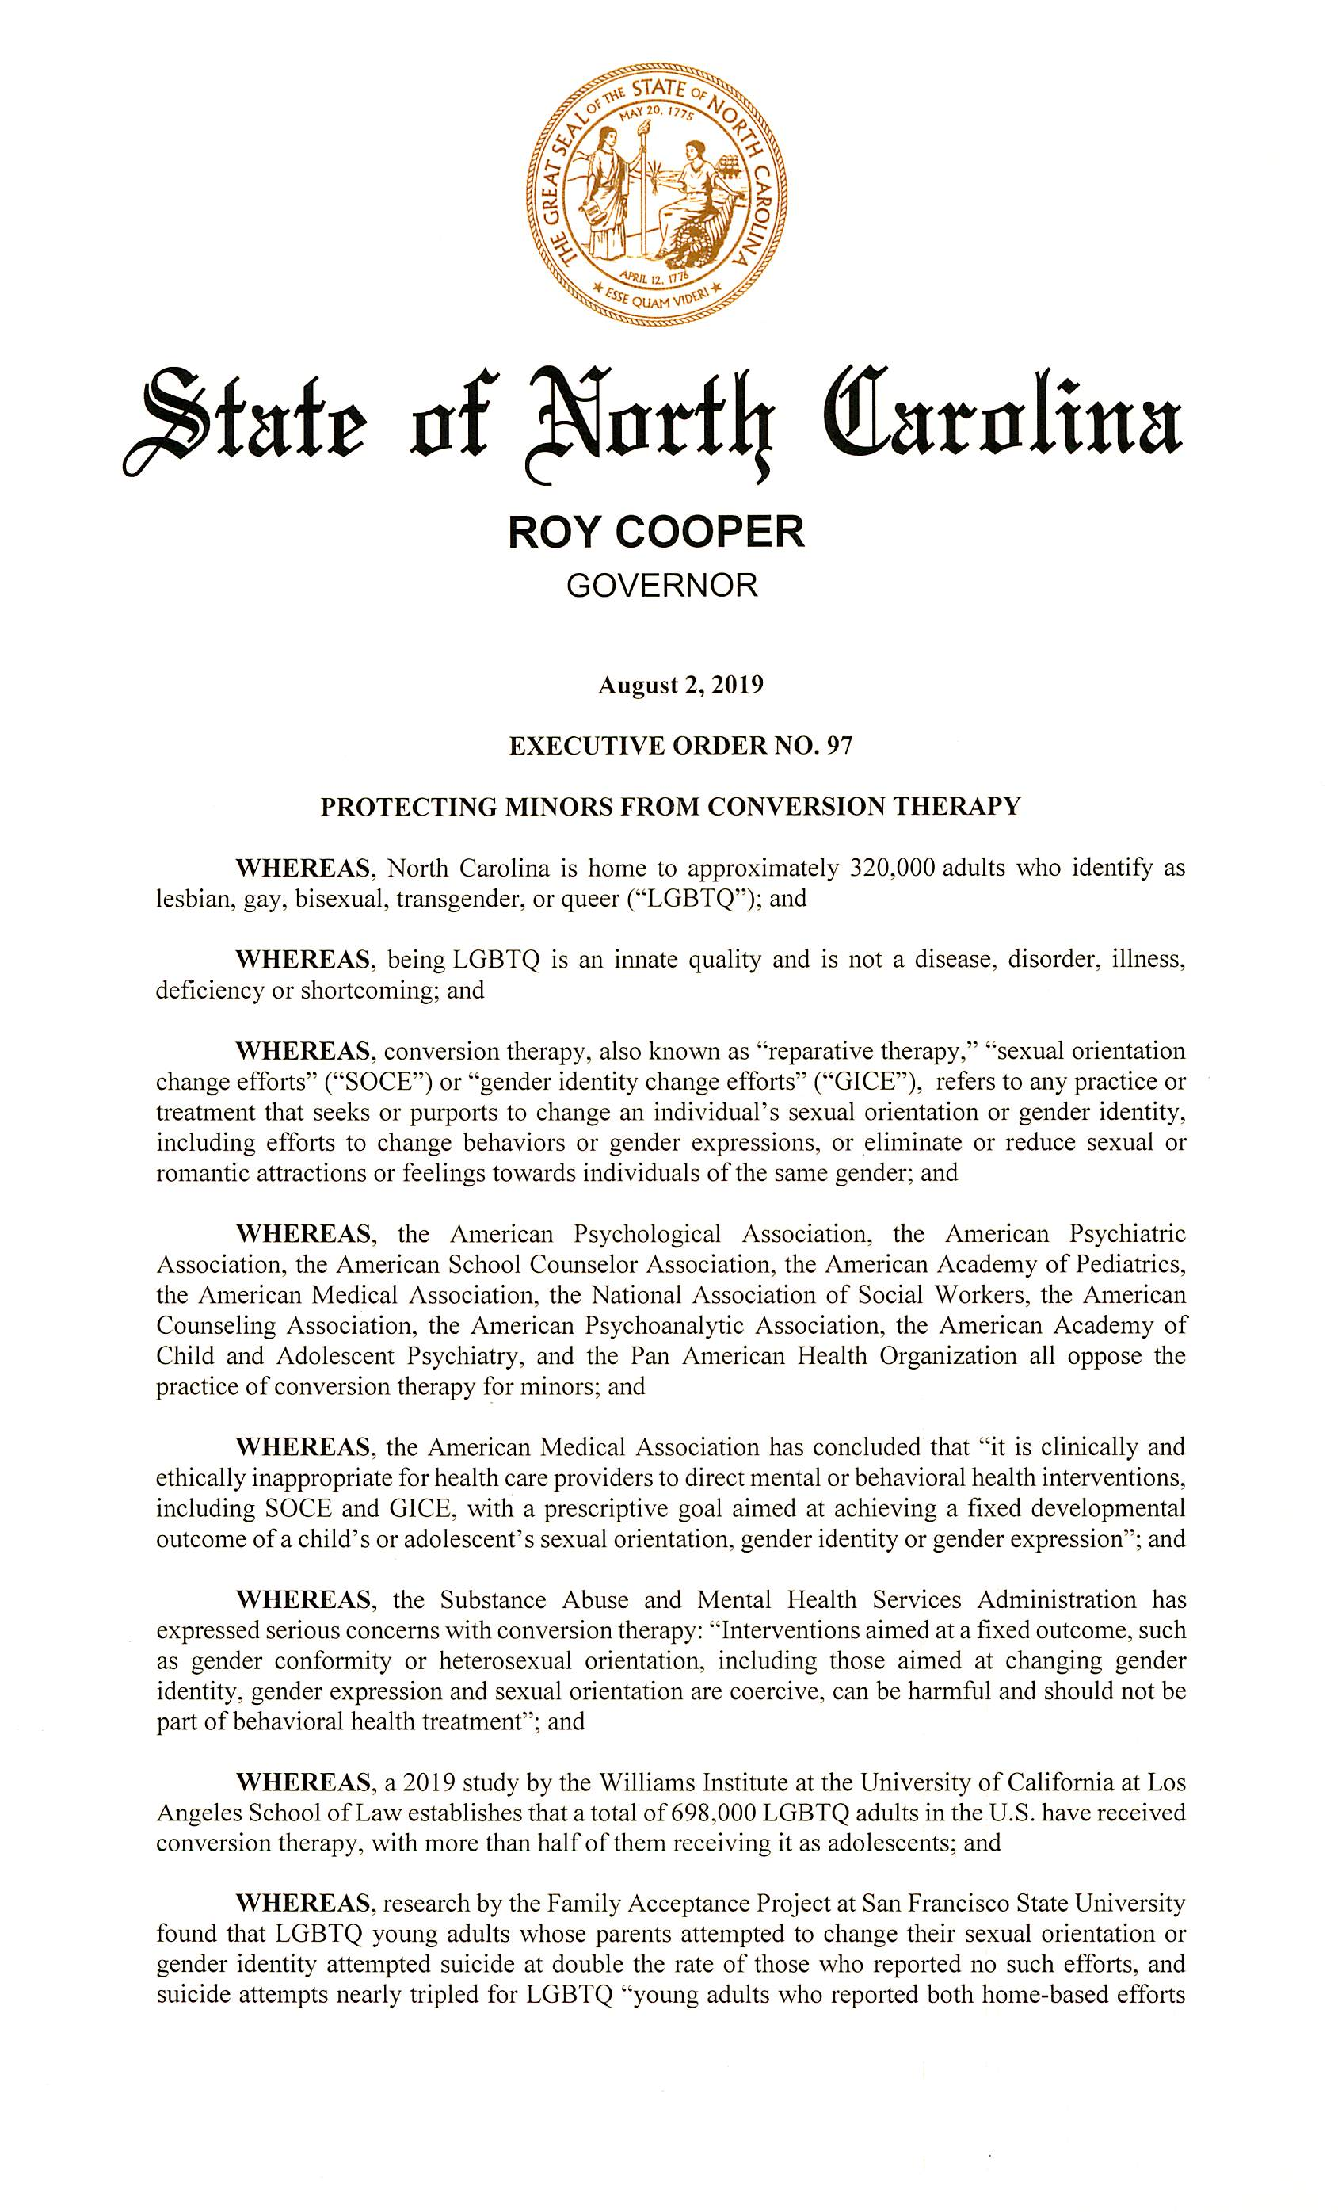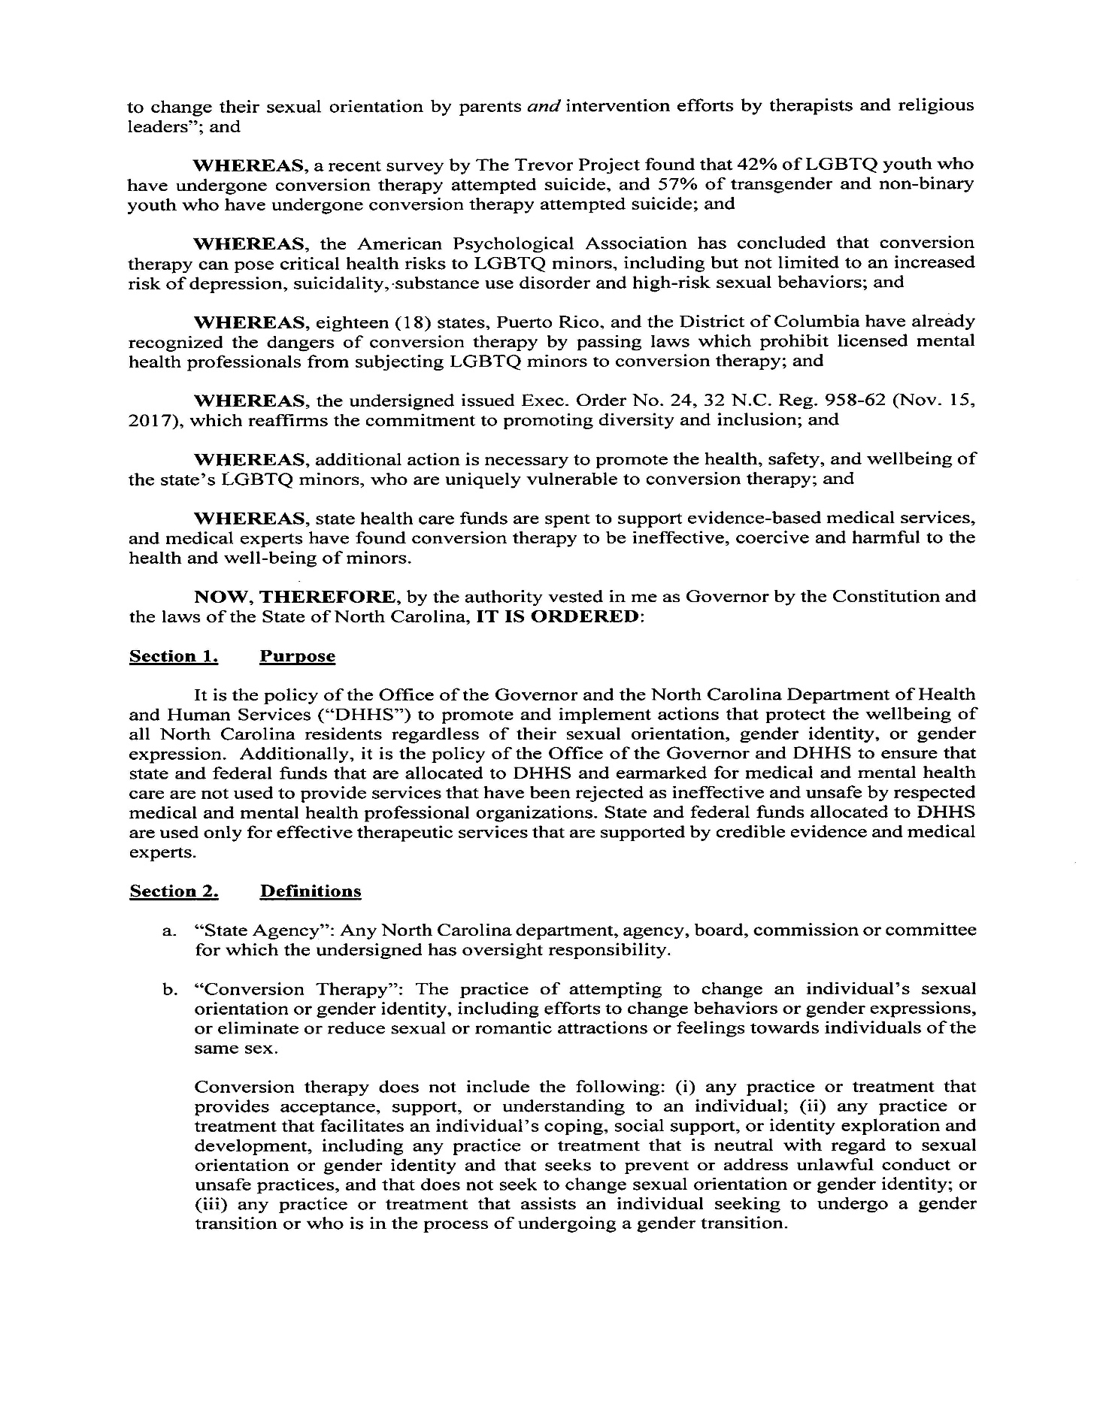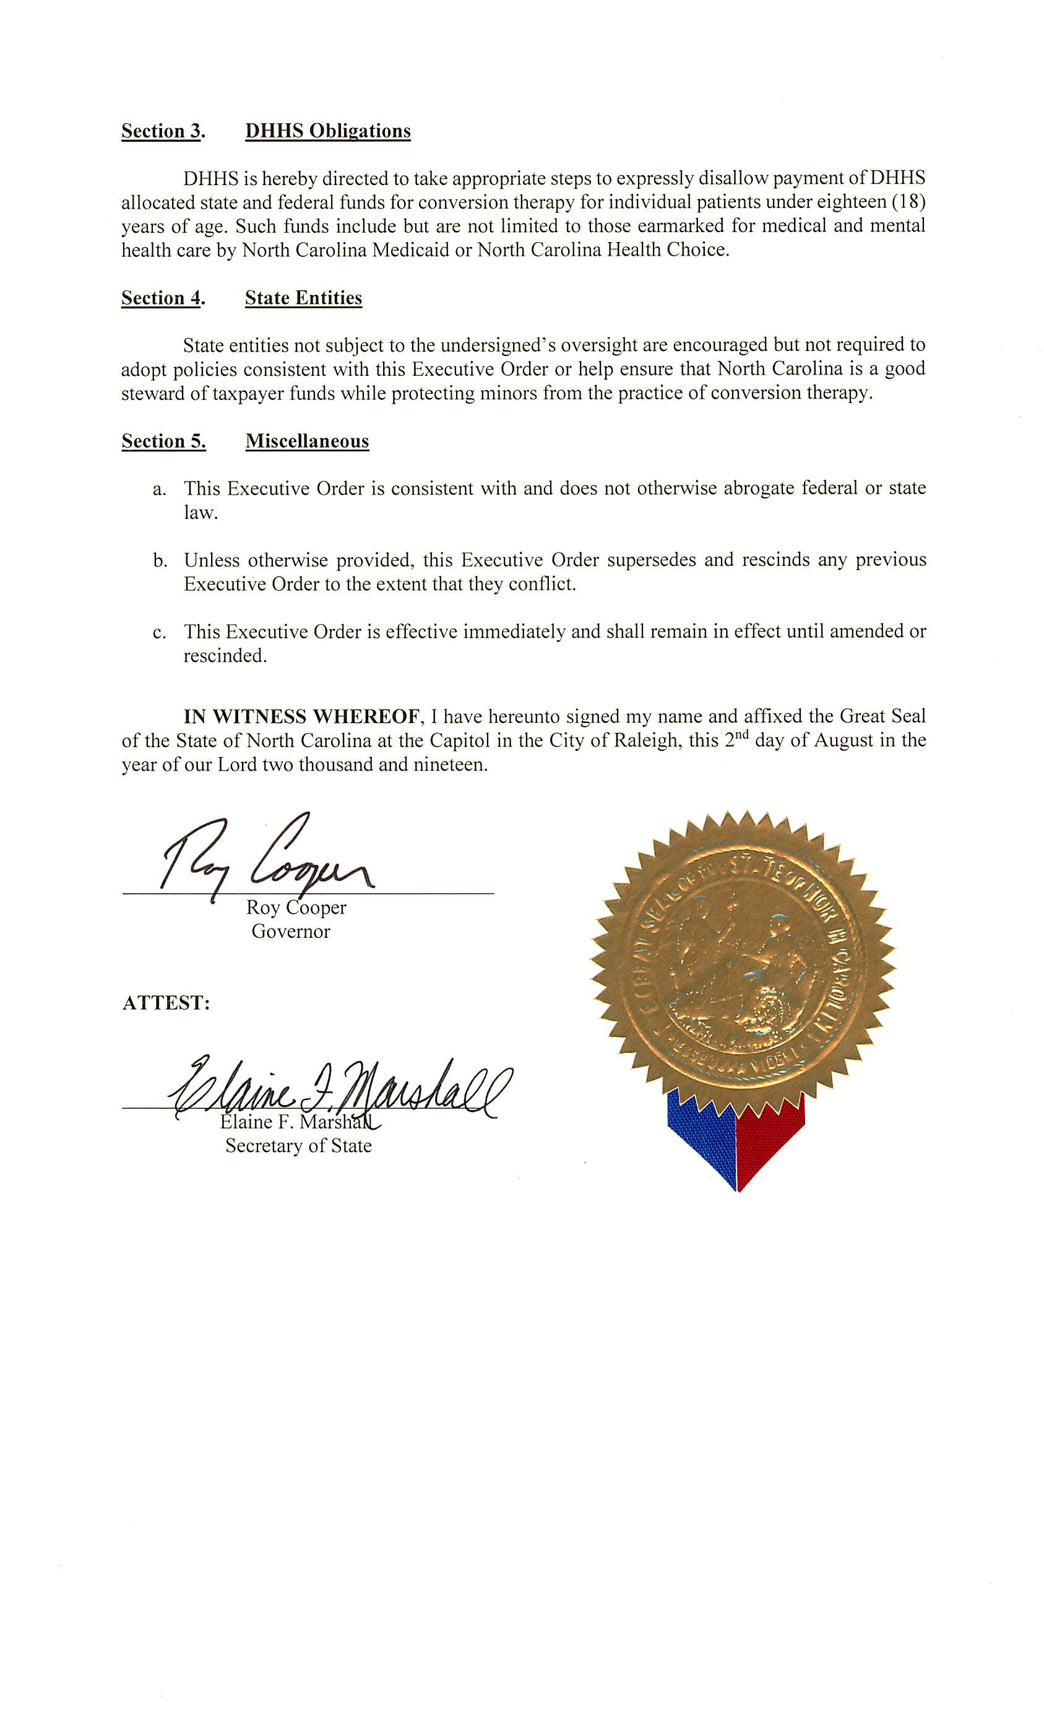
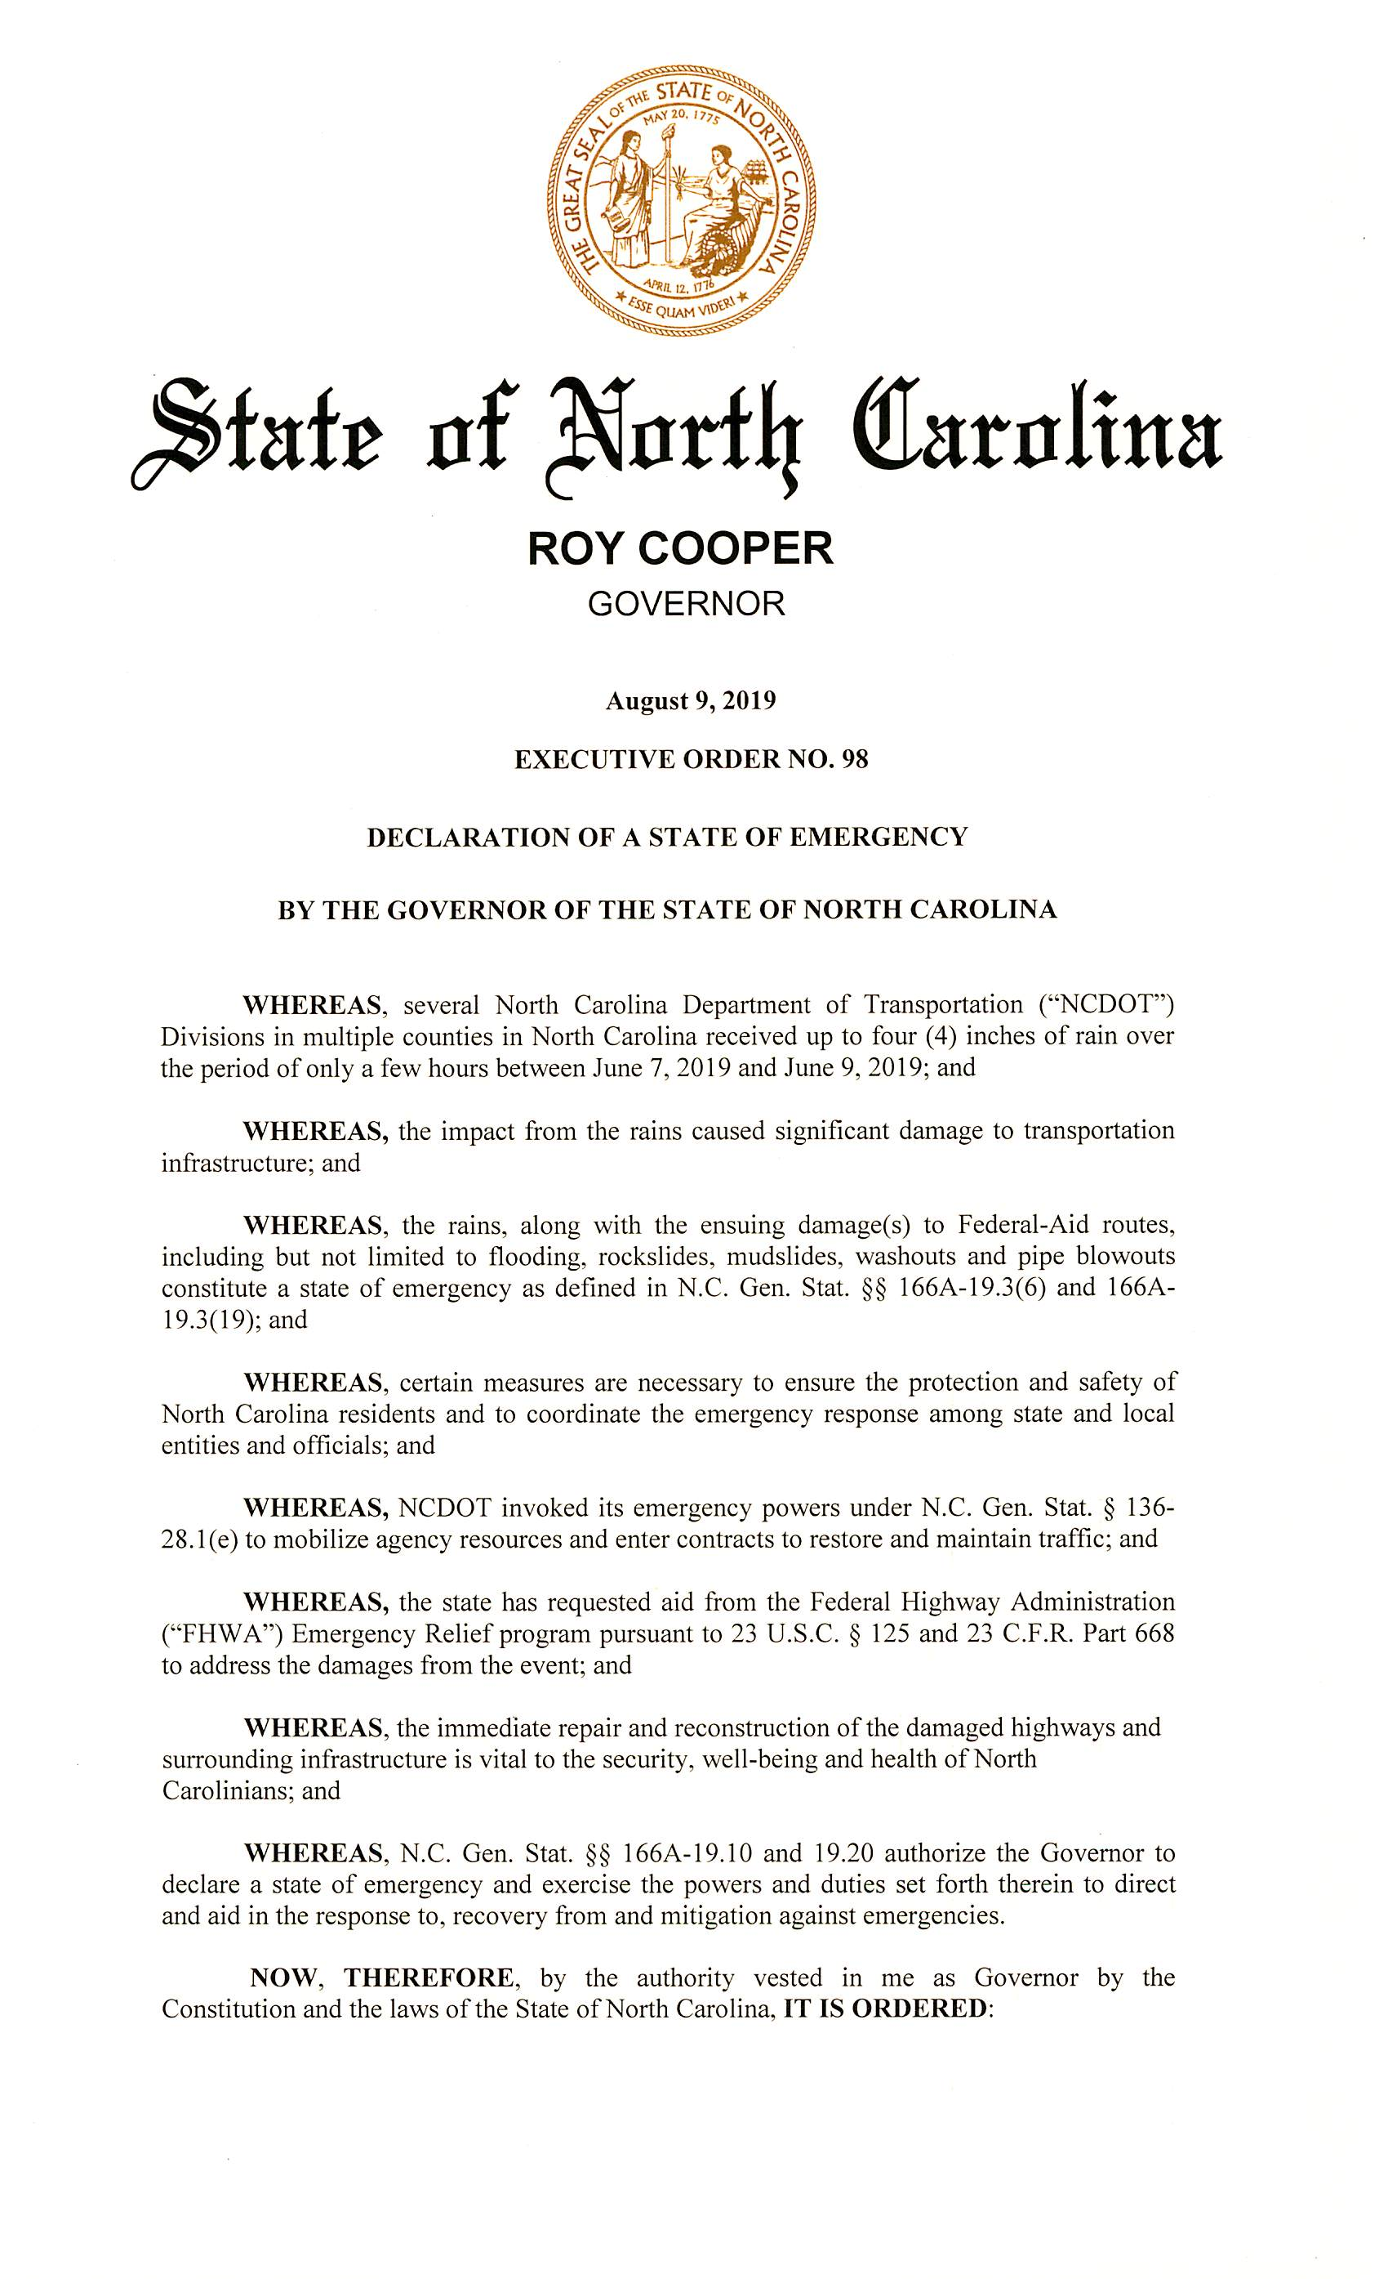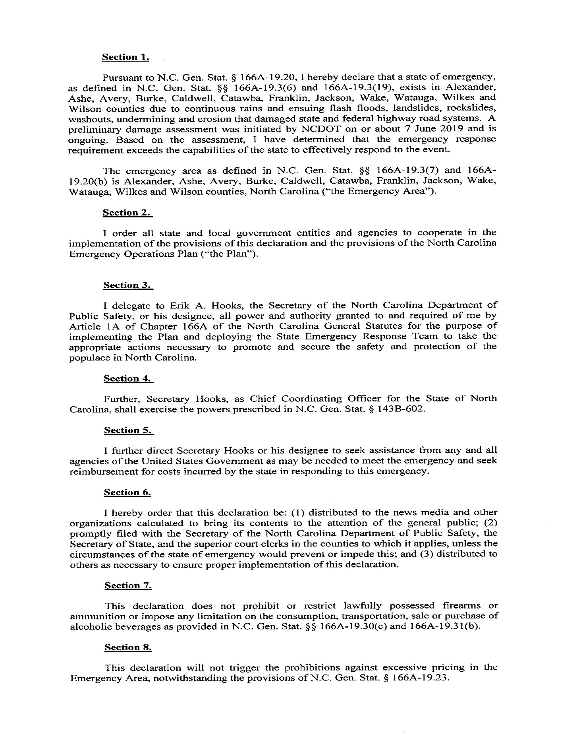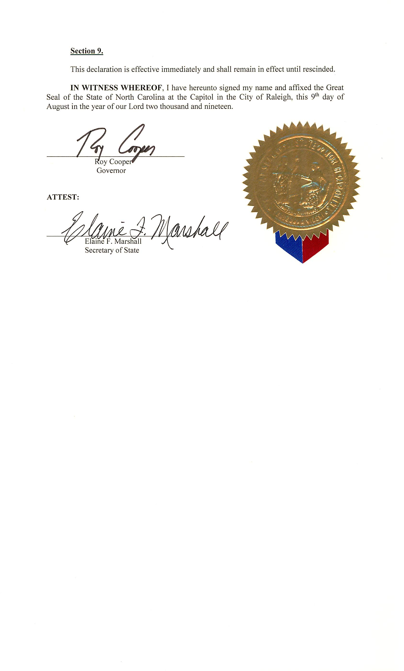
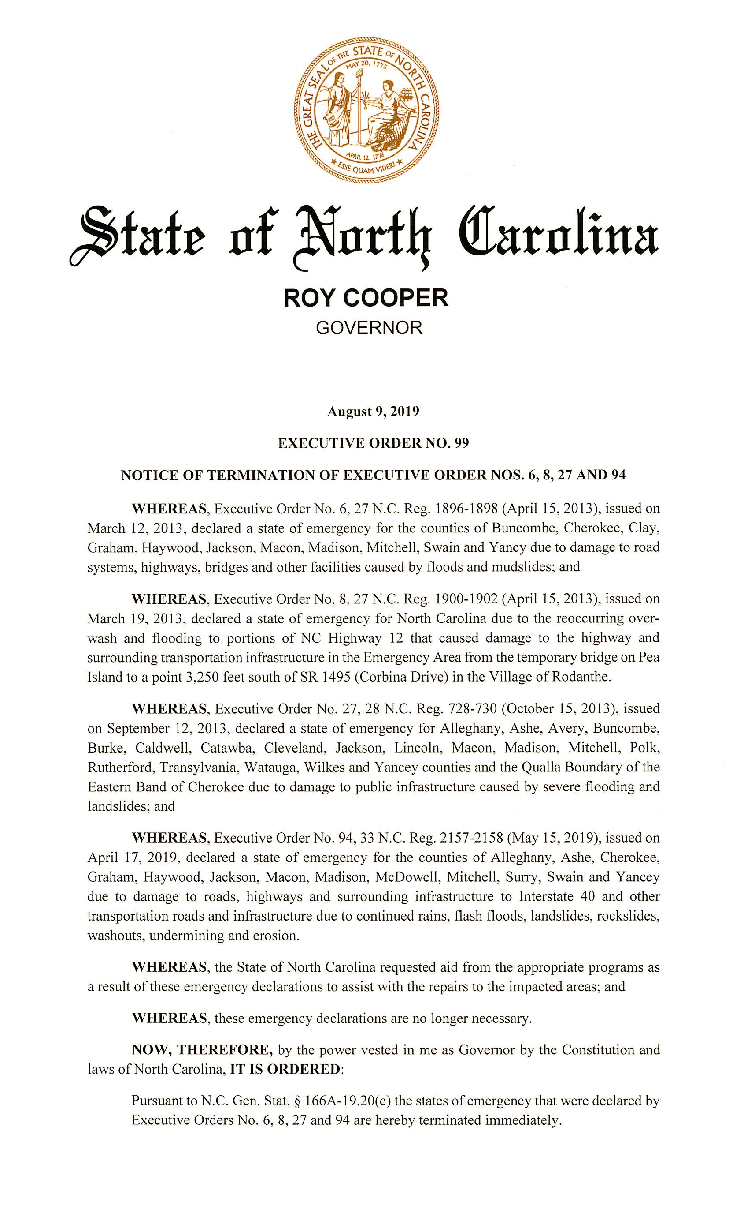

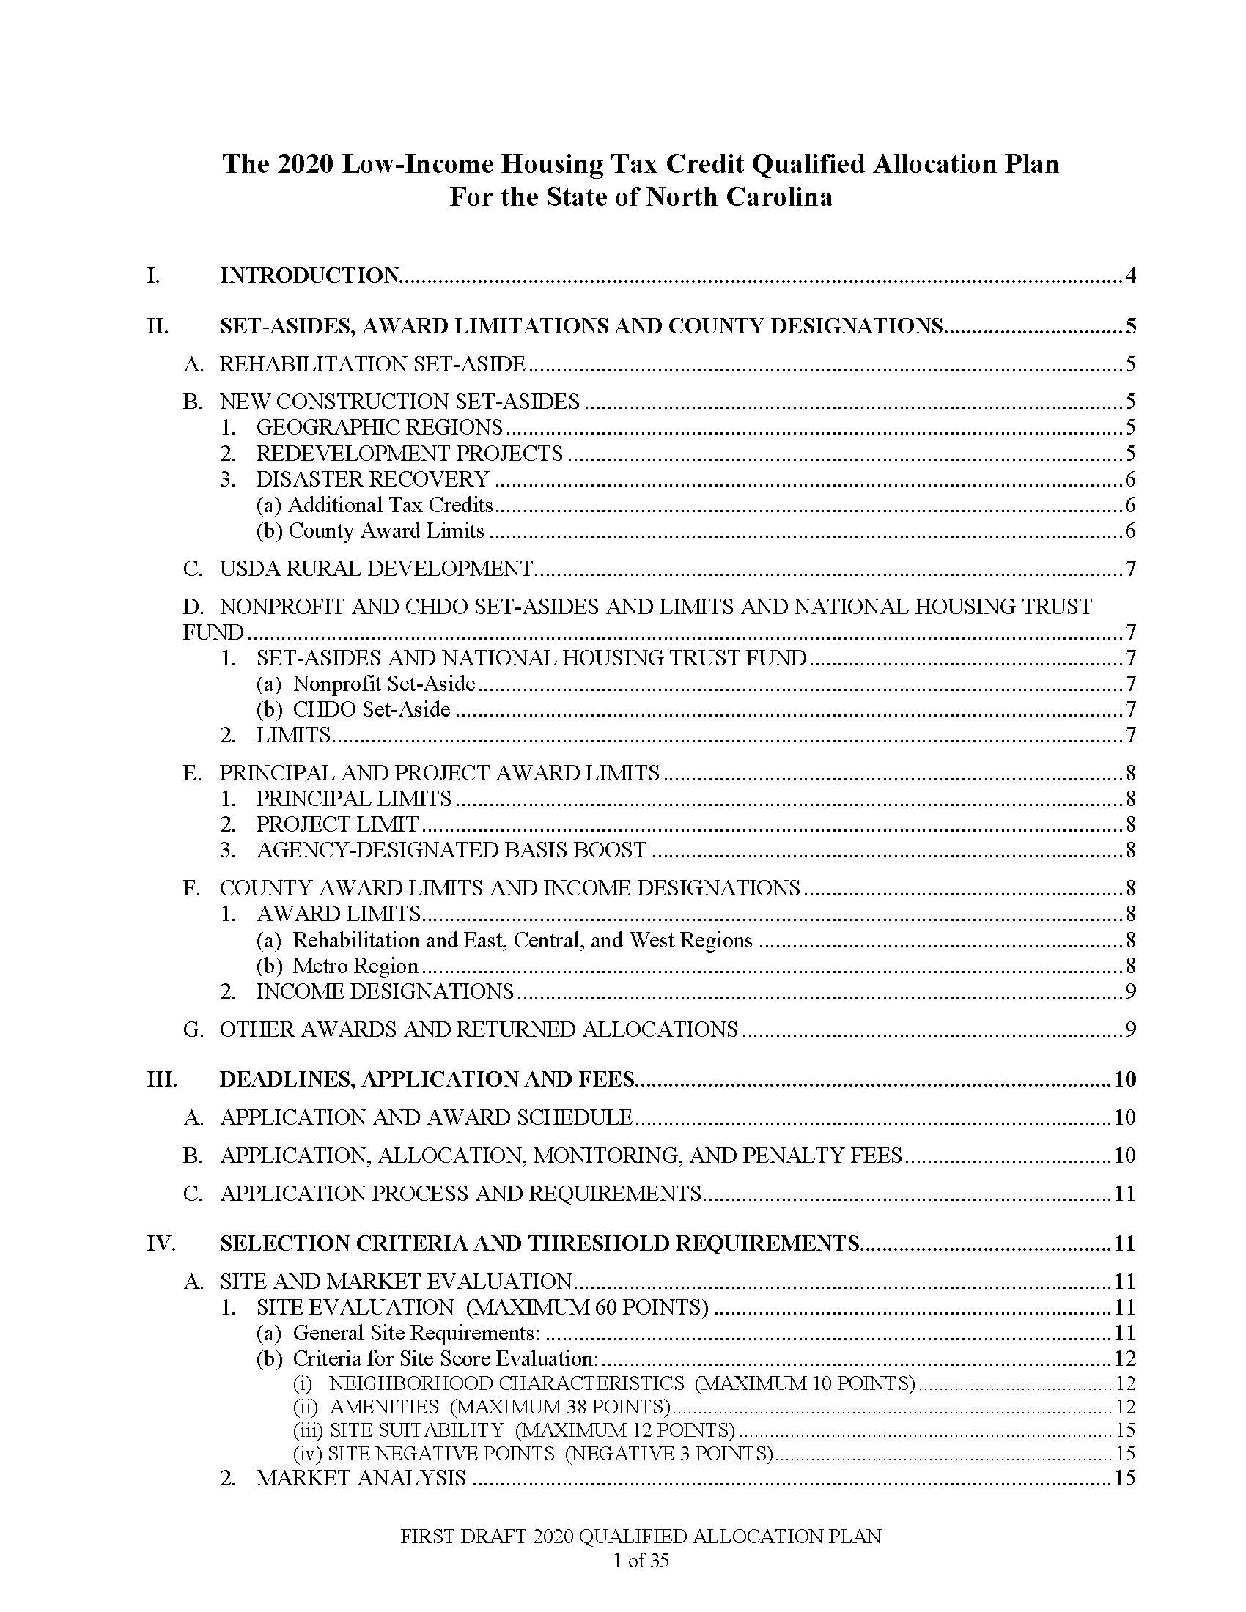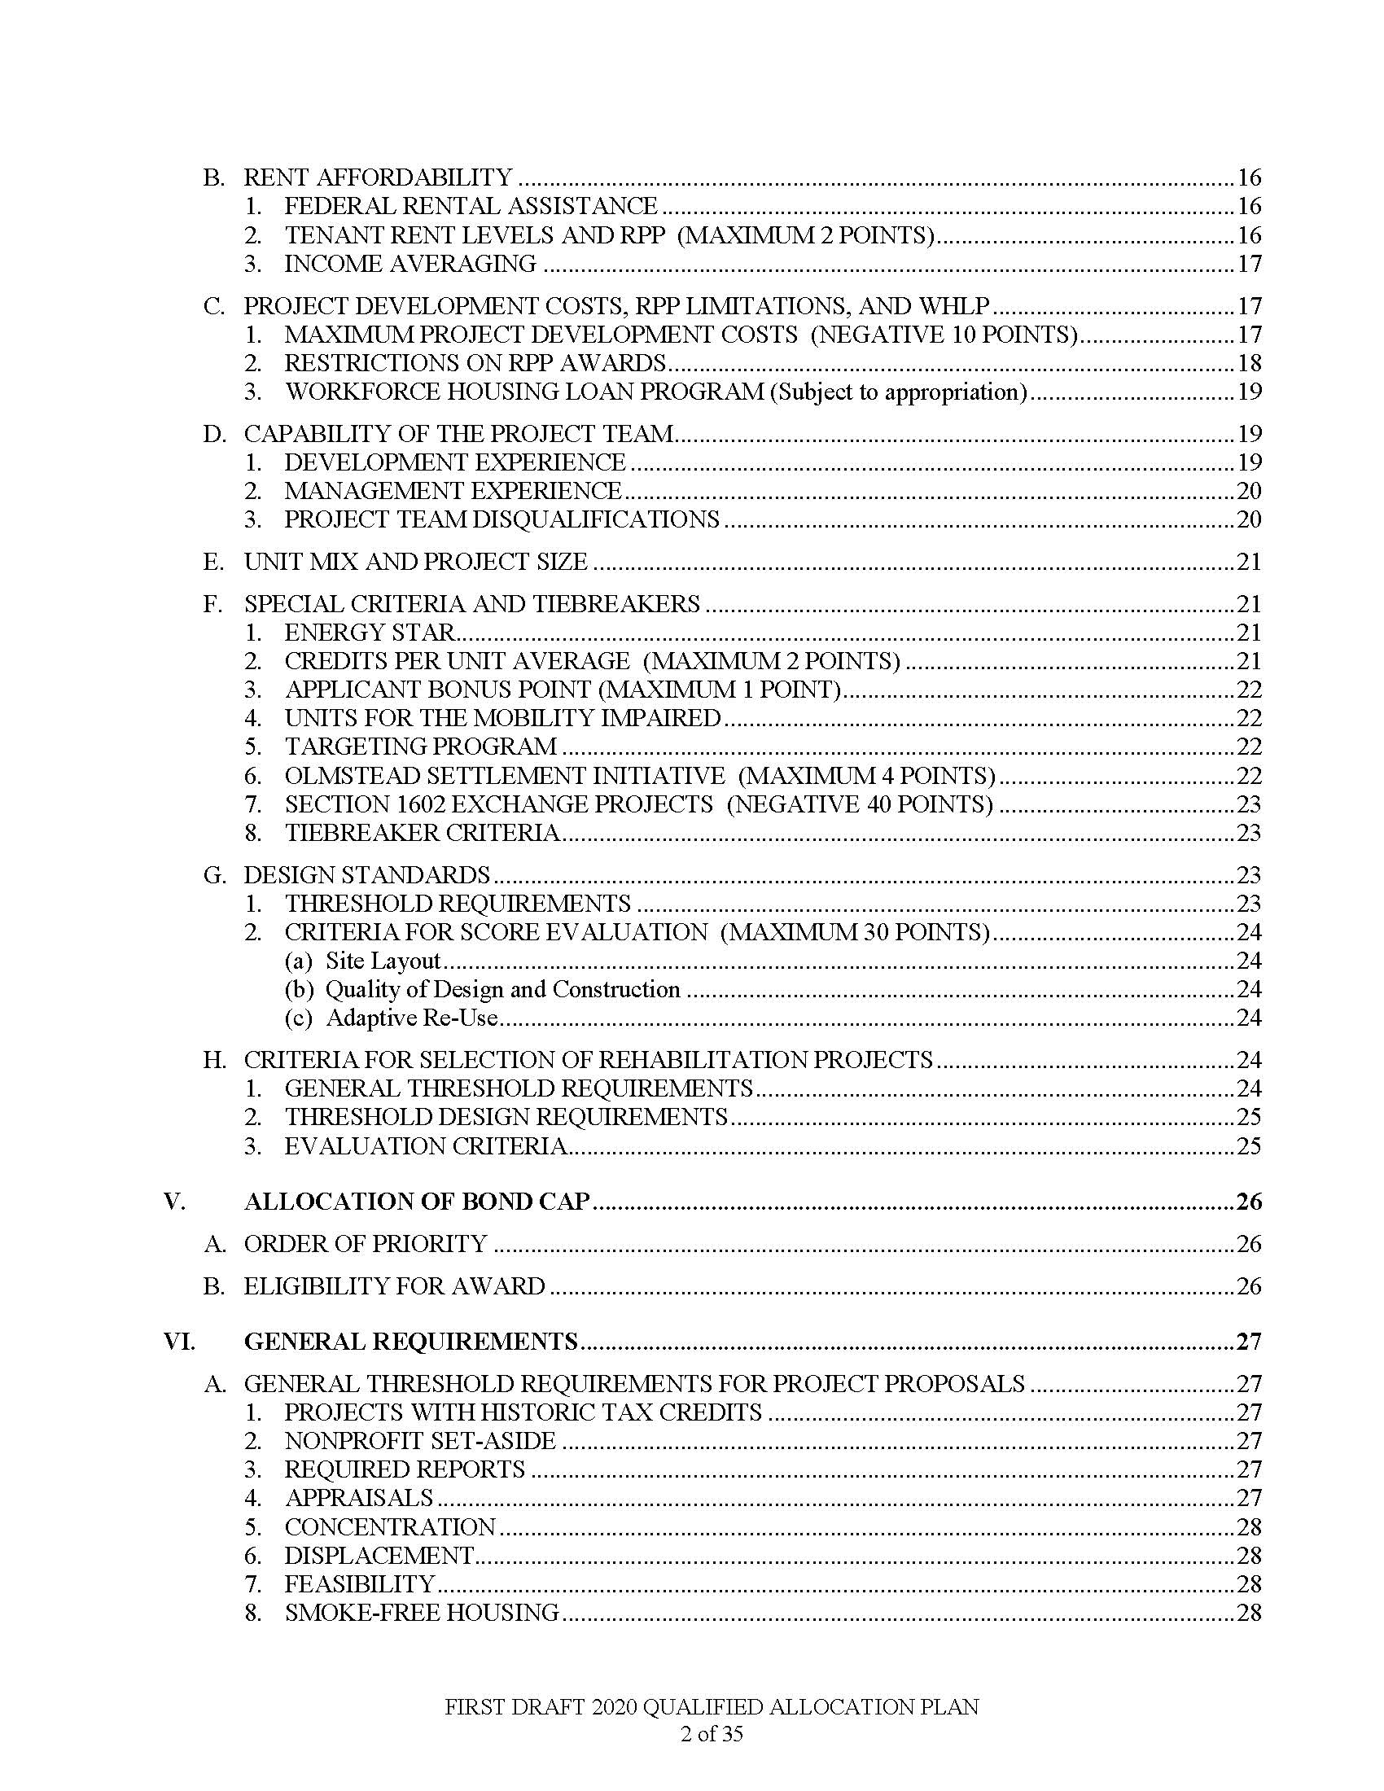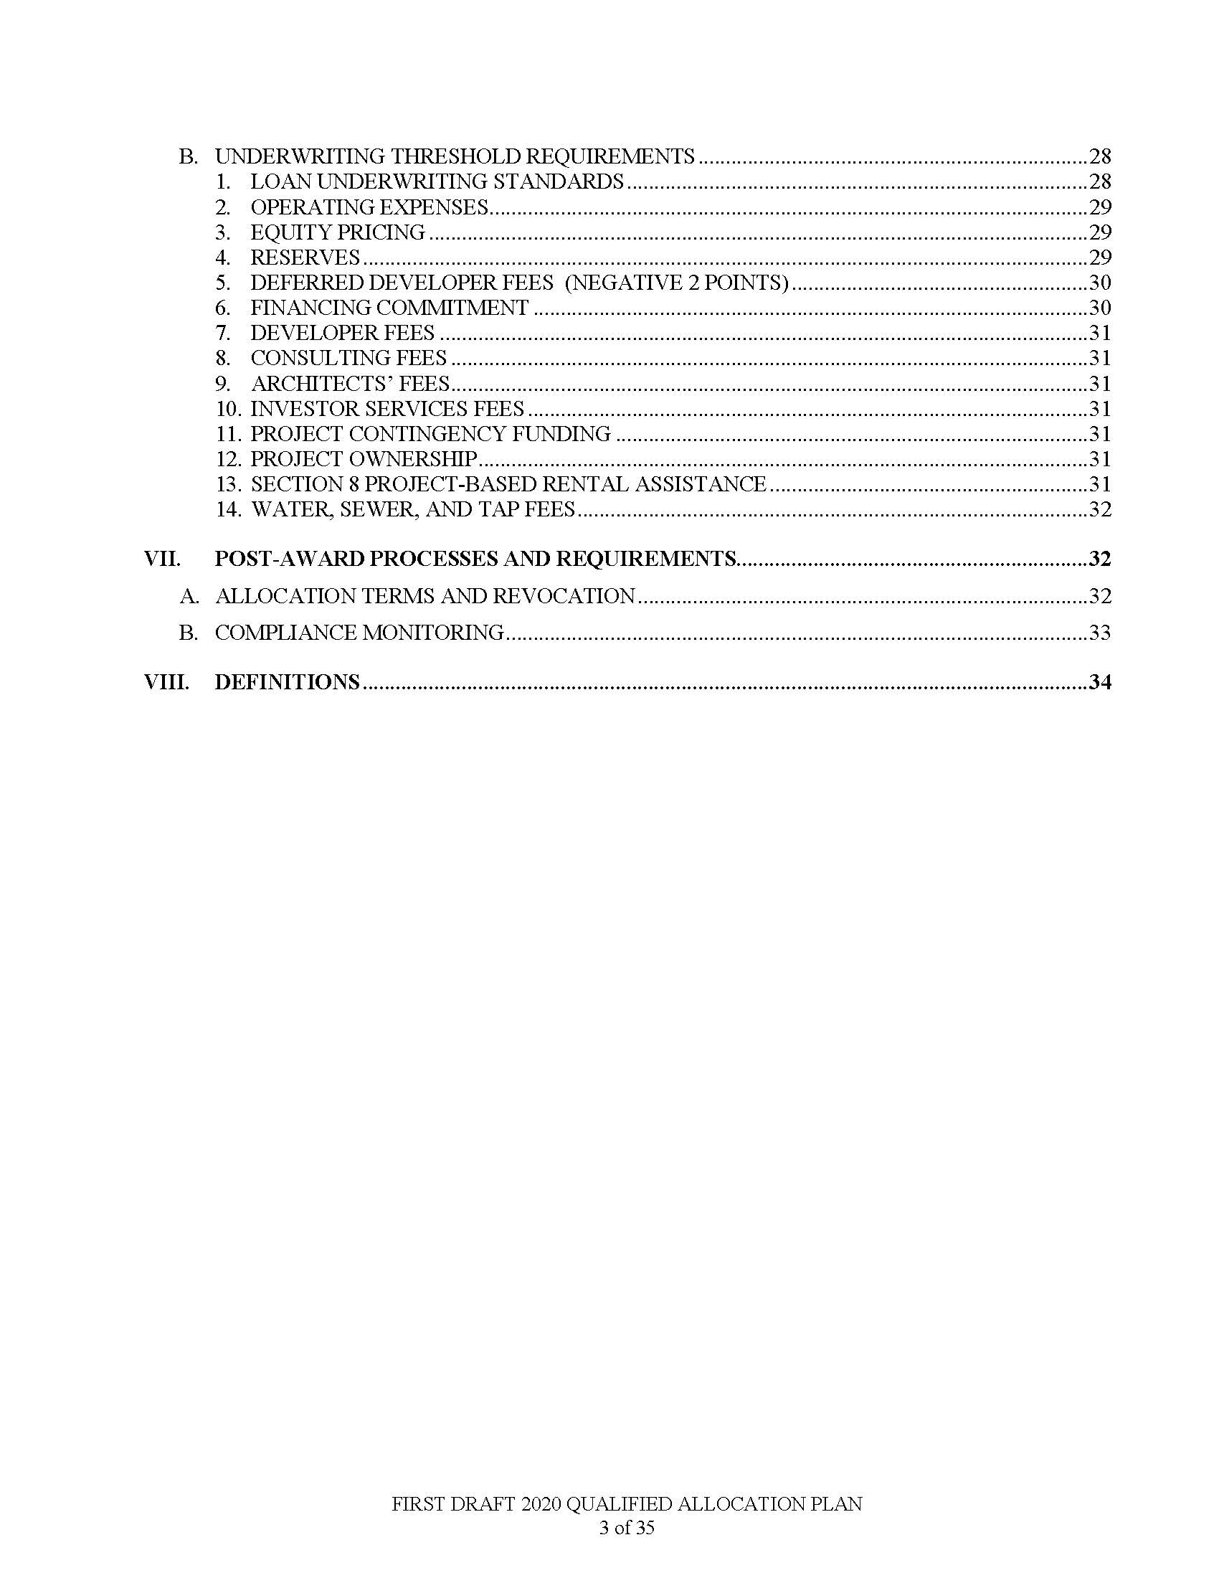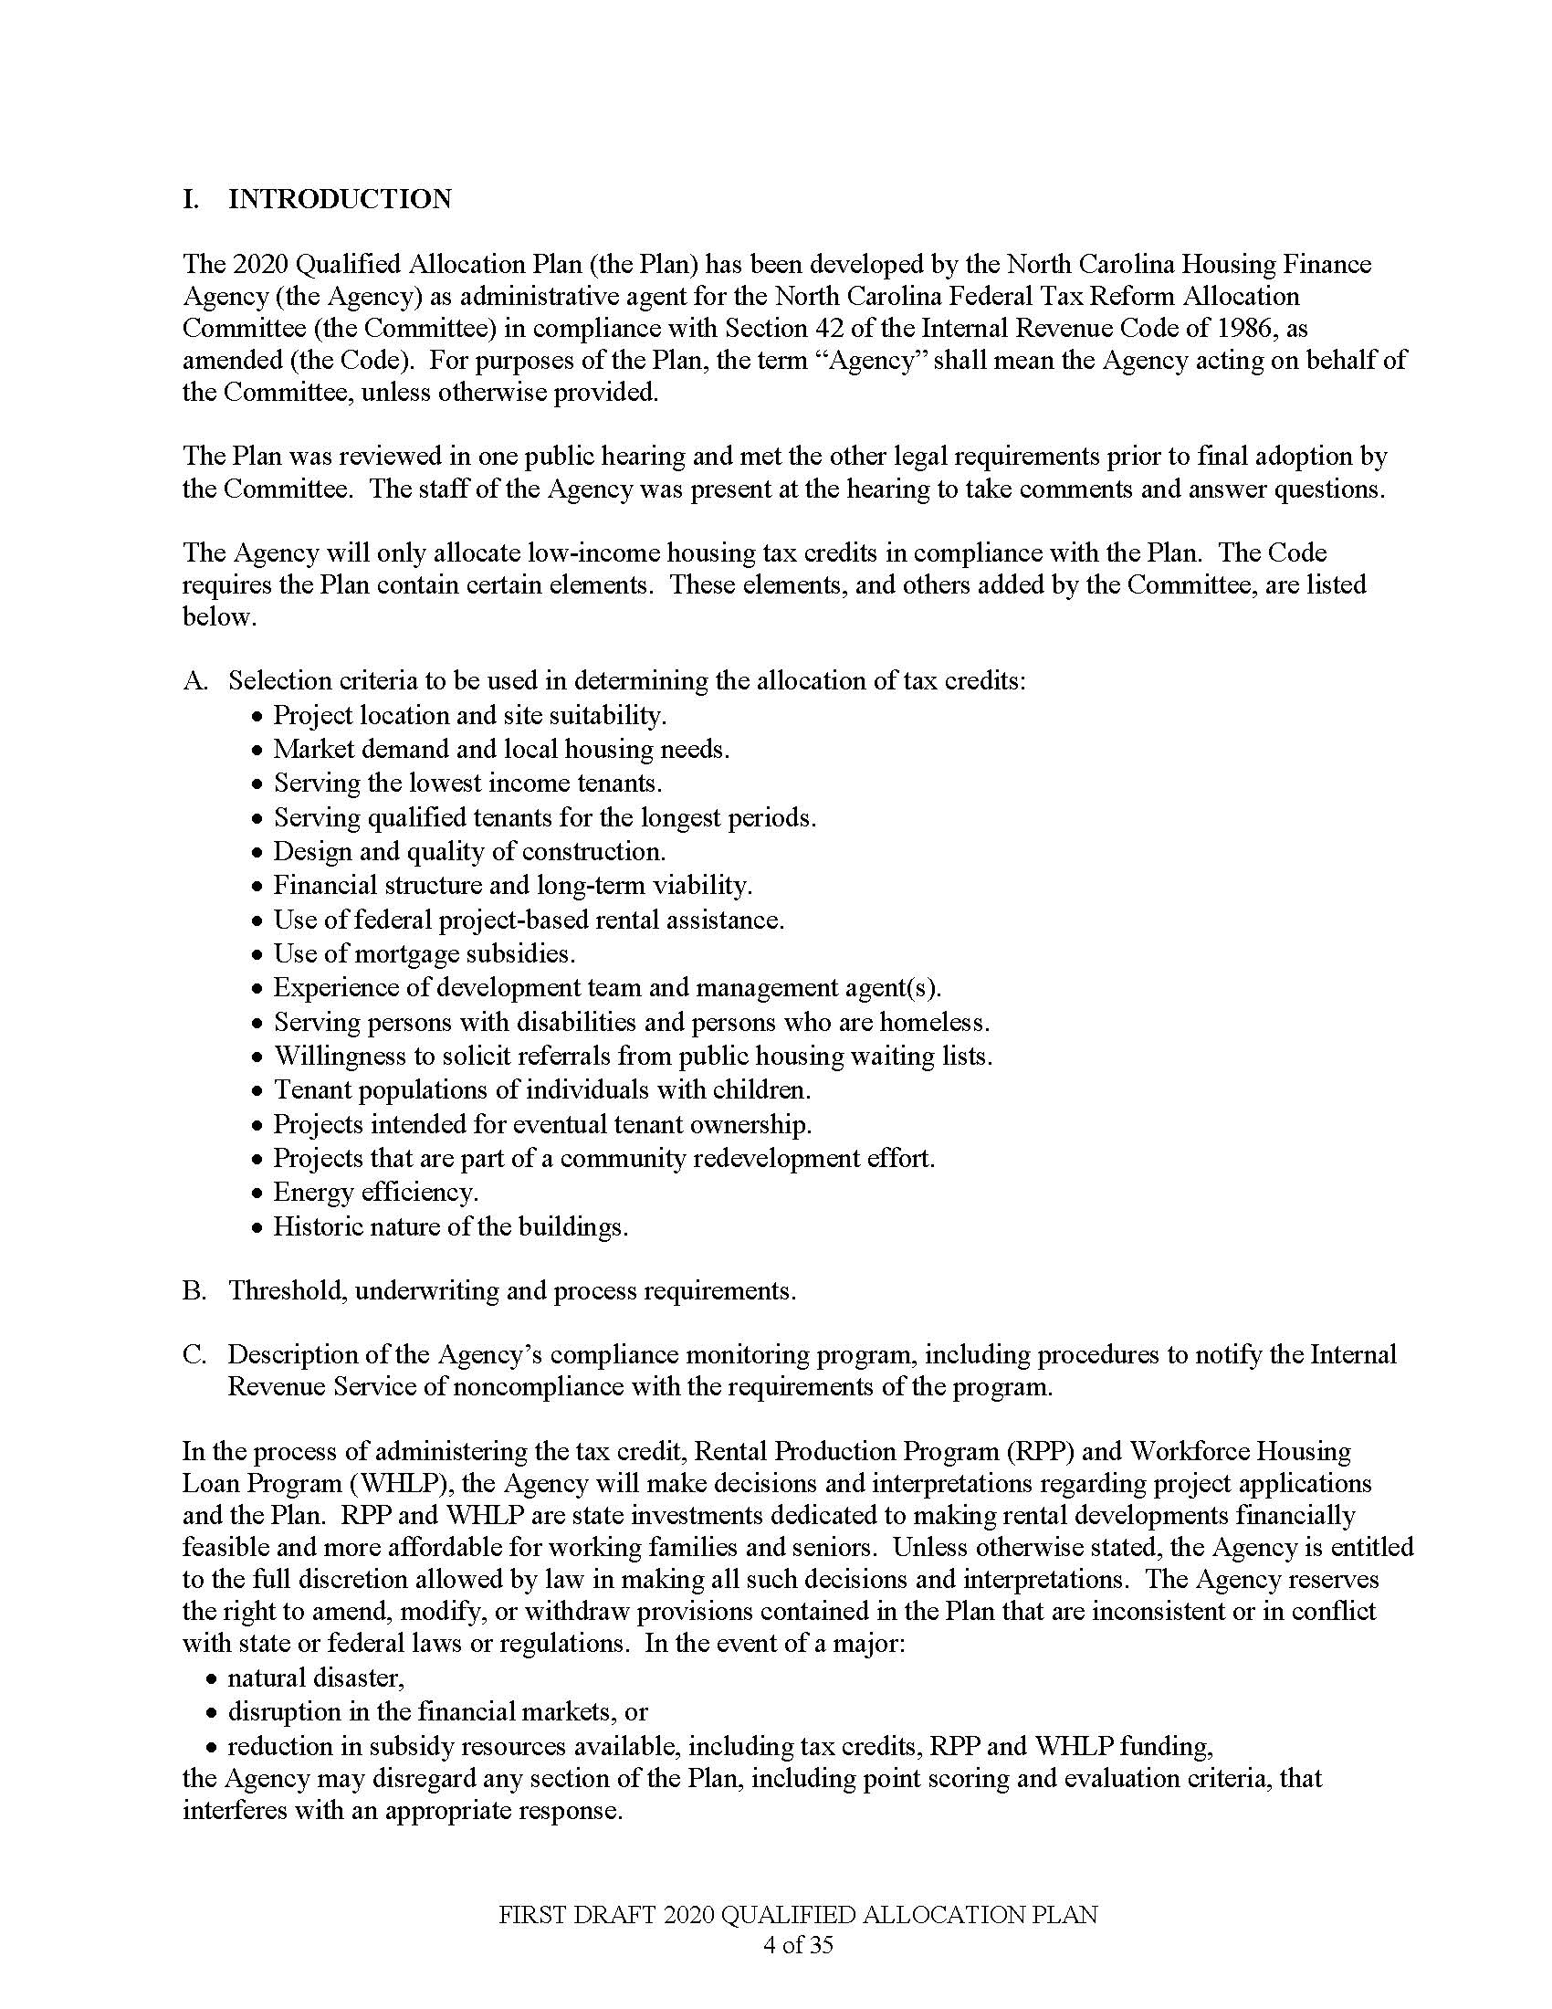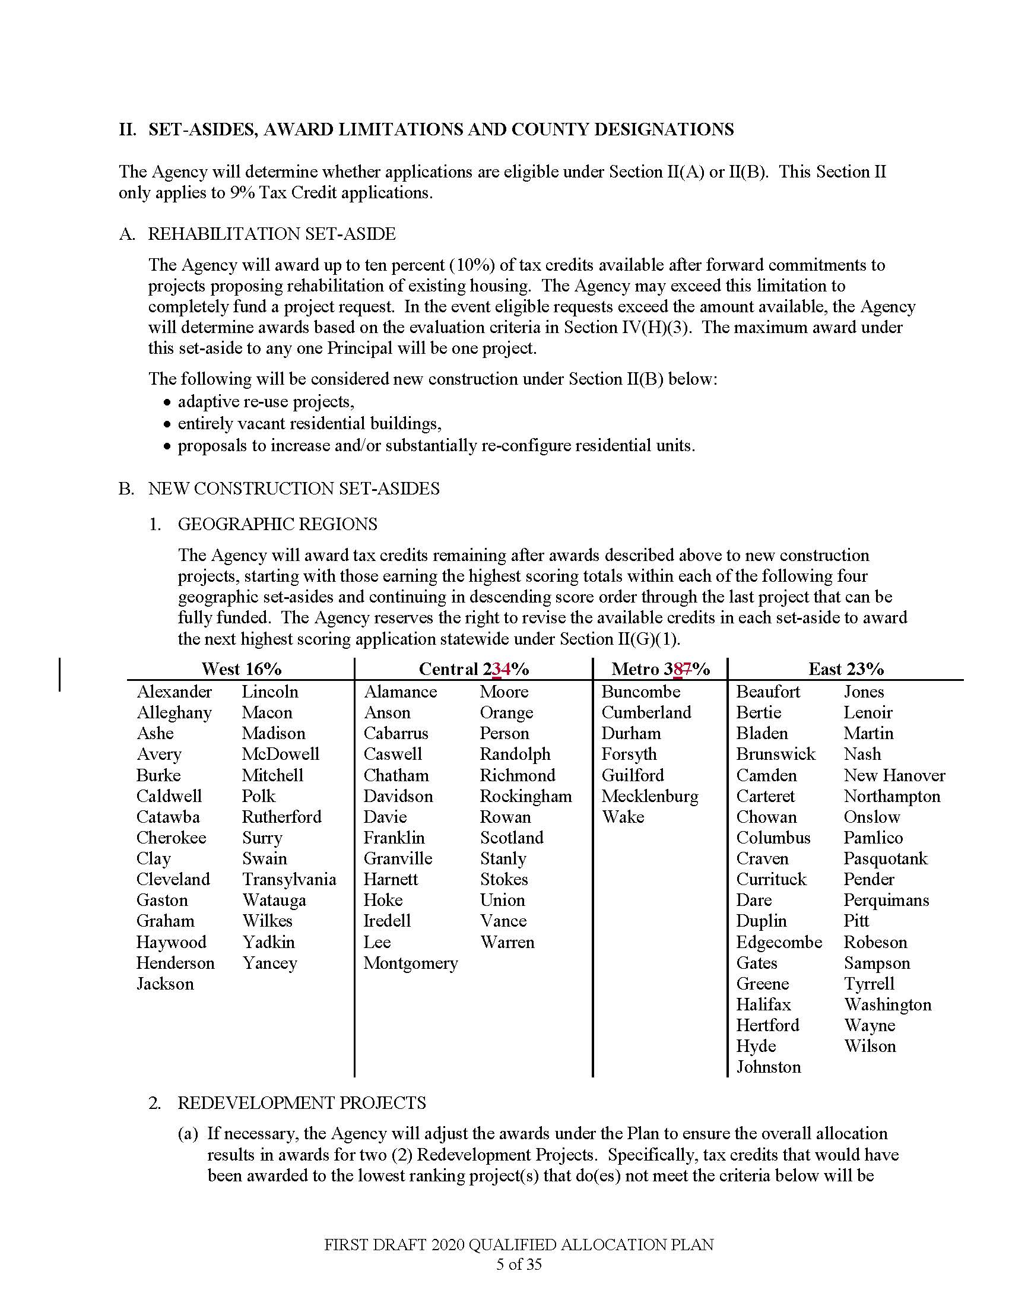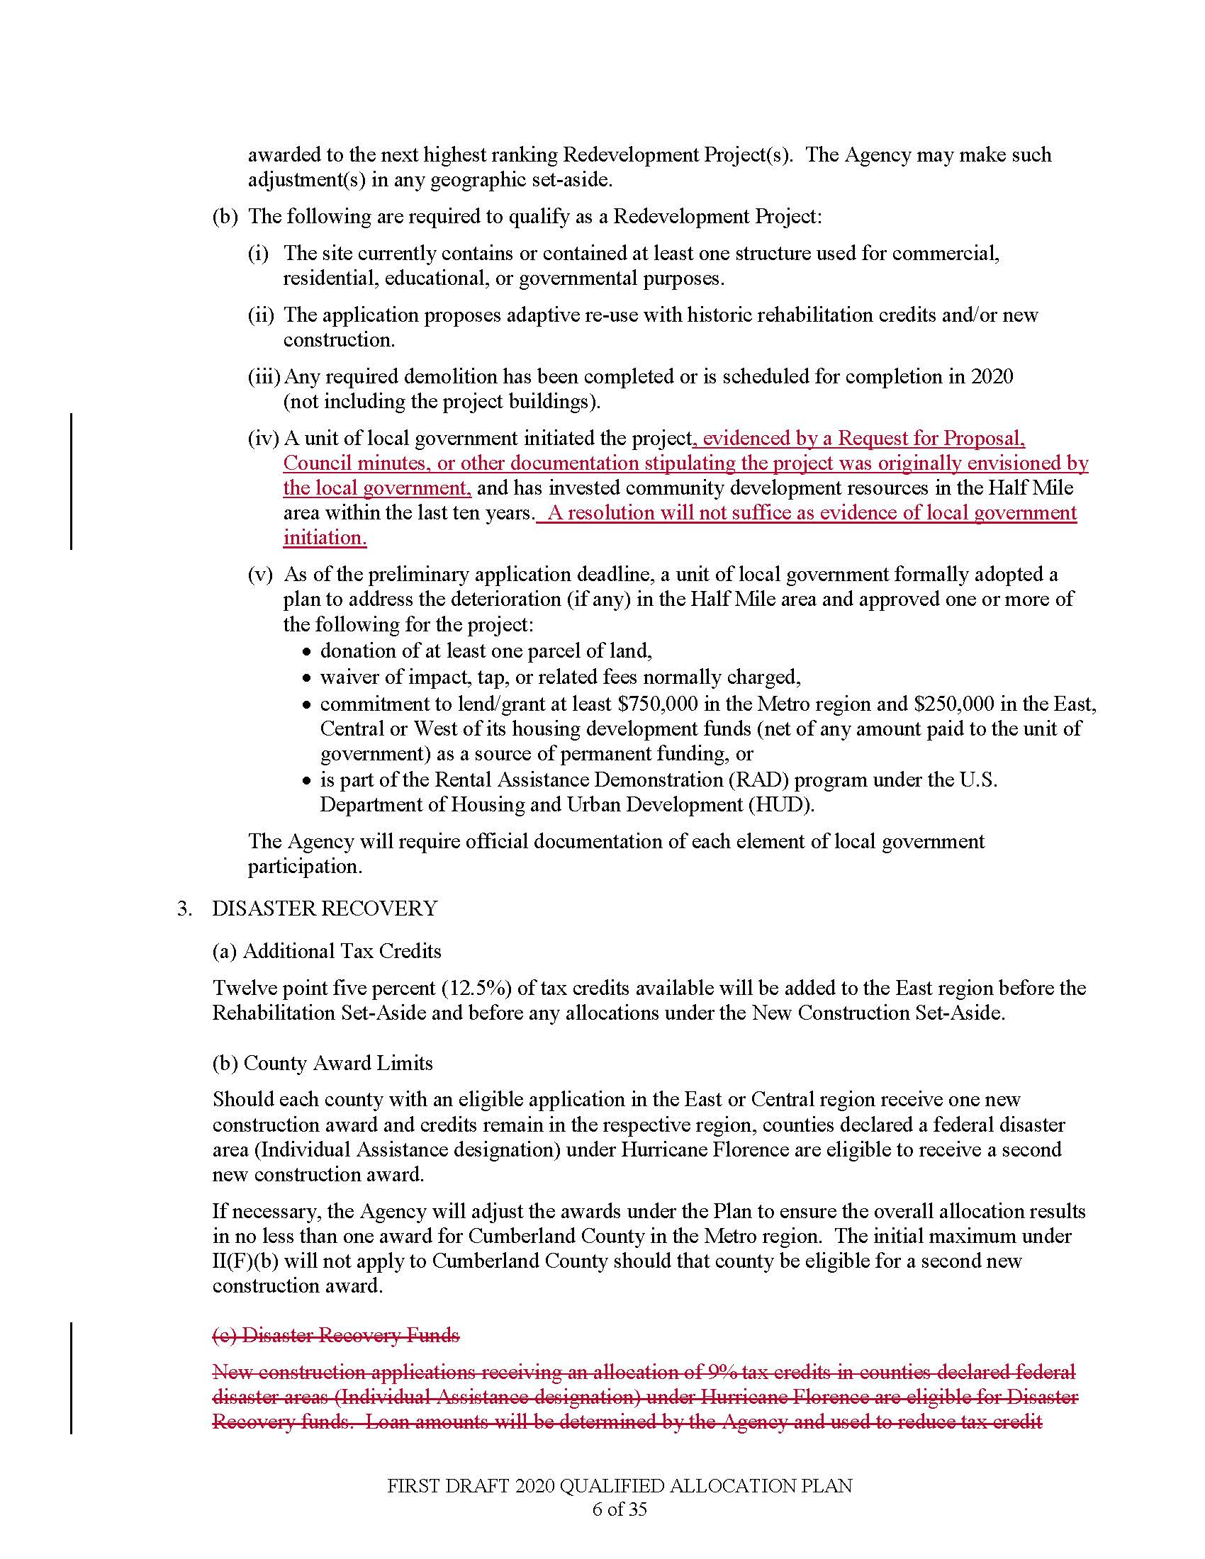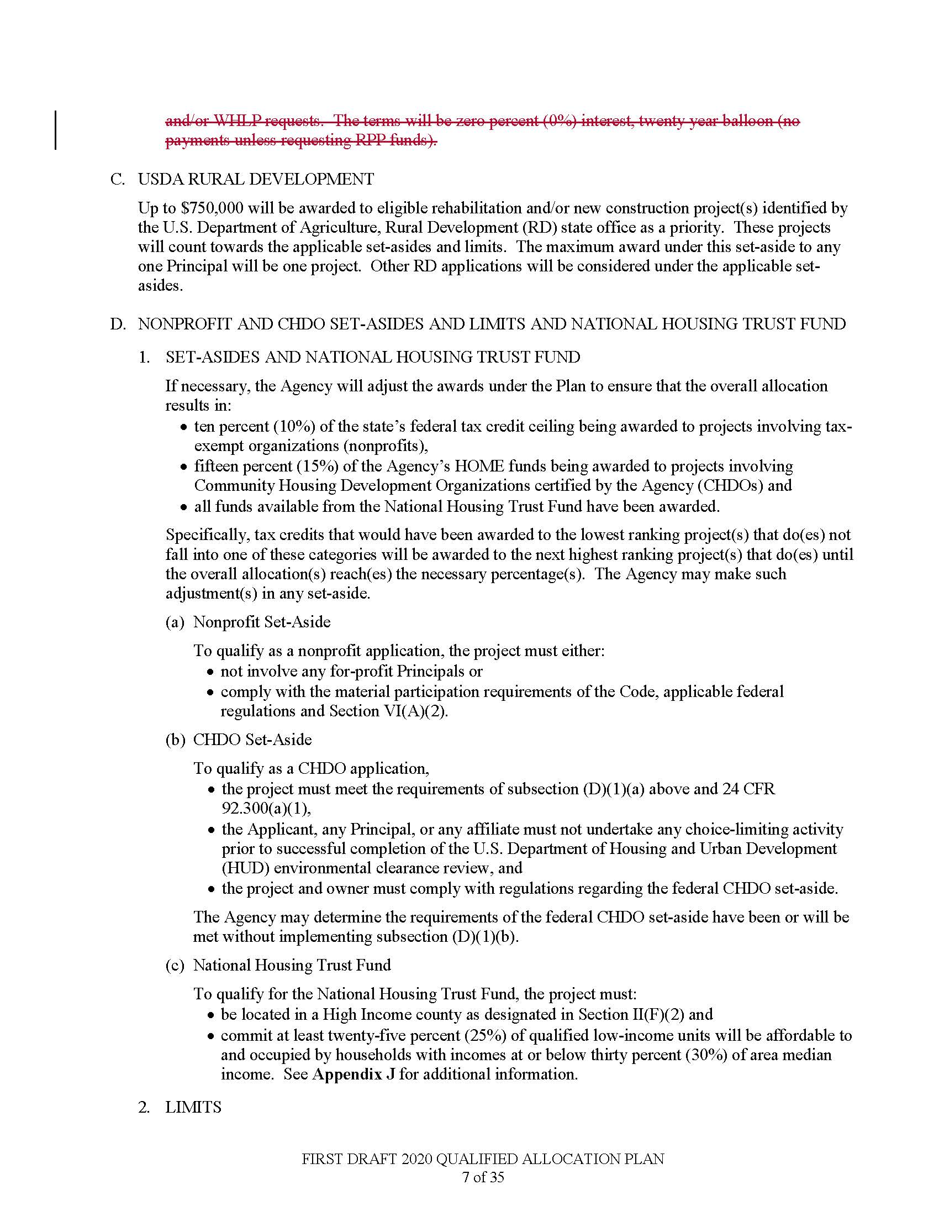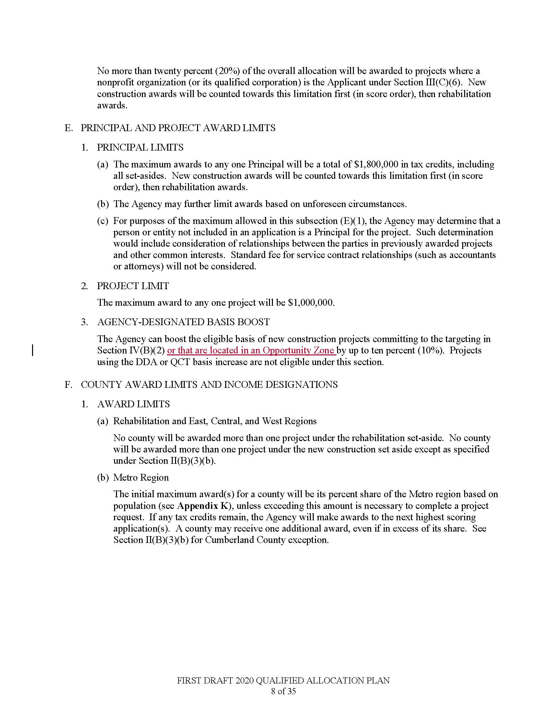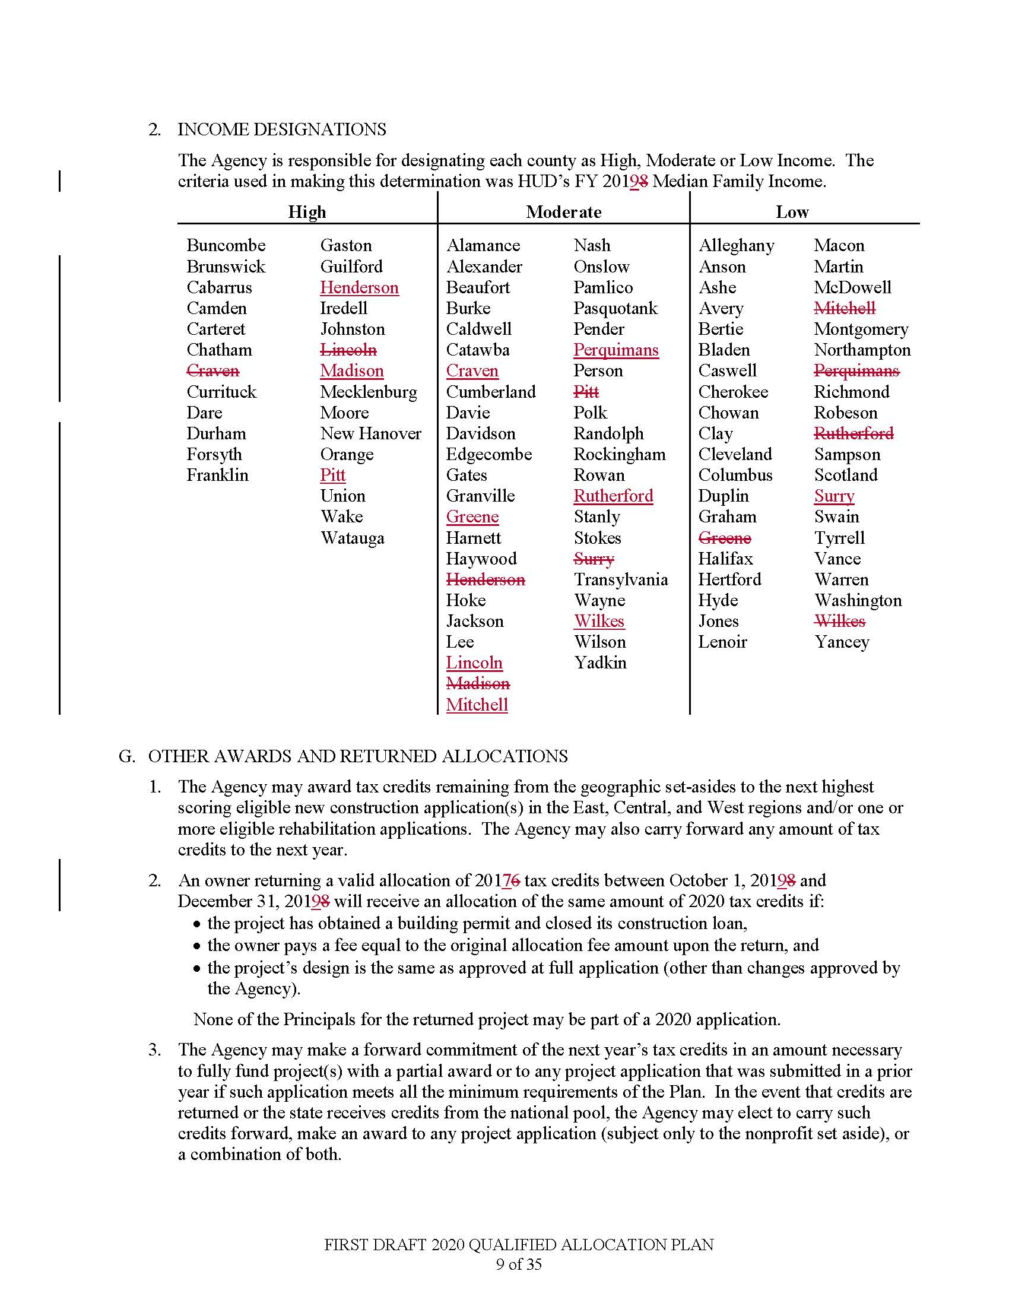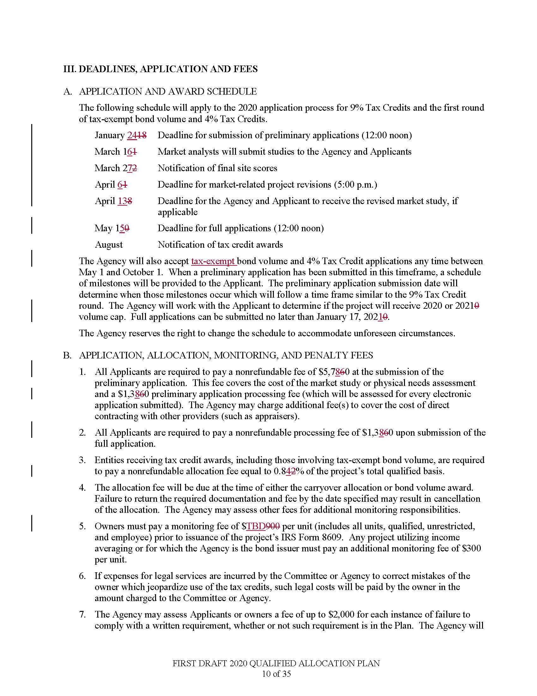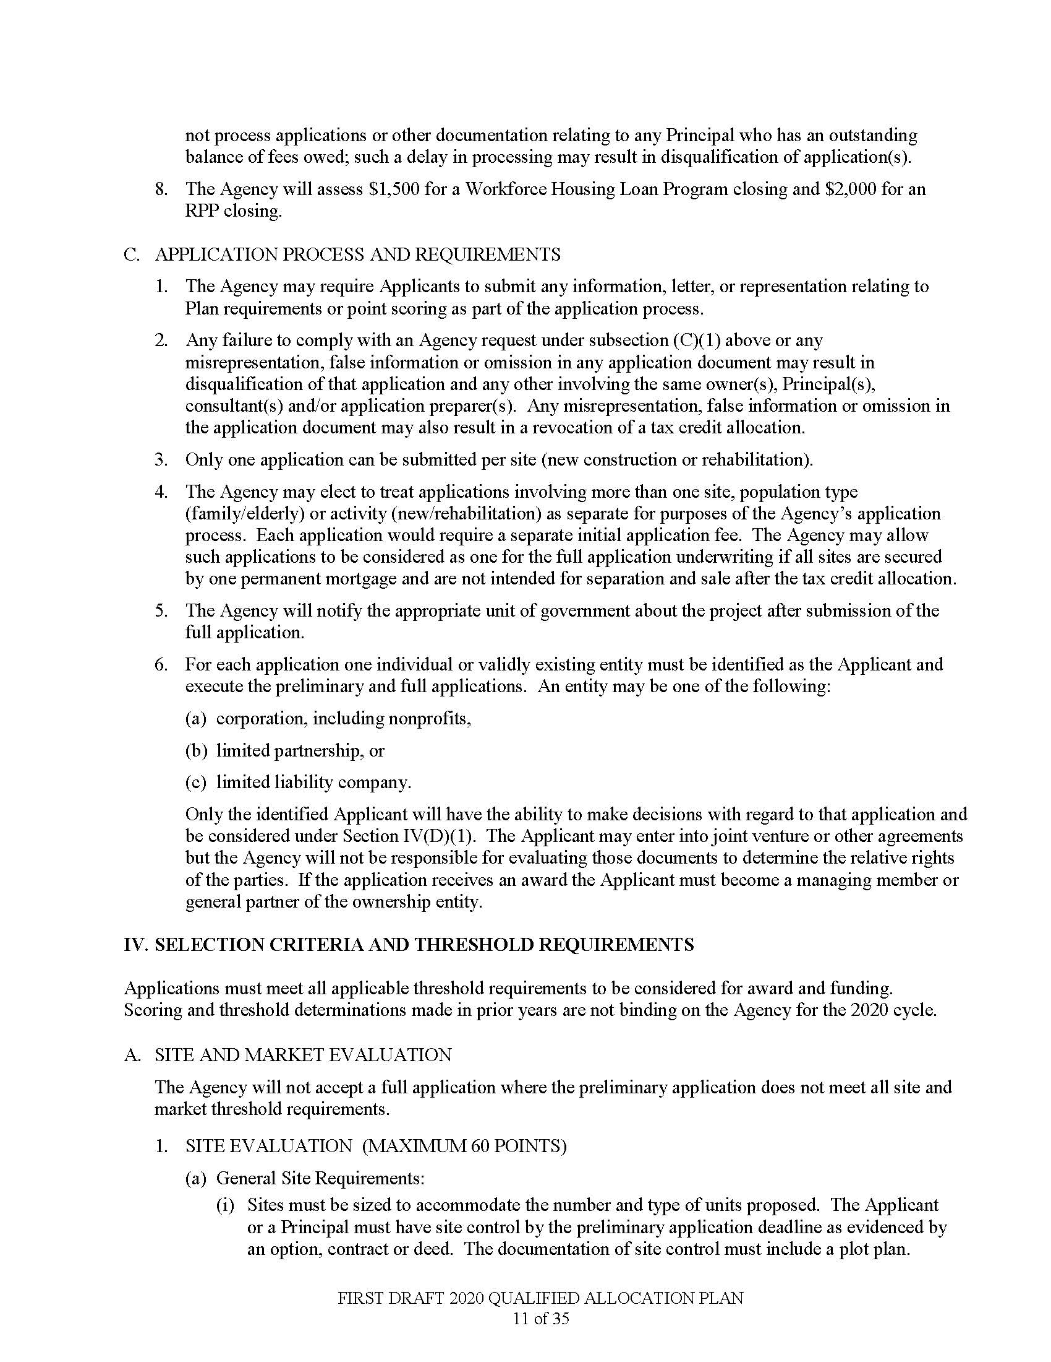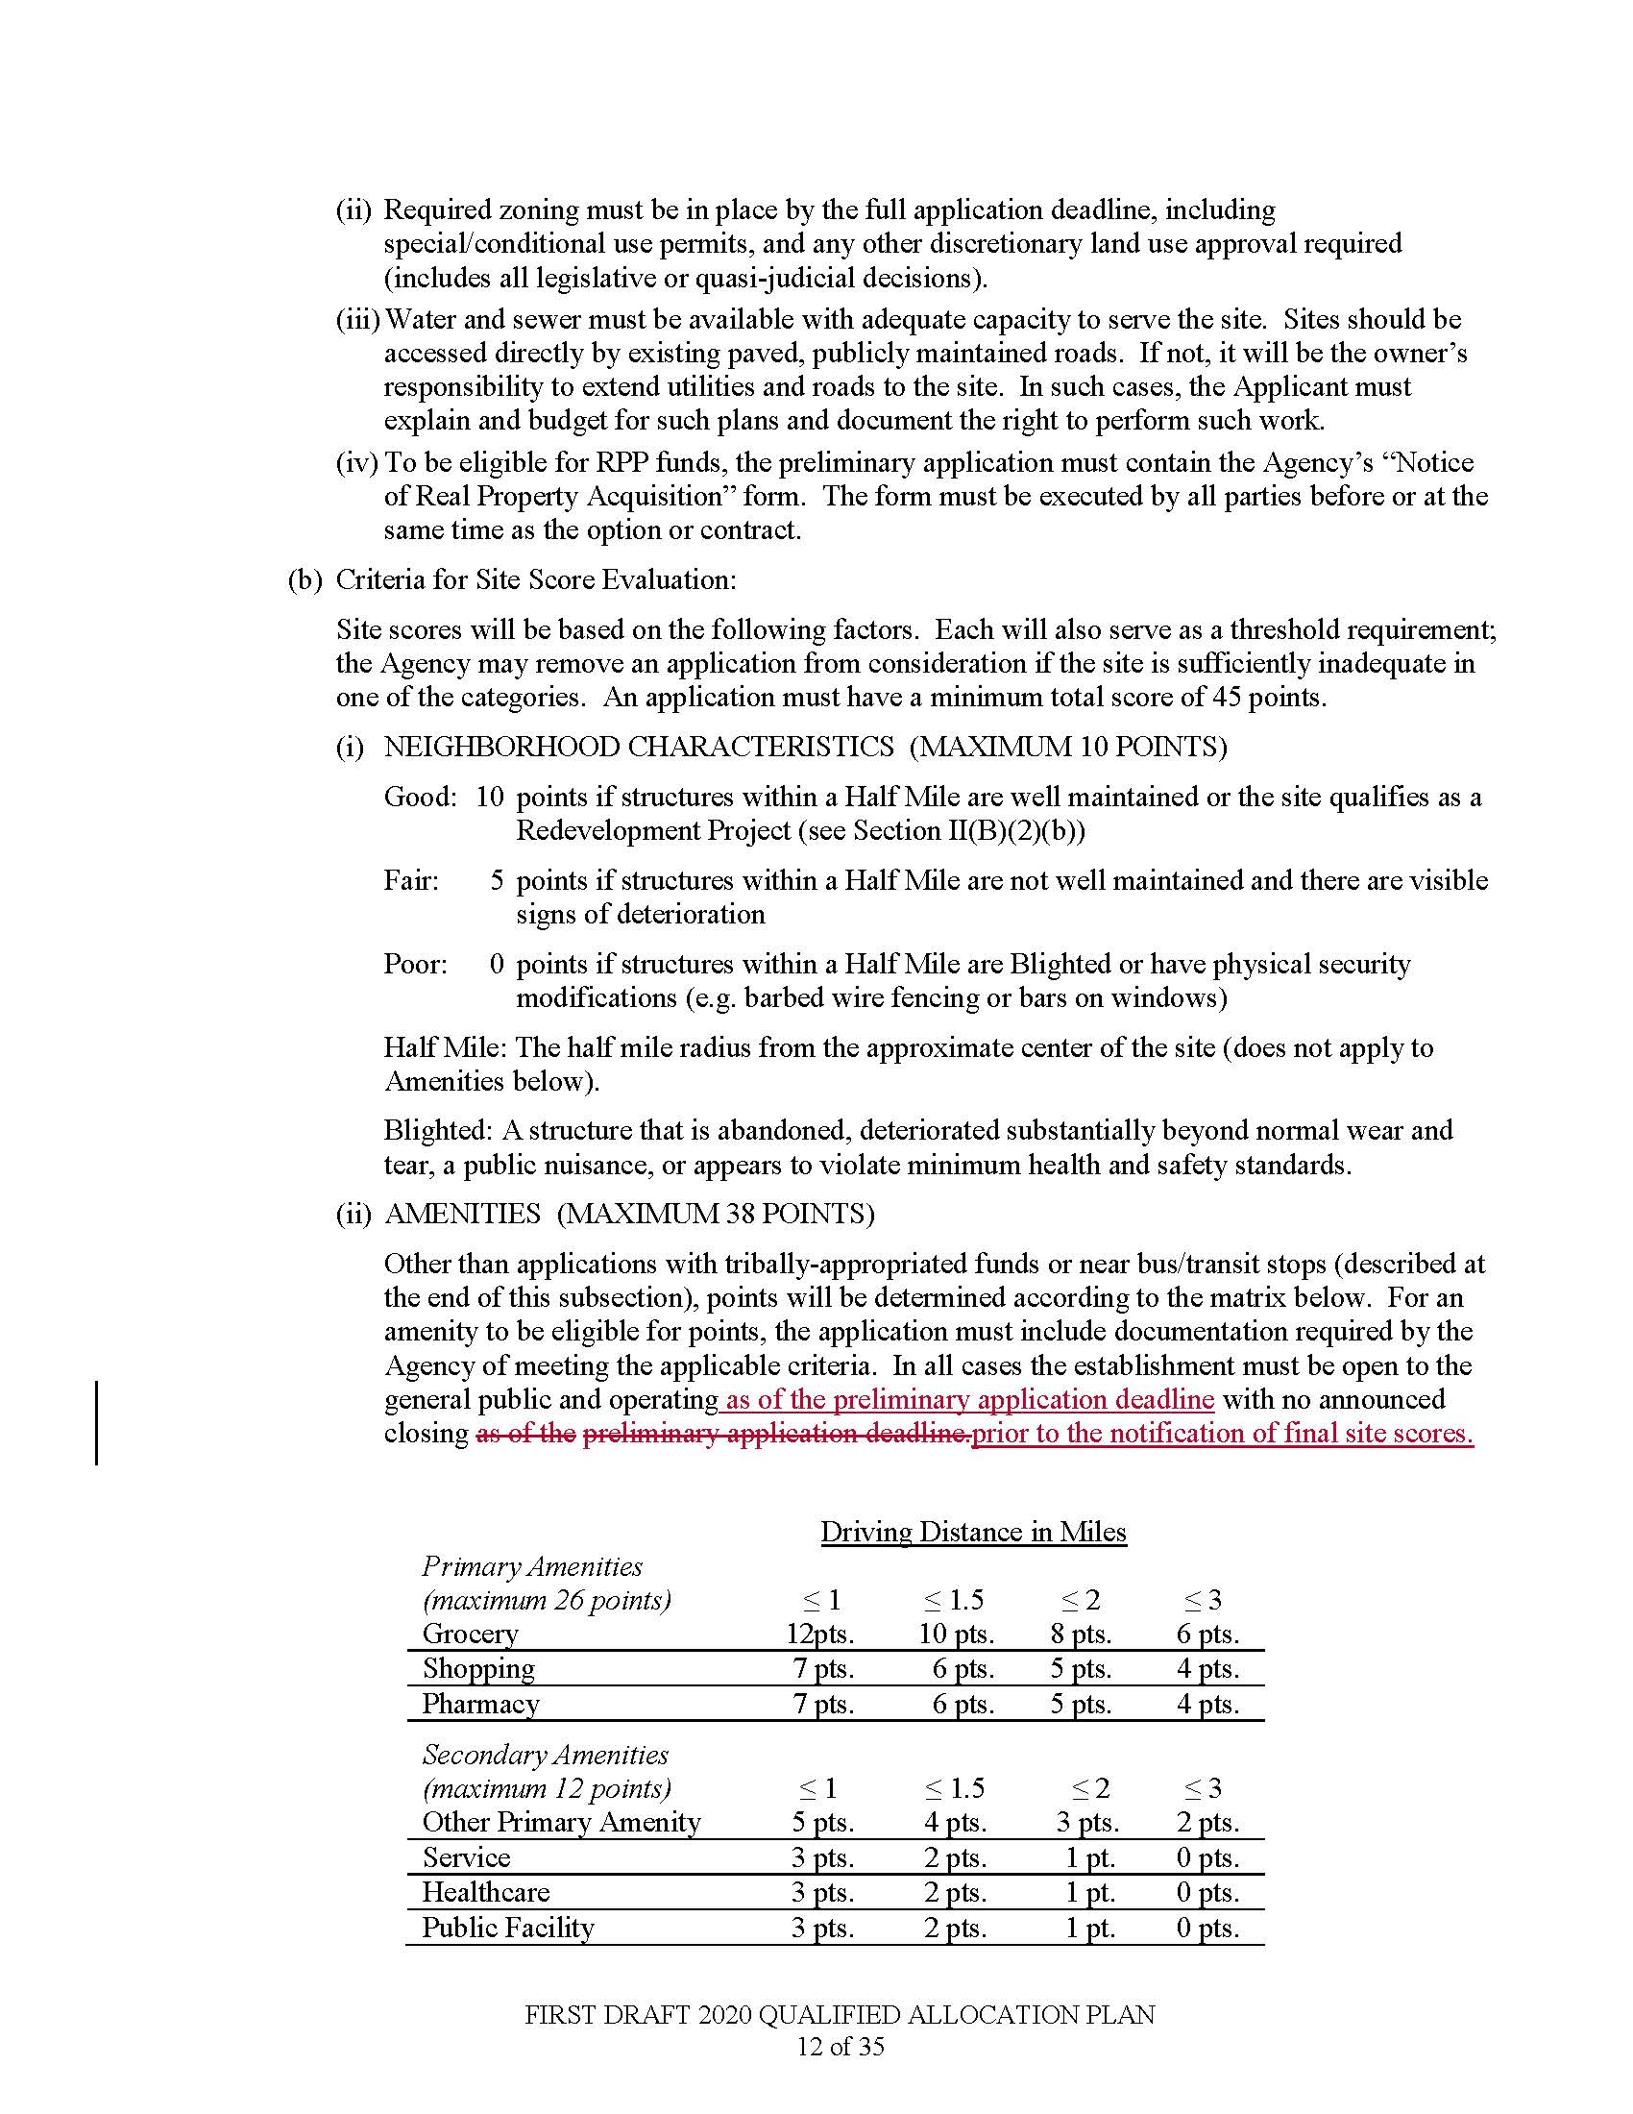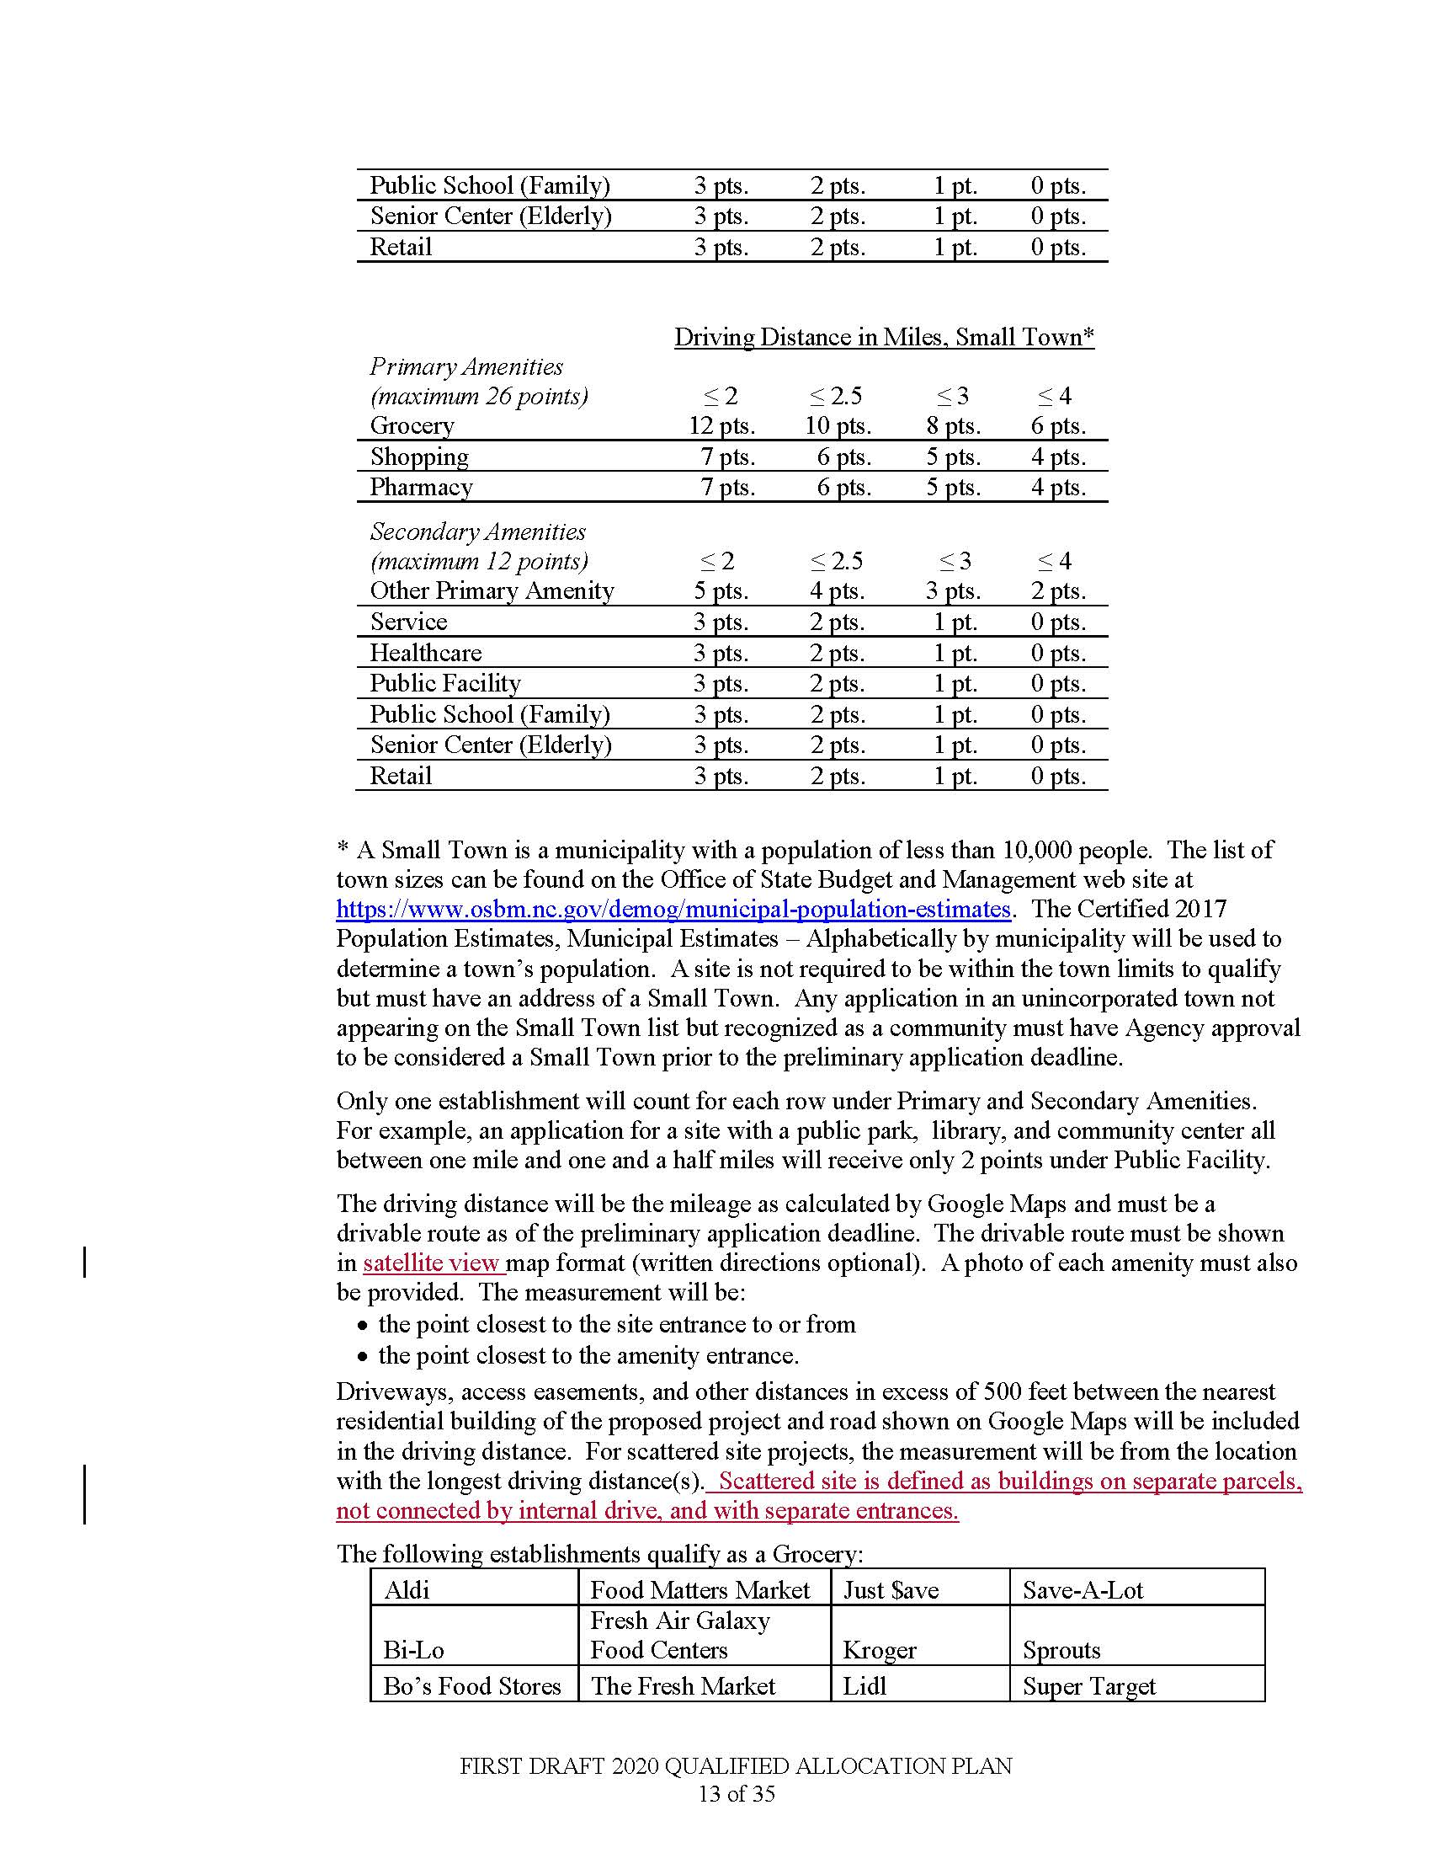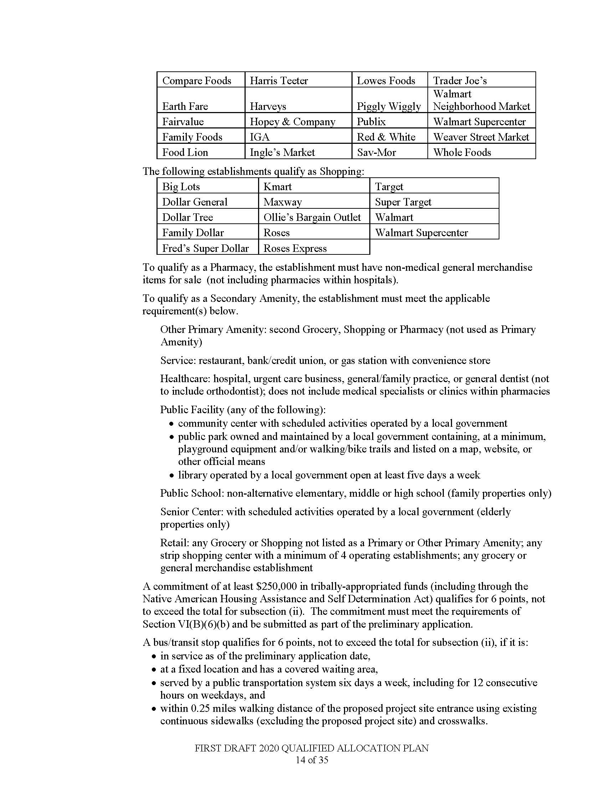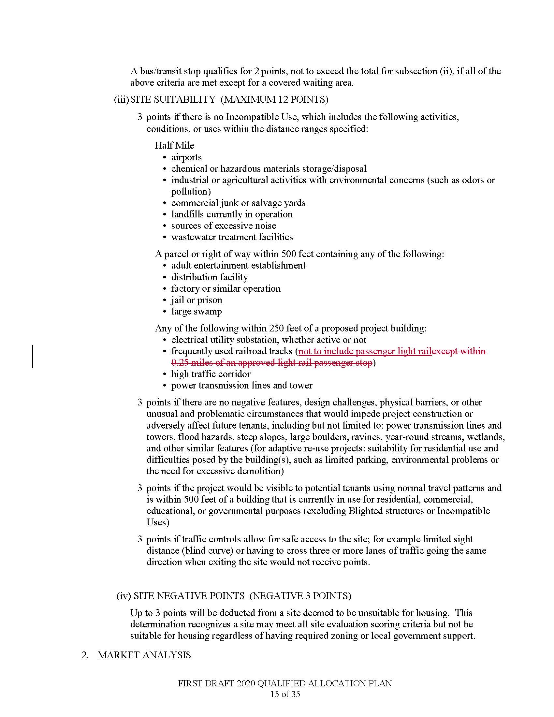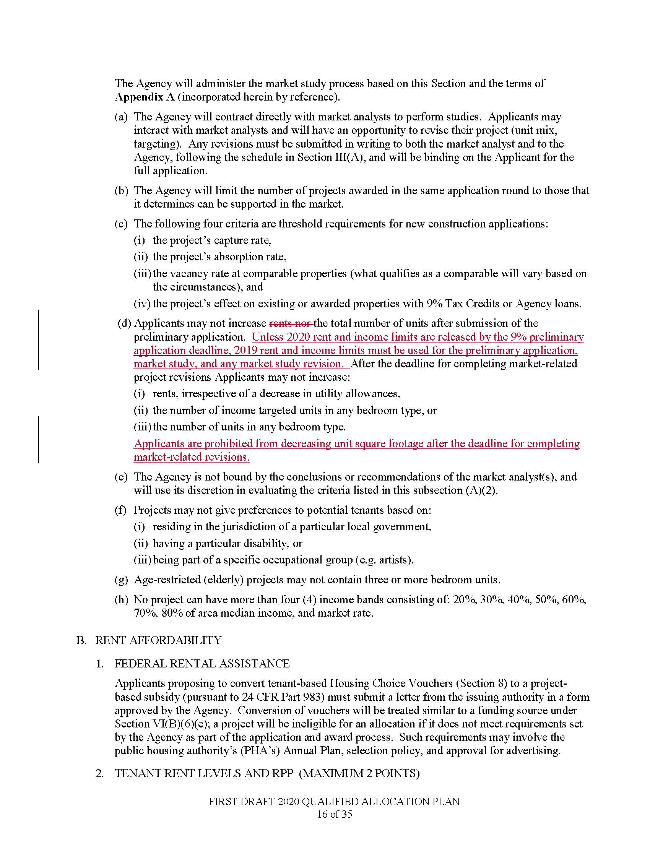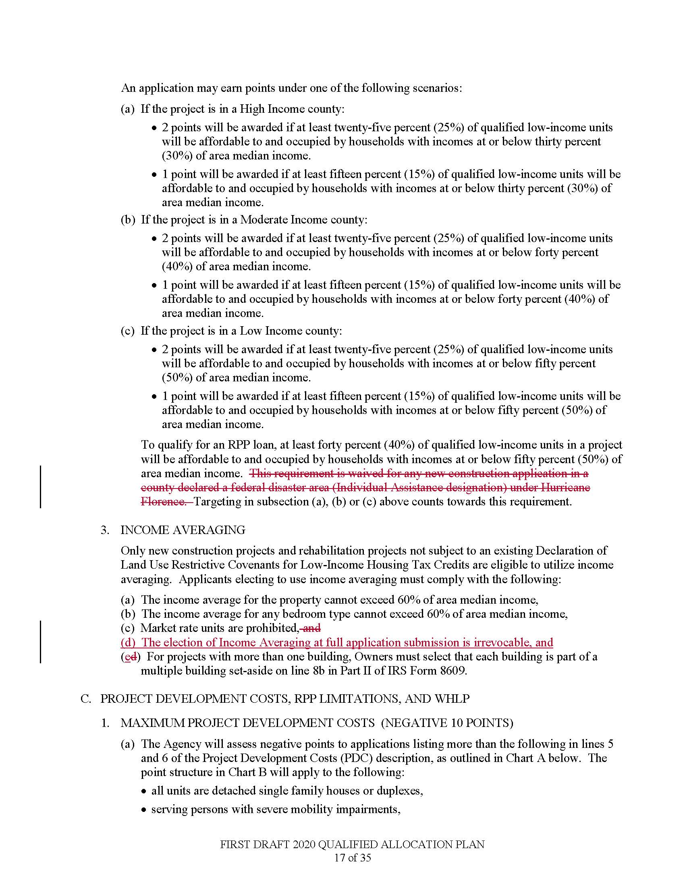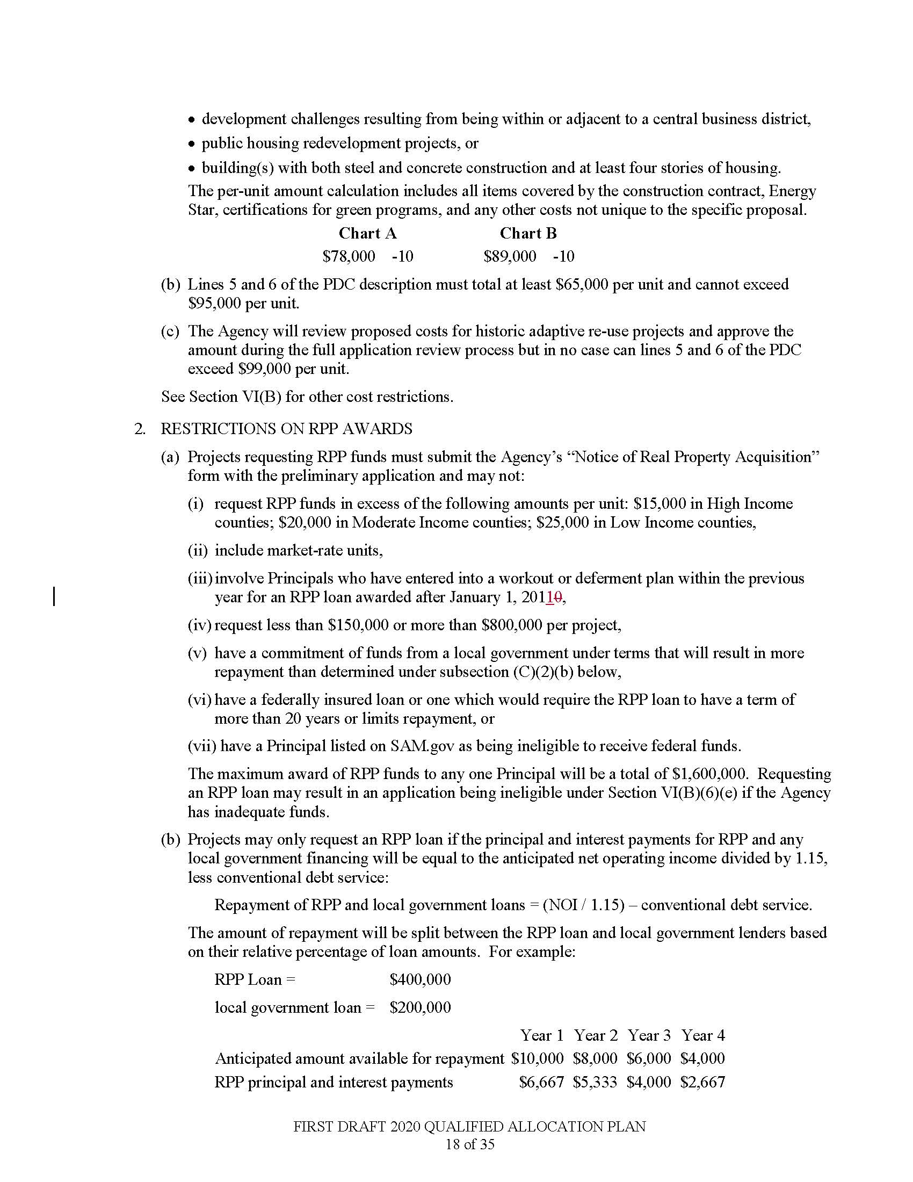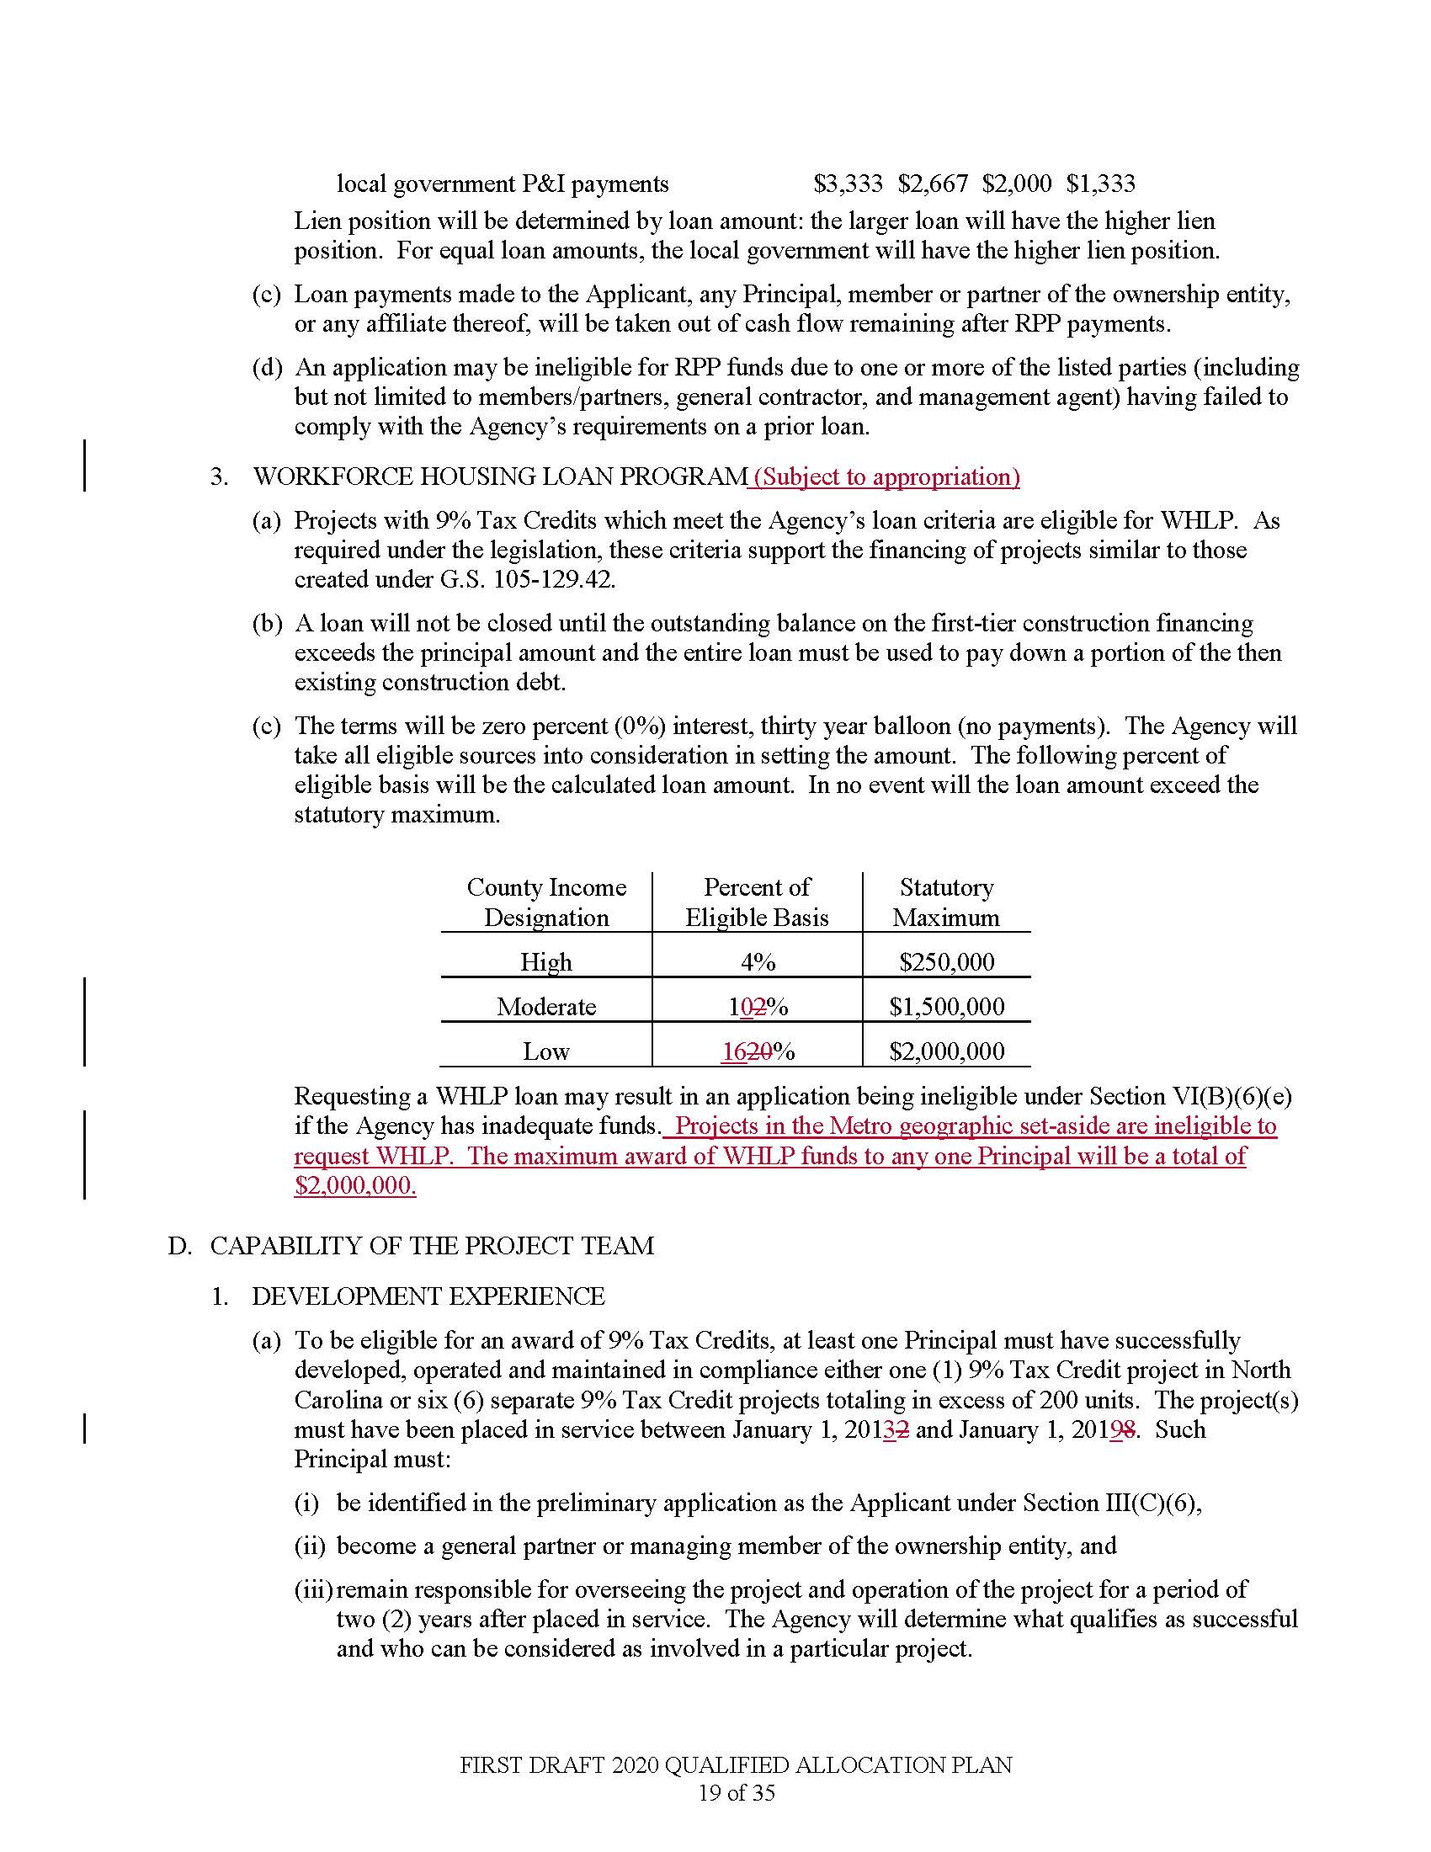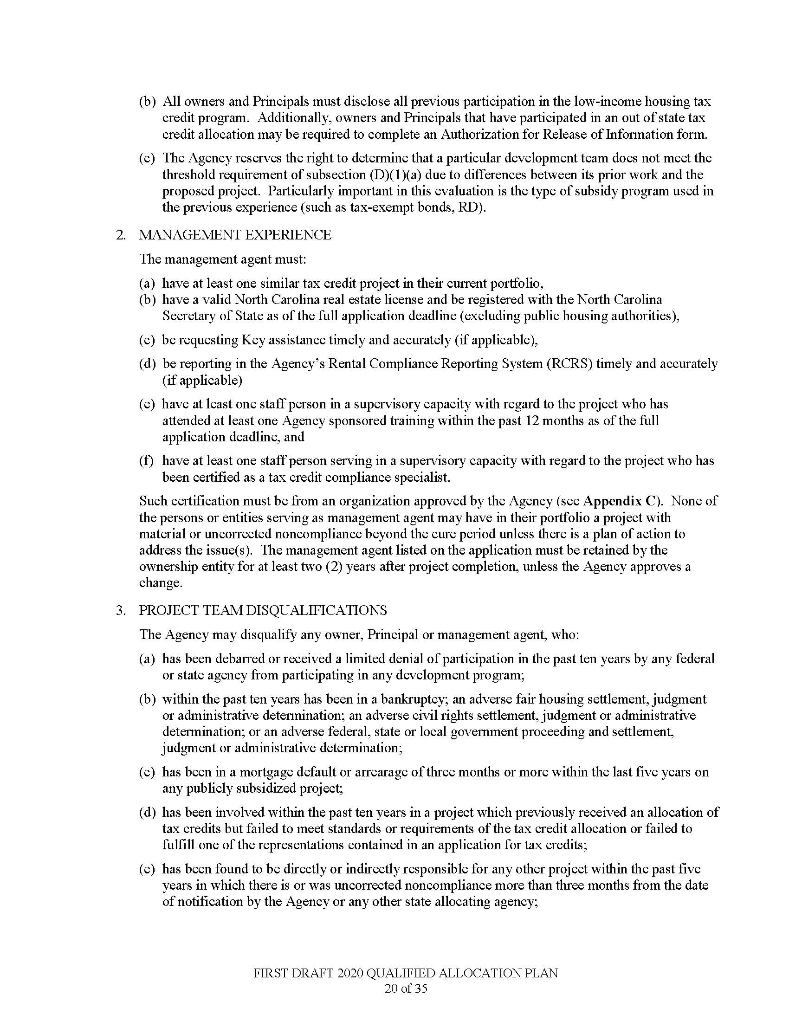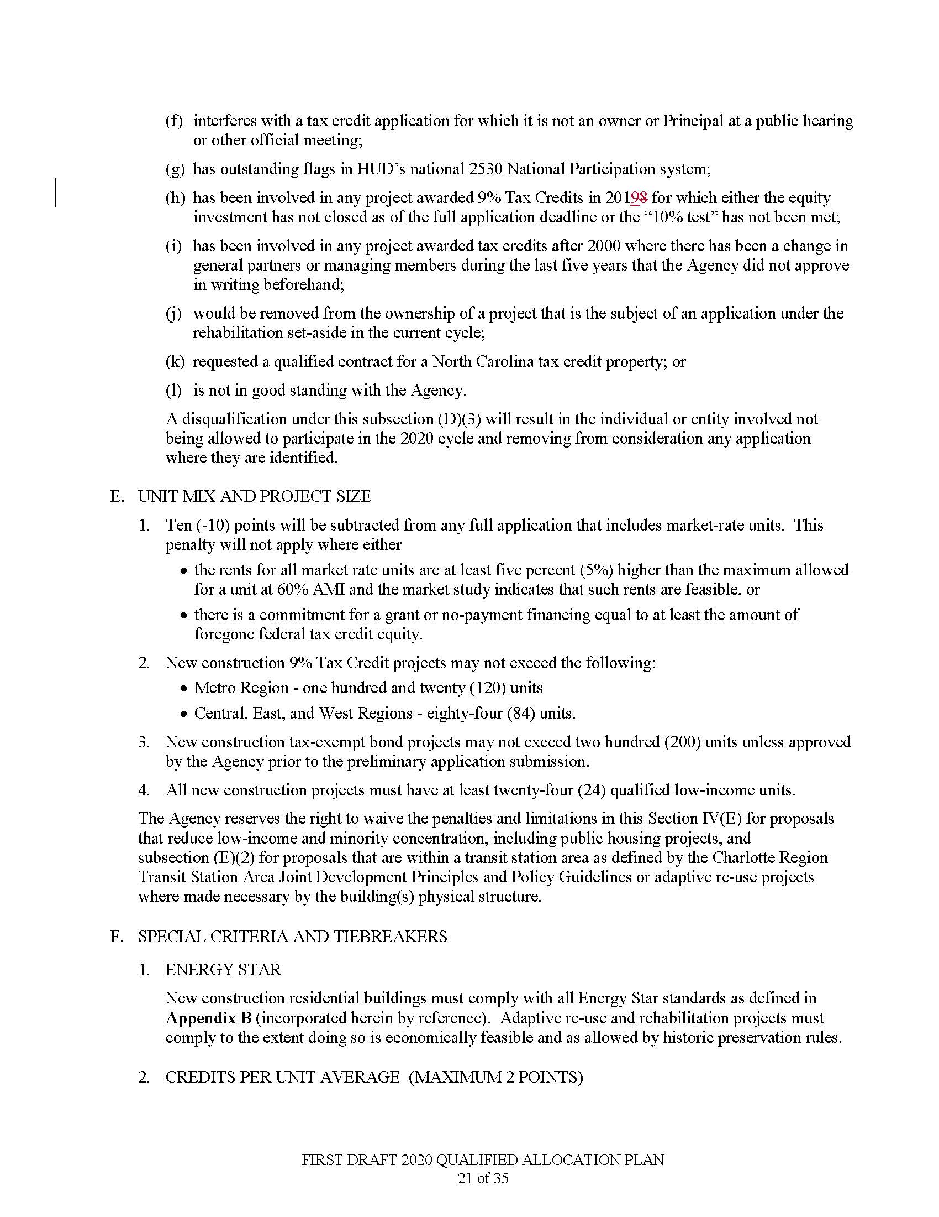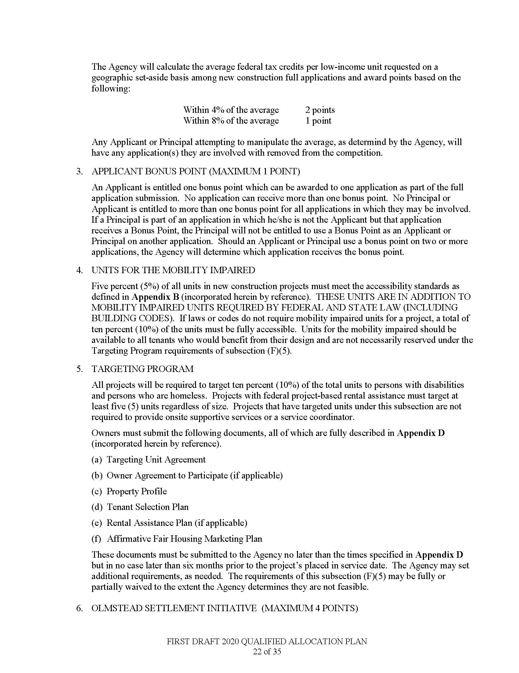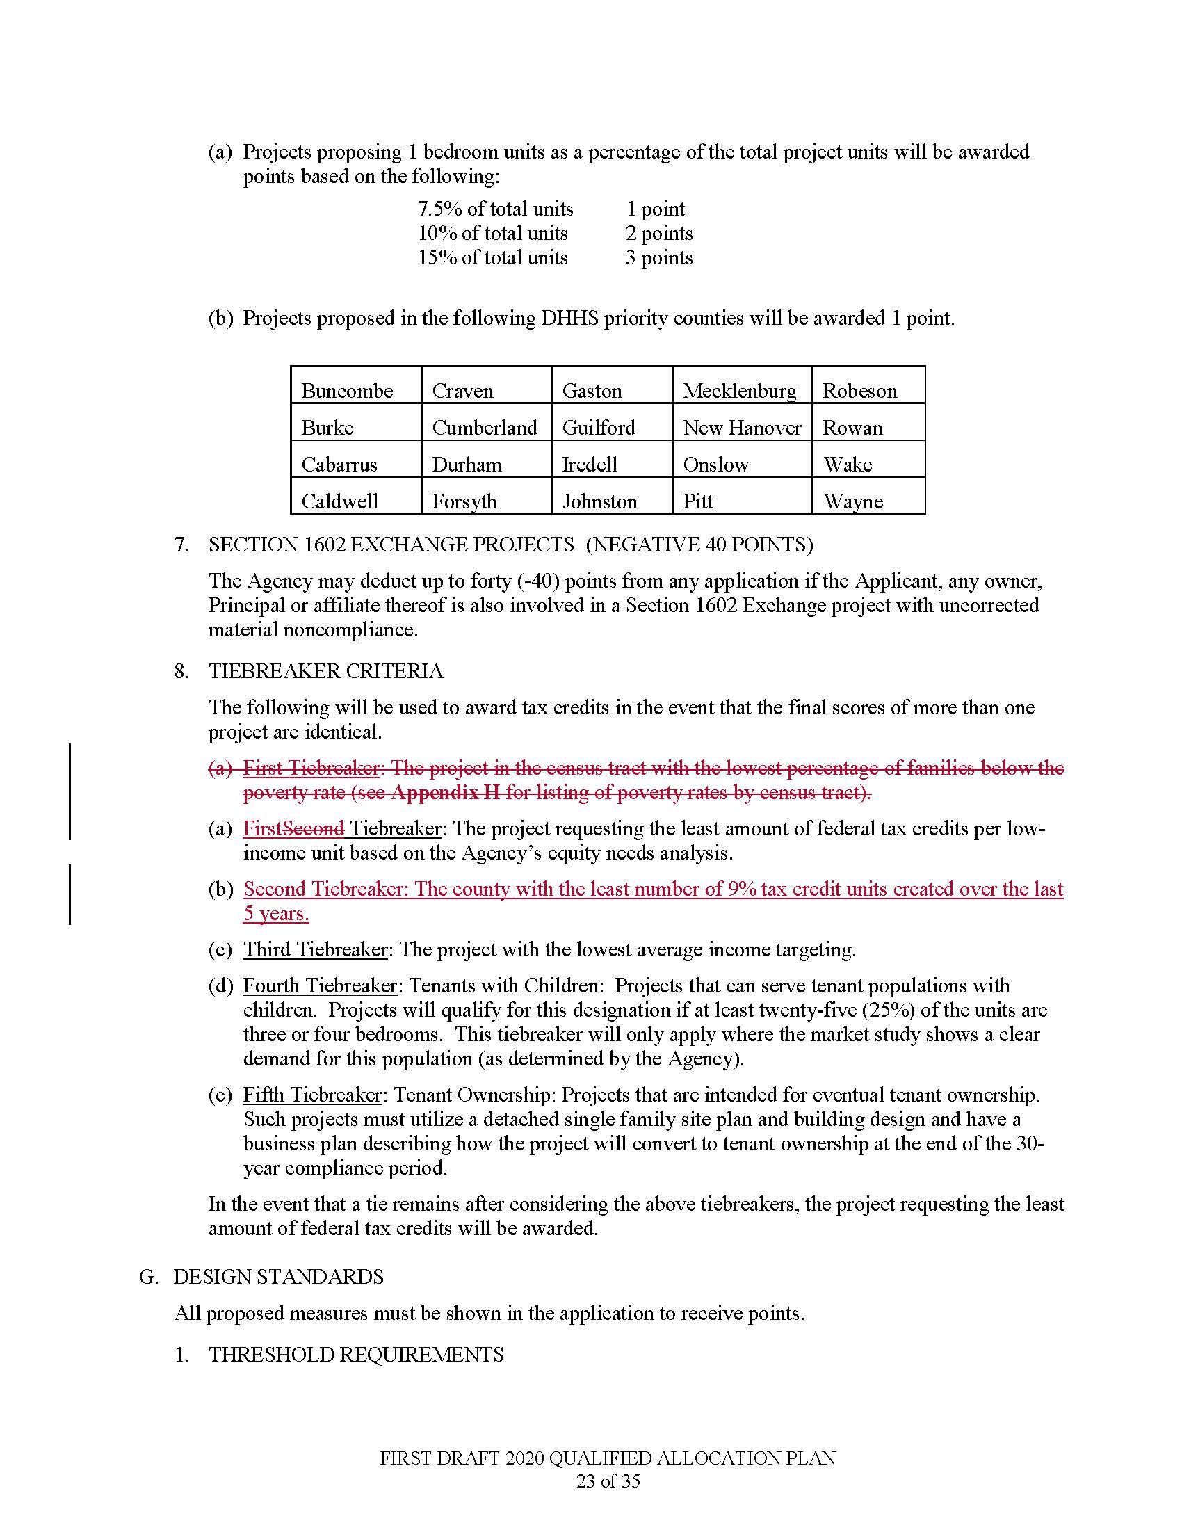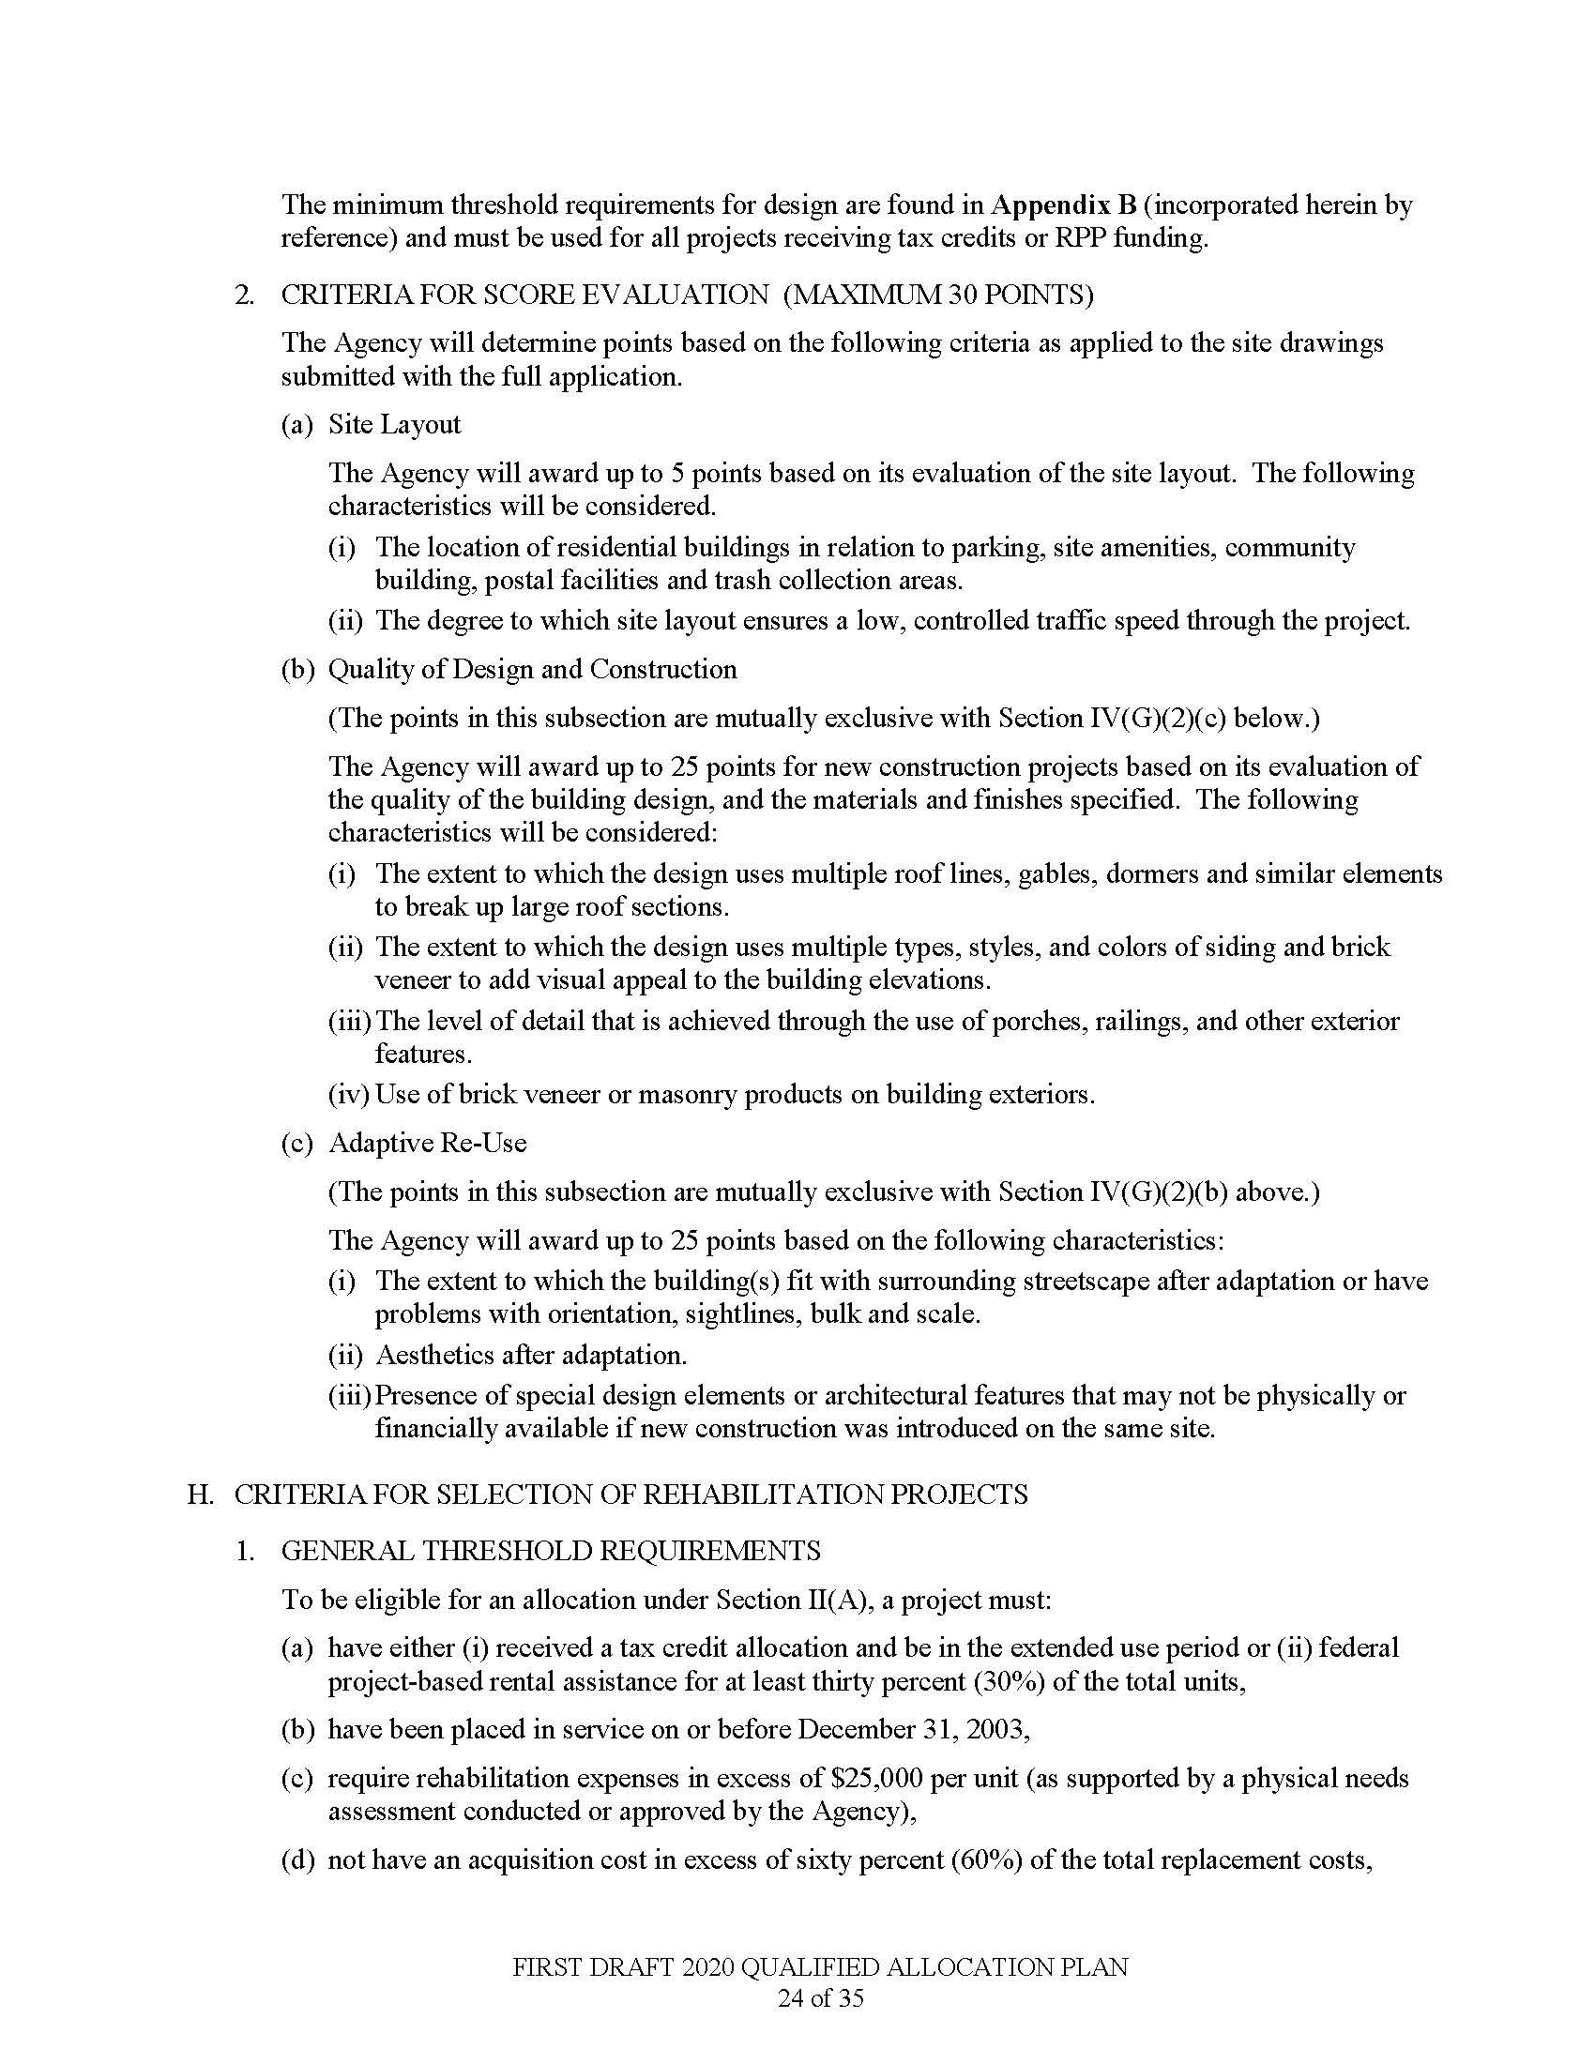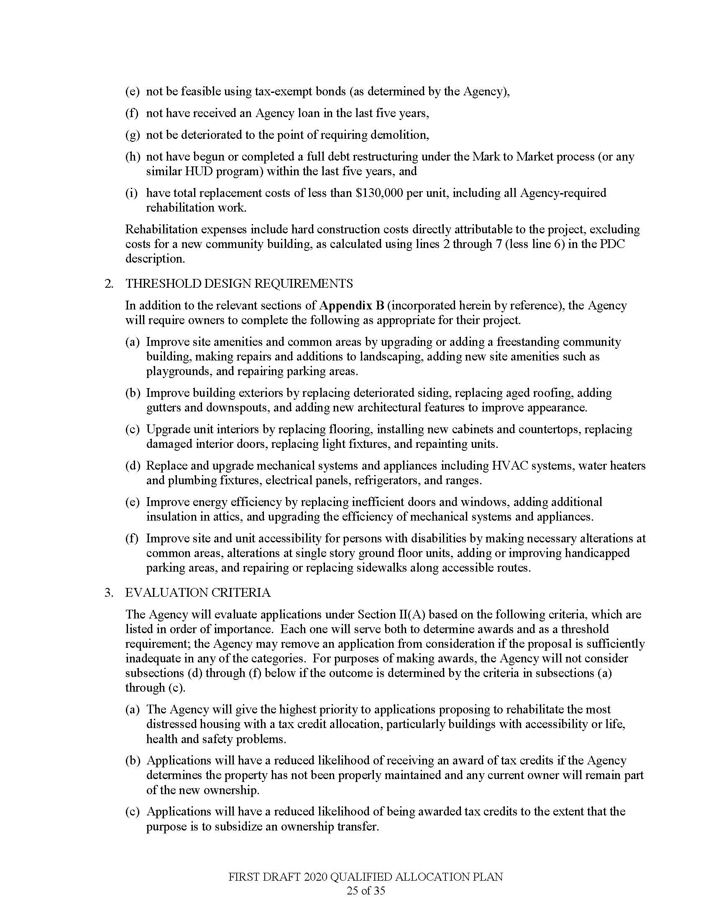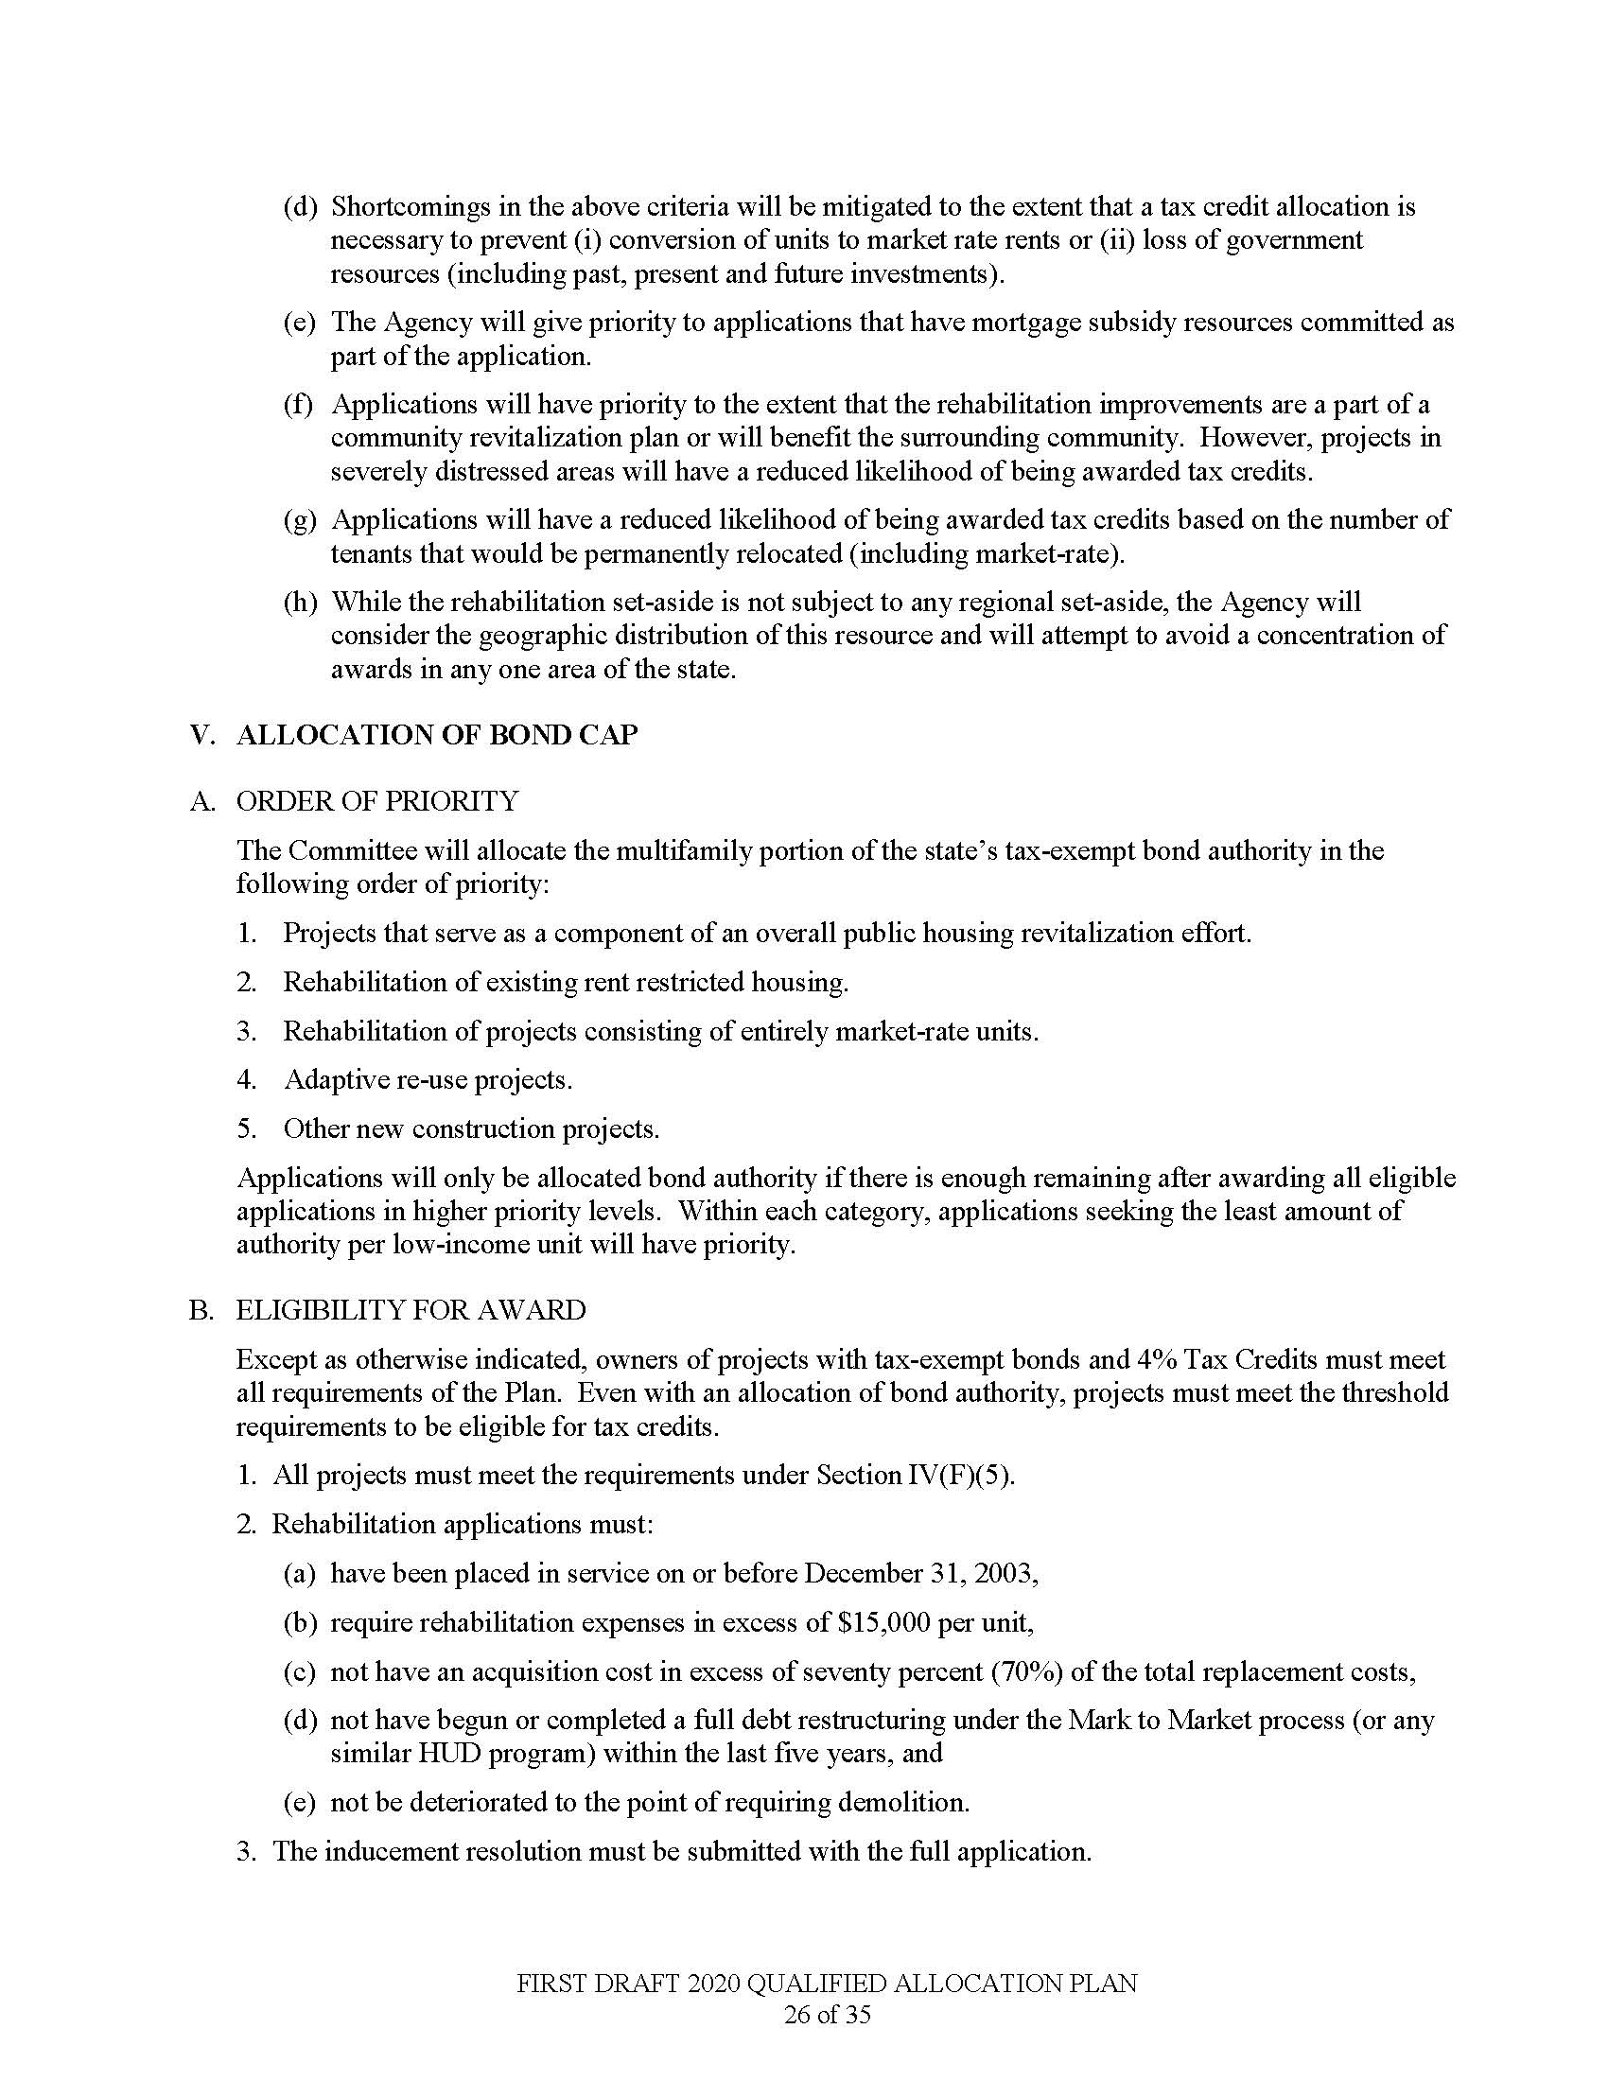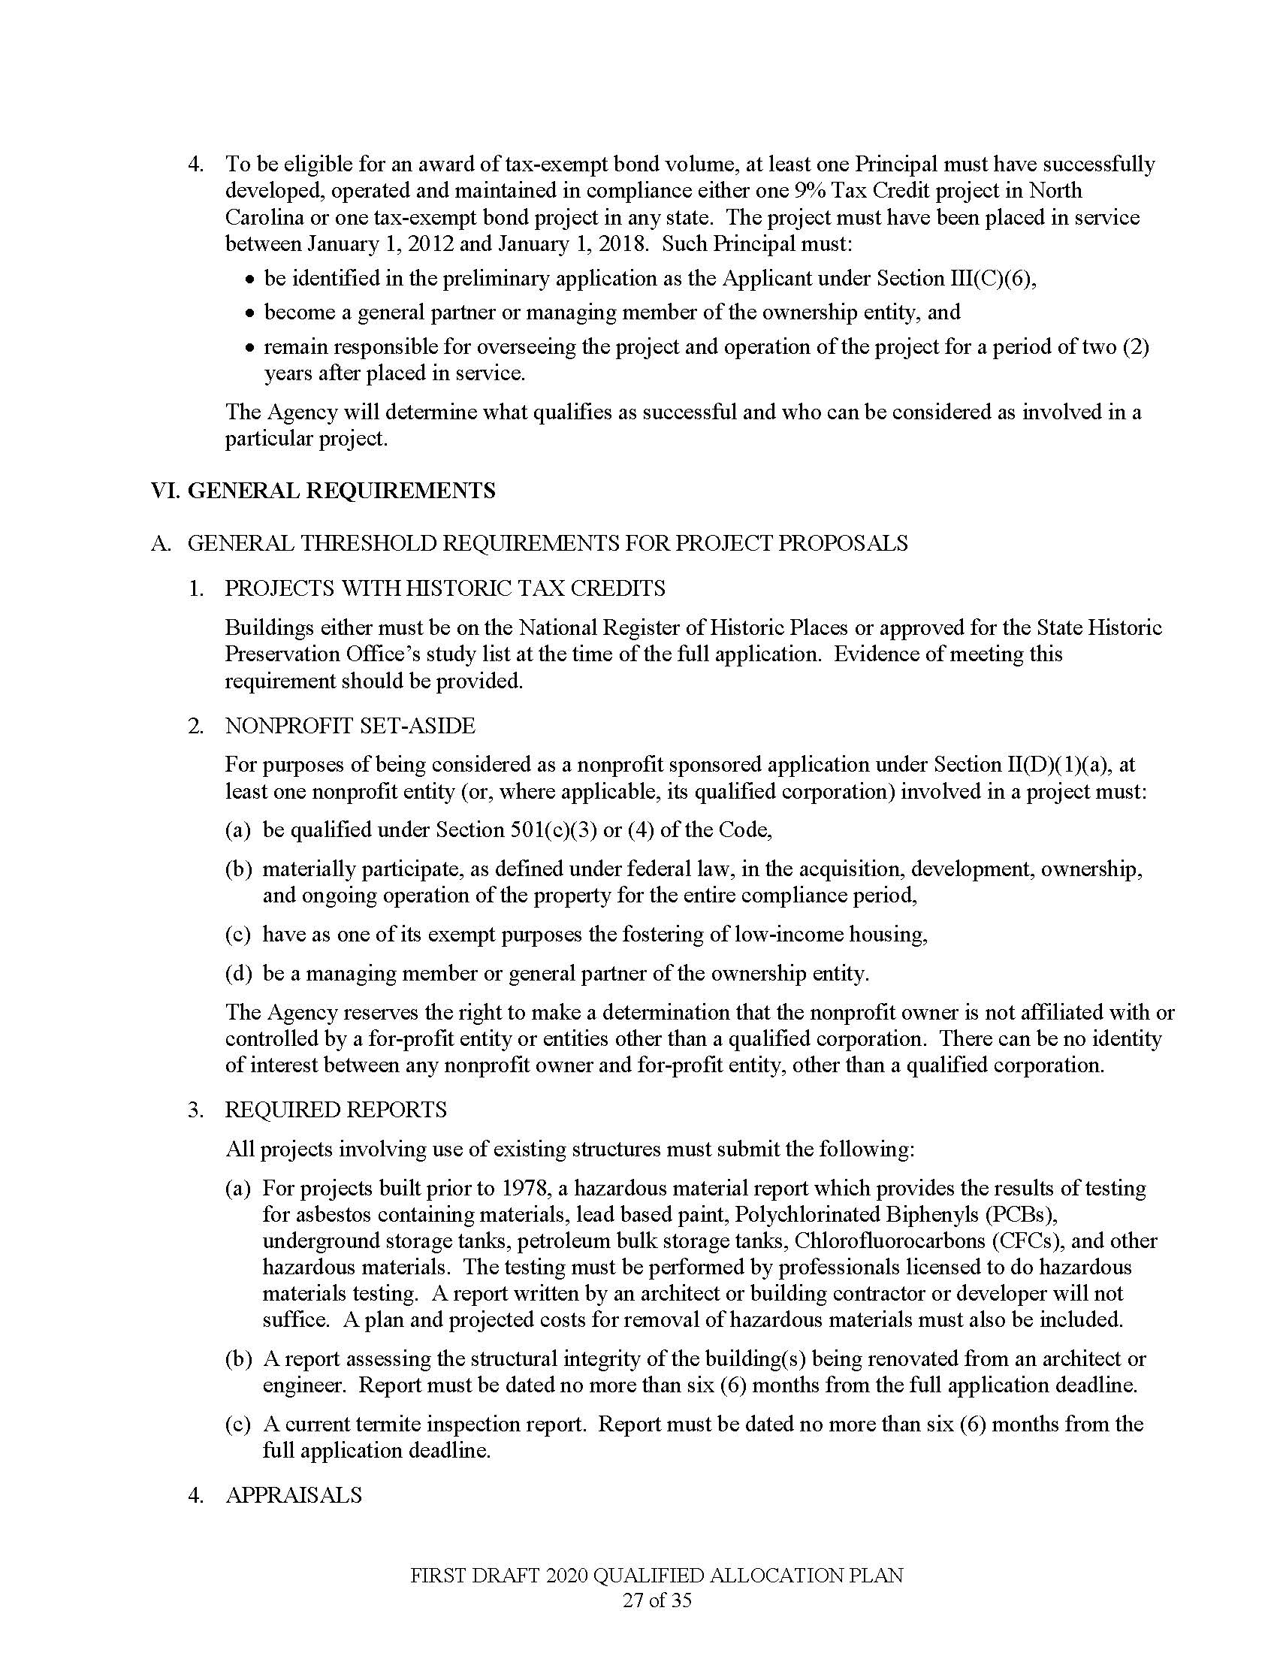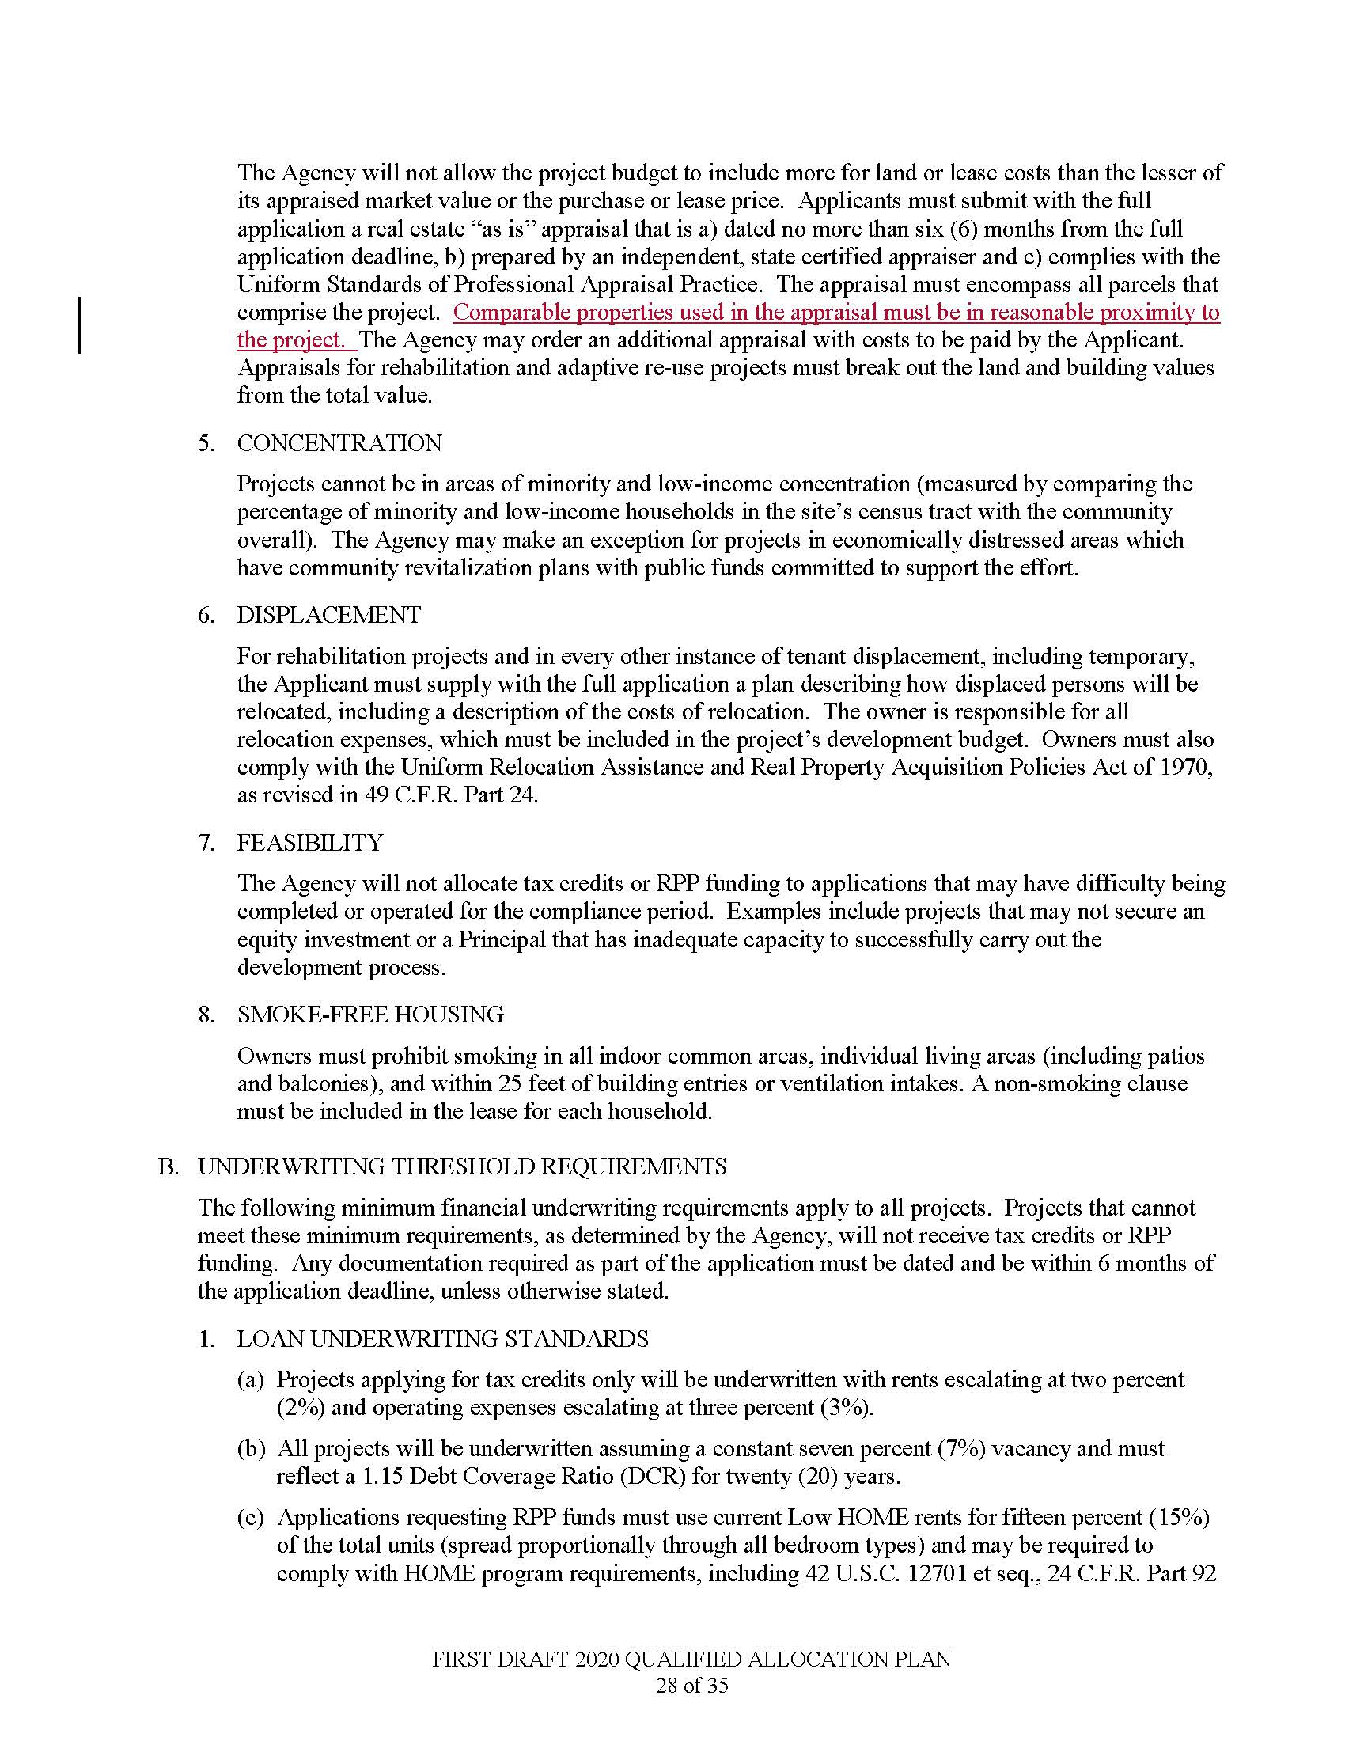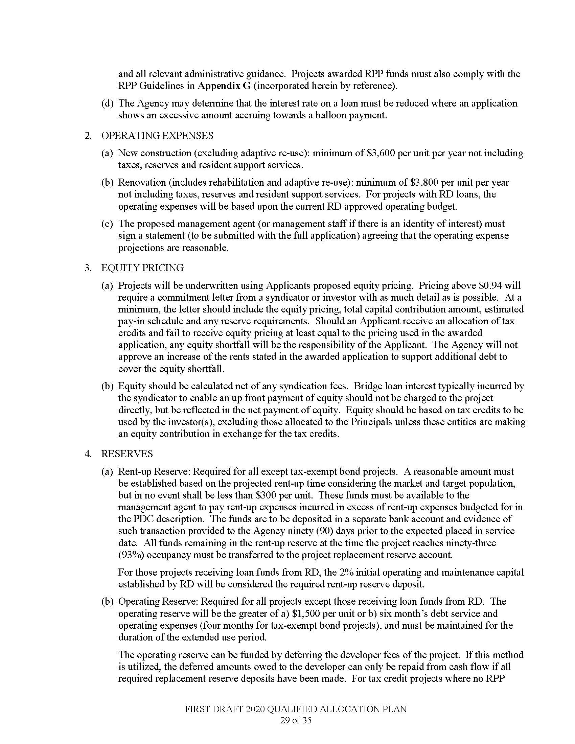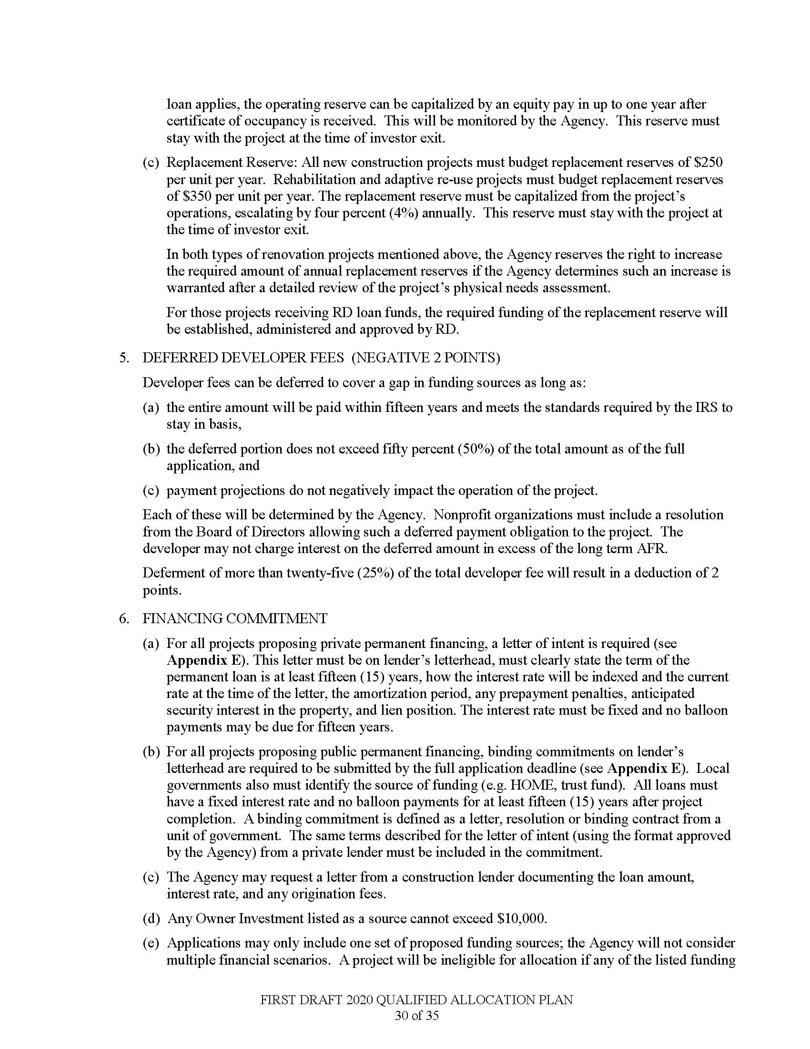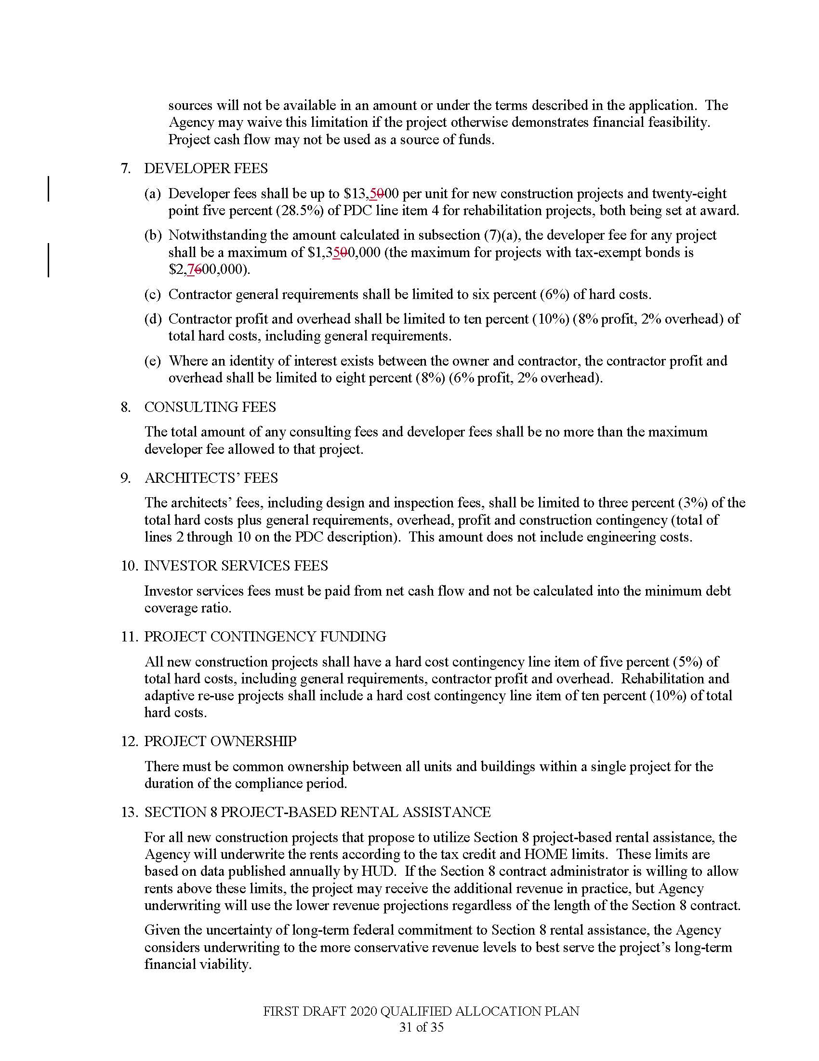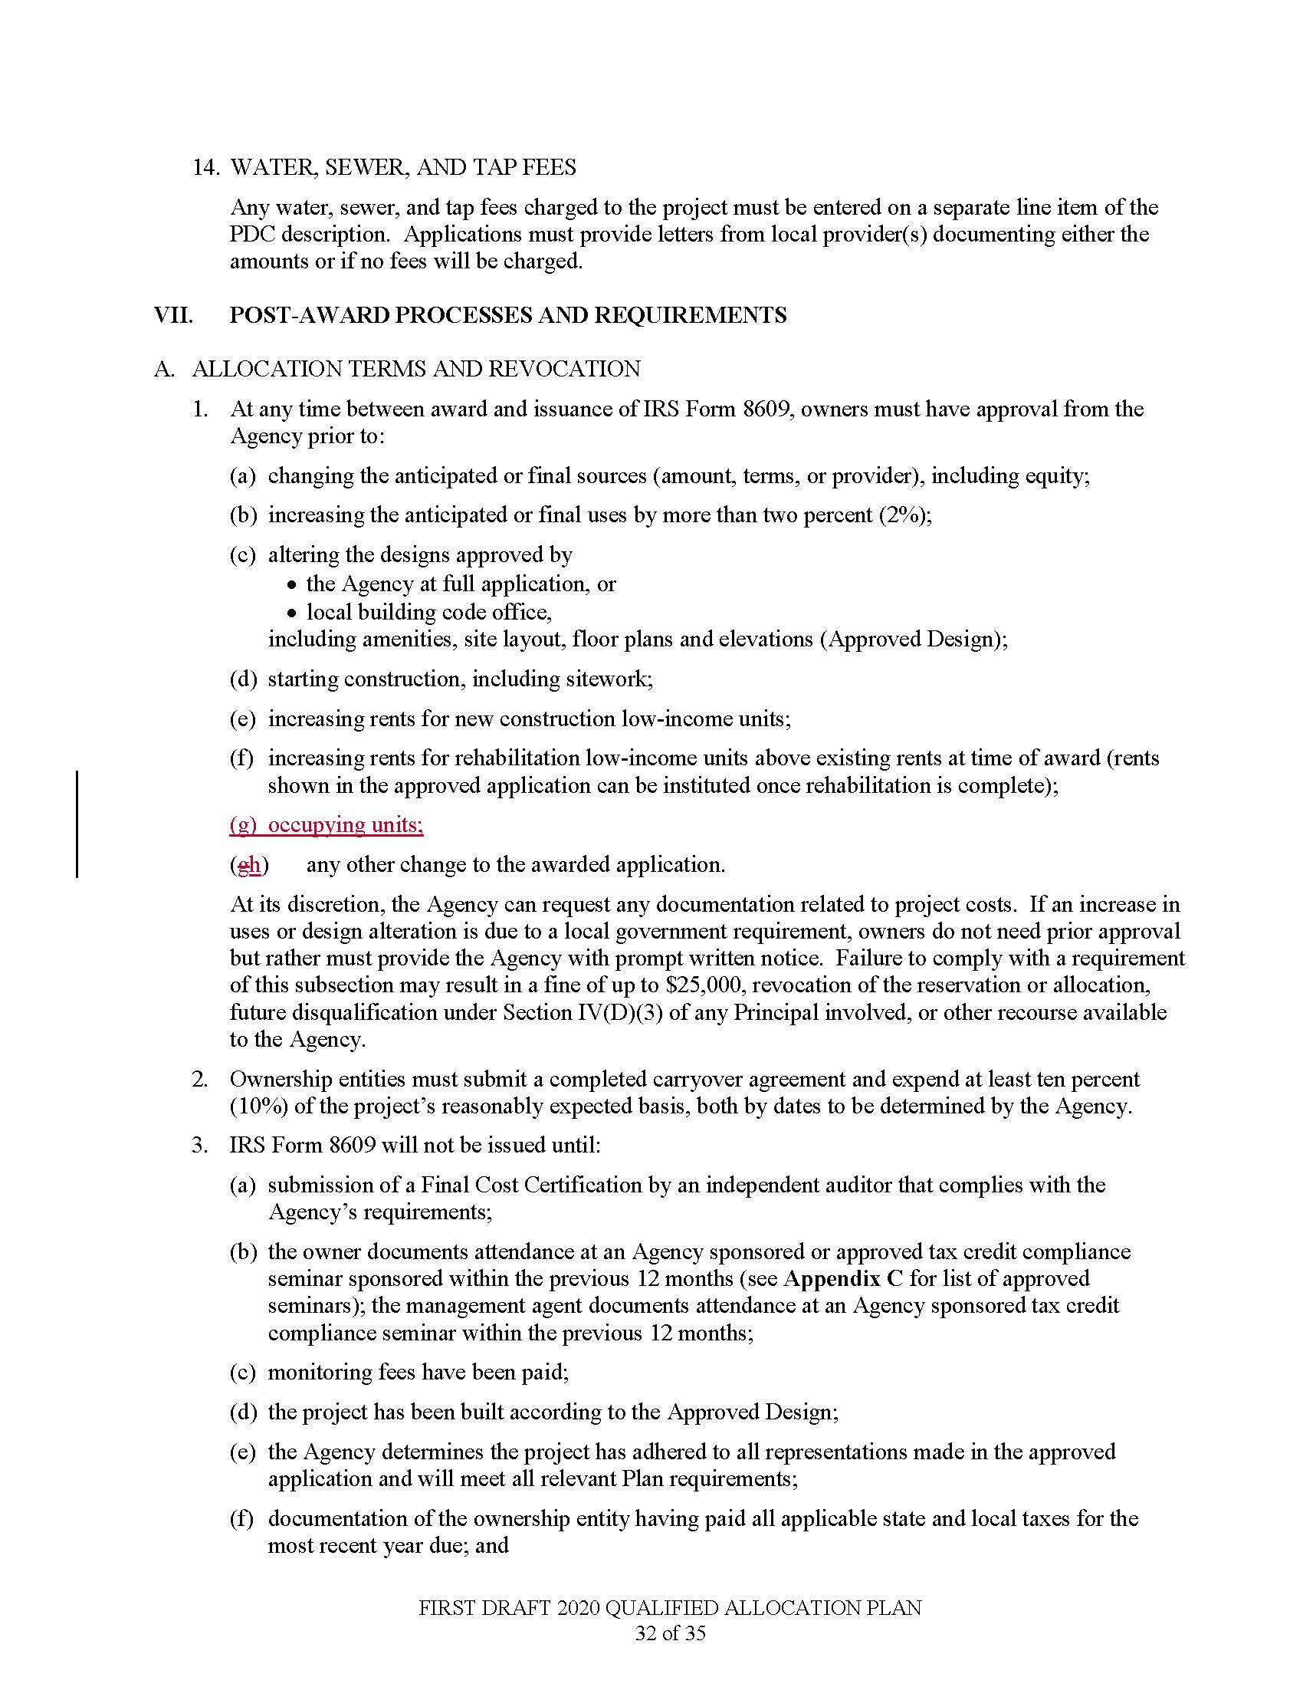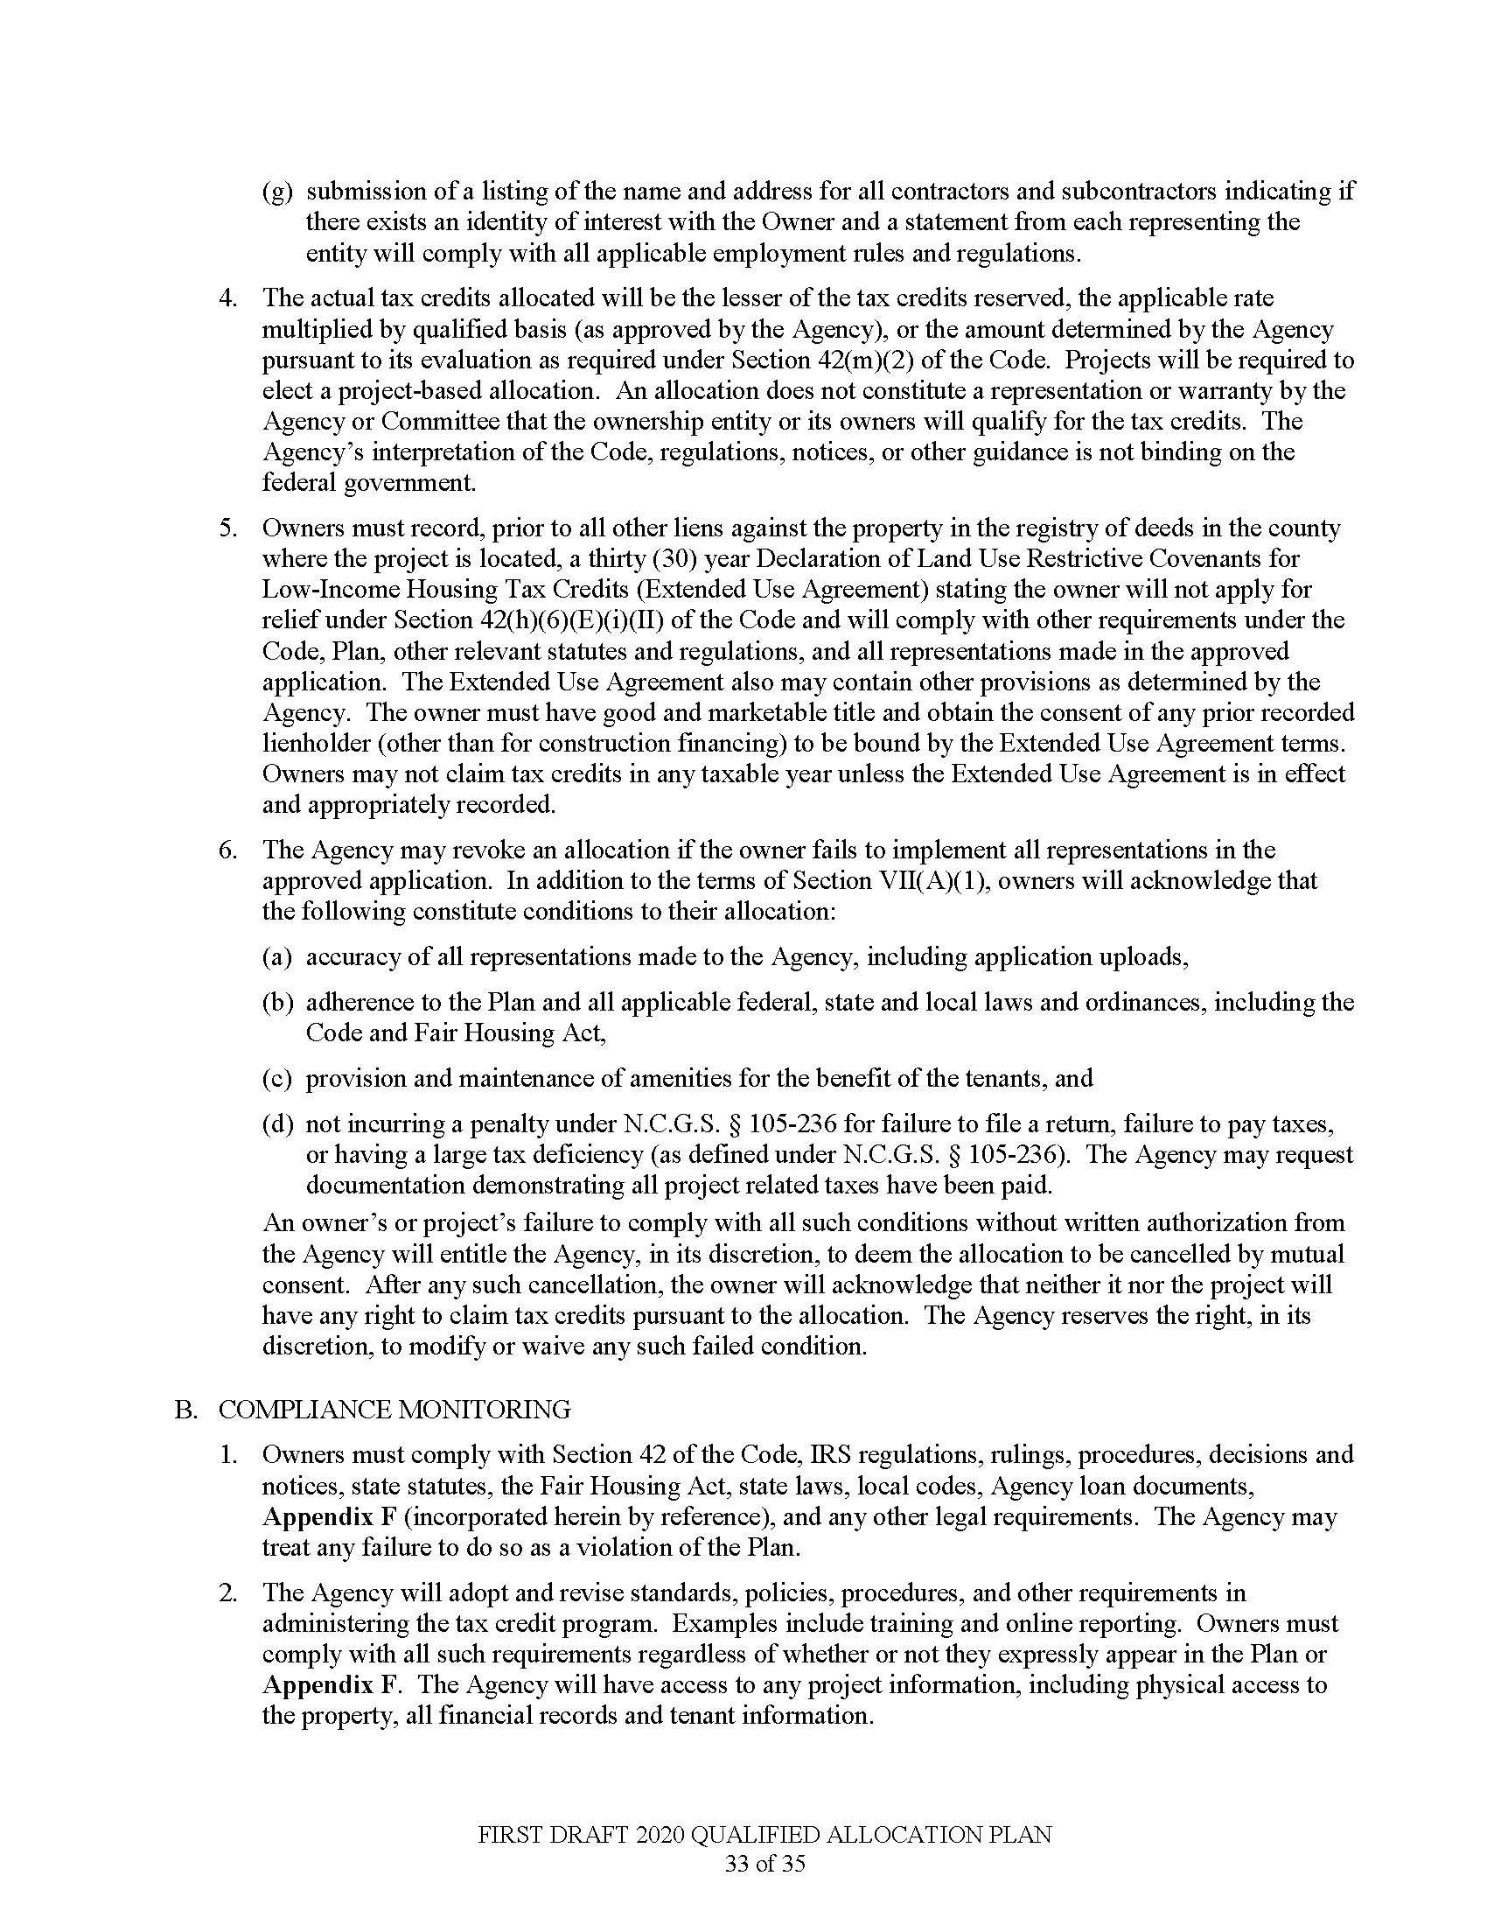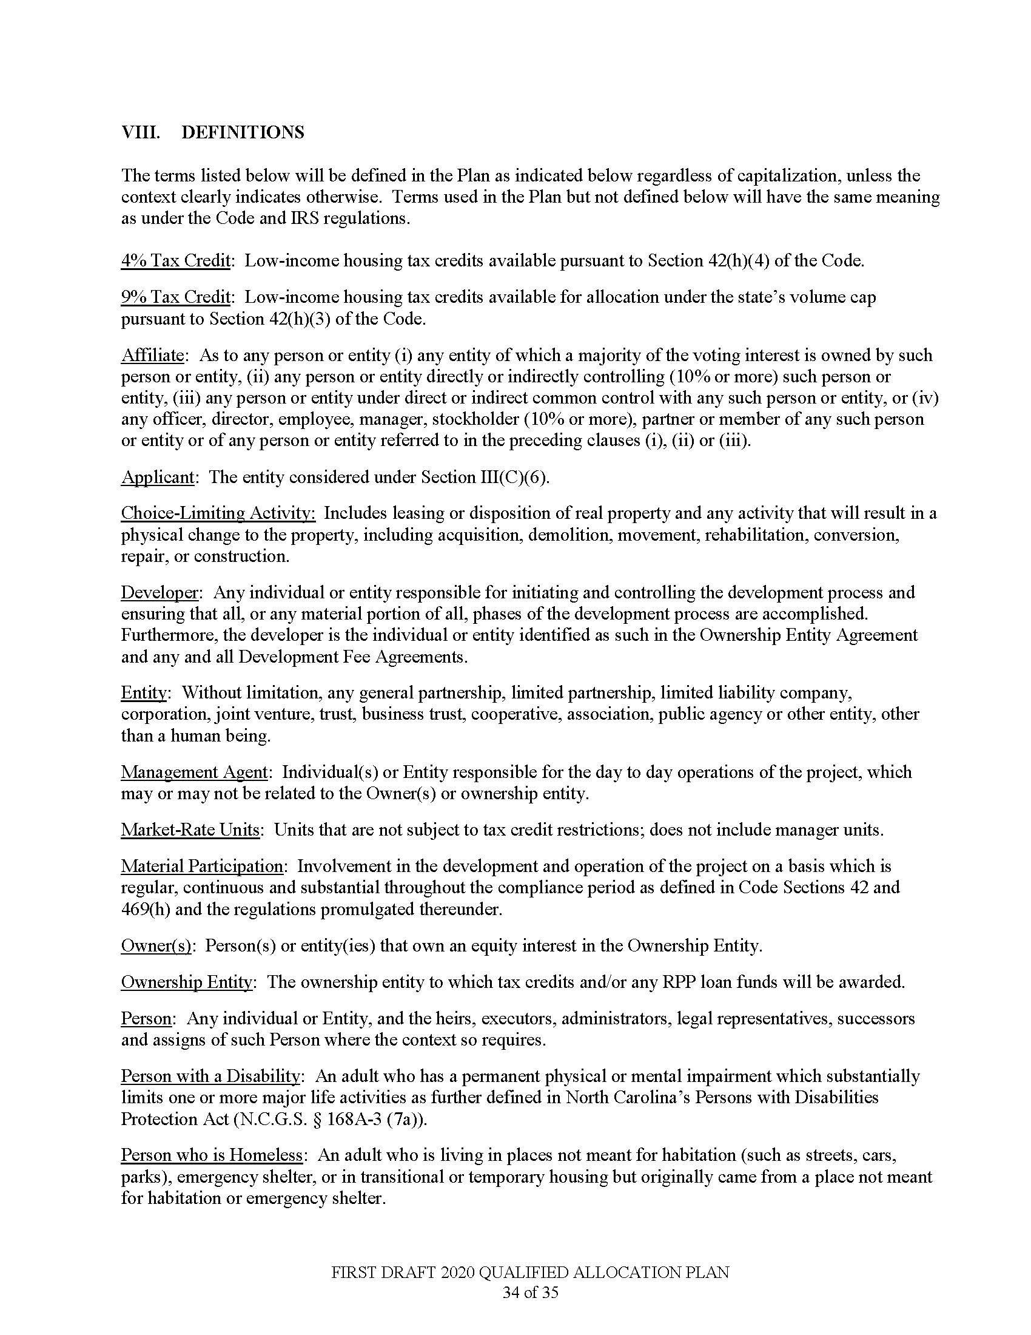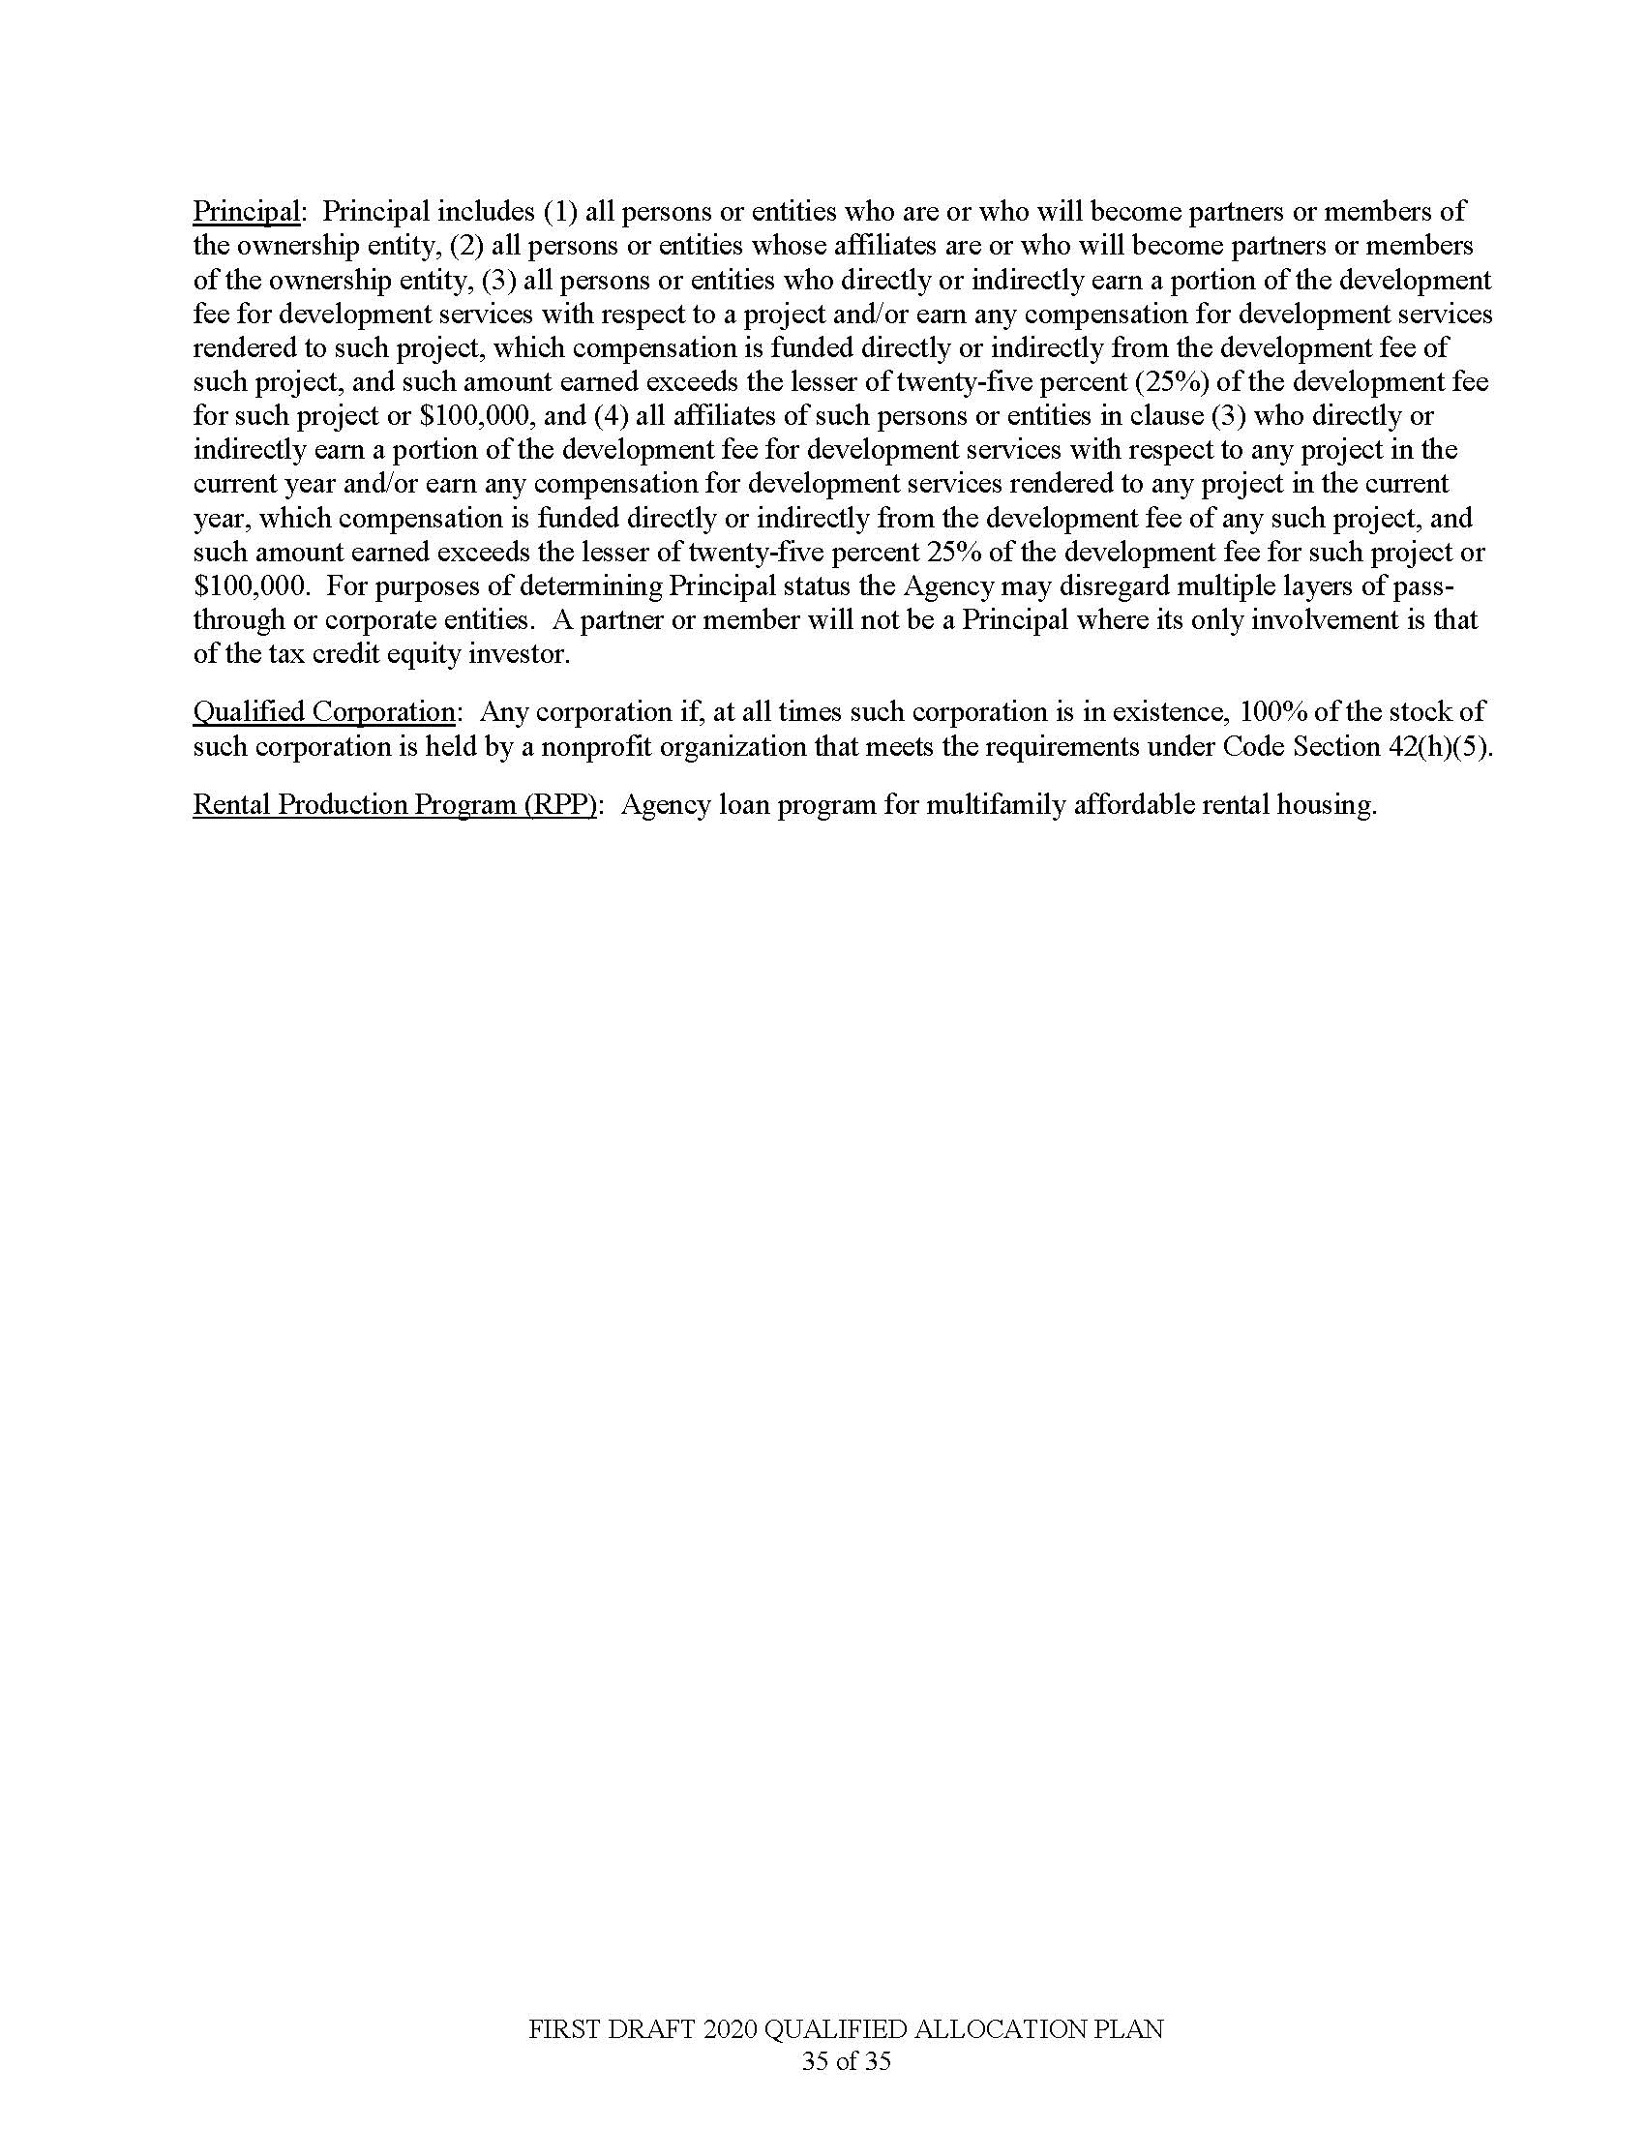

Note from the Codifier: The notices published in this Section of the NC Register include the text of proposed rules. The agency must accept comments on the proposed rule(s) for at least 60 days from the publication date, or until the public hearing, or a later date if specified in the notice by the agency. If the agency adopts a rule that differs substantially from a prior published notice, the agency must publish the text of the proposed different rule and accept comment on the proposed different rule for 60 days.
Statutory reference: G.S. 150B-21.2.

Title 10A – Department of Health and Human Services

Notice is hereby given in accordance with G.S. 150B-21.2 and G.S. 150B-21.3A(c)(2)g. that the Commission for Public Health intends to amend the rule cited as 10A NCAC 41C .0702 and readopt with substantive changes the rules cited as 10A NCAC 41C .0701 and .0703.

Link to agency website pursuant to G.S. 150B-19.1(c): https://cph.publichealth.nc.gov/

Proposed Effective Date: January 1, 2020

Public Hearing:

Date: September 23, 2019

Time: 10:00 a.m.

Location: Cardinal Conference Room, located at 5605 Six Forks Road, Raleigh, NC 27609

Reason for Proposed Action: The proposed rules update surveillance reporting requirements for occupational diseases, illnesses, and injuries to be more protective of public health. In particular, the proposed rules expand reporting of adult blood lead levels to NC DHHS, Division of Public Health because current science indicates that adverse health effects may occur with blood lead levels less than 5 ug/dL. In addition, 10A NCAC 41C .0701 and .0703 are being readopted pursuant to G.S. 150B-21.3A, Periodic Review and Expiration of Existing Rules.

Comments may be submitted to: Virginia Niehaus, Rulemaking Coordinator, 1931 Mail Service Center, Raleigh, NC 27699-1931; phone (919) 707-5006; email cphcomment@lists.ncmail.net

Comment period ends: November 4, 2019

Procedure for Subjecting a Proposed Rule to Legislative Review: If an objection is not resolved prior to the adoption of the rule, a person may also submit written objections to the Rules Review Commission after the adoption of the Rule. If the Rules Review Commission receives written and signed objections after the adoption of the Rule in accordance with G.S. 150B-21.3(b2) from 10 or more persons clearly requesting review by the legislature and the Rules Review Commission approves the rule, the rule will become effective as provided in G.S. 150B-21.3(b1). The Commission will receive written objections until 5:00 p.m. on the day following the day the Commission approves the rule. The Commission will receive those objections by mail, delivery service, hand delivery, or facsimile transmission. If you have any further questions concerning the submission of objections to the Commission, please call a Commission staff attorney at 919-431-3000.

Fiscal impact. Does any rule or combination of rules in this notice create an economic impact? Check all that apply.

State funds affected

Local funds affected

Substantial economic impact (>= $1,000,000)

Approved by OSBM

No fiscal note required

Chapter 41 - Epidemiology Health

SUBCHAPTER 41C - OCCUPATIONAL HEALTH

SECTION .0700 - OCCUPATIONAL HEALTH SURVEILLANCE

10A NCAC 41C .0701 DEFINITION

"Adult" for the purposes of this section means a person age 16 or older.

"Elevated blood lead level" means a blood lead of 40 ug/dL or greater. > 0 µg/dL.

"Non-elevated blood lead level" means all blood lead levels that are not elevated regardless of threshold.

Authority G.S. 130A-455.

10A NCAC 41C .0702 REPORTABLE DISEASES, ILLNESSES, AND INJURIES

(a) The following named diseases, illnesses, and injuries are declared to be dangerous to the public health and shall be reported by a physician within the time period specified after the disease, illness, and injury is diagnosed:

(1) asbestosis - 15 working business days;

(2) silicosis - 15 working business days;

(3) elevated blood lead levels for adults aged 18 years of age and above - 15 working business days;

(4) injuries caused by tractors, farm equipment, or farm machinery that occur while working on a farm and require medical care – 15 working business days;

(5) carbon monoxide poisoning - 15 working business days.

(b) All laboratories providing diagnostic service in North Carolina shall report to the Occupational and Environmental Epidemiology Branch within the Division of Public Health elevated blood lead levels for adults. adults aged 18 years of age and above.

(c) Physicians shall not be required to report elevated blood lead levels for adults aged 18 years of age and above when a laboratory providing diagnostic service in North Carolina reports elevated blood lead levels.

(d) Non-elevated blood lead levels shall be reported in same manner for surveillance purposes.

Authority G.S. 130A-455; 130A-456; 130A-457; 130A-458.

10A NCAC 41C .0703 METHOD OF REPORTING

(a) When a physician makes a report of a disease, illness, injury, or elevated blood lead level for adults aged 18 years of age and above pursuant to G.S. 130A-456 or a medical facility makes such a report pursuant to G.S. 130A-457, the report shall be made to the Occupational Health Section as follows:

(1) The report shall be made on the surveillance forms provided by or approved by the Occupational Health Section and shall include the following information:
(A) The name, address, telephone number, date of birth, social security number, race, ethnicity, gender, and job title of the person;
(B) The name, address, telephone number, and type of business of the person's employer;
(C) The name of the disease, illness, or injury being reported; and
(D) The name, address, and telephone number of the physician, laboratory, or medical facility.

(2) Surveillance forms are available from the SENSOR Program, Division of Public Health, 1915 Mail Service Center, Raleigh, North Carolina 27699-1915. Occupational and Environmental Epidemiology Branch, Epidemiology Section, Division of Public Health, N.C. Department of Health and Human Services, 1912 Mail Service Center, Raleigh, NC 27699-1912. The form can also be downloaded from the following website: https:epi.publichealth.nc.gov/oee/pest/reporting.html.

(b) When a laboratory providing diagnostic service in North Carolina reports laboratory findings related to occupational disease or illness pursuant to G.S. 130A-458, the report shall include:

(1) the specimen collection date;

(2) the person's name, age, date of birth, gender, race, and ethnicity; and social security number;

(3) the submitting physician/employer name, address, and telephone number; and

(4) the name, address, and telephone number of the laboratory.

Authority G.S. 130A-455; 130A-456; 130A-458.

* * * * * * * * * * * * * * * * * * * *

Notice is hereby given in accordance with G.S. 150B-21.2 that the Commission for Public Health intends to amend the rules cited as 10A NCAC 43D .0202, .0408, .0501, .0701-.0703, .0705-.0708, .0710, .0908 and repeal the rule cited as 10A NCAC 43D .0704.

Pursuant to G.S. 150B-21.17, the Codifier has determined it impractical to publish the text of rules proposed for repeal unless the agency requests otherwise. The text of the rule(s) are available on the OAH website at http://reports.oah.state.nc.us/ncac.asp.

Link to agency website pursuant to G.S. 150B-19.1(c): https://cph.publichealth.nc.gov/

Proposed Effective Date: January 1, 2020

Public Hearing:

Date: October 14, 2019

Time: 10:00 a.m.

Location: Cardinal Conference Room, located at 5605 Six Forks Road, Raleigh, NC 27609

Reason for Proposed Action: The proposed rule amendments pertain to the Special Supplemental Nutrition Program for Women, Infants, and Children (WIC) and will: (1) remove language associated with paper food instrument/cash-value voucher issuance and redemption, (2) expand the number of supplemental foods approved for issuance to WIC participants, (3) align the peer group structure with Federal requirements; and (4) update the fair hearing procedures.

Comments may be submitted to: Virginia Niehaus, Rulemaking Coordinator, 1931 Mail Service Center, Raleigh, NC 27699-1931; phone (919) 707-5006; email cphcomment@lists.ncmail.net

Comment period ends: November 4, 2019

Procedure for Subjecting a Proposed Rule to Legislative Review: If an objection is not resolved prior to the adoption of the rule, a person may also submit written objections to the Rules Review Commission after the adoption of the Rule. If the Rules Review Commission receives written and signed objections after the adoption of the Rule in accordance with G.S. 150B-21.3(b2) from 10 or more persons clearly requesting review by the legislature and the Rules Review Commission approves the rule, the rule will become effective as provided in G.S. 150B-21.3(b1). The Commission will receive written objections until 5:00 p.m. on the day following the day the Commission approves the rule. The Commission will receive those objections by mail, delivery service, hand delivery, or facsimile transmission. If you have any further questions concerning the submission of objections to the Commission, please call a Commission staff attorney at 919-431-3000.

Fiscal impact. Does any rule or combination of rules in this notice create an economic impact? Check all that apply.

State funds affected

Local funds affected

Substantial economic impact (>= $1,000,000)

Approved by OSBM

No fiscal note required

Chapter 43 - Personal Health

SUBCHAPTER 43D – WIC/NUTRITION

SECTION .0200 - WIC PROGRAM GENERAL INFORMATION

10A NCAC 43D .0202 DEFINITIONS

(a) For the purposes of this Subchapter, all definitions set forth in 7 C.F.R. Part 246.2 are hereby incorporated by reference, including subsequent amendments and editions, with the following additions and modifications:

(1) An "administrative appeal" is an appeal in accordance with Section .0800 of this Subchapter through which a local WIC agency, potential local WIC agency, authorized WIC vendor, or WIC vendor applicant may appeal the adverse actions listed in 7 C.F.R. 246.18(a)(1)(i), (a)(1)(ii), and (a)(3)(i).

(2) An "authorized store representative" includes an owner, manager, assistant manager, head cashier, or chief fiscal officer.

(3) An "authorized WIC vendor" is a food retailer or free-standing pharmacy that has executed a currently effective North Carolina WIC Vendor Agreement, as set forth in 7 C.F.R 246.12(h)(3).

(4) A "chain store" is a store that is owned or operated by a corporation, partnership, cooperative association, or other business entity that has 20 or more stores owned or operated by the business entity.

(5) An "Electronic Benefit Transfer (EBT) Processor" is an entity contracted by a government agency for the implementation, maintenance, and operation of the State WIC agency's WIC EBT system that acts as the agent of the State WIC agency to process and settle EBT transactions.

(6) A "fair hearing" is the informal dispute resolution process in Section .0900 of this Subchapter through which any individual may appeal a State or local agency action that results in a claim against the individual for repayment of the cash value of issued benefits by which the individual is not eligible or results in the individual's denial of participation or disqualification from the WIC Program, as set forth in Rule .0410 of this Subchapter. This process must be complied with prior to requesting a contested case hearing in accordance with G.S. 150B, as set forth in 7 CFR 246.9.

(7) "FNS" means the Food and Nutrition Service of the U.S. Department of Agriculture.

(8) "Food benefits" are the prescribed amounts of WIC authorized foods and formulas or a fixed dollar amount prescribed to WIC customers to receive fruits and vegetables.

(9) "Food benefit balance" means the unspent food benefits for the current month that are available to use by the cardholder.

(8)(10) "Free-standing pharmacy" means a pharmacy that does not operate within another retail store. Free-standing pharmacy includes free-standing pharmacies that are chain stores and free-standing pharmacies participating under a WIC corporate agreement.

(9)(11) The "local WIC agency" is the local agency that enters into an agreement with the Division of Public Health to operate the Special Supplemental Nutrition Program for Women, Infants and Children.

(10)(12) A "local WIC program plan" is a written compilation of information on the local WIC agency policies concerning program operation, including administration, nutrition education, personnel functions, costs and other information prepared by the local WIC agency and submitted to the Nutrition Services Branch.

(11)(13) A "personal identification number" (PIN) is a numeric password selected and used by a WIC participant to authenticate the participant to the EBT system.

(12)(14) A "point of sale terminal" (POS) is an electronic device used to process EBT card payments at authorized vendor locations.

(13)(15) A "predominantly WIC vendor" is an "above-50-percent vendor" as defined in 7 C.F.R. 246.2.

(14)(16) A "product look-up (PLU) code" is an identification number placed on produce sold at authorized vendor locations.

(17) "Redeemed food benefits" means the benefits that have been used by the WIC customer.

(15)(18) "Redemption" is the process by which a vendor deposits for receives payment from the State agency (or its financial agent) for food benefits a food instrument or cash-value voucher transacted at that vendor location. and the State agency (or its financial agent) makes payment to the vendor for the food instrument or cash-value voucher.

(16)(19) "Shelf price" is the price a vendor charges a non-WIC customer for a WIC supplemental food.

(17)(20) "SNAP-eligible food sales" means "food sales" as defined in 7 C.F.R. 246.2, which are those foods that can be purchased with Supplemental Nutrition Assistance Program ("SNAP") benefits.

(18)(21) The "State agency" is the Nutrition Services Branch, Women's and Children's Health Section, Division of Public Health, North Carolina Department of Health and Human Services.

(19)(22) "Store" means a food retailer or free-standing pharmacy operating at a single, fixed location.

(20)(23) "Supplemental food" or "WIC supplemental food" is a food that satisfies the requirements of 10A NCAC 43D .0501.

(21)(24) " Support costs" are clinic costs, administrative costs, and nutrition education costs.

(22)(25) "Transaction" is the process by which a WIC customer tenders a food instrument or a cash-value voucher to a food benefits at an authorized vendor in exchange for authorized supplemental foods.

(23)(26) "Universal Product Code (UPC)" means an identification code printed on the packaging of WIC approved foods sold at WIC authorized vendor locations.

(24)(27) "Vendor applicant" is a store that has submitted an application to become an authorized WIC vendor but is not yet authorized.

(25)(28) A "vendor overcharge" is intentionally or unintentionally charging more for supplemental food provided to a WIC customer than to a non-WIC customer or charging more than the current shelf price for supplemental food provided to a WIC customer.

(26)(29) A "WIC corporate agreement" is a single WIC Vendor Agreement with a corporate entity that has 20 or more stores authorized as WIC vendors under the Agreement.

(27)(30) "WIC customer" means a WIC participant, parent, or caretaker of an infant or child participant, proxy for the eligible participant, or compliance investigator who tenders a food instrument or a cash-value voucher to transacts food benefits at a vendor in exchange for WIC supplemental food.

(28)(31) "WIC program" means the Special Supplemental Nutrition Program for Women, Infants, and Children authorized by 42 U.S.C. 1786 of the Child Nutrition Act of 1966 as amended.

(b) A copy of 7 C.F.R. Part 246 is available for inspection at the Department of Health and Human Services, Division of Public Health, Women's and Children's Health Section, Nutrition Services Branch, 5601 Six Forks Road, Raleigh, North Carolina 27609. Copies are available at no cost from the Supplemental Nutrition Programs Division, Food and Nutrition Service, USDA, 3101 Park Center Drive, Room 540, Alexandria, Virginia 22302, by calling (703) 305-2730 or online at https://www.ecfr.gov/cgi-bin/text-idx?SID=a42889f84f99d56ec18d77c9b463c613&node=7:4.1.1.1.10&rgn=div5.

Authority G.S. 130A-361; 7 C.F.R. 246; U.S.C. 1786.

section .0400 - ELIGIBILITY FOR WIC PROGRAM PARTICIPATION
10A NCAC 43D .0408 WAITING LIST

(a) If a local WIC agency is serving its maximum caseload or spending its maximum food money and additional participants cannot be issued food instruments, benefits, a waiting list must be established in accordance with 7 C.F.R. 246.7.

(b) Local WIC agencies maintaining a waiting list shall continue to provide WIC program benefits to all individuals enrolled in the program until the expiration of their certification period.

(c) Local WIC agencies shall enroll individuals in a manner which ensures that applicants in a higher priority group are first given an opportunity to receive food instruments benefits in accordance with 7 C.F.R. 246.7(e)(4) which is incorporated by reference with all subsequent amendments and editions.

Authority G.S. 130A-361.

section .0500 – wic program food package

10A NCAC 43D .0501 Supplemental FOODS

(a) The foods which may be provided to WIC program participants are specified in 7 C.F.R. 246.10, which is incorporated by reference including any subsequent amendments and editions. This material is available for inspection at the Department of Health and Human Services, Division of Public Health, 5601 Six Forks Road, Raleigh, North Carolina 27609 and may be obtained from Nutrition Services at no cost.

(b) The following exclusions from the food package have been adopted by the North Carolina WIC program Program and approved by the United States Department of Agriculture, Food and Nutrition Service:

(1) shredded, diced, grated and organic cheese;

(2) eggs other than white, fresh, grade A large;

(3)(1) mackerel and sardines;

(4) organic foods other than fruits and vegetables obtained with cash-value vouchers;

(5)(2) goat milk; and

(6)(3) dried fruits and vegetables.

(c) The state agency may exclude foods other than those described in Paragraph (b) of this Rule if it determines such foods to be inappropriate for provision as supplemental foods through the WIC program Program as a result of their cost, nutritional composition, packaging, statewide availability, participant acceptance, or promotion in a manner which is contrary to the purpose of the program as contained in 7 C.F.R. 246.1.

Authority G.S. 130A-361; 7 C.F.R. 246; 42 U.S.C. 1786.

SECTION .0700 - WIC PROGRAM FOOD delivery SYSTEM

10A NCAC 43D .0701 The North carolina automated wic system

The WIC program shall provide supplemental foods through a uniform retail distribution system in accordance with 7 C.F.R. 246.12. An automated data processing system shall be utilized to promote the provision of and accounting for food instruments and cash-value vouchers benefits issued to participants.

Authority G.S. 130A-361; 42 U.S.C. 1786; 7 C.F.R. 246.
10A nCAC 43D .0702 ISSUANCE OF FOOD INSTRUMENTS and cash-value vouchers BENEFITS

(a) Local WIC agencies shall issue WIC program food instruments and cash-value vouchers benefits to program participants in a manner which ensures that participants can receive the appropriate supplemental foods that have been prescribed for them.

(b) Local WIC agencies shall issue food instruments and cash-value vouchers benefits in a manner which prevents theft and shall retain documentation of the disposition of the food instruments and cash-value vouchers issuance. The documentation of issuance shall include the dated signature of the authorized individual receiving the food instruments or cash-value vouchers benefits. unless the food instruments or cash-value vouchers are mailed.

(c) Participants shall be given appointments to receive food instruments or cash-value vouchers benefits in a manner which promotes coordination with WIC program certification, nutrition education, other health services and the services being received by other family members.

(d) Food instruments and cash-value vouchers benefits shall be issued only to the participant, the participant's parent, the participant's caretaker, a proxy, or a compliance investigator.

Authority G.S. 130A-361; 7 C.F.R. 246; 42 U.S.C. 1786.

10A NCAC 43D .0703 USE OF FOOD INSTRUMENTS AND CASH-VALUE VOUCHERS BENEFITS

(a) Participants may transact food instruments and cash-value vouchers benefits on any day on or between the "First Date to Spend" and "Last Date to Spend" printed on the food instrument or cash-value voucher for their certification period.

(b) Food instruments and cash-value vouchers benefits shall be transacted only at authorized WIC vendors in accordance with the terms of the signed WIC Vendor Agreement and WIC program rules, regulations, and statutes. Authorized WIC vendors shall not be reimbursed for food instruments and cash-value vouchers benefits that are not properly transacted as set forth in Rule .0708 of this Section. Stores that are not authorized WIC vendors shall not be reimbursed for food instruments and cash-value vouchers transacted at their store.

(c) Printed food instruments and cash-value vouchers shall be deposited at the vendor's bank Authorized WIC Vendors vendors that use EBT shall have their bank account credited with payments for completed EBT transactions. Food instruments and cash-value vouchers benefits shall not be assigned, transferred, sold, or otherwise negotiated.

Authority G.S. 130A-361; 7 C.F.R. 246; 42 U.S.C. 1786.

10A NCAC 43D .0704 VALIDITY OF WIC FOOD INSTRUMENTS and cash-value vouchers

Authority G.S. 130A-361; 7 C.F.R. 246; 42 U.S.C. 1786.

10A NCAC 43D .0705 PAYMENT OF WIC FOOD INSTRUMENTS and cash-value vouchers BENEFITS

The State of North Carolina shall:
(1) accept EBT transactions for North Carolina WIC food instruments and cash-value vouchers benefits through the Federal Reserve and commercial banking systems;
(2) ensure that WIC food instruments and cash-value vouchers are valid in accordance with Rule .0704 of this Subchapter;
(3)(2) provide payment for all valid WIC food instruments and cash-value vouchers. benefits. To the extent that sufficient funds are available in the WIC disbursing account, payment shall be provided according to established Department of Health and Human Services procedures for payment of WIC food instruments and cash-value vouchers. benefits.
(4) ensure that every invalid WIC food instrument or cash-value voucher is stamped to indicate the reason for invalidity;
(5) ensure that invalid WIC food instruments and cash-value vouchers are returned to the banks from which they were received, according to established banking procedures.

Authority G.S. 130A-361; 42 U.S.C. 1786; 7 C.F.R. 246.

10A NCAC 43D .0706 VENDOR PEER GROUPS

Vendor applicants and authorized vendors shall be placed into peer groups in accordance with as follows:
(1) When annual WIC supplemental food sales are not yet available, vendor applicants and authorized vendors, excluding chain stores, stores under a WIC corporate agreement, military commissaries, and free-standing pharmacies, shall be placed into peer groups based on the number of cash registers in the store and the geographic location of the store until annual WIC supplemental food sales become available. The following are the peer groups based on the number of cash registers in the store:
Peer Group I - - zero to two cash registers;
Peer Group II - - three to five cash registers; and
Peer Group III - - six or more cash registers.
WIC sales figures of new vendors shall be reviewed six months from authorization. A vendor whose first six months of WIC sales exceed twenty five thousand dollars ($25,000) shall be placed in a peer group in accordance with the dollar thresholds of Item (2) of this Rule. based on redemption.
(2) Authorized vendors for which annual WIC supplemental food sales are available, excluding including chain stores, stores under a WIC corporate agreement, military commissaries, and free-standing pharmacies, shall be placed into peer groups groups, as follows, except as provided in Item (9) of this Rule:
Peer Group I - - two thousand dollars ($2,000) to twenty five thousand dollars ($25,000) annually in WIC supplemental food sales at the store;
Peer Group II - - greater than twenty five thousand dollars ($25,000) but not exceeding seventy five thousand dollars ($75,000) annually in WIC supplemental food sales at the store;
Peer Group III - - greater than seventy five thousand dollars ($75,000) but not exceeding three hundred thousand dollars ($300,000) annually in WIC supplemental food sales at the store; and
Peer Group IV - - greater than three hundred thousand dollars ($300,000) annually in WIC supplemental food sales at the store.
as set forth in 7 CFR 246.12(g)(4) and 7 CFR 246.12(h)(3), which is adopted and incorporated by reference with subsequent changes or amendments and available free of charge at https://www.ecfr.gov/.
(3) Chain stores, stores under a WIC corporate agreement (20 or more authorized vendors under one agreement), military commissaries, and free-standing pharmacies, including free-standing pharmacy chain stores and free-standing pharmacies participating under a WIC corporate agreement, shall be placed into peer groups as follows:
Peer Group IV - - chain stores, stores under a WIC corporate agreement (20 or more authorized vendors under one agreement), and military commissaries; and
Peer Group V - - free-standing pharmacies, including free-standing pharmacy chain stores and free-standing pharmacies participating under a WIC corporate agreement.
(4)(3) "Annual WIC supplemental food sales" is the dollar amount an authorized vendor redeems in WIC food instruments and cash-value vouchers food benefits within a 12-month period.
(5)(4) In determining a vendor's peer group designation based on annual WIC supplemental food sales sales, under Item (2) of this Rule, the state agency shall look at the most recent 12-month period of redemption data.
(6)(5) The state agency may reassess an authorized vendor's peer group designation at any time during the vendor's agreement period and place the vendor in a different peer group if upon reassessment the state agency determines that the vendor is no longer in the appropriate peer group.
(7)(6) If the state agency determines that a vendor applicant is expected to be a predominantly WIC vendor as defined in Rule .0202 of this Subchapter, the vendor application shall be denied. The store must wait 90 days to reapply for vendor authorization. The state agency shall apply the methodology set forth in 7 CFR 246.12(g)(4)(i)(E) for determining whether a vendor applicant is expected to be a predominantly WIC vendor.
(8)(7) If at any time during a vendor's authorization the state agency determines that the vendor has become a predominantly WIC vendor as defined in Rule .0202 of this Subchapter, the vendor's WIC Vendor Agreement shall be terminated. The store must wait 90 days to reapply for vendor authorization. The state agency shall apply the methodology set forth in 7 CFR 246.12(g)(4)(i)(F) for determining whether an authorized vendor has become a predominantly WIC vendor.
(9)(8) A vendor applicant previously authorized in a peer group under Item (2) of this Rule based on annual WIC supplemental food sales that is being reauthorized following the nonrenewal or termination of its agreement or disqualification or withdrawal from the WIC Program shall be placed into the same peer group the vendor applicant was previously in in, under Item (2) of this Rule, provided that no more than one year has passed since the nonrenewal, termination, disqualification or withdrawal. If more than one year has passed, the vendor applicant shall be placed into a peer group in accordance with Item (1) of this Rule using criteria for new vendor applicants as set forth in Item (1) of this Rule.

Authority G.S. 130A-361; 7 C.F.R. 246; 42 U.S.C. 1786.

10A NCAC 43D .0707 VENDOR APPLICANTS

To become authorized as a WIC vendor, a vendor applicant shall comply with the following vendor selection criteria:
(1) A vendor applicant shall complete a WIC Vendor Application, a WIC Price List, as set forth in Item (4) of this Rule, and a WIC Vendor Agreement, as set forth in 7 C.F.R. 246.12(h)(3). A vendor applicant shall submit its current highest shelf price for each WIC supplemental food listed on the WIC Price List, as set forth in Item (4) of this Rule.
(2) A vendor applicant, at the time of application and throughout the term of authorization, shall submit all completed forms to the local WIC agency, except that a corporate entity operating under a WIC corporate agreement shall submit one completed WIC corporate agreement and the WIC Price Lists to the State agency and a separate WIC Vendor Application for each store to the local WIC agency. A corporate entity operating under a WIC corporate agreement may submit a single WIC Price List for those stores that have the same prices for WIC supplemental foods in each store, rather than submitting a separate WIC Price List for each store.
(3) A vendor applicant shall purchase all infant formula, exempt infant formula, and WIC-eligible nutritionals directly from:
(a) The sources specified in 42 U.S.C 1786(h)(8)(A)(ix), which is incorporated by reference with all subsequent amendments and editions;
(b) Retail food stores that purchase directly from the sources referenced in Sub-item (3)(a) of this Item; or
(c) A source on another state's list of approved infant formula sources as verified by that state's agency.
A vendor applicant shall make available to the State or local WIC agency invoices or receipts documenting purchases of all infant formula, exempt infant formula, and WIC-eligible nutritionals. Receipts and invoices shall satisfy the requirements of Sub-items (32)(a)(24)(a) through (32)(c)(24)(c) of Rule .0708 of this Section. A vendor applicant shall not be authorized if within the last year the vendor applicant had a previous WIC Vendor Agreement terminated for failure to purchase infant formula, exempt infant formula, or WIC-eligible nutritionals from the sources specified in this Item. A vendor applicant shall not be authorized if within the last year the vendor applicant had a previous WIC Vendor Agreement terminated for providing infant formula, exempt infant formula, or WIC-eligible nutritionals to WIC customers that was not purchased from the sources specified in this Item.
(4) A vendor applicant's current highest shelf price for each WIC supplemental food listed on the WIC Price List shall not exceed the maximum price set by the State agency for each supplemental food within that vendor applicant's peer group, except as provided in Sub-item (4)(b) of this Item. The maximum price for each supplemental food shall be established as follows:
(a) The most recent WIC Price Lists prices submitted through the EBT system by authorized vendors within the same peer group shall be used to determine the maximum price for each supplemental food. The maximum price shall be the 97th percentile of two standard deviations above the average current highest shelf prices for price of each supplemental food within a vendor peer group. The State agency shall reassess the maximum price set for each supplemental food at least four times a year. For two of its price assessments, the State agency shall use the WIC Price Lists which shall be submitted by all vendors by April 1 and October 1 each year in accordance with Item (34) of Rule .0708 of this Section. The other two price assessments shall be based on WIC Price Lists requested from a sample of vendors within each peer group in January and July of each year.
(b) If any of the vendor applicant's price(s) on its WIC Price List exceed the maximum price(s) set by the State agency for that applicant's peer group, the agency shall send the applicant written notice. Within 30 days of the date of the written notice, the vendor applicant may resubmit price(s) that it will charge the State WIC Program for those foods that exceeded the maximum price(s). If none of the vendor applicant's resubmitted prices exceed the maximum prices set by the State agency, the vendor applicant shall be deemed to have met the requirements of Item (4) of this Rule. If any of the vendor applicant's resubmitted prices still exceed the maximum prices set by the State agency, or the vendor applicant does not resubmit prices within 30 days of the date of written notice, the agency shall send the applicant a written notice of denial. The vendor applicant shall wait 90 days from the date of receipt of the written denial to reapply for authorization.
(5) A vendor applicant shall pass an announced monitoring review by the local WIC agency to determine whether the store has minimum inventory of supplemental foods as specified in Item (25)(17) of Rule .0708 of this Section. A vendor applicant that fails this review shall be allowed a second opportunity for an unannounced monitoring review within 14 days. If the applicant fails both reviews, the application shall be denied in writing and the applicant shall wait 90 days from the date of the second monitoring review before submitting a new application.
(6) A vendor applicant shall either attend, or cause a manager or another authorized store representative to attend, WIC Vendor Training provided by the local WIC agency prior to vendor authorization and ensure that the vendor applicant's employees receive instruction in WIC program procedures and requirements.
(7) An applicant shall mark the current shelf prices of all WIC supplemental foods on the foods or have the prices posted on the shelf or display case at all times.
(8) The store shall be at a single, fixed location within North Carolina. The store shall be located at the address indicated on the WIC vendor application and shall be the site where WIC supplemental foods are selected by the WIC customer.
(9) A vendor applicant shall use point of sale (POS) terminals to support the WIC Program that are deployed in accordance with the minimum lane coverage provisions of 7 C.F.R. 246.12(z)(2)(ii).
(10) The store shall be open throughout the year for business with the public at least six days a week for at least 40 hours per week between 8:00 a.m. and 11:00 p.m.
(11) The store shall not use the acronym "WIC" or the WIC logo, including facsimiles, in total or in part, in the official name under which the business is registered or in the name under which it does business.
(12) A vendor applicant shall not submit false, erroneous, or misleading information in an application to become an authorized WIC vendor or in subsequent documents submitted to the state or local WIC agency. A vendor applicant shall not be authorized if within the last year the vendor applicant had a previous WIC Vendor Agreement terminated for submitting false, erroneous, or misleading information.
(13) The owner(s), officer(s), or manager(s) of a vendor applicant shall not be employed, or have a spouse, child, or parent who is employed by the State WIC program, or the local WIC program serving the county where the vendor applicant conducts business. A vendor applicant shall not have an employee who handles, transacts, deposits, or stores WIC food instruments or cash-value vouchers handles or transacts WIC food benefits who is employed, or has a spouse, child, or parent who is employed by the State WIC program or the local WIC program serving the county where the vendor applicant conducts business. Such situations present a conflict of interest.
(14) WIC vendor authorization shall be denied if in the last six years any of the vendor applicant's current owners, officers, or managers have been convicted of or had a civil judgment entered against them for any activity indicating a lack of business integrity, including fraud, antitrust violations, embezzlement, theft, forgery, bribery, falsification or destruction of records, making false statements, receiving stolen property, making false claims, and obstruction of justice, as set out in 7 C.F.R 246.12(g)(3)(ii). For purposes of this Item, "convicted" or "conviction" includes:
(a) a plea of guilty;
(b) a verdict or finding of guilt by a jury, judge, magistrate, or adjudicating body, tribunal, or official, either civilian or military;
(c) a plea of no contest, nolo contendere, or the equivalent; or
(d) entry of a prayer for judgment continued following a conviction as defined in this Item is the same as a conviction for purposes of this Item.
(15) A vendor applicant shall not be authorized if it is currently disqualified from the Supplemental Nutrition Assistance Program ("SNAP") or it has been assessed a SNAP civil money penalty for hardship and the disqualification period that otherwise would have been imposed has not expired.
(16) A vendor applicant, excluding chain stores and stores under a WIC corporate agreement that have a separate manager on site for each store, shall not have an owner who holds a financial interest in any of the following:
(a) a SNAP vendor that is disqualified from participation in the SNAP or has been assessed a civil money penalty for hardship in lieu of disqualification and the time period during which the disqualification would have run, had a penalty not been paid, is continuing; or
(b) another WIC vendor that is disqualified from participation in the WIC Program or has been assessed a monetary or civil money penalty pursuant to G.S. 130A-22(c1), Paragraph (e) or Paragraph (f) of Rule .0710 of this Section as the result of violation of Paragraphs (a) or (b) of Rule .0710 of this Section and if assessed a penalty, the time during which the disqualification would have run, had a penalty not been assessed, is continuing.
The requirements of this Item shall not be met by the transfer or conveyance of financial interest during the period of disqualification. Additionally, the requirements of this Item shall not be met even if such transfer or conveyance of financial interest in a SNAP vendor under Sub-item (16)(a) of this Item prematurely ends the disqualification period applicable to that SNAP vendor. The requirements of this Item shall apply until the time the SNAP vendor disqualification otherwise would have expired.
(17) A vendor applicant, excluding free-standing pharmacies, shall have SNAP authorization for the store as a prerequisite for WIC vendor authorization and shall provide its SNAP authorization number to the State agency.
(18) A vendor applicant shall not become authorized as a WIC vendor if the store has been disqualified from participation in the WIC Program and the disqualification period has not expired. A vendor applicant shall not be authorized as a WIC vendor if any of the vendor applicant's owner(s), officer(s) or manager(s) currently has or previously had a financial interest in a WIC vendor that was assessed a claim by the WIC Program and the claim has not been paid in full.
(19) A vendor applicant shall enter into contract with the State WIC Program's EBT processor or a third party processor certified according to criteria established by the State WIC Program's EBT processor prior to WIC authorization and comply with all requirements detailed in the EBT or third party processor's Vendor Agreement.

For a food retailer or free-standing pharmacy to participate in the WIC Program, a current WIC Vendor Agreement must be signed by the vendor, the local WIC agency, and the State agency. If an application for status as an authorized WIC vendor is denied, the applicant is entitled to an administrative appeal as described in Section .0800 of this Subchapter.

Authority G.S. 130A-361; 7 C.F.R. 246; 7 C.F.R. 246.12(g)(3); 7 C.F.R. 246.12(g)(3)(ii); 7 C.F.R. 246.12(h)(3)(xix); 7 C.F.R. 246.12(t); 42 U.S.C. 1786.

10A NCAC 43D .0708 AUTHORIZED VENDORS

By signing the WIC Vendor Agreement, the vendor agrees to:
(1) Process WIC Program food instruments and cash-value vouchers benefits in accordance with the terms of the WIC Vendor Agreement and 42 U.S.C. 1786, 7 C.F.R. 246.1-246.28, and the rules of this Subchapter;
(2) Accept WIC Program food instruments and cash-value vouchers benefits in exchange for WIC supplemental foods. Supplemental foods are those foods that satisfy the requirements of 10A NCAC 43D .0501;
(3) Provide only the authorized supplemental foods listed on the printed food instrument, or authorized fruits and vegetables with a printed cash-value voucher. Determine the charges to the WIC Program and complete the "Pay Exactly" box on the printed food instrument, or printed cash-value voucher, as set forth in Item (4) of this Rule, prior to obtaining the signature of the WIC customer. When transacting EBT, the vendor shall provide Provide to the WIC customer only the approved supplemental foods, fruits, and vegetables contained in the authorized product list (APL) after it has been determined that the WIC customer has an available balance on the date of the transaction. The WIC customer is not required to get all of the supplemental foods listed on the printed food instrument or the full dollar value of the printed cash-value voucher. his or her food benefit balance. However, a WIC customer may obtain more fruits and vegetables than the full dollar value of a cash-value voucher his or her cash-value benefit if the WIC customer pays the difference, as set forth in 7 C.F.R. 246.12(h)(3)(xi);
(4) Enter in the "Pay Exactly" box on the printed food instrument or printed cash-value voucher only the total amount of the current shelf prices, or less than the current shelf prices, for the supplemental food provided and shall not charge or collect sales taxes for the supplemental food provided. Vendors that utilize EBT shall only transmit Transmit only the current shelf price of all WIC-approved supplemental foods purchased in the correct sizes, quantities, and the total dollar amount of all WIC-approved supplemental foods purchased in the EBT systems; system and shall not charge or collect sales taxes for the supplemental food provided;
(5) Charge no more for supplemental food provided to a WIC customer than to a non-WIC customer or no more than the current shelf price, whichever is less;
(6) Accept payment from the State WIC Program only up to the maximum price set by the State agency for each supplemental food within that vendor's peer group. The maximum price for each supplemental food shall be based on the maximum prices set by the State agency for each supplemental food, as described in Sub-item (4)(a) of Rule .0707 of this Section, listed on the food instrument. Section. A request for payment submitted over the maximum price allowed by the State agency will only be paid up to the maximum price for that supplemental food;
(7) Accept payment from the State WIC Program only up to the full dollar value of the cash-value voucher; benefit;
(8) Not charge the State WIC Program more than the maximum price set by the State agency under Item (4)(a) of Rule .0707 of this Section for each supplemental food within the vendor's peer group;
(9) Provide to WIC customers infant formula, exempt infant formula, and WIC eligible nutritionals purchased only from the sources specified in Item (3) of Rule .0707 of this Section. Providing infant formula, exempt infant formula, or WIC eligible nutritionals that has not been purchased from the sources specified in Item (3) of Rule .0707 of this Section shall result in termination of the WIC Vendor Agreement;
(10) For free-standing pharmacies, provide only exempt infant formula and WIC-eligible nutritionals;
(11) Excluding free-standing pharmacies, redeem at least two thousand dollars ($2,000) annually in WIC supplemental food sales. Failure to redeem at least two thousand dollars ($2,000) annually in WIC supplemental food sales shall result in termination of the WIC Vendor Agreement. The store must wait 180 days to reapply for authorization;
(12) Accept WIC Program food instruments and cash-value vouchers only on or between the "First Date to Spend" and the "Last Date to Spend" dates;
(13) Prior to obtaining the WIC customer's signature on the printed food instrument and cash-value voucher, enter in the "Date Transacted" box the month, day, and year the WIC food instrument or cash-value voucher is exchanged for supplemental food;
(14)(12) Ensure that the WIC customer signs the food instrument or cash-value voucher in the presence of the cashier. Vendors that utilize EBT shall ensure Ensure that a personal identification number (PIN) is used by the WIC customer to complete the EBT transaction in lieu of a signature;
(15)(13) Ensure that the WIC customer enters the PIN to initiate the EBT transaction. The vendor shall not enter the PIN for the WIC customer;
(16) Refuse to transact any food instrument or cash-value voucher that has been altered;
(17)(14) Not transact food instruments or cash-value vouchers benefits in whole or in part for cash, credit, unauthorized foods, or non-food items;
(18)(15) Not provide refunds or permit exchanges for authorized supplemental foods obtained with food instruments or cash-value vouchers, benefits, except for exchanges of an identical authorized supplemental food when the original authorized supplemental food is defective, spoiled, or has exceeded its "sell by," "best if used by," or other date limiting the sale or use of the food. An "identical authorized supplemental food" means the exact brand, type and size as the original authorized supplemental food obtained and returned by the WIC customer;
(19) Imprint the authorized WIC vendor stamp in the "Pay the Authorized WIC Vendor Stamped Here" box on the face of the printed food instrument or cash-value voucher to enable the vendor number to be read during the WIC Program's editing process;
(20) Imprint the vendor's bank deposit stamp or the vendor's name, address, and bank account number in the "Authorized WIC Vendor Stamp" box in the endorsement on the printed food instrument or cash-value voucher;
(21) Deposit WIC program printed food instruments and cash-value vouchers in the vendor's bank. All North Carolina WIC program printed food instruments and cash-value vouchers must be deposited in the vendor's bank within 60 days of the "First Date to Spend" on the printed food instrument or cash-value voucher;
(22) Ensure that the authorized WIC vendor stamp is used only for the purpose and in the manner authorized by the Agreement and be responsible for the unauthorized use of the authorized WIC vendor stamp;
(23) Maintain storage of the authorized WIC vendor stamp so only the staff designated by the vendor owner or manager have access to the stamp and report loss of this stamp within two business days to the local WIC agency;
(24)(16) Notify the local WIC agency of misuse (attempted or actual) of WIC Program food instruments or cash-value vouchers; benefits;
(25)(17) Maintain a minimum inventory of supplemental foods in the store for purchase. Supplemental foods that are outside of the manufacturer's expiration date do not count towards meeting the minimum inventory requirement. Free-standing pharmacies are not required to maintain a minimum inventory of supplemental foods. The following items and sizes constitute the minimum inventory of supplemental foods for vendors in Peer Groups I through III of Item (1), vendors in Vendor Peer Groups I through IV of Item (2), and vendors in Vendor Peer Group IV of Item (3) of Rule .0706 of this Section: vendors:

Food Item | Type of Inventory | Quantities Required
Milk | Whole fluid: gallon  -and-  Skim/lowfat fluid: gallon | 2 gallons  6 gallons
Cheese | 1 pound package | 2 packages
Cereals | 2 types: whole grain  (minimum package size 12 ounce) | 6 packages total
Eggs | Grade A, large, white:  1 dozen size carton | 2 dozen
Juices | Single strength:  48 ounce container  64 ounce container | 4 containers  4 containers
Dried Peas and Beans | 1 pound package | 2 packages
Peanut Butter | 16 to 18 ounce container | 2 containers
Tuna | 5 to 6 ounce can | 6 cans
Bread/Tortillas | 16 ounce loaf of bread or package of tortillas | 2 loaves or 2 packages OR 1 loaf and 1 package
Rice | 14 to 16 ounce package | 2 packages
Infant Cereal | 8 ounce box | 6 boxes
Infant Fruits and Vegetables | 3.5 to 4 ounce container  1 type of fruit and 1 type of vegetable | 64 ounces
Infant Formula | milk-based powder; 11.0 to 14.0 ounce  -and-  soy-based powder; 11.0 to 14.0 ounce  Brands must be the primary contract infant formulas | 8 cans  4 cans
Fruits | 14 to 16 ounce can: 2 varieties | 10 cans total
Vegetables  (Excludes foods in Dried Peas and Beans category) | 14 to 16 ounce can: 2 varieties | 10 cans total

All vendors vendors, except free-standing pharmacies, in Vendor Peer Groups I through III of Item (1), Peer Groups I through IV of Item (2), and Vendor Peer Groups IV and V of Item (3) of Rule .0706 of this Section shall supply milk, soy-based or lactose-free infant formula in 32 ounce ready-to-feed or lactose-free powder within 48 hours of request by the State or local WIC agency; agency. Free-standing pharmacies shall only supply exempt infant formula or WIC-eligible nutritionals within 48 hours of request;
(26)(18) Ensure that all supplemental foods in the store for purchase are within the manufacturer's expiration date;
(27)(19) Permit the purchase of supplemental food without requiring other purchases;
(28)(20) Comply with the following EBT provisions:
(a) Sign the WIC Vendor Agreement of the EBT Processor selected by the State WIC Program or a third-party processor that has been certified according to criteria established by the EBT Processor selected by the State WIC Program. Failure by a vendor to sign and retain a WIC Vendor Agreement with the State WIC Program's EBT Processor or a third-party processor that has been certified by the State WIC Program's EBT Processor shall result in termination of the WIC Vendor Agreement. Vendors shall notify the WIC Program within 24 hours of any periods of time during which they do not maintain an Agreement with the State WIC Program's EBT Processor or a third-party processor that has been certified by the State WIC Program's EBT Processor;
(b) Process EBT transactions in accordance with the terms of the North Carolina WIC Vendor Agreement, WIC Program State Rules, federal regulations, and statutes;
(c) Maintain Point of Sale (POS) terminals used to support the WIC Program in accordance with the minimum lane provisions of 7 C.F.R. 246.12(z)(2);
(d) Maintain a North Carolina EBT Processor certified in-store EBT system that is available for WIC redemption processing during all hours the store is open;
(e) Request the North Carolina EBT Processor re-certify its in-store system if the vendor alters or revises the system in any manner that impacts the EBT redemption or claims processing system after initial certification is completed;
(f) For vendors with integrated systems, obtain EBT card readers to support EBT transactions within their store(s). The vendor shall ensure that the EBT card readers they obtain meets all EBT and North Carolina EBT Processor requirements;
(g) Require an owner, manager or other authorized store representative to complete training on WIC EBT procedures. The vendor shall ensure that all cashiers and staff are fully trained on WIC EBT requirements, including training in the acceptance and processing of WIC EBT transactions;
(h) Require the WIC customer to approve the WIC transaction. Vendors shall ensure that the vendor's staff does not approve the WIC transactions for WIC customers under any circumstances;
(i) Release supplemental food to WIC customers when the transaction has been completed to include receipt of transaction approval by the EBT processing system, printing of the receipt, and updated balance of the WIC customer's account;
(j) Scan or manually enter Universal Product Codes (UPC) only from approved supplemental foods being purchased by the WIC customer in the types, sizes and quantities available on the WIC customer's EBT account. The vendor shall not scan codes from UPC codebooks or reference sheets;
(k) Return any EBT card found on the vendor's property and unclaimed for 24 hours to the WIC Program. The vendor shall not hold or use a WIC customer's EBT card and PIN for any purpose whatsoever;
(l) Connect the vendor's in-store system for each outlet covered by the WIC Vendor agreement to the State's WIC EBT system at least once each 24-hour period to download reconciliation files and the WIC Authorized Product UPC/Product Look-Up (PLU) list.
(29)(21) Attend, or cause a manager or other authorized store representative to attend, annual vendor training upon notification by the local WIC agency. Failure to attend annual vendor training by September 30 of each year shall result in termination of the WIC Vendor Agreement;
(30)(22) Inform and train vendor's cashiers and other staff on WIC Program requirements;
(31)(23) Be accountable for the actions of its owners, officers, managers, agents, and employees who commit vendor violations;
(32)(24) Allow monitoring and inspection by State and local WIC Program staff of the store premises and procedures to ensure compliance with the agreement and State, and federal WIC Program rules, regulations, and applicable law. This includes providing access to all program-related records, including access to all WIC food instruments and cash-value vouchers at the store; vendor records pertinent to the purchase and sale of WIC supplemental foods, including invoices, receipts, copies of purchase orders, and any other proofs of purchase; federal and state corporate and individual income tax and sales and use tax returns and all records pertinent to these returns; and books and records of all financial and business transactions. These records must be retained by the vendor for a period of three years or until any audit pertaining to these records is resolved, whichever is later. Notwithstanding any other provision of this Rule and Rules .0707 and .0710 of this Section, failure or inability to provide these records for an inventory audit or providing false records for an inventory audit shall be deemed a violation of 7 C.F.R. 246.12(l)(1)(iii)(B) and Subparagraph (a)(1) of Rule .0710 of this Section. Invoices, receipts, purchase orders, and any other proofs of purchase for WIC supplemental foods shall include:
(a) the name of the seller and be prepared entirely by the seller without alteration by the vendor or on the seller's business letterhead;
(b) the date of purchase and the date the authorized vendor received the WIC supplemental food at the store if different from the date of purchase; and
(c) a description of each WIC supplemental food item purchased, including brand name, unit size, type or form, and quantity;
(33)(25) Maintain a record of all SNAP-eligible food sales and provide to the State agency upon request a statement of the total amount of revenue derived from SNAP-eligible food sales and written documentation to support the amount of sales claimed by the vendor, such as sales records, financial statements, reports, tax documents or other verifiable documentation;
(34)(26) Submit a current completed WIC Price List when signing this agreement, and by April 1 and October 1 of each year. The vendor also agrees to submit a WIC Price List within two weeks of any written request by the State or local WIC agency;
(35)(27) Reimburse the State agency in full or agree to a repayment schedule with the State agency within 30 days of written notification of a claim assessed due to a vendor violation that affects payment to the vendor or a claim assessed due to the unauthorized use of the WIC vendor stamp. vendor. Failure to reimburse the State agency in full or agree to a repayment schedule within 30 days of written notification of a claim shall result in termination of the WIC Vendor Agreement. The State agency shall deny payment or assess a claim in the amount of the full purchase price of each food instrument or cash-value voucher invalid under Subparagraphs (a)(2), (a)(5), (a)(6) or (a)(7) of Rule .0704 of this Section. Denial of payment by the State agency or payment Payment of a claim by the vendor for a vendor violation(s) shall not absolve the vendor of the violation(s). The vendor shall also be subject to any vendor sanctions authorized under Rule .0710 of this Section for the vendor violation(s);
(36)(28) Not seek restitution from the WIC customer for reimbursement paid by the vendor to the State agency or for WIC food instruments or cash-value vouchers benefits not paid or partially paid by the State agency. Additionally, the vendor shall not charge the WIC customer for authorized supplemental foods obtained with food instruments or cash-value vouchers; benefits;
(37)(29) Not contact a WIC customer outside the store regarding the transaction or redemption of WIC food instruments or cash-value vouchers; benefits;
(38)(30) Notify the local WIC agency in writing at least 30 days prior to a change of ownership, change in store location, cessation of operations, or withdrawal from the WIC Program. Change of ownership, change in store location of more than three miles from the store's previous location, cessation of operations, withdrawal from the WIC Program, or disqualification from the WIC Program shall result in termination of the WIC Vendor Agreement by the State agency. Change of ownership, change in store location, ceasing operations, withdrawal from the WIC Program, or nonrenewal of the WIC Vendor Agreement shall not stop a disqualification period applicable to the store;
(39) Return the authorized WIC vendor stamp to the local WIC agency upon termination of the WIC Vendor Agreement or disqualification from the WIC Program;
(40)(31) Not discriminate on the basis of WIC participation, such as failing to offer WIC customers the same courtesies, as set forth in 7 C.F.R. 246.12(g)(3)(iii), offered to other customers or requiring separate WIC lines;
(41)(32) Reapply to continue to be authorized beyond the period of its current WIC Vendor Agreement. Additionally, a store shall reapply to become authorized following the expiration of a disqualification period or termination of the Agreement. In all cases, the vendor applicant is subject to the vendor peer group criteria of Rule .0706 of this Section set forth in 7 CFR 246.12(g)(4), 7 CFR 246.12(h)(3), and the vendor selection criteria of Rule .0707 of this Section; and
(42)(33) Comply with all the requirements for vendor applicants of Items (3), (4), and (7) through (17), and (19) of Rule .0707 of this Section throughout the term of authorization. The State agency may reassess a vendor at any time during the vendor's period of authorization to determine compliance with these requirements. The State agency shall terminate the WIC Vendor Agreement of any vendor that fails to comply with Items (3), (4), (8), (9), (10), (11), (12), (13), (14), (16), (17), or (19) of Rule .0707 of this Section during the vendor's period of authorization, and terminate the agreement of or sanction or both any vendor that fails to comply with Items (7), (15), (17),or (19) of Rule .0707 of this Section during the vendor's period of authorization.

Authority G.S. 130A-361; 7 C.F.R. 246; 42 U.S.C. 1786.

10A NCAC 43D .0710 VENDOR VIOLATIONS AND SANCTIONS

(a) Title 7 C.F.R. 246.12(l)(1)(i) through (vi) and (xii) are incorporated by reference with all subsequent amendments and editions. In accordance with 7 C.F.R. 246.12(l)(1)(i), the State agency shall not allow imposition of a civil money penalty in lieu of disqualification for a vendor permanently disqualified. A pattern, as referenced in 7 CFR 246.12 (l)(1)(iii)(B) through (F) and 246.12(l)(1)(iv)(A), shall be established as follows:

(1) claiming reimbursement for the sale of an amount of a specific supplemental food item that exceeds the store's documented inventory of that supplemental food item for six or more days within a 60-day period. The six or more days do not have to be consecutive days within the 60-day period. Failure or inability to provide records or providing false records required under Item (32)(24) of Rule .0708 for an inventory audit shall be deemed a violation of 7 C.F.R. 246.12(l)(1)(iii)(B) and this Subparagraph;

(2) two occurrences of vendor overcharging within a 12-month period;

(3) two occurrences of receiving, transacting or redeeming food instruments or cash-value vouchers benefits outside of authorized channels, including the use of an unauthorized vendor or an unauthorized person within a 12-month period;

(4) two occurrences of charging for supplemental food not received by the WIC customer within a 12-month period;

(5) two occurrences of providing credit or non-food items, other than alcohol, alcoholic beverages, tobacco products, cash, firearms, ammunition, explosives, or controlled substances as defined in 21 U.S.C. 802, in exchange for food instruments or cash-value vouchers benefits within a 12-month period; or

(6) three occurrences of providing unauthorized food items in exchange for food instruments or cash-value vouchers, benefits, including charging for supplemental food provided in excess of those listed on the food instrument benefit balance within a 12-month period.

(b) Title 7 C.F.R. 246.12(l)(2)(i) is incorporated by reference with all subsequent amendments and editions. Except as provided in 7 C.F.R. 246.12 (l)(1)(xii), a vendor shall be disqualified from the WIC Program for the following state-established violations in accordance with the number of occurrences and sanctions set forth below:

(1) One year for two occurrences within a 12-month period of discrimination on the basis of WIC participation as referenced in Item (40)(31) of Rule .0708. Each date this violation is detected is a separate occurrence;

(2) One year for three occurrences within a 12-month period of failure to properly transact a WIC food instrument or cash-value voucher by not completing the date and purchase price on the WIC food instrument or cash-value voucher before obtaining the WIC customer's signature, by not obtaining the WIC customer's signature in the presence of the cashier, or by accepting a WIC food instrument or cash-value voucher prior to the "Issue Date" or after the "Participant Must Use By" dates on the food instrument or cash-value voucher. benefits by manually entering the EBT card number or entering the PIN into the POS instead of the WIC participant, scanning the UPC or PLU codes from UPC codebooks or reference sheets when completing a WIC participant's EBT transaction, not entering the correct quantity and item price, or not providing the WIC participant with a receipt that shows the items purchased and the participant's remaining food benefit balance. Except as provided in 7 C.F.R. 246.12(l)(3)(iv), each improperly transacted food instrument or cash-value voucher improper transaction is a separate occurrence;

(3) One year for three occurrences within a 12-month period of requiring a cash purchase to transact a WIC food instrument or cash-value voucher. benefits. Except as provided in 7 C.F.R. 246.12(l)(3)(iv), each transacted food instrument or cash-value voucher transaction requiring a cash purchase is a separate occurrence;

(4) 270 days for three occurrences within a 12-month period of contacting a WIC customer in an attempt to recoup funds for a food instrument or cash-value voucher benefits or contacting a WIC customer outside the store regarding the transaction or redemption of a WIC food instrument or cash-value voucher. benefits. Each contact with any WIC customer is a separate occurrence, whether each contact is with the same or different WIC customers;

(5) 180 days for three occurrences within a 12-month period of failure to provide program-related records referenced in Item (32)(24) of Rule .0708 when requested by WIC staff, except as provided in Item (32)(24) of Rule .0708 and Subparagraph (a)(1) of this Rule for failure or inability to provide records for an inventory audit. Each request for records is a separate occurrence, whether each request is for the same or different records;

(6) 180 days for three occurrences within a 12-month period of failure to provide the information referenced in Item (33)(25) of Rule .0708 when requested by WIC staff. Each request for information is a separate occurrence, whether each request is for the same or different information;

(7) 180 days for three occurrences within a 12-month period of failure to stock the minimum inventory specified in Item (25)(17) of Rule .0708. Each date this violation is detected is a separate occurrence;

(8) 90 days for three occurrences within a 12-month period of stocking WIC supplemental foods outside of the manufacturer's expiration date. Each date this violation is detected is a separate occurrence;

(9) 90 days for three occurrences within a 12-month period of failure to allow monitoring of a store by WIC staff. Each attempt to monitor the store is a separate occurrence;

(10) 90 days for five occurrences within a 12-month period of failure to submit a WIC Price List as required by Item (34)(26) of Rule .0708. Each written request by the state or local WIC agency for submission of a WIC Price List is a separate occurrence, whether each request is for the same or different WIC Price Lists;

(11) 60 days for three occurrences within a 12-month period of failure to mark the current shelf prices of all WIC supplemental foods on the foods or have the prices posted on the shelf or display case. Each date this violation is detected is a separate occurrence; and

(12) 60 days for five occurrences within a 12-month period of requiring the purchase of a specific brand when more than one WIC supplemental food brand is available. Except as provided in 7 C.F.R. 246.12(l)(3)(iv), each transacted food instrument or cash-value voucher transaction requiring the purchase of a specific brand when more than one WIC supplemental food brand is available is a separate occurrence. occurrence;

(13) 180 days for three occurrences of failure to make EBT point of sale equipment accessible to WIC customers to ensure that EBT transactions are completed in accordance with Rule .0708; and

(14) 90 days for three occurrences within a 12-month period of failure to comply with minimum lane coverage criteria required by 7 CFR 246.12(z)(2) and Rule .0708(20)(c) of this Section;

If during the course of a single investigation the state agency determines that a vendor has committed multiple state-established violations, the disqualification periods shall be cumulative, provided that the total period of disqualification shall not exceed one year for state-established violations investigated as part of a single investigation, as defined in Paragraph (c) of this Rule.

(c) For investigations pursuant to this Section, a single investigation is:

(1) Compliance buy(s) conducted by undercover investigators within a 12-month period to detect the following violations:
(A) buying or selling food instruments or cash-value vouchers benefits for cash (trafficking);
(B) selling firearms, ammunition, explosives, or controlled substances as defined in 21 U.S.C. 802, in exchange for food instruments or cash-value vouchers; benefits;
(C) selling alcohol or alcoholic beverages or tobacco products in exchange for food instruments or cash-value vouchers; benefits;
(D) vendor overcharging;
(E) receiving, transacting, or redeeming food instruments or cash-value vouchers benefits outside of authorized channels, including the use of an unauthorized vendor or an unauthorized person;
(F) charging for supplemental food not received by the WIC customer;
(G) providing credit or non-food items, other than alcohol, alcoholic beverages, tobacco products, cash, firearms, ammunition, explosives, or controlled substances as defined in 21 U.S.C. 802, in exchange for food instruments or cash-value vouchers; benefits;
(H) providing unauthorized food items in exchange for food instruments or cash-value vouchers, benefits, including charging for supplemental food provided in excess of those listed on the food instrument; benefit balance;
(I) failure to properly transact a WIC food instrument or cash-value voucher; benefits;
(J) requiring a cash purchase to transact a WIC food instrument or cash-value voucher benefits; or
(K) requiring the purchase of a specific brand when more than one WIC supplemental food brand is available.

(2) Monitoring reviews of a vendor conducted by WIC staff within a 12-month period which detect the following violations:
(A) failure to stock the minimum inventory specified in Item (25)(17) of Rule .0708;
(B) stocking WIC supplemental food outside of the manufacturer's expiration date;
(C) failure to allow monitoring of a store by WIC staff;
(D) failure to provide program-related records referenced in Item (32)(24) of Rule .0708 when requested by WIC staff;
(E) failure to mark the current shelf prices of all WIC supplemental foods on the foods or have the prices posted on the shelf or display case; or
(F) unauthorized use of the "WIC" acronym or the logo. logo;
(G) failure to ensure that EBT point of sale equipment is accessible to the WIC customer; or
(H) failure to comply with minimum lane coverage criteria required by 7 CFR 246.12(z)(2) and Rule .0708(20)(c) of this Section

(3) Any other method used by the state or local agency to detect the following violations by a vendor within a 12-month period:
(A) failure to attend annual vendor training;
(B) failure to submit a WIC Price List as required by Item (34)(26) of Rule .0708;
(C) discrimination on the basis of WIC participation as referenced in Item (40)(31) of Rule .0708.
(D) contacting a WIC customer in an attempt to recoup funds for food instruments or cash-value vouchers benefits or contacting a WIC customer outside the store regarding the transaction or redemption of WIC food instruments or cash-value vouchers benefits;
(E) nonpayment of a claim assessed by the state agency;
(F) providing false, erroneous, or misleading information to the state or local WIC agency;
(G) claiming reimbursement for the sale of an amount of a specific supplemental food item which exceeds the store's documented inventory of that supplemental food item for a specific period of time, or failure or inability to provide records or providing false records required under Item (32)(24) of Rule .0708 for an inventory audit;
(H) failure to purchase infant formula, exempt infant formula or WIC-eligible medical foods from the sources specified in Item (3) of Rule .0707; or
(I) providing WIC customers infant formula, exempt infant formula, or WIC eligible medical food that was not purchased from the sources specified in Item (3) of Rule .0707.

(d) The SNAP disqualification provisions in 7 C.F.R. 246.12(l)(1)(vii) are incorporated by reference with all subsequent amendments and editions.

(e) The participant access provisions of 7 C.F.R. 246.12(l)(1)(ix) and 246.12(l)(8) are incorporated by reference with all subsequent amendments and editions. The existence of any of the factors listed in Parts (f)(3)(A), (f)(3)(B) or (f)(3)(C) of this Rule shall show adequate participant access provided there is no geographic barrier, such as an impassable mountain or river, to using the other authorized WIC vendors referenced in these Parts. The agency shall not consider other indicators of inadequate participant access when any of these factors exist.

(f) The following provisions apply to monetary and civil money penalties assessed in lieu of disqualification of a vendor:

(1) The civil money penalty formula in 7 C.F.R. 246.12(l)(l)(x) is incorporated by reference with all subsequent amendments and editions, provided that the vendor's average monthly redemptions shall be calculated by using the six-month period ending with the month immediately preceding the month during which the notice of administrative action is dated.

(2) The state agency may also impose monetary penalties in accordance with G.S. 130A-22(c1) in lieu of disqualification of a vendor for the state-established violations listed in Paragraph (b) of this Rule when the state agency determines that disqualification of a vendor would result in participant hardship in accordance with Subparagraph (f)(3) of this Paragraph.

(3) In determining whether to disqualify a WIC vendor for the state-established violations listed in Paragraph (b) of this Rule, the agency shall not consider other indicators of hardship if any of the following factors, which show lack of hardship, are found to exist:
(A) the noncomplying vendor is located outside of the limits of a city, as defined in G.S. 160A-2, and another WIC vendor is located within seven miles of the noncomplying vendor;
(B) the noncomplying vendor is located within the limits of a city, as defined in G.S. 160A-2, and another WIC vendor is located within three miles of the noncomplying vendor; or
(C) a WIC vendor, other than the noncomplying vendor, is located within one mile of the local agency at which WIC participants pick up their food instruments or cash-value vouchers. are certified to receive WIC food benefits.

(4) The provisions for failure to pay a civil money penalty in 7 C.F.R. 246.12(l)(6) are incorporated by reference with all subsequent amendments and editions. These provisions also apply to a vendor that fails to pay a monetary penalty imposed under G.S. 130A-22(c1).

(g) The provisions of 7 C.F.R. 246.12(l)(1)(viii) prohibiting voluntary withdrawal from the WIC Program or nonrenewal of the WIC Vendor Agreement as an alternative to disqualification are incorporated by reference with all subsequent amendments and editions.

(h) The provisions of 42 USC 1786 (f)(26) and 7 CFR 246.12(l)(3) regarding vendor notification of violations are incorporated by reference with all subsequent amendments and editions.

(i) The state agency may offset payments to an authorized vendor if the vendor fails to reimburse the state agency in accordance with Item (35)(27) of Rule .0708.

(j) In accordance with 7 C.F.R. 246.12(l)(7) or 246.12(u)(5) or both, North Carolina's procedures for dealing with abuse of the WIC program by authorized WIC vendors do not exclude or replace any criminal or civil sanctions or other remedies that may be applicable under any federal or state law.

(k) Notwithstanding other provisions of this Rule and Rules .0707 and .0708, for the purpose of providing a one-time payment to a non-authorized store for WIC food instruments or cash-value vouchers accepted by the store, an agreement for a one-time payment need only be signed by the store manager and the state agency. The store may request such one-time payment directly from the state agency. The store manager shall sign an agreement indicating that the store has provided foods as prescribed on the food instrument or as allowed with the cash-value voucher, charged current shelf prices or less than current shelf prices, not charged sales tax, and verified the identity of the WIC customer. Any agreement entered into in this manner shall automatically terminate upon payment of the food instruments or cash-value vouchers. After entering into an agreement for a one-time payment, a non-authorized store shall not be allowed to enter into any further one-time payment agreements for WIC food instruments or cash-value vouchers accepted thereafter.

(l)(k) Except as provided in 7 C.F.R. 246.18(a)(2), an authorized WIC vendor shall be given at least 15 days advance written notice of any adverse action which affects the vendor's participation in the WIC Program. The vendor appeal procedures shall be in accordance with 10A NCAC 43D .0800.

Authority G.S. 130A-361; 7 C.F.R. 246; 42 U.S.C. 1786.

SECTION .0900 - WIC PROGRAM PARTICIPANT FAIR HEARINGS

10A NCAC 43D .0908 NOTICE OF HEARING

(a) The agency official shall notify the aggrieved party, appellant, or his or her representative, the local WIC agency and the Nutrition Services Branch in writing that a request for a hearing has been received. received and shall appoint a time, date, and place for the hearing within 10 days of receipt of the request.

(b) Notice of the date, time, and place of the hearing shall be given to all parties at least 10 days in advance of the hearing.

(c) The notice to the aggrieved party shall include a stamped envelope with the return address of the agency official with a request that it be returned indicating whether the date, time time, and place for the hearing is satisfactory. If a response is not received at least 24 72 hours prior to the time proposed for the hearing, it shall be assumed that the date, time time, and place are satisfactory.

(d) The notice shall contain:

(1) a simplified explanation of the procedure for the hearing;

(2) a statement of the date, hour, place and nature of the hearing;

(3) a reference to the particular sections of the statutes and rules involved; and

(4) a short and plain statement of the factual allegations.

(e) If the aggrieved party appellant, or his or her representative, indicates that he-she he or she desires another time and date, the agency official shall set a new time and date for the hearing. The hearing shall be accessible to the appellant. appellant, or his or her representative.

(f) The hearing shall be held within three weeks 21 days from the date of the receipt of the agency official receives the request.

Authority G.S. 130A-361; 150B-22; 7 C.F.R. 246.9; 42 U.S.C. 1786.

Title 15A – Department of Environmental Quality

Notice is hereby given in accordance with G.S. 150B-21.2 that the Coastal Resources Commission intends to amend the rules cited as 15A NCAC 07H .1901, .1902, .1904, and .1905.

Link to agency website pursuant to G.S. 150B-19.1(c): https://deq.nc.gov/permits-regulations/rules-regulations/proposed-rules

Proposed Effective Date: February 1, 2020

Public Hearing:
Date: September 18, 2019
Time: 1:15 p.m.
Location: New Hanover County Government Center, 230 Government Center Drive, Wilmington, NC 28403

Reason for Proposed Action: Section 07H .1900 defines specific development requirements for the construction of temporary structures in the Estuarine and Ocean System Area of Environmental Concern (AEC). The proposed rule change amends language in Rules 07H .1901, 07H .1902, 07H .1904 and 07H .1905 to make the General Permit consistent with other rules related to General Permits for structures as well as incorporates language for the permitting of research structures as temporary structures within the Estuarine and Ocean System. The proposed amendments will expand the General Permit to include temporary research structures within the Estuarine and Public Trust Waters.

Comments may be submitted to: Braxton Davis, 400 Commerce Ave, Morehead City, NC 28557

Comment period ends: November 4, 2019

Procedure for Subjecting a Proposed Rule to Legislative Review: If an objection is not resolved prior to the adoption of the rule, a person may also submit written objections to the Rules Review Commission after the adoption of the Rule. If the Rules Review Commission receives written and signed objections after the adoption of the Rule in accordance with G.S. 150B-21.3(b2) from 10 or more persons clearly requesting review by the legislature and the Rules Review Commission approves the rule, the rule will become effective as provided in G.S. 150B-21.3(b1). The Commission will receive written objections until 5:00 p.m. on the day following the day the Commission approves the rule. The Commission will receive those objections by mail, delivery service, hand delivery, or facsimile transmission. If you have any further questions concerning the submission of objections to the Commission, please call a Commission staff attorney at 919-431-3000.

Fiscal impact. Does any rule or combination of rules in this notice create an economic impact? Check all that apply.

State funds affected

Local funds affected

Substantial economic impact (>= $1,000,000)

Approved by OSBM

No fiscal note required

Chapter 07 - Coastal Management

SUBCHAPTER 07H - STATE GUIDELINES FOR AREAS OF ENVIRONMENTAL CONCERN

section .1900 – general permit to allow for temporary stRuctures within coastal shorelines THE ESTUARINE and ocean hazard SYSTEMS aecs

15A NCAC 07H .1901 PURPOSE

A permit under this Section shall allow for the placement of temporary structures within estuarine and public trust shorelines, and ocean hazard the estuarine and ocean systems AECs according to the provisions provided in Subchapter 7J .1100 15A NCAC 07J .1100 and according to the rules in this Section.

Authority G.S. 113-229(c1); 113A-107(a)(b); 113A-113(b); 113A-118.1.

15A NCAC 07H .1902 APPROVAL PROCEDURES

(a) The applicant must shall contact the Division of Coastal Management and complete a general permit application form at the address provided in 15A NCAC 07A .0101 and complete an application requesting approval for development. Applicants shall provide information on site location, dimensions of the project area, proposed activity, name, address, and telephone number. For temporary structures associated with scientific research, permit applicants shall be lead investigators on behalf of accredited educational institutions, or state or federal agencies.

(b) The applicant must provide: If a temporary structure is to be located less than 400 feet waterward of normal high water or normal water level, or within the established pier head line as determined by the Division of Coastal Management, the applicant shall provide:

(1) confirmation that a written statement has been obtained signed by the adjacent riparian property owners indicating that they have no objections to the proposed work; or

(2) confirmation that the adjacent riparian property owners have been notified by certified mail of the proposed work. Such notice should instruct adjacent property owners to provide any comments on the proposed development in writing for consideration by permitting officials to the Division of Coastal Management within ten days of receipt of the notice, and, notice, and indicate that no response will be interpreted as no objection. DCM staff will review all comments and determine, based on their relevance to the potential impacts of the proposed project, if the proposed project can be approved by a General Permit. If DCM staff finds that the comments are worthy of more in-depth review, the applicant will be notified that he must submit an application for a major development permit. If DCM determines that the project exceeds the conditions established by this General Permit, DCM shall notify the applicant that a Major Permit application shall be required.

(c) No work shall begin until an onsite meeting is held with the applicant and a Division of Coastal Management representative to inspect and mark the site of construction of the proposed development. Written authorization to proceed with the proposed development may be issued by the Division during this visit. All work must be completed and the structure removed within 180 days following the day written authorization is issued. Temporary structures authorized by this General Permit may remain in place for a maximum of one year from the date of issuance. The project site shall be restored to pre-development conditions and all structures shall be removed within one year of permit issuance, or by the date specified with the General Permit.

Authority G.S. 113-229(cl); 113A-107(a)(b); 113A-113(b); 113A-118.1.

15A NCAC 07H .1904 GENERAL CONDITIONS

(a) Temporary structures for the purpose of this general permit are those which are constructed or installed within the ocean hazard or estuarine and ocean system AECs and because of dimensions or functions do not meet the criteria of the existing general permits (i.e. are not a bulkhead, pier, rip-rap, groin, etc.). cannot be authorized by another General Permit within this Subchapter.

(b) There shall be no encroachment oceanward of the first line of stable vegetation within the ocean hazard AEC except for the placement of auxiliary structures such as signs, fences, posts, pilings, etc. or pilings.

(c) There shall be no fill or excavation activity below the plane of mean normal high water associated with the structure. or normal water level.

(d) This permit will shall not be applicable to proposed construction development where the Department Division of Coastal Management has determined, based on an initial a review of the application, that notice and review pursuant to G.S. 113A-119 is necessary because there are unresolved questions concerning the proposed activity's impact on adjoining properties or on water quality; air quality; coastal wetlands; cultural or historic sites; wildlife; fisheries resources; or public trust rights.

(e) Individuals shall allow authorized representatives of the Department of Environment and Natural Resources Environmental Quality to make periodic inspections at any time necessary to ensure that the activity being performed under authority of this general permit is in accordance with the terms and conditions prescribed herein.

(f) This permit does not eliminate the need to obtain any other state, local or federal authorization, nor, to abide by regulations adopted by any federal, state, or local agency.

(g) Development carried out under this permit must shall be consistent with all local requirements, and local land use plans current at the time of authorization.

Authority G.S. 113-229(c1); 113A-107(a)(b); 113A-113(b); 113A-118.1.

15A NCAC 07H .1905 SPECIFIC CONDITIONS

Proposed temporary structures must shall meet each of the following specific conditions to be eligible for authorization by the general permit:
(1) All aspects of the structure shall be removed and the site returned to pre-project conditions at the termination expiration of this general permit.
(2) There shall be no work within any productive shellfish beds. beds without authorization from the Division of Marine Fisheries.
(3) The proposed project structure shall not involve the disturbance of any marsh, submerged aquatic vegetation, or other wetlands including excavation and/or or filling of these areas.
(4) The proposed activity shall not involve the disruption of normal disrupt navigation and transportation channels and shall be properly marked to prevent being a hazard to navigation.
(5) The proposed structure shall not impede public access or other public trust uses.
(5)(6) The proposed project structure shall not serve as a habitable place of residence. be habitable.
(6)(7) There shall be no adverse disturbance of existing dune structures. dunes.
(7)(8) Development carried out under Temporary structures authorized by this permit shall not individually or cumulatively exceed one acre in size in accordance with 15A NCAC 2H .1002(1) and 15A NCAC 2H .1003(a)(1). 100 square meters in size.
(8)(9) No sewage disposal system will be allowed without a permit authorized by either the Division of Environmental Health or the Division of Environmental Management. Structures shall not be constructed in a designated Primary Nursery Area without approval from the Division of Marine Fisheries or the Wildlife Resources Commission.

Authority G.S. 113-229(c1); 113A-107(a)(b); 113A-113(b); 113A-118.1.

Title 21 - Occupational Licensing Boards and Commissions

Chapter 54 – Psychology board

Notice is hereby given in accordance with G.S. 150B-21.3A(c)(2)g. that the Psychology Board intends to readopt with substantive changes the rules cited as 21 NCAC 54 .1602, .1605, .1610-.1612, .1701-.1703, .1705-.1707, .1802, .1803, .1901, .1903, .1904, .2001, .2002, .2005, .2006, .2008, .2009, .2101, .2103, .2104, .2202, .2304, .2701, .2703-.2706, readopt without substantive changes the rules cited as 21 NCAC 54 .1606-.1609, .2007, .2102, .2203, .2305, .2308, .2309, .2311, .2314, .2401, .2402, .2601, .2801-.2806, and repeal through readoption the rules cited as 21 NCAC 54 .2301-.2303.

Pursuant to G.S. 150B-21.17, the Codifier has determined it impractical to publish the text of rules proposed for repeal unless the agency requests otherwise. The text of the rule(s) are available on the OAH website at http://reports.oah.state.nc.us/ncac.asp.

Pursuant to G.S. 150B-21.2(c)(1), the text of the rule(s) proposed for readoption without substantive changes are not required to be published. The text of the rules are available on the OAH website: http://reports.oah.state.nc.us/ncac.asp.

Link to agency website pursuant to G.S. 150B-19.1(c): http://www.ncpsychologyboard.org/

Proposed Effective Date: April 1, 2020

Public Hearing:
Date: September 27, 2019
Time: 9:30 a.m.- 12:00 p.m.
Location: LaQuinta Hotel, 1201 Lanada Road, Greensboro, NC

Reason for Proposed Action: Rules scheduled for readoption pursuant to periodic review set forth in G.S. 150B-21.3.

Comments may be submitted to: Daniel Collins, 895 State Farm Rd., Boone, NC 28607; phone (828) 262-2258; email dcollins@ncpsychologyboard.org

Comment period ends: November 4, 2019

Procedure for Subjecting a Proposed Rule to Legislative Review: If an objection is not resolved prior to the adoption of the rule, a person may also submit written objections to the Rules Review Commission after the adoption of the Rule. If the Rules Review Commission receives written and signed objections after the adoption of the Rule in accordance with G.S. 150B-21.3(b2) from 10 or more persons clearly requesting review by the legislature and the Rules Review Commission approves the rule, the rule will become effective as provided in G.S. 150B-21.3(b1). The Commission will receive written objections until 5:00 p.m. on the day following the day the Commission approves the rule. The Commission will receive those objections by mail, delivery service, hand delivery, or facsimile transmission. If you have any further questions concerning the submission of objections to the Commission, please call a Commission staff attorney at 919-431-3000.

Fiscal impact. Does any rule or combination of rules in this notice create an economic impact? Check all that apply.

State funds affected

Local funds affected

Substantial economic impact (>= $1,000,000)

Approved by OSBM

No fiscal note required

SECTION .1600 - GENERAL PROVISIONS

21 NCAC 54 .1602 BOARD ADDRESS and forms

(a) The mailing address for the North Carolina Psychology Board is 895 State Farm Road, Suite 102, 101, Boone, North Carolina 28607.

(b) The Board's website address is www.ncpsychologyboard.org.

(c) All forms required by the rules may be found on the Board's website.

Authority G.S. 90-270.9.

21 NCAC 54 .1605 FEES

In addition to fees specified in G.S. 90, Article 18A, the following charges shall be assessed for the indicated services: assessed:
(1) Register of licensed psychologists - $8.00; eight dollars ($8.00) - register of licensed psychologists;
(2) Renewal of license - $250.00; two hundred fifty dollars ($250.00) - renewal of license;
(3) National written examination - $50.00 plus the cost of the examination set by the vendor vendor; plus fifty dollars ($50.00) - national written examination;
(4) State examination - $200.00; two hundred dollars ($200.00) - state examination;
(5) Ethics renewal examination - $150.00;
(5)(6) costs for copies of public records as follows:
(a) "actual costs" as defined in G.S. 132-6.2(b) and provided on the Board's website;
(b) mailing costs if applicable; and
(c) 10 pages or less - no charge charge; if 10 pages or less;
(6)(7) Application fee - $100.00; one hundred dollars ($100.00) - application fee;
(7)(8) Reinstatement fee - $100.00; one hundred dollars ($100.00) - reinstatement fee;
(8)(9) Returned check - $20.00; twenty dollars ($20.00) - returned check;
(9)(10) ten dollars ($10.00) - each written license verification, whether submitted individually or on a list;
(10)(11) costs of disciplinary action as follows:
(a) three hundred dollars ($300.00) - consent order; and
(b) three hundred dollars ($300.00) per hour for a hearing which that results in disciplinary action, with a minimum charge of three hundred dollars ($300.00) for the first hour or portion thereof, and then prorated thereafter for each half-hour;
(11)(12) fifty dollars ($50.00) - registration fee for certificate of registration for professional corporation or professional limited liability company; and
(12)(13) twenty-five dollars ($25.00) - renewal fee for certification of registration for professional corporation or professional limited liability company.

Authority G.S. 12-3.1(c); 55B-10; 55B-11; 90-270.9; 90-270.15(c); 90-270.18(b)(c); 132-6.2(b).

21 NCAC 54 .1606 WAIVER OF COMPLIANCE WITH RULES (READOPTION WITHOUT SUBSTANTIVE CHANGES)

21 NCAC 54 .1607 DELEGATION OF AUTHORITY (READOPTION WITHOUT SUBSTANTIVE CHANGES)

21 NCAC 54 .1608 ETHICAL VIOLATIONS (READOPTION WITHOUT SUBSTANTIVE CHANGES)

21 NCAC 54 .1609 TERMINATION OF PRACTICE (READOPTION WITHOUT SUBSTANTIVE CHANGES)

21 NCAC 54 .1610 PRACTICE BY NONRESIDENT PSYCHOLOGISTS WHO ARE NOT RESIDENTS OF NORTH CAROLINA

(a) To practice psychology in North Carolina for up to five days in a calendar year, a nonresident psychologist who is not a resident of North Carolina shall submit the following information to the Board at least five working business days prior to the psychologist engaging in the practice of psychology in North Carolina:

(1) a written statement from a jurisdiction which that is a member of the Association of State and Provincial Psychology Boards verifying that the psychologist's license is in good standing, that there is no pending disciplinary action against the license, and describing any supervision requirements under which the individual shall practice practices in that jurisdiction;

(2) notarized a signed or digitally signed supervision statement from non-resident psychologist showing compliance with Paragraph (b) of this Rule; and

(3) a written report from the nonresident psychologist who is not a resident of North Carolina describing his or her intended practice in North Carolina and, if applicable, the name of the North Carolina psychologist(s) with whom he or she will be associating.

(b) Supervision shall be provided at the same level as that which is required for the nonresident psychologist's practice psychologist who is not a resident of North Carolina in the jurisdiction verifying licensure in Subparagraph (a)(1) of this Rule by a North Carolina permanently Licensed Psychologist licensed psychologist or Licensed Psychological Associate licensed psychological associate who meets the requirements of 21 NCAC 54 .2001.

(c) The Board shall waive the five day notice period specified in Paragraph (a) of this Rule for nonresident licensed psychologists who licensed psychologists or licensed psychological associates who are not residents of North Carolina and are placed in North Carolina by the American Red Cross due to a national, area, or local disaster.

(d) This Rule applies only to the practice of psychology when the psychologist or client/patient are physically located in North Carolina.

Authority G.S. 90-270.4(f); 90-270.9.

21 NCAC 54 .1611 PRACTICE BY POSTDOCTORAL TRAINEES

An individual pursuing postdoctoral training or experience in psychology shall be exempt from licensure pursuant to G.S. 90-270.4(d) if the following criteria are met:
(1) the postdoctoral training or experience in psychology meets all the criteria set forth in 21 NCAC 54 .2009(i); and
(2) the individual has completed all doctoral degree requirements for a program in psychology from an institution of higher education as defined in G.S. 90-270.2(5). of a program that was accredited by the American Psychological Association or Canadian Psychological Association at the time the individual graduated from the program. Evidence of completion of all degree requirements shall be in the form of either an official transcript showing the date on which the degree was conferred; conferred or a letter from the registrar, dean of graduate school, or director of graduate studies verifying that all substantive and administrative requirements for the doctoral degree have been met without exception, exception and stating the date on which the doctoral degree will be awarded.

Authority G.S. 90-270.4(d); 90-270.9.

21 NCAC 54 .1612 CRIMINAL HISTORY RECORD CHECK

A licensee who is under investigation by the Board shall submit to the Board the following within 30 days of receipt of written communication from the Board or its agent that a criminal history record check is required:
(1) signed consent form; form, which may be found on the Board's website;
(2) completed Fingerprint Record Card; Card, which may be requested from the Board or a local sheffif's department;
(3) payment of fee required by the North Carolina Department of Justice to conduct a criminal history record check; and
(4) other such form(s) or information as required by the North Carolina Department of Justice to perform a criminal history record check.

Authority G.S. 90-270.9; 90-270.22(a).

SECTION .1700 - APPLICATION FOR LICENSURE

21 NCAC 54 .1701 INFORMATION REQUIRED

(a) Except as provided in Paragraph (b) of this Rule and Rule .1707 of this Section, the information required for each applicant for licensure shall consist of:

(1) a typed or legibly printed, notarized signed or digitally signed application form; form. The form shall include the following information:
(A) legal name;
(B) home mailing address and telephone number;
(C) business name, mailing address and telephone number;
(D) preferred mailing address;
(E) Social Security number;
(F) e-mail address;
(G) date and place of birth;
(H) licensure or applicant for licensure by another psychology board;
(I) if taken, the score on the Examination for Professional Practice in Psychology;
(J) if previously applicant for a license to practice psychology in North Carolina;
(K) if denied a professional license or permit, or privilege of taking an examination, or had a professional license or permit ever disciplined by any licensing authority in North Carolina or elsewhere, or aware of any pending charges against a professional license or permit which are held;
(L) if ever withdrawn an application for licensure, or an application to take a professional licensing examination, in North Carolina or elsewhere;
(M) if ever been convicted of, or entered a plea of guilty or nolo contendere to any felony or misdemeanor other than a minor traffic violation;
(N) other fields of work for which licensed or certified; or made application for licensure or certification;
(O) if hold a diploma from the American Board of Professional Psychology;
(P) whether doctoral program was APA accredited at the time of your graduation;
(Q) names of graduate programs attended and dates degrees awarded;
(R) names and mailing addresses of three professional references, other than supervisors;
(S) list all work experience to cover the complete time frame, and including, any graduate internship, practicum, or other supervised training experience that serves as the basis for current application for licensure;
(T) brief describe for applying for licensure in North Carolina;
(U) any disability which may require some special accommodation in taking licensing examinations;
(V) if applying for Health Services Provider Certification;
(W) if applying for senior psychologist as specified in Rule .1707 of this Section; and
(X) employee misclassification certification.

(2) the application fee;

(3) a typed or legibly printed, notarized signed or digitally signed supervision contract form; form. The form shall include the following information:
(A) supervisee's name, North Carolina psychology license number and level, mailing address, e-mail address and telephone number;
(B) supervisee's current work setting;
(C) if supervision contract form is for an applicant or replaces previous supervision contract form(s);
(D) supervisor's name and psychology license number, business telephone number, business name and address;
(E) if the supervisor or the supervisee have ever been denied a professional license or permit or had any disciplinary, remedial, rehabilitative, or other action taken against a professional license, certificate, or permit by any licensing or certification authority in North Carolina or elsewhere; if aware of any pending charges against a professional license, certificate, or permit;
(F) number of hours per week engaged in the practice of psychology;
(G) number of hours allotted for individual supervision per week;
(H) number of individual supervision sessions per week; and
(I) if supervision is not required.

(4) a signed consent form, which may be downloaded from the Board's website; a completed Fingerprint Record Card, which can be obtained from the Board office or a local Sheriff's office; and other such form(s) or information as required by the North Carolina Department of Justice to perform a criminal history record check;

(5) payment of fee required by the North Carolina Department of Justice to conduct a criminal history record check;

(6) an official transcript(s) sent directly to the Board by any institution of higher education from which the applicant received a graduate degree or otherwise completed graduate course work in psychology;

(7) the completed supervisor forms from present and past supervisors; supervisor. The form shall include the following information:
(A) names of applicant and supervisor;
(B) institution or setting where applicant was supervised;
(C) supervisor's position at the time supervision occurred;
(D) applicant's position or title;
(E) dates of applicant's employment or training;
(F) dates of supervision of applicant;
(G) number of hours per week applicant practiced psychology under supervisor's direction
(H) number of weeks during which applicant practiced psychology under supervisor's direction;
(I) number of practice of psychology hours accumulated;
(J) number of health services hours accumulated;
(K) number of hours per week of individual face-to-face supervision;
(L) duties performed by applicant;
(M) if supervisor is licensed as a psychologist in North Carolina or in any other state or jurisdiction in the U.S. or Canada; and
(N) if the applicant is competent to practice psychology.

(8) three completed reference forms from professionals who are familiar with the applicant's current work, one of which is from a doctoral level psychologist; psychologist and the reference form shall include names of reference and applicant, time period reference has known applicant, nature of professional relationship, judgment regarding the applicant's training, experience, professional skills, adherence to legal and ethical standards and areas of concern, further comments, and recommendations to the Board;

(9) a written verification and report on the status of any occupational licensure, including dates of licensure and any disciplinary action which that is pending or has been taken, sent directly to the Board from any other regulatory agency in North Carolina and any other jurisdiction in which the applicant has applied for a license, is currently licensed, or previously was licensed, if applicable;

(10) an official report of any previous score obtained on the Examination for Professional Practice in Psychology sent directly to the Board from the Association of State and Provincial Psychology Boards, if applicable; and

(11) any additional documentation regarding educational credentials described in 21 NCAC 54 Rules .1802 and 21 NCAC 54 .1803, .1803 of this Chapter, if applicable. requested by the Board.

(b) The information required for each applicant applying for licensure on the basis of holding a current credential for psychology licensure mobility shall consist of:
(1) typed or legibly printed, notarized signed or digitally signed application form; form. The form shall include the following information:
(A) applicant's legal name;
(B) mailing address and telephone number;
(C) business name, mailing address and telephone number;
(D) Social Security number;
(E) e-mail address;
(F) date and place of birth;
(G) if ever been licensed or certified by a psychology regulatory board, or made application to such a board;
(H) if ever been denied a professional license or permit, or privilege of taking an examination, or had a professional license or permit ever disciplined in any way or if aware of any pending charges against a professional license or permit;
(I) if ever have withdrawn an application for licensure, or an application to take a professional licensing examination;
(J) if ever have been convicted of, or entered a plea of guilty or nolo contendere to any felony or misdemeanor other than a minor traffic violation;
(K) other fields of work for which licensed or certified; or made application for licensure or certification;
(L) if holds a CPQ issued by the Association of State and Provincial Psychology Boards;
(M) if registrant in the National Register of Health Service Providers in Psychology;
(N) if holds a diploma from the American Board of Professional Psychology;
(O) names of graduate programs attended and dates degrees awarded;
(P) names and mailing addresses of three professional references, other than supervisors;
(Q) list all work experience to cover the complete time frame, and including, any graduate internship, practicum, or other supervised training experience that serves as the basis for current application for licensure;
(R) brief description for applying or reapplying for licensure in North Carolina;
(S) any disability which may require some special accommodation in taking licensing examinations;
(T) if applying for Health Services Provider Certification; and
(U) employee misclassification certification.

(2) affidavit which that attests to having no unresolved complaint in any jurisdiction at the time of application in North Carolina;

(3) application fee;

(4) typed or legibly printed, notarized signed or digitally signed supervision contract form; form as described in Subparagraph (a)(3) of this Rule;

(5) signed consent form, which can be downloaded from the Board's website, completed Fingerprint Record Card, which can be obtained from the Board office or a local Sheriff's office, and other such form(s) or information as required by the North Carolina Department of Justice to perform a criminal history record check;

(6) payment of fee required by the North Carolina Department of Justice to conduct a criminal history record check;

(7) official transcript sent directly to the Board by the institution of higher education from which the applicant received his or her doctoral degree in psychology; or if applicable, a copy of the transcript sent directly to the Board by either the Association of State and Provincial Psychology Boards, National Register of Health Service Providers in Psychology, or American Board of Professional Psychology;

(8) three completed reference forms forms, as described in Subparagraph (a)(8) of this Rule, from professionals who are familiar with the applicant's current work, one of which is from a doctoral level psychologist;

(9) written verification and report on the status of any occupational licensure, including dates of licensure and any disciplinary action which is pending or has been taken, sent directly to the Board from any other regulatory agency in North Carolina and any other jurisdiction in which the applicant has applied for a license, is currently licensed, or previously was licensed;

(10) written verification sent directly to the Board from the applicable organization(s) that the applicant holds a current credential in good standing for psychology licensure mobility, as follows:
(A) Certificate of Professional Qualification (CPQ) from the Association of State and Provincial Psychology Boards;
(B) registrant in the National Register of Health Service Providers in Psychology; or
(C) diplomate of the American Board of Professional Psychology; and

(11) documentation of meeting requirements for health services provider certification as specified in Section .2700 of this Chapter, if applicable.

(c) An application shall contain all required materials required under Paragraph (a) or (b) of this Rule or as requested by the Board to be complete. The application forms may be found on the Board website. An incomplete application shall be active for three months from the date on which the application is received in the Board office. At the end of such time, if still incomplete, the application shall be void, and the applicant shall be deemed to have discontinued the application process. If the individual chooses to pursue licensure at a later date, the individual shall totally reapply.

(d) To be considered to have made application pursuant to G.S. 90-270.5(a), the information specified in Subparagraphs (a)(1) through (a)(5) of this Rule, or Subparagraphs (b)(1) through (b)(6) of this Rule if applying on the basis of a mobility credential, shall be filed in the Board office within 30 days of offering to practice or undertaking the practice of psychology in North Carolina.

Authority G.S. 90-270.4(h); 90-270.5(a); 90-270.9; 90-270.11(a),(b); 90-270.11(a); 90-270.11(b); 90-270.13(a)(b); 90-270.13(a); 90-270(a1)(6); 90-270.13(b); 90-270.15; 90-270.22(a).

21 NCAC 54 .1702 FOREIGN DEGREE APPLICATION POLICY

(a) Applicants applying for licensure on the basis of a foreign degree shall provide documentation, in addition to the information required in 21 NCAC 54 .1701, .1701 which that establishes the following:

(1) the existence of the degree granting degree-granting institution;

(2) the authenticity validity of the degree, transcripts, and any supporting documents;

(3) the equivalence of the degree in terms of level of training, content of curriculum, and course credits; and

(4) the equivalence of any supervised experience obtained in the foreign country. outside the United States.

Documentation shall be in the form of a course-by-course evaluation of credentials submitted directly to the Board from an evaluation service that is a member of the National Association of Credentials Evaluation Services, Inc. A listing of members can be found on the National Association of Credentials Evaluation Services, Inc. website, www.naces.org.

(b) Except as described in Paragraph (c) of this Rule, only official original documents shall be submitted in support of the application and shall be received directly from the institution(s) or individual(s) involved.

(c) When an official original document cannot be provided directly by the institution or individual involved, an original document possessed by the applicant may shall be reviewed and copied by a Board member or designee.

(d) Any document which that is in a language other than English shall be accompanied by a translation with notarized a written verification of the translation's accuracy and completeness. that the translation into English is accurate and complete. This translation shall be completed by an individual, other than the applicant, who upon written request is approved by the Board Board, or a Board designee, and demonstrates no conflict of interest. who does not have a close personal relationship with the applicant. Such individuals include college or university language faculty, a translation service, or an American consul.

(e) An applicant's references shall include individuals from member jurisdictions of the Association of State and Provincial Psychology Boards, including a doctoral level psychologist familiar with the applicant's professional practice of psychology.

Authority G.S. 90-270.9; 90-270.11(c).

21 NCAC 54 .1703 TEMPORARY LICENSES

(a) To be issued a temporary license to practice psychology in North Carolina, a nonresident psychologist who is not a resident of North Carolina shall submit the following information to the Board at least 10 working business days prior to the psychologist engaging in the practice of psychology in North Carolina:

(1) a typed, or legibly printed, notarized signed or digitally signed temporary license application form, including an affidavit that the standards under which the nonresident psychologist who is not a resident of North Carolina is licensed in another jurisdiction are substantially equivalent to or higher than the requirements of G.S. 90-270.1 et seq.; seq., as determined by the Board;

(2) For a five day temporary license, the temporary license application form shall include the following information: name of application; degree awarded; mailing address; telephone number; Social Security number; name of jurisdiction in which you licensed, including date of licensure, and license number; dates of intended practice in North Carolina, name of North Carolina psychologist(s) with whom you will be associating, if applicable; description of intended practice in North Carolina; and whether required to be supervised for practice in the jurisdiction in which applicant is licensed. An applicant for a 30 day temporary license shall also include the following information: whether ever disciplined by any licensing authority in North Carolina or elsewhere, or aware of any pending charges against a professional license or permit which is held; brief description for applying for temporary licensure in North Carolina; and if applicant wants to be considered for temporary health services provider certification.

(2)(3) a written statement from a any jurisdiction which is a member of the Association of State and Provincial Psychology Boards where the psychologist is licensed that the psychologist's license is in good standing, that there is no pending disciplinary action against the license, and describing any supervision requirements under which the individual shall practice practices in that jurisdiction;

(3)(4) notarized a signed or digitally signed statement showing compliance with supervision requirements specified in this Paragraph; Subparagraph (a)(2) of this Rule; and

(4)(5) the temporary license fee. fee set forth in G.S. 90-270.18(b)(8).

Only one 30-day temporary license shall be issued to an individual in any calendar year. Supervision shall be provided at the same level as that which is required for the psychologist's psychologist who is not a resident of North Carolina in the jurisdiction verifying licensure in Subparagraph (a)(2)(a)(3) of this Rule by a North Carolina permanently Licensed Psychologist licensed psychologist or Licensed Psychological Associate licensed psychological associate who meets the requirements of 21 NCAC 54 Rule .2001. .2001 of this Chapter.

(b) To be issued a temporary license to practice psychology in North Carolina, a psychologist requesting reinstatement of licensure shall submit A psychologist requesting reinstatement of licensure may apply for a temporary license to practice psychology in North Carolina by submitting the information listed in 21 NCAC 54 .2103. A temporary license issued under this Paragraph is shall be valid until the applicant takes the first examination to which he or she is admitted by the Board, if applicable, and is notified of the results, and until the reinstatement fee set forth in Rule .1605(8) of this Chapter is paid. This license shall not be issued, reissued, or extended if the applicant fails the examination, fails to appear for the examination, or fails to remit the required fees within the time period stipulated in 21 NCAC 54 Rule .2103. .2103 of this Chapter. A temporary licensee shall comply with supervision requirements specified in Section .2000 of this Chapter for the same level of licensure for which application for reinstatement is approved.

Authority G.S. 90-270.5(f),(g); 90-270.5(f); 90-270.5(g); 90-270.9.

21 NCAC 54 .1705 ISSUANCE OF LICENSE

An applicant who has met all of the requirements for licensure as either a licensed psychologist or licensed psychological associate is shall be issued a certificate of licensure. This license shows the date, license number, licensee's name and name, academic degree upon which licensure is based, level of licensure, and the signatures of all current Board members. The official seal is affixed to each. the certificate of licensure. A The licensee shall display the licensure certificate in his or her principal place of employment. or have the Board-issued wallet licensure card available for view upon request by the licensee's patients or clients, at any time when the licensee is practicing psychology.

Authority G.S. 90-270.9.

21 NCAC 54 .1706 REAPPLICATION

To reapply, reapply for licensure, an applicant must again submit all information listed in 21 NCAC 54 Rule .1701 of this Section Information Required and, if applicable, Rule .1702 Foreign Degree Application Policy. of this Section. A reapplication will be reviewed under the statutes and rules in effect on the date of reapplication.

Authority G.S. 90-270.9; 150B-11(1).

21 NCAC 54 .1707 SENIOR PSYCHOLOGIST

(a) A senior psychologist is someone who has achieved longevity in the practice of psychology as set forth in Subparagraphs (b)(1) and (d)(1) of this Rule and has demonstrated exemplary professional behavior over the course of his/her his or her career, career as defined in this Rule. as set forth in Subparagraphs (b)(2) and (d)(2) of this Rule.

(b) Except as provided in Paragraph (c) of this Rule, to be approved for licensure at the Licensed Psychologist level on the basis of senior psychologist status, an applicant shall hold a doctoral degree in psychology from an institution of higher education and shall meet all of the following requirements:

(1) is licensed and has been licensed for 12 continuous years at the doctoral level by one or more other state or provincial psychology boards which are members of the Association of State and Provincial Psychology Boards, during which time, and in which jurisdiction(s), he/she he or she has practiced psychology for a minimum of 10 years for at least on at least a half-time (i.e., 20 hours per week; week) basis;

(2) has had no disciplinary sanction during his/her his or her period of licensure in any jurisdiction;

(3) has no unresolved disciplinary complaint with a licensing board in any jurisdiction at the time of application or during the pendency of application in North Carolina; and

(4) passes the North Carolina State State Examination. examination.

(c) An applicant who received the doctoral degree prior to January 1, 1978, upon which his or her psychology licensure in another jurisdiction is based, shall hold a doctoral degree from an institution of higher education and meet all of the requirements specified in Subparagraphs (b)(1) through (b)(4) of this Rule.

(d) Except as provided in Paragraph (e) of this Rule, to be approved for licensure at the Licensed Psychological Associate level on the basis of senior psychologist status, an applicant shall hold a master's, specialist, or doctoral degree in psychology from an institution of higher education and shall meet all of the following requirements:

(1) is licensed and has been licensed for 12 continuous years at the master's level by one or more other state or provincial psychology boards which are members of the Association of State and Provincial Psychology Boards, during which time, and in which jurisdiction(s), he/she he or she has practiced psychology for a minimum of 10 years for at least on at least a half-time (i.e., 20 hours per week; week) basis;

(2) has had no disciplinary sanction during his/her his or her entire period of licensure in any jurisdiction;

(3) has no unresolved disciplinary complaint with a licensing board in any jurisdiction at the time of application or during the pendency of application in North Carolina; and

(4) passes the North Carolina State State Examination. examination.

(e) An applicant who received the degree prior to January 1, 1978, upon which his or her psychology licensure in another jurisdiction is based, shall hold a master's, specialist, or doctoral degree from an institution of higher education and meet all of the requirements specified in Subparagraphs (d)(1) through (d)(4) of this Rule.

(f) The information required for each applicant shall consist of:

(1) a typed or legibly printed notarized signed or digitally signed application form, form, as described in Rule .1701(a)(1) of this Section, including and an affidavit which that attests to meeting the requirements specified in Subparagraphs (b)(1) through (b)(3) or Subparagraphs (d)(1) through (d)(3) of this Rule, as applicable;

(2) a typed or legibly printed, notarized signed or digitally signed supervision contract form; form as described in Rule .1701(a)(3) of this Section;

(3) the application fee;

(4) a signed consent form, completed Fingerprint Record Card, and other such form(s) or information as required by the North Carolina Department of Justice to perform a criminal history record check;

(5) payment of fee required by the North Carolina Department of Justice to conduct a criminal history record check;

(6) an official college transcript(s) sent directly to the Board by any training institution(s) from which the applicant received a graduate degree;

(7) three completed reference forms forms, as described in Rule .1701(a)(8) of this Section, from professionals who are familiar with the applicant's current work, one of which is from a doctoral level psychologist; and

(8) a written verification and report on the status of any occupational licensure, including dates of licensure and any disciplinary action which is pending or has been taken, sent directly to the Board from any other regulatory agency in North Carolina and any other jurisdiction in which where the applicant has applied for a license, is currently licensed, or previously was licensed.

(g) An application shall contain all required materials required under Paragraph (f) of this Rule or as requested by the Board to be complete. An incomplete application shall be active for three months from the date on which the application is received in the Board office. At the end of such time, if still incomplete, the application shall be void, and the applicant shall be deemed to have discontinued the application process. If the individual chooses to pursue licensure at a later date, the individual shall totally reapply.

(h) To be considered to have made application pursuant to G.S. 90-270.5(a), the information specified in Subparagraphs (f)(1) through (f)(5) of this Rule shall be filed in the Board office within 30 days of offering to practice or undertaking the practice of psychology in North Carolina.

Authority G.S. 90-270.4(h); 90-270.5(a); 90-270.9; 90-270.13(a),(e); 90-270.13(a); 90-270.13(e); 90-270.22(a).

SECTION .1800 - EDUCATION

21 NCAC 54 .1802 PSYCHOLOGICAL ASSOCIATE

(a) Licensure for the level of psychological associate shall requires require a master's degree or specialist degree in psychology from an institution of higher education. The degree program shall meet all of the following requirements:

(1) The program shall be identified and labeled as a psychology program; program. such a The program shall specify in institutional catalogues its intent to educate and train students to engage in the activities which that constitute the practice of psychology as defined in G.S. 90-270.2(8).

(2) The program shall maintain authority and primary responsibility for the core and specialty areas even if the program crosses administrative lines. areas.

(3) The program shall have an identifiable body of students in residence at the physical campus of the institution who are matriculated in that program for a degree.

(4) There shall be an identifiable full-time psychology faculty in residence at the physical campus of the institution, sufficient in size and breadth to carry out its responsibilities, employed by and providing instruction at the home campus of physical campus of the institution.

(5) There shall be a psychologist responsible for the student's program program, either as the administrative head of the program, or as the advisor, major professor, or committee chair for the individual student's program.

(6) The program shall be an integrated, organized sequence of study in psychology as demonstrated by an identifiable a curriculum track or tracks wherein course sequences and course content are described in institutional catalogues, departmental handbooks, or other institutional publications.

(7) The program shall encompass the equivalent of a minimum of one academic year of full-time graduate study in student residence at the institution from which the degree is granted. Residence requires in person interaction with psychology faculty and other matriculated psychology students at the physical campus of the institution. One year's residency is defined as 30 semester (45 quarter or 40 trimester) hours taken on a full-time or part-time basis in person at the physical campus of the institution. institution over the course of one year.

(8) The program shall include, include supervised training experience as listed on the transcript, transcript. For purposes of this Rule, "supervised trained experience" shall include an internship, externship, practicum, or other supervised field experience appropriate related to the area of specialty and the practice of psychology, as defined in G.S. 90-270.2(8). G.S. 90-270.2(8), which shall be referred to hereinafter as supervised training experience. This supervised training experience shall meet all of the following criteria:
(A) It shall be a planned and directed program of training for the practice of psychology, in contrast to on-the-job training, and shall provide the trainee with a planned and directed sequence of training that is integrated with the educational program in which the student is enrolled. This supervised training experience shall be planned by the educational program faculty and training site staff, rather than by the student.
(B) The supervised training experience shall have a written description detailing of the program of training, or a written agreement, developed prior to the time of the training, between the student's educational program and the training site, detailing the responsibilities of the student and the supervised training experience site. Such an The agreement shall be approved by the student's educational program prior to the beginning of the supervised training experience.
(C) The supervised training experience site shall have a designated and appropriately licensed or certified psychologist or psychological associate responsible for the integrity and quality of the supervised training experience.
(D) A student enrolled in a supervised training experience shall be designated as any of the following: an "intern," "extern," or "practicum student," or shall hold a title which that indicates provides training status for the practice of psychology.
(E) The supervised training experience shall be a minimum of 12 weeks consisting of at least 500 hours of supervised training. At least 400 hours of the training shall be in the practice in psychology of psychology. as defined by G.S. 90-270.2(8). Supervision for this supervised training experience shall be provided as required by Parts (a)(8)(G) (G) or (a)(8)(H) (H) of this Subparagraph. Rule.
(F) The supervised training experience shall be completed within a period of 12 consecutive months at not more than two training sites.
(G) Except as provided in Part (a)(8)(H) (H) of this Subparagraph, Rule, regularly scheduled individual face-to-face in person supervision with the specific intent of that overseeing oversees the practice of psychology shall be provided by a North Carolina licensed or certified psychologist or psychological associate or by a psychologist who is exempt from licensure, pursuant to G.S. 90-270.4(b), at a rate of not less than one hour per week during at least 12 separate weeks of the supervised training experience. The supervisor shall establish and maintain a level of supervisory contact consistent with professional standards and shall be accessible to the student.
(H) If completing a supervised training experience outside of North Carolina, the student shall be provided regularly scheduled individual face-to-face in person supervision with the specific intent of that overseeing oversees the practice of psychology by a licensed or certified psychologist or psychological associate or by an individual holding a master's, specialist, or doctoral degree in psychology, at a rate of not less than one hour per week during at least 12 separate weeks of the supervised training experience. The supervisor shall establish and maintain a level of supervisory contact consistent with professional standards and shall be accessible to the student. Proof of the supervisor's license or degree program, as applicable, may program shall be required by the Board to establish the supervisor's training in psychology.

(9) Except as provided in Paragraph (b) of this Rule, the program of study shall include a minimum of 45 semester (68 quarter or 60 trimester) hours of graduate study in standard psychology courses, including courses drawn from academic psychology (e.g., social, experimental, physiological, and developmental, developmental psychology, and history and systems), of psychology), statistics and research design, scientific and professional ethics and standards, and a specialty area. Of the required 45 semester (68 quarter or 60 trimester) program hours, not more than 6 semester (9 quarter or 8 trimester) hours shall be credited for internship/practicum supervised training experience and not more than 6 semester (9 quarter or 8 trimester) hours shall be credited for thesis/dissertation. No credit shall be allowed for audited courses or courses taken at an institution which does not meet the definition of an "institution of higher education" as defined by G.S. 90-270.2(5).

(b) If an individual's degree program did not include a minimum of 45 semester (68 quarter or 60 trimester) hours of course content, as defined in Subparagraph (a)(9) of this Rule, but included a minimum of 39 semester (59 quarter or 52 trimester) hours of graduate study in standard psychology courses, as specified in Subparagraph (a)(9) of this Rule, allowing not more than 6 semester (9 quarter or 8 trimester) hours for practicum/internship supervised training experience and 6 semester (9 quarter or 8 trimester) hours for thesis/dissertation, the individual shall be allowed to take, and must pass with a grade of "B" or above, additional graduate level course work to meet the hourly requirement specified in Subparagraph (a)(9) of this Rule. The individual shall complete specified course content, as defined by Subparagraph (a)(9) of this Rule, to meet the minimum educational requirements to apply for licensure. The aforementioned course work shall be completed at an institution of higher education, as defined by G.S. 90-270.2(5), in a graduate psychology program in the same specialty area as the degree program completed by the individual and shall be reported on an official transcript. The institution of higher education which permits a student to take additional course work shall be construed as being responsible only for the specific course work taken at that institution and not for the student's entire course of study, unless the student's entire program was completed at that institution. No credit shall be accepted by the Board for audited courses. This additional graduate level course work shall not duplicate course work taken by the individual in his or her degree program or prior to admittance to his or her degree program and shall be completed in one or more of the following areas:

(1) academic psychology (e.g., social, experimental, physiological, and/or developmental, developmental psychology, and history and systems); of psychology);

(2) statistics and research design;

(3) scientific and professional ethics and standards; or

(4) electives offered in the course of study for the individual's specialty area (e.g., clinical psychology, counseling psychology, school psychology, or other specialty area in psychology).

(c) If an individual's degree program did not include a minimum of 39 semester (59 quarter or 52 trimester) hours in standard psychology courses, as specified in Subparagraph (a)(9) of this Rule, allowing not more than 6 semester (9 quarter or 8 trimester) hours for practicum/internship supervised training experience and not more than 6 semester (9 quarter or 8 trimester) hours for thesis/dissertation, the individual shall not be allowed to obtain additional hours at a post-graduate level to meet the hourly requirements in Subparagraph (a)(9) of this Rule.

(d) An individual shall not, under any circumstance following the completion of the individual's master's or specialist degree in psychology, be allowed to complete a practicum, internship, or other supervised training experience requiring the individual to practice psychology in order to meet the minimum educational requirement.

(e) An applicant whose credentials have been approved by the Board for examination at the licensed psychologist level may be issued a license as a psychological associate if the applicant fails an examination at the licensed psychologist level but passes such at the psychological associate level. To receive this license, the applicant shall make a written request to the Board for licensure at the psychological associate level within 30 days from the date on which when the applicant is notified of his or her examination score.

Authority G.S. 90-270.9; 90-270.11(b).

21 NCAC 54 .1803 LICENSED PSYCHOLOGIST

(a) Licensure for the level of licensed psychologist requires a doctoral degree based on a planned and directed program of studies in psychology from an institution of higher education. The applicant's doctoral program, hereinafter referred to as "program," shall be one which was have been accredited by the American Psychological Association or the Canadian Psychological Association at the time of the individual's graduation from the program, or one which meets all of the following requirements:

(1) The program shall be publicly identified and clearly labeled as a psychology program; such a program shall specify in pertinent institutional catalogues its intent purpose to educate and train psychologists to engage in the activities which that constitute the practice of psychology as defined in G.S. 90-270.2(8).

(2) The program shall maintain authority and primary responsibility for the core and specialty areas areas. whether or not the program crosses administrative lines.

(3) The program shall have an identifiable body of students in residence at the physical campus of the institution who are matriculated in that program for a degree.

(4) There shall be an identifiable full-time psychology faculty in residence at the physical campus of the institution, sufficient in size and breadth to carry out its responsibilities, employed by and providing instruction at the home physical campus of the institution.

(5) There shall be a psychologist responsible for the applicant's program either as the administrative head of the program, or as the advisor, major professor, or committee chair for the individual applicant's program.

(6) The program shall be an integrated, organized sequence of study in psychology as demonstrated by an identifiable curriculum track or tracks wherein course sequences are outlined.

(7) The program shall encompass the equivalent of a minimum of three academic years of full-time graduate study, two years of which are at the institution from which the degree is granted, and one year of which is in residence at the institution from which the degree is granted. Residence requires in person interaction with psychology faculty and other matriculated psychology students. One year's residence is defined as 30 semester (45 quarter or 40 trimester) hours taken on a full-time or part-time basis in person at the physical campus of the institution. institution over the course of one year.

(8) The program shall include practicum, internship, field experiences, or laboratory training appropriate to the area of specialty and the practice of psychology. psychology; this This experience shall be supervised by a licensed psychologist.

(9) Except as provided in Paragraph (b) of this Rule, the program of study shall include a minimum of 60 semester (90 quarter or 80 trimester) hours of graduate study in standard psychology courses, exclusive of credits for internship/practicum and thesis/dissertation, including instruction in scientific and professional ethics and standards, research design and methodology, statistics and psychometrics, and the specialty area. No credit shall be allowed for audited courses or courses taken at an institution which does not meet the definition of an "institution of higher education" as defined by G.S. 90-270.2(5).

(10) The program shall include coursework demonstrated competency in the four substantive content areas identified in this Subparagraph; this shall be met through a minimum of three semester (five quarter or four trimester) hours in each of these content areas:
(A) biological bases of behavior behavior, such as, (e.g., physiological psychology, comparative psychology, neuropsychology, sensation and perception, psychopharmacology; psychopharmacology);
(B) cognitive-affective bases of behavior behavior, such as, (e.g.; cognition, memory, learning, thinking, motivation, emotion; emotion);
(C) social bases of behavior behavior, such as, (e.g., social psychology, group processes, organizational and systems theory, cultural and ethnic bases, sex roles; roles); and
(D) individual differences differences, such as, (e.g., personality theory, human development, abnormal psychology, individual differences. differences).

(b) If an individual's degree program did not include a minimum of 60 semester (90 quarter or 80 trimester) hours in standard psychology courses, as specified in Subparagraphs (a)(9) and (a)(10) of this Rule, but included a minimum of 54 semester (81 quarter or 72 trimester) hours of graduate study in standard psychology courses, as specified in Subparagraphs (a)(9) and (a)(10) of this Rule, exclusive of credits for internship/practicum and thesis/dissertation, the individual shall be allowed to take, and must pass with a grade of "B" or above, additional graduate level course work to meet the hourly requirement specified in Subparagraphs (a)(9) and (a)(10) of this Rule. The individual shall complete specified course content, as defined by Subparagraphs (a)(9) and (a)(10) of this Rule, to meet the minimum educational requirements to apply for licensure. The aforementioned course work shall be completed at an institution of higher education education, as defined by G.S. 90-270.2(5), in a graduate psychology program in the same specialty area as the degree program completed by the individual and shall be reported on an official transcript. Alternately, the aforementioned course work may be completed in a formal re-specialization program in psychology, which shall be reported on an official transcript. A formal re-specialization program in psychology means a program in which individuals already holding a doctoral degree in psychology complete additional education and training in order to change their specialist area of study. Re-specialization programs involve coursework in a health service psychology field, including clinical, counseling, school or combinations of these areas. Respecialization programs also include education in profession-wide competencies, such as, ethics, assessment, intervention; experiential education such as practicum; and a one-year internship. The individual shall provide a certificate of completion of a respecialization program, issued by the program. The institution of higher education which permits a student to take additional course work shall be construed as being responsible only for the specific course work taken at that institution and not for the student's entire course of study, unless the student's entire graduate program was completed at that institution. No credit shall be accepted by the Board for audited courses. This additional graduate level course work shall not duplicate course work taken by the individual in his or her degree program or prior to admittance to his or her degree program.

(c) If an individual's degree program did not include a minimum of 54 semester (81 quarter or 72 trimester) hours of graduate study in standard psychology courses, as specified in Subparagraphs (a)(9) and (a)(10) of this Rule, exclusive of credits for internship/practicum and thesis/dissertation, the individual shall not be allowed to obtain additional hours at a post-graduate level to meet the hourly requirements in Subparagraphs (a)(9) and (a)(10).

Authority G.S. 90-270.9; 90-270.11(a).

SECTION .1900 – EXAMINATION

21 NCAC 54 .1901 TYPES EXAMINATIONS

(a) Qualifying Examinations. National and state National, State, and ethics renewal examinations shall be administered. The examinations shall be taken only for licensure purposes. The applicant shall comply with deadlines and procedures established by the Board, the examination contractor contractor, and the testing vendor. vendor when approved to take a computer administered examination.

(1) National Examination. The national examination is the Examination for Professional Practice in Psychology (EPPP) which that is developed by the Association of State and Provincial Psychology Boards (ASPPB). The EPPP assesses the applicant's knowledge of the subject matter of psychology and his or her understanding of professional and ethical problems in the practice of psychology. The passing point for licensed psychologist shall be a scaled score of 500, and the passing point for licensed psychological associate shall be a scaled score of 440 440, unless a licensed psychological associate applies to practice under Rule .2008(h)(3) of this Chapter. Then in order to be approved under Rule .2008(h)(3) of this Chapter, he or she must meet the passing point of a scaled score of 500. If a licensed psychological associate does not meet the passing point of a scaled score of 500, he or she must have been practicing for 5 years, as set forth in Rule .2008(h)(2) of this Chapter in order to apply to practice under Rule .2008(h)(3) of this Chapter. This examination shall not be required for an applicant who has previously taken the EPPP and whose score met the North Carolina passing point which was established for that particular administration date of the examination examination, unless the Board determines pursuant to G.S. 90-270.15 that an individual shall be required to take and pass a current form of the EPPP. Further, this examination The EPPP shall not be required for an applicant who documents meeting requirements for licensure specified in Rule .1707 of this Chapter.

(2) State Examination. The Board-developed State state examination shall assess assesses the applicant's knowledge of the North Carolina Psychology Practice Act, selected rules of the Board Board, covering such topics as education and supervision, and other ethical and legal requirements. The passing point for all licensees shall be set at 78% of the total scored items on the examination. This is an educational examination that shall be completed for licensure.

(3) Ethics Renewal Examination. The Board-developed ethics renewal examination shall be taken every two years in order to renew a license and completion of this examination shall count for three Category A continuing education credits in ethics. This is an educational examination that shall be completed for license renewal.

(b) Oral Examination. Upon proof that an applicant or licensee has engaged in any of the prohibited actions specified in G.S. 90-270.15(a), the Board may administer a state oral examination which assesses knowledge of the North Carolina Psychology Practice Act, selected rules of the Board covering such topics as education and supervision, and other legal requirements.

(c)(b) Special Administrations. Applicants with disabilities as defined by the Americans with Disabilities Act of 1990 (ADA), which is hereby incorporated by reference, including subsequent amendments and editions, available at no cost at www.ada.gov, and documented by a licensed medical professional shall be administered the EPPP and State examination under conditions that shall minimize the effect of the disabilities on their performance. Special test administrations shall be as comparable as possible to a standard administration and shall be granted upon request of the applicant and Board approval. Candidates with documented impairments or disabilities which meet compliance requirements of the Americans with Disabilities Act of 1990 (ADA) shall be administered the EPPP and State Examination under conditions that shall minimize the effect of the impairments or disabilities on their performance. In general, those lifestyle accommodations which an individual uses to compensate for impairments or disabilities, and which have become accepted practice for the individual in his or her graduate program or since the onset of the applicant's impairment of disability, shall be considered as the most appropriate accommodation for testing. Special test administrations shall be as comparable as possible to a standard administration.

Authority G.S. 90-270.9; 90-270.11; 90-270.14(a)(2); 90-270.15(b).

21 ncac 54 .1903 RETAKING the national examination

An applicant may take the national examination no more than 4 times in a 12-month period and no more frequently than every 60 days upon payment of the required fee. The 12-month period begins on the date of the letter which notifies notifying the applicant that his or her credentials have been approved for national examination by the Board. After failing the national examination for the fourth time or after the passage of 12 months, whichever occurs first, an applicant must totally reapply for licensure. Except as exempt under G.S. 90-270.4, after failing the examination for the second time, an applicant shall not practice or offer to practice psychology without first becoming licensed.

Authority G.S. 90-250.5(b); 90-270.9.

21 ncac 54 .1904 FAILURE TO APPEAR for the national examination

If an applicant does not appear for an the national examination within four months after being approved for examination by the Board, he or she shall be deemed to have failed the examination. The four-month period begins on the date of the letter sent by the Board which notifies notifying the applicant that his or her credentials have been approved for national examination by the Board. The applicant shall be permitted to take the examination within the next consecutive four months without reapplying for licensure. If the applicant does not appear for an examination within the second four-month period, he or she shall be deemed to have failed the examination a second time and must reapply for licensure. Except as exempt under G.S. 90-270.4, after failing to appear for the examination for the second time, an applicant shall not practice or offer to practice psychology without first becoming licensed by the Board.

Authority G.S. 90-270.5(b); 90-270.9.

SECTION .2000 - SUPERVISION

21 NCAC 54 .2001 SUPERVISOR

(a) Except as provided in Paragraph (b) of this Rule, the following individuals shall be recognized as appropriate contract qualified supervisors for individuals requiring supervision to practice psychology:

(1) a licensed psychologist, permanent; a licensed psychologist who has been issued a permanent license by the Board;

(2) any person who was in a psychology position with the State of North Carolina on December 31, 1979, and who is still so employed, provided that such supervision is, and was on December 31, 1979, within the psychologist's regular job description and is only for activities which are part of the regular duties and responsibilities of the supervisee within his or her regular position at a State agency or department;

(3) a doctoral level licensed psychologist who is licensed in the jurisdiction where the supervisee is practicing psychology; or

(4) a licensed psychological associate as provided for in Rule .2005 in this Section. who is approved to practice under Rule .2008(h)(3) of this Chapter and is certified as a health services provider psychological associate (HSP-PA) under Rule .2706 of this Chapter.

(b) The Board may disapprove an otherwise qualified supervisor for the following reasons:

(1) evidence documentation that the supervisor is not competent or qualified to supervise the supervisee;

(2) evidence documentation the supervisor has failed to adhere to legal or ethical standards;

(3) evidence documentation that there is a lack of congruence between the supervisor's training, experience, and area of practice and the supervisee's proposed area(s) of practice; or

(4) evidence documentation that the supervisor has a license against which disciplinary or remedial action has been taken. taken by the Board or any other occupational licensing Board; or

(5) documentation that the supervisor has not completed the training described, and within the time frame set forth, in Paragraph (c) of this Rule.

(c) A licensee who engages in the supervision of an applicant for licensure, a licensed psychological associate, or a provisionally licensed psychologist in North Carolina must complete a three-hour training session, the content of which shall be determined and approved by the Board, which meets the following requirements:

(1) is sponsored or co-sponsored by an entity designated by the Board;

(2) is presented by an individual or individuals designated by the Board; and

(3) addresses how to legally and ethically supervise in accordance with Board rules regarding supervision requirements.

If the training session is taken on-line, there shall be an examination at the completion of the session, and the licensee must pass and provide documentation to the Board that he or she has passed such examination. The sponsor or co-sponsor of a training session shall submit a list of attendees who complete the three-hour training session to the Board no later than 30 days following the training session. The training shall be completed, and documentation of completion received in the Board's office, no later than September 1, 2022. If the training is not completed by September 1, 2022, a licensee shall not enter into a supervision contract with an applicant, a licensed psychological associate, or a licensed psychologist-provisional until he or she completes the training and the Board receives documentation of such. A licensee who completes the training and passes the examination shall be permitted to count the three hours toward the minimum continuing education hours required in Rule .2104 of this Chapter for the renewal period it was when completed.

(d) The training described in Paragraph (c) of this Rule is required to be completed only one time, except when the Board requires that a licensee repeat it based on evidence that the licensee is failing to competently supervise or adhere to supervision requirements.

(c)(e) Each supervisor shall:

(1) carefully assess his or her own ability to meet the supervisory needs of supervisees and potential supervisees;

(2) offer and provide supervision only within the supervisor's own area(s) of competence and assure that the professional expertise and experience of the supervisor shall be congruent consistent with the practice of the supervisee;

(3) enter into a written agreement with the supervisee on a Board adopted supervision contract form form, which details sets forth the supervisee's obligations as well as the supervisor's responsibilities to the supervisee;

(4) direct the supervisee to practice psychology only within areas for which he or she the supervisee shall be is qualified by education, training, or supervised experience;

(5) establish and maintain a level of supervisory contact consistent with established professional standards that described in the supervision contract form on file with the Board and be accessible to the supervisee;

(6) direct the supervisee to keep the supervisor informed of services performed by the supervisee;

(7) advise the Board if the supervisor has reason to believe that the supervisee is practicing in a manner which that indicates that ethical or legal violations have been committed;

(8) maintain a clear and accurate record of supervision with a supervisee which that documents the following:
(A) dates and appointment times of each supervision session, including the length of time of each session;
(B) summary content of each session including treatment or assessment issues addressed, concerns identified by the supervisor and supervisee, recommendations of the supervisor, and intended outcome for recommendations of the supervisor; and
(C) fees charged, if any, to the supervisee for supervision;

(9) except when prevented from doing so by circumstances beyond the supervisor's control, retain securely and confidentially the records reflecting supervision with a supervisee for at least seven years from the date of the last session of supervision with a supervisee. If there are pending legal or ethical matters or if there is any other compelling circumstance, the supervisor shall retain the complete record of supervision securely and confidentially for a period of seven years from the final resolution of such legal or ethical matter;

(9)(10) report on the required supervision report form to the Board that agreed upon supervision has occurred; and

(10)(11) file a final supervision report within two weeks of termination of supervision.

(d)(f) To maintain the professional nature of the supervision, a familial or strongly personal relationship shall not exist between the supervisor and supervisee, except in extraordinary circumstances, such as the lack of availability of any other qualified supervisor. In such cases, the Board shall require documentation from the supervisor or supervisee that no other supervision is available and three reference letters from colleagues commenting on the appropriateness of the proposed supervisory relationship. other mental health professionals.

Authority G.S. 90-270.5; 90-270.9.

21 NCAC 54 .2002 NATURE OF SUPERVISION

(a) The nature of mandated supervision shall depend on the specific areas of practice, experience, and training germane related to the area of specialty of the supervisee. This supervision shall be the process to assure that an appropriate professional standard is being applied to the solution of a client's problem, and that the laws that govern the practice of psychology and the ethics that guide that practice are understood and followed. The purpose of such Board mandated required supervision shall not be exclusively for introductory training of the supervisee in additional skills, methods, or interventions, but may and include includes enhancement and refinement of previously learned skills. Supervision shall include consideration of the following areas:

(1) ethical, legal, and professional standards;

(2) technical skills and competency;

(3) supervisee's utilization of supervision; and

(4) supervisee's ability to function independently or with reduced supervision. supervision, as set forth in Rule .2008 of this Section.

(b) Each supervisee shall:

(1) attend scheduled supervision sessions;

(2) provide the supervisor with a disclosure of psychological services being offered or rendered by the supervisee;

(3) cooperate with the supervisor to assure that all conditions in Paragraph (c) of Rule .2001 .2001(c) of this Section are met;

(4) provide the supervisor with information necessary for the supervisor to advise the supervisee on cases giving rise to professional, ethical, and legal concerns;

(5) notify the Board if he or she has reason to believe that the supervisor has behaved in a manner which shall indicate indicates that the supervisor has committed an ethical or legal violation; and

(6) file a revised supervision contract form within 30 days of a change in the conditions specified in the supervision contract form on file with the Board. Board, as set forth in Rule .2008 of this Section.

(c) The supervisee and supervisor shall determine jointly the nature and extent of notification to clients or patients of the supervisory process (e.g., such as clinical information may be discussed with the supervisor or the means by which the supervisor may be contacted, contacted) and which cases, issues, and techniques are appropriate and necessary for supervision. Specific supervision shall not be mandated by the Board for each person evaluated or treated, or for every treatment, evaluative technique, or professional activity undertaken. Contract supervisors Supervisors shall not be required to sign or co-sign reports, treatment plans, letters, or other clinical documents for which the supervisee shall be responsible. responsible; neither shall it be necessary that such clinical Clinical documents are not required to reflect the supervisory process. Agencies shall not be precluded from requiring supervisor signatures or co-signatures.

Authority G.S. 90-270.5; 90-270.9.

21 NCAC 54 .2005 ALTERNATE SUPERVISION REQUIREMENTS DEFINiTION OF FACE TO FACE SUPERVISION

A licensed psychological associate may submit another licensed psychological associate be recognized as an appropriate contract supervisor. Approval by the Board shall be obtained by a licensee prior to receiving supervision under the provisions of this Rule. To be approved by the Board, the alternate supervision plan shall include the following:
(1) documentation that the plan shall provide for superior supervision;
(2) confirmation that the plan shall be reviewed, approved, and monitored by athe plan has been reviewed, approved and monitored by a licensed psychologist permanent, who agrees to assume responsibility for the quality, suitability, and implementation of the plan throughout its duration;
(3) confirmation that the supervising psychological associate shall not engage in reciprocal supervisory arrangements with other licensed psychological associates; and
(4) documentation that the supervising psychological associate shall have practiced psychology on at least a half-time basis (i.e., 20 hours per week) for a minimum of 10 years; and shall have had no disciplinary action sanction during his or her entire period of licensure in any jurisdiction.

(a) As used in these rules the term "face-to-face supervision" shall mean both in-person supervision, where the supervisor and supervisee meet in person at the same physical location, and electronic means of face‐to‐face interaction without meeting in person.

(b) The face‐to‐face supervision shall be live, interactive, and visual. Video or other technology may be used so long as it is real time and involves verbal and visual interaction for the entire session. The face‐to‐face supervision shall maintain the confidentiality of the communication as it relates to the identifying information regarding patients/clients.

(c) When a supervisor and supervisee are deciding whether to meet in person or through electronic medium, they shall consider factors such as:
(1) whether reports or evaluations will be reviewed and whether that can be done through use of electronic medium;
(2) whether the supervisory relationship is recently established; or
(3) whether there are concerns that are better addressed in person.

Authority G.S. 90-270.2(f); 90-270.5; 90-270.9.

21 NCAC 54 .2006 PSYCHOLOGICAL ASSOCIATE ACTIVITIES

(a) The assessment of overall personality functioning by a psychological associate requires supervision supervision. supervision, if practicing under Level 1 or Level 2 supervision, as set forth in Rule .2008(h)(1) or (h)(2) of this Section. The assessment of personality functioning involves any assessment or evaluative technique which leads to conclusions, inferences, and hypotheses regarding personality functioning. This includes:

(1) all statements regarding personality attributes, features, traits, structure, dynamics, and pathology or assets;

(2) the use of personality assessment techniques which include, but are not limited to, observation, interviewing and, and mental status examinations; examinations word association tests, diagnostic play therapy, and autobiographical techniques; and

(3) the use of standardized personality techniques or tests. Examples of techniques or tests include, but are not limited to, the following: Rorschach, Thematic Apperception Test, sentence completion tests, the House Tree Person, Minnesota Multiphasic Personality Inventory, the California Personality Inventory, The Millon tests, the 16PF, and all other self-report inventories and questionnaires, as well as scales and check lists completed by others. The tests identified in this Rule as requiring supervision do not constitute an exhaustive list, only the most commonly utilized measures. the use of current assessment techniques that have adequate evidence of reliability and validity.

Not requiring supervision are screening techniques which lead to simple descriptors of persons which may be completed by a variety of professional and non-professional observers and are interpreted by other parties.

(b) The conduct administration of neuropsychological evaluations by psychological associates requires supervision. supervision, if practicing under Level 1 or Level 2 supervision, as set forth in Rule .2008(h)(1) or (h)(2) of this Section. Not requiring supervision are neuropsychological screenings which lead to simple behavioral descriptions rather than clinical interpretations, or the administration of rating devices which may be completed by a variety of professional and non-professional observers and are subsequently interpreted by other parties.

(c) Psychotherapy, counseling, and any other interventions with a clinical population for the purpose of preventing or eliminating symptomatic, maladaptive, or undesired behavior provided by a psychological associate require supervision. supervision, if practicing under Level 1 or Level 2 supervision, as set forth in Rule .2008(h)(1) or (h)(2) of this Section. Clinical populations include persons with discernible mental, behavioral, emotional, psychological, or psychiatric disorders as evidenced by an established Axis 1 or Axis II diagnosis or V Code condition diagnostic classification system in the then current DSM Diagnostic and Statistical Manual of Mental Disorders or International Classification of Diseases and all persons meeting the criteria for such diagnoses. Interventions other than psychotherapy and counseling that are encompassed by this definition include, but are not limited to, psychological assessment, psychoanalysis, behavior analysis/therapy, biofeedback, and hypnosis. Supervision is required if practicing under Level 1 or Level 2 supervision, as set forth in Rule .2008(h)(1) or (h)(2) of this Section, when the psychological associate is providing an intervention to persons within a clinical population, directly with the person(s) or in consultation with a third party, for the purpose of preventing or eliminating symptomatic, maladaptive, or undesired behavior. Supervision is required if practicing under Level 1 or Level 2 supervision, as set forth in Rule .2008(h)(1) or (h)(2) of this Section, for the design or clinical oversight of interventions for persons within a clinical population, such as biofeedback techniques and behavior intervention programs; however, supervision is not required for the actual implementation of such interventions that were designed for others to implement, which may or may not constitute ancillary services.

(d) The use, including authorization, of intrusive, punitive, or experimental procedures, techniques, or measures by a psychological associate requires supervision. supervision, if practicing under Level 1 or Level 2 supervision, as set forth in Rule .2008(h)(1) or (h)(2) of this Section. These procedures, techniques, or measures include, but are not limited to, seclusion, physical restraint, the use of protective devices for behavioral control, isolation time-out, and any utilization of punishment techniques involving aversive stimulation. Also included in this definition are any other techniques which are physically intrusive, are restrictive of human rights or freedom of movement, place the client at risk for injury, or are experimental in nature (i.e., in which the efficacy and degree of risk have not previously been clinically established).

(e) Supervision is required for a psychological associate who provides clinical supervision to other service providers who are engaged in activities which would require supervision if directly provided by the psychological associate.

Authority G.S. 90-270.5(e); 90-270.9.

21 NCAC 54 .2007 APPLICANTS AND OTHER NONLICENSED INDIVIDUALS (READOPTION WITHOUT SUBSTANTIVE CHANGES)

21 NCAC 54 .2008 PSYCHOLOGICAL ASSOCIATE

(a) Except as provided in this Rule, a Psychological Associate practicing psychology in North Carolina shall receive supervision for activities specified in G.S. 90-270.5(e) and 21 NCAC 54 .2006. Rule .2006 of this Section.

(b) A Psychological Associate whose professional practice is limited to those activities other than those specified in G.S. 90-270.5(e) and 21 NCAC 54 .2006. Rule .2006 of this Section as requiring supervision shall not be required to receive supervision.

(c) A Psychological Associate who is a regular salaried employee of the State Department of Public Instruction or a local board of education, and whose professional activities are limited only to those for which he or she is employed by that agency, shall not be required to receive supervision. This exemption shall not apply to individuals who contract with the Department of Public Instruction or local boards of education for the delivery of psychological services which otherwise require supervision in the schools.

(d) A Psychological Associate who engages in the practice of psychology in a jurisdiction other than North Carolina shall not be required to receive supervision as set forth in this Rule for those services rendered in another jurisdiction so long as said services in another jurisdiction are rendered in a manner consistent with the that jurisdiction's legal requirements.

(e) A written, notarized supervision contract form shall be filed within 30 days of a change in the conditions specified in the supervision contract form on file with the Board and within 30 days after receiving written notification from the Board that the filing of a new form is necessary to provide for the protection of the public or the regulation of the practice of psychology. A supervision contract form shall document either that supervision is required and shall be received, or that supervision is not required. A separate supervision contract form shall be filed for each separate work setting. A work setting is considered as self-employment, employment under an umbrella agency, or employment at a stand-alone business entity. If receiving supervision from more than one supervisor to meet the minimum requirements, a separate supervision contract form shall be filed with each individual supervisor.

(f) A supervisor shall report to the Board that agreed upon supervision has occurred and shall file a final report upon termination of supervision. If not receiving supervision, it shall be the responsibility of the Psychological Associate to report such to the Board. A report shall be submitted to the Board by the following time periods:

(1) within 30 days after receiving written notification from the Board that such is due, due;

(2) within 2 weeks of termination of supervision, supervision; and

(3) within 2 weeks of a change in the conditions specified in the supervision contract form on file with the Board.

If not receiving supervision, it shall be the responsibility of the Psychological Associate to report such to the Board.

(g) Additional supervision and reporting to the Board may be required in cases where previous evaluations or other information (e.g. reference letters, ethical complaints, etc.) suggests possible problems in the supervisee's competence or adherence to ethical standards. Additional documentation or an interview with the Board or its designated representative(s) may be required when questions arise regarding the supervisee's practice due to information supplied or omitted on supervision contract forms and reports or when required forms are not filed with the Board.

(h) Supervision shall be provided in individual, face-to-face, face-to-face supervision, as defined by Rule .2003 of this Section, sessions which shall last no longer than 2 hours or less than 30 minutes by an individual who shall be recognized as an appropriate supervisor as defined in Rule .2001 of this Section. A Psychological Associate shall receive a minimum of one hour per month of individual supervision in any month during which he or she engages in activities requiring supervision. The rates of supervision specified in this Paragraph shall be provided for each separate work setting in which the Psychological Associate engages in the activities requiring supervision. A work setting is considered as self-employment, employment under an umbrella agency, or employment at a stand-alone business entity. Minimum hours of supervision required for each work setting shall not be split between more than two supervisors. The term "post-licensure" in this Paragraph shall refer to the period following issuance of a Psychological Associate license by the North Carolina Psychology Board. The term "supervised practice" in this Paragraph shall refer to activities requiring supervision as specified in G.S. 90-270.5(e) and 21 NCAC 54 .2006. Rule .2006 of this Section. Except as provided in Paragraph (g) of this Rule, minimum supervision requirements shall be as follows:

(1) Level 1. For a Psychological Associate with less than 3 calendar years consisting of at least 4500 hours of post-licensure supervised practice, minimum supervision shall be provided as follows:

No. of hours per month No. of hours of required

engaging in activities individual supervision

that require supervision per month

1 - 10 1

11 - 20 2

21 - 30 3

31 plus 4

(2) Level 2. If a Psychological Associate does not meet the pass point set in Rule .1901(a)(1) of this Chapter, of a scaled score of 500, then after a minimum of 3 calendar years consisting of at least 4500 hours of post-licensure supervised practice a minimum of one hour per month individual supervision may be provided to a Psychological Associate who engages in activities requiring supervision. After a minimum of 3 calendar years consisting of at least 4500 hours of post-licensure supervised practice, minimum supervision may be provided as follows:

No. of hours per month No. of hours of required

engaging in activities individual supervision

that require supervision per month

1 - 20 1

21 plus 2

To be approved by the Board for this level of supervision, a Psychological Associate shall:
(A) make application on an application form provided by the Board;
(B) document that all performance ratings for the preceding 3 years and 4500 hours of post-licensure supervised practice have been average or above average;
(C) have received at least one calendar year of supervision from the most recent supervisor; and
(D) have the recommendation of the most recent supervisor for this level of supervision.

(3) Level 3. After a minimum of 5 calendar years consisting of at least 7500 hours of post-licensure supervised practice, a minimum of 1 hour per month individual supervision may be provided to a Psychological Associate who engages in activities requiring supervision. To be approved by the Board for this level of supervision, a Psychological Associate shall:

(3) Level 3. After a minimum of 3 calendar years consisting of at least 4500 hours of post-licensure supervised practice, as set forth in Subparagraph (h)(1) of this Rule, or 5 calendar years of post licensure supervised experience, as set forth in Subparagraph (h)(2) of this Rule if a psychological associate does not meet the scale score of 500, no further supervision shall be required, provided that a Psychological Associate shall:
(A) make application on an application form provided by the Board;
(B) document that all performance ratings for the preceding 3 years and 4500 hours of post-licensure supervised practice have been average or above average for those applying under Subparagraph (h)(1) of this Rule; or 5 years of post-licensure supervised practice for those required to apply under Subparagraph (h)(2) of this Rule;
(C) have received at least one calendar year of supervision from the most recent supervisor; and
(D) have the recommendation of the most recent supervisor for independent practice.
(A) make application on an application form provided by the Board
(B) document that all performance ratings for the preceding 5 years and 7500 hours of post-licensure supervised practice have been average or above average;
(C) have received at least one calendar year of supervision from the most recent supervisor; and
(D) have the recommendation of the most recent supervisor for this level of supervision.

(i) The frequency and scope of supervision may, at the discretion of the supervising psychologist, be modified provided that the minimum rate of supervision as defined in Paragraph (h) Subparagraph (h)(1) or (h)(2) of this Rule is provided. The supervising psychologist of record may review, approve, and monitor additional individual or group supervision to be provided to the supervisee by a Licensed Psychological Associate, licensed psychological associate, Licensed Psychologist licensed psychologist holding a permanent or provisional license, or a professional from a related discipline. Such supervision shall not substitute for the minimum requirements specified in Paragraph (h) Subparagraph (h)(1) or (h)(2) of this Rule.

(j) Contract and report forms shall be provided by the Board.

Authority G.S. 90-270.4(c); 90-270.5(e); 90-270.9.

21 NCAC 54 .2009 LICENSED PSYCHOLOGIST

(a) Except as provided in 21 NCAC 54 .1707, Rule .1707 of this Chapter, to be issued a permanent license at the Psychologist level, an applicant shall document a minimum of 2 years consisting of at least 3000 hours of supervised practice which shall meet the requirements specified in Paragraphs (i) and (j) of this Rule. A minimum of 1 calendar year consisting of at least 1500 hours of this supervised practice shall be accrued at the postdoctoral level.

(b) A psychologist who shall meet all other requirements for a permanent license except the two years of supervised experience shall be issued a provisional license at the Psychologist level and shall comply with supervision requirements specified in this Rule.

(c) If practicing psychology in North Carolina, a provisional licensee shall receive at least one hour per week of face-to-face individual supervision by an appropriate supervisor as defined in Rule .2001 of this Section until permanent status shall be approved by the Board.

(d) A provisional licensee who is not practicing psychology shall not be required to receive supervision.

(e) A provisional licensee who engages in the practice of psychology in a jurisdiction other than North Carolina shall not be required to receive supervision specified in this Rule for those services rendered in another jurisdiction so long as said services in another jurisdiction shall be rendered in a manner consistent with the that jurisdiction's legal requirements.

(f) A written, notarized supervision contract form shall be filed within 30 days of a change in the conditions specified in the supervision contract form on file with the Board and within 30 days after receiving written notification from the Board that the filing of a new form is necessary to provide for the protection of the public or the regulation of the practice of psychology. A supervision contract form shall document either that supervision is required and shall be received, or that supervision is not required. A separate supervision contract form shall be filed for each separate work setting. A work setting is considered as self-employment, employment under an umbrella agency, or employment at a stand-alone business entity. If receiving supervision from more than one supervisor, a separate supervision contract form shall be filed with each individual supervisor.

(g) A supervisor shall report to the Board that agreed upon supervision has occurred and shall file a final report upon termination of supervision. If not receiving supervision, it shall be the responsibility of the provisional licensee to report such to the Board. A report shall be submitted to the Board within 30 days after receiving written notification from the Board that such is due, within 2 weeks of termination of supervision, and within 2 weeks of a change in the conditions specified in the supervision contract form on file with the Board.

(h) Additional supervision and reporting to the Board may be required in cases where previous evaluations or other information (e.g. reference letters, ethical complaints, etc.) suggests possible problems in the supervisee's competence or adherence to ethical standards. Additional documentation or an interview with the Board or its designated representative(s) may be required when questions arise regarding the supervisee's practice due to information supplied or omitted on supervision contract forms and reports or when required forms are not filed with the Board.

(i) One year of supervised experience shall meet all of the following criteria for a training program in psychology:

(1) The training shall be a planned and directed program in the practice of psychology, in contrast to "on the job" training, and shall provide the trainee with a planned, programmed sequence of training experience.

(2) The training site shall have a written statement or brochure which describes its training program and is made available to prospective trainees.

(3) Trainees shall be designated as "interns," fellows," or "residents," or shall hold other designation which clearly indicates training status.

(4) The training shall be completed within a consecutive period of 24 months.

(5) The training shall consist of at least 1500 hours of practice in psychology as defined by G.S. 90-270.2(8).

(6) The training site shall have a minimum of two doctorally trained licensed, certified, or license eligible psychologists at the training site as supervisors who shall have ongoing contact with the trainee.

(7) The training shall be under the direction of a licensed, certified, or license eligible doctorally trained psychologist who shall be on the staff of the training site, who shall approve and monitor the training, who shall be familiar with the training site's purposes and functions, who shall have ongoing contact with the trainee, and who shall agree to assume responsibility for the quality, suitability, and implementation of the training experience.

(8) The training shall provide a minimum of two hours per week of individual face-to-face discussion of the trainee's practice, with the specific intent of overseeing the psychological services rendered by the trainee. Supervision may be provided in part by psychiatrists, social workers, or other related professionals qualified by the training site, but at least 50% of supervision shall be provided by licensed, certified, or license-eligible doctorally trained psychologists.

(9) In addition to individual supervision, the training site shall provide a minimum of two hours per week of instruction which may be met by group supervision, assigned reading, seminars, and similarly constituted organized training experiences. Internships accredited by the American Psychological Association and other internships which meet all of the specified criteria in this Paragraph shall be deemed to meet the requirements in this Paragraph.

(j) One year of supervised experience shall meet all of the following criteria:

(1) A minimum of one hour per week of face-to-face, individual supervision shall be provided.

(2) The experience shall consist of a minimum of 1 calendar year, shall include 1500 hours of practice, and shall be completed within a consecutive 4-year period.

(3) Supervision shall be provided for the practice of psychology as defined by G.S. 90-270.2(8).

(4) Supervision shall be provided by an individual who shall be recognized as an appropriate supervisor of licensees as defined in Rule .2001 of this Section.

(k) Contract and report forms shall be provided by the Board.

Authority G.S. 90-270.5(d); 90-270.9.

section .2100 - renewal

21 NCAC 54 .2101 LICENSE RENEWAL FORM

(a) The license renewal application form shall be mailed sent either by mail or electronically to each licensee in the fall of each even numbered year. It shall be a licensee's responsibility to renew his/her his or her license in a timely manner, and to notify the Board if a renewal application form is not received.

(b) The form may shall require the licensee to supply information including, but not limited to, the following: name, license number, current addresses; telephone number; area of specialty; principal setting of practice; if malpractice lawsuit has been filed against licensee; if licensee has been denied a professional license or permit, or privilege of taking an examination, or had a professional license or permit ever disciplined in any way or if aware of any pending charges against a professional license or permit; if licensee has been convicted of, or entered a plea of guilty or nolo contendere to any felony or any misdemeanor involving moral turpitude, misrepresentation or fraud in dealing with the public, or conduct otherwise relevant to fitness to practice psychology, or a misdemeanor charge reflecting the inability to practice psychology with due regard to the health and safety of clients or patients; whether or not the licensee received any formal continuing education during the past year; and report on all supervision contract forms on file with the Board.

(c) Failure of a postal service or an internet provider to deliver the renewal application properly, or failure of a licensee to submit all required information on the appropriate form by any established statutory deadline, shall not excuse the late fee or prevent license suspension.

Authority G.S. 90-270.9; 90-270.14.

21 NCAC 54 .2103 REINSTATEMENT

(a) The information required for each applicant requesting reinstatement of licensure within 30 days after a license has been suspended due to non-renewal shall consist of:

(1) completed renewal reinstatement application form; form. The form shall include the following information:
(A) applicant's legal name;
(B) mailing address and telephone number;
(C) business name, mailing address and telephone number;
(D) Social Security number;
(E) e-mail address;
(F) date and place of birth;
(G) licensure or applicant for licensure by another psychology board;
(H) if taken, the score on the Examination for Professional Practice in Psychology;
(I) whether previously applied for a license to practice psychology in North Carolina;
(J) if denied a professional license or permit, or privilege of taking an examination, or had a professional license or permit ever disciplined by any licensing authority in North Carolina or elsewhere, or aware of any pending charges against a professional license or permit which is held;
(K) if ever withdrawn an application for licensure, or an application to take a professional licensing examination, in North Carolina or elsewhere;
(L) if ever been convicted of, or entered a plea of guilty or nolo contendere to any felony or misdemeanor other than a minor traffic violation;
(M) other fields of work for which licensed or certified; or made application for licensure or certification;
(N) if hold a diploma from the American Board of Professional Psychology;
(O) whether doctoral program was APA accredited at the time of graduation;
(P) names of graduate programs attended and dates degrees awarded;
(Q) names and mailing addresses of three professional references, other than supervisors;
(R) list all work experience to cover the complete time frame, and including, any graduate internship, practicum, or other supervised training experience that serves as the basis for current application for licensure; brief describe for reapplying for licensure in North Carolina;
(S) any disability which may require some special accommodation in taking licensing examinations;
(T) if applying for Health Services Provider Certification; and
(U) employee misclassification certification.

(2) documentation of having completed a minimum of 18 24 continuing education hours as specified in Rule .2104 of this Section during the two years preceding the date of application for reinstatement of licensure;

(3) completed supervision report form, if applicable; and

(4) payment of the renewal and reinstatement fees.

The information listed in this Paragraph shall be filed in the Board office within 30 days after a license has been suspended due to non-renewal.

(b) The information required for each applicant requesting reinstatement of licensure after a license has been suspended for more than 30 days due to non-renewal or after a license has been voluntarily relinquished with the Board's consent shall consist of:

(1) typed or legibly printed, notarized signed or digitally signed application form and supervision contract form;

(2) signed consent form, completed Fingerprint Record Card, and other such form(s) or information as required by the North Carolina Department of Justice to perform a criminal history record check;

(3) payment of fee required by the North Carolina Department of Justice to perform a criminal history record check;

(4) documentation of having completed a minimum of 18 24 continuing education hours as specified in Rule .2104 of this Section during the two years preceding the date of application for reinstatement of licensure;

(5) completed information forms from present and past supervisors;

(6) three completed reference forms from professionals who are familiar with the applicant's current work, one of which shall be from a doctoral level psychologist;

(7) written verification and report on the status of any occupational licensure, including dates of licensure and any disciplinary action which is pending or has been taken, sent directly to the Board or to the Board's authorized agent from any other regulatory agency in North Carolina and any other jurisdiction in which the applicant has applied for a license, is currently licensed, or previously was licensed, if applicable;

(8) official graduate college transcripts, not on file in the Board's office, sent directly to the Board or to the Board's authorized agent by the training institution(s); and

(9) payment of the renewal and reinstatement fees within 30 days after receiving notification from the Board that reinstatement of licensure has been approved.

(c) An application shall contain all requested materials as set forth in Paragraph (b) of this Rule to be complete. An incomplete application shall be active for three months from the date of application. At the end of such time, if still incomplete, the application shall be void, and the applicant shall be deemed to have discontinued the application process. If the individual chooses to pursue licensure at a later date, the individual shall totally reapply.

(d) To be considered to have made application for reinstatement of licensure pursuant to G.S. 90-270.5(a), the information specified in Subparagraphs (b)(1) through (b)(4) of this Rule shall be filed in the Board office within 30 days of offering to practice or undertaking the practice of psychology in North Carolina.

(e) Reexamination may be required for reinstatement. The Board may require applicants for reinstatement to take the national examination, state examination, state renewal examination and/or other examination in effect at the time of application for reinstatement.

Authority G.S. 90-270.9; 90-270.14(a)(2); 90-270.15(f),(h); 90-270.22(a).

21 NCAC 54 .2104 CONTINUING EDUCATION

(a) The purpose of continuing education is to provide for the continuing professional education of all psychologists licensed by the North Carolina Psychology Board consistent with the purpose of the Board which is to protect the public from the practice of psychology by unqualified persons and from unprofessional conduct by persons licensed to practice psychology.

(b) This Rule applies to all individuals licensed by the Board who renew their licenses and compliance Compliance with this Rule shall be is a condition for license renewal. A license shall be suspended automatically by operation of law in accordance with G.S. 90-270.15(f) if a licensee fails to meet continuing education requirements specified in this Rule. This Rule shall apply to all individuals licensed by the North Carolina Psychology Board who choose to renew their licenses in North Carolina. No exceptions to the continuing education requirements specified in this Rule shall be granted. Licensees who would otherwise not be exempt from licensure, required to be licensed e.g., because they are not practicing psychology in North Carolina, may relinquish their licenses if they do not wish to comply with the requirements specified in this Rule.

(c) A continuing education hour is defined as one hour of instructional or contact time.

(d) Category A requirements shall be met through attendance at formally organized courses, seminars, workshops, symposiums, and postdoctoral institutes; or through completion of on-line or correspondence courses. Programs shall relate to topics listed in Paragraph (g) of this Rule; be identified as offering continuing education for psychologists; and be sponsored or co-sponsored by the North Carolina Psychology Board, by the American Psychological Association, by American Psychological Association approved sponsors, or by North Carolina Area Health Education Centers. Contact hours shall be specified by the sponsor.

(e) Category B requirements shall be met through attendance at colloquia, presentations of invited speakers, grand rounds, and in-house seminars; attendance at programs offered at meetings of professional or scientific organizations which are not approved for Category A credit; participation in formally organized study groups or journal clubs; and self study (e.g., reading articles or books for professional growth or in preparation for publishing, teaching, or making a presentation). One continuing education hour shall be credited for each hour of participation in Category B activities.

(f) A licensee shall complete a minimum of 18 continuing education hours in each biennial renewal period which begins on the first day of October in each even numbered year. Continuing education hours shall not carry over from one renewal period to the next. At least nine continuing education hours shall be in Category A activities which shall include a minimum of three continuing education hours in the area of ethical and legal issues in the professional practice of psychology.

(g) Topics for Category A and Category B requirements shall fall within the following areas:

(1) ethical and legal issues in the professional practice of psychology, and

(2) the maintenance and upgrading of professional skills and competencies within the psychologist's scope of practice. This includes, but is not limited to, training in empirically supported treatments, the application of research to practice, and training in best practice standards and guidelines.

(h) Continuing education hours shall not be allowed for the following activities:

(1) business meetings or presentations, professional committee meetings, and meetings or presentations concerned with the management of a professional practice;

(2) membership, office in, or participation on boards and committees of professional organizations;

(3) research;

(4) teaching, presentations, and publication, except as allowed as self study in preparation for these activities as provided under Paragraph (e) of this Rule; and

(5) personal psychotherapy or personal growth experience.

(i) An individual licensed on or before October 1, 2002, shall attest on the license renewal application for the 2004-2006 biennial renewal period, and on each subsequent biennial renewal application, to having met the mandatory continuing education requirements specified in this Rule during the two years preceding the October 1st renewal date. An individual licensed after October 1, 2002, shall attest on the second license renewal application following licensure, and on each subsequent biennial renewal application, to having met the mandatory continuing education requirements specified in this Rule during the two years preceding the October 1st renewal date.

(j) An applicant for reinstatement of licensure shall document that he or she has completed a minimum of 18 continuing education hours as specified in this Rule within the two years preceding the date of application for reinstatement of licensure and shall attest on each subsequent biennial renewal application to having met the mandatory continuing education requirements specified in this Rule.

(k) For Category A, a licensee shall maintain certificates from Category A programs and written documentation of the following for a minimum of seven years:

(1) date of program;

(2) number of contact hours;

(3) name of sponsor of program;

(4) title of program; and

(5) location of program.

(l) For Category B, a licensee shall maintain applicable written documentation of the following for Category B activities consistent with this Rule for a minimum of seven years:

(1) date of program or activity;

(2) number of instructional or contact hours as defined in Paragraphs (d) and (e) of this Rule;

(3) description of activity;

(4) name of presenter, facilitator, or leader;

(5) name of sponsor;

(6) location;

(7) full citation of article; and

(8) summary of content.

The nature of the Category B activity determines the applicable documentation. For example, name of presenter, facilitator, or leader; name of sponsor; and location are not required when a licensee documents reading a journal article.

(m) A licensee shall provide certificates, documentation, and a signed attestation form designed by the Board within 30 days after receiving written notification from the Board that proof of completion of continuing education hours is required. The Board may randomly verify the documentation of required continuing education hours for a percentage of licensees and may do so during the investigation of any complaints. A licensee shall not submit documentation of continuing education obtained unless directed to do so by the Board. The Board shall not serve as a depository for continuing education materials prior to its directing that documentation must be submitted.

(c) Definitions.

(1) Continuing education hour – one hour of instructional or contact time.

(2) Biennial renewal period – the period of time from the first day of October in each even numbered year, continuing for the following two years and sixty days, which is until the last day in November in the next even numbered year.

(3) Category A program sponsor –
(A) North Carolina Psychology Board;
(B) American Psychological Association (APA);
(C) American Psychological Association approved sponsors;
(D) National Association of School Psychologists (NASP);
(E) National Association of School Psychologists approved sponsors;
(F) North Carolina Area Health Education Centers (NCAHEC); or
(G) North Carolina Psychological Association (NCPA).

(4) Category B program sponsor – any program sponsor not listed in Subparagraph (3) of this Paragraph.

(d) During each biennial renewal period, a licensee must complete a minimum of 24 continuing education hours, a minimum of 15 of which must be completed under a Category A program sponsor as defined in Subparagraph (c)(3) of this Rule. Included in the 15 hours under a Category A program sponsor, a minimum of 3 continuing education hours in the area of ethics in the professional practice of psychology must be completed. To be credited as fulfillment of this requirement, the word "ethics" or a derivative of the word "ethics" must be in the title of the program, and the program must include such content. After completing a minimum of 15 hours of Category A continuing education, the remaining hours may be completed in either Category A or Category B.

(e) Except as specified in Paragraphs (g) and (h) of this Rule, the 24 continuing education hours, whether Category A or B, must meet all of the following requirements:

(1) The continuing education hours must be obtained through:
(A) in-person attendance at programs;
(B) presentations at programs; or
(C) completion of on-line or correspondence courses.

(2) The program sponsor shall award a certificate of completion which documents the following information:
(A) name of sponsor and any cosponsor of program;
(B) number of contact hours credited explicitly for psychologists;
(C) title of program;
(D) date of program; and
(E) in the case of an APA or NASP approved sponsor, a statement that the entity is APA or NASP approved to provide the program as continuing education to psychologists.

(3) All continuing education hours, whether Category A or B, must be in the maintenance and enrichment of professional skills and competencies within the licensee's scope of practice in psychology, including, but not limited to:
(A) training in empirically supported assessment and/or treatment;
(B) the application of research to the practice of psychology;
(C) legal issues in psychology;
(D) ethics in the professional practice of psychology;
(E) training in how to properly supervise in accordance with Board rules regarding supervision requirements, as described in Rule .2001(c) of this Chapter; and
(F) training in best practice standards and guidelines.

(f) To renew a licensee, a licensee shall submit the following to document that he or she has met the continuing education requirements specified in this Rule:

(1) a signed attestation form created by the Board; and

(2) except as specified in Paragraphs (g) and (h) of this Rule, copies of certificates of completion that include the information specified in Subparagraph (e)(2) of this Rule.

(g) A maximum of three continuing education hours may be credited in each biennial renewal period for any licensee who has received Board-required supervision, except when specified otherwise under a Consent Order or Final Decision executed by the Board. These three hours must be documented by the supervisor and will be credited toward the maximum nine hours allowed under Category B program sponsors.

(h) A maximum of nine continuing education hours may be credited in each biennial renewal period for graduate course work completed on a pass/fail or graded basis in a doctoral psychology program that is approved by the American Psychological Association. These hours must be documented on an official transcript sent to the Board by the institution of higher education at which the applicant completed the courses and will be credited toward the maximum nine hours allowed under Category B program sponsors.

(i) A maximum of three continuing education hours may be credited in each biennial renewal period for completion in each renewal cycle of the Board developed ethics renewal examination described in Rule .1901(a)(3) of this Chapter.

(j) Continuing education hours credited for license renewal in one biennium renewal period shall not be credited for license renewal in another biennium renewal period.

(k) An individual licensed on or before October 1, 2020, shall attest on the license renewal application for the 2020-2022 biennial renewal period, and on each subsequent biennial renewal application, to having met the mandatory continuing education requirements specified in this Rule. An individual licensed after October 1, 2020, shall attest on the second license renewal application following licensure, and on each subsequent biennial renewal application, to having met the mandatory continuing education requirements specified in this Rule.

(l) An applicant for reinstatement of licensure must document that he or she has completed a minimum of 24 continuing education hours as specified in this Rule within the two years preceding the date of application for reinstatement of licensure and must attest on each subsequent biennial renewal application to having met the mandatory continuing education requirements specified in this Rule.

Authority G.S. 90-270.9; 90-270.14(a)(2).

section .2200 - PROFESSIONAL CORPORATION

21 NCAC 54 .2202 CERTIFICATE OF REGISTRATION

The information required for an applicant to obtain a certificate of registration for a professional corporation or professional limited liability company organized to render professional psychological services shall consist of:
(1) typed, or legibly printed, notarized signed or digitally signed application form; form. The form shall include the following information:
(A) name of corporation;
(B) purpose for which corporation is organized;
(C) mailing address;
(D) email address;
(E) telephone number;
(F) name, address, and license number (if applicable) of incorporator(s);
(G) name and license number of stockholder(s);
(H) name and occupation of members of board of directors;
(I) name and occupation of officers;
(J) name and license number of psychologists to be employed by the corporation; and
(K) name and duties of persons other than psychologists employed, or to be employed, by the corporation.
(2) registration fee; a completed Articles of Incorporation for a professional corporation or the Articles of Organization for a professional limited liability company to be reviewed and approved by the Board, Board Chair or the Chair's designee; and
(3) following submission of the Board-approved Articles of Incorporation or Articles of Organization to the Secretary of State by the applicant, the applicant must submit to the Board a final certified copy by from the Secretary of State of the Articles of Incorporation or Articles of Organization. Organization issued by the Secretary of State. The certificate of registration shall remain effective until January 1 following the date of such registration.

Authority G.S. 55B-10; 57C-2-01(c); 90-270.9.

21 NCAC 54 .2203 RENEWAL OF CERTIFICATE OF REGISTRATION (READOPTION WITHOUT SUBSTANTIVE CHANGES)

SECTION .2300 - ADMINISTRATIVE HEARING PROCEDURES

21 NCAC 54 .2301 RIGHT TO HEARING

Authority G.S. 90-270.9; 150B-3(b); 150B-38.

21 NCAC 54 .2302 REQUEST FOR HEARING

Authority G.S. 90-270.9; 150B-38.

21 NCAC 54 .2303 GRANTING OR DENYING HEARING REQUESTS

Authority G.S. 90-270.9; 150B-38.

21 NCAC 54 .2304 NOTICE OF HEARING

In addition to the items specified in G.S. 150B-38(b) to be included in the notice, notices of administrative hearings of the North Carolina Psychology Board: Board of Examiners of Practicing Psychologists:
(1) shall give the name, position, address, and telephone number of a member, employee, or agent of the Board to contact for further information or discussion;
(2) may give notice of the date and place for a prehearing conference, if any;
(3)(2) shall inform the party or parties, other than the Board, of the right to file a written response to the allegations in the notice of hearing no later than ten days prior to any scheduled hearing date or within such other time as may be set out in the notice; and
(4)(3) may include any other information deemed relevant to informing the party or parties as to the procedure of the hearing.

Authority G.S. 90-270.9; 150B-38.

21 NCAC 54 .2305 WHO SHALL HEAR CONTESTED CASES (READOPTION WITHOUT SUBSTANTIVE CHANGES)

21 NCAC 54 .2308 DISQUALIFICATION OF BOARD MEMBER (READOPTION WITHOUT SUBSTANTIVE CHANGES)

21 NCAC 54 .2309 FAILURE TO APPEAR (READOPTION WITHOUT SUBSTANTIVE CHANGES)

21 NCAC 54 .2311 SUBPOENAS (READOPTION WITHOUT SUBSTANTIVE CHANGES)

21 NCAC 54 .2314 PRESIDING OFFICER (READOPTION WITHOUT SUBSTANTIVE CHANGES)

SECTION .2400 - RULEMAKING PROCEDURES

21 NCAC 54 .2401 PETITION FOR RULEMAKING HEARINGS (READOPTION WITHOUT SUBSTANTIVE CHANGES)

21 NCAC 54 .2402 DISPOSITION OF PETITION (READOPTION WITHOUT SUBSTANTIVE CHANGES)

SECTION .2600 - DECLARATORY RULINGS

21 NCAC 54 .2601 REQUEST FOR DECLARATORY RULING (READOPTION WITHOUT SUBSTANTIVE CHANGES)

SECTION .2700 - HEALTH SERVICES PROVIDER CERTIFICATION

21 NCAC 54 .2701 Health Services ACTIVITIES

(a) Health services in psychology include services provided directly to clients/patients or groups of clients/patients. Such services include the following:

(1) the diagnosis, evaluation, treatment, remediation, and prevention of:
(A) mental, emotional, and behavioral disorder;
(B) substance abuse and dependency; and
(C) psychological aspects of physical illness, accident, injury, and disability.

(2) psychotherapy, counseling, psychoeducational, and neuropsychological services related to services described in Subparagraph (a)(1) of this Rule;

(3) psychological assessment and report writing, including scoring of test protocols;

(4) documentation of services provided to clients/patients (e.g., progress or process notes, clinical entries in records);

(5) collateral contacts by a psychologist with family members, caretakers, and other individuals for the purpose of benefiting a client/patient of that psychologist; and

(6) consultation with other professionals in service to the psychologist's clients/patients.

(b) Health services in psychology do not include the following:

(1) clinical supervision of other professionals who provide health services to clients/patients;

(2) psychoeducational instruction to individuals who are not identified clients/patients of the psychologist providing such instruction;

(3) career counseling, to include assessment of interests and aptitudes;

(4) vocational and educational guidance;

(5) the teaching of psychology;

(6) the conduct of psychological research and the provision of psychological services or consultations to organizations or institutions, except when such activities involve the delivery of direct health services to individuals or groups of individuals who are themselves the intended beneficiaries of such services; or

(7) administrative tasks associated with the delivery of health services, (e.g., billing and insurance communications).

Authority G.S. 90-270.2(4); 90-270.2(8); 90-270.9.

21 NCAC 54 .2703 DISPLAY OF CERTIFICATE

A health services provider certificate shall be displayed in close proximity to a licensee's licensure certificate certificate, in his/her principal place of employment and in a place that is visible to the licensee's served clientele. or be available for view upon request by the licensee's patients/clients, at any time that licensee is practicing psychology.

Authority G.S. 90-270.9; 90-270.20.

21 NCAC 54 .2704 HSP-P REQUIREMENTS

(a) To be certified as a health services provider psychologist (HSP-P), a licensed psychologist holding permanent North Carolina licensure shall be qualified by education as defined in Paragraph (b) of this Rule and shall have completed two years of supervised experience, of which at least one year shall be post-doctoral. These two years of experience shall meet the criteria specified in Paragraphs (c) and (d) of this Rule, or in Paragraph (e) of this Rule. An applicant shall submit a completed, notarized application form and and, if requested by the Board, provide documentation of meeting health services provider requirements. The application form shall include the following information: applicant's name; mailing address; email address; telephone number; license number; and health services provider certification level applying for.

(b) An applicant shall demonstrate that he/she he or she is qualified by education to provide health services by meeting one of the following criteria:
(1) is currently approved for listing, or is currently listed, in the National Register of Health Service Providers in Psychology;
(2) is a diplomat in good standing of the American Board of Professional Psychology in a health services specialty area;
(3) is a graduate from a doctoral program which was accredited at the time of the applicant's graduation by the American Psychological Association or the Canadian Psychological Association in Clinical Psychology, Counseling Psychology, School Psychology, or Combined Professional-Scientific Psychology; or
(4) has an academic foundation in the provision of health services as defined in Rule .2701(a) of this Section which meets the following requirements:
(A) The applicant's doctoral program, or formal postdoctoral program of re-specialization, in psychology shall be an organized training program which has established a clear intent, through the structure of the program and in institutional publications, to train individuals to provide health services in psychology as defined in G.S. 90-270.2(4) and Rule .2701(a) of this Section.
(B) Within the applicant's doctoral training program, or formal postdoctoral program of respecialization, in health services in psychology, course work shall have been completed in the areas of assessment, diagnosis, intervention, and psychopathology. The applicant shall further establish that he or she has completed relevant course work that has provided training in diagnosis, evaluation, treatment, remediation, or prevention of one or more of the following areas: (i) mental, emotional, and behavioral disorder, disability, and illness; (ii) substance abuse; (iii) habit and conduct disorder; or (iv) psychological aspects of physical illness, accident, injury, and disability.
(C) Pursuant to final Board approval, an applicant shall be considered to have been trained in the provision of health services in psychology if the applicant establishes that requirements set forth in Parts (b)(4)(A) and (b)(4)(B) of this Rule have been met through a doctoral program, or formal postdoctoral program of re-specialization, in any one of the following areas of specialization in psychology: applied behavior analysis in psychology, applied developmental psychology, clinical psychology, counseling psychology, rehabilitation psychology, or school psychology.
(D) An applicant who holds a doctoral degree in psychology, who applies for licensure as a Licensed Psychologist, and who holds a master's or specialist degree in psychology that provides training in the provision of health services shall not be eligible for HSP-P certification if the applicant's doctoral program, or formal postdoctoral re-specialization program, in psychology does not also provide training in the provision of health services as set forth in Parts (b)(4)(A) and (b)(4)(B) of this Rule. If the applicant has a doctoral degree in an area of psychology that does not provide training in the provision of health services, that applicant shall not be eligible for HSP-P certification even if the applicant establishes that course work in the areas listed in Part (b)(4)(B) was completed or if the applicant has completed an applied training experience (i.e., practicum, internship, residency, postdoctoral fellowship, etc.) in the provision of health services without having completed a planned and directed doctoral or formal postdoctoral training program in health services in psychology.
(E) An applicant who has completed a doctoral program that establishes in institutional publications an intent to train individuals for careers in administration, research, teaching, academia, and other areas not involving training in the provision of health services in psychology shall not be considered to have been provided an academic foundation in the provision of health services and shall not be approved for HSP-P certification.
(F) Only that course work taken at an institution of higher education as defined in G.S. 90-270.2(5) shall be considered by the Board to establish that an applicant has an academic foundation in the provision of health services.

(c) Except as provided in Paragraph (e) of this Rule, an applicant shall demonstrate one year of supervised experience which meets the following requirements for an organized health services training program:

(1) The training shall be a planned and directed program in the provision of health services, in contrast to "on the job" training, and shall provide the trainee with a planned, programmed sequence of training experience.

(2) The training site shall have a written statement or brochure which describes its training program and is made available to prospective trainees.

(3) Trainees shall be designated as "interns," fellows," or "residents," or hold other designation which clearly indicates training status.

(4) The training shall be completed within 24 months.
(5) The training shall consist of at least 1500 hours of practice.
(6) At least 25% of the training shall be spent in the provision of direct health services, as defined in Rule .2701(a) of this Section, to patients or clients seeking assessment or treatment.
(7) Up to 25% of the training may be comprised of research activities.
(8) There shall be a minimum of two doctorally trained licensed, certified, or license eligible psychologists at the training site as supervisors who have ongoing contact with the trainee.
(9) The training shall be under the direction of a licensed, certified, or license eligible doctorally trained psychologist who is on the staff of the training site, who approves and monitors the training, who is familiar with the training site's purposes and functions, who has ongoing contact with the trainee, and who agrees to assume responsibility for the quality, suitability, and implementation of the training experience.
(10) The training shall provide a minimum of two hours per week of individual face-to-face discussion of the trainee's practice, with the specific intent of overseeing the health services rendered by the trainee. Supervision may be provided in part by psychiatrists, social workers, or other mental health professionals qualified by the training site, but at least 50 percent of supervision shall be provided by licensed, certified, or license-eligible doctorally trained psychologists.
(11) In additional to individual supervision, the training site shall provide a minimum of two hours per week of instruction which may be met by group supervision, assigned reading, seminars, and similarly constituted organized training experiences. This specified year of supervised experience may be obtained at a predoctoral level, provided that an additional year of supervised experience as defined in Paragraph (d) of this Rule is obtained at a post-doctoral level. Internships accepted for listing in the National Register of Health Service Providers in Psychology and internships accredited by the American Psychological Association in Clinical Psychology, Counseling Psychology, or School Psychology shall be deemed to meet the requirements in this Paragraph.

(d) An applicant shall demonstrate one year of supervised experience which meets the following requirements:
(1) The experience shall consist of a minimum of one calendar year and include 1500 hours of supervised experience.
(2) The experience shall be completed within a consecutive four-year period.
(3) The supervision shall be for the direct provision of health services in psychology, as defined in Rule .2701(a) of this Section, by the applicant to individuals or groups of clients/patients.
(4) At least one hour per week of formal, face-to-face, individual supervision shall have been provided, except that individual supervision provided up until January 1, 1996, may have been provided in two, two-hour sessions per month.

(5) The supervisor shall have been an appropriately licensed or certified psychologist, whose license or certificate was in good standing, in the state where the practice occurred.

(6) The supervisor, at the time of supervision, shall not have been in a dual relationship with the supervisee, e.g., such as spouse, other close relative, close personal friend, or therapist. This specified year of supervised experience may be obtained at a predoctoral level, provided that an additional year of supervised experience as defined in Paragraph (c) of this Rule is obtained at a post-doctoral level.

(e) An applicant who holds a provisional license as a Licensed Psychologist in North Carolina on the effective date of this Rule shall not be required to have had one year of supervised experience which meets the requirements of an organized health services training program as specified in Paragraph (c) of this Rule, but shall have completed two years of supervised experience, of which at least one year shall be post-doctoral, as defined in Paragraph (d) of this Rule.

(f) An applicant who documents that he/she he or she meets any one of the following criteria shall be deemed to meet all requirements of this Rule for certification as a health services provider psychologist (HSP-P):
(1) is currently approved for listing, or is currently listed, in the National Register of Health Service Providers in Psychology;
(2) is a diplomate in good standing of the American Board of Professional Psychology in Clinical Psychology, Counseling Psychology, or School Psychology;
(3) is a graduate from a doctoral program which was accredited at the time of the applicant's graduation by the American Psychological Association in Clinical Psychology, Counseling Psychology, School Psychology, or Combined Professional-Scientific Psychology and which included an internship accredited by the American Psychological Association, and who completes a postdoctoral year of supervised experience as defined in either Paragraph (c) or (d) of this Rule;
(4) is a graduate from a doctoral program which was fully accredited at the time of the applicant's graduation by the American Psychological Association in School Psychology and which included an internship meeting the guidelines of the Council of Directors of School Psychology Programs as documented by the program chair, and who completes a postdoctoral year of supervised experience as defined in either Paragraph (c) or (d) of this Rule;
(5) is a graduate who received a doctoral degree prior to 1979 from a program which included course work which demonstrates an academic foundation in the provision of health services as defined in Rule .2701(a) of this Section, and which included the equivalent of a one year supervised internship in an American Psychological Association accredited program providing health services, in a Veterans Administration setting providing health services, or at a site providing health services which was specifically acceptable to the applicant's doctoral training program, and who completes a postdoctoral year of supervised experience as defined in either Paragraph (c) or (d) of this Rule; or

(6) is approved for licensure under senior psychologist requirements specified in 21 NCAC 54 .1707 and demonstrates that at least 25 percent of his/her his or her qualifying practice has been in the provision of direct health services, as defined in Rule .2701(a) of this Section.

(g) An applicant applying under Subparagraph (f)(1) of this Rule, and who has not yet been approved for listing in the National Register of Health Service Providers in Psychology, shall be permitted to file an affidavit verifying that he/she he or she qualifies for listing in the Register. Upon receipt of this affidavit, the Board may issue a health services provider certificate, conditioned upon receipt of a letter from the Register within 60 days of receipt of the affidavit which confirms approval for, or listing in, the Register. An extension of the 60 days may be granted upon showing that additional time is needed for application review by the National Register of Health Service Providers. (h) An applicant for health services provider certification who knowingly provides false or fraudulent information to the Board with respect to his/her his or her application, or who fails to provide the notification from the National Register of Health Service Providers in Psychology where required, shall be subject to disciplinary action by the Board, including revocation of licensure and the health services provider certificate.

Authority G.S. 90-270.9; 90-270.15(a)(3); 90-270.15(a)(22); 90-270.20(b).

21 NCAC 54 .2705 HSP-PP REQUIREMENTS

(a) To be certified as a health services provider psychologist (HSP-PP), a licensed psychologist holding provisional North Carolina licensure shall be qualified by education. An applicant shall submit a completed, notarized application form and and, if requested by the Board, provide documentation of meeting health services provider requirements. The application form shall include the following information: applicant's name; mailing address; email address; telephone number; license number; and health services provider certification level applying for.

(b) An applicant shall demonstrate that he/she he or she is qualified by education to provide health services by meeting one of the criteria defined in Rule .2704(b) of this Section.

Authority G.S. 90-270.9; 90-270.20(d).

21 NCAC 54 .2706 HSP-PA REQUIREMENTS

(a) To be certified as a health services provider psychological associate (HSP-PA), a North Carolina licensed psychological associate shall be qualified by education. An applicant shall submit a completed, notarized application form and and, if requested by the Board, provide documentation of meeting health services provider requirements. The application form shall include the following information: applicant's name; mailing address; email address; telephone number; license number; and health services provider certification level applying for.

(b) An applicant shall demonstrate that he/she he or she holds a master's, specialist, or doctoral degree which provides an academic foundation in the provision of health services as defined in Rule .2701(a) of this Section and which meets the following requirements:
(1) The master's, specialist, or doctoral program in psychology shall be an organized training program which has established a clear intent, through the structure of the program and in institutional publications, to train individuals to provide health services in psychology as defined in G.S. 90-270.2(4) and Rule .2701(a) of this Section.
(2) Within the applicant's training program in health services in psychology, course work shall have been completed in the areas of assessment, diagnosis, intervention, and psychopathology. The applicant shall further establish that he or she has completed relevant course work that has provided training in diagnosis, evaluation, treatment, remediation, or prevention of one or more of the following areas:
(A) mental, emotional, and behavioral disorder, disability, and illness;
(B) substance abuse;
(C) habit and conduct disorder; or
(D) psychological aspects of physical illness, accident, injury, and disability.
(3) Pursuant to final Board approval, an applicant shall be considered to have been trained in the provision of health services in psychology if the applicant establishes that requirements set forth in Subparagraphs (b)(1) and (b)(2) of this Rule have been met through a master's, specialist, or doctoral degree program in psychology in any one of the following areas of specialization in psychology: applied behavior analysis in psychology, applied developmental psychology, clinical psychology, counseling psychology, rehabilitation psychology, school psychology, health psychology, or substance abuse treatment psychology.
(4) If the applicant is unable to establish that he or she has a master's, specialist, or doctoral degree from a program in psychology that provides training in the provision of health services, the applicant shall not be eligible for HSP-PA certification. This shall apply even if the applicant establishes that course work in the areas listed in Subparagraph (b)(2) of this Rule was completed or if the applicant has completed an applied training experience (i.e., practicum, internship, residency, postdoctoral fellowship, etc.) in the provision of health services without having completed a planned and directed training program in health services in psychology.
(5) An applicant who has completed a program in psychology that establishes in institutional publications an intent to train individuals for careers in administration, research, teaching, academia, and other areas not involving training in the provision of health services in psychology shall not be considered to have been provided an academic foundation in the provision of health services and shall not be approved for HSP-PA certification.
(6) Only course work taken at an institution of higher education as defined in G.S. 90-270.2(5) shall be considered by the Board to establish that an applicant has an academic foundation in the provision of health services.
(7) Applicants for HSP-PA who received their degrees during or after 1997 shall document that their degree program included an internship, externship, practicum, or supervised field experience at a site providing health services. This supervised training experience shall meet all of the following criteria:
(A) It shall be a planned and directed program of training in health services, in contrast to on-the-job training, and shall provide the trainee with a planned and directed sequence of training integrated with the educational program in which the student is enrolled. This supervised training experience shall be planned by the educational program faculty and training site staff rather than by the student.
(B) The supervised training experience shall have a written description detailing the program of training, or a written agreement, developed prior to the time of the training, between the student's educational program and the training site. Such an agreement shall be approved by the student's educational program prior to the beginning of the supervised training experience.
(C) The supervised training experience site shall have a designated and appropriately licensed or certified psychologist or psychological associate responsible for the integrity and quality of the supervised training experience.
(D) A student enrolled in a supervised training experience shall be designated as any of the following: an "intern," "extern," or "practicum student," or shall hold a title which indicates training status for the practice of psychology and provision of health services.
(E) The supervised training experience shall be a minimum of 12 weeks consisting of at least 500 hours of supervised training. At least 400 hours of the training shall be in the provision of health services as defined by G.S. 90-270.2(4) and Rule .2701(a) of this Section.
(F) The supervised training experience shall be completed within a period of 12 consecutive months at not more than two training sites.
(G) Except as provided in Part (b)(7)(H) of this Rule, regularly scheduled individual face-to-face supervision with the specific intent of overseeing the provision of health services shall be provided by a North Carolina licensed or certified psychologist or psychological associate or by a psychologist who is exempt from licensure, pursuant to G.S. 90-270.4(b), at a rate of not less than one hour per week during at least 12 separate weeks of the supervised training experience. The supervisor shall establish and maintain a level of supervisory contact consistent with professional standards and shall be accessible to the student.
(H) If completing a supervised training experience outside of North Carolina, the student shall be provided regularly scheduled individual face-to-face supervision with the specific intent of overseeing the provision of health services by a licensed or certified psychologist or psychological associate or by an individual holding a master's, specialist, or doctoral degree in psychology, at a rate of not less than one hour per week during at least 12 separate weeks of the supervised training experience. The supervisor shall establish and maintain a level of supervisory contact consistent with professional standards and shall be accessible to the student. Proof of the supervisor's license or degree program, as applicable, may be required by the Board to establish the supervisor's training in psychology.

(c) An applicant who is approved for licensure as a Psychological Associate under senior psychologist requirements specified in 21 NCAC 54 .1707 and demonstrates that at least 25 percent of his/her his or her qualifying practice has been in the provision of direct health services, as defined in Rule .2701(a) of this Section, shall be deemed to meet all requirements of this Rule for certification as a health services provider psychological associate (HSP-PA).
Authority G.S. 90-270.9; 90-270.13(c); 90-270.20(c).

SECTION .2800 - ANCILLARY SERVICES

21 NCAC 54 .2801 SCOPE (READOPTION WITHOUT SUBSTANTIVE CHANGES)

21 NCAC 54 .2802 TITLES (READOPTION WITHOUT SUBSTANTIVE CHANGES)

21 NCAC 54 .2803 EMPLOYMENT AND SUPERVISION OF UNLICENSED INDIVIDUALS (READOPTION WITHOUT SUBSTANTIVE CHANGES)

21 NCAC 54 .2804 QUALIFICATIONS AND TRAINING (READOPTION WITHOUT SUBSTANTIVE CHANGES)

21 NCAC 54 .2805 SERVICES APPROPRIATE FOR ANCILLARY SERVICES PERSONNEL (READOPTION WITHOUT SUBSTANTIVE CHANGES)

21 NCAC 54 .2806 SERVICES NOT APPROPRIATE FOR UNLICENSED INDIVIDUALS (READOPTION WITHOUT SUBSTANTIVE CHANGES)

Note from the Codifier: The rules published in this Section of the NC Register are emergency rules reviewed by the Codifier of Rules and entered in the North Carolina Administrative Code. The agency must subsequently publish a proposed temporary rule on the OAH website (www.ncoah.com/rules) and submit that adopted temporary rule to the Rules Review Commission within 60 days from publication of the emergency rule or the emergency rule will expire on the 60th day from publication.
This section of the Register may also include, from time to time, a listing of emergency rules that have expired. See G.S. 150B-21.1A and 26 NCAC 02C .0600 for adoption and filing requirements.

TITLE 16 – department of public instruction

Rule-making Agency: State Board of Education

Rule Citation: 16 NCAC 06A .0104; 06B .0109-.0114; 06C .0316-.0333, .0701; 06D .0107, .0211, .0212, .0307-.0313; 06E .0106, .0107, .0204-.0206; 06G .0314-.0316, .0503-.0524; 06H .0113-.0117; and 06K .0101-.0105

Effective Date: August 20, 2019

Findings Reviewed and Approved by the Codifier: August 12, 2019

Reason for Action: On July 22, 2019, HB 362 (SL 2019-154)-An Act to Adopt a Fifteen-Point Scale in the Determination of School Performance Grades, To Require the State Board of Education to Adopt Emergency Rules in Preparation for Permanent Rule Making and To Direct the State Board of Education to Study the Reporting Methods used for School Accountability Purposes on the North Carolina Annual Report Cards became law. Section 27.(b) of SL 2019-154 states that, "The General Assembly finds that the North Carolina Supreme Court, in North Carolina State Board of Education v. State of North Carolina and the North Carolina Rules Review Commission, No. 110PA16-2 (June 8, 2018), affirmed the authority of the General Assembly to delegate authority to the Rules Review Commission to review and approve the administrative rules that are proposed by the State Board of Education for codification. To ensure that administration of the free public schools shall continue without interruption, the existing policies of the State Board of Education subject to rule making as provided in Chapter 150B of the General Statutes shall be deemed interim rules so long as they do not conflict with any provisions of the General Statutes."
Section 27.(b)(1) of SL 2019-154 states that, "The State Board of Education shall adopt all interim rules as emergency rules and submit those rules to the Codifier of Rules no later than August 9, 2019." Accordingly, in open session of its August 8, 2019 meeting, the State Board of Education adopted as "emergency rules" those interim rules in its existing policy manual. Presently, it is the Board's intention to adopt these emergency rules as permanent rules by May 30, 2020, in a manner consistent with SL 2019-154 and the Administrative Procedure Act. The Board expects to submit a notice for publication of text to adopt the emergency rules as permanent rule by December 6, 2019.

Citation for Proposed Rule | Title of Proposed Rule | Existing  SBE Interim Code*
16 NCAC 06A .0104 | Waivers for school calendar start and end dates | CALN 000
16 NCAC 06B .0109 | Contract Transportation of Exceptional Children | TRAN-000
16 NCAC 06B .0110 | Establishment of School Bus Routes | TRAN-002
16 NCAC 06B .0111 | School Bus Passengers | TRAN-006
16 NCAC 06B .0112 | Purchase of School Bus Equipment | TRAN-008
16 NCAC 06B .0113 | Activity Bus Drivers | TRAN-010
16 NCAC 06B .0114 | School Bus and Activity Bus Inspections | TRAN-011
16 NCAC 06C .0333 | Clinical Practice in Education Preparation Programs (EPPs) | EVAL-024
16 NCAC 06C .0316 | General Licensure Requirements | LICN 001
16 NCAC 06C .0317 | Routes to Licensure | LICN 002
16 NCAC 06C .0318 | Licensing Testing Requirements | LICN 003
16 NCAC 06C .0319 | Licensure Renewal Requirements | LICN 005
16 NCAC 06C .0320 | Experience/Degree Credit for Salary Purposes | LICN 006
16 NCAC 06C .0321 | License Suspension/Revocation | LICN 007
16 NCAC 06C .0322 | Fees | LICN 008
16 NCAC 06C .0323 | Procedure for Seeking Exception from Licensure Requirements | LICN 021
16 NCAC 06C .0324 | Conversion of Initial Professional License to Continuing Professional License | LICN 022
16 NCAC 06C .0325 | Educator Preparation Program (EPP) Recognition and Approval | TCED 004
16 NCAC 06C .0326 | Sanctions for Educator Preparation Programs (EPPs) | TCED 008
16 NCAC 06C .0327 | Minimum Admissions Requirements and Exceptions for Educator Preparation Program (EPP) Leading to Initial Licensure | TCED 009
16 NCAC 06C .0328 | Reports of Alleged Violations Regarding Educator Preparation Programs (EPPs) | TCED 012
16 NCAC 06C .0329 | Educator Preparation Programs (EPP) Accountability Requirements and Risk Factors | TCED 013
16 NCAC 06C .0330 | Teacher Assistants and Internships | TCED 014
16 NCAC 06C .0331 | School Administrator Preparation Programs | TCED 015
16 NCAC 06C .0332 | Beginning Teacher Support Programs | TCED 016
16 NCAC 06C .0701 | Model Teacher Contracts for Teachers | BENF-009
16 NCAC 06D .0107 | State Graduation Requirements | GRAD 004
16 NCAC 06D .0211 | Textbook Evaluation Criteria and Invitation to Submit | TEXT 002
16 NCAC 06D .0212 | Textbook Publishers Registry | TEXT 006
16 NCAC 06D .0307 | Test Administration in Public Schools | TEST-001
16 NCAC 06D .0308 | Role of the Testing Coordinator | TEST-002
16 NCAC 06D .0309 | Requirements of End-of-Course Assessments | TEST-003
16 NCAC 06D .0310 | Appropriate Use of State Tests | TEST-004
16 NCAC 06D .0311 | Testing Code of Ethics | TEST-010
16 NCAC 06D .0312 | English Learners: Identification, Participation in the Statewide Testing Program, Eligibility for Testing Accommodations and Exit Criteria | TEST-011
16 NCAC 06D .0313 | Use of State-Designated Assessments for the NC Teacher Evaluation Process | TEST-016
16 NCAC 06E .0107 | School Violence Acts Defined & Annual Report of these Crimes | SSCH-000
16 NCAC 06E .0106 | Definition of Student Chronic Absenteeism Rate | ATND-004
16 NCAC 06E .0204 | Interscholastic Athletics | ATHL-001
16 NCAC 06E .0205 | Concussion Safety Requirements for Interscholastic Competition | ATHL-003
16 NCAC 06E .0206 | Athletic Trainers | ATHL 000
16 NCAC 06G .0314 | Alternative Schools’ Accountability Models | ACCT-038
16 NCAC 06G .0315 | Accountability Annual Performance Standards | ACCT-021
16 NCAC 06G .0316 | Purpose and Composition of SBE’s Compliance Commission for Accountability | ADVS-000
16 NCAC 06G .0503 | Charter School Accountability Requirements | CHTR-001
16 NCAC 06G .0504 | Charter Schools Student Admissions | CHTR-003
16 NCAC 06G .0505 | Charter Schools Financial Noncompliance – Impact of Financial Noncompliance | CHTR-006
16 NCAC 06G .0506 | Charter Schools Governance Noncompliance | CHTR-006
16 NCAC 06G .0507 | Charter School Renewal Process | CHTR-007
16 NCAC 06G .0508 | Charter School Application and Review Process | CHTR-012
16 NCAC 06G .0509 | Planning Year for New Preliminary Charter Schools | CHTR-013
16 NCAC 06G .0510 | Charter Amendments for Existing Public Charter Schools – Approval Process | CHTR-014
16 NCAC 06G .0511 | Charter Amendments for Existing Public Charter Schools – Required Documentation | CHTR-014
16 NCAC 06G .0512 | Fast Track Replication of High Quality Charter Schools – Purpose and Definitions | CHTR-016
16 NCAC 06G .0513 | Fast Track Replication of High Quality Charter Schools - Eligibility | CHTR-016
16 NCAC 06G .0514 | Fast Track Replication of High Quality Charter Schools – General Requirements | CHTR-016
16 NCAC 06G .0515 | Fast Track Replication of High Quality Charter Schools - Accountability | CHTR-016
16 NCAC 06G .0516 | Virtual Charter Schools Attendance and Membership – Applicability | CHTR-018
16 NCAC 06G .0517 | Alternative Charter School Designation Policy – Purpose and Applicability | CHTR-020
16 NCAC 06G .0518 | Alternative Charter School Designation Policy - Eligibility | CHTR-020
16 NCAC 06G .0519 | Alternative Charter School Designation Policy - Application | CHTR-020
16 NCAC 06G .0520 | Alternative Charter School Designation Policy – Application Approval | CHTR-020
16 NCAC 06G .0521 | Alternative Charter School Designation Policy – Review and Renewal of Designation | CHTR-020
16 NCAC 06G .0522 | Alternative Charter School Designation Policy – Termination of Designation | CHTR-020
16 NCAC 06G .0523 | Management Organizations and Support Organizations | CHTR-021
16 NCAC 06G .0524 | Charter Schools Process for Assumption of Inadequately Performing Charter Schools | CHTR-017
16 NCAC 06H .0113 | Nutrition Standards for Elementary Schools | CHNU-002
16 NCAC 06H .0114 | Dispute Resolution Process for Homeless Students – Definitions | SBOP-020
16 NCAC 06H .0115 | Dispute Resolution Process for Homeless Students – LEA Dispute Resolution Process | SBOP-020
16 NCAC 06H .0116 | Dispute Resolution Process for Homeless Students – State Appeal Process | SBOP-020
16 NCAC 06H .0117 | Operations of Federal Programs | FEDL-000
16 NCAC 06K .0101 | School Security | ESDB 001
16 NCAC 06K .0102 | Due Process Manual | ESDB 002
16 NCAC 06K .0103 | SCOS | ESDB 010
16 NCAC 06K .0104 | Placement procedures | ESDB 014
16 NCAC 06K .0105 | Weapons Prohibited on School Property | ESDB 021

*Provided for Reference Purposes Only

Full text of the Emergency Rules are posted on the OAH website: https://files.nc.gov/ncoah/documents/Rules/16-NCAC-06-Emergency-Rules.pdf

This Section includes a listing of rules approved by the Rules Review Commission followed by the full text of those rules. The rules that have been approved by the RRC in a form different from that originally noticed in the Register or when no notice was required to be published in the Register are identified by an * in the listing of approved rules. Statutory Reference: G.S. 150B-21.17.

Rules approved by the Rules Review Commission at its meeting on July 18, 2019 Meeting.

REGISTER CITATION TO THE
NOTICE OF TEXT
Administration, Department of
Definitions | 01 | NCAC | 06F | .0101 | 33:19 NCR
Application | 01 | NCAC | 06F | .0102 | 33:19 NCR
Procedures | 01 | NCAC | 06F | .0103 | 33:19 NCR
Terms and Conditions | 01 | NCAC | 06F | .0104 | 33:19 NCR
Termination | 01 | NCAC | 06F | .0105 | 33:19 NCR
Function | 01 | NCAC | 09 | .0501 | 33:20 NCR
Applicant Review | 01 | NCAC | 09 | .0502 | 33:20 NCR
HHS - Health Benefits, Division of
Disability | 10A | NCAC | 23E | .0105* | 33:13 NCR
What Resources are Counted | 10A | NCAC | 23E | .0202* | 33:13 NCR
Time Limits for Corrections | 10A | NCAC | 23G | .0203* | 33:13 NCR
Procedure for Review of Records | 10A | NCAC | 23H | .0109* | 33:13 NCR
Criminal Justice Education and Training Standards Commission
Rule-Making and Administrative Hearing Procedures | 12 | NCAC | 09A | .0107* | 33:13 NCR
Administrative Hearing Procedures | 12 | NCAC | 09A | .0207* | 33:13 NCR
Certification of Instructors | 12 | NCAC | 09B | .0301* | 33:13 NCR
Terms and Conditions of General Instructor Certification | 12 | NCAC | 09B | .0303* | 33:13 NCR
Terms and Conditions of Specialized Instructor Certification | 12 | NCAC | 09B | .0305* | 33:18 NCR
Terms and Conditions of Specialized Instructor Certification | 12 | NCAC | 09B | .0305* | 33:18 NCR
Suspension: Revocation: Denial/School Dir. Certification | 12 | NCAC | 09B | .0503* | 33:13 NCR
Certification of Qualified Assistant | 12 | NCAC | 09B | .0504* | 33:18 NCR
Terms and Conditions of Qualified Assistant | 12 | NCAC | 09B | .0505* | 33:18 NCR
Agency Retention of Records of Certification | 12 | NCAC | 09C | .0307 | 33:13 NCR
Minimum Training Specifications: Annual In-Service Training | 12 | NCAC | 09E | .0105* | 33:13 NCR
Instructor Responsibilities | 12 | NCAC | 09F | .0105* | 33:13 NCR
Retention of Records of Certification | 12 | NCAC | 09G | .0306* | 33:13 NCR
Certification of Instructors | 12 | NCAC | 09G | .0307* | 33:13 NCR
Terms and Conditions of Specialized Instructor Certification | 12 | NCAC | 09G | .0311* | 33:18 NCR
Suspension: Revocation: Denial/School Dir. Certification | 12 | NCAC | 09G | .0407* | 33:13 NCR
Certification of Qualified Assistant | 12 | NCAC | 09G | .0417* | 33:18 NCR
Terms and Conditions of Qualified Assistant Certification | 12 | NCAC | 09G | .0418* | 33:18 NCR
Sheriffs' Education and Training Standards Commission
Documentation of Educational Requirements | 12 | NCAC | 10B | .0302* | 33:17 NCR
Basic Law Enforcement Certificate | 12 | NCAC | 10B | .1003 | 33:17 NCR
Basic Detention Officer Professional Certificate | 12 | NCAC | 10B | .1203 | 33:17 NCR
Basic Reserve Deputy Sheriff Professional Certificate | 12 | NCAC | 10B | .1403 | 33:17 NCR
Basic Telecommunicator Certificate | 12 | NCAC | 10B | .1603 | 33:17 NCR
Minimum Training Requirements | 12 | NCAC | 10B | .2005* | 33:17 NCR
Transportation, Department of
Fees | 19A | NCAC | 02E | .0221* | 33:18 NCR
Location Of TODS | 19A | NCAC | 02E | .1103* | 33:18 NCR
Composition of Signs | 19A | NCAC | 02E | .1105* | 33:18 NCR
Fees | 19A | NCAC | 02E | .1106* | 33:18 NCR
Dietetics/Nutrition, Board of
Applications | 21 | NCAC | 17 | .0104* | 33:20 NCR
Examination for Licensure | 21 | NCAC | 17 | .0105 | 33:20 NCR
Provisional License | 21 | NCAC | 17 | .0107* | 33:20 NCR
Issuance and Renewal of License | 21 | NCAC | 17 | .0109* | 33:20 NCR

TITLE 01 - Department of Administration

01 NCAC 06F .0101 DEFINITIONS

For the purposes of this Chapter, the following definitions apply:
(1) "Agency" means the body to which State owned or leased property is allocated.
(2) "DIT" means the NC Department of Information Technology.
(3) "WISP" means Wireless Internet Service Provider.

History Note: Authority G.S. 146-29.1; 146-29.2; 146-30; S.L. 2018-5, s. 37.1(a)-(i);
Temporary Adoption Eff. January 28, 2019;
Eff. August 1, 2019.

01 ncac 06f .0102 APPLICATION

Upon referral from the DIT, an Agency requesting the construction and placement of broadband equipment on state property shall submit to the Division of State Property a completed PO-2, Disposition of Real Property form, as set forth in 01 NCAC 06B .0300, and BB-2, WISP Application form, that shall include the following information:
(1) description of the state property;
(2) information pertaining to the lessee; and
(3) equipment to be used and scope of work.

History Note: Authority G.S. 146-29.1; 146-29.2; 146-30; S.L. 2018-5, s. 37.1(a)-(i);
Temporary Adoption Eff. January 28, 2019;
Eff. August 1, 2019.

01 NCAC 06F .0103 procedures

(a) The Division of State Property shall evaluate the information provided on the application and determine fair market value of the lease pursuant to G.S. 146-29.1.

(b) The Division of State Property shall generate the lease, license, or easement and provide it to the Agency for review and distribution to the broadband provider.

(c) Prior to the construction or placement of broadband equipment, the broadband provider and the Division of State Property shall execute duplicate original agreements.

(d) The Agency shall ensure all equipment is installed in accordance with the terms set out in the lease, license or easement.

History Note: Authority G.S. 146-29.1; 146-29.2; 146-30; S.L. 2018-5, s. 37.1(a)-(i);
Eff. August 1, 2019.

01 NCAC 06F .0104 TERMS AND CONDITIONS

The following terms and conditions shall apply to the location and installation of equipment by a broadband provider on state owned or leased property:
(1) All lease and license agreements shall be a five year term with two optional five year renewal periods.
(2) All lease and license agreements shall include an access agreement and a non-exclusive utility easement.
(3) The fair market value of the state-owned or leased property is subject to an annual rate adjustment as set forth in the lease.
(4) Rent shall be paid annually on the anniversary of the executed lease.
(5) An Agency may require an escrow fund as part of the broadband provider's lease or license agreement.
(6) Site specific protocols as set out in the lease and license agreement for construction and maintenance procedures shall be adhered to by the Applicant during installation and during any maintenance.
(7) Upgrades or changes to equipment shall be reviewed by the Division of State Property for compliance with the existing lease prior to any changes to equipment.
(8) The Agency shall not supply space in any existing equipment buildings, nor electricity.

History Note: Authority G.S. 146-29.1; 146-29.2; 146-30; S.L. 2018-5, s. 37.1(a)-(i);
Eff. August 1, 2019.

01 ncac 06f .0105 termination

Upon termination of the agreement, at the Agency's request, the broadband provider shall remove equipment and cabling from the tower, ice-bridge, and within fenced property. The Agency shall then inspect the property to ensure compliance with this Paragraph. Upon a finding by the Agency that all equipment and cabling is removed, and the property has been returned to pre-leased conditions, the escrow funds shall be returned to the broadband provider within 60 days.

History Note: Authority G.S. 146-29.1; 146-29.2; 146-30; S.L. 2018-5, s. 37.1(a)-(i);
Eff. August 1, 2019.

* * * * * * * * * * * * * * * * * * * *

01 NCAC 09 .0501 FUNCTION
01 NCAC 09 .0502 APPLICANT REVIEW

History Note: Authority G.S. 113A; 143-341; Federal Executive Order 12372;
Eff. December 1, 1983;
Repealed Eff. August 1, 2019.

TITLE 10A - Department of Health and Human Services

10A NCAC 23E .0105 DISABILITY

(a) As set out in the Medicaid State Plan, individuals eligible for Medicaid in December 1973 as disabled individuals and who meet conditions required by 42 CFR 435.133 shall be permanently and totally disabled based on a physical or mental impairment that precludes him or her from engaging in substantial gainful activity, as defined at 20 CFR 416.910, which is incorporated by reference with subsequent amendments and editions and available free of charge at https://www.ecfr.gov/, and such impairment can be expected to result in death, or has lasted or can be expected to last 12 months or longer.

(b) Any client who has applied for Medicaid since January 1, 1974 on the basis of disability shall be found disabled under the definition of disability and procedures established for evaluation of vocational and medical factors under the supplemental security income program.

(c) A social history shall be completed by the caseworker and submitted to the Division of Vocational Rehabilitation Services, Disability Determination Services Section with the request for disability determination. The social history shall provide information to identify and contact the claimant; contact information of anyone assisting the claimant in providing the social history; nature and onset of the impairment with the date it became disabling; date claimant stopped work or if still working, provide name of employer with contact information, how many hours worked and earnings; claimant's description of impairment; work history and educational background; contact information for all medical sources during the last 12 months with condition treated, dates seen, and whether treatment is still ongoing; Vocational Rehabilitation office, counselor's contact information, and last seen date; in cases where mental impairment is alleged or there is evidence of drug or alcohol abuse or homelessness, provide name, address, and phone number of a third party contact; signature, title, and phone number of caseworker.

(d) The Disability Determination Services Section shall determine disability for all individuals, except for those receiving social security or supplemental security income on the basis of a disability.

(e) Social Security Administration (SSA) decisions made for social security disability or supplemental security income shall be binding for persons applying for Medicaid.

(f) Disability determination shall be verified from the client's award letter, SDX, BENDEX, Disability Determination Services Section approval, Administrative Law Judge decision, or other documentary evidence. SDX and BENDEX are defined in 10A NCAC 23A .0102.

(g) Disability for purposes of Medicaid eligibility shall cease when the client is determined by the Social Security Administration or the Disability Determination Services Section to be capable of engaging in substantial gainful activity. The client may appeal the termination of Medicaid, pursuant to G.S. 108A-70.9A.

History Note: Authority G.S. 108A-54; 108A-54.1B; 20 C.F.R. 404.1505; 42 C.F.R. 435.540; 42 C.F.R. 435.541; Alexander v. Flaherty Consent Order filed February 14, 1992;
Eff. September 1, 1984;
Amended Eff. April 1, 1993; August 1, 1990;
Transferred from 10A NCAC 21B .0305 Eff. May 1, 2012;
Readopted Eff. August 1, 2019.

10A NCAC 23E .0202 WHAT RESOURCES ARE COUNTED

(a) North Carolina has contracted with the Social Security Administration under Section 1634 of the Social Security Act to provide Medicaid to all SSI recipients. Except as specified in Paragraphs (j) and (k) of this Rule, the resources that are counted for Medicaid eligibility for individuals under any aged, blind, and disabled coverage group shall be determined based on standards and methodologies in Title XVI of the Social Security Act, which is incorporated by reference including all subsequent amendments and editions. This CFR may be accessed at http://uscode.house.gov/ at no cost. Applicants for and recipients of Medicaid shall use their own resources to meet their needs for living costs and medical care to the extent that such resources can be made available.

(b) The value of resources currently available to any member of a budget unit, as defined in 10A NCAC 23A .0102, shall be considered in determining financial eligibility. A resource shall be considered available when it is actually available and when the budget unit member has a legal interest in the resource and he or she, or someone acting in his or her behalf, can take any necessary action to make it available.

(c) Resources shall be excluded in determining financial eligibility when the budget unit member with a legal interest in the resources is declared incompetent, unless:

(1) A guardian of the estate, a general guardian, or an interim guardian has been appointed in accordance with the law and is able to act on behalf of his or her ward in North Carolina and in any state where such resources are located; or

(2) A durable power of attorney, valid in North Carolina and in any state where such resource is located, has been granted to a person who is authorized and able to exercise such power.

(d) When there is a guardian, an interim guardian, or a person holding a valid, durable power of attorney for a budget unit member, but such person is unable, fails, or refuses to act within application processing time standards to make the resources available to meet the needs of the budget unit member, a referral shall be made to the services unit of the county department of social services for a determination of whether the guardian or attorney in fact is acting in the best interests of the member and if not, the county department of social services shall contact the clerk of court for intervention. The resources shall be excluded in determining financial eligibility pending action by the clerk of court.

(e) When a Medicaid application is filed on behalf of an individual who:

(1) is alleged to be mentally incompetent;

(2) has or may have a legal interest in a resource that affects the individual's eligibility; and

(3) does not have a representative with legal authority to use or dispose of the individual's resources

the individual's representative or family member shall be instructed by the county department of social services to file within 30 calendar days a judicial proceeding under G.S. 35A to declare the individual incompetent and appoint a guardian. If the representative or family member either fails to file such a proceeding within 30 calendar days or fails to obtain a ruling on the filed proceeding within the deadlines set by the Clerk of Court in the county where the proceeding will be heard or causes it to be dismissed, a referral shall be made to the protective services unit of the county department of social services for guardianship services. If an allegation of incompetence is supported by competent evidence as defined in Paragraph (h) of this Rule, and the incompetence has lasted, or is expected to last, at least 30 consecutive days or until the individual's death, the resources shall be excluded beginning with the date that the evidence shows that he or she became incompetent, except as provided in Paragraphs (f) or (g) of this Rule.

(f) The budget unit member's resources shall be counted in determining his or her eligibility for Medicaid beginning the first day of the month following the month a guardian of the estate, general guardian, or interim guardian is appointed, provided that after the appointment, property that cannot be disposed of or used except by order of the court shall continue to be excluded until completion of the applicable procedures for disposition specified in G.S. 1 or G.S. 35A.

(g) When the court rules that the budget unit member is competent or no ruling is made because of the death or recovery from incompetence of the member, his or her resources shall be counted except for periods of time for which it can be established by competent evidence as defined in Paragraph (h) of this Rule, that the member was in fact incompetent for at least 30 consecutive days, or until his or her death. Any showing of incompetence is subject to rebuttal by competent evidence as defined in Paragraph (h) of this Rule.

(h) For purposes of this Rule, "competent evidence" is defined as the written statement or testimony at a competency hearing of a physician, psychologist, nurse, or social worker with knowledge of the physical and mental condition of the individual, that contains information on the individual's condition, the basis of that information, the beginning date of incompetence, the reason the individual is incompetent, and, if no longer incompetent, when the individual recovered competence.

(i) If the value of countable resources of the budget unit exceeds the reserve allowance for the unit as set out in the Medicaid State Plan, the case shall be ineligible unless one of the following is met:

(1) For Family and Children's medically needy cases and aged, blind, or disabled cases protected by grandfathered provisions, and medically needy cases not protected by grandfathered provision, eligibility shall begin on the day countable resources are reduced to allowable limits or excess income is spent down, whichever occurs later;

(2) For categorically needy aged, blind, or disabled cases not protected by grandfathered provisions, eligibility shall begin no earlier than the month countable resources are reduced to allowable limits as of 11:59 pm on the last day of the previous month.

(j) Resources counted in the determination of financial eligibility for categorically needy aged, blind, and disabled cases, and Qualified Medicare Beneficiaries, Specified Low-Income Medicare Beneficiaries, Qualifying Individual and Qualified Disabled Working Individual cases shall be based on resource standards and methodologies in Title XVI of the Social Security Act except for the following methodologies:

(1) The value of personal effects and household goods shall be not counted.

(2) The value of tenancy in common interest in real property shall be not counted.

(3) The value of life estate interest in real property shall be not counted.

(4) The value of burial plots shall be not counted.

(5) The cash value of life insurance when the total face value of all cash value bearing life insurance policies does not exceed ten thousand dollars ($10,000.00) shall be not counted.

(k) Resources counted in the determination of financial eligibility for medically needy aged, blind, and disabled cases shall be based on resource standards and methodologies in Title XVI of the Social Security Act except for the following methodologies:

(1) The value of personal effects and household goods shall be not counted.

(2) The value of tenancy in common interest in real property shall be not counted.

(3) The value of life estate interest in real property shall not be counted.

(4) Individuals with resources in excess of the resource limit at 11:59 pm on the last day of the previous month, the first moment of the month may become eligible during the current month at the point that resources are reduced to the allowable limit.

(5) The value of burial plots shall be not counted.

(6) The cash value of life insurance when the total face value of all cash value bearing life insurance polities does not exceed ten thousand dollars ($10,000.00) shall be not counted.

(l) Resources counted in the determination of financial eligibility for Family and Children's medically needy cases are:

(1) Cash on hand;

(2) The balance of savings accounts, including savings of a student saving his or her earnings for school expenses;

(3) The balance of checking accounts, less the current monthly income , deposited to meet the budget unit's monthly needs when reserve was verified by the county department of social services or lump sum income from self-employment deposited to pay annual expenses;

(4) The cash value of life insurance policies when the total face value of all policies that accrue cash value exceeds one thousand five hundred dollars ($1,500.00);

(5) Stocks, bonds, mutual fund shares, certificates of deposit, and other liquid assets;

(6) Assets held in patient accounts in long term care facilities; and

(7) Equity in non-income producing personal property limited to:
(A) Mobile home not used as home;
(B) Boats, boat trailers, and boat motors;
(C) Campers;
(D) Farm and business equipment; and
(E) Equity in motor vehicles in excess of one vehicle per adult if not income-producing.

(m) Real property shall be excluded from countable resources for Family and Children's medically needy cases.

(n) One motor vehicle per adult shall be excluded for Family and Children's medically needy cases.

(o) For Family and Children's medically needy cases, income-producing vehicles and personal property shall be excluded from countable resources.

(p) For Family and Children's medically needy cases, the value of non-excluded motor vehicles is the Current Market Value as determined by the assessed county tax value, less encumbrances. If the client disagrees with the assigned value, he or she has the right to rebut the value by producing independent evidence of value.

(q) There is no resource test for Family and Children's categorically needy cases pursuant to 42 C.F.R. 435.603.

History Note: Authority G.S. 108A-54; 108A-54.1B; 108A-55; 42 U.S.C. 703; 42 U.S.C. 704; 42 U.S.C. 1396; 42 C.F.R. 435.121; 42 C.F.R. 435.210; 42 C.F.R. 435.603; 4 42 C.F.R. 435.840; 42 C.F.R. 435.843; 42 C.F.R. 435.845; 45 C.F.R. 233.20;
Eff. September 1, 1984;
Temporary Amendment Eff. September 1, 1985, for a period of 92 days to expire on December 1, 1985;
Amended Eff. January 1, 1995; November 1, 1994; September 1, 1993; March 1, 1993;
Temporary Amendment Eff. September 13, 1999;
Temporary Amendment Expired June 27, 2000;
Temporary Amendment Eff. September 12, 2000;
Amended Eff. March 19, 2001;
Temporary Amendment Eff. April 16, 2001;
Amended Eff. August 1, 2002;
Temporary Amendment Eff. March 1, 2003;
Amended Eff. August 1, 2004;
Transferred from 10A NCAC 21B .0310 Eff. May 1, 2012;
Readopted Eff. August 1, 2019.

10A NCAC 23G .0203 TIME LIMITS FOR CORRECTIONS

(a) The county department of social services and Division shall make corrections required by Rule .0202 of this Section within 30 days after discovery of the need for action unless good cause exists to extend the time limit.

(b) For the purposes of this Rule, "good cause" is limited to:

(1) The need of the county department of social services to obtain verification, as defined at 10A NCAC 23A .0102, of other conditions of eligibility before authorizing eligibility;

(2) The county department of social services is unable to locate the applicant or recipient; or

(3) The county department of social services disagrees with a decision requiring corrective action and requests administrative review by the Division. In the case of disagreement under Rule .0202(a)(2) of this Section, administrative review by the Division shall be limited to decisions issued pursuant to G.S. 108A-79(j).

(c) To receive State and federal financial participation in any benefits authorized retroactively by corrective actions, the effective date of the correction must correspond with the date assistance would have been effective but may be no earlier than the following dates:

(1) Retroactive to the date ordered by the appeal or court decision if all eligibility conditions are met, including any legal retroactive coverage period associated with the adverse action;

(2) Retroactive to the date that all requirements of eligibility are met but no earlier than the 12th month immediately preceding the month the change is reported or the administrative error was discovered; or

(3) Retroactive to the date required for corrective action due to errors cited from monitoring under application processing standards in 10A NCAC 23C .0202.

(d) If the change is adverse to the recipient, it shall be effective the first calendar month following expiration of the 10 business day advance notice period, as defined in 10A NCAC 23A .0102.

History Note: Authority G.S. 108A-54; 108A-54.1B; 42 C.F.R. 431.246; 42 C.F.R. 431.250; 42 C.F.R. 435.903;
Eff. June 1, 1990;
Temporary Amendment Eff. March 1, 2003;
Amended Eff. August 1, 2004;
Transferred from 10A NCAC 21A .0603 Eff. May 1, 2012;
Readopted Eff. August 1, 2019.

10A NCAC 23H .0109 PROCEDURE FOR REVIEW OF RECORDS

(a) The director or his or her delegated representative shall be present when the client reviews the record. The director or his or her delegated representative shall document in the client record the review of the record by the client.

(b) A client may contest the accuracy, completeness, or relevancy of the information in his or her record. If the Division or county department of social services determines correction is required by federal statute or regulation to support receipt of State or federal participation, the correction of the contested information shall be accomplished by inserting it in the record when the director or his or her delegated representative concurs that such correction is justified. When the director or his or her delegated representative does not concur, the client shall be allowed to enter a statement in the record. Deletion of the contested information is not permitted. If a delegated representative decides not to correct contested information, the decision not to correct shall be reviewed by the supervisor of the person making the initial decision. All corrections and statements shall be made a permanent part of the record and shall be disclosed to any recipient of the disputed information.

(c) Upon written request from the client, his or her personal representative, including an attorney, may have access to review or obtain without charge, a copy of the information in his or her record. The client may permit the personal representative to have access to his or her entire record or may restrict access to certain portions of the record. Rules .0107 and .0108 of this Section shall apply.

History Note: Authority G.S. 108A-54; 108A-54.1B; 108A-80;
Eff. September 1, 1984;
Transferred from 10A NCAC 21A .0409 Eff. May 1, 2012;
Readopted Eff. August 1, 2019.

TITLE 12 - Department of Justice

12 NCAC 09A .0107 PROCEDURES FOR PETITONS FOR RULE-MAKING

(a) Petitions for Rule-Making shall be submitted to the Commission and shall contain:

(1) petitioner's name, address, and telephone number;

(2) a draft of the proposed rule or rule change for adoptions or amendments; and

(3) the reason for its proposal.

(b) Petitioners may also submit the following in the petition:

(1) the effect of the proposal on existing rules or decisions;

(2) data supporting the proposal;

(3) practices likely to be affected by the proposal; and

(4) a list or description of persons likely to be affected by the proposed rule.

History Note: Authority G.S. 150B-20;
Eff. January 1, 1981;
Amended Eff. April 1, 2009; November 1, 1993; July 1, 1988; April 1, 1984;
Pursuant to G.S. 150B-33(b)(9), Administrative Law Judge Donald W. Overby declared Paragraph (d) of this rule void as applied in Curtis Canty v. NC Criminal Justice Education and Training Standards Commission (14 DOJ 01202);
Pursuant to G.S. 150B-21.3A, rule is necessary without substantive public interest Eff. May 25, 2019;
Amended Eff. August 1, 2019.

12 NCAC 09A .0207 ADMINISTRATIVE HEARING PROCEDURES

(a) Administrative hearings in contested cases conducted by the Commission or an Administrative Law Judge as authorized in G.S. 150B-40(e) shall be governed by:

(1) procedures set out in Article 3A of G.S. 150B;

(2) the Rules of Civil Procedure as contained in G.S. 1A-1;

(3) the General Rules of Practice for the Superior and District Courts as authorized by G.S. 7A-34 and found in the Rules Volume of the North Carolina General Statutes.

(b) The rules establishing procedures for contested cases adopted by the Office of Administrative Hearings as contained in 26 NCAC 03 are hereby incorporated by reference, including subsequent amendments and editions, for contested cases for which this agency has authority to adopt rules pursuant to G.S. 150B-38(h).

(c) If the case is conducted under G.S. 150B-40(b), the presiding officer shall have the powers and duties of the Chief Administrative Law Judge or the presiding Administrative Law Judge in 26 NCAC 03.

(d) Pursuant to G.S. 17C-11(b), an applicant for certification, or a certified officer shall have 30 days from the date of receipt of a notice of proposed action by the Commission to request a contested case hearing.

History Note: Authority G.S. 17C-6; 17C-11(b); 150B-38(h); 150B-40;
Eff. August 1, 2019.

12 NCAC 09B .0301 CERTIFICATION OF INSTRUCTORS

(a) A person participating in a Commission-certified criminal justice training course or program as an instructor, teacher, professor, lecturer, or other participant making presentations to the class shall first be certified by the Commission as an instructor.

(b) The Commission shall certify instructors under the following categories: General Instructor Certification, Specialized Instructor Certification, or Professional Lecturer Certification as outlined in Rules .0302, .0304 and 0306 of this Section. Instructor certification shall be granted on the basis of documented qualifications of experience, education, and training in accordance with the requirements of this Section and as stated on the applicant's Request for Instructor Certification Form.

(c) In addition to all other requirements of this Section, each instructor certified by the Commission to teach in a Commission-certified course shall remain competent in his or her specialized areas. Such competence shall include remaining current in the instructor's area of expertise, which shall be demonstrated by attending and completing all updated instructor training courses required by the Commission.

(d) If a person certified as an instructor by the Commission is found to have knowingly and willfully violated any provision or requirement of the rules in this Subchapter, the Commission shall take action to correct the violation and to ensure that the violation does not recur, including:

(1) issuing an oral warning and request for compliance;

(2) issuing a written warning and request for compliance;

(3) issuing an official written reprimand;

(4) suspending the individual's certification for a specified period of time or until acceptable corrective action is taken by the individual; and

(5) revoking the individual's certification.

(e) The Commission shall deny, suspend, or revoke an instructor's certification when the Commission finds that the person:

(1) has failed to meet and maintain any of the requirements for qualification;

(2) has failed to remain competent in the person's areas of expertise;

(3) has failed to deliver training in a manner consistent with the instructor lesson plans outlined in the "Instructor Training Manual" as found in Rule .0209 of this Subchapter;

(4) has failed to follow specific guidelines outlined in the "Basic Law Enforcement Training Course Management Guide" as found in Rule .0205 of this Subchapter;

(5) has demonstrated unprofessional personal conduct in the delivery of Commission-mandated training. For the purposes of this Subparagraph, unprofessional personal conduct means an act that is: job-related conduct that constitutes a violation of State or federal law; conviction or commission of a criminal offense, as set out in 12 NCAC 09A .0204; the willful violation of Rules of this Chapter; conduct that is detrimental to instruction in the Commission's mandated courses; the abuse of a client or student whom the instructor is teaching or supervising or falsification of an instructor application or in other employment documentation. For purposes of this Chapter, conduct is "detrimental to instruction" if the conduct is demeaning or disruptive to the learning environment, thus impeding the students' ability to learn;

(6) has demonstrated instructional incompetence;

(7) has knowingly and willfully obtained or attempted to obtain instructor certification by deceit, fraud, or misrepresentation;

(8) has failed to meet or involve moral turpitude as defined in: In re Willis, 288 N.C. 1, 215 S.E.2d 771, appeal dismissed 423 U.S. 976 (1975); State v. Harris, 216 N.C. 746, 6 S.E.2d 854 (1940); In re Legg, 325 N.C. 658, 386 S.E. 2d 174 (1989); In re Applicants for License, 143 N.C. 1, 55 S.E. 635 (1906); In re Dillingham, 188 N.C. 162, 124 S.E. 130 (1924); State v. Benbow, 309 N.C. 538, 308 S.E.2d 647 (1983); and later court decisions that cite these cases as authority, and as required to discharge the duties of a criminal justice instructor;

(9) has failed to deliver training in a manner consistent with the Qualified Retired Law Enforcement Officers Firearms Qualification Certification Program as found in 12 NCAC 09H .0102;

(10) has knowingly and willfully aided or attempted to aid any person in obtaining qualification or certification under the Qualified Retired Law Enforcement Officers Firearms Qualification Certification Program by deceit, fraud, or misrepresentation;

(11) has committed or been convicted of an offense which could result in the denial, suspension, or revocation of an officer's law enforcement certification, pursuant to 12 NCAC 09G .0504; or

(12) has knowingly made a material misrepresentation of any information required for certification or accreditation.

(f) When a person certified as a law enforcement officer by the North Carolina Criminal Justice Education and Training Standards Commission (Commission), the North Carolina Sheriffs Education and Training Standards Commission (Sheriffs' Commission), the North Carolina Department of Insurance, Office of State Fire Marshal, Fire Rescue Commission (Fire Commission), Office of Emergency Medical Services North Carolina Company/Campus Police Program; or a North Carolina, out of state or federal approving, certifying or licensing agency; has been denied certification or had his or her certification suspended or revoked by their respective Commission, or agency the State or local law enforcement officer shall report the suspension or revocation to the Criminal Justice Standards within . five days. He or she shall also have his or her General Instructor Certification (if applicable) automatically suspended or revoked for the same time period as his or her respective Commission certification.

(1) This suspension or revocation of the General Instructor certification shall also include suspension or revocation to any Commission recognized Specialized or additional instructor certification, as outlined in 12 NCAC 09B .0304.

(2) If the term of suspension or revocation exceeds the expiration date of the instructor's initial certification expiration date, he or she shall forfeit their certifications as a General Instructor and Specialized Instructor and shall be required to obtain certification pursuant to the requirements of Rule .0302 of this Section before any instruction may be delivered in any Commission-approved or mandated training, including the completion of a subsequent General Instructor's training course in its entirety.

(3) If the term of suspension or revocation does not exceed the expiration date of the instructor's initial certification expiration date, the instructor shall be reinstated as a General Instructor only upon reinstatement of his or her law enforcement officer certification by the Commission. The terms of renewal for the existing General Instructor and Specialized Instructor certifications shall remain subject to all renewal requirements pursuant to 12 NCAC 09B .0303(d) by the next immediate expiration date.

History Note: Authority G.S. 17C-6;
Eff. January 1, 1981;
Amended Eff. December 1, 2018; October 1, 2017; October 1, 2009; August 1, 2004; April 1, 1999; July 1, 1991; January 1, 1985;
Pursuant to G.S. 150B-21.3A, rule is necessary without substantive public interest Eff. May 25, 2019;
Amended Eff. August 1, 2019.

12 NCAC 09B .0303 TERMS AND CONDITIONS OF GENERAL INSTRUCTOR CERTIFICATION

(a) An applicant meeting the requirements for certification as a general instructor shall, for the first 12 months of certification, be in a probationary status. The General Instructor Certification, Probationary Status, shall automatically expire 12 months from the date of issuance.

(b) The probationary instructor shall be eligible for general instructor status if the instructor, through application at the end of the probationary period, submits to the Commission a favorable recommendation from a School Director or In-Service Training Coordinator accompanied by a certification on a Commission Instructor Evaluation Form F-16 that the instructor taught a minimum of eight hours of Commission-accredited basic training course, Commission-recognized in-service training course, or training course pursuant to 12 NCAC 10B .0601, 10B .1302, or 10B .2005 during the probationary period. The instructor shall achieve a minimum of 64 points on all instruction evaluations submitted to the Commission. The Commission Instructor Evaluation Form F-16 is located on the agency's website: http://www.ncdoj.gov/getdoc/c2eba6aa-12bc-4303-bf4b-5fa0431ef5a1/F-16-6-11.aspx.

(c) Probationary Instructors for just cause, may be granted an extension of the one-year period to teach the eight hour minimum requirement. The Director may grant such extensions on a one-time basis only not to exceed 12 months. For purposes of this Rule, "just cause" includes an accident, illness, emergency, or course cancellation that precluded the instructor from fulfilling the teaching requirement.

(d) The term of certification as a general instructor is indefinite, provided the instructor completes during each calendar year a minimum of one hour of instructor refresher training provided by North Carolina Justice Academy. The Standards Division shall post on its website on January 1 of the current year the list of instructors who have met this requirement during the previous calendar year.

(e) If the instructor fails to meet the instructor refresher training specified in Paragraph (c) of this Rule, he or she shall deliver eight hours of evaluated instruction in a Commission-accredited basic training, Commission-recognized in-service training course, or training course pursuant to 12 NCAC 10B .0601, .1302, or .2005, and complete the instructor refresher training specified in Paragraph (d) of this Rule within 60 days from the last day of the previous calendar year.

(f) If an instructor fails to meet the requirements of Paragraph (d) or (e) of this Rule, the certification period for the instructor shall cease, and the instructor shall be required to complete the requirements of Rule 09B .0302 of this Section in order to obtain probationary instructor status.

(g) The use of guest participants in a delivery of the Basic Law Enforcement Training Course is permissible. However, such guest participants shall be supervised on-site by a Commission-certified instructor and must be authorized by the School Director. A guest participant shall only be used to complement the primary certified instructor of the block of instruction and shall not replace the primary instructor.

(h) "Commission-recognized in-service training" shall mean training meeting the following requirements:

(1) training is taught by an instructor certified by the Commission;

(2) training utilizes a lesson plan in the Instructional Systems Design format; and

(3) completion of training shall be demonstrated by a passing score on a written test as follows:
(A) a written test comprised of at least five questions per credit shall be developed by the agency or the North Carolina Justice Academy for each in-service training topic requiring testing. Written courses that are more than four credits in length are required to have a written test comprising of a minimum of 20 questions. The Firearms Training and Qualifications in-service course is exempt from this written test requirement;
(B) a student shall pass each test by achieving at least 70 percent correct answers; and
(C) a student who completes a topic of in-service training in a traditional classroom setting or online and fails the end of topic exam shall be given one attempt to re-test. If the student fails the exam a second time, the student shall complete the in-service training topic in a traditional classroom setting before taking the exam a third time.
(D) Topics delivered pursuant to 12 NCAC 09E .0104(1) and 12 NCAC 09E .0105(a)(1) shall not require written testing.

History Note: Authority G.S. 17C-6;
Eff. January 1, 1981;
Amended Eff. January 1, 2017; December 1, 2007; November 1, 2007; August 1, 2006; January 1, 2006; August 1, 2000; July 1, 1991; October 1, 1985; January 1, 1985; January 1, 1983;
Pursuant to G.S. 150B-21.3A, rule is necessary without substantive public interest Eff. May 25, 2019;
Amended Eff. August 1, 2019.

12 NCAC 09B .0305 TERMS AND CONDITIONS OF SPECIALIZED INSTRUCTOR CERTIFICATION (EFFECTIVE UNTIL DECEMBER 31, 2019)

(a) An applicant meeting the requirements for Specialized Instructor Certification as set forth in Rule .0304 of this Section shall be issued a certification to expire three years from the date of issuance. The applicant shall apply for certification as a Specialized Instructor within 60 days after the date the applicant achieved a passing score on the state comprehensive exam for the respective Specialized Instructor training course.

(b) Where certification for both General Probationary Instructor as set forth in Rule .0303 of this Section and Specialized Instructor Certification are issued on the same date, the instructor is required to instruct, within three years after certification, a minimum of 12 hours in each of the topics for which Specialized Instructor Certification was granted, and that instruction was provided in a Commission-accredited basic training, Specialized Instructor Training, Commission-recognized in-service training course, or training course delivered pursuant to 12 NCAC 10B .0601, .1302, or .2005. The instructor may satisfy the teaching requirement for the General Probationary Instructor certification by teaching any specialized topic for which certification has been issued.

(c) When Specialized Instructor Certification is issued during an existing period of General Probationary Instructor Certification, the specialized instructor may satisfy the teaching requirement for the General Probationary Certification by teaching the specialized subject for which certification has been issued.

(d) The term of certification as a specialized instructor shall not exceed three years. An application for renewal shall contain, in addition to the requirements listed in Rule .0304 of this Section, documentary evidence that the applicant has remained active in the instructional process during the previous three-year period. Such documentary evidence shall include the following:

(1) proof that the applicant has, within the three-year period preceding application for renewal, instructed at least 12 hours in each of the topics for which Specialized Instructor Certification was granted, and that instruction was provided in a Commission-accredited basic training, Specialized Instructor Training, Commission-recognized in-service training course, or training course delivered pursuant to 12 NCAC 10B .0601, .1302, or .2005. Acceptable documentary evidence shall include official Commission records submitted by School Directors or In-Service Training Coordinators and written certification from a School Director or In-Service Training Coordinator;

(2) proof that the applicant has, within the three-year period preceding application for renewal, attended and completed all instructor updates that have been issued by the Commission. Acceptable documentary evidence shall include official Commission records submitted by School Directors or In-Service Training Coordinators, or copies of certificates of completion issued by the institution which provided the instructor updates; and
(A) a favorable written recommendation from a School Director or In-Service Training Coordinator completed on a Commission Renewal of Instructor and Professional Lecturer Certification Form (Form F-12A) stating the instructor taught at least 12 hours in each of the topics for which Specialized Instructor Certification was granted. The teaching shall have been provided in a Commission-accredited basic training, Specialized Instructor Training course, pursuant to Rule 12 NCAC 09C .0401, Commission-recognized in-service training course, or training course delivered pursuant to 12 NCAC 09F .0101, 12 NCAC 09H, 12 NCAC 10B .0601, .1302, or .2005;
(B) a favorable written evaluation by a School Director, In-Service Training Coordinator, or another Specialized Instructor certified in the same specialized subject, based on an on-site classroom evaluation of a presentation by the instructor in a Commission-accredited basic training, Specialized Instructor Training, Commission-recognized in-service training course, or in-service training course delivered pursuant to 12 NCAC 10B .0601, .1302, or .2005 during the three-year period of Specialized Instructor Certification. Such evaluation shall be certified on a Criminal Justice Instructor Evaluation Form F-16, located on the agency's website: http://www.ncdoj.gov/getdoc/c2eba6aa-12bc-4303-bf4b-5fa0431ef5a1/F-16-6-11.aspx;
(C) proof that the applicant has met the requirement set forth in Rule .0303(d) of this Section;
(D) proof that the individual applying for renewal as a Specialized Firearms Instructor has achieved a minimum score of 92 on the day and night Basic Law Enforcement Training firearms qualification courses, administered by a certified Specialized Firearms Instructor, within the three-year period preceding the application for renewal; and
(E) proof that the individual applying for renewal as a Specialized Physical Fitness Instructor has passed the Basic Law Enforcement Training Police Officer Physical Abilities Test, administered by a certified Specialized Physical Fitness Instructor, within the three-year period preceding the application for renewal.

(e) Certification as a Specialized Instructor in the First Responder, Physical Fitness, Explosive and Hazardous Materials, and Juvenile Justice Medical Emergencies topic areas as outlined in Rule .0304(d)(1), (g)(2), (i)(1), and (j)(1) of this Section shall remain in effect for 36 months from the date of issuance. During the 36 month term all non-Commission certificates required in Rule .0304(d)(1), (g)(2), (i)(1), and (j)(1) for Specialized Instructor certification in the First Responder, Physical Fitness, Explosive and Hazardous Materials, and Juvenile Justice Medical Emergencies topical areas shall be maintained.

(f) The use of guest participants in a delivery of the "Basic Law Enforcement Training Course" shall be permissible. However, such guest participants are subject to the on-site supervision of a Commission-certified instructor and shall be authorized by the School Director. A guest participant shall be used only to complement the primary certified instructor of the block of instruction and shall not replace the primary instructor.

History Note: Authority G.S. 17C-6;
Eff. January 1, 1981;
Amended Eff. January 1, 2017; February 1, 2016; August 1, 2015; May 1, 2014; June 1, 2012; November 1, 2007; January 1, 2006; December 1, 2004; August 1, 2004; August 1, 2000; July 1, 1991; July 1, 1989; December 1, 1987; February 1, 1987;
Pursuant to G.S. 150B-21.3A, rule is necessary without substantive public interest Eff. May 25, 2019;
Amended Eff. August 1, 2019.

12 NCAC 09B .0305 TERMS AND CONDITIONS OF SPECIALIZED INSTRUCTOR CERTIFICATION (EFFECTIVE JANUARY 1, 2020)

(a) An applicant meeting the requirements for Specialized Instructor Certification as set forth in Rule .0304 of this Section shall be issued a certification to expire three years from the date of issuance. The applicant shall apply for certification as a Specialized Instructor within 60 days after the date the applicant achieved a passing score on the state comprehensive exam for the respective Specialized Instructor training course.

(b) Where certification for both General Probationary Instructor as set forth in Rule .0303 of this Section and Specialized Instructor Certification are issued on the same date, the instructor is required to instruct, within three years after certification, a minimum of 12 hours in each of the topics for which Specialized Instructor Certification was granted, and that instruction was provided in a Commission-accredited basic training, Specialized Instructor Training, Commission-recognized in-service training course, or training course delivered pursuant to 12 NCAC 10B .0601, .1302, or .2005. The instructor may satisfy the teaching requirement for the General Probationary Instructor certification by teaching any specialized topic for which certification has been issued.

(c) When Specialized Instructor Certification is issued during an existing period of General Probationary Instructor Certification, the specialized instructor may satisfy the teaching requirement for the General Probationary Certification by teaching the specialized subject for which certification has been issued.

(d) The term of certification as a specialized instructor shall not exceed three years. An application for renewal shall contain, in addition to the requirements listed in Rule .0304 of this Section, documentary evidence that the applicant has remained active in the instructional process during the previous three-year period. Such documentary evidence shall include the following:

(1) proof that the applicant has, within the three-year period preceding application for renewal, instructed at least 12 hours in each of the topics for which Specialized Instructor Certification was granted, and that instruction was provided in a Commission-accredited basic training, Specialized Instructor Training, Commission-recognized in-service training course, or training course delivered pursuant to 12 NCAC 10B .0601, .1302, or .2005. Acceptable documentary evidence shall include official Commission records submitted by School Directors or In-Service Training Coordinators and written certification from a School Director or In-Service Training Coordinator;

(2) proof that the applicant has, within the three-year period preceding application for renewal, attended and completed all instructor updates that have been issued by the Commission. Acceptable documentary evidence shall include official Commission records submitted by School Directors or In-Service Training Coordinators, or copies of certificates of completion issued by the institution which provided the instructor updates; and
(A) a favorable written recommendation from a School Director or In-Service Training Coordinator completed on a Commission Renewal of Instructor and Professional Lecturer Certification Form (Form F-12A) stating the instructor taught at least 12 hours in each of the topics for which Specialized Instructor Certification was granted. The teaching shall have been provided in a Commission-accredited basic training, Specialized Instructor Training course, pursuant to Rule 12 NCAC 09C .0401, Commission-recognized in-service training course, or training course delivered pursuant to 12 NCAC 09F .0101, 12 NCAC 09H, 12 NCAC 10B .0601, .1302, or .2005;
(B) a favorable written evaluation by a School Director, Qualified Assistant, In-Service Training Coordinator, or another Specialized Instructor certified in the same specialized subject, based on an on-site classroom evaluation of a presentation by the instructor in a Commission-accredited basic training, Specialized Instructor Training, Commission-recognized in-service training course, or in-service training course delivered pursuant to 12 NCAC 10B .0601, .1302, or .2005 during the three-year period of Specialized Instructor Certification. Such evaluation shall be certified on a Criminal Justice Instructor Evaluation Form F-16, located on the agency's website: http://www.ncdoj.gov/getdoc/c2eba6aa-12bc-4303-bf4b-5fa0431ef5a1/F-16-6-11.aspx;
(C) proof that the applicant has met the requirement set forth in Rule .0303(d) of this Section;
(D) proof that the individual applying for renewal as a Specialized Firearms Instructor has achieved a minimum score of 92 on the day and night Basic Law Enforcement Training firearms qualification courses, administered by a certified Specialized Firearms Instructor, within the three-year period preceding the application for renewal; and
(E) proof that the individual applying for renewal as a Specialized Physical Fitness Instructor has passed the Basic Law Enforcement Training Police Officer Physical Abilities Test, administered by a certified Specialized Physical Fitness Instructor, within the three-year period preceding the application for renewal.

(e) Certification as a Specialized Instructor in the First Responder, Physical Fitness, Explosive and Hazardous Materials, and Juvenile Justice Medical Emergencies topic areas as outlined in Rule .0304(d)(1), (g)(2), (i)(1), and (j)(1) of this Section shall remain in effect for 36 months from the date of issuance. During the 36 month term all non-Commission certificates required in Rule .0304(d)(1), (g)(2), (i)(1), and (j)(1) for Specialized Instructor certification in the First Responder, Physical Fitness, Explosive and Hazardous Materials, and Juvenile Justice Medical Emergencies topical areas shall be maintained.

(f) The use of guest participants in a delivery of the "Basic Law Enforcement Training Course" shall be permissible. However, such guest participants are subject to the on-site supervision of a Commission-certified instructor and shall be authorized by the School Director. A guest participant shall be used only to complement the primary certified instructor of the block of instruction and shall not replace the primary instructor.

History Note: Authority G.S. 17C-6;
Eff. January 1, 1981;
Amended Eff. January 1, 2017; February 1, 2016; August 1, 2015; May 1, 2014; June 1, 2012; November 1, 2007; January 1, 2006; December 1, 2004; August 1, 2004; August 1, 2000; July 1, 1991; July 1, 1989; December 1, 1987; February 1, 1987;
Pursuant to G.S. 150B-21.3A, rule is necessary without substantive public interest Eff. May 25, 2019;
Amended Eff. January 1, 2020; August 1, 2019.

12 NCAC 09B .0503 SUSPENSION: REVOCATION: DENIAL/SCHOOL DIR. CERTIFICATION

(a) The Commission may deny, suspend, or revoke certification of a school director when the Commission finds that the person has failed to meet or continuously maintain any of the requirements for qualification or through performance fails to comply with the rules of this Chapter.

(b) Prior to the Commission's action denying, suspending, or revoking a school director's certification, the Standards Division may notify the person that a deficiency appears to exist and may attempt, in an advisory capacity, to assist the person in correcting the deficiency.

(c) The Commission shall deny, suspend, or revoke the certification of a School Director when they have found the person has engaged in any conduct outlined in 12 NCAC 09B .0301(e) and (f).

History Note: Authority G.S. 17C-6;
Eff. January 1, 1985;
Pursuant to G.S. 150B-21.3A, rule is necessary without substantive public interest Eff. May 25, 2019;
Amended Eff. August 1, 2019.

12 NCAC 09B .0504 CERTIFICATION OF QUALIFIED ASSISTANT

(a) If the accredited institution or agency assigns additional responsibilities to the certified School Director during the planning, development, and implementation of an accredited basic recruit training course, a qualified assistant shall be designated to assist the School Director in the administration of the course. To be eligible to serve as a Qualified Assistant, an applicant shall:

(1) be selected by the School Director;

(2) have four years of experience as a criminal justice officer or as an administrator or specialist in a field directly related to the criminal justice system;

(3) be certified as a General Instructor, pursuant to 12 NCAC 09B .0302, if certified as a Qualified Assistant for a Instructor Training Course;

(4) if serving as a Qualified Assistant for an Instructor Training Course, must complete an Instructor Orientation Course as offered by the North Carolina Justice Academy;

(5) have completed an orientation course conducted by Standards Division staff; and

(6) participate in the annual training conducted by Commission staff.

(b) Any person designated by a School Director as a Qualified Assistant in the delivery or presentation of a Commission-mandated training course shall have on file confirmation from the Commission acknowledging designation as Qualified Assistant prior to acting in an official capacity as a Qualified Assistant.

(c) The School Director shall submit to the Criminal Justice Standards Division the Qualified Assistant Application form. The Qualified Assistant Application Form is located on the agency's website at no cost http://ncdoj.gov/About-DOJ/Law-Enforcement-Training-and-Standards/Criminal-Justice-Education-and-Training-Standards/Forms-and-Publications.aspx. Applicants shall provide the following information on the Qualified Assistant Application Form:

(1) accredited school name and contact information;

(2) applicant's name and contact information;

(3) applicant's instructor certification number; and

(4) School Director name and signature.

(d) The School Director shall ensure that the person selected meets the requirements set forth in Paragraphs (a) and (b) of this Rule.

(e) When directed by the School Director, the Qualified Assistant shall assist in the planning, developing, coordinating, and delivering of Commission-mandated training courses as outlined in 12 NCAC 09B .0202.

History Note: Authority G.S. 17C-6;
Eff. January 1, 2020.

12 NCAC 09B .0505 TERMS AND CONDITIONS OF QUALIFIED ASSISTANT CERTIFICATION

(a) The term of certification as a Qualified Assistant is three years from the date the Commission issues the certification, unless earlier terminated by action of the Commission. The application for renewal shall include documentation meeting the requirements of Rule .0504(a) and (b) of this Section.

(b) The Commission may deny, suspend, or revoke certification as a Qualified Assistant when the Commission finds that the person failed to meet or maintain any of the requirements for qualification or failed to comply with the Rules of this Chapter.

(c) Prior to the Commission's action denying, suspending, or revoking a Qualified Assistant's certification, the Standards Division may notify the person that a deficiency appears to exist and may attempt, in an advisory capacity, to assist the person in correcting the deficiency.

(d) The Commission shall deny, suspend, or revoke the certification of a Qualified Assistant when it have found the person has engaged in any conduct outlined in Rule .0301(e) or (f) of this Subchapter.

History Note: Authority G.S. 17C-6;
Eff. January 1, 2020.

12 NCAC 09C .0307 AGENCY RETENTION OF RECORDS OF CERTIFICATION

(a) Each criminal justice agency shall place information with respect to employment, education, retention, and training of its criminal justice officers in the criminal justice officer's personnel file as listed in Subparagraphs (a)(1) and (a)(2) of this Rule. The files shall be available for examination in five days by representatives of the Commission for verifying compliance with these Rules.

(1) Criminal Justice Officer with probationary certification:
(A) the officer's Personal History Statement;
(B) the officer's Medical History Statement and Medical Examination Report;
(C) documentation of the officer's drug screening results;
(D) the Commission's Mandated Background Investigation Form as completed by the agency's investigator;
(E) a written summary of the officer's Qualifications Appraisal Interview;
(F) documentation of the officer's degrees obtained;
(G) documentation of all criminal justice training completed by the officer;
(H) the results of the officer's fingerprint record check;
(I) a written summary of the officer's psychological examination results;
(J) for the law enforcement officer, documentation on a commission-approved form as set forth in 12 NCAC 09E .0103(3) and .0110(5) that the officer has completed the minimum in-service training as required;
(K) certified copy of proof of age, citizenship, and educational requirements required in 12 NCAC 09B .0101;
(L) copy of Report of Appointment/Application for Certification Form F-5A;
(M) oath of office;
(N) copy of firearms qualification; and
(O) once separated, a copy of the Affidavit of Separation.

(2) Criminal Justice Officer with general certification:
(A) the officer's Medical History Statement and Medical Examination Report;
(B) documentation of the officer's drug screening results;
(C) documentation of the officer's degrees obtained;
(D) documentation of all criminal justice training completed by the officer;
(E) the results of the officer's fingerprint record check;
(F) for the law enforcement officer, documentation on a commission-approved form as set forth in 12 NCAC 09E .0103(3) and .0110(5) that the officer has completed the minimum in-service training as required;
(G) certified copy of proof of age, citizenship, and educational requirements required in 12 NCAC 09B .0101;
(H) a copy of the Report of Appointment/Application for Certification Form F-5A;
(I) oath of office;
(J) copy of firearms qualification; and
(K) once separated, a copy of the Affidavit of Separation.

(b) These records shall be maintained in compliance with the North Carolina Department of Natural and Cultural Retention and Disposition Schedule established pursuant to G.S. 121 and G.S. 132.

History Note: Authority G.S. 17C-2; 17C-6;
Eff. January 1, 1981;
Amended Eff. August 1, 1998; January 1, 1995; July 1, 1990; July 1, 1989; June 1, 1986;
Pursuant to G.S. 150B-21.3A, rule is necessary without substantive public interest Eff. May 25, 2019;
Amended Eff. August 1, 2019.

12 NCAC 09E .0105 MINIMUM TRAINING SPECIFICATIONS: ANNUAL IN-SERVICE TRAINING (effective January 1, 2020)

(a) The following topics, specifications, and hours shall be included in each law enforcement officer's annual in-service training courses. For the purposes of this Subchapter, a credit shall be equal to one hour of traditional classroom instruction. All sworn law enforcement officers shall complete a minimum of 24 in-service training credits. The following topics, totaling 18 credits, shall be specifically required:

(1) 2020 Firearms Training and Qualification (4 credits);

(2) 2020 Legal Update (4 credits);

(3) 2020 Long-Term Effects of Childhood Adversity (2 credits);

(4) 2020 The Signs Within: Suicide Prevention Education and Awareness (2 credits);

(5) 2020 Career Survival: Training and Standards Issues (2 credits);

(6) 2020 Communication Strategies When Encountering Persons Who are Deaf or Hard of Hearing (2 credits);

(7) 2020 Armed/Unarmed Security/Company Police: Understanding Their Roles and Authority (2 credits);

(8) Topics of Choice (12 credits);
(A) Hazardous Materials (2 credits);
(B) Bloodborne Pathogens (2 credits);
(C) Situational Awareness/Subject Control (4 credits); and
(D) Law enforcement Threat Assessment (4 credits).

(b) All sworn law enforcement officers shall complete a minimum of 6 in-service credits, in topics identified by their respective agency heads. The agency head may choose any topic, provided the lesson plan is written in Instructional Systems Design format and is taught by an instructor who is certified by the Commission. Topics delivered pursuant to Rule .0104(1) of this Section and National Certification Programs administered by the International Association of Directors of Law Enforcement Standards and Training (IADLEST) completed during the mandated in-service year, shall satisfy in part or in whole the topic requirements set forth by the agency head. To satisfy this requirement these topics shall not be required to be written in Instructional Systems Design format or delivered by an instructor certified by the Commission.

(c) The "Specialized Firearms Instructor Training Manual" published by the North Carolina Justice Academy shall be applied as a guide for conducting the annual in-service firearms training program. Copies of this publication may be inspected at the office of the:
Criminal Justice Standards Division
North Carolina Department of Justice
1700 Tryon Park Drive
Raleigh, North Carolina 27610

and may be obtained at the cost of printing and postage from the Academy at the following address:
North Carolina Justice Academy
Post Office Drawer 99
Salemburg, North Carolina 28385

(d) The "In-Service Lesson Plans" published by the North Carolina Justice Academy shall be applied as a minimum curriculum for conducting the annual in-service training program. Copies of this publication may be inspected at the office of the:
Criminal Justice Standards Division
North Carolina Department of Justice
1700 Tryon Park Drive
Raleigh, North Carolina 27610

and may be obtained at the cost of printing and postage from the Academy at the following address:
North Carolina Justice Academy
Post Office Drawer 99
Salemburg, North Carolina 28385

(e) Lesson plans are designed to be delivered in hourly increments. A student who completes an online in-service training topic shall receive the number of credits that correspond to the number of hours of traditional classroom training, regardless of the amount of time the student spends completing the course.

(f) Completion of training shall be demonstrated by passing a written test for each in-service training topic, as follows:

(1) A written test comprised of at least five questions per credit shall be developed by the agency or the North Carolina Justice Academy for each in-service training topic requiring testing. The Firearms Training and Qualifications in-service course and topics delivered pursuant to Rule .0104(1) of this Section shall be exempt from this written test requirement;

(2) A student shall pass each test by achieving at least 70 percent correct answers; and

(3) A student who completes a topic of in-service training in a traditional classroom setting or online and fails the end of topic exam shall be given one attempt to re-test. If the student fails the exam a second time, the student shall complete the in-service training topic in a traditional classroom setting before taking the exam a third time.

History Note: Authority G.S. 17C-6; 17C-10;
Eff. July 1, 1989;
Amended Eff. January 1, 2005; November 1, 1998;
Temporary Amendment Eff. January 1, 2005;
Amended Eff. January 1, 2019; January 1, 2018; January 1, 2017; July 1, 2016; January 1, 2016; January 1, 2015; February 1, 2014; June 1 ,2012; February 1, 2011; January 1, 2010; April 1, 2009; April 1, 2008; February 1, 2007; January 1, 2006;
Pursuant to G.S. 150B-21.3A, rule is necessary without substantive public interest Eff. May 25, 2019;
Amended Eff. January 1, 2020.

12 NCAC 09F .0105 INSTRUCTOR RESPONSIBILITIES

In delivering the "Concealed Carry Handgun Training" course the instructor shall:
(1) have a valid Concealed Carry Handgun instructor certification issued by the Criminal Justice Standards Division;
(2) file a copy of the proposed firearms course description, outline, and proof of instructor certification along with a written request to conduct the "Concealed Carry Handgun Training" course for approval by the Commission prior to delivery of any instruction required by G.S. 14-415.12;
(3) file a copy of all modifications;
(4) be issued by Commission staff a quantity of certificates as requested by the instructor for course participants which shall bear the instructor's name, the instructor's assigned number, be sequentially numbered, and bear the raised seal of the Commission;
(5) if a Concealed Carry Handgun Instructor relinquishes his or her certification and wants to transfer his or her assigned participants' certificates, to another Concealed Carry Handgun instructor a written request shall be submitted to the Criminal Justice Standards Division Director for approval. The written request shall include the following:
(a) instructor name and identification number;
(b) name of business;
(c) phone number and email address;
(d) recipient instructor name and identification number;
(e) business name;
(f) phone number, email address; and
(g) list of the assigned certificate numbers for participants to be transferred;
(6) affix the student's name to one certificate and issue that certificate to the student who successfully completes the "Concealed Carry Handgun Training" course;
(7) conduct the training consistent with the guidelines established in Rule .0102 of this Section;
(8) administer a written examination to the student on the legal issues block of instruction to demonstrate that the student is knowledgeable in the laws of this State governing the carrying of a concealed handgun and the use of deadly force; and
(9) administer a proficiency examination that demonstrates the student is competent in the firing and safe handling of a handgun. Such examination shall include the following:
(a) The student fires 30 rounds of ammunition at a bulls-eye or silhouette target from three, five and seven yard distances;
(b) At each yard distance the student shall fire ten rounds; and
(c) 21 of the 30 rounds fired by the student hit the target.

History Note: Authority G.S. 14-415.12; 14-415.13;
Temporary Adoption Eff. November 1, 1995;
Eff. May 1, 1996;
Amended Eff. April 1, 2018; May 1, 2004;
Pursuant to G.S. 150B-21.3A, rule is necessary without substantive public interest Eff. May 25, 2019;
Amended Eff. August 1, 2019.

12 NCAC 09G .0306 RETENTION OF RECORDS OF CERTIFICATION

(a) The North Carolina Department of Public Safety, Division of Adult Correction and Juvenile Justice shall place in the officer's certification file the official notification from the Commission of either Probationary or General Certification for each correctional officer, probation/parole officer employed or appointed by the North Carolina Department of Public Safety, Division of Adult Correction and Juvenile Justice. The certification file shall also contain:

(1) the officer's Report of Appointment/Application for Certification, including the Department of Public Safety Personnel Action Form;

(2) the officer's Medical History Statement and Medical Examination Report;

(3) documentation of the officer's drug screening results;

(4) documentation of the officer's educational achievements;

(5) documentation of all corrections training completed by the officer;

(6) documentation of the officer's psychological examination results;

(7) documentation and verification of the officer's age;

(8) documentation and verification of the officer's citizenship;

(9) documentation of any prior criminal record; and

(10) miscellaneous documents including letters, investigative reports, and subsequent charges and convictions;

(11) oath of office; and

(12) if separated, a copy of the Report of Separation or Department of Public Safety Action Form.

(b) All files and documents relating to an officer's certification shall be available for examination and utilization at any reasonable time by representatives of the Commission for the purpose of verifying compliance with the Rules in this Subchapter. These records shall be maintained in compliance with the North Carolina Department of Natural and Cultural Resources Records Retention and Disposition Schedule established pursuant to G.S. 121 and G.S. 132.

History Note: Authority G.S. 17C-2; 17C-6;
Temporary Adoption Eff. January 1, 2001;
Eff. August 1, 2002;
Amended Eff. January 1, 2015; August 1, 2004;
Pursuant to G.S. 150B-21.3A, rule is necessary without substantive public interest Eff. May 25, 2019;
Amended Eff. August 1, 2019.

12 NCAC 09G .0307 CERTIFICATION OF INSTRUCTORS

(a) A person participating in a Commission-accredited corrections training course or program as an instructor, teacher, professor, lecturer, or other participant making presentations to the class shall first be certified by the Commission as an instructor.

(b) The Commission shall certify instructors under the following categories: General Instructor Certification or Specialized Instructor Certification or Professional Lecturer Certification as outlined in Rules .0308, .0310, and .0311 of this Section. Instructor certification shall be granted on the basis of documented qualifications of experience, education, and training in accord with the requirements of this Section and as stated on the applicant's Request for Instructor Certification Form.

(c) In addition to all other requirements of this Section, each instructor certified by the Commission to teach in a Commission-certified course shall remain competent in his/her specific or specialty areas. Such competence includes remaining current in the instructor's area of expertise, which may be demonstrated by attending and completing any instructor all updated instructor training courses required by the Commission.

(d) If a person certified as an instructor by the Commission is found to have knowingly and willfully violated any provision or requirement of the Rules in this Subchapter, the Commission shall take action to correct the violation and to ensure that the violation does not recur, including:

(1) issuing an oral warning and request for compliance;

(2) issuing a written warning and request for compliance;

(3) issuing an official written reprimand;

(4) suspending the individual's certification for a specified period of time or until acceptable corrective action is taken by the individual; or

(5) revoking the individual's certification.

(e) The Commission shall deny, suspend, or revoke an instructor's certification when the Commission finds that the person:

(1) has failed to meet and maintain any of the requirements for qualification;

(2) has failed to remain currently knowledgeable in the person's areas of expertise by failing to attend trainings as required by the rules in this Chapter.

(3) has failed to deliver training in a manner consistent with the instructor lesson plans outlined in the "Basic Instructor Training Manual" as found in 12 NCAC 09G .0414;

(4) has failed to follow specific guidelines outlined in the basic corrections officers' training manual set out in Rules .0411 through .0416 of this Subchapter;

(5) has demonstrated unprofessional personal conduct in the delivery of commission-mandated training. For the purposes of this Subparagraph, unprofessional personal conduct means an act that is: job-related conduct which constitutes a violation of State or federal law; conviction or commission of a criminal offense, as set out in 12 NCAC 09G .0504; the willful violation of Rules of this Chapter; conduct that is detrimental to instruction in the Commission's mandated courses; the abuse of a client or student whom the instructor is teaching or supervising; falsification of an instructor application or in other employment documentation;

(6) has demonstrated instructional incompetence;

(7) has knowingly and willfully obtained, or attempted to obtain instructor certification by deceit, fraud, or misrepresentation;

(8) has failed to meet or maintain good moral character as defined in: In re Willis, 288 N.C. 1, 215 S.E.2d 771, appeal dismissed 423 U.S. 976 (1975); State v. Harris, 216 N.C. 746, 6 S.E.2d 854 (1940); In re Legg, 325 N.C. 658, 386 S.E. 2d 174 (1989); In re Applicants for License, 143 N.C. 1, 55 S.E. 635 (1906); In re Dillingham, 188 N.C. 162, 124 S.E. 130 (1924); State v. Benbow, 309 N.C. 538, 308 S.E.2d 647 (1983); and later court decisions that cite these cases as authority, and as required to discharge the duties of a criminal justice instructor;

(9) has committed or been convicted of an offense which could result in the denial, suspension, or revocation of an officers certification pursuant to Rules .0204 or .0504 of this Subchapter;

(10) has knowingly made a material misrepresentation of any information required for certification or accreditation.

(f) When a person certified as an officer by the North Carolina Criminal Justice Education and Training Standards Commission (Commission), the North Carolina Sheriffs Education and Training Standards Commission (Sheriffs' Commission), the North Carolina Department of Insurance, Office of State Fire Marshal, Fire Rescue Commission (Fire Commission), Office of Emergency Medical Services and the North Carolina Company/Campus Police Program; or a similar North Carolina, out of state or federal approving, certifying or licensing agency; has been denied certification or had his or her certification suspended or revoked by their respective Commission or agency the officer shall report the suspension or revocation to the Criminal Justice Standards within five days. They shall also have their General Instructor certification (if applicable) automatically suspended or revoked for the same time period as their respective Commission certification.

(1) This suspension or revocation of the General Instructor certification shall also include suspension or revocation to any Commission recognized Specialized or additional instructor certification, as outlined in Rule .0310 of this Section.

(2) If the term of suspension or revocation exceeds the expiration date of the instructor's initial certification expiration date, they shall forfeit their certifications as a General Instructor and Specialized Instructor and shall be required to obtain certification pursuant to the requirements of Rule .0304 of this Section before any instruction may be delivered in any Commission-approved or mandated training, including the completion of a subsequent General Instructor's training course in its entirety.

(3) If the term of suspension or revocation does not exceed the expiration date of the instructor's initial certification expiration date, the instructor shall be reinstated as a General Instructor only upon reinstatement of his or her law enforcement officer certification by the Commission. The terms of renewal for the existing General Instructor and Specialized Instructor certifications shall remain subject to all renewal requirements pursuant to Rule .0309(c) of this Section by the next expiration date.

History Note: Authority G.S. 17C-6; 17C-10;
Temporary Adoption Eff. January 1, 2001;
Eff. August 1, 2002;
Pursuant to G.S. 150B-21.3A, rule is necessary without substantive public interest Eff. May 25, 2019;
Amended Eff. August 1, 2019.

12 NCAC 09G .0311 TERMS AND CONDITIONS OF SPECIALIZED INSTRUCTOR CERTIFICATION (EffectivE January 1, 2020)

(a) An applicant meeting the requirements for Specialized Instructor Certification shall be issued a certification to expire three years from the date of issuance. The applicant shall apply for certification as a specialized instructor within 60 days from the date of completion of a specialized instructor course.

(b) Where certifications for both General Probationary Instructor and Specialized Instructor are issued on the same date, the instructor shall be required to instruct within three years after certification, a minimum of 12 hours in each of the topics for which Specialized Instructor Certification was granted in a Commission-accredited basic training, Specialized Instructor Training, Commission-recognized in-service training course, or training course delivered pursuant to 12 NCAC 10B .0601, .1302, or .2005. The instructor may satisfy the teaching requirement for the General Probationary Instructor certification by teaching any specialized topic for which certification has been issued.

(c) When Specialized Instructor Certification is issued during an existing period of General Probationary Instructor Certification the specialized instructor may satisfy the teaching requirement for the General Probationary Certification by teaching the specialized subject for which certification has been issued.

(d) The term of certification as a specialized instructor shall not exceed three years. An application for renewal shall contain, in addition to the requirements listed in Rule .0310 of this Section, documentary evidence that the applicant has remained active in the instructional process during the previous three-year period. Such documentary evidence shall include the following:

(1) proof that the applicant has, within the three-year period preceding application for renewal, instructed at least 12 hours in each of the topics for which Specialized Instructor Certification was granted, and that instruction was provided in a Commission-accredited basic training, Specialized Instructor Training, or Commission-recognized in-service training course. Acceptable documentary evidence shall include official Commission records submitted by School Directors or In-Service Training Coordinators, and written certification from a School Director or In-Service Training Coordinator;

(2) proof that the applicant has, within the three-year period preceding application for renewal, attended and completed all instructor updates that have been issued by the Commission. Acceptable documentary evidence shall include official Commission records submitted by School Directors or In-Service Training Coordinators, or copies of certificates of completion issued by the institution which provided the instructor updates; and
(A) a favorable written recommendation from a School Director or In-Service Training Coordinator completed on a Commission Renewal of Instructor and Professional Lecturer Certification Form stating the instructor taught at least 12 hours in each of the topics for which Specialized Instructor Certification was granted. The teaching shall have been provided in a Commission-accredited basic training, Specialized Instructor Training course, pursuant to Rule .0310 of this Section, or Commission-recognized in-service training course;
(B) a favorable written evaluation by a School Director, Qualified Assistant, In-Service Training Coordinator, or another instructor certified in the same specialized subject, based on an on-site classroom evaluation of a presentation by the instructor in a Commission-accredited basic training, Specialized Instructor Training, or Commission-recognized in-service training course, during the three-year period of Specialized Instructor Certification. Such evaluation shall be certified on a Criminal Justice Instructor Evaluation Form F-16, located on the agency's website: http://www.ncdoj.gov/getdoc/c2eba6aa-12bc-4303-bf4b-5fa0431ef5a1/F-16-6-11.aspx.
(C) has met the requirement set forth in Rule .0309(c) of this Section.

(e) The use of guest participants in a delivery of a Commission-mandated training course pursuant to this Section shall be permissible. However, such guest participants are subject to the on-site supervision of a Commission-certified instructor and shall be authorized by the School Director. A guest participant shall be used only to complement the primary certified instructor of the block of instruction and shall not replace the primary instructor.
History Note: Authority G.S. 17C-6;
Temporary Adoption Eff. January 1, 2001;
Eff. August 1, 2002;
Amended Eff. January 1, 2017; May 1, 2014; June 1, 2012; January 1, 2006;
Pursuant to G.S. 150B-21.3A, rule is necessary without substantive public interest Eff. May 25, 2019;
Amended Eff. January 1, 2020.

12 NCAC 09G .0407 SUSPENSION: REVOCATION: DENIAL/SCHOOL DIRECTOR CERTIFICATION

(a) The Commission may deny, suspend, or revoke certification of a School Director when the Commission finds that the person has failed to meet or maintain any of the requirements for qualification or through performance fails to comply with the rules of this Chapter.

(b) Prior to the Commission's action denying, suspending, or revoking a School Director's certification, the Standards Division may notify the person that a deficiency appears to exist and may attempt, in an advisory capacity, to assist the person in correcting the deficiency.

(c) The Commission shall deny, suspend or revoke the certification of a School Director when they have found the person has engaged in any conduct outlined in 12 NCAC 09B .0301(e) and (f).

History Note: Authority G.S. 17C-6;
Temporary Adoption Eff. January 1, 2001;
Temporary Adoption Expired December 20, 2001;
Temporary Adoption Eff. April 15, 2003;
Eff. April 1, 2004;
Pursuant to G.S. 150B-21.3A, rule is necessary without substantive public interest Eff. May 25, 2019;
Amended Eff. August 1, 2019.

12 NCAC 09G .0417 CERTIFICATION OF QUALIFIED ASSISTANT

(a) If the accredited institution or agency assigns additional responsibilities to the certified School Director during the planning, development, and implementation of an accredited basic recruit training course, a qualified assistant shall be designated to assist the School Director in the administration of the course. To be eligible to serve as a Qualified Assistant, an applicant shall:

(1) be selected by the School Director;

(2) have four years of experience as a criminal justice officer or as an administrator or specialist in a field directly related to the criminal justice system;

(3) be certified as a General Instructor, pursuant to Rule .0308 of this Subchapter, if certified as a Qualified Assistant for an Instructor Training Course;

(4) if serving as a Qualified Assistant for an Instructor Training Course, must complete an Instructor Training Orientation Course as offered by the North Carolina Justice Academy;

(5) have completed an orientation course conducted by Standards Division staff; and

(6) participate in the annual training conducted by Commission staff.

(b) Any person designated by a School Director as a Qualified Assistant or who performs the duties of, a Qualified Assistant in the delivery or presentation of a Commission-mandated training course shall have on file confirmation from the Commission acknowledging designation as Qualified Assistant prior to acting in an official capacity as a Qualified Assistant.

(c) The School Director shall submit to the Criminal Justice Standards Division the Qualified Assistant Application Form F-10(QA). The Qualified Assistant Application Form F-10(QA) is located on the agency's website at no cost http://ncdoj.gov/About-DOJ/Law-Enforcement-Training-and-Standards/Criminal-Justice-Education-and-Training-Standards/Forms-and-Publications.aspx. Applicants shall provide the following information on the Qualified Assistant Application Form:

(1) accredited school name and contact information;

(2) applicant's name and contact information;

(3) applicant's instructor certification number; and

(4) School Director name and signature.

(d) The School Director shall ensure that the person selected meets the requirements set forth in Paragraphs (a) and (b) of this Rule.

(e) When directed by the School Director, the Qualified Assistant shall assist in the planning, developing, coordinating, and delivering of Commission-mandated training courses as outlined in Rule .0408 of this Section.

History Note: Authority G.S. 17C-6;
Eff. January 1, 2020.

12 NCAC 09G .0418 TERMS AND CONDITIONS OF QUALIFIED ASSISTANT CERTIFICATION

(a) The term of certification as a Qualified Assistant is three years from the date the Commission issues the certification, unless earlier terminated by action of the Commission. The application for renewal shall include documentation meeting the requirements of Rule .0417(a) and (b) of this Section.

(b) The Commission may deny, suspend, or revoke certification as a Qualified Assistant when the Commission finds that the person failed to meet or maintain any of the requirements for qualification or failed to comply with the rules of this Chapter.

(c) Prior to the Commission's action denying, suspending, or revoking a Qualified Assistant's certification, the Standards Division may notify the person that a deficiency appears to exist and may attempt, in an advisory capacity, to assist the person in correcting the deficiency.

(d) The Commission shall deny, suspend, or revoke the certification of a Qualified Assistant when it have found the person has engaged in any conduct outlined in Rule .0307 of this Subchapter.

History Note: Authority G.S. 17C-6;
Eff. January 1, 2020.

* * * * * * * * * * * * * * * * * * * *

12 NCAC 10B .0302 DOCUMENTATION OF EDUCATIONAL REQUIREMENT

(a) Each applicant for Justice Officer certification shall furnish documentary evidence of high school, college or university graduation to the employing agency. Documentary evidence of high school graduation consists of diplomas or transcripts from public schools or private schools which meet standards adopted by either the North Carolina Department of Public Instruction, the Division of Non-Public Instruction, or a comparable out of state agency. Documentary evidence of college or university graduation consists of diplomas or transcripts from colleges or universities accredited as such by the Department of Education of the state in which the institution is located, an accredited body recognized by either the U.S. Department of Education or Council for Higher Education Accreditation, or the state university of the state in which the institution is located.

(b) High School Diplomas earned through home school programs must be accompanied by a true and accurate or certified transcript and must meet the requirements of Part 3 of Article 39 of Chapter 115C of the North Carolina General Statutes, or a comparable out-of-state statute.

(c) Diplomas earned from High Schools outside of the United States must be translated into English and be accompanied by an authentic transcript. Transcripts shall be evaluated to ensure they are scholastically comparable to United States curriculum requirements.

(d) High School diplomas earned through on-line or correspondence courses shall be evaluated on a case by case basis.

(e) Documentary evidence of having earned a High School Equivalency (HSE) Diploma shall be satisfied by a certified copy of a high school equivalency credential recognized by the U.S. Department of Education or the Department of Education in the issuing state.

(f) Documentary evidence of the attainment of satisfactory scores on any military high school equivalency examination is acceptable as evidence of high school graduation if verified by a true copy of the veteran's DD214.

History Note: Authority G.S. 17E-4;
Eff. January 1, 1989;
Amended Eff. January 1, 2019; January 1, 2008; August 1, 2000; January 1, 1992; January 1, 1990;
Readopted Eff. August 1, 2019.

12 NCAC 10B .1003 BASIC LAW ENFORCEMENT CERTIFICATE

History Note: Authority G.S. 17E-4;
Eff. January 1, 1989;
Amended Eff. January 1, 1994; January 1, 1992; January 1, 1991;
Pursuant to G.S. 150B-21.3A, rule is necessary without substantive public interest Eff. March 6, 2018;
Repealed Eff. August 1, 2019.

12 NCAC 10B .1203 BASIC DETENTION OFFICER PROFESSIONAL CERTIFICATE

History Note: Authority G.S. 17E-4;
Eff. January 1, 1990;
Amended Eff. January 1, 1996; January 1, 1991;
Pursuant to G.S. 150B-21.3A, rule is necessary without substantive public interest Eff. March 6, 2018;
Repealed Eff. August 1, 2019.

12 ncac 10b .1403 BASIC RESERVE DEPUTY SHERIFF PROFESSIONAL CERTIFICATE

History Note: Authority G.S. 17E;
Eff. August 1, 2000;
Amended Eff. April 1, 2001;
Pursuant to G.S. 150B-21.3A, rule is necessary without substantive public interest Eff. March 6, 2018;
Repealed Eff. August 1, 2019.

12 ncac 10b .1603 BASIC TELECOMMUNICATOR CERTIFICATE

History Note: Authority G.S. 17E-4;
Eff. April 1, 2001;
Pursuant to G.S. 150B-21.3A, rule is necessary without substantive public interest Eff. March 6, 2018;
Repealed Eff. August 1, 2019.

12 NCAC 10B .2005 MINIMUM TRAINING REQUIREMENTS

(a) A Sheriff or Department Head may use a lesson plan developed by the North Carolina Justice Academy or a lesson plan for any of the topic areas developed by another entity such as a different law enforcement agency or training provider. The Sheriff or Department Head may also use a lesson plan developed by a certified instructor, provided that the instructor develops the lesson plan in accordance with the Instructional Systems Development model as taught in Criminal Justice Instructor Training and as described in 12 NCAC 09B .0209. Lesson plans shall be designed to be delivered in hourly increments. A student who completes the training shall receive the number of credits that correspond to the number of hours assigned to the course, regardless of the amount of time the student spends completing the course, where each hour of instruction shall be worth one credit (e.g., "Legal Update" is designed to be delivered in four hours and will yield four credits). With the exception of Firearms Training and Requalification, successful completion of training shall be demonstrated by passing tests as developed by the delivering agency or as written by the North Carolina Justice Academy. A written test comprised of at least five questions per hour of training shall be developed by the delivering agency, or the agency may use the written test developed by the North Carolina Justice Academy, for each in-service training topic. A student shall pass each test by achieving 70 percent correct answers. Firearms Training and Requalification shall be demonstrated qualification with a firearm as set out in Section .2100 of this Subchapter.

(b) The in-service training for topic areas of the Sheriff's or Department Head's choosing required by this Rule shall either:

(1) meet the requirements of Paragraph (a) of this Rule; or

(2) be delivered pursuant to National Certification Programs administered by the International Association of Directors of Law Enforcement Standards and Training (IADLEST) completed during the mandated in-service year to satisfy these topics in part or in whole. It is not required that this IADLEST training be written in the Instructional Systems Design (ISD) format or delivered by a Commission certified instructor.

(c) The 2018 Law Enforcement In-Service Training Program requires 24 credits of training and successful completion in the following topic areas:

(1) Legal Update;

(2) Strategies to Improve Law Enforcement Interactions and Relationships with Minority Youth;

(3) Equality in Policing;

(4) Communications Skills With Persons In Crisis – De-escalation Techniques;

(5) Firearms Training and Requalification for deputy sheriffs as set out in Section .2100 of this Subchapter; and

(6) Any topic areas of the Sheriff's choosing.

(d) The 2018 Detention Officer In-Service Training Program requires 16 credits of training and successful completion in the following topic areas:

(1) Recognizing Warning Signs and Strategies Associated with Mental Illness;

(2) Equality in Detention Practices;

(3) Communications Skills With Persons In Crisis – De-escalation Techniques;

(4) Career Survival; and

(5) Any topic areas of the Sheriff's or Department Head's choosing.

(e) The 2018 Telecommunicator In-Service Training Program requires 16 credits of training and successful completion in the following topic areas:

(1) Communications Center Trainer;

(2) Equality in Policing;

(3) Communications Skills With Persons In Crisis – De-escalation Techniques; and

(4) Any topic areas of the Sheriff's or Department Head's choosing.

(f) The 2019 Law Enforcement In-Service Training Program requires 24 credits of training and successful completion in the following topic areas:

(1) Legal Update;

(2) Juvenile Law Update;

(3) Individual Wellness: Coping with Stress and PTSD;

(4) Best Practices for Officers During Community Dissent;

(5) Law Enforcement Intelligence Update: Gangs and Divisive Groups;

(6) Domestic Violence: Law and Procedure Update;

(7) Opioid Awareness and Response;

(8) Firearms Training and Requalification for deputy sheriffs as set out in Section .2100 of this Subchapter; and

(9) Any topic areas of the Sheriff's choosing.

(g) The 2019 Detention Officer In-Service Training Program requires 16 credits of training and successful completion in the following topic areas:

(1) Detention Officer Legal Update;

(2) Detention Intelligence Update: Gangs and Divisive Groups;

(3) Individual Wellness: Coping with Stress and PTSD;

(4) Inmate Suicide Prevention;

(5) Opioid Awareness and Response; and

(6) Any topic areas of the Sheriff's or Department Head's choosing.

(h) The 2019 Telecommunicator In-Service Training Program requires 16 credits of training and successful completion in the following topic areas:

(1) Individual Wellness: Coping with Stress and PTSD;

(2) Civil Liability for Telecommunicators;

(3) Human Fatigue in Shift Work; Strategies for Improving Performance;

(4) Handling Difficult Callers; and

(5) Any topic areas of the Sheriff's or Department Head's choosing.

History Note: Authority G.S. 17E-4; 17E-7;
Eff. January 1, 2007;
Amended Eff. January 1, 2018; January 1, 2017; January 1, 2016; January 1, 2015; February 1, 2014; January 1, 2013; February 1, 2012; January 1, 2011; January 1, 2010; January 1, 2009; January 1, 2008;
Pursuant to G.S. 150B-21.3A, rule is necessary without substantive public interest Eff. March 6, 2018;
Amended Eff. August 1, 2019; January 1, 2019.

TITLE 19A - Department of Transportation

19A NCAC 02E .0221 Logo Program FEES

(a) All logo signs, to which individual Logo Signing Program business panels are attached, shall be constructed, owned, and maintained by the Department. The participating logo business shall pay an annual fee as set forth in this Rule.

(b) The annual fee for participation in the Logo program shall be three hundred dollars ($300.00) for each mainline, ramp, and trailblazer panel. Every participating business shall have a contract that automatically renews annually.

(c) The participating logo business shall provide a new or renovated business panel when necessary due to damages caused by acts of vandalism, accidents, or natural causes including natural deterioration. If the Department replaces a business panel on a logo sign or removes or masks a business panel because of seasonal operation, there shall be no additional charge to the business.

(d) The fee shall be paid by check or money order and shall be due in advance of the period of service covered by the fee. Failure to pay a fee when due shall be grounds for removal of the business panels and termination of the contract.

History Note: Authority G.S. 136-89.56; 136-137; 136-139; 143B-346; 143B-348; 23 C.F.R. 750, Subpart A; 23 U.S.C. 131(f);
Eff. April 1, 1982;
Amended Eff. July 1, 2000; August 1, 1998; April 1, 1994; October 1, 1993; December 1, 1992; September 1, 1990;
Temporary Amendment Eff. October 13, 2003;
Amended Eff. February 1, 2004;
Readopted Eff. August 1, 2019.

19A NCAC 02E .1103 LOCATION OF TODS

The Department shall administer the erection and maintenance of official signs giving specific information of interest to the traveling public in accordance with this Rule.
(1) The Department shall only erect panels at at-grade intersections. An at-grade intersection is an intersection that is controlled by stop signs or traffic signals. A TODS Trailblazer shall be installed if further direction is needed to guide the tourist from the intersection to the attraction.
(2) Panel placement shall be determined by the Department according to the natural terrain and shall not block scenic vistas.
(3) A separate sign panel shall be provided on the intersection approach for each eligible attraction in accordance with G.S. 136-140.16. Panels shall be allowed in each direction only when lateral spacing is available.
(4) TODS panels shall be located at least 200 feet in advance of the main intersection. Signs shall be spaced at least 200 feet apart and at least 200 feet from other traffic control devices. TODS panels shall not be located more than one-half (0.5) mile from the center of the main intersection and shall not be placed in the signing sequence for any other prior intersections.
(5) Warning, regulatory, guide, or other official highway signs shall take precedence over TODS.

History Note: Authority G.S. 136-89.56; 136-140.15; 136-140.16; 136-140.17; 136-140.18; 136-140.19;
Temporary Adoption Eff. January 1, 2003;
Eff. August 1, 2004;
Readopted Eff. August 1, 2019.

19A NCAC 02E .1105 COMPOSITION OF SIGNS

(a) No TODS panel shall be displayed in a manner that would mislead or misinform the traveling public.

(b) No message shall interfere with, imitate, or resemble any official warning or regulatory traffic sign, signal, or similar device.

(c) Each TODS panel shall include only information related to that attraction.

(d) TODS panel and trailblazer designs shall be in conformance with the standards as specified in the MUTCD, as defined in G.S. 136-130, and approved by the Department, prior to fabrication and shipment.

History Note: Authority G.S. 136-130; 136-140.15; 136-140.16; 136-140.17; 136-140.18; 136-140.19;
Temporary Adoption Eff. January 1, 2003;
Eff. August 1, 2004;
Readopted Eff. August 1, 2019.

19A NCAC 02E .1106 TODS Program FEES

(a) The annual fee for each TODS panel or TODS Trailblazer shall be two hundred dollars ($200.00).

(b) All participating businesses shall pay the annual fee prior to installation of the TODS panel(s).

(c) The annual fee shall be paid by check or money order and due in advance of the period of service requested. Failure to pay a fee when due shall be grounds for removal of the TODS panel.

History Note: Authority G.S. 136-140.15; 136-140.16; 136-140.17; 136-140.18; 136-140.19;
Temporary Adoption Eff. January 1, 2003;
Eff. August 1, 2004;
Readopted Eff. August 1, 2019.

TITLE 21 - Occupational Licensing Boards and Commissions

Chapter 17 – board of Dietetics, Nutrition

21 NCAC 17 .0104 APPLICATIONS

(a) Each applicant for initial licensure shall file a completed application with the Board. Application forms are available at www.ncbdn.org.

(b) A complete application shall be:

(1) typed;

(2) signed by the applicant affirming that the information on the application is true and releasing to the Board information pertaining to the application;

(3) accompanied by the application, issuance, and criminal history record check fees; and

(4) accompanied by evidence, statements, or documents demonstrating the applicant meets the applicable requirements specified in G.S. 90-357.5, and the applicant is not in violation of G.S. 90-363.

(c) Applicants shall submit a completed application to the North Carolina Board of Dietetics/Nutrition via its website at www.ncbdn.org.

(d) The Board shall not review an application until the applicant pays the application fee. The fee may be paid online via credit card, or by check mailed to: North Carolina Board of Dietetics/Nutrition, 140 Preston Executive Drive, Suite 205-C, Cary, NC 27513.

(e) Examination information for each of the examinations the Board recognizes may be found on the following websites:

(1) Information regarding the Registered Dietitian Nutritionist examination offered by the Commission on Dietetic Registration may be found at: https://www.cdrnet.org/program-director/student-instructions.

(2) Information regarding the Certified Nutrition Specialist examination offered by the Board for Certification of Nutrition Specialists may be found at: www.nutritionspecialists.org/CNSExam.

(3) Information regarding the Diplomate of the American Clinical Board of Nutrition examination offered by the American Clinical Board of Nutrition may be found at: https://www.acbn.org/handbook.pdf.

(f) Before cancelling an application, the Executive Director shall send notice to an applicant who does not complete the application that lists the additional materials required. An incomplete application shall be valid for a period of six months from the date the application is filed with the Board. After six months, if an application has not been completed by the applicant and ready for Board review, the application shall be considered cancelled due to failure to complete. Complete applications that the Board determines require additional evidence under Paragraph (m) of this Rule shall be eligible for consideration for the timeline set forth in that Paragraph.

(g) Applicants providing evidence of current registration as a Registered Dietitian Nutritionist by the CDR in G.S. 90-357.5(a)(2) shall submit a photocopy of the applicant's registration identification card, or a copy of a CDR Credential Verification certificate certifying that the applicant is a Registered Dietitian Nutritionist.

(h) Applicants providing evidence of completing academic requirements in G.S. 90-357.5(a)(1) shall either:

(1) Submit transcripts and a verification statement that includes the original signature of the Program Director of a college or university where the course of study was accredited by the ACEND as meeting the competency requirements of the most current edition of the Accreditation Standards for Nutrition and Dietetic Didactic Programs; or

(2) Submit documentation, including official transcripts, demonstrating the course of study met the competency requirements of the most current edition of the ACEND Accreditation Standards for Nutrition and Dietetic Didactic Programs.

(i) Applicants providing evidence of completing academic requirements in G.S. 90-357.5(c) shall submit documentation, including official transcripts, demonstrating completion of the requirements stated in G.S. 90-357.5(c)(1).

(j) Applicants providing evidence of completing a supervised practice experience in G.S. 90-357.5(a)(1)(b) shall either:

(1) Submit a verification statement that includes the original signature of the Program Director of a documented, supervised practice experience that has been accredited by the ACEND as meeting the competency requirements of the most current edition of the Accreditation Standards for Nutrition and Dietetics Internship Programs; or

(2) Submit documentation demonstrating at least 1000 hours of documented, supervised practice experience, meeting the competency requirements of the most current edition of the Accreditation Standards for Nutrition and Dietetics Internship Programs issued by ACEND. The scope of activities may include alternate supervised experiential learning such as simulation, case studies, and role playing, but must also include at least 750 hours in a professional work setting. The 1000 hours must be concurrent with or following completion of the academic requirements for licensure and need not be a paid experience. The following shall be necessary to determine and verify supervised practice experience:
(A) The supervisor shall have access to all relevant patient/client records kept during the supervised practice experience. The supervisor shall review performance by periodic observation, either in real-time, or by some recording of the nutrition service.
(B) If there shall be more than one supervisor or facility for different parts of the supervised practice experience, information and verification of each part is required.
(C) The applicant shall provide to the Board for each supervisor/facility:
(i) the name and address of the facility providing the supervised practice experience;
(ii) the name, address, phone, and title of the supervisor who supervised the supervised practice experience;
(iii) a summary of nutrition services performed, along with dates and hours spent performing them;
(iv) evidence that the supervisor met the requirements stated in G.S. 90-357.5(a)(1)(b) at the time of supervision; and
(v) an attestation that the supervisor is not related to, married to, or domestic partners with the supervisee.
(D) Each supervisor shall review the evidence provided by the applicant and verify that the information is true, including:
(i) that the applicant participated in nutrition services under his or her supervision, stating the total number of hours;
(ii) providing a summary of the nutrition services provided under his or her supervision; and
(iii) providing an evaluation of the applicant for the Board to be able to assess the applicant's performance in completion of the competencies required by ACEND.

(k) Applicants providing evidence of completing a supervised practice experience in G.S. 90-357.5(c)(2) shall submit documentation demonstrating at least 1000 hours of documented, supervised practice experience, meeting the requirements as stated in G.S. 90-357.5(c)(2). The scope of activities may include alternate supervised experiential learning such as simulation, case studies, and role playing, but must also include at least 750 hours in a professional work setting. The 1000 hours must be concurrent with or following completion of the academic requirements for licensure and need not be a paid experience. The following shall be necessary to determine and verify the supervised practice experience:

(1) The supervisor shall have access to all relevant patient/client records kept during the supervised practice experience. The supervisor shall review performance by periodic observation, either in real-time or by some recording of the nutrition service.

(2) If there shall be more than one supervisor or facility for different parts of the supervised practice experience, information and verification of each part is required.

(3) The applicant shall provide to the Board for each supervisor/facility:
(A) the name and address of the facility providing the supervised practice experience;
(B) the name, address, phone, and title of the supervisor who supervised the supervised practice experience;
(C) a summary of nutrition services performed, along with dates, and hours spent performing them;
(D) evidence that the supervisor met the requirements as stated in G.S. 90-357.5(c)(2) at the time of supervision; and
(E) an attestation that the supervisor is not related to, married to, or domestic partners with the supervisee.

(4) Each supervisor shall review the evidence provided by the applicant and verify that the information is true, including:
(A) that the applicant participated in nutrition services under his or her supervision, stating the total number of hours;
(B) providing a summary of the nutrition services provided under his or her supervision; and
(C) providing an evaluation of the applicant for the Board to be able to assess the applicant's performance in the areas of nutrition assessment; nutrition intervention, education, counseling, or management; and nutrition monitoring or evaulation.

(l) Applicants who have obtained their education outside of the United States and its territories shall:

(1) Have their academic degree(s) evaluated by a Board-approved foreign credential evaluating service as equivalent to a baccalaureate or higher degree conferred by a U.S. college or university accredited by the regional accrediting agencies recognized by the Council on Higher Education Accreditation and the U.S. Department of Education; and

(2) All documents submitted in a language other than English shall be accompanied by a certified translation thereof in English from a Board-approved translation service.

(3) The following foreign credential evaluating and translation services are Board-approved:
(A) Academic and Professional International Evaluation, Inc., which may be found at: www.apie.org;
(B) Academic Credentials Evaluation Institute, Inc., which may be found at: https://www.acei-global.org/;
(C) American Education Research Corporation, Inc., which may be found at: http://www.aerc-eval.com/;
(D) Association of International Credential Evaluators, Inc., which may be found at: www.aice-eval.org;
(E) Bruscan Educational Information Services, which may be found at: http://www.bruscan.com/;
(F) Center for Educational Documentation, Inc., which may be found at: http://www.cedevaluations.com/;
(G) Education Credential Evaluators, Inc., which may be found at: www.ece.org;
(H) Educational Perspectives, which may be found at: https://www.edperspective.org/;
(I) Foundation for International Services, Inc., which may be found at: https://www.fis-web.com/;
(J) International Education Research Foundation, which may be found at: www.ierf.org;
(K) Josef Silny & Associates, which may be found at: http://www.jsilny.org/;
(L) SpanTran: The Evaluation Company, which may be found at: https://www.spantran.com/; or
(M) World Education Services, Inc., which may be found at: https://www.wes.org/.

(m) If the Board determines that the application does not demonstrate satisfaction of the requirements specified in G.S. 90-357.5, the Board shall notify the applicant in writing. The notification shall include what is required to demonstrate the applicant meets the statutory requirements, and the applicant shall be:

(1) offered the ability to place the application on hold for a time period of up to one year from the date of the letter providing the Board's determination, so long as such a request is made in writing within 30 days of the date of the letter. During this hold time, the applicant may provide other evidence demonstrating the applicant satisfied the requirements the Board determined were not met;

(2) offered the opportunity to appear for an interview before the Board. At any time during that interview, the applicant may stop the interview, and request to have all or any part of requested information provided in writing; and

(3) offered the ability to withdraw the application so long as such a request is made in writing within 30 days of the date of the letter. The applicant will be allowed to apply for licensure at a later time.

(n) If an applicant who received the notice specified in Paragraph (m) of this Rule does not provide a written response to the Board within 30 days of the date of the notification requesting that he or she be granted an interview or his or her application be placed on hold or withdrawn, the Board shall issue the applicant an official rejection as provided in G.S. 90-358.

(o) A rejected applicant shall have 60 days from the date of official rejection to request an administrative hearing.

History Note: Authority G.S. 90-356; 90-357.5; 90-357.6; 90-358;
Temporary Adoption Eff. March 19, 1992 for a Period of 180 Days to Expire on September 13, 1992;
Eff. June 1, 1992;
Recodified from 21 NCAC 17 .0004 Eff. February 1, 1995;
Amended Eff. December 1, 2011; July 18, 2002; March 1, 1996;
Readopted Eff. August 1, 2019.

21 NCAC 17 .0105 EXAMINATION FOR LICENSURE

The Board shall recognize the passing scores set by the testing agencies for the exams in G.S. 90-359 as "successful completion."

History Note: Authority G.S. 90-356; 90-359;
Temporary Adoption Eff. March 19, 1992 for a Period of 180 Days to Expire on September 13, 1992;
Eff. June 1, 1992;
Recodified from 21 NCAC 17 .0005 Eff. February 1, 1995;
Amended Eff. July 18, 2002;
Readopted Eff. August 1, 2019.

21 NCAC 17 .0107 PROVISIONAL LICENSE

(a) Applicants for a provisional license under G.S. 90-357.5(a) shall provide evidence of completing the educational and supervised practice experience requirements by submitting the information required by Rule 21 NCAC 17 .0104(h) and (j), and providing evidence of making application to take the Registered Dietitian Nutritionist examination. Applicants granted provisional licensure under G.S. 90-357.5(a) shall be given the credential "PLDN."

(b) Applicants for a provisional license under G.S. 90-357.5(c) shall provide evidence of completing the educational and supervised practice experience requirements by submitting the information required by Rule 21 NCAC 17.0104(i) and (k), and providing evidence of making application to take the Certified Nutrition Specialist examination or the Diplomate of the American Clinical Board of Nutrition examination. Applicants granted a provisional license under G.S. 90-357.5(c) shall be given the credential "PLN."

(c) Applications for a provisional license are available at www.ncbdn.org.

(d) A provisional license shall be issued for a period of 12 months upon the applicant completing the following:

(1) payment of application, issuance, and criminal history record check fees;

(2) submission of a completed, approved application as provided by the Board; and

(3) provision of evidence of being under the supervision of North Carolina licensed dietitian(s)/nutritionist(s) or licensed nutritionist(s).

(e) Following the successful completion, as defined in 21 NCAC 17 .0105, of one of the licensing examinations, the provisionally licensed dietitian/nutritionist or provisionally licensed nutritionist shall submit a completed application for licensure pursuant to G.S. 90-357.5, payment of fees, and evidence of passing one of the examinations referenced in G.S. 90-359. If the provisionally licensed dietitian/nutritionist or provisionally licensed nutritionist successfully completes one of the licensing examinations and submits an application for licensure pursuant to G.S. 90-357.5 within 12 months of the date that the provisional license became effective, the provisionally licensed dietitian/nutritionist or provisionally licensed nutritionist shall only be required to pay the balance of the issuance fee.

(f) If the provisionally licensed dietitian/nutritionist or provisionally licensed nutritionist does not successfully complete the licensing examination and apply for a license pursuant to G.S. 90-357.5 within 12 months of the date that the provisional license became effective, the provisionally licensed dietitian/nutritionist or provisionally licensed nutritionist must reapply and pay all applicable fees in order to obtain licensure under G.S. 90-357.5.

History Note: Authority G.S. 90-356; 90-357.5; 90-361;
Temporary Adoption Eff. March 19, 1992 for a Period of 180 Days to Expire on September 13, 1992;
Eff. June 1, 1992;
Recodifed from 21 NCAC 17 .0007 Eff. February 1, 1995;
Amended Eff. December 1, 2011; July 18, 2002; March 1, 1996; February 1, 1995;
Readopted Eff. August 1, 2019.

21 NCAC 17 .0109 ISSUANCE AND RENEWAL OF LICENSE

(a) An applicant shall be issued a license based on compliance with requirements stated in G.S. 90-357.5 and the rules in this Chapter.

(b) A licensee shall notify the Board of any change in the licensee's personal or professional mailing address within 30 days of that change.

(c) Licenses shall expire on March 31 of every year. A license for an LDN or LN shall be issued for a period of one year beginning April 1 and ending March 31. If an LDN or LN license is initially granted, reinstated, or reactivated between January 1 and March 31, the license shall be granted from the time of issuance through March 31 of the following year.

(d) At least 30 days prior to the expiration date of the license, the Board shall send the licensee written notice via USPS or electronic mail of the amount of renewal fee due, and instructions on how the licensee may renew online at www.ncbdn.org. Each applicant for renewal shall file a completed application with the Board.

(e) A licensee's renewal application must be submitted online prior to the expiration date. The licensee's renewal fee must also be received or postmarked prior to the expiration date in order to avoid the late renewal fee. If the fee is mailed, it must be sent to the mailing address provided in 21 NCAC 17 .0104(d). The licensee shall be responsible for filing any change of email or physical address where renewal notices are to be sent. Failure to receive renewal notice due to the licensee's failure to file change of addresses with the Board shall not be justification for late renewal.

(f) Renewal applications shall require licensees attest that the information on the application is true and complete. The applicant shall provide a written explanation and all available court documents evidencing the circumstances of any pending charge or conviction, not previously made known to the Board, if requested by the Board. The Board shall use these documents when determining if a license should be renewed under G.S. 90-363.

(g) Applicants for renewal of licenses shall provide documentation of having met continuing education requirements by submitting:

(1) Verification of current certification as a Registered Dietitian Nutritionist by the CDR, and verification of compliance with CDR's continuing education requirements. The continuing education standards required to maintain certification are contained in the "Professional Development Portfolio Guide," which is hereby incorporated by reference including subsequent amendments and editions of reference material. Copies of this standard may be obtained at no charge from CDR's website at: https://www.cdrnet.org/pdp/professional-development-portfolio-guide;

(2) A summary of continuing education on the form provided by the Board documenting completion of 75 hours of continuing education for a five year period. The continuing education hours must meet the standards contained in the "Professional Development Portfolio Guide." Documentary evidence for continuing education activities shall include the following for each activity:
(A) the name of provider/sponsor;
(B) the name of accrediting organization;
(C) the title of the activity;
(D) the date attended;
(E) the continuing education hours earned; and
(F) a record of attendance or participation;

(3) Verification of current certification as a Certified Nutrition Specialist by the BCNS, and verification of compliance with BCNS's continuing education requirements. The continuing education standards required to maintain certification are listed on the Board for Certification of Nutrition Specialists' website, which is hereby incorporated by reference including subsequent amendments or editions of reference material. Copies of this standard may be obtained at no charge from the BCNS's website at: https://nutritionspecialists.org/cns-tools/recertification; or

(4) Verification of current certification as a Diplomate, American Clinical Board of Nutrition by the ACBN, and verification of compliance with ACBN's continuing education requirements. The continuing education standards required to maintain certification are listed on the American Clinical Board of Nutrition's website, which is hereby incorporated by reference including subsequent amendments or editions of reference material. Copies of this standard may be obtained at no charge from the ACBN's website at: https://www.acbn.org/policiesprocedures.pdf.

(h) The Board shall furnish a renewal license to each licensee who meets all renewal requirements by the expiration date.

(i) The Board shall renew a license upon the payment of a late fee within 60 days of the expiration date. If the license has been expired for 60 days or less, the license may be renewed by submitting the online license renewal form, the renewal and late fee, and verification of current certification as a Registered Dietitian Nutritionist, Certified Nutrition Specialist, Diplomate, American Clinical Board of Nutrition, or, if following the requirements of Subparagraph (g)(2) of this Rule, continuing education documentation to the Board, postmarked on or before the end of the 60-day grace period.

History Note: Authority G.S. 90-356; 90-362; 90-363;
Temporary Adoption Eff. March 19, 1992 for a Period of 180 Days to Expire on September 13, 1992;
Eff. June 1, 1992;
Recodified from 21 NCAC 17 .0009 Eff. February 1, 1995;
Amended Eff. December 1, 2011; July 18, 2002; February 1, 1995;
Readopted Eff. August 1, 2019.

This Section contains information for the meeting of the Rules Review Commission September 19, 2019 at 1711 New Hope Church Road, RRC Commission Room, Raleigh, NC. Anyone wishing to submit written comment on any rule before the Commission should submit those comments to the RRC staff, the agency, and the individual Commissioners. Specific instructions and addresses may be obtained from the Rules Review Commission at 919-431-3000. Anyone wishing to address the Commission should notify the RRC staff and the agency no later than 5:00 p.m. of the 2nd business day before the meeting. Please refer to RRC rules codified in 26 NCAC 05.

RULES REVIEW COMMISSION MEMBERS

Appointed by Senate | Appointed by House
Jeff Hyde (1st Vice Chair) | Garth Dunklin (Chair)
Robert A. Bryan, Jr. | Andrew P. Atkins
Margaret Currin | Anna Baird Choi
Brian P. LiVecchi | Paul Powell
 | Jeanette Doran (2nd Vice Chair)
COMMISSION COUNSEL
Amber Cronk May (919) 431-3074
Amanda Reeder (919) 431-3079
Ashley Snyder (919) 431-3081

RULES REVIEW COMMISSION MEETING DATES
September 19, 2019 October 17, 2019
November 21, 2019 December 19, 2019

AGENDA

RULES REVIEW COMMISSION

Thursday, September 19, 2019 9:00 A.M.

1711 New Hope Church Rd., Raleigh, NC 27609
- Recognition and Swearing in of New Member of the Rules Review Commission
- Ethics reminder by the chair as set out in G.S. 163A-159(e)
- Approval of the minutes from the last meeting
- Follow-up matters
- Board of Elections - 08 NCAC 10B .0103 (May)
- Social Services Commission - 10A NCAC 06S .0101, .0102, .0203, .0204, .0301, .0302, .0402, .0403, .0404, .0405, .0501, .0508; 06T .0201 (Reeder)
- DHHS/ Division of Health Benefits - 10A NCAC 23G .0304 (Reeder)
- Commission for the Blind - 10A NCAC 63C .0203, .0204, .0403, .0601 (Reeder)
- Social Services Commission -10A NCAC 67A .0101, .0201, .0202; 68 .0103, .0104, .0105, .0106, .0202, .0203, .0204, .0205, .0206, .0208, .0301, .0303; 69 .0602, .0604, .0605; 72 .0101 (May)
- Department of Justice - 12 NCAC 02I .0306 (Reeder)
- Environmental Management Commission - 15A NCAC 02B .0101, .0103, .0104, .0106, .0108, .0110, .0201, .0202, .0203, .0204, .0205, .0206, .0208, .0211, .0212, .0214, .0215, .0216, .0218, .0219, .0220, .0221, .0222, .0223, .0224, .0225, .0226, .0227, .0228, .0230, .0231, .0301, .0302, .0303, .0304, .0305, .0306, .0307, .0308, .0309, .0310, .0311, .0312, .0313, .0314, .0315, .0316, .0317 (May)
- Environmental Management Commission - 15A NCAC 02B .0402, .0403, .0404, .0406, .0407, .0408, .0501, .0502, .0503, .0504, .0505, .0506, .0508, .0511; 02H .0101, .0102, .0103, .0105, .0106, .0107, .0108, .0109, .0111, .0112, .0113, .0114, .0115, .0116, .0117, .0118, .0120, .0121, .0124, .0125, .0127, .0138, .0139, .0140, .0141, .0142, .0143, .0401, .0402, .0403, .0404, .0405, .0406, .0407, .1201, .1202, .1203, .1204, .1205, .1206 (May)
- Board of Dietetics/Nutrition – 21 NCAC 17 .0101, .0303 (Reeder)
- Review of Log of Filings (Permanent Rules) for rules filed between July 23, 2019 through August 20, 2019
- Department of Administration (May)
- Board of Agriculture (Reeder)
- Criminal Justice Education and Training Standards Commission (Reeder)
- Alcoholic Beverage Control Commission (Snyder)
- Private Protective Services Board (Reeder)
- Wildlife Resources Commission 10B, 10F (Snyder)
- Wildlife Resources Commission 10H (Reeder)
- Commission for Public Health (Reeder)
- Board of Certified Public Accountant Examiners (Reeder)
- Board of Cosmetic Art Examiners (May)
- Board of Dental Examiners (Snyder)
- State Board of Opticians (Snyder)
- Review of Log of Filings (Temporary Rules) for any rule filed within 15 business days prior to the RRC Meeting

VII. Existing Rules Review
- Readoptions

VIII. Commission Business
- Commission vote on adoption of the Administrative Rule Style Guide
- Election of Commission Officers
      - Next meeting: Thursday, October 17, 2019

Commission Review
Log of Permanent Rule Filings
July 23, 2019 through August 20, 2019
Administration, Department of
The rules in Chapter 5 concern purchase and contract.

The rules in Subchapter 5A concern the division of purchase and contract.
Definitions  Amend* |  | 01 | NCAC | 05A | .0112
The rules in Subchapter 5B concern purchase procedures including requisitioning (.0100); specifications (.0200); procurement authorization and procedures (.0300); rejection of offers (.0500); purchase of used items (.0600); removal of certain items from general construction (.0700); inspection and testing (.0900); guarantees and warranties (.1000); term contracts (.1100); partial and multiple awards (.1200); waiver of competition (.1400); miscellaneous provisions (.1500) exemptions, emergencies and special delegations (.1600); inventories and stores (.1800); and records of the division of purchase and contract (.1900).
Confidentiality  Amend* |  | 01 | NCAC | 05B | .0103
Copies of Specifications  Readopt/Repeal* |  | 01 | NCAC | 05B | .0207
Qualified Products List  Readopt/Repeal* |  | 01 | NCAC | 05B | .0208
Confidentiality  Repeal* |  | 01 | NCAC | 05B | .0210
Electronic, Facsimile, and Telephone Offers  Readopt with Changes* |  | 01 | NCAC | 05B | .0303
Recall of Offers  Readopt with Changes* |  | 01 | NCAC | 05B | .0304
Public Opening  Readopt with Changes* |  | 01 | NCAC | 05B | .0305
Late Offers, Modifications, or Withdrawals  Readopt with Changes* |  | 01 | NCAC | 05B | .0306
Extension of Acceptance Time  Readopt with Changes* |  | 01 | NCAC | 05B | .0308
Evaluation  Readopt with Changes* |  | 01 | NCAC | 05B | .0309
Notification of Award  Readopt with Changes* |  | 01 | NCAC | 05B | .0310
Tabulations and Abstracts  Readopt/Repeal* |  | 01 | NCAC | 05B | .0313
Advertisement Requirements  Readopt with Changes* |  | 01 | NCAC | 05B | .0316
Mandatory Conferences/Site Visits  Readopt with Changes* |  | 01 | NCAC | 05B | .0317
Rejection or Cancellation of Offers  Readopt with Changes* |  | 01 | NCAC | 05B | .0501
Public Record  Readopt/Repeal* |  | 01 | NCAC | 05B | .0502
Negotiation  Readopt with Changes* |  | 01 | NCAC | 05B | .0503
Extension of Contract Termination Dates  Readopt with Changes* |  | 01 | NCAC | 05B | .1108
Use  Readopt with Changes* |  | 01 | NCAC | 05B | .1201
Confidentiality  Readopt/Repeal* |  | 01 | NCAC | 05B | .1501
Change in Corporate Structure  Readopt with Changes* |  | 01 | NCAC | 05B | .1507
Use of Purchasing Power for Private Gain  Readopt/Repeal* |  | 01 | NCAC | 05B | .1510
Anticompetitive, Deceptive, and Fraudulent Practices  Readopt with Changes* |  | 01 | NCAC | 05B | .1511
Advertising  Readopt with Changes* |  | 01 | NCAC | 05B | .1516
Protest Procedures  Readopt with Changes* |  | 01 | NCAC | 05B | .1519
Debarment  Readopt with Changes* |  | 01 | NCAC | 05B | .1520
Faithful Performance  Readopt with Changes* |  | 01 | NCAC | 05B | .1521
Reciprocal Preference  Readopt with Changes* |  | 01 | NCAC | 05B | .1522
The rules in Subchapter 5D concern consultant contracts including contracting procedures.
Relationship of Consultant to State  Readopt/Repeal* |  | 01 | NCAC | 05D | .0209
Agriculture, Board of
The rules in Chapter 20 concern the North Carolina State Fair.

The rules in Subchapter 20B concern regulations of the state fair including general provisions (.0100); space rental: commercial exhibit and concession regulations (.0200); competitive exhibit regulations (.0300); and operation of state fair facilities (.0400).
Admission Rules  Amend* |  | 02 | NCAC | 20B | .0104
Criminal Justice Education and Training Standards Commission
The rules in Chapter 9 are from the Criminal Justice Education and Training Standards Commission. This Commission has primary responsibility for setting statewide education, training, employment, and retention standards for criminal justice personnel (not including sheriffs).

The rules in Subchapter 9B cover minimum standards for: employment (.0100); schools and training programs (.0200); criminal justice instructors (.0300); completion of training (.0400); school directors (.0500); and certification of post-secondary criminal justice education programs (.0600).
Certification Training for School Resource Officers  Amend* |  | 12 | NCAC | 09B | .0313
The rules in Subchapter 9F cover concealed handgun training.
Topical Areas  Amend* |  | 12 | NCAC | 09F | .0102
Instructor Responsibilities  Amend* |  | 12 | NCAC | 09F | .0105
Alcoholic Beverage Control Commission
The rules in Chapter 15 are from the Alcoholic Beverage Control Commission. The rules in Subchapter 15B concern retail beer, wine, mixed beverages, brownbagging, advertising, and special permits. The rules include definitions and permit application procedures (.0100); general rules affecting retailers and brownbagging permittees (.0200); malt beverages and the wine retailer/wholesaler relationship (.0300); additional requirements for brownbagging permittees (.0400); additional requirements for mixed beverages permittees (.0500); special requirements for convention centers, community theatres, sports clubs, and nonprofit and political organizations (.0600); special occasions permits (.0700); culinary permits (.0800); wine and beer tastings (.0900); advertising (.1000); and effect of administrative action, fines, and offers in compromise (.1100).
Refund Offers  Amend* |  | 14B | NCAC | 15B | .1013
Private Protective Services Board
The rules in Chapter 16 are from the Private Protective Services Board and cover organization and general provisions (.0100); licenses and trainee permits (.0200); security guard patrol and guard dog service (.0300); private investigator: electronic countermeasures (.0400); polygraph (.0500); psychological stress evaluator (PSE) (.0600); unarmed security guard registration (.0700); armed security guard firearm registration permit (.0800); trainer certificate (.0900); recovery fund (.1000); training and supervision for private investigator associates (.1100); continuing education (.1300); and armed armored car service guards firearm registration permit (.1400).
Reporting Requirements for the Discharge of Firearms  Readopt with Changes* |  | 14B | NCAC | 16 | .0110
Investigation/Armed Security Guard Firearm Registration P...  Readopt with Changes* |  | 14B | NCAC | 16 | .0804
Armed Security Guard Firearm Registration Permit Ident Cards  Readopt with Changes* |  | 14B | NCAC | 16 | .0805
Renewal of Armed Security Guard Firearm Registration Permit  Readopt with Changes* |  | 14B | NCAC | 16 | .0806
Training Requirements for Armed Security Guards  Readopt with Changes* |  | 14B | NCAC | 16 | .0807
Concealed Weapons  Readopt with Changes* |  | 14B | NCAC | 16 | .0808
Authorized Firearms  Readopt with Changes* |  | 14B | NCAC | 16 | .0809
Requirements for Firearms Trainer Certificate  Readopt with Changes* |  | 14B | NCAC | 16 | .0901
Renewal of a Firearms Trainer Certificate  Readopt with Changes* |  | 14B | NCAC | 16 | .0904
Records Retention  Readopt with Changes* |  | 14B | NCAC | 16 | .0906
Unarmed Trainer Certificate  Readopt with Changes* |  | 14B | NCAC | 16 | .0909
Wildlife Resources Commission
The rules in Chapter 10 are promulgated by the Wildlife Resources Commission and concern wildlife resources and water safety.

The rules in Subchapter 10B are hunting and trapping rules and cover general hunting and wildlife provisions (.0100), hunting specific animals (.0200), trapping (.0300), and tagging furs (.0400).
Wildlife Taken for Depredations  Amend* |  | 15A | NCAC | 10B | .0106
The rules in Subchapter 10F cover motorboats and water safety including boat registration (.0100); safety equipment and accident reports (.0200); and local water safety regulations covering speed limits, no-wake restrictions, restrictions on swimming and other activities, and placement of markers for designated counties or municipalities (.0300).
Catawba, Iredell, Lincoln, and Mecklenburg Counties  Amend* |  | 15A | NCAC | 10F | .0307
Onslow County  Amend* |  | 15A | NCAC | 10F | .0320
McDowell County  Amend* |  | 15A | NCAC | 10F | .0339
City of Rocky Mount - Rocky Mount Millpond Dam Safety Zone  Amend* |  | 15A | NCAC | 10F | .0370
The rules in Subchapter 10H concern activities regulated by the Commission including controlled hunting preserves for domestically raised game birds (.0100), holding wildlife in captivity (.0300), commercial trout ponds (.0400), fish propagation (.0700), falconry (.0800), game bird propagators (.0900), taxidermy (.1000), furbearer propagation (.1100), controlled fox hunting preserves (.1200), and reptiles and amphibians (.1300).
Definitions and General Requirements for Captivity License  Adopt* |  | 15A | NCAC | 10H | .1401
Captivity License for Rehabilitation  Adopt* |  | 15A | NCAC | 10H | .1402
Captivity License for Holding  Adopt* |  | 15A | NCAC | 10H | .1403
Minimum Standards Captivity License for Holding  Adopt* |  | 15A | NCAC | 10H | .1404
Captivity License Revocation and Enforcement  Adopt* |  | 15A | NCAC | 10H | .1405
Form for Captivity Licenses  Adopt* |  | 15A | NCAC | 10H | .1406
Public Health, Commission for
The rules in Chapter 18 cover environmental aspects of health such as sanitation (18A), mosquito control (18B), water supplies (18C), and water treatment facility operators (18D). The rules in Subchapter 18A deal with sanitation and include handling, packing and shipping of crustacean meat (.0100) and shellfish (.0300 and .0400); operation of shellstock plants and reshippers (.0500); shucking and packing plants (.0600); depuration mechanical purification facilities (.0700); wet storage of shellstock (.0800); shellfish growing waters (.0900); summer camps (.1000); grade A milk (.1200); hospitals, nursing homes, rest homes, etc. (.1300); mass gatherings (.1400); local confinement facilities (.1500); residential care facilities (.1600); protection of water supplies (.1700); lodging places (.1800); sewage treatment and disposal systems (.1900); migrant housing (.2100); bed and breakfast homes (.2200); delegation of authority to enforce rules (.2300); public, private and religious schools (.2400); public swimming pools (.2500); restaurants, meat markets, and other food handling establishments (.2600); child day care facilities (.2800); restaurant and lodging fee collection program (.2900); bed and breakfast inns (.3000); lead poisoning prevention (.3100); tattooing (.3200); adult day service facilities (.3300); primitive camps (.3500); rules governing the sanitation of resident camps (.3600); and private drinking water well sampling (.3800).
Lead Poisoning Hazards in Child Care Centers  Amend* |  | 15A | NCAC | 18A | .2816
Certified Public Accountant Examiners, Board of
The rules in Subchapter 8F are the requirements for CPA examination and certificate applicants including general provisions (.0100), fees and refunds (.0200), educational requirements (.0300), experience (.0400), and applications (.0500).
Conditioning Requirements  Amend* |  | 21 | NCAC | 08F | .0105
Cosmetic Art Examiners, Board of
The rules in Subchapter 14H are sanitation rules for both operators and facilities including sanitation (.0100); shop licensing and physical dimensions (.0200); cosmetic art shop and equipment (.0300); sanitation procedures and practices (.0400); and enforcement, maintenance of licensure (.0500).
Copy of Rules to Cosmetology Students  Amend* |  | 21 | NCAC | 14H | .0101
Copy of Rules to Beauty Establishments  Amend* |  | 21 | NCAC | 14H | .0102
Ventilation and Light  Amend* |  | 21 | NCAC | 14H | .0302
Licensees and Students  Amend* |  | 21 | NCAC | 14H | .0401
Disinfection Procedures  Amend* |  | 21 | NCAC | 14H | .0403
The rules in Subchapter 14P are civil penalty rules.
Operations of Schools of Cosmetic Art  Amend* |  | 21 | NCAC | 14P | .0113
The rules in Subchapter 14R are continuing education rules.
Continuing Education  Amend* |  | 21 | NCAC | 14R | .0105
The rules in Subchapter 14T concern cosmetic art schools including the scope of the rules and school applications (.0100); physical requirements for cosmetic art schools (.0200); school equipment and supplies (.0300); student equipment (.0400); record keeping (.0500); curricula for all cosmetic art disciplines (.0600); school licensure, operations, closing and relocating schools (.0700); school inspections (.0800); and disciplinary actions (.0900).
New School Applications  Amend* |  | 21 | NCAC | 14T | .0102
All Cosmetic Art Schools  Amend* |  | 21 | NCAC | 14T | .0201
Permanent Records, Forms and Documentation  Amend* |  | 21 | NCAC | 14T | .0502
Cosmetic Art Curricula  Amend* |  | 21 | NCAC | 14T | .0601
Cosmetology Curriculum  Amend* |  | 21 | NCAC | 14T | .0602
Apprentice Cosmetology Curriculum  Amend* |  | 21 | NCAC | 14T | .0603
Esthetics Curriculum  Amend* |  | 21 | NCAC | 14T | .0604
Manicuring Curriculum  Amend* |  | 21 | NCAC | 14T | .0605
Natural Hair Care Curriculum  Amend* |  | 21 | NCAC | 14T | .0606
Cosmetology Teacher Trainee Curriculum  Amend* |  | 21 | NCAC | 14T | .0607
Esthetic Teacher Trainee Curriculum  Amend* |  | 21 | NCAC | 14T | .0608
Manicurist Teacher Trainee Curriculum  Amend* |  | 21 | NCAC | 14T | .0609
Natural Hair Care Teacher Curriculum  Amend* |  | 21 | NCAC | 14T | .0610
Online Instruction  Amend* |  | 21 | NCAC | 14T | .0611
Instruction Guidelines  Amend* |  | 21 | NCAC | 14T | .0612
School Operations/Licensure Maintenance  Amend* |  | 21 | NCAC | 14T | .0701
Expiration of Student Credit  Amend* |  | 21 | NCAC | 14T | .0703
Dental Examiners, Board of
The rules in Subchapter 16A concern the organization of the board of dental examiners.
Definitions  Amend* |  | 21 | NCAC | 16A | .0101
Suspension of Authority to Expend Funds  Adopt* |  | 21 | NCAC | 16A | .0105
The rules in Chapter 16 cover the licensing of dentists and dental hygienists. The rules in Subchapter 16B concern licensure examination for dentists including examination required (.0100); qualifications (.0200); application (.0300); Board conducted examinations (.0400); licensure by credentials (.0500); limited volunteer dental license (.0600); instructor's license (.0700); temporary volunteer dental license (.0800); and exemptions for active military (.0900).
Examination Required; Exemptions  Amend* |  | 21 | NCAC | 16B | .0101
Board Approved Examinations  Amend* |  | 21 | NCAC | 16B | .0303
The rules in Chapter 16 cover the licensing of dentists and dental hygienists. The rules in Subchapter 16C are dental hygienist licensure rules including general provisions (.0100); qualifications (.0200); application (.0300); Board conducted examinations (.0400); and licensure by credentials (.0500).
Licensure  Amend* |  | 21 | NCAC | 16C | .0101
The rules in Subchapter 16H concern dental assistants including classification and training (.0100); and permitted functions of dental assistant (.0200).
General Permitted Functions of Dental Assistant I  Amend* |  | 21 | NCAC | 16H | .0201
Limited Exception for Assisting Hygienists  Adopt* |  | 21 | NCAC | 16H | .0208
The rules in Subchapter 16I concern the annual renewal of the dental hygienist license.
Fee for Late Filing and Duplicate License  Amend* |  | 21 | NCAC | 16I | .0106
The rules in Subchapter 16N concern rule-making and administrative hearing procedures including petitions for rulemaking (.0100); notice of rule-making hearings (.0200); rule-making hearings (.0300); declaratory rulings (.0400); administrative hearing procedures (.0500); and administrative hearings, decisions, related rights and procedures (.0600).
Right to Hearing  Amend* |  | 21 | NCAC | 16N | .0501
Subpoenas  Amend* |  | 21 | NCAC | 16N | .0603
Disciplinary Factors  Adopt* |  | 21 | NCAC | 16N | .0607
The rules in Subchapter 16V concern unprofessional conduct.
Definition: Unprofessional Conduct by a Dentist  Amend* |  | 21 | NCAC | 16V | .0101
Definition: Unprofessional Conduct by a Dental Hygienist  Amend* |  | 21 | NCAC | 16V | .0102
The rules in Subchapter 16W concern public health hygienists.
Training for Public Health Hygienists  Amend* |  | 21 | NCAC | 16W | .0102
Opticians, State Board of
The rules in Chapter 40 are from the Board of Opticians and concern location (.0100); conduct of registrants (.0200); qualifications, applications and licensing (.0300); and administrative hearings (.0400).
Location and Function  Amend* |  | 21 | NCAC | 40 | .0101
Information and Application  Amend* |  | 21 | NCAC | 40 | .0104
Fees  Repeal* |  | 21 | NCAC | 40 | .0108
Election of Members  Amend* |  | 21 | NCAC | 40 | .0109
Display of Registration and License  Amend* |  | 21 | NCAC | 40 | .0209
Duty to Provide Direct Supervision  Amend* |  | 21 | NCAC | 40 | .0212
Licensure Examination Fees  Amend* |  | 21 | NCAC | 40 | .0302
Licensure Examination and Re-Examination  Amend* |  | 21 | NCAC | 40 | .0303
Apprenticeship and Internship Requirements: Registration  Amend* |  | 21 | NCAC | 40 | .0314
Applicants from Other States  Amend* |  | 21 | NCAC | 40 | .0319
License Renewal Information  Amend* |  | 21 | NCAC | 40 | .0320
Training Establishment Requirements  Amend* |  | 21 | NCAC | 40 | .0321
Affidavit of Applicant  Amend* |  | 21 | NCAC | 40 | .0323
Licensure for Military-Trained Applicant; Licensure for M...  Amend* |  | 21 | NCAC | 40 | .0325

This Section contains a listing of recently issued Administrative Law Judge decisions for contested cases that are non-confidential. Published decisions are available for viewing on the OAH website at http://www.ncoah.com/hearings/decisions/

If you are having problems accessing the text of the decisions online or for other questions regarding contested cases or case decisions, please contact the Clerk's office by email: oah.clerks@oah.nc.gov or phone 919-431-3000.

OFFICE OF ADMINISTRATIVE HEARINGS

Chief Administrative Law Judge

JULIAN MANN, III

Senior Administrative Law Judge

FRED G. MORRISON JR.

ADMINISTRATIVE LAW JUDGES

Melissa Owens Lassiter A. B. Elkins II

Don Overby Selina Malherbe

J. Randall May J. Randolph Ward

David Sutton Stacey Bawtinhimer

Tenisha Jacobs

Year | Code | Number | Date Decision  Filed | Petitioner |  | Respondent | ALJ
 |  |  |  | Published
18 | CPS | 06339 | 7/17/2019 | Brenda Rene Branch | v. | North Carolina Crime Victims Compensation Commission | Lassiter
18 | DHR | 05219 | 7/2/2019 | Nicole Baines Sauls | v. | NC Department of Health & Human Services Divison of Health Service Regulations | Jacobs
18 | DHR | 07276 | 7/29/2019 | Audiasha Walker | v. | Department of Health and Human Services, Division of Health Service Regulation | Sutton
19 | DHR | 00851 | 7/25/2019 | Debra P Dennis | v. | DHHS DHSR | Sutton
19 | DHR | 02667 | 7/12/2019 | E C Canada & Associates Inc Timothy DeVane Daniel Canada Ethelean Canada and Dwight Canada | v. | Special Nutrition Programs Nutrition Services Branch Division of Public Health Womens and Childrens Health Section | Overby
19 | DHR | 03052; 03053; 03054 | 7/12/2019 | Sherry Gentry/ HOPE;  Sandra Kirkman/ HOPE;  Douglas Jackson/HOPE | v. | NC Department of Health and Human Services, Nutrition Services, Child & Adult Care Food Program | Overby
19 | DOJ | 01620 | 7/29/2019 | Randy Camacho | v. | NC Sheriffs Education and Training Standards Commission | Bawtinhimer
18 | EDC | 07001 | 7/3/2019 | Kristyn Daney | v. | State Board of Education | May
 |  |  |  | Unpublished
19 | ABC | 00212 | 7/29/2019 | Mr and Mrs Nunez Enterprise LLC Tabu Bar and Lounge | v. | Alcoholic Beverage Control Commission | Mann
19 | ABC | 02353 | 7/26/2019 | NC Alcoholic Beverage Control Commission | v. | Tipsy Crow LLC T/A Tipsy Crow | Mann
19 | ABC | 03293 | 7/9/2019 | Town of Wrightsville Beach North Carolina | v. | North Carolina Alcoholic Beverage Control Commission | Culpepper
19 | CPS | 02112 | 7/8/2019 | Alex C Williams | v. | NC Crime Victims Compensation Commission | Mann
19 | CPS | 02113 | 7/8/2019 | Ray Darnell Smith Jr | v. | NC Crime Victims Compensation Commission | Mann
18 | CSE | 06941 | 7/8/2019 | Michael T Holloway | v. | NC Department of Health and Human Services, Division of Social Services, Child Support Enforcement Section | Jacobs
18 | CSE | 06986 | 7/12/2019 | Thomas N Baker III | v. | NC Department of Health and Human Services, Division of Social Services, Child Support Enforcement | Ward
18 | CSE | 07083 | 7/2/2019 | Sharon F Springfield | v. | NC Department of Health and Human Services, Division of Social Services, Child Support Enforcement | May
19 | CSE | 00009 | 7/24/2019 | Kory Lee Helm | v. | NC Department of Health and Human Services, Division of Social Services, Child Support Enforcement Section | Mann
19 | CSE | 00147 | 7/11/2019 | Larri Hillian | v. | NC Department of Health and Human Services, Division of Social Services, Child Support Enforcement Section | Mann
19 | CSE | 00833 | 7/25/2019 | Ollie L Shamburger Jr | v. | NC Department of Health and Human Services, Division of Social Services, Child Support Enforcement Section | Mann
19 | CSE | 01321 | 7/8/2019 | Rodney K Kirby | v. | NC Department of Health and Human Services, Division of Social Services, Child Support Enforcement Section | Jacobs
19 | CSE | 01504 | 7/22/2019 | Ronald L Roberts | v. | NC Department of Health and Human Services, Division of Social Services, Child Support Enforcement Section | Malherbe
19 | CSE | 01872 | 7/26/2019 | Derrick Nicholson | v. | NC Department of Health and Human Services, Division of Social Services, Child Support Enforcement | Sutton
19 | CSE | 02532 | 7/24/2019 | Cory T Wilkerson | v. | NC Department of Health and Human Services, Division of Social Services, Child Support Enforcement | Ward
19 | CSE | 03357 | 7/1/2019 | Luigi Alessandro Jac Lorfils | v. | NC Department of Health and Human Services, Division of Social Services, Child Support Enforcement Section | Lassiter
19 | CSE | 03937 | 7/29/2019 | Jorge A Salaverria | v. | NC Department of Health and Human Services, Division of Social Services, Child Support Services | Bawtinhimer
18 | DCS | 05919 | 7/16/2019 | Alexis McNeil | v. | NC Department of Health and Human Services, Division of Social Services, Child Support Enforcement | Ward
19 | DCS | 02534 | 7/5/2019 | Willie J Moss | v. | NC Department of Health and Human Services, Division of Social Services, Child Support Enforcement | Lassiter
19 | DHR | 00925 | 7/9/2019 | Mamie Covington | v. | Health Care Registry | Jacobs
19 | DHR | 01589 | 7/19/2019 | Marilene Comai Gilewala | v. | Department of Health and Human Services Division of Health Service Regulation | Malherbe
19 | DHR | 01873 | 7/8/2019 | Iryna Martynyuk Vals Place Inc | v. | NC Department of Health and Human Services, Division of Health Service Regulation | Jacobs
19 | DHR | 01927 | 7/2/2019 | Adline Evans Patterson | v. | Department of Health and Human Services, Division of Health Service Regulation | May
19 | DHR | 01930 | 7/8/2019 | Sharpe and Williams Kesha Spaulding | v. | NC Department of Health and Human Services, Division of Health Service Regulation | Mann
19 | DHR | 02055 | 7/8/2019 | Iryna Martynyuk Vals Place Inc | v. | NC Department of Health and Human Services, Division of Health Service Regulation | Jacobs
19 | DHR | 02214 | 7/19/2019 | Janice Mabe | v. | Rockingham County Department of Social Services | May
19 | DHR | 02457 | 7/8/2019 | Natasia Nicole Knight | v. | North Carolina Health and Human Services, Division of Health Service Regulation | Jacobs
19 | DHR | 02793 | 7/18/2019 | Samantha Davis | v. | NC Department of Health and Human Services, Division of Child Development and Early Education | Malherbe
19 | DHR | 02905 | 7/24/2019 | Voca dba Community Alternative NC | v. | NC Department of Health and Human Services, Division of Health Service Regulation, Mental Health Licensure and Certification Section 2718 Mail Service Center Raleigh NC 27699-2718 | Sutton
19 | DHR | 03064 | 7/24/2019 | Litoya Mikel | v. | NC Department of Health and Human Services | Sutton
19 | DOJ | 02114 | 7/9/2019 | Lydia Waddell | v. | NC Sheriffs Education and Training Standards Commission | Jacobs
19 | DOJ | 02496 | 7/29/2019 | Enricque Boyd | v. | North Carolina Criminal Justice Education and Training Standards Commission | May
19 | DOJ | 02982 | 7/15/2019 | Justin Ryan Thomas | v. | NC Sheriffs Education and Training Standards Commission | Elkins
19 | INS | 01906 | 7/8/2019 | Dr Daniel N Adams | v. | North Carolina State Health Plan | Jacobs
19 | SOS | 01866 | 7/22/2019 | Stanley Bernard Anderson | v. | Secretary of State | May
19 | UNC | 01645 | 7/19/2019; 7/29/2019 | Janet Davis | v. | University of North Carolina Hospitals | Mann

