
NORTH CAROLINA

REGISTER

VOLUME 33 ● ISSUE 14 ● Pages 1482 – 1540

January 15, 2019

I. EXECUTIVE ORDERS

Executive Order No. 82 1482 – 1484

Executive Order No. 83 1485 – 1486

Executive Order No. 84 1487 – 1489

II. IN ADDITION

Labor, Department of – Notice of Verbatim Adoption of Federal Standards 1490

Rate Bureau – Public Notice 1491

III. PROPOSED RULES

Public Safety, Department of

Alarm Systems Licensing Board 1492

Environmental Quality, Department of

Coastal Resources Commission 1492 – 1500

State Treasurer, Department of

Supplemental Retirement Board of Trustees 1500 – 1501

Occupational Licensing Boards and Commissions

Certified Public Accountant Examiners, Board of 1501 – 1502

On-site Wastewater Contractors and Inspectors Certification Board 1502 – 1504

Real Estate Commission 1504 – 1509

IV. RULES REVIEW COMMISSION 1510 – 1537

V. CONTESTED CASE DECISIONS

Index to ALJ Decisions 1538 – 1540

PUBLISHED BY
The Office of Administrative Hearings
Rules Division Julian Mann III, Director
6714 Mail Service Center Molly Masich, Codifier of Rules
Raleigh, NC 27699-6714 Dana McGhee, Publications Coordinator
Telephone (919) 431-3000 Lindsay Woy, Editorial Assistant
Fax (919) 431-3104 Cathy Matthews-Thayer, Editorial Assistant

Contact List for Rulemaking Questions or Concerns

For questions or concerns regarding the Administrative Procedure Act or any of its components, consult with the agencies below. The bolded headings are typical issues which the given agency can address, but are not inclusive.

Rule Notices, Filings, Register, Deadlines, Copies of Proposed Rules, etc.

Office of Administrative Hearings

Rules Division
1711 New Hope Church Road (919) 431-3000
Raleigh, North Carolina 27609 (919) 431-3104 FAX

contact: Molly Masich, Codifier of Rules molly.masich@oah.nc.gov (919) 431-3071
Dana McGhee, Publications Coordinator dana.mcghee@oah.nc.gov (919) 431-3075
Lindsay Woy, Editorial Assistant lindsay.woy@oah.nc.gov (919) 431-3078
Cathy Matthews-Thayer, Editorial Assistant cathy.thayer@oah.nc.gov (919) 431-3006

Rule Review and Legal Issues

Rules Review Commission
1711 New Hope Church Road (919) 431-3000
Raleigh, North Carolina 27609 (919) 431-3104 FAX

contact: Amber Cronk May, Commission Counsel amber.may@oah.nc.gov (919) 431-3074
Amanda Reeder, Commission Counsel amanda.reeder@oah.nc.gov (919) 431-3079
Jason Thomas, Commission Counsel jason.thomas@oah.nc.gov (919) 431-3081
Alexander Burgos, Paralegal alexander.burgos@oah.nc.gov (919) 431-3080
Julie Brincefield, Administrative Assistant julie.brincefield@oah.nc.gov (919) 431-3073

Fiscal Notes & Economic Analysis

Office of State Budget and Management
116 West Jones Street (919) 807-4700
Raleigh, North Carolina 27603-8005 (919) 733-0640 FAX
Contact: Carrie Hollis, Economic Analyst osbmruleanalysis@osbm.nc.gov (919) 807-4757

NC Association of County Commissioners
215 North Dawson Street (919) 715-2893
Raleigh, North Carolina 27603
contact: Amy Bason amy.bason@ncacc.org

NC League of Municipalities (919) 715-4000
150 Fayetteville Street, Suite 300
Raleigh, North Carolina 27601
contact: Sarah Collins scollins@nclm.org

Legislative Process Concerning Rule-making
545 Legislative Office Building
300 North Salisbury Street (919) 733-2578
Raleigh, North Carolina 27611 (919) 715-5460 FAX

Jason Moran-Bates, Staff Attorney
Jeremy Ray, Staff Attorney

NORTH CAROLINA REGISTER
Publication Schedule for January 2019 – December 2019

FILING DEADLINES |  |  | NOTICE OF TEXT |  | PERMANENT RULE |  |  | TEMPORARY RULES
Volume & issue number | Issue date | Last day for filing | Earliest date for public hearing | End of required comment  Period | Deadline to submit to RRC  for review at  next meeting | RRC Meeting Date | Earliest Eff.  Date of  Permanent Rule | 270th day from publication in the Register
33:13 | 01/02/19 | 12/06/18 | 01/17/19 | 03/04/19 | 03/20/19 | 04/18/19 | 05/01/19 | 09/29/19
33:14 | 01/15/19 | 12/19/18 | 01/30/19 | 03/18/19 | 03/20/19 | 04/18/19 | 05/01/19 | 10/12/19
33:15 | 02/01/19 | 01/10/19 | 02/16/19 | 04/02/19 | 04/22/19 | 05/16/19 | 06/01/19 | 10/29/19
33:16 | 02/15/19 | 01/25/19 | 03/02/19 | 04/16/19 | 04/22/19 | 05/16/19 | 06/01/19 | 11/12/19
33:17 | 03/01/19 | 02/08/19 | 03/16/19 | 04/30/19 | 05/20/19 | 06/20/19 | 07/01/19 | 11/26/19
33:18 | 03/15/19 | 02/22/19 | 03/30/19 | 05/14/19 | 05/20/19 | 06/20/19 | 07/01/19 | 12/10/19
33:19 | 04/01/19 | 03/11/19 | 04/16/19 | 05/31/19 | 06/20/19 | 07/18/19 | 08/01/19 | 12/27/19
33:20 | 04/15/19 | 03/25/19 | 04/30/19 | 06/14/19 | 06/20/19 | 07/18/19 | 08/01/19 | 01/10/20
33:21 | 05/01/19 | 04/09/19 | 05/16/19 | 07/01/19 | 07/22/19 | 08/15/19 | 09/01/19 | 01/26/20
33:22 | 05/15/19 | 04/24/19 | 05/30/19 | 07/15/19 | 07/22/19 | 08/15/19 | 09/01/19 | 02/09/20
33:23 | 06/03/19 | 05/10/19 | 06/18/19 | 08/02/19 | 08/20/19 | 09/19/19 | 10/01/19 | 02/28/20
33:24 | 06/17/19 | 05/24/19 | 07/02/19 | 08/16/19 | 08/20/19 | 09/19/19 | 10/01/19 | 03/13/20
34:01 | 07/01/19 | 06/10/19 | 07/16/19 | 08/30/19 | 09/20/19 | 10/17/19 | 11/01/19 | 03/27/20
34:02 | 07/15/19 | 06/21/19 | 07/30/19 | 09/13/19 | 09/20/19 | 10/17/19 | 11/01/19 | 04/10/20
34:03 | 08/01/19 | 07/11/19 | 08/16/19 | 09/30/19 | 10/21/19 | 11/21/19 | 12/01/19 | 04/27/20
34:04 | 08/15/19 | 07/25/19 | 08/30/19 | 10/14/19 | 10/21/19 | 11/21/19 | 12/01/19 | 05/11/20
34:05 | 09/03/19 | 08/12/19 | 09/18/19 | 11/04/19 | 11/20/19 | 12/19/19 | 01/01/20 | 05/30/20
34:06 | 09/16/19 | 08/23/19 | 10/01/19 | 11/15/19 | 11/20/19 | 12/19/19 | 01/01/20 | 06/12/20
34:07 | 10/01/19 | 09/10/19 | 10/16/19 | 12/02/19 | 12/20/19 | 01/16/20 | 02/01/20 | 06/27/20
34:08 | 10/15/19 | 09/24/19 | 10/30/19 | 12/16/19 | 12/20/19 | 01/16/20 | 02/01/20 | 07/11/20
34:09 | 11/01/19 | 10/11/19 | 11/16/19 | 12/31/19 | 01/21/20 | 02/20/20 | 03/01/20 | 07/28/20
34:10 | 11/15/19 | 10/24/19 | 11/30/19 | 01/14/20 | 01/21/20 | 02/20/20 | 03/01/20 | 08/11/20
34:11 | 12/02/19 | 11/06/19 | 12/17/19 | 01/31/20 | 02/20/20 | 03/19/20 | 04/01/20 | 08/28/20
34:12 | 12/16/19 | 11/21/19 | 12/31/19 | 02/14/20 | 02/20/20 | 03/19/20 | 04/01/20 | 09/11/20

This document is prepared by the Office of Administrative Hearings as a public service and is not to be deemed binding or controlling.

EXPLANATION OF THE PUBLICATION SCHEDULE

This Publication Schedule is prepared by the Office of Administrative Hearings as a public service and the computation of time periods are not to be deemed binding or controlling. Time is computed according to 26 NCAC 2C .0302 and the Rules of Civil Procedure, Rule 6.

GENERAL

The North Carolina Register shall be published twice a month and contains the following information submitted for publication by a state agency:
(1) temporary rules;
(2) text of proposed rules;
(3) text of permanent rules approved by the Rules Review Commission;
(4) emergency rules
(5) Executive Orders of the Governor;
(6) final decision letters from the U.S. Attorney General concerning changes in laws affecting voting in a jurisdiction subject of Section 5 of the Voting Rights Act of 1965, as required by G.S. 120-30.9H; and
(7) other information the Codifier of Rules determines to be helpful to the public.

COMPUTING TIME: In computing time in the schedule, the day of publication of the North Carolina Register is not included. The last day of the period so computed is included, unless it is a Saturday, Sunday, or State holiday, in which event the period runs until the preceding day which is not a Saturday, Sunday, or State holiday.

FILING DEADLINES

ISSUE DATE: The Register is published on the first and fifteen of each month if the first or fifteenth of the month is not a Saturday, Sunday, or State holiday for employees mandated by the State Personnel Commission. If the first or fifteenth of any month is a Saturday, Sunday, or a holiday for State employees, the North Carolina Register issue for that day will be published on the day of that month after the first or fifteenth that is not a Saturday, Sunday, or holiday for State employees.

LAST DAY FOR FILING: The last day for filing for any issue is 15 days before the issue date excluding Saturdays, Sundays, and holidays for State employees.

NOTICE OF TEXT

EARLIEST DATE FOR PUBLIC HEARING: The hearing date shall be at least 15 days after the date a notice of the hearing is published.

END OF REQUIRED COMMENT PERIOD
An agency shall accept comments on the text of a proposed rule for at least 60 days after the text is published or until the date of any public hearings held on the proposed rule, whichever is longer.

DEADLINE TO SUBMIT TO THE RULES REVIEW COMMISSION: The Commission shall review a rule submitted to it on or before the twentieth of a month by the last day of the next month.

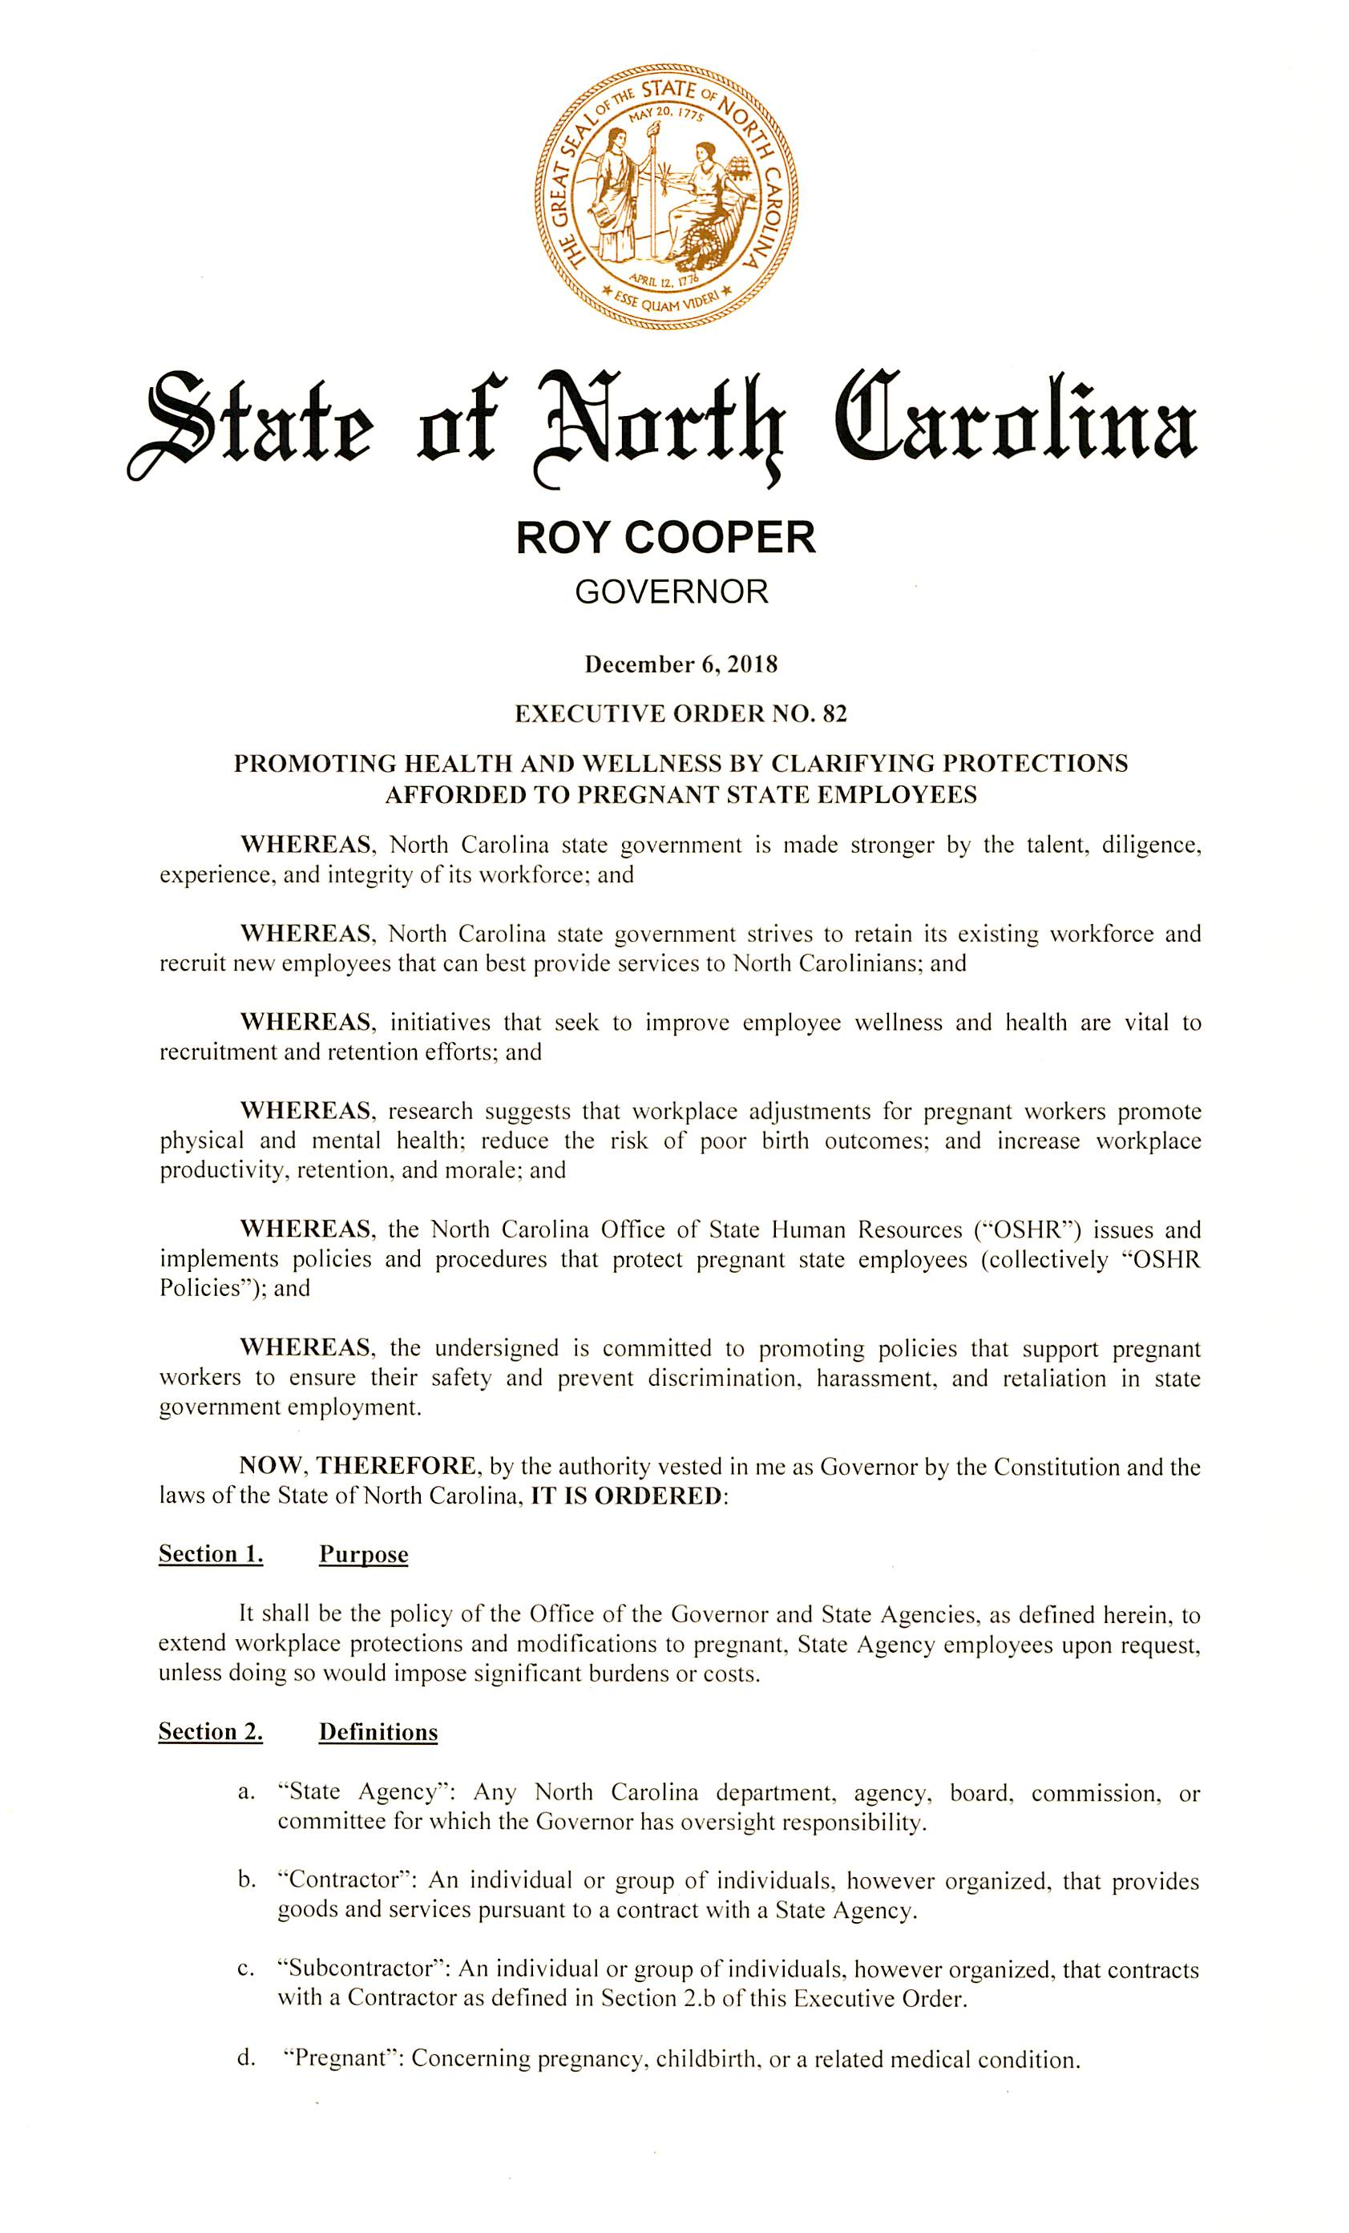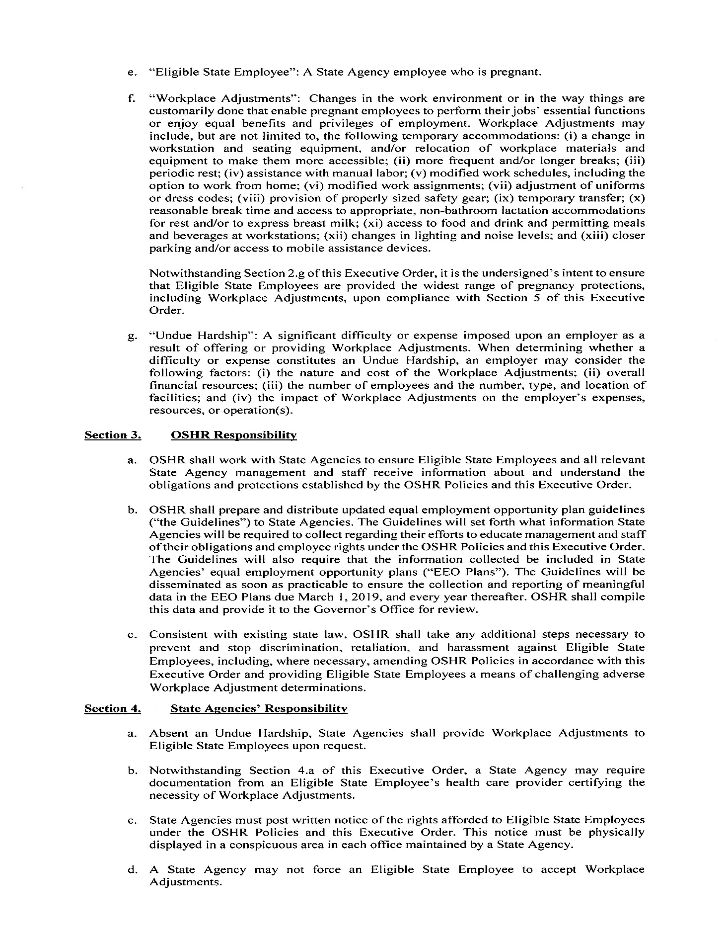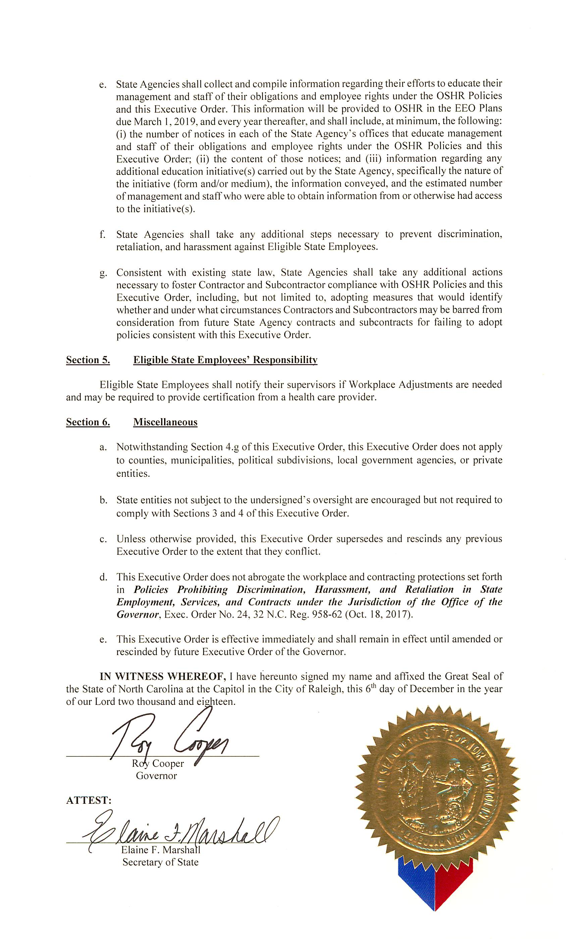
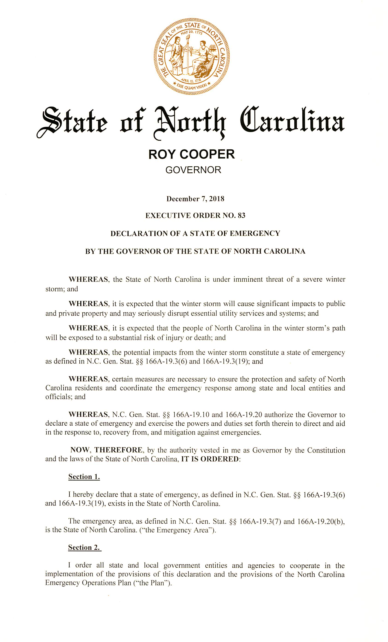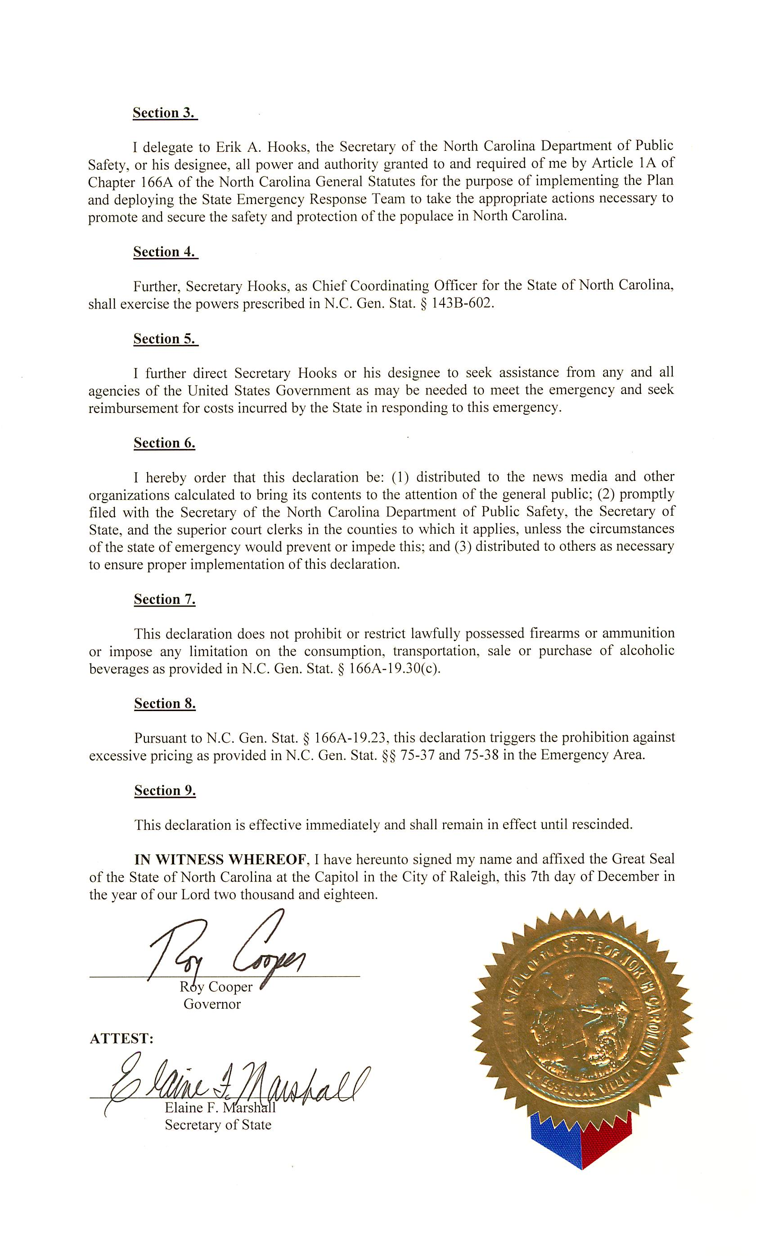
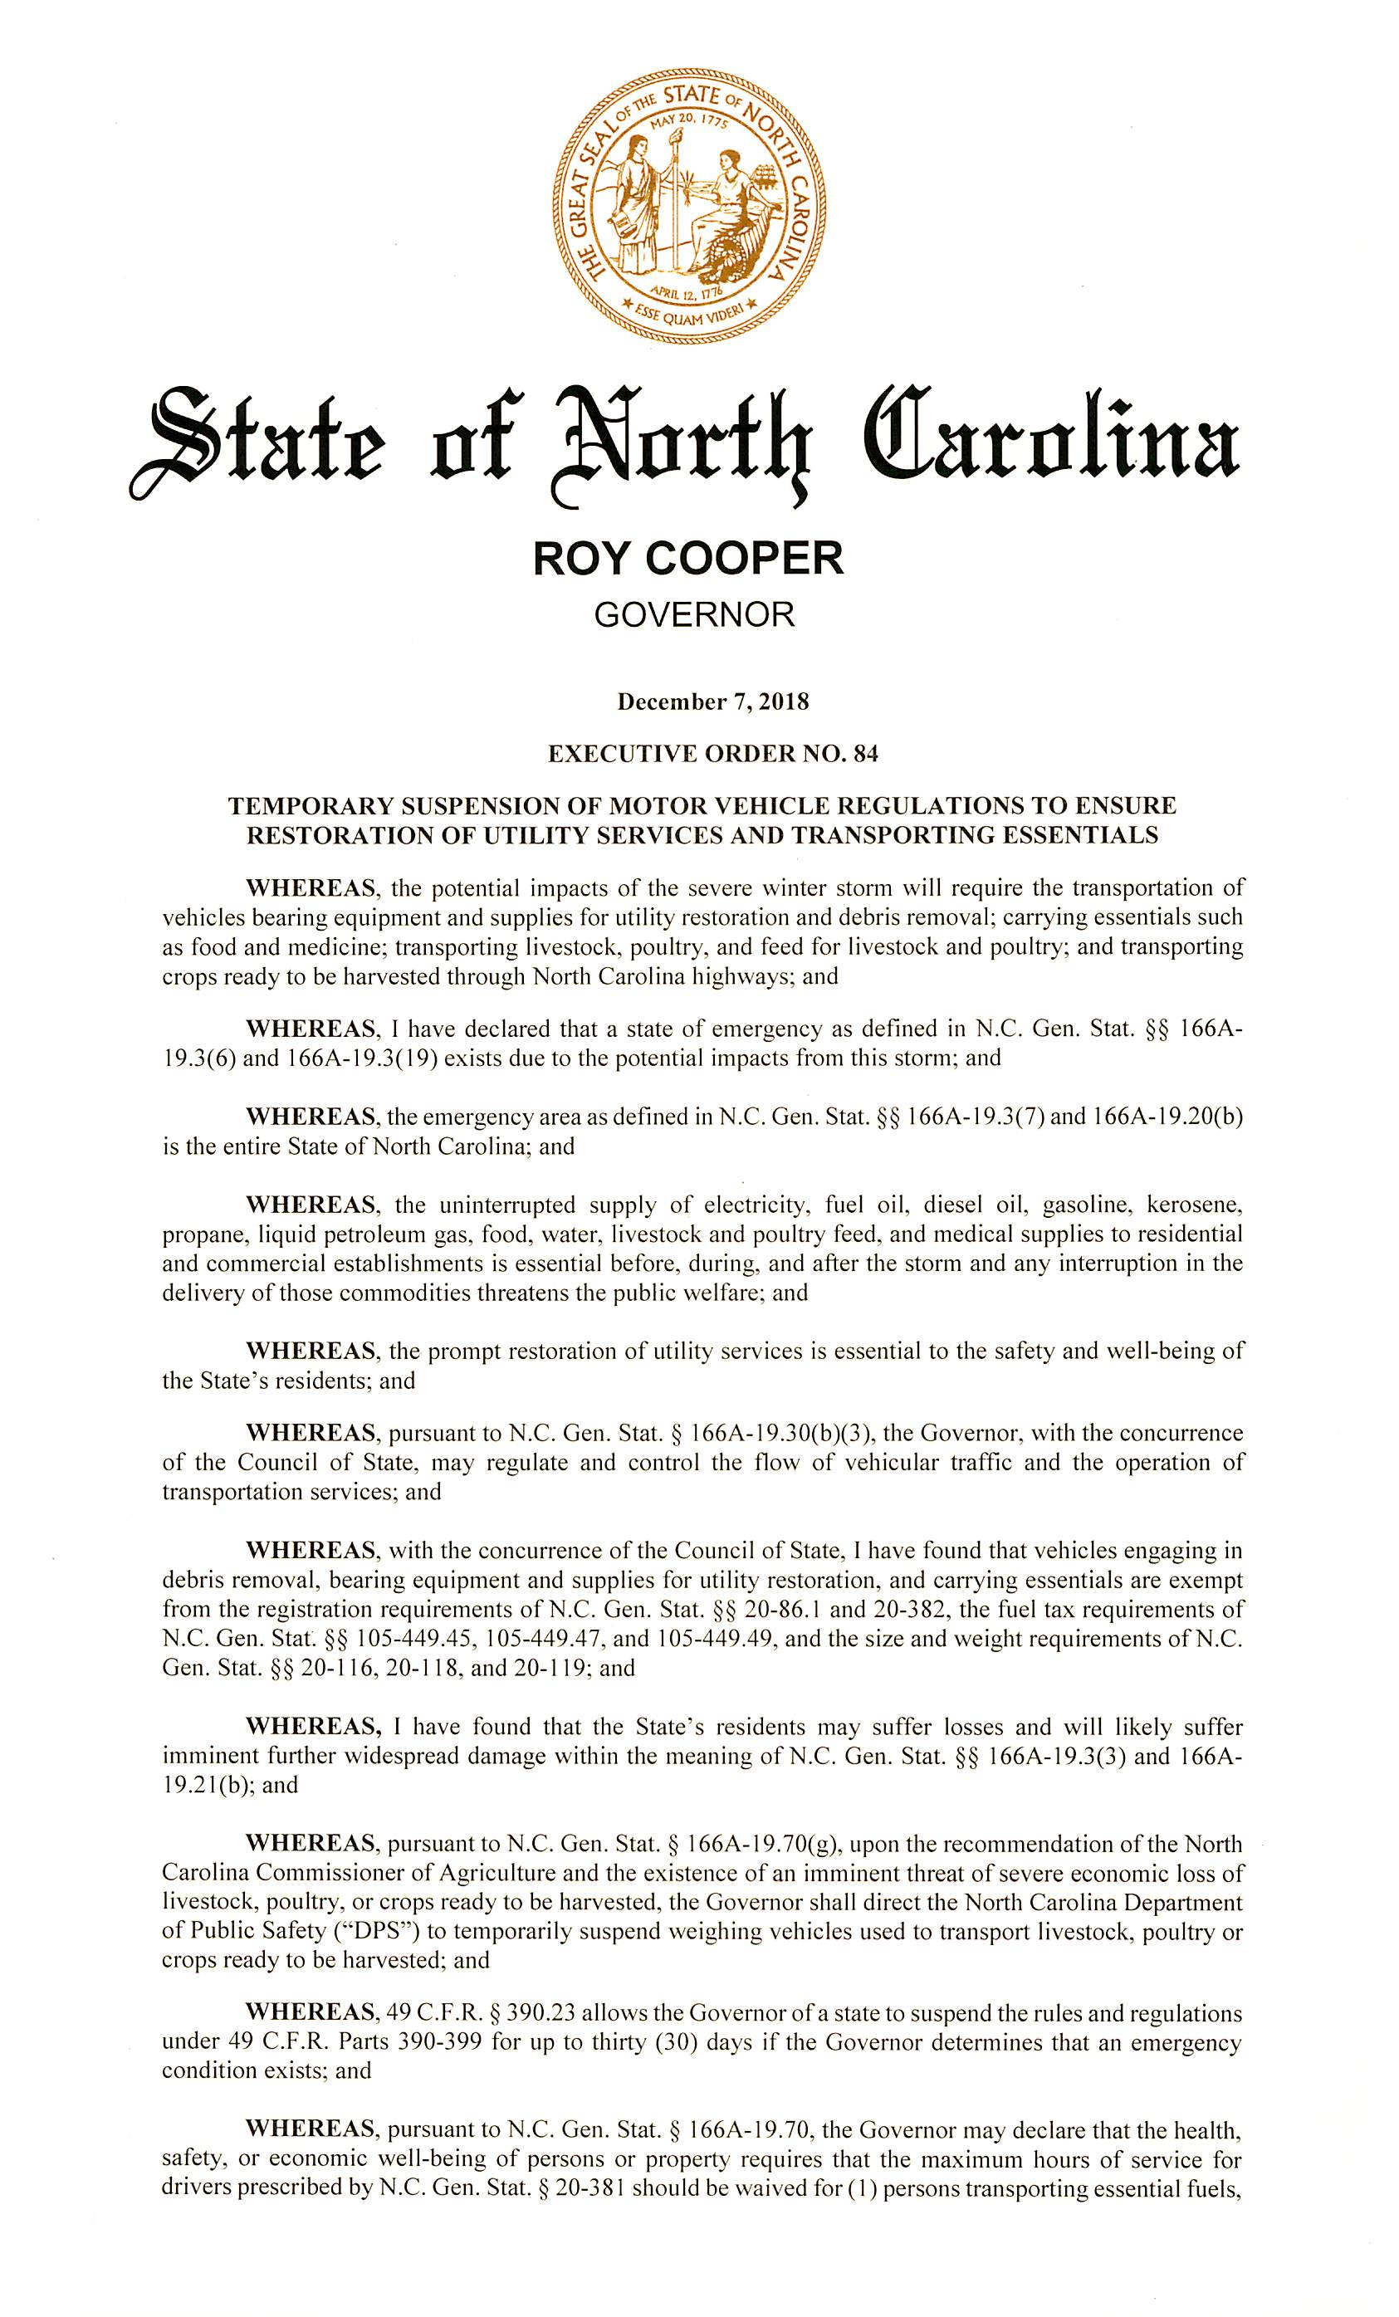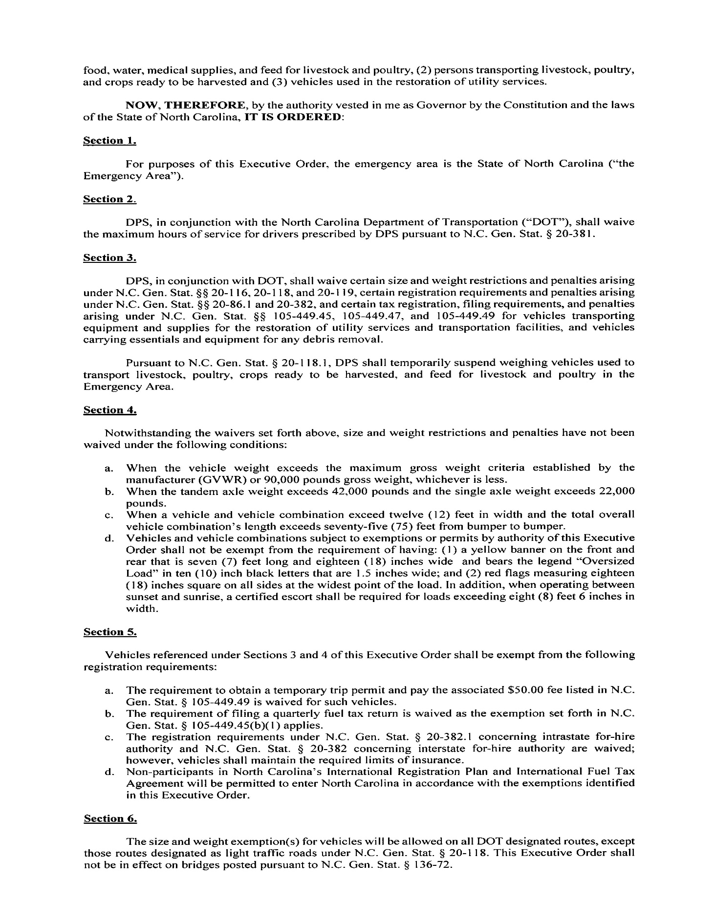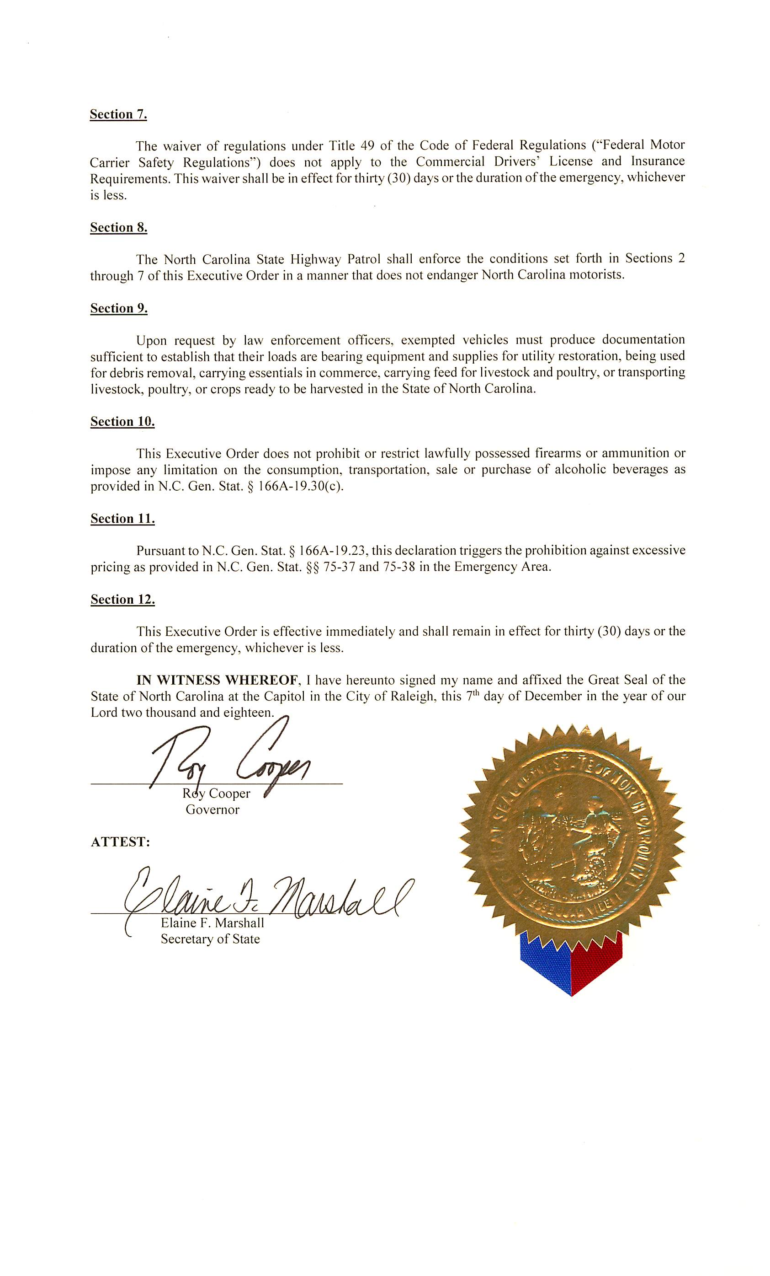

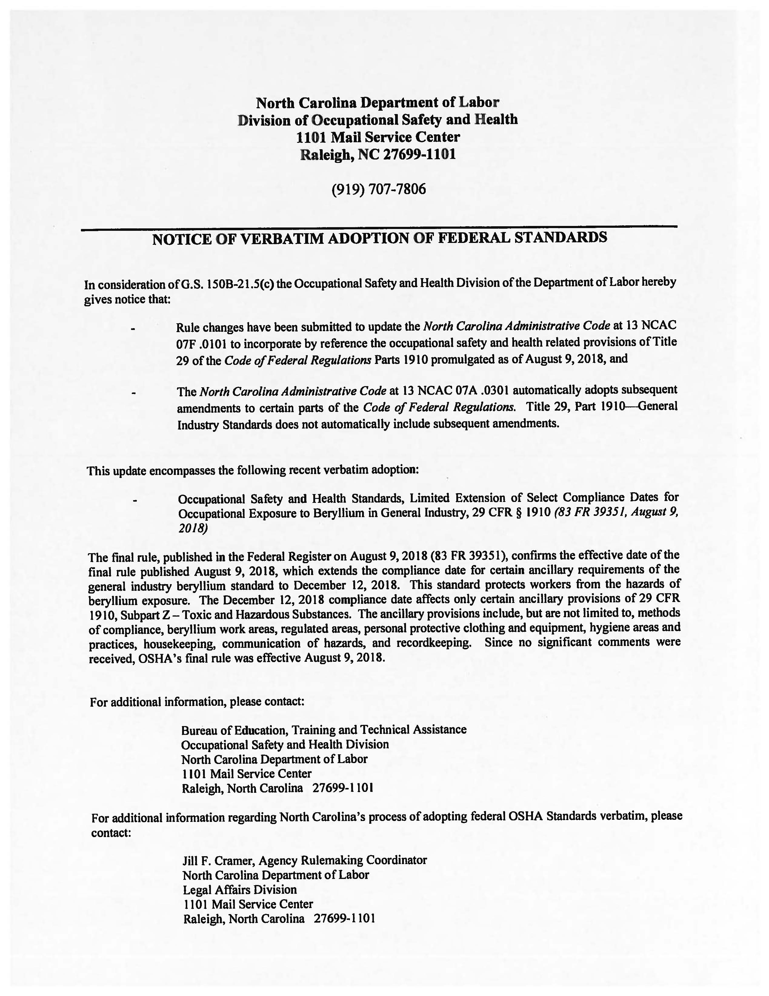
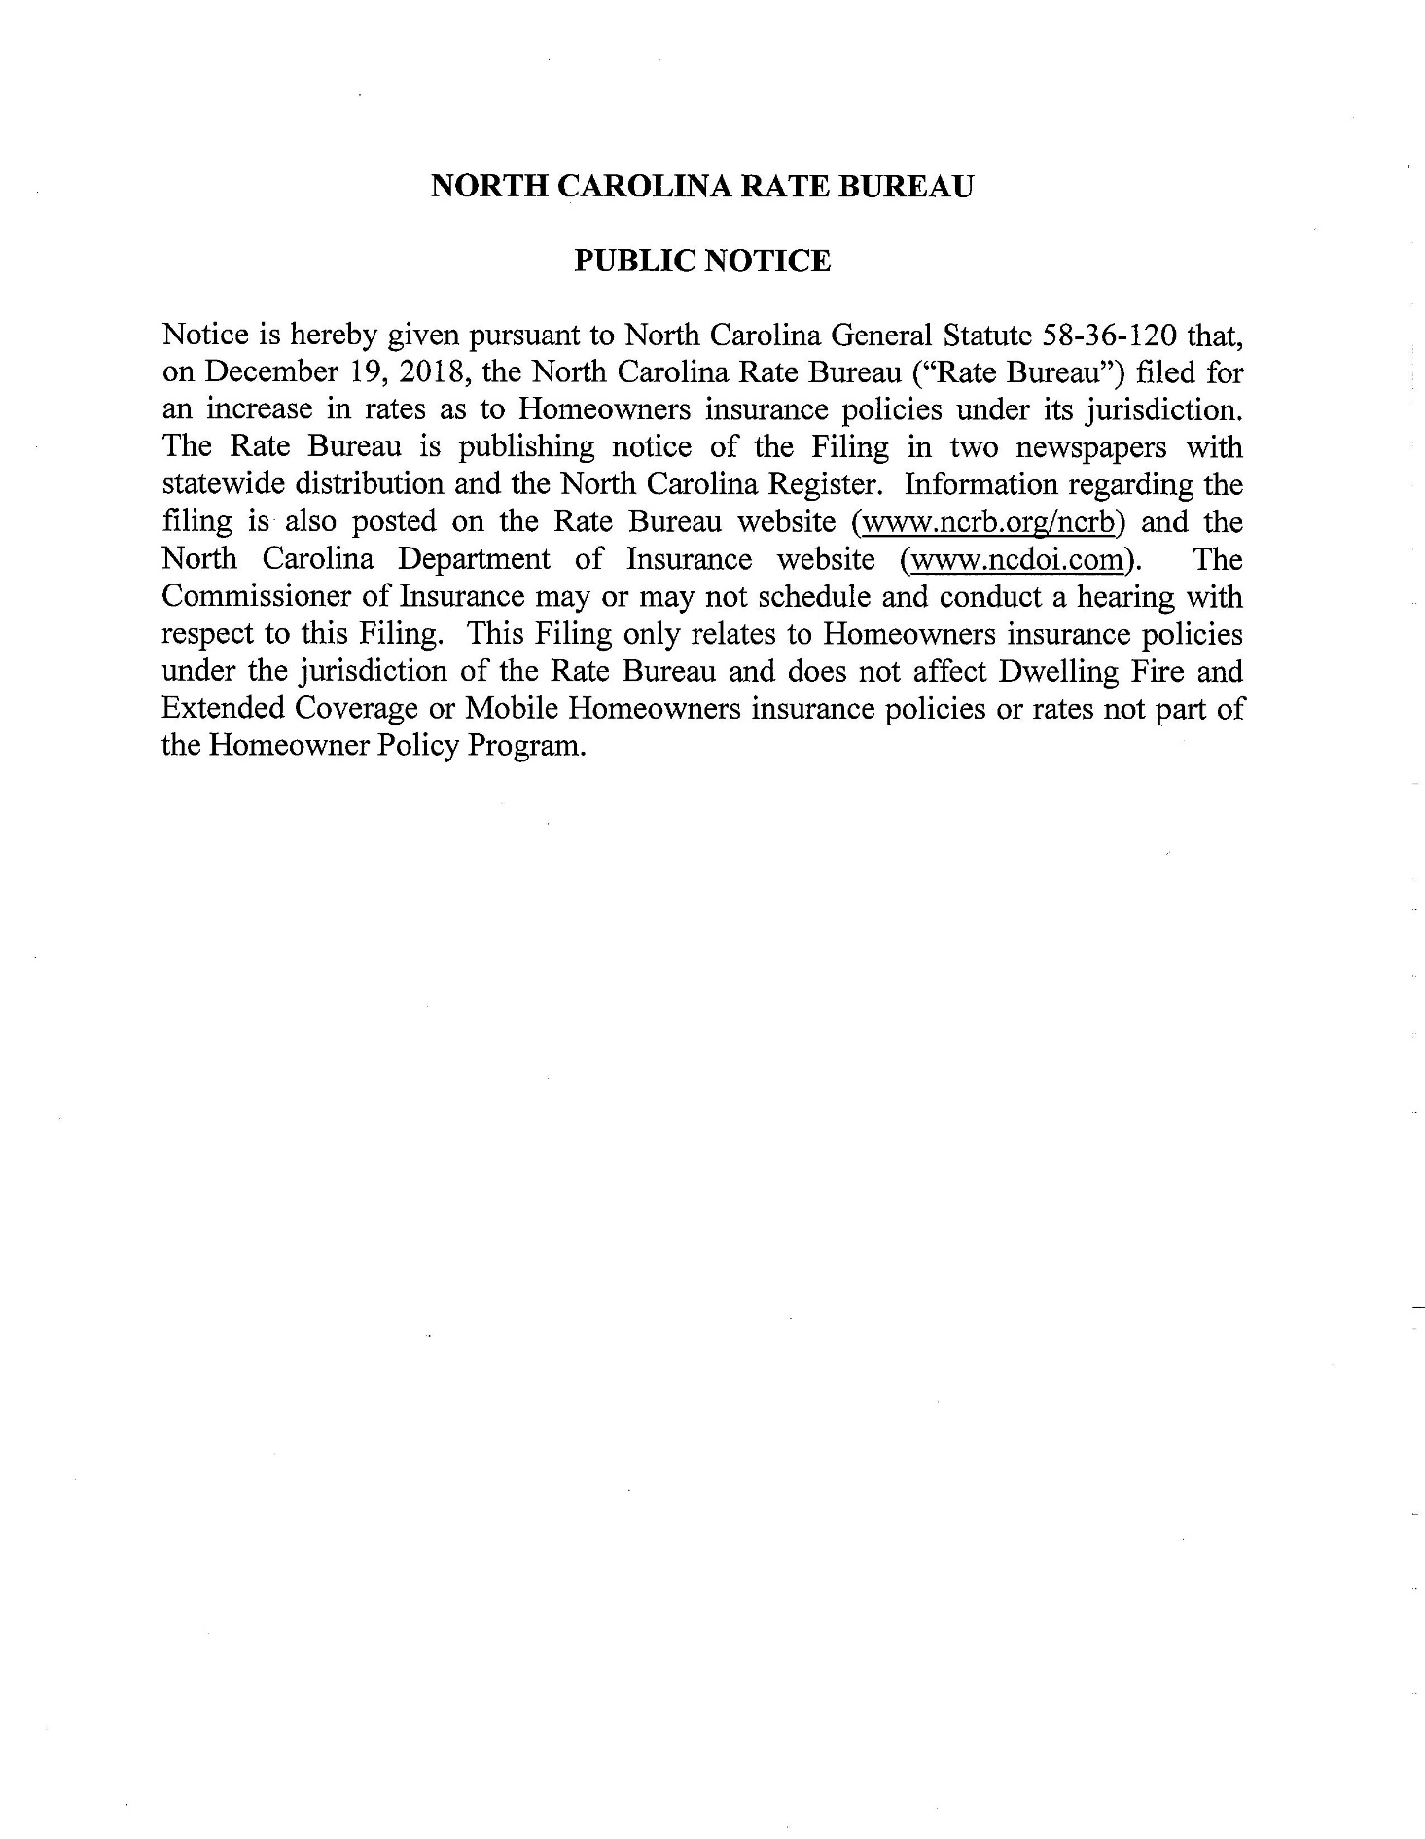

Note from the Codifier: The notices published in this Section of the NC Register include the text of proposed rules. The agency must accept comments on the proposed rule(s) for at least 60 days from the publication date, or until the public hearing, or a later date if specified in the notice by the agency. If the agency adopts a rule that differs substantially from a prior published notice, the agency must publish the text of the proposed different rule and accept comment on the proposed different rule for 60 days.
Statutory reference: G.S. 150B-21.2.

TITLE 14B – DEPARTMENT OF PUBLIC SAFETY

Notice is hereby given in accordance with G.S. 150B-21.2 that the Alarm Systems Licensing Board intends to amend the rule cited as 14B NCAC 17 .0203.

Link to agency website pursuant to G.S. 150B-19.1(c): https://www.ncdps.gov/dps-services/permits-licenses/alarm-system-licensing-board

Proposed Effective Date: May 1, 2019

Public Hearing:

Date: January 30, 2019

Time: 2:00 p.m.

Location: Alarm Systems Licensing Board, 3101 Industrial Dr., Suite 104, Raleigh, NC 27609

Reason for Proposed Action: The Board is fee funded and is not supported by the General Fund of the State of North Carolina. The Board has seen a fund balance decrease of approximately $50,000 in the last year; therefore, it is necessary to increase the licensing fee in order to cover costs. The Board is increasing the licensing application fee from three hundred seventy-five dollars ($375.00) to five hundred dollars ($500.00), an amount allowed pursuant to N.C.G.S. 74D-7. The Board has approximately 400 licenses; therefore, the $125 increase to the licensing fee will result in approximately $50,000 increased revenue.

Comments may be submitted to: Phil Stephenson, Field Services Supervisor, 3101 Industrial Drive, Suite 104, Raleigh, NC 27609, phone (919) 788-5320, fax (919) 715-0370, email Phillip.Stephenson@ncdps.gov

Comment period ends: March 18, 2019

Procedure for Subjecting a Proposed Rule to Legislative Review: If an objection is not resolved prior to the adoption of the rule, a person may also submit written objections to the Rules Review Commission after the adoption of the Rule. If the Rules Review Commission receives written and signed objections after the adoption of the Rule in accordance with G.S. 150B-21.3(b2) from 10 or more persons clearly requesting review by the legislature and the Rules Review Commission approves the rule, the rule will become effective as provided in G.S. 150B-21.3(b1). The Commission will receive written objections until 5:00 p.m. on the day following the day the Commission approves the rule. The Commission will receive those objections by mail, delivery service, hand delivery, or facsimile transmission. If you have any further questions concerning the submission of objections to the Commission, please call a Commission staff attorney at 919-431-3000.

Fiscal impact (check all that apply).

State funds affected

Environmental permitting of DOT affected

Analysis submitted to Board of Transportation

Local funds affected

Substantial economic impact (≥$1,000,000)

Approved by OSBM

No fiscal note required by G.S. 150B-21.4

Chapter 17 - Alarm Systems Licensing Board

SECTION .0200 – PROVISIONS FOR LICENSEES

14b NCAC 17 .0203 FEES FOR LICENSES

(a) Application license fees shall be as follows:

(1) one hundred fifty dollars ($150.00) non-refundable initial application fee;

(2) three hundred seventy-five dollar ($375.00) five hundred dollar ($500.00) biennial fee for a new or renewal license;

(3) one hundred fifty dollars ($150.00) branch office license fee;

(4) one hundred dollars ($100.00) late renewal fee to be paid in addition to the renewal fee if the license has not been renewed on or before the expiration date.

(b) Fees shall be paid as follows:

(1) if the application is submitted by hand delivery, U.S. Mail, or delivery services, payment shall be by check or money order made payable to the Alarm Systems Licensing Board; or

(2) if the application if submitted online, payment shall be by credit card, e-check or other form of electronic funds.

Authority G.S. 74D-7.

TITLE 15A – DEPARTMENT OF ENVIRONMENTAL QUALITY

Notice is hereby given in accordance with G.S. 150B-21.2 that the Coastal Resources Commission intends to amend the rules cited as 15A NCAC 07H .2701, .2704, .2705 and 15A NCAC 07J .0409.

Link to agency website pursuant to G.S. 150B-19.1(c): https://deq.nc.gov/permits-regulations/rules-regulations/proposed-main

Proposed Effective Date: June 1, 2019

Public Hearing:

Date: February 28, 2019

Time: 1:15 p.m.

Location: Carteret County Historical Society Museum, 1008 Arendell Street, Morehead City, NC 28557

Reason for Proposed Action:

15A NCAC 07H .2701, .2704, .2705: Session Law 2018-136 Section 5.13 directs the CRC to adopt rules to revise the Commission's general permit for the construction of riprap sills for wetland enhancement in estuarine and public trust waters in order to make the general permit consistent with the US Army Corps of Engineers regional general permit for living shorelines.

15A NCAC 07J .0409: These amendments address procedural matters, clarifications and inconsistencies with other CRC development rules.

Comments may be submitted to: Braxton Davis, 400 Commerce Avenue, Morehead City, NC 28557

Comment period ends: March 18, 2019

Procedure for Subjecting a Proposed Rule to Legislative Review: If an objection is not resolved prior to the adoption of the rule, a person may also submit written objections to the Rules Review Commission after the adoption of the Rule. If the Rules Review Commission receives written and signed objections after the adoption of the Rule in accordance with G.S. 150B-21.3(b2) from 10 or more persons clearly requesting review by the legislature and the Rules Review Commission approves the rule, the rule will become effective as provided in G.S. 150B-21.3(b1). The Commission will receive written objections until 5:00 p.m. on the day following the day the Commission approves the rule. The Commission will receive those objections by mail, delivery service, hand delivery, or facsimile transmission. If you have any further questions concerning the submission of objections to the Commission, please call a Commission staff attorney at 919-431-3000.

Fiscal impact (check all that apply).

State funds affected 15A NCAC 07H .2701, .2704, .2705

Environmental permitting of DOT affected

Analysis submitted to Board of Transportation

Local funds affected

Substantial economic impact (≥$1,000,000)

Approved by OSBM

No fiscal note required by G.S. 150B-21.4 15A NCAC 07J .0409

Chapter 07 - Coastal Management

SUBCHAPTER 07H - STATE GUIDELINES FOR AREAS OF ENVIRONMENTAL CONCERN

SECTION .2700 – GENERAL PERMIT FOR THE CONSTRUCTION OF RIPRAP SILLS FOR WETLAND ENHANCEMENT IN ESTUARINE AND PUBLIC TRUST WATERS MARSH SILLS
15A NCAC 07H .2701 PURPOSE

A general permit pursuant to this Section shall allow for the construction of riprap marsh sills for wetland enhancement and shoreline stabilization in estuarine and public trust waters as set out in Subchapter 15A NCAC 07J .1100 and according to the rules in this Section. Marsh sills are generally shore-parallel structures built in conjunction with existing, created, or restored wetlands. This general permit shall not apply within the Ocean Hazard System AECs or waters adjacent to these AECs with the exception of those portions of shoreline within the Inlet Hazard Area AEC that feature characteristics of Estuarine Shorelines. Such features include the presence of wetland vegetation, lower wave energy, and lower erosion rates than in the adjoining Ocean Erodible Area.

Authority G.S. 113A-107; 113A-118.1.

15A NCAC 07H .2704 GENERAL CONDITIONS

(a) Structures authorized by a permit issued pursuant to this Section shall be riprap or stone marsh sills conforming to the standards in these Rules.

(b) Individuals shall allow authorized representatives of the Department of Environment and Natural Resources (DENR) Environmental Quality (DEQ) to make periodic inspections at any time deemed necessary in order to insure that the activity being performed under authority of this general permit is in accordance with the terms and conditions prescribed in these Rules.

(c) The placement of riprap or stone marsh sills authorized in these Rules shall not interfere with the established or traditional rights of navigation of the waters by the public.

(d) This permit shall not be applicable to proposed construction where the Department has determined, based on an initial review of the application, that notice and review pursuant to G.S. 113A-119 is necessary because there are unresolved questions concerning the proposed activity's impact on adjoining properties or on water quality, air quality, coastal wetlands, cultural or historic sites, wildlife, fisheries resources, or public trust rights.

(e) This permit does not eliminate the need to obtain any other required state, local, or federal authorization.

(f) Development carried out under this permit shall be consistent with all local requirements, AEC Guidelines as set out in Subchapter 15A NCAC 07H .0200, and local land use plans current at the time of authorization.

Authority G.S. 113A-107; 113A-118.1.

15A NCAC 07H .2705 SPECIFIC CONDITIONS

(a) A general permit issued pursuant to this Section shall be applicable only for the construction of riprap or stone marsh sill structures built in conjunction with existing, created or restored wetlands. Planted wetland vegetation shall consist only of native species.

(b) This general permit shall not apply within the Ocean Hazard System Areas of Environmental Concern (AEC) or waters adjacent to these AECs with the exception of those portions of shoreline within the Inlet Hazard Area AEC that feature characteristics of Estuarine Shorelines. Such features include the presence of wetland vegetation, lower wave energy, and lower erosion rates than in the adjoining Ocean Erodible Area.

(c)(b) On shorelines where no fill is proposed, the The landward edge of the sill shall be positioned no more than 5 greater than 30 feet waterward of the waterward depth contour of locally growing wetlands or to mid-tide depth contour, of the normal high water or normal water level or five feet waterward of the existing wetlands, whichever distance is greater. Where no wetlands exist, in no case shall the landward edge of the sill be positioned greater than 30 feet waterward of the mean high water or normal high water line.

(d) On shorelines where fill is proposed, the landward edge of the sill shall be positioned no more than 30 feet waterward of the existing mean high water or normal high water line.

(e)(c) The permittee shall maintain the authorized sill and existing or planted wetlands including wetlands and tidal inundation in conformance with the terms and conditions of this permit, or the remaining sill structures shall be removed within 90 days of notification from the Division of Coastal Management.

(f)(d) The height of sills shall not exceed six 12 inches above mean normal high water, normal water level, or the height of the adjacent wetland substrate, whichever is greater. higher.

(g)(e) Sill construction authorized by this permit shall be limited to a maximum length of 500 feet.

(h) Sills shall be porous to allow water circulation through the structure.

(i)(f) The sills shall have at least one five-foot drop-down or opening every 100 feet and may be staggered or overlapped or left open as long as the five-foot drop-down or separation between sections is maintained. Overlapping sections shall not overlap more than 10 feet. Deviation from these drop-down opening requirements shall be allowable following coordination with the N.C. Division of Marine Fisheries and the National Marine Fisheries Service. N.C. Division of Coastal Management.

(j)(g) The riprap sill structure shall not exceed a slope of a one foot rise over a two foot horizontal distance and a minimum slope of a one and a half foot rise over a one foot horizontal distance. one and a half foot horizontal distance over a one foot vertical rise. The width of the structure on the bottom shall be no wider than 15 not exceed 12 feet.

(k) For the purpose of protection of public trust rights, fill waterward of the existing mean high water line shall not be placed higher than the mean high water elevation.

(l) The permittee shall not claim title to any lands raised above the mean high or normal water levels as a result of filling or accretion.

(m)(h) For water bodies more narrow narrower than 150 feet, no portion of the structures shall not be positioned offshore more than one sixth (1/6) the width of the waterbody.

(n)(i) The sill shall not be within a navigation channel or associated setbacks marked or maintained by a state or federal agency.

(o)(j) The sill shall not interfere with leases or franchises for shellfish culture.

(p)(k) All structures shall have a minimum setback distance of 15 feet between any parts of the structure and the adjacent property owner's riparian access corridor, unless either a signed waiver statement is obtained from the adjacent property owner or the portion of the structure within 15 feet of the adjacent riparian access corridor is located no more than 25 feet from the mean normal high or normal water level. The riparian access corridor line is determined by drawing a line parallel to the channel, then drawing a line perpendicular to the channel line that intersects with the shore at the point where the upland property line meets the water's edge. edge, as defined in 15A NCAC 07H .1205(t). Additionally, the sill shall not interfere with the exercise of riparians rights by adjacent property owners, including access to navigation channels from piers, or other means of access.

(q) The sill shall not interfere with the exercise of riparian rights by adjacent property owners, including access to navigation channels from piers, or other means of access.

(r)(l) Sills shall be marked at 50-foot intervals with yellow reflectors extending at least three feet above mean normal high water level. or normal water level and must be maintained for the life of the structure.

(s)(m) If the crossing of wetlands with mechanized construction equipment is necessary, temporary construction mats shall be utilized for the areas to be crossed. The temporary mats shall be removed immediately upon completion of the construction of the riprap sill structure. Material used to construct the sill shall not be stockpiled on existing wetlands or in open water unless fully contained in a containment structure supported by construction mats.

(t)(n) Sedimentation and erosion control measures shall be implemented to ensure that eroded materials do not enter adjacent wetlands or waters.

(u)(o) No excavation or filling of any native submerged aquatic vegetation other than that necessary for the construction and proper bedding of the sill structure is authorized by this general permit.

(p) Sills shall not be constructed within any native submerged aquatic vegetation. If submerged aquatic vegetation is present within a project area, a submerged aquatic vegetation survey should be completed during the growing season of April 1 through September 30. All sills shall have a minimum setback of 10 feet from any native submerged aquatic vegetation.

(q) Sills shall not be constructed within any habitat that includes oyster reefs or shell banks. All sills shall have a minimum setback of 10 feet from any oysters, oyster beds, or shell banks.

(v)(r) No excavation of the shallow water bottom or any wetland is authorized by this general permit.

(w) No more than 100 square feet of wetlands may be filled as a result of the authorized activity.

(x) Backfilling of sill structures may be utilized only for the purpose of creating a suitable substrate for the establishment or reestablishment of wetlands. Only clean sand fill material may be utilized.

(y)(s) The riprap sill material shall consist of clean rock rock, marl, oyster shell, or masonry materials such as granite or broken concrete. Concrete or other materials that are approved by the N.C. Division of Coastal Management. Riprap Sill material shall be free of loose sediment or any pollutant. Pollutant, including exposed rebar. The structures sill material shall be of sufficient size and slope to prevent its movement from the site approved alignment by wave or current action.

(z) If one or more contiguous acre of property is to be graded, excavated or filled, an erosion and sedimentation control plan shall be filed with the Division of Energy, Mineral, and Land Resources, or appropriate government having jurisdiction. The plan must be approved prior to commencing the land-disturbing activity.

(aa) In order to ensure that no adverse impacts occur to important fisheries resources, the Division of Marine Fisheries shall review and concur with the location and design of the proposed project prior to the issuance of this general permit.

(bb) Prior to the issuance of this general permit, Division staff shall coordinate with the Department of Administration's State Property Office to determine whether or not an easement shall be required for the proposed activity.

(cc) Following issuance of this general permit, the permittee shall contact the N.C. Division of Water Quality and the U.S. Army Corps of Engineers to determine any additional permit requirements. Any such required permits, or a certification from the appropriate agency(s) that no additional permits are required, shall be obtained and copies provided to the Division of Coastal Management prior to the initiation of any development activities authorized by this permit.

Authority G.S. 113A-107; 113A-118.1.

SUBCHAPTER 07J - PROCEDURES FOR PROCESSING AND ENFORCEMENT OF MAJOR AND MINOR DEVELOPMENT PERMITS, VARIANCE REQUESTS, APPEALS FROM PERMIT DECISIONS, DECLARATORY RULINGS, AND STATIC LINE EXCEPTIONS

SECTION .0400 - FINAL APPROVAL AND ENFORCEMENT

15A NCAC 07J .0409 CIVIL PENALTIES

(a) Purpose and Scope. These Rules provide the procedures and standards governing the assessment, remission, settlement and appeal of civil penalties assessed by the Coastal Resources Commission and the Director pursuant to G.S. 113A-126(d).

(b) Definitions. The terms used herein shall be as defined in G.S. 113A-103 and as follows:

(1) "Act" means the Coastal Area Management Act of 1974, G.S. 113A-100 through 134, plus amendments.

(2) "Delegate" means the Director or other employees of the Division of Coastal Management, or local permit officers to whom the Commission has delegated authority to act in its stead pursuant to this Rule.

(3) "Director" means the Director, Division of Coastal Management.

(4) "Respondent" means the person to whom a notice of violation has been issued or against whom a penalty has been assessed.

(5) "Person" is defined in the Coastal Area Management Act, G.S. 113A-103(9).

(c) Civil penalties may be assessed against any person who commits a violation as provided for in G.S. 113A-126(d)(1) and (2).

(d) Investigative costs. Pursuant to G.S. 113A-126(d)(4a) the Commission or Director may also assess a respondent for the costs incurred by the Division for investigation, inspection, and monitoring associated with assessment the civil penalty. Investigative costs shall be in addition to any civil penalty assessed. For a minor development violation, investigative costs shall not exceed one-half of the amount of the civil penalty assessed or one thousand dollars ($1,000), whichever is less. For a major development violation, investigative costs shall not exceed one-half of the amount of the civil penalty assessed or two thousand five hundred dollars ($2,500), whichever is less. The Division shall determine the amount of investigative costs to assess based upon factors including the amount of staff time required for site visits, investigation, enforcement action, interagency coordination, and for monitoring restoration of the site.

(e) Notice of Violation. The Commission hereby authorizes employees of the Division of Coastal Management to issue in the name of the Commission notices of violation to any person engaged in an activity which constitutes a violation for which a civil penalty may be assessed. Such notices shall set forth the nature of the alleged violation, shall order that the illegal activity be ceased and affected resources be restored in accordance with 15A NCAC 07J .0410. Rule .0410 of this Section. The notice shall specify the time by which the restoration shall be completed as ordered by the Division. The notice shall be delivered personally or by registered or certified mail, return receipt requested.

(f) Civil Penalty Assessment.

(1) The Commission hereby delegates to the Director the authority to assess civil penalties according to the procedures set forth in Paragraph (g) of this Rule.

(2) The Director shall If restoration of affected resources is not required, the Director may issue a notice of assessment within 30 90 days from the date of the Notice of Violation. If restoration of affected resources is required, the Director may issue a Notice of Assessment within 60 days after the Division determines that restoration of the adversely impacted resources is complete. complete or due date of restoration completion.

(3) The notice of assessment shall specify the reason for assessment, how the assessment was calculated, when and where payment shall be made, and shall inform the respondent of the right to appeal the assessment by filing a petition for a contested case hearing with the Office of Administrative Hearings pursuant to G.S. 150B-23. The notice shall be delivered personally or by registered or certified mail, return receipt requested.

(g) Amount of Assessment.

(1) Civil penalties shall not exceed the maximum amounts established by G.S. 113A-126(d).

(2) If any respondent willfully continues to violate by action or inaction any rule or order of the Commission after the date specified in a notice of violation, each day the violation continues or is repeated shall be considered a separate violation as provided in G.S. 113A-126(d)(2).

(3) In determining the amount of the penalty, the Commission or Director shall consider the factors contained in G.S. 113A-126(d)(4).

(4) Pursuant to Subparagraph (g)(3) of this Rule, (3) of this Paragraph, penalties for major development violations, including violations of permit conditions, shall be assessed in accordance with the following criteria.
(A) Major development which could have been permitted under the Commission's rules at the time the notice of violation is issued shall be assessed a penalty equal to two times the relevant CAMA permit application fee, plus investigative costs.
(B) Major development which could not have been permitted under the Commission's rules at the time the notice of violation is issued shall be assessed an amount equal to the relevant CAMA permit application fee, plus a penalty pursuant to Schedule A of this Rule, plus investigative costs. If a violation affects more than one area of environmental concern (AEC) or coastal resource as listed within Schedule A of this Rule, the penalties for each affected AEC shall be combined. Any structure or part of a structure that is constructed in violation of existing Commission rules shall be removed or modified as necessary to bring the structure into compliance with the Commission's rules.

SCHEDULE A
Major Development Violations

Size of Violation (sq. ft.)

AREA OF ENVIRONMENTAL CONCERN AFFECTED | ≤ 100 | 101-  500 | 501-  1,000 | 1001-  3000 | 3001-  5000 | 5001-  8000 | 8001-  11,000 | 11,001-  15,000 | 15,001-  20,000 | 20,001-  25,000 |  | >25,000
ESTUARINE WATERS OR PUBLIC TRUST AREAS (1) | $250 | $375 | $500 | $1,500 | $2,000 | $3,500 | $5,000 | $7,000 | $9,000 | $10,000 |  | $10,000
Primary Nursery  Areas | $100 | $225 | $350 | $850 | $1,350 | $2,850 | $4,350 | $3,000 | $1,000 | n/a |  | n/a
Mudflats and Shell  Bottom | $100 | $225 | $350 | $850 | $1,350 | $2,850 | $4,350 | $3,000 | $1,000 | n/a |  | n/a
Submerged Aquatic  Vegetation | $100 | $225 | $350 | $850 | $1,350 | $2,850 | $4,350 | $3,000 | $1,000 | n/a |  | n/a
COASTAL WETLANDS | $250 | $375 | $500 | $1,500 | $2,000 | $3,500 | $5,000 | $7,000 | $9,000 | $10,000 |  | $10,000
COASTAL SHORELINES | $250 | $350 | $450 | $850 | $1,250 | $2,450 | $3,650 | $5,250 | $7,250 | $9,250 | $10,000
Wetlands (2) | $100 | $200 | $300 | $700 | $1,100 | $2,300 | $3,500 | $4,750 | $2,750 | $750 | n/a
ORW- Adjacent  Areas | $100 | $200 | $300 | $700 | $1,100 | $2,300 | $3,500 | $4,750 | $2,750 | $750 | n/a
OCEAN HAZARD SYSTEM (3)(4) | $250 | $350 | $450 | $850 | $1,250 | $2,450 | $3,650 | $5,250 | $7,250 | $9,250 | $10,000
Primary or Frontal  Dune | $100 | $200 | $300 | $700 | $1,100 | $2,300 | $3,500 | $4,750 | $2,750 | $750 | n/a
PUBLIC WATER SUPPLIES (5) | $250 | $350 | $450 | $850 | $1,250 | $2,450 | $3,650 | $5,250 | $7,250 | $9,250 | $10,000
NATURAL AND CULTURAL RESOURCE AREAS (6) | $250 | $350 | $450 | $850 | $1,250 | $2,450 | $3,650 | $5,250 | $7,250 | $9,250 | $10,000

(1) Includes the Atlantic Ocean from the normal high water mark to three miles offshore.

(2) Wetlands that are jurisdictional by the Federal Clean Water Act.

(3) If the AEC physically overlaps another AEC, use the greater penalty schedule.

(4) Includes the Ocean Erodible, High Hazard Flood Area, Inlet Hazard Area, and Unvegetated Beach Area.

(5) Includes Small Surface Water Supply, Watershed and Public Water Supply Well Fields.

(6) Includes Coastal Complex Natural Areas, Coastal Areas Sustaining Remnant Species, Unique Geological Formations, Significant Coastal Archaeological Resources, and Significant Coastal Historical Architectural Resources.
(C) Assessments for violations by public agencies (i.e. towns, counties and state agencies) shall be determined in accordance with Parts (g)(4)(A) and (B) of this Rule.
(D) Willful and intentional violations. The penalty assessed under Parts (g)(4)(A) and (B) of this Rule shall be doubled for willful and intentional violations except that the doubled penalties assessed under this Subparagraph shall not exceed ten thousand dollars ($10,000) or be less than two thousand dollars ($2,000) for each separate violation. A violation shall be considered to be willful and intentional when:
(i) The person received written instructions from one of the Commission's delegates that a permit would be required for the development and subsequently undertook development without a permit; or
(ii) The person received written instructions from one of the Commission's delegates that the proposed development was not permissible under the Commission's rules, or received denial of a permit application for the proposed activity, and subsequently undertook the development without a permit; or
(iii) The person committed previous violations of the Commission's rules; or
(iv) The person refused or failed to restore a damaged area as ordered by one of the Commission's delegates. If necessary, the Commission or Division shall seek a court order to require restoration.
(E) Assessments against contractors. Any contractor or subcontractor or person or group functioning as a contractor shall be subject to a notice of violation and assessment of a civil penalty in accordance with Paragraph (f) of this Rule. Such penalty shall be in addition to that assessed against the landowner. When a penalty is being doubled pursuant to Part (g)(4)(D) Part (D) of this Subparagraph and the element of willfulness is present only on the part of the contractor, the landowner shall be assessed the standard penalty and the contractor shall be assessed the doubled penalty.
(F) Continuing violations.
(i) Pursuant to G.S. 113A-126(d)(2), each day that the violation continues after the date specified in the notice of violation for the unauthorized activity to cease or restoration to be completed shall be considered a separate violation and shall be assessed an additional penalty.
(ii) Refusal or failure to restore a damaged area as ordered shall be considered a continuing violation and shall be assessed an additional penalty. When resources continue to be affected by the violation, the amount of the penalty shall be determined according to Part (g)(4)(B) of this Rule. Part (B) of this Subparagraph. The continuing penalty period shall be calculated from the date specified in the notice of violation for the unauthorized activity to cease or restoration to be completed and run until:
(I) the Division's order is satisfied, or
(II) the respondent enters into good faith negotiations with the Division, or
(III) the respondent contests the Division's order in a judicial proceeding by raising a justiciable issue of law or fact therein.
The continuing penalty period shall resume if the respondent terminates negotiations without reaching an agreement with the Division, fails to comply with court ordered restoration, or fails to meet a deadline for restoration that was negotiated with the Division.

(5) Pursuant to Subparagraph (g)(3) of this Rule, civil penalties for minor development violations, including violations of permit conditions, shall be assessed in accordance with the following criteria:
(A) Minor development which could have been permitted under the Commission's rules at the time the notice of violation is issued shall be assessed a penalty equal to two times the relevant CAMA permit application fee, plus investigative costs.
(B) Minor development which could not have been permitted under the Commission's rules at the time the notice of violation is issued shall be assessed an amount equal to the relevant CAMA permit application fee, plus a penalty pursuant to Schedule B of this Rule, plus investigative costs. If a violation affects more than one area of environmental concern (AEC) or coastal resource as listed within Schedule B of this Rule, the penalties for each affected AEC shall be combined. Any structure or part of a structure that is constructed in violation of existing Commission rules shall be removed or modified as necessary to bring the structure into compliance with the Commission's rules.

SCHEDULE B
Minor Development Violations

Size of Violation (sq. ft.)
AREA OF ENVIRONMENTAL CONCERN AFFECTED |  | ≤ 100 | 101- 500 | 501- 1,000 | 1001- 3000 | 3001-5000 | 5001-8000 | 8001-11,000 | 11,001-15,000 | 15,001-20,000 | 20,001-25,000 | >25,000
COASTAL SHORELINES |  | $225 | $250 | $275 | $325 | $375 | $450 | $525 | $625 | $750 | $875 | $1,000
 | ORW- Adjacent Areas | $125 | $150 | $175 | $225 | $275 | $350 | $425 | $375 | $250 | $125 | n/a
OCEAN HAZARD SYSTEM (1)(2) |  | $225 | $250 | $275 | $325 | $375 | $450 | $525 | $625 | $750 | $875 | $1,000
Primary or Frontal Dune |  | $125 | $150 | $175 | $225 | $275 | $350 | $425 | $375 | $250 | $125 | n/a
PUBLIC WATER SUPPLIES (3) |  | $225 | $250 | $275 | $325 | $375 | $450 | $525 | $625 | $750 | $875 | $1,000
NATURAL AND CULTURAL RESOURCE AREAS (4) |  | $225 | $250 | $275 | $325 | $375 | $450 | $525 | $625 | $750 | $875 | $1,000

(1) Includes the Ocean Erodible, High Hazard Flood Area, Inlet Hazard Area, and Unvegetated Beach Area.

(2) If the AEC physically overlaps another AEC, use the greater penalty schedule.

(3) Includes Small Surface Water Supply, Watershed and Public Water Supply Well Fields.

(4) Includes Coastal Complex Natural Areas, Coastal Areas Sustaining Remnant Species, Unique Geological Formations, Significant Coastal Archaeological Resources, and Significant Coastal Historical Architectural Resources.
(C) Violations by public agencies (e.g. towns, counties and state agencies) shall be handled by the local permit officer or one of the Commission's delegates within their respective jurisdictions except that in no case shall a local permit officer handle a violation committed by the local government they represent. Penalties shall be assessed in accordance with Parts (g)(5)(A) and (B) of this Rule. (A) and (B) of this Subparagraph.
(D) Willful and intentional violations. The penalty assessed under Parts (g)(5)(A) and (B) of this Rule (A) and (B) of this Subparagraph shall be doubled for willful and intentional violations except that the doubled penalties assessed under this Subparagraph shall not exceed one thousand dollars ($1,000.00) for each separate violation. A violation shall be considered to be willful and intentional when:
(i) The person received written instructions from the local permit officer or one of the Commission's delegates that a permit would be required for the development and subsequently undertook development without a permit; or
(ii) The person received written instructions from the local permit officer or one of the Commission's delegates that the proposed development was not permissible under the Commission's rules, or received denial of a permit application for the proposed activity, and subsequently undertook the development without a permit; or
(iii) The person committed previous violations of the Commission's rules; or
(iv) The person refused or failed to restore a damaged area as ordered by the local permit officer or one of the Commission's delegates. If necessary, a court order shall be sought to require restoration.
(E) Assessments against contractors. Any contractor or subcontractor or person or group functioning as a contractor shall be subject to a notice of violation and assessment of a civil penalty in accordance with Paragraph (f) of this Rule. Such penalty shall be in addition to that assessed against the landowner. When a penalty is being doubled pursuant to Part (g)(5)(D) (D) of this Subparagraph and the element of willfulness is present only on the part of the contractor, the landowner shall be assessed the standard penalty and the contractor shall be assessed the doubled penalty.
(F) Continuing violations.
(i) Pursuant to G.S. 113A-126(d)(2), each day that the violation continues after the date specified in the notice of violation for the unauthorized activity to cease and restoration to be completed shall be considered a separate violation and shall be assessed an additional penalty.
(ii) Refusal or failure to restore a damaged area as ordered shall be considered a continuing violation and shall be assessed an additional penalty. The amount of the penalty shall be determined according to Part (g)(5)(B) of this Rule. (B) of this Subparagraph. The continuing penalty period shall be calculated from the date specified in the notice of violation for the unauthorized activity to cease and restoration to be completed and run until:
(I) the Commission delegate's order is satisfied, or
(II) the respondent enters into good faith negotiations with the local permit officer or the Division, or
(III) the respondent contests the local permit officer's or the Division's order in a judicial proceeding by raising a justiciable issue of law or fact therein.
The continuing penalty period shall resume if the respondent terminates negotiations without reaching an agreement with the local permit officer or the Division, fails to comply with court ordered restoration, or fails to meet a deadline for restoration that was negotiated with the local permit officer or the Division.

(h) Hearings and Final Assessment. Final decisions in contested case hearings concerning assessments shall be made by the Commission. The final decision shall be based on evidence in the official record of the contested case hearing, the administrative law judge's recommended decision, any exceptions filed by the parties and oral arguments. Oral arguments shall be limited to the facts in the official record.

(i) Referral. If any civil penalty as finally assessed is not paid, the Director on behalf of the Commission shall request the Attorney General to commence an action to recover the amount of the assessment.

(j) Reports to the Commission. Action taken by the Director shall be reported to the Commission at the next meeting. Such reports shall include information on the following:

(1) respondent(s) against whom penalties have been assessed;

(2) respondent(s) who have paid a penalty, requested remission, or requested an administrative hearing;

(3) respondent(s) who have failed to pay; and

(4) cases referred to the Attorney General for collection.

(k) Settlements. The Commission hereby delegates to the Director the authority to enter into a settlement of a civil penalty appeal at any time prior to decision in an administrative contested case hearing. Such settlements shall not require the approval of the Commission and shall not be considered a final Commission decision for purposes of G.S. 113A-123.

(l) Any settlement agreement proposed subsequent to a final Commission decision in the contested case shall be submitted to the Commission for approval.

Authority G.S. 113A-124; 113A-126(d).

TITLE 20 – department of state treasurer

Notice is hereby given in accordance with G.S. 150B-21.2 that the Supplemental Retirement Board of Trustees and the Department of State Treasurer intends to adopt the rules cited as 20 NCAC 11 .0101 and .0102.

Link to agency website pursuant to G.S. 150B-19.1(c): https://www.nctreasurer.com/inside-the-department/opengovernment/proposed-rules/pages/default.aspx

Proposed Effective Date: June 1, 2019

Instructions on How to Demand a Public Hearing: (must be requested in writing within 15 days of notice): Any person may request a public hearing on the proposed rules by submitting a request in writing no later than January 30, 2019 to Laura Rowe, Rulemaking Coordinator, Department of State Treasurer, 3200 Atlantic Avenue, Raleigh, NC 27604.

Reason for Proposed Action: The Supplemental Retirement Board and the Department of State Treasurer do not receive any appropriations to operate the NC 401(k) Plan, the NC 457 Plan, or the NC 403(b) Program. Instead, to the knowledge of the Department, the operational expenses of the Board and the Department have historically been funded through an administrative fee charged to participants who opt to enroll in the Supplemental Retirement Plans. The Board and the Department will use the administrative fee receipts to fund the administration of the Plans, including Departmental personnel costs and investment consulting and auditing fees.

Comments may be submitted to: Laura Rowe, 3200 Atlantic Avenue, Raleigh, NC 27604, email dst.ncac@nctreasurer.com

Comment period ends: March 18, 2019

Procedure for Subjecting a Proposed Rule to Legislative Review: If an objection is not resolved prior to the adoption of the rule, a person may also submit written objections to the Rules Review Commission after the adoption of the Rule. If the Rules Review Commission receives written and signed objections after the adoption of the Rule in accordance with G.S. 150B-21.3(b2) from 10 or more persons clearly requesting review by the legislature and the Rules Review Commission approves the rule, the rule will become effective as provided in G.S. 150B-21.3(b1). The Commission will receive written objections until 5:00 p.m. on the day following the day the Commission approves the rule. The Commission will receive those objections by mail, delivery service, hand delivery, or facsimile transmission. If you have any further questions concerning the submission of objections to the Commission, please call a Commission staff attorney at 919-431-3000.

Fiscal impact (check all that apply).

State funds affected

Environmental permitting of DOT affected

Analysis submitted to Board of Transportation

Local funds affected

Substantial economic impact (≥$1,000,000)

Approved by OSBM

No fiscal note required by G.S. 150B-21.4

CHAPTER 11 – SUPPLEMENTAL RETIREMENT PLANS

SECTION .0100 – ADMINISTRATIVE FEES

20 NCAC 11 .0101 ADMINISTRATIVE FEES: NC 401(K) AND NC 457 PLANS

(a) The Board and the Department shall charge an administrative fee at an annual rate of 0.025 percent of the assets in each account in the Supplemental Retirement Income Plan of North Carolina and in each account in the North Carolina Public Employee Deferred Compensation Plan.

(b) The Board and the Department may waive the administrative fee in Paragraph (a) of this Rule for a period of up to 12 months based upon the following factors:

(1) The balance of the administrative expense account for the plans;

(2) Department projections of future expenses to administer the plans; and

(3) Department projections of future receipts available for the administration of the plans.

(c) The Board and the Department shall provide notice of a fee waiver on the plans' website and on participants' quarterly statements.

Authority G.S. 135-91(e); 143B-426.24(h2).

20 NCAC 11 .0102 ADMINISTRATIVE FEES: NC 403(B) PROGRAM

(a) The Board and the Department shall charge an administrative fee at an annual rate of 0.050 percent of the assets in each account in the North Carolina Public School Teachers' and Professional Educators' Investment Plan.

(b) The Board may waive the administrative fee in Paragraph (a) of this Rule for a period of up to 12 months based upon the following factors:

(1) The balance of the administrative expense account for the plan;

(2) Department projections of future expenses to administer the plan; and

(3) Department projections of future receipts available for the administration of the plan.

(c) The Board and the Department shall provide notice of a fee waiver on the plan's website and on participants' quarterly statements.

Authority G.S. 115C-341.2(c).

TITLE 21 – occupational licensing boards and commissions

chapter 08 – board of certified public accountant examiners

Notice is hereby given in accordance with G.S. 150B-21.2 that the Board of Certified Public Accountant Examiners intends to amend the rule cited as 21 NCAC 08F .0105.

Link to agency website pursuant to G.S. 150B-19.1(c): www.nccpaboard.gov

Proposed Effective Date: January 1, 2020

Public Hearing:

Date: February 18, 2019

Time: 10:00 a.m.

Location: NC State Board of CPA Examiners, 1101 Oberlin Road, Suite 104, Raleigh, NC 27605

Reason for Proposed Action: 21 NCAC 08F .0105 explains how many times a Uniform CPA Examination (Exam) candidate can take the same section of the Exam. The Exam vendor is changing when an Exam candidate may retake the same section of the Uniform CPA Examination.

Comments may be submitted to: Robert N. Brooks, NC State Board of CPA Examiners, 1101 Oberlin Road, Suite 104, Raleigh, NC 27605; phone (919) 733-1425; fax (919) 733-4209; email rbrooks@nccpaboard.gov

Comment period ends: March 18, 2019

Procedure for Subjecting a Proposed Rule to Legislative Review: If an objection is not resolved prior to the adoption of the rule, a person may also submit written objections to the Rules Review Commission after the adoption of the Rule. If the Rules Review Commission receives written and signed objections after the adoption of the Rule in accordance with G.S. 150B-21.3(b2) from 10 or more persons clearly requesting review by the legislature and the Rules Review Commission approves the rule, the rule will become effective as provided in G.S. 150B-21.3(b1). The Commission will receive written objections until 5:00 p.m. on the day following the day the Commission approves the rule. The Commission will receive those objections by mail, delivery service, hand delivery, or facsimile transmission. If you have any further questions concerning the submission of objections to the Commission, please call a Commission staff attorney at 919-431-3000.

Fiscal impact (check all that apply).

State funds affected

Environmental permitting of DOT affected

Analysis submitted to Board of Transportation

Local funds affected

Substantial economic impact (≥$1,000,000)

Approved by OSBM

No fiscal note required by G.S. 150B-21.4

SUBCHAPTER 08F - REQUIREMENTS FOR CERTIFIED PUBLIC ACCOUNTANT EXAMINATION AND CERTIFICATE APPLICANTS

SECTION .0100 - GENERAL PROVISIONS

21 NCAC 08F .0105 CONDITIONING REQUIREMENTS

(a) Passing Grades. A candidate shall pass all sections of the examination with a grade of 75 or higher on each section.

(b) Military Service. A candidate who is on active military service shall not have the time on active military service counted against Subparagraph (c)(1) of this Rule unless the candidate applies to take the examination during the active military service, in which case each month a candidate sits shall be counted toward Subparagraph (c)(1) of this Rule.

(c) A candidate is subject to the following conditioning requirements:

(1) a candidate shall obtain a passing grade on all sections of the examination within an 18-month period;

(2) a candidate may sit for any section of the examination individually;

(3) a candidate may sit for each retake a section of the examination up to four times during a one-year period but not more than one time in a three-month testing window as defined by the examination vendors(s); once the candidate's grade for any previous attempt of that same section has been released; and

(4) credit awarded by the Board for passage of a section of the examination is valid for an 18-month period beginning on the date the section is taken.

Authority G.S. 93-12(3); 93-12(5).

* * * * * * * * * * * * * * * * * * * *

chapter 39 – on-site wastewater contractors and inspectors certification BOARD

Notice is hereby given in accordance with G.S. 150B-21.2 that the On-Site Wastewater Contractors and Inspectors Certification Board intends to adopt the rules cited as 21 NCAC 39 .0103; .0802, .0803; .0901-.0903 and amend the rule cited as 21 NCAC 39 .1005.

Link to agency website pursuant to G.S. 150B-19.1(c): www.ncowcicb.info

Proposed Effective Date: July 1, 2019

Public Hearing:

Date: January 31, 2019

Time: 10:00 a.m.

Location: Emeralds View, 1426 Peter Mabe Road, Danbury, NC 27016

Reason for Proposed Action:

21 NCAC 39 .0103 Establish process for filing reports and maintaining escrow accounts per G.S. 93B-2

21 NCAC 39 .0802 Notify certificate holders of responsibility to respond to Board inquiries

21 NCAC 39 .0803 Establish responsibility when work is delegated

21 NCAC 39 .0901 Establish process for rulemaking petitions

21 NCAC 39 .0902 Establish process for declaring ruling requests

21 NCAC 39 .0903 Establish process when Board refuses to issue a declaratory ruling

21 NCAC 39 .1005 Amend rule to clarify inspections

Comments may be submitted to: Connie S. Stephens, NC On-Site Wastewater Contractors and Inspectors Certification Board, P.O. Box 132, Lawsonville, NC 27022, phone (336) 202-3126, email csstephens@ncowcicb.info

Comment period ends: March 18, 2019

Procedure for Subjecting a Proposed Rule to Legislative Review: If an objection is not resolved prior to the adoption of the rule, a person may also submit written objections to the Rules Review Commission after the adoption of the Rule. If the Rules Review Commission receives written and signed objections after the adoption of the Rule in accordance with G.S. 150B-21.3(b2) from 10 or more persons clearly requesting review by the legislature and the Rules Review Commission approves the rule, the rule will become effective as provided in G.S. 150B-21.3(b1). The Commission will receive written objections until 5:00 p.m. on the day following the day the Commission approves the rule. The Commission will receive those objections by mail, delivery service, hand delivery, or facsimile transmission. If you have any further questions concerning the submission of objections to the Commission, please call a Commission staff attorney at 919-431-3000.

Fiscal impact (check all that apply).

State funds affected

Environmental permitting of DOT affected

Analysis submitted to Board of Transportation

Local funds affected

Substantial economic impact (≥$1,000,000)

Approved by OSBM

No fiscal note required by G.S. 150B-21.4

SECTION .0100 - DUTIES AND DEFINITIONS

21 NCAC 39 .0103 ANNUAL REPORTS

(a) On or before October 31 of each year, the Board shall prepare and file reports required pursuant to G.S. 93B-2. The Board shall file reports in the manner requested by receiving agency or committee.

(b) The Board shall maintain an escrow account at the financial institution used regularly for deposits and checks. Fees tendered during a period of suspension under G.S. 93B-2(d) shall be deposited into this escrow account.

Authority G.S. 93B-2.

SECTION .0800 – ONSITE WASTEWATER CONTRACTOR OR INSPECTORS CODE OF ETHICS

21 NCAC 39 .0802 COOPERATION WITH BOARD INQUIRY

A certificate holder shall respond to any inquiry made by the Board within 21 days from the date the inquiry was received by the certificate holder.

Authority G.S. 90A-74(6).

21 NCAC 39 .0803 DELEGATING TO THIRD-PARTY SERVICE PROVIDERS

(a) If a certificate holder delegates service requested by a client to another certificate holder, he or she must give notice to the client on or before the date of service that said work is being delegated to another certificate holder.

(b) The certificate holder who delegates service as indicated above shall be jointly and severably responsible for all aspects of the service provided to the client.

Authority G.S. 90A-74(6).

SECTION .0900 – RULEMAKING PROCEDURES

21 NCAC 39 .0901 PETITION FOR RULE-MAKING

Any person submitting a petition to adopt, amend, or repeal a rule by the Board shall address a petition to the Chairman at the Board office as follows: Post Office Box 132, Lawsonville, North Carolina 27022.
(1) The petition shall contain the following:
(a) for petitions to adopt or amend a rule, a draft of the proposed rule or amendment;
(b) a statement of the effect of the requested rule change; and
(c) the name and address of the petitioner.
(2) The petition may contain the following:
(a) the reason for the proposal;
(b) the effect of the new rule on existing rules; or
(c) any data supporting the rule proposal.

Authority G.S. 150B-20; 90A-74.

21 NCAC 39 .0902 REQUEST FOR DECLARATORY RULING

All requests for a declaratory ruling shall contain the following information:
(1) the name, address, and telephone number of the person making the request;
(2) the statute or rule to which the request relates; and
(3) a statement describing the manner in which the person has been or may be aggrieved by the statute or rule.

If a hearing is desired, the request shall so state and shall include the reason a hearing is desired.

Authority G.S. 150B-4(a); 90A-74.

21 NCAC 39 .0903 REFUSAL TO ISSUE DECLARATORY RULING

The Board shall refuse to issue a declaratory ruling under the following circumstances:
(1) when the Board has issued a decision in a contested case with substantially similar facts;
(2) when the facts underlying the request for a ruling on a rule were considered at the time of the adoption of the rule in question; or
(3) when the subject matter of the request is involved in pending litigation in North Carolina.

Authority G.S. 150B-4; 90A-74.

SECTION .1000 - NC ON-SITE WASTEWATER INSPECTOR STANDARDS OF PRACTICE

21 NCAC 39 .1005 ON-SITE WASTEWATER SYSTEM COMPONENTS

(a) When inspecting an on-site wastewater system the inspector shall inspect and describe the following in a report described in Rule .1002 of this Chapter:

(1) Any any part of the system located more than five feet from the primary structure that is part of the operations permit;

(2) Septic septic tanks;

(3) Pump pump tanks;

(4) Distribution distribution devices;

(5) Dispersal dispersal fields;

(6) Treatment treatment units;

(7) Control control panels;

(8) Any any other components required as part of on-site wastewater system permit, including drainage; and

(9) Any any vegetation and grading with respect only to their effect on the condition of the system or system components.

(b) The inspector shall:

(1) Uncover uncover tank lids and distribution devices so as to gain access, unless blocked as described in Rule .1004(b)(5) of this Section. The distribution box may remain covered if the inspector has an alternate method of observing its condition;

(2) Probe probe system components where deterioration is suspected;

(3) Report report the methods used to inspect the on-site wastewater system;

(4) Open open readily accessible and readily openable components as defined in Rule .1001 of this Chapter; components; and

(5) Report report signs of abnormal or harmful water entry into or out of the system or components. components; and

(6) conduct the inspection using the rules promulgated under Article 11 of Chapter 130A in effect at the time of the initial construction or renovation of the system, whichever occurs later, and any subsequent installation or replacement of any system or component of the system.

(c) The inspector is shall not be required to:

(1) Conduct conduct dosing volume calculations;

(2) Evaluate evaluate soil conditions beyond saturation or ponding;

(3) Evaluate evaluate for the presence or condition of buried fuel storage tanks;

(4) Evaluate evaluate the system for proper sizing, design, or use of proper approved materials pursuant to Article 11 of Chapter 130A and the rules promulgated therefrom; materials; or

(5) Perform perform a hydraulic load test on the system.

Authority G.S. 90A-72; 90A-74.

* * * * * * * * * * * * * * * * * * * *

CHAPTER 58 – rEAL ESTATE COMMISSION

Notice is hereby given in accordance with G.S. 150B-21.2 and G.S. 150B-21.3A(c)(2)g. that the Real Estate Commission intends to amend the rules cites as 21 NCAC 58A .0601, .1905; 58H .0203, .0209, .0214, .0302 and readopt without substantive changes the rules cited as 21 NCAC 58A .0108, .0506, .0612 and .2002.

Pursuant to G.S. 150B-21.2(c)(1), the text of the rule(s) proposed for readoption without substantive changes are not required to be published. The text of the rules are available on the OAH website: http://reports.oah.state.nc.us/ncac.asp.

Link to agency website pursuant to G.S. 150B-19.1(c): www.ncrec.gov

Proposed Effective Date: July 1, 2019

Public Hearing:

Date: March 13, 2019

Time: 9:00 a.m.

Location: 1313 Navaho Drive, Raleigh, NC 27609-7460

Reason for Proposed Action:

21 NCAC 58A .0601 – Complaints/ Inquiries/ Motions/ Other Pleadings

Amend this Rule to clarify the text of the Rule that all brokers are required to cooperate with a Commission investigation.

21 NCAC 58A .1905 – Waiver of 90-hour Postlicensing Education Requirement

Amend this Rule to add language that a broker who was issued a license pursuant to 21 NCAC 58A .0511(b)(2) will not be granted a waiver of Postlicensing education.

21 NCAC 58H .0203 – Application for Original Approval of a Private Real Estate School

Amend this Rule to remove the requirement of a fire inspection report in a private school application.

21 NCAC 58H .0209 – Prelicensing and Postlicensing Course Enrollment

Amend this Rule to allow any broker to take a Postlicensing course.

21 NCAC 58H .0214 – Expiration and Renewal of a School Approval or License

Amend this Rule to remove the requirement of a fire inspection report in a private school renewal application.

21 NCAC 58H .0302 – Application and Criteria for Original Prelicensing, Postlicensing, or Update Course Instructor Approval

Amend this Rule to remove the instructor applicant video from the application process, to require instructor applicants to complete the New Instructor Seminar within the previous six months of application, and to set the completion requirements for the New Instructor Seminar.

Comments may be submitted to: Melissa A. Vuotto, P.O. Box 17100, Raleigh, NC 27619-7100, email public.comment@ncrec.gov

Comment period ends: April 1, 2019

Procedure for Subjecting a Proposed Rule to Legislative Review: If an objection is not resolved prior to the adoption of the rule, a person may also submit written objections to the Rules Review Commission after the adoption of the Rule. If the Rules Review Commission receives written and signed objections after the adoption of the Rule in accordance with G.S. 150B-21.3(b2) from 10 or more persons clearly requesting review by the legislature and the Rules Review Commission approves the rule, the rule will become effective as provided in G.S. 150B-21.3(b1). The Commission will receive written objections until 5:00 p.m. on the day following the day the Commission approves the rule. The Commission will receive those objections by mail, delivery service, hand delivery, or facsimile transmission. If you have any further questions concerning the submission of objections to the Commission, please call a Commission staff attorney at 919-431-3000.

Fiscal impact (check all that apply).

State funds affected

Environmental permitting of DOT affected

Analysis submitted to Board of Transportation

Local funds affected

Substantial economic impact (≥$1,000,000)

Approved by OSBM

No fiscal note required by G.S. 150B-21.4 21 NCAC 58A .0601, .1905; 58H .0203, .0209, .0214, .0302

No fiscal note required by G.S. 150B-21.3A(d)(2) 21 NCAC 58A .0108, .0506, .0612, .2002

SUBCHAPTER 58A – REAL ESTATE BROKERS

SECTION .0100 – GENERAL BROKERAGE

21 NCAC 58A .0108 RETENTION OF RECORD (READOPTION WITHOUT SUBSTANTIVE CHANGES)

SECTION .0500 - LICENSING

21 NCAC 58A .0506 PROVISIONAL BROKER TO BE SUPERVISED BY BROKER (READOPTION WITHOUT SUBSTANTIVE CHANGES)

section .0600 – real estate commission hearings

21 NCAC 58A .0601 COMPLAINTS/INQUIRIES/
MOTIONS/OTHER PLEADINGS

(a) There shall be no specific form required for complaints. To be sufficient, a complaint shall be in writing, identify the respondent licensee and shall reasonably apprise the Commission of the facts which form the basis of the complaint. A complaint shall:

(1) be in writing;

(2) identify the respondent broker or firm; and

(3) apprise the Commission of the facts which form the basis of the complaint.

(b) When investigating a complaint, the scope of the Commission's investigation shall not be limited only to matters alleged in the complaint. In addition, a person making a complaint to the Commission may change his or her complaint by submitting the changes to the Commission in writing. A complaint may be amended by submitting the revised complaint in writing to the Commission.

(c) When investigating a complaint, the scope of the Commission's investigation shall not be limited only to matters alleged in the complaint.

(c) When a complaint has not been submitted in conformity with this Rule, the Commission's legal counsel may initiate an investigation if the available information is sufficient to create a reasonable suspicion that any licensee or other person or entity may have committed a violation of the provisions of the Real Estate License Law or the rules adopted by the Commission.

(d) There shall be no specific forms required for answers, motions, or other pleadings relating to contested cases before the Commission, except they shall be in writing. To be sufficient, the document must reasonably apprise the Commission of the matters it alleges or answers. To be considered by the Commission, every answer, motion, request or other pleading must be submitted to the Commission in writing or made during the hearing as a matter of record.

(d) All answers, motions, or other pleadings relating to contested cases before the Commission shall be:

(1) in writing or made during the hearing as a matter of record; and

(2) apprise the Commission of the matters it alleges or answers.

(e) During the course of an investigation of a licensee, the Commission, through its legal counsel or other staff, may send the licensee a Letter of Inquiry requesting the licensee to respond. The Letter of Inquiry, or attachments thereto, shall set forth the subject matter being investigated. Upon receipt of the Letter of Inquiry, the licensee shall respond within 14 calendar days. Such response shall include a full and fair disclosure of all information requested. Licensees shall include with their written response copies of all documents requested in the Letter of Inquiry.

(e) During the course of an investigation, any broker that receives a Letter of Inquiry from the Commission shall submit a written response within 14 days of receipt. The response shall include:

(1) a full disclosure of all requested information; and

(2) copies of all requested documents.

(f) Hearings in contested cases before the Commission shall be conducted according to the provisions of G.S. 150B, Article 3A.

(g)(f) Persons who make complaints are not parties to contested cases, but may be witnesses.

Authority G.S. 93A-3(d); 93A-3(c); 93A-6(a); 150B-38(h).

21 NCAC 58A .0612 PRESIDING OFFICER (READOPTION WITHOUT SUBSTANTIVE CHANGES)

SECTION .1900 – POST-LICENSING EDUCATION

21 NCAC 58A .1905 WAIVER OF 90-hour Postlicensing Education requirement

(a) A provisional North Carolina real estate broker may apply for a waiver of one or more of the three 30-hour Postlicensing courses described in Rule .1902 of this Section in the following circumstances:

(1) the broker has obtained equivalent education that is parallel to the topics and timings described in the Commission's Postlicensing course syllabi. In this case, the waiver request shall include the course(s):
(A) jurisdiction of delivery;
(B) title;
(C) credit hours earned;
(D) beginning and end dates; and
(E) detailed subject matter description.

(2) the broker has obtained full-time experience as a licensed broker or salesperson in another state for at least five of the seven years immediately prior to application for waiver, which shall include the applicant's:
(A) employer;
(B) title at employer;
(C) dates of employment;
(D) hours per week devoted to brokerage;
(E) approximate number of transactions;
(F) areas of practice;
(G) approximate percentage of time devoted to each area of practice;
(H) detailed description of applicant's role and duties;
(I) managing broker's name, telephone number, and email address; and
(J) official certification of licensure issued within the six months preceding application from a jurisdiction within a state, territory, or possession of the United States or Canada in which the applicant holds a current real estate license that has been active within the three years prior to application.

(3) the broker has obtained full-time experience as a licensed North Carolina attorney practicing primarily in real estate matters for the two years immediately preceding application, which shall include the applicant's:
(A) firm or practice name;
(B) law license number;
(C) dates of employment;
(D) hours per week devoted to real estate law practice;
(E) approximate number of closings conducted;
(F) detailed description of practice; and
(G) manager or supervising attorney's name, telephone number, and email address.

(b) The Commission shall not consider education or experience obtained in violation of any law or rule as fulfilling the requirements for waiver of the 90-hour postlicensing education requirement.

(c) A broker shall be ineligible for a waiver of the 90-hour postlicensing education requirement if the broker was issued a license pursuant to Rule .0511(b)(2) of this Subchaper.

Authority G.S. 93A-4(a1).

SECTION .2000 – ANNUAL REPORTS

21 NCAC 58A .2002 ESCROW ACCOUNT (READOPTION WITHOUT SUBSTANTIVE CHANGES)

SUBCHAPTER 58H - REAL ESTATE EDUCATION

SECTION .0200 - REAL ESTATE SCHOOLS

21 NCAC 58H .0203 ApPLICATION For ORIGINAL LICENSURE OF A Private REAL ESTATE SCHOOL

(a) Any entity seeking original licensure as a private real estate school to conduct Prelicensing or Postlicensing courses shall apply to the Commission on a form available on the Commission's website and shall set forth the following criteria in addition to the requirements in G.S. 93A-34(b):

(1) the physical, website, and email addresses and telephone number of the principal office of the school;

(2) the proposed school director's legal name, real estate license number, if any, email and mailing address, and telephone number;

(3) the type of school ownership entity and the name, title, real estate license number, if any, mailing address, and ownership percentage of each individual or entity holding at least 10% ownership in the entity;

(4) the North Carolina Secretary of State Identification Number;

(5) the criminal history and history of occupational license disciplinary actions of individual school owner(s);

(6) the physical address of each proposed school location;

(7) the source of real estate examinations to be used for each course offered;

(8) a copy of a current fire inspection report;

(9)(8) a copy of a criminal background check for the previous seven years on the proposed school director;

(10)(9) a signed Consent to Service of Process and Pleadings form available on the Commission's website, if a foreign entity;

(11)(10) the Prelicensing or Postlicensing courses to be offered by the school;

(12)(11) the Update courses to be offered by the school; and

(13)(12) the signature and certification of the school owner(s).

(b) Private real estate school names shall contain the words "Real Estate" and other words identifying the entity as a school, such as "school," "academy," or "institute" that are distinguishable from other licensed private real estate schools and from continuing education course sponsors approved by the Commission.

(c) The school name shall be used in all school publications and advertising.

(d) Each school shall certify that its facilities and equipment are in compliance with all applicable local, state and federal laws and regulations regarding health, safety, and welfare, including the Americans with Disabilities Act.

(e) The original license application fee shall be two hundred dollars ($200.00) for each proposed school location.

(f) The initial fee for a school to offer a Prelicensing or Postlicensing course at any of its locations during the licensing period shall be forty dollars ($40.00) per Prelicensing or Postlicensing course.

(g) Private real estate schools offering Prelicensing or Postlicensing courses pursuant to Paragraph (a) of this Rule shall be eligible to offer Update courses and continuing education courses.

(h) If a school relocates any location during any licensing period, the school owner shall submit an original application for licensure of that location pursuant to this Rule.

Authority G.S. 93A-4; 93A-33; 93A-34.

21 NCAC 58H .0209 Prelicensing and Postlicensing Course enrollment

(a) A school shall not enroll an individual in a Postlicensing course if if:

(1) the first day of the Postlicensing course occurs while the individual is enrolled in a Prelicensing course or if that individual has not passed the license examination. course; or

(b) A school shall not enroll an individual in a Postlicensing course if

(2) the first day of the Postlicensing course occurs while the individual is taking another Postlicensing course at the same school or a different school if such enrollment results in the individual being in class for more than 30 instructional hours in any given seven day period.

Authority G.S. 93A-4(a1); 93A-33.

21 NCAC 58H .0214 EXPIRATION AND RENEWAL of A School APPROVAL or LicensE

(a) All Commission approvals and licenses issued to real estate schools shall expire annually on June 30 following issuance of approval or licensure.

(b) A school shall file an electronic application for renewal of its approval or license within 45 days immediately preceding expiration of approval or licensure on a form available on the Commission's website. The school renewal application form shall include:

(1) the school name;

(2) the school number;

(3) the school director's name;

(4) the school's mailing address, telephone number, and web address, if applicable;

(5) all Commission approved courses offered by the school;

(6) any change in the school's business entity;

(7) court records of any conviction, guilty plea, or plea of no contest to, a misdemeanor or felony violation of state or federal law by a court of competent jurisdiction against the school owner(s) and school director since the last renewal;

(8) records pertaining to any disciplinary action taken against the school owner(s) and school director by an occupational licensing board since the last renewal;

(9) a copy of the current bulletin;

(10) proof of bond as required in G.S. 93A-36; and

(11) proof of a current fire inspection; and

(12)(11) the school director's signature.

(c) The private school license renewal fee shall be one hundred dollars ($100.00) for each school location.

(d) The renewal fee for a private real estate school to offer a Prelicensing or Postlicensing course at any of its locations during the licensed period shall be twenty-five dollars ($25.00) per Prelicensing or Postlicensing course.

(e) If a school approval or license has expired, the school shall submit an application for original approval or licensure.

Authority G.S. 93A-4; 93A-33; 93A-34(b); 93A-35(b); 93A-36.

SECTION .0300 – APPROVED INSTRUCTORS

21 NCAC 58H .0302 APPLICATION AND CRITERIA FOR ORIGINAL Prelicensing, Postlicensing, or update COURSE instrucTor APPROVAL

(a) An individual seeking original instructor approval shall submit an application on a form available on the Commission's website that shall require the instructor applicant to indicate the course(s) for which he or she is seeking approval and set forth the instructor applicant's:

(1) legal name, address, email address, and telephone number;

(2) real estate license number and instructor number, if any, assigned by Commission;

(3) criminal and occupational licensing history, including any disciplinary actions;

(4) education background, including specific real estate education;

(5) experience in the real estate business;

(6) real estate teaching experience, if any;

(7) a signed Consent to Service of Process and Pleadings for nonresident applicants; and

(8) signature.

(b) An instructor applicant shall demonstrate that he or she possesses good reputation and character pursuant to G.S. 93A-34(c)(9) and has:

(1) a North Carolina real estate broker license that is not on provisional status;

(2) completed continuing education sufficient to activate a license under 21 NCAC 58A .1702;

(3) completed 60 semester hours of college-level education at an institution accredited by any college accrediting body recognized by the U.S. Department of Education; and

(4) completed the New Instructor Seminar, prescribed by the Commission, within the previous six months; and

(4)(5) within the previous seven years has either:
(A) two years full-time experience in real estate brokerage with at least one year in North Carolina;
(B) three years of instructor experience at a secondary or post-secondary level;
(C) real estate Prelicensing or Postlicensing instructor approval in another jurisdiction; or
(D) qualifications found to be equivalent by the Commission, including a current North Carolina law license and three years' full time experience in commercial or residential real estate transactions or representation of real estate brokers or firms.

(c) Along with their application, an instructor applicant shall submit a digital video recording of themselves teaching a 50 minute block of a single topic in a Prelicensing, Postlicensing, or Update course that demonstrates the ability to teach the subject in a manner consistent with the course materials. The digital video recording shall comply with Rule .0305(c) of this Section.

(d) The digital video recording requirement described in Paragraph (c) of this Rule shall be waived by the Commission if the instructor applicant has a current:

(1) approval as either a General Update Course, Prelicensing, or Postlicensing instructor; or

(2) Distinguished Real Estate Instructor (DREI) designation that has been awarded to the instructor by the Real Estate Educators Association or an equivalent instructor certification.

(e) Prior to teaching any Prelicensing or Postlicensing course, an approved instructor shall take the Commission's New Pre/Postlicensing Instructor Seminar.

(c) In order to complete the New Instructor Seminar, a broker shall:

(1) attend at least 90 percent of all scheduled hours; and

(2) demonstrate the ability to teach a 15-minute block of a single Prelicensing topic in a manner consistent with the Commission's Prelicensing Syllabi.

(d) Instructors approved prior to July 1, 2019 shall be exempt from the New Instructor Seminar requirement pursuant to Subparagraph (b)(4) of this Rule.

(f)(e) Prior to teaching any Update course, an approved instructor shall take the Commission's annual Update Instructor Seminar for the current license period. The Update Instructor Seminar shall not be used to meet the requirement in Rule .0306(b)(4) of this Section.

Authority G.S. 93A-3(f); 93A-4; 93A-10; 93A-33; 93A-34.

* * * * * * * * * * * * * * * * * * * *

CHAPTER 58 – REAL ESTATE COMMISSION

Notice is hereby given in accordance with G.S. 150B-21.2 that the Real Estate Commission intends to amend the rules cited as 21 NCAC 58A .0105 and .1902.

Link to agency website pursuant to G.S. 150B-19.1(c): www.ncrec.gov

Proposed Effective Date: July 1, 2020

Public Hearing:

Date: March 13, 2019

Time: 9:00 a.m.

Location: 1313 Navaho Drive, Raleigh, NC 27609-7460

Reason for Proposed Action:

21 NCAC 58A .0105 – Advertising

Amend this Rule to require the name of the firm or sole proprietorship with which the broker or team is affiliated be at least the same size as the broker's name in advertising.

21 NCAC 58A .1902 – Postlicensing Education Requirement

Amend this Rule to replace 'classroom hour' with 'instructional hour,' to include the new names of the postlicensing courses, and to require provisional brokers to complete all postlicensing courses within 18 months following the date of initial licensure.

Comments may be submitted to: Melissa Vuotto, P.O. Box 17100, Raleigh, NC 27619-7100, email public.comment@ncrec.gov

Comment period ends: April 1, 2019

Procedure for Subjecting a Proposed Rule to Legislative Review: If an objection is not resolved prior to the adoption of the rule, a person may also submit written objections to the Rules Review Commission after the adoption of the Rule. If the Rules Review Commission receives written and signed objections after the adoption of the Rule in accordance with G.S. 150B-21.3(b2) from 10 or more persons clearly requesting review by the legislature and the Rules Review Commission approves the rule, the rule will become effective as provided in G.S. 150B-21.3(b1). The Commission will receive written objections until 5:00 p.m. on the day following the day the Commission approves the rule. The Commission will receive those objections by mail, delivery service, hand delivery, or facsimile transmission. If you have any further questions concerning the submission of objections to the Commission, please call a Commission staff attorney at 919-431-3000.

Fiscal impact (check all that apply).

State funds affected

Environmental permitting of DOT affected

Analysis submitted to Board of Transportation

Local funds affected

Substantial economic impact (≥$1,000,000)

Approved by OSBM

No fiscal note required by G.S. 150B-21.4 21 NCAC 58A .0105 and .1902

SUBCHAPTER 58A – REAL ESTATE BROKERS

SECTION .0100 - GENERAL BROKERAGE

21 NCAC 58A .0105 ADVERTISING

(a) Authority to Advertise.

(1) A broker shall not advertise any brokerage service or the sale, purchase, exchange, rent, or lease of real estate for another or others without the consent of his or her broker-in-charge and without including in the advertisement the name of the firm or sole proprietorship with which the broker is affiliated. In the advertisement, the name of the firm or sole proprietorship with which the broker or team is affiliated, if any, shall be of equal or greater size as the name of the broker or team.

(2) A broker shall not advertise or display a "for sale" or "for rent" sign on any real estate without the written consent of the owner or the owner's authorized agent.

(b) Blind Ads. A broker shall not advertise the sale, purchase, exchange, rent, or lease of real estate for others in a manner indicating the offer to sell, purchase, exchange, rent, or lease is being made by the broker's principal only. Every such advertisement shall indicate that it is the advertisement of a broker or firm and shall not be confined to publication of only contact information, such as a post office box number, telephone number, street address, internet web address, or e-mail address.

(c) A person licensed as a limited nonresident commercial broker shall comply with the provisions of Rule .1809 of this Subchapter in connection with all advertising concerning or relating to his or her status as a North Carolina broker.

Authority G.S. 93A-2(a1); 93A-3(c); 93A-9.

SECTION .1900 – POST-LICENSING EDUCATION

21 ncac 58a .1902 postlicensing education requirement

(a) The 90 classroom hour postlicensing education program shall consist of three 30 classroom hour courses prescribed by the Commission which may be taken in any sequence. A provisional broker as described in G.S. 93A-4(a1) or G.S. 93A-4.3(d) must satisfactorily complete at least one of the 30-hour courses during each of the first three years following the date of his or her initial licensure as a broker in order to retain his or her eligibility to actively engage in real estate brokerage. Upon completion of all three courses by a provisional broker, the provisional status of the broker's license shall be terminated by the Commission. The three courses shall be devoted to:

(1) real estate brokerage relationships and responsibilities;

(2) real estate contracts and transactions; and

(3) specialized topics, including commercial real estate, rental management, real estate finance, real estate appraisal, real estate development, and real estate regulation.

(b) If a provisional broker as describe in G.S. 93A-4(a1) or G.S. 93A-4.3(d) fails to complete the required postlicensing education described in Paragraph (a) of this Rule by the end of either the first or second year following the date of his or her initial licensure as a broker, his or her license shall be placed on inactive status. Between the end of the first year after initial licensure and the end of the third year after initial licensure, a provisional broker who is subject of the postlicensing education requirement and who desires to activate a license that is on inactive status shall make up any postlicensing education deficiency as well as satisfy the continuing education requirements for license activation described in Rule .1703 of this Subchapter, satisfy the requirement for supervision by a broker-in-charge described in Rule .0506 of this Subchapter and file with the Commission a request for license activation as described in Rule .0504 of this Subchapter.

(c) If a provisional broker as described in G.S. 93A-4(a1) or G.S. 93A-4.3(d) fails to complete all three postlicensing courses within three years following the date of his or her initial licensure, his or her license shall be placed on inactive status. In order to activate the license, the provisional broker shall demonstrate completion of all three postlicensing courses within the previous three years, which will terminate the provisional status of the broker's license, and shall satisfy the continuing education requirements for license activation described in Rule .1703 of this Subchapter.

(a) The 90-hour Postlicensing education program, prescribed by the Commission, shall consist of the following three 30 instructional hour courses:

(1) Postlicensing Course 301;

(2) Postlicensing Course 302; and

(3) Postlicensing Course 303.

(b) A provisional broker as described in G.S. 93A-4(a1) shall complete all Postlicensing courses pursuant to Paragraph (a) of this Rule within 18 months following the date of initial licensure.

(c) If a provisional broker fails to complete the required Postlicensing courses pursuant to Paragraph (b) of this Rule, the provisional broker's license shall be placed on inactive status.

(d) A provisional broker seeking to activate a license that was placed on inactive status pursuant to Paragraph (c) of this Rule shall:

(1) complete all three Postlicensing Courses within the previous two years described in Paragraph (a) of this Rule;

(2) satisfy the continuing education requirements for license activation described in Rule .1703 of this Subchapter; and

(3) file an activation form with the Commission pursuant to Rule .0504 of this Subchapter.

Authority G.S. 93A-4; 93A-4(a1).

This Section contains information for the meeting of the Rules Review Commission December 13, 2018 and January 17, 2019 at 1711 New Hope Church Road, RRC Commission Room, Raleigh, NC. Anyone wishing to submit written comment on any rule before the Commission should submit those comments to the RRC staff, the agency, and the individual Commissioners. Specific instructions and addresses may be obtained from the Rules Review Commission at 919-431-3000. Anyone wishing to address the Commission should notify the RRC staff and the agency no later than 5:00 p.m. of the 2nd business day before the meeting. Please refer to RRC rules codified in 26 NCAC 05.

RULES REVIEW COMMISSION MEMBERS

Appointed by Senate | Appointed by House
Jeff Hyde (1st Vice Chair) | Garth Dunklin (Chair)
Robert A. Bryan, Jr. | Andrew P. Atkins
Margaret Currin | Anna Baird Choi
Jeffrey A. Poley | Paul Powell
Brian P. LiVecchi | Jeanette Doran (2nd Vice Chair)
COMMISSION COUNSEL
Amber Cronk May (919)431-3074
Amanda Reeder (919)431-3079
Jason Thomas (919)431-3081

RULES REVIEW COMMISSION MEETING DATES
February 21, 2019 March 21, 2019
April 18, 2019 May 16, 2019

RULES REVIEW COMMISSION MEETING

MINUTES

December 13, 2018

The Rules Review Commission met on Thursday, December 13, 2018, in the Commission Room at 1711 New Hope Church Road, Raleigh, North Carolina. Commissioners present were: Andrew Atkins, Bobby Bryan, Anna Baird Choi, Margaret Currin, Jeanette Doran, Garth Dunklin, Jeff Hyde, Brian LiVecchi, Jeff Poley, and Paul Powell.

Staff members present were Commission Counsels Amber Cronk May, Amanda Reeder, and Jason Thomas; and Julie Brincefield, Alex Burgos, and Dana McGhee.
DRAFT

The meeting was called to order at 9:03 a.m. with Chairman Dunklin presiding.

Chairman Dunklin read the notice required by G.S. 163A-159 and reminded the Commission members that they have a duty to avoid conflicts of interest and the appearances of conflicts of interest.

Chairman Dunklin read into the record the following statement of economic interest for:

Robert Angus Bryan, Jr. and Margaret Person Currin, which stated there was no actual or likely conflict of interest.

Andrew Perry Atkins, which stated there was no actual conflict of interest, but found the potential for a conflict of interest. The potential conflict identified does not prohibit service on this entity.

Mr. Atkins fills the role of a public member on the Commission. He is an Associate Attorney with the law firm of Smith Anderson Blount Dorsett Mitchell & Jernigan, LLP. He has disclosed that the law firm provides representation to various state agencies, boards and commissions. As such, Mr. Atkins has the potential for a conflict of interest and should exercise appropriate caution in the performance of his public duties should issues regarding the State agency, board or commission clients of the law firm come before the Commission for official action.

Anna Baird Choi, which stated there was no actual conflict of interest, but found the potential for a conflict of interest. The potential conflict identified does not prohibit service on this entity.

Ms. Choi fills the role of a public member on the Commission. She is an Attorney with the law firm of Nichols, Choi & Lee, PLLC. She has disclosed that the law firm provides representation to several occupational licensing boards. As such, Ms. Choi has the potential for a conflict of interest and should exercise appropriate caution in the performance of her public duties should issues regarding the occupational licensing board clients of the law firm come before the Commission for official action.

The Chairman notified the Commissioners that the following items on the agenda would be taken up out of order at the end of the agenda: the permanent rules for the Industrial Commission and the report for the Medical Care Commission.

APPROVAL OF MINUTES

Chairman Dunklin asked for any discussion, comments, or corrections concerning the minutes of the November 15, 2018 meeting and the November 26, 2018 special meeting. There were none and the minutes were approved as distributed.
DRAFT

FOLLOW UP MATTERS
Board of Elections and Ethics Enforcement
The agency is addressing the objections for 08 NCAC 02 .0112, .0113; 03 .0101, .0102, .0103, .0104, .0105, .0106, .0201, .0202, .0301, .0302; 04 .0302, .0304, .0305, .0306, .0307; 06B .0103, .0104, .0105; 08 .0104; 09 .0106, .0107, .0108, .0109; 10B .0101, .0102, .0103, .0104, .0105, .0106, .0107 -No action was required by the Commission.

Prior to the review of the rules from the Board of Elections and Ethics Enforcement, Commissioner Doran recused herself and did not participate in any discussion concerning the rules because she has a matter pending before the Board.

DHHS/Division of Medical Assistance
10A NCAC 22F .0301 - No action was required by the Commission, as the rewritten rule was approved at the November 15, 2018 meeting, but the changes were determined to be substantial pursuant to G.S. 150B-21.12(c). The agency is required to republish the rule in accordance with the procedure set forth in G.S. 150B-21.1(a3) and (b).

Commission for the Blind
10A NCAC 63C .0203, .0204, .0403, and .0601 - No action was required by the Commission.

Criminal Justice Education and Training Standards Commission
12 NCAC 09G .0103 was unanimously approved.

Department of Public Safety
14B NCAC 01C .0401, .0402; 07A .0104, .0105, .0106, .0107, .0108, .0109, .0110, .0111, .0112, .0113, .0114, .0115, .0116, .0118, and .0119 – All rules were unanimously approved.

Board of Nursing
21 NCAC 36 .0109, .0112, .0113, .0120, .0201, .0202, .0203, .0207, .0208, .0211, .0213, .0217, .0218, .0219, .0220, .0221, .0223, .0224, .0225, .0226, .0228, .0232, .0233, .0302, .0303, .0309, .0317, .0318, .0320, .0321, .0322, .0323, .0401, .0402, .0403, .0404, .0405, .0406, .0502, .0503, .0504, .0505, .0506, .0507, .0601, .0602, .0603, .0604, .0605, .0801, .0802, .0803, .0804, .0805, .0806, .0807, .0808, .0809, .0810, .0811, .0812, .0813, .0814, and .0815 - All rules were unanimously approved.

Prior to the review of the rules from the Board of Nursing, Commissioner Choi recused herself and did not participate in any discussion or vote concerning the rules because her law firm provides legal services to the Board, including questions on rulemaking from time to time.

LOG OF FILINGS (PERMANENT RULES)

Pre-Reviewed Rules

Medical Care Commission

All rules were unanimously approved.

Prior to the review of the rules from the Medical Care Commission, Commissioner Poley recused himself and did not participate in any discussion or vote concerning the rules because the Medical Care Commission is a client of his law firm.

Department of Public Safety

All rules were unanimously approved.

Alcoholic Beverage Control Commission

All rules were unanimously approved.

Environmental Management Commission 15A NCAC 02K

15A NCAC 02K .0224 was unanimously approved.

Environmental Management Commission 15A NCAC 13B

The Commission extended the period of review for these Rules in accordance with G.S. 150B-21.10. They did so in response to a request from the Environmental Management Commission to extend the period in order to allow the agency to make technical changes and submit the rewritten rules at a later meeting.

Commission for Public Health

15A NCAC 18C .1305 was unanimously approved.
DRAFT

Board of Dental Examiners

All rules were unanimously approved.

Non Pre-Reviewed Rules

North Carolina Housing Finance Agency 04 NCAC 19S

All rules were unanimously approved.

Child Care Commission

All rules were unanimously approved.

Commission for Mental Health

10A NCAC 26F .0106 was unanimously approved.

Department of Insurance

All rules were unanimously approved.

Industrial Commission

All rules in 11 NCAC 23A and 23H were approved.

Rules 11 NCAC 23B .0206 and .0207 were approved with Commissioners Atkins, Bryan, Choi, Currin, Doran, and LiVecchi, voting in favor of the rules; Commissioners Dunklin, Hyde, and Powell voted against. Commissioner Poley was not present for the discussion or vote on these Rules.

Rule 11 NCAC 23B .0503 was unanimously approved contingent upon receiving technical changes to remove “government entities” from the rule. The rule with the technical change was received after the meeting.

Margaret McDonald, Assistant General Counsel and DPS Rulemaking Coordinator, addressed the Commission.

Jerrel Jordan, with DPS, addressed the Commission.

Theresa Stephenson, Senior Deputy General Counsel with DPS, addressed the Commission.

Stephanie Brennan, with the Attorney General’s Office, addressed the Commission on behalf of the NC DOJ.

Kenneth Lassiter, Director of Prisons for DPS, addressed the Commission.

Ashley Snyder, the rulemaking coordinator with the agency, addressed the Commission.

Summit Gupta, the Chief Deputy Commissioner with the agency, addressed the Commission.

The Commission received over 10 letters of objection in accordance with G.S. 150B-21.3(b2), requesting a delayed effective date and legislative review of Rules 11 NCAC 23B .0206, .0207, and .0503.

Environmental Management Commission 15A NCAC 02B

15A NCAC 02B .0304 was unanimously approved.

North Carolina Housing Finance Agency 24 NCAC 01N

24 NCAC 01N .0204 was unanimously approved.

EXISTING RULES REVIEW

Department of Environmental Quality

01 NCAC 41A – The Commission unanimously approved the report as submitted by the agency.

01 NCAC 41C – The Commission unanimously approved the report as submitted by the agency.

01 NCAC 41D – The Commission unanimously approved the report as submitted by the agency.
DRAFT

01 NCAC 41E – The Commission unanimously approved the report as submitted by the agency.

Medical Care Commission

10A NCAC 13G -The Commission unanimously approved the report as submitted by the agency, with the following exceptions for rules that received public comment that were deemed to have merit as defined by G.S. 150B-21.3A(c)(2): .0317 and .0318. The RRC designated those rules as “necessary with substantive public interest”, with Commissioner Atkins voting against.

Steven Lewis, with Division of Health Service Regulation, addressed the Commission.

Prior to the review of the report from the Medical Care Commission, Commissioner Poley recused himself and did not participate in any discussion or vote concerning the report because the Medical Care Commission is a client of his law firm.

Commission for Public Health

10A NCAC 41C – The Commission unanimously approved the report as submitted by the agency.

Department of Health and Human Services

15A NCAC 01O - The Commission unanimously approved the report as submitted by the agency.

Environmental Management Commission

15A NCAC 02G – The Commission unanimously approved the report as submitted by the agency.

15A NCAC 02I – The Commission unanimously approved the report as submitted by the agency.

15A NCAC 02J – The Commission unanimously approved the report as submitted by the agency.

Wildlife Resources Commission

15A NCAC 10A – The Commission unanimously approved the report as submitted by the agency.

15A NCAC 10D – The Commission unanimously approved the report as submitted by the agency.

15A NCAC 10E – The Commission unanimously approved the report as submitted by the agency.

15A NCAC 10G – The Commission unanimously approved the report as submitted by the agency.

15A NCAC 10I – The Commission unanimously approved the report as submitted by the agency.

15A NCAC 10J – The Commission unanimously approved the report as submitted by the agency.

15A NCAC 10K – The Commission unanimously approved the report as submitted by the agency.

Pesticide Board

02 NCAC 09L – As reflected in the attached letter, the Commission voted to schedule readoption of the rules no later than April 30, 2020 pursuant to G.S. 150B-21.3A(d)(2).

Structural Pest Control Committee

02 NCAC 34 – As reflected in the attached letter, the Commission voted to schedule readoption of the rules no later than April 30, 2020 pursuant to G.S. 150B-21.3A(d)(2).

The Chair called the meeting into a brief recess at 11:16 a.m. The meeting resumed at 11:30 a.m.

COMMISSION BUSINESS

At 11:57 a.m., upon a motion and second, and unanimous vote, the Commission ended the public meeting of the Rules Review Commission and called the meeting into closed session pursuant to G.S. 143-318.11(a)(3) to discuss the lawsuit filed by the Department of Health and Human Services and the Commission for Public Health against the Rules Review Commission.

The Commission came out of closed session and reconvened at 12:32 p.m.

The Commission authorized litigation counsel to negotiate a consent order in the matter of DHHS/CPH v. RRC consistent with the action taken at the Commission’s special called meeting on November 26, 2018, and further authorized the Chair to give final approval to the consent order on the Commission’s behalf.
DRAFT

The meeting adjourned at 12:33 p.m.

The next regularly scheduled meeting of the Commission is Thursday, January 17th, 2019 at 9:00 a.m.

Alexander Burgos, Paralegal

Minutes approved by the Rules Review Commission:

Garth Dunklin, Chair

List of Approved Permanent Rules
December 13, 2018 Meeting
Housing Finance Agency
Overview and Purpose | 04 | NCAC | 19S | .0101
Definitions | 04 | NCAC | 19S | .0102
Waiver | 04 | NCAC | 19S | .0103
Eligible Applicants | 04 | NCAC | 19S | .0104
Amendments Adopted by Reference | 04 | NCAC | 19S | .0105
Acts and Regulations Adopted by Reference | 04 | NCAC | 19S | .0106
Eligible Activities and Costs | 04 | NCAC | 19S | .0201
Prohibited Costs | 04 | NCAC | 19S | .0202
Participation Threshold Amount | 04 | NCAC | 19S | .0301
Home Program Funding Distribution | 04 | NCAC | 19S | .0401
Size and Use of Home Awards Made to Recipients | 04 | NCAC | 19S | .0402
Program Category Allocation | 04 | NCAC | 19S | .0403
General Application Requirements | 04 | NCAC | 19S | .0404
Definitions | 04 | NCAC | 19S | .0501
Eligibility Requirements | 04 | NCAC | 19S | .0502
Selection Criteria | 04 | NCAC | 19S | .0503
Definition | 04 | NCAC | 19S | .0601
Eligibility Requirement | 04 | NCAC | 19S | .0602
Selection Criteria | 04 | NCAC | 19S | .0603
Definition | 04 | NCAC | 19S | .0701
Eligibility Requirements | 04 | NCAC | 19S | .0702
Selection Criteria | 04 | NCAC | 19S | .0703
Preliminary Awards | 04 | NCAC | 19S | .0704
Equal Opportunity and Fair Housing | 04 | NCAC | 19S | .1001
Affirmative Marketing | 04 | NCAC | 19S | .1002
Environmental Review | 04 | NCAC | 19S | .1003
Displacement, Relocation, and Acquisition | 04 | NCAC | 19S | .1004
Labor Standards | 04 | NCAC | 19S | .1005
Lead-Based Paint | 04 | NCAC | 19S | .1006
Conflict of Interest | 04 | NCAC | 19S | .1007
National Flood Insurance Program | 04 | NCAC | 19S | .1008
Clearinghouse Review | 04 | NCAC | 19S | .1009
Grant Agreement | 04 | NCAC | 19S | .1101
Method of Administration | 04 | NCAC | 19S | .1102
Audit | 04 | NCAC | 19S | .1103
Closeout | 04 | NCAC | 19S | .1104
Recordkeeping | 04 | NCAC | 19S | .1105
Performance Reports | 04 | NCAC | 19S | .1106
Performance Reviews | 04 | NCAC | 19S | .1107
Corrective and Remedial Actions | 04 | NCAC | 19S | .1108
Administrative Hearings and Sanctions | 04 | NCAC | 19S | .1109
Program Amendments | 04 | NCAC | 19S | .1110
Child Care Commission
Administrative Policies | 10A | NCAC | 09 | .0513
Operational and Personnel Policies | 10A | NCAC | 09 | .0514
Parent Participation | 10A | NCAC | 09 | .0515
Night Care | 10A | NCAC | 09 | .0516
New Staff Orientation | 10A | NCAC | 09 | .1101
Operational Policies | 10A | NCAC | 09 | .1715
Additional Caregiver and Substitute Provider Qualifications | 10A | NCAC | 09 | .1729
Scope | 10A | NCAC | 09 | .2701
Definitions | 10A | NCAC | 09 | .2702
Criminal History Record Check Requirements for Child Care... | 10A | NCAC | 09 | .2703
Criminal History Record Check Requirements for Nonlicense... | 10A | NCAC | 09 | .2704
Scope | 10A | NCAC | 09 | .2801
Application for a Two through Five Star Rated License | 10A | NCAC | 09 | .2802
Caregiving Activities for Preschool-Aged Children | 10A | NCAC | 09 | .2806
Enhanced Space Requirements | 10A | NCAC | 09 | .2809
Enhanced Program Standards for Child Care Centers | 10A | NCAC | 09 | .2817
Enhanced Staff/Child Ratios for a Rated License for Child... | 10A | NCAC | 09 | .2818
Enhanced Education Standards for On-site Administrators f... | 10A | NCAC | 09 | .2819
Enhanced Education Standards for Lead Teachers for a Rate... | 10A | NCAC | 09 | .2820
Enhanced Education Standards for Teachers for Rated Licen... | 10A | NCAC | 09 | .2821
Enhanced Education Standards for Program Coordinators for... | 10A | NCAC | 09 | .2822
Enhanced Education Standards for Group Leaders and Assist... | 10A | NCAC | 09 | .2823
Enhanced Education Standards for a Rated License for Admi... | 10A | NCAC | 09 | .2824
Enhanced Education Standards for Program Coordinators for... | 10A | NCAC | 09 | .2825
Education Standards for Group Leaders and Assistant Group... | 10A | NCAC | 09 | .2826
Enhanced Education Standards for Operators for a Rated Li... | 10A | NCAC | 09 | .2827
Enhanced Program Standards for a Rated License for Family... | 10A | NCAC | 09 | .2828
Quality Points Options | 10A | NCAC | 09 | .2829
Maintaining the Star Rating | 10A | NCAC | 09 | .2830
How an Operator May Request or Appeal A Change in Rating | 10A | NCAC | 09 | .2831
Medical Care Commission
Definitions | 10A | NCAC | 14A | .0301
General | 10A | NCAC | 14A | .0302
Initiating a Hearing | 10A | NCAC | 14A | .0303
HHS - Mental Health, DD/SAS, Division of
Schedule V | 10A | NCAC | 26F | .0106
Insurance, Department of
Definitions | 11 | NCAC | 07 | .0401
Proof of Insurance Coverage | 11 | NCAC | 07 | .0402
Industrial Commission
Contact Information | 11 | NCAC | 23A | .0109
Compromise Settlement Agreements | 11 | NCAC | 23A | .0502
Appointment of Guardian Ad Litem | 11 | NCAC | 23A | .0604
Motions Practice | 11 | NCAC | 23A | .0609
Attorneys Retained for Proceedings | 11 | NCAC | 23A | .0617
Foreign Language and Sign Language Interpreters | 11 | NCAC | 23A | .0619
Written Communications with the Commission | 11 | NCAC | 23A | .0620
Review by the Full Commission | 11 | NCAC | 23A | .0701
Review of Administrative Decisions | 11 | NCAC | 23A | .0702
Waiver of Rules | 11 | NCAC | 23A | .0801
Hearings | 11 | NCAC | 23B | .0206
Hearings of Claims by Prison Inmates | 11 | NCAC | 23B | .0207
Sanctions | 11 | NCAC | 23B | .0503
Determination of Claims by the Commission | 11 | NCAC | 23H | .0201
Hearings Before the Commission | 11 | NCAC | 23H | .0202
Criminal Justice Education and Training Standards Commission
Rule-making and Administrative Hearing Procedures | 12 | NCAC | 09G | .0103
Public Safety, Department of
Agreement to Pay Costs | 14B | NCAC | 01C | .0401
Statement of Costs | 14B | NCAC | 01C | .0402
Notice Of Availability Of Funds | 14B | NCAC | 05 | .0201
Consistency with State or Federal Grant Programs | 14B | NCAC | 05 | .0202
Request for Preapplication Forms | 14B | NCAC | 05 | .0203
Grant Preapplication Form | 14B | NCAC | 05 | .0204
Preapplication Submission Procedures | 14B | NCAC | 05 | .0205
Incomplete Preapplications | 14B | NCAC | 05 | .0206
Review of Preapplications | 14B | NCAC | 05 | .0207
Notification to Preapplications | 14B | NCAC | 05 | .0208
Application Form and Requirements | 14B | NCAC | 05 | .0301
Application Submission Procedures | 14B | NCAC | 05 | .0302
Application Due Date | 14B | NCAC | 05 | .0303
Grant Application Process | 14B | NCAC | 05 | .0304
Grant Period | 14B | NCAC | 05 | .0305
Time Limitation on Federal Funding | 14B | NCAC | 05 | .0306
Grant Award Contracts | 14B | NCAC | 05 | .0307
Continuation Funds | 14B | NCAC | 05 | .0310
Adjustments to Grants | 14B | NCAC | 05 | .0311
Grant Termination or Suspension | 14B | NCAC | 05 | .0401
Loss of Grantee Eligibility | 14B | NCAC | 05 | .0402
Appeal | 14B | NCAC | 05 | .0501
Vehicle Removal Procedures | 14B | NCAC | 07A | .0104
Securing Vehicles When Operator Is Arrested | 14B | NCAC | 07A | .0105
Vehicle Transported and Stored over Objection of Owner | 14B | NCAC | 07A | .0106
Parking Vehicles off the Roadway | 14B | NCAC | 07A | .0107
Transporting and Storing Vehicles | 14B | NCAC | 07A | .0108
Notification | 14B | NCAC | 07A | .0109
Release of Vehicles | 14B | NCAC | 07A | .0110
Vehicle Inventory | 14B | NCAC | 07A | .0111
Reimbursement of Wrecker Operators | 14B | NCAC | 07A | .0112
Financial Interest | 14B | NCAC | 07A | .0113
Impartial Use of Services | 14B | NCAC | 07A | .0114
Rotation, Zone, Contract, and Deviation from System | 14B | NCAC | 07A | .0115
Rotation Wrecker Service Regulations | 14B | NCAC | 07A | .0116
Sanctions for Violations | 14B | NCAC | 07A | .0118
Hearing Procedures | 14B | NCAC | 07A | .0119
Alcoholic Beverage Control Commission
Definitions | 14B | NCAC | 15A | .2301
Competitions | 14B | NCAC | 15A | .2302
Exhibitions | 14B | NCAC | 15A | .2303
Organized Affairs | 14B | NCAC | 15A | .2304
Home Product Production Education Meeting | 14B | NCAC | 15A | .2305
Possession, Consumption, Transportation, and Disposition ... | 14B | NCAC | 15A | .2306
Allowable Fees | 14B | NCAC | 15A | .2307
Environmental Management Commission
French Broad River Basin | 15A | NCAC | 02B | .0304
Additional Requirements for Dams that Impound Coal Combus... | 15A | NCAC | 02K | .0224
Public Health, Commission for
Source Water Protection Planning | 15A | NCAC | 18C | .1305
Dental Examiners, Board of
Record Content | 21 | NCAC | 16T | .0101
Informed Consent | 21 | NCAC | 16T | .0103
Nursing, Board of
Selection and Qualifications of Nurse Members | 21 | NCAC | 36 | .0109
Determination of Vacancy | 21 | NCAC | 36 | .0112
Determination of Qualifications | 21 | NCAC | 36 | .0113
Definitions | 21 | NCAC | 36 | .0120
Regular Renewal | 21 | NCAC | 36 | .0201
Inactive and Retired Status | 21 | NCAC | 36 | .0202
Reinstatement of Lapsed License | 21 | NCAC | 36 | .0203
Verification to Another State | 21 | NCAC | 36 | .0207
Change of Name | 21 | NCAC | 36 | .0208
Licensure by Examination | 21 | NCAC | 36 | .0211
Reexamination | 21 | NCAC | 36 | .0213
Investigations; Disciplinary Hearings | 21 | NCAC | 36 | .0217
Licensure Without Examination (By Endorsement) | 21 | NCAC | 36 | .0218
Temporary License | 21 | NCAC | 36 | .0219
Refresher Course | 21 | NCAC | 36 | .0220
License Required | 21 | NCAC | 36 | .0221
Continuing Education Programs | 21 | NCAC | 36 | .0223
Components of Nursing Practice for the Registered Nurse | 21 | NCAC | 36 | .0224
Components of Nursing Practice for the Licensed Practical... | 21 | NCAC | 36 | .0225
Nurse Anesthesia Practice | 21 | NCAC | 36 | .0226
Clinical Nurse Specialist Practice | 21 | NCAC | 36 | .0228
Continuing Competence | 21 | NCAC | 36 | .0232
Out of State Students | 21 | NCAC | 36 | .0233
Establishment of a Nursing Program - Initial Approval | 21 | NCAC | 36 | .0302
Existing Nursing Program | 21 | NCAC | 36 | .0303
Process for Program Closure | 21 | NCAC | 36 | .0309
Administration | 21 | NCAC | 36 | .0317
Faculty | 21 | NCAC | 36 | .0318
Students | 21 | NCAC | 36 | .0320
Curriculum | 21 | NCAC | 36 | .0321
Facilities | 21 | NCAC | 36 | .0322
Records and Reports | 21 | NCAC | 36 | .0323
Roles of Unlicensed Personnel | 21 | NCAC | 36 | .0401
Coordination with Division of Health Service Regulation (... | 21 | NCAC | 36 | .0402
Qualifications | 21 | NCAC | 36 | .0403
Listing and Renewal | 21 | NCAC | 36 | .0404
Approval of Nurse Aide Education Programs | 21 | NCAC | 36 | .0405
Medication Aide Training Requirements | 21 | NCAC | 36 | .0406
Name of Professional Corporation | 21 | NCAC | 36 | .0502
Prerequisites for Incorporation | 21 | NCAC | 36 | .0503
Certificate of Registration | 21 | NCAC | 36 | .0504
General and Administrative Provisions | 21 | NCAC | 36 | .0505
Forms | 21 | NCAC | 36 | .0506
Fees | 21 | NCAC | 36 | .0507
Name of Limited Liability Company | 21 | NCAC | 36 | .0601
Prerequisites for Organization | 21 | NCAC | 36 | .0602
Certificate of Registration | 21 | NCAC | 36 | .0603
General and Administrative Provisions | 21 | NCAC | 36 | .0604
Fees | 21 | NCAC | 36 | .0605
Definitions | 21 | NCAC | 36 | .0801
Scope of Practice | 21 | NCAC | 36 | .0802
Nurse Practitioner Registration | 21 | NCAC | 36 | .0803
Process for Approval to Practice | 21 | NCAC | 36 | .0804
Education and Certification Requirements for Registration... | 21 | NCAC | 36 | .0805
Annual Renewal | 21 | NCAC | 36 | .0806
Continuing Education (CE) | 21 | NCAC | 36 | .0807
Inactive Status | 21 | NCAC | 36 | .0808
Prescribing Authority | 21 | NCAC | 36 | .0809
Quality Assurance Standards for a Collaborative Practice ... | 21 | NCAC | 36 | .0810
Method of Identification | 21 | NCAC | 36 | .0811
Disciplinary Action | 21 | NCAC | 36 | .0812
Fees | 21 | NCAC | 36 | .0813
Practicing During a Disaster | 21 | NCAC | 36 | .0814
Reporting Criteria | 21 | NCAC | 36 | .0815
Housing Finance Agency
Fees | 24 | NCAC | 01N | .0204

RRC Determination
Periodic Rule Review
December 13, 2018
Necessary with substantive public interest

Environmental Quality,
Department of
01 NCAC 41C .0101
01 NCAC 41C .0201
01 NCAC 41C .0202
01 NCAC 41C .0203
01 NCAC 41C .0204
01 NCAC 41C .0205
01 NCAC 41C .0206
01 NCAC 41C .0207
01 NCAC 41C .0208
01 NCAC 41C .0209
01 NCAC 41C .0210
01 NCAC 41C .0211
01 NCAC 41C .0301
01 NCAC 41C .0302
01 NCAC 41C .0303
01 NCAC 41D .0101
01 NCAC 41D .0102
01 NCAC 41D .0201
01 NCAC 41D .0202
01 NCAC 41D .0301
01 NCAC 41D .0302
01 NCAC 41D .0401

Medical Care Commission
10A NCAC 13G .0202
10A NCAC 13G .0204
10A NCAC 13G .0206
10A NCAC 13G .0207
10A NCAC 13G .0208
10A NCAC 13G .0209
10A NCAC 13G .0212
10A NCAC 13G .0213
10A NCAC 13G .0214
10A NCAC 13G .0301
10A NCAC 13G .0302
10A NCAC 13G .0306
10A NCAC 13G .0307
10A NCAC 13G .0309
10A NCAC 13G .0312
10A NCAC 13G .0315
10A NCAC 13G .0317
10A NCAC 13G .0318
10A NCAC 13G .0402
10A NCAC 13G .0403
10A NCAC 13G .0404
10A NCAC 13G .0405
10A NCAC 13G .0406
10A NCAC 13G .0501
10A NCAC 13G .0502
10A NCAC 13G .0503
10A NCAC 13G .0504
10A NCAC 13G .0507
10A NCAC 13G .0508
10A NCAC 13G .0509
10A NCAC 13G .0601
10A NCAC 13G .0702
10A NCAC 13G .0703
10A NCAC 13G .0704
10A NCAC 13G .0705
10A NCAC 13G .0801
10A NCAC 13G .0802
10A NCAC 13G .0903
10A NCAC 13G .0904
10A NCAC 13G .0905
10A NCAC 13G .1005
10A NCAC 13G .1006
10A NCAC 13G .1102
10A NCAC 13G .1103
10A NCAC 13G .1106
10A NCAC 13G .1207
10A NCAC 13G .1208
10A NCAC 13G .1214
10A NCAC 13G .1301
10A NCAC 13G .1601
10A NCAC 13G .1602
10A NCAC 13G .1603
10A NCAC 13G .1604
10A NCAC 13G .1605

Public Health, Commission for
10A NCAC 41C .0304
10A NCAC 41C .0601
10A NCAC 41C .0602
10A NCAC 41C .0608
10A NCAC 41C .0701
10A NCAC 41C .0703

Environmental Management
Commission
15A NCAC 02I .0101
15A NCAC 02I .0102
15A NCAC 02I .0103
15A NCAC 02I .0106
15A NCAC 02I .0203
15A NCAC 02I .0302
15A NCAC 02I .0501
15A NCAC 02I .0502
15A NCAC 02I .0503
15A NCAC 02I .0504
15A NCAC 02I .0601
15A NCAC 02I .0602
15A NCAC 02I .0603
15A NCAC 02J .0102
15A NCAC 02J .0103
15A NCAC 02J .0104
15A NCAC 02J .0106
15A NCAC 02J .0107
15A NCAC 02J .0108
15A NCAC 02J .0109
15A NCAC 02J .0110
15A NCAC 02J .0111

Wildlife Resources Commission
15A NCAC 10A .0401
15A NCAC 10A .0402
15A NCAC 10A .0501
15A NCAC 10A .0502
15A NCAC 10A .0503
15A NCAC 10A .1001
15A NCAC 10A .1101
15A NCAC 10A .1201
15A NCAC 10A .1301
15A NCAC 10A .1302
15A NCAC 10A .1303
15A NCAC 10D .0102
15A NCAC 10D .0103
15A NCAC 10D .0104
15A NCAC 10D .0105
15A NCAC 10E .0101
15A NCAC 10E .0102
15A NCAC 10E .0103
15A NCAC 10E .0104
15A NCAC 10G .0401
15A NCAC 10G .0402
15A NCAC 10G .0403
15A NCAC 10G .0405
15A NCAC 10G .0501
15A NCAC 10I .0102
15A NCAC 10I .0103
15A NCAC 10I .0104
15A NCAC 10I .0105
15A NCAC 10J .0101
15A NCAC 10J .0102
15A NCAC 10J .0103
15A NCAC 10J .0104
15A NCAC 10K .0101
15A NCAC 10K .0102
15A NCAC 10K .0103

RRC Determination
Periodic Rule Review
December 13, 2018
Necessary without substantive public interest

Medical Care Commission
10A NCAC 13G .0201
10A NCAC 13G .0211
10A NCAC 13G .0303
10A NCAC 13G .0304
10A NCAC 13G .0305
10A NCAC 13G .0308
10A NCAC 13G .0310
10A NCAC 13G .0311
10A NCAC 13G .0313
10A NCAC 13G .0314
10A NCAC 13G .0316
10A NCAC 13G .0505
10A NCAC 13G .0506
10A NCAC 13G .0512
10A NCAC 13G .0701
10A NCAC 13G .0901
10A NCAC 13G .0902
10A NCAC 13G .0906
10A NCAC 13G .0907
10A NCAC 13G .0909
10A NCAC 13G .1001
10A NCAC 13G .1002
10A NCAC 13G .1003
10A NCAC 13G .1004
10A NCAC 13G .1007
10A NCAC 13G .1008
10A NCAC 13G .1009
10A NCAC 13G .1010
10A NCAC 13G .1101
10A NCAC 13G .1104
10A NCAC 13G .1105
10A NCAC 13G .1201
10A NCAC 13G .1202
10A NCAC 13G .1203
10A NCAC 13G .1206
10A NCAC 13G .1209
10A NCAC 13G .1210
10A NCAC 13G .1211
10A NCAC 13G .1212
10A NCAC 13G .1213

Public Health, Commission for
10A NCAC 41C .0102
10A NCAC 41C .0302
10A NCAC 41C .0303
10A NCAC 41C .0305
10A NCAC 41C .0306
10A NCAC 41C .0401
10A NCAC 41C .0402
10A NCAC 41C .0603
10A NCAC 41C .0604
10A NCAC 41C .0605
10A NCAC 41C .0606
10A NCAC 41C .0607
10A NCAC 41C .0609
10A NCAC 41C .0610
10A NCAC 41C .0611
10A NCAC 41C .0702
10A NCAC 41C .0801
10A NCAC 41C .0802
10A NCAC 41C .0803
10A NCAC 41C .0804
10A NCAC 41C .0805
10A NCAC 41C .0806
10A NCAC 41C .0807
10A NCAC 41C .0808
10A NCAC 41C .0809
10A NCAC 41C .0901
10A NCAC 41C .0902
10A NCAC 41C .0903
10A NCAC 41C .0904
10A NCAC 41C .0905
10A NCAC 41C .0906
10A NCAC 41C .0907

Health and Human Services,
Department of
15A NCAC 01O .0102
15A NCAC 01O .0102
15A NCAC 01O .0103
15A NCAC 01O .0104
15A NCAC 01O .0105
15A NCAC 01O .0106
15A NCAC 01O .0107
15A NCAC 01O .0108
15A NCAC 01O .0109

Environmental Management
Commission
15A NCAC 02G .0102
15A NCAC 02G .0103
15A NCAC 02G .0104
15A NCAC 02G .0105
15A NCAC 02G .0106
15A NCAC 02G .0107
15A NCAC 02G .0501
15A NCAC 02G .0502
15A NCAC 02G .0503
15A NCAC 02G .0504
15A NCAC 02G .0505
15A NCAC 02G .0506
15A NCAC 02G .0507
15A NCAC 02G .0602
15A NCAC 02I .0104
15A NCAC 02I .0105
15A NCAC 02I .0301
15A NCAC 02I .0402
15A NCAC 02J .0101

RRC Determination
Periodic Rule Review
December 13, 2018
Unnecessary

Environmental Quality,
Department of
01 NCAC 41A .0101
01 NCAC 41A .0102
01 NCAC 41A .0103
01 NCAC 41E .0101

Medical Care Commission
10A NCAC 13G .0203
10A NCAC 13G .0215
10A NCAC 13G .0407
10A NCAC 13G .0602
10A NCAC 13G .0908

Public Health, Commission for
10A NCAC 41C .0204
10A NCAC 41C .0206

Environmental Management
Commission
15A NCAC 02G .0301
15A NCAC 02G .0302
15A NCAC 02G .0303
15A NCAC 02G .0304
15A NCAC 02G .0402

AGENDA

RULES REVIEW COMMISSION

Thursday, January 17, 2019 9:00 A.M.

1711 New Hope Church Rd., Raleigh, NC 27609
- Ethics reminder by the chair as set out in G.S. 163A-159(e)
- Approval of the minutes from the last meeting
- Follow-up matters
- Board of Elections and Ethics Enforcement - 08 NCAC 02 .0112, .0113; 03 .0101, .0102, .0103, .0104, .0105, .0106, .0201, .0202, .0301, .0302; 04 .0302, .0304, .0305, .0306, .0307; 06B .0103, .0104, .0105; 08 .0104; 09 .0106, .0107, .0108, .0109; 10B .0101, .0102, .0103, .0104, .0105, .0106, .0107 (May)
- DHHS/Division of Health Benefits – 10A NCAC 22F .0301 (May)
- Commission for the Blind - 10A NCAC 63C .0203, .0204, .0403, .0601 (Thomas)
- Environmental Management Commission - 15A NCAC 13B .0830, .0831, .0832, .0833, .0834, .0835, .0836, .0837, .0838, .0839, .0840, .0841, .0842, .0843, .0844, .0845, and .0846 (May)
- Review of Log of Filings (Permanent Rules) for rules filed November 21, 2018 through December 20, 2018
    - Pre-Reviewed Rules
      - Board of Agriculture 09B (Reeder)
    - Soil and Water Conservation Commission (Reeder)
    - Board of Barber Examiners (Reeder)
    - Board of Dental Examiners (May)
    - Substance Abuse Professional Practice Board (Reeder)
    - Non Pre-Reviewed Rules
    - Board of Agriculture 37 (Reeder)
    - Commissioner of Agriculture (Reeder)
    - Board of Agriculture 60 (Reeder)
    - Department of Insurance (Reeder)
    - Alcoholic Beverage Control Commission (Reeder)
    - Marine Fisheries Commission (Thomas)
    - Coastal Resources Commission (May)
    - Department of Transportation (May)
    - Board of Examiners of Electrical Contractors (Reeder)
- Review of Log of Filings (Temporary Rules) for any rule filed within 15 business days prior to the RRC Meeting
- Department of Administration – 01 NCAC 06F .0101, .0102 (May)

VI. Existing Rules Review
      - Review of Reports
      - 02 NCAC 46 - Board of Agriculture (Reeder)
      - 02 NCAC 48A – Board of Agriculture (Reeder)
      - 02 NCAC 48B – Board of Agriculture (Reeder)
      - 02 NCAC 52J - Board of Agriculture (Reeder)
      - 02 NCAC 61- Board of Agriculture (Reeder)
      - 11 NCAC 01- Department of Insurance (Thomas)
      - 11 NCAC 04 - Department of Insurance (Thomas)
      - 11 NCAC 17- Department of Insurance (Thomas)
      - 15A NCAC 18A, Sections .0100, .0300 - .0900 and .3400 – Marine Fisheries

Commission (Reeder)
      - Readoptions
- 10A NCAC 13K - Medical Care Commission (May)
- 14B NCAC 09 - Victims Compensation Commission (May)
        - Review of the 2019 State Medical Facilities Plan (Reeder)
VIII. Commission Business
- Periodic Review and Expiration of Existing Rules Readoption Schedule
      - Executive Committee to meet following Commission Business
      - Next meeting: Thursday, February 21, 2019

Commission Review
Log of Permanent Rule Filings
November 21, 2018 through December 20, 2018
Agriculture, Board of
The rules in Chapter 9 are from the Food and Drug Protection Division.

The rules in Subchapter 9B are the rules and standards adopted by reference.
Adoptions by Reference  Amend* |  | 02 | NCAC | 09B | .0116
Current Good Manufacturing Practices for Retail Food Esta...  Adopt* |  | 02 | NCAC | 09B | .0135
The rules in Chapter 37 concern agronomic services.
Nematode Advisory Service  Amend* |  | 02 | NCAC | 37 | .0203
Agriculture, Commissioner of
The rules in Chapter 58 are for the agricultural development and farmland preservation trust fund.
Evaluation of Applications  Readopt with Changes* |  | 02 | NCAC | 58 | .0105
Grant Agreement  Readopt with Changes* |  | 02 | NCAC | 58 | .0106
Reporting  Readopt with Changes* |  | 02 | NCAC | 58 | .0107
Records  Readopt with Changes* |  | 02 | NCAC | 58 | .0108
Soil and Water Conservation Commission
The rules in Subchapter 59D concern the agriculture cost share program for nonpoint source pollution control.
Purpose  Readopt with Changes* |  | 02 | NCAC | 59D | .0101
Definitions For Subchapter 59D  Readopt with Changes* |  | 02 | NCAC | 59D | .0102
Agriculture Cost Share Program Financial Assistance Alloc...  Readopt with Changes* |  | 02 | NCAC | 59D | .0103
Community Conservation Assistance Program Allocation Guid...  Readopt with Changes* |  | 02 | NCAC | 59D | .0104
Agricultural Water Resources Assistance Program Financial...  Readopt with Changes* |  | 02 | NCAC | 59D | .0105
Best Management Practices Eligible for Cost Share Payments  Readopt with Changes* |  | 02 | NCAC | 59D | .0106
Cost Share and Incentive Payments  Readopt with Changes* |  | 02 | NCAC | 59D | .0107
Technical Assistance Funds  Readopt with Changes* |  | 02 | NCAC | 59D | .0108
Cost Share Agreement  Adopt* |  | 02 | NCAC | 59D | .0109
District Program Operation  Adopt* |  | 02 | NCAC | 59D | .0110
The rules in Subchapter 59H concern community conservation assistance program for nonpoint source pollution control
Purpose  Readopt/Repeal* |  | 02 | NCAC | 59H | .0101
Definitions  Readopt/Repeal* |  | 02 | NCAC | 59H | .0102
Allocation Guidelines and Procedures  Readopt/Repeal* |  | 02 | NCAC | 59H | .0103
Best Management Practices Eligible for Cost Share Payments  Readopt/Repeal* |  | 02 | NCAC | 59H | .0104
Cost Share and Incentive Payments  Readopt/Repeal* |  | 02 | NCAC | 59H | .0105
Technical Assistance Funds  Readopt/Repeal* |  | 02 | NCAC | 59H | .0106
Cost Share Agreement  Readopt/Repeal* |  | 02 | NCAC | 59H | .0107
District Program Operation  Readopt/Repeal* |  | 02 | NCAC | 59H | .0108
Agriculture, Board of
The rules in Chapter 60 are for the division of forest resources.

The rules in Subchapter 60B concern the administration (.0100) of division programs including forest fire control (.0200); pest control (.0300); forest management (.0400); forest tree seedlings (.0500); custom forestry services (.0600); forest development program (.0700); urban and community forestry (.0800); NC prescribed burning act (.0900); and Dupont State Forest (.1000).
Administration of Program  Amend* |  | 02 | NCAC | 60B | .0701
Insurance, Department of
The rules in Chapter 20 concern managed care health benefit plans including managed care definitions (.0100); contracts between network plan carriers and health care providers (.0200); provider accessibility and availability (.0300); network provider credentials (.0400); HMO quality management programs (.0500); and significant modifications to HMO operations (.0600).
Scope and Definitions  Amend* |  | 11 | NCAC | 20 | .0101
Alcoholic Beverage Control Commission
The rules in Subchapter 15A concern organization rules: policies and procedures including general provisions (.0100); structure (.0200); publications, records, copies (.0300); rule-making (.0400); emergency rules (.0500); declaratory rulings (.0600); personnel policies: commission (.0700); adjudication: contested cases (.0800); fiscal rules for local boards (.0900); local abc board: personnel policies (.1000); local abc boards: relationship with state commission (.1100); openings and discontinuance of stores (.1200); storage and distribution of spirituous liquors: commercial transportation (.1300); purchase of alcoholic beverages by local boards (.1400); pricing of spirituous liquor (.1500); warehouse storage of spirituous liquors (.1600); retail sales of alcoholic beverages (.1700); purchase transportation permits for individuals and mixed beverages permittees (.1800); sales of liquor to mixed beverages permittees (.1900); local board training (.2000); distillery permit holders' sale of spirituous liquor distilled on premises to visitors of the distillery for consumption off the premises (.2100); special one-time permits (.2200); and homemade wine and malt beverage events (.2300).
Location and Address  Amend* |  | 14B | NCAC | 15A | .0102
Marine Fisheries Commission
The rules in Subchapter 3I are general and miscellaneous rules.
Possession or Transportation Limits Through State Waters;...  Readopt with Changes* |  | 15A | NCAC | 03I | .0120
The rules in Subchapter 3J concern the use of nets in general (.0100) and in specific areas (.0200); the use of pots, dredges, and other fishing devices (.0300); fishing gear (.0400); and pound nets (.0500).
Nets or Net Stakes  Readopt with Changes* |  | 15A | NCAC | 03J | .0102
Nets Pulled by More than One Vessel  Readopt with Changes* |  | 15A | NCAC | 03J | .0108
Chowan River and Meherrin River  Readopt with Changes* |  | 15A | NCAC | 03J | .0203
Currituck Sound and Its Tributaries  Readopt with Changes* |  | 15A | NCAC | 03J | .0204
Southport Boat Harbor  Readopt with Changes* |  | 15A | NCAC | 03J | .0206
Nuclear Plant Intake Canal  Readopt with Changes* |  | 15A | NCAC | 03J | .0207
Albemarle Sound and Chowan River Herring Management...  Readopt without Changes* |  | 15A | NCAC | 03J | .0209
Dredges and Mechanical Methods Prohibited  Readopt with Changes* |  | 15A | NCAC | 03J | .0303
Electrical Fishing Device in Cape Fear River  Readopt with Changes* |  | 15A | NCAC | 03J | .0304
Hook and Line  Readopt with Changes* |  | 15A | NCAC | 03J | .0306
The rules in subchapter 3K concern oyster, clams, scallops and mussels including shellfish, general (.0100); crabs (.0200); hard clams (mercenaria) (.0300); rangia clams (.0400); and scallops (.0500).
Size and Harvest Limits  Readopt with Changes* |  | 15A | NCAC | 03K | .0402
Disposition of Meats  Readopt with Changes* |  | 15A | NCAC | 03K | .0403
Dredges and Mechanical Methods Prohibited and Open Season  Readopt with Changes* |  | 15A | NCAC | 03K | .0404
Oysters, Hard Clams, or Mussels Prohibited  Readopt with Changes* |  | 15A | NCAC | 03K | .0405
Bay Scallop Harvest Management  Readopt with Changes* |  | 15A | NCAC | 03K | .0501
Taking Bay Scallops at Night and on Weekends  Readopt with Changes* |  | 15A | NCAC | 03K | .0502
Bay Scallop Dredge Prohibited  Readopt without Changes* |  | 15A | NCAC | 03K | .0503
Calico Scallop Harvest  Readopt with Changes* |  | 15A | NCAC | 03K | .0504
Marketing Scallops Taken from Shellfish Leases or Franchises  Readopt with Changes* |  | 15A | NCAC | 03K | .0507
Scallop Aquaculture Harvest Exemptions  Readopt with Changes* |  | 15A | NCAC | 03K | .0508
The rules in Chapter 3 are from the Marine Fisheries Commission. The rules in Subchapter 3L concern shrimp (.0100); crabs (.0200); and lobsters (.0300).
Stone Crabs  Readopt with Changes* |  | 15A | NCAC | 03L | .0208
The rules in Subchapter 3M cover harvesting of finfish including general rules (.0100); striped bass (.0200); mackerel (.0300); menhaden and Atlantic herring (.0400); and other finfish (.0500).
Mutilated Finfish  Readopt with Changes* |  | 15A | NCAC | 03M | .0101
Unmarketable Finfish  Readopt with Changes* |  | 15A | NCAC | 03M | .0102
Minimum Size Limits  Readopt with Changes* |  | 15A | NCAC | 03M | .0103
Red Drum  Readopt with Changes* |  | 15A | NCAC | 03M | .0501
Mullet  Readopt with Changes* |  | 15A | NCAC | 03M | .0502
Snapper Grouper Complex  Readopt with Changes* |  | 15A | NCAC | 03M | .0506
Billfish  Readopt with Changes* |  | 15A | NCAC | 03M | .0507
American Eel  Readopt with Changes* |  | 15A | NCAC | 03M | .0510
River Herring  Readopt with Changes* |  | 15A | NCAC | 03M | .0513
Dolphin  Readopt with Changes* |  | 15A | NCAC | 03M | .0515
Wahoo  Readopt with Changes* |  | 15A | NCAC | 03M | .0517
Kingfishes (Sea Mullet)  Readopt with Changes* |  | 15A | NCAC | 03M | .0518
Tuna  Readopt with Changes* |  | 15A | NCAC | 03M | .0520
Sheepshead  Readopt without Changes* |  | 15A | NCAC | 03M | .0521
The rules in Subchapter 3O cover various licenses (.0100); leases and franchises (.0200); license appeal procedures (.0300); Standard Commercial Fishing License Eligibility Board (.0400); and licenses, leases and franchises (.0500).
Display of Licenses and Registrations  Readopt with Changes* |  | 15A | NCAC | 03O | .0106
For-Hire License Requirements  Readopt with Changes* |  | 15A | NCAC | 03O | .0112
Procedures and Requirements to Obtain Permits  Readopt with Changes* |  | 15A | NCAC | 03O | .0501
Permit Conditions; Specific  Readopt with Changes* |  | 15A | NCAC | 03O | .0503
The rules in Subchapter 3R specify boundaries for various areas (.0100); and fishery management areas (.0200).
Attended Gill Net Areas  Readopt with Changes* |  | 15A | NCAC | 03R | .0112
Coastal Resources Commission
The rules in Chapter 7 are coastal management rules.

The rules in Subchapter 7B are land use planning guidelines including introduction (.0600); land use planning (.0700); CAMA land use plan review and CRC certification (.0800); and CAMA land use plan amendments (.0900).
Public Hearing and Local Adoption Requirements  Amend* |  | 15A | NCAC | 07B | .0802
Certification and Use of the Plan  Amend* |  | 15A | NCAC | 07B | .0803
The rules in Subchapter 7H are the state guidelines for areas of environmental concern (AECs) including introduction and general comments (.0100); the estuarine system (.0200); ocean hazard areas (.0300); public water supplies (.0400); natural and cultural resource areas (.0500); development standards (.0600); general permits for construction or maintenance of bulkheads and the placement of riprap for shoreline protection in estuarine and public trust waters (.1100); piers, docks and boat houses in estuarine and public trust waters (.1200); general permit to construct boat ramps along estuarine and public trust shorelines and into estuarine and public trust waters (.1300); groins in estuarine and public trust waters (.1400); excavation within or connecting to existing canals, channels, basins, or ditches in estuarine waters, public trust waters, and estuarine shoreline AECs (.1500); aerial and subaqueous utility lines with attendant structures in coastal wetlands, estuarine waters, public trust waters and estuarine shorelines (.1600); emergency work requiring a CAMA or a dredge and fill permit (.1700); beach bulldozing landward of the mean high-water mark in the ocean hazard AEC (.1800); temporary structures within the estuarine and ocean hazard AECs (.1900); authorizing minor modifications and repair to existing pier/mooring facilities in estuarine and public trust waters and ocean hazard areas (.2000); construction of sheetpile sill for shoreline protection in estuarine and public trust waters (.2100); construction of freestanding moorings in established waters and public trust areas (.2200); replacement of existing bridges and culverts in estuarine waters, estuarine shorelines, public trust areas and coastal wetlands (.2300); placement of riprap for wetland protection in estuarine and public trust waters (.2400); replacement of structures; the reconstruction of primary or frontal dune systems; and the maintenance excavation of existing canals, basins, channels, or ditches, damaged, destroyed, or filled in by hurricanes or tropical storms (.2500); construction of wetland, stream and buffer mitigation sites by the North Carolina Ecosystem Enhancement Program or the North Carolina Wetlands Restoration Program (.2600); and the construction of riprap sills for wetland enhancement in estuarine and public trust waters (.2700).
Coastal Shorelines  Amend* |  | 15A | NCAC | 07H | .0209
Specific Use Standards for Ocean Hazard Areas  Amend* |  | 15A | NCAC | 07H | .0308
General Conditions  Amend* |  | 15A | NCAC | 07H | .1704
Specific Conditions  Amend* |  | 15A | NCAC | 07H | .1705
The rules in Subchapter 7K set out activities in areas of environmental concern (AECs) which do not require a Coastal Area Management Act (CAMA) permit. These include activities that are not considered development (.0100); exempt minor maintenance and improvement (.0200); and exempt federal agency activities (.0400).
Maintenance and Repair  Amend* |  | 15A | NCAC | 07K | .0103
Single Family Residences Exempted  Amend* |  | 15A | NCAC | 07K | .0208
Transportation, Department of
The rules in Chapter 2 are from the Division of Highways.

The rules in Subchapter 2B concern highway planning including right of way (.0100); traffic engineering (.0200); chief engineer-programs (.0300); relocation assistance procedures (.0400); utility encroachments (.0500); and driveway entrances (.0600).
The Sale of Surplus Lands  Readopt/Repeal* |  | 19A | NCAC | 02B | .0143
Copies of Forms  Readopt/Repeal* |  | 19A | NCAC | 02B | .0145
Definitions  Readopt/Repeal* |  | 19A | NCAC | 02B | .0202
Uniform Traffic Control Devices  Readopt/Repeal* |  | 19A | NCAC | 02B | .0208
Channelization for Entrances and Exits to Property  Readopt/Repeal* |  | 19A | NCAC | 02B | .0240
Personal Property not to be Acquired  Readopt/Repeal* |  | 19A | NCAC | 02B | .0316
Relocation Assistance  Readopt without Changes* |  | 19A | NCAC | 02B | .0432
Applicability  Readopt without Changes* |  | 19A | NCAC | 02B | .0433
Execution of Utility Agreement  Readopt without Changes* |  | 19A | NCAC | 02B | .0507
The rules in Subchapter 2D concern highway operations including standards for design and construction (.0100); landscape (.0200); field operations-maintenance and equipment (.0400); ferry operations (.0500); oversize-overweight permits (.0600); highway design branch (.0700); prequalification advertising and bidding regulations (.0800); regulations for informal construction and repair contracts (.0900); adopt-a-highway program (.1000); and disadvantaged business enterprise, minority business enterprise and women business enterprise programs for highway and bridge construction contracts (.1100).
Minimum Size of Surface Drainage Pipeline  Readopt without Changes* |  | 19A | NCAC | 02D | .0102
Guidelines - Curb Cuts and Ramps  Readopt without Changes* |  | 19A | NCAC | 02D | .0104
Temporary Bridge Weight Limits and Closings  Readopt without Changes* |  | 19A | NCAC | 02D | .0408
General Regulations for Drawbridges  Readopt/Repeal* |  | 19A | NCAC | 02D | .0415
The rules in Subchapter 2E concern miscellaneous operations including tort claims (.0100); outdoor advertising (.0200); junkyard control (.0300); general ordinances (.0400); selective vegetation removal policy (.0600); professional or specialized services (.0700); solicitation of contributions for religious purposes at rest areas (.0800); distribution of newspapers from dispensers at rest areas and welcome centers (.0900); scenic byways (.1000); tourist-oriented directional sign program (.1100); private property owners (.1200).
Aircraft Landing and Taking Off on Highways  Readopt without Changes* |  | 19A | NCAC | 02E | .0412
Parades on Highway System Roads  Readopt without Changes* |  | 19A | NCAC | 02E | .0413
Parking Vehicle for Sale or Distribution of Goods  Readopt without Changes* |  | 19A | NCAC | 02E | .0414
Advertising Signs within Right of Way  Readopt without Changes* |  | 19A | NCAC | 02E | .0415
Private Drives or Roads Intersecting Highways  Readopt without Changes* |  | 19A | NCAC | 02E | .0416
Commercial Entrances Intersecting with Right of Way  Readopt without Changes* |  | 19A | NCAC | 02E | .0417
Fencing within Right-of-Way  Readopt without Changes* |  | 19A | NCAC | 02E | .0418
Cultivating Crops and Maintaining Pastures within Right-o...  Readopt without Changes* |  | 19A | NCAC | 02E | .0419
Construction within Right-of-Way  Readopt without Changes* |  | 19A | NCAC | 02E | .0420
Utility Wires or Cables Over Highways  Readopt without Changes* |  | 19A | NCAC | 02E | .0421
Use of Runaway Truck Ramps  Readopt without Changes* |  | 19A | NCAC | 02E | .0422
Application for Designation  Readopt without Changes* |  | 19A | NCAC | 02E | .1006
Barber Examiners, Board of
The rules in Subchapter 6N establish fees and provide for the use of various forms.
Fees, Access to Forms, and Renewals  Amend* |  | 21 | NCAC | 06N | .0101
Dental Examiners, Board of
The rules in Subchapter 16P concern the advertisement of dental services.
Advertising as a Specialist  Readopt with Changes* |  | 21 | NCAC | 16P | .0105
The rules in Subchapter 16Q concern general anesthesia and sedation including definitions (.0100); general anesthesia (.0200); parenteral conscious sedation (.0300); enteral conscious sedation (.0400); renewal of permits (.0500); reporting and penalties (.0600); and penalty for non-compliance (.0700).
General Anesthesia Equipment and Clinical Requirements  Amend* |  | 21 | NCAC | 16Q | .0202
Procedure for General Anesthesia Evaluation or Inspection...  Amend* |  | 21 | NCAC | 16Q | .0204
Credentials and Permits for Moderate Parenteral and Enter...  Amend* |  | 21 | NCAC | 16Q | .0301
Moderate Parenteral and Enteral Conscious Sedation Clinic...  Amend* |  | 21 | NCAC | 16Q | .0302
Procedure for Moderate Conscious Sedation Evaluation or I...  Amend* |  | 21 | NCAC | 16Q | .0306
Minimal Conscious Sedation Credentials, Evaluation and Pe...  Amend* |  | 21 | NCAC | 16Q | .0401
Minimal Conscious Sedation Permit Requirements, Clinical ...  Readopt with Changes* |  | 21 | NCAC | 16Q | .0402
Credentials and Permits for Moderate Pediatric Conscious ...  Amend* |  | 21 | NCAC | 16Q | .0404
Moderate Pediatric Conscious Sedation Clinical Requiremen...  Amend* |  | 21 | NCAC | 16Q | .0405
Procedure for Moderate Pediatric Conscious Sedation Evalu...  Amend* |  | 21 | NCAC | 16Q | .0408
Annual Renewal Required  Repeal* |  | 21 | NCAC | 16Q | .0501
Electrical Contractors, Board of Examiners of
The rules in Chapter 18B are from the Board of Electrical Contractors including general provisions (.0100); examinations and qualifications (.0200); terms and definitions applicable to licensing (.0300); licensing requirements (.0400); reciprocal licensing agreements with other states (.0700); special restricted licenses (.0800); violations and contested case hearings (.0900); forms, certificates, and publications of the board (.1000); and continuing education courses and requirements (.1100).
Requirements for All Examination Applicants  Amend* |  | 21 | NCAC | 18B | .0201
Substance Abuse Professional Practice Board
The rules in Chapter 68 include general provisions (.0100); certification (.0200); clinical addictions specialist (.0300); education (.0400); ethical principles of conduct (.0500); grounds for discipline and disciplinary procedures (.0600); and appeals process (.0700).
Designation as Substance Abuse Counselor Intern  Readopt with Changes** |  | 21 | NCAC | 68 | .0203
Certified Substance Abuse Counselor Certification  Readopt with Changes** |  | 21 | NCAC | 68 | .0205
Process for Prevention Consultant Certification  Readopt with Changes* |  | 21 | NCAC | 68 | .0206
Certification or Licensure Period  Readopt with Changes* |  | 21 | NCAC | 68 | .0207
Renewal Requirements for Counselor, Criminal Justice Addi...  Readopt with Changes** |  | 21 | NCAC | 68 | .0208
Process for Clinical Supervisor Certification  Readopt with Changes** |  | 21 | NCAC | 68 | .0211
Process for Residential Facility Director Certification  Readopt with Changes** |  | 21 | NCAC | 68 | .0212
Licensure Requirements for Initial Applicants for Licensu...  Readopt with Changes** |  | 21 | NCAC | 68 | .0305
Renewal of Individual Licensure as Clinical Addictions Sp...  Readopt with Changes* |  | 21 | NCAC | 68 | .0306

Commission Review
Log of Temporary Rule Filings
December 27, 2018 through January 17, 2019
Administration, Department of
The rules in Subchapter 6F concern telecommunications facilities for broadband providers.
Procedures  Adopt* |  | 01 | NCAC | 06F | .0101
Terms and Conditions  Adopt* |  | 01 | NCAC | 06F | .0102

This Section contains a listing of recently issued Administrative Law Judge decisions for contested cases that are non-confidential. Published decisions are available for viewing on the OAH website at http://www.ncoah.com/hearings/decisions/

If you are having problems accessing the text of the decisions online or for other questions regarding contested cases or case decisions, please contact the Clerk's office by email: oah.clerks@oah.nc.gov or phone 919-431-3000.

OFFICE OF ADMINISTRATIVE HEARINGS

Chief Administrative Law Judge

JULIAN MANN, III

Senior Administrative Law Judge

FRED G. MORRISON JR.

ADMINISTRATIVE LAW JUDGES

Melissa Owens Lassiter A. B. Elkins II

Don Overby Selina Malherbe

J. Randall May J. Randolph Ward

David Sutton Stacey Bawtinhimer

Tenisha Jacobs

Year | Code | Number | Date Decision  Filed | Petitioner |  |  |  | Respondent |  | ALJ
 |  |  |  |  | PUBLISHED
17 | ABC | 06296 | 10/24/2018; 10/25/2018 |  | NC Alcoholic Beverage Control Commission |  | v. |  | Bees Town Inc T/A Bees Town | Ward
17 | DHR | 04630 | 8/6/2018; 10/9/2018 |  | Managed Health Resources, IncMHR), controlled by The Charlotte Mecklenburg Hospital Authority (CMHA) d/b/a Atrium Heatlh |  | v. |  | Cardinal Innovations Healthcare Solutions | Malherbe
18 | DHR | 01530 | 10/22/2018 |  | Juaneza Kay Gooch |  | v. |  | North Carolina Department of Health and Human Services DSS Program Integrity Food Stamps | Ward
18 | DHR | 02146 | 10/26/2018 |  | Emma P Williams |  | v. |  | NC Department of Health and Human Services, Division of Health Service Regulation | Sutton
18 | DHR | 02983 | 10/10/2018 |  | Carla Denise Cook |  | v. |  | Department of Healh and Human Services | Malherbe
18 | DOJ | 00592 | 10/10/2018 |  | Jeffrey Laine Guyton |  | v. |  | NC Sheriffs Education and Training Standards Commission | Overby
18 | DOJ | 02968 | 10/30/2018 |  | Robert O Laney Jr |  | v. |  | NC Sheriffs Education and Training Standards Commission | May
18 | DOJ | 02974 | 10/30/2018 |  | Tyler Stockton |  | v. |  | NC Sheriffs Education and Training Standards Commission | May
18 | DOL | 01666 | 10/8/2018 |  | Signature Payroll Services LLC D/B/A Signature Payroll Services |  | v. |  | NC Department of Labor | Ward
 |  |  |  |  | UNPUBLISHED
18 | ABC | 03296 | 10/24/2018 |  | NC Alcoholic Beverage Control Commission |  | v. |  | Diversified Corp T/A Mansion | Elkins
18 | BOG | 05185 | 10/23/2018 |  | Donald Bruce Nothdurft |  | v. |  | North Carolina Board for Licensing of Geologists | Malherbe
18 | CPS | 04672 | 10/19/2018 |  | Patricia Nevins |  | v. |  | NC Crime Victims Compensation Commission | Mann
18 | CRA | 04538 | 10/8/2018 |  | Clinton Driggers Jr |  | v. |  | NC Department of Health and Human Services, Division of Social Services, Child Support Enforcement Section | Elkins
18 | CSE | 03326 | 10/3/2018 |  | Derrick Nicholson |  | v. |  | NC Department of Health and Human Services, Division of Social Services, Child Support Enforcement | May
18 | CSE | 03671 | 10/23/2018 |  | William O Martin |  | v. |  | NC Department of Health and Human Services, Division of Social Services, Child Support Enforcement Section | Malherbe
18 | DHR | 03320 | 10/23/2018 |  | Kezmit Howard |  | v. |  | The Division of Child Development and Early Education- Department of Health and Human Services | Malherbe
18 | DHR | 03448 | 10/24/2018 |  | Joyce Sykes Fitch |  | v. |  | NC Department of Health and Human Services Division of Public Health Environmental Health Section | Overby
18 | DHR | 03872 | 10/11/2018 |  | Jennifer R Lewis Executive Director Youth Focus Inc |  | v. |  | NC Department of Health and Human Services, Division of Health Service Regulation, Mental Health Licensure and Certification | May
18 | DHR | 04155 | 10/5/2018 |  | Luis Reyes |  | v. |  | NC Office of EMS/Dept of Health & Human Services | Mann
18 | DHR | 04248 | 10/16/2018 |  | Vanessa Diane Bradley |  | v. |  | DHHS Healthcare Registry | Jacobs
18 | DHR | 04614 | 10/11/2018 |  | Sharpe and Williams Kesha Spaulding |  | v. |  | NC Department of Health and Human Services, Division of Health Service Regulation | May
18 | DHR | 04728 | 10/19/2018 |  | Christopher D Quick |  | v. |  | Medicaid | Mann
18 | DHR | 04880 | 10/4/2018 |  | Jesusito Rondon Guzman Tienda Mexicana La Posadita 2 |  | v. |  | WIC Agency | Elkins
18 | DHR | 05125 | 10/24/2018 |  | Paulette Powell |  | v. |  | Department of Health and Human Services, Division of Health Service Regulation | Jacobs
18 | DHR | 05140 | 10/3/2018 |  | Dianne Clark |  | v. |  | Dept of Health and Human Services, Division of Health Service | Overby
18 | DHR | 05220 | 10/25/2018 |  | Daniel J Hall |  | v. |  | Department of Health and Human Services, Division of Health Service Regulation | Jacobs
18 | DHR | 05228 | 10/24/2018 |  | Paradigm Inc Jason T Barnett Jeannette Barnett |  | v. |  | NCDHHS/ Office of Admin Hearing | Jacobs
18 | DOJ | 04889 | 10/10/2018 |  | John Edward Suttles Jr. |  | v. |  | NC Criminal Justice Education and Training Standards Commission | Sutton
18 | DOJ | 05016 | 10/10/2018 |  | Derrick Demond Lee |  | v. |  | NC Sheriffs Education and Training Standards Commission | Jacobs
18 | DOJ | 05261 | 10/19/2018 |  | Stephen D Watson |  | v. |  | NC Sheriffs Education and Training Standards Commission | Sutton
18 | DOT | 02605 | 10/5/2018 |  | Jannett Stickland Smith |  | v. |  | NC Department of Transportation | Mann
18 | INS | 04329 | 10/26/2018 |  | Jennifer Weider |  | v. |  | North Carolina State Health Plan for Teachers and State Employees | Overby
18 | INS | 05085 | 10/31/2018 |  | Robert Michael Absher |  | v. |  | State Health Plan of NC | May
18 | OSP | 04572 | 10/19/2018 |  | Sanita Jefferies |  | v. |  | Murdoch Developmental Center | Mann
18 | SOS | 04165 | 10/5/2018 |  | Paul Edward Nichols |  | v. |  | State of North Carolina Department of the Secretary of State | Jacobs
18 | UNC | 03931 | 10/5/2018 |  | Lisa M Seaton |  | v. |  | UNC Hospital Patient Account Services | Mann

