
NORTH CAROLINA

REGISTER

VOLUME 33 ● ISSUE 10 ● Pages 1002 – 1102

November 15, 2018

I. EXECUTIVE ORDERS

Executive Order No. 77 1002 - 1003

Executive Order No. 78 1004 - 1005

Executive Order No. 79 1006 - 1007

II. IN ADDITION

Building Code Council – Notice of Rulemaking 1008 – 1021

III. PROPOSED RULES

Health and Human Services, Department of

Department 1022 – 1023

Justice, Department of

Sheriffs' Education and Training Standards Commission 1023 – 1024

Environmental Quality, Department of

Environmental Management Commission 1024 – 1079

Occupational Licensing Boards and Commissions

Pharmacy, Board of 1079 – 1081

IV. RULES REVIEW COMMISSION 1082 – 1099

V. CONTESTED CASE DECISIONS

Index to ALJ Decisions 1100 – 1102

PUBLISHED BY
The Office of Administrative Hearings
Rules Division Julian Mann III, Director
6714 Mail Service Center Molly Masich, Codifier of Rules
Raleigh, NC 27699-6714 Dana McGhee, Publications Coordinator
Telephone (919) 431-3000 Lindsay Woy, Editorial Assistant
Fax (919) 431-3104 Cathy Matthews-Thayer, Editorial Assistant

Contact List for Rulemaking Questions or Concerns

For questions or concerns regarding the Administrative Procedure Act or any of its components, consult with the agencies below. The bolded headings are typical issues which the given agency can address, but are not inclusive.

Rule Notices, Filings, Register, Deadlines, Copies of Proposed Rules, etc.

Office of Administrative Hearings

Rules Division
1711 New Hope Church Road (919) 431-3000
Raleigh, North Carolina 27609 (919) 431-3104 FAX

contact: Molly Masich, Codifier of Rules molly.masich@oah.nc.gov (919) 431-3071
Dana McGhee, Publications Coordinator dana.mcghee@oah.nc.gov (919) 431-3075
Lindsay Woy, Editorial Assistant lindsay.woy@oah.nc.gov (919) 431-3078
Cathy Matthews-Thayer, Editorial Assistant cathy.thayer@oah.nc.gov (919) 431-3006

Rule Review and Legal Issues

Rules Review Commission
1711 New Hope Church Road (919) 431-3000
Raleigh, North Carolina 27609 (919) 431-3104 FAX

contact: Amber Cronk May, Commission Counsel amber.may@oah.nc.gov (919) 431-3074
Amanda Reeder, Commission Counsel amanda.reeder@oah.nc.gov (919) 431-3079
Jason Thomas, Commission Counsel jason.thomas@oah.nc.gov (919) 431-3081
Alexander Burgos, Paralegal alexander.burgos@oah.nc.gov (919) 431-3080
Julie Brincefield, Administrative Assistant julie.brincefield@oah.nc.gov (919) 431-3073

Fiscal Notes & Economic Analysis and Governor's Review

Office of State Budget and Management
116 West Jones Street (919) 807-4700
Raleigh, North Carolina 27603-8005 (919) 733-0640 FAX
Contact: Anca Grozav, Economic Analyst osbmruleanalysis@osbm.nc.gov (919) 807-4740
Carrie Hollis, Economic Analyst osbmruleanalysis@osbm.nc.gov (919) 807-4757

NC Association of County Commissioners
215 North Dawson Street (919) 715-2893
Raleigh, North Carolina 27603
contact: Amy Bason amy.bason@ncacc.org

NC League of Municipalities (919) 715-4000
150 Fayetteville Street, Suite 300
Raleigh, North Carolina 27601
contact: Sarah Collins scollins@nclm.org

Legislative Process Concerning Rule-making
545 Legislative Office Building
300 North Salisbury Street (919) 733-2578
Raleigh, North Carolina 27611 (919) 715-5460 FAX

Karen Cochrane-Brown, Director/Legislative Analysis Division karen.cochrane-brown@ncleg.net
Jeff Hudson, Staff Attorney Jeffrey.hudson@ncleg.net

NORTH CAROLINA REGISTER
Publication Schedule for January 2018 – December 2018

FILING DEADLINES |  |  | NOTICE OF TEXT |  | PERMANENT RULE |  |  | TEMPORARY RULES
Volume & issue number | Issue date | Last day for filing | Earliest date for public hearing | End of required comment  Period | Deadline to submit to RRC  for review at  next meeting | RRC Meeting Date | Earliest Eff.  Date of  Permanent Rule | 270th day from publication in the Register
32:13 | 01/02/18 | 12/06/17 | 01/17/18 | 03/05/18 | 03/20/18 | 04/19/18 | 05/01/18 | 09/29/18
32:14 | 01/16/18 | 12/19/17 | 01/31/18 | 03/19/18 | 03/20/18 | 04/19/18 | 05/01/18 | 10/13/18
32:15 | 02/01/18 | 01/10/18 | 02/16/18 | 04/02/18 | 04/20/18 | 05/17/18 | 06/01/18 | 10/29/18
32:16 | 02/15/18 | 01/25/18 | 03/02/18 | 04/16/18 | 04/20/18 | 05/17/18 | 06/01/18 | 11/12/18
32:17 | 03/01/18 | 02/08/18 | 03/16/18 | 04/30/18 | 05/21/18 | 06/21/18 | 07/01/18 | 11/26/18
32:18 | 03/15/18 | 02/22/18 | 03/30/18 | 05/14/18 | 05/21/18 | 06/21/18 | 07/01/18 | 12/10/18
32:19 | 04/02/18 | 03/09/18 | 04/17/18 | 06/01/18 | 06/20/18 | 07/19/18 | 08/01/18 | 12/28/18
32:20 | 04/16/18 | 03/23/18 | 05/01/18 | 06/15/18 | 06/20/18 | 07/19/18 | 08/01/18 | 01/11/19
32:21 | 05/01/18 | 04/10/18 | 05/16/18 | 07/02/18 | 07/20/18 | 08/16/18 | 09/01/18 | 01/26/19
32:22 | 05/15/18 | 04/24/18 | 05/30/18 | 07/16/18 | 07/20/18 | 08/16/18 | 09/01/18 | 02/09/19
32:23 | 06/01/18 | 05/10/18 | 06/16/18 | 07/31/18 | 08/20/18 | 09/20/18 | 10/01/18 | 02/26/19
32:24 | 06/15/18 | 05/24/18 | 06/30/18 | 08/14/18 | 08/20/18 | 09/20/18 | 10/01/18 | 03/12/19
33:01 | 07/02/18 | 06/11/18 | 07/17/18 | 08/31/18 | 09/20/18 | 10/18/18 | 11/01/18 | 03/29/19
33:02 | 07/16/18 | 06/22/18 | 07/31/18 | 09/14/18 | 09/20/18 | 10/18/18 | 11/01/18 | 04/12/19
33:03 | 08/01/18 | 07/11/18 | 08/16/18 | 10/01/18 | 10/22/18 | 11/15/18 | 12/01/18 | 04/28/19
33:04 | 08/15/18 | 07/25/18 | 08/30/18 | 10/15/18 | 10/22/18 | 11/15/18 | 12/01/18 | 05/12/19
33:05 | 09/04/18 | 08/13/18 | 09/19/18 | 11/05/18 | 11/20/18 | 12/13/18 | 01/01/19 | 06/01/19
33:06 | 09/17/18 | 08/24/18 | 10/02/18 | 11/16/18 | 11/20/18 | 12/13/18 | 01/01/19 | 06/14/19
33:07 | 10/01/18 | 09/10/18 | 10/16/18 | 11/30/18 | 12/20/18 | 01/17/19 | 02/01/19 | 06/28/19
33:08 | 10/15/18 | 09/24/18 | 10/30/18 | 12/14/18 | 12/20/18 | 01/17/19 | 02/01/19 | 07/12/19
33:09 | 11/01/18 | 10/11/18 | 11/16/18 | 12/31/18 | 01/22/19 | 02/21/19 | 03/01/19 | 07/29/19
33:10 | 11/15/18 | 10/24/18 | 11/30/18 | 01/14/19 | 01/22/19 | 02/21/19 | 03/01/19 | 08/12/19
33:11 | 12/03/18 | 11/07/18 | 12/18/18 | 02/01/19 | 02/20/19 | 03/21/19 | 04/01/19 | 08/30/19
33:12 | 12/17/18 | 11/26/18 | 01/01/19 | 02/15/19 | 02/20/19 | 03/21/19 | 04/01/19 | 09/13/19

This document is prepared by the Office of Administrative Hearings as a public service and is not to be deemed binding or controlling.

EXPLANATION OF THE PUBLICATION SCHEDULE

This Publication Schedule is prepared by the Office of Administrative Hearings as a public service and the computation of time periods are not to be deemed binding or controlling. Time is computed according to 26 NCAC 2C .0302 and the Rules of Civil Procedure, Rule 6.

GENERAL

The North Carolina Register shall be published twice a month and contains the following information submitted for publication by a state agency:
(1) temporary rules;
(2) text of proposed rules;
(3) text of permanent rules approved by the Rules Review Commission;
(4) emergency rules
(5) Executive Orders of the Governor;
(6) final decision letters from the U.S. Attorney General concerning changes in laws affecting voting in a jurisdiction subject of Section 5 of the Voting Rights Act of 1965, as required by G.S. 120-30.9H; and
(7) other information the Codifier of Rules determines to be helpful to the public.

COMPUTING TIME: In computing time in the schedule, the day of publication of the North Carolina Register is not included. The last day of the period so computed is included, unless it is a Saturday, Sunday, or State holiday, in which event the period runs until the preceding day which is not a Saturday, Sunday, or State holiday.

FILING DEADLINES

ISSUE DATE: The Register is published on the first and fifteen of each month if the first or fifteenth of the month is not a Saturday, Sunday, or State holiday for employees mandated by the State Personnel Commission. If the first or fifteenth of any month is a Saturday, Sunday, or a holiday for State employees, the North Carolina Register issue for that day will be published on the day of that month after the first or fifteenth that is not a Saturday, Sunday, or holiday for State employees.

LAST DAY FOR FILING: The last day for filing for any issue is 15 days before the issue date excluding Saturdays, Sundays, and holidays for State employees.

NOTICE OF TEXT

EARLIEST DATE FOR PUBLIC HEARING: The hearing date shall be at least 15 days after the date a notice of the hearing is published.

END OF REQUIRED COMMENT PERIOD
An agency shall accept comments on the text of a proposed rule for at least 60 days after the text is published or until the date of any public hearings held on the proposed rule, whichever is longer.

DEADLINE TO SUBMIT TO THE RULES REVIEW COMMISSION: The Commission shall review a rule submitted to it on or before the twentieth of a month by the last day of the next month.

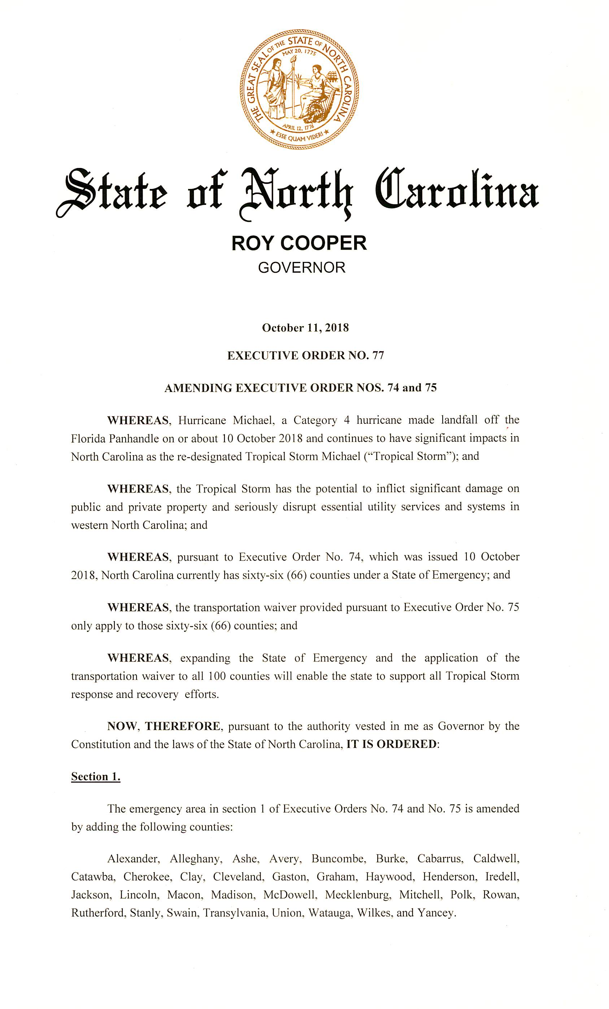
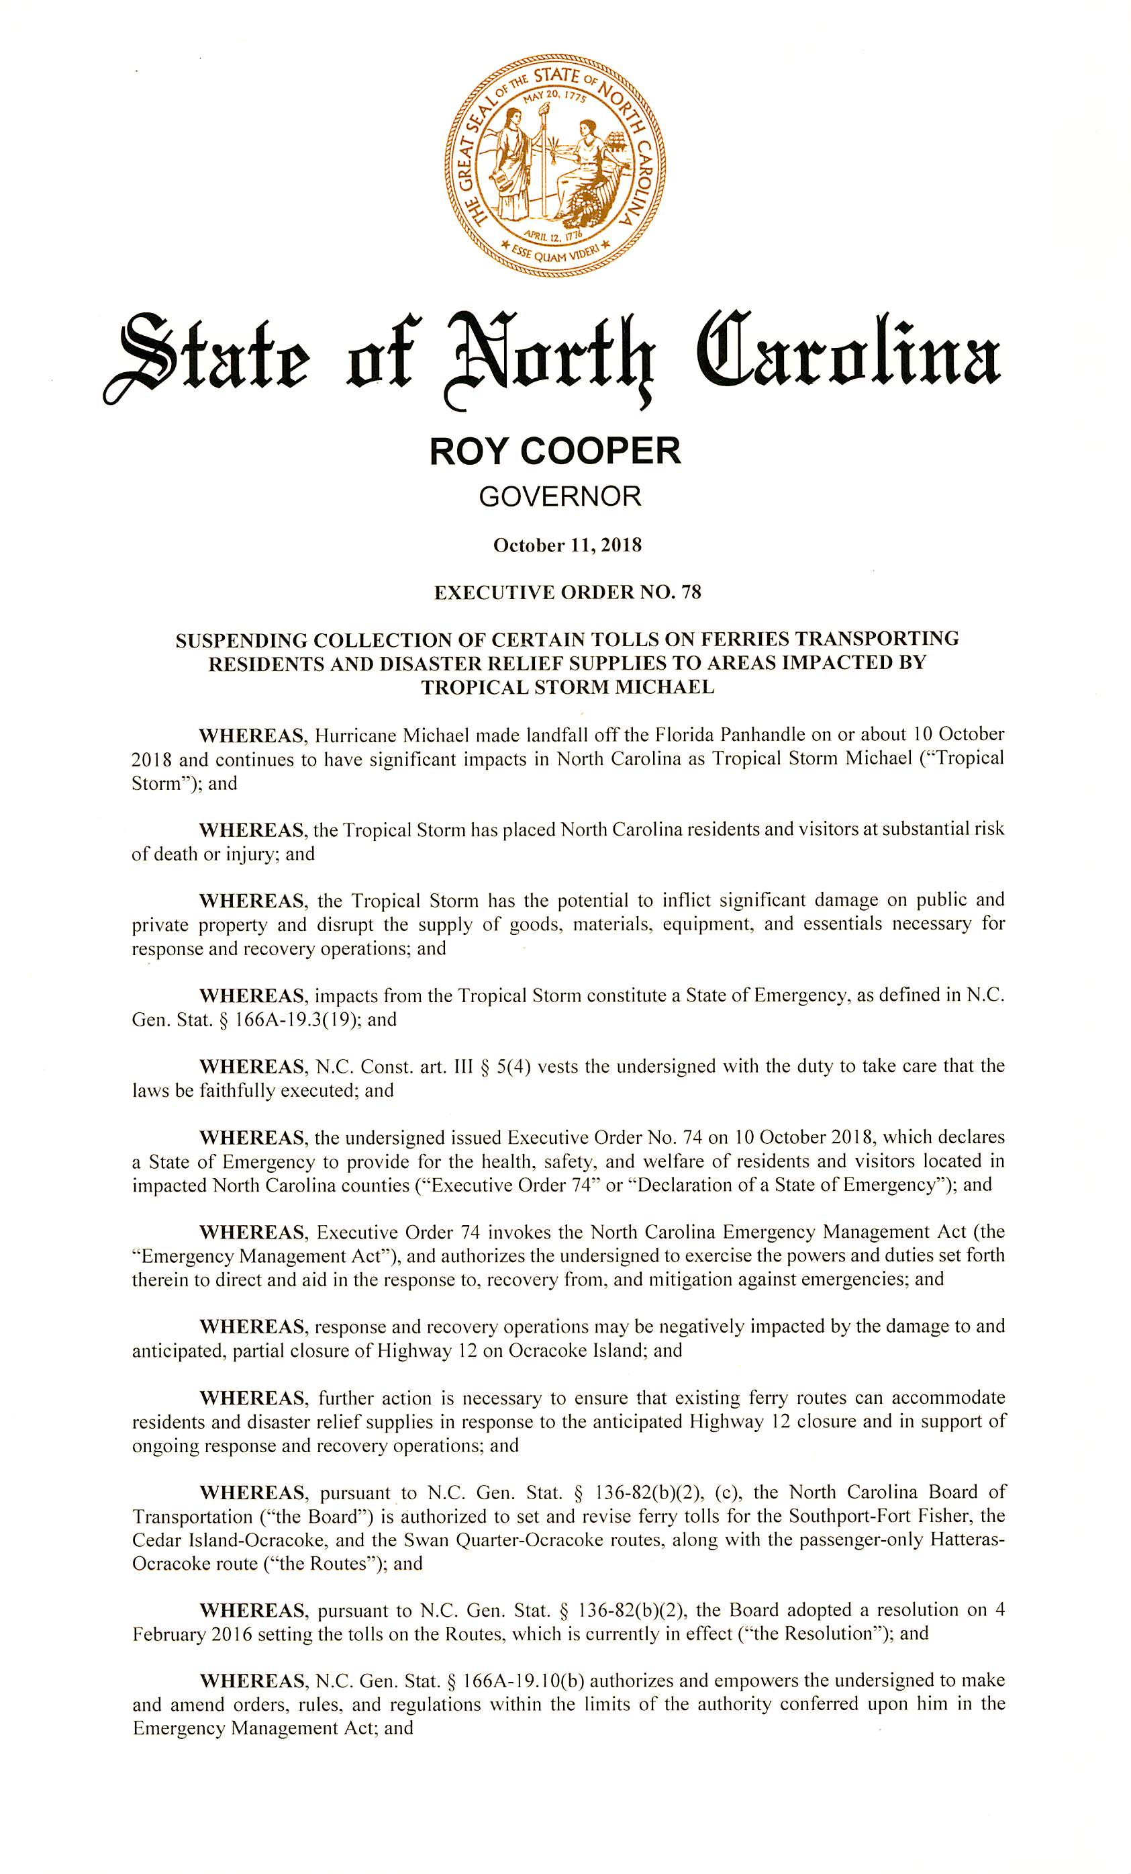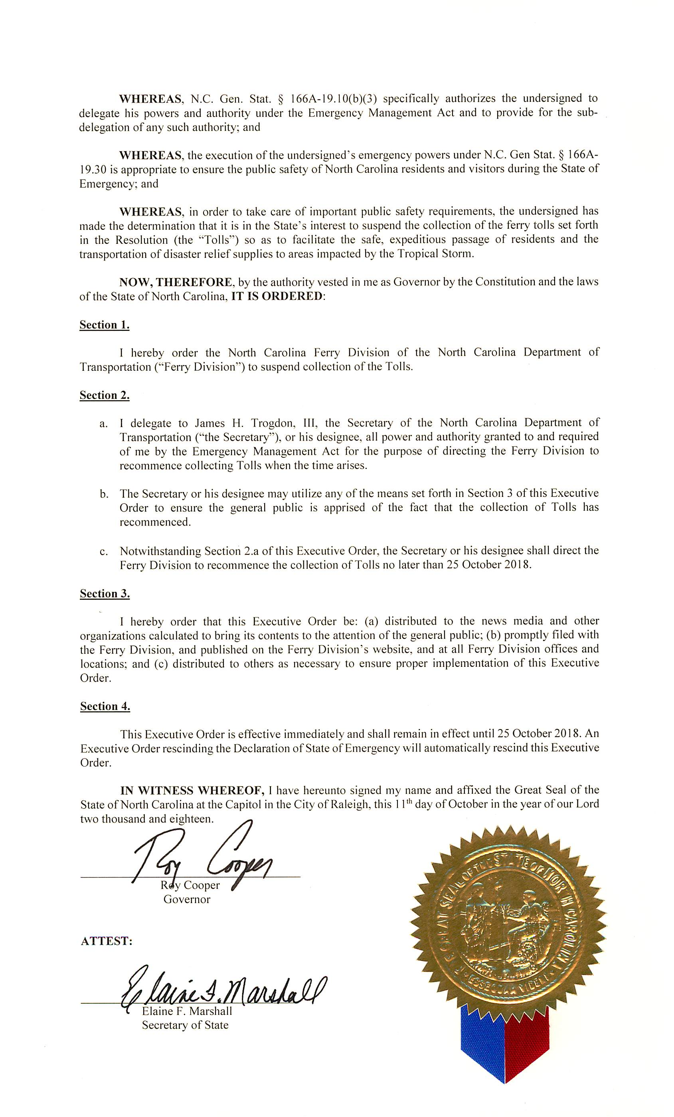
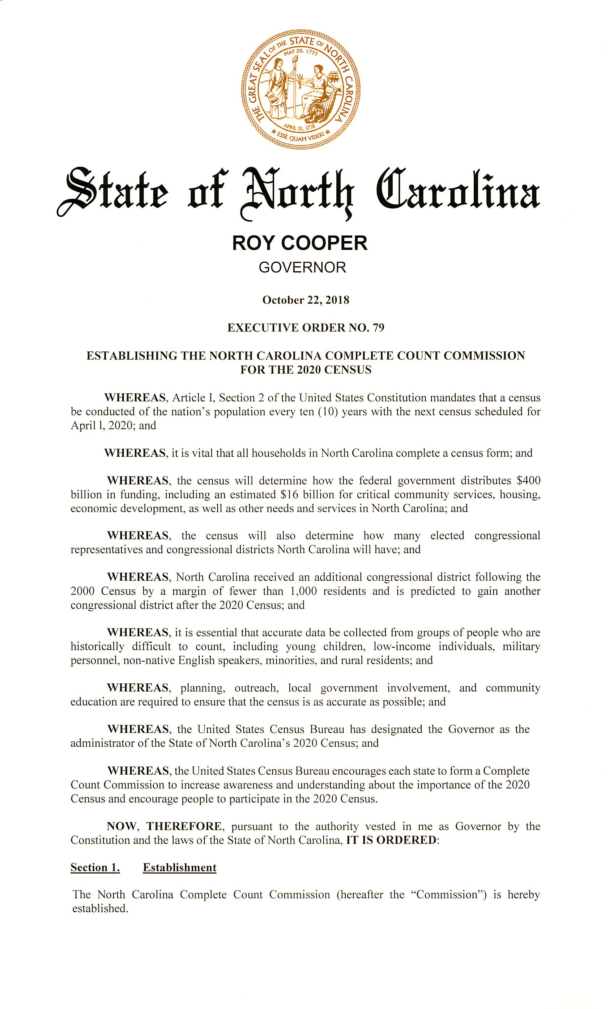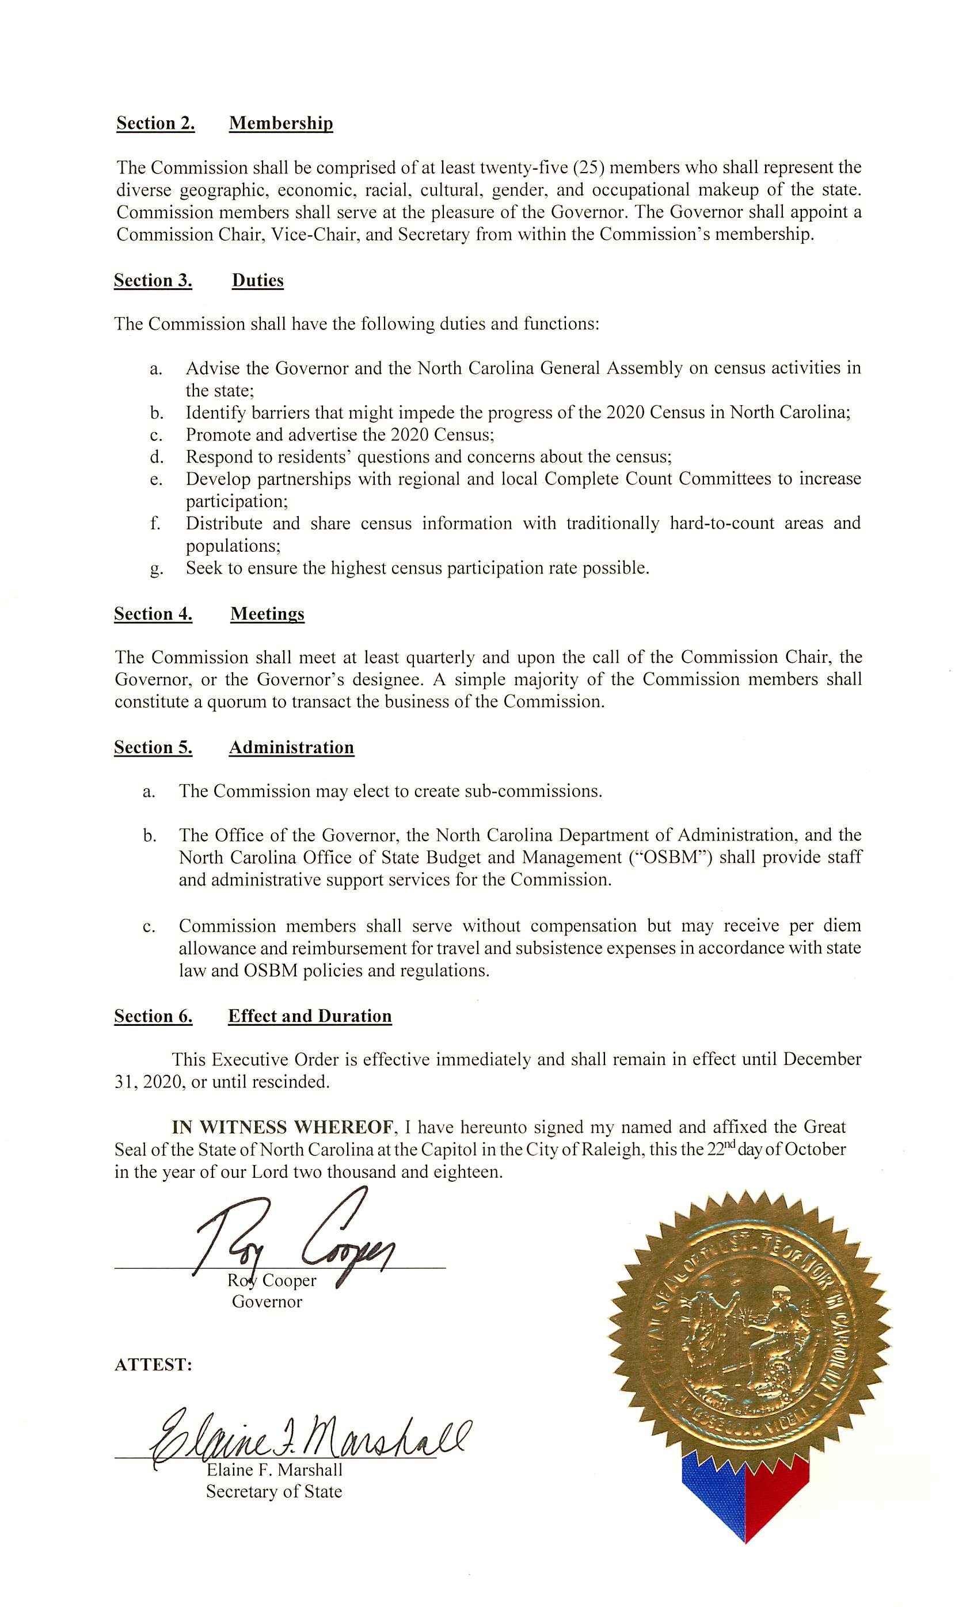

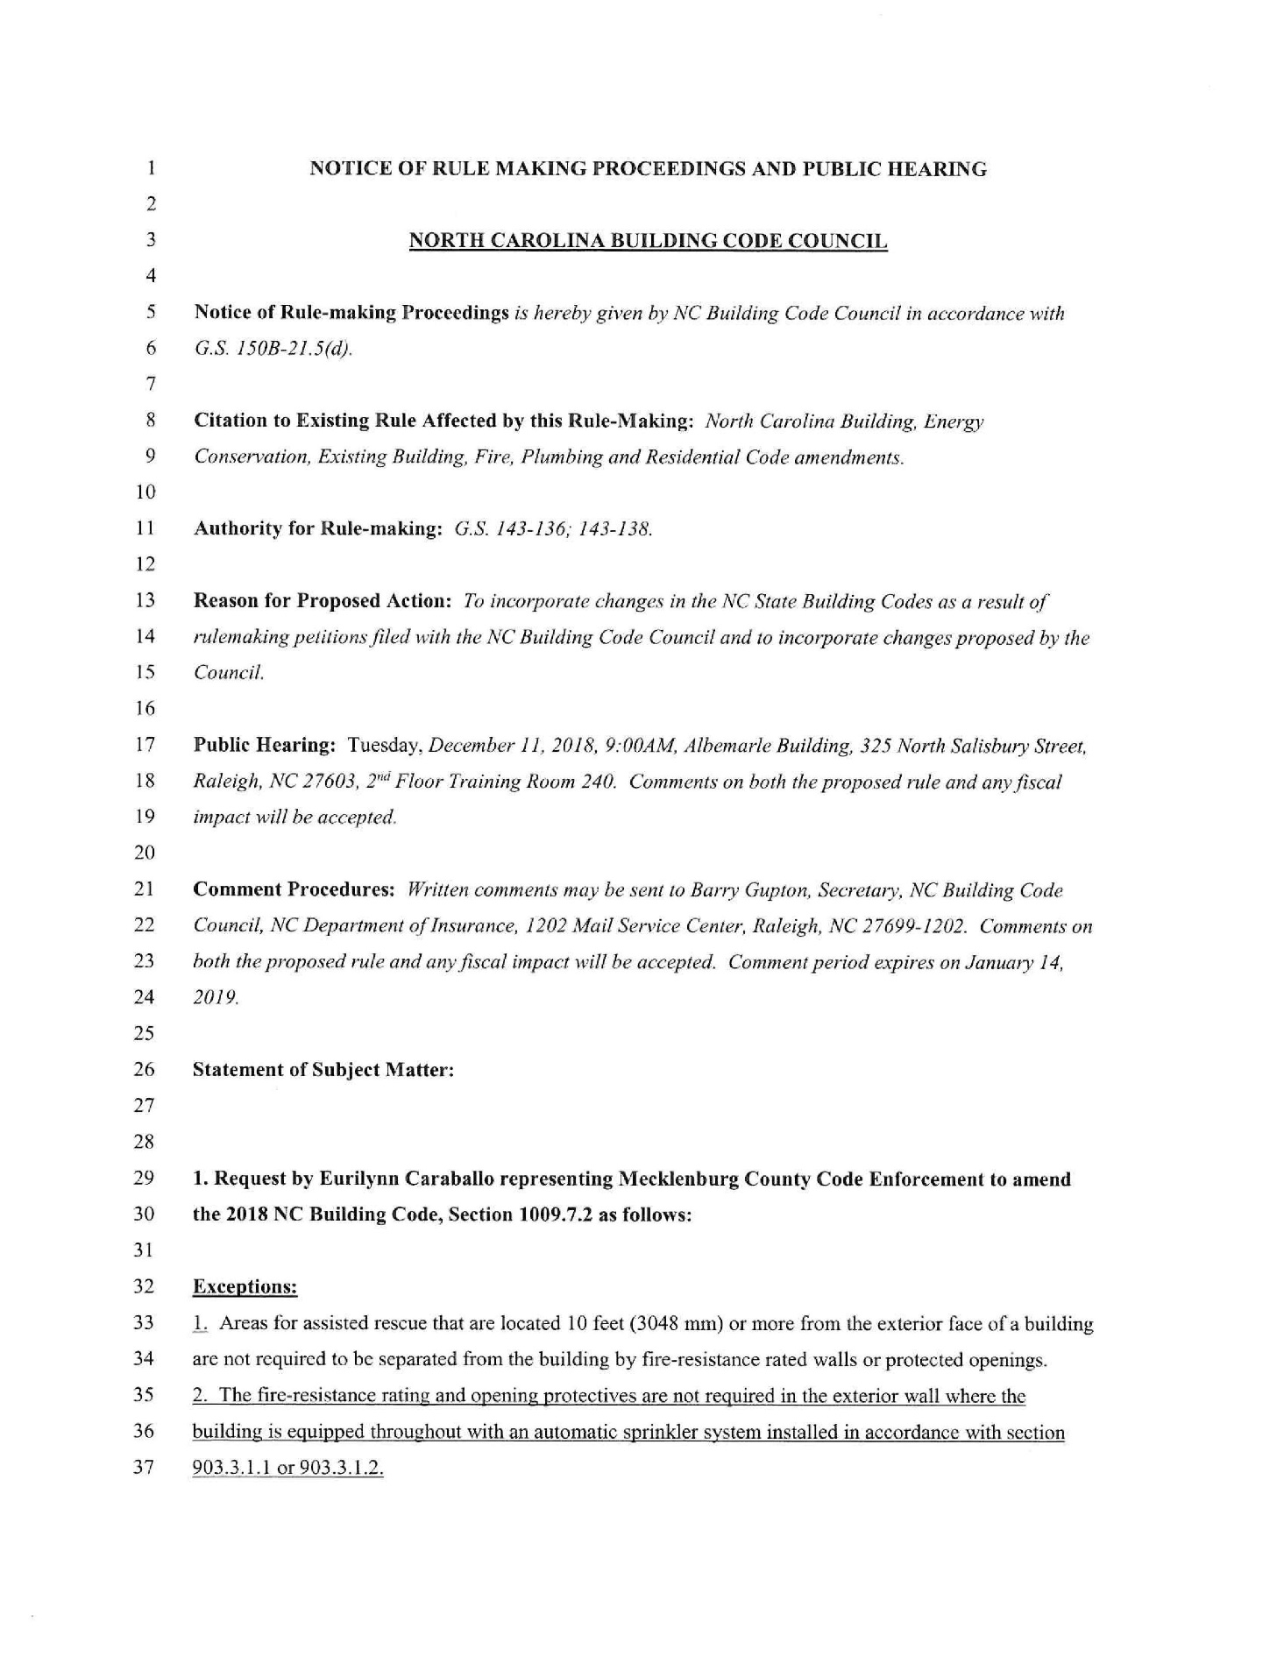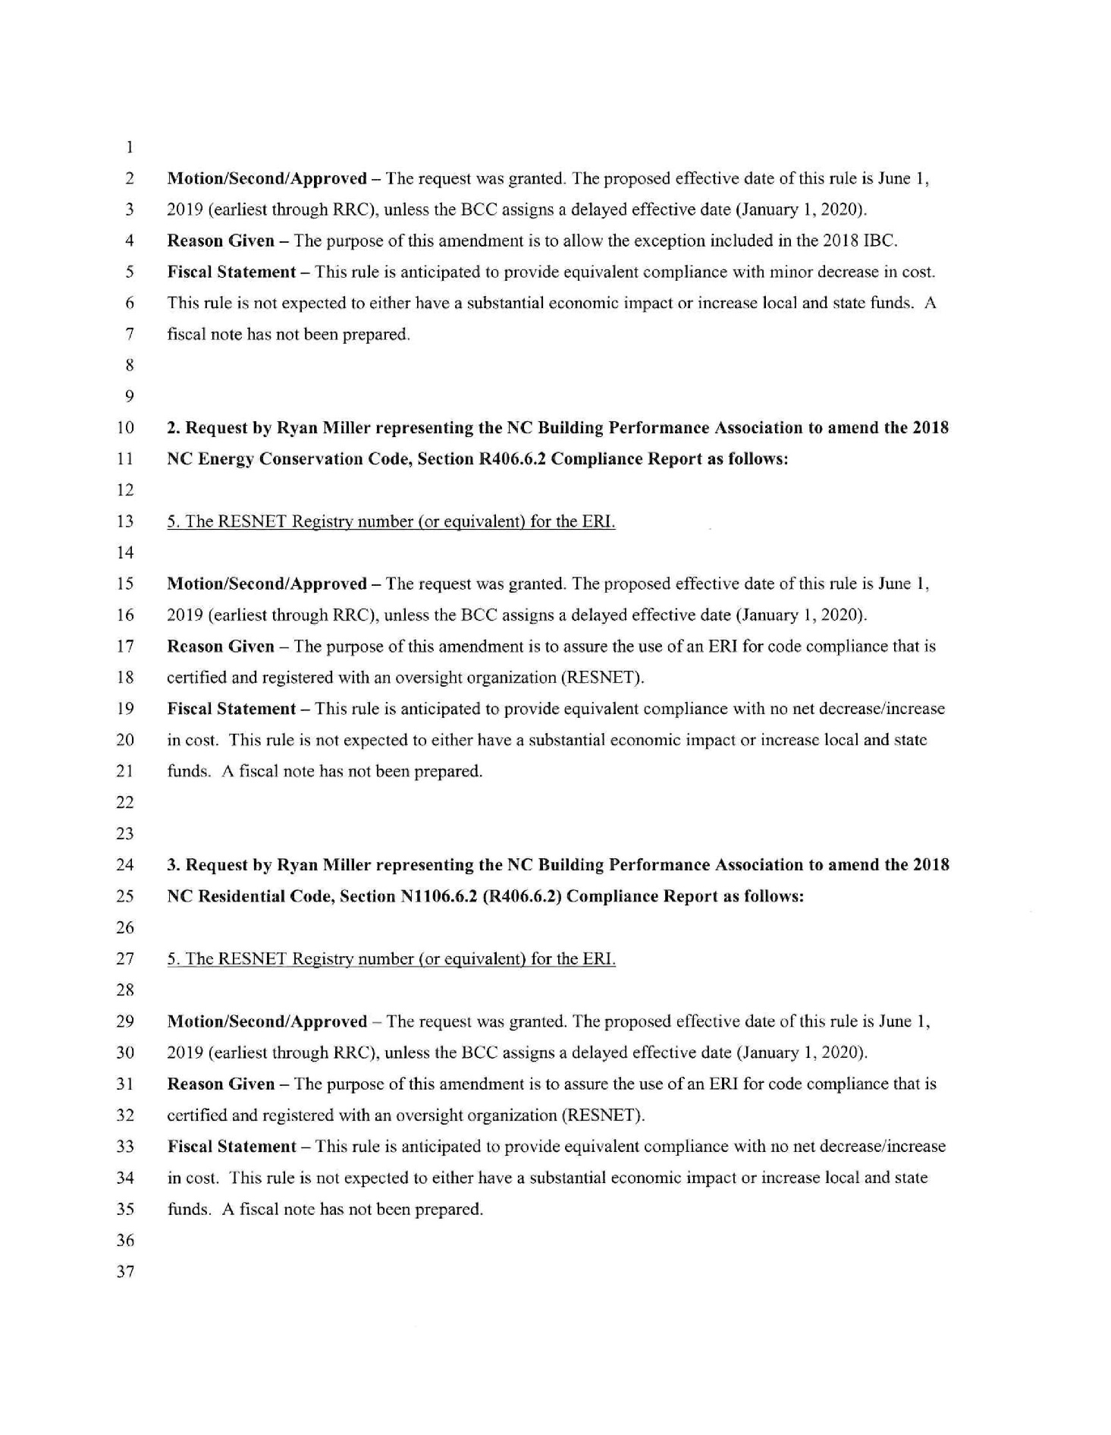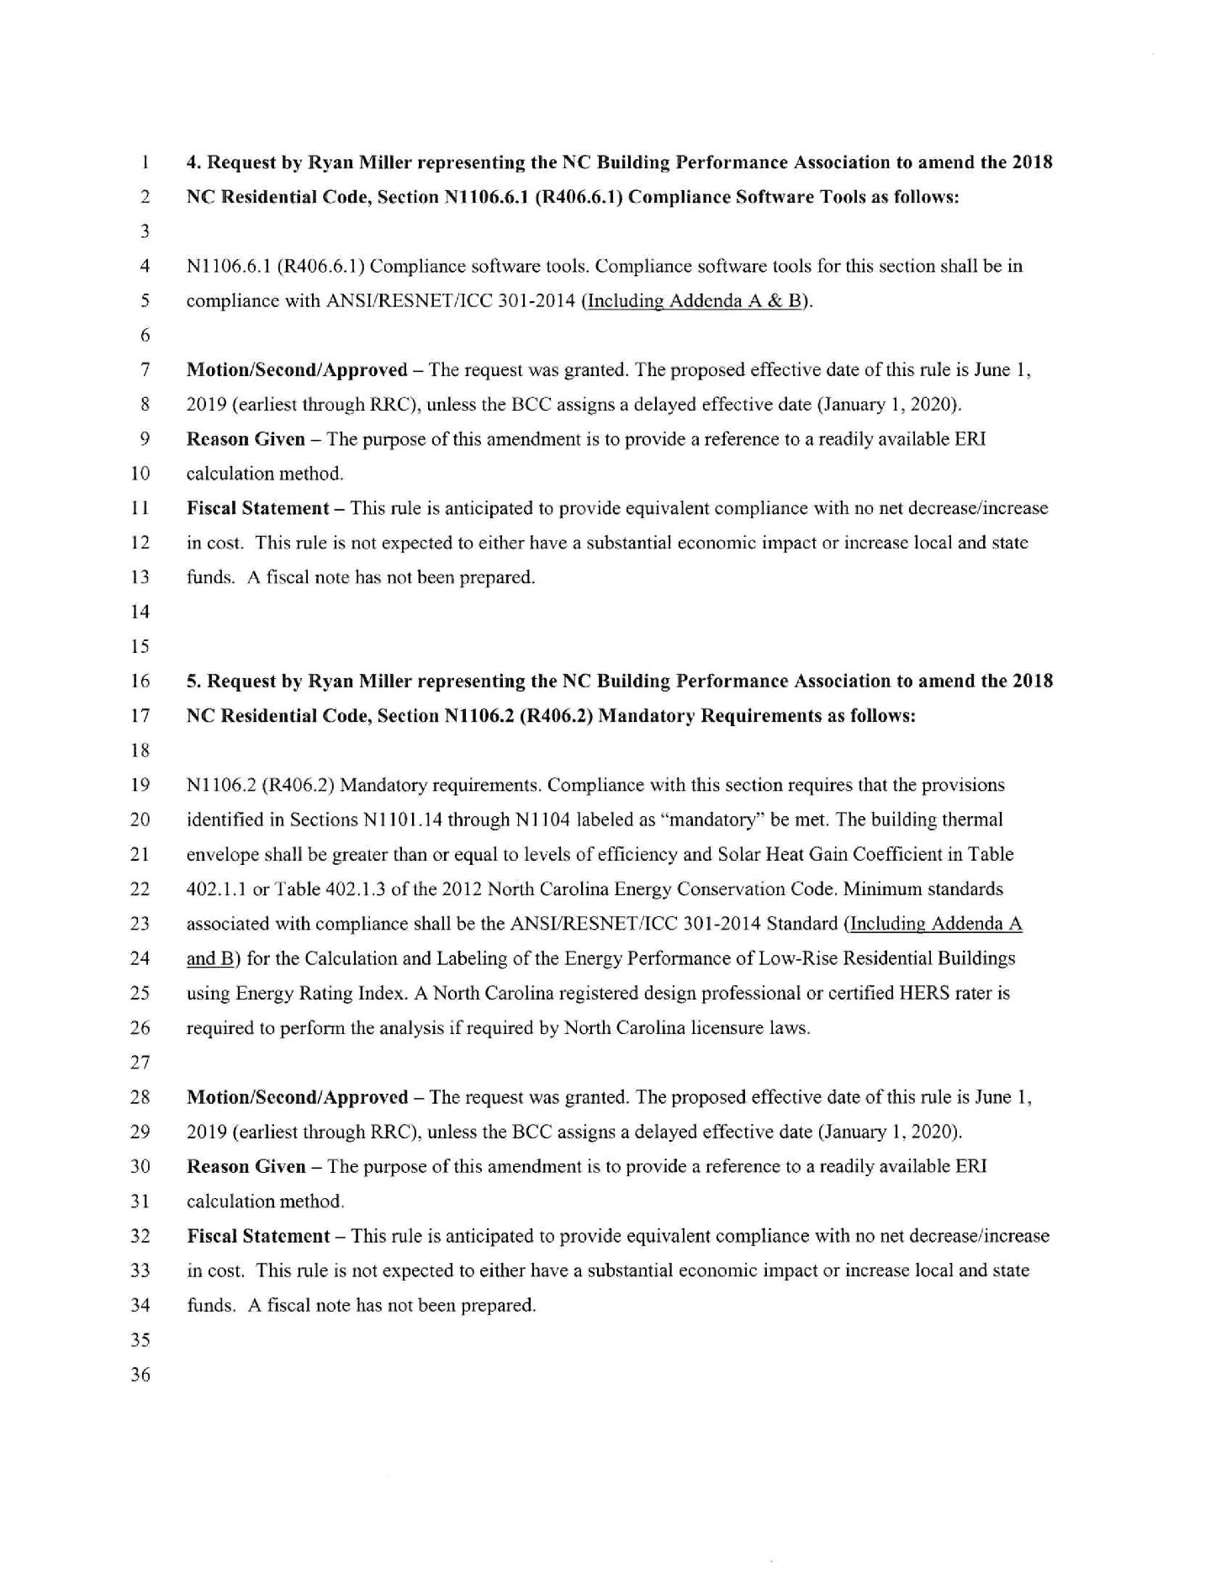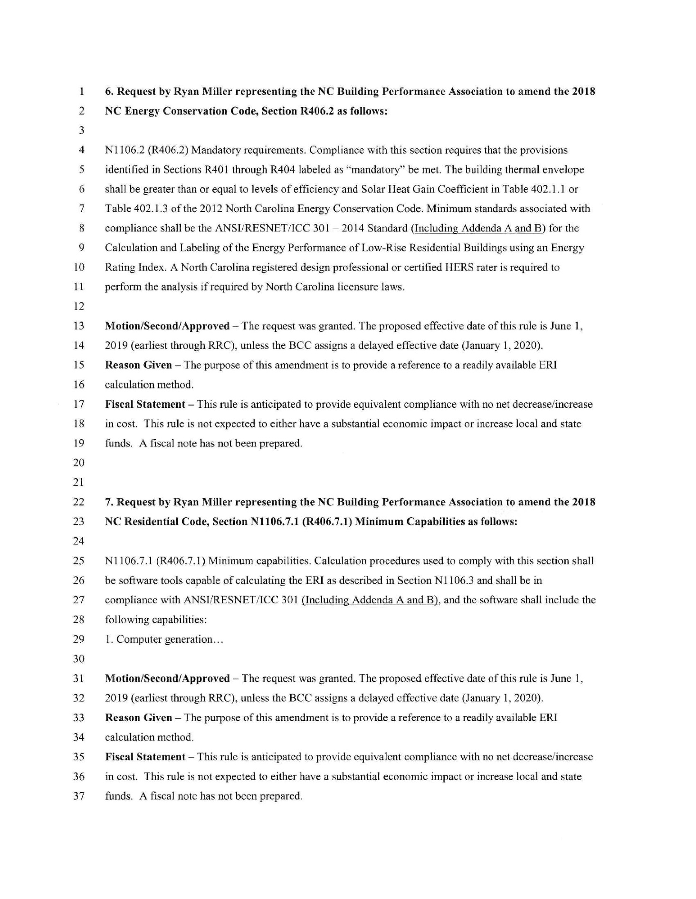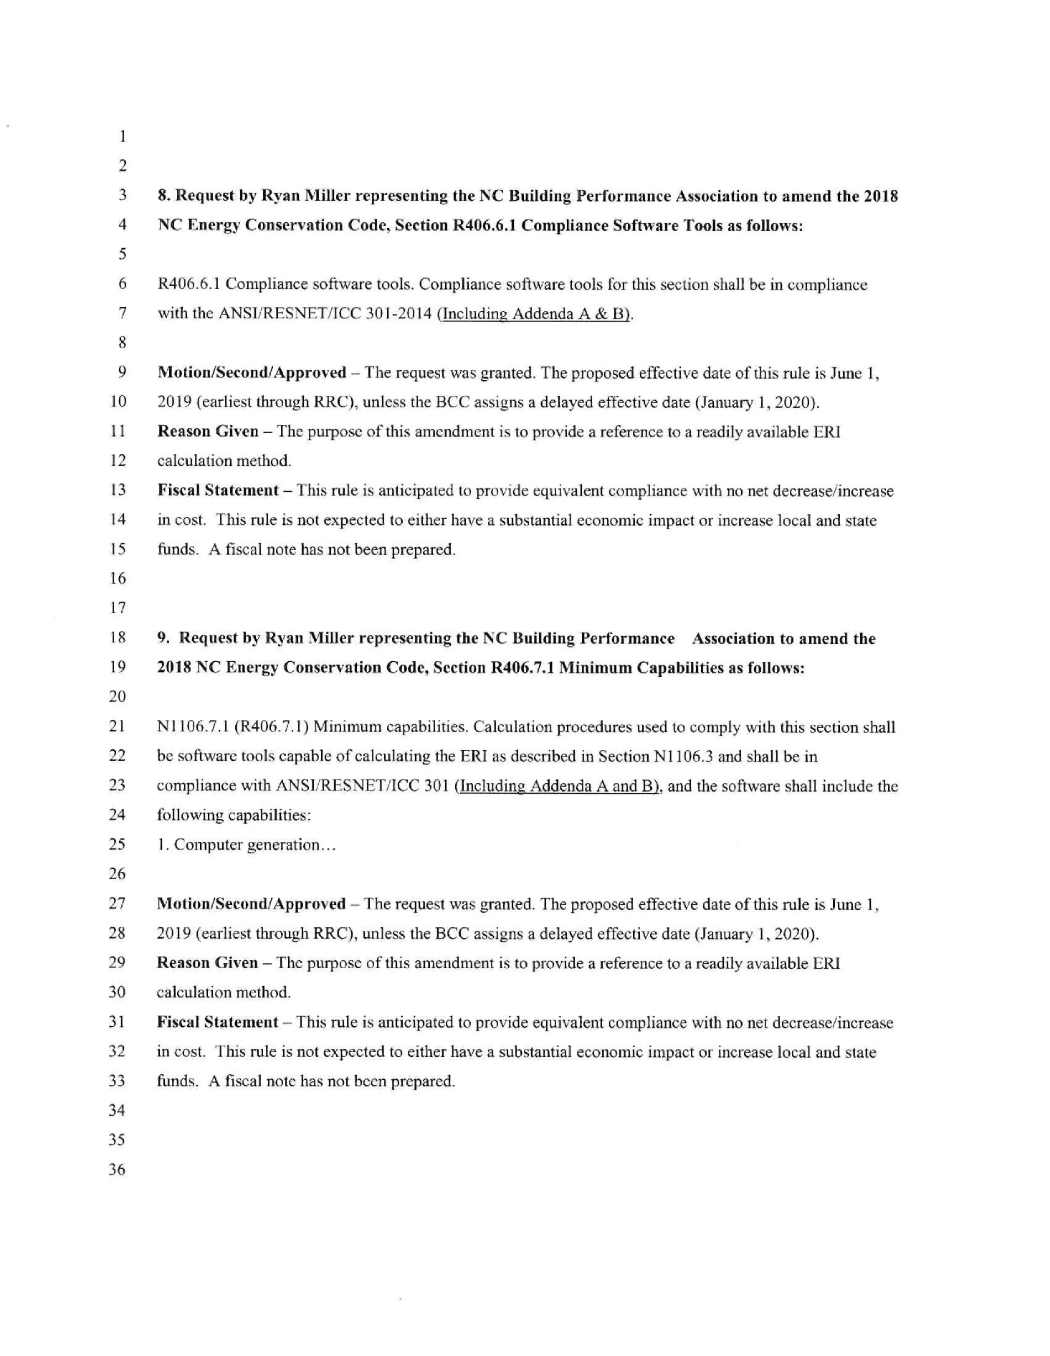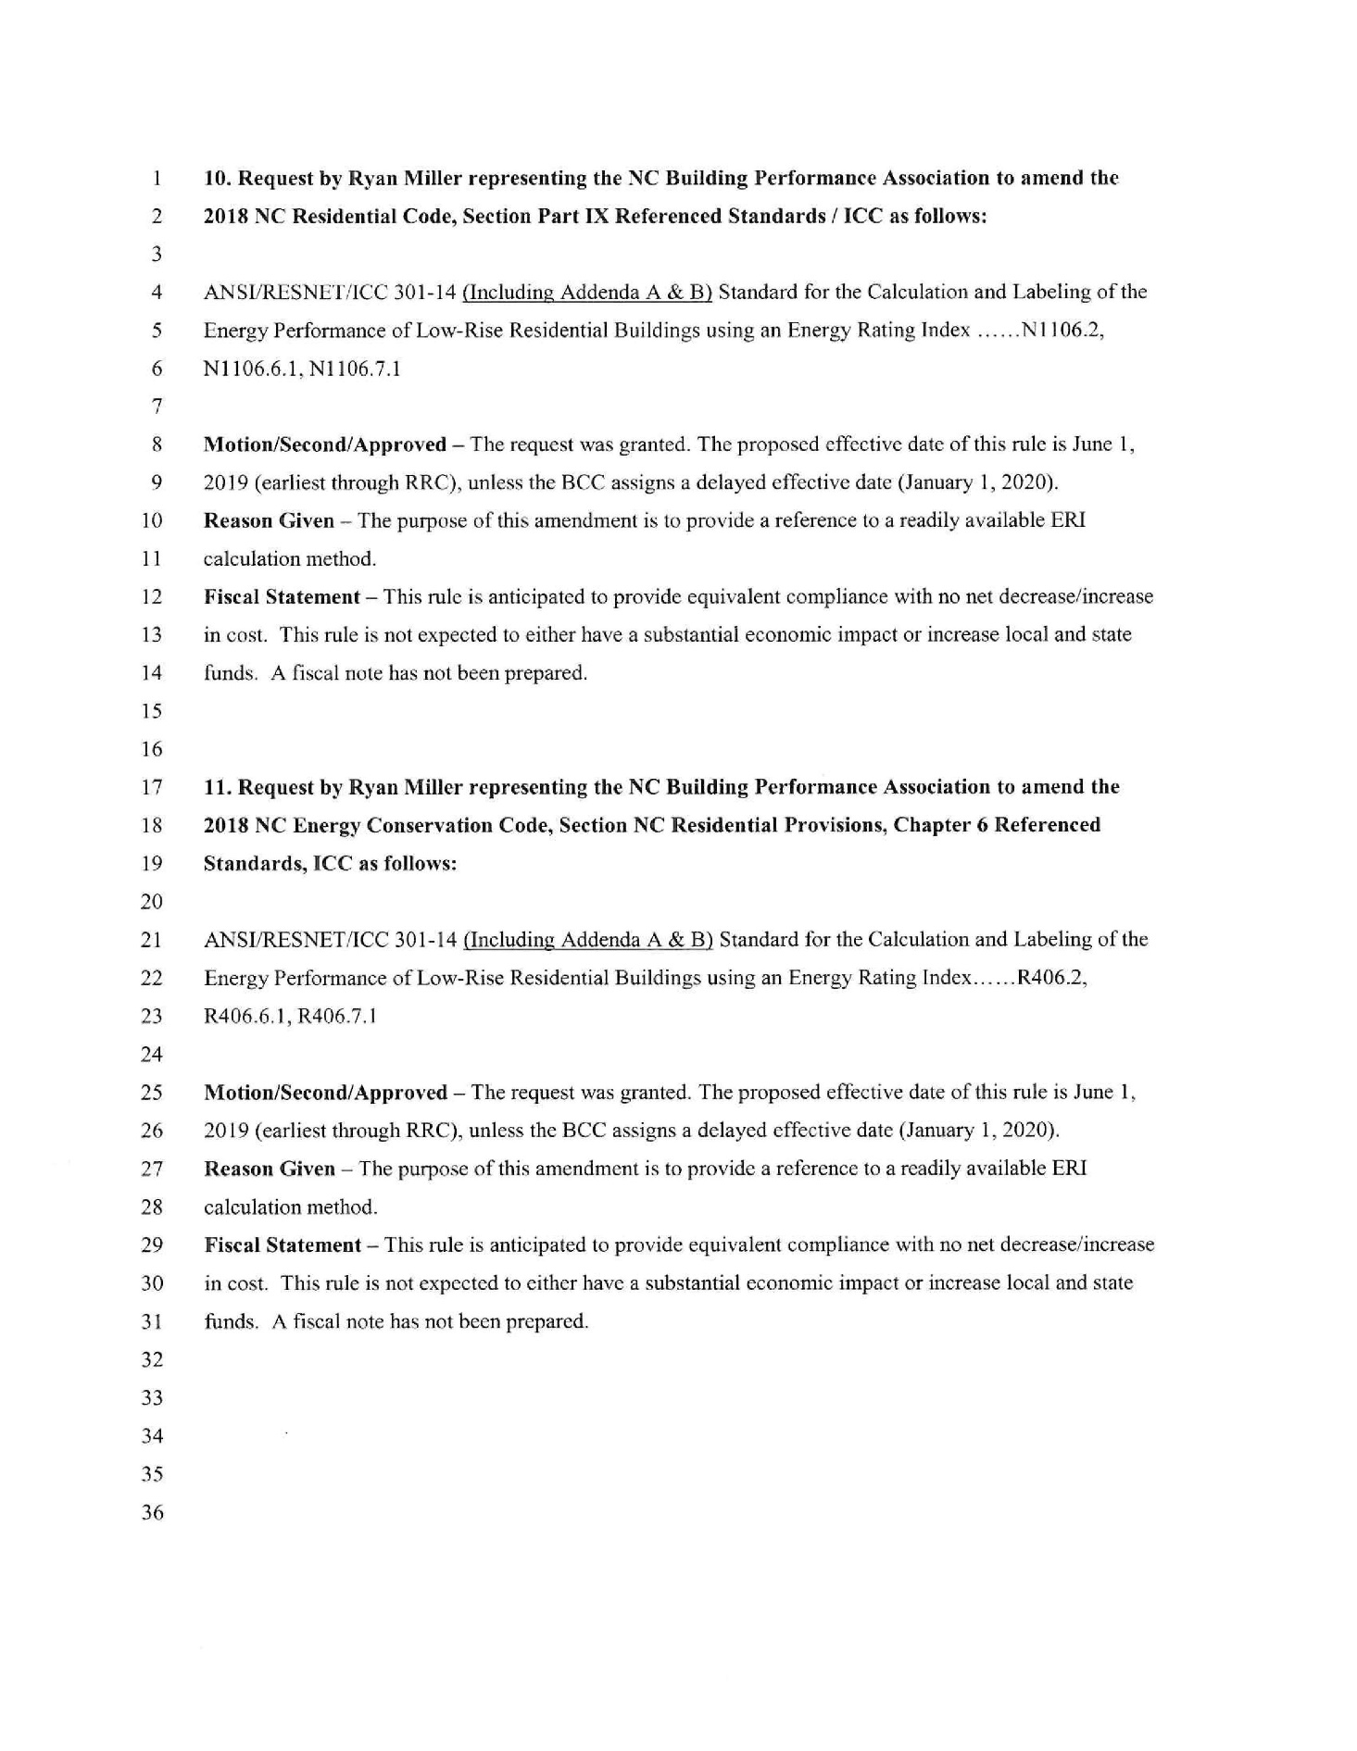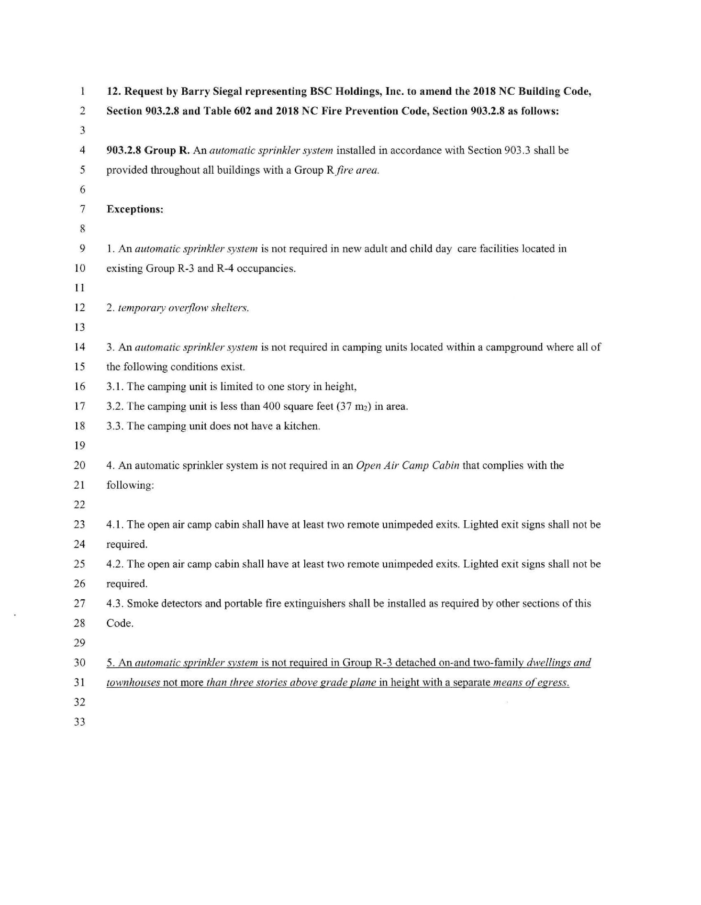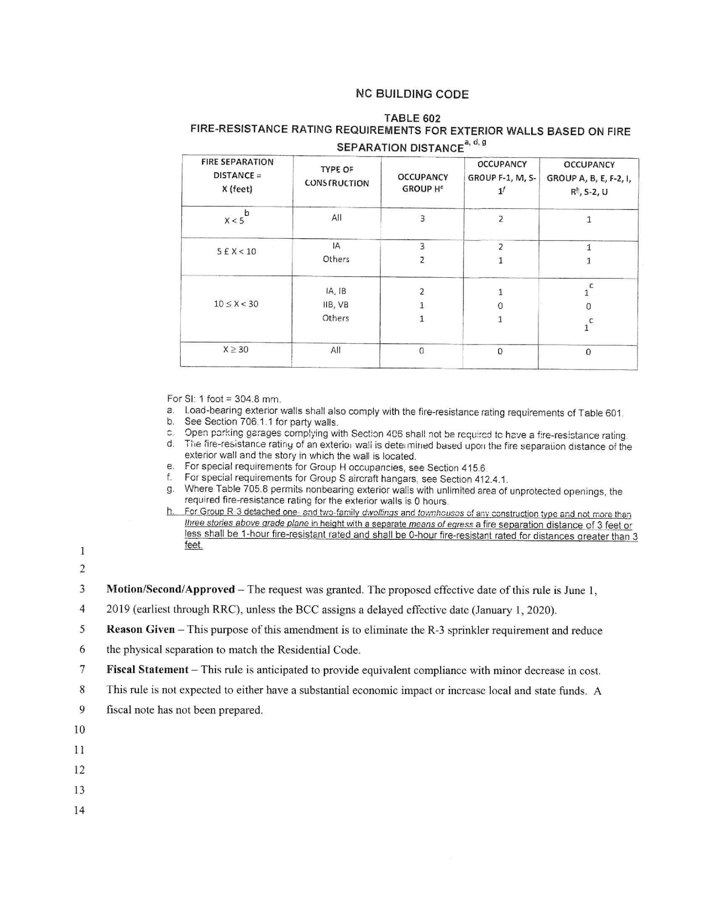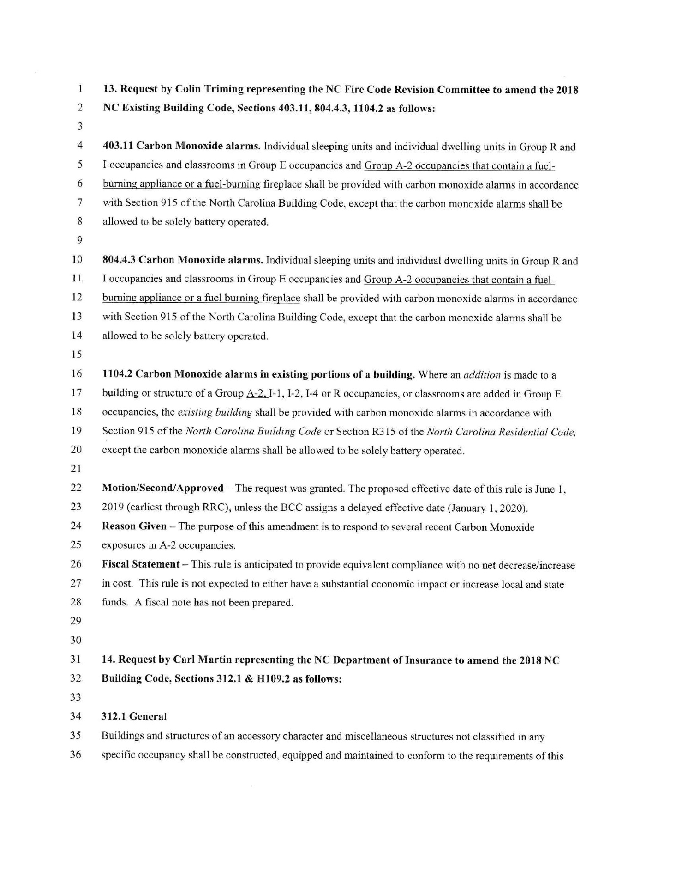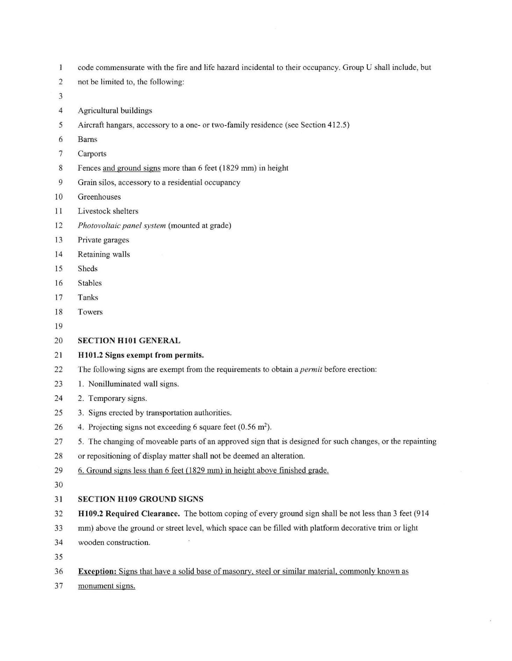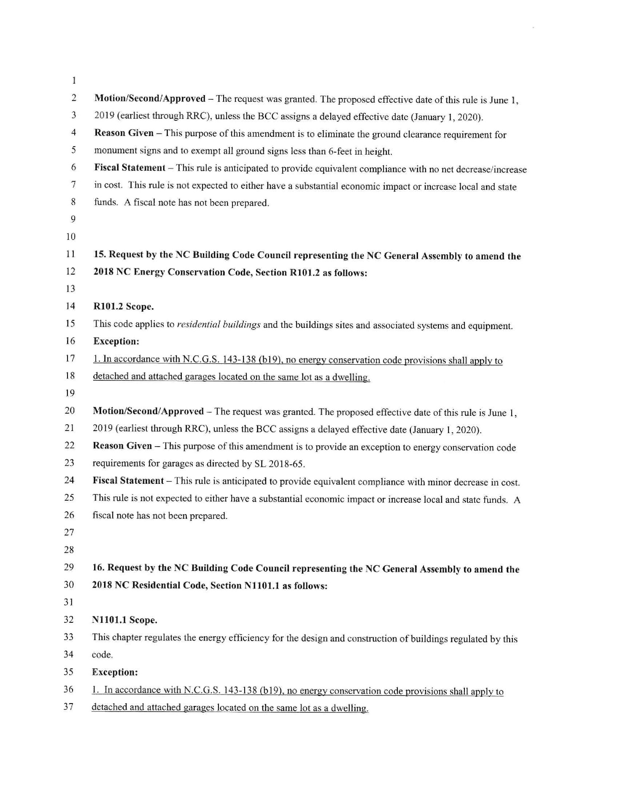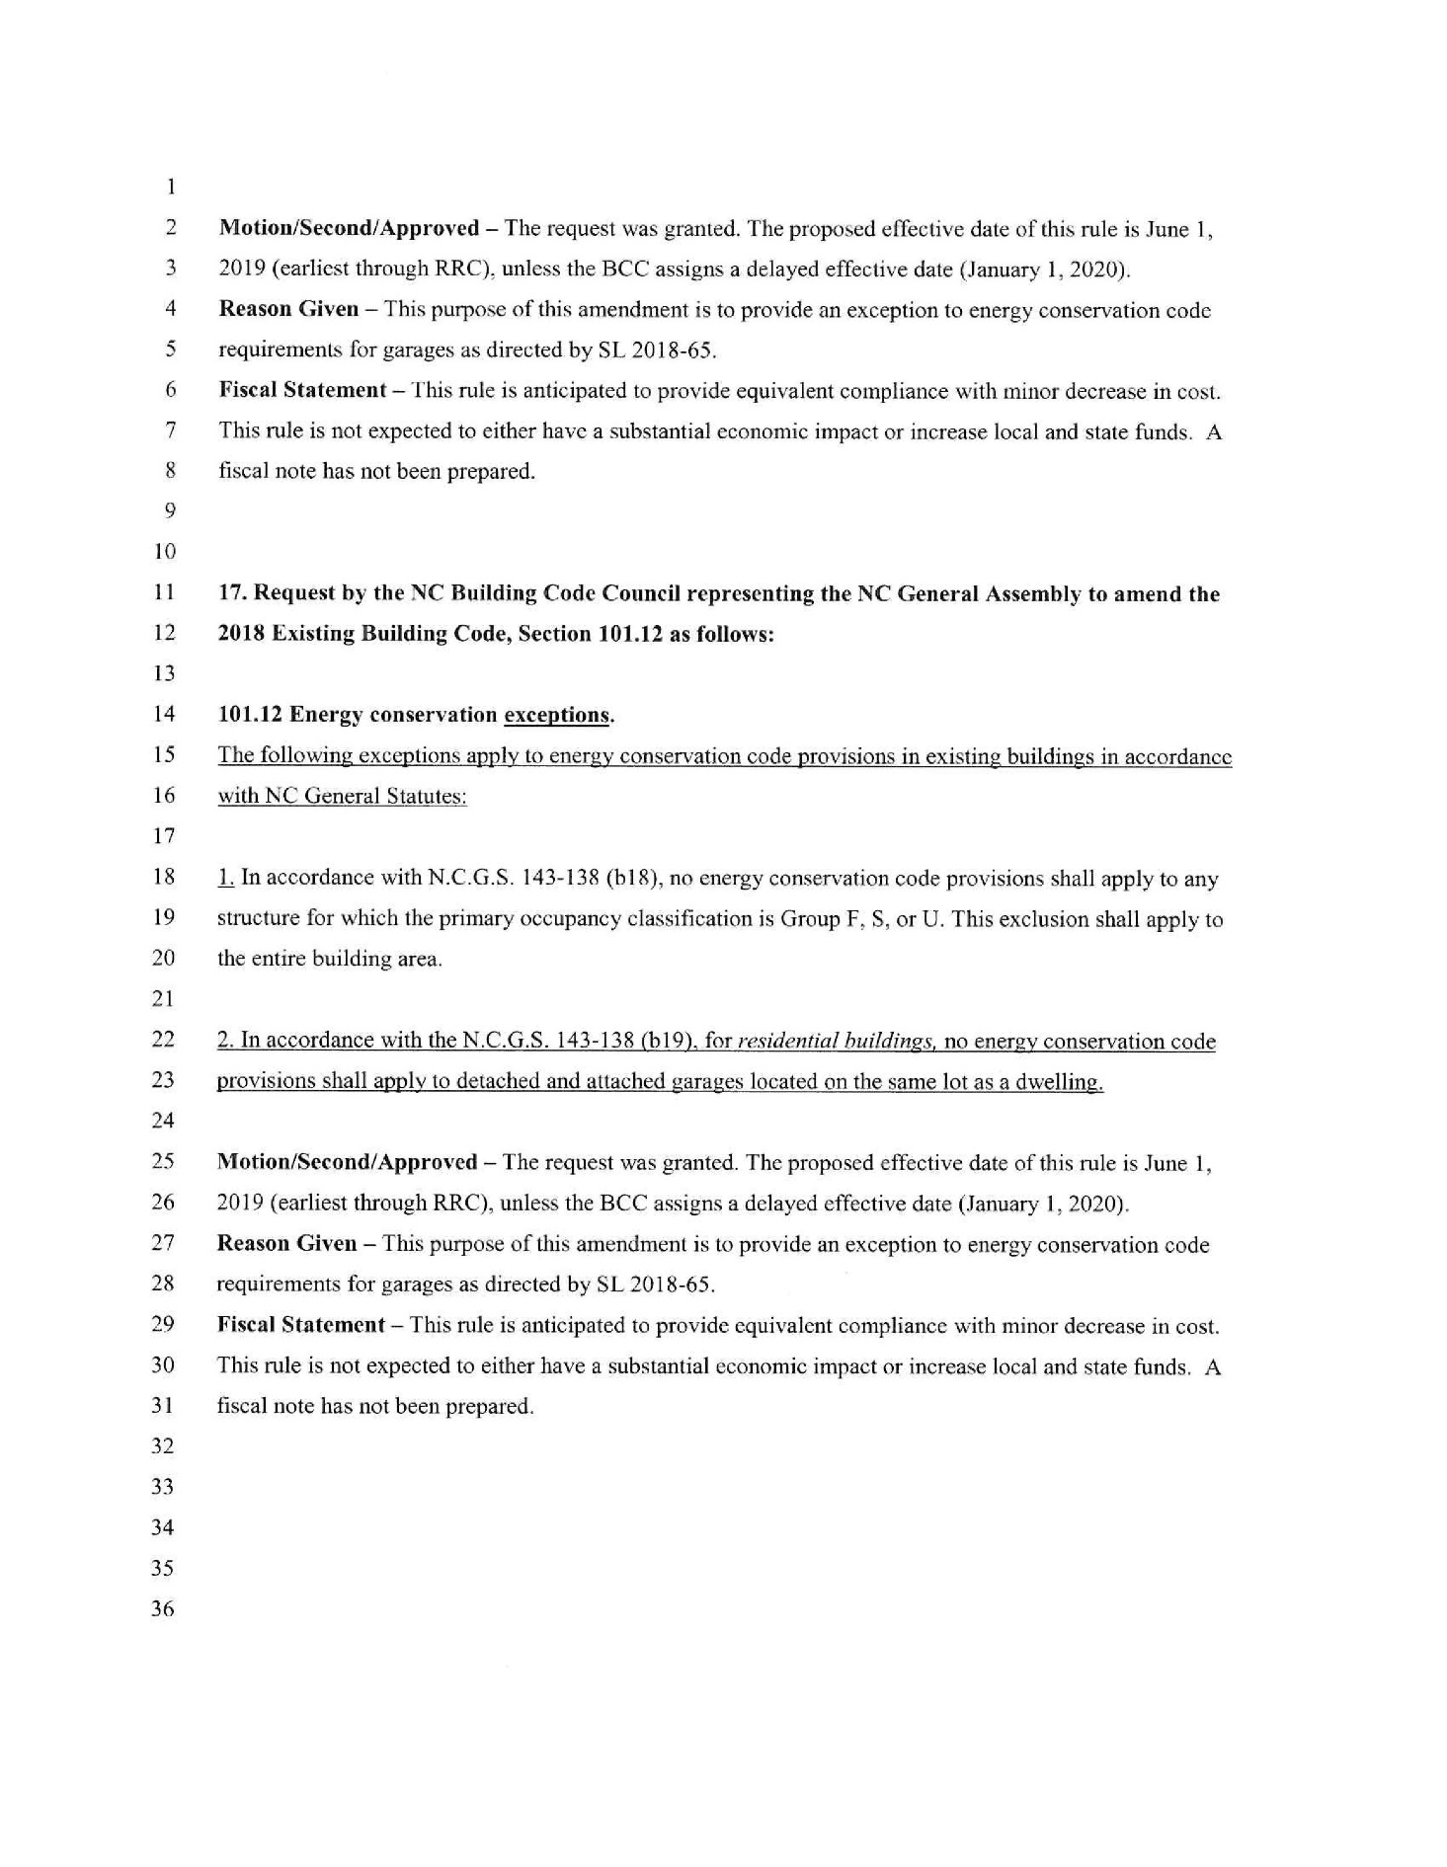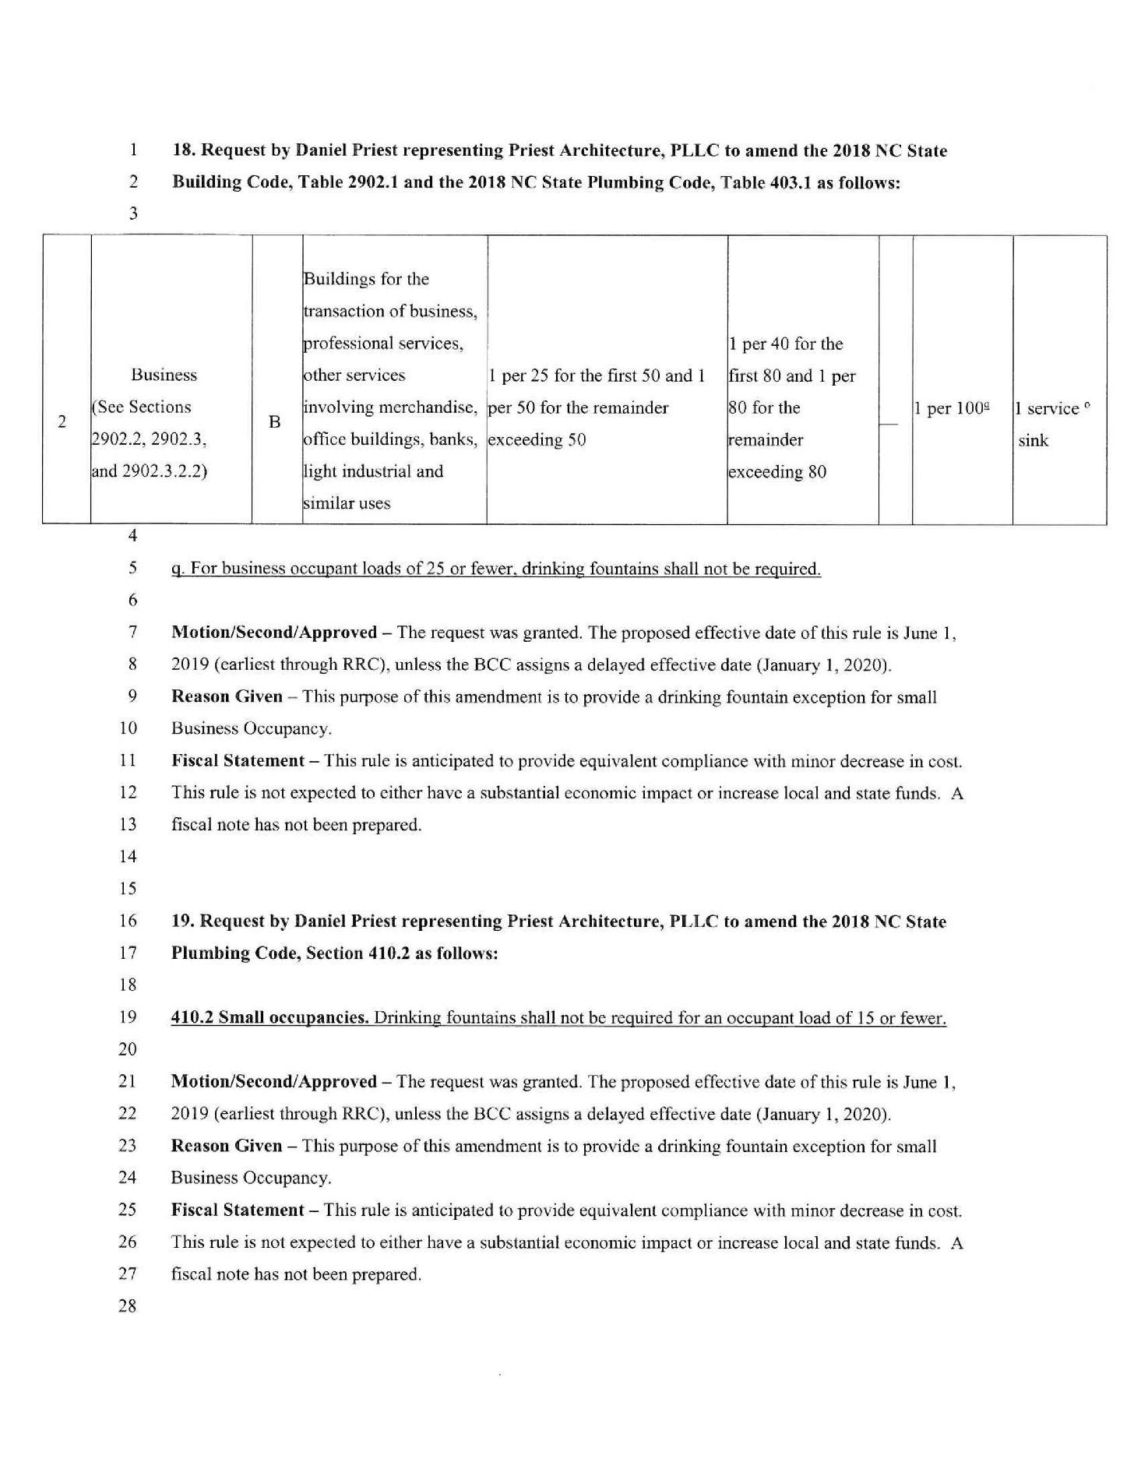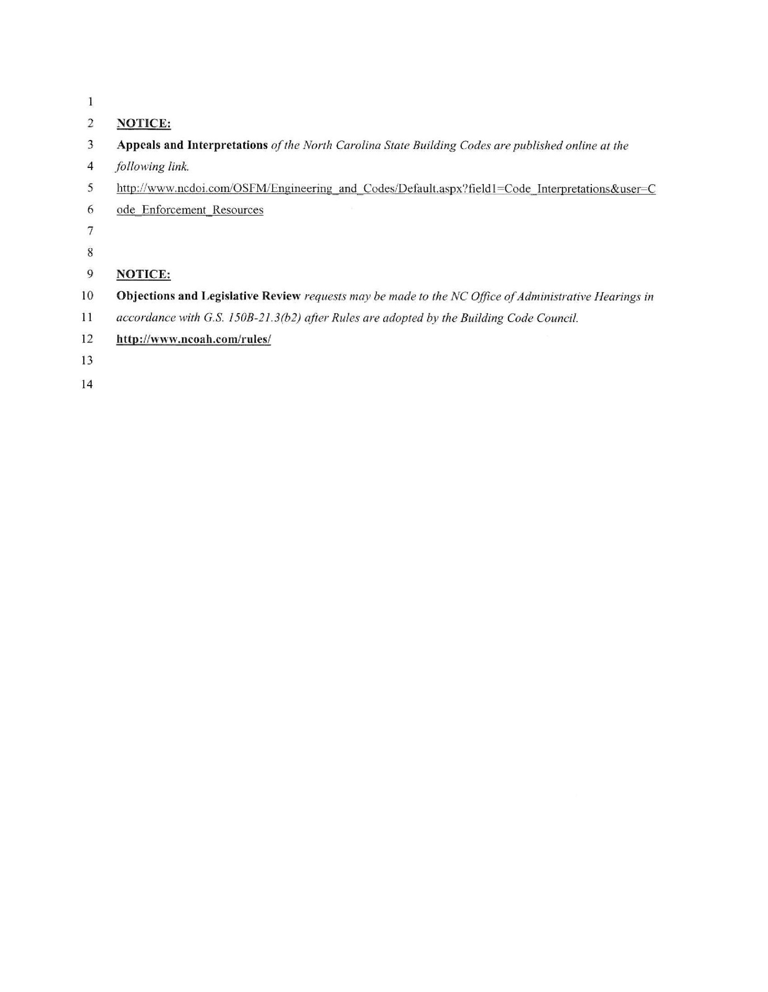

Note from the Codifier: The notices published in this Section of the NC Register include the text of proposed rules. The agency must accept comments on the proposed rule(s) for at least 60 days from the publication date, or until the public hearing, or a later date if specified in the notice by the agency. If the agency adopts a rule that differs substantially from a prior published notice, the agency must publish the text of the proposed different rule and accept comment on the proposed different rule for 60 days.
Statutory reference: G.S. 150B-21.2.

TITLE 10A – DEPARTMENT OF HEALTH AND HUMAN SERVICES

Notice is hereby given in accordance with G.S. 150B-21.2 that the Department of Health and Human Services intends to amend the rule cited as 10A NCAC 15 .1106.

Link to agency website pursuant to G.S. 150B-19.1(c): http://www2.ncdhhs.gov/dhsr/ruleactions.html

Proposed Effective Date: May 1, 2019

Public Hearing:

Date: December 10, 2018

Time: 10:00 a.m.

Location: Dorothea Dix Park, Brown Building, Room 104, 801 Biggs Drive, Raleigh, NC 27603

Reason for Proposed Action: NC's Governor entered into an Agreement with the US Atomic Energy Commission (now the US Nuclear Regulatory Commission (NRC)) in 1964 to discontinue the NRC regulatory authority and responsibility in NC. The Radiation Protection Section of the Division of Health Service Regulation (RPS) is charged with upholding the Agreement for NC with the NRC in maintaining a radiation protection program for the health and safety of citizens in NC that is compatible with the national materials program. Fully funding all of the regulatory activities of the RPS is critical to Agreement State Status maintenance with the NRC. For the last three years, the Radioactive Materials Branch of RPS (RAM) has been operating at a deficit, spending more than it receives in license fees, and has been for the last few years. The fee increase in this proposed rule amendment allows the RAM Branch to be fully funded for the next several fiscal years. This proposed rule amendment is necessary for the agency to continue to maintain its role in the national materials program.

Comments may be submitted to: Nadine Pfeiffer, 809 Ruggles Drive, 2701 Mail Service Center, Raleigh, NC 27699-2701, email DHSR.RulesCoordinator@dhhs.nc.gov

Comment period ends: January 14, 2019

Procedure for Subjecting a Proposed Rule to Legislative Review: If an objection is not resolved prior to the adoption of the rule, a person may also submit written objections to the Rules Review Commission after the adoption of the Rule. If the Rules Review Commission receives written and signed objections after the adoption of the Rule in accordance with G.S. 150B-21.3(b2) from 10 or more persons clearly requesting review by the legislature and the Rules Review Commission approves the rule, the rule will become effective as provided in G.S. 150B-21.3(b1). The Commission will receive written objections until 5:00 p.m. on the day following the day the Commission approves the rule. The Commission will receive those objections by mail, delivery service, hand delivery, or facsimile transmission. If you have any further questions concerning the submission of objections to the Commission, please call a Commission staff attorney at 919-431-3000.

Fiscal impact (check all that apply).

State funds affected

Environmental permitting of DOT affected

Analysis submitted to Board of Transportation

Local funds affected

Substantial economic impact (≥$1,000,000)

Approved by OSBM

No fiscal note required by G.S. 150B-21.4

Chapter 15 - Radiation Protection

SECTION .1100 - FEES

10A NCAC 15 .1106 RADIOACTIVE MATERIALS AND ACCELERATOR FEE AMOUNTS

(a) Annual fees for persons licensed pursuant to the provisions of Section .0300 of this Chapter are as listed in the following table: shall be:

Type of Radioactive Material License Annual Fee

Specific license of broad scope including:

-Medical Broad -academic or research and development (R&D) $ 5,250.00 $ 5,180.00

-Academic Broad -manufacture or distribution $ 3,500.00 $ 6,100.00

-Research and Development Broad $ 3,000.00

-medical $ 6,760.00

Specific license including:

-educational institutions, R&D laboratories $ 2,960.00

-industrial radiography (with temporary subsites) $ 3,500.00 $ 5,400.00

-industrial radiography (in plant only) $ 2,600.00

-irradiator >10,000Ci $ 19,140.00

-irradiator ≤10,000Ci $ 2,160.00

-manufacture or distribution $ 2,320.00

-medical (human use), no written directive required $ 2,940.00

-medical (human use), written directive required $ 4,760.00

-medical institution other than teletherapy $ 2,900.00

-medical private practice $ 950.00

-mobile medical practice (home office including 1 client site) $ 1,600.00

-mobile medical practice (per additional client location) $ 350.00

-medical teletherapy $ 2,100.00

-fixed industrial gauges $ 550.00

-portable gauges $ 425.00

-gas chromatographs $ 375.00

-manufacture or distribute $ 2,250.00

-irradiator >100,000Ci $ 8,500.00

-irradiator ≤100,000Ci $ 4,500.00

-educational institutions $ 1,900.00

-water remediation activities (home office including 1 client site) $ 1,350.00

-water remediation activities (per additional client location) $ 280.00

-services/consultants $ 400.00

-other -services, consultants, gauges (all types), or not specified above $ 500.00 $ 1,860.00

-well logging, subsurface tracer studies $ 3,200.00

General licenses license including:

-licenses subject -not subject to annual registration requirements $ 325.00 $ 200.00

-licenses not subject -subject to annual registration requirements $ 200.00 $ 325.00

-possession of self-luminous devices under Rule .0309 of this Chapter no fee

(b) Annual fees for persons licensed pursuant to the provisions of Section .0900 of this Chapter are as listed in the following table: shall be four thousand seven hundred sixty dollars ($4,760).

Type of Accelerator License Annual Fee

-Medical (home office including 1 unit) $ 2,000.00

-Medical (per additional unit) $ 200.00

-Industrial/Manufacturing (home office including 1 unit) $ 2,000.00

-Industrial/Manufacturing (per additional unit) $ 200.00

-Sales, Service, Refurbishment, Manufacture $ 2,000.00

(c) Annual fees Fees for out-of-state persons granted permission to use sources of radiation in this state State pursuant to provisions of Rule .0345 of this Chapter are the same as that provided for in the applicable category specified in Paragraphs (a) and (b) of this Rule. Such The fees are shall be due when the application for reciprocal recognition of out-of-state license or registration is made in the same manner as for a new license or registration as specified in Rule .1102. is made.

(d) Each location listed on a license issued by the Agency that is not part of a contiguous property controlled by the licensee shall require an additional fee equal to the amount specified in Paragraphs (a) and (b) of this Rule. Fees for client locations listed on mobile medical licenses shall be one-half of the amount specified in Paragraphs (a) or (b) of this Rule for each client site.

(e) Persons licensed to conduct activities subject to multiple categories of fees under Paragraph (a) of this Rule shall be required to pay only the highest fee category.

(f) Persons possessing Sealed Source and Device Registration (SS&D) certificates shall pay an annual fee of one thousand four hundred eighty dollars ($1,480) per active SS&D certificate issued by the Agency, in addition to any amounts specified in Paragraph (a) of this Rule.

Authority G.S. 104E-9(a)(8); 104E-19(a).

TITLE 12 – Department of justice

Notice is hereby given in accordance with G.S. 150B-21.2 that the Sheriffs' Education and Training Standards Commission intends to amend the rule cited as 12 NCAC 10B .0503.

Link to agency website pursuant to G.S. 150B-19.1(c): http://ncdoj.gov/About-DOJ/Law-Enforcement-Training-and-Standards/Sherriffs-Education-and-Training-Standards/All-Commission-Forms-and-Publications.aspx

Proposed Effective Date: May 1, 2019

Public Hearing:

Date: December 4, 2018

Time: 10:00 a.m.

Location: 1700 Tryon Park Drive, Raleigh, NC 27610

Reason for Proposed Action:

12 NCAC 10B .0503 - amendment makes this rule regarding training extensions for deputy sheriffs consistent with rules regarding training extensions for other justice officers; i.e. detention officers (12 NCAC 10B .0602) and telecommunicators (12 NCAC 10B .1303).

Comments may be submitted to: Diane N. Konopka, P.O. Box 629, Raleigh, NC 27602, email dkonopka@ncdoj.gov

Comment period ends: January 14, 2019

Procedure for Subjecting a Proposed Rule to Legislative Review: If an objection is not resolved prior to the adoption of the rule, a person may also submit written objections to the Rules Review Commission after the adoption of the Rule. If the Rules Review Commission receives written and signed objections after the adoption of the Rule in accordance with G.S. 150B-21.3(b2) from 10 or more persons clearly requesting review by the legislature and the Rules Review Commission approves the rule, the rule will become effective as provided in G.S. 150B-21.3(b1). The Commission will receive written objections until 5:00 p.m. on the day following the day the Commission approves the rule. The Commission will receive those objections by mail, delivery service, hand delivery, or facsimile transmission. If you have any further questions concerning the submission of objections to the Commission, please call a Commission staff attorney at 919-431-3000.

Fiscal impact (check all that apply).

State funds affected

Environmental permitting of DOT affected

Analysis submitted to Board of Transportation

Local funds affected

Substantial economic impact (≥$1,000,000)

Approved by OSBM

No fiscal note required by G.S. 150B-21.4

Chapter 10 - Sheriffs' Education and Training Standards Commission

SUBCHAPTER 10B - N.C. SHERIFFS' EDUCATION AND TRAINING STANDARDS COMMISSION

SECTION .0500 - MINIMUM STANDARDS OF TRAINING FOR DEPUTY SHERIFFS

12 NCAC 10B .0503 TIME REQ/COMPLETION/BASIC LAW ENFORCEMENT TRAINING COURSE

(a) Each deputy sheriff holding temporary or probationary certification shall satisfactorily complete a commission-certified basic training course. The deputy shall complete such course within one year from the date of his/her Oath of Office. Any deputy sheriff who does not comply with this Rule or other training provisions of this Chapter shall not be authorized to exercise the powers of a deputy sheriff and shall not be authorized to exercise the power of arrest. If, however, an officer has enrolled in a commission-certified basic law enforcement training program that concludes later than the end of the officer's probationary period, the Commission shall may extend the probationary period for a period not to exceed 12 months.

(b) Persons having completed a commission-certified basic law enforcement training program and not having been duly appointed and certified in a sworn law enforcement position as defined in 12 NCAC 10B .0103(17) within one year of completion of the basic law enforcement training course shall complete a subsequent commission-certified basic recruit training program in its entirety and successfully pass the State Comprehensive Examination within the 12 month probationary period as prescribed in 12 NCAC 10B .0402, unless the Director determines that a delay in applying for certification was due to simple negligence on the part of the applicant or employing agency, in which case the Director shall accept a commission-certified basic training program which is over one year old. Such extension of the one year period shall not exceed 30 days from the expiration date of a commission-certified basic training program.

Authority G.S. 17E-4; 17E-7.

TITLE 15A – DEPARTMENT OF ENVIRONMENTAL QUALITY

Notice is hereby given in accordance with G.S. 150B-21.2 and G.S. 150B-21.3A(c)(2)g. that the Environmental Management Commission intends to adopt the rule cited as 15A NCAC 02C .0309, readopt with substantive changes the rules cited as 15A NCAC 02C .0102, .0105, .0107-.0114, .0116-.0119, .0204, .0206, .0207, .0211, .0218-.0230, .0240, .0241, and .0301-.0308, and readopt without substantive changes the rules cited as 15A NCAC 02C .0101, .0201-.0203, .0208-.0210, .0217, and .0242.

Pursuant to G.S. 150B-21.2(c)(1), the text of the rule(s) proposed for readoption without substantive changes are not required to be published. The text of the rules are available on the OAH website: http://reports.oah.state.nc.us/ncac.asp.

Link to agency website pursuant to G.S. 150B-19.1(c): https://deq.nc.gov/news/events/public-notice-hearings

Proposed Effective Date: July 1, 2019

Public Hearing:

Date: December 4, 2018

Place: Cape Fear Community College – Union Station

Location: 502 N. Front St., Wilmington, NC 28401

Room: 512

Time Reserved: 4:00 p.m. to 8:00 p.m.

Public Hearing Start Time: 6:00 p.m.

Hearing Officer: Julie Wilsey

Newspaper: Wilmington Star

Public Hearing:

Date: December 6, 2018

Place: Western Piedmont Community College – Foothills Higher Education Center

Location: 2128 South Sterling St., Morganton, NC 28655

Room: HEC 163

Time Reserved: 4:00 p.m. to 8:00 p.m.

Public Hearing Start Time: 6:00 p.m.

Hearing Officer: Mitch Gillespie

Newspaper: Asheville Citizen Times

Public Hearing:

Date: December 13, 2018

Place: Martin Community College – Building 1

Location: 1161 Kehukee Park Road, Williamston, NC 27892

Room: Room 10A

Time Reserved: 4:00 p.m. to 8:00 p.m.

Public Hearing Start Time: 6:00 p.m.

Hearing Officer: Steve Keen

Newspaper: Daily Reflector

Public Hearing:

Date: December 11, 2018

Place: Archdale Building

Location: 512 North Salisbury Street, Raleigh, NC 27604

Room: Ground Floor Hearing Room

Time Reserved: 4:00 p.m. to 8:00 p.m.

Public Hearing Start Time: 6:00 p.m.

Hearing Officer: Steve Keen

Newspaper: News & Observer

Reason for Proposed Action:

To readopt rules that establish the following:
- Requirements for when a permit is required; standards of construction; installation and capacity of pumps and related pumping; well tests for yield; disinfection of water supply wells; and well maintenance, repair and abandonment.
- Construction and location requirements for injection wells that include aquifer recharge, storage and recovery, and test wells; experimental technology wells; geothermal wells, groundwater remediation wells; and other less common injection wells.
- Requirements for permitting and inspection of private drinking water wells.

To readopt rules pursuant to G.S. 150B-21.3A.

Comments may be submitted to: 2C Rule Comments, Department of Environmental Quality, Division of Water Resources, Animal Feeding Operations and Groundwater Section, 1636 Mail Service Center, Raleigh, NC 27699-1636, email 15ancac2crule_comments@lists.ncmail.net

Comment period ends: January 14, 2019

Procedure for Subjecting a Proposed Rule to Legislative Review: If an objection is not resolved prior to the adoption of the rule, a person may also submit written objections to the Rules Review Commission after the adoption of the Rule. If the Rules Review Commission receives written and signed objections after the adoption of the Rule in accordance with G.S. 150B-21.3(b2) from 10 or more persons clearly requesting review by the legislature and the Rules Review Commission approves the rule, the rule will become effective as provided in G.S. 150B-21.3(b1). The Commission will receive written objections until 5:00 p.m. on the day following the day the Commission approves the rule. The Commission will receive those objections by mail, delivery service, hand delivery, or facsimile transmission. If you have any further questions concerning the submission of objections to the Commission, please call a Commission staff attorney at 919-431-3000.

Fiscal impact (check all that apply).

State funds affected 15A NCAC 02C .0304

Environmental permitting of DOT affected

Analysis submitted to Board of Transportation

Local funds affected 15A NCAC 02C .0304

Substantial economic impact (≥$1,000,000)

Approved by OSBM 15A NCAC 02C .0304

No fiscal note required by G.S. 150B-21.4 15A NCAC 02C except .0304

No fiscal note required by G.S. 150B-21.3A(d)(2) 15A NCAC 02C except .0304

Chapter 02 - Environmental Management

SUBCHAPTER 02C - WELL CONSTRUCTION STANDARDS

SECTION .0100 - CRITERIA AND STANDARDS APPLICABLE TO WATER-SUPPLY AND

15A NCAC 02C .0101 GENERAL PROVISIONS
(READOPTION WITHOUT SUBSTANTIVE CHANGES)

15A ncac 02c .0102 DEFINITIONS

The terms used in this Subchapter shall be as defined in G.S. 87-85 and as follows, unless the context otherwise requires:
(1) "Abandon" means to discontinue the use of and to seal a well according to the requirements of 15A NCAC 02C .0113 of this Section.
(2) "Access port" means an opening in the a well casing or well head installed for the primary purpose of determining the position of the water level in the well or to facilitate disinfection.
(3) "Agent" means any person who by mutual and legal agreement with a well owner has authority to act in on his or her behalf in executing applications for permits. The agent may be either general agent or a limited agent authorized to do one particular act.
(4) "Annular Space" means the space between the casing and the walls of the a borehole or outer casing or the space between a liner pipe and well casing.
(5) "Artesian flowing well" means any a well in which groundwater flows above the land surface without the use of a pump; pump where and, under natural conditions, the static water level or hydraulic head elevation is greater than the land surface under natural conditions. elevation.
(6) "ASTM" means the American Society for Testing and Materials.
(7) "Casing" means pipe or tubing constructed of materials and having dimensions and weights as specified in the rules of this Subchapter, that is installed in a borehole during or after completion of the borehole to support the side of the hole and thereby prevent caving, to allow completion of a well, to prevent formation material from entering the well, to prevent the loss of drilling fluids into permeable formations, and to prevent entry of contamination.
(8) "Clay" means a substance comprised of natural, inorganic, fine-grained crystalline mineral fragments which, that, when mixed with water, forms a pasty, moldable mass that preserves its shape when air dried.
(9) "Commission" means the North Carolina Environmental Management Commission or its successor, unless otherwise indicated.
(10) "Consolidated rock" means rock that is firm and coherent, solidified or cemented, such as granite, gneiss, limestone, slate or sandstone, that has not been decomposed by weathering.
(11) "Contaminate" or "Contamination" means the introduction of foreign materials of such nature, quality, and quantity into the groundwaters as to exceed the groundwater quality standards specified set forth in 15A NCAC 02L .0200. (Classifications and Water Quality Standards Applicable to the Groundwaters of North Carolina).

[Note: 15A NCAC 02L .0202(b)(3) addresses where naturally occurring substances exceed the established standard.]
(12) "Department" is as defined in G.S. 87-85(5a).
(13) "Designed capacity" means that capacity that is equal to the yield that is specified by the well owner or his or her agent prior to construction of the well.
(14) "Director" means the Director of the Division of Water Quality Resources or the Director's delegate.
(15) "Division" means the Division of Water Quality Resources.
(16) "Domestic use" means water used for drinking, bathing, bathing or other household purposes, livestock, or gardens.
(17) "Formation Material" means naturally occurring material generated during the drilling process that is composed of sands, silts, clays or fragments of rock and which is not in a dissolved state.
(18) "GPM" and "GPD" mean gallons per minute and gallons per day, respectively.
(19) "Grout" means a material approved in accordance with Rule .0107(e) of this Section for use in sealing the annular space of a well or liner or for sealing a well during abandonment.
(20) "Lead Free" means materials containing not more than a weighted average of 0.25 percent lead per the Safe Drinking Water Act amended January 4, 2014.
(20)(21) "Liner pipe" means pipe that is installed inside a completed and cased well for the purpose of preventing the entrance of contamination into the well or for repairing ruptured, corroded or punctured casing or screens.
(21)(22) "Monitoring well" means any well constructed for the primary purpose of obtaining samples information about the physical, chemical, radiological, or biological characteristics of groundwater or other liquids for examination or testing, liquids, or for the observation or measurement of groundwater levels. This definition excludes lysimeters, tensiometers, and other devices used to investigate the characteristics of the unsaturated zone but includes piezometers, a type of monitoring well constructed solely for the purpose of determining groundwater levels. This definition includes all monitoring well types, including temporary wells and wells using Geoprobe® or direct-push technology (DPT).
(22)(23) "Owner" means any person who holds the fee or other property rights in the well being constructed.

[Note: Absent a contrary agreement in writing, the Department will presume that the well owner and the land owner are the same person.]
(23)(24) "Pitless adapters" or "pitless units" are devices manufactured to the standards specified under 15A NCAC 02C .0107(j)(5) for the purpose of allowing a subsurface lateral connection between a well and plumbing appurtenances.
(24)(25) "Public water system" means a water system as defined in 15A NCAC 18C (Rules Governing Public Water Supplies).
(25)(26) "Recovery well" means any well constructed for the purpose of removing contaminated groundwater or other liquids from the subsurface.
(26)(27) "Saline" means having a chloride concentration of more than 250 milligrams per liter.
(27)(28) "Secretary" means the Secretary of the Department of Environment and Natural Resources Environmental Quality or the Secretary's delegate.
(28)(29) "Settleable solids" means the volume of solid particles in a well-mixed one liter sample which that will settle out of suspension, in the bottom of an Imhoff Cone, after one hour.
(30) "Sewer Lateral" means the sewer pipe connecting a structure to a wastewater treatment collection system or a municipal or commercial sewer main line.
(29)(31) "Site" means the land or water area where any facility, activity or situation is physically located, including adjacent or other land used in connection with the facility, activity or situation.
(30)(32) "Specific capacity" means the yield of the well expressed in gallons per minute per foot of draw-down of the water level (gpm/ft.-dd).
(31)(33) "Static water level" means the level at which the water stands in the well when the well is not being pumped and is expressed as the distance from a fixed reference point to the water level in the well.
(32)(34) "Suspended solids" means the weight of those solid particles in a sample which are retained by a standard glass microfiber filter, with pore openings of one and one-half microns, when dried at a temperature between 103 and 105 degrees Fahrenheit.
(33)(35) "Temporary well" means a well that is constructed to determine aquifer characteristics, characteristics and which that will be permanently abandoned or converted to a permanent well within seven 21 days (168 hours) (504 hours) of the completion of drilling of the borehole.
(34)(36) "Turbidity" means the cloudiness in water, water due to the presence of suspended particles such as clay and and/or silt, silt that may create esthetic problems or laboratory analytical difficulties for determining contamination. contamination above 15A NCAC 02L Groundwater Standards.
(35)(37) "Vent" means a permanent opening in the well casing or well head, installed for the purpose of allowing changes in the water level in a well due to natural atmospheric changes or to pumping. A vent may also serve as an access port.
(38) "Water-tight" means put or fit together so tightly that water cannot enter or pass through. For example, water-tight pipe may be filled with water and tested under pressure between three and five pounds per square inch (psi) for several minutes to detect leaks.
(36)(39) "Well" is as defined in G.S. 87-85(14).
(37)(40) "Well capacity" means the maximum quantity of water that a well will yield continuously as determined by methods outlined in 15A NCAC 02C .0110.
(38)(41) "Well head" means the upper terminal of the well including adapters, ports, valves, seals, and other attachments.
(39)(42) "Well system" means two or more wells connected to the same distribution or collection system or, if not connected to a distribution or collection system, two or more wells serving the same site.
(40)(43) "Yield" means the volume of water or other fluid per time that can be discharged from a well under a given set of circumstances.

Authority G.S. 87-85; 87-87; 143-214.2; 143-215.3.

15A NCAC 02C .0105 PERMITS

(a) It is the finding of the Commission that the entire geographical area of the state is vulnerable to groundwater pollution from improperly located, constructed, operated, altered, or abandoned wells. Therefore, in order to ensure reasonable protection of the groundwater resources, prior permission from the Department shall be obtained for the construction of the types of wells enumerated in Paragraph (b) of this Rule.

(b)(a) No person shall locate or construct any of the following wells until a permit has been issued by the Department:

(1) any water-well or well system with a designed capacity of to pump 100,000 gallons per day (gpd) or greater more during one calendar year;

(2) any well added to an existing system where if the total designed capacity of such existing well system and added well will equal or exceed 100,000 gpd;

(3) any temporary or permanent monitoring well or monitoring well system, including wells installed using direct-push technology (DPT) or Geoprobe® technology, constructed to assess hydrogeologic conditions on property not owned by the well owner;

(4) any recovery well;

(5) any well with a design deviation from the standards specified under the rules of this Subchapter, including wells for which a variance is required.

(c)(b) The Department shall issue permits for wells used for geothermal heating and cooling, recharge aquifer storage and recovery (ASR), or other injection purposes in accordance with 15A NCAC 02C .0200.

(d)(c) The Department shall issue permits for private drinking water wells in accordance with 15A NCAC 02C .0300, including private drinking water wells with a designed capacity greater than 100,000 gallons per day and private drinking water wells for which a variance is required.

(e)(d) An application for any well requiring a permit pursuant to Paragraph (b)(a) of this Rule shall be submitted by the owner or his or her agent. In the event that the permit applicant is not the owner of the property on which the well or well system is to be constructed, the permit application shall contain written approval from the property owner and a statement that the applicant assumes total responsibility for ensuring that the well(s) will be located, constructed, maintained and abandoned in accordance with the requirements of this Subchapter.

(f)(e) The application shall be submitted to the Department on forms furnished by the Department, and shall include the following:

(1) the owner's name;

(2) the owner's mailing address and proposed well site address;

(3) description of the well type and activity requiring a permit;

(4) site location (map);

(5) a map of the site, to scale, showing the locations of:
(A) all property boundaries, at least one of which is referenced to a minimum of two landmarks such as identified roads, intersections, streams or lakes within 500 feet of proposed well or well system;
(B) all existing wells, identified by type of use, within 500 feet of proposed well or well system;
(C) the proposed well or well system;
(D) any test borings within 500 feet of proposed well or well system; and
(E) all sources of known or potential groundwater contamination (such as septic tank systems; pesticide, chemical or fuel storage areas; animal feedlots, as defined by G.S. 143-215.10B(5); landfills or other waste disposal areas) within 500 feet of the proposed well.

(6) the well contractor's name and state certification number, if known; and

(7) construction diagram of the proposed well(s) including specifications describing all materials to be used, methods of construction and means for assuring the integrity and quality of the finished well(s).

(g)(f) For water supply wells or well systems with a designed capacity of 100,000 gpd or greater the application shall include, in addition to the information required in Paragraph (f)(e) of this Rule:

(1) the number, yield and location of existing wells in the system;

(2) the water system's name and reference number if already a public water supply system;

(2)(3) the designed capacity of the proposed well(s);

(3)(4) for wells to be screened in multiple zones or aquifers, representative data on the static water level and pH, specific conductance, and concentrations of sodium, potassium, calcium, magnesium, sulfate, chloride, and carbonates from each aquifer or zone from which water is proposed to be withdrawn. The data submitted shall be sufficient to demonstrate that construction of the proposed well will satisfy the requirements of 15A NCAC 02C .0107(h)(2);

(4)(5) a copy of any water use permit required pursuant to G.S. 143-215.15; and

(5)(6) any other well construction information or site specific information deemed necessary by for the Department for the protection of human health and the environment. to ensure compliance with G.S. 87-84.

(h)(g) For those monitoring wells with a design deviation from the specifications of 15A NCAC 02C .0108 of this Section, in addition to the information required in Paragraph (f)(e) of this Rule, the application shall include:

(1) a description of the subsurface conditions sufficient to evaluate the site. Data from test borings, wells, and pumping tests may be necessary;

(2) a description of the quantity, character and origin of the contamination;

(3) justification for the necessity of the design deviation; and

(4) any other well construction information or site specific information deemed necessary by for the Department for the protection of human health and the environment. to ensure compliance with G.S. 87-84.

(i)(h) For those recovery wells with a design deviation from the specifications in 15A NCAC 02C .0108 of this Section, in addition to the information required in Paragraphs (f)(e) and (h)(g) of this Rule, the application shall describe the disposition of any fluids recovered if the disposal of those fluids will have an impact on any existing wells other than those installed for the express purpose of measuring the effectiveness of the recovery well(s).

(j)(i) In the event of an emergency, any well listed in Subparagraph (b)(1)(a)(1) through (b)(4)(a)(4) of this Rule may be constructed after verbal approval is provided by the Department. After-the-fact applications shall be submitted by the person responsible for drilling or owner within ten days after construction begins. The application shall include construction details of the well(s) and include the name of the person who gave verbal approval and the time and date that approval was given.

(k)(j) The well owner or his or her agent, and the North Carolina certified well contractor shall see that a permit is secured prior to the beginning of construction of any well for which a permit is required under the rules of this Subchapter.

Authority G.S. 87-87; 143-215.1.

15a ncac 02c .0107 STANDARDS OF CONSTRUCTION: water supply WELLS

(a) Location.

(1) A water supply well shall not be located in any area where surface water or runoff will accumulate around the well due to depressions, drainage ways, and other landscapes that will concentrate water around the well.

(2) The minimum horizontal separation between a water supply well and potential sources of groundwater contamination, contamination which that exist at the time the well is constructed, constructed is as shall be no less than as follows unless otherwise specified: specified in Subparagraph (a)(3) of this Rule:
(A) Septic tank and drainfield, including drainfield repair area 100 feet
(A) Single-family dwelling with septic tank and drainfield, including the drainfield repair area 50 feet
(B) Single-family dwelling with septic tank and drainfield, including the drainfield repair area in saprolite system as described in 15A NCAC 18A .1956 100 feet
(C) All other facilities with septic tank and drainfield, including drainfield repair area 100 feet
(B)(D) Other subsurface ground absorption waste disposal system 100 feet
(C)(E) Industrial or municipal residuals disposal or wastewater-irrigation sites 100 feet
(D)(F) Industrial or municipal Sewage sewage or liquid-waste collection or transfer facility sewer main, constructed to water main standards in accordance with 15A NCAC 02T .0305(g)(2) or 15A NCAC 18A .1950(e), as applicable in the American Water Works Association (AWWA) Standards C600 and/or C900, which can be obtained from AWWA at American Water Works Association, 6666 West Quincy Avenue, Denver, CO 80235, at a cost of one hundred and four dollars ($104.00) 50 feet
(G) Water-tight sewer lateral line from a residence or other non-public system to a sewer main or other wastewater disposal system 25 feet
(E)(H) Other sewage and liquid-waste collection or transfer facility 100 feet
(F)(I) Cesspools and privies 100 feet
(G)(J) Animal feedlots, as defined by G.S. 143-215.10B(5), or manure or litter piles 100 feet
(H)(K) Fertilizer, pesticide, herbicide herbicide, or other chemical storage areas 100 feet
(I)(L) Non-hazardous waste storage, treatment treatment, or disposal lagoons 100 feet
(J)(M) Sanitary landfills, municipal solid waste landfill facilities, incinerators, construction and demolition (C&D) landfills landfills, and other disposal sites except Land Clearing and Inert Debris landfills 500 feet
(K)(N) Land Clearing and Inert Debris (LCID) landfills 100 feet
(L)(O) Animal barns 100 feet
(M)(P) Building perimeters, including any attached structures that need a building permit, such as garages, patios, or decks, regardless of foundation construction type 25 feet
(N)(Q) Surface water bodies which that act as sources of groundwater recharge, such as ponds, lakes lakes, stormwater retention ponds, and reservoirs 50 feet
(O)(R) All other surface water bodies, such as brooks, creeks, streams, rivers, sounds, bays bays, and tidal estuaries 25 feet
(P)(S) Chemical or petroleum fuel underground storage tank systems regulated under 15A NCAC 02N:
(i) with secondary containment 50 feet
(ii) without secondary containment 100 feet
(Q)(T) Above ground or underground storage tanks which that contain petroleum fuels used for heating equipment, boilers boilers, or furnaces, with the exception of tanks used solely for storage of propane, natural gas, or liquefied petroleum gas 50 feet
(R)(U) All other petroleum or chemical storage tank systems 100 feet
(S)(V) Gravesites 50 feet
(W) Coal ash landfills or impoundments 200 feet
(T)(X) All other potential sources of groundwater contamination 50 feet

(3) For a water supply well [as defined in G.S. 87-85(13)] as defined in G.S. 87-85(13) on a lot serving a single-family dwelling and intended for domestic use, where lot size or other fixed conditions preclude the separation distances specified in Subparagraph (a)(2) of this Rule, the required horizontal separation distances shall be the maximum possible but shall in no case be less than the following:
(A) Septic tank and drainfield, including drainfield repair areas, except saprolite systems as defined in 15A NCAC 18A .1956(6) 50 feet
(B)(A) Industrial or municipal Sewage sewage or liquid-waste collection or transfer facility sewer main, constructed to water main standards in accordance with 15A NCAC 02T .0305(g)(2) or 15A NCAC 18A .1950(e), as applicable as stated in the AWWA Standards C600 and/or C900 25 feet
(C)(B) Animal barns 50 feet

Minimum separation Separation distances for all other potential sources of groundwater contamination shall be those specified in Subparagraph (a)(2) of this Rule.

(4) In addition to the minimum separation distances specified in Subparagraph (a)(2) of this Rule, a well or well system with a designed capacity of 100,000 gallons per day gpd (GPD) or greater shall be located a sufficient distance from known or anticipated sources of groundwater contamination so as to prevent a violation of applicable groundwater quality standards, standards specified in 15A NCAC 02L .0202 resulting from the movement of contaminants, contaminants in response to the operation of the well or well system at the proposed rate and schedule of pumping.

(5) Wells drilled for public water supply systems regulated by the Division of Environmental Health Public Water Supply Section of the Division of Water Resources shall meet the requirements of 15A NCAC 18C.

(b) Source of water.

(1) The source of water for any water supply well shall not be from a water bearing zone or aquifer that is contaminated;

(2) In designated areas described in 15A NCAC 02C .0117 of this Section, the source shall be greater than 35 43 feet below land surface;

(3) In designated areas described in 15A NCAC 02C .0116 of this Section, the source may be less than 20 feet below land surface, but in no case less than 10 feet below land surface;

(4) For wells constructed with separation distances less than those specified in Subparagraph (a)(2) of this Rule based on lot size or other fixed conditions as specified in Subparagraph (a)(3) of this Rule, the source shall be greater than 35 43 feet below land surface except in areas described in Rule .0116 of this Section; and

(5) In all other areas the source shall be at least 20 feet below land surface.

(c) Drilling Fluids and Additives. Fluids. Drilling Fluids and Additives shall not contain organic or toxic substances or include water obtained from surface water bodies or water from a non-potable supply and may shall be comprised only of:

(1) the The formational material encountered during drilling; or

(2) materials Materials manufactured specifically for the purpose of borehole conditioning or water well construction.

(d) Casing.

(1) If steel casing is used:
(A) The casing shall be new, seamless seamless, or electric-resistance welded galvanized or black steel pipe. Galvanizing shall be done in accordance with requirements of ASTM A53/A53M-07, which is hereby incorporated by reference, reference including subsequent amendments and editions, editions and can be obtained from ASTM International, 100 Barr Harbor Drive, PO Box C 700, West Conshohocken, PA, 19428-2959 at a cost of fifty-one dollars ($51.00); eighty dollars and forty cents ($80.40);
(B) The casing, threads and couplings shall meet or exceed the specifications of ASTM A53/A53M-07 or A589/589M-06, which is hereby incorporated by reference, including subsequent amendments and editions, and can be obtained from ASTM International, 100 Barr Harbor Drive, PO Box C 700, West Conshohocken, PA, 19428-2959 at a cost of $ fifty-one dollars ($51.00) and forty-three dollars ($43.00), respectively; eighty dollars and forty cents ($80.40), and fifty-two dollars ($52.00), respectively;
(C) The wall thickness for a given diameter shall equal or exceed that specified in Table 1;

TABLE 1: MINIMUM WALL THICKNESS FOR STEEL CASING:

Nominal Diameter Wall Thickness
(inches) (inches)

______________________________________________________________________________________

For 3.5 inch or smaller pipe, schedule Schedule 40 is required

______________________________________________________________________________________

4 0.142

______________________________________________________________________________________

5 0.156

______________________________________________________________________________________

5.5 0.164

______________________________________________________________________________________

6 0.185

______________________________________________________________________________________

8 0.250

______________________________________________________________________________________

10 0.279

______________________________________________________________________________________

12 0.330

______________________________________________________________________________________

14 and larger 0.375

______________________________________________________________________________________

(D) Stainless steel casing, threads, and couplings shall conform in specifications to the general requirements in ASTM A530/A530M-04a, which is hereby incorporated by reference, reference including subsequent amendments and editions, editions and can be obtained from ASTM International, 100 Barr Harbor Drive, PO Box C 700, West Conshohocken, PA, 19428-2959 at a cost of thirty-seven dollars ($37.00), forty-six dollars ($46.00), and also shall conform to the specific requirements in the ASTM standard that best describes the chemical makeup of the stainless steel casing that is intended for use in the construction of the well;
(E) Stainless steel casing shall have a minimum wall thickness that is equivalent to standard schedule Schedule number 10S; and
(F) Steel casing shall be equipped with a drive shoe if the casing is driven in a consolidated rock formation. The drive shoe shall be made of forged, high carbon, tempered seamless steel and shall have a beveled, hardened cutting edge. edge; and
(G) All material shall be lead free.

(2) If Thermoplastic Casing is used:
(A) The casing shall be new; new and manufactured in compliance with standards of ASTM F480-14, which is hereby incorporated by reference including subsequent amendments and editions, and can be obtained from ASTM International, 100 Barr Harbor Drive, PO Box C 700, West Conshohocken, PA, 19428-2959 at a cost of sixty-seven dollars ($67.00);
(B) The casing and joints shall meet or exceed all the specifications of ASTM F480-06b, except that the outside diameters shall not be restricted to those listed in ASTM F480-06b, which is hereby incorporated by reference, reference including subsequent amendments and editions,

editions and can be obtained from ASTM International, 100 Barr Harbor Drive, PO Box C 700, West Conshohocken, PA, 19428-2959 at a cost of fifty-one dollars ($51.00); eighty dollars and forty cents ($80.40);
(C) The depth of installation for a given Standard Dimension Ratio (SDR) or Schedule number thickness shall not exceed that listed in Table 2 unless, upon request of unless the Department, Department is provided written documentation from the manufacturer of the casing stating that the casing may safely be used at the depth at which it is to be installed is provided.

TABLE 2: Maximum allowable depths (in feet) of Installation of

Thermoplastic Water Well Casing Casing. Dimensional standards for PVC pipe are specified in ASTM F 480-14.
Nominal Diameter (inches) |  | Maximum Depth  (in feet) for Schedule 40 |  | Maximum Depth (in feet) for Schedule 80
2 |  | 485 |  | 1460
3 |  | 415 |  | 1170
3.5 |  | 315 |  | 920
4 |  | 253 |  | 755
5 |  | 180 |  | 550
6 |  | 130 |  | 495
8 |  | 85 |  | 340
10 |  | 65 |  | 290
12 |  | 65 |  | 270
14 |  | 50 |  | 265
16 |  | 50 |  | 255
 | Maximum  Depth(in feet) for  SDR 21 |  | Maximum Depth(in feet) for  SDR 17 |  | Maximum Depth(in feet) for  SDR 13.5
All Diameters | 185 |  | 355 |  | 735

(D) Thermoplastic casing with wall thickness less than that corresponding to SDR 21 or Schedule 40 shall not be used;
(E) For wells in which the casing will extend into consolidated rock, thermoplastic casing shall be equipped with a coupling, coupling or other device approved by the manufacturer of the casing, casing that is sufficient to protect the physical integrity of the thermoplastic casing during the processes of seating and grouting the casing and subsequent drilling operations; and
(F) Thermoplastic casing shall not be driven by impact, but may be pushed. pushed;
(G) PVC well casing joints shall meet the requirements of ASTM F 480-14; and
(H) Screws or similar mechanical fasteners shall not be used for joining PVC well casing.

(3) In constructing any well, all water-bearing zones that contain contaminated, saline, or other non-potable water shall be cased and grouted so that contamination of overlying and underlying groundwater zones shall will not occur.

(4) Every well shall be cased so that the bottom of the casing extends to a minimum depth as follows: the following depths:
(A) Wells located within the area described in Rule .0117 of this Section shall be cased from land surface to a depth of at least 35 43 feet.
(B) Wells located within the area described in Rule .0116 of this Section shall be cased from land surface to a depth of at least 10 feet.
(C) Wells constructed with separation distances less than those specified in Subparagraph (a)(2) of this Rule based on lot size or other fixed conditions as specified in Subparagraph (a)(3) of this Rule shall be cased from land surface to a depth of at least 35 43 feet except in areas described in Rule .0116 of this Section.
(D) Wells located in any other area shall be cased from land surface to a depth of at least 20 feet.

(5) The top of the casing shall be terminated at least 12 inches above land surface, regardless of the method of well construction and type of pump to be installed.

(6) The casing in wells constructed to obtain water from a consolidated rock formation shall meet the requirements specified in of Subparagraphs (d)(1) through (d)(5) of this Rule and shall be: shall:
(A) adequate to prevent any formational material from entering the well in excess of the levels specified in Paragraph (h) of this Rule; and
(B) firmly be seated at least five feet into the rock.

(7) The casing in wells constructed to obtain water from an unconsolidated rock formation (such as gravel, sand sand, or shells) shall extend at least one foot into the top of the water-bearing formation.

(8) Upon completion of the well, the well shall be sufficiently free of obstacles including formation material as necessary to allow for the installation and proper operation of pumps and associated equipment.

(9) Prior to removing equipment from the site, the top of the casing shall be sealed with a water-tight cap or well seal, as defined in G.S. 87-85(16), to preclude the entrance of contaminants into the well.

(e) Allowable Grouts.

(1) One of the following grouts shall be used wherever grout is required by a rule of this Section. Where a particular type of grout is specified by a Rule rule of this Section, no other type of grout shall be used.
(A) Neat cement grout shall consist of a mixture of not more than six gallons of clear, potable water to one 94 pound bag of Portland cement. Up to five percent, by weight, of untreated Wyoming sodium bentonite of bentonite may be used to improve flow and reduce shrinkage. The Wyoming sodium bentonite shall be 200 mesh with a yield rating of 90 barrels per ton. If bentonite is used, additional water may be added at a rate not to exceed 0.6 gallons of water for each pound of untreated Wyoming sodium bentonite.
(B) Sand cement grout shall consist of a mixture of not more than two parts sand and one part cement and not more than six gallons of clear, potable water per 94 pound bag of Portland cement.
(C) Concrete grout shall consist of a mixture of not more than two parts gravel or rock cuttings to one part cement and not more than six gallons of clear, potable water per 94 pound bag of Portland cement. One hundred percent of the gravel or rock cuttings must be able to pass through a one-half inch mesh screen.
(D) Bentonite slurry grout shall consist of a mixture of not more than 24 gallons of clear, potable water to one 50 pound bag of commercial granular Wyoming sodium bentonite. Non-organic, non-toxic substances may be added to bentonite slurry grout mixtures to improve particle distribution and pumpability. Bentonite slurry grout may only be used in accordance with the manufacturer's written instructions.
(E) Bentonite chips or pellets shall consist of pre-screened Wyoming sodium bentonite chips or compressed sodium bentonite pellets with largest dimension of at least one-fourth inch but not greater than one-fifth of the width of the annular space into which they are to be placed. Bentonite chips or pellets shall be hydrated in place. Bentonite chips or pellets may shall only be used in accordance with the manufacturer's written instructions.
(F) Specialty grout shall consist of a mixture of non-organic, non-toxic materials with characteristics of expansion, chemical-resistance, rate or heat of hydration, viscosity, density density, or temperature-sensitivity applicable to specific grouting requirements. Specialty grouts may shall not be used without prior approval by the Secretary Director. Approval of the use of specialty grouts shall be based on a demonstration that the finished grout has a permeability less than 10⁻⁶ centimeters per second and will not adversely impact human health or the environment. A request for approval of a specialty grout shall be submitted to the Director and shall include the following information:
(i) a demonstration of non-toxicity, such as American National Standard Institute (ANSI) or National Sanitation Foundation, Inc. (NSF) Standard 60 certification, which is hereby incorporated by reference including subsequent amendments and editions, and can be obtained from NSF International, P.O. Box 130140, 789 North Dixboro Road, Ann Arbor, MI 48105 at a cost of three hundred and twenty-five dollars ($325.00);
(ii) the results of an independent laboratory that demonstrate the finished product has a permeability of less that 1x10⁻⁶ centimeters per second and, if the product is used in areas of brackish or saline groundwater, the grout will not degrade over the lifetime of the well;
(iii) a general procedure for mixing and emplacing the grout;
(iv) the types of wells the request would apply to; and
(v) any other additional information the Department needs to ensure compliance with G.S. 87-84.

(2) With the exception of bentonite chips or pellets, the liquid and solid components of all grout mixtures shall be blended prior to emplacement below land surface.

(3) No fly ash, other coal combustion byproducts, or other wastes may shall be used in any grout.

(f) Grout emplacement.

(1) Casing shall be grouted to a minimum depth of twenty feet below land surface except that: that in those areas designated in Rule .0116 of this Section, grout shall extend to a depth of two feet above the screen or, for open end wells, to the bottom of the casing, but in no case less than 10 feet.
(A) In those areas designated by the Director to meet the criteria of Rule .0116 of this Section, grout shall extend to a depth of two feet above the screen or, for open end wells, to the bottom of the casing, but in no case less than 10 feet.
(B) In those areas designated in Rule .0117 of this Section, grout shall extend to a minimum of 35 feet below land surface.

(2) In addition to the grouting required by Subparagraph (f)(1) of this Rule, the casing shall be grouted as necessary to seal off all aquifers or zones that contain contaminated, saline, or other non-potable water so that contamination of overlying and underlying aquifers or zones shall not occur.

(3) Bentonite slurry grout may be used in that portion of the borehole that is at least three feet below land surface. That portion of the borehole from land surface to at least three feet below land surface shall be filled with a concrete or cement-type grout or bentonite chips or pellets that are hydrated in place.

(4) Grout shall be placed around the casing by one of the following methods:
(A) Pressure. Grout shall be pumped or forced under pressure through the bottom of the casing until it fills the annular space around the casing and overflows at the surface;
(B) Pumping. Grout shall be pumped into place through a hose or pipe extended to the bottom of the annular space which that can be raised as the grout is applied. The grout hose or pipe shall remain submerged in grout during the entire application; or
(C) Other. Grout may be emplaced in the annular space by gravity flow in such a way to ensure complete filling of the space. Gravity flow shall not be used if water or any visible obstruction is present in the annular space within the applicable minimum grout depth specified in Subparagraph (f)(1) of this Rule at the time of grouting, with the exception that bentonite chips or pellets may be used if water is present, present and if designed for that purpose.

(5) If a Rule rule of this Section requires grouting of the casing to a depth greater than 20 feet below land surface, the pumping or pressure method shall be used to grout that portion of the borehole deeper than 20 feet below land surface, with the exception of bentonite chips and pellets, pellets used in accordance with Part (f)(4)(C) of this Rule.

(6) If an outer casing is installed, it shall be grouted by either the pumping or pressure method.

(7) Bentonite chips or pellets shall be used in compliance with all manufacturer's instructions including pre-screening the material to eliminate fine-grained particles, installation rates, hydration methods, tamping, and other measures to prevent bridging.

(8) Bentonite grout shall not be used to seal zones of water with a chloride concentration of 1,500 milligrams per liter or greater. For wells installed on the barrier island from the Virginia state line south to Ocracoke Inlet, chloride concentrations shall be documented and reported as required by 15A NCAC 02C .0114(1)(e).

(9) The well shall be grouted within seven days after the casing is set. If the well penetrates any water-bearing zone that contains saline water, the well shall be grouted within one day after the casing is set.

(10) No additives which that will accelerate the process of hydration shall be used in grout for thermoplastic well casing.

(11) Where If grouting is required by the provisions of this Section, the grout shall extend outward in all directions from the casing wall to a minimum thickness equal to either one-third of the diameter of the outside dimension of the casing or two inches, whichever is greater; but in no case shall a well be required to have an annular grout seal thickness greater than four inches. greater.

(12) In no case shall a well be required to have an annular grout seal thickness greater than four inches.

(12)(13) For wells constructed in locations where flowing artesian conditions are encountered or expected to occur, the well shall be adequately grouted to protect the artesian aquifer, prevent erosion of overlying material material, and confine the flow within the casing.

(g) Well Screens.

(1) The well, if constructed to obtain water from an unconsolidated rock formation, shall be equipped with a screen that will prevent the entrance of formation material into the well after the well has been developed and completed.

(2) The well screen shall be of a design to permit the optimum development of the aquifer with minimum head loss consistent with the intended use of the well. The openings shall be designed to prevent clogging and shall be free of rough edges, irregularities irregularities, or other defects that may accelerate or contribute to corrosion or clogging.

(3) Multi-screen wells shall not connect aquifers or zones which that have differences in water quality or potentiometric surfaces which that would result in contamination of any aquifer or zone.

(h) Gravel-and Sand-Packed Wells.

(1) In constructing a gravel-or sand-packed well:
(A) The packing material shall be composed of quartz, granite, or similar mineral or rock material and shall be clean, of uniform size, water-washed water-washed, and free from clay, silt, or and other deleterious material. toxic materials.
(B) The size of the packing material shall be determined from a grain size analysis of the formation material and shall be of a size sufficient to prohibit the entrance of formation material into the well in concentrations above those permitted by Paragraph (i) of this Rule.
(C) The packing material shall be placed in the annular space around the screens and casing by a fluid circulation method to ensure accurate placement and avoid bridging.
(D) The packing material shall be disinfected.

(2) The packing material shall not connect aquifers or zones which that have differences in water quality that would result in contamination of any aquifer or zone.

(i) All water supply wells shall be developed by the well contractor. Development shall include removal of formation materials, mud, drilling fluids fluids, and additives additives, such that the water contains no more than:

(1) five Five milliliters per liter of settleable solids; and

(2) 10 Ten NTUs of turbidity as suspended solids.

Development does not require efforts to reduce or eliminate the presence of dissolved constituents which that are indigenous to the ground water quality in that area.

(j) Well Head Completion.

(1) Access Port. Every water supply well shall be equipped with a usable access port or air line, except for the following: those with a multi-pipe deep well with jet pump or adapter mounted on the well casing or well head, head; and wells with casing two inches or less in diameter where if a suction pipe is connected to a suction lift pump. The access port shall be at least one half inch inside the diameter opening so that the position of the water level can be determined determined. at any time. The port shall be installed and maintained in such manner as to prevent entrance of water or foreign material.

(2) Well Contractor Identification Plate.
(A) An identification plate, showing the well contractor and certification number and the information specified in Part (j)(2)(E) of this Rule, shall be installed on the well within 72 hours after completion of the drilling.
(B) The identification plate shall be constructed of a durable weatherproof, rustproof metal, metal or other material approved by the Department as equivalent.
(C) The identification plate shall be permanently attached to either the aboveground portion of the well casing, surface grout pad pad, or enclosure floor around the casing where it is readily visible and in a manner that does not obscure the information on the identification plate.
(D) The identification plate shall not be removed by any person. removed.
(E) The identification plate shall be stamped to show the: the following:
(i) the total depth of well;
(ii) the casing depth (feet) and inside diameter (inches);
(iii) the screened intervals of screened wells;
(iv) the packing interval of gravel-or gravel-packed or sand-packed wells;
(v) the yield, in gallons per minute (gpm), (gpm) or specific capacity in gallons per minute per foot of drawdown (gpm/ft. -dd); (gpm/ft. of drawdown);
(vi) the static water level and the date it was measured;
(vii) the date the well was completed; and
(viii) the well construction permit number or numbers, if such a permit is required.

(3) Pump Installation Information Plate.
(A) An information plate, showing the well contractor and certification number of the person installing the pump, pump and the information specified in Part (j)(3)(D) of this Rule, shall be permanently attached to either the aboveground portion of the well casing, the surface grout pad pad, or the enclosure floor, if present, where it is readily visible and in a manner that does not obscure the information on the identification plate plate, within 72 hours after completion of the pump installation;
(B) The information plate shall be constructed of a durable durable, waterproof, rustproof metal, metal or other material approved by the Department as equivalent; Department;
(C) The information plate shall not be removed by any person; removed; and
(D) The information plate shall be stamped or engraved to show the: the following:
(i) the date the pump was installed;
(ii) the depth of the pump intake; and
(iii) the horsepower rating of the pump.

(4) Controlled flow. Every artesian flowing well shall be constructed, equipped equipped, and operated to prevent the unnecessary uncontrolled discharge of water. groundwater. Flow shall be completely stopped unless the discharge is for beneficial use and only for the duration of that beneficial use. Flow discharge control shall be provided to conserve the groundwater resource and prevent or reduce the loss of artesian hydraulic head. Flow control may consist of valved pipe connections, watertight pump connections, receiving tank, flowing well pitless adapter, packer packer, or other methods approved by the Department to prevent the loss of artesian hydraulic head and stop the flow of water as referenced in G.S. 87-88(d). Well owners are shall be responsible for the operation and maintenance of the valve.

(5) Pitless adapters or pitless units are shall be allowed as a method of well head completion under the following conditions:
(A) Design, installation installation, and performance standards are those specified in PAS-97(04), which is hereby incorporated by reference, reference including subsequent amendments and editions, editions and can be obtained from the Water System Council National Programs Office, 1101 30th Street, N.W., Suite 500, Washington, DC 20007 at no cost;
(B) The pitless device is compatible with the well casing;
(C) The top of the pitless unit extends at least 12 inches above land surface;
(D) The excavation surrounding the casing and pitless device is filled with grout from the top of the casing grout to the land surface; and
(E) The pitless device has an access port.

(6) All openings for piping, wiring, and vents shall enter into the well at least 12 inches above land surface, except where pitless adapters or pitless units are used, and shall be adequately sealed to preclude the entrance of contaminants into the well. The final land surface grade adjacent to the well head shall be such that surface water is diverted away from the well.

Authority G.S. 87-87; 87-88; S.L. 2018-65.

15A NCAC 02C .0108 STANDARDS OF CONSTRUCTION: WELLS OTHER THAN WATER SUPPLY

(a) No well shall be located, constructed, operated, or repaired in any manner that may adversely impact the quality of groundwater.

(b) Injection wells shall conform to the standards set forth in Section .0200 of this Subchapter.

(c) Monitoring wells and recovery wells shall be located, designed, constructed, operated operated, and abandoned with materials and by methods which that are compatible with the chemical and physical properties of the contaminants involved, specific site conditions conditions, and specific subsurface conditions.

(d) Monitoring well and recovery well boreholes shall not penetrate to a depth greater than the depth to be monitored or the depth from which contaminants are to be recovered. Any portion of the borehole that extends to a depth greater than the depth to be monitored or the depth from which contaminants are to be recovered shall be grouted completely to prevent vertical migration of contaminants.

(e) The well shall not hydraulically connect:

(1) separate aquifers; or

(2) those portions of a single aquifer where contamination occurs in separate and definable layers within the aquifer.

(f) The well construction materials used shall be compatible structurally stable, corrosion resistant, and non-reactive based upon with the depth of the well and any contaminants to be monitored or recovered.

(g) The well shall be constructed in such a manner that water or contaminants from the land surface cannot migrate along the borehole annulus into any packing material or well screen area.

(h) In non-water supply wells, packing material placed around the screen shall extend at least one foot or greater above the top of the screen screen. Unless the depth of the screen necessitates a thinner seal, and a one foot or greater thick seal, comprised of chip or pellet bentonite or other material approved by the Department as equivalent, shall be emplaced directly above and in contact with the packing material. If shallow groundwater is observed within five feet or less of land surface during well construction, the packing material and seal shall comply with Paragraph (j) of this Rule.

(i) In non-water supply wells, grout shall be placed in the annular space between the outermost casing and the borehole wall from the land surface to the top of the bentonite seal above any well screen or to the bottom of the casing for open end wells. The grout shall comply with Paragraph (e) of Rule .0107 of this Section Section. except that the upper three feet of grout shall be concrete or cement grout.

(j) For non-water supply wells in which the stabilized water table is visible within five feet of land surface during well installation or field investigation activities, well construction shall meet each of the following requirements:

(1) Packing material placed in the annular space around the well screen shall extend six inches or greater above the top of the screen;

(2) A six-inch or greater thick seal comprised of chip or pellet bentonite shall be placed in the annular space above and in direct contact with the packing material;

(3) A one-foot or greater seal of concrete or cement grout shall be installed in the annular space from land surface to the top of the bentonite seal (upper one foot of well horizon); and

(4) Shallow wells of this class shall be equipped with a two-foot or greater concrete pad around the well, flush with the land surface to prevent surface water infiltration.

If a well is installed under Paragraph (j) of this Rule, shallow water table shall be verified by a NC certified well contractor, licensed professional engineer, geologist, or soil scientist and noted on all documents or reporting forms submitted.

(j)(k) All wells shall be grouted within seven days after the casing is set. If the well penetrates any water-bearing zone that contains contaminated or saline water, the well shall be grouted within one day after the casing is set.

(k)(l) All non-water supply wells, including temporary wells, shall be secured with a locking well cap to ensure against unauthorized access and use.

(l)(m) All non-water supply wells shall be equipped with a steel outer well casing or flush-mount cover, set in concrete, and other measures sufficient to protect the well from damage by normal site activities.

(m)(n) Any well that would flow under natural artesian conditions shall be valved so that the flow can be regulated.

(n)(o) In non-water supply wells, the well casing shall be terminated no less than 12 inches above land surface unless all of the following conditions are met:

(1) site-specific conditions directly related to business activities, such as vehicle traffic, would endanger the physical integrity of the well; and

(2) the well head is completed in such a manner so as to preclude surficial contaminants from entering the well.

(o)(p) Each non-water supply well shall have permanently affixed an identification plate. The identification plate shall be constructed of a durable, waterproof, rustproof metal or other material approved by the Department as equivalent and shall contain the following information:

(1) well contractor contractor's name and certification number;

(2) the date the well was completed;

(3) the total depth of the well;

(4) a warning that the well is not for water supply and that the groundwater may contain hazardous materials;

(5) depth(s) to the top(s) and bottom(s) of the screen(s); the depth to the top and bottom of each screen; and

(6) the well identification number or name assigned by the well owner.

(p)(q) Each non-water supply well shall be developed such that the level of turbidity or settleable solids does not preclude accurate chemical analyses of any fluid samples collected or adversely affect the operation of any pumps or pumping equipment.

(q)(r) Wells constructed for the purpose of monitoring or testing for the presence of liquids associated with tanks regulated under 15A NCAC 02N (Criteria and Standards Applicable to Underground Storage Tanks) shall be constructed in accordance with 15A NCAC 02N .0504.

(r)(s) Wells constructed for the purpose of monitoring for the presence of vapors associated with tanks regulated under 15A NCAC 02N shall:

(1) be constructed in such a manner as to prevent the entrance of surficial contaminants or water into or alongside the well casing; and

(2) be provided with a lockable cap in order to reasonably ensure against unauthorized access and use.

(s)(t) Temporary wells and all other non-water supply wells shall be constructed in such a manner as to preclude the vertical migration of contaminants within and along the borehole channel.

(u) Geotechnical borings advanced for building activities such as foundation testing and road bed strength evaluations shall not be considered wells as defined in G.S. 87-85(14) if they are immediately abandoned after use pursuant to Rule .0113(d)(1) of this Section. These borings shall not require submittal of a well construction or abandonment record pursuant to Rule .0114 of this Section.

(v) Soil borings advanced for such activities as collecting soil samples for contamination assessment or characterization soil profiles shall not be considered wells as defined in G.S. 87-85(14) if they are not intended to penetrate the water table and are immediately abandoned after use pursuant to Rule .0113(d)(1) of this Section. These borings shall not require submittal of a well construction or well abandonment records pursuant to Rule .0114 or this Section.

Authority G.S. 87-87; 87-88.

15A NCAC 02C .0109 PUMPS AND PUMPING EQUIPMENT

(a) The pumping capacity of the pump shall be consistent with the intended use and yield characteristics of the well.

(b) The pump and related equipment for the well shall be located to permit easy access and removal for repair and maintenance.

(c) The base plate of a pump placed directly over the well shall be designed to form a watertight seal with the well casing or pump foundation.

(d) In installations where the pump is not located directly over the well, the annular space between the casing and pump intake or discharge piping shall be closed with a watertight seal.

(e) The well head shall be equipped with a screened vent to allow for the pressure changes within the well except if a suction lift pump or single-pipe jet pump is used or artesian, flowing well conditions are encountered.

(f) The person installing the pump in any water supply well shall install a threadless sampling tap at the wellhead for obtaining water samples except:

(1) In the case of suction pump or offset jet pump installations the threadless sampling tap shall be installed on the return (pressure) side of the pump piping, and

(2) In the case of pitless adapter installations, the threadless sampling tap shall be located immediately upstream of the water storage tank.

(3) If the wellhead is also equipped with a threaded hose bibb in addition to the threadless sampling tap, the hose bibb shall be fitted with a backflow preventer or vacuum breaker.

The threadless sampling tap shall be turned downward, located a minimum of 12 inches above land surface, floor, or well pad, and positioned such that a water sample can be obtained without interference from any part of the wellhead. If the wellhead is also equipped with a threaded hose bibb in addition to the threadless sampling tap, the hose bibb shall be fitted with a backflow preventer or vacuum breaker.

(g) A priming tee shall be installed at the well head in conjunction with offset jet pump installations.

(h) Joints of any suction line installed underground between the well and pump shall be tight under system pressure.

(i) The drop piping and electrical wiring used in connection with the pump shall meet all applicable underwriters specifications.

(j) Only potable water shall be used for priming the pump.

(k) All materials shall be lead-free.

Authority G.S. 87-87; 87-88.

15A ncac 02c .0110 WELL TESTS FOR YIELD

(a) Every domestic well shall be tested for capacity by one of the following methods:

(1) Pump Method
(A) select a permanent measuring point, such as the top of the casing;
(B) measure and record the static water level below or above the measuring point prior to starting the pump;
(C) measure and record the discharge rate at intervals of 10 minutes or less;
(D) measure and record water levels using a steel or electric tape at intervals of 10 minutes or less;
(E) continue the test for a period of at least one hour; and
(F) make measurements within an accuracy of plus or minus one inch.

(2) Bailer Method
(A) select a permanent measuring point, such as the top of the casing;
(B) measure and record the static water level below or above the measuring point prior to starting the bailing procedure;
(C) bail the water out of the well as rapidly as possible for a period of at least one hour; hour or longer; determine and record the bailing rate in gallons per minute at the end of the bailing period; and
(D) determine and record the bailing rate in gallons per minute at the end of the bailing period; and
(D)(E) measure and record the water level immediately after stopping bailing process.

(3) Air Rotary Drill Method
(A) measure and record the amount of water being injected into the well during drilling operations;
(B) measure and record the discharge rate in gallons per minute at intervals of one hour or less during drilling operations;
(C) after completion of the drilling, continue to blow the water out of the well for at least 30 minutes or longer and measure and record the discharge rate in gallons per minute at intervals of 10 minutes or less during the period; and
(D) measure and record the water level immediately after discharge ceases.

(4) Air Lift Method. Measurements shall be made through a pipe placed in the well. The pipe shall have a minimum an inside diameter of at least five-tenths of an inch or greater and shall extend from top of the well head to a point inside the well that is below the bottom of the air line.
(A) Measure and record the static water level prior to starting the air compressor;
(B) Measure and record the discharge rate at intervals of 10 minutes or less;
(C) Measure and record the pumping level using a steel or electric tape at intervals of 10 minutes or less; and
(D) Continue the test for a period of at least one hour. hour or longer.

(b) Public, Industrial Industrial, and Irrigation Wells. Every industrial or irrigation well and, if required by rule adopted by the Commission for Public Health, every well serving a public water supply system upon completion, completion shall be tested for capacity by the following or equivalent method:

(1) The water level in the well to be pumped and any in all observation wells shall be measured and recorded prior to starting the test.

(2) The well shall be tested by a pump of sufficient size and lift capacity to test the yield of the well, consistent with the well diameter and purpose.

(3) The pump shall be equipped with sufficient throttling devices to reduce the discharge rate to approximately 25 percent of the maximum capacity of the pump.

(4) The test shall be conducted for a period of at least 24 hours or longer without interruption and, except for wells constructed in Coastal Plain aquifers, shall be continued for a period of at least four hours or longer after the pumping water level stabilizes stabilizes. (ceases to decline) If the total water requirements for wells not serving a public water supply system are less than 100,000 gpd, the well shall be tested for a period and in a manner to show the capacity of the well, or that the capacity of the well is sufficient to meet the intended purpose.

(5) The pump discharge shall be set at a constant rate or rates that can be maintained throughout the testing period. If the well is tested at two or more pumping rates (a step-drawdown test), pumping at each pumping rate shall continue to the point that the pumping water level declines no more than 0.1 feet per hour for a period of at least four hours or more for each pumping rate, except for wells constructed to Coastal Plain aquifers. In wells constructed in Coastal Plain aquifers, pumping at each pumping rate shall continue for at least four hours. hours or longer.

(6) The pump discharge rate shall be measured by an orifice meter, flowmeter, weir, or equivalent metering device. The metering device used shall have an a calibration accuracy within plus or minus five percent. percent of a known standard.

(7) The discharge rate of the pump and time shall be measured and recorded at intervals of 10 minutes or less during the first two hours of the pumping period for each pumping rate. If the pumping rate is relatively constant after the first two hours of pumping, discharge measurements and recording may be made at longer time intervals but not to exceed one hour.

(8) The water level in each well and time shall be measured and recorded at intervals of five minutes or less during the first hour of pumping and at intervals of 10 minutes or less during the second hour of pumping. After the second hour of pumping, the water level in each well shall be measured at such intervals that the lowering of the pumping water level does not exceed three inches between measurements.

(9) A reference point for water level measurements (preferably the top of the casing) shall be selected and recorded for the pumping well and each observation well to be measured during the test. All water level measurements shall be made from the selected reference points. points, which shall be permanently marked.

(10) All water level measurements shall be made with a steel or electric tape or equivalent measuring device.

(11) All water level measurements shall be made within an accuracy of plus or minus one inch.

(12) After the completion of the pumping period, measurements of the water level recovery rate in the pumped well shall be made for a period of at least two hours in the same manner as the drawdown. drawdown for a period of two hours or greater.

Authority G.S. 87-87; 87-88.

15A ncac 02c .0111 DISINFECTION OF WATER SUPPLY WELLS

(a) Any person constructing, repairing, testing, or performing maintenance, maintenance or installing a pump in a water supply well shall disinfect the well upon completion of construction, repairs, testing, maintenance, or pump installation.

(b) Any person disinfecting a well shall perform disinfection in accordance with the following procedures:

(1) Chlorination.
(A) Hypochlorite shall be placed in the well in sufficient quantities to produce a chlorine residual of at least 100 parts per million (ppm) in the well. Stabilized chlorine tablets or hypochlorite products containing fungicides, algaecides, or other disinfectants shall not be used. Chlorine test strips or other quantitative test methods shall be used to confirm the concentration of the chlorine residual.
[Note: About three ounces of hypochlorite containing 65 percent to 75 percent available chlorine is needed per 100 gallons of water for at least a 100 ppm chlorine residual. As an example, a well having a diameter of six inches, has a volume of about 1.5 gallons per foot. If the well has 200 feet of water, the minimum amount of hypochlorite required would be 9 ounces. (1.5 gallons/foot x 200 feet = 300 gallons at 3 ounces per 100 gallons; 3 ounces x 3 = 9 ounces.)]
(B) The hypochlorite shall be placed in the well by one of the following or equivalent methods:
(i) Granular hypochlorite may be dropped in the top of the well and allowed to settle to the bottom; or
(ii) Hypochlorite solutions shall be placed in the bottom of the well by using a bailer or by pouring the solution through the drill rod, hose, or pipe placed in the bottom of the well. The solution shall be flushed out of the drill rod, hose, or pipe by using water or air.
(C) The water in the well shall be agitated or circulated to ensure thorough dispersion of the chlorine.
(D) The well casing, pump column column, and any other equipment above the water level in the well shall be rinsed with the chlorine solution as a part of the disinfecting process.
(E) The chlorine solution shall stand in the well for a period of at least 24 hours. hours or more.
(F) The well shall be pumped until there is no detectable total chlorine residual in water pumped from the well before the well is placed in use.

(2) Other alternate materials and methods of disinfection, at least as effective as those set forth in Subparagraph (1) of this Paragraph, (b)(1) of this Rule, may be used upon prior approval by the Department. A written request for approval of alternate disinfection methods or materials shall be submitted to the Director and shall include the following information:
(A) a demonstration that the method of disinfection will be at least as effective as chlorination as described under in Subparagraph (b)(1) of this Rule;
(B) a demonstration of non-toxicity, such as ANSI or NSF Standard certification or EPA studies;
(C) the general procedures for the disinfection and emplacement, including the amount of product to be used per unit volume of the well;
(D) a demonstration that, after disinfection is completed, the water within the well will meet 15A NCAC 02L groundwater standards; and
(E) any other information necessary for the Department to ensure compliance with G.S. 87-84.

Authority G.S. 87-87; 87-88.

15A NCAc 02c .0112 WELL MAINTENANCE: REPAIR: GROUNDWATER RESOURCES

(a) Every A well shall be that is not maintained by the owner in a condition whereby it will to conserve and protect the groundwater resources, resources and whereby it will not be or that constitutes a source or channel of contamination or pollution to the water supply or any aquifer, aquifer or the well shall be permanently abandoned in accordance with the requirements of Rule 15A NCAC 02C .0113(b). 0113(b) of this Section.

(b) Dewatering wells Wells that are used for dewatering shall be permanently abandoned in accordance with the requirements of 15A NCAC 02C Rule .0113(b) of this Section within 30 days of completion of the dewatering activity.

(c) All materials used in the maintenance, replacement, or repair of any well shall meet the requirements for new installation. be in accordance with Rules .0107 and .0108 of this Section.

(d) Broken, punctured punctured, or otherwise defective or unserviceable casing, screens, fixtures, seals, or any part of the well head shall be repaired or replaced, or the well shall be permanently abandoned pursuant to the requirements of in accordance with Rule .0113(b) of this Section.

(e) NSF International (NSF) approved PVC pipe rated at 160 PSI may be used for liner pipe. The annular space around the liner casing shall be at least five-eighths inches or greater and shall be completely filled with neat-cement grout or sand cement grout. The well liner shall be completely grouted within 10 working days after collection of water samples or completion of other testing to confirm proper placement of the liner or within 10 working days after the liner has been installed if no sampling or testing is performed.

(f) No well shall be repaired or altered such that the outer casing well head is completed less than 12 inches above land surface. Any grout excavated or removed as a result of the well repair shall be replaced in accordance with Rule .0107(f) of this Section.

(g) Well rehabilitation by noncontinuous chemical treatment shall be conducted using methods and materials approved by the Department based on a demonstration that the materials and methods used will not create a violation of groundwater standards in 15A NCAC 02L or otherwise render the groundwater unsuitable for its intended best usage use after completion of the rehabilitation. A written request for approval of a noncontinuous chemical treatment shall be submitted to the Director and shall include the following information:

(1) a demonstration of non-toxicity, such as ANSI or NSF Standard certification or EPA studies;

(2) the general procedures for the rehabilitation, including the amount of product to be used per unit volume of the well;

(3) a demonstration that, after rehabilitation is completed, the water within the well will meet 15A NCAC 02L groundwater standards;

(4) a description of the dosing frequency; and

(5) any other information necessary for the Department to ensure compliance with G.S. 87-84.

Authority G.S. 87-87; 87-88.

15a ncac 02c .0113 ABANDONMENT OF WELLS

(a) Any A well which that is temporarily removed from service shall be temporarily abandoned in accordance with the following procedures:

(1) The well shall be sealed with a water-tight cap or well seal, as defined in G.S. 87-85 (16), compatible with the casing and installed so that it cannot be removed without the use of hand tools or power tools.

(2) The well shall be maintained whereby it is not a source or channel of contamination during temporary abandonment.

(b) Permanent abandonment of water supply wells other than bored or hand dug wells shall be performed in accordance with the following procedures:

(1) All casing and screen materials may be removed prior to initiation of abandonment procedures if such removal will not cause or contribute to contamination of the groundwaters. Any casing not grouted in accordance with 15A NCAC 02C .0107(f) shall be removed or grouted in accordance with 15A NCAC 02C .0107(f).

(2) The entire depth of the well shall be sounded before it is sealed to ensure freedom from obstructions that may interfere with sealing operations.

(3) Except in the case of temporary wells and monitoring wells, the well shall be disinfected in accordance with Rule .0111(b)(1)(A) through .0111(b)(1)(C) of this Section.

(4) In the case of gravel-packed wells in which the casing and screens have not been removed, neat-cement, neat-cement or bentonite slurry grout shall be injected into the well well, completely filling it from the bottom of the casing to the top.

(5) Wells constructed in unconsolidated formations shall be completely filled with grout by introducing it through a pipe extending to the bottom of the well which that can be raised as the well is filled.

(6) Wells constructed in consolidated rock formations or that penetrate zones of consolidated rock may be filled with grout, sand, gravel or drill cuttings opposite within the zones of consolidated rock. The top of any sand, gravel or cutting fill shall terminate at least 10 feet below the top of the consolidated rock or five feet below the bottom of casing. Grout shall be placed beginning 10 feet below the top of the consolidated rock or five feet below the bottom of casing in a manner to ensure complete filling of the casing, and extend up to the land surface. For any well in which the depth of casing or the depth of the bedrock is not known or cannot be confirmed, the entire length of the well shall be filled with grout up to the land surface.

(c) For bored wells or hand dug water supply wells, wells constructed into unconsolidated material:

(1) The well shall be disinfected in accordance with Rule .0111(b)(1)(A) through .0111(b)(1)(C) of this Section.

(2) All plumbing or piping in the well and any other obstructions inside the well shall be removed from the well.

(3) The uppermost three feet of well casing shall be removed from the well.

(4) All soil or other subsurface material present down to the top of the remaining well casing shall be removed, including the material extending to a width of at least 12 inches or greater outside of the well casing;

(5) The well shall be filled to the top of the remaining casing with grout, dry clay, or material excavated during construction of the well. If dry clay or material excavated during construction of the well is used, it shall be emplaced in lifts no more than five feet thick, each compacted in place prior to emplacement of the next lift.

(6) A six-inch thick concrete grout plug shall be placed on top of the remaining casing such that it covers the entire excavated area above the top of the casing, including the area extending to a width of at least 12 inches or greater outside the well casing.

(7) The remainder of the well above the concrete plug shall be filled with grout or soil.

(d) All wells other than water supply wells, including temporary wells, monitoring wells wells, or test borings:

(1) less than 20 feet in depth and which that do not penetrate the water table shall be abandoned by filling the entire well up to land surface with grout, dry clay, or material excavated during drilling of the well and then compacted in place; and

(2) greater than 20 feet in depth or that penetrate the water table shall be abandoned by completely filling with a bentonite or cement - type grout. grout; and

(3) constructed in consolidated rock formations or that penetrate zones of consolidated rock may be filled with grout, sand, gravel, or drill cuttings within the zones of consolidated rock. The top of any sand, gravel or cutting fill shall terminate 10 feet or greater below the top of the consolidated rock or five feet below the bottom of the casing. Grout shall be placed beginning 10 feet below the top of the consolidated rock or five feet below the bottom of the casing in a manner to ensure complete filling of the casing and shall extend up to the land surface. For any well in which the depth of the casing or the depth of the bedrock is not known or cannot be confirmed, the entire length of the well shall be filled with grout up to the land surface.

(e) Any well which acts as a source or channel of contamination shall be repaired or permanently abandoned within 30 days of receipt of notice from the Department.

(f) All wells shall be permanently abandoned in which the casing has not been installed or from which the casing has been removed, prior to removing drilling equipment from the site.

(g) The well owner is responsible for permanent abandonment of a well except that:

(1) the well contractor is responsible for well abandonment if abandonment is required because the well contractor improperly locates, constructs, repairs or completes the well;

(2) the person who installs, repairs or removes the well pump is responsible for well abandonment if that abandonment is required because of improper well pump installation, repair or removal; or

(3) the well contractor (or individual) who conducts a test boring is responsible for its abandonment at the time the test boring is completed and has fulfilled its useful purpose.

Authority G.S. 87-87; 87-88.

15A NCAc 02c .0114 DATA AND RECORDS REQUIRED

(a) Well Cuttings.

(1) The well contractor shall collect and furnish samples of formation cuttings to the Division from a well the well contractor has drilled when such samples are requested by the Division prior to completion of the drilling or boring activities.

(2) The well contractor shall obtain samples or representative cuttings for depth intervals not exceeding 10 feet. The well contractor shall also collect representative cuttings at depths of each change in formation.

(3) The well contractor shall place samples of cuttings in containers furnished by the Division and such containers shall be filled, sealed and labeled with indelible-type markers, showing the well owner, well number if applicable, and depth interval the sample represents.

(4) The well contractor shall place each set of samples in a container(s) showing the location, owner, well number if applicable, the well contractor's name, depth interval, and date.

(5) The well contractor shall retain samples until delivery instructions are received from the Division or for a period of at least 60 days after the well record form (GW-1), indicating said samples are available, has been received by the Division.

(6) If the well contractor furnishes samples to any person or agency other than the Division, this does not constitute compliance with the department's request and shall not relieve the well contractor of his or her obligation to the Division.

(b) Reports. Reports.

(1) Any A person completing or abandoning any a well well, including wells installed using direct push technology (DPT)(e.g., Geoprobe®), shall submit to the Division a record of the construction construction, on form GW-1, or abandonment. abandonment, on form GW-30. For water supply wells, a copy of each completion or abandonment record shall also be submitted to the health department responsible for the county in which the well is located. The record shall be on forms provided by the Division and shall include include: certification that construction or abandonment was completed as required by this Section, the owner's name and address, latitude and longitude of the well with a position accuracy of 100 feet or less, diameter, depth, yield, and any other information the Division may require as necessary to depict the location and construction details of the well.
(A) a certification that construction or abandonment was completed as required by this Section;
(B) the owner's name and address;
(C) the latitude and longitude of the well with a position accuracy of 100 feet or less;
(D) the diameter, depth, and yield of the well;
(E) the chloride concentration for wells installed in the area delineated in Rule .0107(f)(8) of this Section; and
(F) any other information necessary for the Department to ensure compliance with G.S. 87-84.

(2) The certified record of completion or abandonment shall be submitted within a period of thirty days after completion or abandonment. For multiple DPT/Geoprobe® wells having the same construction, only one GW-1 and/or GW-30 is required to be submitted if the total number of wells is indicated on the form.

(3) The furnishing Furnishing of records to any person or agency other than the Division does shall not constitute compliance with the reporting requirement and shall not relieve the well contractor of his or her obligation reporting requirement to the Division.

Authority G.S. 87-87; 87-88.

15A NCAC 02C .0116 DESIGNATED AREAS: WATER SUPPLY WELLS CASED TO LESS THAN 20 FEET

(a) In some areas If the best or only source of potable water supply exists between ten 10 and twenty 20 feet below the surface of the land. land, In consideration of this, water supply wells may be cased to a depth less than twenty 20 feet in the following areas:

(1) in Currituck County in an area between the sound and a line beginning at the end of SR 1130 near Currituck Sound, thence north to the end of SR 1133, thence north to the end of NC 136 at the intersection with the sound;

(2) on the Outer Banks barrier island from the northern corporate limit of Nags Head Virginia state line, south to Ocracoke Inlet;

(3) all areas lying between the Intracoastal Waterway and the ocean from New River Inlet south to New Topsail Inlet; and

(4) all areas lying between the Intracoastal Waterway and the ocean from the Cape Fear River south to the South Carolina line.

(b) The Director may designate additional areas of the state where water supply wells may be cased to a depth less than 20 feet. feet, if: To designate such areas, the Director shall find:

(1) that the only or best source of drinking water in the area exists between a depth of 10 and 20 feet below the surface of the land; and

(2) at utilization of using this source of water in the area is in the best interest of the public.

(c) In all other areas, the source of water shall be at least 20 feet below land surface, except when adequate quantities of potable water cannot be obtained below a depth of twenty 20 feet, the source of water may be obtained from unconsolidated rock formations at depths less than twenty 20 feet provided that:

(1) sufficient water of acceptable quality for the intended use can be shown, to the satisfaction of the Department that it is not available to a minimum depth of fifty 50 feet; feet can be shown to exist;

(2) the proposed source of water is the maximum feasible depth above 20 feet, but in no case less than ten 10 feet; and

(3) the regional office of the Department is notified prior to the construction of a well obtaining water from a depth between 10 and 20 feet below land surface.

Authority G.S. 87-87.

15A NCAc 02c .0117 DESIGNATED AREAS: WATER SUPPLY WELLS CASED TO MINIMUM DEPTH OF 35 43 FEET

Water supply wells constructed in the following areas or within 400 feet of the following areas shall be cased to a minimum depth of 35 feet: 43 feet and grouted to a depth of 20 feet:
(1) Anson County generally west of a line beginning at the intersection of the runs of the Pee Dee River and Buffalo Creek, thence generally northeast to SR 1627, thence generally south along SR 1627 to the intersection with SR 1632, thence generally west along SR 1632 to the intersection with US 52, thence generally south along US 52 to the intersection with SR 1418, thence generally southwest along SR 1418 to the intersection of NC 218, thence south along NC 218 to the intersection with US 74, thence generally west along US 74 to the intersection of SR 1251, thence generally southwest along SR 1251 to the intersection with SR 1240, thence generally southeast along SR 1240 to the intersection with SR 1252, thence generally south along SR 1252 to the intersection with SR 1003, thence generally west along SR 1003 to the Union County line;
(2) Cabarrus County generally east of a line beginning at the intersection of SR 1113 and the Union County line, thence generally northeast along SR 1113 to the intersection with SR 1114, thence generally east along SR 1114 to the Stanly County line, thence generally northeast along the county line to the intersection with SR 1100, thence generally northeast along SR 1100 to the intersection of with SR 2622, thence generally southeast along SR 2622 to the intersection with SR 2617, thence generally northeast along SR 2617 to the intersection with SR 2611, thence generally north along SR 2611 to the intersection with NC 73, thence generally east along NC 73 to the intersection with SR 2453, thence generally northeast along SR 2453 to the intersection with SR 2444, thence generally northeast along SR 2444 to the Rowan County line;
(3) Davidson County generally east of a line starting at the intersection of the runs of Abbotts Creek and the Yadkin River in High Rock Lake, thence generally north along Abbotts Creek to NC 8 bridge, thence generally north along NC 8 to the intersection with Interstate 85, thence generally northeast along Interstate 85 to the intersection with US 64, thence generally southeast along US 64 to the Randolph County line;
(4) Montgomery County generally west of a line beginning at the intersection of SR 1134 with the Randolph County line, thence generally south along SR 1134 to the intersection with SR 1303, thence generally south along SR 1303 to the intersection with NC 109, thence generally southeast along NC 109 to the intersection with SR 1150, thence generally south along SR 1150 to the intersection with NC 73, thence generally southeast along NC 73 to the intersection with SR 1227, thence generally east along SR 1227 to the intersection with SR 1130, thence generally northeast along SR 1130 to the intersection with SR 1132, thence generally southeast along SR 1132 to the intersection with SR 1174, thence generally east along SR 1174 to the intersection with NC 109, thence generally north along NC 109 to the intersection with SR 1546, generally southeast along SR 1546 to the intersection of SR 1543, thence generally south along SR 1543 to the intersection with NC 731, thence generally west along NC 731 to the intersection with SR 1118, thence generally southwest along SR 1118 to the intersection with SR 1116, thence generally west along SR 1116 to the intersection with NC 109, thence generally south along NC 109 to the intersection with the Richmond County line;
(5) Randolph County generally west of a line beginning at the intersection of US 64 with the Davidson County line, thence generally east along US 64 to the intersection with NC 49, thence generally southwest along NC 49 to the intersection with SR 1107, thence generally south along SR 1107 to the intersection with SR 1105, thence southeast along SR 1105 to the intersection with the Montgomery County line;
(6) Rowan County generally east of a line beginning at the intersection of SR 2352 with the Cabarrus County line, thence generally northeast along SR 2352 to the intersection with SR 2353, thence generally north along SR 2353 to the intersection with SR 2259, thence generally northeast along SR 2259 to the intersection with SR 2142, thence north along SR 2142 to the intersection with SR 2162, thence generally northeast along SR 2162 to the intersection with the run of the Yadkin River in High Rock Lake;
(7) Union County generally east of a line beginning at the intersection of SR 1117 with the South Carolina-North Carolina State line, thence generally north along SR 1117 to the intersection with SR 1111, thence generally northwest along SR 1111 to the intersection with NC 75, thence generally northwest along NC 75 to the intersection with NC 16, thence generally north along NC 16 to the intersection with SR 1008, thence generally northeast along SR 1008 to the intersection with SR 1520, thence generally northeast along SR 1520 to the intersection with NC 218, thence generally east along NC 218 to the intersection with US 601, thence generally north along US 601 to the intersection with SR 1600, thence generally northeast along SR 1600 to the intersection with the Cabarrus County line; and
(8) Stanly County -- all.

Authority G.S. 87-87; S.L. 2018-65.

15A NCAC 02c .0118 VARIANCE

(a) The Secretary may grant a variance from any construction standard under the rules of this Section. Any variance request shall be in writing, submitted using the official form approved the Division and shall may be granted upon oral or written application to by the Secretary, by to the person responsible for the construction of the well for which the variance is sought, if if: the Secretary finds facts to support the following conclusions:

(1) that the use of the well will not endanger human health and welfare or the groundwater; groundwaters; and

(2) that construction in accordance with the standards was is not technically feasible in such a manner as to afford a reasonable water supply at a reasonable cost.

(b) The Secretary may require the variance applicant to submit such information as the Secretary deems necessary to make a decision to grant or deny the variance. The Secretary may impose such conditions on a variance or the use of a well for which a variance is granted as he deems and is necessary to protect human health and welfare and the groundwater resources. ensure compliance with G.S. 87-84. The findings of fact facts supporting any variance under this Rule shall be in writing and made part of the variance.

(c) The Secretary shall respond in writing to a request for a variance within 30 days from after the receipt of the variance request.

(d) A variance applicant who is dissatisfied with the decision of the Secretary may commence a contested case by filing a petition under G.S. 150B-23 within 60 days after receipt of the decision.

Authority G.S. 87-87; 87-88; 87-84; 150B-23.

15A NCAC 02C .0119 DELEGATION

(a) The Secretary is delegated the authority to grant permission for well construction under G.S. 87-87.

(b) The Secretary is delegated the authority to give notices and sign orders for violations under G.S. 87-91.

(c) The Secretary may grant a variance from any construction standard, or the approval of alternate construction methods or materials, specified under the Rules of this Section. Rule .0118 of this Section.

Authority G.S. 143-215.3(a)(1).

SECTION .0200 - CRITERIA AND STANDARDS APPLICABLE TO INJECTION WELLS

15A NCAC 02C .0201 PURPOSE (READOPTION
WITHOUT SUBSTANTIVE CHANGES)

15A NCAC 02C .0202 SCOPE (READOPTION
WITHOUT SUBSTANTIVE CHANGES)

15A NCAC 02C .0203 CONFLICT WITH OTHER
LAWS, RULES, AND REGULATIONS (READOPTION
WITHOUT SUBSTANTIVE CHANGES)

15A NCAC 02C .0204 DEFINITIONS

In addition to the terms defined in Rule .0102 of this Subchapter Subchapter, the following terms and phrases apply unless the context requires otherwise:
(1) "Abandonment or Plugging Record" means a systematic listing of permanent or temporary abandonment of a well and may contain a well log or description of amounts and types of abandonment material used, the method employed for abandonment, a description of formation location, formation thickness, and location of abandonment structures.
(2) "Approved", "require", "necessary", "impose", and similar terms, or other forms of such terms, mean an action of the Director or Division based on the standards or requirements of the rules of this Section unless the context requires otherwise. "Aquifer Storage and Recovery Well (ASR)" means a well that is used to inject potable water for the purposes of subsurface storage and for later recovery of the injected water.
(3) "Area of Review" means the area around an injection well as specified in each applicable rule.
(4) "Best intended usage" is as defined in 15A NCAC 02L .0201 for each groundwater classification.
(5) "Catastrophic Collapse" means the failure collapse of overlying strata caused by removal of underlying materials.
(6) "Closed-Loop Geothermal Well System" means a system of continuous piping, part of which is installed in the subsurface via vertical or angled borings, through which moves a fluid that does not exit the piping, but is used to transfer heat energy between the subsurface and the fluid in association with a heating and cooling system. A variation of this type of system consists of the continuous piping emplaced into a water supply well such that the standing column of groundwater serves as the heat transfer medium.
(7) "Closed-Loop Groundwater Remediation System" is as defined in G.S. 143-215.1A.
(8) "Cluster" means two or more geothermal injection wells connected to the same manifold or header of a geothermal heating and cooling system.
(9) "Confined or Enclosed Space" means any space, space having that has a restricted means of entry and exit and is subject to the accumulation of toxic or flammable contaminants or has an oxygen deficient atmosphere.
(10) "Confining Zone" means a geological formation, group of formations, or part of a formation that is capable of limiting fluid movement. movement of groundwater.
(11) "Contaminant" is as defined in 15A NCAC 02L .0102.
(12) "Facility, Operation, or Activity" "Operation" means any injection well or system.
(13) "Flow Rate" means the volume per unit time of a fluid moving past a fixed reference point.
(14) "Fluid" means a material or substance which is capable of flowing whether in a semisolid, liquid, sludge, gas, or other form or state.
(15) "Formation Fluid" means fluid present in a formation under natural conditions. This does shall not include introduced fluids, such as drilling mud and grout, used to facilitate the construction or development of a well.
(16) "Generator" means any person, identified by site location, whose act or process produces hazardous waste.
(17) "Groundwaters" mean those waters occurring in the subsurface under saturated conditions.
(18) "Hazardous Waste" means any solid, semisolid, liquid, or contained gaseous waste or combination thereof, which thereof that, because of its quantity, concentration, or physical, chemical or infectious characteristic characteristic, may:
(a) cause or contribute to an increase in mortality or an increase in serious irreversible or incapacitating reversible illness; or
(b) pose a present or potential hazard to human health or the environment when improperly treated, stored, transported, disposed of, or otherwise managed.
(19) "Hazardous Waste Management Facility" means all contiguous land and structures and other appurtenances and improvements on the land used for treating, storing, or disposing of hazardous waste. A facility may consist of several treatment, storage, or disposal operational units (for example, one or more landfills, surface impoundments, or combination of them).
(20) "Hose Bibb or Tap" means a fluid sampling port located on or appurtenant to a well.
(21) "Hydraulic Conductivity" means the volume of water at the existing kinematic viscosity that will move in a porous medium in unit time under a unit hydraulic gradient through a unit area measured at right angles to the direction of flow.
(22) "Hydraulic or Pneumatic Fracturing" means the intentional act of injecting potable water, ambient air, or other approved fluids, which may carry a proppant, for the purpose of forming new fractures or propagating existing fractures in a geologic formation or portion thereof with the intent of increasing the formation's permeability. Hydraulic fracturing shall be used only in association with groundwater remediation injection activities and shall not result in the fracturing of any confining units or otherwise cause or contribute to the migration of contamination into uncontaminated areas.
(23) "Hydrostratigraphic" "Hydrostratigraphic Unit " means a body of rock or unconsolidated sediment distinguished and characterized by observable hydraulic properties that relate to its ability to receive, store, transmit, and yield water.
(24) "Infiltration gallery" means a subsurface ground absorption system designed for the introduction of treated wastewater into the subsurface environment.
(24)(25) "Injectant" means any a solid or fluid that is emplaced in the subsurface by means of an injection well.
(25)(26) "Injection" means emplacement or discharge into the subsurface of a solid or fluid substance or material. This definition excludes shall exclude drilling fluids, grout used in association with well construction or abandonment, and fluids used in connection with well development, disinfection, rehabilitation rehabilitation, or stimulation.
(26)(27) "Injection Well" means any well as defined in G.S. 87-85, G.S. 87-85 whose depth is greater than its largest surface dimension and which that is used, or intended to be used, for the injection of fluids or solids into the subsurface or groundwaters.
(27)(28) "Injection Zone" means a geological formation, group of formations, or part of a formation receiving solids or fluids through an injection well.
(29) "In-situ Thermal (IST) Well Systems" means a well or wells that are used to apply heat in a targeted subsurface zone to promote remediation (i.e., electrical resistance heating (ERH), thermal conductive heating (TCH), or steam enhanced extraction (SEE)).
(28)(30) "Lithology" means the description of rocks or sediments on the basis of their physical and chemical characteristics.
(29)(31) "Lithostratigraphic Unit " means a body of rock or unconsolidated sediment that is distinguished and characterized by observable lithologic features or its position relative to other bodies of rock or unconsolidated sediment.
(30)(32) "Mechanical Integrity" means:
(a) an absence of a leak in the casing, tubing, or packer of an injection well; and
(b) an absence of fluid movement through vertical channels adjacent to the injection well bore.
(31)(33) "Oversight agency" means the state or local agency with jurisdiction over a contamination incident.
(31)(34) "Permit" means an authorization, license, or equivalent control document issued by the Director to implement the requirements of the rules of this Section.
(32)(35) "Permitted by Rule" means that the injection activity is authorized by the rules of this Section and does not require the issuance of an individual permit when injection wells are constructed and operated in accordance with the rules of this Section.
(33)(36) "Plug" means the act or process of stopping the flow of fluids into or out of a formation through a borehole or well penetrating that formation.
(34)(37) "Potable Water" means those waters of the State which that are suitable for drinking, culinary, or food processing purposes.
(35)(38) "Pressure" means the total load or force per unit area acting on a surface.
(36)(39) "Proppant" means a granular substance such as quartz sand or other approved material that is used to hold open cracks formed in the subsurface as a result of hydraulic or pneumatic fracturing.
(37)(40) "Receptor" means any human, plant, animal, or structure which that is, or has the potential to be, affected by the release or migration of contaminants. Any well constructed for the purpose of monitoring groundwater and contaminant concentrations shall not be considered a receptor.
(38)(41) "Subsidence" means the lowering of the natural land surface in response to: to earth movements; reduction of formation fluid pressure; removal of underlying supporting material by mining or solution of solids, either artificially or from natural causes; compaction due to wetting (hydrocompaction); oxidation of organic matter in soils; or added load on the land surface.
(39)(42) "Subsurface Distribution System" means an assemblage of perforated pipes, drain tiles, or other similar mechanisms intended to distribute fluids or solids below the surface of the ground.
(40)(43) "Transmissivity" means the rate at which water of the prevailing kinematic viscosity is transmitted through a unit width of an aquifer under a unit hydraulic gradient. It equals the hydraulic conductivity multiplied by the aquifer thickness.
(44) "Thermally Enhanced Grout" is a grout is used to seal or grout water well annular spaces and geothermal ground source heat loops. It is engineered to provide efficient heat transfer and to create a low permeability seal.
(41)(45) "Underground Sources of Drinking Water" means all underground waters of the State classified as existing or potential water supplies in Subchapter 02L.
(42)(46) "Waste" is as defined in G.S. 143-213(18).
(43)(47) "Waters" or "Waters of the State" is as defined in G.S. 143-212.
(48) "Water table" is as defined in 15A NCAC 02L .0102.
(49) "Water-tight" means put or fit together such that water cannot enter or pass through. Generally, water-tight pipe is filled with water and pressure tested at between three to five pounds per square inch (psi) for several minutes to detect leaks.

Authority G.S. 87-85; 87-87; 143-213; 143-215.1A.

15A NCAC 02C .0206 CORRECTIVE ACTION

(a) Injection wells not constructed in compliance with the criteria and standards specified in these Rules shall be brought into compliance with the rules in this Section or abandoned by the person(s) person responsible for the construction of the well(s) wells within 30 calendar days of becoming aware of any instance of noncompliance.

(b) Where If operation of any injection facility is not in compliance with the requirements of the rules in this Section, or where if continued operation of the injection facility threatens any water quality standard or classification established under the authority of G.S. 143-214.1, the owner of the injection facility shall perform the following: shall:

(1) stop all injection activities immediately; activities;

(2) notify the Division orally by the close of the next business day and in writing within five calendar days of becoming aware of any instance of noncompliance;

(3) perform a site assessment and submit the site assessment to the Division within 30 calendar days of notifying the Division. The Director may approve an alternate time period greater than 30 calendar days based on the severity and extent of noncompliance. The site assessment report shall include a description of:
(A) the source and cause of contamination;
(B) any imminent hazards to public health and safety and actions taken to mitigate them;
(C) all receptors and exposure pathways;
(D) the horizontal and vertical extent of soil and groundwater contamination and all factors affecting the contaminant transport; and
(E) any geological and hydrogeological features influencing the movement or chemical or physical character of the contaminants; and

(4) submit a corrective action plan and a proposed schedule for implementation of the corrective action to the Director for approval. For approving In reviewing the proposed plan and schedule, the Director shall consider the compliance history of the well owner, the severity and extent of noncompliance, and any other criteria necessary for the protection of human health and the environment. The corrective action plan shall include:
(A) a description of the proposed corrective action and the reasons for its selection;
(B) specific plans, including engineering details where applicable, for restoring the groundwater quality and for restoring the integrity of the injection facility if the injection activity is to continue;
(C) a schedule for the implementation and operation of the proposed plan; and
(D) a monitoring plan for evaluating the effectiveness of the proposed corrective action.

Authority G.S. 87-87; 87-88; 143-211; 143-215.1A; 143-215.3(a)(1); 143-215.3(c).

15A NCAC 02C .0207 MECHANICAL INTEGRITY

(a) An injection well has internal mechanical integrity integrity, when meaning there is no leak in the casing, tubing, or packer packer, as demonstrated by one of the following methods:

(1) monitoring of the tubing-casing annulus pressure, following an initial pressure test, with sufficient frequency to be representative as determined by the Director. representative. This test must shall be performed at the well head while maintaining an annulus pressure different from atmospheric pressure;

(2) pressure testing with liquid or gas; or

(3) any other method proposed by the permittee and approved by the Director as equally effective.

(b) An injection well has external mechanical integrity integrity, when meaning there is no fluid movement into groundwaters through vertical channels adjacent to the injection well bore bore, as determined by one of the following methods:

(1) the results of a temperature or noise log;

(2) grouting records plus predictive calculations demonstrating that the injection pressures will not exceed the strength of the grout; or

(3) any other method proposed by the permittee and approved by the Director as equally effective.

(c) In conducting and evaluating the tests enumerated in this Section or other tests allowed by the Director, the owner or operator shall apply methods and standards generally accepted in the industry. When the well owner or operator reports the results of mechanical integrity tests, a description of the test(s) tests and the method(s) methods used shall be included. The Director shall review monitoring and other test data submitted since the previous evaluation.

(d) The Director may require additional or alternative tests if the results presented by the owner or operator under Paragraph (c) of this Rule are not satisfactory to do not demonstrate that an injection well has mechanical integrity.

(e) If an injection well fails to demonstrate mechanical integrity, the well owner or operator shall take corrective action as specified in Rule .0206 of this Section.

Authority G.S. 87-87; 143-211; 143-215.1A; 143-215.3(a)(1); 143-215.3(c).

15A NCAC 02C .0208 FINANCIAL RESPONSIBILITY
(READOPTION WITHOUT SUBSTANTIVE CHANGES)

15A NCAC 02C .0209 CLASSIFICATION OF
INJECTION WELLS (READOPTION WITHOUT
SUBSTANTIVE CHANGES)

15A NCAC 02C .0210 REQUIREMENTS: WELLS USED
TO INJECT WASTE OR CONTAMINANTS
(READOPTION WITHOUT SUBSTANTIVE CHANGES)

15A NCAC 02C .0211 GENERAL PERMITTING REQUIREMENTS APPLICABLE TO ALL INJECTION WELL TYPES

(a) A permit shall be obtained from the Director prior to constructing, operating, or using any well for injection unless the well is deemed permitted in accordance with the rules of this Section. No permit shall be granted for the injection of wastes or any substance of a composition and concentration such that, if it were discharged to the land or waters of the state, it would adversely affect human health or would otherwise render those waters unsuitable for their best intended usage unless specifically provided for by Statute or by the rules in this Section.

(b) In making any determination of well construction, operation, and maintenance, the Director shall make the determination based on the rules of this Section.

(c)(b) No person shall construct, operate, maintain, convert, plug, abandon, or conduct any other injection activity in a manner that allows the movement of fluid containing any contaminant into underground sources of drinking water if the presence of that contaminant may cause a violation of any applicable groundwater quality standard specified in Subchapter 02L or may otherwise adversely affect human health. The applicant for a permit shall have the burden of showing that the requirements of this Paragraph are met.

(d)(c) If at any time the Director learns that any injection well may cause a violation of any applicable groundwater quality standard specified in Subchapter 02L not authorized by the rules of this Section, the Director shall do one of the following:

(1) require an individual permit for injection wells that are otherwise permitted by rule;

(2) require such actions as may be necessary to prevent the violation, including corrective action as required in Rule .0206 of this Section; or

(3) take enforcement action as provided for in G.S. 87-91, G.S. 87-94, or G.S. 87-95.

(e)(d) All permit applications shall be signed as follows:

(1) For a corporation: by a responsible corporate officer. For the purposes of this Section, a responsible corporate officer means a president, secretary, treasurer, or vice president of the corporation in charge of a principal business function, or any other person who performs similar policy or decision-making functions for the corporation. corporation; [Note: The Division does not require specific assignments or delegations of authority to responsible corporate officers. The Division will presume that these responsible corporate officers have the requisite authority to sign permit applications unless the corporation has notified the Division to the contrary. Corporate procedures governing authority to sign permit applications may provide for assignment or delegation to applicable corporate positions.];

(2) For a partnership or sole proprietorship: by a general partner or the proprietor, respectively;

(3) For a municipality, state, federal, or other public agency: by either a principal executive officer or ranking elected official;

(4) For all other persons: by the well owner; or

(5) For any other person authorized to act on behalf of the applicant: documentation shall be submitted with the permit application package that identifies the person, grants them specific signature authority, and is signed and dated by the applicant.

(f)(e) The person signing the permit application shall certify that the data furnished on the application is accurate and that the injection well will be operated in accordance with the approved specifications and conditions of the permit.

(g)(f) All reports shall be signed by a person described in Paragraph (e)(d) of this Rule. All records, reports, and information required to be submitted to the Director and all public comment on these records, reports, or information shall be disclosed to the public unless the person submitting the information can show that such information, if made public, would disclose methods or processes entitled to protection as trade secrets as defined in G.S. 66-152. The Director shall determine which information is entitled to confidential treatment. In the event If the Director determines that such information is entitled to be treated as confidential information as defined in G.S. 132-1.2, the Director shall take steps to protect such information from disclosure.

(h)(g) The Director shall consider the cumulative effects of drilling and construction of multiple wells and operation of all proposed wells during evaluation of permit applications.

(i)(h) All permits shall be issued for a period not to exceed five years from the date of issuance. Permits are considered shall be deemed active until all permit requirements have been met and documentation has been received indicating that the wells meet one of the following conditions:

(1) The the wells are temporarily or permanently abandoned in accordance with Rule .0240 of this Section;

(2) the wells have been converted to some other use; or

(3) the wells are permitted under another permit issued by the appropriate permitting authority for that activity.

(j)(i) All facilities shall, at all times, shall be operated and maintained to achieve compliance with the rules of this Section.

(k)(j) The permittee shall allow the Director, Director or an authorized representative, upon their presentation of credentials and other documents as may be required by law, to:

(1) enter upon the permittee's premises where a regulated facility or activity is located or conducted, conducted or where records must are required to be kept under the conditions of the permit;

(2) have access to and copy, during normal business hours, any records that must are required to be kept under the conditions of the permit;

(3) inspect, at reasonable times, inspect any facilities, equipment (including monitoring and control equipment), practices, or operations regulated or required under the permit; and

(4) sample or monitor, at reasonable times, and monitor for the purposes of assuring permit compliances or as otherwise authorized, any substances or parameters.

(l)(k) The permit may be modified, revoked and reissued, or terminated by the Director in whole or part for actions which would adversely affect human health or the environment. Such actions may include:

(1) violation of any terms or conditions of the permit;

(2) obtaining a permit by misrepresentation or failure to disclose fully all relevant facts; or

(3) refusal of the permittee to allow authorized employees of the Division upon proper presentation of credentials to:
(A) enter upon permittee's premises on which a system is located in which any records are required to be kept under terms and conditions of the permit;
(B) have access to and copy any records required to be kept under terms and conditions of the permit;
(C) inspect any monitoring equipment or method required in the permit; or
(D) collect any sample from the injection facility.

(m)(l) The filing of an application by the permittee for a permit modification, revocation and reissuance, termination, or a notification of planned changes or anticipated noncompliance, noncompliance shall not stay any permit condition.

(n) The permit shall not convey any property rights of any sort or any exclusive privilege.

(o)(m) The permittee shall furnish to the Director any information which the Director may request to determine whether cause exists for modifying, revoking and reissuing reissuing, or terminating the permit, permit or to determine compliance with the permit. The permittee shall also furnish to the Director, upon request, copies of records required by the permit to be kept.

(p)(n) The permittee shall retain copies of records of all monitoring information, including all calibration and maintenance records, all original strip chart recordings for continuous monitoring instrumentation, and copies of all reports required by this the permit, permit for a period of at least three years from the date of the sample, measurement, report, or application. Records of monitoring information shall include the:

(1) date, place, and time of sampling or measurements;

(2) individual(s) individuals who performed the sampling or measurements;

(3) date(s) dates analyses were performed;

(4) individual(s) individuals who performed the analyses;

(5) analytical techniques or methods used;

(6) results of any such sampling, measurements, and analyses; and

(7) description and date of any maintenance activities performed performed, including the name and contact information of the individual(s) individuals performing such activities.

(q)(o) The permit shall not be transferred to any person without the submission of a permit ownership or name change request to the Director. The Director may require modification or revocation and reissuance of the permit to change the name of the permittee and incorporate such other requirements as may be appropriate.

(r)(p) The permittee shall report any monitoring or other information that indicates noncompliance with a specific permit condition, that a contaminant may cause a violation of applicable groundwater quality standards specified in Subchapter 02L, or that a malfunction of the injection system may cause the injected fluids to migrate outside the approved injection zone or area. The information shall be provided to the Director orally within 24 hours of the permittee becoming aware of the occurrence and as a written submission within five days of the occurrence. The written submission shall contain a description of the noncompliance and its cause, the period of noncompliance, including dates and times, and if the noncompliance has not been corrected, the anticipated time it is expected to continue, and any steps taken or planned to reduce, eliminate, and prevent reoccurrence of the noncompliance. The written submission shall contain a description of the noncompliance and its cause, the period of noncompliance including dates and times, the anticipated time it is expected to continue if the noncompliance has not been corrected, and all steps taken or planned to reduce, eliminate, and prevent reoccurrence of the noncompliance.

(s) The Commission may delegate, through a Memorandum of Agreement, to another state agency the authority to permit injection wells that are an integral part of a facility requiring a permit from that agency.

(t) Failure to comply with the rules of this Section or any permit issued individually or by rules of this Section may result in enforcement action as provided for in G.S. 87-91, G.S. 87-94, or G.S. 87-95.

Authority G.S. 87-87; 87-88; 87-90; 87-94; 87-95; 89E-13; 89E-18; 143-211; 143-214.2(b); 143-215.1A; 143-215.3(a)(1); 143-215.3(c); 150B-19(4); 40 CFR Part 144.52(a)(7); 40 CFR Part 145.11(a)(20).

15A NCAC 02C .0217 PERMITTING BY RULE
(READOPTION WITHOUT SUBSTANTIVE CHANGES)

15A NCAC 02C .0218 AQUIFER RECHARGE WELLS

Aquifer Recharge Wells are used to recharge depleted aquifers and inject uncontaminated water of equal or better quality than the aquifer being recharged. The requirements for Aquifer Recharge Wells shall be the same as described in Rule .0219 of this Section except that the Director may impose additional requirements for the protection of human health and the environment based on site specific criteria, existing or projected environmental impacts, compliance with the provisions of the rules of this Section, or the compliance history of the facility owner. Aquifer Recharge Wells, which recharge depleted aquifers and inject uncontaminated water of equal or better quality than the aquifer being recharged, shall meet the requirements of Rule .0219 of this Section, except that the Director may impose additional requirements to ensure compliance with G.S. 87-84.

Authority G.S. 87-87; 87-88; 87-90; 87-94; 87-95; 89E-13; 89E-18; 143-211; 143-214.2(b); 143-215.1A; 143-215.3(a)(1); 143-215.3(c); 150B-19(4); 40 CFR Part 144.52(a)(7); 40 CFR Part 145.11(a)(20).

15A NCAC 02C .0219 AQUIFER STORAGE AND RECOVERY WELLS

(a) Aquifer Storage and Recovery Wells are used to inject potable water for the purposes of subsurface storage and for later recovery of the injected water. All Aquifer Storage and Recovery Wells require permits. A permit shall be obtained from the Director prior to constructing, operating, or using an Aquifer Storage and Recovery Well. "Aquifer Storage and Recovery Well" means a well that is used to inject potable water for the purposes of subsurface storage and for later recovery of the injected water.

(b) Permit Applications. In addition to the permit requirements set forth in Rule .0211 of this Section, an application shall be submitted, in duplicate, to the Director on forms furnished by the Director and shall include the following:

(1) Site Description that includes the following:
(A) the name of the well owner or person otherwise legally responsible for the injection well, his or her mailing address and telephone number, and status as whether the owner is a federal, state, private, public, or other entity;
(B) the name of the property owner, if different from the well owner, and their physical address, mailing address, and telephone number;
(C) the name, mailing address, telephone number, and geographic coordinates of the facility for which the application is submitted; and
(D) a list of all other injection permits associated with the injection well system. subject facility.

(2) Project Description. A description of what problem the project is intended to solve or what objective the project is intended to achieve and shall include the following:
(A) the history and scope of the problem or objective;
(B) what is currently being done to solve the problem or achieve the objective;
(C) why existing practices are insufficient to solve the problem or achieve the objective;
(D) what other alternatives were considered to solve the problem or achieve the objective; and
(E) how this option was determined to be the most effective or desirable to solve the problem or achieve the objective.

(3) Demonstration of Financial Responsibility as required in Rule .0208 of this Section.

(4) Injection Zone Determination. The applicant shall specify the horizontal and vertical portion of the injection zone within which the proposed injection activity shall will occur based on the hydraulic properties of that portion of the injection zone specified. No violation of groundwater quality standards specified in Subchapter 02L resulting from the injection shall occur outside the specified portion of the injection zone zone, as detected by a monitoring plan approved by the Director.

(5) Hydrogeologic Evaluation. If required by G.S. 89E, G.S. 89C, or G.S. 89F, a licensed geologist, professional engineer, or licensed soil scientist shall prepare a hydrogeologic evaluation of the facility to a depth that includes the injection zone determined in accordance with Subparagraph (b)(4) of this Rule. A description of the hydrogeologic evaluation shall include all of the following:
(A) regional and local geology and hydrogeology;
(B) changes in lithology underlying the facility;
(C) depth to the mean seasonal high water table;
(D) hydraulic conductivity, transmissivity, and storativity of the injection zone based on tests of site-specific material, including a description of the test(s) tests used to determine these parameters;
(E) rate and direction of groundwater flow as determined by predictive calculations or computer modeling; and
(F) lithostratigraphic and hydrostratigraphic logs of test and injection wells.

(6) Area of Review. The area of review shall be calculated using the procedure for determining the zone of endangering influence specified in 40 CFR 146.6(a). The applicant must shall identify all wells within the area of review that penetrate the injection or confining zone, zone and repair or permanently abandon all wells that are improperly constructed or abandoned.

(7) Analyses of the injection zone(s) zones including:
(A) test results of the native groundwater and the proposed recharge water for the parameters listed in Subparagraph (h)(4) of this Rule;
(B) geochemical analyses of representative samples of the aquifer matrix to determine the type and quantity of reactive minerals; and
(C) evaluation of the chemical compatibility of the native groundwater, injected water, and the aquifer matrix using site specific geochemical data and hydraulic properties of the injection zones, and the results of any geochemical or hydrogeologic modeling, modeling. and any other analytical tool required. The chemical compatibility evaluation shall identify potential changes in groundwater quality resulting from the injection activities within the area of review specified in Subparagraph (b)(6) of this Rule.

(8) Injection Procedure. The applicant shall submit a description of the proposed injection procedure that includes the following:
(A) the proposed average and maximum daily rate and quantity of injectant;
(B) the average maximum injection pressure expressed in units of pounds per square inch (psi);
(C) calculation of fracture pressures of confining units expressed in units of psi; and
(D) the total or estimated volume to be injected.

(9) Injection well construction details including:
(A) the number and depth of injection wells;
(B) indication of whether the injection wells are existing or proposed;
(C) depth and type of casing;
(D) depth and type of screen material;
(E) depth and type of grout; and
(F) plans and specifications of the surface and subsurface construction of each injection well or well system.

(10) Monitoring Wells. Monitoring wells shall be located so as to detect any movement of injection fluids, process byproducts, or formation fluids outside the injection zone as determined by the applicant in accordance with Subparagraph (b)(4) of this Rule. The monitoring schedule shall be consistent with the proposed injection schedule, pace of the anticipated reactions, and rate of transport of the injected fluid. The applicant shall submit a monitoring plan that includes the following:
(A) a list of monitoring parameters and analytical methods to be used;
(B) other parameters that may serve to indicate the progress of the intended reactions;
(C) a list of existing and proposed monitoring wells to be used; and
(D) a sampling schedule to monitor for monitoring the proposed injection.

(11) Well Data Tabulation. A tabulation of data on all existing or abandoned wells within the area of review of the injection well(s) wells that penetrate the proposed injection zone, including water supply wells, monitoring wells, and wells proposed for use as injection or monitoring wells. Such data shall include a description of each well's type, depth, and record of abandonment or completion.

(12) Plan of Action. A proposed plan of action to be taken if the proposed injection operation causes fracturing of confining units, results in adverse geochemical reactions, or otherwise threatens groundwater quality.

(13) Maps and Cross-Sections. Scaled, site-specific site plans or maps depicting the location, orientation, and relationship of facility components including the following:
(A) area map based on the most recent USGS 7.5' topographic map of the area, at a scale of 1:24,000 1:24,000, and showing the location of the proposed injection site;
(B) topographic contour intervals showing all facility related structures, property boundaries, streams, springs, lakes, ponds, and other surface drainage features;
(C) all existing or abandoned wells within the area of review of the injection well(s), wells listed in the tabulation required in Subparagraph (b)(11) of this Rule, Rule that penetrate the proposed injection zone, including water supply wells, monitoring wells, and wells proposed for use as injection wells;
(D) potentiometric surface map(s) maps of each hydrostratigraphic unit in the injection zone(s) that show the direction of groundwater movement, and all existing and proposed wells;
(E) cross-section(s) cross-sections that show the horizontal and vertical extent of the injection zone(s), zones, lithostratigraphic units, hydrostratigraphic units, and all existing and proposed wells, complete with casing and screen intervals; and
(F) any all existing sources of potential or known groundwater contamination, including waste storage, treatment, or disposal systems within the area of review of the injection well or well system.

(14) Such other information as deemed necessary by the Director for the protection of human health and the environment. Any other information necessary for the Director to ensure compliance with G.S. 87-84.

(c) Injection Volumes. The Director may establish maximum injection volumes and pressures necessary to assure that:

(1) fractures are not initiated in the confining zone(s); zones;

(2) injected fluids do not migrate outside the injection zone or area;

(3) injected fluids do not cause or contribute to the migration of contamination into uncontaminated areas; and

(4) there is compliance with operating requirements.

(d) Injection.

(1) Injection may not commence until construction is complete, the permittee has submitted notice of completion of construction to the Director, and the Director has inspected or otherwise reviewed the injection well and finds it in compliance with the permit conditions. If the permittee has not received notice from the Director of intent to inspect or otherwise review the injection well within 10 days after the Director receives the notice, the permittee may commence injection.

(2) Prior to granting approval for the operation, the Director shall consider the following information:
(A) all available logging and testing data on the well;
(B) a demonstration of mechanical integrity pursuant to Rule .0207 of this Section;
(C) the proposed operating procedures;
(D) the results of the formation testing program; and
(E) the status of corrective action on defective wells in the area of review.

(e) Well Construction.

(1) Wells shall not be located where: located:
(A) where surface water or runoff will accumulate around the well due to depressions, drainage ways, or other landscapes that will concentrate water around the well;
(B) if a person would be required to enter confined spaces to perform sampling and inspection activities; or
(C) if injectants or formation fluids would migrate outside the approved injection zone as determined by the applicant in accordance with Subparagraph (b)(4) of this Rule.

(2) The methods and materials used in construction shall not threaten the physical or mechanical integrity of the well during its lifetime and shall be compatible with the proposed injection activities.

(3) The well shall be constructed in such a manner that surface water or contaminants from the land surface cannot migrate along the borehole annulus either during or after construction.

(4) The borehole shall not penetrate to a depth greater than the depth at which injection will occur unless the purpose of the borehole is the investigation of the geophysical and geochemical characteristics of an aquifer. Following completion of the investigation, the borehole beneath the zone of injection shall be completely grouted to prevent the migration of any contaminants.

(5) Drilling fluids and additives shall contain only potable water and may be comprised of one or more of the following:
(A) the formation material encountered during drilling;
(B) materials manufactured specifically for the purpose of borehole conditioning or well construction; or
(C) materials approved by the Director, based on a demonstration of not adversely affecting human health or groundwater quality.

(6) Only grouts listed under Rule .0107 of this Subchapter shall be used with the exception that bentonite grout shall not be used:
(A) to seal zones of water with a chloride concentration of 1,500 milligrams per liter or greater as determined by tests conducted at the time of construction; or
(B) in areas of the State subject to saltwater intrusion that may expose the grout to water with a chloride concentration of 1,500 milligrams per liter or greater at any time during the life of the well.

(7) The annular space between the borehole and casing shall be grouted:
(A) with a grout that is non-reactive with the casing or screen materials, the formation, or the injectant;
(B) from land surface to the top of the gravel pack and in such a way that there is no interconnection of aquifers or zones having differences in water quality that would result in degradation of groundwater quality in any aquifer or zone; and
(C) so that the grout extends outward from the casing wall to a minimum thickness equal to either one-third of the diameter of the outside dimension of the casing or two inches, whichever is greater; but in no case shall a well be required to have an annular grout seal thickness greater than four inches.

(8) Grout shall be emplaced around the casing by one of the following methods:
(A) Pressure. Grout shall be pumped or forced under pressure through the bottom of the casing until it fills the annular space around the casing and overflows at the surface;
(B) Pumping. Grout shall be pumped into place through a hose or pipe extended to the bottom of the annular space which that can be raised as the grout is applied. The grout hose or pipe shall remain submerged in grout during the entire application; or
(C) Other. Grout may be emplaced in the annular space by gravity flow in such a way as to ensure complete filling of the space. Gravity flow shall not be used if water or any visible obstruction is present in the annular space at the time of grouting.

(9) All grout mixtures shall be prepared prior to emplacement per the manufacturer's directions with the exception that bentonite chips or pellets may be emplaced by gravity flow if water is present or the chips or pellets are otherwise hydrated in place.

(10) If an outer casing is installed, it shall be grouted by either the pumping or pressure method.

(11) The well shall be grouted within seven days after the casing is set or before the drilling equipment leaves the site, whichever occurs first. If the well penetrates any water-bearing zone that contains saline water, the well shall be grouted within one day after the casing is set.

(12) No additives that will accelerate the process of hydration shall be used in grout for thermoplastic well casing.

(13) A casing shall be installed that extends from at least 12 inches above land surface to the top of the injection zone.

(14) Wells with casing extending less than 12 inches above land surface may be approved by the Director only when one of the following conditions is met:
(A) site specific conditions directly related to business activities, such as vehicle traffic, would endanger the physical integrity of the well; or
(B) it is not operationally feasible for the well head to be completed 12 inches above land surface due to the engineering design requirements of the system.

(15) Multi-screened wells shall not connect aquifers or zones having differences in water quality which that would result in a degradation of groundwater quality in any aquifer or zone.

(16) Prior to removing the equipment from the site, the top of the casing shall be sealed with a water-tight cap or well seal, as defined in G.S. 87-85, to preclude contaminants from entering the well.

(17) Packing materials for gravel and sand packed wells shall be:
(A) composed of quartz, granite, or other hard, non-reactive rock material;
(B) clean, of uniform size, water-washed and free from clay, silt, or other deleterious material; and toxic materials;
(C) disinfected prior to subsurface emplacement;
(D) emplaced such that it shall will not connect aquifers or zones having differences in water quality that would result in the deterioration of the water qualities groundwater quality in any aquifer or zone;
(E) evenly distributed around the screen and shall extend to a depth at least one foot above the top of the screen. A minimum one-foot or greater thick seal, comprised of bentonite clay clay, or other sealing material approved by the Director, shall be emplaced directly above and in contact with the packing material.

(18) Each injection well shall have a well identification plate that meets the criteria specified in Rule .0107 of this Subchapter.

(19) A hose bibb, sampling tap, or other collection equipment approved by the Director shall be installed on the line entering the injection well such that a sample of the injectant can be obtained immediately prior to its entering the injection well.

(20) If applicable, all piping, wiring, and vents shall enter the well through the top of the casing unless otherwise approved by the Director it is based on a design demonstrated to preclude surficial contaminants from entering the well.

(21) The well head shall be completed in such a manner so as to preclude surficial contaminants from entering the well well, and well head protection shall include:
(A) an accessible external sanitary seal installed around the casing and grouting; and
(B) a water-tight cap or seal compatible with the casing and installed so that it cannot be removed without the use of hand or power tools.

(f) Testing.

(1) Appropriate logs and other tests conducted during the drilling and construction of the wells shall be submitted to the Director after completion of well construction. A descriptive report interpreting the results of such logs and tests shall be prepared by a log analyst and submitted to the Director after completion of the tests. The appropriateness of the logs and tests shall be determined by the Director based on the intended function, depth, construction, and other characteristics of the well; and availability of similar data in the area of the drilling site; site. and the need for additional information that may arise from time to time as the construction of the well progresses. At a minimum, such Such logs and tests shall include:
(A) lithostratigraphic logs of the entire borehole;
(B) hydrosratigraphic logs of the entire borehole; and
(C) deviation checks conducted on all holes where pilot holes and reaming are used, and used at sufficiently frequent intervals to assure that vertical avenues for fluid migration in the form of through diverging holes are not created during drilling.

(2) When the injection zone is a water-bearing formation, the following information concerning the injection zone as determined by the applicant in accordance with Subparagraph (b)(4) of this Rule shall be submitted to the Director after completion of the determinations in an integrated form which includes the following: Director:
(A) fluid pressure;
(B) fluid temperature;
(C) fracture pressure;
(D) other physical and chemical characteristics of the injection zone;
(E) physical and chemical characteristics of the formation fluids; and
(F) compatibility of injected fluids with formation fluids.

(3) When the injection formation is not a water bearing formation, only the fracture pressure and other physical and chemical characteristics of the injection zone shall be determined or calculated and submitted to the Director after completion of the determinations.

(4) Tests for mechanical integrity shall be conducted prior to operation and every 10 years thereafter in accordance with Rule .0207 of this Section. The Director may require more frequent mechanical integrity testing as set out in Rule .0207 of this Section.

(g) Operation and Maintenance.

(1) Pressure at the well head shall be limited to a maximum which will ensure that the pressure in the injection zone does not initiate new fractures or propagate existing fractures in the injection zone, initiate fractures in the confining zone, or cause the migration of injected or formation fluids outside the injection zone or area.

(2) Injection There shall be no injection between the outermost casing and the well borehole is prohibited. borehole.

(3) Monitoring of the operating processes at the well head shall be provided for by the well owner, as well as and protection against damage of the well head during construction and use. use shall be provided for by the well owner.

(h) Monitoring.

(1) Monitoring of the groundwater quality by the permittee shall be required by the Director to demonstrate protection of the groundwaters of the State.

(2) In determining the type, density, frequency, and scope of monitoring, the Director shall consider the following:
(A) physical and chemical characteristics of the injection zone;
(B) physical and chemical characteristics of the injected fluid(s); fluids;
(C) volume and rate of discharge of the injected fluid(s); fluids;
(D) compatibility of the injected fluid(s) fluids with the formation fluid(s); fluids;
(E) the number, type type, and location of all wells, mines, surface bodies of water, and structures within the area of review;
(F) proposed injection procedures;
(G) expected changes in pressure, formation fluid displacement, and direction of movement of injected fluid;
(H) proposals of corrective action to be taken in the event that of a failure in any phase of injection operations that renders the groundwaters unsuitable for their best intended usage as defined in 15A NCAC 02L .0202; and
(I) the life expectancy of the injection operations.

(3) Samples and measurements taken for the purpose of monitoring shall be representative of the monitored activity.

(4) The following analytical parameters shall be included:
(A) disinfectants and disinfection byproducts;
(B) radium, radionuclides, and gross alpha radiation;
(C) Reduction Potential (Eh), pH, Total Dissolved Solids (TDS), Biological Oxygen Demand (BOD), Total Oxygen Demand (TOD), Chemical Oxygen Demand (COD), temperature, conductivity, and dissolved oxygen;
(D) coliform, Escherichia coli (E. Coli), Giardia, and Cryptosporidium;
(E) parameters deemed appropriate by the Director based on the source water, injection zone formation materials, native groundwater, or any other reason deemed necessary to protect groundwater, human health, or the environment; and any other parameters necessary for the Department to ensure compliance with G.S. 87-84; and
(F) other parameters for which National Primary and Secondary Drinking Water Standards have been established.

(5) Analysis of the physical, chemical, biological, or radiological characteristics of the injected fluid shall be made monthly or more frequently, as necessary, necessary in order to provide representative data for characterization of the injectant.

(6) Continuous recording devices to monitor the injection pressure, flow, rate, and volume of injected fluid shall be installed.

(7) Monitoring wells associated with the injection site shall be monitored quarterly or on a schedule determined by the Director to detect any migration of injected fluids from the injection zone. zone to ensure compliance with G.S. 87-84.

(8) Monitoring wells completed in the injection zone and any of those zones adjacent to the injection zone may be affected by the injection operations. If affected, the Director may require additional monitor wells located to detect any movement of injection fluids, process byproducts, or formation fluids outside the injection zone as determined by the applicant in accordance with Subparagraph (b)(4) of this Rule. If the operation is affected by subsidence or catastrophic collapse, the additional monitoring wells shall be located so that they will not be physically affected and shall be of an adequate number to detect movement of injected fluids, process byproducts, or formation fluids outside the injection zone or area. In determining the number, location and spacing of monitoring wells, the following criteria shall be considered by the Director:
(A) the population relying on the groundwater resource affected, or potentially affected, by the injection operation;
(B) the proximity of the injection operation to points of withdrawal of groundwater;
(C) the local geology and hydrology;
(D) the operating pressures;
(E) the chemical characteristics and volume of the injected fluid, formation water, and process by products; and
(F) the density number of existing injection wells.

(i) Reporting.

(1) A record of the construction, abandonment, or repairs of the injection well shall be submitted to the Director within 30 days of completion of the specified activities.

(2) All sampling results shall be reported to the Division quarterly, quarterly or on a at another frequency determined by the Director, and Director based on the reaction rates, injection rates, likelihood of secondary impacts, and site-specific hydrogeologic information.

(3) The results of tests each test required in Paragraph (f) of this Rule shall be submitted to the Director within 30 days of the completion of the test. Results may be submitted within an alternate timeframe approved by the Director.

(j) Public Notice. Public notice of intent to issue permits for applications submitted pursuant to this rule shall be given prior to permit issuance.

(1) Such notice shall:
(A) be posted on the Division website and given in press releases via media outlets having coverage within the area of review;
(B) provide 30 days for public comments to be submitted to the Director; and
(C) include a description of details of the project, such as the permit applicant; the location, number, and depth of injection wells; and the injectant type, source, and volume.

(2) After the public comment period has ended the Director shall:
(A) consider the comments submitted and determine if a public hearing is warranted;
(B) determine if the draft permit shall be issued, modified, or denied; and
(C) post notice on the Division website as of the final permitting action, which shall include the issued permit or the reason for denial if the permit was denied.

(3) In determining if a public hearing is warranted, the Director's consideration shall include the following:
(A) requests by property owners within the area of review;
(B) potential harm to the public by not having a public hearing;
(C) potential harm to the applicant due to the delay in having a public hearing; and
(D) the likelihood of obtaining new information regarding the proposed injection.

Authority G.S. 87-87; 87-88; 87-90; 87-94; 87-95; 89E-13; 89E-18; 143-211; 143-214.2(b); 143-215.1A; 143-215.3(a)(1); 143-215.3(c); 150B-19(4); 40 CFR Part 144.52(a)(7); 40 CFR Part 145.11(a)(20).

15A NCAC 02C .0220 AQUIFER TEST WELLS

(a) Aquifer Test Wells are "Aquifer Test Wells" means wells used to inject uncontaminated fluid into an aquifer to determine the aquifer characteristics.

(b) Injection wells of this type are shall be permitted by rule when constructed and operated in accordance with this Rule.

(c) Only potable water may shall be injected through this type of injection well.

(d) Tests for mechanical integrity shall be conducted in accordance with Rule .0207 of this Section.

(e) Injection wells of this type shall be constructed in accordance with the well construction standards applicable to monitoring wells specified in Rule .0108 of this Subchapter;

(f) The operation of the aquifer test well shall not cause contaminated groundwater to migrate into an area not contaminated prior to initiation of injection activities or cause a violation of applicable groundwater quality standards as specified in Subchapter 02L.

(g) Within 30 days of a change of status of the well, the owner/operator shall provide the following information:

(1) facility name, address, and location indicated by either:
(A) latitude and longitude with reference datum, position accuracy, and method of collection; or
(B) a facility site map with property boundaries;

(2) name, telephone number, and mailing address of legal contact;

(3) ownership of facility as a private individual or organization, organization or a federal, state, county, or other public entity;

(4) number of injection wells and their construction details; and

(5) well status as proposed, active, inactive, temporarily abandoned, or permanently abandoned. (either proposed, active, inactive, temporarily abandoned, or permanently abandoned).

(h) A record of the construction, abandonment, or repairs of the injection well shall be submitted to the Director within 30 days of completion of the specified activities.

Authority G.S. 87-87; 87-88; 87-90; 87-94; 87-95; 89E-13; 89E-18; 143-211; 143-214.2(b); 143-215.1A; 143-215.3(a)(1); 143-215.3(c); 150B-19(4); 40 CFR Part 144.52(a)(7); 40 CFR Part 145.11(a)(20).

15A NCAC 02C .0221 EXPERIMENTAL TECHNOLOGY WELLS

Experimental Technology Wells are "Experimental Technology Wells" means wells used in experimental or unproven technologies where whose operation is in compliance complies with all appropriate applicable rules and statutes. Rule requirements for Experimental Technology Wells shall be evaluated and treated as one of the injection well types comply with the rules governing the injection well types in Rule .0209(5)(b) of this Section that the Director determines most closely resembles the Experimental Technology Well's equivalent hydrogeologic complexity and potential to adversely affect groundwater quality. The Director may impose additional requirements for the protection of human health and the environment based on site specific criteria, existing or projected environmental impacts, compliance with the provisions of the rules of this Section, or the compliance history of the facility owner.

Authority G.S. 87-87; 87-88; 87-90; 87-94; 87-95; 89E-13; 89E-18; 143-211; 143-214.2(b); 143-215.1A; 143-215.3(a)(1); 143-215.3(c); 150B-19(4); 40 CFR Part 144.52(a)(7); 40 CFR Part 145.11(a)(20).

15A NCAC 02C .0222 GEOTHERMAL AQUEOUS CLOSED-LOOP WELLS

(a) Geothermal Aqueous Closed-Loop Wells are used to "Geothermal Aqueous Closed-Loop Wells" means wells that house a subsurface system of closed-loop pipe that circulates potable water only or a mixture of potable water and performance-enhancing additives such as antifreeze, corrosion inhibitors, or scale inhibitors for heating and cooling purposes. Only additives that the Department of Health and Human Services' Division of Public Health determines not to adversely affect human health in compliance with G.S. 130A-5 shall be used.

(b) Permitted by Rule. All Aqueous Closed-Loop Geothermal Wells are permitted by rule when constructed and operated in accordance with the rules of this Section.

(c) Individual Permits. If an individual permit is required pursuant to Rule .0217 of this Section, then an application for permit renewal shall be made at least 120 days prior to the expiration date of the permit.

(d) Notification. In addition to the requirements set forth in Rule .0211 of this Section, notification for systems designed to serve a single family residence shall be submitted at least two or more business days prior to construction and at least 30 days for all other installations. The notification shall be submitted to the Director and to the county health department. The notification shall be on forms supplied by the Director and shall include:

(1) the well owner's name, address, telephone number, email address (if available), and status as whether the owner is a federal, state, private, public, or other activity. entity. If the well operator is different from the owner then the same information shall be provided for the well operator. operator;

(2) the physical location of the well facility;

(3) a description of the proposed injection activities;

(4) a scaled, site-specific map showing the following:
(A) any water supply well and surface water body; septic system including drainfield, waste application area, and repair area; and any other potential sources of contamination listed in Subparagraph (e)(5) of this Rule within 250 feet of the proposed injection well(s); wells;
(B) property boundaries within 250 feet of the parcel on which the proposed wells are located; and
(C) an arrow orienting the site to one of the cardinal directions;

(5) the types and concentrations of additives, if any, to be used in the closed-loop geothermal well system. All proposed additives not already approved for use at the time of application submittal shall be subject to a health risk evaluation. Only approved additives shall be used in any closed loop geothermal well system;

(6) plans and specifications of the surface and subsurface construction details of the system;

(7) the heating/cooling heating and cooling system installation contractor's name and certification number, address, email address (if available), and telephone number;

(8) description of how the items identified in Part (d)(4)(A) of this Rule will be protected during well construction; and

(9) such other information as deemed necessary by the Director for the protection of human health and the environment. any other information necessary for the Department to ensure compliance with G.S. 87-84.

(e) Well Construction.

(1) Only tubing that meets the specifications in Chapter 12 of the North Carolina Mechanical Code shall be used.

(2) Drilling fluids and water produced during well construction shall be managed in such a way as to prevent direct discharges to surface waters as well as violations of groundwater and surface water quality standards. Plans for such preventive measures shall be retained onsite for use throughout the construction process.

(3) The well shall be constructed in such a manner that surface water or contaminants from the land surface cannot migrate along the borehole annulus at any time during or after construction.

(4) The well shall be located such that:
(A) the injection well is not in an area where surface water or runoff will accumulate around the well due to depressions, drainage ways, or other landscape features that will concentrate water around the well; and
(B) the injection well is not in an area that requires a person to enter confined spaces to perform sampling and inspection activities.

(5) The minimum horizontal separation from potential between the geothermal aqueous closed-loop well and potential sources of groundwater contamination that exist at the time the well(s) wells are constructed shall be as follows, unless it can be demonstrated to the Director's satisfaction that a lesser separation distance will not adversely affect human health or cause a violation of a groundwater quality standard as specified in Subchapter 02L: no less that as follows unless otherwise specified:
(A) Building perimeters, including any attached structures for which a building permit is required, such as garages, patios, or decks, regardless of foundation construction type 15 feet
(B) Septic systems systems, including drainfield, waste application area, and repair area 50 feet
(C) Sewage or liquid-waste collection or transfer facilities constructed to water main standards in accordance with 15A NCAC 02T .0305(g)(2) or Rule .1950(e) of Subchapter 18A, as applicable Industrial or municipal sewage or liquid waste collection or transmission sewer mains constructed to water main standards as stated in the American Water Works Association (AWWA) Standards C600 and/or C900 15 feet
(D) Water-tight sewer lateral lines from a residence or other non-public system to a sewer main or other wastewater disposal system 15 feet
(D)(E) Sewage or liquid-waste collection or transfer facilities not constructed to water main standards in accordance with 15A NCAC 02T .0305(g)(2) or 15A NCAC 18A .1950(e), as applicable Other industrial or municipal sewage or liquid waste collection or transmission sewer mains 25 feet
(E)(F) Chemical or petroleum fuel underground storage tank systems regulated under 15A NCAC 02N with secondary containment 50 feet
(F)(G) Chemical or petroleum fuel underground storage tank systems regulated under 15A NCAC 02N without secondary containment 100 feet
(G)(H) Above ground or underground storage tanks which that contain petroleum fuels used for heating equipment, boilers boilers, or furnaces, with the exception of except for tanks used solely for storage of propane, natural gas, or liquefied petroleum gas 50 feet
(H)(I) Land-based or subsurface waste storage or disposal systems 50 feet
(I)(J) Gravesites 50 feet
(J)(K) Any other potential sources of contamination 50 feet

(6) The methods and materials used in construction shall not threaten the physical and mechanical integrity of the well and any tubing during its lifetime and shall be compatible with the proposed injection activities.

(7) Drilling fluids and additives shall contain only potable water and may be comprised of one or more of the following:
(A) the formation material encountered during drilling; and
(B) materials manufactured specifically for the purpose of borehole conditioning or well construction; or construction.
(C) materials approved by the Director, based on a demonstration of not adversely affecting human health or the environment.

(8) Allowable grouts listed under Rule .0107 of this Subchapter shall be used with the exception that bentonite chips or pellets shall not be used. Thermally enhanced bentonite slurry grout shall be used. This grout shall consist of a mixture of not more than 22 gallons of potable water, one 50-pound bag of thermally enhanced commercial Wyoming sodium bentonite, and up to 400 pounds of clean dry 50-70 mesh silica sand. The amount of silica sand may be varied to achieve the thermal conductivity desired of the grout. The thermally enhanced grout slurry shall only be used in accordance with the manufacturers written instructions and shall meet permeability standards in accordance with Rule .0107 of this Subchapter.

(9) Bentonite grout shall not be used:
(A) to seal zones of water with a chloride concentration of 1,500 milligrams per liter or greater as determined by tests conducted at the time of construction, or
(B) in areas of the State subject to saltwater intrusion that may expose the grout to water with a chloride concentration of 1,500 milligrams per liter or greater at any time during the life of the well.

(10) No additives that will accelerate the process of hydration shall be used in grout for thermoplastic well casing.

(11) Grout shall be placed the entire length of the well boring from the bottom of the boring to land surface or, if completed below land surface, to the well header or manifold connection.

(12) The grout shall be emplaced by one of the following methods:
(A) Pressure. Grout shall be pumped or forced under pressure through the bottom of the casing until it fills the borehole or annular space around the casing and overflows at the surface; or
(B) Pumping. Grout shall be pumped into place through a hose or pipe extended to the bottom of the borehole or annular space which can be raised as the grout is applied. The grout hose or pipe shall remain submerged in grout during the entire application; or application.
(C) Other. Grout may be emplaced in the borehole or annular space by gravity flow in such a way to ensure complete filling of the space. Gravity flow shall not be used if water or any visible obstruction is present in the borehole or annular space at the time of grouting.

(13) If temporary outer casing is installed, it shall be removed during grouting of the borehole in such a way that maintains the integrity of the borehole and uniform grout coverage around the geothermal tubing.

(14) If a permanent outer casing is installed:
(A) The space between the interior wall of the casing and the geothermal tubing shall be grouted the entire length of the well boring from the bottom of the boring to land surface or, if completed below land surface, to the well header or manifold connection;
(B) The annular space between the casing and the borehole shall be grouted with a grout that is non-reactive with the casing or the formation;
(C) Grout shall extend outward in all directions from the casing wall to borehole wall and have a minimum thickness equal to either one-third of the diameter of the outside dimension of the casing or two inches, whichever is greater; and
(D) In no case shall a well be required to have an annular grout seal thickness greater than four inches.

(15) Grout emplacement shall not threaten the physical or mechanical integrity of the well.

(16) The well shall be grouted within seven days after drilling is complete or before the drilling equipment leaves the site, whichever occurs first. If the well penetrates any water-bearing zone that contains contaminated or saline water, the well shall be grouted within one day after the casing is set.

(17) Prior to removing the equipment from the site, the top of the casing shall be sealed with a water-tight cap or well seal, as defined in G.S. 87-85, to preclude contaminants from entering the well.

(18) Well head completion shall be conducted in such a manner so as to preclude surficial contaminants from entering the well.

(f) Well Location. The location of each well boring and appurtenant underground piping leading to the heat exchanger(s) all heat exchangers shall be identifiable such that they may be located, repaired, and abandoned as necessary after construction.

(1) The as-built locations of each well boring, header pit, and appurtenant underground piping shall be recorded on a scaled site-specific facility map, which shall be retained onsite and distributed as specified in Subparagraph (i)(1) of this Rule.

(2) Each well boring and header pit shall be located by a North Carolina registered land surveyor, a GPS receiver, or by triangulation from at least two permanent features on the site, such as building foundation corners or property boundary iron pins.

(3) Well boring and appurtenant underground piping locations shall be identifiable in the field by tracer wire and warning tape, concrete monuments, or any other method approved by the Director upon a demonstration that such a method provides a reliable and accurate method of detection.

(4) If tracer wire and warning tape are used, then tracer wire consisting of copper wire of at least 14 gauge shall be placed adjacent to all horizontal piping during pipe installation, and warning tape shall be installed directly above the horizontal piping approximately 12 inches below final grade.

(5) If concrete monuments are used, then each monument shall be located directly above each individual well, at the perimeter corners of each well field, or in the center of each well cluster. Each concrete monument shall be permanently affixed with an identification plate constructed of durable, weatherproof, rustproof metal or other material approved by the Director as equivalent, which shall be stamped with the following information:
(A) well contractor name and certification number;
(B) number and depth of the boring(s); borings;
(C) grout depth interval;
(D) well construction completion date; and
(E) identification as a geothermal well/well well or well field.

(g) Testing.

(1) Closed loop tubing shall pass a pressure test on-site prior to installation into the borehole. Any closed loop tubing that fails the pressure test shall either not be used or have the leaks located and repaired plus shall pass a subsequent pressure test prior to installation. installation and after all leaks have been located and repaired.

(2) The closed loop well system shall pass a pressure test after installation and prior to operation. Any pressure fluctuation other than that due to thermal expansion and contraction of the testing medium shall be considered a failed test. Any leaks shall be located and repaired prior to operating the system.

(h) Operation.

(1) The well shall be afforded protection protected against damage during construction and use.

(2) The well shall be operated and maintained in accordance with the manufacturer's specifications throughout its operating life.

(i) Monitoring and Reporting.

(1) The well owner shall submit the as-built well locations as documented in accordance with Paragraph (f) of this Rule to the Director and applicable the appropriate county health department. The well owner shall also record these documents with the register of deeds of the county in which the facility is located.

(2) Upon sale or transfer of the property, the owner shall give a copy of these records to the new property owner(s). owner or owners.

(3) The Director may require any monitoring necessary to demonstrate protection of waters of the state to the level of the applicable groundwater standards. ensure compliance with G.S. 87-84.

(4) The permitee shall report any leaks to the Division during the lifetime of the well.

(5) A record of the construction, abandonment, or repairs of the injection well shall be submitted to the Director within 30 days of completion of the specified activities.

Authority G.S. 87-87; 87-88; 87-90; 87-94; 87-95; 89E-13; 89E-18; 143-211; 143-214.2(b); 143-215.1A; 143-215.3(a)(1); 143-215.3(c); 150B-19(4); 40 CFR Part 144.52(a)(7); 40 CFR Part 145.11(a)(20).

15A NCAC 02C .0223 GEOTHERMAL DIRECT EXPANSION CLOSED-LOOP WELLS

(a) Geothermal Direct Expansion Closed-Loop Wells "Geothermal Direct Expansion Closed-Loop Wells" means wells are used to house a subsurface system of closed-loop pipe that circulates refrigerant gas for heating and cooling purposes. Only gasses that the Department of Health and Human Services' Division of Public Health determines not to adversely affect human health in compliance with G.S. 130A-5 shall be used.

(b) Permitted by Rule. All Direct Expansion Closed-Loop Geothermal Wells are permitted by rule when constructed and operated in accordance with the rules of this Section.

(c) Individual Permits. If an individual permit is required pursuant to Rule .0217 of this Section, then an application for permit renewal shall be made at least 120 days prior to the expiration date of the permit.

(d) Notification. In addition to the requirements set forth in Rule .0211 of this Section, notification for systems designed to serve a single family residence shall be submitted at least two or more business days prior to construction and at least 30 days or more for all other installations. The notification shall be submitted to the Director and to the county health department. The notification shall be on forms supplied by the Director and shall include:

(1) the well owner's name, address, telephone number, email address (if available), and status as whether the owner is a federal, state, private, public, or other activity. entity. If the well operator is different from the owner then the same information shall be provided for the well operator. operator;

(2) the physical location of the well;

(3) a description of the proposed injection activities;

(4) a scaled, site specific map showing the following:
(A) any water supply well and surface water body; septic system including drainfield, waste application area, and repair area; and any other potential sources of contamination listed in Subparagraph (e)(6) of this Rule within 250 feet of the proposed injection well(s); wells;
(B) property boundaries within 250 feet of the parcel on which the proposed wells are located; and
(C) an arrow orienting the site to one of the cardinal directions;

(5) the type of gas to be used in the closed-loop geothermal well system. All proposed gases not already approved for use at the time of application submittal shall be subject to a health risk evaluation. Only approved gases shall be used in any closed loop geothermal well system;

(6) plans and specifications of the surface and subsurface construction details of the system;

(7) the heating/cooling heating and cooling system installation contractor's name and certification number, address, email address (if available), and telephone number;

(8) description of how the items identified in Part (d)(4)(A) of this Rule will be protected during well construction; and

(9) such other information as deemed necessary by the Director for the protection of human health and the environment.

(e) Well Construction.

(1) Only tubing that meets the specifications in Chapter 12 of the North Carolina Mechanical Code shall be used.

(2) All systems shall be constructed with cathodic protection unless testing conducted in accordance with Paragraph (g) of this Rule indicates that all pH test results are within the range of 5.5 to 11.0 standard units.

(3) Drilling fluids and water produced during well construction shall be managed in such a way as to prevent direct discharges to surface waters as well as and violations of groundwater and surface water quality standards. Plans for such preventive measures shall be retained onsite for use throughout the construction process.

(4) The well shall be constructed in such a manner that surface water or contaminants from the land surface cannot migrate along the borehole annulus at any time during or after construction.

(5) The well shall be located such that:
(A) the injection well is not in an area where surface water or runoff will accumulate around the well due to depressions, drainage ways, or other landscape features that will concentrate water around the well; and
(B) the injection well is not in an area that requires a person to enter confined spaces to perform sampling and inspection activities.

(6) The minimum horizontal separation distance of the entire length of the borehole from between the geothermal direct expansion closed-loop well and potential sources of groundwater contamination that exist at the time the well(s) wells are constructed shall be no less than as follows, follows unless it can be demonstrated to the Director's satisfaction that a lesser separation distance will not adversely affect human health or cause a violation of a groundwater quality standard as specified in Subchapter 02L: otherwise specified:
(A) Building perimeters, including any attached structures for which a building permit is required, such as garages, patios, or decks, regardless of foundation construction type 15 feet
(B) Septic systems systems, including drainfield, waste application area, and repair area 50 feet
(C) Sewage or liquid-waste collection or transfer facilities constructed to water main standards in accordance with 15A NCAC 02T .0305(g)(2) or 15A NCAC 18A .1950(e), as applicable Industrial or municipal sewage or liquid waste collection or transmission sewer mains constructed to water main standards as stated in the American Water Works Association (AWWA) Standards C600 and/or C900 15 feet
(D) Water-tight sewer lateral lines from a residence or other non-public system to a sewer main or other wastewater disposal system 15 feet
(D)(E) Sewage or liquid-waste collection or transfer facilities not constructed to water main standards in accordance with 15A NCAC 02T .0305(g)(2) or 15A NCAC 18A .1950(e), as applicable Other industrial or municipal sewage or liquid waste collection or transmission sewer mains 25 feet
(E)(F) Chemical or petroleum fuel underground storage tank systems regulated under 15A NCAC 02N with secondary containment 50 feet
(F)(G) Chemical or petroleum fuel underground storage tank systems regulated under 15A NCAC 02N without secondary containment 100 feet
(G)(H) Above ground or underground storage tanks which that contain petroleum fuels used for heating equipment, boilers boilers, or furnaces, with the exception of except for tanks used solely for storage of propane, natural gas, or liquefied petroleum gas 50 feet
(H)(I) Land-based or subsurface waste storage or disposal systems 50 feet
(I)(J) Gravesites 50 feet
(J)(K) Any other potential sources of contamination 50 feet

(7) Angled boreholes shall not be drilled in the direction of underground petroleum or chemical storage tanks unless it can be demonstrated to the satisfaction of the Director that doing so will not adversely affect human health or cause a violation of a groundwater quality standard as specified in Subchapter 02L.

(8) The methods and materials used in construction shall not threaten the physical and mechanical integrity of the well during its lifetime and shall be compatible with the proposed injection activities.

(9) Drilling fluids and additives shall contain only potable water and may be comprised of one or more of the following:
(A) the formation material encountered during drilling; and
(B) materials manufactured specifically for the purpose of borehole conditioning or well construction; or construction.
(C) materials approved by the Director, based on a demonstration of not adversely affecting human health or the environment.

(10) Allowable grouts listed under Rule .0107 of this Subchapter shall be used with the exception that bentonite chips or pellets shall not be used. Thermally enhanced bentonite slurry grout shall be used. This grout shall consist of a mixture of not more than 22 gallons of potable water, one 50-pound bag of thermally enhanced commercial Wyoming sodium bentonite, and up to 400 pounds of clean dry 50-70 mesh silica sand. The amount of silica sand maybe varied to achieve the thermal conductivity desired of the grout. The thermally enhanced grout slurry shall only be used in accordance with the manufacturers written instructions.

(11) Bentonite grout shall not be used:
(A) to seal zones of water with a chloride concentration of 1,500 milligrams per liter or greater as determined by tests conducted at the time of construction, or
(B) in areas of the State subject to saltwater intrusion that may expose the grout to water with a chloride concentration of 1,500 milligrams per liter or greater at any time during the life of the well.

(12) No additives that will accelerate the process of hydration shall be used in grout for thermoplastic well casing.

(13) Grout shall be placed the entire length of the well boring from the bottom of the boring to land surface or, if completed below land surface, to the well header or manifold connection.

(14) The grout shall be emplaced by one of the following methods:
(A) Pressure. Grout shall be pumped or forced under pressure through the bottom of the casing until it fills the borehole or annular area space the casing and overflows at the surface; or
(B) Pumping. Grout shall be pumped into place through a hose or pipe extended to the bottom of the borehole or annular space which can be raised as the grout is applied. The grout hose or pipe shall remain submerged in grout during the entire application; or application.
(C) Other. Grout may be emplaced in the borehole or annular space by gravity flow in such a way to ensure complete filling of the space. Gravity flow shall not be used if water or any visible obstruction is present in the borehole or annular space at the time of grouting.

(15) If temporary outer casing is installed, it shall be removed during grouting of the borehole in such a way that maintains the integrity of the borehole and uniform grout coverage around the geothermal tubing.

(16) If a permanent outer casing is installed:
(A) The space between the interior wall of the casing and the geothermal tubing shall be grouted the entire length of the well boring from the bottom of the boring to land surface or, if completed below land surface, to the well header or manifold connection.
(B) The annular space between the casing and the borehole shall be grouted with a grout that is non-reactive with the casing or the formation.
(C) Grout shall extend outward in all directions from the casing wall to borehole wall and have a minimum thickness equal to either one-third of the diameter of the outside dimension of the casing or two inches, whichever is greater; and
(D) In no case shall a well be required to have an annular grout seal thickness greater than four inches.

(17) Grout emplacement shall not threaten the physical or mechanical integrity of the well.

(18) The well shall be grouted within seven days after drilling is complete or before the drilling equipment leaves the site, whichever occurs first. If the well penetrates any water-bearing zone that contains contaminated or saline water, the well shall be grouted within one day after the casing is set.

(19) Prior to removing the equipment from the site, the top of the casing shall be sealed with a water-tight cap or well seal, as defined in G.S. 87-85, to preclude contaminants from entering the well.

(20) Well head completion shall be conducted in such a manner so as to preclude surficial contaminants from entering the well.

(f) Well Location. The location of each well boring and appurtenant underground piping leading to the heat exchanger(s) all heat exchangers shall be identifiable such that they may be located, repaired, and abandoned as necessary after construction.

(1) The as-built locations of each well boring, header pit, and appurtenant underground piping shall be recorded on a scaled site-specific facility map, which shall be retained onsite and distributed as specified in Subparagraph (i)(1) of this Rule.

(2) Each well boring and header pit shall be located by a North Carolina registered land surveyor, a GPS receiver, or by triangulation from at least two permanent features on the site, such as building foundation corners or property boundary iron pins.

(3) Well boring and appurtenant underground piping locations shall be identifiable in the field by tracer wire and warning tape, concrete monuments, or any other method approved by the Director upon a demonstration that such a method provides a reliable and accurate method of detection.

(4) If tracer wire and warning tape are used, then tracer wire consisting of copper wire of at least 14 gauge shall be placed adjacent to all horizontal piping during pipe installation, and warning tape shall be installed directly above the horizontal piping approximately 12 inches below final grade.

(5) If concrete monuments are used, then each monument shall be located directly above each individual well, at the perimeter corners of each well field, or in the center of each well cluster. Each concrete monument shall be permanently affixed with an identification plate constructed of durable, weatherproof, rustproof metal or other material approved by the Director as equivalent, which shall be stamped with the following information:
(A) well contractor name and certification number;
(B) number and depth of the boring(s); borings;
(C) grout depth interval;
(D) well construction completion date; and
(E) identification as a geothermal well/well well or well field.

(g) Testing.

(1) Closed loop tubing shall pass a pressure test on-site prior to installation into the borehole. Any closed loop tubing that fails the pressure test shall either not be used or have the leaks located and repaired plus shall pass a subsequent pressure test prior to installation. installation and after all leaks have been located and repaired.

(2) The closed loop well system shall pass a pressure test after installation and prior to operation. Any pressure fluctuation other than that due to thermal expansion and contraction of the testing medium shall be considered a failed test. Any leaks shall be located and repaired prior to operating the system.

(3) When not providing cathodic protection as specified in Subparagraph (e)(2) of this Rule drilling cuttings shall be tested for pH at a frequency of at least every 10 feet of boring length using a pH meter that has been calibrated prior to use according to the manufacturer's instructions.

(h) Operation.

(1) The well shall be afforded protection protected against damage during construction and use.

(2) The well shall be operated and maintained in accordance with the manufacturer's specifications throughout its operating life. Cathodic protection, if required, shall be maintained at all times in accordance with the manufacturer's specifications throughout the operating life of the well(s). wells.

(i) Monitoring and Reporting.

(1) The well owner shall submit the as-built well locations as documented in accordance with Paragraph (f) of this Rule to the Director and applicable the appropriate county health department. The well owner shall also record these documents with the register of deeds of the county in which the facility is located.

(2) Upon sale or transfer of the property, the owner shall give a copy of these records to the new property owner(s). owner or owners.

(3) The Director may require any monitoring necessary to demonstrate protection of waters of the state to the level of the applicable groundwater standards. ensure compliance with G.S. 87-84.

(4) The permitee shall report any leaks to the Division during the lifetime of the well.

(5) A record of the construction, abandonment, or repairs of the injection well shall be submitted to the Director within 30 days of completion of the specified activities.

Authority G.S. 87-87; 87-88; 87-90; 87-94; 87-95; 89E-13; 89E-18; 143-211; 143-214.2(b); 143-215.1A; 143-215.3(a)(1); 143-215.3(c); 150B-19(4); 40 CFR Part 144.52(a)(7); 40 CFR Part 145.11(a)(20).

15A NCAC 02C .0224 GEOTHERMAL HEATING/COOLING heating and cooling WATER RETURN WELLS

(a) Geothermal Heating/Cooling Water Return Wells "Geothermal Heating and Cooling Water Return Wells" means wells that reinject groundwater used to provide heating or cooling for structures. These wells may shall not be approved by the Director only if unless the temperature of the injection fluid is does not in excess of exceed 30 degrees Fahrenheit above or below the naturally occurring temperature of the receiving groundwater. This includes groundwater, including wells using a geothermal fluid source. All Geothermal Heating/Cooling No Geothermal Heating and Cooling Water Return Wells require a permit. Well shall be constructed, repaired, or operated without a permit.

(b) Permit Applications. In addition to the permit requirements set forth in Rule .0211 of this Section, an application shall be submitted, in duplicate, to the Director on forms furnished by the Director and shall include the following:

(1) the well owner's name, address, telephone number, email address (if available), and status as whether the owner is a federal, state, private, public, or other activity. entity. If the well operator is different from the owner then the same information shall be provided for the well operator. operator;

(2) the physical address of the location of the well site if different than the well owner's mailing address;

(3) a description of the injection activities proposed by the applicant;

(4) a scaled, site-specific map showing at a minimum, the following:
(A) any water supply well and surface water body; septic system including drainfield, waste application area, and repair area; and any other potential sources of contamination listed under Rule .0107 of this Subchapter within 250 feet of the proposed injection well(s); wells;
(B) property boundaries within 250 feet of the parcel on which the proposed wells are located; and
(C) an arrow orienting the site to one of the cardinal directions;

(5) the proposed average and maximum daily injection rate, volume, pressure, temperature, and quantity of fluid to be injected;

(6) plans and specifications of the surface and subsurface construction details of the system including a schematic of the injection and source well(s) wells construction;

(7) the heating/cooling heating and cooling system installation contractor's name, address, email address (if available), and telephone number; and

(8) such other information as deemed necessary by the Director for the protection of human health and the environment. any other information necessary for the Department to ensure compliance with G.S. 87-84.

(c) Permit Renewals. Application for permit renewal shall be made at least 120 days prior to the expiration date of the permit.

(d) Well Construction.

(1) The A water supply well providing water for a separate geothermal heating and cooling injection well shall be constructed in accordance with the requirements of Rule .0107 of this Subchapter.

(2) If a separate injection well A geothermal heating and cooling water return injection well constructed with a well screen is used then it shall also be constructed in accordance with the requirements of Rule .0107 of this Subchapter except that the entire length of the casing shall be grouted from the top of the sand and/or gravel pack to the land surface in such a way that there is no interconnection of aquifers or zones having differences in water quality that would result in the degradation of groundwater quality of any aquifer or zone.

(3) For open-end geothermal heating and cooling water return wells, wells (also referred to as open-hole wells), the casing shall be grouted from the bottom of the casing to the land surface in such a way that there is no interconnection of aquifers or zones having differences in water quality that would result in degradation groundwater quality of any aquifer or zone.

(4) The injection well system shall be constructed such that a sampling tap taps or other collection equipment approved by the Director provides a functional source of water when the system is operational. Such equipment shall provide the means to collect a water sample immediately after emerging from the water supply well (influent sample), and immediately prior to injection into the return well. well (effluent sample).

(e) Operation and Maintenance.

(1) Pressure at the well head shall be limited to a maximum which will ensure to ensure that the pressure in the injection zone does not initiate new fractures or propagate existing fractures in the injection zone, initiate fractures in the confining zone, or cause the migration of injected or formation fluids outside the injection zone or area.

(2) Injection between the outermost casing and the well borehole is shall be prohibited.

(3) Monitoring of the operating processes shall be provided for by the well owner, as well as and protection against damage during construction and use.

(f) Monitoring and Reporting.

(1) Monitoring of any well may be required by the Director as necessary to demonstrate adequate protection of waters of the state to the level of applicable groundwater standards. ensure compliance with G.S. 87-84.

(2) The well owner shall retain copies of records of any site maps showing the location of the injection wells, wells and any testing, calibration, or monitoring information done on-site. Upon sale or transfer of the property, the owner shall give a copy of these records to the new property owner(s). owner or owners.

(3) The permittee shall record the number and location of the wells with the register of deeds in the county in which the facility is located.

(4) A record of the construction, abandonment, or repairs of the injection well shall be submitted to the Director within 30 days of completion of the specified activities.

Authority G.S. 87-87; 87-88; 87-90; 87-94; 87-95; 89E-13; 89E-18; 143-211; 143-214.2(b); 143-215.1A; 143-215.3(a)(1); 143-215.3(c); 150B-19(4); 40 CFR Part 144.52(a)(7); 40 CFR Part 145.11(a)(20).

15A NCAC 02C .0225 GROUNDWATER REMEDIATION WELLS AND SYSTEMS

(a) Groundwater Remediation Wells "Groundwater Remediation Wells" means wells that are used to inject additives, treated groundwater, or ambient air for the treatment of contaminated soil or groundwater. Only additives that the Department of Health and Human Services' Division of Public Health determines not to adversely affect human health in compliance with G.S. 130A-5 shall be approved for injection.

(b) "Groundwater Remediation Systems" include infiltration galleries and injection wells. When on-site contaminated groundwater is used, the groundwater remediation injection wells shall be permitted in accordance with G.S. 143-215.1A.

(b)(c) Permitted by Rule. The following are permitted by rule pursuant to Rule .0217 of this Section when if constructed and operated in accordance with the rules of this Section, all criteria for the specific injection system are met, hydraulic or pneumatic fracturing are not conducted, and the injection wells or injection activities do not result in the violation of any groundwater or surface water standard outside the injection zone:

(1) Passive Injection Systems. Injection wells Systems that use in-well delivery systems to diffuse injectants into the subsurface;

(2) Small-scale Injection Operations. Injection wells Operations used to inject tracers or other additives to remediate contaminant plumes located within a land surface area not to exceed 10,000 square feet;

(3) Pilot Tests. Preliminary studies Tests conducted for the purpose of evaluating to evaluate the technical feasibility of a remediation strategy in order to develop a full scale remediation plan for future implementation, and where if the surface area of the injection zone wells are located within an area that does not exceed five percent of the land surface above the known extent of groundwater contamination. Pilot tests A pilot test may involve multiple injection wells, injection events, and injectants within the specified area. An individual permit shall be required to conduct more than one pilot test on any separate groundwater contaminant plume;

(4) Air Injection Wells. Injection wells Wells used to inject ambient air to enhance in-situ treatment of groundwater. groundwater and that meet the following requirements:
(A) The air to be injected shall not exceed the ambient air quality standards set forth in 15A NCAC 02D .0400 and shall not contain petroleum or any other constituent that would cause a violation of groundwater standards specified in Subchapter 02L; and
(B) Injection wells of this type shall be constructed in accordance with the well construction standards applicable to monitoring wells specified in Rule .0108 of this Subchapter.

(5) In-situ thermal (IST) well systems that apply heat in targeted subsurface zones to promote remediation (i.e., electrical resistance heating (ERH), thermal conductive heating (TCH), or steam enhanced extraction (SEE)) and that meet the following requirements:
(A) Any IST systems used shall not contain petroleum or any other constituent that would cause a violation of groundwater standards specified in Subchapter 02L; and
(B) Injection wells of this type shall be constructed in accordance with the well construction standards applicable to monitoring wells specified in Rule .0108 of this Subchapter.

(c)(d) Notification for Groundwater Remediation Wells described in Subparagraphs (b)(1)(c)(1) through (b)(3)(c)(3), and (c)(5) of this Rule. Notification Rule shall be submitted to the Director two weeks prior to injection on forms supplied by the Director. Such notification shall include the following:

(1) the name and contact information of the well owner;

(2) the name and contact information of the person who can answer technical questions about the proposed injection system system, if different from the well owner;

(3) geographic coordinates of the injection well or well field;

(4) maps of the injection zone relative to indicating the known extent of contamination such as:
(A) contaminant plume map(s) maps with isoconcentration lines that show the horizontal extent of the contaminant plume in soil and groundwater, existing and proposed monitoring wells, and existing and proposed injection wells; and
(B) cross-section(s) cross-sections to the known or projected depth of contamination that show the horizontal and vertical extent of the contaminant plume in soil and groundwater, changes in lithology, existing and proposed monitoring wells, and existing and proposed injection wells;

(5) the purpose, scope, and goals of the proposed injection activity;

(6) the name, volume, concentration, and Material Safety Data Sheet of each injectant;

(7) a schedule of injection well construction and injection activities;

(8) the plans and specifications of each injection well or well system, which include:
(A) the number and depth of injection wells;
(B) an indication whether the injection wells are existing or proposed;
(C) the well contractor name and certification number; and
(D) an indication of whether the injection wells are permanent wells, "direct push" temporary injection wells, or are subsurface distribution systems; and

(9) a description of a monitoring plan capable of determining if violations of groundwater quality standards specified in Subchapter 02L result from the injection activity.

(d)(e) Notification for Air Injection Wells described in Subparagraph (b)(4)(c)(4) of this Rule shall be submitted to the Director two weeks prior to injection on forms supplied by the Director. Such notification shall include the following:

(1) the facility name, address, and location indicated by either:
(A) the latitude and longitude with reference datum, position accuracy, and method of collection; or
(B) a facility site map with property boundaries;

(2) the name, telephone number, and mailing address of legal contact;

(3) the ownership of facility as a private individual or organization, organization or a federal, state, county, or other public entity;

(4) the number of injection wells and their construction details; and

(5) the operating status as proposed, active, inactive, temporarily abandoned, or permanently abandoned.

(e)(f) Permit Applications for all Groundwater Remediation Wells not Permitted by Rule. In addition to the permit requirements set forth in Rule .0211 of this Section, an application for all groundwater remediation wells not permitted by rule shall be submitted, in duplicate, to the Director on forms furnished by the Director and shall include the following:

(1) Site Description and Incident Information. The site description and incident information that shall include the following:
(A) the name of the well owner or person otherwise legally responsible for the injection wells, mailing address, telephone number, and status as whether the owner is a federal, state, private, public, or other entity;
(B) the name of the property owner, if different from the well owner, physical address, mailing address, and telephone number;
(C) the name, mailing address, telephone number, and geographic coordinates of the facility for which the application is submitted and submitted, a brief description of the nature of the business; business, and the status of the facility (e.g., closed, still operating);
(D) a description of the contamination incident including the source, type, cause, and release date(s) dates of the contamination; a list of all contaminants in the affected soil or groundwater; the presence and thickness of free product; and the maximum contaminant concentrations detected in the affected soil and groundwater;
(E) the state agency responsible for management of the contamination incident, including the incident tracking number, and the incident manager's name and telephone number; and
(F) a list of all permits issued for the facility or contamination incident, including: including Hazardous Waste Management program permits or approval under the Resource Conservation and Recovery Act (RCRA), waste disposal permits issued in accordance with G.S. 143-215.1, Sewage Treatment and Disposal Permits issued in accordance with G.S. 130A, and any other environmental permits required by state or federal law.

(2) Soils Evaluation (For Systems Treating On-Site Contaminated Groundwater Only). For systems with proposed discharge within seven feet of land surface and above the seasonal high-water table, a soil evaluation of the disposal site shall be provided to the Division by the applicant. If required by G.S. 89F, a soil scientist shall submit this evaluation. If this evaluation is submitted, it shall include the following information:

[Note: The North Carolina Board for Licensing of Soil Scientists has determined, via letter dated December 1, 2005, that preparation of soils reports pursuant to this Paragraph constitutes practicing soil science under G.S. 89F.]
(A) Field description of soil profile. Based on examinations of excavation pits or auger borings, the following parameters shall be described by individual horizons to a depth of seven feet below land surface or to bedrock: thickness of the horizon; texture; color and other diagnostic features; structure; internal drainage; depth, thickness, and type of restrictive horizons; pH; cation exchange capacity; and presence or absence of evidence of any seasonal high water table. Applicants shall dig pits when necessary for evaluation of the soils at the site.
(B) Recommendations concerning annual and instantaneous loading rates of liquids, solids, other wastewater constituents, and amendments. Annual hydraulic loading rates shall be based on in-situ measurement of saturated hydraulic conductivity in the most restrictive horizon.

(2)(3) Injection Zone Determination. The applicant shall specify the horizontal and vertical portion of the injection zone within which the proposed injection activity shall occur based on the hydraulic properties of that portion of the injection zone specified. No violation of groundwater quality standards specified in Subchapter 02L resulting from the injection shall occur outside the specified portion of the injection zone as detected by a monitoring plan approved by the Division. For systems treating on-site contaminated groundwater, computer modeling or predictive calculations based on site-specific conditions shall be provided to demonstrate that operation of the system shall not cause or contribute to the migration of contaminants into previously uncontaminated areas. This prescribed injection zone shall replace the compliance boundary as defined in 15A NCAC 02L .0107.

(3)(4) Hydrogeologic Evaluation. If required by G.S. 89E, G.S. 89C, or G.S. 89F, a licensed geologist, professional engineer, or licensed soil scientist shall prepare a hydrogeologic evaluation of the facility to a depth that includes the injection zone determined in accordance with Subparagraph (e)(2) of this Rule. The hydrogeologic description shall include all of the following: A hydrogeologic evaluation of the disposal site to a depth that includes the injection zone determined in accordance with Subparagraph (f)(3) of this Rule. If required by G.S. 89E, G.S. 89C, or G.S. 89F, a licensed geologist, professional engineer, or licensed soil scientist shall prepare a hydrogeologic evaluation of the facility. The hydrogeologic evaluation shall include all of the following:
(A) the regional and local geology and hydrogeology;
(B) the changes in lithology underlying the facility;
(C) the depth to bedrock;
(D) the depth to the mean seasonal high-water table;
(E) the hydraulic conductivity, transmissivity, and storativity, storativity of the injection zone based on tests of site-specific material, including a description of the test(s) tests used to determine these parameters;
(F) the rate and direction of groundwater flow as determined by predictive calculations or computer modeling; and
(G) the lithostratigraphic and hydrostratigraphic logs of test and injection wells.

(4)(5) Area of Review. The area of review shall be calculated using the procedure for determining the zone of endangering influence specified in 40 CFR 146.6(a). The applicant must shall identify all wells within the area of review that penetrate the injection or confining zone, zone and repair or permanently abandon all wells that are improperly constructed or abandoned.

(5)(6) Injectant Information. The applicant shall submit the following information for each proposed injectant:
(A) the injectant name and manufacturer, concentration at the point of injection, and percentage if present in a mixture with other injectants;
(B) the chemical, physical, biological, or radiological characteristics necessary to evaluate the potential to adversely affect human health or groundwater quality;
(C) the source of fluids used to dilute, carry, or otherwise distribute the injectant throughout the injection zone as determined in accordance with Subparagraph (e)(2)(f)(3) of this Rule. If any well within the area of review of the injection facility is to be used as the fluid source, then the following information shall be submitted: location/ID number, location or ID number, depth of source, formation, rock/sediment rock or sediment type, and a chemical analysis of the water from the source well, including analyses for all contaminants suspected or historically recognized in soil or groundwater on the site;
(D) a description of the rationale for selecting the injectants and concentrations proposed for injection, including an explanation or calculations of how the proposed injectant volumes and concentrations were determined;
(E) a description of the reactions between the injectants and the contaminants present present, including specific breakdown products or intermediate compounds that may be formed by the injection;
(F) a summary of results if modeling or testing was performed to investigate the injectant's potential or susceptibility for biological, chemical, or physical change in the subsurface; and
(G) an evaluation concerning the development of byproducts of the injection process, including increases in the concentrations of naturally occurring substances. Such an evaluation shall include the identification of the specific byproducts of the injection process, projected concentrations of byproducts, and areas of migration as determined through modeling or other predictive calculations.

(6)(7) Injection Procedure. The applicant shall submit a detailed description of the proposed injection procedure that includes the following:
(A) the proposed average and maximum daily rate and quantity of injectant;
(B) the average maximum injection pressure expressed in units of pounds per square inch (psi); and
(C) the total or estimated total volume to be injected.

(8) Engineering Planning Documents (For Systems Treating On-Site Contaminated Groundwater Only). If required by G.S. 89C, a professional engineer shall prepare these documents. The following documents shall be provided to the Division by the applicant:

[Note: The North Carolina Board of Examiners for Engineers and Surveyors has determined, via letter dated December 1, 2005, that preparation of engineering design documents pursuant to this Paragraph constitutes practicing engineering under G.S. 89C.]
(A) engineering plans for the entire system, including treatment, storage, application, and disposal facilities and equipment, except those previously permitted unless they are directly tied into the new units or are critical to the understanding of the complete process;
(B) specifications describing materials to be used, methods of construction, and means for ensuring quality and integrity of the entire groundwater remediation system;
(C) plans that include construction details of recovery, injection, and monitoring wells and infiltration galleries;
(D) operating plans that include:
(i) the operating schedule including any periodic shut-down times,
(ii) required maintenance activities for all structural and mechanical elements,
(iii) a list of all consumable and waste materials with their intended source and disposal locations,
(iv) restrictions on access to the site and equipment, and
(v) provisions to ensure the quality of the treated effluent and hydraulic control of the system at all times when any portion of the system ceases to function (e.g. standby power capability, complete system-off status, or duplicity of system components).

(7)(9) Fracturing Plan. If hydraulic or pneumatic fracturing is proposed, then the applicant shall submit a detailed description of the fracturing plan that includes the following:
(A) Material Safety Data Sheets of fracturing media including information on any proppants used;
(B) a map of fracturing well locations relative to indicating the known extent of groundwater contamination plus and all buildings, wells, septic systems, underground storage tanks, and underground utilities located within the Area of Review as described in Subparagraph (e)(4)(f)(5) of this Rule;
(C) a demonstration that the fracturing process shall not result in the fracturing of any confining units or otherwise cause or contribute to the migration of contamination into uncontaminated areas, or otherwise cause damage to buildings, wells, septic systems, underground storage tanks, and underground utilities will not be adversely affected by the fracturing process; utilities;
(D) the injection rate and volume;
(E) the orientation of bedding planes, joints, and fracture sets of the fracture zone;
(F) a performance monitoring plan for determining the fracture well radius of influence; and
(G) if conducted, the results of geophysical testing or a pilot demonstration of fracture behavior conducted in an uncontaminated area of the site.

(8)(10) Injection well construction details including:
(A) the number and depth of injection wells;
(B) the number and depth of borings if using multi-level or "nested" well systems;
(C) an indication whether the injection wells are existing or proposed;
(D) the depth and type of casing;
(E) the depth and type of screen material;
(F) the depth and type of grout;
(G) an indication whether the injection wells are permanent or temporary "direct push" points; and
(H) the plans and specifications of the surface and subsurface construction details of each injection well or well system.

(9)(11) Monitoring Wells. Monitoring wells shall be of sufficient quantity and location as determined by the Director so as to detect any movement of injection fluids, injection process byproducts byproducts, or formation fluids outside the injection zone as determined by the applicant in accordance with Subparagraph (e)(2)(f)(3) of this Rule. The monitoring schedule shall be consistent with the proposed injection schedule, the pace of the anticipated reactions, and the rate of transport of the injectants and contaminants. The applicant shall submit a monitoring plan that includes the following:
(A) the target contaminants plus and the secondary or intermediate contaminants that may result from the injection;
(B) the other parameters that may serve to indicate the progress of the intended reactions;
(C) a list of existing and proposed monitoring wells to be used; and
(D) a sampling schedule to monitor for monitoring the proposed injection.

(10)(12) Well Data Tabulation. A tabulation of data on all existing or abandoned wells within the area of review of the injection well(s) wells that penetrate the proposed injection zone, including monitoring wells and wells proposed for use as injection wells. Such data shall include a description of each well's type, depth, record of abandonment or completion, and any additional information the Director may require. require to ensure compliance with G.S. 87-84.

(11)(13) Maps and Cross-Sections. Scaled, site-specific site plans or maps depicting the location, orientation, and relationship of facility components including the following:
(A) an area map based on the most recent USGS 7.5' topographic map of the area, at a scale of 1:24,000 and showing the location of the proposed injection site;
(B) topographic contour intervals showing all facility related structures, property boundaries, streams, springs, lakes, ponds, and other surface drainage features;
(C) all existing or abandoned wells within the area of review of the injection well(s), wells listed in the tabulation required in Subparagraph (e)(10)(f)(12) of this Rule, Rule that penetrate the proposed injection zone, including, including water supply wells, monitoring wells, and wells proposed for use as injection wells;
(D) potentiometric surface map(s) maps that show the direction of groundwater movement, movement and existing and proposed wells;
(E) contaminant plume map(s) maps with isoconcentration lines that show the horizontal extent of the contaminant plume in soil and groundwater, groundwater and existing and proposed wells;
(F) cross-section(s) cross-sections to the known or projected depth of contamination that show the horizontal and vertical extent of the contaminant plume in soil and groundwater, major changes in lithology, and existing and proposed wells; and
(G) any existing sources of potential or known groundwater contamination, including waste storage, treatment, or disposal systems systems, within the area of review of the injection well or well system.

(12)(14) Such other information as deemed necessary by the director for the protection of human health and the environment. Any other information necessary for the Department to ensure compliance with G.S. 87-84.

(f)(g) Injection Volumes. The Director may establish maximum injection volumes and pressures necessary to ensure compliance with G.S. 87-84 and assure that:

(1) fractures are not initiated in the confining zone of the injection zone determined in accordance with Subparagraph (e)(2)(f)(3) of this Rule;

(2) injected fluids do not migrate outside the injection zone or area; and

(3) injected fluids and fractures do not cause or contribute to the migration of contamination into uncontaminated areas; and areas.

(4) there is compliance with operating requirements.

(g)(h) Well Construction.

(1) Wells shall not be located where:
(A) surface water or runoff will accumulate around the well due to depressions, drainage ways, or other landscapes that will concentrate divert water around to the well;
(B) a person would be required to enter confined spaces to perform sampling and inspection activities; and
(C) injectants or formation fluids would migrate outside the approved injection zone as determined by the applicant in accordance with Subparagraph (e)(2)(f)(3) of this Rule.

(2) Wells used for hydraulic or pneumatic fracturing shall be located within the extent boundary of known groundwater contamination but no closer than 75 feet to this boundary unless it can be demonstrated to the satisfaction of the Director that a lesser separation distance will not adversely affect human health or cause a violation of a groundwater quality standard as specified in Subchapter 02L, such as through the use of directional fracturing.

(3) The methods and materials used in construction shall not threaten the physical and mechanical integrity of the well during its lifetime and shall be compatible with the proposed injection activities. lifetime.

(4) The well shall be constructed in such a manner that surface water or contaminants from the land surface cannot migrate along the borehole annulus either during or after construction.

(5) The borehole shall not penetrate to a depth greater than the depth at which injection will occur unless the purpose of the borehole is the investigation of the geophysical and geochemical characteristics of an aquifer. Following completion of the investigation the borehole beneath the zone of injection shall be grouted completely to prevent the migration of any contaminants.

(6) For "direct-push" temporary injection wells constructed without permanent or temporary casing, injection and well abandonment activities shall be conducted within the same working day as when the borehole is constructed.

(7) Drilling fluids and additives shall contain only potable water and may be comprised of one or more of the following:
(A) the formation material encountered during drilling; and
(B) materials manufactured specifically for the purpose of borehole conditioning or well construction; and construction.
(C) materials approved by the Director, based on a demonstration of not adversely affecting human health or groundwater quality.

(8) Only allowable grout listed under Rule .0107 of this Subchapter shall be used with the exception that used; however, bentonite grout shall not be used:
(A) to seal zones of water with a chloride concentration of 1,500 milligrams per liter or greater as determined by tests conducted at the time of construction, or
(B) in areas of the State subject to saltwater intrusion that may expose the grout to water with a chloride concentration of 1,500 milligrams per liter or greater at any time during the life of the well.

(9) The annular space between the borehole and casing shall be grouted:
(A) with a grout that is non-reactive with the casing or screen materials, the formation, or the injectant;
(B) from the top of the gravel pack to land surface and in such a way that there is no interconnection of aquifers or zones having differences in water quality that would result in the degradation of the groundwater quality of any aquifer or zone; and
(C) so that the grout extends outward from the casing wall to a minimum thickness equal to either one-third of the diameter of the outside dimension of the casing or two inches, whichever is greater; but in no case shall a well be required to have an annular grout seal thickness greater than four inches.

(10) Grout shall be emplaced around the casing by one of the following methods:
(A) Pressure. Grout shall be pumped or forced under pressure through the bottom of the casing until it fills the annular space around the casing and overflows at the surface;
(B) Pumping. Grout shall be pumped into place through a hose or pipe extended to the bottom of the annular space which can be raised as the grout is applied. The grout hose or pipe shall remain submerged in grout during the entire application; or
(C) Other. Grout may be emplaced in the annular space by gravity flow in such a way to ensure complete filling of the space. Gravity flow shall not be used if water or any visible obstruction is present in the annular space at the time of grouting.

(11) All grout mixtures shall be prepared prior to emplacement per the manufacturer's directions with the exception that bentonite chips or pellets may be emplaced by gravity flow if water is present or otherwise hydrated in place.

(12) If an outer casing is installed, it shall be grouted by either the pumping or pressure method.

(13) The well shall be grouted within seven days after the casing is set or before the drilling equipment leaves the site, whichever occurs first. If the well penetrates any water-bearing zone that contains contaminated or saline water, the well shall be grouted within one day after the casing is set.

(14) No additives that will accelerate the process of hydration shall be used in grout for thermoplastic well casing.

(15) A casing shall be installed that extends from at least 12 inches above land surface to the top of the injection zone.

(16) Wells with casing extending less than 12 inches above land surface and wells without casing may be approved by the Director only when one of the following conditions is met:
(A) site specific conditions directly related to business activities, such as vehicle traffic, would endanger the physical integrity of the well; or
(B) it is not operationally feasible for the well head to be completed 12 inches above land surface due to the engineering design requirements of the system.

(17) Multi-screened wells shall not connect aquifers or zones having differences in water quality which would result in a degradation of the groundwater quality of any aquifer or zone.

(18) Prior to removing the equipment from the site, the top of the casing shall be sealed with a water-tight cap or well seal, as defined in G.S. 87-85, to preclude contaminants from entering the well.

(19) Packing materials for gravel and sand packed wells shall be:
(A) composed of quartz, granite, or other hard, non-reactive rock material;
(B) clean, of uniform size, water-washed and free from clay, silt, or other deleterious material; and toxic materials;
(C) disinfected prior to subsurface emplacement;
(D) emplaced such that it shall will not connect aquifers or zones having differences in water quality that would result in the deterioration of the water qualities quality in any aquifer or zone; and
(E) evenly distributed around the screen and shall extend to a depth at least one foot above the top of the screen. A minimum one foot thick or greater seal comprised of bentonite clay clay, or other sealing material approved by the Director shall be emplaced directly above and in contact with the packing material.

(20) All permanent injection wells shall have a well identification plate that meets the criteria specified in Rule .0107 of this Subchapter.

(21) A hose bibb, sampling tap, or other collection equipment approved by the Director shall be installed on the line entering the injection well such that a sample of the injectant can be obtained immediately prior to its entering the injection well.

(22) If applicable, all piping, wiring, and vents shall enter the well through the top of the casing unless otherwise approved by the Director it is based on a design demonstrated to preclude surficial contaminants from entering the well.

(23) The well head shall be completed in such a manner so as to preclude surficial contaminants from entering the well well, and well head protection shall include:
(A) an accessible external sanitary seal installed around the casing and grouting; and
(B) a water-tight cap or seal compatible with the casing and installed so that it cannot be removed without the use of hand or power tools.

(24) For subsurface distribution systems the following shall apply:
(A) for systems designed to be constructed within seven feet of the land surface and above the seasonal high water table, the distribution system design volume, injection volume, and injection rate shall be based on the hydraulic conductivity of the geologic material having the lowest permeability as determined by appropriate in situ or laboratory test methods; and
(B) the land surface directly above all systems shall be covered with pavement or compacted soil or other suitable material to prevent stormwater or other fluids on the land surface from infiltrating into the subsurface distribution system.

(h)(i) Mechanical Integrity. All permanent injection wells require tests shall be tested for mechanical integrity, which shall be conducted in accordance with Rule .0207 of this Section.

(i)(j) Operation and Maintenance.

(1) Unless permitted by this rule, pressure at the well head shall be limited to a maximum which that will ensure that the pressure in the injection zone does not initiate new fractures or propagate existing fractures in the injection zone, initiate fractures in the confining zone, or cause the migration of injected or formation fluids outside the injection zone or area.

(2) Injection between the outermost casing and the well borehole is prohibited.

(3) Monitoring of the operating processes at the well head shall be provided for by the well owner, as well as protection The well owner shall monitor the operating processes at the well head and shall protect the well head against damage during construction and use.

(j)(k) Monitoring.

(1) Monitoring of the injection well may be required by the Director to protect groundwaters of the State.
(A) Samples and measurements taken for the purpose of monitoring shall be representative of the monitored activity.
(B) Analysis of the physical, chemical, biological, or radiological characteristics of the injectant shall be made monthly or more frequently, as approved by the Director, in order to provide representative data for characterization of the injectant.
(C) Monitoring of injection pressure, flow rate, and cumulative volume shall occur according to a schedule determined necessary by the Director.
(D) Monitoring wells associated with the injection site shall be monitored quarterly or on a schedule determined by the Director to detect any migration of injected fluids from the injection zone.

(2) In determining the type, density, frequency, and scope of monitoring, the Director shall consider the following:
(A) physical and chemical characteristics of the injection zone;
(B) physical and chemical characteristics of the injected fluid(s); fluids;
(C) volume and rate of discharge of the injected fluid(s); fluids;
(D) compatibility of the injected fluid(s) fluids with the formation fluid(s); fluids;
(E) the number, type type, and location of all wells, mines, surface bodies of water, and structures within the area of review;
(F) proposed injection procedures;
(G) expected changes in pressure, formation fluid displacement, and direction of movement of injected fluid;
(H) proposals of corrective action to be taken in the event that a failure in any phase of injection operations that renders the groundwaters unsuitable for their best intended usage as defined in Rule .0202 of Subchapter 02L; and
(I) the life expectancy of the injection operations.

(3) Monitoring wells completed in the injection zone and any of those zones adjacent to the injection zone may be affected by the injection operations. If affected, the Director may require additional monitor wells located to detect any movement of injection fluids, injection process byproducts, or formation fluids outside the injection zone as determined by the applicant in accordance with Subparagraph (e)(2)(f)(3) of this Rule. If the operation is affected by subsidence or catastrophic collapse, the any other required monitoring wells shall be located so that they will not be physically affected and shall be of an adequate number to detect movement of injected fluids, process byproducts, or formation fluids outside the injection zone or area. In determining the number, location and spacing of monitoring wells, the following criteria shall be considered by the Director:
(A) the population relying on the groundwater resource affected, or potentially affected, by the injection operation;
(B) the proximity of the injection operation to points of withdrawal of groundwater;
(C) the local geology and hydrology;
(D) the operating pressures;
(E) the chemical characteristics and volume of the injected fluid, formation water, and process byproducts; and
(F) the density number of existing injection wells.

(k)(l) Reporting.

(1) For all injection wells, the well owner shall be responsible for submitting to the Director on forms furnished by the Director, or on an alternate approved form that provides the same information:
(A) a record of the construction, abandonment, or repairs of the injection well within 30 days of completion of the specified activities; and
(B) the Injection Event Record within 30 days of completing each injection; and injection.

(2) For injection wells requiring an individual permit, the following shall apply:
(A) The well owner shall be responsible for submitting to the Director on forms furnished by the Director or on an alternate approved form, hydraulic or pneumatic fracturing performance monitoring results;
(B) All sampling results shall be reported by the well owner to the Division quarterly annually or on a at another frequency determined by the Director based on the reaction rates, injection rates, likelihood of secondary impacts, and site-specific hydrogeologic information; and
(C) A Final Project Evaluation report shall be submitted within nine months after completing all injection-related activities associated with the permit or produce submit a project interim evaluation before submitting a renewal application for the permit. This document shall assess the injection projects findings in a written summary. The final project evaluation shall also contain monitoring well sampling data, contaminant plume maps maps, and potentiometric surface maps. maps; and
(D) For groundwater remediation injection permits, each monitoring report shall include a summary identifying any detectable contaminant degradation breakdown products, and a table with historical laboratory analytical results. The table shall indicate any exceedances of groundwater standards per 15A NCAC 02L .0202, and shall distinguish data collected prior to injection from data collected after injection.

(m) Application and Annual Fees (For Systems Treating On-Site Contaminated Groundwater Only)

(1) Application Fee. For every application for a new or major modification of a permit under this Rule, a nonrefundable application processing fee in the amount provided in G.S. 143-215.3D shall be submitted to the Division by the applicant at the time of application. Modification fees shall be based on the annual fee for the facility.

(2) Annual Fees. An annual fee for administering and compliance monitoring shall be charged in each year of the term of every renewable permit per the schedule in G.S. 143-215.3D(a). Annual fees shall be paid for any facility operating on an expired permit that has not been rescinded or revoked by the Division. Permittees shall be billed annually by the Division. A change in the facility, which changes the annual fee, shall result in the revised annual fee being billed effective with the next anniversary date.

(3) Failure to pay an annual fee within 30 days after being billed may be cause for the Division to revoke the permit upon 60 days notice.

Authority G.S. 87-87; 87-88; 87-90; 87-94; 87-95; 89E-13; 89E-18; 143-211; 143-214.2(b); 143-215.1A; 143-215.3(a)(1); 143-215.3(c); 150B-19(4); 40 CFR Part 144.52(a)(7); 40 CFR Part 145.11(a)(20).

15A NCAC 02C .0226 SALINITY BARRIER WELLS

Salinity Barrier Wells Wells, which inject uncontaminated water into an aquifer to prevent the intrusion of salt water into the fresh water. The water, shall meet the requirements for Salinity Barrier Wells shall be the same as in of Rule .0219 of this Section Section, except that the Director may impose additional requirements to ensure compliance with G.S. 87-84. for the protection of human health and the environment based on site specific criteria, existing or projected environmental impacts, compliance with the provisions of the rules of this Section, or the compliance history of the facility owner.

Authority G.S. 87-87; 87-88; 87-90; 87-94; 87-95; 89E-13; 89E-18; 143-211; 143-214.2(b); 143-215.1A; 143-215.3(a)(1); 143-215.3(c); 150B-19(4); 40 CFR Part 144.52(a)(7); 40 CFR Part 145.11(a)(20).

15A NCAC 02C .0227 STORMWATER DRAINAGE WELLS SYSTEMS

(a) Stormwater Drainage Wells Systems means well systems that receive the flow of water that results from precipitation occurring immediately following rainfall or a snowmelt event.

(b) The following Stormwater Drainage Wells Systems are shall be permitted by rule pursuant to Rule .0217 of this Section:

(1) systems designed in accordance with stormwater controls required by federal laws and regulations, state statutes and rules, or local controls controls; adopted consistent with these federal or state requirements; and

(2) roof-top runoff infiltration systems systems, which receive stormwater from roof-tops.

(c) Nothing in this Rule shall be construed as to allow untreated stormwater to be emplaced injected directly into any aquifer or to otherwise result in the violation of any groundwater quality standard as specified in Subchapter 02L.

(d) Reporting. Within 30 days of a change of status of the well, well drainage system, the owner/operator owner or operator shall provide submit the following information: information to the Division:

(1) facility name, address, and location indicated by either:
(A) latitude and longitude with reference datum, position accuracy, and method of collection; or
(B) a facility site map with indicating property boundaries;

(2) name, telephone number, and mailing address of legal contact; owner or operator;

(3) ownership of facility as a private individual or organization, or a federal, state, county, or other public entity;

(4) number of injection wells; wells drainage and collection systems; and

(5) well injection system status as proposed, active, inactive, temporarily abandoned, or permanently abandoned.

Authority G.S. 87-87; 87-88; 87-90; 87-94; 87-95; 89E-13; 89E-18; 143-211; 143-214.2(b); 143-215.1A; 143-215.3(a)(1); 143-215.3(c); 150B-19(4); 40 CFR Part 144.52(a)(7); 40 CFR Part 145.11(a)(20).

15A NCAC 02C .0228 SUBSIDENCE CONTROL WELLS

Subsidence Control Wells are used to inject uncontaminated fluids [to reduce or eliminate subsidence associated with overdraft of fresh water or other activities not related to oil or natural gas production. The requirements for Subsidence Control Wells shall be the same as described in Rule .0219 of this Section except that the Director may impose additional requirements for the protection of human health and the environment based on site specific criteria, existing or projected environmental impacts, compliance with the provisions of the rules of this Section, or the compliance history of the facility owner. Subsidence Control Wells, which are used to inject uncontaminated fluids to reduce or eliminate subsidence associated with overdraft of fresh water or other activities not related to oil or natural gas production, shall meet the requirements of Rule .0219 of this Section, except that the Director may impose additional requirements to ensure compliance with G.S. 87-84.

Authority G.S. 87-87; 87-88; 87-90; 87-94; 87-95; 89E-13; 89E-18; 143-211; 143-214.2(b); 143-215.1A; 143-215.3(a)(1); 143-215.3(c); 150B-19(4); 40 CFR Part 144.52(a)(7); 40 CFR Part 145.11(a)(20).

15A NCAC 02C .0229 TRACER WELLS

Tracer Wells are used to inject substances for the purpose of determining hydrogeologic properties of aquifers. The requirements for Tracer Wells shall be the same as described in Rule .0225 of this Section except that the Director may impose additional requirements for the protection of human health and the environment based on site specific criteria, existing or projected environmental impacts, compliance with the provisions of the rules of this Section, or the compliance history of the facility owner. Tracer Wells, which are used to inject substances for determining hydrogeologic properties of aquifers, shall meet the requirements of Rule .0225 of this Section except, that the Director may impose additional requirements to ensure compliance with G.S. 87-84.

Authority G.S. 87-87; 87-88; 87-90; 87-94; 87-95; 89E-13; 89E-18; 143-211; 143-214.2(b); 143-215.1A; 143-215.3(a)(1); 143-215.3(c); 150B-19(4); 40 CFR Part 144.52(a)(7); 40 CFR Part 145.11(a)(20).

15A NCAC 02C .0230 OTHER WELLS

Rule requirements for Other Wells shall be evaluated and treated as one of the injection well types meet the requirements of that injection well type described in Rule .0209(5)(b) of this Section that the Director determines most closely resembles the equivalent proposed Other Well's hydrogeologic complexity and potential to adversely affect groundwater quality. The Director may impose additional requirements to ensure compliance with G.S. 87-84. for the protection of human health and the environment based on site specific criteria, existing or projected environmental impacts, compliance with the provisions of the rules of this Section, or the compliance history of the facility owner. The Director may permit by rule the emplacement or discharge of a fluid or solid into the subsurface for any activity that meets the definition of an "injection well" that the Director determines not to have the potential to adversely affect groundwater quality and does not fall under other rules in this Section.

Authority G.S. 87-87; 87-88; 87-90; 87-94; 87-95; 89E-13; 89E-18; 143-211; 143-214.2(b); 143-215.1A; 143-215.3(a)(1); 143-215.3(c); 150B-19(4); 40 CFR Part 144.52(a)(7); 40 CFR Part 145.11(a)(20).

15A NCAC 02C .0240 ABANDONMENT AND CHANGE-OF-STATUS OF INJECTION WELLS AND SYSTEMS

(a) The well(s) Injection wells and injection well systems shall be abandoned by the well owner in accordance with one of the following procedures or other alternatives approved by the Director that ensures compliance with G.S. 87-84: based on a demonstration of not adversely affecting human health or the environment:

(1) Procedures for temporarily or permanently abandoning wells Wells other than closed-loop geothermal wells shall be temporarily or permanently abandoned as required by the same as described in Rule .0113 of this Subchapter.

(2) For temporarily abandoning a closed-loop Closed-loop geothermal well, the well wells that are temporarily abandoned shall be maintained whereby it is so that they are not a source or channel of contamination during the period of abandonment.

(3) Procedures for permanently abandoning closed-loop Closed-loop geothermal wells shall be permanently abandoned as follows:
(A) all casing, tubing tubing, or piping, piping and associated materials shall be removed prior to initiation of abandonment procedures if such removal will not cause or contribute to contamination of groundwater;
(B) the boring shall be filled from bottom to top with grout through a hose or pipe which that extends to the bottom of the well and is raised as the well is filled;
(C) for tubing with an inner diameter of one-half inch or greater, the entire vertical length of the inner tubing shall be grouted;
(D) for tubing with an inner diameter less than one-half inch, inch the tubing shall be refilled with potable water and capped or sealed at a depth not less than two feet below land surface in the event that the inner tubing that cannot feasibly be grouted; grouted, the tubing shall be refilled with potable water and capped or sealed at a depth not less than two feet below land surface; and
(E) any protective or surface casing not grouted in accordance with the requirements set forth in this Section shall be removed and the well shall be grouted in accordance with the requirements set forth in this Section.

(4) In those cases when, as a result of the injection operations, If a subsurface cavity has been created, created as a result of the injection operations, the well shall be abandoned in such a manner that will prevent the movement of fluids into or between aquifers and in accordance with the terms and conditions of the permit.

(b) Any well which An injection well that acts as a source or channel of contamination shall be brought into compliance with the standards and criteria of these rules, repaired, or permanently abandoned. Repair or permanent abandonment shall be completed within 15 days of the discovery of the violation. noncompliance.

(c) Exploratory or test wells, constructed for the purposes of obtaining information regarding an injection well site, shall be permanently abandoned in accordance with Rule .0113 of this Subchapter within two days after drilling or two days after testing is complete, whichever is less restrictive. later. An exception would be when However, if a test well is being converted to a permanent injection well, in which case this conversion shall be completed within 30 days. days after drilling.

(d) An injection well shall be permanently abandoned by the drilling contractor before removing his equipment from the site if the well casing has not been installed or has been removed from the well bore.

(e) The well owner is responsible for permanent abandonment of a well except that: when the well contractor is responsible due to improper location, construction, repair, or completion of the well.

(1) the well contractor is responsible for well abandonment if abandonment is required because the well contractor improperly locates, constructs, repairs or completes the well;

(2) the person who installs, repairs or removes the well pump is responsible for well abandonment if that abandonment is required because of improper well pump installation, repair or removal; or

(3) the well contractor (or individual) who conducts a test boring is responsible for its abandonment at the time the test boring is completed and has fulfilled its useful purpose.

(f) Groundwater remediation systems that include infiltration galleries shall be abandoned as follows:

(1) 30 days prior to initiation of closure of a groundwater remediation system, the permittee shall submit the following documentation to the Division:
(A) the reasons for closure,
(B) a letter from the oversight agency authorizing closure of the system, and
(C) a description of the proposed closure procedure.

(2) The infiltration gallery shall be closed such that it:
(A) will be rendered permanently unusable for the disposal of fluids, and
(B) will not serve as a source or channel of contamination.

(3) Within 30 days following upon completion of the closure, the permittee shall submit the following documentation to the Division:
(A) a description of the completed closure procedure;
(B) the dates of all actions taken relative to the procedure; and
(C) a written certification a by North Carolina licensed engineer or geologist that the closure has been accomplished, and that the information submitted is complete, factual and accurate.

Authority G.S. 87-87; 87-88; 143-211; 143-215.1A; 143-215.3(a)(1); 143-215.3(c).

15A NCAC 02C .0241 VARIANCE

(a) The Director may grant a variance from any construction or operation standards under the rules of this Section. Any variance shall be in writing by the person responsible for construction of the well for which the variance is sought. The Director shall grant the variance if the Director finds facts to support the following conclusions: if:

(1) that the use of the well will not endanger human health and welfare or the groundwater; and

(2) that construction or operation in accordance with the standards was is not technically feasible or the proposed construction provides equal or better protection of the groundwater.

(b) The Director may require the variance applicant to submit such information as the Director deems necessary to make a decision to grant or deny the variance. The Director may impose such conditions on a variance or the use of a well for which a variance is granted as the Director deems and is necessary to ensure compliance with G.S. 87-84. protect human health and welfare and the groundwater resources. The findings of fact facts supporting any variance under this rule shall be in writing and made part of the variance.

(c) The Director shall respond in writing to a request for a variance within 30 days from the after receipt of the variance request.

(d) For variances requested as a part of a permit application, the Director may include approval as a permit condition.

(e) A variance applicant who is dissatisfied with the decision of the Director may commence a contested case by filing a petition under G.S. 150B-23 within 60 days after receipt of the decision.

Authority G.S. 87-87(4); 87-88; 143-215.1A; 143-215.3(a)(4); 150B-23.

15A NCAC 02C .0242 DELEGATION (READOPTION WITHOUT SUBSTANTIVE CHANGES)

SECTION .0300 - PERMITTING AND INSPECTION OF PRIVATE DRINKING WATER WELLS

15A NCAC 02C .0301 Scope and purpose

(a) The purpose of the rules of this Section is to set out standards for permitting and inspection of private drinking water wells as defined in G.S 87-85 by local health departments pursuant to G.S. 87-97.

(b) The rules of 15A NCAC 02C .0100 are applicable to private drinking water wells. In addition to the provisions in 15A NCAC 02C .0100, the following shall apply:

(1) The well owner shall not place potential Potential sources of groundwater contamination shall not be located closer to the well than the separation distances specified in 15A NCAC 02C .0107(a)(2) or .0107(a)(3), as applicable;

(2) In addition to the provisions in 15A NCAC 02C .0109 PUMPS AND PUMPING EQUIPMENT, the builder, well contractor, pump installer, or homeowner, as applicable, shall provide assistance when necessary to gain access for inspection of the well, pumps, and pumping equipment; and

(3) In addition to the requirements of 15A NCAC 02C .0113 ABANDONMENT OF WELLS, any well which acts as a source or channel of contamination shall be repaired or permanently abandoned within 30 days of receipt of notice from the local health department. The person abandoning the well shall provide a minimum 24-hour notice to the local health department prior to commencement of permanent abandonment procedures.

Authority G.S. 87-87; 87-97.

15A NCAC 02C .0302 DEFINITIONS

The definitions in G.S. 87-85 and 15A NCAC 02C .0102 apply throughout this Section. In addition, the following definitions apply throughout this Section:
(1) "Abandonment Permit" means a well abandonment permit issued by the local health department authorizing or allowing the permanent abandonment of any private drinking water well as defined in the rules of this Section.
(1) "Addition" means any structure that is constructed, altered or placed on property that contains one or more wells. This would not include replacement of existing equipment within the existing footprint of a structure and addresses only those situations for which a building permit is required.
(2) "Board of Health" means the County Board of Health or successor entity.
(3) "Certificate of Completion" means a certification by the Department local health department that a private drinking water well has been constructed or repaired in compliance with the construction permit or repair permit.
(4) "Construction of wells" means all acts necessary to construct wells for any intended purpose or use, including the location and excavation of the well, placement of casings, screens and fittings, development and testing.
(5) "Construction permit" means a well construction permit issued by the Department local health department authorizing or allowing the construction of any private drinking water well as defined in the rules of this Section.
(6) "Department of Environment and Natural Resources" or "Department" means the North Carolina Department of Environment and Natural Resources. The term also means the authorized representative of the Department. For the purposes of any notices required pursuant to the rules of this Section, notice shall be mailed to "Division of Environmental Health, On-Site Water Protection Section, North Carolina Department of Environment and Natural Resources," 1642 Mail Service Center, Raleigh, NC 27699-1642.
(6) "Known source of release of contamination" means a location where any of the following activities, facilities, or conditions have been documented by the Department of Environmental Quality or a local health department:
(a) Groundwater contamination incidents arising from agricultural operations, including application of agricultural chemicals pursuant to 15A NCAC 02L;
(b) Groundwater contamination associated with the construction or operation of injection, monitoring, and other wells subject to permitting under the Well Construction Act (G.S. 87-88) and this Subchapter;
(c) Groundwater contamination associated with the operation of non- discharge, discharge (NPDES) facilities, land application of animal waste, and other activities subject to permitting under G.S. 143-215.1;
(d) Releases of hazardous waste or constituents that currently exceed the Groundwater Quality Standards listed in 15A NCAC 02 Lat facilities governed under G.S. 130A-294;
(e) Dry-Cleaning Solvent Cleanup sites regulated under G.S. 143-215.104;
(f) Pre-regulatory landfills and Inactive hazardous substance or waste disposal sites governed under the Inactive Hazardous Sites Act of 1987 (G.S. 130A-310 et seq);
(g) Solid waste facilities subject to 15A NCAC 13B that have monitoring wells with exceedances of the Groundwater Protection Standards as defined in 15A NCAC 13A .1634(g) and (h);
(h) Releases of petroleum and hazardous substances subject to G.S. 143-215.75 through 215.98;
(i) Sites that fall within the authority of the Brownfields Program as defined by G.S. 130A, Article 9 Part 5;
(j) Contamination associated with pollution sources in soils or other sites known or suspected to have exceeded the Groundwater Quality Standards listed in 15A NCAC 02L; or
(k) Contamination known to the local health department through experience with the property, surrounding properties or information provided by the applicant.
(7) "Local Health Department" means the authorized agent of the county or district health department or its successor.
(8) "Person" means all persons, including individuals, firms, partnerships, associations, public or private institutions, municipalities or political subdivisions, governmental agencies, or private or public corporations organized or existing under the laws of this State or any other state or country.
(9) "Plat" means a property survey prepared by a registered land surveyor, drawn to a scale of one inch equals no more than 60 feet, that includes: the specific location of all structures and proposed structures and appurtenances, including but not limited to decks, porches, pools, driveways, out buildings, existing and proposed wastewater systems, existing and proposed wells, springs, water lines, surface waters or designated wetlands, easements, including utility easements, and existing or proposed chemical or petroleum storage tanks above or below ground. "Plat" also means, for subdivision lots approved by the local planning authority and recorded with the county register of deeds, a copy of the recorded subdivisions plat that is accompanied by a site plan that is drawn to scale.
(10) "Pumps" and "pumping equipment" means any equipment or materials utilized or intended for use in withdrawing or obtaining ground-water including well seals.
(11) "Repair" means work involved in deepening, reaming, sealing, installing or changing casing depths, perforating, screening, or cleaning, acidizing or redevelopment of a well excavation, or any other work which results in breaking or opening the well seal.
(12) "Repair permit" means a well repair permit issued by the Department local health department authorizing or allowing the repair of any private drinking water well as defined in the rules of this Section.
(13) "Site plan" means a drawing not necessarily drawn to scale that shows the existing and proposed property lines with dimensions, and the specific location of all structures and proposed structures and appurtenances, including decks, porches, pools, driveways, out buildings, existing and proposed wastewater systems, existing and proposed wells, springs, water lines, surface waters or designated wetlands, easements, including utility easements, and existing or proposed chemical or petroleum storage tanks above or below ground.
(14) "Water supply system" means pump and pipe used in connection with or pertaining to the operation of a private drinking water well including pumps, distribution service piping, pressure tanks and fittings.
(15) "Well contractor activity" has the same meaning as in G.S. 87-98.2(6). means the construction, installation, repair, alteration or abandonment of any well.
(16) "Well Contractor" means any person in trade or business who undertakes to perform a well contractor activity or who undertakes to personally supervise or personally manage the performance of a well contractor activity on the person's own behalf or for any person, firm, or corporation in accordance with the well contractor certification requirements of 15A NCAC 27.
(17) "Well seal" means an approved arrangement or device used to cap a well or to establish and maintain a junction between the casing or curbing of a well and the piping or equipment installed therein, the purpose or function of which is to prevent pollutants from entering the well at the upper terminal.

Authority G.S. 87-87; 87-97.

15A NCAC 02C .0303 APPLICATION FOR CONSTRUCTION PERMIT

An application for a permit to construct, repair, or abandon a private drinking water well shall be submitted to the local health department for the county where the well is to be located by a property owner or the property owner's agent. The application shall include:
(1) Name, address and phone number of the proposed well property owner or owner's agent;
(2) Signature of owner or agent;
(3) Address and parcel identification number of the property where the proposed well is to be located;
(4) A plat or site plan as defined in the rules of this Section;
(5) Intended use(s) of the property;
(6) Other information deemed necessary by the Department local health department to determine the location of the property and any site characteristics such as existing or permitted sewage disposal systems, easements or rights of way, existing wells or springs, surface water or designated wetlands, chemical or petroleum storage tanks, landfills, waste storage, known source of contamination release and any other characteristics or activities on the property or adjacent properties that could impact groundwater quality or suitability of the site for well construction;
(7) Any current or pending restrictions regarding groundwater use as specified in G.S. 87-88(a); and
(8) Any variances regarding well construction or location issued under 15A NCAC 02C .0118.

Authority G.S. 87-87; 87-97.

15A NCAC 02C .0304 PERMITTING

(a) No person shall construct a private drinking water well without first obtaining a well construction permit from the Department local health department. No person shall repair a private drinking water well without first obtaining a well repair permit except a well repair permit is not required for maintenance or pump repair or replacement. Disinfection in accordance with 15A NCAC 02C .0113 is a maintenance activity that does not require a repair permit. No person shall permanently abandon a private drinking water well without first obtaining a well abandonment permit from the Department local health department.

(b) Before issuing a well construction permit, the Department local health department shall conduct a field investigation to evaluate the topography, landscape position, available space and potential sources of groundwater contamination on or around the site on which a private drinking water well is to be located. Furthermore, the Department shall conduct a search of DEQ's published inventories to determine whether the proposed well site is located within 1,000 feet of a known source of release of contamination. The Department local health department shall issue a private water well construction permit after determining the site can be permitted for a well meeting the rules of this Section. Notwithstanding the above, the Department local health department shall not issue a construction permit for a well in violation of restrictions regarding groundwater use established pursuant to G.S. 87-88(a). The construction permit shall include a site plan showing the location of potential sources of contamination and area(s) suitable for well construction. The construction permit shall reference documentation from DEQ's published inventories of known releases of contamination within 1,000 feet of the proposed well site, and any known risk of constructing the well related to those findings. The Department local health department shall issue a written notice of denial of a construction permit if it determines a private drinking water well cannot be constructed in compliance with the rules of this Section. The notice of denial shall include reference to specific laws or rules that cannot be met and shall be provided to the applicant.

(c) A well construction permit is valid for a period of five years except that the Department local health department may revoke a permit at any time if it determines that there has been a material change in any fact or circumstance upon which the permit is issued. The validity of a well construction permit or a well repair permit is not affected by a change in ownership of the site on which a private drinking water well is proposed to be located. located if the proposed well can still be constructed or repaired in the permitted area and in accordance with this Section and 15A NCAC 02C .0100.

Well construction permits issued under local well ordinances prior to the effective date of these Rules remain valid for the term of those permits unless those permits are suspended or revoked. The Department local health department may suspend or revoke any permits issued upon a determination that the rules of this Section have been violated.

(d) If there is an improperly abandoned well(s) on the site, the construction permit shall be conditioned upon repair or abandonment of any improperly abandoned well(s) in accordance with the rules of 15A NCAC 02C .0100.

Authority G.S. 87-87; 87-97.

15A NCAC 02C .0305 GROUT INSPECTION AND CERTIFICATION INSPECTIONS: CERTIFICATION

(a) The well contractor shall contact the local health department to schedule a grout inspection before grouting a private drinking water well. Contact shall include the location, permit number and anticipated time for grouting each private drinking water well and the appointment shall be scheduled by the end of the business day before the grouting is to occur except where the local health department has made provisions for scheduling inspections at night or on the same day of the inspection.

(b) Upon completion of a grout inspection, the Department local health department shall provide a written certification on the well permit that a grout inspection was completed and that the grouting is in compliance with the rules of 15A NCAC 02C .0100. When a local health department is unable to conduct a grout inspection within one hour of the scheduled time, the well contractor may grout a well without a grout inspection by the Department local health department. The well contractor shall provide a written certification to the local health department that the well has been grouted in compliance with the rules of 15A NCAC 02C .0100. A completed Well Construction Record form GW-1 indicating the well was grouted in compliance with the rules of this Section shall serve as the well contractor's grout certification. For purposes of issuing a certificate of completion, the well contractor's grout certification shall be accepted by the Department local health department as evidence the grout complies with the rules of this Section if the local health department:

(1) was contacted by the well contractor to schedule a grout inspection;

(2) was unable to inspect the grouting of the well within one hour following the scheduled time; and

(3) upon final inspection, finds no evidence to indicate the well grout does not comply with the rules of this Section.

Authority G.S. 87-87; 87-97.

15A NCAC 02C .0306 WELL COMPLETION AND CERTIFICATION

(a) After receiving a permit to construct a private drinking water well, the property owner or his agent shall notify the health department prior to well construction if any of the following occur:

(1) The separation criteria specified in 15A NCAC 02C .0107 cannot be met;

(2) The residence or other structure is located other than indicated on the permit;

(3) The use of the structure is changed from the use specified on the permit;

(4) The septic system needs to be changed from the location indicated on the permit;

(5) Landscaping changes have been made that may affect the integrity of the well;

(6) There are current or pending restrictions regarding groundwater use as specified in G.S. 87-88(a);

(7) The water source for any well intended for domestic use is adjacent to any water-bearing zone suspected or known to be contaminated; or

(8) Any other changes occur in the information provided in the application for the well permit.

(b) The well contractor shall maintain a copy of the well construction permit permit, or repair permit permit, or abandonment permit on the job site at all times during the construction, repair or abandonment of the well. The well contractor shall meet all the conditions of the permit.

(c) Upon completion of construction of a private drinking water well, the Department shall complete an "as built" drawing of the well location. The well contractor shall submit a copy of Residential Well Construction Record (GW-1) to the local health department. Upon completion of construction or repair of a private drinking water well for which a permit is required, the Department local health department shall inspect the well and issue a Certificate of Completion that includes an "as built" drawing. Prior to the issuance of a Certificate of Completion, the Department local health department shall: verify that the well was constructed in the designated area and according to the well construction permit and the rules of this Subchapter. The Department local health department shall inspect the grout around the casing for any settling, inspect the well head after the well seal is in place and obtain verify that a well construction record Well Construction Record has been received from the Certified Well Contractor. No person shall place a private drinking water well into service without first having obtained a Certificate of Completion.

Authority G.S. 87-87; 87-97.

15A NCAC 02C .0307 WELL DATA AND RECORDS

(a) Any person completing, abandoning or repairing any well shall submit a record of the construction, abandonment or repair to the local health department and the Division of Water Quality Resources within 30 days of completion of construction, abandonment or repair. The record shall be on a form provided by the Department. Department of Environmental Quality.

(b) The local health department shall maintain a registry of all permitted private drinking water wells, specifying the well location and the water quality test results until the well is permanently abandoned in accordance with this Subchapter.

Authority G.S. 87-87; 87-97.

15A NCAC 02C .0308 APPEAL PROCEDURE

Appeals concerning permit decisions or actions by the Department local health department to enforce the rules of this Section shall be conducted according to the procedures established in G.S. 150B, the Administrative Procedures Procedure Act.

Authority G.S. 87-87.

15A NCAC 02C .0309 wELL ABANDONMENT AND CERTIFICATION

(a) The applicant or well contractor shall contact the local health department to provide notification of intent to permanently abandon a private drinking water well. Contact shall include the location, permit number, and anticipated time for abandonment of each private drinking water well and the appointment shall be scheduled by the end of the business day before the abandonment is to occur except where the local health department has made provisions for scheduling inspections at night or on the same day as the inspection.

(b) Upon notification from the well contractor, the local health department may opt to inspect the well abandonment process. The local health department shall inform the well contractor of their availability and intention to inspect the well abandonment after notification as described in Rule .0305(c) of this Section. When a local health department is unable to conduct the abandonment inspection within one hour of the scheduled time, the well contractor may abandon the well without an inspection by the local health department.

(c) Upon completion of a permanent well abandonment, the local health department shall provide a written certification on the well abandonment permit, or other local health department form, that a well abandonment inspection was completed and that the abandonment is in compliance with the rules of 15A NCAC 02C .0100. When the local health department opts to not inspect the permanent abandonment process, the well contractor shall provide written certification to the local health department that the well has been abandoned in compliance with the rules of 15A NCAC 02C .0100. A completed Well Abandonment Record form GW-30 indicating the well was abandoned in compliance with the rules of this Section shall serve as the well contractor's abandonment certification.

Authority G.S. 87-87.

TITLE 21 – OCCUPATIONAL LICENSING BOARDS AND COMMISSIONS

CHAPTER 46 – bOARD OF PHARMACY

Notice is hereby given in accordance with G.S. 150B-21.2 that the Board of Pharmacy intends to amend the rules cited as 21 NCAC 46 .2403 and 2502.

Link to agency website pursuant to G.S. 150B-19.1(c): www.ncbop.org/rulemakings.htm

Proposed Effective Date: March 1, 2019

Public Hearing:

Date: January 15, 2019

Time: 10:00 a.m.

Location: North Carolina Board of Pharmacy, 6015 Farrington Road, Suite 201, Chapel Hill, NC 27517

Reason for Proposed Action:

21 NCAC 46 .2043 - The State Health Director has asked the Board to add over-the-counter nicotine replacement therapies to the list of drugs that can be dispensed by registered nurses in local health department clinics pursuant to this rule. The State Health Director intends to promote nicotine replacement therapies through its Tobacco Control and Prevention Branch. The State Health Director has indicated that, among other things, adding over-the-counter nicotine replacement to the list of drugs in this rule will more readily permit the Tobacco Control and Prevention Branch to implement its programs with the North Carolina Medicaid population. The Board is proposing amending the rule as requested by the State Health Director.

21 NCAC 46 .2502 – The board has proposed amending its pharmacist-manager rule to permit a person to continue to serve as pharmacist-manager at one pharmacy while also serving as the pharmacist-manager for a newly permitted pharmacy during the time that the newly permitted pharmacy has not yet begun providing pharmacy services to patients. The Board recognizes that newly permitted pharmacies will often take time to prepare to provide pharmacy services to patients. It wishes to accommodate that process by allowing a person to continue serving as a pharmacist-manager elsewhere while also preparing the newly permitted pharmacy to provide pharmacy services to patients.

Comments may be submitted to: Jay Campbell, 6015 Farrington Road, Suite 201, Chapel Hill, NC 27517, fax (919)246-1056, email jcampbell@ncbop.org

Comment period ends: January 15, 2019 at 10:00 a.m.

Procedure for Subjecting a Proposed Rule to Legislative Review: If an objection is not resolved prior to the adoption of the rule, a person may also submit written objections to the Rules Review Commission after the adoption of the Rule. If the Rules Review Commission receives written and signed objections after the adoption of the Rule in accordance with G.S. 150B-21.3(b2) from 10 or more persons clearly requesting review by the legislature and the Rules Review Commission approves the rule, the rule will become effective as provided in G.S. 150B-21.3(b1). The Commission will receive written objections until 5:00 p.m. on the day following the day the Commission approves the rule. The Commission will receive those objections by mail, delivery service, hand delivery, or facsimile transmission. If you have any further questions concerning the submission of objections to the Commission, please call a Commission staff attorney at 919-431-3000.

Fiscal impact (check all that apply).

State funds affected

Environmental permitting of DOT affected

Analysis submitted to Board of Transportation

Local funds affected

Substantial economic impact (≥$1,000,000)

Approved by OSBM

No fiscal note required by G.S. 150B-21.4

SECTION .2400 - DISPENSING IN HEALTH DEPARTMENT

21 NCAC 46 .2403 DRUGS AND DEVICES TO BE DISPENSED

(a) Pursuant to the provisions of G.S. 90-85.34A(a)(3), prescription drugs and devices included in the following general categories may be dispensed by registered nurses in local health department clinics when prescribed for the indicated conditions:

(1) Anti-tuberculosis drugs, as recommended by the North Carolina Department of Health and Human Services in the North Carolina Tuberculosis Policy Manual (available at www.ncdhhs.gov), when used for the treatment and control of tuberculosis;

(2) Anti-infective agents used in the control of sexually-transmitted diseases as recommended by the United States Centers for Disease Control in the Sexually Transmitted Diseases Treatment Guidelines (available at www.cdc.gov);

(3) Natural or synthetic hormones and contraceptive devices when used for the prevention of pregnancy;

(4) Topical preparations for the treatment of lice, scabies, impetigo, diaper rash, vaginitis, and related skin conditions;

(5) Vitamin and mineral supplements;

(6) Opioid antagonists prescribed pursuant to G.S. 90-12.7; and

(7) Epinephrine auto-injectors prescribed pursuant to G.S. 115C-375.2A; and 115C-375.2A.

(8) Over-the-counter nicotine replacement therapies.

(b) Regardless of the provisions set out in this Rule, no drug defined as a controlled substance by the United States Controlled Substances Act, 21 U.S. Code 801 through 904, or regulations enacted pursuant to that Act, 21 CFR 1300 through 1308, or by the North Carolina Controlled Substances Act, G.S. 90-86 through 90-113.8, may be dispensed by registered nurses pursuant to G.S. 90-85.34A.

Authority G.S. 90-12.7; 90-85.6; 90-85.34A; 115C-375.2A.

SECTION .2500 - MISCELLANEOUS PROVISIONS

21 ncac 46 .2502 RESPONSIBILITIES OF PHARMACIST-MANAGER

(a) The pharmacist-manager shall assure that prescription legend drugs and controlled substances are safe and secure within the pharmacy.

(b) The pharmacist-manager employed or otherwise engaged to supply pharmaceutical services may have a flexible schedule of attendance but shall be present for at least one-half the hours the pharmacy is open or 32 hours a week, whichever is less. A pharmacist employee not meeting this requirement may serve as pharmacist-manager of the permit holder temporarily for a period not to exceed 90 days from the departure date of the previous pharmacist-manager, if the pharmacist employee is present at least 20 hours per week in the pharmacy.

(c) Whenever a change of ownership or change of pharmacist-manager occurs, the successor pharmacist-manager shall complete an inventory of all controlled substances in the pharmacy within 10 days. A written record of such inventory, signed and dated by the successor pharmacist-manager, shall be maintained in the pharmacy with other controlled substances records for a period of three years.

(d) The pharmacist-manager shall develop and implement a system of inventory record-keeping and control which will enable that pharmacist-manager to detect any shortage or discrepancy in the inventories of controlled substances at that pharmacy at the earliest practicable time.

(e) The pharmacist-manager shall maintain authority and control over any and all keys to the pharmacy and shall be responsible for the security of the pharmacy. A pharmacy shall be secured to prohibit unauthorized entry if no pharmacist will be present in the pharmacy for a period of 90 minutes or more.

(f) These duties are in addition to the specific duties of pharmacist-managers at institutional pharmacies and pharmacies in health departments as set forth in the Rules in this Chapter.

(g) A person shall not simultaneously serve as pharmacist-manager at more than one pharmacy, unless: pharmacy at any one time except for

(1) the person is serving simultaneously as pharmacist-manager at pharmacies holding a limited service permit; or pharmacies.

(2) the person is serving simultaneously as pharmacist-manager at two pharmacies holding full service permits, one of which is a newly permitted pharmacy that has not yet begun providing pharmacy services to patients. When the newly permitted pharmacy begins providing pharmacy services to patients or six months from the issuance of the new pharmacy permit, whichever comes sooner, the person must relinquish the other pharmacist-manager position and notify the Board of having done so.

(h) When a pharmacy is to be closed permanently, the pharmacist-manager shall inform the Board and the United States Drug Enforcement Administration of the closing, arrange for the proper disposition of the pharmaceuticals and return the pharmacy permit to the Board's offices within 10 days of the closing date. If possible, notice of the closing shall be given to the public by posted notice at the pharmacy at least 30 days prior to the closing date and 15 days after the closing date. Such notice shall notify the public that prescription files may be transferred to a pharmacy of the patient's or customer's choice during the 30 day period prior to the closing date. During the 30 day period prior to the closing date, the pharmacist-manager, and the pharmacy's owner (if the owner is other than the pharmacist-manager), shall transfer prescription files to another pharmacy chosen by the patient or customer, upon request. Absent specific instructions from the patient or customer, the pharmacist-manager, and the pharmacy's owner (if the owner is other than the pharmacist-manager), shall transfer prescription files to another pharmacy for maintenance of patient therapy and shall inform the public of such transfer by posted notice at the pharmacy for 15 days after the closing date, if possible. Controlled substance records shall be retained for the period of time required by law.

(i) If possible, the pharmacist-manager shall ensure that notice of the temporary closing of any pharmacy for more than 14 consecutive days is given to the public by posted notice at the pharmacy at least 30 days prior to the closing date, and 15 days after the closing date. Such notice shall notify the public that prescription files may be transferred to a pharmacy of the patient's or customer's choice during the 30 day period prior to the closing date. During the 30 day period prior to the closing date, the pharmacist-manager, and the pharmacy's owner (if the owner is other than the pharmacist-manager), shall transfer prescription files to another pharmacy chosen by the patient or customer, upon request.

(j) The pharmacist-manager shall prepare a plan to safeguard prescription records and pharmaceuticals and minimize the interruption of pharmacy services in the event of a natural disaster such as hurricane or flood.

(k) The pharmacist-manager shall separate from the dispensing stock all drug products more than six months out of date.

(l) The pharmacist-manager shall report to the Board of Pharmacy information that reasonably suggests that there is a probability that a prescription drug or device dispensed from a location holding a permit has caused or contributed to the death of a patient or customer. This report shall be filed in writing on a form provided by the Board within 14 days of the owner representative or pharmacist-manager's becoming aware of the event. The pharmacist-manager shall retain all documents, labels, vials, supplies, substances and internal investigative reports relating to the event. All such items shall be made available to the Board upon request.

(m) The Board shall not disclose the identity of a pharmacist-manager who makes a report under Paragraph (l) of this Rule, except as required by law. No report made under Paragraph (l) of this Rule shall not be released except as required by law.

(n) In any Board proceeding, the Board shall consider compliance with Paragraph (l) of this Rule as a mitigating factor and noncompliance with Paragraph (l) of this Rule as an aggravating factor.

(o) The pharmacist-manager shall ensure that all starter doses of medication supplied to doctors' offices from the pharmacy are accompanied by written materials advising the patient that such doses of medication may be supplied by any pharmacy. Starter doses shall be limited to a 24 hour dose supply per patient.

Authority G.S. 90-85.6; 90-85.21; 90-85.25; 90-85.26; 90-85.32.

This Section contains information for the meeting of the Rules Review Commission October 18, 2018 and October 29, 2018 at 1711 New Hope Church Road, RRC Commission Room, Raleigh, NC. Anyone wishing to submit written comment on any rule before the Commission should submit those comments to the RRC staff, the agency, and the individual Commissioners. Specific instructions and addresses may be obtained from the Rules Review Commission at 919-431-3000. Anyone wishing to address the Commission should notify the RRC staff and the agency no later than 5:00 p.m. of the 2nd business day before the meeting. Please refer to RRC rules codified in 26 NCAC 05.

RULES REVIEW COMMISSION MEMBERS

Appointed by Senate | Appointed by House
Jeff Hyde (1st Vice Chair) | Garth Dunklin (Chair)
Robert A. Bryan, Jr. | Andrew P. Atkins
Margaret Currin | Anna Baird Choi
Jeffrey A. Poley | Paul Powell
Brian P. LiVecchi | Jeanette Doran (2nd Vice Chair)
COMMISSION COUNSEL
Amber Cronk May (919)431-3074
Amanda Reeder (919)431-3079
Jason Thomas (919)431-3081

RULES REVIEW COMMISSION MEETING DATES
November 15, 2018 January 17, 2018
December 13, 2018 February 21, 2018

RULES REVIEW COMMISSION MEETING

MINUTES

October 18, 2018

The Rules Review Commission met on Thursday, October 18, 2018, in the Commission Room at 1711 New Hope Church Road, Raleigh, North Carolina Commissioners present were: Andrew Atkins, Bobby Bryan, Anna Baird Choi, Margaret Currin, Jeanette Doran, Garth Dunklin, and Jeff Hyde.

Staff members present were Commission Counsels Amber Cronk May, Amanda Reeder, and Jason Thomas; and Alex Burgos, Dana McGhee, and Cathy Matthews-Thayer.

The meeting was called to order at 10:03 a.m. with Chairman Dunklin presiding.

Chairman Dunklin read the notice required by G.S. 163A-159 and reminded the Commission members that they have a duty to avoid conflicts of interest and the appearances of conflicts of interest.
DRAFT

Chairman Dunklin read into the record the following statement of economic interest for:

Brian P. LiVecchi will fill the role of a public member on the Commission. He is the owner and incorporator of the LiVecchi Law Office, PA, a law firm which could represent clients that come before the Commission during the rulemaking process. Thus, he has the potential for conflicts of interest and should exercise appropriate caution in the performance of his public duties should issues involving the law firm or any of the firm’s clients come before the Commission for official action.

APPROVAL OF MINUTES

Chairman Dunklin asked for any discussion, comments, or corrections concerning the minutes of the September 20, 2018 meeting. There were none and the minutes were approved as distributed.

FOLLOW UP MATTERS
Commission of Navigation and Pilotage for the Cape Fear River and Bar
The agency is addressing the objections for 04 NCAC 15 .0119, .0121, .0123, .0124, .0127, and .0128. No action was required by the Commission.

Board of Elections and Ethics Enforcement
08 NCAC 05 .0111; 16 .0101, .0102, .0104; 18 .0102 – The rewritten rules were unanimously approved.

The agency is addressing the objections for 08 NCAC 02 .0112, .0113; 03 .0101, .0102, .0103, .0104, .0105, .0106, .0201, .0202, .0301, .0302; 04 .0302, .0304, .0305, .0306, .0307; 06B .0103, .0104, .0105; 08 .0104; 09 .0106, .0107, .0108, .0109; 10B .0101, .0102, .0103, .0104, .0105, .0106, .0107. No action was required by the Commission.

Prior to the review of the rules from the Board of Elections and Ethics Enforcement, Commissioner Doran recused herself and did not participate in any discussion or vote concerning the rules because she has a matter pending before the Board.

DHHS/Division of Medical Assistance
The agency is addressing the objections for 10A NCAC 22F .0301 and 22J .0106. No action was required by the Commission.
DRAFT
Commission for the Blind
The agency is addressing the objections for 10A NCAC 63C .0203, .0204, .0403, and .0601. No action was required by the Commission.

Criminal Justice Education and Training Standards Commission
The agency is addressing the objection to 12 NCAC 09G .0103, and technical change requests for 12 NCAC 09B .0101, .0203, .0301; 09G .0102, .0304, .0504, .0505, .0701. No action was required by the Commission.

Water Pollution Control System Operator Certification Commission
The agency is addressing the objections to 15A NCAC 08F .0406 and 08G .0802. No action was required by the Commission.

Commission for Public Health
15A NCAC 18A .1934, 1935, .1937, .1938, .1939, .1940, .1941, .1942, .1943, .1944, .1945, .1946, .1947, .1948, .1949, .1950, .1951, .1952, .1953, .1954, .1955, .1956, .1957, .1958, .1959, .1960, .1961, .1962, .1964, .1965, .1966, .1967, .1968, .1969, .1970, .1971; 18E .0101, .0102, .0103, .0104, .0105, .0201, .0202, .0203, .0204, .0205, .0206, .0207, .0301, .0302, .0303, .0304, .0305, .0401, .0402, .0403, .0501, .0502, .0503, .0504, .0505, .0506, .0507, .0509, .0510, 0801, .0802, .0803, .0804, .0805, 1401, .1402, .1403, .1404, .1405, .1406, .1501, .1502, .1503, .1504, .1505, .1601, .1602, and .1603 – The rules were unanimously approved.

The Commission received over 10 letters of objection in accordance with G.S. 150B-21.3(b2), requesting a delayed effective date and legislative review of 15A NCAC 18E .0103, .0105, .0303, .0505, .0805, .1401, .1402 and .1404.

The agency is addressing the technical change requests for 15A NCAC 18E .0601, .0602, .0701, .0702, .0703, .0901, .0902, .0903, .0904, .0905, .0906, .0907, .0908, .0909, .0910, .0911, .1001, .1002, .1101, .1102, .1103, .1104, .1105, .1106, .1201, .1202, .1203, .1204, .1205, .1206, .1302, .1303, .1304, .1305, .1306, .1307, .1701, .1702, .1703, .1704, .1705, .1706, .1707, .1709, .1710, .1711, .1712, .and .1713. No action was required by the Commission.

Board of Registration for Foresters
The agency is addressing the technical change requests for 21 NCAC 20 .0103 and .0104. No action was required by the Commission.

Board of Massage and Bodywork Therapy
21 NCAC 30 .1009 and .1010 – The rewritten rules were unanimously approved.

The Commission received over 10 letters of objection in accordance with G.S. 150B-21.3(b2), requesting a delayed effective date and legislative review of 21 NCAC 30 .1009 and .1010.

Prior to the review of the rules from the Board of Massage and Bodywork Therapy, Commissioner Atkins recused himself and did not participate in any discussion or vote concerning the rules because of a conflict.

LOG OF FILINGS (PERMANENT RULES)

Pre-Reviewed Rules

Department of Public Safety

14B NCAC 07C .0101 and .0102 were unanimously approved.

The Commission voted to extend the period of review for 14B NCAC 07A .0104, .0105, .0106, .0107, .0108, .0109, .0110, .0111, .0112, .0113, .0114, .0115, .0116, .0118, and .0119 in accordance with G.S. 150B-21.10. They did so in response to a request from the agency to extend the period in order to allow the agency to address requested technical changes.

14B NCAC 01C .0401 and .0402 – The Commission objected to 14B NCAC 01C .0401 based upon lack of statutory authority.

Specifically, the Commission found that a statute cited to as authority for this Rule, G.S. 160A-288.1, requires the rule to be “necessary to establish a plan under which temporary State law-enforcement assistance will be provided to the cities and counties.” This Rule does not do that; instead, it establishes agreements for the city or county to reimburse the costs after the Secretary provided the assistance. Therefore, there was no authority cited for this Rule.

In addition, G.S. 160A-288.1(c) states that all times, the State law-enforcement officer shall be considered an employee of the State for all purposes. However, in Items (1) through (3), the Rule states that the costs of employment, including pay, workers compensation, and fringe benefits, may be paid by the local government. There was no authority presented for the agency to offset all State employment requirements to local governments through rulemaking
DRAFT

The Commission objected to 14B NCAC 01C .0402 based upon lack of statutory authority and ambiguity.

Specifically, one of the statutes cited as authority for this Rule, G.S. 160A-288.1, states the rules shall be “necessary to establish a plan under which temporary State law-enforcement assistance will be provided to the cities and counties.” This Rule does not do that, but instead establishes the billing method for payment of an agreement. Therefore, there was no authority cited for this Rule.

In addition, the Rule is unclear as written, as it states that the Secretary shall send the notice “at such time as he determines.” There is no guidance in the Rule as to when this will happen and it is left entirely within the discretion of the Secretary.

Wildlife Resources Commission

All rules were unanimously approved.

Board of Dental Examiners

21 NCAC 16R .0201 was unanimously approved.

Non Pre-Reviewed Rules

Department of Labor

13 NCAC 15 .0208 was unanimously approved.

Locksmith Licensing Board

All rules were unanimously approved.

Midwifery Joint Committee

All rules were unanimously approved.

Prior to the review of the rules from the Midwifery Joint Committee, Commissioner Choi recused herself and did not participate in any discussion or vote concerning the rules because her law firm represents the Board of Nursing which has co-jurisdiction over the Midwifery Joint Committee.

Board of Physical Therapy Examiners

All rules were unanimously approved.

EXISTING RULES REVIEW

Medical Care Commission

10A NCAC 13K – The Commission unanimously approved the report as submitted by the agency.

State Registrar of Vital Statistics

10A NCAC 41H – The Commission unanimously approved the report as submitted by the agency.

Department of Revenue

17 NCAC 04 - The Commission unanimously approved the report as submitted by the agency.

Board of Opticians

21 NCAC 40 - The Commission unanimously approved the report as submitted by the agency.

Prior to the review of the rules from the Board of Opticians, Commissioner Choi recused herself and did not participate in any discussion or vote concerning the rules because her law firm represents the Board of Opticians and from time to time provides legal advice on rulemaking.

Department of Transportation/Division of Motor Vehicles

19A NCAC 03B, C, D, E, F, G, I, J - As reflected in the attached letter, the Commission voted to schedule readoption of the rules no later than October 31, 2021 pursuant to G.S. 150B-21.3A(d)(2).

Helen Landi, the rulemaking coordinator with the agency, addressed the Commission.

Commission for Public Health
DRAFT

15A NCAC 18A – The Rules Review Commission (RRC) considered a request of the Commission for Public Health (CPH) for an extension of the filing deadline to submit the Existing Rules Report (Report) for the rules referenced above. The RRC determined that the Report was not submitted in a timely manner, that the CPH has not fully conducted the review required by G.S. 150B-21.3A, and that the rules included in that Report expired pursuant to G.S. 150B-21.3A(b). Finally, the RRC determined that the rules expired as of October 15, 2018.

Pursuant to G.S. 150B-21.3A(d)(1), the RRC must establish a date by which review of titles of the Administrative Code is to be completed. If an agency fails to conduct the review by the date set by the RRC, the rules contained in that Title expire. The RRC set its November 2018 meeting as the date on which it would review the Report, pursuant to 26 NCAC 05 .0211. Under this schedule and pursuant to 26 NCAC 05 .0203(c), CPH was required to file the Report on or before October 15, 2018.

On October 16, 2018, staff received by attachment to email a letter dated October 15, 2018, in which Mr. Bob Martin, the former rulemaking coordinator for CPH, requested an extension of the Report filing deadline pursuant to 26 NCAC 05 .0204. The RRC denied this request.

In response to a question from the Codifier of Rules regarding the date on which the rules expired by operation of statute, the RRC determined that the rules expired on October 15, 2018, the date the Report was required to be filed pursuant to 26 NCAC 05 .0203(c).

Bob Martin, the rulemaking coordinator with the agency, addressed the Commission.

John Barkley, with the Attorney General’s Office representing the agency, addressed the Commission.

Molly Masich, the Codifier of Rules with OAH, addressed the Commission.

COMMISSION BUSINESS

The Commission voted to change the start time of the RRC meetings from 10:00 a.m. to 9:00 a.m. starting at the November 2018 meeting. Additionally, lunch breaks, when appropriate, will be taken for longer RRC meetings. Agenda items can be taken out of order in future meetings in response to the requested number of speakers or the complexity of the issues presented.

The meeting adjourned at 11:47 a.m.

The next regularly scheduled meeting of the Commission is Thursday, November 15th at 10:00 a.m.

Alexander Burgos, Paralegal

Minutes approved by the Rules Review Commission:

Garth Dunklin, Chair

List of Approved Permanent Rules
October 18, 2018 Meeting
Elections and Ethics Enforcement, Board of
Modified Full-Time Offices | 08 | NCAC | 05 | .0111
Multipartisan Assistance Teams | 08 | NCAC | 16 | .0101
Team Members | 08 | NCAC | 16 | .0102
Visits by Multipartisan Assistance Teams | 08 | NCAC | 16 | .0104
In-Person Return of Absentee Ballots | 08 | NCAC | 18 | .0102
Labor, Department of
Safety Standards for Wind Turbine Tower Elevators | 13 | NCAC | 15 | .0208
Public Safety, Department of
Safety of Operation and Equipment | 14B | NCAC | 07C | .0101
Hazardous Materials | 14B | NCAC | 07C | .0102
Wildlife Resources Commission
Application for Certificate of Vessel Number | 15A | NCAC | 10F | .0102
Transfer of Ownership | 15A | NCAC | 10F | .0103
Certificate of Number | 15A | NCAC | 10F | .0104
Numbering Pattern | 15A | NCAC | 10F | .0105
Display of Vessel Numbers | 15A | NCAC | 10F | .0106
Validation Decal | 15A | NCAC | 10F | .0107
Temporary Certificate of Number | 15A | NCAC | 10F | .0109
Abandoned Vessels | 15A | NCAC | 10F | .0110
Safety Equipment | 15A | NCAC | 10F | .0201
Accident Reports | 15A | NCAC | 10F | .0202
General Provisions | 15A | NCAC | 10F | .0301
Chowan County | 15A | NCAC | 10F | .0325
Public Health, Commission for
Scope | 15A | NCAC | 18A | .1934
Definitions | 15A | NCAC | 18A | .1935
Permits | 15A | NCAC | 18A | .1937
Responsibilities | 15A | NCAC | 18A | .1938
Site Evaluation | 15A | NCAC | 18A | .1939
Topography and Landscape Position | 15A | NCAC | 18A | .1940
Soil Characteristics (Morphology) | 15A | NCAC | 18A | .1941
Soil Wetness Conditions | 15A | NCAC | 18A | .1942
Soil Depth | 15A | NCAC | 18A | .1943
Restrictive Horizons | 15A | NCAC | 18A | .1944
Available Space | 15A | NCAC | 18A | .1945
Other Applicable Factors | 15A | NCAC | 18A | .1946
Determination of Overall Site Suitability | 15A | NCAC | 18A | .1947
Site Classification | 15A | NCAC | 18A | .1948
Sewage Flow Rates for Design Units | 15A | NCAC | 18A | .1949
Location of Sanitary Sewage Systems | 15A | NCAC | 18A | .1950
Applicability of Rules | 15A | NCAC | 18A | .1951
Septic Tank, Effluent Filter, Dosing Tank and Lift Statio... | 15A | NCAC | 18A | .1952
Prefabricated Septic Tanks and Pump Tanks | 15A | NCAC | 18A | .1953
Minimum Standards for Precast Reinforced Concrete Tanks | 15A | NCAC | 18A | .1954
Design Installation Criteria for Conventional Sewage Systems | 15A | NCAC | 18A | .1955
Modifications to Septic Tank Systems | 15A | NCAC | 18A | .1956
Criteria for Design of Alternative Sewage | 15A | NCAC | 18A | .1957
Non-Ground Absorption Sewage Treatment Systems | 15A | NCAC | 18A | .1958
Privy Construction | 15A | NCAC | 18A | .1959
Maintenance of Privies | 15A | NCAC | 18A | .1960
Maintenance of Sewage Systems | 15A | NCAC | 18A | .1961
Applicability | 15A | NCAC | 18A | .1962
Interpretation and Technical Assistance | 15A | NCAC | 18A | .1964
Appeals Procedure | 15A | NCAC | 18A | .1965
Severability | 15A | NCAC | 18A | .1966
Injunctions | 15A | NCAC | 18A | .1967
Penalties | 15A | NCAC | 18A | .1968
Approval and Permitting of On-Site Subsurface Wastewater ... | 15A | NCAC | 18A | .1969
Advanced Wastewater Pretreatment System | 15A | NCAC | 18A | .1970
Engineered Option Permit | 15A | NCAC | 18A | .1971
Scope | 15A | NCAC | 18E | .0101
Applicability | 15A | NCAC | 18E | .0102
Incorporation by Reference | 15A | NCAC | 18E | .0103
Abbreviations | 15A | NCAC | 18E | .0104
Definitions | 15A | NCAC | 18E | .0105
General | 15A | NCAC | 18E | .0201
Application | 15A | NCAC | 18E | .0202
Improvement Permit | 15A | NCAC | 18E | .0203
Construction Authorization | 15A | NCAC | 18E | .0204
Operation Permit | 15A | NCAC | 18E | .0205
Existing System Approvals for Reconnections and Property | 15A | NCAC | 18E | .0206
Engineer Option Permit | 15A | NCAC | 18E | .0207
Owners | 15A | NCAC | 18E | .0301
Local Health Department of State | 15A | NCAC | 18E | .0302
Licensed or Certified Professionals | 15A | NCAC | 18E | .0303
Submittal Requirements for Plans, Specifications, and Rep... | 15A | NCAC | 18E | .0304
Submittal Requirements for Plans, Specifications, and Rep... | 15A | NCAC | 18E | .0305
Design Daily Flow | 15A | NCAC | 18E | .0401
Septic Tank Effluent Characteristics | 15A | NCAC | 18E | .0402
Adjustments to Design Daily Flow | 15A | NCAC | 18E | .0403
Site Evaluation | 15A | NCAC | 18E | .0501
Topography and Landscape Position | 15A | NCAC | 18E | .0502
Soil Morphology | 15A | NCAC | 18E | .0503
Soil Wetness Conditions | 15A | NCAC | 18E | .0504
Soil Depth | 15A | NCAC | 18E | .0505
Saprolite | 15A | NCAC | 18E | .0506
Restrictive Horizons | 15A | NCAC | 18E | .0507
Site Suitability and Classification | 15A | NCAC | 18E | .0509
Special Site Evaluations | 15A | NCAC | 18E | .0510
Septic Tank Capacity Requirements | 15A | NCAC | 18E | .0801
Pump Tank Capacity Requirements | 15A | NCAC | 18E | .0802
Grease Tank Capacity Requirements | 15A | NCAC | 18E | .0803
Siphon Tank Capacity Requirements | 15A | NCAC | 18E | .0804
Tank Leak Testing and Installation Requirements | 15A | NCAC | 18E | .0805
Plans for Prefabricated Tanks | 15A | NCAC | 18E | .1401
Tank Design and Construction | 15A | NCAC | 18E | .1402
Tank Material Requirements | 15A | NCAC | 18E | .1403
Plans and Specifications for Risers, Effluent Filters, an... | 15A | NCAC | 18E | .1404
Risers, Effluent Filters, Pipe Penetration Approval Renewal | 15A | NCAC | 18E | .1405
Modification, Suspension, and Revocation of Approvals | 15A | NCAC | 18E | .1406
General | 15A | NCAC | 18E | .1501
Application | 15A | NCAC | 18E | .1502
Design and Construction Standards | 15A | NCAC | 18E | .1503
Sampling Requirements for Residential Wastewater Treatment | 15A | NCAC | 18E | .1504
Residential Wastewater Treatment System Approval Renewal | 15A | NCAC | 18E | .1505
General | 15A | NCAC | 18E | .1601
Design and Construction Standards | 15A | NCAC | 18E | .1602
Drip Dispersal System Testing | 15A | NCAC | 18E | .1603
Dental Examiners, Board of
Continuing Education Required | 21 | NCAC | 16R | .0201
Locksmith Licensing Board
Fees | 21 | NCAC | 29 | .0404
Fair Business Practices | 21 | NCAC | 29 | .0502
Application Form | 21 | NCAC | 29 | .0701
Requirements | 21 | NCAC | 29 | .0802
Massage and Bodywork Therapy, Board of
Change of Ownership | 21 | NCAC | 30 | .1009
Informing Board of Violations | 21 | NCAC | 30 | .1010
Midwifery Joint Committee
Administrative Body and Definitions | 21 | NCAC | 33 | .0101
Fees | 21 | NCAC | 33 | .0102
Application | 21 | NCAC | 33 | .0103
Physician Supervision | 21 | NCAC | 33 | .0104
Due Process | 21 | NCAC | 33 | .0105
Reporting Criteria | 21 | NCAC | 33 | .0110
Continuing Education (CE) | 21 | NCAC | 33 | .0111
Physical Therapy Examiners, Board of
Foreign-Trained Physical Therapist Applicant by Examination | 21 | NCAC | 48E | .0110
Foreign-Trained Physical Therapist by Endorsement | 21 | NCAC | 48E | .0111
Foreign-Trained Physical Therapist Assistant Applicant | 21 | NCAC | 48E | .0112

RRC Determination
Periodic Rule Review
October 18, 2018
Necessary with substantive public interest

Medical Care Commission
10A NCAC 13K .0102
10A NCAC 13K .0401
10A NCAC 13K .0604
10A NCAC 13K .0701
10A NCAC 13K .1104
10A NCAC 13K .1109
10A NCAC 13K .1113
10A NCAC 13K .1114
10A NCAC 13K .1115
10A NCAC 13K .1116
10A NCAC 13K .1201
10A NCAC 13K .1204
10A NCAC 13K .1205
10A NCAC 13K .1206
10A NCAC 13K .1207
10A NCAC 13K .1208
10A NCAC 13K .1211
10A NCAC 13K .1212

State Registrar
10A NCAC 41H .1201

Revenue, Department of
17 NCAC 04B .0612
17 NCAC 04B .2903
17 NCAC 04C .0101
17 NCAC 04C .0201
17 NCAC 04C .0504
17 NCAC 04C .0602
17 NCAC 04C .0702
17 NCAC 04C .0901
17 NCAC 04C .0902
17 NCAC 04C .0903
17 NCAC 04C .1002
17 NCAC 04C .1301
17 NCAC 04C .1401
17 NCAC 04C .1402
17 NCAC 04C .1403
17 NCAC 04C .1801
17 NCAC 04C .1802
17 NCAC 04C .1803
17 NCAC 04E .0204
17 NCAC 04E .0205
17 NCAC 04E .0206
17 NCAC 04E .0301
17 NCAC 04E .0302
17 NCAC 04E .0303
17 NCAC 04E .0502
17 NCAC 04E .0601
17 NCAC 04E .0602

RRC Determination
Periodic Rule Review
October 18, 2018
Necessary without substantive public interest

Medical Care Commission
10A NCAC 13K .0201
10A NCAC 13K .0202
10A NCAC 13K .0206
10A NCAC 13K .0208
10A NCAC 13K .0209
10A NCAC 13K .0210
10A NCAC 13K .0301
10A NCAC 13K .0303
10A NCAC 13K .0402
10A NCAC 13K .0501
10A NCAC 13K .0504
10A NCAC 13K .0505
10A NCAC 13K .0601
10A NCAC 13K .0605
10A NCAC 13K .0801
10A NCAC 13K .0802
10A NCAC 13K .0901
10A NCAC 13K .0902
10A NCAC 13K .1001
10A NCAC 13K .1101
10A NCAC 13K .1102
10A NCAC 13K .1103
10A NCAC 13K .1105
10A NCAC 13K .1106
10A NCAC 13K .1107
10A NCAC 13K .1108
10A NCAC 13K .1110
10A NCAC 13K .1111
10A NCAC 13K .1112
10A NCAC 13K .1202
10A NCAC 13K .1203
10A NCAC 13K .1209
10A NCAC 13K .1210

State Registrar
10A NCAC 41H .0101
10A NCAC 41H .0102
10A NCAC 41H .0103
10A NCAC 41H .0104
10A NCAC 41H .0105
10A NCAC 41H .0201
10A NCAC 41H .0202
10A NCAC 41H .0301
10A NCAC 41H .0302
10A NCAC 41H .0303
10A NCAC 41H .0304
10A NCAC 41H .0305
10A NCAC 41H .0401
10A NCAC 41H .0402
10A NCAC 41H .0403
10A NCAC 41H .0404
10A NCAC 41H .0405
10A NCAC 41H .0406
10A NCAC 41H .0501
10A NCAC 41H .0502
10A NCAC 41H .0503
10A NCAC 41H .0504
10A NCAC 41H .0505
10A NCAC 41H .0506
10A NCAC 41H .0601
10A NCAC 41H .0602
10A NCAC 41H .0603
10A NCAC 41H .0604
10A NCAC 41H .0701
10A NCAC 41H .0702
10A NCAC 41H .0703
10A NCAC 41H .0704
10A NCAC 41H .0801
10A NCAC 41H .0802
10A NCAC 41H .0803
10A NCAC 41H .0804
10A NCAC 41H .0805
10A NCAC 41H .0901
10A NCAC 41H .0902
10A NCAC 41H .0903
10A NCAC 41H .0904
10A NCAC 41H .0905
10A NCAC 41H .0906
10A NCAC 41H .0907
10A NCAC 41H .0908
10A NCAC 41H .0909
10A NCAC 41H .0910
10A NCAC 41H .1001
10A NCAC 41H .1002
10A NCAC 41H .1003
10A NCAC 41H .1004
10A NCAC 41H .1101
10A NCAC 41H .1102
10A NCAC 41H .1202
10A NCAC 41H .1301
10A NCAC 41H .1302
10A NCAC 41H .1402

Revenue, Department of
17 NCAC 04B .0603
17 NCAC 04B .0604
17 NCAC 04B .0605
17 NCAC 04B .0606
17 NCAC 04B .0609
17 NCAC 04B .0610
17 NCAC 04B .0611
17 NCAC 04B .0614
17 NCAC 04B .2902
17 NCAC 04B .2904
17 NCAC 04B .2905
17 NCAC 04B .3301
17 NCAC 04B .3302
17 NCAC 04C .0205
17 NCAC 04C .0801
17 NCAC 04C .1102
17 NCAC 04C .1201
17 NCAC 04C .1601
17 NCAC 04C .1602
17 NCAC 04C .1603
17 NCAC 04C .1701
17 NCAC 04C .1702
17 NCAC 04C .1703
17 NCAC 04C .1704
17 NCAC 04C .1705
17 NCAC 04C .1706
17 NCAC 04C .1707

Opticians, State Board of
21 NCAC 40 .0101
21 NCAC 40 .0104
21 NCAC 40 .0106
21 NCAC 40 .0107
21 NCAC 40 .0108
21 NCAC 40 .0109
21 NCAC 40 .0111
21 NCAC 40 .0202
21 NCAC 40 .0205
21 NCAC 40 .0206
21 NCAC 40 .0207
21 NCAC 40 .0209
21 NCAC 40 .0210
21 NCAC 40 .0211
21 NCAC 40 .0212
21 NCAC 40 .0214
21 NCAC 40 .0301
21 NCAC 40 .0302
21 NCAC 40 .0303
21 NCAC 40 .0312
21 NCAC 40 .0314
21 NCAC 40 .0319
21 NCAC 40 .0320
21 NCAC 40 .0321
21 NCAC 40 .0323
21 NCAC 40 .0324
21 NCAC 40 .0408
21 NCAC 40 .0409
21 NCAC 40 .0410
21 NCAC 40 .0411
21 NCAC 40 .0412
21 NCAC 40 .0413
21 NCAC 40 .0414
21 NCAC 40 .0415
21 NCAC 40 .0416
21 NCAC 40 .0417
21 NCAC 40 .0418
21 NCAC 40 .0419
21 NCAC 40 .0420
21 NCAC 40 .0421
21 NCAC 40 .0422

RRC Determination
Periodic Rule Review
October 18, 2018
Unnecessary

Revenue, Department of
17 NCAC 04B .0302
17 NCAC 04B .0303
17 NCAC 04B .0304
17 NCAC 04B .0306
17 NCAC 04B .0308
17 NCAC 04B .0310
17 NCAC 04B .0311
17 NCAC 04B .0312
17 NCAC 04B .0607
17 NCAC 04B .0608
17 NCAC 04C .0204
17 NCAC 04C .1101
17 NCAC 04C .1202
17 NCAC 04C .1501
17 NCAC 04C .1901
17 NCAC 04E .0703

RULES REVIEW COMMISSION SPECIAL MEETING

MINUTES

October 29, 2018

The Rules Review Commission met for a Special Meeting on Monday, October 29, 2018, in the Commission Room at 1711 New Hope Church Road, Raleigh, North Carolina Commissioners present were: Andrew Atkins, Bobby Bryan, Anna Baird Choi, Margaret Currin, Jeanette Doran, Garth Dunklin, Jeff Hyde, Brian LiVecchi, and Jeff Poley.

Staff members present were Commission Counsels Amber Cronk May, Amanda Reeder, and Jason Thomas; and Julie Brincefield, Alex Burgos, and Dana McGhee.

The meeting was called to order at 1:00 p.m. with Chairman Dunklin presiding.

Commissioner Hyde joined the meeting via telephone conference.

Chairman Dunklin read the notice required by G.S. 163A-159 and reminded the Commission members that they have a duty to avoid conflicts of interest and the appearances of conflicts of interest.

EXISTING RULES REVIEW

Commission for Public Health
The Rules Review Commission (RRC) considered several matters related to the request of the Commission for Public Health (CPH) for acceptance and review of the Existing Rules Report for the rules referenced in 15A NCAC 18A, Sections .1000, .1300, .1400, .1500, .1600, .1700, .1900, .2100, .2300, .2400, .2500, .2600, .2800, .2900, .3100, .3200, .3300, .3500, .3600 and .3800 (“Rules”) or that the Rules Review Commission modify the periodic rules review schedule for that Report.

First, the RRC discussed what procedural vehicle, under Roberts Rules of Order, if any, was appropriate to allow the RRC to review and possibly alter its decisions regarding the Rules made on October 18, 2018.
DRAFT

The RRC declined to consider a motion to rescind its decisions from October 18, 2018. Commissioners Bryan, Currin, Doran, Dunklin, and LiVecchi voted against this motion. Commissioners Atkins, Choi, Hyde and Poley voted in favor of this motion.

The Commission then agreed to take up a motion to reconsider its October 18, 2018, decisions regarding the expiration date of the Rules. Commissioners Atkins, Choi, Currin, Dunklin, Hyde, LiVecchi, and Poley voted in favor of this motion. Commissioners Bryan and Doran voted against this motion.

The RRC next determined that, absent an extension of time in which to file the Report or another action by the RRC to the contrary, the Rules will expire on the date of the RRC’s November 2018 meeting, pursuant to G.S. 150B-21.3A(b) and (d) and the schedule established in 26 NCAC 05 .0203 and 26 NCAC 05 .0211. Commissioners Atkins, Choi, Dunklin, Hyde, and LiVecchi voted in favor of this motion. Commissioners Bryan, Currin, Doran, and Poley voted against this motion.

The RRC then denied a motion to grant CPH an extension of time in which to file the Report, pursuant to 26 NCAC 05 .0204, to permit review by the RRC at its November 2018 meeting. Commissioners Bryan, Currin, Doran, Dunklin, LiVecchi and Poley voted against this motion. Commissioners Atkins, Choi, and Hyde voted in favor of this motion.

Finally, the RRC denied a motion to amend 26 NCAC 05 .0211 and adjust the review schedule to move the review of the Report from November 2018 to January 2019. Commissioners Bryan, Currin, Doran, Dunklin, and LiVecchi voted against this motion. Commissioners Atkins, Choi, Hyde, and Poley voted in favor of this motion.

Julie Cronin, Assistant General Counsel with the Department of Health and Human Services, addressed the Commission.

Mark Benton, Deputy Secretary with the Department of Health and Human Services, addressed the Commission.

Dr. Betsey Tilson, State Health Director and Chief Medical Officer with the Department of Health and Human Services, addressed the Commission.

John Barkley, with the Attorney General’s Office representing the agency, addressed the Commission.

The Chair called the meeting into a brief recess at 2:53 p.m.

The meeting resumed at 3:00 p.m.

The meeting adjourned at 3:34 p.m.

The next regularly scheduled meeting of the Commission is Thursday, November 15th at 9:00 a.m.

Alexander Burgos, Paralegal

Minutes approved by the Rules Review Commission:

Garth Dunklin, Chair

This Section contains a listing of recently issued Administrative Law Judge decisions for contested cases that are non-confidential. Published decisions are available for viewing on the OAH website at http://www.ncoah.com/hearings/decisions/

If you are having problems accessing the text of the decisions online or for other questions regarding contested cases or case decisions, please contact the Clerk's office by email: oah.clerks@oah.nc.gov or phone 919-431-3000.

OFFICE OF ADMINISTRATIVE HEARINGS

Chief Administrative Law Judge

JULIAN MANN, III

Senior Administrative Law Judge

FRED G. MORRISON JR.

ADMINISTRATIVE LAW JUDGES

Melissa Owens Lassiter A. B. Elkins II

Don Overby Selina Malherbe

J. Randall May J. Randolph Ward

David Sutton Stacey Bawtinhimer

Tenisha Jacobs

Year | Code | Number | Date Decision  Filed | Petitioner |  | Respondent | ALJ
 |  |  |  | PUBLISHED
18 | ABC | 01238 | 9/19/2018 | Venue Card LLC | v. | NC Alcoholic Beverage Control Commission | Ward
18 | CPS | 03962 | 9/12/2018 | Heather Johana Bachelder | v. | Crime Victims Compensation | Malherbe
17 | DOJ | 01088 | 9/12/2018 | Robert Herman Peaden III | v. | NC Sheriffs Education and Training Standards Commission | Elkins
18 | DOJ | 02976 | 9/19/2018 | Jamie S Hodges | v. | NC Sheriffs Education and Training Standards Commission | May
18 | DOJ | 04254 | 9/13/2018 | LaVotta Teresa Jennings | v. | NC Private Protective Services Board | Lassiter
18 | DST | 03260 | 9/28/2018 | Jay H Fortenbery | v. | NC Department of State Treasurer, Retirement Systems Division | Lassiter
18 | INS | 02257 | 9/6/2018 | Rachael Dalisay | v. | NC State Health Plan for Teachers | Malherbe
18 | SAP | 03126 | 9/20/2018 | North Carolina Substance Abuse Professional Practice Board | v. | Charlotte Elizabeth Garnes | Overby
18 | SOS | 02195 | 9/14/2018 | Kelly Abayomi Akinjole | v. | North Carolina Department of the Secretary of State | Lassiter
18 | SOS | 02677 | 9/18/2018 | NC Department of the Secretary of State, Securities Division | v. | Patriots Energy Group Inc | Lassiter
18 | SOS | 04787 | 9/6/2018 | Matthew Shaffer | v. | NC Secretary of State | Sutton
 |  |  |  | UNPUBLISHED
18 | ABC | 04072 | 9/5/2018 | NC Alcoholic Beverage Control Commission | v. | Regina Ann Leonard T/A Just One More Tavern | May
18 | ABC | 04151 | 9/12/2018 | NC Alcoholic Beverage Control Commission | v. | Jerry Dean Oxedine T/A Jeco Kwik Shop | Malherbe
18 | CPS | 04404 | 9/11/2018 | Anthony M Leary | v. | NC Dept of Public Safety NC Crime Victims Compensation Commission | Overby
18 | CRA | 03531 | 9/18/2018 | Donald McDaniel Jr | v. | NC Department of Health and Human Services, Division of Social Services, Child Support Enforcement | May
17 | CSE | 07327 | 9/4/2018 | Anthony L Crudup Jr | v. | NC Department of Health and Human Services, Division of Social Services, Child Support Enforcement Section | May
17 | CSE | 07867 | 9/20/2018 | Trenton L Harris Jr | v. | NC Department of Health and Human Services, Division of Social Services, Child Support Enforcement | Malherbe
17 | CSE | 07963 | 9/27/2018 | Corey Anderson | v. | NC Department of Health and Human Services, Division of Social Services, Child Support Enforcement Section | Ward
18 | CSE | 01939 | 9/19/2018 | Thomas J Mahlmeister | v. | NC Department of Health and Human Services, Division of Social Services, Child Support Enforcement Section | Elkins
18 | CSE | 02118 | 9/4/2018 | Roosevelt D Williams | v. | NC Department of Health and Human Services, Division of Social Services, Child Support Enforcement Section | May
18 | CSE | 04080 | 9/6/2018 | Rodney Thompson | v. | Kristen Sigmon Tracy Buchanon Mecklenburg County Child Support Enforcement | Malherbe
18 | CSE | 04200 | 9/19/2018 | Jason A Wells | v. | NC Department of Health and Human Services, Division of Social Services, Child Support Enforcement | Sutton
18 | DCS | 03000 | 9/18/2018 | Shalawn S Covert | v. | Division of Social Services, Child Support Enforcement and North Carolina Department of Health and Human Services | Overby
18 | DHR | 03118 | 9/4/2018 | Kimberly D McSwain | v. | Lincoln County DSS | May
18 | DHR | 03686 | 9/11/2018 | Julian P Heggie III | v. | Dept of Health & Human Services Office of Legal Affairs Adams Building | Elkins
18 | DHR | 03891 | 9/11/2018 | Rebecca DeGregory | v. | Division of Child Development and Early Education-Department of Health and Human Services | Mann
18 | DHR | 04112 | 9/7/2018 | Senetra Reynolds | v. | Department of Health and Human Services, Division of Health Service Regulation, Adult Care Licensure Section | Jacobs
18 | DHR | 04113 | 9/10/2018 | Senetra Reynolds | v. | Department of Health and Human Services, Division of Health Service Regulation, Adult Care Licensure Section | Jacobs
18 | DHR | 04114 | 9/10/2018 | Senetra Reynolds | v. | Department of Health and Human Services, Division of Health Service Regulation, Adult Care Licensure Section | Jacobs
18 | DHR | 04163 | 9/6/2018 | Brittany Davis | v. | NC Department of Health and Human Services, Division of Health Service Regulation | Jacobs
18 | DHR | 04302 | 9/5/2018 | Linda Darlene Davis | v. | Department of Health and Human Services, Division of Health Service Regulation | Overby
18 | DHR | 04492 | 9/6/2018 | Shamaine L Bright | v. | NC Department of Health and Human Services | Jacobs
18 | DHR | 04635 | 9/19/2018 | Valorie R Lassiter | v. | NC Dept of Health and Human Services | Overby
18 | DHR | 04691 | 9/24/2018 | Super Global Mart LLC Stephen Kim | v. | NC Department of Health and Human Services | Sutton
18 | DHR | 04752 | 9/26/2018 | HAL-013-038 Raintree Healthcare of Concord LLC DBA Concord House | v. | NC Division of Health Service Regulation NC Department of Health and Human Services | Malherbe
18 | DOJ | 02604 | 9/19/2018 | Camron Joseph Wathen | v. | North Carolina Sheriffs Education and Training Standards Commission | May
18 | DOJ | 04487 | 9/12/2018 | Robert Harris Jr | v. | NC Criminal Justice Education and Training Standards Commission | Malherbe

