NORTH CAROLINA

REGISTER

VOLUME 33 ● ISSUE 09 ● Pages 887 – 1001

November 1, 2018

I. EXECUTIVE ORDERS

Executive Order No. 65 887 – 889

Executive Order No. 66 890

Executive Order No. 67 891 – 892

Executive Order No. 68 893 – 896

Executive Order No. 69 897 – 900

Executive Order No. 70 901 – 904

Executive Order No. 71 905 – 908

Executive Order No. 72 909 – 912

Executive Order No. 73 913 – 916

Executive Order No. 74 917 – 918

Executive Order No. 75 919 – 922

Executive Order No. 76 923 – 925

II. PROPOSED RULES

Public Safety, Department of

Alcoholic Beverage Control Commission 927 – 929

Department 926 – 927

Environmental Quality, Department of

Wildlife Resources Commission 929 – 931

III. APPROVED RULES 932 – 990

Agriculture and Consumer Services, Department of

Agriculture, Board of

Natural and Cultural Resources, Department of

Department

Elections and Ethics Enforcement, Board of

Board

Health and Human Services, Department of

Child Care Commission

Public Health, Commission for

Blind, Commission for the

Insurance, Department of

Home Inspector Licensure Board

Department

Justice, Department of

Criminal Justice Education and Training Standards Commission

Environmental Quality, Department of

Well Contractors Certification Commission

Occupational Licensing Boards and Commissions

Chiropractic Examiners, Board of

Massage and Bodywork Therapy, Board of

IV. RULES REVIEW COMMISSION 991 – 998

V. CONTESTED CASE DECISIONS

Index to ALJ Decisions 999 – 1001

Contact List for Rulemaking Questions or Concerns

For questions or concerns regarding the Administrative Procedure Act or any of its components, consult with the agencies below. The bolded headings are typical issues which the given agency can address, but are not inclusive.

Rule Notices, Filings, Register, Deadlines, Copies of Proposed Rules, etc.

Office of Administrative Hearings

Rules Division
1711 New Hope Church Road (919) 431-3000
Raleigh, North Carolina 27609 (919) 431-3104 FAX

contact: Molly Masich, Codifier of Rules molly.masich@oah.nc.gov (919) 431-3071
Dana McGhee, Publications Coordinator dana.mcghee@oah.nc.gov (919) 431-3075
Lindsay Woy, Editorial Assistant lindsay.woy@oah.nc.gov (919) 431-3078
Cathy Matthews-Thayer, Editorial Assistant cathy.thayer@oah.nc.gov (919) 431-3006

Rule Review and Legal Issues

Rules Review Commission
1711 New Hope Church Road (919) 431-3000
Raleigh, North Carolina 27609 (919) 431-3104 FAX

contact: Amber Cronk May, Commission Counsel amber.may@oah.nc.gov (919) 431-3074
Amanda Reeder, Commission Counsel amanda.reeder@oah.nc.gov (919) 431-3079
Jason Thomas, Commission Counsel jason.thomas@oah.nc.gov (919) 431-3081
Alexander Burgos, Paralegal alexander.burgos@oah.nc.gov (919) 431-3080
Julie Brincefield, Administrative Assistant julie.brincefield@oah.nc.gov (919) 431-3073

Fiscal Notes & Economic Analysis and Governor's Review

Office of State Budget and Management
116 West Jones Street (919) 807-4700
Raleigh, North Carolina 27603-8005 (919) 733-0640 FAX
Contact: Anca Grozav, Economic Analyst osbmruleanalysis@osbm.nc.gov (919) 807-4740
Carrie Hollis, Economic Analyst osbmruleanalysis@osbm.nc.gov (919) 807-4757

NC Association of County Commissioners
215 North Dawson Street (919) 715-2893
Raleigh, North Carolina 27603
contact: Amy Bason amy.bason@ncacc.org

NC League of Municipalities (919) 715-4000
150 Fayetteville Street, Suite 300
Raleigh, North Carolina 27601
contact: Sarah Collins scollins@nclm.org

Legislative Process Concerning Rule-making
545 Legislative Office Building
300 North Salisbury Street (919) 733-2578
Raleigh, North Carolina 27611 (919) 715-5460 FAX

Karen Cochrane-Brown, Director/Legislative Analysis Division karen.cochrane-brown@ncleg.net
Jeff Hudson, Staff Attorney Jeffrey.hudson@ncleg.net

NORTH CAROLINA REGISTER
Publication Schedule for January 2018 – December 2018

FILING DEADLINES |  |  | NOTICE OF TEXT |  | PERMANENT RULE |  |  | TEMPORARY RULES
Volume & issue number | Issue date | Last day for filing | Earliest date for public hearing | End of required comment  Period | Deadline to submit to RRC  for review at  next meeting | RRC Meeting Date | Earliest Eff.  Date of  Permanent Rule | 270th day from publication in the Register
32:13 | 01/02/18 | 12/06/17 | 01/17/18 | 03/05/18 | 03/20/18 | 04/19/18 | 05/01/18 | 09/29/18
32:14 | 01/16/18 | 12/19/17 | 01/31/18 | 03/19/18 | 03/20/18 | 04/19/18 | 05/01/18 | 10/13/18
32:15 | 02/01/18 | 01/10/18 | 02/16/18 | 04/02/18 | 04/20/18 | 05/17/18 | 06/01/18 | 10/29/18
32:16 | 02/15/18 | 01/25/18 | 03/02/18 | 04/16/18 | 04/20/18 | 05/17/18 | 06/01/18 | 11/12/18
32:17 | 03/01/18 | 02/08/18 | 03/16/18 | 04/30/18 | 05/21/18 | 06/21/18 | 07/01/18 | 11/26/18
32:18 | 03/15/18 | 02/22/18 | 03/30/18 | 05/14/18 | 05/21/18 | 06/21/18 | 07/01/18 | 12/10/18
32:19 | 04/02/18 | 03/09/18 | 04/17/18 | 06/01/18 | 06/20/18 | 07/19/18 | 08/01/18 | 12/28/18
32:20 | 04/16/18 | 03/23/18 | 05/01/18 | 06/15/18 | 06/20/18 | 07/19/18 | 08/01/18 | 01/11/19
32:21 | 05/01/18 | 04/10/18 | 05/16/18 | 07/02/18 | 07/20/18 | 08/16/18 | 09/01/18 | 01/26/19
32:22 | 05/15/18 | 04/24/18 | 05/30/18 | 07/16/18 | 07/20/18 | 08/16/18 | 09/01/18 | 02/09/19
32:23 | 06/01/18 | 05/10/18 | 06/16/18 | 07/31/18 | 08/20/18 | 09/20/18 | 10/01/18 | 02/26/19
32:24 | 06/15/18 | 05/24/18 | 06/30/18 | 08/14/18 | 08/20/18 | 09/20/18 | 10/01/18 | 03/12/19
33:01 | 07/02/18 | 06/11/18 | 07/17/18 | 08/31/18 | 09/20/18 | 10/18/18 | 11/01/18 | 03/29/19
33:02 | 07/16/18 | 06/22/18 | 07/31/18 | 09/14/18 | 09/20/18 | 10/18/18 | 11/01/18 | 04/12/19
33:03 | 08/01/18 | 07/11/18 | 08/16/18 | 10/01/18 | 10/22/18 | 11/15/18 | 12/01/18 | 04/28/19
33:04 | 08/15/18 | 07/25/18 | 08/30/18 | 10/15/18 | 10/22/18 | 11/15/18 | 12/01/18 | 05/12/19
33:05 | 09/04/18 | 08/13/18 | 09/19/18 | 11/05/18 | 11/20/18 | 12/13/18 | 01/01/19 | 06/01/19
33:06 | 09/17/18 | 08/24/18 | 10/02/18 | 11/16/18 | 11/20/18 | 12/13/18 | 01/01/19 | 06/14/19
33:07 | 10/01/18 | 09/10/18 | 10/16/18 | 11/30/18 | 12/20/18 | 01/17/19 | 02/01/19 | 06/28/19
33:08 | 10/15/18 | 09/24/18 | 10/30/18 | 12/14/18 | 12/20/18 | 01/17/19 | 02/01/19 | 07/12/19
33:09 | 11/01/18 | 10/11/18 | 11/16/18 | 12/31/18 | 01/22/19 | 02/21/19 | 03/01/19 | 07/29/19
33:10 | 11/15/18 | 10/24/18 | 11/30/18 | 01/14/19 | 01/22/19 | 02/21/19 | 03/01/19 | 08/12/19
33:11 | 12/03/18 | 11/07/18 | 12/18/18 | 02/01/19 | 02/20/19 | 03/21/19 | 04/01/19 | 08/30/19
33:12 | 12/17/18 | 11/26/18 | 01/01/19 | 02/15/19 | 02/20/19 | 03/21/19 | 04/01/19 | 09/13/19

This document is prepared by the Office of Administrative Hearings as a public service and is not to be deemed binding or controlling.

EXPLANATION OF THE PUBLICATION SCHEDULE

This Publication Schedule is prepared by the Office of Administrative Hearings as a public service and the computation of time periods are not to be deemed binding or controlling. Time is computed according to 26 NCAC 2C .0302 and the Rules of Civil Procedure, Rule 6.

GENERAL

The North Carolina Register shall be published twice a month and contains the following information submitted for publication by a state agency:
(1) temporary rules;
(2) text of proposed rules;
(3) text of permanent rules approved by the Rules Review Commission;
(4) emergency rules
(5) Executive Orders of the Governor;
(6) final decision letters from the U.S. Attorney General concerning changes in laws affecting voting in a jurisdiction subject of Section 5 of the Voting Rights Act of 1965, as required by G.S. 120-30.9H; and
(7) other information the Codifier of Rules determines to be helpful to the public.

COMPUTING TIME: In computing time in the schedule, the day of publication of the North Carolina Register is not included. The last day of the period so computed is included, unless it is a Saturday, Sunday, or State holiday, in which event the period runs until the preceding day which is not a Saturday, Sunday, or State holiday.

FILING DEADLINES

ISSUE DATE: The Register is published on the first and fifteen of each month if the first or fifteenth of the month is not a Saturday, Sunday, or State holiday for employees mandated by the State Personnel Commission. If the first or fifteenth of any month is a Saturday, Sunday, or a holiday for State employees, the North Carolina Register issue for that day will be published on the day of that month after the first or fifteenth that is not a Saturday, Sunday, or holiday for State employees.

LAST DAY FOR FILING: The last day for filing for any issue is 15 days before the issue date excluding Saturdays, Sundays, and holidays for State employees.

NOTICE OF TEXT

EARLIEST DATE FOR PUBLIC HEARING: The hearing date shall be at least 15 days after the date a notice of the hearing is published.

END OF REQUIRED COMMENT PERIOD
An agency shall accept comments on the text of a proposed rule for at least 60 days after the text is published or until the date of any public hearings held on the proposed rule, whichever is longer.

DEADLINE TO SUBMIT TO THE RULES REVIEW COMMISSION: The Commission shall review a rule submitted to it on or before the twentieth of a month by the last day of the next month.

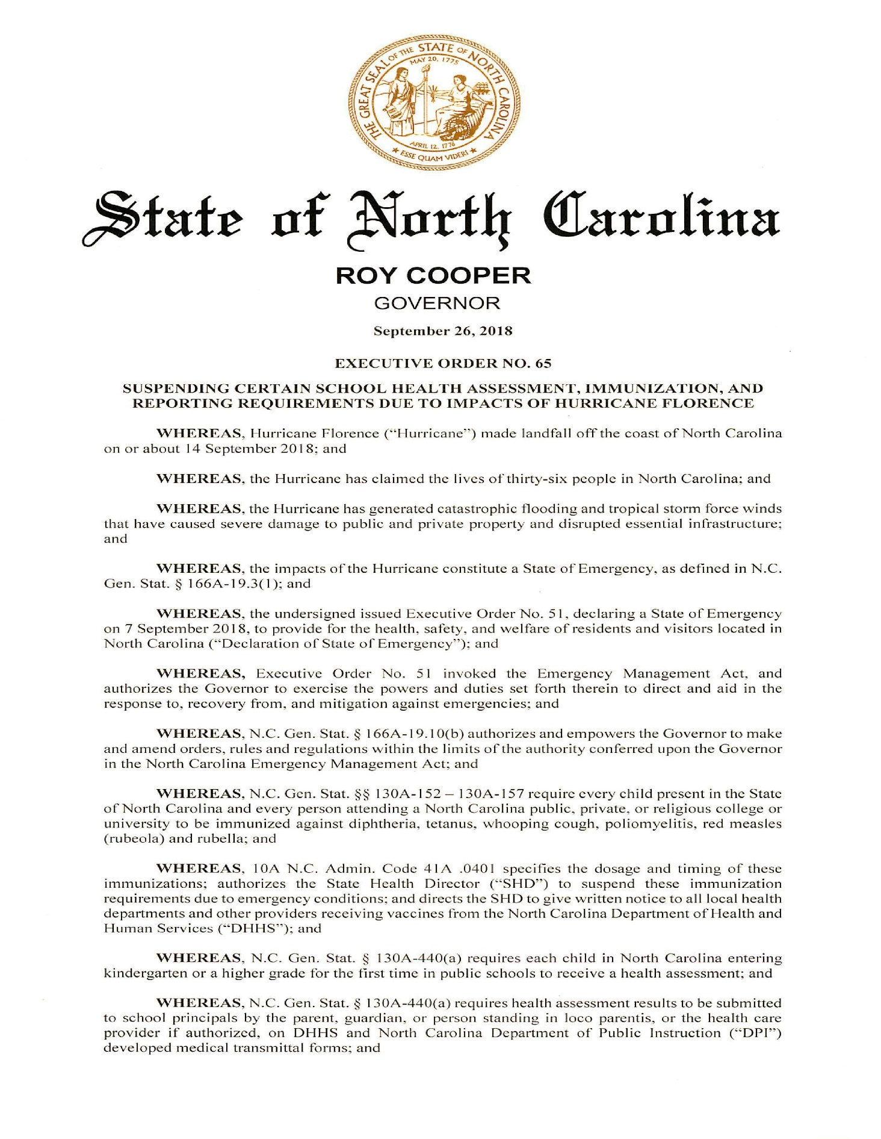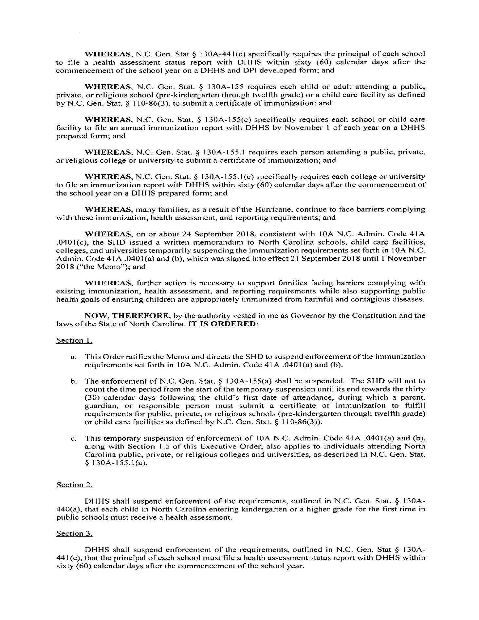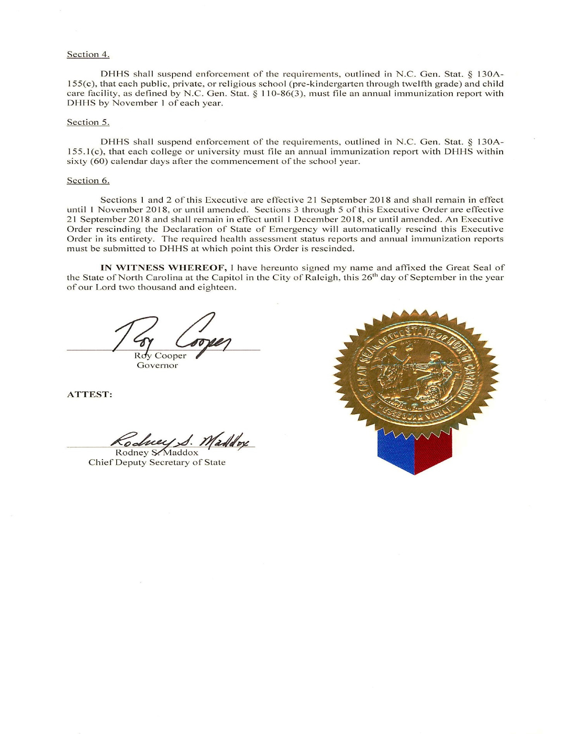
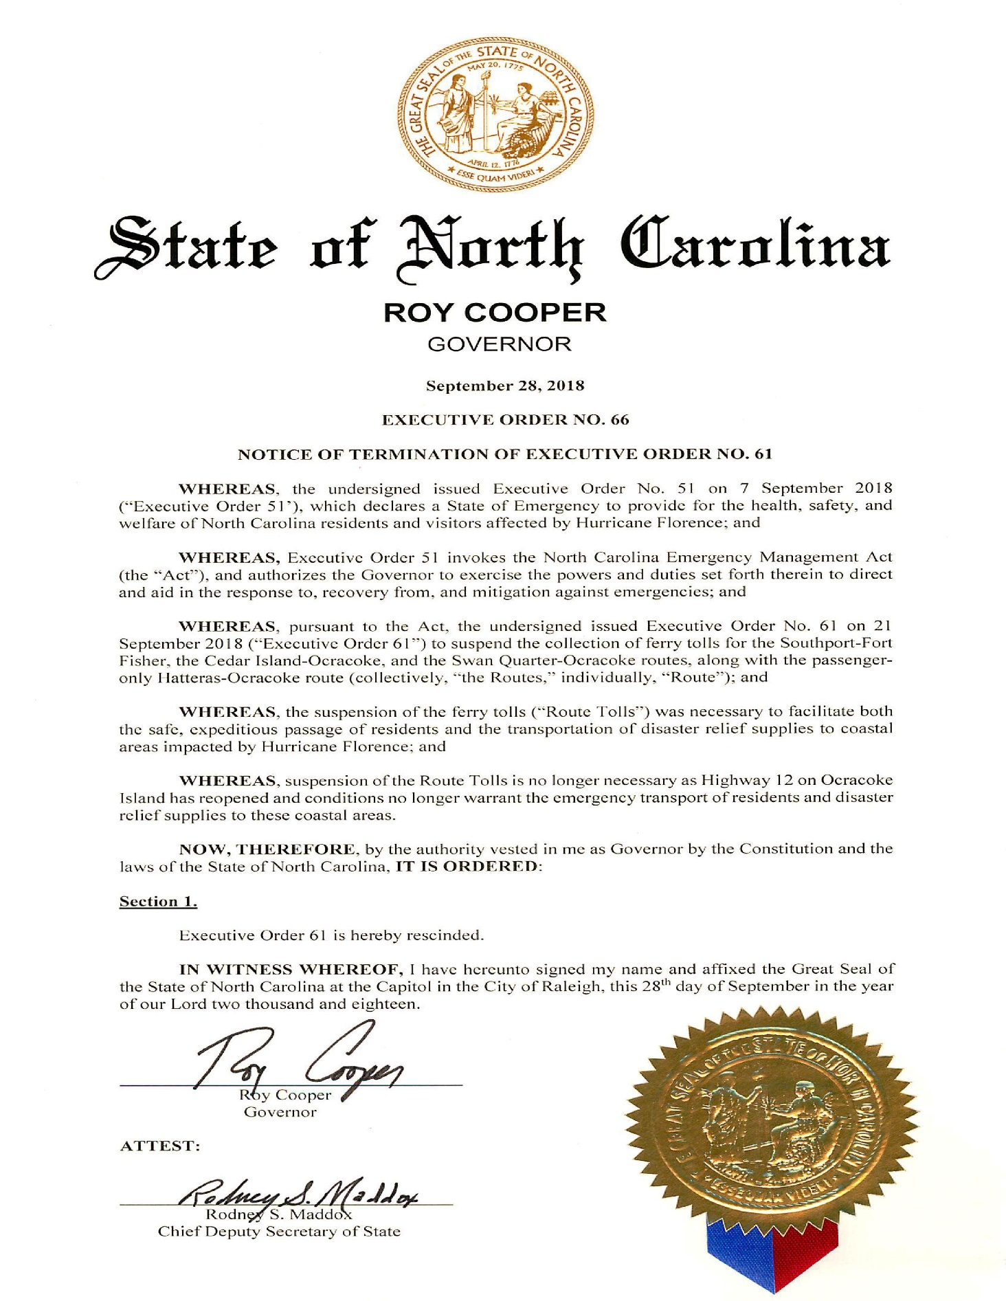
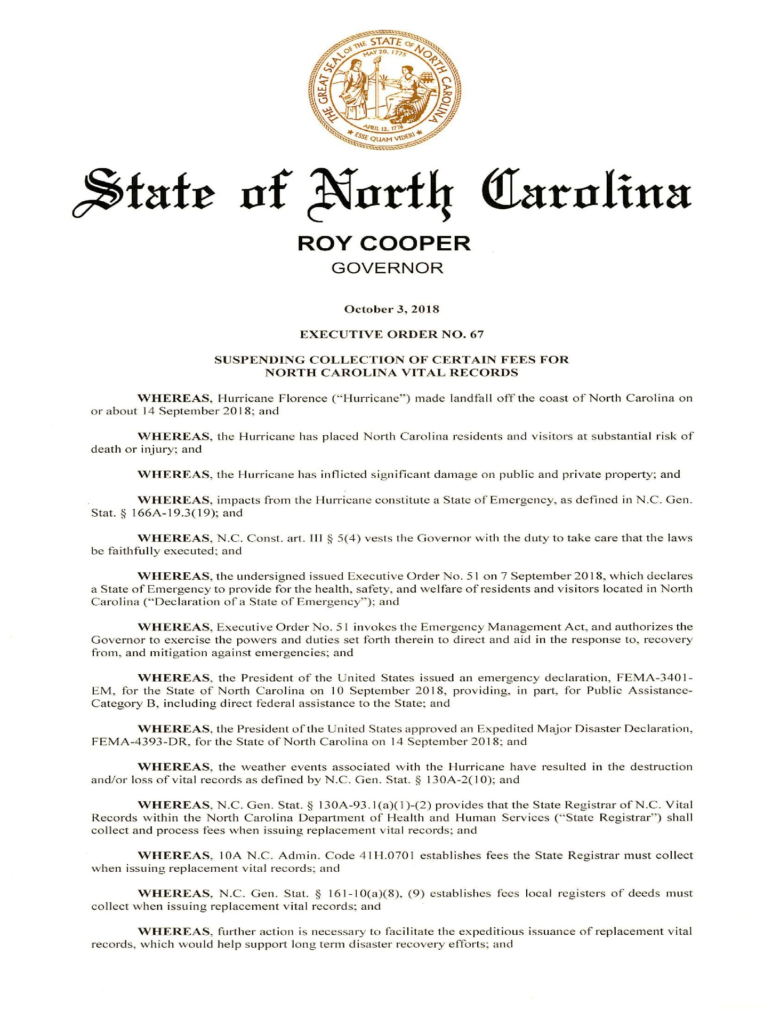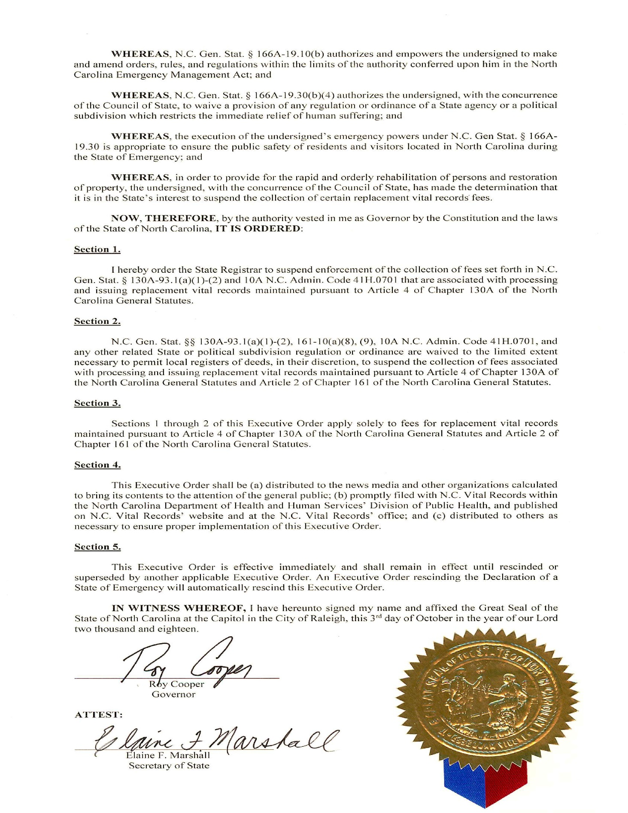
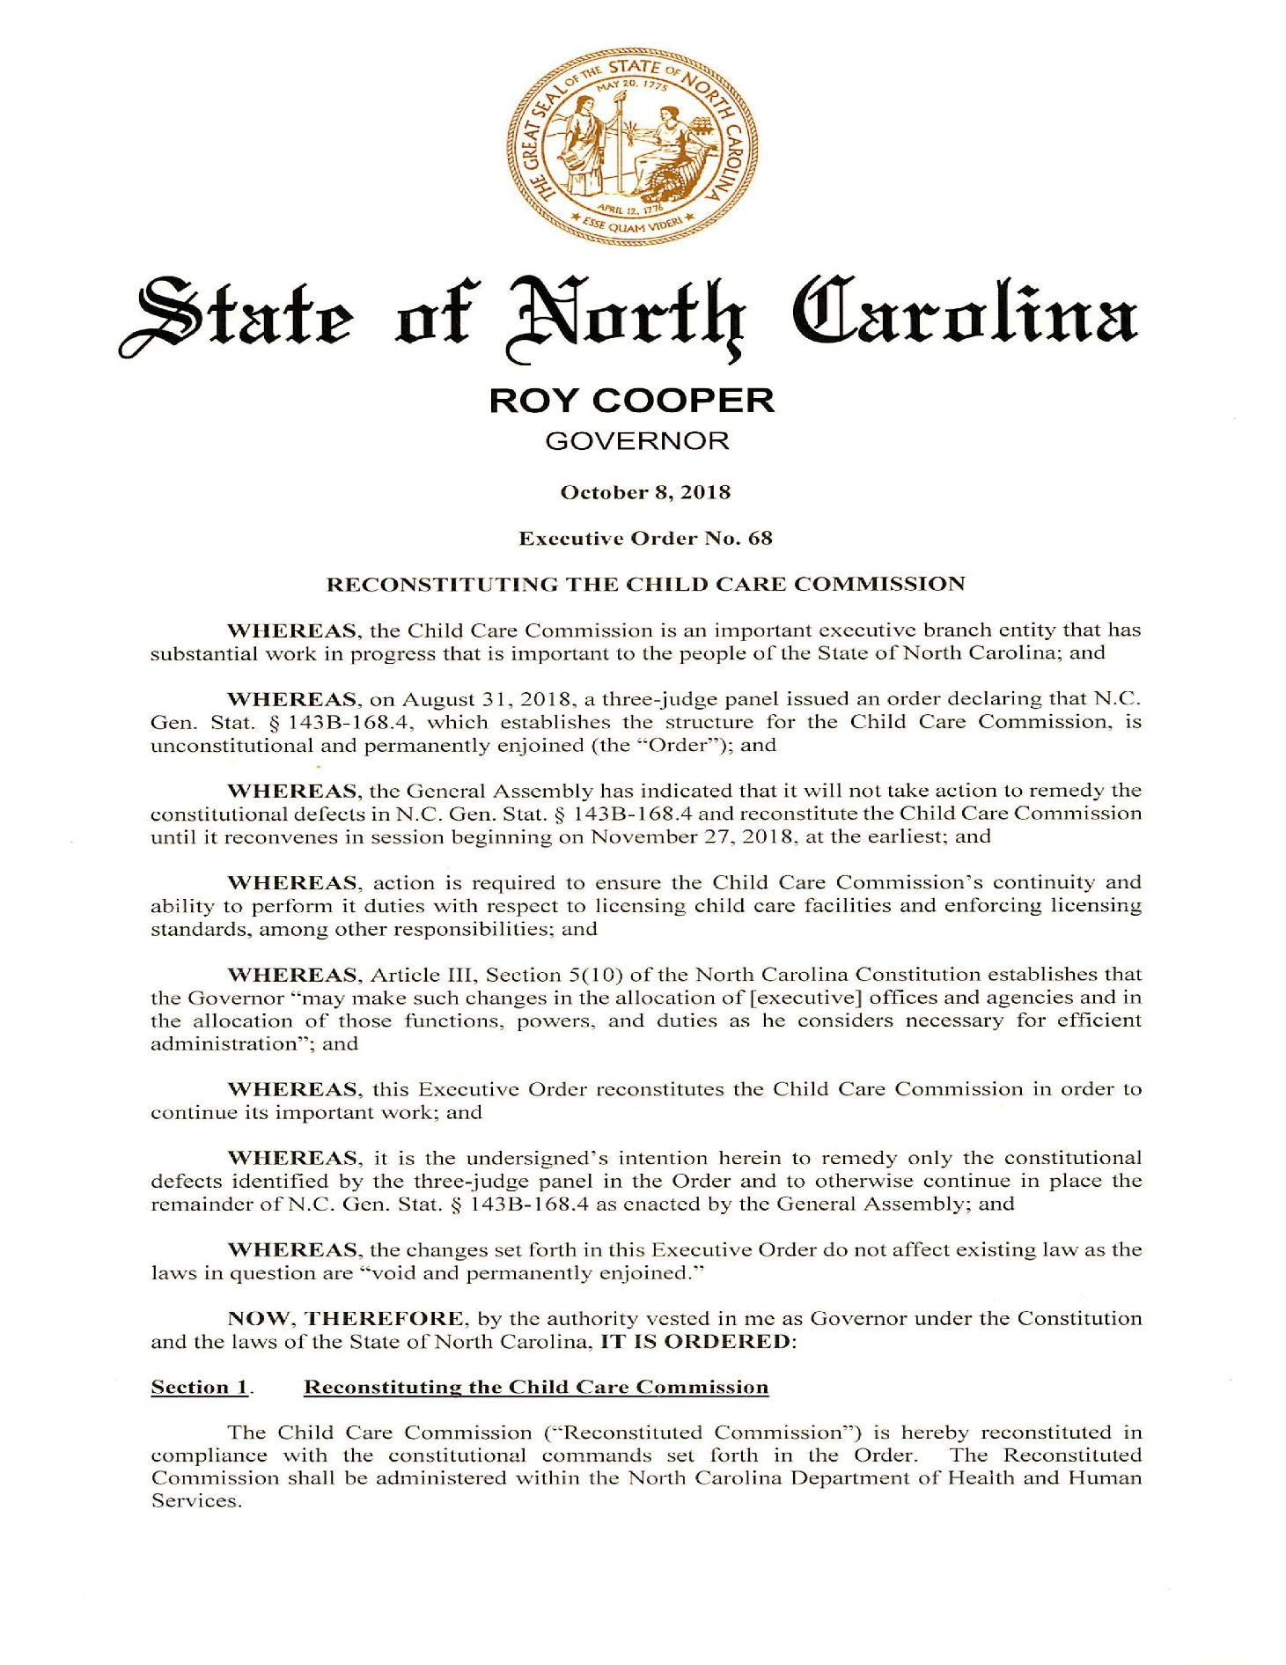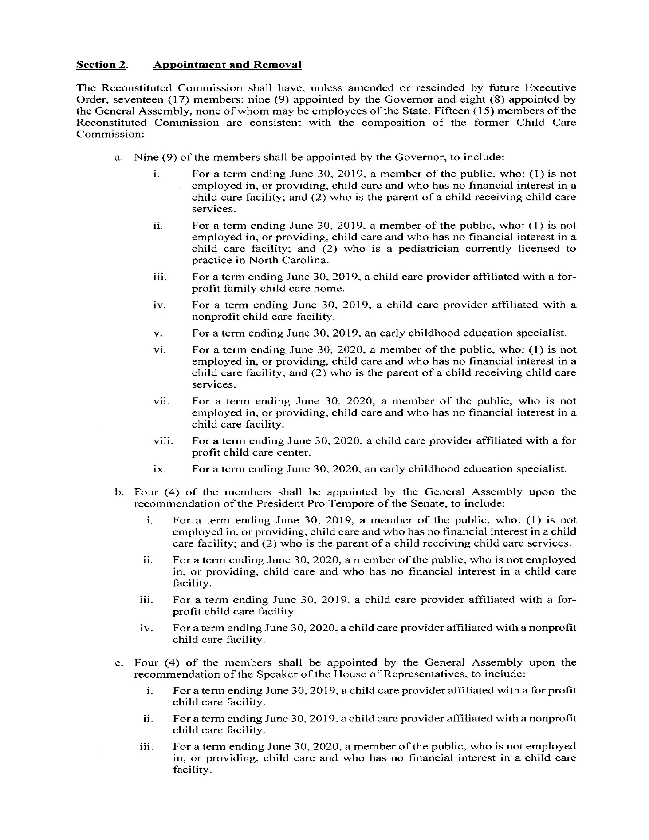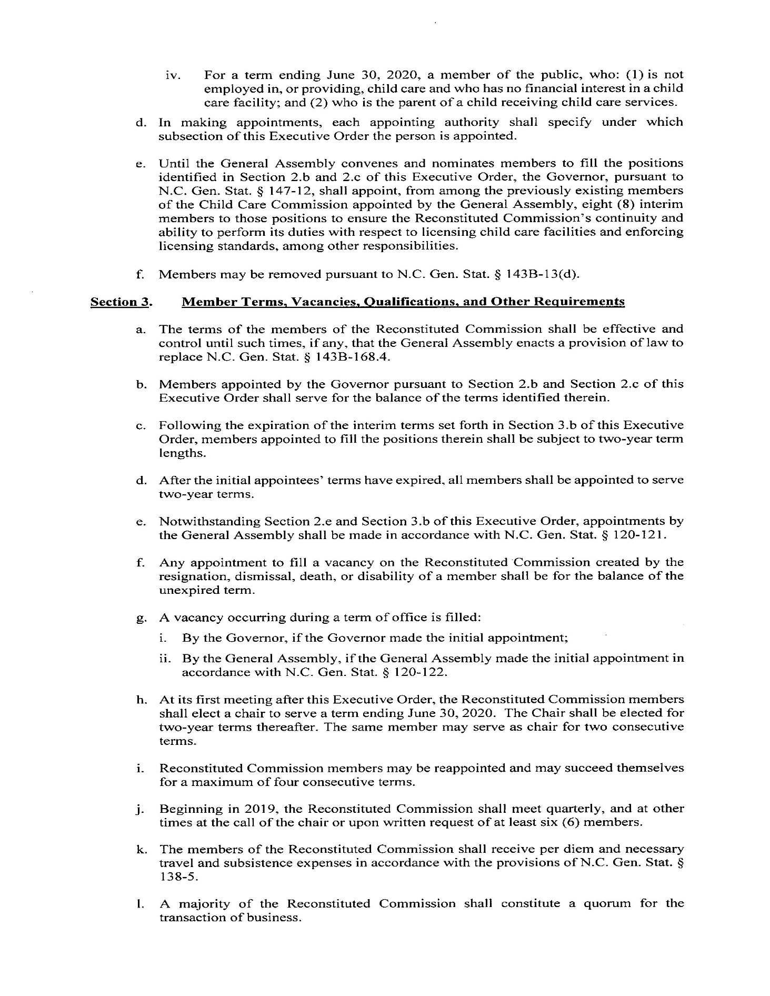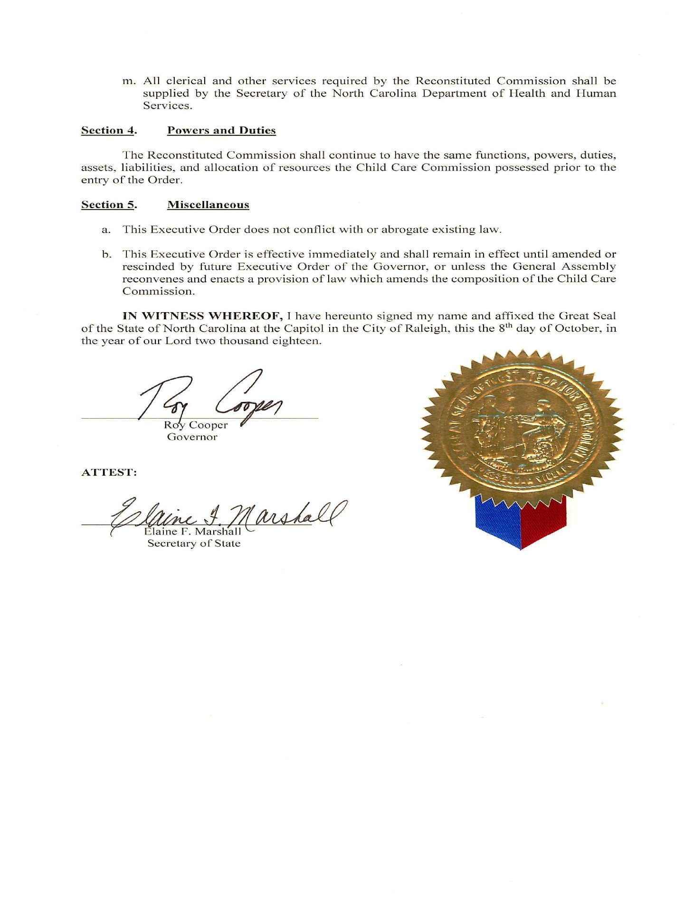
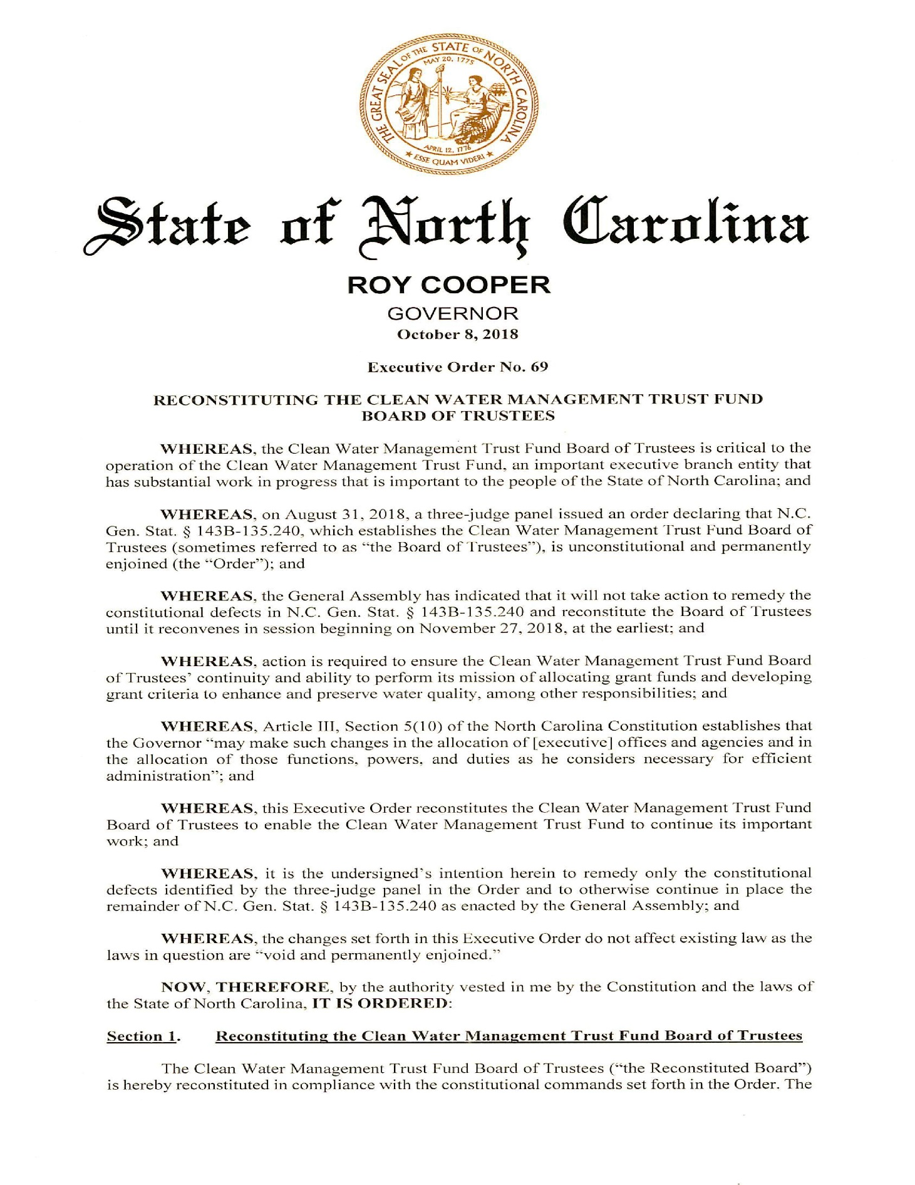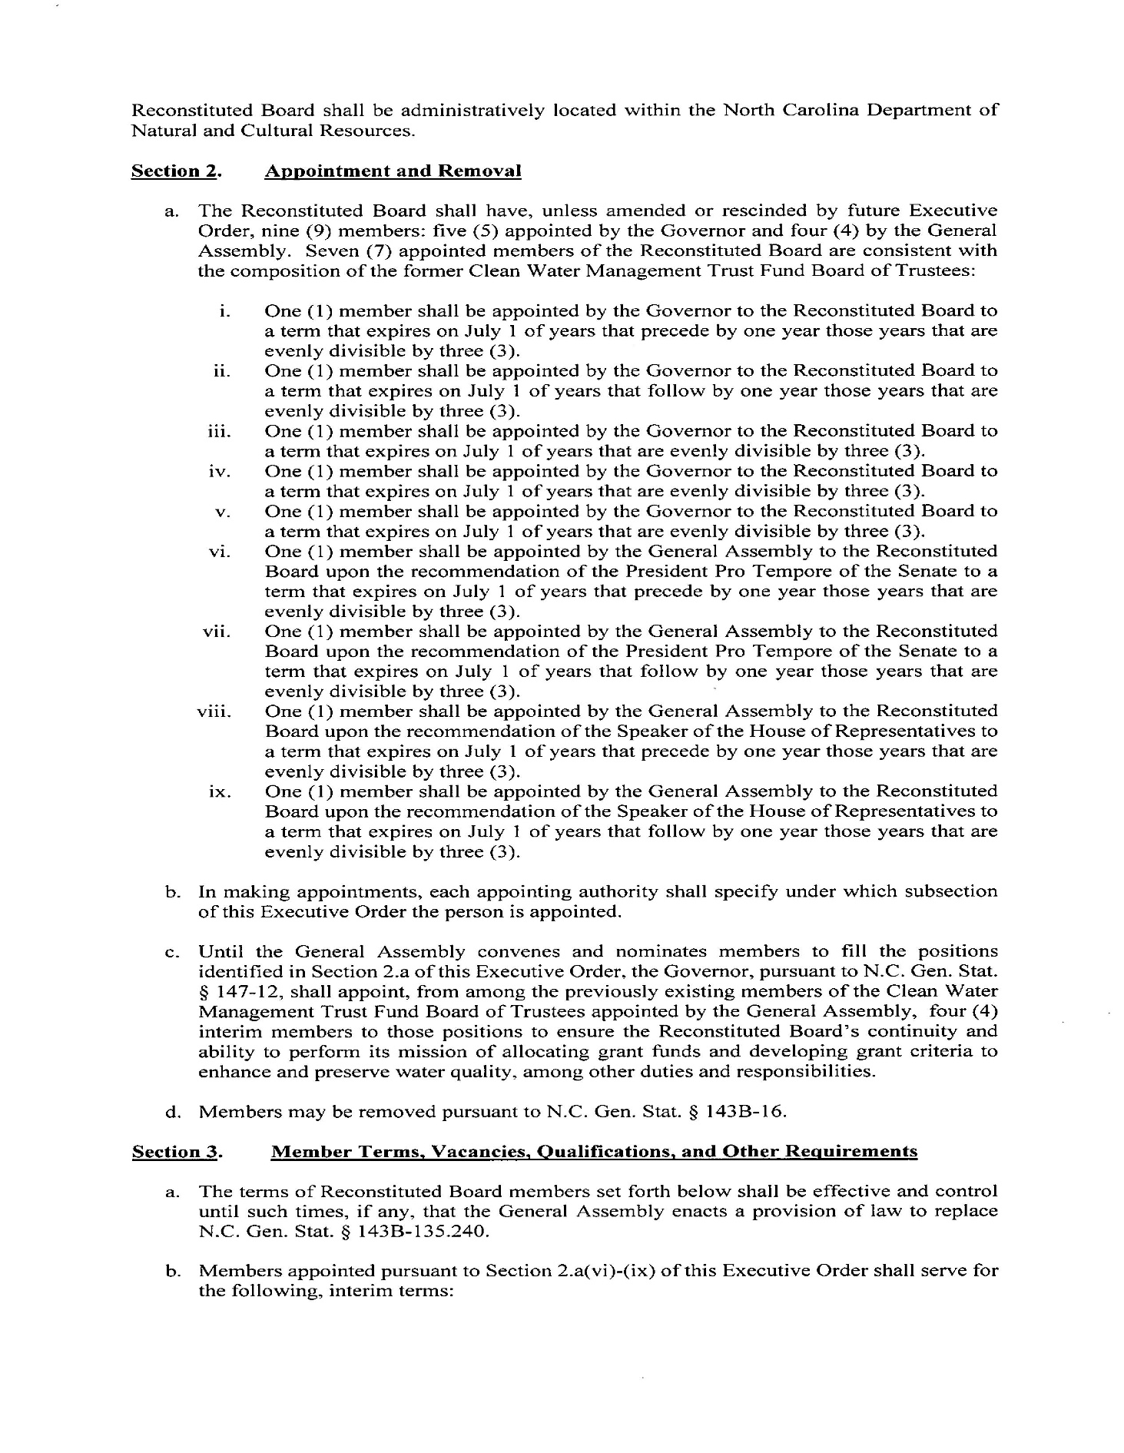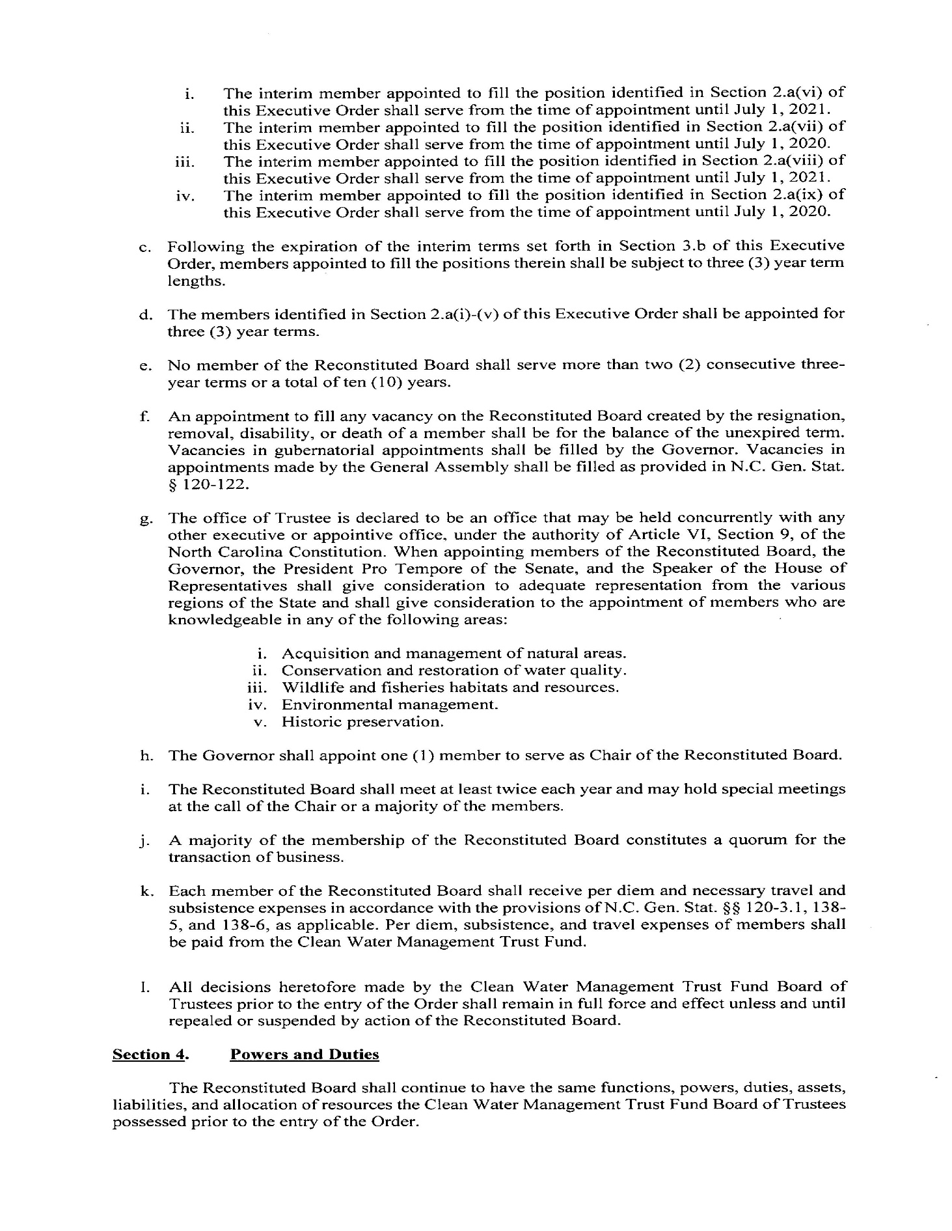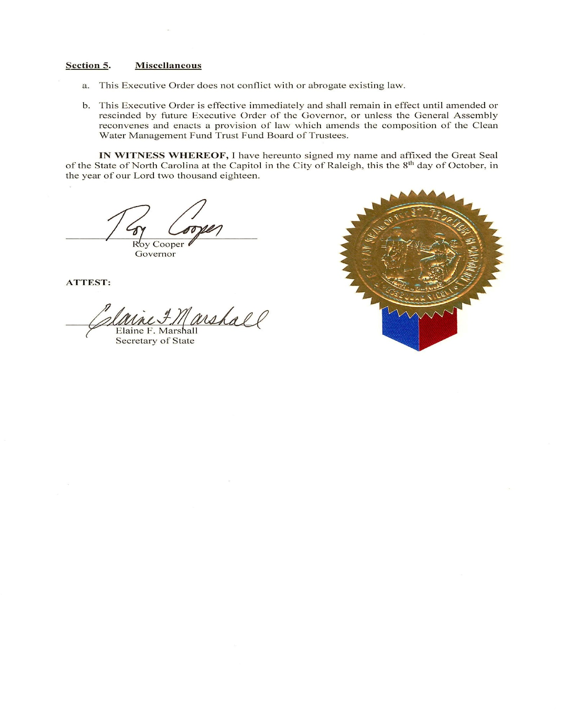
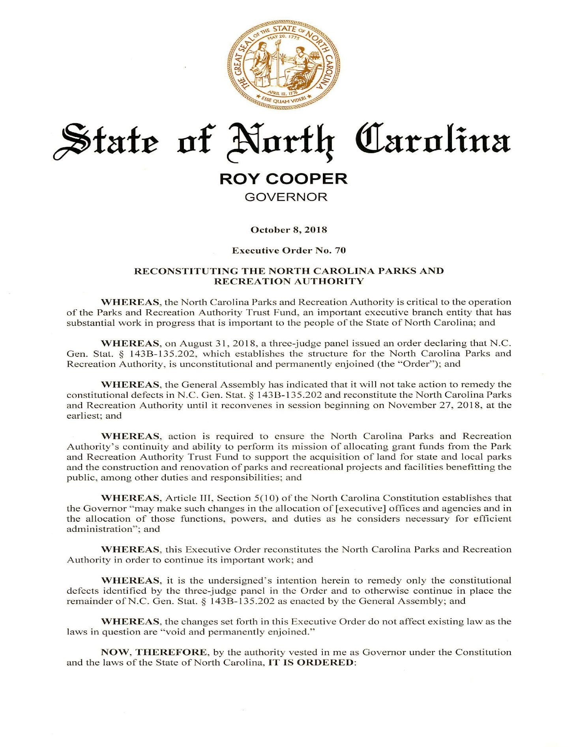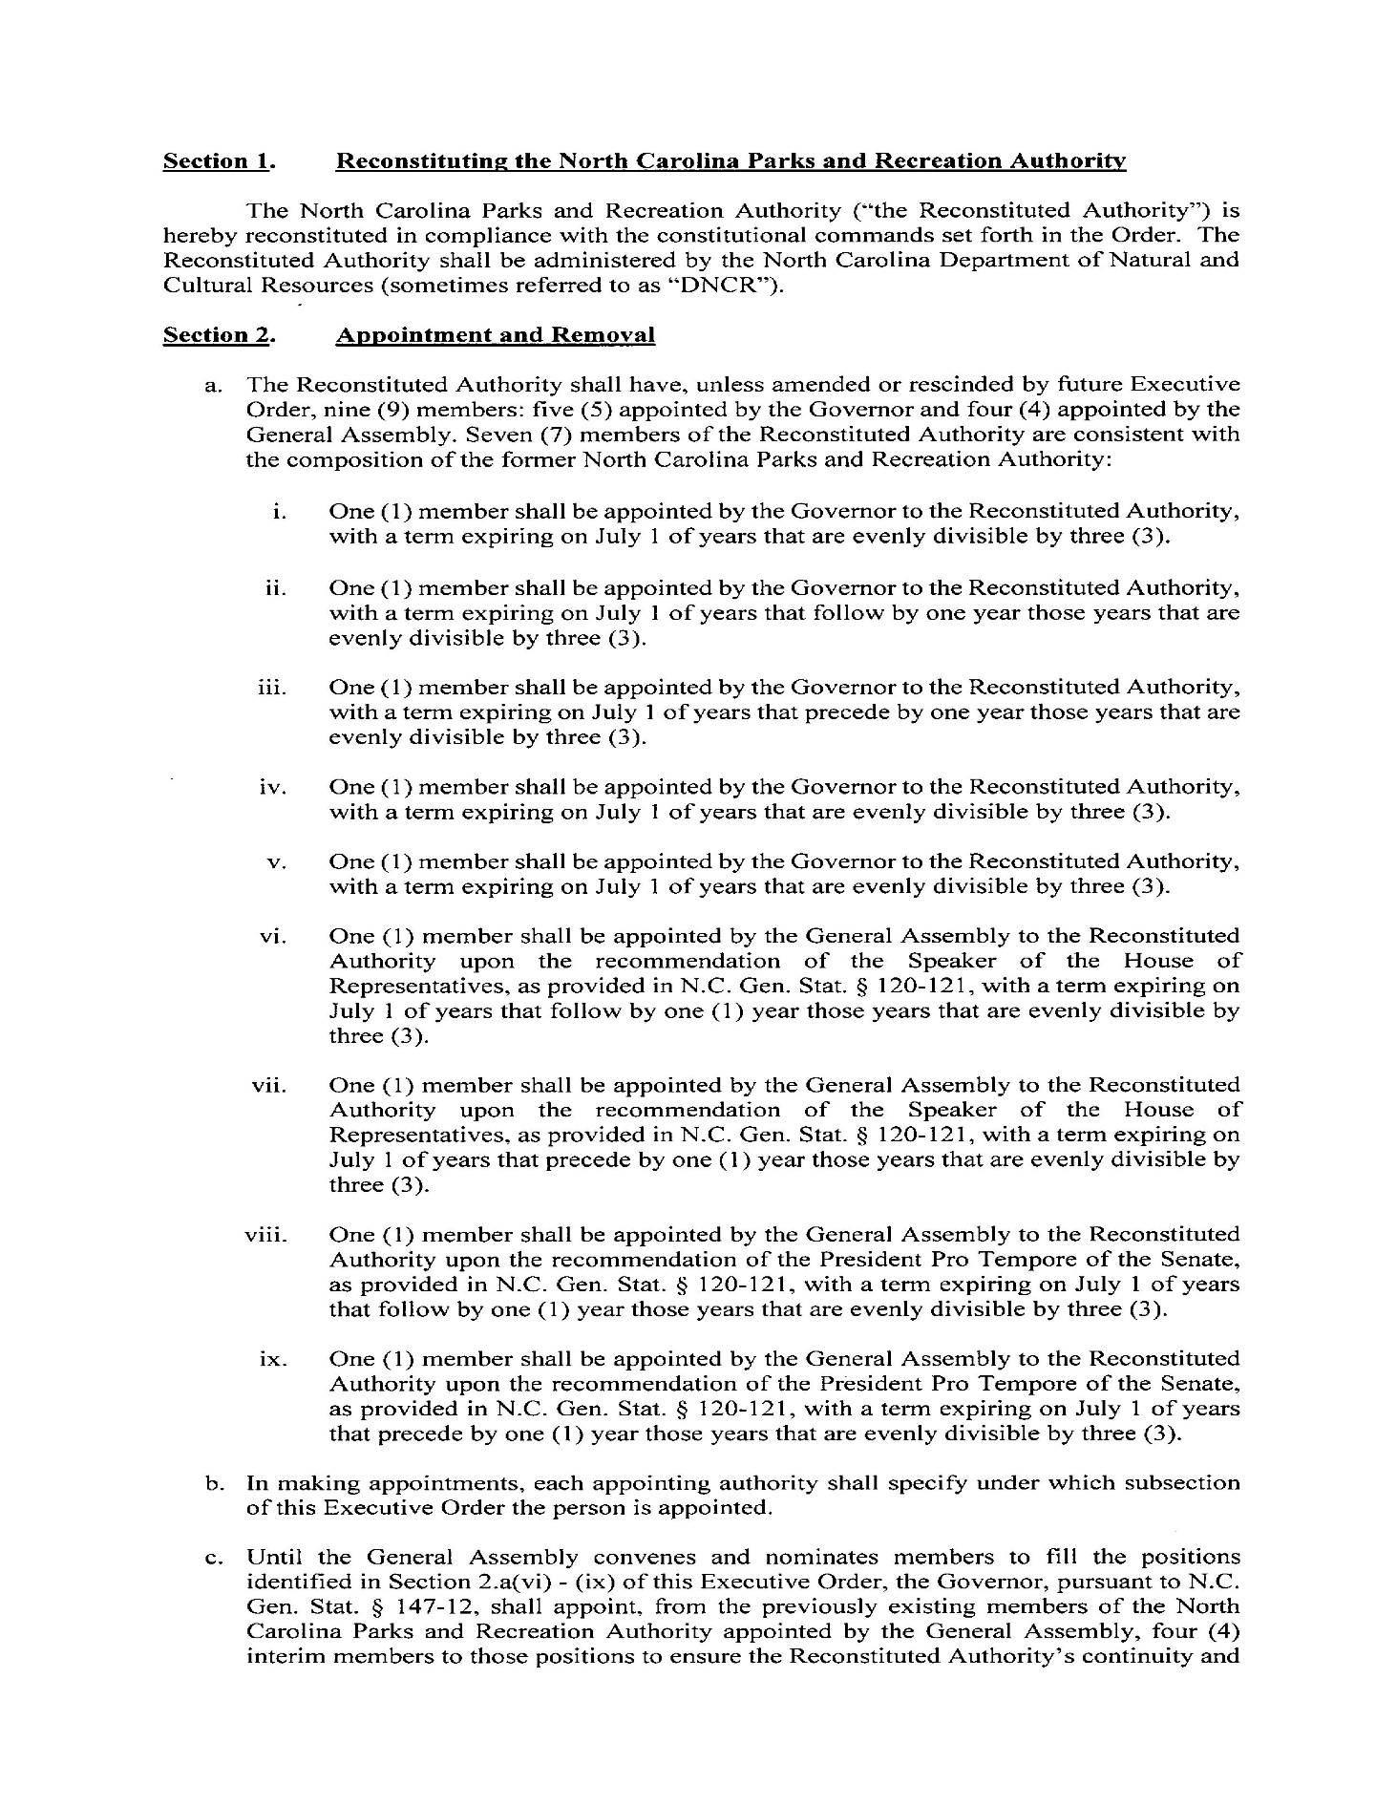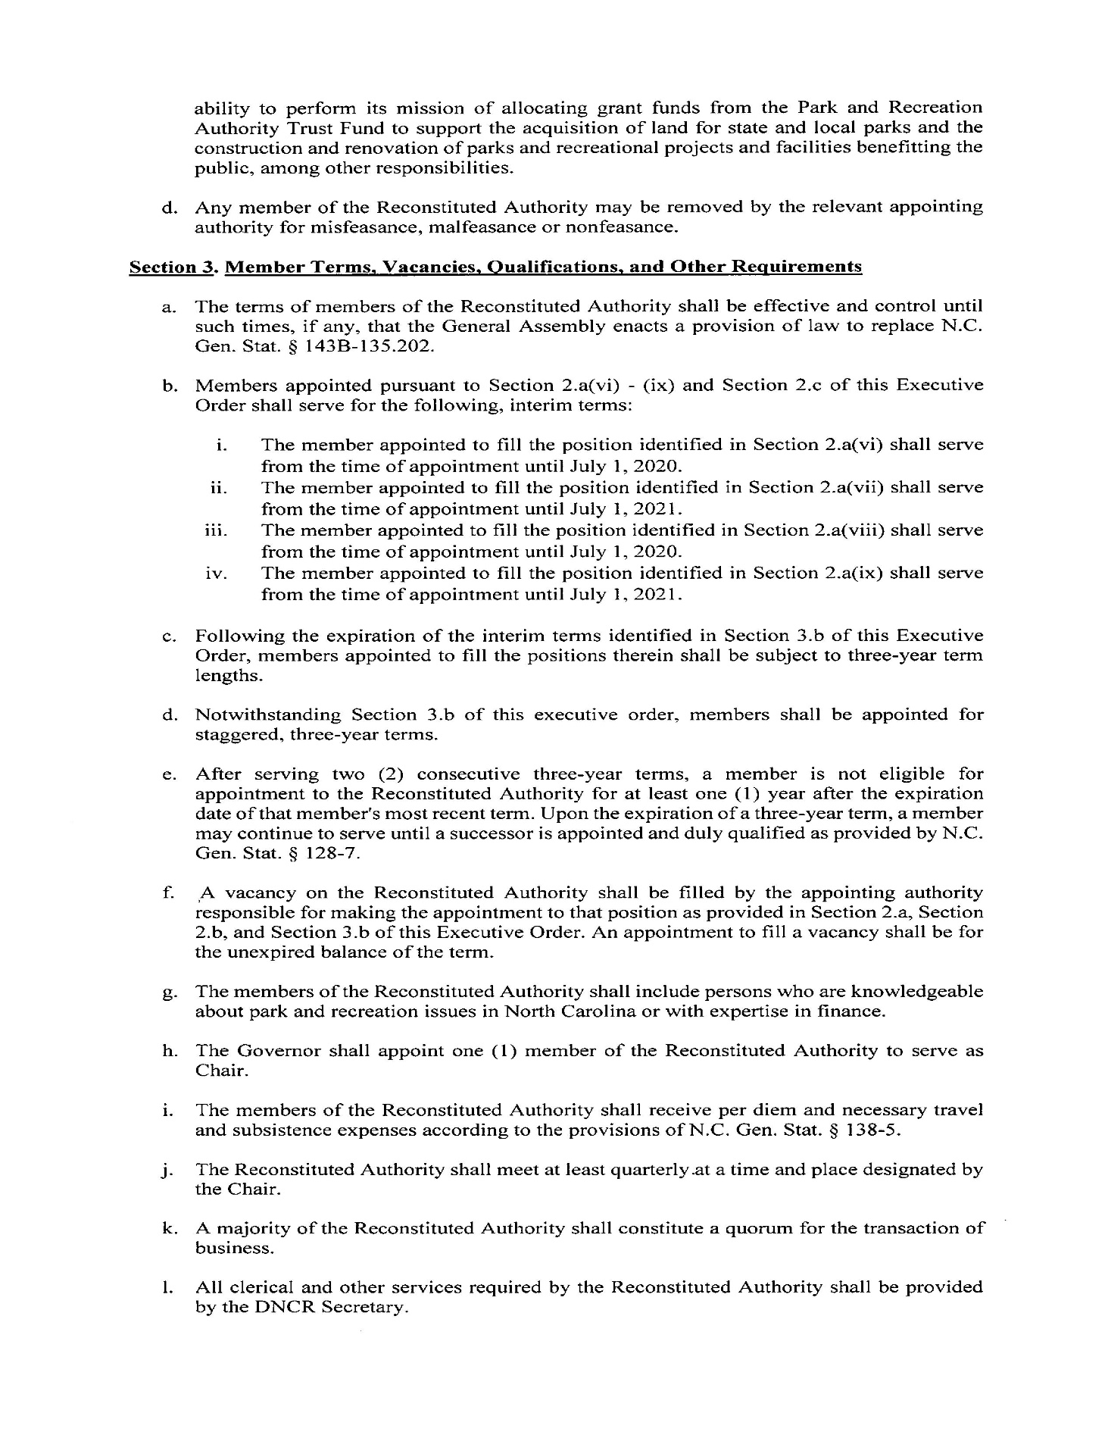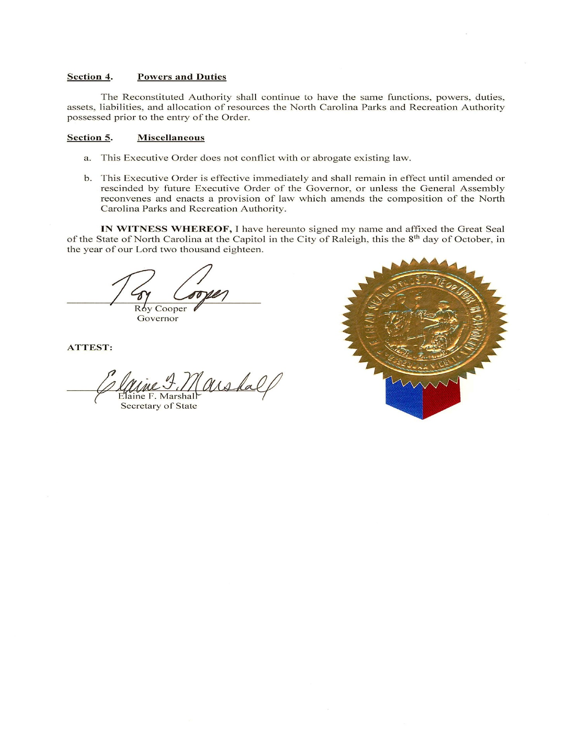
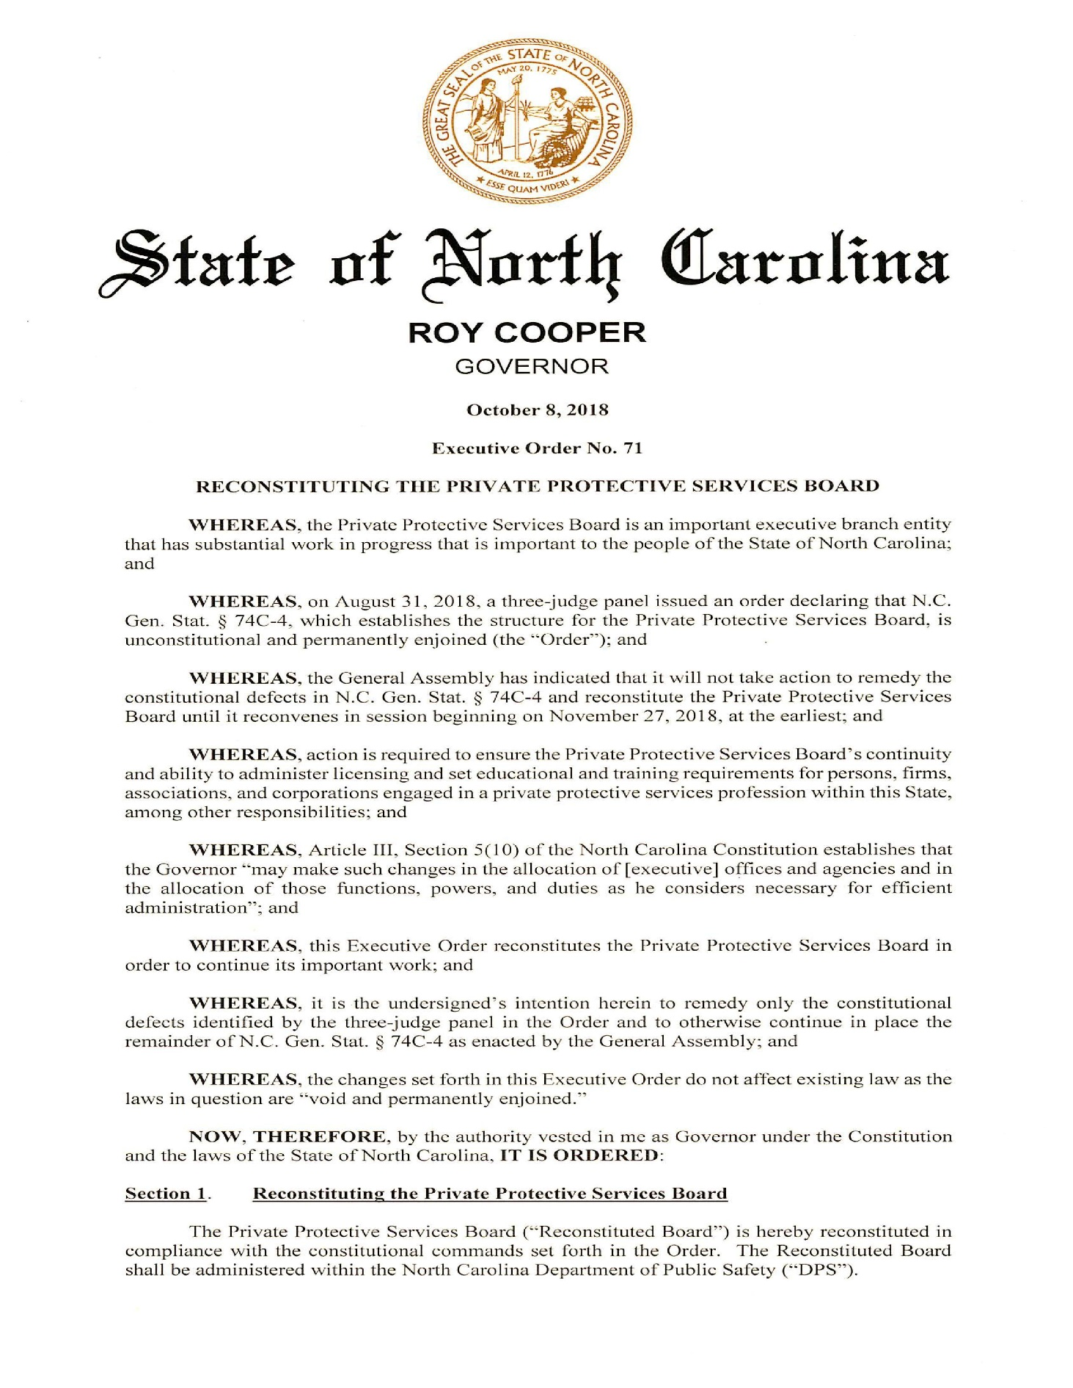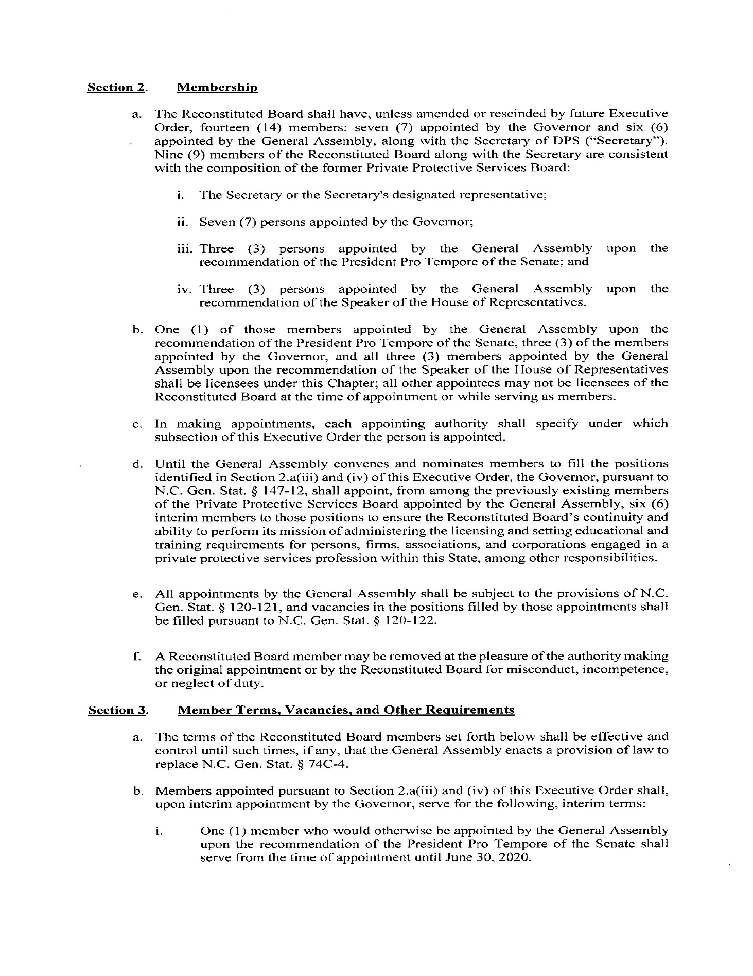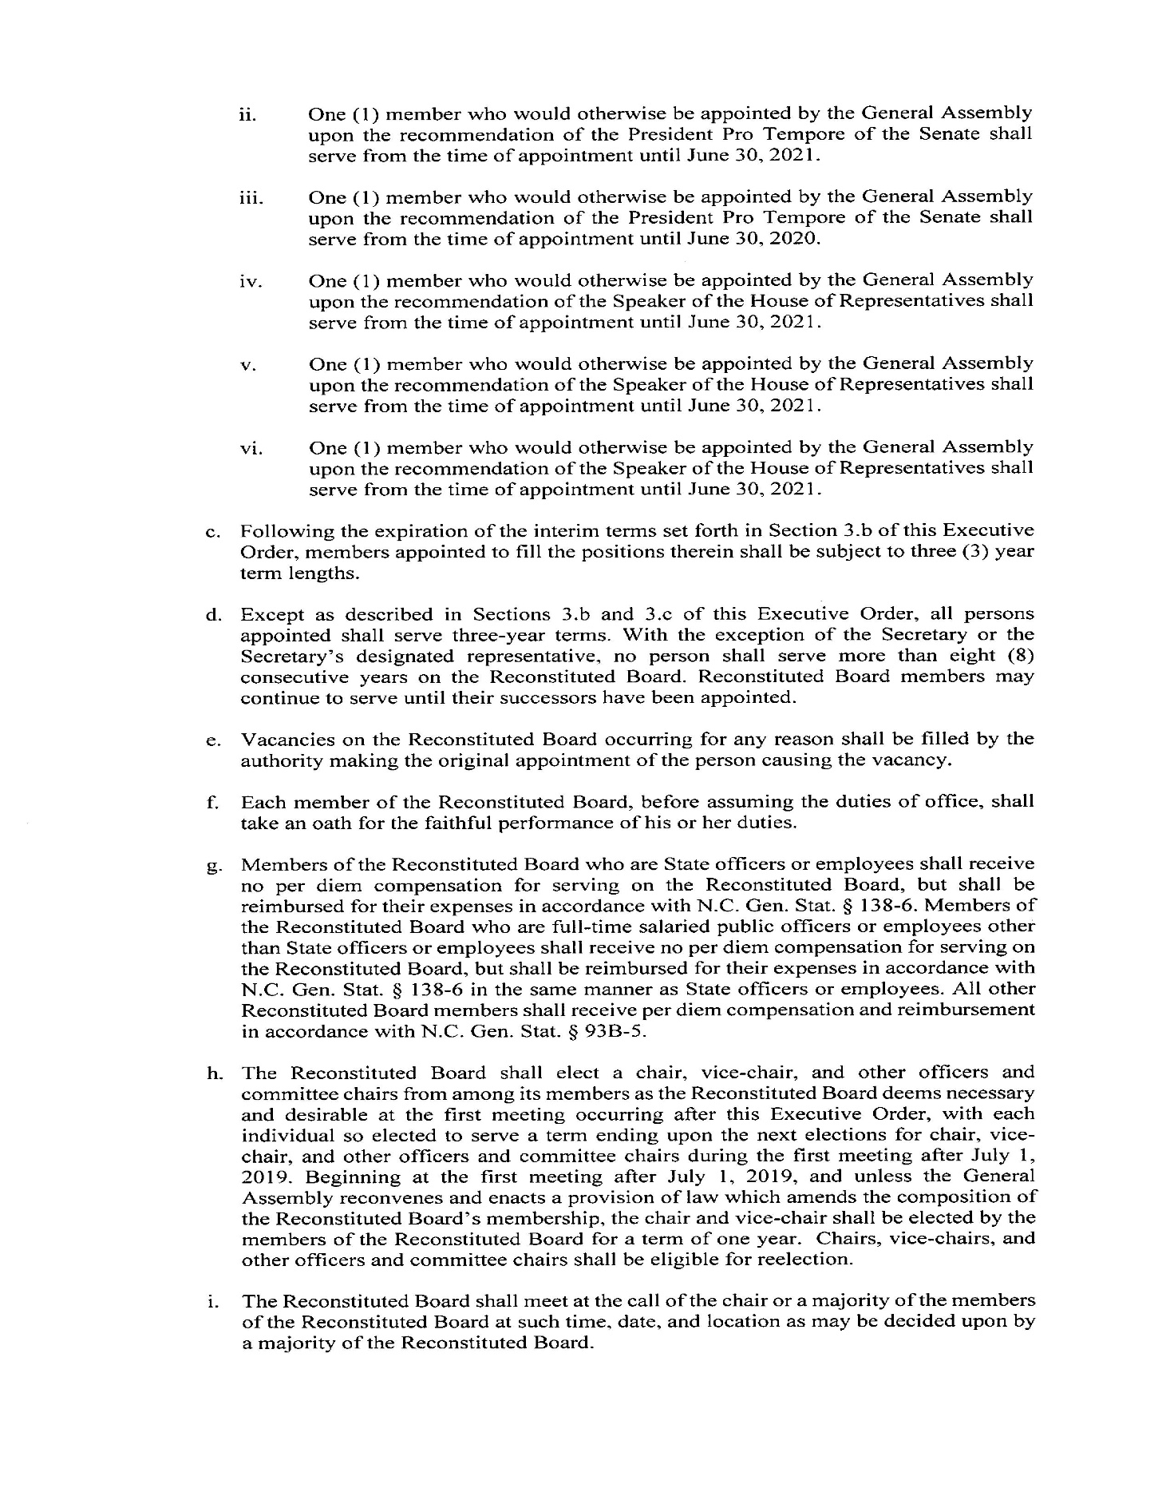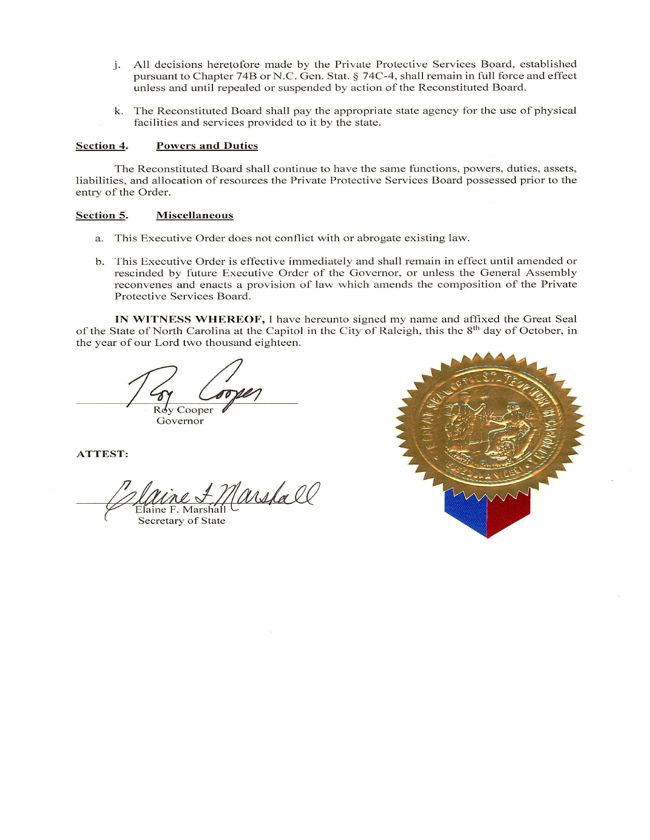
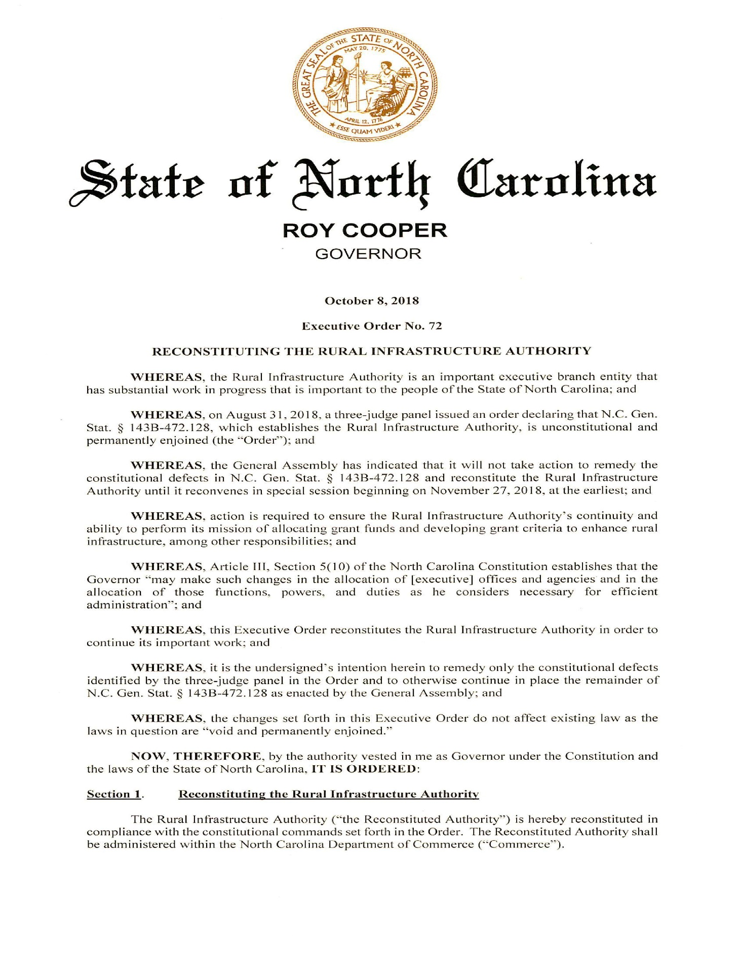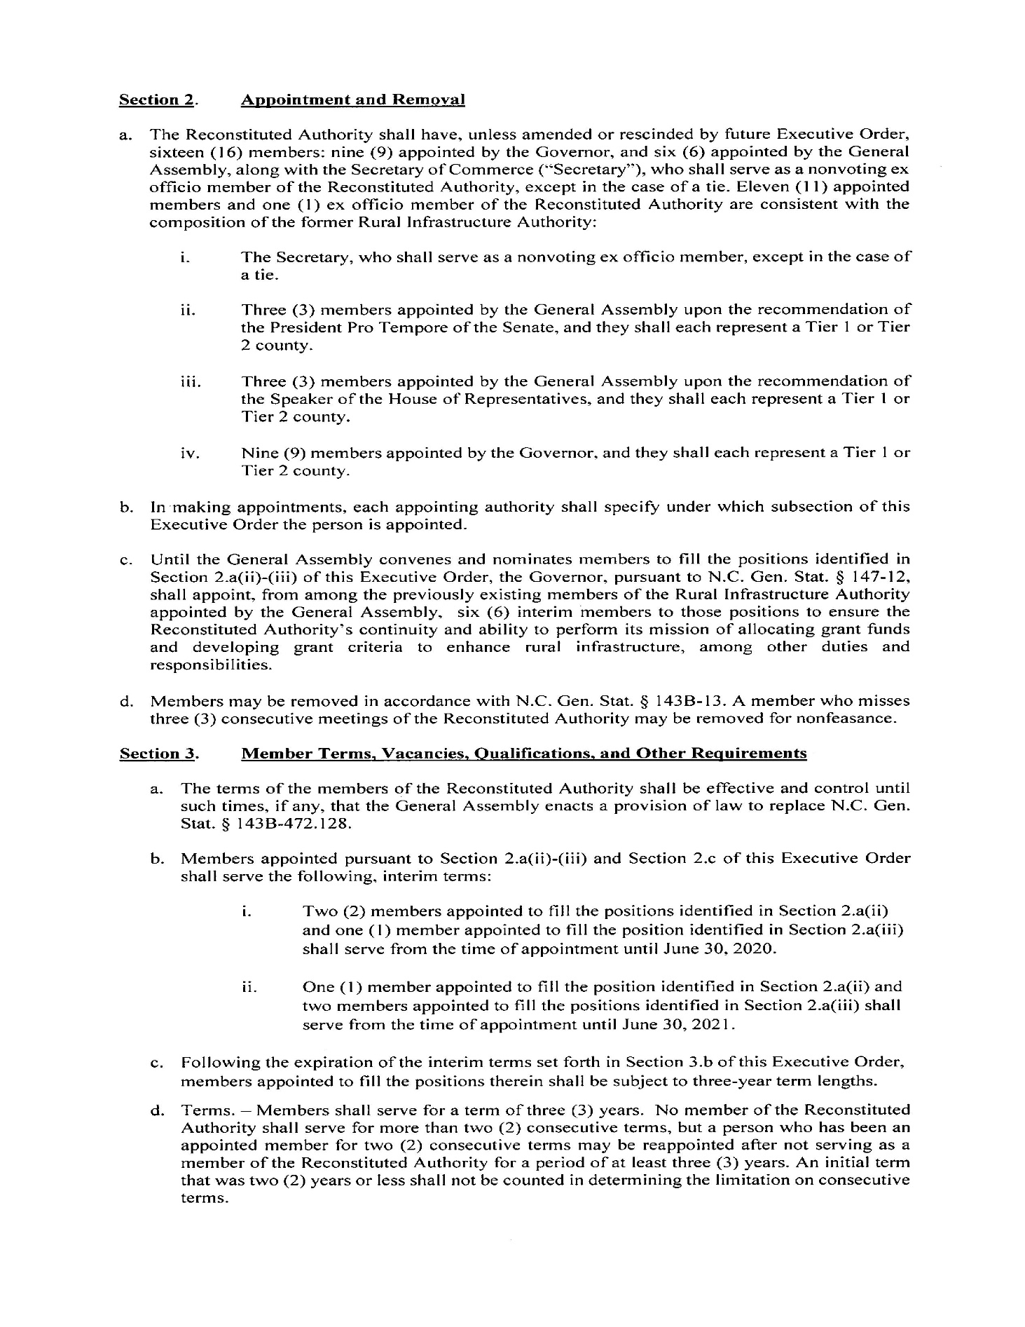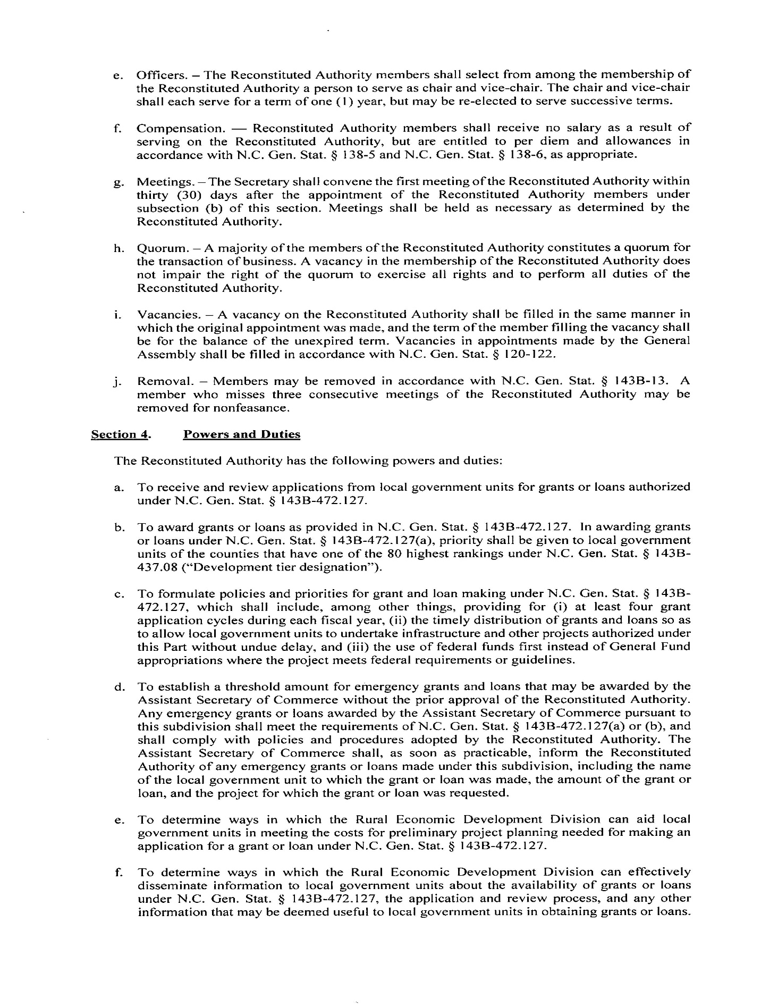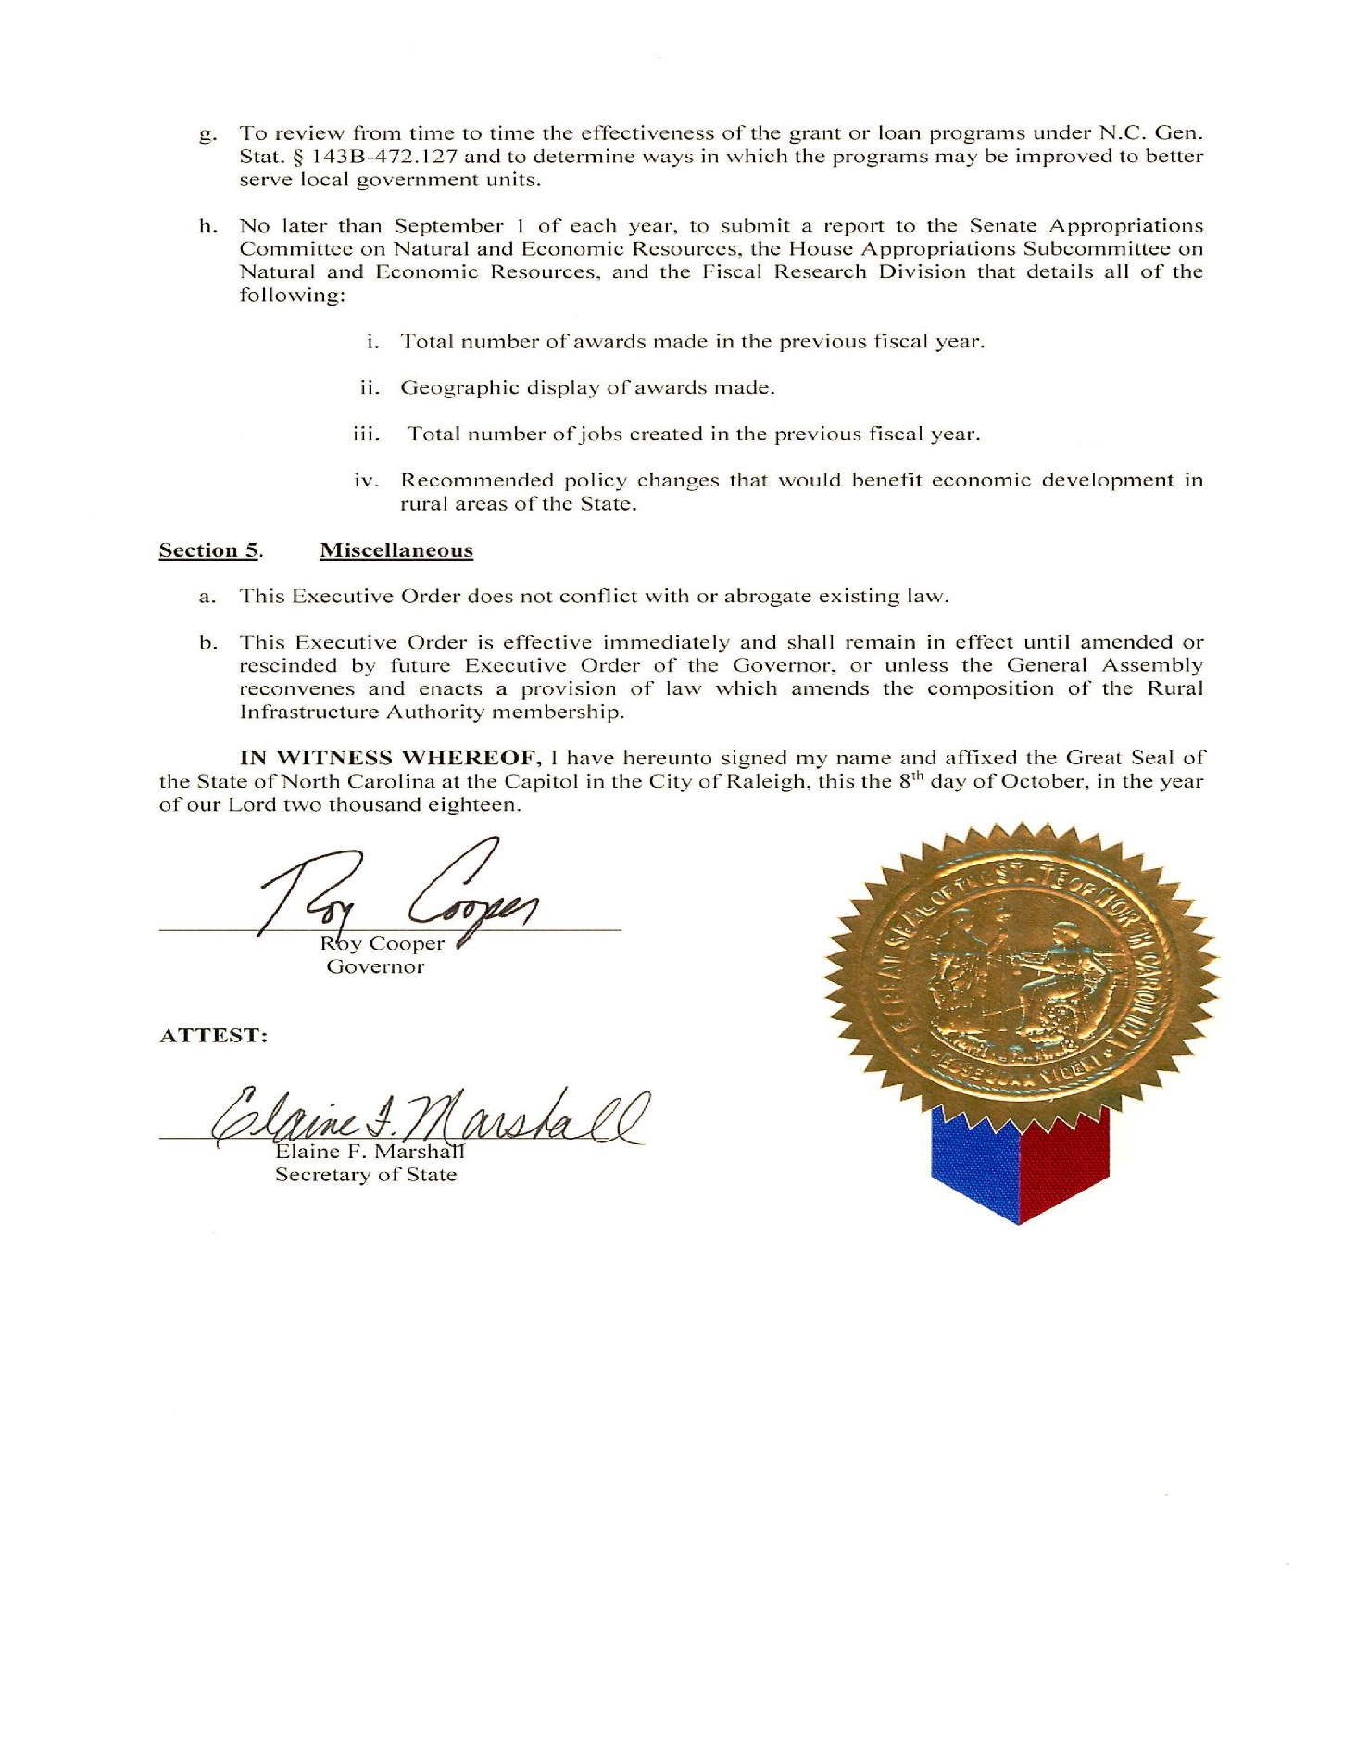
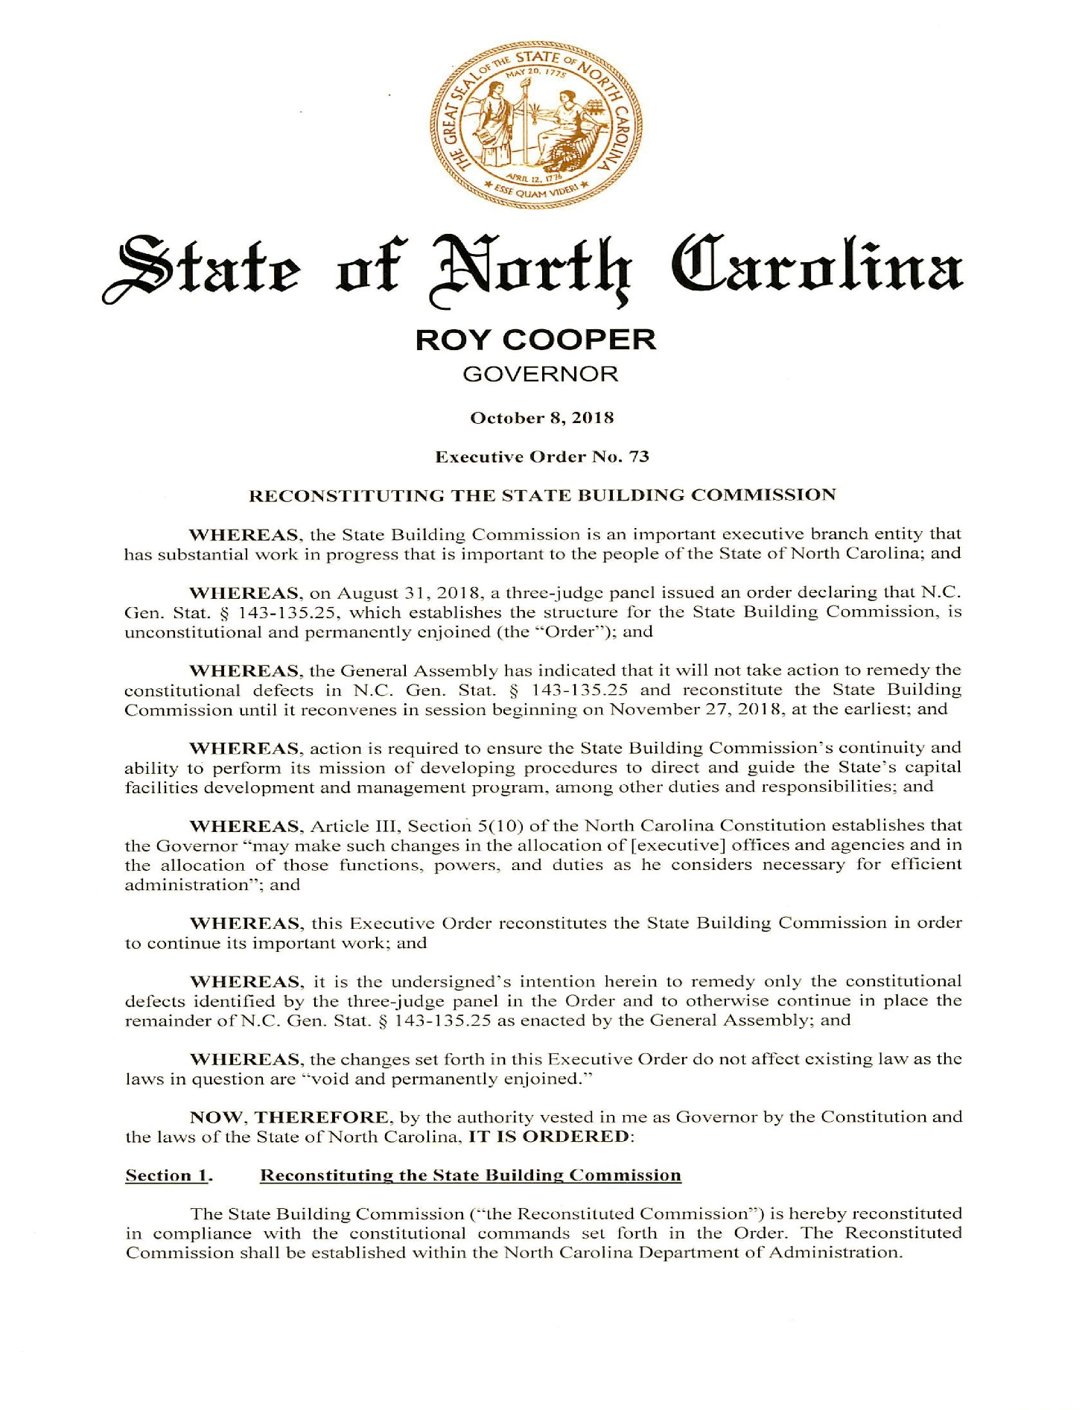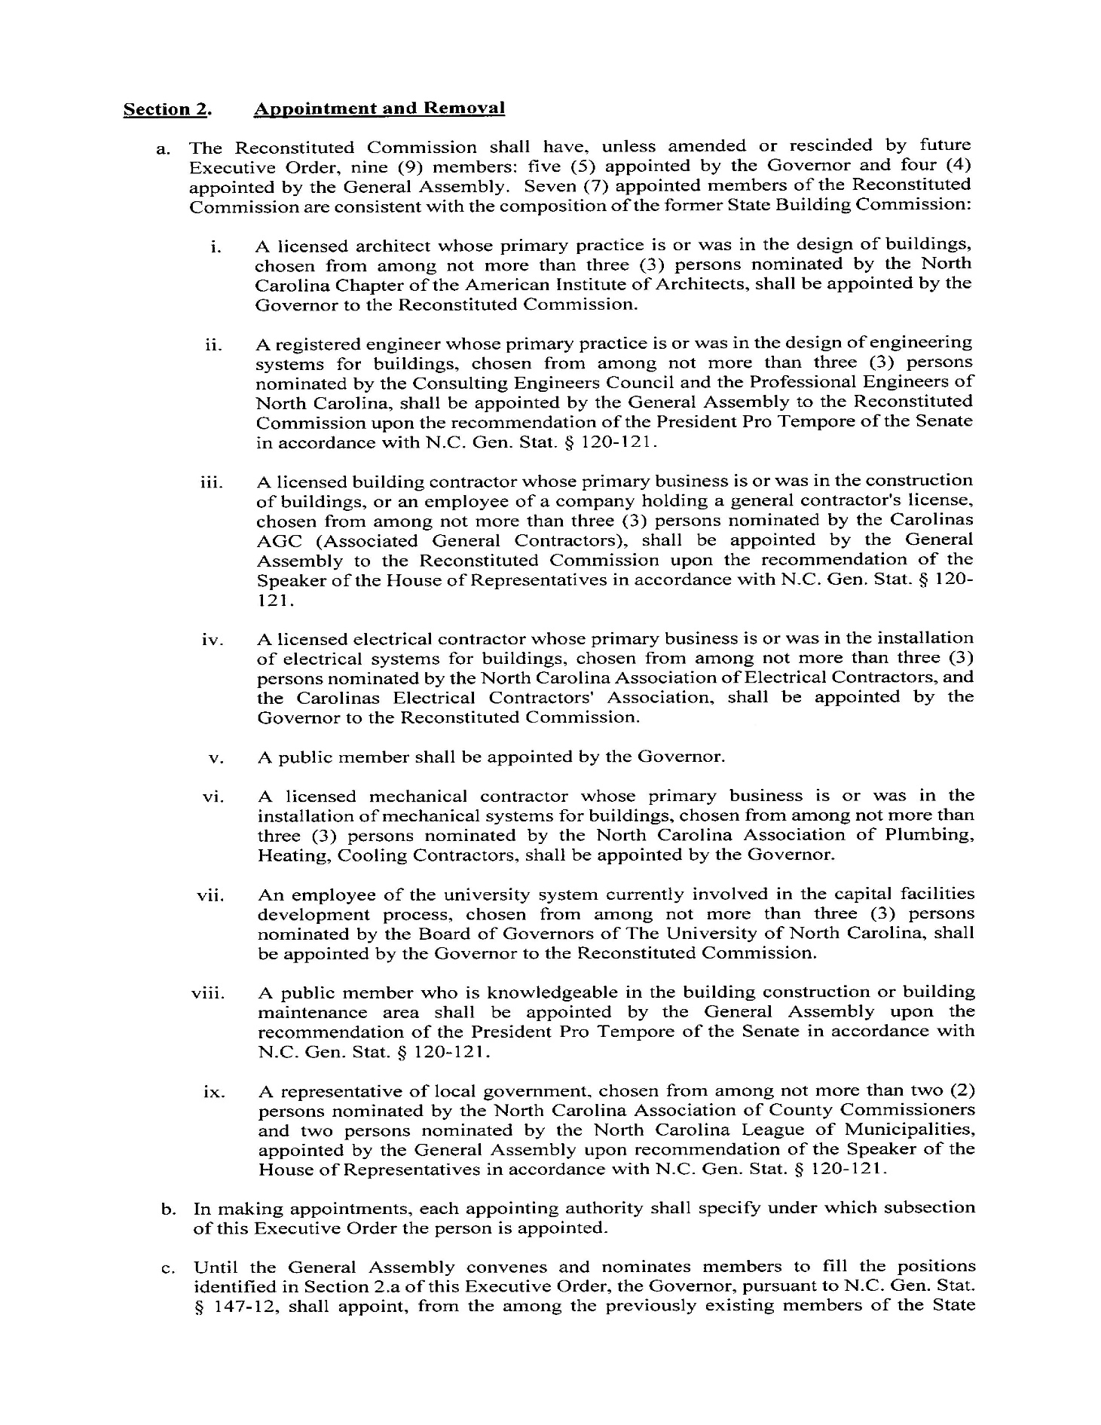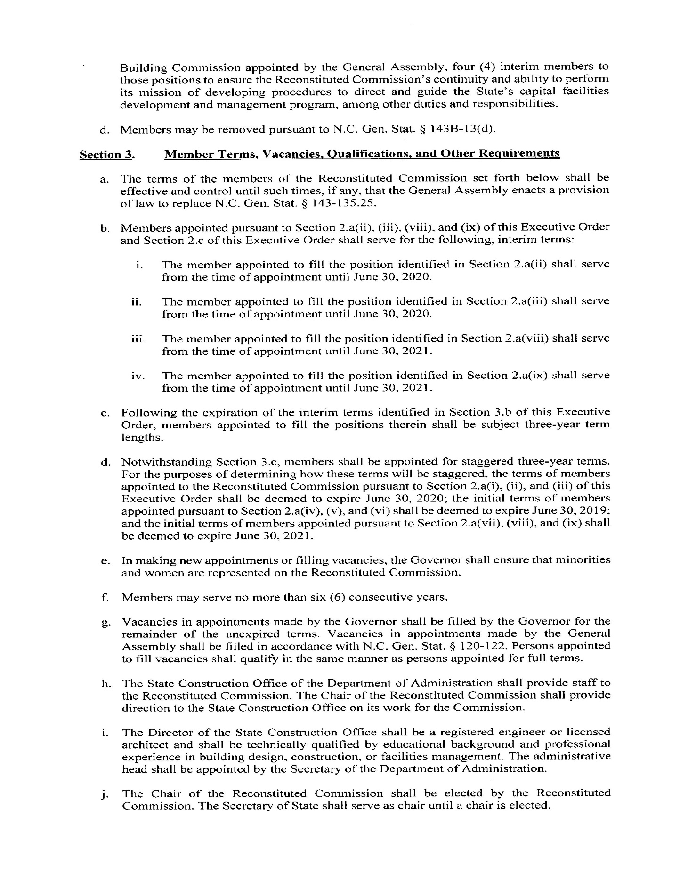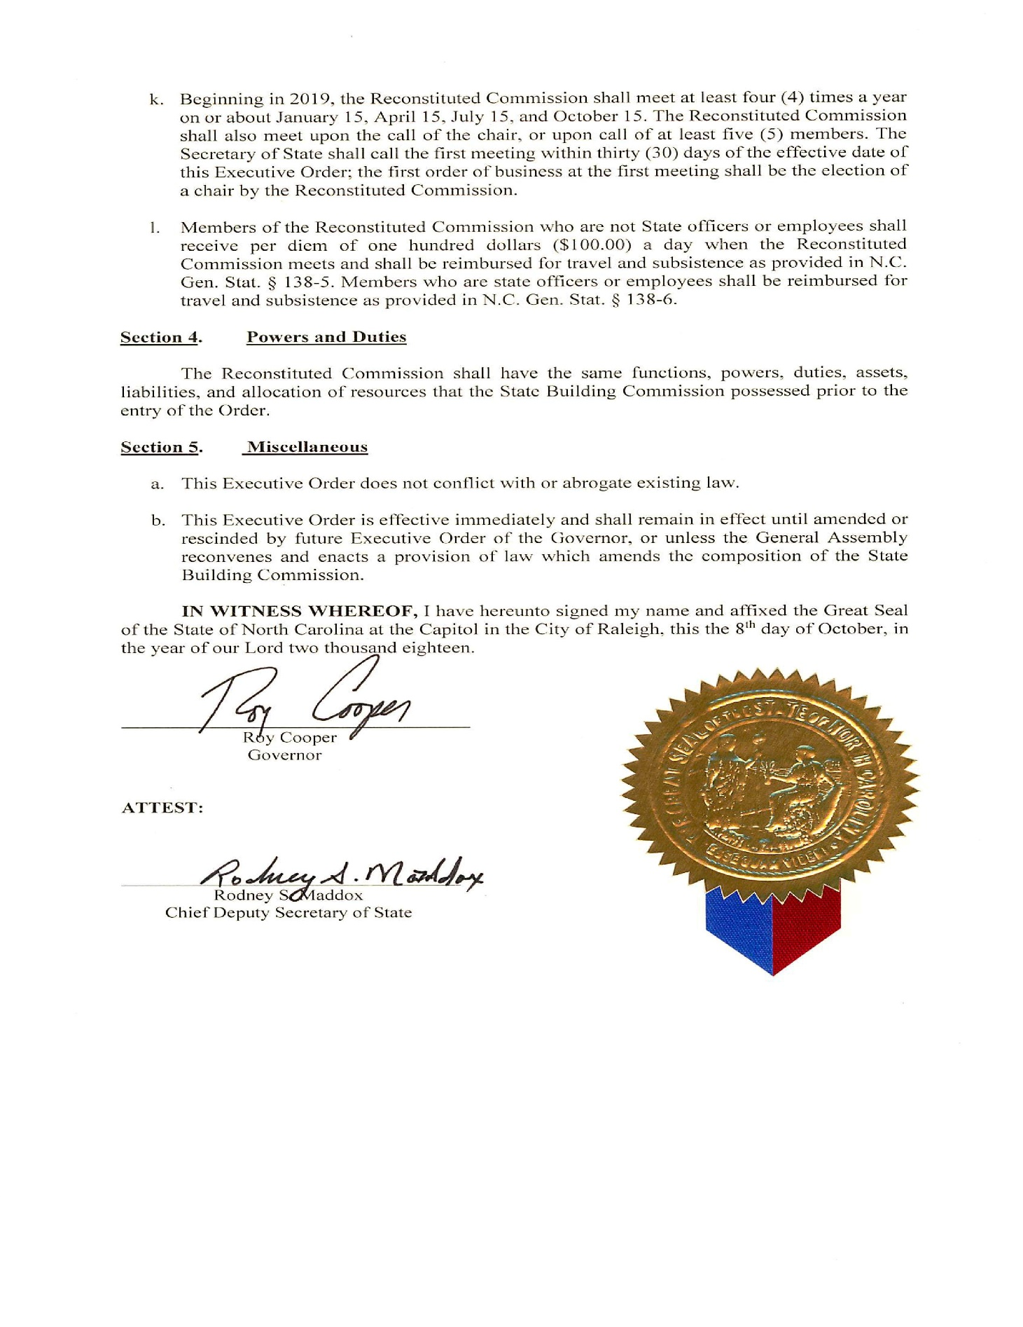
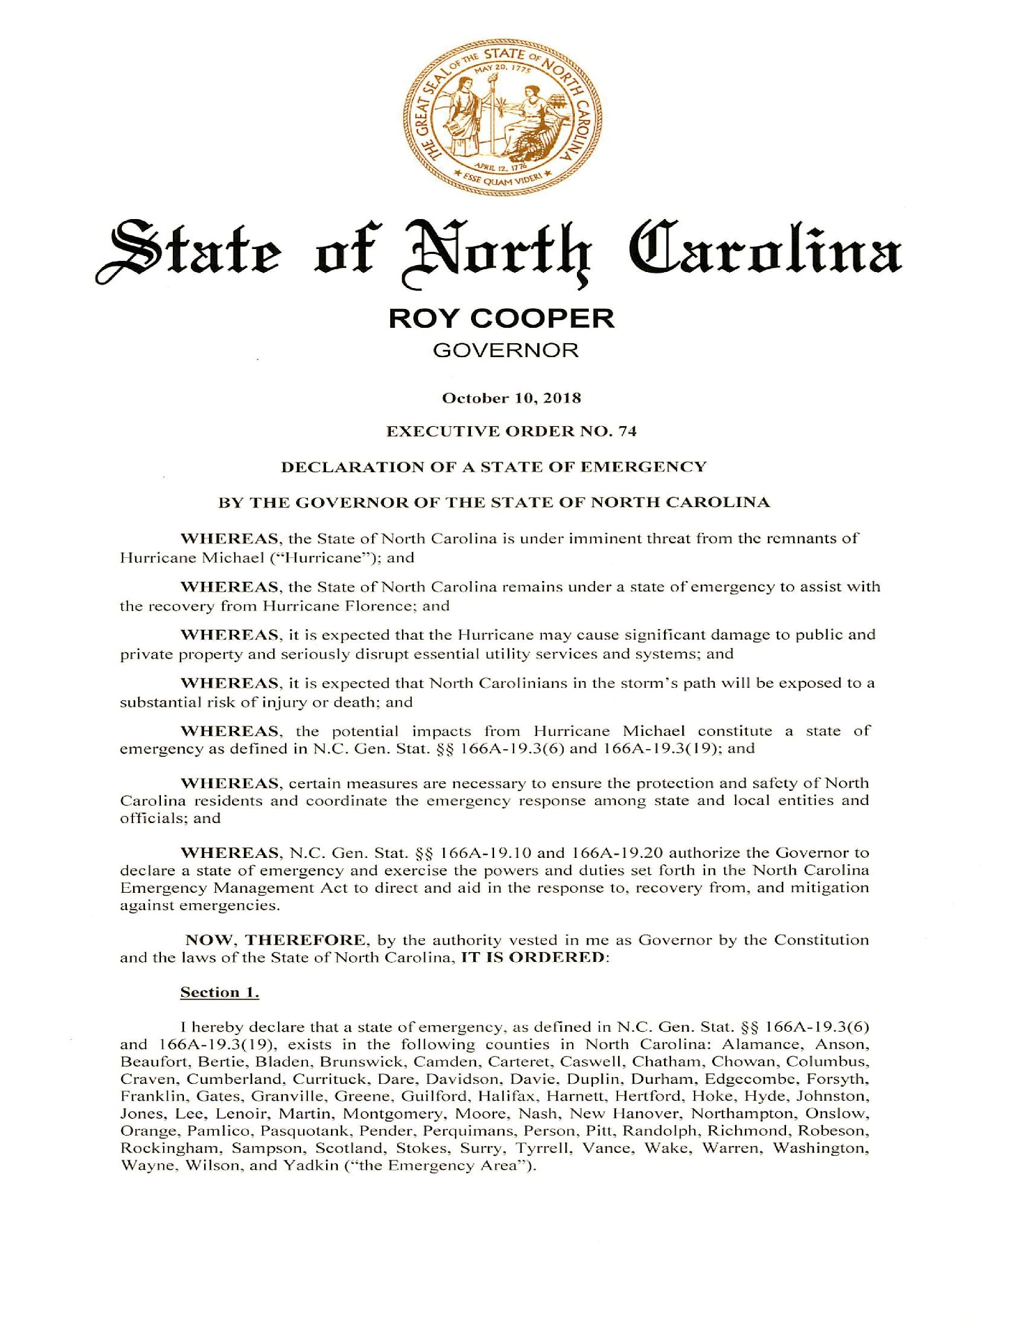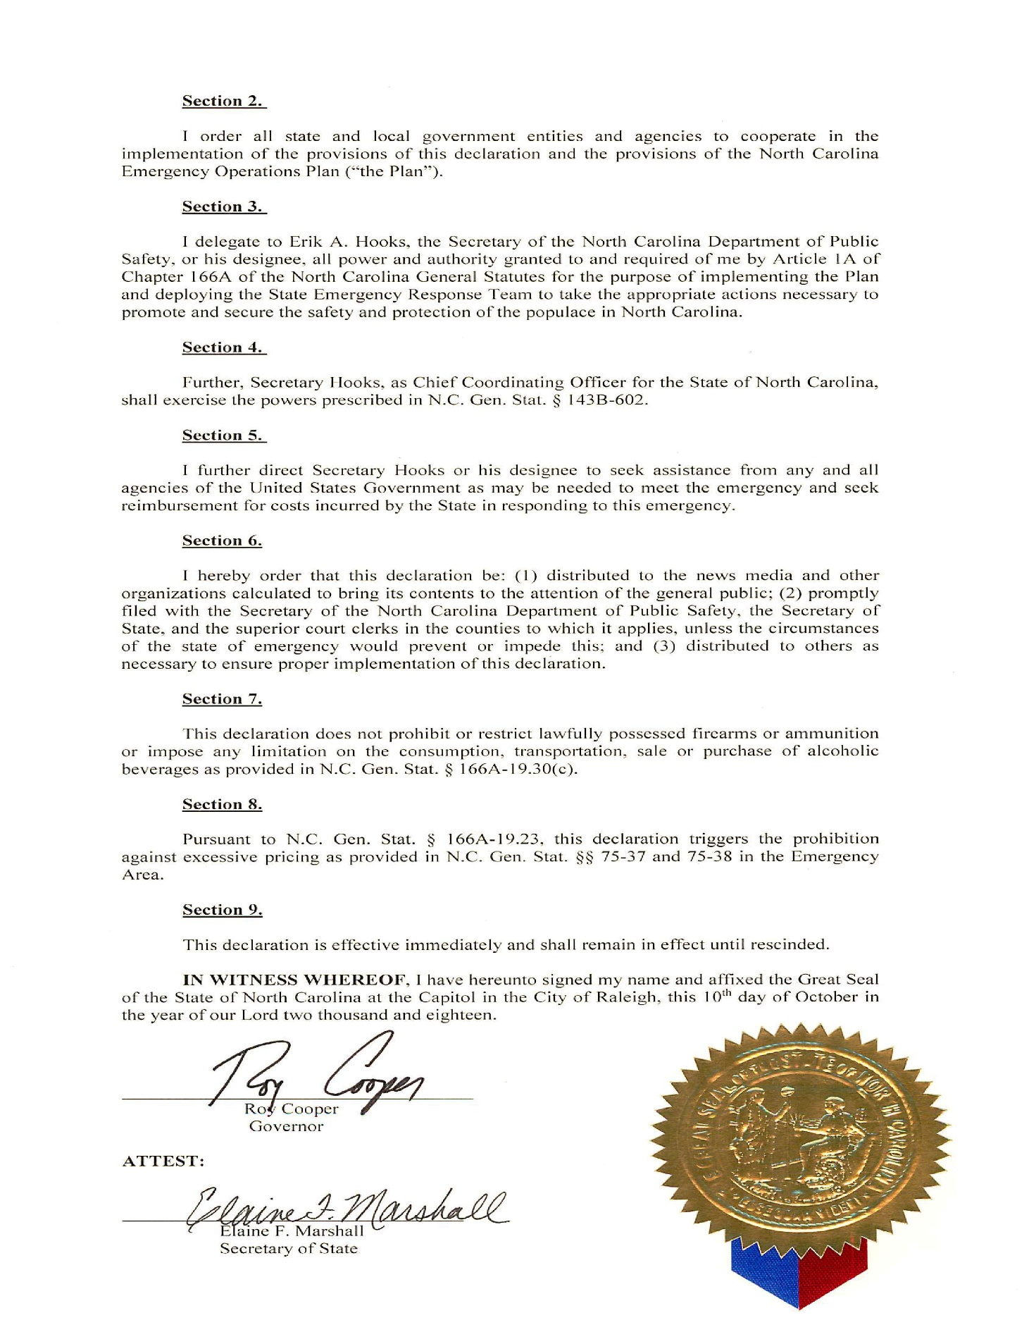
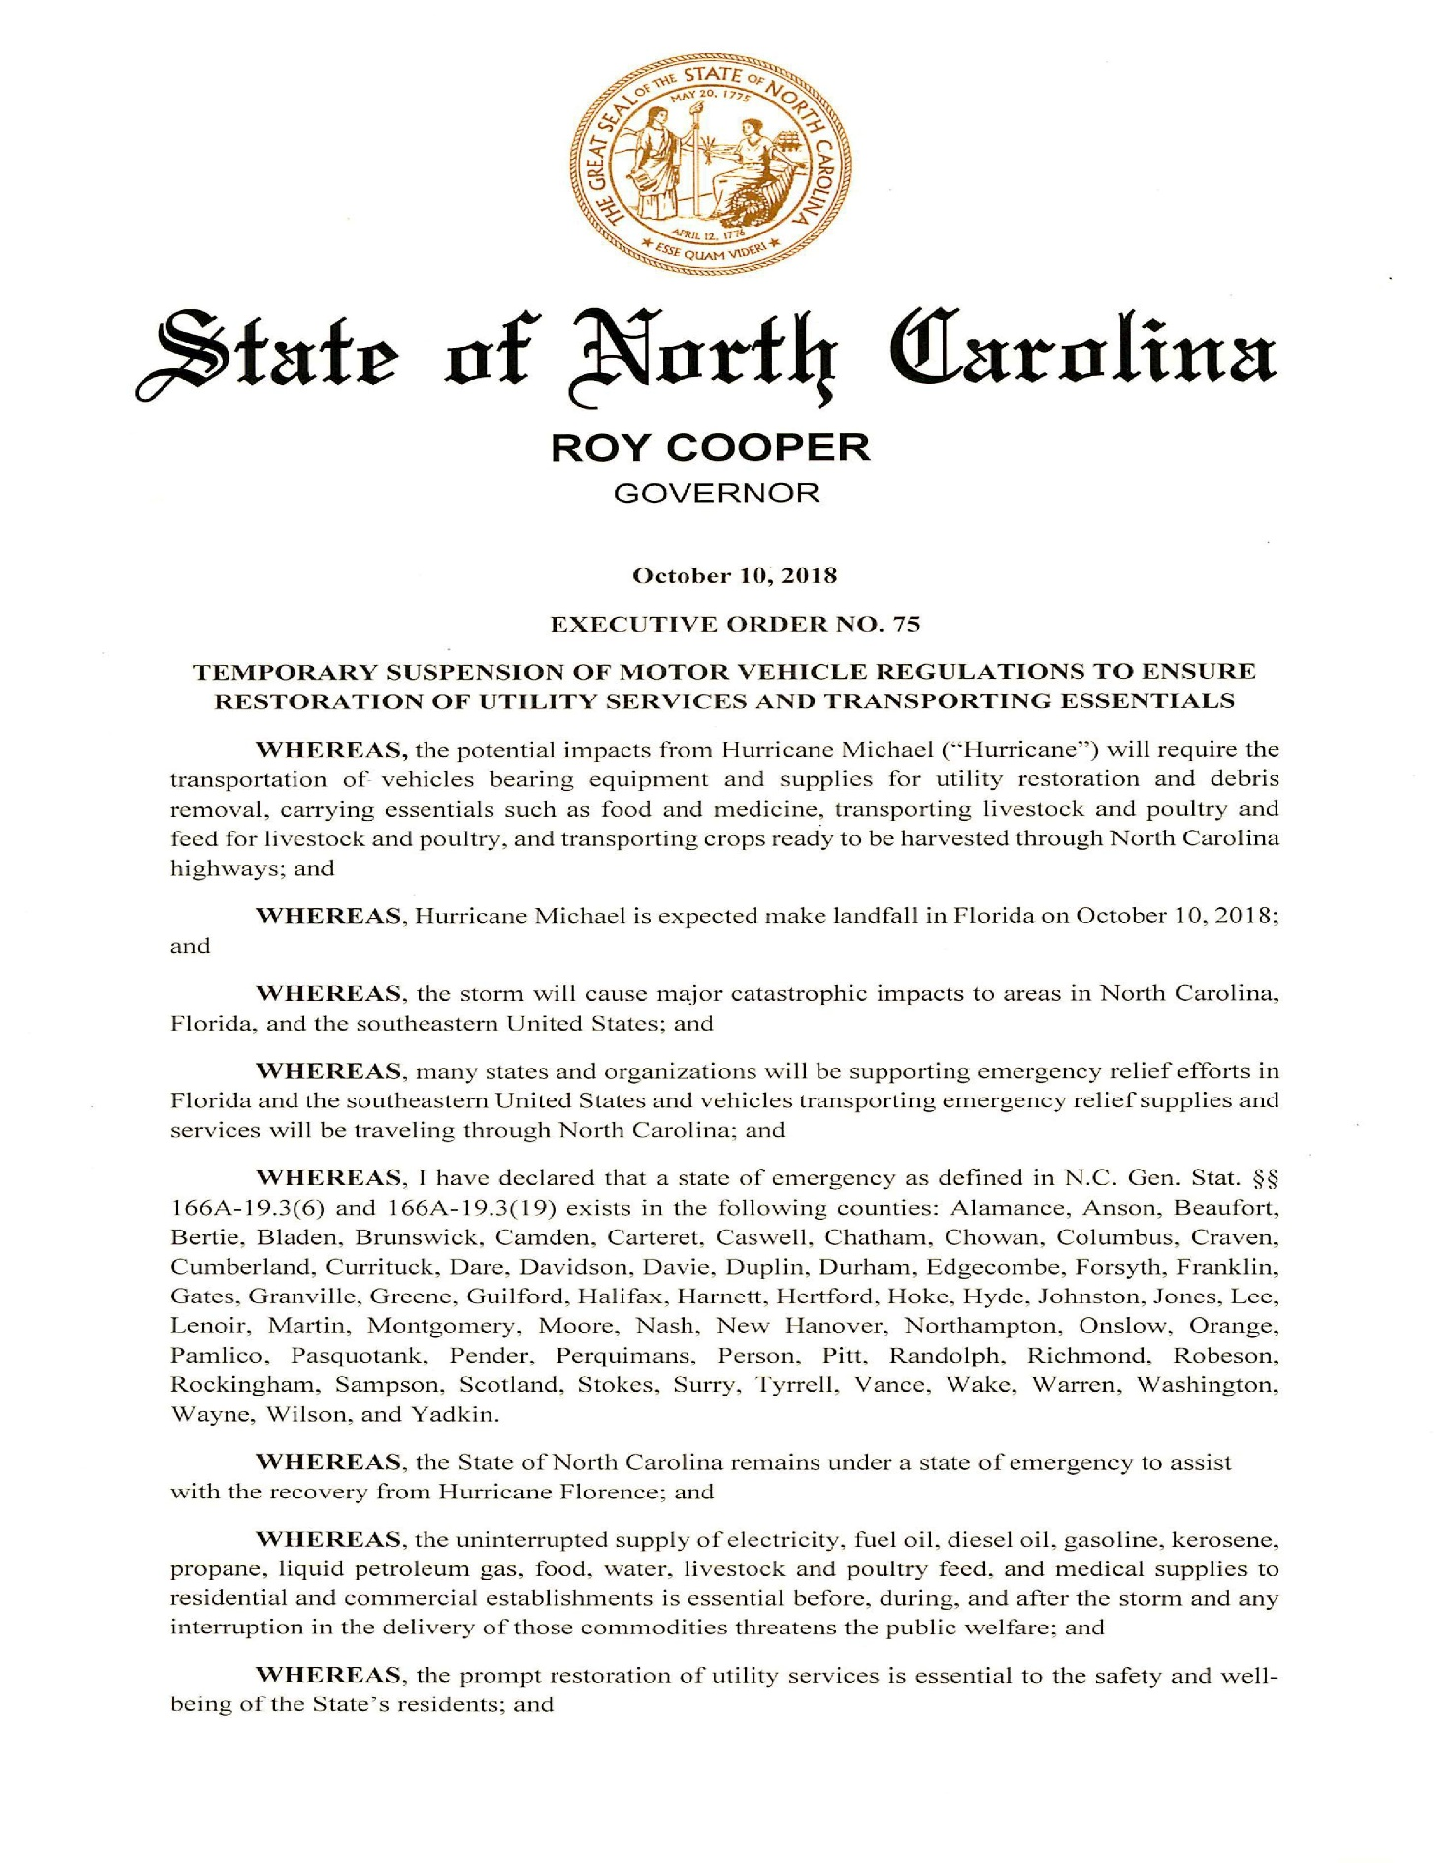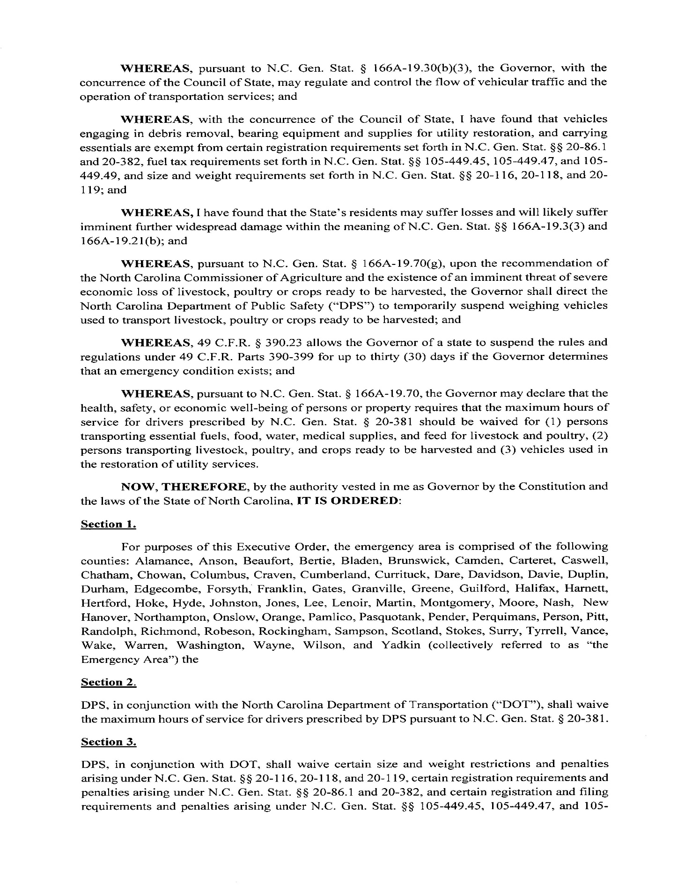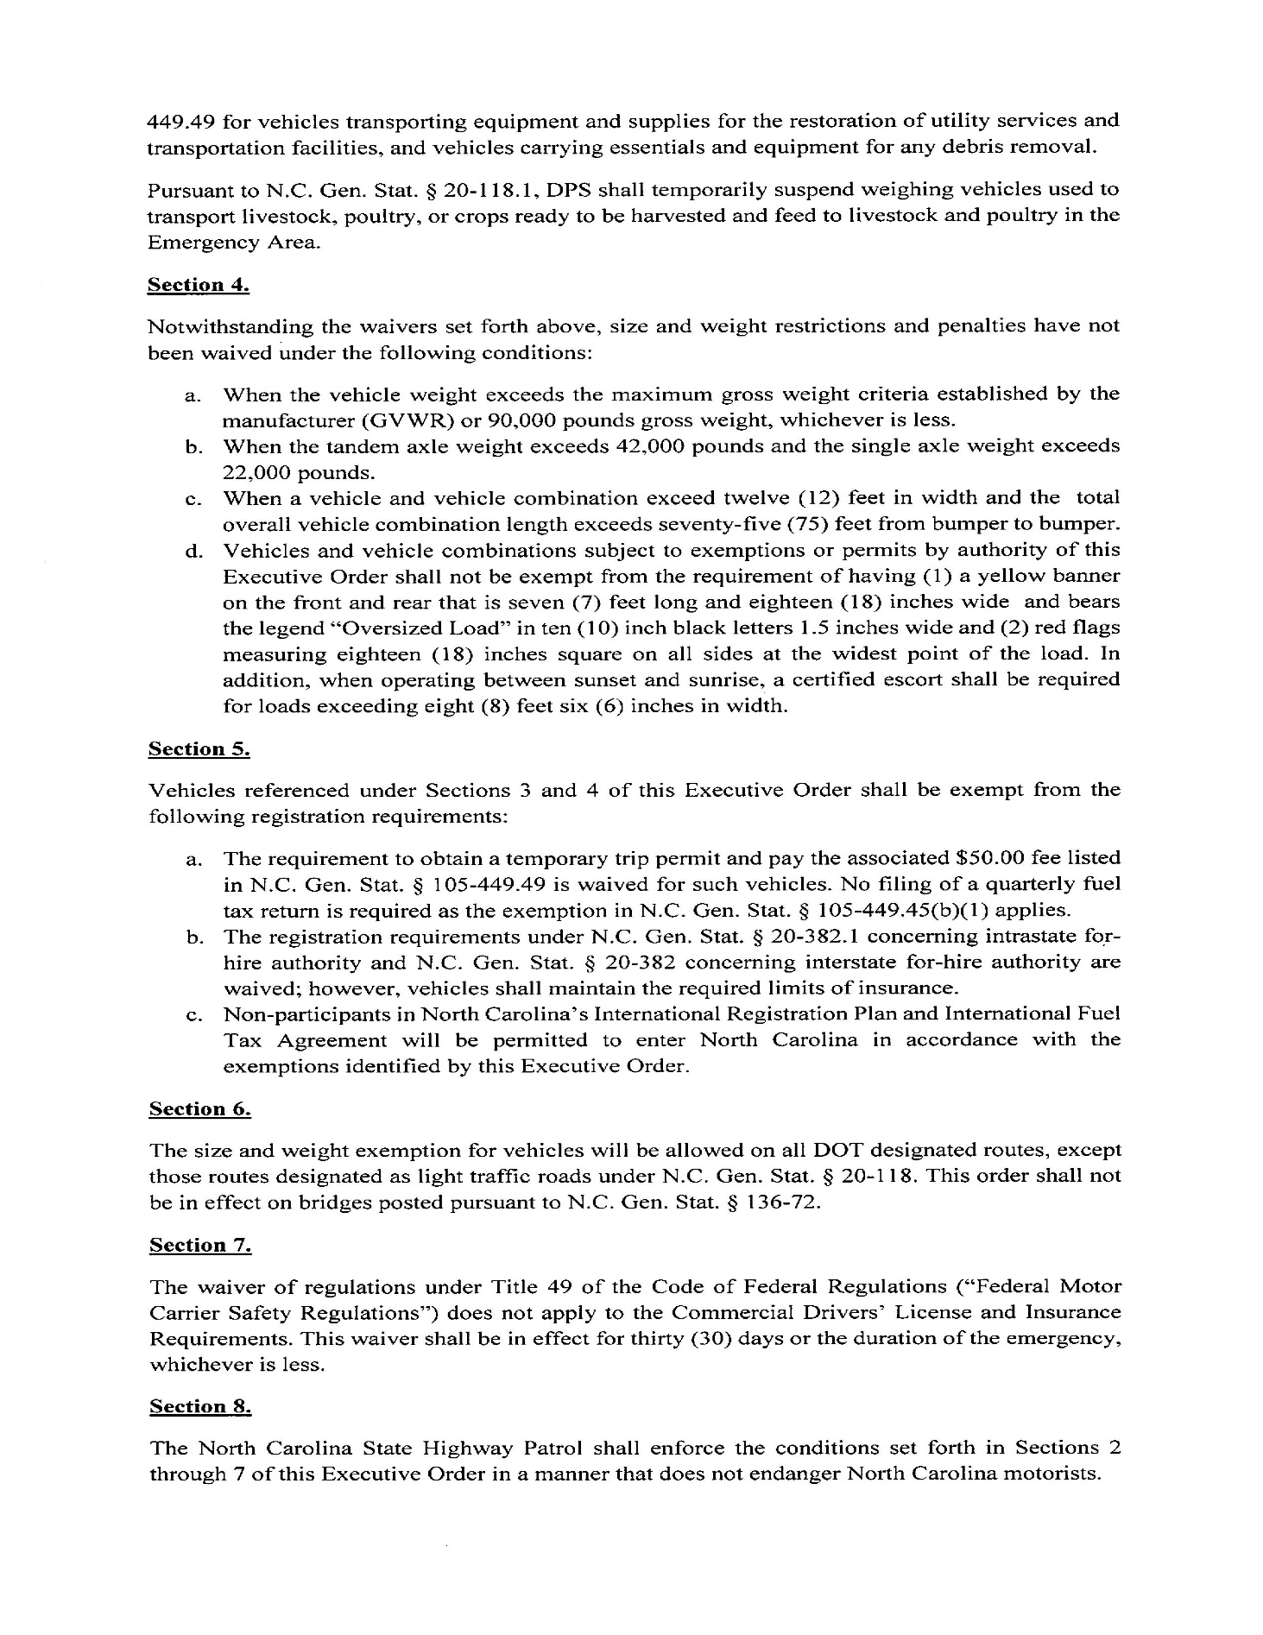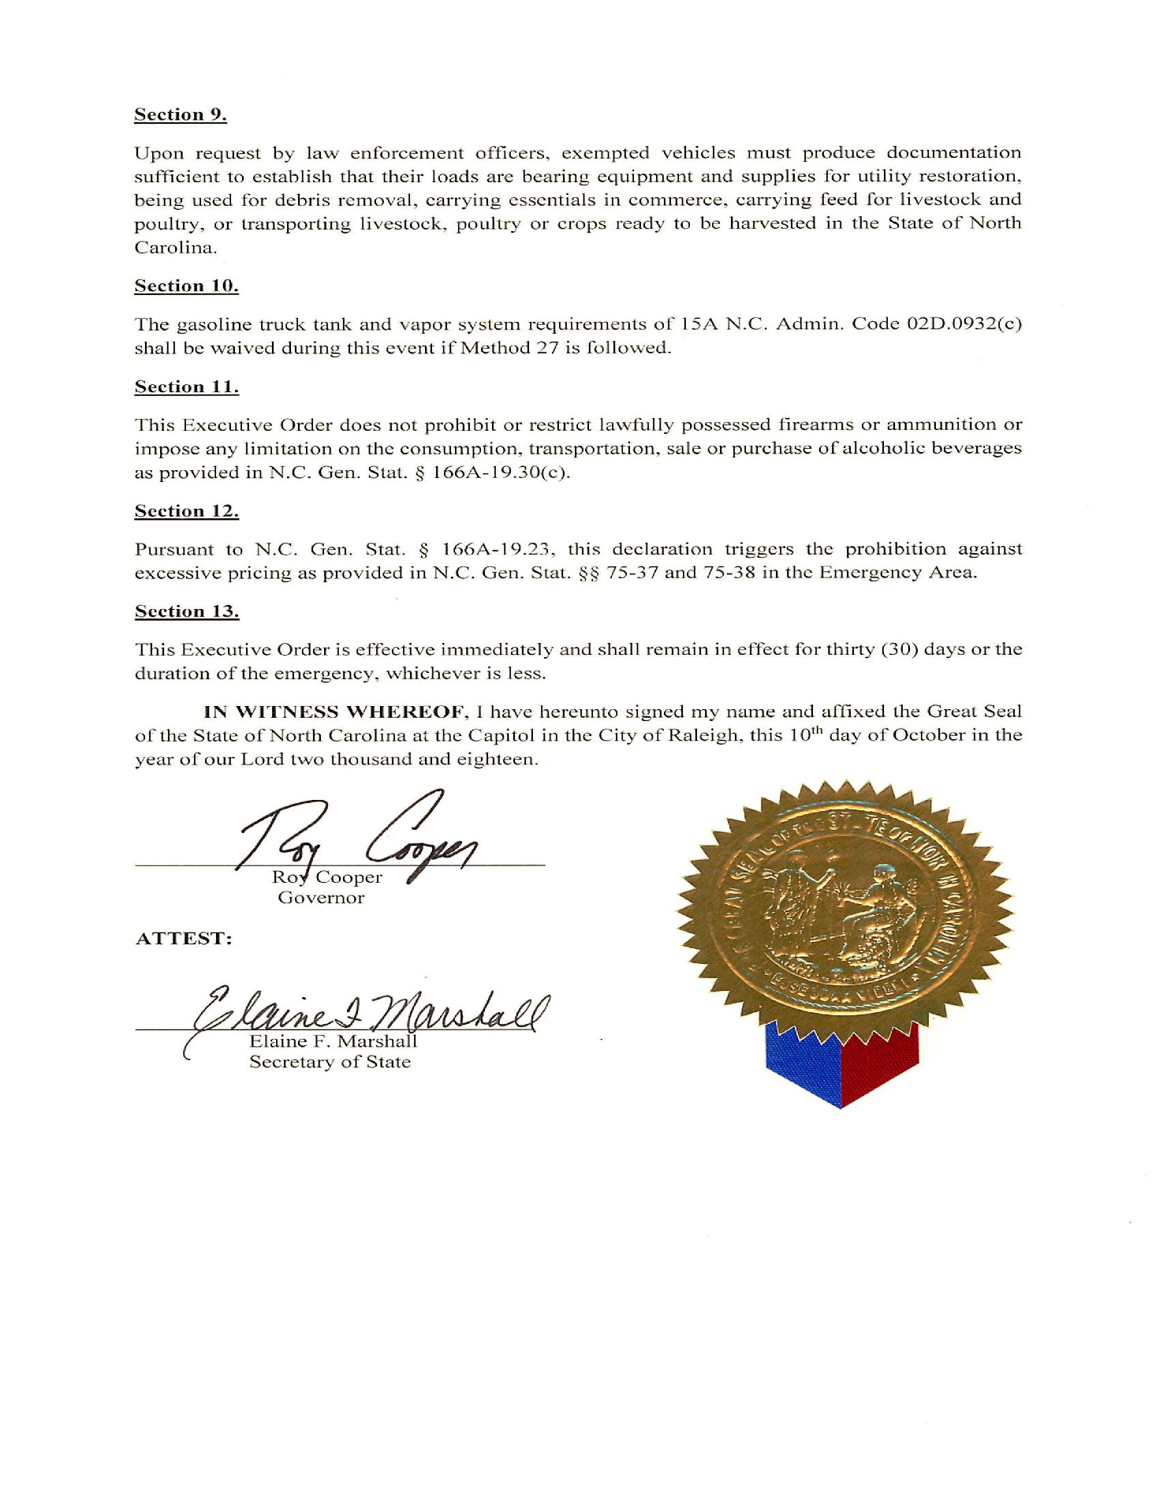
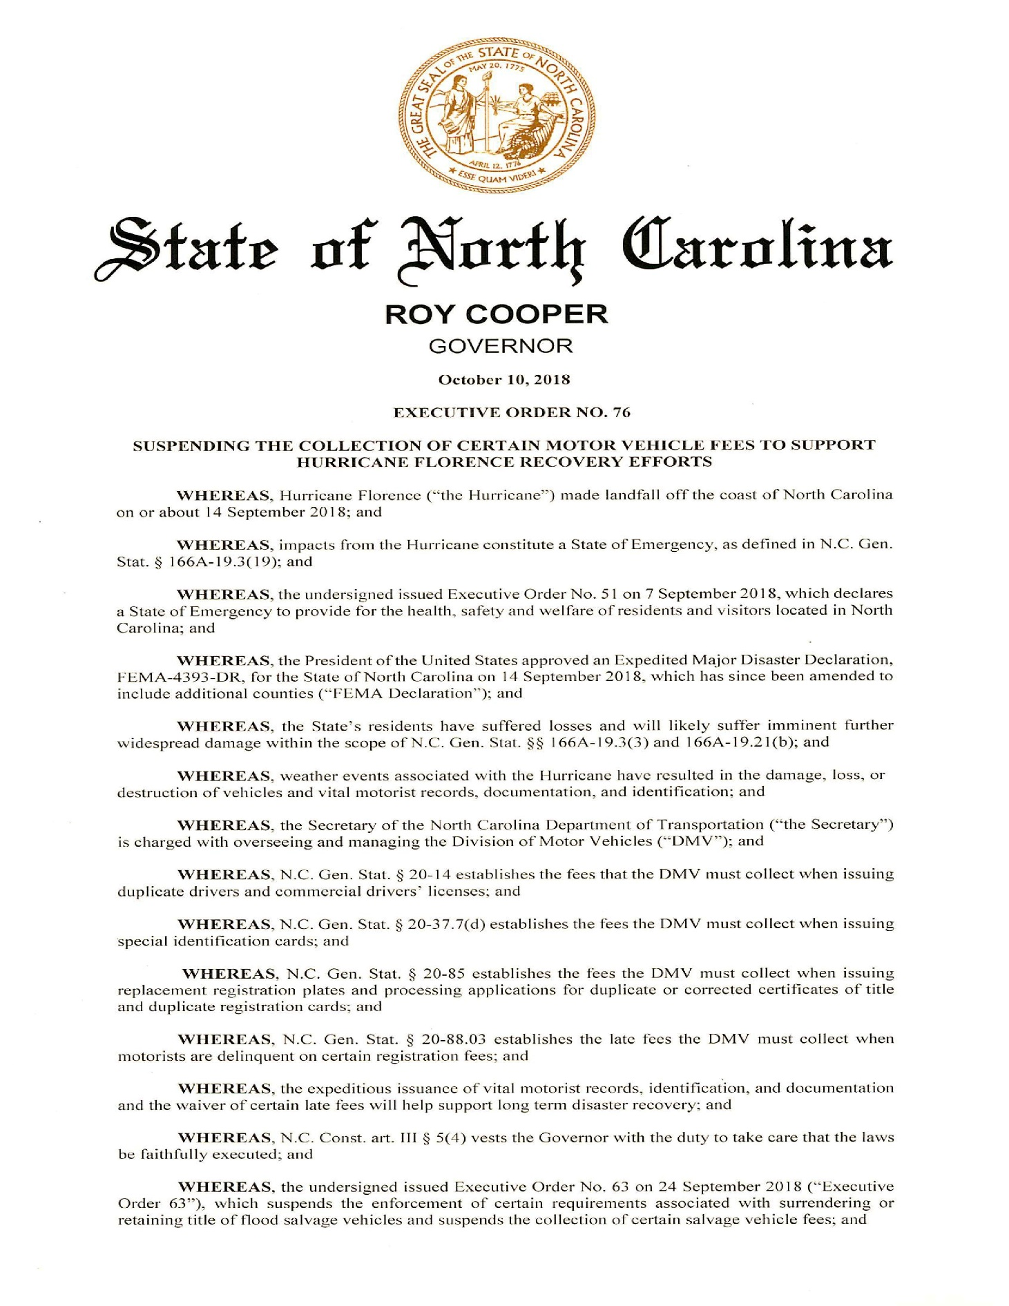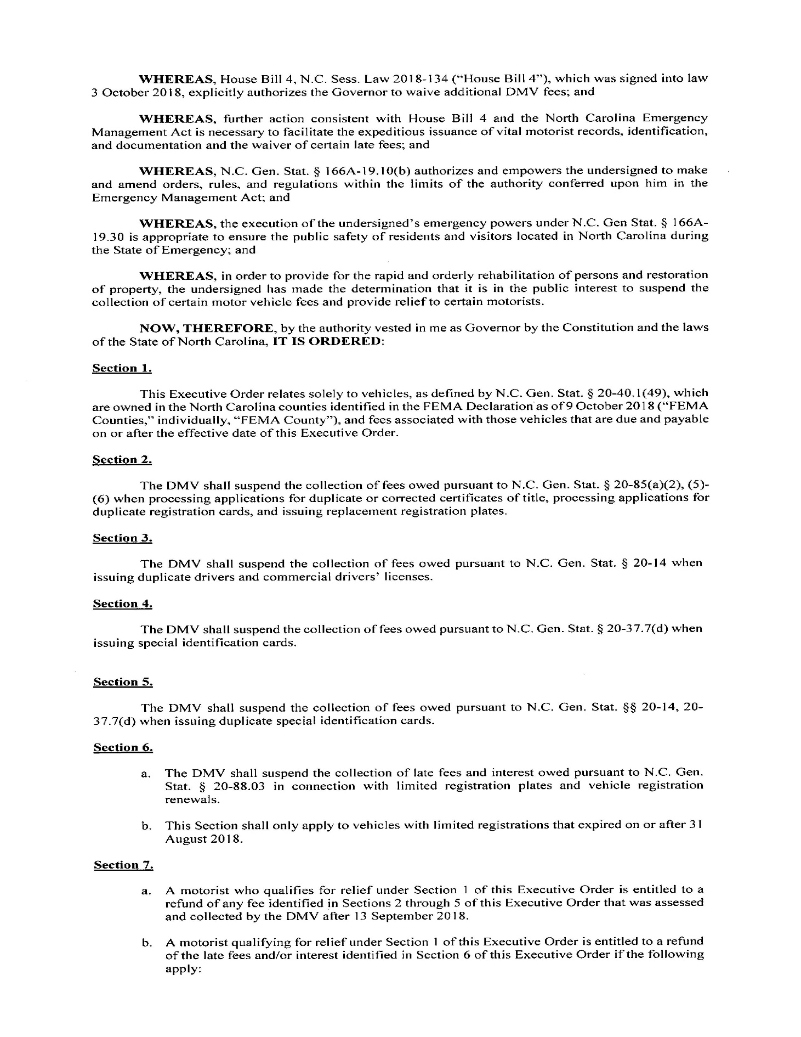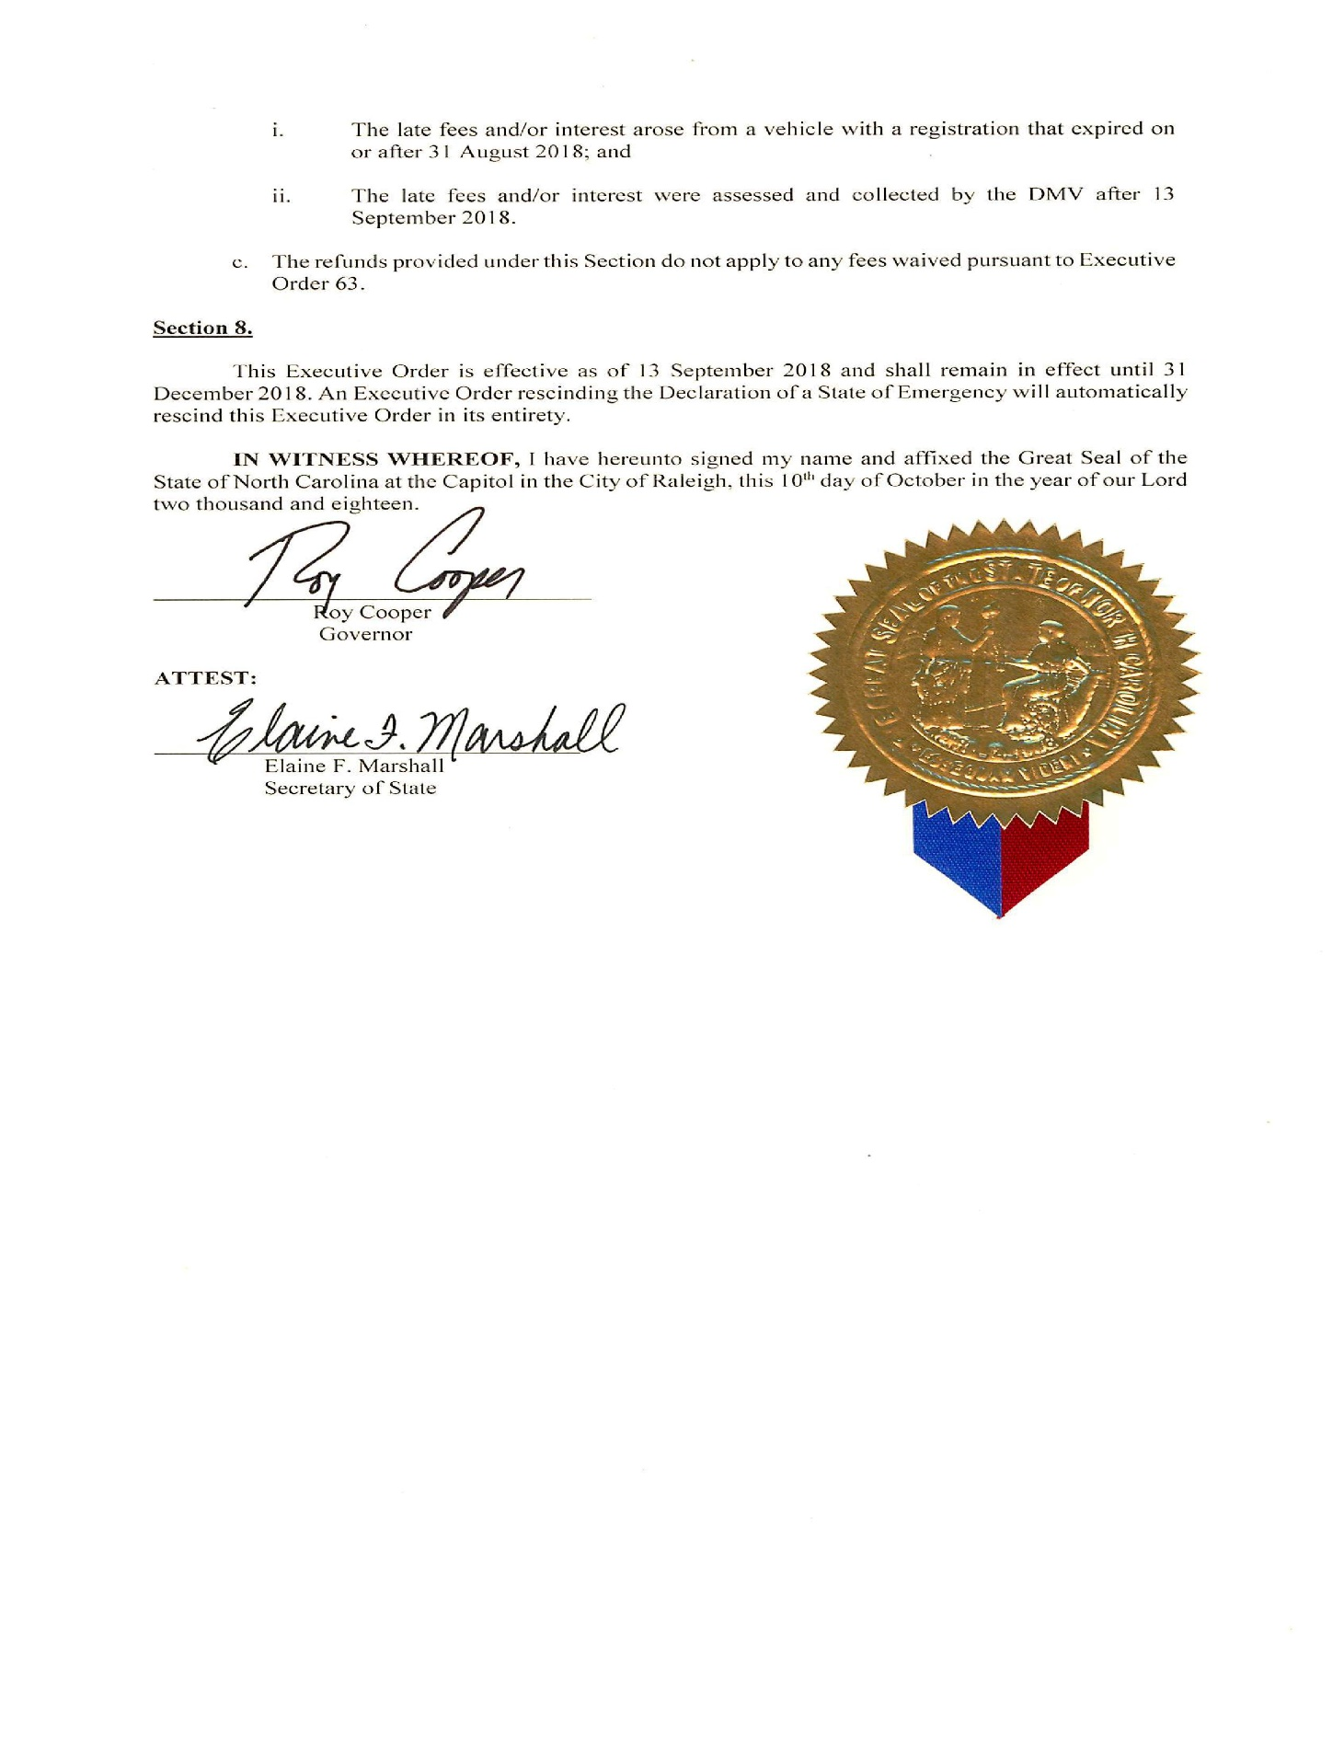

Note from the Codifier: The notices published in this Section of the NC Register include the text of proposed rules. The agency must accept comments on the proposed rule(s) for at least 60 days from the publication date, or until the public hearing, or a later date if specified in the notice by the agency. If the agency adopts a rule that differs substantially from a prior published notice, the agency must publish the text of the proposed different rule and accept comment on the proposed different rule for 60 days.
Statutory reference: G.S. 150B-21.2.

TITLE 14B – DEPARTMENT OF PUBLIC SAFETY

Notice is hereby given in accordance with G.S. 150B-21.2 that the Department of Public Safety intends to adopt the rules cited as 14B NCAC 05B .0101, .0201-.0203 and .0301.

Link to agency website pursuant to G.S. 150B-19.1(c): https://www.ncdps.gov/administrative-rules

Proposed Effective Date: March 1, 2019

Instructions on How to Demand a Public Hearing: (must be requested in writing within 15 days of notice): Email Rulemaking Coordinator Margaret McDonald at Margaret.mcdonald@ncdps.gov to request a public hearing.

Reason for Proposed Action: Rules in Chapter 05 of Title 14B of the North Carolina Administrative Code are pending repeal. The agency is adopting new rules to replace the rules being repealed.

Comments may be submitted to: Margaret McDonald, Department of Public Safety, 4201 Mail Service Center, Raleigh, NC 27699-4201

Comment period ends: December 31, 2018

Procedure for Subjecting a Proposed Rule to Legislative Review: If an objection is not resolved prior to the adoption of the rule, a person may also submit written objections to the Rules Review Commission after the adoption of the Rule. If the Rules Review Commission receives written and signed objections after the adoption of the Rule in accordance with G.S. 150B-21.3(b2) from 10 or more persons clearly requesting review by the legislature and the Rules Review Commission approves the rule, the rule will become effective as provided in G.S. 150B-21.3(b1). The Commission will receive written objections until 5:00 p.m. on the day following the day the Commission approves the rule. The Commission will receive those objections by mail, delivery service, hand delivery, or facsimile transmission. If you have any further questions concerning the submission of objections to the Commission, please call a Commission staff attorney at 919-431-3000.

Fiscal impact (check all that apply).

State funds affected

Environmental permitting of DOT affected

Analysis submitted to Board of Transportation

Local funds affected

Substantial economic impact (≥$1,000,000)

Approved by OSBM

No fiscal note required by G.S. 150B-21.4

Chapter 05 - Governor's Crime Commission

SUBCHAPTER 05B – GRANT ADMINISTRATION

SECTION .0100 – GENERAL PROVISIONS

14B NCAC 05b .0101 PURPOSE

The rules of this Chapter, pursuant to the authority of the Secretary of the Department of Public Safety (Department), implement the administration of duties of the Governor's Crime Commission (Commission), as a Section of the Division of Administration within the Department and as a State administering agency of North Carolina. Applications for state and federal grants shall be submitted in accordance with the rules set forth in Section .0200 of this Chapter.

Authority G.S. 143B-602(5); 143B-1101; 143B-1103; 143B-1104.

SECTION .0200 - PROGRAM GRANTS

14B NCAC 05B .0201 APPLICATIONS FOR GRANTS

(a) The Executive Director of the Commission shall designate requirements for submission of grant applications. The grant application period shall begin on November 1 of each year and end on January 31. Funding priorities, as determined by the Commission, shall be listed on the Commission's website prior to the opening of an application period.

(b) Grant application submission dates shall be announced on the Commission website, https://www.ncdps.gov/about-dps/boards-commissions/governors-crime-commission/grants-planning/grants not less than 90 days before the application is due.

(c) Grant applications shall be electronically submitted to the Commission through the Grants Enterprise Management System (GEMS) on or before the date announced on the Commission website.

(d) To be considered for funding, applicants shall complete the grant application, which shall include the following information:

(1) names, mailing addresses, telephone numbers, and signatures of the applicant;

(2) project information, including the following:
(A) a description of the project, its goals and objectives, and measurable outcomes;
(B) the issues or problems addressed by the project;
(C) project operation and activities; and
(D) a sustainability plan.

(3) a proposed budget;

(4) a project time line;

(5) an explanation of how the project's results will be monitored and evaluated; and

(6) any other information required by these Rules or requested by the Department in order to make a decision on the grant proposal; and

(7) a description of how the objectives of the proposed project are consistent with the outcomes and guidelines set forth in a State or federal grant program.

(e) Applicants seeking funding for a two-year project shall submit the information required by Paragraph (d) of this Rule with the requirements of (d)(2)(A), (d)(2)(C), and (d)(5) written to address the two-year grant period. Applicants shall also submit two one-year budgets.

Authority G.S. 143B-1103; 143B-1104.

14B NCAC 05B .0202 REVIEW OF PROPOSALS

(a) Applications that contain all information required in Rule .0201 of this Section shall be forwarded to a Commission Subcommittee, as designated in G.S. 143B-1102.

(b) The Subcommittee shall review and evaluate each application and make a recommendation to the full Commission, that the application should be approved or denied.

(c) In making this evaluation, the Commission or Subcommittee shall consider:

(1) who will benefit from the grant;

(2) how many will benefit from the grant;

(3) the cost of administering the grant;

(4) geographical representation; and

(5) past performance of grants and publicly funded projects.

(d) The Commission shall determine which applications are eligible for funding.

(e) The Commission shall recommend eligible applications to the Secretary of the Department of Public Safety. The Secretary shall select the applicants who will be awarded funding.

Authority G.S. 143B-1101(a)(8); 143B-1103; 143B-1104.

14B NCAC 05B .0203 Admniistration OF GRANTS

(a) The Commission staff shall administer grants as funds are available. All applicants shall be notified in writing or electronic communication through the GEMS system upon completion of the selection process that the application has been approved or denied.

(b) Within 30 days of receipt of award notification, the applicant shall submit the grant compliance and modification information. An applicant may request an extension of no more than 60 days to submit the information. An applicant who does not provide the required information shall be ineligible for grant funding. For the purposes of this Rule, grant compliance and modification information includes the following:

(1) a list of grant conditions that agreed to by an authorizing official of the applicant;

(2) a certification of non-supplanting;

(3) a certification of filing of an equal employment opportunity program;

(4) a memorandum of agreement or contract with cooperating government agencies;

(5) an original signature of all authorizing officials, implementing project director, and the applicant's chief financial officer; and

(6) a signed agreement to submit to an annual audit of the program.

(c) Funds shall be conveyed to grantees through Grant Award Contracts. The Grant Award Contract shall bear the original signature of the grantee's authorizing official and the Executive Director of the Commission. The Grant Award Contract shall be signed and returned to the Department within 30 days.

(d) The grant period for the project shall be for a period of up to two years. The grant period shall coincide with the start and close of the federal fiscal year, if possible.

(e) Requests for adjustments to approved applications may be made at any time up to 90 days before the project's scheduled termination date. These requests shall be made through the GEMS system, providing an explanation for proposed amendments.

Authority G.S. 143B-602(8); 143B-1103; 143B-1104.

SECTION .0300 – PENALTIES

14B NCAC 05B .0301 GRANT TERMINATION OR SUSPENSION

(a) A grant may be terminated or the funds may be suspended by the Executive Director when the applicant or grantee is not in compliance with any of the following:

(1) the terms and conditions of the grant application;

(2) the terms and conditions of the grant award contract;

(3) the guidelines promulgated by the federal criminal justice block grant program or approved plan;

(4) the rules set forth in this Chapter.

(b) The Executive Director shall notify the grantee of its noncompliance in writing. The notification shall identify the penalty to be taken or allow the grantee an additional period of not more than 30 days to correct the deficiencies. If the deficiencies are not corrected, then the Executive Director may suspend the payment of funds to the grantee or terminate the grant.

Authority G.S. 143B-602(8)(c); 143B-1103(b)(3); 143B-1104.

* * * * * * * * * * * * * * * * * * * *

Notice is hereby given in accordance with G.S. 150B-21.2 that the Alcoholic Beverage Control Commission intends to adopt the rule cited as 14B NCAC 15A .2206.

Link to agency website pursuant to G.S. 150B-19.1(c): https://abc.nc.gov/

Proposed Effective Date: March 1, 2019

Public Hearing:

Date: January 16, 2019

Time: 10:00 a.m.

Location: ABC Commission Hearing Room, 400 East Tryon Road, Raleigh, NC 27610

Reason for Proposed Action: To adopt a rule defining how the sales by a nonprofit organization of alcoholic beverages in the manufacturer's original closed container as a prize in a raffle or by sale at auction at a ticketed event to allow the nonprofit organization to raise funds are to be conducted and when the alcoholic beverages can be given to the person acquiring them from the nonprofit. A rule is also needed to limit who a nonprofit can sell the alcoholic beverages to. This rule is authorized by S.L. 2018-65, Sec. 5(e).

Comments may be submitted to: Walker Reagan, 400 East Tryon Road, Raleigh, NC 27610, phone (919) 779-8367, fax (919) 661-6165, email walker.reagan@abc.nc.gov

Comment period ends: January 16, 2019 at 10:00 a.m.

Procedure for Subjecting a Proposed Rule to Legislative Review: If an objection is not resolved prior to the adoption of the rule, a person may also submit written objections to the Rules Review Commission after the adoption of the Rule. If the Rules Review Commission receives written and signed objections after the adoption of the Rule in accordance with G.S. 150B-21.3(b2) from 10 or more persons clearly requesting review by the legislature and the Rules Review Commission approves the rule, the rule will become effective as provided in G.S. 150B-21.3(b1). The Commission will receive written objections until 5:00 p.m. on the day following the day the Commission approves the rule. The Commission will receive those objections by mail, delivery service, hand delivery, or facsimile transmission. If you have any further questions concerning the submission of objections to the Commission, please call a Commission staff attorney at 919-431-3000.

Fiscal impact (check all that apply).

State funds affected

Environmental permitting of DOT affected

Analysis submitted to Board of Transportation

Local funds affected

Substantial economic impact (≥$1,000,000)

Approved by OSBM

No fiscal note required by G.S. 150B-21.4

Chapter 15 - Alcoholic Beverage Control Commission

SUBCHAPTER 15A - ORGANIZATIONAL RULES: POLICIES AND PROCEDURES

SECTION .2200 – SPECIAL ONE-TIME PERMITS

14B NCAC 15A .2206 Nonprofit sales at raffle or auction

(a) Sales of alcohol under a special one-time permit pursuant to G.S. 18B-1002(a)(5) by a nonprofit organization as a prize in a raffle or at auction shall be sold for off-premises consumption and shall not be consumed on the permitted premises.

(b) Possession of the alcohol sold as a prize at a raffle or at auction pursuant to this rule shall not be given by the nonprofit organization to the raffle prize winner or buyer at auction until the conclusion of the event or until the time the buyer leaves the event.

(c) Sales of alcohol pursuant to G.S. 18B-1002(a)(5) by a nonprofit organization shall be subject to the following conditions:

(1) sales shall only be made to persons at least 21 years of age;

(2) no sales shall be made to a person who is intoxicated as defined in 14B NCAC 15B .0101(2); and

(3) delivery of possession of a quantity of alcohol sold pursuant to this Rule to a single buyer in excess of the limits set forth in G.S. 18B-303 shall not be permitted unless the raffle prize winner or buyer at auction of the alcohol has a valid permit issued pursuant to G.S. 18B-1002(a)(4) or otherwise complies with the provisions of G.S. 18B-303.

Authority G.S. 18B-100; 18B-207; 18B-303; 18B-1002.

* * * * * * * * * * * * * * * * * * * *

Notice is hereby given in accordance with G.S. 150B-21.2 that the Alcoholic Beverage Control Commission intends to amend the rule cited as 14B NCAC 15B .0209.

Link to agency website pursuant to G.S. 150B-19.1(c): https://abc.nc.gov/

Proposed Effective Date: March 1, 2019

Public Hearing:

Date: January 16, 2019

Time: 10:00 a.m.

Location: ABC Commission Hearing Room, 400 East Tryon Road, Raleigh, NC 27610

Reason for Proposed Action: To amend the rule governing consumption by employees of alcoholic beverage permittees while on duty or on the permitted premises, to allow employees of commercial permittees to sample alcoholic beverages for purposes of sensory analysis, quality control or education, not only on the employer's permitted premises but also on the permittee's retail premises, the premises of a special one-time permittee, or the premises of a special event where the permittee is participation under a special event tasting permit, as authorized in S.L. 2018-100, Sec. 1.

Comments may be submitted to: Walker Reagan, 400 East Tryon Road, Raleigh, NC 27610, phone (919) 779-8367, fax (919) 661-6165, email walker.reagan@abc.nc.gov

Comment period ends: January 16, 2019 at 10:00 a.m.

Procedure for Subjecting a Proposed Rule to Legislative Review: If an objection is not resolved prior to the adoption of the rule, a person may also submit written objections to the Rules Review Commission after the adoption of the Rule. If the Rules Review Commission receives written and signed objections after the adoption of the Rule in accordance with G.S. 150B-21.3(b2) from 10 or more persons clearly requesting review by the legislature and the Rules Review Commission approves the rule, the rule will become effective as provided in G.S. 150B-21.3(b1). The Commission will receive written objections until 5:00 p.m. on the day following the day the Commission approves the rule. The Commission will receive those objections by mail, delivery service, hand delivery, or facsimile transmission. If you have any further questions concerning the submission of objections to the Commission, please call a Commission staff attorney at 919-431-3000.

Fiscal impact (check all that apply).

State funds affected

Environmental permitting of DOT affected

Analysis submitted to Board of Transportation

Local funds affected

Substantial economic impact (≥$1,000,000)

Approved by OSBM

No fiscal note required by G.S. 150B-21.4

Chapter 15 - Alcoholic Beverage Control Commission

SUBCHAPTER 15B - RETAIL BEER: WINE: MIXED BEVERAGES: BROWNBAGGING: ADVERTISING: SPECIAL PERMITS

SECTION .0200 - GENERAL RULES AFFECTING RETAILERS AND BROWNBAGGING PERMITTEES

14B NCAC 15B .0209 CONSUMPTION: INTOXICATION BY PERMITTEE PROHIBITED

(a) No permittee or his employees shall be on the licensed premises permitted under G.S. 18B-1001, G.S. 18B-1002, G.S. 18B-1114.1 or G.S. 18B-1114.5 after consuming alcoholic beverages except under the following conditions:

(1) The permittee or employee is off duty for the remainder of that day or night during which he consumes any alcoholic beverage;

(2) The permittee or employee is out of uniform when uniforms are required to be worn while performing any on duty services; and

(3) The permittee or employee shall not perform any on duty services of any nature while or after consuming alcoholic beverages.

(b) Notwithstanding Paragraph (a) of this Rule, a malt beverage or wine permittee or its employee who is of legal age and who is responsible for ordering or serving beverage alcohol may sample new malt beverage or wine products as provided by 14B NCAC 15C .0711(b) on the premises. Samples shall not exceed two-ounce servings of individual products and the total of the samples shall not exceed eight ounces in one calendar day.

(c) No permittee or his agents or employees shall be or become intoxicated on the licensed premises.

(d) Notwithstanding Paragraph (a) of this Rule, a permittee or the permittee's employees may be on licensed premises permitted under G.S. 18B-1001, G.S. 18B-1002, G.S. 18B-1114.1 or G.S. 18B-1114.5 after consuming alcoholic beverages pursuant to G.S. 18B-1121, provided the permittee or permittee's employees do not serve or pour alcoholic beverages for other persons for the remainder of the day while or after consuming alcoholic beverages.

Authority 18B-100; 18B-207; 18B-1005(b); 18B-1006(d); 18B-1121.

TITLE 15A – DEPARTMENT OF eNVIRONMENTAL QUALITY

Notice is hereby given in accordance with G.S. 150B-21.2 that the Wildlife Resources Commission intends to amend the rules cited as 15A NCAC 10F .0303 and .0333.

Link to agency website pursuant to G.S. 150B-19.1(c): www.ncwildlife.org

Proposed Effective Date: May 1, 2019

Public Hearing:

Date: Wednesday, November 28, 2018

Time: 10:00 a.m.

Location: WRC Headquarters 5th Floor, 1751 Varsity Drive, Raleigh, NC 27606

Reason for Proposed Action:

15A NCAC 10F .0303 – Beaufort County submitted a formal application and resolution requesting a no-wake zone in canals at the eastern end of the peninsula where Whichard Beach is located, between Chocowinity Bay and the Pamlico River. The no-wake zone is necessary to mitigate hazards to boater safety caused by narrow shallow canals, with underwater obstructions and heavy vessel traffic.

15A NCAC 10F .0333 – The Lake Wylie Marine Commission submitted an application for a no-wake zone on Lake Wylie in Mecklenburg County, in the vicinity of the terminus of Point Lookout Road and area of community docks near Queens Harbor Road in the Yachtsman on Lake Wylie community. The no-wake zone is necessary to mitigate hazards to boater and recreationist safety near the busy and congested community docks, a marina, kayak and paddle boat launch, and swimming beach.

Comments may be submitted to: Rulemaking Coordinator, 1701 Mail Service Center, Raleigh, NC 27699-1701; email regulations@ncwildlife.org

Comment period ends: December 31, 2018

Procedure for Subjecting a Proposed Rule to Legislative Review: If an objection is not resolved prior to the adoption of the rule, a person may also submit written objections to the Rules Review Commission after the adoption of the Rule. If the Rules Review Commission receives written and signed objections after the adoption of the Rule in accordance with G.S. 150B-21.3(b2) from 10 or more persons clearly requesting review by the legislature and the Rules Review Commission approves the rule, the rule will become effective as provided in G.S. 150B-21.3(b1). The Commission will receive written objections until 5:00 p.m. on the day following the day the Commission approves the rule. The Commission will receive those objections by mail, delivery service, hand delivery, or facsimile transmission. If you have any further questions concerning the submission of objections to the Commission, please call a Commission staff attorney at 919-431-3000.

Fiscal impact (check all that apply).

State funds affected

Environmental permitting of DOT affected

Analysis submitted to Board of Transportation

Local funds affected

Substantial economic impact (≥$1,000,000)

Approved by OSBM

No fiscal note required by G.S. 150B-21.4

Chapter 10 - Wildlife Resources and Water Safety

SUBCHAPTER 10F - MOTORBOATS AND WATER SAFETY

SECTION .0300 - LOCAL WATER SAFETY REGULATIONS

15A NCAC 10F .0303 BEAUFORT COUNTY

(a) Regulated Areas. This Rule shall apply to the following waters in Beaufort County:

(1) the portion of Broad Creek south of a line from a point on the east shore at 35.49472 N, 76.95693 W to a point on the west shore at 35.49476 N, 76.96028 W and north of a line from a point on the east shore at 35.48485 N, 76.95178 W to a point on the west shore at 35.48495 N, 76.95619 W;

(2) the portion of Blounts Creek south of a line 100 yards north of the Blounts Creek Boating Access Area, from a point on the east shore at 35.40846 N, 76.96091 W to a point on the west shore at 35.40834 N, 76.96355 W, and north of a line 100 yards south of Cotton Patch Landing, from a point on the east shore at 35.40211 N, 76.96573 W to a point on the west shore at 35.40231 N, 76.96702 W;

(3) the waters of Battalina Creek, within the territorial limits of the Town of Belhaven;

(4) the navigable portion of Nevil Creek extending upstream from its mouth at the Pamlico River;

(5) the portion of Blounts Creek north of a line 35 yards south-southeast of the Mouth of the Creek Bridge from a point on the east shore at 35.43333 N, 76.96985 W to a point on the west shore at 35.43267 N, 76.97196 W and south of a line 350 yards north-northeast of the Mouth of the Creek Bridge from a point on the east shore at 35.43553 N, 76.96962 W to a point on the west shore at 35.43679 N, 76.97011 W;

(6) the portion of Tranters Creek east of a line from a point on the north shore at 35.56961 N, 77.09159 W to a point on the south shore at 35.56888 N, 77.09118 W and north of a line from a point on the east shore at 35.56714 N, 77.08941 W to a point on the west shore at 35.56689 N, 77.09029 W; and

(7) the waters of Little Creek beginning at a line near its mouth from a point on the east shore at 35.41917 N, 76.97102 W to a point on the west shore at 35.41900 N, 76.96940 W. 76.96940 W; and

(8) the canals at the eastern end of the peninsula between Chocowinity Bay and the Pamlico River at Fork Point and Whichard Beach, beginning at the canal entrance off of Chocowinity Bay at a point a 35.50296 N, 77.03043 W and beginning at the canal entrance off of the Pamlico River at a point at 35.50340 N, 77.02364 W.

(b) Speed Limit. No person shall operate a vessel at greater than no-wake speed within any of the regulated areas identified in Paragraph (a) of this Rule.

(c) Placement of Markers. The Board of Commissioners of Beaufort County and the City Council of the City of Washington shall be the designated agencies for placement of the markers implementing this Rule, subject to the approval of the United States Coast Guard and United States Army Corps of Engineers.

Authority G.S. 75A-3; 75A-15.

15A NCAC 10F .0333 MECKLENBURG AND GASTON COUNTIES

(a) Regulated Areas. This Rule shall apply to the following waters of Lake Wylie within Mecklenburg and Gaston Counties:

(1) McDowell Park. The waters of the coves adjoining McDowell Park and the Southwest Nature Preserve in Mecklenburg County shore to shore, east of the mouth of the cove at a line from a point on the south shore at 35.10272 N, 81.03026 W to a point on the north shore at 35.10556 N, 80.02964 W;

(2) Gaston County Wildlife Club Cove. The waters of the cove west of the Gaston County Wildlife Club on South Point Road in Belmont, north of a line at the mouth of the cove from a point on the east shore at 35.15628 N, 81.01427 W to a point on the west shore at 35.15628 N, 81.01615 W;

(3) Buster Boyd Bridge. The waters from a point 250 feet east of the Buster Boyd Bridge on N.C. Highway 49 in Mecklenburg County at 35.10293 N, 81.03932 W, to a point 150 feet west of the Buster Boyd Bridge at 35.10242 N, 81.04089 W;

(4) N.C. Highway 27 bridge. The waters shore to shore, from a point 50 yards north of the N.C. Highway 27 bridge in Mecklenburg and Gaston counties at 35.29849 N, 81.00346 W to a point 190 yards south of the N.C. Highway 27 bridge at 35.29635 N, 81.00424 W;

(5) Brown's Cove. The area beginning at the mouth of Brown's Cove in Mecklenburg County shore to shore, at a point at 35.16453 N, 81.00474 W, west to a point at 35.16480 N, 81.00309 W;

(6) Paradise Point Cove. The waters of Paradise Point Cove in Gaston County between Paradise Circle and Lake Front Drive, west of a line from a point on the south shore at 35.18853 N, 81.04036 W to a point on the north shore at 35.18991 N, 81.04136 W;

(7) Withers Cove. The waters from a point 50 feet southeast of the Withers Bridge on SR 1116, otherwise known as Shopton Road W. in Mecklenburg County at 35.14576 N, 81.00187 W, to a point 50 feet northwest of the bridge at 35.14599 N, 81.00222 W;

(8) Sadler Island. The waters shore to shore beginning at a line from a point on the west shore of Lake Wylie in Gaston County at 35.27481 N, 81.0138 W east to a point on the east shore of the Lake in Mecklenburg County at 35.27423 N, 81.01111 W, extending south on the Lake west of Sadler Island to a line from a point on the west shore of the Lake in Gaston County at 35.27079 N, 81.01525 W, east to a point on the west side of Sadler Island in Mecklenburg County at 35.27051 N, 81.01396 W, and the waters shore to shore east of Sadler Island in Mecklenburg County from a point at 35.27441 N, 81.01185 W, south-southwest to a line from a point on the south shore of Sadler Island at 35.26635 N, 81.01432 W, south to a point on the Lake shore at 35.26494 N, 81.01368 W; and

(9) Other bridges. The areas within 50 feet of any bridge in North Carolina that crosses the waters of Lake Wylie that is not otherwise specifically mentioned in this Paragraph. Paragraph; and

(10) Yachtsman on Lake Wylie Community. The waters within 50 yards of the community piers near the terminus of Waterside Drive in Mecklenburg County, and northward to include the waters east of the island west of Point Lookout Road, ending at a line from a point on the northern end of the island at 35.12226 N, 81.03306 W, east to a point on the shore at 35.12253 N, 81.03190 W.

(b) Speed Limit Near Ramps. No person shall operate a vessel at greater than no-wake speed within 50 yards of any public boat-launching ramp, dock, pier, marina, boat storage structure, or boat service area.

(c) Speed Limit in Marked Swimming or Mooring Areas. No person shall operate a vessel at greater than no-wake speed within 50 yards of any marked mooring area or marked swimming area.

(d) Placement and Maintenance of Markers. The Lake Wylie Marine Commission shall be the designated agency for placement and maintenance of markers implementing this Rule.

Authority G.S. 75A-3; 75A-15.

This Section includes a listing of rules approved by the Rules Review Commission followed by the full text of those rules. The rules that have been approved by the RRC in a form different from that originally noticed in the Register or when no notice was required to be published in the Register are identified by an * in the listing of approved rules. Statutory Reference: G.S. 150B-21.17.

Rules approved by the Rules Review Commission at its meeting on September 20, 2018 Meeting.

REGISTER CITATION TO THE
NOTICE OF TEXT
Agriculture, Board of
Advertising Matter | 02 | NCAC | 20B | .0103* | 32:20 NCR
Alcoholic Beverages | 02 | NCAC | 43L | .0337* | 32:20 NCR
Natural and Cultural Resources, Department of
Natural Heritage Program Fees; Inventory Data, Environmen... | 07 | NCAC | 13H | .0404 | 32:18 NCR
Elections and Ethics Enforcement, Board of
Procedures For Political Committees | 08 | NCAC | 01 | .0104* | 31:23 NCR
Emergency Powers of Executive Director | 08 | NCAC | 01 | .0106* | 31:23 NCR
Dismissal of Improper Filings | 08 | NCAC | 02 | .0114* | 31:23 NCR
Curbside Voting | 08 | NCAC | 10B | .0108* | 31:23 NCR
Voting Site Uniformity | 08 | NCAC | 10B | .0109* | 31:23 NCR
Election Observer | 08 | NCAC | 20 | .0101* | 31:23 NCR
Child Care Commission
Provisional Licenses for Facilities | 10A | NCAC | 09 | .0401 | 32:14 NCR
Administrative Sanctions | 10A | NCAC | 09 | .1904 | 32:14 NCR
Administrative Actions and Civil Penalties: General Provi... | 10A | NCAC | 09 | .2201* | 32:14 NCR
Written Reprimands | 10A | NCAC | 09 | .2202* | 32:14 NCR
Written Warnings | 10A | NCAC | 09 | .2203* | 32:14 NCR
Provisional Child Care Facility License or Provisional No... | 10A | NCAC | 09 | .2204* | 32:14 NCR
Probationary License | 10A | NCAC | 09 | .2205* | 32:14 NCR
Suspension | 10A | NCAC | 09 | .2206* | 32:14 NCR
Special Provisional Child Care Facility License or Specia... | 10A | NCAC | 09 | .2207* | 32:14 NCR
Civil Penalties: Scope and Purpose | 10A | NCAC | 09 | .2208 | 32:14 NCR
Revocation of a Child Care Facility License or an Order t... | 10A | NCAC | 09 | .2209* | 32:14 NCR
Summary Suspension | 10A | NCAC | 09 | .2213* | 32:14 NCR
Amount of Civil Penalties for Child Care Facilities | 10A | NCAC | 09 | .2216* | 32:14 NCR
Schedule of Civil Penalties for Child Care Centers | 10A | NCAC | 09 | .2217* | 32:14 NCR
Public Health, Commission for
Reportable Diseases and Conditions | 10A | NCAC | 41A | .0101* | 32:23 NCR
Blind, Commission for the
Non-Discrimination | 10A | NCAC | 63A | .0101 | 32:22 NCR
Purpose and Definitions | 10A | NCAC | 63C | .0101* | 32:22 NCR
Division Responsibility | 10A | NCAC | 63C | .0102* | 32:22 NCR
Business Enterprises Facility Equipment: Merchandise and ... | 10A | NCAC | 63C | .0103* | 32:22 NCR
Training Program | 10A | NCAC | 63C | .0104 | 32:22 NCR
Issuance of Licenses | 10A | NCAC | 63C | .0201* | 32:22 NCR
Eligibility for Licensing | 10A | NCAC | 63C | .0202* | 32:22 NCR
Contractual Agreement Between Division and Operator | 10A | NCAC | 63C | .0205* | 32:22 NCR
Confidential Information | 10A | NCAC | 63C | .0206* | 32:22 NCR
Temporary Closing | 10A | NCAC | 63C | .0302 | 32:22 NCR
Purpose | 10A | NCAC | 63C | .0401* | 32:22 NCR
Policy | 10A | NCAC | 63C | .0402* | 32:22 NCR
Election | 10A | NCAC | 63C | .0501 | 32:22 NCR
Organization and Operation | 10A | NCAC | 63C | .0506* | 32:22 NCR
Functions | 10A | NCAC | 63C | .0508* | 32:22 NCR
Subcommittees | 10A | NCAC | 63C | .0509 | 32:22 NCR
Committee Initiative | 10A | NCAC | 63C | .0511* | 32:22 NCR
Division Responsibility and Relationship with Committee | 10A | NCAC | 63C | .0512* | 32:22 NCR
Security | 10A | NCAC | 63C | .0603* | 32:22 NCR
Reports | 10A | NCAC | 63C | .0604 | 32:22 NCR
Minimum Fair Return and Definitions | 10A | NCAC | 63C | .0701 | 32:22 NCR
Set-Aside | 10A | NCAC | 63C | .0702* | 32:22 NCR
Income from Vending Machines on Federal Property | 10A | NCAC | 63C | .0704* | 32:22 NCR
Eligibility for and Authorization of Services | 10A | NCAC | 63F | .0101* | 32:22 NCR
Training and Training Materials | 10A | NCAC | 63F | .0102* | 32:22 NCR
Economic Needs Policies | 10A | NCAC | 63F | .0402* | 32:22 NCR
Home Inspector Licensure Board
Definitions | 11 | NCAC | 08 | .1101* | 32:22 NCR
Standards of Practice | 11 | NCAC | 08 | .1102 | 32:22 NCR
Purpose and Scope | 11 | NCAC | 08 | .1103* | 32:22 NCR
General Limitations | 11 | NCAC | 08 | .1104 | 32:22 NCR
General Exclusions | 11 | NCAC | 08 | .1105* | 32:22 NCR
Structural Components | 11 | NCAC | 08 | .1106* | 32:22 NCR
Exterior | 11 | NCAC | 08 | .1107* | 32:22 NCR
Roofing | 11 | NCAC | 08 | .1108 | 33:22 NCR
Plumbing | 11 | NCAC | 08 | .1109* | 32:22 NCR
Electrical | 11 | NCAC | 08 | .1110* | 32:22 NCR
Heating | 11 | NCAC | 08 | .1111* | 32:22 NCR
Air Conditioning | 11 | NCAC | 08 | .1112* | 32:22 NCR
Interiors | 11 | NCAC | 08 | .1113 | 32:22 NCR
Insulation and Ventilation | 11 | NCAC | 08 | .1114* | 32:22 NCR
Built-in Kitchen Appliances | 11 | NCAC | 08 | .1115* | 32:22 NCR
Code of Ethics | 11 | NCAC | 08 | .1116* | 32:22 NCR
Continuing Education Required for Renewal of Active License | 11 | NCAC | 08 | .1302* | 32:22 NCR
Insurance, Department of
Applicability | 11 | NCAC | 16 | .0101* | 32:23 NCR
Nonfleet Private Passenger Automobile Insurance | 11 | NCAC | 16 | .0103* | 32:23 NCR
Physicians And Surgeons Professional Liability Insurance | 11 | NCAC | 16 | .0105* | 32:23 NCR
Single or Dual Interest Automobile Physical Damage Insurance | 11 | NCAC | 16 | .0108* | 32:23 NCR
Minimum Loss Ratio Standards | 11 | NCAC | 16 | .0201* | 32:23 NCR
Accident and Health Insurance Renewability Definitions | 11 | NCAC | 16 | .0202* | 32:23 NCR
Conditionally Renewable Stated Reason Prohibited | 11 | NCAC | 16 | .0203* | 32:23 NCR
Optionally Renewable Prohibited | 11 | NCAC | 16 | .0204* | 32:23 NCR
Data Requirements for Rate Revision Submission | 11 | NCAC | 16 | .0205* | 32:23 NCR
Class Definition Restriction | 11 | NCAC | 16 | .0206* | 32:23 NCR
Common Block | 11 | NCAC | 16 | .0207* | 32:23 NCR
Annual Actuarial Certifications for Long-Term Care Forms | 11 | NCAC | 16 | .0208* | 32:23 NCR
Definitions | 11 | NCAC | 16 | .0401* | 32:23 NCR
General Submission Requirements | 11 | NCAC | 16 | .0402* | 32:23 NCR
Calculation Procedure and Data Requirements for Rate Devi... | 11 | NCAC | 16 | .0403* | 32:23 NCR
Minimum Incurred Loss Ratio | 11 | NCAC | 16 | .0501 | 32:23 NCR
Definitions | 11 | NCAC | 16 | .0502* | 32:23 NCR
General Submission Requirements | 11 | NCAC | 16 | .0503* | 32:23 NCR
Calculation Procedure and Demonstration of Compliance | 11 | NCAC | 16 | .0504* | 32:23 NCR
Definitions | 11 | NCAC | 16 | .0601* | 32:23 NCR
HMO General Filing Requirements | 11 | NCAC | 16 | .0602* | 32:23 NCR
HMO Rate Filing Data Requirements | 11 | NCAC | 16 | .0603* | 32:23 NCR
Initial HMO Rate Filing Data Requirements And Standards | 11 | NCAC | 16 | .0604* | 32:23 NCR
HMO Expansion Request Data Requirements | 11 | NCAC | 16 | .0605* | 32:23 NCR
HMO Data Revision Filing Data Requirements | 11 | NCAC | 16 | .0606* | 32:23 NCR
HMO Incurred Loss Ratio Standards | 11 | NCAC | 16 | .0607* | 32:23 NCR
Definitions | 11 | NCAC | 16 | .0701* | 32:23 NCR
Claims | 11 | NCAC | 16 | .0702* | 32:23 NCR
Claim Reserve Filing Requirements | 11 | NCAC | 16 | .0703* | 32:23 NCR
Claim Reserve Data and Format Requirements | 11 | NCAC | 16 | .0704* | 32:23 NCR
Claim Reserve Methodology and Actuarial Certification | 11 | NCAC | 16 | .0705 | 32:23 NCR
Small Employer Group Health Insurance Actuarial Certifica... | 11 | NCAC | 16 | .0801* | 32:23 NCR
Criminal Justice Education and Training Standards Commission
Basic Law Enforcement Training | 12 | NCAC | 09B | .0205* | 32: 24 NCR
Certification Training for School Resource Officer | 12 | NCAC | 09B | .0313* | 32: 24 NCR
Divulging Personnel Information | 12 | NCAC | 09C | .0103* | 32: 24 NCR
Report of Separation | 12 | NCAC | 09C | .0208* | 32: 24 NCR
Report of Separation | 12 | NCAC | 09C | .0305 | 32: 24 NCR
Agency Reporting of Drug Screening Results | 12 | NCAC | 09C | .0310* | 32: 24 NCR
Basic Criminal Justice Certificate | 12 | NCAC | 09D | .0203 | 32: 24 NCR
Minimum Training Specifications: Annual In-Service Training | 12 | NCAC | 09E | .0105* | 32: 24 NCR
Basic State Corrections Certificate | 12 | NCAC | 09G | .0603 | 32: 24 NCR
Well Contractors Certification Commission
Petition for Rulemaking | 15A | NCAC | 27 | .0120* | 32:19 NCR
Chiropractic Examiners, Board of
North Carolina Examination | 21 | NCAC | 10 | .0203* | 32:23 NCR
Massage and Bodywork Therapy, Board of
Complaints | 21 | NCAC | 30 | .0902 | 32:18 NCR

The following rules are subject to Legislative Review.
Insurance, Department of
Credit Property Insurance | 11 | NCAC | 16 | .0106* | 32:23 NCR
Nonfiling Insurance | 11 | NCAC | 16 | .0107* | 32:23 NCR
Massage and Bodywork Therapy, Board of
Display of License | 21 | NCAC | 30 | .0302* | 32:18 NCR
Address of Record | 21 | NCAC | 30 | .0401* | 32:18 NCR
Place of Practice | 21 | NCAC | 30 | .0405* | 32:18 NCR
Continuing Education Requirements | 21 | NCAC | 30 | .0701* | 32:18 NCR
Continuing Education Definitions | 21 | NCAC | 30 | .0702* | 32:18 NCR
Scope of Qualified Activities for Maintaining Continuing ... | 21 | NCAC | 30 | .0703* | 32:18 NCR
Disciplinary Sanctions | 21 | NCAC | 30 | .0905* | 32:18 NCR
Establishment of License Required | 21 | NCAC | 30 | .1001* | 32:18 NCR
Term of License | 21 | NCAC | 30 | .1002 | 32:18 NCR
Initial Application for Licensure | 21 | NCAC | 30 | .1003* | 32:18 NCR
Establishment Operations | 21 | NCAC | 30 | .1004* | 32:18 NCR
Client Records Retention and Ownership | 21 | NCAC | 30 | .1005* | 32:18 NCR
Inspections | 21 | NCAC | 30 | .1006* | 32:18 NCR
Change of Trade Name | 21 | NCAC | 30 | .1007* | 32:18 NCR
Change of Location | 21 | NCAC | 30 | .1008* | 32:18 NCR
Continuing Duty to Report Certain Crimes and Civil Suits | 21 | NCAC | 30 | .1011* | 32:18 NCR
License Renewal | 21 | NCAC | 30 | .1012* | 32:18 NCR
Address of Record | 21 | NCAC | 30 | .1013* | 32:18 NCR

TITLE 02 - Department of Agriculture and Consumer Services

02 NCAC 20B .0103 ADVERTISING MATTER

(a) Distribution of advertising material of any kind, nature, or description by concessionaires, exhibitors, patrons attending annual exhibitions on the State Fairgrounds, political parties, or by any person shall be prohibited on the State Fairgrounds unless distributed from the designated space and shall have been approved by the State Fair Manager or his or her designee. Advertising material shall be on the counter or display area and may be handed out when requested by fair patrons.

(b) Operation of a sound truck or other mobile vehicle equipped with a public address system or sign, whether in motion or parked on the fair grounds, whether within or without the fenced-off area, is prohibited.

(c) For the purpose of enforcing this Rule, the State Fair grounds shall consist of the land in Wake County bounded on the south by Hillsborough Street, on the east by Blue Ridge Road, on the north by Trinity Road, and on the west by the Gov. James B. Hunt, Jr. Horse Complex, and includes the area without as well as within the fenced portion.

(d) The prohibitions and restrictions in this Rule shall not apply to service trucks with writing on the sides advertising its products while making deliveries of merchandise or service to concessionaires or exhibitors on the State Fair grounds, or the advertising on bumper stickers and window decals of vehicles.
History Note: Authority G.S. 106-503;
Eff. February 1, 1976;
Amended Eff. October 1, 1993; July 17, 1981;
Pursuant to G.S. 150B-21.3A, rule is necessary without substantive public interest Eff. September 19, 2015;
Amended Eff. October 1, 2018.

* * * * * * * * * * * * * * * * * * * *

02 NCAC 43L .0337 ALCOHOLIC BEVERAGES

(a) The possession, sale, or consumption of any alcoholic beverage shall be in compliance with the State alcoholic beverage control laws set forth in G.S. 18B and rules set forth in 14B NCAC 15.

(b) The sampling or sale of alcoholic beverages at an event on the Western NC Agricultural Center, including the Mountain State Fair, shall require approval by the Manager of the Western NC Agricultural Center or his or her designee in negotiation and at the time of the signing of the contract to rent the premises. In making this determination, the Manager of the Western NC Agricultural Center Manager shall consider the following factors:

(1) the nature of the event;

(2) the time of the event;

(3) the number of attendees at the event;

(4) the age of the attendees at the event;

(5) prior history of the event;

(6) other events on Western NC Agricultural Center property at that time;

(7) security needed and available at the time of the event; and

(8) the health, safety, and welfare of all patrons on Western NC Agricultural Center property.

History Note: Authority G.S. 106-530;
Eff. June 1, 1994;
Pursuant to G.S. 150B-21.3A, rule is necessary without substantive public interest Eff. September 23, 2017;
Amended Eff. October 1, 2018.

Title 07 – department of Natural and Cultural Resources

07 NCAC 13H .0404 NATURAL HERITAGE PROGRAM FEES; INVENTORY DATA, ENVIRONMENTAL SERVICES, AND DATA

(a) Individuals may obtain access to Natural Heritage Program (NHP) data by purchasing a subscription at https://ncnhde.natureserve.org/ as set forth in Paragraph (b) of this Rule.

(b) Data subscriptions shall be available in accordance with the following fee schedules:

(1) Annual subscription for online project review: six hundred dollars ($600.00) per individual user. Annual subscription shall include 12 months of access to reports and maps of rare species, natural areas, and nature preserves related to a user specified geographic location. Reviews conducted by NHP shall not be included with an annual subscription. Access shall last for 12 months from the purchase date of the subscription.

(2) Online project review with no annual subscription: one hundred dollars ($100.00) per project review request. Online project review with no annual subscription shall include a generated map of a rare species, natural community, natural area, and nature preserves for user specified geographic location.

(3) Customized environmental review services: sixty-five dollars ($65.00) per hour. Customized environmental review services shall include a report and a map, prepared by NHP of rare species, natural communities, natural areas, and nature preserves related to a user specified geographic location.

(4) Electronic Geographic Information Systems (GIS) files of natural heritage element occurrence records: one hundred dollars ($100.00) per county, species, or eight digit hydrologic unit code (HUC) established by the U.S. Geological Survey. NHP shall provide updated GIS files upon request for the same county, species, or eight digit HUC for a 12-month period from delivery of the initial GIS files.

(5) Biological field surveys: sixty-five dollars ($65.00) per hour. Biological field surveys shall include an observation summary and habitat assessment of maps, rare species, natural communities, natural areas, and nature preserves for the user specified project area.

(c) Federal, State, local government, and nonprofit agencies using natural heritage data to establish or manage nature preserves in accordance with this Section shall be exempt from fees set forth in Paragraph (b) of this Rule.

History Note: Authority G.S. 143B-135.256; 143B-135.272;
Eff. October 1, 2018.

TITLE 08 - Board of Elections

08 NCAC 01 .0104 PROCEDURES FOR POLITICAL COMMITTEES

(a) All bank accounts, safety deposit boxes, and other depositories utilized by political committees and listed on the statement of organization as required by G.S. 163A-1412(b)(8) or G.S. 163A-1414(b) must be maintained in North Carolina.

(b) Whenever a political committee or referendum committee fails to file with the State Board any report required to be filed under the provisions of G.S. 163A-1418 or G.S. 163A-1419, the Board, by certified mail, shall issue a formal Notice of Noncompliance to the political treasurer of the committee and shall order that the report be filed within 20 days of issuance. In the event the committee does not file its report within 20 days of the issuance of the Notice of Noncompliance, the Board by certified mail shall issue a Notice of Termination of Active Status, which shall render the committee ineligible to receive or make contributions until such time as it has filed the delinquent report and has satisfied any statutory penalty incurred pursuant to G.S. 163A-1451.

History Note: Authority G.S. 163A-1412; 163A-1414; 163A-1439; 163A-1440; 163A-1441; 163A-1445; 163A-1451;
Eff. December 1, 1982;
Amended Eff. February 1, 1990;
Readopted Eff. October 1, 2018.

08 NCAC 01 .0106 emergency powers of executive director

(a) In exercising his or her emergency powers and determining whether the "normal schedule" for the election has been disrupted in accordance with G.S. 163A-750, the Executive Director shall consider whether one or more components of election administration has been impaired. The Executive Director shall consult with State Board members when exercising his or her emergency powers if feasible given the circumstances set forth in this Rule.

(b) For the purposes of G.S. 163A-750, the following shall apply:

(1) A natural disaster or extremely inclement weather include a:
(A) Hurricane;
(B) Tornado;
(C) Storm or snowstorm;
(D) Flood;
(E) Tidal wave or tsunami;
(F) Earthquake or volcanic eruption;
(G) Landslide or mudslide; or
(H) Catastrophe arising from natural causes resulted in a disaster declaration by the President of the United States or the Governor.

(2) An armed conflict includes mobilization, pre-deployment, or deployment of active or reserve members of the United States armed forces or National Guard during a national emergency or time of war.

(c) The Executive Director acting under G.S. 163A-750 to conduct an election in a district where the normal schedule for the election is disrupted must ensure that remedial measures are calculated to offset the nature and scope of the disruption(s). In doing so, the Executive Director shall consider the following factors:

(1) Geographic scope of disruption;

(2) Effects on contests spanning affected and non-affected areas;

(3) Length of forewarning and foreseeability of disruption;

(4) Availability of alternative registration or voting opportunities;

(5) Duration of disruption;

(6) Displacement of voters or election workers;

(7) Access to secure voting locations;

(8) Sufficiency of time remaining for the General Assembly and the Governor to adopt emergency legislation addressing the disruption;

(9) Detrimental effects on election integrity and ballot security; and

(10) Aggregate effects on important Federal and State certification deadlines.

History Note: Authority G.S. 163A-750;
Eff. October 1, 2018.

* * * * * * * * * * * * * * * * * * * *

08 NCAC 02 .0114 dismissal of improper Protest filings

(a) The county board of elections shall dismiss any matter purporting to arise as an election protest under G.S. 163A-1177 on the following bases:

(1) The matter fails to contest the manner in which votes were counted or results tabulated, or fails to allege a violation of election law or irregularity or misconduct sufficient to cast doubt on the results of the election;

(2) The individual submitting the matter was neither a registered voter eligible to participate in the protested contest within the county nor a candidate for nomination or election in the protested contest;

(3) The matter was not filed in accordance with G.S. 163A-1177 or was not filed on the form prescribed in 08 NCAC 02 .0111;

(4) The protest is duplicative or was made for the purpose of delay;

(5) The protest filing, taking into account the totality of the circumstances, fails to include evidence which, if true, substantiates the probable occurrence of an outcome-determinative defect in the manner in which votes were counted or results tabulated, or the probable occurrence of an outcome-determinative violation of election law, irregularity, or misconduct; or

(6) The matter, including the initial filing and all subsequent oral or written submissions, fails to allege facts sufficient to constitute substantial evidence of the occurrence of an outcome-determinative violation of election law, irregularity, or misconduct.

The State Board may consider protests in accordance with G.S. 163A-1180.

(b) If the matter is filed with a county board of elections, the county director of elections shall review the allegations and evidence presented in or attached to the filing. If the director of elections finds that the filing must be dismissed pursuant to Paragraph (a) of this Rule, the director shall transmit his or her administrative recommendation that the matter be dismissed, citing applicable defects and the requirements of this Rule. The director's administrative recommendation shall be transmitted in writing to the county board members and the executive director of the State Board no later than two business days after the matter was filed. The director of elections shall confirm that the county board members have received all filings and the director's administrative recommendation before proceeding to issue a notice of dismissal. Nothing in this Paragraph shall delay the county board of elections in proceeding to consider the protest as required under G.S. 163A-1178. If, after two calendar days following the transmission required under this Paragraph, neither a county board member nor the executive director of the State Board has raised any oral or written objection to the county director's recommendation for administrative dismissal, the county director shall issue a written notice of administrative dismissal to the individual(s) who has filed the matter. The notice shall:

(1) Be sent by certified mail or commercial courier such that the date of delivery may be verified, unless the recipient has agreed in writing to receive notice by electronic means;

(2) State that the matter was provided to the county board of elections members, but will not be heard by the county board;

(3) State that the matter has been dismissed administratively, citing this rule and all applicable bases listed in Paragraph (b) of this Rule; and

(4) Enclose an appeal form required under Paragraph (d) of this Rule.

If within two calendar days, any county board member or the executive director of the State Board raises any oral or written objection to the recommendation for administrative dismissal by the county director, the county board of elections shall proceed to hear the matter. An objection raised under this Subparagraph shall in no way affect or limit the county board of elections' authority to dismiss the matter under Paragraph (b) of this Rule or any other basis permitted by law.

(c) Individuals subject to an administrative dismissal entered by the director of elections may appeal the decision to the executive director of the State Board. All appeals brought under this Paragraph shall be in writing on a form prescribed under this Paragraph (available at ncsbe.gov) and must be received by the State Board office no later than five business days after receipt of the written notice of administrative dismissal from the county director. The State Board shall be deemed to have received the written appeal when it receives the physical form required under this Paragraph either by U.S. mail, courier service, or hand delivery. All appeals shall be made on a form that includes the following statements:

(1) I am appealing from an administrative dismissal of a matter that I filed at the [county name] Board of Elections on [date].

(2) I received an administrative notice of dismissal on [date].

(3) I have enclosed a copy of my original materials filed with the county board of elections.
____ YES ____ NO

(4) I have enclosed a copy of the written notice of administrative dismissal.
____ YES ____ NO

(5) This matter should be heard for the following reasons:

_____________________________________________________________________________________________________________________________________________________________________________________________________________________________________________

(6) I request notice of any action on this appeal at the following address:
Mailing Address: _______________________________
Phone Number: _______________________________
Email Address: _______________________________

(d) The executive director of the State Board shall inspect all appeals filed under Paragraph (c) of this Rule. Within two business days after the receipt of an appeal, the executive director shall transmit a copy of the appeal to the State Board members along with a written statement indicating the executive director's administrative determination either to grant or to deny the appeal.

(1) If the executive director's administrative determination is to grant the appeal, the executive director shall issue written notice to the county board of elections and to the appealing party indicating that the matter is remanded to the county board of elections for a hearing. The executive director's administrative determination under this Subparagraph shall in no way affect the county board of elections' authority to dismiss the matter under Paragraph (a) of this Rule or any other basis permitted by law.

(2) If the executive director's administrative determination is to deny the appeal, but any State Board member raises any oral or written objection within three calendar days, the executive director shall grant the appeal, issue a written notice, and remand the matter to the county board of elections. If no State Board member raises any oral or written objection within three calendar days, the executive director shall issue a written notice to the appealing party and to the county board of elections stating that the appeal is denied. Dismissal under this Subparagraph shall be considered a final agency action for purposes of seeking judicial review.

(e) If the matter is filed with the State Board, the executive director of the State Board shall proceed in a manner outlined in Paragraph (b) of this Rule, including distribution to the State Board members, the opportunity to interpose an objection, and the issuance of notice, except that there shall be no right of appeal under Paragraph (c) of this Rule and that the executive director may administratively remand the matter for hearing by the county board of elections in the manner prescribed under Subparagraph (d) of this Rule.

History Note: Authority G.S. 163A-741; 163A-1180;
Eff. October 1, 2018.

* * * * * * * * * * * * * * * * * * * *

08 ncac 10B .0108 CURBSIDE VOTING

Pursuant to G.S. 163A-1140, curbside voting shall take place under the following procedures:
(1) The county board of elections shall have printed and numbered a supply of affidavits to be distributed to each precinct chief judge that shall be in the following form:

Affidavit of Person Voting Outside Voting Place or Enclosure

State of North Carolina

County of___________

I do solemnly swear (or affirm) that I am a registered voter in____________________________ precinct. That because of age or physical disability I am unable to enter the voting place to vote in person without physical assistance. That I desire to vote outside the voting place and enclosure. I understand that a false statement as to my condition will be in violation of North Carolina law.

____________________________ ____________________________

Date Signature of Voter

____________________________

Address

____________________________

Signature of precinct election official who administered oath;

(2) The chief judge or a judge may designate one of the assistants to attend the voter, or assist the voter himself or herself. Upon arrival outside the voting place, the voter shall execute the affidavit after being sworn by a precinct election official. The ballot shall then be delivered to the voter who shall mark the ballot and hand it to the assisting precinct election official. The ballot shall then be delivered to one of the judges of elections who shall deposit the ballot in the proper boxes. The affidavit shall be delivered to a different judge of election.
(3) The voter and any assisting person shall be entitled to the same assistance and subject to the same restrictions in marking the ballot as set forth in G.S. 163A-1139 and 08 NCAC 10B .0107.
(4) The affidavit executed by the voter shall be retained by the county board of elections for a period of six months.
(5) In those precincts using voting machines, the county board of elections shall furnish paper ballots of each kind for use by persons in accordance with this Rule and G.S. 163A-1140.
(6) In any precinct using direct record electronic voting equipment, the county board of elections may provide for all such paper ballots to be transported upon closing of the polls to the office of the county board of elections for counting. Those ballots may be transported only by the chief judge, judge, or assistant and shall be tracked using a ballot control form. Upon receipt by the county board of elections, these ballots shall be counted and canvassed in the same manner as one-stop ballots cast under G.S. 163A-1300 except that the count shall commence when the board has received from each precinct either that precinct's ballots or notification that no such ballots were cast. Ballots counted by the county board of elections under this Paragraph shall be tabulated so that election-day curbside ballots and one-stop curbside ballots are tabulated separately from each other and from other precincts and/or reporting groups.

History Note: Authority G.S. 163A-741; 163A-1140;
Temporary Adoption Eff. April 15, 2002;
Eff. August 1, 2004;
Readopted Eff. October 1, 2018.

08 NCAC 10B .0109 Voting site uniformity

(a) Station Set-Up. All equipment and furniture in the voting enclosure shall be arranged so that it can be seen from the public space of the voting enclosure. Each voting enclosure shall contain at a minimum:

(1) Check-in station, where voters may provide identification information if required pursuant to G.S. 163A-1144 and declare their intent to vote. The check-in station shall include the following:
(A) Voter lists or pollbooks. If the voting site utilizes an electronic pollbook, the site must also maintain a backup hardcopy for use in the event of technical difficulty or disruption;
(B) Authorization to Vote Forms and labels on Election Day or One-Stop Absentee Applications during the one-stop early voting period, and all such other supplies as may be required by the Executive Director of the State Board; and
(C) Guides, signage, and all other materials as may be required by the Executive Director of the State Board for the effective administration of elections, displayed in the manner specified;

(2) Ballot station, where elections officials distribute official ballot and provide ballot-marking instructions to voters who have completed required vote-authorization document(s);

(3) Help station, where voters can receive assistance if there is any issue checking in the voter, pursue provisional voting, and where voter challenges shall be heard;

(4) Voting stations (or "booths") shall be situated in a manner that ensures the privacy of the voter's selections and shall be maintained in an manner clear of electioneering materials and sample ballots. The number of booths shall not be fewer than a minimum number determined by the county board of elections, unless a greater number is specified by the Executive Director of the State Board based on expected voter turnout or other factors;

(5) Exit station, where an election official ensures ballots are appropriately placed in the tabulator or ballot box; and

(6) Curbside station, where qualified voters may vote curbside in accordance with 08 NCAC 10B. 0108.

(b) Technology and Connectivity. Every voting enclosure must have access to a phone or other device, including a cell phone when service is available in the building, that facilitates communication with the county board of elections office and emergency services. The county board of elections office shall keep a record of contact information for each voting enclosure within the county and ensure all elections officials have contact information for the county board of elections office and emergency services. Elections officials shall monitor the phone or device.

(c) Check-in Station. Persons seeking to vote shall enter the voting enclosure through the entrance and present at the Check-in Station. The election official at the check-in station shall:

(1) Ask the voter to state their current name (as required by G.S. 163A-1137(a)). If, due to disability, a voter is unable to state his or her name, he or she may otherwise signal to the elections official, including by way of a person providing assistance or through documents;

(2) Ask the voter to state the address where he or she resided for at least 30 days as of Election Day (as required by G.S. 163A-1137(a));

(3) If the election is a partisan primary: Ask the voter to indicate his or her party affiliation or, if the voter is unaffiliated, to state which of the available primary ballots he or she prefers;

(4) If required under G.S. 163A-1144, ask the voter to provide acceptable identification. Examine identification document presented by the voter;

(5) Search for and correctly identify the voter in the pollbook or its equivalent;

(6) Make any updates or corrections to the voter's name in the voter record;

(7) Update the voter's address in the voter record (or alternately, complete documentation to make that change if the process is not automatic), if the voter has moved to a new address in the county and will have lived at the address for at least 30 days as of the date of the election;

(8) If the voter does not present acceptable identification necessary to verify the identity of a previously unverified voter:
(A) Provide the help referral form provided by the State Board; and
(B) Direct the voter to the Help Station;

(9) Provide the voter with an authorization to vote document or one-stop application and ask the voter to confirm the information and sign the document. The vote-authorizing documents should be numbered sequentially to aid in the voting site's required ballot reconciliation process;

(10) Sign the authorization to vote document or one-stop application before directing the voter to the ballot station where, provided the voter is duly registered and has not been successfully challenged, the official assigned to distribute the official ballots shall hand the voter the official ballot that voter is entitled to vote, or that voter shall be directed to the voting equipment that produces the official ballot; and

(11) If a voter is not found to be registered or cannot be directed to the ballot station:
(A) Provide the help referral form provided by the State Board; and
(B) Refer the voter to the help station for the purpose of receiving alternate voting options.

(d) Ballot Station. The ballot station official shall accept the vote-authorizing document from the voter and review the form and ensure that it is signed by the voter. For counties using paper ballots, the official shall retrieve the ballot style listed on the vote-authorizing document. If the voting site has more than one ballot style, the official must scan the barcode on the ballot style retrieved and then scan the barcode on the vote-authorizing document to ensure that the voter is issued the correct ballot. During one-stop absentee voting, before issuing the ballot to the voter, the precinct official shall record the absentee application number on the ballot. For counties whose paper ballots are coded by style the official must record the precinct/voter tabulation district number on the ballot. The official shall sequentially number the authorization to vote document or one-stop application. Next, the precinct official shall:

(1) Direct the voter to the voting equipment and provide instructions for use of the equipment as necessary;

(2) Instruct the voter to mark the ballot before placing the ballot into the tabulator;

(3) Provide the voter with any technical information the voter desires as necessary to enable voting; and

(4) If a voter makes a mistake and asks for a new ballot, the ballot station official shall follow procedures pursuant to 08 NCAC 10B. 0104.

(e) Help Station. The help station is the location in the voting enclosure for discussion with voters about irregular situations including provisional voting or precinct transfers. A voter may be sent to the help station if there is some issue with the voter's registration or the voter is unable to receive a regular ballot. Each individual help station shall have:

(1) A Voting Site Station Guide available and on display, as provided by the Executive Director of the State Board;

(2) Supplies as specified by the Executive Director of the State Board; and

(3) At least one voting booth set up at or near the station for provisional voters to mark their ballots.

(f) Exit Station. An election official shall be posted at the exit point of a voting enclosures where paper ballots are used and shall ensure only official ballots are deposited into the tabulator or ballot box. The exit station official shall ensure that no provisional ballots are placed in the ballot box and that voters do not leave the voting enclosure with a ballot.

(g) Curbside Station. Every voting site in the state shall have an area where qualified voters may vote curbside in accordance with 08 NCAC 10B. 0108.

History Note: Authority G.S. 163A-741; 163A-1137; 163A-1168;
Eff. October 1, 2018.

* * * * * * * * * * * * * * * * * * * *

08 NCAC 20 .0101 Election Observers

(a) Observer Lists. The chair of each political party in a county may designate two precinct-specific observers to attend each voting place on Election Day and each one-stop site during a primary or general election in accordance with this Rule. The party chair may designate 10 additional at-large observers who may attend any voting place in the county. The list of observers for one-stop must designate the names of the observers who will be present on each day of early voting and, for precinct-specific observers, at each one-stop site. At-large observers may serve at any one-stop site.

(b) Submission of Lists. The party chair shall submit a written, signed list of at-large observers to the county director of elections, with two copies provided to the chair of the county board of elections, prior to 10:00 a.m. on the fifth day prior to Election Day. The party chair shall submit a written, signed list of the observers appointed for each precinct to the chief judge of each precinct, with two copies provided to the chair of the county board of elections, prior to 10:00 a.m. on the fifth day prior to Election Day; the list may be delivered in care of the county director of elections. The party chair shall submit the list of observers for one-stop before 10:00 a.m. on the fifth day before the observer is to observe. The party chair may provide the list by facsimile or email provided the letters are signed. The list of at-large observers to serve on Election Day may be amended prior to Election Day to substitute one or all of the at-large observers. The list of at-large observers who serve during early voting and the list of precinct-specific observers may not be amended after the submission deadline.

(c) Observers at Voting Place. No more than two precinct-specific observers from each political party may be in the voting enclosure at any time. Only one at-large observer from each political party may be in the voting enclosure at any time, even if no precinct-specific observers are present. All observers, whether precinct-specific or at-large, may be relieved after serving no less than four hours. An observer may leave the voting place without having served for four hours, but the observer cannot be replaced by a new observer until at least four hours have passed since the first observer began serving. An observer who leaves the voting place for any reason may be prohibited by the chief judge from returning if the observer's return would cause a disruption in the voting enclosure.

(d) Observer Conduct. Observers in the voting enclosure are prohibited from engaging in certain activities. Observers who engage in prohibited conduct after receiving a warning may be required by the chief judge to leave the voting enclosure. Prohibited activities by observers include:

(1) Wearing or distributing campaign material or electioneering;

(2) Impeding or disrupting the voting process or speaking with voters or election assistants;

(3) Interfering with the privacy of the voter, including positioning themselves in such a way that they can view confidential voter information on poll books or laptops or standing in such a way that they can view the contents of ballots inserted into a tabulator;

(4) Using an electronic device to film or take photographs inside the voting enclosure;

(5) Taking photographs, videos, or recording a voter without the consent of the voter and the chief judge;

(6) Entering the voting booth area or attempting to view voted ballots;

(7) Boarding a vehicle containing curbside voters; and

(8) Providing voter assistance.

(e) Eligibility. No person who is a candidate on the ballot in a primary or general election may serve as an observer or runner in that primary or that general election. No person who serves as an observer or runner in a primary or general election may serve as a precinct official or one-stop election official in that primary or that general election.

(f) Observers for unaffiliated candidates. An unaffiliated candidate or the candidate's campaign manager may appoint two observers at each voting place as set forth in this Rule.

(g) The use of the term "chief judge" includes one-stop site managers.

History Note: Authority G.S. 163A-741; 163A-821; 163A-1136; 163A-1137;
Eff. October 1, 2018.

TITLE 10A - Department of Health and Human Services

10A NCAC 09 .0401 PROVISIONAL LICENSES FOR FACILITIES

History Note: Authority G.S. 110-88(6); 110-99; 143B-168.3;
Eff. January 1, 1986;
Amended Eff. July 1, 1998; April 1, 1992; August 1, 1990; July 1, 1988; January 1, 1987;
Repealed Eff. February 1, 2019.

10A NCAC 09 .1904 ADMINISTRATIVE SANCTIONS

History Note: Authority G.S. 110-88(5); 110-88(6a); 110-102.2; 110-103.1; 143B-168.3; 150B-3; 150B-23;
Eff. January 1, 1986;
Amended Eff. April 1, 2001; August 1, 1990; November 1, 1989; July 1, 1988;
Repealed Eff. February 1, 2019.

10A NCAC 09 .2201 ADMINISTRATIVE actions GENERAL PROVISIONS

(a) Upon a finding that a child care facility operator has violated any provision of G.S. 110, Article 7, the rules of this Chapter, or 10A NCAC 10, the Secretary or his or her designee may order one or more administrative actions. The administrative actions include:

(1) a written reprimand as set forth in Rule .2202 of this Section;

(2) a written warning as set forth in Rule .2203 of this Section;

(3) a provisional child care facility license or provisional notice of compliance not to exceed 12 months as set forth in Rule .2204 of this Section;

(4) a special provisional child care facility license or special provisional notice of compliance not to exceed six months and may include a limited enrollment restriction as set forth in Rule .2207 of this Section;

(5) a probationary child care facility license or probationary notice of compliance not to exceed 12 months as set forth in Rule .2205 of this Section;

(6) revocation of the child care facility license, or an order to cease operation to operate a child care facility as set forth in Rule .2209 of this Section;

(7) summary suspension of the child care facility license, notice of compliance, or other permit to operate a child care facility that results in immediate closure of the facility as set forth in Rule .2213 of this Section;

(8) denial of an application or child care facility license as set forth in Rule .2215 of this Section; and

(9) suspension of the child care facility license, notice of compliance, or other permit to operate a child care facility not to exceed 12 months and results in closure of the facility on the date of the order as set forth in Rule .2206 of this Section.

(b) The Division shall consider the following factors when determining whether to issue an administrative action or what type of administrative action to be issued, including:

(1) the severity of the violation or incident;

(2) the probability of recurrence of the violation or incident;

(3) all prior administrative actions issued to the facility;

(4) all prior incidents where the Division has determined that abuse, neglect, or child maltreatment occurred at the facility;

(5) the operator's response to the violation or incident, including actions taken to prevent recurrence, such as revision to facility policies and procedures or additional staff training;

(6) a self- report of the violation or incident was submitted to the Division by the operator; and

(7) information or records received from local, State, or federal agencies relevant to the violation or incident.

(c) For purposes of this Section, the following definitions shall apply:

(1) "Pattern of noncompliance" means violations of G.S. 110, Article 7, this Chapter, or 10A NCAC 10 documented during a time period of 18 months or less involving situations or incidents for which technical assistance has been provided and the operator continues to demonstrate noncompliance.

(2) "Harm" as referenced in G.S. 110-105.3(b)(3) means:
(A) physical, psychological, or emotional injury to a child by a caregiver;
(B) an act of omission or commission to a child by a caregiver that is likely to result in or that results in permanent limitations or disability;
(C) sexual abuse; or
(D) the death of a child.

(d) In accordance with G.S. 150B-3(b) the Division shall issue a prior notice of administrative action to the operator or prospective operator regarding the determination to issue a provisional child care facility license or notice of compliance, special provisional child care facility license or notice of compliance, probationary child care facility license or notice of compliance, revocation of the child care facility license, order to cease operation, suspension of the child care facility license or notice of compliance, or denial of a child care facility license or notice of compliance. The operator or prospective operator shall be given an opportunity to respond in writing as to why the administrative action should not be taken. The written response shall be submitted to the Division within 15 days of receiving the prior notice of administrative action. Upon receiving a written request from an owner or operator, the Division shall grant an extension of time not to exceed an additional 15 days, so long as the request is received before the initial response time has ended.

(e) The Division may issue a different type of administrative action based upon the operator's or prospective operator's written response in accordance with Paragraph (d) of this Rule.

(f) The Division shall issue a final notice of administrative action to the operator or prospective operator. The final notice of administrative action shall describe the reasons for its issuance including identification of the statutes or rules violated.

(g) When a corrective action plan is included in the notice of administrative action, it shall describe those actions necessary for the operator to be in full compliance with requirements of G.S. 110, Article 7, this Chapter, or 10A NCAC 10, and shall specify a time period for completion of additional requirements that may prevent recurrence, such as training or policy implementation. Corrective action plans may be issued only with a written warning, provisional child care facility license or notice of compliance, special provisional child care facility license or notice of compliance, and probationary child care facility license or notice of compliance. Subject to the exceptions in Paragraph (i) of this Rule, corrective action plans are stayed during the pendency of an appeal.

(h) Protection plans and immediate corrective action plans as set forth in G.S. 110-105.3(e) and (f) and restrictions that prohibit new enrollment as set forth in G.S. 110-105.6(f) shall not be stayed during the pendency of an appeal.

(i) Following the issuance of any administrative action the operator shall post the administrative action, cover letter, and corrective action plan, if applicable, received from the Division in a location visible to parents and visitors near the entrance of the child care facility during the pendency of an appeal and throughout the effective time period of an administrative action. The effective time period shall end as follows:

(1) three months from receipt of a final notice of administrative action containing a written reprimand;

(2) three months and upon receipt of a closure letter from the Division stating that the corrective action plan has been completed for a final notice of administrative action containing a written warning;

(3) upon issuance of a star rated license following a final notice of administrative action containing a special provisional child care facility license, a provisional child care facility license, or a probationary child care facility license; or

(4) upon re-issuance of a notice of compliance following a final notice of administrative action containing a special provisional notice of compliance, a provisional notice of compliance, or a probationary notice of compliance.

(j) Following the issuance of an administrative action other than a written reprimand, the Division shall monitor the child care facility for compliance with:

(1) the following health and safety requirements:
(A) supervision of children;
(B) discipline, nurture, or care of children;
(C) staff/child ratio;
(D) group size;
(E) licensed capacity;
(F) permit restriction;
(G) CPR training;
(H) First Aid training;
(I) ITS-SIDS training; and
(J) criminal record check requirements regarding pre-service and three-year reassessments in accordance with G.S. 110-90.2(b).

(2) protection plans and immediate corrective action plans as set forth in G.S. 110-105.3(e) and (f), restrictions that prohibit new enrollment as set forth in G.S. 110-105.6(f), and license restrictions during the time period of the administrative action, including administrative actions that may be stayed pending appeal; and

(3) the terms of the administrative action, including license restrictions and completion of the corrective action plan, except for administrative actions that are stayed pending appeal.

(k) If the operator fails to achieve compliance during the specified time period of an administrative action, the Division may assess a civil penalty or take additional administrative action to achieve compliance.

History Note: Authority G.S. 110-85; 110-88; 110-90; 110-102.2; 110-103.1; 110-105.3; 110-105.5; 110-105.6; 143B-168.3; 150B-3;
Eff. July 1, 1988;
Amended Eff. July 1, 2010; January 1, 2006; April 1, 2001, November 1, 1989;
Readopted Eff. February 1, 2019.

10A NCAC 09 .2202 WRITTEN REPRIMANDS

A written reprimand may be issued to an operator for any of the criteria set forth in Rule .2203 of this Section for which the Division has determined that no corrective action plan is required using the factors contained in Rule .2201(b) of this Section.

History Note: Authority G.S. 110-88; 110-90; 110-102.2; 143B-168.3;
Eff. July 1, 1988;
Amended Eff. April 1, 2001; August 1, 1990; November 1, 1989;
Readopted Eff. February 1, 2019.

10A NCAC 09 .2203 WRITTEN WARNINGS

A written warning, which shall include a corrective action plan, may be issued to an operator in regard to any violation including, but not limited to, these situations:
(1) a substantiation of one or more violations as a result of a complaint that do not meet the criteria for a maltreatment finding in accordance with G.S. 110-105.3(b)(3) but for which corrective action is needed;
(2) citation of 16 or more violations of separate rules in a single visit where the operator does not meet the criteria of other administrative actions set forth in this Section; or
(3) citation of one of the following violations on two consecutive visits:
(a) supervision of children;
(b) discipline, nurture, or care of children;
(c) staff/child ratio;
(d) group size;
(e) licensed capacity;
(f) permit restriction;
(g) CPR training;
(h) First Aid training;
(i) ITS-SIDS training; and
(j) criminal record check requirements regarding pre-service and three-year reassessments in accordance with G.S. 110-90.2(b).

History Note: Authority G.S. 110-88; 110-90; 110-102.2; 143B-168.3;
Eff. July 1, 1988;
Amended Eff. April 1, 2001; November 1, 1989;
Readopted Eff. February 1, 2019.

10A NCAC 09 .2204 PROVISIONAL Child Care Facility license or provisional notice of compliance

A provisional child care facility license or provisional notice of compliance may be issued to an operator for any period of time not to exceed 12 months for, among other things, the following reasons:
(1) a substantiation of one or more violations as a result of a complaint that do not meet the criteria for a maltreatment finding pursuant to G.S. 110-105.3(b)(3) but for which more than three months is needed to monitor for corrective action implementation;
(2) to allow a time period for correcting a violation of the building, fire, or sanitation requirements, provided that the inspector documents that the violation is not hazardous to the health or safety of the children, including lead hazard remediation;
(3) to allow a time period for correction of an administratively dissolved corporation status from the North Carolina Secretary of State;
(4) when the compliance history of the facility drops below the minimum requirement set forth in G.S. 110-90;
(5) change of location of a child care facility without proper notification to the Division as specified in Rules 10A NCAC 09 .0204(b), .0403(a), and .1702(d); or
(6) pattern of noncompliance.

History Note: Authority G.S. 110-88(6); 110-90; 110-99; 143B-168.3;
Eff. February 1, 2019.

10A NCAC 09 .2205 PROBATIONARY LICENSE or probationary Notice of compliance

A probationary license or probationary notice of compliance may be issued to an operator for any period of time not to exceed 12 months in accordance with the factors listed in 10A NCAC 09 .2201(b) for the following reasons:
(1) a violation of any section of the G.S. 110, Article 7 of this Chapter that has been willful, continual, or hazardous to the health or safety of children;
(2) the operator has failed to comply with the terms of a corrective action plan issued with a written warning or provisional license or notice of compliance; or
(3) when, in accordance with G.S. 110-105.3, the Division determines that child maltreatment occurred in a child care facility and there is a pattern of noncompliance.

History Note: Authority G.S. 110-88; 110-90; 110-102.2; 143B-168.3;
Eff. July 1, 1988;
Amended. Eff. April 1, 2001; November 1, 1989;
Readopted Eff. February 1, 2019 (Transferred from 10A NCAC 09 .2204).

10A NCAC 09 .2206 SUSPENSION

A suspension of a license or suspension of a notice of compliance may be issued to an operator for a time period not to exceed 12 consecutive months for the following reasons:
(1) the operator of the child care facility is a corporate entity that has been placed under revenue suspension by the North Carolina Secretary of State;
(2) when the Division has issued a provisional child care facility license or notice of compliance related to building, fire, or sanitation requirements and the operator has failed to comply; or
(3) to allow a specific time period for correcting a violation of building, fire, or sanitation requirements, provided that the appropriate inspector documents that closure of the child care facility is necessary to protect health or safety of children during correction.

The suspension of a child care facility license or suspension of a notice of compliance shall not be stayed during the pendency of an appeal.

History Note: Authority G.S. 110-88; 110-90; 110-102.2; 143B-168.3; 150B-3;
Eff. July 1, 1988;
Amended Eff. April 1, 2001; November 1989;
Readopted Eff. February 1, 2019 (Transferred from 10A NCAC 09 .2205).

10A NCAC 09 .2207 Special provisional Child Care Facility license or special provisional notice of compliance

(a) When the Division determines that child maltreatment has occurred in accordance with G.S. 110-105.3, the Division may issue a special provisional license or special provisional notice of compliance to an operator for a period not to exceed six months.

(b) A limited enrollment restriction may be included on the special provisional child care facility license or special provisional notice of compliance that prevents new children from being enrolled during the special provisional time period until the Division is satisfied that unsafe conditions no longer exist.

History Note: Authority G.S. 110-88; 110-90; 110-105.3; 110-105.6; 143B-168.3;
Eff. February 1, 2019.

10A NCAC 09 .2208 CIVIL PENALTIES: SCOPE AND PURPOSE

History Note: Authority G.S. 110-90(9); 110-103.1; 143B-168.3;
Eff. January 1, 1986;
Amended Eff. April 1, 2001; November 1, 1989; January 1, 1987;
Repealed Eff. February 1, 2019.

10A NCAC 09 .2209 REVOCATION of a Child Care Facility license or an order to cease operation

Revocation of a child care facility license or an order to cease operation may be issued to an operator for the following reasons:
(1) child maltreatment has occurred in a child care facility and harm occurred as set forth in Rule .2201(c)(2) of this Section;
(2) more than two determinations of child maltreatment have occurred at a child care facility within three years;
(3) violation of any section of G.S. 110, Article 7 or the Rules of this Chapter or 10A NCAC 10 has been willful or continual as evidenced by:
(a) a pattern of noncompliance, and the operator has not made efforts to correct repeated violations or is unable to comply; or
(b) the operator has failed to comply with the terms of a corrective action plan issued with a special provisional or probationary license or notice of compliance;
(4) violation of any section of G.S. 110, Article 7 or the Rules of this Chapter or 10A NCAC 10 is hazardous to health or safety of children;
(5) the operator fails to comply with an implemented protection plan as set forth in G.S. 110-105.3(e);
(6) the operator falsifies information in violation of G.S. 110-91(14);
(7) the compliance history of the facility drops below the minimum requirement set forth in G.S. 110-90 and the conditions at the facility are hazardous to the health and safety of the children or staff;
(8) receipt of a disapproved sanitation classification that is not corrected with a provisional or approved sanitation classification; or
(9) the operator of the child care facility is a corporate entity that has been placed under revenue suspension from the North Carolina Secretary of State that has not been corrected within one year of issuance of a Suspension as set forth in Rule .2206 of this Section.

History Note: Authority G.S. 110-88; 110-90; 110-102.2; 143B-168.3; 150B-3;
Eff. July 1, 1988;
Amended Eff. April 1, 2001; August 1, 1990; November 1, 1989;
Readopted Eff. February 1, 2019 (Transferred from 10A NCAC 09 .2206).

10A NCAC 09 .2213 SUMMARY SUSPENSION

The Division may issue a summary suspension of a child care facility license or notice of compliance to an operator if the agency finds that the public health, safety, or welfare requires emergency action. The order shall be effective on the date on the date specified in the order or on service of the certified copy of the order, whichever is later, in accordance with G.S. 150B-3. The order shall be effective during proceedings to suspend or revoke the child care facility license or during proceedings to cease operation of a facility with a notice of compliance. Administrative actions summarily suspending a child care facility license, notice of compliance, or other permit to operate a child care facility shall not be stayed during the pendency of an appeal pursuant to G.S. 150B-3(c).

History Note: Authority G.S. 110-88; 110-90; 110-105.6; 143B-168.3; 150B-3;
Eff. July 1, 1988;
Amended Eff. April 1, 2001; November 1, 1989;
Readopted Eff. February 1, 2019 (Transferred from 10A NCAC 09 .2207).

10A NCAC 09 .2216 AMOUNT OF civil penalties for child care facilities

(a) The amount of the penalty assessed to an operator shall be based upon the following:

(1) willful or negligent noncompliance by the operator;

(2) extent of deviation from the rule or law;

(3) evidence of effort to comply;

(4) harm or risk of harm to children; and

(5) any other factors relevant to the situation.

(b) A separate penalty may be imposed for each violation.

(c) A civil penalty in an amount up to one thousand dollars ($1,000) may be imposed for the following violations:

(1) Noncompliance with the rules and laws for:
(A) staff-child ratios;
(B) adequate supervision of children;
(C) transportation of children;
(D) use of swimming pools and other swim areas;
(E) administration of medication;
(F) discipline, nurture, or care of children; or
(G) medical action plan requirements;

(2) Disapproved fire safety, building or sanitation inspection reports;

(3) Exceeding licensed capacity of center, or use of unauthorized space;

(4) Change of ownership or relocation of center without prior notification to the Division;

(5) Determination of child maltreatment at the center as set forth in G.S. 110-105.3;

(6) Willful, repeated noncompliance with any requirement; or

(7) Denial of entry to a representative of the Department or Division.

(d) A civil penalty in an amount up to five hundred dollars ($500.00) may be imposed for the following violations:

(1) Noncompliance with the rules and laws for:
(A) staff health requirements;
(B) staff qualifications;
(C) children's health requirements;
(D) proper nutrition;
(E) sanitation and personal hygiene practices;
(F) indoor or outdoor space;
(G) emergency medical plan; or

(2) Failure to comply with a corrective action plan.

(e) A civil penalty in an amount up to two hundred fifty dollars ($250.00) may be imposed for the following violations:

(1) Noncompliance with the rules and laws for:
(A) safe environment;
(B) age-appropriate activities; or
(C) staff development;

(2) Failure to post current child care license or notice of compliance to operate a child care center; or

(3) Failure to maintain records as set forth in Rule .2318 of this Chapter.

History Note: Authority G.S. 110-88; 110-90(9); 110-103.1; 143B-168.3;
Eff. January 1, 1989;
Readopted Eff. February 1, 2019 (Transferred from 10A NCAC 09 .2209).

10A NCAC 09 .2217 SCHEDULE OF CIVIL PENALTIES FOR CHILD CARE CENTERS

History Note: Authority G.S. 110-88; 110-90(9); 110-103.1; 143B-168.3;
Eff. January 1, 1986;
Amended eff. April 1, 2001, October 1, 1991;
Repealed Eff. February 1, 2019 (Transferred from .2213).

* * * * * * * * * * * * * * * * * * * *

10A NCAC 41A .0101 REPORTABLE DISEASES AND CONDITIONS

(a) The following named diseases and conditions are declared to be dangerous to the public health and are hereby made reportable within the time period specified after the disease or condition is reasonably suspected to exist:

(1) acquired immune deficiency syndrome (AIDS) ‑ 24 hours;

(2) anthrax ‑ immediately;

(3) botulism ‑ immediately;

(4) brucellosis ‑ 7 days;

(5) campylobacter infection ‑ 24 hours;

(6) Candida auris - 24 hours;

(7) Carbapenem-Resistant Enterobacteriaceae (CRE) – 24 hours;

(8) chancroid ‑ 24 hours;

(9) chikungunya virus infection ‑ 24 hours;

(10) chlamydial infection (laboratory confirmed) ‑ 7 days;

(11) cholera ‑ 24 hours;

(12) Creutzfeldt-Jakob disease – 7 days;

(13) cryptosporidiosis – 24 hours;

(14) cyclosporiasis – 24 hours;

(15) dengue ‑ 7 days;

(16) diphtheria ‑ 24 hours;

(17) Escherichia coli, shiga toxin-producing ‑ 24 hours;

(18) ehrlichiosis – 7 days;

(19) encephalitis, arboviral ‑ 7 days;

(20) foodborne disease, including Clostridium perfringens, staphylococcal, Bacillus cereus, and other and unknown causes ‑ 24 hours;

(21) gonorrhea ‑ 24 hours;

(22) granuloma inguinale ‑ 24 hours;

(23) Haemophilus influenzae, invasive disease ‑ 24 hours;

(24) Hantavirus infection – 7 days;

(25) Hemolytic-uremic syndrome – 24 hours;

(26) Hemorrhagic fever virus infection – immediately;

(27) hepatitis A ‑ 24 hours;

(28) hepatitis B ‑ 24 hours;

(29) hepatitis B carriage ‑ 7 days;

(30) hepatitis C, acute – 7 days;

(31) human immunodeficiency virus (HIV) infection confirmed ‑ 24 hours;

(32) influenza virus infection causing death – 24 hours;

(33) legionellosis ‑ 7 days;

(34) leprosy – 7 days;

(35) leptospirosis ‑ 7 days;

(36) listeriosis – 24 hours;

(37) Lyme disease ‑ 7 days;

(38) Lymphogranuloma venereum ‑ 7 days;

(39) malaria ‑ 7 days;

(40) measles (rubeola) ‑ 24 hours;

(41) meningitis, pneumococcal ‑ 7 days;

(42) meningococcal disease ‑ 24 hours;

(43) Middle East respiratory syndrome (MERS) ‑ 24 hours;

(44) monkeypox – 24 hours;

(45) mumps ‑ 7 days;

(46) nongonococcal urethritis ‑ 7 days;

(47) novel influenza virus infection – immediately;

(48) plague ‑ immediately;

(49) paralytic poliomyelitis ‑ 24 hours;

(50) pelvic inflammatory disease – 7 days;

(51) psittacosis ‑ 7 days;

(52) Q fever ‑ 7 days;

(53) rabies, human ‑ 24 hours;

(54) Rocky Mountain spotted fever ‑ 7 days;

(55) rubella ‑ 24 hours;

(56) rubella congenital syndrome ‑ 7 days;

(57) salmonellosis ‑ 24 hours;

(58) severe acute respiratory syndrome (SARS) – 24 hours;

(59) shigellosis ‑ 24 hours;

(60) smallpox ‑ immediately;

(61) Staphylococcus aureus with reduced susceptibility to vancomycin – 24 hours;

(62) streptococcal infection, Group A, invasive disease ‑ 7 days;

(63) syphilis ‑ 24 hours;

(64) tetanus ‑ 7 days;

(65) toxic shock syndrome ‑ 7 days;

(66) trichinosis ‑ 7 days;

(67) tuberculosis ‑ 24 hours;

(68) tularemia – immediately;

(69) typhoid ‑ 24 hours;

(70) typhoid carriage (Salmonella typhi) ‑ 7 days;

(71) typhus, epidemic (louse-borne) ‑ 7 days;

(72) vaccinia – 24 hours;

(73) vibrio infection (other than cholera) – 24 hours;

(74) whooping cough – 24 hours; and

(75) yellow fever ‑ 7 days.

(b) For purposes of reporting, "confirmed human immunodeficiency virus (HIV) infection" is defined as a positive virus culture, repeatedly reactive EIA antibody test confirmed by western blot or indirect immunofluorescent antibody test, positive nucleic acid detection (NAT) test, or other confirmed testing method approved by the Director of the State Public Health Laboratory conducted on or after February 1, 1990. In selecting additional tests for approval, the Director of the State Public Health Laboratory shall consider whether such tests have been approved by the federal Food and Drug Administration, recommended by the federal Centers for Disease Control and Prevention, and endorsed by the Association of Public Health Laboratories.

(c) In addition to the laboratory reports for Mycobacterium tuberculosis, Neisseria gonorrhoeae, and syphilis specified in G.S. 130A-139, laboratories shall report using electronic laboratory reporting (ELR), secure telecommunication, or paper reports.

(1) Isolation or other specific identification of the following organisms or their products from human clinical specimens:
(A) Any hantavirus or hemorrhagic fever virus.
(B) Arthropod-borne virus (any type).
(C) Bacillus anthracis, the cause of anthrax.
(D) Bordetella pertussis, the cause of whooping cough (pertussis).
(E) Borrelia burgdorferi, the cause of Lyme disease (confirmed tests).
(F) Brucella spp., the causes of brucellosis.
(G) Campylobacter spp., the causes of campylobacteriosis.
(H) Candida auris.
(I) Carbapenem-Resistant Enterobacteriaceae (CRE).
(J) Chlamydia trachomatis, the cause of genital chlamydial infection, conjunctivitis (adult and newborn) and pneumonia of newborns.
(K) Clostridium botulinum, a cause of botulism.
(L) Clostridium tetani, the cause of tetanus.
(M) Corynebacterium diphtheriae, the cause of diphtheria.
(N) Coxiella burnetii, the cause of Q fever.
(O) Cryptosporidium parvum, the cause of human cryptosporidiosis.
(P) Cyclospora cayetanesis, the cause of cyclosporiasis.
(Q) Ehrlichia spp., the causes of ehrlichiosis.
(R) Shiga toxin-producing Escherichia coli, a cause of hemorrhagic colitis, hemolytic uremic syndrome, and thrombotic thrombocytopenic purpura.
(S) Francisella tularensis, the cause of tularemia.
(T) Hepatitis B virus or any component thereof, such as hepatitis B surface antigen.
(U) Human Immunodeficiency Virus, the cause of AIDS.
(V) Legionella spp., the causes of legionellosis.
(W) Leptospira spp., the causes of leptospirosis.
(X) Listeria monocytogenes, the cause of listeriosis.
(Y) Middle East respiratory syndrome virus.
(Z) Monkeypox.
(AA) Mycobacterium leprae, the cause of leprosy.
(BB) Plasmodium falciparum, P. malariae, P. ovale, and P. vivax, the causes of malaria in humans.
(CC) Poliovirus (any), the cause of poliomyelitis.
(DD) Rabies virus.
(EE) Rickettsia rickettsii, the cause of Rocky Mountain spotted fever.
(FF) Rubella virus.
(GG) Salmonella spp., the causes of salmonellosis.
(HH) Shigella spp., the causes of shigellosis.
(II) Smallpox virus, the cause of smallpox.
(JJ) Staphylococcus aureus with reduced susceptibility to vanomycin.
(KK) Trichinella spiralis, the cause of trichinosis.
(LL) Vaccinia virus.
(MM) Vibrio spp., the causes of cholera and other vibrioses.
(NN) Yellow fever virus.
(OO) Yersinia pestis, the cause of plague.

(2) Isolation or other specific identification of the following organisms from normally sterile human body sites:
(A) Group A Streptococcus pyogenes (group A streptococci).
(B) Haemophilus influenzae, serotype b.
(C) Neisseria meningitidis, the cause of meningococcal disease.

(3) Positive serologic test results, as specified, for the following infections:
(A) Fourfold or greater changes or equivalent changes in serum antibody titers to:
(i) Any arthropod-borne viruses associated with meningitis or encephalitis in a human.
(ii) Any hantavirus or hemorrhagic fever virus.
(iii) Chlamydia psittaci, the cause of psittacosis.
(iv) Coxiella burnetii, the cause of Q fever.
(v) Dengue virus.
(vi) Ehrlichia spp., the causes of ehrlichiosis.
(vii) Measles (rubeola) virus.
(viii) Mumps virus.
(ix) Rickettsia rickettsii, the cause of Rocky Mountain spotted fever.
(x) Rubella virus.
(xi) Yellow fever virus.
(B) The presence of IgM serum antibodies to:
(i) Chlamydia psittaci.
(ii) Hepatitis A virus.
(iii) Hepatitis B virus core antigen.
(iv) Rubella virus.
(v) Rubeola (measles) virus.
(vi) Yellow fever virus.

(4) Laboratory results from tests to determine the absolute and relative counts for the T-helper (CD4) subset of lymphocytes and all results from tests to determine HIV viral load.

(5) Identification of CRE from a clinical specimen associated with either infection or colonization, including all susceptibility results and all phenotypic or molecular test results.

(d) Laboratories utilizing electronic laboratory reporting (ELR) shall report in addition to those listed under Paragraph (c) of this Rule:

(1) All positive laboratory results from tests used to diagnosis chronic Hepatitis C Infection, including the following:
(A) Hepatitis C virus antibody tests (including the test specific signal to cut-off (s/c) ratio);
(B) Hepatitis C nucleic acid tests;
(C) Hepatitis C antigen(s) tests; and
(D) Hepatitis C genotypic tests.

(2) All HIV genotypic test results, including when available:
(A) The entire nucleotide sequence; or
(B) The pol region sequence (including all regions: protease (PR)/reverse transcriptase (RT) and integrase (INI) genes, if available).

(e) For the purposes of reporting, Carbapenem-Resistant Enterobacteriaceae (CRE) are defined as:

(1) Enterobacter spp, E.coli or Klebsiella spp positive for a known carbapenemase resistance mechanism or positive on a phenotypic test for carbapenemase production; or

(2) Enterobacter spp, E.coli or Klebsiella spp resistant to any carbapenem in the absence of carbapenemase resistance mechanism testing or phenotypic testing for carbapenemase production.

History Note: Authority G.S. 130A-134; 130A-135; 130A-139; 130A-141;
Amended Eff. October 1, 1994; February 1, 1990;
Temporary Amendment Eff. July 1, 1997;
Amended Eff. August 1, 1998;
Temporary Amendment Eff. February 13, 2003; October 1, 2002; February 18, 2002; June 1, 2001;
Amended Eff. April 1, 2003;
Temporary Amendment Eff. November 1, 2003; May 16, 2003;
Amended Eff. January 1, 2005; April 1, 2004;
Temporary Amendment Eff. June 1, 2006;
Amended Eff. April 1, 2008; November 1, 2007; October 1, 2006;
Temporary Amendment Eff. January 1, 2010;
Temporary Amendment Expired September 11, 2011;
Amended Eff. July 1, 2013;
Temporary Amendment Eff. December 2, 2014;
Amended Eff. October 1, 2015;
Emergency Amendment Eff. March 1, 2016;
Temporary Amendment Eff. July 1, 2016;
Amended Eff. January 1, 2018; October 1, 2016;
Pursuant to G.S. 150B-21.3A, rule is necessary without substantive public interest Eff. January 9, 2018;
Amended Eff. October 1, 2018.

* * * * * * * * * * * * * * * * * * * *

10A ncac 63a .0101 NON-DISCRIMINATION

No individual seeking or receiving services through any program administered by the Division of Services for the Blind shall be discriminated against on the basis of race, national origin, gender, religion, or disabling condition.

History Note: Authority G.S. 143B-157;
Eff. August 1, 2002;
Readopted Eff. October 1, 2018.

10A ncac 63c .0101 PURPOSE AND DEFINITIONS

As used in this Subchapter:
(1) "Blind person" or "legally blind" means a person who meets the criteria defined in 34 CFR 395.1(c) and G.S. 111-11.
(2) "Division" or "DSB" means Division of Services for the Blind.
(3) "Blind licensee" or "licensee" means a blind person licensed by the Division to operate a Business Enterprises facility on federal, State, or other property.
(4) "Blind operator" or "operator" means a blind licensee who is operating a Business Enterprises facility on federal, State, or other property.
(5) The "Business Enterprises Program (BEP)" means a program that provides training and the opportunity for blind individuals to achieve self-employment through the operation of vending and food service facilities on federal, State, and other properties.
(6) "Business Enterprises facility" "or facility" means any vending and food service facility operated by the North Carolina Business Enterprises Program as defined in 34 CFR 395.1.
(7) "Elected Committee of Blind Vendors (ECBV)" means a committee as defined in 34 CFR 395.14 whose members are elected by the Business Enterprises operators.
(8) "Active participation" means communications and negotiations between the Elected Committee of Blind Vendors and the Division in matters pertaining to major administrative decisions and policy and program development decisions affecting the overall administration of the Business Enterprises Program prior to implementation.
(9) "Host facility" means the sponsor or owner of a site upon which a Business Enterprises facility is located.

History Note: Authority G.S. 111-27; 143B-157; 34 C.F.R. 395; 20 U.S.C. Sec. 107;
Eff. February 1, 1976;
Readopted Eff. November 16, 1977;
Amended Eff. August 1, 2002; February 1, 1986; October 1, 1978;
Pursuant to G.S. 150B-21.3A, rule is necessary without substantive public interest Eff. November 23, 2015;
Amended Eff.October 1, 2018.

10A ncac 63c .0102 RESPONSIBILITY

(a) The Division shall assure that:

(1) each operator is provided access to all program and financial data of the Division relevant to the operation of the Business Enterprises Program, including quarterly and annual financial reports, to the extent that such disclosure does not violate applicable federal and state laws pertaining to the disclosure of confidential information;

(2) insofar as practicable such data shall be made available on tape, disk, large print, and Braille; and

(3) at the request of an operator, the Division will arrange a convenient time to assist in the interpretation of such data.

(b) The Division shall furnish to each operator copies of documents relevant to the operation of the Business Enterprises facility, including the rules, regulations and program manuals, a written description of the arrangements for providing services, and the agreement and permit covering the operation of the Business Enterprises facility, and shall, upon request, explain these documents to each operator. Documents shall be made available in the requested accessible format.

(c) The Division shall supervise and manage each Business Enterprises facility in accordance with the rules and regulations governing the Business Enterprises Program.

(d) The Division shall assist the Elected Committee of Blind Vendors in planning meetings and instructional conferences upon request.

History Note: Authority G.S. 111-27; 143B-157; 34 C.F.R. 395; 20 U.S.C. Sec. 107;
Eff. February 1, 1976;
Readopted Eff. November 16, 1977;
Amended Eff. August 1, 2002; October 1, 1978;
Readopted Eff. October 1, 2018.

10A ncac 63c .0103 business enterprises facility EQUIPMENT: MERCHANDISE: AND SUPPLIES

(a) The Division shall furnish each Business Enterprises facility with the equipment, initial stock, and initial supplies that are necessary to operate the unit.

(b) Except as set forth in Paragraph (c) of this Rule, the right, title to, and interest in Business Enterprises equipment, merchandise, petty cash, and all other assets used in the program shall be vested in the Division only and may be used and disposed of by the Division for program purposes only, and in accordance with state and federal law.

(c) If the Division and operator agree in writing that the right, title to, and interest in Business Enterprises stock will be vested in the operator, then the Division shall retain a first option to repurchase such stock and, in the event the operator dies, for any other reason ceases to be an operator, or transfers to another vending facility, the ownership of such stock shall become vested in the Division for transfer to a successor operator subject to an obligation of the Division to pay to such operator or the operator's heirs the fair value of the stock. The Division's obligation to pay the fair value of the stock to the operator or the operator's heirs under this Rule shall be reduced by the amount of any outstanding debt owed by the operator to the Division.

(d) The Division shall maintain all Business Enterprises equipment in good repair and in attractive condition, and shall replace worn-out or obsolete equipment as required to assure the continued successful operation of the facility. The licensed operator of a facility shall take the initiative in identifying needed equipment repairs and replacement.

History Note: Authority G.S. 111-27; 143B-157; 34 C.F.R. 395.6; 20 U.S.C. Sec. 107;
Eff. October 1, 1978;
Amended Eff. August 1, 2002;
Pursuant to G.S. 150B-21.3A, rule is necessary without substantive public interest Eff. November 23, 2015;
Amended Eff. October 1, 2018.

10A ncac 63c .0104 TRAINING PROGRAM

The Division shall provide for the training of legally blind individuals according to the requirements of 34 CFR 395.11 and for the training and retraining of blind operators with assistance from the Elected Committee of Blind Vendors.

History Note: Authority G.S. 111-27; 143B-157; 34 C.F.R. 395.11; 34 C.F.R. 395.14; 20 U.S.C. Sec. 107;
Eff. October 1, 1978;
Amended Eff. August 1, 2002; February 1, 1986;
Pursuant to G.S. 150B-21.3A, rule is necessary without substantive public interest Eff. November 23, 2015;
Amended Eff. October 1, 2018.

10A ncac 63c .0201 ISSUANCE OF LICENSES

The Division, through the Business Enterprises Program, shall license blind individuals who meet eligibility requirements for the Business Enterprises Program. The licensee shall signify acceptance of the licensing by placing their signature or mark on the license. This license shall be issued for an indefinite period but shall be subject to suspension or termination if, after affording the operator or licensee an opportunity for a full evidentiary hearing, the Business Enterprises facility is not being operated in accordance with the rules in this Subchapter, the terms and conditions of the facility permit, contract or agreement and the terms and conditions of the operator agreement.

History Note: Authority G.S. 111-27; 34 C.F.R. 395.7; 20 U.S.C. Sec. 107;
Eff. October 1, 1978;
Amended Eff. August 1, 2002;
Pursuant to G.S. 150B-21.3A, rule is necessary without substantive public interest Eff. November 23, 2015;
Amended Eff. October 1, 2018.

10A ncac 63c .0202 ELIGIBILITY FOR LICENSING

(a) The Division shall interview prospective licensees as referred by the vocational rehabilitation program and shall make written recommendations to the Chief of the Business Enterprises Program concerning the potential of the referral commensurate with the specific job requirements of the Business Enterprises Program.

(b) To be considered for training and licensure, the prospective licensee shall:

(1) meet the definition of legally blind in 34 CFR 395.1(c) and G.S. 111-11;

(2) be at least 21 years of age;

(3) be physically able to perform all the duties as further detailed in this Subchapter;

(4) be evaluated for and demonstrate proficiency of skill in basic mobility, mathematics, basic computer skills, verbal and written communications, reading comprehension, and basic food service practices;

(5) be familiar with the rules and regulations for Business Enterprises Program, successfully complete the Business Enterprises training program sponsored by the Division, and be certified by the Division as capable of operating a Business Enterprises facility;

(6) be a citizen of the United States and reside in North Carolina;

(7) not have previous convictions of misdemeanors involving crimes of dishonesty or of any felony; and

(8) submit to and pass a drug and alcohol screening provided by the Division.

History Note: Authority G.S. 111-27; 34 C.F.R. 395; 20 U.S.C. sec. 107; 143B-157;
Eff. October 1, 1978;
Amended Eff. January 1, 2009; August 1, 2002; August 1, 1990; February 1, 1986; June 1, 1982;
Readopted Eff. October 1, 2018.

10A ncac 63c .0205 CONTRACTUAL AGREEMENT BETWEEN DIVISION AND OPERATOR

(a) Each licensee or operator who accepts a Business Enterprises assignment shall enter into an operating agreement with the Division upon initial placement and upon subsequent reassignment.

(b) When a permit or contract with a host facility is developed, it shall become a part of the operator agreement and the operator shall conduct the business in accordance with the provisions of that permit or contract.

(c) The operator agreement shall include provisions which specify:

(1) responsibilities of the licensed operator required by the rules in this Subchapter;

(2) responsibilities of the Division required by the rules in this Subchapter;

(3) the licensed operator will receive the net proceeds in accordance with 34 CFR 395.9 from the Business Enterprises facility he or she operates in accordance with Section .0700 of this Subchapter;

(4) the operator's right to terminate the agreement at any time;

(5) the agreement will terminate upon termination of the permit or contract with the host facility;

(6) that the agreement will terminate upon failure of the licensed operator to operate the Business Enterprises facility in accordance with the agreement or the rules in this Subchapter or applicable federal, State, or local laws or regulations;

(7) the agreement will terminate upon the closing of a facility that offers no possibility of being profitable.

History Note: Authority G.S. 111-27; 34 C.F.R. 395.1; 34 C.F.R. 395.3; 20 U.S.C. sec. 107;
Eff. October 1, 1978;
Amended Eff. August 1, 2002; February 1, 1984; February 1, 1983;
Readopted Eff. October 1, 2018.

10A NCAC 63C .0206 CONFIDENTIAL INFORMATION

All information and records pertaining to participants in the Business Enterprises Program shall be confidential and may not be revealed except in the administration of the program, by the consent of the participant, or as otherwise required by law.

History Note: Authority G.S. 111-27; 34 C.F.R. 361.49; 20 U.S.C. Sec. 107a et seq., as amended;
Eff. October 1, 1978;
Recodified from .0409(f) effective May 30, 1984;
Amended Eff. February 1, 1986;
Readopted Eff. October 1, 2018.

10A ncac 63c .0302 TEMPORARY CLOSING

History Note: Authority G.S. 111-27; 34 C.F.R. 395.4; 20 U.S.C. sec. 107;
Eff. February 1, 1976;
Readopted Eff. November 16, 1977;
Amended Eff. August 1, 2002; April 1, 1990; February 1, 1986; October 1, 1978;
Pursuant to G.S. 150B-21.3A, rule is necessary without substantive public interest Eff. November 23, 2015;
Repealed Eff October 1, 2018.

10A ncac 63c .0401 PURPOSE

History Note: Authority G.S. 111-27; 143B-157; 34 C.F.R. 395.4; 34 C.F.R. 395.13; 20 U.S.C. sec. 107;
Eff. October 1, 1978;
Amended Eff. August 1, 2002; May 1, 1996; February 1, 1984;
Repealed Eff. October 1, 2018.

10A ncac 63c .0402 POLICY

(a) Every operator or licensee or the ECBV has the right to present a problem or appeal free from interference, restraint, coercion, discrimination, or reprisal. This Rule shall be covered fully during orientation procedures for new operators or licensees.

(b) When presenting an appeal, an operator or licensee or the ECBV may be accompanied by a person or persons of his or her choice.

History Note: Authority G.S. 111-27; 143B-157; 34 C.F.R. 395.4; 34 C.F.R. 395.13; 20 U.S.C. sec 107;
Eff. October 1, 1978;
Amended Eff. February 1, 1984, February 1, 1981;
Recodified Paragraph (f) to Rule .0212 Eff. May 30, 1984;
Amended Eff. August 1, 2002; May 1, 1996; August 1, 1990; February 1, 1986;
Readopted Eff. October 1, 2018.

10A ncac 63c .0501 ELECTION

History Note: Authority G.S. 111-27; 143B-157; 34 C.F.R. 395.14; 20 U.S.C. sec. 107;
Eff. October 1, 1978;
Amended Eff. August 1, 2002; May 1, 1996; February 1, 1986;
Repealed Eff. October 1, 2018.

10A ncac 63c .0506 ORGANIZATION AND OPERATION

(a) The Division shall provide for the biennial election of a State Elected Committee of Blind Vendors (ECBV) that, to the extent possible, shall be fully representative of all blind licensees and operators in the Business Enterprises Program on the basis of such factors as geography and vending facility type, with a goal of providing for proportional representation of blind vendors on federal property and blind vendors on other property. Participation by any blind vendor in any election shall not be conditioned upon the payment of dues or any other fees.

(b) The ECBV membership shall be composed of operators who represent all licensees and operators in the Business Enterprises Program, as elected based on the four geographic regions and the one federal region that encompasses all federal facilities. Two representatives shall be elected from each designated ECBV region.

(c) The term of office for ECBV members shall be two years beginning on April 1 following the election. Each region shall have one term expire in even-numbered years and one term expire in odd-numbered years. The ECBV members may serve unlimited terms.

(d) Unexpired terms in the elective offices shall be filled by majority vote of the ECBV. Filling an unexpired term on the ECBV shall not be considered countable time toward the two-year term of office.

(e) The officers of the ECBV shall be a chair and a vice-chair, as elected by the ECBV from among ECBV members.

(f) The ECBV chair and vice-chair may serve unlimited terms.

(g) The ECBV shall hold quarterly business meetings and at other times upon the call of the chair with majority approval of the ECBV. The chair shall provide the Business Enterprises Program with a written meeting agenda ten business days before each meeting.

(1) The chair shall preside over all business meetings of the ECBV.

(2) The chair shall conduct meetings according to Roberts Rules of Order.

(3) A majority shall constitute a quorum.

(4) The chair shall create subcommittees as the business of the ECBV warrants, excluding those subcommittees specifically required in Paragraph (h) of this Rule.

(5) In the absence or disability of the chair, the vice-chair shall assume all the duties of the chair.

(h) The ECBV chair shall serve as a non-voting ex-officio member of all subcommittees. The ECBV shall maintain the following standing subcommittees: Operator Relations Subcommittee, Transfer and Promotion Subcommittee and the Training and Retraining Subcommittee.

(1) Operator Relations Subcommittee, whose function is to receive and transmit appeals at the verbal or written request of an operator or licensee.
(A) This subcommittee shall be elected by the ECBV from its members.
(B) The ECBV chair shall appoint temporary replacements to this subcommittee to fill vacancies until a new member is elected.
(C) The ECBV chair shall appoint a temporary replacement for an Operator Relations Subcommittee member who has filed an appeal and whose appeal is pending before the Operator Relations Subcommittee.

(2) Transfer and Promotion Subcommittee, whose function is to actively participate with the Division in the development and administration of a system for the transfer and promotion of operators; and

(3) Training and Retraining Subcommittee, whose function is to actively participate with the Division in the development of training and retraining programs and to assist the Division in sponsoring meetings and instructional conferences for the operators and licensees.

History Note: Authority G.S. 111-27; 143B-157; 34 C.F.R. 395.14; 20 U.S.C. Sec. 107;
Eff. October 1, 1978;
Amended Eff. August 1, 2002; May 1, 1996; February 1, 1984; February 1, 1983;
Readopted Eff. October 1, 2018.

10A ncac 63c .0508 FUNCTIONS

(a) The ECBV shall actively participate with the Division in major administrative decisions and policy and program development decisions affecting the overall administration of the Business Enterprises Program. The Division and the ECBV shall comply with 34 C.F.R. 395.14.

(b) The ECBV shall participate in drafting Business Enterprises Program rules. The Division and ECBV shall work together in good-faith effort to come to agreement in matters related to Business Enterprises Program rule and policy changes.

(c) ECBV relationship to operators and licensees.

(1) Operators and licensees who elect the members of the ECBV shall ensure that those elected represent all operators and licensees.

(2) The ECBV shall act as advocates for operators and licensees.

(3) The ECBV, ECBV officers, ECBV members, operators, employees of an operator, or licensees shall not be employees of the Division.

History Note: Authority G.S. 111-27; 143B-157; 34 C.F.R. 395.14; 20 U.S.C. sec. 107;
Eff. October 1, 1978;
Amended Eff. August 1, 2002; May 1, 1996; February 1, 1984;
Readopted Eff. October 1, 2018.

10A ncac 63c .0509 SUBCOMMITTEES

History Note: Authority G.S. 111-27; 143B-157; 34 C.F.R. 395.14; 20 U.S.C. Sec. 107;
Eff. October 1, 1978;
Amended Eff. August 1, 2002; May 1, 1996; February 1, 1984;
Repealed Eff. October 1, 2108.

10A ncac 63c .0511 COMMITTEE INITIATIVE

The committee may initiate matters for consideration and its views and positions shall be considered by the Division.

History Note: Authority G.S. 111-27; 34 C.F.R. 395.14; 20 U.S.C. Sec. 107;
Eff. October 1, 1978;
Amended Eff. August 1, 2002; February 1, 1986;
Readopted Eff. October 1, 2018.

10A ncac 63c .0512 DIVISION RESPONSIBILITY AND RELATIONSHIP WITH COMMITTEE

The Division shall be responsible for the administration of the Business Enterprises Program. It shall consider all recommendations forthcoming from the Elected Committee of Blind Vendors. If the Division does not adopt the views and positions of the Elected Committee of Blind Vendors on a particular issue, it shall give written notice to the committee of the decision reached, the actions taken, and the reasons therefore.

History Note: Authority G.S. 111-27; 34 C.F.R. 395.14; 20 U.S.C. Sec. 107;
Eff. October 1, 1978;
Amended Eff. August 1, 2002;
Readopted Eff. October 1, 2018.

10A NCAC 63C .0603 SECURITY

The operator shall ensure that security and safety measures are carried out in accordance with good business practice and the requirements of each location.

History Note: Authority G.S. 111-27; 34 C.F.R. 395.7; 20 U.S.C. sec. 107a et seq., as amended;
Eff. February 1, 1976;
Readopted Eff. November 16, 1977;
Amended Eff. February 1, 1984; October 1, 1978;
Readopted Eff October 1, 2018.

10A ncac 63c .0604 REPORTS

History Note: Authority G.S. 111-27; 143B-157; 34 C.F.R. 395; 20 U.S.C. Sec. 107;
Eff. February 1, 1976;
Amended Eff. August 1, 1976;
Readopted Eff. November 16, 1977;
Amended Eff. August 1, 2002; May 1, 1996; February 1, 1996; February 1, 1984; October 1, 1978;
Repealed Eff. October 1, 2018.

10A ncac 63c .0701 MINIMUM FAIR RETURN AND DEFINITIONS

History Note: Authority G.S. 111-27; 34 C.F.R. 395.8; 34 C.F.R. 395.9; 20 U.S.C. sec. 107;
Eff. February 1, 1976;
Readopted Eff. November 16, 1977;
Amended Eff. August 1, 2002; April 1, 1990; October 1, 1978;
Pursuant to G.S. 150B-21.3A, rule is necessary without substantive public interest Eff. November 23, 2015;
Repealed Eff. October 1, 2018.

10A ncac 63c .0702 SET-ASIDE

(a) "Set-aside" and "Net Proceeds" are used as defined in 34 CFR 395.1.

(b) The Division shall set aside funds from the net proceeds of each business enterprises facility to be used for the purposes outlined in 34 C.F.R. 395.9.

(c) The set-aside shall not exceed an amount determined to be reasonable by the Commissioner of the Rehabilitation Services Administration, as set forth in 34 C.F.R. 395.9.

(d) Any set-aside collected in excess of the amount needed to cover the purposes in this Rule and in excess of any reasonable reserve necessary to assure that such purposes can be achieved on a consistent basis shall be refunded on a pro rata basis.

(e) Set-aside rates may be adjusted based on the set-aside fund balance and program goals and objectives and shall be determined by the Division after consultation with the operators and the NC Commission for the Blind.

(f) The Division shall, with the active participation of the ECBV, develop an annual set-aside authorized budget for the Business Enterprises Program subject to Office of State Budget Management approval.

(g) The Division shall provide to the operators an annual report with full and complete disclosure of all set-aside expenditures of the Business Enterprises Program.
History Note: Authority G.S. 111-12.5; 111-13; 111-27; 111-50; 143B-157; 34 C.F.R. 395.8; 34 C.F.R. 395.9; 20 U.S.C. sec. 107;
Eff. February 1, 1976;
Readopted Eff. November 16, 1977;
Amended Eff. August 1, 2002; May 1, 1996; January 1, 1990; July 1, 1987; February 1, 1986; July 1, 1980;
Readopted Eff. October 1, 2018.

10A ncac 63c .0704 INCOME FROM VENDING MACHINES ON FEDERAL PROPERTY

34 C.F.R. 395.8 is incorporated by reference with subsequent amendments and editions, and may be found at no cost at https://www.govinfo.gov/content/pkg/CFR-2018-title34-vol2/pdf/CFR-2018-title34-vol2-sec395-8.pdf.

History Note: Authority G.S. 111-27; 34 C.F.R. 395.14; 20 U.S.C. Sec. 107;
Eff. October 1, 1978;
Amended Eff. August 1, 2002; February 1, 1986;
Readopted Eff. October 1, 2018.

10A ncac 63F .0101 eligibility for and authorization of SERVICES

(a) An Individualized Plan for Employment shall be developed to provide services to applicants to the vocational rehabilitation program who meet the following criteria:

(1) the applicant for services has a physical or mental impairment;

(2) the physical or mental impairment constitutes or results in a substantial impediment to employment for the applicant; and

(3) the applicant requires vocational rehabilitation services in order to prepare for, secure, retain, advance in, or regain employment.

(b) It shall be presumed that the applicant can benefit in terms of an employment outcome from the provision of vocational rehabilitation services unless it can be demonstrated through clear and convincing evidence that the applicant is incapable of benefiting in terms of an employment outcome from vocational rehabilitation services due to the severity of the disability.

(c) Applicants who have been determined eligible for Social Security benefits under Title II or Title XVI of the Social Security Act shall be presumed eligible for vocational rehabilitation services; however, the applicant shall intend to achieve an employment outcome.

(d) Authorization of Services:

(1) The Division shall issue a written authorization for services prior to or simultaneously with the provision of the service. A copy of the authorization shall be retained in the case file.

(2) The Division shall authorize services that are required for a consumer to participate in an assessment to determine eligibility for services. The Division shall also authorize services required for a consumer to complete the goals identified on his or her Individualized Plan for Employment (IPE).

(3) Authorizations shall be issued based on availability of funds.

History Note: Authority G.S. 134B-157; 34 C.F.R. 361.1; 34 C.F.R. 361.3; 34 C.F.R. 361.42(a); 34 C.F.R. 361.45;
Eff. February 1, 1976;
Amended Eff. November 8, 1976; June 25, 1976;
Readopted Eff. November 16, 1977;
Amended Eff. August 1, 2002;
Readopted Eff. October 1, 2018.

10A ncac 63F .0102 TRAINING AND TRAINING MATERIALS

(a) The Division shall furnish training to all eligible individuals to the extent necessary to achieve their vocational rehabilitation outcome and to the extent that entry level qualifications of the job, profession, or employment are achieved.

(b) Training provided by the Division shall include vocational, prevocational, personal adjustment training, and other rehabilitation training that contributes to the determination of the rehabilitation potential or to the individual's personal and vocational adjustment and it shall cover training provided directly by the Division or procured from other public or private training facilities, including community rehabilitation programs.

(c) The Division shall provide necessary books and other training materials to applicants accepted for evaluation of the rehabilitation potential and to financially eligible consumers.

(d) The Division shall provide financial support for post-secondary education of consumers under the following terms and conditions:

(1) Financial support for consumers attending institutions of higher learning shall not exceed the maximum rate for tuition and fees established at State-supported colleges and universities in North Carolina.

(2) Requests for support shall be considered only when the consumer has applied for grants and scholarships at the accepting institution. The Division shall deduct the grant amount from the consumer's training allotment.

(3) Consumers who are sponsored for an undergraduate degree shall not receive more than 10 semesters or 15 quarters of sponsorship to complete their undergraduate degree or five semesters/eight quarters to complete a community college program. The Division may grant an exception to the semester or quarter requirements when necessary to accommodate the special training needs of consumers with severe disabilities.

(4) Consumers who are sponsored for undergraduate programs shall maintain a grade point average (GPA) of 2.0. Agency sponsorship shall be withdrawn from any consumer in an undergraduate program whose GPA falls below 2.0 for two consecutive semesters or quarters. If the consumer continues in the educational institution under his or her own sponsorship and brings his or her cumulative GPA to 2.0, the consumer may again be considered for sponsorship through the VR Program of the agency. Consumers under agency sponsorship for graduate or professional programs shall maintain a grade point average commensurate with the standards established by the educational institution they are attending for degree requirements. Agency sponsorship shall be withdrawn from any consumer in graduate or professional programs whose GPA falls below the standards established by the educational institution for degree requirements for two consecutive semesters or quarters. If the consumer continues in the educational institution under his own sponsorship and brings his cumulative GPA to the standard established by the educational institution, the consumer may again be considered for sponsorship through the VR Program of the agency. Consumers may receive agency sponsorship for vocational training or on-the-job training outside of programs offered in undergraduate, graduate, and professional schools. A consumer who is participating in such a program shall maintain grades or standards of performance commensurate with the standards established by the institution or trainer for satisfactory completion of the training program within an established time frame. The agency shall not sponsor a consumer in a vocational training or on-the-job training program for more than one additional unit of time as defined by the particular institution or trainer in order to complete the program. The Division may grant an exception to the length of training sponsorship when necessary to accommodate the special training needs of consumers with severe disabilities.

(5) The Division may provide graduate training for consumers when the training is required to enter a position. The consumer's case file shall contain a letter from an official of the appropriate graduate school of higher learning designating the number of semesters or quarters required to achieve the graduate degree. The Division shall not sponsor consumers in excess of one quarter or one semester above that specified in the letter as a time required to receive the graduate degree. The Division may grant an exception to the length of training when necessary to accommodate the special training needs of consumers with severe disabilities.

History Note: Authority G.S. 111-28; 34 C.F.R. 361.42; 34 C.F.R. 361.47; C.F.R. 361.48(f);
Eff. February 1, 1976;
Readopted Eff. November 16, 1977;
Amended Eff. February 1, 1982;
Temporary Amendment Eff. August 1, 2001;
Amended Eff. August 1, 2002;
Readopted Eff. October 1, 2018.

10A ncac 63F .0402 ECONOMIC NEEDS POLICIES

(a) The Division of Services for the Blind shall establish the economic need of each eligible consumer either simultaneously with or prior to the provision of those services for which the Division requires a needs test. The financial need of a consumer shall be determined by the financial needs test specified in Rule .0403 of this Section. If the consumer has been determined eligible for Social Security benefits under Title II or XVI of the Social Security Act, (SSA), the Division of Services for the Blind shall not apply a financial needs tests or require the financial participation of the consumer. A financial needs test shall be applied for all consumers determined eligible to receive services through the Independent Living Rehabilitation Program regardless of SSA Title II or Title XVI eligibility.

(b) The Division of Services for the Blind shall furnish the following services not conditioned on economic need:

(1) an assessment for determining eligibility and priority for services, except those non-assessed services that are provided during an exploration of the applicant's abilities, capabilities, and capacity to perform in work situations through the use of trial work experiences or an extended evaluation and an assessment by personnel skilled in rehabilitation technology;

(2) an assessment for determining rehabilitation needs by a qualified vocational rehabilitation counselor;

(3) vocational rehabilitation counseling and guidance, including information and support services to assist an applicant or consumer in exercising informed choice; and

(4) tuition and supplies for Community Rehabilitation Program training;

(5) tuition and fees for:
(A) community college and university educational and vocational programs up to the catalog rate; and
(B) post-secondary education up to the maximum rate charged for the North Carolina public university system.

The Division shall require eligible consumers applying for training programs listed in Parts (b)(5)(A) and (B) of this Rule to first apply for all available grants and financial aid. The Division may grant an exception to the rate for tuition and required fees for post-secondary education specified in Part (b)(5)(B) of this Rule when necessary to accommodate the special training needs of severely disabled individuals who must be enrolled in special programs designed for severely physically disabled students;

(6) interpreter services, including sign language and oral interpreter services for applicants or consumers who are deaf or hard of hearing, and tactile interpreting services for applicants or consumers who are deaf-blind;

(7) reader services, rehabilitation teaching services, and orientation and mobility services;

(8) job-related services, including job search, job placement employment assistance, and job retention services;

(9) DSB Rehabilitation Center services or fundamental independent living rehabilitation adjustment services, including transportation and training supplies, contingent on a consumer's participation in the program;

(10) diagnostic transportation;

(11) on-the-job training;

(12) training and associated maintenance and transportation costs for Business Enterprises Program trainees;

(13) upward mobility training and associated maintenance and transportation costs for Business Enterprises Program trainees;

(14) equipment and initial stocks and supplies for state-owned (Randolph-Sheppard) vending stands;

(15) supported employment services;

(16) personal assistance services provided while a consumer with a disability is receiving vocational rehabilitation services;

(17) referral and other services designed to assist applicants or consumers with disabilities in securing needed services from other agencies through agreements developed under Section 101(a)(11) of Rehabilitation Act Amendments (the Act, P.L. 102-569), if such services are not available under this Act, and to advise those individuals about client assistance programs established under the Act;

(18) transition services for students with disabilities that facilitate the achievement of the employment outcome identified in the student's individualized plan for employment, except for those services based on economic need;

(19) technical assistance and other consultation services to consumers who are pursuing self-employment, telecommuting, or establishing a business operation as an employment outcome; and

(20) provision of pre-employment transition services to students with disabilities who are 14-21 years of age, whether they are presently a VR client or a potentially eligible individual.

(c) The following services shall be provided by the Division of Services for the Blind and shall be conditioned on economic need:

(1) physical and mental restoration services that are medical services other than diagnostic;

(2) maintenance for additional costs incurred while participating in rehabilitation;

(3) transportation in connection with rendering any vocational rehabilitation service except where necessary in connection with determination of eligibility or nature and scope of services;

(4) services to members of a disabled consumer's family necessary to the adjustment or rehabilitation of the consumer with a disability;

(5) post-employment services necessary to assist consumers with visual disabilities to maintain, regain, or advance in employment, except for those services not conditioned on economic need listed in Paragraph (b) of this Rule;

(6) fees necessary to obtain occupational licenses;

(7) tools, equipment, and initial stocks and supplies for items listed in Subparagraphs (1) through (7) of this Paragraph;

(8) expenditures for short periods, not to exceed 30 days of medical care for acute conditions arising during the course of vocational rehabilitation that if not cared for, will constitute a hazard to the achievement of the vocational rehabilitation objective; and

(9) other goods and services not prohibited by the Act (P.L. 102-569) that can reasonably be expected to benefit an individual with a disability in terms of his employability or independent living skill development.

(d) Notwithstanding Paragraph (c) of this Rule, the following services shall not be subject to economic need for individuals being served through the Vocational Rehabilitation Program:

(1) books and other training materials required for post-secondary training; and

(2) rehabilitation technology, including telecommunications, sensory aids, and other technological aids and devices for consumers who have an Individualized Plan for Employment (IPE) who are working toward an employment goal that requires specified technology to attain, regain, or maintain employment and who have the capability to use the equipment.

(e) The Division of Services for the Blind shall publish the standard for measuring the financial need of consumers with respect to normal living requirements, for determining their financial ability to meet the cost of necessary rehabilitation services, and for determining the amount of agency supplementation required to procure the necessary services.

History Note: Authority G.S. 111-28; 34 C.F.R. 361.5; 34 C.F.R. 361.48; 34 C.F.R. 361.52; 34 C.F.R. 361.54; P.L. 102-569, Section 103; S.L. 2009-475;
Eff. February 1, 1976;
Amended Eff. August 1, 1976;
Readopted Eff. November 16, 1977;
Amended Eff. January 1, 1996; June 1, 1993; October 1, 1990; April 1, 1990;
Temporary Amendment Eff. August 1, 2001;
Amended Eff. August 1, 2002;
Emergency Amendment Eff. September 23, 2009;
Temporary Amendment Eff. November 16, 2009 to expire on June 30, 2012(See G.S. 150B-21.1B);
Amended Eff. July 1, 2012;
Readopted Eff. October 1, 2018.

TITLE 11 - Department of Insurance

11 NCAC 08 .1101 DEFINITIONS

The following definitions apply to this Section:
(1) "Abnormal" means nontypical or unusual conditions that could cause damage to systems and components of the home.
(2) "Automatic safety controls" means devices designed and installed to protect systems and components from excessively high or low pressures and temperatures, excessive electrical current, loss of water, loss of ignition, fuel leaks, fire, freezing, or other unsafe conditions as stated in manufacturer's instructions.
(3) "Central air conditioning" means a system that uses ducts to distribute cooled or dehumidified air to more than one room or uses pipes to distribute chilled water to heat exchangers in more than one room, and that is not plugged into an electrical convenience outlet.
(4) "Component" means a readily accessible and visible aspect of a system, such as a floor, or wall, but not individual pieces such as boards or nails where many similar pieces make up the component.
(5) "Cosmetic damage" means blemishes or defects that do not interfere with the functionality of the component or system.
(6) "Cross connection" means any physical connection or arrangement between potable water and any source of contamination.
(7) "Dangerous or adverse situations" means situations that pose a threat of injury to the inspector, or those situations that require the use of special protective clothing or safety equipment.
(8) "Describe" means report in writing a system or component by its type, or other inspected characteristics, to distinguish it from other systems or components used for the same purpose.
(9) "Dismantle" means to take apart or remove any component, device, or piece of equipment that is bolted, screwed, or fastened by other means and that would not be disassembled by a homeowner in the course of routine household maintenance
(10) "Enter" means to go into an area to inspect all visible components.
(11) "Functional drainage" means a drain that empties at a rate equal to or greater than the supply water flow to the fixture.
(12) "Functional flow" means a usable flow at the highest fixture in a dwelling when another fixture is operated simultaneously.
(13) "Habitable space" means a space in a building for living, sleeping, eating or cooking. "Habitable space" does not mean a bathroom, toilet room, closet, or any space used or designed for storage.
(14) "Harmful" means conditions that cause damage to systems and components of the home.
(15) "Inspect" means to make a visual examination.
(16) "Installed" means attached or connected such that an item requires tools for removal.
(17) "Normal operating controls" means homeowner operated devices such as a thermostat, wall switch, or safety switch.
(18) "On-site water supply quality" means water quality based on the bacterial, chemical, mineral, and solids content of the water.
(19) "On-site water supply quantity" means the rate of flow of on-site well water.
(20) "Operate" means to cause systems or equipment to function.
(21) "Readily accessible" means approachable or enterable for visual inspection without the risk of damage to any property or alteration of the accessible space, equipment, or opening.
(22) "Readily openable access panel" means a panel provided for homeowner inspection and maintenance that has removable or operable fasteners or latch devices in order to be lifted off, swung open, or otherwise removed by one person; and its edges and fasteners are not painted in place. This definition is limited to those panels within reach standing on the floor or from a four-foot stepladder, and that are not blocked by stored items, furniture, or building components.
(23) "Readily visible" means seen by using natural or artificial light without the use of equipment or tools other than a flashlight.
(24) "Representative number" means, for multiple identical components such as windows and electrical outlets, one such component per room; and, for multiple identical exterior components, one such component on each side of the building.
(25) "Roof drainage systems" means gutters, downspouts, leaders, splash blocks, and similar components used to carry water off a roof and away from a building.
(26) "Shut down" means a piece of equipment or a system that cannot be operated by the device or control provided for homeowner operation. If its safety switch or circuit breaker is in the "off" position, or its fuse is missing or blown, the inspector is not required to reestablish the circuit for the purpose of operating the equipment or system.
(27) "Solid fuel heating device" means any wood, coal, fossil, or other similar organic fuel burning device, including fireplaces whether masonry or factory built, fireplace inserts and stoves, wood stoves (room heaters), central furnaces, and combinations of these devices.
(28) "Structural component" means a component that supports non-variable forces or weights (dead loads) and variable forces or weights (live loads).
(29) "System" means a combination of interacting or interdependent components, assembled to carry out one or more functions.
(30) "Technically exhaustive" means an inspection involving the use of measurements, instruments, testing, calculations, and other means to develop scientific or engineering findings, conclusions, and recommendations.
(31) "Under floor crawl space" means the area within the confines of the foundation and between the ground and the underside of the lowest floor structural component.

History Note: Authority G.S. 143-151.49;
Codifier determined that agency findings did not meet criteria for temporary rule Eff. October 15, 1996;
Temporary Adoption Eff. October 24, 1996;
Eff. July 1, 1998;
Amended Eff. February 1, 2007; April 1, 2005; May 1, 2003;
Readopted Eff. October 1, 2018.

11 NCAC 08 .1102 STANDARDS OF PRACTICE

This Section sets forth the minimum standards of practice required of licensed home inspectors. In this Section, the term "home inspectors" means licensed home inspectors.

History Note: Authority G.S. 143-151.49(a)(2); 143-151.49(a)(13);
Codifier determined that agency findings did not meet criteria for temporary rule Eff. October 15, 1996;
Temporary Adoption Eff. October 24, 1996;
Eff. July 1, 1998;
Readopted Eff. October 1, 2018.

11 NCAC 08 .1103 PURPOSE AND SCOPE

(a) Home inspections performed according to this Section shall provide the client with an understanding of the property conditions, as inspected at the time of the home inspection.

(b) Home inspectors shall:

(1) provide a written contract, signed by the client, before the home inspection is performed that shall:
(A) State that the home inspection is in accordance with the Standards of Practice of the North Carolina Home Inspector Licensure Board as set forth in this Section;
(B) State what services shall be provided and the cost; and
(C) When an inspection is for only one or a limited number of systems or components, state that the inspection is limited to only those systems or components;

(2) inspect readily visible and readily accessible installed systems and components described in Rules .1106 through .1115 of this Section;

(3) submit a written report pursuant to G.S. 143-151.58(a), to the client that shall:
(A) Describe those systems and components required to be described in Rules .1106 through .1115 of this Section;
(B) State which systems and components present at the home and designated for inspection in this Section were not inspected, and the reason for not inspecting;
(C) State any systems or components inspected that do not function as intended, allowing for normal wear and tear, or appear not to function as intended, based upon documented tangible evidence;
(D) Describe each system or component, pursuant to Part (b)(3)(C) of this Rule; state how the condition is defective; explain the implications of defective conditions reported; and direct the client to a course of action for repair, monitoring, or further investigation by a specialist;
(E) State the name, license number, and signature of the person conducting the inspection.

(4) submit a summary page(s) pursuant to G.S. 143-151.58(a1).

(c) Home inspectors may:

(1) report observations and conditions, including safety or habitability concerns, or render opinions of items in addition to those required in Paragraph (b) of this Rule; or

(2) exclude systems and components from the inspection if requested by the client, and so stated in the written contract.

History Note: Authority G.S. 143-151.49; 143-151.58;
Codifier determined that agency findings did not meet criteria for temporary rule Eff. October 15, 1996;
Temporary Adoption Eff. October 24, 1996;
Eff. July 1, 1998;
Amended Eff. October 1, 2014; October 1, 2011; March 1, 2010; February 1, 2009; February 1, 2007; April 1, 2005; May 1, 2003; July 1, 2000;
Readopted Eff. October 1, 2018.

11 NCAC 08 .1104 GENERAL LIMITATIONS

(a) Home inspections done in accordance with this Section are not technically exhaustive.

(b) This Section applies to buildings with four or fewer dwelling units, and individually owned residential units within multi-family buildings, and their attached garages or carports.

History Note: Authority G.S. 143-151.49;
Codifier determined that agency findings did not meet criteria for temporary rule Eff. October 15, 1996;
Temporary Adoption Eff. October 24, 1996;
Eff. July 1, 1998;
Amended Eff. October 1, 2010;
Readopted Eff. October 1, 2018.

11 NCAC 08 .1105 GENERAL EXCLUSIONS

(a) Home inspectors are not required to report on:

(1) Life expectancy of any component or system;

(2) The causes of the need for a repair;

(3) The methods, materials, and costs of corrections;

(4) The suitability of the property for any specialized use;

(5) Compliance or non-compliance with codes, ordinances, statutes, regulatory requirements, or restrictions;

(6) The market value of the property or its marketability;

(7) The advisability or inadvisability of purchase of the property;

(8) Any component or system that was not inspected;

(9) The presence or absence of pests such as wood damaging organisms, rodents, or insects;

(10) Cosmetic damage, underground items, or items not installed; or

(11) The presence or absence of systems installed to control or remove suspected hazardous substances listed in Subparagraph (b)(7) of this Rule.

(b) Home inspectors are not required to:

(1) Offer warranties or guarantees of any kind;

(2) Calculate the strength, adequacy, or efficiency of any system or component;

(3) Enter any area or perform any procedure that may damage the property or its components or be dangerous to or adversely affect the health or safety of the home inspector or other persons;

(4) Operate any system or component that is shut down or otherwise inoperable;

(5) Operate any system or component that does not respond to normal operating controls;

(6) Move personal items, panels, furniture, equipment, plant life, soil, snow, ice, or debris that obstructs access or visibility;

(7) Determine the presence or absence of any suspected adverse environmental condition or hazardous substance, including mold, toxins, carcinogens, noise, contaminants in the building or in soil, water, and air;

(8) Determine the effectiveness of any system installed to control or remove suspected hazardous substances;

(9) Determine House Energy Ratings (HER), insulation R values, system or component efficiencies;

(10) Inspect heat recovery and similar whole house ventilation systems;

(11) Predict future condition, including failure of components;

(12) Project operating costs of components;

(13) Evaluate acoustical characteristics of any system or component;

(14) Inspect special equipment or accessories that are not listed as components to be inspected in this Section; or

(15) Disturb insulation, except as required in Rule .1114 of this Section.

(c) Home inspectors shall not:

(1) Offer or perform any act or service contrary to law; or

(2) Offer or perform engineering, architectural, plumbing, electrical or any other job function requiring an occupational license in the jurisdiction where the inspection is taking place, unless the home inspector holds a valid occupational license. In that case the home inspector shall inform the client that the home inspector is so licensed, and therefore qualified to go beyond this Section and perform additional inspections beyond those within the scope of the Standards of Practice.

History Note: Authority G.S. 143-151.49;
Codifier determined that agency findings did not meet criteria for temporary rule Eff. October 15, 1996;
Temporary Adoption Eff. October 24, 1996;
Eff. July 1, 1998;
Amended Eff. February 1, 2007; April 1, 2005; May 1, 2003;
Readopted Eff. October 1, 2018.

11 NCAC 08 .1106 STRUCTURAL COMPONENTS

(a) The home inspector shall inspect structural components including:

(1) Foundation;

(2) Floors;

(3) Walls;

(4) Columns or piers;

(5) Ceilings; and

(6) Roofs.

(b) The home inspector shall describe the type of:

(1) Foundation;

(2) Floor structure;

(3) Wall structure;

(4) Columns or piers;

(5) Ceiling structure; and

(6) Roof structure.

(c) The home inspector shall:

(1) Probe structural components where deterioration is suspected;

(2) Enter under floor crawl spaces, basements, and attic spaces except when access is obstructed, when entry could damage the property, or when dangerous or adverse situations are suspected;

(3) Report the methods used to inspect underfloor crawl spaces and attics; and

(4) Report signs of abnormal or harmful water penetration into the building or signs of abnormal or harmful condensation on building components.

History Note: Authority G.S. 143-151.49;
Codifier determined that agency findings did not meet criteria for temporary rule Eff. October 15, 1996;
Temporary Adoption Eff. October 24, 1996;
Eff. July 1, 1998;
Amended Eff. April 1, 2005; July 1, 2000;
Readopted Eff. October 1, 2018.

11 NCAC 08 .1107 EXTERIOR

(a) The home inspector shall inspect:

(1) Wall cladding, flashings, and trim;

(2) Entryway doors and a representative number of windows;

(3) Garage door operators;

(4) Decks, balconies, stoops, steps, areaways, porches, and appurtenant railings;

(5) Eaves, soffits, and fascias;

(6) Driveways, patios, walkways, and retaining walls; and

(7) Vegetation, grading, and drainage with respect only to their effect on the condition of the building.

(b) The home inspector shall:

(1) Describe wall cladding materials;

(2) Operate all entryway doors;

(3) Operate garage doors manually or by using installed controls for any garage door operator;

(4) Report whether or not any garage door operator will automatically reverse or stop when meeting reasonable resistance during closing; and

(5) Probe exterior wood components where deterioration is suspected.

(c) The home inspector is not required to inspect:

(1) Storm windows, storm doors, screening, shutters, and awnings;

(2) Fences;

(3) For the presence of safety glazing in doors and windows;

(4) Garage door operator remote control transmitters;

(5) Geological conditions;

(6) Soil conditions;

(7) Recreational facilities (including spas, saunas, steam baths, swimming pools, tennis courts, playground equipment, and other exercise, entertainment, or athletic facilities), except as otherwise required in 11 NCAC 08 .1109(d)(5)(F);

(8) Detached buildings or structures; or

(9) For the presence or condition of buried fuel storage tanks.

History Note: Authority G.S. 143-151.49;
Codifier determined that agency findings did not meet criteria for temporary rule Eff. October 15, 1996;
Temporary Adoption Eff. October 24, 1996;
Eff. July 1, 1998;
Amended Eff. February 1, 2007; April 1, 2005; July 1, 2000;
Readopted Eff. October 1, 2018.

11 NCAC 08 .1108 ROOFING

(a) The home inspector shall inspect:

(1) Roof coverings;

(2) Roof drainage systems;

(3) Flashings;

(4) Skylights, chimneys, and roof penetrations; and

(5) Signs of leaks or abnormal condensation on building components.

(b) The home inspector shall:

(1) Describe the type of roof covering materials; and

(2) Report the methods used to inspect the roofing.

(c) The home inspector is not required to:

(1) Walk on the roofing; or

(2) Inspect attached accessories including solar systems, antennae, and lightning arrestors.

History Note: Authority G.S. 143-151.49;
Codifier determined that agency findings did not meet criteria for temporary rule Eff. October 15, 1996;
Temporary Adoption Eff. October 24, 1996;
Amended Eff. April 1, 2005; July 1, 1998;
Readopted Eff. October 1, 2018.

11 NCAC 08 .1109 PLUMBING

(a) The home inspector shall inspect:

(1) Interior water supply and distribution system, including: piping materials, supports, and insulation; fixtures and faucets; functional flow; leaks; and cross connections;

(2) Interior drain, waste, and vent system, including: traps; drain, waste, and vent piping; piping supports and pipe insulation; leaks; and functional drainage;

(3) Hot water systems including: water heating equipment; normal operating controls; automatic safety controls; and chimneys, flues, and vents;

(4) Fuel storage and distribution systems including: interior fuel storage equipment, supply piping, venting, and supports; leaks; and

(5) Sump pumps.

(b) The home inspector shall describe:

(1) Water supply and distribution piping materials;

(2) Drain, waste, and vent piping materials;

(3) Water heating equipment, including fuel or power source, storage capacity or tankless point of use demand systems, and location; and

(4) The location of any main water supply shutoff device.

(c) The home inspector shall operate all plumbing fixtures, including their faucets and all exterior faucets attached to the house, except where the flow end of the faucet is connected to an appliance.

(d) The home inspector is not required to:

(1) State the requirement for or effectiveness of anti-siphon devices;

(2) Determine whether water supply and waste disposal systems are public or private or the presence or absence of backflow devices;

(3) Operate automatic safety controls;

(4) Operate any valve except water closet flush valves, fixture faucets, and hose faucets;

(5) Inspect:
(A) Water conditioning systems;
(B) Fire and lawn sprinkler systems;
(C) On-site water supply quantity and quality;
(D) On-site waste disposal systems;
(E) Foundation irrigation systems;
(F) Bathroom spas, whirlpools, or air jet tubs except as to functional flow and functional drainage;
(G) Swimming pools;
(H) Solar water heating equipment; or
(I) Fixture overflow devices or shower pan liners;

(6) Inspect the system for proper sizing, design, or use of approved materials;

(7) Report on the absence or presence of thermal expansion tanks; or

(8) Report on the adequacy of the reported water heater capacity.

History Note: Authority G.S. 143-151.49;
Codifier determined that agency findings did not meet criteria for temporary rule Eff. October 15, 1996;
Temporary Adoption Eff. October 24, 1996;
Eff. July 1, 1998;
Amended Eff. February 1, 2007; April 1, 2005;
Readopted Eff. October 1, 2018.

11 NCAC 08 .1110 ELECTRICAL

(a) The home inspector shall inspect:

(1) Electrical service entrance conductors;

(2) Electrical service equipment, grounding equipment, main overcurrent device, and interiors of panelboard enclosures unless unsafe conditions are reported;

(3) Amperage and voltage ratings of the electrical service;

(4) Branch circuit conductors, their overcurrent devices, and the compatibility of their ampacities at the interiors of panelboard enclosures unless unsafe conditions are reported;

(5) The operation of a representative number of installed ceiling fans, lighting fixtures, switches, and receptacles located inside the house, garage, and on the dwelling's exterior walls;

(6) The polarity and grounding of all receptacles within six feet of interior plumbing fixtures, and all receptacles in the garage or carport, and on the exterior of inspected structures;

(7) The operation of ground fault circuit interrupters; and

(8) Smoke detectors and installed carbon monoxide alarms.

(b) The home inspector shall describe:

(1) Electrical service amperage and voltage;

(2) Electrical service entry conductor materials;

(3) The electrical service type as being overhead or underground; and

(4) The location of main and distribution panels.

(c) The home inspector shall report in writing the presence of any readily accessible single strand aluminum branch circuit wiring.

(d) The home inspector shall report in writing on the presence or absence of smoke detectors, and installed carbon monoxide alarms in any homes with fireplaces, fuel fired appliances or attached garages, and operate their test function, if readily accessible, except when detectors are part of a central alarm system.

(e) The home inspector is not required to:

(1) Insert any tool, probe, or testing device inside the panels;

(2) Test or operate any overcurrent device except ground fault circuit interrupters;

(3) Dismantle any electrical device or control other than to remove the covers of panelboard enclosures; or

(4) Inspect:
(A) Low voltage systems;
(B) Security systems and heat detectors;
(C) Telephone, security, cable TV, intercoms, or other ancillary wiring that is not a part of the primary electrical distribution system;
(D) Built-in vacuum equipment;
(E) Back up electrical generating equipment;
(F) Other alternative electrical generating or renewable energy systems such as solar, wind, or hydro power;
(G) Battery or electrical automotive charging systems; or
(H) Electrical systems to swimming pools or spas, including bonding and grounding.

History Note: Authority G.S. 143-151.49; 143-151.58;
Codifier determined that agency findings did not meet criteria for temporary rule Eff. October 15, 1996;
Temporary Adoption Eff. October 24, 1996;
Eff. July 1, 1998;
Amended Eff. September 1, 2013; February 1, 2007; April 1, 2005;
Readopted Eff. October 1, 2018.

11 NCAC 08 .1111 HEATING

(a) The home inspector shall inspect permanently installed heating systems including:

(1) Heating equipment;

(2) Normal operating controls;

(3) Automatic safety controls;

(4) Chimneys, flues, and vents, where readily visible;

(5) Solid fuel heating devices;

(6) Heat distribution systems including fans, pumps, ducts and piping, with supports, insulation, air filters, registers, radiators, fan coil units, convectors; and

(7) The presence or absence of an installed heat source for each habitable space.

(b) The home inspector shall describe the:

(1) Energy source; and

(2) Heating equipment and distribution type.

(c) The home inspector shall operate the systems using normal operating controls appropriate to weather conditions at the time of the inspection.

(d) The home inspector shall open readily openable access panels provided by the manufacturer or installer for routine homeowner maintenance. The home inspector shall report the method of inspection used to inspect the heating system and whether or not access panels were removed.

(e) The home inspector is not required to:

(1) Operate heating systems when weather conditions or other circumstances may cause equipment damage or when inappropriate to weather conditions at the time of inspection;

(2) Operate automatic safety controls;

(3) Ignite or extinguish solid fuel fires;

(4) Ignite a pilot light; or

(5) Inspect:
(A) The interior of flues;
(B) Fireplace insert flue connections;
(C) Heat exchangers;
(D) Humidifiers;
(E) Electronic air filters;
(F) The uniformity or adequacy of heat supply to the various rooms; or
(G) Solar space heating equipment.

History Note: Authority G.S. 143-151.49;
Codifier determined that agency findings did not meet criteria for temporary rule Eff. October 15, 1996;
Temporary Adoption Eff. October 24, 1996;
Eff. July 1, 1998;
Amended Eff. February 1, 2007; April 1, 2005;
Readopted Eff. October 1, 2018.

11 NCAC 08 .1112 AIR CONDITIONING

(a) The home inspector shall inspect:

(1) Central air conditioning and through-the-wall ductless installed cooling systems including:
(A) Cooling and air handling equipment; and
(B) Normal operating controls.

(2) Cooling distribution systems including:
(A) Fans, pumps, ducts and piping, with associated supports, dampers, insulation, air filters, registers, fan-coil units; and
(B) The presence or absence of an installed cooling source for each habitable space.

(b) The home inspector shall describe the:

(1) Energy sources; and

(2) Cooling equipment type.

(c) The home inspector shall operate the systems using normal operating controls appropriate to weather conditions at the time of the inspection.

(d) The home inspector shall open readily openable access panels provided by the manufacturer or installer for routine homeowner maintenance. The home inspector shall report the method used to inspect the air conditioning system and whether or not access panels were removed.

(e) The home inspector is not required to:

(1) Operate cooling systems when weather conditions or other circumstances may cause equipment damage;

(2) Inspect window air conditioners; or

(3) Inspect the uniformity or adequacy of cool-air supply to the various rooms.

History Note: Authority G.S. 143-151.49;
Codifier determined that agency findings did not meet criteria for temporary rule Eff. October 15, 1996;
Temporary Adoption Eff. October 24, 1996;
Eff. July 1, 1998;
Amended Eff. February 1, 2007; April 1, 2005; May 1, 2003;
Readopted Eff. October 1, 2018.

11 NCAC 08 .1113 INTERIORS

(a) The home inspector shall inspect:

(1) Walls, ceiling, and floors;

(2) Steps, stairways, balconies, and railings;

(3) Counters and a representative number of built-in cabinets; and

(4) A representative number of doors and windows.

(b) The home inspector shall:

(1) Operate a representative number of windows and interior doors; and

(2) Report signs of water penetration into the building or signs of abnormal or harmful condensation on building components.

(c) The home inspector is not required to inspect:

(1) Paint, wallpaper, and other finish treatments on the interior walls, ceilings, and floors;

(2) Carpeting;

(3) Draperies, blinds, or other window treatments; or

(4) Coatings on and hermetic seals between panes of glass in windows and doors.

History Note: Authority G.S. 143-151.49;
Codifier determined that agency findings did not meet criteria for temporary rule Eff. October 15, 1996;
Temporary Adoption Eff. October 24, 1996;
Eff. July 1, 1998;
Amended Eff. February 1, 2007; April 1, 2005; May 1, 2003;
Readopted Eff. October 1, 2018.

11 NCAC 08 .1114 INSULATION AND VENTILATION

(a) The home inspector shall inspect:

(1) Insulation and vapor retarders in unfinished spaces;

(2) Ventilation of attics and foundation areas;

(3) Kitchen, bathroom, and laundry venting systems; and

(4) The operation of any readily accessible attic ventilation fan, and, when temperature permits, the operation of any readily accessible thermostatic control.

(b) The home inspector shall describe:

(1) Insulation in unfinished spaces; and

(2) The absence of insulation in unfinished space at conditioned surfaces.

(c) The home inspector is not required to report on:

(1) Concealed insulation and vapor retarders; or

(2) Venting equipment for household appliances that are not required to be inspected pursuant to the North Carolina Home Inspector Standards of Practice.

(d) The home inspector shall:

(1) Move insulation where readily visible evidence indicates a problem; and

(2) Move floor insulation where plumbing drain/waste pipes penetrate floors, adjacent to earth-filled stoops or porches, and at exterior doors.

History Note: Authority G.S. 143-151.49;
Codifier determined that agency findings did not meet criteria for temporary rule Eff. October 15, 1996;
Temporary Adoption Eff. October 24, 1996;
Eff. July 1, 1998;
Amended Eff. February 1, 2007; April 1, 2005; May 1, 2003;
Readopted Eff. October 1, 2018.

11 NCAC 08 .1115 BUILT-IN KITCHEN APPLIANCES

(a) The home inspector shall inspect and operate the basic functions of the following kitchen appliances:

(1) Installed, dishwasher(s) through a complete cycle;

(2) Range(s), cook top(s), and permanently installed oven(s);

(3) Trash compactor(s);

(4) Garbage disposal(s);

(5) Ventilation equipment or range hood(s); and

(6) Installed microwave oven(s).

(b) The home inspector is not required to inspect:

(1) Clocks, timers, self-cleaning oven functions, or thermostats for calibration or automatic operation;

(2) Non built-in appliances; or

(3) Refrigeration units.

(c) The home inspector is not required to operate:

(1) Appliances in use; or

(2) Any appliance that is shut down or otherwise inoperable.

History Note: Authority G.S. 143-151.49;
Codifier determined that agency findings did not meet criteria for temporary rule Eff. October 15, 1996;
Temporary Adoption Eff. October 24, 1996;
Eff. July 1, 1998;
Amended Eff. April 1, 2005;
Readopted Eff. October 1, 2018.

11 NCAC 08 .1116 CODE OF ETHICS

(a) Licensees shall discharge their duties with fidelity to the public and to their clients, with fairness and impartiality to all.

(b) Opinions expressed by licensees shall be based only on their education, experience, and honest convictions.

(c) A licensee shall not disclose any information about the results of an inspection without the approval of the client for whom the inspection was performed, or the client's representative.

(d) No licensee shall accept compensation or any other consideration from more than one interested party for the same service without the written consent of all interested parties.

(e) No licensee shall compensate, either financially or through other services or benefits, realty agents or other parties with a financial interest in closing or settlement of real estate transactions for the following:

(1) Referral of inspections; or

(2) Inclusion on a list of recommended inspectors or preferred providers.

(f) No licensee shall express, within the context of an inspection, an appraisal or opinion of the market value of the inspected property.

(g) Before the execution of a contract to perform a home inspection, a licensee shall disclose to the client any interest he or she has in a business that may create a conflict of interest for the home inspector. No licensee shall allow his or her interest in any business to affect the quality or results of the inspection work that the licensee may be called upon to perform.

(h) A licensee shall not solicit for repairs of systems or components found defective in the course of a home inspection performed by the licensee or that licensee's company.

(i) Licensees shall not engage in false or misleading advertising or otherwise misrepresent any matters to the public.

(j) Licensees shall not inspect properties under contingent arrangements whereby any compensation or future referrals are dependent on reported findings or on the sale of a property.

(k) A licensee shall not impugn the professional reputation or practice of another home inspector, nor criticize another inspector's reports.

History Note: Authority G.S. 143-151.49;
Codifier determined that agency findings did not meet criteria for temporary rule Eff. October 15, 1996;
Temporary Adoption Eff. October 24, 1996;
Eff. July 1, 1998;
Amended Eff. May 1, 2013; October 1, 2010; July 1, 2000;
Readopted Eff. October 1, 2018.

11 NCAC 08 .1302 CONTINUING EDUCATION REQUIRED FOR RENEWAL OF ACTIVE LICENSE

(a) In order to renew an active home inspector license, for the licensee shall complete 12 credit hours during the license renewal period, except as described in Paragraph (b) of this Rule.

(b) In order to renew an active home inspector license, home inspectors licensed pursuant to G.S. 143-151.51(a)(5), who have not completed the pre-licensing education program or its equivalent pursuant to Rule .1004(c) of this Chapter, shall complete 16 hours of continuing education per year for the first three years of licensure that include the following:

(1) Four hours of a Board-approved course consisting of the following:
(A) for the first year, a Board-approved course on the Standards of Practice and Report Writing; and
(B) for the second and third years, a Board-approved course of the home inspector's choosing.

(2) Four hours of the update course component described in Rule .1309 of this Chapter; and

(3) Eight hours of Board approved elective courses.

(c) A licensee who is newly licensed on or after June 1 is exempt from this Section for the initial license period.

History Note: Authority G.S. 143-151.49; 143-151.51; 143-151.55; 143-151.64;
Eff. August 1, 1998;
Amended Eff. October 1, 2014; February 1, 2011; July 18, 2002;
Readopted Eff. October 1, 2018.

* * * * * * * * * * * * * * * * * * * *

11 NCAC 16 .0101 APPLICABILITY

The following Rules describe statistical data that shall be submitted to the Actuarial Services Division.
(1) 11 NCAC 16 .0103 shall apply to all companies that write North Carolina nonfleet private passenger automobile insurance and to all statistical organizations that collect data relating to that line of insurance.
(2) 11 NCAC 16 .0105 shall apply to all companies that provide professional liability insurance to more than two percent of the insured physicians and surgeons in North Carolina.
(3) 11 NCAC 16 .0106 shall apply to all companies that write North Carolina credit property insurance.
(4) 11 NCAC 16 .0107 shall apply to all companies that write North Carolina nonfiling insurance.

History Note: Authority G.S. 58-2-40(1); 58-2-190;
Eff. December 1, 1990;
Amended Eff. July 1, 2011;
Readopted Eff. October 1, 2018.

11 NCAC 16 .0103 NONFLEET PRIVATE PASSENGER AUTOMOBILE INSURANCE

All companies writing North Carolina nonfleet private passenger automobile insurance shall collect the statistical data described in this Rule and shall report such data to their statistical agent. The statistical agents shall thereupon provide the data on a combined basis to the Actuarial Services Division.
(1) Premium, Exposure, Loss, and Claim Experience. Provide written and earned exposures, written and earned premiums, number of paid and incurred claims, and paid and incurred total limit losses biannually for each of the latest six accident or calendar half-years in the following detail:
(a) by coverage as follows: bodily injury, property damage, medical payments, uninsured motorist, underinsured motorist, comprehensive, or collision;
(b) by type of exposure as follows: voluntary, or involuntary;
(c) by territory;
(d) by class;
(e) by basic or increased limit or deductible; and
(f) by cause or type of loss for comprehensive coverage.
(2) Loss and Premium Experience by Zip Code. Provide data by zip code annually in the following detail:
(a) calendar year written premium for all coverages combined;
(b) accident year incurred losses and incurred claims valued at 15 months for bodily injury and property damage coverages;
(c) calendar year incurred losses and incurred claims for comprehensive and collision coverages;
(d) calendar year voluntary written exposures separately for bodily injury and property damage, comprehensive, and collision;
(e) calendar year involuntary written exposures for bodily injury and property damage;
(f) calendar year substandard written exposures for comprehensive and collision; and
(g) calendar year written exposures for bodily and property damage by class.
(3) Loss Trend Experience. Provide earned exposures, earned premiums, number of paid or incurred claims, paid or incurred losses, loss frequency, and loss severity for each of the latest 16 three-month and twelve-month calendar periods ending quarterly in the following detail:
(a) for bodily injury coverage:
(i) basic limits and total limits paid trends including allocated loss adjustment expense;
(ii) basic limits and total limits paid trends excluding allocated loss adjustment expense;
(iii) basic limits and total limits incurred trends including allocated loss adjustment expense; and
(iv) basic limits and total limits incurred trends excluding allocated loss adjustment expense.
(b) for property damage coverage, the same trends required for bodily injury.
(c) for medical payments coverage, total limits paid trend excluding allocated loss adjustment expense.
(d) for uninsured motorist bodily injury coverage:
(i) total limits paid trend excluding allocated loss adjustment expense; and
(ii) total limits incurred trend excluding allocated loss adjustment expense.
(e) for comprehensive coverage:
(i) paid trend excluding allocated loss adjustment expense for exposures with no deductible;
(ii) paid trend excluding allocated loss adjustment expense separately for exposures with deductibles of fifty dollars ($50.00), one hundred dollars ($100.00), two hundred dollars ($200.00), two hundred fifty dollars ($250.00), five hundred dollars ($500.00), and one thousand dollars ($1000.00); and
(iii) paid trend excluding allocated loss adjustment expense for all exposures not otherwise included.
(f) for collision coverage:
(i) paid trend excluding allocated loss adjustment expense separately for exposures with deductibles of fifty dollars ($50.00), one hundred dollars ($100.00), two hundred dollars ($200.00), two hundred fifty dollars ($250.00), five hundred dollars ($500.00), and one thousand dollars ($1000.00); and
(ii) paid trend excluding allocated loss adjustment expense for all exposures not otherwise included.
(4) Liability Loss Development Experience. Provide loss and earned exposure data for fiscal accident years ending June 30 and December 31 at annual evaluation dates from 15 to 63 months for at least ten years in the following detail:
(a) for bodily injury and property damage coverages, separately detail the coverages for voluntary business and for business ceded to the North Carolina Reinsurance Facility and also provide the total for both types of business:
(i) basic limits paid losses;
(ii) basic limits incurred losses;
(iii) total limits paid losses;
(iv) total limits incurred losses;
(v) paid claims;
(vi) incurred claims;
(vii) earned premium for the corresponding calendar year; and
(viii) earned exposures for the corresponding calendar year.
(b) for medical payments coverage, separately detail the coverages for voluntary business and for business ceded to the North Carolina Reinsurance Facility and also provide the total for both types of business:
(i) total limits paid losses;
(ii) total limits incurred losses;
(iii) paid claims;
(iv) incurred claims;
(v) earned premium for the corresponding calendar year; and
(vi) earned exposures for the corresponding calendar year.
(c) for uninsured and underinsured motorist coverage:
(i) total limits paid losses;
(ii) total limits incurred losses;
(iii) paid claims;
(iv) incurred claims;
(v) estimated (actual if available) earned premium for the corresponding calendar year; and
(vi) estimated (actual if available) earned exposures for the corresponding calendar year.
(5) Physical Damage Age and Symbol Trend Experience. Provide the average age and symbol value for each of the latest twenty half-year periods ending June 30 and December 31 for the following coverages:
(a) full coverage comprehensive;
(b) comprehensive coverage with a fifty dollar ($50.00) deductible;
(c) comprehensive coverage with a one hundred dollar ($100.00) deductible;
(d) collision coverage with a one hundred dollar ($100.00) deductible;
(e) collision coverage with a two hundred fifty dollar ($250.00) deductible; and
(f) collision coverage with a five hundred dollar ($500.00) deductible.

History Note: Authority G.S. 58-2-40; 58-2-190;
Eff. December 1, 1990;
Readopted Eff. October 1, 2018.

11 NCAC 16 .0105 PHYSICIANS AND SURGEONS PROFESSIONAL LIABILITY INSURANCE

Companies that insure more than two percent of the insured physicians and surgeons in North Carolina shall submit the following data upon request, evaluated as of December 31 to the Actuarial Services Division:
(1) number of insured doctors by speciality;
(2) basic limits losses and ultimate claims for the most recent ten accident or report years;
(3) class one frequency, basic limits severity, and basic limits pure premium for the most recent ten accident or report years;
(4) exposure distributions separately by class, by maturity, and by increased limits factor for the most recent ten calendar years; and
(5) percentage of claims closed with neither a loss payment nor an allocated loss adjustment payment and the percentage of claims closed with only an allocated loss adjustment payment for the most recent ten calendar and for the most recent ten accident or report years.

History Note: Authority G.S. 58-2-40(1); 58-2-190; 58-41-50(e)(14);
Eff. December 1, 1990;
Readopted Eff. October 1, 2018.

11 NCAC 16 .0106 CREDIT PROPERTY INSURANCE

Each writer of North Carolina credit property insurance shall submit the data described in this Rule upon request to the Actuarial Services Division.
(1) North Carolina premium, loss, and expense:
(a) written premium;
(b) earned premium;
(c) paid losses and claims;
(d) incurred losses and claims;
(e) paid loss adjustment expense;
(f) incurred loss adjustment expense;
(g) incurred commissions and brokerage expenses;
(h) incurred other acquisition costs;
(i) incurred premium taxes;
(j) other incurred expenses;
(k) incurred loss and loss adjustment expense ratio;
(l) incurred loss, loss adjustment expense, and other underwriting expense ratio;
(m) dividends paid;
(n) retrospective rate credits paid; and
(o) commissions paid.
(2) Investment income on loss, loss expense, and unearned premium reserves:
(a) loss reserve at the beginning of the year;
(b) loss reserve at the end of the year;
(c) loss expense reserve at the beginning of the year;
(d) loss expense reserve at the end of the year;
(e) unearned premium reserve at the beginning of the year;
(f) unearned premium reserve at the end of the year; and
(g) investment income earned on loss, loss expense, and unearned premium reserves.
(3) Nonrefundable fees collected.
(a) total number of transactions;
(b) transactions involving insured values less than two hundred fifty dollars ($250.00);
(c) transactions involving insured values of two hundred fifty dollars ($250.00) or more but less than five hundred dollars ($500.00); and
(d) transactions involving insured values of five hundred dollars ($500.00) or more.
(4) Insured values:
(a) insured values for single interest insurance at the beginning of the year;
(b) insured values for single interest insurance at the end of the year;
(c) insured values for dual interest insurance at the beginning of the year; and
(d) insured values for dual interest insurance at the end of the year.
(5) Supplementary information:
(a) identification of the Page 14 Annual Statement line under which the experience is reported; and
(b) explanations of any change in the amounts reported in Subparagraphs (1)(a), (1)(k) and (1)(l) of this Rule that is greater than 50 percent of the previous calendar year's value.

History Note: Authority G.S. 58-2-40; 58-57-90(b);
Eff. December 1, 1990;
Amended Eff. September 1, 1991;
Readopted Eff. Pending Legislative Review

11 NCAC 16 .0107 NONFILING INSURANCE

Writers of North Carolina nonfiling insurance shall submit the following information upon request to the Actuarial Services Division:
(1) written premium;
(2) earned premium;
(3) earned exposures;
(4) incurred losses;
(5) number of incurred claims; and
(6) incurred expenses.

History Note: Authority G.S. 53-177; 58-2-40(1);
Eff. December 1, 1990;
Readopted Eff. Pending Legislative Review.

11 NCAC 16 .0108 SINGLE OR DUAL INTEREST AUTOMOBILE PHYSICAL DAMAGE INSURANCE

Writers of North Carolina Single or Dual Interest Automobile Physical Damage Insurance shall submit the following data described in this Rule upon request to the Actuarial Services Division.
(1) North Carolina premium, loss, and expense:
(a) written premium and car year exposures;
(b) earned premium and car year exposures;
(c) paid losses and claims;
(d) incurred losses and claims;
(e) paid loss adjustment expense;
(f) incurred loss adjustment expense;
(g) incurred commissions and brokerage expenses;
(h) incurred other acquisition costs;
(i) incurred premium taxes;
(j) other incurred expenses;
(k) incurred loss and loss adjustment expense ratio;
(l) incurred loss, loss adjustment expense and other underwriting expense ratio; and
(m) policyholder dividends paid.
(2) Investment income on loss, loss expense, and unearned premium reserves:
(a) loss reserve at the beginning of the year;
(b) loss reserve at the end of the year;
(c) loss expense reserve at the beginning of the year;
(d) loss expense reserve at the end of the year;
(e) unearned premium reserve at the beginning of the year;
(f) unearned premium reserve at the end of the year; and
(g) investment unearned income earned on loss, loss expense, and unearned premium reserves.
(3) Insured values:
(a) insured values for single interest insurance at the beginning of the year;
(b) insured values for single interest insurance at the end of the year;
(c) insured values for dual interest insurance at the beginning of the year; and
(d) insured values for dual interest insurance at the end of the year.
(4) Supplementary information: identification of the Annual Statement line of business under which the experience is reported on the state page of the NAIC Annual Statement.

History Note: Authority G.S. 58-2-40; 58-57-100;
Eff. September 1, 1991;
Readopted Eff. October 1, 2018.

11 NCAC 16 .0201 MINIMUM LOSS RATIO STANDARDS

(a) For individual accident and health insurance policies and riders delivered in this State, the standard minimum guideline loss ratio for conditionally renewable, guaranteed renewable, and non-cancelable medical expense, loss of income, and other type coverages, but not including long-term care insurance policies issued in this State on or after February 1, 2003, shall be as promulgated by the National Association of Insurance Commissioners (NAIC) for such coverages as of the issue date of such policies and riders.

(b) If a company fails to satisfy NAIC minimum future or lifetime loss ratio standards for a particular type of coverage, then to comply with the loss ratio standards in Paragraph (a) of this Rule, the company shall:

(1) combine the experience of such policy forms with other forms with similar type of coverage for which the pooling of experience is actuarially justified;

(2) provide premium credits or refunds;

(3) decrease premium rates for one or more subsequent rating periods; or

(4) implement an actuarially justified alternative proposal.

History Note: Authority G.S. 58-2-40; 58-3-275; 58-51-95; 58-63-15(7)b;
Eff. March 1, 1992;
Amended Eff. July 1, 2006;
Readopted Eff. October 1, 2018.

11 NCAC 16 .0202 ACCIDENT AND HEALTH INSURANCE RENEWABILITY DEFINITIONS

With respect to all individual accident and health insurance in this State, the following renewability definitions or substantively similar wording as the Commissioner approves shall be used:
(1) Conditionally Renewable - Renewal may be declined for stated reasons, except for the deterioration of health of an individual insured, provided that the declination applies to all insureds in this state insured under the same policy or rider.
(2) Guaranteed Renewable - Renewal may not be declined by an insurance company for any reason, but the insurance company may revise rates on a class basis.
(3) Non-cancelable - Renewal may not be declined nor may rates be revised by an insurance company.

History Note: Authority G.S. 58-2-40; 58-51-95; 58-63-15(7)b.;
Eff. March 1, 1992;
Readopted Eff. October 1, 2018.

11 NCAC 16 .0203 CONDITIONALLY RENEWABLE STATED REASON PROHIBITED

For policies or riders permitting the adjustment of premiums for which the insurer retains the right to nonrenew, no insurer shall exercise a right not to renew for the following reason or any synonymous reason:

"The insurer is prevented by any law, or any regulation, or any ruling of a government agency from using a table of premium rates that the insurer has certified as being reasonable in relation to the benefits provided under the policy."

History Note: Authority G.S. 58-2-40; 58-51-20;
Eff. March 1, 1992;
Readopted Eff. October 1, 2018.

11 NCAC 16 .0204 OPTIONALLY RENEWABLE PROHIBITED

No policy of accident, health, or accident and health insurance shall contain a provision that permits the insurer to refuse to renew the coverage of an individual insured based upon the deterioration of health of an individual insured or based upon the claim experience of an individual insured. As used in this Rule, "policy" shall include an endorsement, rider, or any amendment to a policy.
History Note: Authority G.S. 58-2-40; 58-51-95; 58-63-15(7)b;
Eff. March 1, 1992;
Readopted Eff. October 1, 2018.

11 NCAC 16 .0205 DATA REQUIREMENTS FOR RATE REVISION SUBMISSION

(a) With respect to any individual accident and health insurance policy governed by G.S. 58, Articles 1 through 64, for which an adjustment of premium rate is allowed by law, the insurer shall submit an actuarial memorandum describing and demonstrating the development of any requested premium rate revision. The actuarial memorandum shall contain a subsection identified as "Additional Data Requirements." The initial rate revision filing shall be submitted to the Department's Life and Health Division. An insurer shall submit all data required by this Rule within 45 days after the date that the initial rate revision filing is stamped received by the Division. Subsequent data submissions on incomplete initial rate revision filings shall be made directly to the Department's Actuarial Services Division within the 45 day period. The "Additional Data Requirements" subsection shall include:

(1) identification of the submitted data as North Carolina or countrywide and consistent use of this data identification throughout this Section;

(2) identification of all previously approved policy forms included in the rate revision submission, by North Carolina policy form number;

(3) the month, year, and percentage amount of all previous rate revisions;

(4) the month and year that the rate revision is scheduled to be implemented (hereinafter referred to as the "implementation date");

(5) the type of renewability provision contained in each policy form; such as guaranteed renewable;

(6) the type of coverage provided by each policy form; such as medical expense;

(7) identification of the type of rating methodology; such as issue age, attained age, or community rate;

(8) the National Association of Insurance Commissioners minimum guideline loss ratio and, if different, the insurer's minimum guideline loss ratio;

(9) the average annual premium for North Carolina and countrywide before and after the implementation date;

(10) the number of North Carolina and countrywide policyholders affected by the rate revision;

(11) the requested rate revision percentage attributable to experience;

(12) the requested rate revision percentage attributable to changes in benefits promulgated by Medicare, if applicable, and the calculation used to develop this percentage;

(13) identification and actuarial justification of all groupings of policy forms;

(14) the historical calendar year earned premium divided by duration and expressed on an actual and a current premium rate basis for the period of time from the earliest date that experience is recorded to the most recent date that experience is recorded;

(15) the "expected" incurred loss ratios by duration based upon original pricing assumptions for all policy durations considered in the original pricing;

(16) the "expected" lapse rates by duration based upon original pricing assumptions for all policy durations considered in the original pricing, including assumptions for voluntary lapse rates and mortality rates;

(17) the "actual" lapse rates for duration one through the duration coinciding with the calendar year for which the most recent experience is recorded;

(18) the historical calendar year incurred claims, for other than Medicare supplement insurance, covering the period of time from the earliest date that experience is recorded to the most recent date that experience is recorded;

(19) the historical calendar year incurred claims, for Medicare supplement insurance, expressed on an actual and a current benefit level basis covering the period of time from the earliest date experience is recorded to the most recent date that experience is recorded;

(20) a count of the number of incurred claims for each calendar year of data provided. The count shall be calculated by adding the total number of claims reported during the calendar year, whether paid or in the process of payment, plus the number of incurred but not reported claims at the end of the calendar year, minus the number of incurred but not reported claims at the beginning of the calendar year. For disability income insurance, only the initial claim payment for each period of disablement shall be counted. For each type of medical expense benefit, only the initial claim payment per cause shall be counted; for example, payments for continuation of a claim, such as refills on a prescription drug, shall be excluded from the incurred claim count;

(21) an estimation of the amount of policy year exposure contributed by all policyholders within each calendar year of data provided;

(22) a statement declaring whether this is an open block of business or a closed block of business;

(23) an estimation of the annual earned premium on new issues stated at the current premium rate basis for the period of time from the date that the most recent experience is last recorded to a date not exceeding the fifth year following the implementation date;

(24) the number of months that the rate will be guaranteed to an individual policyholder;

(25) the rate revision implementation method, such as the next premium due date following a given date, the next policy anniversary date, or otherwise. If otherwise, an explanation shall be included;

(26) a statement declaring the month and year of the earliest anticipated date of the next rate revision;

(27) an explanation and actuarial justification of the apportionment of the aggregate rate revision within each policy form or between policy forms that have been grouped and a demonstration that the apportionment of the aggregate rate revision yields the same premium income as if the rate revision had been applied uniformly;

(28) an explanation and actuarial justification, if applicable, for changing any factor that affects the premium;

(29) an explanation of the effect that the rate revision will have on the incurred loss ratio on those policies in force for three years or more as exhibited in the Medicare Supplement Experience Exhibit of the Annual Statement; and

(30) the name, address, and telephone number of an insurance company representative who will be available to answer questions relating to the rate revision.

(b) For the following individual accident and health policies, except Medicare supplement and long-term care, data shall not be required to be subdivided by policy year duration and the data in Subparagraphs (a)(15), (a)(16), and (a)(17) of this Rule may be omitted:

(1) short term non-renewable; e.g., airline trip, student, or accident;

(2) annual renewable term that are repriced every year; and

(3) any closed block of business for which all in force policies have exceeded the seventh year duration.

History Note: Authority G.S. 58-2-40(1); 58-51-95; 58-63-15(7)b;
Eff. June 1, 1992;
Amended Eff. August 1, 2005; February 1, 1994; October 1, 1993; January 1, 1993;
Readopted Eff. October 1, 2018.

11 NCAC 16 .0206 CLASS DEFINITION RESTRICTION

With respect to individual accident and health insurance policies for which the adjustment of premium rates is allowed by law, the insurer shall not establish, for rate revision purposes, a class within a policy form or group of policy forms so as to eliminate the possibility of new entrants into the class. This Rule shall not preclude actuarially justified apportionments of aggregate rate revisions on either open or closed blocks of business between classes established at the time the policy form or group of policy forms were approved by the Commissioner.

History Note: Authority G.S. 58-2-40(1); 58-51-95; 58-63-15(7)b;
Eff. June 1, 1992;
Readopted Eff. October 1, 2018.

11 NCAC 16 .0207 COMMON BLOCK

(a) As used in this Rule, "Common Block" means a grouping of similar policy form types for which the pooling of experience is actuarially justified and for which the rate revisions are based upon the common experience. A Common Block may include both open and closed policy form types.

(b) If a company establishes a Common Block for compliance with G.S. 58-51-95(h), with respect to all future rate revision filings, the company shall request a common uniform rate revision to apply to all policy forms in the Common Block and shall not request an apportionment by form. If policy forms are grouped into a Common Block, they shall remain grouped for future rate filings. Actuarially justified apportionments of the common rate increase, due to differences in benefits between forms, shall be allowed.

(c) If a company establishes a Common Block for compliance with G.S. 58-51-95(h), the Closed Block portion of policy forms that make up the Common Block shall comply with G.S. 58-3-275.

History Note: Authority G.S. 58-2-40; 58-3-275; 58-51-95; 58-63-15(7)b;
Eff. July 1, 2006;
Readopted Eff. October 1, 2018.

11 NCAC 16 .0208 ANNUAL ACTUARIAL CERTIFICATIONS FOR LONG-TERM CARE FORMS

For actuarial certifications required by G.S. 58-51-95(i):
(1) The actuarial certification shall be made by an individual who is either a Fellow or an Associate of the Society of Actuaries, a Fellow or an Associate of the Casualty Actuarial Society, or a member of the American Academy of Actuaries.
(2) For a policy form which becomes closed, but for that no corrective action is currently required, or for other situations for which no corrective action is currently required, the actuary shall, in lieu of the plan of corrective action required by G.S. 58-51-95(i)(2), provide a certification that the actuary has reviewed the historical experience for the policy form and that, in the actuary's opinion, a rate revision is not currently justified.

History Note: Authority G.S. 58-2-40; 58-2-171; 58-3-275; 58-51-95; 58-63-15(7)b;
Eff. July 1, 2006;
Readopted Eff. October 1, 2018.

11 NCAC 16 .0401 DEFINITIONS

As used in this Section:
(1) "Class of Business" means one of the following determined by the source of the business:
(a) Credit Unions;
(b) Commercial Banks and Savings and Loan Associations;
(c) Finance Companies;
(d) Motor Vehicle Dealers;
(e) Other Sales Finance; or
(f) All Others.
(2) "Account" means the aggregate credit life insurance, credit accident and health insurance, or credit unemployment insurance coverage for a single plan of insurance and for a single class of business written through a single creditor, whether coverage is written on a group or individual basis.
(3) "Case" means either a "Single Account Case" or a "Multiple Account Case" as follows:
(a) "Single Account Case" means an account that is at least 25% credible or, at the option of the insurer, any higher percentage as determined by the Credibility Formula as defined in Item (6) of this Rule; and
(b) "Multiple Account Case" means two or more accounts of the same plan of insurance and class of business having similar underwriting characteristics, excluding single account cases defined in Sub-item (3)(a) of this Rule, and that when combined, are at least as credible as the minimum level of credibility elected in Sub-item (3)(a) of this Rule.
(4) "Plan of Insurance" means:
(a) decreasing term credit life insurance on single or joint lives;
(b) level term credit life insurance on single or joint lives;
(c) credit accident and health insurance on single or joint lives, with single premiums that vary by waiting period and retroactive or nonretroactive benefits; and
(d) credit Unemployment insurance on single or joint lives.
(5) "Credibility Factor" means the degree to which the past experience of a case is expected to occur in the future.
(6) "Credibility Formula" means the following process used to calculate the credibility factor:
(a) determine the incurred claim count during the experience period;
(b) divide Sub-item (6)(a) of this Rule by 1082;
(c) take the square root of Sub-item (6)(b) of this Rule; and
(d) the credibility factor is the lesser of the number one and the results of Sub-item (6)(c) of this Rule.
(7) "Earned Premium at Current Approved Rate" means North Carolina earned premium, during the experience period, restated as though the current North Carolina approved rate had been charged.
(8) "Incurred Losses" means North Carolina incurred losses during the experience period including the increase in provision for incurred losses, whether reported or not, from the beginning to the end of the period.
(9) "Expense Ratio" means the ratio of the insurer's operating expenses for a class of business and plan of insurance to its earned premium for that class of business and plan of insurance.
(10) "Operating Expenses" means any combination of the following expenses:
(a) commissions;
(b) other acquisition;
(c) general Administration;
(d) taxes, licenses, and fees; and
(e) profit and contingency margin.
(11) "Benchmark Loss Ratio" means the percentage of premium that is expected to be used to pay losses. It is calculated by subtracting the expense loss ratio from the number one.
(12) "Rate Adjustment Factor" means the result of the calculations in 11 NCAC 16 .0403(15).
(13) "Experience Period" means the period of time for which experience is reported, but not for a period longer than the most recent three years.
(14) "Incurred Claim Count" means the number of North Carolina claims incurred for the case during the experience period. This means the total number of claims reported during the experience period, whether paid or in the process of payment, plus any claims incurred but not reported at the end of the experience period less the number of claims incurred but not reported at the beginning of the experience period. If a debtor has been issued more than one certificate for the same plan of insurance, then only one claim shall be counted. If a debtor receives credit disability or credit unemployment benefits, then only the initial claim payment for that period of disability or period of unemployment is counted.
(15) "Incurred Loss Ratio at Current Approved Rate" means the ratio of incurred losses, as defined in Item (8) of this Rule, to earned premium at current North Carolina approved rate, as defined in Item (7) of this Rule.
(16) "Class of Business Incurred Loss Ratio at Current Approved Rate" means the ratio of incurred losses, as defined in Item (8) of this Rule, to earned premium at current North Carolina approved rate, as defined in Item (7) of this Rule, for the class of business and plan of insurance associated with the case.
(17) "Qualified Actuary" means an individual who is a member of the American Academy of Actuaries, an Associate or Fellow of the Society of Actuaries, or an Associate or Fellow of the Casualty Actuarial Society.
(18) "Maximum Approved Rate" means the current North Carolina approved rate for the case multiplied by the prima facie rate adjustment factor as defined in Item (12) of this Rule.

History Note: Authority G.S. 58-2-40; 58-57-35(a); 58-57-70;
Eff. January 1, 1994;
Readopted Eff. October 1, 2018.

11 NCAC 16 .0402 GENERAL SUBMISSION REQUIREMENTS

(a) All rate deviation requests, including the data required by Rule .0403 of this Section, shall be submitted to the Life and Health Division. All rate deviation requests shall be submitted no later than March 31, of each calendar year to become effective during the calendar year of submission.

(b) All experience used in the calculation of the rate deviation shall only be North Carolina experience.

(c) All rate deviations shall be submitted, in accordance with this Rule, to the Life and Health Division each succeeding year for reevaluation.

(d) All rate deviation calculations shall be performed by or under the supervision of a qualified actuary.

(e) The following information shall be submitted in regards to the qualified actuary:

(1) the name of the qualified actuary;

(2) the professional designations of the qualified actuary, e.g. A.S.A., F.S.A., ACAS, FCAS, or M.A.A.A.;

(3) the name and address of the company or actuarial consulting firm employing the qualified actuary; and

(4) the telephone number, including extension, of the qualified actuary.

(f) The qualified actuary shall include in the credit rate deviation request a written statement certifying the following:

(1) that the qualified actuary has reviewed Rules .0401 through .0403 of this Section;

(2) that the qualified actuary certifies that all submitted calculations and data preparation are in conformity with Rules .0401 through .0403 of this Section; and

(3) that all data submitted are accurate and in conformity with Rule .0401 of this Section.

History Note: Authority G.S. 58-2-40; 58-57-35(a); 58-57-70;
Eff. January 1, 1994;
Readopted Eff. October 1, 2018.

11 NCAC 16 .0403 CALCULATION PROCEDURE AND DATA REQUIREMENTS FOR RATE DEVIATIONS

An insurer requesting a rate deviation shall submit to the Department of Insurance the following information, the results of each calculation as follows, and the corresponding data required to perform each calculation in accordance with this Rule, identified for each case for which the insurer is requesting a rate deviation:
(1) identification of the class of business and plan of insurance associated with the case;
(2) identification of the single or multiple account case and, for a multiple account case, identification of each case;
(3) for the case, calculate the incurred loss ratio at the current North Carolina approved rate as defined in Rule .0401(15) of this Section;
(4) for the case, calculate the credibility factor using the credibility formula as defined in 11 NCAC 16 .0401(6);
(5) multiply Item (3) of this Rule by Item (4) of this Rule;
(6) for the class of business, calculate the class of business incurred loss ratio at current North Carolina approved rate as defined in 11 NCAC 16. 0401(16);
(7) for the class of business, calculate the credibility factor using the credibility formula as defined in 11 NCAC 16.0401(6);
(8) multiply Item (7) of this Rule by the quantity one minus Item (4) of this Rule, as in the following formula: Item (7) of this Rule x [1 - Item (4) of this Rule];
(9) multiply Item (6) of this Rule by Item (8) of this Rule;
(10) multiply the quantity one minus Item (4) of this Rule by the quantity one minus Item (7) of this Rule, as in the following formula: [1 - Item (4) of this Rule] x [1 - Item (7) of this Rule];
(11) multiply .60 by Item (10) of this Rule;
(12) add Items (5), (9) and (11) of this Rule;
(13) calculate the expense ratio as defined in 11 NCAC 16. 0401(9);
(14) calculate the benchmark loss ratio as defined in 11 NCAC 16. 0401(11);
(15) the rate adjustment factor is equal to Item (12) of this Rule divided by Item (14) of this Rule; however, if the rate adjustment factor is greater than or equal to 0.95 and less than or equal to 1.05, then the rate adjustment factor shall be set equal to the number one; and
(16) the maximum approved rate in effect for a period of 12 months is equal to the current North Carolina approved rate for the case multiplied by Item (15) of this Rule.

History Note Authority G.S. 58-2-40; 58-57-35(a); 58-57-70;
Eff. January 1, 1994;
Amended Eff. October 1, 2008;
Readopted Eff. October 1, 2018.

11 NCAC 16 .0501 MINIMUM INCURRED LOSS ratio

The premium rates charged for credit unemployment insurance shall be reasonable in relation to the benefits provided as indicated by a minimum annual incurred loss ratio of 60%.

History Note: Authority G.S. 58-2-40; 58-57-110(a);
Eff. January 1, 1994;
Amended Eff. November 11, 2011;
Readopted Eff. October 1, 2018.

11 NCAC 16 .0502 DEFINITIONS

As used in this Section:
(1) "Earned Premium" means North Carolina credit unemployment earned premium, during the experience period, restated as though the current North Carolina credit unemployment rate had been charged.
(2) "Incurred Claims" means North Carolina credit unemployment incurred losses during the experience period.
(3) "Experience Period" means the period of time for which experience is reported, but not for a period longer than the most recent three years.
(4) "Incurred Claim Count" means the number of North Carolina credit unemployment claims incurred during the experience period. This means the total number of claims reported during the experience period, whether paid or in the process of payment, plus any claims incurred but not reported at the end of the experience period less the number of claims incurred but not reported at the beginning of the experience period. Only the initial claim payment for that period of unemployment shall be counted.
(5) "Credibility Factor" means the degree to which the past experience is expected to occur in the future.
(6) "Credibility Formula" means the following process used to calculate the credibility factor:
(a) determine the incurred claim count during the experience period;
(b) divide Sub-item (6)(a) of this Rule by 1082;
(c) take the square root of Sub-item (6)(b) of this Rule; and
(d) the credibility factor is the lesser of the number one and the results of Sub-item (6)(c) of this Rule.
(7) "Qualified Actuary" means an individual who is a member of the American Academy of Actuaries, an Associate or Fellow of the Society of Actuaries, or an Associate or Fellow of the Causality Actuarial Society.
(8) "Incurred Loss Ratio at Current Credit Unemployment Rate" means the ratio of incurred losses, as defined in Item (2) of this Rule, to earned premium, as defined in Item (1) of this Rule.

History Note: Authority G.S. 58-2-40; 58-57-70; 58-57-110(a);
Eff. January 1, 1994;
Readopted Eff. October 1, 2018.

11 NCAC 16 .0503 GENERAL SUBMISSION REQUIREMENTS

(a) All credit unemployment minimum incurred loss ratio compliance demonstrations shall be submitted to the Life and Health Division upon request.

(b) All experience used in the demonstration of compliance shall be only North Carolina experience.

(c) All compliance demonstrations shall be submitted, in accordance with this Rule, to the Life and Health Division each succeeding year for reevaluation.

(d) The following information shall be submitted in regards to the qualified actuary:

(1) the name of the qualified actuary;

(2) the professional designations of the qualified actuary;

(3) the name and address of the company or actuarial consulting firm employing the qualified actuary; and

(4) the telephone number, including extension, of the qualified actuary.

(e) The qualified actuary shall include in the credit unemployment rate request a written statement certifying the following:

(1) that the qualified actuary has reviewed Rules .0501 through .0504 of this Section;

(2) that the qualified actuary certifies that all submitted calculations and data preparation are in conformity with Rules .0501 through .0504 of this Section; and

(3) that all data submitted are accurate and in conformity with Rule .0502 of this Section.

History Note: Authority G.S. 58-2-40; 58-57-70; 58-57-110(a);
Eff. January 1, 1994;
Amended Eff. November 1, 2011;
Readopted Eff. October 1, 2018.

11 NCAC 16 .0504 CALCULATION PROCEDURE AND DEMONSTRATION OF COMPLIANCE

Each credit unemployment insurer shall submit to the Department of Insurance the results of each calculation as follows and the corresponding data required to perform each calculation in accordance with this Rule:
(1) calculate the incurred loss ratio at current credit unemployment rate as defined in 11 NCAC 16 .0502(8);
(2) calculate the credibility factor using the credibility formula as defined in 11 NCAC 16 .0502(6);
(3) multiply Item (1) of this Rule by Item (2) of this Rule;
(4) multiply .60 by the quantity one minus Item (2) of this Rule;
(5) add Items (3) and (4) of this Rule; and
(6) divide Item (5) of this Rule by .60. Compliance with 11 NCAC 16 .0501 shall be satisfied if this quotient is equal to or greater than one. If this quotient is less than one, then in order to satisfy 11 NCAC 16 .0501 the insurer shall decrease the current credit unemployment rate until the quotient is equal to or greater than one.

History Note: Authority G.S. 58-2-40; 58-57-70; 58-57-110(a);
Eff. January 1, 1994;
Readopted Eff. October 1, 2018.

11 NCAC 16 .0601 DEFINITIONS

(a) The definitions contained in G.S. 58-67-5 shall apply in this Section.

(b) As used in this Section:

(1) "Adjusted community rating" means a rating method that allows an HMO to prospectively establish premium rates based upon the expected revenue requirements for individual groups and to take into account a group's historical utilization, intensity, or cost experience.

(2) "Capitated" means covered health care services are provided by an HMO, medical group, or institution based on a prepaid fixed amount per enrollee regardless of the actual value of those services.

(3) "Community rating" means a general method of establishing premiums for financing health care in which an individual's rate is based on the actual or anticipated average cost of health services used by all HMO members in a specified service area.

(4) "Community rating by class" means a modification of community rating whereby individual groups may have different rates depending on the composition by age, gender, number of family members covered, geographic area, or industry.

(5) "Contingency reserve" means the unassigned funds held over and above any known or estimated liabilities of an HMO for the protection of its enrollees against the insolvency of the HMO.

(6) "Contract type" means a classification of the members into categories, usually based on enrolled dependent status, such as subscriber only, subscriber with one dependent, and subscriber with two or more dependents.

(7) "Credibility rating" means a rating method that establishes premium rates based upon the assignment of a level of credibility to an HMO group's historical utilization, intensity, or cost experience.

(8) "Fee-for-service" means payment for health care services is made on a retrospective basis based on the actual value of those services.

(9) "Full-service HMO" means an HMO that provides a comprehensive range of medical services, including hospital and physician services.

(10) "HMO expansion request" means all materials submitted for the purpose of obtaining authority to operate an HMO in a new or expanded geographic area in this State.

(11) "HMO model type" means a classification that describes the manner in which physicians are affiliated with the HMO and the contractual and payment arrangements with hospitals, and includes types such as group, network, staff, independent practice association, and point-of-service.

(12) "HMO rate filing" means an initial HMO rate filing, an HMO expansion request, or an HMO rate revision filing.

(13) "HMO rate revision filing" means all materials submitted for the purpose of making a revision to an existing schedule of premiums.

(14) "Incurred loss ratio" means the ratio of total medical expenses, including the change in claim reserves to total earned premium revenues.

(15) "Initial HMO rate filing" means all materials submitted for the purpose of obtaining a certificate of authority to operate an HMO in this State.

(16) "Single-service HMO" means an HMO that undertakes to provide or arrange for the delivery of a single or limited type of health care service to a defined population on a prepaid basis.

History Note: Authority G.S. 58-67-50(b); 58-67-150;
Eff. April 1, 1995;
Readopted Eff. October 1, 2018.

11 NCAC 16 .0602 HMO GENERAL FILING REQUIREMENTS

(a) All schedules of premiums for enrollee coverage for health care services and all amendments to schedules of premiums that are filed with the Department shall be submitted to and stamped received by the Life and Health Division and shall indicate whether the filing is an original or amended filing. All data requirements prescribed by this Section shall be submitted within 30 days after the date that the filing is stamped received, or the filing will be deemed to be disapproved. Subsequent data submissions for rate filings deemed to be in non-compliance with this Section shall be made directly to the Department's Actuarial Services Division within the 30 day period.

(b) All filings shall be accompanied by:

(1) A certification by a qualified actuary that the premiums applicable to an enrollee are not individually determined based on the status of their health and that such premiums are established in accordance with actuarial principles for various categories of enrollees and are not excessive, inadequate, or unfairly discriminatory.

(2) Actuarial data supporting the schedule of premiums as prescribed by 11 NCAC 16 .0603, 11 NCAC 16 .0604, 11 NCAC 16 .0605, 11 NCAC 16 .0206 and 11 NCAC 16 .0207.

(c) As used in Paragraph (b) of this Rule, "qualified actuary" means an individual who is a member of the American Academy of Actuaries, an Associate or Fellow of the Society of Actuaries, or an Associate or Fellow of the Casualty Actuarial Society, and has at least three years of substantive experience in the HMO or another managed health care field.

History Note: Authority G.S. 58-67-50(b); 58-67-150;
Eff. April 1, 1995;
Amended Eff. February 1, 1996;
Readopted Eff. October 1, 2018.

11 NCAC 16 .0603 HMO RATE FILING DATA REQUIREMENTS

All HMO rate filings shall include the following data:
(1) identification and a brief description of the HMO model type;
(2) identification of the enrollee issue basis, whether individual or group;
(3) identification and a brief description of the type of rating methodology, such as community rating, community rating by class, adjusted community rating, credibility rating, or other;
(4) identification and listing of all rate classification factors, such as age, gender, geographic area, industry, group size, or effective date;
(5) a brief, summary description and numerical demonstration of the development of the capitated rate, including a listing of sources used;
(6) a brief, summary description and numerical demonstration of the development of any portion of the premium rate developed for fee-for-service claims, including a listing of sources used;
(7) a brief, summary description of the claim reserving methodology and the incorporation of claim reserves into the premium rate;
(8) a brief, summary description of the procedure and assumptions used to convert the total per member per month cost to the proposed premium rates, including assumptions for the distribution of community rated contracts by contract type, the ratios by tier to the single rate, and the average number of members in each contract type;
(9) the projected monthly incurred loss ratios for the period of time equal to the number of months for which the rates will be in effect, plus the number of months the rates will be guaranteed; and
(10) the percentage of the per member per month premium for administrative expenses and for surplus.

History Note: Authority G.S. 58-67-50(b); 58-67-150;
Eff. April 1, 1995;
Readopted Eff. October 1, 2018.

11 NCAC 16 .0604 INITIAL HMO RATE FILING DATA REQUIREMENTS AND STANDARDS

(a) All initial HMO rate filings shall include, in addition to the data required by 11 NCAC 16 .0603, the following data:

(1) a comparison of the rates to other HMO rates with the same effective date in North Carolina for similar benefit plans; and

(2) a three-year financial projection, provided by the Department's Actuarial Services Division, that details total membership, revenues, and expenses, and that includes a statement of cash flow, a balance sheet, and a statement of working capital and net worth.

(b) All initial HMO rate filings shall use in the rate development a total retention loading of:

(1) no greater than 25.0% of the total premium rate for full-service HMO products issued on a group basis;

(2) no greater than 35.0% of the total premium rate for single-service HMO products issued on a group basis;

(3) no greater than 35.0% of the total premium rate for full-service HMO products issued on an individual basis; or

(4) no greater than 45.0% of the total premium rate for single-service HMO products issued on an individual basis.

(c) If an HMO uses a total retention loading that is less than the maximum limit cited in Paragraph (b) of this Rule minus 15.0%, then the following supporting documentation shall be included in the filing:

(1) a listing of each of the specific components that make up the total retention loading expressed as a percentage of premium;

(2) a brief description of the methodology employed to obtain each of the components that make up the total retention loading;

(3) a brief explanation as to why any of the components which make up the total retention loading have changed and a statement of opinion from an officer of the HMO that these changes are permanent in nature;

(4) a brief, summary description of the impact of any special fee negotiations or contract arrangements that affect the premium rates. Identification of specific hospitals or physician groups shall not be required; and

(5) a comparison of the rates to other HMO rates with similar benefit plans.

(d) All HMO's must project a positive net income after taxes in each of the last 12 months of the three year financial projection.

History Note: Authority G.S. 58-67-10(d)(1); 58-67-50(b); 58-67-150;
Eff. April 1, 1995;
Readopted Eff. October 1, 2018.

11 NCAC 16 .0605 HMO EXPANSION REQUEST DATA REQUIREMENTS

All HMO expansion requests shall include, in addition to the data required by 11 NCAC .0603, the following data:
(1) a comparison of the actual financial results, including total membership, revenues, and expenses, to the projected financial results for at least the most recent 12-month period; and
(2) a three-year financial projection, provided by the Department's Actuarial Services Division, that details total membership, revenues, and expenses, and that includes a statement of cash flow, a balance sheet, and a statement of working capital and net worth for both the existing service area and the proposed area of expansion.

History Note: Authority G.S. 58-67-10(d)(1); 58-67-50(b); 58-67-150;
Eff. April 1, 1995;
Readopted Eff. October 1, 2018.

11 NCAC 16 .0606 HMO RATE REVISION FILING DATA REQUIREMENTS

All HMO rate revision filings shall include, in addition to the data required by 11 NCAC 16 .0603, the following data:
(1) a brief, summary description of the scope and reason for any rate revision, including the methodology employed to determine the revised rates;
(2) the number of months the rates will be in effect and the number of months the rates will be guaranteed;
(3) the dates and average percentage amounts of:
(a) all prior rate revisions in North Carolina during the preceding three years; and
(b) the current rate revision request;

and quarterly rate increases shall be shown in comparison to both the immediately preceding quarter and the corresponding quarter of the previous 12-month period;
(4) the North Carolina average annual per member per month premium revenue before and after the rate revision;
(5) a brief, summary explanation of all deviations in actual versus expected utilization rates or medical costs that may be used to justify a premium rate revision;
(6) identification and a brief, summary description of the derivation of all trend factors used to project medical expenses;
(7) a comparison of the actual financial results, including total membership, revenues, and expenses, to the projected financial results for at least the most recent 12-month period; and
(8) a financial projection for the period of time equal to the number of months the rates will be in effect plus the number of months the rates will be guaranteed, provided by the Department Actuarial Services Division, that details total membership, revenues, and expenses, and that includes a statement of cash flow, a balance sheet, and a statement of working capital and net worth.

History Note: Authority G.S. 58-67-50(b); 58-67-150;
Eff. April 1, 1995;
Readopted Eff. October 1, 2018.

11 NCAC 16 .0607 HMO INCURRED LOSS RATIO STANDARDS

(a) The following shall apply to all HMO rate revision filings:

(1) The application of a requested rate increase or decrease shall result in an average incurred loss ratio projected for North Carolina over the period required in 11 NCAC 16 .0606(8) of this Section that is not less than:
(A) 75.0% for full-service HMO products issued on a group basis;
(B) 65.0% for single-service HMO products issued on a group basis;
(C) 65.0% for full-service HMO products issued on an individual basis; or
(D) 55.0% for single-service HMO products issued on an individual basis.

(2) If the average incurred loss ratio projected for North Carolina over the period required in 11 NCAC 16 .0606(8) of this Section is greater than the minimum limit cited in Subparagraph (a)(1) of this Rule plus 15.0%, then the following supporting documentation shall be included in the filing:
(A) a list of each of the specific components that make up the total retention loading expressed as a percentage of premium;
(B) a brief description of the methodology employed to obtain each of the components that make up the total retention loading;
(C) a brief explanation as to why any of the components that make up the total retention loading have changed and a statement of opinion from an officer of the HMO that these changes are permanent in nature;
(D) a brief, summary description of the impact of all special fee negotiations or contract arrangements that affect the premium rates. Identification of specific hospitals or physician groups shall not be required; and
(E) a comparison of the rates to other HMO rates with similar benefit plans.

(b) The following shall apply to all initial HMO rate filings and HMO expansion requests:

(1) The average incurred loss ratio projected for North Carolina over the last 12 months of the three year financial projection period shall be no less than:
(A) 75.0% for full-service HMO products issued on a group basis;
(B) 65.0% for single-service HMO products issued on a group basis;
(C) 65.0% for full-service HMO products issued on an individual basis; or
(D) 55.0% for single-service HMO products issued on an individual basis.

(2) If the average incurred loss ratio projected for North Carolina over the last 12 months of the three year financial projection is greater than the minimum limit cited in Subparagraph (b)(1) of this Rule plus 15.0%, then the following supporting documentation shall be included in the filing:
(A) a list of each of the specific components that make up the total retention loading expressed as a percentage of premium;
(B) a brief description of the methodology employed to obtain each of the components that make up the total retention loading;
(C) a brief explanation as to why any of the components that make up the total retention loading have changed and a statement of opinion from an officer of the HMO that these changes are permanent in nature;
(D) a brief, summary description of the impact of any special fee negotiations or contract arrangements that affect the premium rates. Identification of specific hospitals or physician groups shall not be required; and
(E) a comparison of the rates to other HMO rates with similar benefit plans.

History Note: Authority G.S. 58-67-50(b); 58-67-150;
Eff. April 1, 1995;
Readopted Eff. October 1, 2018.

11 NCAC 16 .0701 DEFINITIONS

As used in this Section:
(1) "Claim reserves" means reserves or liabilities held for claims incurred on or before the valuation date, but unpaid as of the valuation date. Claim reserves include both reported and unreported claims. Claim reserves are established for both accrued and unaccrued benefits.
(2) "Valuation date" means the date at which reserves are estimated.

History Note: Authority G.S. 58-2-40; 58-67-135(b);
Eff. February 1, 1995;
Readopted Eff. October 1, 2018.

11 NCAC 16 .0702 CLAIMS

(a) When an HMO has been informed that a claim has been incurred, if the date reported is on or before the valuation date, the claim shall be considered as a reported claim.

(b) When an HMO has not been informed, on or before the valuation date, concerning a claim that has been incurred on or before the valuation date, the claim shall be considered as an unreported claim.

(c) The date on which a claim is determined to be a liability of an HMO is the incurred date. For example: The incurred date for charges for inpatient hospital and physician visits in hospital shall be the date of admission, for outpatient hospital charges shall be the date of service, and for surgical expenses shall be the date of the surgery.

History Note: Authority G.S. 58-2-40; 58-67-135(b);
Eff. February 1, 1995;
Readopted Eff. October 1, 2018.

11 NCAC 16 .0703 CLAIM RESERVE FILING REQUIREMENTS

(a) A quarterly claim reserve data filing shall be made by any HMO that has been in operation for more than one full calendar year but less than three full calendar years.

(b) An annual claim reserve data filing shall be made by any HMO that satisfies either of the following conditions:

(1) for the most recent quarterly valuation the net worth less the contingency reserve is less than the statutory minimum stated in G.S. 58-67-110(c) or G.S. 58-67-110(d); or

(2) for the most recent annual valuation the sum of the following exceeds 110 percent of the estimated liability of unpaid claims on December 31 of the previous year:
(A) total of claims paid during the year and incurred in previous years; and
(B) claims unpaid at December 31 of the current year on claims incurred in previous years.

(c) A triennial claim reserve data filing shall be made by all HMOs.

(d) All annual and triennial claim reserve data filings shall be sent to the Actuarial Services Division by March 1 of the reporting year.

(e) All quarterly claim reserve data filings shall be sent to the Actuarial Services Division within 45 days after the end of each calendar quarter.

History Note: Authority G.S. 58-2-40; 58-67-135(b); 58-67-150;
Eff. February 1, 1995;
Amended Eff. April 1, 1997;
Readopted Eff. October 1, 2018.

11 NCAC 16 .0704 CLAIM RESERVE DATA AND FORMAT REQUIREMENTS

(a) The data requirements in Paragraph (b) of this Rule shall be recorded for the following types of claims:

(1) inpatient Claims;

(2) physician Claims;

(3) referral Claims; and

(4) other.

(b) For the most recent 24-month period immediately preceding and including the valuation date, the following "monthly" historical data shall be recorded by the month in which the claim or payment was incurred and by the following:

(1) cumulative number of claims reported through the 24-month period;

(2) cumulative number of claims paid through the 24-month period;

(3) cumulative dollar amount of claims paid through the 24-month period; and

(4) cumulative dollar amount of claims incurred through the 24-month period.

(c) The following monthly historical data shall be recorded for the most recent 24-month period immediately preceding and including the valuation date:

(1) earned premiums by calendar month;

(2) total number of enrollees at the beginning and end of each month; and

(3) data on claim amounts greater than or equal to one hundred thousand dollars ($100,000).

History Note: Authority G.S. 58-2-40; 58-67-135(b); 58-67-150;
Eff. February 1, 1995;
Amended Eff. December 1, 1995;
Readopted Eff. October 1, 2018.

11 NCAC 16 .0705 CLAIM RESERVE METHODOLOGY AND ACTUARIAL CERTIFICATION

(a) A written description of the claim reserve methodology and a numerical verification of the claim reserves submitted in 11 NCAC 16 .0704(d) shall be included with each annual filing.

(b) Each annual filing shall contain an actuarial certification signed by an actuary stating that the actuary has examined the claim reserves listed in Schedule - H, Section II, and affirms that these claim reserves are calculated in accordance with generally accepted actuarial principles and practices and in the actuary's opinion are adequate.
History Note: Authority G.S. 58-2-40; 58-67-135(b);
Eff. February 1, 1995;
Readopted Eff. October 1, 2018.

11 NCAC 16 .0801 SMALL EMPLOYER GROUP HEALTH INSURANCE ACTUARIAL CERTIFICATION

(a) Each small employer group carrier, as defined in G.S. 58-50-110(23), shall use the following language in its actuarial certification:

(1) The opening paragraph shall state either of the following, as applicable:
(A) For a carrier actuary, the opening paragraph shall state:
"I, (name and title of actuary), am an (officer, employee) of (name of carrier) and am a member of the American Academy of Actuaries. I am familiar with G.S. 58-50-130."
(B) For a consulting actuary, the opening paragraph shall state:
"I, (name and title of consulting actuary), am associated with (name of actuarial consulting firm) and am a member of the American Academy of Actuaries. I have been involved in the preparation of the small employer group health insurance premium rates for the (name of carrier) and am familiar with G.S. 58-50-130."

(2) A scope paragraph shall be included, which shall include the following language:

"I have examined the actuarial assumptions and methodology used by (name of carrier) in used by (name of carrier) in implementing the small employer group health benefit plan rating provisions of G.S. 58-50-130.

(3) If the actuary has examined the underlying records, the scope paragraph shall include the following language:

"I have examined the underlying records and summaries of data used by (name of carrier) in determining small employer group health benefit plan premium rates and procedures used by (name of carrier) in implementing the small employer group health benefit plan rating provisions of G.S. 58-50-130."

(4) If the actuary has not examined the underlying records, but has relied upon listings and summaries of data prepared by an officer of the company, the scope paragraph shall include the following language:

"I have not examined the underlying records used by (name of carrier) in determining small employer group health benefit plan premium rates and procedures used by (name of carrier) in implementing the small employer group health benefit plan rating provisions of G.S. 58-50-130. I have relied upon listings and summaries of data prepared by (name and title of company officer) as certified in the attached statement."

(5) The certification paragraph shall state:

"I certify that for the period from January 1, (year) to December 31, (year) the rating method(s) of (name of carrier) are actuarially sound and that:
(A) The rating factors used by (name of carrier) in its adjusted community rating (ACR) methodology are being applied consistently, are not being applied individually in the final premium rate charged to an employee, and are being applied uniformly to the premium rate charged to all eligible employee enrollees in a small employer group.
(B) Periodic adjustment factors that give recognition to medical claim or medical inflation trends are based on (name of carrier)'s entire small employer group health benefit plan business, the same in a given month for a new and a renewing small employer group with the exception of Part (J) of this Subparagraph, and the same for 12 consecutive months for a given small employer group.
(C) All small employer groups within a given medical care system have the same medical care system factor.
(D) The medical care system factors produce rates that are not excessive, are not inadequate, are not unfairly discriminatory in the medical care system areas, and are revenue neutral to the small employer group carrier for its small group business in North Carolina.
(E) The medical care system factors reflect only the relative differences in expected costs.
(F) Rate differences because of differences in health benefit plan design only reflect benefit differences.
(G) Participation and contribution requirements do not vary by policy form.
(H) Stop loss, catastrophic, or reinsurance coverage provided to small employers complies with the underwriting, rating, and other applicable standards in G.S. 58-50-100 through G.S. 58-50-156.
(I) The percentage increase in the premium rate charged to a small employer for a new rating period does not exceed the sum of the following: the percentage change in the ACR as measured from the first day of the previous rating period to the first day of the new rating period; any adjustment, not to exceed 15 percent annually, because of claim experience, health status, or duration of coverage of the employees or dependents of the small employer; and any adjustment because of change in coverage or change in case characteristics of the small employer group.
(J) Any adjustment because of duration of coverage only reflects a difference between first year and renewal coverage.
(K) (Name of carrier) uses an ACR methodology as prescribed in G.S. 58-50-130(b)(1) and the premium rates charged during a rating period to small employer groups with similar case characteristics for the same coverage do not deviate from the adjusted community rate by more than 25 percent for any reason, including differences in administrative costs and claims experience.
(L) Differences in administrative costs, defined as all non-medical care costs, within a policy form are reflected within the 25 percent deviation from the ACR.
(M) (Name of carrier) only uses the following demographic factors, as prescribed by G.S. 58-50-130(b)(2): age, gender, family size, medical care system, and industry.
(N) All small employer group health benefit plans are guaranteed issue as prescribed by G.S. 58-68-40.
(O) The industry rate factor associated with any industry classification divided by the lowest industry rate factor associated with any other industry classification shall not exceed 1.2.
(P) All small employer group health benefit plan premium rates are guaranteed for 12 months as prescribed in G.S. 58-50-130(b)(3).
(Q) All small employer group health benefit plan premium rate increases include a common premium rate increase shared by all small employer group business.
(R) The premium rates exhibit a reasonable relationship to the benefits provided by the policies and are not excessive, are not inadequate, and are not unfairly discriminatory."

(b) The certifying actuary shall include a description and a sample numerical demonstration of how the small employer group health benefit plan premium rates were tested for compliance.

(c) If the certifying actuary has not examined the underlying records or summaries, the person or persons who performed the examination of the underlying records or summaries shall provide the following certification, which shall be signed, dated, and attached to the actuarial certification:

"I, (name and title of certifying officer), am (title) of (name of insurer). I hereby affirm that the listings and summaries of data for (name of carrier) prepared for and submitted to (name of certifying actuary) were prepared under my direction and, to the best of my knowledge and belief, are accurate and complete."

(d) If the certifying actuary submits a qualified certification, the following information shall be attached to the small employer group actuarial certification:

(1) a description of the incident or incidents that resulted in the certifying actuary submitting a qualified certification; and

(2) a submission of a remedial plan to bring the incidents described in Paragraph (d)(1) of this Rule into compliance with G.S. 58-50-130(b).

History Note: Authority G.S. 58-2-40; 58-50-130;
Eff. December 1, 2007;
Readopted Eff. October 1, 2018.

TITLE 12 - Department of Justice

12 NCAC 09B .0205 BASIC LAW ENFORCEMENT TRAINING (effective january 1, 2019)

(a) The basic training course for law enforcement officers shall consist of instruction designed to provide the trainee with the skills and knowledge to perform those tasks essential to function in law enforcement.

(b) The course entitled "Basic Law Enforcement Training" shall consist of a minimum of 640 hours of instruction and shall include the following identified topical areas and minimum instructional hours for each:

(1) LEGAL UNIT
(A) Motor Vehicle Laws 20 Hours
(B) Controlled Substance 12 Hours
(C) Elements of Criminal Law 24 Hours
(D) Juvenile Laws and Procedures 8 Hours
(E) Arrest, Search and Seizure/Constitutional Law 28 Hours
(F) Alcohol Beverage Control (ABC)Laws and Procedures 4 Hours
UNIT TOTAL 96 Hours

(2) PATROL DUTIES UNIT
(A) Techniques of Traffic Law Enforcement 24 Hours
(B) Explosives and Hazardous Materials Emergencies 12 Hours
(C) Traffic Crash Investigation 24 Hours
(D) In-Custody Transportation 8 Hours
(E) Crowd Management 12 Hours
(F) Patrol Techniques 28 Hours
(G) Law Enforcement Communication and Information Systems 8 Hours
(H) Anti-Terrorism 4 Hours
(I) Rapid Deployment 8 Hours
UNIT TOTAL 128 Hours

(3) LAW ENFORCEMENT COMMUNICATION UNIT
(A) Responding to Victims and the Public 10 Hours
(B) Domestic Violence Response 16 Hours
(C) Ethics for Professional Law Enforcement 4 Hours
(D) Individuals with Mental Illness and Developmental Disabilities 24 Hours
(E) Crime Prevention Techniques 6 Hours
(F) Communication Skills for Law Enforcement Officers 8 Hours
(G) Preparing for Court and Testifying in Court 12 hours
UNIT TOTAL 80 Hours

(4) INVESTIGATION UNIT
(A) Fingerprinting and Photographing Arrestee 6 Hours
(B) Field Note-taking and Report Writing 12 Hours
(C) Criminal Investigation 34 Hours
(D) Interviews 16 Hours
(E) Human Trafficking 2 Hours
UNIT TOTAL 70 Hours

(5) PRACTICAL APPLICATION UNIT
(A) First Responder 32 Hours
(B) Firearms 48 Hours
(C) Law Enforcement Driver Training 40 Hours
(D) Physical Fitness (classroom instruction) 8 Hours
(E) Fitness Assessment and Testing 12 Hours
(F) Physical Exercise 1 hour daily, 3 days a week 34 Hours
(G) Subject Control Arrest Techniques 40 Hours
UNIT TOTAL 214 Hours

(6) SHERIFF-SPECIFIC UNIT
(A) Civil Process 24 Hours
(B) Sheriffs' Responsibilities: Detention Duties 4 Hours
(C) Sheriffs' Responsibilities: Court Duties 6 Hours
UNIT TOTAL 34 Hours

(7) COURSE ORIENTATION 2 Hours

(8) TESTING 16 Hours
TOTAL COURSE HOURS 640 Hours

(c) The "Basic Law Enforcement Training Manual" published by the North Carolina Justice Academy shall be used as the curriculum for this training course. Copies of this publication may be inspected at the office of the agency:
Criminal Justice Standards Division
North Carolina Department of Justice
1700 Tryon Park Drive
Post Office Drawer 149
Raleigh, North Carolina 27602

and may be obtained at the cost of printing and postage from the North Carolina Justice Academy at the following address:
North Carolina Justice Academy
Post Office Drawer 99
Salemburg, North Carolina 28385

(d) The "Basic Law Enforcement Training Course Management Guide" published by the North Carolina Justice Academy shall be used by school directors in planning, implementing, and delivering basic training courses. Copies of this guide may be obtained at the cost of printing and postage from the Justice Academy.

History Note: Authority G.S. 17C-6; 17C-10;
Eff. January 1, 1981;
Temporary Amendment Eff. December 14, 1983 for a period of 120 days to expire on April 12, 1984;
Amended Eff. January 1, 2019; July 1, 2018; January 1, 2018; July 1, 2017; July 1, 2016; January 1, 2015; February 1, 2014; July 1, 2011; July 1, 2009; January 1, 2006; August 1, 2002; August 1, 2000; November 1, 1998; July 1, 1997; January 1, 1995; February 1, 1991; July 1, 1989.

12 ncac 09B .0313 Certification training for school resource officer

(a) The School Resource Officer training course for law enforcement officers shall provide the trainee with the skills and knowledge to perform in the capacity of a School Resource Officer. The course shall be for a period of 40 hours.

(b) The "School Resource Officer Training" course published by the North Carolina Justice Academy shall be used as the curriculum for this training course. Copies of this publication may be inspected at the office of the agency:
Criminal Justice Standards Division
North Carolina Department of Justice
1700 Tryon Park Drive
Post Office Drawer 149
Raleigh, North Carolina 27602

and may be obtained at the cost of printing and postage from the North Carolina Justice Academy at the following address:
North Carolina Justice Academy
Post Office Drawer 99
Salemburg, North Carolina 28385

(c) Law Enforcement officers assigned by their agency to perform duties as a School Resource Officer shall:

(1) have been issued general certification by the NC Criminal Justice Education and Training Standards Commission as a law enforcement officer; and

(2) have completed, or complete within one year after being assigned as a School Resource Officer, the School Resource Officer the "School Resource Officer Training" course pursuant to Paragraph (b) of this Rule.

History Note: Authority G.S. 17C-6; 17C-10;
Eff. October 1, 2018.

12 NCAC 09C .0103 DIVULGING PERSONNEL INFORMATION

(a) The head of a criminal justice agency may request in writing and with the appropriate authorization for release, information in the Standards Division files regarding the suitability or qualifications of a criminal justice officer for employment or retention.

(b) The Director of the Standards Division shall evaluate the request to determine what, if any, information the Standards Division files contain that is necessary to the retention or employment of the officer or applicant.

(c) The Director shall divulge the information in the Standards Division files in accordance with State personnel laws. The information shall be provided to the head of the criminal justice agency in writing by personal delivery or personally addressed first class mail.

(d) The Standards Division shall maintain a copy of the letter divulging such information in the personnel file of the subject officer or applicant.

History Note: Authority G.S. 17C-9;
Eff. January 1, 1981;
Amended Eff. October 1, 2018.

12 ncac 09c .0208 REPORT OF SEPARATION

(a) The Affidavit of Separation and Report of Separation shall be used for reporting the date of and reason for the separation of a criminal justice officer from the employing agency. The date of separation shall be the date the criminal justice officer resigned or the date the employing agency terminated the employee.

(b) An agency separating a person from employment or appointment as a criminal justice officer shall, not later than 10 days after separation, forward to the Commission a completed Affidavit of Separation and Report of Separation.

History Note: Authority G.S. 17C-6;
Eff. January 1, 1981;
Temporary Amendment Eff. January 1, 2001;
Amended Eff. October 1, 2018; August 1, 2002.

12 NCAC 09C .0305 REPORT OF SEPARATION

History Note: Authority G.S. 17C-6;
Eff. January 1, 1981;
Repealed Eff. October 1, 2018.

12 NCAC 09C .0310 AGENCY REPORTING OF DRUG SCREENING RESULTS

(a) Each agency shall report in writing to the Criminal Justice Standards Division all refusals and all positive results of required drug screening obtained from applicants and lateral transfers. If the positive result were explained to the satisfaction of the agency's medical review officer, who shall be a licensed physician, the positive results are not required to be reported.

(b) Each agency, if it conducts a drug screen for in-service officers, shall report in writing positive results or refusals to submit to an in-service drug screening to the Criminal Justice Standards Division within 30 days of the positive result or refusal, unless the positive result has been explained to the satisfaction of the agency's medical review officer to the extent the drug screen conducted conforms to the specifications of 12 NCAC 09B .0101(5)(a), (b), (c), (d), and (f).

(c) For reporting purposes, a result is considered "positive" only in those cases where the drug screen reveals the presence of an illegal drug at a level equal to or greater than the threshold value as established by the Department of Health and Human Services for Federal Workplace Drug Testing Programs and incorporated by reference in 12 NCAC 09B .0101(5)(d).

(d) All written reports required to be submitted to the Criminal Justice Standards Division by this Rule shall contain the individual's name, date of birth, either the date the test was administered or the date of the refusal, and a copy of the drug screen panel with the results of the medical officer review.

History Note: Authority G.S. 17C-6; 17C-10;
Eff. July 1, 1990;
Amended Eff. October 1, 2018; May 1, 2009;

12 NCAC 09D .0203 BASIC CRIMINAL JUSTICE CERTIFICATE

History Note: Authority G.S. 17C-6;
Eff. August 15, 1981;
Repealed Eff. October 1, 2018.

12 NCAC 09E .0105 MINIMUM TRAINING SPECIFICATIONS: ANNUAL IN-SERVICE TRAINING (effective january 1, 2019)

(a) The following topics, specifications, and hours shall be included in each law enforcement officer's annual in-service training courses. For the purposes of this Subchapter, a credit shall be equal to one hour of traditional classroom instruction. All sworn law enforcement officers shall complete a minimum of 24 in-service training credits. The following topics, totaling 20 credits, shall be specifically required:

(1) 2019 Firearms Training and Qualification (4 credits);

(2) 2019 Legal Update (4 credits);

(3) 2019 Juvenile Law Update (2 credits);

(4) Individual Wellness: Coping with Stress & PTSD (2 credits);

(5) 2019 Best Practices for Officers During Community Dissent (2 credits);

(6) 2019 Law Enforcement Intelligence Update: Gangs and Divisive Groups (2 credits);

(7) 2019 Domestic Violence: Law and Procedure Update (2 credits);

(8) 2019 Opioid Awareness and Response (2 credits).

(b) All sworn law enforcement officers shall complete a minimum of 4 in-service credits, in topics identified by their respective agency heads. The agency head may choose any topic, provided the lesson plan is written in Instructional Systems Design format and is taught by an instructor who is certified by the Commission. Topics delivered pursuant to Rule .0104(1) of this Section and National Certification Programs administered by the International Association of Directors of Law Enforcement Standards and Training (IADLEST) completed during the mandated in-service year, shall satisfy in part or in whole the topic requirements set forth by the agency head. To satisfy this requirement these topics shall not be required to be written in Instructional Systems Design format or delivered by an instructor certified by the Commission.

(c) The "Specialized Firearms Instructor Training Manual" published by the North Carolina Justice Academy shall be applied as a guide for conducting the annual in-service firearms training program. Copies of this publication may be inspected at the office of the:
Criminal Justice Standards Division
North Carolina Department of Justice
1700 Tryon Park Drive
Raleigh, North Carolina 27610

and may be obtained at the cost of printing and postage from the Academy at the following address:
North Carolina Justice Academy
Post Office Drawer 99
Salemburg, North Carolina 28385

(d) The "In-Service Lesson Plans" published by the North Carolina Justice Academy shall be applied as a minimum curriculum for conducting the annual in-service training program. Copies of this publication may be inspected at the office of the:
Criminal Justice Standards Division
North Carolina Department of Justice
1700 Tryon Park Drive
Raleigh, North Carolina 27610

and may be obtained at the cost of printing and postage from the Academy at the following address:
North Carolina Justice Academy
Post Office Drawer 99
Salemburg, North Carolina 28385

(e) Lesson plans are designed to be delivered in hourly increments. A student who completes an online in-service training topic shall receive the number of credits that correspond to the number of hours of traditional classroom training, regardless of the amount of time the student spends completing the course.

(f) Completion of training shall be demonstrated by passing a written test for each in-service training topic, as follows:

(1) A written test comprised of at least five questions per credit shall be developed by the agency or the North Carolina Justice Academy for each in-service training topic requiring testing. Written courses that are more than four credits in length shall include a written test comprising of a minimum of 20 questions. The Firearms Training and Qualifications in-service course and topics delivered pursuant to Rule .0104(1) of this Section shall be exempt from this written test requirement;

(2) A student shall pass each test by achieving 70 percent correct answers; and

(3) A student who completes a topic of in-service training in a traditional classroom setting or online and fails the end of topic exam shall be given one attempt to re-test. If the student fails the exam a second time, the student shall complete the in-service training topic in a traditional classroom setting before taking the exam a third time.

History Note: Authority G.S. 17C-6; 17C-10;
Eff. July 1, 1989;
Amended Eff. January 1, 2005; November 1, 1998;
Temporary Amendment Eff. January 1, 2005;
Amended Eff. January 1, 2019; January 1, 2018; January 1, 2017; July 1, 2016; January 1, 2016; January 1, 2015; February 1, 2014; June 1 ,2012; February 1, 2011; January 1, 2010; April 1, 2009; April 1, 2008; February 1, 2007; January 1, 2006.

12 NCAC 09G .0603 BASIC STATE CORRECTIONS CERTIFICATE

History Note: Authority G.S. 17C-6;
Temporary Adoption Eff. January 1, 2001;
Eff. August 1, 2002;
Repealed Eff. October 1, 2018.

TITLE 15A - Department of Environmental Quality

15a NCAC 27 .0120 petition for rulemaking

(a) Any person wishing to request that the Commission adopt, amend, or repeal a rule shall make the request in a petition addressed to offices of the Commission:

NC Well Contractors Certification Commission
1653 Mail Service Center
Raleigh, NC 27699-1653

(b) Additional contact information for the Commission may be found online at www.wellcontractors.nc.gov.

(c) The petition shall contain the following information:

(1) the text of the proposed rule(s) for adoption or amendment;

(2) a statement of the reasons for adoption of the proposed rules(s) or the amendment or repeal of an existing rule(s);

(3) the name(s) and address(es) of the petitioner(s); and

(4) a request to present the petition to the Commission, if desired.

(d) The petitioner may include the following additional information:

(1) the statutory authority for the agency to promulgate the rule(s);

(2) a statement of the effect of the proposed rule(s) on existing practices in the area involved, including cost factors for persons affected by the proposed rule(s);

(3) a statement explaining the computation of the cost factors;

(4) a description, including the names and addresses, of those most likely to be affected by the proposed rule(s); and

(5) documents and data supporting the proposed rule(s).

(e) In its review of the petition, the Commission shall consider:

(1) whether it has authority to adopt the rule;

(2) the effect of the proposed rule on existing rules, programs, and practices;

(3) costs of the proposed rule; and

(4) the impact of the rule on the public and regulated entities.

(f) The Commission shall return petitions that do not contain the information required by Paragraph (c) of this Rule.

History Note: Authority G.S. 143B-301.11; 150B-20;
Eff. October 1, 2018.

TITLE 21 - Occupational Licensing Boards and Commissions

Chapter 10 – BOARD OF Chiropractic Examiners

21 NCAC 10 .0203 NORTH CAROLINA EXAMINATION

(a) Eligibility. Only those applicants who meet the requirements of this Rule and G.S. 90-143 or, in the case of reciprocity applicants, G.S. 90-143.1, and who have submitted a written application and paid the non-refundable application fee pursuant to Rule 21 NCAC 10 .0202 shall be allowed to take the North Carolina examination.

(b) Dates of Examination. The North Carolina examination shall be given at least once each year, and additional examination dates may be scheduled based on the number of applications received. The Board shall announce an examination date not less than 90 days in advance, and the date, time, and location of upcoming examinations shall be published on the Board's website, www.ncchiroboard.com. The Board shall also individually notify an eligible applicant of the date, time, and location of the next examination as soon as possible after the applicant's non-refundable application fee has been paid and the written application completed.

(c) National Boards. Except as provided in Paragraph (e) of this Rule, in order to take the North Carolina examination, an applicant who has never been licensed in this State or who is not a reciprocity applicant shall first achieve a score of 375 or higher on each of the following examinations given by the National Board of Chiropractic Examiners: Part I, Part II, Part III (WCCE), the elective examination (termed "Physiotherapy" by the National Board), and Part IV.

(d) Report of Scores. The applicant shall arrange for his or her test results from any National Board examination to be reported to the North Carolina Board. Failure to comply with this provision shall be a basis for delaying the issuance of a license.

(e) Waiver of National Boards. Notwithstanding the requirements of Paragraph (c) of this Rule, an applicant who submits National Board examinations in conformity with the following schedule shall not be disqualified from licensure in North Carolina;

(1) An applicant who graduated from chiropractic college before July 1, 1966 shall not be required to submit a score from any National Board examination.

(2) An applicant who graduated from chiropractic college between July 1, 1966 and June 30, 1986 shall be required to submit scores of 375 or higher on National Board Part I, Part II, and the elective examination termed "Physiotherapy" but shall not be required to submit a score on Part III (WCCE) or Part IV.

(3) An applicant who graduated from chiropractic college between July 1, 1986 and June 30, 1997 shall be required to submit scores of 375 or higher on National Board Part I, Part II, the elective examination termed "Physiotherapy," and Part III (WCCE) but shall not be required to submit a score on Part IV.

In order to receive a license, an applicant who qualifies for a waiver of any National Board score shall take and pass the SPEC examination and the North Carolina Examination and satisfy all other requirements for licensure.

(f) SPEC Examination. In order to take the North Carolina examination, a reciprocity applicant, a waiver applicant pursuant to Paragraph (e) of this Rule, or an applicant previously licensed in this State whose license has been cancelled pursuant to G.S. 90-155 for more than 180 days shall first take and pass the Special Purpose Examination for Chiropractic ("SPEC"). The SPEC exam is administered by the National Board of Chiropractic Examiners. The passing score shall be 375 or higher.

(g) Nature of Examination. The North Carolina examination shall be a written test of an applicant's knowledge of North Carolina chiropractic jurisprudence. No part of the examination shall be open-book, and no reference material of any kind shall be allowed in the examination area. The passing grade shall be 75 percent.

(h) Review of Examination. An applicant who has failed the North Carolina examination may request a review of his or her examination if the request is made in writing and received by Board not later than 20 days after issuance of the examination results. Unless the applicant requests to review his or her answers in person, the review shall be limited to a re-tabulation of the applicant's score to make certain no clerical errors were made in grading. If the applicant requests to review his or her answers in person, the applicant shall be permitted to do so at the Board office in the presence of a representative of the Board and for a period of not more than 30 minutes. The applicant shall not be permitted to discuss the examination with any member of the Board, grader, or test administrator.

History Note: Authority G.S. 90-142; 90-143; 90-143.1; 90-144; 90-145; 90-146; 93B-8;
Eff/ February 1, 1976;
Readopted Eff. January 27, 1978;
Amended Eff. January 1, 1983; October 17, 1980;
Legislative Objection Lodged Eff. January 31, 1983;
Curative Amendment Eff. February 18, 1983;
Temporary Amendment Eff. May 1, 1998;
Amended Eff. October 1, 2018; April 1, 2018; February 1, 2009; July 1, 2004; August 1, 2000; August 1, 1995; December 1, 1988.

* * * * * * * * * * * * * * * * * * * *

Chapter 30 – BOARD OF Massage and Bodywork Therapy

21 NCAC 30 .0302 DISPLAY OF LICENSE

Licensees shall display their Board-issued original license at the licensees' primary place of practice so as to be visible for inspection by the public. Licensees providing massage and bodywork therapy outside their primary place of practice, or at the location of clients, shall have a Board-issued original license or wallet card available for inspection upon request by the public.

History Note: Authority G.S. 90-626(9);
Temporary Adoption Eff. February 15, 2000;
Eff. April 1, 2001;
Amended Eff. September 2, 2005;
Pursuant to G.S. 150B-21.3A, rule is necessary without substantive public interest Eff. November 12, 2014;
Amended Eff. Pending Legislative Review.

21 NCAC 30 .0401 ADDRESS OF RECORD

(a) Each licensee shall notify the Board in writing within 30 days of any change of the licensee's current residence street address and primary place of practice. The licensee shall provide in writing to the Board his or her mailing address, email address, and telephone number for the purposes of receiving communication from the Board and for listing in the registry of licensees.

(b) "Primary place of practice" shall mean:

(1) a licensed establishment owned by the licensee where the licensee provides massage and bodywork therapy; or

(2) a licensed establishment where the licensee provides massage and bodywork therapy, whether as an employee or independent contractor.

(c) If the licensee provides massage and bodywork therapy only at the location of clients, the primary place of practice is the residence address of the licensee.

History Note: Authority G.S. 90-626(9);
Temporary Adoption Eff. February 15, 2000;
Eff. April 1, 2001;
Pursuant to G.S. 150B-21.3A, rule is necessary without substantive public interest Eff. November 12, 2014;
Amended Eff. Pending Legislative Review.

21 ncac 30 .0405 PLACE OF PRACTICE

Licensees may only engage in the practice of massage and bodywork therapy at a massage and bodywork therapy establishment that is licensed by the Board or at a location that is exempt from establishment licensure as set forth in G.S. 90-622(3a).

History Note: Authority G.S. 90-626(9)b.2;
Eff. Pending Legislative Review.

21 NCAC 30 .0701 CONTINUING EDUCATION REQUIREMENTS

(a) For the purposes of this Section, "approved continuing education" means a course offered as follows:

(1) Continuing Education:
(A) Includes attendance and participation at a live presentation by an approved provider pursuant to Rule .0702(7) of this Chapter such as a workshop, seminar, conference, or in-service educational program. It may also include participation in other continuing education activities that require a formal assessment of learning, such as an evaluation or survey. Examples include distance learning, electronic, or Web-based courses;
(B) There are no maximum contact hours in this category; however, distance learning shall not comprise more than 12 contact hours in this category; and
(C) Documentation shall include a certificate of completion or similar documentation including the name of the course, date, author/instructor, sponsoring organization, location, and number of contact hours attended.

(2) Academic Coursework:
(A) Includes participation in on-site or distance learning academic courses from a university, college, or vocational technical adult education course in anatomy, physiology, pathology, psychology, pharmacology, massage and bodywork therapy or business management;
(B) There are no maximum contact hours in this category; and
(C) Documentation shall include an original transcript indicating completion of the course, date, and a description of the course from the school catalogue or course syllabus.

(3) Small Group Study:
(A) Includes on-site, in-person review and discussion, by at least two licensed practitioners, of professional medical journal articles, clinical videotapes or audiotapes related to the practice of massage and bodywork therapy;
(B) There is a maximum of two contact hours in this category; and
(C) Documentation shall include title, author, publisher, time spent, and date of completion. The licensee shall must complete the Small Group Study Form provided by the Board on its website at www.bmbt.org and include a statement that describes how the review and discussion relates to the licensee's current or anticipated roles and responsibilities.

(4) Mentorship Agreement:
(A) Participation as a Mentee;
(i) Participation in a formalized mentorship agreement with a mentor currently licensed by the Board with at least two years of professional experience and as defined by a signed contract between the mentor and mentee provided by or approved by the Board that outlines goals and objectives and designates the plan of activities that are to be met by the mentee. These activities must be related to massage and bodywork therapy skills, knowledge, or practice;
(ii) There is a maximum of five contact hours in this category; and
(iii) Documentation shall include name of mentor and mentee, copy of signed contract, dates, hours spent and focus of mentorship activities, and outcomes of mentorship agreement.
(B) Participation as Mentor:
(i) Participation in a formalized mentorship agreement with a mentee as defined by a signed contract between the mentor and mentee that designates the responsibilities of the mentor and goals and objectives that are to be met by the mentee. These activities must be related to massage and bodywork therapy skills, knowledge, or practice;
(ii) There is a maximum of five contact hours in this category; and
(iii) Documentation shall include name of mentor and mentee, copy of signed contract, dates, hours spent and focus of mentorship activities, and outcomes of mentorship agreement.

(5) Professional Writing:
(A) Publication or written acceptance for publication of a book, chapter, or article evaluated by experts in and related to massage and bodywork therapy;
(B) During the year written or edited a licensee may earn;
(i) 15 contact hours as author of a book;
(ii) 10 contact hours as author of a chapter;
(iii) Five contact hours as author of an article; or
(iv) Five contact hours as listed editor of a book.
(C) Documentation shall consist of full reference for publication including title, author, editor, and date of publication; or copy of acceptance letter, if not yet published; and
(D) Credit for submitted items shall be given for one licensure period only.

(6) Presentation and Instruction:
(A) Presentation for the first time of an academic course, workshop, or seminar related to massage and bodywork therapy;
(B) There is a maximum of five contact hours in this category; and
(C) Documentation shall include a syllabus and the date and hours of presentation.

(7) Professional Meetings and Activities:
(A) Consistent with Rule .0703 of this Section, participation in board or committee work with agencies or organizations to promote and enhance the practice of massage and bodywork therapy;
(B) There is a maximum of five contact hours in this category; and
(C) Documentation shall include the name of the committee or board, the name of the agency or organization, purpose of service, and description of licensee's role. Participation and hours shall be documented in writing by an officer or representative of the organization or committee.

(8) Research and Grants:
(A) Development of or participation in a research project or grant proposal related to massage and bodywork therapy;
(B) A licensee may earn one contact hour for each three hours spent working on a research project or grant proposal. There is a maximum of five contact hours in this category; and
(C) Documentation includes verification stating the name of the research project, dates of participation, major hypotheses or objectives of the project, and licensee's role in the project or name of grant proposal, name of grant source, purpose and objectives of the project, and verification from the grant author regarding licensee's role in the development of the grant if the licensee is not the author.

(b) Distance learning, as defined in Rule .0702 of this Section, shall not comprise more than 12 hours of the required continuing education hours per licensure period.

(c) Licensees shall document that they have completed at least three contact hours of continuing education in professional ethics as defined in Rule .0702 of this Section, out of the minimum of 24 hours of approved continuing education required for license renewal. This may be obtained through supervised classroom instruction or distance learning.

(d) Business management, as defined in Rule .0702 of this Section, shall not comprise more than eight hours of the minimum 24 hours of approved continuing education required for license renewal.

(e) Licensees shall ensure that each continuing education course for which they claim credit on their application for renewal of licensure complies with this Section.

(f) The Board shall audit licensees at random to assure compliance with these requirements.

History Note: Authority G.S. 90-626(9); 90-630.5;
Temporary Adoption Eff. February 15, 2000;
Eff. April 1, 2001;
Amended Eff. November 1, 2008; September 2, 2005;
Readopted Eff. October 1, 2015;
Amended Eff. Pending Legislative Review.

21 NCAC 30 .0702 CONTINUING EDUCATION DEFINITIONS

The following definitions apply to this Section:
(1) Continuing education -- Learning experiences that develop, maintain, enhance, and expand the performance skills, interpersonal abilities, critical reasoning skills, ethical reasoning skills, knowledge, and attitudes of massage and bodywork therapists that enable them to render competent professional service to clients, the profession, and the public.
(2) Distance learning -- Courses taken by home study that are produced by an approved provider, whether delivered by videotape, audiotape, printed materials, or computer-based means. The licensee shall demonstrate achievement of learning objectives and completion of course requirements to the provider before credit is given.
(3) One "contact hour" of continuing education -- At least 50 minutes of any one clock hour during which the student participates in a learning activity in the physical presence of an instructor, or in a distance learning activity designed by an approved provider. One semester credit hour at a post-secondary institution shall be equivalent to 21 contact hours.
(4) Professional ethics -- A system of conduct guided by principles that are intended to ensure the safe and effective practice of massage and bodywork therapy. Acceptable subject matter for required professional ethics courses may include: compliance with the Practice Act and Rules of the Board, management of the client/therapist relationship, boundary functions, professional communication skills, conflict resolution, cultural diversity issues, and standards of practice.
(5) Business management -- Courses that enable licensees to learn business skills to apply to their practice.
(6) Post secondary institution of higher learning – A degree granting institution accredited by an accrediting agency recognized by the United States Department of Education.
(7) Approved provider -- One that has been approved by any entity with which the Board has reached a contractual agreement for the approval of continuing education providers and courses. A list of accrediting entities with which the Board has entered into a contractual agreement is available on the Board's website at www.bmbt.org. The provider shall have this designation when the course begins and shall maintain this designation continuously until the course is completed. The Board shall not recognize any retroactive designation of provider approval. The provider shall follow all regulations set forth by its accrediting agency. The Board may also recognize a continuing education provider outside the United States or its territories that is a post-secondary institution of higher learning approved by the educational regulation authority of that foreign country.

History Note: Authority G.S. 90-626(9); 90-630.5;
Temporary Adoption Eff. February 15, 2000;
Eff. April 1, 2001;
Amended Eff. November 1, 2015; April 1, 2005;
Amended Eff. Pending Legislative Review.

21 ncac 30 .0703 SCOPE OF QUALIFIED ACTIVITIES FOR MAINTAINING CONTINUING EDUCATION

(a) To be approved by the Board, continuing education activities shall be related to roles and responsibilities in massage and bodywork therapy and serve to protect the public by enhancing the licensee's continuing competence.

(b) Subject matter for approved activities include:

(1) research;

(2) theoretical or practical content related to the practice of massage and bodywork therapy; or

(3) the development, administration, supervision, and teaching of clinical practice or service delivery programs by massage and bodywork therapists.

History Note: Authority G.S. 90-626(9); 90-630.5;
Eff. Pending Legislative Review.

21 ncac 30 .0902 COMPLAINTS

A complaint regarding a violation of the Practice Act or the rules in this Chapter shall be submitted in writing and shall document:
(1) the name of the licensed massage and bodywork therapist, licensed establishment, school, person, or other entity involved;
(2) a description of the alleged behavior or incident; and
(3) the name, mailing address, and phone number of the person filing the complaint.

History Note: Authority G.S. 90-626(13);
Temporary Adoption Eff. February 15, 2000;
Eff. April 1, 2001;
Amended Eff. September 2, 2005;
Pursuant to G.S. 150B-21.3A, rule is necessary without substantive public interest Eff. November 12, 2014;
Amended Eff. Pending Delayed Effective Date.

21 ncac 30 .0905 DISCIPLINARY SANCTIONS

(a) The following types of disciplinary sanctions regarding licensed massage and bodywork therapists and massage and bodywork therapy establishments (licensees) may be utilized by the Board:

(1) Denial of Application: Refusal to license the applicant;

(2) Letter of Reprimand: This formal expression of disapproval will be retained in the licensee's file but shall not be publicly announced. It is not published, but is released upon request by the public;

(3) Probation: A period of time where restrictions or conditions are imposed on a licensee. Continued licensure is subject to fulfillment of specified conditions;

(4) Suspension of license: A condition of probation. Loss of license for a period after which the licensee shall be required to reapply for licensure or remain on probation;

(5) Refusal of License Renewal: A refusal to reinstate or renew a license;

(6) Revocation of license: An involuntary termination of a license;

(7) Injunction: A court action prohibiting or compelling conduct by a licensee; or

(8) Assessment of a civil penalty.

(b) The following types of disciplinary sanctions regarding schools of massage and bodywork therapy may be utilized by the Board:

(1) Denial of Application: Refusal to grant approval to the applicant school;

(2) Letter of Reprimand: A formal expression of disapproval will be retained in the school's file but shall not be publicly announced. It is not published, but is released upon request by the public;

(3) Probation: A period of time where restrictions or conditions are imposed on an approved school. Continued approval is subject to fulfillment of specified conditions;

(4) Suspension of approval: A condition of probation. Loss of approval status for a period after which the school shall be required to reapply for approval or remain on probation;

(5) Refusal of Approval: A refusal to reinstate or renew a school's approval status;

(6) Revocation of Approval: An involuntary termination of school's approval status;

(7) Injunction: A court action prohibiting or compelling conduct by a school; or

(8) Assessment of a civil penalty.

(c) During an investigation, the Board may request information from professional associations, professional review organizations (PROs), hospitals, clinics or other institutions in which a licensee performs professional services, regarding chemical abuse or incompetent or unethical behavior.

(d) During an investigation, the Board may request information from state regulatory agencies, accrediting commissions, or other institutions that oversee the activities of a school.

(e) The Board shall provide notice of sanction taken by it to other public entities to ensure that other state boards, national certification boards, professional associations, enforcement authorities, and accrediting agencies receive the names of licensees and schools disciplined.

History Note: Authority G.S. 90-626(4), 90-626(14); 90-633; 90-634.1;
Temporary Adoption Eff. February 15, 2000;
Eff. April 1, 2001;
Amended Eff. April 1, 2005;
Pursuant to G.S. 150B-21.3A, rule is necessary without substantive public interest Eff. November 12, 2014;
Amended Eff. Pending Legislative Review.

21 NCAC 30 .1001 Establishment LICENSE REQUIRED

(a) For purposes of the rules in this Chapter, "establishment" means "massage and bodywork therapy establishment" as defined in G.S. 90-622.

(b) An establishment license granted by the Board shall be for a single location. An owner who intends to operate additional locations shall submit an application for licensure for each location.

(c) Establishments already in operation on the date this Section becomes effective shall have 180 days from the effective date to submit an application for licensure to the Board.

History Note: Authority G.S. 90-626(9)b.2; 90-632.10;
Eff. Pending Legislative Review.

21 NCAC 30 .1002 TERM OF LICENSE

(a) Initial establishment license applications submitted between October 1 and December 31 shall be granted for two years, plus an additional period of up to three months. Initial establishment license applications submitted between January 1 and September 30 shall be granted for two years, minus the period following January 1.

(b) Pursuant to G.S. 90-630.5, an establishment license shall be renewed for a term of two years, beginning on January 1 following the initial expiration date.

History Note: Authority G.S. 90-630.5(a) ;
Eff. Pending Legislative Review.

21 NCAC 30 .1003 INITIAL APPLICATION FOR licensure

A massage and bodywork therapy establishment seeking initial licensure shall submit an application on a form provided by the Board containing the information set forth in G.S. 90-632.11 and the following:
(1) Ownership information, including:
(a) type of ownership structure;
(b) names, residence addresses, phone numbers, and email addresses of all persons who have an ownership interest in the establishment, including parent corporations; and
(c) if the operator is not the owner, the operator shall provide the information required in Rule .1004.
(2) Location information, including:
(a) Physical address of the establishment, and mailing address if different;
(b) Website address, if any; and
(c) Business phone number.
(3) Trade name of establishment, if different from owner's name;
(4) List of all LMBTs hired as employees or contracted with as independent contractors to provide treatment to clients, if known, or, if not known, submit to the Board within 60 days following granting of a license to operate;
(5) Copy of lease or name, address, phone number and email address of lessor, if establishment does not own its facility;
(6) Copy of city or county business license, if required; and
(7) Completed self-evaluation inspection report demonstrating compliance with Rule .1004.

History Note: Authority G.S. 90-632.11; 90-632.13;
Eff. Pending Legislative Review.

21 NCAC 30 .1004 ESTABLISHMENT OPERATIONS

Licensed establishments shall comply with the following requirements:
(1) Facility requirements:
(a) comply with State and local building code requirements, State fire safety codes, and State health inspection codes;
(b) provide for the use of clients and therapists a restroom with at least one toilet and one sink with running water. The facilities shall be equipped with toilet tissue, a soap dispenser with soap or other hand cleaning materials, sanitary towels or other hand drying device such as a wall-mounted electric blow dryer, and waste receptacle. Restroom and shower facilities shall be lighted, ventilated, and maintained. Establishments located in buildings housing multiple businesses under one roof, such as shopping malls, terminals, or hotels, may substitute centralized toilet facilities;
(c) if equipped with a whirlpool bath, sauna, steam cabinet, or steam room, maintain shower facilities on the premises; and
(d) display the original Massage and Bodywork Therapy Establishment License, and the licenses of all LMBTs in a place at the establishment so as to be visible for inspection by the public.
(2) Safety and sanitary requirements:
(a) provide for human passage in the public areas of the premises;
(b) provide for removal of garbage;
(c) provide for storage or removal of flammable materials;
(d) exterminate all vermin, insects, termites, and rodents on the premises;
(e) maintain all equipment used to perform massage and bodywork therapy services on the premises. Clean sheets, towels, or other coverings shall be used to cover the massage table for each client; and
(f) maintain a supply of clean drapes, towels, gowns, or sheets, for the purpose of draping each client while the client is being massaged, and launder before reuse all linens furnished for the personal use of the client.
(3) Treatment requirements:
(a) All massage and bodywork therapy treatments shall be administered by LMBTs licensed in North Carolina; and
(b) The establishment is responsible for ensuring that the Standards of Professional Conduct set forth in Section .0500 of this Chapter are maintained in its facility by all owners, employees, and independent contractors.
(4) Business and advertising requirements:
(a) notify the Board in writing of all assumed name certificates filed by the establishment owner with any county register of deeds pursuant to the requirements of G.S. 66-71.1 through 66-71.15;
(b) notify the Board within 30 days of changes to the LMBT staff who provide massage and bodywork therapy services at the establishment, including employees and independent contractors; and
(c) advertisement of massage and bodywork therapy services shall include the establishment's name and license number.

History Note: Authority G.S. 90-632.12(b); 90-632.13;
Eff. Pending Legislative Review.

21 NCAC 30 .1005 CLIENT RECORDS RETENTION AND OWNERSHIP

(a) Records shall be maintained by the establishment or the LMBT in compliance with Rules .0504 and .0505 of this Chapter.

(b) Records stored electronically shall be maintained with a weekly back-up system.

(c) Client records are the property of the:

(1) Establishment; or

(2) LMBT, when working at an establishment.

(d) Release of Records:

(1) Client records shall be released within 30 days from being requested and authorized by the client in writing or when compelled by law or rule; and

(2) The establishment or LMBT may charge cost for duplicating client records pursuant to G.S. 90-411.

History Note: Authority G.S. 90-632.13(3);
Eff. Pending Legislative Review.

21 NCAC 30 .1006 INSPECTIONS

(a) Upon receipt of an application for a massage and bodywork therapy establishment license, employees or representatives of the Board may inspect the location upon allegations of violations of the Practice Act and Rules to verify Rules .1003 and .1004 of this Chapter are satisfied.

(b) The Board may inspect all licensed establishments upon allegations of violations of the Practice Act and Rules to ensure compliance with the Practice Act. Inspectors shall respect the client's safety, comfort, and privacy.

(c) During any inspection, if the posted establishment license is expired, suspended, or revoked, the establishment license shall be removed from the establishment by the inspector and returned to the Board, and the owner whose license was expired, suspended, or revoked shall be notified by the Board. During any inspection, if any license for a massage and bodywork therapist posted in the establishment is expired, suspended, or revoked, the massage and bodywork therapist license shall be removed from the establishment and shall be returned to the Board by the inspector. The person whose license was expired, suspended, or revoked shall be notified and a hearing scheduled if requested by that person.

History Note: Authority G.S. 90-632.13(5);
Eff. Pending Legislative Review.

21 NCAC 30 .1007 CHANGE OF TRADE NAME

When there is no change of owner or location, the owner may change the trade name of the establishment in compliance with Rules .0402 and .0403 of this Chapter. The owner shall notify the Board in writing of the change of name. A new trade name shall not be used until the establishment is in compliance with this Rule. When an establishment trade name is changed without a change in owner or location, a new establishment facility inspection shall not be required.

History Note: Authority G.S. 90-632.12; 90-632.13(6);
Eff. Pending Legislative Review.

21 NCAC 30 .1008 CHANGE OF LOCATION

An establishment license shall not be transferable when there is a change in the physical location of the establishment. The owner shall submit a new application for licensure. The Board may issue temporary operating approval to the owner for the new location for a period of 90 days if the establishment held a valid license prior to the change, and the Board finds that the new location will qualify for licensure upon preliminary review of the application.

History Note: Authority G.S. 90-632.13(6);
Eff. Pending Legislative Review.

21 NCAC 30 .1011 CONTINUING DUTY TO REPORT CERTAIN CRIMES AND CIVIL SUITS

(a) Establishment licensees shall report to the Board any charges, convictions of, or pleas of guilty or no contest to the following criminal offenses, whether committed by themselves, employees, independent contractors, or by other licensees:

(1) felonies;

(2) crimes that involve moral turpitude;

(3) alcohol or drug-related offenses;

(4) sexual-related offenses; and

(5) assault.

(b) Establishment licensees shall report to the Board if they are named as a defendant in a civil suit arising out of a licensee's practice of massage and bodywork therapy or out of the practice of massage and bodywork therapy by any employee or independent contractor.

(c) Establishment licensees shall report a charge, conviction, plea in a criminal case, or involvement as a defendant in a civil suit, as set forth in Paragraphs (a) or (b) of this Rule, within 30 days after the licensee obtains knowledge.

History Note: Authority G.S. 90-626(9); 90-626(9)b.2; 90-632.10; 90-632.15(a)(5); 90-632.17; 90-632.18; 90-633(a)(6); 90-634(b3);
Eff. Pending Legislative Review.

21 NCAC 30 .1012 LICENSE RENEWAL

(a) Any establishment licensee renewing a license shall comply with all requirements for licensure and shall submit the required renewal fee pursuant to G.S. 90-632.14(a)(3).

(b) An establishment license that has not been renewed prior to its expiration date is expired and shall submit an initial application for licensure pursuant to Rule .1003 of this Chapter.

(c) Any owner whose establishment license has expired and who engages in or permits any massage and bodywork therapy activities governed by the Practice Act shall be subject to the penalties prescribed in G.S. 90-634 and G.S. 90-634.1.

(d) Members of the armed forces whose establishment licenses are in good standing and to whom G.S. 105-249.2 grants an extension of time to file a tax return shall be granted that same extension of time to pay the establishment license renewal fee. A copy of military orders and the extension approval by the Internal Revenue Service shall be furnished to the Board to be granted the extension of time to pay the renewal fee.

History Note: Authority G.S. 90-630.5; 90-632.14; 93B-15;
Eff. Pending Legislative Review.

21 NCAC 30 .1013 ADDRESS OF RECORD

Each licensed establishment shall notify the Board in writing within 30 days of any change of the street address of the licensee's current place of practice and the owner's residence or business address. The establishment shall provide to the Board the mailing address and telephone number of the owner for the purposes of receiving communication from the Board and for listing in the registry of licensed establishments.

History Note: Authority G.S. 90-632.11(a)(5)
Eff. Pending Legislative Review.

This Section contains information for the meeting of the Rules Review Commission November 15, 2018 at 1711 New Hope Church Road, RRC Commission Room, Raleigh, NC. Anyone wishing to submit written comment on any rule before the Commission should submit those comments to the RRC staff, the agency, and the individual Commissioners. Specific instructions and addresses may be obtained from the Rules Review Commission at 919-431-3000. Anyone wishing to address the Commission should notify the RRC staff and the agency no later than 5:00 p.m. of the 2nd business day before the meeting. Please refer to RRC rules codified in 26 NCAC 05.

RULES REVIEW COMMISSION MEMBERS

Appointed by Senate | Appointed by House
Jeff Hyde (1st Vice Chair) | Garth Dunklin (Chair)
Robert A. Bryan, Jr. | Andrew P. Atkins
Margaret Currin | Anna Baird Choi
Jeffrey A. Poley | Paul Powell
Brian P. LiVecchi | Jeanette Doran (2nd Vice Chair)
COMMISSION COUNSEL
Amber Cronk May (919)431-3074
Amanda Reeder (919)431-3079
Jason Thomas (919)431-3081

RULES REVIEW COMMISSION MEETING DATES
November 15, 2018 December 13, 2018
January 17, 2019 February 21, 2018

AGENDA

RULES REVIEW COMMISSION

Thursday, November 15, 2018 9:00 A.M.

1711 New Hope Church Rd., Raleigh, NC 27609

- Ethics reminder by the chair as set out in G.S. 163A-159(e)
- Approval of the minutes from the last meeting
- Follow-up matters
- Commission of Navigation and Pilotage for the Cape Fear River and Bar – 04 NCAC 15 .0119, .0121 .0123, .0124, .0127, .0128 (Thomas)
- Board of Elections and Ethics Enforcement - 08 NCAC 02 .0112, .0113; 03 .0101, .0102, .0103, .0104, .0105, .0106, .0201, .0202, .0301, .0302; 04 .0302, .0304, .0305, .0306, .0307; 06B .0103, .0104, .0105; 08 .0104; 09 .0106, .0107, .0108, .0109; 10B .0101, .0102, .0103, .0104, .0105, .0106, .0107 (May)
- DHHS/Division of Medical Assistance – 10A NCAC 22F .0301; 22J .0106 (May)
- Commission for the Blind - 10A NCAC 63C .0203, .0204, .0403, .0601 (Thomas)
- Criminal Justice Education and Training Standards Commission - 12 NCAC 09B .0101, .0203, .0301; 09G .0102, .0103, .0304, .0504, .0505, .0701 (Reeder)
- Department of Public Safety - 14B NCAC 01C .0401, .0402; 07A .0104, .0105, .0106, .0107, .0108, .0109, .0110, .0111, .0112, .0113, .0114, .0115, .0116, .0118, .0119 (Reeder)
- Water Pollution Control System Operators Certification Commission – 15A NCAC 08F .0406; 08G .0802 (Reeder)
- Commission for Public Health – 15A NCAC 18E .0601, .0602, .0701, .0702, .0703, .0901, .0902, .0903, .0904, .0905, .0906, .0907, .0908, .0909, .0910, .0911, .1001, .1002, .1101, .1102, .1103, .1104, .1105, .1106, .1201, .1202, .1203, .1204, .1205, .1206, .1302, .1303, .1304, .1305, .1306, .1307, .1701, .1702, .1703, .1704, .1705, .1706, .1707, .1709, .1710, .1711, .1712, .1713 (May)
- Board of Registration for Foresters - 21 NCAC 20 .0103, .0104 (Reeder)
- Review of Log of Filings (Permanent Rules) for rules filed September 21, 2018 through October 22, 2018
    - Pre-Reviewed Rules
    - DHHS - Division of Health Service Regulation (Reeder)
    - Environmental Management Commission 02K (Reeder)
    - Environmental Management Commission 13B (May)
    - Water Treatment Facility Operators Certification Board (Reeder)
    - Medical Board (May)
    - Non Pre-Reviewed Rules
    - Department of Insurance (May)
    - Industrial Commission (May)
    - Sheriffs Education and Training Standards Commission (May)
    - Alcoholic Beverage Control Commission (May)
    - Board of Nursing (Thomas)
    - Building Code Council (Reeder)
- Review of Log of Filings (Temporary Rules) for any rule filed within 15 business days prior to the RRC Meeting

VI. Existing Rules Review
      - Review of Reports
      - 10A NCAC 14C - DHHS - Division of Health Service Regulation (Reeder)
      - 11 NCAC 05 – Department of Insurance (Reeder)
      - 11 NCAC 07 – Department of Insurance (Reeder)
      - Readoption
      - 15A NCAC 07O - Department of Environmental Quality (May)
        - Commission Business
J. Periodic Review and Expiration of Existing Rules Readoption Schedule
      - Next meeting: Thursday, December 13, 2018

Commission Review
Log of Permanent Rule Filings
September 21, 2018 through October 22, 2018
HHS - Health Service Regulation, Division of
The rules in Chapter 14 concern services provided by the Division of Health Service Regulation.

The rules in Subchapter 14C are Certificate of Need regulations including general provisions (.0100); applications and review process (.0200); exemptions (.0300); appeal process (.0400); enforcement and sanctions (.0500); and criteria and standards for nursing facility or adult care home services (.1100), intensive care services (.1200), pediatric intensive care services (.1300), neonatal services (.1400), hospices, hospice inpatient facilities, and hospice residential care facilities (.1500), cardiac catheterization equipment and cardiac angioplasty equipment (.1600), open heart surgery services and heart-lung bypass machines (.1700), diagnostic centers (.1800), radiation therapy equipment (.1900), home health services (.2000), surgical services and operating rooms (.2100), end stage renal disease services (.2200), computed tomography equipment (.2300), immediate care facility/mentally retarded (ICF/MR) (.2400), substance abuse/chemical dependency treatment beds (.2500), psychiatric beds (.2600), magnetic resonance imaging scanner (.2700), rehabilitation services (.2800), bone marrow transplantation services (.2900), solid organ transplantation services (.3000), major medical equipment (.3100), lithotriptor equipment (.3200), air ambulance (.3300), burn intensive care services (.3400), oncology treatment centers (.3500), gamma knife (.3600), positron emission tomography scanner (.3700), acute care beds (.3800), gastrointestinal endoscopy procedure rooms in licensed health service facilities (.3900), and hospice inpatient facilities and hospice residential care facilities (.4000).
Definitions  Amend* |  | 10A | NCAC | 14C | .2101
Performance Standards  Amend* |  | 10A | NCAC | 14C | .2103
Insurance, Department of
The rules in Chapter 10 are from the property and casualty division and include general provisions (.0100); interpretations (.0300); fire and casualty rating organizations (.0400); consent to rate (.0600); insurance in unlicensed foreign and alien companies (.0700); licensing of rating organizations (.0800); licensing of advisory organizations (.0900); licensing of joint underwriting organizations (.1000); rate filings (.1100); forms filings (.1200); NC Joint Underwriting Association (.1300); NC Insurance Underwriting Association (.1400); prospective loss costs filings (.1600); and licensing of statistical organizations (.1700).
Consent to Rate Procedures: Rate Bureau Coverages  Amend* |  | 11 | NCAC | 10 | .0602
Consent to Rate Procedures: Commercial Coverages  Amend* |  | 11 | NCAC | 10 | .0603
Consent to Rate Auto Liability Coverage  Amend* |  | 11 | NCAC | 10 | .0605
Consent to Rate Procedures  Repeal* |  | 11 | NCAC | 10 | .0606
Industrial Commission
The rules in Subchapter 23A concern workers' compensation rules including administration (.0100); notice of act (.0200); insurance (.0300); disability, compensation, fees (.0400); agreements (.0500); claims administration and procedures (.0600); appeals (.0700); rules of the commission (.0800); report of earnings (.0900); and preauthorization for medical treatment (.1000).
Location of Main Office and Hours of Business  Amend* |  | 11 | NCAC | 23A | .0101
Official Forms  Amend* |  | 11 | NCAC | 23A | .0102
Notice of Accident and Claim of Injury or Occupational Di...  Amend* |  | 11 | NCAC | 23A | .0103
Electronic Filings with the Commission; How to File  Amend* |  | 11 | NCAC | 23A | .0108
Required Contact Information from Carriers  Amend* |  | 11 | NCAC | 23A | .0302
Safety Rules  Amend* |  | 11 | NCAC | 23A | .0411
Notice of Last Payment Filing Requirement  Amend* |  | 11 | NCAC | 23A | .0503
Request for Hearing  Amend* |  | 11 | NCAC | 23A | .0602
Responding to a Party's Request for Hearing  Amend* |  | 11 | NCAC | 23A | .0603
Statement of Incident Leading to Claim  Amend* |  | 11 | NCAC | 23A | .0608
Medical Motions and Emergency Medical Motions  Amend* |  | 11 | NCAC | 23A | .0609A
Pre-Trial Agreement  Amend* |  | 11 | NCAC | 23A | .0610
Hearings Before the Commission  Amend* |  | 11 | NCAC | 23A | .0611
Disqualification of a Commissioner or Deputy Commissioner  Repeal* |  | 11 | NCAC | 23A | .0618
Sheriffs Education and Training Standards Commission
The rules in Subchapter 10B govern the commission organization and procedure (.0100); enforcement rules (.0200); minimum standards for employment as a justice officer (deputy or jailer) (.0300); certification of justice officers (.0400); standards and accreditation for justice officers schools, training programs, and the instructors (.0500-.0900); certificate and awards programs for sheriffs, deputies, justice officers, jailers, reserve officers, and telecommunicators (.1000-.1700); in-service training (.2000); and firearms in-service training and re-qualification (.2100).
Documentation of Educational Requirement  Amend* |  | 12 | NCAC | 10B | .0302
Evaluation for Training Waiver  Amend* |  | 12 | NCAC | 10B | .0505
Training for School Resource Officers  Adopt* |  | 12 | NCAC | 10B | .0510
Minimum Training Requirements  Amend* |  | 12 | NCAC | 10B | .2005
Alcoholic Beverage Control Commission
The rules in Subchapter 15A concern organization rules: policies and procedures including general provisions (.0100); structure (.0200); publications, records, copies (.0300); rule-making (.0400); emergency rules (.0500); declaratory rulings (.0600); personnel policies: commission (.0700); adjudication: contested cases (.0800); fiscal rules for local boards (.0900); local abc board: personnel policies (.1000); local abc boards: relationship with state commission (.1100); openings and discontinuance of stores (.1200); storage and distribution of spirituous liquors: commercial transportation (.1300); purchase of alcoholic beverages by local boards (.1400); pricing of spirituous liquor (.1500); warehouse storage of spirituous liquors (.1600); retail sales of alcoholic beverages (.1700); purchase transportation permits for individuals and mixed beverages permittees (.1800); sales of liquor to mixed beverages permittees (.1900); local board training (.2000); distillery permit holders' sale of spirituous liquor distilled on premises to visitors of the distillery for consumption off the premises (.2100); and special one-time permits (.2200).
Definitions  Adopt* |  | 14B | NCAC | 15A | .2201
Collector Transport or Sale Permits  Adopt* |  | 14B | NCAC | 15A | .2202
Permissible Sales Under Collector Transport or Sale Permit  Adopt* |  | 14B | NCAC | 15A | .2203
Special Auction Permits  Adopt* |  | 14B | NCAC | 15A | .2204
Conditions of Sale Under Special Auction Permits  Adopt* |  | 14B | NCAC | 15A | .2205
Environmental Management Commission
The rules in Subchapter 2K concern dam safety including general provisions (.0100); obtaining approval for dam construction: repair: or removal (.0200); inspections: dam safety orders (.0300); and minimum stream flows to maintain aquatic habitat (/0500).
Additional Design Requirements  Readopt with Changes* |  | 15A | NCAC | 02K | .0212
The rules in Chapter 13 concern Solid Waste Management. The rules in Subchapter 13B concern Solid Waste Management including general provisions (.0100); permits for solid waste management facilities (.0200); treatment and processing facilities (.0300); transfer facilities (.0400); disposal sites (.0500); monitoring requirements (.0600); administrative penalty procedures (.0700); septage management (.0800); yard waste facilities (.0900); solid waste management loan program (.1000); scrap tire management (.1100); medical waste management (.1200); disposition of remains of terminated pregnancies (.1300); municipal solid waste compost facilities (.1400); standards for special tax treatment of recycling and resource recovery equipment and facilities (.1500); requirements for municipal solid waste landfill facilities (.1600); and requirements for beneficial use of coal combustion by-products (.1700).
Definitions  Readopt with Changes* |  | 15A | NCAC | 13B | .1101
Application Fee and Annual Permit Fee  Repeal* |  | 15A | NCAC | 13B | .1102
Generator of Scrap Tires  Readopt with Changes* |  | 15A | NCAC | 13B | .1103
General Conditions  Readopt with Changes* |  | 15A | NCAC | 13B | .1104
Permit Required  Readopt with Changes* |  | 15A | NCAC | 13B | .1105
Scrap Tire Collection Site Permit Requirements  Readopt with Changes* |  | 15A | NCAC | 13B | .1106
Scrap Tire Collection Site Operational Requirements  Readopt with Changes* |  | 15A | NCAC | 13B | .1107
Scrap Tire Disposal Site Permit and Operational Requirements  Repeal* |  | 15A | NCAC | 13B | .1108
Closure of Non-Conforming Sites  Readopt with Changes* |  | 15A | NCAC | 13B | .1109
Scrap Tire Processing Facilities  Repeal* |  | 15A | NCAC | 13B | .1110
Water Treatment Facility Operators Certification Board
The rules in Chapter 18 deal with environmental health.

The rules in Subchapter 18D concern water treatment facility operators including general policies (.0100); qualification of applicants and classification of facilities (.0200); applications and fees (.0300); issuance of certificate (.0400); rule-making procedures (.0500); contested cases (.0600) and operation and management (.0700).
Certified Operator Required  Readopt with Changes* |  | 15A | NCAC | 18D | .0206
Medical Board
The rules in Subchapter 32Y concern the controlled substance reporting system.
Reporting Criteria  Amend* |  | 21 | NCAC | 32Y | .0101
Nursing, Board of
The rules in Chapter 36 include rules relating to general provisions (.0100); licensure (.0200); approval of nursing programs (.0300); unlicensed personnel and nurses aides (.0400); professional corporations (.0500); articles of organization (.0600); nurse licensure compact (.0700); and approval and practice parameters for nurse practitioners (.0800).
Selection and Qualifications of Nurse Members  Readopt with Changes* |  | 21 | NCAC | 36 | .0109
Determination of Vacancy  Readopt with Changes* |  | 21 | NCAC | 36 | .0112
Determination of Qualifications  Readopt with Changes* |  | 21 | NCAC | 36 | .0113
Definitions  Amend* |  | 21 | NCAC | 36 | .0120
Regular Renewal  Amend* |  | 21 | NCAC | 36 | .0201
Inactive and Retired Status  Readopt with Changes* |  | 21 | NCAC | 36 | .0202
Reinstatement of Lapsed License  Readopt with Changes* |  | 21 | NCAC | 36 | .0203
Verification to Another State  Amend* |  | 21 | NCAC | 36 | .0207
Change of Name  Amend* |  | 21 | NCAC | 36 | .0208
Licensure by Examination  Readopt with Changes* |  | 21 | NCAC | 36 | .0211
Reexamination  Readopt with Changes* |  | 21 | NCAC | 36 | .0213
Investigations; Disciplinary Hearings  Amend* |  | 21 | NCAC | 36 | .0217
Licensure Without Examination (By Endorsement)  Readopt with Changes* |  | 21 | NCAC | 36 | .0218
Temporary License  Readopt with Changes* |  | 21 | NCAC | 36 | .0219
Refresher Course  Readopt with Changes* |  | 21 | NCAC | 36 | .0220
License Required  Readopt with Changes* |  | 21 | NCAC | 36 | .0221
Continuing Education Programs  Readopt with Changes* |  | 21 | NCAC | 36 | .0223
Components of Nursing Practice for the Registered Nurse  Readopt with Changes* |  | 21 | NCAC | 36 | .0224
Components of Nursing Practice for the Licensed Practical...  Readopt with Changes* |  | 21 | NCAC | 36 | .0225
Nurse Anesthesia Practice  Readopt with Changes* |  | 21 | NCAC | 36 | .0226
Clinical Nurse Specialist Practice  Readopt with Changes* |  | 21 | NCAC | 36 | .0228
Continuing Competence  Readopt with Changes* |  | 21 | NCAC | 36 | .0232
Out of State Students  Readopt with Changes* |  | 21 | NCAC | 36 | .0233
Establishment of a Nursing Program - Initial Approval  Readopt with Changes* |  | 21 | NCAC | 36 | .0302
Existing Nursing Program  Readopt with Changes* |  | 21 | NCAC | 36 | .0303
Process for Program Closure  Readopt without Changes* |  | 21 | NCAC | 36 | .0309
Administration  Readopt with Changes* |  | 21 | NCAC | 36 | .0317
Faculty  Readopt with Changes* |  | 21 | NCAC | 36 | .0318
Students  Readopt with Changes* |  | 21 | NCAC | 36 | .0320
Curriculum  Readopt with Changes* |  | 21 | NCAC | 36 | .0321
Facilities  Readopt without Changes* |  | 21 | NCAC | 36 | .0322
Records and Reports  Readopt with Changes* |  | 21 | NCAC | 36 | .0323
Roles of Unlicensed Personnel  Amend* |  | 21 | NCAC | 36 | .0401
Coordination with Division of Health Service Regulation  Amend* |  | 21 | NCAC | 36 | .0402
Qualifications  Readopt with Changes* |  | 21 | NCAC | 36 | .0403
Listing and Renewal  Readopt with Changes* |  | 21 | NCAC | 36 | .0404
Approval of Nurse Aide Education Programs  Readopt with Changes* |  | 21 | NCAC | 36 | .0405
Medication Aide Training Requirements  Readopt with Changes* |  | 21 | NCAC | 36 | .0406
Name of Professional Corporation  Amend* |  | 21 | NCAC | 36 | .0502
Prerequisites for Incorporation  Amend* |  | 21 | NCAC | 36 | .0503
Certificate of Registration  Amend* |  | 21 | NCAC | 36 | .0504
General and Administrative Provisions  Amend* |  | 21 | NCAC | 36 | .0505
Forms  Amend* |  | 21 | NCAC | 36 | .0506
Fees  Amend* |  | 21 | NCAC | 36 | .0507
Name of Limited Liability Company  Amend* |  | 21 | NCAC | 36 | .0601
Prerequisites for Organization  Amend* |  | 21 | NCAC | 36 | .0602
Certificate of Registration  Amend* |  | 21 | NCAC | 36 | .0603
General and Administrative Provisions  Amend* |  | 21 | NCAC | 36 | .0604
Fees  Amend* |  | 21 | NCAC | 36 | .0605
Definitions  Readopt without Changes* |  | 21 | NCAC | 36 | .0801
Scope of Practice  Readopt without Changes* |  | 21 | NCAC | 36 | .0802
Nurse Practitioner Registration  Readopt without Changes* |  | 21 | NCAC | 36 | .0803
Process for Approval to Practice  Readopt without Changes* |  | 21 | NCAC | 36 | .0804
Education and Certification Requirements for Registration...  Readopt without Changes* |  | 21 | NCAC | 36 | .0805
Annual Renewal  Readopt without Changes* |  | 21 | NCAC | 36 | .0806
Continuing Education (CE)  Readopt without Changes* |  | 21 | NCAC | 36 | .0807
Inactive Status  Readopt without Changes* |  | 21 | NCAC | 36 | .0808
Prescribing Authority  Readopt without Changes* |  | 21 | NCAC | 36 | .0809
Quality Assurance Standards for a Collaborative Practice ...  Readopt without Changes* |  | 21 | NCAC | 36 | .0810
Method of Identification  Readopt without Changes* |  | 21 | NCAC | 36 | .0811
Disciplinary Action  Readopt without Changes* |  | 21 | NCAC | 36 | .0812
Fees  Readopt without Changes* |  | 21 | NCAC | 36 | .0813
Practicing During a Disaster  Readopt without Changes* |  | 21 | NCAC | 36 | .0814
Reporting Criteria  Readopt without Changes* |  | 21 | NCAC | 36 | .0815
Building Code Council
2018 NC Residential Code/Tying and bracing of wood piles  Amend* |  | R4603.6
2018 NC Residential Code/Girder Connection to Side of Post  Amend* |  | AM105.1
2018 NC Fire Prevention Code/Vehicles  Amend* |  | 314.4
2018 NC Building Code/Stairway Doors  Amend* |  | 1010.1.9.11
2017 NC Electrical Code/Definition. Closet Storage Space  Amend* |  | 410.2
2017 Electrical Code/Luminaires in Clothes Closets  Amend* |  | 410.16

This Section contains a listing of recently issued Administrative Law Judge decisions for contested cases that are non-confidential. Published decisions are available for viewing on the OAH website at http://www.ncoah.com/hearings/decisions/

If you are having problems accessing the text of the decisions online or for other questions regarding contested cases or case decisions, please contact the Clerk's office by email: oah.clerks@oah.nc.gov or phone 919-431-3000.

OFFICE OF ADMINISTRATIVE HEARINGS

Chief Administrative Law Judge

JULIAN MANN, III

Senior Administrative Law Judge

FRED G. MORRISON JR.

ADMINISTRATIVE LAW JUDGES

Melissa Owens Lassiter A. B. Elkins II

Don Overby Selina Malherbe

J. Randall May J. Randolph Ward

David Sutton Stacey Bawtinhimer

Tenisha Jacobs

Year | Code | Number | Date Decision  Filed | Petitioner |  | Respondent | ALJ
 |  |  |  | PUBLISHED
18 | ABC | 01238 | 9/19/2018 | Venue Card LLC | v. | NC Alcoholic Beverage Control Commission | Ward
18 | CPS | 03962 | 9/12/2018 | Heather Johana Bachelder | v. | Crime Victims Compensation | Malherbe
17 | DOJ | 01088 | 9/12/2018 | Robert Herman Peaden III | v. | NC Sheriffs Education and Training Standards Commission | Elkins
18 | DOJ | 02976 | 9/19/2018 | Jamie S Hodges | v. | NC Sheriffs Education and Training Standards Commission | May
18 | DOJ | 04254 | 9/13/2018 | LaVotta Teresa Jennings | v. | NC Private Protective Services Board | Lassiter
18 | DST | 03260 | 9/28/2018 | Jay H Fortenbery | v. | NC Department of State Treasurer, Retirement Systems Division | Lassiter
18 | INS | 02257 | 9/6/2018 | Rachael Dalisay | v. | NC State Health Plan for Teachers | Malherbe
18 | SAP | 03126 | 9/20/2018 | North Carolina Substance Abuse Professional Practice Board | v. | Charlotte Elizabeth Garnes | Overby
18 | SOS | 02195 | 9/14/2018 | Kelly Abayomi Akinjole | v. | North Carolina Department of the Secretary of State | Lassiter
18 | SOS | 02677 | 9/18/2018 | NC Department of the Secretary of State, Securities Division | v. | Patriots Energy Group Inc | Lassiter
18 | SOS | 04787 | 9/6/2018 | Matthew Shaffer | v. | NC Secretary of State | Sutton
 |  |  |  | UNPUBLISHED
18 | ABC | 04072 | 9/5/2018 | NC Alcoholic Beverage Control Commission | v. | Regina Ann Leonard T/A Just One More Tavern | May
18 | ABC | 04151 | 9/12/2018 | NC Alcoholic Beverage Control Commission | v. | Jerry Dean Oxedine T/A Jeco Kwik Shop | Malherbe
18 | CPS | 04404 | 9/11/2018 | Anthony M Leary | v. | NC Dept of Public Safety NC Crime Victims Compensation Commission | Overby
18 | CRA | 03531 | 9/18/2018 | Donald McDaniel Jr | v. | NC Department of Health and Human Services, Division of Social Services, Child Support Enforcement | May
17 | CSE | 07327 | 9/4/2018 | Anthony L Crudup Jr | v. | NC Department of Health and Human Services, Division of Social Services, Child Support Enforcement Section | May
17 | CSE | 07867 | 9/20/2018 | Trenton L Harris Jr | v. | NC Department of Health and Human Services, Division of Social Services, Child Support Enforcement | Malherbe
17 | CSE | 07963 | 9/27/2018 | Corey Anderson | v. | NC Department of Health and Human Services, Division of Social Services, Child Support Enforcement Section | Ward
18 | CSE | 01939 | 9/19/2018 | Thomas J Mahlmeister | v. | NC Department of Health and Human Services, Division of Social Services, Child Support Enforcement Section | Elkins
18 | CSE | 02118 | 9/4/2018 | Roosevelt D Williams | v. | NC Department of Health and Human Services, Division of Social Services, Child Support Enforcement Section | May
18 | CSE | 04080 | 9/6/2018 | Rodney Thompson | v. | Kristen Sigmon Tracy Buchanon Mecklenburg County Child Support Enforcement | Malherbe
18 | CSE | 04200 | 9/19/2018 | Jason A Wells | v. | NC Department of Health and Human Services, Division of Social Services, Child Support Enforcement | Sutton
18 | DCS | 03000 | 9/18/2018 | Shalawn S Covert | v. | Division of Social Services, Child Support Enforcement and North Carolina Department of Health and Human Services | Overby
18 | DHR | 03118 | 9/4/2018 | Kimberly D McSwain | v. | Lincoln County DSS | May
18 | DHR | 03686 | 9/11/2018 | Julian P Heggie III | v. | Dept of Health & Human Services Office of Legal Affairs Adams Building | Elkins
18 | DHR | 03891 | 9/11/2018 | Rebecca DeGregory | v. | Division of Child Development and Early Education-Department of Health and Human Services | Mann
18 | DHR | 04112 | 9/7/2018 | Senetra Reynolds | v. | Department of Health and Human Services, Division of Health Service Regulation, Adult Care Licensure Section | Jacobs
18 | DHR | 04113 | 9/10/2018 | Senetra Reynolds | v. | Department of Health and Human Services, Division of Health Service Regulation, Adult Care Licensure Section | Jacobs
18 | DHR | 04114 | 9/10/2018 | Senetra Reynolds | v. | Department of Health and Human Services, Division of Health Service Regulation, Adult Care Licensure Section | Jacobs
18 | DHR | 04163 | 9/6/2018 | Brittany Davis | v. | NC Department of Health and Human Services, Division of Health Service Regulation | Jacobs
18 | DHR | 04302 | 9/5/2018 | Linda Darlene Davis | v. | Department of Health and Human Services, Division of Health Service Regulation | Overby
18 | DHR | 04492 | 9/6/2018 | Shamaine L Bright | v. | NC Department of Health and Human Services | Jacobs
18 | DHR | 04635 | 9/19/2018 | Valorie R Lassiter | v. | NC Dept of Health and Human Services | Overby
18 | DHR | 04691 | 9/24/2018 | Super Global Mart LLC Stephen Kim | v. | NC Department of Health and Human Services | Sutton
18 | DHR | 04752 | 9/26/2018 | HAL-013-038 Raintree Healthcare of Concord LLC DBA Concord House | v. | NC Division of Health Service Regulation NC Department of Health and Human Services | Malherbe
18 | DOJ | 02604 | 9/19/2018 | Camron Joseph Wathen | v. | North Carolina Sheriffs Education and Training Standards Commission | May
18 | DOJ | 04487 | 9/12/2018 | Robert Harris Jr | v. | NC Criminal Justice Education and Training Standards Commission | Malherbe

