
NORTH CAROLINA

REGISTER

VOLUME 33 ● ISSUE 08 ● Pages 778 – 886

October 15, 2018

I. EXECUTIVE ORDERS

Executive Order No. 54 778 – 779

Executive Order No. 55 780 – 782

Executive Order No. 56 783 – 784

Executive Order No. 57 785 – 786

Executive Order No. 58 787 – 788

Executive Order No. 59 789 – 792

Executive Order No. 60 793 – 794

Executive Order No. 61 795 – 796

Executive Order No. 62 797 – 798

Executive Order No. 63 799 – 801

Executive Order No. 64 802 – 804

II. IN ADDITION

Environmental Management Commission – Public Notice 805

III. PROPOSED RULES

Health and Human Services, Department of

Social Services Commission 806 – 817

Insurance, Department of

Industrial Commission 817 – 824

Public Safety, Department of

Alcoholic Beverage Control Commission 824 – 835

Occupational Licensing Boards and Commissions

Medical Board 835 – 838

Physical Therapy Examiners, Board of 838

Substance Abuse Professional Practice Board 838 – 844

IV. EMERGENCY RULES

Occupational Licensing Boards and Commissions

Medical Board 845 – 849

V. TEMPORARY RULES

Insurance, Department of

Department 850 – 851

VI. RULES REVIEW COMMISSION 852 – 882

VII. CONTESTED CASE DECISIONS

Index to ALJ Decisions 883 – 886

Contact List for Rulemaking Questions or Concerns

For questions or concerns regarding the Administrative Procedure Act or any of its components, consult with the agencies below. The bolded headings are typical issues which the given agency can address, but are not inclusive.

Rule Notices, Filings, Register, Deadlines, Copies of Proposed Rules, etc.

Office of Administrative Hearings

Rules Division
1711 New Hope Church Road (919) 431-3000
Raleigh, North Carolina 27609 (919) 431-3104 FAX

contact: Molly Masich, Codifier of Rules molly.masich@oah.nc.gov (919) 431-3071
Dana McGhee, Publications Coordinator dana.mcghee@oah.nc.gov (919) 431-3075
Lindsay Woy, Editorial Assistant lindsay.woy@oah.nc.gov (919) 431-3078
Cathy Matthews-Thayer, Editorial Assistant cathy.thayer@oah.nc.gov (919) 431-3006

Rule Review and Legal Issues

Rules Review Commission
1711 New Hope Church Road (919) 431-3000
Raleigh, North Carolina 27609 (919) 431-3104 FAX

contact: Amber Cronk May, Commission Counsel amber.may@oah.nc.gov (919) 431-3074
Amanda Reeder, Commission Counsel amanda.reeder@oah.nc.gov (919) 431-3079
Jason Thomas, Commission Counsel jason.thomas@oah.nc.gov (919) 431-3081
Alexander Burgos, Paralegal alexander.burgos@oah.nc.gov (919) 431-3080
Julie Brincefield, Administrative Assistant julie.brincefield@oah.nc.gov (919) 431-3073

Fiscal Notes & Economic Analysis and Governor's Review

Office of State Budget and Management
116 West Jones Street (919) 807-4700
Raleigh, North Carolina 27603-8005 (919) 733-0640 FAX
Contact: Anca Grozav, Economic Analyst osbmruleanalysis@osbm.nc.gov (919) 807-4740
Carrie Hollis, Economic Analyst osbmruleanalysis@osbm.nc.gov (919) 807-4757

NC Association of County Commissioners
215 North Dawson Street (919) 715-2893
Raleigh, North Carolina 27603
contact: Amy Bason amy.bason@ncacc.org

NC League of Municipalities (919) 715-4000
150 Fayetteville Street, Suite 300
Raleigh, North Carolina 27601
contact: Sarah Collins scollins@nclm.org

Legislative Process Concerning Rule-making
545 Legislative Office Building
300 North Salisbury Street (919) 733-2578
Raleigh, North Carolina 27611 (919) 715-5460 FAX

Karen Cochrane-Brown, Director/Legislative Analysis Division karen.cochrane-brown@ncleg.net
Jeff Hudson, Staff Attorney Jeffrey.hudson@ncleg.net

NORTH CAROLINA REGISTER
Publication Schedule for January 2018 – December 2018

FILING DEADLINES |  |  | NOTICE OF TEXT |  | PERMANENT RULE |  |  | TEMPORARY RULES
Volume & issue number | Issue date | Last day for filing | Earliest date for public hearing | End of required comment  Period | Deadline to submit to RRC  for review at  next meeting | RRC Meeting Date | Earliest Eff.  Date of  Permanent Rule | 270th day from publication in the Register
32:13 | 01/02/18 | 12/06/17 | 01/17/18 | 03/05/18 | 03/20/18 | 04/19/18 | 05/01/18 | 09/29/18
32:14 | 01/16/18 | 12/19/17 | 01/31/18 | 03/19/18 | 03/20/18 | 04/19/18 | 05/01/18 | 10/13/18
32:15 | 02/01/18 | 01/10/18 | 02/16/18 | 04/02/18 | 04/20/18 | 05/17/18 | 06/01/18 | 10/29/18
32:16 | 02/15/18 | 01/25/18 | 03/02/18 | 04/16/18 | 04/20/18 | 05/17/18 | 06/01/18 | 11/12/18
32:17 | 03/01/18 | 02/08/18 | 03/16/18 | 04/30/18 | 05/21/18 | 06/21/18 | 07/01/18 | 11/26/18
32:18 | 03/15/18 | 02/22/18 | 03/30/18 | 05/14/18 | 05/21/18 | 06/21/18 | 07/01/18 | 12/10/18
32:19 | 04/02/18 | 03/09/18 | 04/17/18 | 06/01/18 | 06/20/18 | 07/19/18 | 08/01/18 | 12/28/18
32:20 | 04/16/18 | 03/23/18 | 05/01/18 | 06/15/18 | 06/20/18 | 07/19/18 | 08/01/18 | 01/11/19
32:21 | 05/01/18 | 04/10/18 | 05/16/18 | 07/02/18 | 07/20/18 | 08/16/18 | 09/01/18 | 01/26/19
32:22 | 05/15/18 | 04/24/18 | 05/30/18 | 07/16/18 | 07/20/18 | 08/16/18 | 09/01/18 | 02/09/19
32:23 | 06/01/18 | 05/10/18 | 06/16/18 | 07/31/18 | 08/20/18 | 09/20/18 | 10/01/18 | 02/26/19
32:24 | 06/15/18 | 05/24/18 | 06/30/18 | 08/14/18 | 08/20/18 | 09/20/18 | 10/01/18 | 03/12/19
33:01 | 07/02/18 | 06/11/18 | 07/17/18 | 08/31/18 | 09/20/18 | 10/18/18 | 11/01/18 | 03/29/19
33:02 | 07/16/18 | 06/22/18 | 07/31/18 | 09/14/18 | 09/20/18 | 10/18/18 | 11/01/18 | 04/12/19
33:03 | 08/01/18 | 07/11/18 | 08/16/18 | 10/01/18 | 10/22/18 | 11/15/18 | 12/01/18 | 04/28/19
33:04 | 08/15/18 | 07/25/18 | 08/30/18 | 10/15/18 | 10/22/18 | 11/15/18 | 12/01/18 | 05/12/19
33:05 | 09/04/18 | 08/13/18 | 09/19/18 | 11/05/18 | 11/20/18 | 12/13/18 | 01/01/19 | 06/01/19
33:06 | 09/17/18 | 08/24/18 | 10/02/18 | 11/16/18 | 11/20/18 | 12/13/18 | 01/01/19 | 06/14/19
33:07 | 10/01/18 | 09/10/18 | 10/16/18 | 11/30/18 | 12/20/18 | 01/17/19 | 02/01/19 | 06/28/19
33:08 | 10/15/18 | 09/24/18 | 10/30/18 | 12/14/18 | 12/20/18 | 01/17/19 | 02/01/19 | 07/12/19
33:09 | 11/01/18 | 10/11/18 | 11/16/18 | 12/31/18 | 01/22/19 | 02/21/19 | 03/01/19 | 07/29/19
33:10 | 11/15/18 | 10/24/18 | 11/30/18 | 01/14/19 | 01/22/19 | 02/21/19 | 03/01/19 | 08/12/19
33:11 | 12/03/18 | 11/07/18 | 12/18/18 | 02/01/19 | 02/20/19 | 03/21/19 | 04/01/19 | 08/30/19
33:12 | 12/17/18 | 11/26/18 | 01/01/19 | 02/15/19 | 02/20/19 | 03/21/19 | 04/01/19 | 09/13/19

This document is prepared by the Office of Administrative Hearings as a public service and is not to be deemed binding or controlling.

EXPLANATION OF THE PUBLICATION SCHEDULE

This Publication Schedule is prepared by the Office of Administrative Hearings as a public service and the computation of time periods are not to be deemed binding or controlling. Time is computed according to 26 NCAC 2C .0302 and the Rules of Civil Procedure, Rule 6.

GENERAL

The North Carolina Register shall be published twice a month and contains the following information submitted for publication by a state agency:
(1) temporary rules;
(2) text of proposed rules;
(3) text of permanent rules approved by the Rules Review Commission;
(4) emergency rules
(5) Executive Orders of the Governor;
(6) final decision letters from the U.S. Attorney General concerning changes in laws affecting voting in a jurisdiction subject of Section 5 of the Voting Rights Act of 1965, as required by G.S. 120-30.9H; and
(7) other information the Codifier of Rules determines to be helpful to the public.

COMPUTING TIME: In computing time in the schedule, the day of publication of the North Carolina Register is not included. The last day of the period so computed is included, unless it is a Saturday, Sunday, or State holiday, in which event the period runs until the preceding day which is not a Saturday, Sunday, or State holiday.

FILING DEADLINES

ISSUE DATE: The Register is published on the first and fifteen of each month if the first or fifteenth of the month is not a Saturday, Sunday, or State holiday for employees mandated by the State Personnel Commission. If the first or fifteenth of any month is a Saturday, Sunday, or a holiday for State employees, the North Carolina Register issue for that day will be published on the day of that month after the first or fifteenth that is not a Saturday, Sunday, or holiday for State employees.

LAST DAY FOR FILING: The last day for filing for any issue is 15 days before the issue date excluding Saturdays, Sundays, and holidays for State employees.

NOTICE OF TEXT

EARLIEST DATE FOR PUBLIC HEARING: The hearing date shall be at least 15 days after the date a notice of the hearing is published.

END OF REQUIRED COMMENT PERIOD
An agency shall accept comments on the text of a proposed rule for at least 60 days after the text is published or until the date of any public hearings held on the proposed rule, whichever is longer.

DEADLINE TO SUBMIT TO THE RULES REVIEW COMMISSION: The Commission shall review a rule submitted to it on or before the twentieth of a month by the last day of the next month.

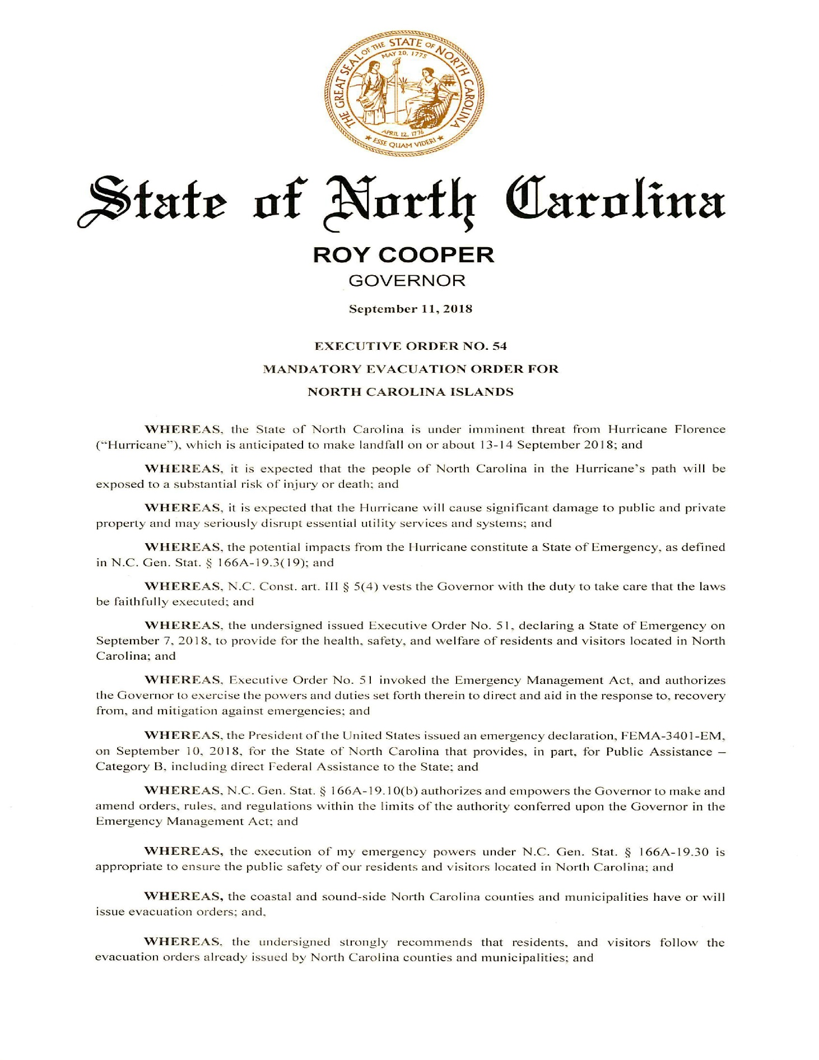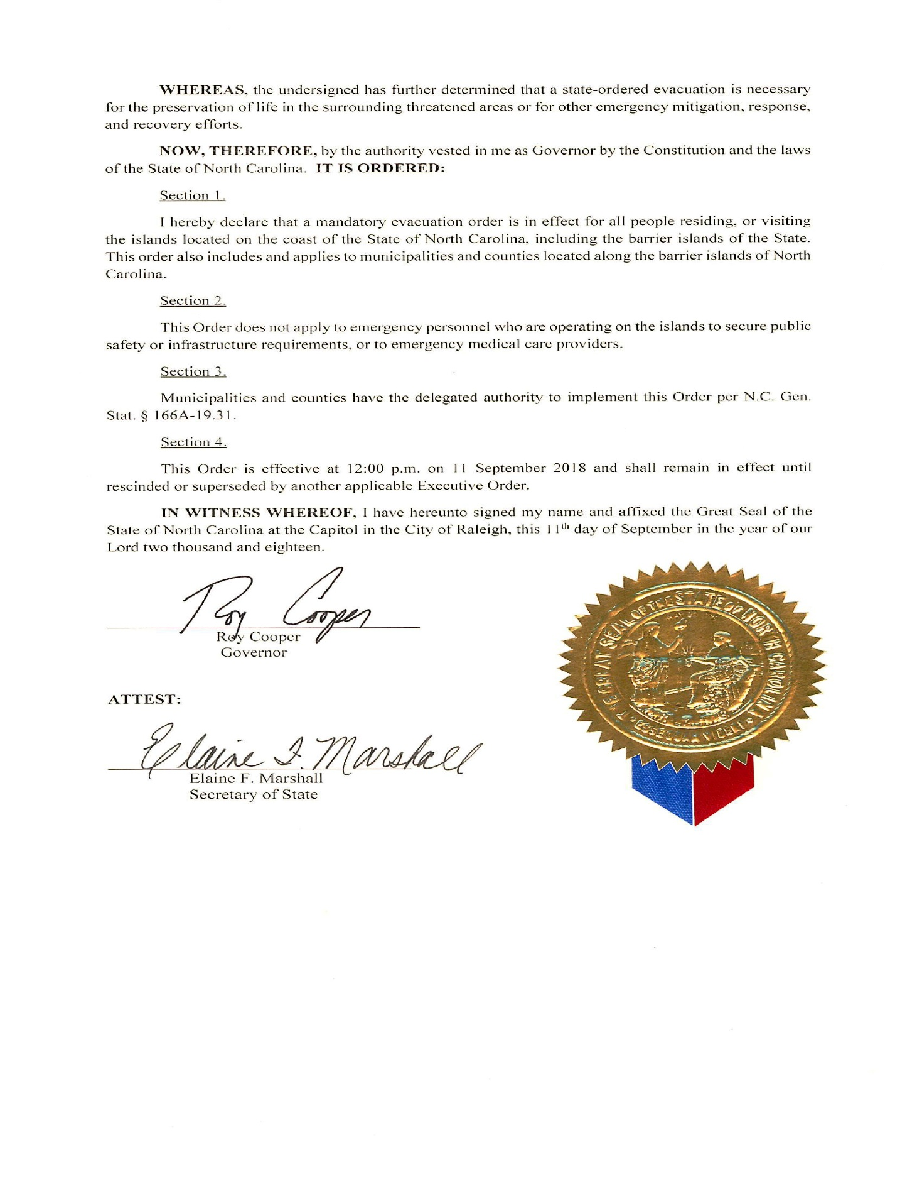

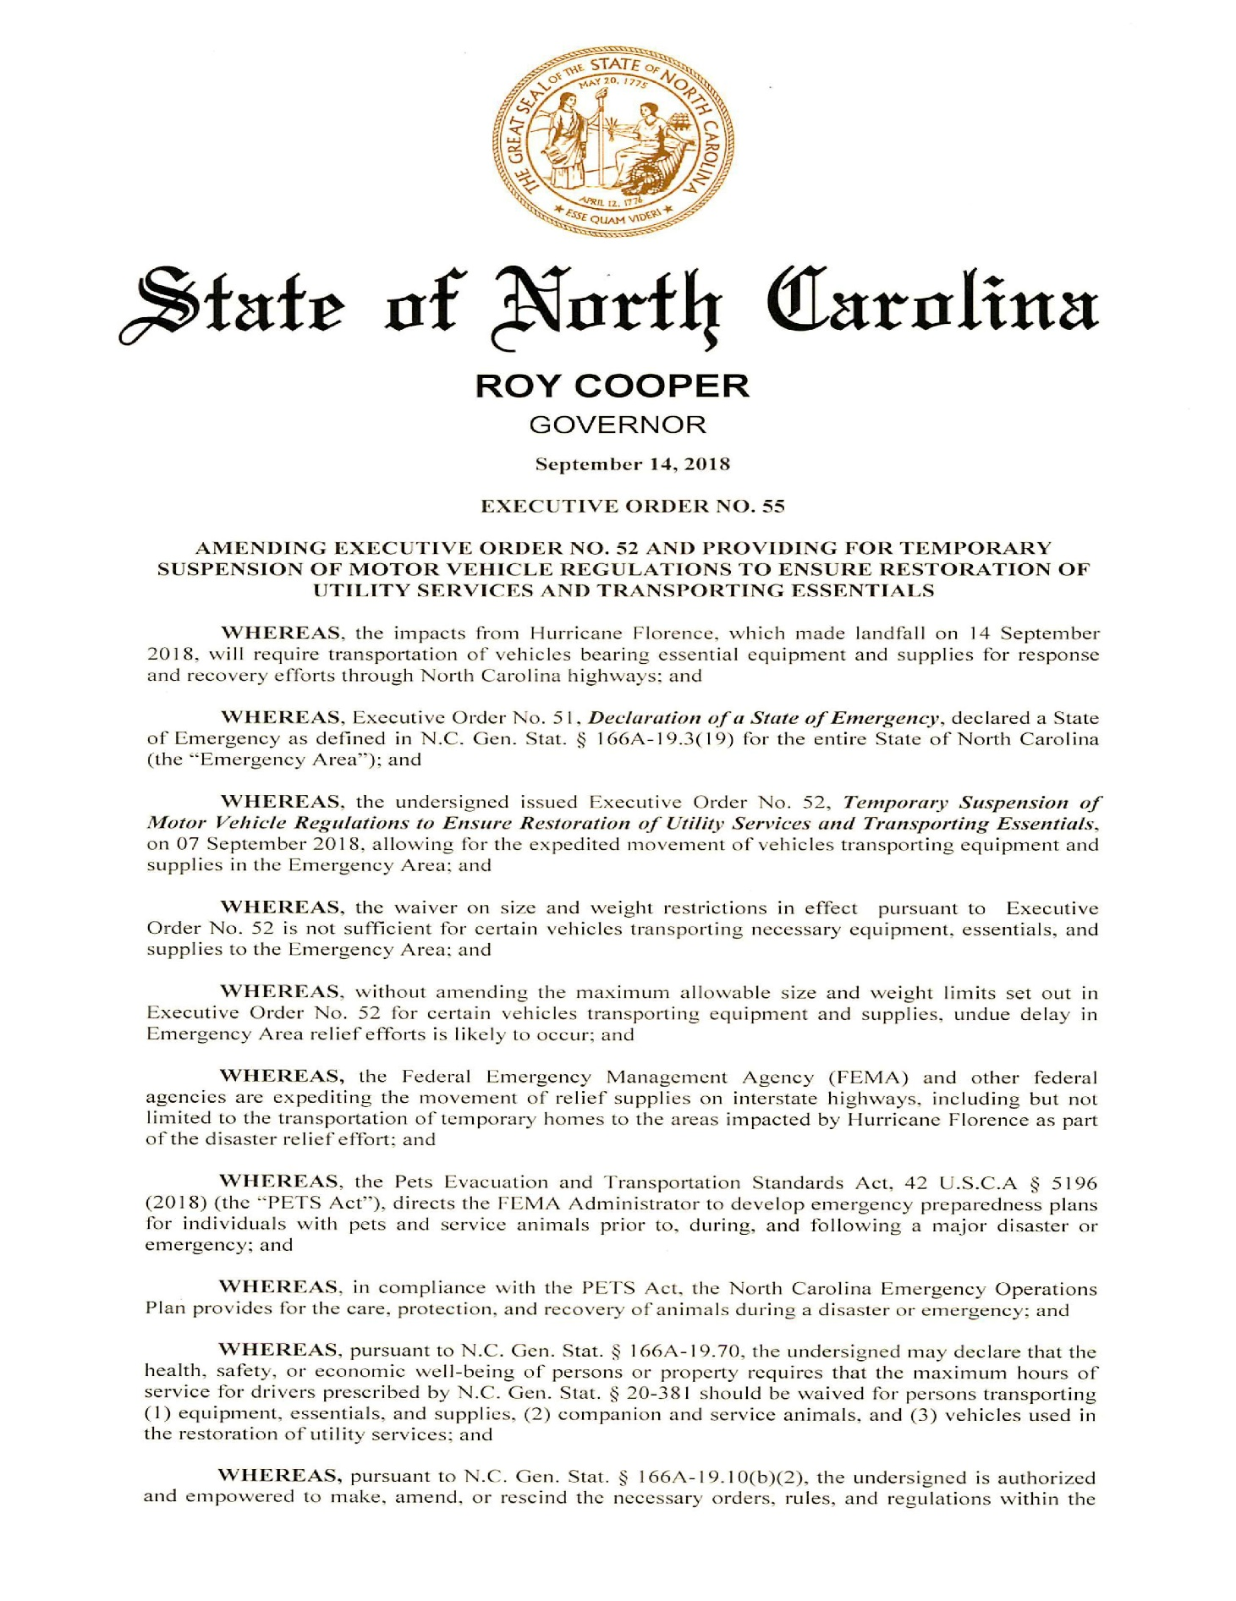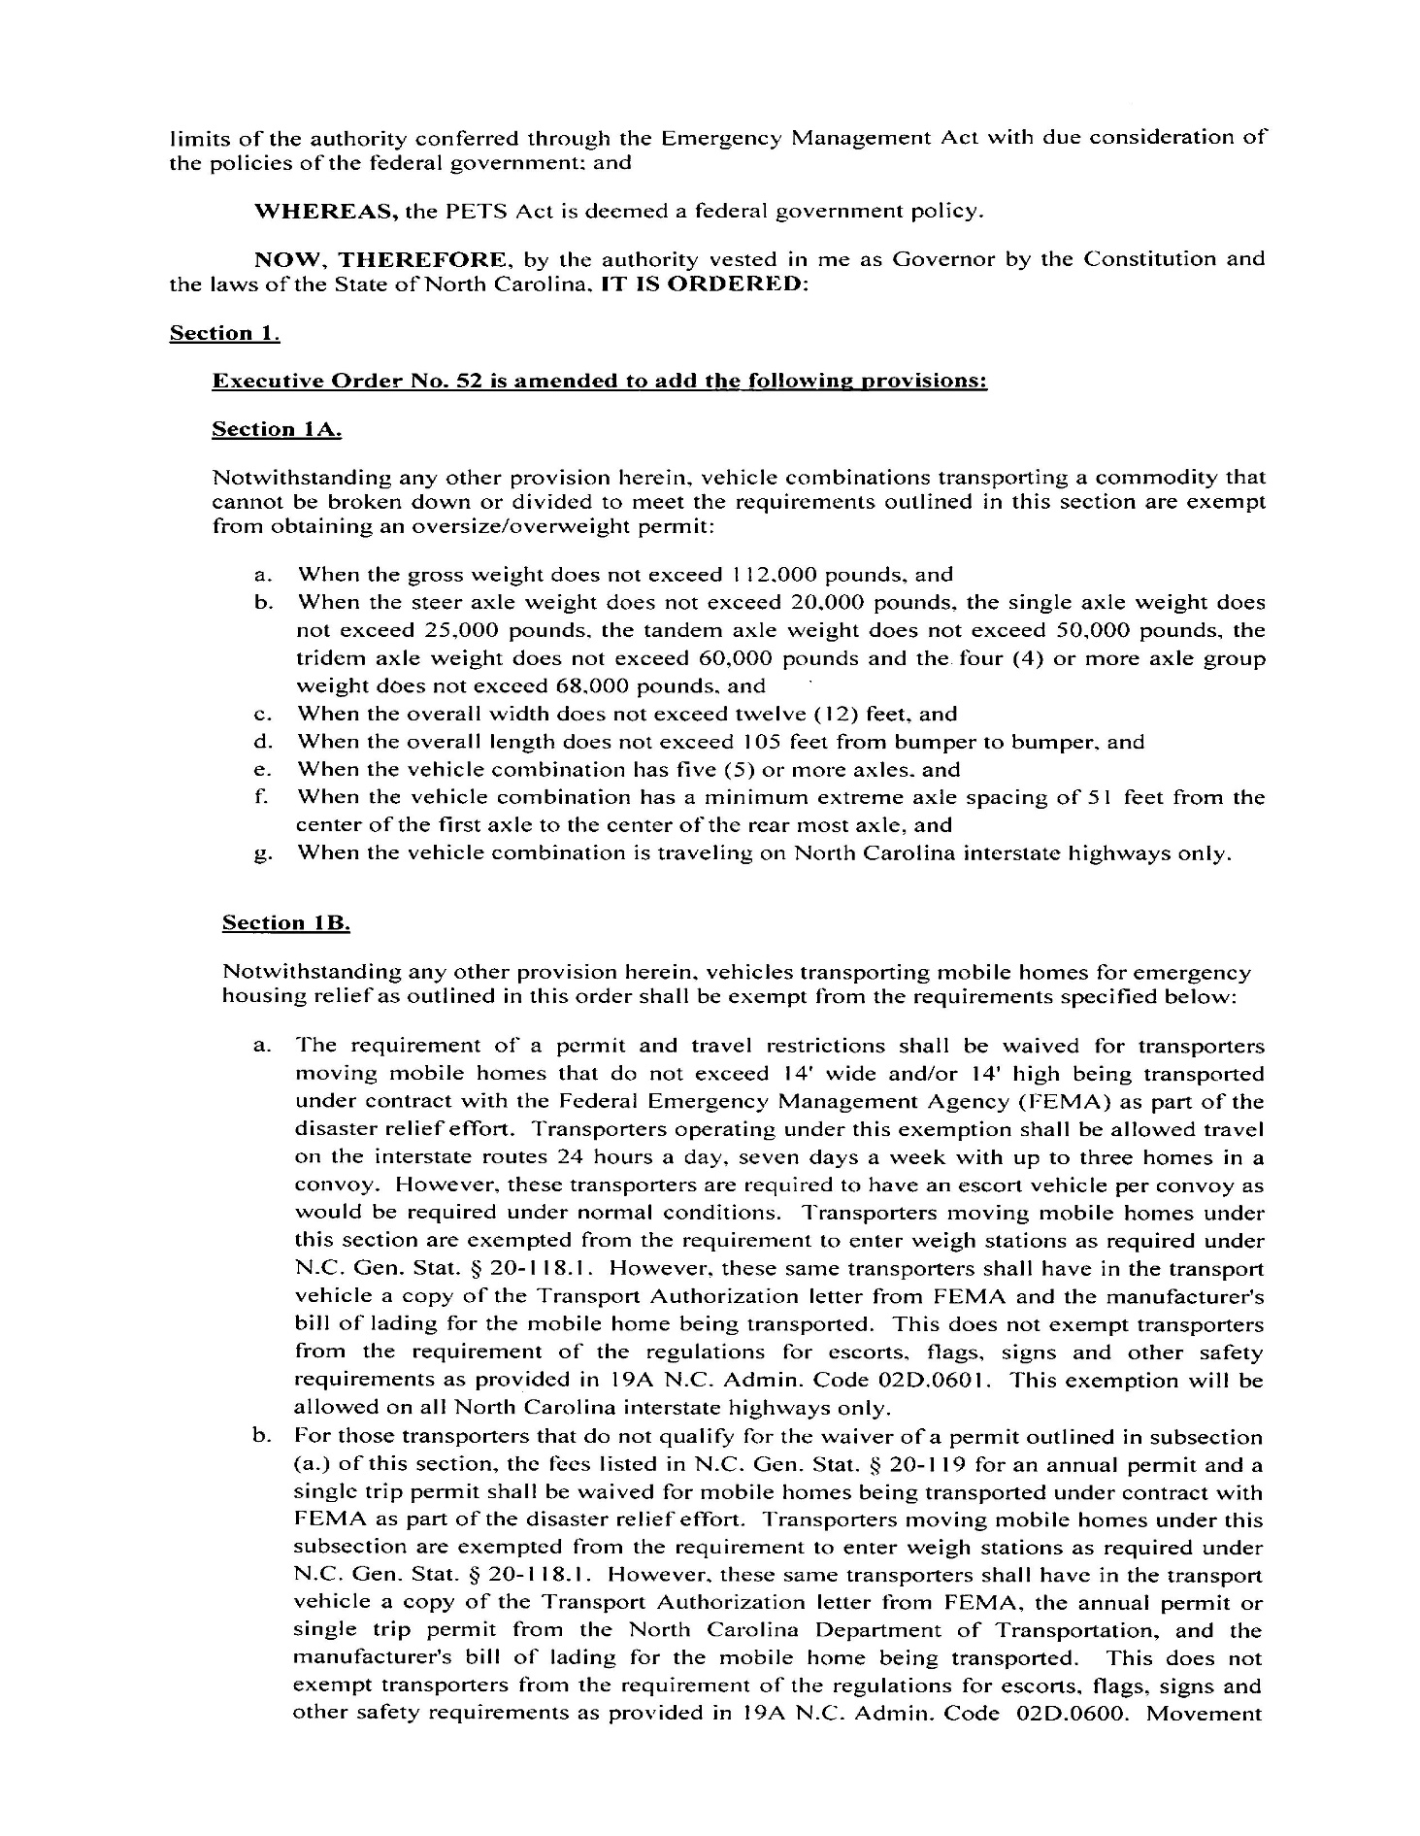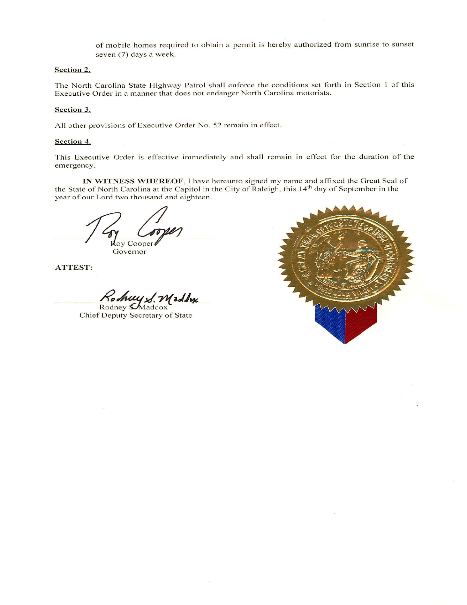
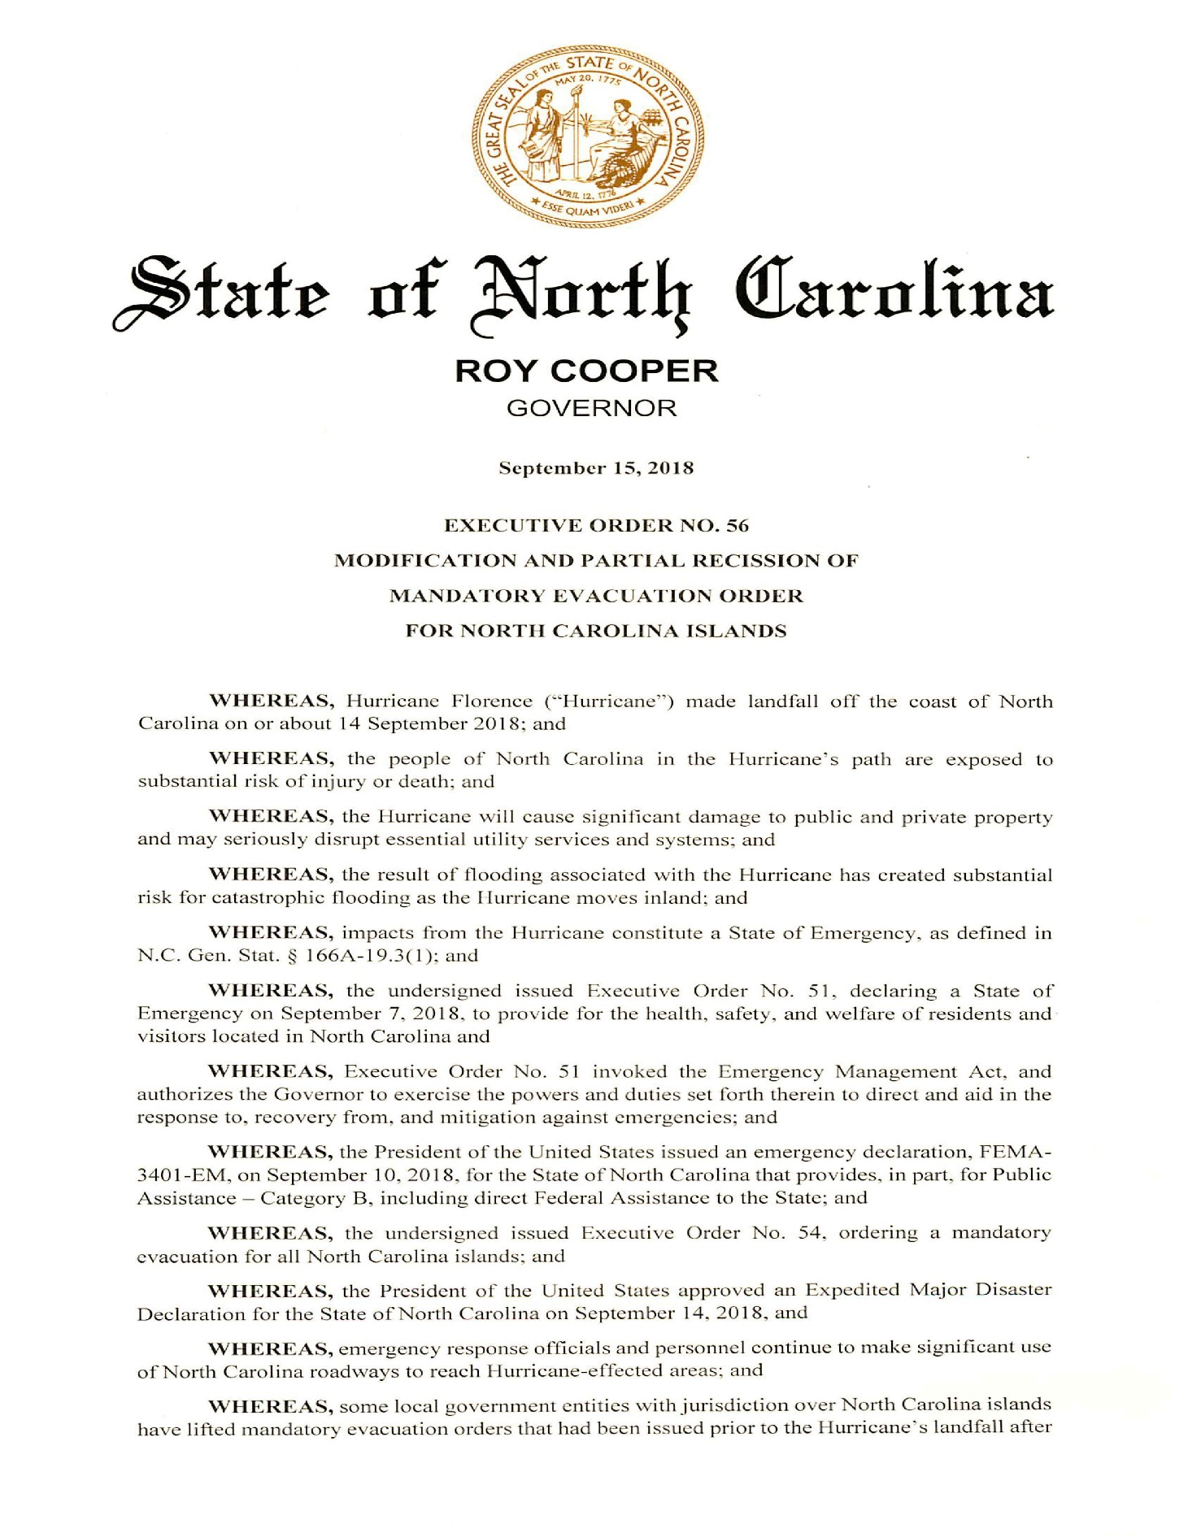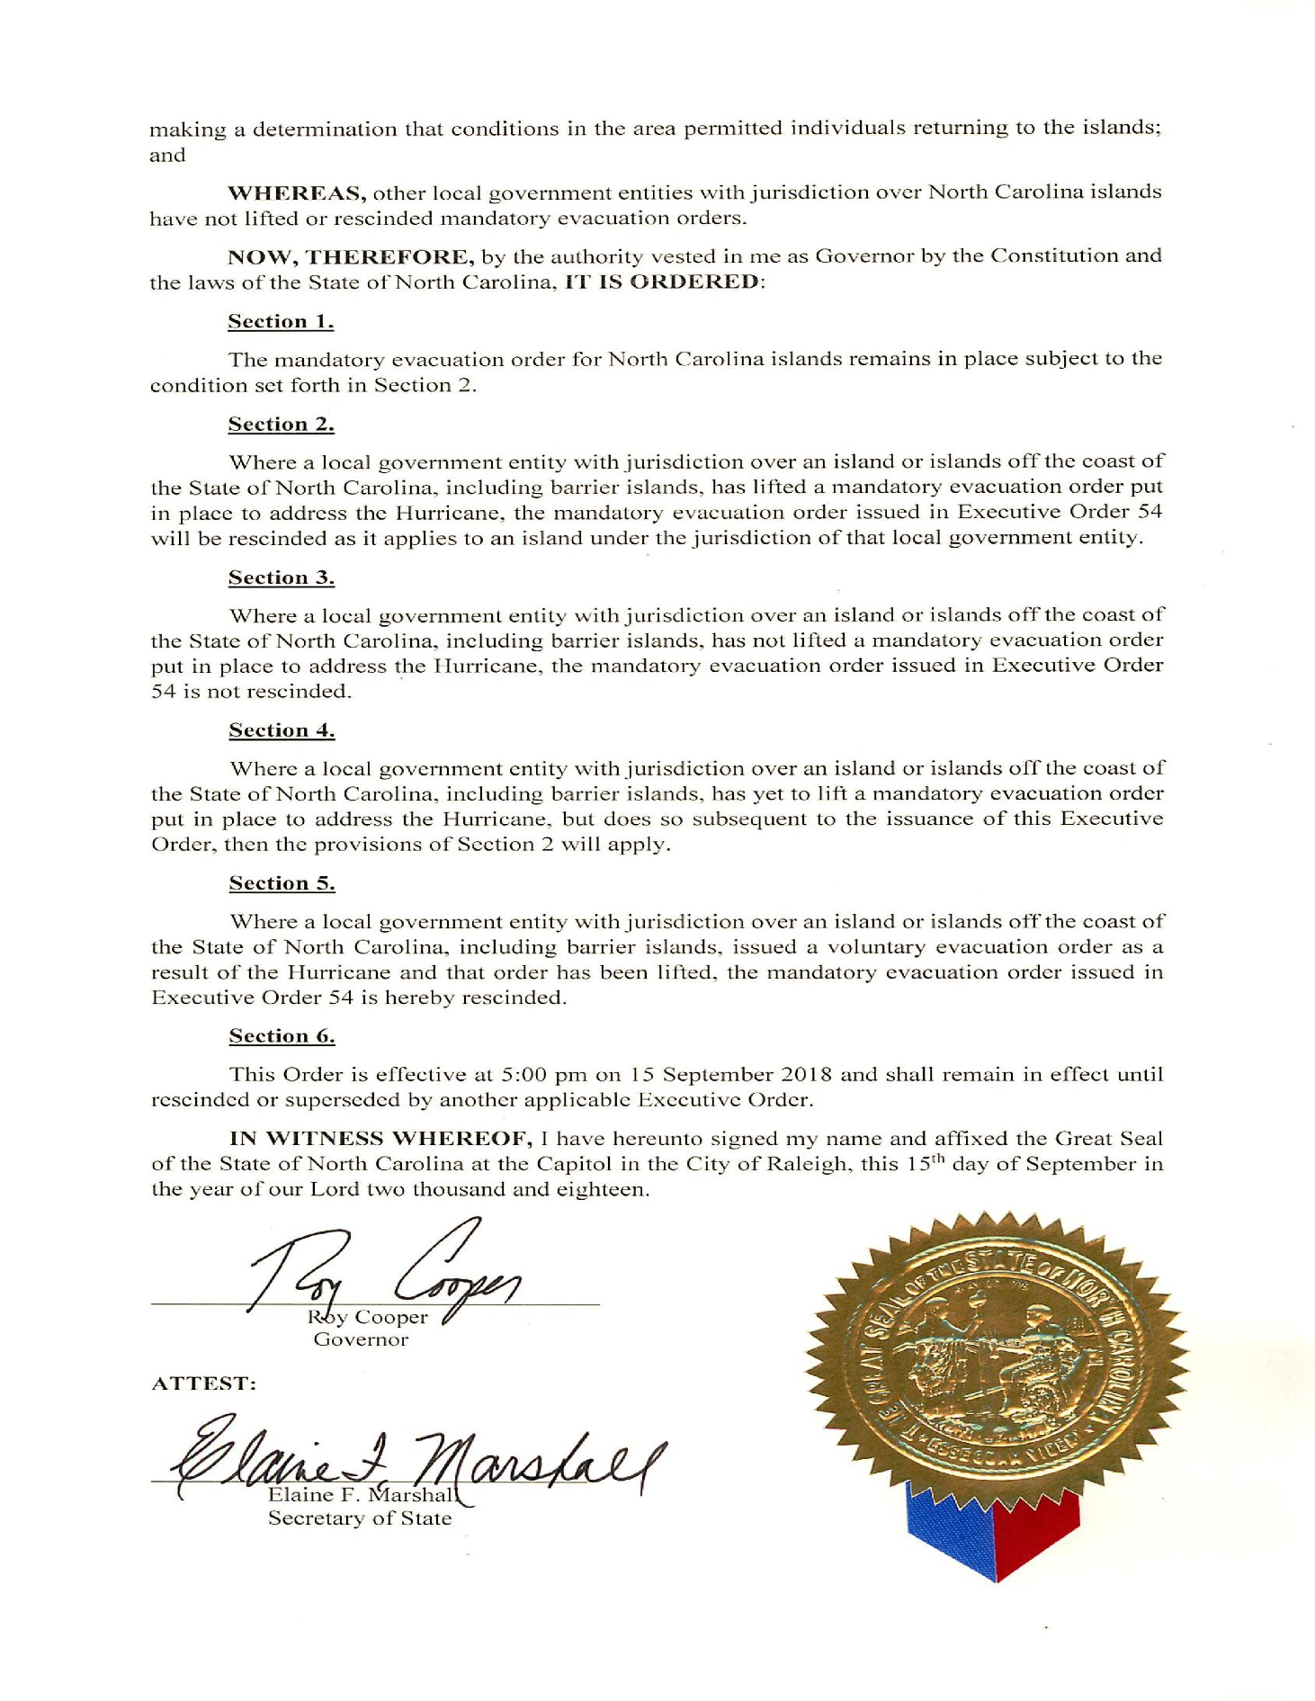
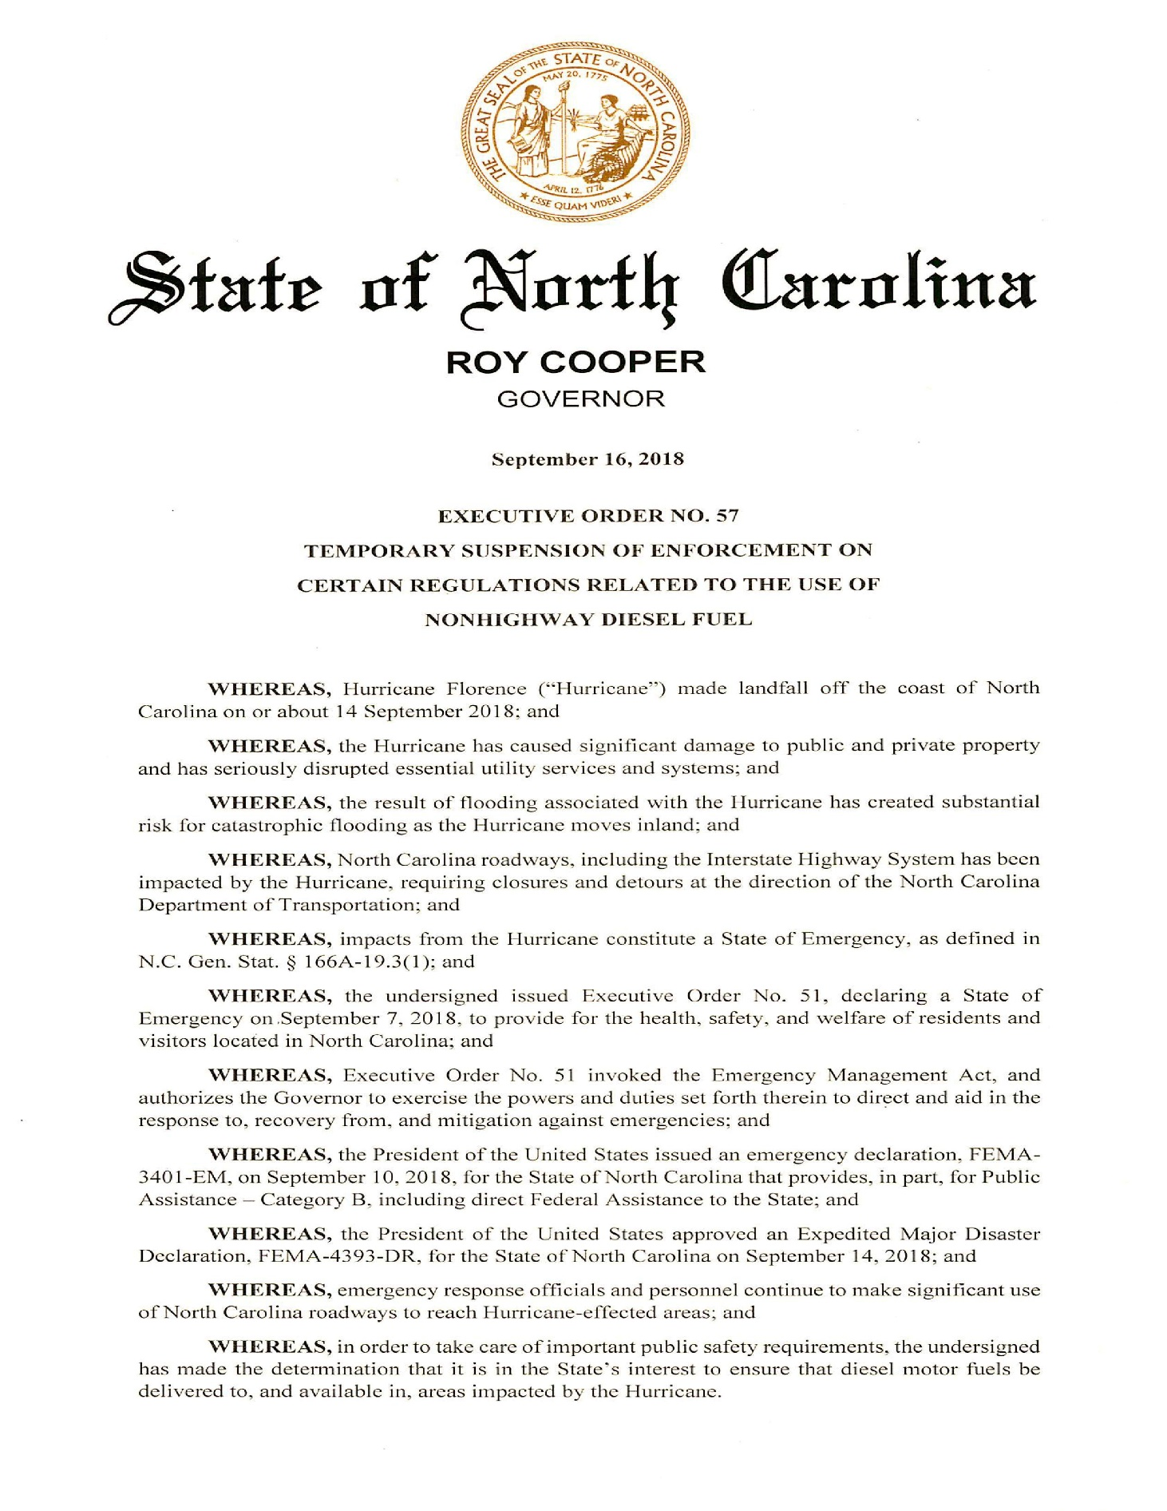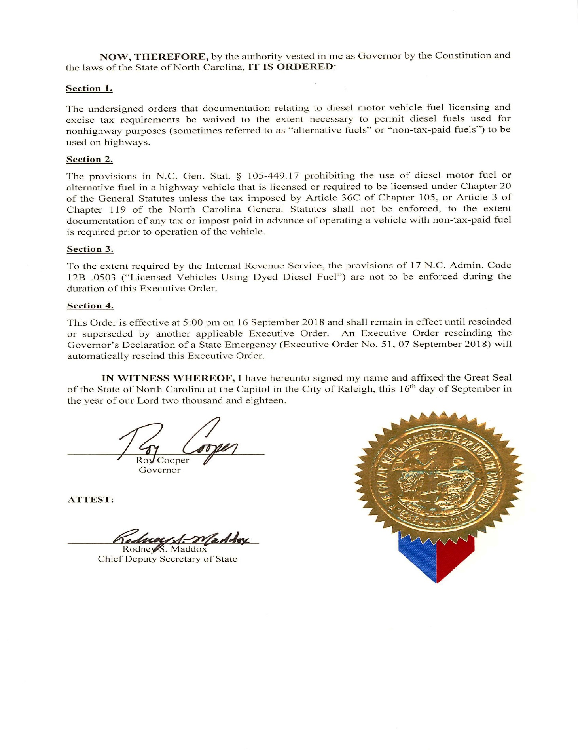
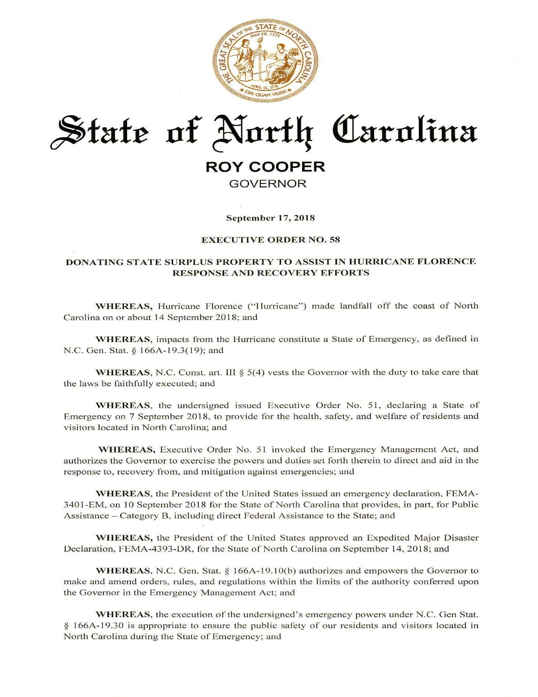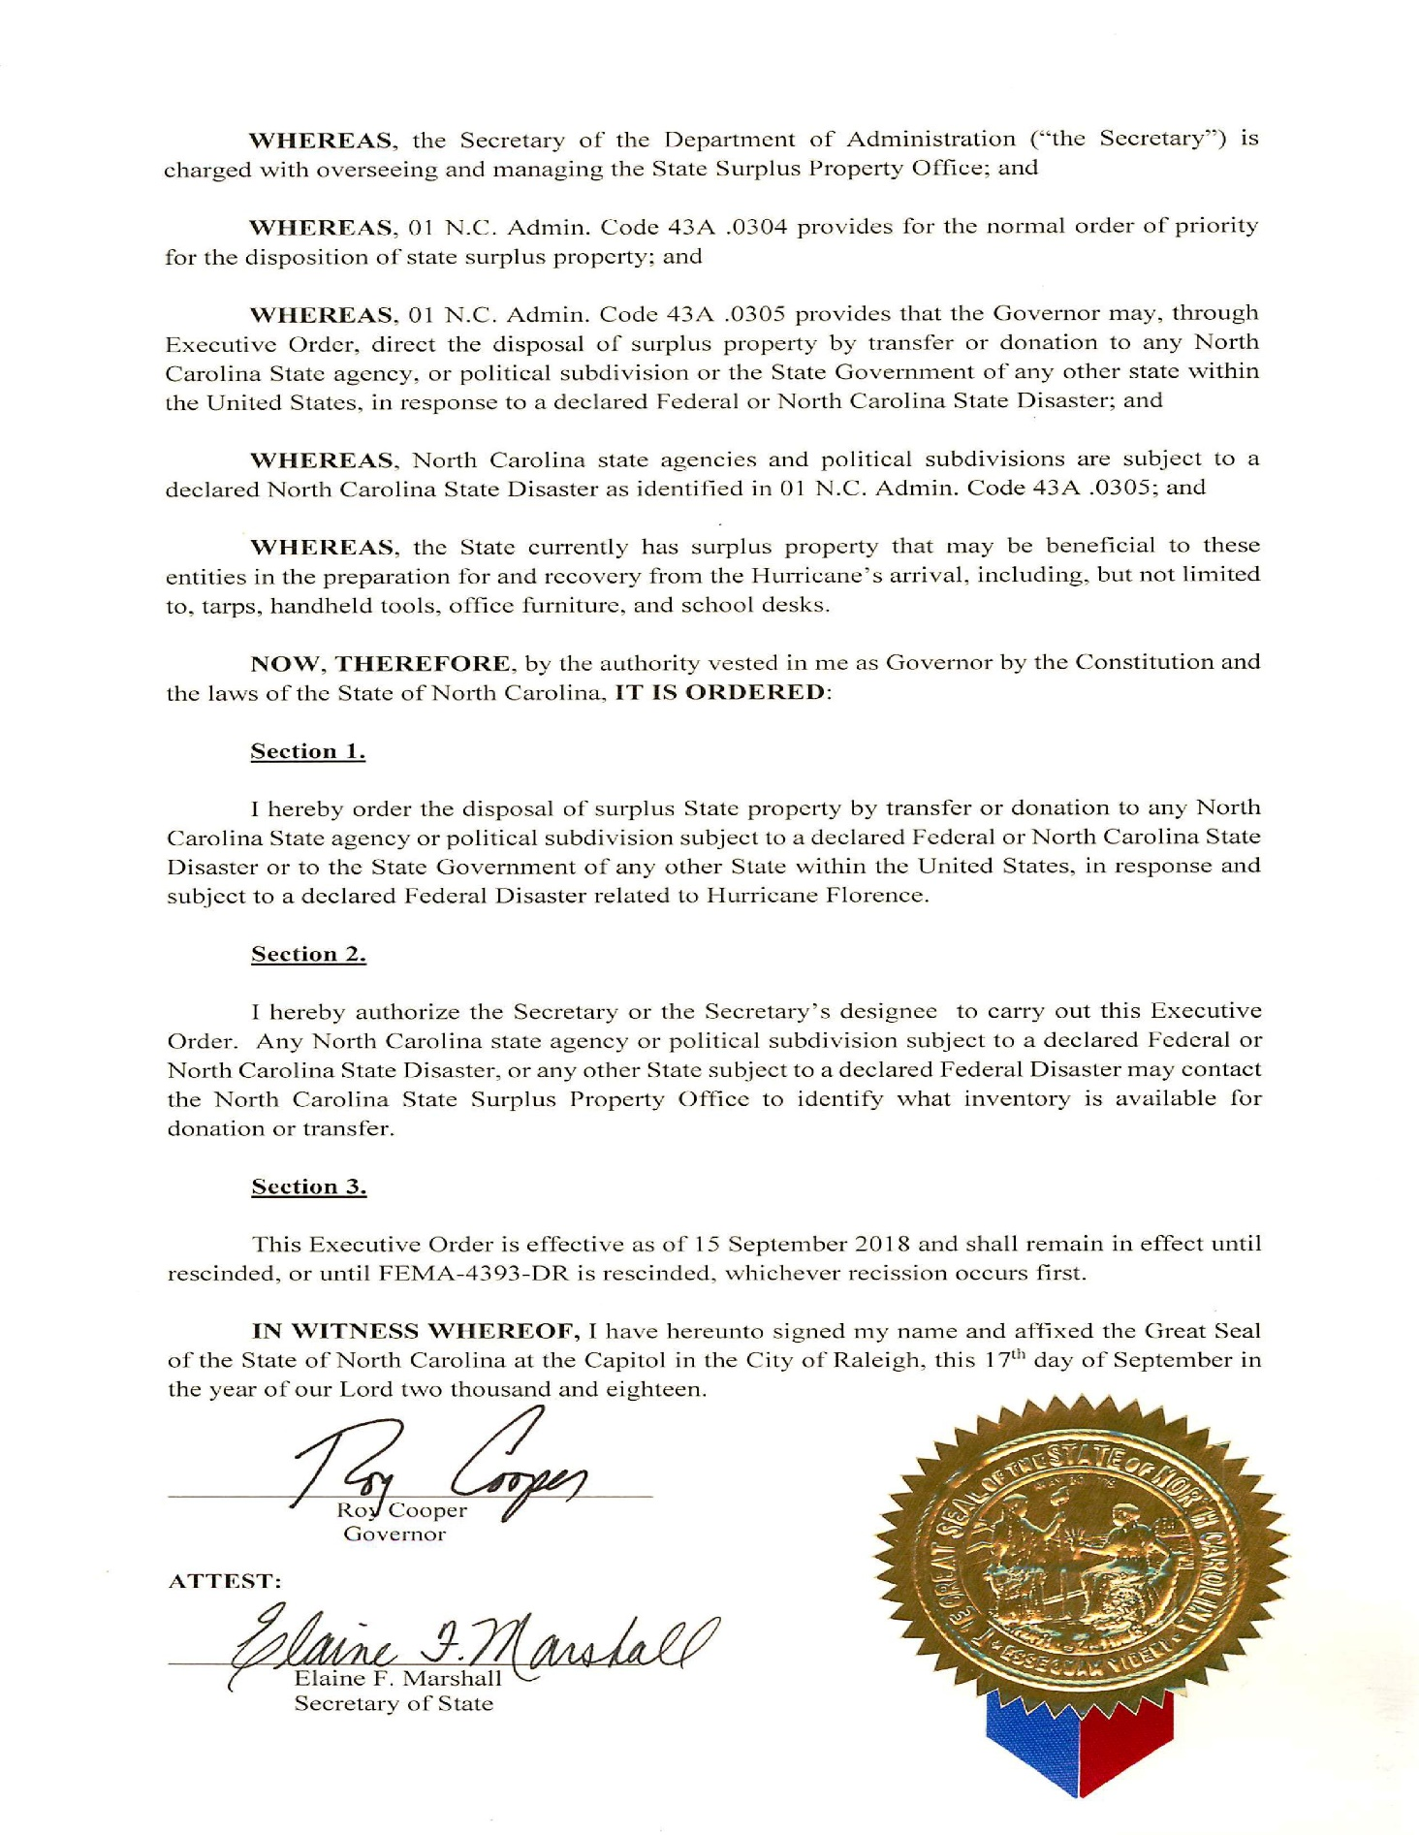
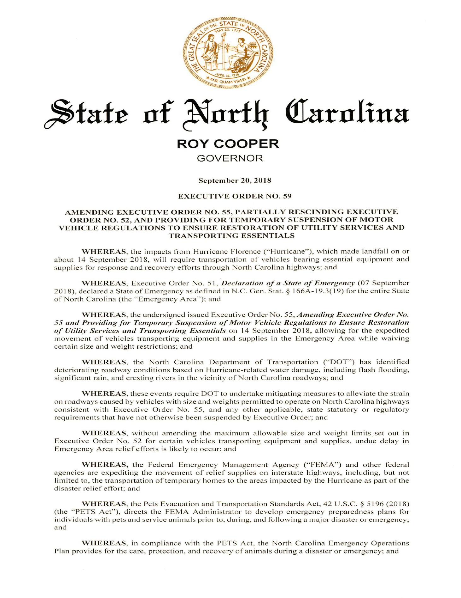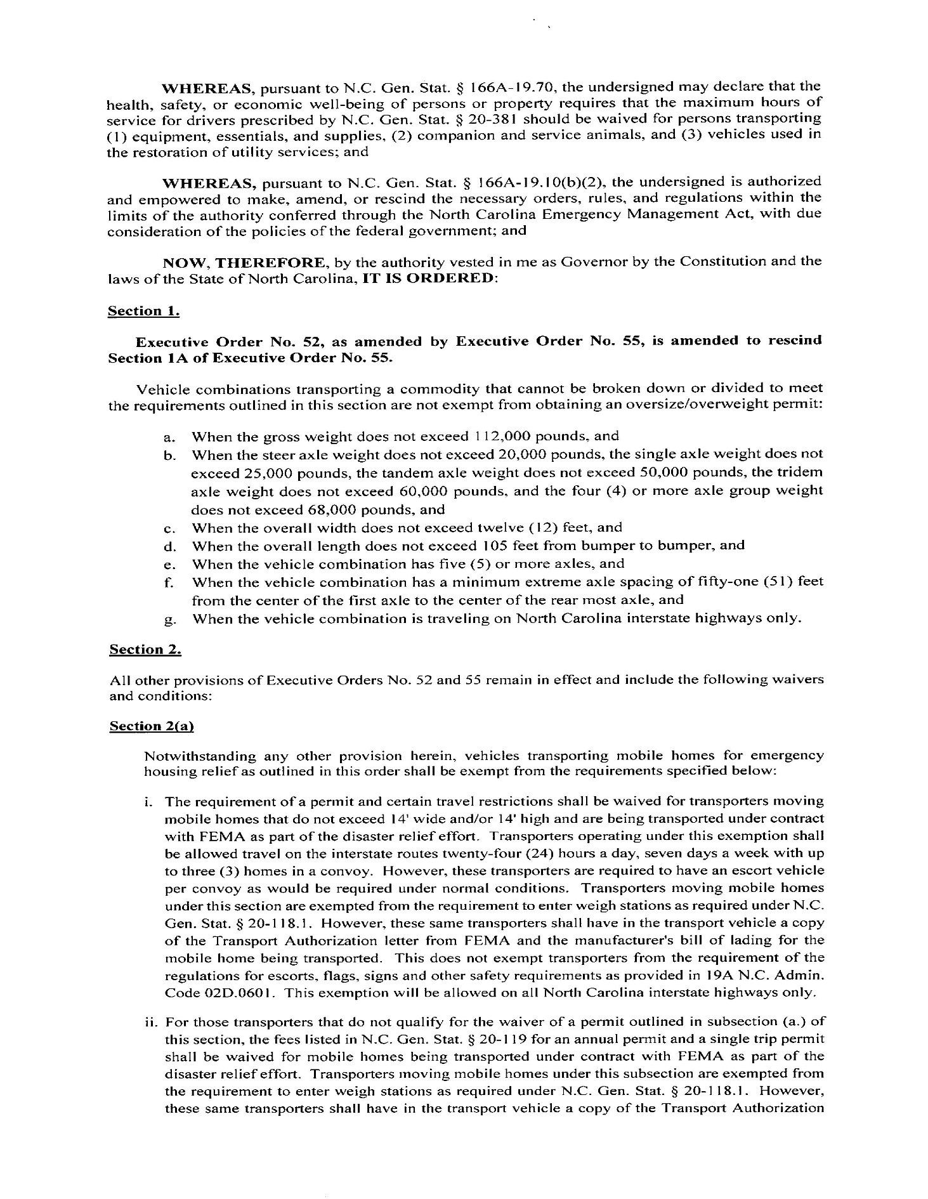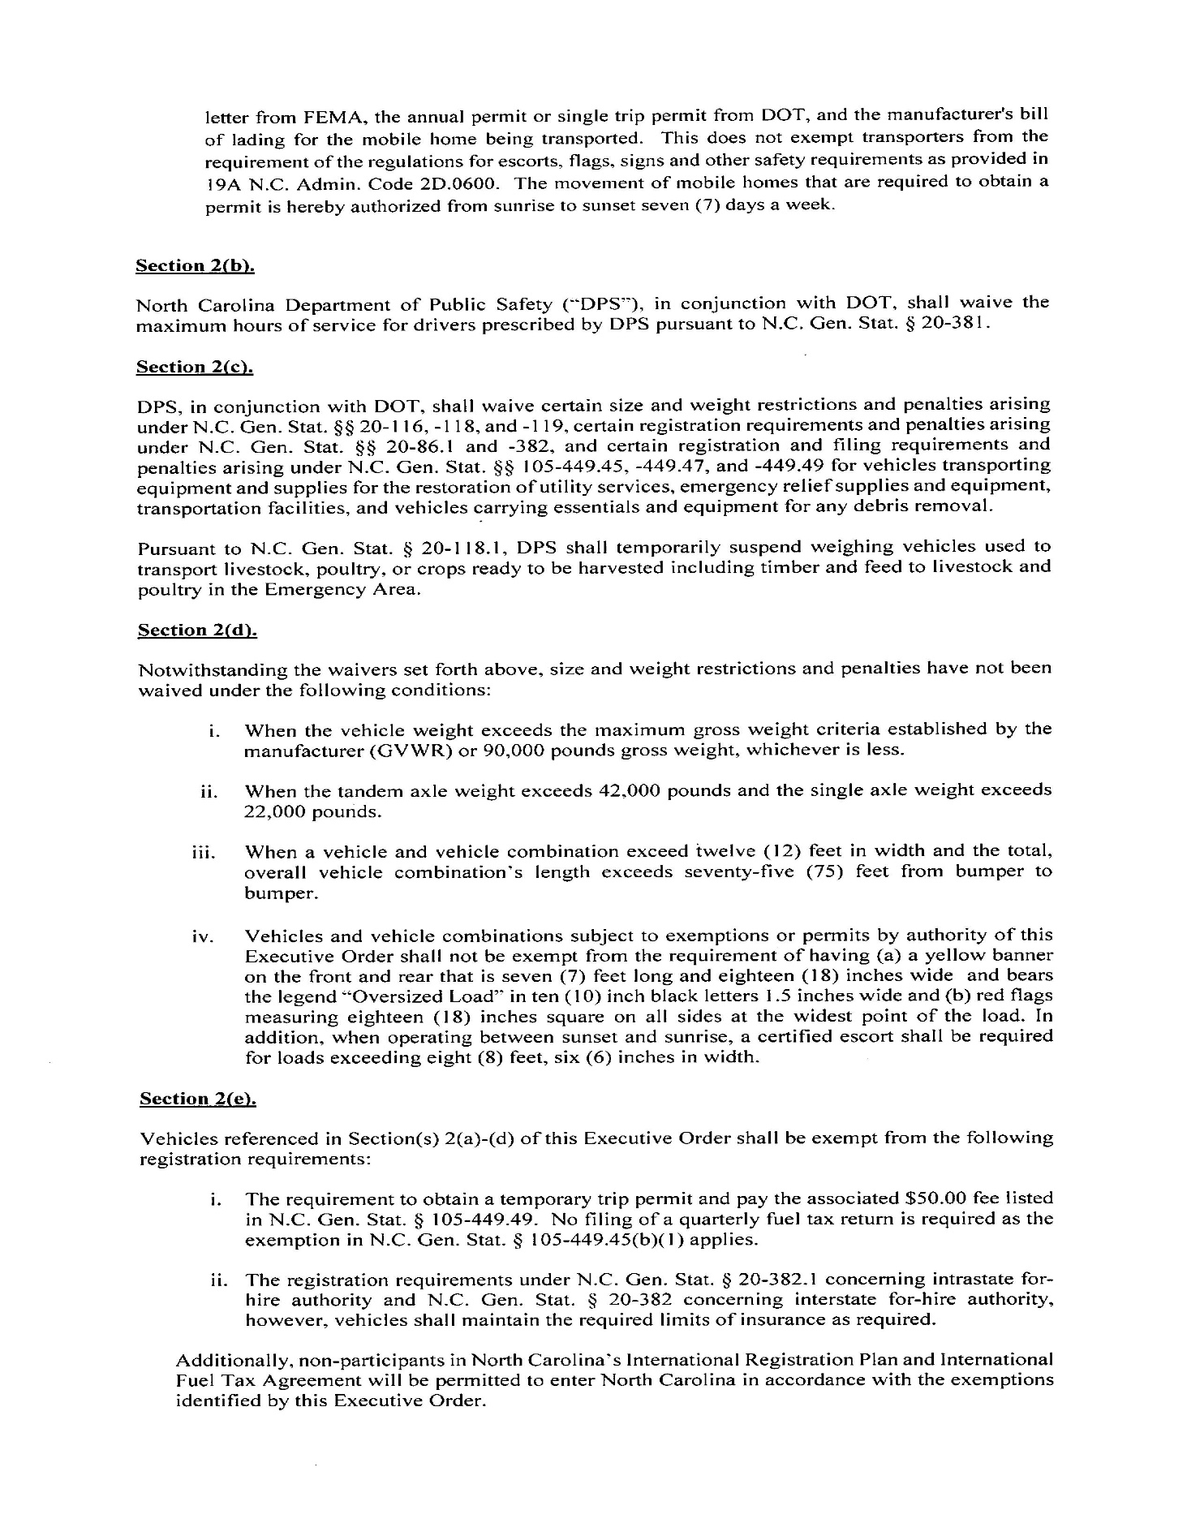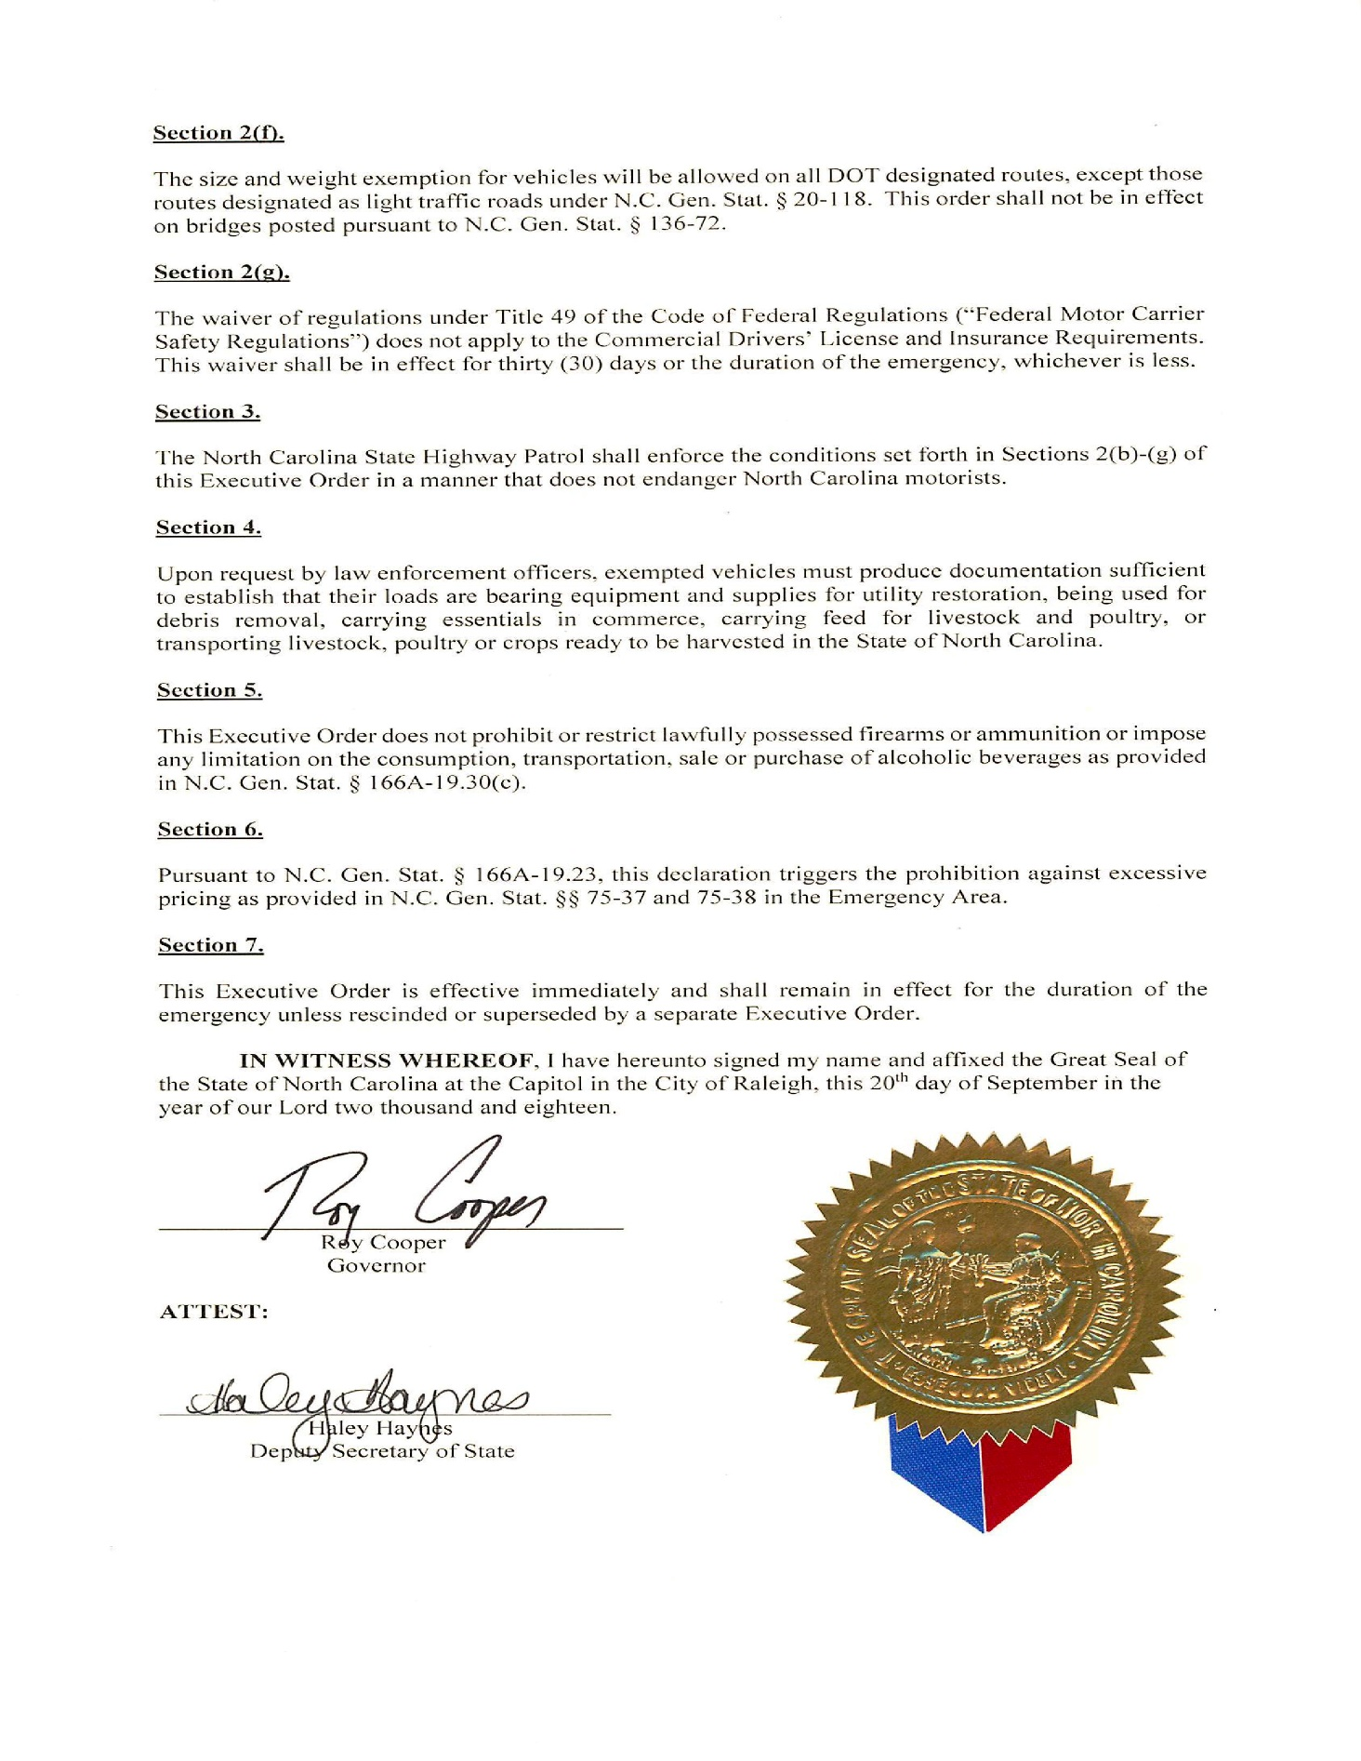
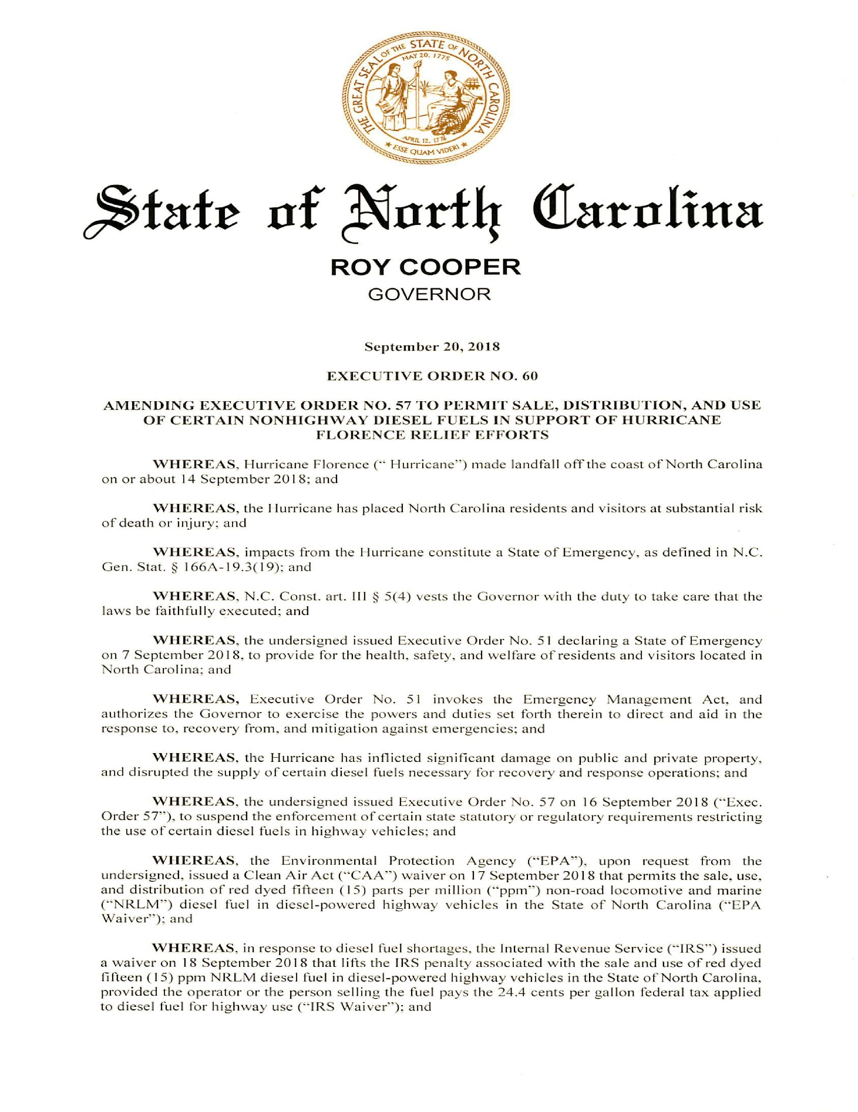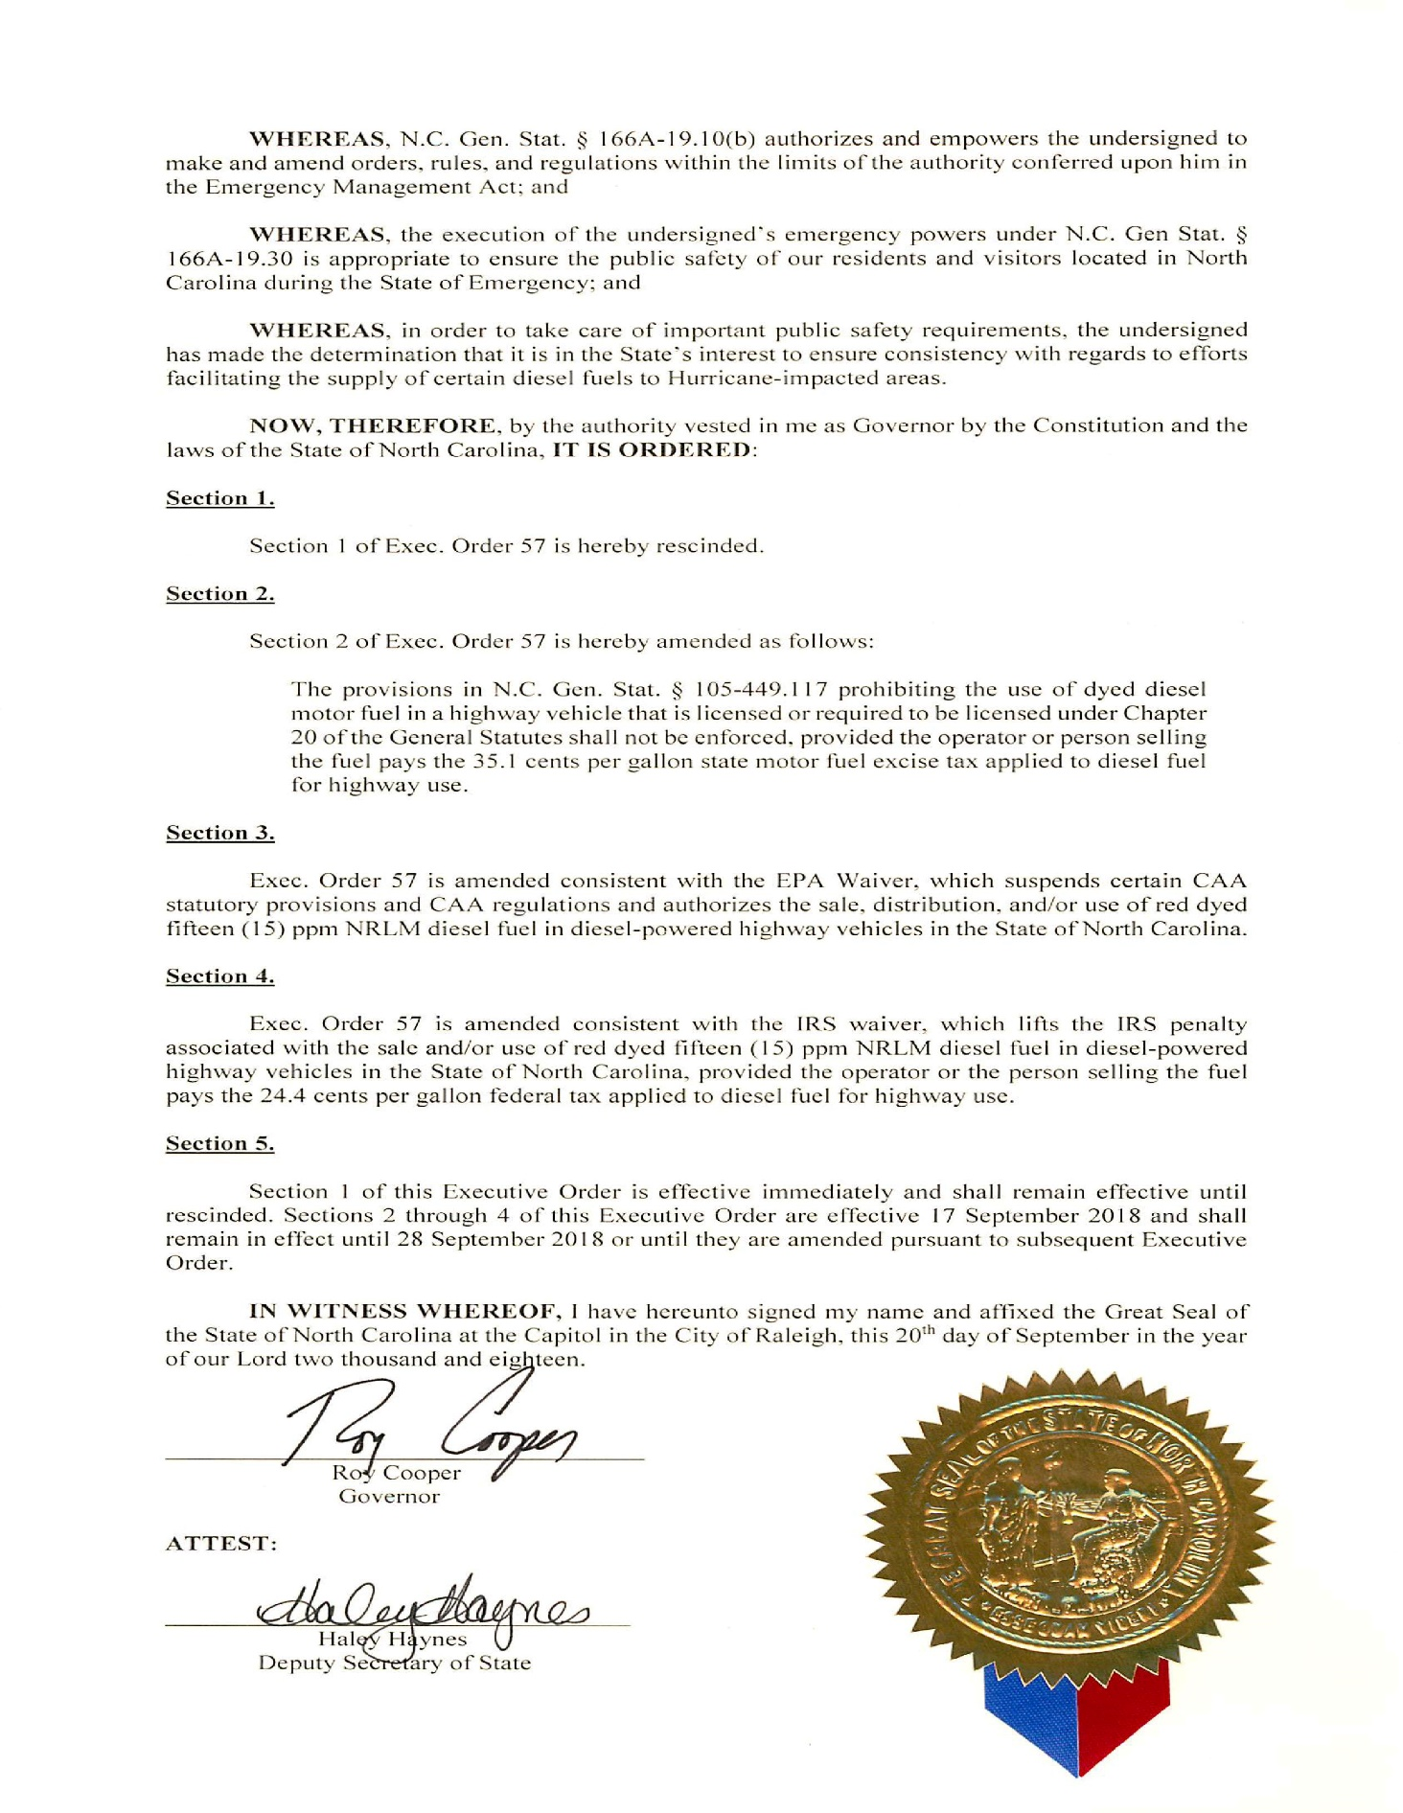
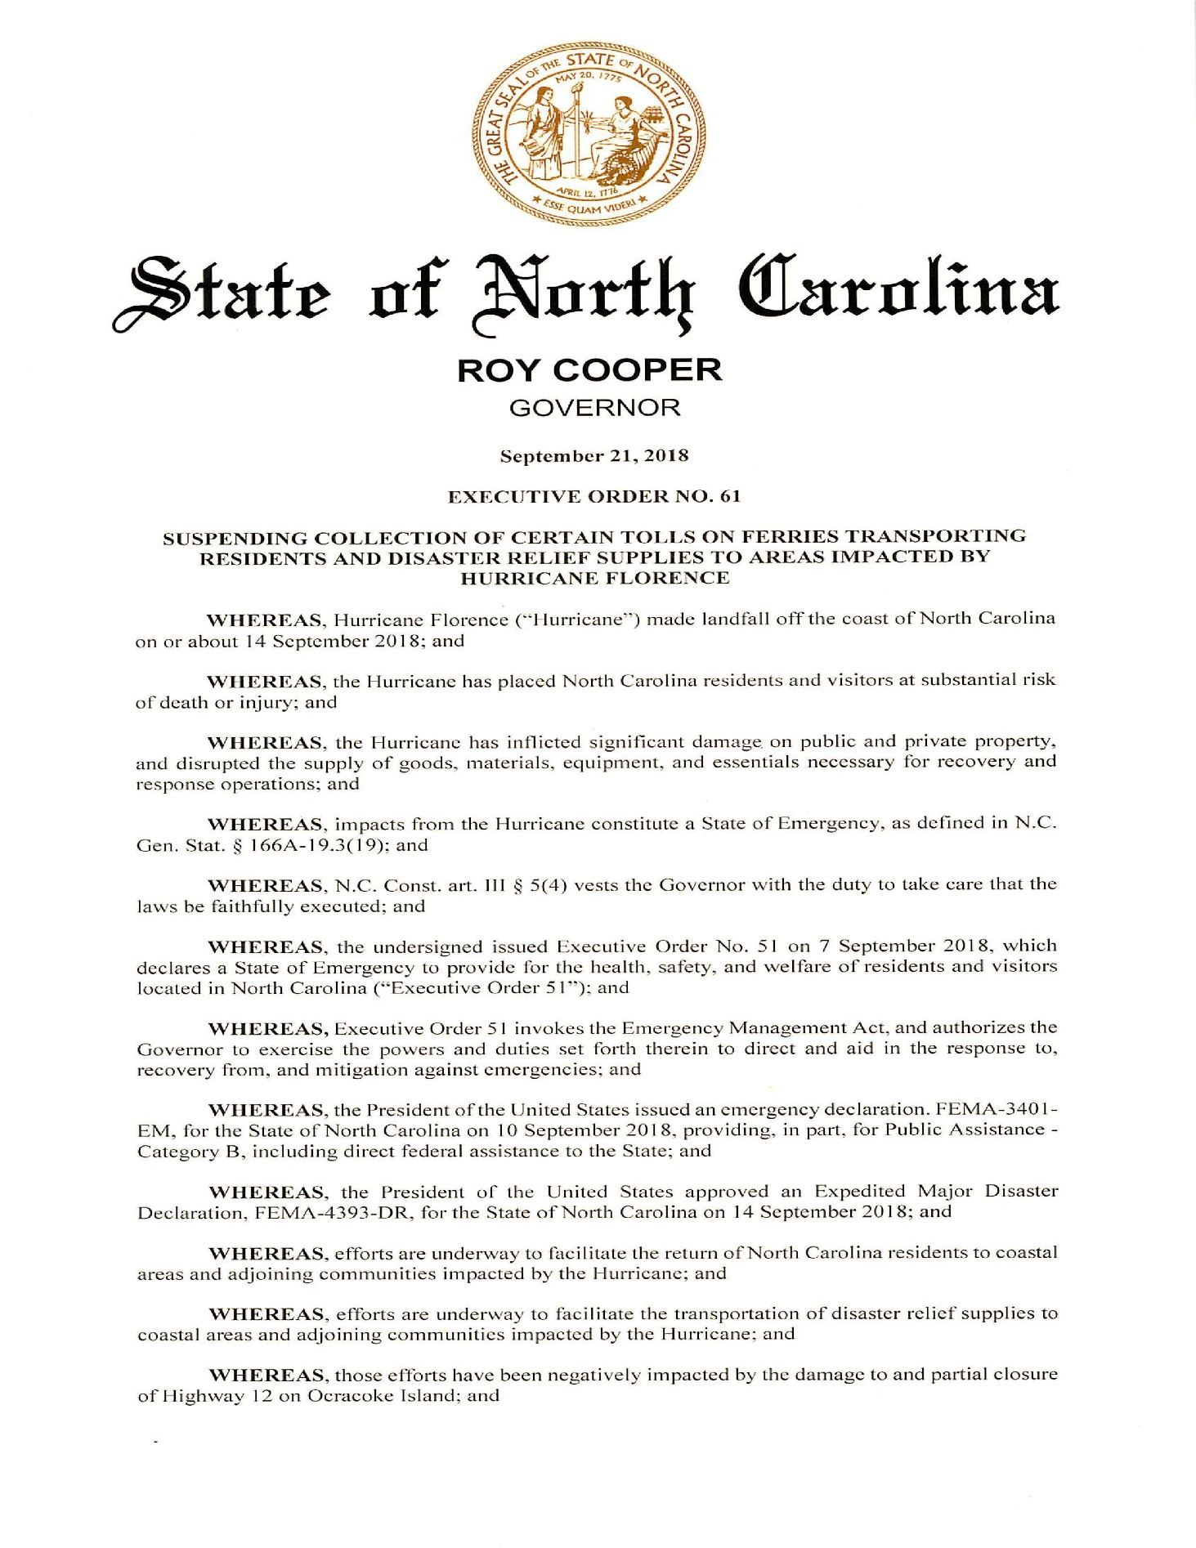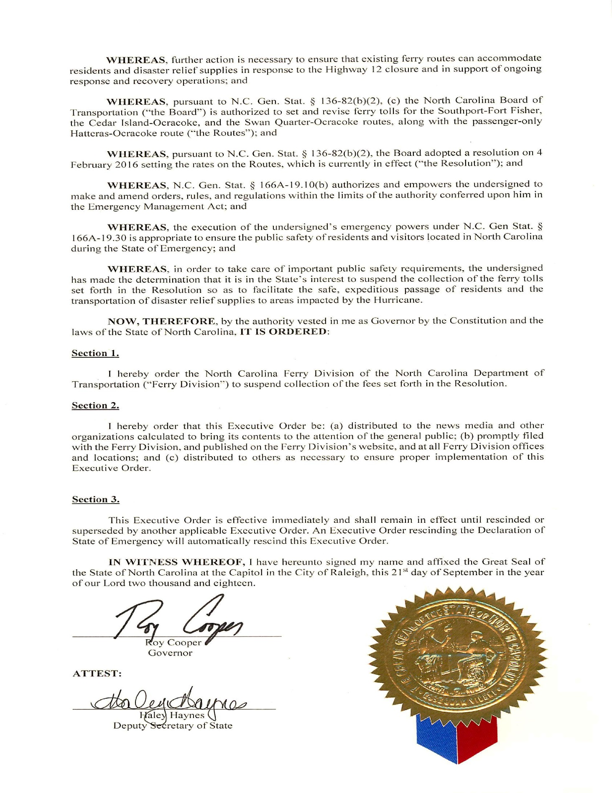
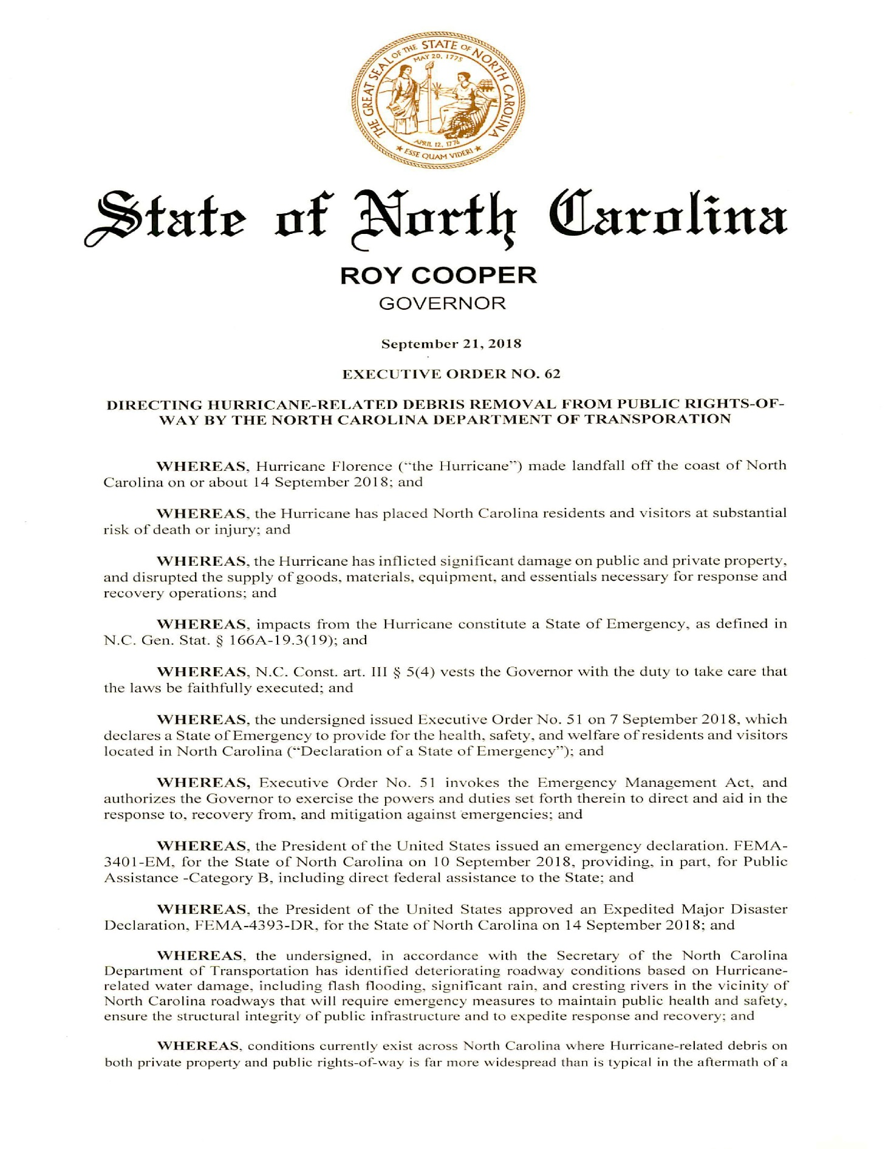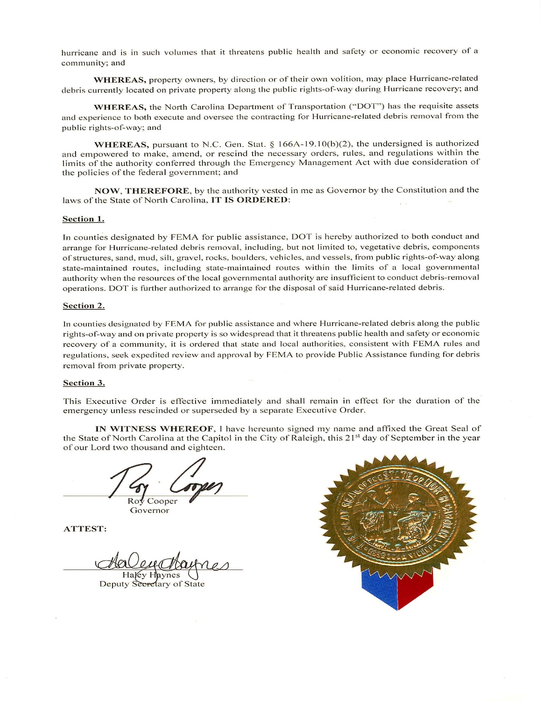
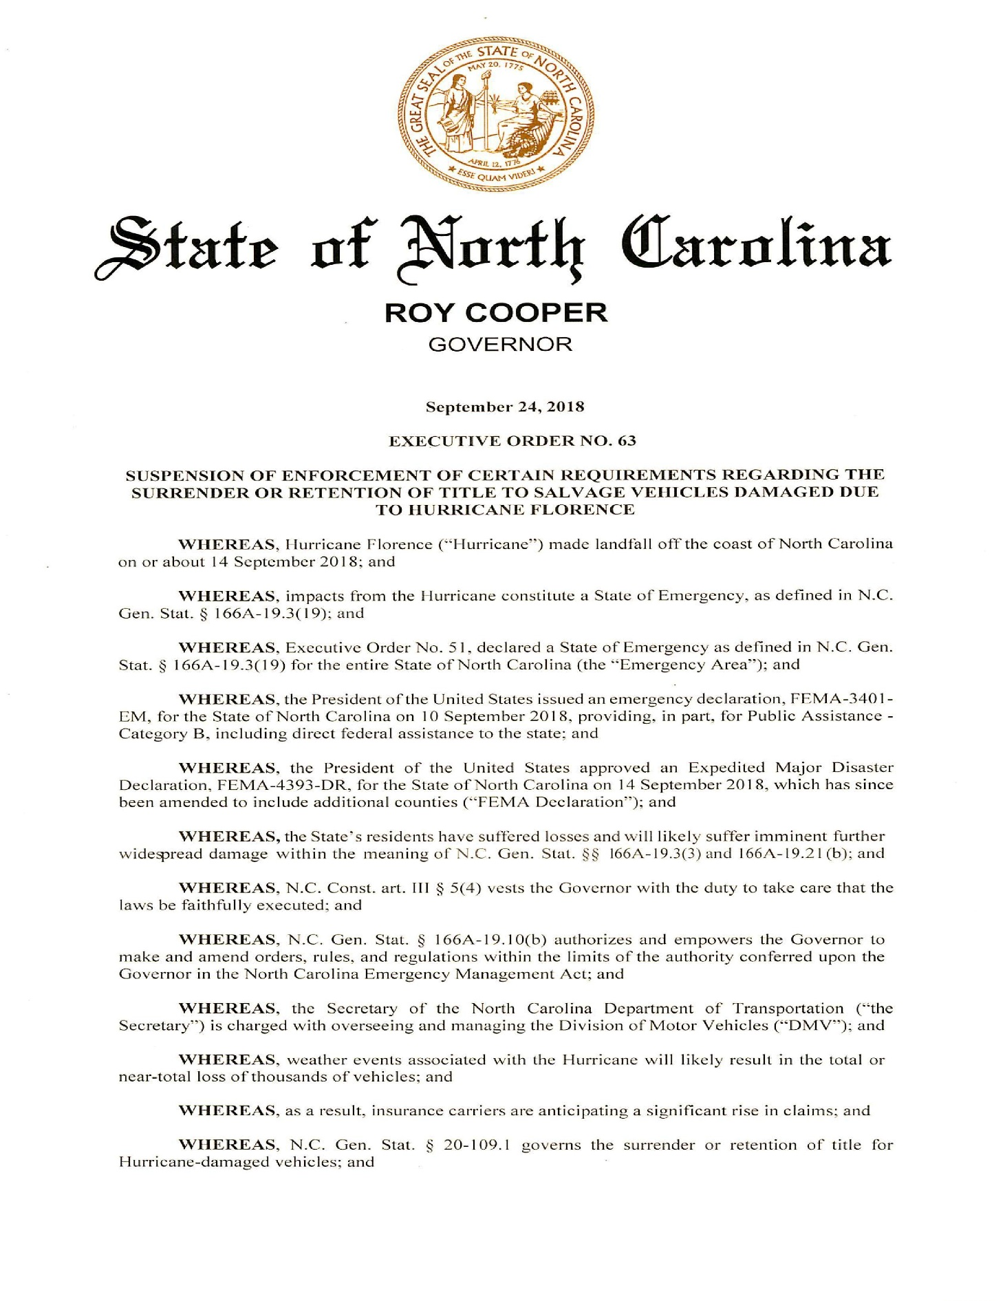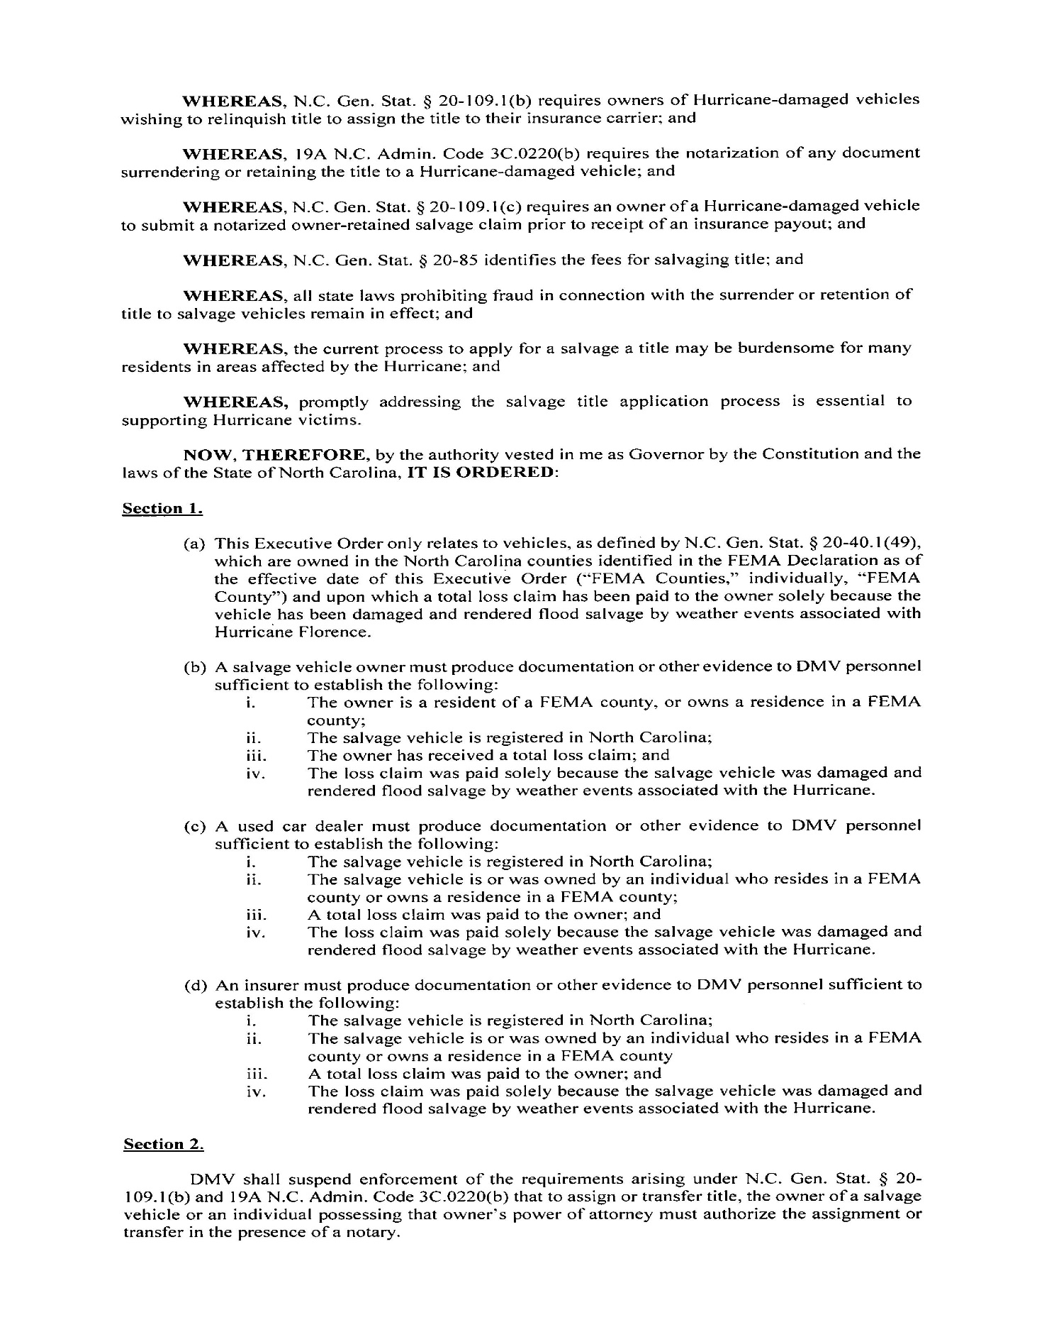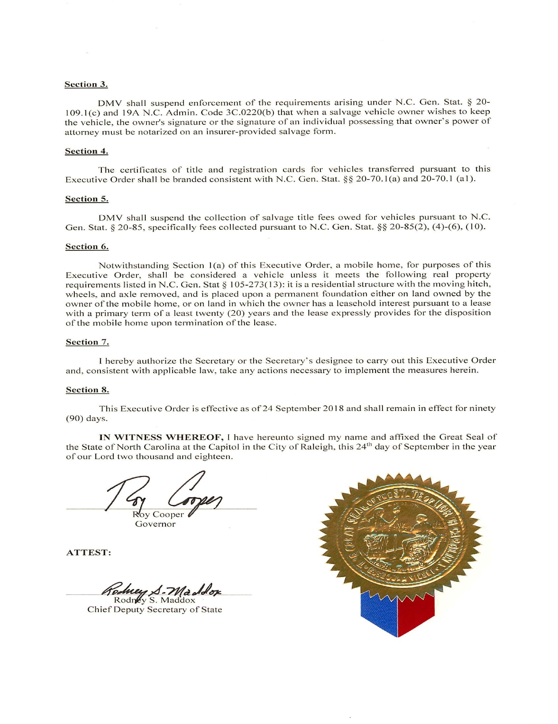
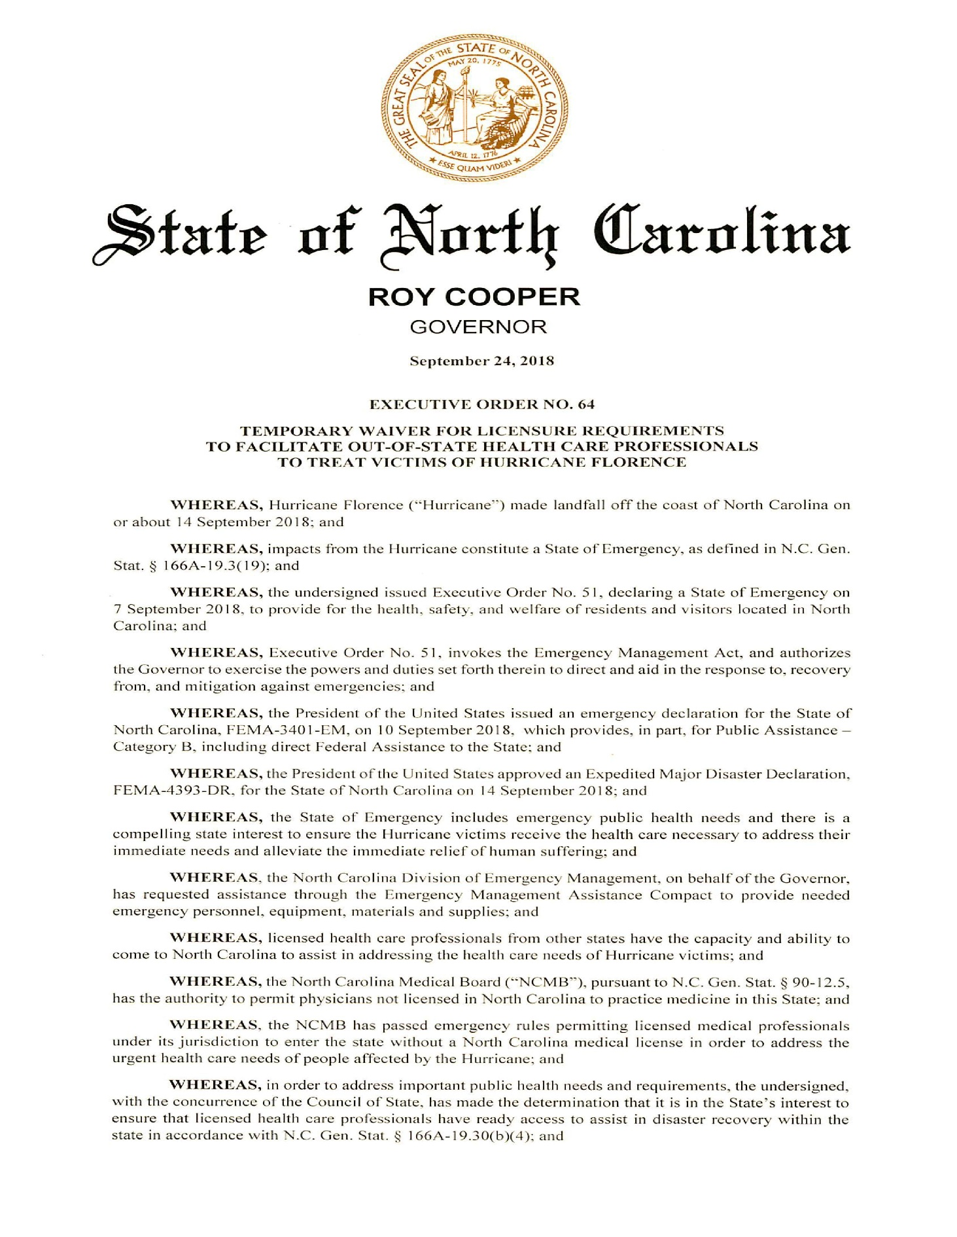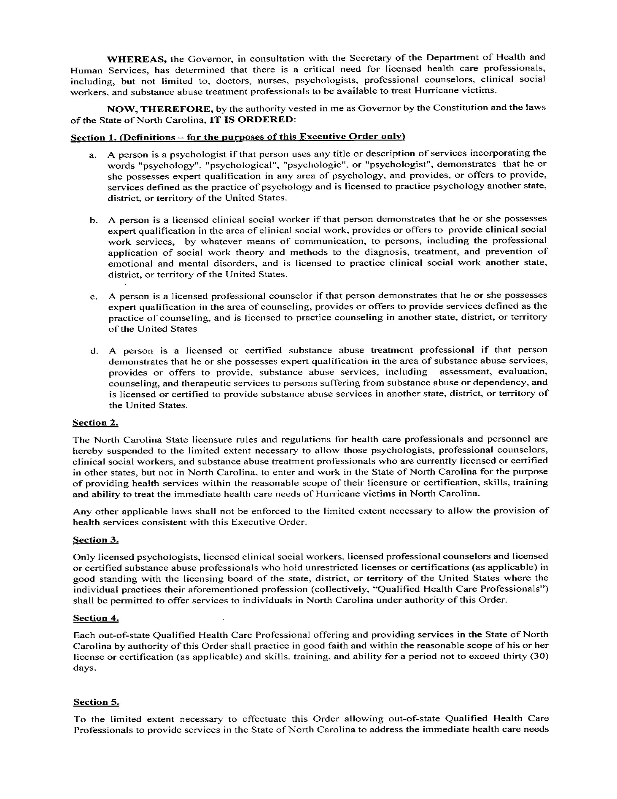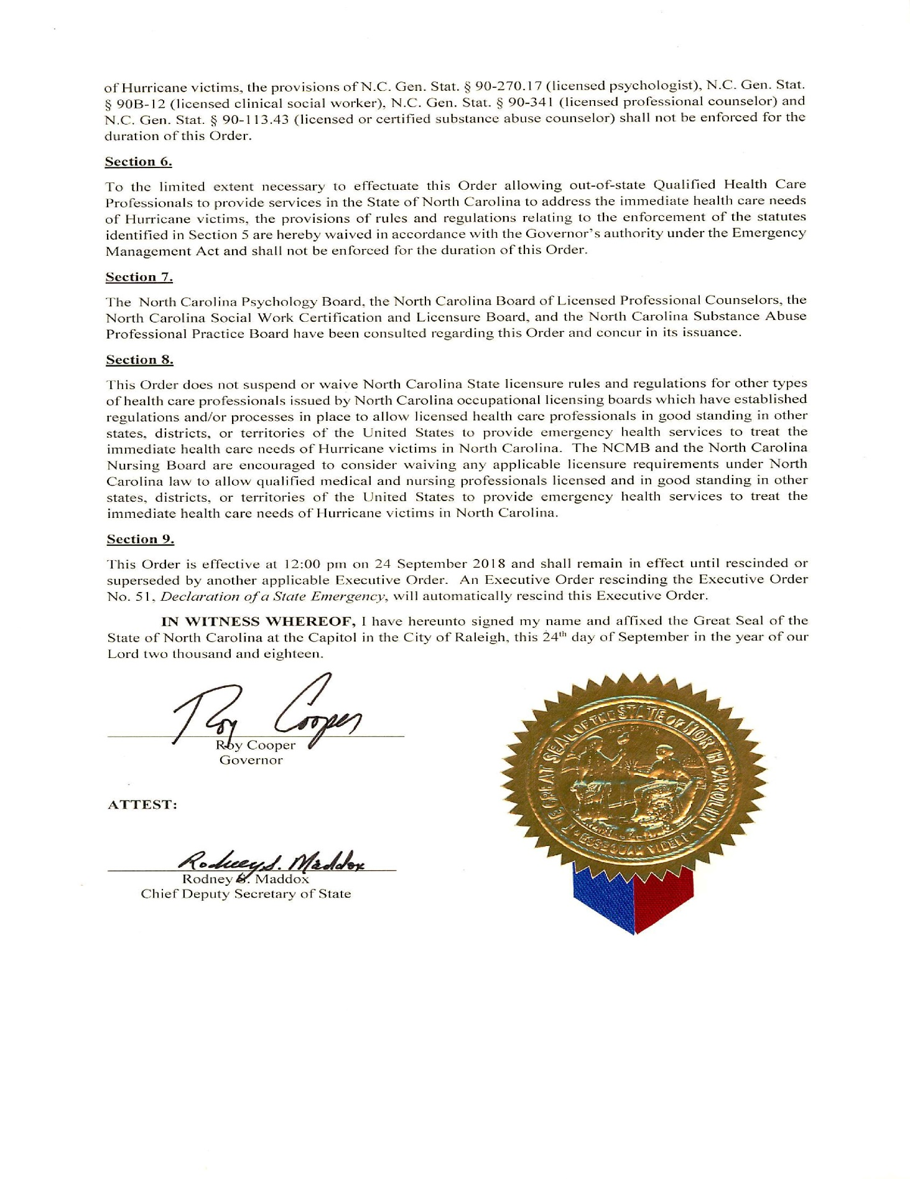

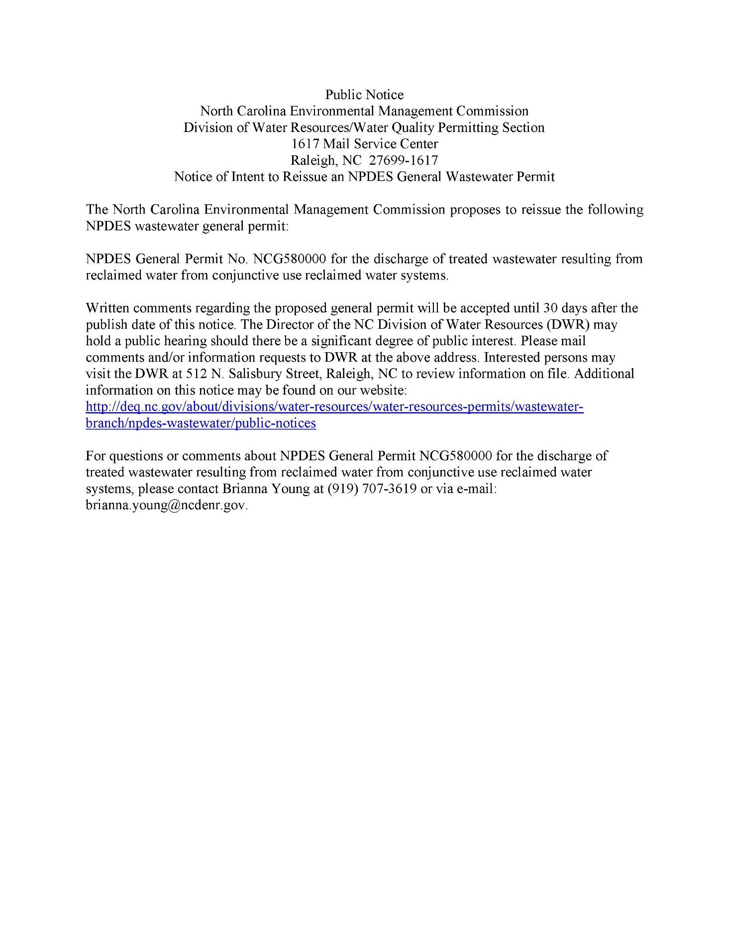

Note from the Codifier: The notices published in this Section of the NC Register include the text of proposed rules. The agency must accept comments on the proposed rule(s) for at least 60 days from the publication date, or until the public hearing, or a later date if specified in the notice by the agency. If the agency adopts a rule that differs substantially from a prior published notice, the agency must publish the text of the proposed different rule and accept comment on the proposed different rule for 60 days.
Statutory reference: G.S. 150B-21.2.

TITLE 10A – DEPARTMENT OF HEALTH AND HUMAN SERVICES

Notice is hereby given in accordance with G.S. 150B-21.2 that the Social Services Commission intends to adopt the rules cited as 10A NCAC 10 .1201- .1205, amend the rule cited as 10A NCAC 10 .0101, repeal the rules cited as 10A NCAC 10 .0202, .0301, .0501, .0901, and readopt with substantive changes the rules cited as 10A NCAC 10 .0102, .0201, .0203, .0306, .0307, .0310-.0312, .0502-.0506, .0601, .0701, .0902-.0910, .1001-.1007, and .1101-.1103.

Pursuant to G.S. 150B-21.17, the Codifier has determined it impractical to publish the text of rules proposed for repeal unless the agency requests otherwise. The text of the rule(s) are available on the OAH website at http://reports.oah.state.nc.us/ncac.asp.

Link to agency website pursuant to G.S. 150B-19.1(c): https://ncchilddcare.ncdhhs.gov/Whats-New

Proposed Effective Date: March 1, 2019

Public Hearing:

Date: December 12, 2018

Time: 10:00 a.m.

Location: Division of Social Services, McBride Building, 820 South Boylan Avenue, Conference Room 151, Raleigh, NC 27603

Reason for Proposed Action: The North Carolina Social Services Commission and the Division of Child Development and Early Education propose to readopt rules in 10A NCAC 10 in accordance with G.S. 150B-21.3A as part of the periodic review of rules process. The proposed rules direct the purchase of child care services with state and federal child care funds administered by the Division through the Subsidized Child Care Assistance Program. The Commission and the Division also propose to repeal Rules 10A NCAC 10 .0201, .0202, .0301, .0306, .0311, .0312, .0501, .0502, .0503, .0504, .0505, .0506, .0701, .0901, .0902, .0903, .0908, .1003, and .1005. In addition to repealing many rules, there are also rules that were rearranged to provide greater clarity and understanding to them such as: Rules .0101, .0203, .0601, .0904, .0906, .0907, .0909, .0910, .1001, .1002, .1004, .1006, .1007, .1101, .1103, .1202, and .1204. Rule .0102 adds definitions that are used with the subsidized child care program. Proposed changes to Rule .0310 changes the name of the program and also clarifies language within the rule. Rule .1201 defines terms that are used in the appeals section. In Rule .0307 proposed language changes how attendance is entered in order to reimburse providers for services provided. Rule .0905 clarifies language in the rule and changes post-secondary education maximum from 2 years to 20 months. Rule .1102 clarifies language in the rule and changes language about the collection of recipient fees. Proposed language in Rule .1203 changes the name of the rule, clarifies language in the rule and separates the appeals process for operators and recipients.

Comments may be submitted to: Dedra Alston, 2201 Mail Service Center, Raleigh, NC 27699-2201, phone (919) 527-6502, fax (919) 715-0970, email Dedra.Alston@dhhs.nc.gov

Comment period ends: December 14, 2018

Procedure for Subjecting a Proposed Rule to Legislative Review: If an objection is not resolved prior to the adoption of the rule, a person may also submit written objections to the Rules Review Commission after the adoption of the Rule. If the Rules Review Commission receives written and signed objections after the adoption of the Rule in accordance with G.S. 150B-21.3(b2) from 10 or more persons clearly requesting review by the legislature and the Rules Review Commission approves the rule, the rule will become effective as provided in G.S. 150B-21.3(b1). The Commission will receive written objections until 5:00 p.m. on the day following the day the Commission approves the rule. The Commission will receive those objections by mail, delivery service, hand delivery, or facsimile transmission. If you have any further questions concerning the submission of objections to the Commission, please call a Commission staff attorney at 919-431-3000.

Fiscal impact (check all that apply).

State funds affected 10A NCAC 10 .0307 and .1102

Environmental permitting of DOT affected

Analysis submitted to Board of Transportation

Local funds affected 10A NCAC 10 .0307, .1102 and .1203

Substantial economic impact (≥$1,000,000) 10A NCAC 10 .0905

Approved by OSBM

No fiscal note required by G.S. 150B-21.4

No fiscal note required by G.S. 150B-21.3A(d)(2)

Chapter 10 - Subsidized Child Care

SECTION .0100 - IDENTIFYING AND GENERAL INFORMATION

10A NCAC 10 .0101 SCOPE

The rules in this Chapter govern the purchase of child care services with state and federal child care funds administered by the Division. The rules in this Chapter shall apply to child care facilities participating in the Subsidized Child Care Assistance Program.
Authority G.S. 143B-10; 143B-153; S.L. 1985, c. 757, s. 155(q).

10A NCAC 10 .0102 DEFINITIONS

In addition to the terms defined in G.S. 110-86, 110-86(2), (3), (4a), (6), (7), and (8) the following definitions apply to the term used in this Chapter. shall apply:
(1) "Child with special needs" means:
(a) a child who is determined by the Division of Public Health, Children's Developmental Services Agency, to be developmentally delayed or have an established condition pursuant to 10A NCAC 43G .0110, incorporated by reference including subsequent amendments. A copy of the Rule can be found at http://reports.oah.state.nc.us/ncac/title%2010a%20%20health%20and%20human%20services/chapter%2043%20%20personal%20health/subchapter%20g/10a%20ncac%2043g%20.0110.pdf;
(b) a child who is determined by the local educational agency (LEA) to have a disability as defined in G.S. 115C-106.3; or
(c) a child who is determined to be a child with special needs by a Local Managing Entity - Managed Care Organization (LME-MCO) as defined in G.S. 122C-3(20b) and (20c).
(1)(2) "Director" means the Director of the Division of Child Development and Early Education.
(2)(3) "Division" means the Division of Child Development and Early Education, Department of Health and Human Services, located at 820 South Boylan Avenue, Raleigh, North Carolina 27603.
(3)(4) "Foster Parent" parent" means anyone other than that a child's parent parent(s) or legal custodian custodian(s) who is providing full time care for a child who is in the custody of a North Carolina county department of social services.
(5) "Funds" means all state and federal funds appropriated and otherwise made available to the Department of Health and Human Services that are administered by the Division of Child Development and Early Education for the Subsidized Child Care Assistance Program.
(4)(6) "Homeless Children" children" means the definition as defined in section 725(2) of the McKinney-Vento Homeless Assistance Act, 42 U.S.C. 11434a(2), which is hereby incorporated by reference and includes including subsequent amendments and editions. A copy of the Act can be found at https://www.gpo.gov/fdsys/pkg/FR-2016-03-17/pdf/2016-06073.pdf.
(7) "Legal Guardian" means a person appointed by a court to be legally in charge of the affairs of a minor.
(5)(8) "Local Purchasing Agency" means the local agency responsible for administering the state's subsidized child care program. Subsidized Child Care Assistance Program.
(9) "Market Rates" means rates that more than half of private paying parents in the locality are paying for child care.
(10) "NC FAST" means the electronic integrated case management system, developed and managed by the North Carolina Department of Health and Human Services.
(6)(11) "Owner" means any person with a five percent or greater equity interest in a child care facility. center or family child care home as defined in G.S. 110-86(3)b.
(7)(12) "Private Agency" means a private, for profit, profit or non-profit, non-profit non-governmental entity.
(8)(13) "Provider" means the owner of a child care center or family child care home.
(9)(14) "Recipient" means the parent or responsible adult approved for subsidized child care services assistance pursuant to Section .1000 of this Chapter.
(15) "Recipient Fee" means that portion of an operator's payment that is paid to the operator by a recipient approved for subsidy assistance.
(10)(16) "Subsidized Child Care Assistance Program" means the North Carolina program to assist eligible families in paying the cost of child care services. the administrative, programmatic, and fiscal activities related to the use of public funds to pay for child care services for families.
(17) "Supplemental Payment" means payment or reimbursement by the Division for additional expenses incurred by the operator to care for a child with special needs.

Authority G.S. 143B-153(2a).

SECTION .0200 - REQUIREMENTS FOR THE PURCHASE OF CHILD CARE

10A NCAC 10 .0201 APPLICABILITY

Authority G.S. 143B-153(2a).

10A NCAC 10 .0202 PAYMENT RATES

Authority G.S. 143B-153(8)a.

10A NCAC 10 .0203 PayMENT RATES FOR SUBSIDIZED CHILD CARE

(a) With the exception of Centers that are certified as developmental day centers by the Division, the The payment rates for child care facilities centers, and family child care homes, and nonlicensed child care homes are shall be implemented in accordance with the annual appropriations act. act and shall be limited to the market rate or the child care facility's private rate, whichever is lower.

(b) Centers, as defined in G.S. 110-86(3), which For centers that are certified as developmental day centers by the Division of Child Development and Early Education and serve children who meet the definition of special needs set forth in 10A NCAC 10 .0910, are exempt from the provisions of Paragraph (a) of this Rule. The payment the following shall apply:

(1) payment rates for special needs children with special needs served in developmental day centers are shall be calculated by deducting the total revenues per child per month from the total costs per child. child month. That rate is shall then be multiplied by the current inflation percentage provided by the Office of State Budget and Management. Management;

(2) payment rates for For typically developing children enrolled served in developmental day centers the rates shall exclude those costs associated exclusively with serving children with special needs. needs; and

(3) The payment payment rates for special needs children with special needs and typically developing children served in developmental day centers are shall be calculated every two years and are shall be implemented as state and federal funding allows.

(c) Any A facility approved for participation in the Subsidized Child Care Assistance Program Local Purchasing Agency (LPA) approved child care provider not included in Paragraph (b) of this Rule who that provides care to children who meet the definition of special needs set forth with special needs, as defined in 10A NCAC 10 .0910 .0910, that is not a certified developmental day facility may be paid a supplemental rate above the provider's LPA supplement to the facility's approved rate, rate for a particular age group. subject to available funding, as follows:

(1) the facility shall submit a request to the Local Purchasing Agency for approval for a supplemental payment;

(2) The the supplemental rate payment shall be based on actual additional documented costs incurred by the provider facility in serving the child with special needs. needs such as learning materials, equipment, and additional staff for one-on-one care;

(3) The the costs shall be determined by the early intervention specialist, the local education agency's exceptional children program specialist, the local purchasing agency, Local Purchasing Agency and the provider facility based on the plan developed to meet the child's individual needs. needs; and

(4) the Local Purchasing Agency shall submit requests for all one-time supplemental payments in excess of one thousand dollars ($1,000) and all recurring supplemental payments in excess of three hundred dollars ($300.00) to the Division. The Division shall approve all requests that the Division determines meet the child's development needs. All other supplemental payments must be approved by the Local Purchasing Agency.

(d) The reimbursement of additional fees as charged by centers is limited to registration fees. The payment rate for registration fees is determined by the annual appropriations act. Registration fees may not be paid more than twice per year per child regardless of the type of center.

(e) Purchasing agencies may negotiate with child care center providers for purchase of child care services at payment rates lower than those prescribed by this Rule, only with approval from the Division. Approval shall be granted if it can be determined that a non-negotiated payment rate would have a negative impact on the purchasing agency's ability to purchase subsidized child care services, based on the following factors:

(1) the number of children on the waiting list for subsidized child care services;

(2) whether the non-negotiated rates exceed the rates for services paid by private paying families in the service area; and

(3) the amount of subsidized child care funds available.

(d) Payment rates for part time care shall be prorated according to the number of hours the child is scheduled to attend.

(e) Recipient fees imposed in accordance with the annual appropriations act shall be subtracted from the facility's payment rate to determine the state payment amount for an individual child.

(f) Child care services Subsidized Child Care Assistance funds shall not be used to pay for services provided by the Department of Health and Human Services, Division of Public Health or the Department of Public Instruction, Division of Exceptional Children's Services Services, for that portion of the service delivery costs which that are reimbursed by the Division of Public Health or Department of Public Instruction.

Authority G.S. 143B-153(8)a; 143B-153(2a).

SECTION .0300 - REQUIREMENTS FOR SUBSIDIZED CHILD CARE aSSISTANCE PROGRAM REQUIREMENTS SERVICE FUNDS

10A NCAC 10 .0301 DEFINITION OF FUND

Authority G.S. 143B-153(2a); S.L. 1985, c. 479, s. 95-97.

10A NCAC 10 .0306 ALLOCATION

Authority G.S. 143B-153(2a).

10A NCAC 10 .0307 REIMBURSEMENT PAYMENT

Local purchasing agencies shall key information regarding expenditures for subsidized child care services into the Division's Subsidized Child Care Reimbursement System on a monthly basis in order for the services to be reimbursed. Operators shall enter accurate attendance, as defined in 10A NCAC 10 .0602(b), into the NC FAST Provider Portal no later than the fifth day of the month for the preceding month's attendance in order to receive payment for services provided.

Authority G.S. 143B-153(2a).

10A ncac 10 .0310 REQUIREMENTS FOR THE ADMINISTRATION OF THE SUBSIDIZED CHILD CARE ASSISTANCE PROGRAM

(a) Any agency that administers child care services funding through the state's subsidized child care program shall maintain records of administration of the program for a period of three years, following the final report issued to the funding agency, or until all audits begun within the retention period are complete, whichever is longer.

Each Local Purchasing Agency shall maintain records of program administration including recipient records documenting eligibility and ongoing service, and provider records related to investigations of fraudulent misrepresentation, sanctions, and noncompliance with program requirements. These records shall be retained in accordance with most recent Records Retention and Disposition Schedule Spreadsheet issued by the Office of the Controller, North Carolina Department of Health and Human Services or until all audits begun within the retention period are complete, whichever is longer. The Records Retention and Disposition Schedule Spreadsheet is incorporated by reference, including subsequent amendments and editions, and is available free of charge at https://www2.ncdhhs.gov/control/retention/retention.htm.

(b) Any Each Local Purchasing Agency agency that administers funding for the State's state's subsidized child care program Subsidized Child Care Assistance Program shall provide records of administration of the program administration upon request for review by local, state, or federal agency representatives.

(c) The Division shall require the Local Purchasing Agency to repay funds not spent in accordance with applicable state or federal regulations. Upon review of agency records of administration of the subsidized child care program the Division determines if it is found child care services funding was not spent in accordance with applicable state or federal regulations, the Division shall require the agency to pay back funds improperly spent.

(d) Any agency Each Local Purchasing Agency that both administers the State's state's subsidized child care program Subsidized Child Care Assistance Program and also owns and operates a child care facility receiving Subsidized Child Care Assistance Program funds and is a provider of subsidized child care services shall develop and implement a conflict of interest policy that shall include provision provisions for:

(1) parental choice of child care facility for recipients of subsidized child care; and

(2) separate management of the Subsidized Child Care Assistance Program and the child care facility owned or operated by the agency.

(e) Operators enrolled in the Subsidized Child Care Assistance Program shall maintain all records and forms for a period of at least three years or until all audits continued beyond the three-year period are completed by local, state, or federal officials. Program records and forms shall be maintained at the location of the child care facility and shall be made available for review upon request by local, state, or federal officials. Operators shall make available for review a record of payments received from other sources and each schedule of parent payments due if requested. For the purposes of this Paragraph, program records and forms include:

(1) all enrollment and attendance records, including those contained in 10A NCAC 10 .0602;

(2) private paying parent rates;

(3) receipts; and

(4) other fiscal records related to the operator's participation in the Subsidized Child Care Assistance Program, including records related to a child care facility's operating budget.

Authority G.S. 143B-153(2a).

10A NCAC 10 .0311 PROVIDER APPEAL TO LOCAL PURCHASING AGENCY
10A NCAC 10 .0312 APPEAL TO DIVISION OF CHILD DEVELOPMENT AND EARLY EDUCATION SUBSIDY SERVICES REVIEW PANEL

Authority G.S. 143B-153.

SECTION .0500 - REQUIREMENTS FOR CONTRACTS WITH PRIVATE AGENCIES

10A NCAC 10 .0501 SCOPE

Authority G.S. 143B-153(2a).

10A NCAC 10 .0502 APPROVAL
10A NCAC 10 .0503 LENGTH OF CONTRACT
10A NCAC 10 .0504 ADMINISTRATION OF FUNDS
10A NCAC 10 .0505 ADMINISTRATION OF PROGRAM
10A NCAC 10 .0506 RECORDS

Authority G.S. 143B-153(2); 143B-153(2a).

SECTION .0600 - REQUIREMENTS FOR Licensed CHILD CARE CENTERS Facilities

10A NCAC 10 .0601 STANDARDS FOR CENTERS Facilities PARTICIPATING IN THE subsidized child CARE assistance PROGRAM

(a) Any center which An operator that wishes to participate in the state Subsidized Child Care Assistance Program as defined in 10A NCAC 10 .0102 shall satisfy all applicable state child care requirements requirements, as codified in G.S. 110-85, et seq. and 10A NCAC 09, and must be approved by the local purchasing agency for participation and payment. shall enroll in the Subsidized Child Care Assistance Program as set forth in 10A NCAC 10 .0602(a).

(b) Any center not required by G.S. 110 to be licensed, except for religious-sponsored centers operating in accordance with G.S. 110-106, shall be licensed in order to participate in the state's Subsidized Child Care Program. An operator that wishes to participate in the Subsidized Child Care Assistance Program, with the exception of religious-sponsored facilities operating in accordance with G.S. 110-106 and Department of Defense facilities operating in accordance with G.S. 110-106.2, shall hold a North Carolina child care license.

(c) Out of state operators wishing to participate in the Subsidized Child Care Assistance Program shall hold a license to operate a child care facility in the state where they are located.

(c)(d) The operator of any center a facility participating in the Subsidized Child Care Assistance Program shall assure ensure that the center facility complies with all applicable provisions of the Civil Rights Act of 1964. 1964 and all requirements imposed thereunder.

(d) Each child care center shall submit appropriate information to enable the local purchasing agency to establish a payment rate for the center in accordance with the rate setting policies in the annual appropriations act and codified in Section .0200.

Authority G.S. 143B-153(2a).

SECTION .0700 - REQUIREMENTS FOR FAMILY CHILD CARE HOMES

10A ncac 10 .0701 STANDARDS FOR FAMILY CHILD CARE HOMES PARTICIPATING IN THE SUBSIDIZED CHILD CARE PROGRAM

Authority G.S. 143B-153.

SECTION .0900 - GENERAL POLICIES FOR PROVISION OF SUBSIDIZED CHILD CARE SERVICES

10A NCAC 10 .0901 SCOPE

Authority G.S. 143B-153.

10A NCAC 10 .0902 METHODS OF SERVICE PROVISION
10A NCAC 10 .0903 DEFINITION OF SERVICE

Authority G.S. 143B-153.

10A NCAC 10 .0904 OPTIONAL PROVISION OF SERVICES AVAILABILITY of funding

(a) Notwithstanding other rules in this Chapter, child day care services may be provided to children in counties receiving Smart Start funds authorized by G.S. 143B, Part 10B of Article 3, provided that the child care services are included in the local partnership's approved Smart Start plan.

(b) When If the availability of funding is less than the amount needed to serve all eligible children, the local agency responsible for determining child eligibility for subsidized child care services may each Local Purchasing Agency shall establish the priority for serving families. The order of priority shall be stated in writing writing, approved by the Division in accordance with annual appropriations act and federal law, and made available the Local Purchasing Agency shall provide a copy of the written order of priority to applicants for child care assistance.

Authority G.S. 143B-153; 45 C.F.R. 98.46.
10A NCAC 10 .0905 SUPPORT TO EMPLOYMENT: for employment AND TRAINING FOR EMPLOYMENT

(a) Child care services shall be provided to support employment of the recipient.

(b) Child care services shall be provided to support training leading to employment of the recipient.

(a) The Subsidized Child Care Assistance Program shall pay for child care services provided to support:

(1) employment of the recipient; and

(2) training leading to employment of the recipient.

(c)(b) Where a recipient remains in the home and is capable of providing care for the child, child care services shall not be provided as a support for employment or training. Where the local purchasing agency determines the recipient is incapable of providing care for the child, and child care services shall be provided for the needs of the child and to maintain family stability. The Subsidized Child Care Assistance Program shall pay for child care services for recipients the Local Purchasing Agency determines are unable to work or to participate in training leading to employment, and who are also incapable of providing care for the child. The Local Purchasing Agency shall document the The reasons for this determination shall be documented in the client's record and recipient's record, which may include the following:

(1) illness;

(2) disability;

(3) complications related to pregnancy;

(4) hospitalization;

(5) substance abuse treatment; or

(6) that the recipient is elderly. elderly and incapable of caring for the child.

(d) Child care services may be provided when recipient is engaged in gainful employment on either a full-time or part-time basis.

(e)(c) Where the If a recipient is already receiving child care services funded through the Subsidized Child Care Assistance Program and is temporarily absent from employment, training, or an educational program with arrangements to continue the same employment, training, or educational program, child care services shall continue for at least up to 90 days. Where If an absence from work, training, or an educational program extends beyond 90 days, the local purchasing agency Local Purchasing Agency shall determine on the basis of individual circumstances whether child care services shall continue beyond that time period. Where child care is continued beyond 90 days, The Local Purchasing Agency shall document the reasons for such extension shall be documented in the client's record and recipient's record, which may include the following:

(1) the recipient is on maternity leave and intends to return to work;

(2) the recipient has been temporarily laid off and the employer has indicated that employment will resume within a month; or

(3) the recipient works in a high demand high-demand field and is likely to find new employment within a month.

(f)(d) Where If a recipient is already receiving child care services funded through the Subsidized Child Care Assistance Program and becomes unemployed but is seeking employment, funding for child care services shall be provided for at least 90 days. days if the recipient is already receiving subsidized child care services. Continuation of the Funding for services service may be extended if the agency Local Purchasing Agency determines such extension is warranted, provided the reason for the extension is documented in the client's recipient's record and may include be based upon the following:

(1) the likelihood of obtaining employment based upon prior job search activities;

(2) the recipient has a job interview scheduled in the near future; scheduled; or

(3) the recipient is waiting to hear the results of a recent job interview.

(g)(e) Where When a recipient is already receiving child care services funded through the Subsidized Child Care Assistance Program and no longer attends a training or educational program, child care services shall continue to be provided for at least 90 days after the recipient stops attending the training or educational program. program to permit the recipient to seek employment or resume attendance at a training or educational program if the recipient is already receiving subsidized child care services. Continuation of the service funding for services may be extended if the agency Local Purchasing Agency determines such extension as warranted, provided the reason for the extension is documented in the client's recipient's record and may include the following: be based on:

(1) recommendations from teaching staff at educational institutions;

(2) the individual needs and abilities of the recipient;

(3) whether the recipient has developed career goals; or

(4) whether the recipient has developed a personal plan for completing training.

(h)(f) For purposes of this Rule, training leading to employment shall include: include the following:

(1) continuation of high school; school within the school system;

(2) basic education or a high school education or its equivalent in community colleges or technical institutes; and

(3) post secondary post-secondary education or skills training, up to a maximum of 20 months two years enrollment. enrollment, but shall not include assistance when the recipient is participating in graduate or post-graduate studies.

Authority G.S. 143B-153; 45 C.F.R. 98.21.

10A NCAC 10 .0906 SUPPORT FOR CHild PROTECTIVE AND CHILD WELFARE SERVICES

(a) Child care services shall be provided The Subsidized Child Care Assistance Program shall provide assistance when needed to enable a child to remain in his or her own home when while receiving child protective services. services for children. The child shall not receive assistance unless he or she is must be receiving protective services through the local department of social services pursuant to G.S. 7B.

(b) Child care services shall be provided The Subsidized Child Care Assistance Program shall provide assistance to children who need child care as a support to receiving Child Welfare Services. Child Welfare Services means the protection of a child from abuse, neglect, or dependency; or support to the dependency or; provision of a safe permanent home for a child as described in G.S. 7B-101; G.S. 7B-300; G.S. 48-1-101; G.S. 108A-14 (11) and (12); G.S. 108A-48; 10A NCAC 70A; and 10A NCAC 70B.

(c) The provisions of this Rule shall not apply to children living in a foster care arrangement.

Authority G.S. 143B-153.

10A NCAC 10 .0907 PROMOTE CHILD'S DEVELOPMENT SUPPORT FOR CHILDREN WITH OR AT RISK FOR DEVELOPMENTAL DELAYS

(a) Child care services shall be provided The Subsidized Child Care Assistance Program shall provide assistance to a child who does not meet any eligibility criteria in this Section and whose emotional, cognitive, social social, or physical development is delayed or is at risk of being delayed. in accordance with this Rule.

(b) This service may be provided by any approved center or home which meets the child's need for developmental care. The Local Purchasing Agency shall document the type of developmental delay or the risk of delay in writing in the recipient's record. Information regarding the delay or risk of delay shall be provided by the parent, child care director, teacher, social worker, doctor, or other medical professional; however, medical or psychological reports shall not be required for a determination of eligibility.

(c) In making a determination of eligibility, the Local Purchasing Agency shall consider factors that include whether the child:

(1) has a severe disability or special needs;

(2) lives in a situation which inhibits his or her ability to develop normally, including living with elderly or adults with disabilities; and

(3) would benefit from early intervention in a child care setting which may prevent the child from experiencing serious, ongoing problems later in life.

Authority G.S. 143B-153.

10A NCAC 10 .0908 LIMITATIONS

Authority G.S. 143B-153.

10A NCAC 10 .0909 PARENTAL FREEDOM OF RECIPIENT CHOICE

(a) Parents receiving assistance for their children through the subsidized child care program Recipients shall choose any a child care provider, facility approved for participation in the subsidized child care program under Sections .0600, .0700, or .0800 Subsidized Child Care Assistance Program under Section .0600 of these Rules to provide child care services for their the recipient's eligible children. The parent's choice of provider shall be accepted when The Local Purchasing Agency shall accept the recipient's choice of facility if there is space available in the facility and the child's enrollment will not violate the provider's facility's licensed capacity. capacity as set forth in G.S. 110-91(6).

(b) During the eligibility determination, Local Purchasing Agencies Purchasing agencies administering funds through the subsidized child care program shall notify recipients parents applying for participation in the program of their right to choose the any approved child care facility. provider which will provide child care services to their eligible children.

Authority G.S. 143B-153; 45 C.F.R. 98.30; 45 C.F.R. 98.31.

10A NCAC 10 .0910 DEFINITION OF SPECIAL NEEDS CHILD CHildren with special needs

(a) As used in this Chapter a special needs child is one who qualifies under one or more of the criteria listed in this Paragraph:

(1) a child who is determined by the Division of Public Health, Children's Developmental Service Agency, to be developmentally delayed or have an established condition pursuant to 10A NCAC 43G .0110; including subsequent amendments; or

(2) a child who is determined by the local educational agency (LEA) to have a disability as defined in G.S. 115C-106.3.

A copy of 10A NCAC 43G .0110 may be obtained from the Office of Administrative Hearings, 6714 Mail Service Center, Raleigh, North Carolina, 27699-6714, (919) 431-3000.

(b) The Local Purchasing Agency agency determining eligibility for the services shall have on file an Individualized Education Program (IEP) as defined in G.S. 115C-106.3, an Individualized Family Service Plan (IFSP) as defined in 10A NCAC 27G .0903, a Section 504 Plan as defined in 29 USC 794 794, or a Person-Centered Plan (PCP) as defined in 10A NCAC 70G .0402 to document the "special need" or "disability". for all children with special needs who have been determined eligible for the Subsidized Child Care Assistance Program that documents the special need or disability in accordance with these Rules.

(c) Eligibility for the supplemental rate is contingent upon the provider's compliance with the activities designated for the provider in the child's individualized plan.

Authority G.S. 143B-153(2a).

SECTION .1000 - ELIGIBILITY FOR SERVICES

10A NCAC 10 .1001 BASIC ELIGIBILITY CRITERIA

In addition to the requirements of 10A NCAC .0900, in order for an individual to be determined eligible to receive subsidized child care services, it must be established that he or she is eligible on the basis of income eligible status unless the service is available without regard to income as referenced in Rule .1004 of this Section.

An individual shall be eligible to receive subsidized child care services in accordance with Section .0900 of these Rules if:
(1) he or she meets the requirements in 10A NCAC 10 .1002 and .1003; or
(2) the service is available without regard to income pursuant to 10A NCAC 09 .1004.

Authority G.S. 143B-153.

10A NCAC 10 .1002 INCOME ELIGIBLE STATUS

(a) For the purpose of the rules in this Subchapter, Chapter, the term "income unit" shall apply to persons who reside in the same household and who who, according to North Carolina law, are responsible for the financial support of the individual whose eligibility for child care services is being determined. Also for For the purpose of determining eligibility for child care services, the terms "income unit" and "family" are used interchangeably shall have the same meaning in the rules in this Subchapter. Chapter.

(b) For the purposes of the rules in this Chapter, "income unit size" or "family size" mean the number of individuals in the income unit, and "gross income of the income unit" or "family income" mean the total amount of the income used to determine child care eligibility. When the amount of income available to an individual is a condition of eligibility for child care services, it is necessary to determine the number of persons in the individual's income unit and the amount of the gross income available to the income unit. The number of individuals in the income unit is referred to as the "income unit size" or "family size". These terms are used interchangeably in the rules in this Subchapter. The total amount of the income used to determine child care eligibility is referred to as the "gross income of the income unit" or "family income". These terms are used interchangeably in the rules in this Subchapter.

(c) If an individual meets any of the criteria set forth in 10A NCAC 10 .0905 or .0907, the Local Purchasing Agency shall determine:

(1) the number of persons in the individual's income unit through the eligibility application in NC FAST or through the eligibility interview process; and

(2) the amount of gross income available to the income unit in accordance with 10A NCAC 10 .1006.

(c)(d) Child care services may be provided to individuals other than those described in 10A NCAC 10 .0906 and in Rule .1004 of this Section provided the gross annual income of the individual's income unit does not exceed the state's maximum income eligibility limit (as defined in Rule .1003 of this Section) for the number of persons in that income unit. Individuals who meet any of the criteria set forth in 10A NCAC 10 .0905 or .0907 shall be eligible to receive Subsidized Child Care Services, provided that:

(1) for initial eligibility and annual redeterminations, the gross income of the income unit:
(A) for children ages 0 to 5 years old shall not exceed the state's maximum income eligibility limit of 200 percent of the federal poverty level as set forth in 82 FR 8831, incorporated by reference, including subsequent amendments and editions, for the number of persons in that income unit;
(B) for children ages 6 to 12 years old shall not exceed the state's maximum income eligibility limit of 133 percent of the federal poverty level as set forth in 82 FR 8831 for the number of persons in that income unit; or
(C) for any child with special needs as defined 10A NCAC 10 .0910 shall not exceed the state's maximum income eligibility limit of 200 percent of the federal poverty level as set forth in 82 FR 8831 for the number of persons in that income unit.

(2) for individuals whose income increases during the annual eligibility period, the maximum income eligibility limit for children of all ages and special needs status shall not exceed 85 percent of the state median income as set forth in 82 FR 8831 for that income unit size.

(d)(e) The following are defined as individuals living in a residence shall be separate income units for the purposes of determining eligibility and client fees for child care services:

(1) Biological biological and adoptive parents and their minor children. A step-parent shall be included in the income unit with his/her his or her spouse when if the children in need of care include the step-parent and spouse's their biological or adoptive child children and step-siblings;

(2) A a minor parent and his or her children;

(3) Each each person 18 years of age or older; adult whether related or unrelated, other than spouses; and

(4) Each each child living with anyone other than their biological or adoptive parents.

(e)(f) Income to be considered when computing the gross income of the income unit is as follows: shall include:

(1) Gross gross earned wages or salary salary, which are defined as (earnings earnings received for work performed as an employee, including wages, salary, commissions, tips, piece-rate payments, and cash bonuses earned, before any deductions are made such as for taxes, bonds, pensions, and union dues; dues, etc.);

(2) Adjusted gross income from taxable self-employment income; after deductions made for business expenses and any other expense that is deductible for purposes of federal or state tax returns;

(3) Social Security benefits (includes including Social Security pensions, survivors' benefits benefits, and permanent disability insurance payments); payments;

(4) Dividends, dividends, interest (on on savings or bonds), bonds, income from estates or trusts, royalties, and adjusted gross rental income on houses, stores stores, or other property;

(5) Pensions pensions and annuities paid directly by an employer or union or through an insurance company;

(6) Workers' workers' compensation for injuries incurred at work.; work;

(7) Unemployment unemployment insurance benefits;

(8) Alimony alimony (includes including direct and indirect payments, payments such as rent and utility payments); payments;

(9) Child child support, direct or indirect; indirect, such as health care costs, school tuition, camps, lessons, and afterschool activities;

(10) Pensions pensions paid to veterans or survivors of deceased veterans;

(11) On-the-Job Training (OJT) payments;

(12) Job Training Partnership Act (JTPA) payments made to an adult;

(13) AmeriCorps stipend' stipend (living allowance);

(14) the taxable amount of Armed Forces pay; (only the amounts taxable, such as base pay);

(15) Work work release payments;

(16) Cherokee Tribal Per Capita Income paid to adult family members;

(17) Work-study payments, if the income is from a program not administered under Title IV of the Higher Education Act or the Bureau of Indian Affairs; and

(18) Recurring recurring cash contributions paid directly to the parent. parent, such as severance pay or child support not paid pursuant to a written agreement or court-ordered arrangement.

(f)(g) The following sources of income shall not be counted when computing the gross income of the income unit:

(1) Work First Family Assistance;

(2) Supplemental Security Income (SSI);

(3) non-recurring lump Lump sum payments such as (e.g. Social Security benefits, workers' compensation, alimony, veteran's benefits, HUD); and housing assistance paid to or on behalf of a family member by HUD;

(4) Foster care assistance payments;

(5) Adoption Assistance payments;

(6) Payments/trust payments or trust funds under from the Indian Claims Commission;

(7) Payments payments from the Alaska Native Claims Settlement Act;

(8) Income income from sale of personal assets (stocks, including stocks, bonds, house, car, and insurance); insurance;

(9) Bank withdrawals;

(10)(9) Money money borrowed;

(11)(10) Tax refunds; tax refunds, including Earned Income Tax Credits or Dependent Care Credits;

(12)(11) Gifts or contributions; gifts or contributions, including cash, monetary gifts, and charitable contributions given on a regular basis to meet the recipient's needs;

(13)(12) Other in-kind other, non-cash contributions from non-legally responsible adults; adults, such as food, clothing, furniture, or non-cash military benefits such as insurance;

(14)(13) Emergency Assistance, Low Income Energy Assistance Program, Crisis Intervention Program, General Assistance, or CP&L Share Program payments;

(15)(14) Section VIII housing subsidy;

(16)(15) Capital capital gains;

(17)(16) Value the value of food stamp benefits allotted under the Food Stamp Act of 1977;

(18)(17) Free free and reduced lunch program;

(19)(18) Any and all food subsidy programs;

(20)(19) Relocation/Acquisition Relocation or Acquisition Act payments;

(21)(20) Earnings earnings of a dependent child under 18 years of age, unless a minor parent of a child needing child care;

(22)(21) Loans, loans, grants, scholarships, and money received to pay for job training; through training, Pell or Carl Perkins grants;

(23)(22) Home home produce utilized for household consumption;

(24)(23) Volunteers in Service to America (VISTA) earnings;

(25) Payments received as Earned Income Tax Credits or Dependent Care Credits;

(26)(24) All all subsidized housing and housing allotments, including military housing allotments. If rent is provided by an organization on a regular recurring basis, it shall be counted as income;

(27)(25) Money money received from an employer as an employee benefit for child care; and

(28)(26) Work-study payments, if the income is from the College Work-Study Program administered under Title IV of the Higher Education Act or the Bureau of Indian Affairs. (Likewise, if the income from college work-study goes directly to the college, it is not counted as income.)

Authority G.S. 143B-153.

10A NCAC 10 .1003 INCOME ELIGIBILITY LEVELS

Authority G.S. 143B-153.

10A ncac 10 .1004 WITHOUT REGARD TO INCOME

Child care services shall be provided The Subsidized Child Care Assistance Program shall provide assistance without regard to income for:
(1) when child care services are provided in conjunction with protective services as children described in 10A NCAC 10 .0906(a); .0906(b) who need child care services as a support for Child Welfare Services;
(2) children receiving foster care services who are in the custody of the county department of social services and are residing in licensed foster care homes or in the care of adults other than their parents; and
(3) when child care services are provided to a child receiving Child Welfare Services as children described in 10A NCAC 10 .0906(b). .0906(a) who need child care in conjunction with protective services.

Authority G.S. 143B-153(2a).

10A NCAC 10 .1005 RESPONSIBILITY FOR ELIGIBILITY DETERMINATION

Authority G.S. 143B-153.

10A NCAC 10 .1006 VERIFICATION DETERMINATION OF INCOME ELIGIBILITY

(a) An individual that who applies for child care services shall provide to the local purchasing agency Local Purchasing Agency verification of the amount and sources of his or her countable income. income as set forth in 10A NCAC 10 .1002. The amount and source of income shall be verified by one of the following:

(1) A a copy of a source document; document, such as wage stubs, pay statements, and award letters; or

(2) A written statement by the social worker describing either the source document that was reviewed to verify the income or a telephone conversation that confirmed the required information; or

(3)(2) Identification identification of an existing agency record confirming the required information. information; or

(3) electronic verification through Online Verification Service (OVS) within NC FAST as defined in 10A NCAC 10 .0102.

(b) If the Local Purchasing Agency cannot verify the recipient's income using the methods described in Paragraph (a) of this Rule:

(1) the recipient shall provide a written statement of the amount and sources of their income to the Local Purchasing Agency; or

(2) the Local Purchasing Agency shall confirm sources of income through a telephone conversation or email communication with the source of the income.

Authority G.S. 143B-153.

10A ncac 10 .1007 REQUIREMENTS FOR DETERMINATION AND REDETERMINATION OF ELIGIBILITY

(a) The Division shall establish the requirements for application and eligibility determination and redetermination for child care services. Eligibility shall be determined initially in accordance with 10A NCAC 10 .0900 and .1000, and annually thereafter unless a change occurs that impacts eligibility. Recipients who are employed or in school and whose income is at or below the federal income limit of 85 percent of State Median Income shall not have these activities disrupted during the 12 month eligibility period. The Local Purchasing Agency shall determine initial eligibility in accordance with Sections .0900 and .1000 of this Chapter, and every 12 months thereafter.

(b) If the Local Purchasing Agency determines that a recipient is eligible, the recipient shall remain eligible for the 12 month eligibility period unless:

(1) the recipient ceases to be employed, in training leading to employment, or in an educational program as described in 10A NCAC 10 .0905 for more than 90 days;

(2) the recipient changes residency to outside the state;

(3) the recipient's income exceeds 85 percent of the State Median Income; or

(4) the Local Purchasing Agency or the Division issues the recipient a sanction for fraudulent

(b)(c) If the Local Purchasing Agency, upon redetermination, determines that the family exceeds the State's income eligibility limits, the family shall continue to receive subsidized child care services for 90 days 3 months if their income is at or below the federal income limit of 85 percent of State Median Income.

(c)(d) Annual federal income limits are shall be determined in accordance with the U.S. Federal Poverty Guidelines issued by the U.S. Department of Health and Human Services, is incorporated by reference and includes including subsequent amendments and editions. A copy of these guidelines may be found are available free of charge at http://aspe.hhs.gov/poverty/index.cfm.

Authority G.S. 143B-153; 45 C.F.R. 98.21(a)(1); 45 C.F.R. 98.21(b)(1).

SECTION .1100 - CLIENT RECIPIENT FEES FOR CHILD CARE services

10A NCAC 10 .1101 GENERAL recipient FEE POLICY

(a) Recipient fees for child care services shall be 10 percent of the income unit's gross monthly income as set forth in 10A NCAC 10 .1002; however, no No fees shall be charged to the client when recipient if child care services are provided to individuals in the following circumstances:

(1) children receiving if child care services are provided in conjunction with protective services as described in 10A NCAC 10 .0906(a);

(2) when if child care services are provided as a support to a child receiving Child Welfare Services as described in 10A NCAC 10 .0906(b); and

(3) when if a child with no income is living with someone other than his or her biological or adoptive parent or is living with someone who does not have court-ordered financial responsibility.

(b) Except as provided for in Paragraph (a) of this Rule, the client recipient shall be assessed a fee for child care services.

Authority G.S. 143B-153(2a).

10A NCAC 10 .1102 AMOUNT and collection OF RECIPIENT client FEES

(a) The amount of the fees charged to the client recipient shall be in accordance with the annual appropriations act.

(b) Fee charges to the client may be disregarded when the total amount due is less than five dollars ($5.00) per month.

(c)(b) Collection of fees assessed to the client shall be the responsibility of the child care provider. The child care provider shall collect recipient fees on a monthly basis.

Authority G.S. 143B-153.

10A ncac 10 .1103 ADJUSTMENTS IN FEES

(a) If family recipient medical expenses exceed 10 percent of the family's recipient's gross income as set forth in 10A NCAC 10 .1002 in any eligibility period, the family's recipient's fee shall be reassessed based on the family's recipient's adjusted income. The family's recipient's income shall be adjusted by deducting the amount of medical expenses that exceed 10 percent of the family's recipient's gross income.

(b) If the plan of care is for less than a full day, the recipient fee shall be assessed in accordance with the annual appropriations act. When the approved care plan is for less than full-day care, the assessed fee for the service shall be adjusted by the appropriate percentage relative to the approved care plan.

Authority G.S. 143B-153.

section .1200 – APPEALS

10A NCAC 10 .1201 definitions

In addition to the terms defined in G.S. 110-86 and in 10A NCAC 10 .0102, the following definitions shall apply to the terms used in this Section:
(1) "Administrative Review Decision" means the decision made by the State Subsidy Services Appeals Panel that is made after review and analysis of all documentation related to an appeal pursuant to this Section.
(2) "File or Filing" means personal delivery, delivery by certified mail, or delivery by overnight express mailed to the current Division Director or the Subsidy Appeals Coordinator, North Carolina Division of Child Development and Early Education, 2201 Mail Service Center, Raleigh, NC 27699-2200.
(3) "Initial Review" means the review by the Local Purchasing Agency of the operator's appeal.
(4) "Local Appeal Hearing" means a hearing held by a hearing officer assigned by the Local Purchasing Agency after the Initial Review.
(5) "State Subsidy Services Appeals Panel" or "Panel" means the North Carolina Division of Child Development and Early Education internal review panel. The Panel shall be impartial and shall consist of one representative and one alternate representative for each Section of the Division. Representatives and alternates shall be chosen by the Division Director.

Authority G.S. 108A-79; 143B-153.

10A NCAC 10 .1202 notice

Notice shall be given by one of the methods for service of process under G.S. 1A-1, Rule 4(j) or Rule 4(j3). If given by registered or certified mail, by signature confirmation as provided by the United States Postal Service, or by designated delivery service authorized pursuant to 26 U.S.C. 7502(f)(2) with delivery receipt, notice shall be deemed to have been given on the delivery date appearing on the return receipt, copy of the proof of delivery provided by the United States Postal Service, or delivery receipt. If notice cannot be accomplished by a method under G.S. 1A-1, Rule 4(j) or Rule 4(j3), notice shall then be given in the manner provided in G.S. 1A-1, Rule 4(j1).

Authority G.S. 143B-153.

10A NCAC 10 .1203 FILING

For purposes of this Chapter, the following apply:
(1) A document or paper shall be deemed filed as of the date it is delivered to the Division Director or the Subsidy Appeals Coordinator; or
(2) Filings shall be denied under the following circumstances:
(a) the filing is not filed in accordance with this Rule.
(b) the filing fails to comply with the rules of this Section.

Authority G.S. 143B-153.

10A NCAC 10 .1204 APPEAL TO THE LOCAL PURCHASING AGENCY

(a) Appeals by recipients from services determinations pursuant to Section .1000 of this Chapter, changes in recipient fees pursuant to Section .1100 of this Chapter, terminations of payment pursuant to 10A NCAC 10 .1007, or a sanctions issued by the Local Purchasing Agency in accordance with 10A NCAC 10 .0308, shall be made in accordance with G.S. 108A-79.

(b) Procedures for an operator to appeal to the Local Purchasing Agency are as follows:

(1) An operator wishing to contest an action shall contact the Local Purchasing Agency in writing to request an initial review. Requests shall be made within 30 calendar days after the date of the Local Purchasing Agency action.

(2) The Local Purchasing Agency shall make a determination on the initial review within 10 business days of the request for an initial review. Within 30 calendar days of notice of the determination of the initial review by the Local Purchasing Agency, the operator may request a local appeal hearing by the Local Purchasing Agency.

(3) The local appeal hearing shall be held within five business days of when the request for a hearing is received. The Local Purchasing Agency shall grant a delay of up to 10 additional business days at the written request of the operator, but in no event shall the local appeal hearing be held more than 15 business days after the receipt of the request for a hearing.

(4) The Local Purchasing Agency shall serve a written statement of decision within 10 business days following the local hearing. The decision shall include the facts and conclusions that support the determination by the Local Purchasing Agency.

(5) The Local purchasing agency shall include with its written statement of decision instructions for appealing its decision in accordance with this Rule.

(6) If the operator is not satisfied with the final decision of the Local Purchasing Agency, he or she may appeal to the State Subsidy Services Appeals Panel by filing a notice of appeal within 30 calendar days of receipt of the written statement of decision in accordance with this Rule.

Authority G.S. 143B-153; G.S. 108A-79.

10A NCAC 10 .1205 OPERATOR APPEAL TO DIVISION OF CHILD DEVELOPMENT AND EARLY EDUCATION

(a) The following persons may appeal to the Panel within 15 calendar days after having exhausted the appeals process at the appropriate Local Purchasing Agency or within 15 calendar days after the Division takes action as described in Subparagraphs (2) and (3) of this Paragraph:

(1) an operator to whom a Local Purchasing Agency has issued a sanction pursuant to 10A NCAC 10 .0308;

(2) an operator whom a Local Purchasing Agency or the Division has failed to approve for participation in or has terminated participation from the Subsidized Child Care Assistance Program pursuant to Section .0600 of this Chapter; or

(3) an operator contesting the determination of an overpayment pursuant to 10A NCAC 10 .0309.

(b) Upon notification of an appeal filed pursuant to this Section, the Local Purchasing Agency shall, within five business days of the date of notification, forward the appeal record to the Division Director or Subsidy Appeals Coordinator, with a copy to the appellant, consisting of the following:

(1) a copy of its final decision;

(2) the signed agreement between the Local Purchasing Agency and the operator, where applicable; and

(3) all supplementary documentation considered during the local appeals process.

(c) The Panel shall complete its review and notify the appealing party and the Local Purchasing Agency of its decision in writing within 30 business days of the Panel's receipt of the appeal record as follows:

(1) the decision shall include the facts and conclusions that support the determination by the Panel; or

(2) the decision may be delayed up to an additional 15 business days if the Panel lacks sufficient information to render a decision at the initial administrative review. The Panel may request additional information from the Local Purchasing Agency or the operator.

(d) The appealing party may appeal the administrative review decision by filing a petition for a contested case hearing pursuant to G.S. 150B-23 and in accordance with G.S. 110-94. Appeals from the Panel shall be filed within 30 calendar days of notice of the Panel's decision, in accordance with G.S. 150B-23(f).

(e) The administrative review decision may direct a Local Purchasing Agency to take an action or reverse an action based upon its review of the record as set forth in Paragraph (b) of this Rule.

(f) An operator may appeal a final determination pursuant to 10A NCAC 10 .0308(k) by filing a petition for a contested case hearing pursuant to G.S. 150B-23 and in accordance with G.S. 110-94.

Authority G.S. 143B-153.

TITLE 11 – department of insurance

Notice is hereby given in accordance with G.S. 150B-21.2 that the Industrial Commission intends to adopt the rules cited as 11 NCAC 23B .0105; 23L .0105, amend the rules cited as 11 NCAC 23B .0101-.0104, .0202-.0205, .0208, .0302, .0307, .0308, .0310, .0402, .0501, and repeal the rules cited as 11 NCAC 23B .0303 and .0305.

Pursuant to G.S. 150B-21.17, the Codifier has determined it impractical to publish the text of rules proposed for repeal unless the agency requests otherwise. The text of the rule(s) are available on the OAH website at http://reports.oah.state.nc.us/ncac.asp.

Link to agency website pursuant to G.S. 150B-19.1(c): http://www.ic.nc.gov/proposedtortrules.html

Proposed Effective Date: February 1, 2019

Public Hearing:

Date: November 29, 2018

Time: 10:00 a.m.

Location: Room 245, 2nd Floor, Department of Insurance, Albemarle Building, 325 North Salisbury Street, Raleigh, NC 27603

Reason for Proposed Action: On its own initiative, the Industrial Commission conducted an internal review of its rules governing State tort claims. The proposed adoptions, amendments, and repeals represent changes necessary to improve and clarify the rules, provide for increased efficiency, or to update the rules to reflect current processes.

The Commission also proposes to adopt Rule 11 NCAC 23L .0105 which codifies a new form, the T-42, required in the proposed amendments to Rule 11 NCAC 23B .0203.

Comments may be submitted to: Ashley B. Snyder, 1233 Mail Service Center, Raleigh, NC 27699-1233; phone (919) 807-2524; email ashley.snyder@ic.nc.gov

Comment period ends: December 14, 2018

Procedure for Subjecting a Proposed Rule to Legislative Review: If an objection is not resolved prior to the adoption of the rule, a person may also submit written objections to the Rules Review Commission after the adoption of the Rule. If the Rules Review Commission receives written and signed objections after the adoption of the Rule in accordance with G.S. 150B-21.3(b2) from 10 or more persons clearly requesting review by the legislature and the Rules Review Commission approves the rule, the rule will become effective as provided in G.S. 150B-21.3(b1). The Commission will receive written objections until 5:00 p.m. on the day following the day the Commission approves the rule. The Commission will receive those objections by mail, delivery service, hand delivery, or facsimile transmission. If you have any further questions concerning the submission of objections to the Commission, please call a Commission staff attorney at 919-431-3000.

Fiscal impact (check all that apply).

State funds affected 11 NCAC 23B .0104, .0105, .0202, .0204, .0205, .0302, .0310, .0501

Environmental permitting of DOT affected

Analysis submitted to Board of Transportation

Local funds affected 11 NCAC 23B .0104, .0204, .0302, .0310, .0501

Substantial economic impact (≥$1,000,000)

Approved by OSBM

No fiscal note required by G.S. 150B-21.4 11 NCAC 23B .0101-.0103, .0203, .0208, .0303, .0305, .0307, .0308, .0402; 23L .0105

Chapter 23 - Industrial Commission

SUBCHAPTER 23B – TORT CLAIMS RULES

SECTION .0100 – ADMINISTRATION

11 NCAC 23B .0101 LOCATION OF OFFICES Main Office AND HOURS OF BUSINESS

For purposes of this Subchapter, the offices The main office of the North Carolina Industrial Commission (Commission) are is located in the Dobbs Building, 430 North Salisbury Street, Raleigh, North Carolina. Documents that are not being filed electronically may be filed at the main office between the hours of 8:00 a.m. and 5:00 p.m. only. Documents related to tort claims are permitted to be filed electronically may be so filed until 11:59 p.m. on the required filing date.
Authority G.S. 143-291; 143-300.

11 NCAC 23B .0102 OFFICIAL FORMS

(a) Copies of the Commission's rules, forms, and minutes rules and forms regarding tort claims can be obtained by contacting the Commission in person, person at the address in Rule .0101 of this Section, by written request mailed to 4340 1236 Mail Service Center, Raleigh, NC 27699-4340, 27699-1236, Attn.: Office of the Clerk, or from the Commission's website. website at http://www.ic.nc.gov/abtrules.html and http://www.ic.nc.gov/forms.html.

(b) The use of any printed forms other than those provided by the Commission is prohibited, except that insurance carriers, self-insureds, attorneys and other parties may reproduce current Commission forms for their own use, provided:

(1) No no statement, question, or information blank contained on the Commission form is omitted from the substituted form. form; and

(2) The the substituted form is identical in size and format with to the Commission form.

Authority G.S. 143-300.

11 NCAC 23B .0103 FILING FEES

(a) No tort claim shall be accepted for filing with the Commission unless the claim is accompanied by an attorney's check, certified check, money order, or electronic transfer of funds in payment of a filing fee in an amount equal to the filing fee required for the filing of a civil action in the Superior Court division of the General Court of Justice.

(b) The provisions of Paragraph (a) of this Rule notwithstanding, a tort claim that is accompanied by a Petition to Sue as an Indigent shall be accepted for filing upon the date of its receipt.

(c) A Petition to Sue as an Indigent shall consist of an affidavit sufficient to satisfy the provisions of G.S. 1-110, stating that plaintiff is unable to comply with Paragraph (a) of this Rule.

(d) If the Commission determines the plaintiff is able to pay all or any part of the fees fee assessed under this Rule, an Order shall be issued directing payment of all or any part of that fee, and the plaintiff shall, within 30 days from his receipt of the Order, forward to the Commission an attorney's check, certified check, money order, or electronic fund transfer of funds for the full amount required to be paid. Failure to submit the required amount of the filing fee within this time shall result in the tort claim being dismissed without prejudice.

(e) Upon consideration of a prison inmate's Petition to Sue as an Indigent, the Commission may determine that the inmate's tort claim is frivolous and dismiss the claim pursuant to G.S. 1-110. Appeals from the dismissal of a frivolous tort claim pursuant to this statute G.S. 1-110 shall proceed directly to the Full Commission and shall be decided without oral argument. The Commission shall forward a copy of the file to the Attorney General's Office without cost upon plaintiff's notice of appeal to the Full Commission.

Authority G.S. 143-291.2; 143-300.

11 NCAC 23B .0104 FILING BY FACSIMILE TRANSMISSION ELECTRONIC FILINGS WITH THE COMMISSION; HOW TO FILE

Filing documents pertaining to tort claims by facsimile transmission is permitted. Any filing fee required shall be received by the Commission contemporaneously with the facsimile by electronic transfer of funds.

(a) All filings to the Commission in tort claims shall be submitted electronically in accordance with this Rule. Any document transmitted to the Commission in a manner not in accordance with this Rule shall not be accepted for filing. Plaintiffs without legal representation may file all documents with the Office of the Clerk of the Commission via the Commission's Electronic Document Filing Portal ("EDFP"), electronic mail, facsimile, U.S. Mail, private courier service, or hand delivery.

(b) Except as set forth in Paragraph (c) of this Rule, all documents shall be transmitted to the Commission via EDFP. Information regarding how to register for and use EDFP is available at http://www.ic.nc.gov/training.html. In the event EDFP is inoperable, all documents required to be filed via EDFP shall be transmitted to the Commission via electronic mail to edfp@ic.nc.gov. Documents required to be filed via EDFP that are sent to the Commission via electronic mail when EDFP is operable shall not be accepted for filing.

(c) The tort claims forms and documents listed in Table 1 shall not be required to be transmitted via EDFP provided all applicable qualifying conditions are met.

Table 1: Forms and documents exempt from EDFP filing requirements and how to file them:
DOCUMENT | QUALIFYING CONDITION(S) | HOW TO FILE
Form T-1 | No IC file number has been assigned | Hand delivery to the Industrial Commission's main office or by mail to 1236 Mail Service Center, Raleigh, North Carolina 27699-1236.
Form T-3 | No IC file number has been assigned | Email to dockets@ic.nc.gov, hand delivery to the Industrial Commission's main office, or by mail to 1236 Mail Service Center, Raleigh, North Carolina; 27699-1236
Pre-affidavit motion under Rule 9(j)(3) of the Rules of Civil Procedure to extend the Statute of Limitations. | No IC file number has been assigned. | Hand delivery to the Industrial Commission's main office or by mail to 1236 Mail Service Center, Raleigh, North Carolina 27699-1236.

(d) A one-year waiver shall be granted to an attorney that notifies the Commission of the attorney's inability to comply with the electronic filing requirements in Paragraph (a) of this Rule due to a lack of the necessary internet technology resources. The notification shall indicate why the attorney is unable to comply with the rule and outline the attorney's plan for coming into compliance within the one-year period. The notification shall be filed with the Office of the Clerk of the Commission via facsimile or U.S. Mail. This Paragraph shall expire one year from the effective date of this Rule.

(e) Any party may apply to the Commission for an emergency temporary waiver of the electronic filing requirement set forth in Paragraph (a) of this Rule when it is unable to comply because of temporary technical problems or lack of electronic mail or internet access. The request for an emergency temporary waiver shall be included with any filing submitted via facsimile, U.S. Mail, or hand delivery due to such temporary technical or access issues.

(f) A Notice of Appeal to the North Carolina Court of Appeals shall be accepted for filing by the Commission via EDFP or U.S. Mail.

Authority G.S. 143-291; 143-291.2; 143-297; 143-300.

11 NCAC 23B .0105 Contact information

(a) "Contact information" for purposes of this Rule shall include telephone number, facsimile number, email address, and mailing address.

(b) All persons or entities without legal representation with matters pending before the Commission shall advise the Commission upon any change in contact information by filing a written notice via the Commission's Electronic Document Filing Portal ("EDFP"), electronic mail, facsimile, U.S. Mail, private courier service, or hand delivery.

(c) Any plaintiff without legal representation who was an inmate in the North Carolina Division of Adult Corrections at the time of filing his or her tort claim, shall, within 30 days of release, provide the Commission with written notice of his or her post-release contact information in any manner authorized in Paragraph (b) of this Rule. Following the initial written notice of post-release contact information, the previously incarcerated plaintiff shall continue to advise the Commission upon any change in contact information in accordance with Paragraph (b) of this Rule.

(d) All attorneys of record with matters before the Commission shall inform the Commission in writing of any change in the attorney's or the represented party's contact information via email to dockets@ic.nc.gov.

Authority G.S. 143-291, 143-300.

SECTION .0200 - CLAIMS PROCEDURES

11 NCAC 23B .0202 MEDICAL MALPRACTICE CLAIMS BY UNREPRESENTED PRISON INMATES

(a) In any tort claim medical malpractice cases filed by or on behalf of an unrepresented prison inmates inmate where the plaintiff is alleging in which the Commission determines that the plaintiff is alleging that a health care provider provider, as defined in G.S. 90-21.11 90-21.11, failed to comply with the applicable standard of care under G.S. 90-21.12 90-21.12, and or the defendant has filed a Motion to Dismiss moved to dismiss the claim, claim for failure to comply with Rule 9(j) of the North Rules of Civil Procedure, all discovery is stayed until the following occur: a recorded non-evidentiary hearing before the Commission is held for the purpose of determining whether a claim for medical malpractice has been stated and, if so, whether:

(1) A recorded hearing in which no evidence is taken is held before a Deputy Commissioner or a Special Deputy Commissioner for the purpose of determining:
(A) whether a claim for medical malpractice has been stated;
(B)(1) whether expert testimony is necessary for the plaintiff to prevail; and plaintiff must meet the requirements of Rule 9(j)(1) or (2) of the North Carolina Rules of Civil Procedure to proceed with the claim; or
(2) plaintiff has alleged facts establishing negligence under the existing common-law doctrine of res ipsa loquitur.
(C) if expert testimony is deemed necessary, whether the plaintiff will be able to produce such testimony on the applicable standard of care.

(2) Upon receipt of a Motion to Dismiss and Request for Hearing from the defendant, the Commission issues an order setting the motion on a hearing docket and the case is assigned to a Deputy Commissioner or a Special Deputy Commissioner.

If the Commission determines that a claim for medical malpractice has been stated, and plaintiff must meet the requirements of Rule 9(j)(1) or (2) of the North Carolina Rules of Civil Procedure, the defendant shall produce medical records to the plaintiff within the time period prescribed by the Commission. Upon receipt of the medical records, the plaintiff shall then have 120 days to comply with Rule 9(j) of the North Carolina Rules of Civil Procedure.

(b) If the defendant's Motion to Dismiss is granted, an appeal lies to the Full Commission.

(c) If defendant's Motion to Dismiss is denied, the case shall proceed as any other tort claims case. Defendant shall produce medical records to plaintiff within 45 days of the Order of the Commission denying defendant's Motion to Dismiss. Plaintiff shall then have 120 days to comply with Rule 9(j) of the North Carolina Rules of Civil Procedure.

Authority G.S. 143-300.

11 NCAC 23B .0203 INFANTS AND INCOMPETENTS

(a) Persons seeking to appear on behalf of an infant or incompetent, in accordance with G.S. 1A-1, Rule 17, shall apply on a Form 42 Form T-42 Application for Appointment of Guardian Ad Litem. ad Litem. The Commission shall appoint a fit and proper person as guardian ad litem, if the Commission determines it to be in the best interest of the minor or incompetent. The Commission shall appoint the guardian ad litem only after due inquiry as to the fitness of the person to be appointed.

(b) The Commission may assess a fee to be paid to an attorney who serves as a guardian ad litem for actual services rendered upon receipt of an affidavit of actual time spent in representation of the minor or incompetent as part of the costs.

Authority G.S. 143-291; 143-295; 143-300.

11 NCAC 23B .0204 MOTIONS

(a) All motions regarding tort claims shall be filed pursuant to Rule .0104 of this Subchapter. with the Docket Section, unless the case is currently calendared before a Commissioner or Deputy Commissioner. All motions in calendared cases shall be filed with the Commissioner or Deputy Commissioner.

(b) A motion shall state with particularity the grounds on which it is based, based with particularity, the relief sought, and a statement of the opposing party's position, if known. or that the opposing party's position could not be ascertained after a good faith effort. Service shall be made on all opposing attorneys of record, or on all opposing parties, if not represented.

(c) At the same time a motion is filed, the party filing the motion shall provide a copy of the motion to all opposing attorneys of record, or on all opposing parties, if not represented.

(c)(d) All motions and responses thereto filed electronically shall include a proposed Order in Microsoft Word format to be considered by the Commission.

(d)(e) By motion of the parties, or on its own motion, the Commission may enlarge the time for an act required or allowed to be done under the Rules in this Subchapter in the interests of justice or to promote judicial economy. An enlargement of time may be granted either before or after the relevant time requirement has elapsed.

(e)(f) Motions to continue or remove a case from the hearing docket shall be made as much in advance as possible of the scheduled hearing as possible and shall be made in writing. The moving party shall state that the other parties have been advised of the motion and relate the position of the other parties regarding the motion. Oral motions are permitted in emergency situations.

(f)(g) The responding party to a motion, with the exception of motions to continue or to remove a case from a hearing docket, has 10 days after a motion is served during which to file and serve copies of a response in opposition to the motion. The Commission may shorten or extend the time for responding to any motion in the interests of justice or to promote judicial economy.

(g)(h) Notwithstanding Paragraph (f)(g) of this Rule, a motion may be acted upon at any time by the Commission, despite the absence of notice to all parties and without awaiting a response. A party who has not received actual notice of the motion or who has not filed a response at the time such action is taken and who is adversely affected by the ruling may request that it be reconsidered, vacated, or modified. Motions shall be determined without oral argument, unless the Commission orders otherwise in the interests of justice.

(h) When a Motion to Amend Pleadings has been filed, served upon opposing parties, and not previously ruled upon, the Commissioner or Deputy Commissioner may permit amendment of pleadings at the time of the hearing and then proceed to a determination of the case based on the evidence presented at the time of the hearing without requiring additional pleadings.

(i) Motions to dismiss or for summary judgment filed by the defendant on the ground that plaintiff has failed to name the individual officer, agent, employee or involuntary servant whose alleged negligence gave rise to the claim, or has failed to properly name the department or agency of the State with whom such person was employed, shall be ruled upon following the completion of discovery.

(j) Motions to reconsider or amend an order, opinion and award, Order or decision and order, Decision and Order, made prior to giving notice of appeal to the Full Commission, shall be directed addressed to the Deputy Commissioner who authored the Opinion and Award. Order or Decision and Order.

(k) Upon request of either party, or upon motion of the Commission, motions shall be set for hearing before a Commissioner or Deputy Commissioner.

Authority G.S. 143-296; 143-300.

11 NCAC 23B .0205 MEDIATION (EFFECTIVE JULY 1, 2014)

(a) The parties to tort claims, by agreement or Order of the Commission, shall participate in mediation. Any party participating in mediation is bound by the Rules for Mediated Settlement and Neutral Evaluation Conferences of the Commission found in 11 NCAC 23G, except to the extent the same conflict with the Tort Claims Act or the rules in this Subchapter, in which case the Tort Claims Act and the rules in this Subchapter apply.

(b) An employee or agent of the named governmental entity or agency shall be available via telecommunication. Mediation shall not be delayed due to the absence or unavailability of the employee or agent of the named governmental entity or agency.

Authority G.S. 143-295; 143-296; 143-300.

11 NCAC 23B .0208 HEARING COSTS

Costs relating Costs assessed pursuant to Rule 11 NCAC 23E .0202 in to tort claims payable to the Commission are due upon receipt of a bill or statement from the Commission.

Authority G.S. 7A-305; 143-291.1; 143-291.2; 143-300.

SECTION .0300 - APPEALS TO FULL COMMISSION

11 NCAC 23B .0302 NOTICE OF APPEAL Appeals TO THE FULL COMMISSION

(a) A letter expressing an intent to Notice of appeal shall be considered notice of appeal to the Full made to the Commission within the meaning of G.S. 143-292, 15 days from the date when notice of the Deputy Commissioner's Order or Decision and Order has been received. The notice of appeal shall specify, provided that the letter specifies by tort claim number and filing date, the Order, Opinion and Award, Order or Decision and Order from which appeal is taken. The notice of appeal shall include a written statement confirming that a copy of the notice of appeal has been sent to the opposing party or parties.

(b) After receipt of the notice of appeal, the Commission shall acknowledge the notice of appeal in writing. Within 30 days of the acknowledgement, the Commission shall prepare and provide, at no charge to the parties, electronic copies of any official transcript and exhibits, along with a Form T-44 Application for Review. In cases where it is not possible to provide a party with the official transcript and exhibits electronically, the Commission shall provide the official transcript and exhibits and a Form T-44 Application for Review via any class of U.S. mail that is fully prepaid.

(c) Within 25 days of receipt of the official transcript and exhibits, or receipt of notice that there will be no official transcript and exhibits, the appellant shall submit a Form T-44 Application for Review or written statement stating with particularity all assignments of error and grounds for review, including, where applicable, the pages in the transcript or the record on which the alleged errors are recorded. The Form T-44 Application for Review or the written statement shall include confirmation that a copy of the document has been sent to the opposing party or parties. Failure to file the proposed issues on appeal, either by Form T-44 Application for Review or by written statement, may result in the dismissal of the appeal either upon the motion of the non-appealing party or upon the Full Commission's own motion.

(d) An appellant may file a brief in support of the grounds for appeal with the Commission, with a written statement confirming that a copy of the brief has been sent to the opposing party or parties, within 25 days after receipt of the official transcript and exhibits or receipt of notice that there will be no official transcript and exhibits. The appellee shall have 25 days from service of the appellant's brief to file a reply brief with the Commission, with a written statement confirming that a copy of the brief has been sent to the opposing party or parties. When the appellant fails to file a brief, the appellee shall file a brief within 25 days after the appellant's time for filing a brief has expired. If multiple parties appeal, each party may file an appellant's brief and appellee's brief on the schedule set forth in this Rule. If the matter has not been calendared for hearing, any party may file a written stipulation to a single extension of time not to exceed 15 days with the Office of the Clerk. In no event shall the cumulative extensions of time exceed 30 days. A party who fails to file a brief shall not be allowed oral argument before the Full Commission.

(e) Cases shall be cited to the North Carolina Reports, the North Carolina Court of Appeals Reports, or the North Carolina Reporter, and when possible, to the South Eastern Reporter. Counsel shall not discuss matters outside the record, assert personal opinions or relate personal experiences, or attribute wrongful acts or motives to opposing counsel or members of the Commission.

(f) Briefs to the Full Commission shall not exceed 35 pages, excluding attachments. No page limit applies to the length of attachments. Typed briefs shall be prepared using 12-point proportional type, shall be double spaced, and shall be prepared with non-justified right margins. Each page of the brief shall be numbered at the bottom right of the page. When a party quotes or paraphrases testimony or evidence from the official transcript or exhibits in a brief, the party shall include, at the end of the sentence, a parenthetic entry that designates the source and page number of the quoted or paraphrased material. The party shall use "T" for transcript and "Ex" for exhibit. For example, (1) if a party quotes or paraphrases material located in the transcript on page 11, the party shall use the following format "(T 11)" and (2) if a party quotes or paraphrases material located in an exhibit on page 12, the party shall use the following format "(Ex 12)". When a party quotes or paraphrases testimony or other evidence in the transcript of a deposition, the party shall include, at the end of the sentence, a parenthetic entry that contains the name of the person deposed and the page number location within the transcript of the deposition. For example, if a party quotes or paraphrases the testimony of John Smith, located on page 11 of the transcript of the deposition, the party shall use the following format "(Smith 11)".

(g) Any request for review by the Full Commission of an order by a Commissioner or Deputy Commissioner made during the pendency of a case assigned to them shall be filed with the Office of the Clerk. If the order made by the authoring Commissioner or Deputy Commissioner is a final judgment as to one or more issues or parties and the order contains a certification that there is no just reason for delay, the request for review shall be referred directly to a panel of the Full Commission. If the order contains no certification, requests for review will be referred to the Chair of the Commission for a determination regarding the right to immediate review, and the parties shall address the grounds upon which immediate review shall be allowed.

Authority G.S. 143-292; 143-300.

11 NCAC 23B .0303 Proposed Issues on Appeal

Authority G.S. 143-292; 143-300; 362 N.C. 191 (2008).

11 NCAC 23B .0305 Briefs to the Full Commission

Authority G.S. 143-296; 143-300.

11 NCAC 23B .0307 MOTIONS BEFORE THE FULL COMMISSION

(a) After notice of appeal has been given to the Full Commission, any motions related to the claim before the Full Commission shall be in writing and filed with the Full Commission, with service on a statement confirming that copies have been provided to the other parties. A Motion for a New Hearing must be supported by an Affidavit.

(b) A Motion for a New Hearing must be filed in writing, and supported by Affidavit. Motions related to the issues for review on appeal, including motions for new trial, to amend the record, or to take additional evidence, filed during the pendency of an appeal to the Full Commission shall be argued before the Full Commission at the time of the hearing of the appeal.

Authority G.S. 143-296; 143-300.

11 NCAC 23B .0308 STAYS

When a case is appealed to the Full Commission, all orders, opinion and awards, Orders or decision and orders Decision and Orders of a Deputy Commissioner are stayed pending appeal.

Authority G.S. 143-292; 143-296; 143-300.

11 NCAC 23B .0310 WAIVER OF ORAL ARGUMENT

Upon the request of a party or its own motion, the Commission may waive oral argument in the interests of justice or to promote judicial economy. In the event of such waiver, the Full Commission shall file an award, based on the record and briefs.

(a) A party may waive oral argument at any time with approval of the Commission. Upon the request of a party or on its own initiative, the Commission may review the case and file an Order or Decision and Order without oral argument.

(b) When presenting oral argument, each appellant(s) shall have 20 minutes to present oral argument and may reserve any amount of the 20-minute total allotment for rebuttal, unless otherwise specified by Order of the Commission. Each appellee(s) shall also have 20 minutes to present oral argument, unless otherwise specified by Order of the Commission; however, the appellee(s) may not reserve rebuttal time. In the case of cross-appeals, each appealing party may reserve rebuttal time.

(c) Any party may request additional time to present oral argument in excess of the standard twenty-minute allowance. Such requests shall be made in writing and submitted to the Full Commission no less than 10 days prior to the scheduled hearing date. The written request for additional time shall state with specificity the reason(s) for the request of additional time and the amount of additional time requested.

(d) If any party fails to appear before the Full Commission upon the call of the case, the Commission may disallow the party's right to present oral argument. If neither party appears upon the call of the case, the Full Commission may decide the case upon the record and briefs on appeal, unless otherwise ordered.

(e) Parties shall not discuss matters outside the record, assert personal opinions or relate personal experiences, or attribute wrongful acts or motives to opposing counsel or members of the Commission.

Authority G.S. 143-292; 143-296; 143-300.

SECTION .0400 - APPEALS TO THE COURT OF APPEALS

11 NCAC 23B .0402 STAYS

When a case is appealed to the Court of Appeals, all orders, opinion and awards, Orders or decision and orders Decision and Orders of the Full Commission are stayed pending appeal.

Authority G.S. 143-292; 143-294; 143-296; 143-300.

SECTION .0500 – RULES OF THE COMMISSION

11 NCAC 23B .0501 WAIVER of Rules

In the interests of justice or to promote judicial economy, the Commission may, except as otherwise provided by the rules in this Subchapter, waive or vary the requirements or provisions of any of the rules in this Subchapter in a case pending before the Commission upon written application request of a party or upon its own initiative only if the employee plaintiff is not represented by counsel. Factors the Commission shall use in determining whether to grant the waiver are:
(1) the necessity of a waiver;
(2) the party's responsibility for the conditions creating the need for a waiver;
(3) the party's prior requests for a waiver;
(4) the precedential value of such a waiver;
(5) notice to and opposition by the opposing parties; and
(6) the harm to the party if the waiver is not granted.

Authority G.S. 143-291; 143-300.

SUBCHAPTER 23L – INDUSTRIAL COMMISSION FORMS

SECTION .0100 – WORKERS’ COMPENSATION FORMS

11 NCAC 23L .0105 Form T-42 – Application for Appointment of Guardian Ad Litem

(a) Persons seeking to appear on behalf of an infant or incompetent shall apply on a Form T-42, Application for Appointment of Guardian Ad Litem, in accordance with Rule 11 NCAC 23B .0203. The Form 7-42, Application for Appointment of Guardian Ad Litem, shall read as follows:

North Carolina Industrial Commission

IC File # T- __________

Application for Appointment of Guardian Ad Litem

The use of this Form is required under Rule 11 NCAC 23B .0203

___________ Plaintiff(s) v. _________Defendant(s)

To the North Carolina Industrial Commission:

The undersigned __________ respectfully shows unto the North Carolina Industrial Commission that __________ is an __ infant or __ incompetent without general or testamentary guardian in this State, and that by reason thereof can bring an action only by a guardian ad litem; that the infant or incompetent has a cause of action against the defendants on account of the following matter and things:

_____________________________________________________________________________________________

The undersigned is a reputable person closely connected with the infant or incompetent having the relationship with the infant or incompetent as follows: _______________________________________________________________

Wherefore, the undersigned prays the Commission that a fit and proper person be appointed Guardian Ad Litem for the infant or incompetent for the purpose of bringing on his or her behalf an action as above set out.

Signature of Applicant __________________________________________________ Date____________________

(Please complete page 2 of form)

Order Appointing Guardian Ad Litem

It appearing to the North Carolina Industrial Commission from the above application that ____________________ is an __ infant or __ incompetent having no general or testamentary guardian within this State and that said infant or incompetent appears to have a good cause of action against the defendant(s); and it further appearing to the Commission after due inquiry that ____________________ is a fit and proper person to be appointed guardian ad litem for the infant or incompetent for the purpose of bringing this action on his or her behalf;

It is therefore ordered that ____________________ be and is hereby appointed guardian ad litem of ____________________ to bring action on his or her behalf.

This __________ day of ____________________.

Commissioner or Deputy Commissioner ____________________

Please type or print:

Full name and address of minor or incompetent:

_____________________________________________________________________________________________

Birth date of minor: ____________________

Full name and address of proposed guardian ad litem:

_____________________________________________________________________________________________

Important Information for Parties

Parties should take notice of the provisions set forth in Rule 11 NCAC 23B .0203.

11 NCAC 23B .0203 Infants and Incompetents

(a) Persons seeking to appear on behalf of an infant or incompetent, in accordance with G.S. 1A-1, Rule 17, shall apply on a Form T-42 Application for Appointment of Guardian ad Litem. The Commission shall appoint a fit and proper person as guardian ad litem, if the Commission determines it to be in the best interest of the minor or incompetent. The Commission shall appoint the guardian ad litem only after due inquiry as to the fitness of the person to be appointed.

(b) The Commission may assess a fee to be paid to an attorney who serves as a guardian ad litem for actual services rendered upon receipt of an affidavit of actual time spent in representation of the minor or incompetent as part of the costs.

SEND TO:

dockets@ic.nc.gov

Office of the Clerk

1236 Mail Service Center

Raleigh, NC 27699-1236

Main telephone: (919) 807-2500

Helpline (800) 688-8349

Website: http://www.ic.nc.gov

FORM T-42

(b) A copy of the form described in Paragraph (a) of this Rule can be accessed at http://www.ic.nc.gov/formt42.pdf. The form may be reproduced only in the format available at http://www.ic.nc.ogv/forms/formt42.pdf and may not be altered or amended in any way.

Authority G.S. 143-291; 143-295; 143-300.

TITLE 14B – DEPARTMENT OF PUBLIC SAFETY

Notice is hereby given in accordance with G.S. 150B-21.2 that the Alcoholic Beverage Control Commission intends to amend the rules cited as 14B NCAC 15A .1603, .1604, and .1701.

Link to agency website pursuant to G.S. 150B-19.1(c): www.abc.nc.gov

Proposed Effective Date: March 1, 2019

Public Hearing:

Date: December 12, 2018

Time: 10:00 a.m.

Location: ABC Commission Hearing Room, 400 East Tryon Road, Raleigh, NC 27610

Reason for Proposed Action: To adopt a permanent rule to eliminate the requirement that a distiller representative be present for the ABC Commission, a privately owned bonded warehouse, or a local ABC board to destroy distressed liquor, as directed by the General Assembly in S.L. 2018-100, Sec. 2.

Comments may be submitted to: Walker Reagan, 400 East Tryon Road, Raleigh, NC 27610; phone (919) 779-8367; fax (919) 661-6165; email walker.reagan@abc.nc.gov

Comment period ends: December 14, 2018

Procedure for Subjecting a Proposed Rule to Legislative Review: If an objection is not resolved prior to the adoption of the rule, a person may also submit written objections to the Rules Review Commission after the adoption of the Rule. If the Rules Review Commission receives written and signed objections after the adoption of the Rule in accordance with G.S. 150B-21.3(b2) from 10 or more persons clearly requesting review by the legislature and the Rules Review Commission approves the rule, the rule will become effective as provided in G.S. 150B-21.3(b1). The Commission will receive written objections until 5:00 p.m. on the day following the day the Commission approves the rule. The Commission will receive those objections by mail, delivery service, hand delivery, or facsimile transmission. If you have any further questions concerning the submission of objections to the Commission, please call a Commission staff attorney at 919-431-3000.

Fiscal impact (check all that apply).

State funds affected

Environmental permitting of DOT affected

Analysis submitted to Board of Transportation

Local funds affected

Substantial economic impact (≥$1,000,000)

Approved by OSBM

No fiscal note required by G.S. 150B-21.4

Chapter 15 - Alcoholic Beverage Control Commission

SUBCHAPTER 15A - ORGANIZATIONAL RULES: POLICIES AND PROCEDURES

SECTION .1600 - WAREHOUSE STORAGE OF SPIRITUOUS LIQUORS

14B NCAC 15A .1603 REQUIREMENTS FOR STORAGE

All privately-owned bonded warehouses holding permits for the storage of spirituous liquors are required to:
(1) store all liquor separately separate and apart from other merchandise;
(2) store all military codes separately separate and apart from state codes;
(3) store all liquor of the same code together and spaced evenly for inventory purposes;
(4) submit to the Commission monthly reports of all spirituous liquors received and delivered so that a perpetual inventory may be kept at the Commission, which report must match the inventory at the bonded warehouse at all times and upon inspections for inventory purposes;
(5) take at their expense, and submit to the Commission, semi-annual inventories of all spirituous liquors being held in the bonded warehouse, which inventories may be observed by representatives of the Commission or the State Auditor's Office;
(6) return all distressed liquor received to the distiller within 30 days of its receipt, or destroy in the presence of a distiller representative; receipt; or
(7) destroy, in the presence of the distiller representative for the brand involved, destroy all liquor that becomes distressed after it is received. received, after notifying the distiller and obtaining in writing the distiller's approval to destroy the distressed liquor. The distiller, or a representative of the distiller, shall be given an opportunity to:
(a) be present in person or by video conference at the destruction, or
(b) request proof of destruction by photographs or video recordings showing the distressed liquor before and after the destruction.

The distiller shall be provided with a written or electronic copy of the Unsalable Merchandise Report for the distressed liquor destroyed. The report shall contain the name and title of the distiller, or representative of the distiller, who provided written approval to destroy the distressed liquor and the date the approval to destroy was given. A written or electronic copy of the report shall be sent quarterly to the Commission.

Authority G.S. 18B-100; 18B-204; 18B-207; S.L. 2018-100, Sec. 2.

14B NCAC 15A .1604 PROHIBITED PRACTICES

(a) The removal of any spirituous liquors except as provided for in these Rules to any place except the state State ABC warehouse, military posts, points outside the State of North Carolina or the shipping distillery is prohibited.

(b) No liquor, distressed or otherwise, shall be given to any distiller representative or employee of the warehouse but shall be destroyed in accordance with Rule .1603 of this Section and recorded in the Unsalable Merchandise Report in the presence of a distiller representative. Report.

Authority G.S. 18B-100; 18B-204; 18B-207; S.L. 2018-100, Sec. 2.

SECTION .1700 - RETAIL SALES OF ALCOHOLIC BEVERAGES

14b NCAC 15a .1701 REMOVAL OF BEVERAGES FROM ABC STORES

(a) Spirituous liquor, either distressed or otherwise, shall not leave the custody of a local board after receipt unless:

(1) The spirituous liquor is sold at retail;

(2) The liquor is returned to the state State ABC warehouse; or

(3) The liquor is purchased, exchanged, or otherwise obtained by another local board as provided by 14B NCAC 15A .1301(e).

Any spirituous liquor otherwise leaving the local board is nontaxpaid spirituous liquor.

(b) Distressed Liquor. Distressed liquor shall be given to a public or private hospital for medicinal purposes only or destroyed and the destruction witnessed by the manager, or his designee and a distiller representative. the manager's designee in accordance with this Paragraph. The local board shall notify the distiller, or a representative of the distiller, in writing of the intent to destroy the distressed liquor, and obtain the distiller's, or a representative of the disiller's, written approval to destroy the distressed liquor. The distiller, or a representative of the distiller, shall be given an opportunity to:

(1) be present in person or by video conference at the destruction, or

(2) request proof of destruction by photographs or video recordings showing the distressed liquor before and after the destruction.

A Destruction of Unsalable Merchandise Report shall be completed and signed by the witnessing parties. The report shall contain the name and title of the distiller, or representative of the distiller, who provided written approval to destroy the distressed liquor and the date the approval to destroy was given. A written or electronic copy of the report shall be sent to the distiller and a written or electronic copy shall be sent quarterly to the Commission. The original shall be retained by the local board for a period of three years.

(c) No sales of alcoholic beverages shall be made to employees, board members or other retail customers on credit. This does not prohibit purchases made by the use of credit cards.

Authority G.S. 18B-100; 18B-207; 18B-806; 18B-807; S.L. 2018-100, Sec. 2.

* * * * * * * * * * * * * * * * * * * *

Notice is hereby given in accordance with G.S. 150B-21.2 that the Alcoholic Beverage Control Commission intends to amend the rule cited as 14B NCAC 15A .1901.

Link to agency website pursuant to G.S. 150B-19.1(c): www.abc.nc.gov

Proposed Effective Date: March 1, 2019

Public Hearing:

Date: December 12, 2018

Time: 10:00 a.m.

Location: ABC Commission Hearing Room, 400 East Tryon Road, Raleigh, NC 27610

Reason for Proposed Action: To adopt a permanent rule to eliminate the requirement that a mixed beverages tax stamp be placed on the label of the container and allow the tax stamp to be placed on any vertical portion of the container, as directed by the General Assembly in S.L. 2018-100, Sec. 3.

Comments may be submitted to: Walker Reagan, 400 East Tryon Road, Raleigh, NC 27610; phone (919) 779-8367; fax (919) 661-6165; email walker.reagan@abc.nc.gov

Comment period ends: December 14, 2018

Procedure for Subjecting a Proposed Rule to Legislative Review: If an objection is not resolved prior to the adoption of the rule, a person may also submit written objections to the Rules Review Commission after the adoption of the Rule. If the Rules Review Commission receives written and signed objections after the adoption of the Rule in accordance with G.S. 150B-21.3(b2) from 10 or more persons clearly requesting review by the legislature and the Rules Review Commission approves the rule, the rule will become effective as provided in G.S. 150B-21.3(b1). The Commission will receive written objections until 5:00 p.m. on the day following the day the Commission approves the rule. The Commission will receive those objections by mail, delivery service, hand delivery, or facsimile transmission. If you have any further questions concerning the submission of objections to the Commission, please call a Commission staff attorney at 919-431-3000.

Fiscal impact (check all that apply).

State funds affected

Environmental permitting of DOT affected

Analysis submitted to Board of Transportation

Local funds affected

Substantial economic impact (≥$1,000,000)

Approved by OSBM

No fiscal note required by G.S. 150B-21.4

Chapter 15 - Alcoholic Beverage Control Commission

SUBCHAPTER 15A - ORGANIZATIONAL RULES: POLICIES AND PROCEDURES

SECTION .1900 - SALES OF LIQUOR TO MIXED BEVERAGES PERMITTEES

14B NCAC 15A .1901 MIXED BEVERAGES TAX STAMP

(a) Prior to the sale of any container of spirituous liquor or antique spirituous liquor to a permittee, the local board shall affix to the container a mixed beverages tax stamp that states the following:

(1) the local board system of sale;

(2) the permittee's transaction number; and

(3) the permittee's Mixed Beverage Permit number.

(b) The mixed beverages tax stamp shall be affixed to the original paper labeling of each container, except that in the case of a container bearing no original label, the stamp shall be affixed to any vertical portion of the each container. In no event shall the stamp be affixed to the cap or closure of a container. Where a case of one brand has been purchased, the mixed beverages tax stamp shall be affixed to each container in the case and it shall not be sufficient to stamp the exterior of the case.

(c) For sales of liquor to a guest room cabinet permittee, a local board may affix the mixed beverages tax stamp to any portion of the container other than the cap or closure. In lieu of affixing the stamp to each container purchased by a guest room cabinet permittee, a local board may choose to give to the guest room cabinet permittee one tax stamp for each container of liquor purchased for resale from a guest room cabinet, as authorized by Rule .1804 of this Subchapter.

(d) Mixed beverage permittees may transport no more than eight liters of opened containers of spirituous liquor without a purchase-transportation permit to and from a local board in the non-passenger area of a motor vehicle for the purpose of replacing mixed beverage tax stamps that are defaced or that have worn out numbers.

Authority G.S. 18B-100; 18B-203(a)(1); 18B-207; 18B-807; S.L. 2018-100, Sec. 3.

* * * * * * * * * * * * * * * * * * * *

Notice is hereby given in accordance with G.S. 150B-21.2 that the Alcoholic Beverage Control Commission intends to amend the rule cited as 14B NCAC 15B .0101.

Link to agency website pursuant to G.S. 150B-19.1(c): www.abc.nc.gov

Proposed Effective Date: March 1, 2019

Public Hearing:

Date: December 12, 2018

Time: 10:00 a.m.

Location: ABC Commission Hearing Room, 400 East Tryon Road, Raleigh, NC 27610

Reason for Proposed Action: To define what constitutes a sports and entertainment venue under 14B NCAC 15B .1006, and for purposes of permissible ABC retail establishments under G.S. 18B-1000 and 18B-1001, as amended by S.L. 2018-65, Sec. 5.1 and S.L. 2018-100, Sec. 4.

Comments may be submitted to: Walker Reagan, 400 East Tryon Road, Raleigh, NC 27610, phone (919) 779-8367, fax (919) 661-6165, email walker.reagan@abc.nc.gov

Comment period ends: December 14, 2018

Procedure for Subjecting a Proposed Rule to Legislative Review: If an objection is not resolved prior to the adoption of the rule, a person may also submit written objections to the Rules Review Commission after the adoption of the Rule. If the Rules Review Commission receives written and signed objections after the adoption of the Rule in accordance with G.S. 150B-21.3(b2) from 10 or more persons clearly requesting review by the legislature and the Rules Review Commission approves the rule, the rule will become effective as provided in G.S. 150B-21.3(b1). The Commission will receive written objections until 5:00 p.m. on the day following the day the Commission approves the rule. The Commission will receive those objections by mail, delivery service, hand delivery, or facsimile transmission. If you have any further questions concerning the submission of objections to the Commission, please call a Commission staff attorney at 919-431-3000.

Fiscal impact (check all that apply).

State funds affected

Environmental permitting of DOT affected

Analysis submitted to Board of Transportation

Local funds affected

Substantial economic impact (≥$1,000,000)

Approved by OSBM

No fiscal note required by G.S. 150B-21.4

Chapter 15 - Alcoholic Beverage Control Commission

SUBCHAPTER 15B - RETAIL BEER: WINE: MIXED BEVERAGES: BROWNBAGGING: ADVERTISING: SPECIAL PERMITS

SECTION .0100 - DEFINITIONS: PERMIT APPLICATION PROCEDURES

14B NCAC 15B .0101 DEFINITIONS

In addition to the definitions found in Sections 18B-101 and 18B-1000 of the North Carolina General Statutes, the following definitions apply to this Subchapter:
(1) "Employee" means any person who performs a service for any person holding an ABC permit, regardless of whether that person is compensated for the performance of those services.
(2) "Intoxicated" means the condition of a person whose mental or physical functioning appears to be presently substantially impaired as a result of the use of alcohol or other substance, such as when the person appears to a reasonable observer to be so far under such influence that:
(A) the person's emotions are conspicuously uncontrolled; or
(B) the person's intelligence, sense-perceptions, judgment, continuity of thought or of ideas, speech and coordination of volition with muscular action, or some of these faculties or processes are materially impaired.
(3) "Modified Plan Permits," as used in 14B NCAC 15B .0105 and 14B NCAC 15B .0106, mean on-premise malt beverage permits authorized by elections held pursuant to G.S. 18B-602(a)(4).
(4) "Original container" means a bottle, can or other alcoholic beverage product container filled by a manufacturer or bottler that has been approved for sale within this State.
(5) "Premises" means the same as defined in G.S. 18B-101(12a). A diagram attached to the investigative report and kept in the permittee's file is prima facie evidence of the premises covered by that permit and for which the permittee and his employees are responsible. Permits shall authorize the sale and possession or consumption of alcoholic beverages only on the premises described in the investigative report and diagram furnished by the investigating agent.
(6) "Private dining area" means any area of a restaurant or hotel that is or can be substantially closed off from public view.
(7) "Sports and entertainment venue", as used in G.S. 18B-1000(7a) and in this Subchapter, shall include a building, structure, or place in which sporting competitions or contests are held, or shows, performances, or other entertainment is provided.

Authority G.S. 18B-100; 18B-207; 18B-1000; 18B-1008; 122C-3(18).

* * * * * * * * * * * * * * * * * * * *

Notice is hereby given in accordance with G.S. 150B-21.2 that the Alcoholic Beverage Control Commission intends to amend the rule cited as 14B NCAC 15B .1006.

Link to agency website pursuant to G.S. 150B-19.1(c): www.abc.nc.gov

Proposed Effective Date: March 1, 2019

Public Hearing:

Date: December 12, 2018

Time: 10:00 a.m.

Location: ABC Commission Hearing Room, 400 East Tryon Road, Raleigh, NC 27610

Reason for Proposed Action: To adopt a permanent rule to allow a sports or entertainment venue with a permanent seating capacity of 3,000 or more, not located on a school, college or university campus, to display point-of-sale advertising for malt beverages and unfortified wine inside the venue that is visible from outside the venue, as directed by the General Assembly in S.L. 2018-65, Sec. 5.1.

Comments may be submitted to: Walker Reagan, 400 East Tryon Road, Raleigh, NC 27610, phone (919) 779-8367, fax (919) 661-6165, email walker.reagan@abc.nc.gov

Comment period ends: December 14, 2018

Procedure for Subjecting a Proposed Rule to Legislative Review: If an objection is not resolved prior to the adoption of the rule, a person may also submit written objections to the Rules Review Commission after the adoption of the Rule. If the Rules Review Commission receives written and signed objections after the adoption of the Rule in accordance with G.S. 150B-21.3(b2) from 10 or more persons clearly requesting review by the legislature and the Rules Review Commission approves the rule, the rule will become effective as provided in G.S. 150B-21.3(b1). The Commission will receive written objections until 5:00 p.m. on the day following the day the Commission approves the rule. The Commission will receive those objections by mail, delivery service, hand delivery, or facsimile transmission. If you have any further questions concerning the submission of objections to the Commission, please call a Commission staff attorney at 919-431-3000.

Fiscal impact (check all that apply).

State funds affected

Environmental permitting of DOT affected

Analysis submitted to Board of Transportation

Local funds affected

Substantial economic impact (≥$1,000,000)

Approved by OSBM

No fiscal note required by G.S. 150B-21.4

Chapter 15 - Alcoholic Beverage Control Commission

SUBCHAPTER 15B - RETAIL BEER: WINE: MIXED BEVERAGES: BROWNBAGGING: ADVERTISING: SPECIAL PERMITS

SECTION .1000 - ADVERTISING

14B NCAC 15B .1006 ADVERTISING OF MALT BEVERAGES, WINE AND MIXED BEVERAGES BY RETAILERS

(a) Interior Advertising.

(1) Point-of-Sale. Retail malt beverage, wine and mixed beverage permittees may utilize any amount of point-of-sale advertising for malt beverage, wine and mixed beverage products offered for sale in the establishment. This advertising may be supplied by the industry member unless it constitutes a fixture or has value other than as advertising material; except that an industry member may give a retailer brand-identified items listed in 14B NCAC 15C .0711(c) for use as point-of-sale advertising;

(2) Price Boards. Retail malt beverage, wine and mixed beverage permittees may display inside price boards showing the brand names and prices of malt beverage, wine and mixed beverage products offered for sale in the establishment;

(3) Menus and Beverage Lists. Retail on-premise malt beverage, wine and mixed beverage permittees may place on the menu and beverage lists the brand names and prices of malt beverage, wine and mixed beverage products offered for sale in the establishment. Beverage lists may be supplied by an industry member and may include up to six items from the retailer's food menu but shall not include the name, logo or other identifier of the retail permittee on the advertisement. A table tent is considered a beverage list for purposes of this Rule;

(4) Retailer Advertising Specialty Items. Retailer advertising specialty items are items such as trays, coasters, mats, meal checks, paper napkins, glassware, cups, foam scrapers, back bar mats, thermometers and other similar items that bear advertising matter. Advertising specialty items may be provided to a retailer by an industry member as provided in 14B NCAC 15C .0711(b)(8);

(5) Window Displays. Retail malt beverage, wine and mixed beverage permittees may arrange unopened malt beverage, wine or spirituous liquor products in a window display;

(6) Location. No Except as permitted pursuant to Paragraph (e) of this Rule, no point-of-sale advertising, advertising specialty item or price board shall be displayed in a manner designed or intended to advertise malt beverages, wine or mixed beverages on the outside of the establishment;

(7) T-shirts. A retailer's employees shall not wear alcoholic beverage brand identified t-shirts while working on the retailer's licensed premises; and

(8) Removal of Signs. A permittee shall remove any sign, display or advertisement in or about his licensed premises if the Commission finds it is contrary to public interest and orders its removal.

(b) Exterior Advertising.

(1) Outside signs on the premises.
(A) Malt Beverages. Retail malt beverage permittees may display the term "beer", "cold beer", "draught beer", "specialty beer", "craft beer", "North Carolina beer", "local beer" or "imported beer" on a single, non-mechanical outside sign. This sign may be neon illuminated. The letters and figures on the sign shall not be more than 5 inches in height and 2 inches apart and the sign shall be attached to the building on the licensed premises. Retail malt beverage permittees may also display the term "beer", "cold beer", "draught beer", "specialty beer", "craft beer", "North Carolina beer", "local beer" or "imported beer" or a similar term on a single, portable, non-mechanical sidewalk sign that is no larger than 25 inches by 45 inches on each of its two sides. The sidewalk sign shall be displayed only during the hours of operation;
(B) Wine. Retail wine permittees may display the term "wine permit-off premise", "wine permit-on premise", "fine wine" or a similar term on a single non-mechanical outside sign. This sign may be neon illuminated. The letters and figures on the sign shall not be more than 5 inches in height and 2 inches apart and the sign shall be attached to the building on the licensed premises. Instead of the sign described in this Paragraph, retail wine permittees engaged in off-premise sales of wine may display the term "Wine Shop", "Wine and Cheese" or a similar term on a single non-mechanical sign. This sign may be neon illuminated. The letters and figures on the sign shall not be more than 18 inches in height and the sign shall be attached to the building on the licensed premises. Retail wine permittees may also display the term "wine permit-off premise", "wine permit-on premise", "fine wine" or a similar term on a single, portable, non-mechanical sidewalk sign that is no larger than 25 inches by 45 inches on each of its two sides. Instead of the sidewalk sign described in this Paragraph, retail wine permittees engaged in off-premise sales of wine may display the term "Wine Shop", "Wine and Cheese", "fine wine" or a similar term on a single, portable, non-mechanical sidewalk sign that is no larger than 25 inches by 45 inches on each of its two sides. A sidewalk sign shall be displayed only during the hours of operation;
(C) Restriction. Retail malt beverage, wine and mixed beverage permittees shall not allow price advertising or additional signs advertising malt beverages, wine and mixed beverages on the outside of their premises. Outside signs alluding to malt beverages, wine or mixed beverages by slang descriptions such as "brew," "suds," "six-pack," "vino" or "booze" are prohibited;
(D) Exceptions; Menus; Trade Names. The placement of a food menu that also contains a list of alcoholic beverages by brand and price in a window, on the exterior of the retailer's building or on a sidewalk sign that is no larger than 25 inches by 45 inches on each of its two sides is not a violation of this Rule. A sidewalk sign shall be displayed only during the hours of operation;
(E) Mixed Beverages. Retail mixed beverage permittees may display the term "mixed beverages," "all ABC permits," "mixed drinks," "cocktails," or "spirits," on a single non-mechanical, non-neon, or otherwise self-illuminated outside sign. The letters and figures on the sign shall not be more than five inches in height and two inches apart and the sign shall be attached to the building on the licensed premises; and
(F) Private Club. A private club shall not display any exterior sign advertising the availability of malt beverages, wine or mixed beverages;

(2) Billboards. Retail permittees shall not advertise malt beverage, wine or mixed beverage products or the availability of alcoholic beverages by means of a billboard or outdoor sign except as provided in this Section. Industry members with retail permits may advertise tastings;

(3) Aerial Displays. Retail permittees shall not advertise malt beverage, wine or mixed beverage products or the availability of alcoholic beverages by means of an aerial display or an inflatable item that is tethered; and

(4) Only exterior advertising permitted by local ordinances is authorized.

(c) Removal of Signs. A permittee shall remove any sign, display, or advertisement in or about his licensed premises if the Commission finds it is contrary to public interest and orders its removal.

(d) Media Advertising. A retail malt beverage, wine or mixed beverage permittee may advertise price and brand of malt beverage, wine and mixed beverage products offered for sale by means of circular, newspaper, magazine, radio, television and internet.

(e) Notwithstanding Subparagraph (a)(6) and Paragraph (c) of this Rule, a sports or entertainment venue with a permanently constructed seating capacity of 3,000 or more, which is not located on the campus of a school, college, or university, may display point-of-sale advertising for malt beverages and unfortified wine inside the venue that is visible from the outside of the venue, and shall not be required by the Commission to move or remove the advertising.

Authority G.S. 18B-100; 18B-105; 18B-207; 18B-1116(b); S.L. 2018-65, Sec. 5.1.

* * * * * * * * * * * * * * * * * * * *

Notice is hereby given in accordance with G.S. 150B-21.2 that the Alcoholic Beverage Control Commission intends to adopt the rules cited as 14B NCAC 15C .1301-.1306 and amend the rules cited as 14B NCAC 15C .0101, .0102 and .0901.

Link to agency website pursuant to G.S. 150B-19.1(c): www.abc.nc.gov

Proposed Effective Date: March 1, 2019

Public Hearing:

Date: December 12, 2018

Time: 10:00 a.m.

Location: ABC Commission Hearing Room, 400 East Tryon Road, Raleigh, NC 27610

Reason for Proposed Action: To adopt permanent rules to implement G.S. 18B-1114.7 to allow for issuance of spirituous liquor special event permits to supplier representatives, brokerage representatives and distilleries to allow these permittees to conduct free spirituous liquor tastings at certain events, to amend the commercial alcoholic beverage permit rules with regards to spirituous liquor special event permits, and to put into commercial permit application rule policies and practices with regards to other commercial permit applicants.

Comments may be submitted to: Walker Reagan, 400 East Tryon Road, Raleigh, NC 27610; phone (919) 779-8367; fax (919) 661-6165; email walker.reagan@abc.nc.gov

Comment period ends: December 14, 2018

Procedure for Subjecting a Proposed Rule to Legislative Review: If an objection is not resolved prior to the adoption of the rule, a person may also submit written objections to the Rules Review Commission after the adoption of the Rule. If the Rules Review Commission receives written and signed objections after the adoption of the Rule in accordance with G.S. 150B-21.3(b2) from 10 or more persons clearly requesting review by the legislature and the Rules Review Commission approves the rule, the rule will become effective as provided in G.S. 150B-21.3(b1). The Commission will receive written objections until 5:00 p.m. on the day following the day the Commission approves the rule. The Commission will receive those objections by mail, delivery service, hand delivery, or facsimile transmission. If you have any further questions concerning the submission of objections to the Commission, please call a Commission staff attorney at 919-431-3000.

Fiscal impact (check all that apply).

State funds affected

Environmental permitting of DOT affected

Analysis submitted to Board of Transportation

Local funds affected

Substantial economic impact (≥$1,000,000)

Approved by OSBM

No fiscal note required by G.S. 150B-21.4

Chapter 15 - Alcoholic Beverage Control Commission

SUBCHAPTER 15C - INDUSTRY MEMBERS: RETAIL/INDUSTRY MEMBER RELATIONSHIPS: SHIP CHANDLERS: AIR CARRIERS: FUEL ALCOHOL

SECTION .0100 - DEFINITIONS: APPLICATION PROCEDURES

14B NCAC 15C .0101 DEFINITIONS

The following terms shall have the following meanings when used in this Chapter:
(1) "Brand," in relation to wines, means the name under which a wine is produced and includes trade names or trademarks. A brand shall not be construed to mean a class or type of wine, but all classes and types of wines sold under the same brand label are shall be considered a single brand. Differences in packaging such as a different style, type type, or size of container are not shall not be considered different brands.
(2) "Branded merchandise" means items, including glassware, cups, signs, t-shirts, hats and other apparel, that bears the brand of the alcoholic beverage being served, or the brand of the brewery, winery, or distiller whose alcoholic beverages is being served, at a tasting conducted pursuant to G.S. 18B-1114.1, G.S. 18B-1114.5 or G.S. 18B-1114.7.
(3) "Brokerage" means a business that brokers in the State the sale of spirituous liquor on behalf of a spirituous liquor supplier.
(4) "Brokerage representative" means an individual who promotes spirituous liquor on behalf of a brokerage.
(5) "Distiller representative" means an individual who promotes spirituous liquor on behalf of a distiller, or otherwise represents a distiller.
(2)(6) "Industry member" means any wholesaler, salesman, brewery, winery, bottler, importer, liquor importer/bottler, distiller, distiller representative, brokerage, brokerage representative, supplier representative, rectifier, nonresident vendor, vendor representative, or affiliate thereof, that sells or solicits orders for alcoholic beverages, whether or not licensed in this state. State.
(7) "Rectifier" means a permittee that processes spirituous liquor by cutting, blending, mixing, or infusing with any ingredient that reacts with the constituents of the distilled spirits and changes the character and nature, or standards of identity, of the distilled spirits, but does not include a person who extracts spirituous liquor by original or continuous distillation, or who mixes spirituous liquor with other ingredients for immediate consumption.
(3)(8) "Retail permittee" or "retailer" means any permittee holding a retail alcoholic beverage permit issued pursuant to the authority of G.S. 18B-1001, but does not include a non-profit or political organization that has been issued a Special One-Time permit pursuant to the provisions of G.S. 18B-1002(a)(2) or (5).
(4) "Representative" means any vendor representative, as that term is used in G.S. 18B-1112, or any other person selling or soliciting orders for alcoholic beverages on behalf of a manufacturer, bottler, vendor, or importer.
(5)(9) "Spirituous liquor supplier" means a distiller, liquor importer/bottler, or rectifier.
(10) "Supplier representative" means, as the term is used in G.S. 18B-1114.7, an individual who promotes on behalf of a spirituous liquor supplier, or otherwise represents a spirituous liquor supplier.
(11) "Vendor" means any brewery, winery, bottler, malt beverages or wine importer, or nonresident malt beverage vendor or nonresident wine vendor, vendor as those terms are used in G.S. 18B-1113 and 18B-1114.
(12) "Vendor representative" means any person who holds a permit issued pursuant to G.S. 18B-1112.
(6)(13) "Wine" means both fortified wine and unfortified wine, as those terms are defined in G.S. 18B-101(7) and (15). wine.

Authority G.S. 18B-100; 18B-101; 18B-207; 18B-1112; 18B-1113; 18B-1114; 18B-1114.7; 18B-1116.

14B NCAC 15C .0102 APPLICATION PROCEDURES

(a) Who Files. Before any winery, brewery, distiller, wholesaler, importer, bottler, representative, vendor, distiller representative, brokerage representative, salesman, supplier representative, or vendor representative sells, solicits orders for, or manufactures, bottles bottles, or imports any alcoholic beverage in this State, that person shall first file written application for the appropriate permit and pay the any required fees, as described in G.S. 18B-902. G.S. 18B-902, and as set forth in this Rule. Applications for permits for businesses shall be filed by those individuals listed in G.S. 18B-900(c).

(b) Who Files. Application for permits shall be filed by those individuals listed in G.S. 18B-900(c). Application. Application forms for all ABC permits may be obtained from the North Carolina Alcoholic Beverage Control Commission's office or website as set forth in 14B NCAC 15A .0102.

Each person shall provide in the application, under oath, the following information: information, as applicable:

(1) name, address, and residence of applicant; the name, address, email address, last four digits of social security number, and telephone number(s) of the applicant;

(2) the mailing address and of location address of the business for which a permit is desired, and the county and state in which where the business is located;

(3) corporate or partnership name; the name of the business and whether the business is a sole proprietorship, corporation, limited liability company, or partnership;

(4) the trade name of business;

(5) name and address of owner of premises;

(6)(5) the applicant's date and place of birth;

(7)(6) if the business is a corporation, corporation or limited liability company, the name and address of the agent or employee person authorized to serve as process agent; accept service of process of Commission notices or orders under G.S, 1A, Rule 4(j).

(8)(7) if a nonresident, the applicant is a non-resident intending to operate a business in the State of North Carolina, State, the name and address of person a resident of the State appointed as the applicant's attorney-in-fact by virtue of a duly executed and registered power of attorney; in accordance with Chapter 32C of the General Statutes for purposes of G.S. 18B-900(a)(2)b.; and

(9)(8) if the application is for a vendor representative representative, brokerage representative, distiller representative, or supplier representative permit, authorization from the commercial permittee permittee, brokerage, distiller. or spirituous liquor supplier to represent it. it; and

(9) that the applicant is in compliance with G.S. 18B-900(a)(3) through (8).

In addition the applicant shall certify, under oath, that he has not been convicted of a felony within three years, an alcohol or drug law violation within two years, nor had any permit authorizing the sale, importation, or manufacture of alcoholic beverages revoked by this State, any other state, or the federal government revoked within the past three years.

(c) Additional documentation. The following documents completed, signed, notarized, and recorded, as applicable, shall be attached to and submitted with an application, and shall be incorporated as part of the application:

(1) for applicants applying on behalf of a business pursuant to G.S. 18B-900(c), the fingerprint card, Authority for Release of Information Form, and certified check, cashier check, money order, electronic payment, or credit card payment made payable to the North Carolina ABC Commission in the amount of thirty-eight dollars ($38.00) for payment of a state and national fingerprint-based criminal history record check pursuant to 14B NCAC 18B .0405;

(2) for applicants applying for brokerage representative, distiller representative, or supplier representative permits, a certified copy of the applicant's State criminal history record check;

(3) payment of applicable permit fees as authorized in 14B NCAC 15A .0104;

(4) for businesses located in this State, a certified copy of any recorded power of attorney registered in the county where the proposed licensed premises is located;

(5) for corporations not already holding a permit in this State, a copy of the Articles of Incorporation and notarized corporate certification of shareholders holding 25 percent or more of the shares of the corporation;

(6) for limited liability companies not already holding a permit in this State, a copy of Articles of Organization and notarized organizational certification of members owning 25 percent or more interest in the company. Additionally, if manager-managed, a copy of the Operating Agreement;

(7) a black and white copy of applicant's current photo identification;

(8) for a business located in this State, a copy or memorandum of the lease showing the applicant as tenant, a copy of the deed showing the applicant as the grantee or owner, or a copy of a management agreement with the owner or lessee of the permitted property showing the applicant has the authority to operate the business at the permitted location; and

(9) a Federal Employer Identification/Social Security Number Verification Form.

(c)(d) Salesmen, Representatives, Vendors To State Companies. All salesmen, vendor representatives, distiller representatives, brokerage representatives, supplier representatives, and vendors shall further state on the permit application the name of every manufacturer, importer, wholesaler, distiller, brokerage, spirituous liquor supplier, or vendor that the applicant will represent in the State of North Carolina. State. The persons listed in this Paragraph shall notify the Commission when their authorization to represent an industry member ceases. The manufacturer, importer, wholesaler, distiller, brokerage, spirituous liquor supplier, or vendor shall notify the Commission whenever any of the persons listed in this Paragraph are no longer their authorized representative. Notification required pursuant to this Paragraph shall be made to the Commission in writing within 30 days of the termination of the authorization to represent.

(d)(e) Resident Wholesalers. In addition to the requirements set forth in Paragraphs (a) and (b)(a), (b), and (c) of this Rule, every applicant for a permit to sell malt beverages or wine at wholesale shall submit with the permit application before a wholesaler receives, possesses, transports, sells, delivers, or ships wine or malt beverages in the State, the vendor shall file with the Commission a separate distribution agreement filing form specifying the brands for each brand authorized to be sold by the wholesaler and the specific territory in which where the product may be sold. sold for each wholesaler location. The distribution agreement filing form shall contain the vendor's and wholesaler's names, trade names if applicable, addresses, telephone numbers, ABC permit numbers, and the name of the brand and territory where the sales may take place in the State, by county or parts of counties. For wine vendors, the form shall also state whether the vendor ships 1,250 cases or more of wine in the State each year. The form shall be signed and dated by the vendor and the wholesaler. If any changes in the distribution agreement affect the information on the distribution agreement filing form filed with the Commission, the wholesaler shall amend the form and file it with the Commission on a revised distribution agreement filing form before the changes become effective.

(f) Liquor Importer/Bottler. In addition to the requirements set forth in Paragraphs (a), (b), and (c) of this Rule, a liquor importer/bottler applying for a permit shall submit a description of the operations of its business, which shall include the location address of any storage facility or bottling plant, if different than the address shown on the permit application, and any associated federal alcoholic beverage permit numbers.

(g) Nonresident Vendors. In addition to the requirements set forth in Paragraphs (a), (b), and (c) of this Rule, a nonresident malt beverage vendor or a nonresident wine vendor applying for a permit shall submit the following:

(1) a copy of the Federal Basic Permit or Brewers Notice;

(2) a statement of whether the business is a malt beverage vendor or a wine vendor;

(3) a statement whether the applicant has ever been disapproved by any government agency for any application to manufacture, use, store, rectify, bottle, distribute, sell, import, or transport distilled spirits, beer or wine;

(4) a statement whether the applicant has ever compromised, by payment of penalties or otherwise, any violation of any federal or state laws relating to internal revenue or customs taxation of alcoholic beverages; and

(5) certification of understanding that the applicant can only engage in activities authorized by the ABC laws of this State for the permit issued, and that before any wine or malt beverage can be offered for sale in the State, the product and label must be approved by the Commission.

(h) Wine Producers. In addition to the requirements set forth in Paragraphs (a), (b), and (c) of this Rule, a wine producer applying for a permit shall submit a copy of the recorded deed or lease for the farming establishment that meets the requirements set forth in G.S. 18B-1000(10), including the address of the farm and one of the following:

(1) a survey or diagram of the farm, indicating the areas and acreage used in the production of grapes, berries, or other fruits for the manufacture of unfortified wine; or

(2) an affidavit stating that the farm consists of at least five acres committed to the production of grapes, berries, or other fruits for the manufacture of unfortified wine, listing the acreage used for this purpose and its function.

(i) Wine Shippers. In addition to the requirements set forth in Paragraphs (a), (b), and (c) of this Rule, a wine shipper applying for a permit shall submit the following:

(1) a description of the operation of the business;

(2) a website address through which orders will be received;

(3) a statement whether the applicant has ever been disapproved by any government agency for any application to manufacture, use, store, rectify, bottle, distribute, sell, import or transport distilled spirits, beer, or wine;

(4) a statement whether the applicant has ever compromised, by payment of penalties or otherwise, any violation of any federal or state laws relating to internal revenue or customs taxation of alcoholic beverages;

(5) a statement whether the business entity holds a valid Federal Basic Permit, either as a Bonded Wine Cellar or Bonded Winery, and a copy of the Federal Basic Permit; and

(6) a wine shipper brand listing consisting of all brands of fortified and unfortified wines identified to be shipped into the State by the wine shipper, including the names of the common carriers used for shipping. The permitted wine shipper may amend the brands of wine permitted to be shipped into the State by filing an amended wine shipper brand listing with the Commission. Only brands identified by the wine shipper to the Commission in writing may be legally shipped into the State.

Authority G.S. 18B-100; 18B-109; 18B-201; 18B-207; 18B-900; 18B-902; 18B-1000; 18B-1001.1; 18B-1105.1; 18B-1109(b) ;18B-1200 through 18B-1216; 18B-1113; 18B-1114; 18B-1114.3; 18B-1114.7; 18B-1203; 18B-1303.

SECTION .0900 - DISTILLERS: REPRESENTATIVES

14B NCAC 15C .0901 DISTILLER DISTILLER, SUPPLIER AND BROKERAGE REPRESENTATIVES: PROHIBITED ACTS

(a) Representatives Prohibited from Entering Store. Distiller representatives representatives, supplier representatives, or brokerage representatives shall not enter any ABC store except for the purpose of calling on the buyer if the buyer's office is maintained in the store, for the purpose of making a purchase purchase, or unless given permission by a local Board for the purpose of visiting a store to market product, build displays, or attach added value items. items in accordance with written permission from the local Board. An initial request for permission to visit a store pursuant to this Paragraph shall be made in writing by the representative to the general manager of the local Board in a form acceptable to the local Board. The local Board may adopt policies regulating when a representative may visit the local Board's ABC store, which may include the times, frequency, purpose, method of requesting and approving, and any advance notice requirements. Permission granted by the general manager, or other persons designated by the local Board, to the representative to visit the local Board's ABC stores shall initially be made in writing and in accordance with any policies adopted by the local Board. The duration of the permission may be for an indefinite time. The local Board's policies may authorize the general manager, or his or her designee, to verbally authorize subsequent specific visits after written permission has been given.

(b) Representatives Prohibited from Contacting Store Personnel. Distiller representatives representatives, supplier representatives, or brokerage representatives shall not contact, either directly or indirectly, or call upon contact store personnel while store personnel are off duty for the purpose of promoting their merchandise. merchandise while store personnel are off-duty. Store personnel shall not allow distiller representatives representatives, supplier representatives, or brokerage representatives to contact them, either directly or indirectly, or allow the distiller representativesto call upon them in any manner while they are off duty for the purpose of promoting their merchandise. merchandise while store personnel are off-duty.

(c) Gifts Prohibited. Representatives Distiller representatives, supplier representatives, or brokerage representatives shall not give liquor, including samples, or anything of value to local ABC board members or employees, which includes including store managers and general managers, at any time. Local ABC board members or employees, which includes store managers and general managers, shall not accept gifts, either directly or indirectly, or through a third person, from any distiller representative, supplier representative, or brokerage representative.

(d) Soliciting and Advertising Prohibited. Except for purchases made by state or local officials for supply of ABC stores, salesmen of spirituous liquor shall not with regard to purchases of spirituous liquor by any person: Except for contact with the Commission, local ABC boards, and retail permittees, with regards to the promotion and purchase of spirituous liquor, no distiller representative, supplier representative, or brokerage representative shall:

(1) solicit any order, agreement, or other commitment to purchase liquor, whether or not it is legally enforceable; or

(2) advertise, promote promote, or encourage purchases by any means or method or furnish any means by which spirituous liquor may be obtained, except as provided in 14B NCAC 15B .1008.

Exceptions shall be made upon notification from the Commission to a distiller representative when there is expressed interest by a fraternal or civic group in the purchase of a ceramic or commemorative decanter. Upon notice, distiller representatives may present pictorial art work or renderings in solicitation and a presentation to that group. This Paragraph shall not apply to a distiller representative, supplier representative, or brokerage representative who has been granted an exemption by the Commission to make presentations of pictorial artwork or renderings of the design of the decanter and solicitation of a special order of these decanters at the request of a local ABC board and non-profit, charitable corporation related to orders and sales of commemorative bottles pursuant to Rule 14B NCAC 15A .1404. Requests for an exception under this Paragraph shall be made in writing to the Commission.

(e) Relationship With Mixed Beverages Permittee. No employee or representative of any distiller, importer, rectifier rectifier, or bottler may promote or solicit orders by a mixed beverages permittee or aid the permittee in placing orders for any spirituous liquor or for any other alcoholic beverages.

(f) Gifts and Inducements Prohibited. No Except as permitted pursuant to Rules .0710 and .0711 of this Subchapter, no employee or representative of any rectifier or industry member may give or lend to any mixed beverage permittee, or his permittee or the permittee's employee any gift, money, services, equipment, furniture, fixture fixture, or other thing of value.

Authority G.S. 18B-100; 18B-207; 18B-807; 18B-1116.

section .1300 – special event permits

14B NCAC 15C .1301 DEFINITIONS

As used in G.S. 18B-1114.7 and in this Section:
(1) "Charitable, nonprofit organization" means a nonprofit organization that is a charitable organization as defined in G.S. 1-539.11(1).
(2) "Local fund-raiser" means a special event sponsored or cosponsored by a local government, a local charitable, nonprofit organization, or a local political organization for the purpose of raising funds for a governmental, charitable or political purpose.
(3) "Special event" means either:
(a) an event in which the spirituous liquor special event permittee participates that is a trade show, convention, street festival, holiday festival, agricultural festival, balloon race, local fund-raisers, or other similar events approved pursuant to Rule .1302 of this Section, that is for a limited duration of no more than 10 days and organized or sponsored by a person other than the spirituous liquor special event permittee; or
(b) an event of limited duration of no more than 60 days at a shopping mall that is organized and sponsored by the shopping mall or an association of shopping mall merchants as part of a promotion or sale for all merchants in the shopping mall.

Authority G.S. 18B-100; 18B-207; 18B-1114.7.

14B NCAC 15C .1302 Other SIMILAR events approval

For other events not specifically listed in G.S. 18B-1114.7, the holder of a spirituous liquor special event permit issued pursuant to G.S. 18B-1114.7 shall obtain approval of that other similar event from the Commission prior to the permit holder participating in the event. The holder of the permit shall submit a written application for approval to the Commission no less than seven business days prior to the date of the event. The application, available on the Commission's website, includes:
(1) the permit holder's name, business name, spirituous liquor special event permit number, email address, and telephone and fax numbers;
(2) the name, dates, time, location, address, and county of the event;
(3) whether an admission fee will be charged of the attendees by the event sponsor;
(4) the event sponsor's name, address, contact information, event or sponsor's social media link or webpage, and whether the event sponsor is a non-profit organization;
(5) whether the event sponsor holds a special one-time ABC permit pursuant to G.S. 18B-1002(a)(2) or (5) and whether alcohol will otherwise be sold or given away at the event; and
(6) the names of other co-sponsors, supporters, vendors, or exhibitors who are expected to participate in the event, and whether those persons hold ABC permits.

The Commission shall not approve events sponsored exclusively by the holder of the permit. Tastings of spirituous liquor shall not be allowed pursuant to a spirituous liquor special event permit on the premises of a retail permittee or an ABC store.

Authority G.S. 18B-100; 18B-207; 18B-1114.7.

14B NCAC 15C .1303 tastings held for consumers

(a) Tasting Area Designation. Tastings permitted pursuant to a spirituous liquor special event permit shall only be conducted within a designated tasting area, delineated by vertical markings no less than 24 inches in height that the consumer would recognize as indicating the boundaries that physically separate the tasting area from the remainder of the special event. Only tastings, sale of branded merchandise, and advertising authorized pursuant to G.S. 18B-1114.7 may be conducted in the tasting area. No unrelated activities may be conducted in the designated tasting area. Consumers shall not be permitted to take tasting samples outside the designated tasting area. The permittee shall ensure that designated tasting area signs are displayed at the permittee's tastings serving tables and at the entrances and exits to the designated tasting area, with lettering of at least two inches in height, informing consumers that they must be 21 years of age to participate in the tastings and that no tasting samples are allowed to be taken out of the designated tasting area. A designated tasting area may include one or more permittees. A special event may have multiple designated tasting areas.

(b) Each permittee conducting a tasting may give each consumer tasting samples up to the limits set forth in G.S. 18B-1114.7(b)(3).

(c) Training. Any employee of a permittee who will be conducting or supervising any tasting conducted pursuant to a spirituous liquor special event permit shall be given training, including:

(1) identification of potential underage consumers;

(2) recognition of fictitious identification;

(3) identification of consumers who are visibly intoxicated;

(4) service of correct sample sizes; and

(5) methods to ensure compliance with G.S. 18B-1114.7 in accordance with Rule .1304 of this Section.

(d) Consumption prohibited. The permittee, the permittee's agent, or employee shall not be in the designated tasting area after consuming alcoholic beverages except under the following conditions:

(1) the permittee, agent, or employee is off duty for the remainder of that day or night during which the individual consumes any alcoholic beverage;

(2) the permittee, agent, or employee is out of uniform when uniforms are required to be worn while performing any on duty services; and

(3) the permittee, agent, or employee shall not perform any on duty services of any nature while or after consuming alcoholic beverages.

(e) Limitations. Spirituous liquors provided as tastings pursuant to a spirituous liquor special event permit shall not be mixed with any other alcoholic or non-alcoholic beverage. No non-alcoholic beverages, other than water, shall be made available to the consumer in the designated tasting area.

(f) Source of spirituous liquor. All spirituous liquor used for tasting samples given in accordance with this Rule shall be purchased by the permittee from an ABC store.

Authority G.S. 18B-100; 18B-207; 18B-1114.7.

14B NCAC 15C .1304 Special Event compliance procedure

(a) The permittee to whom the spirituous liquor special event permit was issued must be present in the designated tasting area at the time the tastings occur. A copy of the spirituous liquor special event permit shall be on display in the designated tasting area and shall be made available to law enforcement agents upon request.

(b) For other special events approved by the Commission pursuant to Rule .1302 of this Section, a copy of the Commission's approval shall be kept in the designated tasting area during the duration of the tastings and made available to law enforcement upon request.

(c) A spirituous liquor special event permit holder shall maintain a written procedure establishing the method to be used by the permit holder and the permit holder's employees or agents to ensure compliance with the requirements of G.S. 18B-1114.7(b)(3), (4), and (5). A copy of the written procedure shall be available in the designated tasting area to the permit holder's employees and designated agents and shall be made available in the designated tasting area to law enforcement agents upon request.

(d) A copy of the written procedure required pursuant to Paragraph (c) of this Rule shall be:

(1) maintained for one year following the tasting;

(2) included as part of the consumer tasting record maintained in accordance with G.S. 18B-1114.7(b)(10); and

(3) made available upon request to the Commission and law enforcement agents pursuant to G.S. 18B-502.

Authority G.S. 18B-100; 18B-201; 18B-1114.7.

14B NCAC 15C .1305 Special event SALE OF BRANDED MERCHANDISE, Point-of-sale advertising materials and advertising specialties

(a) In addition to the tastings permitted under this Section, a spirituous liquor special event permit holder may sell branded merchandise and provide point-of-sale advertising materials and advertising specialties to consumers at consumer tastings only within the designated tasting area. No other activities shall be conducted within the designated tasting area.

(b) For purposes of this Section:

(1) "Point-of-sale advertising materials" means advertising that is located inside the designated tasting area established in accordance with Rule .1303 of this Section where the product is displayed or sampled. Advertising materials may include signs, posters, banners, and decorations that bear product advertising matter. Point-of-sale advertising materials as used in this Section shall not include items listed in 14B NCAC 15C .0711(c).

(2) "Advertising specialties" means coasters, shot glasses, bottle or can openers, cork screws, ash trays, shopping bags, individual can coolers, hats, caps, visors, t-shirts (without collars or buttons), and key chains.

Authority G.S. 18B-100; 18B-207; 18B-1114.7.

14B NCAC 15C .1306 special event participation limitations

(a) For special events in shopping malls, the spirituous liquor special event permittee shall not participate in any single mall more than 10 days cumulatively in any three-month period.

(b) A spirituous liquor special event permittee shall not participate more than 10 days cumulatively during a three-month period in a special event sponsored or arranged by the same person or business.

(c) A spirituous liquor special event permittee shall not participate in a special event for which the permittee was the only spirituous liquor special event permittee invited or allowed to participate in the special event.

Authority G.S. 18B-100; 18B-207; 18B-1114.7; 18B-1116.

TITLE 21 – occupational licensing boards and commissions

chapter 32 – medical board

Notice is hereby given in accordance with G.S. 150B-21.2 that the Medical Board intends to amend the rules cited as 21 NCAC 32S .0202, .0204, and .0220.

Link to agency website pursuant to G.S. 150B-19.1(c): www.ncmedboard.org/about_the_board/rule_changes

Proposed Effective Date: April 1, 2019

Public Hearing:

Date: December 11, 2018

Time: 10:00 a.m.

Location: North Carolina Medical Board, 1203 Front Street, Raleigh, NC 27609

Reason for Proposed Action: The proposed fees will provide revenue to enable the North Carolina Medical Board to carry out its statutory function to regulate Physician Assistants in North Carolina for the benefit and protection of the public.

The proposed fee increase is the first increase for the physician assistants since 2005. During this 13-year interval, physician fees have been increased twice. The proposed fee increase for physician assistants is proportionate to the latest fee increase borne by physicians.

Comments may be submitted to: Wanda Long, Rules Coordinator, NC Medical Board, PO Box 20007, Raleigh, NC 27619; email rules@ncmedboard.org

Comment period ends: December 14, 2018

Procedure for Subjecting a Proposed Rule to Legislative Review: If an objection is not resolved prior to the adoption of the rule, a person may also submit written objections to the Rules Review Commission after the adoption of the Rule. If the Rules Review Commission receives written and signed objections after the adoption of the Rule in accordance with G.S. 150B-21.3(b2) from 10 or more persons clearly requesting review by the legislature and the Rules Review Commission approves the rule, the rule will become effective as provided in G.S. 150B-21.3(b1). The Commission will receive written objections until 5:00 p.m. on the day following the day the Commission approves the rule. The Commission will receive those objections by mail, delivery service, hand delivery, or facsimile transmission. If you have any further questions concerning the submission of objections to the Commission, please call a Commission staff attorney at 919-431-3000.

Fiscal impact (check all that apply).

State funds affected

Environmental permitting of DOT affected

Analysis submitted to Board of Transportation

Local funds affected

Substantial economic impact (≥$1,000,000)

Approved by OSBM

No fiscal note required by G.S. 150B-21.4

SUBCHAPTER 32S - PHYSICIAN ASSISTANTS

SECTION .0200 – PHYSICIAN ASSISTANT REGISTRATION

21 NCAC 32S .0202 QUALIFICATIONS AND REQUIREMENTS FOR LICENSE

(a) Except as otherwise provided in this Subchapter, an individual shall obtain a license from the Board before practicing as a physician assistant. An applicant for a physician assistant license shall:

(1) submit a completed application, available at www.ncmedboard.org, to the Board;

(2) meet the requirements set forth in G.S. 90-9.3 and has not committed any of the acts listed in G.S. 90-14;

(3) supply a certified copy of applicant's birth certificate if the applicant was born in the United States or a certified copy of a valid and unexpired U.S. passport. If the applicant does not possess proof of U.S. citizenship, the applicant shall provide information about the applicant's immigration and work status that the Board shall use to verify applicant's ability to work lawfully in the United States;

(4) submit to the Board proof that the applicant completed a Physician Assistant Educational Program. He or she shall also show successful completion of the Physician Assistant National Certifying Examination;

(5) pay to the Board a non-refundable fee of two hundred dollars ($200.00) two hundred thirty dollars ($230.00) plus the cost of a criminal background check. There is no fee to apply for a physician assistant limited volunteer license;

(6) submit National Practitioner Data Bank (NPDB) and Healthcare Integrity and Protection Data Bank (HIPDB) reports. These reports shall be requested by the applicant and submitted to the Board within 60 days of the request;

(7) submit a Board Action Data Bank Inquiry report from the Federation of State Medical Boards (FSMB). This report shall be requested by the applicant and submitted to the Board within 60 days of the request;

(8) submit to the Board, at P. O. Box 20007, Raleigh, NC 27619, two complete original fingerprint record cards, on fingerprint record cards supplied by the Board upon request;

(9) submit to the Board, at P. O. Box 20007, Raleigh, NC 27619 or license@ncmedboard.org, a signed consent form allowing a search of local, state, and national files to disclose any criminal record;

(10) disclose whether he or she has ever been suspended from, placed on academic probation, expelled, or required to resign from any school, including a PA educational program;

(11) attest that he or she has no license, certificate, or registration as a physician assistant currently under discipline, revocation, suspension, probation, or any other adverse action resulting from a health care licensing board;

(12) certify that he or she is mentally and physically able to safely practice as a physician assistant and is of good moral character;

(13) provide the Board with two original recommendation forms dated within six months of the application, at P. O. Box 20007, Raleigh, NC 27619, These recommendations shall come from persons under whom the applicant has worked or trained who are familiar with the applicant's academic competence, clinical skills, and character. At least one reference form shall be from a physician and the other reference form must be from a physician assistant peer under whom the applicant has worked or trained. References shall not be from any family member or, in the case of applicants who have not been licensed anywhere, references shall not be from fellow students of the applicant's Physician Assistant Educational Program;

(14) if two years or more have passed since graduation from a Physician Assistant Educational Program, document that he or she has completed at least 100 hours of continuing medical education (CME) during the preceding two years, at least 50 hours of which must be recognized by the National Commission on Certification of Physician Assistants as Category I CME. An applicant who is currently certified with the NCCPA will be deemed in compliance with this Subparagraph; and

(15) In the event any of the above required information should indicate a concern about the applicant's qualifications, the applicant shall supply any other information the Board deems necessary to evaluate the applicant's qualifications, including explanation or documentation of the information required in this Rule.

(b) In the event any of the above required information should indicate a concern about the applicant's qualifications, an applicant may be required to appear in person for an interview with the Board, if the Board determines in its discretion that more information is needed to evaluate the application.

Authority G.S. 90-9.3; 90-11; 90-14(a); 90-18(c)(13); 90-18.1.

21 NCAC 32S .0204 ANNUAL RENEWAL

(a) A physician assistant shall renew his/her license each year no later than 30 days after his/her birthday by:

(1) completing the Board's renewal form; and

(2) submitting a nonrefundable fee of one hundred twenty dollars ($120.00), one hundred sixty-five dollars ($165.00), except that a physician assistant who renews not later than 30 days after his/her birthday shall pay an annual renewal fee of one hundred dollars ($100.00); one hundred forty dollars ($140.00);

(b) If a physician assistant fails to renew his/her license, the Board shall send a certified notice, return receipt requested. If the physician assistant does not renew his/her license within 30 days of the date of the mailing of that notice, his/her license automatically becomes inactive.

Authority G.S. 90-9.3(c).

21 NCAC 32S .0220 EXPEDITED APPLICATION FOR PHYSICIAN ASSISTANT LICENSURE

(a) An physician assistant who has been licensed, certified, or authorized to practice in at least one other state, the District of Columbia, U.S. Territory or Canadian province for at least five years, has been in active clinical practice during the past two years and who has a clean license application, as defined in Paragraph (c) of this Rule, may apply for a license on an expedited basis.

(b) In order to apply for an expedited Physician Assistant License, an applicant shall:

(1) submit a completed application, using the Board's form, attesting under oath that the information on the application is true and complete, and authorizing the release to the Board of all information pertaining to the application;

(2) submit documentation of a legal name change, if applicable;

(3) on the Board's form, submit a recent photograph, at least two inches by two inches, certified as a true likeness of the applicant by a notary public;

(4) supply a certified copy of applicant's birth certificate if applicant was born in the United States or a certified copy of a valid and unexpired US passport. If the applicant does not possess proof of U.S. citizenship, the applicant must provide information about applicant's immigration and work status, which the Board will use to verify applicant's ability to work lawfully in the United States;

(5) provide proof that applicant had held an active license, certification or authorization as a physician assistant in at least one other state or jurisdiction for the last five years immediately preceding this application;

(6) submit proof of successful completion of the Physician Assistant National Certifying Examination;

(7) submit proof of current certification by the National Commission on Certification of Physician Assistants;

(8) provide proof of an active clinical practice, providing patient care for an average of 20 hours or more per week, for at least the last two years;

(9) submit a NPDB/HIPDB report dated within 60 days of applicant's oath;

(10) submit a FSMB Board Action Data Bank report;

(11) submit two completed fingerprint cards supplied by the Board;

(12) submit a signed consent form allowing a search of local, state, and national files to disclose any criminal record;

(13) pay to the Board a non-refundable fee of two hundred dollars ($200.00), two hundred thirty dollars ($230.00), as required by 21 NCAC 32S .0202, plus the cost of a criminal background check;

(14) upon request, supply any additional information the Board deems necessary to evaluate the applicant's qualifications.

(c) A clean license application means that the physician assistant has none of the following:

(1) professional liability insurance claim(s) or payment(s);

(2) criminal record;

(3) medical condition(s) which could affect the physician assistant's ability to practice safely;

(4) regulatory board complaint(s), investigation(s), or action(s)(including applicant's withdrawal of a license application);

(5) adverse action taken by a health care institution;

(6) investigation(s) or action(s) taken by a federal agency, the US military, medical societies or associations; or

(7) suspension or expulsion from any school, including an educational program for physician assistants.

(d) All reports must be submitted directly to the Board from the primary source, when possible.

(e) An application must be completed within one year of the date on which the application fee is paid. If not, the applicant shall be charged a new application fee.

Authority G.S. 90-9.3; 90-13.1.

* * * * * * * * * * * * * * * * * * * *

CHAPTER 48 - BOARD OF PHYSICAL THERAPY EXAMINERS

Notice is hereby given in accordance with G.S. 150B-21.3A(c)(2)g. that the Board of Physical Therapy Examiners intends to readopt without substantive changes the rules cited as 21 NCAC 48F .0102 and .0103; 48G .0504.

Pursuant to G.S. 150B-21.2(c)(1), the text of rules to be readopted without substantive changes are not required to be published. The text of the rules is available on the OAH website: http://reports.oah.nc.us/ncac.asp.

Link to agency website pursuant to G.S. 150B-19.1(c): www.ncptboard.org/

Proposed Effective Date: May 1, 2019

Public Hearing:

Date: December 5, 2018

Time: 2:00 p.m.

Location: Siena Hotel, 1505 E. Franklin Street, Chapel Hill, NC 27514

Reason for Proposed Action: The NC Board of Physical Therapy Examiners proposes to readopt 21 NCAC 48F .0101, .0103, and 48G .0504 in accordance with G.S. 150B-21.3A as part of the periodic review of rules process. These rules are determined to be without substantive public interest and will be readopted by the Board without changes.

Comments may be submitted to: Deborah J. Ragan, PT, DPT, North Carolina Board of Physical Therapy Examiners, 8300 Heath Park Suite 233, Raleigh, NC 27615; phone (919) 490-6393; fax (919) 490-5106; email dragan@ncptboard.org

Comment period ends: December 14, 2018

Procedure for Subjecting a Proposed Rule to Legislative Review: If an objection is not resolved prior to the adoption of the rule, a person may also submit written objections to the Rules Review Commission after the adoption of the Rule. If the Rules Review Commission receives written and signed objections after the adoption of the Rule in accordance with G.S. 150B-21.3(b2) from 10 or more persons clearly requesting review by the legislature and the Rules Review Commission approves the rule, the rule will become effective as provided in G.S. 150B-21.3(b1). The Commission will receive written objections until 5:00 p.m. on the day following the day the Commission approves the rule. The Commission will receive those objections by mail, delivery service, hand delivery, or facsimile transmission. If you have any further questions concerning the submission of objections to the Commission, please call a Commission staff attorney at 919-431-3000.

Fiscal impact (check all that apply).

State funds affected

Environmental permitting of DOT affected

Analysis submitted to Board of Transportation

Local funds affected

Substantial economic impact (≥$1,000,000)

Approved by OSBM

No fiscal note required by G.S. 150B-21.4

No fiscal note required by G.S. 150B-21.3A(d)(2)

SUBCHAPTER 48F - CERTIFICATES: FEES: INVESTIGATIONS: RECORD OF LICENSEES

SECTION .0100 - CERTIFICATES: FEES: INVESTIGATIONS: RECORD OF LICENSEES

21 NCAC 48F .0102 FEES (READOPTION WITHOUT SUBSTANTIVE PUBLIC INTEREST)

21 NCAC 48F .0103 INVESTIGATIONS (READOPTION WITHOUT SUBSTANTIVE PUBLIC INTEREST)

SUBCHAPTER 48G - RETENTION OF LICENSE

SECTION .0500 - CONTESTED CASE HEARINGS

21 NCAC 48G .0504 COMPLAINTS AND INVESTIGATIONS (READOPTION WITHOUT SUBSTANTIVE PUBLIC INTEREST)

* * * * * * * * * * * * * * * * * * * *

Chapter 68 - Substance Abuse Professional Practice Board

Notice is hereby given in accordance with G.S. 150B-21.3A(c)(2)g. that the Substance Abuse Professional Practice Board intends to readopt with substantive changes the rules cited as 21 NCAC 68 .0203, .0205-.0208, .0211, .0212, .0305, and .0306.

Link to agency website pursuant to G.S. 150B-19.1(c): www.ncsappb.org/rules

Proposed Effective Date: February 1, 2019

Public Hearing:

Date: December 14, 2018

Time: 8:30 a.m.

Location: NCSAPPB Board Meeting, Sheraton Imperial Hotel, 4700 Emperor Blvd., Durham, NC 27703

Reason for Proposed Action:

21 NCAC 68 .0203 - Modernizes terminology, increases fee for Examination

21 NCAC 68 .0205 – Modernizes terminology, increases fee for Registration

21 NCAC 68 .0206 – Modernizes terminology, increases fee for Examination and Registration

21 NCAC 68 .0207, .0208 – Modernizes terminology, increases Renewal fee

21 NCAC 68 .0211 – Modernizes terminology, increases Registration, Examination and Renewal

21 NCAC 68 .0212 – Modernizes terminology, increases Registration and Renewal fee

21 NCAC 68 .0305 – Modernizes terminology, increases Registration and Examination Fee

21 NCAC 68 .0306 - Modernizes terminology and increases fees.

Comments may be submitted to: Barden Culbreth, NCSAPPB, PO Box 10126, Raleigh, NC 27605, email barden@ncsappb.org

Comment period ends: December 14, 2018

Procedure for Subjecting a Proposed Rule to Legislative Review: If an objection is not resolved prior to the adoption of the rule, a person may also submit written objections to the Rules Review Commission after the adoption of the Rule. If the Rules Review Commission receives written and signed objections after the adoption of the Rule in accordance with G.S. 150B-21.3(b2) from 10 or more persons clearly requesting review by the legislature and the Rules Review Commission approves the rule, the rule will become effective as provided in G.S. 150B-21.3(b1). The Commission will receive written objections until 5:00 p.m. on the day following the day the Commission approves the rule. The Commission will receive those objections by mail, delivery service, hand delivery, or facsimile transmission. If you have any further questions concerning the submission of objections to the Commission, please call a Commission staff attorney at 919-431-3000.

Fiscal impact (check all that apply).

State funds affected

Environmental permitting of DOT affected

Analysis submitted to Board of Transportation

Local funds affected

Substantial economic impact (≥$1,000,000)

Approved by OSBM

No fiscal note required by G.S. 150B-21.4

No fiscal note required by G.S. 150B-21.3A(d)(2)

SECTION .0200 - CERTIFICATION

21 NCAC 68 .0203 DESIGNATION AS SUBSTANCE ABUSE COUNSELOR INTERN

(a) An applicant may by-pass early registration at the entry level and seek designation as a Counselor Intern.

(b)(a) To be designated as a Substance Abuse Counselor Intern, a counselor shall submit and successfully complete the following:

(1) A registration form provided by the Board; Registration status issued by the Board;

(2) Documentation provided by to the Board verifying the successful completion of 300 hours of Supervised Practice; practice by a Certified Clinical Supervisor or Clinical Supervisor Intern;

(3) Successful completion of the written Achieving a passing score on the Alcohol and Drug Counselor examination developed by the IC&RC/AODA, Inc. IC&RC or its successor organization; and

(4) Payment of a non-refundable, one hundred twenty-five dollar ($125.00) written one hundred fifty dollar ($150.00) exam fee plus a one hundred twenty-five dollar ($125.00) one hundred fifty dollar ($150.00) registration fee if not already registered Registered with the Board.

(c)(b) Upon the failure of an applicant to achieve a passing score, the applicant may request a reexamination and pay a non-refundable reexamination fee of one hundred fifty dollars ($150.00) after a period of three months from the date of the failed test.

(d)(c) Once an individual has been designated as a Substance Abuse Counselor Intern, he or she may function as a counselor intern under an approved supervisor at a ratio of one hour of supervision for every 40 hours of practice.

Authority G.S. 90-113.30; 90-113.33; 90-113.34; 90-113.38; 90-113.39; 90-113.40; 90-113.41.

21 NCAC 68 .0205 CERTIFIED SUBSTANCE ABUSE COUNSELOR CERTIFICATION

Requirements for certification as a Certified Substance Abuse Counselor shall be as follows:
(1) Successful completion Completion of 6,000 hours of paid or volunteer supervised experience earned in not less than three years, as set out in G.S. 90-113.40(a). If the work setting is not exclusively substance abuse focused, the applicant may accumulate experience proportional to the substance abuse services performed; performed or as determined and verified by the applicant supervisor.
(2) Board approved education and training of at least 270 clock hours as follows:
(a) Substance Abuse Specific (SAS) education and training in the amount of at least 190 hours;
(b) Up to 80 hours may be directed toward general professional skill building to enhance counselor development;
(c) No more than 25% of the 270 hours (67.5) hours may be inservice in-service education received within the applicant's organization by staff of the same organization;
(d) The 190 Substance Abuse Specific clock hours needed for initial certification must be in the core competencies. Core competencies are listed as follow:
(i) Basic alcoholism and drug addiction knowledge;
(ii) Screening, intake, orientation orientation, and assessment;
(iii) Individual, group group, and family counseling and intervention techniques;
(iv) Case management, treatment planning, reporting reporting, and record keeping;
(v) Crisis intervention skills:
(vi) Prevention and client education;
(vii) Consultation, referral referral, and networking that utilizes community resources;
(viii) Ethics, legal issues, and confidentiality;
(ix) Special populations which that include but are not limited to individuals or groups with specific ethnic, cultural, sexual orientation, and gender characteristics as well as persons dealing with HIV, co-occurring disabilities, persons with criminal justice related issues issues, and perinatal issues:
(x) Physiology and pharmacology of alcohol and other drugs that include the licit and illicit drugs, inhalants inhalants, and nicotine;
(xi) Psychological, emotional, personality personality, and developmental issues; and
(xii) Traditions and philosophies of 12-step and other recovery support groups;
(e) Of the 270 clock hours, applicants for certification as a Substance Abuse Professional must document six hours of HIV/AIDS/STDS/TB/Bloodborne pathogens training and education, six hours professional ethics education, and six hours of education to be selected from the following:
(i) Nicotine Dependence; nicotine dependence;
(ii) Psychopathology; psychopathology;
(iii) Evidence-Based Treatment Approaches; evidence-based treatment;
(iv) Substance Abuse Issues In Older Adults; and substance use disorder issues and senior citizens;
(v) Substance Abuse Issues Affecting Veterans; substance use disorder issues affecting veterans; and
(vi) substance use disorder and domestic violence.
(3) A one hundred twenty-five dollar ($125.00) written one hundred fifty dollar ($150.00) exam fee and a one hundred twenty-five dollar ($125.00) two hundred dollar ($200.00) non-refundable registration fee, unless previously paid. The applicant may request a reexamination and pay a non-refundable reexamination fee as set out in G.S. 90-113.38(c) for the written exam if a passing score is not achieved and at least three months have passed from the date of failed test;
(4) Successful completion of the IC&RC/AODA, Inc. Achieving a passing score on the IC&RC or its successor organization written Alcohol and Drug Counselor exam;
(5) Completed evaluation forms and contracts for supervision. These forms must be mailed directly to the Board by three references: a supervisor, co-worker, and colleague; by the professional's applicant supervisor documenting 6,000 hours of clinical substance use disorder counseling experience submitted to the Board, and two references from other substance use disorder professionals as part of the application for certification.
(6) A signed form attesting to the applicant's adherence An attestation or otherwise signed adherence by the applicant to the Ethical Standards of the Board;
(7) Documentation of highest level education. Verification of high school graduation, graduation or completion of GED, GED may be evidenced by diploma. Otherwise applicants presenting baccalaureate or advanced degree; degrees must submit a completed transcript;
(8) Completed registration forms; application found on the Board's website.
(9) Resume; and
(10) Job description that verifies job function.

Authority G.S. 90-113.30; 90-113.31; 90-113.33; 90-113.36; 90-113.39; 90-113.40.
21 NCAC 68 .0206 PROCESS FOR PREVENTION CONSULTANT CERTIFICATION

(a) The Board shall certify an applicant as a substance abuse prevention consultant certified substance abuse prevention consultant as set out in Article 5C of Chapter 90 of the North Carolina General Statutes. A prevention consultant's certified substance abuse prevention consultant's primary responsibilities are to provide substance abuse use disorder information and education, environmental approaches, alternative activities, community organization, networking, and referral. and referral to promote personal health and well-being to individuals, families, and communities who may not otherwise be clients receiving substance use disorder treatment.

(b) In addition to the requirements set out in G.S. 90-113.40, the The requirements for certification include:

(1) Supervised work experience as set out in G.S. 90-113.40(a)(8) in prevention consultation.

(2) 270 hours of academic and didactic training divided in the following manner:
(A) 170 hours primary and secondary prevention and in the prevention performance domains; and
(B) 100 hours in substance abuse use disorder specific studies, which includes six hours of HIV/AIDS/STDS/TB/Bloodborne pathogens training and education, six hours professional ethics education, and six hours of education to be selected from the following:
(i) Nicotine Dependence; nicotine dependence;
(ii) Psychopathology; psychopathology;
(iii) Evidence-Based Treatment Approaches; evidence-based treatment;
(iv) Substance Abuse Issues in Older Adults; and substance use disorder issues and senior citizens;
(v) Substance Abuse Issues Affecting Veterans. substance use disorder issues and veterans; and
(vi) substance use disorder issues and domestic violence.

(3) Supervised practical training as set out in G.S. 90-113.40(a)(7);

(4)(3) A minimum of 300 hours of supervised practical training practice hours documented by a certified substance abuse professional; clinical supervisor, clinical supervisor intern, or certified substance abuse prevention consultant who has been certified more than three years;

(5)(4) A form signed by the applicant attesting to the applicant's adherence An attestation or otherwise signed adherence by the applicant to the Ethical Standards of the Board;

(6)(5) An application packet fee of twenty-five dollars ($25.00), a certification fee of one hundred twenty-five dollars ($125.00), two hundred dollar ($200.00) and an examination fee of one hundred twenty-five dollars ($125.00). one hundred fifty dollars ($150.00).

Authority G.S. 90-113.30; 90-113.31B; 90-113.33; 90-113.34; 90-113.38; 90-113.39; 90-113.40; 90-113.41.

21 NCAC 68 .0207 CERTIFICATION OR LICENSURE PERIOD

Certification or licensure is for a period of two years after which re-credentialing renewal is necessary. Failure to renew a credential within five business days following the end of the two-year period shall result in a late renewal fee of one hundred twenty-five dollars ($125.00) to be paid by the professional in addition to the renewal fee of one hundred fifty dollars ($150.00).

Authority G.S. 90-113.30; 90-113.37; 90-113.33; 90-113.37A; 90-113.38.

21 ncac 68 .0208 CONTINUING EDUCATION REQUIRED RENEWAL REQUIREMENTS FOR Counselor, CriMinal justice addictions professional AND PREVENTION CONSULTANT re-credentialing

(a) In order to be re-credentialed, a substance abuse professional renew a certification, a certified substance abuse counselor, certified criminal justice addictions professional, and certified substance abuse prevention consultant shall:

(1) Comply with the following: Complete 60 hours of training approved or recognized by the Board as follows:
(A) No more than 25 percent may be in-service education, received within your organization by staff of the same employment;
(B) No more than 25 percent of workshop presentation with one hour of presentation translating to one hour of education. Workshop presentation shall be a part of an event pre-approved by the Board as set out in these Rules;
(C) An applicant shall include documentation of each event submitted;
(D) All applicants shall include three hours of HIV/AIDS/STDS/TB/Bloodborne pathogens training and education, three hours of professional ethics training and education and three hours of education to be selected from the list appearing in Rule 21 NCAC 68 .0205(2)(e)(i) through (v) for each re-credentialing; in Rule 21 NCAC 68 .0205(2)(e)(i); and
(E) No more than 50 percent self-study, shall be self-study or pre-recorded online training; and approved by the Board as set out in these Rules; and

(2) Submit the following:
(A) A completed application form with continuing education documented; renewal application found on the Board website;
(B) A non-refundable one hundred twenty-five dollar ($125.00) one hundred fifty dollar ($150.00) recertification fee; and
(C) A signed and dated An attestation or adherence statement that the applicant shall follow the substance abuse professional's code of conduct.

(b) Each credentialed counselor, criminal justice addictions professional and prevention consultant shall receive 60 hours of Board approved, as set out in these Rules, education during the current re-credentialing period that shall be documented. No more than 25 percent may be in-service education. A minimum of 30 hours shall be substance abuse specific (SAS). The education may include a combination of hours including attending and conducting workshops.

(c) To be re-credentialed, The renewal application of a certified criminal justice addictions professional and a certified substance abuse counselor shall submit a include post-certification supervision contract signed by agreement between a practice supervisor and supervisee. The supervision required by this Rule shall be provided by the practice supervisor and set forth as follows:

(1) The first 4,000 hours of practice shall be performed at the rate of one hour of supervision for every 40 hours of practice;

(2) The second 4,000 hours of practice shall be performed at the rate of one hour of supervision for every 80 hours of practice;

(3) All subsequent practice shall be performed at the rate of one hour of supervision for every 160 hours of practice.

Authority G.S. 90-113.30; 90-113.33; 90-113.37; 90-113.37A; 90-113.38; 90-113.39.

21 NCAC 68 .0211 PROCESS FOR CLINICAL SUPERVISOR CERTIFICATION AND RENEWAL

In order to be certified as a Clinical Supervisor an applicant shall:

(a) In order to be certified as a certified clinical supervisor, an applicant shall:

(1) Obtain and maintain a license as a Clinical Addictions Specialist licensed clinical addictions specialist to be eligible for Clinical Supervisor Certification; certified clinical supervisor;

(2) Hold a master's or higher degree in a human services field with a clinical application from a regionally accredited college or university;

(3) Submit documentation signed by the Certified Clinical Supervisor certified clinical supervisor of 4000 hours or two years full-time experience as a Substance Abuse Clinical Supervisor, in a supervisory role working or volunteer in a clinical setting, supervised in at a ratio of one hour supervision for every 80 hours of practice in the field of alcohol and other drug abuse; misuse;

(4) Submit documentation of 30 hours of clinical supervision specific education for initial certification and 15 hours of clinical supervision specific education for re-certification (which will occur every two years). certification. These hours shall be reflective of clinical supervision domains. or clinical supervision of the twelve core functions or performance domains in their clinical application and practice and may also be used as re-credentialing hours for Clinical Addictions Specialist. For the purpose of re-certification as a Clinical Supervisor, 25 percent of the required total hours may be obtained by providing supervision of a Criminal Justice Addictions Professional, Prevention Consultant, Substance Abuse Counselor or Clinical Addictions Specialist;

(5) Submit three letters of reference. references. One from a substance abuse professional certified clinical supervisor who can attest to supervisory competence and two from either substance abuse use disorder counselors professionals who have been supervised by the candidate or substance abuse use disorder professionals who can attest to the applicant's competence;

(6) Successfully complete an IC&RC/AODA, Inc. Achieved a passing score on the IC&RC or its successor organization's written clinical supervisor examination;

(7) Pay all application fees. A fee of twenty-five dollars ($25.00) shall be submitted to the Board with a letter of intent in order to receive the application packet. Board. Also, an applicant shall submit with a completed registration packet a registration fee of one hundred twenty-five dollars ($125.00) two hundred dollars ($200.00) and a written an examination fee of one hundred twenty-five dollars ($125.00); of one hundred fifty dollars ($150.00).
(8) Submit a fee of one hundred twenty-five dollars ($125.00) required as a recertification fee.

(b) In order to renew as a certified clinical supervisor, the certified professional shall submit to the Board the following:

(1) A completed renewal found on the Board website with 15 clock hours of continuing education in the field of clinical supervision;

(2) An attestation or adherence statement by the applicant stating his or her commitment to follow the Board's code of ethical conduct; and

(3) A recertification or renewal fee of one hundred fifty dollars ($150.00).

Authority G.S. 90-113.30; 90-113.33; 90-113.34; 90-113.38; 90-113.40; 90-113.41; 90-114.41A.

21 NCAC 68 .0212 PROCESS FOR RESIDENTIAL FACILITY DIRECTOR CERTIFICATION

(a) Residential facility director certification may be obtained and continued by any person credentialed as a Substance Abuse Counselor or Clinical Addictions Specialist. certified substance counselor or licensed clinical addictions specialist.

(b) Requirements for certification shall be as follows:

(1) 50 hours of academic and didactic management specific training;

(2) Recommendation of applicant's current supervisor;

(3) Recommendation of a colleague and or co-worker of the applicant; and

(4) An application packet fee of twenty-five dollars ($25.00), a registration fee of one hundred twenty-five dollars ($125.00), two hundred dollars ($200.00). and a certification fee of one hundred twenty-five dollars ($125.00).

(c) In addition to meeting the continuing education requirements to practice as a Certified Counselor certified substance abuse counselor or Clinical Addictions Specialist, licensed clinical addictions specialist, in order to maintain certification as a Residential Facility Director, certified substance abuse residential facility director, the applicant shall take 40 hours of continuing education every two years and maintain documentation of such training. years. Anyone allowing certification to lapse beyond three months of the re-certification due date shall reapply as a new applicant.

Authority G.S. 90-113.30; 90-113.33; 90-113.35; 90-113.37A; 90-113.38; 90-113.39; 90-113.40.

SECTION .0300 - CLINICAL ADDICTIONS SPECIALIST

21 NCAC 68 .0305 licensure REQUIREMENTS FOR INDIVIDUAL APPLICANT Initial applicants for licensed clinical addictions specialist

In addition to meeting the requirements of G.S. 90-113.40, an An applicant seeking licensure as a clinical addictions specialist shall submit the following, if applicable: following:
(1) Documentation of completion of:
(a) Six hours of HIV/AIDS/STDS/TB/Bloodborne pathogens training and education;
(b) Six hours of professional ethics training; and
(c) Six hours of clinical supervision specific training. training; and
(d) Six hours selected from the following list:
(i) Nicotine Dependence; nicotine dependence;
(ii) Psychopathology; psychopathology;
(iii) Evidence-Based Treatment Approaches; evidence-based treatment;
(iv) Substance Abuse Issues in Older Adults; and substance use disorder issues and senior citizens;
(v) Substance Abuse Issues Affecting Veterans. substance use disorder issues and veterans; and
(vi) substance use disorder issues and domestic violence.

All hours listed in Sub-items (a), (b), (c) and (d) of this Item may be this Section may be included in the 180 hours completed for licensure in the core competencies by an applicant not in the deemed status. of substance use disorder training required for licensure;
(2) Copy A copy of a substance abuse specialty certificate or its equivalent; or transcript if the applicant is applying under Criteria C as defined in G.S. 90-113.40(c)(3), or seeking education credit as described in Item (1) of this Rule under any other Criteria outlined in G.S. 90-113.40(c);
(3) Copy of his or her masters' or doctorate degree diploma; An official transcript of completed masters or other advanced degree in a human services field with a clinical application, if not previously submitted under Item (2) of this Rule;
(4) Completed registration form; and A completed application found on the Board's website; and
(5) Payment of the following fees:
(a) All applicants who are in the deemed status group shall make payment of a non-refundable application fee of ten dollars ($10.00) and payment of a non-refundable credentialing fee of forty dollars ($40.00).
(b) All other applicants shall make payment of an application packet fee of twenty-five dollars ($25.00) and payment of a non-refundable credentialing registration fee of one hundred twenty-five dollars ($125.00). two hundred dollars ($200.00).
(c) All applicants seeking credentialing pursuant to Criteria A, Criteria B, and Criteria C Criteria C, and where applicable Criteria D (Deemed Status) of G.S. 90-113.40(c) shall make payment of a non-refundable examination fee of one hundred twenty-five dollars ($125.00). one hundred fifty dollars ($150.00).

Authority G.S. 90-113.30; 90-113.33; 90-113.38; 90-113.40; 90-113.41; 90-113.43.

21 NCAC 68 .0306 RENEWAL OF INDIVIDUAL licensure AS Licensed CLINICAL ADDICTIONS SPECIALIST

(a) An applicant who is in the deemed status group shall submit the following every two years:

(1) A completed application form and a copy of the applicant's current substance abuse licensure or its equivalent from the deemed status professional discipline.

(2) A non-refundable re-licensing fee of thirty-five dollars ($35.00).

(b) All other individual applicants shall:

(1) Renew licensure as classified by the criteria for their original licensing every two years.

(2) Document completing 40 hours of education pursuant to Section .0400 of this Chapter, during the current licensing period. A minimum of 30 hours shall be substance abuse use disorder specific. This education may include a combination of hours including attending and providing workshops.

(3) Meet re-licensing educational guidelines as a substance abuse use disorder professional as follows:
(A) No more than 25 percent may be in-service education, received within the applicant's organization by staff of the same employment.
(B) No more than 25 percent receiving supervision with two hours of supervision translating to one hour of education.
(C) No more than 25 percent of workshop presentation with one hour of presentation translating to one hour of education. Workshop presentation shall be pursuant to Rule .0213 of this Chapter.
(D) All applicants shall include three hours of HIV/AIDS/STDS/TB/Bloodborne pathogens training and education, three hours of professional ethics training and education, and three hours of education to be selected from the list appearing in Rule.0305(1)(d) of this Section.

(4) Submit a completed application form with continuing education documented.

(5) Submit a non-refundable one hundred twenty-five dollar ($125.00) one hundred fifty dollar ($150.00) re-licensing fee.

Authority G.S. 90-113.30; 90-113.33; 90-113.37; 90-113.37A; 90-113.38; 90-113.39; 90-113.41A; 90-113.43.

Note from the Codifier: The rules published in this Section of the NC Register are emergency rules reviewed by the Codifier of Rules and entered in the North Carolina Administrative Code. The agency must subsequently publish a proposed temporary rule on the OAH website (www.ncoah.com/rules) and submit that adopted temporary rule to the Rules Review Commission within 60 days from publication of the emergency rule or the emergency rule will expire on the 60th day from publication.
This section of the Register may also include, from time to time, a listing of emergency rules that have expired. See G.S. 150B-21.1A and 26 NCAC 02C .0600 for adoption and filing requirements.

TITLE 21 – occupational licensing boards AND commissions

Chapter 32 - Medical Board

Rule-making Agency: North Carolina Medical Board

Rule Citation: 21 NCAC 32B .1706, .0219; 32W .0116

Effective Date: October 2, 2018

Findings Reviewed and Approved by the Codifier: September 24, 2018

Reason for Action: On September 13, 2018, Hurricane Florence impacted the coast of North Carolina causing massive storm surge on the outer banks. The next day, Florence made landfall on the southeast coast near Wilmington. Heavy rains persisted for several days before Florence finally exited the state. All of North Carolina was impacted by the storm with the brunt being felt heaviest in the southeast. Thousands of residents have been displaced and relocated to shelters, have lost power, and have had homes damaged or destroyed. To date, 31 fatalities in North Carolina have been attributed to Florence. Given the massive damage and displacement of individuals from their homes, North Carolina needs additional healthcare providers to cover the need created by Florence. The Board finds that Hurricane Florence poses a serious and unforeseen threat to the public health and safety. To counter this threat, the Board adopted an emergency rule suspending and modifying certain licensing requirements. The emergency rule will allow for an expeditious influx of needed physicians, physician assistants (PA) and Anesthesiologist Assistants (AA) to the state, without having the out of state providers undergo the typical licensing process, which can take several weeks or months. The Board's present rules for emergencies and disasters do not allow for a quicker method of allowing other physicians, PAs and AAs into the state. In addition, the Board needs to suspend requirements for PAs who are called into active duty for the National Guard so that those PAs may practice without need to follow certain regulatory requirements.

SUBCHAPTER 32B – LICENSE TO PRACTICE MEDICINE

SECTION .1700 – OTHER LICENSES

21 NCAC 32B .1706 PHYSICIAN PRACTICE AND LIMITED LICENSE FOR DISASTERS AND EMERGENCIES

(a) The Board shall, pursuant to G.S. 90-12.5, waive requirements for licensure except to the extent set forth below and after the Governor of the State of North Carolina has declared a disaster or state of emergency, or in the event of an occurrence for which a county or municipality has declared a state of emergency, or to protect the public health, safety or welfare of its citizens under Article 22 of Chapter 130A of the General Statutes. There are two ways for physicians to practice under this Rule:

(1) Hospital to Hospital Credentialing: A physician who holds a full, unlimited and unrestricted license to practice medicine in another U.S. state, territory or district and has unrestricted hospital credentials and privileges in any U.S. state, territory or district may come to North Carolina and practice medicine at a hospital that is licensed by the North Carolina Department of Health and Human Services upon the following terms and conditions:
(A) the licensed North Carolina hospital shall verify all physician credentials and privileges;
(B) the licensed North Carolina hospital shall keep a list of all physicians coming to practice and shall provide this list to the Board within 10 days of each physician practicing at the licensed North Carolina hospital. The licensed North Carolina hospital shall also provide the Board a list of when each physician has stopped practicing medicine in North Carolina under this Section within 10 days after each physician has stopped practicing medicine under this Section;
(C) all physicians practicing under this Section shall be authorized to practice medicine in North Carolina and shall be deemed to be licensed to practice medicine in the State of North Carolina and the Board shall have jurisdiction over all physicians practicing under this Section for all purposes set forth in or related to Article 1 of Chapter 90 of the North Carolina General Statutes, and such jurisdiction shall continue in effect even after any and all physicians have stopped practicing medicine under this Section;
(D) a physician may practice under this Section for the shorter of (a) 30 days from the date the physician has started practicing under this Section or (b) a statement by an appropriate authority is made that the emergency or disaster declaration has been withdrawn or ended and, at such time, the license deemed to be issued shall become inactive; and
(E) physicians practicing under this Section shall not receive any compensation outside of their usual compensation for the provision of medical services during a disaster or emergency.
(2) Limited Emergency License: A physician who holds a full, unlimited and unrestricted license to practice medicine in another U.S. state, territory or district may apply for a limited emergency license on the following conditions:
(A) the applicant must complete a limited emergency license application;
(B) the Board shall verify that the physician holds a full, unlimited and unrestricted license to practice medicine in another U.S. state, territory or district;
(C) in response to the specific circumstances presented by a declared disaster or state of emergency and in order to best serve the public interest, the Board may limit the physician's scope of practice;
(D) the Board shall have jurisdiction over all physicians practicing under this Section for all purposes set forth in or related to Article 1 of Chapter 90 of the North Carolina General Statutes, and such jurisdiction shall continue in effect even after such physician has stopped practicing medicine under this Section or the Limited Emergency License has expired;
(E) this license shall be in effect for the shorter of (a) 30 days from the date it is issued or (b) a statement by an appropriate authority is made that the emergency or disaster declaration has been withdrawn or ended and, at such time, the license issued shall become inactive; and
(F) physicians holding limited emergency licenses shall not receive any compensation outside of their usual compensation for the provision of medical services during a disaster or emergency.

History Note: Authority G.S. 90-12.5; 90-13.2(e); 90-14(a);
166A-45;
Emergency Adoption Eff. October 2, 2018.

SUBCHAPTER 32S - PHYSICIAN ASSISTANTS

SECTION .0200 – PHYSICIAN ASSISTANT REGISTRATION

21 NCAC 32S .0219 PHYSICIAN ASSISTANT PRACTICE AND LIMITED LICENSE FOR DISASTERS AND EMERGENCIES

(a) The Board shall, pursuant to G.S. 90-12.5, issue a limited physician assistant license under the following conditions:

(1) the Governor of the State of North Carolina has declared a disaster or state of emergency, or in the event of an occurrence for which a county or municipality has enacted an ordinance to deal with states of emergency under G.S. 14-288.12, 14-288.13, or 14-288.14, or to protect the public health, safety or welfare of its citizens under Article 22 of Chapter 130A of the General Statutes, G.S. 160A-174(a) or G.S. 153A-121(a);

(2) the applicant provides government-issued photo identification;

(3) the applicant provides proof of licensure, certification or authorization to practice as a physician assistant in another state, the District of Columbia, US Territory or Canadian province;

(4) applicant affirms under oath that such license is in good standing; and

(5) no grounds exist pursuant to G.S. 90-14(a) for the Board to deny a license.

(b) In response to the specific circumstances presented by a declared disaster or state of emergency and in order to best serve the public interest, the Board may limit the physician assistant's scope of practice including, but not limited to, the following: geography; term; type of practice; prescribing, administering and dispensing therapeutic measures, tests, procedures and drugs; supervision; and practice setting.

(c) The physician assistant must practice under the direct supervision of an on-site physician. The supervising physician must be licensed in this State or approved to practice in this State during a disaster or state of emergency pursuant to G.S. 90-12.5 and 21 NCAC 32B .1705. The physician assistant may perform only those medical acts, tasks, and functions delegated by the supervising physician and not limited by the physician assistant's scope of practice as set out in Paragraph (b) of this Rule.

(d) A team of physician(s) and physician assistant(s) practicing pursuant to this Rule is not required to maintain on-site documentation describing supervisory arrangements and instructions for prescriptive authority as otherwise required by 21 NCAC 32S .0213.

(e) A physician assistant holding a Limited Physician Assistant License for Disasters and Emergencies shall not receive any other or additional compensation outside his or her usual compensation, either direct or indirect, monetary, in-kind, or otherwise for the provision of medical services during a disaster or emergency.

(a) The Board shall, pursuant to G.S. 90-12.5, waive requirements for licensure except to the extent set forth below and after the Governor of the State of North Carolina has declared a disaster or state of emergency, or in the event of an occurrence for which a county or municipality has declared a state of emergency, or to protect the public health, safety or welfare of its citizens under Article 22 of Chapter 130A of the General Statutes. There are two ways for physician assistant assistants to practice under this Rule:

(1) Hospital to Hospital Credentialing: A physician assistant who holds a full, unlimited and unrestricted license to practice medicine in another U.S. state, territory or district and has unrestricted hospital credentials and privileges in any U.S. state, territory or district may come to North Carolina and practice medicine at a North Carolina hospital that is licensed by the North Carolina Department of Health and Human Services upon the following terms and conditions:
(A) the licensed North Carolina hospital shall verify all physician assistant credentials and privileges;
(B) the licensed North Carolina hospital shall keep a list of all physician assistants coming to practice and their respective supervising physicians and shall provide this list to the Board within 10 days of each physician assistant practicing at the licensed North Carolina hospital. The licensed North Carolina hospital shall also provide the Board a list of when each physician assistant has stopped practicing medicine in North Carolina under this section within 10 days after each physician assistant has stopped practicing medicine under this Section;
(C) all physician assistants practicing under this section shall be authorized to practice medicine in North Carolina and deemed to be licensed to practice medicine in the State of North Carolina and the Board shall have jurisdiction over all physician assistants practicing under this Section for all purposes set forth in or related to Article 1 of Chapter 90 of the North Carolina General Statutes, and such jurisdiction shall continue in effect even after any and all physician assistants have stopped practicing medicine under this Section;
(D) the physician assistant must practice under the direct supervision of an on-site physician and the supervising physician must be licensed in this State or approved to practice in this State during a disaster or state of emergency pursuant to G.S. 90-12.5;
(E) a physician assistant may practice under this Section for the shorter of (a) 30 days from the date the physician assistant has started practicing under this Section or (b) a statement by an appropriate authority is made that the emergency or disaster declaration has been withdrawn or ended and, at such time, the license deemed to be issued shall become inactive; and
(F) physician assistants practicing under this section shall not receive any compensation outside of their usual compensation for the provision of medical services during a disaster or emergency.
(2) Limited Emergency License: A physician assistant who holds a full, unlimited and unrestricted license to practice medicine in another U.S. state, territory or district may apply for a limited emergency license on the following conditions:
(A) the applicant must complete a limited emergency license application;
(B) the Board shall verify that the physician assistant holds a full, unlimited and unrestricted license to practice medicine in another U.S. state, territory or district;
(C) in response to the specific circumstances presented by a declared disaster or state of emergency and in order to best serve the public interest, the Board may limit the physician assistant assistant's scope of practice;
(D) the physician assistant must practice under the direct supervision of an on-site physician and the supervising physician must be licensed in this State or approved to practice in this State during a disaster or state of emergency pursuant to G.S. 90-12.5;
(E) physician assistants and physicians practicing pursuant to this Rule are not required to maintain onsite documentation describing supervisory arrangements and instructions for prescriptive authority as otherwise required by 21 NCAC 32S .0213;
(F) the Board shall have jurisdiction over all physician assistants practicing under this section for all purposes set forth in or related to Article 1 of Chapter 90 of the North Carolina General Statutes, and such jurisdiction shall continue in effect even after such physician assistant has stopped practicing medicine under this section or the Limited Emergency License has expired;
(G) this license shall be in effect for the shorter of (a) 30 days from the date it is issued or (b) a statement by an appropriate authority is made that the emergency or disaster declaration has been withdrawn or ended and, at such time, the license issued shall become inactive; and
(H) physician assistants holding limited emergency licenses shall not receive any compensation outside of their usual compensation for the provision of medical services during a disaster or emergency.

(3) National Guard supervision waiver. The rules of this Subchapter are waived during a declared state of emergency by the Governor of the State of North Carolina or by a resolution of the North Carolina General Assembly for members of the North Carolina National Guard who are actively licensed as physician assistants in the State of North Carolina and are serving in a State Active Duty status.

History Note: Authority G.S. 90-12.5; 90-18(c)(13); 90-
13.2(e); 90-14(a); 166A-45;
Eff. September 1, 2009;
Amended Eff. November 1, 2010;
Pursuant to G.S. 150B-21.3A rule is necessary without substantive public interest Eff. March 1, 2016;
Emergency Amendment Eff. October 2, 2018.

SUBCHAPTER 32W - ANESTHESIOLOGIST ASSISTANT REGULATIONS

21 NCAC 32W .0116 ANESTHESIOLOGIST ASSISTANT PRACTICE AND LIMITED LICENSE FOR DISASTERS AND EMERGENCIES

(a) The Board shall, pursuant to G.S. 90-12.5, waive requirements for licensure except to the extent set for below and after the Governor of the State of North Carolina has declared a disaster or state of emergency, or in the event of an occurrence for which a county or municipality has declared a state of emergency, or to protect the public health, safety or welfare of its citizens under Article 22 of Chapter 130A of the General Statutes. There are two ways for anesthesiologist assistants to practice under this Rule:

(1) Hospital to Hospital Credentialing: A anesthesiologist assistant who holds an unrestricted license in good standing to practice as an anesthesiologist assistant in another U.S. state, territory or district and has unrestricted hospital credentials and privileges in any U.S. state, territory or district may practice at a licensed North Carolina hospital upon the following terms and conditions:
(A) the licensed North Carolina hospital shall verify all anesthesiologist assistant credentials and privileges;
(B) the licensed North Carolina hospital shall keep a list of all anesthesiologist assistants coming to practice and shall provide this list to the Board within 10 days of each anesthesiologist assistant practicing at the licensed North Carolina hospital. The licensed North Carolina hospital shall also provide the Board a list of when each anesthesiologist assistant has stopped practicing at the hospital under this Section within 10 days after each anesthesiologist assistant has ceased practicing under this Section;
(C) all anesthesiologist assistants practicing under this section shall be authorized to practice in North Carolina and deemed to be licensed in North Carolina and the Board shall have jurisdiction over all anesthesiologist assistants practicing under this Section for all purposes set forth in or related to Article 1 of Chapter 90 of the North Carolina General Statutes, and the Board shall retain jurisdiction over any and all anesthesiologist assistants after they have stopped practicing under this Section;
(D) anesthesiologist assistants may practice under this Section for the shorter of (a) 30 days from the date the anesthesiologist assistant has started practicing under this Section or (b) a statement is made by the Governor or the Governor's designee that the emergency or disaster declaration has been withdrawn or ended and, at such time, the license deemed to be issued shall become inactive; and
(E) anesthesiologist assistants practicing under this section shall not receive any compensation outside of their usual compensation for the provision of medical services during a disaster or emergency.
(2) Limited Emergency License: An anesthesiologist assistant who holds an unrestricted license in good standing to practice as an anesthesiologist assistant in another U.S. state, territory or district may apply for a limited emergency license on the following conditions:
(A) the applicant must complete an application;
(B) the Board shall verify that the anesthesiologist assistant holds an unrestricted license in good standing to practice in another U.S. state, territory or district;
(C) in response to the specific circumstances presented by a declared disaster or state of emergency and in order to best serve the public interest, the Board may limit the anesthesiologist assistant's scope of practice;
(D) the Board shall have jurisdiction over all anesthesiologist assistants practicing under this Section for all purposes set forth in or related to Article 1 of Chapter 90 of the North Carolina General Statutes, and the Board shall retain jurisdiction over any and all anesthesiologist assistants after they have stopped practicing under this Section;
(E) this license shall be in effect for the shorter of (a) 30 days from the date the anesthesiologist assistant has started practicing under this Section or (b) a statement is made by the Governor or the Governor's designee that the emergency or disaster declaration has been withdrawn or ended and, at such time the license issued shall become inactive; and
(F) anesthesiologist assistants holding limited emergency licenses shall not receive any compensation outside of their usual compensation for the provision of medical services during a disaster or emergency.

History Note: Authority G.S. 90-12.5; 90-13.2(e); 90-14(a);
166A-45;
Emergency Adoption Eff. October 2, 2018.

Note from the Codifier: The rules published in this Section of the NC Register are temporary rules reviewed and approved by the Rules Review Commission (RRC) and have been delivered to the Codifier of Rules for entry into the North Carolina Administrative Code. A temporary rule expires on the 270th day from publication in the Register unless the agency submits the permanent rule to the Rules Review Commission by the 270th day.
This section of the Register may also include, from time to time, a listing of temporary rules that have expired. See G.S. 150B-21.1 and 26 NCAC 02C .0500 for adoption and filing requirements.

TITLE 11 – Department of Insurance

Rule-making Agency: Department of Insurance

Rule Citation: 11 NCAC 20 .0101

Effective Date: September 28, 2018

Date Approved by the Rules Review Commission: September 20, 2018

Reason for Action: The effective date of a recent act of the General Assembly or of the U.S. Congress. Cite: S.L. 2018-120, Part 4, Section 4.6(d). Effective Date: June 28, 2018. This rule is being submitted to reflect changes enacted in SL 2018-120, Part 4, Section 4.6(a). S.L. 2018-120 amends G.S. 58-50-56(a)(2) to allow preferred providers to receive reimbursement on an other than fee-for-service basis. As a result, it is necessary to amend 11 NCAC 20 .0101 to reflect this change.

Chapter 20 - Managed Care Health Benefit Plans

SECTION .0100 - MANAGED CARE DEFINITIONS

11 NCAC 20 .0101 SCOPE AND DEFINITIONS

(a) Scope.

(1) Sections .0200, .0300, and .0400 of this Chapter shall apply to HMOs, licensed insurers offering PPO benefit plans, and any other entity that falls under the definition of "network plan carrier". is a network plan carrier as defined in this Rule.

(2) Sections .0500 and .0600 of this Chapter shall apply only to HMOs.

(3) Nothing in this Chapter applies shall apply to service corporations offering benefit plans under pursuant to G.S. 58-65-25 or G.S. 58-65-30 that do not have any differences in copayments, coinsurance, or deductibles based on the use of network versus non-network providers.

(b) Definitions. As used in this Chapter:

(1) "Carrier" means a network plan carrier.

(2) "Health care provider" means any person who is licensed, registered, or certified under pursuant to Chapter 90 of the General Statutes; or a health care facility as defined in G.S. 131E-176(9b); or a pharmacy.

(3) "Health maintenance organization" or "HMO" has the same meaning as in G.S. 58-67-5(f).

(4) "Intermediary" or "intermediary organization" means any entity that employs or contracts with health care providers for the provision of health care services, services and that also contracts with a network plan carrier or its intermediary.

(5) "Member" means an individual who is covered insured by a network plan carrier.

(6) "Network plan carrier" means an insurer, health maintenance organization, or any other entity acting as an insurer, insurer as defined in G.S. 58-1-5(3), G.S. 58-1-5(3) that provides reimbursement or provides or arranges to provide health care services; services and uses increased copayments, deductibles, or other benefit reductions for services rendered by non-network providers to encourage members to use network providers.

(7) "Network provider" means any health care provider participating in a network utilized by a network plan carrier.

(8) "PPO benefit plan" means a benefit plan that is offered by a hospital or medical service corporation or network plan carrier, under pursuant to G.S. 58-50-56, in which plan:
(A) either or both of the following features are present:
(i) utilization review or quality management programs are used to manage the provision of covered services; or
(ii) enrollees are given incentives via benefit differentials to limit the receipt of covered services to those furnished by participating providers; and
(B) health care services are provided by participating providers who are paid on negotiated or discounted fee-for-service bases; and bases or have agreed to accept special reimbursement or other terms for health care services under a contract with the hospital or medical service corporation or network plan carrier.
(C) there is no transfer of insurance risk to health care providers through capitated payment arrangements, fee withholds, bonuses, or other risk-sharing arrangements.

(9) "Preferred provider" has the same meaning as in G.S 58-50-56 and 58-65-1.

(10) "Provider" means a health care provider.

(11) "Quality management" means a program of reviews, studies, evaluations, and other activities used to monitor and enhance the quality of health care and services provided to members.

(12) "Service area" means the geographic area in North Carolina as described by the HMO pursuant to G.S. 58-67-10(c)(11) in which an HMO enrolls persons who either work in the service area, reside in the service area, or work and reside in the service and area, as approved by the Commissioner pursuant to G.S. 58-67-20.

(13) "Service corporation" means a medical or hospital service corporation operating under pursuant to Article 65 of Chapter 58 of the General Statutes.

(14) "Single service HMO" means an HMO that undertakes to provide or arrange for the delivery of a single type or single group of health care services to a defined population on a prepaid or capitated basis, except for a member's responsibility for non-covered services, coinsurance, copayments, or deductibles.

(15) "Utilization review" means those methodologies used to improve the quality and maximize the efficiency of the health care delivery system through review of particular instances of care, including, whenever performed, precertification, concurrent review, discharge planning, and retrospective review.

History Note: Authority G.S. 58-2-40(1); 58-50-50; 58-50-
55; 58-65-1; 58-65-140; 58-67-150;
Eff. October 1, 1996;
Amended Eff. July 1, 2006;
Pursuant to G.S. 150B-21.3A, rule is necessary without substantive public interest Eff. December 16, 2014;
Temporary Amendment Eff. September 24, 2018.

This Section contains information for the meeting of the Rules Review Commission September 20, 2018 at 1711 New Hope Church Road, RRC Commission Room, Raleigh, NC. Anyone wishing to submit written comment on any rule before the Commission should submit those comments to the RRC staff, the agency, and the individual Commissioners. Specific instructions and addresses may be obtained from the Rules Review Commission at 919-431-3000. Anyone wishing to address the Commission should notify the RRC staff and the agency no later than 5:00 p.m. of the 2nd business day before the meeting. Please refer to RRC rules codified in 26 NCAC 05.

RULES REVIEW COMMISSION MEMBERS

Appointed by Senate | Appointed by House
Jeff Hyde (1st Vice Chair) | Garth Dunklin (Chair)
Robert A. Bryan, Jr. | Andrew P. Atkins
Margaret Currin | Anna Baird Choi
Jeffrey A. Poley | Paul Powell
Brian LiVecchi | Jeanette Doran (2nd Vice Chair)
COMMISSION COUNSEL
Amber Cronk May (919)431-3074
Amanda Reeder (919)431-3079
Jason Thomas (919)431-3081

RULES REVIEW COMMISSION MEETING DATES
November 15, 2018 December 13, 2018
January 17, 2019 February 15, 2018

RULES REVIEW COMMISSION MEETING

MINUTES

September 20, 2018

The Rules Review Commission met on Thursday, September 20, 2018, in the Commission Room at 1711 New Hope Church Road, Raleigh, North Carolina. Commissioners present were: Andrew Atkins, Bobby Bryan, Anna Baird Choi, Garth Dunklin, Jeff Hyde, Brian LiVecchi, and Paul Powell.

Staff members present were Commission Counsels Amber Cronk May, Amanda Reeder, and Jason Thomas; and Julie Brincefield, Alex Burgos, and Dana McGhee.

The meeting was called to order at 10:04 a.m. with Chairman Dunklin presiding.
DRAFT

Chairman Dunklin introduced Judge Jefferson Griffin of the 10th Judicial District Court to the Commission.

Judge Jefferson Griffin administered the oath of office to new Commissioner Brian LiVecchi.

Chairman Dunklin read the notice required by G.S. 163A-159 and reminded the Commission members that they have a duty to avoid conflicts of interest and the appearances of conflicts of interest.

The Chairman announced that due to the number of speakers that submitted requests to speak, the following agenda items be reviewed at the end of the agenda in the order set forth below, and not in the order they appear in the online agenda or in these minutes:

Follow Up Matters and Non Pre-Reviewed Permanent Rules
Child Care Commission

Non Pre-Reviewed Permanent Rules
Criminal Justice Education and Training Standards Commission, Rule 12 NCAC 09G .0403

Pre-Reviewed Permanent Rules
Board of Massage and Bodywork Therapy
Non Pre-Reviewed Permanent Rules
Commission for the Blind

APPROVAL OF MINUTES

Chairman Dunklin asked for any discussion, comments, or corrections concerning the minutes of the August 16, 2018 meeting. There were none and the minutes were approved as distributed.

FOLLOW UP MATTERS
Commission of Navigation and Pilotage for the Cape Fear River and Bar
The agency is addressing the objections for 04 NCAC 15 .0119, .0121, .0123, .0124, .0127, and .0128. No action was required by the Commission.

Board of Elections and Ethics Enforcement
08 NCAC 01 .0104, .0106; 02 .0114; 10B .0108, .0109; and 08 NCAC 20 .0101– The rules were unanimously approved.

The agency is addressing the objections and technical change requests for 08 NCAC 02 .0112, .0113; 03 .0101, .0102, .0103, .0104, .0105, .0106, .0201, .0202, .0301, .0302; 04 .0302, .0304, .0305, .0306, .0307; 05 .0111; 06B .0103, .0104, .0105; 08 .0104; 09 .0106, .0107, .0108, .0109; 10B .0101, .0102, .0103, .0104, .0105, .0106, .0107; 16 .0101, .0102, .0104; and 18 .0102. No action was required by the Commission.
DRAFT

Child Care Commission
10A NCAC 09 .2201, .2202, .2203, .2204, .2205, .2206, .2207, .2209, .2213, .2216, and .2217. All rewritten rules were unanimously approved.

Andrea Stogsdill, with the NC Licensed Child Care Association, addressed the Commission.

Alexi Gruber, with the Attorney General’s office and representing the agency, addressed the Commission.

DHHS/Division of Medical Assistance
10A NCAC 22F .0301 and 22J .0106. The Commission unanimously continued its objections.

Water Pollution Control System Operator Certification Commission
The agency is addressing the objections to 15A NCAC 08F .0406 and 08G .0802. No action was required by the Commission.

LOG OF FILINGS (PERMANENT RULES)

Pre-Reviewed Rules

Department of Natural and Cultural Resources

07 NCAC 13H .0404 was unanimously approved.

Commission for Public Health 15A NCAC 18

The Commission voted to extend the period of review for 15A NCAC 18A .1934, 1935, .1937, .1938, .1939, .1940, .1941, .1942, .1943, .1944, .1945, .1946, .1947, .1948, .1949, .1950, .1951, .1952, .1953, .1954, .1955, .1956, .1957, .1958, .1959, .1960, .1961, .1962, .1964, .1965, .1966, .1967, .1968, .1969, .1970, .1971; 18E .0101, .0102, .0103, .0104, .0105, .0201, .0202, .0203, .0204, .0205, .0206, .0207, .0301, .0302, .0303, .0304, .0305, .0401, .0402, .0403, .0501, .0502, .0503, .0504, .0505, .0506, .0507, .0509, .0510, .0601, .0602, .0701, .0702, .0703, .0801, .0802, .0803, .0804, .0805, .0901, .0902, .0903, .0904, .0905, .0906, .0907, .0908, .0909, .0910, .0911, .1001, .1002, .1101, .1102, .1103, .1104, .1105, .1106, .1201, .1202, .1203, .1204, .1205, .1206, .1302, .1303, .1304, .1305, .1306, .1307, .1401, .1402, .1403, .1404, .1405, .1406, .1501, .1502, .1503, .1504, .1505, .1601, .1602, .1603, .1701, .1702, .1703, .1704, .1705, .1706, .1707, .1709, .1710, .1711, .1712, and .1713 in accordance with G.S. 150B-21.10. They did so in response to a request from the agency to extend the period in order to allow the agency to address requested technical changes.

Well Contractors Certification Commission

All rules were unanimously approved.

Board of Registration for Foresters

The Commission voted to extend the period of review for 21 NCAC 20 .0103 and .0104 in accordance with G.S. 150B-21.10. They did so in response to a request from the agency to extend the period to allow the agency to address requested technical changes and submit the rewritten rules at a later meeting.

Board of Massage and Bodywork Therapy

All rules were unanimously approved with the following exceptions:

The Commission objected to 21 NCAC 30 .1009 and .1010 in accordance with G.S. 150B-21.10.

The Commission objected to 21 NCAC 30 .1009 based upon lack of statutory authority and ambiguity. Specifically, the Commission found that the agency does not have statutory authority to completely forbid transfers of licenses, and as written, the rule appears to do that. In addition, the rule is unclear as written because it appears to conflate licensure transfer with a change of ownership, and therefore, it is not clear what is intended in Paragraph (b).

The Commission objected to 21 NCAC 30 .1010 for ambiguity, as it is unclear in Paragraph (a) if the agency is only requiring the submission of allegations of violations addressed in (a)(1) through (3), or all rules in the Chapter and the Practice Act as set forth in the first sentence of the Rule.

Prior to the review of the rules from the Board of Massage and Bodywork Therapy, Commissioner Atkins recused himself and did not participate in any discussion or vote concerning the rules because of a conflict.

Mitch Armbruster, representing Massage Envy, addressed the Commission.
DRAFT

Jeff Gray, representing the American Massage Therapy Association, addressed the Commission. Prior to his presentation, the Commission voted pursuant to 26 NCAC 05 .0112 to waive the deadline to address the Commission, as set forth in 26 NCAC 05 .0105. Commissioner Choi was not present for the vote to allow the waiver.

Charles Wilkins, the rulemaking coordinator for the agency, addressed the Commission.

The Commission received over 10 letters of objection in accordance with G.S. 150B-21.3(b2), requesting a delayed effective date and legislative review of all rules with the exception of 21 NCAC 30 .0902.

Non Pre-Reviewed Rules
Board of Agriculture
All rules were unanimously approved.

Board of Elections and Ethics Enforcement
08 NCAC 04 .0301 was withdrawn at the request of the agency. No action was required by the Commission.

Child Care Commission

All rules were unanimously approved.

Commission for Public Health 10A NCAC 41
10A NCAC 41A .0101 was unanimously approved.

Commission for the Blind

All rules were unanimously approved with the following exceptions:

The Commission objected to 10A NCAC 63C .0203, .0204, .0403, and .0601 in accordance with G.S. 150B-21.10.

The Commission objected to 10A NCAC 63C .0203, Paragraph (d)(6), because it lacks statutory authority to require an operator to provide a copy of his or her concealed weapons permit. The Commission also objected to Paragraphs (b) and (c) (“conventional means”), (d)(1) (“may be suspended or terminated”), (d)(4) (“information”), and (d)(11) and (d)(12) (“failing to cooperate”) because the indicated terms are unclear and ambiguous.

The Commission objected to 10A NCAC 63C .0204 because the rule as submitted for review by the Commission differs substantially from the rule proposed in the North Carolina Register, in violation of G.S. 150B-21.2(g). The Commission also objected to 10A NCAC 63C .0204, Paragraphs (c) (criteria for evaluating “adjustments”) and (d)(7) (tie breaking procedures), because the indicated terms or procedures are unclear and ambiguous.

The Commission objected to 10A NCAC 63C .0403 because the rule as submitted for review by the Commission differs substantially from the rule proposed in the North Carolina Register, in violation of G.S. 150B-21.2(g).

The Commission objected to 10A NCAC 63C .0601, Paragraphs (a)(4) (“full managerial attention”), (a)(5) (“maintain professional relationships”), (a)(6) (“neat, business-like appearance” and “orderly, business-like manner”), (a)(8) (“in which are maintained to operate”), (a)(12) (“business consultation”), (a)(13) (“consultation to support operations”), and (a)(15) (“appropriate actions”), because the indicated terms are unclear and ambiguous.

Meisha Evans, with Disability Rights of North Carolina, addressed the Commission.

Chris Hodgson, with Disability Rights of North Carolina, addressed the Commission.

Dixon Snukals of McGuire Woods, representing the Elected Committee of Blind Vendors, addressed the Commission.

Charles Case of McGuire Woods, representing the Elected Committee of Blind Vendors, addressed the Commission.

Kathie Trotter, rulemaking coordinator for the agency, addressed the Commission.

Cynthia Speight, the Director of the Division of Services for the Blind, addressed the Commission.

William Walton, with the Attorney General’s office and representing the agency, addressed the Commission.

Steven Shores, a member of the Elected Committee of Blind Vendors, addressed the Commission.
DRAFT

Gerald Fischer, the Chairman for the Elected Committee of Blind Vendors, addressed the Commission.

Jessica Macari, with the Attorney General’s office and representing the agency, addressed the Commission.

Commissioner Powell left the meeting during the discussion of the rules from the Commission for the Blind and did not return for the remainder of the meeting.

Home Inspector Licensure Board

All rules were unanimously approved.

Department of Insurance

All rules were unanimously approved.

Criminal Justice Education and Training Standards Commission

All rules were unanimously approved with the following exceptions:

The Commission extended the period of review for 12 NCAC 09B .0101, .0203, .0301 and 12 NCAC 09G .0102, .0304, .0504, .0505, and .0701 in accordance with G.S. 150B-21.10. They did so in response to a request from the agency to extend the period in order to allow the agency to address requested technical changes and submit the rewritten rules at a later meeting.

The Commission objected to 12 NCAC 09G .0403 in accordance with G.S. 150B-21.10.

The Commission objected to the 12 NCAC 09G .0403 based upon ambiguity and a lack of statutory authority. Specifically, the Commission found that the agency lacks authority to require the items in Subparagraphs (a)(2) (as it relates to repealed rules, which is also unclear as written), (a)(3), (a)(4) (as it relates to the effect on existing decisions, which is also unclear as written), (a)(5), (a)(6), and (a)(7). The Commission also found that Paragraph (c) is unclear as written, as it relates to a cross-reference that does not exist. Finally, in Paragraph (d), the agency did not present any statutory authority that it allowed it to set the deadline to request a contested case at 30 days.

Charminique Williams, the rulemaking coordinator for the agency, addressed the Commission.

Whitney Belich, with the Attorney General’s office and representing the agency, addressed the Commission.

Board of Chiropractic Examiners

21 NCAC 10 .0203 was unanimously approved.

Prior to the review of the rule from the Board of Chiropractic Examiners, Commissioner Choi recused herself and did not participate in any discussion or vote concerning the rule because her law firm represents the Board.

LOG OF FILINGS (TEMPORARY RULES)

Department of Insurance

11 NCAC 20 .0101 was unanimously approved.

EXISTING RULES REVIEW

Pesticide Board

02 NCAC 09L – The Commission unanimously approved the report as submitted by the agency.

Structural Pest Control Committee

02 NCAC 34 – The Commission unanimously approved the report as submitted by the agency.

Office of the Commissioner of Banks

04 NCAC 16 - The Commission unanimously approved the report as submitted by the agency.

Department of Natural and Cultural Resources

07 NCAC 13B - As reflected in the attached letter, the Commission voted to schedule readoption of the rules no later than January 31, 2022 pursuant to G.S. 150B-21.3A(d)(2).
DRAFT

07 NCAC 13C - As reflected in the attached letter, the Commission voted to schedule readoption of the rules no later than December 31, 2022 pursuant to G.S. 150B-21.3A(d)(2).

07 NCAC 13F - As reflected in the attached letter, the Commission voted to schedule readoption of the rules no later than January 31, 2020 pursuant to G.S. 150B-21.3A(d)(2).

07 NCAC 13K - As reflected in the attached letter, the Commission voted to schedule readoption of the rules no later than January 31, 2021 pursuant to G.S. 150B-21.3A(d)(2).

07 NCAC 15 - As reflected in the attached letter, the Commission voted to schedule readoption of the rules no later than October 31, 2019 pursuant to G.S. 150B-21.3A(d)(2).

Department of Insurance

11 NCAC 12 - As reflected in the attached letter, the Commission voted to schedule readoption of the rules no later than January 31, 2020 pursuant to G.S. 150B-21.3A(d)(2).

The chair called the meeting into a brief recess at 12:59 p.m.

The meeting resumed at 1:08 p.m.

COMMISSION BUSINESS

The Commission’s Bylaws require that elections be held at the September meeting.

Prior to the election and pursuant to its bylaws, the Commission voted to allow the Chairman and 1st Vice-Chairman to be eligible for reelection for a fourth term and the 2nd Vice-Chairman for a second term.

The following members were elected as officers:

Garth Dunklin was re-elected Chairman.

Jeff Hyde was re-elected 1st Vice-Chairman.

Jeanette Doran was re-elected 2nd Vice Chair.

The meeting adjourned at 3:20 p.m.

The next regularly scheduled meeting of the Commission is Thursday, October 18th at 10:00 a.m.

Alexander Burgos, Paralegal

Minutes approved by the Rules Review Commission:

Garth Dunklin, Chair

List of Approved Permanent Rules
September 20, 2018 Meeting
Agriculture, Board of
Advertising Matter | 02 | NCAC | 20B | .0103
Alcoholic Beverages | 02 | NCAC | 43L | .0337
Natural and Cultural Resources, Department of
Natural Heritage Program Fees; Inventory Data, Environmen... | 07 | NCAC | 13H | .0404
Elections and Ethics Enforcement, Board of
Procedures For Political Committees | 08 | NCAC | 01 | .0104
Emergency Powers of Executive Director | 08 | NCAC | 01 | .0106
Dismissal of Improper Filings | 08 | NCAC | 02 | .0114
Curbside Voting | 08 | NCAC | 10B | .0108
Voting Site Uniformity | 08 | NCAC | 10B | .0109
Election Observer | 08 | NCAC | 20 | .0101
Child Care Commission
Provisional Licenses for Facilities | 10A | NCAC | 09 | .0401
Administrative Sanctions | 10A | NCAC | 09 | .1904
Administrative Actions and Civil Penalties: General Provi... | 10A | NCAC | 09 | .2201
Written Reprimands | 10A | NCAC | 09 | .2202
Written Warnings | 10A | NCAC | 09 | .2203
Provisional Child Care Facility License or Provisional No... | 10A | NCAC | 09 | .2204
Probationary License | 10A | NCAC | 09 | .2205
Suspension | 10A | NCAC | 09 | .2206
Special Provisional Child Care Facility License or Specia... | 10A | NCAC | 09 | .2207
Civil Penalties: Scope and Purpose | 10A | NCAC | 09 | .2208
Revocation of a Child Care Facility License or an Order t... | 10A | NCAC | 09 | .2209
Summary Suspension | 10A | NCAC | 09 | .2213
Amount of Civil Penalties for Child Care Facilities | 10A | NCAC | 09 | .2216
Schedule of Civil Penalties for Child Care Centers | 10A | NCAC | 09 | .2217
Public Health, Commission for
Reportable Diseases and Conditions | 10A | NCAC | 41A | .0101
Blind, Commission for the
Non-Discrimination | 10A | NCAC | 63A | .0101
Purpose and Definitions | 10A | NCAC | 63C | .0101
Division Responsibility | 10A | NCAC | 63C | .0102
Business Enterprises Facility Equipment: Merchandise and ... | 10A | NCAC | 63C | .0103
Training Program | 10A | NCAC | 63C | .0104
Issuance of Licenses | 10A | NCAC | 63C | .0201
Eligibility for Licensing | 10A | NCAC | 63C | .0202
Contractual Agreement Between Division and Operator | 10A | NCAC | 63C | .0205
Confidential Information | 10A | NCAC | 63C | .0206
Temporary Closing | 10A | NCAC | 63C | .0302
Purpose | 10A | NCAC | 63C | .0401
Policy | 10A | NCAC | 63C | .0402
Election | 10A | NCAC | 63C | .0501
Organization and Operation | 10A | NCAC | 63C | .0506
Functions | 10A | NCAC | 63C | .0508
Subcommittees | 10A | NCAC | 63C | .0509
Committee Initiative | 10A | NCAC | 63C | .0511
Division Responsibility and Relationship with Committee | 10A | NCAC | 63C | .0512
Security | 10A | NCAC | 63C | .0603
Reports | 10A | NCAC | 63C | .0604
Minimum Fair Return and Definitions | 10A | NCAC | 63C | .0701
Set-Aside | 10A | NCAC | 63C | .0702
Income from Vending Machines on Federal Property | 10A | NCAC | 63C | .0704
Eligibility for and Authorization of Services | 10A | NCAC | 63F | .0101
Training and Training Materials | 10A | NCAC | 63F | .0102
Economic Needs Policies | 10A | NCAC | 63F | .0402
Home Inspector Licensure Board
Definitions | 11 | NCAC | 08 | .1101
Standards of Practice | 11 | NCAC | 08 | .1102
Purpose and Scope | 11 | NCAC | 08 | .1103
General Limitations | 11 | NCAC | 08 | .1104
General Exclusions | 11 | NCAC | 08 | .1105
Structural Components | 11 | NCAC | 08 | .1106
Exterior | 11 | NCAC | 08 | .1107
Roofing | 11 | NCAC | 08 | .1108
Plumbing | 11 | NCAC | 08 | .1109
Electrical | 11 | NCAC | 08 | .1110
Heating | 11 | NCAC | 08 | .1111
Air Conditioning | 11 | NCAC | 08 | .1112
Interiors | 11 | NCAC | 08 | .1113
Insulation and Ventilation | 11 | NCAC | 08 | .1114
Built-in Kitchen Appliances | 11 | NCAC | 08 | .1115
Code of Ethics | 11 | NCAC | 08 | .1116
Continuing Education Required for Renewal of Active License | 11 | NCAC | 08 | .1302
Insurance, Department of
Applicability | 11 | NCAC | 16 | .0101
Nonfleet Private Passenger Automobile Insurance | 11 | NCAC | 16 | .0103
Physicians And Surgeons Professional Liability Insurance | 11 | NCAC | 16 | .0105
Credit Property Insurance | 11 | NCAC | 16 | .0106
Nonfiling Insurance | 11 | NCAC | 16 | .0107
Single or Dual Interest Automobile Physical Damage Insurance | 11 | NCAC | 16 | .0108
Minimum Loss Ratio Standards | 11 | NCAC | 16 | .0201
Accident and Health Insurance Renewability Definitions | 11 | NCAC | 16 | .0202
Conditionally Renewable Stated Reason Prohibited | 11 | NCAC | 16 | .0203
Optionally Renewable Prohibited | 11 | NCAC | 16 | .0204
Data Requirements for Rate Revision Submission | 11 | NCAC | 16 | .0205
Class Definition Restriction | 11 | NCAC | 16 | .0206
Common Block | 11 | NCAC | 16 | .0207
Annual Actuarial Certifications for Long-Term Care Forms | 11 | NCAC | 16 | .0208
Definitions | 11 | NCAC | 16 | .0401
General Submission Requirements | 11 | NCAC | 16 | .0402
Calculation Procedure and Data Requirements for Rate Devi... | 11 | NCAC | 16 | .0403
Minimum Incurred Loss Ratio | 11 | NCAC | 16 | .0501
Definitions | 11 | NCAC | 16 | .0502
General Submission Requirements | 11 | NCAC | 16 | .0503
Calculation Procedure and Demonstration of Compliance | 11 | NCAC | 16 | .0504
Definitions | 11 | NCAC | 16 | .0601
HMO General Filing Requirements | 11 | NCAC | 16 | .0602
HMO Rate Filing Data Requirements | 11 | NCAC | 16 | .0603
Initial HMO Rate Filing Data Requirements And Standards | 11 | NCAC | 16 | .0604
HMO Expansion Request Data Requirements | 11 | NCAC | 16 | .0605
HMO Data Revision Filing Data Requirements | 11 | NCAC | 16 | .0606
HMO Incurred Loss Ratio Standards | 11 | NCAC | 16 | .0607
Definitions | 11 | NCAC | 16 | .0701
Claims | 11 | NCAC | 16 | .0702
Claim Reserve Filing Requirements | 11 | NCAC | 16 | .0703
Claim Reserve Data and Format Requirements | 11 | NCAC | 16 | .0704
Claim Reserve Methodology and Actuarial Certification | 11 | NCAC | 16 | .0705
Small Employer Group Health Insurance Actuarial Certifica... | 11 | NCAC | 16 | .0801
Criminal Justice Education and Training Standards Commission
Basic Law Enforcement Training | 12 | NCAC | 09B | .0205
Certification Training for School Resource Officer | 12 | NCAC | 09B | .0313
Divulging Personnel Information | 12 | NCAC | 09C | .0103
Report of Separation | 12 | NCAC | 09C | .0208
Report of Separation | 12 | NCAC | 09C | .0305
Agency Reporting of Drug Screening Results | 12 | NCAC | 09C | .0310
Basic Criminal Justice Certificate | 12 | NCAC | 09D | .0203
Minimum Training Specifications: Annual In-Service Training | 12 | NCAC | 09E | .0105
Basic State Corrections Certificate | 12 | NCAC | 09G | .0603
Well Contractors Certification Commission
Petition for Rulemaking | 15A | NCAC | 27 | .0120
Chiropractic Examiners, Board of
North Carolina Examination | 21 | NCAC | 10 | .0203
Massage and Bodywork Therapy, Board of
Display of License | 21 | NCAC | 30 | .0302
Address of Record | 21 | NCAC | 30 | .0401
Place of Practice | 21 | NCAC | 30 | .0405
Continuing Education Requirements | 21 | NCAC | 30 | .0701
Continuing Education Definitions | 21 | NCAC | 30 | .0702
Scope of Qualified Activities for Maintaining Continuing ... | 21 | NCAC | 30 | .0703
Complaints | 21 | NCAC | 30 | .0902
Disciplinary Sanctions | 21 | NCAC | 30 | .0905
Establishment of License Required | 21 | NCAC | 30 | .1001
Term of License | 21 | NCAC | 30 | .1002
Initial Application for Licensure | 21 | NCAC | 30 | .1003
Establishment Operations | 21 | NCAC | 30 | .1004
Client Records Retention and Ownership | 21 | NCAC | 30 | .1005
Inspections | 21 | NCAC | 30 | .1006
Change of Trade Name | 21 | NCAC | 30 | .1007
Change of Location | 21 | NCAC | 30 | .1008
Continuing Duty to Report Certain Crimes and Civil Suits | 21 | NCAC | 30 | .1011
License Renewal | 21 | NCAC | 30 | .1012
Address of Record | 21 | NCAC | 30 | .1013

List of Approved Temporary Rules
September 20, 2018 Meeting
Insurance, Department of
Scope and Definitions | 11 | NCAC | 20 | .0101

RRC Determination
Periodic Rule Review
September 20, 2018
Necessary with substantive public interest

Pesticide Board
02 NCAC 09L .0101
02 NCAC 09L .0102
02 NCAC 09L .0103
02 NCAC 09L .0308
02 NCAC 09L .0310
02 NCAC 09L .0317
02 NCAC 09L .0318
02 NCAC 09L .0402
02 NCAC 09L .0502
02 NCAC 09L .0503
02 NCAC 09L .0504
02 NCAC 09L .0505
02 NCAC 09L .0509
02 NCAC 09L .0515
02 NCAC 09L .0516
02 NCAC 09L .0519
02 NCAC 09L .0520
02 NCAC 09L .0522
02 NCAC 09L .0523
02 NCAC 09L .0524
02 NCAC 09L .0525
02 NCAC 09L .0526
02 NCAC 09L .0527
02 NCAC 09L .0529
02 NCAC 09L .0602
02 NCAC 09L .0603
02 NCAC 09L .0701
02 NCAC 09L .0702
02 NCAC 09L .0703
02 NCAC 09L .0705
02 NCAC 09L .0706
02 NCAC 09L .0707
02 NCAC 09L .0810
02 NCAC 09L .1001
02 NCAC 09L .1002
02 NCAC 09L .1003
02 NCAC 09L .1005
02 NCAC 09L .1006
02 NCAC 09L .1009
02 NCAC 09L .1102
02 NCAC 09L .1103
02 NCAC 09L .1104
02 NCAC 09L .1105
02 NCAC 09L .1107
02 NCAC 09L .1108
02 NCAC 09L .1109
02 NCAC 09L .1111
02 NCAC 09L .1201
02 NCAC 09L .1202
02 NCAC 09L .1302
02 NCAC 09L .1303
02 NCAC 09L .1305
02 NCAC 09L .1306
02 NCAC 09L .1401
02 NCAC 09L .1402
02 NCAC 09L .1404
02 NCAC 09L .1805
02 NCAC 09L .1806
02 NCAC 09L .1901
02 NCAC 09L .1902
02 NCAC 09L .1905
02 NCAC 09L .1906
02 NCAC 09L .1907
02 NCAC 09L .1908
02 NCAC 09L .1909
02 NCAC 09L .1913
02 NCAC 09L .1914
02 NCAC 09L .2001
02 NCAC 09L .2002
02 NCAC 09L .2003
02 NCAC 09L .2004
02 NCAC 09L .2201
02 NCAC 09L .2202
02 NCAC 09L .2203

Structural Pest Control
Committee
02 NCAC 34 .0302
02 NCAC 34 .0309
02 NCAC 34 .0328
02 NCAC 34 .0331
02 NCAC 34 .0501
02 NCAC 34 .0502
02 NCAC 34 .0503
02 NCAC 34 .0504
02 NCAC 34 .0505
02 NCAC 34 .0506
02 NCAC 34 .0602
02 NCAC 34 .0703
02 NCAC 34 .1206

RRC Determination
Periodic Rule Review
September 20, 2018
Necessary without substantive public interest

Pesticide Board
02 NCAC 09L .0301
02 NCAC 09L .0306
02 NCAC 09L .0313
02 NCAC 09L .0316
02 NCAC 09L .0506
02 NCAC 09L .0507
02 NCAC 09L .0512
02 NCAC 09L .0517
02 NCAC 09L .0528
02 NCAC 09L .0601
02 NCAC 09L .0604
02 NCAC 09L .1110
02 NCAC 09L .1301
02 NCAC 09L .1911
02 NCAC 09L .2101
02 NCAC 09L .2102
02 NCAC 09L .2103
02 NCAC 09L .2104
02 NCAC 09L .2105
02 NCAC 09L .2106
02 NCAC 09L .2107

Structural Pest Control
Committee
02 NCAC 34 .0101
02 NCAC 34 .0102
02 NCAC 34 .0203
02 NCAC 34 .0301
02 NCAC 34 .0303
02 NCAC 34 .0305
02 NCAC 34 .0306
02 NCAC 34 .0307
02 NCAC 34 .0308
02 NCAC 34 .0310
02 NCAC 34 .0312
02 NCAC 34 .0313
02 NCAC 34 .0316
02 NCAC 34 .0317
02 NCAC 34 .0318
02 NCAC 34 .0320
02 NCAC 34 .0321
02 NCAC 34 .0323
02 NCAC 34 .0325
02 NCAC 34 .0326
02 NCAC 34 .0327
02 NCAC 34 .0329
02 NCAC 34 .0330
02 NCAC 34 .0401
02 NCAC 34 .0402
02 NCAC 34 .0403
02 NCAC 34 .0404
02 NCAC 34 .0405
02 NCAC 34 .0406
02 NCAC 34 .0407
02 NCAC 34 .0408
02 NCAC 34 .0507
02 NCAC 34 .0508
02 NCAC 34 .0509
02 NCAC 34 .0601
02 NCAC 34 .0603
02 NCAC 34 .0604
02 NCAC 34 .0605
02 NCAC 34 .0701
02 NCAC 34 .0702
02 NCAC 34 .0801
02 NCAC 34 .0802
02 NCAC 34 .0803
02 NCAC 34 .0804
02 NCAC 34 .0805
02 NCAC 34 .0806
02 NCAC 34 .0807
02 NCAC 34 .0808
02 NCAC 34 .0810
02 NCAC 34 .0811
02 NCAC 34 .0812
02 NCAC 34 .0901
02 NCAC 34 .0902
02 NCAC 34 .0903
02 NCAC 34 .0904
02 NCAC 34 .1001
02 NCAC 34 .1002
02 NCAC 34 .1004
02 NCAC 34 .1101
02 NCAC 34 .1102
02 NCAC 34 .1103
02 NCAC 34 .1201
02 NCAC 34 .1202
02 NCAC 34 .1203
02 NCAC 34 .1204
02 NCAC 34 .1205

Banks, Office of the
Commissioner of
04 NCAC 16A .0103
04 NCAC 16A .0105
04 NCAC 16C .0304
04 NCAC 16E .0103
04 NCAC 16E .0104
04 NCAC 16E .0301
04 NCAC 16E .0302
04 NCAC 16E .0401
04 NCAC 16E .0403
04 NCAC 16E .0502
04 NCAC 16F .0101
04 NCAC 16F .0102
04 NCAC 16F .0103
04 NCAC 16F .0105
04 NCAC 16G .0103
04 NCAC 16G .0104
04 NCAC 16G .0106
04 NCAC 16G .0311
04 NCAC 16G .0312
04 NCAC 16G .0313
04 NCAC 16G .0315
04 NCAC 16G .0405
04 NCAC 16G .0509
04 NCAC 16G .0510
04 NCAC 16G .0511
04 NCAC 16G .0512
04 NCAC 16G .0513
04 NCAC 16G .0515
04 NCAC 16G .0516
04 NCAC 16G .0712
04 NCAC 16G .0713
04 NCAC 16G .0715
04 NCAC 16G .0717
04 NCAC 16G .0718
04 NCAC 16G .0720
04 NCAC 16G .0722
04 NCAC 16G .0823
04 NCAC 16H .0101
04 NCAC 16H .0103
04 NCAC 16H .0104
04 NCAC 16H .0105
04 NCAC 16H .0108
04 NCAC 16I .0702
04 NCAC 16I .0703
04 NCAC 16I .0801
04 NCAC 16I .0802
04 NCAC 16I .0803
04 NCAC 16I .0901
04 NCAC 16I .0902
04 NCAC 16I .1001
04 NCAC 16I .1002
04 NCAC 16I .1003
04 NCAC 16I .1102
04 NCAC 16I .1103
04 NCAC 16I .1104
04 NCAC 16I .1105
04 NCAC 16I .1301
04 NCAC 16I .1302
04 NCAC 16K .0101
04 NCAC 16K .0102
04 NCAC 16K .0103
04 NCAC 16K .0104
04 NCAC 16K .0105
04 NCAC 16K .0106
04 NCAC 16K .0107
04 NCAC 16K .0108
04 NCAC 16K .0109
04 NCAC 16K .0110
04 NCAC 16K .0111
04 NCAC 16K .0112
04 NCAC 16K .0117
04 NCAC 16L .0102
04 NCAC 16L .0103
04 NCAC 16L .0104

RRC Determination
Periodic Rule Review
September 20, 2018
Unnecessary

Pesticide Board
02 NCAC 09L .0704
02 NCAC 09L .0901
02 NCAC 09L .1004
02 NCAC 09L .1807
02 NCAC 09L .1904
02 NCAC 09L .1910

This Section contains a listing of recently issued Administrative Law Judge decisions for contested cases that are non-confidential. Published decisions are available for viewing on the OAH website at http://www.ncoah.com/hearings/decisions/

If you are having problems accessing the text of the decisions online or for other questions regarding contested cases or case decisions, please contact the Clerk's office by email: oah.clerks@oah.nc.gov or phone 919-431-3000.

OFFICE OF ADMINISTRATIVE HEARINGS

Chief Administrative Law Judge

JULIAN MANN, III

Senior Administrative Law Judge

FRED G. MORRISON JR.

ADMINISTRATIVE LAW JUDGES

Melissa Owens Lassiter A. B. Elkins II

Don Overby Selina Malherbe

J. Randall May J. Randolph Ward

David Sutton Stacey Bawtinhimer

Tenisha Jacobs

Year | Code | Number | Date Decision  Filed | Petitioner |  | Respondent | ALJ
 |  |  |  | PUBLISHED
17 | CPS | 07192 | 8/2/2018 | Steve Bondi | v. | NC Crime Victims Compensation Commission Respondent | Elkins
17 | DOJ | 07407 | 8/23/2018 | Brandon Reginald Gore | v. | NC Sheriffs Education and Training Standards Commission | Bawtinhimer
18 | DOJ | 00497 | 8/30/2018 | Daniel James Boonbumrung | v. | NC Criminal Justice Education and Training Standards Commission | Bawtinhimer
18 | DOJ | 00594 | 8/27/2018 | LaSonya Kijafa Pemberton | v. | NC Sheriffs Education and Training Standards Commission | Ward
18 | DOJ | 01937 | 8/30/2018 | Coty Donovan Wood | v. | NC Sheriffs Education and Training Standards Commission | Bawtinhimer
18 | INS | 01815 | 8/28/2018 | Jillian Bellino | v. | North Carolina Department of State Treasurer | Malherbe
18 | OSP | 01115 | 8/9/2018 | Cathy Callahan | v. | North Carolina Department of Public Safety | Bawtinhimer
18 | OSP | 02123 | 8/8/2018 | Monroe Brown Sr | v. | NC Department of Transportation | Bawtinhimer
18 | OSP | 04299 | 8/17/2018 | Okwudiri Morris Ekwuruke | v. | NC Department of Public Safety | Overby
 |  |  |  | UNPUBLISHED
18 | ABC | 01783 | 8/16/2018 | NC Alcoholic Beverage Control Commission | v. | Vision China Bistro LLC T/A Vision China Bistro | Sutton
18 | ABC | 03631 | 8/17/2018 | NC Alcoholic Beverage Control Commission | v. | L C C Inc T/A Good Stop | Sutton
18 | CPS | 02990 | 8/15/2018 | Demarcus Ingram | v. | North Carolina Division of Victim Compensaton Services Division of the Department of Public Safety | Malherbe
17 | CSE | 07401 | 8/6/2018 | Lewis Alston | v. | NC Department of Health and Human Services,Child Support Enforcement | Ward
17 | CSE | 07410 | 8/3/2018 | Abdel Malik Ali | v. | NC Department of Health and Human Services, Division of Social Services, Child Support Enforcement | Elkins
17 | CSE | 07634 | 8/6/2018 | Roger Lee Sparks | v. | NC Department of Health and Human Services, Division of Social Services, Child Support Enforcement Section | Malherbe
17 | CSE | 07918 | 8/6/2018 | Anton M Caple | v. | NC Department of Health and Human Services, Division of Social Services, Child Support Enforcement | Malherbe
17 | CSE | 08048 | 8/3/2018 | Jeffrey R Griffith | v. | NC Department of Health and Human Services, Division of Social Services, Child Support Enforcement Section | Elkins
17 | CSE | 08101 | 8/7/2018 | Chad Atkins | v. | NC Department of Health and Human Services, Division of Social Services, Child Support Enforcement Section | Elkins
17 | CSE | 08349 | 8/1/2018 | Channing T Daye | v. | NC Department of Health and Human Services, Division of Social Services, Child Support Enforcement Section | Overby
17 | CSE | 08560 | 8/10/2018 | Amanda Renee Palmer Clark | v. | NC Department of Health and Human Services, Division of Social Services, Child Support Enforcement | Elkins
18 | CSE | 00384 | 8/3/2018 | Clyde Doss | v. | NC Department of Health and Human Services, Division of Social Services, Child Support Enforcement Section | Elkins
18 | CSE | 03688 | 8/30/2018 | Matthew T Minga | v. | NC Department of Health and Human Services, Division of Social Services, Child Support Enforcement Section | May
18 | DAG | 03089 | 8/10/2018 | Daimler Trucks North America LLC Gastonia | v. | NC Department of Agriculture & Consumer Services | Mann
18 | DHR | 01503 | 8/28/2018 | Georgette Johnson Managing Member of MTC Adult Care LLC Licensee For Heritage Oaks Assisted Living | v. | Department of Health and Human Services, AdultCare Licensure Section Department of Health and Human Services | Malherbe
18 | DHR | 02090 | 8/24/2018 | Brookdale Cary Carmen Scott Executive Director | v. | Dept of Health and Human Services, Division of Health Service Regulation | Mann
18 | DHR | 02143 | 8/13/2018 | Kimmy L Ellis | v. | Department of Health and Human Services, Division of Health Service Regulation | Ward
18 | DHR | 02372 | 8/13/2018 | Selena Harrell | v. | DHHS | Ward
18 | DHR | 02426 | 8/2/2018 | Holly Chadwick | v. | NC Department of Health and Human Services, Food and Nutrition Services | Elkins
18 | DHR | 02992 | 8/15/2018 | Joy Medical Supply Benson Ejindu | v. | Dept of Health and Human Services | Malherbe
18 | DHR | 03003 | 8/6/2018 | Grace Massala | v. | Department of Health and Human Services | Overby
18 | DHR | 03241 | 8/10/2018 | TLC W MHL-036-323 Tina Wilson CEO | v. | Ms. Lisa Corbett Department of Health and Human Services | Mann
18 | DHR | 03258 | 8/27/2018 | Catering II You LLC | v. | NC Department of Health and Human Services Division of Public Health Environmental Health Section | Mann
18 | DHR | 03347 | 8/10/2018 | Asha Bs Closet | v. | NC Department of Health and Human Services, Division of Medical Assistance | Mann
18 | DHR | 03509 | 8/27/2018 | Segrest International Realtors | v. | NC Department of Health and Human Services | Mann
18 | DHR | 03609 | 8/3/2018 | Arvenise Walker | v. | Division of Child Development and Early Education- Department of Health and Human Services | Elkins
18 | DHR | 03630 | 8/13/2018 | Julius Byass | v. | Department of Health and Human Services | Elkins
18 | DHR | 03694 | 8/30/2018 | Bryant's Family Home Care | v. | NCDHHS | May
18 | DHR | 03881 | 8/10/2018 | Martha M Smith | v. | NC Department of Health and Human Services, Division of Health Service Regulation | May
18 | DHR | 04256 | 8/17/2018 | Sharie Leonard | v. | North Carolina Department of Health and Human Services, Division of Health Service Regulation | Ward
18 | DHR | 04417 | 8/30/2018 | Marquetta Renee Scott | v. | Department of Health and Human Services, Division of Health Service Regulation | May
18 | DHR | 04491 | 8/24/2018 | Veronica Smith | v. | Department of Health and Human Services, Division of Health Service Regulation | Jacobs
18 | DOJ | 01921 | 8/31/2018 | Ki-Yon Amari Walden | v. | NC Sheriffs Education and Training Standards Commission | Elkins
18 | DOL | 03804 | 8/30/2018 | William C Elmore OD DBA American Eye Care Optometric CTRS PA | v. | NC Department of Labor | Malherbe
18 | HFA | 02856 | 8/23/2018 | Samantha Hooker a/k/a Samantha Peterson | v. | North Carolina Housing Finance Agency | Lassiter
18 | INS | 02058 | 8/10/2018 | Ashley Foster Schauer | v. | The North Carolina State Health Plan for Teachers and State Employees' (the Plan) 2018 Open Enrollment | Bawtinhimer
18 | INS | 02781 | 8/20/2018 | Hadijatou Joyce Jarra Administrator of the Estate of Brenda P Jarra | v. | North Carolina State Health Plan A Division of the Department of State Treasurer | Overby
18 | OSP | 02759 | 8/6/2018 | Anthony Reeves | v. | DHHS | Overby
18 | OSP | 03853 | 8/28/2018 | Shaunna L Carlton | v. | University of North Carolina at Chapel Hill | Overby
18 | OSP | 04083 | 8/15/2018 | Nancy Newkirk | v. | NC Department of Health and Human Services | Lassiter
18 | UNC | 02733 | 8/29/2018 | Desma George | v. | University of North Carolina Hospitals | Overby
18 | UNC | 03532 | 8/24/2018 | Rebecca Carrington | v. | University of North Carolina Hospitals | Mann

