NORTH CAROLINA

REGISTER

VOLUME 33 ● ISSUE 05 ● Pages 456 – 566

September 4, 2018

I. EXECUTIVE ORDERS

Executive Order No. 48 456 – 457

II. IN ADDITION

2018 Low-Income Housing Tax Credit Qualified Allocation Plan 458 – 491

Environmental Management Commission – Public Notice 492

III. PROPOSED RULES

Health and Human Services, Department of

Medical Care Commission 493 – 498

Insurance, Department of

Department 498 – 500

Public Safety, Department of

Alcoholic Beverage Control Commission 500 – 503

Occupational Licensing Boards and Commissions

Dental Examiners, Board of 503 – 505

Medical Board 505 – 506

State Human Resources, Office of

State Human Resources Commission 506

IV. APPROVED RULES 507 – 546

Commerce, Department of

Banking Commission

Insurance, Department of

Department

Public Safety, Department of

Alcoholic Beverage Control Commission

Occupational Licensing Boards and Commissions

Barber Examiners, Board of

Dental Examiners, Board of

Appraisal Board

V. RULES REVIEW COMMISSION 547 – 561

VI. CONTESTED CASE DECISIONS

Index to ALJ Decisions 562 – 566

PUBLISHED BY
The Office of Administrative Hearings
Rules Division Julian Mann III, Director
6714 Mail Service Center Molly Masich, Codifier of Rules
Raleigh, NC 27699-6714 Dana McGhee, Publications Coordinator
Telephone (919) 431-3000 Lindsay Woy, Editorial Assistant
Fax (919) 431-3104 Cathy Matthews-Thayer, Editorial Assistant

Contact List for Rulemaking Questions or Concerns

For questions or concerns regarding the Administrative Procedure Act or any of its components, consult with the agencies below. The bolded headings are typical issues which the given agency can address, but are not inclusive.

Rule Notices, Filings, Register, Deadlines, Copies of Proposed Rules, etc.

Office of Administrative Hearings

Rules Division
1711 New Hope Church Road (919) 431-3000
Raleigh, North Carolina 27609 (919) 431-3104 FAX

contact: Molly Masich, Codifier of Rules molly.masich@oah.nc.gov (919) 431-3071
Dana McGhee, Publications Coordinator dana.mcghee@oah.nc.gov (919) 431-3075
Lindsay Woy, Editorial Assistant lindsay.woy@oah.nc.gov (919) 431-3078
Cathy Matthews-Thayer, Editorial Assistant cathy.thayer@oah.nc.gov (919) 431-3006

Rule Review and Legal Issues

Rules Review Commission
1711 New Hope Church Road (919) 431-3000
Raleigh, North Carolina 27609 (919) 431-3104 FAX

contact: Amber Cronk May, Commission Counsel amber.may@oah.nc.gov (919) 431-3074
Amanda Reeder, Commission Counsel amanda.reeder@oah.nc.gov (919) 431-3079
Jason Thomas, Commission Counsel jason.thomas@oah.nc.gov (919) 431-3081
Alexander Burgos, Paralegal alexander.burgos@oah.nc.gov (919) 431-3080
Julie Brincefield, Administrative Assistant julie.brincefield@oah.nc.gov (919) 431-3073

Fiscal Notes & Economic Analysis and Governor's Review

Office of State Budget and Management
116 West Jones Street (919) 807-4700
Raleigh, North Carolina 27603-8005 (919) 733-0640 FAX
Contact: Anca Grozav, Economic Analyst osbmruleanalysis@osbm.nc.gov (919) 807-4740
Carrie Hollis, Economic Analyst osbmruleanalysis@osbm.nc.gov (919) 807-4757

NC Association of County Commissioners
215 North Dawson Street (919) 715-2893
Raleigh, North Carolina 27603
contact: Amy Bason amy.bason@ncacc.org

NC League of Municipalities (919) 715-4000
150 Fayetteville Street, Suite 300
Raleigh, North Carolina 27601
contact: Sarah Collins scollins@nclm.org

Legislative Process Concerning Rule-making
545 Legislative Office Building
300 North Salisbury Street (919) 733-2578
Raleigh, North Carolina 27611 (919) 715-5460 FAX

Karen Cochrane-Brown, Director/Legislative Analysis Division karen.cochrane-brown@ncleg.net
Jeff Hudson, Staff Attorney Jeffrey.hudson@ncleg.net

NORTH CAROLINA REGISTER
Publication Schedule for January 2018 – December 2018

FILING DEADLINES |  |  | NOTICE OF TEXT |  | PERMANENT RULE |  |  | TEMPORARY RULES
Volume & issue number | Issue date | Last day for filing | Earliest date for public hearing | End of required comment  Period | Deadline to submit to RRC  for review at  next meeting | RRC Meeting Date | Earliest Eff.  Date of  Permanent Rule | 270th day from publication in the Register
32:13 | 01/02/18 | 12/06/17 | 01/17/18 | 03/05/18 | 03/20/18 | 04/19/18 | 05/01/18 | 09/29/18
32:14 | 01/16/18 | 12/19/17 | 01/31/18 | 03/19/18 | 03/20/18 | 04/19/18 | 05/01/18 | 10/13/18
32:15 | 02/01/18 | 01/10/18 | 02/16/18 | 04/02/18 | 04/20/18 | 05/17/18 | 06/01/18 | 10/29/18
32:16 | 02/15/18 | 01/25/18 | 03/02/18 | 04/16/18 | 04/20/18 | 05/17/18 | 06/01/18 | 11/12/18
32:17 | 03/01/18 | 02/08/18 | 03/16/18 | 04/30/18 | 05/21/18 | 06/21/18 | 07/01/18 | 11/26/18
32:18 | 03/15/18 | 02/22/18 | 03/30/18 | 05/14/18 | 05/21/18 | 06/21/18 | 07/01/18 | 12/10/18
32:19 | 04/02/18 | 03/09/18 | 04/17/18 | 06/01/18 | 06/20/18 | 07/19/18 | 08/01/18 | 12/28/18
32:20 | 04/16/18 | 03/23/18 | 05/01/18 | 06/15/18 | 06/20/18 | 07/19/18 | 08/01/18 | 01/11/19
32:21 | 05/01/18 | 04/10/18 | 05/16/18 | 07/02/18 | 07/20/18 | 08/16/18 | 09/01/18 | 01/26/19
32:22 | 05/15/18 | 04/24/18 | 05/30/18 | 07/16/18 | 07/20/18 | 08/16/18 | 09/01/18 | 02/09/19
32:23 | 06/01/18 | 05/10/18 | 06/16/18 | 07/31/18 | 08/20/18 | 09/20/18 | 10/01/18 | 02/26/19
32:24 | 06/15/18 | 05/24/18 | 06/30/18 | 08/14/18 | 08/20/18 | 09/20/18 | 10/01/18 | 03/12/19
33:01 | 07/02/18 | 06/11/18 | 07/17/18 | 08/31/18 | 09/20/18 | 10/18/18 | 11/01/18 | 03/29/19
33:02 | 07/16/18 | 06/22/18 | 07/31/18 | 09/14/18 | 09/20/18 | 10/18/18 | 11/01/18 | 04/12/19
33:03 | 08/01/18 | 07/11/18 | 08/16/18 | 10/01/18 | 10/22/18 | 11/15/18 | 12/01/18 | 04/28/19
33:04 | 08/15/18 | 07/25/18 | 08/30/18 | 10/15/18 | 10/22/18 | 11/15/18 | 12/01/18 | 05/12/19
33:05 | 09/04/18 | 08/13/18 | 09/19/18 | 11/05/18 | 11/20/18 | 12/13/18 | 01/01/19 | 06/01/19
33:06 | 09/17/18 | 08/24/18 | 10/02/18 | 11/16/18 | 11/20/18 | 12/13/18 | 01/01/19 | 06/14/19
33:07 | 10/01/18 | 09/10/18 | 10/16/18 | 11/30/18 | 12/20/18 | 01/17/19 | 02/01/19 | 06/28/19
33:08 | 10/15/18 | 09/24/18 | 10/30/18 | 12/14/18 | 12/20/18 | 01/17/19 | 02/01/19 | 07/12/19
33:09 | 11/01/18 | 10/11/18 | 11/16/18 | 12/31/18 | 01/22/19 | 02/21/19 | 03/01/19 | 07/29/19
33:10 | 11/15/18 | 10/24/18 | 11/30/18 | 01/14/19 | 01/22/19 | 02/21/19 | 03/01/19 | 08/12/19
33:11 | 12/03/18 | 11/07/18 | 12/18/18 | 02/01/19 | 02/20/19 | 03/21/19 | 04/01/19 | 08/30/19
33:12 | 12/17/18 | 11/26/18 | 01/01/19 | 02/15/19 | 02/20/19 | 03/21/19 | 04/01/19 | 09/13/19

This document is prepared by the Office of Administrative Hearings as a public service and is not to be deemed binding or controlling.

EXPLANATION OF THE PUBLICATION SCHEDULE

This Publication Schedule is prepared by the Office of Administrative Hearings as a public service and the computation of time periods are not to be deemed binding or controlling. Time is computed according to 26 NCAC 2C .0302 and the Rules of Civil Procedure, Rule 6.

GENERAL

The North Carolina Register shall be published twice a month and contains the following information submitted for publication by a state agency:
(1) temporary rules;
(2) text of proposed rules;
(3) text of permanent rules approved by the Rules Review Commission;
(4) emergency rules
(5) Executive Orders of the Governor;
(6) final decision letters from the U.S. Attorney General concerning changes in laws affecting voting in a jurisdiction subject of Section 5 of the Voting Rights Act of 1965, as required by G.S. 120-30.9H; and
(7) other information the Codifier of Rules determines to be helpful to the public.

COMPUTING TIME: In computing time in the schedule, the day of publication of the North Carolina Register is not included. The last day of the period so computed is included, unless it is a Saturday, Sunday, or State holiday, in which event the period runs until the preceding day which is not a Saturday, Sunday, or State holiday.

FILING DEADLINES

ISSUE DATE: The Register is published on the first and fifteen of each month if the first or fifteenth of the month is not a Saturday, Sunday, or State holiday for employees mandated by the State Personnel Commission. If the first or fifteenth of any month is a Saturday, Sunday, or a holiday for State employees, the North Carolina Register issue for that day will be published on the day of that month after the first or fifteenth that is not a Saturday, Sunday, or holiday for State employees.

LAST DAY FOR FILING: The last day for filing for any issue is 15 days before the issue date excluding Saturdays, Sundays, and holidays for State employees.

NOTICE OF TEXT

EARLIEST DATE FOR PUBLIC HEARING: The hearing date shall be at least 15 days after the date a notice of the hearing is published.

END OF REQUIRED COMMENT PERIOD
An agency shall accept comments on the text of a proposed rule for at least 60 days after the text is published or until the date of any public hearings held on the proposed rule, whichever is longer.

DEADLINE TO SUBMIT TO THE RULES REVIEW COMMISSION: The Commission shall review a rule submitted to it on or before the twentieth of a month by the last day of the next month.

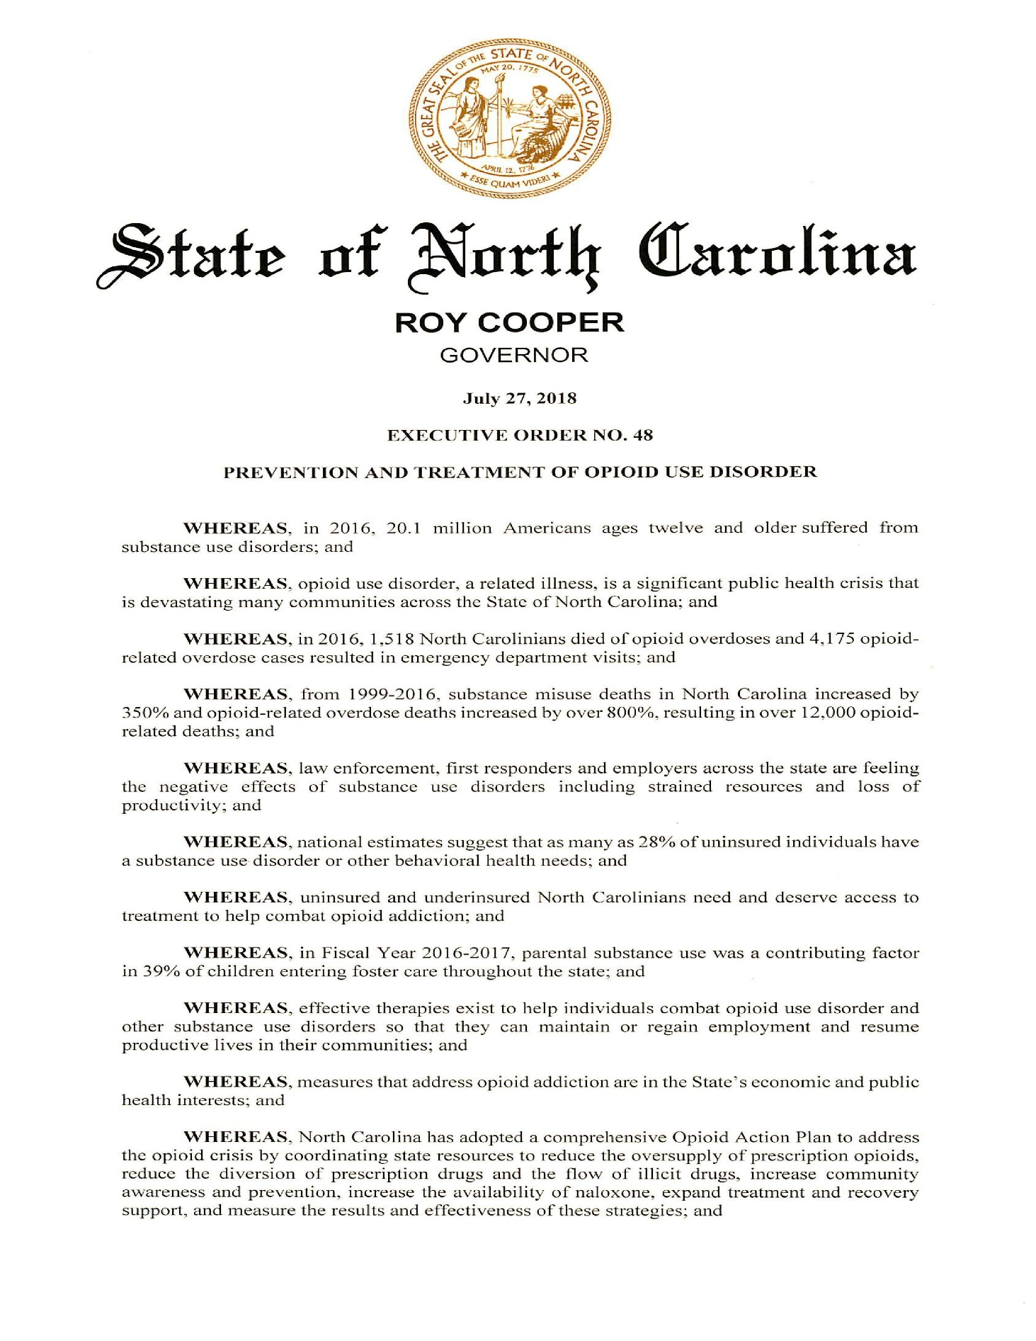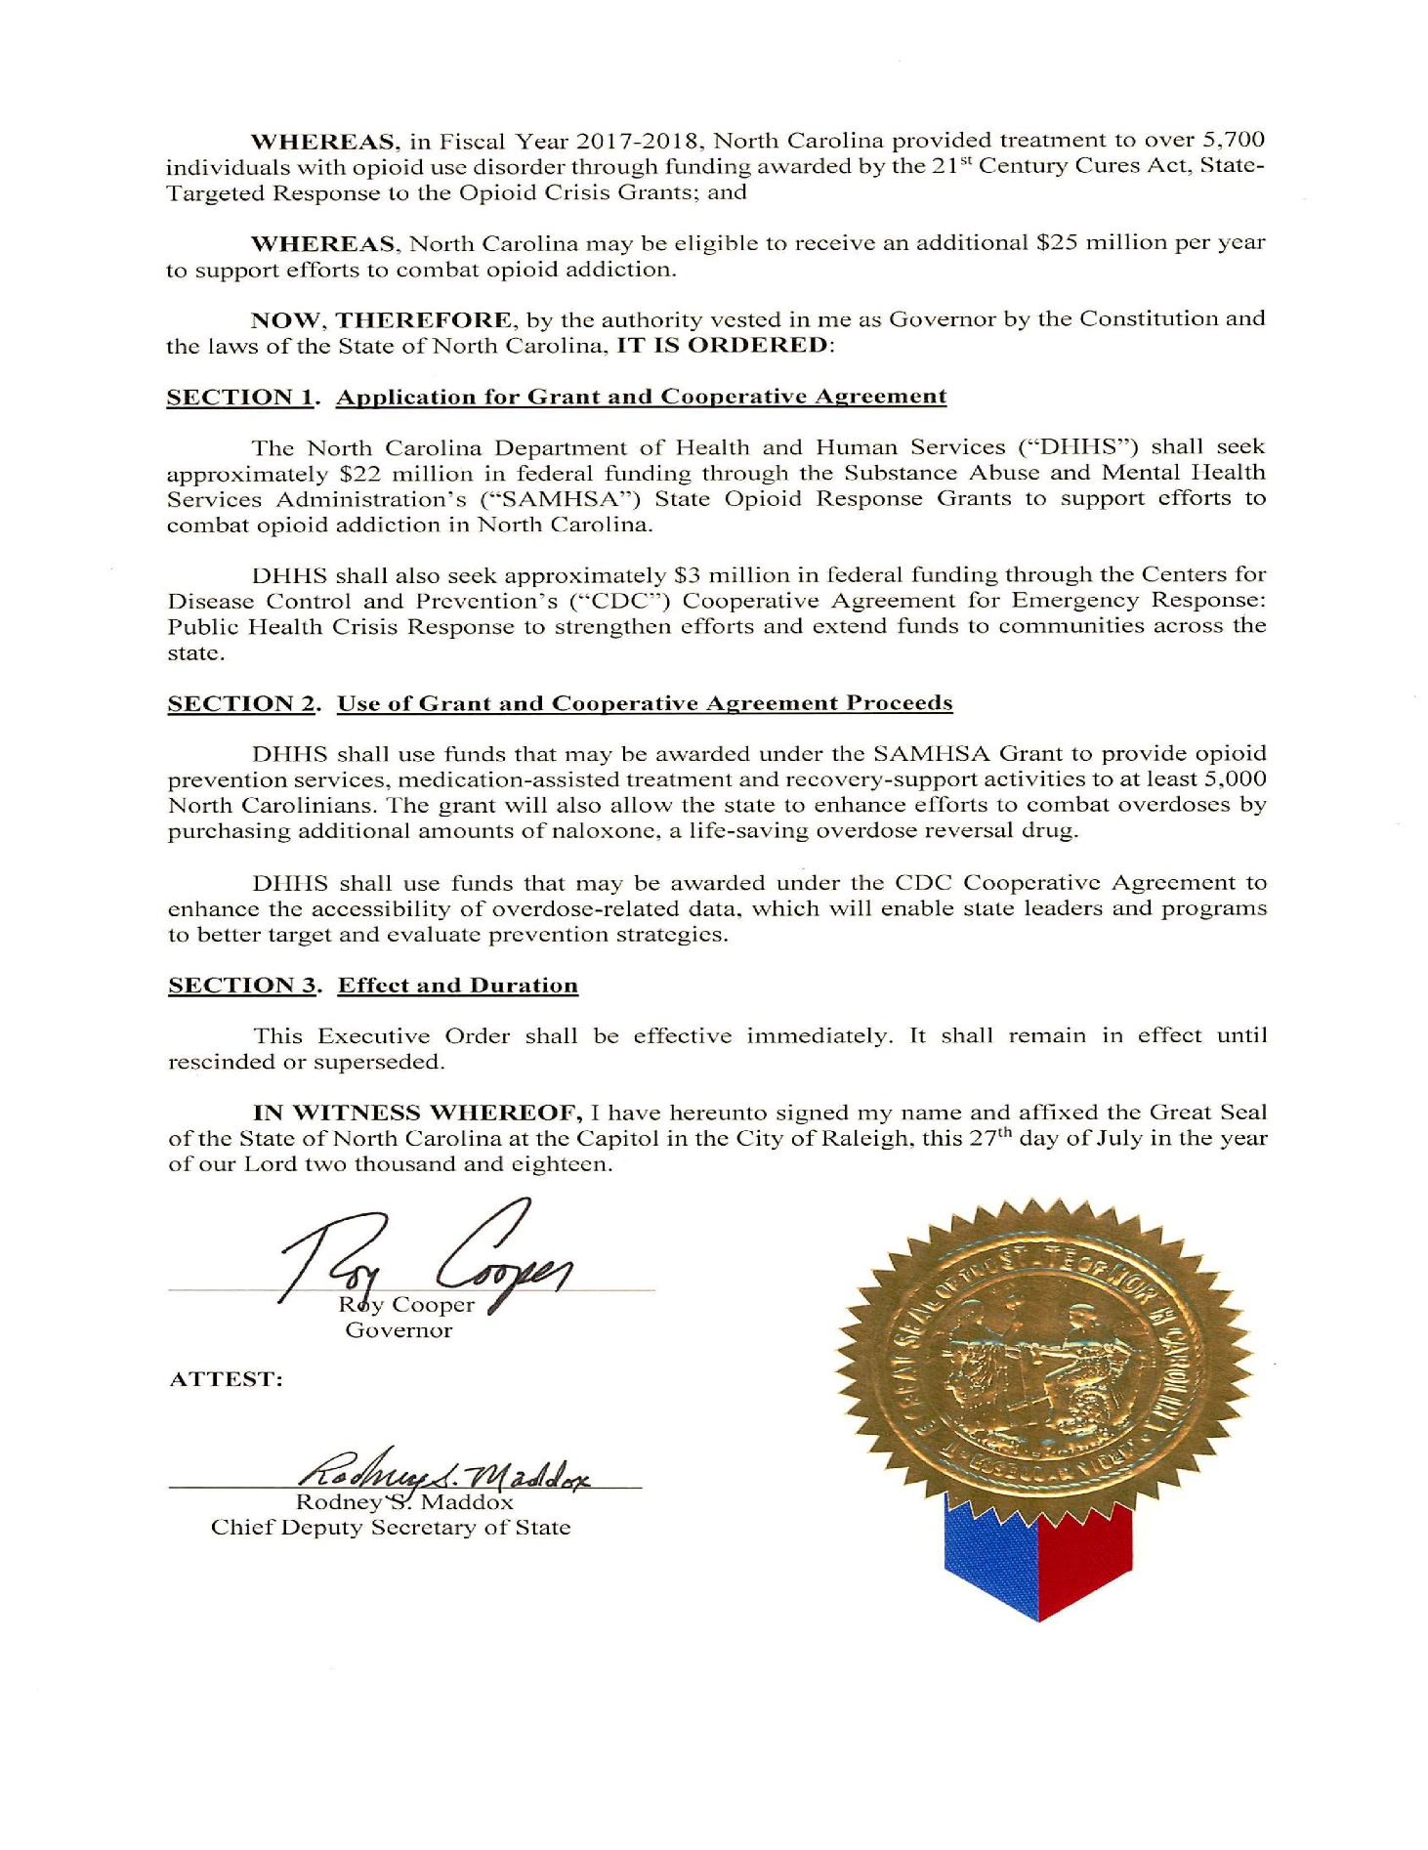

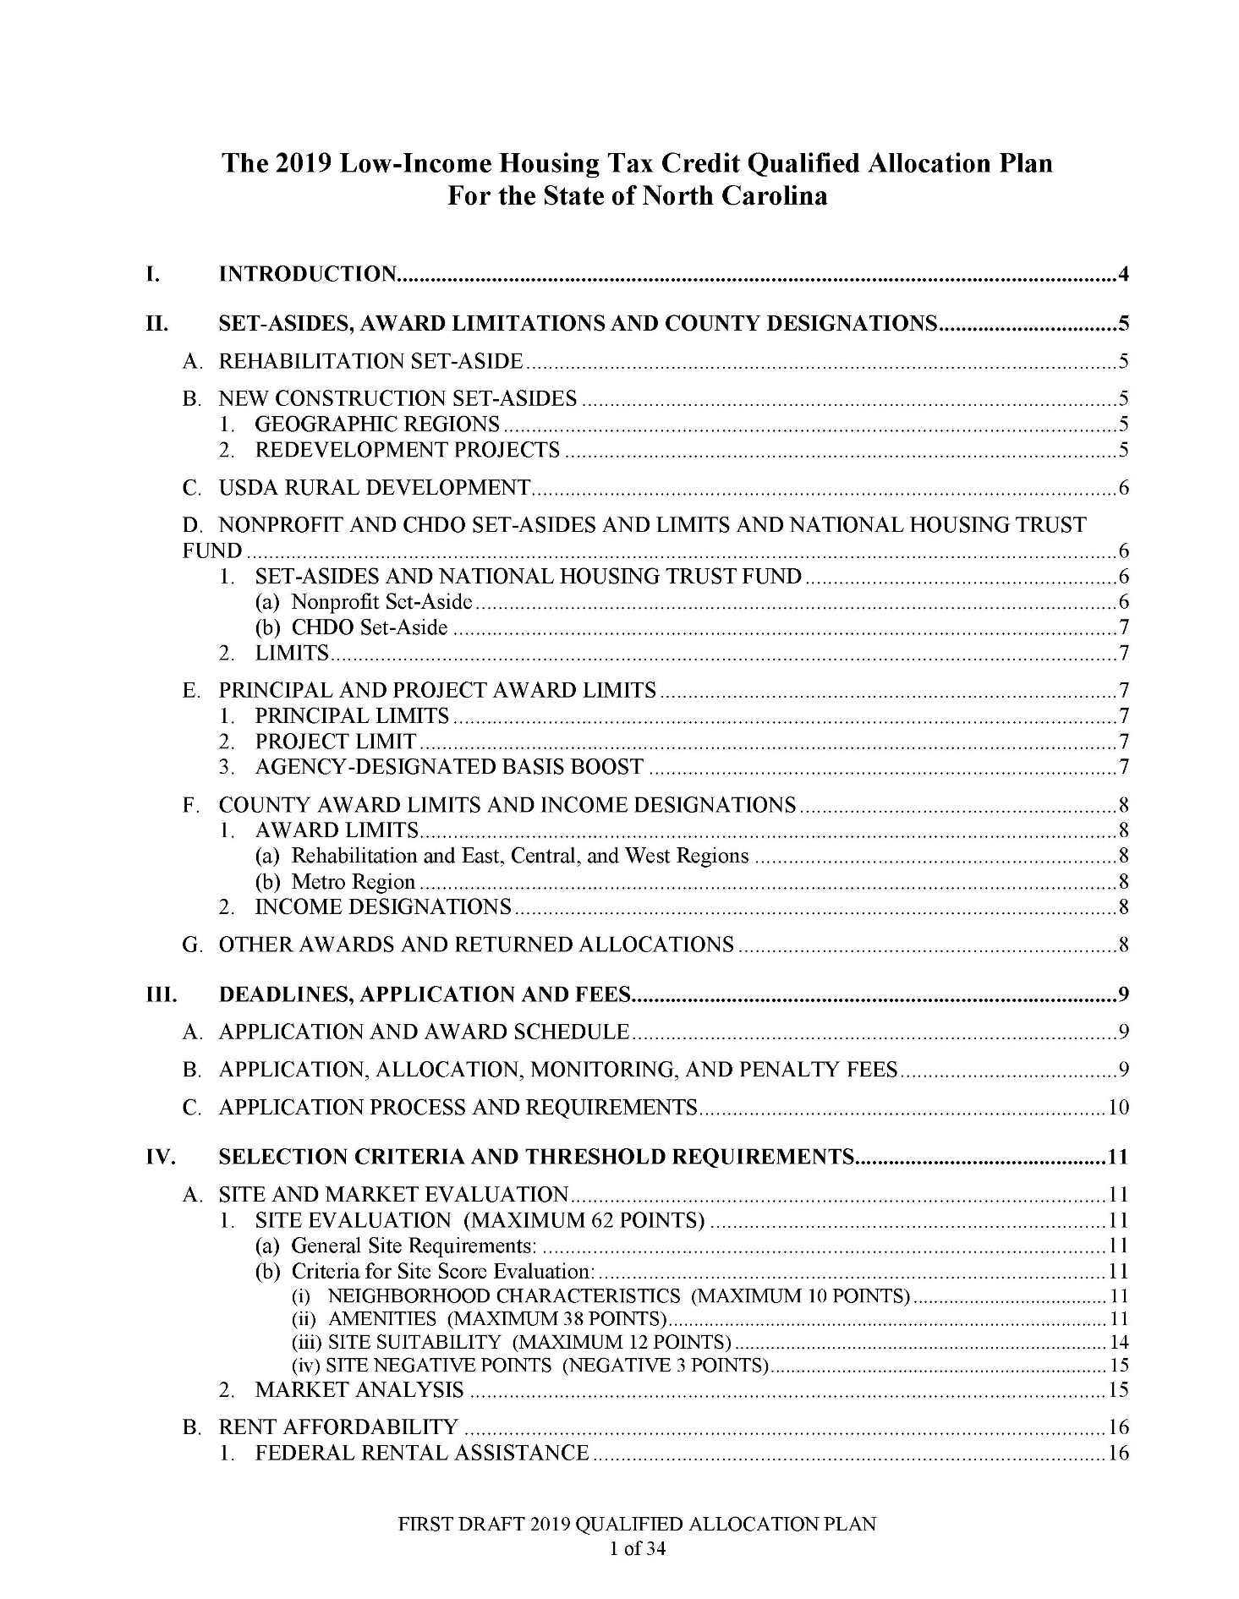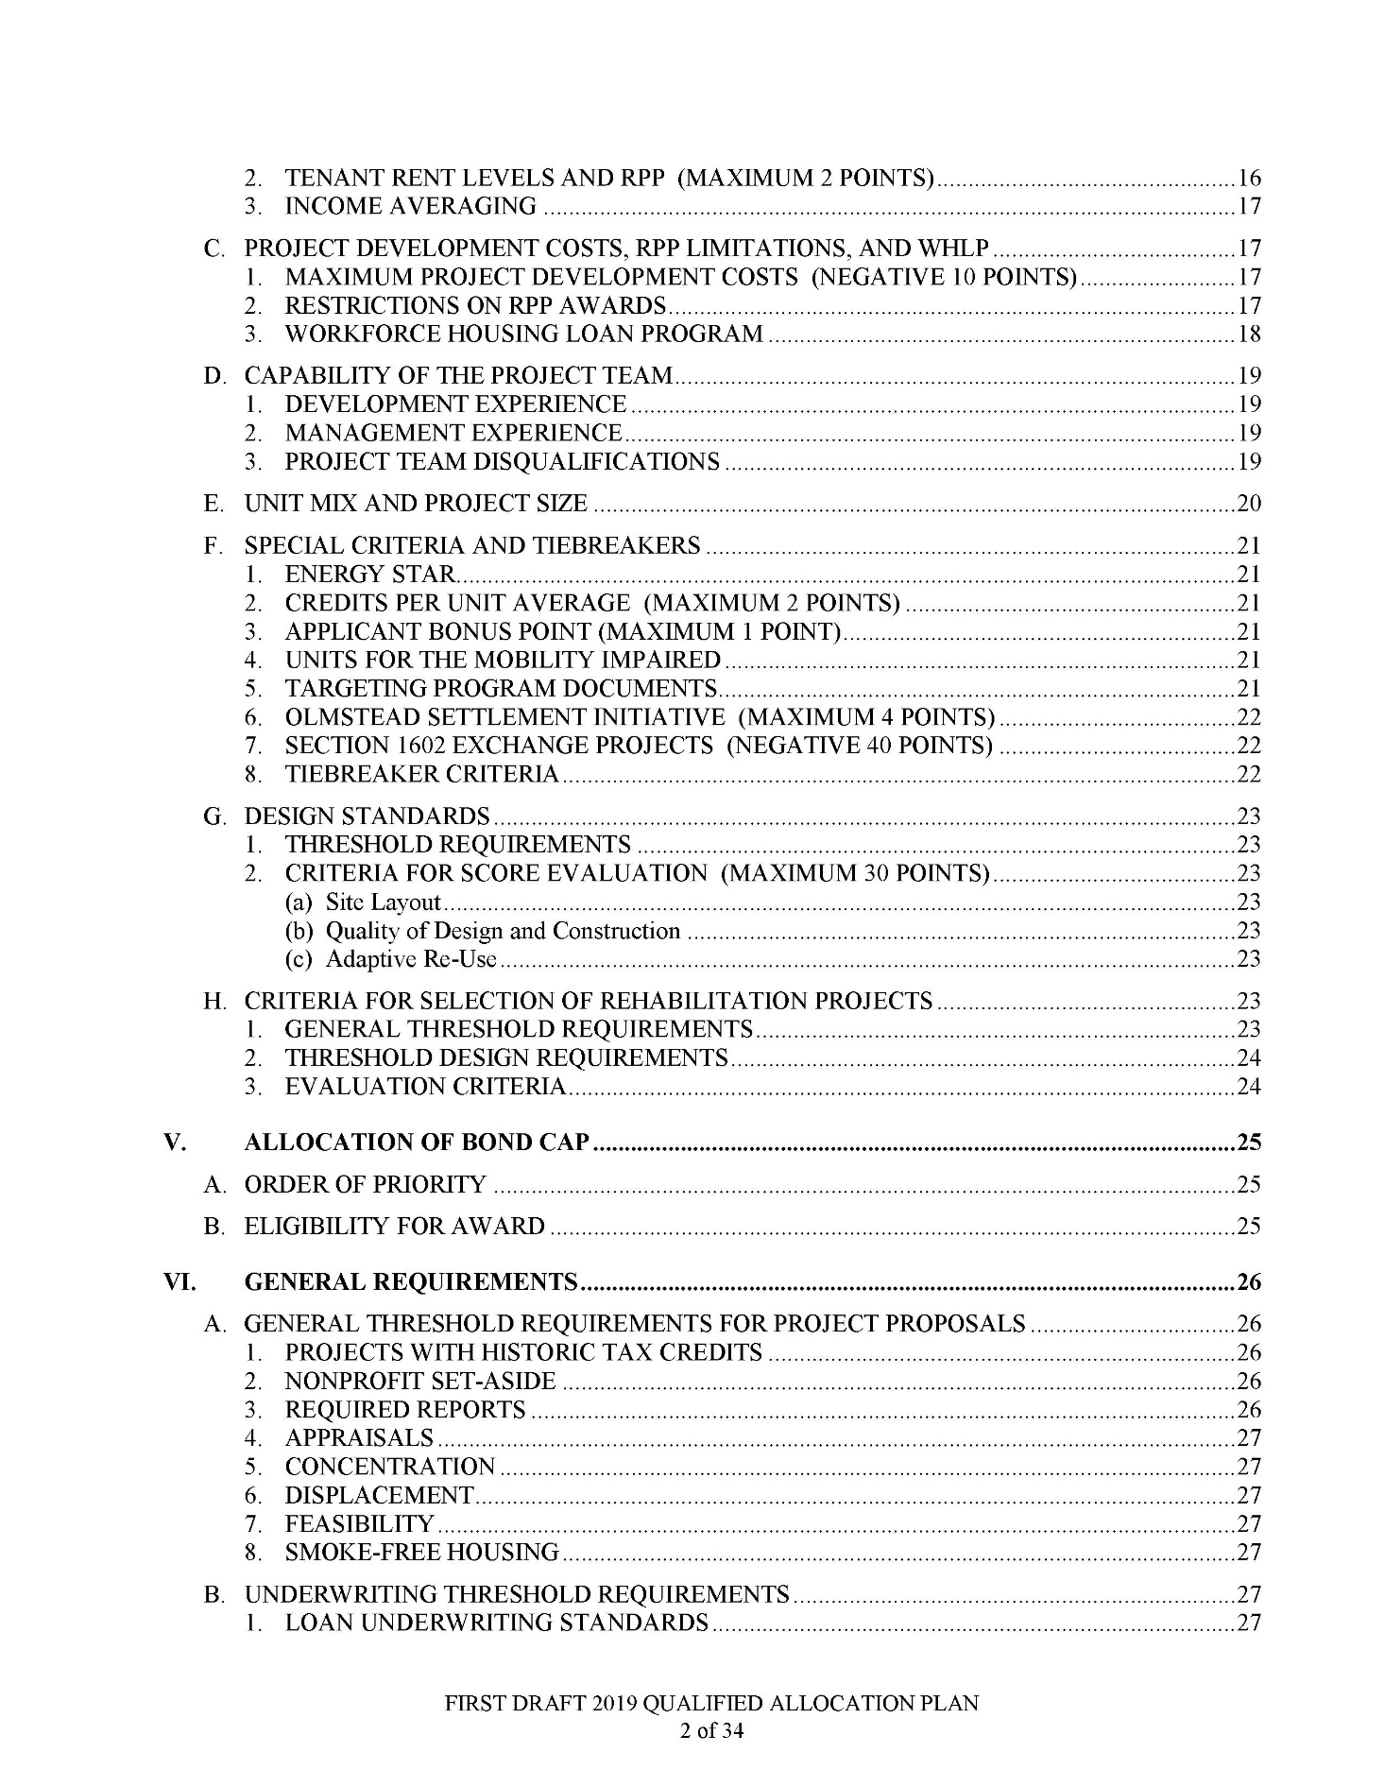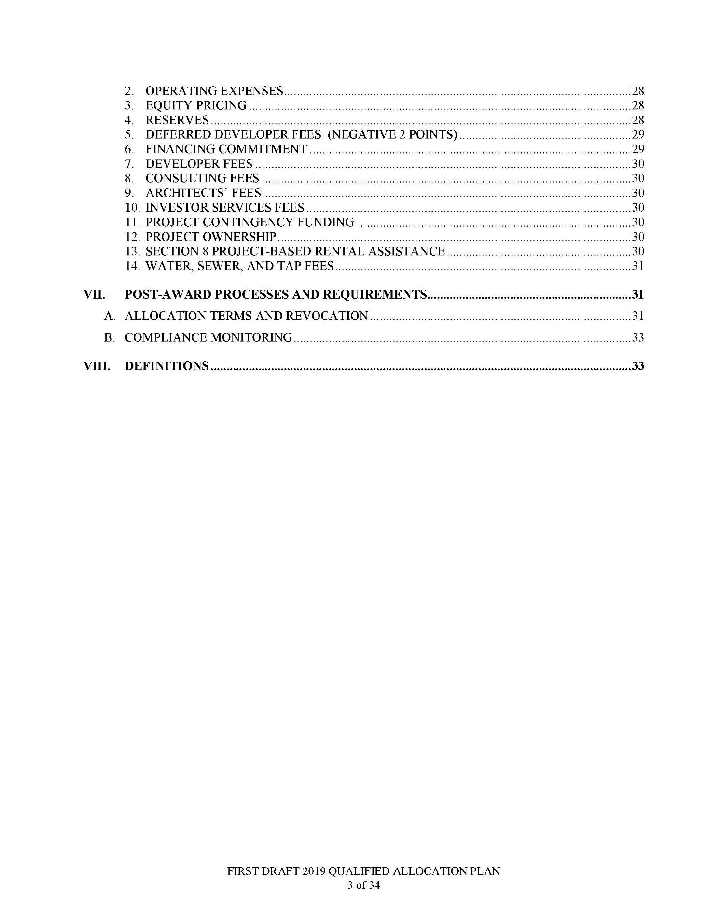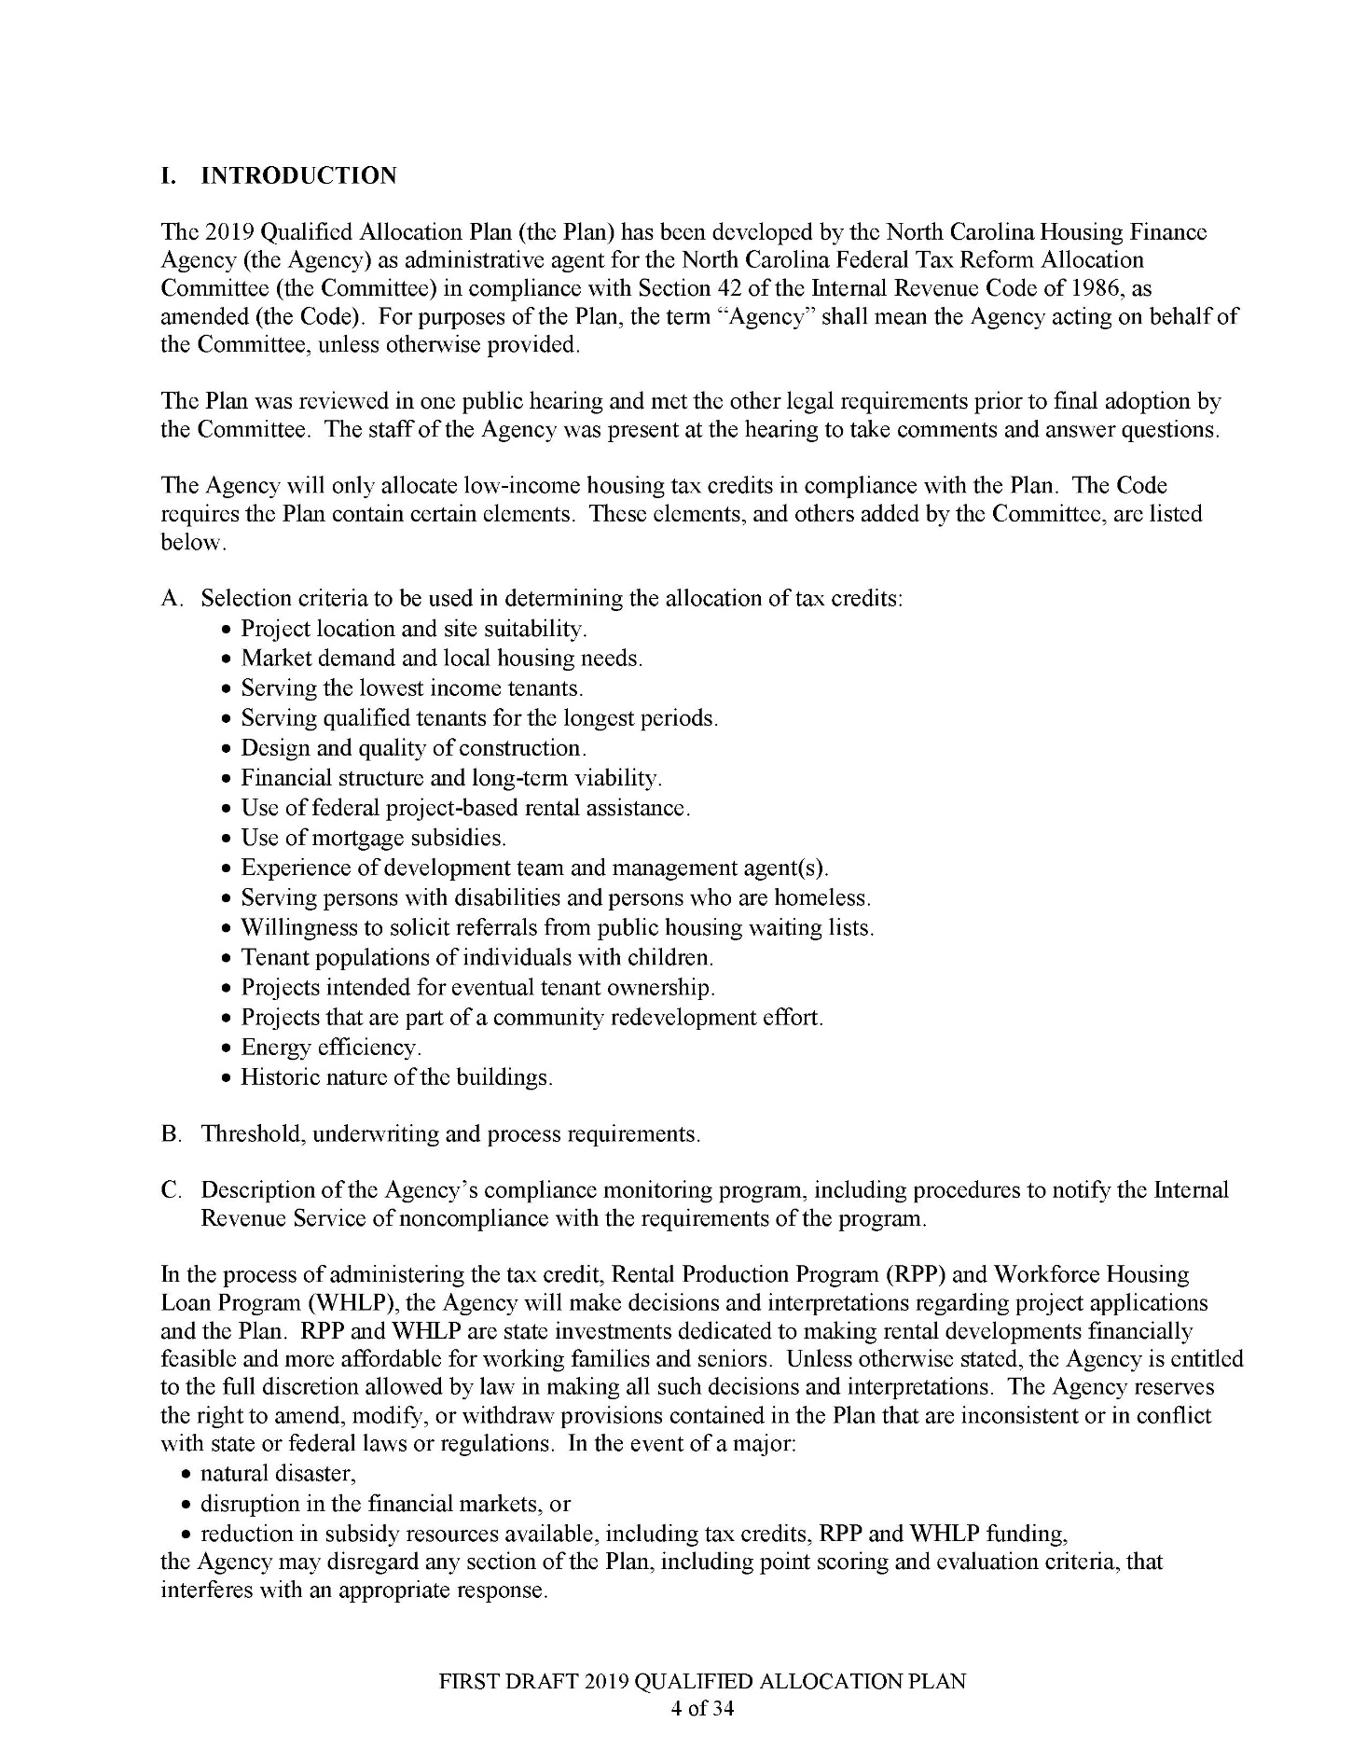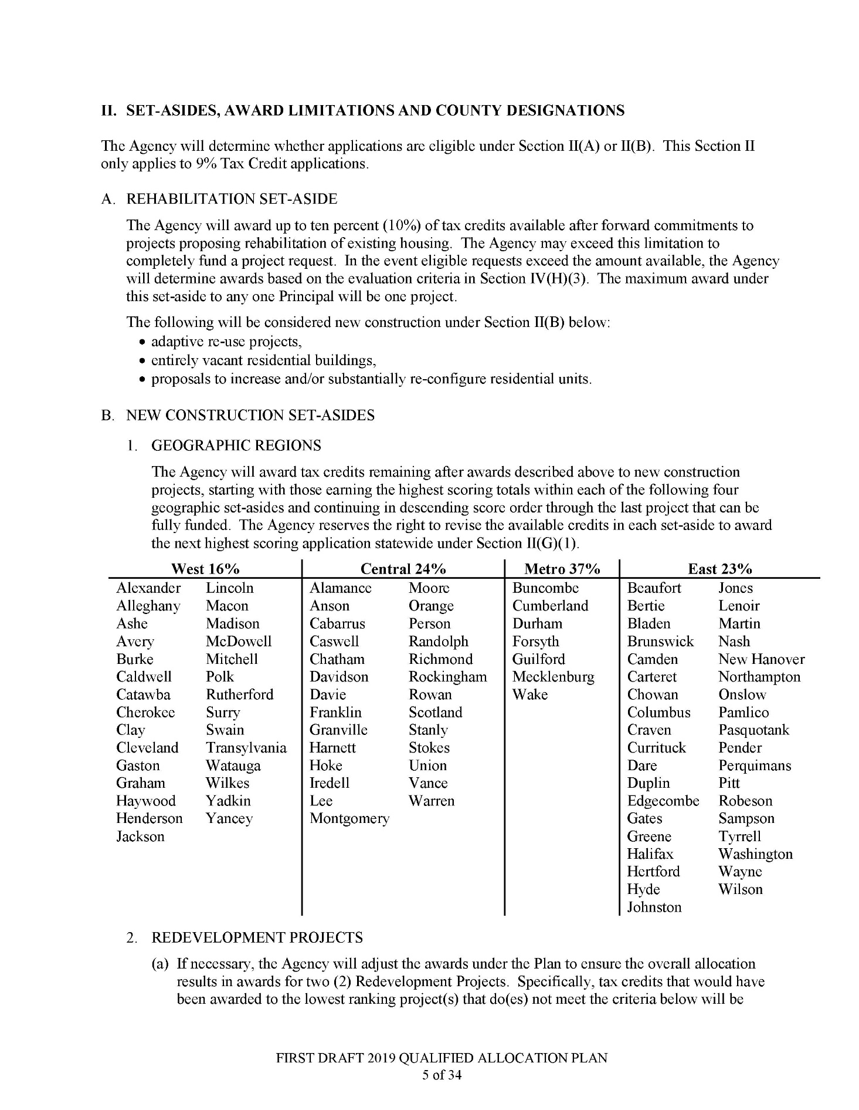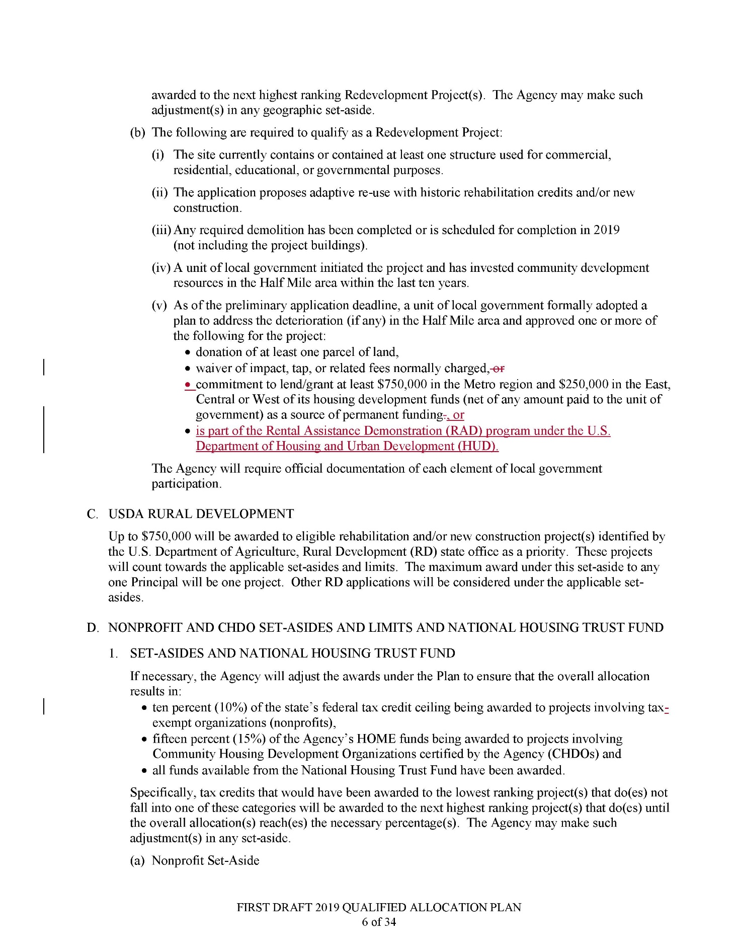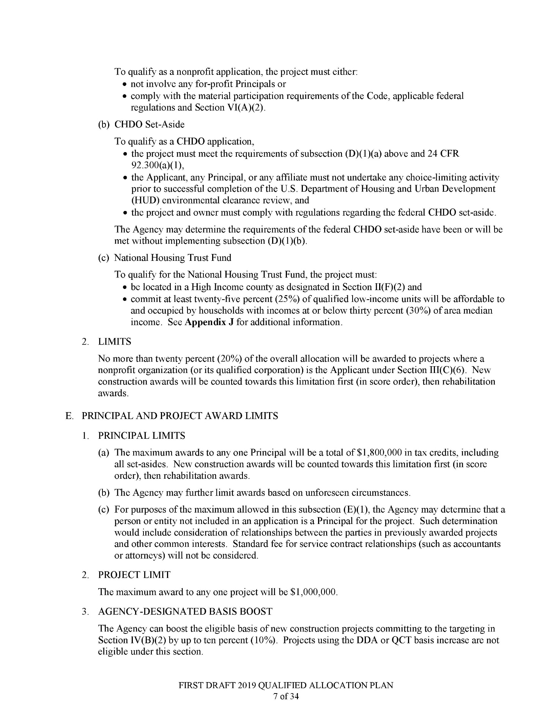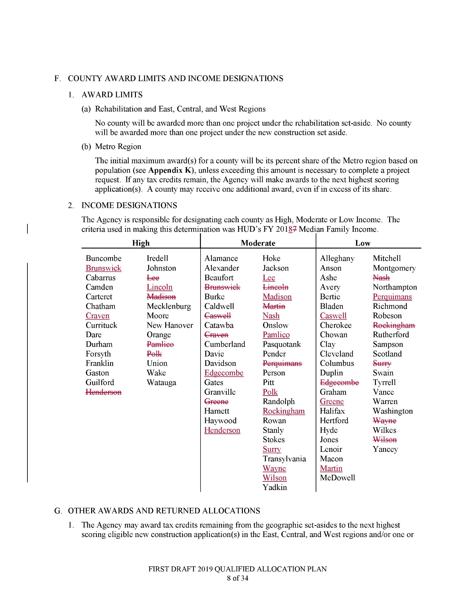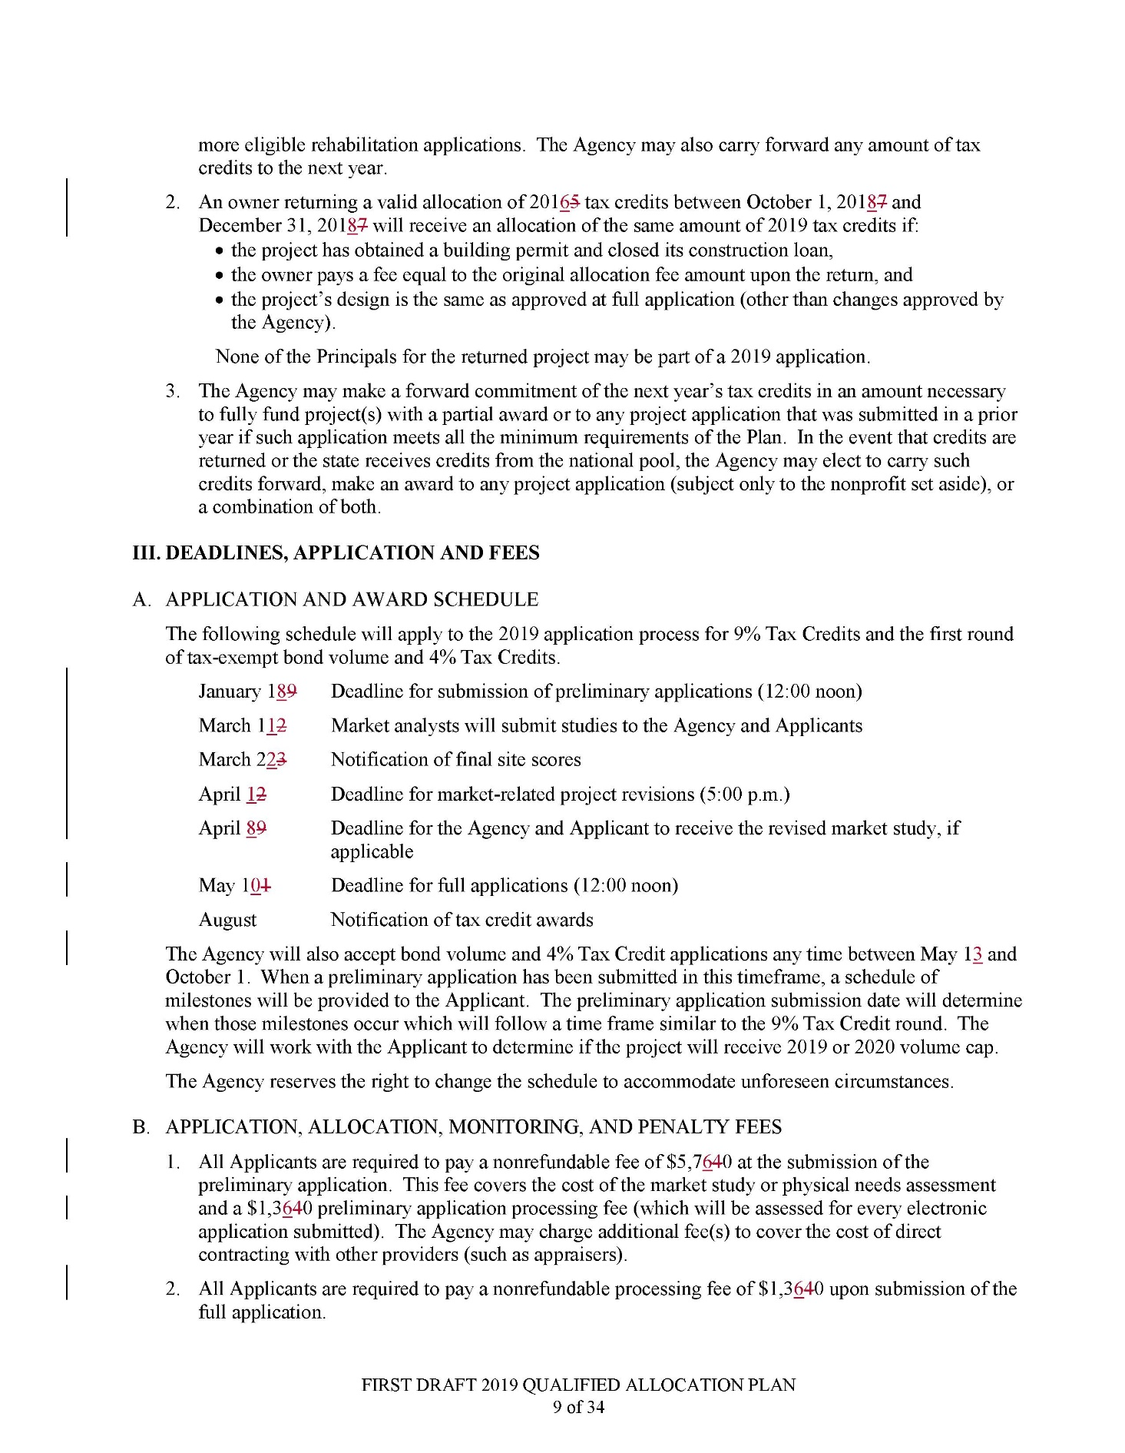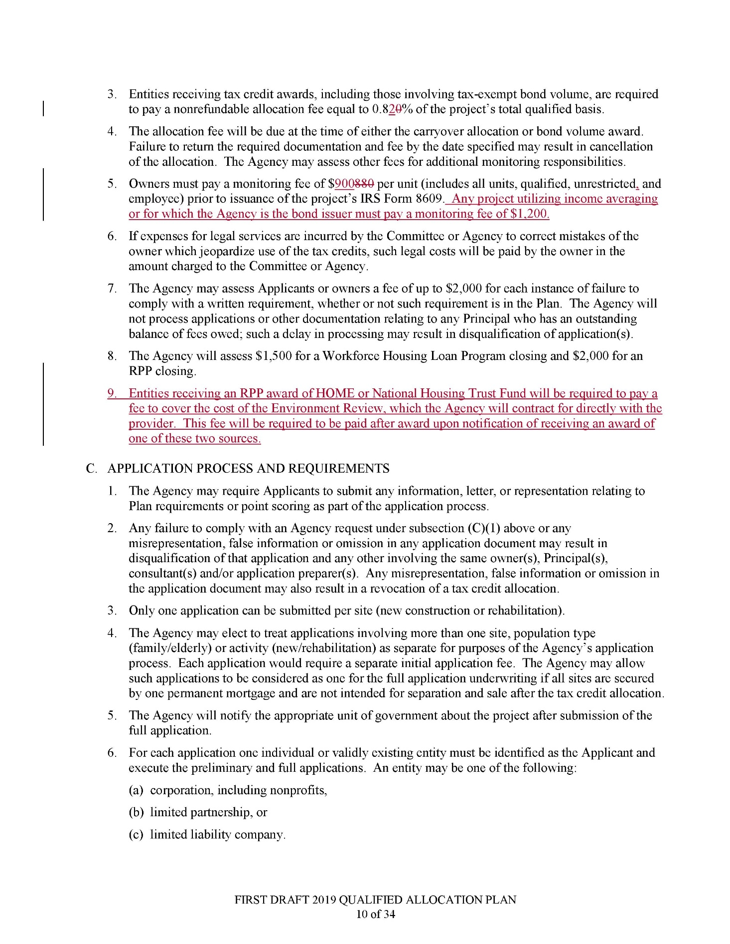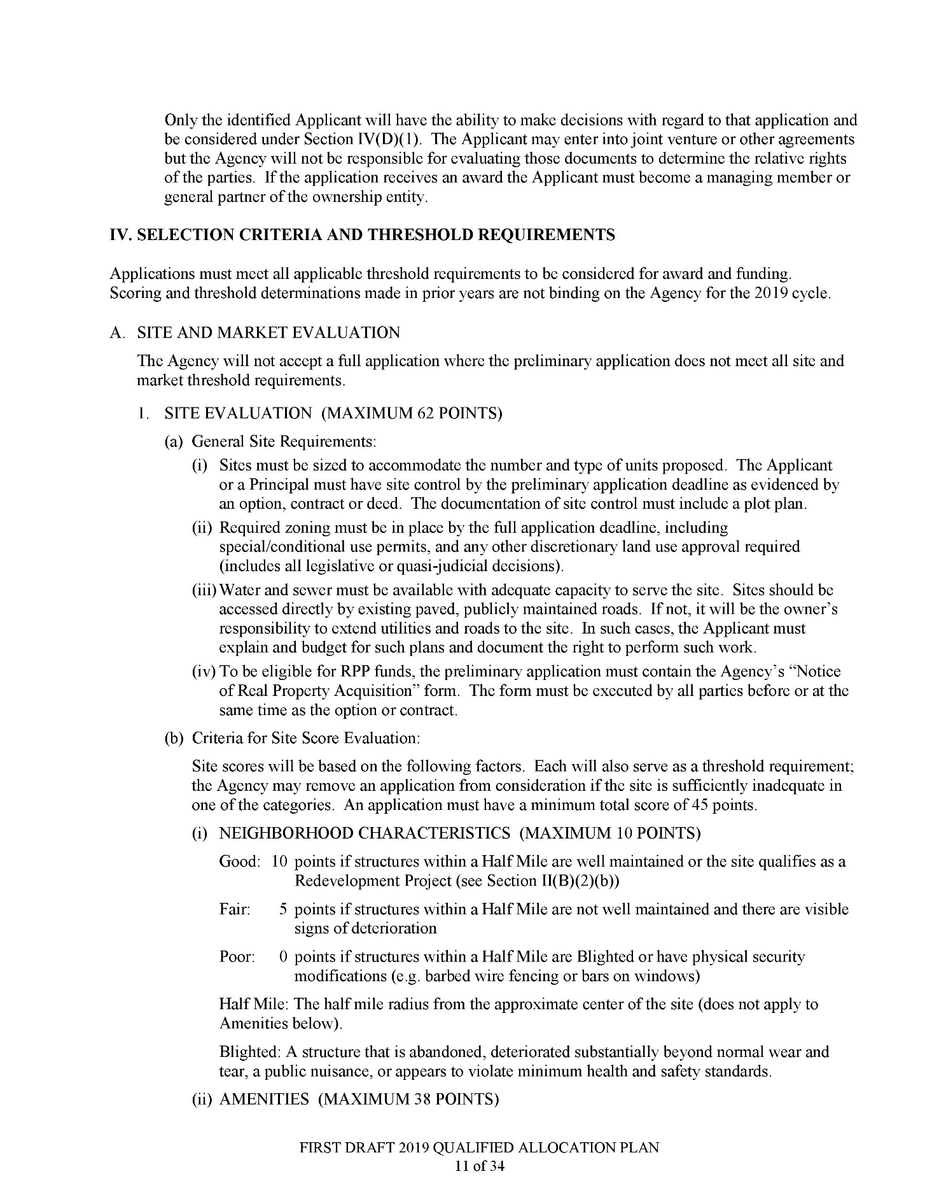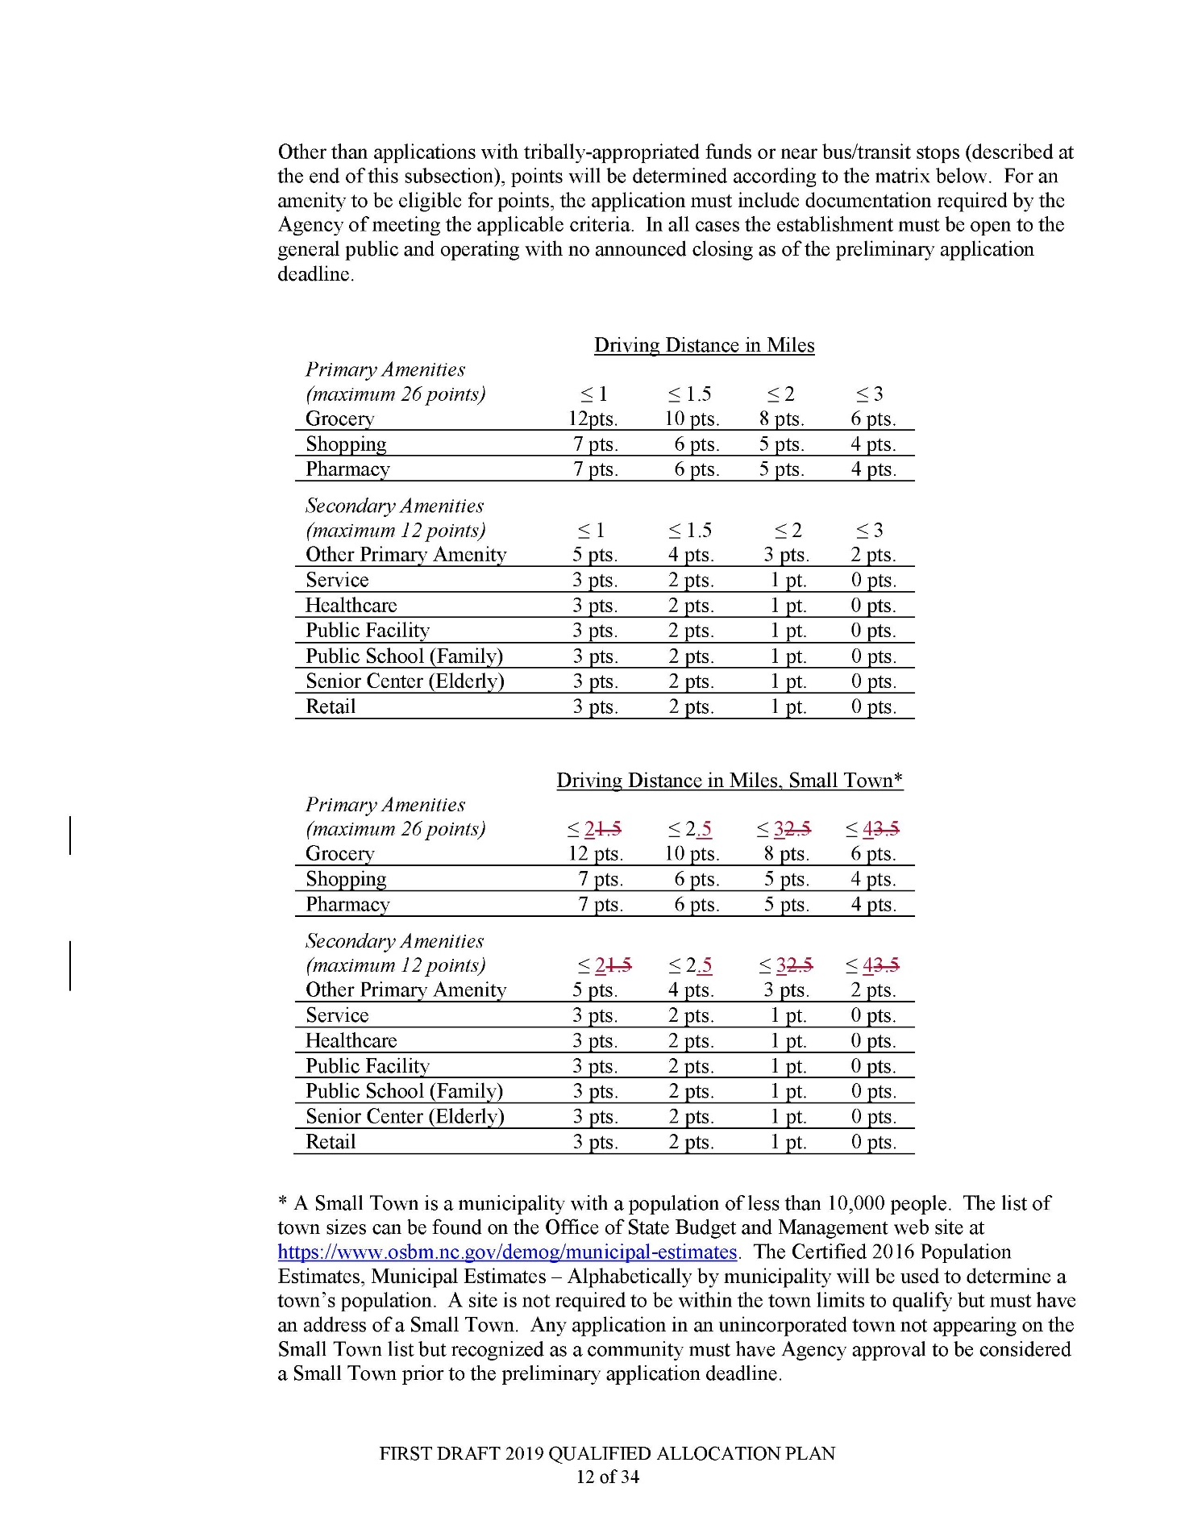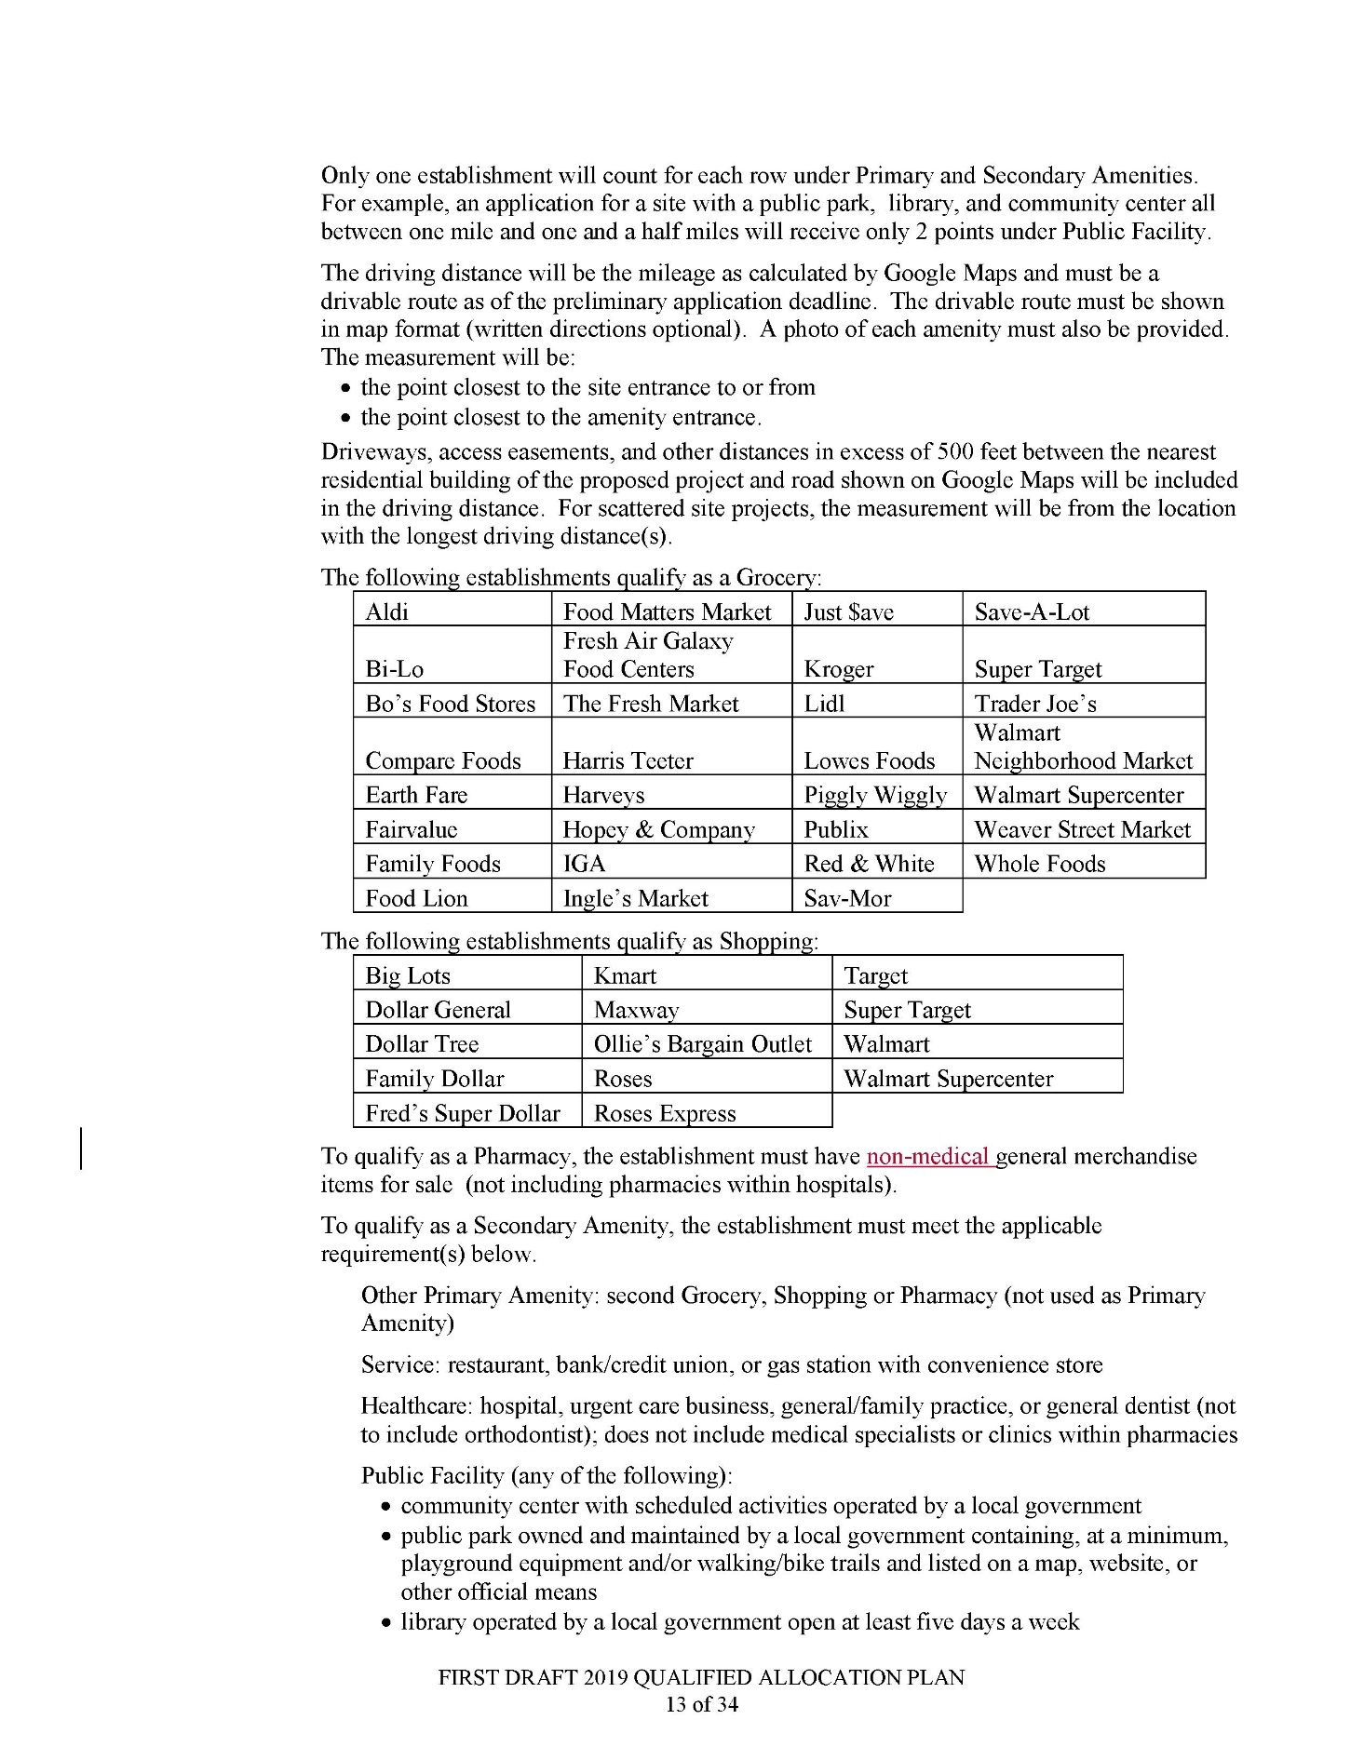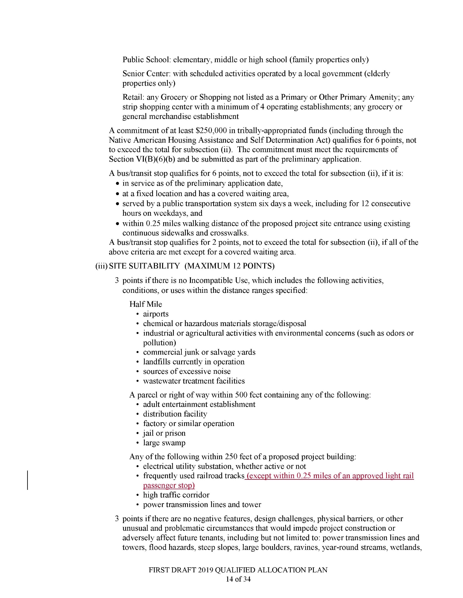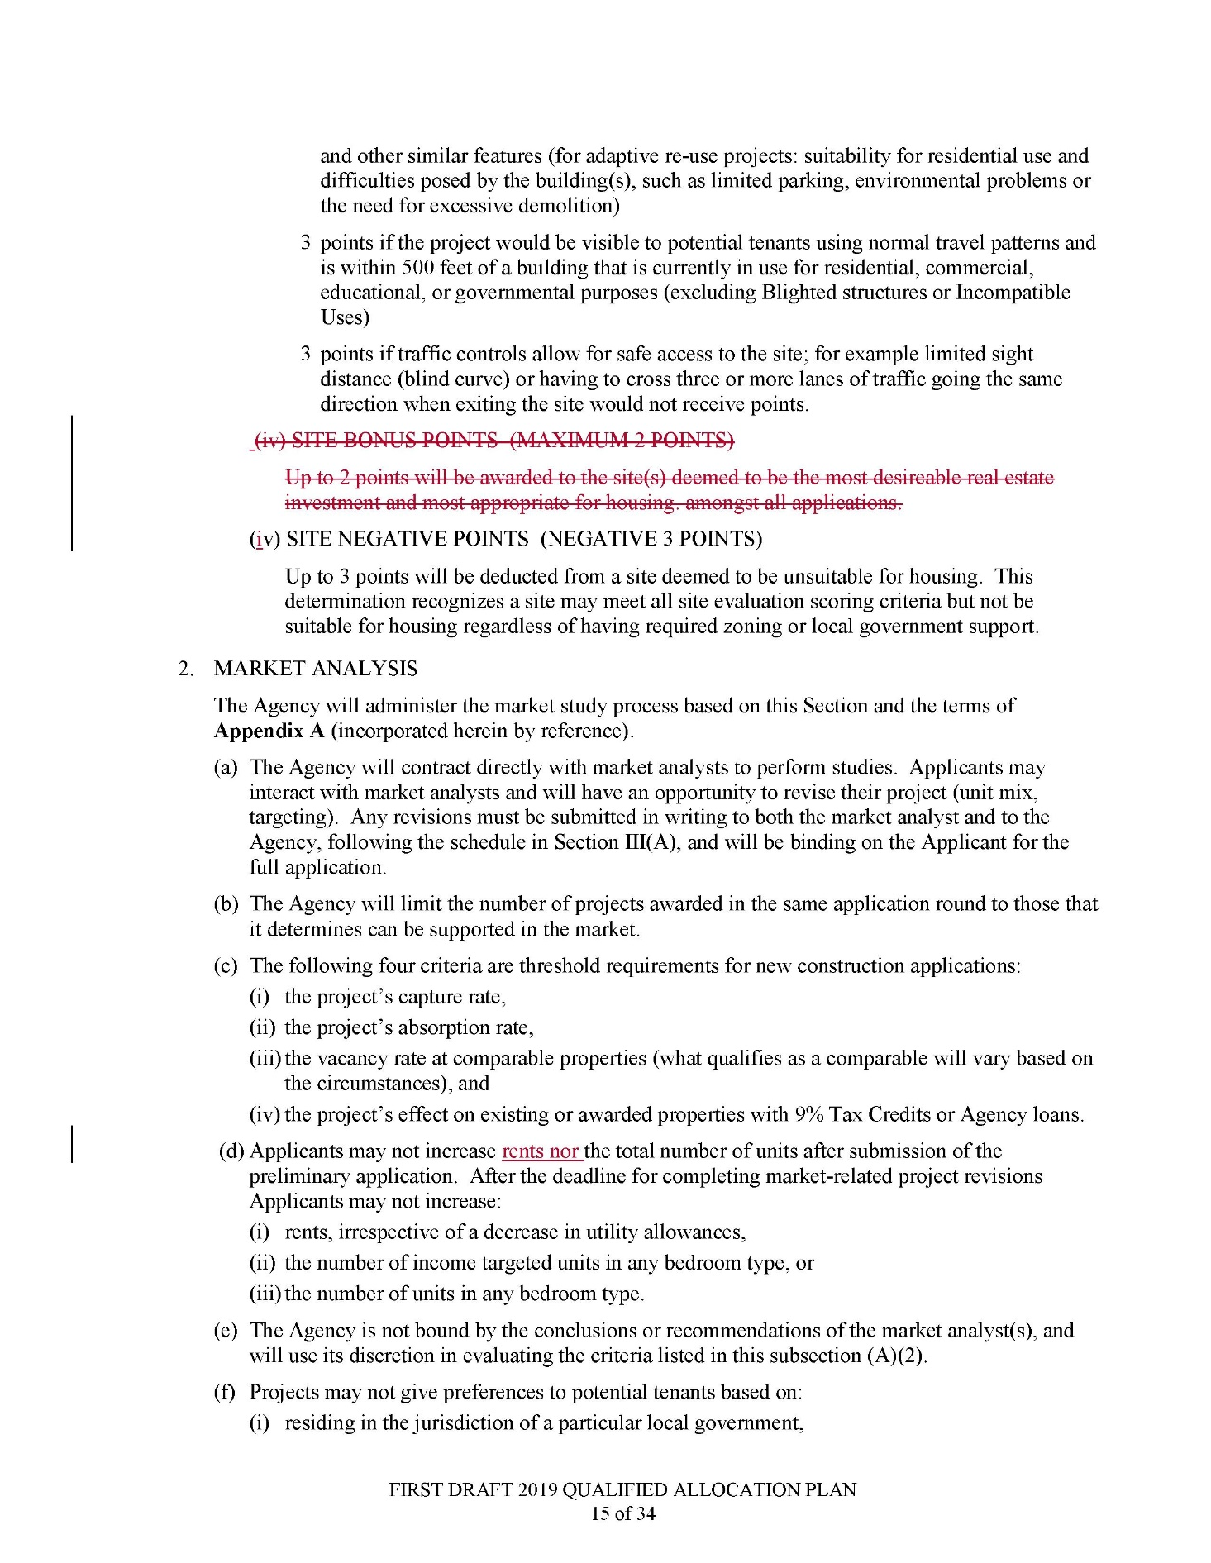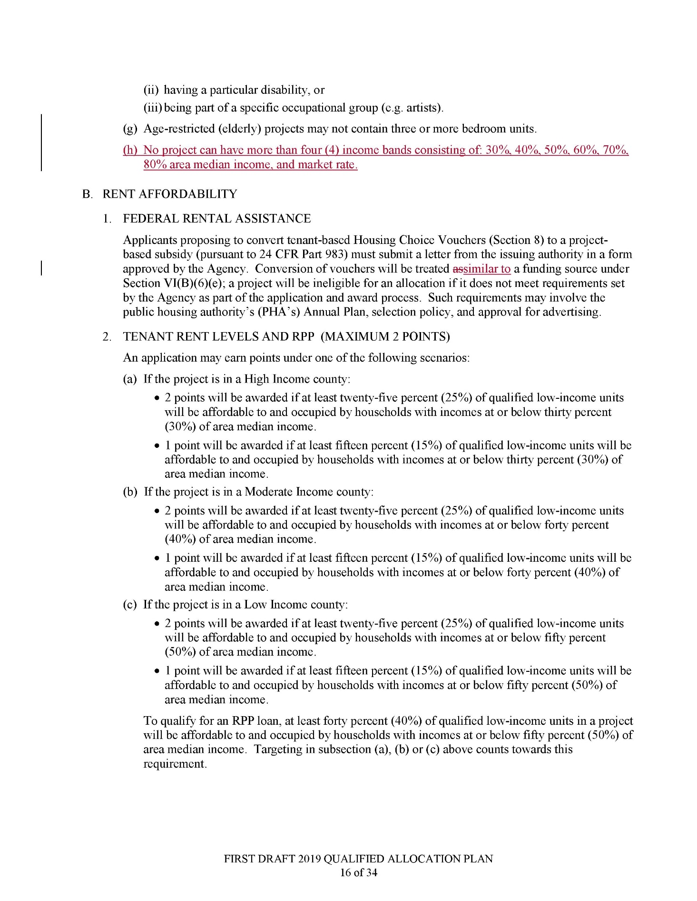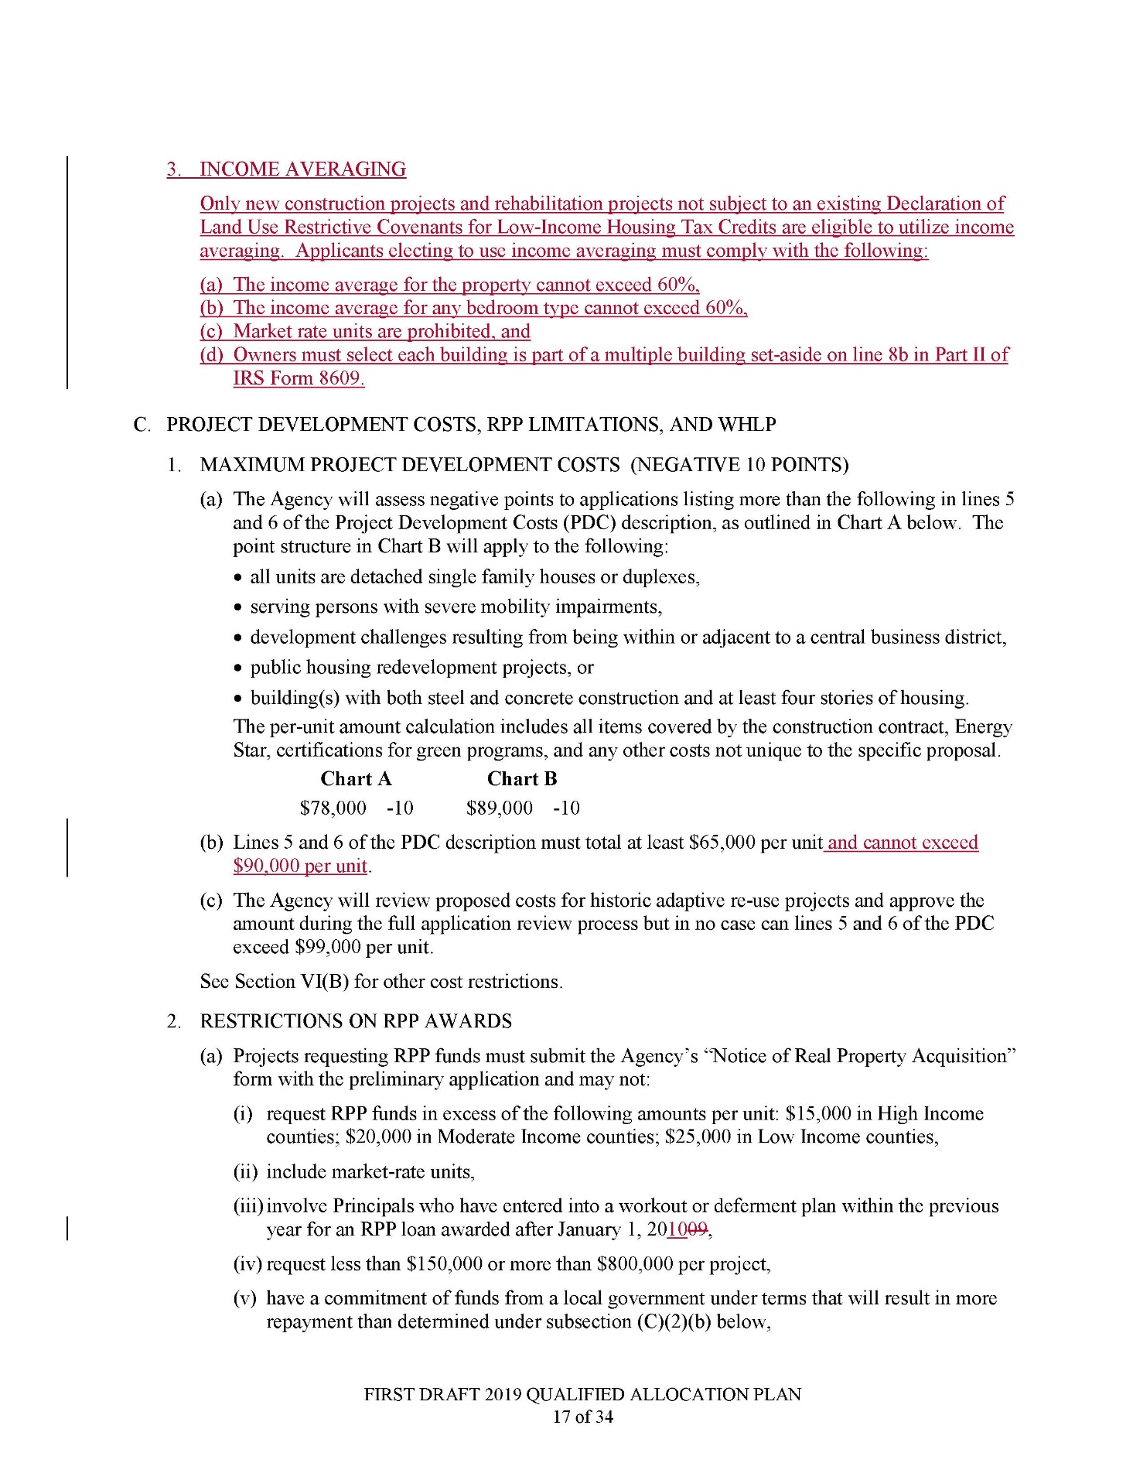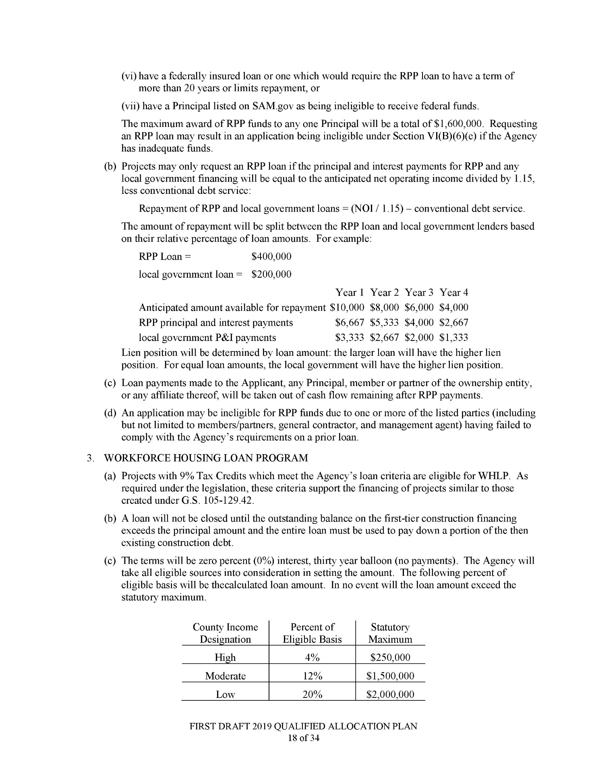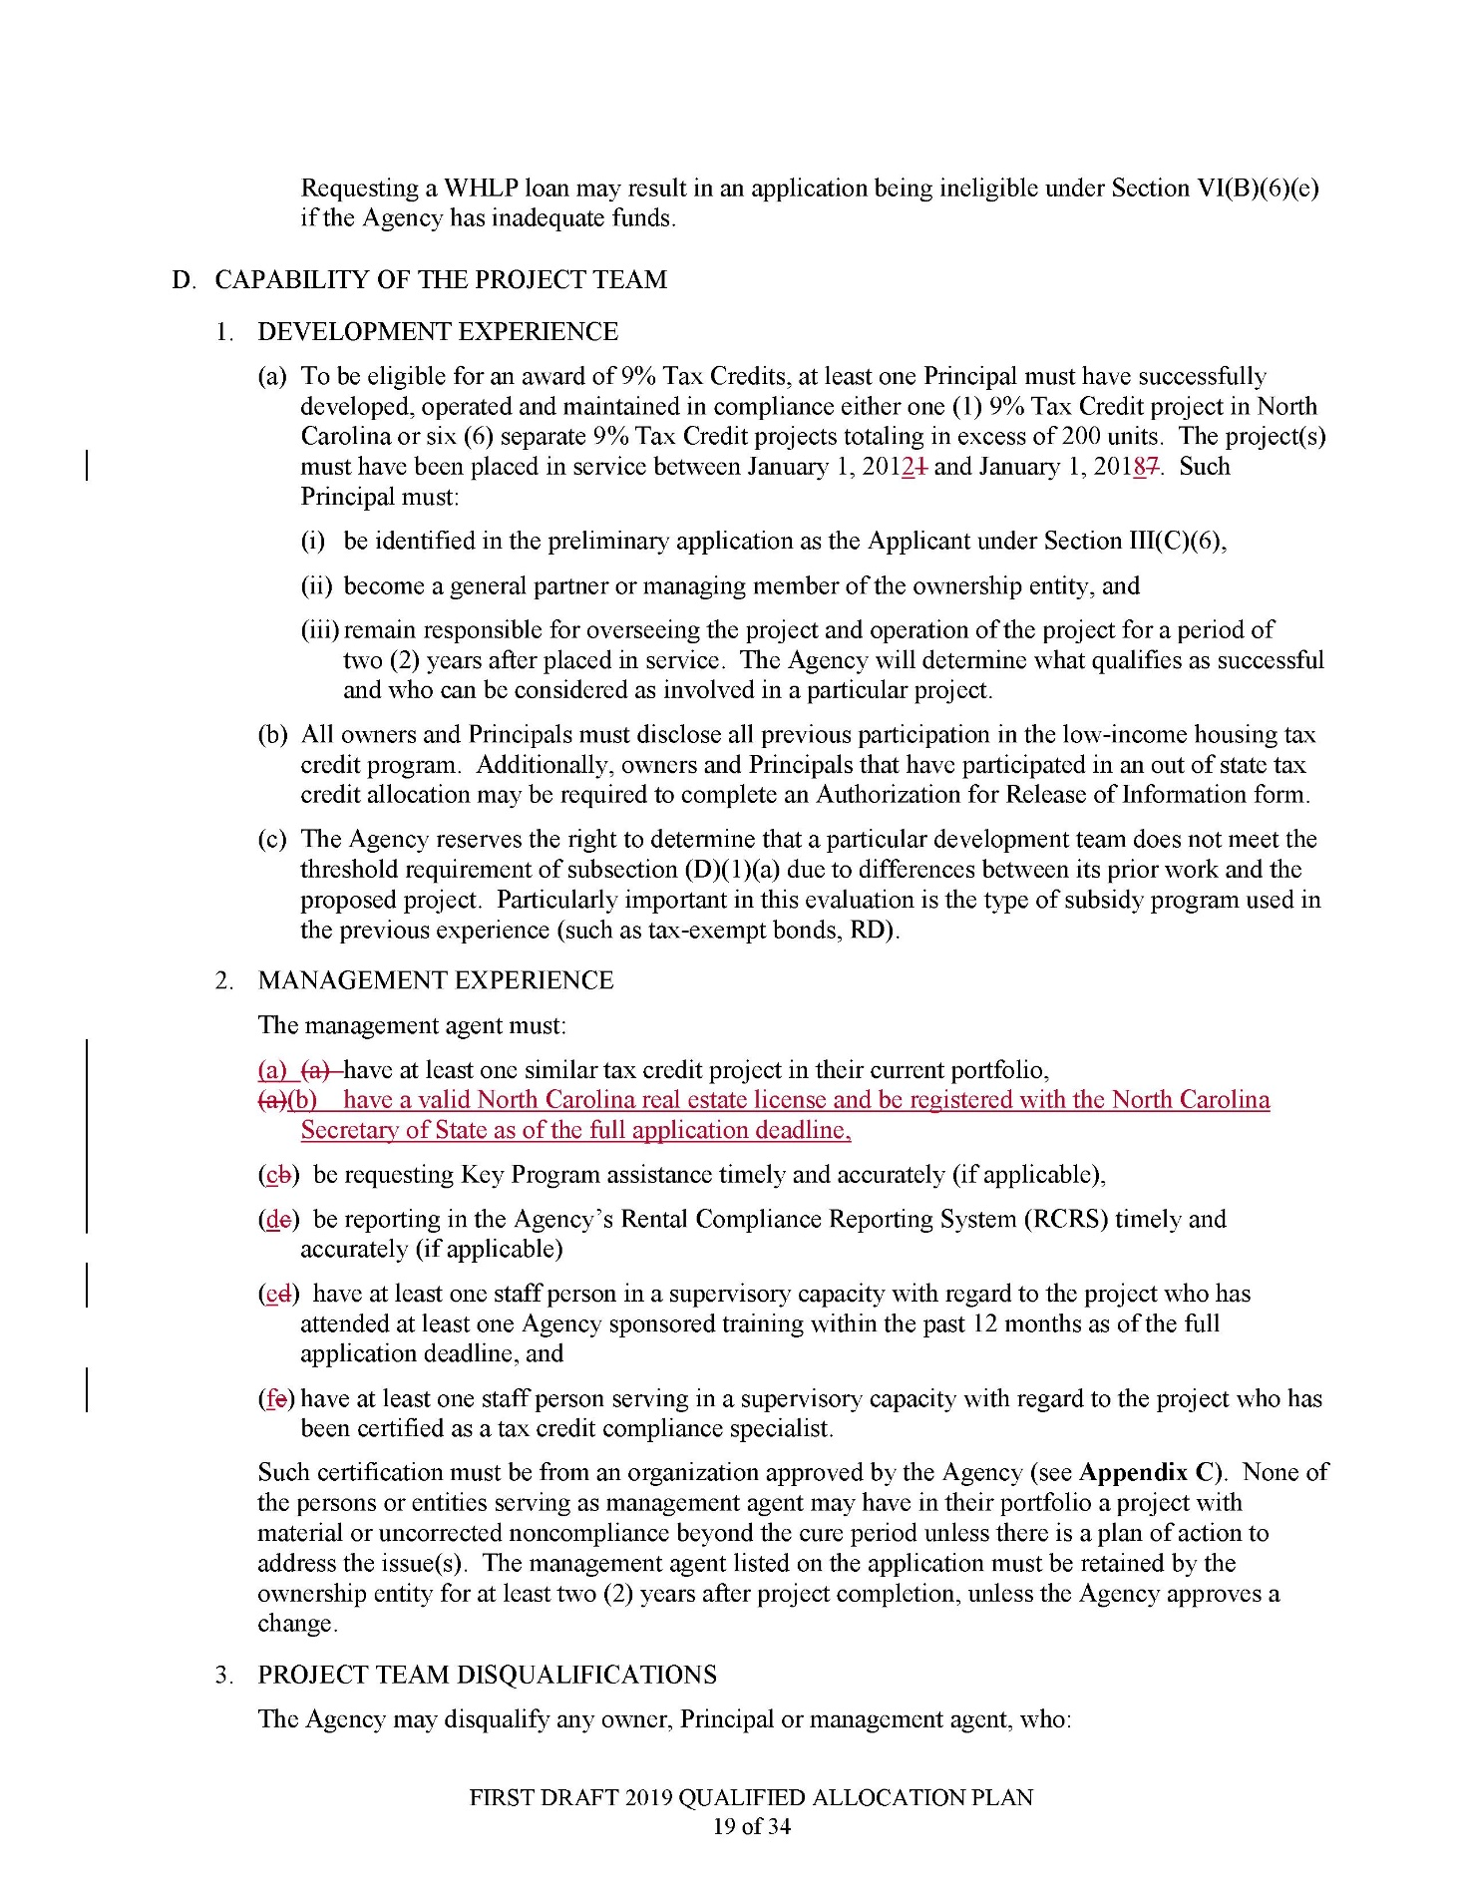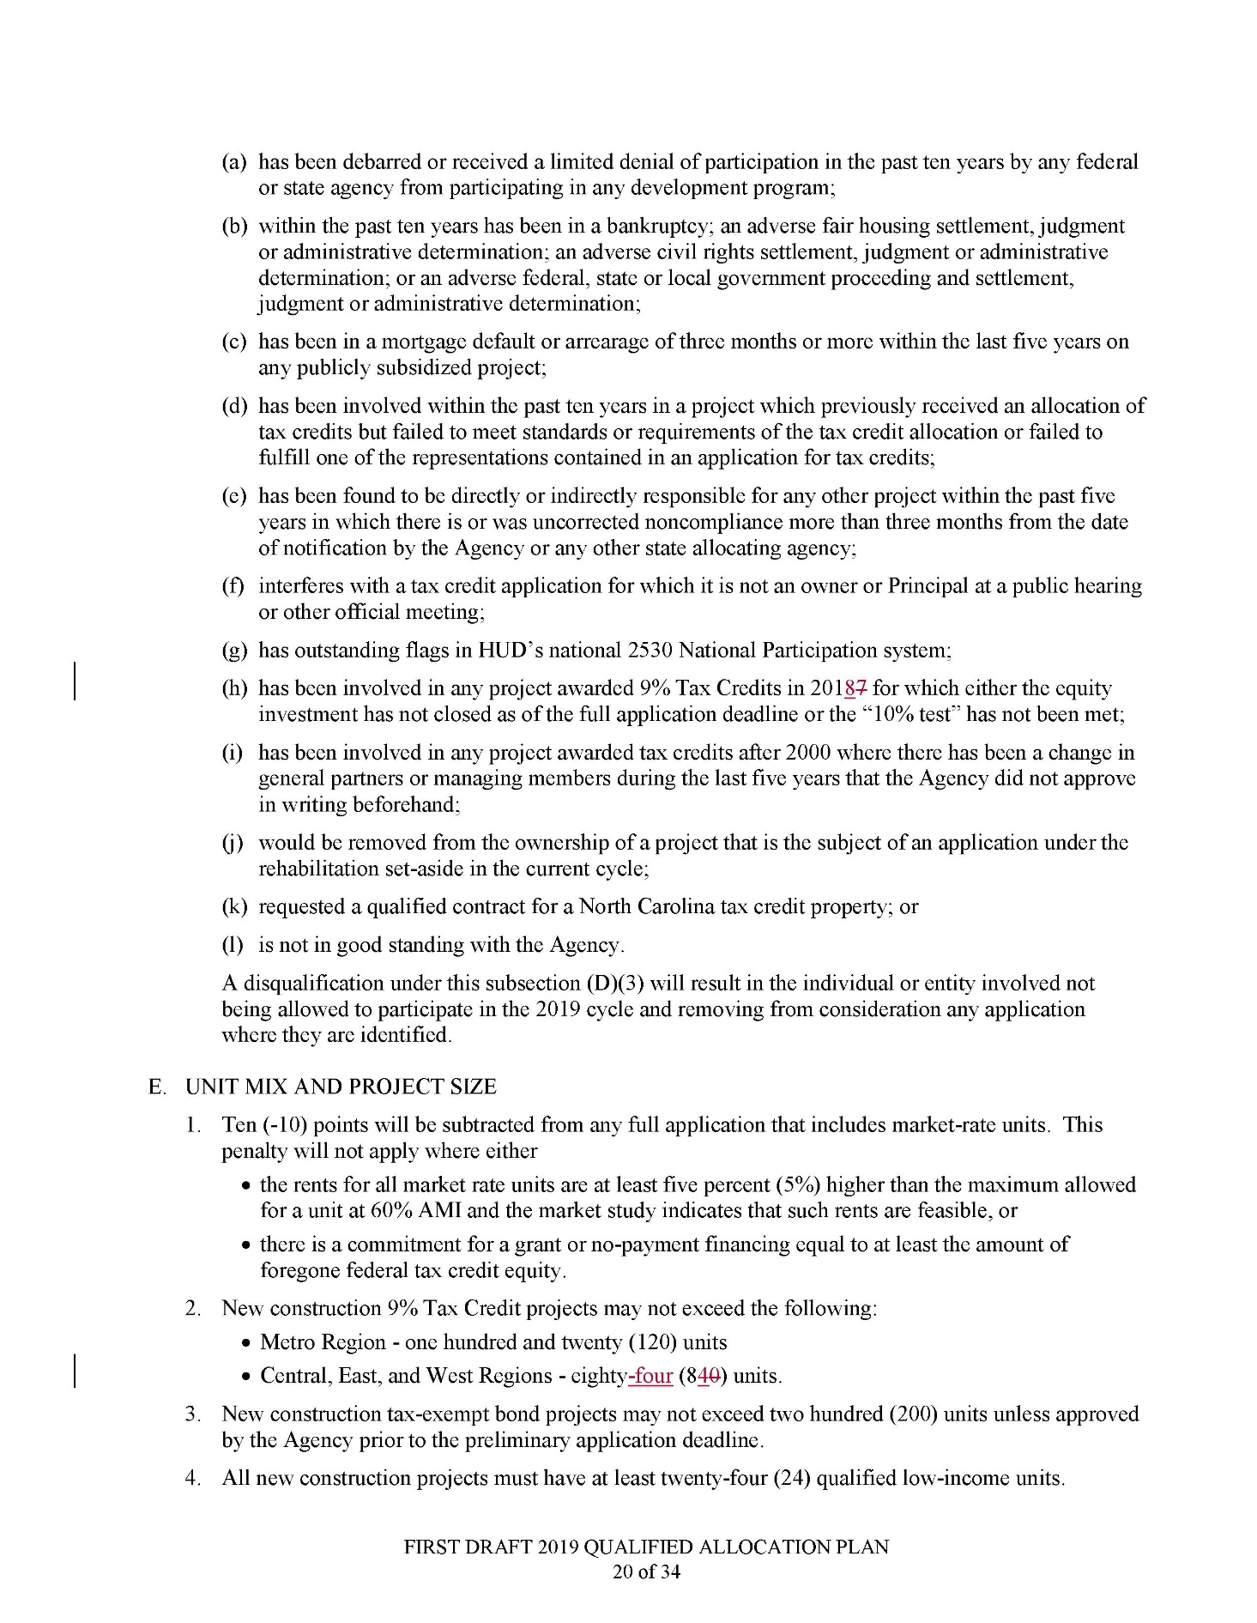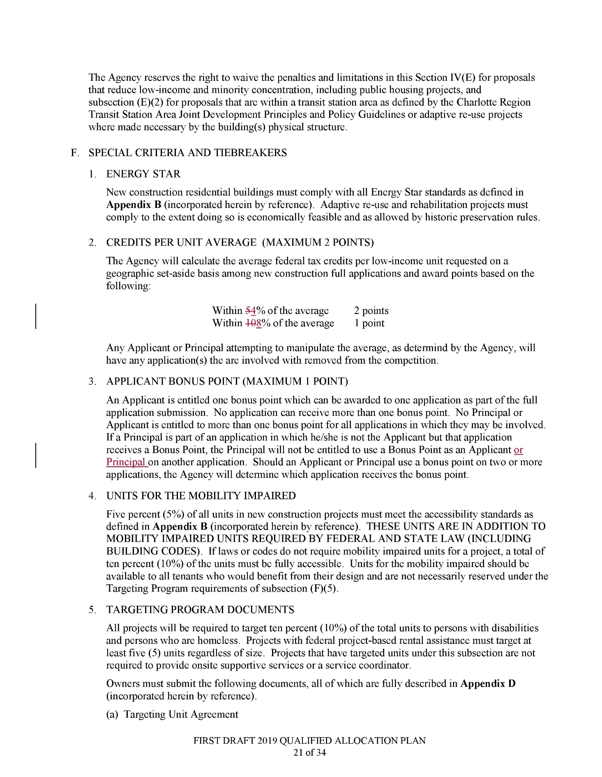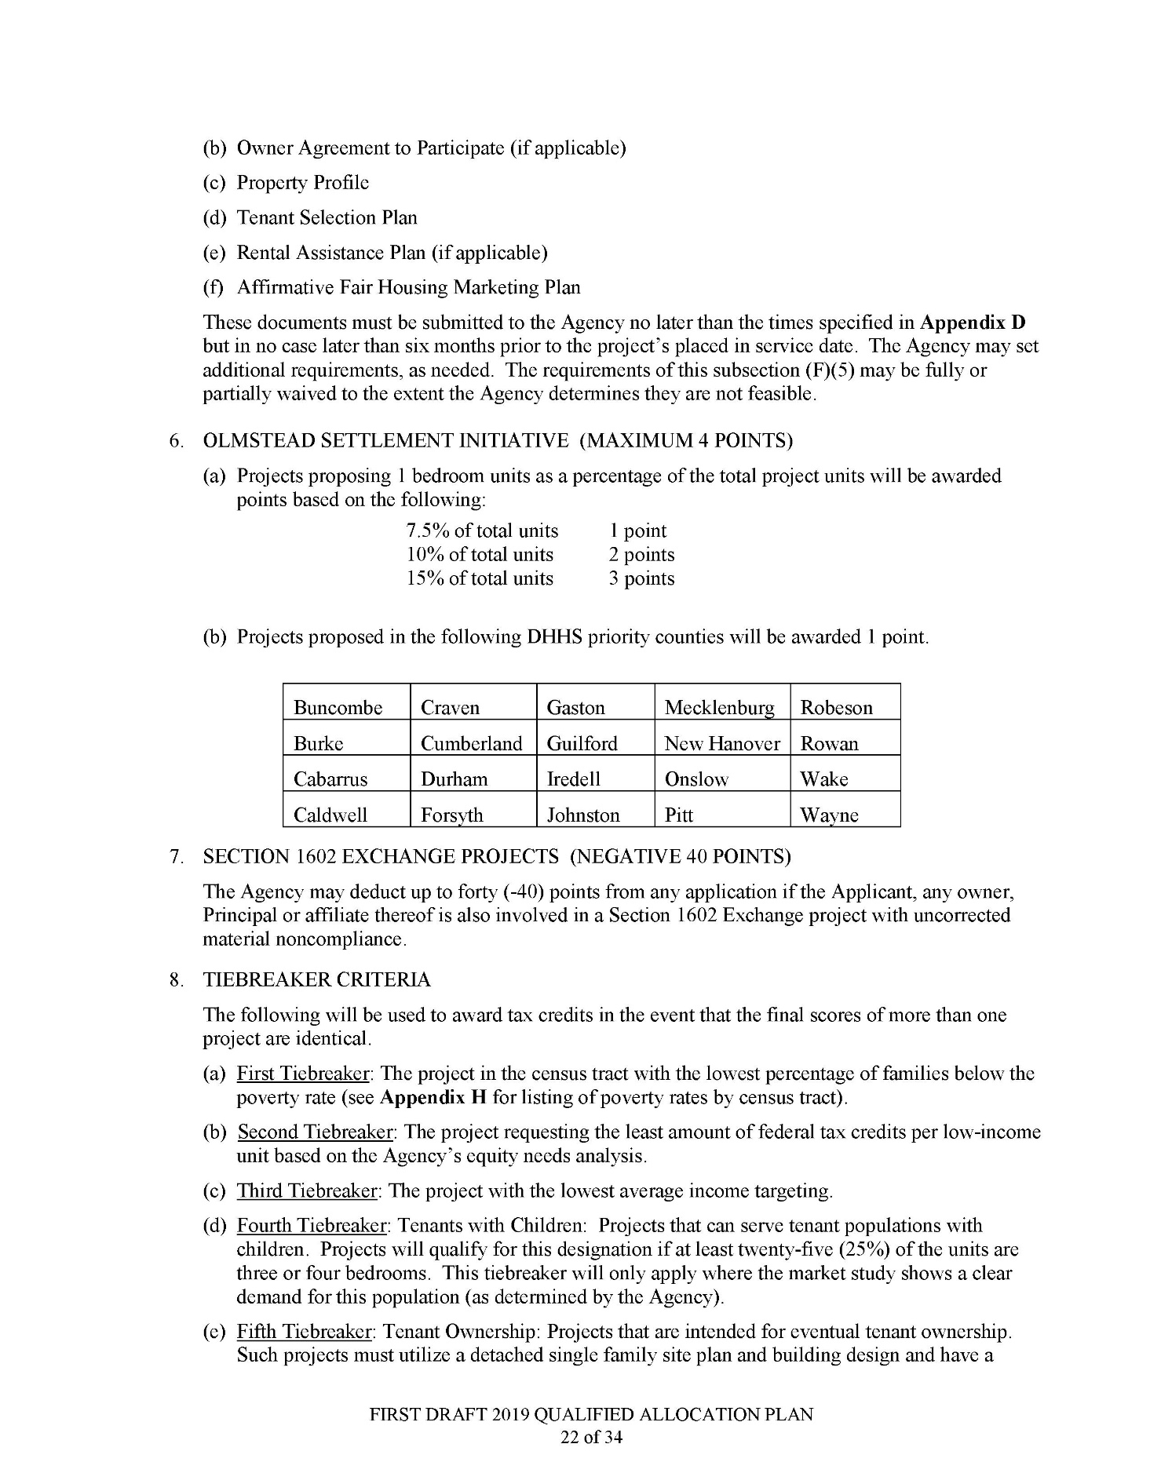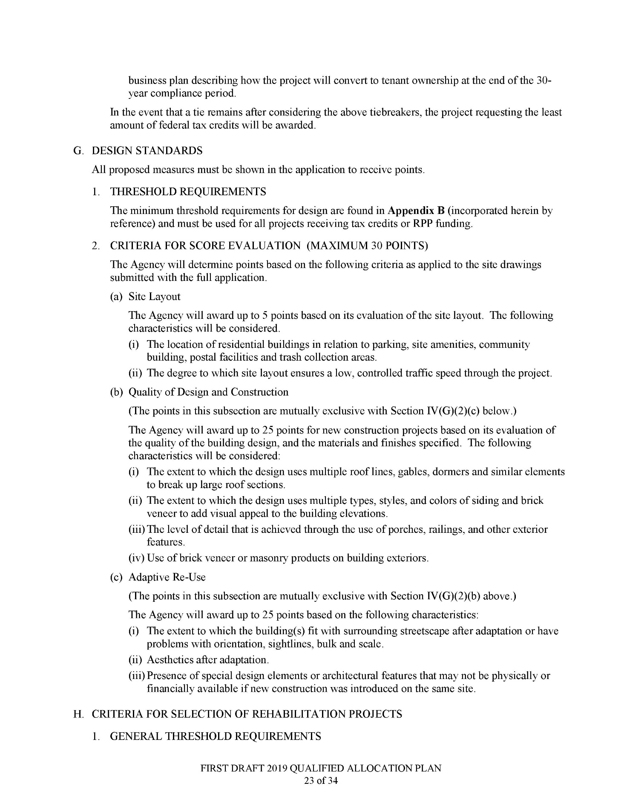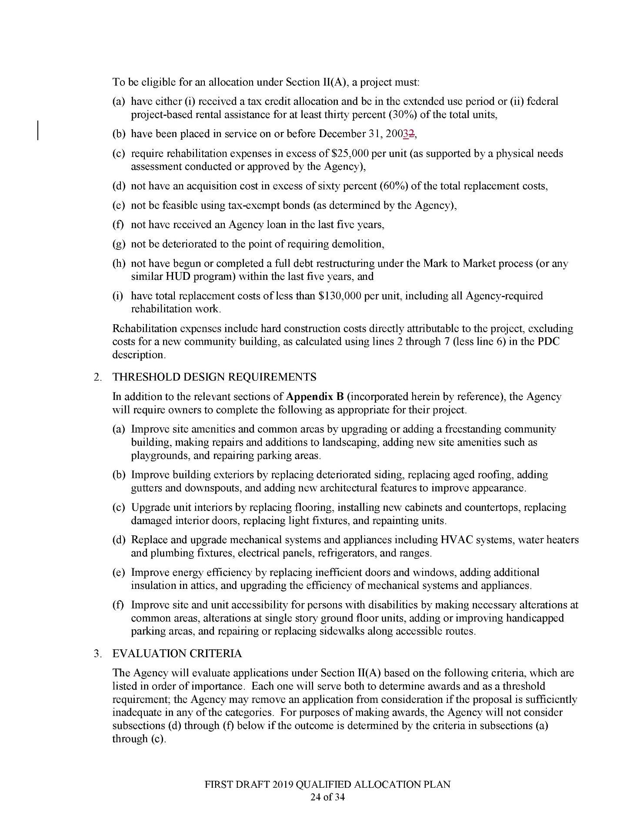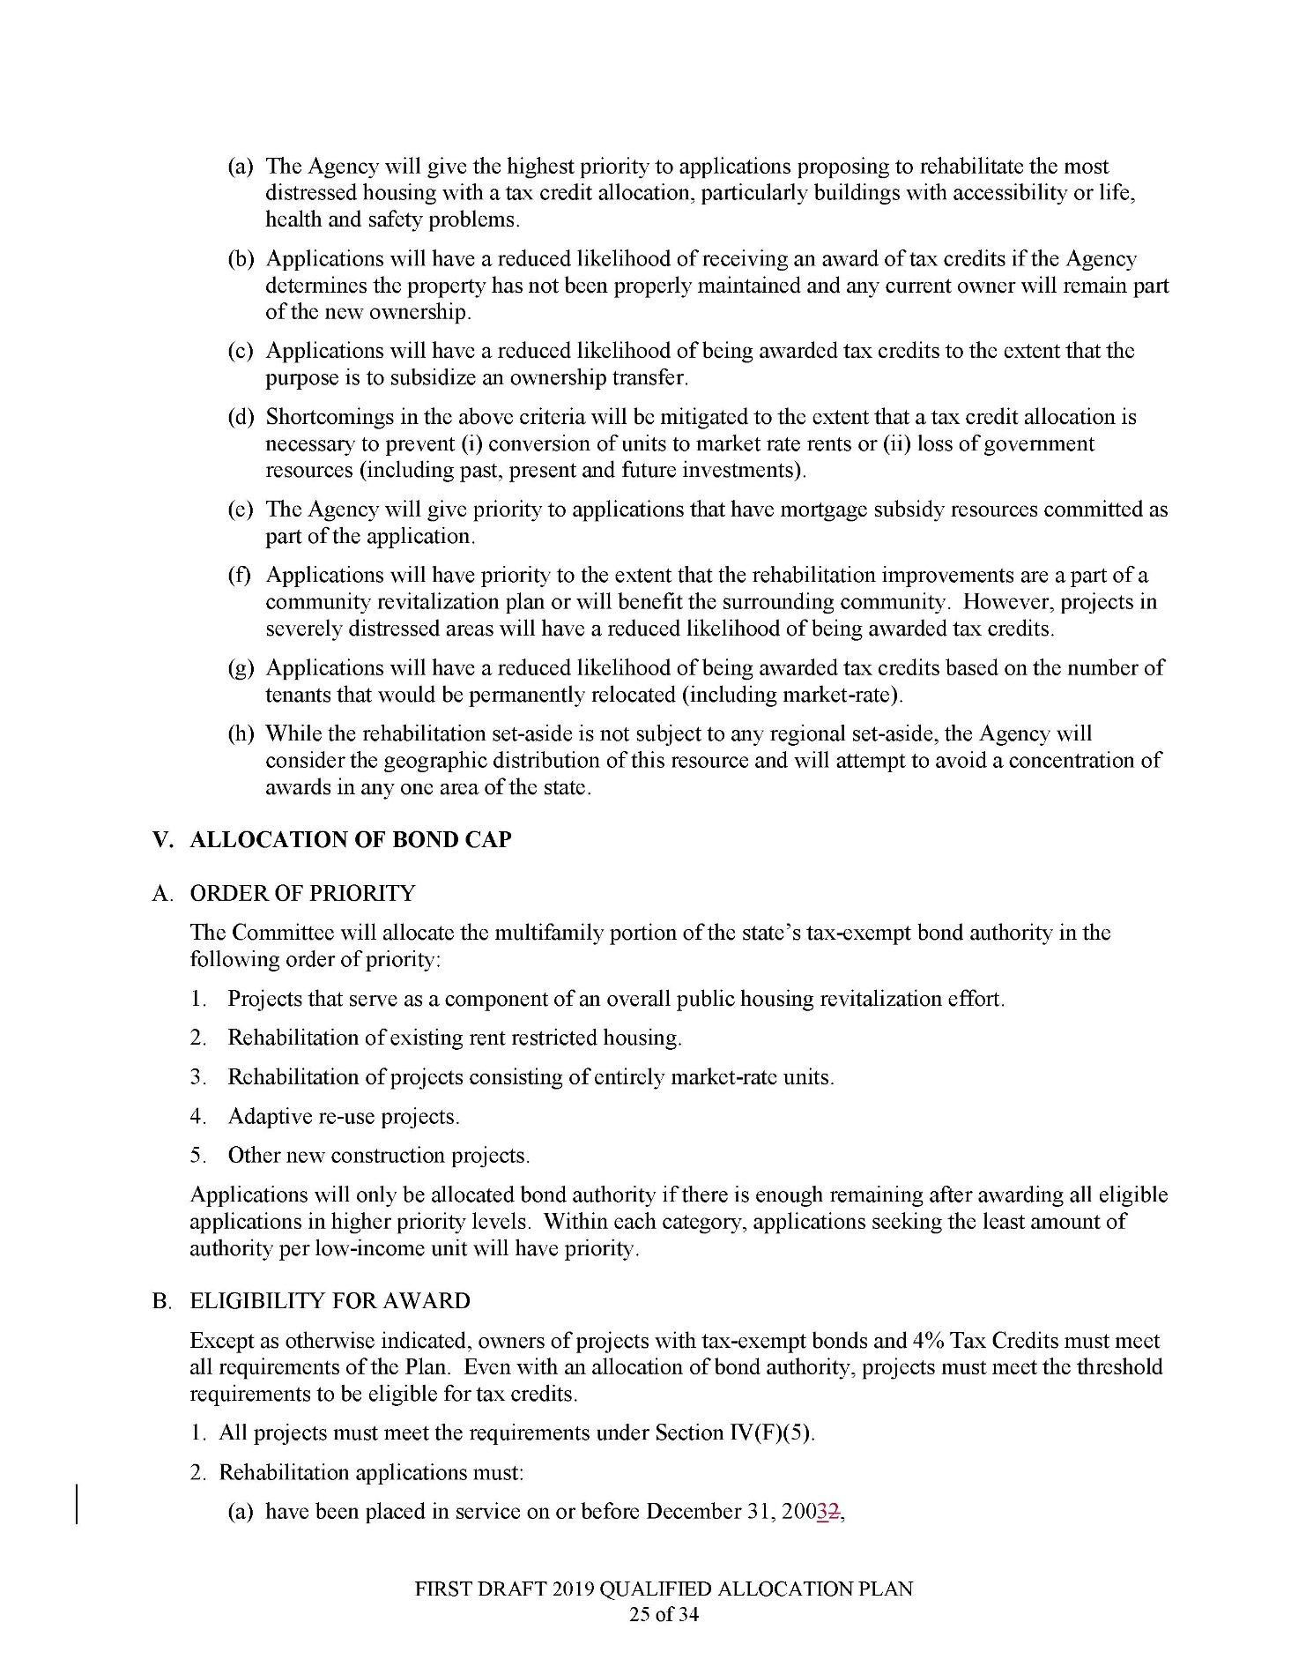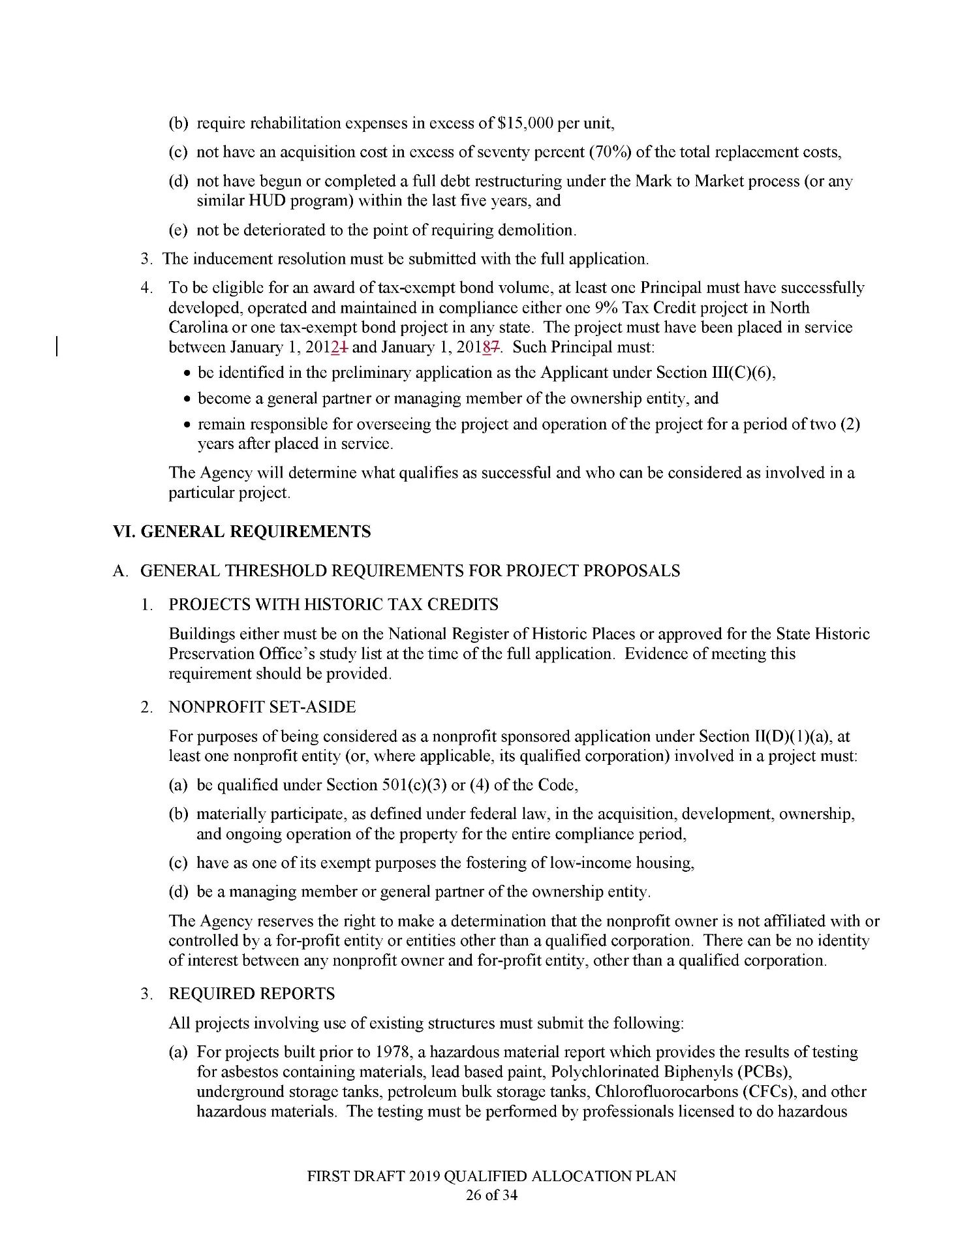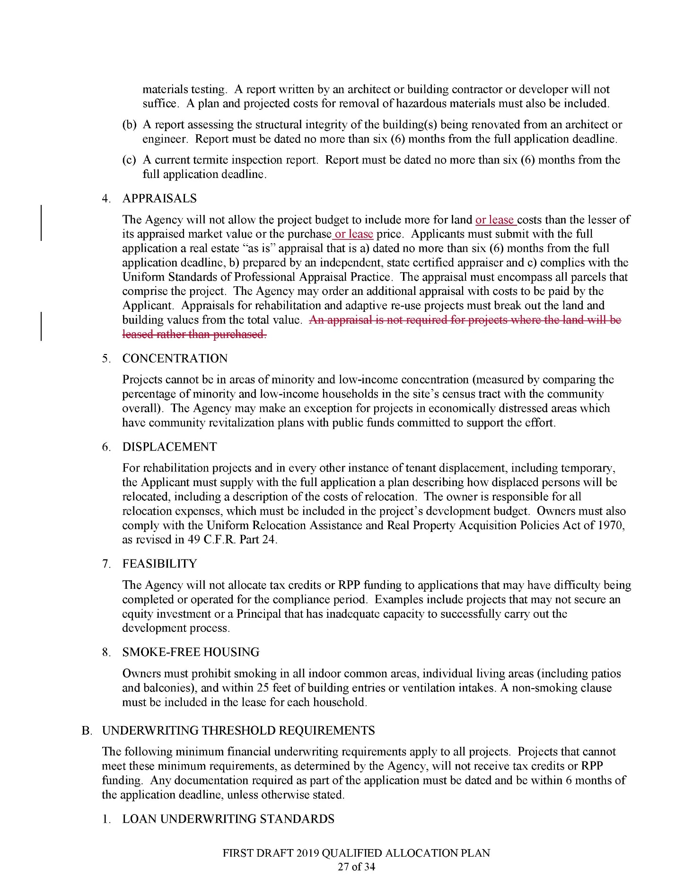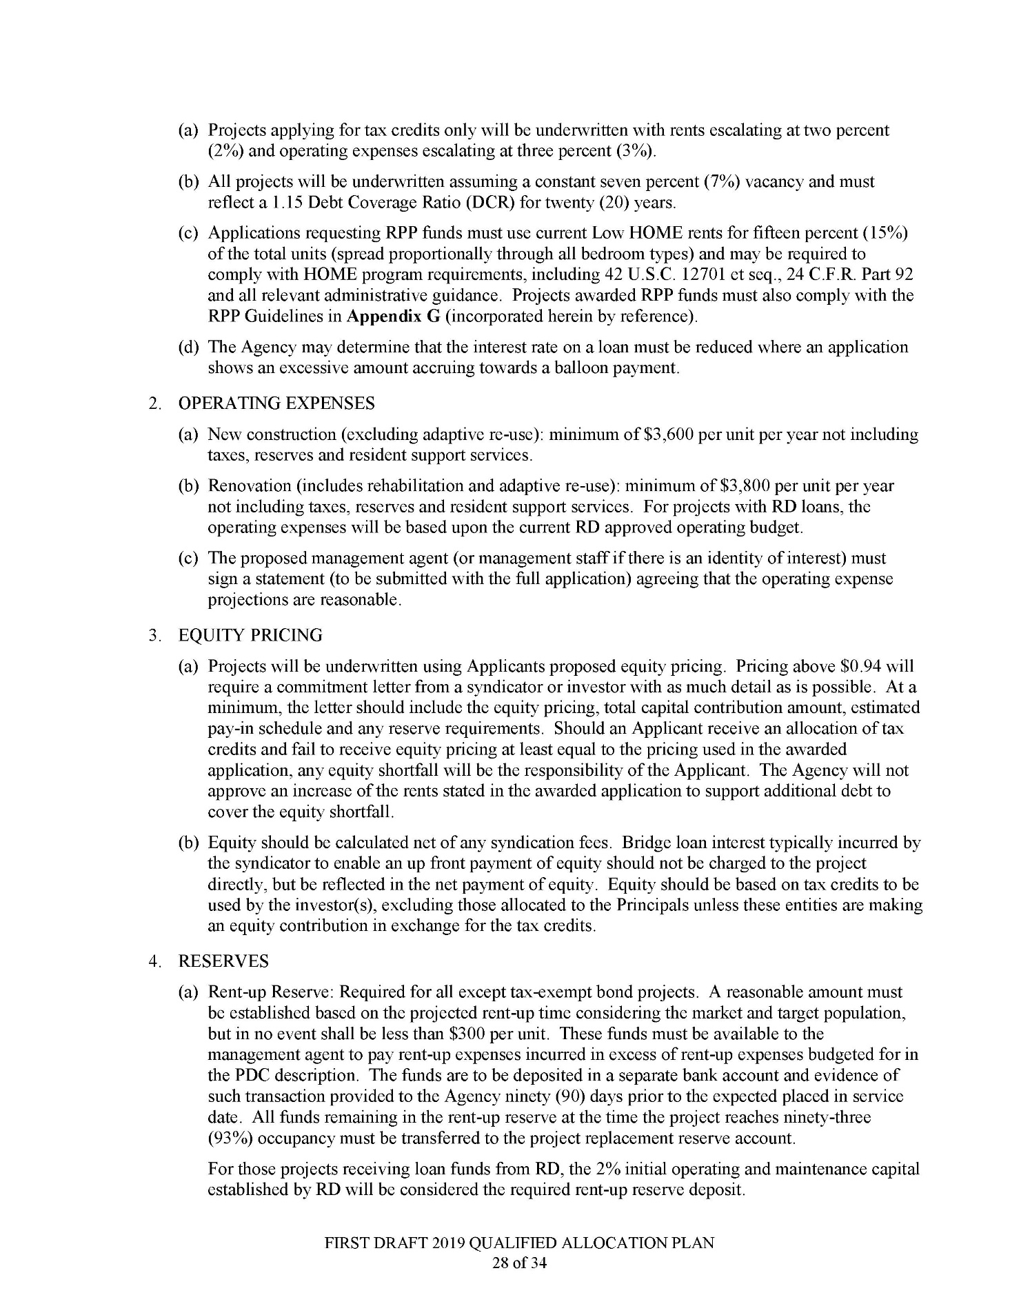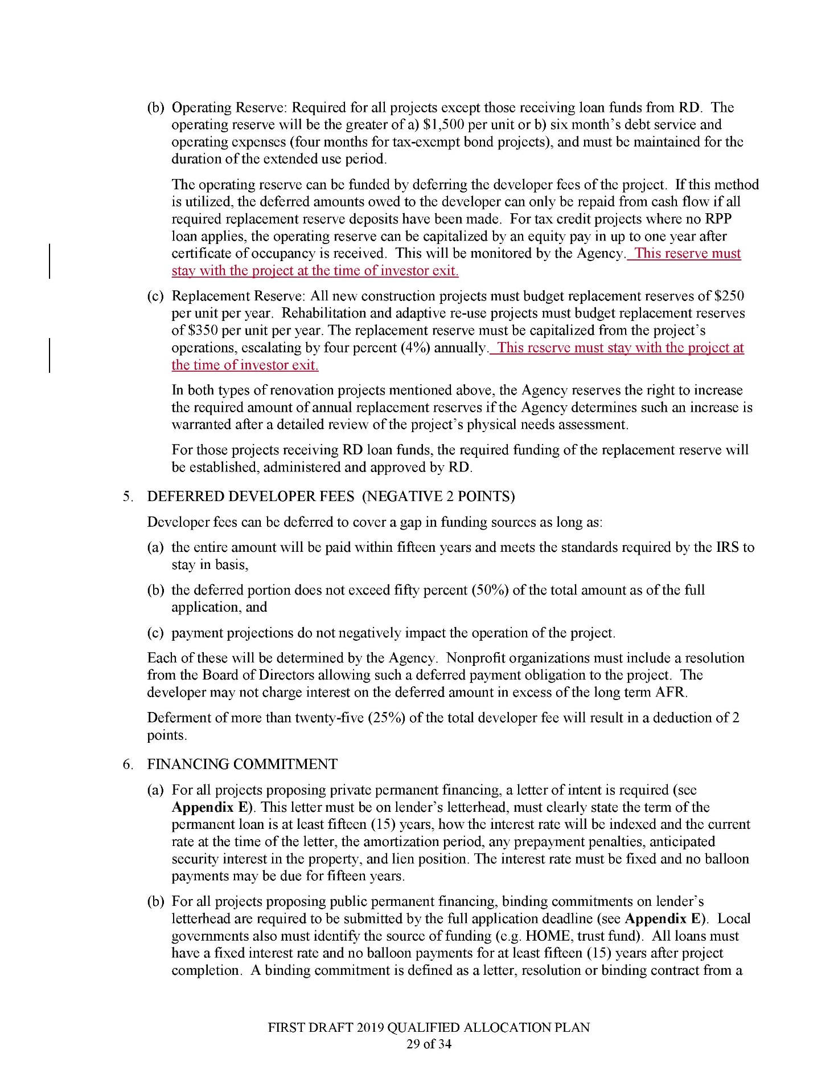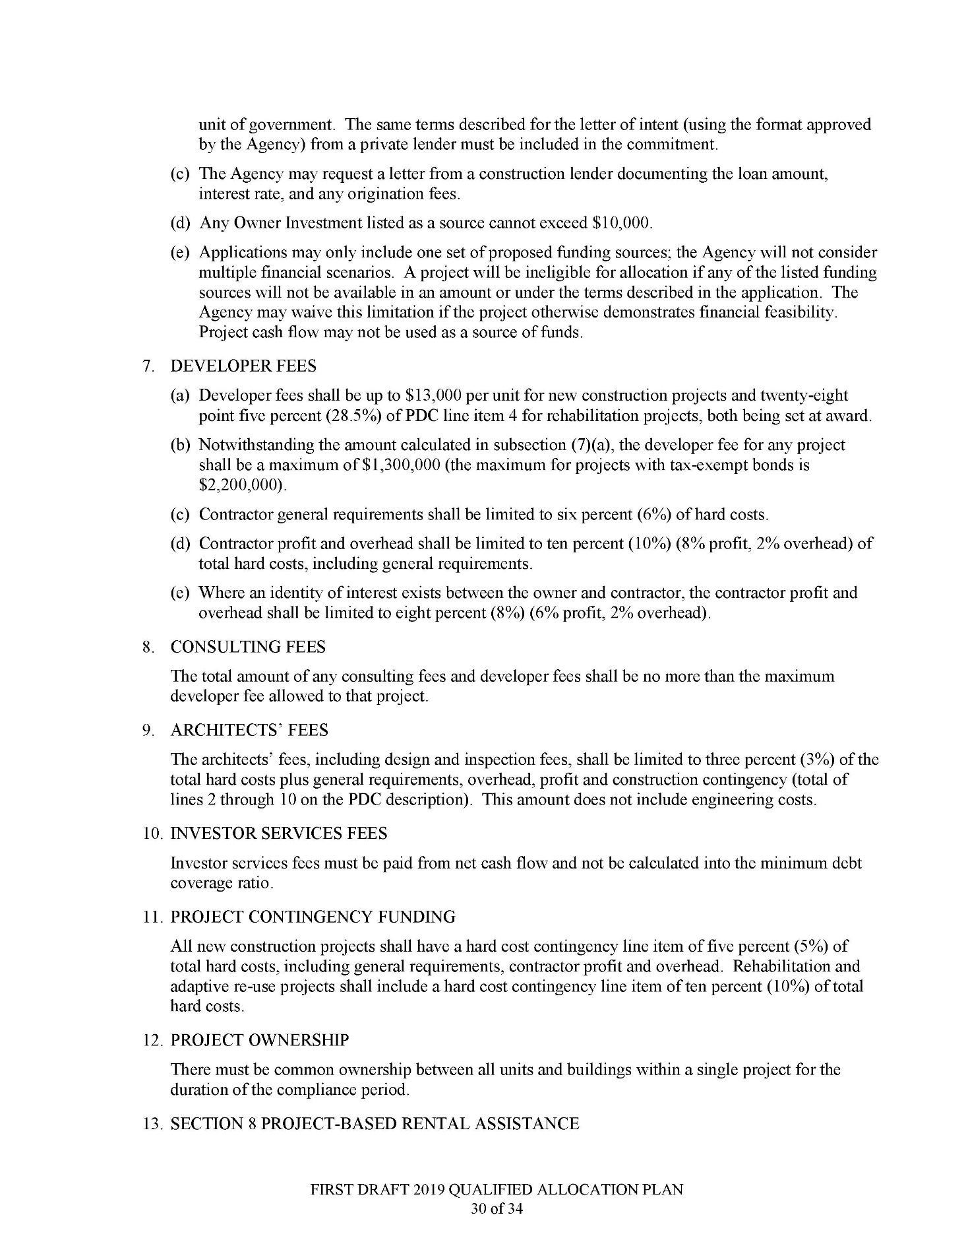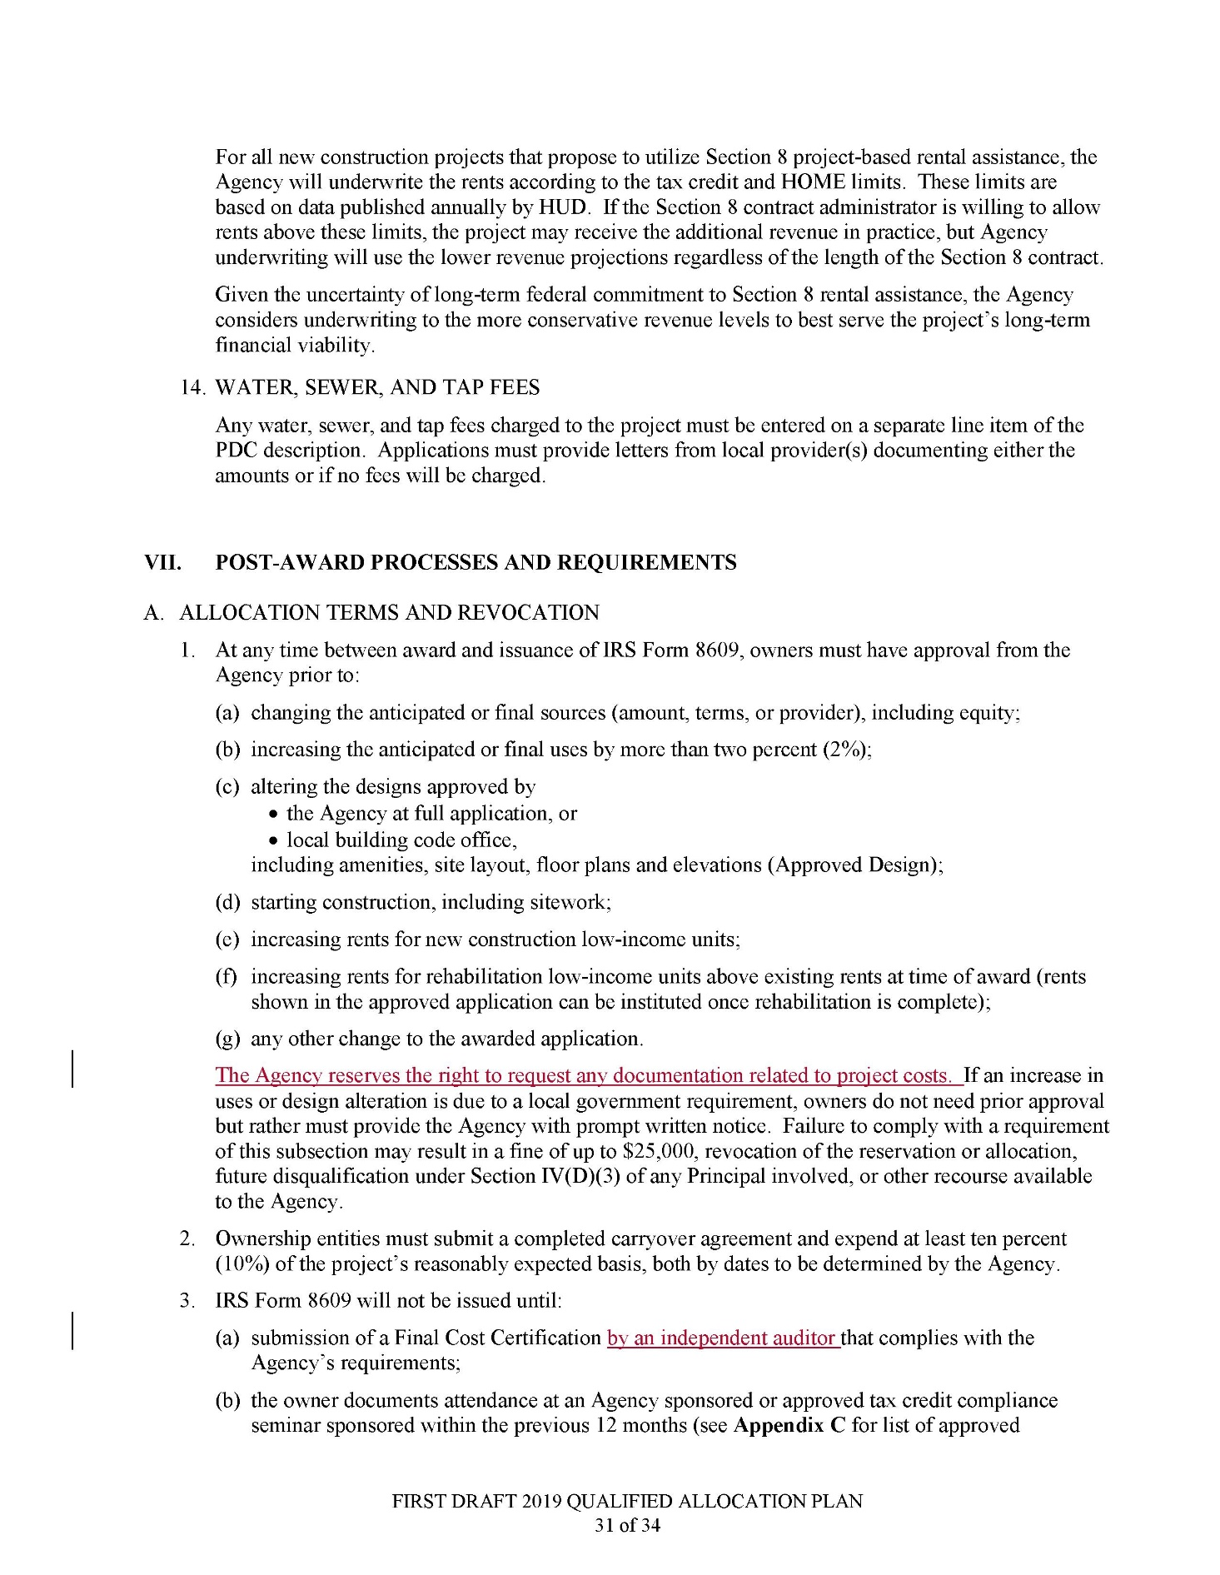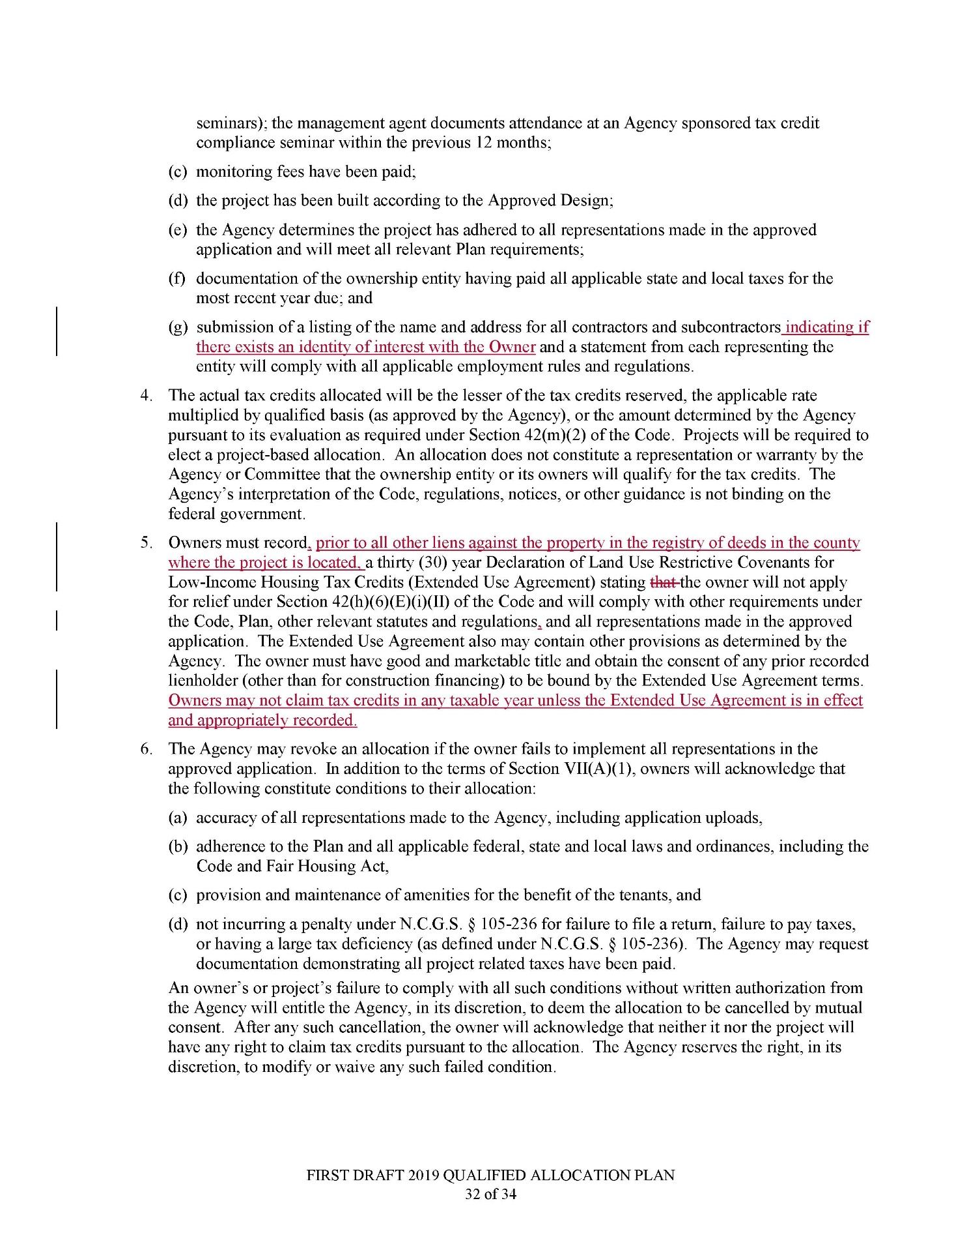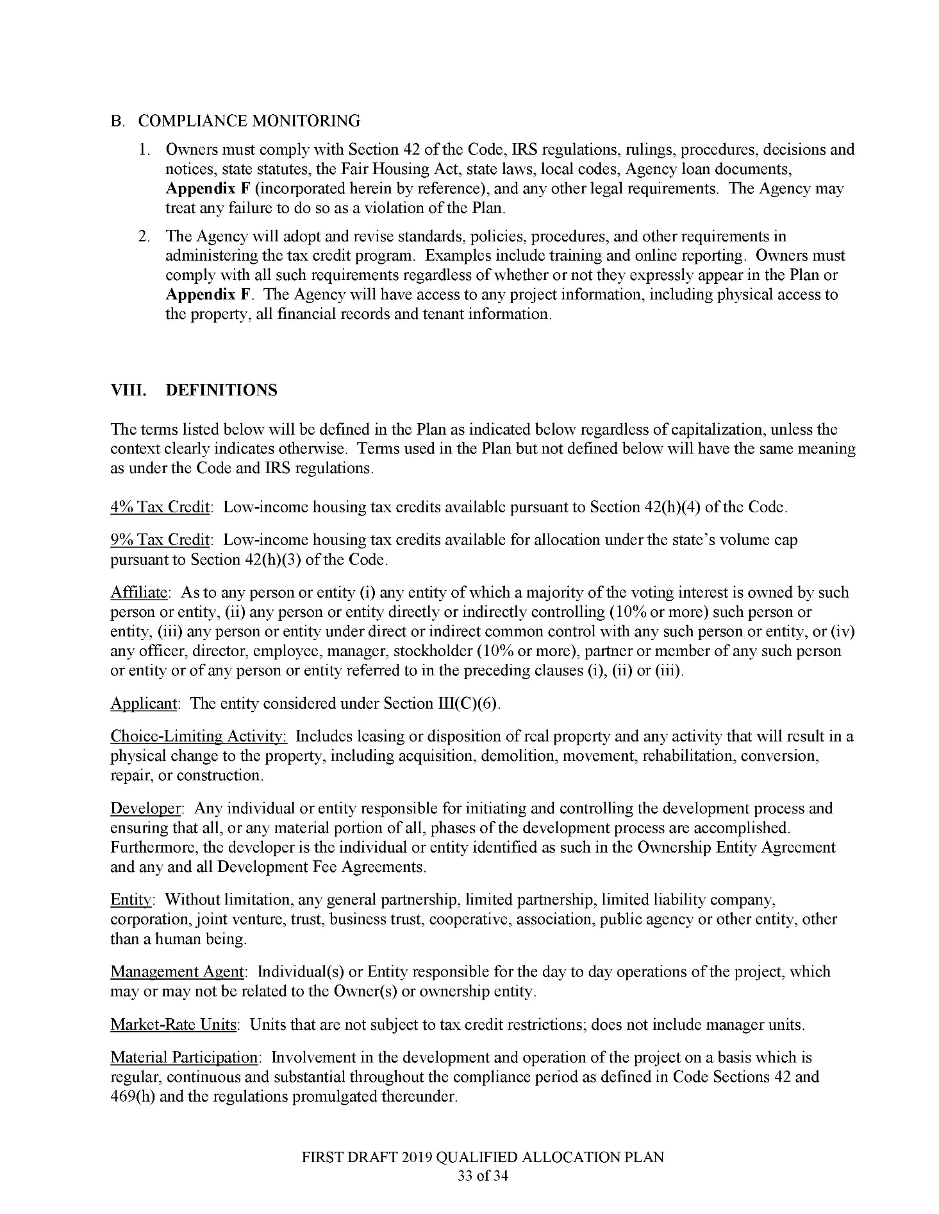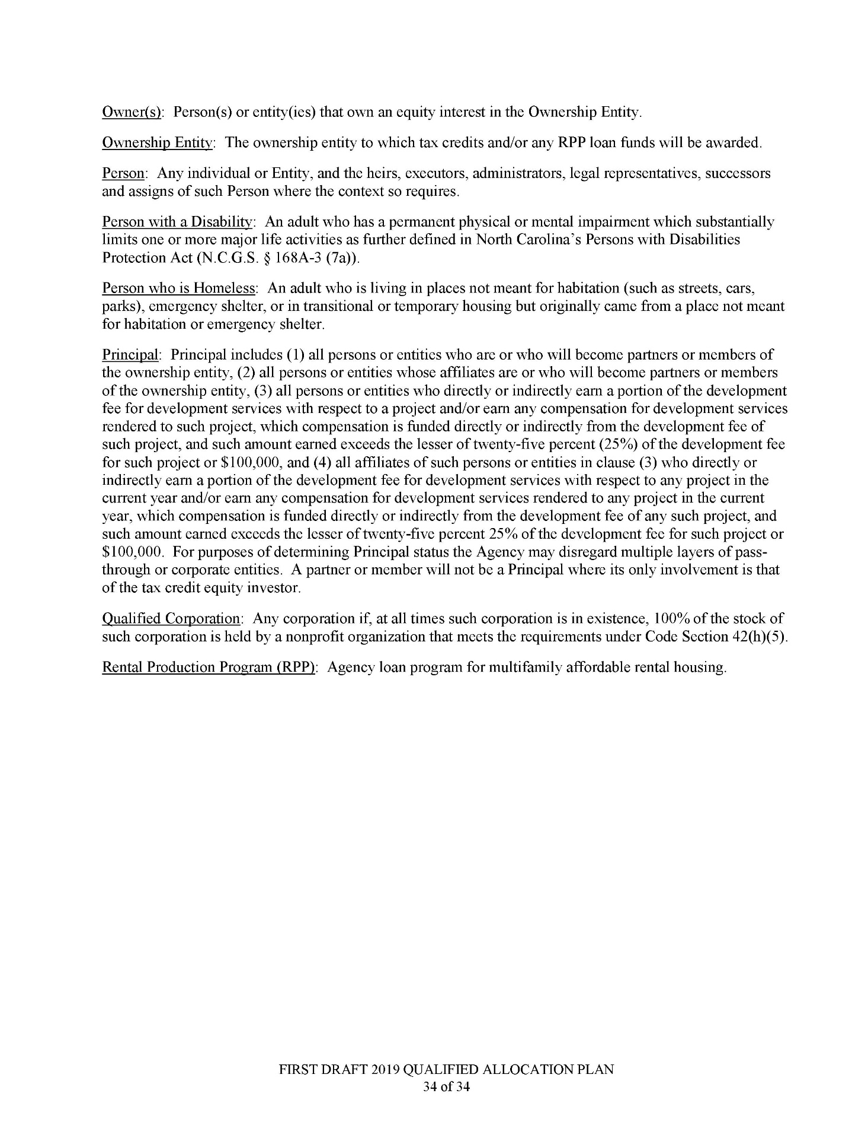

PUBLIC NOTICE
STATE OF NORTH CAROLINA
ENVIRONMENTAL MANAGEMENT COMMISSION

The Division of Energy, Mineral, and Land Resources (DEMLR) invites public comment on, or objections to, the following NPDES industrial stormwater General Permits to be revised and re-issued. The public comment period begins at 8:00 am on 9/4/2018 and ends at 5:00 pm on 10/5/2018.

Persons wishing to comment or object may submit written comments to the address below during the public comment period. All comments received during the public comment period will be considered in the final determinations regarding permit issuance. Public comments may result in changes to the proposed permitting actions. All comments should reference the specific permit number listed below.

- NCG010000 for Construction Activities subject to the NC Sediment Pollution Control Act (second draft of this permit), proposed issuance date 12/1/2018
- NCG250000 for Construction Activities not subject to the NC Sediment Pollution Control Act, proposed issuance date 12/1/2018
- NCG030000 for Metal Fabrication, proposed issuance date 11/1/2018
- NCG060000 for Food and Kindred, proposed issuance date 11/1/2018
- NCG080000 for Transit and Transportation, proposed issuance date 11/1/2018
- NCG090000 for Paints and Varnishes, proposed issuance date 11/1/2018
- NCG100000 for Used Motor Vehicles, proposed issuance date 11/1/2018
- NCG120000 for Landfills, proposed issuance date 11/1/2018
The General Permits and Fact Sheets may be viewed at: https://deq.nc.gov/news/events/public-notices-hearings

Please direct comments or objections to:

Annette Lucas
Stormwater Program
NC Division of Energy, Mineral, and Land Resources
1612 Mail Service Center
Raleigh, NC 27699-1612
Telephone Number: (919) 707-3639
annette.lucas@ncdenr.gov

Note from the Codifier: The notices published in this Section of the NC Register include the text of proposed rules. The agency must accept comments on the proposed rule(s) for at least 60 days from the publication date, or until the public hearing, or a later date if specified in the notice by the agency. If the agency adopts a rule that differs substantially from a prior published notice, the agency must publish the text of the proposed different rule and accept comment on the proposed different rule for 60 days.
Statutory reference: G.S. 150B-21.2.

TITLE 10A – DEPARTMENT OF HEALTH AND HUMAN SERVICES

Notice is hereby given in accordance with G.S. 150B-21.2 and G.S. 150B-21.3A(c)(2)g. that the Medical Care Commission intends to readopt with substantive changes the rules cited as 10A NCAC 13B .3102, .6101-.6103, and .6207.

Link to agency website pursuant to G.S. 150B-19.1(c): http://www2.ncdhhs.gov/dhsr/ruleactions.html

Proposed Effective Date: April 1, 2019

Public Hearing:

Date: October 17, 2018

Time: 10:00 a.m.

Location: Dorothea Dix Park, Brown Building, Room 104, 801 Biggs Drive, Raleigh, NC 27603

Reason for Proposed Action: Pursuant to G.S. 150B-21.3A, Periodic Review and Expiration of Existing Rules, all rules are reviewed at least every 10 years or they shall expire. As a result of the periodic review of subchapter 10A NCAC 13B, Licensing of Hospitals, these five proposed readoption rules were part of the 40 rules determined as "Necessary With Substantive Public Interest," thus requiring readoption. The proposed readoptions coordinate with the rule 10A NCAC 13B .6105 that incorporate by reference the "Guidelines for the Design and Construction of Hospitals and Outpatient Facilities" (FGI Guidelines), provide updates to reflect the current operating procedures of the DHSR Construction Section, clarify and remove ambiguity from the rules, and make technical and formatting changes in the rules.

Comments may be submitted to: Nadine Pfeiffer, 809 Ruggles Drive, 2701 Mail Service Center, Raleigh, NC 27699-2701; email DHSR.RulesCoordinator@dhhs.nc.gov

Comment period ends: November 5, 2018

Procedure for Subjecting a Proposed Rule to Legislative Review: If an objection is not resolved prior to the adoption of the rule, a person may also submit written objections to the Rules Review Commission after the adoption of the Rule. If the Rules Review Commission receives written and signed objections after the adoption of the Rule in accordance with G.S. 150B-21.3(b2) from 10 or more persons clearly requesting review by the legislature and the Rules Review Commission approves the rule, the rule will become effective as provided in G.S. 150B-21.3(b1). The Commission will receive written objections until 5:00 p.m. on the day following the day the Commission approves the rule. The Commission will receive those objections by mail, delivery service, hand delivery, or facsimile transmission. If you have any further questions concerning the submission of objections to the Commission, please call a Commission staff attorney at 919-431-3000.

Fiscal impact (check all that apply).

State funds affected

Environmental permitting of DOT affected

Analysis submitted to Board of Transportation

Local funds affected

Substantial economic impact (≥$1,000,000)

Approved by OSBM

No fiscal note required by G.S. 150B-21.4

No fiscal note required by G.S. 150B-21.3A(d)(2)

chapter 13 – medical care commission

subchapter 13b – licensing of hospital rules

section .3100 - procedure

10A ncac 13B .3102 PLAN APPROVAL

(a) For the purposes of this Rule, the Guidelines for the Design and Construction of Hospitals and Outpatient Facilities that is incorporated by reference in Rule .6105 of this Subchapter shall be referred to as the "FGI Guidelines."

(b) The definitions as set forth in Rule .6003 of this Subchapter shall apply to this Rule.

(a)(c) The facility design and construction shall be in accordance with the construction standards of the Division, the North Carolina Building Code, and local municipal codes. this Rule and the standards set forth in Sections .6000 through .6200 of this Subchapter.

(b) Submission of Plans:

(1) Before construction is begun, color marked plans and specifications covering construction of the new buildings, alterations or additions to existing buildings, or any change in facilities shall be submitted to the Division for approval.

(2) The Division shall review the plans and notify the licensee that said buildings, alterations, additions, or changes are approved or disapproved. If plans are disapproved the Division shall give the applicant notice of deficiencies identified by the Division.

(3) In order to avoid unnecessary expense in changing final plans, as a preliminary step, proposed plans in schematic form shall be submitted by the applicant to the Division for review.

(4) The plans shall include a plot plan showing the size and shape of the entire site and the location of all existing and proposed facilities.

(5) Plans shall be submitted in triplicate in order that the Division may distribute a copy to the Department of Insurance for review of North Carolina State Building Code requirements and to the Department of Environment and Natural Resources for review under state sanitation requirements.

(c)(d) Location: The site where the facility is located shall:

(1) The site for new construction or expansion shall be approved by the Division. Construction Section prior to the construction of a new facility or the construction of an addition to an existing facility;

(2) Hospitals shall be so located that they are free from noise from railroads, freight yards, main traffic arteries, and schools and children's playgrounds. playgrounds; and

(3) The site shall not be exposed to smoke, foul odors, or dust from industrial plants.

(4) The area of the site shall be sufficient to permit future expansion and to provide parking facilities.

(5) Available paved roads, water, sewage and power lines shall be taken into consideration in selecting the site.

(e) Prior to the construction of a new facility or the construction of an addition or alteration to an existing facility, the governing body shall submit paper copies of the following to the Construction Section for review and approval:

(1) one set of schematic design drawings;

(2) one set of design development drawings; and

(3) one set of construction documents and specifications.

(f) If the North Carolina State Building Code Administrative Code and Policies requires the North Carolina Department of Insurance to review and approve the construction documents and specifications, the governing body shall submit a copy of the construction documents and specifications to the North Carolina Department of Insurance.

(g) The governing body shall submit a functional program that complies with Section 1.2-2 Functional Program of the FGI Guidelines with each submittal cited in Paragraph (e) of this Rule.

(h) The governing body shall:

(1) prepare any component of the safety risk assessment required by Section 1.2-3 Safety Risk Assessment of the FGI Guidelines; and

(2) submit any component of the safety risk assessment prepared to the Construction Section with each submittal cited in Paragraph (e) of this Rule.

(i) In order to maintain compliance with the standards established in this Rule and Sections .6000 through .6200 of this Subchapter, the governing body shall obtain written approval from the Construction Section for any changes made during the construction of the facility in the same manner as set forth in Paragraph (e) of this Rule.

(j) Two weeks prior to the anticipated construction completion date, the governing body shall notify the Construction Section of the anticipated construction completion date in writing either by U.S. Mail at the Division of Health Service Regulation, Construction Section, 2705 Mail Service Center, Raleigh, NC, 27699-2705 or by e-mail at DHSR.Construction.Admin@dhhs.nc.gov.

(k) Construction documents and building construction, including the operation of all building systems, shall be approved in writing by the Construction Section prior to licensure or patient occupancy.

(l) When the Construction Section approves the construction documents and specifications, they shall provide the governing body with an approval letter. The Construction Section's approval of the construction documents and specifications shall expire 12 months after the issuance of the approval letter, unless the governing body has obtained a building permit for construction. If the Construction Section's approval has expired, the governing body may obtain a renewed approval of the construction documents and specifications from the Construction Section as follows:

(1) If the standards established in this Rule and Sections .6000 through .6200 of this Subchapter have not changed, the governing body shall request a renewed approval of the construction documents and specifications from the Construction Section.

(2) If the standards established in this Rule and Sections .6000 through .6200 of this Subchapter have changed, the governing body shall:
(A) submit revised construction documents and specifications meeting the current standards established in this Rule and Sections .6000 through .6200 of this Subchapter to the Construction Section; and
(B) obtain written approval of the revised construction documents and specifications from the Construction Section.

(d)(m) The bed capacity and services provided in a facility shall be in compliance with G.S. 131E, Article 9 regarding Certificate of Need. A facility shall be licensed for no more beds than the number for which required physical space and other required facilities are available. Neonatal Level II, III and IV beds are considered part of the licensed bed capacity. Level I bassinets are not considered part of the licensed bed capacity however, no more bassinets shall be placed in service than the number for which required physical space and other required facilities are available. Bassinets in a Neonatal Level I nursery as specified in Rule .6228 of this Subchapter shall not be included in a facility's bed capacity; however, no more bassinets shall be placed in service than the number allowed by the requirements set forth in Rule .6228 of this Subchapter. Beds in Neonatal Level II, III, and IV nurseries as specified in Rule .6228 of this Subchapter shall be included in a facility's bed capacity.

Authority G.S. 131E-77; 131E-79.

SECTION .6100 – GENERAL REQUIREMENTS

10A NCAC 13B .6101 GENERAL LIST OF REFERENCED CODES, RULES, REGULATIONS, AND STANDARDS

The design, construction, maintenance and operation of a facility shall be in accordance with those codes and standards listed in Rule .6102, LIST OF REFERENCED CODES AND STANDARDS of this Section, and codes, ordinances, and regulations enforced by city, county, or other state jurisdictions with the following requirements:
(1) Notify the Division when all construction or renovation has been completed, inspected and approved by the architect and engineer having responsibility, and the facility is ready for a final inspection. Prior to using the completed project, the facility shall receive from the Division written approval for use. The approval shall be based on an on-site inspection by the Division or by documentation as may be required by the Division;
(2) In the absence of any requirements by other authorities having jurisdiction, develop a master fire and disaster plan with input from the local fire department and local emergency management agency to fit the needs of the facility. The plan shall require:
(a) Training of facility employees in the fire plan implementation, in the use of fire-fighting equipment, and in evacuation of patients and staff from areas in danger during an emergency condition;
(b) Conducting of quarterly fire drills on each shift;
(c) A written record of each drill shall be on file at the facility for at least three years;
(d) The testing and evaluation of the emergency electrical system(s) once each year by simulating a utility power outage by opening of the main facility electrical breaker(s). Documentation of the testing and results shall be completed at the time of the test and retained by the facility for three years; and
(e) Disaster planning to fit the specific needs of the facility's geographic location and disaster history, with at least one documented disaster drill conducted each year.

For the purposes of the rules in this Subchapter, the following codes, rules, regulations, and standards are incorporated herein by reference including subsequent amendments and editions. Copies of these codes, rules, regulations, and standards may be obtained or accessed from the online addresses listed:
(1) the North Carolina State Building Codes with copies that may be purchased from the International Code Council online at http://shop.iccsafe.org/ at a cost of five hundred seventy-one dollars ($571.00) or accessed electronically free of charge at http://codes.iccsafe.org/North%20Carolina.html;
(2) 42 CFR Part 482.41, Condition of Participation: Physical Plant, that is incorporated herein by reference including all subsequent amendments and editions; however, Part 482.41(c)(1) shall not be incorporated by reference. Copies of this regulation may be accessed free of charge at https://www.gpo.gov/fdsys/pkg/CFR-2017-title42-vol5/xml/CFR-2017-title42-vol5-sec482-41.xml or purchased online at https://bookstore.gpo.gov/products/cfr-title-42-pt-482-end-code-federal-regulationspaper-201-7 for a cost of seventy-seven dollars ($77.00);
(3) the following National Fire Protection Association standards, codes, and guidelines with copies of these standards, codes, and guidelines that may be accessed electronically free of charge at https://www.nfpa.org/Codes-and-Standards/All-Codes-and-Standards/List-of-Codes-and-Standards or may be purchased online at https://catalog.nfpa.org/Codes-and-Standards-C3322.aspx for the costs listed:
(a) NFPA 22, Standard for Water Tanks for Private Fire Protection for a cost of fifty-four dollars ($54.00);
(b) NFPA 53, Recommended Practice on Materials, Equipment, and Systems Used in Oxygen-Enriched Atmospheres for a cost of fifty-three dollars ($53.00);
(c) NFPA 59A, Standard for the Production, Storage, and Handling of Liquefied Natural Gas for a cost of fifty-four dollars ($54.00);
(d) NFPA 255, Standard Method of Test of Surface Burning Characteristics of Building Materials for a cost of forty-two dollars ($42.00);
(e) NFPA 407, Standard for Aircraft Fuel Servicing for a cost of forty-nine dollars ($49.00);
(f) NFPA 705, Recommended Practice for a Field Flame Test for Textiles and Films for a cost of forty-two dollars ($42.00);
(g) NFPA 780, Standard for the Installation of Lightning Protection Systems for a cost of sixty-three dollars and fifty cents ($63.50);
(h) NFPA 801, Standard for Fire Protection for Facilities Handling Radioactive Materials for a cost of forty-nine dollars ($49.00); and
(i) Fire Protection Guide to Hazardous Materials for a cost of one hundred and thirty-five dollars and twenty-five cents ($135.25);
(4) 42 CFR Part 482.15 Condition of participation: Emergency preparedness with copies of this regulation that may be accessed free of charge at https://www.gpo.gov/fdsys/pkg/CFR-2017-title42-vol5/xml/CFR-2017-title42-vol5-sec482-15.xml or purchased online at https://bookstore.gpo.gov/products/cfr-title-42-pt-482-end-code-federal-regulationspaper-201-7 for a cost of seventy-seven dollars ($77.00);
(5) the "Rules Governing the Sanitation of Hospitals, Nursing Homes, Adult Care Homes, and Other Institutions" 15A NCAC 18A .1300 with copies of these rules that may be accessed electronically free of charge at http://reports.oah.state.nc.us/ncac/title%2015a%20-%20environmental%20quality/chapter%2018%20-%20environmental%20health/subchapter%20a/15a%20ncac%2018a%20.1301.pdf; and
(6) the rules for ambulatory surgical facilities in 10A NCAC 13C, Licensing of Ambulatory Surgical Facilities with copies of these rules that may be accessed electronically free of charge at http://reports.oah.state.nc.us/ncac/title%2010a%20-%20health%20and%20human%20services/chapter%2013%20-%20nc%20medical%20care%20commission/subchapter%20c/subchapter%20c%20rules.pdf.

Authority G.S. 131E-79.

10A NCAC 13B .6102 LIST OF REFERENCED CODES AND STANDARDS General

The following codes and standards are adopted by reference including subsequent amendments. Copies of these publications can be obtained from the various organizations at the addresses listed:
(1) The North Carolina State Building Code, current edition, all volumes including subsequent amendments. Copies of this code may be purchased from the N.C. Department of Insurance Engineering and Codes Division located at 410 North Boylan Avenue, Raleigh, NC 27603 at a cost of two hundred fifty dollars ($250.00).
(2) The National Fire Protection Association codes and standards listed in this Paragraph, current editions including subsequent amendments. Copies of these codes and standards may be obtained from the National Fire Protection Association, 1 Batterymarch Park, PO Box 9101, Quincy, MA 02269-9101 at the cost shown for each code or standard listed.
(a) 10 Portable Fire Extinguishers ($22.50)
(b) 12 Carbon Dioxide Extinguishing Systems ($20.25)
(c) 12A Halon 1301 Fire Extinguishing Systems ($22.25)
(d) 12B Halon 1211 Fire Extinguishing Systems ($20.25)
(e) 13 Installation of Sprinkler Systems ($28.50)
(f) 13D Installation of Sprinkler Systems in One- and

Two-Family Dwellings and Manufactured Homes ($20.25)
(g) 13R Installation of Sprinkler Systems in Residential

Occupancies up to and including Four Stories

in Height ($20.25)
(h) 14 Installation of Standpipe and Hose Systems ($20.25)
(i) 15 Water Spray Fixed Systems ($20.25)
(j) 17 Dry Chemical Extinguishing Systems ($20.25)
(k) 17A Wet Chemical Extinguishing Systems ($16.75)
(l) 20 Installation of Centrifugal Fire Pumps ($20.25)
(m) 22 Water Tanks for Private Fire Protection ($22.25)
(n) 25 Water-Based Fire Protection Systems ($22.25)
(o) 30 Flammable and Combustible Liquids Code ($22.25)
(p) 31 Installation of Oil-Burning Equipment ($20.25)
(q) 37 Stationary Combustion Engines and Gas Turbines ($16.75)
(r) 45 Fire Protection for Laboratories Using Chemicals ($20.25)
(s) 49 Hazardous Chemicals Data ($26.50)
(t) 50 Bulk Oxygen Systems at Consumer Sites ($16.75)
(u) 53 Fire Hazards in Oxygen-Enriched Atmospheres ($22.50)
(v) 54 National Fuel Gas Code ($26.50)
(w) 55 Compressed and Liquefied Gases in Portable Cylinders ($16.75)
(x) 58 Storage and Handling of Liquefied Petroleum Gases ($26.50)
(y) 59A Liquefied Natural Gas (LNG) ($20.25)
(z) 72 National Fire Alarm Code ($32.25)
(aa) 80 Fire Doors and Windows ($22.50)
(bb) 82 Incinerators, Waste and Linen Handling Systems

and Equipment ($16.75)
(cc) 88A Parking Structures ($16.75)
(dd) 90A Installation of Air Conditioning and Ventilating Systems ($20.25)
(ee) 90B Installation of Warm Air Heating and Air Conditioning

Systems ($16.75)
(ff) 92A Smoke-Control Systems ($20.25)
(gg) 92B Smoke Management Systems in Malls, Atria, Large Areas ($20.25)
(hh) 96 Ventilation Control and Fire Protection of Commercial

Cooking Operations ($20.25)
(ii) 99 Health Care Facilities ($32.25)
(jj) 99B Hypobaric Facilities ($20.25)
(kk) 101 Safety to Life from Fire in Buildings and Structures ($39.50)
(ll) 101M Alternative Approaches to Life Safety ($22.25)
(mm) 105 Smoke-Control Door Assemblies ($16.75)
(nn) 110 Emergency and Standby Power Systems ($20.25)
(oo) 111 Stored Electrical Energy Emergency and Standby

Power Systems ($16.75)
(pp) 204M Smoke and Heat Venting ($20.25)
(qq) 220 Types of Building Construction ($16.75)
(rr) 221 Fire Walls and Fire Barrier Walls ($16.75)
(ss) 241 Construction, Alteration, and Demolition Operations ($20.25)
(tt) 251 Fire Tests of Building Construction and Materials ($20.25)
(uu) 255 Test of Surface Burning Characteristics of Building

Materials ($16.75)
(vv) 321 Basic Classification of Flammable and Combustible

Liquids ($16.75)
(ww) 325 Fire Hazard Properties of Flammable Liquids, Gases,

and Volatile Solids ($22.25)
(xx) 407 Aircraft Fuel Servicing ($20.25)
(yy) 418 Roof-top Heliport Construction and Protection ($16.75)
(zz) 704 Identification of the Fire Hazards of Materials ($16.75)
(aaa) 705 Field Flame Test for Textiles and Films ($16.75)
(bbb) 780 Lightning Protection Code ($20.25)
(ccc) 801 Facilities Handling Radioactive Materials ($20.25)

(3) American Society of Heating, Refrigerating & Air Conditioning Engineers Inc., (ASHRAE) HVAC APPLICATIONS, current edition including subsequent amendments. Copies of this document may be obtained from the American Society of Heating, Refrigerating & Air Conditioning Engineers, Inc. at 1791 Tullie Circle NE, Atlanta, GA 30329 at a cost of one hundred nineteen dollars ($119.00).
(4) Rules and Statutes Governing the Licensure of Ambulatory Surgical Facilities, current edition including subsequent amendments. Copies of this document may be obtained from the N.C. Department of Health and Human Services, Division of Health Service Regulation, Licensure and Certification Section, 2711 Mail Service Center, Raleigh, NC 27699-2711 at a cost of three dollars ($3.00).

(a) A new facility or any addition or alteration to an existing facility whose construction documents were approved by the Construction Section on or after April 1, 2019 shall comply with the requirements provided in the codes, regulations, rules, and standards incorporated by reference in Items (1) through (3) of Rule .6101 of this Section. An existing facility whose construction documents were approved by the Construction Section prior to April 1, 2019 shall comply with the codes and standards incorporated by reference in Items (1) through (3) of this Rule that were in effect at the time construction documents were approved by the Construction Section.

(b) The facility shall develop and maintain an emergency preparedness program as required by 42 CFR Part 482.15 Condition of Participation: Emergency Preparedness. The emergency preparedness program shall be developed with input from the local fire department and local emergency management agency. Documentation required to be maintained by 42 CFR Part 482.15 shall be maintained at the facility for at least three years and shall be made available to the Division during an inspection upon request.

(c) The facility shall comply with the "Rules Governing the Sanitation of Hospitals, Nursing Homes, Adult Care Homes, and Other Institutions," 15A NCAC 18A .1300 of the North Carolina Division of Public Health, Environmental Health Services Section.

Authority G.S. 131E-79.

10A NCAC 13B .6103 APPLICATION OF PHYSICAL PLANT REQUIREMENTS equivalency AND Conflicts with REQUIREMENTS

The physical plant requirements for each facility shall be applied as follows:
(1) New construction shall comply with the requirements of Section .6000 of this Subchapter;
(2) Existing buildings shall meet licensure and code requirements in effect at the time of construction, alteration, or modification;
(3) New additions, alterations, modifications, and repairs shall meet the technical requirements of Section .6000 of this Subchapter, however, where strict conformance with current requirements would be impractical, the authority having jurisdiction may approve alternative measures where the facility can demonstrate to the Division's satisfaction that the alternative measures do not reduce the safety or operating effectiveness of the facility;
(4) Rules contained in Section .6000 of this Subchapter are minimum requirements and not intended to prohibit buildings, systems or operational conditions that exceed minimum requirements;
(5) Equivalency: Alternate methods, procedures, design criteria, and functional variations from the physical plant requirements, because of extraordinary circumstances, new programs, or unusual conditions, may be approved by the authority having jurisdiction when the facility can effectively demonstrate to the Division's satisfaction, that the intent of the physical plant requirements are met and that the variation does not reduce the safety or operational effectiveness of the facility; and
(6) Where rules, codes, or standards have any conflict, the most stringent requirement shall apply.

(a) The Division may grant an equivalency to allow an alternate design or functional variation from the requirements in Rule .3102 and the Rules contained in Sections .6000 through .6200 of this Subchapter. The equivalency may be granted by the Division if a governing body submits a written equivalency request to the Division that indicates the following:
(1) the rule citation and the rule requirement that will not be met;
(2) the justification for the equivalency;
(3) how the proposed equivalency meets the intent of the corresponding rule requirement; and
(4) a statement by the governing body that the equivalency request will not reduce the safety and operational effectiveness of the facility design and layout.

The governing body shall maintain a copy of the approved equivalence issued by the Division.

(b) If the rules, codes, or standards contained in this Subchapter conflict, the most restrictive requirement shall apply.

Authority G.S. 131E-79.

SECTION .6200 - CONSTRUCTION REQUIREMENTS

10A NCAC 13B .6207 OUTPATIENT SURGICAL FACILITIES

(a) When If a facility elects to share outpatient surgical facilities with inpatient surgical facilities, the outpatient operating room and support areas shall meet the same physical plant requirements as inpatient, general operating rooms and support areas. set forth in Sections .6000 through .6200 of this Subchapter.

(b) When If a facility elects to provide separate, non-sharable outpatient surgical facilities, the operating rooms and support areas shall meet the physical plant construction requirements of Outpatient Surgical Licensure requirements of set forth in 10A NCAC 13C .1400.

Authority G.S. 131E-79.

Title 11 - Department of Insurance

Notice is hereby given in accordance with G.S. 150B-21.2 that the Department of Insurance intends to amend the rule cited as 11 NCAC 20 .0101.

Link to agency website pursuant to G.S. 150B-19.1(c): http://www.ncdoi.com/LS/Rules.aspx

Proposed Effective Date: January 1, 2019

Public Hearing:

Date: October 9, 2018

Time: 10:00 a.m.

Location: 1st Floor Hearing Room, Room 131 (Albemarle Building) located at 325 N. Salisbury Street, Raleigh, NC 27603

Reason for Proposed Action: This rule is being submitted to reflect changes enacted in SL 2018-120, Part 4, Section 4.6(a). S.L. 2018-120 amends G.S. 58-50-56(a)(2) to allow preferred providers to receive reimbursement on an other than fee-for-services basis. As a result, it is necessary to amend 11 NCAC 20 .0101 to reflect this change.

Comments may be submitted to: Loretta Peach-Bunch, NC Department of Insurance, 1201 Mail Service Center, Raleigh, NC 27699-1201, phone 919-807-6004, email Loretta.peace-bunch@ncdoi.gov

Comment period ends: November 5, 2018

Procedure for Subjecting a Proposed Rule to Legislative Review: If an objection is not resolved prior to the adoption of the rule, a person may also submit written objections to the Rules Review Commission after the adoption of the Rule. If the Rules Review Commission receives written and signed objections after the adoption of the Rule in accordance with G.S. 150B-21.3(b2) from 10 or more persons clearly requesting review by the legislature and the Rules Review Commission approves the rule, the rule will become effective as provided in G.S. 150B-21.3(b1). The Commission will receive written objections until 5:00 p.m. on the day following the day the Commission approves the rule. The Commission will receive those objections by mail, delivery service, hand delivery, or facsimile transmission. If you have any further questions concerning the submission of objections to the Commission, please call a Commission staff attorney at 919-431-3000.

Fiscal impact (check all that apply).

State funds affected

Environmental permitting of DOT affected

Analysis submitted to Board of Transportation

Local funds affected

Substantial economic impact (≥$1,000,000)

Approved by OSBM

No fiscal note required by G.S. 150B-21.4

Chapter 20 - Managed Care Health Benefit Plans

SECTION .0100 - MANAGED CARE DEFINITIONS

11 NCAC 20 .0101 SCOPE AND DEFINITIONS

(a) Scope.

(1) Sections .0200, .0300, and .0400 of this Chapter apply to HMOs, licensed insurers offering PPO benefit plans, and any other entity that falls under the definition of "network plan carrier".

(2) Sections .0500 and .0600 of this Chapter apply only to HMOs.

(3) Nothing in this Chapter applies to service corporations offering benefit plans under G.S. 58-65-25 or G.S. 58-65-30 that do not have any differences in copayments, coinsurance, or deductibles based on the use of network versus non-network providers.

(b) Definitions. As used in this Chapter:

(1) "Carrier" means a network plan carrier.

(2) "Health care provider" means any person who is licensed, registered, or certified under Chapter 90 of the General Statutes; or a health care facility as defined in G.S. 131E-176(9b); or a pharmacy.

(3) "Health maintenance organization" or "HMO" has the same meaning as in G.S. 58-67-5(f).

(4) "Intermediary" or "intermediary organization" means any entity that employs or contracts with health care providers for the provision of health care services, and that also contracts with a network plan carrier or its intermediary.

(5) "Member" means an individual who is covered by a network plan carrier.

(6) "Network plan carrier" means an insurer, health maintenance organization, or any other entity acting as an insurer, as defined in G.S. 58-1-5(3), that provides reimbursement or provides or arranges to provide health care services; and uses increased copayments, deductibles, or other benefit reductions for services rendered by non-network providers to encourage members to use network providers.

(7) "Network provider" means any health care provider participating in a network utilized by a network plan carrier.

(8) "PPO benefit plan" means a benefit plan that is offered by a hospital or medical service corporation or network plan carrier, under G.S. 58-50-56, in which plan:
(A) either or both of the following features are present:
(i) utilization review or quality management programs are used to manage the provision of covered services;
(ii) enrollees are given incentives via benefit differentials to limit the receipt of covered services to those furnished by participating providers;
(B) health care services are provided by participating providers who are paid on negotiated or discounted fee-for-service bases; and bases or have agreed to accept special reimbursement or other terms for health care services under a contract with the hospital or medical service corporation or network plan carrier.
(C) there is no transfer of insurance risk to health care providers through capitated payment arrangements, fee withholds, bonuses, or other risk-sharing arrangements.

(9) "Preferred provider" has the same meaning as in G.S 58-50-56 and 58-65-1.

(10) "Provider" means a health care provider.

(11) "Quality management" means a program of reviews, studies, evaluations, and other activities used to monitor and enhance quality of health care and services provided to members.

(12) "Service area" means the geographic area in North Carolina as described by the HMO pursuant to G.S. 58-67-10(c)(11) in which an HMO enrolls persons who either work in the service area, reside in the service area, or work and reside in the service and as approved by the Commissioner pursuant to G.S. 58-67-20.

(13) "Service corporation" means a medical or hospital service corporation operating under Article 65 of Chapter 58 of the General Statutes.

(14) "Single service HMO" means an HMO that undertakes to provide or arrange for the delivery of a single type or single group of health care services to a defined population on a prepaid or capitated basis, except for a member's responsibility for non-covered services, coinsurance, copayments, or deductibles.

(15) "Utilization review" means those methodologies used to improve the quality and maximize the efficiency of the health care delivery system through review of particular instances of care, including, whenever performed, precertification, concurrent review, discharge planning, and retrospective review.

Authority G.S. 58-2-40(1); 58-50-50; 58-50-55; 58-65-1; 58-65-140; 58-67-150.

TITLE 14B – DEPARTMENT OF Public safety

Notice is hereby given in accordance with G.S. 150B-21.2 that the Alcoholic Beverage Control Commission intends to adopt the rules cited as 14B NCAC 15A .2301-.2307.

Link to agency website pursuant to G.S. 150B-19.1(c): www.abc.nc.gov

Proposed Effective Date: January 1, 2019

Public Hearing:

Date: October 10, 2018

Time: 10:00 a.m.

Location: ABC Commission Hearing Room, 400 East Tryon Road, Raleigh, NC 27610

Reason for Proposed Action: To adopt permanent rules regulating the possession, transportation and uses of homemade alcoholic beverages as set forth in G.S. 18B-306, as necessitated by S.L 2017-87, Section 10.

Comments may be submitted to: Walker Reagan, 400 East Tryon Road, Raleigh, NC 27610, phone (919)779-8367, fax (919)661-6165, email walker.reagan@abc.nc.gov

Comment period ends: November 5, 2018

Procedure for Subjecting a Proposed Rule to Legislative Review: If an objection is not resolved prior to the adoption of the rule, a person may also submit written objections to the Rules Review Commission after the adoption of the Rule. If the Rules Review Commission receives written and signed objections after the adoption of the Rule in accordance with G.S. 150B-21.3(b2) from 10 or more persons clearly requesting review by the legislature and the Rules Review Commission approves the rule, the rule will become effective as provided in G.S. 150B-21.3(b1). The Commission will receive written objections until 5:00 p.m. on the day following the day the Commission approves the rule. The Commission will receive those objections by mail, delivery service, hand delivery, or facsimile transmission. If you have any further questions concerning the submission of objections to the Commission, please call a Commission staff attorney at 919-431-3000.

Fiscal impact (check all that apply).

State funds affected

Environmental permitting of DOT affected

Analysis submitted to Board of Transportation

Local funds affected

Substantial economic impact (≥$1,000,000)

Approved by OSBM

No fiscal note required by G.S. 150B-21.4

CHAPTER 15 – ALCOHOLIC BEVERAGE CONTROL COMMISSION

SUBCHAPTER 15A - ORGANIZATIONAL RULES: POLICIES AND PROCEDURES

section .2300 – Homemade wine and malt beverage events

14B NCAC 15A .2301 homemade wine and malt beverage events

As used in this Section:
(1) "Competition" means, as the term is used in G.S. 18B-306, a gathering or activity organized by homemakers at which homemade product is entered to be judged, that is either:
(a) sanctioned by a national or international beer or wine judging program; or
(b) judged by individuals of whom at least 50 percent are currently certified as judges by a national or international beer or wine judging program.
(2) "Contest" means, as the term is used in G.S. 18B-306, a gathering or activity organized by a homemaker club at which homemade product of members of the club is entered to be judged.
(3) "Exhibition" means, as the term is used in G.S. 18B-306, a gathering or activity at which homemade product produced by multiple homemakers is displayed or shown, but is not consumed or judged.
(4) "Event" includes an organized affair, exhibition, or competition.
(5) "Family" means a spouse, lineal descendant, ancestor, sibling, spouse's lineal descendant, spouse's ancestor, spouse's sibling, and the spouse of any of these individuals.
(6) "General public" means any individual not a homemaker, a homemaker's family, or a guest.
(7) "Guest" means an individual known to the homemaker or the homemaker's family who is invited to the event by direct contact, including in person or by telephone, mail, or electronic mail, between the individual and the homemaker or the homemaker's family, and that person's personal guest.
(8) "Homemade product" means wine or malt beverages produced pursuant to G.S. 18B-306.
(9) "Homemaker" means a person who makes homemade product.
(10) "Homemaker club" means an organization devoted to homemade product that:
(a) has a defined membership with a stated common purpose;
(b) levies an annual membership fee, separate from any admission or cover charge, that shall be collected from each member whose dues shall not be more than 30 days past due;
(c) has a written policy for granting membership that includes a written application submitted by each member; and
(d) maintains a list of all active members and their complete addresses that is present at all organized affairs of the club and is open to inspection by alcohol law-enforcement agents upon request.
(11) "Organized affair" means, as the term is used in G.S. 18B-306, a gathering or activity, other than a competition or exhibition, organized in whole or part by homemakers that includes as one of its purposes tasting or judging of homemade product. An organized affair includes meetings of a homemaker club, and a home product production educational meeting that meets the requirements of Rule .2305 of this Section, if tasting of homemade product is included as part of the meeting.
(12) "Tasting" means, as the term is used in G.S. 18B-306, a gathering or activity at which samples of one or more home products are given for immediate consumption by a homemaker to another homemaker, that homemaker's family, or that homemaker's guest or to registered attendees at a home product production education meeting in accordance with the requirements of Rule .2305 of this Section.

Authority G.S. 18B-100; 18B-207; 18B-306.

14b NCAC 15A .2302 COMPETITIONS

(a) Consumption of homemade products at a competition, other than at a private residence, shall be limited to judges of the competition, as defined by a national or international beer or wine judging program, who are identified in advance of the competition. Judges may enter their homemade product in competitions in which they judge provided they do not judge any competition category in which they have entries. A competition may be limited to invitees or open to the general public, except as prohibited in Paragraph (d) of this Rule.

(b) A competition may be held on a premise holding a retail ABC permit if the following conditions are met:

(1) the competition shall be segregated from the remainder of the premises in a separate room with closable doors from the portion of the premises where food or beverages are served to the general public during the time of the event;

(2) no homemade product shall be consumed outside of the homemade product consumption area designated pursuant to Subparagraph (1) of this Paragraph during the times any portion of the retail premises is open to the general public;

(3) the retail permittee shall only provide or offer commercial alcoholic products to participants in the competition at the same rate and method as offered to the general public at any other times of that business day that the permittee is authorized to sell; and

(4) homemade product for the competition shall not be stored on permitted premises for more than 48 hours prior to the competition, and the homemade product is sealed, labeled as "homemade product for competition entry," and segregated from other alcoholic beverages located on the premises. No homemade product shall remain on the permitted premises the day after the conclusion of the competition. All containers of homemade product left on the permitted premises contrary to the provisions of this Rule shall be disposed of by the permittee or the permittee's employee by making the homemade product unsuitable for, or incapable of, being consumed.

(c) A competition may be held on a premise holding a commercial ABC permit if the following conditions are met:

(1) the area for consumption of homemade product during a competition shall only be in the non-production portions of the permitted premises;

(2) the competition shall only be held on those portions of permitted premises that are not open to the public;

(3) no homemade product shall be consumed on the commercial permitted premises, except for judges, during the times any portion of the commercial premises is open to the general public; and

(4) homemade product for the competition shall not be stored on permitted commercial premises for more than 30 days prior to the competition, and the homemade product is sealed, labeled as "homemade product for competition entry," stored only in post-production areas that may also contained sealed alcoholic beverages produced by the commercial permittee, and segregated from other alcoholic beverages located on the premises. No homemade product shall remain on the permitted premises the day after the conclusion of the competition. All containers of homemade product left on the permitted premises contrary to the provisions of this Rule shall be disposed of by the permittee or the permittee's employee by making the homemade product unsuitable for, or incapable of, being consumed.

(d) Cash prizes may be paid to entrants in a competition from the registration fees collected so long as not all homemakers participating in the event share in the proceeds from the registration fees.

Authority G.S. 18B-100; 18B-207; 18B-306.

14B NCAC 15A .2303 eXHIBITIONS

(a) An exhibition may be open to the general public.

(b) An exhibition shall not be held at a private residence.

Authority G.S. 18B-100; 18B-207; 18B-306.

14B NCAC 15A .2304 ORGANIZED AFFAIRS

(a) Homemade product may be consumed at organized affairs provided that, if the affair is a contest, it is not sanctioned by a national or international beer or wine judging program and no admission fee is charged to attend, except as authorized pursuant to Rule .2305 of this Section. Consumption at organized affairs shall be limited to homemakers, their families, and their guests.

(b) All judges of a contest shall be members of the homemaker club or their guests. Prizes shall not be awarded as a result of the contest, but homemakers may be recognized for their homemade products.

(c) An organized affair may be held on a premise holding a retail ABC permit if the following conditions are met:

(1) the area for consumption of homemade product during an organized affair shall be segregated from the portion of the premises open to the general public during the time of the event by vertical boundaries that separate the private event from areas open for public consumption;

(2) no homemade product shall be consumed outside of the homemade product consumption area designated pursuant to Subparagraph (1) of this Paragraph during the times any portion of the retail premises is open to the general public;

(3) the retail permittee may sell or offer commercial alcoholic products the permittee is authorized to sell to persons attending the organized affair on the retail permittee's premises, provided that all alcoholic beverages offered to participants in the organized affair shall be at the same price and method as offered to the general public at any other times of that business day; and

(4) for an organized affair, homemade product may be stored on permitted premises for no more than 48 hours prior to the organized affair, provided that the homemade product shall be sealed, labeled as "homemade product for contest entry," and segregated from other alcoholic beverages located on the premises. No homemade product shall remain on the permitted premises the day after the conclusion of the organized affair. All containers of homemade product left on the permitted premises contrary to the provisions of this Rule shall be disposed of by the permittee or the permittee's employee, by making the homemade product unsuitable for, or incapable of, being consumed.

(d) An organized affair may not be held on a premise holding a commercial ABC permit.

(e) There shall be no admission or entrance fee charged for an organized affair occurring at a private residence.

Authority G.S. 18B-100; 18B-207; 18B-306.

14B NCAC 15A .2305 home product production education meeting

A home product production education meeting shall be an organized affair open only to dues paying members of a state, regional, national, or international homemade beer or wine organization that includes programs to educate and inform homemakers concerning the production of homemade products. Registration may be charged to participate in the educational portions of the program. In addition to educational programs, the home product production education meeting may include homemade product tastings by registered attendees of homemade product brought to the meeting by registered attendees. Commercial alcoholic products may be sold or offered at home product education meetings by a retail permittee, in addition to home products, provided that all commercial alcoholic products offered by the retail permittee to participants at the meeting shall be at the same price and method as offered to the general public at any other times of that business day.

Authority G.S. 18B-100; 18B-207; 18B-306.

14B NCAC 15A .2306 POSSESSION, CONSUMPTION, TRANSPORTATION, and disposition of homemade product

(a) Possession and consumption of homemade product shall be limited to persons who are 21 years of age or older. Homemade product shall not be offered, given to, or consumed by the general public.

(b) Except as limited by this Section, events may be held at locations where possession and consumption of malt beverages and unfortified wine are otherwise authorized by law.

(c) Homemade product shall remain in possession of the homemaker, except:

(1) at an exhibition; or

(2) when the homemade product is under the control of a retail permittee or a commercial permittee in accordance with Rules .2302 and .2304 of this Section.

Only a homemaker shall deliver that person's homemade product to the location of an event.

(d) A homemaker may transport quantities of homemade product up to the limits set forth in G.S. 18B-303(a), provided that the maximum aggregate amount of all homemade product transported by an individual homemaker at any one time for any one event shall not exceed 80 liters.

(e) All containers of homemade product remaining on non-permitted premises after the conclusion of an event, other than events held at a private residence, shall be removed from the premises or the contents of the container shall be disposed of by being made unsuitable for, or incapable of, being consumed at the conclusion of the event.

Authority G.S. 18B-100; 18B-207; 18B-306.

14B NCAC 15A .2307 admission fees

(a) No admission fee shall be charged to persons consuming homemade product.

(b) An admission or entrance fee may be charged for a competition, except that no fees shall be charged for a competition occurring at a private residence.

(c) An admission or entrance fee may be charged by the organizer of an exhibition.

(d) A registration fee may be charged to homemakers participating in a competition or home product production education meeting.

Authority G.S. 18B-100; 18B-207; 18B-306.

Title 21 – OCCUPATIONAL LICENSING BOARDS AND COMMISSIONS

CHAPTER 16 - BOARD OF DENTAL EXAMINERS

Notice is hereby given in accordance with G.S. 150B-21.3A(c)(2)g. and G.S. 150B-21.2(g) that the Board of Dental Examiners intends to readopt with substantive changes the rule cited as 21 NCAC 16P .0105 with changes from the proposed text noticed in the Register, Volume 32, Issue 21, pages 2274-2276.

Link to agency website pursuant to G.S. 150B-19.1(c): www.ncdentalboard.org

Proposed Effective Date: January 1, 2019

Public Hearing:

Date: October 11, 2018

Time: 6:30 p.m.

Location: 2000 Perimeter Park Drive, Suite 160, Morrisville, NC 27560

Reason for Proposed Action: The Board identified 21 NCAC 16P .0105 as a rule with substantive public interest during its periodic review of existing rules. The board seeks to readopt the rule with changes based upon comments received from the public. Proposed amendments were first published in Volume 32, Issue 21 of the North Carolina Register. The Board received additional comments from the public following publication and during the comment period, and now proposes additional changes.

Comments may be submitted to: Bobby D. White, Esq., 2000 Perimeter Park Drive, Suite 160, Morrisville, NC 27560

Comment period ends: November 5, 2018

Procedure for Subjecting a Proposed Rule to Legislative Review: If an objection is not resolved prior to the adoption of the rule, a person may also submit written objections to the Rules Review Commission after the adoption of the Rule. If the Rules Review Commission receives written and signed objections after the adoption of the Rule in accordance with G.S. 150B-21.3(b2) from 10 or more persons clearly requesting review by the legislature and the Rules Review Commission approves the rule, the rule will become effective as provided in G.S. 150B-21.3(b1). The Commission will receive written objections until 5:00 p.m. on the day following the day the Commission approves the rule. The Commission will receive those objections by mail, delivery service, hand delivery, or facsimile transmission. If you have any further questions concerning the submission of objections to the Commission, please call a Commission staff attorney at 919-431-3000.

Fiscal impact (check all that apply).

State funds affected

Environmental permitting of DOT affected

Analysis submitted to Board of Transportation

Local funds affected

Substantial economic impact (≥$1,000,000)

Approved by OSBM

No fiscal note required by G.S. 150B-21.4

No fiscal note required by G.S. 150B-21.3A(d)(2)

SUBCHAPTER 16P - ADVERTISEMENT OF DENTAL SERVICES

21 ncac 16p .0105 ADVERTISING AS A SPECIALIST

Only dentists who have successfully completed a postdoctoral course approved by the American Dental Association Commission on Accreditation in a specialty area recognized by the ADA or have been approved by one of the specialty examining Boards recognized by the ADA may announce a specialty practice and advertise as a specialist.

(a) A dentist shall not advertise or otherwise hold himself or herself out to the public as a specialist, or use any variation of the term, in an area of practice if the communication is false or misleading under Rule .0101 of this Section.

(b) It shall not be false or misleading for a dentist to hold himself or herself out to the public as a specialist in a practice area provided the dentist has completed a qualifying postdoctoral educational program in that area. A qualifying postdoctoral educational program is a postdoctoral advanced dental educational program accredited by an agency recognized by the U.S. Department of Education (U.S. DOE).

(c) A dentist who has not completed a qualifying postdoctoral educational program shall not advertise or otherwise hold himself or herself out to the public as a specialist, certified specialist, or board-certified specialist, or use any variation of those terms, unless she or he holds current certification by a qualifying specialty board or organization. The Board shall consider the following criteria in determining a qualifying specialty board or organization:

(1) the organization requires completion of a training program with training, documentation, and clinical requirements similar in scope and complexity to a qualifying postdoctoral educational program in the specialty or subspecialty field of dentistry in which the dentist seeks certification. Programs that require solely experiential training, continuing education classes, on-the-job training, or payment to the specialty board shall not constitute an equivalent specialty board;

(2) the organization requires all dentists seeking certification to pass a written or oral examination, or both, that tests the applicant's knowledge and skill in the specialty or subspecialty area of dentistry and includes a psychometric evaluation for validation;

(3) the organization has written rules on maintenance of certification and requires periodic recertification;

(4) the organization has written by-laws and a code of ethics to guide the practice of its members;

(5) the organization has staff to respond to consumer and regulatory inquiries; and

(6) the organization is recognized by another entity whose primary purpose is to evaluate and assess dental specialty boards and organizations.

(d) A dentist qualifying under Paragraph (c) of this rule and advertising or otherwise holding himself or herself out to the public as a "specialist," "certified specialist," or "board-certified specialist" shall disclose in the advertisement or communication the specialty board by which the dentist was certified and provide information about the certification criteria or where the certification criteria may be located.

(e) A dentist shall maintain documentation of either completion of a qualifying postdoctoral educational program or of his or her current specialty certification and provide the documentation to the Board upon request. Dentists shall maintain documentation demonstrating that the certifying board qualifies under the criteria in Subparagraphs (c)(1) through (6) of this Rule and provide the documentation to the Board upon request.

(f) Nothing in this Section shall be construed to prohibit a dentist who does not qualify as a specialist "specialist," "certified specialist" or "board certified specialist" under the preceding paragraph Paragraphs (b) or (c) of this Rule from restricting his or her practice to one or more specific areas of dentistry or from advertising the availability of his or her services. services, provided that Such such advertisements may do not, not however, include the terms "specialist," "specialty," or "specializing" "certified specialist," or "board-certified specialist," or any variation of those terms, and must state that the services advertised are to be provided by a general dentist.

Authority G.S. 90-41(a)(16),(17),(18); 90-48.

* * * * * * * * * * * * * * * * * * * *

CHAPTER 16 - BOARD OF DENTAL EXAMINERS

Notice is hereby given in accordance with G.S. 150B-21.2 and G.S. 150B-21.3A(c)(2)g. that the Board of Dental Examiners intends to adopt the rule cited as 21 NCAC 16T. 0103 and readopt with substantive changes the rule cited as 21 NCAC 16T .0101.

Link to agency website pursuant to G.S. 150B-19.1(c): www.ncdentalboard.org

Proposed Effective Date: January 1, 2019

Public Hearing:

Date: October 11, 2018

Time: 6:30 p.m.

Location: 2000 Perimeter Park Drive, Suite 160, Morrisville, NC 27560

Reason for Proposed Action: The Board determined that a patient's informed consent to treatment must be documented by the dentist in the patient record. To that end, the Board proposes amending 21 NCAC 16T .0101 to add this requirement, and to adopt 21 NCAC 16T .0103 to define the requirements for obtaining informed consent. 21 NCAC 16T .0101 was identified as a rule with substantive public interest during the Board's periodic review of existing rules, and the Board seeks to readopt the rule with this change.

Comments may be submitted to: Bobby D. White, Esq., 2000 Perimeter Park Drive, Suite 160, Morrisville, NC 27560

Comment period ends: November 5, 2018

Procedure for Subjecting a Proposed Rule to Legislative Review: If an objection is not resolved prior to the adoption of the rule, a person may also submit written objections to the Rules Review Commission after the adoption of the Rule. If the Rules Review Commission receives written and signed objections after the adoption of the Rule in accordance with G.S. 150B-21.3(b2) from 10 or more persons clearly requesting review by the legislature and the Rules Review Commission approves the rule, the rule will become effective as provided in G.S. 150B-21.3(b1). The Commission will receive written objections until 5:00 p.m. on the day following the day the Commission approves the rule. The Commission will receive those objections by mail, delivery service, hand delivery, or facsimile transmission. If you have any further questions concerning the submission of objections to the Commission, please call a Commission staff attorney at 919-431-3000.

Fiscal impact (check all that apply).

State funds affected

Environmental permitting of DOT affected

Analysis submitted to Board of Transportation

Local funds affected

Substantial economic impact (≥$1,000,000)

Approved by OSBM

No fiscal note required by G.S. 150B-21.4

No fiscal note required by G.S. 150B-21.3A(d)(2)

SUBCHAPTER 16T– PATIENT RECORDS

SECTION .0100 – patient records
21 NCAC 16T .0101 RECORD CONTENT

A dentist shall maintain complete treatment records on all patients for a period of at least 10 years from the last treatment date. date, except that work orders must only be maintained for a period of 2 years. Treatment records may include such information as the dentist deems appropriate but shall include:
(1) the patient's Patient's full name, address, and treatment dates;
(2) the patient's Patient's nearest relative emergency contact or responsible party;
(3) a current Current health history;
(4) the diagnosis Diagnosis of condition;
(5) the Specific treatment rendered and by whom;
(6) the name Name and strength of any medications prescribed, dispensed, or administered along with the quantity and date provided;
(7) the work Work orders issued; issued during the past two years;
(8) the treatment Treatment plans for patients of record, except that treatment plans are not required for patients seen only on an emergency basis;
(9) the diagnostic Diagnostic radiographs, orthodontic study models, and other diagnostic aids, if taken;
(10) the patient's Patients' financial records and copies of all insurance claim forms; and
(11) the rationale Rationale for prescribing each narcotic. narcotic; and
(12) A written record that the patient gave informed consent consistent with Rule .0103 of this Section.

Authority G.S. 90-28; 90-48.

21 NCAC 16T .0103 INFORMED CONSENT

(a) To obtain informed consent to a specific procedure or treatment to be provided, the dentist shall discuss with a patient or other person authorized by the patient or by law to give informed consent on behalf of the patient, prior to any treatment or procedure, information sufficient to permit the patient or authorized person to understand:

(1) the condition to be treated;

(2) the specific procedures and treatments to be provided;

(3) the anticipated results of the procedures and treatments to be provided;

(4) the risks and hazards of the procedures or treatments to be provided that are recognized by dentists engaged in the same field of practice;

(5) the risks of foregoing the proposed treatments or procedures; and

(6) alternative procedures or treatment options;

(b) A dentist is not required to obtain informed consent if:

(1) treatment is rendered on an emergency basis; and

(2) the patient is incapacitated.

Authority G.S. 90-28; 90-48.
* * * * * * * * * * * * * * * * * * * *

CHAPTER 32 – medical board

Notice is hereby given in accordance with G.S. 150B-21.2 that the Medical Board intends to amend the rule cited as 21 NCAC 32W .0112.

Link to agency website pursuant to G.S. 150B-19.1(c): www.ncmedboard.org/about_the_board/rule_changes

Proposed Effective Date: January 1, 2019

Public Hearing:

Date: November 5, 2018

Time: 10:00 a.m.

Location: North Carolina Medical Board, 1203 Front Street, Raleigh, NC 27609

Reason for Proposed Action: This proposed amendment is necessary to update the title of anesthesiologist assistants to conform with contemporary usage.

Comments may be submitted to: Wanda Long, Rules Coordinator, NC Medical Board, PO Box 20007, Raleigh, NC 27619-0007; email rules@ncmedboard.org

Comment period ends: November 11, 2018

Procedure for Subjecting a Proposed Rule to Legislative Review: If an objection is not resolved prior to the adoption of the rule, a person may also submit written objections to the Rules Review Commission after the adoption of the Rule. If the Rules Review Commission receives written and signed objections after the adoption of the Rule in accordance with G.S. 150B-21.3(b2) from 10 or more persons clearly requesting review by the legislature and the Rules Review Commission approves the rule, the rule will become effective as provided in G.S. 150B-21.3(b1). The Commission will receive written objections until 5:00 p.m. on the day following the day the Commission approves the rule. The Commission will receive those objections by mail, delivery service, hand delivery, or facsimile transmission. If you have any further questions concerning the submission of objections to the Commission, please call a Commission staff attorney at 919-431-3000.

Fiscal impact (check all that apply).

State funds affected

Environmental permitting of DOT affected

Analysis submitted to Board of Transportation

Local funds affected

Substantial economic impact (≥$1,000,000)

Approved by OSBM

No fiscal note required by G.S. 150B-21.4

SUBCHAPTER 32W - ANESTHESIOLOGIST ASSISTANT REGULATIONS

21 NCAC 32W .0112 IDENTIFICATION REQUIREMENTS

An Anesthesiologist Assistant licensed under this Subchapter shall keep proof of current licensure and registration available for inspection at the primary place of practice and shall, when engaged in professional activities, wear a name tag identifying the licensee as an "Anesthesiologist Assistant," which may be abbreviated as "AA," or as an "Anesthesiologist Assistant – Certified," a "Certified Anesthesiologist Assistant," which may be abbreviated as "AA-C." "CAA."

Authority G.S. 90-18.5; 90-640.

TITLE 25 – office of STATE HUMAN RESOURCES

Notice is hereby given in accordance with G.S. 150B-21.2 that the State Human Resources Commission intends to adopt the rule cited as 25 NCAC 01D .0913.

Link to agency website pursuant to G.S. 150B-19.1(c): https://oshr.nc.gov/about-oshr/state-hr-commission/proposed-rulemaking

Proposed Effective Date: January 1, 2019

Public Hearing:

Date: September 19, 2018

Time: 2:00 p.m.

Location: Learning Development Center, Coastal Conference Room, 101 West Peace Street, Raleigh, NC 27603

Reason for Proposed Action: This proposed rule was originally 25 NCAC 01H .0910 which expired December 1, 2016. This proposed rule is substantially similar but has been revised to: 1) allow an increase in the salary rate after a transfer to a position having the same salary grade so long as such increase does not create an internal salary inequity; and 2) remove the word "serious" from the exception because it is not necessary nor clearly defined.

Comments may be submitted to: Jessica Middlebrooks or Lars Nance, Office of State Human Resources, 1331 Mail Service Center, Raleigh, NC 27699-1331; phone (919) 807-4819; email jessica.middlebrooks@nc.gov; lars.nance@nc.gov

Comment period ends: November 5, 2018

Procedure for Subjecting a Proposed Rule to Legislative Review: If an objection is not resolved prior to the adoption of the rule, a person may also submit written objections to the Rules Review Commission after the adoption of the Rule. If the Rules Review Commission receives written and signed objections after the adoption of the Rule in accordance with G.S. 150B-21.3(b2) from 10 or more persons clearly requesting review by the legislature and the Rules Review Commission approves the rule, the rule will become effective as provided in G.S. 150B-21.3(b1). The Commission will receive written objections until 5:00 p.m. on the day following the day the Commission approves the rule. The Commission will receive those objections by mail, delivery service, hand delivery, or facsimile transmission. If you have any further questions concerning the submission of objections to the Commission, please call a Commission staff attorney at 919-431-3000.

Fiscal impact (check all that apply).

State funds affected

Environmental permitting of DOT affected

Analysis submitted to Board of Transportation

Local funds affected

Substantial economic impact (≥$1,000,000)

Approved by OSBM

No fiscal note required by G.S. 150B-21.4

SUBCHAPTER 01D - COMPENSATION

SECTION .0900 - TRANSFER

25 NCAC 01D .0913 SALARY RATE

(a) If an employee transfers to a position having the same salary grade, the salary may be increased as long as such increase does not create internal salary inequity. Exception: The salary may be reduced if there is a lack of sufficient funds or if it results in the creation of internal salary inequity. This exception does not apply to employees with reduction-in-force priority consideration, in which case the salary shall remain unchanged in accordance with G.S. 126-7.1(a2).

(b) If the transfer is to a higher class and results in a promotion, the Promotion Policy shall apply. (See 25 NCAC 01D .0300).

(c) If the transfer is to a lower class and results in a demotion or reassignment, the Demotion/Reassignment Policy shall apply. (See 25 NCAC 01D .0400).

If an employee is in an agency not utilizing an authorized special entry rate and transfers to an agency which does, the special entry rate cannot be used as justification for a salary increase if both work stations are within the same geographic area.

If an employee is receiving a higher rate of pay by virtue of working in a position to which a geographic differential applies and transfers to a position to which a geographic differential does not apply, whether in the same geographic area to a position without a differential, or to the same job in a geographic area without a differential, the employee's pay rate must be reduced by the amount of the differential the employee had been receiving.

Authority G.S. 126-4.

This Section includes a listing of rules approved by the Rules Review Commission followed by the full text of those rules. The rules that have been approved by the RRC in a form different from that originally noticed in the Register or when no notice was required to be published in the Register are identified by an * in the listing of approved rules. Statutory Reference: G.S. 150B-21.17.

Rules approved by the Rules Review Commission at its meeting on July 19, 2018 Meeting.

REGISTER CITATION TO THE
NOTICE OF TEXT
Banking Commission
Application | 04 | NCAC | 03E | .0101* | 32:19 NCR
Approval | 04 | NCAC | 03E | .0102 | 32:19 NCR
Operation of Other Business in Same Office | 04 | NCAC | 03E | .0201 | 32:19 NCR
Transfer of License and Change of Location | 04 | NCAC | 03E | .0204 | 32:19 NCR
Annual Report | 04 | NCAC | 03E | .0302 | 32:19 NCR
Examination | 04 | NCAC | 03E | .0401 | 32:19 NCR
Reports of Examination | 04 | NCAC | 03E | .0402 | 32:19 NCR
Books, Records, and Application of Fees | 04 | NCAC | 03E | .0601* | 32:19 NCR
Collection Practices | 04 | NCAC | 03E | .0602 | 32:19 NCR
Definitions | 04 | NCAC | 03F | .0201 | 32:19 NCR
Incomplete Applications | 04 | NCAC | 03F | .0301* | 32:19 NCR
Surrender of License | 04 | NCAC | 03F | .0402 | 32:19 NCR
Generally Accepted Accounting Principles | 04 | NCAC | 03F | .0501 | 32:19 NCR
Agent Activity Reports | 04 | NCAC | 03F | .0504 | 32:19 NCR
Amendments To Application | 04 | NCAC | 03F | .0505 | 32:19 NCR
Revocation or Cancellation of Surety Bond | 04 | NCAC | 03F | .0506 | 32:19 NCR
Ceasing Operations | 04 | NCAC | 03F | .0507 | 32:19 NCR
Impairment of Minimum Net Worth | 04 | NCAC | 03F | .0508 | 32:19 NCR
Dishonor Or Default In Payment Instrument | 04 | NCAC | 03F | .0509 | 32:19 NCR
Record and Bookkeeping Requirements | 04 | NCAC | 03F | .0601 | 32:19 NCR
Examination Fee | 04 | NCAC | 03F | .0602 | 32:19 NCR
Regional Bank Holding Company Acquisitions | 04 | NCAC | 03H | .0102 | 32:19 NCR
Bank Holding Company Registration | 04 | NCAC | 03H | .0103 | 32:19 NCR
Definitions; Filings | 04 | NCAC | 03J | .0101* | 32:19 NCR
Application For Registration As A Facilitator | 04 | NCAC | 03J | .0201* | 32:19 NCR
Issuance of a Certificate or Registration | 04 | NCAC | 03J | .0202 | 32:19 NCR
Expiration And Renewal | 04 | NCAC | 03J | .0203 | 32:19 NCR
Application for Renewal of Certificate of Registration | 04 | NCAC | 03J | .0204* | 32:19 NCR
Nontransferability of Certificate of Registration | 04 | NCAC | 03J | .0205* | 32:19 NCR
Check Cashing Services | 04 | NCAC | 03J | .0301 | 32:19 NCR
Record and Bookkeeping Requirements | 04 | NCAC | 03J | .0302* | 32:19 NCR
Filing and Posting of Fee Schedule | 04 | NCAC | 03J | .0303 | 32:19 NCR
Disclosures | 04 | NCAC | 03J | .0304* | 32:19 NCR
Amendments to Application | 04 | NCAC | 03J | .0305* | 32:19 NCR
Cessation Of Operations | 04 | NCAC | 03J | .0306 | 32:19 NCR
Hearings | 04 | NCAC | 03J | .0401 | 32:19 NCR
Examinations, Audits | 04 | NCAC | 03J | .0402 | 32:19 NCR
Definitions; Filings | 04 | NCAC | 03K | .0101* | 32:19 NCR
Application for Authorization as a Reverse Mortgage Lender | 04 | NCAC | 03K | .0201* | 32:19 NCR
Notification of Intent to Engage in Reverse Mortgage Lending | 04 | NCAC | 03K | .0202 | 32:19 NCR
Current Authorized Lender Information | 04 | NCAC | 03K | .0203* | 32:19 NCR
Annual Renewal Fee | 04 | NCAC | 03K | .0204* | 32:19 NCR
Certificate of Authorization | 04 | NCAC | 03K | .0205 | 32:19 NCR
Nontransferability of Certificate of Authorization | 04 | NCAC | 03K | .0206 | 32:19 NCR
Minimum Net Worth Requirement for Authorized Lender or Le... | 04 | NCAC | 03K | .0301 | 32:19 NCR
Surety Bonds | 04 | NCAC | 03K | .0302 | 32:19 NCR
Certified Financial Statements | 04 | NCAC | 03K | .0401 | 32:19 NCR
Record And Bookkeeping Requirements | 04 | NCAC | 03K | .0402* | 32:19 NCR
Examinations | 04 | NCAC | 03K | .0403* | 32:19 NCR
Impairment of Minimum Net Worth, and Surety Bond | 04 | NCAC | 03K | .0405* | 32:19 NCR
Reverse Mortgage Lender Application Disclosure | 04 | NCAC | 03K | .0501 | 32:19 NCR
Permitted Fees | 04 | NCAC | 03K | .0502 | 32:19 NCR
Counseling | 04 | NCAC | 03K | .0601 | 32:19 NCR
Prohibited Acts | 04 | NCAC | 03K | .0701 | 32:19 NCR
Enforcement Actions | 04 | NCAC | 03K | .0702* | 32:19 NCR
Hearings | 04 | NCAC | 03K | .0703 | 32:19 NCR
Definitions | 04 | NCAC | 03L | .0101* | 32:19 NCR
Filings | 04 | NCAC | 03L | .0102* | 32:19 NCR
Application for License | 04 | NCAC | 03L | .0201 | 32:19 NCR
Fees | 04 | NCAC | 03L | .0202 | 32:19 NCR
Issuance | 04 | NCAC | 03L | .0301 | 32:19 NCR
Nontransferability of License | 04 | NCAC | 03L | .0302 | 32:19 NCR
Annual Renewal of License | 04 | NCAC | 03L | .0303* | 32:19 NCR
Posting of License or Branch Certificate | 04 | NCAC | 03L | .0401* | 32:19 NCR
Surrender of License | 04 | NCAC | 03L | .0402 | 32:19 NCR
Posting of Fees | 04 | NCAC | 03L | .0403 | 32:19 NCR
Books and Records | 04 | NCAC | 03L | .0501* | 32:19 NCR
Examinations | 04 | NCAC | 03L | .0502* | 32:19 NCR
Amendments to Information on File with the Commissioner | 04 | NCAC | 03L | .0601 | 32:19 NCR
Expansion or Relocation | 04 | NCAC | 03L | .0602 | 32:19 NCR
Impairment of Financial Requirements | 04 | NCAC | 03L | .0603 | 32:19 NCR
Definitions | 04 | NCAC | 03M | .0101* | 32:19 NCR
Notices | 04 | NCAC | 03M | .0102* | 32:19 NCR
Application | 04 | NCAC | 03M | .0201* | 32:19 NCR
Nontransferability | 04 | NCAC | 03M | .0202* | 32:19 NCR
Name Changes | 04 | NCAC | 03M | .0203* | 32:19 NCR
Experience | 04 | NCAC | 03M | .0204 | 32:19 NCR
Financial Responsibility | 04 | NCAC | 03M | .0205 | 32:19 NCR
Surety Bond | 04 | NCAC | 03M | .0206 | 32:19 NCR
Reporting Requirements | 04 | NCAC | 03M | .0401* | 32:19 NCR
Information Security Breaches | 04 | NCAC | 03M | .0402* | 32:19 NCR
Termination of Operations or Employment | 04 | NCAC | 03M | .0403* | 32:19 NCR
Records to be Maintained | 04 | NCAC | 03M | .0501* | 32:19 NCR
Form and Location of Records | 04 | NCAC | 03M | .0502* | 32:19 NCR
Seller Discounts for Use of Affiliated Mortgage Lender or... | 04 | NCAC | 03M | .0602* | 32:19 NCR
Transfer of Servicing Rights | 04 | NCAC | 03M | .0701 | 32:19 NCR
Requirements for Mortgage Services to Communicate Effecti... | 04 | NCAC | 03M | .0702* | 32:19 NCR
Cessation of Foreclosure Activities During Pendency of Lo... | 04 | NCAC | 03M | .0703* | 32:19 NCR
Insurance, Department of
Contract Provisions | 11 | NCAC | 20 | .0202* | 32:18 NCR
Carrier and Intermediary Contracts | 11 | NCAC | 20 | .0204* | 32:18 NCR
Alcoholic Beverage Control Commission
Fill or Refill Original Containers | 14B | NCAC | 15B | .0217 | 32:19 NCR
Dispensing Alcoholic Beverages: Product Identification | 14B | NCAC | 15B | .0220 | 32:19 NCR
Labels to Be Submitted to Commission | 14B | NCAC | 15C | .0302 | 32:19 NCR
Labels Contents: Malt Beverages | 14B | NCAC | 15C | .0303* | 32:19 NCR
Label Contents: Wine | 14B | NCAC | 15C | .0304* | 32:19 NCR
Growlers | 14B | NCAC | 15C | .0307* | 32:19 NCR
Growlers: Cleaning, Sanitizing, Filling and Sealing | 14B | NCAC | 15C | .0308* | 32:19 NCR
Containers | 14B | NCAC | 15C | .0403 | 32:19 NCR
Barber Examiners, Board of
Physical Structure | 21 | NCAC | 06F | .0101* | 32:20 NCR
Dental Examiners, Board of
General Anesthesia Equipment and Clinical Requirements | 21 | NCAC | 16Q | .0202* | 32:16 NCR
Procedure for General Anesthesia Evaluation or Inspection... | 21 | NCAC | 16Q | .0204* | 32:16 NCR
Itinerant (Mobile) General Anesthesia Permit, Equipment a... | 21 | NCAC | 16Q | .0206* | 32:16 NCR
Annual Renewal of General Anesthesia and Itinerant (Mobil... | 21 | NCAC | 16Q | .0207* | 32:16 NCR
Credentials and Permits for Moderate Parenteral and Enter... | 21 | NCAC | 16Q | .0301* | 32:16 NCR
Moderate Parenteral and Enteral Conscious Sedation Clinic... | 21 | NCAC | 16Q | .0302* | 32:16 NCR
Itinerant (Mobile) Moderate Permit, Equipment and Evaluation | 21 | NCAC | 16Q | .0304* | 32:16 NCR
Annual Renewal of Moderate Parenteral and Enteral Conscio... | 21 | NCAC | 16Q | .0305* | 32:16 NCR
Procedure for Moderate Conscious Sedation Evaluation or I... | 21 | NCAC | 16Q | .0306* | 32:16 NCR
Credentials and Permits for Moderate Pediatric Conscious ... | 21 | NCAC | 16Q | .0404* | 32:16 NCR
Moderate Pediatric Conscious Sedation Clinical Requiremen... | 21 | NCAC | 16Q | .0405* | 32:16 NCR
Itinerant (Mobile) Moderate Pediatric Conscious Sedation ... | 21 | NCAC | 16Q | .0406* | 32:16 NCR
Annual Renewal of Moderate Pediatric Conscious Sedation P... | 21 | NCAC | 16Q | .0407* | 32:16 NCR
Procedure for Moderate Pediatric Conscious Sedation Evalu... | 21 | NCAC | 16Q | .0408* | 32:16 NCR
Annual Renewal Required | 21 | NCAC | 16Q | .0501* | 32:16 NCR
Payment of Fees | 21 | NCAC | 16Q | .0502 | 32:16 NCR
Inspection Authorized | 21 | NCAC | 16Q | .0503 | 32:16 NCR
Appraisal Board
Appraisal Standards | 21 | NCAC | 57A | .0501* | 32:17 NCR

TITLE 04 - Department of Commerce

04 NCAC 03E .0101 APPLICATION

(a) The application for a consumer finance license shall include information necessary to determine whether an applicant is qualified to hold a consumer finance license pursuant to G.S. 53-168(a) and G.S. 53-169. A copy of the application may be obtained from the agency's website located at https://www.nccob.org.

(b) Upon receipt of an application for a consumer finance license, the Commissioner of Banks shall give written notice of the application to all licensees by electronic mail.

(c) Following an investigation of the application pursuant to G.S. 53-168, the Commissioner of Banks shall either approve or deny the application.

History Note: Authority G.S. 53-168; 53-169; 53-170; 53-185;
Eff. February 1, 1976;
Amended Eff. September 1, 2006; January 1, 1993; August 1, 1978;
Readopted Eff. August 1, 2018.

04 NCAC 03E .0102 APPROVAL

History Note: Authority G.S. 53-92; 53-95; 53-104; 53-168; 58-169; 53-185; 53-188;
Eff. February 1, 1976;
Amended Eff. June 1, 1995; August 1, 1978;
Repealed Eff. August 1, 2018.

04 NCAC 03E .0201 OPERATION OF OTHER BUSINESS IN SAME OFFICE

History Note: Authority G.S. 53-92; 53-122(3); 53-168; 53-172; 53-185; 150B-21.2;
Eff. February 1, 1976;
Amended Eff. September 1, 2006; January 1, 1993;
Repealed Eff. August 1, 2018.

04 NCAC 03E .0204 TRANSFER OF LICENSE AND CHANGE OF LOCATION

(a) Requests to transfer or assign a license shall contain the name, address, and telephone number of the proposed transferee or assignee, the reasons for the transfer or assignment, and the date that the licensee proposes to make the transfer or assignment. In reviewing an application for transfer or assignment, the Commissioner of Banks shall consider whether a proposed transfer or assignment meets the requirements of G.S. 53-168(a). Transfer or assignments of a license to anyone other than existing licensees shall not be approved. If the request is approved, the licensee shall surrender to the Commissioner of Banks its consumer finance license for reissuance to the transferee or assignee.

(b) Prior to any change in the business location of a licensee, the licensee shall apply to the Commissioner of Banks. In reviewing an application for a change of location, the Commissioner of Banks shall consider whether a proposed change of location meets the requirements of G.S. 53-168(a). If the request is approved, the licensee shall submit to the Commissioner of Banks its license for amendment.

History Note: Authority G.S. 53-168(e); 53-170(a);
Eff. January 1, 1993;
Readopted Eff. August 1, 2018.

04 NCAC 03E .0302 ANNUAL REPORT

The annual report form shall contain various schedules that reflect the financial condition of the licensee, as well as the results of its operations. The form and instructions shall be obtained and filed online through the agency's internal website for licensees, https://www.nccob.org/online.aspx.

History Note: Authority G.S. 53-184(b); 53-185;
Eff. February 1, 1976;
Amended Eff. September 1, 2006; January 1, 1993; September 26, 1979;
Readopted Eff. August 1, 2018.

SECTION .0400 - EXAMINATION

04 NCAC 03E .0401 EXAMINATION
04 NCAC 03E .0402 REPORTS OF EXAMINATION

History Note: Authority G.S. 53-92;53-99; 53-184; 53-185;
Eff. February 1, 1976;
Repealed Eff. August 1, 2018.

04 NCAC 03E .0601 Books, Records, and application of fees

Each consumer finance office licensed by the Commissioner of Banks shall keep the following books and accounting records. Except as permitted by G.S. 53-184(a), these records shall be maintained in each office and be available to the Commissioner of Banks or his or her authorized agent. Licensees shall maintain separate loan ledgers and accounts related to the making and collecting of loans within the provisions of the Consumer Finance Act, including where a licensee is also an installment paper dealer. Allocation of expenses shall be made monthly according to generally accepted accounting principles. All books, records, and fees covered by this Rule shall be retained for a period of three years after the last transaction:
(1) Cash Transaction Journal. All transactions of receipts and disbursements of any nature or amount shall be recorded in a cash transaction journal, which shall be the book of original entry. Each transaction made in connection with a loan shall be identified with the loan by the name or account number of the borrower and shall define the nature of each charge, collection, or refund made in connection with the loan. All entries shall state the exact date the transactions occur.
(2) General Ledger. The general ledger shall be double entry, showing in detail the total of assets, liabilities, capital, income, and expenses. Each account shall be individually designated. No net or "wash" entries shall be made to any account. The general ledger shall be posted once each month and the posting shall include all transactions through the last business day of the month. The actual posting shall be completed by the 30th day of each ensuing month for the previous month's business. A licensee shall maintain a description of each general ledger entry, including adjusting and closing entries. If any account on the general ledger does not agree with the corresponding account on the annual report to the Commissioner of Banks, a supplement to the annual report shall be furnished that reconciles or explains any differences.
(3) Individual Account Record. A separate account record shall be maintained for each loan made. Each account record shall provide the following information:
(a) the name and address of borrower(s) and the name of any other person obligated directly or indirectly on the loan;
(b) the cross reference to other loans of the borrower, endorser, guarantor, surety, or to any joint obligation of the borrower;
(c) the account number;
(d) the date of loan and maturity;
(e) the length of contract;
(f) the cash advance, finance charge, number of payments, and amount of each;
(g) the date and amount of each payment, an allocation between principal, interest, and any fees authorized by statute for each payment, and the remaining loan balance after each payment;
(h) a brief description of security;
(i) the type of insurance, insurance origination fees, and amount of insurance premium for each coverage written;
(j) the amount of recording fee or non-filing charges;
(k) the amount of any other charge made in connection with the loan;
(l) the amount of unearned insurance premium refunded for each coverage written;
(m) if refunds are paid by cash or check, a receipt of refund; and
(n) the contract interest rate and the annual percentage rate computed under 12 C.F.R. Part 226 (Regulation Z), if the rates are different. Regulation Z is incorporated by reference and includes subsequent amendments. A copy of the regulation may be obtained from the website free of charge at U. S. Government Publications Office website at https://www.gpo.gov/fdsys/granule/CFR-2012-title12-vol3/CFR-2012-title12-vol3-part226.
(4) Index of Borrowers. Each office shall keep a single report showing a cumulative index record of all loans to each individual, which shall be entered in order by date made, showing the account number, amount of loan, and date of cancellation.
(5) Loan Documents. Loans made by a licensee shall on the loan contract contain the following statement printed in a conspicuous manner: "This loan is regulated by the provisions of the North Carolina Consumer Finance Act, located at Chapter 53, Articles 15 of the North Carolina General Statutes." For the purpose of this Rule, "conspicuous" means the term as defined in G.S. 25-1-201(b).
(6) Judgments. When a loan has been reduced to final judgment, all of the following provisions shall be complied with:
(a) the individual account record maintained pursuant to Item (3) of this Rule shall be designated a judgment account;
(b) payments received shall be identified and applied on the judgment account record;
(c) the licensee shall maintain a copy of the final judgment and any other court documents that are necessary to disclose the following information:
(i) the final judgment date;
(ii) the name of the licensee;
(iii) the final judgment debtor's name;
(iv) the date the suit was filed;
(v) the nature of the suit;
(vi) the name and location of the court;
(vii) the amount of the final judgment, specifying principal, interest charges, any fees authorized by statute, and court costs; and
(viii) the disposition of the case;
(d) a licensee that charges a borrower for court costs it incurred on a final judgment account shall itemize these costs on the individual account record and retain a receipt or other document showing the costs; and
(e) a licensee shall retain a copy of the sheriff's return of execution issued when property is sold pursuant to a final judgment.
(7) Repossessions. When property is taken in accordance with the terms of a security agreement, by judicial process, or abandonment, the individual account record shall be designated as a repossession account and shall state when and how possession of the security was obtained and shall identify the proceeds of the sale of the property. The licensee shall also retain the following:
(a) a copy of any agreement entered into with the borrower with respect to the terms of surrender;
(b) a copy of the notice of sale, together with proof of mailing or personal delivery;
(c) an inventory of the property taken, unless it appears on the notice of sale;
(d) a signed bill of sale or a statement from the purchasers, or from the auctioneer if the sale was public, describing the collateral purchased and showing the amounts paid;
(e) evidence that the sale took place on the date set forth in the notice of sale, including a notice of any bids received;
(f) a copy of a final accounting sent to the borrower, setting forth the disposition of the proceeds of sale and the principal balance due, if any, on the account; and
(g) paid receipts showing the costs incurred in the repossession and sale of the security that have been charged to the borrower.
(8) Late Fees.
(a) Lenders may apply a borrower's most recent payment to the oldest installment due;
(b) A lender may not collect more than one late fee from any full or partial payment made toward a particular scheduled installment payment. However, a lender may collect more than one late fee from any payment made toward more than one installment payment, provided the number of late fees collected does not exceed the number of different installment payments that were past due for 10 days or more and to which such payment was applied.
(c) If a lender declares a borrower in default and accelerates a loan, the lender may collect a late fee for each installment payment that was, as of the date of acceleration, past due for 10 days or more. A lender may not collect a late fee for any installment that becomes due solely because the lender has declared a borrower in default and accelerated a loan.
(d) If a lender refinances a loan, a lender may include in the amount financed late fees for each installment payment that was, as of the date of refinancing, past due for 10 days or more.
(e) If a loan reaches maturity, a lender may include in the final balance owed a late fee for each installment payment that remains past due for 10 days or more.
(9) Deferral Charges. For any loan made on or after July 1, 2013, licensees may assess a deferral charge for each month of the remaining loan term on each installment owed after the date of deferral. Licensees may charge a late fee on deferred payments that remain past due for 10 days or more after the agreed upon due date. Deferrals shall not alter the maturity date of the loan contract, even where a payment is deferred beyond maturity.
(10) ELT Fees. Licensees who are required by the North Carolina Division of Motor Vehicles (NCDMV) to use its electronic lien title (ELT) system to file or record the licensee's security interest in a vehicle may collect from borrowers the fees charged by NCDMV, ELT vendors, and service provider vendors to use the ELT system at a rate prescribed by 20-58.4A(b)(3). When a borrower takes out a junior lien on a vehicle pledged as security, licensees who are senior lienholders with an already perfected lien may collect from borrowers the fees charged to the licensee by NCDMV, ELT vendors, and service provider vendors, provided the licensee has disclosed the potential for the fee at origination of the loan. Licensees shall account for ELT fees as they account for other recording fees as described in Sub-Item (3)(j) of this Rule.

History Note: Authority G.S. 20-58.4A; 53-177; 53-184; 53-185;
Eff. February 1, 1976;
Amended Eff. January 1, 1993;
Readopted Eff. August 1, 2018.

04 NCAC 03E .0602 COLLECTION PRACTICES

History Note: Authority G.S. 53C-2-1; 53C-2-2; 53-180; 53-185;
Eff. February 1, 1976;
Repealed Eff. August 1, 2018.

04 NCAC 03F .0201 DEFINITIONS

History Note: Authority G.S. 53-208.27;
Eff. February 1, 1993;
Amended Eff. November 1, 2013; September 1, 2006; June 1, 1995;
Repealed Eff. August 1, 2018.

04 NCAC 03F .0301 Incomplete Applications

Incomplete application files shall be closed and withdrawn without prejudice when the applicant has not submitted information requested by the Commissioner within 30 days of the request.

History Note: Authority G.S. 53-208.45; 53-208.60;
Eff. February 1, 1993;
Amended Eff. November 1, 2013;
Readopted August 1, 2018.

04 NCAC 03F .0402 SURRENDER OF LICENSE

History Note: Authority G.S. 53-208.27;
Eff. February 1, 1993;
Repealed Eff. August 1, 2018.

04 NCAC 03F .0501 GENERALLY ACCEPTED ACCOUNTING PRINCIPLES

History Note: Authority G.S. 53-208.27;
Eff. February 1, 1993;
Repealed Eff. August 1, 2018.

04 NCAC 03F .0504 AGENT ACTIVITY REPORTS
04 NCAC 03F .0505 AMENDMENTS TO APPLICATION
04 NCAC 03F .0506 REVOCATION OR CANCELLATION OF SURETY BOND
04 NCAC 03F .0507 CEASING OPERATIONS
04 NCAC 03F .0508 IMPAIRMENT OF MINIMUM NET WORTH
04 NCAC 03F .0509 DISHONOR OR DEFAULT IN PAYMENT INSTRUMENT

History Note: Authority G.S. 53-208.5; 53-208.8; 53-208.27;
Eff. February 1, 1993;
Amended Eff. November 1, 2013; June 1, 1995;
Repealed Eff. August 1, 2018.

04 NCAC 03F .0601 RECORD AND BOOKKEEPING REQUIREMENTS
04 NCAC 03F .0602 EXAMINATION FEE

History Note: Authority 53-208.15; 53-208.16; 53-208.20; 53-208.27; 53-282(c);
Eff. February 1, 1993;
Amended Eff. November 1, 2013;
Repealed Eff. August 1, 2018.

04 NCAC 03H .0102 REGIONAL BANK HOLDING COMPANY ACQUISITIONS
04 NCAC 03H .0103 BANK HOLDING COMPANY REGISTRATION

History Note: Authority G.S. 53-211; 53-214(b); 53-227; 53-230;
Eff. May 1, 1992;
Amended Eff. September 1, 2006; April 1, 1999;
Repealed Eff. August 1, 2018.

04 NCAC 03J .0101 DEFINITIONS; FILINGS

(a) In addition to the definitions in G.S. 53, Article 20, for the purposes of this Subchapter the following definitions apply:

(1) "Controlling person" means any person as defined in G.S. 53-246(7) who owns or holds with the power to vote 10% or more of the equity securities of the registrant, or who has the power to direct the management and policy of the registrant.

(2) "Creditor loan fee" means the charges, fees, or other consideration charged or imposed by the creditor for the making of a refund anticipation loan.

(3) "Electronic filing fee" means the fee imposed by the facilitator in consideration for the electronic filing of a tax return.

(4) "Facilitator loan fee" means the charges, fees, or other consideration charged or imposed by the facilitator for the making of a refund anticipation loan.

(5) "Transmitter" means any person who sends electronic returns directly to the Internal Revenue Service. This term shall include persons who receive information to be reformatted and transmitted to the Internal Revenue Service, i.e., third-party transmitters.

(b) An application for registration or any report, notice, or other document that is required by law or rule to be filed with the Commissioner shall be obtained from and filed online through https://www.nccob.gov.

History Note: Authority G.S. 53-245; 53-246; 53-248; 53-253;
Eff. September 1, 1993;
Amended Eff. September 1, 2006;
Readopted Eff. August 1, 2018.

04 NCAC 03J .0201 APPLICATION FOR REGISTRATION AS A FACILITATOR

(a) The application for registration as a facilitator shall include the following:

(1) a description of the applicant's organizational structure, including the name, business address, and business telephone number of the applicant, and the name of its controlling persons;

(2) copies of the following documents, where applicable:
(A) the applicant's Articles of Incorporation, Articles of Organization, or partnership agreement;
(B) a Certificate of Existence or Certificate of Good Standing not more than 90 days old from the applicant's state of incorporation;
(C) a Certificate of Authority to do business in this State; and
(D) a copy of the applicant's Certificate of Assumed Name.

(3) a description of the applicant's operations, including the names and addresses of the lenders that will fund refund anticipation loans to its customers, the names and addresses of transmitters, and any other intermediary parties involved in the process of facilitating refund anticipation loans;

(4) a description of the business(es) in which the applicant is primarily engaged;

(5) the applicant's Electronic Filer Identification Number (EFIN) and Preparer Tax Identification Number (PTIN) as provided by the Internal Revenue Service;

(6) proof that the applicant has been accepted by the Internal Revenue Service to participate in its electronic filing program for the present tax year;

(7) disclosure of any civil judgments entered against the applicant or its controlling persons during the past 10 years that are partially or wholly unpaid;

(8) disclosure of any civil proceedings pending against or civil judgments entered against the applicant or its controlling persons that involve fraud or dishonesty;

(9) disclosure of any felony convictions entered against the applicant or its controlling persons;

(10) disclosure of any misdemeanor convictions entered against the applicant or its controlling persons that involve theft, fraud, or dishonesty;

(11) disclosure of any enforcement proceeding brought against the applicant or its controlling persons by any agency or department of this State, the Federal government or any other state that involves the revocation or suspension of any business license;

(12) disclosure of whether the applicant, or its controlling persons have been denied acceptance in or suspended from the Electronic Filing Program of the Internal Revenue Service;

(13) disclosure of whether the applicant is, or has ever been, the subject of the following proceedings: bankruptcy, assignment for the benefit of creditors, receivership, conservatorship, or similar proceeding; and

(14) the address of each office in this State where the applicant intends to facilitate refund anticipation loans.

(b) Incomplete applications shall be closed and the application withdrawn when the applicant has not submitted information requested by the Commissioner within 30 days of request. If an application is withdrawn, in order to become registered, the applicant shall submit a new application and pay all fees associated with the application.

History Note: Authority G.S. 53-245(b); 53-247(a); 53-248(a); 53-253;
Eff. September 1, 1993;
Readopted Eff. August 1, 2018.

04 NCAC 03J .0202 ISSUANCE OF A CERTIFICATE OF REGISTRATION
04 NCAC 03J .0203 EXPIRATION AND RENEWAL

History Note: Authority G.S. 53-248(a); 53-248(b); 53-253; 150B-21.2;
Eff. September 1, 1993;
Repealed Eff. August 1, 2018.

04 NCAC 03J .0204 APPLICATION FOR RENEWAL OF CERTIFICATE OF REGISTRATION

(a) The application for renewal of the Certificate of Registration shall include the following:

(1) where applicable, any amendments to the application for registration filed pursuant to Rule .0201 of this Subchapter; and

(2) a written verification of the accuracy of the application for Certificate of Registration filed pursuant to Rule .0201 of this Subchapter and any amendments filed pursuant to Subparagraph(a)(1) of this Rule and Rule .0305 of this Subchapter.

(b) Incomplete applications for renewal of the Certificate of Registration shall be closed and the application for renewal withdrawn when the registrant has not submitted information requested by the Commissioner within 30 days of the request. If an application is withdrawn, in order to be registered, the applicant shall submit a new application and pay all fees associated with the application.

History Note: Authority G.S. 53-248(b); 53-253;
Eff. September 1, 1993;
Readopted Eff. August 1, 2018.

04 NCAC 03J .0205 NONTRANSFERABILITY OF CERTIFICATE OF REGISTRATION

(a) A Certificate of Registration shall be neither transferable nor assignable.

(b) The Certificate of Registration shall become void if the registrant changes organizational structure, such as to or from a sole proprietorship, partnership, limited partnership, general partnership, limited liability company, or corporation. The new entity may apply for a Certificate of Registration pursuant to Rule .0201 of this Section. If the entity that results from the change in the registrant's organization would like to engage in business as a facilitator in this State, it shall apply for a Certificate of Registration pursuant to Rule .0201 of this Section.

History Note: Authority G.S. 53-253;
Eff. September 1, 1993;
Readopted Eff. August 1, 2018.

04 NCAC 03J .0301 CHECK CASHING SERVICES

History Note: Authority G.S. 53-250(5); 53-253; 150B-21.2;
Eff. September 1, 1993;
Repealed Eff. August 1, 2018.

04 NCAC 03J .0302 RECORD AND BOOKKEEPING REQUIREMENTS

(a) A registrant shall maintain the following records with respect to each application for a refund anticipation loan in this State:

(1) the name of applicant;

(2) the social security number of applicant;

(3) the date of application;

(4) disposition of application, e.g., whether loan was funded, denied, etc.;

(5) the gross amount of the refund anticipation loan;

(6) the amount of the creditor fee;

(7) the amount of the facilitator loan fee, if any;

(8) the amount of the electronic filing fee;

(9) the amount of refund anticipation loan proceeds disbursed by the registrant to the debtor;

(10) the date on which refund anticipation loan proceeds were disbursed by the registrant to the debtor; and

(11) the identity of the individual originating the application for the refund anticipation loan.

These records shall be kept in an office or offices of the registrant in this State. This Rule shall not be interpreted to require a registrant to maintain one central office where all records required are located.

(b) Evidence of all disbursements delivered by the registrant to each debtor in payment of the proceeds of the refund anticipation loan shall be available upon request by the Commissioner.

(c) All records required to be kept pursuant to Paragraph (a) of this Rule shall be kept for a period of three years.

History Note: Authority G.S. 53-253;
Eff. September 1, 1993;
Readopted Eff. August 1, 2018.

04 NCAC 03J .0303 FILING AND POSTING OF FEE SCHEDULE

(a) The fee schedule of refund anticipation loan fees required by G.S. 53-249(a) shall be filed pursuant to Rule .0101(b) of this Subchapter.

(b) The fee schedule referenced in Paragraph (a) of this Rule shall include the following fees:

(1) the creditor fee; and

(2) the facilitator loan fee.

(c) Pursuant to G.S. 53-249(c), the registrant shall display the following fees:

(1) the creditor fee;

(2) the facilitator loan fee; and

(3) the electronic filing fee.

History Note: Authority G.S. 53-249; 53-253;
Eff. September 1, 1993;
Readopted Eff. August 1, 2018.

04 NCAC 03J .0304 DISCLOSURES

(a) For the purposes of G.S. 53-249(d)(1) and (2), the registrant shall disclose and provide a copy to the debtor the following fees:

(1) The creditor loan fee;

(2) The facilitator loan fee; and

(3) The electronic filing fee.

(b) For the purposes of G.S. 53-249(d)(5), the term "appropriate taxing authority" shall mean the Internal Revenue Service.

History Note: Authority G.S. 53-249(d); 53-253;
Eff. September 1, 1993;
Readopted Eff. August 1, 2018.

04 NCAC 03J .0305 AMENDMENTS TO APPLICATION

(a) A registrant shall maintain a current application with the Commissioner. If there is a change in the information contained in the application, the registrant shall notify the Commissioner within 30 days of the effective date of the change. Notification shall be made by either letter or by a revision of the applicable section of the application filed pursuant to Rule .0201 of this Subchapter.

(b) If a registrant decides to open a new office in this State where it intends to facilitate refund anticipation loans, it shall notify the Commissioner of the opening of the new office at least 30 days before it begins business as a facilitator in the new office. The notification shall comply with Paragraph (a) of this Rule and shall be accompanied by a fee made payable to the Commissioner in the amount set forth in G.S. 53-248(a) for each new office in this State at which the registrant facilitates refund anticipation loans.

History Note: Authority G.S. 53-253;
Eff. September 1, 1993;
Readopted Eff. August 1, 2018.

04 NCAC 03J .0306 CESSATION OF OPERATIONS

History Note: Authority G.S. 53-253; 150B-21.2;
Eff. September 1, 1993;
Repealed Eff. August 1, 2018.

04 NCAC 03J .0401 HEARINGS

History Note: Authority G.S. 53-251; 53-253; 150B-21.2;
Eff. September 1, 1993;
Repealed Eff. August 1, 2018.

04 NCAC 03J .0402 EXAMINATIONS, AUDITS

The Commissioner may conduct or cause to be conducted an examination or audit of the books and records of any registrant.

History Note: Authority G.S. 53-253;
Eff. September 1, 1993;
Readopted Eff. August 1, 2018.

04 NCAC 03K .0101 DEFINITIONS; FILINGS

(a) In addition to the definitions in G.S. 53-257, for the purpose of this Subchapter, the following definitions apply:

(1) "Accounting period" means either a period of 12 months (or less in the first year of operation) ending December 31 or a fiscal year of not more than 12 months ending on the last day of any month except December.

(2) "Application fee" means any fee accepted by an authorized lender or lenders in connection with an application for a reverse mortgage loan including any charge for soliciting, processing, placing, or negotiating a reverse mortgage loan.

(3) "Branch office" has the same meaning as defined in G.S. 53-244.030.

(4) "Engaging in the mortgage business" has the same meaning at G.S. 53-244.030.

(5) "Mortgage lender" has the same meaning as G.S. 53-244.030.

(6) "NC SAFE Act authorized lender" means a mortgage lender licensed in this State that has obtained a Notice of Authorization.

(7) "Notice of Authorization" means the document granted by the Commissioner that authorizes a mortgage lender to engage in the business of making reverse mortgage loans.

(8) "Person" has the same meaning as G.S. 53-244.030.

(b) Any application for authorization to make reverse mortgage loans, any report, annual statement, amendment to application, notice, or other document that is required by law or rule shall be obtained and filed with the Commissioner of Banks. Any application shall be obtained and filed with the Commissioner of Banks at http://www.nccob.gov.

History Note: Authority G.S. 53-257; 53-259; 53-271(a);
Eff. January 1, 1995;
Amended Eff. September 1, 2006;
Readopted Eff. August 1, 2018.

04 NCAC 03K .0201 APPLICATION FOR AUTHORIZATION AS A REVERSE MORTGAGE LENDER

(a) The application shall be in writing, attested by the applicant, and filed pursuant to Rule .0101(b) of this Subchapter, and shall include the following:

(1) a business plan that includes a description of the applicant's reverse mortgage business operations;

(2) the addresses where the applicant intends to engage in business as a reverse mortgage lender, including branch offices and the name of each branch manager;

(3) a description of the business experience and current business activities of the applicant, its partners, directors, principal officers and controlling persons; and

(4) three business references, including one bank reference.

(b) In addition to the documents and information described in Paragraph (a) of this Rule, the Commissioner may require additional information as necessary to make the findings required by G.S 53-258.

(c) Incomplete application files may be closed and deemed withdrawn when the applicant has not submitted information requested by the Commissioner within 30 days of the request.

History Note: Authority G.S. 53-258; 53-259;
Eff. January 1, 1995;
Readopted Eff. August 1, 2018.

04 NCAC 03K .0202 NOTIFICATION OF INTENT TO ENGAGE IN REVERSE MORTGAGE LENDING

History Note: Authority G.S. 53-258(a)(c); 53-259; 53-271(a);
Eff. January 1, 1995;
Repealed Eff. August 1, 2018.

04 NCAC 03K .0203 CURRENT AUTHORIZED LENDER INFORMATION

(a) A NC SAFE Act authorized lender shall notify the Commissioner within 30 days of the effective date of any material changes to the information on file with the Commissioner. Notification shall be made on the lender's letterhead.

(b) For the purposes of this Rule, the term "material" means any information that would influence the granting of authorization to engage in reverse mortgage lending. The term "material" shall include information concerning a change in the address of the authorized lender's reverse mortgage branch office locations or the cessation of reverse mortgage lending activities in this State.

History Note: Authority G.S. 53-258; 53-259; 53-271;
Eff. January 1, 1995;
Readopted Eff. August 1, 2018.

04 NCAC 03K .0204 ANNUAL Renewal FEE

(a) On or before December 31 of each year, each NC SAFE Act authorized lender shall pay the annual fee set forth in G.S. 53-258(d).

(b) Failure of an NC SAFE Act authorized lender to pay the annual fee as of the date specified in Paragraph (a) of this Rule shall be grounds for revocation of its authorization to make reverse mortgage loans.

History Note: Authority G.S. 53-258(d); 53-259; 53-271;
Eff. January 1, 1995;
Readopted Eff. August 1, 2018.

04 NCAC 03K .0205 CERTIFICATE OF AUTHORIZATION

History Note: Authority G.S. 53-122(3); 53-258(b)(d); 53-259; 53-271(a);
Eff. January 1, 1995;
Repealed Eff. August 1, 2018.

04 NCAC 03K .0206 NONTRANSFERABILITY OF CERTIFICATE OF AUTHORIZATION

A Certificate of Authorization shall be neither transferrable nor assignable.

History Note: Authority G.S. 53-258(d); 53-259; 53-271(a);
Eff. January 1, 1995;
Readopted Eff. August 1, 2018.

04 NCAC 03K .0301 MINIMUM NET WORTH REQUIREMENT FOR AUTHORIZED LENDER OR LENDERS

History Note: Authority G.S. 53-258(b); 53-259; 53-271(a);
Eff. January 1, 1995;
Repealed Eff. August 1, 2018.

04 NCAC 03K .0302 SURETY BONDS

All NC SAFE Act authorized lenders shall post a surety bond in the amount of one hundred thousand dollars ($100,000) with the Commissioner that shall run to the benefit of the State. The bond shall be executed by an insurance company authorized to do business in North Carolina and not affiliated with the lender. The bond shall be conditioned upon the authorized lender's compliance with the provisions of Articles 19B and 21 of Chapter 53 of the General Statutes and all rules adopted thereunder.

History Note: Authority G.S. 53-244.103; 53-244.118; 53-258(b); 53-259; 53-271(a);
Eff. January 1, 1995;
Readopted Eff. August 1, 2018.

04 NCAC 03K .0401 CERTIFIED FINANCIAL STATEMENTS

History Note: Authority G.S. 53-259; 53-271(a);
Eff. January 1, 1995;
Repealed Eff. August 1, 2018.

04 NCAC 03K .0402 RECORD AND BOOKKEEPING REQUIREMENTS

(a) All NC SAFE Act authorized lenders shall maintain their books and records relating to the making of reverse mortgage loans for a period of three years after payment of the debt and make them available for inspection by the Commissioner.

(b) An NC SAFE Act authorized lender shall notify the Commissioner of any change in the location of its books and records.

History Note: Authority G.S. 53-244.105; 53-259; 53-271(a);
Eff. January 1, 1995;
Readopted Eff. August 1, 2018.

04 NCAC 03K .0403 EXAMINATIONS

The Commissioner may make such examination of the books, records and affairs of NC SAFE Act authorized lenders pursuant to G.S. 53-244.115.

History Note: Authority G.S. 53-244.115; 53-259; 53-270; 53-271(a);
Eff. January 1, 1995;
Readopted Eff. August 1, 2018.

04 NCAC 03K .0405 IMPAIRMENT OF SURETY BOND

(a) A NC SAFE authorized lender shall notify the Commissioner in writing within three business days of any cancellation or suspension of the surety bond required by Rule .0302 of this Subchapter.

(b) If an applicant fails to meet the minimum surety bond requirements, the Commissioner may revoke or suspend authorization of NC SAFE Act authorized lender to engage in reverse mortgages.

History Note: Authority G.S. 53-244.114; 53-258(b); 53-259; 53-271;
Eff. January 1, 1995;
Readopted Eff. August 1, 2018.

SECTION .0500 - DISCLOSURE REQUIREMENTS

04 NCAC 03K .0501 REVERSE MORTGAGE LENDER APPLICATION DISCLOSURE
04 NCAC 03K .0502 PERMITTED FEES

History Note: Authority G.S. 53-259; 53-264; 53-265(a); 53-270; 53-271(a);
Eff. January 1, 1995;
Repealed Eff. August 1, 2018.

04 NCAC 03K .0601 COUNSELING

History Note: Authority G.S. 53-259; 53-260; 53-264; 53-271(a);
Eff. January 1, 1995;
Repealed Eff. August 1, 2018.

04 NCAC 03K .0701 PROHIBITED ACTS

History Note: Authority G.S. 53-259; 53-270; 53-271(a);
Eff. January 1, 1995;
Repealed Eff. August 1, 2018.

04 NCAC 03K .0702 ENFORCEMENT ACTIONS

The grounds upon which the Commissioner may revoke the authorization of a lender to engage in reverse mortgage loans includes the following:
(1) The making of any false statement in an application for authorization;
(2) The making of any false statement on any form or document requested by the Commissioner;
(3) One or more violations of G.S. 53, Article 21 or rules of this Subchapter;
(4) The conviction of any crime that would have a bearing upon the fitness or ability of the authorized lender to conduct its business; or
(5) The commission of any action that involves dishonesty, fraud, or misrepresentation.

History Note: Authority G.S. 53-259; 53-270; 53-271;
Eff. January 1, 1995;
Readopted Eff. August 1, 2018.
04 NCAC 03K .0703 HEARINGS

History Note: Authority G.S. 53-259; 53-270; 53-271; 53-272;
Eff. January 1, 1995;
Repealed Eff. August 1, 2018.

04 NCAC 03L .0101 DEFINITIONS

(a) In addition to the definitions in G.S. 53, Article 22, the following definitions apply:

(1) "Any one maker" means any single signatory on a personal checking account.

(2) "Branch location" means a location, including a mobile unit, but not the principal place of business, where the licensee holds itself out to the public as engaging in a check-cashing business.

(3) "Business day" means a calendar day, other than Saturday, Sunday, or State recognized holiday under 25 NCAC 01E .0901, which is incorporated by reference and includes subsequent amendments.

(4) "Check" means a draft (other than a draft payable upon presentation of documentation, such as securities) payable on demand and drawn on a bank. The term "check" may also include any cashier's check or teller's check, but shall not include travelers checks or foreign denomination payment instruments.

(5) "Conspicuously posted" means placed in public view in a location, manner, and size of typeface that a person seeking the services of a licensee could see and read the contents of the posted notice.

(6) "Controlling person" means a person who owns or holds with the power to vote 10% or more of the equity securities of an applicant or licensee, or who has the power to direct the management and policy of the licensee.

(7) "Draft" means a written order to pay money signed by the drawer, to another person, who is the drawee.

(8) "Liquid assets" means cash, bank deposit accounts, money market accounts, and US Treasury bonds owned by the applicant or licensee, plus undeposited checks cashed by a licensee, less any returned checks doubtful of collection and cash remittances due others.

(9) "Location" means a place of business where check-cashing activity is conducted.

(10) "Mobile unit" means a vehicle, or other movable means, or a computer terminal from which the business of check cashing is conducted.

(11) "Principal" means:
(A) any person who controls directly, or indirectly through one or more intermediaries, alone or in concert with others, a 10 percent or greater interest in a partnership, company, association, or corporation;
(B) the owner of a sole proprietorship;
(C) any natural person acting with apparent authority for or on behalf of an owner, officer, member, or director of a licensee; or
(D) any natural person who directs the performance of other employees as manager of a branch of any licensee.

(12) "Principal place of business" means the location where the licensee holds itself out to the public as engaging in a check cashing business and that the licensee has declared to the Commissioner to be the main site of its business operations.

(13) "Receipt" means a written record of a check-cashing transaction.

(b) A term not defined in this Rule or in G.S. 53, Article 22 shall have the meaning given it, if any, by G.S. 25, Article 3.

History Note: Authority G.S. 53-288;
Eff. July 1, 2000;
Amended Eff. November 1, 2013;
Readopted Eff. August 1, 2018.

04 NCAC 03L .0102 FILINGS

Licensees may obtain from the agency's website, located at https://www.nccob.gov, information concerning applications for a license, reports, applications for annual renewal, amendments to applications, renewal notices, or other documents that are required by law or rule to be filed with the Commissioner.

History Note: Authority G.S. 53-288;
Eff. July 1, 2000;
Amended Eff. September 1, 2006;
Readopted Eff. August 1, 2018.

04 NCAC 03L .0201 APPLICATION FOR LICENSE

(a) An application for a license as a check-cashing business shall include a financial statement that shows liquid assets of fifty thousand dollars ($50,000) as required by G.S. 53-279(a) and shall include the following:

(1) the business address in North Carolina, mailing address, business telephone number, facsimile number, and name of the supervisor or manager for the principal place of business and for each branch location;

(2) the address where books and records for the business will be kept;

(3) name, title, and business telephone number and facsimile number for the application contact person;

(4) the applicant's federal employer identification number; and

(5) a declaration as to whether the applicant's business will be conducted as a sole proprietorship, a partnership, a limited liability company, or a corporation.

(b) Each applicant shall provide a signed statement authorizing the Commissioner to run a credit report on the applicant and on each owner, partner, director, principal, or controlling person.

(c) Each applicant shall provide a signed statement making disclosure to the Commissioner concerning information that pertains to either the applicant, its partners, directors, principal officers, or controlling persons for the following:

(1) all criminal proceedings or criminal convictions;

(2) all civil proceedings or civil judgments entered that involve fraud or dishonesty;

(3) all civil judgments during the past 10 years that have remained partially or wholly unpaid;

(4) all of the following proceedings: bankruptcy, assignment for the benefit of creditors, receivership, conservatorship, or similar proceeding;

(5) all proceedings brought by a state or federal administrative agency;

(6) all judgments entered by state or federal administrative agency that involve fraud, dishonesty, or that reflect on the applicants' character and fitness to command the confidence of the public; and

(7) a description of the current business activities of the applicant and the business experience, business activities, and education of the applicant's partners, directors, principal officers, and controlling persons.

(d) The application shall be verified by the oath of the applicant.

(e) In addition to the documents and information described in this Rule, the Commissioner may require additional information necessary or helpful in order to perform the investigation required by G.S. 53-278 and to make the findings required by G.S. 53-279.

(f) Incomplete application files may be closed and may be denied without prejudice when the applicant has not submitted information requested by the Commissioner within 30 days of the request.

History Note: Authority G.S. 53-276; 53-278; 53-279; 53-288;
Eff. July 1, 2000;
Readopted Eff. August 1, 2018.

04 NCAC 03L .0202 FEES

History Note: Authority G.S. 53-278; 53-288; 53C-2-1; 53C-2-2;
Eff. July 1, 2000;
Repealed Eff. August 1, 2018.

04 NCAC 03L .0301 ISSUANCE

History Note: Authority G.S. 53-278; 53-279; 53-288; 53C-2-1; 53C-2-2;
Eff. July 1, 2000;
Repealed Eff. August 1, 2018.

04 NCAC 03L .0302 NONTRANSFERABILITY OF LICENSE

(a) A check-cashing license shall be neither transferable nor assignable.

(b) A change in the licensee's organizational structure that constitutes a transfer or assignment of the license shall include the following:

(1) if the licensee is a corporation or limited liability company:
(A) a change in ownership of 50% or more of the licensee's stock; or
(B) the conversion of the corporation or company into a general or limited partnership or sole proprietorship;

(2) if the licensee is a general or limited partnership:
(A) a change in one of the licensee's general partners;
(B) the conversion of the general partnership into a limited partnership, corporation, or sole proprietorship; or

C) the conversion of the limited partnership into a general partnership, corporation, or sole proprietorship; and

(3) if the licensee is a sole proprietor:
(A) the conversion of the sole proprietorship into a general or limited partnership or corporation; or
(B) the sale or assignment of all of the assets of the licensee's business to another person.

(c) Upon a change in organization as set forth in Paragraph (b) of this Rule, the licensee's license shall become void and the licensee shall surrender its license to the Commissioner within 10 days of the change. The entity that results from the change in the licensee's organizational structure shall not engage in a check-cashing business in this State, unless it first obtains a license pursuant to Section .0200 of this Subchapter. An application for a license may be made prior to the effective date of the change in structure.

History Note: Authority G.S. 53-276; 53-278; 53-288;
Eff. July 1, 2000;
Readopted Eff. August 1, 2018.

04 NCAC 03L .0303 ANNUAL RENEWAL OF LICENSE

A check-cashing license shall be valid from the date of issuance and, unless renewed, shall expire on September 30 of each year without further action by the Commissioner. The renewal period shall begin on July 1 of each year. Licensees may file renewal applications and pay applicable renewal fees on the agency website located at www.nccob.gov. Any new license issued on or after July 1 of each year shall not be required to be renewed until the subsequent renewal period.

History Note: Authority G.S. 53-276; 53-278; 53-288;
Eff. July 1, 2000;
Readopted Eff. August 1, 2018.
04 NCAC 03L .0401 POSTING OF LICENSE OR BRANCH CERTIFICATE

A licensee shall obtain a branch location certificate for each location other than its principal place of business where its business of cashing checks is conducted. The license or certificate shall be conspicuously posted.

History Note: Authority G.S. 53-276; 53-278; 53-288;
Eff. July 1, 2000;
Readopted Eff. August 1, 2018.

04 NCAC 03L .0402 SURRENDER OF LICENSE

A licensee shall notify the Commissioner in writing of its decision to cease operations as a check-cashing business in this State within seven days of the decision. A licensee shall surrender its license and branch certificates, if any, to the Commissioner no later than 30 days after it has voluntarily ceased operations in this State or within a shorter time as the Commissioner may order if operations end involuntarily pursuant to G.S. 53-284 or G.S. 53-285.

History Note: Authority G.S. 53-285; 53-276; 53-288;
Eff. July 1, 2000;
Readopted Eff. August 1, 2018.

04 NCAC 03L .0403 POSTING OF FEES

(a) The notice of fees required by G.S. 53-280(c) shall be conspicuously posted.

(b) A licensee shall file with the Commissioner a scaled duplicate of the notice of fees on 8 1/2 x 11 inch paper.

History Note: Authority G.S. 53-280; 53-288;
Eff. July 1, 2000;
Amended Eff. November 1, 2013;
Readopted Eff. August 1, 2018.

04 NCAC 03L .0501 BOOKS AND RECORDS

(a) Each check-cashing business licensed by the Commissioner of Banks shall record all transactions of receipts and disbursements pertaining to checks cashed. All entries shall document the date the transactions occur. A licensee shall maintain books and accounting records that include the following:

(1) a daily transaction journal or equivalent record that shows the customer's name for each transaction;

(2) the written receipt required by G.S. 53-282(b); and

(3) the bank statements of the licensee. If the statements are not maintained on the premises of the licensee, they shall be made available upon request by the Office of the Commissioner of Banks.

(b) These records shall be maintained for a period of three years from the date of entry and shall be made available by the close of business on the next business day upon request to the Commissioner of Banks or his or her designee for inspection or examination.

History Note: Authority G.S. 53-282; 53-288;
Eff. July 1, 2000;
Amended Eff. November 1, 2013;
Readopted Eff. August 1, 2018.

04 NCAC 03L .0502 EXAMINATIONS

(a) Examinations may be done with or without advance notice to the licensee.

(b) In addition to examinations authorized by G.S. 53-278(b) or G.S. 53-282(c), the Commissioner may request reports from the licensee for the purpose of determining the general results of operations pursuant to Article 22 of Chapter 53.

(c) If a licensee fails to pay the costs of examination as authorized by G.S. 53-282(c) and at a rate pursuant to 04 NCAC 03C .1601 to the Commissioner within 60 days of billing, the Commissioner may proceed to remedies set forth in G.S. 53-284.

History Note: Authority G.S. 53-278; 53-282; 53-284; 53-288;
Eff. July 1, 2000;
Readopted Eff. August 1, 2018.

04 NCAC 03L .0601 AMENDMENTS TO INFORMATION ON FILE WITH THE COMMISSIONER

(a) A licensee shall notify the Commissioner within 30 days of any material change to information that it submitted to the Commissioner, whether provided in the initial application, request for annual renewal, or in any other report or information.

(b) Notification shall be by letter or by revision or modification of the appropriate portions of the application (whether initial or renewal).

(c) For the purposes of this Rule, the term "material" shall mean any information that would influence the granting, revocation, or expiration of a license. The term "material" includes the following:

(1) changes in the licensee's corporate officers, partners, or business structure;

(2) changes in the address of the licensee's main or branch locations and any names under which the licensee operates; or

(3) changes that would render untrue, inaccurate, or misleading any of the disclosures made by the licensee in its application pursuant to Rule .0201 of this Subchapter.

History Note: Authority G.S. 53-278; 53-283; 53-284; 53-288;
Eff. July 1, 2000;
Readopted Eff. August 1, 2018.

04 NCAC 03L .0602 EXPANSION OR RELOCATION

(a) A licensee shall notify the Commissioner of the opening of any new branch locations or the relocation of its principal place of business or of any branch locations at least 20 days prior to the effective date of the change. The notification shall be on a form obtained from the Commissioner. The notification shall provide an explanation of the reasons for the change and shall be accompanied by a certificate fee for the new branch certificate in the amount of fifty dollars ($50.00). Licensees may surrender their inaccurate certificate by mailing the certificate to the Commissioner at: Office of the Commissioner of Banks, 4309 Mail Service Center, Raleigh, North Carolina 27699-4309 or may be delivered to the physical address: 316 West Edenton Street, Raleigh, North Carolina 27603.

(b) The Commissioner shall issue a revised branch certificate upon his or her receipt of the required notification, the explanation, and the filing fee and upon surrender of the licensee's inaccurate certificate.

History Note: Authority G.S. 53-276; 53-278; 53-279; 53-283; 53-288;
Eff. July 1, 2000;
Readopted Eff. August 1, 2018.

04 NCAC 03L .0603 IMPAIRMENT OF FINANCIAL REQUIREMENTS

A licensee shall notify the Commissioner in writing within 30 days if it fails to meet the minimum liquid asset requirement of G.S. 53-279(a).

History Note: Authority G.S. 53-279; 53-288;
Eff. July 1, 2000;
Readopted Eff. August 1, 2018.

04 NCAC 03M .0101 DEFINITIONS

In addition to the definitions in G.S. 53, Article 19B for the purposes of this Subchapter the following definitions apply:
(1) "Act" means Article 19B of Chapter 53 of the North Carolina General Statutes, the "North Carolina Secure and Fair Enforcement (S.A.F.E.) Mortgage Licensing Act," or "NC SAFE Act."
(2) "Advertisement" means material used or intended to be used to induce the public to apply for a mortgage loan. The term includes any printed or published material, or descriptive literature concerning a mortgage loan to be solicited, processed, negotiated, or funded by a licensee or exempt entity whether disseminated by direct mail, newspaper, magazine, radio or television broadcast, electronic mail or other electronic means, or billboard or similar display. The term does not include any disclosures, program descriptions, or other materials prepared or authorized by any state or federal government agency, nor does the term include any material or communication that has been excluded for purposes of any regulation of the Board of Governors of the Federal Reserve System regulating consumer credit disclosures.
(3) "Call Report" means a report of condition on a company and its operations that includes financial and loan activity information.
(4) "License" means a mortgage lender, mortgage servicer, mortgage broker, exclusive mortgage broker, or mortgage loan originator license issued pursuant to the Act and this Subchapter.
(5) "Material borrower information" means facts or information that a reasonable person knows, or should know, would reasonably be expected to influence a borrower's decision with regard to one or more loans, including:
(a) the total compensation the mortgage broker expects to receive from all sources in connection with each loan option presented to the borrower;
(b) the terms of each loan option presented to the borrower;
(c) the anticipated monthly payment (including property tax and insurance payments) for each loan option presented to the borrower;
(d) if the loan contains a variable rate feature or other terms that may result in a change to the borrower's monthly payments over the life of the loan, the circumstances upon which the terms or payments will change and the impact of the changes upon the borrower's required monthly payments; and
(e) any affiliate relationships that may exist between the licensee and any party or parties to the sale or financing of the subject property, or any provider of settlement services.
(6) "Material change" means a change to any material facts.
(7) "Material facts" means information provided to the Commissioner by a licensee or applicant, regarding the person's identity, contact information, or business operations that a reasonable person knows, or should know, would influence a decision to grant, suspend, condition, limit, renew, or revoke a license or to take other disciplinary action against a licensee or exempt person, including:
(a) notice of a pending administrative action involving the licensee or applicant for licensure by any state or federal authority to which the licensee is subject;
(b) the issuance of an administrative order against the licensee or applicant for licensure by any state or federal authority to which the licensee is subject;
(c) notice of a pending criminal charge against the licensee or applicant for actions related to financial services or moral turpitude;
(d) the entry of a conviction or one of the following on a criminal charge against the licensee or applicant for licensure for a felony or other criminal charge for actions related to financial services or moral turpitude:
(i) a plea of guilty;
(ii) a plea of no contest or nolo contendere;
(iii) a prayer for judgment continued;
(iv) a deferred prosecution agreement;
(v) an adjudication or verdict of guilty by a domestic, foreign, military, or other court of competent jurisdiction;
(vi) the equivalent of any of the foregoing in a domestic, foreign, military, or other court of competent jurisdiction; or
(vii) any other classification that is a conviction pursuant to the applicable law in the jurisdiction where the criminal charge was brought.
(e) a change in status to the licensee's bond, including the reduction or cancellation of such bond;
(f) the licensee's primary phone number, mailing address, and principal office address;
(g) any assumed name, trade name, or d/b/a (doing business as) under which the licensee may be operating;
(h) the address at which files and documents retained pursuant to the Act or the rules in this Subchapter are stored;
(i) the identity of the licensee's bonding company or carrier, and the bond number;
(j) for corporate licensees, the identity of any affiliated mortgage lender, mortgage broker, mortgage servicer, or provider of settlement services; and
(k) for a corporate license, the identity of the licensee's owners, officers, directors, qualifying individual, branch manager(s), or control persons.
(8) "Nationwide Mortgage Licensing System and Registry" or "NMLS&R" has the same meaning as defined in the NC SAFE Act.
(9) "Registration" means the approval granted to a mortgage origination support registrant to engage exclusively in the processing or underwriting of residential mortgage loans but not the mortgage business.
(10) "Settlement Services" has the same meaning as defined in federal Real Estate Procedures Act (RESPA) 12 U.S.C. Sec. 2601 et. seq. Regulation X, 24 C.F.R. Part 3500 et. seq, which is incorporated by reference and includes subsequent amendments. A copy of the regulation may be obtained from the website free of charge U. S. Government Publications Office website at https://www.gpo.gov/fdsys/granule/CFR-2000-title24-vol5/CFR-2000-title24-vol5-part3500/content-detail.html.

History Note: Authority G.S. 53-244.118;
Temporary Adoption Eff. July 1, 2002;
Eff. April 1, 2003;
Amended Eff. July 1, 2010; July 18, 2008;
Readopted Eff. August 1, 2018.

04 NCAC 03M .0102 NOTICES

(a) Except as otherwise required by G.S. 53-244.113(b), Article 3A, Chapter 150B of the General Statutes, or by the rules of the Office of Administrative Hearings, 26 NCAC 03, which are incorporated by reference, including subsequent amendments and editions, any document, decision, or other communication required or permitted to be given by the Commissioner to a person is considered given when either:

(1) deposited in the United States mail with sufficient first class postage affixed, addressed to the most recent principal office address provided by the addressee to the Office of the Commissioner of Banks; or

(2) transmitted through electronic mail to the address provided by the addressee to the Office of the Commissioner of Banks.

(b) Any application for licensure, report, annual statement, amendment to application, notice, or other document that is required or permitted by law or rule to be filed with the Commissioner shall be through the NMLS&R.

(c) Where the NMLS&R does not make available submission of any document required or permitted by law to be filed with the Commissioner, the document may be filed by electronic submission through the Office of the Commissioner of Bank's website https://www.nccob.gov if the Commissioner makes electronic submission available.

History Note: Authority G.S. 53-244.118; 53-244.119;
Temporary Adoption Eff. July 1, 2002;
Eff. April 1, 2003;
Amended Eff. May 1, 2010;
Readopted Eff. August 1, 2018.

04 NCAC 03M .0201 APPLICATION

(a) Each type of application required by the rules in this Subchapter or the Act shall be filed through the NMLS&R and shall be verified by the affirmation of the applicant or a principal officer.

(b) In addition to the documents and information required by the rules in this Subchapter, the Commissioner may require additional information r to determine that the applicant meets or continues to meet the requirements of the Act.

(c) Applications submitted without the required fees, missing material facts, or any information requested under Paragraph (b) of this Rule shall be held in pending status for a period of 30 calendar days after notification through the NMLS&R to the applicant specifying the nature of the deficiency. If the deficiency remains outstanding for more than 30 days, the application shall automatically be considered withdrawn without further action by the Commissioner, and in order to become licensed, the applicant shall submit a new application and pay all fees.

History Note: Authority G.S. 53-244.040; 53-244.050; 53-244.060; 53-244.070; 53-244.080; 53-244.100; 53-244.101; 53-244.102; 53-244.103; 53-244.104; 53-244.115; 53-244.118;
Temporary Adoption Eff. July 1, 2002;
Eff. April 1, 2003;
Amended Eff. May 1, 2010;
Readopted Eff. August 1, 2018.

04 NCAC 03M .0202 NONTRANSFERABILITY

(a) Any attempt to transfer or assign a license or registration through a change of control without the prior consent of the Commissioner shall:

(1) be ineffective; and

(2) be grounds for summary suspension, revocation of the license or registration, or other remedies available to the Commissioner.

(b) A change in the identity of a control person or any material change in organizational structure shall be considered a transfer or assignment of the license or registration. A licensee or registrant may transfer a license or registration without submission of an application by providing the following to the Commissioner:

(1) the licensee or registrant gives notice to the Commissioner at least 60 days in advance of the effective date of the proposed change; and

(2) the Commissioner determines that permitting the licensee or registrant to continue to operate under its existing license or registration would not be inconsistent with the purposes of the Act.

(c) A notice pursuant to Subparagraph (b)(1) of this Rule shall include information to enable the Commissioner to make the determination described in that Subparagraph (b)(2) of this Rule.

(d) The Commissioner shall waive or reduce the advance notice requirement of Subparagraph (b)(1) of this Rule if the Commissioner determines that:

(1) circumstances beyond the licensee or registrant's control would make compliance unduly burdensome to the licensee or registrant;

(2) consumers would not be harmed by such a waiver or reduction of the advance notice requirement;

(3) the licensee or registrant has otherwise satisfied the requirements of this Rule; and

(4) waiver of the requirement of Subparagraph (b)(1) is in the public interest.

History Note: Authority G.S. 53-244.050; 53-244.060; 53-244.100; 53-244.118;
Temporary Adoption Eff. July 1, 2002;
Eff. April 1, 2003;
Amended Eff. May 1, 2010;
Readopted Eff. August 1, 2018.

04 NCAC 03M .0203 NAME CHANGES

A licensee or registrant may change its corporate name or the name under which it operates, provided:
(1) the licensee or registrant and the proposed new name satisfies all applicable laws pertaining to assumed business names;
(2) the licensee or registrant has given the Commissioner at least 30 days prior notice of the proposed new name; and
(3) the Commissioner determines that the new name will not result in confusion among the general public regarding the licensee or registrant's identity or powers in accordance with G.S. 53C-1-3.

History Note: Authority G.S. 53-244.118; 53C-1-3;
Temporary Adoption Eff. July 1, 2002;
Eff. April 1, 2003;
Readopted Eff. August 1, 2018.

04 NCAC 03M .0204 EXPERIENCE

As used in G.S. 53-244.050(b)(2), an individual is considered to have acquired "experience in residential mortgage lending" during any documented period in which:
(1) more than half of the individual's employment income was derived from employment in the mortgage lending, mortgage servicing, or mortgage brokerage industry; and
(2) that individual had actual responsibility for job functions in each area of study included in a prelicensing education program.

History Note: Authority G.S. 244-118;
Eff. April 1, 2003;
Amended Eff. May 1, 2010; April 1, 2008;
Readopted Eff. August 1, 2018.

04 NCAC 03M .0205 financial responsibility

Financial Responsibility is an ongoing requirement and upon issuance of a license, a licensee must continue to meet the requirements of G.S. 53-244.060(4).

History Note: Authority G.S. 53-244.060(4); 53-244.104; 53-244.118;
Eff. July 18, 2008;
Amended Eff. July 1, 2010;
Readopted Eff. August 1, 2018.

04 NCAC 03M .0206 SURETY BOND

(a) All licensees with surety bonds under G.S. 53-244.103 shall ensure that full amount of the surety bond is in effect at all times. Failure to maintain the surety bond at the level required in G.S. 53-244.103 is grounds for immediate suspension of licensure.

(b) All licensees with surety bonds under G.S. 53-244.103 shall report any claims made against the surety bond to the Commissioner within 10 business days upon receipt of notice of any claim.

(c) All surety bonds under G.S. 53-244.103 shall:

(1) require the bonding company to report all claims and any claims paid on the bond to the Commissioner within 10 days of such claim or payment;

(2) require the bonding company to pay within 30 days any amount that the Commissioner orders the bonding company to pay upon a determination by the Commissioner that the licensee has failed to faithfully perform the licensee's obligations; and

(3) remain in effect for a minimum of five years after lapse or termination of the bond in order to satisfy possible claims for failure to faithfully fulfill obligations during the term of the bond.

History Note: Authority G.S. 53-103; 53-244.118;
Eff. April 1, 2008;
Amended Eff. May 1, 2010;
Readopted Eff. August 1, 2018.

04 NCAC 03M .0401 REPORTING REQUIREMENTS

(a) No later than 90 days after the end of the calendar year, mortgage lenders, mortgage servicers, and mortgage brokers shall file an annual report in the NMLS&R. The annual report shall be supplemented with additional information about operations, characteristics of loans made, or other similar composite data if the Commissioner determines that this additional information is necessary to safeguard the interests of the borrowing public. Mortgage brokers shall as a part of the annual report provide certification from an insured depository institution that the broker has for the year of the current annual report owned and held on a continual basis cash or other liquid assets of at least ten thousand dollars ($10,000) in a deposit account under the firm's name. Failure to submit an annual report within 90 days after the end of the calendar year is grounds for summary suspension pursuant to G.S. 53-244.114.

(b) Mortgage lenders, mortgage servicers, and mortgage brokers shall provide an audited statement of financial condition or a certified statement of financial condition as required by G.S. 53-244.104 within 90 days of the end of the licensee's fiscal year. If not shown in the audited statement of financial condition, mortgage lenders shall provide evidence of available warehouse lines of credit or other funding facilities.

(c) Mortgage lenders and mortgage brokers shall provide information on the characteristics of loan originations in an electronic format prescribed by the Commissioner on a quarterly basis within 45 days after the close of the calendar quarter. Mortgage lenders shall provide:

(1) information sufficient to identify the mortgage loan and the unique identifier of the mortgage loan originator, mortgage broker (if applicable), and mortgage lender for the loan;

(2) information sufficient to enable a computation of applicable loan terms in the Federal Truth in Lending disclosures, including the annual percentage rate, finance charge, and a schedule of payments, and any deviations between the final disclosures and the most recent disclosures issued prior to the final disclosures;

(3) information included in the "Loan Estimate" (LE) or "Good Faith Estimate" (GFE) disclosure required under the Federal Real Estate Settlement Procedures Act including the rate, the date of any interest rate lock, itemization of settlement charges, and all broker compensation;

(4) information included in the final Closing Disclosure or HUD-1 Settlement Statement, if maintained by the mortgage lender in an electronic format;

(5) information related to the terms of the loans, including adjustable rate loan features (including timing of adjustments, indices used in setting rates, maximum and minimum adjustments, and floors and ceilings of adjustments), the undiscounted interest rate (if maintained by the mortgage lender in an electronic format), penalties for late payments, and penalties for prepayment (including computation of the penalty amount, duration of prepayment penalty, and the maximum amount of penalty);

(6) information used in underwriting, including the appraised value of the property, sales price of the property (if a purchase loan), borrowers' income, monthly payment amount, housing debt-to-income ratio, total debt-to-income ratio, and credit score(s) of borrower(s); and

(7) information included in a Loan Application Register for mortgage lenders required to submit information pursuant to the Federal Home Mortgage Disclosure Act.

Mortgage brokers shall provide information identified in this Paragraph unless such information is not prepared or known by the mortgage broker and the mortgage broker does not have access to the information in an electronic format.

(d) On a quarterly basis, mortgage lenders and mortgage brokers shall provide call reports containing financial and loan activity information in an electronic format through the NMLS&R.

(e) A licensee or registrant shall report within 30 days the name of any person suspected of making a misstatement of a material facts or material borrower information in connection with the mortgage lending or servicing process to the Commissioner. Mortgage lenders and mortgage brokers shall report within 30 days any loan repurchased due to a misstatement of material borrower information made in connection with the mortgage lending process.

(f) A licensee or registrant shall report within 30 days the name of any person suspected of making a misstatement of material facts or material borrower information in connection with an inquiry, investigation, or examination to the Commissioner.

History Note: Authority G.S. 53-244.104; 53-244.108; 53-244.115; 53-244.118;
Eff. April 1, 2003;
Amended Eff. July 1, 2010; July 3, 2008;
Readopted Eff. August 1, 2018.

04 NCAC 03M .0402 SECURITY BREACHES

(a) Upon discovery of a security breach as defined in G.S. 75-61(14), the licensee or registrant shall within one business day provide to the Commissioner a copy of any notification that is required pursuant to G.S. 75-65.

(b) Notification by the licensee or registrant shall be in accordance with Rule .0102 of this Subchapter.

History Note: Authority G.S. 53-244.105(b); 53-244.118;
Eff. April 1, 2003;
Amended Eff. May 1, 2010; April 1, 2008;
Readopted Eff. August 1, 2018.

04 NCAC 03M .0403 TERMINATION OF OPERATIONS OR EMPLOYMENT

(a) A licensee or registrant shall notify the Commissioner in writing of its decision to cease operations in this State, and the anticipated effective date of the cessation of operations, at least 15 days before the cessation.

(b) A mortgage lender, mortgage servicer, or mortgage broker that has not originated or serviced a mortgage loan within a 12-month period is considered to have ceased operations. A mortgage origination support registrant that has not processed or underwritten a mortgage loan within a 12-month period is considered to have ceased operations. Cessation of operations is grounds for summary suspension pursuant to G.S. 53-244.114(b). However, that suspension for cessation of operations shall not extend or revive any license that would otherwise terminate on December 31st based on the person's failure to renew its license or registration or the Commissioner's refusal to renew the license or registration.

(c) A mortgage broker, mortgage lender, mortgage servicer, or mortgage origination support registrant shall not sponsor a mortgage loan originator who is not an employee of the person and shall notify the Commissioner within 30 days of the termination of the individual mortgage loan originator's employment and sponsorship.

History Note: Authority G.S. 53-244.100; 53-244.114(b); 53-244.118;
Eff. April 1, 2003;
Amended Eff. May 1, 2010; April 1, 2008;
Readopted Eff. August 1, 2018.

04 NCAC 03M .0501 RECORDS TO BE MAINTAINED

(a) A licensee shall maintain or cause to be maintained a record of all cash, checks, or other monetary instruments received in connection with each mortgage loan application showing the identity of the payor, date received, amount, and purpose.

(b) A licensee shall maintain a record showing a sequential listing of checks written for each bank account relating to the licensee's business as a mortgage broker or mortgage lender, showing the payee, amount, date, and purpose of payment, including identification of the loan to which it relates. The licensee shall reconcile the bank accounts monthly. Financial records shall be kept in a manner to permit review by examiners.

(c) A licensed mortgage lender or mortgage broker shall maintain a current listing of all mortgage loan applications in an electronic, searchable, and sortable format that permits a review of information by the Commissioner.

(d) A licensed mortgage lender or mortgage broker shall create and retain a file for each mortgage loan application that contains the following, as applicable:

(1) the applicant's name;

(2) date the application was taken;

(3) name of the person taking the application;

(4) the executed application itself; and

(5) if the loan was closed;
(A) the Closing Disclosure or HUD-1 Settlement Statement;
(B) the loan note;
(C) the deed of trust;
(D) all agreements or contracts with the applicant, including any commitment and lock-in agreements, and other information utilized in the origination of the mortgage loan; and
(E) all disclosures required by State or Federal law.

(e) A licensed mortgage servicer shall create and retain a file for each mortgage loan that it services that contains the following:

(1) the borrower or borrowers names;

(2) a copy of the original note and deed of trust;

(3) a copy of any disclosures or notifications provided to the borrower required by State or Federal law;

(4) a copy of all written requests for information received from the borrower and the servicer's response to the requests as required by State or Federal law;

(5) a record of all payments received from the borrower that contains all information required to be provided to a borrower upon request under G.S. 45-93(2)b;

(6) a copy of any bankruptcy plan approved in a proceeding filed by the borrower or a co-owner of the property subject to the mortgage;

(7) a communications log, if maintained by the servicer, that documents all verbal communication with the borrower or the borrower's representative;

(8) a record of all efforts by the servicer to comply with the duties required under G.S. 53-244.110(7) including all information utilized in the servicer's determination regarding loss mitigation proposals offered to the borrower;

(9) a copy of all notices sent to the borrower related to any foreclosure proceeding filed against the encumbered property; and

(10) records regarding the final disposition of the loan including a copy of any collateral release document, records of servicing transfers, charge-off information, or real estate owned disposition.

(f) A licensee shall maintain a record of samples of each piece of advertising relating to the licensee's business of mortgage lending or mortgage brokerage in North Carolina for a period of 12 months.

(g) A licensee shall maintain copies of all contracts, agreements, and escrow instructions to or with any depository institution, mortgage lender, mortgage servicer, mortgage broker, warehouse lender or other funding facility, servicer of mortgage loans, and investor, for a period of three years after expiration of the contract or agreement.

History Note: Authority G.S. 53-244.105; 53-244.115; 53-244.118;
Eff. April 1, 2003;
Amended Eff. May 1, 2010; April 1, 2008;
Readopted Eff. August 1, 2018.

04 NCAC 03M .0502 FORM AND LOCATION of records

(a) The records may be maintained in any form that is convertible into legible, tangible documents by the licensee.

(b) All records required by this Section shall be prepared in accordance with generally accepted accounting principles, where applicable.

(c) All records required to be maintained shall be secured against unauthorized access and damage in a location within the State accessible to the Commissioner. However, a licensee or registrant that maintains a centralized out-of-state storage facility for the records from multiple states may request the Commissioner to approve its storage of such records in such out-of-state location. The requests shall be approved provided that:

(1) the Commissioner determines that the proposed storage will ensure that the records are secured against unauthorized access and damage; and

(2) the licensee or registrant agrees in writing to make available at its expense for inspection and copying upon request by the Commissioner copies of all requested records in a form that satisfies the requirements of Paragraph (a) of this Rule.

(d) If the Commissioner has reason to believe that records are not or will not be secured against unauthorized access or damage, the Commissioner shall summarily revoke any approval granted under Paragraph (c) of this Rule.

(e) A licensee or registrant shall notify the Commissioner of any change in the location of its books and records within 15 days following such change.

History Note: Authority G.S. 53-244.105; 53-244.115; 53-244.118;
Eff. April 1, 2003;
Amended Eff. May 1, 2010;
Readopted Eff. August 1, 2018.

04 NCAC 03M .0602 SELLER DISCOUNTS FOR USE OF AFFILIATED MORTGAGE LENDER OR BROKER

(a) A mortgage lender or mortgage broker shall not originate a mortgage loan if the use of that mortgage lender or mortgage broker is a condition for the borrower to receive a discount or thing of value from a seller affiliated with the mortgage lender or mortgage broker, unless:

(1) the discount conditioned on the use of the mortgage lender or mortgage broker is disclosed on a separate document from any other discount provided by the seller in a written document that informs the borrower that the choice of a lender not affiliated with the seller will not affect any other concessions or discounts offered to the borrower for the purchase of the home, other than the incentive offered for the use of the affiliated lender;

(2) the discount conditioned on the use of the mortgage lender or mortgage broker may be used to pay only the following:
(A) bona fide and reasonable closing costs associated with the loan as permitted under G.S. 24-8(d); and
(B) bona fide discount points, that are paid by the borrower for the purpose of reducing the interest rate below the market rate for that loan product and which in fact reduces the interest rate below the market rate for that loan product; and

(3) the discount does not exceed three percent of the final sales price.

(b) For any discount used as described in Part (a)(2)(B) of this Rule, the following documents shall be maintained in the individual loan file:

(1) the disclosure required under Subparagraph (a)(1) of this Rule;

(2) the rate sheet used by the mortgage lender or mortgage broker to inform the borrower of the available interest rate of the loan; and

(3) the signed lock-in agreement that demonstrates the below-market rate chosen by the borrower.

(c) For any discount used as described in Part (a)(2)(B) of this Rule, the mortgage lender shall maintain written policies and procedures related to the charging of discount points, which include the method of informing borrowers of the benefits and costs of discount points and a commercially reasonable method for determining the amount by which the interest rate will be reduced for the payment of a discount point.

(d) The discount provided in Paragraph (a) of this Rule shall not be applied in a manner that would exceed amounts that may be imposed under North Carolina or Federal law related to mortgage lending or mortgage servicing regardless of whether a party affiliated with the lender directly or indirectly pays for any portion of such charges.

History Note: Authority G.S. 53-244.111(1); 53-244.111(8); 53-244.118(a);
Eff. April 1, 2011;
Readopted Eff. August 1, 2018.

04 NCAC 03M .0701 transfer of servicing rights

A person shall not transfer servicing rights or obligations to a person unless that person holds a mortgage servicing license or is a person exempt from the Act pursuant to G.S. 53-244.040.

History Note: Authority 53-244.100(a); 53-244.110(1); 53-244.110(3);
Eff. May 1, 2010;
Readopted Eff. August 1, 2018.

04 NCAC 03M .0702 Requirements for Mortgage Servicers to Communicate Effectively with Borrowers Regarding Loss Mitigation

(a) A mortgage servicer shall acknowledge in writing a borrower's loss mitigation request no later than 10 business days after the request. The acknowledgement shall identify information needed from the borrower in order for the mortgage servicer to consider the borrower's loss mitigation request. For purposes of this Rule and Rule .0703 of this Subchapter, a loss mitigation request is considered received by a servicer upon the borrower or the borrower's agent by contacting the servicer at the address, phone, or other contact information required to be provided to borrowers in a notice complying with G.S. 53-244.111(22).

(b) A mortgage servicer shall respond to a loss mitigation request from a borrower no later than 30 business days after the receipt of all information necessary from the borrower to assess whether or not a borrower qualifies for any loss mitigation programs offered by the mortgage servicer.

(c) A mortgage servicer shall include in a final response denying a loss mitigation request the reason for the denial and contact information for a person at the mortgage servicer with authority to reconsider the denial. In addition, the denial shall also include the following statement, in a boldface type and in a print no smaller than the largest print used elsewhere in the main body of the denial: "If you believe the loss mitigation request has been wrongly denied, you may file a complaint with the North Carolina Office of the Commissioner of Banks website, www.nccob.gov."

History Note: Authority G.S. 53-244.110(7); 53-244.118(a);
Eff. June 1, 2010;
Readopted Eff. August 1, 2018.

04 NCAC 03M .0703 Cessation of Foreclosure Activity During Pendency of Loss Mitigation REquest

(a) A mortgage servicer shall not initiate or further a foreclosure proceeding or impose a charge incident to a foreclosure proceeding during the pendency of a loss mitigation request. This requirement does not apply if:

(1) the borrower has failed to comply with the terms of a loss mitigation plan within the previous 12 months, if the loss mitigation plan:
(A) was implemented pursuant to a Federal or State foreclosure prevention program, including the Home Affordable Modification Program; or
(B) reduced the monthly payment of loan by six percent from the scheduled monthly payment and resulted in a monthly payment of principal, interest, taxes, and insurance of less than 31 percent of the borrower's household income;

(2) the mortgage servicer has provided a final response regarding a loss mitigation request within the last 12 months and believes that the current loss mitigation request was not made in good faith;

(3) the borrower has failed to comply with a Chapter 13 bankruptcy repayment plan or has had any bankruptcy proceedings dismissed for abuse of process within the last 12 months;

(4) the loss mitigation request is received by the servicer after the time for appealing an order granting foreclosure of the secured residential real estate has passed in accordance with Article 2A of Chapter 45; or

(5) the servicing contract or the terms of the mortgage loan, entered into prior to October 1, 2009, prohibits such a delay.

(b) Nothing in this Rule shall prevent a mortgage servicer, in order to avoid dismissal or any other adverse order in a foreclosure proceeding that was initiated prior to the loss mitigation request being received, from filing or causing to be filed any pleading or notice that is required under Article 2A of Chapter 45, the Rules of Civil Procedure, or the Local Rules of Court to continue or delay further proceedings.

History Note: Authority G.S. 53-244.110(7); 53-244.118(a);
Eff. June 1, 2010;
Readopted Eff. August 1, 2018.

TITLE 11 - Department of Insurance

11 NCAC 20 .0202 CONTRACT PROVISIONS

All contract forms shall contain provisions addressing the following:
(1) Whether the contract and any attached or incorporated amendments, exhibits, or appendices constitute the entire contract between the parties.
(2) Definitions of technical insurance or managed care terms used in the contract, and whether those definitions reference other documents distributed to providers and are consistent with definitions included in the evidence of coverage issued in conjunction with the network plan.
(3) Term of the contract.
(4) Any requirements for written notice of termination and each party's grounds for termination.
(5) The provider's continuing obligations after termination of the provider contract or in the case of the carrier or intermediary's insolvency. The obligations shall address:
(a) Transition of administrative duties and records.
(b) Continuation of care, when inpatient care is on-going. If the carrier provides or arranges for the delivery of health care services on a prepaid basis, inpatient care shall be continued until the patient is ready for discharge.
(6) The provider's obligation to maintain licensure, accreditation, and credentials that meet the carrier's credential verification program requirements and to notify the carrier of subsequent changes in status of any information relating to the provider's professional credentials.
(7) The provider's obligation to maintain professional liability insurance coverage in an amount acceptable to the carrier and notify the carrier of subsequent changes in status of professional liability insurance.
(8) With respect to member billing:
(a) If the carrier provides or arranges for the delivery of health care services on a prepaid basis under G.S. 58, the provider shall not bill any network plan member for covered services, except for specified coinsurance, copayments, and applicable deductibles. This provision shall not prohibit a provider and member from agreeing to continue non-covered services at the member's own expense, as long as the provider has notified the member in advance that the carrier may not cover or continue to cover specific services and the member chooses to receive the service.
(b) Any provider's responsibility to collect applicable member deductibles, copayments, coinsurance, and fees for noncovered services shall be specified.
(9) Any provider's obligation to arrange for call coverage or other back-up to provide service in accordance with the carrier's standards for provider accessibility.
(10) The carrier's obligation to provide a mechanism that allows providers to verify member eligibility, based on current information held by the carrier, before rendering health care services. Mutually agreeable provision may be made for cases where incorrect or retroactive information was submitted by employer groups.
(11) Provider requirements regarding patients' records. The provider shall:
(a) Maintain confidentiality of enrollee medical records and personal information as required by G.S. 58, Article 39 and other health records as required by law.
(b) Maintain medical and other health records according to standards established by the carrier and as required by law.
(c) Make copies of such records available to the carrier and Department in conjunction with its regulation of the carrier.
(12) The provider's obligation to cooperate with members in member grievance procedures.
(13) A provision that the provider shall not discriminate against members on the basis of race, color, national origin, gender, age, religion, marital status, health status, or health insurance coverage.
(14) Provider payment that describes the methodology to be used as a basis for payment to the provider. For example, Medicare DRG reimbursement, discounted fee for service, withhold arrangement, HMO provider capitation, or capitation with bonus.
(15) The carrier's obligations to provide data and information to the provider, such as:
(a) Performance feedback reports or information to the provider, if compensation is related to efficiency criteria.
(b) Information on:
(i) benefit exclusions;
(ii) administrative and utilization management requirements;
(iii) credential verification programs;
(iv) quality assessment programs; and
(v) provider sanction policies.
Notification of changes in these requirements shall also be provided by the carrier, allowing providers time to comply with such changes.
(16) The provider's obligations to comply with the carrier's utilization management programs, credential verification programs, quality management programs, and provider sanctions programs with the stipulation that none of these shall override the professional or ethical responsibility of the provider or interfere with the provider's ability to provide information or assistance to their patients.
(17) The provider's authorization and the carrier's obligation to include the name of the provider or the provider group in the provider directory distributed to its members.
(18) Any process to be followed to resolve contractual differences between the carrier and the provider.
(19) Provisions on assignment of the contract shall contain:
(a) The provider's duties and obligations under the contract shall not be assigned, delegated, or transferred without the prior written consent of the carrier.
(b) The carrier shall notify the provider, in writing, of any duties or obligations that are to be delegated or transferred, before the delegation or transfer.

History Note: Authority G.S. 58-2-40(1); 58-2-131; 58-39-45; 58-39-75; 58-65-25; 58-65-105; 58-67-10; 58-67-20; 58-67-35; 58-67-65; 58-67-100; 58-67-115; 58-67-140; 58-67-150;
Eff. October 1, 1996;
Readopted Eff. August 1, 2018.

11 NCAC 20 .0204 CARRIER AND INTERMEDIARY CONTRACTS

(a) If a carrier contracts with an intermediary for the provision of a network to deliver health care services, the carrier shall file with the Division for prior approval its form contract with the intermediary. The filing shall be accompanied by a certification from the carrier that the intermediary will, by the terms of the contract, be required to comply with all statutory and regulatory requirements that apply to the functions delegated. The certification shall also state that the carrier shall monitor such compliance.

(b) A carrier's contract form with the intermediary shall state that:

(1) All provider contracts used by the intermediary shall comply with the provisions of Rule .0202 of this Section.

(2) The network carrier retains its legal responsibility to monitor and oversee the offering of services to its members and financial responsibility to its members.

(3) The intermediary may not subcontract for its services without the carrier's written permission.

(4) The carrier may approve or disapprove participation of individual providers contracting with the intermediary for inclusion in or removal from the carrier's own network plan.

(5) The carrier shall retain copies or the intermediary shall make available for review by the Department all provider contracts and subcontracts held by the intermediary.

(6) If the intermediary organization assumes risk from the carrier or pays its providers on a risk basis or is responsible for claims payment to its providers:
(A) The carrier shall receive documentation of utilization and claims payment and maintain accounting systems and records.
(B) The carrier shall arrange for financial protection of itself and its members through such approaches as member hold harmless language, retention of signatory control of the funds to be disbursed, or financial reporting requirements.
(C) To the extent provided by law, the Department shall have access to the books, records, and financial information to examine activities performed by the intermediary on behalf of the carrier. Such books and records shall be maintained in North Carolina.

(7) The intermediary shall comply with all statutory and regulatory requirements that apply to the functions delegated by the carrier and assumed by the intermediary.

(c) If a carrier contracts with an intermediary to provide health care services and pays that intermediary directly for the services provided, the carrier shall either monitor the financial condition of the intermediary to ensure that providers are paid for services, or maintain member hold harmless agreements with providers.

History Note: Authority G.S. 58-2-40(1); 58-2-131; 58-34-10; 58-34-15; 58-65-1; 58-65-25; 58-65-105; 58-65-140; 58-67-10; 58-67-20; 58-67-30; 58-67-35; 58-67-65; 58-67-100; 58-67-115; 58-67-150;
Eff. October 1, 1996;
Readopted Eff. August 1, 2018.

TITLE 14B - Department of Public Safety

14B NCAC 15B .0217 FILL OR REFILL ORIGINAL CONTAINERS

No permittee shall fill or refill in whole or in part any original container of alcoholic beverages with the same or any other kind of alcoholic beverage, except a bottler, manufacturer, or permittee authorized pursuant to G.S. 18B-1001(1), (2), (3), (4), or (16).

History Note: Authority G.S. 18B-206(a); 18B-207; 18B-1001;
Eff. January 1, 1982;
Amended Eff. May 1, 1984;
Transferred and Recodified from 04 NCAC 02S .0224 Eff. August 1, 2015;
Pursuant to G.S. 150B-21.3A, rule is necessary without substantive public interest Eff. August 20, 2016;
Temporary Amendment Eff. November 28, 2017;
Amended Eff. August 1, 2018.

14B NCAC 15B .0220 DISPENSING ALCOHOLIC BEVERAGES: PRODUCT IDENTIFICATION

(a) Malt Beverages, On-Premises. Malt beverages may be sold by persons holding on-premise permits in the original containers, by the glass, by the mug, by the pitcher, or a single-service and single-use container as defined by FDA Food Code 2009, 1-201.10(B). The brand name of draught malt beverages dispensed in retail outlets shall be shown on the knobs of draught faucets. Covers for these faucets bearing a brand name may be used if the brand name appearing on the cover corresponds with the brand name on the knob of the faucets that are to be used for that brand.

(b) Malt Beverages, Off-Premises. Malt beverages may be sold by persons holding an off-premise permit only in the unopened original container that was filled by the product manufacturer, except as permitted pursuant to G.S. 18B-1001.

(c) Wine, On-Premises. A person holding an on-premises wine permit may sell wine in the unopened original container, by the carafe, by the glass, or a single-service and single-use container. A person holding an on-premises wine permit may sell wine mixed with non-alcoholic beverages by the carafe, by the glass, or a single-service and single-use container. Wine served in carafes, by the glass, or single-service and single-use containers may be dispensed under pressure from nitrogen from sealed bulk containers provided the containers and dispensing systems have been approved by the Commission and the Commission for Public Health. The vintner, brand, and type of wine dispensed by the carafe, glass, or single-service and single-use container, except for the house wine, shall appear on the wine list. Where the wine is dispensed from bulk containers, the vintner, brand, and type shall be shown on the knobs of draught faucets.

(d) Use of Siphons. The use of siphons or pressurized dispensers is allowed if the malt beverage or wine contents are dispensed directly from the original containers.

(e) Mixed Beverages. A person holding a mixed beverages permit may sell mixed beverages in a glass, in a pitcher, or in a single-service and single-use container.

(f) Multi-Use Containers. All multi-use containers used by permittees to serve any alcoholic beverages shall meet the requirements as referenced by FDA Food Code 2009, 3-304.11(a). Multi-use containers include glassware, mugs, pitchers, and carafes.

(g) Incorporation by Reference. The 2009 FDA Food Code, as established by the U.S. Department of Health and Human Services, Food and Drug Administration, is hereby incorporated by reference, excluding subsequent amendments and editions, and may be accessed at no cost at https://www.fda.gov/food/guidanceregulation/retailfoodprotection/foodcode/ucm2019396.htm.

History Note: Authority G.S. 18B-100; 18B-206; 18B-207; 18B-1001; 130A-248(a);
Eff. January 1, 1982;
Amended Eff. June 1, 2013; May 1, 1984;
Transferred and Recodified from 04 NCAC 02S .0228 Eff. August 1, 2015;
Pursuant to G.S. 150B-21.3A, rule is necessary without substantive public interest Eff. August 20, 2016;
Temporary Amendment Eff. November 28, 2017;
Amended Eff. August 1, 2018.

14B NCAC 15C .0302 LABELS TO BE SUBMITTED TO COMMISSION

(a) All labels for malt beverage and wine products shall be submitted in duplicate to the Commission on an "Application for Label Approval Form," as required by Rule .0201 or .0202 of this Subchapter.

(b) Each person requesting label approval shall furnish, in the application for label approval, the names and addresses of the manufacturer, bottler, and importer of the product.

(c) Notwithstanding Paragraphs (a) and (b) of this Rule, holders of retail permits pursuant to G.S. 18B-1001(1), (2), (3), (4), or (16) that fill or refill growlers on demand shall not be required to submit the labels required by Rules .0303(b) or (c) or .0304(d) or (e) of this Section.

History Note: Authority G.S. 18B-100; 18B-206(a); 18B-207; 18B-1001;
Eff. January 1, 1982;
Temporary Amendment Eff. October 25, 2013;
Amended Eff. September 1, 2014;
Transferred and Recodified from 04 NCAC 02T .0302 Eff. August 1, 2015;
Pursuant to G.S. 150B-21.3A, rule is necessary without substantive public interest Eff. August 19, 2017;
Temporary Amendment Eff. November 28, 2017;
Amended Eff. August 1, 2018.

14b NCAC 15c .0303 LABEL CONTENTS: MALT BEVERAGES

(a) Containers that are prefilled by the manufacturer shall be affixed with malt beverage labels that shall contain the following information in a form legible to the consumer:

(1) brand name of product;

(2) name and address of brewer or bottler;

(3) class of product (e.g., beer, ale, porter, lager, bock, stout, or other brewed or fermented beverage);

(4) net contents;

(5) if the malt beverage is fortified with any stimulants, the amount of each (milligrams) per container; and

(6) the alcoholic beverage health warning statement as required by the Federal Alcohol Administration Act, 27 C.F.R. Sections 16.20 through 16.22.

(b) Growlers that are filled or refilled on demand with malt beverages pursuant to Rule .0308 of this Section shall be affixed with a label or a tag containing the following information in type not smaller than 3 millimeters in height and not more than 12 characters per inch:

(1) brand name of the product dispensed;

(2) name of brewer or bottler;

(3) class of product (e.g., beer, ale, porter, lager, bock, stout, or other brewed or fermented beverage);

(4) net contents;

(5) if the malt beverage is fortified with any stimulants from the original manufacturer, the amount of each (milligrams) per container;

(6) name and address of business that filled or refilled the growler;

(7) date of fill or refill;

(8) if the malt beverage is more than six percent alcohol by volume, the amount of alcohol by volume pursuant to G.S. 18B-101(9); and

(9) the following statement: "This product may be unfiltered and unpasteurized. Keep refrigerated at all times."

(c) Growlers that are filled or refilled on demand pursuant to Rule .0308 of this Section shall be affixed with the alcoholic beverage health warning statement as required by the Federal Alcohol Administration Act, 27 C.F.R. Sections 16.20 through 16.22. The provisions of 27 C.F.R. Sections 16.20 through 16.22 referenced in this Section are hereby incorporated by reference, including subsequent amendments and editions, and may be accessed for free at https://www.gpo.gov.

History Note: Authority G.S. 18B-100; 18B-101(9); 18B-206(a); 18B-207; 18B-1001;
Eff. January 1, 1982;
Amended Eff. April 1, 2011;
Temporary Amendment Eff. October 25, 2013;
Amended Eff. September 1, 2014;
Transferred and Recodified from 04 NCAC 02T .0303 Eff. August 1, 2015;
Pursuant to G.S. 150B-21.3A, rule is necessary without substantive public interest Eff. August 19, 2017;
Temporary Amendment Eff. November 28, 2017;
Amended Eff. August 1, 2018.

14B NCAC 15C .0304 LABEL CONTENTS: WINE

(a) All wine labels shall contain the following information, in a form legible to the consumer:

(1) brand name of product;

(2) class and type, in conformity with Section .0400 of this Subchapter;

(3) name and address of manufacturer, or bottler, except as otherwise provided in these Rules;

(4) on blends consisting of foreign and domestic wine, if any reference is made to the presence of foreign wine, the exact percentage by volume the foreign wine;

(5) net contents (unless blown or otherwise permanently inscribed in the container); and

(6) the alcoholic beverage health warning statement as required by the Federal Alcohol Administration Act, 27 C.F.R. Sections 16.20 through 16.22.

(b) Exception for Retailer's Private Brand. In the case of wine bottles packaged for a retailer or other person under the person's private brand, the name and address of the bottler may be stated on another label affixed to the container, if the name and address of the person for whom the wine was bottled or packed appears on the label. The net contents shall be stated on the brand label or on a separate label affixed thereto on the same side of the container in legible form, unless blown or otherwise permanently inscribed in the container.

(c) Imported Wines. The name and address of the importer of a foreign wine need not be stated on the brand label if it is stated upon another label affixed to the container.

(d) Growlers that are filled or refilled on demand with unfortified wine pursuant to Rule .0308 of this Section shall be affixed with a label or a tag containing the following information in type not smaller than 3 millimeters in height and not more than 12 characters per inch:

(1) brand name of the product dispensed;

(2) name of manufacturer or bottler;

(3) class and type of product;

(4) net contents;

(5) name and address of business that filled or refilled the growler;

(6) date of fill or refill; and

(7) the following statement: "This product may be unfiltered and unpasteurized. Keep refrigerated at all times."

(e) Growlers that are filled or refilled on demand pursuant to Rule .0308 of this Section shall be affixed with the alcoholic beverage health warning statement as required by the Federal Alcohol Administration Act, 27 C.F.R. Sections 16.20 through 16.22.

History Note: Authority G.S. 18B-100; 18B-206(a); 18A-207; 18B-1001;
Eff. January 1, 1982;
Amended Eff. May 1, 1984;
Transferred and Recodified from 04 NCAC 02T .0304 Eff. August 1, 2015;
Pursuant to G.S. 150B-21.3A, rule is necessary without substantive public interest Eff. August 19, 2017;
Temporary Amendment Eff. November 28, 2017;
Amended Eff. August 1, 2018.

14B NCAC 15C .0307 GROWLERS

(a) As used in this Section, a "growler" is a rigid glass, ceramic, plastic, aluminum, or stainless steel container with a closure or cap with a secure sealing that is no larger than 2 liters (0.5283 gallons) into which a malt beverage or unfortified wine is prefilled, filled, or refilled for off-premises consumption.

(b) Malt beverages may be sold in growlers as follows:

(1) Holders of only a brewery permit may sell, deliver, and ship growlers prefilled with the brewery's malt beverage for off-premises consumption provided a label is affixed to the growler that provides the information as required by Rules .0303(a) and .0305 of this Section.

(2) Holders of retail permits pursuant to G.S. 18B-1001(1), (2), or (16) who do not hold a brewery permit shall not prefill growlers with malt beverage.

(3) Holders of a brewery permit who also have retail permits pursuant to G.S. 18B-1001(1) may fill or refill growlers on demand with the brewery's malt beverage for off-premises consumption, provided the label as required by Rules .0303(b) and (c) and .0305 of this Section is affixed to the growler.

(4) Holders of retail permits pursuant to G.S. 18B-1001(1), (2), or (16) may fill or refill growlers on demand with draft malt beverage for off-premises consumption, provided the label as required by Rules .0303(b) and (c) and .0305 of this Section is affixed to the growler.

(c) Unfortified wine may be sold in growlers as follows:

(1) Holders of only an unfortified winery permit may sell, deliver, and ship growlers prefilled with the winery's unfortified wine for off-premises consumption provided a label is affixed to the growler that provides the information as required by Rules .0304(a), (b), and (c), and .0305 of this Section.

(2) Holders of retail permits pursuant to G.S. 18B-1001(3), (4), or (16) who do not hold an unfortified winery permit shall not prefill growlers with unfortified wine.

(3) Holders of an unfortified winery permit who also have retail permits pursuant to G.S. 18B-1001(3) may fill or refill growlers on demand with the winery's unfortified wine for off-premises consumption, provided the label as required by Rules .0304(d) and (e) and .0305 of this Section is affixed to the growler.

(4) Holders of retail permits pursuant to G.S. 18B-1001(3), (4), or (16) may fill or refill growlers on demand with unfortified wine for off-premises consumption, provided the label as required by Rules .0304(d) and (e) and .0305 of this Section is affixed to the growler.

(d) Holders of retail permits pursuant to G.S. 18B-1001(1), (2), (3), (4), or (16) shall affix a label as required by Rules .0303(b) and (c), .0304(d) and (e), and .0305 of this Section to the growler when filling or refilling a growler.

(e) Holders of retail permits pursuant to G.S. 18B-1001(1), (2), (3), (4), or (16), may, in their discretion, refuse to fill or refill a growler, except in matters of discrimination pursuant to G.S. 18B-305(c).

History Note: Authority G.S. 18B-100; 18B-206(a); 18B-207; 18B-305; 18B-1001;
Eff. April 1, 2011;
Temporary Amendment Eff. October 25, 2013;
Amended Eff. September 1, 2014;
Transferred and Recodified from 04 NCAC 02T .0308 Eff. August 1, 2015;
Pursuant to G.S. 150B-21.3A, rule is necessary without substantive public interest Eff. August 19, 2017;
Temporary Amendment Eff. November 28, 2017;
Amended Eff. August 1, 2018.

14B NCAC 15C .0308 GROWLERS: CLEANING, SANITIZING, FILLING AND SEALING

(a) Except as permitted pursuant to Rules .0307(b) and (c) of this Section, filling and refilling growlers shall only occur on demand by a consumer.

(b) Growlers shall only be filled or refilled by a permittee or the permittee's employee.

(c) Prior to filling or refilling a growler, the growler and its cap shall be cleaned and sanitized by the permittee or the permittee's employee using one of the following methods:

(1) Manual washing in a three compartment sink:
(A) prior to starting, clean sinks and work area to remove any chemicals, oils, or grease from other cleaning activities;
(B) empty residual liquid from the growler to a drain. Growlers shall not be emptied into the cleaning water;
(C) clean the growler and cap in water and detergent. Water temperature shall be at a minimum 110ºF or the temperature specified on the cleaning agent manufacturer's label instructions. Detergent shall not be fat or oil based;
(D) remove any residues on the interior and exterior of the growler and cap;
(E) rinse the growler and cap in the middle compartment with water. Rinsing may be from the spigot with a spray arm, from a spigot, or from the tub as long as the water for rinsing is not stagnant and continually refreshed;
(F) sanitize the growler and cap in the third compartment. Chemical sanitizer shall be used in accordance with the EPA-registered label use instructions and shall meet the minimum water temperature requirements of that chemical; and
(G) a test kit or other device that accurately measures the concentration in mg/L of chemical sanitizing solutions shall be provided and be accessible for use; or

(2) Mechanical washing and sanitizing machine:
(A) mechanical washing and sanitizing machines shall be provided with an easily accessible and readable data plate affixed to the machine by the manufacturer and shall be used according to the machine's design and operation specifications;
(B) mechanical washing and sanitizing machines shall be equipped with chemical or hot water sanitization;
(C) concentration of the sanitizing solution or the water temperature shall be accurately determined by using a test kit or other device; and
(D) the machine shall be regularly serviced based upon the manufacturer's or installer's guidelines.

(d) Notwithstanding Paragraph (c) of this Rule, a growler may be filled or refilled without cleaning and sanitizing the growler, as follows:

(1) Filling or refilling a growler with a tube as referenced by Paragraph (e) of this Rule:
(A) food grade sanitizer shall be used in accordance with the EPA-registered label use instructions;
(B) a container of liquid food grade sanitizer shall be maintained for no more than 10 malt beverage taps that will be used for filling and refilling growlers;
(C) each container shall contain no fewer than five tubes that will be used only for filling and refilling growlers;
(D) the growler is inspected visually for contamination;
(E) after each filling or refilling of a growler, the tube shall be immersed in the container with the liquid food grade sanitizer; and
(F) a different tube from the container shall be used for each fill or refill of a growler; or

(2) Filling a growler with a contamination-free process:
(A) the growler shall be inspected visually for contamination;
(B) for growlers that can be refilled, the process shall be otherwise in compliance with the FDA Food Code 2009, Section 3-304.17(C); and
(C) for growlers that are for single use, the process shall be otherwise in compliance with the FDA Food Code 2009, Sections 4-903.11 and 4-903.12.

(e) Growlers shall be filled or refilled from the bottom of the growler to the top with a tube that is attached to the malt beverage or unfortified wine faucet and extends to the bottom of the growler or with a commercial filling machine.

(f) When not in use, tubes to fill or refill growlers shall be immersed and stored in a container with liquid food grade sanitizer.

(g) After filling or refilling a growler, the growler shall be sealed with a closure or cap.

History Note: Authority G.S. 18B-100; 18B-206(a); 18B-207; 18B-1001;
Temporary Adoption Eff. October 25, 2013;
Eff. September 1, 2014;
Transferred and Recodified from 04 NCAC 02T .0309 Eff. August 1, 2015;
Pursuant to G.S. 150B-21.3A, rule is necessary without substantive public interest Eff. August 19, 2017;
Temporary Amendment Eff. November 28, 2017;
Amended Eff. August 1, 2018.

14b NCAC 15c .0403 CONTAINERS

(a) Unsealed Container Prohibited. Except as permitted by Rule .0307 of this Subchapter, the sale of wine in any unsealed container, any container originally designed for a product other than wine, or in any container the design or shape of which would tend to mislead the consumer as to the nature of the contents is prohibited.

(b) Distinguishing Mark Different from Retailer. The sale of wine in containers that have the blown, branded, or burned name or other distinguishing mark of any person engaged in business as a wine producer, importer, wholesaler, or bottler or any other person different from the person whose name is required to appear on the brand label by Rule .0304 of this Subchapter is prohibited.

History Note: Authority G.S. 18B-206; 18B-207; 18B-1001;
Eff. January 1, 1982;
Amended Eff. June 1, 1986; May 1, 1984;
Transferred and Recodified from 04 NCAC 02T .0410 Eff. August 1, 2015;
Pursuant to G.S. 150B-21.3A, rule is necessary without substantive public interest Eff. August 19, 2017;
Temporary Amendment Eff. November 28, 2017;
Amended Eff. August 1, 2018.

TITLE 21 - Occupational Licensing Boards and Commissions

Chapter 06 – BOARD OF Barber Examiners

21 NCAC 06F .0101 PHYSICAL STRUCTURE

(a) For the purpose of this Rule, "practical area" means the area of the school where barbering services are provided.

(b) The physical structure of barber schools in North Carolina shall conform to the following criteria:

(1) be a minimum of 14 linear feet wide;

(2) be equipped with a minimum of five barber chairs for barber schools within jail or prison facilities or 10 barber chairs for all other schools, and these chairs shall meet the sanitary conditions required by G.S. 86A-15(a)(2);

(3) have a minimum of 896 square feet in the practical area;

(4) have an additional 70 square feet in the practical area for each additional barber chair over 10 chairs;

(5) have at least five linear feet of space between each chair, center to center;

(6) have no more than two students enrolled per barber chair;

(7) be equipped with toilet facilities with hand-washing sink or basin;

(8) have concrete or wood floors covered with smooth, nonporous materials;

(9) have instructional materials, such as blackboard space or slide programs;

(10) have a workstand, with a mounted mirror with minimum dimensions of 36 inches tall and 20 inches wide, for each barber chair in the practical area, constructed of material that can be washed and cleansed;

(11) have a tool cabinet for each barber chair, with a door to limit exposure of the tools to the open air;

(12) have a towel cabinet, or other method of storage, so that clean towels are stored separate from used towels;

(13) have at least one functional sink or lavatory, with hot and cold water, for each two barber chairs, located within seven unobstructed linear feet of each barber chair. This sink distance requirement does not apply to schools permitted on or before September 1, 2009;

(14) have the school separate from any other place or type of business, except for a business allowed by G.S. 86A-15(a)(1)(b), by a wall of ceiling height;

(15) have a classroom area, separate from the practical area, with desk chairs sufficient to serve the number of students enrolled, and a desk and chair for the instructors;

(16) have a means for electronic recordation of student hours;

(17) have a sign displayed in each practical area of the school stating that all barbering services are performed by students; and

(18) have a bulletin board hanging in each classroom area with a posting of the rules in this Subchapter and the minimum school curricula as set forth in 21 NCAC 06F .0120.

This Paragraph applies to barber schools permitted on or after December 1, 1994 or which undergo structural renovations after that date.

(c) All barber schools seeking a new permit shall receive a satisfactory building inspection by the jurisdiction having authority prior to obtaining a shop inspection pursuant to 21 NCAC 06L .0105.

History Note: Authority G.S. 86A-15; 86A-22;
Eff. February 1, 1976;
Readopted Eff. February 8, 1978;
Amended Eff. September 1, 2013; October 1, 2009; June 1, 2008; December 1, 1994; May 1, 1989;
Readopted Eff. July 1, 2016;
Amended Eff. August 1, 2018.

* * * * * * * * * * * * * * * * * * * *

Chapter 16 – BOARD OF Dental Examiners

21 NCAC 16Q .0202 GENERAL ANESTHESIA EQUIPMENT AND CLINICAL REQUIREMENTS

(a) A dentist administering general anesthesia shall ensure that the facility where the general anesthesia is administered meets the following requirements:

(1) The facility shall be equipped with the following:
(A) an operatory of size and design to permit access of emergency equipment and personnel and to permit emergency management;
(B) a CPR board or a dental chair without enhancements, suitable for providing emergency treatment;
(C) lighting as necessary for specific procedures and back-up lighting; and
(D) suction equipment as necessary for specific procedures, including non-electrical back-up suction;
(E) positive pressure oxygen delivery system, including full face masks for small, medium, and large patients, and back-up E-cylinder portable oxygen tank apart from the central system;
(F) small, medium, and large oral and nasal airways;
(G) blood pressure monitoring device;
(H) EKG monitor;
(I) pulse oximeter;
(J) automatic external defibrillator (AED);
(K) precordial stethoscope or capnograph;
(L) thermometer;
(M) vascular access set-up as necessary for specific procedures, including hardware and fluids;
(N) laryngoscope with working batteries;
(O) intubation forceps and advanced airway devices;
(P) tonsillar suction with back-up suction;
(Q) syringes as necessary for specific procedures; and
(R) tourniquet and tape.

(2) The following unexpired drugs shall be maintained in the facility and with access from the operatory and recovery rooms:
(A) Epinephrine;
(B) Atropine;
(C) antiarrhythmic;
(D) antihistamine;
(E) antihypertensive;
(F) bronchodilator;
(G) antihypoglycemic agent;
(H) vasopressor;
(I) corticosteroid;
(J) anticonvulsant;
(K) muscle relaxant;
(L) appropriate reversal agents;
(M) nitroglycerine;
(N) antiemetic; and
(O) Dextrose.

(3) The permit holder shall maintain written emergency and patient discharge protocols and training to familiarize auxiliaries in the treatment of clinical emergencies shall be provided;

(4) The permit holder shall maintain the following records for 10 years:
(A) Patient's current written medical history, including a record of known allergies and previous surgeries;
(B) Consent to general anesthesia, signed by the patient or guardian, identifying the risks and benefits, level of anesthesia, and date signed;
(C) Consent to the procedure, signed by the patient or guardian identifying the risks, benefits, and date signed; and
(D) Patient base line vital signs, including temperature, SPO2, blood pressure, and pulse;

(5) The anesthesia record shall include:
(A) base line vital signs, blood pressure (unless patient behavior prevents recording), oxygen saturation, ET CO2 if capnography is utilized, pulse and respiration rates of the patient recorded in real time at 15 minute intervals;
(B) procedure start and end times;
(C) gauge of needle and location of IV on the patient, if used;
(D) status of patient upon discharge; and
(E) documentation of complications or morbidity; and

(6) The facility shall be staffed with at least two BLS certified auxiliaries, one of whom shall be dedicated to patient monitoring and recording general anesthesia or sedation data throughout the sedation procedure. This Subparagraph shall not apply if the dentist permit holder is dedicated to patient care and monitoring regarding general anesthesia or sedation throughout the sedation procedure and is not performing the surgery or other dental procedure.

(b) During an inspection or evaluation, the applicant or permit holder shall demonstrate the administration of anesthesia while the evaluator observes, and shall demonstrate competency in the following areas:

(1) monitoring of blood pressure, pulse, ET CO2 if capnography is utilized, and respiration;

(2) drug dosage and administration;

(3) treatment of untoward reactions including respiratory or cardiac depression;

(4) sterile technique;

(5) use of BLS certified auxiliaries;

(6) monitoring of patient during recovery; and

(7) sufficiency of patient recovery time.

(c) During an inspection or evaluation, the applicant or permit holder shall verbally demonstrate competency in the treatment of the following clinical emergencies:

(1) laryngospasm;

(2) bronchospasm;

(3) emesis and aspiration;

(4) respiratory depression and arrest;

(5) angina pectoris;

(6) myocardial infarction;

(7) hypertension and hypotension;

(8) syncope;

(9) allergic reactions;

(10) convulsions;

(11) bradycardia;

(12) hypoglycemia;

(13) cardiac arrest; and

(14) airway obstruction.

(d) A general anesthesia permit holder shall evaluate a patient for health risks before starting any anesthesia procedure.

(e) Post-operative monitoring and discharge shall include the following:

(1) vital signs shall be continuously monitored when the sedation is no longer being administered and the patient shall have direct continuous supervision until oxygenation and circulation are stable and the patient is recovered as defined by Subparagraph (e)(2) of this Rule and is ready for discharge from the office; and

(2) recovery from general anesthesia shall include documentation of the following:
(A) cardiovascular function stable;
(B) airway patency uncompromised;
(C) patient arousable and protective reflexes intact;
(D) state of hydration within normal limits;
(E) patient can talk, if applicable;
(F) patient can sit unaided, if applicable;
(G) patient can ambulate, if applicable, with minimal assistance; and
(H) for the special needs patient or a patient incapable of the usually expected responses, the pre-sedation level of responsiveness or the level as close as possible for that patient shall be achieved; and

(3) before allowing the patient to leave the office, the dentist shall determine that the patient has met the recovery criteria set out in Subparagraph (e)(2) of this Rule and the following discharge criteria:
(A) oxygenation, circulation, activity, skin color, and level of consciousness are sufficient, stable, and have been documented;
(B) explanation and documentation of written postoperative instructions have been provided to the patient or a responsible adult at time of discharge; and
(C) vested adult is available to transport the patient after discharge.

History Note: Authority G.S. 90-28; 90-30.1; 90-48;
Eff. February 1, 1990;
Amended Eff. June 1, 2017; November 1, 2013; August 1, 2002; August 1, 2000;
Pursuant to G.S. 150B-21.3A, rule is necessary without substantive public interest Eff. January 9, 2018;
Amended Eff. August 1, 2018.

21 ncac 16q .0204 PROCEDURE FOR GENERAL ANESTHESIA EVALUATION OR INSPECTION and RE-inspection

(a) When both an evaluation and on-site inspection is required, the Board shall designate two or more qualified persons to serve as evaluators, each of whom has administered general anesthesia for at least three years preceding the inspection. Training in general anesthesia shall not be counted in the three years. The fee for an evaluation and on-site inspection shall be three-hundred seventy-five dollars ($375.00). When an on-site inspection involves only a facility and equipment check and not an evaluation of the dentist, the inspection may be accomplished by one evaluator, and the fee for the on-site inspection shall be two-hundred seventy-five dollars ($275.00).

(b) An inspection fee of two-hundred seventy-five dollars ($275.00) shall be due 10 days after the dentist receives notice of the inspection of each additional location at which the dentist administers general anesthesia.

(c) Any dentist-member of the Board may observe or consult in any evaluation or inspection.

(d) The inspection team shall determine compliance with the requirements of the rules in this Subchapter, as applicable, by assigning a grade of "pass" or "fail."

(e) Each evaluator shall report his or her recommendation to the Board's Anesthesia and Sedation Committee, setting forth the details supporting his or her conclusion. The Committee shall not be bound by these recommendations. The Committee shall determine whether the applicant has passed the evaluation and inspection and shall notify the applicant in writing of its decision.

(f) An applicant who fails an inspection or evaluation shall not receive a permit to administer general anesthesia. If a permit holder's facility fails an inspection, no further general anesthesia procedures shall be performed at the facility until it passes a re-inspection by the Board.

(g) An applicant who fails an inspection or evaluation may request a re-evaluation or re-inspection within 15 days of receiving the notice of failure. The request shall be directed to the Board in writing and shall include a statement of the grounds supporting the re-evaluation or re-inspection. The Board shall require the applicant to receive additional training prior to the re-evaluation to address the areas of deficiency determined by the evaluation. The Board shall notify the applicant in writing of the need for additional training.

(h) Re-evaluations and re-inspections shall be conducted by Board-appointed evaluators not involved in the failed evaluation or inspection.

History Note: Authority G.S. 90-28; 90-30.1; 90-39;
Eff. February 1, 1990;
Amended Eff. April 1, 2016; February 1, 2009; December 4, 2002; January 1, 1994;
Pursuant to G.S. 150B-21.3A, rule is necessary without substantive public interest Eff. January 9, 2018;
Amended Eff. August 1, 2018.

21 NCAC 16Q .0206 ITINERANT (Mobile) GENERAL ANESTHESIA PERMIT, EQUIPMENT AND EVALUATION

(a) A dentist who holds a general anesthesia permit from the Board and who wishes to provide general anesthesia or other sedation services in the office of another practitioner shall obtain a mobile general anesthesia permit from the Board by completing the application requirements of this Rule and paying a one hundred dollar ($100.00) application fee and a two-hundred seventy-five dollar ($275.00) inspection fee. No mobile permit shall be required to administer general anesthesia in a hospital or credentialed surgery center.

(b) Before a mobile general anesthesia permit may be issued, a general anesthesia permit holder appointed by the Board shall inspect the applicant's equipment and medications to ensure that they comply with Paragraphs (c) and (d) of this Rule.

(c) The permit holder shall maintain in good working order the equipment required by Rule .0202(a)(1) of this Section.

(d) The unexpired medications required by Rule .0202(a)(2) of this Section shall be on site and available to the permit holder.

(e) The evaluation and on-site inspection shall be conducted as set out in Rule .0204 of this Section.

(f) Prior to administering general anesthesia or sedation at another provider's office, the mobile permit holder shall inspect the host facility within 24 business hours before each procedure and shall ensure that:

(1) the operatory's size and design permit emergency management and access of emergency equipment and personnel;

(2) there is a CPR board or dental chair without enhancements suitable for providing emergency treatment;

(3) there is lighting to permit performance of all procedures planned for the facility;

(4) there is suction equipment, including non-electrical back-up suction; and

(5) the facility shall be staffed with at least two BLS certified auxiliaries, one of whom shall be dedicated to patient monitoring and recording general anesthesia or sedation data throughout the sedation procedure. This Subparagraph shall not apply if the dentist permit holder is dedicated to patient care and monitoring regarding general anesthesia or sedation throughout the sedation procedure and is not performing the surgery or other dental procedure.

(g) Upon inspection, the permit holder shall document that the facility where the general anesthesia or sedation procedure will be performed was inspected and that it met the requirements of Paragraph (f) of this Rule. The permit holder shall retain the inspection and compliance record required by this Paragraph for 10 years following the procedure and provide these records to the Board upon request.

(h) The mobile general anesthesia permit shall be displayed in the host facility where it is visible to patients receiving treatment.

(i) All applicants for mobile general anesthesia permit shall be in good standing with the Board.

History Note: Authority G.S. 90-28; 90-30.1; 90-39; 90-48;
Eff. June 1, 2017;
Amended Eff. August 1, 2018.

21 NCAC 16Q .0207 ANNUAL RENEWAL OF GENERAL ANESTHESIA AND ITinERANT (Mobile) GENERAL ANESTHESIA PERMIT REQUIRED

(a) General anesthesia and itinerant general anesthesia permits shall be renewed by the Board annually at the same time as dental licenses by the dentist paying a one-hundred dollar ($100.00) fee and completing the application requirements of this Rule. If the completed general anesthesia and itinerant general anesthesia permit renewal application and renewal fee are not received before January 31 of each year, a fifty dollar ($50.00) late fee shall be paid.

(b) Itinerant general anesthesia permits shall be renewed by the Board annually at the same time as dental licenses by paying a one hundred dollar ($100.00) fee and completing the application requirements of this Rule. The application is available on the Board's website: www.ncdentalboard.org. If the completed itinerant general sedation permit application and renewal fee are not received before January 31 of each year, a fifty dollar ($50.00) late fee shall be paid.

(c) Any dentist who fails to renew a general anesthesia permit or itinerant general anesthesia permit before March 31 of each year shall complete a reinstatement application, pay the renewal fee, late fee, and comply with all conditions for renewal set out in this Rule. Dentists whose anesthesia permits or itinerant general anesthesia permits have been lapsed for more than 12 calendar months shall pass an inspection and an evaluation as part of the reinstatement process.

(d) A dentist who administers general anesthesia in violation of this Rule shall be subject to the penalties prescribed by Rule .0701 of this Subchapter.

(e) As a condition for renewal of the general anesthesia and itinerant general anesthesia permit, the general anesthesia permit holder shall meet the clinical equipment and requirements set out in Rule .0202 of this Section and the itinerant general anesthesia permit holder shall maintain the clinical equipment and requirements set out in Rule .0206 of this Section and shall document the following:

(1) six hours of continuing education each year in one or more of the following areas, which shall be counted toward fulfillment of the continuing education required each calendar year for license renewal:
(A) sedation;
(B) medical emergencies;
(C) monitoring IV sedation and the use of monitoring equipment;
(D) pharmacology of drugs and agents used in general anesthesia and IV sedation;
(E) physical evaluation, risk assessment, or behavioral management; or
(F) airway management;

(2) unexpired ACLS certification, which shall not count towards the six hours of continuing education required in Subparagraph (e)(1) of this Rule;

(3) that the permit holder and all auxiliaries involved in anesthesia or sedation procedures have practiced responding to dental emergencies as a team at least once every six months in the preceding year;

(4) that the permit holder and all auxiliaries involved in anesthesia or sedation procedures have read the practice's emergency manual in the preceding year; and

(5) that all auxiliaries involved in sedation procedures have completed BLS certification and three hours of continuing education annually in any of the areas set forth in Subparagraph (e)(1) of this Rule.

(f) All permit holders applying for renewal of a general anesthesia or itinerant general anesthesia permit shall be in good standing and their office shall be subject to inspection by the Board.

History Note: Authority G.S. 90-28; 90-30.1; 90-31; 90-39(12); 90-48;
Eff. June 1, 2017;
Amended Eff. August 1, 2018.

21 NCAC 16Q .0301 CREDENTIALS AND PERMITS FOR MODERATE PARENTERAL AND ENTERAL CONSCIOUS SEDATION

(a) Before a dentist licensed to practice in North Carolina may administer or supervise a CRNA employed to administer or RN employed to deliver moderate conscious sedation, the dentist shall obtain a permit from the Board by completing the application requirements in this Rule and paying a fee of three hundred seventy-five dollar ($375.00) that includes the one-hundred dollar ($100.00) application fee and the two-hundred seventy-five dollar ($275.00) inspection fee. The permit shall be renewed annually and shall be displayed with the current renewal at all times in the facility of the permit holder where it is visible to patients receiving treatment.

(b) The permit holder shall provide supervision to any CRNA employed to administer or RN employed to deliver sedation, and shall ensure that the level of the sedation does not exceed the level of the sedation allowed by the permit holder's permit.

(c) A dentist applying for a permit to administer moderate conscious sedation shall document the following:

(1) Training that may consist of either:
(A) Completion of 60 hours of Board approved didactic training in intravenous conscious sedation, and 30 hours of clinical training that shall include successful management of a minimum of 20 live patients, under supervision of the course instructor, using intravenous sedation. Training shall be provided by one or more individuals who meet the American Dental Association Guidelines for Teaching Pain Control and Sedation to Dentists that is hereby incorporated by reference, including subsequent amendments and editions. The guidelines may be found at www.ada.org/coda; or
(B) Completion of a pre-doctoral dental or postgraduate program that included intravenous conscious sedation training equivalent to that defined in Part (c)(1)(A) of this Rule;

(2) Unexpired ACLS certification; and

(3) That all auxiliaries involved in sedation procedures have unexpired BLS certification.

(d) All applicants for a moderate conscious sedation permit shall be in good standing with the Board.

(e) Prior to issuance of a moderate conscious sedation permit, the applicant shall pass an evaluation and a facility inspection. The applicant shall be responsible for passing the evaluation and inspection of his or her facility within 90 days of notification. An extension of no more than 90 days shall be granted if the designated evaluator or applicant requests one by contacting the Board in writing.

(f) A dentist who holds a moderate conscious sedation permit shall not intentionally administer deep sedation.

(g) A moderate conscious sedation permit holder may provide moderate conscious sedation at the office of another licensed dentist, regardless of the permit, if any held, by the hosting dentist. The permit holder shall ensure that the facility where the moderate conscious sedation is administered has been inspected and complies with the requirements set out in Rule .0302 of this Section. The permit holder shall also obtain an itinerant moderate conscious sedation permit and comply with the requirements of Rule .0304 of this Section.

History Note: Authority G.S. 90-30.1; 90-39; 90-48;
Eff. February 1, 1990;
Amended Eff. April 1, 2001; August 1, 2000; January 1, 1994;
Temporary Amendment Eff. December 11, 2002;
Amended Eff. June 1, 2017; July 1, 2010, July 3, 2008; August 1, 2004;
Pursuant to G.S. 150B-21.3A, rule is necessary without substantive public interest Eff. January 9, 2018;
Amended Eff. August 1, 2018.

21 NCAC 16Q .0302 MODERATE PARENTERAL AND ENTERAL CONSCIOUS SEDATION CLINICAL REQUIREMENTS AND EQUIPMENT

(a) A dentist administering moderate conscious sedation or supervising any CRNA employed to administer or RN employed to deliver moderate conscious sedation shall ensure that the facility where the sedation is administered meets the following requirements:

(1) The facility shall be equipped with the following:
(A) an operatory of size and design to permit access of emergency equipment and personnel and to permit emergency management;
(B) a CPR board or a dental chair without enhancements, suitable for providing emergency treatment;
(C) lighting as necessary for specific procedures and back-up lighting; and
(D) suction equipment as necessary for specific procedures, including non-electrical back-up suction;
(E) positive pressure oxygen delivery system, including full face masks for small, medium, and large patients and back-up E-cylinder portable oxygen tank apart from the central system;
(F) small, medium, and large oral and nasal airways;
(G) blood pressure monitoring device;
(H) EKG monitor;
(I) pulse oximeter;
(J) automatic external defibrillator (AED);
(K) precordial stethoscope or capnograph;
(L) thermometer;
(M) vascular access set-up as necessary for specific procedures, including hardware and fluids;
(N) laryngoscope with working batteries;
(O) intubation forceps and advanced airway devices;
(P) tonsillar suction with back-up suction;
(Q) syringes as necessary for specific procedures; and
(R) tourniquet and tape.

.

(2) The following unexpired drugs shall be maintained in the facility and with access from the operatory and recovery rooms:
(A) Epinephrine;
(B) Atropine;
(C) antiarrhythmic;
(D) antihistamine;
(E) antihypertensive;
(F) bronchodilator;
(G) antihypoglycemic agent;
(H) vasopressor;
(I) corticosteroid;
(J) anticonvulsant;
(K) muscle relaxant;
(L) appropriate reversal agents;
(M) nitroglycerine;
(N) antiemetic; and
(O) Dextrose.

(3) The permit holder shall maintain written emergency and patient discharge protocols and training to familiarize auxiliaries in the treatment of clinical emergencies shall be provided;

(4) The dentist shall maintain the following records for at least 10 years:
(A) patient's current written medical history and pre-operative assessment;
(B) drugs administered during the procedure, including route of administration, dosage, strength, time, and sequence of administration; and
(C) a sedation record;

(5) The sedation record shall include:
(A) base line vital signs, blood pressure (unless patient behavior prevents recording), oxygen saturation, ET CO2 if capnography is utilized, pulse and respiration rates of the patient recorded in real time at 15 minute intervals;
(B) procedure start and end times;
(C) gauge of needle and location of IV on the patient, if used;
(D) status of patient upon discharge;
(E) documentation of complications or morbidity; and
(F) consent form, signed by the patient or guardian, identifying the procedure, risks and benefits, level of sedation, and date signed; and

(6) The following conditions shall be satisfied during a sedation procedure:
(A) The facility shall be staffed with at least two BLS certified auxiliaries, one of whom shall be dedicated to patient monitoring and recording sedation data throughout the sedation procedure. This Subparagraph shall not apply if the dentist permit holder is dedicated to patient care and monitoring regarding sedation throughout the sedation procedure and is not performing the surgery or other dental procedure; and
(B) If IV sedation is used, IV infusion shall be administered before the start of the procedure and maintained until the patient is ready for discharge.

(b) During an inspection or evaluation, the applicant or permit holder shall demonstrate the administration of moderate conscious sedation on a patient, including the deployment of an intravenous delivery system, while the evaluator observes. During the demonstration, the applicant or permit holder shall demonstrate competency in the following areas:

(1) monitoring blood pressure, pulse, ET CO2 if capnography is utilized, and respiration;

(2) drug dosage and administration;

(3) treatment of untoward reactions including respiratory or cardiac depression if applicable;

(4) sterile technique;

(5) use of BLS certified auxiliaries;

(6) monitoring of patient during recovery; and

(7) sufficiency of patient recovery time.

(c) During an inspection or evaluation, the applicant or permit holder shall verbally demonstrate competency to the evaluator in the treatment of the following clinical emergencies:

(1) laryngospasm;

(2) bronchospasm;

(3) emesis and aspiration;

(4) respiratory depression and arrest;

(5) angina pectoris;

(6) myocardial infarction;

(7) hypertension and hypotension;

(8) allergic reactions;

(9) convulsions;

(10) syncope;

(11) bradycardia;

(12) hypoglycemia;

(13) cardiac arrest; and

(14) airway obstruction.

(d) A moderate conscious sedation permit holder shall evaluate a patient for health risks before starting any sedation procedure as follows:

(1) a patient who is medically stable and who is ASA I or II shall be evaluated by reviewing the patient's current medical history and medication use or;

(2) a patient who is not medically stable or who is ASA III or higher shall be evaluated by a consultation with the patient's primary care physician or consulting medical specialist regarding the potential risks posed by the procedure.

(e) Post-operative monitoring and discharge:

(1) vital signs shall be continuously monitored when the sedation is no longer being administered and the patient shall have direct continuous supervision until oxygenation and circulation are stable and the patient is recovered as defined in Subparagraph (e)(2) of this Rule and is ready for discharge from the office.

(2) recovery from moderate conscious sedation shall include documentation of the following:
(A) cardiovascular function stable;
(B) airway patency uncompromised;
(C) patient arousable and protective reflexes intact;
(D) state of hydration within normal limits;
(E) patient can talk, if applicable;
(F) patient can sit unaided, if applicable;
(G) patient can ambulate, if applicable, with minimal assistance; and
(H) for the special needs patient or patient incapable of the usually expected responses, the pre-sedation level of responsiveness or the level as close as possible for that patient shall be achieved.

(3) before allowing the patient to leave the office, the dentist shall determine that the patient has met the recovery criteria set out in Subparagraph (e)(2) of this Rule and the following discharge criteria:
(A) oxygenation, circulation, activity, skin color, and level of consciousness are stable, and have been documented;
(B) explanation and documentation of written postoperative instructions have been provided to the patient or a responsible adult at time of discharge; and
(C) a vested adult is available to transport the patient after discharge.

History Note: Authority G.S. 90-28; 90-30.1; 90-48;
Eff. February 1, 1990;
Amended Eff. August 1, 2002; August 1, 2000;
Temporary Amendment Eff. December 11, 2002;
Amended Eff. June 1, 2017; November 1, 2013; July 1, 2010; July 3, 2008; August 1, 2004;
Pursuant to G.S. 150B-21.3A, rule is necessary without substantive public interest Eff. January 9, 2018;
Amended Eff. August 1, 2018.

21 NCAC 16Q .0304 ITINERANT (Mobile) Moderate PERMIT, EQUIPMENT AND EVALUATION

(a) A dentist who holds a moderate conscious sedation permit from the Board and who wishes to provide moderate conscious sedation or other sedation services in the office of another practitioner shall obtain a mobile moderate conscious sedation permit from the Board by completing the application requirements of this Rule and paying a one-hundred dollar ($100.00) application fee and a two-hundred seventy-five dollar ($275.00) inspection fee. No mobile permit shall be required to administer moderate conscious sedation in a hospital or credentialed surgery center.

(b) The permit holder shall maintain in good working order the equipment required by Rule .0302(a)(1) of this Section.

(c) The unexpired medications required by Rule .0302(a)(2) of this Section shall be on site and available to the permit holder.

(d) Before a mobile moderate sedation permit may be issued, a permit holder appointed by the Board shall inspect the applicant's equipment and medications to ensure that they comply with Paragraphs (b) and (c) of this Rule. The evaluation and inspection shall be conducted as set out in Rule .0306 of this Section.

(e) Prior to administering moderate conscious sedation or other sedation services at another provider's office, the mobile permit holder shall inspect the host facility within 24 business hours before each procedure and shall ensure that:

(1) the operatory's size and design permit emergency management and access of emergency equipment and personnel;

(2) there is a CPR board or dental chair without enhancements suitable for providing emergency treatment;

(3) there is lighting to permit performance of all procedures planned for the facility;

(4) there is suction equipment, including non-electrical back-up suction; and

(5) the facility shall be staffed with at least two BLS certified auxiliaries, one of whom shall be dedicated to patient monitoring and recording moderate conscious sedation or other sedation services data throughout the sedation procedure. This Subparagraph shall not apply if the dentist permit holder is dedicated to patient care and monitoring regarding sedation throughout the sedation procedure and is not performing the surgery or other dental procedure.

(f) Upon inspection, the permit holder shall document that the facility where the general anesthesia or sedation procedure will be performed was inspected and that it met the requirements of Paragraph (e) of this Rule. The permit holder shall retain the inspection and compliance record required by this Paragraph for 10 years following the procedure and provide these records to the Board upon request.

(g) The mobile moderate conscious sedation permit shall be displayed in the host facility where it is visible to patients receiving treatment.

(i) All applicants for mobile moderate conscious sedation permit shall be in good standing with the Board.

History Note: Authority G.S. 90-28; 90-30; 90-30.1; 90-39; 90-48;
Recodified from 21 NCAC 16Q .0302(e)(f), Eff. November 1, 2013;
Amended Eff. June 1, 2017;
Pursuant to G.S. 150B-21.3A, rule is necessary without substantive public interest Eff. January 9, 2018;
Amended Eff. August 1, 2018.

21 NCAC 16Q .0305 ANNUAL RENEWAL of MODERATE PARENTERAL AND ENTERAL CONSCIOUS SEDATION PERMIT REQUIRED

(a) Moderate conscious sedation permits shall be renewed by the Board annually at the same time as dental licenses by the dentist paying a one-hundred dollar ($100.00) fee and completing the application requirements in this Rule. If the completed permit renewal application and renewal fee are not received before January 31 of each year, a fifty dollar ($50.00) late fee shall be paid.

(b) Itinerant moderate conscious sedation permits shall be renewed by the Board annually at the same time as dental licenses by paying a one-hundred dollar ($100.00) fee and completing the application requirements in this Rule. If the completed permit renewal application and renewal fee are not received before January 31 of each year, a fifty dollar ($50.00) late fee shall be paid.

(c) Any dentist who fails to renew a moderate conscious sedation permit or itinerate moderate conscious sedation permit before March 31 of each year shall complete a reinstatement application, pay the renewal fee, late fee, and comply with all conditions for renewal set out in this Rule. Dentists whose sedation permits have been lapsed for more than 12 calendar months shall pass an inspection and an evaluation as part of the reinstatement process.

(d) A dentist who administers moderate conscious sedation in violation of this Rule shall be subject to the penalties prescribed by Rule .0701 of this Subchapter.

(e) As a condition for renewal of the moderate conscious sedation permit and itinerate moderate conscious sedation permit, the permit holder shall meet the clinical and equipment requirements of Rules .0302 and .0304 of this Section and shall document the following:

(1) six hours of continuing education each year in one or more of the following areas, which shall be counted toward fulfillment of the continuing education required each calendar year for license renewal:
(A) sedation;
(B) medical emergencies;
(C) monitoring IV sedation and the use of monitoring equipment;
(D) pharmacology of drugs and agents used in IV sedation;
(E) physical evaluation, risk assessment, or behavioral management; or
(F) airway management;

(2) unexpired ACLS certification, which shall not count towards the six hours of continuing education required in Subparagraph (e)(1) Rule;

(3) that the permit holder and all auxiliaries involved in sedation procedures have practiced responding to dental emergencies as a team at least once every six months in the preceding year;

(4) that the permit holder and all auxiliaries involved in sedation procedures have read the practice's emergency manual in the preceding year; and

(5) that all auxiliaries involved in sedation procedures have completed BLS certification and three hours of continuing education annually in any of the areas set forth in Subparagraph (e)(1) of this Rule.

(f) All permit holders applying for renewal of a moderate conscious sedation permit or itinerate moderate conscious sedation permit shall be in good standing and their office shall be subject to inspection by the Board.

History Note: Authority G.S. 90-28; 90-30.1; 90-31; 90-39(12); 90-48;
Eff. June 1, 2017;
Amended Eff. August 1, 2018.

21 ncac 16q .0306 PROCEDURE FOR MODERATE CONSCIOUS SEDATION EVALUATION OR INSPECTION and Re-INSPECTION

(a) When an evaluation or on-site inspection is required, the Board shall designate one or more qualified persons to serve as evaluators each of whom has administered moderate conscious sedation for at least three years preceding the inspection. Training in moderate conscious sedation shall not be counted in the three years.

(b) An inspection fee of two-hundred seventy-five dollars ($275.00) shall be due 10 days after the dentist receives notice of the inspection of each additional location at which the dentist administers moderate conscious sedation.

(c) Any dentist-member of the Board may observe or consult in any evaluation or inspection.

(d) The inspection team shall determine compliance with the requirements of the rules in this Subchapter, as applicable, by assigning a grade of "pass" or "fail."

(e) Each evaluator shall report his or her recommendation to the Board's Anesthesia and Sedation Committee, setting forth the details supporting his or her conclusion. The Committee shall not be bound by these recommendations. The Committee shall determine whether the applicant has passed the evaluation or inspection and shall notify the applicant in writing of its decision.

(f) An applicant who fails an inspection or evaluation shall not receive a permit to administer moderate conscious sedation. If a permit holder's facility fails an inspection, no further moderate sedation procedures shall be performed at the facility until it passes a re-inspection by the Board.

(g) An applicant who fails an inspection or evaluation may request a re-evaluation or re-inspection within 15 days of receiving the notice of failure. The request shall be directed to the Board in writing and shall include a statement of the grounds supporting the re-evaluation or re-inspection. The Board shall require the applicant to receive additional training prior to the re-evaluation to address the areas of deficiency determined by the evaluation. The Board shall notify the applicant in writing of the need for additional training.

(h) Re-evaluations and re-inspections shall be conducted by Board-appointed evaluators not involved in the failed evaluation or inspection.

History Note: Authority G.S. 90-30.1; 90-39; 90-48;
Eff. April 1, 2016;
Pursuant to G.S. 150B-21.3A, rule is necessary without substantive public interest Eff. January 9, 2018;
Amended Eff. August 1, 2018.

21 NCAC 16Q .0404 CREDENTIALS AND PERMITS FOR MODERATE PEDIATRIC CONSCIOUS SEDATION

(a) Before a dentist licensed to practice in North Carolina may administer moderate pediatric conscious sedation, the dentist shall obtain a general anesthesia or moderate pediatric conscious sedation permit from the Board by completing the application requirements of this Rule and paying a fee of three hundred seventy-five dollars ($375.00) that includes the one-hundred dollar ($100.00) application fee and the two-hundred seventy-five dollar ($275.00) inspection fee. The permit shall be renewed annually and shall be displayed with the current renewal at all times in the permit holder's facility where it is visible to patients receiving treatment.

(b) A dentist applying for a permit to administer moderate pediatric conscious sedation shall meet at least one of the following criteria:

(1) completion of a postgraduate program that included pediatric intravenous conscious sedation training;

(2) completion of a Commission On Dental Accreditation (CODA) approved pediatric residency that included intravenous conscious sedation training; or

(3) completion of a pediatric degree or pediatric residency at a CODA approved institution that includes training in the use and placement of IVs or intraosseous vascular access. A list of CODA approved institutions that is hereby incorporated by reference, including subsequent amendments and editions, appears at www.ada.org/coda and is available at no cost.

(c) All applicants for moderate pediatric conscious sedation permits shall have completed the training required by Paragraph (b) of this Rule within the last two years or show evidence of moderate pediatric conscious sedation practice within the last two years in another state or U.S. Territory.

(d) All applicants for moderate pediatric conscious sedation permits shall be in good standing with the Board.

(e) Prior to issuance of a moderate pediatric conscious sedation permit, the applicant shall pass an evaluation and a facility inspection. The applicant shall be responsible for passing the evaluation and inspection of his or her facility within 90 days of notification. An extension of no more than 90 days shall be granted if the designated evaluator or applicant requests one by contacting the Board in writing.

(f) A moderate pediatric conscious sedation permit holder may provide moderate pediatric conscious sedation at the office of another licensed dentist, regardless of the permit, if any held, by the hosting dentist. The permit holder shall ensure that the facility where the moderate pediatric conscious sedation is administered has been inspected and complies with the requirements set out in Rule .0405 of this Section. The permit holder shall also obtain an itinerant moderate pediatric conscious sedation permit and comply with the requirements of Rule .0406 of this Section.

History Note: Authority G.S. 90-30.1; 90-39; 90-48;
Eff. June 1, 2017;
Amended Eff. August 1, 2018.

21 NCAC 16Q .0405 MODERATE PEDIATRIC CONSCIOUS SEDATION CLINICAL REQUIREMENTS AND EQUIPMENT

(a) A dentist administering moderate pediatric conscious sedation shall ensure that the facility where the sedation is administered meets the following requirements:

(1) The facility shall be equipped with the following:
(A) an operatory of size and design to permit access of emergency equipment and personnel and to permit emergency management;
(B) a CPR board or a dental chair without enhancements, suitable for providing emergency treatment;
(C) lighting as necessary for specific procedures and back-up lighting;
(D) suction equipment as necessary for specific procedures, including non-electrical back-up suction;
(E) positive pressure oxygen delivery system, including full face masks for small, medium, and large patients and back-up E-cylinder portable oxygen tank apart from the central system;
(F) small, medium, and large oral and nasal airways;
(G) blood pressure monitoring device;
(H) EKG monitor;
(I) pulse oximeter;
(J) automatic external defibrillator (AED);
(K) precordial stethoscope or capnograph;
(L) thermometer;
(M) vascular access set-up as necessary for specific procedures, including hardware and fluids;
(N) laryngoscope with working batteries;
(O) intubation forceps and advanced airway devices;
(P) tonsillar suction with back-up suction;
(Q) syringes as necessary for specific procedures; and
(R) tourniquet and tape.

(2) The following unexpired drugs shall be maintained in the facility and with access from the operatory and recovery rooms:
(A) Epinephrine;
(B) Atropine;
(C) antiarrhythmic;
(D) antihistamine;
(E) antihypertensive;
(F) bronchodilator;
(G) antihypoglycemic agent;
(H) vasopressor;
(I) corticosteroid;
(J) anticonvulsant;
(K) muscle relaxant;
(L) appropriate reversal agents;
(M) nitroglycerine;
(N) antiemetic; and
(O) Dextrose.

(3) The permit holder shall maintain written emergency and patient discharge protocols and training to familiarize auxiliaries in the treatment of clinical emergencies shall be provided;

(4) The following records are maintained for at least 10 years:
(A) patient's current written medical history and pre-operative assessment;
(B) drugs administered during the procedure, including route of administration, dosage, strength, time, and sequence of administration;
(C) a sedation record; and
(D) a consent form, signed by the patient or a guardian, identifying the procedure, risks and benefits, level of sedation, and date signed;

(5) The sedation record shall include:
(A) base line vital signs, blood pressure (unless patient behavior prevents recording), oxygen saturation, ET CO2 if capnography is utilized, pulse and respiration rates of the patient recorded in real time at 15 minute intervals;
(B) procedure start and end times;
(C) gauge of needle and location of IV on the patient, if used;
(D) status of patient upon discharge; and
(E) documentation of complications or morbidity; and

(6) The following conditions shall be satisfied during a sedation procedure:
(A) the facility shall be staffed with at least two BLS certified auxiliaries, one of whom shall be dedicated to patient monitoring and recording sedation data throughout the sedation procedure. This Subparagraph shall not apply if the dentist permit holder is dedicated to patient care and monitoring regarding sedation throughout the sedation procedure and is not performing the surgery or other dental procedure; and
(B) when IV sedation is used, IV infusion shall be administered before the commencement of the procedure and maintained until the patient is ready for discharge.

(b) During an inspection or evaluation, applicants and permit holders who use intravenous sedation shall demonstrate the administration of moderate pediatric conscious sedation on a live patient, including the deployment of an intravenous delivery system, while the evaluator observes. Applicants and permit holders who do not use IV sedation shall describe the proper deployment of an intravascular delivery system to the evaluator and shall demonstrate the administration of moderate pediatric conscious sedation on a live patient while the evaluator observes.

(c) During the demonstration, all applicants and permit holders shall demonstrate competency in the following areas:

(1) monitoring blood pressure, pulse, and respiration;

(2) drug dosage and administration;

(3) treatment of untoward reactions including respiratory or cardiac depression if applicable;

(4) sterile technique;

(5) use of BLS certified auxiliaries;

(6) monitoring of patient during recovery; and

(7) sufficiency of patient recovery time.

(d) During an inspection or evaluation, the applicant or permit holder shall verbally demonstrate competency in the treatment of the following clinical emergencies:

(1) laryngospasm;

(2) bronchospasm;

(3) emesis and aspiration;

(4) respiratory depression and arrest;

(5) angina pectoris;

(6) myocardial infarction;

(7) hypertension and hypotension;

(8) allergic reactions;

(9) convulsions;

(10) syncope;

(11) bradycardia;

(12) hypoglycemia;

(13) cardiac arrest; and

(14) airway obstruction.

(e) A moderate pediatric conscious sedation permit holder shall evaluate patients for health risks before starting any sedation procedure as follows:

(1) a patient who is medically stable and who is ASA I or II shall be evaluated by reviewing the patient's current medical history and medication use; or

(2) a patient who is not medically stable or who is ASA III or higher shall be evaluated by a consultation with the patient's primary care physician or consulting medical specialist regarding the potential risks posed by the procedure.

(f) Patient monitoring:

(1) Patients who have been administered moderate pediatric conscious sedation shall be monitored for alertness, responsiveness, breathing, and skin coloration during waiting periods before operative procedures.

(2) Vital signs shall be continuously monitored when the sedation is no longer being administered and the patient shall have direct continuous supervision until oxygenation and circulation are stable and the patient is recovered as defined in Subparagraph (f)(3) of this Rule and is ready for discharge from the office.

(3) Recovery from moderate pediatric conscious sedation shall include documentation of the following:
(A) cardiovascular function stable;
(B) airway patency uncompromised;
(C) patient arousable and protective reflexes intact;
(D) state of hydration within normal limits;
(E) patient can talk, if applicable;
(F) patient can sit unaided, if applicable;
(G) patient can ambulate, if applicable, with minimal assistance; and
(H) for the special needs patient or a patient incapable of the usually expected responses, the pre-sedation level of responsiveness or the level as close as possible for that patient shall be achieved.

(4) Before allowing the patient to leave the office, the dentist shall determine that the patient has met the recovery criteria set out in Subparagraph (f)(3) of this Rule and the following discharge criteria:
(A) oxygenation, circulation, activity, skin color, and level of consciousness are stable, and have been documented;
(B) explanation and documentation of written postoperative instructions have been provided to a responsible adult at time of discharge; and
(C) a vested adult is available to transport the patient after discharge, and for the patient for whom a motor vehicle restraint system is required, an additional responsible individual is available to attend to the patient.

History Note: Authority G.S. 90-28; 90-30.1; 90-48;
Eff. June 1, 2017;
Amended Eff. August 1, 2018.

21 NCAC 16Q .0406 ITINERANT (Mobile) Moderate PEDIATRIC CONSCIOUS SEDATION PERMITS

(a) A dentist who holds a moderate pediatric conscious sedation permit from the Board and who wishes to provide moderate pediatric conscious sedation or other sedation services in the office of another practitioner shall obtain a mobile moderate pediatric conscious sedation permit from the Board by completing the application requirements of this Rule and paying a one hundred dollar ($100.00) application fee and a two-hundred seventy-five dollar ($275.00) inspection fee. No mobile permit shall be required to administer moderate pediatric conscious sedation in a hospital or credentialed surgery center.

(b) The permit holder shall maintain in good working order the equipment required by Rule .0405(a)(1) of this Section.

(c) The unexpired medications required by Rule .0405(a)(2) of this Section shall be on site and available to the permit holder.

(d) Before a mobile moderate pediatric sedation permit may be issued, a permit holder appointed by the Board shall inspect the applicant's equipment and medications to ensure that they comply with Paragraphs (b) and (c) of this Rule. The evaluation and on-site inspection shall be conducted as set out in Rule .0405 of this Section.

(e) Prior to administering moderate pediatric conscious sedation or other sedation services at another provider's office, the mobile permit holder shall inspect the host facility within 24 business hours before each procedure and shall ensure that:

(1) the operatory's size and design permit emergency management and access of emergency equipment and personnel;

(2) there is a CPR board or dental chair without enhancements suitable for providing emergency treatment;

(3) there is lighting to permit performance of all procedures planned for the facility;

(4) there is suction equipment, including non-electrical back-up suction; and

(5) the facility shall be staffed with at least two BLS certified auxiliaries, one of whom shall be dedicated to patient monitoring and recording moderate pediatric conscious sedation or other sedation services data throughout the sedation procedure. This Subparagraph shall not apply if the dentist permit holder is dedicated to patient care and monitoring regarding sedation throughout the sedation procedure and is not performing the surgery or other dental procedure.

(f) Upon inspection, the permit holder shall document that the facility where the sedation procedure will be performed was inspected and that it met the requirements of Paragraph (e) of this Rule. The permit holder shall retain the inspection and compliance record required by this Paragraph for 10 years following the procedure and provide these records to the Board upon request.

(g) The mobile moderate pediatric conscious sedation permit shall be displayed in the host facility where it is visible to patients receiving treatment.

(h) All applicants for a mobile moderate pediatric conscious sedation permit shall be in good standing with the Board.

History Note: Authority G.S. 90-28; 90-30.1; 90-48;
Eff. June 1, 2017;
Amended Eff. August 1, 2018.

21 NCAC 16Q .0407 ANNUAL RENEWAL OF MODERATE PEDIATRIC CONSCIOUS SEDATION PERMIT REQUIRED

(a) Moderate pediatric conscious sedation permits shall be renewed by the Board annually at the same time as dental licenses by the dentist paying a one-hundred dollar ($100.00) fee and completing the application requirements in this Rule.

If the completed renewal application and renewal fee are not received before January 31 of each year, a fifty ($50.00) dollar late fee shall be paid.

(b) Itinerant moderate pediatric conscious sedation permits shall be renewed by the Board annually at the same time as dental licenses by paying a one-hundred dollar ($100.00) fee and completing the application requirements in this Rule. If the completed permit renewal application and renewal fee are not received before January 31 of each year, a fifty dollar ($50.00) late fee shall be paid.

(c) Any dentist who fails to renew a moderate pediatric conscious sedation permit or itinerant moderate pediatric conscious sedation permit before March 31 of each year shall complete a reinstatement application, pay the renewal fee, late fee, and comply with all conditions for renewal set out in this Rule. Dentists whose sedation permits have been lapsed for more than 12 calendar months shall pass an inspection and an evaluation as part of the reinstatement process.

(d) A dentist who administers moderate pediatric conscious sedation in violation of this Rule shall be subject to the penalties prescribed by Rule .0701 of this Subchapter.

(e) As a condition for renewal of the moderate pediatric conscious sedation permit and itinerant moderate pediatric conscious sedation permit, the permit holder shall meet the clinical and equipment requirements of Rule .0405 of this Section and shall document the following:

(1) six hours of continuing education each year in one or more of the following areas, which shall be counted toward fulfillment of the continuing education required each calendar year for license renewal:
(A) sedation;
(B) medical emergencies;
(C) monitoring IV sedation and the use of monitoring equipment;
(D) pharmacology of drugs and agents used in IV sedation;
(E) physical evaluation, risk assessment, or behavioral management; or
(F) airway management;

(2) unexpired PALS certification, which shall not count towards the six hours of continuing education required in Subparagraph (e)(1) of this rule;

(3) that the permit holder and all auxiliaries involved in sedation procedures have practiced responding to dental emergencies as a team at least once every six months in the preceding year;

(4) that the permit holder and all auxiliaries involved in sedation procedures have read the practice's emergency manual in the preceding year; and

(5) that all auxiliaries involved in sedation procedures have completed BLS certification and three hours of continuing education annually in any of the areas set forth in Subparagraph (e)(1) of this Rule.

(f) All permit holders applying for renewal of a moderate pediatric conscious sedation permit or itinerant moderate pediatric conscious sedation permit shall be in good standing and their office shall be subject to inspection by the Board.

History Note: Authority G.S. 90-28; 90-30.1; 90-31; 90-39(12); 90-48;
Eff. June 1, 2017;
Amended Eff. August 1, 2018.

21 ncac 16q .0408 PROCEDURE FOR MODERATE PEDIATRIC SEDATION EVALUATION OR INSPECTION and RE-INSPECTION

(a) When an evaluation or on-site inspection is required, the Board shall designate one or more qualified persons to serve as evaluators, each of whom has administered moderate pediatric sedation for at least three years preceding the evaluation or inspection. Training in moderate pediatric sedation shall not count toward the three years.

(b) An inspection fee of two-hundred seventy-five dollars ($275.00) shall be due 10 days after the dentist receives notice of the inspection of each additional location at which the dentist administers moderate pediatric sedation.

(c) Any dentist-member of the Board may observe or consult in any evaluation or inspection.

(d) The inspection team shall determine compliance with the requirements of the rules in this Subchapter, as applicable, by assigning a grade of "pass" or "fail."

(e) Each evaluator shall report his or her recommendation to the Board's Anesthesia and Sedation Committee, setting forth the details supporting his or her conclusion. The Committee shall not be bound by these recommendations. The Committee shall determine whether the applicant has passed the evaluation or inspection and shall notify the applicant in writing of its decision.

(f) An applicant who fails an inspection or evaluation shall not receive a permit to administer moderate pediatric sedation. If a permit holder's facility fails an inspection, no further moderate pediatric sedation procedures shall be performed at the facility until it passes a re-inspection by the Board.

(g) An applicant who fails an inspection or evaluation may request a re-evaluation or re-inspection within 15 days of receiving the notice of failure. The request shall be directed to the Board in writing and include a statement of the grounds supporting the re-evaluation or re-inspection. The Board shall require the applicant to receive additional training prior to the re-evaluation to address the areas of deficiency determined by the evaluation. The Board shall notify the applicant in writing of the need for additional training.

(h) Re-evaluations and re-inspections shall be conducted by Board-appointed evaluators not involved in the failed evaluation or inspection.

History Note: Authority G.S. 90-30.1; 90-39; 90-48;
Eff. April 1, 2016;
Pursuant to G.S. 150B-21.3A, rule is necessary without substantive public interest Eff. January 9, 2018;
Amended Eff. August 1, 2018.

21 NCAC 16Q .0501 ANNUAL RENEWAL REQUIRED

(a) General anesthesia and all sedation permits must be renewed annually. Such renewal shall be accomplished in conjunction with the license renewal process, and applications for permits shall be made by the permit holder at the same time as applications for renewal of licenses. A one-hundred dollar ($100.00) annual permit renewal fee shall be paid by the permit holder at the time of renewal and is in addition to the annual license renewal fee.

(b) All sedation permits shall be subject to the same renewal deadlines as are dental practice licenses, in accordance with G.S. 90-31. If the permit renewal application is not received by the date specified in G.S. 90-31, continued administration of general anesthesia or any level of conscious sedation shall be unlawful and shall subject the dentist to the penalties prescribed by Section .0700 of this Subchapter.

(c) As a condition for renewal of the general anesthesia permit or itinerate general anesthesia permit, the permit holder shall meet the requirements of Rule .0207 of this Subchapter.

(d) As a condition for renewal of the moderate conscious sedation permit or itinerate moderate conscious sedation permit, the permit holder shall meet the requirements of Rule .0305 of this Subchapter.

(e) As a condition for renewal of the moderate pediatric conscious sedation permit or itinerate moderate pediatric conscious sedation permit, the permit holder shall meet the requirements of Rule .0407 of this Subchapter.

(f) As a condition for renewal of the minimal conscious sedation permit , the permit holder shall meet the requirements of Rule .0402 of this Subchapter and shall document annual, successful completion of BLS training and obtain six hours of continuing education every two years in one or more of the following areas, which may be counted toward fulfillment of the continuing education required each calendar year for license renewal:

(1) pediatric or adult sedation;

(2) medical emergencies;

(3) monitoring sedation and the use of monitoring equipment;

(4) pharmacology of drugs and agents used in sedation;

(5) physical evaluation, risk assessment, or behavioral management; or

(6) audit ACLS/PALS courses; and

(7) airway management.

(g) Any dentist who fails to renew a general anesthesia or sedation permit on or before March 31 of each year must complete a reinstatement application, pay the one hundred dollar ($100.00) renewal fee and a fifty dollar ($50.00) penalty and comply with all conditions for renewal set out in this Rule for the permit sought. Dentists whose anesthesia or sedation permits have been lapsed for more than 12 calendar months must pass an evaluation and facilities inspection and must pay the application evaluation and inspection fee set forth in the applicable rules of this Subchapter as part of the reinstatement process.

History Note: Authority G.S. 90-28; 90-30.1; 90-48;
Eff. February 1, 1990;
Amended Eff. August 1, 2002;
Transferred and Recodified from 16Q .0401 to 16Q .0501;
Temporary Amendment Eff. December 11, 2002;
Amended Eff. November 1, 2013; July 3, 2008; August 1, 2004;
Pursuant to G.S. 150B-21.3A, rule is necessary without substantive public interest Eff. January 9, 2018;
Amended Eff. August 1, 2018.

21 NCAC 16Q .0502 PAYMENT OF FEES

History Note: Authority G.S. 90-28; 90-30.1;
Eff. February 1, 1990;
Transferred and Recodified from 16Q .0402 to .0502;
Pursuant to G.S. 150B-21.3A, rule is necessary without substantive public interest Eff. January 9, 2018;
Repealed Eff. August 1, 2018.

21 ncac 16q .0503 INSPECTION AUTHORIZED

Incident to the renewal of an anesthesia or sedation permit or any itinerant permit, in order to ensure compliance, the Board may require an on-site inspection of the dentist's facility, equipment, personnel, and procedures. The inspection shall be conducted in accordance with the applicable rules of this Subchapter.

History Note: Authority G.S. 90-28; 90-30.1;
Eff. February 1, 1990;
Amended Eff. January 1, 1994;
Transferred and Recodified from 16Q .0403 to 16Q .0503;
Temporary Amendment Eff. December 11, 2002;
Amended Eff. August 1, 2004;
Pursuant to G.S. 150B-21.3A, rule is necessary without substantive public interest Eff. January 9, 2018;
Amended Eff. August 1, 2018.

* * * * * * * * * * * * * * * * * * * *

Chapter 57 - Appraisal Board

21 NCAC 57A .0501 APPRAISAL STANDARDS

(a) Every registered trainee and licensed and certified real estate appraiser shall, in performing the acts and services of a registered trainee or licensed or certified real estate appraiser, comply with the following provisions of the "Uniform Standards of Professional Appraisal Practice" (USPAP) promulgated by the Appraisal Standards Board of the Appraisal Foundation, all of which are incorporated by reference including subsequent amendments and editions:

(1) Definitions;

(2) Preamble;

(3) Ethics Rule;

(4) Record Keeping Rule;

(5) Competency Rule;

(6) Scope of Work Rule;

(7) Jurisdictional Exception Rule; and

(8) Standards Rules 1, 2, 3, and 4.

(b) A copy of USPAP may be obtained from the Appraisal Foundation at https://www.appraisalfoundation.org. The cost for a copy of USPAP is seventy-five dollars ($75.00).

History Note: Authority G.S. 93E-1-10;
Eff. July 1, 1994;
Amended Eff. July 1, 2016; January 1, 2013; January 1, 2008; July 1, 2005; August 1, 2002; April 1, 1999;
Pursuant to G.S. 150B-21.3A, rule is necessary without substantive public interest Eff. October 3, 2017;
Amended Eff. August 1, 2018.

This Section contains information for the meeting of the Rules Review Commission September 20, 2018 at 1711 New Hope Church Road, RRC Commission Room, Raleigh, NC. Anyone wishing to submit written comment on any rule before the Commission should submit those comments to the RRC staff, the agency, and the individual Commissioners. Specific instructions and addresses may be obtained from the Rules Review Commission at 919-431-3000. Anyone wishing to address the Commission should notify the RRC staff and the agency no later than 5:00 p.m. of the 2nd business day before the meeting. Please refer to RRC rules codified in 26 NCAC 05.

RULES REVIEW COMMISSION MEMBERS

Appointed by Senate | Appointed by House
Jeff Hyde (1st Vice Chair) | Garth Dunklin (Chair)
Robert A. Bryan, Jr. | Andrew P. Atkins
Margaret Currin | Anna Baird Choi
Jeffrey A. Poley | Paul Powell
 | Jeanette Doran (2nd Vice Chair)
COMMISSION COUNSEL
Amber Cronk May (919)431-3074
Amanda Reeder (919)431-3079
Jason Thomas (919)431-3081

RULES REVIEW COMMISSION MEETING DATES
September 20, 2018 October 18, 2018
November 15, 2018 December 13, 2018

AGENDA

RULES REVIEW COMMISSION

Thursday, September 20, 2018 10:00 A.M.

1711 New Hope Church Rd., Raleigh, NC 27609

- Ethics reminder by the chair as set out in G.S. 138A-15(e)
- Approval of the minutes from the last meeting
- Follow-up matters
- Commission of Navigation and Pilotage for the Cape Fear River and Bar – 04 NCAC 15 .0119, .0121 .0123, .0124, .0127, .0128 (Thomas)
- Board of Elections and Ethics Enforcement - 08 NCAC 01 .0104, .0106; 02 .0112, .0113, .0114; 03 .0101, .0102, .0103, .0104, .0105, .0106, .0201, .0202, .0301, .0302; 04 .0302, .0304, .0305, .0306, .0307, .0111; 06B .0103, .0104, .0105; 08 .0104; 09 .0106, .0107, .0108, .0109; 10B .0101, .0102, .0103, .0104, .0105, .0106, .0107, .0108, .0109; 16 .0101, .0102, .0104; 18 .0102; 20 .0101 (May)
- Child Care Commission - 10A NCAC 09 .2201, .2202, .2203, .2204, .2205, .2206, .2207, .2209, .2213, .2216, .2217 (May)
- DHHS/Division of Medical Assistance – 10A NCAC 22F .0301; 22J .0106 (May)
- Water Pollution Control System Operators Certification Commission - 15A NCAC 08F .0406; 08G .0802 (Reeder)

IV. Review of Log of Filings (Permanent Rules) for rules filed July 23, 2018 through August 20, 2018
    - Board of Agriculture (Reeder)
    - Department of Natural and Cultural Resources (Reeder)
    - Board of Elections and Ethics Enforcement (May)
    - Child Care Commission (May)
    - Commission for Public Health 10A (Reeder)
    - Commission for The Blind (Thomas)
    - Home Inspector Licensure Board (Thomas)
    - Department of Insurance (Thomas)
    - Criminal Justice Education and Training Standards Commission (Reeder)
    - Commission for Public Health 15A (May)
    - Well Contractors Certification Commission (Reeder)
    - Board of Chiropractic Examiners (Reeder)
    - Board of Registration for Foresters (Reeder)
    - Board of Massage and Bodywork Therapy (Reeder)

- Review of Log of Filings (Temporary Rules) for any rule filed within 15 business days prior to the RRC Meeting

VI. Existing Rules Review
      - Review of Reports
      - 02 NCAC 09L – Pesticide Board (Reeder)
      - 02 NCAC 34 – Structural Pest Control Committee (Reeder)
      - 04 NCAC 16 – Office of the Commissioner of Banks (Reeder)

VII. Commission Business
- Periodic Review and Expiration of Existing Rules Readoption Schedule
      - Election of Commission Officers
      - Next meeting: Thursday, October 18, 2018

Commission Review
Log of Permanent Rule Filings
July 23, 2018 through August 20, 2018
Agriculture, Board of
The rules in Chapter 20 concern the North Carolina State Fair.

The rules in Subchapter 20B concern regulations of the state fair including general provisions (.0100); space rental: commercial exhibit and concession regulations (.0200); competitive exhibit regulations (.0300); and operation of state fair facilities (.0400).
Advertising Matter  Amend* |  | 02 | NCAC | 20B | .0103
The rules in Subchapter 43L concern markets including fees: western North Carolina horse and livestock facility fee and schedule (.0300); fees: western North Carolina farmers market (.0400); authority: duties and responsibility of manager (.0500); and operational rules (.0600).
Alcoholic Beverages  Amend* |  | 02 | NCAC | 43L | .0337
Natural And Cultural Resources, department of
The rules in Subchapter 43L concern the natural heritage program including general provisions (.0100); registry of natural heritage areas (.0200); dedication of nature preserves (.0300); and management, use, and protection of dedicated nature preserves (.0400).
Natural Heritage Program Fees; Inventory Data, Environment...  Adopt* |  | 07 | NCAC | 13H | .0404
Elections and Ethics Enforcement, Board of
The rules in Chapter 4 concern voting equipment including use of mechanical voting machines (.0100); use of punch-card voting equipment (.0200); and approval and operation of voting systems (.0300).
Requirements of Voting Systems  Readopt without Changes* |  | 08 | NCAC | 04 | .0301
Child Care Commission
The rules in Chapter 9 are child care rules and include definitions (.0100); general provisions related to licensing (.0200); procedures for obtaining a license (.0300); issuance of provisional and temporary licenses (.0400); age and developmentally appropriate environments for centers (.0500); safety requirements for child care centers (.0600); staff qualifications (.0700); health standards for children (.0800); nutrition standards (.0900); transportation standards (.1000); continuing education and professional development (.1100); building code requirements for child care centers (.1300); space requirements (.1400); temporary care requirements (.1500); family child care home requirements (.1700); discipline (.1800); special procedures concerning abuse/neglect in child care (.1900); rulemaking and contested case procedures (.2000); religious-sponsored child care center requirements (.2100); administrative actions and civil penalties (.2200); forms (.2300); child care for mildly ill children (.2400); care for school-age children (.2500); child care for children who are medically fragile (.2600); criminal records checks (.2700); voluntary rated licenses (.2800); developmental day services (.2900); and NC pre-kindergarten services (.3000).
Provisional Licenses for Facilities  Repeal* |  | 10A | NCAC | 09 | .0401
Administrative Sanctions  Repeal* |  | 10A | NCAC | 09 | .1904
Civil Penalties: Scope and Purpose  Repeal* |  | 10A | NCAC | 09 | .2208
Public Health, Commission for
The rules in Chapter 41 concern epidemiology health.

The rules in Subchapter 41A deal with communicable disease control and include reporting of communicable diseases (.0100); control measures for communicable diseases including special control measures (.0200-.0300); immunization (.0400); purchase and distribution of vaccine (.0500); special program/project funding (.0600); licensed nursing home services (.0700); communicable disease grants and contracts (.0800); and biological agent registry (.0900).
Reportable Diseases and Conditions  Amend* |  | 10A | NCAC | 41A | .0101
Blind, Commission for the
The rules in Subchapter 63A concern the organization of the services for the blind including rights (.0100); and definitions (.0200).
Non-Discrimination  Readopt without Changes* |  | 10A | NCAC | 63A | .0101
The rules in Subchapter 63C concern business enterprises program including licensing and placement (.0200); special provisions (.0300); administrative appeal procedure (.0400); election: organization and functions of the committee on the stand program (.0500); responsibilities of licensed operators (.0600); and earnings: funds and proceeds (.0700).
Purpose and Definitions  Amend* |  | 10A | NCAC | 63C | .0101
Division Responsibility  Readopt with Changes* |  | 10A | NCAC | 63C | .0102
Business Enterprises Facility Equipment: Merchandise and ...  Amend* |  | 10A | NCAC | 63C | .0103
Training Program  Amend* |  | 10A | NCAC | 63C | .0104
Issuance of Licenses  Amend* |  | 10A | NCAC | 63C | .0201
Eligibility for Licensing  Readopt with Changes* |  | 10A | NCAC | 63C | .0202
Suspension of Termination of License and Removal from Bus...  Readopt with Changes* |  | 10A | NCAC | 63C | .0203
Filling of Vacancies  Amend* |  | 10A | NCAC | 63C | .0204
Contractual Agreement Between Division and Operator  Readopt with Changes* |  | 10A | NCAC | 63C | .0205
Confidential Information  Readopt with Changes* |  | 10A | NCAC | 63C | .0206
Temporary Closing  Repeal* |  | 10A | NCAC | 63C | .0302
Purpose  Readopt with Changes* |  | 10A | NCAC | 63C | .0401
Policy  Readopt with Changes* |  | 10A | NCAC | 63C | .0402
Procedure  Readopt with Changes* |  | 10A | NCAC | 63C | .0403
Election  Repeal* |  | 10A | NCAC | 63C | .0501
Organization and Operation  Readopt with Changes* |  | 10A | NCAC | 63C | .0506
Functions  Readopt with Changes* |  | 10A | NCAC | 63C | .0508
Subcommittees  Repeal* |  | 10A | NCAC | 63C | .0509
Committee Initiative  Readopt without Changes* |  | 10A | NCAC | 63C | .0511
Division Responsibility and Relationship with Committee  Readopt with Changes* |  | 10A | NCAC | 63C | .0512
General Responsibilities  Readopt with Changes* |  | 10A | NCAC | 63C | .0601
Security  Readopt without Changes* |  | 10A | NCAC | 63C | .0603
Reports  Repeal* |  | 10A | NCAC | 63C | .0604
Minimum Fair Return and Definitions  Repeal* |  | 10A | NCAC | 63C | .0701
Set-Aside  Readopt with Changes* |  | 10A | NCAC | 63C | .0702
Income from Vending Machines on Federal Property  Readopt without Changes* |  | 10A | NCAC | 63C | .0704
The rules in Subchapter 63F concern vocational rehabilitation including services (.0100); construction of rehabilitation facility (.0200); standards for facilities (.0300); economic need (.0400); applicants (.0500); and hearing procedures (.0600).
Eligibility for and Authorization of Services  Readopt with Changes* |  | 10A | NCAC | 63F | .0101
Training and Training Materials  Readopt with Changes* |  | 10A | NCAC | 63F | .0102
Economic Needs Policies  Readopt with Changes* |  | 10A | NCAC | 63F | .0402
Home Inspector Licensure Board
The rules in Chapter 8 are the engineering and building codes including the approval of school maintenance electricians (.0400); qualification board-limited certificate (.0500); qualification board-probationary certificate (.0600); qualification board-standard certificate (.0700); disciplinary actions and other contested matters (.0800); manufactured housing board (.0900); NC Home Inspector Licensure Board (.1000); home inspector standards of practice and code of ethics (.1100); disciplinary actions (.1200); home inspector continuing education (.1300); Manufactured Housing Board continuing education (.1400); and alternate designs and construction appeals (.1500).
Definitions  Readopt with Changes* |  | 11 | NCAC | 08 | .1101
Standards of Practice  Readopt with Changes* |  | 11 | NCAC | 08 | .1102
Purpose and Scope  Readopt with Changes* |  | 11 | NCAC | 08 | .1103
General Limitations  Readopt without Changes* |  | 11 | NCAC | 08 | .1104
General Exclusions  Readopt with Changes* |  | 11 | NCAC | 08 | .1105
Structural Components  Readopt without Changes* |  | 11 | NCAC | 08 | .1106
Exterior  Readopt without Changes* |  | 11 | NCAC | 08 | .1107
Roofing  Readopt without Changes* |  | 11 | NCAC | 08 | .1108
Plumbing  Readopt with Changes* |  | 11 | NCAC | 08 | .1109
Electrical  Readopt with Changes* |  | 11 | NCAC | 08 | .1110
Heating  Readopt with Changes* |  | 11 | NCAC | 08 | .1111
Air Conditioning  Readopt with Changes* |  | 11 | NCAC | 08 | .1112
Interiors  Readopt with Changes* |  | 11 | NCAC | 08 | .1113
Insulation and Ventilation  Readopt without Changes* |  | 11 | NCAC | 08 | .1114
Built-in Kitchen Appliances  Readopt without Changes* |  | 11 | NCAC | 08 | .1115
Code of Ethics  Readopt with Changes* |  | 11 | NCAC | 08 | .1116
Continuing Education Required for Renewal of Active License  Readopt without Changes* |  | 11 | NCAC | 08 | .1302
Insurance, Department of
The rules in Chapter 16 are from the Actuarial Division and relate to fire and casualty statistical data (.0100); individual accident and health insurance (.0200); credit life, accident, and health rate deviation (.0400); credit unemployment minimum loss ratio standard (.0500); health maintenance organization filings and standards (.0600); health maintenance organization claim reserve data requirements (.0700); and small employer group health insurance actuarial certification (.0800).
Applicability  Readopt without Changes* |  | 11 | NCAC | 16 | .0101
Nonfleet Private Passenger Automobile Insurance  Readopt with Changes* |  | 11 | NCAC | 16 | .0103
Physicians and Surgeons Professional Liability Insurance  Readopt with Changes* |  | 11 | NCAC | 16 | .0105
Credit Property Insurance  Readopt with Changes* |  | 11 | NCAC | 16 | .0106
Nonfiling Insurance  Readopt with Changes* |  | 11 | NCAC | 16 | .0107
Single or Dual Interest Automobile Physical Damage Insurance  Readopt with Changes* |  | 11 | NCAC | 16 | .0108
Minimum Loss Ratio Standards  Readopt with Changes* |  | 11 | NCAC | 16 | .0201
Accident and Health Insurance Renewability Definitions  Readopt with Changes* |  | 11 | NCAC | 16 | .0202
Conditionally Renewable Stated Reason Prohibited  Readopt without Changes* |  | 11 | NCAC | 16 | .0203
Optionally Renewable Prohibited  Readopt without Changes* |  | 11 | NCAC | 16 | .0204
Data Requirements for Rate Revision Submission  Readopt with Changes* |  | 11 | NCAC | 16 | .0205
Class Definition Restriction  Readopt without Changes* |  | 11 | NCAC | 16 | .0206
Common Block  Readopt with Changes* |  | 11 | NCAC | 16 | .0207
Annual Actuarial Certifications for Long-Term Care Forms  Readopt with Changes* |  | 11 | NCAC | 16 | .0208
Definitions  Readopt with Changes* |  | 11 | NCAC | 16 | .0401
General Submission Requirements  Readopt with Changes* |  | 11 | NCAC | 16 | .0402
Calculation Procedure and Data Requirements for Rate Devi...  Readopt without Changes* |  | 11 | NCAC | 16 | .0403
Minimum Incurred Loss Ratio  Readopt without Changes* |  | 11 | NCAC | 16 | .0501
Definitions  Readopt with Changes* |  | 11 | NCAC | 16 | .0502
General Submission Requirements  Readopt with Changes* |  | 11 | NCAC | 16 | .0503
Calculation Procedure and Demonstration of Compliance  Readopt without Changes* |  | 11 | NCAC | 16 | .0504
Definitions  Readopt without Changes* |  | 11 | NCAC | 16 | .0601
HMO General Filing Requirements  Readopt with Changes* |  | 11 | NCAC | 16 | .0602
HMO Rate Filing Data Requirements  Readopt with Changes* |  | 11 | NCAC | 16 | .0603
Initial HMO Rate Filing Data Requirements And Standards  Readopt with Changes* |  | 11 | NCAC | 16 | .0604
HMO Expansion Request Data Requirements  Readopt with Changes* |  | 11 | NCAC | 16 | .0605
HMO Data Revision Filing Data Requirements  Readopt with Changes* |  | 11 | NCAC | 16 | .0606
HMO Incurred Loss Ratio Standards  Readopt without Changes* |  | 11 | NCAC | 16 | .0607
Definitions  Readopt without Changes* |  | 11 | NCAC | 16 | .0701
Claims  Readopt without Changes* |  | 11 | NCAC | 16 | .0702
Claim Reserve Filing Requirements  Readopt without Changes* |  | 11 | NCAC | 16 | .0703
Claim Reserve Data and Format Requirements  Readopt with Changes* |  | 11 | NCAC | 16 | .0704
Claim Reserve Methodology and Actuarial Certification  Readopt without Changes* |  | 11 | NCAC | 16 | .0705
Small Employer Group Health Insurance Actuarial Certifica...  Readopt without Changes* |  | 11 | NCAC | 16 | .0801
Criminal Justice Education and Training Standards Commission
The rules in Chapter 9 are from the Criminal Justice Education and Training Standards Commission. This Commission has primary responsibility for setting statewide education, training, employment, and retention standards for criminal justice personnel (not including sheriffs).

The rules in Subchapter 9B cover minimum standards for: employment (.0100); schools and training programs (.0200); criminal justice instructors (.0300); completion of training (.0400); school directors (.0500); and certification of post-secondary criminal justice education programs (.0600).
Minimum Standards for Criminal Justice Officers  Amend* |  | 12 | NCAC | 09B | .0101
Admission of Trainees  Amend* |  | 12 | NCAC | 09B | .0203
Basic Law Enforcement Training  Amend* |  | 12 | NCAC | 09B | .0205
Certification of Instructors  Amend* |  | 12 | NCAC | 09B | .0301
Certification Training for School Resource Officer  Adopt* |  | 12 | NCAC | 09B | .0313
The rules in Subchapter 9C concern the administration of criminal justice education and training standards including responsibilities of the criminal justice standards division (.0100); forms (.0200); certification of criminal justice officers (.0300); accreditation of criminal justice schools and training courses (.0400); minimum standards for accreditation of associate of applied science degree programs incorporating basic law enforcement training (.0500); and equipment and procedures (.0600).
Divulging Personnel Information  Amend* |  | 12 | NCAC | 09C | .0103
Report of Separation  Amend* |  | 12 | NCAC | 09C | .0208
Report of Separation  Repeal* |  | 12 | NCAC | 09C | .0305
Agency Reporting of Drug Screening Results  Amend* |  | 12 | NCAC | 09C | .0310
The rules in Subchapter 9D concern professional certificate programs including law enforcement officers' professional certificate program (.0100); and criminal justice officers' professional certificate program (.0200).
Basic Criminal Justice Certificate  Repeal* |  | 12 | NCAC | 09D | .0203
The rules in Subchapter 9E relate to the law enforcement officers' in-service training program.
Minimum Training Specifications: Annual In-Service Training  Amend* |  | 12 | NCAC | 09E | .0105
The rules in Subchapter 9G are the standards for correction including scope, applicability and definitions (.0100); minimum standards for certification of correctional officers, probation/parole officers, and probation/parole officers-intermediate (.0200); certification of correctional officers, probation/parole officers, probation/parole officers intermediate and instructors (.0300); minimum standards for training of correctional officers, probation/parole officers, and probation/parole officers-intermediate (.0400); enforcement of rules (.0500); professional certification program (.0600); and forms (.0700).
Definitions  Amend* |  | 12 | NCAC | 09G | .0102
Rule-making and Administrative Hearing Procedures  Amend* |  | 12 | NCAC | 09G | .0103
General Certification  Amend* |  | 12 | NCAC | 09G | .0304
Suspension: Revocation: or Denial of Certification  Amend* |  | 12 | NCAC | 09G | .0504
Period of Suspension: Revocation: or Denial  Amend* |  | 12 | NCAC | 09G | .0505
Basic State Corrections Certificate  Repeal* |  | 12 | NCAC | 09G | .0603
Report: Application: and Certification Forms  Amend* |  | 12 | NCAC | 09G | .0701
Public Health, Commission for
The rules in Chapter 18 cover environmental aspects of health such as sanitation (18A), mosquito control (18B), water supplies (18C), and water treatment facility operators (18D). The rules in Subchapter 18A deal with sanitation and include handling, packing and shipping of crustacean meat (.0100) and shellfish (.0300 and .0400); operation of shellstock plants and reshippers (.0500); shucking and packing plants (.0600); depuration mechanical purification facilities (.0700); wet storage of shellstock (.0800); shellfish growing waters (.0900); summer camps (.1000); grade A milk (.1200); hospitals, nursing homes, rest homes, etc. (.1300); mass gatherings (.1400); local confinement facilities (.1500); residential care facilities (.1600); protection of water supplies (.1700); lodging places (.1800); sewage treatment and disposal systems (.1900); migrant housing (.2100); bed and breakfast homes (.2200); delegation of authority to enforce rules (.2300); public, private and religious schools (.2400); public swimming pools (.2500); restaurants, meat markets, and other food handling establishments (.2600); child day care facilities (.2800); restaurant and lodging fee collection program (.2900); bed and breakfast inns (.3000); lead poisoning prevention (.3100); tattooing (.3200); adult day service facilities (.3300); primitive camps (.3500); rules governing the sanitation of resident camps (.3600); and private drinking water well sampling (.3800).
Scope  Repeal* |  | 15A | NCAC | 18A | .1934
Definitions  Repeal* |  | 15A | NCAC | 18A | .1935
Permits  Repeal* |  | 15A | NCAC | 18A | .1937
Responsibilities  Repeal* |  | 15A | NCAC | 18A | .1938
Site Evaluation  Repeal* |  | 15A | NCAC | 18A | .1939
Topography and Landscape Position  Repeal* |  | 15A | NCAC | 18A | .1940
Soil Characteristics (Morphology)  Repeal* |  | 15A | NCAC | 18A | .1941
Soil Wetness Conditions  Repeal* |  | 15A | NCAC | 18A | .1942
Soil Depth  Repeal* |  | 15A | NCAC | 18A | .1943
Restrictive Horizons  Repeal* |  | 15A | NCAC | 18A | .1944
Available Space  Repeal* |  | 15A | NCAC | 18A | .1945
Other Applicable Factors  Repeal* |  | 15A | NCAC | 18A | .1946
Determination of Overall Site Suitability  Repeal* |  | 15A | NCAC | 18A | .1947
Site Classification  Repeal* |  | 15A | NCAC | 18A | .1948
Sewage Flow Rates for Design Units  Repeal* |  | 15A | NCAC | 18A | .1949
Location of Sanitary Sewage Systems  Repeal* |  | 15A | NCAC | 18A | .1950
Applicability of Rules  Repeal* |  | 15A | NCAC | 18A | .1951
Septic Tank, Effluent Filter, Dosing Tank and Lift Statio...  Repeal* |  | 15A | NCAC | 18A | .1952
Prefabricated Septic Tanks and Pump Tanks  Repeal* |  | 15A | NCAC | 18A | .1953
Minimum Standards for Precast Reinforced Concrete Tanks  Repeal* |  | 15A | NCAC | 18A | .1954
Design Installation Criteria for Conventional Sewage Systems  Repeal* |  | 15A | NCAC | 18A | .1955
Modifications to Septic Tank Systems  Repeal* |  | 15A | NCAC | 18A | .1956
Criteria for Design of Alternative Sewage  Repeal* |  | 15A | NCAC | 18A | .1957
Non-Ground Absorption Sewage Treatment Systems  Repeal* |  | 15A | NCAC | 18A | .1958
Privy Construction  Repeal* |  | 15A | NCAC | 18A | .1959
Maintenance of Privies  Repeal* |  | 15A | NCAC | 18A | .1960
Maintenance of Sewage Systems  Repeal* |  | 15A | NCAC | 18A | .1961
Applicability  Repeal* |  | 15A | NCAC | 18A | .1962
Interpretation and Technical Assistance  Repeal* |  | 15A | NCAC | 18A | .1964
Appeals Procedure  Repeal* |  | 15A | NCAC | 18A | .1965
Severability  Repeal* |  | 15A | NCAC | 18A | .1966
Injunctions  Repeal* |  | 15A | NCAC | 18A | .1967
Penalties  Repeal* |  | 15A | NCAC | 18A | .1968
Approval and Permitting of On-Site Subsurface Wastewater ...  Repeal* |  | 15A | NCAC | 18A | .1969
Advanced Wastewater Pretreatment System  Repeal* |  | 15A | NCAC | 18A | .1970
Engineered Option Permit  Repeal* |  | 15A | NCAC | 18A | .1971
The rules in Subchapter 18E concern wastewater treatment and dispersal systems including general provisions (.0100); permits (.0200); responsibilities (.0300); design daily flow and effluent characteristics (.0400); soil and site evaluation (.0500); location of wastewater systems (.0600); collection sewers, raw sewage lift stations, and pipe materials (.0700); tank capacity, leak testing, and installation requirements (.0800); subsurface dispersal (.0900); non-ground absorption wastewater treatment systems (.1000); system dosing and controls (.1100); advanced pretreatment systems standards, siting, and sizing criteria (.1200); operation and maintenance (.1300); approval of tanks, risers, effluent filters, and pipe penetrations (.1400); approval and use of residential wastewater treatment systems (.1500); approval of pre-engineered package drop dispersal systems (.1600); approval and permitting of wastewater systems, technologies, components, devices (.1700);
Scope  Adopt* |  | 15A | NCAC | 18E | .0101
Applicability  Adopt* |  | 15A | NCAC | 18E | .0102
Incorporation by Reference  Adopt* |  | 15A | NCAC | 18E | .0103
Abbreviations  Adopt* |  | 15A | NCAC | 18E | .0104
Definitions  Adopt* |  | 15A | NCAC | 18E | .0105
General  Adopt* |  | 15A | NCAC | 18E | .0201
Application  Adopt* |  | 15A | NCAC | 18E | .0202
Improvement Permit  Adopt* |  | 15A | NCAC | 18E | .0203
Construction Authorization  Adopt* |  | 15A | NCAC | 18E | .0204
Operation Permit  Adopt* |  | 15A | NCAC | 18E | .0205
Existing System Approvals for Reconnections and Property  Adopt* |  | 15A | NCAC | 18E | .0206
Engineer Option Permit  Adopt* |  | 15A | NCAC | 18E | .0207
Owners  Adopt* |  | 15A | NCAC | 18E | .0301
Local Health Department of State  Adopt* |  | 15A | NCAC | 18E | .0302
Licensed or Certified Professionals  Adopt* |  | 15A | NCAC | 18E | .0303
Submittal Requirements for Plans, Specifications, and Rep...  Adopt* |  | 15A | NCAC | 18E | .0304
Submittal Requirements for Plans, Specifications, and Rep...  Adopt* |  | 15A | NCAC | 18E | .0305
Design Daily Flow  Adopt* |  | 15A | NCAC | 18E | .0401
Septic Tank Effluent Characteristics  Adopt* |  | 15A | NCAC | 18E | .0402
Adjustments to Design Daily Flow  Adopt* |  | 15A | NCAC | 18E | .0403
Site Evaluation  Adopt* |  | 15A | NCAC | 18E | .0501
Topography and Landscape Position  Adopt* |  | 15A | NCAC | 18E | .0502
Soil Morphology  Adopt* |  | 15A | NCAC | 18E | .0503
Soil Wetness Conditions  Adopt* |  | 15A | NCAC | 18E | .0504
Soil Depth  Adopt* |  | 15A | NCAC | 18E | .0505
Saprolite  Adopt* |  | 15A | NCAC | 18E | .0506
Restrictive Horizons  Adopt* |  | 15A | NCAC | 18E | .0507
Site Suitability and Classification  Adopt* |  | 15A | NCAC | 18E | .0509
Special Site Evaluations  Adopt* |  | 15A | NCAC | 18E | .0510
Location of Wastewater Systems  Adopt* |  | 15A | NCAC | 18E | .0601
Applicability of Setbacks  Adopt* |  | 15A | NCAC | 18E | .0602
Collection Sewers  Adopt* |  | 15A | NCAC | 18E | .0701
Raw Sewage Lift Stations  Adopt* |  | 15A | NCAC | 18E | .0702
Pipe Materials  Adopt* |  | 15A | NCAC | 18E | .0703
Septic Tank Capacity Requirements  Adopt* |  | 15A | NCAC | 18E | .0801
Pump Tank Capacity Requirements  Adopt* |  | 15A | NCAC | 18E | .0802
Grease Tank Capacity Requirements  Adopt* |  | 15A | NCAC | 18E | .0803
Siphon Tank Capacity Requirements  Adopt* |  | 15A | NCAC | 18E | .0804
Tank Leak Testing and Installation Requirements  Adopt* |  | 15A | NCAC | 18E | .0805
General Design and Installation Criteria for Subsurface D...  Adopt* |  | 15A | NCAC | 18E | .0901
Conventional Wastewater Systems  Adopt* |  | 15A | NCAC | 18E | .0902
Bed Systems  Adopt* |  | 15A | NCAC | 18E | .0903
Large Diameter Pipe Systems  Adopt* |  | 15A | NCAC | 18E | .0904
Prefabricated Permeable Block Panel Systems  Adopt* |  | 15A | NCAC | 18E | .0905
Sand Lined Trench Systems  Adopt* |  | 15A | NCAC | 18E | .0906
Low Pressure Pipe Systems  Adopt* |  | 15A | NCAC | 18E | .0907
Drip Dispersal Systems  Adopt* |  | 15A | NCAC | 18E | .0908
Fill Systems  Adopt* |  | 15A | NCAC | 18E | .0909
Artificial Drainage Systems  Adopt* |  | 15A | NCAC | 18E | .0910
Privies  Adopt* |  | 15A | NCAC | 18E | .0911
Alternative Toilets  Adopt* |  | 15A | NCAC | 18E | .1001
Reclaimed Water Systems  Adopt* |  | 15A | NCAC | 18E | .1002
General Dosing System Requirements  Adopt* |  | 15A | NCAC | 18E | .1101
Pump Dosing  Adopt* |  | 15A | NCAC | 18E | .1102
Control Panels  Adopt* |  | 15A | NCAC | 18E | .1103
Siphon Dosing  Adopt* |  | 15A | NCAC | 18E | .1104
Timed Dosing  Adopt* |  | 15A | NCAC | 18E | .1105
Pressure Dosed Gravity Distribution Devices  Adopt* |  | 15A | NCAC | 18E | .1106
Advanced Pretreatment System Standards  Adopt* |  | 15A | NCAC | 18E | .1201
Siting and Sizing Criteria for Advanced Pretreatment Syst...  Adopt* |  | 15A | NCAC | 18E | .1202
Siting and Sizing Criteria for Advanced Pretreatment Syst...  Adopt* |  | 15A | NCAC | 18E | .1203
Advanced Pretreatment Dispersal Systems  Adopt* |  | 15A | NCAC | 18E | .1204
Advanced Pretreatment Sand Lined Trench Systems  Adopt* |  | 15A | NCAC | 18E | .1205
Advanced Pretreatment Bed Systems  Adopt* |  | 15A | NCAC | 18E | .1206
Operation and Maintenance of Advanced Pretreatment Systems  Adopt* |  | 15A | NCAC | 18E | .1302
Owner Responsibilities for Wastewater System Operation an...  Adopt* |  | 15A | NCAC | 18E | .1303
Management Entity Responsibilities for Wastewater System ...  Adopt* |  | 15A | NCAC | 18E | .1304
Local Health Department Responsibilities for Wastewater S...  Adopt* |  | 15A | NCAC | 18E | .1305
System Malfunction and Repair  Adopt* |  | 15A | NCAC | 18E | .1306
Wastewater Systems Abandonment  Adopt* |  | 15A | NCAC | 18E | .1307
Plans for Prefabricated Tanks  Adopt* |  | 15A | NCAC | 18E | .1401
Tank Design and Construction  Adopt* |  | 15A | NCAC | 18E | .1402
Tank Material Requirements  Adopt* |  | 15A | NCAC | 18E | .1403
Plans and Specifications for Risers, Effluent Filters, an...  Adopt* |  | 15A | NCAC | 18E | .1404
Risers, Effluent Filters, Pipe Penetration Approval Renewal  Adopt* |  | 15A | NCAC | 18E | .1405
Modification, Suspension, and Revocation of Approvals  Adopt* |  | 15A | NCAC | 18E | .1406
General  Adopt* |  | 15A | NCAC | 18E | .1501
Application  Adopt* |  | 15A | NCAC | 18E | .1502
Design and Construction Standards  Adopt* |  | 15A | NCAC | 18E | .1503
Sampling Requirements for Residential Wastewater Treatment  Adopt* |  | 15A | NCAC | 18E | .1504
Residential Wastewater Treatment System Approval Renewal  Adopt* |  | 15A | NCAC | 18E | .1505
General  Adopt* |  | 15A | NCAC | 18E | .1601
Design and Construction Standards  Adopt* |  | 15A | NCAC | 18E | .1602
Drip Dispersal System Testing  Adopt* |  | 15A | NCAC | 18E | .1603
General  Adopt* |  | 15A | NCAC | 18E | .1701
Application  Adopt* |  | 15A | NCAC | 18E | .1702
Department of Commission Application Review  Adopt* |  | 15A | NCAC | 18E | .1703
Approval Criteria for Provisional Systems  Adopt* |  | 15A | NCAC | 18E | .1704
Approval Criteria for Innovative Systems  Adopt* |  | 15A | NCAC | 18E | .1705
Approval Criteria for Accepted Systems  Adopt* |  | 15A | NCAC | 18E | .1706
Design and Installation Criteria for Provisional, Innovat...  Adopt* |  | 15A | NCAC | 18E | .1707
Wastewater Sampling Requirements for Advanced Pretreatmen...  Adopt* |  | 15A | NCAC | 18E | .1709
Compliance Criteria for Advanced Pretreatment Systems  Adopt* |  | 15A | NCAC | 18E | .1710
Provisional and Innovative Approval Renewal  Adopt* |  | 15A | NCAC | 18E | .1711
Authorized Designers, Installers, and Management Entities  Adopt* |  | 15A | NCAC | 18E | .1712
Local Health Department Responsibilities  Adopt* |  | 15A | NCAC | 18E | .1713
Well Contractors Certification Commission
The rules in Chapter 27 concern well contractor certification including duties and definitions (.0100); well contractor fees (.0200); certification of well contractors (.0300); certification by examination (.0400); certification without examination (.0500); certification renewal (.0600); types of certification (.0700); continuing education (.0800); and procedures for disciplinary actions (.0900).
Petition for Rulemaking  Adopt* |  | 15A | NCAC | 27 | .0120
Chiropractic Examiners, Board of
The rules in Chapter 10 include organization of the Board (.0100); the practice of chiropractic (.0200); rules of unethical conduct (.0300); rule-making procedures (.0400); investigation of complaints (.0500); contested cases and hearings in contested cases (.0600-.0700); and miscellaneous provisions (.0800).
North Carolina Examination  Amend* |  | 21 | NCAC | 10 | .0203
Foresters, Board of Registration for
The rules in Chapter 20 cover registered foresters. North Carolina forbids the use of the title "Forester," "registered forester," or any other descriptive term including those terms unless the person is registered under this act. It does not forbid the practice of forestry or anything that can be done by a registered forester. Forester means a person who by reason of special knowledge and training is qualified to engage in the practice of forestry, which is defined as giving professional forestry services, including consultation, investigation, evaluation, education, planning, or responsible supervision of any forestry activities requiring knowledge, training, and experience in forestry principles and techniques.
Qualifications for Registration  Readopt without Changes* |  | 21 | NCAC | 20 | .0103
Examinations  Readopt with Changes* |  | 21 | NCAC | 20 | .0104
Massage and Bodywork Therapy, Board of
The rules in Chapter 30 concern organization and general provisions (.0100); application for licensure (.0200); licensing (.0300); business practices (.0400); standards of professional conduct (.0500); massage and bodywork therapy schools (.0600); continuing education (.0700); rules (.0800); complaints, disciplinary action and hearings (.0900); and massage and bodywork therapy establishments (.1000).
Display of License  Amend* |  | 21 | NCAC | 30 | .0302
Address of Record  Amend* |  | 21 | NCAC | 30 | .0401
Place of Practice  Adopt* |  | 21 | NCAC | 30 | .0405
Continuing Education Requirements  Amend* |  | 21 | NCAC | 30 | .0701
Continuing Education Definitions  Amend* |  | 21 | NCAC | 30 | .0702
Scope of Qualified Activities for Maintaining Continuing ...  Adopt* |  | 21 | NCAC | 30 | .0703
Complaints  Amend* |  | 21 | NCAC | 30 | .0902
Disciplinary Sanctions  Amend* |  | 21 | NCAC | 30 | .0905
Establishment of License Required  Adopt* |  | 21 | NCAC | 30 | .1001
Term of License  Adopt* |  | 21 | NCAC | 30 | .1002
Initial Application for Licensure  Adopt* |  | 21 | NCAC | 30 | .1003
Establishment Operations  Adopt* |  | 21 | NCAC | 30 | .1004
Client Records Retention and Ownership  Adopt* |  | 21 | NCAC | 30 | .1005
Inspections  Adopt* |  | 21 | NCAC | 30 | .1006
Change of Trade Name  Adopt* |  | 21 | NCAC | 30 | .1007
Change of Location  Adopt* |  | 21 | NCAC | 30 | .1008
Change of Ownership  Adopt* |  | 21 | NCAC | 30 | .1009
Informing Board of Violations  Adopt* |  | 21 | NCAC | 30 | .1010
Continuing Duty to Report Certain Crimes and Civil Suits  Adopt* |  | 21 | NCAC | 30 | .1011
License Renewal  Adopt* |  | 21 | NCAC | 30 | .1012
Address of Record  Adopt* |  | 21 | NCAC | 30 | .1013

This Section contains a listing of recently issued Administrative Law Judge decisions for contested cases that are non-confidential. Published decisions are available for viewing on the OAH website at http://www.ncoah.com/hearings/decisions/

If you are having problems accessing the text of the decisions online or for other questions regarding contested cases or case decisions, please contact the Clerk's office by email: oah.clerks@oah.nc.gov or phone 919-431-3000.

OFFICE OF ADMINISTRATIVE HEARINGS

Chief Administrative Law Judge

JULIAN MANN, III

Senior Administrative Law Judge

FRED G. MORRISON JR.

ADMINISTRATIVE LAW JUDGES

Melissa Owens Lassiter A. B. Elkins II

Don Overby Selina Malherbe

J. Randall May J. Randolph Ward

David Sutton Stacey Bawtinhimer

Tenisha Jacobs

Year | Code | Number | Date Decision  Filed | Petitioner |  | Respondent | ALJ
 |  |  |  | PUBLISHED
17 | DHR | 08430 | 6/19/2018 | June Cecil Causey | v. | Glana Surles c/o DH & HS, Division of Medical Assistance | May
18 | DHR | 00802 | 6/11/2018 | William A Meekins | v. | The North Carolina Department of Health and Human Services Division of Medical Assistance | Overby
18 | DHR | 01363 | 6/4/2018 | Maximo Gutierrez Joe Gutierrez J and M Gutierrez Inc d/b/a Tropicana Foods | v. | Department of Health and Human Services Divison of Public Health | Lassiter
18 | DHR | 01364 | 6/4/2018 | Felipe Guiterrez Maximo Gutierrez Joe Gutierrez FJM Gutierrez Inc d/b/a Tropicana Supermarket | v. | Department of Health and Human Services Divison of Public Health | Lassiter
17 | EHR | 07676 | 6/19/2018 | Evan brice Partnership James Rice | v. | NC Department of Environmental Quality, Division of Water Resources | Sutton
16 | OSP | 12291 | 6/4/2018 | Mylandia Wesley | v. | University of North Carolina at Wilmington | Overby
17 | OSP | 08518 | 6/13/2018 | Judith M Ayers | v. | Currituck County Department of Social Services | Lassiter
 |  |  |  | UNPUBLISHED
18 | ABC | 01366 | 6/19/2018 | Jarvis Investments LLC dba Anchorz | v. | North Carolina Alcoholic Beverage Control Commission | Overby
18 | ABC | 01768 | 6/8/2018 | Roderick Bailey John Clifton Gloria Johnson | v. | ABC Commission | Malherbe
18 | ABC | 02073 | 6/15/2018 | NC Alcoholic Beverage Control Commission | v. | Spice and Curry LLC T/A Spice and Curry | Malherbe
18 | CPS | 00725 | 6/20/2018 | Brenda R Stephens | v. | NC Crime Victims Compensation Commission | Ward
17 | CSE | 06890 | 6/13/2018 | Fabio Oliveira | v. | NC Department of Health and Human Services, Division of Social Services, Child Support Enforcement Section | Elkins
17 | CSE | 07041 | 6/14/2018 | Daryl T Smith | v. | NC Department of Health and Human Services, Division of Social Services, Child Support Enforcement | Elkins
17 | CSE | 07148 | 6/6/2018 | Robert Nimocks III | v. | NC Department of Health and Human Services, Division of Social Services, Child Support Enforcement Section | Sutton
17 | CSE | 07151 | 6/20/2018 | Maurice A Carter | v. | NC Department of Health and Human Services, Division of Social Services, Child Support Enforcement | Bawtinhimer
17 | CSE | 07320 | 6/14/2018 | Donnimechi Williams | v. | NC Department of Health and Human Services, Division of Social Services, Child Support Enforcement Section | Elkins
17 | CSE | 07325 | 6/5/2018 | Jonathan B Gailes | v. | NC Department of Health and Human Services, Division of Social Services, Child Support Enforcement Section | May
17 | CSE | 07375 | 6/14/2018 | Justin R Wilson | v. | NC Department of Health and Human Services, Division of Social Services, Child Support Enforcement | Elkins
17 | CSE | 07404 | 6/5/2018 | Wayne E Goff | v. | NC Department of Health and Human Services, Division of Social Services, Child Support Enforcement | May
17 | CSE | 07461 | 6/20/2018 | Johntia L Barnette | v. | NC Department of Health and Human Services, Division of Social Services, Child Support Enforcement Section | Bawtinhimer
17 | CSE | 07472 | 6/6/2018 | Richard A Seagroves | v. | NC Department of Health and Human Services, Division of Social Services, Child Support Enforcement Section | May
17 | CSE | 07567 | 6/19/2018 | Derrick O Dempsey | v. | NC Department of Health and Human Services, Division of Social Services, Child Support Enforcement Section | May
17 | CSE | 07681 | 6/5/2018 | Keith C Alston | v. | NC Department of Health and Human Services, Division of Social Services, Child Support Enforcement Section | Ward
17 | CSE | 07839 | 6/5/2018 | Christopher Devon Goodman | v. | NC Department of Health and Human Services, Division of Social Services, Child Support Enforcement | Ward
17 | CSE | 08175 | 6/14/2018 | Darry D McMorris | v. | NC Department of Health and Human Services, Division of Social Services, Child Support Enforcement Section | Elkins
17 | CSE | 08323 | 6/21/2018 | Marcus A White | v. | NC Department of Health and Human Services, Division of Social Services, Child Support Enforcement Section | Elkins
18 | CSE | 01749 | 6/1/2018 | Samuel Hinton Jr | v. | NC Department of Health and Human Services, Division of Social Services, Child Support Enforcement | May
18 | CSE | 01940 | 6/19/2018 | Brian W Burnett | v. | NC Department of Health and Human Services, Division of Social Services, Child Support Enforcement Section | Lassiter
18 | CSE | 02046 | 6/8/2018 | Rommell P Carpenter | v. | NC Department of Health and Human Services, Division of Social Services, Child Support Enforcement | Ward
18 | CSE | 02573 | 6/29/2018 | Monquell Jenkins | v. | NC Department of Health and Human Services, Division of Social Services, Child Support Enforcement | Malherbe
17 | DCS | 08476 | 6/29/2018 | Jayson Torres | v. | NC Department of Health and Human Services, Division of Social Services, Child Support Enforcement | Malherbe
17 | DHR | 05886 | 6/15/2018 | Alyson Moss Wilson | v. | Department of Health and Human Services, Division of Health Service Regulation | Sutton
17 | DHR | 06583 | 6/7/2018 | Santana D Barrett | v. | Department of Health and Human Services, Division of Health Service Regulation | Ward
18 | DHR | 01476 | 6/8/2018 | Shaquan Lesane | v. | Department of Human Services | Ward
18 | DHR | 02060 | 6/5/2018 | Devon Strickland | v. | Caldwell County DSS | May
18 | DHR | 02062 | 6/27/2018 | Neter Foye Stanley | v. | Department of Health and Human Services, Division of Health Service Regulation | Ward
18 | DHR | 02069 | 6/4/2018 | Murray Barrie | v. | Division of Child Development and Early Education- Department of Health and Human Services | Sutton
18 | DHR | 02241 | 6/21/2018 | Cathy Seals Barber | v. | Department of Health and Human Services, Division of Health Service Regulation | Elkins
18 | DHR | 02268 | 6/22/2018 | Innovative Compliance Solutions Desareta Jones | v. | NC Department of Health and Human Services, Division of Health Service Regulation | Sutton
18 | DHR | 02398 | 6/18/2018 | Rashonda Henley | v. | Mecklenburg County DSS | Sutton
18 | DHR | 02667 | 6/26/2018 | Sonja R Hazelwood | v. | DHHS | Overby
18 | DHR | 02734 | 6/14/2018 | Tiffany E Watterson | v. | Cleveland County Dept of Social Services | May
18 | DHR | 02797 | 6/21/2018 | James Lewis Mitchell Jr | v. | Dept of Health and Human Services, Division of Health Service Regulation | Sutton
18 | DOL | 01764 | 6/8/2018 | SBT Construction Inc Scott Taylor | v. | Jill F Cramer NC Department of Labor | Ward
18 | DOT | 01469 | 6/22/2018 | Horace Hunter Bethune | v. | Commissioner of Motor Vehicles | Ward
18 | DOT | 02294 | 6/19/2018 | Michael Wayne Perdue | v. | North Carolina Department of Transportation | Malherbe
18 | DOT | 02928 | 6/27/2018 | Dillon Shane Webb c/oRomona Tedder | v. | NC Department of Motor Vehicles | Overby
18 | INS | 02242 | 6/4/2018 | Evan Jensen | v. | State Health Plan | Malherbe
18 | INS | 02490 | 6/29/2018 | Rhonda Todd | v. | North Carolina Department of State Treasurer | Lassiter
18 | MIS | 01811 | 6/8/2018 | Danielle A Carter | v. | Raleigh Police Department | Ward
18 | SOS | 03156 | 6/21/2018 | Luther Bennett Williams Luther Bennett Williams | v. | Department of the Secretary of State (Ann Wall) | Lassiter
 |  |  |  | PUBLISHED
15 | DHR | 02731 | 7/23/2018 | Coy and Shelby Miller | v. | APPALACHIAN DISTRICT HEALTH DEPARTMENT | May
17 | DHR | 08079 | 7/31/2018 | Alana B Heuermann | v. | NC DHHS | Bawtinhimer
18 | DHR | 02002 | 7/3/2018 | William Aguirre Owner Mi Barrio Su Tienda Hispana Inc d/b/a Mi Barrio Su Tienda Hispana | v. | NC Department of Health and Human Services, Nutrition Services, Women Infants & Children Program | Elkins
17 | DOJ | 07274 | 7/11/2018 | Tommy Lee Briley Jr | v. | NC Criminal Justice Education and Training Standards Commission | Ward
17 | DOJ | 07675 | 7/2/2018 | Jody Richard Stacy | v. | NC Private Protective Services Board | Ward
18 | DOJ | 00593 | 7/24/2018 | Olavio Diaz Lopes | v. | NC Sheriffs Education and Training Standards Commission | Overby
18 | DOJ | 00734 | 7/20/2018 | Richard Neal Shipper | v. | NC Sheriffs Education and Training Standards Commission | Elkins
18 | DOJ | 02717 | 7/9/2018 | Carlos Santino Barbee | v. | NC Private Protective Services Board | Elkins
18 | INS | 01172 | 7/13/2018 | Julie Anne Williams | v. | The State Health Plan of North Carolina | May
17 | OSP | 06444 | 7/27/2018 | Kenneth Johnson | v. | NC Dept of Administration | Ward
17 | OSP | 08095 | 7/3/2018; 7/5/2018 | Ella Deaver | v. | New Hanover County Department of Social Services | Ward
18 | OSP | 00407 | 7/10/2018 | Ray Dion Brown | v. | Fayetteville State University | Bawtinhimer
 |  |  |  | UNPUBLISHED
18 | ABC | 02323 | 7/16/2018 | NC Alcoholic Beverage Control Commission | v. | A And K Mini Mart T/A A and K Mini Mart | Ward
18 | ABC | 02840 | 7/13/2018 | NC Alcoholic Beverage Control Commission | v. | Food Lion LLC T/A Food Lion 1614 | Sutton
18 | CRA | 02216 | 7/18/2018 | Robert Brian Pierce | v. | NC Department of Health and Human Services, Division of Social Services, Child Support Enforcement | Overby
17 | CSE | 07561 | 7/26/2018 | Dariel Jones, Inmate #A51801 | v. | NC Department of Health and Human Services, Division of Social Services, Child Support Enforcement | Bawtinhimer
17 | CSE | 07570 | 7/16/2018 | Juan Cervantes | v. | NC Department of Health and Human Services, Division of Social Services, Child Support Enforcement Section | Mann
17 | CSE | 08108 | 7/31/2018 | Gregory L Goodman | v. | NC Department of Health and Human Services, Division of Social Services, Child Support Enforcement Section | Ward
17 | CSE | 08139 | 7/12/2018 | Alan Blakeborough | v. | NC Department of Health and Human Services, Division of Social Services, Child Support Enforcement Section | May
17 | CSE | 08142 | 7/19/2018 | Floyd C Creecy Jr | v. | NC Department of Health and Human Services, Division of Social Services, Child Support Enforcement Section | Malherbe
17 | CSE | 08166 | 7/19/2018 | Vincent A Izediuno | v. | NC Department of Health and Human Services, Division of Social Services, Child Support Enforcement | Malherbe
17 | CSE | 08176 | 7/10/2018 | Sean Garner | v. | NC Pitt Co CSE Agency | Lassiter
17 | CSE | 08254 | 7/25/2018 | Phillip R Markunas | v. | NC Department of Health and Human Services, Division of Social Services, Child Support Enforcement | Ward
18 | CSE | 01069 | 7/23/2018 | Eric L Dobbins | v. | NC Department of Health and Human Services, Division of Social Services, Child Support Enforcement Section | Bawtinhimer
18 | CSE | 03092 | 7/26/2018 | Antwon J Taborn | v. | NC Department of Health and Human Services, Division of Social Services, Child Support Enforcement Section | Bawtinhimer
18 | DHR | 01355 | 7/25/2018 | April Seibles | v. | NC Department of Health and Human Services | Ward
18 | DHR | 02093 | 7/23/2018 | Jessica Crawford | v. | NC Department of Health and Human Services Enterprise Program Integrity Control System Notice to Debtor DHHS Office of Legal Affairs | May
18 | DHR | 02326 | 7/23/2018 | Alamance Academy Mollissre Peterson | v. | Department of Health and Human Services | Lassiter
18 | DHR | 02882 | 7/30/2018 | Ladonna Clark | v. | North Carolina Department of Health and Human Services Division of Mental Health Developmental Disabilities and Substance Abuse Services | Overby
18 | DOJ | 00930 | 7/6/2018 | Britley Jornique Reed | v. | NC Criminal Justice Education and Training Standards Commission | Bawtinhimer
18 | DOJ | 02970 | 7/11/2018 | Lance Paul White Jr | v. | NC Sheriffs Education and Training Standards Commission | Jacobs
18 | INS | 02643 | 7/12/2018 | James M Faison Jr by Waverly M Faison POA | v. | North Carolina State Health Plan | Bawtinhimer
18 | MIS | 02369 | 7/3/2018 | Erinn Denise Watkins | v. | Jason B Avery Fort Bragg Provost Marshall | Bawtinhimer
18 | OSP | 03792 | 7/26/2018 | LaQueisha Booth | v. | Pitt County Public Health | Lassiter

